X-RAY SHIELDING BARRIER ESTIMATION: A CASE STUDY OF RADIOLOGY DEPARTMENT, AHMADU BELLO UNIVERSITY TEACHING HOSPITAL, SHIKA – ZARIA

ABSTRACT

The shielding barrier already constructed in the general radiography, fluoroscopy and mammography rooms of Ahmadu Bello University Teaching Hospital, Shika and the general radiography room of Barau Dikko Specialist Hospital, Kaduna was evaluated. The evaluation was based on the shielding code called XRAYBARR, which is a routine to calculate radiation shielding requirements for diagnostic radiology installations. This code uses distances to the occupied area, x-ray tube information, workload and use factor, and with the design dose limit and occupancy factor specified, to calculate the barrier thickness required to reduce the total annual dose to acceptable limit. Area survey of the already constructed shielding barrier was also carried out using TLDs. The calculated values from XRAYBARR and the measured values from TLD readings were compared to the shielding design already constructed. The results showed that the ratio of the measured to design dose was less than 1(<1) for all the rooms indicating that the measured dose beyond the barriers were lower than the design dose limit. The ratio of the calculated to the design shielding barrier thickness was less than 1(<1) indicating that the shielding already provided in the rooms were adequate. The general radiography rooms in both hospitals were also compared. The area survey from TLD measurements and the calculated shielding barrier thickness from XRAYBARR when compared to the design dose and design barrier thickness were found to be satisfactory.

7

 | TABLE OF CONTENTS
Title Page |  | i
Declaration |  | ii
Certification |  | iii
Dedication |  | iv
Acknowledgement |  | v
Abstract |  | vii
Table of Content |  | viii
Lists of Tables |  | xi
Lists of Figures |  | xiii
CHAPTER ONE: INTRODUCTION
1.1 | General Remarks | 1
1.2 | Statement of Research Problem | 2
1.3 | Aims and Objectives | 3
1.4 | Justification of Research Project | 3
1.5 | Scope and Limitations | 4
CHAPTER TWO: LITERATURE REVIEW
2.1 | Shielding | 6
2.1.1 | Shielding for Particle Radiation | 6
2.1.2 | X-Ray Shielding | 7
2.2 | Medical X-Ray Imaging Facilities | 10
2.2.1 | Radiographic Installations | 10
2.2.2 | Mammographic Installations (Permanent and Mobile) | 11
2.2.3 | Fluoroscopic Installations | 12

8

2.3 | X-Ray Shielding Barrier Requirements | 12
2.3.1 | Design Dose Limit (P) | 12
2.3.2 | Room Layout | 13
2.3.3 | Workload and Workload Distribution | 14
2.3.4 | Use Factor (U) | 16
2.3.5 | Occupancy Factor (T) | 17
2.4 | Construction of Shielding Barrier | 19
2.4.1 | Shielding Materials | 19
2.4.2 | Construction Details | 20
2.5 | Radiation Protection Surveys | 22
2.6 | XRAYBARR and Thermoluminescent Dosimetry | 24
2.6.1 | Overview of XRAYBARR | 24
2.6.2 | Thermoluminescent Dosimetry | 26
2.7 | Other Methods of Control of External Radiation | 26
2.8 | Review of Previous Works | 28
CHAPTER THREE: MATERIALS AND METHODS
3.1 | Materials | 32
3.1.1 | X-Ray Facilities | 32
3.1.2 | Calibration of Thermoluminescent Dosimeters (TLDs) | 33
3.2 | Methods | 34
3.2.1 | Determination of Workload and Workload Distribution | 34
3.2.2 | Estimation of Shielding Barrier | 34
3.2.3 | Area Monitoring Survey | 36

9

CHAPTER FOUR: RESULTS
4.1 | Workload and Workload Distribution | 40
4.2 | Estimation of Shielding Barrier | 46
4.3 | Area Monitoring Survey | 59

CHAPTER FIVE: DISCUSSIONS, CONCLUSIONS AND

RECOMMENDATIONS

5.1 | Discussion | 69
5.2 | Summary and Findings | 73
5.3 | Conclusion | 75
5.4 | Recommendations for Further Studies | 75
 | References | 76
 | Appendix | 79

10

 | LIST OF TABLES
Table 2.1: | Proposed primary use factors for workload distribution | 17
Table 2.2: | Suggested occupancy factors for use as a guide in
 | Planning where other occupancy data are not available | 18
Table 2.3 | Lead equivalence of some shielding materials | 23
Table 4.1: | Total workload distribution per x-ray room in
 | Ahmadu Bello University Teaching Hospital, Shika | 40
Table 4.2: | Total workload distribution in the general radiography
 | Room in Barau Dikko Specialist Hospital, Kaduna | 41
Table 4.3: | Unshielded and shielded doses per week and the
 | shielding barrier thickness required, calculated from
 | XRAYBARR for the general radiography
 | room of Ahmadu Bello University Teaching Hospital, Shika | 47
Table 4.4: | Unshielded and shielded doses per week and the
 | shielding barrier thickness required, calculated from
 | XRAYBARR for the general radiography room of
 | Barau Dikko Specialist Hospital, Kaduna | 51
Table 4.5: | Unshielded and shielded doses per week and the
 | shielding barrier thickness required, calculated from
 | XRAYBARR for the fluoroscopy room of
 | Ahmadu Bello University Teaching Hospital, Shika | 54
Table 4.6: | Unshielded and shielded doses per week and the
 | shielding barrier thickness required, calculated from
 | XRAYBARR for the mammography room of
 | Ahmadu Bello University Teaching Hospital, Shika | 57
Table 4.7: | Measured doses per week of area survey from TLDs
 | measurements for the general radiography room of
 | Ahmadu Bello University Teaching Hospital, Shika | 59
Table 4.8: | Measured doses per week of area survey from TLDs
 | measurements for the general radiography room of
 | Barau Dikko special hospital, Kaduna | 60
Table 4.9: | Measured doses per week of area survey from TLDs
 | measurements for the fluoroscopy room of
 | Ahmadu Bello University Teaching Hospital, Shika | 62

11

Table 4.10: | Measured doses per week of area survey from TLDs
 | measurements for the mammography room of
 | Ahmadu Bello University Teaching Hospital, Shika | 62
Table 4.11: | Comparison of the measured shielded doses to
 | shielded dose and calculated shielding barrier thickness
 | to design shielding barrier thickness for the general
 | radiography room of Ahmadu Bello University
 | Teaching Hospital, Shika | 65
Table 4.12: | Comparison of design dose limit to measured shielded
 | dose and calculated shielding barrier thickness to design
 | barrier thickness for the general radiography room of
 | Barau Dikko Specialist Hospital, Kaduna | 66
Table 4.13: | Comparison of design dose limit to measured shielded
 | dose and calculated shielding barrier thickness to
 | design barrier thickness for the fluoroscopy room of
 | Ahmadu Bello University Teaching Hospital, Shika. | 67
Table 4.14: | Comparison of design dose limit to measured shielded
 | dose and calculated shielding barrier thickness to design
 | shielding barrier thickness for the mammography room of
 | Ahmadu Bello University Teaching Hospital, Shika | 68
Table 5.1: | Comparison of the general radiography rooms in Ahmadu Bello
 | University Teaching Hospital, Shika and Barau Dikko specialist
 | Hospital, Kaduna | 71

12

 | LIST OF FIGURES
Figure 2.1: | Narrow beam condition | 8
Figure 2.2: | Broad beam condition | 9
Figure 2.3: | A typical medical imaging x-ray room layout | 13
Figure 3.1 | XRAYBARR calculation model | 31
Figure 3.2: | Layout of radiology department of.
 | Ahmadu Bello University Teaching Hospital, Shika | 37
Figure 3.3: | Layout of radiology department of
 | Barau Dikko Specialist Hospital Kaduna | 38
Figure 4.1: | Workload distribution plot for the erect bucky
 | in the general radiography room of
 | Ahmadu Bello University Teaching Hospital, Shika | 42
Figure 4.2: | Workload distribution plot for the floor/other barriers
 | of the general radiography room of
 | Ahmadu Bello University Teaching Hospital, Shika | 43
Figure 4.3: | Workload distribution plot for general radiography
 | room (all barriers) of Ahmadu Bello University Teaching
 | Hospital, Shika | 43
Figure 4.4: | Workload distribution plot for the fluoroscopy room
 | (fluoroscopic tube) of Ahmadu Bello University
 | Teaching Hospital, Shika | 44
Figure 4.5: | Workload distribution plot for the fluoroscopy room
 | (radiographic tube) of Ahmadu Bello University
 | Teaching Hospital, Shika | 44
Figure 4.6: | Workload distribution plot for the general radiography
 | room (X-ray table only) of Barau Dikko Specialist Hospital,
 | Kaduna | 45
Figure 4.7: | Workload distribution plot of the mammography room of
 | Ahmadu Bello University Teaching Hospital, Shika | 46
Figure 4.8: | Transmission curve with its fitting parameters for
 | position 3 (Operator’s Console) of the general
 | radiography room of Ahmadu Bello University
 | Teaching Hospital, Shika | 50

13

Figure 4.9: | Transmission curve with its fitting parameters for
 | position 22 (Operator’s Console) of the general
 | radiography room of Barau Dikko Specialist
 | Hospital, Kaduna | 53
Figure 4.10: | Transmission curve with its fitting parameters for
 | position 11 (Operator’s Console) of the fluoroscopy
 | room of Ahmadu Bello University Teaching
 | Hospital, Shika | 56
Figure 4.11: | Transmission curve with it’s fitting parameters for
 | position 19 (Ultrasound room) for the mammography
 | room of Ahmadu Bello University
 | Teaching Hospital, Shika. | 58

.

14

CHAPTER ONE

INTRODUCTION

1.1 General Remarks

Over the years, x-rays have become an important tool in medical diagnosis and therapy. It has been estimated that a third to a half of crucial medical decisions are dependent on x-ray diagnosis, and the early diagnosis of some diseases depend completely on x-ray examinations (Braestrup and Vikterlof, 1974). However, if x-rays are not shielded such that they only interact with intended parts of the body, they are a potential health hazard to the workers, patients and members of the public (ICRP, 1991); (IAEA, 1996). The triad of radiation protection actions comprise of time-distance-shielding. Reduction of exposure time, increasing distance from source, and shielding of patients and occupational workers have proven to be of great importance in protecting patients, personnel and members of the public from the potential risks of radiation (Seeram and Travis, 1997); (AERB, 2005). Protection practices are aimed simply at keeping all-radiation risks to health as low as is reasonably achievable, social and economic considerations being taken into account, under the constraint that no individual will be subjected to undue risk (IAEA, 1989).

With the commissioning of the new radiology department (which houses one general x-ray machine, one fluoroscopy machine, one computed tomography machine and one mammography machine) of Ahmadu Bello University Teaching Hospital following the movement of the hospital to its permanent site, Shika, it is important that the shielding barrier provided is evaluated since the shielding design was not based on the National Council on Radiation Protection and Measurements (NCRP) recommendations. NCRP, (1976) provides the widely accepted methodology for radiation shielding design.

15

NCRP, (1976) has been reviewed and the new recommendations contained in NCRP, (2005). So the estimation of the x-ray shielding barrier in radiology department of Ahmadu Bello University Teaching Hospital, Shika will be based on NCRP, (2005).

1.2 Statement of Research Problem

The provision of adequate shielding barrier is one method of controlling exposure to x-rays. To ensure that adequate protection is afforded both workers and members of the public, adequate shielding barrier is very essential to attenuate the intensity of x-rays to acceptable limits. The standard or general concept of provision of radiation shielding barrier for radiation installations begins with the designing of radiation shielding structures by a qualified expert (medical physicist or health physicist) to ensure that the required degree of protection is achieved (NCRP, 2005). This is followed by the correct construction of the designed radiation shielding structures, taking into consideration of possible future needs. After construction, a performance assessment (radiation survey) is made by the qualified expert to confirm that the shielding provided will achieve the respective shielding design dose limit (P). But in the case of the new radiology department of Ahmadu Bello University Teaching Hospital, Shika, this process (concept) was not carried out. Since any radiation exposure may have an associated level of risk, it is important that the already existing shielding barrier be evaluated to ensure that all anticipated exposures also meet the ALARA Principle (as low as reasonably achievable) (NCRP, 1993).

Based on this realization, this study will try to determine the radiation dose levels at selected points using the program XRAYBARR developed by Simpkin, (1996) and area survey using thermo luminescent dosimeters (TLDs).

16

1.3 Aims and Objectives

The aim of this research study is to make contributions to the radiation protection and safety of radiation workers (radiographers and radiologists) and members of the public in the radiology department of Ahmadu Bello University Hospital, Shika by assessing the various parameters that influence the designing of radiation shielding barrier and using measured and calculated values and comparing both with the recommended shielding design dose limit given by NCRP, (2005). The specific objectives are to determine:
- The total workload (W) and workload distribution for the general radiography, fluoroscopy and mammography rooms;
- Use the total workload (W) to estimate the shielding barrier thickness required and efficiency of the shielding barrier provided;
- To compare the measured values from TLDs and calculated values from XRAYBARR (a radiation shielding calculation code) with the design dose limit and the design shielding barrier.

1.4 Justification of Research Study

The provision of adequate shielding barrier in any diagnostic radiology installation is very vital as this is the preferred method of control of external radiation (Martin and Harbison, 1986). The effectiveness of the shielding barrier gives the radiation worker a sense of security when the radiation intensity is reduced to the shielding design dose limit and members of the public not exposed above the recommended shielding design dose (IAEA, 1973).

17

The new radiology department of Ahmadu Bello University Teaching Hospital, Shika have already been designed and constructed, but the criteria for the shielding design have not been made public. This study is expected to provide information on the type and amount of shielding in each of the walls and on the post construction radiation survey. This information will serve as a guide for future review of x-ray shielding conditions when the designing assumptions change due to increase in workload and changes in occupancy factors following the expansion of x-ray services as limited x-ray facilities for diagnosis are often called on to take larger workloads. The x-ray facilities for diagnostic purposes in several third world countries are very few compared to the demand (Fletcher, 1993).

1.5 Scope and Limitations

Although the new radiology department of Ahmadu Bello University Teaching Hospital, Shika was constructed before the publication of NCRP Report 147, (2005) this study will be based on this report. This study will compare the various parameters influencing the estimation of radiation shielding barrier thickness in the new radiology department of Ahmadu Bello University Teaching Hospital, Shika (a tertiary health institution) with that of Barau Dikko Specialist Hospital, Kaduna (a secondary health Institution). All these estimations will be made using the shielding code, XRAYBARR by Simpkin, (1996). XRAYBARR is a routine to calculate radiation shielding requirements for diagnostic radiology installations. After entering the information about the design and use of a radiology installation, the program uses models of the transmitted primary, scatter and leakage radiation dose to calculate the total dose to an occupied area. This study will also be restricted to the use of x-rays in the diagnostic radiology range of

18

25kVp to 150kVp and thermoluminescent dosimeters (TLDs) will be used for area survey to assess the shielding barrier design provided in the general radiography, fluoroscopy and mammography rooms.

19

CHAPTER TWO

LITERATURE REVIEW

2.1 Shielding

The term radiation shielding implies the deliberate introduction of material between the radiation and an object to reduce the radiation intensity and damage to the object. This is preferred method of controlling radiation because it results in intrinsic safe working conditions (Martin and Harbison, 1986). The type of shielding used and the thickness required depend on the type of radiation, its energy, the flux and the dimension of the source (IAEA, 1973).

2.1.1 Shielding for particle radiation

- Alpha ( ) particles lose energy rapidly in passage through matter and hence do not penetrate very far. For the range of alpha particles usually encountered, a fraction of a millimeter of thin rubber, Perspex, stout paper or cardboard will absorbed them. This radiation is normally not an external radiation hazard since only at high energies can alpha particles penetrate even to the basal layer of the skin.

- Beta ( ) particles lose energy mainly through ionization and by production of bremsstrahlung (braking radiation). Because of their small mass, beta particles undergo frequent scattering with little loss of energy and thus follow a tortuous path which can cause a process called backscattering (IAEA, 1973). For these reasons, material composed mostly of elements of low atomic number such as Perspex, aluminum and thick rubber are most appropriate for the absorption of beta particle since only a small percentage of beta particle will produce bremsstrahlung from these materials. With high energy beta particles, bremsstrahlung contribution may become significant and it may became necessary to provide additional shielding of high atomic weight material (such as

20
lead) to attenuate the bremsstrahlung. Thus in the design of shielding barrier of beta emitter, particular attention should be paid to possible production of bremsstrahlung.
- Neutrons are uncharged particles and are therefore capable of considerable penetration in matter. The use of shielding barrier to attenuate a neutron beam is always directed at reducing the energy of the neutrons to levels at which they can be easily absorbed. This reduction is best accomplished by collisions with atoms of light elements, such as hydrogen. For neutrons of energies above 1MeV, the use of heavier elements is also effective. Neutron interaction in these materials produces inelastic collisions from which the neutrons are ejected with reduced energy and gamma photons are also emitted. Additional light elements must be used to reduce the neutron energy to below that at which neutron capture becomes possible. The absorption of neutrons is most easily accomplished at thermal energy levels in suitable materials. The absorption process gives rise to secondary particle and/or gamma emission. Water and paraffin wax, which are hydrogenous compounds, are effective for reducing the energy of fast neutrons. For example, 10 inches of paraffin wax will attenuate 1MeV of fast neutrons by about a factor of 10. In places where neutron absorption is considerable, it is necessary to provide additional shielding of lead or similar material to attenuate the gamma, which accompanies neutron.

2.1.2 X-ray shielding

The shielding of x-rays involves two geometrical conditions namely the narrow beam and broad beam conditions.

- Narrow beam conditions

Here the x-ray photons in the shielding material placed in the collimated beam are removed from the emergent beam (Figure 2.1).

21

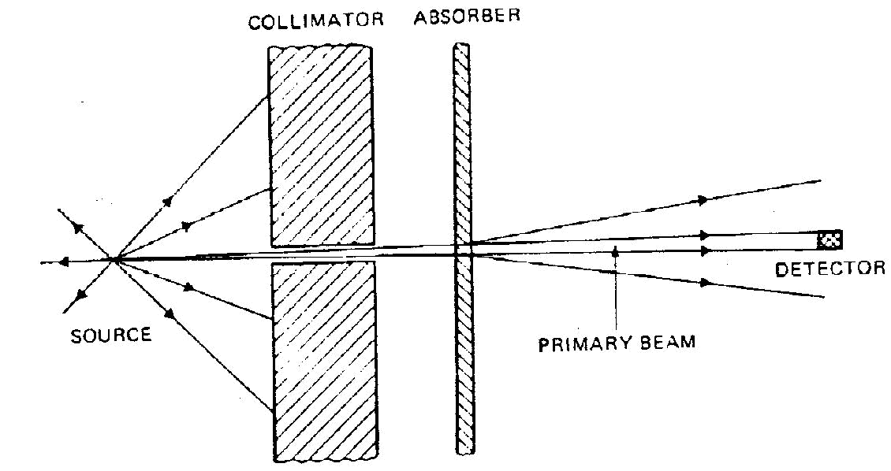

Figure 2.1: Narrow beam condition

The attenuation is then an exponential process expressed by

I I _{o} e ^{x} | 2.1
Where I is the intensity of radiation beam emerging from the shielding material in photons/cm²
- _{o}is the intensity (flux) of the beam incident on the shielding material.

is the linear attenuation coefficient for shielding material.

x is the thickness of the shielding material in cm.

- Broad beam conditions

This is the more frequently encountered condition in radiation shielding problems.

When broad parallel or divergent beams pass through attenuating material, some scattered radiation re-enters the emergent beam, Figure 2.2. Thus the attenuation no longer follows an exponential process, as it is reduced by an amount known as the build up factor for any particular source shield arrangement. The build up factor is always

22
greater than one and may be defined as the ratio of the intensity of the radiation including both the primary and scattered radiation at any point in a beam, to the intensity of the primary radiation only at that point. Build up may apply also to radiation dose. Equation for broad beam is given by

I B | x I_{o}e | x | 2.2
Where | _{B} is the build up factor
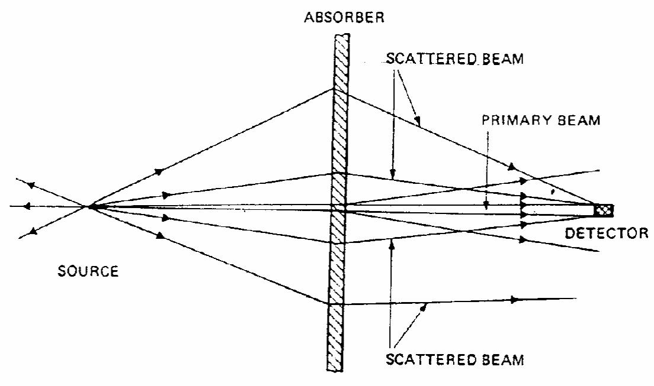

Figure 2.2: Broad beam condition

Shielding for protection against x-rays is can be considered under two categories:- source shielding and structural shielding

- Source shielding: - This is usually supplied by the manufacturer of the x-ray equipment as a lead shield in which the x-ray tube is housed. The safety regulations recommended by National (American) Committee on Radiation Protection specify that

23

for the protective tube housing for medical diagnostic installation; the leakage radiation at a distance of 1m from the target cannot exceed 100mR (30µ C/kg) in 1 hour when the tube is operated at its maximum continuous rated current for the maximum rated tube potential (Cember, 1989).

- Structural shielding: - This is designed to protect against the useful x-rays, leakage radiation and scatter radiation. It encloses both the x-ray tube (with its protective housing) and the space in which is located the object being irradiated. Structural shielding is designed to protect people in an occupied area outside an area of high radiation intensity (Cember, 1989).

2.2 Medical X-ray Imaging Facilities

2.2.1 Radiographic installations

A general purpose (conventional) radiographic system produces brief radiation exposures with applied electrical potentials on the x-ray tube (operation potential) in the range from 50-150kVp. The x-ray beam can be directed downwards towards the radiographic table and ultimately the floor or the tube can also so be directed horizontally towards the vertical cassette assembly (chest bucky) or directed towards other barriers. Barriers that may be directly irradiated are considered to be primary barriers. General purpose or conventional radiography refers to the use of x-ray for routine examinations of different parts of the human body. A protective design for a room containing a general purpose radiographic system will have to consider primary protective barrier against the primary beam and secondary protective barrier against leakage and scattered radiation.

24

2.2.2 Mammographic installations

Mammography is a radiographic imaging of the breast. Mammography is usually performed at low operating potentials in the range of 25-35kVp. Because the part of the body concerned is soft tissue, an x-ray beam of soft radiation and hence low kilovoltage is used (Chesney and Chesney, 1981). The low kilovoltage results in beams of low intensity. The mammography system is a specialized equipment consisting of an x-ray tube with a molybdenum, rhodium or tungsten anode and molybdenum, rhodium or aluminum filtration used.
Mammographic units have a C-arm configuration with the image-receptor size not exceeding 24x30cm. The source to receptor distance typically does not exceed 0.8m (NCRP, 2005). The mammographic image-receptor assemble is required by regulation to serve as a primary beam stop to the vast majority of the primary radiation (FDA, 2003). A small strip (<1.2cm) of primary radiation up to two percent of the subject to image distance (SID) in width is allowed to miss the image receptor along the chest-wall edge of the beam. However most of this radiation is attenuated to insignificant levels by the patients. Hence, only secondary radiation need be considered for mammography rooms. These permanent mammographic installations may not require protection other than that provided by typical gypsum wallboard construction. Also adequate protective barriers of lead acrylic or lead glass are usually incorporated into the mammography imaging system to protect the operator. Mobile mammography units present special problems in protection of the patient staff and members of the public. These machines must be evaluated by a qualified expert prior to first use (NCRP, 2005).

25

2.2.3. Fluoroscopic installations

Fluoroscopic imaging systems are usually operated at potentials ranging from 60-120kVp. Fluoroscopy refers to continuous x-ray imaging or real time imaging of the dynamics of the organs and tissue in the human body. The advantages of fluoroscopy are speed and ease (Chesney and Chesney, 1981). A primary barrier is incorporated into the fluoroscopic image receptor (image intensifier). The primary beam from the fluoroscopic tube is totally intercepted to below scattered radiation levels. Therefore, a protective design for a room containing only a fluoroscopic unit need consider only secondary radiations (NCRP, 2005). Since most modern fluoroscopic x-ray imaging systems also include a radiographic tube, the rooms housing the fluoroscopic systems may be provided with primary barriers to take care of the radiographic tube if the functions of the room is changed in future (NCRP, 2005). The shielding requirements for such a room are based on the combine workload of both units.

2.3 X-ray Shielding Barrier Requirements

2.3.1 Design dose limit (P)

A barrier interposed between the source and individual to be protected must attenuate the radiation level to design effective dose limit. The limit represents the maximum radiation dose that a particular barrier is designed to transmit. NCRP, (2005) recommends 5mSv/year and a weekly shielding design dose limit of 0.1mSv/week for controlled areas. This P value adopted for controlled areas will allow pregnant radiation workers continued access to their working areas. Controlled areas are limited access areas in which the occupational exposure of personnel to radiation and the radiation environment is subject to monitoring. Examples of controlled area include the x-ray

26

rooms or x-ray control booth. Based on ICRP, (1991) and NCRP, (1993) recommendations for annual limit on effective dose to a member of the general public of 1mSv/year, NCRP, (2005) recommends that a suitable source control for shielding individuals in uncontrolled areas is an effective dose of 1mSv/yr with a design dose limit of 0.02mSv/week. Uncontrolled areas are other areas in the hospitals or clinics where non-occupationally exposed persons may have access. Examples of uncontrolled area include the corridors and public toilets. This study will use the design dose limit recommended by NCRP Report 147, because this study is based on this report.

2.3.2 Room layout

The shielding requirements for an x-ray room depend strongly on the layout of the room (Simpkin, 1996). The layout determines the distances from the x-ray tube and patient to the occupied area, and defines which barriers shield against primary or secondary radiation. The diagram of a typical chest room medical imaging room layout shown in figure 2.3 below defines the distances involved in shielding calculations.

Wall 3

 | Wall 1 | dp
 |  | Wall 3 | Wall 4
 |  | ^{d}F | Wall 4
1 | Chest stand
Area | X-ray tube
Area | d_{L}
Area | Field size (F) | d_{S} | Operator Console
 |  |  | (Area 2)
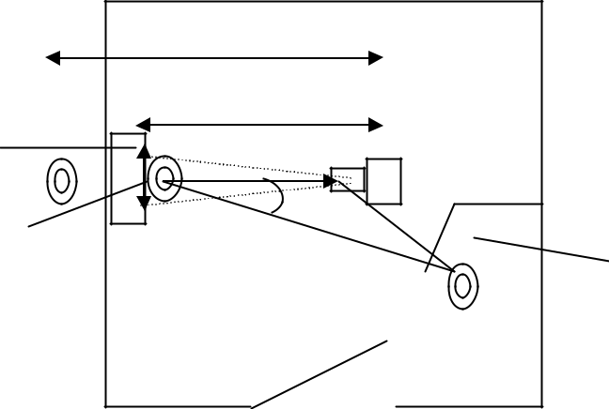

Wall 2

Figure 2.3: A typical medical imaging x-ray room layout

27

Any barrier, which may be in the direct x-ray beam, is called a primary barrier. If the x-ray beam will never be directed towards a barrier, it is called a secondary barrier. From figure 2.3, the distance from the x-ray tube to the scatterer (patient) is called d_{F}
Where N

(SID), the distance from the x-ray tube to the primary barrier is called the primary distance (dp) and the distance from the patient to a secondary barrier is called secondary distance (ds). The distance from the x-ray tube to the control booth is the leakage distance d_{L} (Simpkin, 1996). For the tube orientation indicated in figure 2.3, the individual in Area

1 would need to be shielded from the primary beam and the person in Area 2 would need to be shielded against scattered and leakage radiations. The distance to the occupied area of interest can be taken from the source to the nearest likely approach of the sensitive organs of a person to the barrier (NCRP, 2005). For a wall this may be assumed to be not less than 0.3m. For a source located above potentially occupied spaces, the sensitive organs of the person below can be assumed to be not greater than 1.7m above the lower floor, while for ceiling transmission the distance of at least 0.5m above the floor of the occupied room above the imaging room is generally reasonable (NCRP, 2005).

2.3.3 Workload and workload distribution

To calculate correct shielding the amount of work an x-ray unit does in a week must be known (Simpkin, 1996). This is known as the workload (W) of the x-ray unit. It is the time integral of the x-ray tube current over a week and is conventionally given in units of milliampere - minutes. The total workload per week (W_{tot}) is given by

^{W}tot ^{N W}norm | 2.3
is the number of patients examined in a week and

_{Wnorm} is the normalized workload (average workload per patient).

28

At a given x-ray tube operating potential and given distance, the dose at a given reference point from the primary beam is directly proportional to the workload (NCRP, 2005). The National (American) Council on Radiation Protection and Measurement (NCRP) Report 49 assumed that the entire workload in an x-ray diagnostic installation is

performed at a single kVp, for example – 1000mAmin wk⁻¹ at 100 kVp. This assumption ignored the fact that diagnostic workload is spread over a wide range of x-ray tube potentials (Archer, 1993). Also assuming a single conservatively high value for the tube potential can lead to significant over estimation of the barrier thickness requirements (Tsalafoutas et al., 2003). Workload distribution is the kilovoltage potential (kVp) distribution of workloads generated by the x-ray unit during the week (Simpkin, (1996).

For shielding design, the workload distribution as a function of kVp is much more important than the magnitude of the workload since the attenuation properties of barriers exhibit a strong kVp dependence. For example, the radiation level on the protected side of a 1mm lead barriers varies exponentially with kVp (three orders of magnitude over the range of 60 to 100kVp) whereas it varies only linearly with the workload. Thus the dose in air as well as the barrier transmission exhibits a strong kVp dependence (Archer, 1993). The actual work load for a given x-ray room will vary from facility to facility and even from week to week in the same facility, the average distribution obtained from survey represents a more realistic model of x-ray use than the single kVp approximation. It is also independent of the number of patients examined because the workload distributions are scaled per patient (NCRP, 2005).

The required barrier thickness is that where the transmitted radiation dose in the occupied area beyond the barrier does not exceed the weekly shielding design dose limit scaled by the occupancy factor (i.e. P/T). Using workload distributions, unshielded

29

primary or secondary dose per patient at 1m may be calculated. Scaling these by the weekly number of patients imaged in the room and correcting by the inverse square of the distance yields the unshielded radiation dose in the occupied area. By determination of the radiation transmission through a given barrier material for this specific workload distribution, the thickness of a barrier that reduces the unshielded radiation dose to the desired value of P/T can be determined (NCRP, 2005).

2.3.4 Use factor (U)

The use factor (U) is the fraction of the primary beam workload that is directed toward a given primary barrier. The value of U will depend on the type of radiographic installations and the barrier of concern (NCRP, 2005). In radiographic and radiographic and fluoroscopic (R & F) rooms, the equipment is arranged to allow different beam orientations so that different barriers have different use factors. For installations other than a radiographic room (or portable radiography), such as fluoroscopy, special procedures and mammography, the primary beam is stopped by an attenuating image receptor. Therefore U = 0 is assumed for all barriers (Simpkin, 1996).

Values of U have been suggested or observed by various groups for a radiographic room. The National (American) Council for Radiation and Measurement (NCRP) Report 49 (1976) recommended U=1 for the floor and U = 0.25 for each wall for radiographic room. Simpkin, (1996) displayed the use factors found in the Task Group 9 of the American Association of Physicist in Medicine (AAPM), which involved 2400 patients. The survey results suggest that the primary beam is directed to the non chest walls much less often than the fraction suggested by NCRP, (1976). The proposed primary use factors recommended in the study is show below.

30

Table 2.1: Proposed primary use factors for workload distribution models

(Archer, 1993)

Barrier |  | Use Factor | Use Factor (Workload Distribution)
 |  | (Single kVp)
Floor |  | 0.70 | 1 | (floor/other barriers)
Wall 1 | (Chest image receptor) | 0.25 | 1 | (Chest Bucky)
Wall 3 |  | 0.10 | 0.1 (Floor/other barriers
Wall 4 | (Control Booth Wall) | 0.05 | 0.05 (Floor/other barriers

2.3.5 Occupancy factor (T)

The occupancy factor (T) for an area is defined as the fraction of time that the maximally exposed individual is present at that area while the x-ray beam is on. Assuming the x-ray unit is randomly used during the week, the occupancy factor is the fraction of the working hours in the week that a given person would occupy that area, averaged over the year (NCRP, 2005). For example, an outdoor area adjacent to an x-ray room having an assigned occupancy factor of 1/40 would imply that a given member of the public would spend an average of 1 hour per week in that area (while the x-ray beam is activated) every week for a year (NCRP, 2005). The Occupancy Factor (T) for an area is not the fraction of time it is occupied by any person but rather is the fraction of time that is occupied by the single person who spends the most time there. When designing a new facility, reasonable and realistic assumptions concerning occupancy factor is made as each facility will have its own particular circumstance. For example, an outdoor area that has benches where employees can eat lunch will have an occupancy factor influenced by the climate of the location. When designing a new facility, it should be kept in mind that the function of adjacent areas may change over time. For example, a storage room can be converted into an office without anyone reconsidering the adequacy 31
of the existing shielding, particularly if the conversion is made in an adjacent uncontrolled area (NCRP, 2005).
General guidance values that may be utilized if more detailed information on occupancy is not available is shown in Table 2.2 below:

Table 2.2: Suggested occupancy factors for use as a guide in planning where other occupancy data are not available (NCRP, 2005)

 | Location | Occupancy factor
 |  | (T)
 | Administrative or clerical offices; laboratory, pharmacies and other work
 | area fully occupied by an individual; receptionist area, attended waiting
 | room, children’s indoor play area adjacent x-ray room, film reading, nurse’s | 1
 | station, x-ray control room.
 | Room used for patient examinations and treatment. | ½
 | Corridor, patient room, employees lounges, staff rest room. | ¹/₅
 | Corridor door | ¹/₆
 | Public toilets, unattended vending areas storage rooms, outdoor areas patient
 | holding areas. | ¹/₂₀
 | Outdoor areas with only transient pedestrians or vehicular traffic, unattended
 | parking lots, vehicular drop off areas (unattended), attic stairway, unattended | ¹/₄₀
 | elevators, and janitor closets.

32

2.4 Construction of Shielding Barrier

The correct construction of required shielding barrier is very important. It involves the use of appropriate choice of materials, correct construction methods and lastly verification by an appropriately qualified person that the shielding has been built according to design and is safe for use.

2.4.1 Shielding materials

The building materials available for shielding vary. The possibilities include:

- Sheet lead has traditionally been the material of choice for shielding medical imaging x-ray room walls. For typical shielding applications a lead sheet is glued to a sheet of gypsum wallboard and installed lead inward with nails or screws on wooden or metal stud (NCRP, 2005).

- Cement blocks (solid) with mortar joins carrying through the full thickness of the blocks. As a rule of the thumb, it is equivalent to at least 2/3 of its thickness in solid concrete.

- Bricks may be used, provided it provides sufficient attenuation. Mortar joins must carry through the full thickness of the brick. Bricks vary in their attenuation therefore one has to be careful on the type of brick one is using.
- Gypsum wallboard (sheet rock) is also commonly used for shielding in medical facilities. Gypsum is sandwiched between a 1mm of paper. Although gypsum wallboard provides relatively little attenuation at higher beam energies, it provides sufficient attenuation of the low energies used in mammography (NCRP, 2005).

33

When advising on shielding materials, it is often useful to know the comparative densities and lead equivalence of various materials, so that options can be made.

Table 2.3: | Lead equivalence of some shielding materials
Material | Equivalence at 70kVp | Equivalence at 80kVp
Lead | 1.0mm | 1.389mm
Concrete | 92.51mm | 115.4mm
Gypsum | 271.2mm | 339.0mm
Steel | 6.799mm | 10.15mm
Plate glass | 106.6mm | 130.0mm
Wood | 949.4mm | 1020mm

2.4.2 Construction details

The following information will help to ensure that any shielding barrier constructed will be free of defects, which will be expensive to correct:

- Shielding integrity: Shielding should be continuous; there should be no gaps, particularly at the boundaries between different materials such as wall to window or joints between lead sheets. The surfaces of these materials should be in contact and an overlap of not less than 1cm. Shielding should extend from finish floor level (FFL) to a height of at least 2.1m. Gaps between the shielding barrier will impair overall protection of the barrier. For example, gaps between lead shielding in a barrier protecting the darkroom (with occupancy factor of 1) from an x-ray room with a high workload will result in radiation dose levels higher than the design dose limit beyond the barrier.

34

- Penetration: These are openings made in the shielding barrier for things like air conditioning ducts, electrical conduits, plumbing and service boxes or hatches used to transfer cassettes carrying films from the x-ray room to the darkroom. These penetrations are backed with supplementary lead shielding and these penetrations are usually located in the secondary barrier. Without the supplementary lead shielding, the shielding provided would be impaired by these penetrations.
- Floor and ceiling: Locating an x-ray room above or below a corridor or mechanical room rather than an occupied office is an effective strategy for reducing shielding requirements and no costly addition of lead shielding in the floor or ceiling. Concrete is a basic construction material used in floor or ceiling slab. The ability of concrete to protect occupied areas depends on the thickness, density and composition. Concrete is usually designed and specified as standard weight (density = 2.48cm⁻³ = 145 lb foot⁻³) or light weight (density = 1.88cm⁻³ = 115 lb foot⁻³) (NCRP, 2005).
- Viewing windows: Viewing window protects the radiographer from scatter and leakage radiation when the x-ray beam is on, and allows the radiographer to observe the patient when the procedure is going on. Materials suitable for viewing windows in medical x-ray imaging facilities need to be durable and maintain optical transparency over the life of the facility. Materials usually used as viewing windows are lead acrylic or lead glass specified in terms of millimeters of lead (for 1.5mm and 2.0mm lead equivalence is mostly used).
- Doors: Doors in the x-ray room are usually lead lined. The inside of the door frame is lined with lead and worked into the contour of the frame to provide effective overlap with the adjoining barrier so that the door and frame can provide the attenuation required to reduce the unshielded radiation dose levels to the design dose limit.

35

- Vertical bucky (chest stands): Where vertical chest stands are installed, there is need for additional protection (shielding) behind the stand. As a rule, an additional

- 5mm of lead to extend 0.5m either side of the stand’s centre line and to a minimum height from the finished floor level of 2m.

2.5 Radiation Protection Surveys

This is an onsite evaluation of the x-ray facility performed by or under the direction of a qualified expert. It is usually performed after the facility is completed, although some components may be conducted prior to the completion of construction (NCRP, 2005). The survey consists of:

- Inspection for voids

Corrections made after construction of the radiation room is completed can be expensive and destructive; so the shielding of the radiation room shall be constructed such that the protection is not impaired by voids or openings in the protective barriers. A visual inspection during the protection phase helps to ensure that the barriers are free of voids (Braestrup and Vikterlof, 1974). Voids in the barriers can be located by the use of a suitable x-or gamma ray source and a sensitive radiation detector such as Geiger-Mueller (GM) tube or scintillation detector. The use of an audible detector with a meter will save time in finding areas of unexpected high transmission when a radionuclide source such as a low-energy gamma source like 99mTC is placed in the centre of the room (NCRP, 2005).

36

- Evaluation of shielding adequacy

Evaluation of the shielding adequacy says what level of radiation protection the barriers in the facility can provide. This evaluation determines if adequate thickness of barrier has been installed by estimating the number of patients that may undergo x-ray procedures without exceeding the design dose limit for occupied adjacent areas (NCRP, 2005). This survey will involve direct measurement of the x-ray transmission provided by each barrier. In some instances, it may be possible to verify the amount and type of shielding by visual inspection. If the thickness and composition of radiation barriers cannot be determined by visual inspection, the barrier transmission factor must be determined. This is done by using the primary x-ray beam, an appropriate survey instrument and a water equivalent phantom at 20cm thick with a convex upper surface (NCRP, 2005). The primary beam is collimated to a large cassette placed in the image receptor. The total primary beam shielding thickness is the sum of the structural barrier thickness (X _{barrier}) and the effective thickness of the image receptor hardware including
the cassette (X_{pre}). To ensure the actual radiation levels beyond the various barriers

resulting from actual workload, it is necessary to place sensitive, integrating dosimeters on the outside of all barriers for a period of time. This is not practical since the result is required in a short time. An alternative is to use the method that relies on a determination of the equivalent barrier thickness (X _{barrier}) whether by direct inspection or from

measurement of transmission factor [B(X _{barrier})] using an x-ray beam or a suitable

radionuclide source. Once the equivalent barrier thickness (X _{barrier}) has been determined,

the number per patients/week, N, that can be examined without exceeding the appropriate weekly value of P/T (NCRP, 2005).

37

2.6 XRAYBARR and Thermoluminescent Dosimetry

2.6.1 Overview of XRAYBARR

XRAYBARR is a code (program) introduced by Douglas J. Simpkin, to calculate radiation shielding requirements for diagnostic radiology installations. This program calculates the thickness of lead, concrete, gypsum, steel, plate glass and wood required to shield diagnostic x-ray installations using W and Mo anode x-ray tubes in the range 25-150kVp. XRAYBARR considers up to 5 x-ray tubes in a room, calculating the primary, scatter and leakage dose, contributions to a shielded area from each tube. From the workload in the room, distances to the occupied areas and leakage technique factors (kVp and mA) at which the 100 mR/hr leakage requirement is defined, and with the annual design dose limit (P) and occupancy factor defined, the program determines the barrier thickness required to reduce the total annual dose to P/T.

1. Primary barrier

The exposure per week per mAmin, adjusted for occupancy and use factor:

^{K}ux | P(d _{pri} )² | 2.4
^{K}ux | WUT

Where,

- _{ux} is the exposure per week per mA-min
_{W} is the workload

U is the use factor

T is the occupancy factor
- _{pri} is the distance from focal spot to the occupied area.
From the value of K_{ux} , the required amount of shielding can be obtained. WhereK_{ux} is

used, some of the measure of unattenuated radiation output is needed. The required shielding attenuation is given by:

38

B | ^{K} ux | 2.5
- _{o}
Where,

- _{o} is the relative output with no attenuator

The amount of shielding required for a given K_{ux} is given by:

1 |  |  |  |  | B
x ( |  | ) | In
x ( |  | ) | In |  | 1 |  |  |  |  | 2.6
Where,
 | B is the required attenuation and , and |  |  |  |  |  |  |  |  | are fitting parameters in the
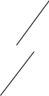

mathematical model for transmission of broad x-ray beams through shielding materials. These fitting parameters depend on shielding material, as well as workload as a function of kVp.

- Secondary barriers

When the x-ray beam is not aimed at a particular barrier, scattered radiation will reach that barrier. The amount of radiation depends on the radiation energy, the x-ray field size, distance from the scatterer and the scattering angle. The scattered radiation level is:

k_{ux}

Where:

P | d_{sca} ² . d_{sec} ² . | 400 | 2.7
aWT |  | F

- is the actual field size in cm² and
_{a} is the ratio of scattered to incident intensity

Although α varies with scattering angle and kVp, a good approximation to use is 0.0015 for diagnostic x-ray energies.

39

- X-ray tube leakage

All x-ray tube housings are shielded, the amount of shielding and attenuation is limited and there will always be a small amount of leakage. International standard gives the

maximum allowable leakages as 1mGyhr⁻¹ at 1m from the target at the maximum rated tube current. The required attenuation for leakage is:

 | 2 |  | . 600I |  | 2.8
^{B}leak |  | P d_{sec}
^{B}leak |  | WT
Where, I | is the maximum rated x-ray tube current.

2.6.2 Thermoluminescent dosimetry

Thermoluminescent dosimeters are natural synthetic materials which emit Light the intensity of which is proportional to the dose of irradiation when heated after having been exposed to radiation (Ranogajec-komor, 2002). TLDs respond qualitatively to x-rays gamma rays, beta rays, electrons and protons over a range that extends from about 0.1mGy (10mrad) to 1000 Gy (100,000 rad) ( IAEA, 1995).
TLDs can be usable over a wide range of radiation quantities, its sensitivity is independent of dose rate and exposures can be made in the field away from the measuring laboratory (Meredith and Meredith, 1977). It is a very versatile dosimeter to use either as a personnel or environmental monitor of radiation (IAEA, 1995).

2.7 Other Methods of Control of External Radiation

External radiation in the x-ray department originates from the x-ray machines. Since it is not feasible to do away with the radiation source, then exposure of personnel to external radiation can be controlled by the application of one or more of these principles: -Time, distance and shielding.

40

1. Time

The dose received by a worker in an area of constant dose rate is proportional to the time the work spends in that area.
Thus: dose = dose rate x time 2.9

Therefore, minimizing the time spent in the area with constant dose rate will reduce the amount of radiation received. In x-ray diagnostic installations, x-rays are produced in the x-ray room when the x-ray beam is on. The dose received by a radiation personnel will depend on the time spent in the x-ray room when the x-ray beam is on. For example, when a radiological procedure is performed under fluoroscopic control, the amount of radiation dose received by the personnel and patient will depend on the screening time (x-ray beam on time). Reducing the number of patients examined under fluoroscopic control will reduce the time spent in the room and subsequently reduce the radiation dose received. The x-ray beam on time is related to the workload and occupancy factor. The larger the workload, the longer the x-ray beam on time and the greater the shielding barrier thickness required to shield occupied areas. The higher the occupancy factor during the x-ray beam-on time, a greater shielding barrier thickness needed to protect the area.

- Distance

Radiation exposure decreases with increasing distance from a radiation source. This is a powerful tool in radiation safety in quantitative terms (Cember, 1989). In this study, the point source will be considered, as it is relevant to the study. In the case of point source, the variation of dose rate with distance is given by the inverse square law. The dose received is inversely proportional to the square of the distance between the source and the individual

41

D |  | 1 |  |  | 2.10
D |  | _{r} 2 |  |  | 2.10
D | k |  |  |  | 2.11
D | r²
Where: | _{D} is the dose
_{r} is the distance between source and individual.

For example, during fluoroscopic procedures, the radiologist who stands near the fluoroscopic table receives more radiation dose during screening time than a radiographer who stands 2m away behind an operator’s console. Also the distance from the x-ray tube to occupied areas, show that the nearer the occupied area to the x-ray tube, the greater the amount of radiation and subsequently a greater thickness of shielding barrier required to shield that particular area.

2.8 Review of Previous Works

A search of relevant literature revealed many facts, figures and opinions. Lots of researches have been carried out on the designing of diagnostic x-ray shielding barrier and the parameters that affect it like workload, use factor and occupancy factor. NCRP, (1976) has remained the primary guide for diagnostic x-ray structural shielding design. NCRP, (1976) proposed a design dose limit of 100mR/week (1mSv/week) for controlled areas and 10mR/week (0.1mSv/week) for uncontrolled areas. This was based on the assumption that the entire workload in an installation is performed at a single kVp; for

example, 1000mAmin wk⁻¹ at 100kVp. NCRP, (1993) recently lowered these design values significantly. Regarding occupational exposures, this report states that all new facilities and introduction of new practices should be designed to limit annual exposures

42

to individuals to a fraction of the 10mSv per year limit implied by the cumulative dose limit and that radiation protection goal in such cases should be that no member of the public would exceed the 1mSv/year annual effective dose limit from all man-made sources and that a pregnant radiation worker should not be exposed to levels that result in greater than the monthly equivalent dose limit (H) of 0.5mSv to the worker’s embryo or foetus. NCRP, (2005) while considering the design of new facilities and the pregnant radiation worker, recommends a fraction of one-half of the effective dose value or 5mSv per year and a weekly design dose limit (P) of 0.1mSv/week, dose for controlled areas and weekly design dose limit (P) of 0.02mSv/week dose (that is an annual effective dose of 1mSv) for uncontrolled areas.
Archer, (1993) noted that the diagnostic workload is spread over a wide range of x-ray tube potentials. That for shielding design, the workload distribution of kVp is much more important than the magnitude of the workload since the attenuation properties of barriers exhibit a strong kVp dependence, thus the dose in air as well as the barrier transmission exhibits a strong kVp dependence. Also Simpkin, (1996) while evaluating the NCRP 49 Report assumptions on workload and use factors in diagnostic radiology facilities carried out a national survey to measure workload and use factor data at 14 medical institutions involving approximately 2500 patients in seven types of radiology installations, namely, general radiographic rooms, fluoroscopic and radiographic rooms, chest radiographic rooms, mammography suites and cardiac and peripheral angiographic suites in the United States of America. The survey results showed that the kVp distribution of workloads (workload distribution) provides a more accurate estimate of the quality and quantity of radiation produced in a diagnostic x-ray room than the single

43

kVp approximation of NCRP Report 49 and that the surveyed clinical workload distributions are specific for a given type of radiological installation.
Dixon, (1994) measured the degree of attenuation provided by x-ray tables, grids, cassettes and cassette holders using a three-phase x-ray equipment. The primary beam was shown to be attenuated by more than two orders of magnitude at 100kVp by the x-ray tables prior to impinging on the floor (ignoring patient attenuation). Calculations for heavy workload show that only a modest amount of concrete is required in the floor as a primary barrier if attenuation of these materials is taken into consideration (less than 2.5cm at 80kVp and less than 4cm at 100kVp). This was verified by radiation survey carried out just below the table bucky over a period of 3 weeks using film dosimetry in two radiographic rooms and results concluded that no primary beam shielding would have been required in the floor of these x-ray rooms.
Ogbanje, (2000) while working on quality assessment of radiological diagnostic facilities in hospitals in Kaduna, Nigeria, used the workload of each x-ray machine to determine the shielding barrier thickness required in seven hospitals within Kaduna town. Results showed that barrier thickness increase with the maximum applied voltage (kVp) across the x-ray tube. Tube voltages of 70kVp, 100kVp and 125kVp required shielding thickness of 17.5, 27.7 and 35.0cm of concrete respectively for chest x-rays and shielding barrier thickness of concrete required to protect radiographers were 15.5, 23.0 and 27.0cm for tube voltages 70kVp, 100kVp and 125kVp respectively.
Muhogora and Kondoro, (2004) carried out an assessment of secondary radiation shielding requirements for diagnostic x-ray facility in Tanzania. They compared the results based on the model by Simpkin and Dixon, (1998) for calculating shielding requirement with area monitoring data using TLDs. The results showed that the ratio of

44

the calculated to the measured dose level inside the x-ray room varied from 1.85 to 5.86 indicating that the radiation exposure inside the room was highly variable and that the model and the area monitoring data was useful in optimizing radiation shielding conditions in x-ray rooms.
Okunade, (2005) in estimating the additional shielding requirements for primary beam apart from that provided by patient and hardware in the x-ray beam in Ibadan, Nigeria tried to distinguish between attenuation and hardening properties of materials in comparison. He did a numerical comparison of attenuation and hardening properties of phantom (Lucite, soft tissue, water) and hardware (aluminum and steel) materials with those of lead. Results showed that the shielding affordable by lead attenuation equivalent thicknesses (LAE) and lead hardening equivalent thickness (LHE) is not strictly equivalent to that affordable by thicknesses of substitutes (phantom materials, aluminum and steel) when there are differences in attenuation and hardening properties. Example calculations showed that the use of lead thickness (LAE) that are not ‘exact’ to account for shielding affordable by the thickness of the patient (water phantom) produced lesser reduction of the primary radiation level in the area indicated for shielding and that the ‘exact’ LAE that will reduce the primary radiation level equally as the patient and radiographic table may be higher by close to 20% or more of that which is not exact.

45

CHAPTER THREE

MATERIALS AND METHOD

3.1 Materials

3.1.1 X-ray facilities

Facilities at the two hospitals, Ahmadu Bello University Teaching Hospital, Shika and Barau Dikko Specialist Hospital, Kaduna were used for the study. In Ahmadu Bello University Teaching Hospital, Shika, the general radiography, fluoroscopy and mammography rooms were used for the study. The fourth room which houses the computed tomography machine was not included in this study because the program X-RAYBARR does not include the computed tomography machine in its calculation of shielding thickness for diagnostic x-ray installations. The layout of diagnostic x-ray rooms in Ahmadu Bello University Teaching Hospital, Shika is shown in figure 3.2.
The room housing the general x-ray machine has an area of 6.36 x 5m while the operator console in the room has area of 1.52m x 2.35m and 2m high. The general x-ray machine is a Silhouette General X-ray machine; model MS-185N with serial number 0877 manufactured by General Electric (GE) Medical Systems in September, 2004. It has a minimum inherent filtration of 1.5mmAl equivalent at 100kV.It has a leakage radiation of 0.876mGy/h dose (100 mR/h exposure) at 1m (150kVp, 3.3mA).
The fluoroscopy room has an area of 5.92m x 4.93m while the operator console has an area of 2.11m x 1.2m and 2m high. The fluoroscopy machine is a Prestige S1 Fluoroscopy and Radiography Machine with model number ZAOULOOA, serial number 169524M06 (type 45296463) manufactured by General Electric (GE) Medical Systems in October 2004. It has an inherent filtration of 1.5mm Al equivalent at 80kV.It also has leakage radiation of 0.876mG\h dose (100mR\h exposure) at 1m (150kVp 3.3mA).

46

The mammography room has an area of 5.14m x 2.73m dimension. The operator console has an area of 1.2m x 1.2m. The Mammography Machine is a Senographe DMR+ Mammography machine with model number 2241027-2 type, serial number 171497M01 manufactured in October, 2004 by General Electric (GE) Medical systems.
In Barau Dikko Specialist Hospital, Kaduna, only the general radiography room was used in this study as shown in figure 3.3. The room housing the general x-ray machine has an area of 5.35m x 3.73m while the operator console has area of 2.23m x 1.7m and 2m high. The general x-ray machine used in this study was a small mobile x-ray machine, Ralco S.R.L. Lissone manufactured by P/h Medical Limited, Italy in November, 1996. The model and serial number could not be ascertained as it had been wiped off. The machine cannot be used for horizontal projection. All examinations done with this machine was done on the x-ray table.

3.1.2 Calibration of thermoluminescent dosimeters (TLDs)

The calibration of the TLDs was carried out at the Centre for Energy, Research and Training, Ahmadu Bello University, Zaria. The TLDs are lithium fluoride (LiF) chips of 3.8mm x 3.8mm in size originally supplied by RISQ Laboratories in Denmark. These chips were first annealed and then calibrated to determine their dose and responses by exposing them (two TLDs at a time) at a distance of 8cm to a 137 Cs-gamma source(from Austria) with a dose rate of 0.4mSv/hr at 0.5 hours, 1 hour, 1.5 hours, 2 hours, 2.5 hours, 3 hours, 3.5 hours and 4 hours respectively.
The TLD Processor Model 680 Solaro by Vinten Analytical Systems Limited, United Kingdom was employed to read the TLDs with its sensitivity level being 99.9%.

The Vinten Solaro TLD reader was set at a preheat temperature of 160ºC, preheat time

47

of 10s, read temperature of 260ºC, read time of 16s, anneal temperature of 300ºC, anneal time of 16s and calibration factor of 1 (Vinten,1989).

3.2 Methods

3.2.1 Determination of workload distribution

The total workload distribution for the studied rooms had earlier been surveyed over four calendar weeks. The total workload per week is given by equation 2.3.

3.2.2 Estimation of shielding barrier

The code, XRAYBARR was used to calculate the thickness of barrier required to shield the diagnostic x-ray installations in Ahmadu Bello University Teaching Hospital, Shika and Barau Dikko Specialist Hospital, Kaduna. With the annual dose limit (P) and occupancy factor (T) to the area to be shielded specified, the program uses the workload in the room, use factor, distances to the occupied area and the x-ray tube information to calculate the barrier thickness required to reduce the total annual dose to P/T. The XRAYBARR calculation model is shown below in figure 3.1.

48

Institution | ABUTH

Barrier Information

Room

Gen. Radiog.

Architectural Distance Unit

metres

Identification

Permitted

Dose

Secondary Barrier

Controlled Area

Occupancy

Factor ^{1.0}

= | 5 | mSv/yr

X-ray tube Information (Fill in X-ray tube ID box to add a tube)

X-ray Tube |  |  |  | Tube 1
Identification |  |  |  | Tube 1
Workload distribution |  | Radiog. Rm
Plot distribution |  | 208 | Pats/wk
Total W m Amin/ week |  | 78.64
Leakage | Max kVp | 150
Techinique | Max mA | 3.3
Factors
Primary Use Factor |  | 0.68
Primary distance (m) |  | 3.18
Secondary distance (m) |  | 3.18
Leakage distance (m) |  | 3.18
Primary distance @ which |  | 1.83
Field size is know (m):
Field size (cm²) |  | 1535cm |  | Resize
Scattering Angle (degrees) |  | 90°
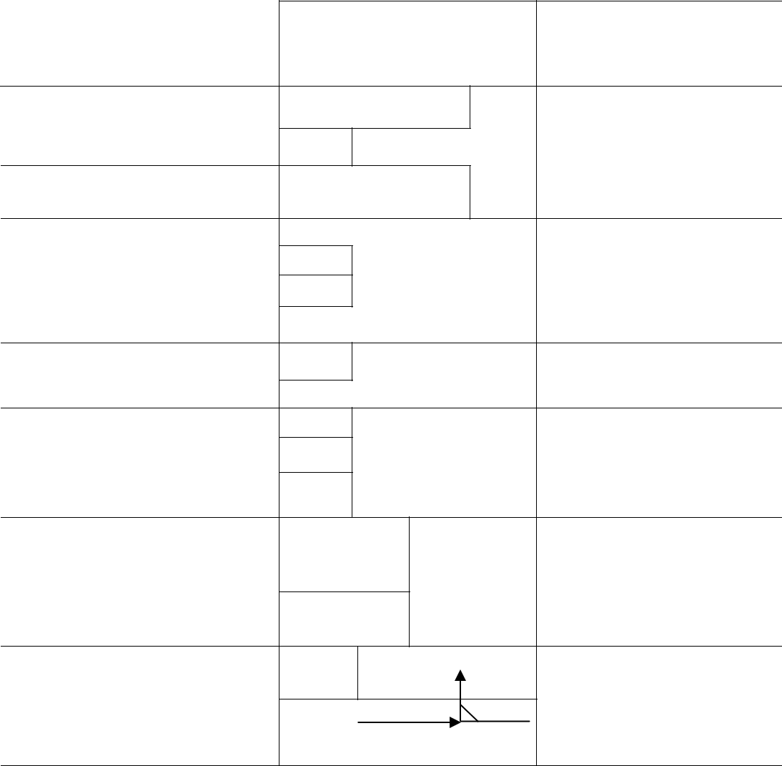

Figure 3.1: The XRAYBARR Calculation Model

49

Upon inputting the type of barrier and x-ray tube information and clicking the calculate button, the program presents the required minimum shielding thickness in (mm and inches) and the details of the calculated unshielded and shielded primary, scatter and leakage dose generated by the x-ray tube. The program uses equations 2.4, 2.5, 2.6, 2.7 and 2.8 to calculate the unshielded and shielded primary, scatter, leakage radiation and the thickness of barrier required.

3.2.3 Area monitoring survey

For the secondary barriers, area monitoring inside the x-ray rooms and beyond the secondary barriers was done for four calendar weeks (every week for four weeks) using calibrated TLDs in Ahmadu Bello University Teaching Hospital, Shika and Barau Dikko Specialist Hospital, Kaduna. For the purpose of this survey, a pair of two TLDs was placed at certain positions at a height of 1m from the floor within the x-ray rooms and beyond the secondary barriers. The placement of the TLDs was done based on the importance of such barrier to the adjacent occupied area. The TLDs were readout on a TLD reader every week with the background radiation of the TLDs corrected accordingly. The mean TLD reading at a point was deduced from the weekly measurements over four weeks period. The positions of the TLD chips are shown in figures 3.2 and 3.3.

50

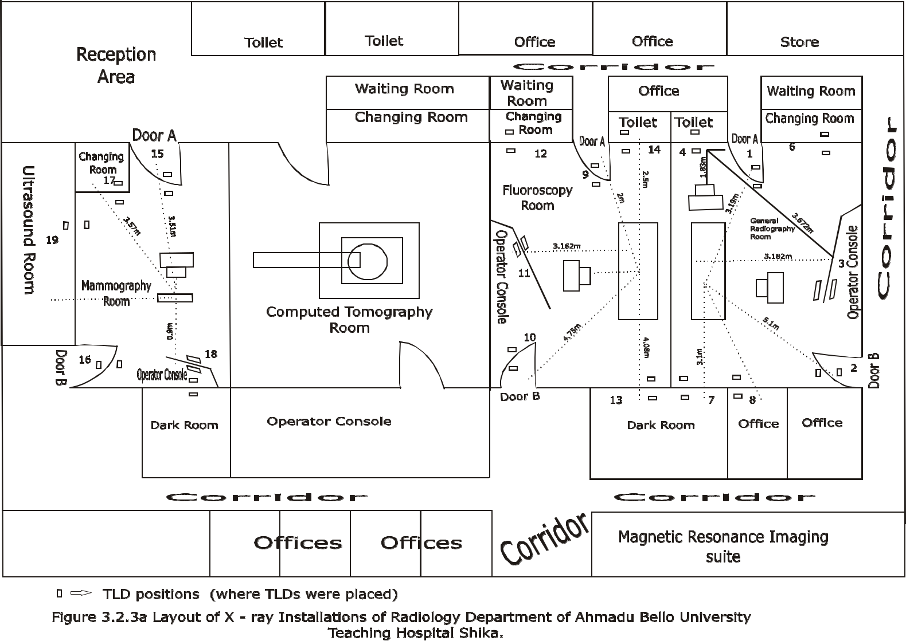

41

51
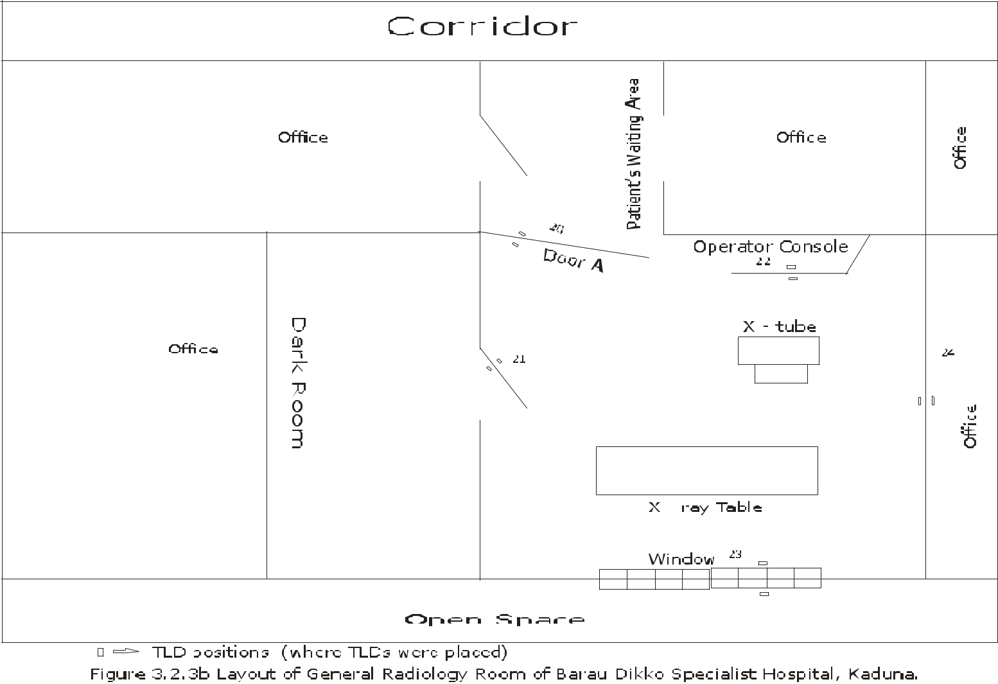

42

52
For the primary barrier, area survey inside the x-ray room and beyond the primary barrier behind the erect bucky (toilet) was done in the General radiography room of Ahmadu Bello University Hospital. A pair of TLDs was placed directly behind the erect bucky inside the x-ray room and also beyond the primary barrier at a height of 1m from the floor as shown in figure 3.2. The x-ray tube was directed horizontally to the erect bucky and the field size opened to correspond to the largest size of cassette (cassette size = 35cm x 43cm). The exposure factors for the most frequently done erect x-ray examination which is chest x-ray was chosen. And the TLDs are exposed to direct x-ray beam, removed immediately and readout on a TLD reader.

53

CHAPTER FOUR

RESULTS

4.1 Workload and Workload Distribution

Tables 4.1 and 4.2 show the results of the workload calculated using data and parameters specific to each x-ray room and x-ray installation in Ahmadu Bello University Teaching Hospital, Shika and Barau Dikko Specialist Hospital, Kaduna.

Table 4.1: Total workload distribution per x-ray room in Ahmadu

Bello University Teaching Hospital, Shika

X-ray room |  | Average | Workload mA-min /Week
 |  | patients
 |  | per week
 |  |  | <60kVp | 60-100kVp | >100kvp
 | Chest Wall | 208 | 3.74 | 74.9 | ----
General
Radiography
Room | Floor/other |  |  |  | ----
 | Barriers | 208 | 19.14 | 40.54
General
Radiography | all barriers | 208 | 22.88 | 115.44 | ----
Room
Mammography Room |  | 6 | 35.95 | ---- | ----
Fluoroscopy & Radiography Room |  | 25 | ---- | 300.7 | ----
(Fluoroscopic tube)
Fluoroscopy & Radiography
Room(Radiographic Tube) |  | 25 | 2.33 | 40.14 | ----
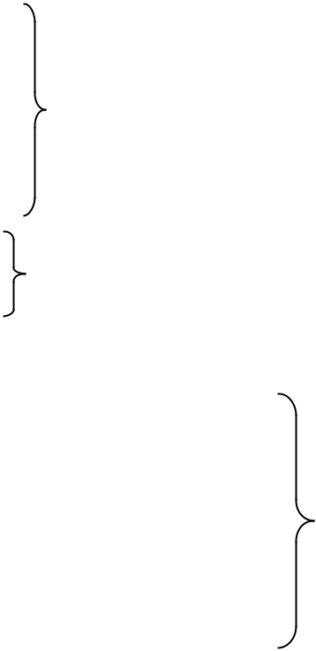

54

Table 4.2: Total workload distribution in the general radiography room of Barau Dikko Specialist Hospital, Kaduna

X-ray room | Average patients | Workload mAmin/ Week
 | per week
 |  | <60kVp | 60-100kVp | >100kVp
General Radiography | 100 | 0.833 | 51.45 | ---
Room (X-ray table only)

Table 4.1 presents the kilovoltage distribution of the total workload and the total number of patients per week in the general radiography, fluoroscopy and mammography rooms of Ahmadu Bello University Teaching Hospital, Shika. The total workload distribution in the general radiography room is divided into the chest wall (Erect Bucky) and floor/other barriers (x-ray table) workload distributions. Separating the total workload into these two barrier-specific distributions provides a more accurate description of the intensity and penetrating ability of the radiation directed at primary barriers and it is used for primary beam barrier calculations (NCRP, 2005).In the general radiography room, the primary beam was directed at the chest wall (Erect Bucky) for 68% of the total workload, with the remaining 32% directed at towards the floor/other barriers. Meaning that in the general radiography room, out of the 208 patients/week, 141 patients were for chest wall examinations and the remaining 67 patients were for x-ray table (floor\other barriers) examinations. The Rad Room (all barriers) consists of exposures in a general radiography room containing a chest bucky and radiographic table. It is composed of the sum of Rad Room (chest bucky) and Rad Room (floor or other barriers) workload distributions. Rad Room (all barriers) workload distribution is used for secondary barrier shielding calculations (NCRP, 2005).

55

The total workload distribution in the fluoroscopy room is also divided into fluoroscopic and radiographic tubes distributions, because most fluoroscopic cases also involves the overhead radiographic tube for taking additional films covering a larger field of view (FOV) than that available with spot-film images of fluoroscopic tube (NCRP, 2005). In the general radiography and fluoroscopy rooms of the Ahmadu Bello University Teaching Hospital, Shika the bulk of the workload distribution occurs between 60kVp – 100kVp. The workload distribution plots of these rooms are shown in figures 4.1, 4.2, 4.3, 4.4, and 4.5
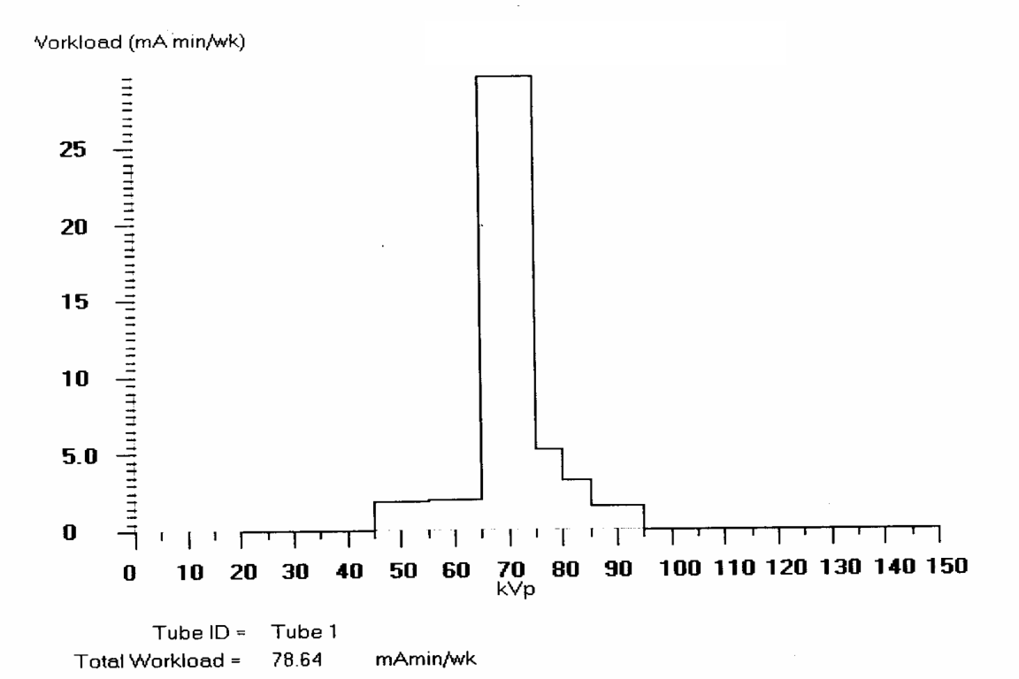

Figure 4.1: Workload distribution plot for the erect bucky in the general

radiography room of Ahmadu Bello University Teaching Hospital,

Shika.

56

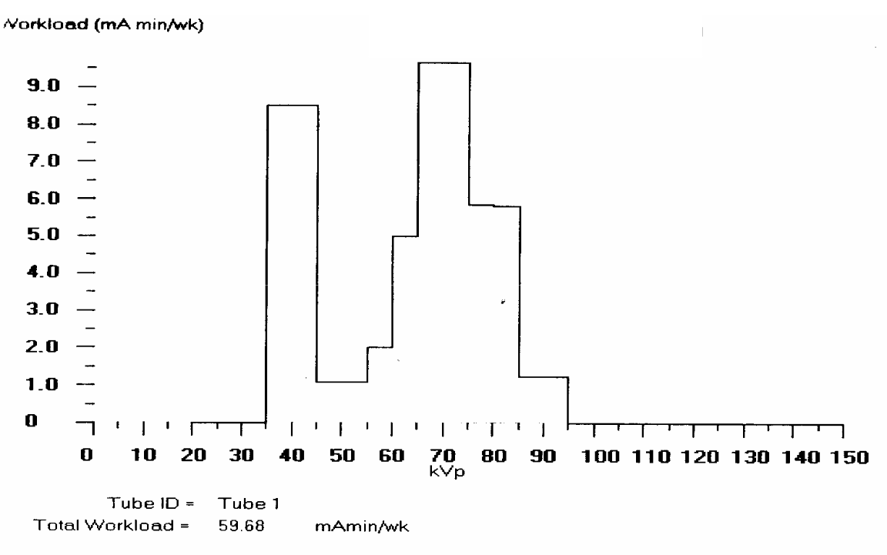

Figure 4.2: Workload distribution plot for the floor/ other barriers of the general radiography room of Ahmadu Bello University Teaching Hospital, Shika
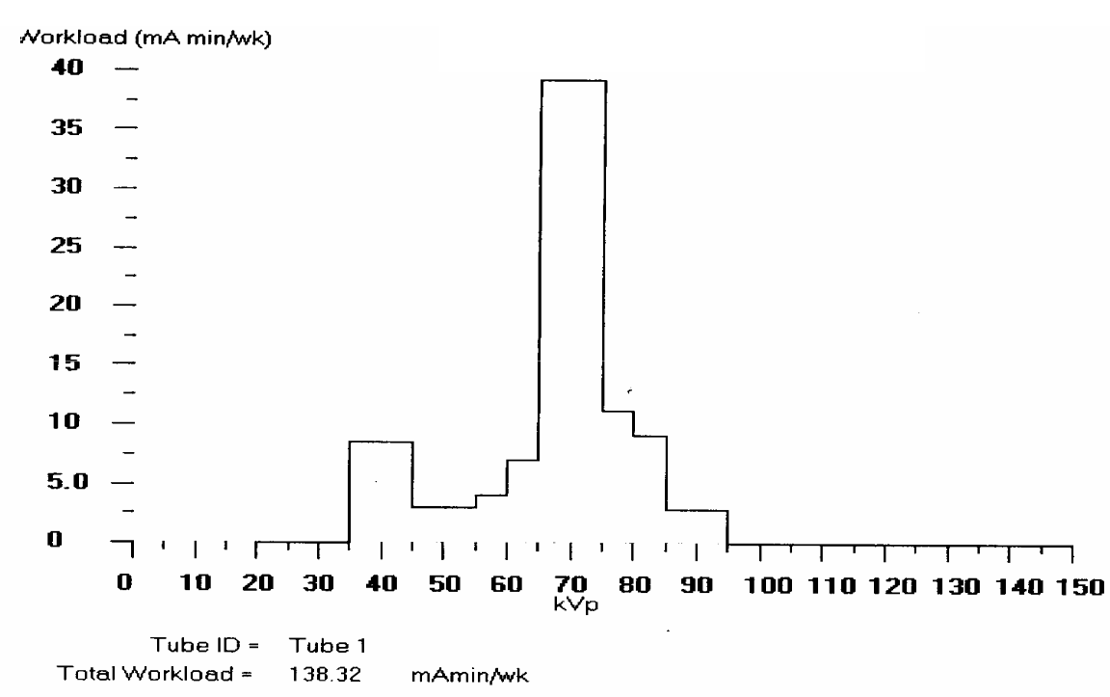

Figure 4.3: Workload distribution plot for general radiography room

(all barriers) of Ahmadu Bello University Teaching Hospital, Shika

57
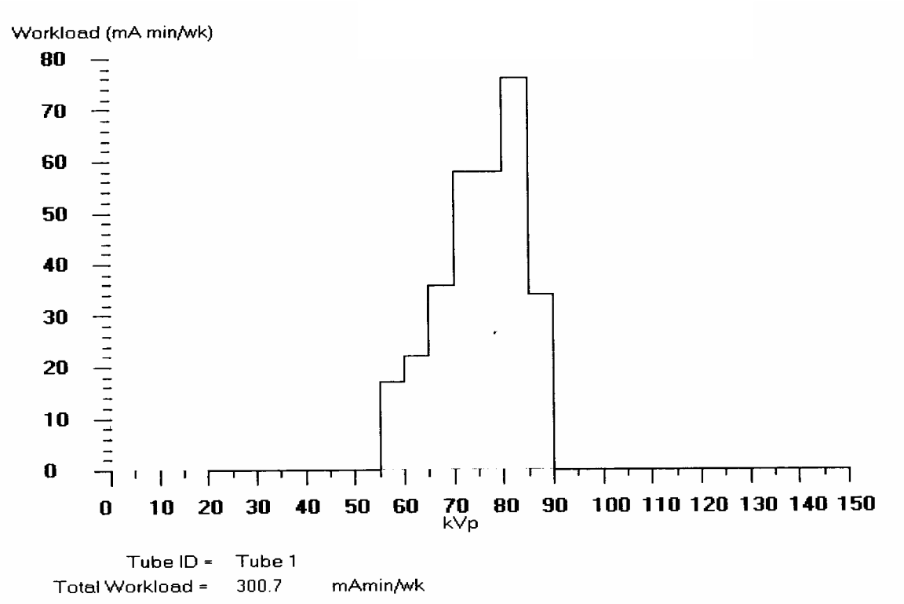

Figure 4.4: Workload distribution plot for the fluoroscopy room (fluoroscopic tube) of Ahmadu Bello University Teaching Hospital, Shika
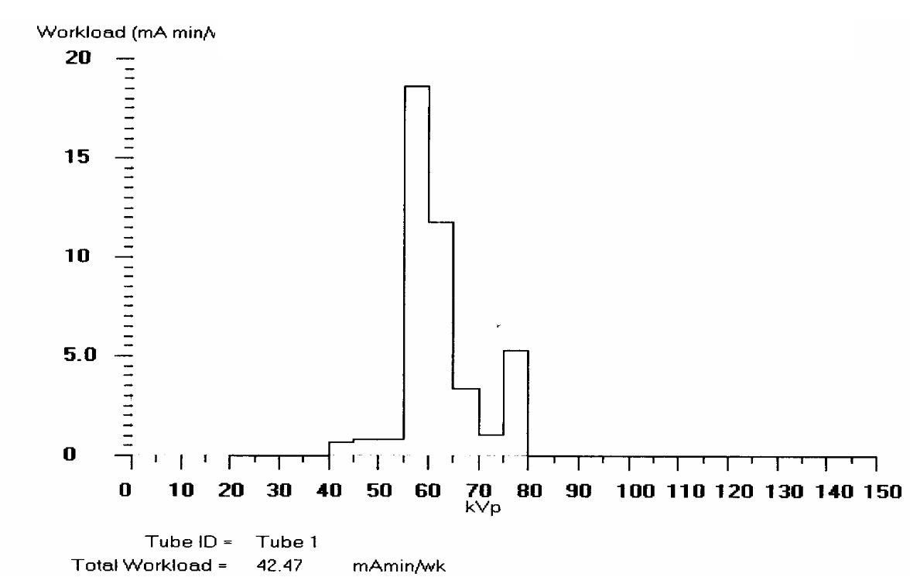

Figure 4.5: Workload distribution plot for the fluoroscopy room (radiographic tube) of Ahmadu Bello University Teaching Hospital, Shika

58
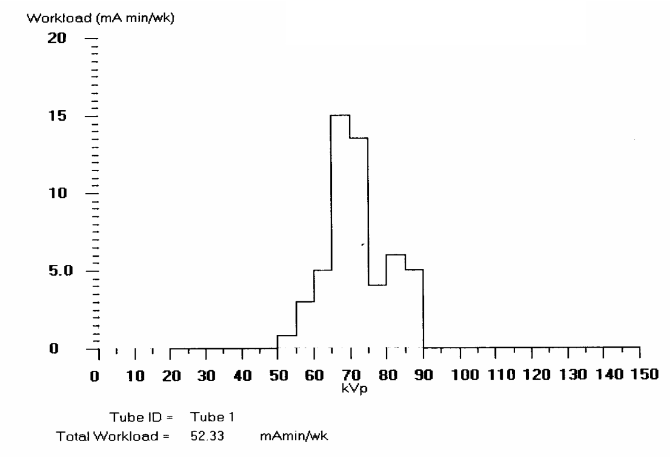

Figure 4.6: Workload distribution plot for general radiography

room (X-ray table only) of Barau Dikko Specialist Hospital, Kaduna

In the general radiography room of Barau Dikko Specialist Hospital, Kaduna, the total workload was calculated for Rad Room (x-ray table only). This is because all exposures in this room was done on the x-ray table as the x-ray machine could not be used for erect exposures (horizontal projection). The workload distribution plot of this room is shown in figure 4.6.

59
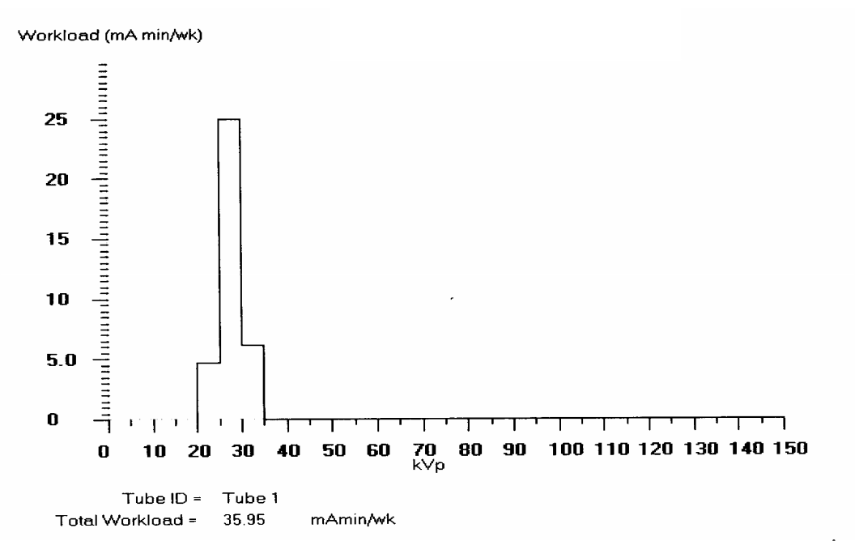

Figure 4.7: Workload distribution plot of the mammography room of

Ahmadu Bello University Teaching Hospital, Shika

In the mammography room, the workload distribution occurs below 60kvp (precisely between 20 – 35kvp) as can be seen in figure 4.7. This is because very low operating potential is used for breast examinations.

4.2 Estimation of Shielding Barrier

The results of calculated radiation levels inside the x-ray rooms and beyond the barriers and the shielding barrier thickness required to shield the diagnostic x-ray installations in Ahmadu Bello University Teaching Hospital, Shika and the general radiography room in Barau Dikko Specialist Hospital, Kaduna using the program, XRAYBARR are shown in Tables 4.3, 4.4, 4.5 and 4.6

60

Table 4.3: Unshielded and shielded doses per week and the shielding barrier thickness required, calculated from XRAYBARR for the general radiography room of Ahmadu Bello University Teaching Hospital, Shika

 | Position | ^{d}pri | ^{d}leak | ^{d}sec | T | U | W | Scattering |  | Calculated dose in mSv week⁻¹ |  |  | Shielding
 |  |  |  |  |  |  |  | angle |  |  |  |  | Barrier (mm)
 |  | (m) | (m) | (m) |  |  |  |  |  |  |  |  | of Lead
 |  |  |  |  |  |  |  |  |  | Unshielded dose |  | Shielded
 |  |  |  |  |  |  |  |  | Primary | Scatter | Leakage | dose
1 | Chest Wall | 3.19 | 3.19 | 1.65 | 0.5 | 0.68 | 78.6 | 135º | 6.4116 | 0.03259 | 2.594E-5
Door A | floor/other |  |  |  |  |  |  |  |  |  |  | 0.0200 | 0.795mm
 | floor/other |  |  |  |  |  |  | 90º
 | barriers | 3.19 | 3.19 | 3.19 | 0.5 | 0.32 | 59.7 | 90º | 1.9051 | 0.01785 | 5.119E-5
2 Door B (All barriers) |  | 5.0 | 5.0 | 5.0 | 0.5 | 1.0 | 138.3 | 90º | 6.242 | 0 | 0 | 0.0200 | 0.737mm
6 | Chest | 4.15 | 4.15 | 2.98 | 0.5 | 0.68 | 78.6 | 120º | 3.769 | 8.687E-3 | 1533E-5
Wall |  |  |  |  |  |  |  |  |  |  |  | 0.0200 | 0.677mm
Changing |  |  |  |  |  |  |  |  |  |  |  | 0.0200 | 0.677mm
 |  |  |  |  |  |  |  | 90º
Room | floor/other | 4.15 | 4.15 | 4.15 | 0.5 | 0.32 | 59.7 | 90º | 1.091 | 0.1054 | 3.025E-5
 | barriers |  |  |  |  |  |  | 180º
3 | Chest Wall | 3.18 | 3.18 | 3.67 | 1.0 | 0.68 | 78.6 | 180º | 12.84 | 0.01381 | 5.221E-5
Console |  |  |  |  |  |  |  |  |  |  |  | 0.100 | 0.599mm
 | floor/other |  |  |  |  |  |  |  |  |  |  | 0.100 | 0.599mm
 | floor/other |  |  |  |  |  |  | 90º
 | barriers | 3.18 | 3.18 | 3.18 | 1.0 | 0.32 | 55.7 | 90º | 3.835 | 0.1043 | 2.508E-4
7 Darkroom |  | 3.10 | 3.10 | 3.10 | 1.0 | 1.0 | 138.3 | 90º | 32.48 | 0 | 0 | 0.0200 | 1.141mm
(All barriers) |  |  |  |  |  |  |  | 90º
8 Office (All barriers) |  | 3.80 | 3.80 | 3.80 | 1.0 | 1.0 | 138.3 | 90º | 21.61 | 0 | 0 | 0.0200 | 1.045mm
4 | Chest Wall | 2.98 | 2.98 | 1.15 | 1.0 | 0.68 | 78.6 | ₀o | 14.62 | 0.1227 | 5.945E-5
Toilet | floor/other |  |  |  |  |  |  |  |  |  |  | 0.0200 | 0.994mm
 | floor/other |  |  |  |  |  |  | 90º
 | barriers | 2.98 | 2.98 | 2.98 | 1.0 | 0.32 | 59.7 | 90º | 4.230 | 0.04090 | 1.173E-4

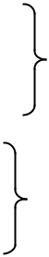

208 Patients/week

Field size = 1000cm² at 1m primary distance for(floor/other barriers) distribution 1535cm² at 1.83m primary distance for (chest wall) distribution

61

The results in table 4.3 presents the unshielded and shielded doses per week and the thickness of shielding barrier required to reduce these doses to the design dose limit (P), in the general radiography room of Ahmadu Bello University Teaching Hospital, Shika. In this room, apart from the position 4, (toilet) which lies behind the chest bucky that is a primary barrier, the other positions are secondary barriers. Shielding barriers at position 1 (Door A) and position 6,(Changing room) protects against secondary radiation from the erect bucky and x-ray table, therefore the sum of the workload of the two distributions was used in calculating the thickness of these shielding barriers. The shielding barrier at the position 3 (Console) protects the Radiographer behind the console against primary radiation from cross table lateral and secondary radiation from the erect bucky and x-ray table, so the sum of these three workloads was used to determine the shielding barrier thickness at position 3 (Console). The barrier at position 4 (toilet) protects against primary radiation from the erect bucky and secondary radiation from the x-ray table, so the sum of both distribution was used to determine the shielding barrier thickness. The barrier at position 7 (darkroom), position 8 (office) and position 2 (Door

- protects against secondary radiation from the x-ray table only; therefore, the Rad Room (all barriers) distribution was used to determine the shielding barrier thickness at these positions.
The results in table 4.3 show that the primary radiation beam is the major contributor to the unshielded radiation dose inside the x-ray room. Table 4.3 also shows that for the same occupancy factor for chest wall (erect bucky) and floor/other barriers (x-ray table) workload distributions for positions affected by the separation of the total workload into these two barrier-specific distributions; the higher the workload, the higher

62

amount of unshielded radiation at these positions. This can be attributed to the use factor

- which is higher for higher workloads. This can be seen at position 1 (Door A), position 6 (Changing room), position 3 (Console) and position 4 (Toilet). And the thickness of shielding barrier required to protect the occupied area beyond these positions increases with decreasing distance for the same occupancy factors. Again it can be seen from the table that for the same workload and use factor, the greater the occupancy factor, the thicker the shielding barrier required at these positions. For example, comparing position 7 (Dark room) and position 8 (Office) with occupancy = 1, to position 2 (Door B) with occupancy factor = 0.5. Distance also plays an important role here, the greater the distance, the lower the amount of radiation produced at these positions.
In the general radiography room of Ahmadu Bello University Teaching Hospital, Shika, the shielding barrier thickness required at the different positions to reduce the unshielded radiation dose to the design dose limit of 0.02mSv/week for uncontrolled areas ranges from 0.677mm of lead at position 6 (Changing room) to 1.141mm of lead at position 7 (Dark room). The required lead shielding at the position 3 (Console), a controlled area is 0.599mm of lead (design dose limit is 0.1mSv/week)). The thickness of lead already in the walls of the general radiography room is 2mm while the lead glass at position 3 (Console) is 2mm of lead thick. The transmission curve for the operator’s

console with its fitting parameters ( , and ) is shown in figure 4.8 below.

63

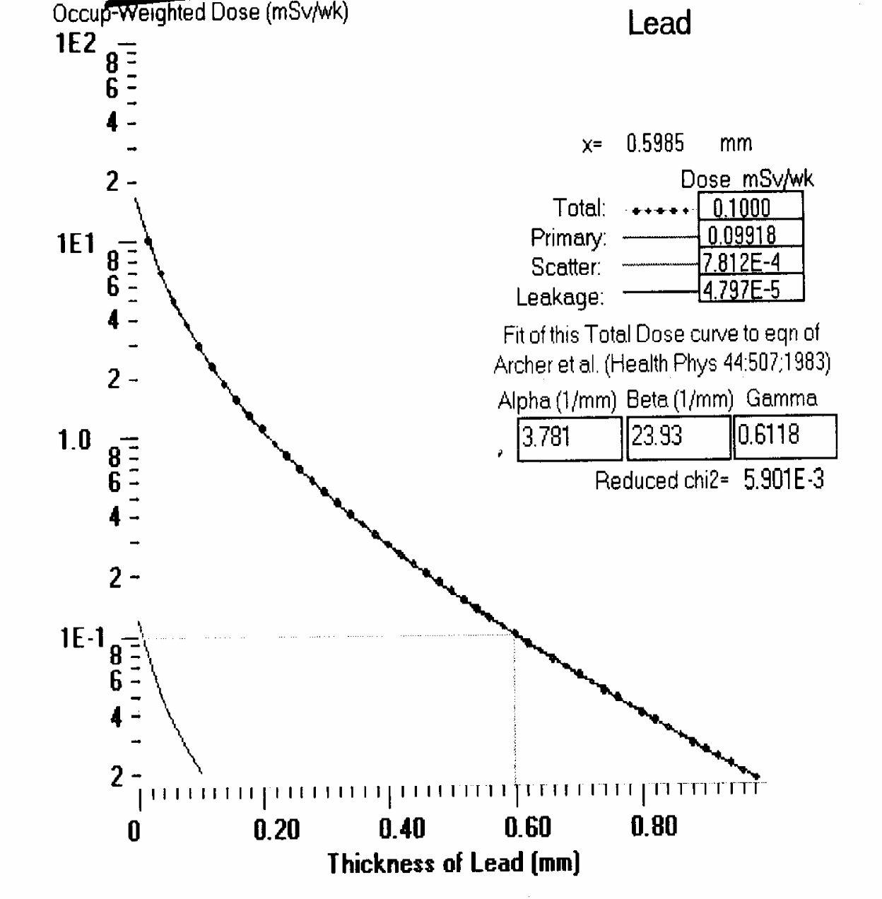

Figure 4.8: Transmission curve for the operator’s console (position 3) with its fitting parameters of the general radiography room of Ahmadu Bello University Teaching Hospital, Shika

64

Table 4.4: Unshielded and shielded doses per week and the shielding barrier thickness required, calculated

from XRAYBARR for the general radiography room, (x-ray table only) of Barau Dikko Specialist Hospital, Kaduna

Position |  | dp_{ri} | ^{d}sec | ^{d}leak | Occupancy |  |  | Calculated dose in mSv week⁻¹ |  | Shielding Barrier
 |  |  |  |  | Factor |  |  |  |  | (mm) of Lead
 |  | (m) | (m) | (m) | (T)
 |  |  |  |  |  |  | Unshielded dose |  | Shielded dose
 |  |  |  |  |  | Primary | Scatter | Leakage
20 | Door A | 3.35 | 3.35 | 3.35 | 0.5 | 5.935 | 0 | 0 | 0.02000 | 0.772mm
21 |  | 3.38 | 3.38 | 3.38 | 1.0 | 11.66 | 0 | 0 | 0.02000 | 0.938mm
Darkroom
22 | Console | 2.20 | 2.20 | 2.20 | 1.0 | 27.52 | 0 | 0 | 0.1000 | 0.754mm
23 |  | 2.0 | 2.0 | 2.0 | 0.5 | 16.65 | 0 | 0 | 0.02000 | 1.03mm
Window
24 | Office | 2.16 | 2.16 | 2.16 | 1.0 | 28.55 | 0 | 0 | 0.02001 | 1.17mm

Total Workload = 52.3mAmin/week (100 patients/week)

Use factor (U) = 1.0
Field Size 1000cm² at 1m primary distance, scattering angle 90º
All barriers are secondary barriers

65

Table 4.4 present the results of the calculated unshielded and shielded doses and the shielding barrier thickness required to reduce these unshielded doses to the recommended shielding design goal (P) in the general radiography room of Barau Dikko Specialist Hospital, Kaduna. In this room, all examinations were carried out on the x-ray table and all barriers are secondary. From the table, it can be seen that for the same occupancy factor, use factor and workload, the thickness of shielding barrier required increased with decreasing distance. For example, at position 21 (Dark room), and position 24 (Office); position 20 (Door A) and position 23 (Window). This can be attributed to the fact that radiation exposure increases with decreasing distance from a radiayion source. Comparing tables 4.3 and table 4.4, it can be seen that the workload per week was lower in Barau Dikko Specialist Hospital, Kaduna (52.3mAmin/week) compared with 138.3mAmin/week for Ahmadu Bello University Teaching Hospital, Shika. This low workload can be attributed to the number of patients seen in a week (100 patients/week) in Barau Dikko Specialist Hospital, Kaduna compared with 208 patients/week in Ahmadu Bello University Teaching Hospital, Shika. Table 4.4 shows that the shielding barrier thickness required to reduce the unshielded radiation dose to the design dose limit (P) ranges from 0.772mm of lead at position 20 (Door A) to 1.17mm of lead at position 24 (Office) for uncontrolled areas and 0.754mm of lead at position 22 (Console) for controlled area. The shielding barrier already constructed in the walls of the general radiography room of Barau Dikko Specialist Hospital, is 2mm of lead thick while the lead glass at position 22 (console) is 1.5mm of lead thick. The transmission curve for the

operator’s console with its fitting parameters ( , and ) is shown in figure 4.9

below.

66

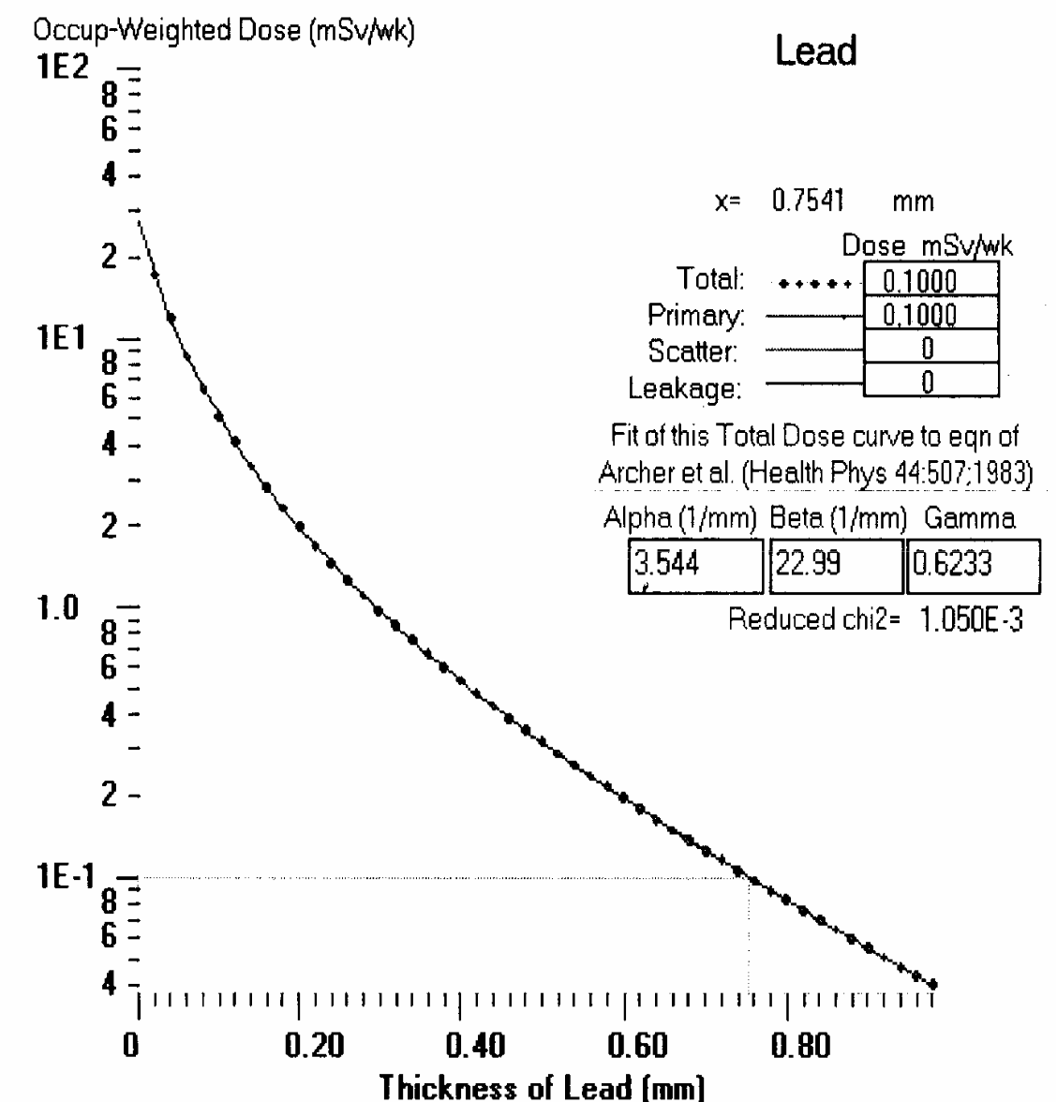

Figure 4.9: Transmission curve of the Operator’s console (position22) with its

Fitting parameters for the general radiography room of Barau Dikko Specialist Hospital, Kaduna

67

Table 4.5: Unshielded and shielded doses per week and the shielding barrier thickness required, calculated from XRAYBARR for the fluoroscopy room of Ahmadu Bello University Teaching Hospital, Shika.

 | Position |  | ^{d}pri | ^{d}sec | ^{d}leak |  |  |  |  | Calculated dose in mSv week⁻¹ |  |  | Shielding
 |  |  | (m) | (m) | (m) | T | U | W |  |  |  |  | Barrier (mm)
 |  |  |  |  |  |  |  |  |  | Unshielded dose |  | Shielded dose | of Lead
 |  |  |  |  |  |  |  |  | Primary | Scatter | Leakage
9 Door A |  | Fluoro Tube | 2.0 | 2.0 | 2.0 | 0.5 | 0 | 300.7 | 0 | 0.3447 | 1.794E-3 | 0.0200 | 0.795mm
 |  | Rad Tube | 2.0 | 2.0 | 2.0 | 0.5 | 1.0 | 42.5 | 9.912 | 0 | 0 | 0.0200 | 0.795mm
10 Door B |  | Fluoro Tube | 4.75 | 4.75 | 4.75 | 0.5 | 0 | 300.7 | 0 | 0.06111 | 3.181E-4 | 0.0200 | 0.378mm
 |  | Rad Tube | 4.75 | 4.75 | 4.75 | 0.5 | 1.0 | 42.5 | 1.757 | 0 | 0 | 0.0200 | 0.378mm
 |  | Fluoro Tube | 3.16 | 3.16 | 3.16 | 1.0 | 0 | 300.7 | 0 | 0.2762 | 1.438E-3
11 Console |  |  | 3.16 | 3.16 | 3.16 | 1.0 | 1.0 | 42.5 | 7.941 | 0 | 0 | 0.100 | 0.363mm
 |  | Rad Tube
13 Dark |  | Fluoro Tube | 4.08 | 4.08 | 4.08 | 1.0 | 0 | 300.7 | 0 | 0.1657 | 8.62E-4 | 0.0200 | 0.542mm
Room |  | Rad Tube | 4.08 | 4.08 | 4.08 | 1.0 | 1.0 | 42.5 | 4.763 | 0 | 0 | 0.0200 | 0.542mm
Changing |  | Fluoro Tube | 3.48 | 3.48 | 3.48 | 0.5 | 0 | 300.7 | 0 | 0.1139 | 5.927E-4 | 0.0200 | 0.477mm
12 Room |  | Rad Tube | 3.48 | 3.48 | 3.48 | 0.5 | 1.0 | 42.5 | 3.274 | 0 | 0 | 0.0200 | 0.477mm
14 | Fluoro Tube |  | 2.5 | 2.5 | 2.5 | 1.0 | 0 | 3.00.7 | 0 | 0.4412 | 2.297E-3
Toilet | Rad Tube |  | 2.5 | 2.5 | 2.5 | 1.0 | 1.0 | 42.5 | 12.69 | 0 | 0 | 0.0200 | 0.728mm
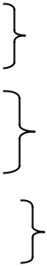




Number of Patients/week = 25

Field size = 730cm² at 1m primary distance for the fluoroscopic tube 1000cm2 at 1m primary distance for Radiography tube All barriers are secondary barriers

68

Table 4.5 presents the results of the calculated unshielded and shielded doses and the shielding barrier thickness required to reduce the unshielded radiation dose in the fluoroscopy room of Ahmadu Bello University Teaching Hospital, Shika to the design dose limit (P). In this room, the major contribution to the unshielded radiation dose comes from scatter radiation from the fluoroscopic tube while the primary radiation makes the most contribution from the radiographic tube.
For the same workload, occupancy and use factors (for radiographic tube), and for the same workload and occupancy factor (fluoroscopic tube), distance played an important part on the thickness of lead shielding required at the different barrier positions. For example, comparing position 9 (Door A) to position 10 (Door B) and position 12 (Changing room), and also comparing position (13) (dark room) with position 14 (toilet). This is due to the amount of unshielded radiation at the different barrier position which decreases with increasing distance from the tube (fluoroscopic and radiographic tubes).Position 11, (Console) is a controlled area. The combination of both fluoroscopic and radiographic tubes workload distribution was used in calculating shielding barrier thickness required. The calculated shielding barrier thickness required to reduce the unshielded radiation dose inside the x-ray room to the design dose limit varied from 0.363mm of lead at position 11 (Console) to 0.728mm of lead at position 14 (Toilet). This thickness of lead is lower than that already provided in the walls of the fluoroscopy room (which is 2mm of lead) and the lead glass protecting the operator’s console (which is 2mm of lead glass).

The transmission curve with its fitting parameters ( , β and ) of the console is shown in figure 4.10.

69

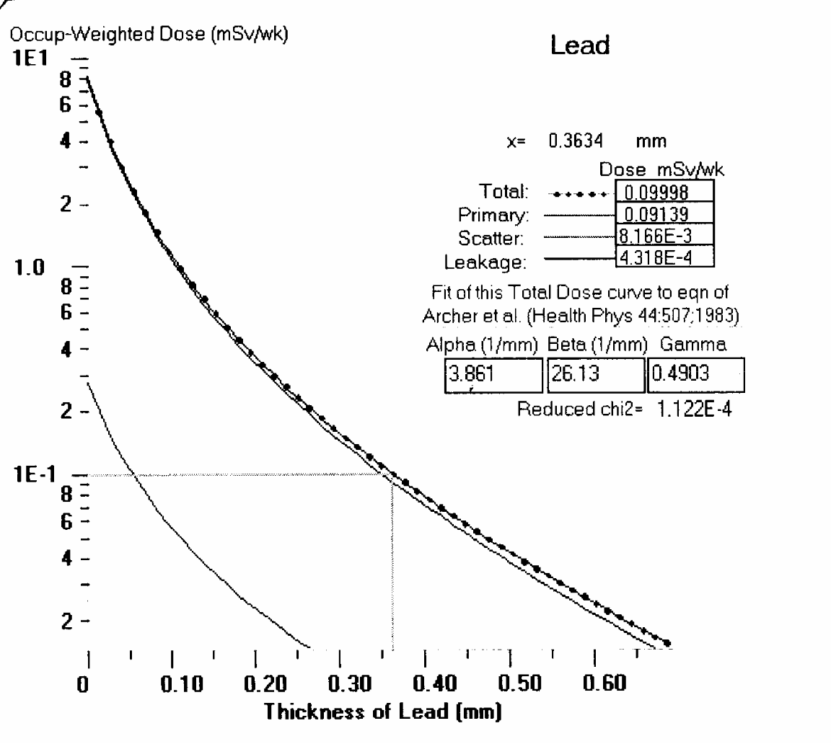

Figure 4.10: Transmission curve with its fitting parameters of the

Operator’s Console (position 11) of the fluoroscopy

room of Ahmadu Bello University Teaching Hospital, Shika

70

Table 4.6: Unshielded and shielded doses per week and the shielding barrier thickness required, calculated from XRAYBARR for the mammography room of Ahmadu University Teaching Hospital, Shika

 |  | Position | ^{d}pri | ^{d}sec | ^{d}leak | Occupancy |  |  | Calculated dose in mSv week⁻¹ |  | Shielding
 |  |  | (m) | (m) | (m) | Factor |  |  |  |  | Barrier (mm) of
 |  |  |  |  |  | (T) |  | Unshielded dose |  | Shielded dose | Lead
 |  |  |  |  |  |  |  | Scattered | Leakage
 | 15 Door A |  | 3.51 | 3.51 | 3.51 | 0.5 |  | 1915E-3 | 4.418E-8 | 0.0019 | 0
 | 16 Door B |  | 1.35 | 1.35 | 1.35 | 0.5 |  | 0.01295 | 2.987E-7 | 0.0130 | 0
 | 18 | Console | 0.90 | 0.90 | 0.90 | 1.0 |  | 0.05826 | 1.344E-6 | 0.0583 | 0
 | 19 | Ultrasound | 1.15 | 1.15 | 1.15 | 1.0 |  | 0.03568 | 8.232E-7 | 0.0200 | 2.980E-3mm
 |  | Room | 3.57 | 3.57 | 3.57 | 0.5 |  | 1.851E-3 | 4.271E-8 | 0.0019 | 0
 | 17 | Changing
 |  | Room
 |  | Total workload | = 36.95mAmion/week (6 patients/week)
Use factor (U) = 0, All barriers are secondary, field size 720cm² at 0.66m primary distance.
Scattering angle = 90º

71

Table 4.6 presents the unshielded and shielded radiation doses and the shielding barrier thickness required in mammography room of Ahmadu Bello University Teaching Hospital, Shika. It can be seen that the calculated values of the unshielded doses are very small and are the same as the shielded doses. Meaning that no shielding barrier is required in the walls of the mammography room needed except for position 19 (Ultrasound room) that requires a shielding barrier thickness of 2.980E-3 of lead. This can be attributed to the low workload (36.95mAmin/week) in the room which is due to the small number of patients that come for this examination (6 patients/week). The transmission curve position 19 (Ultrasound Room) is shown in figure 4.11 below.
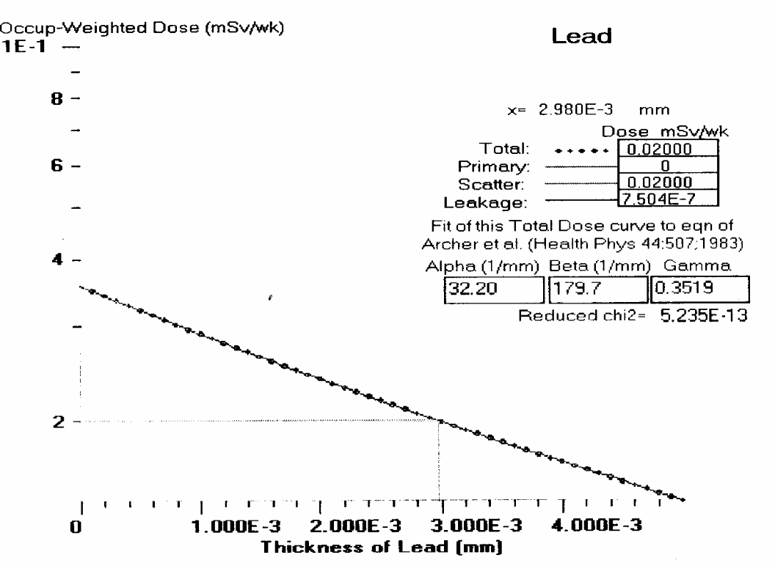

Figure 4.11: Transmission curve with its fitting parameters of the Ultrasound room barrier (position 19) of the mammography room of Ahmadu Bello University Teaching Hospital, Shika

72

4.3 Area Monitoring Survey

The results of the area survey in Ahmadu Bello University Teaching Hospital, Shika and Barau Dikko Specialist Hospital, Kaduna are shown in tables 4.7, 4.8, 4.9 and 4.10.

 |  | Table 4.7: | Measured doses per week of area survey from TLD measurements for
 |  |  | the general radiography room of Ahmadu Bello University Teaching
 |  |  | Hospital, Shika
 | Position |  | Measured doses in mSv week⁻¹ |  | Type of barrier
 |  |  | Inside the Room | Beyond the Barrier
 | 1 | Door A | 0.178 0.032 | 0.016 0.0059 | Secondary
 | 2 | Door B | 0.113 0.026 | 0.0028 0.007 | Secondary
 | 3 | Console | 0.155 0.036 | 0.017 0.0045 | Secondary
 | 7 | Dark | 0.171 0.031 | 0.016 0.0065 | Secondary
 | Room
 | 6 | Changing | 0.143 0.019 | 0.009 0.0089 | Secondary
 | Room
 | 8 | Office | 0.128 0.024 | 0.007 0.0087 | Secondary
 | 4 | Toilet | 0.196 0.010 | 0.082 0.021 | Primary

73

Table 4.8: Measured doses per week of area survey from TLD measurement for

the general radiography room of Barau Dikko Specialist Hospital,

Kaduna

 | Position |  |  | Measured doses in mSv week⁻¹ |  | Type of barrier
 |  |  | Inside the Room |  | Beyond the Barrier
 | 20 | Door A | 0.101 | 0.004 | 0.0078 0.0019 | Secondary
 | 21 | Dark room | 0.0788 0.003 |  | 0.0060 0.0024 | Secondary
 | 22 | Console | 0.1078 | 0.0628 | 0.0116 0.0048 | Secondary
 | 23 | Window | 0.1136 | 0.0025 | 0.0548 0.005 | Secondary
 | 24 | Office | 0.0890 | 0.0031 | 0.0080 0.0018 | Secondary

Table 4.7 presents the measured doses from the area survey carried out in the general radiography room of Ahmadu Bello University Teaching Hospital, Shika. The mean radiation dose levels from the TLD measurements at different positions inside the room are variable. Apart from position 4 (Toilet) that is a primary barrier, the rest positions are secondary barriers. The measured doses at the secondary barriers inside the room varied from 0.113mSv/week at position 2 (door B) to 0.178mSv/week at position 1 (door A) while the measured dose inside the room at the primary barrier, position 4 (Toilet), is 0.196mSv/week. Beyond the secondary barriers, the measured doses are also variable and less than the design dose limit (P) of 0.02mSv/week for uncontrolled areas, when the background dose of 0.0113mSv/week is subtracted from it. Beyond the primary barrier, position 4 (Toilet), the measured dose is 0.082mSv/week. This is higher than the design dose limit (P) of 0.02mSv/week for uncontrolled area. The shielding barrier at this position needs to be re-enforced or this area can be made a controlled area. The shielding barrier already provided is 2mm of lead thick.

74

Comparing table 4.7 with table 4.8 (which are the measured doses from the area survey carried out in the general radiography room of Barau Dikko Specialist Hospital, Kaduna) it can be seen that the mean radiation dose levels from the TLD measurements are also variable at the different positions inside the room but were lower than the mean radiation dose levels inside the general radiography room in Ahmadu Bello University Teaching Hospital, Shika (table 4.7). This low value of measured dose may be due to the workload (52.2mAmin/week) which is lower than that in Ahmadu Bello University Teaching Hospital, Shika (138.3mAmin /week). The measured doses varied from 0.0788mSv/week at position 21 (darkroom) to 0.1136mSv/week at position 23 (window) inside the x-ray room. Beyond the barriers, the measured doses were lower than the design dose limit (P) of 0.02mSv/week for uncontrolled areas, when the background dose of 0.0103mSv/week was subtracted from it, except at position 23 (window). Beyond the position 23 (window), the measured dose was 0.0548mSv/week. This is higher than the design dose limit (P) of 0.02mSv/week for uncontrolled areas. This high dose is due to the nature of the shielding material and its thickness at the window which is ordinary glass of 2mm thickness.

75

Table 4.9: Measured doses per week of area survey from TLD measurements for the fluoroscopy room of Ahmadu Bello University Teaching Hospital, Shika
 | Position |  |  | Measured dose in mSv week⁻¹
 |  |  | Inside the Room |  | Beyond the Barrier
 | 9 | Door A | 0.675 | 0.74 | 0.016 0.0057
 | 10 | Door B | 0.142 | 0.041 | 0.0058 0.0052
 | 11 | Console | 0.476 | 0.099 | 0.0161 0.0053
 | 13 | Dark room | 0.515 | 0.121 | 0.0164 0.0067
 | 14 | Toilet | 0.542 | 0.049 | 0.017 0.006
 | 12 | Changing Room | 0.405 | 0.045 | 0.0142 0.0029

Table 4.10: Measured dose per week of Area Survey from TLD measurements for the mammography room of Ahmadu Bello University Teaching Hospital, Shika
 |  | Position | Measured dose in mSv week⁻¹
 |  |  | Inside the Room | Beyond the Barrier
 | 15 | Door A | 0.006 0.0029 | 0.0002 0.004
 | 16 | Door B | 0.014 0.0025 | 0.0022 | 0.0053
 | 18 | Console | 0.038 0.006 | 0.012 | 0.004
 | 17 | Changing Room | 0.016 0.0048 | 0.003 | 0.005
 | 19 | Ultrasound Room | 0.013 0.0035 | 0.005 0.0057

Table 4.9 presents the measured doses from the area survey carried out in the

fluoroscopy room of Ahmadu Bello University Teaching Hospital, Shika. It can be seen

from the table that the mean radiation dose levels from the TLD measurements at

different positions inside the fluoroscopy room were variable. This is similar to the

situation in the general radiography room of Ahmadu Bello University Teaching

Hospital, Shika and Barau Dikko Specialist Hospital, Kaduna.

76

It can also be seen that the dose level in the fluoroscopy room is high compared to the general radiography room. The high dose level in this room may be due to the manner of operation of the fluoroscopy machine by the radiographer. Some factors are under the control of the operator of the fluoroscopy machine (radiographer), for example, the time that the machine is emitting x-rays and the beam size (Braestrup and Vikterlof, 1974). Another reason for these high values lies in the setting of the radiology department. Due to lack of space, all special procedures (procedures involving the use of contrast media) are carried out under fluoroscopic control. Of all these special procedures, intravenous urography (IVU) constitutes 70%. Intravenous urography can be done under radiographic control since this procedure is interested in the functioning of the renal system and not the dynamics of the system. Carrying out this procedure under fluoroscopic control results in high radiation dose to patients and staff working in the fluoroscopy room. Because of the high dose from fluoroscopy examinations, it should not be undertaken if the same information can be obtained by radiography, (Department of Health and Social Security, 1972). The measured dose beyond the secondary barriers also varied at different positions and is lower than the design dose limit of 0.02mSvweek for uncontrolled area when the background dose of 0.0113mSv/week is subtracted from it.

Table 4.10 presents the measured dose from the area survey carried out in the mammography room of Ahmadu Bello University Teaching Hospital, Shika. It can be seen that apart from varying, the measured dose inside the room were very low. This could be attributed to the workload which is very small (36.95mAmin/week) due to small number of patients coming for breast examinations. The measured dose beyond the

barrier are also very low when the background dose of 0.0113mSv week⁻¹ is subtracted

77

from it, and are lower than the design dose limit (P) of 0.02mSv week⁻¹ for uncontrolled

areas.

78

Table 4.11: Comparison of the measured shielded doses to the design dose limit and calculated shielding barrier thickness to the design shielding barrier thickness for the general radiography room of

Ahmadu Bello University Teaching Hospital, Shika

Position |  | Measured | Design dose | Ratio of | Calculated | Design | Ratio of | Type of
 |  | shielded dose | limit | measured | barrier | barrier | calculated | barrier
 |  | (mSv/week) | (mSv/week) | shielded | thickness | thickness | to design
 |  |  |  | doses to the | (mm of | (mm of | barrier
 |  |  |  | design | lead) | lead) | thickness
 |  |  |  | dose limit
1 | Door A | 0.016 0.0059 | 0.0200 | 0.8 | 0.795 | 2 | 0.396 | Secondary
2 | Door B | 0.0028 0.007 | 0.0200 | 0.14 | 0.737 | 2 | 0.369 | Secondary
6 | Changing Room | 0.009 0.0089 | 0.0200 | 0.45 | 0.677 | 2 | 0.339 | Secondary
3 | Console | 0.017 0.0045 | 0.100 | 0.17 | 0.599 | 2 | 0.30 | Secondary
7 | Darkroom | 0.016 0.0065 | 0.0200 | 0.8 | 1.141 | 2 | 0.57 | Secondary
8 | Office | 0.007 0.0087 | 0.0200 | 0.35 | 1.040 | 2 | 0.52 | Secondary
4 | Toilet | 0.082 0.021 | 0.0200 | 4.1 | 0.994 | 2 | 0.50 | Primary

79

Table 4.12: Comparison of the measured shielded doses to the design dose limit and calculated shielding barrier thickness to the design shielding barrier thickness for the general radiography room of Barau Dikko Specialist Hospital, Kaduna

 | Position |  | Measured | Design dose | Ratio of the | Calculated | Design | Ratio of | Type of
 |  |  | shielded doses | limit | measured | barrier | barrier | calculated to | barrier
 |  |  | (mSv/week) | (mSv/week) | shielded | thickness | thickness | design
 |  |  |  |  | doses to the | (mm of | (mm of | barrier
 |  |  |  |  | design dose | lead) | lead) | thickness
 |  |  |  |  | limit
 | 20 | Door A | 0.007 0.0019 | 0.0200 | 0.35 | 0.772 | 2 | 0.396 | Secondary
 | 21 | Darkroom | 0.006 0.0024 | 0.0200 | 0.3 | 0.938 | 2 | 0.47 | Secondary
 | 22 | Console | 0.0116 0.0048 | 0.100 | 0.116 | 0.754 | 1.5 | 0.5.0 | Secondary
 | 23 | Window | 0.0548 0.005 | 0.0200 | 2.74 | 1.03 | 0.0203 | 50.74 | Secondary
 | 24 | Office | 0.0080 0.008 | 0.0200 | 0.4 | 1.17 | 2 | 0.59 | Secondary

80

Table 4: Comparison of measured shielded doses to the design dose limit and calculated shielding

barrier thickness to the design barrier thickness for the fluoroscopy room of Ahmadu Bello

University Teaching Hospital, Shika

 |  | Position | Measured |  |  | Design dose | Ratio of the | Calculated | Design | Ratio of | Type of
 |  |  | shielded |  | dose | limit | measured | barrier | barrier | calculated | barrier
 |  |  | (mSv/week) |  |  | (mSv/week) | shielded | thickness | thickness | to design
 |  |  |  |  |  |  | doses to the | (mm of lead) | (mm of lead) | barrier
 |  |  |  |  |  |  | design dose |  |  | thickness
 |  |  |  |  |  |  | limit
 | 9 Door A |  | 0.016 0.0057 |  |  | 0.0200 | 0.8 | 0.679 | 2 | 0.34 | Secondary
 | 10 | Door B | 0.0058 |  | 0.0052 | 0.0200 | 0.29 | 0.378 | 2 | 0.19 | Secondary
 | 11 | Console | 0.0161 |  | 0.0053 | 0.100 | 0.161 | 0.363 | 2 | 0.18 | Secondary
 | 13 | Darkroom | 0.0164 |  | 0.0067 | 0.0200 | 0.82 | 0.542 | 2 | 0.27 | Secondary
 | 12 | Changing Room | 0.0142 |  | 0.0029 | 0.0200 | 0.71 | 0.477 | 2 | 0.24 | Secondary
 | 14 | Toilet | 0.017 |  | 0.006 | 0.0200 | 0.85 | 0.728 | 2 | 0.36 | Secondary

81

Table 4.14: Comparison of measured shielded doses to the design dose limit and calculated

shielding barrier thickness to the design barrier thickness for the mammography

room of Ahmadu Bello University Teaching Hospital, Shika

 | Position |  | Measured shielded |  | Design dose | Ratio | Calculated | Design | Ratio of | Type of
 |  |  | doses (mSv/week) |  | limit | measured | barrier | Barrier | calculated | barrier
 |  |  |  |  | (mSv/week) | shielded | thickness | thickness | to design
 |  |  |  |  |  | doses to | (mm of | (mm of | barrier
 |  |  |  |  |  | the design | lead) | lead) | thickness
 |  |  |  |  |  | dose limit
 | 15 | Door A | 0.006+_ 0.0029 |  | 0.02 | 0.3 | 0 | 2 | 0 | Secondary
 | 16 | Door B | 0.0022 | 0.0053 | 0.02 | 0.11 | 0 | 2 | 0 | Secondary
 | 19 | Ultrasound Room | 0.005 0.0057 |  | 0.02 | 0.25 | 0.0029 | 2 | 0.0015 | Secondary
 | 17 | Changing Room | 0.003 | 0.005 | 0.02 | 0.15 | 0 | 2 | 0 | Secondary
 | 18 | Console | 0.012 | 0.004 | 0.1 | 0.12 | 0 | 2 | 0 | Secondary

82

CHAPTER FIVE

5.1 Discussion

Tables 4.11 and 4.12 present the radiation dose levels beyond the shielding barrier from TLD measurements with the corresponding design dose limit and the calculated shielding barrier thickness from the shielding code, XRAYBARR with the corresponding design shielding barrier thickness for the general radiography rooms of Ahmadu Bello University Teaching Hospital, Shika and Barau Dikko Specialist Hospital, Kaduna. It can be seen from the tables that the ratio of the measured to design shielded doses was less than 1 (<1) indicating that the radiation dose levels beyond the barriers were lower than the design dose limit (P) of 0.02mSv/week for uncontrolled areas and 0.1mSv/week for controlled areas except at position 4 (Toilet) in Ahmadu Bello University Teaching Hospital, Shika and position 23 (Window) in Barau Dikko Specialist Hospital, Kaduna where the ratio was greater than 1 (> 1). The ratio of the calculated to design shielding barrier thickness was less than 1 (<1) indicating that the shielding barrier thickness already constructed is adequate to reduce the unshielded radiation dose inside the x-ray room to the recommended design dose limit for uncontrolled and controlled areas except at position 23 (window) in Barau Dikko Specialist Hospital, where the ratio is greater than 1 (>1). The differences in the thickness of the calculated shielding barrier in tables 4.11 and 4.12 can be attributed to the differences in the calculated unshielded radiation dose produced inside the x-ray rooms at the different barrier positions. Therefore, the calculated unshielded radiation dose inside the x-ray room can be useful to predict the shielding barrier thickness that will reduce unshielded radiation dose to the design dose limit beyond the different barrier positions (Muhogora and Kondoro, 1998). The variations in the measured radiation dose levels beyond the different barrier positions in

83

the two general radiography rooms can be attributed to variations in radiological techniques employed in clinical situations, for example, field sizes influences x-ray scattering and absorption from different objects not normally considered during radiation shielding design. The higher design dose limit than measured shielded dose is of merit for shielding optimization purposes and also allows for future increase of patient workload (Muhogora and Kondoro, 1998). The greater design shielding barrier thickness than calculated barrier thickness results in safe occupied areas beyond the barriers and allows for increase in patients workload in future except behind position 4 (Toilet) for the general radiography room of Ahmadu Bello University Teaching Hospital, Shika and beyond position 23 (Window) for the general radiography room of Barau Dikko Specialist Hospital, Kaduna.

Beyond position 4 (toilet) in table 4.11, the ratio of the measured to design shielded radiation dose is greater than 1 (>1) meaning that the radiation dose levels beyond this barrier is higher than the design dose limit (P) of 0.02mSv/week for uncontrolled areas. This high measured shielded dose can be attributed to the barrier thickness not being adequate to reduce the unshielded radiation dose to the design dose limit. This barrier needs to be re-enforced or this area should be regarded as a controlled area. Also beyond position 23 (Window) in Table 4.12, the ratio of the measured to design shielded dose is greater than 1 (>1) indicating that the radiation dose levels beyond this position is higher than the design dose limit for uncontrolled area. This is due to the type and thickness of material used as shielding barrier, which in this case is ordinary glass of 2mm thickness (equivalent to 0.0203mm of lead). This position also needs to be re-enforced or the area behind this position can be regarded as a controlled

84

area. The comparison of the general radiography rooms in ABUTH, Shika and BDSH,

Kaduna in shown in table 5.1 below.

Table 5.1: Comparison of the general radiography rooms in Ahmadu Bello University Teaching Hospital, Shika and Barau Dikko Specialist Hospital, Kaduna

Ahmadu Bello University Barau Dikko Specialist

Teaching Hospital, Shika Hospital, Kaduna

Size of x-ray room | 6.36m x 5m
Type of x-ray machine | Silhouette General x-ray
 | machine | manufactured by
 | General | Electrical (GE)
 | Medical Systems in 2004
Number of orientation of | Vertical | and horizontal
x-ray tube | orientations

5.35 x 3.73m

Ralcos S.R.L. Lissone mobile x-ray machine manufactured by P/H Medical systems in 1996 Vertical orientation only

Number of patients/week | 208 | 100
Workload (mAmin/Week) | 138.32 | 52.28
Ratio of measured to design | <1 (except at position (4) | <1 (except at position (23)
dose |  | window
Ratio of calculated to | <1 | <1 (except at position (23)
design shielding barrier |  | window)

Table 4.13 above presents the radiation dose levels beyond the shielding barrier

from TLD measurements with the corresponding design dose limit and the calculated

shielding barrier thickness from the code, XRAYBARR with the corresponding design

shielding barrier thickness for the fluoroscopy room of Ahmadu Bello University

Teaching Hospital, Shika. The table shows that the ratio of the measured to design dose

beyond the different barrier positions was less than 1 (<1), indicating that the radiation

dose levels beyond the different barrier positions was lower than the design dose limit for

85

uncontrolled and controlled areas. The ratio of the calculated to design shielding barrier thickness was less than 1 (<1), indicating that the shielding barriers at the different positions were enough, and that the uncontrolled and controlled area were adequately shielded. The variation in the calculated shielding barrier thickness can be attributed to the differences in the amount of unshielded radiation dose levels inside the fluoroscopy room at the different barrier positions which determines the shielding barrier thickness that will reduce the radiation dose beyond the barrier to the design dose limit. Variations in the measured radiation dose levels beyond the different barrier positions may be due to different field sizes used for different radiological procedures and on the distances from the x-ray tube and patient to the occupied areas. The higher design dose limit than measured shielded dose will allow for future increase in patient’s workload.

Table 4.14 presents the radiation dose levels beyond the shielding barrier from TLD measurements with the corresponding design dose limit and the calculated shielding barrier thickness from the program, XRAYBARR with the corresponding design shielding barrier thickness for the mammography room of Ahmadu Bello University Teaching Hospital, Shika. From the table, it can be seen that the ratio of the measured to the design shielded dose is less than 1 (<1) indicating that the radiation dose levels beyond the different barrier positions are lower than the design dose limit. The variations in the measured radiation dose levels beyond the different barrier positions can be attributed to the field size, and on the distance from the tube to the occupied areas. The ratio of the calculated to the design shielding barrier thickness shows that no shielding is required except at position 19 (Ultrasound room) where the ratio is less than 1 (<1), indicating that the shielding barrier provided is adequate.

86

5.2 Summary of Findings

A review of the radiation shielding adequacy for the diagnostic x-ray facilities housed in the radiology department of Ahmadu Bello University Hospital, Shika and Barau Dikko Specialist Hospital, Kaduna met the required standard. The number of patients in a particular diagnostic room played a major role in the workload generated in that room. The larger the number of patients in a particular diagnostic installation, the larger the workload generated in the room. The workload generated in each room was spread between operating potential resulting in a workload distribution for each diagnostic installation. The workload distribution was spread between the operating potentials of 35kVp to 100kVp in the general radiography room and fluoroscopy rooms of Ahmadu Bello University Teaching Hospital, Shika and the general radiography room of Barau Dikko Specialist Hospital, Kaduna. In the mammography room of ABUTH, the workload distribution was spread between operating potential of 20-35kVp. The bulk of the workload in each room occurred between the operating potentials of 60kVp to 100kVp except in the mammography room. The larger the workload and occupancy factor, the greater the radiation dose generated inside the rooms and therefore the thicker the shielding barrier required to shield occupied areas.

The National Council on Radiation Protection and Measurements (NCRP) Report 147, (2005) on which this study is based, recommends an annual effective dose of 5mSv/year and a design dose limit (P) of 0.1mSv/week in controlled areas and an annual effective dose of 1mSv/year and a design dose limit of 0.02mSv/week in uncontrolled areas for new facility operations. The walls of the rooms housing the different x-ray diagnostic equipments (general radiography machine, fluoroscopy and mammography machine) of Ahmadu Bello University Teaching Hospital, Shika are made of 12 inches

87

hollow cement blocks, followed by 2mm of lead glued outwardly to gypsum sheet of 13.2mm, and screwed to metal studs on the block. Another 13.2mm of gypsum is glued to the lead as a cover. The doors of the different rooms are made of lead mixed with wood. The thickness of the door is 5cm. The operator console is made of 2mm of lead glass. The controlled areas are the operator’s console in all the rooms while the rest barriers are uncontrolled areas. The results of the TLD measurements show that both the controlled and uncontrolled areas are adequately shielded except behind the primary barrier, position 4 (Toilet). However, this present situation can be tolerated if the barrier at this position is re-enforced with additional lead shielding or the toilet can be considered to be a controlled area thereby restricting the use of the toilet. The calculated values from XRAYBARR also show that the uncontrolled and controlled areas are adequately shielded.

In Barau Dikko Specialist Hospital, Kaduna, the walls of the general radiography room is made of 9 inches of hollow cement blocks lined by 2mm of lead thickness. The doors are also lined with 2mm of lead. The Operator console is made of 1.5mm of lead glass, but the window at position 23 is made of 2mm of ordinary glass. The control area is the operator’s console while the rest barriers are uncontrolled areas. The results of the TLD measurements show that both the control and uncontrolled areas are adequately protected except behind position 23 (Window). This barrier can be re-enforced with additional lead glass shielding or the area behind the Window can be considered a controlled area. Also, the calculated values from XRAYBARR show that the uncontrolled and controlled areas are adequately shielded except at the Window. The area monitoring data from TLD measurements and the shielding barrier thickness calculated

88

from XRAYBARR was compared with design dose limit and the design shielding barrier thickness and found to be satisfactory

5.3 Conclusion

The ratio of the measured shielded dose to the design dose limit was less than 1 (<1) and the ratio of the calculated to the design shielding barrier was also less than 1
(<1). It is hereby concluded that based on NCRP recommendations, the design barrier thickness in the radiology department of Ahmadu Bello University Teaching Hospital, Shika was overestimated.

5.4 Recommendations

- Position 4, (Toilet) situated behind the erect bucky in the general radiography room of Ahmadu Bello University Teaching Hospital, Shika should be converted into a control area.
- The area behind position 23 in the general radiography room of Barau Dikko

Specialist Hospital, Kaduna should also be made a control area.

- This work can be extended to include the Computed Tomography Suite of the Radiology Department of Ahmadu Bello University Teaching Hospital, Shika
- A Regional or National Research will give this study a boost and help produce a normalized workload per patient and workload distribution for Health Institution.

89

REFERENCES

Archer, B.R., (1993). Shielding of diagnostic X-ray Facilities for Cost-effective

and Beneficial use and Protection. IRPA– 10, Course EO-6, Houston, Texas, pp.3-4.

AERB, (2005). Protection Against Radiation Hazards: Regulatory Bodies, Safety Norms, Dose. Recommendations of Atomic Energy Regulatory Board, (AERB). New Delhi, pp.3.

Braestrup, C.B. and Vikterlof, K.J., (1974). Manual on Radiation Protection in Hospitals and General Practice. World Health Organization, Geneva, pp. 11-55.

Cember, H (1989). Introduction to Health Physics. Second Edition, Pergamon Press, New York, pp. 293-304.

Chesney and Chesney, (1981). X-ray Equipment for Radiographers. Second Edition, Blackwell Scientific Publications, London, pp. 376-579

Department of Health and Social Security, (1972). Code of Practice for the

Protection of Persons against ionizing Radiation arising from Medical and Dental Use. Her Majesty Stationery Office, London, pp.17.

Dixon, R.L., (1993). On the primary barrier in diagnostic x-ray shielding.

Medical Physics Journal, 2: pp 1785 – 1793.

FDA, (2003). Performance Standard For Ionizing Radiation Emitting Products.

Primary Protective barrier for mammography x-ray systems. Food and Drug Administration, 2:. US Government Printing Office, Washington ,pp. 42.

Fletcher, J.J., (1993). Diagnostic X-ray Shielding in some African Countries.

International Journal of Biology, Chemistry and Physics, 2: pp 93-96.

IAEA, (1973). Radiation Protection Procedures. International Atomic Energy Agency. Safety Series 3: Vienna pp. 71-76.

IAEA, (1989). Facts About Low-level Radiation. International Atomic Energy Agency, Division of Public Information, Vienna, pp. 10.

IAEA, (1996). International Basic Safety Standards for Radiation: Protection

Against Ionizing Radiation and for the Safety of Radiation Sources. International Atomic Energy Agency, Safety Series 115: Vienna, pp .5-6

IAEA, (1995). The Safe Use of Radiation Sources. International Atomic Energy Agency, Training Course 6: Vienna pp. 37-38.

90

ICRP, (1991). 1990 Recommendations of the International Commission on

Radiological Protection. ICRP Publication 60, annals of the ICRP 21, New York,
pp.1-3.

Martin, A. and Harbison, S.A., (1986). Introduction to Radiation Protection. Chapman & Hall, London, pp.85.

Meredith, W.J and Massey, J.B. (1977). Fundamental Physics of Radiology. John Wright and Sons Limited, London, pp.117-129.

Muhogora, W.E and Kondoro, J.W.A., (1998) Assessment of Secondary Shielding Requirements for Diagnostics Facility in Tanzania : Comparison of recently proposed model and area monitoring data. International Journal of Biology, Chemistry and Physics, 2, pp.4.

NCRP, (1976). Structural Shielding Design and Evaluation for Medical Use of X-rays and Gamma Rays of Energies up to 10MeV .National Council on Radiation Protection, Report 49, Bethesda, Maryland, pp.31-56.

NCRP, (1993). Limitation of Exposure to Ionizing Radiation. National Council on Radiation Protection, Report 116, Bethesda, Maryland pp. 23.

NCRP, (2005). Structural Shielding Design for Medical X-ray Imaging

Facilities. National Council on Radiation Protection, Report 147,Bethesda, Maryland, pp.3-14, 29-48.

OgbanJe, G.O. (2000). Quality Assessment of Radiological Diagnostic Facilities in Hospitals in Kaduna. Unpublished M.Sc. Thesis. Ahmadu Bello University, Zaria, Nigeria.

Okunade, A.A. (2005). Evaluation of Lead Equivalence of Patient and Hardware Materials in Medical Diagnostic X-ray Shielding. Health Physics, Operational Radiation Safety, 88(2), pp. 34-43.

Ranogajec-Komor, M., (2002). Thermoluminescence Dosimetry: Application in

Environmental Monitoring. Journal of Radiation Safety : pp. 2-16.

Seeram, E and Travis, E.C., (1997). A Textbook of Radiation Protection.

Philadelphia press, New York, pp.3

Simpkin, J.D. (1996). XRAYBARR, A Software to Calculate Radiation Shielding Requirements for Diagnostic Radiology Installations. pp.1-25.

Tsalafoutas, I.A., Yakoumakis, E and Sandilos, P. (2003)., A model for calculating shielding requirements in diagnostic x-ray facilities. British Journal of Radiology: 76. pp. 731-737.

91

Vinten and GCA (1989). Model 680 Solar Dual Channel TLD Reader User’s Manual. Vinten Instruments Limited, Great Britain, pp.11-17.

92

APPENDIX
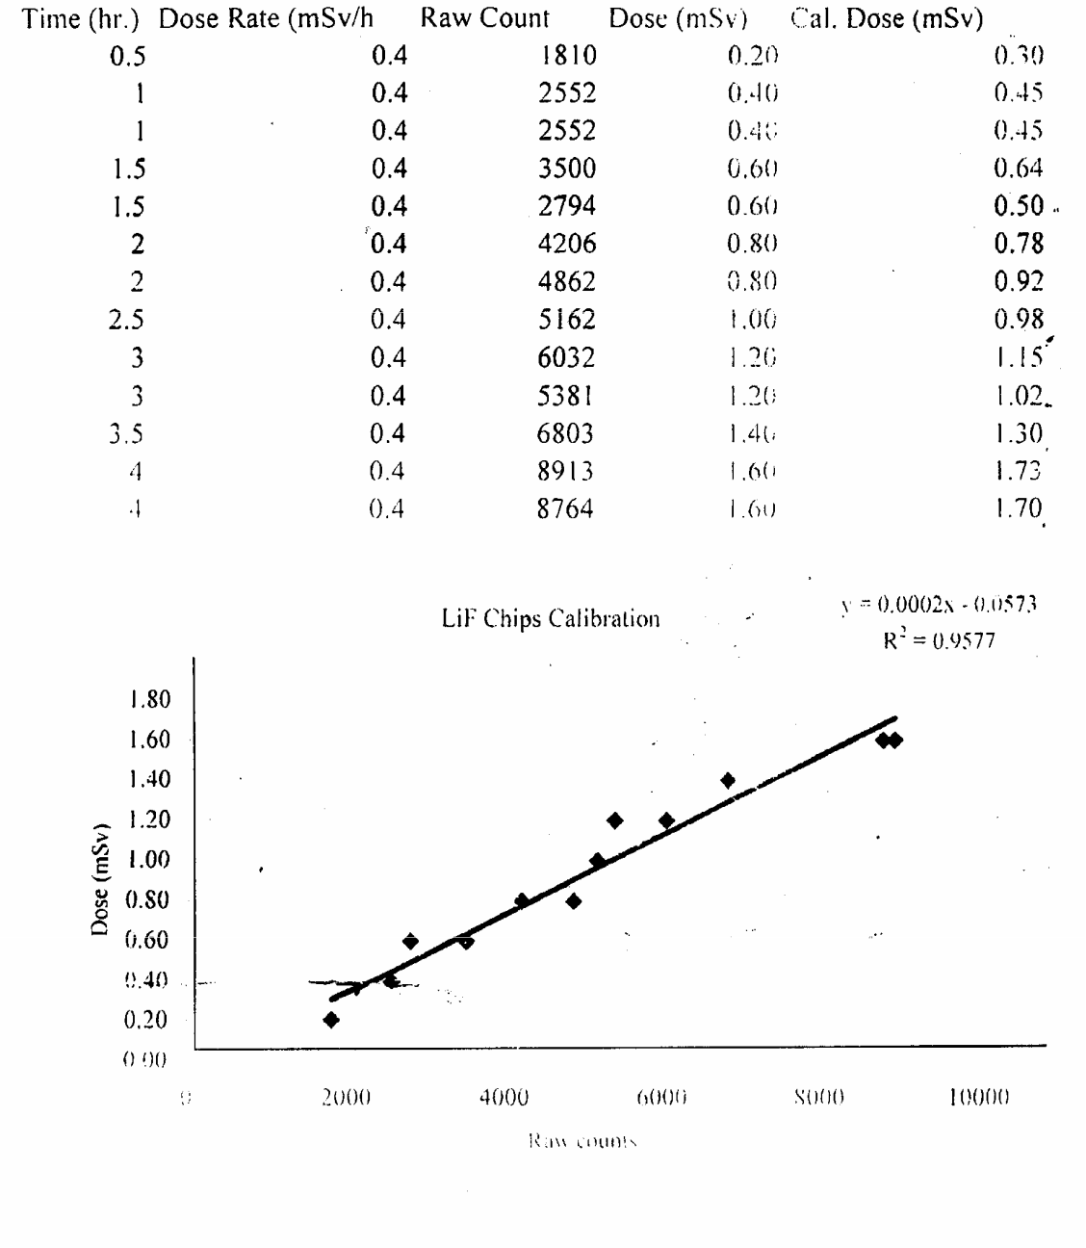

93

