**UNEMPLOYMENT AND ITS EFFECT ON NIGERIA YOUTH**

# ABSTRACT

Unemployment has been a challenge to many economies especially to those in the developing world. The main purpose of the study was to examine the effect of unemployment among the youth in Ibesikpo asutan of Akwa ibom state. Both quantitative and qualitative approaches were employed. The quantitative data on the youth were collected from 300 respondents in 10 communities while qualitative data on the youth were also collected through focus group discussions in the same communities. Descriptive statistics and thematic analysis were respectively chosen to analyse the quantitative and qualitative data collected from the field. Among other things, the study indicated rural-urban migration as a major cause of youth unemployment in Ibesikpo asutan. Suggestion was therefore made to the Government to create jobs in the rural communities of Nigeria.

# TABLE OF CONTENTS

DECLARATION i

DEDICATION ii

ACKNOWLEDGEMENT iii

ABSTRACT iv

TABLE OF CONTENTS v

LIST OF TABLES vii

LIST OF FIGURES viii

LIST OF ABBREVIATIONS ix

**CHAPTER ONE** 1

INTRODUCTION 1

1.1 Background to the Study 1

1.2 Problem Statement 3

1.3 Research Objectives 5

1.4 Research Questions 5

1.5 Significance of Research 5

1.6 Scope and Limitation of the Study 6

1.7 Organization of the Study 6

**CHAPTER TWO** 8

LITERATURE REVIEW 8

2.1 Introduction 8

2.2 Theoretical Framework 8

2.2.1 The Keynesian unemployment theory 8

2.2.2 Marxist theory of unemployment 9

2.3 Concept of unemployment 9

2.4 Empirical Literature 12

2.4.1 General unemployment 14

2.4.2 Causes of unemployment and its consequences 15

2.5 Unemployment among the Youth 19

2.6 The Nature of Joblessness in Nigeria 21

2.7 Efforts in Addressing Youth Unemployment in Nigeria 24

2.7.1 The Youth Employment Agency (YEA) 24

2.8 Reasons why the youth are frequently undermined 26

**CHAPTER THREE** 28

METHODOLOGY 28

3.1 Introduction 28

3.2 Research Design 28

3.2.1 Study area 29

3.2.2 Population of the study 30

3.2.3 Sample size and sampling technique 30

3.3 Data Collection Instrument 31

3.4 Data Administration Procedure 31

3.5 Data Analysis 31

3.6 Ethical Consideration 32

**CHAPTER FOUR** 33

RESULTS AND DISCUSSIONS 33

4.1 Introduction 33

4.2 Demographic Characteristics of the Respondents of the Quantitative Interviews 33

4.3 Causes of youth unemployment in the Ibesikpo asutan (Objective One) 40

4.4 Socio-Economic Consequences of Unemployment on the Youth (Objective Two) 45

4.5 Effects of Youth Unemployment on the Community Development (Objective Three) 48

**CHAPTER FIVE** 53

SUMMARY, CONCLUSIONS AND RECOMMENDATIONS 53

5.1 Introduction 53

5.2 Summary of Findings 53

5.3 Conclusions 54

5.4 Recommendations 55

REFERENCES 57

APPENDIX: QUESTIONNAIRE 67

**CHAPTER ONE**

**INTRODUCTION**

**1.1 BACKGROUND OF THE STUDY**

Current World Population include an estimated 1.2 billion young people between the ages of 15 and 24 years, which is about 24.7% of the world’s working age population. Worldwide youth unemployment is high, almost three times higher than the adult unemployment rate. With the economic downturn, the worldwide youth unemployment is expected to reach 25% in 2012 (International Labour Organisation, 2008).

In certain parts of the world, especially Sub-Saharan, African, youth unemployment rates can be as high as 60%. More than one third of the young people in the world are unemployed, have completely given up looking for a job or are working but still living below the $2 a day poverty line (International Labour Organisation), or have migrated. Young job seekers face increasing difficulties finding work in the current economic scenario and these have resulted in several social phenomena in the society.

Nigeria is the most populous country in Africa and the eighth most populous country in the world with a population of 154, 729,000 citizens. Our nominal GDP is $207.166 billion and we have a nominal per capita income of $140,011. Nigeria also has the second largest economy in Africa, if I may ask, is this country not blessed? Yet, it is still plagued by youth unemployment which had been one of our major problems in recent years. Both government and the private sector had discussed this issue at forums and conferences but have not found a solution to it. Its continued existence has been linked to lack of power supply and financial empowerment for youths.

Youth unemployment in Nigeria is mostly referred to as graduate unemployment and this means that only the skilled youths are seen as unemployed while the unskilled youths are not given any consideration. However, youths are not a homogenous group and their employment prospects differ according to numerous factors ranging from region to gender to schooling. These phenomena have pushed the Nigerian yoiuths to a stage of anomie and they have adopted dysfunctional methods, such as: armed robbery, prostitution, terrorism, kidnapping, thuggery, militancy, internet scam, fraudulent acts, and so on, in order to cope with the increasing trend of economy meltdown in the country.

This research will x-ray how the impact of unemployment in Nigeria has severely affected youths, using a case study of Ibesikpo Asutan Local Government Area of Akwa Ibom State. The study will examine the rural and urban population of people living in the area responses to unemployment predicaments and their differential variables.

**1.2 STATEMENT OF THE PROBLEM**

Ibesikpo Asutan Local Government is an area with an increasing population of 137,100 thousand people, (National Planning Commission, 2006). The population is growing at a very fast rate with large unemployment youths living together in the population. Due to high level of unemployment in the Local Government Area, people have adopted dysfunctional methods such as pick-pocketing, kidnapping, assassination, political thuggery, prostitution, defrauding and so on, in order to provide themselves with income and enhances their societal survival.

People living in Ibesikpo Asutan Local Government Area see these dysfunctional methods as an alternative to their unemployment status in the area, as the government have failed to provide the unemployment opportunities needed as one of the basic necessity in life.

Base on the above statements, many questions arise like, why is the rate of unemployment at an alarming rate in Ibesikpo Local Government Area; despite the area richness in mineral and natural resources, and what are the destructive effect of these social phenomena to the people of Ibesikpo Asutan Local Government Area?.

# 1.3 Research Objectives

The general objective of the study is to examine the causes and effect of unemployment among the youth in the Ibesikpo asutan of Akwa ibom state. Specifically, the study seeks to:

* Identify the causes of unemployment among the youth in the Ibesikpo asutan
* Examine the socio-economic consequences of unemployment among the youth in the
* Assess the perception of the effects of youth unemployment on community development

# 1.4 Research Questions

This study seeks to answer the following general and specific questions:

* What are the perceptions of unemployment on the youth of the ibesikpo asutan ?
* What are the causes of unemployment on the youth of the Ibesikpo asutan?
* What are the consequences of unemployment problem on the youth?
* Identify the challenges faced by the unemployed youth in this area?
* What are the solutions to the problems of unemployment on the youth?

# 1.5 Significance of Research

The findings of the study provide evidence to the civil societies and Government to have better views on the youth unemployment in Nigeria. In the light of this observation, it is envisaged that the results contribute in filling gaps in the literature on youth unemployment in Africa. The study conceptualizes youth unemployment differently from the ILO‟s definition and therefore the outcome is useful to inform policy on conceptualization of unemployment.

Specifically, the findings and recommendations of this study provide a framework on the effect of unemployment among the youth to the officials of the ibesikpo asutan

in order to address the problem from their end. This will help the Assembly to fashion out appropriate intervention programmes to address the canker. By so doing, the general economy in the will grow to add on to the national economy. Moreover, the outcome of the study will guide the chiefs and opinion leaders in the communities in the to have a better view on the problem in order to contribute meaningfully in all programmes initiated by Government and the development partners to address the problem.

# 1.6 Scope and Limitation of the Study

The main study area is Ibesikpo asutan. While other assemblies could have been considered, the high incidence of youth unemployment makes the an ideal area for the study. Generalization of outcome of the study will therefore be done with a greater caution.

The main constraint of the study was that the research was piloted in the Ibesikpo asutan in the Akwa ibom state of Nigeria and the outcome might not reflect the general view of the unemployed youth in other Regions of Nigeria. The unwillingness of respondents to give out information to enhance the study was also a difficulty to the research.

# 1.7 Organization of the Study

The study consists of five chapters. Chapter one describes issues such as the background, the problem statement and objectives of the study. Chapter two reviews the related literature and the theoretical perspectives of the study. Chapter three discusses the various methods of the study while chapter four continues with data analyses and discussion of the results. Chapter five then concludes with the summary of the results and policy recommendations.

# CHAPTER TWO

# LITERATURE REVIEW

# 2.1 Introduction

This chapter consists of a review of chosen theoretical framework, concepts of unemployment, empirical literature and other related studies on youth unemployment identified with the study. The review of the subject matter provides a foundation for subsequent discussions during data analysis.

# 2.2 Theoretical Framework

This section focuses on two main theories of unemployment, Keynesian and Marxist theories of unemployment to explain the unemployment situation in Nigeria.

## 2.2.1 The Keynesian unemployment theory

Keynesian hypothesis of joblessness is additionally alluded to as the repetitive or insufficient request joblessness. This hypothesis suggested that joblessness emerges when there is declining total request in the economy to give employment to each capable, qualified and willing person who need to work. In perspective of this financial hypothesis, when there is decline in aggregate demand, there is associated weakening in manufacturing, which require the need to diminish the quantity of staff.

This study therefore presumes that the Nigeriaian economy has not been growing fast enough to absorb the teeming unemployed youth because the manufacturing sector is weak. The weakness of the manufacturing sector is as a result of weak macroeconomic fundamentals including low aggregate demand. The theory is therefore appropriate for the study because it is able to explain the fundamental reasons for general unemployment.

## 2.2.2 Marxist theory of unemployment

Marxist hypothesis of joblessness was propounded by a well-known researcher, Karl Marx in 1863. He explained in the theory how industrialist method of job creation includes few labourers while keeping the rest as an armed force of jobless homeless people (Marx, 1863). He considered that joblessness is essential inside the unequal industrialist framework and irregular disasters of mass joblessness are to be expected. Free enterprise, as indicated by Marx, unduly and falsely promotes joblessness. Section of industrial workers get scarred when remuneration had to be increased which could eventually lead to job cuts in the free market system. In the view of Marx, the main way to create jobs is to prevent the free market system from working to promote wage agitations.

This study position, considers wage agitations in the free market economy such as the Nigeriaian economy to be the main reason why some enterprises do not employ so many people.

# 2.3 Concept of unemployment

Unemployment is one of the most serious problems facing the African continent (Frimpong, 2012) and Nigeria is no exception. Accordingly, the unemployment rate in Nigeria has remained generally low over the years ranging from 2.8 per cent in 1984 to 10.4 per cent in

2010 based on population and housing census data and within range of 2.3 per cent in 1991/92 and 3.1 per cent in 2005/06 based on Nigeria Living Standards Survey (GLSS) dataset (Baah- Boateng, 2013).

The issue of unemployment among the youth is therefore presumed to be grounded in its uncontrollable causes that may be blamed on the conditional demands of the international community, the educational system, training facilities, geographical locations and availability of resources among others. The effects of the causes of unemployment are therefore likely to breed social problems and political instability and other associating problems.

There is therefore the need to explore the concept of unemployment, its effect since it may help situate and understand the situation within the Ibesikpo asutan in the Akwa ibom state. The concept of unemployment and its subsequent effect have been discussed by William Baah-Boateng and Paul Frimpong respectively.

The concept explains with referential considerations to the International Conference of Labour Statisticians (ICLS) that, a Nigeriaian unemployed youth is one with working age of

15+ if during a specified reference period, either a day or a week, that person had been; “without work”, not even for one hour in paid employment or self-employment of the type covered by the international definition of employment; “currently available for work”, whether for paid employment or self-employment; and “seeking work”, by taking active steps in a specified recent period to seek paid employment or self-employment (Baah-Boateng, 2013). In this regard, Baah-Boateng, (2013) insists that unemployment is a phenomenon of job-seeking resulting out of joblessness.

The concept explains various forms of unemployment within different perspectives of economic literature. Unemployment is involuntary if individuals cannot obtain work even if they are prepared to accept lower real wages or poorer conditions than similar qualified workers who are currently in employment (Shackleton, 1985). Involuntary unemployment occurs when wages are determined by taking into accounts only the interests of those employed, thus, “insiders”, without regard to the interest of “outsiders”, those seeking to be to be employed (Bentolila et al., 2011).

Voluntary unemployment is a result of clearance of labour market.

Baah- Boateng explains that employment that is voluntary results from the time it takes the job-seeker to find and move into a new job or the time and resources it takes an employer to identify and recruit suitable workers to fill vacancies (Baah-Boateng, 2013). Similarly, Structural unemployment, a variant description of voluntary unemployment results from a mismatch between demand for labour and the skills and location of job-seekers created by technological advancement that makes skills of some workers obsolete (Baah-Boateng, 2013).

Baah-Boateng‟s assertion on the causes of unemployment in Nigeria was based on situational and econometric analyses. In his general assertions on the overview of unemployment in Nigeria, he concludes that the youth lack job search experience and labour market information to facilitate their job acquisition (Baah- Boateng, 2013). Similarly, accounting for the sources of Nigeria‟s unemployment problem, Baah- Boateng identified slow economic growth and low employment content of growth, in that, the divergence between economic growth and employment generation is largely explained by the slow growth of the high labour absorption sectors of agriculture and manufacturing on one hand and higher growth of low employment generating sectors such as mining and finance (Baah-Boateng, 2013).

Baah-Boateng concludes that, the quality of labour force measured by education and skills acquired over time and their relevance to the needs of the labour market is determine the probability of an individual being employed or unemployed (Baah-Boateng, 2013). Frimpong therefore thinks that there is high positive correlation between defective educative system and most unemployment in Africa, in that there is considerable lack of vocational guidance and training facilities Frempong, 2012). The educational models and concepts in Africa less matches with the demands of the available job requirement skills. Similarly, Africa is the only continent with most of its populace leaving in the rural and semi-urban areas yet there is less means for self-employment (Frempong, 2012).

Unemployment poses various effects which impede against the economic development in Nigeria (Frempong, 2012). It leads to loss of human resources, poverty and the breeding of social problems. Among others it leads to political instability, exploitation of labour (Frempong 2012).

Having discussed the concept of unemployment, its causes and virtual effects, it would offer firm grounds to base the researcher‟s understanding of the pervading unemployment issues in the Ibesikpo asutan. Similarly the concept will guide the researcher to unveil the effect of unemployment on the youth within the scope of the study.

# 2.4 Empirical Literature

The origin of unemployment has frequently been centered on the supplyside of the market through observational research made. Unemployment has a higher tendency on the youth compared to the ageing generation (Johnson and Layard, 1993, AfDB, OECD, UNDP and UNECA (2012), UNECA, 2005). Sackey and Osei (2006) find that more youth will probably be unemployed because of the reduction in work advertisement.

As AfDB et al. (2012) indicate, within some countries in Africa, urban youth unemployment rate is assessed more frequently and it is six times higher than that of rate in provincial regions. By and large, living in an urban region expands the likelihood of being unemployed in Nigeria (Sackey and Osei, 2006). Kingdom and Knight (2004) explain that the likelihood of an urban occupant getting unemployed is at 8.6 percent in South Africa. The sex orientation gaps of the youth are also a factor of unemployment. Dickens and Lang (1995) find out that there is a high unemployment rate among females than males in Sri Lanka. In Nigeria, however, BaahBoateng (2012) observes that unemployment is a great challenge for males than females from 1960, until 2000 when the turnaround happened. He insists that the unemployment rate among females in 2000 was higher than males. Naudé and SerumagaZake (2001) also reveal that sexual orientation was a huge determinant of joblessness in South Africa's NorthWest territory. Similarly AfDB et al. (2012) observe joblessness to be high among the uneducated especially in middle income nations than low income nations. They argue that the informed unemployed youth will probably in the long run migrate in order to escape unemployment than the uneducated youth.

According to Sackey and Osei (2006), the fundamental levels of education are related generally with greater joblessness in Nigeria. Anyanwu (2013) utilizes crosssectional information over the time, 1991–2009 in Africa to demonstrate the expanding impact in the country's household venture on the rate of work and suggesting a diminishing impact on youth unemployment in SubSaharan Africa (SSA) with the modification stated in North Africa.

Elhorst (2003) finds an immediate connection between the level of instructive achievement and employability. He examines a number of effects that instruction has on people's business design/employability. He states that in an economy with mechanical advancement, work requests normally concentrate on skills and trained people. Secondly, inquiry practices of skilled people empower them to discover employment more rapidly than the less trained people. Finally, man's instructive accomplishment results in the likelihood of individual to be laid off. Kabaklarli, Hezeler and Buhus (2011), discover that, the rate of unemployment among the adolescent (15-29years) increased for those in higher educational level than those with optional training level and low educational level.

According to Sackey and Osei (2006) fundamental and optional training is related to generally high unemployment in Nigeria because of the moderately low levels of training and education. Various investigations have likewise discovered that adolescent preparing to work in a superior position are at likely to get work than their partners who had never gone for any preparation. For instance, in South Africa, adolescents with higher education reduce unemployment because youngsters who finished essential and optional training have aptitudes employment (Msigwa and Kipesha, 2013).

Sex differences in joblessness have been accounted for using information on work constrains to examine reasons for joblessness among youngsters. An investigation by the Universal Work Office (2004), called attention to adolescent joblessness sex measurement, since by and large is higher. Similar conclusion was drawn by Msigwa and Kipesha (2013). Equally, Quyyum (2007) reports that, conjugal status demonstrates that, comparatively there is higher unemployment among the unmarried than the married lot; wedded young people (46.5 percent) was more noteworthy compared to the never wedded youth (36.9 percent).

On the other hand, delayed joblessness has been ascribed to frail interest for work. For instance, Altman and Potgieter-Gqubule (2009), as referred to in Smith (2011), contend that the quantum of occupation creation was too little to make a mark in youth joblessness in South Africa, in spite of the fact that Altman and Potgieter-Gqubule (2009) similarly bring up supply side factors, for example, between laborer aptitudes and business needs, which makes accessible occupations go unfilled clarifying the moderate work development in the South African economy. An investigation on youth work by Kiiru, Onsomu and Wamalwa (2013) proposes that a young Fund ought to be set up to help youth business people.

## 2.4.1 General unemployment

Economic activities began to decline at the beginning of the second period of the Financial Recuperation Programme in 1986 when conservation and redeployment arrangements were presented. Solid measurements on the correct nature and the levels of joblessness in Nigeria are not promptly accessible as the figures shift from organization and office and are liable to different types of explanations. About 26 percent of the population, which constitutes the adolescent in Nigeria comprised both jobless and underemployed young fellows and ladies. Despite contrasts in figures, joblessness rate and youth joblessness rate are at present evaluated to be around 13.4 percent and 25.6 percent individually (Nigeria Statistical Service, 2000).

The unemployment rate is the most generally utilized indicator of the prosperity of work and energetic measure of the condition of an economy (Bryne and Strobl, 2009). They state however that the use of such data can be tricky. For example, a few financial specialists assert that accessibility and status of effort are sufficient to separate workers in the work constrain from the utilized ones.

Among other factors, Baah-Boateng (2013) suggests that, low quality of the labour force or lack of it in relation to the skill requirement in the labour market also explains the phenomenon of general unemployment in Nigeria. Simliarly, he explains that the higher probability of individuals seeking a specific type of employment as against seeking any type of job becoming unemployed in the econometric analysis confirms that observation that

Nigeria‟s growth has not been accompanied by sufficient job openings. In addition, the greater likelihood of individuals seeking full-time jobs suffering from unemployment is also an indication of limited job opportunities for many jobseekers (Baah-Boateng, 2013)

## 2.4.2 Causes of unemployment and its consequences

The accounting factors of unemployment in Nigeria are various. For instance Baah- Boateng (2013) asserts that one of the underlying causes of unemployment according to the implicit contract theory is the relative risk of aversion of employees. Other major factors that accounts for the high rate of unemployment in Nigeria have been outlined in the following sub-topics below.

***Poor Education:***

Poor education is identified indicator of the cause of high rate of joblessness among our adolescences in most African nations. In this regard, about half of the working age population has acquired just basic education which only enables them to read and write with no employable skills to secure employment in the formal segment of the labour market (Baah-

Boateng, 2013. Additionally, Frimpong (2012) suggests that, the educational systems in Africa do not correspond directly to the economic realities prevailing outside the school system. He insists that it simply imparts general and literary education devoid of any practical content.

#### *Qualities of Markets*

As indicated by USAID (2006), numerous poor nations have dualistic work markets, in which a little part of savers or investors have consistent formal segment employments while a greater part, particularly ladies, work in the casual division. Ghai (2003) contends that the official joblessness rates, especially in low-salary nations, could give a truly deceptive picture of work openings. He insists that, unlike the circumstances in rich nations, the joblessness rates are by and large low in most creating nations; predominantly in light of the fact that individuals in poor nations can't stand to remain jobless. Here, it merits citing the possibility of the UN in its Report of the MDGs contending how higher work to-populace proportions could point to a plenitude of low quality employments.

In most low-pay nations, Ghai (2003) observes that, interest rates are high whereas the joblessness rates are low. He insists that profits are deficient to help a base way of life. He equally contends that the extent of the working populace acquiring earnings could be a superior indication of business openings in respect to the previously mentioned regular measures. As a result, it is unable to generate enough additional job opportunities for the youth populace. Consequently, the economy enters a vicious cycle of low investment and low employment thereby becoming a perpetual feature of many African economies.

#### *Corrupt Leadership*

Frimpong explains that there is a positive association of unemployment with the negligence of the political leadership and their corrupt attitude. Accordingly, they imbibe the culture of power retention and money embezzlement, the funds needed for the development of a sector would be diverted for personal use. He suggests that, with this, there is no way forward and we remain undeveloped, hence high rate of employable youth (Frimpong, 2012).

#### *Poverty*

Sen (72) suggests that poverty has been identified not merely with inequality but also with employment. He cites for example, in the International Labour Organization‟s (ILO) “country reports” that it remains a fact that a person may be working for long hours and be paid for his efforts, but if his remuneration rate is low, he may still end up being classified as unemployment. Sen (1973) states,

Whether it makes sense to stretch the concept of unemployment into the field of poverty as such remains an open question, which I have tried to discuss elsewhere, even though it should be observed that Dendeker and Rath‟s own use of their estimates is hardly affected by whether they call those people „poor‟ or unemployed.

#### *Psychological impacts and effects of well being*

Adolescents, who have burned through at least two years in schools and universities, have dreams and goals. These are dreams of securing fulfilling occupations following their long years of battle, meeting fundamental necessities of life (nourishment, attire, asylum and medicinal services), graduating to an existence of solace and pride and, in the long run, getting a charge out of the extravagances of life. The injury of seeing their fantasies trampled week-after-week, after a seemingly endless amount of time, can and leads to profound mental scars that is exceptionally hard to confront at such a youthful age. This injury can have effect on person's confidence and can prompt clinical misery.

Similarly to get a job underway that settles the individual into realizing his dreams defines his wellbeing as a non-deficient one. Bill Clinton once indicated that, „I do not believe we can repair the basic fabric of society until people who are willing to work have work. Work organizes life. It gives structure and discipline to life ( Frimpong, 2012).

#### *Political violence and crime*

At the point when joblessness develops in a group, disappointment with the occupant

Government takes after. According to Iffat Idris (2016), a US Agency for International Development (USAID) report on youth and conflict identified unemployment as a risk factor for young people, asserting that, „Young people often participate in violence because membership in extremist organisations provides immediate economic benefits, because violence itself offers opportunities for economic gain through direct payment or looting, or because conflict promises to open up longer term economic options, for example, through patronage if "their" ethnic or religious group captures power‟ (2005: 4).

Idris (2016) similarly indicates that, few studies examine the link between unemployment and crime specifically among young people. Cantor and Laub (1985, cited in CDB, 2015: 39) posited two ways in which unemployment could lead to crime: 1) by altering criminal motivation – as economic conditions worsen, so there is greater motivation to take up criminal activity; and 2) by changing opportunities for crime – in periods of high unemployment general spending falls, reducing the availability of criminal targets (attractive items to steal).

# 2.5 Unemployment among the Youth

The International Labour Organization (2010) gauges that, the rate of young ladies and men who are jobless all through the world speaks to approximately two-fifths of every jobless individual (ILO, 2010). As a rule, youngsters are a few times more probable than grown-ups to be jobless. A recent report by the ILO shows that the offer of youth who are utilized in the young populace saw a diminishing from 47.9 to 44.7 for every penny in the vicinity of 1998 and 2008 (ILO, 2010; Joined Countries, 2010). This sort of a situation does not forecast well for worldwide economies and thusly stringent measures ought to be set up to address youth joblessness keeping in mind that the circumstance turns out to be more regrettable in future. This is because of the way that the total populace is anticipated to increments immensely with the impact being felt more in creating nations. Future populace development will be high in the emerging scene, with the speediest development in the poorest nations and districts.

The International Labour Organization (2010) report additionally expresses that around one of every five individuals, more than 1.2 billion individuals are between the ages of 15 and 24 and by far most of this energetic populace are in Least Developed Countries (LDCs). SubSaharan Africa remains as the world's most energetic populace and is anticipated to remain as such for quite a long time (PRB, 2010). Youth joblessness, especially in Sub Saharan Africa, Latin America, the Caribbean and Asia has achieved conceivably intense levels (AEO, 2012). In sub-Saharan Africa, the offer of youth joblessness in absolute joblessness is high, coming to as much as almost 80 for every penny of aggregate jobless in a few nations. In the 1990s, both sub-Saharan Africa and North Africa documented the world's most elevated youth joblessness and add up to joblessness rates.

Youth joblessness is a standout amongst the most squeezing financial issues confronting most creating nations with the issue irritated by an adolescent populace blast. Apprehensions have been ascending over the financial circumstance of youngsters in quite a bit of Africa and the possibilities of making extra work open doors for them (Bakan, 2010; Drape, 2000; Mkandawire, 1996; Mayor& Binde, 2001).

Joblessness has social and also financial outcomes and involves some cost to the jobless individual, to the group of the jobless and the general public everywhere (ECA, 2005; Getnet, 2003). The issue deteriorates among the young and, especially in creating nations where government managed savings and joblessness benefits are poor or nonexistent.

The monetary cost of joblessness, as ECA (2005) and Getnet (2003) noted can be seen as far as the done without yield that the jobless rare asset could have delivered. Thusly, abnormal state of joblessness involves lost income to the administration as far as immediate and aberrant assessments and other income that it would have raised had more individuals been working. Since a large portion of the jobless individuals confront with absence of budgetary assets and social duties, they may unwillingly choose to take employments that don't fit their aptitudes; prompting underemployment which thus brings about the bringing down of the economy's productivity. In addition, amid a long stretch of joblessness, specialists can lose their aptitudes; making lost human capital the country on the loose.

It is therefore that the rate of high joblessness is said to have an unfriendly financial result not exclusively to the jobless people themselves and the close family, additionally to the general public that neglects to productively use its rare assets. From the social perspective, more elevated amount of joblessness when all is said in done and youth joblessness specifically has unfavorable social outcomes. The more extended the term of joblessness is, the more the subsequent issue will be. It is frequently contended that joblessness builds people's powerlessness to lack of healthy sustenance, ailment, mental anxiety, loss of confidence, and prompts discouragement. Thus, as the financial aspects writing contends, joblessness can be viewed as a component of an endless twist with poverty, weakness, and socio-political periphery. Youngsters, especially those encountering long stretch of joblessness, are probably going to have flimsy individual connections, delay marriage, as well as put off tolerating duty regarding kids. In endeavoring to defeat money related weakness, jobless youngsters have a tendency to take part in illicit exercises and introverted conduct, for example, sedate trafficking, vicious wrongdoing or pack fighting and risky sex rehearses, which compounds the rate of spread of HIV/Helps. Especially, the issue is basic in sub Saharan Africa. The expanding yearly therapeutic cost of HIV/Helps combined with the high cost of wrongdoing anticipation and in addition the high cost of working together has made the sub-landmass less appealing to remote direct speculation, which thusly obstructs potential business openings (ECA, 2005:168; Getinet, 2003; UN, 2003).

# 2.6 The Nature of Joblessness in Nigeria

Nigeria's monetary execution has been very great since 1984, inciting Leechor (1994) to portray the nation's economy as a leader in the financial change prepare. Nigeria recorded around 5.2 percent yearly normal development in the vicinity of 1984 and 2010 and turned into a lower center salary nation after the rebasing of its national records in 2006, which pushed the nation's yearly normal development to 8.5 percent in the vicinity of 2006 and 2011 (BaahBoateng et al., 2014). Nigeria's genuine Gross domestic product development came to around 15.2 percent when the nation started its business oil generation in 2011. Regardless of this solid development execution, business era remains a test. Nigeria recorded a decrease in business versatility of yield from 0.64 in the 1990s to 0.4 amid 2005–2008 (ILO, 2008). Till date, the nation keeps on engaging with high frequency of joblessness and work looking for especially as of late. The Focal Insight Office World Factbook positioned Nigeria

86th on nations with the percent of the work drive that is without occupations on the planet

(CIA World Factbook, 2014).

Assessments from the 2010 Populace and Lodging Evaluation demonstrate that 14 percent of the nation's working age populace was dormant outside the educational system while 633,994 individuals, speaking to 5.8 percent of the work constrain, were jobless (GSS, 2012). Joblessness constitutes one of the key work showcase challenges in Nigeria. It mirrors the eagerness and longing of jobless people to work and a sign of the strength of an economy.

The extent characterized as jobless was 2.8 percent in 1984 and expanded to 10.4 percent in 2000 and declined to 5.3 percent in 2010. The expansion in the vicinity of 1984 and 2000 happened in both urban and rustic regions and in addition among guys and females. While the least rate for guys was 2.7 percent in Northern Area, the most reduced for females was 2.9 percent in the Upper East District. By and large, the joblessness rates in 2000 were higher than those in 2010 in all locales. The high joblessness rates for 2000 contrasted with 2010 dared to be because of the period inside which the two censuses were led (GSS, 2012).

In 2000, the enumeration was held in Spring April amid the dry season while in 2010, it was in September-October, the pinnacle of the blustery season in the northern piece of the nation. These two seasons introduce distinctive work openings in the nation. Since lump of the nation's dynamic work drive are into agribusiness which is vigorously subject to rain water for water system, it is for the most part amid the stormy season that agriculturists are found in dynamic business. In any case, dry seasons in the nation accompany joblessness challenges particularly to laborer agriculturists with no option water system frameworks and needs work broadening. Consequently, representing the high aberrations of joblessness in both censal periods.

In 2010, around 59 percent of the jobless people were looking for work the first run through and 41.0 percent had worked some time recently. More than 60.0 percent of jobless guys and 55.0 percent of the jobless females were first time work searchers. This example is reflected in all areas, for guys and females, however with changing extents: going from 56.1 percent in the more noteworthy akwa ibom state District to 47.4 percent and 47.4 percent in the Upper West and Northern locales separately (GSS, 2012)

For the most part, the extent jobless diminished with expanding age. In 2010, 42.7 percent of the jobless populaces were matured 15-24 years, 46.2 percent matured 25-44 years, 9.9 percent matured 45-64 years and 1.3 percent matured 65 years and more seasoned. In all the four censal years analyzed, the extent of jobless people was most astounding among those matured 15-24 years with the exception of 2000. In 1984, this extent was about seventy five percent, and with similar levels for the two guys and females. These outcomes are normal as the 15-24-year-olds are the individuals who have finished one level of training or the other and are entering the employment market for the initial period.

Joblessness rates were most noteworthy among people with optional school instruction in both 2000 and 2010 at 9.6 percent and 19.7 percent separately. The following gathering which recorded generally high joblessness rates was people with tertiary training: 2.7 percent in 2000 and 9.1 percent in 2010. By and large, female joblessness rates were higher than male joblessness rates at each level of training. Joblessness rates were most reduced among those with no formal instruction (17.0%) in 2012 with comparative example for guys and females. Given the joblessness rates by age and instruction, one can derive that joblessness is related with the move time frame for youngsters from the universe of training to that of work.

Various scholarly writings indicate that joblessness has a tendency to be higher among the youthful than the old (AfDB et al., 2012; UNECA, 2005). An investigation by Echebiri (2005) in Umuahia reveals that, Nigeria utilizing a double logit display demonstrated that period of respondent was exceptionally huge and conversely related with the likelihood of being jobless. Sackey and Osei (2006) assumed the circumstance could be because of the way that more youthful individuals have bring down work advertise aptitudes with respect to more seasoned accomplices. For example, BaahBoateng, (2014) certified, joblessness rates declined with age, with the most astounding rate among the young. Figures from his investigation demonstrated that young joblessness from 5.0 percent in 1998/99 to 6.6 percent in 2005/06 contrasted and under 4 percent for more seasoned age bunches in Nigeria.

O'Higgins, (2001) suggests that adolescent joblessness will probably experience a further down turn if the total work showcase is not adequate to retain the expanding number of youth populace. Sexual orientation has additionally been found to have a relationship with a man's financial movement status. Ladies and men are influenced in an unexpected way, because of the current sexual orientation standards which keep on affecting the joblessness examples of ladies and men which differ over all nations (ILO, 2011). An examination by ILO (2011), watched no significant change in the general examples of sexual orientation crevices in the joblessness rates throughout the years, however reasoned that worldwide female joblessness rate has stayed higher than men with provincial varieties.

# 2.7 Efforts in Addressing Youth Unemployment in Nigeria

Baah-Boateng (2013) observes that youth unemployment requires the need for targeted policy intervention to remove the constraints facing them particularly at the entry point of the labour market. Nigeria has since few years back introduced some intervention policies to reduce youth unemployment.

## 2.7.1 The Youth Employment Agency (YEA)

The Youth Employment Agency (YEA) was set up under the Youth Employment Act 2015 (Act 887) to enable youngsters to contribute seriously to the financial and supportable advancement of the country. Its goal is to help the young between the ages of 15 to 35 years through abilities preparing and temporary job modules to shift from joblessness to business activities. To guarantee manageability, the arrangement center of YEA was changed in 2009 from the conventional modules which have pay move suggestions to the independent work modules. For example, exchanges and employment modules through open private

organization in order to decrease the weight on installment of stipend for the Paid Temporary Position Module. This has pulled in Global recognition, with the BBC positioning YEA as the best Youth Business Program in Africa in 2011. Accessible records demonstrate that as at December, 2012, more than Six Hundred Thousand, (600,000) recipients were enrolled by the YEA. New modules were presented and a portion of the current modules, for example, The Young in Security Administrations and Exchanges and Job were checked on and extended to take care of the developing demand for youth work in the nation. From 2001, a few endeavors were made in Nigeria to address the issue of youth joblessness and underemployment.

The administration initially enrolled around, 950,000 youngsters from various instructive, exchanges and expert foundations who required work. Different activities that took after incorporate the Abilities Preparing and Business Situation (STEP) Program, an endeavor to set up a National Youth Reserve (NYF). Additionally different miniaturized scale credit plans to help little scale ventures (NYEP Rules, 2006) were employed. Whereas the

administration's endeavors were to a great extent recognized similar to a stage the correct way, the issue of youth business endured and the joblessness rate among the adolescent increased to 25.6 percent in 2005 (NYEP Survey Report, 2009).

The National Youth Employment Programme (NYEP), also called the National Youth Occupation Corps Program (NYOCP), was an arrangement started by the NPP government in

2006 in light of a presidential order to guarantee that the adolescent including Middle School (JHS) and Senior Secondary School (SHS), Specialized/Professional School graduates, school dropouts as well as unskilled youth would be effectively occupied with some gainful work (Attipoe-Fittz, 2010). Youngsters enlisted under the program were to exit following two years to scan for perpetual employments in different divisions of the economy or continue for advance instruction (NYEP, 2006). The program was expected to cover a wide range of financial endeavors and social administration exercises in neighborhood groups.

The principal period of the program secured all the ten modules; in particular, Youth-in-AgriBusiness; Youth-in-Exchanges and Occupations; Youth-in-ICT (Information,

Communication and Technology); People group Assurance Framework; Waste and Sanitation Administration Corps; Country Training Educators Aides; Paid Entry level positions and Modern Connections; Get-away Employments; and Volunteer Administrations. Other modules included; Youth in Eco Unit, Cell phone repairs, Sachet water generation,

Bamboo handling, Youth in Afforestation, Youth in Street Repairs and Upkeep and Youth in Film Industry (Attipoe-Fittz, 2010).

# 2.8 Reasons why the youth are frequently undermined

Many times, the reasons why programs for youth employment do not succeed fully is the fact that, as Pitkin (1967) observes, representatives of chosen leaders relied upon to make and effect plans that will reduce the level of youth unemployment fail due to the fact that, these representatives lack counseling and technical know-how as far that portfolio is concerned. Similarly, financial constraints and seeming embezzlements abounding in the institution may also account for the neglect of the youth.

Along these lines, in figuring the NYEP, the basic leadership structure was commanded by delegated authorities whose part was to define the program while the youth were to be involved in actualizing it. Amoo (2011) insists that, the youth were not included in the process.

The cost of running the program has never been met since its origin in 2006. In 2006, the normal sum for running the program was GH¢93,055,075.67. However just GH¢ 9,048,532.57 was accessed. Once more, in 2008, the program got GH¢ 61, 123,629.31 from the administration; its consumption for that year added up to GH¢ 69,851,762.68; and by September 2010, the program had not gotten any money related allotment from the legislature for that year (Attipoe-Fittz, 2010). The foundation of the National and Region Work Teams under the NYEP would expect cash to compensate individuals and pay for their sitting recompenses. In any case, as expressed above, governments have not paid up all required funds since 2006.

In conclusion, the research is to be additionally guided by the conceptual perception of the definitions of unemployment and its associating operational variables as explained within the conceptual framework. In the conceptual perceptions of Baah-Boateng (2013) and Frimpong (2012), a youth who is unemployed is 15+ to 35 years of age during a specified period without work. That, unemployment is assumed to be voluntary, involuntary or structural with its consequential effects in the activities of violence, political disturbances, socio-economic problems among others that is based on defective educative system and poor economic growth.

# CHAPTER THREE

# METHODOLOGY

# 3.1 Introduction

This chapter outlines the methodology used in the research. It focuses on the various processes and procedures used in conducting the research. The chapter also discusses the various sources of the data for the study, the technique for sampling and the approaches for data analysis.

# 3.2 Research Design

The study used mixed methods in the design. This method is a research approach that combines qualitative and quantitative methods. It is premised on an assumption that combination of quantitative and qualitative research approaches provides better understanding of research problems than using just only one of the two. The study adopted this approach for a reason that the demerits of quantitative and qualitative methods will be dealt with in order to produce a robust results (Creswell, 2003).

Sullivan (2001) explained that qualitative data is data collected in the form of words, pictures, descriptions or narratives. On the other hand, quantitative approach involves quantifying data or assigning measures in order to statistically test their relationship. Gay, Mills and Airasian (2011) confirmed that the study based on qualitative data is unstructured, primarily exploratory, and focuses at breaking fresh grounds and giving insights. Quantitative-data research employ techniques that quantify data and typically subject them to statistical analysis. Therefore, combination of the two approaches would appear to yield better outcome.

In the considerations of the choice of both the qualitative and quantitative methodology, primarily, the quantitative research placed me in the position to focus on my main concerns as the researcher, whereas qualitative research positioned me to focus on my subject's perspective. I was able to capture views of at least subtleties that would often be missed. Equally it helped me to examine forms of knowledge from the respondents by gaining new insights. Finally this choice made the analysis more challenging and interesting.

## 3.2.1 Study area

The study took place in the Ibesikpo asutan in the Akwa ibom state. The was chosen from Akwa ibom state for the study because of the high incidence of youth unemployment in the Region (PHC, 2010). While other Assemblies in the Region could have been considered, Ibesikpo asutan appears very unique in terms of having sharp rural- urban dichotomy. With this sharp rural-urban differentiation, it would be possible to address the rural-urban dimension of the identified problem.

The population of ibesikpo asutan , according to the 2010 Population and Housing Census, is 219,788 with relatively more females (51.0%) than males (49.0%). The population of the is youthful with 33.4 percent of the population aged below 15 years and the elderly persons (aged 60 years and older) in smaller proportion (4.0%). The total age dependency ratio for the is 56.4 and is higher for the rural areas (62.2) as compared with that of the urban areas (53.1). The child dependency ratio (52.1) is higher than the old age dependency ratio (4.3). Of the population 11 years and above, 92.3 percent are literate. Of the literate population, 34.9 percent are able to read and write in English language only while 56.3 percent indicated they could read and write in both English and a Nigeriaian language.

## 3.2.2 Population of the study

The target population for the study was the youth of ibesikpo asutan . The study adopts definition of the unemployed youth age (15+) as stated in the conceptual framework. However the Nigeria Statistical Service pegs the highest youth age at 35 years. Therefore, all people within the age bracket from 15+ up to 35yeras were potential respondents for the quantitative interviews.

## 3.2.3 Sample size and sampling technique

In all, the study used a sample of 300 youth for the quantitative interviews. The respondents were randomly selected from both urban and rural communities in the . A multistage random sampling technique was used with cluster sampling being the main sampling technique. The was clustered into urban and rural communities. In all, there were 141 urban and 60 rural communities. Names of all the urban communities were written on equal sheets of paper and later folded and put in a closed basket. After shaking the basket several times, five communities were eventually selected to represent the urban. The same process was followed to select five other rural communities.

On entering a selected community, all households were listed after which the figure obtained was divided by a predetermined number of respondents to be interviewed from a community.

A household became eligible for the quantitative survey if it had a youth otherwise it is ignored and the next available household was considered.

In the case of the qualitative, twenty focus group discussions (FDGs) were conducted in the ten selected communities. In each community, an all-male and all-female FDGs were conducted. The respondents were carefully selected to include employed, unemployed, opinion leaders and students.

# 3.3 Data Collection Instrument

Questionnaire was the main instrument used in collecting the quantitative data while interview guide was used for the qualitative interviews. Questionnaire tend to provide the researchers with a quick method of collecting data from respondents. Besides, most people are familiar with questionnaires. The questionnaire used had 15 closed ended questions and one open-ended question. Age question was made open in order to capture age variations across the respondents. Some of the closed ended questions used Likert 5 Rating Scale (1=Strongly Disagree, 2= Disagree, 3=Neutral, 4= Agree and 5=Strongly Agree).

# 3.4 Data Administration Procedure

The researcher personally administered the questionnaires to the respondents. She sought the permission for the respondents individually and separately to participate in the study. Once the permission was granted, she briefed the respondents individually and separately as to what the study was about in order to get the needed attention, support and co-operation.

# 3.5 Data Analysis

Statistical Package for Social Sciences (SPSS) was used. Given the package‟s advantage for automatic performance of several tasks such as cutting, copying, pasting, finding, replacing, etc., we were able to conveniently import the data, edited and cleared it later. Relevant variables and their corresponding applications properties of same were used to analyze the data into charts, tables and graphs.

In the case of the qualitative data, we reviewed the entire data into themes and assigned symbols to designate categories; like-responses on particular topics were grouped together. Thus, we organized the survey data by demographic characteristics, age, gender, marital status, educational back grounds, and religious affiliation among others.

# 3.6 Ethical Consideration

The main ethical issues involved in this study were respondents‟ rights to self-determination, anonymity and confidentiality. For this reason, respondents were given full information on the nature of the study. The names of the respondents were not recorded.

# CHAPTER FOUR

# RESULTS AND DISCUSSIONS

# 4.1 Introduction

This chapter analyses the data collected from the field and discusses results in response to the objectives of the study. It begins with a section on the demographic characteristics of the respondents. This is followed by discussions on the causes of youth unemployment, its socioeconomic consequences and effects on the development of the larger community.

# 4.2 Demographic Characteristics of the Respondents of the Quantitative Interviews

The study took place in ten communities – five rural and five urban in the Ibesikpo asutan. Table 4.1 illustrates the number of respondents and their communities. As explained earlier, a multi-stage sampling technique was employed to randomly select 300 youth in the for the study. This included 100 youth from five rural communities and 200 youth from five urban communities.

### Table 4.1: Distribution of Respondents

|  |  |  |  |
| --- | --- | --- | --- |
| Rural Communities | | Urban Communities | |
| Name | Frequency | Name | Frequency |
|  | 20 |  | 40 |
|  | 20 |  | 40 |
|  | 20 |  | 40 |
|  | 20 |  | 40 |
|  | 20 |  | 40 |
| Total | 100 | Total | 200 |

***Source: Field work, June, 2017***

#### *Gender of the respondents*

Gender is very important characteristics of every individual. The sampling technique of the study made conscious effort to balance the gender composition of the respondents. The data

(see Figure 4.1) indicate that 52 per cent of the respondents were men. This contrasts the 2010 population and housing census which rather put women slightly above men.

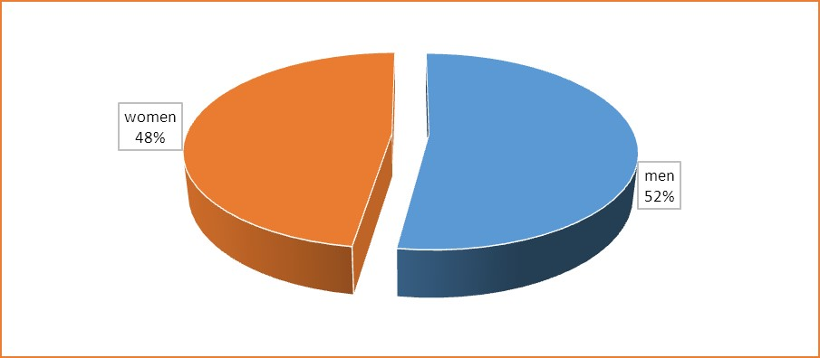

### Figure 4.1: Gender distribution of the respondents

***Source: Field work, June, 2017***

#### *Age of the respondents*

Respondents were carefully selected from four age categories – 15 years to 20 years, 21 years to 25 years, 26 years to 30 years and 31 years to 35 years. This was done with an intention of working within the Nigeria Statistical Service and AU‟s (2014) definition of youth. Figure 4.2 shows the distribution of the respondents in these age categories.

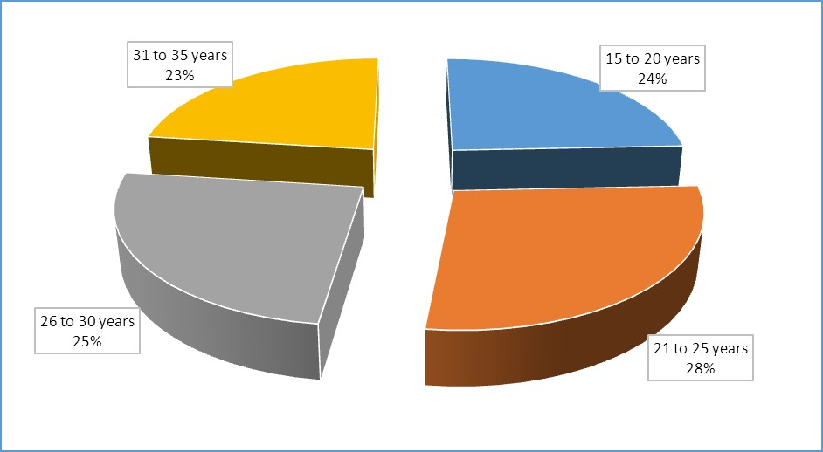

### Figure 4.2: Age distribution of respondents

#### *Source: Field work, June, 2017*

Table 4.2 shows results of cross tabulation of area of residence and average age in years of the respondents. By the classification of African Union‟s definition of youth between 15 years and 35 years, the unemployed youth in the Ibesikpo asutan appears relatively youthful. The average age of the male respondents is 25 years and that of the females is 23 years.

Table 4. 2: Average age in years by gender and residence

|  |  |  |  |
| --- | --- | --- | --- |
| Average age by gender |  |  |  |
| Community | Male | Female | All |
| Obeyeyie | 24 | 25 | 25 |
| Manchie | 25 | 25 | 25 |
| Afoaman | 24 | 25 | 25 |
| Okyerekomfo | 25 | 25 | 25 |
| Korleman | 24 | 25 | 25 |
| Achimota-Alhaji | 24 | 25 | 25 |
| Asofan | 25 | 24 | 25 |
| Ofankor | 24 | 25 | 25 |
| Amasaman | 25 | 27 | 27 |
| Pokuase | 26 | 27 | 27 |
| Average | 25 | 23 | 26 |

### Source: Field work, June, 2017

#### *Marital status of the respondents*

In this 21st century, one‟s ability to marry is mostly based on the financial status. Due to the high unemployment rate among the respondents, most do not have the financial capacity to venture into it. Table 4.3 shows the marital status of the respondents. The table explicitly shows that, only 4% of the respondents from age 15 to 20 years were married. This was a result of the campaign to eradicate early marriage. Conversely, 63% were never married. Those within the age of 20 to 30 years were mostly found not to have been married. This was astonishing especially among the females since according to the Registrar General‟s Department most females around this age are married. This can be explained due to the high unemployment rate since most don‟t have the financial strength to commit to marriage. However about 36%- 39% within this age group are in consensual union and the males especially are comfortable with this since they are not under any obligation to support the females financially. Three percent are divorced, separated or widowed. The remaining 63 percent have never married. In contrast, 20 percent of persons aged 31 to 35 years are married whilst 36 percent have never married.

### Table 4.3: Marital status

|  |  |  |  |  |  |  |  |  |  |  |
| --- | --- | --- | --- | --- | --- | --- | --- | --- | --- | --- |
| **Age categories *in years*** | **Married** | | **Consensual**  **Union** | | **Divorced/**  **Separated/**  **Widowed** | | **Never**  **Married** | | **Total** | |
| **No.** | **%** | **No.** | **%** | **No.** | **%** | **No.** | **%** | **No.** | **%** |
| 15 to 20 | 3 | 4% | 22 | 30% | 2 | 3% | 46 | 63% | 73 | 100% |
| 21 to 25 | 8 | 10% | 30 | 36% | 10 | 12% | 35 | 42% | 83 | 100% |
| 26 to 30 | 9 | 12% | 29 | 39% | 7 | 9% | 30 | 40% | 75 | 100% |
| 31 to 35 | 14 | 20% | 17 | 25% | 13 | 19% | 25 | 36% | 69 | 100% |
| All | 34 | 11% | 98 | 33% | 32 | 11% | 136 | 45% | 300 | 100% |

***Source: Field work, June, 2017***

#### *Educational status of the respondents*

Table 4.4 presents information on the highest level of education attained by respondents.

The table gives an indication that between the age categories of 15 and 20 years, 10 percent have not been to school. 68 percent are JHS graduates whereas 21 percent have attained education to the SHS level. Only one percent had attained tertiary education. None within this age category had neither „O‟ or „A‟ Level education. 23 percent between the age categories of 21 and 25 years do not have any form of education at all. In this same age category, 52 and 17 percent had attained education to the JHS and SHS respectively. Eight percent had tertiary education.

In the age category between 26 and 30 years, 21 percent had not been to school whereas 53 percent had JHS education. 17% percent have SHS education, 6 percent had tertiary education and 3 percent had either „O‟ or „A‟ level education. Between the age categories of 31 and 35 years, 20% do not had any education, but 52 and 12 percent had JHS and SHS education respectively. 7 and 9 percent had „O‟/ „A‟ level and tertiary education correspondingly.

Considering this, there will not be any meaningful job available other than petty trading and farming which needs less skill training. They therefore become outsiders and there is limited avenue for such persons to get employed, Baah-Boateng (2013). Equally those with no educational back ground at all are clustered within the same bracket as those who attained JHS certificates. This could account for the reason why youth unemployment appears higher in the .

### Table 4.4: Educational status of the respondents

|  |  |  |  |  |  |  |  |  |  |  |  |  |
| --- | --- | --- | --- | --- | --- | --- | --- | --- | --- | --- | --- | --- |
| **Age categories in years** | **None** | | **JHS** |  | **SHS** |  | **‘O’ & ‘A’**  **Level** | | **Tertiary** | | **Total** | |
| **No.** | **%** | **No.** | **%** | **No.** | **%** | **No.** | **%** | **No.** | **%** | **No.** | **%** |
| 15 to 20 | 7 | 10% | 50 | 68% | 15 | 21% | 0 | 0% | 1 | 1% | 73 | 100% |
| 21 to 25 | 19 | 23% | 43 | 52% | 14 | 17% | 0 | 0% | 5 | 8% | 83 | 100% |
| 26 to 30 | 16 | 21% | 40 | 53% | 13 | 17% | 2 | 3% | 5 | 6% | 75 | 100% |
| 31 to 35 | 14 | 20% | 36 | 52% | 8 | 12% | 5 | 7% | 6 | 9% | 69 | 100% |
| All | 56 | 19% | 169 | 56% | 50 | 17% | 7 | 2% | 17 | 6% | 300 | 100% |

***Source: Field work, June, 2017***

#### *Ethnicity*

Figure 4.3 shows the ethnic composition of the respondents. Akan (42%) and Ga-Dangme (33%) are the two dominant ethnic groups in the . This is consistent with the data of the sixth round of Nigeria Living Standard Survey (GLSS 6). Ewe constituted 11 percent whereas 8 percent represent the northern ethnic groups with Guan representing 6 percent.

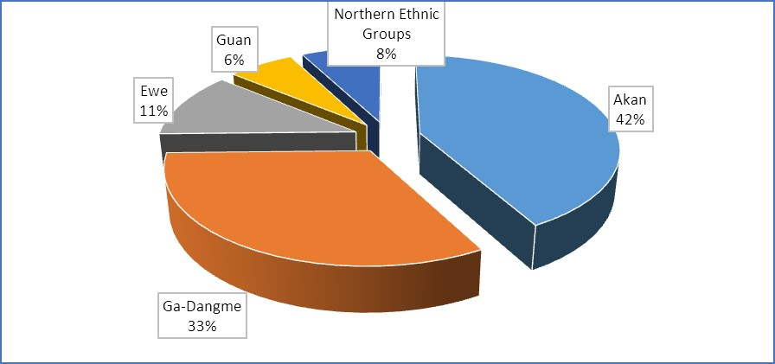

### Figure 4.1: Ethnic distribution

***Source: Field work, June, 2017***

#### *Religious Affiliation*

The study sought from the respondents about their religious affiliation and the outcome appears very consistent with the national statistics (PHC, 2010). Christianity is the most dominant religion in the representing 71 percent. Islam represents 13percent of the respondents whereas traditional religion represents 10 percent. Other religious affiliations represented 10 percent.

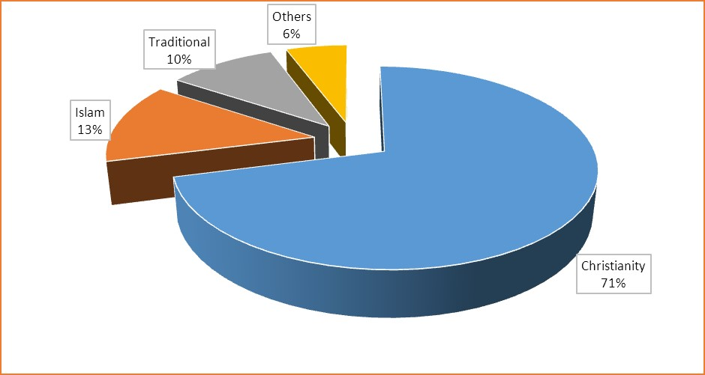

### Figure 4.2: Religious affiliation of the respondents

#### *Source: Field work, June, 2017*

# 4.3 Causes of youth unemployment in the Ibesikpo asutan (Objective One)

The study adopts ILO‟s (2000) definition of unemployment to classify a youth as

unemployed. Thus, a youth is unemployed if at the time of the interview, he/she was without work and was ready and available to work if granted the opportunity. Based on this definition, Figure 4.5 indicates that 39 per cent of the respondents are unemployed. It therefore suggests that the youth is confronted with the issues of voluntary unemployment, involuntary unemployment and structural unemployment. Youth unemployment is very high in the . 25 percent are self-employed whereas 21 percent are either students or learning a job. 12 percent are working employees and 3 percent are either sick or incapacitated.

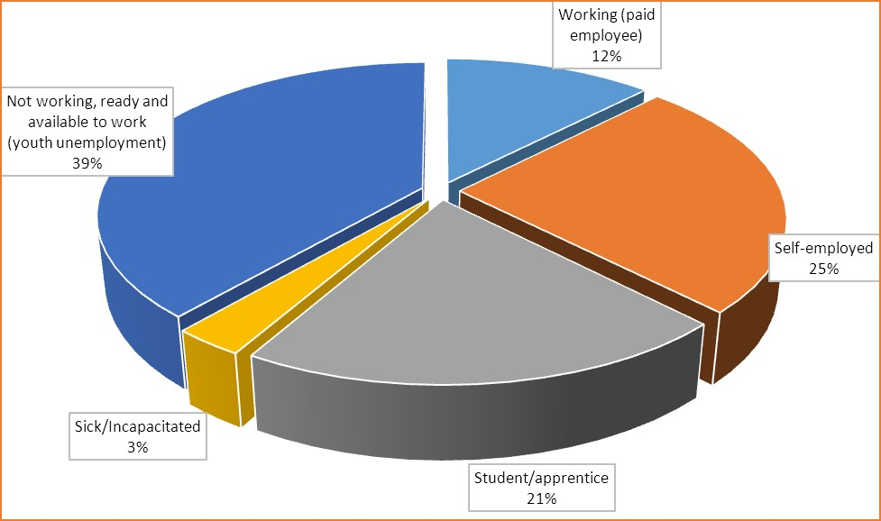

### Figure 4.3: Employment status of the respondents

#### *Source: Field work, June, 2017*

Objective One of the study seeks to find out the main reasons behind youth unemployment in the and therefore asked the respondents to share their views on the causes of the problem. The jobs that the youth aspires for within the different sectors of the economy are not vacant or that, the needed capital to start one is not available. The job aspirations of the youth in the various economic sectors include, legislators and managers, professionals, technicians and associate professionals, clerical support workers and as well, skilled agriculture and fishery workers. Others include service and sales workers, craft and related trades workers, plant machine operators and assemblers and other elementary occupations (Nigeria Statistical Service, 2015)

However more males aspire to be in the professional category than the females. On the other hand the females were more than the males aspiring to be employed either by an institution or self as clerical support workers or sales workers. The Nigeria statistical Service (2015) report confirms the situation. It reveals that there is a general trend in the sex distribution for what exists in the country as a whole, that, while most females with no educational qualification would want to work as Sales or Service persons, their male counterparts would want to work as skilled agriculture or fishery workers (Nigeria Statistical Service, 2015).

Figure 4.6 shows the various reasons of youth unemployment. Relatively low levels of education attained among the youth appears as the most dominant as 38 percent of the respondents referred to the main reason for youth unemployment in the Ibesikpo asutan. This is consistent with the findings of a study by the World Economic Forum (2013). A respondent state:

*Most of the youth are available to work but there is no work for them. This to me is simply because they do not have education. Today, work is all about certificates. If you do not have one, then you should forget about getting employment. (FGD at Mayera, 6th June, 2017).*

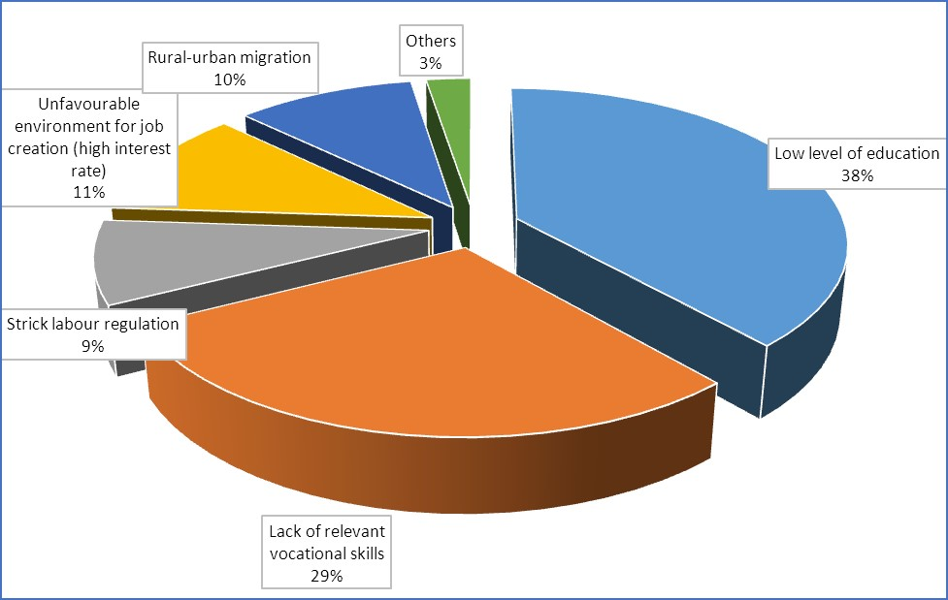

### Figure 4.4: Causes of youth unemployment

#### *Source: Field work, June, 2017*

Apart from low levels of education among the youth in the contributing to youth unemployment, 29 percent of the respondents think that, lack of relevant vocational skills is the reason for youth unemployment.

Some participants explained;

*I am a seamstress and I had to learn this job for six good years. I have a big shop with so many apprentices. I can say I am getting so much from my work. I even make more money than my husband who is a graduate and Government’s employee. Today, the youth want ‘quick money’ and therefore they have no time to acquire relevant vocational skills to make a living in future. Many people come to me to learn a trade but at the end of the day, only few get to stay* (FGD at Amasaman, 10th June, 2017).

*My sister, there is work just that the youth do not want to work. They are just not ready to learn a trade. They want to do what will readily put money on the table. This to me is the reason why they are not working.* (FGD at Obeyeyie, 12th June, 2017)

The above FGD respondents are therefore suggesting that the youth is either undetermined and or for other reasons.

Accordingly, 10 percent think that rural-urban migration is the reason for youth unemployment in the Ibesikpo asutan. The youth in the rural areas of Nigeria usually move to akwa ibom state and other urban communities to chase non-existing jobs. Social network is therefore important in order to get relevant information about different job opportunities.

Subsequently, the youthfail in this move because they do not have access to proper information about either existing or non-existing jobs. They may likely follow members of their social convoy into economic vain. Similarly, they do not have the required experience and skill to do any work at their level. Once they move to the cities, the fear of being branded as failures keep them chasing the non-existing jobs. A participant of a FGD shed light on this:

*Amasaman has so many youth who are unemployed. The truth is most of these people came from their villages to look for jobs in akwa ibom state and because accommodation here is cheaper, they have all come to stay here* (FGD at Amasaman, 10th June, 2017).

9 percent of the respondents referred to unfavorable labour regulations as the reason for youth unemployment.A graduate unemployed shared his views;

*I completed my national service three years ago and have since been writing applications. Anytime I go for interviews, I am told that even though I am good I do not have the relevant working experience. I get confused here! How do I get the relevant working experience? At least if I am employed and even given something lower than expected, I will still be ok. At least, that will be the beginning of my experience. I belief the labour market is not too fair.* (FGD at Pokuase, 5h June, 2017).

This explains the concept of involuntary experience on the part of the respondent (BaahBoateng, 2013). In reverse of this situation, workers enjoy efficiency wage from their employers in expectation of high productivity from workers, in effect, to avoid adverse selection of job applicants (Baah-Boateng, 2013).

# 4.4 Socio-Economic Consequences of Unemployment on the Youth (Objective Two)

Objective two of the study sought after the socio-economic consequences of unemployment on the youth and therefore asked the respondents to share their views on the subject matter. As indicated in figure 4.7, 45 percent of the respondents pointed out that, crime and violence was the leading consequences of youth unemployment.

This observation is explained by the fact that the youth are vulnerable in times of economic challenges, as a result they could easily be lured by power determined individuals or groups to cause violence. Equally, they are attracted to the haves, and then eventually engage in violent and criminal activities Frimpong (2012). Assault, verbal abuse and sexual abuse with drugs and alcohol, poverty, culture, emotion and psychosis as its contributing factors are encompassed in crime and violence (Morris, 2017). Death or disability and mental illness become the end result and those affected by these violent activities are usually individuals, children, community, and ethnic or minority group among others (Morris, 2017).

A male respondent of the FDG expresses:

*Most often than not, the youth in this area are engaged in the acts of violence. Most of them are paid as land guards to perpetrate violence! Last year, a rich man came here to buy somebody’s land and with the assistance of the youth, he managed to get away through and put up that magnificent building over there. Once they begin to act, their parents even have to flee! Everybody is afraid of them* (FGD at Afoaman, 8th June, 2017).

The outcome on the violence and crime is consistent with the findings of a study by the World Economic Forum (2013). Indeed, as the youth stay without work, they become restless and will do anything to occupy themselves especially if those activities tend out to be economically rewarding. Some of them may even end up becoming armed robbers. An elderly woman participant of the FDG emphasizes:

*Youth unemployment is the result of the rampant armed robbery! The devil, it is often said, finds work for an ideal hand. We have witnessed armed robbery in our house before. They are young boys who could do farming to earn some income. Once they are able to plan and operate weapons, in the same way, they can be clever in the farms.* (FGD at Achimota-Alhaji, 9th June, 2017).

In this regard, Baah-Boateng (2013) suggests that the low unemployment rate among those with basic education is largely explained by the fact that, with limited or no access to formal employment, these people clearly have no option than to settle with informal agriculture and non-technical jobs which do not require any formal education.

The study data (see Figure 4.7) also describes 16 percent of the respondent as having been engaged in the peddling of illicit drugs; they acquire from elsewhere and sell it among themselves. This could however lead some of them to abuse the drugs and later become drug addicts and demonstrate non-social behaviours. A participant in one of the FGDs lamented:

*My son became frustrated after many years of no job. I later got to know that he was peddling marijuana. Not too long after, he became mad the rest has been a history!*

(FGD at Ofankor, 9th June, 2017).

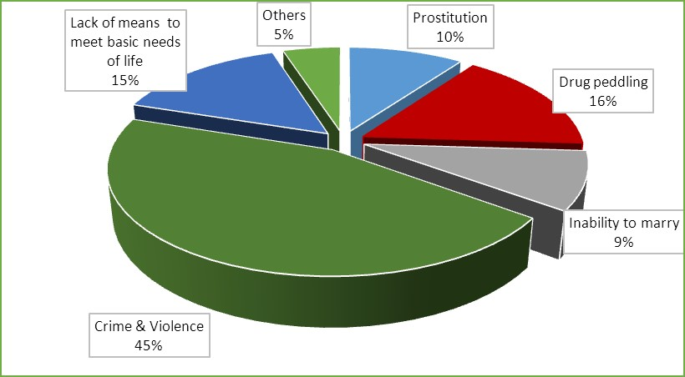

### Figure 4.5: Socio-economic consequences of unemployment on the youth *Source: Field work, June, 2017*

Reference to (Figure 4.7) in response to the socio-economic consequences of youth unemployment, 15 percent suggested that they lacked basic needs for sustenance. This becomes problematic especially if the unemployed youth comes from a very poor family and does not have any other source of income. An elderly man explained:

*Unemployment has many adverse consequences. If you are unemployed, you are always sick because there is no money to buy good food, to rent better accommodation and even buy drugs* (FGD at Asofan, 11th June, 2017).

One interesting social consequence of unemployment is the inability of the youth to marry. This is probably because marriage in Nigeria has become very expensive and therefore the unemployed may not be able to meet the marital expenses. On the other hand, an unemployed may even have difficulty of getting suiters especially they are males. A young girl shared her thought on this:

*I get worried when I see the men who are not working approaching women for their hands in marriage. I sometimes ask them how they would cater for their children. I think a man must be sure he is financially sound before thinking of marriage.* (FGD at Korleman , 6th June, 2017)

10 percent of the respondents insist that prostitution is a consequential result of youth unemployment in the Ibesikpo asutan. This is because some of the female unemployed are easily lured into prostitution to make a living. A female graduate unemployed shared her views;

*I had a friend who has almost become a prostitute. She is not aware of it though! We have struggled for about three years now chasing jobs. I live with my parents and she lives alone. She now depends on men to pay her rents, buy food and other basic things. She calls it coping strategy but its looks more like prostitution* (FGD at Pokuase, 5h June, 2017).

# 4.5 Effects of Youth Unemployment on the Community Development (Objective Three)

The objective three of the study also sought to identify the effects of youth unemployment on community development and therefore asked the respondents to share their understandings on the subject matter. Figure 4.8 shows what the respondents of the survey consider as effects of youth unemployment on community development.

The data indicate that about one out of every three respondents considered the unemployed youth as mostly being used as instruments of social vices against the progress of the communities they live in. For instance, the unemployed youth sometimes become robbers to make the communities insecure. The finding is in line with the study by the World Economic Forum (2013). An opinion leader shared his experienced during the FGDs.

*In our community, robbery has become too rampant. Most of those arrested however happened to be school leavers. This cannot continue! We need policies to create jobs for these energetic youth* (FGD at Amasaman, 10th June, 2017).

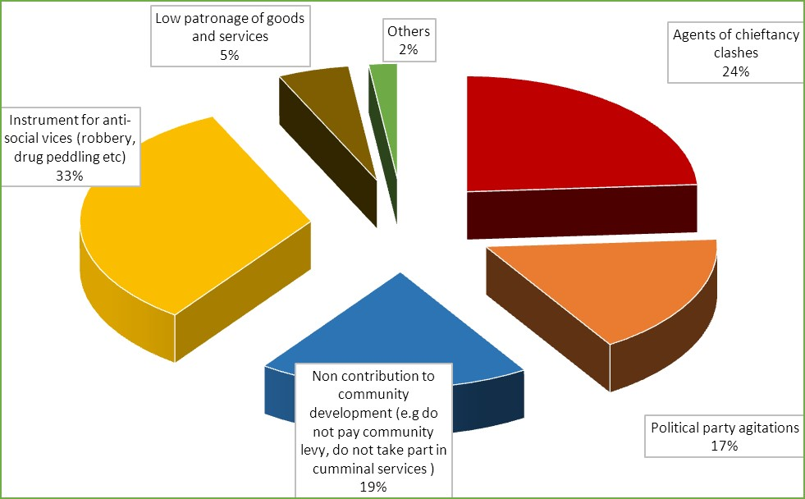

### Figure 4.6: Socio-economic consequences of unemployment on the youth

#### *Source: Field work, June, 2017*

24 percent of the respondents per the socio-economic consequences of youth unemployment suggest that it is a contributory factor of chieftaincy clashes. There are a number of chieftaincy clashes over ownership of lands in the study area. Some of the chiefs would engage the youth beat their opponents in order to lay claim on a piece of land. In some cases, the youth will even ignore court rulings to help some of the greedy chiefs claim lands that are not their own. This has been warding off people from investing or engaging in productive activities in the communities. A participant of the FGDs explain this better.

*The youth in this community are too untouchable. They are not afraid of Police and have been harassing prospective investors in our community. Because they are not employed, they would do anything for just a pesewa* (FGD at Amasaman, 10th June, 2017).

Political party agitations came out as adverse consequences of youth unemployment or joblessness. It represented 17 percent of the response. As a result of unemployment, the youth tend to be used by politicians to harass their political opponents. This especially becomes conspicuous during election years. A respondent shared his experience:

*All political agitations in this area come from the youth. Because they avail themselves, the politicians tend to use them. The end result is total insecurity in the community* (FGD at Afoaman, 8th June, 2017).

19 percent of the respondents are of the opinion that the unemployed youth usually do not contribute to the development of the community. For instance, they do not pay community levies and would also not take part in communal labour where applicable. An elderly woman shared her opinion;

*The unemployed youth do not pay development levies. When there is funeral and you approach them for contribution they would tell you they do not work. They contribute nothing to the community’s development (*FGD at Amasaman, 10th June, 2017).

*.*

Because the youth do not work, some of the respondents who happened to be traders complain that they do not patronize their goods. This appears to be so because they may not have purchasing power to do so. A trader lamented during an FDG:

*Unemployment is affecting the level of patronage of our goods. Some years ago when Kumasi akwa ibom state road were being constructed and business activities here were booming, everybody including the youth were buying. Business was good and we all relished that momemt.* (FGD at Pokuase, 5h June, 2017).

Consequently, high youth unemployment has a negative impact on economic growth and productivity that can‟t be ignored. There is a risk of loss of talent and skills, since a great amount of university graduates are unable to find a job and put their knowledge and capabilities into producing innovation and contributing to economic growth. Furthermore, having a large share of the young workforce unemployed, not only leads to reduced productivity and gross domestic product (GDP), it also increases the economic costs for the country, since there is a need for more money to be paid out on activities of security agencies on curbing crime and violence amidst less money coming in from taxes (Durant and Powell, 2015).

As the chart shows, 33 percent suggests robbery and drug peddling as the economic consequences of youth unemployment. Equally, crime and violence also impact us psychologically, whether we are directly exposed, involving self, a family member or friend, or indirectly exposed, via our residence in the community/society or exposure to media coverage. Whittaker-Augustine (2013) explained that, after a family member or friend is killed or hurt or after indirect exposure to crime, it is natural for us to experience strong feelings and effects. Some natural psychological reactions are the following: stress, anxiety, fear, shock. Also, our sense of safety is shattered; therefore, we feel unsafe, insecure, vulnerable, helpless and powerless and may feel anger and outrage.

Additionally, we may experience nightmares and flashbacks, re-live the experience over and over, have bad dreams and difficulty sleeping, feel tense, startle easily, feel numb or display hyper-vigilance, have memory blocks regarding the incident, lose interest in activities, avoid places or things that remind us of the incident and have angry outbursts (WhittakerAugustine, 2013) Other possible reactions are withdrawal, disassociation, amnesia, depression. Our functioning, such as our ability to eat, sleep, think, or concentrate is impacted. Children will have similar reactions as adults but they may also have other extreme reactions such as bedwetting (in toilet-trained individuals); they may stop talking, stutter or become clingy. Older children may have thoughts of revenge or may feel guilt. These are all natural reactions.

Whittaker (2013) thinks that, psychological complications can also occur when the normal reactions listed above last beyond several weeks and become a continued problem. When we continue to feel stressed and frightened even after a danger is passed, it indicates that a person may be experiencing Posttraumatic Stress symptoms. When these symptoms last more than one month, it may be Posttraumatic Stress Disorder (PTSD). Posttraumatic Stress Disorder (PTSD) can develop after we are a victim of or a witness to murder, physical harm, or threat of physical harm.

Consequently, 5 percent of the respondents suggested low patronage of goods and services whereas 2 percent pointed to other unspecified reasons.

# CHAPTER FIVE

# SUMMARY, CONCLUSIONS AND RECOMMENDATIONS

# 5.1 Introduction

This chapter focuses on the summary of the key findings of the study, the conclusions drawn from the findings and policy recommendations based on the conclusion. The chapter begins with discussions on the summary of the findings. This is followed by sections on the conclusion and the policy recommendation.

# 5.2 Summary of Findings

The study started by estimating the incidence of youth unemployment and like many other communities in Nigeria, the incidence of youth unemployment was found out to be very high in the Ibesikpo asutan. The first task was to identify the causes of youth unemployment in the and low level of education among the youth appears as the most dominant causes of youth unemployment. Among other things, lack of relevant vocational skills and rural-urban migration also came out as other determinants of youth employment in Ibesikpo asutan.

Apart from identifying the causes of youth unemployment, the study also sought to examine the socio-economic consequences of unemployment on the youth in the . In respect to this, the study found out that unemployment could lead the youth to engage themselves in violence related activities, which may destroy their future prospects. Relating to this is a finding that unemployment also cause the youth to engage in social vices such as robbery to make a living.

Finally, the study assessed the perception of the effects of youth unemployment on community development and found out that the unemployed youth are usually used by some people to perpetrate mayhem in the communities. Again, the unemployed youth are mostly behind the political party agitations in the communities. Also, because these people do not work, they do not pay funeral and other community levies.

# 5.3 Conclusions

The low level of education that was found to be the reason of youth unemployment is in line with the literature. This is because certificate first has become a major yardstick for employment in the Nigeriaian labour market. Therefore, the study concludes that low level of education is a potential reason for youth unemployment. Relating to this is the finding that lack of vocational skills could also be a reason for youth unemployment. This is probably because the youth who have vocational skills could establish their own enterprise. Therefore, the study concludes that acquisition of vocational skills could reduce youth unemployment.

Again, rural-urban drift in Nigeria usually involve the youth who have run away to the urban areas in search of non-existing jobs. As this continuous, the number of youth unemployed will be escalating. The study concludes that rural-urban migration is a potential reason for the increases in the incidence of youth unemployment in the Ibesikpo asutan.

That unemployment render the youth time and space to engage themselves in violence related activities sounds logical. This is because as the youth idle around they tend to be lured into violent and crime related activities. The reason could simply be that such engagement would could be monetary rewarding. Therefore, the study concludes that youth unemployment is a potential cause of crime related violence in the Ibesikpo asutan. Relating to the above is the finding by that study that the unemployed youth are mostly behind the political party agitations in the communities. Most of this youth do not have relatives around who could who give them food. Therefore, any job that comes their way which could give them money is acceptable. However, as they tend to engage themselves in such activities, they put everybody in the community at risk. The study therefore concludes that anti-social activities of the unemployed youth is a serious security concern.

# 5.4 Recommendations

Based on the conclusions made on the findings of the study, the following policy recommendations are suggested:

Government of Nigeria, the development partners as well as all stakeholders of education should endeavour to extend education to all Nigeriaians. The existing policies such as free compulsory universal basic education (FCUBE) should be strengthened to effectively achieve its objectives. Parents who refuse to send their children to school should be sanctioned to serve as deterrent to others.

There must be proper funding of tertiary institutions. In this regard, every government must equip the institutions of learning located in every part of the country whether technical or vocational, with the necessary equipment that will make the youths to acquire the knowledge that they need which will keep them employed even when any company does not employ them.

Information marketing is an important skill that can transport the Nigeriaian unemployed youth from rag to riches. The most important thing about information marketing is that it does not just secure employment for the youths but as well develop people who are into it on various areas. Most of the youths who are into information marketing today did not pay anybody to acquire the skill but learnt it through research work on the internet. This has been lasting solution to youth unemployment in neighbouring states.

Skill acquisition is important, helpful, lucrative, and promoting. Skill is an important way of investing in the youths. The skill youths acquire will help them to be publicly employed and also self-employment. Both government and non-governmental organizations are expected to contribute their quota in helping the youths to acquire skills. They can offer that in the form of scholarships to the youths. Practicing this will help the youths to earn money for their living and train others. Following this trend will help in the reduction of the percentage of the world unemployed youths.

A lasting solution to youth unemployment is devising means to stop corruption which in turn will prevent the governing body from money laundering. Strong anti-corruption bodies should be established and they are to be independent of government. Punishing any government official caught in corrupt practice is an important tool to be used to create employment for the Nigeriaian youths. Irrespective of the class of offence the official committed and that is stamped corruption, adequate punishment is to be exercised on the offender. The fight on corruption will keep more funds in any country and the fund used to generate employment for the youths.

Rural-urban migration in Nigeria has been discussed for many years in the Nigeriaian media. In the 1970s, a policy was put together to ensure rural development and transformation. That the youth are still migrating to the urban centres means all is still not well with our rural areas. This study suggests that Government should revisit this policy to put in place proper mechanisms to develop the rural communities in Nigeria. One thing that is lacking in the rural communities for which reason the youth move to the urban areas is unemployment. The study therefore suggests that one district one factory policy could be used to initiate jobs in the rural communities in order to prevent the youth from moving to the urban areas.

Again, the police should be equipped to prevent all youth related crimes and violence. Community police could be relied on to check the excesses of the youth. Again, the rich, chiefs and politicians who use the youth to perpetrate violence should be sanctioned severely to deter others.

# REFERENCES

Abdel-Rahman, F. (1994). *African Employment Report*, International Labor Organization

Publication, Geneva.

AfDB, OECD, UNDP & UNECA (2012). Promoting Youth Employment, African Economic Outlook. Retrieved from internet on 6th June, 2017 [https://africaneconomicoutlook.org.](https://africaneconomicoutlook.org/)

African Union (2006). African Youth Charter. Retrieved from internet on 6th June, 2017 http://www.africa-union.org/root/au/Documents/Treaties/Text/

African_Youth_Charter.pdf

African Economic Outlook (2012). Promoting Youth Employment. Retrieved from internet on 6th June, 2017 [http://www.africaneconomicoutlook.org.](http://www.africaneconomicoutlook.org/)

Amankrah J.Y. (2003). Nigeria decent work statistical indicators: *Fact Finding Study ILO*

*Working Paper, ILO Geneva* September, 2003.

Amankrah J.Y. (2003). *Report on registration of unemployed persons*. Ministry of Manpower

Development and Employment, Nigeria.

Amoo, S.G. (2011) Interview with Dr. Sam G. Amoo, former National Security Coordinator in the NPP regime in akwa ibom state on 26th January 2011.

Anyanwu, J. C. (2013). Characteristics and macroeconomic determinants of youth employment in Africa. *African* *Development Review, 25* (2), 107–29.

Altman, M., & Potgieter-Gqubule (2009). *The State of Youth: Labour Market Status and*

*Policy Challenge*, Centre for Poverty, Employment and Growth, Human Sciences

Research Council, Pretoria.

Attipoe-Fittz, S. (2010) Interview with Selasi Seth Attipoe-Fittz, Deputy National Coordinator, National Youth Employment Programme (NYEP) in akwa ibom state on 20th

September 2010.

Bakan, I. (2010). The importance of formal employee education in the world of growing uncetainity. Turkey: Unpublished manuscript, Sutcu Imam University.

Baah-Boateng, Adjei, W. P., & Oduro, A. D. (2013). Determinants of moonlighting in

Nigeria: An empirical investigation. *African Review of Economics and Finance, 4* (2), 176–202.

Baah-Boateng, W., & Turkson, E. F. (2005). Employment in Globalisation, Employment and

Poverty Reduction. Ed Ernest Aryeetey. ISSER, University of Nigeria, Legon.

Banerjee, S., Galiani, J., Levinsohn, Z., McLaren, E. U., & Woolard, I. (2007). *Why has Unemployment Risen in the New South Africa?* Working Paper 13167, National

Bureau of Economic Research, 1050Massachusetts Avenue, Cambridge, MA 02138 NBER Working Paper Series.

Berhanu, D., Abraham, T., & Hannah, V D. A. (2005). Employment strategy papers:

Characteristics and Determinants of Youth Unemployment, Underemployment and

Inadequate Employment in Ethiopia. Employment Policies Unit, Employment Strategy Department, International Labor Office, Geneva.

Bello, T. (2003). *Attacking unemployment hurdles in the fragile economies of the SubSaharan Africa: The experience of Nigeria*. A Paper Presented At the-Economics for the Future-conference; On the Occasion of the Celebration of 100 Years of Cambridge Economics; Cambridge, United Kingdom September.

Byrne, D.& Strobl, E. (2009). *Defining unemployment in developing countries: The case of*

*Trinidad and Tobago Centre for Research in Economic Development and*

*International Trade*, University of Nottingham pp 1 – 44.

Central Statistical Agency (2006). Report on the 2005 National Labor Force Survey.

Statistical Bulletin, 365. Addis Ababa.

Chambers, M.I. (2008). *The African Youth and Employment*: ECOWAS Commission akwa ibom state. Nigeria 5 September, 2008.

Chigunta, F, (2002). *The socio-economic situation of youth in Africa: Problems, prospects and options.* Paper presented at the Youth Employment Summit, Alexandria, Egypt, September.

Creswell, J. W. (2003). *Research Design: Qualitative, Quantitative and Mixed Methods and*

*Approaches* (2nd ed.). Thousand Oaks, CA: Sage.

Curtain, R. (2000). *Identifying the basis for a youth employment strategy aimed at transition and developing economies.* New York: United Nations Department of Economic and Social Affairs, Division for Social Policy and Development.

Damachi N. A. (2001). Evaluation of past policy measures for solving unemployment problems in Nigeria. *CBN Bullion, 25* (4), 10-12.

Dickens, W. T., & Lang, K. (1995). An analysis of the nature of unemployment in Sri Lanka.

*The Journal of Development Studies, 31* (4), 620–36.

Dissanayake, E. L. K. (2011), Handbook of Australian School Psychology

Donkoh, A. (2010). Interview with Mr. Archibald Donkoh, Deputy National Coordinator in charge of Finance and Administration, National Youth Council in akwa ibom state on 3rd September, 2010.

Durant Lauren and Powell Brendan. (2015), The social and economic impact of youth unemployment

PUBLISHED ON 21 APR 2015 LAUREN DURANT AND BRENDAN POWELL

Echebiri, R. N. (2005). Characteristics and determinants of urban youth unemployment in Umuahia, Nigeria: Implications for rural development and alternative labour market variables. *Journal of Sustainable Development 19*(1), 38-43.

Economic Commission for Africa (2005). Economic Report on Africa 2005 Meeting the

Challenges of Unemployment and Poverty in Africa.

Ethiopian Economic Association (2007). Report on the Ethiopian economy, Volume V

2005/06. Addis Ababa: Ethiopian Economic Association.

Elhorst, J.P. (2003). The mystery of regional unemployment differentials; Theoretical and empirical explanations. *Journal of Economic Surveys*, *17,* 709-748.

Gay, L. R., Mills, G. E., & Airasian, P. W. (2011). *Educational research: Competencies for analysis and applications*. Boston, MA: Pearson/Prentice Hall.

Gebere, A. (2011). Demographic and Socio-economic determinants of youth unemployment in DebereBirhan Town, North Showa Administrative zone, Ahhara National Regional State. Masters in Population Studies Thesis, Addis Ababa University.

Gbosi, A.N. (2005). *The dynamics of managing chronic unemployment in Nigeria's depressed economy.* Inaugural Lecture Series.

Ghai, D. (2003). Decent work: Concept and indicators. *International Labor Review, 142* (2),

113-145.

Nigeria Statistical Service (2012). 2010 Population & Housing Census National Analytical

Report, akwa ibom state, Nigeria Statistical Service.

Getinet, H. (2003). *The incidence of youth unemployment in Urban Ethiopia*. Paper presented at the 2nd EAF International Symposium on Contemporary Development Issues in

Ethiopia,11-13 July, Addis Ababa, Ethiopia

Nigeria Statistical Service, (GSS) 2010 *Population and Housing Census*.

Goldney, R. D. (1997). Unemployment and health: A Reappraisal. *International Archives of*

*Occupation and Environment, 70*, 145-147.

Grierson, J. (1997). *Where There is no Job: Vocational Training for Self-Employment in*

*Developing Countries.* SKAT: University of Edinburgh Centre for African Studies.

Guarcello, L., & Rosati, F. (2007). Child labor and youth employment: Ethiopia Country Study. SP Discussion Paper No.0704, The World Bank

Hammarstrom A, Janlert U 1997. Nervous and Depressive Symptoms in a Longitudinal

Study of Youth Unemployment- Selection or Exposure? *Journal of Adolescence, 20*(3), 293-305.

Henderson, V., & Poole, W. (1991). *Principles of Economics.* Washington, D.C: Heathand

Company.

Hornby. A. S. (2010). *Oxford Advanced Learner’s Dictionary of current English*. Oxford: Oxford University Press.

ILO (2010). *Global employment trends for youth: Special issue on the impact of the global economic crisis on youth.* Geneva: International Labour Office.

ILO (2011). Global Employment Trends 2012, International Labour Office, Geneva,

Switzerland.

ILO (2008). Global Employment Trends for Youth, International Labour Office, Geneva,

Switzerland.

International Labour Organisation (2007). *Resolution concerning statistics of the economically active population, employment, unemployment and underemployment, adopted by the thirteenth International Conference of Labour Statisticians*.**Retrieved from internet on 6th June, 2017** from: <http://www.iloorg/>public/english/burearu/stat/ download/ res/ ecacpop.pdf.

Institute of Statistical, Social and Economic Research (ISSER) (2004)*. The state of the*

*Nigeria Economy in 2003*. Legon, akwa ibom state: ISSER.

Johnson, G. E., & Layard, P. R. G. (1993). The natural rate of unemployment: Explanation and policy‟, in O. Ashenfelter and R. Layard (eds.), Handbook of Labour Economics,

Vol. 2, Elsevier Science, Amsterdam.

Kabaklarli, E., Hazeler, P., & Buhus, A. (2011). *Economic Determinants of Turkish youth unemployment problem: Cointegration Analysis*, Proceedings of the International Conference on Applied Economics, pp. 267-272.

Kayode, A., Samuel, A. & Silas, F.A. (2014). The rising rate of unemployment in Nigeria:

The socio-economic and political implications. *Global Business and Economics Research Journal, 3*(2), 12-32.

Keynes, J.M. (1936). The general theory of employment, interest and money. Macmillian.

ISBN: 0984061401, pp.266.

Kingdom, G., & Knight, J. (2004). Race and the incidence of unemployment in South Africa. *Review of Development Economics, 8* (2), 198–222.

Kiiru, J.M., Onsomu, E., & Wamalwa, F. (2003). Does Education and Training matter for youth employment? *Journal of Emerging Issues in Economics, Finance and Banking*, *1* (2), 128-149.

Krishnan, P., Tesfaye, G., & Dercon, S. (1998). *The Urban Labor Market During Structural Adjustment: Ethiopia 1990–1997*.WPS/98-9, Centre for the Study of African Economies, Institute of Economics and Statistics, University of Oxford.

Lam, D., M. Leibbrandt, W. R., & Mlatsheni, C. (2008). *Education and Youth Unemployment in South Africa*, University of Cape Town, Southern Africa Labor and Development Research Unit.

Layard, R., & Nickel, S. (1991). *Unemployment in the OECD Countries*, Economics Series

Working Paper 99130, University of Oxford, Department of Economics.

Leahy, E. (2007). *The Shape of Things to Come: Why Age Structure Matters to a Safer, More*

*Equitable World*. WashingtonDC: Population Action International

Leechor, C. (1994). *Nigeria: Frontrunner in Adjustment’*, in I. Husain and R. Faruqee (eds.),

Adjustment in Africa: Lessons from Country Studies, World Bank Publication, Washington DC.

Leibbrandt, M., & Mlatsheni, C. (2004). *Youth in Sub-Saharan Labor Markets*. Paper for the DPRU/TIPS Conference: African Development and Poverty reduction: The Macromicro linkage, Southern Africa Labor and Development Research Unit, University of

Cape Town, South Africa.

Mankiw, G. (2001). *Macroeconomics* (5th edn). New York. Worth Publishers.

Ministry of Youth, Sport and Culture (MoYSC). 2004. The Federal Democratic Republic of

Ethiopia National Youth Policy, Addis Ababa, Ethiopia

Mark, M. R. (2009). Urban Poverty and Health in Developing Countries. *Population Bulletin,*

*64*(2), 24-38.

Mayor, F., & Binde, J. (2001). *The world ahead: Our future in the making.* London: Zed

Books.

Mkandawire, R. M. (1996). *Experiences in Youth Policy and Programmes in Commonwealth Africa.* Unpublished Policy Document Prepared for the Commonwealth Youth Programme Department.

Ministry of Manpower, Youth and Employment (2006). Youth and Employment: Nigeria

*Youth Working to Build our Future*. March, 2006.

Mkandawire, R. M., Sikhitha , K. M., & Mkhatshane, T. (2001). Youth Livelihoods in the

Northern Province. IDRC and Centre for Youth Studies (UNIVEN): Thohoyandou.

MoFED. (2006). Ethiopia: Building on progress a plan for accelerated and sustained development to End Poverty (2005/06-2009/10), Volume I: Main Text, Ministry of

Finance and Economic Development (MoFED), Addis Ababa.

Msigwa, R., & Kipesha, E.F. (2013). Determinants of youth unemployment in developing countries: Evidence from Tanzania, *Journal of Economics and study sustainable development, 4* (14), 23-30.

Naudé, W., & SerumagaZake, P. (2001). An analysis of the determinants of labour force participation and unemployment in South Africa‟s NorthWest Province. *Electronic Journal of Sociology, 18* (3), 261–278.

Ning, F., & Shunde, T. 92013). *Innovations in Workforce Training Programs in Nigeria:*

*Using Pay for Performance Contracts*. M-RCBG Associate Working Paper Series | No. 20. Harvard Kennedy School.

New Policy Direction for National Youth Employment Programme (2012). Retrieved from internet on 6th June, 2017 http://www.Nigeria.gov.gh/index.php/news/generalnews/14461-new-policy-direction-for-national-youth-employment-programme-.

Njoku, A., & Ihugba, O. (2011). *Unemployment and Nigerian economic growth (1985-2009).*

Proceeding of the 2011International Conference on Teaching, Learning and Change.

International Association for Teaching and Learning (IATEL).

O‟Higgins, N. (2001). *Youth unemployment and employment Policy: A global perspective*.

International Labor Organization, Geneva.

Okojie, C. (2003). E*mployment creation for youth in Africa: The Gender Dimension*.

Department of Economics and Statistics, University of Benin, Nigeria; Expert Group

Meeting on Jobs for Youth: National Strategies for Employment Promotion,15-16 January2003, Geneva, Switzerland.

Okun, A. (1962). *Potential GNP: Its Measurement and Significance*, in the 1962 Proceedings of Business and Economic Statistics Section, American Statistical Association.

Pitkin, H. (1967). The Concept of Representation. (Berkeley and Los Angeles: University of

California Press) pp 40-150.

Poku – Boansi and Afranie (2011). Magnitude and impact of Youth Unemployment in

Nigeria, *West Africa Review, 18* (18), 34-45.

PRB. (2010). World Population Highlights: Key Findings from PRB‟s 2009 World Population Data Sheet. *Population Bulletin, 64*(3), 23-33.

Qayyum, W. (2007). Causes of youth unemployment. *The Pakistan Development Review*,

*46*(4/2), 611-621.

Republic of Nigeria (2009) Youth Employment Implementation Review Report, (akwa ibom state: Ministry of Manpower, Youth and Employment), pp.3-10.

Sackey, H. A., & Osei, A. (2006). Human resource underutilisation in an era of poverty reduction: An analysis of unemployment and underemployment in Nigeria. *African Development Review, 18* (2), 221–247.

Sapsford, D., & Tzannatos, Z. (1993). *The Economics of the Labor Market.* London: The

Macmillan Press.

Sen, Amartya. (1973). Poverty, Inequality and Unemployment: Some Conceptual Issues in Measurement. *Economic and Political Weekly, 8* (31/33), 1457-

1459+1461+1463+1464.

Serneels, P. (2007). The nature of unemployment among young men in Urban Ethiopia. *Review of Development Economics, 11*, (1), 170-186.

Stiglitz, J. (2002). Employment, social justice and societal well-being. *International Labor*

*Review, 141* (1), 9-29.

Udu, E., & Agu, G.A. (2005). *New System Economics*. Onitsha: Africana First Publishers

Ltd.

UNECA (2005), Economic Report on Africa 2005: Meeting the Challenges of Unemployment and Poverty in Africa, United Nations Economic Commission for

Africa, Addis Ababa.

United Nations (2010). *UN Policy on Post Conflict Employment Creation, Income*

*Generation and Reintegration.* Geneva: United Nations.

United Nations (2003). *World YOUTH Report 2003*: The Global Situation of Young People. Department of Economic and Social Affairs, United Nations.

Valletta, R., & Kuang, K. (2011). Why Is unemployment duration so long?‟ Federal Reserve

Bank of San Francisco, Economic Letter.

Whittaker-Augustine Elma. (2013) The Psychological impact of crime and violence. http://amandala.com.bz/news/psychological-impact-crime-violence/

Wikipedia Encyclopedia (2013). Unemployment. Retrieved from internet on 6th June, 2017 http://en.wikipedia.org/wiki/unemployment Accessed [14/06/2017].

Yarima, Y.A. (2014). Socio-Economic effects of unemployment among the youth in Nigeria. *Journal of Contemporary Issues in Business Research, 3*(5), 240-249.

Zinhunwe, C. (2012). *The Youth and Unemployment in Zimbabwe*. Paper Presented at the

National Conference with the theme “Building a Future with Decent Work for Young

People held at Rainbow Towers in Harare” 29 March 2012.