**The Role of Alpha Lipoic Acid and Olive Oil on Metabolic Syndrome Associated with Letrozole-induced Polycystic Ovarian Syndrome**

**TABLE OF CONTENTS**

**Title page** …………………………………………………………………………………...i

**Declaration** …………………………………………………………………………………ii

**Certification** ………………………………………………………………………………..iii

**Dedication** ………………………………………………………………………………….iv

**Acknowledgements** ………………………………………………………………………...v **Table of Contents** ..................................................................................................................vi

**List of Tables** ………………………………………………………………………………...x

**List of Figures** ………………………………………………………………………………xi

|  |  |  |  |
| --- | --- | --- | --- |
| **Abstract**.................................................................................................................................... | | | xii |
| **CHAPTER ONE** | | |  |
| 1.0 | Introduction………………………………………………………………………….…1 | |  |
| 1.1 | Statement of Problem……………………………………………………………….….2 | |  |
| 1.2 | Justification of Study……………………………………………………………….…..2 | | |
| 1.3 | Aim of Study…………………………………………………………………………...3 | |  |
| 1.4 | Specific Objectives of Study……………………………………………………………3 | |  |
| **CHAPTER TWO** | | |  |
| 2.0 |  | Literature Review……………..…………………………………………………….4 | |
| 2.1 |  | Polycystic Ovarian Syndrome…..…………………………………………………..4 | |
| 2.2 |  | Historical Perspective of PCOS……………………………………………………..6 | |
| 2.2.1 | | Classification of PCOS……………………………………………………………...7 | |
| 2.2.1.1 | | PCOS Phenotype A and B…………………………………………………………..8 | |
| 2.2.1.2 | | PCOS Phenotype C………………………………………………………………….8 | |
| 2.2.1.3 | | PCOS Phenotype D………………………………………………………………….8 | |
| 2.2.2 | | Ovarian Dysfunction of PCOS………………………………………………………9 | |

2.2.2.1 Primary Ovarian Dysfunction……………………………………………………….10

vi

2.3 Diagnostic criteria of PCOS………………………………………………………....10

2.4 Prevalence of PCOS…………………………………………………………………13

2.5 Symptoms of PCOS………………………………………………………………….13

2.6 Etiologies of PCOS…………………………………………………………………..17

2.7 Metabolic disturbances associated with PCOS………………………………………17

2.7.1 Insulin Resistance and hyperinsulinemia…………………………………………….19

2.7.1.1 Visceral Obesity……………………………………………………………………...21

2.7.1.2 Hypertension…………………………………………………………………………21

2.7.1.3 Dyslipidemia…………………………………………………………………………22

2.8 Management options of PCOS……………………………………………………….23

2.8.1 Modification of Lifestyle……………………………………………………………..23

2.8.2 Medical Interventions………………………………………………………………...24

2.8.2.1 Oral contraceptive pills (OCPs)………………………………………………………24

2.8.2.2 Hormone Medications………………………………………………………………...24

2.8.2.3 Ovulation-inducing Substance………………………………………………………..25

2.9 Aromatase inhibitors………………………………………………………………….26

2.9.1 Letrozole……………………………………………………………………………...27

2.9.1.1 Mechanism of action of letrozole……………………………………………………..28

2.9.1.2 Pharmacology of letrozole…………………………………………………………….28

2.10 Alpha-lipoic acid in PCOS……………………………………………………………30

2.10.1 Structure of Alpha Lipoic acid………………………………………………………..34

2.10.2 Synthesis and Pharmacology of Alpha Lipoic Acid………………………………….36

2.11 Olive oil………………………………………………………………………………39

2.11.1 Chemistry of Olive oil………………………………………………………………..39

2.11.2 Synthesis of Olive oil………………………………………………………………....41

2.11.3 Pharmacology of Olive oil………………………………………………………….....42

**CHAPTER THREE**

3.0 Methodology……………………….……………………………………………...…….44

vii

3.1 Materials……………………………………………………………………………….44

3.1.1 Drugs and Assay Kits………………………………………………………………….44

3.1.2 Other Chemicals and Reagents………………………………………………………..44

3.1.3 Experimental Animal………………………………………………………………….44

3.1.4 Equipments…………………………………………………………………………….45

3.2 Methodology…………………………………………………………………………..45

3.2.1 Induction of PCOS…………………………………………………………………….45

3.2.2 Confirmation of PCOS and Vaginal Cytology………………………………………...46

3.2.2.1 Animal grouping and dosage administration………………………………………….46

3.2.3 Determination of Fasting Blood Glucose……………………………………………..47

3.2.4 Preparation of Serum and Tissue Supernatants……………………………………….47

3.2.5 Determination of Serum Concentration of Hormones………………………………...47

3.2.5.1 Insulin………………………………………………………………………………….47

3.2.6 Lipid Profile Determination……………………………………………………………48

3.2.6.1 Serum Total Cholesterol Concentration………………………………………………..48

3.2.6.2 Serum Triglyceride Concentration……………………………………………………..49

3.2.6.3 Serum High Density Lipoprotein-Cholesterol Concentration………………………….49

3.2.6.4 Serum Low Density Lipoprotein-Cholesterol Concentration…………………………..50

3.2.7 Data Analysis…………………………………………………………………………...50

**CHAPTER FOUR**

4.0 Results…………………………………………………………………………………..51

4.1 Fasting blood glucose of letrozole-induced animals administered Alpha lipoic acid and olive oil………………………………………………………………………………………….51

4.2 Body weight of letrozole-induced animals administered Alpha lipoic acid and olive

oil………………………………………………………………………………………………..57

4.3 Lipid profile of letrozole-induced animals administered Alpha lipoic acid and olive

oil………………………………………………………………………………………………..63

4.4 Effects of administration of letrozole on insulin concentration of female wistar rats…66

viii

**CHAPTER 5**

5.1 Discussion………………………………………………………………………………68

5.2 Conclusion………………………………………………………………………………69

5.3 Recommendation………………………………………………………………………..69

References……………………………………………………………………………………….70

Appendices I……………………………………………………………………………………..90

Calibration curve…………………………………………………………………………………91

ix

LIST OF TABLES

Table 1: PCOS phenotypes and its associated Diagnostic Criteria…………………………….8

Table 2: Diagnostic Criteria for PCOS………………………………………………………..13

Table 3: Diagnostic Criteria for PCOS………………………………………………………..33

Table 4: Serum Lipid profile of letrozole induced female rats………………………………..65

LIST OF FIGURES

Figure 1: The normal ovary and polycystic ovary……………………………………….…..6

Figure 2: Associated symptoms of PCOS…………………………………………………..16

Figure 3: Pathophysiology of PCOS………………………………………………………..18

Figure 4: Pathway showing the effects of Insulin resistance……………………………….20

Figure 5: Showing the biosynthetic and salvage pathway of Alpha Lipoic Acid…………..32

Figure 6: The structure of the Enantiomers of ALA……………………………………….35

Figure 7: Dynamic role of Alpha lipoic Acid……………………………………………....38

Figure 8: Structure of Oleic acid……………………………………………………………40

Figure 9: Fasting blood glucose of Female rats in the control group……………………….52

Figure 10: Fasting blood glucose of letrozole-induced Female rats untreated group……….53

Figure 11: Fasting blood glucose of letrozole-induced Female rats treated with standard drug (MET+CC)………………………………………………………………………………......54

Figure 12: Fasting blood glucose of letrozole-induced Female rats treated with ALA…......55

Figure 13: Fasting blood glucose of letrozole-induced Female rats treated with olive oil.....56

Figure 14: Body weight of Female rats in the control group………………………………..58

Figure 15: Body weight of letrozole-induced Female rats’ untreated group………………...59

Figure 16: Body weight of letrozole-induced Female rats treated with standard drugs(MET+CC)……………………………………………………………………………..60

Figure 17: Body weight of letrozole-induced Female rats treated with ALA………………..61

Figure 18: Body weight of letrozole-induced Female rats treated with olive oil…………….62

Figure 19: The effect of letrozole-induced PCOS on serum insulin………………………….67

Figure 20: Calibration curve for Insulin………………………………………………………90

**ABSTRACT**

Polycystic ovary syndrome (PCOS) is a chronic endocrine disorder prevalent in premenopausal women and is characterized by a range of physiological and biochemical abnormalities which may include reproductive, endocrine, and metabolic alterations such as insulin resistance. Insulin resistance is the hallmark of PCOS as it predisposes the affected subjects to a higher risk of impaired glucose tolerance and type 2 diabetes mellitus (T2DM). Among the various reference drugs used to treat PCOS, the combination of metformin and clomiphene citrate used in this study has demonstrated to exhibited a good therapeutic impact in the management of PCOS. For women with polycystic ovarian syndrome, Alpha Lipoic acid (ALA) reduces oxidative damage and insulin resistance. Such changes in the oestrous cycle point to a shift in the functional integrity of the hypothalamic-pituitary-gonadal axis. Therefore, the purpose of this study was to ascertain if ALA and olive oil have an ameliorative effect as a management option in the metabolic syndrome associated with letrozole-induced PCOS female rats.

Thirty-five (35) female Wistar rats (205.27 ±5.23g) into 5 groups (A - E) of 7 each. The rats in group A were the control animals while rats in groups B, C, D, and E were induced with 1 mg/kg body weight of letrozole for 21 days. After the period of induction, group A (control rats) received 1 ml of distilled water while group B-E received oral administration of 7.14 mg/kg of metformin co-administered with 2 mg/kg of clomiphene citrate (reference drugs), 1 mg/kg of ALA and olive oil respectively for 21 days. The result of the study reveals that, in comparison to the control group, the administration of 1mg/kg B.W. of ALA to PCOS rats significantly (p>0.05) decreased the serum concentrations of HDL-C but increased serum insulin levels, which were brought on by PCOS, as well as their TG, TC, and LDL-C levels. ALA and Olive oil can be used in the management and treatment of metabolic disorders related to PCOS.

**Keywords:** Alpha lipoic acid , Polycystic ovarian syndrome, Olive oil, Insulin.

xii

**CHAPTER ONE**

**1.0 INTRODUCTION**

A prevalent reproductive endocrine disorder called polycystic ovarian syndrome (PCOS) affects 5–10% of females who are of reproductive age. Over 116 million women globally, according to estimates from the World Health Organization (WHO), have PCOS. Hyperandrogenism, anovulatory infertility, irregular menstruation, and metabolic abnormalities such obesity, insulin resistance (IR), hyperinsulinemia, dyslipidemia, and glucometabolic diseases are some of its hallmarks. The main PCOS treatments currently used are lifestyle modifications and drugs that help with weight management, ovulation induction, IR reduction, menstrual cycle regulation, and serum androgen levels.

One of the symptoms of PCOS is a drop in Sex Hormone Binding Globin (SHBG) levels, which is connected to insulin resistance and hyperandrogenism. Estradiol, Progesterone, Testosterone, Follicle Stimulating Hormone (FSH), Luteinizing Hormone (LH), and Insulin are examples of selective reproductive hormones that should be studied. The ovarian hyperstimulation syndrome (OHSS), gastrointestinal issues, irregular glucose and lipid metabolism, mental disturbance, hair loss, vision loss, and allergic dermatitis are only a few of the side effects that these medications may cause. They may also not significantly help Insulin resistance (IR) and metabolic abnormalities when given alone, necessitating their combination with additional therapeutics.

The natural antioxidant alpha-lipoic acid (ALA), which is produced by both plants and animals, is known to act as a catalyst in the oxidative decarboxylation of pyruvate and –ketoglutarate. ALA lowers insulin resistance and oxidative stress in women with polycystic ovary syndrome (PCOS). The lipophilic natural antioxidant alpha-lipoic acid (ALA) serves as a crucial cofactor for mitochondrial enzymes. Particularly in lab-grown liver, lung, and kidney cell cultures, it boosts the potency of other antioxidants like glutathione by 30 to 70%. The complex ALA-DHLA gets involved in the repair of DNA, lipids, and proteins that have been oxidized-damaged. ALA has attracted interest in recent years for the treatment of neurological and liver illnesses. It has been used in people with type-2 diabetes to enhance glucose control and to alleviate symptoms of diabetic neuropathy.

1

Olive oil considerably reduced TC less than oils high in omega-3s, according to research by Ghobadi *et al.* (2019). On the other hand, PCOS women's inflammatory state is known to be influenced by the ratio of n-6 to n-3 fatty acids.

Despite the complexity of PCOS' pathophysiology, there is mounting evidence that oxidative stress (OS) plays a role in the disease's etiology. Numerous studies have demonstrated that PCOS patients have elevated levels of OS indicators, which may increase their chance of developing long-term problems such type 2 diabetes (T2DM) and endometrial cancer. In order to provide a useful reference for the clinical treatment of PCOS as well as for the research and development of new drugs, this study investigates the use of antioxidants as a therapeutic.

**1.1 Statement of Problem**

Obesity, insulin resistance, hyperinsulinemia, hypertension, and dyslipidemia are all cardiometabolic risk factors that are included in the metabolic syndrome associated with PCOS. There is growing proof that oxidative stress (OS) contributes to the pathophysiology of this condition. A number of human metabolic syndrome, including diabetes, hypertension, and aging, are thought to be largely influenced by oxidative stress, but there is none to harness letrozole-induced PCOS. Numerous studies have demonstrated that PCOS individuals have higher levels of OS markers. Therefore, there is need to evaluate the role of ALA and olive oil as management options in the metabolic syndrome associated with letrozole-induced PCOS rats compared to clomiphene citrate and metformin that have toxicological effects in the treatment of PCOS.

**1.2 Justification of Study**

Numerous studies on PCOS patients have shown that antioxidants can not only enhance the ovarian environment, encourage follicular maturation, and increase oocyte quantities, but can also control lipid and glucose metabolism as well as vascular endothelial cell function in PCOS patients. This lowers adiposity and lowers the frequency of chronic complications to ensure that patients can benefit long-term. ALA may be utilized to stop premature fetal membrane rupture brought on by inflammation and diabetic embryopathy. ALA lowers insulin resistance and oxidative stress as well as olive oil which reduce TC in women with polycystic ovary syndrome (PCOS). Therefore there is need to evaluate the ameliorative effects of ALA on metabolic

2

syndrome such as hyperinsulinemia, dyslipidemia and hyperglycemia associated with PCOS in rat model.

**1.3 Aim of Study**

The aim of this study is to determine the ameliorative effects of ALA and olive oil as a management option in the metabolic syndrome associated with letrozole-induced PCOS female rats.

**1.4 Specific Objectives of Study**

The specific objectives of this study are as follows:

1. To induce PCOS using letrozole on female Wistar rats and monitor the oestrous cycle,
2. To evaluate the ameliorative effects of ALA and olive oil as management options of PCOS.
3. To determine the serum lipid profile of PCOS rats,
4. To evaluate the associated metabolic disturbance associated with PCOS such as hyperglycemia and increased body weight and hyperinsulinemia.

3

**CHAPTER TWO**

**2.0 LITERATURE REVIEW**

**2.1. Polycystic Ovarian Syndrome**

Polycystic ovarian syndrome (PCOS) is a common endocrine and heterogeneous disorder which affects females of reproductive age. Little pearl-sized cyst clusters arise from the ovary on a regular basis due to polycystic ovarian syndrome (PCOS) (Yildiz *et al.,* 2012). An immature egg filled with fluid is what a cyst is (Figure 1) (Yildiz *et al.,* 2012). PCOS, also referred to as "Stein-Leventhal Syndrome," is a complicated, diverse disorder that impacts 8 to 20% of girls in the world who are of reproductive age (De Leo *et al.,* 2016). It affects females between the ages of 18 and 44 and is brought on by environmental or genetic factors (De Leo *et al.,* 2016). PCOS symptoms include amenorrhea, polycystic ovaries, and hyperandrogenism (Unluturk *et al.,* 2016).

This endocrinopathy has been linked to a number of metabolic issues, including insulinemia and dyslipidemia, as well as an increased risk of cardiovascular effects, type 2 diabetes, and the metabolic syndrome (Unluturk *et al.,* 2016). The specific cause of this sickness is unknown despite the fact that it is extremely common (Crespo *et al.,* 2018). Symptoms of PCOS are ones that affect women who are fertile (Patel, 2018). Cysts develop in the antral ovarian follicle as a result of an imbalance in the female sex hormone that causes this condition (Patel, 2018). The hypothalamic-pituitary gonadal axis regulates the reproductive system (HPG).

The anterior pituitary gonadotropes are stimulated by the release of gonadotropin releasing hormone (GnRH) from the brain to release LH and FSH, which results in the development of ovaries (Chauldhari *et al.,* 2018). Due to insufficient progesterone peaks during the luteal stage of the menstrual cycle, which causes an increase in LH output, the mechanism of GnRH generation is altered (Figure 1)(Unluturk *et al.,* 2016). By encouraging the release of androgens from the ovaries and the synthesis of androgens when LH levels rise, the adrenal gland aids in the development of hyperandrogenism in PCOS (Unluturk *et al.,* 2016).

Alterations in lifestyle, such as better nutrition and exercise, oral contraceptives, and metformin, which controls the menstrual cycle, reduces insulin resistance, and aids in regaining normal body weight (Kim, 2020).

4

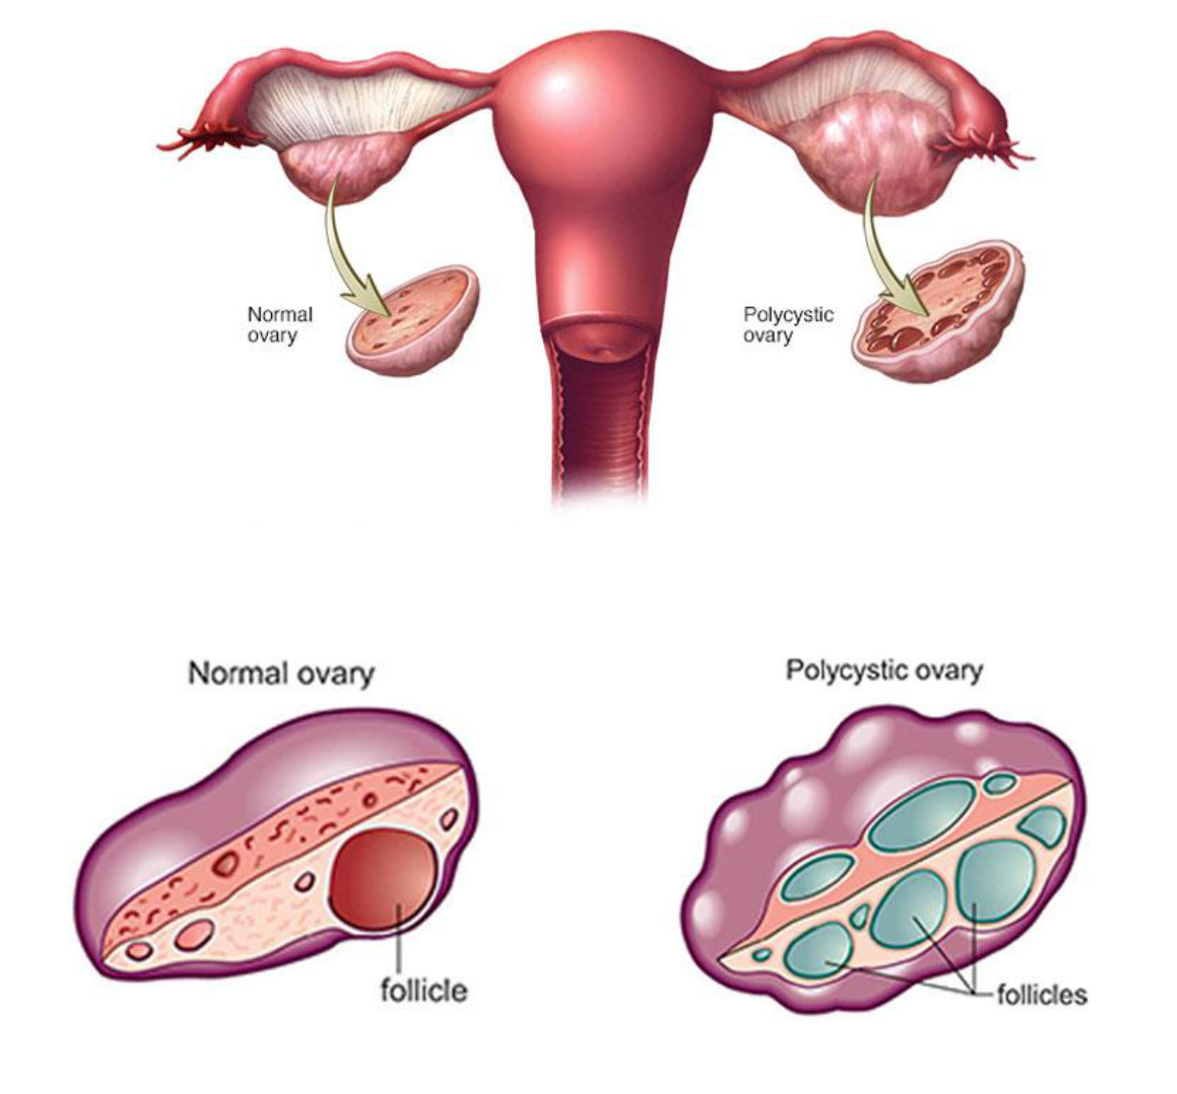

**Figure 1:** The normal ovary and polycystic ovary.

**Source:** Sharja. (2019).

5

**2.2 Historical Perspective of PCOS**

In 1935, Stein and Leventhal made the initial discovery of PCOS as a syndrome marked by oligo-amenorrhea, polycystic ovaries, as well as hirsutism, acne, and obesity (Azziz *et al.,* 2016). Research by Stein and Leventhal on a group of seven women who had menstruation issues, hirsutism, and ovarian hypertrophy was published in 1935 (Stein and Leventhal, 1935). He also addressed the absence of menstruation in women with enlarged ovarian volume and suggested ovarian wedge excision, which led to the pregnancies of two of the seven patients who underwent surgery and restored a regular monthly cycle (Stein *et al.,* 1948).

When medical treatments like clomiphene citrate, follicular stimulating hormone (FSH), and urinary source were available, surgical treatment became less popular (Wang and Gemzell, 1980). Formal diagnosis criteria for PCOS were established and widely used during a National Institutes of Health (NIH)-sponsored meeting on the condition in the early 1990s (Dorota *et al.,* 2017). Several possible genes have been proposed despite the fact that it is now widely acknowledged that it is multifactorial and partially inherited (Dorota *et al.,* 2017).

Some genes that may be related to the condition include the insulin receptor (INSR), luteinizing hormone/choriogonadotropin receptor (LHCGR), follicle stimulating hormone receptor (FSHR), yes-associated protein 1 (YAP1), and chromosome 9 open reading frame 3 (C9orf3), also known as aminopeptidase (Liu *et al.,* 2016; Zhao *et al.,* 2016). Finally, the Androgen Excess Society (now known as the Androgen Excess and PCOS Society) released diagnosis recommendations in November 2006. These guidelines mainly focused on connecting PCOS criteria to metabolic and other long-term comorbidities (Azziz *et al.,* 2009).

The realization that the Rotterdam 2003 and Androgen Excess Society 2006 criteria were merely deferrals of the NIH 1990 criteria, and that PCOS can be divided into four phenotypes based on the three characteristics of hyperandrogenism, oligoanovulation, and polycystic ovaries, was a turning point in our understanding of PCOS (Azziz, 2021). Diagnostic classifications based on clinical symptoms were created as a result, including the 1990 NIH Criteria, the 2003 Rotterdam Criteria, and the 2006 Androgen Excess-PCOS Criteria (Azziz *et al.,* 2009).

6

**2.2.1 Classification of PCOS**

PCOS is classified into four phenotypes: phenotype A, phenotype B, phenotype C, and phenotype D (Table 1).

7

**Table 1: PCOS phenotypes and its associated Diagnostic Criteria**

|  |  |  |  |  |  |
| --- | --- | --- | --- | --- | --- |
| Phenotypes |  | A | B | C | D |
|  |  |  |  |  |  |
|  |  | Classic | NIH | Ovulatory | Normal androgenic |
|  | |  |  |  |  |
| Hyperandrogenism | | Yes | Yes | Yes | No |
|  | |  |  |  |  |
| Chronic anovulation | | Yes | Yes | No | Yes |
|  | |  |  |  |  |
| Polycystic ovaries | | Yes | No | Yes | Yes |
|  |  |  |  |  |  |
| NIH 1990 |  | X | X | X | X |
|  | |  |  |  |  |
| Rotterdam 2003 | | X | X | X | X |
|  |  |  |  |  |  |
| AE-PCOS | Society | X | X | X | X |
| 2006 |  |  |  |  |  |
|  |  |  |  |  |  |

**Source: Adapted from** Tracy *et al.* (2016).

8

**2.2.1.1 PCOS Phenotype A and B**

PCOS phenotypes A and B, also referred to as the "complete" PCOS phenotype, are referred to as classic and NIH PCOS (Azziz, 2018) (Table 1). Women with typical PCOS have more hairs, are heavier, have more irregular menstrual cycles, and are more likely to develop an insulin-resistant, dyslipidemic fatty liver with a higher risk of developing metabolic syndrome than women with ovulatory or non-hyperandrogenic phenotypes (C and D) (Lizneva *et al.,* 2016).

**2.2.1.2 PCOS Phenotype C**

Comparing patients with typical and non-hyperandrogenic PCOS to those with phenotypic C (ovulatory PCOS), patients with phenotype C have modestly higher levels of serum insulin, atherogenic lipids, and androgen (Guastella *et al*., 2010) (Table 1). The 2003 Rotterdam criteria and the 2006 AE-PCOS Society standards both contain phenotype C, which consists of hyperandrogenism, polycystic ovaries, and no ovarian dysfunction (Lizneva *et al*., 2016). Ovulatory PCOS has a higher prevalence of metabolic disorders than other forms of PCOS (Guastella *et al.,* 2010).

**2.2.1.3 PCOS Phenotype D**

It exhibits the least metabolic impairment of the PCOS phenotypes, with normal androgen levels, modestly raised hormone levels, and elevated hormone levels (Zhang *et al.,* 2009). Phenotype D was first defined by Rotterdem criteria in 2003 and includes polycystic ovaries, ovarian dysfunction, and no hyperandrogenism (Table 1). In 2016 (Lizneva *et al*.). These patients' testosterone levels are normal, and they only exhibit mild endocrine dysfunctions including insulin resistance and a lower prevalence of the metabolic syndrome (Lizneva *et al.,* 2016).

In comparison to healthy controls, phenotype D had the least metabolic inefficiency, the most sex hormone-binding globulin, and the lowest LH/FSH ratio (Jamil *et al.,* 2016).

9

**2.2.2 Ovarian Dysfunction of PCOS**

Prior to menopause, women who have primary ovarian failure, sometimes referred to as basic ovarian insufficiency, may experience this dysfunction (Tracy *et al.,* 2016).

In women under the age of 40, it is described as the ovary's inability to function properly in its capacity as a reproductive organ (Pellegrini, 2016). According to Pellegrini (2016), primary ovarian dysfunction can happen when the ovary is unable to function normally as a result of the brain and pituitary gland's natural gonadotropin stimulation. Secondary ovarian dysfunction can result from insufficient gonadotropin stimulation in the hypothalamus and pituitary.

The term "premature ovarian insufficiency" (POI) was chosen because it covers a wide range of disorders, and the term "insufficiency," rather than "failure," indicates to the possibility of intermittent ovarian development, which can lead to ovulation and pregnancy (Panay *et al.,* 2020). Her primordial follicles contain 700,000 to 1 million oocytes when a female infant is born (Panay *et al.,* 2020). The pool's average survival time is 400 ovulated cycles, which determines thereproductive lifetime. POI is brought on by the loss of these follicles, which leads to infertility and a decrease in the production of the estrogen hormone.

Some women may experience their initial signs of ovarian insufficiency with new-onset menstrual abnormalities, which can range from infrequent to excessively frequent menses preceding amenorrhea (Torrealday, 2017). While oligo-ovulation occurs when ovulation is imbalanced but not entirely absent, anovulation refers to the absence or lack of ovulation (Bharathi *et al.,* 2017). Oligo-ovulation is the term for an imbalanced but nonetheless present ovulation (Rachel, 2020).

Diseases of the pituitary gland or hypothalamus are the most frequent causes of secondary ovarian failure, although there is a problem with hormone signals reaching them from the brain (Pellegrini, 2016). Prolactinomas, a type of pituitary growth, can cause hyperprolactinemia, which can cause secondary ovarian insufficiency (Pellegrini, 2016). There is still no known cause for secondary ovarian insufficiency (Pellegrini, 2016). Secondary ovarian failure can be brought on by a variety of factors, such as certain medications, strenuous exercise, and eating disorders. If they experience menstruation, some women with secondary ovarian failure might be able to become pregnant (Pellegrini, 2016).

10

The stoppage of antral follicles is a characteristic of PCOS that can be reversed by increasing circulating FSH levels (Stephen and Kate, 2020). Anomalies in gonadotropin regulation, secretion, and action, as well as intraovarian factors, have all been related to the etiology of anovulation (Stephen and Kate, 2020). A higher amount of anti-müllerian hormone (AMH) is connected to anovulation and hyperandrogenism in women with polycystic ovarian morphology (PCOM) (Alebic *et al.,* 2015).

**2.2.2.1 Primary Ovarian Dysfunction**

Loss of ovarian functions before the age of 40 is a sign of primary ovarian dysfunction. The primary sign of PCOS is the absence of regular menstrual periods, and the diagnosis is made when elevated follicle-stimulating hormone and decreased estradiol levels are found in the serum. Follicular dysfunction and follicle loss are likely two processes at play in POD (Petríková and Lazúrová, 2012). This entity, which has a prevalence of 0.9 to 3% frequently results in infertility and psychological stress. According to estimates, it affects 1% of women under the age of 40, 0.1

* of women under 30, and 0.01% of women under the age of 20 (Petríková and Lazúrová, 2012). The etiology is comprised of particular genetic alterations (referred to as oocyte, enzymes, or hormone receptors), autoimmune and environmental factors (viral infection, chemotherapy, radiotherapy, and pelvic surgery), as well as metabolic abnormalities (galactosemia). However, in the majority of instances, no specific etiology can be found, and these kinds are known as idiopathic (Petríková and Lazúrová, 2012). Because there are still eggs in the ovary that can be recruited and fertilized, this situation is not irreversible or permanent.

**2.3 Diagnostic criteria of PCOS**

The 1990-developed National Institutes of Health (NIH) Criteria for PCOS only take into account the prevalence of clinical and biochemical hyperandrogenism as well as oligo/amenorrhea and anovulation. (1992; Zawadoski and Dunaif). The Rotterdam Criteria introduced polycystic ovarian morphology on ultrasound as a new criterion in 2003, in addition to the two NIH criteria. (1992; Zawadoski and Dunaif).

The diagnosis of PCOS was established and expanded by the Rotterdam consensus of the European Society of Human Reproduction and Embryology and the American Society for Reproductive Medicine (ESHRE/ASRM) (Table 2), which requires two of the three characteristics of anovulation or oligo-ovulation, clinical or biochemical hyperandrogenism, and ultrasound-

11

detected polycystic ovarian morphology (PCOM) (Zawadski and Dunaif, 1992). Last but not least, PCOS is described by the Androgen Excess Society as hyperandrogenism with ovarian dysfunction or polycystic ovaries (Azziz *et al.,* 2006).

The Androgen Excess Society (AES) concluded as a result that excess androgen is a crucial event in the pathophysiology and development of polycystic ovarian syndrome and that excess androgen must occur prior to either oligomenorrhea or PCOM, or both (Azziz *et al.,* 2006). The existence of two of the three criteria for PCOS—hyperandrogenism, ovarian dysfunction, and polycystic ovaries—has come to be recognized as a severe illness (Tracy *et al.,* 2016).

12

**Table 2: Diagnostic Criteria for PCOS**

|  |  |  |  |  |  |  |  |  |  |
| --- | --- | --- | --- | --- | --- | --- | --- | --- | --- |
| National | Institute | | of | Health | Rotterdam (2003) | Androgen Excess-PCOS Society | | | |
| (1990) |  |  |  |  |  | (2006) |  |  |  |
|  |  | |  | |  |  |  | |  |
| Clinical | and/or | | biochemical | | Anovulation, oligo-, and/or | Ovarian | dysfunction | | (oligo- |
| indications |  |  |  | of | anovulation Hyperandrogenism | anovulation and/or | | polycystic | |
| hyperandrogenism, | | |  | chronic | manifests itself clinically and/or | ovarian | morphology) | | Clinical |
| anovulation | | (Both | | criteria | biochemically. Ovaries with | and/or biochemical | | indications | |
| needed) |  |  |  |  | polycystic cysts (Two of three | of hyperandrogenism | | | (Both |
|  |  |  |  |  | criteria needed) | criteria needed) | |  |  |
|  |  |  |  |  |  |  |  |  |  |

**Source: Adapted from** Tracy *et al,* (2016).

13

**2.4 Prevalence of PCOS**

Depending on location and race/ethnicity, the prevalence of PCOS is thought to range from 3 to 10%, however, it is uncertain for particular subpopulations (Wendy *et al.,* 2018). The presence of PCOS affects the population studied, diagnostic criteria, and symptoms (Wendy *et al.,* 2018). PCOS prevalence rates were 6 percent and 10 percent, respectively, according to the Rotterdam and AE-PCOS Society's diagnosis standards and the National Institutes of Health. Rotterdam features were present between 8% and 13% of the time (Tripathy *et al.*, 2018). Phenotypes A and B, which were connected to hyperandrogenism, insulin resistance, and a poor cardiometabolic profile, were more likely to be present in obese women (Tripathy *et al.,* 2018). The study's most common characteristic was metabolic syndrome (Tripathy *et al.,* 2018).

**2.5 Symptoms of PCOS**

The hypothalamic-pituitary-gonadal axis is dysfunctional in people with PCOS, which impairs steroidogenesis and results in hyperandrogenism (figure 4) (Laura *et al.,* 2018). Theca cells of the ovaries exhibit steroidogenic dysregulation, which raises the level of androgens in the blood. Women who have PCOS produce less SHBG, which raises free testosterone levels (Laura *et al.,* 2018).

Early follicular growth is stimulated by hormonal imbalances, which leads to anovulation, amenorrhea, polycystic ovaries, and infertility (Laura *et al.,* 2018). Hyperandrogenism is associated with belly fat storage and hyperinsulinemia due to insulin resistance (IR) (Laura *et al.*, 2018). The metabolic effects of PCOS, such as IR, dyslipidemia, and T2DM, are linked to inflammation (Laura *et al.,* 2018). Visceral obesity raises blood levels of inflammatory mediators, which causes dyslipidemia because adipocytes produce fatty acids through lipolysis (Laura *et al.,* 2018).

Women with PCOS have elevated levels of oxidative stress indicators as well as an unbalanced level of pro- and anti-coagulant mediators (Laura *et al.,* 2018). These individuals' cardiovascular risk is increased by hemostatic and oxidative diseases, as well as inflammation, insulin resistance (IR), and dyslipidemia (Laura *et al.,* 2018). IR is one of the most typical PCOS symptoms (Wang *et al.,* 2019). A side effect of IR is hyperinsulinemia, which can progress to diabetes mellitus.(Patel, 2018). Central adiposity, or fat accumulation across the belly button, is caused by high insulin levels (Meldrum, *et al.,* 2017).

14

A BMI of 30 or higher is seen in the majority of women with PCOS (Gupta *et al.,* 2019). PCOS co-morbidities include hypertension, heart issues, dyslipidemia, and more (Patel, 2018). Patients with PCOS commonly experience sugar cravings, frequent urination, exhaustion, nausea, blurred vision, tingling sensations, mood swings, anxiety, and depressive episodes (Patel, 2018). The most common sign of PCOS is anovulation or oligovulation, in which some male-like traits appear in females as a result of androgens that cause cysts (Madnani *et al.,* 2013).

Numerous male symptoms are brought on by PCOS, also referred to as "hyperandrogenism." (Madnani *et al*., 2013) Visible signs of hyperandrogenism include weight gain, belly and subcutaneous fat, hirsutism, male-pattern alopecia, clitoromegaly, deep voice, seborrhea, and acne (Madnani *et al.,* 2013). Acanthosis nigricans, autoimmune thyroiditis, endometrial cancer, breast cancer, type 2 diabetes, obstructive sleep apnea, heart disease, depression, and (Nicandri *et al.,* 2012).

Pregnancy issues and miscarriage are more common in women with PCOS (Rees *et al*., 2016). Premature birth, preeclampsia, gestational diabetes, and cesarean sections all carry significantly greater risks, according to a recent meta-analysis (Figure 2) (Rees *et al*., 2016). Although it's not apparent whether this risk is separate from other PCOS-related risk factors such obesity, diabetes, metabolic syndrome, and anovulation, endometrial cancer is linked to PCOS (Barry *et al.,* 2014).

15

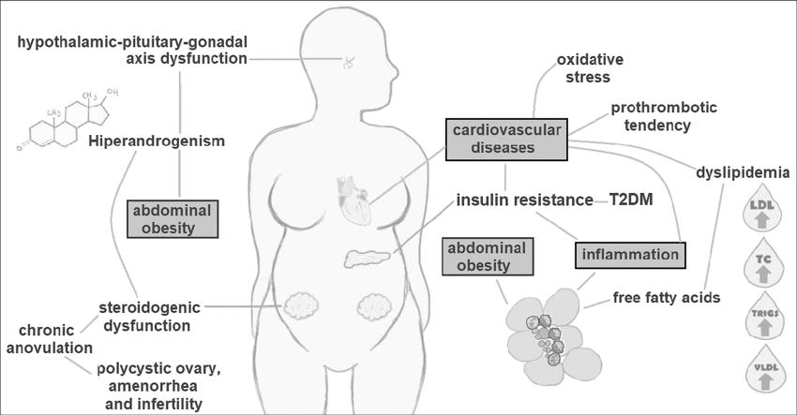

**Figure 2:** Associated symptoms of PCOS

**Source: Adapted from** Laura *et al.* (2018).

16

**2.6 Etiologies of PCOS**

The etiology of PCOS is unknown (Dunaif, 2016), although it is clear that this condition has a variety of different symptoms (Aytan *et al.,* 2016). Although Wang et al. determined that hyperandrogenemia (HA) and IR are the main hormonal characteristics and the central etiology of PCOS in 2019, (Wang, *et al.,* 2019). They suggested that IR and HA, which may interact in the pathophysiology of the disorder, are the primary causes of PCOS (Wang, *et al.,* 2019)

Despite the gaps in our knowledge of the etiology of PCOS, some biochemical abnormalities that are connected to it have been thoroughly documented, and inflammation is believed to be a major factor in the development of these metabolic imbalances (Carvalho *et al*., 2017a). PCOS is made worse by a bad diet, lifestyle, or other infectious agents (Ajmal *et al.,* 2019). As a result of IR and HA's impact on ovarian function, testosterone levels rise, which aids in anovulation (Ajmal *et al.,* 2019).

PCOS has an impact on GnRH, FSH, LH, and prolactin levels (Ajmal *et al.,* 2019). The etiology of PCOS is influenced by both genetic and environmental factors. Databases indicate that 241 different gene variations may contribute to PCOS (Ajmal *et al.,* 2019). A gene's lack of transcriptional activity in PCOS is brought on by a polymorphism (Ajmal *et al.,* 2019).

This is mostly caused by the genes that encode for the androgen receptor, LH receptors, FSH, and leptin receptors (Ajmal *et al.,* 2019). Lowering insulin resistance and improving reproductive biomarkers including the antral follicle count and blood levels of sex hormones, gonadotropins, and AMH are two additional ways that exercise is beneficial for patients' health (Al-Eisa *et al.,* 2017).

**2.7 Metabolic disturbances associated with PCOS**

According to Bozdag *et al.* (2016), PCOS affects women of reproductive age and has serious metabolic, reproductive, and psychological effects. These effects include an increase in type 2 diabetes mellitus (T2DM), anxiety, depression, and cardiovascular risk factors, all of which are serious health burdens (Kakoly *et al.,* 2018). Due to the intricate systemic interactions between the many components of the metabolic syndrome, numerous theories have been put up to elucidate the underlying pathophysiology of these interactions (Swaramya *et al.,* 2018).

17

The metabolic syndrome includes cardiovascular risk factors which include visceral obesity,

atherogenic dyslipidemia, and hypertension as well as hyperinsulinemia and type 2 diabetes.

(Figure 3).

18

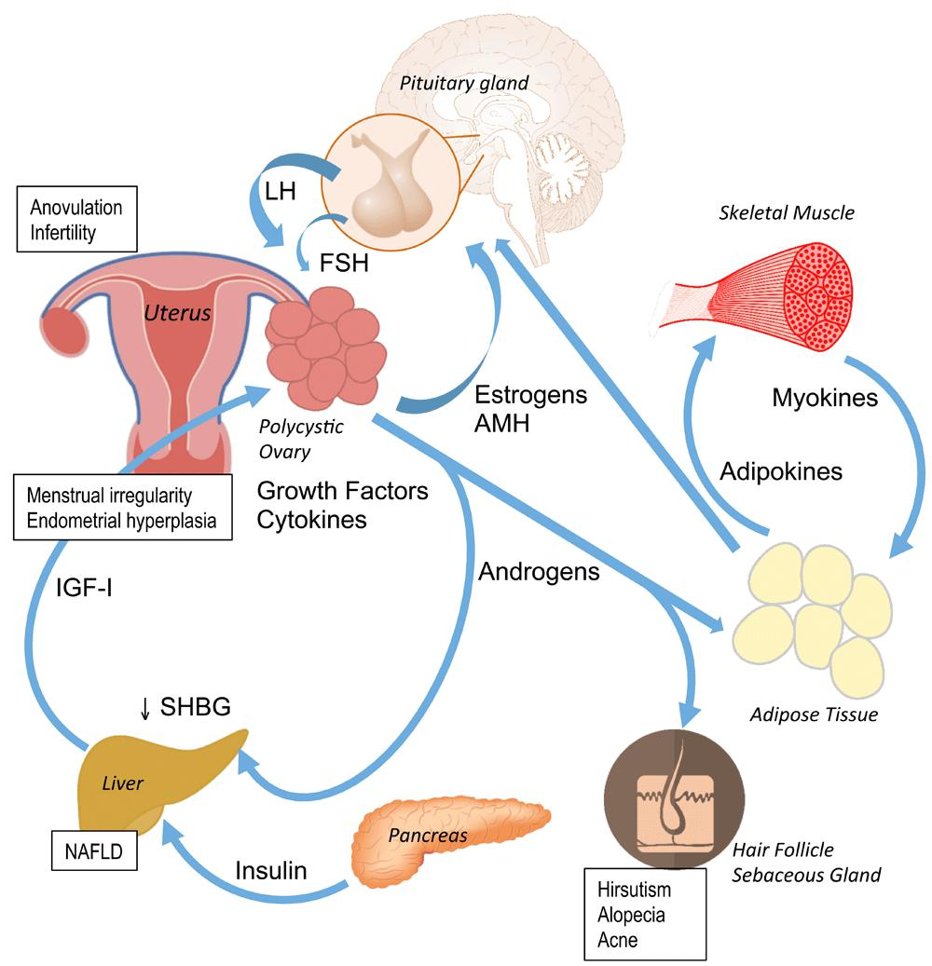

**Figure 3.** Pathophysiology of PCOS

**Source:** Walters *et al.* (2018).

19

**2.7.1. Insulin Resistance and hyperinsulinemia**

When the physiologic response to insulin stimulation is diminished in target tissues such the liver, muscle, and adipose tissue, insulin resistance develops (Seong *et al.,* 2019).

Patients with PCOS, both obese and lean, are affected by insulin resistance (Stepto et al., 2019). Obese PCOS patients are impacted 70% to 95% of the time, compared to lean PCOS patients who are afflicted 30% to 75% of the time (Randeva et al., 2012). High insulin levels are a symptom of PCOS and one of its primary causes (Diamanti-Kandarakis and Papavassiliou, 2006). Excessive testosterone production in the ovaries can impede ovulation when insulin levels are high (Corbould *et al.,* 2005). Insulin interacts with cell surface receptors that share structural similarities with theinsulin-like growth factor-1 (IGF-1) receptor (Macut *et al.,* 2017).

This promotes glucose absorption by increasing the transfer of the insulin-responsive glucose transporter 4 (GLUT4) from intracellular vesicles to the cell surface. This mechanism is brought on by phosphatidylinositol 3-kinase (PI3-K) activation (Macut *et al.,* 2017). Excess androgens are brought on by hyperinsulinemia, which develops when insulin imitates the impact of LH and indirectly raises Gonadotropin-releasing Hormone (GnRH) (Puttabyatappa and Padmanabhan, 2018). The amount of SHBG, a vital circulatory protein that regulates testosterone levels, is decreased by insulin (Rojas *et al.,* 2014). Inflammatory conditions like infertility and weight gain have been linked to insulin signaling. (Figure 4)

Inflammation impairs the effects of insulin and glucose tolerance and may contribute to PCOS patients' hyperandrogenism, insulin resistance, and abdominal fat (Phinney and Volek, 2019). Insulin resistance worsens the clinical signs and symptoms of hyperandrogenism (Cassar *et al.,* 2016). Regardless of Body mass index, PCOS increases the risk of type 2 diabetes, accounting for 23% of cases in young women. However, the fundamental causes of PCOS's insulin resistance are still unknown (Kakoly *et al.,* 2018).

Evidence suggests that PCOS may not be the cause of insulin resistance, but rather that it is one of its effects (Moghetti and Tosi, 2021). Several studies utilizing multi-step hyperinsulinemic glucose clamps have shown that after supraphysiological testosterone treatment, insulin resistance rapidly develops in females (Moghetti and Tosi, 2021). In a two-step glucose clamp investigation, insulin-

20

induced glucose uptake was impaired in hyperandrogenic women compared to healthy controls, as expected (Moghetti and Tosi, 2021).

21

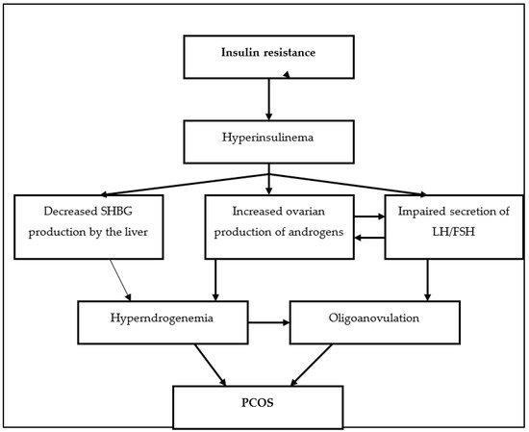

**Figure 4:** Pathway showing the effects of Insulin resistance

**Source:** Ajmal *et al.*(2019).

22

**2.7.1.1 Visceral Obesity**

Women with PCOS are more vulnerable to visceral obesity, which has been linked to insulin resistance, dyslipidemia, and cardiovascular disease (Pavaleanu *et al.,* 2016; Papadakis *et al.,* 2017, Zeng, 2020). Androgens stimulate adipocyte formation in the abdominal region of the body, which can result in adipose tissue malfunction, insulin resistance, and fat storage (Zeng, 2019). Additionally, despite having a normal BMI, non-obese females with PCOS showed better visceral adiposity and greater inflammatory cytokines than comparable non-obese controls (Jena *et al.,* 2018).

Obesity is indicated by elevated triglyceride (TAG), cholesterol, free fatty acid, and different apolipoprotein abnormalities (Torre-Villalvazo *et al.,* 2018). Reduced insulin sensitivity and decreased glucose absorption are brought on by an increase in free fatty acids (Chow *et al.,* 2017).

Obesity, particularly visceral obesity, which is prevalent in PCOS patients who are overweight or underweight, exacerbates and worsens metabolic and reproductive consequences (Azziz *et al.,* 2016). As a result of increased adipogenesis and decreased lipolysis, obesity results in insulin resistance and compensatory hyperinsulinemia (Legro, 2012).

Obesity promotes ovarian androgen activity, which raises functional ovarian hyperandrogenism and alerts the thecal cells to LH activation (Pavaleanu *et al.,* 2016). Increased insulin resistance and adipogenesis are caused by obesity, which increases inflammatory adipokine levels (Glueck and Goldenberg, 2019). PCOS may be exacerbated by obesity since it has been linked to a disturbance of the hypothalamic-pituitary-ovarian axis (Legro, 2012).

Reduced visceral fat would regulate appetite, blood sugar levels, lipolysis, and SHBG, all of which would regulate the ovarian androgen response (Ouchi *et al.,* 2011). Obesity is not a requirement for PCOS diagnosis, however those with the condition have more visceral adipose tissue (VAT) than women without it do. The relationship between VAT and total androgen levels has also been demonstrated, suggesting that obesity may contribute to PCOS (Jena *et al.,* 2018).

**2.7.1.2. Hypertension**

Another cardiovascular risk factor linked to PCOS is this (Gandevani *et al.,* 2018). High baseline blood pressure has been established as a key indicator of cardiovascular risk, and over 30% of women with PCOS had a blood pressure of less than 130/85 mmHg (Azziz *et al.,* 2016). The levels

23

of glucose, insulin, and lipids were greater in hypertensive women even after correcting for body mass index (BMI) (Glintborg *et al.,* 2016).

Additionally, hypertension was identified at an early age, in particular when pregnant PCOS women's blood pressure was checked (Glintborg *et al.,* 2016). Amiri, found that coronary artery calcification is four times more likely in the study group than in the control group in young obese women with PCOS and a 5-fold higher risk of preclinical coronary atherosclerosis than the general population (39.0 % vs. 9.9%) (Amiri and others, 2020)

The coagulation cascade, interleukins, and other inflammatory cytokines were once brought on by oral contraceptives in women with the syndrome, increasing their risk of thromboembolic events and overall cardiovascular disease (Glintborg *et al.,* 2016).

**2.7.1.3 Dyslipidemia**

Dylipidemia is defined as either a high level of lipids (cholesterol, triglycerides, or both) or a low level of high-density lipoprotein (HDL) cholesterol. Dylipidemia is one of the cardiovascular risk factors linked to PCOS (Michael *et al.,* 2019). It has been hypothesized that dyslipidemia contributes to the development of PCOS (Michael *et al.,* 2019). Low levels of HDL cholesterol, high triglycerides (TG), total cholesterol (TC), and low-density lipoprotein (LDL) cholesterol are characteristics of PCOS (Ghaffarzad *et al.,* 2016). Women with PCOS have higher dyslipidemia levels, including smaller LDL particles, which raises their risk of heart disease (Kumar *et al.,* 2017).

An abnormal lipid profile therefore affects the clinical course of PCOS (Diamanti-Kandarakis *et al.,* 2007). The most prevalent metabolic disruption in PCOS is dyslipidemia, also known asatherogenic dyslipidemia, along with insulin resistance disorders (Macut *et al*., 2011). It was found that androgen excess produces more atherogenic LDL cholesterol particles in the early stages of PCOS development, leading to long-term atherogenic potential with a longer time for oxidative transformation of LDL cholesterol. (Macut *et al.,* 2011)

According to Zhang *et al*. (2016), PCOS patients have low levels of LDL and high levels of triglycerides, and the development of the metabolic syndromes is dependent on HDL levels (Shaman *et al.,* 2017). PCOS has been associated with a large increase in LDL, and statin therapy lowers these levels (Seymam *et al.,* 2017). Women with PCOS have smaller LDL particles and

24

greater dyslipidemia, which raises their risk of cardiovascular illnesses (Kumar *et al.,* 2017). Women with PCOS frequently have lipid abnormalities and mild hypercholesterolemia (Pergialiotis *et al.,* 2018).

**2.8 Management options of PCOS**

Treatment methods can be classified into four groups based on the clinical symptoms and underlying causes: ovulatory dysfunction, hyperandrogenism, reducing insulin resistance, and infertility treatment (Zimmerman *et al.,* 2019). All PCOS symptoms must be treated and under control in order to prevent health issues. PCOS is a persistent condition that necessitates constant care (Zimmerman *et al.,* 2019).

PCOS can be treated with lifestyle modifications, pharmacological interventions such oral contraceptives, hormonal prescriptions, and infertility therapies like insulin sensitizers and ovulation inducers, depending on the symptoms.

**2.8.1. Modification of Lifestyle**

Given the effects of obesity on reproductive, metabolic, and psychosocial health, lifestyle changes such as a healthy diet, increased physical activity, and the application of behavioral approaches are the initial treatments for PCOS (Teede *et al.,* 2011, Lim *et al.,* 2013). When overweight PCOS patients receive treatment and drop a little weight, biochemical reproduction, insulin resistance, and surrogate markers of fat distribution improve (Moran *et al.,* 2011).

Studies have shown that altering one's lifestyle—including what they eat, how often they exercise, and how they think—has a positive effect on body weight, insulin resistance, and testosterone levels (Moran *et al.,* 2011). There are no specific, research-based recommendations for cooking PCOS-friendly cuisine (Orio *et al.,* 2016). Exercise benefits PCOS-diagnosed women's anthropometric measurements, insulin sensitivity, lipid profile, cardiovascular inflammatory markers, and menstrual cycle, according to the Structured Activity Training Program (Orio *et al.,* 2016).

The standard recommendations for exercise are 150 minutes of moderate exercise per week or 75 minutes of vigorous exercise per week (Teede *et al.,* 2018). For modest weight loss, weight recovery prevention, and increased health benefits, it is advised to engage in at least 250 minutes of moderate-intensity activity or 150 minutes of vigorous-intensity activity each week (Teede *et al.,* 2018). Some behavioral weight management strategies include goal setting, self-monitoring,

25

stimulus control, problem-solving, self-assertion training, slow eating, strengthening change, and preventing recurrence (Brennan *et al.,* 2017).

The most important and simple step for women with PCOS is to change their lifestyle because PCOS is a chronic illness with a higher risk of consequences like type 2 diabetes (Carmina, 2012).

**2.8.2 Medical Interventions**

**2.8.2.1 Oral contraceptive pills (OCPs)**

By reducing levels of male hormones, OCPs can help PCOS women manage excessive hair growth and acne (Leo *et al.,* 2009). By restoring the menstrual cycle to normal, OCPs that contain estrogen and progestin can aid in the management of PCOS symptoms (Leo *et al.,* 2009).

The best method of birth control for PCOS patients should prevent the development of antagonist follicles, reduce androgen levels, block the effects of testosterone on peripheral sebaceous units, balance estrogen and progesterone in the endometrium, and provide good menstrual cycle control (Wiegratz *et al.,* 2003).

**2.8.2.2 Hormone Medications**

Women with PCOS who exhibit hyperandrogenic clinical symptoms (such hirsutism, acne, or alopecia) can be administered antiandrogens in addition to or instead of OCPs to reduce the intensity of hyperandrogenism (Katsambas and Dessinioti, 2010). Spironolactone, an aldosterone antagonist, has been shown to help with hirsutism and acne when combined with OCPs (Saha *et al.,* 2011).

At high concentrations, the aldosterone antagonist spirolactone exerts an antiandrogenic effect (Badawy and Elnashar, 2011). As first-line treatments for hirsutism and acne, antiandrogens such spironolactone, flutamide, and cyproterone acetate are used because they prevent the release of testosterone by inhibiting androgen receptors (Badawy and Elnashar, 2011). When combined with metformin, the selective nonsteroidal antiandrogen flutamide is as effective at treating hirsutism as spironolactone and is superior to OCPs in improving fatty, inflammatory, and lipid structural characteristics. However, use of flutamide is inadequate due to hepatotoxicity (Ibanez and Zegher, 2006).

Finasteride, which inhibits the production of dihydrotestosterone, is better at reducing hirsutism than spironolactone and flutamide, but less successful at enhancing it (Koulouri and Conway,

26

2008). When it comes to treating acne, Flutamide appears to be more successful than Finasteride (Archer and Chan., 2004). Because there is a chance of feminizing a male child during pregnancy, all antiandrogens should be avoided (Archer and Chang, 2004). Metformin is used with flutamide to prevent hepatotoxicity (Ibanez and Zegher, 2006).

When used with Clomiphene Citrate (CC), glucocorticoids (such as prednisone and dexamethasone) lower adrenal androgen secretion, improve ovulation and conception rates, and diminish the endometrium's ability to produce reverse estrogens in PCOS patients (Elnashar *et al.,* 2006). Glucocorticoids are also used to treat the clinical signs of androgen hyperplasia in women with PCOS (Parsanezhad *et al.,* 2002). Glucocorticoids should only be used after trying other medications when adrenal androgen levels are high due to deteriorating glucocorticoid-related insulin resistance and its link to osteoporosis (Badawy and Elnashar, 2011).

If OCPs are ineffective for treating acne and hirsutism, gonadotropin-releasing hormone agonist (GnRHa) is another alternative (Acien *et al.,* 1997). Hirsutism has demonstrated to be more active in reducing the score when paired with OCPs than OCPs alone (Ciotta *et al.,* 1996). In a different trial, women with PCOS who had their hirsutism treated with GnRHa alone or in conjunction with OCPs or flutamide experienced considerable decreases in their hirsutism (De Leo *et al.,* 2000).

Although studies have shown that GnRHa can help with acne, few studies have contrasted it with other acne therapies (Couzinet *et al.,* 1986). Contrarily, GnRHa therapy costs a lot of money and has side effects such headaches, bone loss, and menopausal disorders (Lupoli *et al.,* 1997).

By increasing SHBG levels and dispersing them in adipose tissue, TZDs reduce excessive androgens (Brettenthaler *et al.,* 2004).

**2.8.2.3 Ovulation-inducing Substance**

Clomiphene citrate (CC) is the drug of choice for treating anovulatory infertile women (Dhaliwal *et al.,* 2020). By inhibiting the estrogen receptor in a negative feedback loop, CC raises FSH levels(Dhaliwal *et al.,* 2020). It is designated for the treatment of PCOS patients who are anovulatory, despite the fact that pregnancy rates greatly rely on BMI.

The likelihood of pregnancy increases for BMIs under 30, whereas it reduces for BMIs beyond 30. (Legro *et al.,* 2007). A selective estrogen receptor modulator called clomiphene citrate (also known as Serophene or Clomid) binds to estrogen receptors to cause ovulation by boosting pituitary

27

gonadotropin production. A spike of LH produced by CC directly causes ovulation to occur within a few days (Lucidi, 2019).

Clomiphene citrate is advised as the first line of treatment when ovulation induction occurs and fertility is desired (Vause *et al.,* 2010). After receiving clomiphene citrate treatment, some patients' patients show signs of resistance. As a result, second-line therapy is an option. (2015) Spritzer et al. When CC with or without metformin fails to achieve fertility, laparoscopic ovarian drilling, exogenous gonadotropins, and in vitro fertilization have been regarded as the second-line treatments for PCOS (Spritzer *et al.,* 2015).

Tamoxifen and CC are comparable medications that are both used to treat anovulation in patients who do not respond to CC therapy (Dhaliwal *et al.,* 2020). Trials using both clomiphene and tamoxifen together showed a noticeably higher pregnancy rate as a result of tamoxifen's putative impact on uterine lining (Dhaliwal *et al*., 2020). For anovulatory infertile PCOS patients, gonadotropins such human menopausal gonadotropin (HMG) and recombinant FSH are second-line treatments (Melo *et al.,* 2015).

Low-dose FSH therapy for PCOS patients is effective at causing ovulation and raising conception rates (Melo *et al.,* 2015). For PCOS women with infertility who have no issues, in-vitro fertilization (IVF) is recommended as a third-line treatment (Melo *et al.,* 2015).

**2.9 Aromatase inhibitors**

The enzyme known as aromatase is a member of the cytochrome P450 superfamily. Ovarian granulosa cells, placental syncytiotrophoblast, adipose tissue, brain, and skin fibroblasts all express the aromatase enzyme. Ovarian granulosa cells in premenopausal women and adipose cells in postmenopausal women are the main producers of aromatase. Beginning the day after treatment, aromatase inhibitors reduce the production of estrogen in peripheral organs and the ovaries. They function by preventing the enzyme aromatase from converting androgens (such as testosterone into estradiol and androstenedione into oestrone) into oestrogens (Burney and Guidice, 2012).

Three generations of aromatase inhibitors have been developed (AIs). A first-generation aromatase inhibitor is aminoglutethimide. The inhibitors of the second generation include fadrozole and formestane. Third-generation inhibitors include exemestane, letrozole, and anastrozole. To cause a medical adrenalectomy, aminoglutethimide is injected intramuscularly. Sleepiness, rashes, and

28

nausea are among the side effects of aminoglutethimide therapy that are frequently experienced. Second-generation aromatase inhibitors can also be taken intramuscularly and are thought to have milder side effects. The third generation AIs are the most effective, selective, and reversible inhibitors. They are often taken orally. As soon as 24 hours following dosage, the third-generation AIs reduce serum 17-estradiol by 97-99%. Premenopausal women's FSH levels are also raised by them. Third-generation AI side effects, which are predominantly linked to low oestrogen levels, include vaginal dryness, hot flushes, headache, back discomfort, numbness in lower extremities, and arthralgia (Cavalho *et al.,* 2011).

**2.9.1 Letrozole**

Letrozole, often known as "Femara," is an oral drug that is given to women with PCOS and unexplained infertility in order to promote ovulation (2.5 mg) (Rachel., 2020).

Compared to other estrogenic drugs, it is an aromatase inhibitor with less anti-estrogenic characteristics (Rachel., 2020). Drugs known as aromatase inhibitors prevent the manufacture of estradiol rather than how it interacts with receptors (Pritts *et al.,* 2011). These inhibitors work by preventing the aromatase enzyme from "aromatizing," or converting androgens into estrogens (Soni *et al.,* 2020).

Letrozole, on the other hand, is widely used to treat CC resistance, which happens when CC fails to promote ovulation despite increasing dosages of the medication after at least three treatment cycles (Rachel., 2020). Additionally, letrozole is normally taken once daily for five days and prevents the body from converting androgens to estrogen, which happens when estrogen is suppressed (Rachel., 2020).

When estrogen is suppressed, the pituitary gland is informed to create FSH, which, as previously mentioned, stimulates the ovary to develop an egg (Ataollah *et al.,* 2016). Some letrozole-using women release many eggs at once because letrozole causes them to create more FSH than they would ordinarily when ovulating (Alex Mlynek, 2018). Letrozole is an organic substance that belongs to the diphenylmethane class of substances (Wishart *et al.,* 2018).

Compounds having a diphenylmethane moiety, or methane with two hydrogen atoms swapped out for two phenyl groups, are known as diphenylmethanes. Methanes known as diphenylmethanes have two phenyl groups (Wishart *et al.,* 2018). It is used to treat early-stage breast cancer in

29

postmenopausal women who have already undergone adjuvant tamoxifen therapy for five years. The Food and Drug Administration (FDA) has approved the medication letrozole (Wishart *et al.,* 2018). Whether or not their breast cancer is hormone receptor positive, women with locally progressed or metastatic breast cancer after menopause should think about using this medicine as their first line of treatment (Wishart *et al.*, 2018).

As a sort of negative feedback, the pituitary gland produces FSH, and it is this secretion that triggers ovulation or oligovulation (Casper., 2004). Early in the menstrual cycle, letrozole can mimic the effects of cyclosporine without lowering estrogen receptors (Casper., 2004). Letrozole has been investigated as a reproductive drug at the University of Toronto recently, with encouraging outcomes (Mitwally and Casper., 2006).

The results show that after a few days of taking the last tablet, the medicine appears to be totally removed from the body (Mitwally and Casper., 2006). It looks to be a secure fertility drug because there is currently no data to suggest that it harms the developing embryo (Mitwally and Casper., 2006). 35 anovulatory infertile individuals who were unresponsive to CC were included in a study at a tertiary referral infertility center in Dhaka (Begum *et al.,* 2009). Using letrozole at doses ranging from 2.5 to 5 mg, Begum et al. (2009) observed a high success rate of 77.77 % for follicular development. Another study by Badawy *et al.* (2007) discovered that using 5 mg of letrozole in PCOS patients who had previously received CC led to a majority of the time to a successful induction rate of 62%.

**2.9.1.1 Mechanism of action of letrozole**

A category II non-steroidal aromatase inhibitor is letrozole (Drugbank, 2020). It prevents the aromatase enzyme (cytochrome P-450 19) from functioning, blocking an essential step in the production of estrogen in the ovaries and other vital organs.

C-19 androgens are converted to C-18 estrogens during this phase (Rose and Brown, 2020). In postmenopausal women, the aromatase enzyme predominantly produces estrogen and estradiol by converting the adrenal androgens, chiefly androstenedione and testosterone, into estrogens and progesterone, respectively (Novartis, 2018). By directly aiming at and blocking the aromatase enzyme, estrogen biosynthesis can be reduced in both cancerous and peripheral tissues (Novartis, 2018).

30

Letrozole suppresses estrogen biosynthesis all over the body by competitively binding to the heme of the aromatase's cytochrome P450 subunit, which causes a decrease in estrogen production in all tissues (Begum and Siddiqui, 2009). While letrozole medication has been demonstrated to dramatically lower serum levels of estrogen, estradiol, and estrone sulfate in females, it has not been demonstrated to have any impact on the production of aldosterone, adrenal corticosteroids, or thyroid hormones (Novartis, 2018).

**2.9.1.2 Pharmacology of letrozole**

The Food and Drug Administration has authorized the use of letrozole since 1998 as a tool in the treatment of postmenopausal women with hormone receptor-positive early breast cancer, whose indication is targeted toward those who have already received treatment with tamoxifen for five years, as well as a first and second line in the treatment of advanced breast cancer at a dosage of 2.5mg/d (Cai *et al.,* 2021). Despite the absence of strong evidence of morbidity and mortality, letrozole was recommended by the American Society of Clinical Oncology as an additional endocrine treatment for women with hormone receptor-positive breast cancer in an effort to reduce the disease's recurrence rate (Cai *et al.,* 2021). By promoting insulin-like growth factor-1, letrozole has also been proposed as a method to help postmenopausal women reabsorb more bone (Cai *et al.,* 2021). It's interesting to note that letrozole has been studied for potential clinical uses in othercontexts, including female to male transsexuals and children with constitutional delay of growth and puberty (CDGP) (Cai *et al.,* 2021).

Letrozole is a third-generation aromatase inhibitor that is reversible and acts in the final stage of the conversion of androgens into estrogens (Cai *et al.,* 2021). It has an 80–90% inhibition rate, which reduces the availability of estrogen in a variety of organs and tissues, including the ovaries, breasts, adipose tissue, and musculoskeletal (Cai *et al.,* 2021). Letrozole significantly reduces the effects of estrogen on breast cancer cells while simultaneously having systemic effects (Cai *et al.,* 2021). For instance, estrogens control how lipids and lipoproteins are metabolized, therefore a decrease in their output may indicate a dysregulation of lipid indices (Cai *et al.,* 2021).

Based on the physiological condition, estrogen increases the catabolism of low-density lipoprotein cholesterol (LDL-C) in the liver while also stimulating the secretion of very-low-density lipoprotein cholesterol (VLDL-C) and VLDL-C uptake by the liver. Several enzymes involved in the metabolism of triglycerides (TG) and high-density lipoprotein cholesterol (HDL-C) may be

31

impacted by a decrease in estrogen production, including hepatic TG lipase and regulating lipoprotein lipase (Cai *et al.,* 2021).

**2.10 Alpha-lipoic acid in PCOS**

By promoting glucose uptake and causing an intracellular redistribution of the glucose transporters GLUT1 and GLUT4, similar to what insulin does, ALA aids in the control of lipid and glucose metabolism (Konrad *et al.,* 2001).

Alpha lipoic acid may help PCOS-affected women's reproductive health and metabolic parameters, according to growing data. In a recent study, a group of 36 PCOS patients' insulin resistance and glucose-load-induced hyperinsulinemia were evaluated, as well as the efficiency of a combination of 400mg of alpha-lipoic acid and 1g of myo-inositol in enhancing gonadotropin production and lowering insulin resistance. However, only hyperinsulinemic PCOS patients did show variations in the Homeostasis Model Assessment Insulin Resistance index (HOMA-IR) and response to oral glucose tolerance test (OGTT), which indicated a significant increase in insulin sensitivity (Genazzani *et al.,* 2014). All of the patients had a significant decrease in LH serum levels and the LH/FSH ratio.

Treatment with metformin 1.7g and alpha lipoic acid with myo-inositol also resulted in a superior response in terms of hyperandrogenism, BMI, and HOMA index in PCOS women than metformin 3g alone (Cappelli *et al.,* 2013).

A group of 37 non-obese PCOS patients who had had Intracytoplasmic Sperm Injection (ICSI) but were unable to conceive were studied by Rago *et al.,* (2015) to determine the effects of a cycle of treatment using 2g of myo-inositol and 800mg of ALA daily. Significant changes in insulin levels, BMI, and ovarian volume were observed after 3 months of treatment, while the pregnancy rate and oocyte quality were comparable to those of patients on myo-inositol alone (Rago *et al.,* 2015). In a different recent trial, 30 young women with PCOS and insulin resistance were given one of two regimens for six months: 1g of myo-inositol, 5mg of monacolin K, and 400mg of lipoic acid, or a double dose of 2g of myo-inositol, 10mg of monacolin K, and 800mg of lipoic acid. Treatment with myo-inositol and ALA showed a dose-dependent improvement in BMI, dyslipidemia, and symptoms of hyperandrogenism such hirsutism and menstrual problems when paired with monacolin K, a natural statin (Morgante *et al.,* 2015).

32

In a group of 46 women with PCOS (26 study group participants and 20 controls), treatment with 1g D-chiro-inositol (DCI) and 600mg ALA daily for 180 days was compared to no treatment. The outcomes were comparable in terms of clinical and metabolic aspects. In fact, insulin levels, lipid profiles, and menstrual cycle frequency all considerably improved in the research group HOMA-IR (Cianci *et al.,* 2015) (Figure 6). Six thin women with PCOS were given a formulation containing 600mg of controlled-release ALA twice day for 16 weeks by Masharani *et al.*, (2010). Even though this group of patients did not have severe insulin resistance, treatment with controlled-release ALA reduced triglyceride levels and improved insulin sensitivity as well as menstruation frequency (Masharani *et al.,* 2010). In a recent trial, Genazzani *et al.*, (2018) demonstrate how daily 400 mg of ALA oral intake improved metabolic impairment in obese PCOS women, particularly those with a history of known diabetes. Practically, ALA supplementation increased insulin sensitivity, particularly in patients with a family history of diabetes who had a deficiency in mitochondrial LASY (lipoic acid synthase) synthesis or function. It's interesting to note that in these patients, lowering plasma levels of triglycerides and GOT significantly enhanced and/or safeguarded liver function, lowering the likelihood of developing a liver impairment (Genazzani *et al.,* 2018).

33

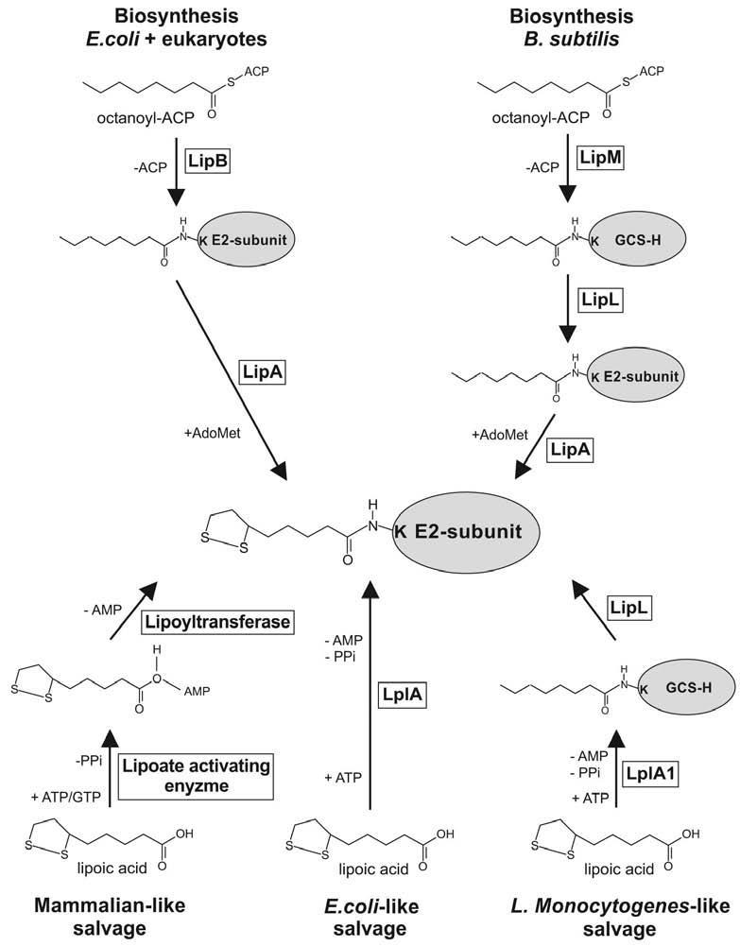

**Figure 5:** The biosynthetic and salvage pathway of Alpha Lipoic Acid Sylke Muller, (2022).

34

**Table 3: Diagnostic Criteria for PCOS**

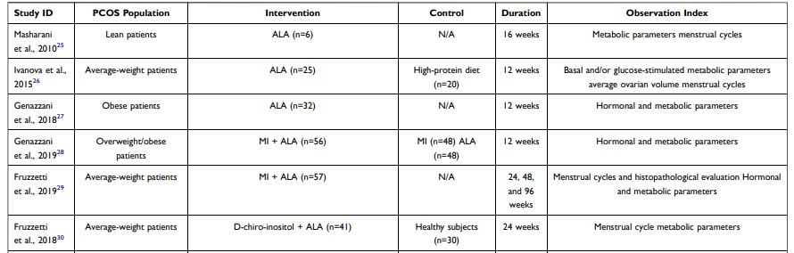

**Adapted from Cheng and He (2022).**

35

**2.10.1 Structure of Alpha Lipoic acid**

Nature has the R-Alpha Lipoic Acid isomer (Figure 6), which can be found in plants, animals, and the human body. This is the way ALA manifests its effects in nature (Golbidi 2011).

There is no S-Alpha Lipoic Acid isomer in nature. It can be made via a variety of thioctic acid chemical processes and inhibits the critical functions of R-ALA, such as their interactions with genes, enzymes, and proteins (Golbidi 2011).

36

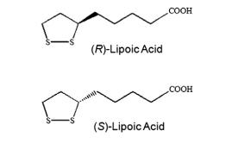

**Figure 6: The structure of the Enantiomers of ALA**

**Source:** Marilia and Carlos (2014).

37

**2.10.2 Synthesis and Pharmacology of Alpha Lipoic Acid**

ALA is typically found in a variety of meals, including vegetables (spinach, broccoli, and tomato), meats, particularly viscera, and dietary supplements. Additionally, enzymatic mechanisms that use cysteine as a sulfur donor and octanoic acid as the starting material can create ALA in the mitochondria of plants and animals (Szelag *et al.,* 2012). Because it contains sulphur, ALA is categorized as a thiol compound. Mammalian cells produce ALA through the action of mitochondrial lipoic acid synthase (LASY), which can be down-regulated in a number of clinical circumstances (Padmalayam *et al.,* 2009).

The R isoform of ALA, one of its two enantiomeric (optical isomers), is a crucial cofactor for mitochondrial enzymes of oxidative metabolism because it is linked in an amide linkage to the €-amino group of lysine residues (Marilia and Carlos 2014).

Dietary supplements that combine R-ALA and S-ALA have been the focus of studies on ALA's absorption and bioavailability. When combined, dietary intake reduces the absolute bioavailability of both enantiomers, which is frequently no higher than 40%. (Packer *et al.,* 2001). Therefore, ALA must be taken 30 minutes before meals. In a number of metabolic pathways, experimental studies have shown that R-ALA is more bipotent than S-ALA (Marilia and Carlos 2014).

After being consumed orally, ALA is absorbed by the digestive system and transported to a number of organs, including the brain, where it has the ability to easily cross the blood-brain barrier (Marilia and Carlos 2014). ALA is converted to DHLA, processed in the liver to a number of byproducts such bisnorlipoate and tetranorlipoate, and then eliminated through the kidneys, regardless of where it comes from initially (diet or nutritional supplements). One system that has so far been connected to the cellular transport of ALA is the transmembrane protein sodium dependent transport, which is made by the SLC5A6 gene and also transports other vitamins and cofactors. Additionally, ALA intestinal absorption is controlled by both transporters (Moini *et al.,* 2002).

The treatment of ALA in cells results in dynamic redox reactions (Haramaki *et al.,* 1997). The disulfide connections in LA have the ability to change the cellular redox environment by oxidizing protein thiols (Haramaki *et al.,* 1997). The thiolane ring of ALA can be converted to vicinal thiols like dihydrolipoic acid (DHLA) in cells via NADH- and NADPH-dependent mechanisms

38

including the mitochondrial electron transport chain, thioredoxin and thioredoxin reductase, lipoamide dehydrogenase, and oxidized glutathione (GSSG) reductases (Haramaki *et al.,* 1997). While ALA can be reduced to DHLA in cells with mitochondria through a process involving lipoamide dehydrogenase and NADH, ALA can also be reduced to DHLA in cells without mitochondria through a process involving glutathione and thioredoxin reductases and NADPH (Arner *et al.,* 1996).

Therefore, ALA is a pharmacological antioxidant that may be created by the body and consumed through food in the form of synthetic R-enantiomers (a type that naturally exists) and S-enantiomers. It also functions as a cofactor for mitochondrial bioenergetic enzymes. In addition, like other potent antioxidants, ALA displays amphiphilic properties and, unlike glutathione, is effective in both reduced and oxidized forms (Arner *et al.,* 1996). In cells, the thiolane ring of LA can be transformed to dihydrolipoic acid (DHLA) by NADH- and NADPH-dependent mechanisms (Figure 6). The amount of GSH and cysteine transport in the cells increases when the DHLA is released into the extracellular environment. When DHLA and GSH levels increase, reactive oxygen species levels may decrease and protein function and activity may vary.

Therefore, ALA is a pharmacological antioxidant that may be created by the body and consumed through food in the form of synthetic R-enantiomers (a type that naturally exists) and S-enantiomers. It also functions as a cofactor for mitochondrial bioenergetic enzymes. In addition, like other potent antioxidants, ALA displays amphiphilic properties and, unlike glutathione, is effective in both reduced and oxidized forms (Arner *et al.,* 1996). In cells, the thiolane ring of LA can be transformed to dihydrolipoic acid (DHLA) by NADH- and NADPH-dependent mechanisms. The amount of GSH and cysteine transport in the cells increases when the DHLA is released into the extracellular environment. When DHLA and GSH levels increase, reactive oxygen species levels may decrease and protein function and activity may vary.

However, fascinating cardiovascular, cognitive, anti-aging, detoxifying, anti-inflammatory, anti-cancer, and neuroprotective properties have also been demonstrated for ALA and DHLA (Barky *et al.,* 2017). The main connection between ALA's pharmacological advantages and its antioxidantactivity (Barky *et al.,* 2017).

39

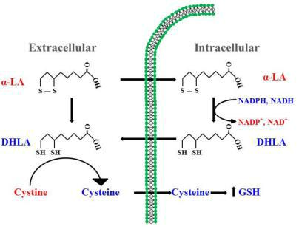

**Figure 7: Dynamic role of Alpha lipoic Acid**

**Source:** Park *et al.* (2014).

40

**2.11 Olive oil**

In Mediterranean regions and communities, where it accounts for one to two thirds of all vegetable fat consumption, olive oil is the primary nutritional staple (Lipworth *et al.,* 1997). The juice of the Olea europaea fruit is what makes olive oil. Virgin olive oil is defined as olive oil that has undergone no additional processing beyond washing, decanting, centrifuging, and filtration. As a result, it serves as a good source of unsaturated fats as well as other dietary elements and minerals (Lopez et al., 2010). Consuming olive oil has been related to a lower risk of metabolic and cardiovascular diseases (Pelucchi *et al.,* 2009). The validity of this association is still up for debate, however higher intakes of oleic acid and monounsaturated fatty acids, as well as a lower ratio of n-6 to n-3 poly-unsaturated fatty acids, have been related to a lowered risk of PCOS (Lopez et al., 2010). These results are one of the things that could help to explain why olive oil has such positive impacts (Verberne *et al.,* 2010).

Olive oil contains a variety of healthy biomolecules, such as monounsaturated free fatty acids (oleic acid), phenolic compounds, squalene, tocopherols, and sterols (Figure 8). Its composition is influenced by the cultivar, environment, ripeness of the olives, and method of oil extraction. (Owen *et al.,* 2004).

The Mediterranean diet (MD) is widely regarded as one of the nutritional approaches that promotes health due to its distinctive features, such as the regular consumption of unsaturated fats, low glycaemic index carbohydrates, fiber, vitamins, and antioxidants, and a moderate number of animal-derived proteins (Nesic *et al.,* 2010). Olive oil has been demonstrated to have well-documented anti-inflammatory qualities in addition to aiding in weight loss. These properties are mostly brought on by the microbiota's production of short chain fatty acids, which is encouraged by dietary fiber (Launoy *et al.,* 1998). The usage of olive oil and the severity of PCOS are not connected, nevertheless, according to the literature.

**2.11.1 Chemistry of Olive oil**

Due to the various extraction techniques, we have access to several kinds of olive oil. According to the International Olive Oil Council (IOOC), "virgin olive oil" is exclusively obtained from the fruits of the olive tree using mechanical or other physical processes in environments where the oil is not altered. Basic procedures including washing, pressing, decantation, centrifugation, and

41

filtering are permissible. Olive oil is divided into different categories based on the method of production, the chemical characteristics, and taste testing panels.

42

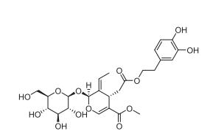

**Figure 8: Structure of Oleic acid**

Source: Lipworth *et al.* (1997)

43

**2.11.2 Synthesis of Olive oil**

Glycerides, which make up the majority of the chemical components in olive oil, account for more than 98% of its weight. Linoleic acid (18: 2 n6), the most significant polyunsaturated fatty acid in our diet, makes up 3 to 21% of total fatty acids, while oleic acid (18: 1 n9), a monounsaturated fatty acid, makes up 56 to 84% of total fatty acids (Rocha et al., 2011). This group of chemicals includes glycerol, fragrance compounds, pigments, sterols, tocopherols, phenols, and others (Hernandez *et al.,* 2015). The principal techniques for analyzing biomolecules in samples of extra virgin olive oil are gas chromatography and high-performance liquid chromatography (HPLC), together with mass spectrometry analysis for quantification and identification (Hernandez *et al.,* 2015).

Triacylglycerols (also known as triglycerides or fats) and a minor amount of free fatty acids make up the majority of the fatty acids in olive oil (FFA). Triacylglycerols, which are analyzed by an HPLC system, are produced when three fatty acid molecules naturally esterify with a glycerol molecule. 55 to 83% of olive oil is composed of the monounsaturated omega-9 fatty acid oleic acid (C18:1). About 3.5 to 21% of olive oil is composed of the polyunsaturated omega-6 fatty acid linoleic acid (C18:2). Olive oil contains 7.5 to 20% of the saturated fatty acid palmitic acid (C16:0). Olive oil contains 0.5 to 5% of the saturated fatty acid stearic acid (C18:0). Olive oil contains 0 to 1.5% linolenic acid (C18:3), a polyunsaturated omega-3 fatty acid. Additionally, the most common triacylglycerol (oleic-oleic-oleic) is created when glycerol is esterified with three molecules of oleic acid, followed by the palmitic-oleicoleic, palimitic-oleic-linoleic, stearic-oleic-oleic, and so forth (Pangiotakos *et al.,* 2015). It is possible to produce additional biomolecules such phenols, phytosterols, vitamins, and fragrance compounds (Pangiotakos *et al.,* 2015).

**2.11.3 Pharmacology of Olive oil**

Monounsaturated fatty acid are more prevalent in olive oil as compared to other fatty acids (oleic acid). The majority of olive oil's health advantages, however, appear to be brought about by its more minor components (Gouvinhas *et al*., 2017). Several studies have provided information regarding the mechanisms of action and therapeutic potential or ability of these tiny components, usually in animal models or ex vivo experiments on people (Visioli *et al.,* 2020).

Consuming olive oil reduces the levels of inflammatory and cell adhesion mediators such vascular cell adhesion molecule 1 (VCAM-1), intercellular adhesion molecule 1 (ICAM-1), interleukin 6 (IL-6) and C-reactive protein, which are produced both pre- and postprandially (CRP). Ex vivo

44

human investigations have discovered that consuming a meal high in olive oil lowers levels of thromboxane B2, leukotriene B4, tumour necrosis factor (TNF) mRNA, arachidonic acid synthesis, and natural killer (NK) cell activity (Mastralexi *et al.,* 2021).

Olive oil has a coagulant impact through decreasing the expression of the von Willebrand factor, which also appears to limit platelet adhesion. Regular usage of olive oil may also reduce blood levels of the plasminogen activator inhibitor-1 (PAI-1) and factor VII activation (Cicerale *et al.,* 2010). Regular olive oil consumption increases the fraction of high-density lipoprotein (HDL) and lowers the atherogenic potential of LDLs by improving their sensitivity to oxidation. There is some, if inconsistent, data to suggest that olive oil can reduce abdominal fat (Marcelino *et al.,* 2019). Homeostasis model assessment-estimated insulin resistance (HOMA-IR) was dramatically decreased with olive oil. None of the three groups, meanwhile, saw their SHBG levels significantly drop after the intervention. Our results agreed with some study that claimed consuming omega-3 fatty acids improved insulin sensitivity. Omega-3 fatty acid supplementation resulted in significant drops in Fasting blood glucose, and Homeostasis model assessment-estimated insulin resistance (HOMA-IR) in 61 overweight or obese women with PCOS, but not in weight loss or BMI (Rafraf *et al.,* 2012). By altering the concentrations of the glucose transporters (GLUT1 and GLUT4) inadipose and muscle tissue, omega-3 fatty acids may increase insulin sensitivity (Rafraf *et al.,* 2012). Olive oil can shed information on the processes by which it can exert its beneficial antioxidative effect by measuring its polyphenol activity or by examining the cumulative protective effect of its polyphenols and MUFA content. A recent meta-analysis found that olive oil considerably reduced serum levels of TC, LDL-c, and TG, but to a smaller extent than other vegetable oils, particularly in subgroup analysis for refined olive oil (Ghobadi et al. 2019).

Ghobadi *et al* (2019) study 's found that oils rich in omega-3s significantly lowered TC, while olive oil did not. On the other hand, it is known that the proportion of n-6 to n-3 fatty acids affects PCOS women's inflammatory state (Szostak et al., 2013). Numerous research have demonstrated that consuming more n-6 PUFA increases the risk of CVD, which is independently connected to higher levels of TC and TG in the blood (Szostak *et al.,* 2013).

45

**CHAPTER THREE**

**3.0 Materials and Methodology**

**3.1 Materials**

Measuring cylinder, Plastic container, Distilled water, conical flask, measuring cylinder, test tubes, test tube racks, diethyl ether, syringe, cannula, cuvette, Accu-check active test strips were products of Roche Diagnostic, Mannheim Sandhofer strasse, Germany.

**3.1.1 Drugs and Assay Kits.**

Letrozole was manufactured by Pharmadox healthcare, UK, Metformin Hydrochloride was manufactured by Sante Pharmaceuticals, France. Clomiphene Citrate was manufactured by Firstsource Pharmachem Lagos, Nigeria. Alpha Lipoic acid was manufactured by NATROL LLC Chatsworth, USA. Insulin Kit was manufactured by Elabscience Biotechnology Inc, USA, Cholesterol test kit was manufactured in the UK by fortress diagnostics limited and the Triglycerides, High density lipoprotein kit was manufactured by Randox Laboratories limited, Co-Atrims, UK.

**3.1.2 Other Chemicals and Reagents**

All chemicals and reagents used used were of analytical grade obtained mainly from Sigma Aldrich Ltd, Buchs, Canada.

**3.1.3 Experimental Animal**

Thirty-five healthy female Wister rats were obtained from the animal holding unit of the Mountain Top University, Ogun State, Nigeria. The animals were kept in a well-ventilated house condition and fed with rat pellets (Vital Feeds, Grand Cereals, Lagos, Nigeria) and water.

**3.1.4 Equipments**

UV-Visible Spectrophotometer (agilent cary 60)**,** ELISA machine (Thermo Scientific), Hot air oven (memmert), Centrifugator (iSG 24-place microcentrifuge CD3024), vortex (VORTEX GENIE-2 Digital)

**3.2 Methodology**

**3.2.1 Induction of PCOS**

Thirty-five female Wistar rats of average weight 205.27 ± 5.23g were acclimatized for seven days under standard room condition (temperature of 22±3 ͦ C; photoperiod of 12h/12h light/dark cycle)

46

and fed with rat pellets and water ad libitum. A known amount of letrozole (1mg/kg) was dissolved in a known volume of saline solution. Administration was carried out once daily for 21 days via oral administration to induce PCOS and the body weight was determined every 7 days, after which were treated with the standard drugs and as well as ALA and olive oil for a period of 14 days. The rats were randomly grouped into five groups of seven animals as follows:

**Group 1**- Control

**Group 2**– PCOS+ Distilled water (0.5ml)

**Group 3**- PCOS+ Metformin (7.14mg/kg )+ Clomiphene citrate(2mg/kg)

**Group 4**- PCOS+ ALA (1mg/kg)

**Group 5**- PCOS+ Olive oil (0.8ml/kg)

**3.2.2 Confirmation of PCOS and Vaginal Cytology**

Using light microscope, the vaginal cytology of the stages of oestrous cycle in the female rats were monitored to observe the predominant cell type in the vaginal smears which was obtained daily for 21 days during the induction period. Twenty-four hours after the last dose (1ml) of letrozole, and after an overnight 12 hours fast, the fasting blood glucose was determined. The rats were sacrificed and blood samples collected using the procedures earlier described by (Yakubu *et al.,* 2008). The serum was used for the assay of serum lipids and reproductive hormones.

At 6-7am vaginal smears were obtained on daily basis throughout the period of study. Holding the rats at the thorax, ventral surface uppermost to provide lumbar support, vaginal secretions were collected using a cotton-tipped swabs softened with a drop of saline. Inserting into the vagina about 1-2 inches of the swab and rotated through 2-3 revolutions, to pick an adequate load of cells, the swab was gently withdrawn, rolled on the glass slide and examined under the light microscope (x40 magnification) (Yakubu *et al.* 2008).

**3.2.2.1 Animal grouping and dosage administration**

PCOS was induced in twenty female Wistar rats with 1ml of letrozole as described previously. Female rats which experienced irregularity in their oestrous cycle were completely randomized into 5 groups (designated 1 – 5) of seven (7) animals in each after which were treated via oral administration of different doses of the standard drugs and plant extracts for a period of 14 days. The administration of the treatment doses according to the groups are as follows:

**Group 1** (non-PCOS-induced control) were administered 1ml of saline water.

47

**Group 2** (PCOS-induced) were administered 1ml of saline water.

**Group 3** (PCOS-induced) were administered 0.5ml each of 7.14 mg/kg body weight of metformin and 2mg/kg body weight clomiphene citrate (Reference drugs).

**Group 4** (PCOS-induced) were administered 1mg/kg body weight of Alpha Lipoic Acid

(ALA).

**Group 5** (PCOS-induced) were administered 1mg/kg body weight of Olive oil.

Using light microscope, the vaginal cytology of the stages of estrous cycle in the female rats were monitored to observe the predominant cell type in the vaginal smears which was obtained daily for 14 days during the treatment period. Twenty-four hours after the last dose of ALA and Olive oil after an overnight 12 hours fast, the fasting blood glucose was determined. At the end of the experimental period, the rats were anesthetized using diethyl ether and sacrificed by jugular puncture. The rats were sacrificed and blood samples collected using the procedures earlier described by (Yakubu *et al.,* 2008). Thereafter, the ovaries, liver and kidney were isolated and separately fixed in 10% diethyl ether for histological studies. Whereas the serum and tissue supernatants were used to carry out biochemical hormonal assays.

**3.2.3 Determination of Fasting Blood Glucose Level**

Using the glucometer kit (Accu-check, product of Roche Diagnostic GmbH, Sandhofer Strasse Germany), the level of fasting blood glucose was determined, after an overnight fast for 12 hours. In the morning (6:00 – 7:00 am), the tip of the tail of the rats were pricked with lancet and blood from the tail was allowed to drop on the strip which had been inserted into the glucometer. The blood glucose concentration was obtained in mg/dl for each rat in all the groups (Saidu *et al.,* 2014).

**3.2.4 Preparation of Serum and Tissue Supernatants**

The rats were weighed individually and thereafter anaesthetized in a jar containing cotton wool soaked in diethyl ether. The neck area was cleared of fur and skin to expose the jugular veins. The jugular veins were displaced slightly from the neck region and thereafter cut with a sharp sterile blade. The animals were held head downwards, allowed to bleed into clean, dry sample tubes and left at room temperature for 10 minutes to clot. The blood samples were centrifuged at 4000rpm for 10 minutes to obtain the supernatant from the stock using Thermo Scientific Centrifuge (Heraeus Megafuge 8).

48

**3.2.5 Determination of Serum Concentration of Hormones**

**3.2.5.1 Insulin**

The serum insulin was quantitatively determined using microplate immunoenzymometric assay kit as described in the manufacturer’s protocol version (Eastham, 1985).

**Principle**

The principle is based on the interaction of streptavidin coated wells with exogenously injected biotinylated monoclonal insulin antibody to immobilize the surface of a microplate well. The enzyme-labeled antibody and a serum containing the natural antigen create a soluble sandwich complex with no competition or steric hindrance between the native antigens and antibodies. The enzyme's activity in the antibody-bound fraction is proportional to the concentration of natural antigen (Eastham, 1985).

**Procedure**

An aliquot (0.05ml) of the standard solution, control, serum samples were placed in appropriate wells. Exactly 0.01 ml of the insulin enzyme reagent was dispensed into each well and the microplates were swirled gently for 20 seconds. The microplates containing the reaction medium was wrapped in a plastic bag and incubated for 120 minutes at 25 ͦC. the wells were washed three times with 0.35ml of working substrate solution per well and aspirated using a 61 micropipette. A known volume (0.1ml) of the working substrate was added to each well and incubated at 25 ͦC for 15 minutes. Exactly 0.05 ml of stopping reagent was placed into each well and mixed gently for 20 seconds. The plate was read on microplate reader at 450nm within 30 minutes after the addition of the stopping reagent (Eastham, 1985).

**Calculation**

The serum insulin concentration absorbance of the standard sample 1985).

was extrapolated from the calibration curve. Plotting the at 450nm against its corresponding concentration (Eastham,

**3.2.6 Lipid Profile Determination**

**3.2.6.1 Serum Total Cholesterol Concentration**

The total cholesterol concentration in the serum of the rats was carried out using the CHOD-PAP reaction (Tietz 1995).

**Principle**

49

It is based on the following reactions:

Cholesterol + H2O  Cholesterol +Fatty acids

+ H2O + O2  Cholesterol + H2O2

H2O2 + 4-Amino antipyrine + P-Hydrobenzoic acid Colored Quinonic derivatives + 4 H2O 62



**Procedure**

A known volume (2.0ml) of the working reagent was placed into test tubes containing 0.02 ml of the appropriately diluted serum samples. The blank and standard were constituted by substituting the serum with 0.01 ml of distilled water and standard working reagent respectively. The reaction constituent was thoroughly mixed and incubated at 37 ͦ C for 5 minutes. Absorbance was spectrophotometrically read at 546nm against the blank (Tietz 1995).

**Calculation**

Concentration of cholesterol = x 5.40mM/L

**3.2.6.2 Serum Triglyceride Concentration**

The concentration of serum triglyceride, (TG) was determined calorimetrically (Tietz 1995).

**Principle**

The triglyceride concentration is determined after enzyme activity hydrolysis with lipases, the indicator is quinonimine formed from hydrogen peroxide, 4- aminophenazone and 4- chlorophenol under the catalytic influence of peroxidase.

Triglyceride + H2O  Glycerol + Fatty acid

H2O2 + 4-aminophenazone  Quinonimine + HCl + 4 H2O + Chlorophenol.

**Procedure**

Exactly 1000μl of the working reagent was added to well clean labelled test tubes consisting of blank, standard and sample. Thereafter 10μl of the distilled water, standard solution (200mg/dL) and serum samples were added respectively. The resulting solution was mixed and incubated for 5 minutes at 37 ͦC. The change in absorbance of standard and sample against the reagent blank was read at 500nm (Tietz 1995).

**Calculation**

Concentration of Triglyceride (TG) = x 2.17mM/L

50

**3.2.6.3. Serum High Density Lipoprotein-Cholesterol Concentration**

The determination of serum High Density Lipoprotein Cholesterol (HDL) concentration (Tietz 1995).

**Principle**

The addition of phosphotungstic acid in the presence of magnesium quantitatively precipitates the low-density lipoprotein (LDL and VLDL) and chylomicron fractions. The cholesterol concentration in the HDL-Cholesterol fraction that remains in the supernatant is evaluated after centrifugation (Tietz 1995).

**Procedure**

Exactly 200μl of the serum samples and standard were dispensed into separate test tubes and 500μl of the reagent was added. The resulting solution was mixed and left for 10 minutes at room temperature. Thereafter, it was centrifuged at 4000rpm for 10 minutes and the clear supernatant was separated for determination of cholesterol content. The concentration of cholesterol was determined using enzymatic saponification procedure as described by Tietz (1995).

**Calculation**

HDL-C = x 5.25mM/L

**3.2.6.4 Serum Low Density Lipoprotein-Cholesterol Concentration**

The serum Low Density Lipoprotein (LDL) cholesterol concentration can be expressed as: LDL Cholesterol = Total Cholesterol – (HDL + TG) (Tietz 1995).

**3.2.7 Data Analysis**

All data were expressed as the mean of seven replicates ± standard error of mean (S.E.M) except otherwise stated. Statistical analysis of the data was performed by SPSS version 20 using one way analysis of variance (ANOVA), followed by Duncan multiple range test for multiple comparison. Values were considered statistically significant at (p <0.05) (Yakubu *et al.,* 2015).

51

**CHAPTER FOUR**

**4.0 Results**

**4.1 Fasting blood glucose of letrozole-induced animals administered Alpha lipoic acid and olive oil**

The fasting blood glucose levels of animals before induction was significantly (p>0.05) higher than the fasting blood glucose of the animals after induction. The administration of the 1 mg/kg body weight of ALA to letrozole-induced animals significantly increased the fasting blood glucose concentration in a similar way to letrozole-induced animals that received the reference drugs: metformin, clomiphene citrate and olive oil (Figures 9, 10, 11, 12, 13).

52

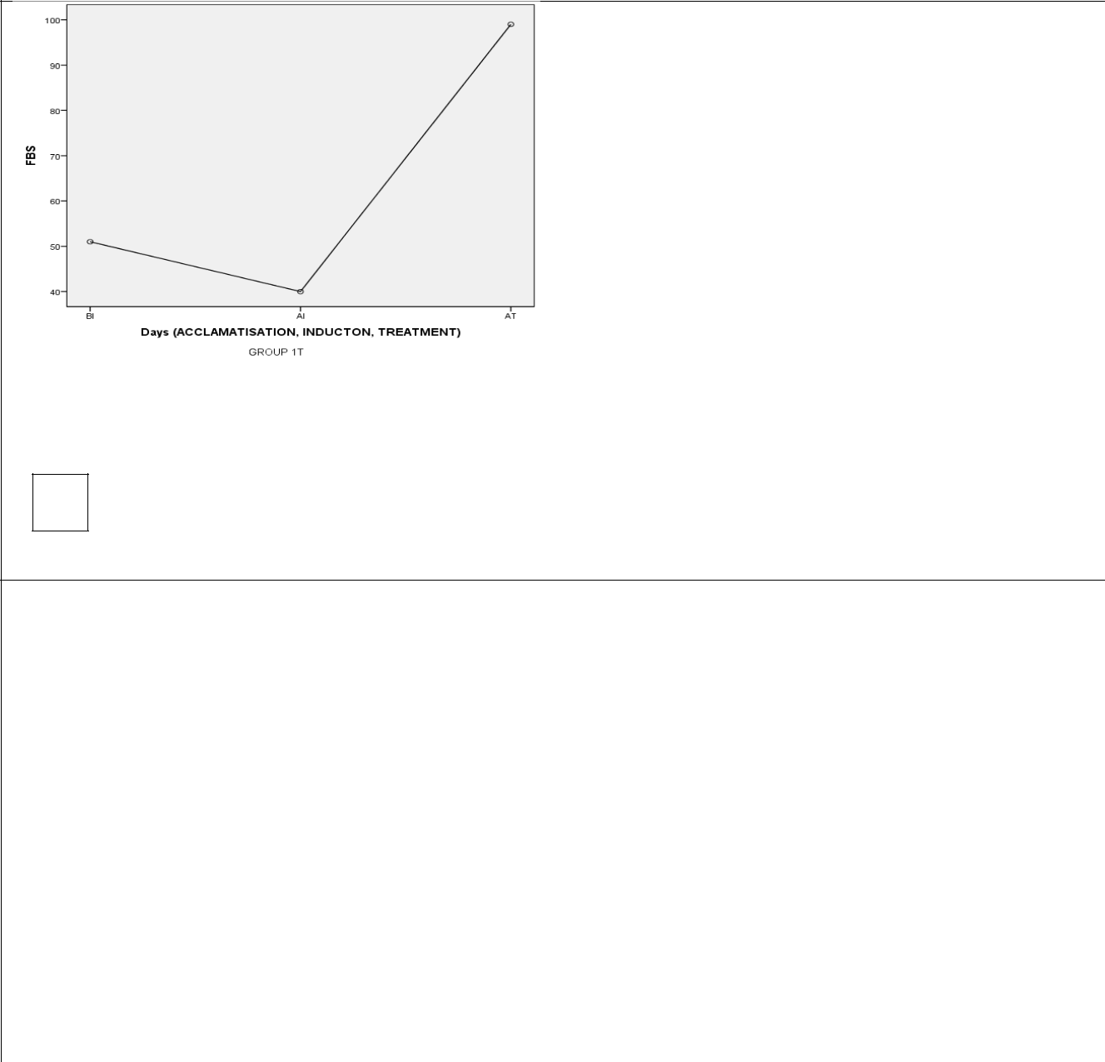

A

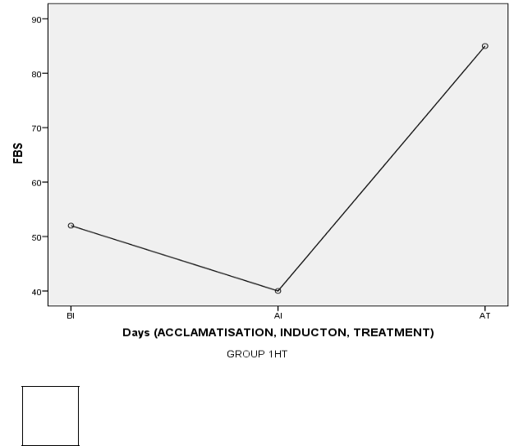

C

B

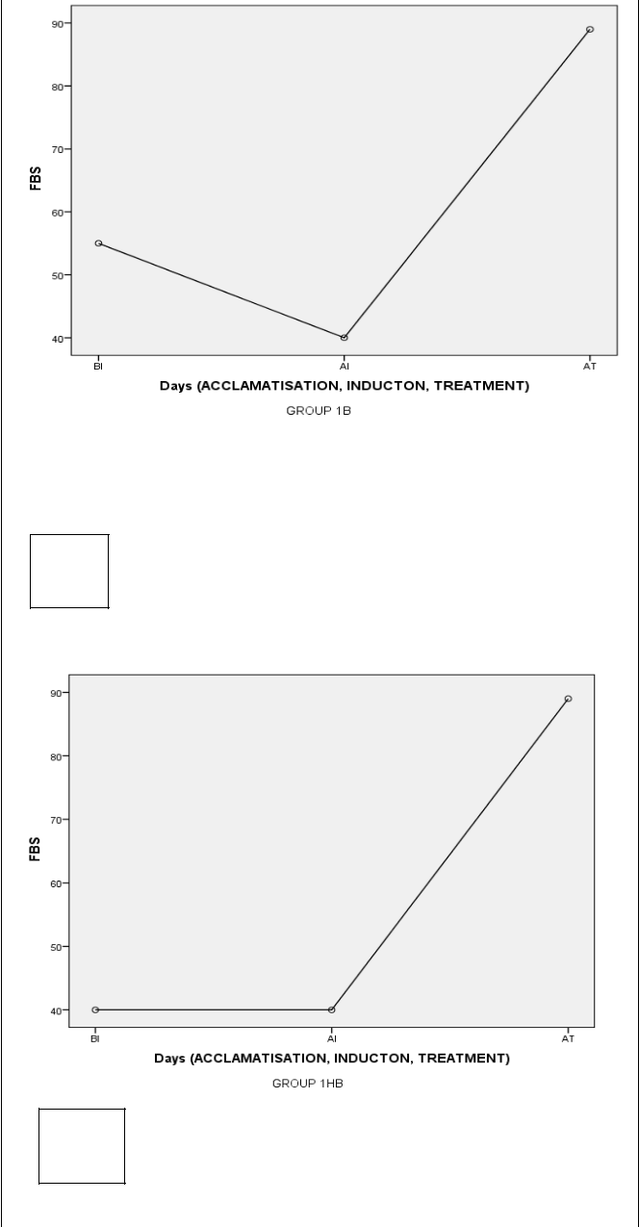

D

**Figure 9: Representation graph on the Fasting blood glucose of Female rats in the control group**

**BI- Before Induction; AI- After Induction; AT- After Treatment**

53

A

B

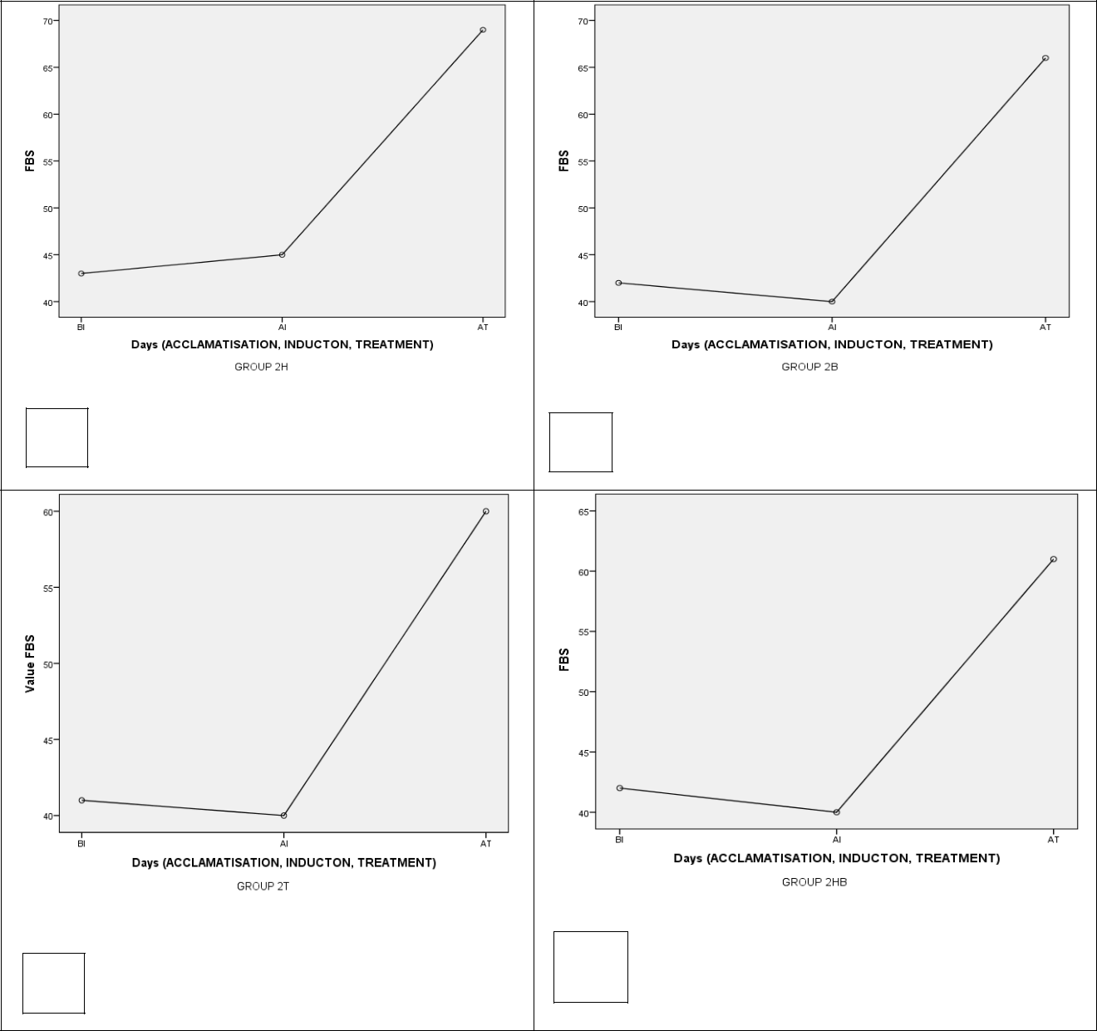

C

D

**Figure 10: Representation graph on the Fasting blood glucose of letrozole-induced Female rats untreated group**

**BI- Before Induction; AI- After Induction; AT- After Treatment**

54

A

C

B

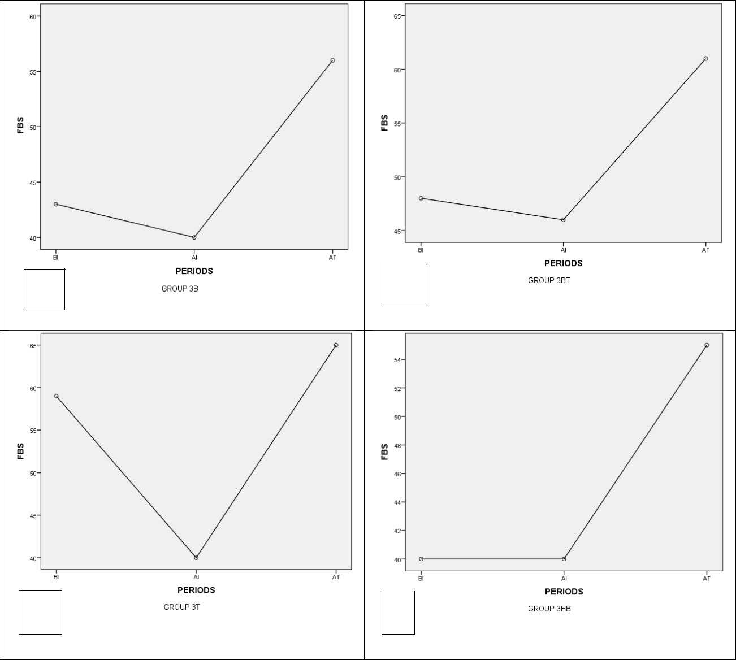

D

**Figure 11: Representation graph on the Fasting blood glucose of letrozole-induced Female rats treated with standard drug (MET+CC)**

**MET- Metformin; CC- Clomiphene Citrate BI- Before Induction; AI- After Induction; AT- After Treatment**

55

A

C

B

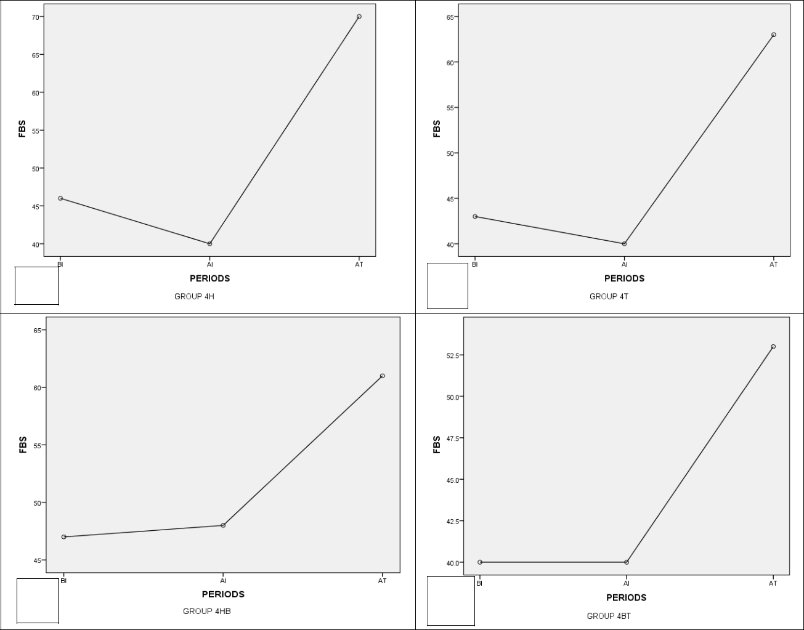

D

**Figure 12: Representation graph on the Fasting blood glucose of letrozole-induced Female rats treated with ALA**

**ALA- Alpha Lipoic Acid; BI- Before Induction; AI- After Induction; AT- After Treatment**

56

A

C

B

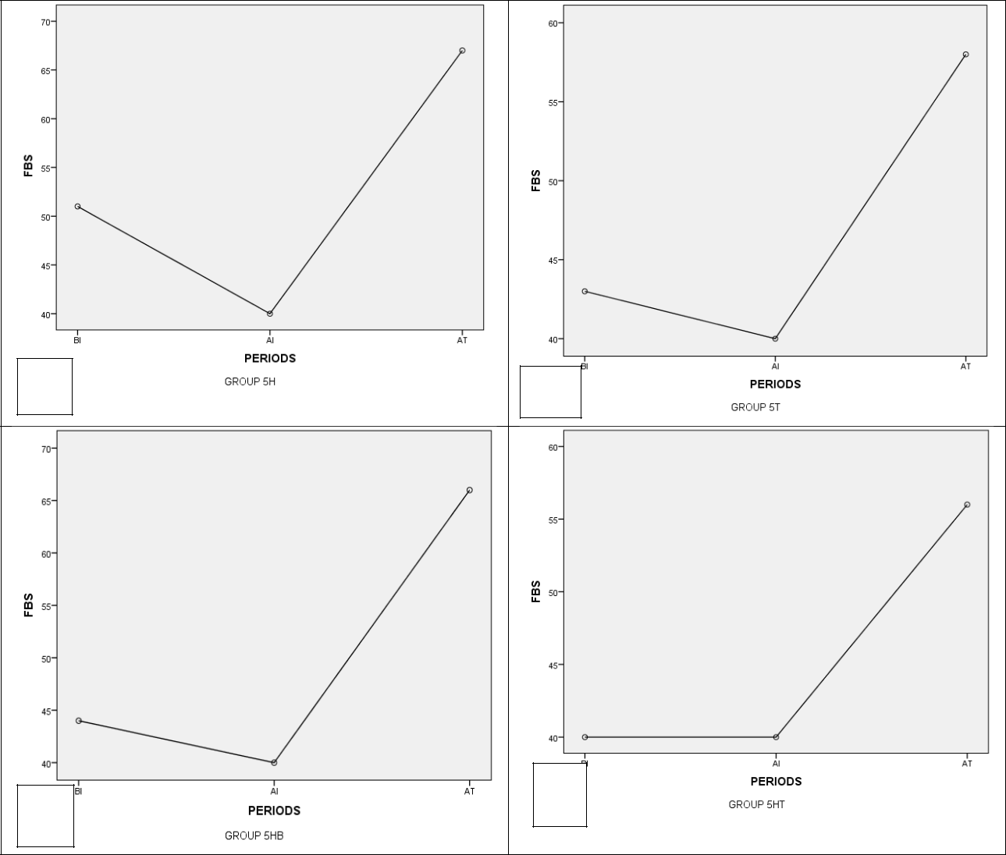

D

**Figure 13: Representation graph on the Fasting blood glucose of letrozole-induced Female rats treated with olive oil**

**BI- Before Induction; AI- After Induction; AT- After Treatment**

57

**4.2 Body weight of letrozole-induced animals administered Alpha lipoic acid and olive oil**

The body weight of letrozole-induced animals after induction was elevated compared to the period before induction of animals with letrozole. The body weight of the period after treatment was reduced drastically (p>0.05) after treatment with reference drugs: metformine and clomiphene citrate, Alpha lipoic acid and olive oil (Figures 14, 15, 16, 17, 18).

58

A

B

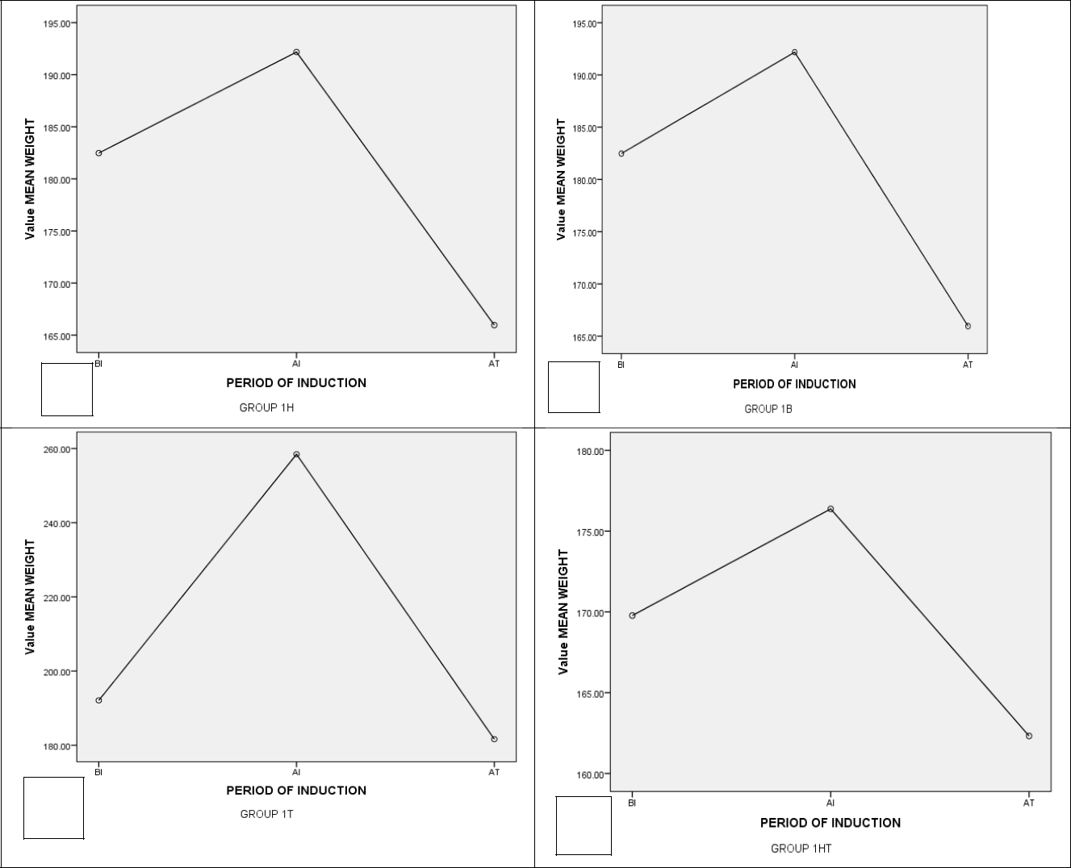

C

D

**Figure 14: Representation graph on the Body weight of Female rats in the control group**

**BI- Before Induction; AI- After Induction; AT- After Treatment**

59

A

B

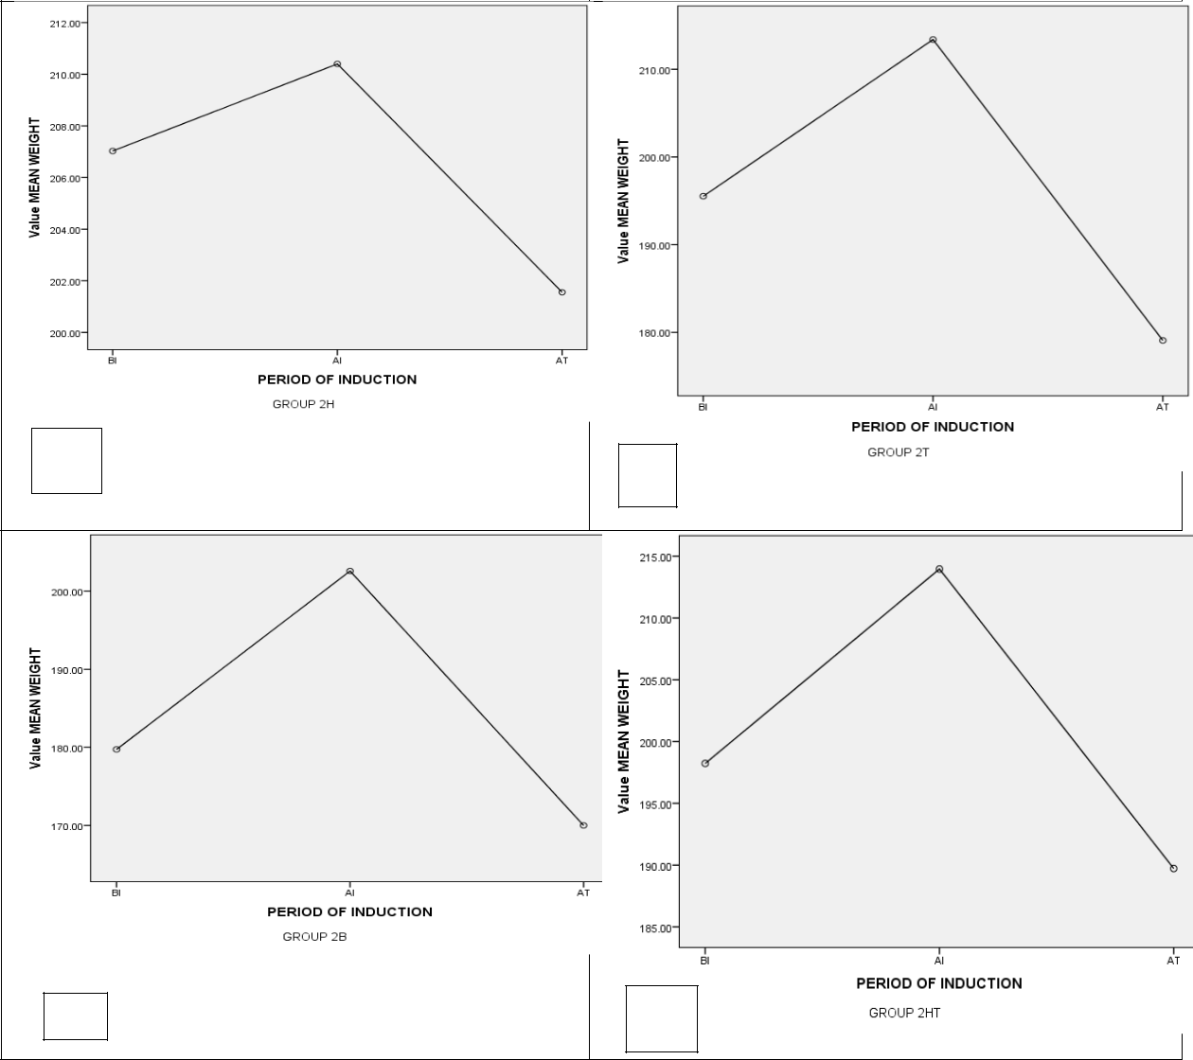

C

D

**Figure 15: Representation graph on the Body weight of letrozole-induced Female rats’ untreated group**

**BI- Before Induction; AI- After Induction; AT- After Treatment**

60

A

C

B

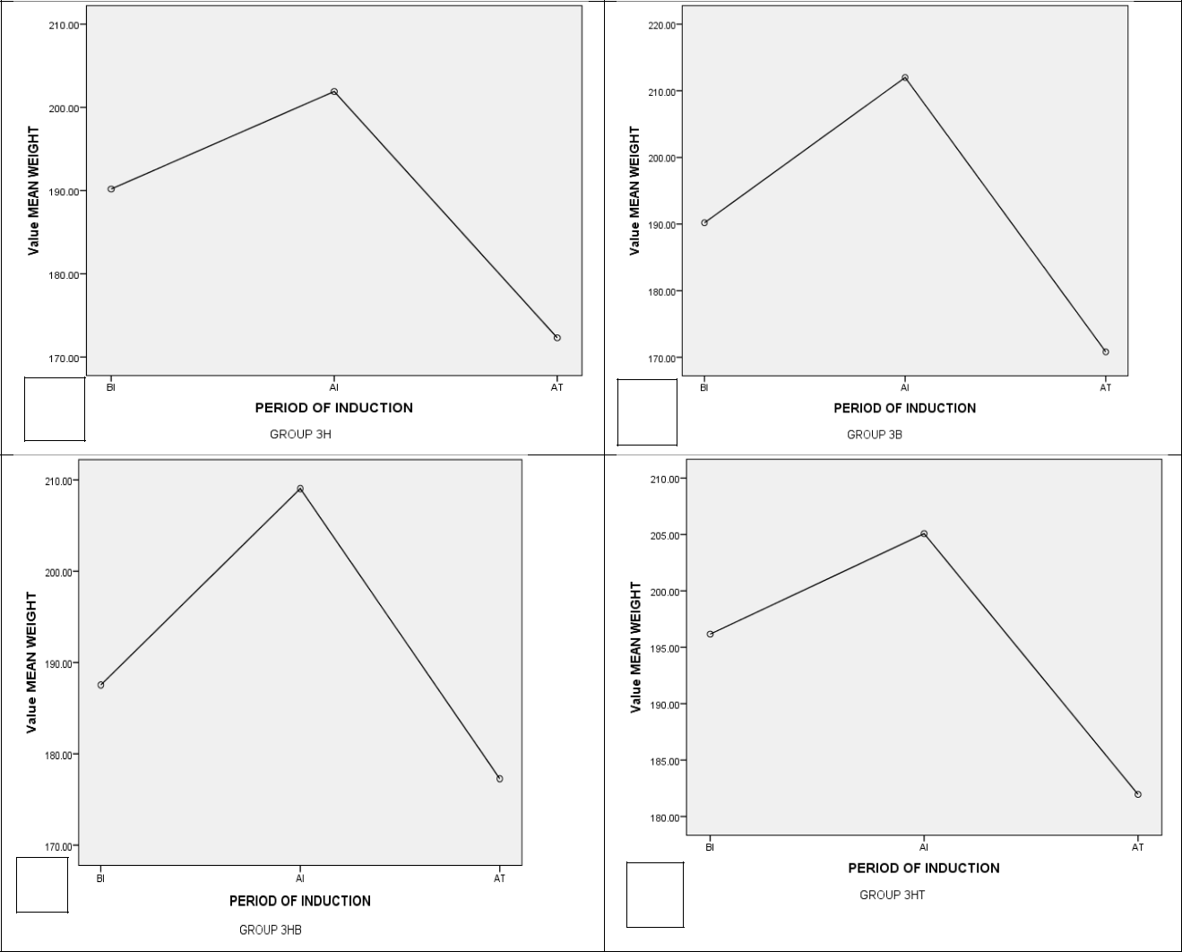

D

**Figure 16: Representation graph on the Body weight of letrozole-induced Female rats treated with standard drugs(MET+CC)**

**MET- Metformin; CC- Clomiphene Citrate; BI- Before Induction; AI- After Induction; AT- After Treatment**

61

A

B

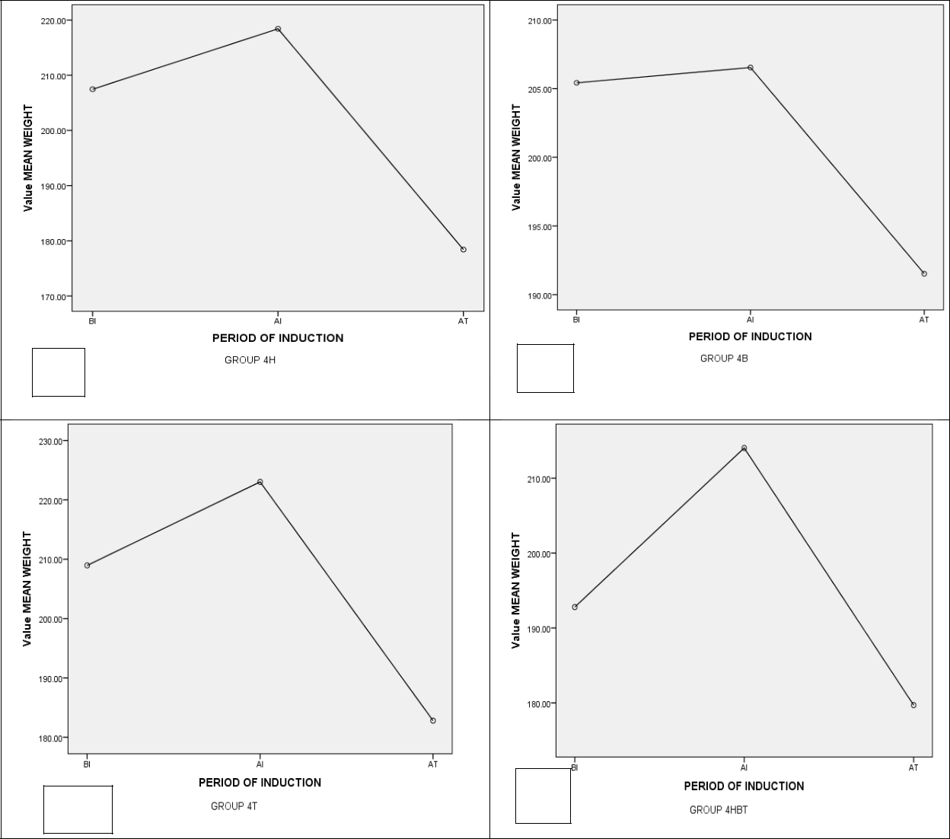

B

D

**Figure 17: Representation graph on the Body weight of letrozole-induced Female rats treated with ALA**

**ALA- Alpha Lipoic Acid; BI- Before Induction; AI- After Induction; AT- After Treatment**

62

A

B

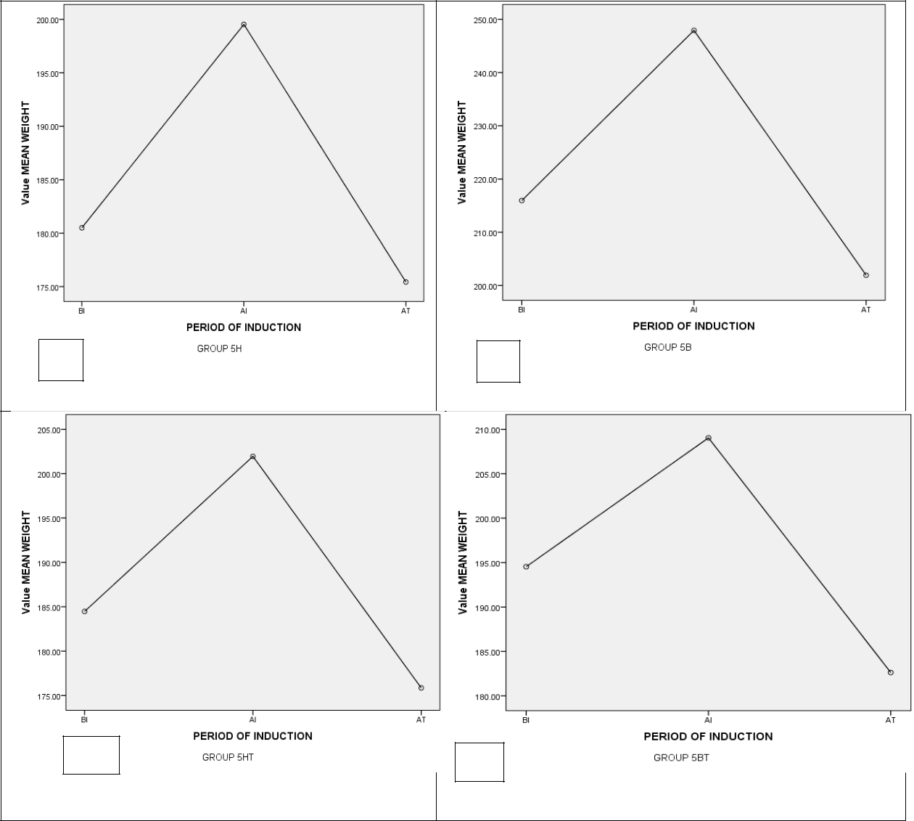

C

D

**Figure 18: Representation graph on the Body weigth of letrozole-induced Female rats treated with olive oil**

**BI- Before Induction; AI- After Induction; AT- After Treatment**

63

**4.3 Lipid profile of letrozole-induced animals administered Alpha lipoic acid and olive oil**

The administration of letrozole significantly (p<0.05) increased the serum total cholesterol, triacylglycerol and LDL-C on every other group compared to the metformin and clomiphene citrate group. However, it significantly (p<0.05) decreased the serum concentration of HDL-C.

Total cholesterol: The total cholesterol concentration of animals treated with letrozole and reference drugs (metformin and clomiphene citrate) significantly decreased in comparison to the untreated group. Animals treated with alpha lipoic acid had a significant (p<0.05) decrease compared to the control group, and there was a significant decrease of total cholesterol in those treated with oleic acid.

Triglycerides: The triglycerides concentration of animals treated with letrozole and reference drugs (metformin and clomiphene citrate) significantly decreased in comparison to the untreated group. Animals treated with alpha lipoic acid and oleic acid had a significant (p<0.05) decrease in the concentration of cholesterol compared to the control group. There was no significant difference in triglyceride concentration after treatment with oleic acid.

High density lipoprotein-cholesterol: The HDL-cholesterol concentration of the untreated group (PCOS + Distilled water) had no significant difference compared to the control group after the administration of letrozole. The animals treated with reference drugs (metformin and clomiphene citrate) significantly (p<0.05) increased in comparison to those treated with PCOS. Animals treated with alpha lipoic acid and oleic acid had a significant (p=0.01) decrease in the concentration of HDL-C, but not that of oleic acid.

Low density lipoprotein: The LDL-cholesterol concentration of animals treated with letrozole, alpha lipoic acid and oleic acid had a significant (p<0.05) decrease compared to those treated with reference drugs, metformin and clomiphene citrate. (Figure 18).

64

**Table 4: Serum Lipid profile of letrozole induced female rats**

|  |  |  |  |  |  |  |  |  |  |
| --- | --- | --- | --- | --- | --- | --- | --- | --- | --- |
|  | **Groups** | **TC** | **TG** | | **HDL-C** | **LDL-C** | | |  |
|  |  | **(mmol/L)** | **(mmol/L)** | | **(mmol/L)** | **(mmol/L)** | | |  |
|  |  |  |  | |  |  |  | |  |
|  | **Control** | 54.76 ±1.95a | 0.92 ±0.03a | | 2.33 ±0.17a | 47.72 | ± 2.42a | |  |
|  | **PCOS +** | 75.97 ±1.37c |  | ±0.88b | 1.25 ±0.69a |  | ± 1.56c | |  |
|  | **distilled water** | 1.68 | 70.20 |  |
|  | **PCOS +** | 61.91 ±2.42b |  | ±0.26a | 6.98 ±0.70c |  |  | ± 1.25b |  |
|  | **Metformin (7.14mg/kg B.W)** | 1.10 | 54.67 |  |  |
|  | **+ Clomiphene Citrate** |  |  |  |  |  |  |  |  |
|  | **(2mg/kg B.W)** |  |  |  |  |  |  |  |  |
|  | **PCOS + ALA** | 25.16 ±2.66e | 1.22 ±0.08a | | 3.15 ±0.71a | 22.42 | | ± 2.11e |  |
|  | **PCOS + Olive oil** | 15.04 ±1.92d | 0.83 | ±0.06a | 3.30 ±0.55b | 12.48 | | ± 1.72d |  |

**Data are mean of four determinations** ± **SEM; Values with different superscripts in each column are significantly different (P**<**0.05).**

**TC- Total Cholesterol; TG- Triglyceride; HDL-C - High Density Lipoprotein-Cholesterol; LDL-C- Low Density Lipoprotein-Cholesterol.**

65

**4.4 Effects of administration of letrozole on insulin concentration of female wistar rats**

Compared to the control, there was a significant (p<0.05) increase in the level of serum insulin in PCOS untreated rats after the induction of letrozole. The treatment with standard drugs (metformin and clomiphene), 1mg/kg body weight of ALA and olive oil resulted in a significant regression in the level of serum insulin as compared to PCOS untreated rats. There was no significant difference in the level of insulin concentration in animals treated with reference drugs; metformine and clomiphene citrate, ALA and oleic acid (Figure 19).

66

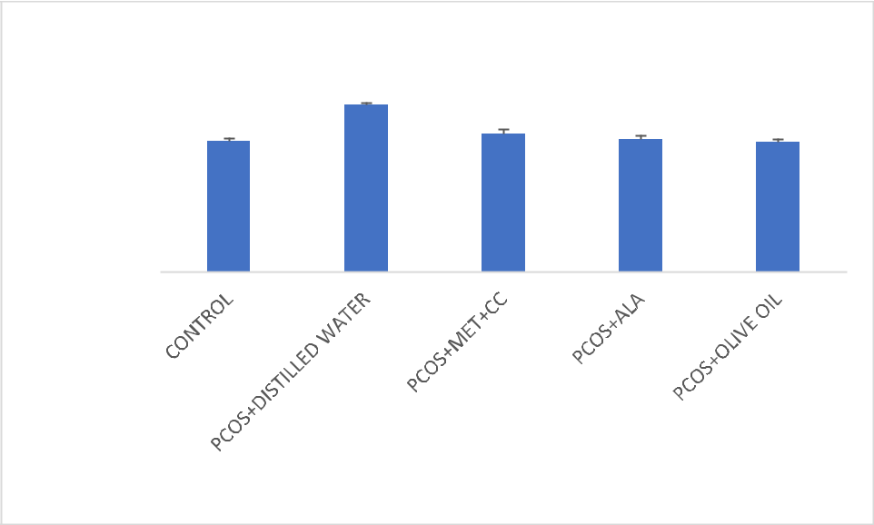

|  |  |  |  |  |  |
| --- | --- | --- | --- | --- | --- |
| (ng/mL) | 35.0000 |  | b |  |  |
| 30.0000 |  | a | a | a |
| Conc. | a |
| 25.0000 |  |
|  |  |  |  |
| 20.0000 |  |  |  |  |
| Insulin |  |  |  |  |
| 15.0000 |  |  |  |  |
| 10.0000 |  |  |  |  |
| 5.0000 |  |  |  |  |
| Serum |  |  |  |  |
| 0.0000 |  |  |  |  |
|  |  |  |  |  |

**Figure 19: The effect of letrozole-induced PCOS on serum insulin concentration**

Data are mean of two determinations ± SEM; Values with different superscripts in each column are significantly different (P<0.05). **MET-Metformin; CC- Clomiphene Citrate; ALA- Alpha Lipoic Acid**

67

**CHAPTER FIVE**

**5.1 Discussion**

Polycystic ovarian syndrome is the most frequent reproductive illness identified in women of reproductive age (Mikhael *et al.,* 2019). It is a medical condition that affects women who have a variety of defective reproductive and metabolic characteristics, resulting in infertility (Emamalipour *et al.,* 2019).

Polycystic ovary syndrome (PCOS) being a chronic endocrine disorder prevalent in premenopausal women and is characterized by a range of physiological and biochemical abnormalities which may include reproductive, endocrine, and metabolic alterations which include visceral obesity, atherogenic dyslipidemia, and hypertension as well as hyperinsulinemia, type 2 diabetes and insulin resistance.

Letrozole, an aromatase inhibitor, works by blocking the enzyme aromatase, which converts androgens to estrogens, in a competitive manner (Rose and Brown, 2020). Letrozole causes an increase in androgen levels in the ovary (Rose and Brown, 2020), with characteristics similar to human PCOS, such as hyperandrogenism and aberrant follicles (Rose and Brown, 2020).

In this study, letrozole induction significantly (p<0.05) elevated insulin, body weight and fsting blood glucose.. This study backs up the research of Ndeingang *et al.* (2019). High levels of cholesterol, triglycerides and LDL were significantly lowered by metformin and clomiphene citrate, but HDL levels were increased, whereas ALA and Olive oil at 1mg/kg B.W. induced a significant (p<0.05) decrease in body weight, insulin and fasting blood glucose.

This finding concurs with Zhang *et al.* (2017) who discovered that the combination of metformin and clomiphene significantly reduced body weight. The weight of the rats after treatment with metformin and clomiphene citrate was significantly (p<0.05) lower than the weight of the rats after induction with 1mg/kg B.W of letrozole. Studies have shown that the insulin-sensitizing properties of metformin help PCOS-affected women's menstrual cycles and ovulation rates. Additionally, hyperandrogenism, metabolic alterations, and, most importantly, fertility may all be impacted by metformin (Pasquali and Gambineri, 2006).

68

Another major sign of PCOS is likely to be hyperglycemia. However, in this investigation, the glucose level in the PCOS group was significantly (p0.05) higher than in the healthy control group before letrozole induction. Comparing the PCOS group to the healthy control group following ALA induction and therapy, the PCOS group's glucose level dropped dramatically (p<0.05).

As a result, it was discovered that insulin levels in the PCOS-untreated rats were much greater than in the control group. No hyperglycemia or hyperinsulinemia resulted as a result, which may have been caused by the glucose molecules' successful and efficient attachment to the insulin receptors. This demonstrates that there is no insulin resistance.

**5.2 Conclusion**

The treatment of letrozole-induced PCOS with ALA and olive oil have attenuated metabolic abnormalities, as was confirmed in this study. Therefore ALA can be exploited in the treatment of metabolic syndromes associated with PCOS which include dyslipidemia, hyperinsulinemia and hyperglycemia linked with PCOS.

**5.3 Recommendation**

Further study should be carried out on the toxicological effects of ALA and olive oil on letrozole-induced PCOS.

69

**REFERENCES**

Acien, P., Mauri, M., & Gutierrez, M. (1997). Clinical and hormonal effects of the combination gonadotrophin-releasing hormone agonist plus oral contraceptive pills containing ethinyl-oestradiol (EE) and cyproterone acetate (CPA) versus the EE-CPA pill alone on polycystic ovarian disease-related hyperandrogenisms. *Human Reproduction (Oxford, England)*, *12*(3), 423-429.

Roe, Andrea, et al. "Decreased cholesterol efflux capacity and atherogenic lipid profile in young women with PCOS." *The Journal of Clinical Endocrinology & Metabolism* 99.5 (2014): E841-E847.

Ajayi, A. F., & Akhigbe, R. E. (2020). Staging of the estrous cycle and induction of estrus in experimental rodents: an update. *Fertility Research and Practice*, *6*(1), 1-15. [https://doi.org/10.1186/s40738-020-00074-3.](https://doi.org/10.1186/s40738-020-00074-3)

Ajayi, A. F., & Akhigbe, R. E. (2020). Staging of the estrous cycle and induction of estrus in experimental rodents: an update. *Fertility Research and Practice*, *6*(1), 1-15.

Ajmal, N., Khan, S. Z\., & Shaikh, R. (2019). Polycystic ovary syndrome (PCOS) and genetic predisposition: A review article. *European Journal of Obstetrics & Gynecology and Reproductive Biology: X*, *3*, 100060. <https://doi.org/10.1016/j.eurox.2019.100060.>

Alebić, M. Š., Stojanović, N., Duhamel, A., & Dewailly, D. (2015). The phenotypic diversity in per-follicle anti-Müllerian hormone production in polycystic ovary syndrome. *Human Reproduction*, *30*(8), 1927-1933.

Al-Eisa, E., Gabr, S. A., & Alghadir, A. H. (2017). Effects of supervised aerobic training on the levels of anti-Mullerian hormone and adiposity measures in women with normo-ovulatory and polycystic ovary syndrome. *J Pak Med Assoc*, *67*(4), 499-507.

Amiri, M., Tehrani, F. R., Behboudi-Gandevani, S., Bidhendi-Yarandi, R., & Carmina, E. (2020). Risk of hypertension in women with polycystic ovary syndrome: a systematic review, meta-analysis and meta-regression. *Reproductive Biology and Endocrinology*, *18*(1), 1-15.

Amutha, P., & Rajkumar, T. (2017). Role of insulin-like growth factor, insulin-like growth factor receptors, and insulin-like growth factor-binding proteins in ovarian cancer. *Indian journal*

70

*of medical and paediatric oncology: official journal of Indian Society of Medical & Paediatric Oncology*, *38*(2), 198. <https://doi.org/10.4103/ijmpo.ijmpo_3_17>

Archer, J. S., & Chang, R. J. (2004). Hirsutism and acne in polycystic ovary syndrome. *Best Practice & Research Clinical Obstetrics & Gynaecology*, *18*(5), 737-754.

are current protocols optimal?. *Journal of Assisted Reproduction and Genetics* 37, 2093–2104 (2020). <https://doi.org/10.1007/s10815-020-01892-6>

Ashraf, S., Nabi, M., Rashid, F., Amin, S., 2019 Dec 1. Hyperandrogenism in polycystic ovarian syndrome and role of CYP gene variants: a review. Egypt. J. Med. Hum. Genetics 20 (1), 25.

Auta, T., & Hassan, A. T. (2016). Alteration in oestrus cycle and implantation in Mus musculus administered aqueous wood ash extract of Azadirachta indica (neem). *Asian Pacific Journal of Reproduction*, *5*(3), 188-192.

Aytan, Nehir A., Bastu, E., Demiral, I., Bulut, H., Dogan, M., & Buyru, F. (2016). Relationship between hyperandrogenism, obesity, inflammation and polycystic ovary syndrome. *Gynecological Endocrinology*, *32*(9), 709-713.

Ayurvedic Medicines for PCOS | PCOD- Poly Cystic Ovarian Syndrome & Disease.

https://curaayurveda.wordpress.com. 12 April, 2014.

Azziz R, Adashi EY Stein and Leventhal: 80 years on. (2016). *Am J Obstet Gynecol*, 214-247.

Azziz R., (2018). “Polycystic ovary syndrome” Obstet Gynecol, 132. pp. 321-336.

Azziz, R. (2008). Polycystic ovary syndrome is a family affair.

Azziz, R., Carmina, E., Chen, Z., Dunaif, A., Laven, J. S., Legro, R. S., & Yildiz, B. O. (2016).

Polycystic ovary syndrome. *Nature Reviews Disease Primers*, *2*(1), 1-18.

Azziz, R., Carmina, E., Dewailly, D., Diamanti-Kandarakis, E., Escobar-Morreale, H. F., Futterweit, W., ... & Witchel, S. (2006). Position statement: Criteria for defining polycystic ovary syndrome: An Androgen Excess Society guideline. *J Clin Endocrinol Metab*, *91*(11), 4237-4245.

71

Azziz, R., Carmina, E., Dewailly, D., Diamanti-Kandarakis, E., Escobar-Morreale, H. F., Futterweit, W., ... & Witchel, S. F. (2009). The Androgen Excess and PCOS Society criteria for the polycystic ovary syndrome: the complete task force report. *Fertility and Sterility*, *91*(2), 456-488.

Badawy, A., & Elnashar, A. (2011). Treatment options for polycystic ovary syndrome. *International Journal of Women's Health*, *3*, 25.

Badawy, A., Aal, I. A., & Abulatta, M. (2009). Clomiphene citrate or anastrozole for ovulation induction in women with polycystic ovary syndrome? A prospective controlled trial. *Fertility and Sterility*, *92*(3), 860-863.

Barber, T. M., Dimitriadis, G. K., Andreou, A., & Franks, S. (2016). Polycystic ovary syndrome: insight into pathogenesis and a common association with insulin resistance. *Clinical Medicine*, *16*(3), 262. [https://dx.doi.org/10.7861.](https://dx.doi.org/10.7861)

Bardei, K. (2015). The effects of hydro-alcoholic extract of raspberry fruit on ovarian follicles and serum parameters in poly cystic ovary syndrome-induced rat. *Armaghane Dnesh*, *19*(11), 955-968.

Barry, J. A., Azizia, M. M., & Hardiman, P. J. (2014). Risk of endometrial, ovarian and breast cancer in women with polycystic ovary syndrome: a systematic review and meta-analysis. *Human Reproduction Update*, *20*(5), 748-758.

Bast A, Haenen GR. Lipoic acid: a multifunctional antioxidant. Biofactors. 2003;17:207–213.

Bozdag, G., Mumusoglu, S., Zengin, D., Karabulut, E., & Yildiz, B. O. (2016). The prevalence and phenotypic features of polycystic ovary syndrome: a systematic review and meta-

analysis. *Human* *reproduction*, *31*(12), 2841-2855.

[https://doi.org/10.1093/humrep/dew218.](https://doi.org/10.1093/humrep/dew218)

Brennan, L., Teede, H., Skouteris, H., Linardon, J., Hill, B., & Moran, L. (2017). Lifestyle and behavioral management of polycystic ovary syndrome. *Journal of Women's Health*, *26*(8), 836-848.

72

Brettenthaler, N., De Geyter, C., Huber, P. R., & Keller, U. (2004). Effect of the insulin sensitizer pioglitazone on insulin resistance, hyperandrogenism, and ovulatory dysfunction in women with polycystic ovary syndrome. *The Journal of Clinical Endocrinology & Metabolism*, *89*(8), 3835-3840.

Burney RO, Giudice LC. Pathogenesis and pathophysiology of endometriosis. Fertil Steril 2012; 98: 511-519.

Cai, T., Al-Jubairi, N. N., Santos, H. O., de Souza, I. G., & Chen, Y. (2021). Does letrozole treatment have favorable effects on the lipid profile? A systematic review and meta-analysis of randomized clinical trials. *Steroids*, *172*, 108875.

Cappelli V, Di Sabatino A, Musacchio MC, De Leo V.(2013) Evaluation of a new association between insulin-sensitizers and alpha-lipoic acid in obese women affected by PCOS. Minerva Ginecol.;65: 425–434.

Carmina, E. (2012). PCOS: metabolic impact and long-term management. *Minerva ginecologica*, *64*(6), 501-505.

Carvalho L, Podgaec S, Bellodi-Privato M.(2011) Role of eutopic endometrium in pelvic endometriosis. J Minim Invasive Gynecol; 18: 419-227.

Carvalho, L. M. L., Ferreira, C. N., Sóter, M. O., Sales, M. F., Rodrigues, K. F., Martins, S. R., ...

* Gomes, K. B. (2017). Microparticles: inflammatory and haemostatic biomarkers in polycystic ovary syndrome. *Molecular and Cellular Endocrinology*, *443*, 155-162.

Casper, R. F. (2004). Aromatase inhibitors: New experiments or new value. In *Updates in Infertility treatment 2004 Seminar in Florida* (pp. 22-24).

Cassar, S., Misso, M. L., Hopkins, W. G., Shaw, C. S., Teede, H. J., & Stepto, N. K. (2016). Insulin resistance in polycystic ovary syndrome: a systematic review and meta-analysis of euglycaemic–hyperinsulinaemic clamp studies. *Human Reproduction*, *31*(11), 2619-2631.

Chandrasekaran CV, Vijayalakshmi MA, Prakash K, Bansal VS, Meenakshi J, Amit A. Herbal Approach for Obesity Management Review Article. American Journal of Plant Sciences. 2012; 3(No.7A):1003-1014.

73

Chen, J. S., Wei, C. I., & Marshall, M. R. (1991). Inhibition mechanism of kojic acid on polyphenol oxidase. *Journal of Agricultural and Food Chemistry*, *39*(11), 1897-1901.

Cheng, X., & He, B. (2022). Clinical and Biochemical Potential of Antioxidants in Treating Polycystic Ovary Syndrome. *International Journal of Women's Health*, *14*, 467-479.

Chiara Di Tucci, Mara Di Feliciantonio, Flaminia Vena, Carmela Capone, Michele Carlo Schiavi, Daniela Pietrangeli, Ludovico Muzii & Pierluigi Benedetti Panici (2018): Alpha lipoic acid

in obstetrics and gynecology, Gynecological Endocrinology, DOI:

10.1080/09513590.2018.1462320.

Chow, L. S., Mashek, D. G., Wang, Q., Shepherd, S. O., Goodpaster, B. H., & Dubé, J. J. (2017). Effect of acute physiological free fatty acid elevation in the context of hyperinsulinemia on fiber type-specific IMCL accumulation. *Journal of Applied Physiology*, *123*(1), 71-78.

Cianci A, Panella M, Fichera M.(2015) D-Chiro-Inositol and alpha lipoic acid treatment of metabolic and menses disorders in women with PCOS. Gynecol Endocrinol. ;31:483–486.

Ciotta, L., Cianci, A., Giuffrida, G., Marletta, E., Aglianò, A., & Palumbo, G. (1996). Clinical and hormonal effects of gonadotropin-releasing hormone agonist plus an oral contraceptive in severely hirsute patients with polycystic ovary disease. *Fertility and Sterility*, *65*(1), 61-67.

Corbould, A., Kim, Y. B., Youngren, J. F., Pender, C., Kahn, B. B., Lee, A., & Dunaif, A. (2005). Insulin resistance in the skeletal muscle of women with PCOS involves intrinsic and acquired defects in insulin signaling. *American Journal of Physiology-Endocrinology and Metabolism*, *288*(5), E1047-E1054.

Couzinet, B., Le Strat, N., Brailly, S., Schaison, G., (1986). “Comparative effects of cyproterone acetate or long-acting gonadotropin-releasin hormone agonist in polycystic ovarian disease”. J Clin Endocrinol Metab. 63: 1031–5.

Crespo, R. P., Bachega, T. A., Mendonça, B. B., & Gomes, L. G. (2018). An update of genetic basis of PCOS pathogenesis. *Archives of Endocrinology and Metabolism*, *62*, 352-361.

Cui L, Chen Z. Introduction to diagnostic criteria and guidelines for diagnosis and treatment of polycystic ovary syndrome. Int J Reprod Health Family Plann. 2011;30(05):405–408.

74

Dasari, P., & Pranahita, G. K. (2009). The efficacy of metformin and clomiphene citrate combination compared with clomiphene citrate alone for ovulation induction in infertile patients with PCOS. *Journal of Human Reproductive Sciences*, *2*(1), 18.

De Leo V, Musacchio MC, Cappelli V, Massaro MG, Morgante G, Petraglia F. (2016) Genetic, hormonal and metabolic aspects of PCOS: an update. Reproductive Biology and Endocrinology: RB&E;14(1):38.

De Leo, V., Fulghesu, A. M., La Marca, A., Morgante, G., Pasqui, L., Talluri, B., ... & Caruso, A. (2000). Hormonal and clinical effects of GnRH agonist alone, or in combination with a combined oral contraceptive or flutamide in women with severe hirsutism. *Gynecological Endocrinology*, *14*(6), 411-416.

Dhaliwal, L. K., Suri, V., Gupta, K. R., & Sahdev, S. (2011). Tamoxifen: An alternative to clomiphene in women with polycystic ovary syndrome. *Journal of Human Reproductive Sciences*, *4*(2), 76.

Diamanti-Kandarakis, E., & Papavassiliou, A. G. (2006). Molecular mechanisms of insulin resistance in polycystic ovary syndrome. *Trends in Molecular Medicine*, *12*(7), 324-332.

Dorota Szydlarska., Machaj, M., & Jakimiuk, A. (2017). History of discovery of polycystic ovary syndrome. *Advances in Clinical and Experimental Medicine*, *26*(3), 555-558.

Dunaif, A. (2016). Perspectives in polycystic ovary syndrome: from hair to eternity. *The Journal of Clinical Endocrinology & Metabolism*, *101*(3), 759-768.

Ekambaram, G., Kumar, S. K. S., & Joseph, L. D. (2017). Comparative study on the estimation of estrous cycle in mice by visual and vaginal lavage method. *Journal of Clinical and Diagnostic Research: JCDR*, *11*(1), AC05.

El Hayek, S., Bitar, L., Hamdar, L. H., Mirza, F. G., & Daoud, G. (2016). Poly cystic ovarian syndrome: an updated overview. *Frontiers in Physiology*, *7*, 124.

Emamalipour, M., Seidi, K., Esfahlan, A. J., Esfahlan, R. J. (2019). Implications of resistin in type 2 diabetes mellitus and coronary artery disease: Impairing insulin function and inducing

75

pro‐inflammatory cytokines. *Journal of Cellular Physiology.* <https://doi.org/10.1002/jcp.28913>

Escobar-Morreale, H. F. (2018). Polycystic ovary syndrome: definition, aetiology, diagnosis and treatment. *Nature Reviews Endocrinology*, *14*(5), 270-284.

Feyzollahi, Z., Kouchesfehani, H. M., Jalali, H., Eslimi-Esfahani, D., & Hosseini, A. S. (2021). Effect of Vitex agnus-castus ethanolic extract on hypothalamic KISS-1 gene expression in a rat model of polycystic ovary syndrome. *Avicenna Journal of Phytomedicine*, *11*(3), 292.

Froment, P., & Touraine, P. (2006). Thiazolidinediones and fertility in polycystic ovary syndrome (PCOS). *PPAR research*, *2006*.

Gandevani, B. S., Tehrani, F. R., Hosseinpanah, F., Khalili, D., Cheraghi, L., Kazemijaliseh, H.,

* Azizi, F. (2018). Cardiometabolic risks in polycystic ovary syndrome: long-term population-

based follow-up study. *Fertility and Sterility*, *110*(7), 1377-1386. <http://www.ncbi.nlm.nih.gov/pubmed/30503137>

Geller, D.H., Pacaud, D., Gordon, C.M., Misra, M., 2011. of the Drug and Therapeutics Committee of the Pediatric Endocrine Society (2011). Emerging therapies: the use of insulin sensitizers in the treatment of adolescents with polycystic ovary syndrome (PCOS). Int. J. Endocrinol. 9.

Genazzani AD, Despini G. Santagni S, et al. Effects of a combination of alpha lipoic acid and myo-inositol on insulin dynamics in overweight/obese patients with PCOS. Endocrinol Metab Syndr. 2014;3(3):140. doi:10.4172/2161-1017.1000140.

Genazzani AD, Shefer K, Della Casa D (2018). Modulatory effects of alpha-lipoic acid (ALA) administration on insulin sensitivity in obese PCOS patients. J Endocrinol Invest. 2018;41(5):583–590.

Ghaffarzad, A., Amani, R., Mehrzad, S.M., Darabi, M., Cheraghian B., (2016). “Correlation of serum lipoprotein ratios with insulin resistance in infertile women with polycystic ovarian syndrome: a case control study”. Int J Fertil Steril, 10, pp. 29-35.

76

Ghahiri, A., Mogharehabed, N., & Mamourian, M. (2016). Letrozole as the first-line treatment of infertile women with poly cystic ovarian syndrome (PCOS) compared with clomiphene citrate: A clinical trial. *Advanced Biomedical Research*, *5*.

Gjoanness H., (1984). “Polycystic ovarian syndrome treated by ovarian electrocautery through the laparoscope”. Fertil Steril. 41:20–25.

Glintborg D. Endocrine and metabolic characteristics in polycystic ovary syndrome. Dan Med J 2016; 63(4): pii: B5232.

Glueck, C.J., Goldenberg, N., (2019) Mar 1. Characteristics of obesity in polycystic ovary syndrome: etiology, treatment, and genetics. Metabolism 92, 108–120.

Guastella E, Longo RA, Carmina E. Clinical and endocrine characteristics of the main polycystic ovary syndrome phenotypes. Fertil Steril. 2010; 94:2197–2201.

Ibanez, L., Zegher, F., (2006). “Low-dose flutamide-metformin therapy for hyper insulinemic hyperandrogenism in non-obese adolescents and women”. Hum Reprod Update. 12: 243– 52.

Ipsa, E., Cruzat, V. F., Kagize, J. N., Yovich, J. L., & Keane, K. N. (2019). Growth Hormone and Insulin-Like Growth Factor Action in Reproductive Tissues. Frontiers in endocrinology, 10, 777. <https://doi.org/10.3389/fendo.2019.00777>

Jamil AS, Alalaf SK, Al-Tawil NG, Al-Shawaf T. (2016). Comparison of clinical and hormonal characteristics among four phenotypes of polycystic ovary syndrome based on the Rotterdam criteria. Arch Gynecol Obstet. 293:447–456.

Jena D, Choudhury AK, Mangaraj S, Singh M, Mohanty BK, Baliarsinha AK. (2018). Study of Visceral and Subcutaneous Abdominal Fat Thickness and Its Correlation with Cardiometabolic Risk Factors and Hormonal Parameters in Polycystic Ovary Syndrome. Indian J Endocrinol Metab. 22:321-7. Journal of human reproductive sciences, 4(1), 2–7.

Jungbauer, Alois, Svjetlana Medjakovic. (2014). Phytoestrogens and the metabolic syndrome. The Journal of steroid biochemistry and molecular biology. 139:277-289.

77

Kakoly NS., Khomami MB, Joham AE., Cooray SD., Misso ML., Norman RJ, Harrison CL., Ra nasinhaS., Teede HJ, Moran LJ., (2018). “Ethnicity, obesity and the prevalence of impaired glucose tolerance and type 2 diabetes in PCOS: a systematic review and meta-regression”. *Human Reproduction Update*, 24455–467.

Katsambas, A.D., Dessinioti, C., (2010). “Hormonal therapy for acne: why not as first line therapy? Facts and controversies”. Clin Derm. 17–23.

Kim CH, Chon SJ, Lee SH. (2020). Effects of lifestyle modification in polycystic ovary syndrome compared to metformin only or metformin addition: a systematic review and meta-analysis. Sci Rep.10(1):7802.

Konrad D, Somwar R, Sweeney G, et al. The antihyperglycemic drug alpha-lipoic acid stimulates glucose uptake via both Glut4 translocation and Glut4 activation: potential role of P38 mitogen-activated protein kinase in Glut4 activation. Diabetes. 2001;50:1464–1471.

Koulouri, O., Conway, G.S., (2008). “A systematic review of commonly used medical treatments for hirsutism in women”. Clin Endocrinol. 68: 800–5.

Kumar D, Seshadri KG, Pandurangi M. (2017). Effect of metformin-sustained release therapy on low-density lipoprotein size and adiponectin in the South Indian women with polycystic ovary syndrome. Indian J Endocrinol Metab; 21:679e83.

Kumar, P., & Sait, S. F. (2011). Luteinizing hormone and its dilemma in ovulation induction.

Lashen, H., 2010 Aug. Role of metformin in the management of polycystic ovary syndrome.

Therapeutic Adv. Endocrinol. Metabol. 1 (3), 117–128 10.

Laura M. L. Carvalho., Fernando M. dos Reis., Ana Lucia Candido., Fernanda F. C. Nunes., Claudia N. Ferreira., Karina B. Gomes., (2018). “Polycystic Ovary Syndrome as a systemic disease with multiple molecular pathways: a narrative review”. Endo. Reg. Vol. 52, No. 4, 208–221. [http://doi:10.2478/enr-2018-0026.](http://doi:10.2478/enr-2018-0026)

Lauretta, R., Lanzolla, G., Vici, P., Mariani, L., Moretti, C., Appetecchia, M., (2016) Jan 1. Insulin-sensitizers, polycystic ovary syndrome and gynaecological cancer risk. Int. J. Endocrinol.

78

Legro, R.S., Barnhart, H.X., Schlaff, W.D., Carr, B.R., Diamond, M.P., Carson, S.A., Steinkampf, M.P., Coutifaris, C., McGovern, P.G., Cataldo, N.A., Gosman, GG., (2007) Feb 8. Clomiphene, metformin, or both for infertility in the polycystic ovary syndrome. N. Engl. J. Med. 356 (6), 551–566.

Legro, RS., (2012). Obesity and PCOS: implications for diagnosis and treatment. In Seminars in reproductive medicine, Vol. 30. NIH Public Access, p. 496.

Leo V., Caruso S., Scolaro V., Cianci A., (2009). “Low dose oral contraceptives: 30 c are still used?”. Minerva Ginecol, 61:453–8.

Li H, Chao J, Chen S (2013). Observation on the therapeutic effect of Diane-35 in the treatment of adolescent polycystic ovary syndrome. Int Med Health Guidance News. 2013;19(1):49– 51. doi:10.3760/cma.j.issn.1007-1245.2013.01.018.

Liang R, Liu Z, Li P (2019). Kuntai capsules improve glucolipid metabolism in patients with polycystic ovary syndrome: a randomized, double-blind, placebo-controlled trial. Medicine. 2019;98(39):e16788. doi:10.1097/MD.0000000000016788.

Lim SS., Norman RJ., Davies MJ., Moran LJ., (2013). “The effect of obesity on polycystic ovary syndrome: a systematic review and meta-analysis”. Obes Rev. 14(02):95–109.

Liu H., Zhao H., Chen ZJ., (2016). “Genome-wide association studies for Polycystic Ovary Syndrome”. Semin Reprod Med 34, 224–229.

Lizneva D., Suturina, L., Walker, W., S. Brakta, L. Gavrilova-Jordan, R. Azziz., (2016). “Criteria, prevalence, and phenotypes of polycystic ovary syndrome” Fertil Steril, 106 pp. 6-15.

Lupoli, G.D., Carlo, C., Nuzzo, V., (1997). “Gonadotropin-releasing hormone agonists administration in polycystic ovary syndrome”. Effects on bone mass. J Endocrinol Invest

1. 493-6.

Macut D, Simic T, Lissounov A (2011). Insulin resistance in nonobese women with polycystic ovary syndrome: Relation to byproducts of oxidative stress. Exp Clin Endocrinol Diabetes, 119(7): 451-5.

79

Macut, D. Macut, J.B. Rahelic, D. Doknic, M. (2017). Insulin and Polycystic Ovary Syndrome. Diabetes Research and clinical practice

Madnani, N., Khan, K., Chauhan, P., Parmar, G., (2013). “Polycystic ovarian syndrome, Indian J. Dermatol”. Venereol. Leprol. 79 (2013) 310–321. http://dx.doi.org/10.4103/ 0378-6323.110759.

Mancini A, Bruno C, Vergani E, d’Abate C, Giacchi E, Silvestrini A (2021). Oxidative stress and low-grade inflammation in polycystic ovary syndrome: controversies and new insights. Int J Mol Sci. 2021;22(4):1667. doi:10.3390/ijms22041667.

Masharani U, Gjerde C, Evans JL, et al. Effects of controlled-release alpha lipoic acid in lean, nondiabetic patients with polycystic ovary syndrome. J Diabetes Sci Technol. 2010;4:359– 364.

Mayer, S. B., Evans, W. S., and Nestler, J. E. (2015). Polycystic ovary syndrome and insulin: our understanding in the past, present and future. *Women’s Health.*

Melo, A.S., Ferriani, R.A., Navarro, PA., (2015) Nov. Treatment of infertility in women with polycystic ovary syndrome: approach to clinical practice. Clinics 70 (11), 765–769.

Mikhael, J., Ismaila, N., Cheung, M. C., Costello, C., Dhodapkar, M. V., Kumar, S., & Martin, T. (2019). Treatment of multiple myeloma: ASCO and CCO joint clinical practice guideline. *Journal of Clinical Oncology*, *37*(14), 1228-1263.

Milutinović. D, M. Nikolić, N. Veličković, A. Djordjevic, B. Bursać, J. Nestorov, A. Teofilović, I. Antić, J. Macut, A. Zidane, G. Matić, D. Macut, (2017) Enhanced Inflammation without Impairment of Insulin Signaling in the Visceral Adipose Tissue of 5α-Dihydrotestosterone-Induced Animal Model of Polycystic Ovary Syndrome, Experimental and Clinical Endocrinology & Diabetes 125(08) 522-529

Mitwally MF, Casper RF., (2006). “Potential of aromatase inhibitors for ovulation and superovulation induction in infertile women”. Drugs;66(17):2149-60.

Moghetti, P. and Tosi, F. (2021). insulin resistance and PCOS: chicken or egg. *Journal of endocrinological investigation.*

80

Moran LJ., Hutchison SK., Norman RJ., Teede HJ., (2011). “Lifestyle changes in women with polycystic ovary syndrome”. Cochrane Database Syst Rev. 16(2).

Morgante G, Cappelli V, Di Sabatino A, et al. Polycystic Ovary Syndrome (PCOS) and hyperandrogenism: the role of a new natural association. Minerva Ginecol. 2015;67:457– 663.

Nallathambi, A., & Bhargavan, R. (2019). Regulation of estrous cycle by Cynodon dactylon in letrozole induced polycystic ovarian syndrome in Wistars albino rats. *Anatomy & cell biology*, *52*(4), 511-517.

Nallathambi, A., & Bhargavan, R. (2019). Regulation of estrous cycle by Cynodon dactylon in letrozole induced polycystic ovarian syndrome in Wistars albino rats. *Anatomy & cell biology*, 52(4), 511–517. <https://doi.org/10.5115/acb.19.114>

National Center for Biotechnology Information (2021). PubChem Compound Summary for CID

3902, Letrozole. Retrieved August 29.

from [https://pubchem.ncbi.nlm.nih.gov/compound/Letrozole.](https://pubchem.ncbi.nlm.nih.gov/compound/Letrozole)

Ndeingang, E. C., Defo Deeh, P. B., Watcho, P., & Kamanyi, A. (2019). Phyllanthus muellerianus (Euphorbiaceae) restores ovarian functions in letrozole-induced polycystic ovarian syndrome in rats. *Evidence-Based Complementary and Alternative Medicine*, *2019*.

Nicandri KF, Hoeger K (2012) Diagnosis and treatment of polycystic ovarian syndrome inadolescents. Curr Opin Endocrinol Diabetes Obes 19(6): 497-504.

Niroumand, M., Heydarpour, F. and Farzaei, M., (2018). Pharmacological and therapeutic effects of Vitex agnus-castus L.: A review. Pharmacognosy Reviews, 12(23).

Novartis Pharmaceuticals Corporation (Letrozole tablets), East Hanover, New Jersey 07936 (2018).

Oluwaseun Ruth Alara, Nour Hamid Abdurahman, Siti Kholijah Abdul Mudalip, Olusegun Abayomi Olalere, (2017). Phytochemical and pharmacological properties of vernonia amygdalina: a review, 80-96.

Omar Gailani, (2018). Polycystic ovaries vs Polycystic Ovarian Syndrome.

81

Orio F., Muscogiuri G., Giallauria F., (2016). “Oral contraceptives versus physical exercise on cardiovascular and metabolic risk factors in women with polycystic ovary syndrome: a randomized controlled trial”. Clin Endocrinol (Oxf), 85(05):764–771.

Ouchi N, Parker JL, Lugus JJ, Walsh K. (2011). Adipokines in inflammation and metabolic disease. Nat Rev Immunol 11, 85–97.

Oyebanji O. G., M. F. Asaolu, E. O. Amonimo, (2018). Hormonal Imbalance in Polycystic Ovarian Syndrome (Pcos) in Teaching Hospitals in Ekiti State, Nigeria., 8, 1456-1464.

Panay N, R. A. Anderson, R. E. Nappi, A. J. Vincent, S. Vujovic, L. Webber & W. Wolfman (2020) Premature ovarian insufficiency: an International Menopause Society White Paper, Climacteric, 23:5, 426-446, DOI: 10.1080/13697137.2020.1804547

Papadakis G, Kandaraki E, Papalou O, Vryonidou A, Diamanti-Kandarakis E. (2017). Is cardiovascular risk in women with PCOS a real risk? Current insights. Minerva Endocrinol 42, 340–355.

Parsanezhad, M.E., Alborzi, S., Motazedian, S., Omrani, G., (2002). “Use of dexamethasone and clomiphene citrate in the treatment of clomiphene citrate-resistant patients with polycystic ovary syndrome and normal dehydroepiandros-teronesulfate levels: a prospective, double-blind, placebo-controlled trial., Fertil Steril. 78: 1001–4.

Patel. S., (2018). Polycystic Ovarian Syndrome (PCOS), an inflammatory, systemic, lifestyle, endocrinopathy. Journal of steroid biochemistry and molecular Biology.

Pavaleanu I, Gafitanu D, Popovici D, Duceac LD, Pavaleanu M. (2016). Treatment of metabolic alterations in Polycystic Ovary Syndrome. Rev Med Chir Soc Med Nat Iasi 120, 258–263.

Pellegrini, V., A. (2016). Ovarian Insuffieciency. *Medscape.*

Pergialiotis V, E. Trakakis, C. Chrelias, N. Papantoniou, E. Hatziagelaki. (2018). The impact of mild hypercholesterolemia on glycemic and hormonal profiles, menstrual characteristics and the ovarian morphology of women with polycystic ovarian syndrome Horm Mol Biol Clin Investig, 10.1515/hmbci-2018-0002

82

Petríková, J., & Lazúrová, I. (2012). Ovarian failure and polycystic ovary syndrome. *Autoimmunity reviews*, *11*(6-7), A471-A478.

Phinney, S. and Volek, J (2019). polycystic Ovarian Syndrome, Insulin Resistance and Inflammation. *Virta.*

Pinola, P.; Piltonen, T.T.; Puurunen, J.; Vanky, E.; Poromaa, I.S.; Stener-Victorin, E.; Ruokonen, A.; Puukka, K.; Tapanainen, J.S.; Morin-Papunen, L.C. (2015). Androgen profile through life in women with polycystic ovary syndrome: A Nordic multicenter collaboration study. J. Clin. Endocrinol. Metab, 100, 3400–3407.

Pritts, E. A., Alexander K. Yuen, Shefaali Sharma, Robert Genisot, David L. Olive, (2011). "The Use of High Dose Letrozole in Ovulation Induction and Controlled Ovarian Hyperstimulation", International Scholarly Research Notices, vol. Article ID 242864, 4 pages. <https://doi.org/10.5402/2011/242864>

Puttabyatappa, M., Padmanabhan, V., (2018) Nov 1. Ovarian and extra-ovarian mediators in the development of polycystic ovary syndrome. J. Mol. Endocrinol. 61 (4).

R. Jeffrey Chang, Ralph R. Kazer, (2014). Polycystic Ovary Syndrome. 1756-2228.

Rachel Gurevich., (2020). “Anovulation and ovulatory dysfunction”.

Rago R, Marcucci I, Leto G, et al. Effect of myo-inositol and alphalipoic acid on oocyte quality in polycystic ovary syndrome non-obese women undergoing in vitro fertilization: a pilot study. J Biol Regul Homeost Agents. 2015;29:913–924.

Rajan, R. K., Balaji, B. (2017). Soy isoflavones exert beneficial effects on letrozole-induced rat polycystic ovary syndrome (PCOS) model through anti-androgenic mechanism. Pharm. Biol., 55 (2017), pp. 242-251

Randeva HS., Tan BK., Weickert MO., Lois K., Nestler JE., Sattar N., Lehnert H., (2012).

“Cardiometabolic aspects of the polycystic ovary syndrome”. Endocr Rev; 33(5): 812-41.

83

Rees DA, Jenkins-Jones S, Morgan CL. (2016). Contemporary reproductive outcomes for patients with polycystic ovary syndrome: a retrospective observational study. J Clin Endocrinol Metab; 101 (04):1664–1672.

Ricardo Azziz M.D (2021). How polycystic ovary syndrome came into its own, F&S Science.

<https://doi.org/10.1016/j.xfss.2020.12.007.>

Rodrigues de Assis, N.P., Laganà, A., Zaia, V, Vitagliano, A., Barbosa, C.P., Renato de Oliveira, Trevisan, C.M., and Montagna, E (2019).The role of Kisspeptin levels in polycystic ovary syndrome: a systematic review and meta-analysis. Arch Gynecol Obstet 300, 1423–1434 <https://doi.org/10.1007/s00404-019-05307-5>

Rohini, C., Geetha, P. S., Vijayalakshmi, R., & Mini, M. L. (2021). Phytochemicals characterization of nutraceutical enriched fruits and nuts spread. *Journal of Applied and Natural Science*, *13*(SI), 124-129.

Rojas, J., Chávez, M., Olivar, L., Rojas, M., Morillo, J., Mejías, J., Calvo, M., Bermúdez, V., (2014). “Polycystic ovary syndrome, insulin resistance, and obesity: navigating the pathophysiologic labyrinth”. Int. J. Reprod. Med. 2014. [https://doi:10.1155/2014/719050.](https://doi:10.1155/2014/719050)

Rose, B.I., Brown, S.E. (2020). A review of the physiology behind letrozole applications in infertility: are current protocols optimal?. J Assist Reprod Genet 37, 2093–2104 <https://doi.org/10.1007/s10815-020-01892-6>

Rose, B.I., Brown, S.E (2016). A review of the physiology behind letrozole applications in infertility:

Rosenfield, R.L. and Ehrmann, D.A. The pathogenesis of polycystic ovary syndrome (PCOS): the hypothesis of PCOS as functional ovarian hyperandrogenism revisited. Endocrine reviews, 37(5), pp.467-520.

Rosenfield, R.L., Ehrmann, DA., (2016) Oct 1. The pathogenesis of polycystic ovary syndrome (PCOS): the hypothesis of PCOS as functional ovarian hyperandrogenism revisited. Endocr. Rev. 37 (5), 467–520.

Saha, L., Kaur, S., Saha, P.K., (2011). “Pharmacotherapy of polycystic ovary syndrome—an update”. Fundam Clin Pharmacol. in press.

84

Saidu, M., Yuzir, A., Salim, M. R., Azman, S., & Abdullah, N. (2014). Biological pre-treated oil palm mesocarp fibre with cattle manure for biogas production by anaerobic digestion during acclimatization phase. *International Biodeterioration & Biodegradation*, *95*, 189-194.

Sampurna, K., Reddy, B.V., Vijayaraghavan, R. and Rajesh, P. (2017) Role of Steroid Hormones in Polycystic Ovarian Syndrome (PCOS) in South Indian Women. International Journal of Research in Ayurveda and Pharmacy, 8, 234-237.

Sato Junko, Masahiro Nasu, and Minoru Tsuchitani (2016). Comparative histopathology of the estrous or menstrual cycle in laboratory animals. *Journal of Toxicologic Pathology.*

Seong J, Kang JY, Sun JS, Kim KW. (2019). Hypothalamic inflammation and obesity: a mechanistic review. Arch Pharm Res. May;42(5):383-392. [[Abstract](http://europepmc.org/article/MED/30835074)]

Shaman, A. A., Mukhtar, H. B., Mirghani, H. O. (2017). Risk factors associated with metabolic syndrome and cardiovascular disease among women with polycystic ovary syndrome in Tabuk, Saudi Arabia. Electron Physician, 9, pp. 5697-5704

Sharpe A, Morley LC, Tang T, Norman RJ, Balen AH (2019). Metformin for ovulation induction (excluding gonadotrophins) in women with polycystic ovary syndrome. Cochrane Database Syst Rev; 12(12):CD013505. doi:10.1002/14651858.CD013505.

Siddiqui, M., Mahmud, N., Begum, M. R., & Chowdhury, T. A. (2010). Aromatase Inhibitors: New Drug of Choice for Induction of Ovulation. *Journal of Bangladesh College of Physicians and Surgeons*, *28*(1), 40-44.

Sivalingam, V.N., Myers, J., Nicholas, S., Balen, A.H., Crosbie, EJ., (2014) Nov 1. Metformin in reproductive health, pregnancy and gynaecological cancer: established and emerging indications. Hum. Reprod. Update 20 (6), 853–868.

Song Y, Li R (2018). Interpretation of Chinese guidelines for diagnosis and treatment of polycystic ovary syndrome. J Pract Obstet Gynaecol ;34 (10):22–26.

85

[Soni,](https://www.researchgate.net/scientific-contributions/Monica-Soni-2101576644) M.., [Kalal,](https://www.researchgate.net/scientific-contributions/Gajendra-Kumar-Kalal-2174183487) G. K., [Meena,](https://www.researchgate.net/scientific-contributions/Arti-Meena-2174185273) A., [Sharma,](https://www.researchgate.net/scientific-contributions/Anita-Sharma-2174191458) A. (2020). Clomiphene citratye versus letrozole for ovulation induction in anovulation infertility: a prospective study. *International Journal of Reproduction, Conception, Obstetrics and Gynecology.*

Stein IF., Cohen MR., Elson RE., (1948). “Results of bilateral ovarian wedge resection in 47 cases of sterility”. Am J Obstet Gynecol. 58:267–273.

Stein IF., Leventhal ML., (1935). “Amenorrhoea associated with bilateral polycystic ovaries”. Am J Obstet Gynecol. 29:181–191.

Stephanie Watson., (2021). “Polycystic ovary syndrome (PCOS): symptoms, causes and treatments”.

Stephen Franks., Kate Hardy., (2020). “What causes anovulation in polycystic ovary syndrome”? Volume 12, page 59-65 [Abstract].

Stepto NK, Moreno-Asso A, McIlvenna LC, Walters KA, Rodgers RJ. (2019), Molecular mechanisms of insulin resistance in polycystic ovary syndrome. Unraveling the conundrum in skeletal muscle? *Journal of Clinical Endocrinology and Metabolism*, 104 5372–5381

Stepto, N.K., Walters KA, Rodgers RJ (2013). “Women with polycystic ovary syndrome have intrinsic insulin resistance on euglycaemichyperinsulaemic clamp”. Hum Reprod, 28(3): p. 777-84.

Sudhakar Pachiappan, Suganeswari Matheswaran, Poorana Pushkalai Saravanan and Gayathiri Muthusamy, (2017), Medicinal plants for polycystic ovary syndrome: A review of phytomedicine research, 5(2): 78-80.

Susha Cheriyedath, (2019), Gas Chromatography- Mass spectrometry (GC-MS) Applications.

Swanson M., Sauerbrei EE., Cooperberg PL., (1981). “Medical implications of ultrasonically detected polycystic ovaries”. J Clin Ultrasound. 219–222.

Swaramya Chandrasekara and Haritha Sagili, (2018), metabolic syndrome in women with polycystic ovary syndrome.

86

Teede H., Michelmore J., McCallister V., Norman R., (2011). “Evidence- based guidelines in PCOS”. Available at: www.nhmrc.gov.au/ guidelines/publications/ext2.

Teede HJ., Misso ML., Costello MF., (2018). “Norman RJ on behalf of the International PCOS Network. Recommendations from the international evidence-based guideline for the assessment and management of polycystic ovary syndrome”. Fertil Steril, In press.

Torrealday, S., Kodaman, P., & Pal, L. (2017). Premature Ovarian Insufficiency - an update on recent advances in understanding and management. F1000Research, 6, 2069. <https://doi.org/10.12688/f1000research.11948.1>

Torre-Villalvazo. I, A.E. Bunt, G. Alemán, C.C. Marquez-Mota, A. Diaz-Villaseñor, L.G. Noriega, I. Estrada, E. Figueroa-Juárez, C. Tovar-Palacio, L.A. Rodriguez-López, P. López-Romero, N. Torres, A.R. Tovar, (2018), Adiponectin synthesis and secretion by subcutaneous adipose tissue is impaired during obesity by endoplasmic reticulum stress, Journal of Cellular Biochemistry 119(7), 5970-5984.

Tracy Williams., Rami Mortada., Samuel Porter., (2016). “Diagnosis and treatment of polycystic ovary syndrome”. July 15; 94(2): 106-113.

Tripathy P, Sahu A, Sahu M, Nagy A. (2018), Metabolic risk assessment of Indian women with polycystic ovarian syndrome in relation to four Rotterdam criteria, based phenotypes. Eur J Obstet Gynecol Reprod Biol; 224:60–65.

Tugume, P., Kakudidi, E.K., Buyinza, M. *et al.,* (2016). Ethnobotanical survey of medicinal plant species used by communities around Mabira Central Forest Reserve, Uganda. *J Ethnobiology Ethnomedicine* 12, 5. [https://doi.org/10.1186/s13002-015-0077-4.](https://doi.org/10.1186/s13002-015-0077-4)

Unluturk U., Sezgin E., Yildiz BO., (2016). “Evolutionary determinants of polycystic ovary syndrome–part 1”. Fertil Steril 106, 33–41.

Walters, K.A., Gilchrist, R.B., Ledger, W.L., Teede, H.J., Handelsman, D.J., Campbell, RE., (2018). “New perspectives on the pathogenesis of PCOS: neuroendocrine origins”. Trends in Endocrinol. Metabol. 29 (12), 841–852. [https://doi:10.1016/j.tem.2018.08.005.](https://doi:10.1016/j.tem.2018.08.005)

87

Wang CF., Gemzell C., (1980). “The use of human gonadotrophins for induction of ovulation in women with polycystic ovarian disease”. Fertil Steril. 33:479–486.

Wang, J., Wu, D., Guo, H. and Li, M., (2019). Hyperandrogenemia and insulin resistance: the chief culprit of polycystic ovary syndrome. Life sciences, 236, p.116940.

Wendy M. Wolf, Rachel A. Wattick , Olivia N. Kinkade and Melissa D. Olfert; (2018), Geographical Prevalence of Polycystic Ovary Syndrome as Determined by Region and Race/Ethnicity.

Wiegratz I., Kutschera E., Lee JH., (2003). “Effect of four different oral contraceptives on various sex hormones and serum-binding globulins”. Contraception, 67:25–32.

Wishart DS, Feunang YD, Marcu A, Guo AC, Liang K, et al., HMDB 4.0 — The Human Metabolome Database for 2018. Nucleic Acids Res. 2018. Jan 4;46(D1):D608-17. 29140435.

Wulffelé, E.M., Kooy, A., De Zeeuw, D., Stehouwer, C.D., Gansevoort, RT., (2004). The effect of metformin on blood pressure, plasma cholesterol and triglycerides in type 2 diabetes mellitus: a systematic review. J. Intern. Med. 256 (1), 1–4.

Xin Zeng, Yuan-jieXie, Ya-tingLiu, Shuang-lianLong, Zhong-chengMo. (2020) Polycystic ovarian syndrome: Correlation between hyperandrogenism, insulin resistance and diabetes; 214-221. [Abstract].

Yildiz BO., Bozdag G., Yapici Z., Esinler I., Yarali H., *et al*. (2012). “Prevalence, phenotype and cardiometabolic risk of polycystic ovary syndrome under different diagnostic criteria”. Hum Reprod 27(10): 3067-3073.

Zawadski JK., Dunaif A., (1992). “Diagnostic criteria for polycystic ovary syndrome; towards a rational approach”. In: Dunaif A, Givens JR, Haseltine F, editors. *Polycystic ovary syndrome.* Vol. 1992. Boston, MA: Black-well Scientific; pp. 377–84.

Zeng, X., Xie, Y.J., Liu, Y.T., Long, S.L. and Mo, Z.C., (2020). Polycystic ovarian syndrome: correlation between hyperandrogenism, insulin resistance and obesity. Clinica Chimica Acta, 502, pp.214-221.

88

Zhang HY, Zhu FF, Xiong J, Shi XB, Fu SX, (2009). Characteristics of different phenotypes of polycystic ovary syndrome based on the Rotterdam criteria in a large-scale Chinese population. BJOG an Int J Obstet Gynaecol.; 116:1633–1639.

Zhang, Y., Zhao, W., Xu, H., Hu, M., Guo, X., Jia, W., Liu, G., Li, J., Cui, P., Lager, S. and Sferruzzi‐Perri, A.N., (2019). Hyperandrogenism and insulin resistance‐induced fetal loss:

evidence for placental mitochondrial abnormalities and elevated reactive oxygen species production in pregnant rats that mimic the clinical features of polycystic ovary syndrome. The Journal of physiology, 597(15), pp.3927-3950.

Zhao H., Lv Y., Li., Chen ZJ., (2016). “Genetic studies on Polycystic Ovary Syndrome”. Best

Pract Res Clin Obstet Gynaecol 37, 56–65.

Zimmerman, L.D., Setton, R., Pereira, N., Rosenwaks, ZE., (2019) Jun 1. Contemporary Management of Polycystic Ovarian Syndrome. Clin. Obstet. Gynecol. 62 (2), 271–281.

89

**APPENDIX I**

**0.25M Sucrose solution**

171.15g of sucrose was dissolved in small quantity of water and made up to 2 litres with distilled water.

**Preparation of 7.14mg/kg of Metformin**

Each tablet of metformin drug contains 500mg of active ingredient is used by humans with

approximately 70kg body weight. The average weight of the experimental animals was 205.27g i.e. 0.20kg. Therefore 7.14mg/kg body weight metformin was used.

**Preparation of 1mg/kg of Letrozole**

Each tablet of letrozole contains 2.5mg of active ingredient letrozole is used by humans with

approximately 70kg body weight. The average weight of the experimental animals was 205.27g.

Therefore, 1mg/kg body weight of the experimental animals was used.

**Preparation of 1mg/kg body weight of Clomiphene Citrate**

Each tablet of clomiphene citrate contains 2mg of active clomiphene citrate is used by humans with approximately 70kg body weight. The average weight of the experimental animals was 205.27g. Therefore, 1mg/kg body weight of the experimental animals were used.

**Preparation of 20mg/kg body weight of Alpha lipoic acid**

Each tablet of alpha lipoic acid 300mg of active ingredient alpha lipoic acid is used by humans with approximately 70kg body weight. The average weight of the experimental animals was 205.27g. Therefore, 20mg/kg body weight of the experimental were used.

90

**CALLIBRATION CURVE (INSULIN)**

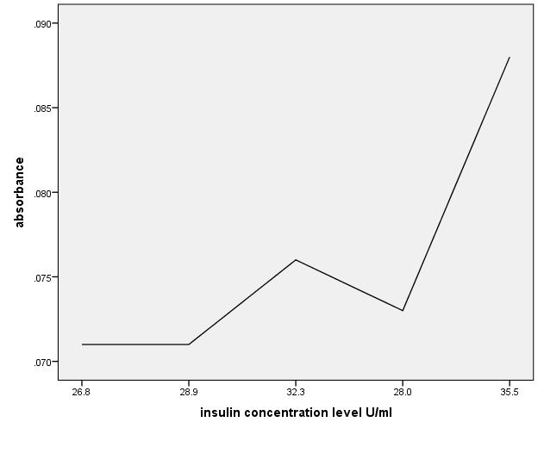

91