THE US SECURITY POLICY AND NORTH KOREA NUCLEAR PROGRAMME, 2000 - 2008

7

Table of Contents

Title Page…………………….……………………………………….……..……….….i

Approval Page…………………………………………….…….……….…………...…ii

Dedication………………………………………….………………………………......iii

Acknowledgements……………………………….………………………………..…..iv

Table of Contents……………………………………………………..…………...........v

Abstract…………………………………………………………………………….….vii

CHAPTER ONE: INTRODUCTION

1.1 Introduction----------------------------------------------------------------------------------1

1.2 Statement of Problem-----------------------------------------------------------------------5

1.3 Objectives of Study-------------------------------------------------------------------------7

1.4 Significance of Study-----------------------------------------------------------------------8

1.5 Literature Review---------------------------------------------------------------------------9

1.6 Theoretical Framework-------------------------------------------------------------------24

1.7 Hypotheses---------------------------------------------------------------------------------27

1.8 Method of Data Collection---------------------------------------------------------------28

CHAPTER TWO: NORTH KOREA NUCLEAR PROGRAMME AND US

NATIONAL SECURITY
8

2.1 North Korea acquisition and development of nuclear weapons--------------------- |  |  |  |  |  | 33
2.2 North Korea nuclear programme as a threat to US national security--------------- |  |  |  |  |  | 38
2.3 | US disarmament diplomacy with North Korea--------------------------------------- |  |  |  |  | 42
CHAPTER THREE: NORTH KOREA NUCLEAR PROGRAMME AND US
FIGHT AGAINST TERRORISM
3.1North Korea development of ballistic missile capabilities and Possession of
 | plutonium production facilities---------------------------------------------------------- |  |  |  |  | 50
3.2 | Pre-emptive actions to counter a sufficient threat to US national security |  |  |  |  | --------56
3.3 | Intimidating and isolating of states suspected of acquiring weapons of mass
 | destruction---------------------------------------------------------------------------------- |  |  |  |  | 59
CHAPTER FOUR: US |  | GOVERNMENT | SECURITY | POLICY | ON | NORTH
 | KOREA | NUCLEAR | PROGRAMME | AND | MULTILATERAL
 | INTERVENTION ON NUCLEAR WEAPON DEVELOPMENT

4.1 US Strategy of containment and isolation---------------------------------------------------

63
4.2 US government security policy on North Korea nuclear programme and 1968
Non-proliferation Treaty (NPT) -------------------------------------------------------------------------------------------- | 66

4.3 US government security policy on North Korea nuclear programme and

International Atomic Energy Agency---------------------------------------------------------70
9

CHAPTER FIVE: SUMMARY, CONCLUSION AND RECOMMENDATIONS

5.1 Summary------------------------------------------------------------------------------------------73

5.2 Conclusion----------------------------------------------------------------------------------------75

5.3 Recommendation--------------------------------------------------------------------------------76

Bibliography-------------------------------------------------------------------------------78

Appendix------------------------------------------------------------------------------------------83

Abstract

This study examines the interface between the US security policy and North Korea nuclear programme. The thrust of the study however is to find out if the US government perceived North Korea nuclear programme as a threat to its national security on the one hand and part of its war on terror, between 2000 and 2008 on the other. The study also investigated whether the US government security policy on North Korea nuclear programme relegates multilateral intervention on nuclear weapon development within the same period. Relying on the realist approach which tackles politics for what it is
10

without moralizing it, qualitative method and qualitative descriptive method of analysis, and relying on secondary sources, the study argues that the US government perceived North Korea nuclear programme as a threat to its national security as well part of its war on terror, between 2000 and 2008 and as such orient its security policy on North Korea nuclear programme to relegate multilateral intervention on nuclear weapon development. Accordingly, the study maintains that the US government should really curtail the rate at which it seeks, foster and protect what it regards as its national interests as this accounts for North Korea’s nuclear enrichment.
11

CHAPTER ONE

INTRODUCTION

1.1 Introduction

The posture of the US foreign and defense policies especially in the post-Cold War era of international politics has demonstrated blatantly and abundantly a tendency to seek power, increase power and to demonstrate power (Morganthau, 1973). More importantly, the 9/11 terrorist attack did transform the way America government think about their foreign and defense policies. In fact, there have been remarkable changes in U.S defense and nuclear weapons policy following the 9/11 terrorist attack. These changes in U.S nuclear weapon policy were announced in two official documents that were released by the Bush’s administration in 2002. Both documents, according to Intriligator (2003), were influenced, in part, by the September 11, 2001 terrorist attacks on the U.S. The first of these documents is the U.S Nuclear Posture Review (NPR) issued by the U.S Department of Defense which expressively states that “A combination of offensive and defensive and nuclear and non-nuclear capabilities is essential to meet the deterrence requirements of the 21st century” (cited in Intriligator, 2003:2). The second of these documents is the National Security Strategy of the United States of America (NSS). Issued by the Office of the National Security Advisor to the President in September, 2000, the document reveals that there are plans to ensure that no nation could rival U.S military strength. It proclaims the doctrine of U.S preemption, where it “cannot let our enemies strike first” and gives arguments for preemption. It notes that for “centuries, international law recognized that nations need not suffer an attack before
12

they can lawfully take action to defend themselves against forces that present an imminent danger of attack.” (Intriligator, nd: 2).

Thus, influenced mostly by the latter document, President George W. Bush, on June 1st, 2002, at West Point, set forth a new doctrine for U.S security policy. According to him,

The successful strategies of the cold war era are ill-suited to national defense in the 21st century. Deterrence means nothing against terrorist networks; containment will not thwart unbalanced dictators possessing weapons of mass destruction. We cannot afford to wait until we are attacked. In today’s circumstances, Americans must be ready to take ‘preemptive action’ to defend our lives and liberties (Galston, 2002: np).

With this, George W. Bush not only introduced what has since been widely known as “Bush Doctrine”, but has also made it an official part of U.S policy. Therefore, US defense/strategic policy under George W. Bush, as aptly described by Falk (2002) implies striking first, not in a crisis, but on the basis of shadowy intentions, alleged potentials links to terrorist groups, supposed plans and projects to acquire weapons of mass destruction, and anticipations of possible future dangers.

Meanwhile, the US government, even before the 9/11, appeared to have been committed to unilateral military solution to the problems of terrorism and acquisition and possible use of Weapons of Mass Destruction (WMD). Hence, in the aftermath of the 11 September terrorist attacks, the United States found justification to harass, intimidate, attack and dethrone regimes suspected of either harboring terrorists, amassing weapons of mass destruction or colluding with the known terrorist organizations. These states were variously labeled by the Bush administration as “terrorist states”, “axis of evil”, “rogue states”, among others and therefore proclaimed its determination to attack “foes in anticipation of hostile acts” and to carry out these attacks “unilaterally, presumably without prior authorization from the United Nations Security Council” (cited in Wirtz and Russel, 2003: 117).
13

True to its threat, the administration of Bush preemptively and unilaterally attacked Iraq in 2003, dethroning its leader- Saddam Hussein and installing another government which is believed to be pliable to the government on the United States. However, despite the avalanche of criticisms and condemnations that have trailed the US unilateralism and hegemonism in the aftermath of the Cold war, the US government, particularly the administration of George Bush, did maintain unequivocally that the menace of terrorism as well as the potential dangers posed by the accumulation and the possible use of Weapons of Mass Destruction (WMD) by the “rogue states” has made the resort to preemption unquestionably desirable.

As for the North Korea, various diplomatic efforts have been underway, in the last 25 years, to grapple with the North Korean nuclear issue in terms of whether to prevent North Korea from acquiring nuclear weapons or to disarm its assumed nuclear weapons capability. At different times, the instruments to achieve these objectives have included an international treaty (the NPT), a regional nuclear-free zone (the NSDD) and a bilateral agreement between the US and North Korea. In the end, none of these diplomatic efforts and agreements has been fully successful, although, in different degrees, they have helped to delay or constrain – sometimes very significantly – North Korea’s nuclear weapons efforts (Niksch, 2002). The current diplomatic effort involves a fourth variation – a Six Party multilateral agreement or perhaps a package of bilateral agreements stitched together in an overall multilateral framework. As with previous efforts, the future success or failure of the Six Party Talks is uncertain.

In crafting their approaches to the nuclear issue, the US and other powers have struggled to come to grips with Pyongyang’s ultimate intentions. For years, North Korea watchers have debated whether Pyongyang views nuclear weapons as indispensable to the regime’s survival and therefore non-negotiable, or whether it sees its nuclear assets as a bargaining chip to be traded away for political and
14

economic benefits necessary to sustaining the regime. The historical record suggests that the answer is both, and the emphasis that Pyongyang places on one or the other varies with domestic conditions and external circumstances (Henneka, 2006). On the one hand, the time and energy that North Korea has invested in developing its nuclear weapons capability, allied to its willingness to repeatedly violate nuclear agreements, strongly suggests that North Korean leaders deeply believe that some kind of nuclear hedge – or at least the appearance of a credible nuclear hedge – is essential to regime survival. Pyongyang sees itself as a besieged and beleaguered state, surrounded by more powerful enemies, untrustworthy allies, and a successful southern competitor. To this end, as articulated by Henneka (2006), if North Korea is ever going to reform itself and survive in the long run, it must find respite from external pressures and perceived threats in which case, nuclear weapons are the ultimate defence. Therefore, as long as outside powers believe that it has a nuclear deterrent they are – in Pyongyang’s view – more likely to leave North Korea alone and less likely to pursue hostile policies that could provoke a confrontation in which such weapons are used. On the other hand, North Korea has demonstrated that it does respond to international inducements and pressures to limit its nuclear programme. In the past, Soviet diplomacy, backed by promises of nuclear power assistance, persuaded North Korea to join the NPT, and US diplomatic efforts convinced North Korea to implement IAEA inspections. Later, Washington and Pyongyang negotiated a complex bilateral agreement that froze North Korea’s plutonium production facilities and established a process for the eventual elimination of these facilities. With a combination of carrots and sticks, Washington has been making enormous diplomatic efforts to convince Pyongyang to open up a secret underground facility and to accept a moratorium on long-range missile tests (Niksch, 2002). Be that as it may, diplomatic efforts in the past have constrained, but not eliminated North Korea’s nuclear capabilities.
15

Against the background of the foregoing, the study critically assesses the US security policy and North Korean nuclear programme, between 2000 and 2008. The study also examines the US defense policy in terms of the North Korean nuclear programme jeopardizes US national security as well as her crusade against international terrorism with the same period.

1.2 Statement of the Problem

Diplomatic efforts oriented towards grappling with the attempts by North Korean government to acquire nuclear weapons and develop its ballistic missile capabilities have witnessed both success and failure. During this period, four different approaches have been variously tried. First, beginning in the 1980s, the US-led efforts to use pressures and inducements to convince North Korea to adhere to the 1968 Treaty on the Non-proliferation of Nuclear Weapons on the one hand, and accept International Atomic Energy Agency (IAEA) inspection of its nuclear facilities and materials, on the other. In December 1985, North Korea acceded to the NPT and, after significant prevarication, accepted international inspections in April 1992. The implementation of the inspection agreement however collapsed following North Korean government refusal to cooperate with the IAEA to verify plutonium production prior to 1992, a situation compounded when Pyongyang threatened to withdraw from the NPT in March 1993.

Second, in December 1991, North and South Korea entered into a bilateral agreement on ‘denuclearisation’ which included restrictions on nuclear activities beyond those specified in the NPT. Unfortunately, this agreement was not implemented as a result of disagreements between Seoul and Pyongyang over the number and type of bilateral inspections necessary to verify it.

Third, consequent upon threat by North Korean government to pull out from the NPT in March 1993, the US and North Korea in October 1994 concluded a bilateral agreement: the Agreed Framework. The Agreed Framework called for an
16

ambitious undertaking to freeze and eventually dismantle North Korea’s plutonium production facilities and account for its plutonium stocks in exchange for interim supplies of heavy fuel oil and an alternative nuclear energy project, as well as improved bilateral relations with Washington. For nearly a decade, the Agreed Framework halted North Korean production of additional plutonium, but it did not end North Korea’s efforts to acquire nuclear weapons. Meanwhile, the Agreed Framework collapsed amid diplomatic acrimony arising from public revelations in October 2002 that North Korea was pursuing a secret programme to produce weapons grade uranium. North Korea however revived its plutonium production facilities in December 2002 and withdrew from the NPT in January 2003, arguing that it had already given the requisite 90-day notice when it announced its original intent to withdraw in March 1993.

Finally, the US has, since the collapse of the Agreed Framework, promoted a fourth effort to deal with the North Korean nuclear issue – through Six Party Talks between the US, Russia, China, Japan, and North and South Korea. These are intended to secure a multilateral agreement for North Korea to abandon its nuclear weapons programme in exchange for security assurances and political and economic benefits. This is in line with the present US national security strategy which states that “the US may not deter the types of threats that are emerging today, such as those created by rogue nations or terrorists armed with weapons of mass destruction” (Woolf, 2008: 9-10). Consequently, the US government has sought to preempt these threats through persuasive diplomacy, and attacking the adversaries before they can attack the US, its allies and interests.

The link between the US national security policy and North Korean nuclear programmes has been a subject of intellectual discourse and considerable efforts have been made by scholars such as Niksch (2002), Henneka (2006), Boureston and Russell (2009), Niksch (2006), Chanlett-Avery (2012), Pritchard (2005), Ur-Reham
17

(2010) and so on to examine the threats of North Korean nuclear programmes to the US national interests/security. Despite the forgoing inquiries, the extant literature has suffered from important shortcomings. This is because the existing research in this area has not satisfactorily explained whether the US government perceives North Korea Nuclear Programme as a threat to its national security. Of much importance, however, is the fact that the existing inquiries have failed short of evaluating adequately whether the US government perceive North Korea Nuclear Programme as part of its war on terror. Finally, adequate attempts have not been made to explore the link between the US government security policy on North Korea Nuclear Programme and multilateral intervention on nuclear weapon development.

In the light of the above, attempt is made, therefore, to critically examine the US national security policy and North Korean nuclear programmes, between 2000 and 2008 in context of the understated research questions:

- Did the US government perceive North Korea Nuclear Programme as a threat to its national security, between 2000 and 2008?

- Did the US government perceive North Korea Nuclear Programme as part of its war on terror, between 2000 and 2008?

- Did the US government security policy on North Korea nuclear programme relegate multilateral intervention on nuclear weapon development, between 2000 and 2008?

1.3 Objectives of the Study

The broad objective of this study is to critically examine the interface between the US security policy and North Korea nuclear programme. However, the study is set to achieve the following specific objectives:

- To examine whether the US government perceives North Korea nuclear programme as a threat to its national security, between 2000 and 2008.
18

- To ascertain whether the US government perceives North Korea nuclear programme as part of its war on terror, between 2000 and 2008.

- To investigate if the US government security policy on North Korea nuclear programme relegates multilateral intervention on nuclear weapon development, between 2000 and 2008.

1.4 Significance of the Study

This research work has both theoretical and practical significance. Theoretically, the study interrogates the link between the North Korea nuclear programme and threat to the national security; between the North Korea nuclear programme and the US government war on terror; and between the US government security policy on North Korea nuclear programme and multilateral intervention on nuclear weapon development.

Practically, the study will be of interest and immense importance to the Nigerian government, the organs of the United Nations and other people, groups and organizations interested in American hegemony and unilateralism in this 21st century. The issues will not only help to enhance understanding of American defense and foreign policy in the 21st century, but will also provide valuable information/data that will assist global actors in articulating potent policies that will help to address the US government -North Korean government face-off over nuclear programme.

Again, by examining, in its entirety, the North Korea nuclear programme, the study will constructively highlight how it poses a threat to the US government national security on the one hand and how the US government security policy on North Korea nuclear programme relegates multilateral intervention on nuclear weapon development on the other.

Finally, the study by addressing the research questions, clarifying issues, facilitating understanding and stimulating enlightened intellectual discourse will not
19

only be a further contribution to knowledge and a source for further research but will equally chart a new intellectual course in the study of US hegemony and unilateralism in this 21st century.

1.5 Literature Review

The thrust of this review is to ascertain how writers have tried to explain the link between the following: North Korea nuclear programme and threat to the US national security; North Korea nuclear programme and the US government war on terror; and US government security policy on North Korea nuclear programme and multilateral intervention on nuclear weapon development. This is with a view to locating the gaps in the literature. The implication of this, therefore, is that our research questions will generally guide the review.

Did the US government perceive North Korea nuclear programme as a threat to its national security, between 2000 and 2008?

There is no doubt that scholars have oriented their intellectual energies towards explaining the US national security and the North Korean nuclear programme. To this end, Intriligator (2003) maintained that the national Security Strategy of the United States (NSS) places major emphasis on preemption and calls for it rather than deterrence as the fundamental basis of national security, such policy, of course, is a violation of the UN system that was set up in large part to prevent precisely such preemption. According to the writer, the United Nations forbids a member state from taking military action against another member state unless it has itself been attacked or it has the sanctions of the Security Council. To this end, the writer contends that the US violation of international law in its attack on Iraq was as much a violation as Saddam Hussein was in his attack on Kuwait. Again, the writer fails to provide specific sections of international law or UN Charter that uphold that preemption amounts to violation of law.
20

In the view of Niksch (2002), North Korea’s nuclear weapons program has been an immediate foreign policy issue facing the United States because of North Korea’s refusal to carry out its obligations under the Nuclear Non-Proliferation Treaty (NPT) and other nuclear accords it had signed. According to the writer, North Korea has constructed nuclear reactors and a plutonium reprocessing plant at a site called Yongbyon. U.S. and other foreign intelligence assessments have concluded that North Korea probably has acquired enough weapons-grade plutonium for the manufacture of at least one nuclear weapon. The United States and North Korea signed an agreement on October 21, 1994, that offers North Korea a package of benefits in return for a freeze of North Korea’s nuclear program. Benefits to North Korea include: light water nuclear reactors totaling 2,000 electric megawatts; shipments of “heavy oil” to North Korea. However, the pace of implementation of the Agreed Framework has been very slow, according to the writer, and instead of the original target date of 2003, it is estimated that completion of the light water reactors will not take place until well beyond 2010. The United States has faced several policy problems since the signing of the Agreed Framework, including securing money annually to finance heavy oil shipments to North Korea, suspicions of clandestine North Korean nuclear activities, and North Korea’s development of long range missiles.

Similarly, Wirtz and Russel (2003) have noted that the Bush administration developed new guidelines to govern the use of force in combating emerging terrorist adversaries or “terrorist states.” The writers maintained that by advocating preventive war and preemption, especially as a possible response to Iraq’s failure to fulfill its obligations under UN Security Council resolutions to eliminate its nuclear, chemical, and biological weapons and associated infrastructure following the Gulf War, the Bush administration is generally depicted if not being on the wrong side of international law, then pushing the limits of what is generally considered to be constructive international behavior. To the duo, the apparent effort to legitimize
21

preventive war and preemption is often depicted as creating an intolerable precedent when it comes to other enduring conflicts. They, therefore, concluded by wondering whether the Bush administration decision to undertake preventive war would shape the overall tenor of international relations. That is, whether it would signal a new respect for international law, or just a growing reliance on the use of force in world politics.

In a similar vein, Thomas (2004) criticizes America for preferring “to conduct massive bombing campaigns against other states without much fear of casualties to American forces.” He therefore, contends that the United States has done this time and time again, despite the necessity of it, the justness of the cause, or the civilian casualties incurred. He states that “Washington wants other states to trust its noble intentions, but the record of U.S. military interventions in Vietnam, Iraq, Panama, Afghanistan, and other places would give rise to doubts.” In addition to the suspicions many in the global theater have developed concerning America’s benevolent intentions, the writer also believes that there is also a growing awareness of its insensitivity to other cultures and values.

In line with the foregoing contention, Galston (2002) upholds that the invasion of Iraq based on the new Bush doctrine of preemption meant not only the most fateful deployments of American power since World War II, but also an end to the system of international institutions, laws and norms that Americans have worked to build for more than half a century. To this effect, the writer believes that this revolution in international doctrine is justified and wise. For the writer, rather than continuing to serve as first among equals in the postwar international system, the United States has acted as a law unto itself, creating new rules of international engagement without the consent of other nations. In his judgment therefore, this new stance would ill serve the long-term interests of the United States. In the first place, the United States is a signatory to (indeed, the principal drafter of) the United Nations Charter, which
22

explicitly reserves to sovereign nations the inherent right of individual or collective self-defense, but only in the event of armed attack. Unless the administration establishes Iraqi complicity in the terrorism of 9-11, it cannot invoke self-defense, as defined by the charter, as the justification for attacking Iraq. Furthermore, the writer insists that the broader structure of international law creates additional obstacles to an invasion of Iraq. Though such law contains a doctrine of "anticipatory self-defense," there must be shown a necessity of self-defense, instant, overwhelming, leaving no choice of means, and no moment for deliberation. In this regard, the concept of anticipatory self-defense was too narrow to support an attack on Iraq: The threat to the United States from Iraq is not sufficiently specific, clearly enough established or shown to be imminent, the writer contends. In sum, he avers that with preemptive war in Iraq, the Bush administration has shifted its focus from stateless foes to state-based adversaries, and from terrorism in the precise sense to the possession of weapons of mass destruction. Each constitutes a threat. But they are not the same threat and do not warrant the same response. It serves no useful purpose to pretend that they are seamlessly connected, let alone one and the same, be believes.

In another development, Niksch (2006) maintained that North Korea’s decisions at the end of 2002 to restart nuclear installations at Yongbyon that were shut down under the U.S.-North Korean Agreed Framework of 1994 and to withdraw from the Nuclear Non-Proliferation Treaty (NPT), and its multiple missile tests of July 4, 2006, create a foreign policy problem for the United States. Restarting the Yongbyon facilities opens up a possible North Korean intent to stage a “nuclear breakout” of its nuclear program and openly produce nuclear weapons. North Korea has also threatened to test a nuclear weapon. North Korea’s actions follow the disclosure in October 2002 that it is operating a secret nuclear program based on uranium enrichment and the decision by the Korean Peninsula Energy Development Organization (KEDO) in November 2002 to suspend shipments of heavy oil to North
23

Korea. North Korea claims that it has nuclear weapons and that it has completed reprocessing of over 8,000 nuclear fuel rods. To this the U.S. officials and other experts state that North Korea probably had reprocessed most or all of the fuel rods and may have produced enough plutonium for 6-10 atomic bombs. The main objective of the Bush Administration, according to the writer, was to secure the dismantling of North Korea’s plutonium and uranium-based nuclear programs. Its strategy included :(1) terminating the Agreed Framework; (2) withholding U.S. reciprocal measures until North Korea takes steps to dismantle its nuclear programs;

- assembling an international coalition, through six party negotiations, to apply diplomatic and economic pressure on North Korea; and (4) imposing financial sanctions on foreign banks that facilitate North Korea’s illegal counterfeiting activities. China, South Korea, and Russia criticized the Bush Administration for not negotiating directly with North Korea, and they also voiced opposition to economic sanctions and to the potential use of force against Pyongyang. China, Russia, and South Korea increasingly have expressed support for North Korea’s position in six-party talks. The talks have made little progress. As also articulated by the writer, North Korea, in the six party meetings of July- September 2005, widened the gap between the U.S. and North Korean positions when it asserted that it would not dismantle or even disclose its nuclear programs until light water reactors were physically constructed in North Korea. The widening gap was not narrowed by a statement of the six parties on September 19, 2005, in which North Korea agreed to rejoin the NPT and its 1992 safeguards agreement with the International Atomic Energy Agency “at an early date” but which also contained a reference to North Korea’s right to have a light water reactor, the writer concluded.

Again, Finstad (nd) contends that it makes more sense to define preemption as striking a potential adversary before it can become a nuclear power, rather than striking an enemy before it can strike you. According to him, China and Russia are
24

more threatening to the US than the entire "axis of evil" combined, but, as nuclear powers, it would be unthinkable for the US to launch a first strike (or preemption) on either nation the way it did to Iraq. Furthermore, the writer insists that the re-definition of the preemption doctrine is most significant in the way that it impacts the incentive structure of nations at odds with US foreign policy. For him, analysis of actions and statements made by Iran and North Korea show that these countries are acting rationally from within this structure: Having already developed atomic bombs and viable delivery systems, North Korea believes that bold statements of its willingness to use these weapons will deter an American attack. Conversely, Iran realizes that it must not make its ongoing pursuit of nukes public, but believes it is not only essential to Iran’s security to continue developing its nuclear program, but the programme will also serves sound deterrent against American invasion. In sum the writer argues that these recent actions by Iran and North Korea further demonstrate that the Bush administration’s preemption doctrine in Iraq was not a deterrent at all. The implication is that countries that find themselves at odds with the interests of the United States feel threatened by the example of Iraq, and are encouraged to develop nukes by the example of North Korea. Smaller countries with fewer resources to foster nuclear research, such as Libya, may be intimidated into scrapping their programs. Larger, wealthier, more threatening nations, however, are simply encouraged to build nuclear bombs, and to make their willingness to use them known to the world.

For Chanlett-Avery (2012), North Korea has been among the most vexing and persistent problems in U.S. foreign policy in the post-Cold War period. Negotiations over North Korea’s nuclear weapons program have consumed the past three U.S. administrations, even as some analysts anticipated a collapse of the isolated authoritarian regime. North Korea, according to the writer, has been the recipient of well over $1 billion in U.S. aid and the target of dozens of U.S. sanctions. As U.S.
25

policy toward Pyongyang evolved through the George W. Bush presidency and into the Obama Administration, the negotiations moved from mostly bilateral to the multilateral Six-Party Talks (made up of China, Japan, Russia, North Korea, South Korea, and the United States). To this end, the writer maintained that although the negotiations have reached some key agreements that lay out deals for aid and recognition to North Korea in exchange for denuclearization, major problems with implementation have persisted. With talks suspended since 2009, concern about proliferation to other actors has grown. The Obama Administration, like its predecessors, faces fundamental decisions on how to approach North Korea.

Did the US government perceive North Korea Nuclear Programme as part of its war on terror, between 2000 and 2008?
Our major concern in this segment of the literature review is to find out

whether the US government perceives North Korea Nuclear Programme as part of its

war on terror. To this end, Ifesinachi (2006) sees the US-led war on terror in terms of

unilateralism. According to him, the trajectories of the phenomenon of terror derive

from political motivation. To this effect, he maintains that political terror has served

the ends of political struggle and as such, sovereign recognition and intervention are

products of political struggles which reflect the contradictions of material condition at

every phase of human history. Berating America’s military crusade against terrorism,

the writer rightly and logically argues that terrorism as a political problem will subsist

(notwithstanding America’s seemingly efforts to stamp it) since the political problem

that induces it persist. Accordingly, Ifesinachi writes:

…terrorism as a political problem will persist as long as the political problem that induces it persists. The solution to terrorism is not just to punish terrorists but in seeking out common political solutions to the political malaise prompting terrorism. The rationalization of state terrorism in terms of the war on terror is seen to be sterile and redundant. It is in this context that the need for defining anti-terrorism campaigns as a
26

global problem becomes contingent on the restructuring of the global order (Ifesinachi, 2006: 7).

As for Gardner (nd), Al Quaida, instead of regressing during the fight on terrorism, is increasing its membership greatly worldwide. More alarming, according to the writer, is that it has decentralized even more after 9/11; it has more popular support among young Arabs and non-Arab Muslims and Osama is to many Muslims what "Che" was for many Latin Americans. Now many Muslims and non-Muslims alike see more clearly the comparison between Israel's occupation and treatment of Palestinians and U.S. occupation and treatment of Iraq. This brings into question the limits of the military solution as the ultimate option, and the Bush administration's failure to appreciate the complexity of terrorism as a manifestation of deeper societal problems combined with adamant opposition to western imperialism. More so, the writer insists that because terrorism has existed for centuries in one form or another, one would think that intelligent people working in Washington D.C. today would realize that the best method of containing it is to understand its root causes and then to provide a long-term political solution. This does not mean that armed forces should not be utilized, but if that is the only solution, it leads to more terrorism and an endless cycle of political violence that costs the status-quo state more than it costs the terrorists, he concludes

Contributing, Marszka (2009) wondered whether the Bush Doctrine has increased asymmetric warfare in the form of terrorism or whether it has been an effective policy against it. He, therefore, insists that if the United States can justify preemption and unilateralism in defense of its national security with Security Council authorization, that would be catastrophic in most cases as other nations would equally be attempted to attack and justify their actions as preempting. The writer, therefore, bemoaned the Bush administration for favoring this seemingly counterproductive foreign policy strategy.
27

In another development, Okolie (2005) investigates the changing pattern of terrorism and its implications for global security. To this effect, the writer avers that terrorism is escalating and posing threats to peace and security. Continuing, the writer maintains that the September 11, 2001 incident compelled the then President of United States, George Bush to refocus US foreign and security policies on two distinct, if not cross-cutting missions: defeating ‘terrorism with a global reach’ and ‘keeping the worst weapons out of the hands of the worst people’. According to him, at the heart of the above policies is the policy of preemptive use of force. However, rather than American hegemony and unilateralism, the writer advocates for a new global security codes that would be ratified and agreed upon and enforcement done under the auspices of the United Nations.

On the other hand, Mamdani (2004) avers that events after the collapse of the Soviet Union and the Cold War suggest that America’s low intensity conflict against militant nationalist regimes continued thereafter, even up to 9/11. According to him, by 9/11, the methods changed drastically, from low-intensity proxy war to high intensity direct warfare; the shift which was made possible by a changed political climate in post 9/11. More so, the author insists that the trajectory of proxy war in the rough decade from the end of the Cold War to 9/11 is best illuminated on the ground of Iraq where the Bush administration saw a golden opportunity to shed the inhibitions of the Cold War and declare open season of militant nationalism. However, as the writer argues, whereas the Taliban had been pinpointed as hosts of al-Qaeda, there was little legitimate effort to connect the invasion of Iraq to the terror that was 9/11. For the author therefore the war on terror had moved on from addressing broadly shared security concerns to targeting militant nationalism, and the war against militant nationalism would conclude the unfinished business of the Cold War. However, the author concludes that:
28

…the two adversaries in the war on terror: the United States and al-Qaeda are both veterans of Cold War. Both see the through lenses of power….Caught in a situation where both adversaries in the war on

terror claim to be fighting terror with weapons of terror, nothing less than a global movement for peace will save humanity. If we are to go by the lesson of the last global struggle for peace, that to end the war in Vietnam, this struggle, too, will have to be waged as a mass movement inside each country, particularly the democratic countries, and especially in the United States and Israel (Mamdani (2004: 257-258)

Falode (2002), prior to the attack on America in 2001, the political interplay in the

Middle-East and South-East Asia had been a very volatile one, speckled with distrust

and suspicion as well as America’s passivity. Continuing, the writer stated that while

factors of economy, territory, irredentism and religion essentially accounted for these

volatile relationships, the coordinated terrorist attack on America on September 11,

2001 impacted profoundly on this fragile and political balance. The implication of

this, according to the writer was the fact that America was forced to jettison the

multinationalist and isolationalist approach for the more flexible, uncompromising

unilateralist approach. And this meant that America would no longer seek the views of

the allies before embarking on any political adventure or misadventure in the internati

onal environment.

In a similar argument, Eliot (2003) insists that while concern about peaceful

strategies for the 21st century is essential, it is more crucial to attempt stopping this

very risky war and lowering the Bush administration's bellicose rhetoric (and

exorbitant military budget) that is escalating tensions and dangers across the globe. As

for the writer, the Bush administration's paranoia and militaristic belligerence has

erased much of the sympathy people around the globe felt toward America after

September 11th, and has escalated tensions and dangers throughout the planet.

Furthermore, the writer avers that the terrible risks inherent in pre-emptive war-the

potential deaths of thousands of innocent Iraqis, the danger to U.S. troops, the likely

rise in terrorist recruitment, the long-term environmental degradation of the region
29

through oil fires and depleted uranium, and the temptation to move on to the next war and the next generation of dangerous weaponry simply cannot be justified by any of the reasons offered by the Bush administration. Instead of brainstorming justifications and military strategies for a pre-emptive war, the writer believes that it would be nice if the Bush administration would devote its creativities to thinking about non-war alternatives.

Did the US government security policy on North Korea nuclear programme relegate multilateral intervention on nuclear weapon development, between 2000 and 2008?

In this final segment of the literature review, our concern is to find out whether the US government security policy on North Korea nuclear programme relegates multilateral intervention on nuclear weapon development. To this end, Pritchard (2005) averred that the lack of a permanent multilateral structure for security dialogue in North-East Asia and the lack of a successful precedent involving the DPRK in multilateral talks contribute to the likelihood that this iteration of multilateral talks may well fail. The period of time between sessions of the Six-Party Talks and the lack of progress suggest that there is insufficient common ground or commitment by the key participants (the United States and the DPRK) for resolution of the crisis in the foreseeable future. In the face of likely failure of the multilateral process currently underway, it would seem prudent for the participants to review the substantial track record of DPRK participation and accommodation in bilateral negotiations with both the United States and the Republic of Korea and modify the Six-Party Talks accordingly. One way to do this, according to the writer, would be for the United States to enter into a serious and sustained bilateral dialogue with Pyongyang as a complementary component of the six-party process. In this scenario, as the United States begins to shape what may ultimately result in a resolution to the crisis in its complementary negotiations with North Korea under the auspices of the six-party
30

process, it would continue to consult with its close allies South Korea and Japan. Washington’s coordinated policy approach to North Korea would be enhanced by Tokyo and Seoul’s own bilateral meetings with Pyongyang. This two-pronged approach has the best chance of forging a near-term negotiated settlement through an extensive and mutually supportive bilateral component and the best chance to ensure its implementation through a multilateral component of guarantees and monitoring. Given the track record of the past two years, the prognosis for successful resolution of the nuclear crisis through the current framework of multilateral talks is not very bright, the writer concluded.

Ur-Reham (2010) reviewed the prospects for Korean reunification in view of the policies and actions of the governments of the two Koreas. The writer examined the roles played by china, Japan and Russia, as their policies directly affect any long term political solution and ongoing humanitarian concerns on the Korean Peninsula. The writer equally discussed President Kim Dae-jung’s ‘sunshine policy’ in the late 1990s, a policy of engagement which revived hopes for Korean reunification. Those hopes suffered serious setbacks following North Korea’s nuclear tests in 2006 and 2009. Also, in 1998, there was a radical shift in South Korea’s policy towards North Korea with the election of Lee Myung-bak’s conservative administration which tied aid to denuclearization. The renewed talk of contingencies’ and succession struggle’ in North Korea in the wake of Kim Jong-il’s reported stroke in August 2008 has also been vitiating inter-Korean relations. Conflicting US and China policies on North Korea is another factor that has bedeviled reunification. To this effect, the writer argued that Korean reunification could best take place through sustained engagement and peaceful means. An important facet is the creation of the right environment for achieving the goal of reunification and denuclearization, a daunting task, particularly before the implementation of at least one of the international commitments made, such as the 2000 and 2007 South-North Summit Declarations of the 1994 Agreed
31

Framework between the US and North Korea; or the lifting of international sanctions on North Korea, the writer concluded.

Contributing, Wampler (2003) maintained that North Korea's nuclear weapons program has moved back to the front pages with the unprecedented acknowledgement by North Korea that it has developed nuclear weapons. According to the writer, news of this revelation came as Assistant Secretary of State for East Asian Affairs James A. Kelly was preparing to leave Beijing for consultations in Seoul. To the writer, this was but the latest step in a simmering crisis that began with the admission by North Korea, after being confronted with hard evidence by Assistant Secretary Kelly in October 2002, that it has been pursuing in secret a nuclear weapons program in violation of the Agreed Framework of 1994 and its adherence to the Non-Proliferation Treaty (NPT). Pyongyang's subsequent actions in asserting the right to possess nuclear weapons, breaking the seals on its nuclear reactor put there by the International Atomic Energy Agency, withdrawing from the NPT and the expulsion of IAEA inspectors from the Yongbyon nuclear facilities, have kept the crisis simmering, and laid the basis for reported splits within the Bush administration over the best strategy for dealing with Pyongyang. Seemingly replaying debates marking the lead-up to the war with Iraq, newspaper analyses portray the State Department under Secretary of State Colin Powell pressing for diplomacy and efforts to reassure the North Koreans that the U.S. was not seeking regime change.

Richter (2003) remarked that international law has long held that the use of force between states is illegal except on two grounds- authorization by the Security Council, and that done in self-defense. Furthermore, the writer evaluates the notion of preemptive self-defense as well as the customary laws that give rise to it, and whether such can be extended to address the threats of terrorism and WMDs. In so doing so, the writer addresses the general laws relating to self-defense and the limits of the doctrine of preemption. It argues that aside the threat posed by terrorism and WMDs,
32

the extended version of preemption is the US is not only potentially dangerous, but will be rejected by the international community.

Again, Henneka (2006) maintained that nothing in the political behavior of Korean policy could be understood without reflecting upon the experience of the Korean Peninsula and its people under the policy of the Great Powers. Moreso, the writer contended that one of the main reasons of the radicalisation of the US – and North Korean – policy is the underestimation of the meaning of Korean history before and after its division. To this end, the writer pointed out that a peaceful solution for the North Korean problem would probably not be found by waiting for regime collapse, regime change, or by forcing North Korea to one-sided reforms. Instead the international community and especially the United States must accept that this policy would only lead to a further escalation of the situation and increase the possibility of military confrontation. The historical perspective shows that one-sided accusations for the situation, no matter in which direction, do not reflect the historical facts. The problem cannot be solved without a wide understanding of Korean history in general. For the future, it is important for the administration in Washington to realise that dealing with the Korean Peninsula in a responsible way means to consider the region’s wider historical dimensions, the writer concludes.

Moreso, Boureston and Russell (2009) maintained that the proliferation activities of Pakistan, Iran, Iraq, and North Korea illustrate the problem faced today by the international community: procurement networks are staying ahead of export controls by altering their tactics, learning new and more evasive techniques and finding ways to exploit legitimate trade practices to acquire sensitive materials. According to the writers, while control regimes may have successfully slowed the first and second tier of proliferation networks, there is actually a third tier of networks

– a ‘substructure’ that is comprised of a variety of semi-autonomous groups that can service the demand size of today’s nuclear black market. The challenge for
33

intelligence agencies, and international and national regulatory bodies, in the view of the writers, is to continue to investigate questionable activities and to find new tools to interdict any transactions which may result. Looking for indicators such as frequent buying missions to industrial countries, suspicious contacts and organizations operating out of embassies, scientific exchanges and other doubtful alliances among allied nations, and nationals living overseas shipping materials to their home country, investigators can identify and analyze the existence of new and existing procurement networks. These and other more innovative measures are needed to help enable the international community to stifle nuclear procurement activities, thereby slowing the spread of nuclear weapons, the writers concluded.

Summary of the Review

In all, the review of the extant shows that our research questions have not been satisfactorily addressed. In the first segment, none of the writers whose works were reviewed specifically evaluated whether the US government perceives North Korea nuclear programme as a threat to its national security, between 2000 and 2008. In the second segment also, the works reviewed could not explicitly articulated whether the US government perceives North Korea nuclear programme as part of its war on terror, between 2000 and 2008. Finally, in the last segment, the authors reviewed failed to logically and coherently articulate the link between the US government security policy on North Korea nuclear programme and multilateral intervention on nuclear weapon development, between 2000 and 2008.

We have to reiterate that our broad concern in this study is to find out whether the US government perceives North Korea nuclear programme both as a threat to its national security and as part of its war on terror, between 2000 and 2008, on the one hand and whether the US government security policy on North Korea nuclear programme relegates multilateral intervention on nuclear weapon development, between 2000 and 2008, on the other.
34

Despite the fact that the extant literature is redolent of efforts by scholars to address the foregoing, we discovered that the issue as articulated above still needs attention because it has not been satisfactorily addressed within the existing literature. In other words, there is need to re-interrogate the issue raised above with a view to filling the lacuna noted in the literature.

1.6 Theoretical Framework

For an in-depth explanation and understanding of the link between the US government security policy and North Korea nuclear programme, we predicated our analysis on the realist approach. This approach tackles politics from what it is without moralizing as to what ought to be. It comes to term with current facts and is ready to shift positions to meet the prevailing political trends. Here what is obtained in society is addressed as against what ought to or should obtain. The political realist must negotiate with situations as they really are.

Indeed, the world is full of opposing interest and moral principles can never be fully realized, rather they must be balanced with interests and the precarious settlement of conflicts. Hence all pluralist societies must work in a system of check and balances, appealing to historic precedent rather than to abstract principles, and aim at realizing the lesser evil rather than the absolute good (Whitaker and Mills, 1922).

The realist or power politics approach in the study of international relations essentially is anchored on a particular conception of man. This view of man arose as a result of the attraction of the realists to thinkers such as Thomas Hobbes, Nicollo Machiavelli, whose works emphasized the dark side of human behavior. As Hobbes noted while painting the picture of man in the state of nature, “in the first place, I put for a general inclination of all mankind, a perpetual and restless desire of power after power that ceaseth only in death”. Thus, political realism centers on the belief that man is generally selfish and aggressive in nature. H. Morgenthau, a leading figure in
35

political realism believes that politics, like society in general is governed by objectives law that has their roots in human nature”. Arguing further, Morgenthau, like Hobbes asserts that the principal trait in man is a striving to dominate, which shapes relations not only among individuals but also among nations. Hobbes also pointed out that “at a time when men lived without a common power to keep them all in awe, they were in condition of war, and such a war, as is of every man, against every man”.

Therefore, for most of the realists, international politics like all politics, is a struggle for power. As one of the realists, K.W. Thompson, notes, ‘the realist approach accepts for the guide and premise of its thought the permanence and ubiquity of the struggle for power”. Schwarzenberger another realist also asserts that “power politics has been a constant feature of international relations throughout the ages”.

Thus the central organizing concept for the realist is “power” supplemented by the concept of “National interest”. The central thesis of the realist perspective is that states, acting through statesmen who personify them, think and act in term of interest defined as power, to them is so necessary for states in international politics because of divergent national interests of states. The national interest of a state should be defined in terms of power because in international Relations, might is always right” (Asogwa 1999: 40).

A realist theory of international politics thus will guard against two fallacies

- The concern with motives

- And the concern with ideological preference

If understood one will appreciate that there is no correlation between motives and the formulation of foreign policy what matters is the interest of the nation. Identification of states or individuals and the only bond of union that endures is the
36

absence of clashing interest. Universal moral principles cannot be applied in the actions of states in their abstract universal formulations but they must be filtered through the concrete circumstance of the time and place political morality without prudence; that is without consideration of the political consequences of seemingly moral action. The political realist thinks in terms of interest are determined by the political and cultural context within which foreign policy is formulated” (Scort, 1981: 59).

This would be a useful approach to the study especially when you look at the two nations that are the key players. American interests in the Middle East is not compatible with Iranian interest in fact it is confliction Obama diplomacy means that one party had to abandon its position but it is a fact that the national interest of a country can never be abandoned, then direct confrontation is unavoidable. This will now determine who achieves its interest. That will justify the saying of a Chinese philosopher Mao setting that “war is continuation of politics by other means”.

This theory is very suitable in explaining the link between the US national security and the North Korean nuclear programme. This is because the United States is the only nuclear weapon state that stockpiles its nuclear weapons on foreign soil an integral part of Cold War strategy—aimed to counterbalance overwhelming Soviet conventional superiority in Europe. The remaining US nuclear weapons have been deployed in Europe serve no military purpose and but to raise tensions among even our European allies. The US nuclear policy has followed the same directions as it has since the end of the Cold War. Nuclear proliferation may have been declared as the number one security threat facing the United States and its allies, but measures to strengthen non-proliferation and counter-proliferation continue to be insufficient, and even has economic undertone. Furthermore, US advocating and pursing of a potential large-scale increase in global civilian nuclear use has been judged as
37

counterproductive and self-serving since the same US is known to stockpiles nuclear weapons.

This theory therefore helps us understand that security interest has been at the root of America’s crusade against the proliferation of nuclear weapons, and not necessarily because of the danger such weapons pose to humanity. This becomes glaring when it is known that US equally stockpiles nuclear weapons and that states such as Israel that also engage in nuclear programmes but are strong allies of the US are not being subjected to the level of US-inspired inspection, intimidation, harassment and isolation as the North Korea.

The US government perceives North Korea Nuclear Programme as a threat to its national security has therefore been borne out of the need to ensure that no nation rivals the U.S military strength. The US government security policy on North Korea Nuclear has also been a way to ensure that the consolidation and expansion of US global power is not undermined in any way so that its unilateralism and hegemonism will not be challenged. More importantly, the efforts of the US government to contain the North Korean nuclear programmes is a way to give impression that the US government is ever safeguard and protect its allies so that its (US) multinationals will continue to economically exploit them. The US nuclear weapons stationed in South Korea which perpetually posed a grave threat to North Korea confirm this. It is within this context that the link between the US security policy and North Korean nuclear programme, between 2000 and 2008 is understood.

1.7 Hypotheses

The study is guided by the following hypotheses:

The US government perceived North Korea Nuclear Programme as a threat to its national security, between 2000 and 2008.
38

The US government perceived North Korea Nuclear Programme as part of its war on terror, between 2000 and 2008.

The US government security policy on North Korea Nuclear Programme relegated multilateral intervention on nuclear weapon development, between 2000 and 2008.

1.8 Method of Data Collection

To generate data to test and validate our hypotheses in this study, we shall principally rely on qualitative method. Qualitative method is used to obtain in-depth information and concept clarification so as to facilitate instrument designs. To this end, it is well suited for contextual analysis (Biereenu-Nnabugwu, 2006). Qualitative method is particularly useful when the task is to extract, illuminate and interpret valuable information so as to draw inference from the available evidence in order to reach a conclusion. The advantage of qualitative method lies in the fact that it is “able to gain access to organizational structure, bureaucratic processes… it can more readily lead to the discovery of the unexpected phenomenon” (Obikeze in Biereenu-Nnabugwu, 2006:372),

Meanwhile, with respect to sources of data, we shall heavily depend on secondary sources of data. This is essentially because of the nature of this study on the one hand, and the type of data required to test and validate our hypotheses on the other. Secondary sources of data refer to a set of data gathered or authored by another person, usually data from the available data, archives, either in the form of document or survey results and code books (Ikeagwu, 1998 & Asika, 2006). The advantages of secondary sources of data have been articulated Selltiz et al (1977) to include that of economy. Again, is the fact that much information of this sort is collected periodically thereby making the establishment of trends over time possible. Much more important, is the obvious fact that the gathering of information from secondary sources does not require the cooperation of the individual about whom information is being sought.
39

Therefore, the study will rely on institutional and official documents from international organizations such as the UNDP, UNO, World Bank and so on that contain information with respect to the US government security policy and North Korea nuclear programme. In addition, documents, statistics, graphs and tables on the same subject matter will be sourced from Nnamdi Azikiwe Library University of Nigeria, Nsukka and Center for American Studies (CAST). The afore-stated institutional and official documents shall be complemented by other secondary data sources as textbooks, journals and magazines, articles and other written works bordering on the US government security policy and North Korea nuclear programme. Finally, this study will extensively utilize materials sourced from the internet that border on the same subject matter.

The use of qualitative method in this study will be complemented by the experience the writer has gathered over the years as a keen observer of contentious international issues.

1.8.1 Research Design

Research design is the plan and structure of investigation so as to obtain the answers of research questions (Sun, 2009). Against this background, this study adopts ex post facto research design. Ex post facto or after-the-fact research design is based on the examination of the independent and dependent variables after the events have taken place and the data already in existence. In ex post facto research design, the test of the hypothesis involves observing the independent and dependent variables at the same time because the effects of the former on the latter have already taken place before the investigation. Kerlinger (1977) defines the ex post facto research design as a form of descriptive research in which an independent variable has already occurred and in which an investigator starts with the observation of a dependent variable, then studies the independent variable in retrospect for its possible relationship to and effects on the dependent variable.
40

As Cohen and Manion (1980) further clarifies, the phrase ex post facto means “after the fact” or “retrospectively” and refers to those studies which investigates possible cause-and effect relationships by observing an existing condition and searching back in time for plausible causal factors.

The ex post facto or single-case design assumes the form of an experimental design where an existing case is observed for sometimes in order to study or evaluate it. The single case design is represented as follows:

R |  | B₁ |  | B₂ |  | B₃ | X | A₁ |  | ^{A}2 |  | A₃

Where:

- = Random assignment of subjects X = Independent variable

- = dependent variable

- = Before observation

- = After observation

The analytical routines involved in testing the independent variable (X) and the dependent variable (Y) is based on concomitant variation. This is to demonstrate that (X) is the factor that determines (Y). This implies that whenever (X) occurs, there is the likelihood that (Y) will follow later. The criteria for inferring causality have been summarized by Selltiz et al (1977: 32) as follows:

(a) Covariation between the presumed cause and presumed effect.
41

- Proper time order with the cause preceding the effect.

- Elimination of plausible alternative explanations for the observed relationship.

In applying the ex post facto research design to our study, the test of hypothesis involves observing X, that is, the independent variable, and Y, that is, dependent variable simultaneously and in retrospect because the effects of the independent variable on the dependent variable had already taken place before the study. Therefore, a randomized judgmental selection of “before” and “after” observation of the US security policy was used to test our hypotheses.

1.8. 2 Validity and Reliability of Data

The problems associated with the validity and reliability of this study need to be satisfactorily and adequately dealt with so as to enhance its scientific utility. To this end, a rigorous use of qualitative method of data collection in order to ensure reliability and validity will be adopted. We shall also rely on ‘Ex-post-facto research design. Essentially, this will enable us to structure our observation. Again, a theoretical framework of analysis based on Marxian political economy will help to link the theoretical base of this research work with the observable consistent behavioral orientations of the US government security policy and North Korea nuclear programme.

1.8.3 Method of Data Analysis

The mass of qualitative data generated in the course of this study was analyzed using qualitative descriptive analysis. Qualitative descriptive analysis, as described by Asika (2006), essentially has to do with summarizing the information generated in the course of research verbally. Qualitative descriptive analysis is an analysis strategy in qualitative descriptive studies. It is a dynamic form of analysis of verbal and visual data that is oriented toward summarizing the informational contents of that data (Morgan, 1993). Qualitative descriptive analysis moves farther into the domain of
42

interpretation because effort is made to understand not only the manifest but also the latent content of data with a view to discovering patterns or regularities in the data. (For summary see the logical data framework below)

Logical Data Framework (LDF)

S/N | Hypotheses |  |  |  | Variables |  |  |  | Main indicators | Data/Sources | Method of | Methods of
 |  |  |  |  |  |  |  |  |  |  | data | Analysis
 |  |  |  |  |  |  |  |  |  |  | collection
 | The US government |  |  |  | (X) | Acquisition of nuclear weapons |  |  |  | Official documents | Qualitative | Realist approach,
 | perceived North Korea |  |  |  |  | Development of ballistic missile |  |  |  | Books | method | ex post facto
1. | Nuclear Programme as |  |  |  | The US government |  |  |  |  | Journal Articles |  | research design
1. |  |  |  |  | The US government | capabilities |  |  |  | Journal Articles |  | research design
 | a threat to its national |  |  |  | perception of North |  |  |  |  | Conference Papers |  | qualitative
 | security, between 2000 |  |  |  | Korea Nuclear | Possession of plutonium |  |  |  | Internet materials |  | descriptive
 | and 2008 |  |  |  | Programme | production facilities |  |  |  |  |  | analysis.
 |  |  |  |  | (Y) |  | Rivaling the U.S military |  |  | Official documents | Qualitative | Realist approach,
 |  |  |  |  | North Korea nuclear |  |  | strength. |  | Books | method | ex post facto
 |  |  |  |  | programme as a threat |  |  | Undermining the |  | Journal Articles |  | research design
 |  |  |  |  | to US national security. |  |  | consolidation and expansion |  | Conference Papers |  | qualitative
 |  |  |  |  | to US national security. |  |  | of US global power. |  | Conference Papers |  | descriptive
 |  |  |  |  |  |  |  |  |  | Internet materials |  | descriptive
 |  |  |  |  |  |  |  | Threatening the US allies. |  | Internet materials |  | analysis.
 | The US government |  |  |  | (X) | Acquisition of nuclear weapons |  |  |  | Official documents | Qualitative | Realist approach,
 | perceives North Korea |  |  |  |  | Development of ballistic missile |  |  |  | Books | method | ex post facto
2. | Nuclear Programme as |  |  |  | The US government |  |  |  |  | Journal Articles |  | research design
2. |  |  |  |  | The US government |  | capabilities |  |  | Journal Articles |  | research design
 |  |  |  |  | perception of North |  |  |  |  | Conference Papers |  | research design
 | part of its war on terror, |  |  |  | perception of North |  |  |  |  | Conference Papers |  | qualitative
 |  |  |  |  | perception of North |  |  | Possession of plutonium |  | Internet materials |  | qualitative
 | between 2000 and |  |  |  | Korea Nuclear |  |  |  |  | Internet materials |  | descriptive
 |  |  |  |  | Korea Nuclear |  |  | production facilities |  |  |  | descriptive
 |  |  |  |  | Programme |  |  |  |  |  |  | descriptive
 | 2008. |  |  |  | Programme
 | 2008. |  |  |  | Programme |  |  |  |  |  |  | analysis.
 |  |  |  |  | (Y) |  |  | Attacking and dislodging |  | Official documents | Qualitative | Realist approach,
 |  |  |  |  |  | alleged |  |  | potentials links to | Books | method | ex post facto
 |  |  |  |  | North Korea nuclear | terrorist groups |  |  |  | Journal Articles |  | research design
 |  |  |  |  | programme as part of | Attacking and dislodging states |  |  |  | Conference Papers |  | qualitative
 |  |  |  |  | US war on terror |  | suspected of harboring terrorists |  |  | Internet materials |  | descriptive
 |  |  |  |  |  | or |  | sponsoring terrorism |  |  |  | analysis.
 |  |  |  |  |  |  |  | Harassing, intimidating and |  |  |  | analysis.
 |  |  |  |  |  |  |  | isolating of states suspected of
 |  |  |  |  |  |  |  | acquiring or planning to
 |  |  |  |  |  | acquire |  |  | weapons of mass
 |  |  |  |  |  | destruction.
 | The US | government |  |  | (X) |  | Preemptive actions to counter a |  |  | Official documents | Qualitative | Realist approach,
 | security | policy |  | on |  |  |  | sufficient threat to US national |  | Books | method | ex post facto
3. | North Korea |  | Nuclear |  | The US government |  |  | security. |  | Journal Articles |  | research design
 | Programme |  | relegates |  | security policy on |  | A strategy of containment and |  |  | Conference Papers |  | qualitative
 | multilateral |  |  |  | North Korea Nuclear |  |  | isolation to hasten the collapse |  | Internet materials |  | descriptive
 | intervention on nuclear |  |  |  | Programme |  |  | of the North Korean regime |  |  |  | analysis.
 | weapon | development, |  |  |  |  |  |  |  |  |  | analysis.
 | weapon |  |  |  |  | The use of ‘Agreed
 | between | 2000 |  | and
 | between |  |  | and |  |  |  | Framework’
 | 2008.

 |  |  |  |  |  | 43
 |  | (Y) | 1968 Non-proliferation Treaty | Official | Qualitative | Realist approach,
 |  | Multilateral | (NPT) | documents | method | ex post facto
 |  | intervention on | International Atomic Energy | Books |  | research design
 |  | nuclear weapon | Agency (IAEA) inspection | Journal Articles |  | qualitative
 |  | development. |  | Conference Papers |  | descriptive
 |  |  |  | Internet materials |  | analysis.

CHAPTER TWO

NORTH KOREA NUCLEAR PROGRAMME AND US NATIONAL SECURITY

2.1 North Korea Acquisition and Development of Nuclear Program

Following the devastating bombing of Hiroshima and Nagasaki that killed more than 40,000 Koreans who were drafted to work in the Japanese arms factories, the Korean Peninsula was liberated from 35 years of Japanese colonial rule in August 1945. However, the peninsula was later divided into the communist north and the democratic south. On 25 June 1950, North Korean troops invaded South Korea in order to unify the country with the aids of the Soviet Union. The disastrous war lasted for three years. North Korean development of nuclear program dates back to 1954 immediately after the Korean War (Choi, Hwang and Kim, 2010).

The North Korea’s quest for a nuclear program began as a reaction to nuclear threats from the United States (Radchenko, 2006). This was reinforced by the knowledge that South Korea was pursuing its own nuclear program. Moreover, the desire of the President of North Korea - Pyongyang to pursue nuclear program was influenced by the Cold War context in which Moscow and Washington were providing peaceful nuclear technology to their respective allies around the world. In 1956, therefore, Pyongyang signed two bilateral agreements with Moscow. These agreements provided, among others, for Soviet assistance in North Korea’s nuclear research. Similar documents were equally signed with China 3 years later. Following the agreements with Moscow, a number of North Korean scientists began to study at a nuclear research institute in Moscow. North Korea also initiated basic research
44

infrastructure building and human resources development. In 1954-55, an installation of Atomic and Nuclear Physics Research Institute was decided with leadership‘s strong commitment. In 1959, the North Korea and USSR signed a treaty whereby Moscow agreed to provide technical assistance to establish a nuclear research center for Pyongyang. It also started the construction of Yongbyon nuclear research complex that was completed in around 1964.

However, though the decision of the North Korean government to aggressively pursue a nuclear program was made in the mid-1950s, it was two decades later that there was renewed efforts by Seoul to develop its own indigenous nuclear weapons program. Kim II Sung reportedly requested China’s help in establishing North Korea’s indigenous nuclear weapons program as well as protecting North Korea under the Chinese nuclear umbrella. Beijing obliged and provided training for Pyongyang scientists and technicians and perhaps the transfer of technology (Zhebin, 2000).

The effort of the North Korean government to develop nuclear weapons was gained momentum in the 1980s and was redoubled in the1990s and thereafter. Table 2.1 below presents important issues/events that contour the development of nuclear weapons by the North Korean government.

At this time, North Korea also constructed a second reactor at Yongbyon that was designed domestically. Pyongyang “began construction of a 200 MWe nuclear reactor and nuclear reprocessing facilities at Taechon and Yongbyon, respectively, and conducted high explosive detonation tests.” (Radchenko, 2006: 29). During the mid-1980s, the United States began to pay close attention to evidence of increasing activity in North Korea’s nuclear program.

On December 12, 1985, North Korea signed the Nuclear Non-proliferation Treaty (NPT) apparently because Moscow offered to provide four reactors to Pyongyang but only on the condition it first signed the treaty. However, these reactors never were delivered (Chanlett-Avery, 2012). Then for 3 years, North Korea stalled
45

over an agreement for inspections of its nuclear facilities. In 1986 a 20 megawatt

S/N | DATE | EVENTS/ISSUES
1 | 1985 | The DPRK signs the NPT, but does not complete a safeguards agreement
 |  | with the IAEA
2 | 1989 | A nuclear fuel reprocessing facility appears at Yongbyon nuclear site
3 | 1991 | The DPRK joins the UN and enters into a denuclearization agreement with South Korea
4 | 1992 | North Korea signs a safeguards agreement with the IAEA
5 | 1993 | The IAEA requests a special inspection at Yongbyon processing plant, but the DPRK
 |  | announces that it would withdraw from the NPT rather than endure the IAEA inspections
6 | 1993 | UNSC passes a resolution calling on the DPRK to fully comply with its nonproliferation

thermal reactor near Yongbyon began operation. Of particular concern was the establishment of plutonium reprocessing facility at Yongbyon which reportedly has been supplying plutonium since 1989.
46

 |  | obligations and asks all countries to facilitate this solution
7 | 1993 | The DPRK suspends its NPT withdrawal and agrees to application of the IAEA
 |  | Safeguards
8 | 1994 | The IAEA confirms that the DPRK began to remove spent fuel from its research
 |  | Reactor
9 | 1994 | The DPRK announces withdrawal from the IAEA
10 | 1994 | The United States and the DPRK sign the Agreed Framework. Pyongyang is
 |  | required to freeze the nuclear reactors suspected of being part of a nuclear weapons program in
 |  | exchange for two proliferation-resistant reactors. KEDO is formed to implement the agreement
11 | 1994 – | The DPRK issues invitations to the IAEA and then refuses to comply
 | 2000
12 | 2002 | The DPRK for the first time announces that it pursues a nuclear weapons program.
13 | 2002 | The DPRK asks the IAEA to remove seals on the frozen facilities and then
 |  | orders the IAEA out the country
14 | 2003 | The DPRK withdraws from the NPT
15 | 2005 | The DPRK declares that it has manufactured nuclear weapons
16 | 2006 | The DPRK tests its missiles. The UNSC unanimously condemns the tests
17 | 2006 | The DPRK tests one of its nuclear weapons
18 | 2006 | The UNSC unanimously votes to increase sanctions on the DPRK
19 | 2007 | Director-General of the IAEA, Mohamed ElBaradei, visits the DPRK.
20 | 2007 | The IAEA confirms the shutdown of the Yongbyon plutonium nuclear facilities.
21 | 2008 | The DPRK delivers a declaration of its nuclear programs to China, the six-party talks chair.
 |  | The declaration reportedly indicates that North Korea separated a total of about 30 kilograms
 |  | of plutonium and used about 2 kilograms for its nuclear test in 2006
22 | 2008 | North Korean leader Kim Jong-il reportedly suffers a stroke
23 | 2008 | The United States completes the final shipment of its 200,000 tons of heavy
 |  | fuel oil pledged to the DPRK bringing the total energy assistance to about 550,000 tons.

Table2.1: Important chronological issues/events that contour the development of nuclear weapons by the North Korean government

Culled from Niksch, L. A (2006) “North Korea’s Nuclear Weapons Program” CRS Issue Brief for Congress.

Meanwhile, North Korea, in February 1992, reached an inspection agreement with the International Atomic Energy Agency (IAEA) and inspections were permitted. The findings of these inspections identified significant inconsistencies with the answers and documentation provided to the IAEA by the North Korea and set off a flurry of concern about what North Korea was doing secretly. The major concern was that North Korea had reprocessed considerably more plutonium than it officially claimed (Zhebin, 2000). In March 1993 Pyongyang announced it was withdrawing from the NPT. This led to talks with Washington in June 1993.

Meanwhile, by June 1994, the United States was pursuing a two-pronged approach: working diplomatically through the UN to impose phased sanctions against North Korea, while at the same time preparing possible military options. The crisis
47

was defused literally in the 11th hour when former U.S. President Jimmy Carter visited Pyongyang in mid-June. Carter was eager to go and the Clinton administration permitted the trip, while stressing that he was going purely in a private capacity and not as an official envoy of the United States. Kim Il Sung promised Carter that North Korea would freeze its nuclear program and permit IAEA inspectors to remain in the country, provided the United States agreed to discuss the provision of light water reactors (LWRs) to North Korea (Chanlett-Avery, 2012).

Negotiations began in July, with a short recess following Kim II Sung’s death on July 9, but resumed again in August. The outcome was the Agreed Framework of October 1994 signed by the United States and North Korea. The agreement provided a clear roadmap for improved relations between Pyongyang and Washington, and committed the two sides to work together to dismantle North Korea’s existing nuclear program and build two LWRs. The Agreed Framework seemed doomed to failure as delays, disputes, and mutual distrust plagued the project (www.fas.org/nuke/guide/ index.html accessed20/06/2012). This is true because Pyongyang, throughout the life of the Agreed framework, appears to have been pursuing its nuclear program secretly. This is as a result of the fact that in the “second half of the 1990s,” Pakistan reportedly supplied North Korea with “uranium enrichment equipment and perhaps even warhead designs” (Wampler, 2003).

Meanwhile, on January 10, 2003, Pyongyang announced to the world that it would withdraw from the NPT. It restarted the 20 MWt reactor and reprocessing facility at Yongbyon and by June 2003, it had extracted plutonium from 8,000 spent fuel rods. This amount of plutonium, as estimated, could produce 25-30 kilograms for weapons. In October, North Korea government publicly declared that the reprocessing had been concluded. Eventually, on February 10, 2005, a North Korean Foreign Ministry official announced that North Korea possessed nuclear weapons (Henneka, 2006).
48

After the US‘s regime change, US President George W. Bush called North Korea as one of Axis of Evil countries and listed them in a possible target of US nuclear weapons (Suh, 2009). Moreover, in early October 2002, North Korea's clandestine highly uranium enrichment program in cooperation with Pakistan18 was revealed - a direct violation of the 1994 Agreed Framework; therefore, the problem reverted to its starting point. Heavy oil supply and light water reactor construction were terminated. In response, North Korea re-operated its nuclear facilities and reprocessed 8,000 spent nuclear fuel rods with declaration of withdrawal from the NPT on 10 January 2003. North Korea officially announced the manufacture of nuclear weapons on 10 February 2005 (Suh, 2009).

What can be deduced from the foregoing analysis is that “North Korea has an active nuclear weapons program and may already possess enough separated plutonium to produce as many as nine nuclear weapons.” (Henneka, 2006: 45). Moreover, Pyongyang also has a reprocessing plant and fuel fabrication, a plant at Yongbyon, a 200 MWt reactor at Yongbyon, and 700- 800 MWt reactor near as well as uranium ore processing at Pyongsan and Pakchon (Ur-Reham, 2010). Determining whether Pyongyang possesses nuclear weapons is made all the more challenging because if North Korea does possess nukes, it is still to Pyongyang’s advantage to be extremely ambiguous about the precise details of its nuclear capability. However, even if the DPRK actually does not possess a nuclear weapon, it is possible, based on the foregoing, that it is Pyongyang’s driving ambition is to acquire nukes as soon as possible. This is based on the estimated figure for the size of North Korea’s nuclear arsenal. It is estimated that North Korea possesses at least a handful of nuclear devices. These estimates vary between one and 12.310. In fact, since 1989, speculation has been that Pyongyang might possess at least one or two nuclear devices. Given the lack of concrete evidence specifying a particular number of devices, it was estimated that Pyongyang possessed between zero and 13 nuclear
49

weapons (Henneka, 2006). Even after the underground test of October 9, it was still unclear whether North Korea weaponized a nuclear device and doubts existed over whether the explosion actually was nuclear.

North Korea also could produce more weapon material through highly enriched uranium (HEU). While Pyongyang has denied using HEU to make weapon material, it is believed to be doing so. Indeed, in October 2002, after initial denials, the North Koreans finally admitted for the first time that they had an active nuclear weapons program. In fact, it would be rather surprising if Pyongyang did not have a HEU effort underway, given that North Korea is believed to have millions of tons of extractable uranium ore (Ur-Reham, 2010). Moreover, North Korea has a sizeable strategic enclave focused on the research, development, and production of nuclear devices. They reportedly live isolated in a vast and largely self-contained complex. It should be noted that North Korea has been boasting for at least 30 years that it possesses nuclear warheads that can be delivered by missiles.

2.2 North Korea nuclear programme as a threat to US national security

North Korea’s first nuclear test on October 9, 2006 sent security shockwaves across Northeast Asia in particular and the international community led by the United States in general. Although the test was expected since there have United States –led efforts to contain North Korea’s nuclear program for a decade and half. The test has therefore forced the regional powers to scrabble to find a response in the form of sanctions and attempts have been made to restart the six-party talks. At the forefront of regional policymakers’ minds is the concern that, with the first nuclear test on October 9, 2006, any potential window of opportunity to either roll back or at least stop further North Korean nuclear proliferation may be closing. Moreso, Pyongyang’s ability to flout bilateral talks, six-party talks and Treaty on the Non-Proliferation of Nuclear Weapons (NPT), agreements regarding North Korea’s nuclear program can
50

suggests that the U.S.-led efforts whether in the form of engagement, containment, or the threat of military force to dissuade North Korea from its nuclear program might be close to exhaustion (Hughes, 2007). This is true especially against the background that regional Long standing efforts such as NPT, bilateral-multilateral agreements and IAEA protocols in international nonproliferation, security and safeguard has been threatened by unsatisfactory failures. In fact, global nonproliferation community has experienced several failures through India, Israel, Pakistan, South Africa, Iraq, Libya, and Iran in the last 60 years (Hughes, 2007).

The consequence is that the North Korea government is poised to progress, unhindered, toward the production of miniaturized nuclear weapons to be combined with its ongoing ballistic program, thereby providing North Korea with a full-fledged nuclear deterrent. The undesirable consequences of the foregoing is the long-held apprehension that if North Korea is allowed the unbridled maintenance of its nuclear program then this might have a broader impact on nuclear proliferation in Northeast Asia. This is because the current non-nuclear weapon states in Northeast Asia, whether “reversal” or “threshold” states, may be provoked by North Korea to embark on their own nuclear weapons programs. This “nuclear cascade” might begin with Japan reconsidering its nuclear option, closely followed by South Korea reacting to the change of stance by both North Korea and Japan (Zhebin, 2000). The implication is that possible further upgrading by China of its nuclear capabilities and doctrine, in reaction to a nuclearized Korean Peninsula and possible Japan, might then trigger renewed interest by Taiwan in a nuclear weapons capacity. Since October of 2006, North Korea’s nuclear test has refueled this type of speculation.

In mid-October 2007, almost as if on cue, Nakagawa Shoichi, Chairman of the Policy Research Council of the governing Liberal Democratic Party (LDP), and Foreign Minister Aso Taro attempted to initiate a debate in Japan on the utility of nuclear weapons. Abe Shinzo, the new prime minister, moved to reaffirm Japan’s
51

non-nuclear principles, but not before Japan’s purported nuclear intentions had attracted the interest of China and South Korea (Zhebin, 2000). To this end President George W. Bush was quoted as saying that Japan’s possible reconsideration of its nuclear stance would cause anxieties for China and that North Korea’s nuclear weapons might produce an arms race in Northeast Asia (Nobyyoshi, 2005).

Again, for the last six decades, the Korean Peninsula has been terrified by everlasting military tension between South Korea and North Korea. This strain in the peninsula significantly enlarges regional disputes in Northeast Asia because North Korea attempts to be recognized as a nuclear weapons state by developing nuclear weapons and intercontinental ballistic missile delivery capability. North Korea's nuclear weapon program has particularly intensified security crisis and accelerated the military build-up in Asia. ASEAN, India, and Australia have increased their defense budgets at an average annual rate of 7%. China defense budgets in like manner have shown an alarming rate of 17% between 2001 and 2008. South Korea is not equally left out as it now ranks the 4th in the world in her weapon imports from 2004 to 2008 (Niksch, 2002). This self-destructive defense competition will inevitably increase military tensions and the susceptibility to the next nuclear proliferation trouble in Asia, introducing a greater negative impact on the global non-proliferation regime.

On the other hand, North Korea's nuclear weapon program has necessitated and reinforced continuous expansion of nuclear deployment in Northeast Asia after the Korea War. In 1956, the US began to deploy nuclear weapons in pacific region (Zhebin, 2000). Two years later, nuclear weapons were deployed in South Korea for the first time ( Suh, 2009). At that time, the US retained the right of first nuclear strike to repel any attack on South Korea that was a requisite to South Korea's survival but was a threat to North Korea's survival. These nuclear weapons remained in South Korea until the 1991 joint declaration of the denuclearization of the Korean Peninsula. Most recently, George W. Bush expressed the possibility of the US preemptive
52

nuclear strike to North Korea as its nuclear weapon program has posed a formidable threat to South Korea - an ally of the United States in the Asia.

North Korea nuclear weapon program also has poses a formidable threat to the global community since it can reach all locations. North Korea has conducted two nuclear tests with a first generation plutonium warhead that could have a mass of 1,000 kg or more. North Korea is currently thought to have enough separated plutonium for fewer than 10 nuclear weapons. Figure 2.1 below show the ranges from the North Korean launch site to several locations. The implication of this is that North Korea already has a missile that can reach Japan with its Nodong missile, which is believed to have a range of 1,000-1,300 km with a 700-1,000 kg payload. The figure shows the ranges required to reach other potential targets, starting with Guam (3,400 km), Anchorage (5,600 km), Washington DC (10, 700 km), Chicago (10,000 km) Seattle 97,900 km) and Los Angeles (9, 100 km).

Figure 2.1: Distances from the North Korean launch site to locations around the world
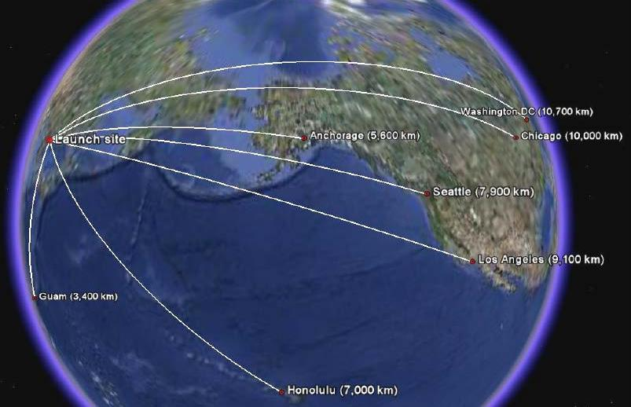

So
urce: Wright, D (nd)North Korea’s Missile Program: “Improving Regional Security and
53

Denuclearizing the Korean Peninsula: U.S. Policy Interests and Options.” Retrieved from http://www.ucsusa.org/assets/documents/nwgs/north-koreas-missile- program.pdfon 12/06/2012

Finally, if North Korea could agree to irreversible and verifiable dismantlement in exchange for unprecedented economic and energy aid and the lifting of most economic sanctions as well as security guarantee it then means nuclear renunciation, achieved by providing huge economic incentives, could create negative and unacceptable precedents to other vulnerable countries and provide them a reason for developing nuclear weapons. (Suh, 2009). Based on this scenario, the international society would begin to grapple with countries using bargaining chips or coercive signals48 to respond to outside pressure like North Korea (Zhebin, 2000).

2.3 US Disarmament Diplomacy with North Korea

The United States has pursued a variety of policy responses to the proliferation challenges posed by North Korea, including military cooperation with U.S. allies in the region, wide-ranging sanctions, and non-proliferation mechanisms such as export controls. The United States also engaged in two major diplomatic initiatives in which North Korea to abandon its nuclear weapons efforts in return for aid. In 1991, the Administration of the then US President - George Bush Jnr took several actions oriented towards securing from the government of North Korea adherence to the Nuclear Non-Proliferation Treaty (NPT) as a signatory. North Korea had signed the treaty in 1985. North Korea entered into two agreements, which specified nuclear obligations. In a denuclearization agreement signed in December 1991, North Korea and South Korea pledged not to possess nuclear weapons, not to possess plutonium reprocessing or uranium enrichment facilities, and to negotiate a mutual nuclear inspection system (Niksch, 2002).

In January 1992, North Korea signed a safeguards agreement with the International Atomic Energy Agency (IAEA), providing for regular IAEA inspections of nuclear facilities. In 1992, North Korea rebuffed South Korea regarding
54

implementation of the denuclearization agreement, but allowed the IAEA to conduct six inspections during June 1992-February 1993. In late 1992, the IAEA found evidence that North Korea had reprocessed more plutonium than the 80 grams it had disclosed to the Agency. In February 1993, the IAEA invoked a provision in the safeguards agreement and called for a “special inspection” of two concealed but apparent nuclear waste sites at Yongbyon (Niksch, 2002). The IAEA believed that a special inspection would uncover information on the amount of plutonium which North Korea had produced since 1989. North Korea rejected the IAEA request and announced on March 12, 1993, an intention to withdraw from the NPT.

The NPT withdrawal threat led to low and higher level diplomatic talks between North Korea and the Clinton Administration. North Korea, however, “suspended” its withdrawal from the NPT when the Clinton Administration agreed to a high-level meeting in June 1993. Meanwhile, North Korea continued to refuse both special inspections and IAEA regular inspections of facilities designated under the safeguards agreement. In May 1994, North Korea refused to allow the IAEA to inspect the 8,000 fuel rods, which it had removed from the five megawatt reactor. By June 1994, however, the United States began to pursue a two-pronged approach: working diplomatically through the UN to impose phased sanctions against North Korea, while at the same time preparing possible military options (Henneka, 2006 ). The crisis was defused literally in the 11th hour when former U.S. President Jimmy Carter visited Pyongyang in mid-June. North Korea’s President Kim Il-sung reactivated a longstanding invitation to former U.S. President Jimmy Carter to visit Pyongyang. Carter was eager to go and the Clinton administration permitted the trip, while stressing that he was going purely in a private capacity and not as an official envoy of the United States. Kim offered Carter a freeze of North Korea’s nuclear facilities and operations. He also promised Carter that North Korea would freeze its nuclear program and permit IAEA inspectors to remain in the country, provided the
55

United States agreed to discuss the provision of light water reactors (LWRs) to North Korea. Kim took this initiative after China reportedly stated that it would not veto a first round of economic sanctions, which the Clinton Administration had proposed to members of the U.N. Security Council over North Korea’s nuclear programme. The Clinton Administration, because of Kim’s proposal, responded by dropping its sanctions proposal and entering into a new round of high-level negotiations with North Korea. Negotiations began in July, with a short recess following Kim II Sung’s death on July 9, but resumed again in August. The outcome was the Agreed Framework of October 21, 1994 signed by the United States and North Korea. The agreement provided a clear roadmap for improved relations between Pyongyang and Washington, and committed the two sides to work together to dismantle North Korea’s existing nuclear program and build two LWRs.

Under the Agreed Framework, North Korea was to receive two light water reactors (LWRs) with a generating capacity of approximately 2,000 megawatts. The United States was under obligation to organize an international consortium arrangement for the acquisition and financing of the reactors. The Clinton Administration and the governments of South Korea, Japan, and other countries established in March 1995 the Korean Peninsula Energy Development Organization (KEDO) to coordinate the provision of the LWRs. KEDO signed the supply contract with North Korea in December 1995. With the groundbreaking at the reactor site in August 1997, KEDO officials changed the estimated completion date from 2003 to 2007; other experts predict a much later date. KEDO’s estimated cost of the reactors in 1994 was $4.6 billion. South Korea was to supply the reactors through a South Korean company as the main contractor; and South Korea and Japan would provide most of the financing. The Clinton Administration’s objective was to secure all the money for the light water reactors from other governments. It approached Western European and Southeast Asian countries about financial assistance. An agreement
56

reached by KEDO members on November 9, 1998, sets South Korea’s contribution at $3.22 billion, Japan’s contribution at $1 billion, and the European Union’s contribution at $76 million (Radchenko, 2006 ).

Clinton Administration officials noted that before construction begins, the United States, in accord with the Atomic Energy Act, must enter into a bilateral nuclear cooperation agreement with North Korea, since U.S. technology is incorporated into the South Korean light water reactors that North Korea will receive. The officials also stated that light water reactors are less dangerous than North Korea’s current graphite reactors, partly because plutonium produced from light water reactors is more technologically difficult to use in the manufacture nuclear weapons. They also asserted that North Korea would have to secure enriched uranium fuel for light water reactors from outside North Korea. This, the officials claimed, would give the United States leverage on the supply of fuel if North Korea should violate the Agreed Framework (Radchenko, 2006). Moreover, exercising U.S. leverage over the supply of fuel would require that potential suppliers of fuel like China and Russia coordinate their policies with the United States.

However, prior to the construction of light water reactors, the Agreed Framework required the United States to facilitate the provision to North Korea of “alternative energy” to compensate for the freeze of nuclear facilities. The alternative energy is to be “heavy oil”. In January 1995, the Clinton Administration arranged for the shipment of 50,000 metric tons of U.S. heavy oil to North Korea. This was followed by a shipment of 100,000 metric tons of oil in October 1995. Starting in October 1996, the United States began to facilitate shipments of 500,000 metric tons of heavy oil to North Korea annually until the first of the two light water reactors becomes operational (Zhebin, 2000). The Administration financed the initial shipment of 50,000 tons of oil with $4.5 million from appropriated Defense Department funds designated for “emergency expenses. The European Union joined KEDO’s executive
57

board in May 1997 and provided over $15 million annually for the oil shipments. Financial supports were also secured from Southeast Asian and Persian Gulf countries. In all, the annual cost of the heavy oil rose from about $30 million in 1995 to over $100 million in 2001 (Radchenko, 2006).

However, following the collapse of the Agreed Framework in 2002, North Korea claimed that it had withdrawn from the NPT in January 2003 and once again began operating its nuclear facilities. This led to the second major diplomatic effort - the Six-Party Talks initiated in August of 2003 which involved China, Japan, North Korea, Russia, South Korea, and the United States. The talks arrived at critical breakthroughs in 2005, when North Korea pledged to abandon “all nuclear weapons and existing nuclear programs” and return to the NPT, and in 2007, when the parties specified two Phases of implementation.

The phases provided for a freeze of North Korean nuclear installations at the Yongbyon site, a subsequent disablement of all North Korean nuclear facilities, and a North Korean declaration of “all nuclear programs.” The Agreement also establishes working groups of the six parties on subjects such as U.S.-North Korean normalization of relations, denuclearization of the Korean peninsula, energy and economic cooperation, Japan-North Korea normalization of relations, and a North Korean peace and security mechanism (Niksch, 2006). The Six Party Agreement was negotiated following a North Korean nuclear test in October 2006, the imposition of sanctions against North Korea by the United Nations Security Council. The nuclear test signaled progress by North Korean in reprocessing plutonium since 2002 for six to eight atomic bombs.

The Agreement also came about because of changes in Bush Administration policy. Tactically, the Administration ended its unwillingness to negotiate bilaterally with North Korea and actively sought bilateral meetings; the details of the Agreement were negotiated at these meetings. The implementation of the Initial Phase of the
58

Agreement, which had a 60-day deadline, was delayed until the Bush Administration acceded to North Korean demands for access to foreign banks to deposit $25 million from frozen accounts at the Banco Delta in Macau (Niksch, 2006). Following the release of the funds, North Korea shut down its operational nuclear reactor and plutonium reprocessing plant. The Bush Administration asserted in early September 2007 that North Korea had agreed to disclose all of its nuclear programs and disable them by the end of 2007. North Korean statements spoke of steps to implement the 2007 agreement by the end of the year, but they also asserted that the Bush Administration had agreed to reciprocal steps, including the removal of North Korea from the U.S. list of state sponsors of terrorism.

Apart from energy assistance, North Korea also received enormous assistance from the United States in terms of food, medical supplies within the period under study (see table 2.2 below). In fact, from 1996, the United States sent over 2 million metric tons (MT) of food assistance, worth about $700 million, to help North Korea alleviate chronic, massive food shortages that began in the early 1990s. Over 90% of U.S. food assistance to Pyongyang has been channeled through the U.N. World Food Program (WFP), which has sent over 3.7 million MT of food to the DPRK since 1996. The United States has been by far the largest cumulative contributor to the WFP’s North Korea appeals (Haggard and Noland, 2005).

Table 2.2: U.S. Assistance to North Korea, 1995-2008

Calendar | Food Aid (per FY) |  | KEDO | 6-Party Talks-Related |  |  | Medical | Total ($
of Fiscal |  |  | Assistance | Assistance (per FY; $ |  |  | Supplies | million)
 | Metric Tons | Community | (per calendar |  | million) |  | & Other
Year (FY) |  | Value |  |  |  |  | (per FY;
 |  | ($ million) | yr: $ million) | Fuel Oil |  | Nuclear | $ million)
 |  |  |  |  |  | Disablement
1995 | 0 | $0.0 | $9.0 | - |  | - | $0.2 | $9.7
1996 | 19.500 | $8.3 | $22.0 | - |  | - | $5.0 | $30.3
1997 | 177.000 | $52.4 | $25.0 | - |  | - | $0.0 | $82.4
1998 | 200.000 | $72.9 | $50.0 | - |  | - | $0.0 | $122.9
1999 | 695.194 | $222.1 | $65.1 | - |  | - | $0.0 | $287.2

59

2000 | 265.000 | $74.3 | $64.4 | - | - | $0.0 | $138.7
2001 | 350.000 | $102.8 | $74.9 | - | - | $0.0 | $177.7
2002 | 207.000 | $82.4 | $90.5 | - | - | $0.0 | $172.9
2003 | 40.200 | $25.5 | $2.3 | - | - | $0.0 | $27.8
2004 | 110.000 | $52.8 | $0.0 | - | - | $0.1 | $52.9
2005 | 22.800 | $7.5 | - | - | - | - | $7.5
2006 | 0 | $0.0 | - | - | - | $0.0 | $0.0
2007 | 0 | $0.0 | - | $26.0 | $ 20.0 | $0.0 | $45.0
2008 | 500.00 | n.a | - | $106.0 | - | $0.0 | $196.0
Total | 2,586.694 | $701.0 | $403.7 | $131.0 | $ 20.0 | $5.3 | $1,276.0

Source: Manyin, M. E and M. B. Nikitin (2007) “U.S. Assistance to North Korea” CRS Issue Brief for Congress.

As can be seen from the table, after 2002, U.S. shipments fell steadily, bottoming out at zero in FY2006 and FY2007. Assistance provided by the WFP also fell dramatically in 2001, when over 900,000 MT were shipped. There are two primary reasons for the decline in WFP assistance. The first is “donor fatigue,” as contributing nations objected to the North Korean government’s continued development of its nuclear and missile programs as well as tightened restrictions on the ability of donor agencies to monitor food shipments to ensure food is received by the neediest. Since June 2002, the Bush Administration officially has linked the level of U.S. food aid to three factors: the need in North Korea, competing needs on U.S. food assistance, and “verifiable progress” in North Korea allowing the humanitarian community improved access and monitoring (The Washington Post, July 1, 2008). In practice, some argue that the timing for U.S. pledges sometimes appears to be motivated also by a desire to influence talks over North Korea’s nuclear program

Based on the foregoing evidence, we accept and validate our first hypothesis. Hence, the US government perceived North Korea Nuclear Programme as a threat to its national security, between 2000 and 2008.
60

CHAPTER THREE

NORTH KOREA NUCLEAR PROGRAMME AND US FIGHT AGAINST TERRORISM

3.1 North Korea development of ballistic missile and Possession of plutonium production facilities

North Korea has been accumulating plutonium since 1986. In fact, between 1994 and 2003, North Korea “froze” its plutonium production program under the “Agreed Framework” with the United States. Under this agreement, North Korea shut down its main source of plutonium, the 5 megawatt-electric reactor at the Yongbyon nuclear site, and its nearby plutonium separation plant, the Radiochemical Laboratory (see figures 3.1 and 3.2 below).

Figure 3.1: 5 MWe reactors at Yongbyon.
61
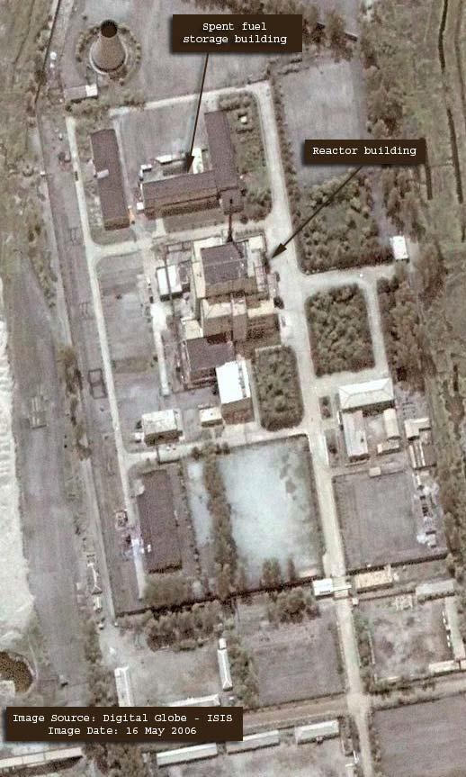

Source: Albright, D. and K. O’Neill (2000), Solving the North Korean Nuclear Puzzle. Washington, ISIS.

DC:

Figure 3.2: Radiochemical Laboratory at Yongbyon.

62
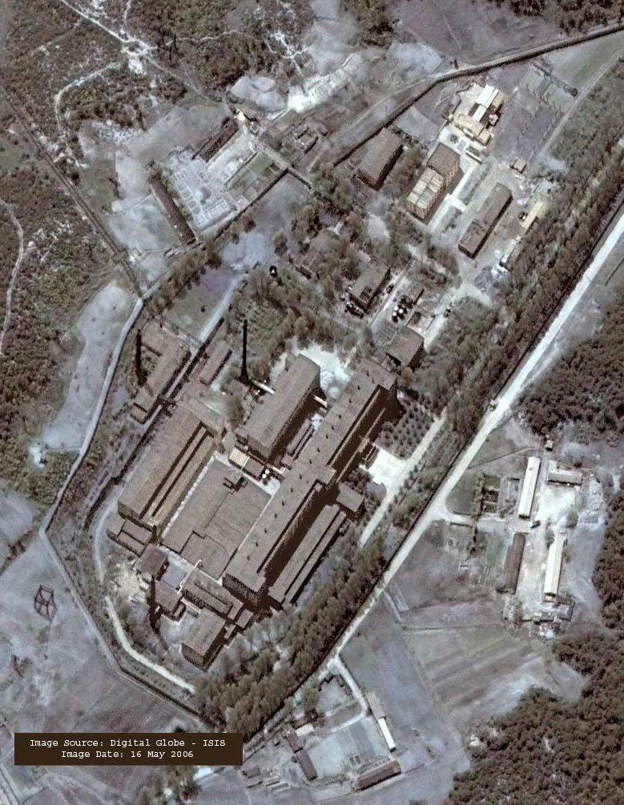

Source: Albright, D. and K. O’Neill (2000), Solving the North Korean Nuclear Puzzle. Washington, DC: ISIS.

NB: Note the demolished corner near the bottom of the image in a facility whose purpose is unknown. The “canyon” where reprocessing occurs is a long, multistory building on the right.

Since the freeze ended, North Korea has been both producing and separating plutonium at Yongbyon. In total through mid-2006, North Korea has produced an estimated 43 to 61 kilograms of plutonium, of which about 20 to 53 kilograms are in separated form and usable in nuclear weapons (Albright and Brannan, 2006). About 80 to almost 100 percent of the separated plutonium were generated since the freeze ended in late 2002 (see table 3.1).

Table3.1: North Korean Plutonium Production and Separation, as of mid-2006

Plutonium Discharged |  | Plutonium Separation |  | Weapon Equivalents*
From 5 MWe Reactor |  |  |  | (number)
Date | Amount (kg) | Date | Amount (kg)
Before 1990 | 1-10** | 1989-1992 | 0-10 | 0-2
1994 | 27-29 | 2003-2004 | 20-28 | 4-7
Spring 2005? | 0-15 | 2005-2006 | 0-15 | 0-3
In core of 5 MWe reactor | 5-7 | -- | -- | --
Total | 43-61 |  | 20-53 | 4-13***
Source: Albright, D. and K. O’Neill (2000), Solving the North Korean Nuclear Puzzle. Washington, DC: ISIS.

NB:
* It is assumed that each nuclear weapon would require 4-5 kilograms of separated plutonium.
63

- This quantity includes up to 1-2 kilograms of plutonium produced in the IRT reactor prior to 1994, see text. Since then, this reactor has barely operated.

- The upper bound of the number of weapons is higher than the sum of the individual upper bounds, because particular periods list more plutonium than needed to give the upper bound for that period

North Korea’s stock of separated plutonium was enough for about 4 to 13 nuclear weapons. Little is known about its ability to make a nuclear weapon, although it is assessed as likely able to build a crude nuclear warhead for its Nodong missile. At this time, there is little evidence to suggest that North Korea is capable of making a nuclear warhead light enough for the Taepodong-2 missile. Based on commercial satellite images, North Korea did not seem to be making significant progress in finishing its 50 megawatt-electric reactor at Yongbyon. If finished, this reactor could expand North Korea’s plutonium production tenfold. As a result of no agreement limiting plutonium production, North Korea was projected by mid- 2008 to have as much as 53 to 76 kilograms of plutonium, of which 40 to 68 kilograms could be usable in nuclear weapons (see table 3.2).

Table3.2: Table 3.2: North Korean Plutonium Production and Separation, “High Side” Projection as of Mid-2008

Plutonium Discharged |  | Plutonium Separation |  | Weapon Equivalents*
From 5 MWe Reactor |  |  |  | (number)
Date | Amount (kg) | Date | Amount (kg)
Before 1990 | 1-10** | 1989-1992 | 0-10 | 0-2
1994 | 27-29 | 2003-2004 | 20-28 | 4-7
Spring 2005? | 10-15 | 2005-2006 | 10-15 | 2-3
Summer 2007 | 10-15 | 2007-2008 |  | 2-3
In core of 5 MWe reactor | 5-7 | -- | -- | --
Total | 53-76 |  | 40-68 | 8-17***
Source: Albright, D. and K. O’Neill (2000), Solving the North Korean Nuclear Puzzle. Washington, DC: ISIS.

NB:
* It is assumed that each nuclear weapon would require 4-5 kilograms of separated plutonium.

- This quantity includes up to 1-2 kilograms of plutonium produced in the IRT reactor prior to 1994.

- The upper bound of the number of weapons is higher than the sum of the individual upper bounds, because particular periods list more plutonium than needed to give the upper bound for that period.

3.1.1 Plutonium Production Prior to the End of the Freeze

64

Prior to 2003, North Korea had an estimated stock of roughly 28 to 39 kilograms of plutonium. Almost all of this plutonium was produced in the 5 megawatt-electric roperates on a core of nuclear fuel for a considerable period of time before the reactor is shut down and the irradiated fuel unloaded. International Atomic Energy Agency (IAEA) inspectors witnessed the core being discharged in 1994. However, the IAEA found evidence that another core could have been discharged earlier when inspectors were not permitted to inspect this reactor. North Korea insists that the 1994 discharge involved the reactor’s first core and had been in the reactor since it started in 1986. After the irradiated fuel cools for several months, it can be transported safely to the Radiochemical Laboratory for chemical processing to separate the plutonium. The US intelligence community estimates that North Korea separated up to 10 kilograms of plutonium prior to 1992, although this is a “worst-case” estimate subject to continuing scrutiny and controversy. The worst case estimate was that North Korea separated and did not declare to the IAEA about 8 to 9 kilograms of plutonium produced in the megawatt-electric reactor and discharged in about 1989 (Albright and Brannan, 2006). Some US intelligence agencies believed that North Korea also separated and did not declare up to another 1 to 2 kilograms of plutonium produced in the Russian-supplied IRT research reactor at Yongbyon and separated in a nearby facility. Other US intelligence agencies believed the amount of plutonium produced in the IRT reactor was no more than a few hundred grams. The IAEA also independently arrived at this smaller estimate. In any case, a reasonable estimate is that no more than 10 kilograms of plutonium were separated prior to 1994, when the Agreed Framework froze all plutonium activities at the Yongbyon site.

In its assessments for this period, the CIA estimated that North Korea had separated 8-9 kilograms of plutonium. In interviews, CIA officials involved in these assessments have stated that there is a better than even chance that North Korea separated this plutonium, although the basis for this specific judgment can be
65

debated.2 Nonetheless, after taking account of estimated losses, the CIA concluded that this is enough separated plutonium for one or perhaps two nuclear weapons. However, assuming losses of 20 percent, which is reasonable for an initial effort and assumed in Energy Department intelligence assessments, the 8-9 kilograms of plutonium would likely not be enough plutonium for two nuclear weapons, if approximately 4-5 kilograms of plutonium are needed for each weapon. Until 2003, the bulk of the plutonium produced by North Korea remained in almost 8,000 irradiated fuel rods stored in a pond near the 5 megawatt-electric reactor and subject to monitoring by the IAEA. These rods contained an estimated 27-29 kilograms of plutonium (Nobuyoshi, 2005).

However, since restarting the Radiochemical Laboratory in 2003, North Korea is believed to have reprocessed most of the 8,000 irradiated fuel rods discharged from the reactor in 1994. This is based on North Korean statements to the media and ISIS experts, commercial satellite images, and on information from government officials and experts in the United States, Japan, and South Korea. North Korea has stated that it has reprocessed all the fuel rods, but this statement has not been independently verified. Nonetheless, a reasonable conclusion is that North Korea has separated a significant amount of plutonium from these rods—between 20 and 28 kilograms. The lower bound reflects confidence that at least most of rods have been reprocessed and the amount separated is highly unlikely to be lower than this value. The upper bound is the amount that would result if all the rods have been reprocessed with only small losses of plutonium during the entire process. The 5 megawatt-electric reactor is estimated to produce about 5-7 kilograms of plutonium each year. Unclassified reports, confirmed by commercial satellite imagery, indicate that North Korea shut down the reactor in April 2005, likely to unload the fuel.

At this time, the reactor’s core was estimated to have contained 10-15 kilograms of plutonium. North Korea is believed to have begun reprocessing the fuel
66

that would have been unloaded from the 5 megawatt reactor in 2005. By mid-2006, it could have finished reprocessing all this fuel, although there is no confirmation of such an act. Our assessment, therefore, is that between 0 and 15 kilograms of this plutonium could have been separated by mid-2006. In August 2005, Japanese media reported that US satellites had detected a plume at the megawatt-electric reactor, indicating that operations had resumed. A September 2005 commercial satellite image shows a steam plume, confirming that the reactor was operating again. Subsequent satellite images confirm continued, although not continuous, operation of the reactor. From mid-2005 to mid-2006, the reactor could have produced another 5-7 kilograms of plutonium. This plutonium likely remains in the reactor core (Nobuyoshi, 2005).

Figure 3.3: A comparison of September 2005 and May 2006 images of the 50 MWe reactor at Yongbyon
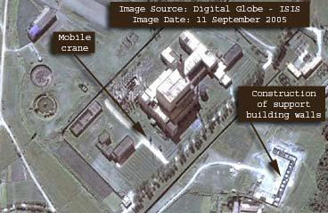

September 11, 2005
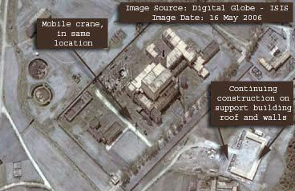

May 16, 2006

Source: Albright, D. and K. O’Neill (eds) (2000), Solving the North Korean Nuclear Puzzle. Washington,
DC: ISIS.

NB: Continuing construction is evident at a support building adjacent to the 50 MWe reactor facility. Within the compound housing the industrial buildings, however, there does not appear to be any substantial construction activity. A mobile crane, first identified in the September 2005 image, remains in the same location in May 2006.
67

Meanwhile, as of mid-2006, North Korea is estimated to have produced in total 43 to 61 kilograms of plutonium, of which 20 to 53 kilograms have been separated and are usable in nuclear weapons. The separated plutonium is sufficient to build between 4 and 13 nuclear weapons. Absent an agreement to limit North Korea’s nuclear weapons program, the 5 megawatt electric reactor can be expected to continue to produce plutonium.

North Korean officials stated in the first half of 2005 that construction of the 50 megawatt-electric reactor had resumed. As of early June 2005, commercial satellite imagery did not show significant construction activity; in August 2005 media reports state that a mobile crane was moved to the site. Additional reports stated that new gravel was seen along the road at the same site. Commercial satellite images from September 2005 confirmed these activities. A satellite image from May 2006 does not appear to show any substantial construction activity. In addition, the mobile crane, first identified in the September 2005 image, remains in the same location in the May 2006 image (see

figure 3.3 above).

Nevertheless, because of the long period of inactivity at this reactor site, and the effect of the weather on the unfinished reactor, the completion of this reactor would likely take several years. If finished, the 50 megawatt-electric reactor could produce enough plutonium annually for roughly ten nuclear weapons.

3.2 Pre-emptive actions to counter a sufficient threat to US national security

The nuclear status of North Korea has become a challenge for the USA – both as for the nuclear power and guard of the NPT regime, its regional interests of stability in the region and the system of military-political alliances there. Thus, the matters of security which concern the situation in Korea include unsanctioned nuclear status, weapons of mass destruction (WMD) proliferation, military regroup in the region
68

The security of the United States was perceived to be in jeopardy as long as this regime in North Korea is in power. In order to eliminate the nuclear threat posed by North Korea, the US was convinced that it must act quickly and decisively to destroy North Korea’s ability to make nuclear bombs, initiate the downfall of Kim Jong-Il’s regime, and send a clear message that the United States would not accept nuclear proliferation. In the calculation of the US government, since North Korea did declare that it had several nuclear weapons and which it claimed to have tested, waiting would only give them time to develop more. These could be used against its neighbors, if not against the United States. Again, fully aware that weapons-grade fissile material is also easy to transport and that once North Korea has what it feels is enough to maintain leverage, it could begin to sell its nuclear materials to whomever it wants, the US government concluded to engage in pre-emptive dislodgement of Korean government and not remove her from the list of countries possessing nuclear weapons as this would could compel Japan or Taiwan to develop their own nuclear weapons program as a deterrent and nuclear proliferation in Asia could, in turn, set off an arms race that could go worldwide.

However, with the presidential office taken by the Bush administration in January 2001, the policy towards the Korean peninsula made a shift starting from disregarding previous approach and its achievements. The Bush administration approach to North Korea did not become a logical continuation of the policy line initiated by Clinton. The principal shift was from the policy of engagement to following the hard line of pressure, abandon and antagonism. The term “rogue state” was reintroduced into the political discourse regarding the North Korea after years it has not been used. The Clinton administration abandoned the expression in the middle of the 1990s when referring to North Korea (Harnisch, 2001).

The September 11, 2001 terrorist attacks on the U.S served to reinforce this hard-line approach towards North Korea and other “rogue states”. In fact, the anti-
69

terror campaign led by the USA created concerns that Washington had chosen to limit its diplomatic activities and give priority to military power logic and advantages it possesses in this sphere (Guzzini, 2002). This is true because following the attack, the U.S Nuclear Posture Review (NPR) issued by the U.S Department of Defense which expressively states that “A combination of offensive and defensive and nuclear and non-nuclear capabilities is essential to meet the deterrence requirements of the 21st century” (cited in Intriligator, 2003:2). Similarly, the National Security Strategy of the United States of America (NSS) issued by the Office of the National Security Advisor to the President categorically stated that US government “cannot let our enemies strike first” and gives arguments for preemption. It notes that for “centuries, international law recognized that nations need not suffer an attack before they can lawfully take action to defend themselves against forces that present an imminent danger of attack.” It further asserts that “The U.S has long maintained the option of preemptive actions to counter a sufficient threat to our national security” (Intriligator, nd: 2).

Thus, influenced mostly by the latter document, President George W. Bush, on June 1st, 2002, at West Point, set forth a new doctrine for U.S security policy. According to him,

The successful strategies of the cold war era are ill-suited to national defense in the 21st century. Deterrence means nothing against terrorist networks; containment will not thwart unbalanced dictators possessing weapons of mass destruction. We cannot afford to wait until we are attacked. In today’s circumstances, Americans must be ready to take ‘preemptive action’ to defend our lives and liberties (Galston, 2002: nd).

With these, the Bush administration, after the 9/11 terrorist attacks, found justification to attack and dethrone regimes suspected of either harboring terrorists, amassing weapons of mass destruction or colluding with the known terrorist organizations. These states were variously characterized by the Bush administration as
70

“terrorist states”, “axis of evil”, “rogue states”, among others and therefore proclaimed its determination to attack “foes in anticipation of hostile acts” and to carry out these attacks “unilaterally, presumably without prior authorization from the United Nations Security Council” (cited in Wirtz and Russel, 2000: 117). True to its threat, the administration of Bush preemptively and unilaterally attacked Iraq in 2003, dethroning its leader- Saddam Hussein and was poised to move over to Iran, North Korea and Libya if not that the unintended consequences of such action, deriving from Iraq experience was apparent to be ignored. These unintended consequences, with respect to North Korea, among others, include (1)To bypass negotiation in favor of plans for military action will only increase North Korea’s determination to build a nuclear capability as quickly as possible as a deterrence. (2) In response to a military strike North Korea could launch strikes of its own against Japan, China, or South Korea, or our bases in those countries. Such a war could mean the deaths of millions.

- A war could also mean economic disaster resulting from the possible destruction of the Tokyo, Beijing, and Seoul stock markets (http://www.choices.edu/resources/ documents/koreaoptions_001.pdf, accessed on 20/06/2012 ).

3.3 Intimidating and isolating of states suspected of acquiring weapons of mass destruction

Since the outbreak of the Korean War in 1950, the United States had imposed fairly comprehensive economic, diplomatic, and political restrictions on North Korea. In 1999, however, President Clinton announced he would lift many restrictions on U.S. exports to and imports from North Korea in areas other than those controlled for national security concerns; the Departments of Commerce, Treasury, and Transportation issued new regulations a year later that implemented the new policy. On June 26, 2008, President George W. Bush removed restrictions based on authorities in the Trading with the Enemy Act and the terrorism designation, replacing
71

them with more circumscribed economic restrictions related to proliferation concerns

(Rennack, 2011).

The U.S. sanctions in place are a result both of requirements incorporated into

U.S. law by Congress and decisions made in the executive branch to exercise

discretionary authorities. Though the President, in accordance with the Constitution,

leads the way in conducting foreign policy, Congress holds substantial power to shape

foreign policy by authorizing and funding programs, advising on appointments, and

specifically defining the terms of engagement in accordance with U.S. political and

strategic interests. This report presents the legislative basis for U.S. sanctions policy

toward North Korea. These sanctions are a critical tenet of the larger bilateral

relationship, and this report highlights Congress’s role and responsibility in

determining the nature of U.S.-North Korea relations.

The United States imposes economic sanctions on North Korea for activities

related to weapons proliferation; regional disruptions; terrorism; narcotics trafficking;

undemocratic governance; and illicit activities in international markets, including

money laundering, counterfeiting of goods and currency, and bulk cash smuggling.

United States law has been applied to North Korea in the following ways in response

to the North Korean government’s objectionable activities (See the Appendix). Some

of the activities, as articulated by Rennack (2011:1-2) include:

- North Korea poses a threat to U.S. national security because of “the current existence and risk of the proliferation of weapons-usable fissile material on the Korean Peninsula”, as declared by President George W. Bush on June 26, 2008, under the terms of the National Emergencies Act and the International Emergency Economic Powers Act, 2 and expanded and adjusted by President Obama in 2010 and 2011;

- North Korea has engaged in proliferation of weapons of mass destruction, the State Department finds pursuant to the Arms Export Control Act, Export Administration Act of 1979, Iran, North Korea, and Syria Non-proliferation Act of 2000, and a national emergency declared by President George H. W. Bush relating to the proliferation of such weapons;
72

- North Korea is not cooperating fully with U.S. antiterrorism efforts, the State Department has determined, under terms of the Arms Export Control Act; and

- North Korea has detonated a nuclear explosive device, President George W. Bush has determined, pursuant to the Arms Export Control Act, the Atomic Energy Act, and the Export-Import Bank Act of 1945.

Based on the foregoing, the United States economic sanctions imposed on North Korea, as a result of both of requirements in U.S. law and decisions made in the executive branch to exercise discretionary authorities cover diverse areas including trade and aid. With respect to trade, the United States curtails trade with North Korea for reasons of regional stability, that support for acts of international terrorism, lack of cooperation with U.S. antiterrorism efforts, proliferation, and its status as a Communist country and a nonmarket economy. The United States also prohibits transactions relating to trade with certain North Korean entities identified as those who procure luxury goods, launder money, smuggle bulk cash, engage in counterfeiting goods and currency, and traffic in illicit narcotics. North Korea’s access to U.S. foreign assistance is limited in annual foreign operations appropriations measures. Under the Department of State, Foreign Operations, and Related Programs Appropriations Act, 24 North Korea is generally denied direct foreign aid, economic support funds (ESF) for energy-related programs (Rennack, 2011).

At the President’s discretion, North Korea is also subject to the economic sanctions provided in three provisions of law addressing human rights conditions: the Foreign Assistance Act of 1961under which North Korea is annually castigated for its human rights record; the International Religious Freedom Act of 1998, under which the administration has identified North Korea as a “country of particular concern” since 2001; and the Trafficking Victims Protection Act of 2000, under which the administration has, since 2003, classified North Korea as a Tier 3 offender of
73

standards pertaining to the trafficking of persons for slavery or sex trade (Rennack, 2011).

On the contrary, imposing economic sanctions has proved its little efficiency in changing the situation in the North. In case of the “rogue states” against which they are used, such sanctions have rather lead to lowering the people’s standard of living and thereby destabilizing the regime. The reliance on economic sanctions therefore seems erroneous, since they do not frighten North Korea.

The effectiveness of sanctions against the North Korea has been low and has not achieved the aim of discouraging North Korea from its nuclear programme or any other illicit activities. Imposing sanctions has rather had the opposite effect.

On the basis of the foregoing, we are inclined to accept and validate our second hypothesis that the US government perceived North Korea Nuclear Programme as part of its war on terror, between 2000 and 2008.
74

CHAPTER FOUR

US GOVERNMENT SECURITY POLICY ON NORTH KOREA NUCLEAR PROGRAMME AND MULTILATERAL INTERVENTION ON NUCLEAR WEAPON DEVELOPMENT

4.1 US Government Strategy and Policy of Containment and Isolation of North

Korean Government

The United States has been the primary actor seeking to address the negative consequences of North Korean weapon development and production programmes. Issues related to weapon proliferation are discussed by the USA and North Korea bilaterally rather than in the framework of the Four-Party Talks. One important objective of the USA is to curtail North Korea’s efforts to develop, deploy and sell long-range missiles. The United States has mixed coercive and cooperative elements in an effort to achieve this objective. It has made clear to North Korea that normalization of relations and a peace agreement cannot be concluded without resolving the question of North Korean nuclear and missile capabilities (Hun-kyung, 1999). In September 1999 North Korea and the USA reached an agreement by which North Korea would suspend the development and testing of its long range ballistic missile programme. In exchange for the suspension the United States agreed to ease unilateral sanctions maintained against North Korea in the framework of US national law—specifically, the Trading with the Enemy Act (TEA) of 1917. The USA and North Korea are technically still at war and under the TEA the US president may, during time of war, investigate, regulate or prohibit a wide range of financial transactions. Under this authority an embargo was established in 1950 on financial transactions between North Korea and any US citizen or permanent resident, wherever they live in the world, all people and organizations physically located in the USA and all branches, subsidiaries and controlled affiliates of any US organization throughout the world. The United States maintained comprehensive sanctions against North Korea from 1950 to 1989, when a ban against academic, cultural and sporting contacts
75

was relaxed. Sanctions were modified in 1989 to permit the transfer of US humanitarian assistance to North Korea. In September 1999 the sanctions regime was modified again to remove the ban on exports and imports of US and North Korean consumer goods and to ease restrictions on US investment in North Korea. In addition, direct and personal commercial transactions between US and North Korean legal persons (including companies) were permitted and US commercial carriers were no longer prohibited from calling at North Korean ports and airports under the TEA (http://www.state.gov/www/regions/eap/fs-nkorea_sancs_990917.html, accessed on 20/06/2012).

The decision to ease sanctions was taken in the overall context of the comprehensive review of US policy towards North Korea that was completed in 1999. 35 This review, undertaken by former Secretary of Defense William J. Perry at the request of the president, concluded that there was a need to revise the US approach towards North Korea. Having concluded that the status quo was not acceptable from the US perspective, the review evaluated alternative approaches to managing bilateral relations with North Korea. The Perry Report recommended against undermining the Government of North Korea and determined that accelerated democratic reform in North Korea was desirable but unlikely in the short term. The report recommended against ‘buying’ changes in North Korean policy as this path was felt to create an incentive for North Korea to engage in provocative behaviour in pursuit of financial rewards. The main recommendation of the report was that ‘the U.S. should be prepared to establish more normal diplomatic relations with the DPRK and join in the ROK’s policy of engagement and peaceful coexistence’. The United States would maintain its existing policy of deterrence and the existing size and structure of forces in the region and on the Korean peninsula. The practical effect of easing sanctions under the TEA is mitigated by the fact that North Korea is subject to several US laws with overlapping authority. Many transactions no longer prohibited under the TEA
76

after September 1999 remained prohibited by other US legislation. In particular, US laws related to terrorism and missile proliferation have a bearing on North Korea. The Antiterrorism and Effective Death Penalty Act of 1996 prohibits all financial transactions by US legal persons with any state designated a terrorism supporting nation in the 1979 Export Administration Act (http://www.treas.gov/press/ release/pr1742.htmhttp://www.state.gov/www/regions/eap/fsnkorea_sancs_990917.ht ml, accessed on 20/06/2012). Although the Perry Report recommended changes in US policy, the responsibility for translating this recommendation into specific decisions rested primarily with the State Department.

However, the US decision to ease sanctions was made after a meeting between officials in Berlin on 7–12 September 1999. It is not clear from public reports exactly what was said at this meeting, but it appears that North Korea agreed to suspend missile launches while US–North Korean normalization talks are under way. This ambiguity led to some criticism of the agreement. First, it was unclear, perhaps even in Pyongyang, what kinds of space research North Korea could undertake without being considered by the United States to be in breach of its undertaking (Gertz, 1999).

As already noted, the logic of the North Korean nuclear programme suggested that additional rocket launches was in the offing. To this end, how would the USA and other concerned countries respond in the event of additional rocket launches, one would ask. Therefore, in parallel with its diplomatic efforts to freeze and then roll back North Korean missile programmes, the United States, prior to 9/11, continued to implement, to a certain degree, the security policy of containment and isolation of North Korean government.

Nevertheless, the 9/11 terrorist attack did transform the way America think about their foreign and security policies, particularly the nuclear weapons policy. These changes in U.S nuclear weapon policy were announced in two official documents that were released by the Bush’s administration in 2002. Both documents, according to
77

Intriligator (2003), were influenced, in part, by the September 11, 2001 terrorist attacks on the U.S. The first of these documents is the U.S Nuclear Posture Review (NPR) issued by the U.S Department of Defense which expressively states that “A combination of offensive and defensive and nuclear and non-nuclear capabilities is essential to meet the deterrence requirements of the 21st century” (cited in Intriligator, 2003:2). The second of these documents is the National Security Strategy of the United States of America (NSS). Issued by the Office of the National Security Advisor to the President in September, 2000, the document reveals that there are plans to ensure that no nation could rival U.S military strength. It proclaims the doctrine of U.S pre-emption, where it “cannot let our enemies strike first” and gives arguments for pre-emption. In the light of the above, we shall, in the subsequent sub-sections, examine the US security policy with particular emphasis on North Korea nuclear programme and whether these undermined or support multilateral intervention on nuclear weapon development.

4.2 US government security policy on North Korea nuclear programme and 1968 Non-proliferation Treaty (NPT)

On account of its universal nature, the second agreement on the renunciation of nuclear arms was negotiated between 1965 and 1968 following the partial test ban treaty of 1963. As such, it has a political importance that extends far beyond the Tlatelolco Treaty which preceded it. Negotiation of it began in 1965, following the Chinese explosion of October 1964, and the vote of the United Nations Commission on Disarmament in June 1965, by which the Eighteen-Nation Disarmament Committee was requested to consider the question of a treaty or a convention on non-proliferation (Goldschmidt, nd). This Treaty, which is unique in the political history of the world, is aimed at halting the course of this history in a crucial field by fixing once and for all the number of nuclear weapon powers. It classes France as a member of the club in which it had had so much difficulty, if not in gaining entry, at least in making itself recognized. The Treaty prohibits the signatory nuclear powers from transferring nuclear weapons or other explosive devices or control over them to any
78

nation whatsoever. It was this clause that put an end to the plan for a NATO nuclear force. The Treaty also prohibits the nuclear weapon States from helping any non-nuclear-weapon State to manufacture or acquire such weapons or devices, or to have control over them. It does not involve any genuine concessions on the part of those belonging to it, but rather leaves the transfer of technology or weapons among the nuclear power themselves completely unrestricted.

Conversely, the other States party to the Treaty i.e. the non-nuclear powers, undertake not to accept the transfer of or control over such weapons or devices from any nation whatsoever and not to manufacture them. The Treaty not only refers to nuclear weapons without defining them, but also to any other nuclear explosive device. The renunciation of nuclear weapons therefore covers all systems intended for a peaceful nuclear explosion (Goldschmidt, nd).

The United States and the then Soviet Union were, by the NPT, compelled to agree to the incorporation into the Treaty of a clause promising the non-nuclear powers, at minimal cost and on a non-discriminatory basis, a share of the benefits to be gained from the peaceful uses of nuclear explosions. In the autumn of 1968, the General Assembly of the United Nations recommended that a study be carried out on establishing, within the IAEA, a service for conducting such peaceful explosions under international control. Between 1970 and 1975, a committee and a large number of international conferences dealt with the technical, legal and safety aspects of the matter, but the clause of the Treaty relating to such explosions for the benefit of the non-nuclear powers has remained a dead letter.

As for the nuclear disarmament measures so insistently demanded during the Treaty negotiations in order to strike a fair balance in the concessions made, the nuclear powers have managed to divest them entirely of their binding nature. In the Treaty, these States only undertake to continue negotiating in good faith to find effective measures for ending the arms race in the near future and for a general and
79

complete disarmament treaty under strict and effective control. They also recall their determination, recorded in the Moscow Treaty five years before, to continue negotiations aimed at a total ban on nuclear weapon tests.

Conversely, the non-nuclear weapon States party to the Treaty undertake to accept IAEA safeguards for the sole purpose of verifying that nuclear energy has not been diverted from peaceful uses to nuclear weapons or other explosive devices. These safeguards apply to all the peaceful nuclear materials and activities, in their territory or elsewhere, under their control. Furthermore, all States party to the Treaty undertake not to provide nuclear materials and equipment specially designed for the processing, utilization or production of uranium and plutonium to any non-nuclear weapon State whatsoever.

The clause on international inspection was also stated. The non-nuclear States were under obligation to open all their nuclear activities to IAEA inspection on a permanent basis, whereas the nuclear powers were exempt from such a requirement. However, Article VI, for example, requires the States Parties to enter into good faith negotiations on nuclear disarmament. Article VI also identified the goal of concluding a treaty on “general and complete disarmament under strict and effective international control”, which would ultimately outlaw all weapons of mass destruction and limit conventional arms (http://cns.miis.edu/inventory/pdfs/npt.pdfhttp://www.state.gov/ www/regions/eap/fs-nkorea_sancs_990917.html, accessed on 20/06/2012).

The treaty’s non-proliferation obligations are found in Articles I and II, which deal with the commitments of the five recognized nuclear-weapon States (China, France, the Russian Federation, the United Kingdom, and the United States) and the non-nuclear-weapon States. These obligations include:

- Nuclear weapon states (NWS) are not to transfer to any recipient whatsoever nuclear weapons or other nuclear explosive devices and not to assist, encourage, or induce any
80

non-nuclear weapon states (NNWS) to manufacture or otherwise acquire them.

- NNWS are not to receive nuclear weapons or other nuclear explosive devices from any transferor, and not to manufacture or acquire them.

- NNWS must place all nuclear materials in all peaceful nuclear activities under IAEA safeguards.

- All Parties are obligated to facilitate and participate in the exchange of equipment, materials, and scientific and technological information for the peaceful uses of nuclear energy.

- All Parties must pursue negotiations in good faith on effective measures relating to the cessation of the nuclear arms race and to nuclear disarmament, and on a treaty on general and complete disarmament under strict and effective international control (http://cns.miis.edu/inventory/pdfs/npt .pdf. accessed 05/07/2012).

At NPT Review Conferences over the years, however, the nuclear-weapon

States have made various commitments concerning nuclear disarmament. In 1995,

they agreed to undertake “systematic and progressive efforts” to achieve this goal. At

the 2000 Review Conference, they agreed on a thirteen “practical steps” to implement

Article VI.

From the foregoing analysis, it is seen that nuclear disarmament measures

against any recalcitrant state were quite stated and under the International Atomic

Energy Agency is to embark on inspection with the sole purpose of verifying that

nuclear energy has not been diverted from peaceful uses to nuclear weapons or other

explosive devices. The treaty, as can be seen does not contain any clause that

empowers the nuclear-weapon States whether as a group or individually to

unilaterally sanction any non nuclear-weapon States that either renege its obligations

under the NPT or failed to allow the IAEA inspectors. The security policies of US

whether in form of economic sanctions, isolation, containment, pre-emption and so on

against the North Korea nuclear programme, on this basis, amount to relegation of the
81

NPT even though the government of North Korea reneged in its obligations under the NPT and equally expelled the IAEA inspectors.

4.3 US government security policy on North Korea nuclear programme and International Atomic Energy Agency

The International Atomic Energy Agency (IAEA) is entrusted with the responsibility of establishing and administering the international safeguards system with the purpose of ensuring that nuclear energy would not be used for furthering military purposes. It is a key piece of the international system for the maintenance of world peace and security. Being the final outcome of the “Atoms for Peace” initiative proposed by President Dwight D. Eisenhower, the IAEA was set up in 19572 as an independent intergovernmental organization for universal scientific and technical cooperation in the nuclear field (Andrés, 2008). Thus, the Agency was ascribed with the mission of promoting and spreading the benefits arising from the peaceful uses of nuclear energy throughout the world.

In view of the dual nature of atomic energy (i.e. for peaceful and military uses), the IAEA’s founders expressly provided that in pursuing the above mentioned objective the Agency should ensure that its assistance would not be used for furthering military purposes (IAEA Statute, Article II). Nuclear science and technology developed at fast rates during the first part of the twentieth century and the first handmade atomic explosion by the US in 1945 gave it a major.

In view of this context, it was conceived that through the promotion of international cooperation in the peaceful uses of atomic energy the IAEA would make sure that nuclear energy and technology would not be diverted to military purposes. This vision was based on the later proven false premise that the international share of nuclear materials and technology for civil purposes through an international organization endorsed with an international system of control and verification would discourage and inhibit States from pursuing nuclear weapons (Fisher, 1997).
82

Accordingly, the Agency assumed the responsibility of establishing and administering an international system of nuclear safeguards with the main purpose of ensuring that atomic energy would not be diverted to military purposes ( IAEA Statute, III.A.5).

The IAEA was intended to be ‘a receiver, distributor, broker and safeguarder of nuclear materials’ and a “nuclear clearance house”, carrying out at the same time a function of accountancy in respect to nuclear material and technology and performing a role of international guarantor of their peaceful use (Szasz, 1996).

The IAEA’s mission of verifying that nuclear energy is used solely for peaceful purposes. Safeguards are means applied by the IAEA for verifying that States comply with the nuclear non-proliferation commitments they assumed on international agreements. Consequently, both the legal obligation to be subject to safeguards as well as the nature and scope of the measures to apply stem from and are dependent on the international instruments to which the State involved is a party. In any case, safeguards measures aim to ensure that nuclear material in peaceful nuclear activities placed under the IAEA safeguards regime will not be diverted to military purposes (particularly to developing nuclear weapons or other nuclear explosive devices).

On top of the safeguards regime is the IAEA Statute which confers the Agency with the mandate of establishing and administering the safeguards system. Pursuant to Article III.A.5 of the Statute, the Agency is authorized to apply safeguards in two sets of circumstances, namely: when the Agency makes available nuclear material, services, equipment, facilities and/or information, and when the application of safeguards has been requested by the parties to any bilateral or multilateral agreement or unilaterally by any State. It is important to note that the statutory powers conferred on the Agency are not self-enforcing and the consent of the State expressed in another international instrument is a legal requirement for the application of safeguards measures; i.e. mere membership to the IAEA is not enough for a State to be subject to safeguards. This is why though the IAEA is not a party to the NPT, it became the
83

instrument for verifying that Non Nuclear Weapon Sates are living up to their non-proliferation commitments (Andrés, 2008).

The foregoing position of the IAEA on nuclear weapon is very clear. It does in any way confer on the United States the task of enforcing its stature. Therefore, the security policy of North Korea aim at forcing or cajoling the government of the North Korea to give up its nuclear programme amount to a deliberate and blatant relegation of the legal frameworks of the IAEA.

Our last hypothesis which maintains that the US government security policy on North Korea Nuclear Programme relegated multilateral intervention on nuclear weapon development, between 2000 and 2008 is therefore accepted in the light of the above evidence.
84

CHAPTER FIVE

SUMMARY, CONCLUSION AND RECOMMENDATIONS

5.1 Summary

The study examined the US security policy and North Korea Nuclear Programme. Specifically, the study investigated whether the North Korea Nuclear Programme undermined the US national security and multilateral intervention on nuclear weapon development as well as whether US government perceive North Korea Nuclear Programme as part of its war on terror. To this end, the research work sought to satisfactorily provide answers to the understated research questions:

- Did the US government perceive North Korea Nuclear Programme as a threat to its national security, between 2000 and 2008?

- Did the US government perceive North Korea Nuclear Programme as part of its war on terror, between 2000 and 2008?

- Did the US government security policy on North Korea nuclear programme relegate multilateral intervention on nuclear weapon development, between 2000

and 2008?

In order to adequately address the above-stated research questions, we predicated our analysis on the realist approach. This approach tackles politics from what it is without moralizing as to what ought to be. The adoption of this theory became necessary due to its analytical utility especially its ability to unveil that international politics like all politics, is a struggle for power. The theory is also necessary because in exposes that states, acting through statesmen who personify them, think and act in term of interest defined as power,

Based on the foregoing, the study was oriented towards achieving the following objectives:
85

- To examine whether the US government perceived North Korea nuclear programme as a threat to its national security, between 2000 and 2008.

- To ascertain whether the US government perceives North Korea nuclear programme as part of its war on terror, between 2000 and 2008.

- To investigate if the US government security policy on North Korea nuclear

programme relegates multilateral intervention on nuclear weapon development, between 2000 and 2008.

To achieve the above-stated objectives, we put forward for empirical verification the following hypotheses:

The US government perceived North Korea Nuclear Programme as a threat to its national security, between 2000 and 2008.

The US government perceived North Korea Nuclear Programme as part of its war on terror, between 2000 and 2008.

The US government security policy on North Korea Nuclear Programme relegated multilateral intervention on nuclear weapon development, between 2000 and 2008.

We employed qualitative method to generate qualitative data from secondary sources for our study. And these were analyzed accordingly using qualitative descriptive analysis.

The study was, therefore, divided into five chapters. Chapter one contains the introductory and the conventional methodological requirements of the study These included the statement of problem, objective of study, significance of study, literature review, theoretical framework, hypotheses, and method of data collection and analysis. Chapter two examined the impact of North Korea nuclear programme on the US national security, between 2000 and 2008. Chapter three investigated the interface between the North Korea nuclear programme and the US fight against terrorism, between 2000 and 2008. Chapter four proved that the Us Government security policy on North Korea nuclear programme undermined multilateral intervention on nuclear
86

weapon development, between 2000 and 2008. Finally, Chapter five embodied the summary of the entire work, the conclusion and our recommendations.

5.2 Conclusion

Based on the qualitative evidence generated through secondary sources, we have established that the US government perceived North Korea Nuclear Programme as a threat to its national security, between 2000 and 2008.

Futhermore, we have also proved that the US government perceived North Korea

Nuclear Programme as part of its war on terror, between 2000 and 2008 and has justified pre-emption, isolation and containment of the North Korean government on account of its nuclear programme even though the war on terror championed by the United States of America and essentially built around new pretexts of WMD and links to terrorist organization served as a means of fostering and advancing the national interest of the US.

Finally, our inquiry has revealed that US government security policy on North Korea Nuclear Programme relegated multilateral intervention on nuclear weapon development, between 2000 and 2008.

Therefore, security interest is at the root of America’s campaign against North Korea’s nuclear programme. The US government perceives North Korea Nuclear Programme as a threat to its national security has therefore been borne out of the need to ensure that no nation rivals the U.S military strength. The US government security policy on North Korea Nuclear has also been a way to ensure that the consolidation and expansion of US global power is not undermined in any way so that its unilateralism and hegemonism will not be challenged.
87

5.3 Recommendations

The study has revealed that the quest for nuclear enrichment by North Korea has posed a formidable threat to the US national interest in the Asia. We therefore put forward the following recommendations for policy implementation:

- The two nations have and should explore common ground to work out point of agreement even as they disagree on other issues.

- Again, the US should put its concerns forward in negotiations with North Korea-not necessarily to make a grand bargain, but as a way to begin seeking common ground. To this end, the US needs to allay North Korea’s fear of regime change, just as North Korea must deal the consequences of the outrageous and inflammatory remarks by its president. This has become necessary because outsourcing US diplomacy to others has not worked and is even less likely to work in the foreseeable future.

- Moreso, as a solution to the nuclear dispute, the US and its allies should propose turning North Korea’s national enrichment efforts into a multilateral program. Under this approach, the North Korea government will agree to allow two or more additional governments to participate in the management and operation of those activities within North Korea. In exchange, Iran will be able to jointly own and operate an enrichment facility without facing international sanctions. A multilateral approach will allow North Korea to continue to own the existing nuclear facilities; but the management and operation of those facilities will be shared with the other partner governments, and any new facilities and technology will be owned and managed jointly by the consortium. Furthermore, multinational management and operation of North Korean facilities combined with upgraded international safeguards and inspection will provide an unprecedented level of transparency about North Korea’s production of nuclear fuel. Finally, a multilateral solution to the North Korean nuclear impasse may also provide a blue print for dealing with a
88

more general global problem: the potential spread of enrichment and reprocessing technology to other nations that do not now have nuclear weapons.

- Finally, America should really curtail the rate at which it seeks, foster and protect what it regards as its national interests. This has become necessary because, as the study shows, America’s belligerency somehow accounts for North Korea’s nuclear enrichment.
89

Bibliography

Books

Albright, D. and K. O’Neill (2000), Solving the North Korean Nuclear Puzzle.

Washington, DC: ISIS.

Asika, N (2006). Research Methodology in the Behavioural Sciences. Lagos:

Longman Nigerian Plc.

Asogwa F.C (1999:40) Understanding International Relations. Enugu: Vougasan ltd Enugu

Biereenu-Nnabugwu, M. (2006). Methodology of Political Inquiry: Issues and

Techniques of Research Methods in Political Science. Enugu: Quintagon

Publishers.

Cohen, L. and L. Manion (1980).Research Methods in Education. UK: Croom Helm.

Ikeagwu, E.K (1998). Groundwork of Research Methods and Procedures. Enugu:
Institute for Development Studies.

Kerlinger, F.N 1977). Foundations of Behavioural Research. New York: Holt, Rinehart and Winston.

Mamdani, M (2204). Good Muslim, Bad Muslim: America, the Cold War and the Roots
of Terrors. America: Pantheon.

Morgenthau, H.J (1966). Politics among Nations: The Struggle for Power and Peace.

New York: Alfred Knopf.

Scort, M. (1981) Contemporary Political Analysis. York: Washmgton

Selltiz, et al (1977). Research Methods in Social Relations. London: Methuen & Co. Ltd.

Book Chapters

Thomas, R,G.C (2004). “US Regional Security Policy in South Asia “ in B. Lovemen (ed) Strategy for Empire: US Regional Security Policy in the Post-Cold War Era. Oxford: SR Books.

Zhebin, A. (2000) “A Political History of Soviet-North Korean Nuclear Cooperation,” in J. C Moltz and A. Y. Mansourov, (eds.), The North Korean Nuclear Program: Security, Strategy, and New Perspectives from Russia, New York: Routledge.
90

Journal Articles

Andrés, G. E. (2008) The International Atomic Energy Agency’s Safeguards System, Int. Law: Rev. Colomb. Derecho Int. Bogotá (Colombia) N° 11

Boureston, J and J. A. Russell (2009), “Illicit Nuclear Procurement Networks and Nuclear Proliferation: Challenges Intelligence, Detection, and Interdiction,” stair 4 (2)

Goldschmidt, T. (nd) “The Negotiation of the Non-Proliferation Treaty (NPT)” IAEA Bulletin, 22(3/4)

Guzzini, S (2002) Foreign Policy Without Diplomacy: the Bush Administration at a Crossroads International relations, 16 (2).

Harnisch, S.(2001) Make Multilateralism Work on the Korean Peninsula: A View from Europe International Journal of Korean Unification Studies, 5.

Henneka, A (2006) “Reflections on Korean history and its impacts on the US-North

Korean conflict” ISYP Journal on Science and World Affairs, 2 (1).

Hughes, C. W (2007) “North Korea’s Nuclear Weapons: Implications for the Nuclear Ambitions of Japan, South Korea, and Taiwan” Asia Policy, number 3.

Hun-kyung, L (2009) ‘Inter-Korean relations in aftermath of Perry Report’, Korea Focus, 7 (4).

Ifesinachi, K (2006). “The Political and Strategic Challenges of US Anti-Terrorist Policy in the 21st Century” Journal of International Politics and Development Studies, 2 (1).

Manyin, M. E and M. B. Nikitin (2007) “U.S. Assistance to North Korea” CRS Issue Brief for Congress.

Morgan, D.L. (1993). “Qualitative content analysis: A guide to paths not taken.” Qualitative Health Research, 3, 112±121.

Niksch, L. A (2002) “North Korea’s Nuclear Weapons Program” CRS Issue Brief for Congress.

Niksch, L. A (2006) “North Korea’s Nuclear Weapons Program” CRS Issue Brief for Congress.
91

Okolie, A.M (2005). “Reconstituting Global Security Code for Collective Action against Terrorism” American Journal of International Politics and Development Studies (AJIPDS) 1(1).

Pritchard, C. L (2005) “The Korean Peninsula and the role of multilateral talks” North-East Asian Security 2 (1)

Rennack, D E. (2011) “North Korea: Legislative Basis for U.S. Economic Sanctions” CRS Issue Brief for Congress.

Richter, C (2003). “Pre-emptive Self-Defense, International Law and US Policy.” Dialogue 1 (2).

Wirtz, J.J and J. A Russel (2003). “US Policy on Preventive War and Preemption.” The Nonproliferation Review/Spring, 2003.

Institutional/Official Publications

Haggard, S and M. Noland (2005), Hunger and Human Rights: The Politics of Famine in North Korea. Washington, DC: U.S. Committee for Human Rights in North Korea.

Fisher, N (1997) Then and Now: The IAEA Turns Forty, 39/3 IAEA Bulletin, 1997.

Szasz, P.C (1996) IAEA Safeguards for NPT, 5(3) RECIEL, 239-240.

Conference/working Papers

Choi, S; I. Hwang and J. Kim (2010). Multinational Approach Focusing on North Korea’s Nuclear Ambition "Pacific Northwest International Conference on Global Nuclear Security–the Decade Ahead" 11-16 April 2010, in Portland.

Intriligator, M.D (2003). “Recent Changes in US Nuclear Weapons Policy.” A Presentation to the GRAD Conference on ‘Regional Cooperation and Global Security’ Simon Frazer University, Vancouver, June 14-16, 2003.

Radchenko, C. (2006) “North Korea’s Efforts to Acquire Nuclear Technology and Nuclear Weapons: Evidence from Russian and Hungarian Archives”, Cold War International History Project Working Paper #53

Ur-Rehman, H (2010) The Korean Peninsula: Peaceful Engagement for Humanitarian concerns, NTS-Asia Research Paper No.3

Wampler, R. A (2003) North Korea and Nuclear Weapons: The Declassified U.S.
Record National Security Archive Electronic Briefing Book No. 87.
92

Magazines

Eliot, K (2003). “To Declare Pre-emptive War is to declare a Bankruptcy of the Imagination” Counter Punch, February 28, 2003.

Falk, R (2002). “The New Bush Doctrine” The Nation, June 27, 2002.

Internet Materials
Albright, D and P. Brannan (2006) “The North Korean Plutonium Stock Mid-2006”

retrived from http://www.isis-online.org/publications/dprk/dprkplutonium.pdf

on 04/06/2012

Chanlett-Avery, E (2012) “North Korea: U.S. Relations, Nuclear Diplomacy, and Internal Situation” Congressional Research Report for Congress retrieved from www.crs.gov on 23/04/2012

“Fact Sheet”, Retrieved from http://www.state.gov/www/regions/eap/fs-nkorea_sancs_990917.html on 12/06/2012.

Finstad, R (nd). “Preemption: Deterrent or Incentive?” Retrieved on 07/08/09

from http://www.international.ucla.edu/author.asp?Author-ID=195.

Galston, W (2002). “Why America’s Place in the World Will Shift- for the worse-if we attack Iraq” in The Intellectual Activist Retrieved on 08/08/09 from http://www.

alexepstein.cm/

Gardiner, N (2008). “Iraq Five Years On: The Coalition is Winning the War against Al-Qaeda.” Retrieved on 07/10/09 from http:// www.heritage.org/about/staff/Nile

Gardiner.cfm

Gertz, B. (1999)‘North Korea continues to develop missiles’, Washington Times Online. Retrieved from http://www.washtimes.com/investiga/investiga1.html. 12/06/2012.

Intriligator, M..D (nd). “A Special Threat: US Nuclear Weapons Policy under the Bush Doctrine” Retrieved on 09/09/09 from http://.profeusfund.orgspwg.

Maszka, J (2009). “A Critical Juncture: American Foreign Policy and Asymmetric

Warfare” Retrieved on 07/08/09 from http://www.ccc.nps.navy.nii/si/2009/Apr/
93

Nobuyoshi S. (2005) “North Korea Brings in Crane Vehicle in Nuclear Construction Site Probably Six Party Talks in Mind,” retrieved from http://www.isis-online.org/publications/dprk/Nuclear Construction.pdf on 04/06/2012.

“North Korea and Nuclear Weapons - Policy Options” Retrieved from http://www.choices.edu/resources/documents/koreaoptions_001.pdf12/06/2012

“Nuclear Weapons Program” retrieved from www.fas.org/nuke/guide/index.html on January 20/06/2012

Sun, Y.Yen (2009). “Research Method Week 6: Qualitative Research” Retrieved

from https://www.msu.edu/~sunyayen/document/method/Method-week6.pdfon

3/072011.

“Testimony of Richard Newcomb, Director, Treasury Office of Foreign Assets Control before the House of Representatives Judiciary Sub-Committee on Crime”, Retrieved from http://www.treas.gov/press/release/pr1742.htm on 12/06/2012.

“Treaty on The Non-Proliferation of Nuclear Weapons (NPT)” retrieved fromhttp://cns.miis.edu/inventory/pdfs/npt.pdf on 05/07/2012).

Wright, D (nd)North Korea’s Missile Program: “Improving Regional Security and

Denuclearizing the Korean Peninsula: U.S. Policy Interests and Options.” Retrieved from http://www.ucsusa.org/assets/documents/nwgs /north-koreas-missile-program.pdf on 12/06/2012.
94

APPENDIX

North Korea—Economic Sanctions Currently Imposed in Furtherance of U.S. Foreign
Policy or National Security Objectives
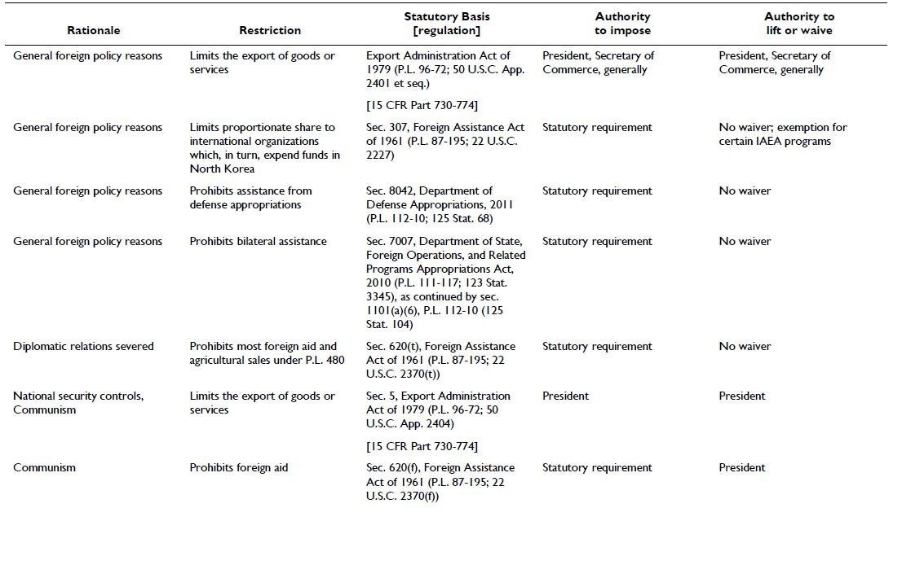
95
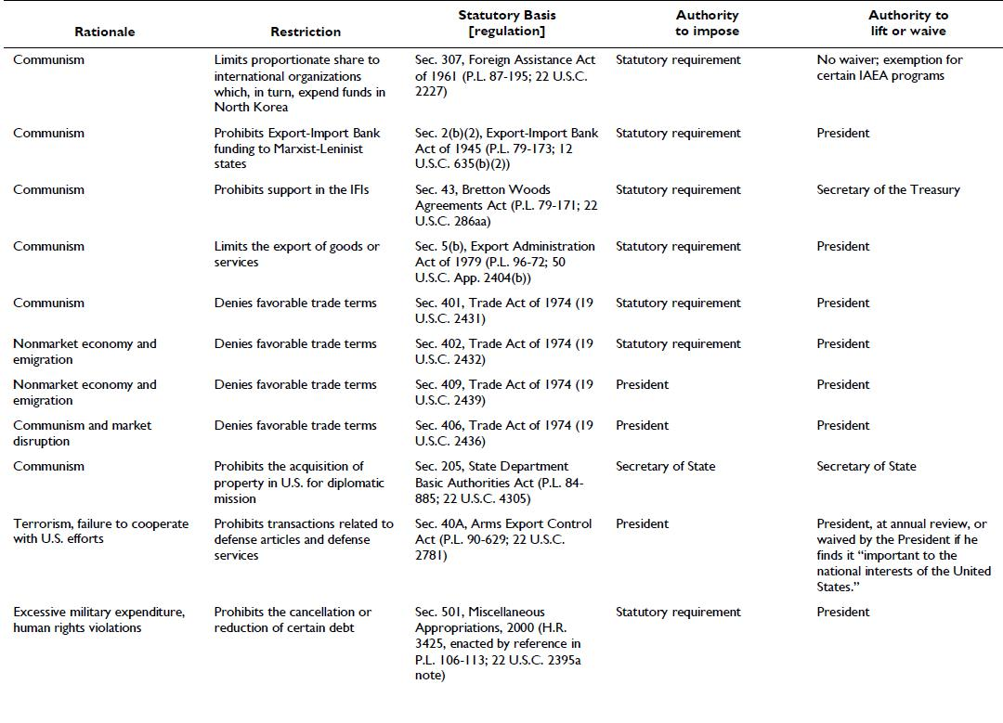
96
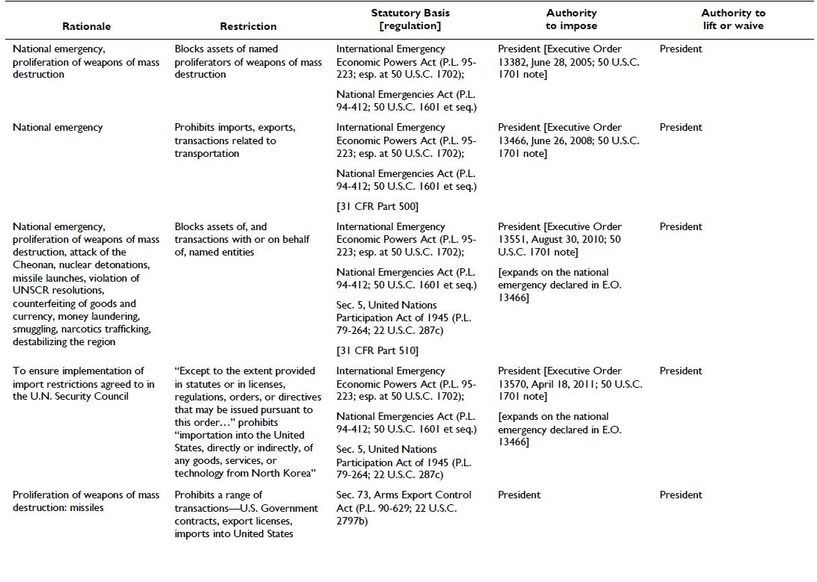
97
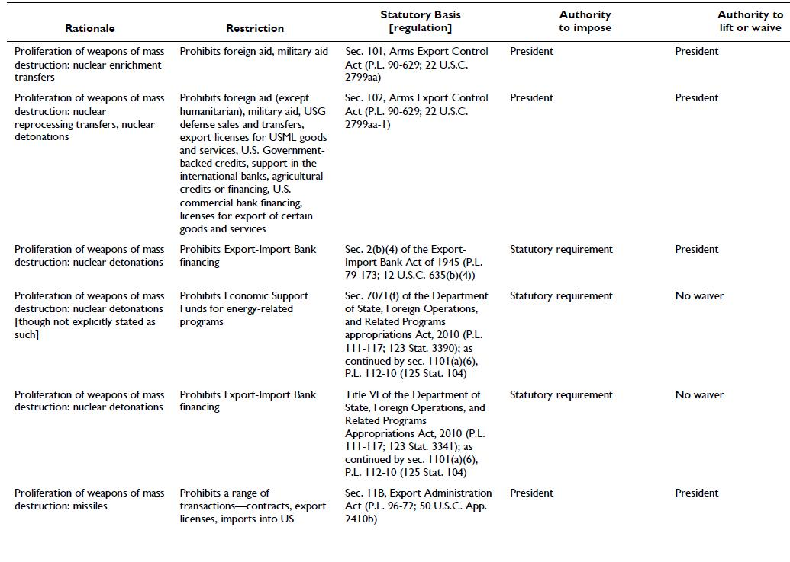
98
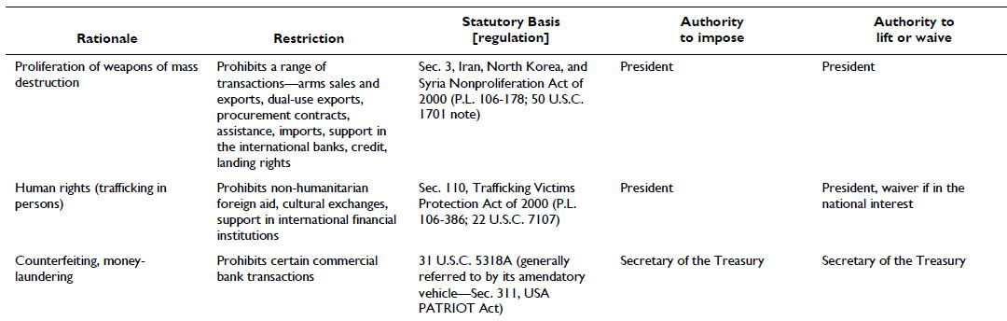

Source: Rennack, D E. (2011) “North Korea: Legislative Basis for U.S. Economic Sanctions” CRS Issue Brief for Congress.

