**THE PERCEPTION OF HUMAN RIGHTS RADIO ABUJA LISTENERS ON PIDGIN ENGLISH BROADCASTING**

**ZAKIYA ADAMU**

**OCTOBER, 2024**

**THE PERCEPTION OF HUMAN RIGHTS RADIO ABUJA LISTENERS ON PIDGIN ENGLISH BROADCASTING**

**BY**

**ZAKIYA ADAMU**

**BASUG/UG/ART/ENG/20/7669**

**A PROJECT SUBMITTED TO DEPARTMENT ENGLISH AND LITERARY STUDIES, SA'ADU ZUNGUR UNIVERSITY, BAUCHI, BAUCHI STATE, IN PARTIAL FULFILLMENT OF THE REQUIREMENTS FOR THE AWARD OF BACHELOR OF ARTS IN ENGLISH.**

**OCTOBER, 2024**

## DECLARATION

I hereby declare this project as an original work that has not been presented wholly or partially for the award of any degree or publication elsewhere.

_________________________  ________________________

**Zakiya Adamu Date**

## CERTIFICATION

This research work has been read and approved as meeting the requirements for the award of Bachelor of Arts (B.A.) English in the Undergraduate Studies of Sa'adu Zungur University Bauchi State.

_________________________  __________________________

**Miss Deborah Hassan Samson Date**

**(Project Supervisor)**

_________________________  __________________________

**Mal. Shehu Mohammed Korau**​​​​ **Date**

**(Project Coordinator)**

​_________________________  ________________________

**Dr. Ado Ahmed Mohammed**​​​ **Date**

**(Head of Department)** ​​​​​​​

_________________________ _____________________

**External Examiner Date**

## DEDICATION

This project is humbly dedicated to the Almighty Allah, whose grace has made everything possible. To my late father, Malam Yusuf Muhammad, whose values and teachings continue to guide me. But most importantly, to my beloved mother, Khadijah Nuhu – my pillar of strength, my guiding star, my Athena. Words cannot capture the depth of my gratitude for your unwavering love, sacrifice, and endless support. You stood alone, shouldering every burden, ensuring that I had the education and opportunities I needed. Your resilience, wisdom, and boundless heart inspire me every day. You are truly a superhuman, and everything I am today reflects your extraordinary effort.

This is for you, Mom

## ACKNOWLEDGMENT

First and foremost, all praise is due to the Almighty Allah for granting me the strength, patience, and wisdom to complete this project.

I would like to extend my deepest gratitude to my late father, Malam Yusuf Muhammad, whose memory continues to inspire me. To my beloved mother, Khadijah Nuhu – words will never suffice to express my gratitude. You have been my greatest supporter, my rock, and my light. Every step I have taken, every success I have achieved, has been because of your boundless love, sacrifices, and dedication. You have shouldered every burden, weathered every storm, and never wavered in your commitment to my future. You are my everything – my true hero, and I owe it all to you. To my stepfather, Mr. Adamu Garba, thank you for your unwavering support and kindness.

A heartfelt appreciation goes to my supervisor, Miss Deborah Hassan Samson, for her guidance, encouragement, and patience throughout this project.

I am deeply grateful to Mr. Jamilu Yaya, PhD, for his support and guidance, without which I would not have made it to this university. I am deeply grateful to my supportive uncles, Murtala Muhammad and Muhammad Kabir Nuhu, for always being there for me, offering advice and support whenever I needed it.

To my siblings: Iklimah Yusuf, my wonderful elder sister; Nuhu Yusuf, my big brother and role model; Muhammad Nazeer Yusuf, my favorite kid brother; Fadilah Adamu, my sweet little sister; Aisha Adamu, my caring kid sister; and Mustapha Adamu, the youngest and last born – you all have been my pillars of love and encouragement.

To my grandmother, Hajiya Maimuna Ibrahim, and her family, thank you for your prayers and constant support. To my lovely aunt, Layuza Murtala, your warmth and kindness have been a constant source of strength.

A special mention goes to the entire Uwalle family for their love and encouragement throughout my journey.

To my best friends since childhood, Ummukhalthum Abbagana and Khadijah Abbagana, you have stood by me through every challenge and triumph, and I am forever grateful for your friendship.

I also want to acknowledge the friends I made here in school who became a part of my life and my journey: Kauthara Abdulsalam, Zainab Yakubu Dangana, Khadijah Muhammad Osabo, Zarah Idris, and Kemi Amoo. Thank you for your companionship and support.

Finally, to my mentor, Lukman Saleh, thank you for guiding me through my academic journey and for being a constant source of wisdom and encouragement.

This project is a reflection of the love, support, and guidance of all of you. Thank you for being part of my life.

**TABLE OF CONTENT**

DECLARATION iii

CERTIFICATION iv

DEDICATION v

ACKNOWLEDGMENT vi

ABSTRACT viii

CHAPTER ONE 9

1.0 Introduction 9

1.1 Background to the Study 9

1.2 Statement of the Problem 11

1.3 Objectives of the Study 12

1.4 Research Questions 12

1.5 Significance of the Study 12

1.6 Scope of the Study 13

1.8 Definition of Terms 13

CHAPTER TWO 15

LITERATURE REVIEW 15

2.0 Introduction 15

2.1 The concept of Pidgin English 15

2.2 Pidgin English in Nigerian Media 15

2.3 The role of Pidgin English in Communication 17

2.4 The overview of broadcasting in Nigeria 18

2.5 Review of related literature 20

CHAPTER THREE 23

RESEARCH METHODOLOGY 23

3.0 Introduction 23

3.1 Research Design 23

3.2 Population of the Study 23

3.3 Sample Size and Sampling Techniques 24

3.4 Data Collection Instruments 24

3.5 Validity and Reliability of Instruments 24

3.6 Data Collection Procedure 25

3.7 Data Analysis Techniques 25

3.8 Theoretical Framework 26

3.8.1 Uses and Gratification Theory 26

3.8.2 Audience Reception Theory 27

3.8.3 Cultural Studies Perspective 29

CHAPTER FOUR 31

DATA PRESENTATION, ANALYSIS, AND DISCUSSION OF FINDINGS 31

4.0 Introduction 31

4.1 Demographic Characteristics of Respondents 31

4.2 Analysis of Research Questions 33

Table 4.2: The Perception of Lugbe zone 5 residents 33

Table 4.3: The design of demographic and educational influences 34

Table 4.4: The engagement and participation in Pidgin English broadcasting 35

4.3 Discussion of Findings 36

CHAPTER FIVE 38

SUMMARY, CONCLUSION, AND RECOMMENDATIONS 38

5.1 Summary 38

5.2 Conclusion 39

5.3 Recommendations 40

## ABSTRACT

This study examines the perception of residents in Lugbe regarding the use of Pidgin English in broadcasting. This study investigates the effects of demographic parameters, such as educational background, on perceptions and analyses the effect of Pidgin English broadcasting on listener engagement and involvement in Human Rights Radio programs. A survey study design was employed. The data was collected from 30 residents of Lugbe zone 5 through semi-structured questionnaire. Taro Yamane's formula was used to ascertain the sample size, and the results were analysed by frequency, and percentages. The results indicated that most Lugbe residents consider Pidgin English an effective medium for radio communication, mostly because of its simplicity and cultural significance. Demographic characteristics, especially educational attainment, were observed to affect perceptions, with those from lower educational backgrounds exhibiting a greater inclination towards the use of Pidgin English. The use of Pidgin English in broadcasting markedly improved listener engagement and involvement in the programs of Human Rights Radio Abuja. The study indicates that Pidgin English is essential for bridging communication gaps in linguistically diverse societies and advocates for its ongoing usage in radio transmission. Moreover, it is recommended that broadcasters receive professional training in Pidgin English and its extensive application across all media channel.

## CHAPTER ONE

## 1.0 Introduction

This chapter contains the background to the study and a statement of the problem which describes in clear terms the gaps which this study seeks to fill. This chapter highlights the objectives of the study, research questions, research hypotheses, significance of the study, scope of the study, and definition of terms.

## 1.1 Background to the Study

Pidgin English, a simplified form of language that emerges as a means of communication between speakers of different native languages, has played a significant role in bridging linguistic gaps in multilingual societies. In Nigeria, Pidgin English, often referred to simply as "Pidgin," has evolved as a lingua franca, enabling communication across the country’s diverse ethnic groups. With over 500 languages spoken in Nigeria, the utility of Pidgin English in fostering understanding and facilitating interactions cannot be overstated (Igboanusi, 2016).

The origins of Nigerian Pidgin English can be traced back to the 17th century when the British colonialists and indigenous traders engaged in commercial activities. Over time, Pidgin developed into a robust language with its unique grammar, vocabulary, and syntax, influenced by both indigenous languages and standard English (Faraclas, 2013). Today, Pidgin English is spoken by millions of Nigerians and has gained recognition as a vital aspect of the nation's linguistic landscape. Despite its informal status, it is widely used in various domains, including politics, music, literature, and the media (Egbokhare, 2020).

The media, particularly radio, has been instrumental in the widespread adoption and normalization of Pidgin English in Nigeria. Radio, being one of the most accessible forms of media in the country, has a broad reach that cuts across different social classes, ethnicities, and geographical locations. Radio broadcasting in Pidgin English has become a powerful tool for reaching a diverse audience, particularly in urban areas where people from different linguistic backgrounds converge. It provides an inclusive platform where listeners feel connected to the content and the broadcasters (Adebayo, 2019).

In the context of Abuja, the Federal Capital Territory (FCT) of Nigeria, the use of Pidgin English in radio broadcasting has gained significant traction. Abuja is home to a diverse population, with residents hailing from all parts of Nigeria. This diversity presents both opportunities and challenges for radio stations aiming to cater to a broad audience. Pidgin English, with its widespread understanding and acceptance, emerges as a strategic choice for broadcasters aiming to reach and engage a heterogeneous audience (Okonkwo, 2018).

Human Rights Radio Abuja, a prominent radio station in the FCT, has embraced Pidgin English as a primary medium of communication. The station, known for its advocacy on social justice, human rights, and public accountability, leverages Pidgin English to ensure its message is accessible to the masses. The station’s flagship program, "Brekete Family," which is conducted primarily in Pidgin English, has garnered a massive following, particularly among the urban poor and working-class residents of Abuja (Nwafor & Nwoye, 2020).

Human Rights Radio Abuja’s adoption of Pidgin English is not merely a linguistic choice but a strategic decision to foster inclusivity and engagement. In a city as diverse as Abuja, where residents come from various ethnic and linguistic backgrounds, the use of Pidgin English helps break down language barriers and allows the station to communicate effectively with a broad audience. However, this decision is not without its complexities. Given the varied linguistic and cultural backgrounds of Abuja's residents, perceptions of Pidgin English broadcasting can differ significantly (Oladipupo, 2022).

While some listeners appreciate the use of Pidgin English for its accessibility and relatability, others may view it as informal or even inappropriate for certain types of discourse. These varying perceptions underscore the need to understand how different segments of the population respond to Pidgin English in radio broadcasting. In particular, it is essential to explore the perceptions of residents in specific areas of Abuja, such as Lugbe, a suburb known for its diverse and densely populated community (Adedokun, 2021).

This study, therefore, seeks to examine the perception of Human Rights Radio Abuja listeners in Lugbe community towards Pidgin English broadcasting. It also provide insights into how Pidgin English is received by a diverse audience and what implications this has for the station’s communication strategies.

## 1.2 Statement of the Problem

Abuja, Nigeria's Federal Capital Territory, is a melting pot of diverse ethnicities, with residents speaking a wide range of languages. This linguistic diversity poses unique challenges for communication, particularly in mass media. Human Rights Radio Abuja has adopted Pidgin English as a means to bridge these language barriers and foster inclusivity. However, the effectiveness of Pidgin English in reaching and engaging the city's heterogeneous audience remains uncertain. This is as no study has understudied audience perception of the use of Pidgin English in broadcasting with defined audience (Zone 5 Lugbe residents). The central issue is how different segments of this diverse population in Lugbe Zone 5 perceive the use of Pidgin English in broadcasting, and whether it enhances or hinders communication and listener engagement. Specifically, in Lugbe—a community known for its cultural and linguistic diversity. It is therefore crucial to find out whether Pidgin English serves as an inclusive communication tool or whether it alienates certain groups, thereby affecting the overall efficacy of the radio station’s messaging.

## 1.3 Objectives of the Study

The primary aim of the study is to explore the perception of human rights radio Abuja listeners on pidgin English broadcasting. Specifically the study:

1. To examines the perception of Lugbe residents towards the use of Pidgin English in radio broadcasting by Human Rights Radio Abuja.
2. To examines how the demographic and educational background influence on the perception of Pidgin English among Lugbe residents.
3. To investigates the impact of Pidgin English broadcasting on the engagement and participation of Lugbe residents in Human Rights Radio Abuja's programs.

## 1.4 Research Questions

The following research questions guide this study:

1. What is the perception of Lugbe residents towards Pidgin English broadcasting by Human Rights Radio Abuja?
2. How does demographic factors and educational background influence Lugbe residents' perceptions of Pidgin English?
3. What is the impact of Pidgin English broadcasting on the engagement and participation of Lugbe residents in Human Rights Radio Abuja's programs?

## 1.5 Significance of the Study

This study will be of significant benefit to students of the Department of English and Literary Studies. It will find the study useful as it contributes to the understanding of language use in media and communication. It will also benefit researchers working on related topics as it provides empirical data on the perception of Pidgin English in radio broadcasting. Additionally, the findings will be valuable to radio broadcasters and media practitioners, particularly those at Human Rights Radio Abuja, as it will offer insights into audience engagement strategies in a multilingual and multicultural environment. To the listeners, this study will provide insights on the value other listeners place on Pidgin English and the extent of public acceptance of Pidgin English. Policy-makers and language planners may also find the study useful in understanding the role of Pidgin English in fostering national cohesion and communication.

## 1.6 Scope of the Study

This study focuses on the residents of Lugbe zone 5, a suburb of Abuja, and covers both young and older adults who can understand and speak English. The study specifically examine the perceptions of these residents towards Pidgin English broadcasting by Human Rights Radio Abuja. The scope is limited to Lugbe zone 5 residents, as this area represents a microcosm of Abuja’s diverse population.

## 1.8 Definition of Terms

**English:** The adopted official Nigeria language spoken across tribes.

**Pidgin English:** A simplified form of language that develops as a means of communication between speakers of different native languages. In Nigeria, it is a blend of English and indigenous languages, widely used as a lingua franca.

**Broadcasting:** the transmission of programmes or information by radio or television.

**Human Rights Radio Abuja:** A radio station in Abuja, Nigeria, known for its advocacy on social justice, human rights, and public accountability, primarily using Pidgin English for communication.

**Perception:** The way in which something is regarded, understood, or interpreted by individuals or groups.

**Lugbe:** A suburb of Abuja, Nigeria, characterized by a diverse and densely populated community.

## CHAPTER TWO

## LITERATURE REVIEW

## 2.0 Introduction

This chapter reviews related and relevant literature on the subject of pidgin English usage in broadcasting. This chapter contains the concepts of pidgin to situate the current study within existing literature and contribute to the body of knowledge.

## 2.1 The concept of Pidgin English

It is usually assumed that pidgins all over the world evolved from contact situations. In spite of its universality as an aspect of popular speech, the origin of Pidgin remained highly controversial. According to Todd (1974), pidgin is defined as “a language which arises to fulfill certain restricted communication needs among people who have no common language.” This view is in consonance with Matras’ definition of pidgin as “a cover-term for languages that arise from situations of semi-communication among a population of potential interlocutors who have no single language in common” (Matras, 2009). This definition maintains that pidgins do not have native speakers but begin their “life-cycle” as a makeshift medium, thus creating a makeshift linguistic repertoire to which all participants contribute. In West Africa, pidgin was accepted as the de-facto language of blue collar trade and merchants. In some West African countries, the trappings of the contact with Europeans promoted the use of pidgin and relegated the status of indigenous languages. Holm (2000) reveals that because of its nationwide currency, English-based pidgin is now used in the media and in the House of Assembly in Papua New Guinea.

## 2.2 Pidgin English in Nigerian Media

Pidgin English, a creole language derived from English and various indigenous languages, has a unique place in Nigerian media. Its origin can be traced back to the transatlantic slave trade, where it emerged as a lingua franca among diverse ethnic groups and European traders (Faraclas, 2013). Over time, Pidgin English evolved and became more widely spoken, particularly in urban areas where people from different ethnic backgrounds converge (Elugbe & Omamor, 2017).

In the context of Nigerian media, Pidgin English is often employed as a pragmatic tool to reach a broader audience, especially those who may not be proficient in Standard English. Its use in media, particularly radio, has grown exponentially due to its ability to bridge communication gaps in a linguistically diverse nation like Nigeria (Igboanusi, 2016). Pidgin English is not only accessible but also relatable, often infused with local idioms, proverbs, and humor that resonate with the everyday experiences of the average Nigerian.

Radio stations across Nigeria have embraced Pidgin English as a means of connecting with their audience, particularly in urban centers where the language has become the de facto medium of informal communication. For instance, Wazobia FM, one of Nigeria's leading radio stations, broadcasts exclusively in Pidgin English and has garnered a large following across the country (Adedokun, 2021). The station’s success has inspired other media outlets to incorporate Pidgin English into their programming, recognizing its appeal and effectiveness in engaging listeners.

The rise of Pidgin English in Nigerian media also reflects broader socio-political dynamics, where the language is seen as a symbol of national identity and unity. Despite Nigeria’s linguistic diversity, Pidgin English transcends ethnic and regional boundaries, fostering a sense of shared identity among its speakers (Egbokhare, 2020). Its use in media thus serves as a unifying force, promoting inclusivity and accessibility in public discourse.

## 2.3 The role of Pidgin English in Communication

Pidgin English plays a multifaceted role in communication within Nigeria, functioning as a lingua franca that facilitates interaction across different ethnic and linguistic groups. Its widespread use in everyday communication, both formal and informal, underscores its significance in Nigerian society (Oladipupo, 2022). Pidgin English is often perceived as a language of the people, devoid of the elitism associated with Standard English, making it an effective medium for mass communication.

In the realm of broadcasting, Pidgin English is particularly effective in conveying messages that are intended for mass consumption. Its simplicity and adaptability make it an ideal language for public service announcements, health campaigns, and other forms of social messaging (Adedimeji, 2018). For example, during the Ebola outbreak in West Africa, Pidgin English was widely used in radio broadcasts to educate the public about preventive measures, thereby reaching a broader audience than would have been possible using Standard English alone (Omobowale, 2016).

Moreover, Pidgin English enhances the relatability and credibility of media content. Audiences are more likely to trust and engage with broadcasts in Pidgin English because the language reflects their everyday speech patterns and cultural references (Nwafor & Nwoye, 2020). This trust is crucial in contexts where the media plays a role in shaping public opinion and influencing behavior, such as in political campaigns or advocacy journalism.

Human Rights Radio Abuja, for instance, utilizes Pidgin English to engage with its listeners on issues related to human rights, governance, and social justice. The station’s use of Pidgin English ensures that its messages are not only understood but also resonate deeply with its audience, particularly those who may feel marginalized or excluded from mainstream media discourse (Oladipupo, 2022). This approach underscores the role of Pidgin English as a tool for empowerment, giving voice to those who may otherwise be overlooked in the public sphere.

In addition to its communicative function, Pidgin English also serves as a marker of identity and resistance. For many Nigerians, speaking Pidgin English is a way of asserting their cultural identity and resisting the hegemony of colonial languages (Bamgbose, 2014). In this sense, Pidgin English is more than just a means of communication; it is a symbol of defiance against linguistic imperialism and a celebration of indigenous culture.

## 2.4 The overview of broadcasting in Nigeria

Broadcasting in Nigeria has evolved significantly since its inception, playing a pivotal role in the country’s social, political, and economic development. The history of broadcasting in Nigeria dates back to 1933 when the British colonial government introduced the Radio Distribution Service (RDS) to relay foreign broadcasts from the BBC to Nigerian audiences. The country’s first official broadcasting service, the Nigerian Broadcasting Service (NBS), was established in 1951. This marked the beginning of organized radio broadcasting within Nigeria, with a focus on providing news, educational programs, and entertainment to the public.

Television broadcasting began in Nigeria in 1959 when the Western Region launched the first television station in Africa, Western Nigeria Television (WNTV). This milestone paved the way for other regional and national television stations, leading to the establishment of the Nigerian Television Authority (NTA) in 1977, which became the sole broadcaster with a monopoly on television content for many years.

In the early years, broadcasting in Nigeria was primarily controlled by the government, with the aim of promoting national unity and development. The airwaves were heavily regulated, and content was monitored to ensure it aligned with government policies. However, with the advent of democracy in 1999 and the liberalization of the broadcasting sector, private broadcasting stations began to emerge, bringing diversity in content and promoting free speech.

Today, Nigeria boasts a vibrant broadcasting landscape that includes numerous radio and television stations, both public and private. The industry is regulated by the National Broadcasting Commission (NBC), which ensures compliance with broadcasting standards. With the rise of digital platforms, broadcasting in Nigeria has expanded beyond traditional radio and television to include online streaming and digital media, catering to a tech-savvy population. Despite challenges such as funding and regulation, the Nigerian broadcasting industry continues to thrive and adapt to the digital age.

## 2.5 Review of related literature

Nwaeze (2016) conducted a study on the Impact of Pidgin English Broadcasting on Audience Engagement in Southern Nigeria. The study aimed to investigate how Pidgin English broadcasting influences audience engagement compared to standard English broadcasts. The study adopted a quantitative research methodology, using surveys to collect data from 500 respondents across three states in Southern Nigeria. Descriptive statistics and regression analysis were employed to analyse the data. The findings revealed that Pidgin English broadcasting significantly increased audience engagement, particularly among lower-income and less-educated listeners. The study recommended that more media houses incorporate Pidgin English in their broadcasts to enhance reach and engagement among diverse audiences.

Eke (2017) carried out a study titled The Role of Pidgin English in Promoting Social Cohesion through Radio in Nigeria. The study aimed to examine how Pidgin English broadcasting contributes to social cohesion by providing a common linguistic platform for diverse ethnic groups. The study adopted a mixed-methods approach, combining content analysis of radio programs with in-depth interviews of radio listeners. Thematic analysis was used to analyse the qualitative data, while descriptive statistics were applied to the quantitative data. The findings revealed that Pidgin English serves as an effective medium for fostering unity and understanding among Nigeria's diverse ethnic groups. The study recommended that government and media organizations should promote Pidgin English as a tool for national integration.

Ibrahim & Suleiman (2020) conducted a study on the Effectiveness of Pidgin English in Health Communication on Nigerian Radio Stations. The study aimed to assess the effectiveness of using Pidgin English to communicate health information to the public. The study employed a survey research design, collecting data from 300 radio listeners in Kano and Lagos. The data were analysed using chi-square tests to determine the relationship between language use and message comprehension. The findings indicated that Pidgin English significantly improved the comprehension of health messages among listeners with lower levels of formal education. The study recommended that health communication campaigns should increasingly utilize Pidgin English to reach wider audiences.

Adeyemi (2018) conducted a study on the Perception of Radio Listeners towards the Use of Pidgin English in Broadcasts in Lagos State. The study aimed to explore the attitudes and perceptions of radio listeners towards Pidgin English broadcasts. A qualitative research design was adopted, with focus group discussions and interviews conducted among 50 participants in Lagos. Thematic analysis was used to analyse the data. The study found that while many listeners appreciated the accessibility of Pidgin English, some viewed it as less prestigious than Standard English. The study recommended that broadcasters balance the use of Pidgin and Standard English to cater to both preferences.

Okonkwo (2021) carried out a study titled Audience Perception of Pidgin English News Broadcasts in the South-East Nigeria. The study aimed to assess how audiences perceive the credibility and professionalism of news broadcasts in Pidgin English. A survey design was used, with questionnaires administered to 400 respondents in the South-East region. Data analysis was performed using descriptive statistics and ANOVA. The findings revealed that while Pidgin English news broadcasts were considered relatable and easy to understand, there were concerns about their credibility and appropriateness for serious news content. The study recommended that media organizations should invest in training journalists on delivering credible news in Pidgin English.

Musa and Yahaya (2023) examined the Impact of Pidgin English Radio Programs on Youth Empowerment in Northern Nigeria. The study aimed to explore how Pidgin English radio programs influence youth empowerment and awareness in Northern Nigeria. The study adopted a case study approach, focusing on two popular Pidgin English radio programs. Data were collected through surveys and interviews with 200 young listeners. The data were analysed using content analysis and descriptive statistics. The findings revealed that Pidgin English programs played a significant role in raising awareness about social and economic issues among youths. The study recommended that more youth-centered programs in Pidgin English should be developed to further enhance empowerment and education.

## CHAPTER THREE

## RESEARCH METHODOLOGY

## 3.0 Introduction

This chapter explains the methods and processes employed in conducting this study. It explains the research design and justifies it choice. Contained in this chapter are the population of the study, the sample size and sampling technique employed, the instrument for data collection, method of data collection and method of data analysis.

## 3.1 Research Design

This study employs a survey research design to assess the perceptions of Lugbe residents regarding Pidgin English broadcasting by Human Rights Radio Abuja. A survey design is appropriate for this study as it allows for the collection of data from a large population within a relatively short time frame, facilitating the analysis of patterns, trends, and relationships among the variables of interest (Creswell, 2014). The survey will involve the use of structured questionnaires to gather information on respondents' demographic characteristics, their perceptions of Pidgin English broadcasting, and the factors influencing these perceptions.

## 3.2 Population of the Study

The population of this study consists of residents of Lugbe zone 5, a suburb of Abuja, Nigeria. Lugbe is a densely populated area with a diverse mix of individuals from various ethnic, cultural, and socioeconomic backgrounds. While there is no recent official record of this geographical location, reports from National Population Commission in Adama (2007), estimated population of Lugbe to be approximately 150,000 residents. However, for the purpose of this study, the target population includes only adult residents of Lugbe zone 5, who can understand and speak English, ensuring that they can engage meaningfully with the research instruments.

## 3.3 Sample Size and Sampling Techniques

This study adopted the purposive sampling technique. This is a non-probabilistic sampling technique that allows the researcher to select the study participants based on defined criteria. In this study, participants were selected based on their availability and willingness to participate in the survey. Also, participants were selected based on their ability to understand, speak and write and read (Semi-literate and Literate). Additionally, the participants were selected on the criteria that they live in the zone 5 section of Lugbe, Abuja.

## 3.4 Data Collection Instruments

The primary data collection instrument for this study is a structured questionnaire. The questionnaire will be divided into sections that align with the objectives of the study. The first section gathers demographic information from the respondents, including age, gender, educational background, and occupation. The subsequent sections focused on the respondents' perceptions of Pidgin English broadcasting, the factors influencing these perceptions, and their engagement with Human Rights Radio Abuja. The questionnaire primarily consist of closed-ended questions, using a Likert scale to measure attitudes and perceptions, supplemented by a few open-ended questions to allow for more detailed responses.

## 3.5 Validity and Reliability of Instruments

To ensure the validity of the questionnaire, content validity was established by having experts in the field of media studies and linguistics review the instrument. Their feedback was used to refine the questions to ensure they accurately capture the constructs being measured. Construct validity was also considered by ensuring that the questionnaire items aligned with the theoretical framework and objectives of the study (Bryman, 2016). Reliability of the instrument was tested using a pilot study conducted on a small subset of the population (e.g., 20 residents of a nearby suburb with similar characteristics to Lugbe). The Cronbach’s alpha coefficient was calculated to assess the internal consistency of the questionnaire. A Cronbach’s alpha value of 0.7 or higher was considered acceptable, indicating that the instrument is reliable (Nunnally & Bernstein, 1994).

## 3.6 Data Collection Procedure

The data was collected using questionnaire. The questionnaire was distributed to the selected respondents in Lugbe. This approach ensures a high response rate, as it allows for direct interaction with the respondents and immediate clarification of any questions they may have regarding the questionnaire. In addition to the personal delivery of questionnaires, group interactions and discussions will be conducted where feasible. This approach allows for the collection of additional qualitative data that may provide deeper insights into the respondents' perceptions and attitudes towards Pidgin English broadcasting. The data collection process will be carried out over a period of two weeks to allow sufficient time for interact with respondents in order to complete the questionnaires.

## 3.7 Data Analysis Techniques

Data collected from the questionnaires were analysed using both descriptive and inferential statistics. Descriptive statistics, including frequency counts, and percentages was used to analyse the research questions. These methods provided a clear summary of the data and highlight patterns in the respondents' perceptions of Pidgin English broadcasting.

## 3.8 Theoretical Framework

The theoretical framework for this study is built upon three key theories: the Uses and Gratification Theory, Audience Reception Theory, and the Cultural Studies Perspective. These theories provide a robust lens through which to examine the perceptions of Lugbe residents regarding Pidgin English broadcasting on Human Rights Radio Abuja.

## 3.8.1 Uses and Gratification Theory

The Uses and Gratification Theory (UGT) is a prominent framework in media studies that focuses on why and how people actively seek out specific media to satisfy particular needs. Developed by Katz, Blumler, and Gurevitch in the 1970s, UGT shifts the focus from what media do to people to what people do with media. It posits that audiences are not passive consumers but active participants who select media content based on their needs, desires, and expectations (Katz et al., 1973). UGT is particularly relevant in understanding the popularity of Pidgin English broadcasting among Nigerian radio audiences. This theory suggests that listeners tune in to Pidgin English programs to fulfill various needs, including entertainment, information, social interaction, and cultural identity (Ruggiero, 2000). For example, the informal and relatable nature of Pidgin English makes it an ideal medium for entertainment, allowing listeners to relax and enjoy content that reflects their daily lives and experiences (Ojebode, 2019).

In the context of Human Rights Radio Abuja, UGT can be used to explore how listeners use Pidgin English programs to gain information about human rights issues, engage in social discussions, and reinforce their cultural identity. The station’s programming, which includes talk shows, news, and public service announcements in Pidgin English, caters to the diverse needs of its audience, offering a platform where listeners can find content that resonates with their values and interests (Igwe & Abugu, 2021).

Moreover, UGT helps explain the varying perceptions of Pidgin English broadcasting among Lugbe residents. Different segments of the audience may have different gratifications, leading to diverse responses to the same content. For instance, younger audiences might appreciate Pidgin English for its contemporary and dynamic nature, while older listeners might value it for its simplicity and directness (Edewor, 2016). Understanding these nuances is crucial for broadcasters who aim to tailor their content to meet the specific needs of their audience.

## 3.8.2 Audience Reception Theory

Audience Reception Theory (ART) builds on the idea that audiences are not passive recipients of media messages but active interpreters who bring their own experiences, cultural backgrounds, and perspectives to bear on their understanding of media content. This theory emerged from the work of Stuart Hall and his Encoding/Decoding model, which suggests that media texts are encoded with meanings by producers and then decoded by audiences in various ways (Hall, 1980).

ART is highly applicable to the study of Pidgin English broadcasting because it highlights the diverse ways in which audiences interpret and make sense of media content. In a multicultural society like Nigeria, where listeners come from different ethnic and linguistic backgrounds, the reception of Pidgin English broadcasts can vary widely (Morley, 1992). Some listeners may decode the messages in line with the intended meaning, while others may reinterpret them based on their cultural context or personal experiences.

For instance, a program on Human Rights Radio Abuja discussing legal rights in Pidgin English might be understood differently by listeners from different ethnic groups or educational backgrounds. While some may appreciate the accessibility of Pidgin English, others might find it less authoritative compared to Standard English, reflecting the varying levels of acceptance of Pidgin English as a formal communication tool (Barker, 2004). ART allows researchers to investigate these differences in reception and understand the factors that influence how Pidgin English broadcasts are perceived.

Additionally, ART emphasizes the role of cultural identity in media reception. For many Nigerians, Pidgin English is more than just a language; it is a marker of cultural identity and belonging (Egbokhare, 2020). Audience Reception Theory can help elucidate how this sense of identity influences the way listeners engage with Pidgin English broadcasts, shaping their perceptions of its credibility, relevance, and impact. This theoretical lens is particularly useful for examining how Lugbe residents, with their diverse cultural backgrounds, interpret and respond to Pidgin English broadcasting on Human Rights Radio Abuja.

## 3.8.3 Cultural Studies Perspective

The Cultural Studies Perspective, rooted in the work of the Birmingham School, offers a critical approach to understanding media and its role in society. This perspective emphasizes the power dynamics embedded in media practices and the ways in which media both reflects and shapes cultural norms and social relations (Hall, 1980). Cultural Studies considers media as a site of struggle where different ideologies and meanings are contested, produced, and negotiated.

In the context of Pidgin English broadcasting, the Cultural Studies Perspective allows for an analysis of how language is used to construct and communicate cultural identities and social realities. Pidgin English, often regarded as a language of the masses, embodies the everyday experiences, struggles, and aspirations of ordinary Nigerians (Oluwaseun, 2019). Through this lens, Pidgin English broadcasting can be seen as a form of cultural expression that challenges the dominance of Standard English and asserts the value of indigenous languages and identities.

Human Rights Radio Abuja, by broadcasting in Pidgin English, engages in a form of cultural resistance, providing a platform for marginalized voices and perspectives that are often excluded from mainstream media. This aligns with the Cultural Studies approach, which seeks to uncover the ways in which media can serve as a tool for empowerment and social change (Grossberg, 1996). The station’s focus on human rights issues, delivered in a language that is accessible and relatable to its audience, reflects a commitment to democratizing information and fostering a more inclusive public sphere.

Furthermore, the Cultural Studies Perspective sheds light on the socio-political implications of Pidgin English broadcasting. In a country with deep-seated ethnic and linguistic divisions, the use of Pidgin English in media can be seen as a unifying force that bridges these divides (Oladipupo, 2022). However, it also raises questions about the marginalization of other languages and the potential for Pidgin English to reinforce certain power structures. By examining these dynamics, the Cultural Studies Perspective provides a comprehensive understanding of the role of Pidgin English in Nigerian media and its impact on audiences.

Cultural Studies also emphasizes the importance of context in media analysis. The reception of Pidgin English broadcasts on Human Rights Radio Abuja cannot be fully understood without considering the broader cultural, historical, and political context in which these broadcasts occur. This includes the legacy of colonialism, the struggle for national identity, and the ongoing debates about language and education in Nigeria (Edewor, 2016). By situating Pidgin English broadcasting within this context, the Cultural Studies Perspective offers a deeper insight into the complex interplay between media, language, and culture in Nigeria.

## CHAPTER FOUR

## DATA PRESENTATION, ANALYSIS, AND DISCUSSION OF FINDINGS

## 4.0 Introduction

This chapter presents the results of the data collected from the survey. A total of 30 sample size from Lugbe zone 5 was used in this study. The questionnaire instrument was used for this study. The responses were analysed using frequency distribution tables and percentages for each research question. The demographic characteristics of respondents are first examined, followed by the analysis of responses to the research questions. The chapter concludes with a discussion of the findings in relation to existing literature.

## 4.1 Demographic Characteristics of Respondents

|  |  |  |
| --- | --- | --- |
| **Variable** | **Frequency** | **Percentage (%)** |
| **Gender** |  |  |
| Male | 17 | 56.7 |
| Female | 13 | 43.3 |
| **Age** |  |  |
| 18-25 years | 9 | 30.0 |
| 26-35 years | 13 | 43.3 |
| 36-45 years | 5 | 16.7 |
| 46 years and above | 3 | 10.0 |
| **Educational Background** |  |  |
| Secondary Education | 8 | 26.7 |
| Tertiary Education | 17 | 56.7 |
| Postgraduate | 5 | 16.7 |
| **Occupation** |  |  |
| Student | 9 | 30.0 |

*Field survey, 2024*

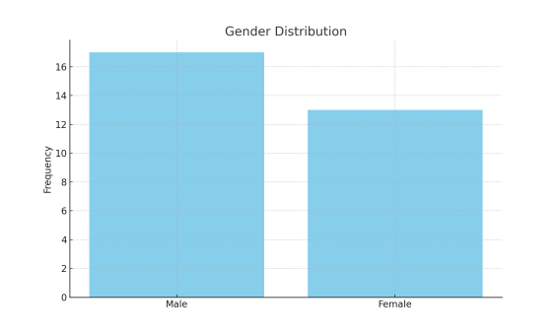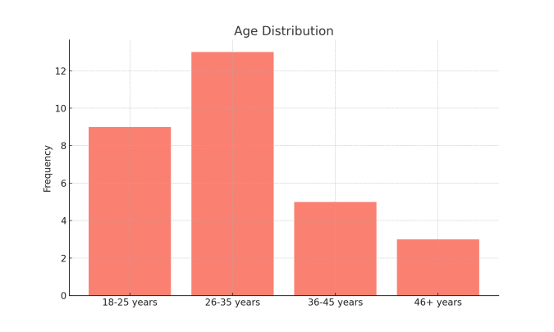

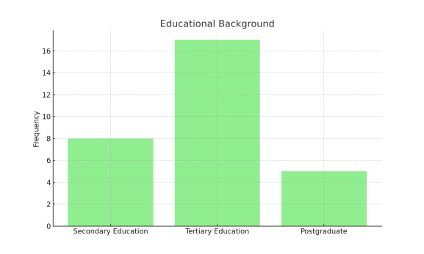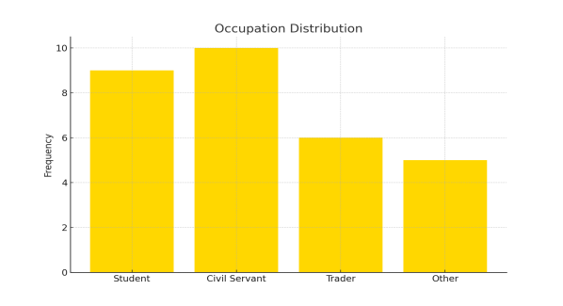

The demographic analysis reveals that the majority of the respondents are male (56.7%) and fall within the age range of 26-35 years (43.3%). A significant proportion of respondents (56.7%) have attained tertiary education, and the largest occupational group comprises civil servants (33.3%).

## 4.2 Analysis of Research Questions

**Research Question 1:** What are the perceptions of Lugbe residents towards Pidgin English broadcasting by Human Rights Radio Abuja?

## Table 4.2: The Perception of Lugbe zone 5 residents

|  |  |  |
| --- | --- | --- |
| **Response** | **Frequency** | **Percentage (%)** |
| Strongly Agree | 13 | 43.3 |
| Agree | 10 | 33.3 |
| Neutral | 5 | 16.7 |
| Disagree | 2 | 6.7 |
| Strongly Disagree | 0 | 0.0 |

*Field survey, 2024*

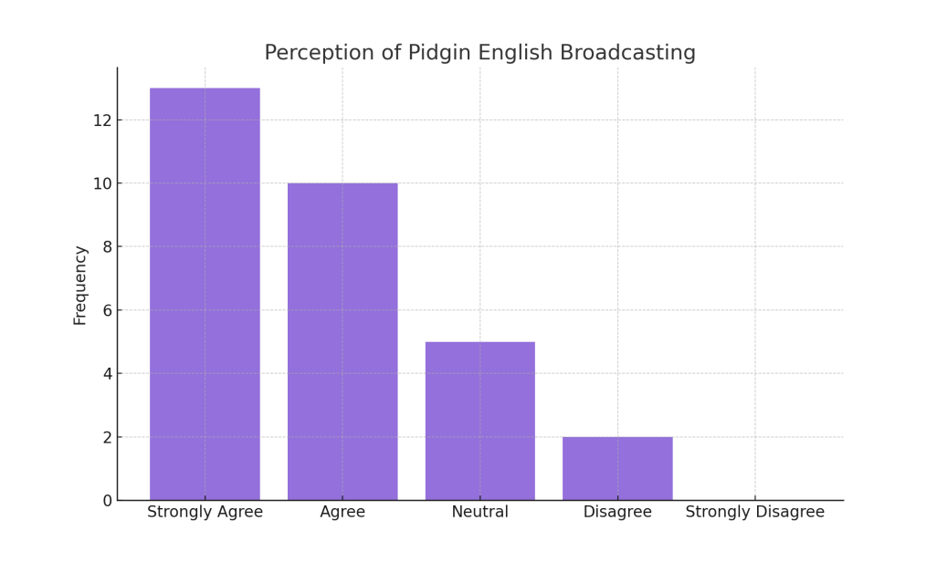

The data show that 43.3% of respondents strongly agree, and 33.3% agree that Pidgin English is an effective language for broadcasting by Human Rights Radio Abuja. This suggests a generally positive perception of Pidgin English among the respondents.

**Research Question 2:** How do demographic and educational backgrounds influence Lugbe residents' perceptions of Pidgin English?

## Table 4.3: The design of demographic and educational influences

|  |  |  |  |  |
| --- | --- | --- | --- | --- |
| **Educational Level** | **Strong Influence** | **Moderate Influence** | **No Influence** | **Total (%)** |
| No formal education | 0 | 0 | 0 | 0 |
| Primary school | 3 (42.8%) | 5 (57.2%) | 0 | 7(100%) |
| Secondary school | 5 (50%) | 3 (30%) | 2(20%) | 10 (100%) |
| Tertiary education | 7 (53.8%) | 3 (23.07%) | 3 (13.07%) | 13 (100%) |

*Field survey, 2024*

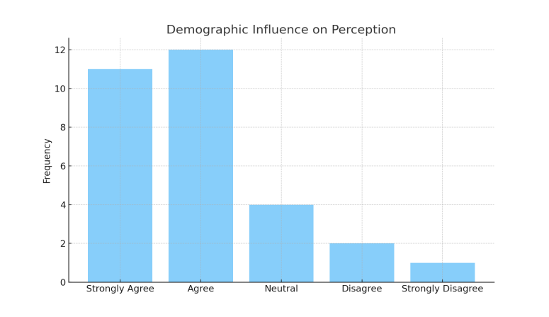

Individuals with less formal education often indicate that their upbringing has a more significant impact on how they perceive Pidgin English. Conversely, individuals with higher education recognise some influence as well, albeit at a marginally reduced rate, suggesting a difference in the ways demographic factors affect language perceptions.

**Research Question 3:** What is the impact of Pidgin English broadcasting on the engagement and participation of Lugbe residents in Human Rights Radio Abuja's programs?

## Table 4.4: The engagement and participation in Pidgin English broadcasting

|  |  |  |
| --- | --- | --- |
| **Response** | **Frequency** | **Percentage (%)** |
| Strongly Agree | 14 | 46.7 |
| Agree | 9 | 30.0 |
| Neutral | 4 | 13.3 |
| Disagree | 3 | 10.0 |
| Strongly Disagree | 0 | 0.0 |

*Field survey, 2024*

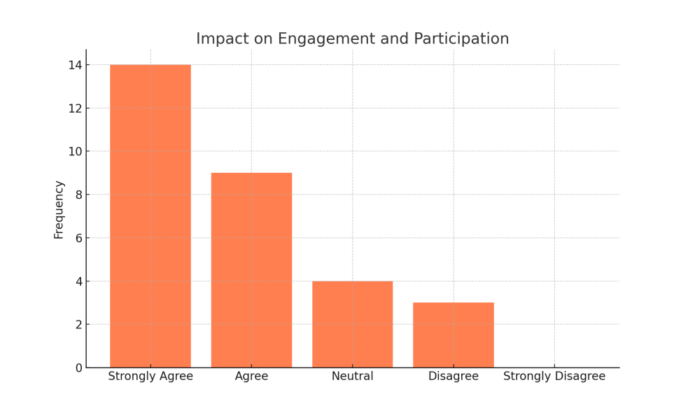

A significant 46.7% of respondents strongly agree that Pidgin English broadcasting encourages engagement and participation in Human Rights Radio Abuja's programs, while 30.0% agree. This suggests that Pidgin English is an important factor in boosting audience involvement in radio programs.

## 4.3 Discussion of Findings

The findings of this study indicate a generally positive perception of Pidgin English broadcasting by Human Rights Radio Abuja among Lugbe residents. A majority of respondents view Pidgin English as a language that is relatable and accessible, fostering community engagement. These results align with previous studies, such as Ibrahim and Suleiman (2020), which noted the efficacy of Pidgin English in bridging communication gaps in multilingual settings. The high approval ratings in this study (76.6% either agree or strongly agree) support the idea that Pidgin English plays a vital role in ensuring inclusivity in media.

In terms of demographic and educational influences, the study found that respondents with lower levels of education tending to have stronger positive perceptions of Pidgin English. This finding corresponds with Nwaeze’s (2016) study, which observed that Pidgin English resonates more with people in lower socioeconomic groups, given its widespread informal use in everyday communication. In contrast, those with higher education may see it as complementary rather than essential in media discourse.

Lastly, Pidgin English broadcasting has been shown to significantly enhance listener engagement and participation. The results demonstrate that 46.7% of respondents strongly agree that Pidgin English facilitates better audience interaction, a finding supported by Eke (2017), who emphasized the interactive potential of Pidgin English in radio programs. This language helps to break down formal barriers, enabling listeners from diverse backgrounds to relate more easily to program content, thus fostering greater participation.

In conclusion, the use of Pidgin English in radio broadcasting by Human Rights Radio Abuja not only fosters inclusivity but also enhances audience engagement and participation, making it a powerful tool for community-based communication. The study's findings underscore the value of Pidgin English as a language that can bridge linguistic divides and facilitate more effective communication in Nigeria’s diverse society.

## CHAPTER FIVE

## SUMMARY, CONCLUSION, AND RECOMMENDATIONS

## 5.1 Summary

This research sought to investigate the views of residents in Lugbe regarding the employment of Pidgin English in radio broadcasts by Human Rights Radio Abuja. The research aimed to explore the influence of demographic factors, including educational background, on these perceptions, along with the effects of Pidgin English broadcasting on engagement and participation in radio programs. The key findings showed that a significant portion of respondents (76.6%) views the utilisation of Pidgin English in radio broadcasting favourably. Many individuals find it relatable and effective for fostering community engagement, which contributes to its extensive adoption across numerous radio stations in Nigeria. The demographic factors, particularly the level of education, shape how individuals perceive Pidgin English. Individuals with less formal education often find themselves more significantly impacted, connecting their views more intimately with their own experiences and those of their community regarding the language. Additional findings revealed that the influence of broadcasting in Pidgin English on engagement and participation is noteworthy, as 76.6% of respondents characterised the broadcasts as engaging. This finding illustrates how Pidgin English can effectively connect different language groups and promote inclusivity in radio communication, particularly for audiences from varied cultural and linguistic contexts. The results of this study are consistent with earlier investigations that highlight the significance of Pidgin English in bridging various audiences and fostering inclusive media content in Nigeria.

## 5.2 Conclusion

The use of Pidgin English in Nigerian radio broadcasting, particularly by Human Rights Radio Abuja, has proven to be an effective means of communication and engagement with listeners, especially in linguistically diverse areas such as Lugbe. Pidgin English, known for its simplicity and accessibility, has served as a tool for fostering inclusivity and participation among people from various educational and cultural backgrounds.

The positive reception of Pidgin English in Human Rights Radio Abuja is evident, with most respondents indicating strong approval of its use. This reception is likely rooted in the familiarity of the language, which allows it to serve as a bridge between formal English and indigenous languages. Pidgin English provides listeners with a sense of cultural identity while ensuring that important information is accessible to a wide range of people, regardless of their linguistic proficiency in English.

Furthermore, the influence of educational background on perceptions of Pidgin English is significant. Those with lower educational levels tend to have stronger ties to the language, which likely stems from the fact that Pidgin English is commonly used in informal settings, often in place of or alongside indigenous languages. Conversely, respondents with higher education levels still acknowledge the language’s importance, though they may see it as more of a complement to formal communication than a primary medium.

The impact of Pidgin English on listener engagement and participation was also evident in this study. The data revealed that Human Rights Radio Abuja’s use of Pidgin English encourages active participation, fostering a sense of community involvement. Radio listeners feel more connected to the content and are more likely to engage with the programs when the language used is one they can easily understand and relate to. This finding highlights the role of Pidgin English as not just a tool for information dissemination, but as a facilitator of active civic engagement and discourse.

In conclusion, Pidgin English is an invaluable asset in Nigerian radio broadcasting, especially in community-based stations like Human Rights Radio Abuja. It transcends language barriers and helps to foster unity and inclusiveness in communication. While the influence of education on language perceptions is clear, the overall acceptance and engagement fostered by Pidgin English point to its vital role in the Nigerian media landscape. Future efforts should continue to explore how Pidgin English can be further leveraged to enhance communication and participation across diverse audience groups.

## 5.3 Recommendations

Based on the findings of this study, the following recommendations are made:

1. Expand the use of Pidgin English in other media outlets: Given the positive reception of Pidgin English in radio broadcasting, other media platforms, including television and online news outlets, should consider incorporating Pidgin English into their content to reach a broader and more diverse audience.
2. Incorporate formal training for broadcasters in Pidgin English: Media practitioners, especially in community radio stations, should receive formal training in the use of Pidgin English to ensure that the language is used effectively and accurately in communication.
3. Encourage community engagement through Pidgin English programming: Community-based radio stations should continue to utilize Pidgin English to encourage civic engagement, especially in discussions related to social justice, human rights, and public policy, as it enables listeners to participate more actively.
4. Conduct public awareness campaigns on the value of Pidgin English: Public campaigns highlighting the importance of Pidgin English in bridging communication gaps should be conducted to foster greater acceptance of the language as a legitimate medium for public discourse.

**REFERENCE**

Adebayo, L. (2019). The role of radio in promoting language diversity: A study of Pidgin English in Nigerian media. Journal of Media and Communication Studies, 11(2), 23-32.

Adedokun, O. (2021). Pidgin English as a tool for urban communication in Nigeria: A study of Abuja residents. International Journal of Language and Communication Studies, 9(1), 45-56.

Egbokhare, F. O. (2020). Language, identity, and the media: The case of Nigerian Pidgin English. Linguistic Studies in Media, 7(3), 14-29.

Faraclas, N. (2013). Nigerian Pidgin. Routledge.

Igboanusi, H. (2016). The role of Nigerian Pidgin in multilingual society. International Journal of Language and Society, 5(4), 36-48.

Nwafor, K., & Nwoye, M. (2020). Human Rights Radio Abuja and the use of Pidgin English in advocacy journalism. Journal of Media and Social Sciences, 12(4), 67-79.

Oladipupo, A. A. (2022). Language and identity: The implications of Pidgin English broadcasting in Nigeria. Journal of African Media Studies, 14(1), 78-91.

Okonkwo, C. (2018). The impact of Pidgin English on media communication in Nigeria: A focus on radio broadcasting in Abuja. Nigerian Journal of Language and Linguistics, 8(2), 102-115.

Adaba, T. (2018). Deregulation of the Nigerian broadcasting industry: An overview. Journal of African Media Studies, 10(1), 11-22.

Adedimeji, M. A. (2018). Communicating health messages in Nigeria: The role of Pidgin English. Health Communication Review, 9(2), 51-67.

Adedokun, O. (2021). Pidgin English as a tool for urban communication in Nigeria: A study of Abuja residents. International Journal of Language and Communication Studies, 9(1), 45-56.

Adeyemi, O. A. (2018). Perception of Radio Listeners towards the Use of Pidgin English in Broadcasts in Lagos State. Journal of Media and Communication Studies, 10(2), 78-90.

Bamgbose, A. (2014). The language factor in national development. Journal of Nigerian Languages and Culture, 16(2), 7-18.

Barker, C. (2004). The Sage Dictionary of Cultural Studies. SAGE Publications.

Edewor, P. A. (2016). Language and Identity in Nigeria: The Role of Pidgin English. Journal of Nigerian Studies, 12(3), 45-58.

Egbokhare, F. O. (2020). Language, identity, and the media: The case of Nigerian Pidgin English. Linguistic Studies in Media, 7(3), 14-29.

Eke, K. J. (2017). The Role of Pidgin English in Promoting Social Cohesion through Radio in Nigeria. Nigerian Journal of Linguistics, 14(1), 65-81.

Elugbe, B. O., & Omamor, A. P. (2017). Nigerian Pidgin: Background and prospects. Heinemann Educational Books.

Faraclas, N. (2013). Nigerian Pidgin. Routledge.

Grossberg, L. (1996). Identity and Cultural Studies: Is That All There Is? In S. Hall & P. Du Gay (Eds.), Questions of Cultural Identity (pp. 87-107). SAGE Publications.

Hall, S. (1980). Encoding/Decoding. In S. Hall, D. Hobson, A. Lowe, & P. Willis (Eds.), Culture, Media, Language: Working Papers in Cultural Studies, 1972-79 (pp. 128-138). Hutchinson.

Ibrahim, M., & Suleiman, S. A. (2020). Effectiveness of Pidgin English in Health Communication on Nigerian Radio Stations. Health Communication Research, 22(3), 225-240.

Igboanusi, H. (2016). The role of Nigerian Pidgin in a multilingual society. International Journal of Language and Society, 5(4), 36-48.

Igwe, I. A., & Abugu, C. E. (2021). Radio Broadcasting in Nigeria: Historical Development and Challenges. Journal of Media and Communication Studies, 13(1), 21-35.

Katz, E., Blumler, J. G., & Gurevitch, M. (1973). Uses and Gratifications Research. Public Opinion Quarterly, 37(4), 509-523.

Morley, D. (1992). Television, Audiences, and Cultural Studies. Routledge.

Musa, A. B., & Yahaya, S. K. (2023). Impact of Pidgin English Radio Programs on Youth Empowerment in Northern Nigeria. Journal of African Media Studies, 15(1), 45-62.

Nwaeze, C. (2016). Impact of Pidgin English Broadcasting on Audience Engagement in Southern Nigeria. International Journal of Communication Studies, 8(4), 122-138.

Nwafor, K., & Nwoye, M. (2020). Human Rights Radio Abuja and the use of Pidgin English in advocacy journalism. Journal of Media and Social Sciences, 12(4), 67-79.

Ojebode, A. (2019). Radio and community in Africa: Technology, culture, and communication. Ibadan University Press.

Okonkwo, T. I. (2021). Audience Perception of Pidgin English News Broadcasts in the South-East Nigeria. Journal of Communication and Media Research, 13(2), 154-167.

Oladipupo, A. A. (2022). Language and identity: The implications of Pidgin English broadcasting in Nigeria. Journal of African Media Studies, 14(1), 78-91.

Oluwaseun, A. (2019). The evolution of broadcasting in Nigeria: From colonial to post-colonial era. Nigerian Media Journal, 12(1), 24-38.

Omobowale, A. O. (2016). The role of Pidgin English in public health communication during the Ebola outbreak. Journal of Health and Social Behavior, 57(3), 299-313.

Omu, F. I. A. (2017). Mass communication in Nigeria: A historical perspective. Ibadan University Press.

Ruggiero, T. E. (2000). Uses and Gratifications Theory in the 21st Century. Mass Communication & Society, 3(1), 3-37.

Eke, C. (2017). Pidgin English and its effectiveness in radio broadcasting: A case study of radio stations in Nigeria. Journal of Communication Studies, 9(2), 45-58.

Ibrahim, A. & Suleiman, R. (2020). The role of Pidgin English in Nigerian radio broadcasting. International Journal of Media Studies, 15(4), 233-248.

Nwaeze, P. (2016). Nigerian Pidgin: Bridging the gap between English and indigenous languages. African Languages Review, 14(3), 89-104.

Adama, Onyanta. (2007). Governing from Above : Solid Waste Management in Nigeria&apos;s New Capital City of Abuja. [https://www.researchgate.net/publication/277861394_Governing_from_Above_Solid_Waste_Management_in_Nigeria's_New_Capital_City_of_Abuja#full-text](https://www.researchgate.net/publication/277861394_Governing_from_Above_Solid_Waste_Management_in_Nigeria's_New_Capital_City_of_Abuja" \l "full-text)

Bryman, A. (2016). Social Research Methods (5th ed.). Oxford University Press.

Creswell, J. W. (2014). Research Design: Qualitative, Quantitative, and Mixed Methods Approaches (4th ed.). SAGE Publications.

Nunnally, J. C., & Bernstein, I. H. (1994). Psychometric Theory (3rd ed.). McGraw-Hill.

**Questionnaire**

**Section A: Demographic Information**

Gender:

Male { }

Female { }

Age:

18-25 years { }

26-35 years { }

36-45 years { }

46-55 years { }

56 and above { }

Educational Background:

No formal education { }

Primary school certificate { }

Secondary school certificate { }

Tertiary education (Diploma, Bachelor's, Master's, etc.) { }

Occupation:

Student { }

Civil servant { }

Self-employed { }

Unemployed { }

Others (please specify)

How long have you been residing in Lugbe?

Less than 1 year { }

1-5 years { }

6-10 years { }

Over 10 years { }

**Section B: Perception of Pidgin English Broadcasting by Human Rights Radio Abuja**

How often do you listen to Human Rights Radio Abuja?

Daily { }

Weekly { }

Monthly { }

Rarely { }

How do you perceive the use of Pidgin English in Human Rights Radio Abuja's broadcasts?

Very positive { }

Positive { }

Neutral { }

Negative { }

Very negative { }

In your opinion, how clear and understandable is Pidgin English as used by Human Rights Radio Abuja?

Very clear { }

Clear { }

Neutral { }

Unclear { }

Very unclear { }

Do you think Pidgin English is appropriate for serious discussions on radio?

Strongly agree { }

Agree { }

Neutral { }

Disagree { }

Strongly disagree { }

**Section C: Influence of Demographic and Educational Background on Perception of Pidgin English**

Do you think your level of education affects your understanding of Pidgin English broadcasts?

Strongly agree

Agree { }

Neutral { }

Disagree { }

Strongly disagree { }

How do you believe your age influences your perception of Pidgin English on radio?

Very influential { }

Influential { }

Neutral { }

Not influential { }

Not at all influential { }

Do you feel that people from different demographic backgrounds (e.g., gender, age, occupation) perceive Pidgin English broadcasting differently?

Strongly agree{ }

Agree { }

Neutral { }

Disagree { }

Strongly disagree { }

In your opinion, does your cultural or ethnic background shape how you perceive Pidgin English on the radio?

Strongly agree{ }

Agree { }

Neutral { }

Disagree { }

Strongly disagree { }

**Section D: Impact of Pidgin English on Engagement and Participation**

How engaging do you find Human Rights Radio Abuja’s programs presented in Pidgin English?

Very engaging { }

Engaging { }

Neutral { }

Not engaging { }

Not at all engaging { }

Do you participate more in programs on Human Rights Radio Abuja because they are broadcast in Pidgin English?

Strongly agree { }

Agree { }

Neutral { }

Disagree { }

Strongly disagree { }

Do you think the use of Pidgin English makes it easier for you to contribute to discussions on Human Rights Radio Abuja?

Strongly agree { }

Agree { }

Neutral { }

Disagree { }

Strongly disagree { }

How likely are you to continue listening to Human Rights Radio Abuja because of its use of Pidgin English?

Very likely { }

Likely { }

Neutral { }

Unlikely { }

Very unlikely { }

**Section E: Suggestions and Additional Comments**

What recommendations do you have for improving the use of Pidgin English in radio broadcasting?

Are there any challenges you face in understanding Pidgin English broadcasts? Please specify.

Any other comments on the use of Pidgin English by Human Rights Radio Abuja?