THE IMPORTANCE OF SHIPPING TO THE ECONOMIC DEVELOPMENT OF NIGERIA

ABSTRACT
The study investigates the impact of Ocean shipment trade on Nigeria’s economic development, covering the period, 1976-2006. Ocean shipment trade in thousands of tones served as the independent variable in all the three hypothesis defined while, the gross domestic product Nigerian value of external reserve served as the dependent variable.
The three hypotheses were actually tested for the following conclusions to be reached:
1) Shipment export trade has actually exerted a positive effect on the economy as a whole.
2) Shipment Export Trade exerts a significant positive effect on the level external reserve in Nigeria.
3) Akin to the two revelations above, the Shipmen Export Trade exerts a significant effect on the level of Nigeria’s external debt payment, especially for the period under investigation, 1976-2006.
The findings of this study therefore, bring to the limelight the need for the following recommendations:
With the perceived weak institutional setting, there is therefore the need to improve the institutional setting in order to boost external trade contribution to the economic as a whole. Even though Shipment Export has been found to contribute positively to the economy generally, whether in terms of contribution to gross domestic product, external reserve or external debt payment, one is tempted to say that more contributions would have been recorded with strong institutional setting.
Similarly, the poor transparency and corruption that appear to be endemic in our country call for concerted effort to make for an improved performance.

CHAPTER ONE
INTRODUCTION

1.1 BACKGROUND

Shipping has for a long time been recognized as one of the strong catalysts for socio-economic development. Back in 1776, Adams Smith noted that ’’A business working in a country town without links to the outside world can never achieve high levels of efficiency because its small market will limit the degree of specialization”. Because distances, it has since the ancient times been at the fore front of opening up of the world and thus a major driver in of the process of globalization. Shipping, especially container shipping has been both a cause and effect of globalization. Container shipping could lay claim to being the world’s first truly global industry. In fact container shipping could claim to be the industry which, more than any other, makes it possible for truly global economy to work, it connects countries, markets, business and people, allowing them to buy and sell on a scale not previously possible. It is now impossible to imagine world’s trade, and ultimately our lives as consumers, without container shipping. Shipping has led to a phenomenal growth in world merchandise trade, which has consistently grown faster than output. In 2006, goods loaded at ports worldwide are estimated at 7.42billion tonnes, up from 5.98 billion tonnes 2000. The value of total world export increased from US$6,454 billion in 2002 to US$40,393 billion in 2005 representing an increase of 64 per cent.

1.2 STATEMENT OF RESEARCH PROBLEMS

The maritime industry is international in nature and is acknowledged to be a very dynamic component in the socio-economic configuration of any given maritime nation. Nigeria is no exception. Even land-locked countries such as Mali and Burkina - Faso in West Africa also hinge, their economic fortunes on the maritime sector relying as it were on the port of Abidjan for import and export transactions. One major problem that has continued to plague the industry in Nigeria is the issue of adequate policy formulation and implementation, hence the contribution of shipping trade to economic growth has therefore being a subject of debate.
In traditional maritime nations such as United Kingdom, the USA, the Scandinavians, other European Countries among others, the factors of time, proper planning, co-ordination and implementation of clear-cut policies through government intervention largely account for the enviable levels of efficiency, sophistication and monumental success in their maritime activities especially in respect of its contribution to economic growth. The reverse appears to be the case in Nigeria as the fortunes of the

15
industry have continued to suffer progressive catastrophe over the years. A very near example is the fact that the Nigerian National Shipping Line (NNSL) which took delivery of 19 (nineteen) brand new tonnages from European shipyards in 1979 and 1980, has not only lost all her vessels but has been liquidated altogether. This is complicated by the inability of governments of different types to float an indigenous national carrier up till date.
Therefore, the basic questions that will agitate the mind of the researcher include the following:

- What has been the trend and pattern of shipping or maritime trade in Nigeria?

- What are the causes of the trends in the shipping trade?

- What has been the impact of shipping trade on economic growth in Nigeria using economic indicators of Gross Domestic Product (GDP), External Reserves and Debt Services payment

as yardsticks?
1.3 OBJECTIVE OF THE STUDY

The central objective of this study is to empirically determine the impact of ocean shipping export trade on Nigeria’s economic
development. Specifically, the study intends to accomplish the

following:

- To determine the relationship between ocean shipping export trade and Nigeria’s gross domestic product.

- To ascertain the influence of ocean shipping export on Nigeria’s external reserve.

- To determine whether ocean shipping export significantly influences the level of external debts payment.

- To isolate policy constraints towards the effective use of oceanshipping export to boost economy and proffer policyrecommendations

1.4 RESEARCH QUESTIONS.

Having stated the above objectives, we therefore, consider the

following research question relevant for the study?

- What is the nature of relationship between ocean shipping export and Nigeria’s economic development?

- To what extent has ocean shipping export influenced the level of Nigeria’s gross domestic product?

- What is the influence of ocean shipping export on Nigeria’s foreign exchange reserve?

- To what extent has ocean shipping export influenced Nigeria’s debt service payment?

- What are the policy constraints toward the effective use of ocean shipping export receive in Nigeria?

1.5 RESEARCH HYPOTHESES

In order to carry out an adequate research work, and to analyze the relationship of the needed variables, we shall make the following hypotheses:

H0: 1 There is no significant relationship between ocean shipping export and the Gross Domestic Product.

H0: 2 There is no significant relationship between ocean shipping export and External Reserve.

H0: 3 There is no significant relationship between ocean shipping export and External Debts Payment.
- SIGNIFICANCE/JUSTIFICATION OF THE STUDY

There is no gain saying the fact that the issue of economic growth and development is one of the most sensitive issues in Nigeria of today. One reason for the sensitivity of this issue is the scenario of abject poverty in the Land of surplus as is the case in Nigeria. The reason for this boils down to the fact that every reasonable Nigerian is bothered about the economic imperialism brought about by the level of underdevelopment. The generation yet unborn is even saddled and sold to economic slavery because of the present level of poverty and penury.
A research work on such a sensitive matter as the relationship between economic development, external reserve, debt payment and ocean shipping export in Nigeria, is therefore at this time a necessity.

The need to provide a lasting solution to the problem of underdevelopment, abject poverty, tribal clashes, Niger Delta Youth restiveness, religious bigotry among others, provide workable economic growth scenario, management of our abundant natural resources among others as would be advocated in this research work is therefore a task that must be done and hence a justification for this research work. Hence, this study is significant.

1.7 SCOPE OF STUDY

This research work aims at covering an overview of the nature of the relationship between the ocean shipping export and economic development in Nigeria, giving special attention to the some indicators of economic growth in Nigeria - gross domestic product, external reserve and external debt payment.
References would be made to other countries which are relevant to this research work. The study also covers a period of 39years, 1976-2015.
1.8 LIMITATIONS OF STUDY

The research work has been intended to have an overview analysis of the Nigerian ocean shipping export in relation to it economic development and growth.

It would assess the concept of ocean shipping export in relation to the current level of economic growth given special attention to relationships between ocean shipping export and some indicators of economic growth.
However, due to time constraints and lack of good data base and information sources in Nigeria and worst still because of lack of good data in the required government ministries and parastatals, the research work could not cover all the economic growth information of the country.

CHAPTER TWO

LITERATURE REVIEW

2.1 CONCEPTUAL FRAMEWORK

Commentaries have over the year been given about shipping in Nigeria. Most of these works are focused on selected and diverse aspect of maritime practice as it affects the growth and development in Nigeria. We have such central theme relating to the roles of the National Maritime Authority (now NIMASA) and the effectiveness of the shipping policy decree 10 of 1987, the function of the Nigerian Ports Authority; problems and prospect of the shipping industry in Nigeria among others. No previous work has actually gone the extra mile of attempting to bridge the yawning gap among the maritime regulating agencies in Nigeria such as the Nigerian Port Authority (NPA), Shippers Council, Nigerdock and the N.MA. among others to the effect of making them a functional. Whole capable of elevating shipping in Nigeria to international standards. Nigeria possesses the geo-political and demographic potentials of a major maritime power yet the industry continues to suffer degradation.

Ihenacho (1997) enunciated some strategies towards the development of the shipping industry in Nigeria. His main focus was

on the shortcoming of the shipping policy Decree 10 of 1987 which

21
vested policy implementation in the industry on the National Maritime Authority (N. M. A. now NIMASA). In his view, the shipping policy is rather too deficient in scope and coverage to make any meaningful impact on maritime transport and in Nigeria.

He sees it as not protective enough of indigenous interest especially in the area of cabotage and government assistance to indigenous operators through subsidies for the acquisition or building of new tonnage or ships. He opines that Decree 10 of 1987 could better be appreciated as an instrument setting up the National Maritime Authority and advocated a new policy provision on shipping with a clear definition of the role of shipping in the larger scheme of the national economic and development which will have impart on economic growth and development.

Aluko (1995) focused her discourse on the development of Nigeria’s shipping industry in the context of vision 2010, an agenda constituted by Nigeria’s late Head of state General Sani Abacha to chart a new socio-political and economic direction for Nigeria in the

21st century. Her work more or less reviewed the National shipping policy decree and dealt extensively on the issue of what should inform Nigeria National interest in the realm of shipping. She posed the question of choice between a protectionist and liberal approach

to the development of Nigeria’s shipping and maritime against

22
the back drop of global towards liberalization and free ", She submitted that for Nigeria shipping industry to be

of relevance in the 21st century, there is need to formulate a comprehensive shipping policy to cover not only deep sea, but also coastal shipping and inland waterways which will give consideration to the Inland Shipping Act. Beside, she canvassed the need for the strengthening of the Ship Acquisition Ship Building Fund (SASBF) of the N. M. A, so that Nigeria's cargoes can be carried by her indigenous shipping companies. Above all, the challenge was posed to the Nigeria government to demonstrate a high degree of consistency in the implementation of its chosen policy.

Osholowu (1995) examined the role of the national maritime authority in the development of the maritime industry in Nigeria. Apart form highlighting the major Functions and operational objectives of the Authority he also noted some problems of policy implementation such as the obstacle posed by European Union and the United States to cargo sharing in particular and Nigeria shipping policy in general. This, he say is compounded by the lack of cooperation by some government agencies such as the Nigerian National Petroleum Corporation (N. N. P. C) with regards to the lifting of Nigeria's crude oil' by

23
indigenous national carriers or shipping companies. Osholowu also pointed out all the factors inhibiting acquisition by indigenous companies and enunciated the statutory role of the N. M. A in granting loans to qualified National Carriers through the instrument of the Ship Acquisition and Ship Building Fund (SASBF) as well as the effort the Authority has made towards man power development capacity building for the industry as exemplified by the huge financial and technical assistance being given to the Maritime Academy of Nigeria (M. A. N) Oron. His work mainly present as historical overview of the maritime industry in Nigeria and the role the N. M. A has played so far towards its development in the maritime sector and human capacity building in the industry.
Al-Bishak (1996) took a sweeping look at the productive and unproductive aspect of the Nigeria maritime industry and outlined some of the high and low score points of the sector. With a background information about the development of the industry in selected western countries such as Great Britain, the United State, France, Norway and the European Union. He submitted that the crisis of under-development that continues to plague the maritime industry in Nigeria can only be ameliorated when all players in the maritime field embrace

24
professional excellence and develop a thorough sense of commitment towards achieving the desired result. He noted for instance that the indigenous operators should look inward by consulting local technical experts and professional in matters relating to legislation, policy making and execution of maritime pacts, treaties, and conventions with other nations. He also advocate a crusade where-by Nigeria would champion the pooling together of African maritime resources to achieve economy of scale via the formation of consortia or super shipping lines and sub regional specialization in major aspects of the industry such as ship buildings maritime communication gadgets, freight forwarding, marine research and development among others. There is also the need to develop a hub-centre for sub-African regions.

Badejo (1997) in examining the prospect of Nigerian as a load center in West African cities one of the militating factors as the low level or total absence of inter-institutional co-ordination which would have served as an avenue for the dissemination of information to all practitioners and operator in the maritime transport sector in Nigeria. He noted such institutions as the Nigerian Port Authority (N.P.A.) Shippers Councils, Niger Dock the N.M.A. and Nigerian Railways

25
Corporation (NRC) among others, as the cardinal bodies that need to work together to effect not only the development of the industry but also to clinch for Nigeria the coveted load-center. He made specific reference to the ugly spectacle of the presence of numerous public sector agencies at Nigerian Seaports many of which constitute a threat to the smooth running of maritime business at the ports and by extension, Nigeria's position as the natural choice center in the West Africa sub-region.

Momoh (1998) in analyzing some constraints in the development of Nigeria shipping industry alerted on the danger of the futility of continuing to hinge the nation's shipping policy on the instrument of the UNCTAD code for liner conference. He pointed out for instance that the code, in spite of it much orchestrated cargo sharing leverage, is applicable only to the negotiation of shipping in the liner and its scope is specially addressed to the administrative contingency involving the resolution of the freighting right of the "National line" of two trading nations. Thus in the USA/Nigeria route which is dominated by crossed r such as the Dutch, Danes, and the Norwegians, the applicability of the code fall flat on it’s face in as much as Nigerian and the U.S.A. do not operate within a given

26
liner conference. He also sees the rigid adherence to the code as automatically sidelining Nigeria tonnage from non-liner s such as it is obtainable in the narrative wet cargo and bulks as these do not operate within the ambit of liner conferences. In his view therefore, the Nigerian shipping policy as contained in decree 10 of 1987 must necessarily undergo an overhaul if the desired development of the industry and the nation economy can be achieved, and thus an improvement in shipping and consequent improvement in economic development to be achieved.

Ja'afaru (2001) in examining the future' of Nigeria’s maritime industry observed among other things that Nigeria requires a well articulated maritime law and policy constructed to encourage and foster economic growth and development. Nigeria’s shipping laws are more the result of historical chance rather than the outcome of careful consideration. The Nigeria maritime laws which were inherited from her colonial master have become absolute and ill- equipped to deal with the present economic demands of the nation and finally that maritime law research and development is neither undertaken nor related to courses taught in higher institutions in Nigeria coming as it were from someone who had the responsibility of giving teeth of the implementation of the shipping policy. It becomes too obvious that necessary changes need to be carried out to inject new blood into the industry in Nigeria.
27
Oyedeji (2004) in his write-up is also of the opinion that for a greater impacts or relevance in the maritime sector to be achieved, the nation must embark on a more elaborate shipping policy which should encompass the development of maritime capacity building in line with the trends of the world maritime growth taken into consideration the relevance of shipping globalization.

The current emphases should be the coordination of a National Shipping Policy inline with international shipping practices taken into consideration the world maritime treaties and international conventions. A lesson from the developed maritime nations would be very useful in developing the industry human capacity building and infrastructure which will build the shipping and consequently result in very serious impact on economic growth and development especially in the maritime sector.

A common thread that runs through the length of all the presentations above is the degree of rustiness and inertia that characterize the operation relevance of Nigeria shipping policy against the background of dynamism which constitutes the hallmark of global maritime activities.

28

2.2 CURRENT STATUS AND TRENDS IN WORLD SHIPPING

2.2.1 OVERVIEW OF THE WORLD SHIPPING INDUSTRY.

World shipping follows the it serves, but because of its international and entrepreneurial nature, the industry tends to be even more volatile than trading patterns. The industry presently is experiencing a major excess of tonnage, but large fluctuations in supply and demand in shipping have been quite common for a long time.

According to Balarabe (2003) the shipping industry consists of several diverse business sectors. In total, it includes those companies that operate the world fleet of over 45,000 major cargo-carrying ships, tankers, chemical and liquefied gas carriers, combination bulk and oil carriers, ore and dry-bulk ships, general cargo ships, container ships, and many even more specialized types such as automobile carriers and roll-on, roll-off {RO/RO} ships.

The principal sectors today are the tanker operators, the dry-bulk operators, and the liner operators. The tanker and dry-bulk-carrier operators are similar in that fleets of ships usually are owed and/or chartered to carry single, large-volume commodities {i.e., iron ore, grain, coal, crude oil, and petroleum products} over fixed, and sometimes, long periods

29
of time. Shipping thus is closely related to a large enterprise. Many independent operators participate under ‘time – charter’ or voyage charter; in other case, major petroleum or other resource companies own and operate their own fleet.

The liner industry, or general, or cargo business, on the other hand, operates more like a railroad-carrying freight from port to port at fixed rates and on a regular schedule. The modern container ship and RO/RO ships are typical of the ships used in this within the industrialized world. The liner industry is characterized further by the predominance of conferences, international groups of carrier lines that collectively agree on routes, schedules, rates, and other aspects of liner services.

The composition of the world merchant fleet, as of January 1, 2004, is shown in figure 1. Viewed in the conventional shipping categories, there are roughly twice as many general cargos ships as bulk ships. Within the bulk fleet, nearly two-thirds of the ships are devoted to carrying liquid (mostly petroleum) cargoes. However, the number of ships do not accurately reflect the magnitude of the various shipping sectors. As shown in figure 2, the general cargo ships represent a much smaller portion of the fleet when measured in gross tonnage.

30
The general cargo tonnage is less than one-third of that in the combined bulk fleets. Tankers dominate the bulk fleet in gross tonnage as well as numbers

While shipping always has been an international business reflecting the nature of foreign , the international complexity of world shipping is increasing.

Prior to the 1990’s, the relative magnitude of the shipping industries owed in various nations corresponded to the size of the fleets registered in each country. The significant fleets were found almost exclusively in the industrialized nations with the largest trading volumes.

In the 1990’s some countries (Cyprus, Lebanon, Liberia, Panama, Singapore 1990, Oman, Bahamas (Since 1976), and Honduras) developed fleets of ‘open registries’ or flags of convenience’ that do not require owner citizenship. Tax advantages and, often, less strict vessel and crewing standards attracted ship registration to these countries.

31

World Fleet

Fishing | Cargo – carrying | Offshore vessels
Vessels | Fleet | Ferries & harbour craft
(26,670) | (50,877) | (18,669)

Liquid | Dry
Cargo | Cargo
(10,832) | (40,046)

Gas | Special | Oil | Dry-bulk | General
carrier | tanker | tanker | cargo | cargo
(871) | (1,892) | (8,068) | (6,181) | (33,865)

OBO | Ore | Special | Bulk
(573) | carrier | bulk carrier | carrier
 | (394) | (683) | (4,531)

Singledeck | Multideck | Refrigerated | Special | Semi- | Container | RO/RO
general cargo | general cargoes | cargo | cargo | container | (857) | (2,449)
 |  |  | (96,164)

Figure 2.1: Composition of the world fleet (by number)

225

200

175

150

125

100
75
50
25
Qt
Oil | Dry- | General | OBO
 | Bulk | cargo

Container Liquid Passenger Chemical Other
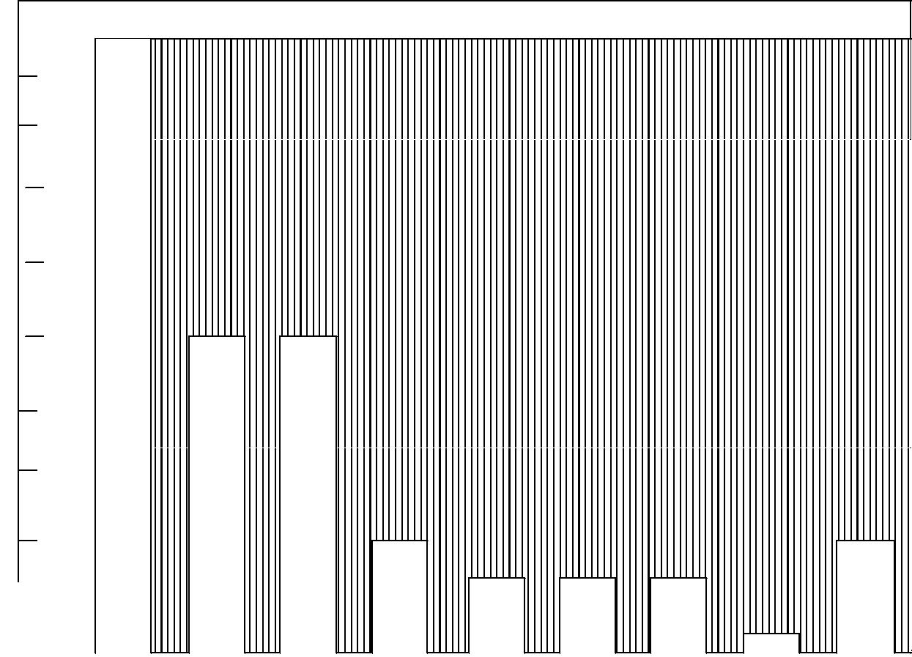
gas

Figure 2.2: Shipping statistic table.

SOURCE: Lloyd’s Register of Shipping Statistical Tables 2005.

Thus while the United States had the largest registered fleet by tonnage 30 years age, Liberian fleet has about tonnage largest fleet in the world.

The spectacular growth in the Liberian fleet (800 percent in 20 years) and other open registries is attributable primarily to business practices of U. S. and other companies of the industrialized world.

33

Two – thirds of the world fleet is registered in eight countries, which are (in order of fleet size): Liberia, Japan, Greece, the United Kingdom, Panama, the former U.S.S.R., Norway, and the United States. Fleet – of open-registry countries accounted for 25 percent

of the world fleet in 2004.

When the tonnage registered under flags of convenience is distributed among the countries of beneficial ownership the United States, Hong Kong, Greece, and Japan total 75 percent clear leaders in ownership of world shipping, flags of convenience are far more widely used in bulk s than in the general cargo industry. The Liberian fleet is the predominant world tanker fleet (now over one-half of all ship tonnage) that is, for the most part, owned by or chartered by the multinational petroleum companies.

Liner ships have a greater diversity of route, flag, ownership and design than the other segments of the industry. For example, container ships make up 3 percent of the world fleet by tonnage and the largest portion of this fleet is U.S. flag, followed by the United Kingdom, Japan, and West Germany. Since these countries are also the predominant nations trading in manufactured goods, this fleet trends to match the in nationality.

34
Today, world shipping is at its peak. Much of the tanker fleet (about one-third) is in shortage to the need for transporting petroleum products. A substantial portion of the dry-bulk fleet also is in shortage to demand, and the liner s have expanded in recent years. The supply of much ships has caused substantial adjustments in the world fleet, with ship scrapping (especially of large tankers) at an all – time high.

The diversification in maritime transportation makes it difficult to characterize the shipping industry in other than very general terms and adds to the difficulty in developing effective policies on which national government can agree.

2.2.2 TRENDS IN SHIP TYPES AND FEATURES.

According to Afonso (2004), the two major changes influencing shipping in recent decades, and which are likely to continue to do so in the future are automation of ship systems and specialization of ship types. A third important trend is change in both propulsion systems and ship design to promote energy efficiency.

The past decades has seen a proliferation of specialized ship types, causing a number of changes in the world shipping industry. One result is that there is now less flexibility to ship tonnage from one

35
to another as markets change. As an example, ships designed for specific s, such as VLCCS for the Arabian crude oil , cannot be used economically in other oil transport routes consequently, the economic risk when a tonnage surplus exists are magnified.

A second major impact from specialization is the trend toward unitization of cargo. Many ships are designed now to carry a specific type of cargo, such as vehicles, or cargo that is transported in uniform units, such as containers. Containerization has transformed the general cargo business. Not only has the type of ship changed dramatically, but routes are shifting depending on the availability of container handling facilities at the various ports. The compatibility of containerized cargo with both land and water transportation system has led to the streamlining of inter-modal transportation services with the introduction of single through rates and through bill of lading. Ocean carrier have expanded their activities from providing strictly port-to-port services to offering consolidated inter-modal transport in which the seaborne leg is just one part of point-to point service. As a result, the availability and interface with rail service is also altering traditional routes.

36
The rate of technological change in general is increasing and maritime policies must be able both to foster and to accommodate that change if a country is to participate in future shipping innovations.

- TRENDS IN SHIPPING ECONOMICS

According to Addico (2005) the economic status of any shipping operation will be determined by the relative levels of costs (capital and operating) and revenues. The demand and freight rates, which determine revenues are presently at severity increased level in all shipping sectors. Given the global nature of the shipping business, the changes in market tends to affect all operators. Competition among commercial fleets for the available revenues is intensified by political factors. More and more countries have instituted cargo preference policies reserving some or all cargo for their own fleets. In oddities some countries have rationalized, noncommercial fleets that are insensitive to non profitable freight rates.

Traditionally, operators in the liner s have formed cartels or adopted cooperative business practices within conferences that are intended to restrict competition and allocate the available market.

Such practices are common worldwide and competition is even more restricted in non U.S. s. Bulk operators, on the other

37
hand, traditionally have favored and followed practices of open competition Bulk shipping also has been populated by many individual entrepreneurs who take extreme risks for high returns. Present economic conditions and the massive oversupply of bulk-ship tonnage, placing some large banks at risk, have led some to reconsider bulk- shipping practices. The larger economic risks of future shipping ventures probably will foster industry restructuring toward managing competition.

There are wide variation in both the capital and operating costs among various countries. National policies should be provided to protect and promote national fleets economic equation as well as capital cost which is a major concern to shipping interests. New investment packages are becoming larger and more difficult to finance. Joint ventures and cooperative arrangements are growing and there is a trend toward reducing high- risk investment caused by speculative building in the past.

Increasing fuel costs are felt by all fleets. For U. S. – flag vessels, they currently represent nearly 50 percent of operating cost as compared to 10 to 15 percent in the early 1990’s.

38
Response include both changes in ship design and propulsion systems have notably shifted form steam to diesel ships, and changes in operating to increase fuel efficiency. While fuel prices currently are higher than in recent past, there is need to study operating cost.

2.2.5 OVERVIEW OF SHIPPING MARKETS–THE CURRENT

TREND

Chiazor (2006) noted that shipping is a complex industry. It is segmented into several markets differentiated by ship type, requirements, organization and geographical location. From the perspective of maritime economics, shipping is divided into two major segments viz. bulk shipping and liner shipping. See fig. 2.3 below.

39

Shipping Market

 |  |  |  | Liner Shipping |  |  |  |  |  |  |  |  |  |  |  |  | Bulk Shipping

Break Bulk |  | Neo-Bulk |  | Container |  | Liquid Bulk |  | Dry - Bulk
Sacks, |  | Lumber, |  | Containers, |  | LNG |  | Grain, Sand
Cartons, |  | Paper, Steel, |  | Lift on/Lift |  | Petroleum, |  | & Gravel,
Crates, |  | Autos. |  | Off (Lo/Lo) |  | Molasses, |  | Scrap Metal,
Drums, |  |  |  | Roll On/Roll |  | Chemicals, |  | Coal/Coke
Pallets, Bags. |  |  |  | Off (Ro/Ro) |  | Vegetable |  | Clinker
 |  |  |  |  |  | Oil |  | Fertilizer,
 |  |  |  |  |  |  |  | Mineral Ore.

40

44,000,000
42,000,000 |  |  |  |  |  |  |  | 44,982,932
40,000,000 |  |  |  |  |  |  | 40,440,780
8,000,000 |  |  |  |  |  | 9,467,420
6,000,000 |  |  |  |  | 7,562,945
 |  |  | 6,444,406 | 6,472,603
4,000,000
 |  | 3,478,574
2,000,000 | 2,032,439
 | 1980 | 1990 | 2000 | 2002 | 2003 | 2004 | 2005 | 2006
 |  |  |  | YEAR
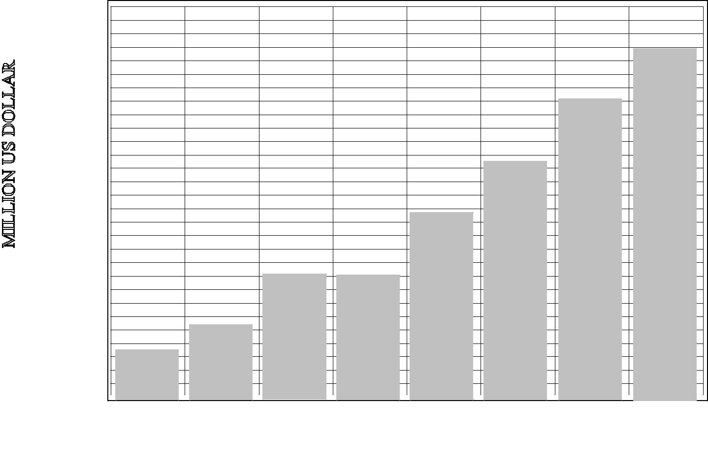

2.4: Figure WORLD MERCHANDISE (EXPORTS F.O.B) IN

MILLION US DOLLARS – 1980 – 2006.

SOURCE: UNCTAD Handbook of statistics 2006 – 2007. Pages 2-40.

Bulk shipping emerged as a dominant sector of the shipping industry in the decades following World War II. Bulk tonnage accounts for close to three quarters of the world merchant fleet. Most of the bulk cargos are drawn from the raw material such

41
as oil, iron ore, coal and grain; and it is commonly described as Bulk commodities. There are four main categories of bulk cargo:

Liquid bulk – requires tanker transportation. The main ones arecrude oil products, liquid chemicals such as caustic soda, vegetable oils, and wine. The size of individual consignment varies from a few thousand tons to half a million tons in the case of crude oil.

Minor bulk – cover the many other commodities that travel inshiploads. The most important are steel products, cement gypsum, non- ferrous metal ores, sugar, salt, sulphur, forest products, wood chips and chemicals.

Specialist bulk cargoes – includes any bulk cargoes that presenthandling or storage problems. Motor vehicles, steel products, refrigerated cargo and special cargoes such as cement plant or prefabricated building fall into this category.

The five major bulks – cover the five homogenous bulk cargoesi.e iron ore, grain, coal phosphate and Bauxite which is transported satisfactorily in conventional dry bulk carrier or teen Decker.

LINER SHIPPING – The transport of general cargo is the domain

of liner shipping. Liner vessels operate with fixed and pre-

42
announced sailing schedules and itinerary. Liner vessels carry general cargoes which consists of consignment of less than ship load or hold size and therefore, too small to justify setting up a bulk shipping operation. In addition they are often of high – value or delicate cargoes that require special shipping services and for which the shipper requires a fixed tariff rather that a fluctuating market rates. The most important classes of general cargo from a shipping view point are:

Loose cargo – individual items and packages of varying size andweight like boxes, pieces of machinery, drums, bags, baling etc, each of which must be handled and stowed separately.

Containerized cargo – standard boxes, usually 8 feet wide, often8.5 feet high and 20,30, or 40 feet long filled with cargo.

Palletized cargo – cargo packed onto a pallet for easy sticking and

fast handling.

Pre-slung cargo – small items such as planks wood lashedtogether into standard – sized packages.

Refrigerated cargo – perishable goods that must be shipped,chilled or frozen, in insulated holds or containers.

43
Roll able Cargoes – Automobiles, machinery and equipment, roll

– on roll off.

2.2.6 THE GLOBAL EVOLUTION OF CONTAINERIZATION

According to kummi (2007), before the advent ofcontainerization, most general cargo was shipped in loose form, and each item had to be packed and stowed into the Ocean Liner. This was a highly labour-intensive activity that was slow, expensive and difficult to execute. It also exposed cargo to the risk of damage or pilferage. As a result, ships spent two- thirds trading life in ports and cargo handling costs had escalated to more than one-thirds of the total costs of the ship-owner. Liner shipping was headed for bankruptcy and the need to find an urgent solution became imperatives. The introduction of containerization mid – 1970’s changed everything, and launched liner shipping into a revolution that continues to shape the industry.

44
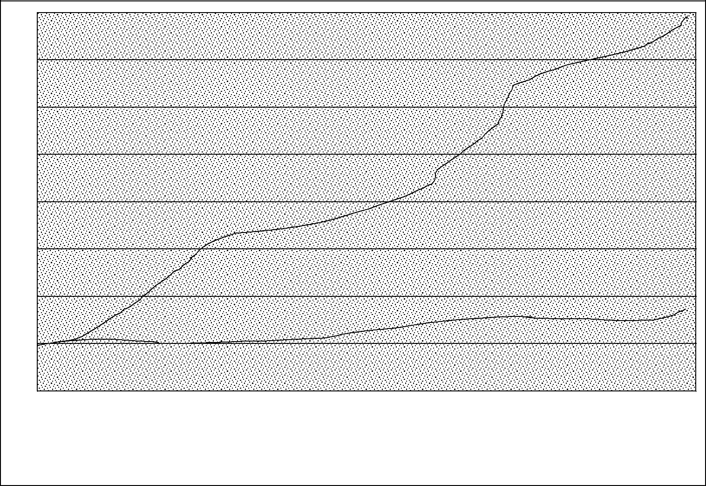

800

700

600

500

400

300

200

100

0

1980 1981 1982 1983 1984 1985 1986 1987 1988 1989 1990 1991 1992 1993 1994 1995 1996 1997 1998 1999 2000 2001 2002 2003 2004

YEAR

CONTAINERS – ALL MARITIME

Figure 2.5: Global Containerization

Source: Economic and Social Commission for Asia and the Pacific.

45

1400

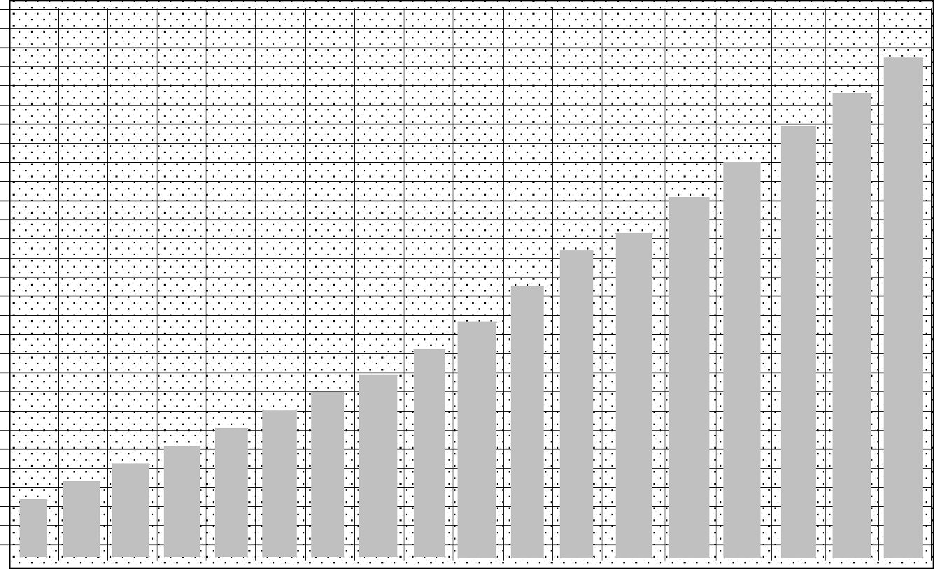

1200

 1000


 800


600


 400

200

0

1980 1981 1982 1983 1984 1985 1986 1987 1988 1989 1990 1991 1992 1993 1994 1995 1996 1997 1998 1999 2000 2001 2002 2003 2004

YEAR

FIGURE 2.6: GROWTH IN CONTAINERIZED SHIPPING (TONNES) 1985-2006.

Source: Clarkson Research Services. Shipping Review Database. Spring 2007. Page 101.

According to Kummi (2007), international containerized shipping grew by

600 per cent between 1979 and 2004, ahead of growth in shipping as a whole. See Fig. 2.6 According to estimates by Drewry Shipping Consultants Ltd (2007) about 141 Million TEUs of loaded containers

46
were moved across the oceans in 2007. it is estimated that more than 80 per cent of the volume of global in general cargo is now containerized. The volume of containerized , measured in cargo tones, grew at an average rate of 9.8 per cent during the last two decades, reaching 1.13 billion tones in 2006. see Fig. 2.5 and 2.6. Consequently, the share of containerized cargo in the world’ total dry cargo has increased from 7.4 cent in 1985 to 24 per cent in 2006.

Dewry Shipping consultants estimates that over 70 per cent of the value of world international seaborne is moved in containers.

The Asian region has emerged as a major hub of container traffic accounting for 48 per cent of the share of worldwide container traffic in 2006. Rapid growth in international in China and India has been one of the major driving forces behind the dominance of the Asia region.

In response to the need to reduce the cost of transporting goods, shipping lines been rationalizing their fleet and scope of operation. The strategy has led to steady increase in the size of container vessels with at least 10 years witnessing a surge in the rate of increase.

47
Container ships of 600 TUEs capacity are becoming the standard vessel size with mega vessel of 5000 TUEs or more becoming the emerging trend. Vessels in this size category now account for 30 per cent of the total cellular capacity available or on order. At the same time there has been an increasing concentration of container

shipping lines, achieved through merger, acquisition and pooling of resources. It is estimated that the top 25 container carriers now

control 84 per cent of the TEU capacity available or on order.
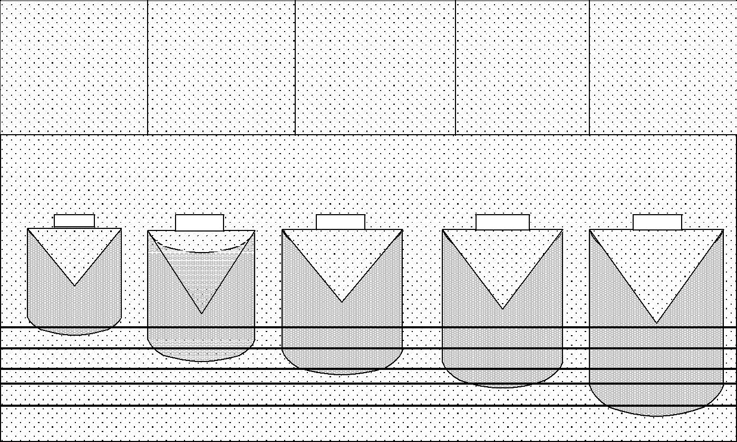

Pre-1970 | 1970 – 1985 | 1985 – 2000 | 2000 – 2010 | Post – 2010
1,700 TEUs | 2,300 TEUs | 4,800 TEUs | 8,000 TEUs | 13,000 TEUs
10 Boxes Wide | 10 Boxes Wide | 13-15 Boxes Wide | 17 Boxes Wide | 21 Boxes Wide
9m Draft | 10m Draft | 13m Draft | 15m Draft | 15m | Draft
137m Length | 189m Length | 351m Length | 531m Length | 142m | Length

FIG. 2.7: EVOLUTION OF CONTAINER VESSEL SIZE

Transport – 2007

Sources: Adapted from UNCTAD Review of Maritime

48
Furthermore, shipping lines are integrating their operations vertically to enable them assume effective control of their supply chains. This trend has witnessed shipping lines extending the scope of their operations beyond their traditional services to include marine terminal operations. Inland transport, warehousing, and freight forwarding. This trend has given rise to what has been termed one-stop Logistics shopping.

The expansion of container operations across the globe has also given rise to global port operators specializing in the management and operation of container terminals. Prominent among these global

port operators are Hutchion Port Holding, PSA Corporation and APM

Terminals.

The changes that have occurred in the shipping and ports sectors over the last few decades can be reviewed in the large forces that have changed the structure of the global economy. The fundamental underlying factor has been an increased reliance on international as the primary engine of economic growth and development, thanks to globalization. The reality is that the global economy requires goods and resources to be transported cheaply and efficiently around the world. The container shipping industry has made this process possible. Consider that in a year, a typical container ship travels nearly 300,000 kilometer. That is more than

49
seven times around the world, or three quarters of the distance to the moon. This means that in a typical container ship’s lifetime of about 26 years, it travels the equivalent distance to the moon and back nearly ten times. Multiply that by today’s 4,000 containers shipping becomes apparently an economic activity. And this is what keeps the globe running.

CONTAINER TRAFFIC PERFORMANCE

According to Drewry Shipping Consultants Ltd (2007) estimates, loaded containers moved across the oceans in 2007 was 141 million TEUs. African accounts for 3 percent of global container handled in seaports. See Figure 2.8 Infact, of the league of top 100 container ports of the world in 2006, only three were in Africa. Two of these (Ports Said and Demietta) are in Egypt and one (Durban) in South Africa. There is none in East, Central and West Africa. While this situation points to the poor performance of the economies and the low participation of African countries in the high value end of the world , it also points to the low level of income and Investments of these regions.

50
60
50
40
40 |  |  |  |  |  |  |  |  | Developing
30 |  |  |  |  |  |  |  |  | countries in
30 |  |  |  |  |  |  |  |  | Asia 53%
20
10
10 |  |  |  |  |  |  |  |  |  |  | Developing
 |  |  |  |  |  |  |  |  |  |  | Developing |  | Developing |  | Developed
0 |  |  |  |  |  |  |  |  |  |  | countries in the |  | Developing |  | Developed
0 |  |  |  |  |  |  |  |  |  |  | Americans 7% |  | countries in |  | countries
 |  |  |  |  |  |  |  |  |  |  |  |  | Africa 3% |  | 3%


FIGURE 2.8: DISTRIBUTION OF WORLD CONTAINER TRAFFIC BY REGION (2005).

Source: Plotted from data from UNCTAD: Review of Maritime Transport (2007). Page 89.

2.2.7 OWNERSHIP OF MERCHANT NAVY FLEET

Ishola (2008) asserted that the world merchant fleet grew by 8.4 per cent in 2006 to reach 1.04 billion deadweight tones. The total tonnage on order was 6,908 vessels with a deadweight tonnage of 302.7 million. Developing Countries controlled about 31.2 per cent of the total world deadweight tonnage. Developed countries 65.9 per cent and economies in transition took the remaining 2.9 per

51

cent. The world fleet of cellular vessels totaled 3,904 at the beginning of 2007, with a total TUE capacity of 9.4 million. And This represent an increase of 11.7 per in the number as vessels and 16.2 per cent in TEU capacity. Nationals of 35 countries control 97.17 per cent of the total world merchant fleet Africa controls less than one per cent of the total world merchant fleet measured in

deadweight tones. See Table 2.1.

The above analysis indicate that overall Africa has lagged behind in reaping the benefits of globalization and in participation in the international shipping market. At best Africa has reaped only marginal benefits from globalization and international shipping . The situation of Africa reflects the inability of African countries to integrate into global economy and thereby take advantage of the opportunities thereof. Part of this problem stems from the structural defects in the economic development policy of African countries and the inefficiencies in its logistics and supply chain system. Available evidence suggest that producers in Africa

often face a transport disadvantage vis-a vis their competitions. The

precise magnitude and nature of this disadvantage varies between

countries, but in general, transport costs are high.

52
TABLE 2.1 DISTRIBUTION OF THE WORLD FLEET AND DWT

CAPACITY OF CONTAINERSHIPS, BY COUNTRY GROUP-BEGINNING 2007
 |  | Share (%) of
Country Group | Dwt | world total
World Total | 128,321,475 | 100.00
Developed Countries | 36,475,603 | 28.43
Countries with Economies in Transition | 167,314 | 0.13
Developing countries of which: | 22,005,522 | 17.15
Africa | 186,895 | 0.52
Asia | 1,114,009 | 16.45
Oceania | 41,476 | 0.03
Other unallocated | 51.364 | 0.04
10 major open and international registries. | 69,261,672 | 54.26

Source: Adapted from UNCTAD Review of Maritime Transport –

2007. Page 26

53
TABLE 2.2 FREIGHT COSTS AS PERCENTAGE OF IMPORT VALUE

FOR VARIOUS REGIONS OF THE WORLD 1990 – 2005

 | 1990 | 1994 | 1996 | 1997 | 1998 | 2000 | 2001 | 2002 | 2003 | 2004 | 2005
WORLD | 5.22 | 5.4 | 5.25 | 5.24 | 5.06 | 5.6 | 6.11 | 5.5 | 5.4 | 5.1 | 5.9
TOTAL
DEVELOPED | 4.4 | 4.29 | 4.19 | 4.17 | .07 | 4.3 | 5.12 | 4.1 | 3.9 | 4.7 | 4.8
COUNTRIES
DEVELOPING | 8.6 | 8.25 | 8.06 | 8.04 | 8.06 | 8.8 | 8.7 | 9.1 | 9.1 | 5.5 | 7.7
COUNTRIES
AFRICA | 11.05 | 1.05 | 11.41 | 11.53 | 11.86 | 12.9 | 12.65 | 11.8 | 11.9 | 10.3 | 10
AMERICA | 8.17 | 7.97 | 7.08 | 7.02 | 6.86 | 8.7 | 8.57 | 10.5 | 9.8 | 4.4 | 4.4
ASIA | 8.19 | 7.97 | 7.97 | 7.9 | 8.11 | 8.5 | 8.35 | 8.5 | 8.6 | 5.9 | 5.9
OCEANIA | 12.26 | 12.24 | 12.32 | 12.36 | 12.26 | 11.8 | 11.7 | 10.9 | 12.3 | 10.0 | 9.6

Source: Plotted from Data from UNCTAD – Review of

Maritime Various Editions.

As indicated in the Figure 2.2 above, Africa has one of the highest freight factors {percentage of freight in the value of goods} in the world. Oceania is the only other region in the world that has this particular problem. It is therefore not surprising that Africa’s share in world , it economic growth, production capacity and stock of foreign direct investment have declined steadily over the years a

54
situation that points to African being a marginal beneficiary of

globalization and international shipping.

- OPPORTUNITIES FOR AFRICAN MARITIME COUNTRIES

Chiori (2007) in her study revealed that shipping offers a myriad of opportunities to Africa maritime and landlocked countries. Basically, shipping has the great potential to open up Africa markets and accelerate the pace of socio – economic development. Growth international would stimulate a boom in the maritime and allied logistic sectors of economies of African countries. In order to take advantage of the opportunities offered by shipping African countries must initiate policies and programmes that will integrate their economies into the global economy. Among the opportunities for African maritime nations are the following.

Expansion of the Volume of International : Globalizationhas resulted in the accelerated growth of world seaborne . In fact, world has grown faster than and the world economy (GDP) over the last couple of decades. Shipping promotes liberalized and export – oriented economic development policies in place of protectionist policies like import substitution. Export oriented development has the potential to promote the growth of traffic through African seaports.

Industrialization of African Economies: As a result of shipping,businessmen have been scouting round the globe in search of cheap

source of raw materials and other factors of production. This offers

56
African Countries that are endowed with raw materials to expand their exports. The countries with competitive factors also stand the chance of attracting foreign direct investments in the manufacturing sector. Shipping also opens opportunities for African countries to market their manufactured goods. All these developments would support the expansion of the maritime sector of Africa.

Development of Maritime Logistics and Allied Sector: CaptainTurkson of the Regional Maritime Academy, Ghana in a study in 2007 believed that shipping and its attendant growth in provide the stimulus for African maritime nations to growth and develop their maritime and allied logistic sector of their economies. Sectors such as Ship owning, Ship Management, Ship Brokerage, Ship Finance, Marine Insurance, Maritime Law and Arbitration, Maritime Training and Education would experience some boom. Other Sectors that can be targeted include inland transport networks (Road, Rail, Inland Waterways and Pipelines), port management and operations, warehousing, freight forwarding and distribution. Improvements in these sectors will enhance logistic and supply chain management, reduce transport and distribution costs, enhance the competitiveness of African exports, and accelerate the integration of African economic into the global economy.

57
Concentration of Shipping Lines: Shipping lines, especially thecontainer lines have been concentrating to take advantage of economies of scope and scale.

There has emerged what is called “Mega Carrier”. Currently, the Top 25 Container lines control about 84 cent of the total TEU capacity available or on order. This growing concentration, coupled with the government subsidies given to ship building in the developed and Asian countries will make it difficult for African countries to relaunch their fortunes in the ownership of shipping tonnage. This Mega Carriers can make life very difficult for any shipping companies that African countries will promote.

The Vertical Integration of Shipping Services: Shipping lines havebeen transforming themselves into one stop logistic shops by integrating their operations vertically. This practice has posed a serious threat to indigenous African shipping agencies, freight forwarders, warehouse operators and inland transport operators.
Already in many African countries ship agencies operating on the traditional model have collapsed or on the verge of collapse as most of the main lines have established their own agencies. This trend will pose a serious treat to the development offers.

58
The opportunity for African indigenous logistics firms to partner with foreign ship-owners who control large volumes of freight is of paramount importance. Such partnerships will offer the opportunity for transfer of technical and managerial know-how.

Meg Vessels: The advent of mega container ships presents a majorchallenge to ports all over the world. They require deep access channel, alongside draughts, giant shore cranes, and massive shore back up support. For African countries, this will mean further marginalization if they are unable to make the required investment to receive such vessels.

Environmental Issues: As African countries develop their transportand logistics infrastructure, major environmental problems would emerge. There is growing concern about the impact of transport on the environment. This means that environmental considerations in the design of transport projects would add to the costs and also increase project lead times.

2.2.9 IMPORTANCE OF MARITIME IN NIGERIA’S ECONOMY

Balarabe (2004) believed that perhaps unlike any other industry, the maritime industry on a global level provides a horde of opportunities for investment.

59
First and foremost, it has served to stimulate import and export by way of providing surface transport through which goods are moved by sea on a massive scale.

Indeed, since the arrival of Johnl d’ Averino, the Portuguese explorer at the Benin River in 1485, trading contact by sea had been established between the Europeans and the West African sub region and Nigeria in particular. The obnoxious in Africa, the slave would have been impossible on the scale it was carried out but for the usage of the sea routes by ship. Shipping also made it possible for colonialists to establish a firm hold on settler economies such as in South Africa where in 1627 the Dutch explorer Jan Van Riebek and his successors ensured that the natives continue to serve as cheap labour in mines and plantations. It also ensured the scramble for and partition of the African continent by Europeans, a phenomenon which was consummated at the Berlin conference in 1884 and 1885 primarily to ease the plunder of African seas. In all, it could be said that apart from the establishment of 3 lop-sided social contact between the Europeans and Africans, the maritime industry was decidedly exploitative of the African Continent in the beginning.

Nevertheless, maritime has played a major role in Nigeria’s economic development. It account for instance, for about 95% of the

60
vehicular means of Nigeria’s International . Besides, it has also acted as a cardinal force in Nigeria’s attempt to correct her imbalances with the industrialized nations of the world.

Indeed, since becoming a signatory to the UNCTAD code for liner conference in 1975, a number of bilateral and multilateral maritime agreements have been entered into by the Nigerian Government and this to a large extent has aided the sector in the movement of cargo in and out of the Nigerian shores.

According to Olokoba (2006), Maritime business has helped the process of diversification of Nigeria’s economy and has continued to provide employment opportunities to Nigerians as crew staff, mariners and dock workers in addition to various practitioners among which are freight forwarders. In fact, for as long as it existed, the Nigerian National Shipping Line (N.N.S.L) not only provided employment to Nigerians but also served as a pool or training ground for majority of the master mariners and other experienced professional people in Nigeria’s maritime sector up till today.

The need for adequate training and re-training of personnel for the industry also culminated in the establishment of the Maritime Academy of Nigeria (MAN) at Oron – an institute devoted to the training of cadets and which has been upgraded to a Higher National Diploma awarding Institution.

61

Maritime transport also generates the much needed foreign exchange to the Nigerian economy. This is in the form of ship repairs, levies (such as the NMA 3% Levy), taxes and port fees and charges among others. The Nigerdock for examples even though has not been known to have built any ocean-going vessel, has been meaningfully engaged in the repairs and maintenance of ships and the construction of ferry-boats all of which constitute an integral part maritime transport. Besides it is the official policy of the National Maritime Authority to collect a levy on the gross freight from any vessel that calls at the Nigerian port (for Export and Import purposes).

The rationale behind this is the desire to boost Nigeria’s merchant shipping fleet for the sake of effective lifting of her share of cargo. Whether this purpose was ever achieved through the disbursement of the Ship Acquisition And Ship Building Fund (S A S B F) is another matter entirely.

Since 1958 when oil was discovered in commercial quantity at Oloibiri, Nigeria’s Oil Terminals such as in Bonny, Escravos, and Forcados have continued to play host to oil tankers of various profiled and sizes. Crude Oil has since displaced agriculture as Nigeria’s economic mainstay accounting as it were, for about 85% of Nigeria’s total export. Even though crude oil export has served to boost Nigeria’s external reserves

62
and buoyed the economy, the total exclusion of Nigeria’s indigenous carriers from the lucrative has been a subject of heated debate between the maritime practitioners and the Federal Government.

Igbecha in a study (2004) revealed that Nigeria loses about $800,000,000.00 (Eight Hundred Million US Dollars) annually as a result of non involvement of indigenous carriers of crude oil. Even cabotage activities involving movement of shore oil prospecting and drilling equipment are still controlled by foreigners thereby denying Nigeria maritime sector and the Federal Government a lot of accruable revenue, Maritime transport however, has provided opportunity for inland water-way transport, coastal and high sea trading and has also made it possible for Nigerians to develop the skill for fish and shrimps trawling enterprise. In a word, maritime transport has engendered employment for a sizeable number of Nigerians in various maritime related occupations.

It has accounted in part for the urbanization and industrialization of the nation as well as giving a boost to Nigerians and commercial relation with the outside world. A coastal nation without security consciousness is a nation susceptible to attack from the seas. Maritime transport has however, made it imperative for the establishment of one of the most sophisticated naval force in the West Africa sub-region. The later carries out security surveillance of Nigeria’s territorial waters and

63
serves as a shield to merchant vessels in time of trouble and distress. Besides, the protection of maritime pollution is closely monitored especially with the current roles of NIMASA (formerly NMA) in pollution control activities and surveillance.

Without any inkling of a doubt, maritime has played a crucial role in Nigeria’s economic development but such roles could be largely improved upon if and when various maritime agencies such as the Nigerian Port Authority (NPA), National Maritime Authority (NMA now NIMASA) Shippers Council, Nigerdock among other, work closely with one accord to better the lot of the industry in Nigeria.

64
CHAPTER THREE

RESEARCH DESIGN AND METHODOLOGY

3.1 DEFINITION OF AREA AND POPULATION OF STUDY

This study focuses of the impact of shipping on economic growth of Nigeria. The period 1976-2006 is therefore covered and no attempt is made to extend the area of study to other countries of the world.

3.2 SOURCES OF DATA

The study employs mainly secondary sources of data as collected from the following specific offices/sources.

- CBN publications – Statistical Belletin, Annual reports and Statement of Accounts, Economic and financial Review, Research Seminar papers. etc.

- National Bureau for statistics – Annual Abstract of statistics

3.3 PROCEDURE FOR DATA ANALYSIS

The data generated for this study is analyzed employing both descriptive and inferential statistics. However, the three hypotheses formulated are analyzed using simple regression model. This is in view of the single explanatory variables (independent variables) involved in each of the three hypotheses of the study.

65
Therefore, the analysis of variance (ANOVA), coefficient of

determination and student t-test is all employed in the various

tests.

- OPERATIONAL DEFINITION OF VARIABLES / HYPOTHESES TESTING

The study is concerned with the analysis of the impact of shipment on the level of economic growth in Nigeria. Hence, the study requires the specification of the dependent and independent variables in order to encourage effective analysis.

In the three hypotheses, we have the following dependant variables respectively for hypotheses 1 through 3:
GDP_{t}= Level of Gross Domestic Product in year, t:

EXT. RES_{t} = Level of External Reserve in year, t:

EXTDEBT_{t} = Level of External Debt Payment in year, t.

For all the three hypotheses however, the independent variable is given as:
SHIPEXPT_{t}: = Level of Shipment Export in year, t.

- HYPOTHESIS 1

Ho1: There is no significant relationship between shipping and the Level of Gross Domestic Product in Nigeria.

66
- The independent variable is the level of shipping from 1976-2015.

- The dependent variable is economic growth proxied by the Level of Gross Domestic Product for the same period and denoted as GDP_{t}.

Mathematically, therefore we have;

GDP_{t} = f(SHIPEXPT_{t}) + e……3.20

i.e GDP_{t} = B_{o} + SHIPEXPT_{t} + e……3.21

Where:

GDP_{t} = Level of Gross Domestic Product in year, t:

SHIPEXPT_{t} = Level of Ocean Shipping in year, t

B₁ = Estimated Parameter of Coefficient of Regression

E = the error term

- HYPOTHESES 2

Ho2: There is no significant relationship between the shipment and the Level of External Reserves in Nigeria.

- Here again, the independent variable is shipping (SHIPEXPT_{t}) for the period under investigation, 1976-2015.

- The dependent variable is the level of external Reserve, EXTRES_{t}.

67
This is denoted by EXTRES_{t}

Hence, mathematically, we have;

EXTRES_{t} = F(SHIPEXPT_{t})

i.e (EXTRES_{t}) | =B_{o} + B₁ SHIPEXPT_{t}) ….........3.22
Where;
EXTRES_{t} | = | Level of External Reserves in year t:
^{B}o | = | Regression Intercept
B₁ | = | Estimated Parameter of Coefficient of
Regression
E | = | Error Term

HYPOTHESES 3

Ho3: There is no significant relationship between the Shipment

and External Debt Payment.

- Here, also the independent variable is the Shipment , SHIPEXPT_{t}

- The dependent variable is the level of External Debt Payment. Hence, mathematically, we have;
EXTDEBT_{t} = F(SHIPEXPT_{t})

i.e (EXTDEBT_{t}) |  | =B_{o} + B₁ SHIPEXPT_{t} + e_{t}…..…3.24
Where;
EXTDEBT_{t} | = | External Debt Payment
SHIPEXPT_{t} | = | Level of Shipping in thousands of tones
 |  | 68

B_{o} | = | Intercept
B₁ | = | Estimated Parameter of Coefficient of
 |  | Regression
E | = | Error Term

3.5 TEST OF SIGNIFICANCE

3.5.1 TEST OF MODEL SIGNIFICANCE – ANOVA

For the hypotheses to be tested, it is pertinent, if not imperative for a test of the model as a whole to be conducted. Carrying out such a test has the advantage of confirming the appropriateness of the model specification. Two ways of achieving this are: (1) the analysis of variance approach and, (2) the coefficient of determination approach, both calculated from the regression mode.

The analysis of variance approach seeks to split the variations of the Dependent variable (Gross Domestic Product, External Reserve and External Debt Payment, respectively for hypotheses 1, 2 and 3) with its components parts.
Variations in the Dependent Variables (GDP_{t} for hypothesis)

1, EXTRES_{t} for hypothesis 2 and EXTDEBT, for hypothesis 3) that

are accounted for by the explanatory variables, are called the EXPLAINED VARIATIONS. Other sources not thus explained are due

to random or chance factors. These are estimates of the population

69

disturbance variable ’u’ represented by ‘e’ otherwise called the RESIDUALS or error term.

Table 3.1 Hypothetical ANOVA table

Source of |  | Sum of |  | Degree of | Mean Square | F-ratio
Variation |  | Squares (SS) |  | Freedom (if) | (MS)
Regression |  | SSR = y²R² |  | K | MSR = SSR | F=MSR
 |  |  |  |  | K
Residual |  | SSE=SST – |  | n-k-1 | MSE=SSE | MSE
 |  | SSR = y²(1- |  |  | n-k-1
 |  | R²)
Total |  | SST = y² |  | n-1

Where;
SSR | = | Sum of squares of the regression
SSE | = | Sum of Squares of the error term.
SST | = | Sum of squares total variation.
K | = | Number of independent variables
N | = | Number of observations.

Note R² = b1 X1Y + b2 X2Y

Y2

70
3.5.2 TEST OF THE MODEL; COEFFICIENT OF DETERMINATION

AND THE F-TEST APPROACH:

Another method to test the statistical significance of the estimated

regression model is through the coefficient of determination. (R²),

calculated from the regression, R², gives the proportion of the total variation in the dependent variable.

R², from the sample is a statistical estimate of the population, ρ²,

(row-squared. Value of R² ranges between 0 and 1. in setting up the test, the following hypothesis is tested;

HO₁: ρ²=O (i.e. the regressor, in a given year have no significant

relationship with the Actual dependent for that year).

HA₁: ρ^{2>}O (One –tailed 0 test of significance) (i.e. at least there is a

significant relationship between one of the independent variables and Actual dependent variable.

DECISION RULE:

If f-ratio (calculated) is greater than the f-ratio (tabulated, at Alpha

α– level of significance, and (k-1) (n-k), degrees of freedom, thenwe reject Ho and Accept H1, and state that there is some truth in the estimated model (-i.e., the regression model is significant since the regressors significantly account for the variation in the dependent variable.
Here, F-ratio (calculated) = (R²)/(k-1)

71
 |  | (1- R²)/(N-k)
Where:
R² | = | R square of the model
K | = | No variables (independedt and dependent)

  - = No of observations.

- TEST OF THE SIGNIFICANCE OF THE EXPLANATORY VARIABLES

Having established the significance of the estimated model as a whole, we now go further to test the specific strengths of the various regressors in bringing about this result. And we can check this through conducting T-tests on the estimated parameters of the regressors.

The test – statistic, t-ratio is calculated thus: t-ratio = βk for k=1…………7

Se (βk)

Where, βk = estimate of the population parameters for the regressors and Se (βk) = Standard error of the estimate.

DECISION RULE

If absolute value, βk > tn-k α/2

72

Se (βk)

Level of significance, we reject HO and accept H1: and conclude that the variable belongs significantly to the model.

3.6 ASSUMPTIONS OF THE LINEAR REGRESSION MODEL

In choosing the above model, we make the following principal assumptions about our population disturbance term, ut. These assumptions about the distribution of the values of ‘ut’ are very crucial for the estimates of the regression. These include the following:

- Assumption of Randomness: The value “ut” may assume in any given period depends on chance ‘ut’ being a random real variable may be positive, zero or negative, each with a certain probability of occurrence for a particular period.

- Assumption of Zero Mean: The mean value of ‘ut’ in any particular period is zero. This being the case, the expected value, (E(ut), of ‘ut’, for all observations, t=1,2,3……….n, is equal to zero.

- Constant Variance Assumption: The variance, 8²ut, is constant in each period, that is, the variance of ‘u_{t}’ for each explanatory variable is constant. This being the case, ‘u_{t}’ will show the

same dispersion for all values of the explanatory variables.

(E(u²t) = 8². This is called the assumption of
73
HOMOSCEDASTICITY. If this assumption does not apply, then the condition of HETROSCEDASTICITY obtains under which condition, therefore, it would be difficult for us to construct confidence intervals on the regression estimates. These tests, therefore, become inapplicable.

- Normality Assumption: The variable ‘u_{t}’ has a normal distribution that is, the values of ‘u_{t}’ (for each explanatory variables) have a bell shaped symmetrical distribution. The above four principal assumptions are symbolically represented as; u_{t} – N (O, 8²u_{t}), that is, u_{t} is a random variable, with a normal distribution, zero mean and a constant variance.

- Other Assumption of the Model

- Cov (uiuj) – O (there is no covariance between the disturbance terms of different observations.

- Cov (Xisui) = O (No covariance between the disturbance term and the explanatory variables)

- Cov (XiS) = O (No Covariance between the explanatory variables (i.e. No multicollinearity exists).

- The relationship is IDENTIFIED – that is the model has a unique mathematical form. Its explanatory variables are not found in any other mathematical equation related to phenomena being studied.

74
- It is also assumed that the model is correctly SPECIFIED mathematically.

75
CHAPTER FOUR

DATA PRESENTATION, ANALYSIS AND INTERPRETATION 4.1 INTRODUCTION

This chapter focuses on the presentation, analysis and interpretation of the data collected mainly through secondary sources. Hence, the emphasis here is to estimate, analyze and interpret the model as already formulated in chapter three of this project. Also, the three hypotheses of chapter one are equally tested in order to draw policy implications.

As already stated, we need to note that only secondary data were employed in carrying out the tests, supported by other analytical tools as percentages, charts etc, where applicable: Due to the nature of the hypotheses, a simple linear regression model was employed to test each of the three hypotheses. To achieve clarity, we also observed an orderly presentation in this chapter.

4.2 DATA PRESENTATION

This section is devoted to the presentation of data used in estimating the three models as developed and enumerated in chapter three. The data were sourced mainly from secondary sources thus;

- The Central Bank of Nigeria (CBN) publications;

76
- National Bureau for Statistics (NBS)

- Maritime Data Bank

The data for these analyses are presented in Table 4.1 below.

Table 4.1: The Nigeria data set on Nigeria’s total ocean shipment export thousands of tonnes, Gross Domestic Product, External reserve and External Debt Service Payments in millions, from 1976 to 2006.

Table 4.1 Nigeria’s Total Ocean Shipment Export, Gross Domestic Product, External Reserve and External Debt Service in millions, 1976-2006
 | YEAR | GROSS | EXTERNAL | EXTERNAL | SHIPMENT
 |  | DOMESTIC | RESERVE | DEBT | EXPORT
 |  | PRODUCT | N’m | N’m | N’m
 |  | N’m
1 | 1976 | 88854.30 | 3057.60 | 30.40 | 894.00
2 | 1977 | 96098.50 | 2521.00 | 33.40 | 684.00
3 | 1978 | 89020.90 | 1249.10 | 160.80 | 684.00
4 | 1979 | 91190.70 | 3043.20 | 182.90 | 2255.00

77
5 | 1980 | 96186.60 | 5445.60 | 110.40 | 2152.00
6 | 1981 | 70395.90 | 2424.80 | 513.60 | 1227.50
7 | 1982 | 70243.10 | 1026.50 | 775.20 | 1546.00
8 | 1983 | 65958.00 | 781.70 | 1335.20 | 503.90
9 | 1984 | 62474.20 | 1143.80 | 2640.50 | 458.90
10 | 1985 | 68286.20 | 1641.10 | 3718.00 | 478.60
11 | 1986 | 70806.40 | 3587.40 | 2502.20- | 636.00
12 | 1987 | 71194.90 | 4643.30 | 3574.60 | 425.10
13 | 1988 | 77733.20 | 3272.70 | 8149.70 | 659.00
14 | 1989 | 83179,00 | 13457.10 | 15577.70 | 1007.00
15 | 1990 | 92238,50 | 34953.10 | 30855,80 | 1923.40
16 | 1991 | 94235.30 | 44249.60 | 35334.20 | 3010.90
17 | 1992 | 97019.90 | 123992.5 | 11327.90 | 2779.20
18 | 1993 | 99604.20 | 29345.60 | 38266.40 | 1175,00

78

19 | 1994 | 100936.7 | 36455.90 | 34722.80 | 2098.90
20 | 1995 | 103078.6 | 1019208 | 122446.1 | 1579.90
21 | 1996 | 106600.6 | 284603.1 | 147048.0 | 1368.90
22 | 1997 | 109972.5 | 65662.20 | 149122.1 | 1687.00
23 | 1998 | 113509.0 | 65895,10 | 157331.0 | 1912.80
24 | 1999 | 116655.5 | 120585.2 | 158471.0 | 2419.50
25 | 2000 | 121207.8 | 166355.2 | 161112.8 | 4345.10
26 | 2001 | 126323.8 | 318968.2 | 173117.4 | 8349.40
27 | 2002 | 131489.8 | 321520.1 | 182224.2 | 9446.00
28 | 2003 | 136460.0 | 413600.4 | 200114.9 | 7988.00
29 | 2004 | 145380.0 | 473702.1 | 201113.2 | 607759.0
30 | 2005 | 147105.0 | 514310.7 | 201922.5 | 634148.0
31 | 2006 | 148022.0 | 582607.1 | 203456.6 | 652094.0

Source: CBN Statistical Bulletin and National Bureau for statistics

As already stated, Table 4.1 above, contains the data set used in testing all the three hypotheses. It therefore, shows the value of Total Ocean Shipment Export, External Reserve, External Debt Payment and Gross Domestic Product of Nigeria, for the period,

79

1976-2006.

4.3 DATA ANALYSIS AND HYPOTHESES TESTING

4.3.1 THE INFLUENCE OF SHIPMENT EXPORT ON

ECONOMIC DEVELOPMENT.

In order to determine the effect of shipment Export on Gross Domestic Product, we therefore carried out a simple regression model as detailed in chapter three. Hypothesis I states thus:

Ho1: There is no significant relationship between Shipment Export and the level of Gross Domestic Product in Nigeria.

Ha1: There is a significant relationship between shipment Export and the level of Gross Domestic Product in Nigeria.

The result of this hypothesis is presented in Table 4.2. As already pointed out in chapter three, the first test carried out was the analysis of variance (ANOVA) and the F-test using the coefficients of
determination (R²)

TABLE 4.2: HYPOTHESIS 1 RESULT/OUTPUT

0.632 R

0.399 R²

0.379 Adjusted R²

31 OBSERVATIONS

80
I | Predictor Variable
Y | Dependent Variable
Variables | Coefficients |  | Std error | T(df = 19) | Significance
intercept | β₀ = | 94428.359 | 3753.777 | 4.390
X₁ = SHIPEXPT | β₁ = | 0.084 | 0.019 |  | 0.000****
ANOVA
Source | SS | DF | MS | F=19.274 | 0.000****
Regression | 7.5E + 009 | 1 | 7549656026
Residual | 1.9E + 010 | 29 | 391701404.5
TOTAL | 2E+010 | 30
NB: ****significant at 0%; ***significant at 1%; ** = significant at 5%; F = ratio tabulated df (1,29) 1% = 7.77, 5% = 4.17, t = ratio tabulated (df = 19); 1% = 2.462; 5% = 1.699.

- TEST OF MODEL SIGNIFICANCE – ANOVA METHOD

In order to confirm the specification status of our model, we employ two approaches. One is through the analysis of variance or ANOVA, for short. The other method is the use of coefficient of multiple
determination, R².

The ANOVA table from the regression result is as presented in table 4.2 and appendix 1.

From Table 4.2, the lower degree of freedom (K – 1; 2 – 1 = 1) and the upper degree of freedom (N – K; 31 – 2 = 29), for both 99% and 95% confidence levels.

81

DECISION RULE

If the calculated F – ratio is greater than the tabulated F – ratio or critical F – ratio, we reject Ho and accept Ha. Here, the F – ratio calculated (19.274) > F – ratio theoretical (7.77, 4.17), at both 1% and 5% levels of significance respectively. Hence, we reject Ho and accept Ha, to conclude that Shipment Export has a significant relationship with the level of Gross Domestic Product in Nigeria.

- Test of model significance, R² method.

Another way to test the model significance is to through the

coefficient of determination or R² approach. The difference between this method and the earlier one lies in the calculation of the F- ratio. Here, the F-ratio is calculated thus: -

F – ratio calculated = (R²) / (K – 1)

(I – R²) / (N –K) = | ..........................4.1

Where;

R² = 0.399

K = 2

N = 31

Hence,

F – ratio cal = (0.399) / (2-1) (I – 0.399) / (31 –2)

82
- 19.274

Here again, F – ratio cal {19.274) > F – ratio tabulated (7.77, 4.17). Hence, we reject Ho and accept Ha to conclude that the model is actually significant, and that there is a significant relationship between the Shipment Export and the level of Gross Domestic Product in Nigeria. The resulting model is:
GDP_{t} = 94428.359 + 0.084 SHIPEX_{t} ............................... | 4.2.

4.3.1.3 TEST OF THE SIGNIFICANCE OF THE EXPLANATORY VARIABLE

Having tested the significance of the model, we go a step further to test the significance of the Shipment Export in contributing to the total variation in the level of Gross Domestic Product in Nigeria. This is achieved through the student t-test. We again refer to the simple regression result in Table 4.2 and appendix 1.

DECISION RULE

If the calculated t is greater than the tabulated t (df = 29), we reject Ho and accept Ha to conclude that the variable belongs significantly, meaning that the Shipment Export makes a

83
significant contribution to the dependent variable, Gross Domestic Product.

Here, the t – calculated (4.390) > t – tabulated (2.462, 1.699), respectively for 1% and 5% levels of significance. We therefore reject Ho and accept Ha to conclude that the Shipment Export makes a significant contribution to the level of Gross Domestic Product in Nigeria, for the period under consideration.

4.3.2 THE INFLUENCE OF SHIPPMENT EXPORT ON

NIGERIA EXTERNAL RESERVE.

Hypothesis two states as follows: -

Ho2: There is no significant relationship between the Shipment Export and level of External Reserve.

Ha2: There is a significant relationship between Shipment Export and level of External Reserve.

To test this hypothesis, we refer to the simple regression result in Table 4.3

Table 4.3: Hypothesis 2 result/output

0.528 | R
0.279 | R²
0.254 | Adjusted R²
31 | Observations
I | Predictor Variables
Y | Dependent variable

84
Variables |  | Coefficients |  |  | Std error | T(df | = | Significance
intercept |  | β₀ = |  | 108515.50 | 38931.845 | 19)
^{X}1 | = | β₁ = |  | 0.664 | 0.198 |  |  | 0.002***
TOMAC |  |  |  |  |  | 3.350
ANOVA
Source |  | SS |  | DF | MS | F | = | 0.002***
 |  |  |  |  |  | 11.222
Regression |  | 4.7E | + 011 | 1 | 4.728E + 011
Residual |  | 1.2E | +012 | 29 | 42133568707
TOTAL |  | 1.7E | + 012 | 30

NB: NB: **** = significant at 0%; *** significant at 1%; ** = significant at 5%; F = ratio tabulated df (1,19) 1% = 7.77, 5% = 4.17, t = ratio tabulated (df = 19); 1% = 2.462; 5% = 1.699.

- TEST OF MODEL SIGNIFICANCE – ANOVA METHOD

Here again, we test for the specification status of the model through the analysis of variance. Therefore, we refer to Table 4.3 by comparing the calculated F – ratio with the F – ratio tabulated.

Decision Rule

Since the F – calculated (11.222) > F – ratio tabulated (7.77,4.17), we therefore, reject Ho and accept Ha, to conclude that there is a

85

significant relationship between Shipment Export and the level of External Reserve.

- TEST OF MODEL SIGNIFICANCE – R² METHOD

Also, testing through the coefficient of determination approach, we adopt the formula;

Thus;

F – calculated = (R²) / (K-1)

(1-R²) / (N-K)

Where:
R2 | = | 0.279
K | = | 2
N | = | 31
 | = | (0.279) / (2-1)
 |  | (1-0.279) / (31-2) | F – Calculated = 11.222

Decision Rule

With F – calculated (11.222) > F – tabulated (7.77, 417), we reject Ho and accept Ha to conclude that there is a significant relationship between Shipment Export and the level of External Reserve Nigeria. The resulting estimated model is presented as:
EXTRES_{t} = 108515.50 + 0.6645 SHIPEXPT_{t}..................... | 4.4.

86
4.3.2.3 TEST OF THE SIGNIFICANCE OF THE EXPLANATORY

VARIABLES

In order to conduct this test, we employ the student t – test. Therefore, with the calculated t – test (3.350) > t – tabulated (2.462, 1.699), we reject Ho and accept Ha to conclude that the Shipment Export contributes significantly to the level of External Reserve.

- THE INFLUENCE OF SHIPPMENT EXPORT ON

EXTERNAL DEBT PAYMENT

This hypothesis states as follows:

Ho3: There is no significant relationship between Shipment Export and External Debt Payment.

Ha3: There is a significant relationship between the Shipment Export and External Debt Payment.

The result of this hypothesis is presented in Table 4.4 thus;

87
Table 4.4: Hypothesis 3 result/output

0.532 | R
0.283 | R²
0.258 | Adjusted R²
31 | Observations
I | Predictor Variable
Y | Dependent variable
Variables | Coefficients |  |  | Std error | T(df | = | Significance
intercept | β₀= | 57857.313 |  | 13426.651 | 19)
X₁ = PER_{t} | β₁= | 0.231 |  | 0.068 |  |  | 0.002***
 |  |  |  |  | 3.384
ANOVA
Source | SS | DF |  | MS | F | = | 0.002***
 |  |  |  |  | 11.454
Regression | 57E+010 | 1 |  | 57401807107
Residual | 15E + 011 | 29 |  | 5011337355
TOTAL | 2.0E+011 | 30

NB: **** = significant at 0%; *** =significant at 1%; ** = significant at 5%; F = ratio tabulated df (1,19) 1% = 7.77, 5% = 4.17, t = ratio tabulated (df = 19); 1% = 2.462; 5% = 1.699.

- TEST OF MODEL SIGNIFICANCE – ANOVA METHOD

This anova test compares the F – calculated with F – ratio tabulated.

88

DECISION RULE

Since F – calculated (11.454) > F – ratio tabulated (7.77,4.17) respectively for 1% and 5% we reject Ho and accept Ha to again conclude that the model is significant hence, there is a significant relationship between Shipment Export and Nigeria’s external debt payment.

- TEST OF MODEL SIGNIFICANCE, R².

This is achieved through the formula thus;

Fecal = (R²) / (K-1)

(1-R²) / (N-K)

- (0.283) / (2 -1)

(1-0.283) / (31-2) = 11.454

Also, since F – calculated (11.454) > F – ratio tabulated (7.77, 4.17), we reject Ho and accept Ha to conclude that the model is significant. The resulting model is thus:
EXTDEBT_{t} = 57857.313 + 0.231 SHIPEXT_{t}................. | 4.5

4.3.3.3 TEST OF THE SIGNIFICANCE OF THE EXPLANATORY VARIABLE

This is also carried out through the student t – test.

89

DECISION RULE

Since the t – ratio calculated (3.384) > t – tabulated (2.462, 1.699), we reject the Ho and accept Ha to conclude that the Shipment Export contributes significantly to External Debt Payment.

4.4. DISCUSSION OF RESULTS

4.4.1 HYPOTHESIS ONE

From the results of hypothesis one, it is interesting to note that the Shipment Export contributes significantly to the level of Gross Domestic Product in Nigeria. Equally revealing is the fact that this model shows about 63% level of relationship between the explanatory variable or Shipment Export and the Economic Development of Nigeria, represented by the value Gross Domestic Product, the dependent variable (see the ANOVA result in Table 4.2

and appendix I). Similarly, with an R² of about 40%, it therefore, suffices to say that the explanatory variable has been able to explain at least, 40% of the variations in the level of Gross Domestic Product. Also, the results of other, test statistics, like the

adjusted R², of about 37% equally mean that after adjusting for errors, the variation in Shipment Export can still explain at

90
least 37% of the total variation in Gross Domestic Product (GDP). The resulting estimated model from this hypothesis 1 is thus:
GDP_{t} = 94428.359 + 0.084SHIPEXPT_{t} …………… 4.2

From the above equation 4.2 above, the model as a whole bears an interesting coefficient as it posits a significant positive relationship between the explanatory variable and the dependent variable. All things being equal, a unit increase in the value of the Shipment Export , will bring about an increase of 0.084 unit in the level of Gross Domestic Product.

4.4.2 HYPOTHESIS TWO

From our hypothesis two, seeking to determine the nature of the relationship between the Shipment Export and the level of Gross External Reserve, as one of the economic indicators, we notice some remarkable results. First, the study demonstrates an interesting correlation between the variables. For instance, with an R of 52.8%, it means there is a fairly strongly correlation or relationship between the External Reserve as a dependent variable and Ocean Shipping Export , as the independent variable.
Equally towing this pattern are the results of the R²and the adjusted

R² of 27% and 25% respectively. What this means is that the variation in the Shipment Export has been able to explain at least, 27% of the total variation in the volume of external reserve.

91
These results have been supported by the positive coefficient of the model. Thus, meaning that the Shipment Export contributes positively to the level of External Reserve in Nigeria and a unit increase in the Ocean Shipping Export is expected to contribute about 0.664 unit to the level of external reserve of Nigeria. The estimated regression model for this relation is presented thus:

EXTRES_{t} = 108515.50 +0.6645SHIPEXPT_{t} ………4.4

4.4.3 HYPOTHESIS THREE

In the last hypothesis, hypothesis three, similar results were equally achieved. Recalling that the focus was to determine the nature of relationship between the Shipment Export and the level of External Debt Payment, the study posted about 53% level of correlation between the variables under investigation. Also, it
shows, with an R² of about 28%, it means that at least, 28% of the total variation in the level of External Debt Payment owes its explanation to the variation in the Shipment Export .

In the same vein, the Shipment Export bears a direct positive relationship with the level of External Debt Payment. Hence, a unit increase in the Shipment Export will lead to about 0.231 unit

92
increase in the level of External Debt Payment. The resulting

estimated model is as follows:

EXTDEBT_{t} = 57857.313+0.231 SHIPEXPT_{t. …………………………} 4.5

93
CHAPTER FIVE

SUMMARY, CONCLUSION AND RECOMMENDATIONS 5.1 SUMMARY OF FINDINGS

This study investigated the impact of Shipment Export on Nigeria’s Economic Development, covering the period, 1976-2006. Three major hypotheses were formulated and tested with these objectives in mind.

- To determine the nature of relationship between Shipment Export and the level of gross domestic product in Nigeria.

- To ascertain if Shipment Export exhibits a significant relationship with the level of External in Nigeria.

- To determine whether a significant relationship exists between Shipment Export and the level of External Debt Payment in Nigeria.

- To determine whether the Shipment Export contributes significantly to Economic Development.

- In all cases, the hypotheses proved significant even at 0% alpha level or 100% confidence level, thus, suggesting that Shipment Export exerts a significant influence on the levels gross domestic product, external reserve and external debt payment, respectively for hypotheses one through three.

94

5.2 CONCLUSION

The study is on the impact of Shipment Export on economic development of Nigeria, covering a period of thirty-one years from, 1976-2006. Three hypotheses were actually tested for the following conclusions to be reached:

- Shipment export has actually exerted a positive effect on the economy as a whole.

- Shipment Export exerts a significant positive effect on the level external reserve in Nigeria.

- Akin to the two revelations above, the Shipment Export exerts a significant effect on the level of Nigeria’s external debt payment, especially for the period under investigation, 1976 – 2006.

5.3 RECOMMENDATIONS

The findings of this study therefore, bring to the limelight the need

for the following recommendations:

- With the perceived weak institutional setting, there is therefore the need to improve the institutional setting in order to boost external contribution to the economic as a whole. Even though Shipment Export has been found to contribute

positively to the economy generally, whether in terms of

contribution to gross domestic product, external reserve or

95
external debt payment, one is tempted to say that more

contributions would have been recorded with strong

institutional setting.

- Similarly, the poor transparency and corruption that appear to be endemic in our country call for concerted effort to make for an improved performance.

- It has also been observed that information is grossly inadequate in the export . Hence, the need to improve the market information, especially in the areas of reporting and disclosure standards can hardly be over-emphasized. For instance, it appears disturbing that there seems to very wide gaps between what the Nigeria’s actual export receipts and the export targets. At best, this portends or lends further credence to the seeming over-orchestrated corrupt practices in high places in Nigeria.

- Above all, there is need for policy makers to be consistent, both in terms of formulation and policy implementation.

96
REFERENCES

Anyanwu, J.C. (1993), Monetary Economics, Theory, Policy and

Institutions: Hybrid Publishers, Onitsha.

Amidit, H.W. (1987), Economic Development - The History of an

Idea: University of Chicago Press, Chicago

Backhouse, R . E. (1985) – A History of Modern Economic

Analysis: Oxford: Basil Blackwell.

Dominic S. Statistics And Econometrics Schaum’s Outline Series

Edward B.A.: Economics of Public Finance Prienticell – Hall Incorporated New York (1947)

Fenkel, J.A. and Assaf, K. (1978); Fiscal Policies and the WorldEconomy Massachusetts Institute of Technology, PressCambridge: Massachusetts.

Gujarati D (1979): Basic Econometrics; Mc Graw – Hill International Book Company Ltd, Kogakusha.

Koutsoyannis A, (1991): Theory of Econometrics Second Edition.

Nworuh, G. E. (2004), Basic Research Methodology for Researchers,Trainees and Trainers in Management Science:AmbixPrinters Nigeria

Olalokun, F.A. (1979); Structure of the Nigerian Economy The Macmillan Press, London (1979)

Oscar, A. (2001); The Impact of International on EconomicGrowth: Universidad Do, Porto, Portugal.

Phillips, E. T.; The Economic of Public Finance: The Macmillan Company, New York.

Prest, A.R. (1977); Public Finance in Developing Countries: (Second

Edition)

Roland, E. (1983); The Political Economy of GovernmentExpenditure in Nigeria – An Econometric Analysis:

Artha Vijnana, June

Balassa, B. (1978); Export and Economic growth: further evidence,

Journal of Development Economics Volume 5 No. 2 PP181 – 189

Baldwin, R (1989): Economic Policy, Vol. 9, October, PP 248 – 281

Barro, R. J. (1991), Economic growth in a cross – section of countries: Quarterly Journal of Economics, Vol CVI, 2 Pp. 407 – 443.

Bleget, M.I. and Cheasty, A. (1991); “The Measurement of Fiscal

Deficits: Analytical and Methodological Issues⁹⁹; Journalof Economics Literature; IMF Washington D.C.

CBN (1976 - 2005): Annual Reports and Statement of Accounts

Central Bank of Nigeria, Abuja.

Chenry, H. Elkington, H. and Sims, C. (1970), A Uniform analysis of development patterns; Economic Development Report No 148 Harvard, University Centre for International Affairs, Cambridge, London, July.

Chenery, H. and Syiquin, M. (1989), Patterns of development 1950 – 1983: World Bank Discussion Papers No 41

Feamly; World Review 1991; Article Compiled in MaritimeTransport, 1981, OECD.

99

Frankel, J., Romer, D. and Cyrus, T. (2001) and growth in East Asian Countries; Cause and Effect: NBER Working Paper5732 August.

Fred, B. and William, R. C. (2001); Policy in the 1980’s. (Washington D.C) Journal of Institute for InternationalEconomics, 1983.

Gambo, B. (1999); An evaluation of Nigerian Shipping Policy; Aresearch work conducted in 1999.

Maritime Transport (1981); A study by the Maritime TransportCommittee (Paris Organisation for Economic Cooperation and Development 1981)

Review of Maritime Transport: Journal of UNCTAD, 2007.

Uche, N.; (March 2008); the role of the state in Maritime Industry in Contemporary Time: In House Journal of NIMASA.

100

