THE IMPACT OF OFFICE ENVIRONMENT ON OFFICE PROFESSIONALS

ABSTRACT
A lot of employees think that their secretaries are not producing as much as they should. That they are not working up to maximum capacity where as there is room for improvement in their job performance. In order for any organization to achieve its basic objectives, it must lay strong emphasis on the way it observes the environmental factors that affect their organizations as a whole and that of the secretary in particular.
Efficient performance is contingent upon the proper match between he secretary and the job on the other hand and the environmental factors or physical conditions affecting her performance on the other hand. In this research work, attempt were made to identify and analyze the good physical factors influencing secretary’s job performance.

CHAPTER ONE
INTRODUCTION
1.1 BACKGROUND OF THE STUDY
Contemporary dictionary defines environment as all the surrounding condition, which influence growth and development. Environment can also be defined as the external and internal surrounding of an office as it affects a secretary. According to Rwuaan (2010), an office is a building where clerical work is done, where information is received, conveyed, recorded processed and safeguard. An office is generally a room or other area in which people work, but may also denote a position within an organization with specific duties attached to it (see office, office holder, official), the latter is an fact an earlier usage, office as place originally referring to the location of oneâ€™s duty.
An office is an architectural and design phenomenon and a social phenomenon, whether it is a small office such as a bench in the corner of a â€œmom and pop shopâ€ of extremely small size (see small office home office) through entire floors of buildings up to and including massive building dedicated entirely to one company. In modern terms an office usually refers to the location where white-collar workers are employed.
Productivity has been generally defined as a ration of a measure of output to a measure of some or all of the resources used to produces these output. In this way, one or a number of input measures can be taken and compared with one or a number of output measure. When attempt is made to include all inputs and all output in a system, the measure is called a Total Productivity Measure (TPM) Palik (2006) explains in his what that the input used in a process can be hour of labour, unit of capital and qualities of raw materials compared with the consequent output.
History has it that the background of office professional dates back to the days when ancient office professionals who were then called secretaries worked under the primitive circle of office surroundings. Despite the fact that the importance of the early office professionals was realized when the need for keeping, retrieving and safeguarding confidential matters were needed. At that time, the duties and responsibilities of office professionals was of much importance in terms of job satisfaction the office profession. The duties and responsibilities of office professional involves providing services relating to processing, documenting and disseminating information, (Smith, 2008).
Today, the duties and responsibilities of office professional in organization are very important that no organization can survive without this class of workers. They are so important that the ill conceived idea of the federal Government to right size and down size these class of worker caused great set back in the discharge of office function which made it imperative for all affected office professional to be recalled back to their duties (BPSR, 2008).
The function of office professionals in organizations have formed part of the cardinal roles stated in available literatures. In consonance with the views expressed above. Omotosho (1990) states that no business activity succeeds without an efficient office professional. The office professional copes with all demands and stresses of the office in the way that he enjoys leadership control of crisis that might emanate from managing records, people communication, information and other resources that are instinctively involved in making an office.
In most office today, two types of office professionals are recognized and these are the personal or private and confidential. For the purpose of updating the duties and responsibilities of office professionals, MTU in Madelyn and Urwin (1980( defined office professionals as one in charge of typesetting, recording and keeping vital or confidential document of an organization that some executives may not be allowed access to; while the private office professional is one who employed to assist a member of staff at top level by undertaking some of his routine work and ensuring the smooth running of the office.
Ceik and forti (2009) state that the duties of office professional in organization includes organizing, coordinating and implementing delicious for the day to day running of the organization. Azuonge (2007) says executives in most organization are ignorant of the vital roles performed by office professional for the growth of an organization as such these class of worker are seen with little or no respect as clerksÂ and mail runners by this officers. To achieve any set objective by an organization in a work place, it require the complete efforts of a team work. The office professional being part of this team plays an important and essential function in bringing about the desired success in every organization, irrespective of services it renders to the general public. Jeffrey and Kevin, (2001) state that in this age of globalization, characterized by computer and other office technology, as well as sophisticated nature of office dealings, the duties and function of office professionals in achieving organizational goals cannot be over emphasized.
Njoku (2003) opines that the duties of office professionals vary and are often unspecified. However, the duties and function of office professionals and the expectations of an employer. These duties include taking down notes from the speech of the boss and producing a mail able copy out of it, performing reception duties involving public relations, clerical duties involving replying to correspondence, filling operations, records management, other unspecified function such as booking flights and accommodation, running specialized errands etc.
He adds that the functions of the office professionals are ever expanding rapidly. However, the proper performance of duties by office professional is a reliable avenue for the image making profiles such office professional work with. It is with this in mind that the research work is being carried out to identify the duties and responsibilities of office professionals in Kaduna polytechnic.
Statement of the Problem
The office environment is a determining factor to office professionals performance and productivity but this has not been achieved in modern day office as a result of the following problems such as inadequate of modern office equipments, poor human relations, physical environmental factors and poor remuneration of office professionals, all these factors contribute to low performance of office professionals. It is not uncommon to find some organizations still subjecting office professional to the use of manual typewriters. When office professional are not provided with efficient and effective working tools, productivity is definitely bound to be low.
It is equally agreed that some office professionals find it difficult to get along with their work as a result of un-conducive environment in the office. this brings about other tendencies among with include the inability to control staff under her or not giving proper attention to visitors in the office. Overcrowding and of clean office or environment especially in the office professional office seriously have impacts in the productivity of the office professional
Purpose of the Study
The major purpose of this study was to examine the impact of office environment on the productivity of office professional. But in specific terms, the study was under taken to:
find out the types of modern office machines require for office professionals productivity.
determine the physical environmental factors that lead to the attainment of the organizational objectives:
- to find out how adequate remuneration of office professional improve office productivity in an organization.
- to find out how human relation skills increase office professional productivity.
Research Questions
The following research questions and hypotheses were posed and formulated for the study:
1. What are the types of office equipment require for office professionals productivity
2. What are the physical environmental factors that lead to the attainment of organizational objectives
3. How does human relations skills influence office professional productivity in an organization
4. How does remuneration influence office professional productivity in an organization.
Significance of the Study
The significance of this research can never be over emphasized. It is only conducted to identify, the importance of office environment on a office professions, the study will be of immense importance for the following:
Office Profession: Office professional as an individual who oversees the running of an organization, plan coordinate and oversees various organizational function which are performed by the other employee of the company.
Future References: To service as a source of information for future researchers who which to gather useful data pertaining to office profession.
Organizations: To educate the organizations so that they can provide conducive environment to secretaries work.
Scope of the Study
The study concentrated on the internal segments of the office profession in order to determine the level of influence it on the performance of the office profession. The scope of this study also cover executives and office profession.
Limitation of the Study
The researcher intended to provide as much material as possible with respect to the topic under study, but a lot of limitation prevented him from doing so. Time proved to be a major limitation in the conduct of this research topic. The problem was the combining of attendance of lecturers and sourcing for data to writ the project.
Financial constraints also posed a problem in the data collection during the course of survey research, as the research did not have enough money to make calls on the respondents for data/
Definition of Terms
Impact: Change produced by an action or cause, it may be negative or positive
Office: Literally speaking an office is any given place where information is received, sorted, recorded, rearranged, retrieved and kept for future reference.
Environment: This relates to the physical condition in the working place of the secretary.
Organization: Organization is the rational co-ordination of the activities of a number of people for achievement of some common explicit purpose or goal, through division of labour.
Secretary: A secretary is defined as a keeper of secrets or any persons employed by another person, society, enterprise, organization or co-operationÂ for the purpose of conducting correspondence, keeping business records and transacting other business.
Executive: Person in business organization with administrative or managerial skills.
Colleagues: Persons with whom one work within the office or organization.

CHAPTER TWO
LITERATURE REVIEW

2.1 INTRODUCTION
Many business executives are under the mistaken impression that the level of employee performance on the job is proportional to the size of the employee’s compensation package. Although compensation package is one of the extrinsic motivation tools, it has a limited short term effect on secretaries’ performance. A widely accepted assumption is that better workplace environment motivates secretaries and produces better results (Leblebici, 2012).
Essentially, an elegant and functional workplace environment often culminates in improved employee efficiency and productivity. In recognition of this fact, most offices are now designed and furnished with the employee in mind to ensure that his workplace environment including furniture and equipment adequately supports and induces high performance. The quest to equip secretaries and workers with most suitable workplace environment, furniture, equipment, tools and techniques to discharge their duties efficiently and effectively is the fundamental philosophy behind the development and growth of ergonomics. The performance of an employee is measured actually by the output that the individual produces and it is related to productivity. At corporate level, productivity is affected by many factors such as secretaries, technology and objectives of the organization. It is also dependent on the physical environment and its effect on health and secretaries’ performance (Al-Anzi, 2009).

2.2 WORKPLACE ENVIRONMENT
BusinessDictionary.com (2012) defines workplace environment as a location where a task is completed. When pertaining to a place of employment, the work environment involves the physical geographical location as well as the immediate surroundings of the workplace, such as a construction site or office building. Typically involves other factors relating to the place of employment, such as the quality of the air, noise level, and additional perks and benefits of employment such as free child care or unlimited coffee, or adequate parking. Besides manufacturing plants and other specialized production unit, nearly all employee productive activities take place in the office environment. In other words, most workplace environments are fundamentally office environments.
Office environment as defined by BNet Business Dictionary (2008) and cited in Hameed (2009) is, “the arrangement of workspace so that work can be performed in the most efficient way”. Office design incorporates both ergonomics and work flow, which examine the way in which work is performed in order to optimize layout. Office design is an important factor in job satisfaction. It affects the way in which secretaries work, and many organizations have implemented open-plan offices to encourage teamwork. Office design is very vital in employee satisfaction, and the broad concept of office design also includes the workflow.

2.3 KEY ELEMENTS IN THE OFFICE ENVIRONMENT
A productive office environment consists of a number of elements. Al-Anzi (2009) identifies; furniture, noise, flexibility, comfort, communication, lighting, temperature and air quality as the constituents of an office design and productivity. These elements are shown on Figure 2.1 Figure 2.1: Office Design and Productivity

OFFICE DESIGN AND
PRODUCTIVITY

Furniture

Noise

Flexibility

Comfort

Communication

Lighting

Temperature

Air Quality

Source: Al-Anzi (2009)
In addition to these elements, Leblebici (2012) identifies the variables on Figure 2.2 below as some of the elements at the workplace environment that may lead to the engagement or disengagement of secretaries.

Figure 2.2: Workplace factors affecting employee performance

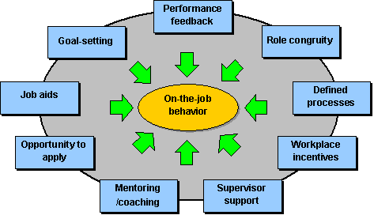
Source: (http://www.businessperform.com/workplace-training/workplace_environment.html)
Statt (1994) as cited by Leblebici (2012) argues that, the modern work physical environment is characterized by technology; computers and machines as well as general furniture and furnishings. To enhance employee performance therefore, it is imperative that the organization’s physical environment is fashioned to support employee in their quest to attain organizational objectives.

2.4 ERGONOMICS AND BRANCHES
According to International Ergonomics Association (IEA), (2012) Ergonomics (or human factors) is the scientific discipline concerned with the understanding of interactions among humans and other elements of a system, and the profession that applies theory, principles, data and methods to design in order to optimize human well-being and overall system performance. A publication by the Health and Safety Executive (HSE), UK in 2003: “Understanding Ergonomics at Work” also defines Ergonomics as the scientific study of human work. It considers the physical and mental capabilities and limits of the worker as he or she interacts with tools, equipment, work methods, tasks and the working environment. The publication further postulates that the application of Ergonomics to workplace improves health and safety by: reducing the potential for accidents, reducing the potential for injury and ill health and improves performance and productivity. Ergonomics permeates every aspect of human endeavour. As a result, various branches or concepts of Ergonomics have evolved and developed over the years. Some of the branches are:

Office environment – Washington State Department for Labour and Industry in its document: “Office environment – Practical Solution for a Safer Workplace (2002)” identifies Office environment and defines it as the branch of ergonomics dealing specifically with the office environment. This field of ergonomic considers how key workplace elements such as workstations, computers, chairs, lighting, noise level, room temperature etc. could be tailored to fit and enhance employee health, safety and performance.
Other areas of Ergonomics identified and posted at the Blog: Safecomputingtips.com includes the following;
Engineering Psychology – “This field of study examines the relationship between machines and human beings, along with the effort to improve that relation. Possible recommendations of the study could inform change in the location of the work place, redesigning of work equipment and modifications in the way that work related equipment is used. The aim is to make things as user friendly as possible”.
Macro ergonomics – “This field is less of person specific and concentrates more on the organizational environment including the history, culture, goal and design of the environment.
The aim of this field of ergonomics is to improve productivity and enhance employee satisfaction, health and safety”.
The International Ergonomics Association (IEA) identifies three main application domains of ergonomics. These include Physical Ergonomics, Cognitive Ergonomics and Organizational Ergonomics.

Physical Ergonomics
Physical ergonomics is concerned with human anatomical, anthropometric, physiological and biomechanical characteristics as they relate to physical activity. The focal areas include working postures, materials handling, repetitive movements, work-related musculoskeletal disorders, workplace layout, safety and health.

Cognitive Ergonomics
Cognitive ergonomics is concerned with mental processes, such as perception, memory, reasoning, and motor response, as they affect interactions among humans and other elements of a system. The main focal areas include mental workload, decision-making, skilled performance, human-computer interaction, human reliability, work stress and training as these may relate to human-system design.

Organizational Ergonomics
Organizational ergonomics is concerned with the optimization of sociotechnical systems, including their organizational structures, policies, and processes. The key focal areas include communication, crew resource management, work design, design of working times, teamwork, participatory design, community ergonomics, cooperative work, new work paradigms, organizational culture, virtual organizations, telework, and quality management.

2.5 OFFICE ENVIRONMENT
BNet Business Dictionary (2008) defines office as “a place in which business, clerical, or professional activities are conducted”. In simple term, it is often a building facility in which business activities take place. It ranges from temporal structures such as site offices to permanent multi-storey corporate edifices. Fundamentally, they all perform the function of supporting business activities. The office is a work system that entirely depends on humans: without them, no work gets done. Therefore, office environment focuses on the human as the most important component of the office and adopts the office to the people involved. Such human-centered design requires knowledge of the characteristics of the people in the office, particularly of their dimensions, their capabilities, and their preferences (Kroemer and Kroemer, 2001).
The Office environment Handbook (2008) identifies the under-listed as the key ergonomic elements in the office;
- Your Chair and Workstation;
- Your Keyboard, Mouse and Monitor;
- Office Lights;
- Office Arrangement and Environmental Concerns;
- Indoor Air Quality and Thermal Comfort and;
- Noise Levels.
Figure 2.3 demonstrates the right human posture and fit in an office environment. The siting posture, angles, distances and the arrangement of the chair, workstation, monitor, keyboard and mouse best support human function in the office and promotes employee health, safety and performance.

Figure 2.3 – Computer Workstation Variables
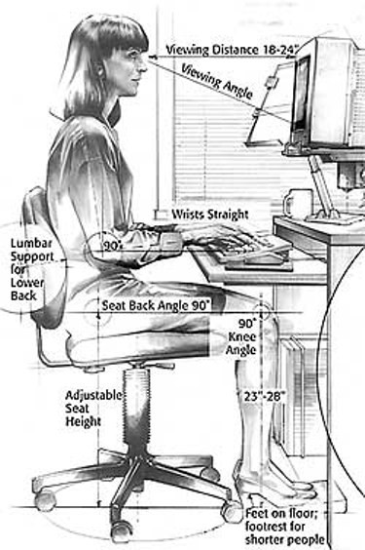
Source: (http://en.wikipedia.org/wiki/File:Computer_Workstation_Variables.jpg)

2.5.1 DIMENSIONS OF OFFICE ENVIRONMENT
Moran (2010) suggests that because of the health risks posed by poor posture and repetitive stress, proper ergonomics are too important to ignore. In his article “Home Office environment”, Moran analyses how; the lack of ergonomic principles in the office can negatively affect some of the key human body parts i.e. the eyes, neck, wrist, arms, back, hips, legs, knees and feet.
Eyes and neck: Incorrect monitor positioning can cause neck and eye strain, and can lead to poor seat positioning, which creates pressure on the back. Costello, the ergonomics consultant, says the top of your monitor should be positioned just above your eye level when you're seated. This is the best place for your "vision cone," your most immediate field of vision, which starts at the top at your eye level and descends at a 30-degree angle.
When monitors are too far away, people tend to lean forward to see well. This is increasingly true as people age, since vision almost inevitably declines over time. A rule of thumb: If you can extend your arm and just touch the screen with your fingertips, then you're in the right position (Moran, 2010).
Wrists and arms: To keep wrists and arms at an optimum position, reducing the risk of repetitive-motion injuries, your keyboard and mouse should be at the same level as your elbows when you're seated. Since most desks are too high for this position, a simple fix is an adjustable keyboard tray that attaches to the underside of your desk, says Cynthia M. Burt of the Environmental Health and Safety Department at UCLA (Moran 2010).
Back and hips: Good news for aging disks: Sitting properly takes 20 percent to 30 percent of the pressure off your lower back. Your chair should be between 17 inches and 19 inches deep, and it should have good lower-back support. Your body should be positioned with your back against the chair and your hips open. If you find yourself leaning forward to see your monitor or reach the keyboard, move them toward you (Moran 2010).
Legs and knees: Leg positioning contributes to your overall position in the chair, says Burt, so be sure your legs are bent at about 90-degree angles at the knees. This helps alleviate pressure on the back. Burt warns that movement is essential for circulation, however, so allow for subtle shifts in positioning and be sure to stand, stretch and walk a few steps at least once an hour. Move about more frequently if you have diagnosed circulation problems
(Moran 2010).
Feet: Feet should be firmly planted on the floor. If the chair positioning you require for proper wrist alignment results in your feet not reaching the floor, use a block, a few books or some other type of footrest to support your feet. However, make sure that the height of the support keeps your knees at a right angle, says Costello (Moran 2010).

2.6 THE CONCEPT OF EMPLOYEE PERFORMANCE
Every organization requires highly performing individuals in order to ensure competitive advantage and attainment of corporate goals. High employee performance is therefore one of the critical determinants of the level of organizational productivity and accomplishments. Accomplishing tasks and performing at a high level can be a source of satisfaction, with feelings of mastery and pride. In defining the concept of employee performance, Campbell et al., (1993) as cited in Sonnentag (2002) differentiates between an action (i.e. behavioural) aspect and an outcome aspect of performance. The behavioral aspect refers to what an individual does in the work situation. It encompasses behaviors such as assembling parts of a car engine, selling personal computers, teaching basic reading skills to elementary school children, or performing heart surgery.
The outcome aspect refers to the consequence or result of the individual’s behavior. The above described behaviors may result in outcomes such as numbers of engines assembled, pupils’ reading proficiency, sales figures, or number of successful heart operations. In simple terms, employee performance can be defined as the extent to which an organizational member contributes to achieving the goals of the organization.

2.6.1 FACTORS AFFECTING EMPLOYEE PERFORMANCE
Al-Anzi (2009) suggests that the key factors that affect employee productivity and performance fall into two categories: o Management driven factors and; o Factors that arise from premises, offices or factory design.

Management Driven Factors
Al-Anzi (2009) identifies the following as some of the management driven factors that tends to affect employee’s productivity and performance:
- Organization plans such as the allocation of responsibilities at all levels of the organization, definition of job descriptions and the degree of access to the management and administrative support needed to complete their tasks;
- Working patterns, shift-working, break times, absence or holiday cover; and
- Health and safety policies, including the provision of training, development of safe working practices and the adequate supply of protective clothing and equipment.

Factors that arise from premises, offices or factory design
Al-Anzi (2009) proceeds to further identify the following as the key premises or office factors that tends to affect employee productivity and performance:
- Furniture
- Workspace availability
- Light intensity
- Weather/temperature
- Ventilation/humidity
- Noise/vibration
- Premises hygiene/welfare facilities
Similarly, Leblebici (2012) identifies two (2) major variables as affecting employee performance and productivity:
- Physical Components of the Environment; and Ø Behavioural Component of the Environment.

Physical Components of the Environment
Leblebici explains that the physical component of the environment to include; o Comfort Level: Ventilation, heating, natural lighting, artificial lighting, decor, cleanliness, overall comfort, physical security.
o Office Layout: Informal meeting areas, formal meeting areas, quiet areas, privacy, personal storage, general storage, work area – desk and circulation space.

Behavioural Components of the Environment
He explains the behavioural components of the environment to include:
o Level of Interaction and Distraction: Social interaction, work interaction, creative physical environment, overall atmosphere, position relative to colleagues, position relative to equipment, overall office layout and refreshments.
In another breath, Leblebici (2012) also identifies the under listed as some of the workplace factors affecting employee performance:
- Performance feedback;
- Role recognition;
- Defined processes;
- Workplace incentives;
- Supervisor support;
- Mentoring/coaching;
- Opportunity to apply;
- Job aids; and Ø Goal-setting.

2.7 RELEVANCE OF WORKPLACE ERGONOMICS
The ultimate aim of workplace ergonomics is to generally ensure employee safety, enhance performance and productivity. Beyond these objectives, many other benefits are known to accrue to an organization when management commits to the development and maintenance of ergonomics in the workplace. “Practical Solution for a Safer Workplace (2002)” published by the Washington State Department for Labour and Industries observes that while ergonomic improvements to the work environment are primarily used to create a safer and more healthful work environment, companies may experience other benefits, including:
- increased productivity
- increased work quality
- reduced turnover
- reduced absenteeism
- increased morale

From a safety perspective, Gyekye (2006) emphasizes that environmental conditions affect employee safety perceptions which impacts upon employee commitment. Similarly, extensive scientific research conducted by Roelofsen (2002) has also yielded indications suggesting that improving working environment results in a reduction in a number of complaints and absenteeism and an increase in productivity.

2.8 CONCEPTUAL FRAMEWORK
Following from the literature reviewed, the relationship between office environment design and employee performance can be conceptualized and depicted in Figure 2.3. The conceptualized framework defines the set of workplace elements that are perceived to impacts on an employee performance. The elements such as furniture, noise level, temperature which are essentially independent variables impacting on employee performance, the dependent variable.

For instance, poorly designed furniture set out in an inefficient spatial arrangement and noisy environment will most likely increase employee stress and fatigue level, lead to back, neck and eye strains. These negative outcomes consequently lead to high rates of employee incapacitations, absenteeism, low morale and interest. The gross result of these happenings is impairment of employee performance. It is significant to note that these elements have different impacts on different secretaries based on their objective assessment of the role the workplace environment has on their performance.

Emphasizing on the relationship that exist between an secretaries’ workplace environment and his/her level of performance on the job, Al-Anzi (2009) posits that, how well secretaries engage with the organization, especially with their immediate environment, influences to a great extent their error rate, level of innovation and collaboration with other secretaries, absenteeism and, ultimately, how long they stay in the job. The model was formulated as a result of the researcher’s perspective of how he perceives the problem at NNPC, and from insights gained from reading the literature.


Figure: 2.3. Conceptual Framework

Figure: 1. Conceptual Framework
Independent Variables Dependent Variable

Source: Author’s own construct, 2012

FURNITURE
EQUIPMENT
LIGHTING
SPATIAL
ARRANGEMENT

TEMPERATURE
NOISE LEVEL
EMPLOYEE
PERFORMANCE

Independent Variables

Independent Variables

Dependent Variable

CHAPTER THREE
RESEARCH METHODOLOGY

3.1 INTRODUCTION
This chapter considers the methodology of the research and describes the selection of the sample and the design of the survey instruments used to collect the data from the staff of NNPC operating from the Petroleum House in Enugu. The principal aim of this chapter is to present the instruments used in the study and the statistical analysis undertaken in an effort to provide answers to the research questions and the general objectives of the research. The chapter also presents a profile of the Nigeria National Petroleum Corporation, the case study for the research.

3.2 RESEARCH DESIGN
This research adopts the case study approach by examining the office ergonomic situation of the Nigeria National Petroleum Corporation’s office in Enugu. Yin (1984) defines the case study research method as an empirical inquiry that investigates a contemporary phenomenon within its real-life context; when the boundaries between phenomenon and context are not clearly evident; and in which multiple sources of evidence are used.

The case study research design has been used by many researchers as it has proven to be a useful tool for investigating trends and specific situations in many scientific disciplines. The findings from the research will however be generalized for similar entities, particularly those in the Oil and Gas Industry.

3.3 SOURCES OF DATA
There are two principal types of data: primary and secondary data. Data for the study were obtained from both primary and secondary sources. Primary data was obtained directly from secretaries and management of the Nigeria National Petroleum Corporation through mainly the administration of questionnaires during the fieldwork. Secondary data was also obtained from reports and other documents from the Corporation, as well as from journals, books, and from the internet, among others. Literature obtained from secondary sources regarding workplace environment and performance was reviewed to identify workplace environment and strategies that adequately support the realization of corporate objectives.
The various workspace types such as enclosed cubicles with partition walls, cellular offices with floor-to-ceiling walls, and desks, chairs, computers and other office equipment located in the various offices was studied with the aim of gathering information on how they impact on employee performance.

3.4 TARGET POPULATION
Kitchenham (2002) defines target population as the group or the individuals to whom the survey applies. In other words, you seek those group or individuals who are in a position to answer the questions and to whom results of the survey apply. The target population for this study was the entire staff and management of the Nigeria National Petroleum Corporation specifically operating from the Head Office Building in Community 1, Enugu. As far as this work is concerned therefore, customers and other service providers such as bankers were not interviewed. Also out of the sampling frame are security officials and casual workers.

3.5 SAMPLING
A total of 88 staff were drawn from the various functional departments and units at NNPC for the survey. In addition, 10 heads of identifiable Units and Managers were also interviewed for more in-depth information on the subject. This gives an overall sample size of 98 respondents. The 88 respondents were chosen by the simple random sampling procedure, which gives everyone an equal chance of being selected. Kitchenham (2002) defines simple random sampling as a method of sampling in which every member of the target population has the same probability of being included in the sample. This form of sampling tends to eliminate subjectivity and obtains a sample that is both unbiased and representative of the target population. This method also facilitated the generalization of the findings from the study. The Unit Heads and Managers were however selected by purposive sampling.

3.6 DATA COLLECTION
The main tool for data collection was the questionnaire. A questionnaire is a formalized set of questions for obtaining information from respondents that translate the researcher’s information needs into a set of specific questions that respondents are willing and able to answer. The selected respondents were contacted and informed of the project and what it seeks to achieve. The respondents were all well-educated and could read and understand the questionnaires with little guidance. To ensure uniformity, the questions were mostly close ended, although there were few instances for open ended questions, in order to give them the chance to express themselves freely. In addition to the questionnaire, direct observations of office ergonomic situation were done in randomly selected offices. The views and opinions of 10 heads of identifiable Units and Managers on the subject were acquired through an unstructured interview. Punch (1998) explains an unstructured interview as a way to understand the complex behaviour of people without imposing any a prior categorization which might limit the field of inquiry. The flexibility of this approach afforded the opportunity to gain in-depth information regarding management’s perspectives on the subject.

3.7 DATA ANALYSIS
The data obtained from the questionnaire was validated through vetting for consistency and completeness. Subsequently, the responses were partitioned into homogeneous sub-groups to facilitate analysis. The data was analyzed quantitatively using the Statistical Package for the Social Sciences (SPSS) and Microsoft Excel, and results presented through graphs, pie charts, and tables. Pictures of unique offices to show office arrangement, seating arrangement, furniture etc., were also taken for good visual effect.

CHAPTER FOUR
PRESENTATION OF RESULTS AND DISCUSSION

DEMOGRAPHIC CHARACTERISTICS OF THE RESPONDENTS
A total of 100 questionnaires were administered to staff of NNPC who operate from the NNPC headquarters building. Out of this, 88 questionnaires representing 88 percent were completed and returned. Over 80 percent of the respondents were less than 50 years old indicating the youthful nature of NNPC secretaries at the NNPC headquarters building. Indeed 76.1 percent of the total respondents were males whiles 23.9 percent were females.
The respondents who were drawn spanned the various job levels with the majority of the respondents being junior and middle level staff, accounting for 92.0 percent of the total respondents. Senior management accounted for only 8 percent of the respondents.
The respondents were drawn from the various divisions, departments and units at NNPC to ensure adequate and fair representation of views of secretaries on the subject. Those from the Administration Division were however in the majority accounting for 17.5 percent of the total, followed by the Finance Division with 14.77 percent of the total. Besides the respondents of the questionnaires, the views of 10 senior managers on the subject were elicited through an unstructured interviewed and incorporated in the study.

ERGONOMIC FEATURES IN THE DESIGN, FINISHES AND FURNISHING OF THE WORKPLACE
The study identified considerable ergonomic lapses in various offices at the NNPC headquarters building. Generally, the lapses bothered mainly on poor office décor/finishes, inadequate office illumination, appreciable office noise levels, uncomfortable room temperature and in certain cases un-ergonomic office furniture. The views expressed by the respondents on the various ergonomic elements as presented on Figures 4.2, 4.3 and 4.4 confirm some of the ergonomic challenges identified in offices at the NNPC headquarters building.

OFFICE DESIGN AND DÉCOR
NNPC’s workplace environment is generally defined by cellular offices created with polished plywood partitions. From ergonomics perspective, the plywood partitions give the offices a dull monotonous and uninspiring ambiance. The study revealed that a total of 60.2 percent of the secretaries surveyed are not satisfied with the office design and décor at the NNPC headquarters building. Respondents who are dissatisfied with the office design and décor alluded to the dark partitioning walls, seemingly noisy window air-conditions and inadequate lighting. Fig, 4.1 gives an overview of the respondents’ level of satisfaction with the office design and décor at the NNPC headquarters building. The Chief Facilities Officer and the Principal Human Resources Officer expressed similar sentiments and hinted that the Corporation was considering moving out of the NNPC headquarters building in the near future.

Fig. 4.1: Respondents’ Satisfaction with Office Design and Décor
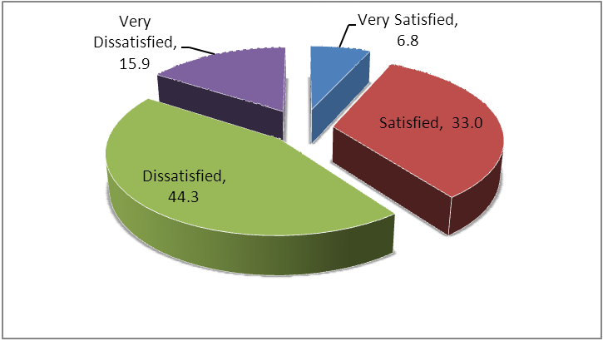

Source: Field Survey, June 2012

Only 6.8 percent of the total respondents were very satisfied with their office design and décor, while 33.0 percent were satisfied. As much as 44.3 percent indicated they were dissatisfied while 15.9 percent were very dissatisfied. As already indicated, some of the offices at the NNPC headquarters building have over the years been given facelift in the form of floor tiling, replacement of old plywood partition and introduction of window blinds. The respondents who indicated their satisfaction with their office design and décor are most likely to be occupants of such improved offices.

OFFICE FURNITURE
In terms of the functionality and ergonomics of the office furniture, the study revealed as presented in Fig. 4.2 that, although 53.4 percent of the respondents are satisfied with their office furniture, as much as 42.1 percent are dissatisfied with their office furniture as they found them not suited enough for their comfort and work.

Figure 4.2: Secretaries’ satisfaction with office furniture
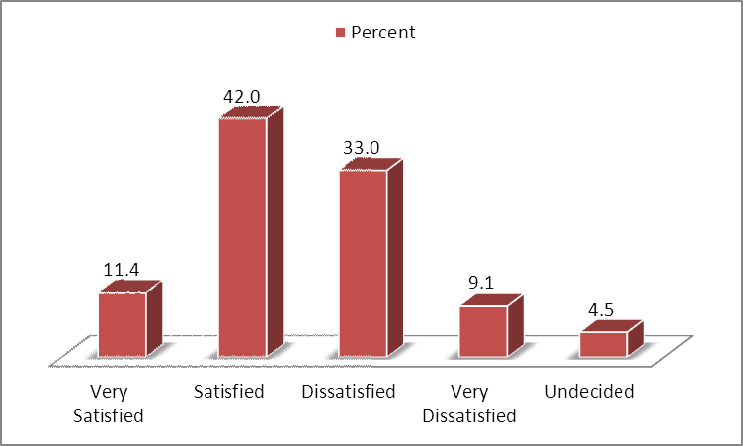

Source: Field Survey, June 2012
This level of dissatisfaction with office furniture gives cause for concern as furniture is one major source of back and neck related injuries which has the tendency to affect the health and performance of the employee. Perhaps conscious of the negative impact of un-ergonomic furniture on its secretaries, NNPC over the years has progressively been replacing the outdated furniture with new ones. For instance, in the year 2012, NNPC procured 181 pieces of assorted office furniture to replace outdated ones.
Specifically with regard to the comfortability and flexibility of their furniture, although the larger majority indicated that they found their furniture to be comfortable, as much as 33 percent only partly agreed while 12.5 percent did not agree at all that their furniture were flexible to adjust, rearrange to offer support, comfort and functionality (Fig 4.3).

Fig. 4.3: Response on level of Comfort and flexibility of office furniture
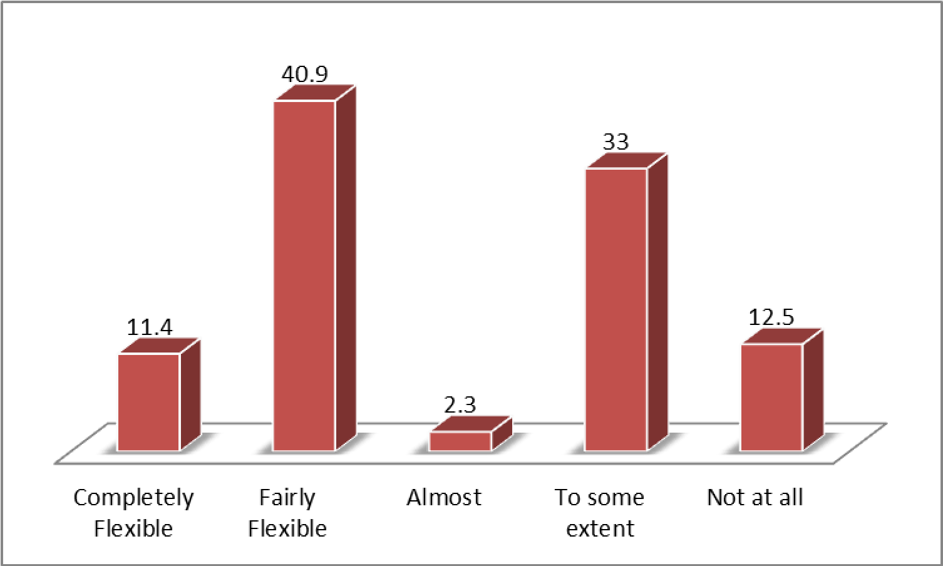

Source: Field Survey, June 2012

Obviously, NNPC’s effort to replace old furniture does not appear to have been effective as evidently, appreciable number of the old furniture (most of which were procured over 20 years ago) are still in use at the NNPC headquarters building. In an interview with the managers in charge of the Geology and Geophysics Departments, they recounted that their earlier requests to the Administration Division for some old furniture to be replaced in their respective departments were yet to be met.

OFFICE ILLUMINATION
Office illumination is one of the key elements of office environment. This is because it impact on the visual comfort and capabilities of secretaries. The study therefore sought respondents’ views on their office illumination levels. Although 27.3 percent described their offices as illuminated, nearly half of them (48.9 percent) described their offices as only fairly illuminated while 9.1 percent thought their offices were poorly illuminated (Fig. 4.4).

Fig 4.4: Response on Office Illumination Levels
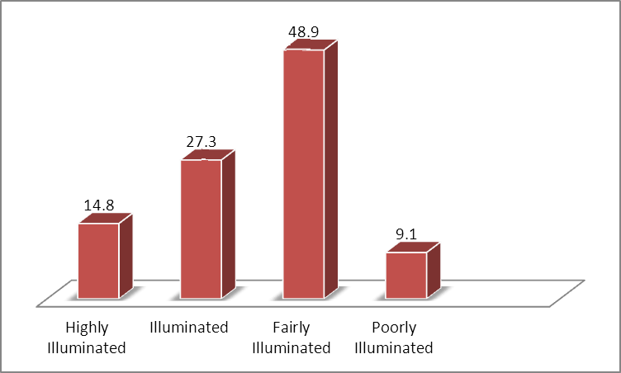

Source: Field Survey, June 2012
The study observed that a lot of the offices at the NNPC headquarters building did not appear to be adequately illuminated ostensibly due to dark looking plywood partition walls that weaken the illuminative intensity of the compact fluorescent lights installed in the offices.

NOISE LEVEL
Noise level is one of the ergonomic elements that impacts on employee communication and cognitive activities. Responses were obtained on the noise levels at the NNPC headquarters building. As shown in Fig. 4.5, a total of 27.3 percent of the respondents indicated that their offices are always quiet for productive work, while 31.8 percent indicated that their offices are quiet to some extent, but not so all the time. Respondents complained of the window unit airconditioners as the main contributing factor to the noise at various offices. On the whole, the results seem to suggest that respondents do not have much of a problem with office noise levels as they might with other variables.

Fig. 4.5: Response on Office Quietness Levels
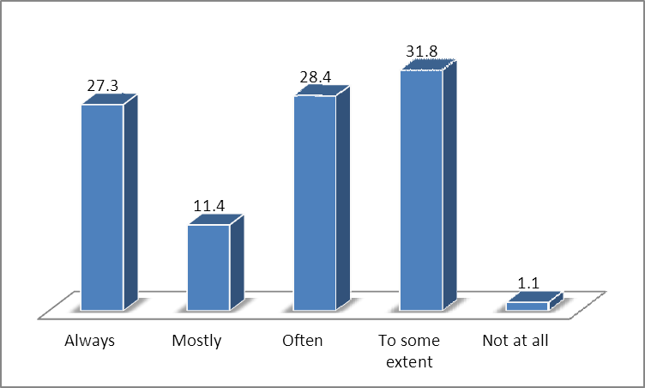
Source: Field Survey, June 2012

ROOM TEMPERATURE
The study considered room temperature as one of the key elements of office ergonomic. It was observed that nearly all the offices at the NNPC headquarters building have been fitted with window unit air-conditioners to afford secretaries comfortable working environment. As seen in Fig. 4.6, only 1.1 percent of the respondents found their office room temperature to be not conducive at all, and like office illumination, it seems this is also an area that respondents don’t have issues with.

Fig. 4.6: Response on Conduciveness of Office Room Temperature
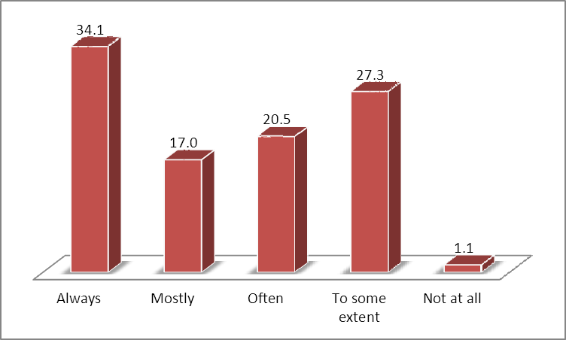

Source: Field Survey, June 2012
Regardless of the appreciable ergonomic lapses prevalent at the NNPC headquarters building, it is worthy to note that few positive ergonomic features were identified in the areas of office space allocation and equipment. The study observed that the office layout at the NNPC headquarters building provide secretaries with ample room and space to conduct their work activities. It is therefore not surprising that as much as 71.6 percent of the respondents are satisfied with their office spaces.

OFFICE EQUIPMENT
Office equipment such as computers, printers, photocopiers, plotters among others have increasingly become the basic job tools for enhanced performance in the corporate world. Evidently nearly all secretaries at the NNPC headquarters building have been provided with computers and other complementary office equipment to facilitate their work. Nevertheless, Fig. 4.7 shows that 18.2 percent and 11.4 percent respectively are dissatisfied and very dissatisfied with their office equipment.

Fig. 4.7: Secretaries’ satisfaction with office equipment
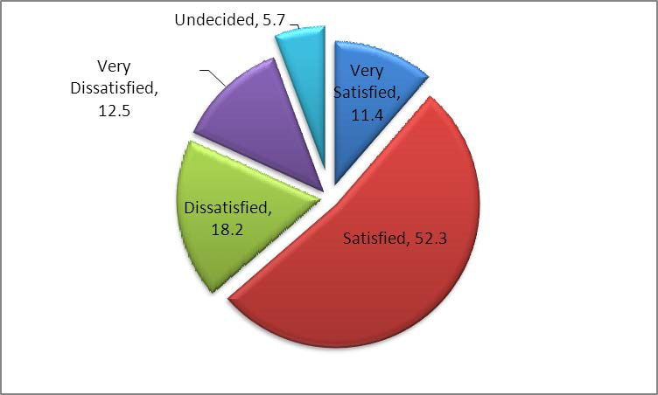
Source: Field Survey, June 2012

WORKPLACE HEALTH AND SAFETY
Workplace safety is an integral part of office environment. The study therefore required respondents to make an assessment of their workplace safety and security. A total of 51 respondents representing 58 percent indicated that their offices were safe and secured. However, 37 respondents representing 42 percent did not feel that their offices were safe and secured enough. Table 4.1 shows the responses on how safe and secure respondents feel about their offices.

Table 4.1: Responses on safety and security of offices
 | Frequency | Percent | Cumulative Percent
Yes | 51 | 58.0 | 58.0
No | 37 | 42.0 | 100.0
Total | 88 | 100.0

Source: Field Survey, June 2012
Observation of the NNPC headquarters building building revealed that basic safety and security measures and installations such as emergency fire exits, fire extinguishers, emergency directional signs and guard security have been provided. However, isolated cases of poor cable management and stockpile of papers which pose safety and fire hazards respectively were identified. The responses shown in Table 4.1 above may have been informed by these considerations.
IMPACT OF OFFICE ENVIRONMENT ON PERFORMANCE OF NNPC SECRETARIES
The study sought to find out whether NNPC’s workplace environment has any impact on the performance of its secretaries. What seems to emerge is that although nearly all the respondents conceded that workplace elements such as office space, room temperature and lighting, furniture and equipment etc. have one way or the other affected their performance, the extent of the impact varied from one employee to the other.
Fig. 4.8 shows that 27.3 percent of the total respondents indicated that their office designs and décor impacted negatively on their job performance by between 70-80 percent. Cumulatively 63.6 percent of the total respondents were of the opinion that the effect of office design and décor on their job performance range from 10 – 60 percent.

Fig. 4.8 Respondent view on the extent of office design and décor on their performance
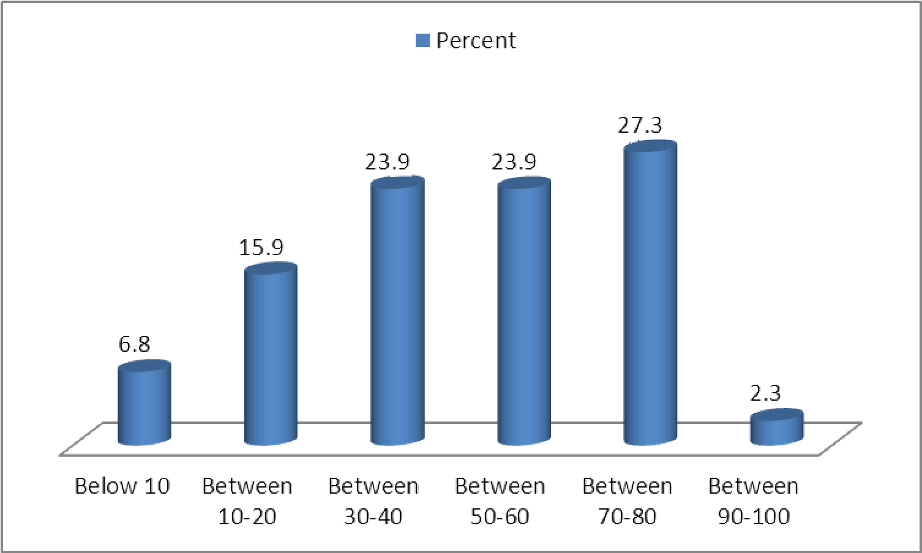

Source: Field Survey, June 2012
In their opinion, the cellular offices limit the needed team collaboration and communication. They also argue that the design and the décor was uninspiring, sometimes stressful and in some cases demoralizing thereby affecting their level of productivity. Regardless, 6.8 percent of them were of the opinion that the negative effect of their office design and décor on their performance was really less than 10 percent. The need for an open collaborative work environment was reiterated by the managers in charge of Information Systems, Data Management & Communication, Finance, Engineering and Marketing Departments.
Most of NNPC’s transactions with foreign investors and other business stakeholders and technical review meeting often take place in the NNPC headquarters building and as remarked by the Manager in charge of the Geology Department “the current state and décor of the NNPC headquarters building sometimes indirectly limits our capacity to negotiate hard on certain international deals”.
Considering NNPC’s workplace ergonomic elements and their impact on employee’s performance, the study again revealed that workplace elements (such as office furniture, equipment, room temperature, air quality, noise levels and quality of office lighting) negatively affect secretaries’ performance at varying degrees.

Fig. 4.9 Respondent view on the extent of office furniture on their performance
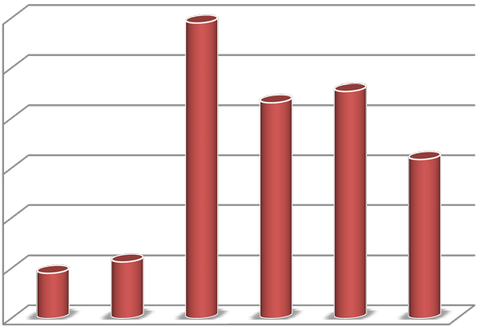

0.00
5.00
10.00
15.00
20.00
25.00
30.00
Below 10
Between
10-20
Between
30-40
Between
50-60
Between
70-80
Between
90-100
Percent
Percent
Percentage Effect
effect
Percenta
effect

Source: Field Survey, June 2012
Fig. 4.9 gives an over view of the negative effect of office furniture on the performance of the respondents. Twenty six respondents representing 29.5 percent of the total indicated that their office furniture negatively impacted on their performance by between 30 – 40 percent. Similarly, other respondents as shown in Fig. 4.9 expressed their concerns at varying degrees (ranging from 10-100 percent) on the effect office furniture has on their performance.
With respect to office environment, 33 percent of the respondents felt that this had impacted negatively on their health, while 15 percent actually confirmed having suffered an injury or illness due to the nature of their office environments.
Some of the respondents complained that sometimes they are unable to sit through for the day’s work because their furniture causes them backaches and neck strains. Some also confirmed that there had been occasions where they had to stay out of the office for a couple of days due to excruciating back pain which they attributed to their un-ergonomically designed chairs.
The study sought the opinion of NNPC secretaries at the NNPC headquarters building on the effect their office equipment has on their performance. As shown on Figure 4.10, majority of the respondents indicated that their office equipment affects their performance considerably. Indeed, 36 respondents representing 40.9 percent of the total respondents rated the positive impact of office equipment on their performance at between 70-80 percent. Similarly, other respondents expressed at varying degrees (ranging from 30-100 percent) the positive effect office equipment has on their performance at the NNPC headquarters building.

Fig. 4.10 Respondent view on the extent of office equipment on their performance
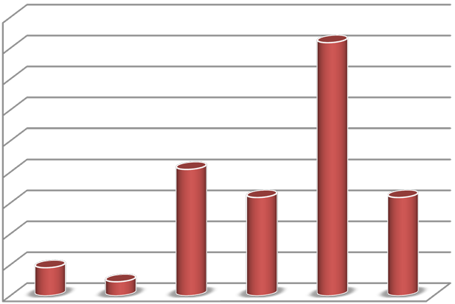
0.00
5.00
10.00
15.00
20.00
25.00
30.00
35.00
40.00
45.00
Below 10
Between
Between
Between
Between
Between
Percent
Percent
Percent
effect
10-20 30-40 50-60 70-80 90-100
Percentage Effect effect

Source: Field Survey, June 2012

Nearly all secretaries at the NNPC headquarters building have been provided with computers to facilitate their work. NNPC secretaries at the Geology, Geophysics and Engineering Departments (NNPC’s technical departments) mostly use Geo-workstations (advanced computers) for their daily operations. Plotters and large format printers have also been provided to aid NNPC’s operations at the NNPC headquarters building.
The views expressed by the respondents show that their office equipment offers them the right support for their job delivery and performance. According to some of them, the geoworkstations help them in their geological and geophysical surveys and analysis thereby enhancing their performance and productivity.
Room temperature and quality of lighting are some of the key elements of office environment that impact on overall performance of secretaries. Prolonged expAMACre to a seemingly dark and hot office environment is likely to contribute to visual and stress related problems among occupants.
Fig. 4.11 and 4.12 show the extent to which room temperature and office lighting affect the performance of secretaries at the NNPC headquarters building. In both cases, over 35 percent of the total respondents concluded that both room temperature and lighting impacted negatively on their performance by between 70-80 percent.
Figure 4.11 Respondent view on the extent of Room Temperature on their performance
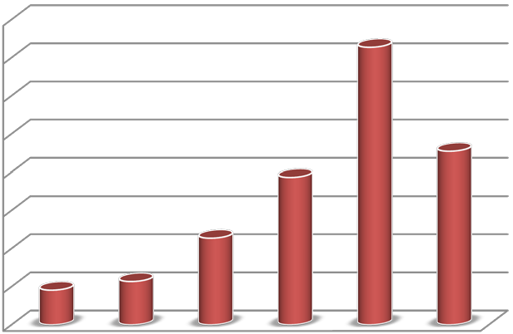
0.00
5.00
10.00
15.00
20.00
25.00
30.00
35.00
40.00
Below 10
Between
Between
Between
Between
Between
Percent
Percent
Percent
effect
10-20 | 30-40 50-60 70-80  Percentage Effect effect | 90-100

Source: Field Survey, June 2012
Some of the respondents alluded to the frequent breakdown of air-conditioners which renders the offices unbearably hot and stressful for productive work. Some also mentioned that the not-so-well-lit office environments sometimes prove to be disincentive to performance as it renders the office gloomy and stressful. The responses obtained on the effect of office lighting on the performance of the NNPC secretaries surveyed underscored the need for adequate lighting in the offices.
Similarly, nearly 45 percent of the total respondents expressed concerns on the quality of lighting in their offices which they claim exerted considerable negative effect ranging from 70-80 percent on their performance. Although offices at NNPC have been fitted with compact fluorescent bulbs, the rooms appear to be poorly illuminated due to the dark looking partitioning walls. As a result, a number of the secretaries see their offices as poorly illuminated and wish for brighter offices. Again they pointed to the fact that the offices are least exciting and barely encourage one to want to spend considerable hours within them.

Fig. 4.12 Respondent view on the extent of quality of lighting on their performance
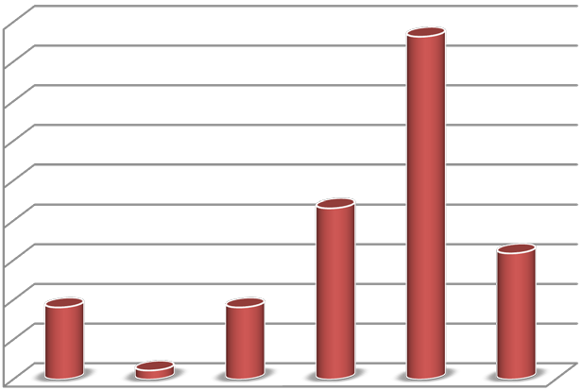

0.00
5.00
10.00
15.00
20.00
25.00
30.00
35.00
40.00
45.00
Below 10
Between
10-20
Between
30-40
Between
50-60
Between
70-80
Between
90-100
Percent
Percent
PercentageEffect
effect
Percent
effect

Source: Field Survey, June 2012
ERGONOMICALLY BASED INTERVENTIONS TO ADDRESS EMPLOYEE HEALTH, COMFORT, WELLBEING AND PERFORMANCE
The workplace environment is one of the critical factors that drive employee performance. Asked whether their current offices will require improvement, a whopping 98.9 percent of the total respondents responded in the affirmative.

Analysis of the responses in favour of workplace improvement revealed that 43.7 percent of the respondents expressed their desire for modern and brighter office partitions fitted with window blinds and other related decorative pieces. Similarly, the interventions requested by 18.2 percent of the respondent related to the installation less noisy but efficient airconditioners that will guarantee stable and comfortable room temperature.

The need to deploy highly ergonomic furniture at the NNPC headquarters building was also suggested by 27.3 percent of the total respondents as a measure to curb the health hazards posed by some of the old and un-adjustable furniture currently in use at the NNPC headquarters building.

As part of the required office improvements, 5 percent of the total respondents want to see ICT related interventions such as replacement or provision of new computers as well as proper management of ICT cables to avoid the present situation where ICT cables have been laid across offices in some cases posing safety hazard.

Generally, the spectrum of ergonomic interventions requested by the respondents is a clear indication of the extent to which NNPC secretaries are dissatisfied with their current workplace environment and further echoes the extreme desire for improvement to help address employee health, comfort, wellbeing and overall performance. The Director of Operations who also acts as the Acting Director of Administration spoke of his dream to see NNPC operate from a facility that compares well with National Oil Companies in the advanced world and confirmed that plans were already underway to realize this dream.

DISCUSSIONS OF FINDINGS
The finding from the study to a considerable extent validates and brings to reality the widely accepted assumption presented in Leblebici (2012) that a better workplace environment motivates secretaries and produces better results.

The study demonstrated that office environment deficiencies at the NNPC headquarters building which includes outdated office design and décor, inadequate office illumination, un-ergonomic office furniture, unsuitable office design and décor have variedly impaired the performance of an average NNPC employee by between 20 to 80 percent.

According to Beautyman (2006), businesses that ignore the design and layout of their workplaces are failing to optimize the full value of their human capital. The findings from the study confirm Beautyman’s assertion in view of the fact that the office design and décor of the NNPC headquarters building has impaired the performance of the average NNPC employee by between 20 to 80 percent. Selected senior managers interviewed were also of the opinion that NNPC’s current workplace environment does not seem to enhance employee performance. “Practical Solution for a Safer Workplace (2002)” published by the Washington State Department for Labour and Industries observes that ergonomic improvements to the work environment primarily lead to a safer and more healthful work environment. The lack of ergonomic improvements is known to predispose secretaries to safety and health hazards. According to the Health and Safety Executive (HSE), 2007, failure to observe ergonomic principles may have serious repercussions, not only for individuals, but the whole organization. Many well-known work related accidents might have been prevented if ergonomics had been considered in designing the jobs people did and the systems within which they worked.
It emerged from the study however, that 33.0 percent of the respondents felt that their office environment had impacted negatively on their health, while 15.0 percent actually confirmed having suffered an injury or illness due to the nature of their office environments. These results uphold the assertion made by the HSE that some of these injuries that reduces employee performance may have been prevented if adequate ergonomic interventions were in existence at the NNPC headquarters building.

Increasingly, open plan offices are replacing hitherto cellular office layouts due to the latter’s restrictions on employee collaboration and communication, monotonous and less inspiring attributes and overall inefficient utilization of office space.

Hamilton et al. (1996) recounts how the hitherto inefficient cellular office layout of the 31storey Alcoa Building in Pittsburgh, Pennsylvania characterized by 12-feet by 15-feet offices has now been transformed into a modern office layout made up of executive suites of open cubicles and areas for impromptu meetings: “the communication centre,” featuring televisions, fax machines, newspapers and tables to encourage team/group meetings.

The findings from the study show that the current office layout at the NNPC headquarters building typifies Alcoa Building’s outdated and inefficient cellular office design prior to its modernization. The Alcoa Building’s experience underscores the need to design office ergonomically to ensure that the workplace environment suits employee needs, functions and enhances performance.

CHAPTER FIVE
CONCLUSIONS AND RECOMMENDATIONS

CONCLUSION
This study has assessed the impact of office environment on the performance of NNPC secretaries operating from the NNPC headquarters building in abuja. The results from the study confirm that office environment deficiencies at the NNPC headquarters building are impacting negatively on the performance of the employee.
From the findings of the study, which identifies substantial office ergonomic lapses such as inadequate office illumination, use of un-ergonomic furniture, appreciable noise levels and pockets of safety hazards, it is obvious that NNPC is yet to leverage on its workplace environment as a means of motivating and enhancing the performance of its secretaries.

5.4 RECOMMENDATIONS
In view of the findings and conclusion of the study, the following recommendations are made for consideration by NNPC as a means of utilizing its workplace environment to motivate and enhance the performance of its secretaries.

The findings from the study clearly show that the design and décor of the NNPC headquarters building is somehow deficient in ergonomics and has some negative impacts on the performance of secretaries. Given the state of the NNPC headquarters building, any attempt to modernize the building will require a huge capital outlay and a considerable period of time. Against this backdrop, the study recommends the relocation of the NNPC head office to a purpose-built office facility that integrates high standards of office environment, and identifies with NNPC’s real estate objectives. With the help of a market survey, NNPC can identify alternative office facilities that will be most suitable for the operations and aspirations of the Corporation.

In the design and décor of the proposed new NNPC head office building, emphasis should be made on the use of executive suites of open plan offices that inspires teamwork and collaboration. The open plan offices as reported in Hamilton et al. (1996) should be complemented with meeting rooms, breakout areas, isolated enclosed offices and other ancillary offices/facilities that will be essential to the peculiar operations of NNPC. The new office should incorporate brighter office partitions with exciting colour schemes that will stimulate secretaries and help reduce stress levels.

The study further recommends that NNPC should undertake post-occupancy evaluation one year after occupation of the new NNPC head office. The post-occupancy evaluation should involve the circulation of a multi-disciplinary questionnaire once a year among all secretaries of NNPC to determine how the workplace elements such as furniture, illumination, noise levels etc. are affecting their performance. Based on the results of the survey, ergonomic adjustments should be made to render the workplace environment more supportive to employee performance.
The study further recommends that NNPC should develop and implement a Corporate Real Estate Policy that will focus on leveraging NNPC workplace environment to attract, retain and boost the performance of NNPC secretaries. The Policy should focus on modern ways and systems of working that optimizes employee delivery and productivity.

The study identified a number of health and safety concerns in the form of un-ergonomic furniture, poor illumination levels and poor cable management in selected offices leading to 42 percent of the respondents claiming not to feel safe and secured in their offices. The development and implementation of a health and safety policy to help identify and deal with health and safety hazards at NNPC offices is strongly recommended. Similarly, the adoption of enterprise risk management system to sysEnugutically identify risk factors in the office and pragmatically deal with them is further recommended by the study.

Lastly, secretaries should be made to undergo periodic training on office environment issues such as correct sitting posture, the right way to use and adjust computer monitor to avoid neck, back and eye strain, how to reduce stress and strains in repetitive work and how to avoid injury and disorders at the workplace. The training is expected to enlighten secretaries on the subject to help secretaries contribute meaningfully to the development of office ergonomic interventions.

REFERENCES
Al-Anzi, N. M. (2009). Workplace environment and its impact on employee performance. A Thesis Submitted in partial fulfilment of the Requirements of Open University of Malaysia for the Degree of Master of Business Administration. Bahrain: Open University of Malaysia.

Beautyman, M. (2006). Office design effects, innovation, collaboration, and creativity. [Online] July 2006. Interior Design. Available from: http://www.interiordesign.net/id_newsarticle/CA6356188.html. [Accessed: 20th May 2012]

Doman, U. (2008). The impact of the indoor environment on the performance of call centre employee. A Thesis Submitted in partial fulfilment of the Requirements of Universitas
Quinqueeclesiensis for a Degree of Doctor of Philosophy. Hungary: Universitas Quinqueeclesiensis

Gutnick, L. (2007). A workplace design that reduces employee stress and increases employee productivity using environmentally responsible materials. A Thesis Submitted in partial fulfilment of the Requirements of Eastern Michigan University for the Degree of Master of Science and Doctor of Philosophy. Michigan: Eastern Michigan University

Gyekye, S. A. (2006). Safety Management: Perceptions of Workplace Safety. The
International Journal of Aging and Human Development Issue: Volume 68, Number 2. pp. 23-27

Hameed, A. (2009). Impact of Office Design on Secretaries’ Productivity: a case study of Banking Organizations of Abbottabad, Abbottabad, Journal of Public affairs, Administration and Management, Volume 3, Issue 1, pp. 1-5

Hamilton, J. O. C; Baker, S.; Vlasic, B. (1996). “The new Workplace: walls are falling as the “office of the Future” finally takes shape. BusinessWeek. [Online] April 1996. Available from: http://www.businessweek.com/1996/18/b34731.htm [Accessed 12 June 2012]

Kitchenham, B. A., & Pfleeger, S. L. (2002). Principles of Survey Research, Part 5: Populations and Samples, Software Engineering Notes, Vol. 27, No. 5, pp.17-20

Kroemer, K. H. E & Kroemer, A. O. (2001). Office environment. London. Taylor & Francis,

Leblebici, D. (2012): Impact of workplace quality on employee’s productivity: case study of a bank in Turkey, Turkey, Journal of Business, Economics and Finance, Vol. 1, Iss. 1 pp. 3840 Available online at http://www.jbef.org/archive/pdf/volume1/4-Demet%20Leblebici.pdf [Accessed 18, May 2012]

McNeill, M. & O’Neill, D. (1998). Occupational Disorders in Nigeriaian Subsistence
Farmers, Proceedings of the Annual Conference of the Ergonomics Society, Royal
Agricultural College, Cirencester, 1-3 April 1998. M.A.Hanson, (ed). 1998
Moran, G. (2010): “Home Office environment [Online] Available from: http://www.aarp.org/work/self-employment/info-09-2010/home-office-ergonomics.html (Accessed May 17, 2012)

O’Neil, M. (2011). “Office ergonomic standards; a layperson’s guide” Available online at http://www.knoll.com/research/downloads/WP_ErgoStandards.pdf [Accessed 23 April, 2012]

Punch, K.F. (1998): Introduction to Social Research: Quantitative and Qualitative Approaches. London. Sage.

Roelofsen, P. (2002): "The impact of office environments on employee performance: The design of the workplace as a strategy for productivity enhancement", Journal of Facilities Management, Vol. 1 Iss: 3, pp.78-86

Sonnentag. S, (2002): Psychological Management of Individual Performance. Wales. John Wiley & Sons.

Stoessel, J. M. (2001): The impact of the workplace on effective employee performance in Corporate America, A Thesis Submitted in partial fulfilment of the Requirements of Seaton Hall University for the Degree of Master of Arts. New Jersey: Seaton Hall University.

Taiwo, A. S (2010). The influence of work environment on employee performance: a case of selected oil and gas industry in Lagos, Nigeria, African Journal of Business Management Vol. 4 (3), pp. 299-307

Yin, R. K. (1984): Case study research: Design and methods. Newbury Park. CA. Sage

QUESTIONNAIRE FOR DATA COLLECTION

INTRODUCTION:
This is an academic exercise aimed at gathering primary data towards the writing of a thesis on the above topic. Your co-operation in providing honest and prompt responses to the questionnaire would be very much appreciated. You are also assured of the privacy and confidentiality of your responses. Thank you very much.

Please tick or write out your responses where appropriate

SECTION A: SOCIO-DEMOGRAPHIC DATA OF RESPONDENT

- Gender 1. Male [ ] 2. Female [ ]
- Age 1. 20-29 yrs. [ ] 2. 30-39 yrs. [ ] 3. 40-49 yrs. [ ] 4. 50 yrs. and above
[ ]
- Level of work 1. Junior Staff [ ] 2. Middle level staff [ ]

3. Senior management [ ]
- Division/Department/Unit
- Length of service at NNPC 1. 0-1 year [ ] 2. 2-3 years [ ] 3. 4-6 years [ ] 4. 7-9 years [ ] 5. 10 years or more [ ]

SECTION B: LEVEL OF EMPLOYEE SATISFACTION WITH OFFICE

ENVIRONMENT

6. Please indicate your level of satisfaction with each of the under listed workplace elements using the ratings from 1 to 5 described below (by ticking) as:

1-Very Satisfied (VS), 2-Satisfied (S) 3-Dissatisfied (D) 4- Very Dissatisfied (VD), 5-Undecided (UN)
NOTE: For each response kindly indicate the reason for your choice. You may use the sample reasons below the table as a guide.

Table 1: Employee satisfaction with office environment
Brief Description of Workplace Elements | 1  (VS) | 2 (S) | 3  (D) | 4 (VD) | 5 (UN)
1.General Design and Office Décor
Reason
2.Spatial Arrangement & Furnishing
Reason
3.Level of office flexibility and comfort
Reason
4.Size of space allocated for your workplace
Reason
5.Ease of communication and collaboration
Reason
6.State and suitability of office furniture
Reason
7.State of office Equipment (computers etc)
Reason
8.Room temperature and air quality
Reason
9.Quality of lighting – artificial lighting
Reason
10.Level of noise from speech, equipment etc
Reason

Sample Reasons
- Office is too small and crowded o Office is dark and not lively
- Furniture/equipment is modern and functional
- Office is noisy
- Office is well air-conditioned and comfortable
- There is ease of communication, etc, etc.

SECTION C: IMPACT OF OFFICE ENVIRONMENT ON EMPLOYEE HEALTH, SAFETY AND SECURITY

- Do you find your current office safe and secured
Yes  No 

- Does your office have enough space for easy movement and emergency exit
Yes  No 

- Have you ever felt stressed by your office environment (furniture, decor , airconditioner)
Yes  No 

- Do you feel that your office environment (including your chair, desk and computer) has affected your health in anyway?

Yes  No 

- Have you suffered any injury/disorders/illnesses due to your current workplace environment

Yes  No 

If you have answered “Yes”, please state the nature of illness and the attributed course

- To what extent did the disorder/illness affect your job performance?

1. Very much affected [ ] 2. Affected [ ] 3. Mildly affected [ ] 4. Not affected at
all

Please explain how your job performance was affected as indicated in the Question above.

SECTION D: IMPACT OF PHYSICAL OFFICE ENVIRONMENT ON EMPLOYEE PERFORMANCE

- Please select the option below that best describes your current office environment

  - Highly Impressive [ ] 2. Impressive [ ] 3. Least Impressive [ ]
4. Indifferent [ ] 5. Not Impressive [ ] 6. Can’t tell [ ]

- Indicate to what extent your current office environment is a source of motivation to your job performance

  - Highly Motivating [ ] 2. Motivating [ ] 3. Least Motivating [ ]
4. Indifferent [ ] 5. Not Motivating [ ] 6. Can’t tell [ ]

- Is your furniture comfortable, flexible to adjust, rearrange or reorganize to offer you support and functionality?

  - Completely Flexible [ ] 2. Fairly Flexible [ ] 3. Almost [ ]
4. To some extent [ ] 5. Not at all [ ] 6. Don’t know [ ]

- Is your office environment quiet enough for productive work?

  - Always [ ] 2. Mostly [ ] 3. Often [ ]
4. To some extent [ ] 5. Not at all [ ]

- Is your office room temperature conducive enough for productive work?

  - Always [ ] 2. Mostly [ ] 3. Often [ ]
4. To some extent [ ] 5. Not at all [ ]

- Is your office room well illuminated for productive work?

  - Highly illuminated [ ] 2. Illuminated [ ] 3. Fairly illuminated [ ] 4. Poorly illuminated [ ] 5. Not at all [ ]
- Using the scale below, please indicate the extent (in percentage) to which the workplace elements affect your job performance by ticking.
  - Below 10% - 0
  - Between 10% - 20% - 1
  - Between 30% - 40% - 2
  - Between 50% - 60% - 3
  - Between 70% - 80% - 4
  - Between 90% - 100% - 5


Table 3: Effects of workplace elements on employee’s performance
Brief Description of Workplace Elements | 0 | 1 | 2 | 3 | 4 | 5
1. General Design and Office Decor
2. Spatial Arrangement & Furnishing
3. Size of office space and level of comfort
4. Ease of communication and collaboration
5. State and suitability of office furniture
6. State of office Equipment (computers etc)
7. Room Temperature
8. Level of air quality (fresh air, stale air)
9. Quality of lighting – artificial lighting
10. Level of noise from speech, equipment etc

- Does your current workplace environment require improvement? Yes No

If you have answered “Yes”, please state the nature of improvements required

- Please offer any suggestions that will improve your safety, comfort, security and performance at the workplace.

