**THE IMPACT OF FINANCIAL MANAGEMENT BEST PRACTICES ON SME PERFORMANCE IN NIGERIA**

**ABSTRACT**

A significant proportion of small and medium-sized enterprises (SMEs) in Nigeria fail to incorporate and execute essential financial management practices, resulting in an inability to fulfil their daily obligations and a potential risk of cessation of operations within a five-year time-frame. This research was conducted with the aim of examining the impact of best financial management practices on the operational efficiency of small and medium-sized enterprises located in Abuja, Nigeria. This study utilized a quantitative methodology and implemented a survey research design. Two discrete methods of estimation were employed to ascertain the magnitude of the sample. The study employed both stratified sampling and simple random sampling techniques. The study received a total of 216 valid responses. This investigation utilized descriptive statistics and the Pearson correlation coefficient to examine the research inquiries and evaluate the hypotheses, correspondingly. The findings indicate a positive association between the management of working capital and the profitability of small and medium-sized enterprises. A positive correlation was observed between the management of working capital and the debt levels of small and medium-sized enterprises (SMEs) located in Abuja. Additional findings have demonstrated a direct association between the management of working capital and the generation of value. Consequently, the three null hypotheses were refuted and their corresponding alternatives were upheld. The findings of this research suggest that the preservation of sufficient levels of liquidity to support day-to-day business operations is a crucial factor for small and medium-sized enterprises (SMEs). Effective working capital management can provide businesses with a competitive advantage by enabling them to swiftly and astutely respond to unforeseen market fluctuations, such as alterations in the interest rates and the prices of essential resources.

**CHAPTER ONE**

**INTRODUCTION**

* 1. **. Purpose Statement**

This quantitative survey-based study aims to examine the effect of financial management best practices on the performance of small and medium-sized businesses. It specifically sought to assess the relationship that exist between working capital management (a component of financial management) and profitability. It analyzes the influence of working capital management on corporate debt; and its impact on value creation.

* 1. **Background of the Study**

The administration of the company's finances serves as the foundation for all major decisions. This is because financial management practice is applicable to any market, industry, and company, making it one of the most essential responsibilities of corporate executives and directors (O’Neill et al., 2016). Financial management practice impacts every facet of a company, from small and medium-sized businesses to large global corporations, and determines a firm’s financial sustainability, which affects both the present and future prosperity of the company (Brigham, & Ehrhardt, 2004; Brown & Moles, 2014). If top management wants a company to thrive, they need to pay close attention to the necessity of financial management and find ways to implement and sustain its practice (Aparicio et al., 2016).

Yang & Ping (2019), observed that financial management refers to the specific process of managing an organization's money in order to accomplish the goals of the business; the senior management oversees it, most often, the chief financial officers (CFOs) or vice presidents of finance, among others. It involves planning, directing, monitoring, and regulating the organization's financial resources in order to arrive at financially responsible judgments (Kiptoo et al., 2017). In essence, the goal is to modify managerial practices so that they are more compatible with the financial structure of a company. Conversely, improper financial management practices have been shown to be a major cause of business failure (Yensu et al., 2016). According to Solomon (2017), lots of businesses fail after sometime due to improper financial management practices result in financial difficulties, mismanagement of cash, and a lack of long-term funds to cover operational costs and capital expenditures. Oluoch (2016), added that businesses with well-aligned financial management systems are productive and efficient.

As part of management skill, effective financial management practice of small and Medium Enterprises (SMEs) can boost capacity flexibility, delivery speed, and degree of product variety when they establish higher degrees of operational processes. These businesses can also increase market share, productivity, customer happiness, and safety. Additionally, market oriented strategies can increase earnings. Adopting human resource management strategies like internal promotions and competitive pay can improve a company's capacity to recruit, hire, and retain staff with better knowledge, skills, and motivation (Nwagu & Enofe, 2021). Consequently, the adoption of management accounting procedures such as budgeting for cost control, product profitability analysis, and strategic planning can give significant information for linking operations to the firm's aims and goals (Neumann, 2021).

Manuylenko & Shebzukhova (2021), observed that financial management practice is the mechanisms that an organization puts in place to ensure that its resources are managed in an effective and efficient manner in order to achieve the organization's goals. Kasim et al. (2015) assert that financial management encompasses the acquisition of capital required to fund a company's assets and operations, allocation of available capital among various competing uses, and assurance of efficient and effective utilisation of capital to advance the company's objectives.

In addition to working capital, investments, finance, accounting information systems, financial reporting, and analysis, Kieu (2004), widened the scope of financial management to incorporate cash, receivables, and inventory management, cash flow, fixed asset, and profit planning; short-term and long-term financing, and intermediate financing. Kamande (2015) posits that the financial performance of entrepreneurship is directly impacted by financial management practises.

In order for SMEs to maintain its operations and fulfill its goals and objectives, it must manage its financial practices effectively and prudently. Consequently, financial management contributes to the enhancement of corporate organizations' profitability by the application of efficient financial control instruments, such as budgeting control, ratio analysis, and CVP analysis (Inuwa, 2014). The success of a business depends on the capital budget decisions it makes (Hamza et al., 2014).

According to John & Willie (2021), the capital budgeting decisions that owners or managers of SMEs must make to ensure their financial stability are among the most essential. This is based on the fact that capital budgeting decisions usually involve substantial capital expenditures for the acquisition of fixed assets. Olawale and Garwe (2010) indicate that the deployment of sophisticated investment evaluation techniques such as NPV and IRR approaches has a positive impact on the profitability of firms.

Financial management is therefore, one of numerous managerial functional areas crucial to the success of SMEs (Hnatenko et al., 2020). Financial difficulties, incorrect fund management, and a lack of long-term cash to pay operational costs and capital spending have been demonstrated to be significant contributors to the failure of SMEs (Gbandi & Amissah, 2014). The inclusion of financial management methods is intended to enhance financial performance. When SMEs' financial management systems are well-aligned, they are productive and efficient (Etuk et al., 2014). Integration of financial management approaches improves the financial performance by ensuring rapid coordination of the numerous business activities and correction of defects (Etikan, 2016). The financial performance of an SME is directly influenced by financial management practices such as financial analysis and forecasting, budget controls, cash management procedures, and financing decisions. Small and medium-sized enterprises with well-managed financial management systems report improved financial returns (NSE, 2018). The significance of financial management practices cannot be understated due to the fact that the majority of organizational challenges can be prevented by employing solid financial management procedures (Uluyol, 2013). Particularly, working capital ensures that SMEs can make their payments each day.

Accounting and budgeting ensure the firm's commercial operations are transparent and accountable (Di Vaio, 2019). Risk management ensures that a company is prepared for adverse events (Egbuna & Agali, 2013), whereas capital structure management ensures that all financial activities are coordinated (Uluyol, 2013). All of these are designed to improve the financial performance of SMEs when properly implemented into their everyday operations.

However, additional costs may be incurred in putting these financial management principles into operation, burdening the company and reducing returns (Abaniset al., 2013). Financial management methods' effects on SME are moderated by additional characteristics such firm size, amount of risk, capital intensity, leverage, and industry factors. Thus, when developing the organization's financial management processes, these elements should be taken into account (Crespo et al., 2019). If a company cannot carefully plan and draw out a policy to efficiently manage its finances, it may not see the long term (Cole, 2018). As a result, the main factor contributing to the fundamental issues SMEs face is inefficient financial management. The financial management system includes the processes that govern how the department manages its sales, expenses, assets, liabilities, and contingencies. It also comprises its risk management methods and financial and operational performance control, including budget performance and internal and external reporting for these responsibilities. Business organizations are expected to expand and develop by passing from one stage to the next, from small firms to the organization with many employees.

Financial management practices (FMP) are the methods used by firms to manage their assets in a way that leads to growth and maximizes owner profits (Yensu, Konadu-Yiadom, & Awatey, 2016). FMP shows that entrepreneurs (or their representatives) are capable of organizing, directing, and supervising all financial-related activities inside the organization. One of the actions that defines financial management is the necessity to acquire and employ the entity's financial resources (Atems & Shand, 2018).

Despite the impact that financial management methods have made, as evidenced by our ongoing discussion, many SMEs in Nigeria have been observed to struggle with managing their finances effectively, and their mortality rate is still very high, even in industrialized nations ( Okunlola et al., 2019; Oladimeji & Aladejebi, 2020). Due to this, there is increased exposure to market risk, rivalry, and poor management, all of which have a negative impact on financial performance. Thus, financial management practices, the subject of this dissertation, is a knowledge that ensures the use of corporate development ideas to guarantee that a firm's financial resources are being used effectively.

* 1. **. Rationale of the study**

SMEs account for 48% of Nigeria's GDP, 96% of all enterprises, or more than 17.4 million businesses, 50% of all industrial jobs, and approximately 90% of all manufacturing-related activities as well as 84% of all jobs in Nigeria (PWC, 2018). A total of 54,502,500 persons are employed in the SME sector, representing 84.02% of Nigeria total labor force (NBS, 2021). Since 2017, however, at least 1.9 million SMEs have gone into extinction due to the country's dismal economic conditions (NBS, 2021). Nigeria, the largest economy in West Africa, has an average startup failure rate of 61% from 2010 to 2018. (Punch, 2022). Continue to exist are obstacles to the progress and advancement of the sector. Among the several challenges facing the SME sector in Nigeria, inadequate financial management practices is the dominant factor (CBN, 2019; Bunmi, 2020, NBS, 2021). Ekanem (2010), explained that the inability of SMEs in Nigeria to preserve receivables demonstrates their weak financial management practices.

According to Okafor and Onebunne (2015), the profit and survival of SMEs in Nigeria are at an all-time low due to inadequate financial management practices. Maungal and Garbharra (2014), revealed that 60% of SMEs in Nigeria are unable to generate a profit from the date of inception to the date of closure while 92% of SMEs fail during the first five years due to inadequate preparedness of the owners for financial management (Babatunde & Perera, 2017; Karadag, 2017). This failure of SMEs in their first five years of operation has been related to a lack of financial management understanding and practice (Olokoyo, Oyewo, & Babajide, 2014). Financial management duties essential for the effective management of SMEs in Nigeria are not taught to and implemented by SMEs' owners as they acquire leadership roles (Olokoyo et al., 2014; Kamande, 2015; Okafor, 2016; Kambi, & Ali, 2016; Karadag, 2017).

All of these findings indicate that the majority of SME owners in Nigeria are unprepared to implement the financial management techniques necessary for business survival (Babatunde & Perera, 2017). It is on this premise that this thesis seeks to examine the impact of financial management practices on SME performance in Nigeria and to contribute to recent knowledge on financial management practices.

* 1. **. Research Aims, Questions and Objectives**
     1. **Aim**

The objective of this dissertation is to examine the influence of financial management strategies on the performance of Small and Medium Enterprises (SMEs) in Nigeria. Financial management practice in this study will be measured using working capital management.

* + 1. **Questions**

The following sub-questions will be answered in this study to further buttress SME performance.

1. What is the impact of working capital management practices on the profitability of small and medium-sized enterprises (SMEs)?
2. What is the impact of working capital management practices on debt management?
3. What is the influence of working capital management practices on the creation of value in small and medium-sized enterprises (SMEs)?

**1.3.2 Research Objectives**

1. To determine the influence of financial management practices on SMEs profit.
2. To examine the influence of financial management practices on SMEs debt.
3. To establish the relationship between financial management practices and SMEs value creation.
   * 1. **Research Hypotheses**

H01: There is no relationship between working capital management practice and SME profit.

H02: There is no relationship between working capital management practice and SME debt.

H03: There is no relationship between working capital management practice and SME value creation.

* 1. **. Contribution to Knowledge**

The findings will benefit the government of Nigeria, especially the Small and Medium Enterprises Development Agency, a body responsible for industrialization formulating policies to cushion SMEs against financial crisis arising from poor financial management practices. The study findings may be adopted by SME in Abuja, Nigeria, in designing interventions to enhance the growth and development of their businesses. The study would also contribute to the existing body of knowledge on the extant literature on financial management practices of SMEs.

**1.5. Overview of Research Methodology**

This research employs a quantitative approach to evaluate the influence of financial management, specifically working capital management, on the operational effectiveness of small and medium-sized businesses.

This approach is used because it uses measurable or observed data to investigate questions regarding the sample population (Ahmad et al., 2019). This strategy explains how to acquire data in numerical form to explain a problem or phenomena (Apuke, 2017). Quantitative research is frequently concise, scientific, and applicable. When used effectively, this approach enables researchers to extrapolate findings from the test group to larger, more general populations (Bryman, 1988).

**1.6. Thesis Structure**

This study is presented in five distinct but interrelated chapters. In the first chapter, the business problem, objectives, research questions, and justification for the study are covered. The second chapter reviews the scholarly opinions and empirical findings. It is divided into conceptual, theoretical, and empirical sections. In the third chapter, the systematic methods and approaches adopted to providing fact-based answers are provided. Chapter four of the study conducts an analysis of the data collected through the use of descriptive statistical techniques and Pearson correlation analysis. In contrast, chapter five presents a comprehensive summary of the research, a fact-based conclusion, and possible recommendations for installing effective financial management best practices necessary for driving entrepreneurship growth in Nigeria.

**CHAPTER TWO**

**LITERATURE REVIEW**

**2.0 Introduction**

The purpose of this chapter is to further contextualize the present study within other empirical works and to broaden the justification for the study by exploring the thoughts, opinions, and findings of scholars who have previously contributed to the subject of discourse. In addition, the researcher's perspective on the veracity of the business challenge presented in the preceding chapter will be shaped by this review. There are four divisions to this chapter. The conceptual background, the theoretical underpinnings, the empirical analysis, and the gaps in the current literature.

**2.1 Conceptual Framework**

The financial management practices of an organization have a direct bearing on its financial health. According to Bhattacharya (2006), for a business to continue operations and fulfill its goals, it must have strong financial rules and procedures. Financial management practices help firms boost their profitability by employing solid financial control mechanisms such as budgetary control, ratio analysis, and CVP analysis (Paramasivan et al., 2009). Methods of financial management include working capital, investments, finance, accounting information systems, financial reporting, and analysis (Firer et al., 2004; Gitman, 2007). According to Chung & Chuang (2010), the key parts of financial management include financial planning (cash, fixed asset, and profit planning), investment decision making, working capital management (cash, receivable, and inventory management), and sources of financing  (short- and long-term finance, intermediate financing, and initial public offering).  Numerous authors and experts have written and conducted study on the issue of financial management, however their approaches have differed based on their respective areas of expertise.

Chung and Chuang (2010) have identified five distinct financial management practises, namely capital structure management, working capital management, financial reporting and analysis, capital budgeting, and accounting information systems. As per the findings of Mohd et al. (2010), the constituents of financial management encompass capital budgeting, working capital management, financial planning and control, financial accounting, financial analysis, and management accounting. Deresse and Prabhakara (2012) utilised independent variables including accounting, reporting, and analysis, working capital management, fixed asset management, and financial planning, whereas Kieu (2006) employed variables such as accounting information system, financial reporting and analysis, working capital management, and financial planning to represent financial management practises.

Meanwhile, small and medium enterprises Enterprises (SMEs) have been demonstrated to play critical roles in the economic growth and development of a nation by providing jobs, improving GDP, innovating, and promoting other economic activities (Waweru and Ngugi, 2014). small and medium enterprises (SMEs) are closely tied to their success or failure through the conception, development, implementation, and maintenance of effective financial management methods (Githinji, 2016). The skill with which business owners manage their finances remains a vital indicator of the success of their enterprises and their ability to withstand the challenges given by their highly competitive professions (Wolmorans 2015).

Poor financial management and misallocation of funds have a negative impact on performance and, if allowed unchecked, can eventually lead to the demise of a company (Asian & Uwaoma, 2017). Improved financial performance typically results in enhanced business performance; hence, the regularity with which financial reports are issued and their utility to management of SMEs are significant factors of an institution's success. The majority of small and medium enterprises firms (SME) rely on simple accounting systems and lack the financial means to retain specialized accountants to initiate and monitor the implementation of more complex financial strategies (Makori, 2013). Using substandard financial management systems and having insufficient personnel might contribute to inferior business outcomes (Hamza et al., 2015). To succeed in today's fast-paced, highly competitive business environment, a company must be adaptable, innovative, and adept at managing its finances.

As stated by Horngren, Harrison, and Oliver (2011), financial management focuses primarily on a company's capacity to leverage management ideas in order to finance its working capital and make sound investment decisions. How much a business decides to use debt, equity, or a mix of the two when financing initiatives is a direct result of the financing decisions it makes (Oladipupo & Okafor, 2013). Among the most significant responsibilities of financial management is identifying the most useful sources of funding and determining how much should be allocated to each (Salazar, Soto & Mosqueda, 2013). When evaluating potential sources, it's crucial to think about how much time and money will be invested and how much money is expected to be returned. Investment decisions are related to the entity's use of cash and other noncurrent assets. The term "working capital" refers to the money used to maintain an organization's liquidity and operations (Hofman, 2010). The financial management strategies discussed in this chapter will be anchored on three contextual pillars: working capital management, investment management, and the accounting information system.

**2.1.1. Working Capital Management**

Working capital shortages are a common cause of business failure. A company's prosperity may rest on its ability to effectively manage its working capital (Kabir et al., 2021). Managing both current assets and current liabilities is part of working capital management. Many SMEs struggle to implement sound working capital management practices because of persistent and vexing issues over a period of time. A company can function even if it doesn't make a profit, but it needs cash flow to stay in business (Francis, 2015). Working capital management serves a similar purpose in a business as the heart does in a physical body. The business owner or his or her agent is responsible for calculating the appropriate working capital amount and settling on the best combination of current assets and current liabilities (Micheal et al., 2017). They need to make sure that the company's short-term obligations are met and that working capital is funded from reliable sources. Controlling one's working capital is a crucial aspect of sound financial management. Concerned with the company's short-term financing, a trade-off between earnings and cash flow (Onaolapo & Kajola, 2015).

Improving a company's operating success and ensuring its own short-term liquidity are both outcomes of effective working capital management. Therefore, working capital management is not only vital to sound financial management, but also to the successful management of the business as a whole. Yazdanfar & Öhman (2014), defined working capital as the difference between the book value of current assets and current liabilities, which is a form of non-fixed capital.

**Determinants of Working Capital**

A company's goal is to stay in the black with as little working capital as feasible, provided it is not placed in an untenable financial position. This is perfectly reasonable as it demonstrates the instrumental nature of working capital. Knowing how much working capital a particular company needs might be challenging. When striking these balances, the business's leadership must think about a number of factors. Taking a look at them would help management make better predictions about demand. The following are referred to as factors affecting working capital.

**1. Nature of business:** The fundamental determinant in determining the amount of working capital required by a business is the type of its operations. The working capital requirements of manufacturing companies, for instance, vary based on the industry in which they operate, but those of trading and financial firms are quite large (Ogbuji & Ogunyomi,, 2014).

**2. Production policies:** The impact of seasonal fluctuations on a company's working capital can be reduced by adjusting production based on the nature of the products manufactured (Micheal et al., 2017). The choices are to adapt production to seasonal demand by increasing or decreasing inventory levels, or to maintain constant production and allow off-season stockpiles to accumulate (Francis, 2015). Consequently, it is evident that a plan for constant production will require greater working capital.

**3. Manufacturing process:** If an industry's manufacturing process takes longer because it is more complicated, more working capital is needed to pay for it. The more time and money it takes to make an approach, and the more it costs, the more inventory is tied up in making it, which means the amount of working capital is higher.

**4. Turnover of circulating capital:** The rate at which cash is turned into raw materials and finished goods is called the "turnover rate of capital" (Almeida & Eid, 2014). The conversion of finished products inventory into book debts or accounts receivables and book debts into cash account is a big and important part of figuring out if working capital needs are being met or not.

5. **Growth and expansion of business:** Even though it's hard to say for sure how the size of a company's business affects its working capital, it's safe to assume that the company will need more working capital as it grows (Mohammad, 2015).

6. **Business cycle fluctua**tions: As a business grows and changes, its working capital needs will also change. When prices are going up and the economy is doing well, managers tend to stock up on raw materials and other goods that are likely to be used in business operations. They do this in the hopes of profiting from lower prices in the future (Almeida & Eid, 2014). When there is inflation, businesses grow, which in turn makes them need more money (Micheal et al., 2017).

7. **Terms of purchase and sales:** According to Onaolapo & Kajola (2015), a company unit that acquires on credit and sells its finished items on a cash basis will require less working capital; nevertheless, a company that does not have access to credit but is compelled to give credit to its clients may face difficulties.

8. **Dividend policy:** Working capital may be affected by the decision to maintain a given dividend policy, while dividend policy is in turn affected by shifts in the company's working capital (Osundina, 2014). There is a well-established link between dividend policy and working capital, and few businesses would ever declare a dividend without first calculating how much cash they have on hand and how much they will require in the near future. Some companies reduce or eliminate their cash dividends because they need the money for operating expenses. Alternatively, if the company is in a strong position, it may be able to sustain dividend payments.

**2.1.2. Investment Management**

Investment is the commitment of present financial resources for greater future returns (Hamuda et al., 2013). It addresses the so-called uncertainty domains. An entrepreneur must consider time restrictions and the level of risk involved while making an investment. This is significant because, among other things, these two factors determine the performance of an investment. Investment and saving differ from an economic perspective; saving is defined as any income not spent for consumption, regardless of whether it is invested to create better returns. Consumption refers to the total amount spent on goods and services to meet a person's needs during a given time period.

Various statistical techniques can be used to compute the values of consumption, investment, and saving at both the macroeconomic and individual levels, according to Hung et al. (2020). The two categories under which investments are conducted are real assets and financial assets. Real assets are the physical or mental resources used to produce commodities or services, such as land, buildings, and equipment (Jwan & James, 2014). Financial assets are encumbrances on real property or the income received from it (Cher & Nor, 2021). Examples include stocks and bonds, which are worthless when held alone and get their value from the claims they carry rather than being actively involved in the production of a product or service. Consequently of these discrepancies, real and financial assets are evaluated differently. The market for financial assets is more regulated and more liquid (Marshall & Rochon, 2019).

In addition, they are shattered into small bits, which allows a higher number of potential customers to enter the market (Deleidi et al., 2020). Consider how purchasing a stock compares with purchasing a vehicle or a piece of property. A vehicle or a parcel of land are far more expensive than a single share of a particular corporation. Additionally, stocks can be traded more quickly than automobiles or real estate. Consequently, many individuals are increasingly concerned with money assets. Real and financial assets (both of which have their own markets) are valued according to different variables, as noted by (Nusrat et al., 2020). This word refers to the market for financial assets. Similar to other marketplaces, financial markets are unique venues where buyers and sellers meet to deal in a particular product (Ari et al., 2020).

These markets are dedicated to the trading of financial assets. A financial market may be located in a particular area, or vendors and buyers may communicate electronically (online). The London Stock Exchange (LSE) is an example of a physical trading platform with a trading floor. Financial markets are also subdivided into electronic markets, which are digital platforms where transactions are conducted via an interactive electronic system linking trading halls to a central mainframe at the market to match buyer and seller during the market's business hours (Bom, 2014).

**Classification of Investment**

Depending on their purpose, investments come into a variety of types. The most essential classification is the one that takes into consideration the time standard (Bom, 2014). The term "money market" refers to the market for trading financial instruments with maturities of less than one year (Nusrat et al., 2020). On the contrary, the capital market's financial instruments have maturities of more than one year (Bom, 2014). On the money market, "investment instruments" refer to debt securities, deposits, and other forms of cash with maturities of less than one year. This is due to the fact that the money market is considered a short-term market. Despite this, shares are regarded a type of capital market instrument due to the lack of a more specific term to define them.

**Determinants of Investment Decision-making**

To make the best investment option, the investor (here, an entrepreneur) often seeks out high returns in terms of risk and return ratios. Risk are categorized according to their source as the following:

**1. Business Risk**

It's an inherent danger of doing business in this sector (Ari et al., 2020). Companies in the petrochemical industry, for instance, are particularly vulnerable to industry-wide issues like, periodic price fluctuations of petrochemical products or changes in the cost of raw materials used in the production of petrochemicals. Other businesses in different industries, such as agriculture, are impacted by variables such as weather conditions such as cold waves and frost or high heat or diseases, etc.

**2. Economic Risk**

It is the risk brought on by changes in macroeconomic variables including unemployment, inflation, government spending, budget deficits, and other such variables (de Mello, 2014). Nearly all industries are subject to these risks, although the severity of their effects varies depending on how closely related a given business type is to a given set of general economic conditions. For instance, shifting amounts of government spending have an impact on all economic sectors. However, businesses and institutions involved in building and maintaining infrastructure, or those that depend on government projects and contracts, would be more severely affected than others. Additionally, all economic sectors will be impacted when the economy experiences inflation, which will result in a drop in the overall performance of those sectors.

**3. Interest Rate Risk**

It is the risk brought on by changes in the economy's financial system's interest rates (Monarch et al., 2014). The financial industry and the businesses that operate there, particularly banks, are at risk. The ease and affordability of borrowing is made possible by the decline in interest rates, which boosts the profits of those financial institutions.

**4. Exchange Rate Risk**

The risk associated with fluctuations in currency exchange rates. Typically, organizations engaged in the import-export trade are more susceptible to this form of risk (Singer, 2014). Enterprises that rely on foreign currencies to purchase raw materials and companies that rely on exports to sell their products abroad are particularly susceptible to these risks.

**5. Liquidity Risk**

The risk associated with fluctuations in currency exchange rates. Typically, organizations engaged in the import-export trade are more susceptible to this form of risk (Masten et al., 2019). Enterprises that rely on foreign currencies to purchase raw materials and companies that rely on exports to sell their products abroad are particularly susceptible to these risks.

**6. Firm-Specific Risk**

The risk associated with any element that affects the institution itself, such as the purchase of a factory, a decline in the market for its products, a change in its performance, and other company-specific issues. The choice to expand the firm's capital, for instance, is an internal affair that pertains only to the company, and its results are for the company alone.

**2.1.3. The Accounting Information System (AIS)**

Entrepreneurs may take advantage of specialized parts of information systems (IS) built for a given task. When it comes to logistics, one function that can benefit from an IS implemented at an MSE is inventory control, which the IS can help with by keeping track of product data. A sales and marketing department may also benefit from the IS's ability to analyze sales in a number of different ways. Human resources, manufacturing, banking, and auditing functions are also common IS subsystems. In contrast, an integrated accounting system is a sort of program that performs all of the essential tasks of financial accounting in a single interface (Kalabashkina, 2014). The requirement for a plethora of different books or records for ordering, costing, and other management accounting functions is done away with when one unified system or application replaces many.

Traditionally, Information Systems have included an independent AIS as a specialized component (Menshikov, 2014). This independent AIS is meant to gather data on the monetary consequences of business activities and then report on them. One possible input to an AIS is a completed transaction. When processing a sale, information is recorded in a sales diary, categorized using a chart of accounts, and then posted to the general ledger. Trial accounts and financial statements are produced on a regular basis by the AIS. However, due to the interconnected structure of modern IS, it is unusual to identify an AIS from the IS.

An entrepreneur's understanding of the technology and the operational goals of the organizational tasks for which financial data are processed is essential (Nurmuhametov, 2014). Supermarket checkout scanners, for instance, record financial and operational sales data concurrently. Consequently, in order to efficiently run, assess, or audit a superstore AIS, a business owner has to be familiar with sales and marketing objectives and the technology employed in operations . As businesses move toward more comprehensive and interconnected information systems, such as enterprise systems, these abilities become increasingly important.

More like IS, an AIS can be broken down into subsystems based on the operations it supports. It's possible that the billing/accounts receivable/cash receipts subsystem is the original source of sales data in a given scenario. You might hear these referred to as AIS parts, AIS processes, or AlS modules.

The three main components of the AIS are the transaction processing system (TPS), the general ledger/financial reporting system (GL/FRS), which generates the standard financial statements like the income statement, balance sheet, statement of cash flows, tax returns, and other reports required by law, and the management information system (MIS).

**Transaction Processing System**

The TPS plays a crucial role in the information system as a whole by translating economic events into monetary transactions, recording monetary transactions in accounting records (journals and ledgers), and disseminating crucial monetary information to operations staff to aid in day-to-day operations (Singer, 2014). The TPS manages routine business situations. A corporation may handle hundreds of transactions every day. Similar transactions are grouped into transaction cycles so that they can be completed more efficiently and rapidly. The TPS cycle consists of three separate periods of company activity: receipts/remittances/expenditures/conversions. Each cycle captures and processes distinct types of financial transactions.

**General Ledger/Financial Reporting Systems**

The general ledger system (GLS) and the financial reporting system (FRS) are two related subsystems. However, because of how interrelated their working procedures are, they are often considered as a single, cohesive system—the GL/FRS. The transaction cycles make up the majority of the input to the GL component of the system. GLS processes transaction cycle activity summaries to update general ledger control accounts (Masten et al., 2019). Other, less frequent occurrences like stock transfers, mergers, and lawsuit settlements reach the GLS via various channels. The FRS measures and reports the status and developments of financial resources. This information is mostly disseminated to users outside the organization via the FRS. This sort of reporting is known as nondiscretionary since the corporation has minimal or no control over the information it provides (Nurmuhametov, 2014). The majority of this data is comprised of conventional bank records, tax returns, and other legal documents.

**Management Reporting System**

The MRS offers the internal financial data required for business management (Kalabashkina, 2014). Numerous daily company issues must be resolved right away, and managers must also plan and oversee their operations. Different types of information are needed by managers for the various decisions they must make. Budgets, variance reports, cost-volume-profit studies, and reports using current (rather than historical) cost data are examples of the kind of reports that the MRS frequently produces. This style of reporting is referred to as discretionary reporting since the organization decides which data to report and how to show it.

**2.2 Theoretical Framework**

In this section, some theories were considered based on their rationale to explain the business problem or amplify the importance of the study. Three theories were considered, which include; The shareholder Value theory, The liquid-profitability trade-off theory, and the Pecking Order Theory.

1. **The shareholder value**

Changes in business structure, the economic climate, and the financialization of markets all had an impact on the development of shareholder value maximization as the primary corporate goal (Bhasin & Shaikh, 2013). The origins of shareholder value theory can be found in the late 18th century, when the industrial revolution's capital investment requirements forced a shift in business structure from small, traditionally family-run corporations to large, publicly traded corporations with dispersed shareholders and professional managers (Bhatnagar et al., 2015). New methods of coordinating business, technology, and planning were produced as a result of this transformation in governance, known as managerialism.

According to the shareholder theory, management's main goal is to maximize shareholder value. Other corporate stakeholders, including employees, suppliers, customers, and society, are subordinate to this goal. According to the shareholder theory, managers and boards should prioritize safeguarding and expanding a company's assets for the benefit of its shareholders since they are the true owners of those assets. According to the shareholder theory, shareholders evaluate the worth of business assets using the two quantifiable indicators of dividends and share price. As a result, management should make choices that maximize the value of dividends and share price growth taken together. The shareholder theory, however, disregards the possibility that investors and corporations may have other goals other than those based on financial performance.

For instance, Berle and Means stated that businesses had a variety of goals and interests, such as promoting entrepreneurship, innovation, and community development as early as 1932. Recent decades have seen a rise in interest in ethical investing funds, which is indication that this broader perspective is gaining ground. This suggests that owners and potential shareholders are interested in corporate social responsibility as well as financial rewards (Kyriakou, 2018). It would appear that while creating shareholder value is vital, it must be balanced with the interests of other stakeholders. This is known as an enlightened strategy for maximizing shareholder value. This hypodissertation is thought to be pertinent to this research since it supports the main motivation for entrepreneurship, which is creating a profit. Profit-making is at the core of many entrepreneurial objectives, from which other business objectives can be carried out.

1. **Liquidity-Profitability Trade-Off**

According to the trade-off theory of liquidity, firms strive to achieve an optimal level of liquidity in order to effectively manage the benefits and drawbacks associated with cash management. One of the drawbacks associated with holding cash is that it enables businesses to avoid exchange costs when building reserves and eliminates the need to liquidate assets in order to meet obligations. Moreover, enterprises have the option to utilise their liquid assets to finance their endeavours in situations where alternative means of funding are restricted. According to Orshi (2016), the expenses associated with cash management encompass the liquidity premium and potential tax obligations, which result in a minimal rate of return on current assets.

The trade-off hypodissertation contends that businesses with high levels of leverage incur substantial costs when repaying their debt, impeding their capacity to remain financially viable. This makes it difficult for such businesses to find other sources of funding (Kong et al., 2019). At that point, holding cash becomes a problem for both smaller and larger businesses. Therefore, for businesses to have the appropriate degree of liquid resources, they need to strike a balance between liquidity and profitability (Gonga & Sasaka, 2017).

In other words, the companies should maintain a level of liquidity that will not jeopardize their ability to continue operating while yet enabling them to generate a sizable return on their investments. As a result, the enterprises should balance (trade off) their profitability and liquidity. The importance of financial management methods as a tool for striking a balance between liquidity and profitability is revealed by this theory, which is pertinent to the subject at hand. Additionally, a firm's financial management techniques need to become part of its culture in order for it to reach a specific level of liquidity.

1. **Pecking Order Theory**

According to the pecking order theory, businesses prioritize their financing options (internal financing to equity financing) and reserve equity financing as a last resort. Priority is given to internal resources, and when they are exhausted, debt is issued. When issuing further debt would not be prudent, equity is issued. According to this theory, organizations follow a hierarchy of financing options and favor internal funding when it is available. If external financing is needed, debt is favoured above equity. According to Malenko & Tsoy (2011), the hierarchy is dependent on the firm's size and stage of development because each stage of growth has a unique level of information asymmetry and financial requirements.

Due to their propensity to work with businesses that are informationally opaque, venture capitalists and private equity operators may increase the effectiveness of the overall financial system throughout this cycle. Due to the lack of information, the uncertainty of future outcomes, and the organizational structure that is expected to emerge, they serve as the ideal startup solutions. At the same time, businesses that desire to make strategic choices regarding corporate governance or financial position may discover that the private equity sector is the best fit for them.

This idea holds that because equity financing sometimes precedes debt financing, private equity operators and venture capitalists altered the pecking order structure. This happens as a result of the need for greater openness and a reduction in information asymmetry among traditional financiers, such as banks and businesses, where the need for funding is only a portion of the overall issue that has to be resolved.

The pecking order theory clarifies the function of the private equity sector and, more significantly, emphasizes the causes for its existence, regardless of a company's size or level of development. Unlike conventional financiers, who often just provide financial support to businesses, the private equity sector also provides information to the entire financial system and management capabilities to businesses. These characteristics distinguish this sector from credit or banking institutions. This theory is pertinent to this study because it emphasizes the significance of sound financial management practices in ensuring that funds obtained through equity or debt financing are wisely allocated to achieve organizational goals and, more importantly, in minimizing financial malpractices that may result in bankruptcy.

**2.3 Empirical Studies**

In order to appropriately position this study and identify the gap that it intends to fill, this section draws on the work of scholars from a variety of cultures who have written on the topic of discourse. The selection criteria include the study's capacity to capture the present study's topic (Entrepreneurship/SME or/and financial management practices) and its relevance (no older than ten years) to the body of knowledge.

Tharmarajah and Kengatharan (2023) conducted a study to determine the financial management methods used by SME in the Batticaloa district of Sri Lanka. They also investigated the impact of these practices on how well the SME performed. One hundred (100) SME operating in the Batticaloa district received self-administered surveys. The sample was chosen using a stratified random sampling technique from the district of Batticaloa's SME registered businesses. The study's findings showed that small and medium-sized businesses apply financial management strategies in significantly different ways. Medium-sized businesses apply financial management procedures such as financial reporting and analysis, as well as working capital management, more so than small businesses do.

Ogundajo and Kwarbai (2020) examined how financial management techniques affect the financial performance of Lagos-based SMEs. The study sampled 400 Ketu, Lagos State, small and medium-sized enterprises. The study's sample consisted of 200 entrepreneurs/CEOs of various SME in Lagos, Nigeria. Utilizing a well-structured questionnaire, primary data were collected. The regression study demonstrated that Financial Management Practice had a beneficial impact on the financial performance of small and medium enterprises enterprises (SME) in Lagos, Nigeria.

The impact of financial management methods on the financial performance of insurance companies in Bangladesh was studied by Abdul & Abu (2019). A semi-structured questionnaire with open-ended and closed-ended questions was used to collect primary data. Using Sloven's technique, a sample size of 52 insurance companies was chosen. Their research demonstrated that poor financial management methods, which are the primary reason for business failure, frequently caused major issues for business operations, as did the uncertainty of the business climate.

Ali and Adan (2019) conducted a study aimed at assessing the impact of financial management practises on the financial performance of service companies in Somalia. The working capital, investment choices, and financial decisions made by service businesses in the Mogadishu region were the main subjects of their study. Explanatory and descriptive research designs were used in the study. Utilizing the stratified selection technique, a sample of 145 entrepreneurs was chosen, and information was gathered via a cross-sectional questionnaire. The research found that the financial success of the service organizations in Somalia is significantly influenced by investment decision-making capacity and working capital management skills.

Cheruyot (2019) conducted research to ascertain how financial management strategies affected the performance of manufacturing SME in Kericho County ( Kenya). Data were gathered through the use of questionnaires with both open-ended and closed-ended questions as part of the study's descriptive cross-sectional research design. The data were analyzed using descriptive statistics, correlation analysis, and regression analysis. The study found that financial management practices improved SME performance. However, it was discovered that the adoption of financial management procedures was only at a moderate level, indicating that they had not yet been fully employed to achieve enhanced performance.

Musah, Gakpetor, and Pomaa (2018) examined four financial management practises: working capital management, capital structure management, accounting information and financial reporting, and capital budgeting methodologies and fixed asset management. This study uses Return on Assets (ROA) to evaluate SMEs' profitability and growth. Using a questionnaire, 100 Accra, Ghana-based SMEs were surveyed. Data analysis used descriptive statistics and Pearson correlation. Working capital management practises had the highest mean score in descriptive statistics. Capital structure management, capital budgeting, and fixed asset management followed in descending order of mean scores. SME profitability and growth are positively correlated with their financial management practises, according to Pearson correlation analysis. The study found that the four financial management elements positively influenced the outcomes. The results show that SMEs must improve their financial management to increase profitability and growth.

Ademola and Kolawole (2017) investigated how financial management strategies affect Nigerian female entrepreneurs. Stratified and simple random sampling selected 348 female entrepreneurs from 2700 registered SMEs. 82% of female business owners do not keep accounting records and use company funds for non-business expenses, according to the survey. Women entrepreneurs also believe record keeping oppresses. Errors, misappropriation, and losses increase their risk of negative outcomes.

Mebrahtu (2017) examined the connections between current practices and company profitability. The Order probit regression method was used while data were gathered from both secondary and primary sources. The study also examined how financial management techniques affect profitability and found a correlation between these variables, financial reporting, analysis, and the accounting information system. Profitability decreased with age and capital budgeting and structure management.

Solomon (2017) investigated the SME's finance management procedures in Ethiopia's Sokoru District. Owners/managers of SMEs and the industry office of the Sokoru District provided the primary data. The sample for the study was chosen using both stratified and straightforward random selection techniques. In particular, the study indicated that SME's financial planning, analysis, and control, working capital management, and investment decision-making processes are particularly weak.

The effect of financial management methods and competitive advantage on the loan performance of microfinance organizations was examined by Nkundabanyanga et al. (2017). In Kampala, Uganda, 70 MFIs in all were surveyed. Their study's findings demonstrated a correlation between MFI loan performance and sound financial management methods. The results also show a strong correlation between the MFIs' competitive advantage and their lending success. Additionally, it was discovered that competitive advantage and loan performance had a considerable positive association. Additionally, their findings indicate that competitive advantage fully mediates the relationship between financial management practices and loan performance, indicating that the relationship between financial management practices and loan performance at MFIs is solely a result of competitive advantage.

Kahando et al. (2017) examined how financial management strategies affect Kenyan SMEs. Descriptive research examined financial protocol evolution. 150 small-business owners and managers were targeted. Effective questionnaires collected primary data. Descriptive and inferential statistical analyses were performed using the Social Sciences Statistical Package. Financial management strategies and expansion were examined using linear regression analysis. The study found that good financial management practises help SMEs grow.

Ahmad et al. (2017) examined the financial management techniques used by Pakistani business owners. Their study, which used a mixed method approach, included qualitative (interviews) and quantitative (surveys) methodologies. According to their analysis, the majority of microbusiness owners have poor financial management procedures. This shows that the numerous microbusiness owners who took part in the study did not maintain accurate records.

Selvanayakia et al. (2016) collected financial data from 40 SME in Tamil Nadu, India, between 2011 and 2014 to study their financial management procedures. Significant differences were found using factor analysis and multiple regression in the creation of cash budgets, the implementation of credit policies, the creation of inventory budgets and reviews of inventory turnover, capital budgeting in investment analyses, and accounting procedures. The financial management practices indicators were able to explain 58.4% (R-squared value) of the variation in the profitability indicator return on equity.

Joseph et al. (2016) investigated how financial management affects the profitability of SMEs. The study used empirical data from 98 Ghanaian SMEs in Obuasi. Working capital and capital budget management were examined in the study where it was determined that these variables affects profit margin and return on sales.

Turyahebwa et al. (2013) studied SME financial management in Western Uganda. This study used retrospective, prospective, descriptive comparative, and correlational designs. Respondents received 335 questionnaires. The study shows that financial management in SMEs is limited. The research suggests that sensitizing SME owners may improve their performance.

Fatoki (2012) examined South African microenterprises' financial management. Surveys used structured face-to-face interviews. Dichotomous and Likert scale questions comprised the survey. Statistical data suggests that many small and medium-sized enterprises (SMEs) do not engage in financial planning, control, analysis, or investment evaluation. Most SMEs keep sales and purchasing books for accounting. They exclude drawing books, though.

**2.4. Literature Gap**

The extensive research conducted by academics on the issue of financial management practices has been established by the empirical review stated above which have shown positive impact of financial management practices on the performance of small and medium enterprises. We now have access to astounding results and suggestions for further study. This dissertation, however, will be located within the time, space, and context of these masterpieces. First, the findings of this research will update the state of the art in the field of financial management. Second, the entrepreneurs of Nigeria would be the primary target of this research. This is because many small and medium enterprises enterprises (SME) in the country, both new and old, only partially adopt best practices in financial management (Oladipupo & Okafor, 2013; Okoye et al., 2016). Third, this research will help fill in the blank of how financial management practices impact debt management and value development. Inadequate attention to these details has prevented prior studies from drawing any firm conclusions; hence, the motivation for the present investigation.

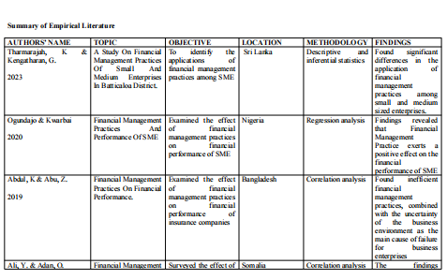

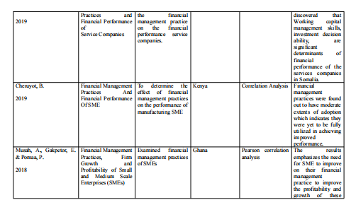

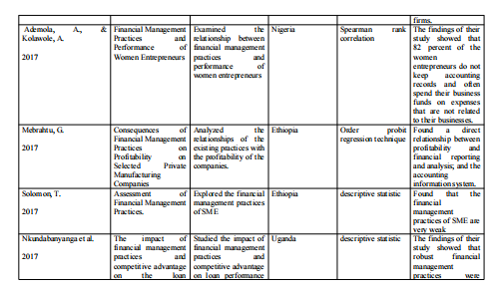

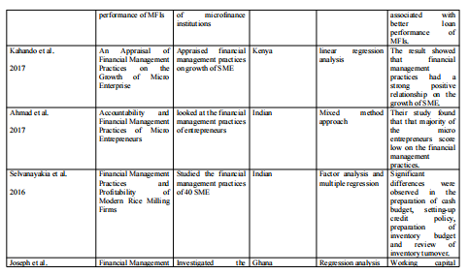

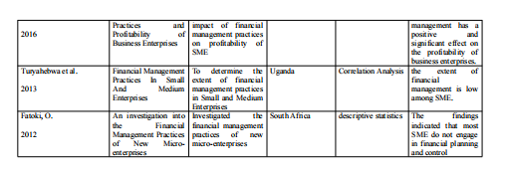

**CHAPTER THREE**

**METHODOLOGY**

**Introduction**

This chapter describes in details the systematic methods and approaches employed in providing answers to the research questions raised in chapter one. It also provides a pathway to arrive at certain factual conclusions necessary for this study.

**3.1. Research Design**

This dissertation adopts the survey research design. Survey research is typically done to describe what exists, in what amounts, and in what context. Surveys are used to answer questions, solve problems that have been given or observed, assess requirements and set goals, decide whether or not particular objectives have been attained, establish baselines for future comparisons, and track trends over time (Ponto, 2015).  In addition, survey research is applied to measure distinctive characteristics of a certain group.

Typically, these components include analyzing the interrelationships between multiple aspects. The information required for survey research must be gathered from individuals; consequently, it must be realized that the information is subjective (Belkhir, 2022). In order to generalize results to the entire population, survey research utilizes a subset of the population (Check & Schutt, 2012). It is utilized in this investigation because it embodies the necessary techniques for its accomplishment.

**3.2. Philosophy**

This study adopts the positivist research philosophy. A research philosophy is a way of thinking about the collection, analysis, and use of data related to a topic. According to Saunders, Lewis, and Thornhill (2009), research philosophy is strongly related with two concepts: ontology, the nature of reality or what is thought to be true, and epistemology, the relationship between the researcher and reality or what is known to be true. These are philosophy's two main subdisciplines. Additionally, the two main philosophical frameworks or concepts applied in social science research are positivism and interpretivism. This research philosophy is used because it makes the underlying assumption that knowledge is based on an accurate and unbiased interpretation of the evidence at hand.

This philosophy makes the supposition that knowledge, particularly knowledge obtained from observation, can be transferred in tangible form (Ryan, 2018).

Positivism, often known as epistemology, is a philosophy of knowledge that maintains that only knowledge obtained via direct observation is factual and reliable (Park et al., 2019).

Positivists hold that applying the scientific process can "reveal" or "discover" information. We can offer potential explanations for the causes of events in the world due to the "discovered" information (Creswell, 1994).

In the course of conducting research, the positivist approach places a strong emphasis on experimentation, observation, control, measurement, dependability, and validity (Bunniss & Kelly, 2010). This kind of thinking is compatible with quantitative investigation (Varpio & MacLeod, 2020).

**3.3. Methodology**

There are arguments for and against research methods. Quantitative and qualitative research in many fields do not always coexist harmoniously. The dispute stems from the distinction between sociologies derived from various epistemological positions (Poudel, 2014). Typically, quantitative methodology refers to the collection and analysis of numerical data and is associated with positivist epistemology. Interpretative epistemology is associated with the term "qualitative methodology," which is frequently used to characterize data collection and analysis methods that rely on understanding and emphasize meanings (Amaratunga, P. & Baldry, D. (2001)). Quantitative researchers criticize qualitative approaches on the grounds that they lack objectivity, are difficult to assess in terms of reliability and validity, and prohibit generalization to persons or situations other than those actually researched (Poudel, 2014). According to qualitative researchers, quantitative methods disregard the diversity of human behavior and experience, focusing instead on providing straightforward responses to straightforward questions regarding easily quantifiable characteristics (Muftahu, 2016).

A quantitative approach has been adopted for this study. The generation of numerical data or data amenable to transformation into useful statistics makes this approach a reliable strategy for quantifying the problem. The results from quantitative research can be expressed in a specific management terminology and its evaluation and results are based on objective methods (Apuke, 2017; Almeida et al., 2017).

It is a tool for getting at the numerical value of abstract concepts like beliefs and values as well as concrete actions and extending those findings to a bigger population. By collecting and analyzing large amounts of numerical data, quantitative researchers can establish causal relationships and draw conclusions about phenomena of interest (Babbie, 2010). Data collected using quantitative approaches are substantially more organized than qualitative methods. Quantitative data can be gathered in a variety of ways, including online surveys, paper surveys, mobile surveys, kiosk surveys, in-person interviews, telephone interviews, longitudinal studies, website interceptors, online polls, and systematic observations.

**3.4. Data collection method**

This research relies on responses from questionnaires sent to SME operators and their representatives. Email and social networking sites are among the channels used for this dispersal. There will be four distinct parts to the questionnaire, including a demographic portion and questions related to the research at hand. The data collected must adhere to the school's policy on the ethical treatment of study participants.

**3.5. Sampling technique**

This study employed two distinct estimating strategies to determine sample size. The stratified sampling technique was adopted because it is cost effective (Pirzadeh et al, 2011; Lynn, 2016; Etikan, 2016), while, the simple random sampling will give each participant the opportunity to be selected (Singh & Mangat, 1996; Noor et al., 2022). Utilizing stratified sampling as the initial strategy for industry selection. In order to obtain a representative sample of the target demographic, the sample for this study was drawn from four distinct industries. This comprises industries such as , construction, consumer products, information and communications technology, and agriculture. This is being done because the goods and services produced by this industry are crucial to Nigeria's economy and have established a global reputation. These fields also contain the greatest number of entrepreneurs. Using a random sampling technique, entrepreneurs (CEOs, Managers, or their agents) from the four selected industries were then recruited. Random sampling decreases the probability of error in the sample by removing potential sources of bias (Taherdoos, 2016).

**3.6. Population size**

The number of small and medium enterprises enterprises (SME) that were officially registered in Abuja as of 2017 was 482,365, as reported by the Small and Medium Enterprises Development Agency of Nigeria in partnership with the National Bureau of statistics (2017). This number will serve as the population for the purpose of this study.

**3.7. Data Analysis**

In this thesis, descriptive statistics and correlation analysis was used. The Pearson correlation analysis tests the null hypotheses, while the descriptive statistics provided the answers to the study questions. The correlation analysis is used in this research to identify relationships between two variables and evaluate how strongly they are linearly related (Mukaka, 2012; Senthilnathan, 2019). To determine how much one variable has changed as a result of another, correlation analysis is performed. It looks for links between two variables or datasets as well as trends, patterns, significant linkages, and connections. When an increase in one variable results in an increase in the other, there is a positive correlation between the two variables. When one variable rises while the other falls or vice versa, there is a negative connection.

**3.8. Ethics**

This dissertation complies with Sheffield Hallam University's ethical guidelines for research involving human subjects. The present investigation aims to safeguard the privacy of the subjects by implementing measures such as maintaining confidentiality of data and providing the option of anonymity to the participants. Participation is voluntary and participants have the right to discontinue with the study anytime they feel the need to do so. Statements or questions considered offensive to religious, cultural, or professional beliefs and ideology of participants can be skipped. All information received shall be stored in a safe file and format. The information obtained shall not be shared with a third-party except the school if necessary. The data collected shall be used solely for the purpose of this academic research. At the conclusion of the study, the data shall be carefully disposed.

**CHAPTER FOUR**

**DATA ANALYSIS**

This chapter presents the result of data collected in order to provide answers to the research questions. This chapter is divided into two sections; answers to research question and test of hypotheses. For additional tables and figures on related questions, kindly refer to the appendix page.

**Questionnaire Distribution**

The questionnaire consisted of 27 questions, categorized into demographic information and objective-based questions. The questionnaire was developed and distributed using electronic channels. This channel includes the researchers’ Linkedin contact, email, and SMS. The distribution and follow-up period lasted for over 33 days. Respondents must be a business own or manager of a business resident in Abuja, Nigeria. A total of 300 responses was expected, however, a total of 231 responses were received (216 valid, 15 invalid responses). The table below gives an explanation for the distribution.

|  |  |  |
| --- | --- | --- |
|  | **Frequency** | **Percent** |
| Valid responses | 216 | 93.5 |
| Invalid responses | 15 | 6.5 |
| Total Responses received | 231 | 100 |

The IBM SPSS statistics version 23 software was used to analyze the data. Research questions were analyzed using descriptive statistics while Pearson correlation was used to test the null hypotheses.

**4.1 Research Questions**

**Descriptive statistics**

1. **How does working capital management practices influence profits of SMEs?**

|  |  |  |  |  |  |
| --- | --- | --- | --- | --- | --- |
| **Table 1. Cashreceiptpractice** | | | | | |
|  | | Frequency | Percent | Valid Percent | Cumulative Percent |
| Valid | Agreed | 86 | 39.8 | 39.8 | 39.8 |
| Disagreed | 56 | 25.9 | 25.9 | 65.7 |
| Neutral | 21 | 9.7 | 9.7 | 75.5 |
| Strongly Agreed | 37 | 17.1 | 17.1 | 92.6 |
| Strongly Disagreed | 16 | 7.4 | 7.4 | 100.0 |
| Total | 216 | 100.0 | 100.0 |  |

Table 1 shows the responses received on the practice of cash receipt. A total of 86 respondents agreed to the practice of cash receipt in their business, 56 disagreed, 21 were neutral, 37 strongly agreed while 16 respondents strongly disagreed. The table shows that a total of 123 agreed to the practice of cash receipt while a total of 56 disagreed to this practice.

|  |  |  |  |  |  |
| --- | --- | --- | --- | --- | --- |
| **Table 2. Budgetingpractice** | | | | | |
|  | | Frequency | Percent | Valid Percent | Cumulative Percent |
| Valid | Agreed | 75 | 34.7 | 34.7 | 34.7 |
| Disagreed | 60 | 27.8 | 27.8 | 62.5 |
| Neutral | 31 | 14.4 | 14.4 | 76.9 |
| Strongly Agreed | 38 | 17.6 | 17.6 | 94.4 |
| Strongly Disagreed | 12 | 5.6 | 5.6 | 100.0 |
| Total | 216 | 100.0 | 100.0 |  |

Table 2 shows the responses received on budgeting practice. A total of 75 respondents agreed to the practice of budgeting in their business, 60 disagreed, 31 were neutral, 38 strongly agreed while 12 respondents strongly disagreed. The table shows that a total of 113 agreed to the practice of budgeting while a total of 72 disagreed to this practice.

|  |  |  |  |  |  |
| --- | --- | --- | --- | --- | --- |
| **Table 3. Auditingpractice** | | | | | |
|  | | Frequency | Percent | Valid Percent | Cumulative Percent |
| Valid | Agreed | 59 | 27.3 | 27.3 | 27.3 |
| Disagreed | 66 | 30.6 | 30.6 | 57.9 |
| Neutral | 37 | 17.1 | 17.1 | 75.0 |
| Strongly Agreed | 48 | 22.2 | 22.2 | 97.2 |
| Strongly Disagreed | 6 | 2.8 | 2.8 | 100.0 |
| Total | 216 | 100.0 | 100.0 |  |

Table 3 shows the responses received on Auditing practice. A total of 59 respondents agreed to implementing audit practice in their business, 66 disagreed, 37 were neutral, 48 strongly agreed while 6 respondents strongly disagreed. The table shows that a total of 108 agreed to the practice of auditing while a total of 72 disagreed to this practice.

|  |  |  |  |  |  |
| --- | --- | --- | --- | --- | --- |
| **Table 4. Descriptive Statistics** | | | | | |
|  | N | Minimum | Maximum | Mean | Std. Deviation |
| Cashreceiptpractice | 216 | 1 | 5 | 2.26 | 1.336 |
| Budgetingpractice | 216 | 1 | 5 | 2.31 | 1.266 |
| Auditingpractice | 216 | 1 | 5 | 2.43 | 1.187 |
| Valid N (listwise) | 216 |  |  |  |  |

In ascertaining how working capital management practices influences profits of SMEs, specific working capital components (practices) such as cash receipt, budgeting, and auditing were examined. Evidence from the table 4 shows a mean of 2.26, 2.31, and 2.43 with a standard deviation of 1.33, 1.26, 1.18 respectively. The proximity of the standard deviation values from the mean values are wide, which implies that working capital management practices are less evident in some of the participated businesses. Hence, it can be inferred that profits of SMEs can be influenced when these practices (cash receipt, budgeting, and auditing) are implemented. The prevalence of profitability influence is dependent on the adoption and implementation of WCM practices.

SME operators in Nigeria that do not adopt nor implement any of these practices may not have its profits influenced. Also, the extent of influence is dependent on the consistency of practice. A firm will have its profits positively influenced of they adopt WCM practices and ensure the practice for a long-run. Conversely, a firm will not have its profit influenced if it does not adopt and implement WCM practices, neither will the practice be of a significant benefit if the firm do not maintain these practices for long. Thus, WCM influences SME profitability. The implication of this finding is discussed in the next chapter.

1. **What is the effect of working capital management practice on debt control?**

|  |  |  |  |  |  |
| --- | --- | --- | --- | --- | --- |
| **Table 5. Baddebtprovision** | | | | | |
|  | | Frequency | Percent | Valid Percent | Cumulative Percent |
| Valid | Agreed | 59 | 27.3 | 27.3 | 27.3 |
| Disagreed | 66 | 30.6 | 30.6 | 57.9 |
| Neutral | 37 | 17.1 | 17.1 | 75.0 |
| Strongly Agreed | 43 | 19.9 | 19.9 | 94.9 |
| Strongly Disagreed | 11 | 5.1 | 5.1 | 100.0 |
| Total | 216 | 100.0 | 100.0 |  |

Table 1 shows the responses received on the practice bad debt provision. A total of 59 respondents agreed to the practice of providing for bad debts in their business, 66 disagreed, 37 were neutral, 43 strongly agreed while 11 respondents strongly disagreed. The table shows that a total of 102 agreed to the practice of providing for bad debt while a total of 77 disagreed to this practice.

|  |  |  |  |  |  |
| --- | --- | --- | --- | --- | --- |
| **Table 6. Paybackpractice** | | | | | |
|  | | Frequency | Percent | Valid Percent | Cumulative Percent |
| Valid | Agreed | 87 | 40.3 | 40.3 | 40.3 |
| Disagreed | 41 | 19.0 | 19.0 | 59.3 |
| Neutral | 33 | 15.3 | 15.3 | 74.5 |
| Strongly Agreed | 49 | 22.7 | 22.7 | 97.2 |
| Strongly Disagreed | 6 | 2.8 | 2.8 | 100.0 |
| Total | 216 | 100.0 | 100.0 |  |

Table 6 shows the responses received on the practice pay back. A total of 87 respondents agreed to the practice of paying back debts in their business, 41 disagreed, 33 were neutral, 49 strongly agreed while 6 respondents strongly disagreed. The table shows that a total of 136 agreed to the practice of pay back while a total of 47 disagreed to this practice.

|  |  |  |  |  |  |
| --- | --- | --- | --- | --- | --- |
| **Table 7. Debtinterestrate** | | | | | |
|  | | Frequency | Percent | Valid Percent | Cumulative Percent |
| Valid | Agreed | 57 | 26.4 | 26.4 | 26.4 |
| Disagreed | 43 | 19.9 | 19.9 | 46.3 |
| Neutral | 25 | 11.6 | 11.6 | 57.9 |
| Strongly Agreed | 76 | 35.2 | 35.2 | 93.1 |
| Strongly Disagreed | 15 | 6.9 | 6.9 | 100.0 |
| Total | 216 | 100.0 | 100.0 |  |

In Table 7 above, the responses shows how debt interest rate determines the decision of a business owner to accept or reject a credit. The table shows that a total of 57 respondents agreed to the practice of carefully considering interest rate before accepting credit facility in their business, 43 disagreed, 25 were neutral, 76 strongly agreed while 15 respondents strongly disagreed. The table shows that a total of 133 agreed to the practice of considering interest rate before accepting a credit while a total of 58 disagreed to this practice.

|  |  |  |  |  |  |
| --- | --- | --- | --- | --- | --- |
| **Table 8. Descriptive Statistics** | | | | | |
|  | N | Minimum | Maximum | Mean | Std. Deviation |
| Baddebtprovision | 216 | 1 | 5 | 2.45 | 1.227 |
| Paybackpractice | 216 | 1 | 5 | 2.29 | 1.280 |
| Debtinterestrate | 216 | 1 | 5 | 2.76 | 1.355 |
| Valid N (listwise) | 216 |  |  |  |  |

Evidence in table 8 below shows a widespread of values within this dataset. Working capital management (WCM) components identified in this question shows a wide deviation from the mean. Provision for bad debts (2.45, 1.22), payback practice (2.29, 1.28), and debt interest rate consideration (2.76, 1.35). This evidence indicates a possibility of low implementation of WCM practices in the 216 SMEs that participated in this survey.

Many SME operators in Nigeria do not practice provision for bad and irrecoverable debt; they do not adopt and implement a reliable payback system for their debts, neither do they carefully consider the impact of interest rate on any accessible credit. The impact of this poor WCM practice on SMEs in Nigeria is seen in their inability to lower their current debt and eliminate it. Thus, it can be inferred that lots of SMEs in Nigeria who do not adopt and implement working capital management practices have difficulty lowering or eliminating their debts.

1. How does working capital management practice influence value creation of SMEs?

**Frequency Table**

|  |  |  |  |  |  |
| --- | --- | --- | --- | --- | --- |
| **Table 9. Financialobligations** | | | | | |
|  | | Frequency | Percent | Valid Percent | Cumulative Percent |
| Valid | Agreed | 112 | 51.9 | 51.9 | 51.9 |
| Disagreed | 29 | 13.4 | 13.4 | 65.3 |
| Neutral | 27 | 12.5 | 12.5 | 77.8 |
| Strongly Agreed | 48 | 22.2 | 22.2 | 100.0 |
| Total | 216 | 100.0 | 100.0 |  |

Table 9 shows the responses received on the practice financial responsibility by meeting up obligation to customers, suppliers, and other business partners. A total of 112 respondents agreed to this practice, 29 disagreed, 27 were neutral, 48 strongly agreed. There was no response for strongly disagreed. The table shows that a total of 160 agreed to the practice of executing financial obligation while a total of 77 disagreed to this practice.

|  |  |  |  |  |  |
| --- | --- | --- | --- | --- | --- |
| **Table 10. Financialallocation** | | | | | |
|  | | Frequency | Percent | Valid Percent | Cumulative Percent |
| Valid | Agreed | 92 | 42.6 | 42.6 | 42.6 |
| Disagreed | 28 | 13.0 | 13.0 | 55.6 |
| Neutral | 27 | 12.5 | 12.5 | 68.1 |
| Strongly Agreed | 63 | 29.2 | 29.2 | 97.2 |
| Strongly Disagreed | 6 | 2.8 | 2.8 | 100.0 |
| Total | 216 | 100.0 | 100.0 |  |

Table 10 shows the responses received on the practice financial allocation. A total of 92 respondents agreed to the practice of allocating financial resources in their business, 28 disagreed, 27 were neutral, 63 strongly agreed while 6 respondents strongly disagreed. The table shows that a total of 155 agreed to the practice of allocating financial resources while a total of 77 disagreed to this practice.

|  |  |  |  |  |  |
| --- | --- | --- | --- | --- | --- |
| **Table 11. servicedelivery** | | | | | |
|  | | Frequency | Percent | Valid Percent | Cumulative Percent |
| Valid | Agreed | 113 | 52.3 | 52.3 | 52.3 |
| Disagreed | 23 | 10.6 | 10.6 | 63.0 |
| Neutral | 39 | 18.1 | 18.1 | 81.0 |
| Strongly Agreed | 41 | 19.0 | 19.0 | 100.0 |
| Total | 216 | 100.0 | 100.0 |  |

Table 11 shows the responses received on the practice of focusing on delivering service. A total of 113 respondents agreed to this culture, 23 disagreed, 39 were neutral, 41 strongly agreed. There was no record of strongly disagreed. The table shows that a total of 154 agreed to the practice of cash receipt while a total of 23 disagreed to this practice.

|  |  |  |  |  |  |
| --- | --- | --- | --- | --- | --- |
| **Table 12. Descriptive Statistics** | | | | | |
|  | N | Minimum | Maximum | Mean | Std. Deviation |
| Financialallocation | 216 | 1 | 5 | 2.37 | 1.357 |
| Financialobligations | 216 | 1 | 4 | 2.05 | 1.240 |
| servicedelivery | 216 | 1 | 4 | 2.04 | 1.212 |
| Valid N (listwise) | 216 |  |  |  |  |

Evidence in table 12 above shows a widespread of values within this dataset. Working capital management (WCM) components identified in this question shows a wide deviation from the mean. Financial allocation (2.37, 1.35), financial obligation (2.05, 1.24), and service delivery (2.04, 1.21). This evidence indicates a possibility of low implementation of WCM practices in the 216 SMEs that participated in this survey although there is a wide acceptance of this practice.

**Research Hypotheses**

In this section the three null hypotheses formulated were tested using the Pearson Correlation test. The test had dependent and independent variables. Working capital management (WCM) was the dependent variable while independent variables includes cash receipt practice, budgeting practice, auditing practice, provision for bad debt, interest rate, payback, financial allocation, financial obligation, and service delivery. Result from the test showed positive correlation between working capital management and SME profit. Additionally, there is a positive correlation between WCM and debt among Nigerian SME's. Additional evidence demonstrated a correlation between WCM and value creation. Thus, the three null hypotheses were rejected in favour of the alternative.

However, an in-depth examination of the associations between the independent variables and dependent variable reveals that, despite being positive, there is no strong relationship. Discussion on the implication of this observation and further findings are provided in chapter five of this dissertation. Table 13 provides a description of the nature of association between the dependent and independent variables.

|  |  |  |  |  |  |  |  |  |  |  |  |
| --- | --- | --- | --- | --- | --- | --- | --- | --- | --- | --- | --- |
| **Table 13. Correlations** | | | | | | | | | | | |
|  | | WCM | Cashreceipt | Budgeting | Auditing | Baddebtprovision | Payback | Debtinterestrate | Financialallocation | servicedelivery | Financialobligations |
| WCM | Pearson Correlation | 1 | .164* | .136* | .249** | .080 | .146* | .134* | .138* | .082 | .181** |
| Sig. (2-tailed) |  | .016 | .046 | .000 | .240 | .032 | .049 | .043 | .230 | .008 |
| N | 216 | 216 | 216 | 216 | 216 | 216 | 216 | 216 | 216 | 216 |
| Cashreceiptpractice | Pearson Correlation | .164* | 1 | .531** | .770** | .455** | .578** | .363** | .441** | .494** | .354** |
| Sig. (2-tailed) | .016 |  | .000 | .000 | .000 | .000 | .000 | .000 | .000 | .000 |
| N | 216 | 216 | 216 | 216 | 216 | 216 | 216 | 216 | 216 | 216 |
| Budgetingpractice | Pearson Correlation | .136* | .531** | 1 | .579** | .388** | .659** | .236** | .442** | .432** | .286** |
| Sig. (2-tailed) | .046 | .000 |  | .000 | .000 | .000 | .000 | .000 | .000 | .000 |
| N | 216 | 216 | 216 | 216 | 216 | 216 | 216 | 216 | 216 | 216 |
| Auditingpractice | Pearson Correlation | .249** | .770** | .579** | 1 | .418** | .504** | .222** | .446** | .419** | .396** |
| Sig. (2-tailed) | .000 | .000 | .000 |  | .000 | .000 | .001 | .000 | .000 | .000 |
| N | 216 | 216 | 216 | 216 | 216 | 216 | 216 | 216 | 216 | 216 |
| Baddebtprovision | Pearson Correlation | .080 | .455** | .388** | .418** | 1 | .460** | .198** | -.032 | .126 | .349** |
| Sig. (2-tailed) | .240 | .000 | .000 | .000 |  | .000 | .003 | .639 | .064 | .000 |
| N | 216 | 216 | 216 | 216 | 216 | 216 | 216 | 216 | 216 | 216 |
| Paybackpractice | Pearson Correlation | .146* | .578** | .659** | .504** | .460** | 1 | .045 | .435** | .338** | .231** |
| Sig. (2-tailed) | .032 | .000 | .000 | .000 | .000 |  | .514 | .000 | .000 | .001 |
| N | 216 | 216 | 216 | 216 | 216 | 216 | 216 | 216 | 216 | 216 |
| Debtinterestrate | Pearson Correlation | .134* | .363** | .236** | .222** | .198** | .045 | 1 | .199** | .399** | .234** |
| Sig. (2-tailed) | .049 | .000 | .000 | .001 | .003 | .514 |  | .003 | .000 | .001 |
| N | 216 | 216 | 216 | 216 | 216 | 216 | 216 | 216 | 216 | 216 |
| Financialallocation | Pearson Correlation | .138* | .441** | .442** | .446** | -.032 | .435** | .199** | 1 | .617** | .475** |
| Sig. (2-tailed) | .043 | .000 | .000 | .000 | .639 | .000 | .003 |  | .000 | .000 |
| N | 216 | 216 | 216 | 216 | 216 | 216 | 216 | 216 | 216 | 216 |
| servicedelivery | Pearson Correlation | .082 | .494** | .432** | .419** | .126 | .338** | .399** | .617** | 1 | .615** |
| Sig. (2-tailed) | .230 | .000 | .000 | .000 | .064 | .000 | .000 | .000 |  | .000 |
| N | 216 | 216 | 216 | 216 | 216 | 216 | 216 | 216 | 216 | 216 |
| Financialobligations | Pearson Correlation | .181** | .354** | .286** | .396** | .349** | .231** | .234** | .475** | .615** | 1 |
| Sig. (2-tailed) | .008 | .000 | .000 | .000 | .000 | .001 | .001 | .000 | .000 |  |
| N | 216 | 216 | 216 | 216 | 216 | 216 | 216 | 216 | 216 | 216 |
| *. Correlation is significant at the 0.05 level (2-tailed). | | | | | | | | | | | |
| **. Correlation is significant at the 0.01 level (2-tailed). | | | | | | | | | | | |

|  |  |  |  |  |
| --- | --- | --- | --- | --- |
| Table 14. Summary of test of Hypotheses | | | | |
| Independent variable name | Correlation value | Result | Null hypothesis | Condition |
| Cash receipt practice | 0.164* | Positive correlation | There is no relationship between working capital management practice and SME profit | Rejected |
| Budgeting Practice | 0.136* | Positive correlation |
| Auditing Practice | 0.249** | Positive correlation |
| Provision for bad debt | 0.080 | No correlation | There is no relationship between working capital management practice and SME Debt | Rejected |
| Payback practice | 0.146* | Positive correlation |
| Interest rate | 0.134* | Positive correlation |
| Financial allocation | 0.138* | Positive correlation | There is no relationship between working capital management practice and SME value creation | Rejected |
| Financial allocation | 0.082 | No correlation |
| Service delivery | 0.181** | Positive correlation |

**CHAPTER FIVE**

**DISCUSSION OF FINDINGS**

This chapter's purpose is to provide an analysis of the results presented in the previous chapter. This discussion will include a summary of the findings, the implications of the findings, the conclusion of the study, the limitations of this study, and the identification of research openings for future study.

**5.1 Summary of Findings**

The objective of this research was to examine the impact of optimal financial management strategies on the operational outcomes of small and medium-sized enterprises in Nigeria. The selection of working capital management (WCM) as a metric for financial management practise was based on the breadth of the subject matter. The present choice was made on the basis of a substantial corpus of research that has established the influence of WCM (financial management component) on the performance of SMEs (Oladipupo & Okafor, 2013; Okoye et al., 2016; Raji, 2017; Okunlola et al., 2019; Oladimeji & Aladejebi, 2020). Empirical evidence suggests that a significant proportion of small and medium-sized enterprises (SMEs) in Nigeria fail to adopt and implement basic financial management practises, resulting in their inability to fulfil their daily obligations (Salawu & Alao, 2014; Yahaya, 2016). The present investigation employed a survey research design, utilizing a simple random sampling technique to gather data from a sample of two hundred and sixteen (216) participants. Demographic information pertaining to the sample can be found in the appendix.

**Research Question 1**

The study employed descriptive statistics and the Pearson correlation test to analyse the responses. The findings indicate that there exists a favourable association between the management of working capital and the financial performance of small and medium-sized businesses. The present study aligns with the results of Aldubhani et al. (2022), which indicate that small and medium-sized enterprises (SMEs) that have shorter receivables collection and cash conversion cycles tend to exhibit greater profitability. Furthermore, Morshed's (2020) study demonstrated a correlation between working capital management (WCM) and profitability. The research findings indicate that the proficiency in managing working capital has a substantial influence on the financial performance of small and medium-sized enterprises. Samuel and Pradeep (2014) posited that inadequate WCM knowledge could jeopardise a firm's profitability, leading to mismanagement and suboptimal shareholder value. Syeda's (2021) study yielded findings that are in opposition to the aforementioned results, as it determined that a negative correlation exists between working capital management (WCM) and profitability. Syeda discovered a negative correlation between Return on Assets, Inventory Turnover, and Cash Conversion Cycle.

**Research Question 2**

The study's second finding indicates a favourable correlation between working capital management (WCM) and small and medium-sized enterprise (SME) debt. The study conducted by Alrahamneh et al. (2020) revealed a positive correlation between short-term debt, long-term debt, and working capital management (WCM), which aligns with the results of the present study. Kabir and colleagues (2021) have reported that a decrease in business performance is associated with an increase in the cash conversion cycle and debtors' collection period. This finding highlights the significance of these factors in influencing business success.

**Research Question 3**

The final result shows a favorable correlation between value creation and WCM. This outcome is consistent with those of Nurein & Din (2017), who emphasized that innovative organizations outperform non-innovative businesses in terms of working capital because they make use of their imaginative abilities to accomplish so. In order to boost firm value, organizations should, according to their research, align their inventive capabilities with working capital management. Soenen (1993) asserts that WCM determines a firm's value and that organizations with strong WCM can raise their firm value. Businesses with good WCM can also maximize their value and possibly lessen their need on outside funding because they have the ability to generate money internally (Autukaite & Molay, 2013; Baos-Caballero et al., 2014).

**5.2 Implication of Findings**

Since it has been established that WCM practices have an impact on profits, it follows that WCM practices will increase SME profits in Nigeria if they are adopted and put into operation. However, only when WCM is implemented can profits be influenced positively. Evidence from this study indicates that many SMEs in Nigeria fail to adhere to WCM, which is attributable to various factors identified by Ayeyemi (2013), including some SME operators' limited formal education and the industry's poor managerial and financial management capabilities. Additionally, many SMEs in Nigeria lack the competent accounting personnel and appropriate accounting software that serve as incentives for efficient working capital management techniques. Gumel & Bardai (2021) also discovered that owners and managers impede the effective application of working capital management techniques.

In addition, the relationship between working capital and debt has been established in this study, which suggests that when WCM practices are implemented effectively, they can assist SMEs in managing their debts and possibly eliminating them. This further implies that when a company lacks WCM expertise, it runs the risk of accumulating debt, which could ultimately lead to insolvency. Therefore, there is a need for adequate working capital management knowledge, adoption, and application.

Furthermore, this study demonstrates that WCM influences the value creation potential of Nigerian SMEs. In today's environment, intangible assets like brands, ideas, people, and innovation are what create value. Therefore, value creation is viewed as a better management tool than merely financial metrics of corporate performance when used extensively. Every firm should be driven by the desire to create value. It is simple for firms to deploy financial resources, fulfill their financial obligations, and provide gratifying service when they concentrate on adding value for customers. Therefore, it is imperative that SMEs in Nigeria adopt and implement WCM practices to continuously create value, which will set them apart from their competitors and secure long-term clients.

**5.3 Conclusion**

Best practices for financial management lead an organization down a path of accountability and duty. It is the foundation of professional conduct within an organization and confirms the inventiveness of any entity's operations. Effective financial management procedures ensure the stability and future of a business. Working capital management, a vital aspect of financial management, assists businesses in optimizing their use of current assets and monetary flow. It focuses on ensuring that immediate financial obligations and expenditures can be met while advancing longer-term business objectives. Working capital management becomes a business practice when its characteristics are adopted and applied to a variety of business activities. It was discovered that small and medium-sized enterprises in Nigeria lacked working capital management techniques. Inadequate working capital management practices frequently result in cash being held in inventory, thereby reducing the liquidity and profitability of SMEs. Even if it appears effective on paper, a company with insufficient working capital may be unable to meet its current obligations and may ultimately fail. In Nigeria, a considerable number of small and medium-sized enterprises (SMEs) encounter formidable challenges as a result of inadequate working capital management (WCM) practises, ultimately culminating in their swift collapse.

The effective management of working capital is a crucial aspect of ensuring the success of small and medium-sized enterprises (SMEs) in Nigeria. This involves the strategic planning and control of current assets and liabilities to mitigate the risk of being unable to meet short-term obligations and to avoid overinvestment in these assets. The objective of working capital management as a managerial accounting technique is to maintain a balance between the working capital levels of efficient components, or current assets and current liabilities. Working capital management may include the implementation of short-term decisions that may or may not be carried over from one financial period to the next. Small and medium-sized enterprises that are "not doing well" will fail if their working capital components are not correctly managed. The ability of small and medium-sized enterprises to manage their working capital would essentially ensure that they have sufficient cash flow to meet their short-term loan obligations and operating expenses. Consequently, working capital management has become a fundamental and comprehensive aspect of a company's performance evaluation.

The conclusion of this study is that maintaining adequate liquidity for operational activities is essential for SMEs. Businesses who are able to properly manage their working capital will be in a better position to outperform their competitors because they will be able to react rapidly and intelligently to unanticipated shifts in market dynamics such as changes in the cost of borrowing money and the cost of raw materials.

**5.4 Limitations Of The Study And Need For Future Research**

According to the findings of this research, the implementation of best practices for effective financial management actually positions firms for remarkable performance. Having said that, it is important to remember that the mere application of working capital management does not ensure overall business success. When integrated with other aspects of the operations of a business, effective management of working capital can help ensure that the company as a whole achieves its goals and objectives. The conclusions of this study were derived from the information obtained through the survey that was conducted. Future research could take into account different types of data or different ways to acquire data. In addition, there were 216 people who took part in the survey. Moving forward, researchers might think about increasing the size of their samples in order to get more accurate results. Last but not least, in further research, it could be worthwhile to investigate the current obstacles that prevent small and micro enterprises in Nigeria from adopting and putting into practice the most effective methods of competent financial management.

**5.5 Contribution to Knowledge**

This research has made a valuable contribution to the limited body of literature available on the financial management practices and growth of small and medium-sized enterprises (SMEs) in Abuja, Nigeria. This dissertation highlights the significance of financial management practices for the growth of small and medium-sized enterprises in Nigeria. Despite Abuja being the capital city of Nigeria and hosting a diverse range of businesses, there appears to be a scarcity of literature pertaining to financial management for businesses in this region. This study has effectively addressed the existing gap and has paved the way for potential future research.

**REFERENCES**

**APPENDIX**

**Bar Chart**

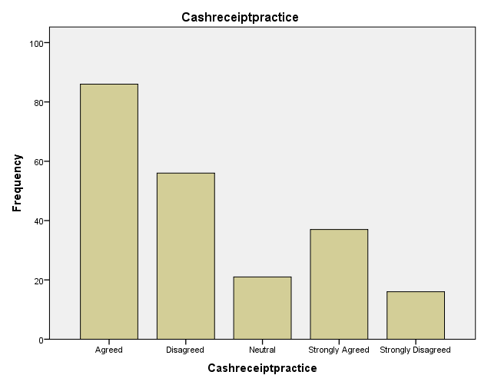 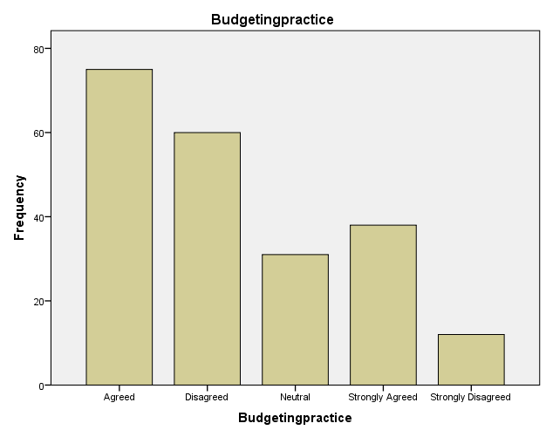

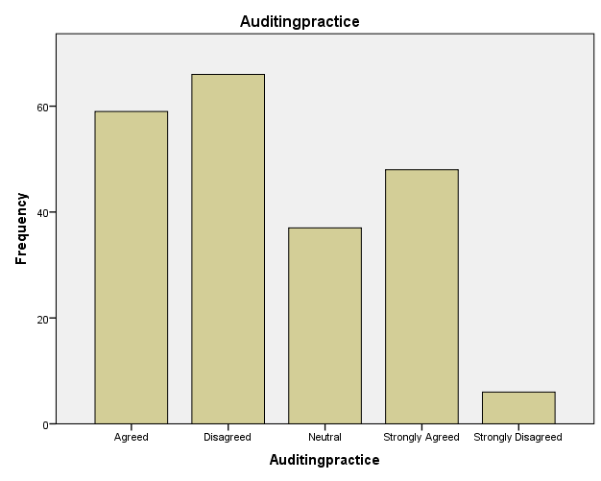

Research Question 2

|  |  |  |  |  |
| --- | --- | --- | --- | --- |
| **Statistics** | | | | |
|  | | Baddebtprovision | Paybackpractice | Debtinterestrate |
| N | Valid | 216 | 216 | 216 |
| Missing | 0 | 0 | 0 |
| Mean | | 2.45 | 2.29 | 2.76 |
| Median | | 2.00 | 2.00 | 3.00 |
| Std. Deviation | | 1.227 | 1.280 | 1.355 |
| Minimum | | 1 | 1 | 1 |
| Maximum | | 5 | 5 | 5 |

**Frequency Table**

**Bar Chart**

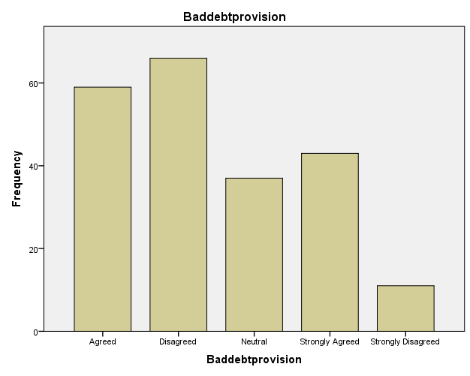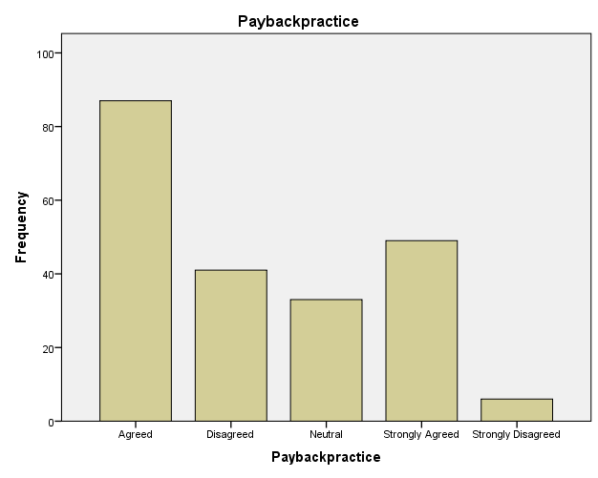

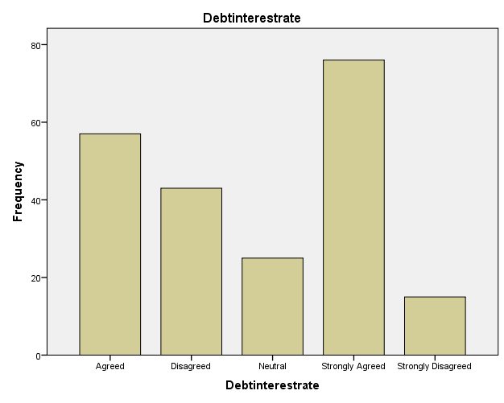

Research Question 3

|  |  |  |  |  |
| --- | --- | --- | --- | --- |
| **Statistics** | | | | |
|  | | Financialobligations | Financialallocation | servicedelivery |
| N | Valid | 216 | 216 | 216 |
| Missing | 0 | 0 | 0 |
| Mean | | 2.05 | 2.37 | 2.04 |
| Median | | 1.00 | 2.00 | 1.00 |
| Std. Deviation | | 1.240 | 1.357 | 1.212 |
| Minimum | | 1 | 1 | 1 |
| Maximum | | 4 | 5 | 4 |

**Bar Chart**

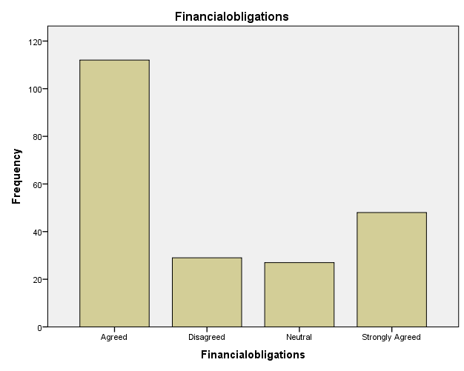

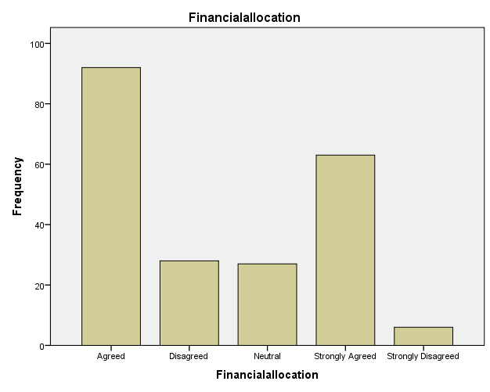

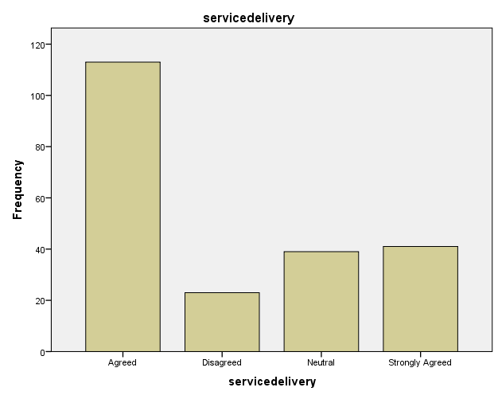

**Demographic information**

|  |  |  |  |  |  |
| --- | --- | --- | --- | --- | --- |
| **Gender** | | | | | |
|  | | Frequency | Percent | Valid Percent | Cumulative Percent |
| Valid | Female | 86 | 39.8 | 39.8 | 39.8 |
| Male | 130 | 60.2 | 60.2 | 100.0 |
| Total | 216 | 100.0 | 100.0 |  |

|  |  |  |  |  |  |
| --- | --- | --- | --- | --- | --- |
| **Age Category** | | | | | |
|  | | Frequency | Percent | Valid Percent | Cumulative Percent |
| Valid | 25 - 30 | 9 | 4.2 | 4.2 | 4.2 |
| 31 - 40 | 75 | 34.7 | 34.7 | 38.9 |
| 40 - 50 | 107 | 49.5 | 49.5 | 88.4 |
| Above 50 | 25 | 11.6 | 11.6 | 100.0 |
| Total | 216 | 100.0 | 100.0 |  |

|  |  |  |  |  |  |
| --- | --- | --- | --- | --- | --- |
| **Education** | | | | | |
|  | | Frequency | Percent | Valid Percent | Cumulative Percent |
| Valid | Secondary | 35 | 16.2 | 16.2 | 16.2 |
| Tertiary | 181 | 83.8 | 83.8 | 100.0 |
| Total | 216 | 100.0 | 100.0 |  |

|  |  |  |  |  |  |
| --- | --- | --- | --- | --- | --- |
| **Duration of business** | | | | | |
|  | | Frequency | Percent | Valid Percent | Cumulative Percent |
| Valid | 0 - 5 years | 36 | 16.7 | 16.7 | 16.7 |
| 11 - 15 years | 54 | 25.0 | 25.0 | 41.7 |
| 16 - 20 years | 4 | 1.9 | 1.9 | 43.5 |
| 6 - 10 years | 117 | 54.2 | 54.2 | 97.7 |
| 6 - 10 years, 16 - 20 years | 5 | 2.3 | 2.3 | 100.0 |
| Total | 216 | 100.0 | 100.0 |  |

|  |  |  |  |  |  |
| --- | --- | --- | --- | --- | --- |
| **Sector of Business** | | | | | |
|  | | Frequency | Percent | Valid Percent | Cumulative Percent |
| Valid | Agriculture | 42 | 19.4 | 19.4 | 19.4 |
| Construction | 25 | 11.6 | 11.6 | 31.0 |
| Consumer Product | 60 | 27.8 | 27.8 | 58.8 |
| Education | 26 | 12.0 | 12.0 | 70.8 |
| Information Technology | 63 | 29.2 | 29.2 | 100.0 |
| Total | 216 | 100.0 | 100.0 |  |

|  |  |  |  |  |  |
| --- | --- | --- | --- | --- | --- |
| **Staff size of business** | | | | | |
|  | | Frequency | Percent | Valid Percent | Cumulative Percent |
| Valid | 0-5 employees | 122 | 56.5 | 56.5 | 56.5 |
| 10-20 employees | 81 | 37.5 | 37.5 | 94.0 |
| 21-30 employees | 13 | 6.0 | 6.0 | 100.0 |
| Total | 216 | 100.0 | 100.0 |  |

**Pie Chart**

