**THE IMPACT OF CHALLENGES AND LIMITATIONS CONFRONTING INTERNATIONAL ORGANISATION IN CARRYING OUT HUMANITARIAN AID**

**ABSTRACT**

The gap between the magnitude of humanitarian need and the global capacity to respond is massive and growing. Humanitarian crises directly affect more than 140 million people in 37 countries, according to the United Nations Office for the Coordination of Humanitarian Affairs.The aim of this study was to examine the impact of challenges and limitations confronting international organization in carrying out humanitarian aid. The method used in this study is mainly of doctrinal or library research in nature.What can be concluded from this analysis is that policy makers, diplomats and aid workers are increasingly struggling to develop appropriate responses to humanitarian crisis and conflict in contexts characterised by state breakdowns and competing military and para­military structures. From the observations and reports, it can be concluded that the major constraints to effective humanitarian aids are Counterterrorism Regulation, Bureaucratic Constraints, Violence and Insecurity,and Funding

**TABLE OF CONTENT**

**ABSTRACT**

**CHAPTER ONE - BACKGROUND OF THE STUDY**

1.0 INTRODUCTION

1.2 Statement of the Problem

1.3 Objectives of the study

1.4 Research questions

1.5 Research hypothesis

1.6 Significance of the study

1.7 Scope and limitation of the study

1.8 Organization of the study

**CHAPTER TWO- LITERATURE REVIEW**

Introduction

Humanitarianism: from the ‘old’ to the ‘new’

Political Instrumentalization of Humanitarian Aid

**CHAPTER THREE - RESEARCH METHODOLOGY**

3.1 Research Design

3.2 Population and Sampling of study

3.4 Data Gathering Method

3.5 Data Analysis

**CHAPTER FOUR**

ANALYSIS AND DISCUSSION

**CHAPTER FIVE- SUMMARY, CONCLUSION AND RECOMMENDATION**

5.1 Summary Of Findings

5.2 Conclusion

Bibliography

**CHAPTER ONE**

**1.0 INTRODUCTION**

Crises in so many regions of Nigeria have really caused so many set back in recent times. There are some states in Nigeria that even the indigenes find it difficult to settle down; most of them move out of their own state to another state just to find peace. By this time early last year, in Benue state of Nigeria, there was a dispute between the Tiv tribes and the Fulani in gboko local government area. This fiasco was on for a very long period of time. Indigenes of gboko; running out of their own village to another local government area just to find peace. Questions were ask as regard the ongoing crises, so many responses were given by the people in gboko area.

It was heard from a reliable source that the Fulani herd’s men were fighting over a land; claim was that the land was given to them to graze on for at least 7 years. The elders of gboko local government area claimed that there was no record of any agreement what so ever given to them neither by the state government nor the local government as regard the purpose. The fulani herd’s men reacted to being cheated by Benue state. They ask the elders to return their money, but all to no avail. The killings continued; when the state government came to settle the crises, it became war on the government.

Nigeria has really suffered so many crises in recent years; is it terrorist attack by book haram? Or is it just crises? All these happening will definitely affect some of the organizations in carrying out humanitarian aids especially in most of these areas of crises; some might end up being killed or kidnapped.

**1.2 Statement of the Problem**

The gap between the magnitude of humanitarian need and the global capacity to respond is massive and growing. Humanitarian crises directly affect more than 140 million people in 37 countries, according to the United Nations Office for the Coordination of Humanitarian Affairs (UNOCHA). More than 65 million of these people have been forcibly displaced from their homes — the highest level since the Second World War. Nearly 60% are currently in Africa and the Middle East, including in Turkey, Lebanon, Uganda and Ethiopia1 . The rest include refugees, asylum seekers, people displaced internally, those not yet seeking asylum and many more. Much of this humanitarian need derives from violent conflicts and civil wars that target civilians and their support systems, including shelters and hospitals. Much also follows natural disasters such as earthquakes, hurricanes, floods and drought. With climate change, it is highly likely that some of these disasters will get worse and more frequent. All of these people need aid, and the funds available are increasingly inadequate. Just one-third of the US$25.4 billion required for humanitarian aid for 2018 was covered. In other words, the current humanitarian system is buckling. It desperately needs much more programme funding to close the gap. At the same time, it needs more funding for innovative solutions: uses of technology, products and processes from other sectors; new forms of partnership; and drawing on the ideas and coping capacities of crisis-affected people — in a way that is iterative and rigorously evaluated. A balance of the two types of funding would help the humanitarian system to become more efficient and more effective.

**1.3 Objectives of the study**

The aim of this study is to examine the impact of challenges and limitations confronting international organization in carrying out humanitarian aid. Specifically, the study seeks:

1. To determine the challenges confronting international organization regarding humanitarian aid.
2. To determine the impact of these challenges on the crisis-affected people.

**1.4 Research questions**

1. What are the challenges confronting international organization in carrying out humanitarian aid?
2. What are the effects of the above challenges on the crisis-affected people.
3. What are the possibly methods to ameliorate the impact of these challenges?

**1.5 Research hypothesis**

**H0:** Crises do not have significant effect in carrying out humanitarian aid in Nigeria.

**Ha:** Crises have significant effect in carrying out humanitarian aid in Nigeria.

**1.6 Significance of the study**

The study will explain the factors that has been limiting the reception of help from the international organization for crisis-affected areas. The study will help policy makers to make informed decisions concerning international humanitarian aid, that will facilitate effectiveness.

**1.7 Scope and limitation of the study**

This study is focused on the challenges the international humanitarian organizations encounters in the course of providing assistance to crisis-affected people. The study however limits its findings from the responses obtained from the place of study.

**1.8 Organization of the study**

The study is divided into five chapters. In the first chapter, the research problem, objectives and scope of study were clearly defined. In the second chapter, we reviewed the various activities of the humanitarian organization across the globe. In the third chapter, we describe the methodology employed for the study. In the chapter four, a brief analysis was drawn to highlight the challenges of international organizations towards providing humanitarian aid. In the last chapter (chapter five), the findings of the study is summarized and concluded.

**Chapter Two- Literature Review**

**Introduction**

The international humanitarian and development actors have come a long way since their strictly framed roles during the cold war. At that time, humanitarian organisations did not get involved in development, and development agencies and the International Financial Institutions stayed away from countries in conflict. Humanitarian organisations often kept all parties to conflict at arms length, including the security forces of the state authorities, relying on humanitarian law and principles for security. The period since the end of the cold war has been characterised by a large number of internal conflicts and a shift in strategic paradigm from containment to peacebuilding. The idea that development organisations, and even more so humanitarian organisations, have a role to play in supporting the transition process emerged in the 1990s as the international community was looking for cost-effective and non-military ways to contain the growing number of internal conflicts2 . It was recognised that the signing of a comprehensive peace accord between parties to internal conflicts was not enough to consolidate peace, with 40-50% of countries relapsing into conflict. The muti-dimensional character of peace-building, covering notably the humanitarian and development dimensions, has also been recognised. The recent report of the High Level Panel on Threats, Challenges and Change states: “Serious attention to the longer-term process of peacebuilding is critical: failure to invest adequately in peace-building increases the odds that a country will relapse into conflict3 ”.

The UN Secretary-General’s An Agenda for Peace (1992)4 and subsequent Supplement to an Agenda for Peace (1995)5 defined the new concept of collective security that was to guide the work of the Organisation. In particular, in addition to the traditional modes of UN intervention it defined the novel concept of post-conflict peacebuilding, summarised in the Agenda as “…comprehensive efforts to identify and support structures, which will tend to consolidate peace and advance a sense of confidence and well being among people6 ”. The new relations that humanitarian and especially development agencies have with the security sector in transition situations should be seen in the context of the peace-building paradigm.

Development agencies are now being tasked with helping to implement peace accords and to address the root causes of the conflict, including in the socioeconomic, political and security fields. For the OECD Development Assistance Committee “development agencies now accept the need to work in and on conflicts rather than around them, and make peacebuilding the main focus when dealing with conflict situations7 ”. Humanitarian organisations have also increasingly played a crisis management and peace-building role, through capacity-building activities and mediation for example. The second lens through which one has to see the role of development organisations is through their role in democratisation and the building of “good governance” in relation to the security sector. The reform of the security sector has taken place in numerous states in the 1990s as part of a wave of democratisation and reforms, including in South-Eastern Europe, Latin America and East Asia.

**Humanitarianism: from the ‘old’ to the ‘new’**

The concept and practice of humanitarian action has its origins and roots in historical, religious, and philosophical traditions. However, we can affirm that humanitarian action dates back to 1859 when the young Swiss entrepreneur Henri Dunant witnessed the Battle of Solferino. Outraged and shocked by the brutality of that particular battle, Dunant felt compelled to seek help and medical assistance for the wounded and sick soldiers. Dunant convinced Napoleon III to release the doctors kept as war prisoners in order to provide assistance to wounded soldiers. After Solferino, Dunant returned to Switzerland and wrote his memoires (A Memory of Solferino, 1862) where he proclaimed that all nations should establish voluntary societies to assist and care for all individuals who are injured, wounded, and sick in war. In 1862, Dunant, along with Gustave Moynier, President of the Public Welfare Geneva Society, and General Dufour, created a committee aimed at guaranteeing medical care and assistance to those involved in war. At a conference in Geneva in 1863, delegates from 17 countries established the International Committee for Relief to the Wounded, which later became the International Committee of the Red Cross (ICRC).[3] These events symbolized the convergence of four fundamental developments within the humanitarian sphere: the crystallization of the idea of humanitarian action; the institutionalization of that same idea with the creation of what has become the most well­known international organization in human crises responses the codification of the idea of humanitarian action in humanitarian law with the definition of the Hague Law (1899 and 1907) and the 1949 Geneva Conventions (Geneva Law); and finally, the will of a sovereign authority to place humanitarian imperative above national interests and security.

Classical humanitarianism involves a series of activities and legal principles that seek to restrain and limit violence and its effects. The type is also characterized by a specific normative and legal basis that includes international humanitarian law, human rights law, and refugee law, all applicable in the context of armed conflicts. Thus, classical humanitarianism and humanitarian action are concerned with the protection of the lives and dignity of all individuals who are not part of a conflict, namely civilians, refugees, or internally displaced persons.[4] In light of these characteristics, classical humanitarian activities are based on certain underlying principles such as a commitment to provide protection and assistance without any distinction based on race, color, religious belief, or ethnic affiliation. Thus, it is essential for humanitarian action to be guided by the principles of impartiality to ensure all individuals in need are assisted equally and with sole regard given to their immediate needs.[5] Classical humanitarian action has been, since its origin, justified and legitimized by some distinctive features, such as the defense of certain ethical principles and values and a vision of the human being that is not attached to any political ideology.[6] The notion has also been characterized by the need for an independent and neutral involvement of humanitarian actors. Based on these principles and assumptions, actions led by the international civil society up until the 1980s underlined the vision that this should be, ideally, seen as a universal and unconditional right that could not be tainted by bureaucracy.[7] However, the concept of classical humanitarianism has changed and become more fragmented and complex, referring to a wider range of actions and situations. As a result, and as suggested by Hugo Slim, humanitarian activities became no longer limited to humanitarian agencies in their classical sense. In fact, besides organizations like the ICRC or MSF (by principle dedicated exclusively to humanitarian work), a multiplicity of other organizations and actors, both governmental and non­governmental, were progressively on humanitarian concerns and goals in their mandates.[8] This was particularly clear in the beginning of the 1990s. The emergence of a ‘new world order’ was characterized by important geopolitical changes, a growing number of violent conflicts and crises as well as by a progressive erosion of the distinction between civilian and combatants. During this time, there were equally significant changes at the level of the traditional vision of humanitarianism in relation to the multiple ‘complex (political) emergencies’, i.e. humanitarian crises of a broader, multi­causal nature involving all the dimensions of society and of the populations’ lives.

Among UN agencies, a complex emergency is understood as denoting a conflictrelated humanitarian disaster involving a higher degree of political, economic and cultural breakdown and social dislocation. An emergency reflecting this condition, requires a system­wide aid response from the international community. In fact, by 1993 there were about 50 “new” wars, mostly internal and defined by the United Nations as “complex (political) emergencies”, i.e., major humanitarian crisis of a multi­causal nature, all­encompassing and involving every dimension of a society and the lives of the whole population.[1] However, responses to humanitarian crises and conflicts were frequently chaotic and ill­conceived, reflecting an international community concerned with the alleviation of human suffering worldwide but, at the same time, ill­prepared and sharing very different interests and priorities [9]. As a consequence, classical humanitarian action has received intense criticism for responses in these new conflict scenarios. This criticism, originally targeted at crises and famines in Sudan and Ethiopia at the end of the 1980s, was mainly directed to the failed humanitarian responses in Somalia, Bosnia, Rwanda and, more specifically, to its merely palliative and thus unsustainable character.[10]

According to its critics, both at the academic and practical level, these actions emphasized the ineffectiveness and lack of professionalism characteristic of classical humanitarian organizations that fed and perpetuated conflicts and crises through their misuse of aid and poor resource distribution.[11] Claiming to correct the mistakes of the past and representing a radical rupture with the classic conception of humanitarian assistance, a new and more political conception of humanitarianism emerged. The movement gained importance and was adopted by most donor governments, multilateral agencies and many NGOs. This so­called “new humanitarianism” clearly challenged the classic paradigm. Given the change in conflict and post­conflict circumstances, the traditional objectives of saving lives and relieving human suffering were insufficient and merely temporary. The basic idea was that humanitarian assistance should have longer­term objectives such as peace building, human rights protection and promotion and, in a last stage, peace.[12] This trend was related to the need for a linkage between emergency and development assistance that gained increased support and strength through this new humanitarianism during the mid­90s. As Anderson and Woodrow suggest, far from contributing to longer term development objectives, emergency aid was detracting from the future of these populations. It was, therefore, necessary to conceive and undertake emergency assistance interventions, which could contribute, in the longer term, to development and peace.[13]

With this ‘new humanitarianism’, a clearer analysis of the contexts is defended, seeking a combination between the immediate needs and future development, reinforcement of local services and structures, empowerment, participation and enhancement of the populations’ capacities, human rights promotion and protection (including gender issues) and contribution to peacebuilding. In this context, and far from its neutral nature, the new humanitarianism emerged, as Adam Roberts defends, “as an answer, or even as a substitute or a supplement to the liberal, democratic ideology.”[14] As a consequence, in part, of its limited and apparent success, the new humanitarian policy started shifting towards conflict resolution and post­conflict reconstruction. The movement began developing tools and institutions that were able to undertake transformations that would lead to violence reduction and conflict prevention instead of humanitarian assistance per se. In fact, most humanitarian projects funded by Western donor agencies became dependent on this merge between humanitarian and broader security goals. The association of conflict and underdevelopment with instability that could undermine and risk the world’s peace and stability helped blur security and development concerns and was translated into concrete policies by many donor agencies. As argued by Duffield, the promotion of development has become synonymous with the pursuit of security, while at the same time, security has become a prerequisite for sustainable development.[15] Humanitarian action is thus incorporated in this security­ development nexus, with all the implications it entails from the point of view of its implementation and the variety of involved actors, not necessarily all with a humanitarian mandate.[16]

This international context of experimentation and chronic instability in many humanitarian aid recipient countries has shaped what has become known as the 1990s ‘new aid’ paradigm. In this sense, the use of “humanitarian” rhetoric has become another instrument of foreign policy at the service of states and reflects the growing politicisation of humanitarian assistance. The term also contributes to a weakening of a specific mandate and objectives that undermine humanitarian priorities. In contrast with classic humanitarianism, which tended to ignore political contexts, this new conception emerged by a much more political dimension of humanitarian assistance that was no longer aimed at responding above all to the victim’s needs and suffering, but instead to stimulate more political and social processes.[17] For that, even humanitarian aid provided within this frame should be ‘politically intelligent and conscious of the contexts in which it is used in order to contribute to such objectives.’[18] Due to the fact that, in contemporary conflicts, humanitarian aid is increasingly tied to political interests, effective and well­conceived humanitarian action requires broader objectives. These objectives are defined in accordance with possible consequences as well as with the degree of cooperation and obedience by the recipient countries and actors to those same objectives. Furthermore, the classical principle of ‘humanitarian imperative’ as a fundamental basis for responding to human suffering gives place to a consequentialist logic according to which humanitarian action should be dependent on the attainment of the defined long­term objectives. [19] No longer seen as a right to which people are entitled to in times of human distress, contemporary forms of humanitarian aid ended up neglecting the principle of humanity by allowing victims of humanitarian crisis to be left without any aid if one considers that such action will risk medium and long­term goals.[20] Donor governments thus take control and initiative of the humanitarian agenda. It also becomes clear that within the framework of this ‘new humanitarianism,’ the guiding principles of classical humanitarian action – humanity, impartiality, neutrality and independence – are progressively abandoned and replaced by other principles and priorities in these new contexts. They follow a new, integrated agenda to respond to new types of violent conflicts and resulting humanitarian crisis. These new circumstances obliged most agencies to address, more directly, the contested neutrality as well as the independent nature of their actions at the same time they had to adjust to an increasing legal vacuum.[21] By frequently leaving aside traditional humanitarian concerns and principles and replacing these with development and conflict resolution goals, the ‘new humanitarianism’ tried to adapt itself to the complexity of the ‘new’ human crisis. ‘New humanitarianism’ adopted a more flexible type of action according to the circumstances and the anticipated consequences of such action.[22] Humanitarian organizations thus become confronted with a series of difficult and uncomfortable dilemmas in their work due to an increasing difficulty in separating their traditional humanitarian activities from these new political constraints and broader objectives.[23] Although progressively defended in theory and practice, especially by donor governments, this new framing also raised various important ethical problems since it resulted in a distortion in the original essence of humanitarianism and limited independent and impartial humanitarian action. ‘New humanitarianism’ also started being questioned and challenged in its assumptions by academics and practitioners due to the fact that decisions that had humanitarian implications were increasingly being taken on the basis of political criteria and interests instead of on the victims’ needs. It is exactly in this scenario of important changes that the first criticism to the ‘new humanitarianism’ arises focusing mainly on what were considered as its main risks and challenges: political instrumentalization of humanitarian action, conditionality (mainly in terms of human rights conditions attached to aid); erosion of classical humanitarian principles and militarization. We will now look in more detail at the content of each of these criticisms. The article will illustrate these with examples that, in our view, reflect many of the challenges and dilemmas faced by humanitarian agencies and raised by this new approach to humanitarian action.

**Political Instrumentalization of Humanitarian Aid**

As previously stated, the relation between aid and politics has changed significantly, with humanitarian aid increasingly seen as being part of a strategy led by donor governments and agencies to transform conflicts, decrease violence, and promote peace and human rights. This ‘new humanitarianism,’ with a focus on political analysis and on the assumptions of liberal development, market economy and participative democracy, was put forward as an alternative to the supposedly failed paradigm of classical humanitarianism. The paradigm was a new model to govern, and to a certain extent, control the borderlands of the international system.[24] The main problem is that this broadening of humanitarian goals was not accompanied by a revitalized and effective international commitment towards conflict prevention and conflict resolution in order to develop more stable states. Instead, for most donors and political actors, humanitarian action was from then on viewed as the main form of political action to avoid and respond to new conflicts. Again, in most Western countries, there has been a convergence between development and security concerns which was based on the idea that underdevelopment was one of the main causes of conflict, thus threatening international peace and security. As a result, peace and security could only be achieved and maintained only through a liberal development model.[25] Simultaneously, and in relation to NGOs, this convergence made it more difficult to separate their own humanitarian activities from the security objectives and concerns of the northern donors. In these circumstances, attempts by aid agencies to promote development in the context of these new assistance framings reinforced their subscription to political and economic criteria and constraints, namely for funding purposes. In this sense, according to Duffield, humanitarian action becomes an instrument of international regulation, obeying new strategic interests incorporated in the emerging complex networks and structures that constitute liberal peace and development models.[26] In the words of Tony Vaux, “politicization of aid is an important aspect for debate.” Humanitarian aid workers do not necessarily want to be detached from politics, but they expect to know if they are being manipulated or not by interest they do not necessarily support, as well as the risks resulting from the political agendas they are involved in.[27] This seems to be a real and problematic trend with serious implications at the level of humanitarian action, but also at the level of the relations between donors and recipients, and of the perceptions of humanitarian action by the international community. Duffield expresses these same concerns by affirming that political humanitarianism is viewed ‘more as a reaffirmation of a technocratic authority in a mechanical universe than as a way to face complex and permanently mutating systems’.[28] As a consequence, criticism emerges as to the effectiveness and ethical dimension of this ‘new humanitarianism’ based essentially on the vision of humanitarian aid as a very limited instrument that should be used to prevent and respond to human suffering, rather than to attain other broader political goals, namely security related ones.[29] The main problem of such politicization of humanitarian aid relates to the fact that humanitarian agencies and NGOs run the risk of being seen as a resource channel and as a mechanism to provide aid depending on the political will of the main donor countries.[30] In this debate, many humanitarian agencies and actors have defended the idea that humanitarian action should not be primarily an instrument or a substitute of political action and that there cannot be humanitarian solutions to problems that are mainly political.[31] Despite the many limitations and practical difficulties that humanitarian action has to face, its values and principles, even if not always seen as absolute, should not be founded upon a political agenda since we can end up being confronted with very difficult choices between greater or lesser evils.[32][33] In other words, instead of a coherent use of the potentialities of humanitarian action as a way to secure structural changes in such volatile and complex scenarios, one resorts to humanitarian rhetoric as a new control tool by developed countries and major donors. The tool imposes conditions and behaviors on the recipient countries that are often incapable of reacting to such authority. Several other examples illustrate the negative effects of this political use of humanitarian aid. One of these examples is the case of Afghanistan in the end of the 1990s, which was still ruled by the Taliban regime and where the population was subjected to neglect and lived under a very difficult humanitarian situation. According to Mohammed Atmar, although there has been a complex historical relation between aid and politics in Afghanistan, this is a case that demonstrates how humanitarian policies and practices have increasingly been determined by western political objectives. It is also an example of the negative implications of political conditionality to humanitarian aid in which donor countries that are hostile to the fundamentalist Taliban regime and its poor record in terms of human rights have contributed to a clear marginalization of the civilian victims of the humanitarian crisis in the country.[34] This political use of humanitarian aid can be found in different forms that the involvement and commitment of donor countries in Afghanistan has assumed. One example is related to minimum responses to the Afghan civilian war that undermined the countries’ already precarious humanitarian conditions without seeking coherent and comprehensive political solutions to the problems. Instead, priority was given to isolating the Taliban at any cost, including through punitive conditionality. The result, also acknowledged by Atmar, was prolonged civilian conflict, which underestimated the role of humanitarian agencies as impartial and neutral.[35] The negative nature of this political use of aid and resulting imposition of sanctions was itself ranging from security concerns – due to increasing working conditions for humanitarian agencies which led most donors to significantly cut aid­ and development and capacity building issues. In this case, the main reason to impose conditions and withdraw necessary humanitarian aid was the fact that these actors were dealing with an illegitimate regime, which was responsible for discriminatory and repressive policies towards its own population. However, the results were obviously negative from the humanitarian point of view since the lack of response to conditionality by the Taliban regime led to the suspension and withdrawal of most humanitarian projects in the country with all the entailed human consequences for the population that was left without access to necessary aid. Another example of the most questionable side of this politicized ‘new humanitarianism’ was the international response to the Balkans war in the 1990s. In this case, the political interests and imposed conditions by the European countries created distinctions between the various vulnerable groups thus creating clear patterns of inclusion and exclusion when it came to access to humanitarian aid. As an example, some donor countries interpreted the provision of humanitarian aid to the Serbs as being in contradiction with their external political interests fearing that aid would again be channeled to the government. In our view, this action reflected the incapacity to distinguish between humanitarian assistance provided to the Serbs in need and the underlying political situation represented by the Serb authorities. These short examples clearly show that the political use of humanitarian action, especially in the context of complex political and humanitarian emergencies, can have very negative and counterproductive effects and to a certain extent question and limit an impartial, neutral and effective humanitarian action.

Conditionality and Human Rights As analyzed before, the increasing and more explicit political nature of humanitarian aid within the framework of the ‘new humanitarianism’ raises serious problems to the activities led and implemented by humanitarian agencies in the field. Nevertheless, this is not the only aspect of the ‘new humanitarianism’ that puts humanitarian agencies in face of very difficult decisions and choices. The inclusion of negative conditionality in humanitarian action implied very similar dilemmas. The use of conditionality in development aid has been an established practice within the donor community including UN agencies, Oxfam or USAID. However, as development aid has significantly decreased since the end of the 1980s, humanitarian aid has borne the burden of becoming an important channel for donor countries.[36] As the borders between the various types of aid were blurred, it also became more legitimate for aid donors to concern themselves with the internal functioning of recipient countries. The political and economic conditionality associated with humanitarian aid is a clear sign of that move. By supporting the possibility to resort to conditionality, the ‘new humanitarianism’ was seen as an important source of normalization of violence since it tended to trivialize human suffering or justify a passive stance towards violence and human rights violations if the conditions imposed were not met. This type of politics often means ignoring human rights and humanitarian law norms in the name of greater and more important objectives.[37] By pursuing long­term objectives, humanitarian action becomes managed on the basis of a ‘stick and carrot’ strategy with which donor countries reward or punish recipient countries and internal actors according to their behavior and receptivity to the political and economic conditions and criteria defined by donors.[38] As a consequence of all these factors, it is almost inevitable that a tension emerges between the use of humanitarian aid with a long­term strategic vision aimed at combating the root causes of conflict and stimulating development on one hand; and on the other hand, the imperative dimension of humanitarian action viewed almost as an obligation to provide emergency assistance on the basis of the victims’ needs only.[39] For example, towards the end of the 1990s, Afghanistan exhibited mainly punitive humanitarian and human rights approaches and ended up punishing the people already suffering extreme poverty and famine rather than the main target of those conditions. The main reasoning was that without changes in human rights policies, or the disappearance of the Taliban regime, no peace would be achieved and, therefore, no aid should be provided to undertake development goals including education, agriculture or even health issues in the country. These would be conditioned to clear political changes within the Taliban regime. In this context, perhaps the most controversial issue of conditionality from a human rights perspective in its relation to humanitarian action was the fact that donors focused on gender equality claims on the part of the Taliban regime as a condition for the provision of humanitarian aid. Committed to punish the regime and lacking other type of policy instruments, donor governments saw humanitarian aid as the primary, if not the only, means to fight gender discrimination. What followed was, in the words of Atmar, massive politicisation in the form of ill­informed conditionality by donors and aid agencies[41]. The World Food Programme, for example, made part of its food provision conditional upon the Taliban’s change of policy and practice to respond favourably to UN appeals on basic rights for women. As a consequence, several food programmes were restricted or simply curtailed because of the inability or unwillingness of the regime to fulfil the conditions imposed. A second example is related to UNICEF’s action; in face of Taliban’s restrictions on girl’s access to education, the incapacity to change this policy, as well as its own inability to continue its work based on the impartiality principle, this agency decided to discontinue its national­level support that it had been undertaking for the education of Afghan boys only. The results of conditionality have worsened the situation, since the Taliban decided to expand the restrictions to boys nationwide. This has raised difficult ethical dilemmas to humanitarian actors as to whether it was allowable to protect the rights of girls to education by violating the right of boys, especially given the ineffectiveness of such policies in changing the Taliban’s attitudes and policies. One final example relates to Oxfam’s activity in the country and the decision to suspend their clean water program. One primary reason for this suspension was that it would be impossible to maintain it according to their human rights principles and policies, and which resulted in the death of about 2000 lives as Afghans were forced to drink polluted water after the suspension of the programme.[40] These are only a few examples, but in our view representative of the problems and dilemmas posed by the politicisation and conditionality of humanitarian assistance. No matter what form it has taken, this type of conditionality has placed obvious limits, not only to the independent, impartial work of NGOs and humanitarian agencies in the field, but also to the notion of humanitarian assistance as an imperative. At the same time, these changes and actions were in no way helpful for the promotion and advancement of human rights and peace. On the contrary, the reluctance of donor governments to provide timely and effective humanitarian assistance to the people suffering extreme famine and poverty has proved ineffective, unhelpful, and has cost the loss of human rights, especially children and women.[41] C. Erosion of Humanitarian Principles As mentioned before, there are fundamental principles guiding classical humanitarianism ever since its origins: neutrality, impartiality and humanity. In practice, however, clearer commitments and compromises are often necessary since humanitarian actors are not always capable of ensuring full respect and fulfillment of these principles. [42][43] To some extent, some donors and humanitarian actors felt that the strict interpretation of this principle, along with the absolute respect of the confidentiality vows, had become an obstacle to the effective protection of the victims of humanitarian crisis and conflicts as well as to the accomplishment of broader and longer­term objectives. However, progressively taking over of humanitarian action, politicization and conditionality in the name of human rights have also significantly questioned impartiality. In Bosnia, for example, the imposed conditionality by donor governments, which was based on the risk of Serbian military distorting aid, damaged the impartial action of humanitarian agencies, leaving thousands of people without any type of help. These actions led the Serbs to view humanitarian aid provided by humanitarian agencies as a political instrument of western countries and not as a neutral and impartial action.[44] In this sense, and in the context of the ‘new humanitarianism’, both the theory and practice of most humanitarian principles were highly questioned in crisis scenarios like Bosnia. The risk of creating a moral hierarchy of victims who do or do not deserve assistance is one of the most perverse consequences of this new political impulse to humanitarian action.[45] Even if donor governments and agencies have emphasized the importance of impartiality and neutrality, many humanitarian organizations have argued that respect and compliance to these same principles is almost impossible due to very complex and unpredictable operational conditions in the field. Others have argued that when such principles are not respected and fulfilled, humanitarianism is but a façade.[46] Whenever these principles are absent, political actors end up dictating the nature and scale of external assistance and humanitarian action becomes political action. D. Militarization of Humanitarian Action Another controversial and problematic feature of the ‘new humanitarianism’ has been the recent and direct involvement of military forces in humanitarian activities. Although the support of military forces in humanitarian action has been a relatively common phenomenon, this has become much more active and explicit ever since the mid­1990s, as a complement of an increasingly political humanitarian action. In these new contexts, and in relation to a new type of conflict, of a more internal nature, the dominant logic is that military forces should create the necessary conditions to allow for the work of humanitarian organizations in terms of conflict resolution and social reconstruction[47] all framed in the peacebuilding framework. As a consequence, external military forces start assuming various degrees of humanitarian roles in large­scale operations, as in Kosovo, Timor Leste, Afghanistan or Iraq. Examples of these broader mandates include providing food or health assistance to populations in need, or even education infrastructures for children in refugee of displaced camps. This new trend of military intromission into what is traditionally considered ‘humanitarian space’ raises a few principle issues and problems, as well as important operational questions from the point of view of its impact on the work of the humanitarian organizations themselves. In fact, this situation raises questions about the existence of different roles and functions between military personnel and humanitarian agencies, as well as the need for a more coherent, independent and impartial response to extreme needs situations.[48] All these dilemmas and challenges to an effective humanitarian action seem to have been reinforced in the post­ 9/11 international scenario and especially after the ‘war on terror’.[49] The way in which the United States and other countries have responded to this phenomenon, including through the military interventions in Afghanistan and Iraq, have shown how the most concerning trends of the ‘new humanitarianism’ have been reinforced: a humanitarian action increasingly conditioned on geopolitical and geostrategic interests of the main international actors; an increasing confusion between the civilian and military spheres resulting from the performance by military forces of traditionally humanitarian activities (providing food, water, shelter); a setback in the respect for humanitarian principles, human rights and international humanitarian law; as well as a clear shift in international security priorities making it harder to respond to the crises at the margins of the international system, which became increasingly perceived as not important or non – existing.[50] Another problem with this increased militarization of humanitarian action relates to the consequences that arise from the different approaches and cultures that characterize both the military and humanitarian actors. While NGOs often regard the military as being too bureaucratic and inappropriate, the military tends to regard aid workers as undisciplined, disorganised and resistant to military coordination.[51] Furthermore, in the context of humanitarian action, this blurring of roles and confusion of local perceptions of humanitarian agencies and military forces can endanger and undermine the purpose and aim of the activities of humanitarian personnel. This has been a real concern in the context of the intervention in Afghanistan in 2001 and Iraq in 2003 where civilians tended to associate humanitarian actors with military forces and vice versa. [52] Dropping food while bombing military targets, for instance, blurs the line between humanitarian action and hidden political agendas. Authors like Barry and Jefferys argue that this merging of roles and goals is inevitable and desirable for the better achievement of conflict resolution and peace­building objectives.[53] However, with the attempt to bring political, military and humanitarian objectives within the same framework, there is a danger that humanitarian objectives and principles will be totally compromised by a strategy that makes aid delivery a means of achieving politico­military objectives and by a blurring that creates increased security risks for the humanitarian workers in an already highly insecure environment.[54] In such complex circumstances, it becomes necessary to rethink the role and place of military forces in the framework of humanitarian action since these may well perform a very useful and important role in the immediate restoration of vital infrastructures and of the security conditions, especially in contexts where the capacity of aid channels is limited. However, it is important that, in humanitarian terms, such contribution is limited to guaranteeing the protection and security conditions of humanitarian organizations instead of assuming broader (and more sensitive) humanitarian mandates.

**CHAPTER THREE**

**RESEARCH METHODOLOGY**

**3.1 Research Design**

The method used in this study is mainly of doctrinal or library research in nature. The theory-based teaching methodology will allow the researcher to consult, address, examine, study and fill in the gaps in the authors’ work contained in textbooks, magazines and the Internet. The data collected through library research, which the researcher reads, writes and collects relevant information about this project. When seeking information from related documents, such as books, scientific journals and others that consider the main problem of this subject of study, the researcher tries to draw conclusions from examining various views.

**3.2 Population and Sampling of study**

The target population for this study comprised of reviews and findings from different Humanitarian organizations. However, In view of the researcher’s inability to reach out to the entire population the research used sample cases from Center for strategic and international studies and also publication from The Journal of Humanitarian Assistance Field Experience And Current Research On Humanitarian Action And Policy

**3.4 Data Gathering Method**

The data we collected through library research in which the researcher reads, writes and gathers pertinent information related to the topic of this project. After collating information from related documents such as international legal instrument, books, scientific journals, and others regarding the main problem as the object of this research, then the researcher tries to make conclusion.

**3.5 Data Analysis**

In this study, the researcher uses qualitative prescriptive analysis in which the researcher analyzes, interprets, or discusses the topic based on relevant previous researches conducted.

**CHAPTER FOUR**

**ANALYSIS AND DISCUSSION**

Humanitarian access is the ability of humanitarian aid to reach the most vulnerable and for the most vulnerable to reach humanitarian aid. According to reports from Center for strategic and international studies, today nearly 132 million people need emergency humanitarian assistance, but in recent years, there has been a steep escalation in the deliberate, willful obstruction of access to this aid.

Denial of humanitarian access takes many forms, from mundane bureaucratic delays to horrific attacks on civilians seeking refuge and aid workers.

Access denials like these are not new but have shifted from being an unintended consequence of conflict to a weapon of war used for political or military gain. As a consequence, principled humanitarian action is under attack all around the world.

In this chapter, we do not limit the reports of this analysis to Nigeria context alone, we report the analysis taking into consideration other country that had and is in need of humanitarian aid.

**Access barriers manifest differently depending on the context:**

* **Afghanistan:** More than six million people are in acute need of humanitarian assistance, yet the Taliban has banned the World Health Organization from working in crucial areas.
* **Yemen:** Severe movement constraints for humanitarian organizations, aerial bombardments, and restrictions on lifesaving imports including food, fuel, and medicine have left millions teetering on the brink of famine.
* **Northeast Nigeria:** State armed forces coerce civilians into garrison towns in order to access emergency aid.
* **Syria, South Sudan, and Myanmar:** Governments and nonstate actors unapologetically use siege, starvation, and obstruction as military and political tactics, putting millions of their own people at risk while impeding aid agencies from operating.

Violent conflict in the world has reached record highs. In part because of the increasing length and severity of conflicts, 70.8 million people are considered forcibly displaced by armed conflict. Humanitarian access is essential to protecting the rights, dignity, and safety of civilians affected by conflict, as established by international humanitarian law. As a global leader in humanitarian assistance, blocked humanitarian access is an urgent crisis which demands action from global leadership.

Below are the different challenges confronting humanitarian aids

1. **Violence and Insecurity**

Violence and insecurity are a tragic reality for aid workers in protracted conflicts and the populations they are trying to help. Between 2014 and 2017, there were more than 660 attacks on aid workers worldwide, 90 percent of which targeted local aid workers.5 There have also been many attacks on vital physical infrastructure that facilitates access, like hospitals and pharmacies.

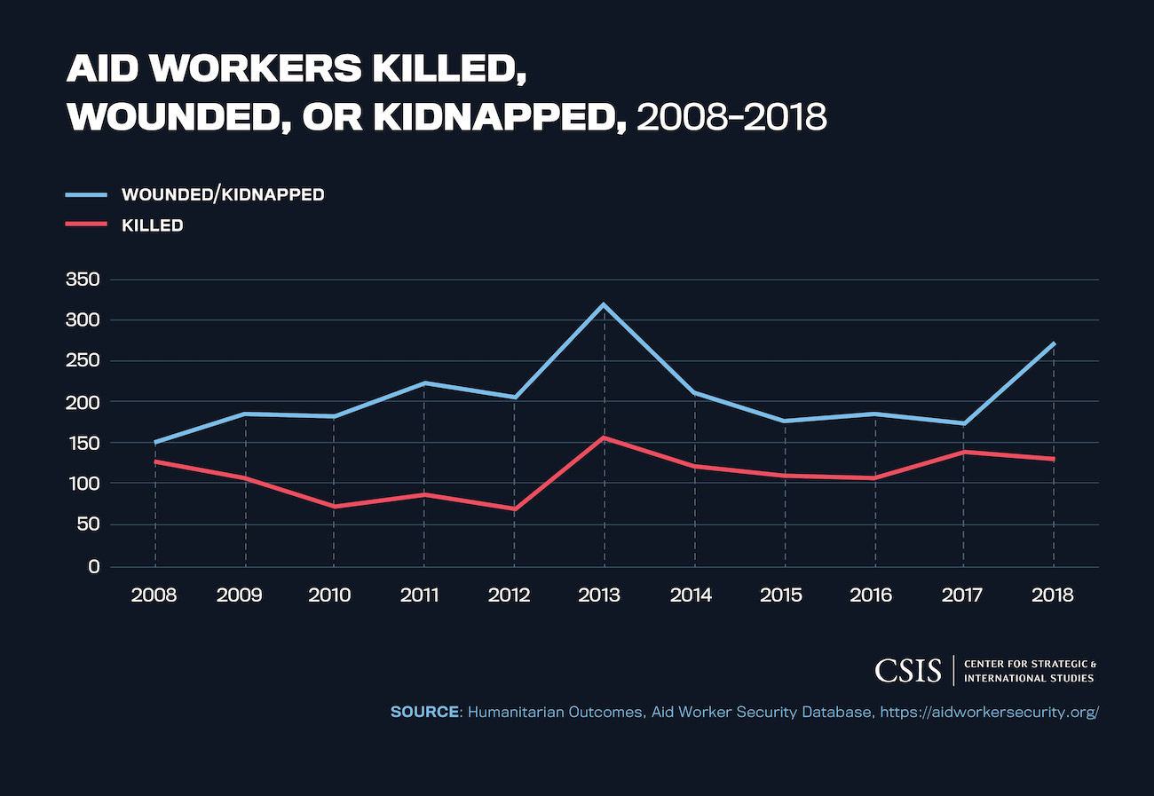

However, threats impacting access are not limited to direct attacks from armed groups. These range from landmines and unexploded artillery or ordnance to blockades, kidnapping, and arbitrary detention. Aid workers also face the risk of sexual exploitation and abuse.

Providing the necessary security and protection for aid workers puts financial pressure on humanitarian organizations and donor governments. Such security measures also threaten the perception of humanitarian actors’ neutrality in a conflict. For example, an armed aid escort traveling to a contested area may give the perception it is a proxy of one side, which can create additional security concerns for the aid workers and limit future access.

Insecurity also takes a toll on other types of infrastructure that humanitarian access depends on. Roads, highways, and bridges are critical to humanitarian assistance delivery and are therefore at the core of access. In conflict zones, they often become the target of political or strategic control through blockade or checkpoint. In Yemen, armed groups use checkpoints as a means of security and control and as a point of taxation for financial gain.

Access constraints in Northeast Nigeria have become so extreme that it can take four hours to travel a route that normally takes 15 minutes. The vulnerability of local civilian populations increases as infrastructure connecting communities and cities like this deteriorates. Aside from access denial, limiting people’s movement or destroying their means of mobility also deepens a population’s isolation and exacerbates underlying causes of conflict, such as economic and political fragility. This can exacerbate existing inequalities for persons with disabilities, women and girls, and the elderly.

Violence and insecurity pose serious physical and psychological risks to aid workers, restrict movement, and limit access to critical infrastructure like hospitals and schools. It is one of the most serious and pervasive threats to humanitarian access and creates undue suffering and loss of life.

1. **Bureaucratic Constraints**

Bureaucratic impediments to humanitarian access greatly complicate the ability of people in need to reach basic assistance and impair the ability of aid workers to provide it. Governments may seek to harm vulnerable communities or exploit aid organizations through many different bureaucratic tactics, from curbing the import of aid equipment and relief items to targeting aid workers as they attempt to operate in the country.

In some cases, parties have tried to exploit humanitarian action by levying excessive taxes and fees. They also have reduced administrative allowances for organizations to import goods, sometimes requiring permits to move and delaying their issuance. On top of this, onerous reporting and registering processes have been imposed on aid organizations.

States often exploit the visa process to deny humanitarian access to populations in need. The government of Myanmar for example regularly denied or delayed visas for international aid staff working in Rakhine state in late 2017. The aid professionals who were delayed or denied entry to the country were also denied the chance to help the Rohingya, even as hundreds of thousands of them were being attacked and forced from their homes.

Short of outright denial, state authorities may also impose excessive costs for registration and visas. One outrageous example of humanitarian extortion was the attempt by the government of South Sudan to increase visa fees to $10,000 for humanitarian personnel in 2017.

Bureaucratic constraints to humanitarian access are also put in place by donor countries and institutions. While all of these impediments may not generate the same media coverage and outrage as security incidents, they are equally harmful to the health and safety of civilians and equally difficult to overcome.

1. **Counterterrorism Regulation**

Counterterrorism and related economic sanctions regimes are designed to prohibit intentional support to terrorist organizations. However, while critical for national security, these same statutes can at times block humanitarian access to the populations suffering because of those terrorist organizations.

Should assistance fall into the hands of sanctioned actors, aid could be criminalized and aid workers carry the risk of prosecution for life-saving humanitarian activity. Domestic legal frameworks crafted in response to legitimate national security concerns do not always account for situations like this, which can put them in tension with state obligations to protect humanitarian assistance under international humanitarian law.

Counterterrorism regulation can create a burdensome standard for humanitarian actors and limit their ability to reach the most vulnerable. Some clauses require organizations to vet recipients of assistance, even prohibiting the provision of aid to those who may have been forcibly kidnapped by sanctioned armed groups.17

Aid organizations must dedicate substantial time and staff resources toward compliance with ever-evolving reporting regulations. Navigating these legal and regulatory requirements can contribute to financial constraints, which reduces the funds available for aid operations.

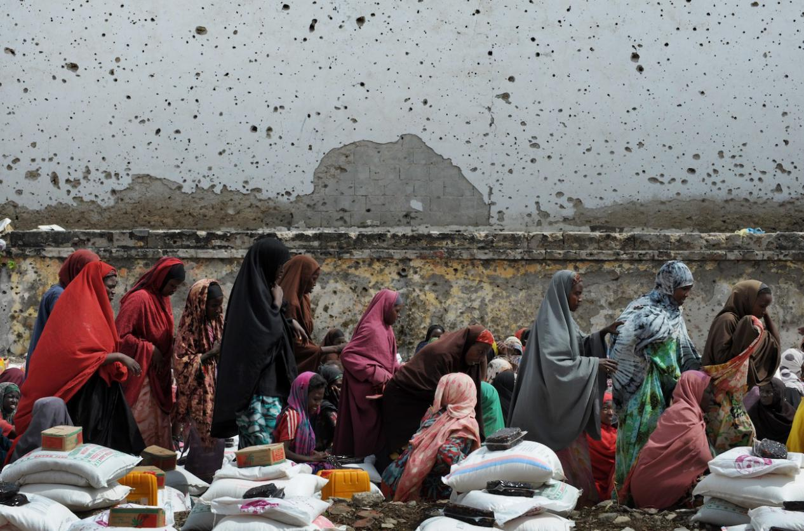

In spite of these complications, only in very rare cases have aid organizations and implementing partners turned down funding with stringent counterterrorism requirements. More often, despite strong reservations, the humanitarian imperative compels humanitarian actors to conform to donor requirements, despite the legal risks and compliance hurdles they entail.

These policies have effectively limited humanitarian organizations’ operational footprint and compelled them to engage in humanitarian action only in areas understood to be safe from legal risk. This runs counter to one of the core principles of humanitarian aid—that assistance be based on need—and leaves many vulnerable populations without lifesaving support.

**4. Funding**

Denial, delay, and diversion of humanitarian aid lead to substantial wasted time for humanitarian organizations who grapple with bureaucratic impediments, sit stuck at checkpoints, or are compelled to take circuitous routes to avoid insecure areas. This adds up to dollars and staff capacity being directed to navigating access constraints instead of being directed to meeting the needs of the most vulnerable. Funding for overcoming these impediments is increasingly hard to come by at a time when restrictions tied to funding are themselves an impediment to getting assistance to those who need it.

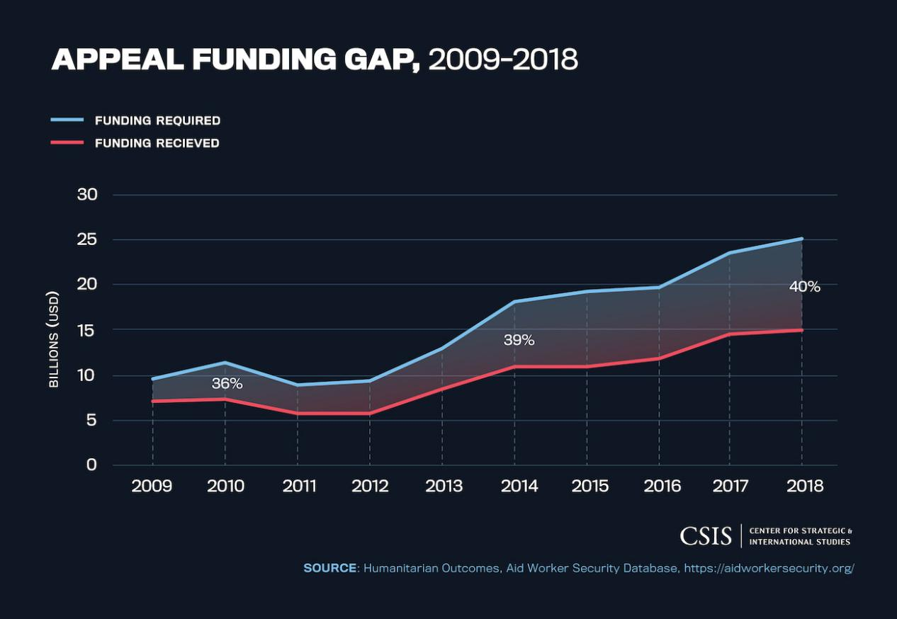

Access denial is becoming increasingly acute at a time when humanitarian needs are growing. While the overall number of armed conflicts globally fluctuates, the severity and length of ongoing conflicts have risen.21 In the last four years, the average length of crises with a UN-coordinated response increased from 5.2 years to 9.3 years.22 This average increase in response duration means 4 more years of aid funding on a global scale.

As a result, the international community is spending more money on humanitarian assistance than ever before, yet the need is growing even faster. In 2018, the total funding received for UN-coordinated appeals was $15.2 billion—a record high. One-third of this funding came from the United States.23 However, 2018 also saw a nearly $10 billion shortfall against UN appeal requirements—the largest ever.

Meanwhile, rising populism in donor states fuels skepticism about humanitarianism itself, undermining their willingness to tackle access challenges.

The disparity between funding needs and funding received is driven by the changing nature of crises. The UN Office for the Coordination of Humanitarian Affairs has stated that most of this aid is dedicated to civilians in regions struggling with protracted conflicts. Reducing access challenges is crucial to overcoming growing funding gaps.

**CHAPTER FIVE- SUMMARY, CONCLUSION AND RECOMMENDATION**

**5.1 SUMMARY OF FINDINGS**

What can be concluded from this analysis is that policy makers, diplomats and aid workers are increasingly struggling to develop appropriate responses to humanitarian crisis and conflict in contexts characterised by state breakdowns and competing military and para­military structures. But what comes out very clearly from the humanitarian experience in the past three decades is that the international community does not know yet how to deal with such dysfunctional states, particularly those which have limited strategic interests and even less in complex human crisis contexts.

From the observations and reports, it can be concluded that the major constraints to effective humanitarian aids are Counterterrorism Regulation, Bureaucratic Constraints, Violence and Insecurity,and Funding.

**5.2 CONCLUSION**

Humanitarian aid is one of the most effective and practical means of mitigating situations of armed conflict, natural disasters and other disaster situations. Humanitarian crisis crises are in many most cases unexpected and require immediate action to minimize suffering. It is a very complex area and assistance is given in many different forms, from efforts in conflict prevention to support to the difficult transitions phase towards peaceful development.

It includes support in areas related to health, sanitation, food security, shelter, migration and refugee issues, as well as efforts to clear mines, and peace-keeping efforts including police and military.Drawing borderlines between humanitarian policy, international security policy and migration policy is not an easy task. An increased number of natural disasters and drawn out situations of conflict have resulted in an increased need for humanitarian aid and international humanitarian operations have expanded substantially in reach and scale. Disaster risks such as extreme depletion of water resources, rapid and unplanned urbanization, global climate change, and environmental degradation, among other reasons, are expected to create more frequent and severe disasters in the near future.

The number of international humanitarian actors has grown considerably including Civil Society Organisations (CSOs), humanitarian donor countries and regional organisations. In addition, the UN agencies, as well as the Red Cross and Red Crescent movement, have developed and expanded. There has also been an increased engagement and support from military entities and in recent years also private companies and foundations. The increased humanitarian needs and growth of humanitarian assistance, in combination with a larger and more diversified group of actors, makes an increased international coordination and a strong, efficient and effective international humanitarian system even more important.

**Bibliography**

1. Mark Duffield, Global governance and the new wars, the merging of development and security. (London: Zed Books, 2001).
2. Nicolas de Torrenté, “Humanitarian Action under Attack: Reflections on the Iraq War”, Harvard Human Rights Journal, 17, (2004): 1­29.
3. Michael Barnett, Empire of Humanity: A History of Humanitarianism. (Ithaca/NY: Cornell University Press, 2011).
4. Hugo Slim, Military intervention to protect Human Rights: the humanitarian agency perspective. (International Council for Human Rights Policy, 2001); Barnett (2011).
5. Barnett (2011); Jorge Castilla, “On the Nature of Humanitarian Action”. MSF­Cuadernos para el debate 14: Ayuda humanitarian suministrada por los ejércitos. El ejemplo del lanzamiento desde el aire de raciones humanitarias de alimentos en Afeganistan. (Barcelona: Ed. Dirección Géneral MSF, 2002): 15­17.
6. (Francisco Rey; Victor Cuerra­Lugo, El debate humanitário. (Barcelona: Icaria, 2002): 27; Barnett (2011).
7. Duffield (2001): 77; Barnett (2011).
8. Slim (2001: 5).
9. Thomas Weiss, Military­civilian interactions: intervening in Humanitarian crises. (Maryland: Rowman and Littlefield Publishers Inc, 1999).
10. Fiona Terry, Condemned to Repeat? The Paradoxes of Humanitarian Action. (Ithaca NY: Cornel University Press, 2002); Rieff, 2002).
11. Mary B. Anderson, Do No Harm: How Can Aid Support Peace or War. (London: Lynne& Rienner Publishers, 1999). In Bosnia, for example, aid agencies were frequently accused of facilitating the ethnic cleansing they were condemning, by providing transportation and shelter; Karlos Pérez de Armiño, La vinculación ayuda humanitaria­cooperación al desarrollo. Objectivos, puesta en prática y críticas. (Vitoria­Gasteiz: Cuadernos de Trabajo de Hegoa, No. 33, 2002): 6. In Bosnia, for example, aid agencies were frequently accused of facilitating the ethnic cleansing they were condemning, by providing transportation and shelter.
12. Thomas Weiss; Michael Barnett (eds), Humanitarianism in Question: Politics, Power, Ethics. (Ithaca NY: Cornell University Press, 2008); Armiño (2002).
13. This debate about a necessary linkage between humanitarian and development assistance was itself focused on two main strategies: a first one consisting of a number of continuous phases in time starting from an emergency situation, through rehabilitation and ending in the development stage, the so­called continuum; and a second one, the contiguum, which emerged in part through a critics to the previous one, defending a combination, at every moment, of the different forms of intervention, suggesting an integral and coherent strategy aimed at reducing the vulnerabilities of the affected population and enhancing their own capacities (Armiño, 2002: 13).
14. Adam Roberts, “Humanitarian action in war”, Adelphy Paper, no. 305 (London: Oxford University Press, London, 1996): 13
15. Duffield (2001: 3); Bjorn Hettne, “Development and Security: Origins and Future”, Security Dialogue, 41, no.1 (2010): 31­52.
16. Mark Cutts, “Politics and Humanitarianism”, Refugees Survey Quarterly, 17, no.7 (1998):1­ 15.
17. Duffield (2001).
18. Armiño (2002: 6).
19. Weiss and Barnett (2008); Duffield (2001).
20. Armiño (2002: 7).
21. Hugo Slim, “Relief agencies and moral standings in war: principles of humanity, neutrality, impartiality and solidarity”, Development in Practice, 7, no. 4, (1997): 342­352.
22. Armiño (2002: 26).
23. Duffield (2001: 259).
24. Devon Curtis (ed.) Politics and Humanitarian Aid: Debates, Dilemmas and Dissension. Humanitarian Policy Group, Overseas Development Institute, London, 10 (2001): 7; Duffield (2001).
25. Duffield (2001: 16).
26. Duffield (2001: 88).
27. Deborah Eade; Tony Vaux, Development and Humanitarianism: Practical Issues. (Bloomfield CT, Kumarian Press, 2007): 3.
28. Duffield (2001: 76); Cutts (1998).
29. Joanna Macrae, “Politics vs. Aid: is coherence the answer?”, January 2001, available at http://www.eldis.org/go/country­profiles&id=10295&type=Document#.UcMtQ5z9UuA, last accessed 10 November 2014.
30. Duffield (2001: 96­97).
31. Francisco Rey, “Visiones de la Acción Humanitária en 1997”, Anuário CIP: Guerras Periféricas, derechos humanos y Prevención de conflitos. (Barcelona: Icaria and Fundación Hogar del Empleado, 1998):187.
32. Eade and Vaux (2007).
33. Mohammed Atmar, (2001) “The politicisation of humanitarian aid and its consequences for Afghans”, Disasters, 25, no.4 (2001): 321.
34. Atmar (2001: 322).
35. Joanna Macrae et al. (eds) War and Hunger: rethinking international responses to complex emergencies. (London: Zed Books (in association with Save the Children Fund (UK), 1994): 60.
36. Duffield (2001).
37. Fiona Fox, “A New Humanitarianism: Does it Provide a Moral Banner for the 21 st Century?”, Disasters. 25, no. 4, (2001): 280; Armiño (2002: 25).
38. Armiño (2002: 34).
39. Atmar (2001)
40. Atmar (2001: 326).
41. Ibid.; Fox (2001: 283).
42. Larry Minear, The Humanitarian Enterprise: Dilemmas and Discoveries. (Bloomfield CT: Kumarian Press, 2002)
43. Eade and Vaux (2007).
44. Marina Skuric Prodanovic, “Exclusion in Serbia”, in Devon Curtis (ed), Politics and Humanitarian Aid: Debates, Dilemmas and Dissension.Humanitarian Policy Group, Overseas Development Institute, London, 10 (2001).
45. Armiño (2002: 34); Fox (2001).
46. Rieff (2002).
47. Duffield (2001: 58).
48. Minear (2002); Tennant, Vicky, Bernie Doyle and Raouf Mazou, ‘Safeguarding humanitarian space: a review of key challenges for UNHCR’, Policy Development and Evaluation Service, UNHCR, February 2010, available at http://www.unhcr.org/4b68042d9.html (last visited July 13, 2012); Collinson, Sarah and Samir Elhawary, ‘Humanitarian Space: a review of trends and issues’, HPG Report 32, ODI, April 2012.
49. Joanna Macrae; Adele Harmer, (2003) Humanitarian Action and the ‘global war on terror’: a review of trends and issues. Humanitarian Policy Group, Overseas Development Institute, London, 9 (2003); Torrenté (2004).
50. Nicolas de Torrenté, The war on terror’s challenge to humanitarian action. Humanitarian Exchange, no. 22 (London: Overseas Development Institute, 2002): 44.
51. Duffield (2001: 60).
52. Torrenté (2004).
53. Jane Barry; Anna Jefferys, “A bridge too far: aid agencies and the military in humanitarian response”, Humanitarian Network Paper 37Network Paper 37, Overseas Development Institute, London (2002)
54. Vanessa Pupavac, “The Politics of Emergency and the Demise of the Developing State: If you enjoyed this article, please consider sharing it! POST COMMENT Problems for Humanitarian Advocacy”, in Deborah Eade; Tony Vaux, Development and Humanitarianism: Practical Issues. (Bloomfield CT, Kumarian Press, 2007), 27­49; John Cosgrave, The Impact of the War on Terror on Aid Flows. (London:Action Aid, 2004).