**The Impact of Cannabidiol on Intestinal Tumorigenesis: A Pilot Study on Caco-2 Cell**

**ABSTRACT**

Colorectal cancer (CRC) is the third most prevalent cause of cancer-related deaths worldwide. Despite the availability of early diagnosis and treatment options, which could potentially increase the 5-year survival rate, the accessibility of such CRC management measures remains limited due to cost barriers and uneven healthcare infrastructure globally. This underscores an urgent need for effective preventive methods and affordable treatments.Cannabidiol (CBD), a compound derived from cannabis, has garnered attention as a potential natural therapeutic agent. This study investigates the influence of CBD on the serotonin pathway and intestinal tumorigenesis. Serotonin, primarily produced in the intestine, is not only a critical neurotransmitter but also has complex and multifaceted biological functions. In this investigation, Caco-2 cells were exposed to CBD, and we observed an increase in serotonin levels. The treatment elevated the expression of several genes related to serotonin such as TPH, SLC6A4, HTR2A, HTR1D, HTR2C, and HTR4, with a notable increase in TPH and HTR2C. Concurrently, CBD exhibited an enhancement in immune response and significant inhibition of the Wnt signaling pathway, implying a protective role of CBD in CRC. Given the dual roles of serotonin in CRC — protective in early stages and promotive in later stages — the interaction between serotonin, the Wnt signaling pathway, and the immune system necessitates further research. Our findings shed new light on the potential role of CBD in inflammatory colorectal tumors, suggesting that CBD could be a promising candidate for CRC immunotherapy.

***Key words:*** Canabidiol, Colorectal Cancer, Serotonin pathway, Wnt-signaling.

III

**TABLE OF CONTENTS**

***ACKNOWLEDGMENT I***

***ABSTRACT II***

***LIST OF TABLES VI***

***LIST OF FIGURES VII***

***CHAPTER 1 1***

***INTRODUCTION 1***

***CHAPTER 2 4***

***LITERATURE REVIEW 4***

**2.1 Colorectal Cancer 4**

2.1.1 Inflammatory Bowel Disease and Colorectal Cancer 8

2.1.2 Wnt Signaling Pathway and Colorectal Cancer 9

2.1.3 Inflammation and Colorectal Cancer 11

2.1.4 Treatment for colorectal cancer 12

**2.2 CBD and Colorectal Cancer 14**

2.2.1 Cannabinoids Receptors and Endocannabinoids 15

2.2.2 Anti-Tumor Function of Cannabidiol (CBD) 16

**2.3 Serotonin and Colorectal Cancer 20**

**2.4 Linkage of CBD, Serotonin and CRC 27**

***CHAPTER 3 31***

***PURPOSE OF THE STUDY 31***

***CHAPTER 4 33***

***RESEARCH PLAN 33***

**4.1 Research Design 33**

**4.2 Reagents and Chemicals 34**

**4.3 Cells line and cell culture 34**

**4.4 Cell Viability Assays 35**

**4.5 Quantitative Real Time PCR Analyses 36**

**4.6 Western Blot 37**

**4.7 Statistical Analysis 38**

***CHAPTER 5 39***

IV

***RESULTS 39***

**5.1 Cell Viability Assay of CBD Treatment in Caco-2 Cells 39**

**5.2 CBD Alters the Inflammatory Mediators Profile of Caco-2 Cells 40**

**5.3 CBD increase the expression of Serotonin receptors 44**

**5.4 Effect of CBD on the Expression of Wnt Targeted Genes and Other Signaling Pathways in Caco-2**

**Cells 48**

***CHAPTER 6 54***

***DISCUSSION 54***

***APPENDIX A 69***

***TABLE OF PERFORMED ASSAYS AND EXPERIMENTAL DESIGN 69***

***APPENDIX B 71***

***TABLE OF PRIMERS USED FOR REAL-TIME PCR ANALYSIS 71***

***REFERENCES 73***

V

**LIST OF TABLES**

**TABLE**

**Page**

1.Experimental design…………………………………………………………………64

VI

**LIST OF FIGURES**

**FIGURE**

**Page**

1.Colorectal Cancer……………………………………………………………………………6

2.Serotonin Synthesis and Serotonin Receptors……………………………………………22

3.Cannabidiol (CBD) reduce cell viability of Caco-2 cells…………………………………39

1. Heatmap and relative gene expression level of targeted inflammatory mediators in Caco-2 cells with 24h CBD treatment ……………………………………………………41
2. Heatmap and relative gene expression level of targeted serotonin receptors in Caco-2 cells with 24h CBD treatment ………………………………………………………………45
3. Heatmap and relative gene expression level of genes related to Wnt signaling pathway in Caco-2 cells with 24h CBD treatment ……………………………………………………50

VII

**CHAPTER 1**

**INTRODUCTION**

Colorectal cancer (CRC) is one of major global public health concerns, ranking as the third most common cancer in men and women in the United States in terms of high morbidity and mortality. After surgical resection, the five-year survival rate for CRC is 99% for stage 1, 68-83% for stage 2, and 45-65% for stage 3 disease(Knapen et al. 2023). CRC can be induced by several factors, such as family history, age, environmental factors including the critical dietary factors. Having inflammatory bowel diseases (IBD) including Crohn's disease and ulcerative colitis that affects most of your colon can increase your risk of CRC. *Wnt*/β-catenin signaling pathway is a crucial pathway in both normal and malignant cell proliferation. In over 90% of CRC, *Wnt*/β-catenin signaling pathway is abnormally activated. According to the previous studies, *Wnt*/β-catenin signaling can also be enhanced through different inflammatory pathways, thus initiate tumorigenesis (Grivennikov 2013). Although the overall incidence of CRC is decreasing due to colonoscopies, there is a concerning increase in its incidence among young people

1

(Harewood et al. 2022). Therefore, the development for novel strategies for the prevention and treatment of CRC is warranted.

Cannabidiol (CBD), one of the most common components of over 100 different cannabinoids, is a non-psychoactive compound extracted from cannabis. Its effectiveness in inhibiting the proliferation, migration, and invasion of cancer has been explored. Numerous studies have shown the anti-proliferative function of CBD in CRC and the potential mechanisms. Previous research has shown that CBD can impact CRC through various ways, including binding to serotonin receptors, modulating immune mediators, and affecting the *Wnt*-signaling pathway. As such, CBD holds a great potential as a reagent for the prevention and treatment of CRC.

Serotonin (5-HT) is a neurotransmitter that plays a crucial role in regulating various physiological functions, including mood, appetite, and intestinal motility. Approximately 90% of serotonin is synthesized in the intestine, and studies have showed a dual role of serotonin in colorectal tumorigenesis. Serotonin has been linked to exacerbating the symptoms of colitis and promoting the expansion of CRC cells. Nevertheless, recent discoveries have shown that deficiencies in serotonin synthesis cause colonocytes to

2

undergo high levels of DNA damage, which is associated with inflammatory response that facilitate the growth of CRC (Kannen et al. 2020). Here, we review the dual role of serotonin in CRC and discuss how CBD mediates colorectal tumorigenesis via the highly complicated serotonin pathway. This proposal aims to examine the relationship between CBD and serotonin, as well as their effects on the tumorigenic *Wnt*-signaling in the Caco-2 CRC cell lines.

3

**CHAPTER 2**

**LITERATURE REVIEW**

**2.1 Colorectal Cancer**

Cancer is a leading cause of death worldwide, leading to nearly 10 million deaths in 2020. The most commonly diagnosed cancers are breast, lung, colorectal and prostate cancer. CRC, also known as colon cancer or rectum cancer, is a type of cancer that occurs in the colon or rectum. According to WHO data, there were 1.93 million cases of CRC in 2020, resulting in 916,000 deaths. CRC is the third most common cancer globally, as the data from the World Cancer Research Fund International (WCRF). It is also the third most common cancer in men and second most common cancer in women. The American Cancer Society (ACS) estimates that there will be 106,970 new cases of colon cancer and 46,050 new cases of rectal cancer in the United States in 2023(Oseghale and Ikokwu n.d.). Although the overall incidence rate of CRC has decreased due to screening and lifestyle changes, the incidence rate among young people has been steadily increasing since at least the mid-1990s. However, the good news is that the death rate of CRC has decreased for several decades.

4

Colon cancer can be prevented by detecting and removing premalignant colon adenomas and by detecting colon cancers at early stages when they can be surgically removed(Markowitz et al. 2002). The 5-year survival rate is a commonly used measure of prognosis in cancer patients, which refers to the percentage of people who survive at least five years after their cancer diagnosis. In colon cancer, it is noted that the 5-year survival rate is strongly correlated with the stage of the disease at the time of diagnosis. Specifically, patients diagnosed with regional disease have a higher 5-year survival rate of 70%, whereas those diagnosed with metastatic disease have a much lower survival rate of only 9%(Burt 2000). Mass screening starting at age 50 is recommended for the average risk adult population, with earlier screening for those at higher risk. Available screening methods include chemical testing for blood in stool, sigmoidoscopy, or colonoscopy, with colonoscopy having the highest sensitivity. However, the expense and inconvenience of colonoscopy have made mass screening difficult. The recent discovery of colon cancer-specific mutations in DNA from feces has raised hope for the development of molecular-based screening.

5

The large intestine is a vital component of the digestive system, responsible for absorbing water and electrolytes from undigested food and forming feces for elimination. It is composed of two main parts: the colon and rectum. The colon itself is divided into four parts, including the ascending colon, transverse colon, descending colon, and sigmoid colon. The ascending colon moves waste material from the small intestine to the transverse colon, which then moves waste across the abdomen to the descending colon,

6

and finally to the sigmoid colon. The sigmoid colon then connects to the rectum, which is the final six inches of the large intestine.

Figure 1. Colorectal Cancer

The first step in the development of colon cancer is the appearance of neoplastic polyps on the inner lining of the colon. Adenomatous polyps are the most common precursor of

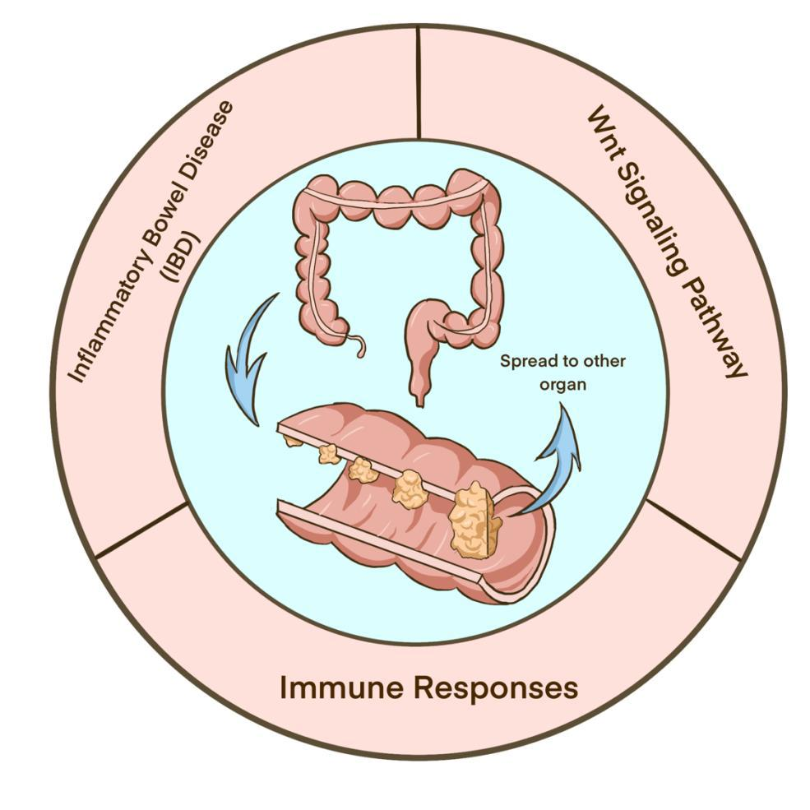

colon cancer, with an increasing number of adenomatous polyps in the colon significantly

7

increasing the risk of colon cancer. Patients diagnose with adenomatous polyps larger than 1 cm or more than three polyps are at high risk for colon cancer. Familial adenomatous polyposis (FAP) is a risk factor for the development of colon cancer. Adenomatous tissue is frequently found contiguous to frank carcinoma(Cappell 2005). Although hyperplastic polyps were once thought to have little connection to CRC, recent studies show that some hyperplastic polyps are associated with colon cancer, especially if they are large, located in the right colon, have a focus of adenoma within the polyp, or if there are more than 20 hyperplastic polyps in the colon(Jass 2004). Serrated adenomas can also lead to colon cancer via *BRAF* genetic mutations, exhibiting extensive DNA methylation and a lack of adenomatous polyposis coli (APC) gene mutations(Cappell 2008).

**2.1.1 Inflammatory Bowel Disease and Colorectal Cancer**

Inflammatory bowel diseases (IBD), such as Crohn's disease and ulcerative colitis, are chronic inflammatory disorders that affect the intestine. The prevalence of IBD in the United States is over 200 cases per 100,000, with 1 to 1.5 million patients affected. Crohn’s disease can impact any part of the gastrointestinal tract, but it typically affects the distal part of the small intestine or ileum and colon. On the other hand, ulcerative

8

colitis causes colonic inflammation that may affect only the rectum or progress proximally to involve part or the entire colon. Clinical symptoms of IBD include diarrhea, abdominal pain, gastrointestinal bleeding, and weight loss. Long-term complications of chronic inflammation include the development of CRC(Rubin, Shaker, and Levin 2012).

The pathogenesis of IBD is not completely understood, but there is growing evidence that the pro-inflammatory cytokine interleukin-6 (IL-6) plays a crucial role in the uncontrolled inflammatory process(Atreya and Neurath 2005). Elevated production of IL-6 and its soluble receptor (sIL-6R) by intestinal macrophages and T-cells contribute to the perpetuation of chronic intestinal inflammation by increasing T-cell expansion. IL-6-sIL-6R complexes also play a potential role in the pathogenesis of CRC. This understanding of the pathogenic role of IL-6 may lead to the development of new therapeutic strategies for IBD and CRC.

**2.1.2 Wnt Signaling Pathway and Colorectal Cancer**

The Wnt signaling pathway is essential for maintaining intestinal stem cells and the self-renewal of the intestinal epithelium. It also plays a crucial role in embryonic development and carcinogenesis. The pathway is initiated by a Wnt signal binding to the Frizzled/LRP

9

receptor complex on the cell membrane, which then transmits signals to intracellular

proteins like Dishevelled (Dsh), glycogen synthase kinase-3β (GSK-3), Axin, and

Adenomatous Polyposis Coli (APC). The GSK-3/APC/Axin complex inhibits β-catenin

degradation, causing β-catenin to accumulate in the nucleus and interact with TCF,

leading to the activation of critical genes such as cell proliferation(Logan and Nusse 2004).

The Wnt signaling pathway plays a crucial role in the pathogenesis of CRC, with mutations in β-catenin, APC, and Axin promoting β-catenin stability. This inhibits apoptosis in colon cancer, and high β-catenin expression is correlated with various cancers, including colon cancer. Tcf4 is the predominant Tcf factor in colon cancer cells. Dysfunctional regulation of the Wnt/beta-catenin pathway is the primary cause of colon cancers, with abnormal accumulation of a beta-catenin/T-cell factor 4 complex in the nucleus, leading to c-MYC activation and differentiation suppression. Both Bmi1+ and Lgr5+ stem cell populations generate tumors when beta-catenin signaling is activated in these cells(Sanders 2011).

10

**2.1.3 Inflammation and Colorectal Cancer**

In recent years, the correlation between inflammation and CRC has been established, with inflammation playing a crucial role in colorectal carcinogenesis. The process of colon cancer immunoediting involves three phases: elimination, equilibrium, and escape. During the elimination phase, immune cells remove neoplastic cells that are naive to surface expression. In the equilibrium phase, tumors survive through antigenic surface molecules hiding or inhibiting macrophages and T lymphocytes directly. Finally, in the escape stage, cancer cells escape from being killed and keep on evading and proliferating.

CD8+ T cells have been found to have potent anti-tumor functions, as demonstrated in a study by Naito et al, which revealed that patients with CD8+ T cells infiltrating cancer cell nests had better survival rates(Naito et al. n.d.). However, regulatory T cells (Tregs) expressing CD4+CD25+ can accumulate in the tumor environment, potentially inducing an immune escape mechanism(Waldner 2006).

IL-6, a mediator of the immune response, plays a role in promoting the differentiation of naive CD4+ T cells. In a study by Korn et al, it was found that IL-6 can inhibit transforming growth factor (TGF)-β from inducing Foxp3, the transcription factor for Tregs. IL-6, in

11

combination with TGF-β, can induce a significant amount of IL-17 from naive T cells. IL-6 induction also leads to the differentiation of CD8+ T cells into cytotoxic T cells(Tanaka, Narazaki, and Kishimoto 2014). Additionally, recent studies have shown a potential role of IL-6 in the pathogenesis of colon cancer as it promotes the growth of colon cancer epithelial cells and enhances colony formation of human colon carcinoma cells in vitro(Schneider et al. 2000). A recent study demonstrated a functional relationship between TGF-β signaling in tumor-infiltrating cells and IL-6 trans-signaling in colon carcinogenesis(Becker et al. n.d.). The study showed that IL-6 trans-signaling is essential for colon carcinogenesis and that sIL-6R plays a critical role at different stages of colon cancer pathogenesis. This implies the possible therapeutic strategy of targeting the sIL-6R and ensuing IL-6 trans-signaling.

**2.1.4 Treatment for colorectal cancer**

Despite the high morbidity and mortality of CRC, identified at an early stage will increase the chance of cure with the standard therapies. The prevention of CRC relies on screening to diagnose adenomatous polyps, which can lead to cancer. Standard treatments for colon cancer include surgery, chemotherapy, and radiation therapy(Aiello et al. 2019). Antiangiogenic agents are also used to treat cancer progression. The

12

treatment approach depends on the stage of cancer. In 75-80% of patients, colon cancer is limited to the intestinal wall at diagnosis, without invasion of regional lymph nodes (stages I and II) or with invasion of them (stage III)(Grávalos et al. 2009). In stage IV, the cancer has spread to other organs, which is less common at diagnosis but can happen in recurrent colon cancer. Adjuvant chemotherapy is recommended for stage III patients, but its benefit in stage II patients is uncertain(Chakrabarti et al. 2020). While surgery and chemotherapy are options for stage IV and recurrent colon cancer. Chemotherapy drugs such as 5-fluorouracil, along with bevacizumab, panitumumab, or cetuximab, are commonly used. Chemotherapy targets active cells, including cancer cells, but can also damage healthy cells, leading to side effects such as fatigue, nausea, and hair loss.

Although the standard treatment for colon cancer is effective, many developing countries lack access to modern diagnostic methods and facilities, leading to the use of traditional treatments such as phytotherapy (the use of plant extracts)(Edgar et al. 2007). Medicinal plants have been shown to have therapeutic effects on various diseases and their potential use in cancer prevention and therapy has been suggested. In particular, medicinal plants may be useful in treating colon cancer with fewer side effects than current treatments(Aiello et al. 2019). Recent studies suggested that CBD, which is

13

extracted from cannabis sativa, is a potential treatment for colon cancer. It is found to reduce cell proliferation via activation of CB1 and CB2 receptor. This review aims to analyze the effectiveness of CBD in treating CRC, as well as the relationship between CBD and serotonin in colon cancer cells. Besides, we will also investigate the underlying molecular mechanisms of CBD in CRC.

**2.2 CBD and Colorectal Cancer**

Cannabis sativa is a member of the Cannabis genus, part of the Cannabaceae family of plants. These plants contain cannabinoids, of which there are over 100 different types, with their presence and quantity varying between individual plants. One well-known cannabinoid is tetrahydrocannabinol (THC), which is responsible for the psychoactive effects associated with the plant(Schilling, Melzer, and McCabe 2020). Another important cannabinoid in Cannabis sativa is cannabidiol (CBD), which does not have psychoactive effects and is thus useful for further research. CBD has been found to inhibit the migration, invasion, and metastasis of cancer cells. This paper will discuss the anti-tumor properties of CBD and the mechanisms behind them.

14

According to Seltzer et al., the use of Cannabis sativa plant extract can be traced back to 500BC in Asia(Seltzer et al. 2020). In the 19th and early 20th centuries, cannabis was widely used as medicine in the US until it was excluded from the United States Pharmacopoeia more than half a century later. This led to the prohibition of cannabis possession and use until 1996, when it was legalized for medical purposes in California(Bridgeman and Abazia n.d.). Now it is legal for medicinal use in 36 states and DC, including Massachusetts. Moreover, the use of cannabidiol extract has been permitted in all 50 states. Despite the legalization of cannabis for medical purposes, its use and effectiveness for various medical conditions are still subject to ongoing research and debate.

**2.2.1 Cannabinoids Receptors and Endocannabinoids**

In the late-1980s, specific cannabinoids receptor, CB1 and CB2, were discovered(Seltzer et al. 2020). CB1 and CB2 receptors have different sensitivity when detect different endocannabinoids, with some being more selective for one over the other. CB1 receptors, which are found on presynaptic terminals and involved in the inhibition of neurotransmitter release. The endocannabinoids anandamide and 2-arachidonoylglycerol, which act as partial or full agonists at CB1 receptors and can regulate cAMP synthesis, Ca2+ channels,

15

and inwardly rectifying Kir channels(Howlett 2002). These observations suggest that endocannabinoids may serve as retrograde synaptic messengers in controlling neurotransmitter release. CB2 receptors have many different functions in various immune cells and organs, including the spleen, thymus, tonsils, bone marrow, pancreas, and peripheral blood leukocytes(Berdyshev 2000). Cannabinoid drugs can modulate the activities of macrophages and macrophage-like cells involved in the activation of T lymphocytes(Mccoy et al. 1999). The effects of CB2 receptors on immune function include inhibition of natural killer cell activity, modulation of immune cytokines, and suppression of antitumor immunity. Additionally, signal transduction via the CB2 receptor is mediated via Gi/o proteins, and 2-Arachidonoylglycerol is a full agonist for this receptor(Gonsiorek et al. n.d.).

**2.2.2 Anti-Tumor Function of Cannabidiol (CBD)**

One interesting aspect of cannabinoids is their potential anti-tumor properties. Interestingly, endocannabinoids have be both inhibitor and promotor to the CRC according to the stage of cancer. Both CB1 and CB2 receptors have been found to be expressed in many types of cancer, and their overexpression is correlated with disease severity and poor prognosis in some cases(Martínez-Martínez et al. 2015; Mukhopadhyay

16

et al. 2015). The administration of cannabinoids has been shown to inhibit the growth of various types of cancer in vitro and in vivo models through mechanisms such as cell cycle arrest, induction of apoptosis, and inhibition of neovascularization, migration, adhesion, invasion, and metastasis. However, the clinical use of these compounds is limited due to their psychoactive side effects(Seltzer et al. 2020).

The antiproliferative function of CBD in CRC has been extensively researched. Previous study investigated the effect of a Cannabis sativa extract with high CBD content, CBD BDS, on colon cancer cell proliferation and in experimental models of colon cancer in vivo. The results showed that CBD BDS and CBD reduced cell proliferation in tumoral cells but not in healthy cells, and the effect was counteracted by selective CB1 and CB2 receptor antagonists. In vivo, CBD BDS reduced preneoplastic lesions, polyps, and tumor growth in a xenograft model of colon cancer. The study suggests that CBD BDS attenuates colon carcinogenesis and inhibits CRC cell proliferation via CB1 and CB2 receptor activation, which may have clinical relevance for the use of Cannabis-based medicines in cancer patients(Romano et al. 2014). Furthermore, CBD has been shown to inhibit colon cancer proliferation in a dose-dependent manner.

17

PanFeng et al. conducted a study to investigate the effect of CBD on suppression of invasion and metastasis in CRC cells using HCT116, SW620, and DLD-1 with different concentrations of CBD (0, 3, 6, 9, 12, and 15 μM). After 24 hours, the proliferation of HCT116, SW620, and DLD-1 was decreased in a concentration-dependent manner. They studied the anticancer ability of CBD in the orthotopic xenograft tumor model in BALB/c mice and found that the tumor volume and weight in the CBD-treated group were decreased compared to the control group. EMT markers were detected to show the metastasis ability of colorectal cells. The expression of N-cadherin, Snail, vimentin, and β-catenin was in a declining trend, whereas only the expression of E-cadherin was increased, indicating that CBD suppresses colorectal cell metastasis by inhibiting EMT. The impact of the Wnt/β-catenin cell signaling pathway by CBD was also studied. Consistent with the hypothesis, β-catenin was decreased after treatment with CBD, which can inhibit EMT in CRC. Taken together, these studies suggest that CBD may block the Wnt/β-catenin signaling pathway to inhibit the proliferation, invasion, and metastasis of CRC (Feng et al., 2022).

Azoxymethane (AOM) is a possible pathway to induce colon cancer with abnormal expression of aberrant crypt foci (ACF, preneoplastic lesions), polyps, and tumor

18

formation, upregulation of phospho-Akt, iNOS and COX-2 and downregulation of caspase-3. A study showed Cannabis sativa, as a chemopreventive agent in colon cancer. The study found that cannabidiol reduced preneoplastic lesions, polyps, and tumors in a mouse model of colon cancer, and protected DNA from oxidative damage in colorectal carcinoma cell lines. The researchers also observed that cannabidiol increased endocannabinoid levels and reduced cell proliferation in a CB1-, TRPV1-, and PPARγ-antagonists sensitive manner. The study suggests that cannabidiol has multiple mechanisms for reducing colon cancer and may be a promising candidate for future chemoprevention research.

In conclusion, CBD has been found to have significant effects on immune mediators. Studies have shown that it can suppress the secretion of the proinflammatory cytokine IL-1β and induce significant modulation of IL-6 production(Sermet et al. 2021). Additionally, CBD has the ability to modulate the JAK/STAT pathway, which provides a novel approach to immunosuppression(Peyravian et al. 2020). CBD inhibits the production of various activators of JAK/STAT, including IL-2, IFN-γ, and IL-10, and also suppresses TNF and IFN-γ production in certain models. The overall effect of CBD on the immune system is immunosuppressive through the suppression of JAK/STAT

19

initiators. These findings suggest that CBD has the potential to be used as a therapeutic agent for various autoimmune and inflammatory diseases.

**2.3 Serotonin and Colorectal Cancer**

Serotonin, also known as 5-hydroxytryptamin(5HT), is a monoamine that regulates various biological processes in the central and peripheral nervous system, including brain activity, blood clotting, immunological responses, cardiovascular function, and the intestinal microbiome. Despite being most well-known for regulating neural activity, all 15 serotonin receptors have been found to express outside of the brain (Berger, Gray, and Roth 2009). Serotonin is synthesized from tryptophan, an essential amino acid that people must obtain from their diet. After absorption in the gut, tryptophan is transformed into free and albumin-bond fractions, which can cross the blood-brain barrier and synthesize serotonin in the central nervous system. In addition to the CNS, the majority of serotonin exists in the gut system (O’Mahony et al. 2015). Serotonin is synthesized in the enterochromaffin cells of the intestinal epithelia. Tryptophan is taken up by amino acid transport systems in enteroendocrine units, where it is catalyzed by tryptophan hydroxylase (TPH) to produce 5-hydroxytrptophan (5-HTP). TPH has two forms: TPH1 is primarily found in the enterochromaffin cells of the intestine, while TPH2 is expressed

20

only in the central nervous system. 5-hydroxytryptophan is then converted to serotonin (5-HT) by aromatic amino acid decarboxylase (AADC). After serotonin secretion, serotonin reuptake transporters (SERT) transport serotonin into neurons and platelets (Wan et al. 2020).

In addition, 5-HT synthesis can be promoted by human- and mouse-derived gut microbiota(Reigstad et al. 2015). Reigstad and her colleagues evaluated the effects of gut microbiota on colonic serotonin production in mice that were germ-free or humanized. Results showed that gut microbiota from humanized and conventionally raised mice increased colonic Tph1 and chromogranin A, leading to increased colonic Tph1 protein and 5-HT concentrations. Short-chain fatty acids were found to be important determinants of enteric 5-HT production and homeostasis through their effect on enterochromaffin cells. Interestingly, 5-HT, in turn, promote proliferation of particular gut microbes, such as Enterococcus faecalis, E.coli and Rhodospirillum(Yano et al. 2015). Notably, the gut microbiota can influence the production, secretion, and degradation of serotonin. In a study, both CRC tumor tissue and normal tissue were examined. The results showed that serotonin and 5-Hydroxy-3-indoleacetic acid (5-HIAA) were only present in the normal

21

tissue samples. Therefore, it appears that cancer-related local microbiome dysbiosis is associated with the inhibition of the serotonin synthesis pathway(Loke et al. 2018).

Serotonin is essential in the gastrointestinal system, with about 95% of serotonin residing in the gut (Gershon and Tack 2007). Serotonin regulates many gastrointestinal activities. After food activates the taste-bud cells, serotonin is released. Serotonin can stimulate sensory afferent nerves, which then send messages to the central nervous system. When food enters the GI tract, serotonin regulates peristaltic waves. Serotonin is also released by pancreatic enzyme secretion. Additionally, serotonin can be a promising treatment for irritable bowel syndrome (IBS) and can be treated with 5-HT3 and 5-HT4. Excessive GI serotonin that is released from enterochromaffin cells can activate 5-HT3 (Bertrand and Bertrand 2010).

22

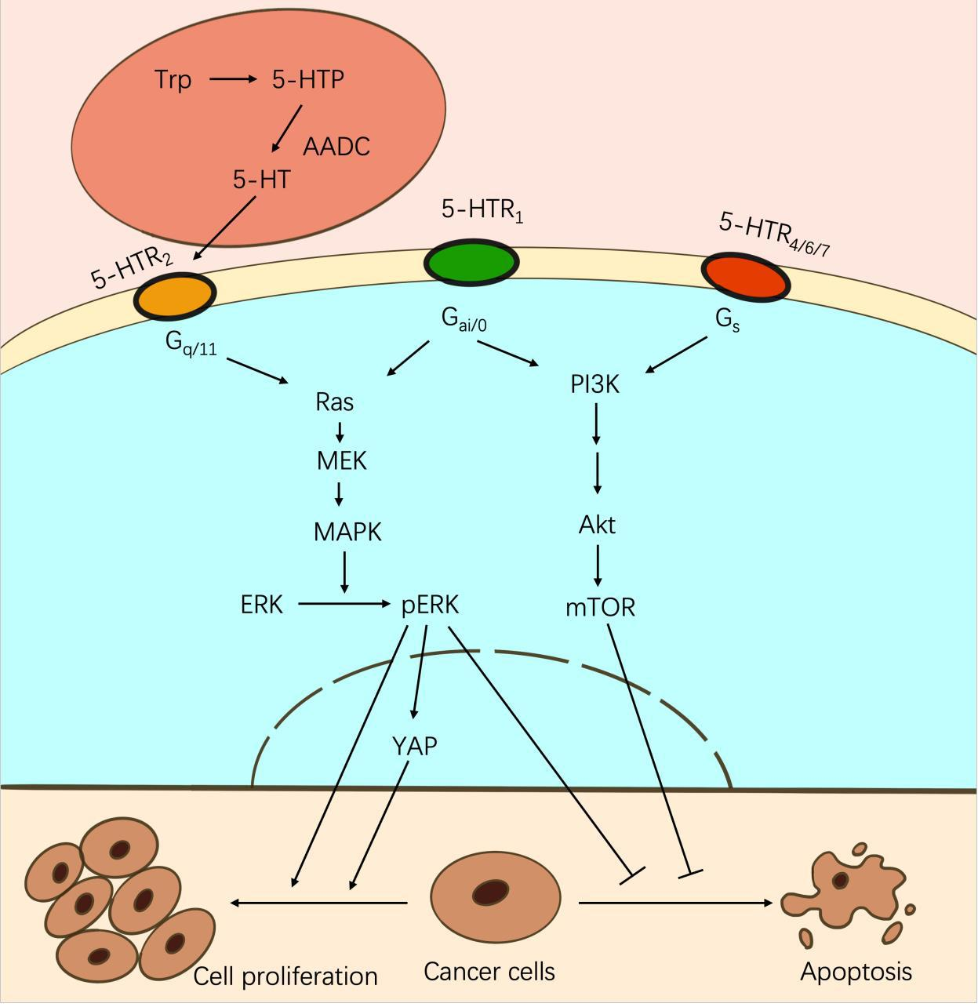

Figure 2. Serotonin Synthesis and Serotonin Receptors

In vitro, serotonin promote tumor cell proliferation in CRC (Sarrouilhe and Mesnil 2019). Elevated levels of 5-HT have been linked to worsened colitis symptoms and increased colorectal tumor development in mice(Sikander et al. 2015). A study aimed to investigate

23

the relationship between the serotonin transporter gene promoter polymorphism (5-HTTLPR) and 5-HT concentration in microscopic colitis (MC) and ulcerative colitis (UC) patients has been conducted. The results showed that the frequency of the 5-HTTLPR genotype was significantly lower in MC patients compared to controls, and the frequencies of non-deletion/deletion (non-S) genotype was significantly higher in MC patients than the deletion/ deletion (S/S) genotype. Serotonin levels were significantly higher in UC and MC patients compared to healthy controls. The study suggests that 5-HTTLPR is a potential candidate gene involved in the pathogenesis of microscopic colitis, and serotonin may play an important role in the pathogenesis of colitis.

Nonetheless, studies have shown that 5-HT plays a crucial role in intestinal protection, which is why administering selective 5-HT reuptake inhibitors to patients can decrease their risk of CRC (Coogan, Strom, and Rosenberg 2009). While some studies suggest that 5-HT is involved in intestinal diseases, further examination of its role in the complex protective mechanism of the intestine indicates that it promotes malignancies only when its function is compromised.

24

To reveal how mutation of serotonin synthesis impact the early stages of colorectal tumorigenesis (CRT), Juliana and colleagues investigated the role of 5-HT synthesis in this period. Using mouse models with defective 5-HT synthesis, the study found that 5-HT deficiency increased colonic DNA damage, inhibited genetic repair of carcinogen-related damage, and led to CRT-related inflammatory reactions and dysplasia. Restoring 5-HT levels with treatment decreased levels of DNA damage and increased DNA repair activity, indicating a protective role for 5-HT synthesis in the early stages of CRT. These findings suggest that 5-HT signaling pathways may be involved in preventing the development of early events related to CRT (Sakita et al. 2019).

Given the idea that harmful compounds promoting CRC may impair 5-HT activity, it is worth noting the impact of high-fat diets (HFD), which have been found to alter the intestinal microbiome and promote early CRC development(Schulz et al. 2014). In this

study, the HFD consumption in conjunction with *K-rasG12Dint* mutation mediates a shift in the composition of the gut microbiota that compromises host defense leading to dendritic cell recruitment and major histocompatibility complex (MHC) class II molecule presentation in the gut-associated lymphoid tissues. MYD88 deficiency blocked tumour progression, and treatment with antibiotics completely blocked HFD-induced tumour

25

progression, suggesting that distinct shifts in the microbiota have a pivotal role in aggravating disease. Notably, in rats exposed to carcinogens and fed a fat-enriched diet, 5-HT synthesis and reuptake were found to be inhibited. This occurred despite the diet not significantly increasing body weight, but rather enlarging visceral adipose tissue, promoting inflammation, and increasing the risk of CRC(Kannen et al. 2012).

The mechanism by which 5-HT promote proliferation in CRC cells remains unclear, but it is thought that activation of 5-HT reuptake transporters and receptors can stimulate this process (Kannen et al. 2020). Sui and colleagues found that overexpress of 5-HT1D receptor (5-HT1DR) was related with Wnt signaling pathway and advanced tumor stage,

and promotes tumor invasion through activation of the Axin1/β-catenin/MMP-7 pathway.

A 5-HT1DR antagonist effectively inhibits tumor metastasis in a CRC mouse model.

Additionally, 5-HT1DR also plays a role in cell invasion via the Axin1/β-catenin/MMP-7

pathway in intestinal epithelium cells. These findings suggest that 5-HT1DR has an

essential role in pulmonary metastasis of CRC (Sui et al. n.d.).

The results demonstrate that the role of 5-HT in the development of CRC is crucial, but it is still not fully understood. An interesting interaction exists between 5-HT and the gut

26

microbiome. Normal gut microbiota can promote serotonin secretion, while cancer-related dysbiosis of the local microbiome inhibits the serotonin synthesis pathway. Additionally, the dual roles of serotonin in CRC are worth investigating. While existing evidence indicates that 5-HT serves as a regulating factor that enables colon tissue to respond to various harmful conditions, it is evident that 5-HT-associated mechanisms can easily convert into mechanisms that promote the development of CRC.

Serotonin has a protective effect against early colon carcinogenesis and could potentially be a target for anti-tumor therapies. Although serotonin appears to promote CRC metastatic progression in later stages, it still holds promise as a monoamine in cancer treatment. By investigating the role of 5-HT at various stages of CRC, new treatment methods can be uncovered to improve the effectiveness of current anticancer therapies. The recently discovered anti-DNA damage activity and immune response modulation by 5-HT during CRC development are particularly crucial. These 5-HT functions offer new prospects for prophylactic therapies and alternative anticancer treatments.

**2.4 Linkage of CBD, Serotonin and CRC**

27

Over the years, several studies have highlighted the vital role of serotonin in maintaining the delicate balance of various physiological processes in the gastrointestinal (GI) tract. Many studies have indicated the importance of serotonin in maintaining homeostasis in the GI tract, and CBD is a potential substance that interacts with serotonin to treat CRC. Future research will concentrate on the mechanism between CBD and CRC in serotonin.

CBD, or cannabidiol, is a compound found in the cannabis plant that has been shown to interact with several types of serotonin receptors. Studies have shown that CBD can inhibit 5-HT reuptake, which can lead to an increase in the availability of serotonin in the brain. Additionally, CBD has been shown to reduce 5-HT neurotransmission.

Recent studies have demonstrated that disturbances in serotonin signaling in the gut can contribute to the development of several GI disorders, including inflammatory bowel disease (IBD), irritable bowel syndrome (IBS), and CRC. These findings have led researchers to explore the potential of targeting serotonin pathways for the treatment of these diseases. One potential substance that has garnered attention in this regard is cannabidiol (CBD). It has been shown to interact with serotonin receptors in the gut, which

28

has led to its investigation as a potential therapeutic agent for several GI disorders, including CRC.

A study conducted by Ethan B. Russo et al. examined the potential of CBD to act as an agonist at serotonin receptors in vitro(Russo et al. 2005). The researchers found that CBD was able to interact with both the H5-HT1aR and rat 5-HT2aR serotonin receptors, with the former being more sensitive to CBD's effects. The study demonstrated that CBD was able to increase [35S]GTPγS binding via the G protein-coupled receptor system, similar to the action of serotonin agonists. Additionally, CBD was able to reduce cAMP concentration, a function that is similar to that of serotonin. While the study found that CBD was more active at the human 5-HT1a receptor than at the rat 5-HT2a receptor, the results suggest that CBD is a mild affinity agonist at the human 5-HT1a receptor. These findings provide insight into the potential mechanisms by which CBD may exert its therapeutic effects in various conditions, including its potential interaction with the serotonin system.In summary, the study conducted by Russo et al. suggests that CBD has the potential to act as an agonist at serotonin receptors, particularly the H5-HT1aR, and may contribute to its therapeutic effects in various conditions. Further research is

29

necessary to fully understand the potential implications of these findings and to develop effective treatments based on these mechanisms.

Despite these promising findings, the exact mechanism underlying the interaction between CBD and serotonin in the treatment of CRC remains unclear. Future research in this area will focus on elucidating the specific pathways involved in this interaction and determining the optimal dosage and delivery methods for CBD-based treatments.

30

**CHAPTER 3**

**PURPOSE OF THE STUDY**

Cannabidiol (CBD), a non-psychoactive extract of cannabis, has gained attention in recent research due to its numerous prospective therapeutic functions. Studies have shown that CBD can influence serotonin, which is a neurotransmitter that plays a crucial role in regulating various physiological functions, Interestingly, approximately 90% of serotonin is synthesized in the intestine, rather than the brain, and studies have shown it also plays a role in maintaining intestinal homeostasis, and evidence has shown a complicated role of serotonin in terms of colorectal tumorigenesis: it may play dual role in the development CRC with prevention at the early stage and promotion in the later stage. This proposal aims to understand the mechanisms by which CBD mediates colorectal tumorigenesis via the serotonin pathway, and we proposed to complete the following specific aims:

**Specific Aim # 1: To examine the effect of CBD on serotonin receptors in CRC cells.**

Our hypothesis is that CBD induces apoptosis in CRC cells by acting as an agonist to

serotonin receptors.

31

**Specific Aim # 2: To characterize the role of CBD in *Wnt*-signaling pathway in CRC**

**cells.** Our hypothesis is that CBD can induces β-catenin accumulation, leading to

aberrant *Wnt*-signaling.

**Specific Aim # 3: To examine the influences of CBD in immune mediators.** Our

hypothesis is that CBD suppresses the gene expression of IL-6, thereby reducing the IL-

6 trans-signaling and decrease the carcinogenesis.

32

**CHAPTER 4**

**RESEARCH PLAN**

The purpose of our experiment was to investigate the impact of CBD on serotonin, inflammatory mediators and *Wnt* signaling pathway in Caco-2 CRC cell line. Prior to conducting the experiment, we determined the appropriate doses of CBD treatment using MTT assays.

We will evaluate the gene expression of serotonin receptors, inflammatory mediators, and *Wnt*-signaling in Caco-2 cells using quantitative real-time PCR and immunoblotting. Thisallowed us to determine the effects of CBD on tumorigenesis. The goal is to delineate the molecular mechanisms that may inform the mediation of CBD on the development of CBD.

**4.1 Research Design**

See Table 1. in the Appendix

33

**4.2 Reagents and Chemicals**

The materials used in the study, including Dulbecco's modified Eagle medium (DMEM), fetal bovine serum (FBS), phosphate buffered saline (PBS), trypsin-EDTA, penicillin-streptomycin, TRIzol® reagent, high-capacity cDNA reverse transcription kit, PowerUp™ SYBR™ green master mix, and DEPC-treated water, were purchased from Thermo Fisher Scientific Co. (Waltham, MA). 3-(4,5-Dimethyl-2-thiazolyl)-2,5-diphenyl-2H-tetrazolium Bromide (MTT) was obtained from MilliporeSigma (Burlington, MA) and dissolved in PBS to make a 5 mg/ml stock solution, which was filter-sterilized and stored at -20°C in aliquots. Recombinant human TNF-α was acquired from PeproTech Inc. (Rocky Hill, NJ) and reconstituted in sterile double distilled water containing 0.1% bovine serum albumin (BSA) from Cell Signaling Technology Inc. (Danvers, MA) to make a 100 ng/μL stock solution, which was stored at -20°C in aliquots.

**4.3 Cells line and cell culture**

The Caco-2 CRC cell line was acquired from the American Type Culture Collection (ATCC) located in Manassas, VA. The cells were cultured in DMEM supplemented with 10% FBS, or CBD (4µM, 6µM, 8µM with DMSO<0.01%) at 37 °C in a humidified incubator

34

containing 5% CO2. Cells were sub-cultured once they reached 80% confluency, and the

culture medium was renewed every 72 hours.

**4.4 Cell Viability Assays**

Caco-2 cells were seeded at a density of 2×104 cells per well in 96-well plates and incubated for 48 hours until they reached 80% confluency. Then, the cells were starved in DMEM supplemented with 0.5% FBS overnight. After starvation, the cells were treated with either DMEM supplemented with 0.5% FBS and CBD (4µM, 8µM, 12µM, 16µM, 20µM, 24µM with DMSO<0.01%). Blanks were incubated with culture medium without seeding cells. Cell viability was measured by incubating with MTT (0.5 mg/mL) for 1 hour, and formazan crystals were dissolved in DMSO. The absorbance was measured using a SpectraMax microplate reader (Molecular Devices, Sunnyvale, CA) at 570 nm wavelength. The average value obtained from blanks was subtracted from average values obtained from treatment and control groups. Cell viability was expressed as a percentage compared to control. All experiments were performed in sextuplicate.

35

**4.5 Quantitative Real Time PCR Analyses**

RNA extraction and cDNA preparation: Caco-2 cells were seeded in 6-well plates with 6×105 cells per well and incubated for 48 hours. At 80% confluency, cells were starved in DMEM containing 0.5% FBS overnight before being treated with DMEM containing 0.5% FBS and CBD (4 µM with DMSO<0.01% or 6 µM with DMSO<0.01%) for 24 hours. Total RNA was extracted from cells using TRIzol reagent (Invitrogen™) and cDNA was synthesized using a high-capacity cDNA reverse transcription kit (Applied Biosystems™).

Gene expression analysis: The ViiA™ 7 Real-Time PCR System (Applied Biosystems®) was used to measure the expression of target genes. Relative gene expression levels were calculated using the ΔΔCt method with GAPDH as the reference gene. Statistical analyses were based on ΔCt, which is defined as Ct (target gene) – Ct (ref. gene), and ΔΔCt, which is defined as ΔCt (treatment) – ΔCt (control). DNA primers for target genes (IL6, IL10, IFNγ, TNF, TGF, C-MYC, AXIN2, and GAPDH) were obtained from PrimerBank (https://pga.mgh.harvard.edu/primerbank/) and ordered from Thermo Fisher Scientific (Invitrogen™ Custom DNA Oligos). A list of the primers used can be found in Table 2 in the Appendix.

36

**4.6 Western Blot**

Western blotting analysis was used to examine the expression of proteins. Caco-2 cells were treated with CBD at either 4 µM with DMSO < 0.01% or 6 µM with DMSO < 0.01% to investigate the levels of inducible phospho-Akt, β-catenin, and other proteins. To prepare cell lysates, cells were washed with ice-cold PBS and then scraped off the dish using a cold plastic cell scraper. The cells were then transferred into a pre-cooled microcentrifuge tube containing ice-cold lysis buffer and kept at 4°C for 30 minutes with constant agitation. After centrifugation, the supernatant was collected and placed in a fresh tube on ice while the pellet was discarded. A small volume of lysate was used to determine the protein concentration using a protein quantification assay. The appropriate amount of protein was then loaded, and an equal volume of 2X Laemmli sample buffer were added. The samples were reduced and denatured by boiling each cell lysate in sample buffer at 100°C for 5 minutes. After loading and running the gel, transferring the protein from the gel to the membrane, the membranes were blocked with 5% non-fat dry milk in TBST buffer for 1 hour. They were then incubated overnight with primary antibodies targeting the proteins of interest. After washing with TBST, the membranes were incubated with secondary antibodies conjugated to HRP for 1 hour. Finally, the bands were visualized using chemiluminescence and quantified using ImageJ software.

37

**4.7 Statistical Analysis**

Statistical analyses were conducted using both Excel. Unpaired t-tests were used to evaluate statistical significance. A p-value less than 0.05 was deemed statistically significant.

38

**CHAPTER 5**

**RESULTS**

**5.1 Cell Viability Assay of CBD Treatment in Caco-2 Cells**

To determine the optimal concentration of CBD, we exposed Caco-2 cells to different concentrations of CBD (0-24µM). After 24 hours of treatment, we assessed cell viability using the MTT assay. Our results demonstrated that higher concentrations of CBD resulted in decreased cell viability, as depicted in the figure 3. Specifically, CBD showed a moderate cytotoxic effect on Caco-2 cells at concentrations between 4 and 6 μM. Consequently, we selected 4 μM and 6 μM concentrations of CBD for subsequent experiments.

39

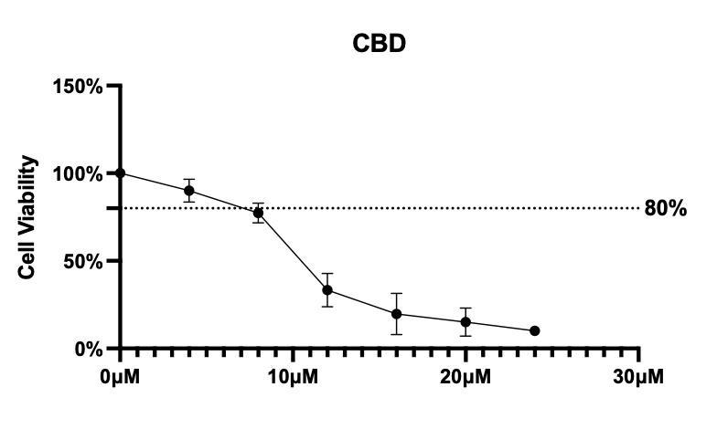

Figure 3. Cannabidiol9CBD) reduce cell viability of Caco-2 cells. Growth inhibitory effects of CBD against Caco-2 cells after 24h treatment. Cell viability is measured by MTT assay and is expressed as the percentage viability relative to the untreated control group. All experiments were performed in six replicates and data are presented as mean ± SEM.

**5.2 CBD Alters the Inflammatory Mediators Profile of Caco-2 Cells**

To investigate the effect of CBD on inflammatory cytokines in Caco-2 cells, we examined

the gene expression levels of several inflammatory mediators (IL10, CSF1, IFNG, TP53,

IL-1β, and MAPK8) using real-time PCR (Applied Biosystems®). We then conducted

unpaired t-tests to compare the differences between the control group and the CBD

treatment group.

40

The results from the CBD treatment heatmap showed a significant increase in the expression levels of IL10, CSF1, IFNG, TP53, and MAPK8 in the CBD treatment group compared to the control group (Figure 4A). In particular, CSF1 was significantly increased after CBD treatment at both 4µM and 6µM concentrations (Figure 4B, p-value were 0.04 and 0.00005). The expression of IL10, IFNG, TP53, and MAPK8 also showed a significant increasing trend at the concentration of 6µM compared to the control group (Figure 4B, p-values were 0.002, 0.000006, 0.005, and 0.0001, respectively). On the other hand, the expression of IL-1β showed a decreasing trend at both concentrations of CBD compared to the control group (Figure 4B, p-values were 0.00003 and 0.47, respectively).

Our study reveals a complex immune regulatory landscape within the colorectal cancer (CRC) microenvironment that may influence disease progression and patient outcomes. Notably, we observed increased expression of IL10, CSF1, IFNG, TP53, and MAPK8, and a decrease in IL1β. The upregulated IL10 and CSF1 may potentially promote tumor growth and progression via immune evasion and the activation of tumor-associated macrophages, respectively. Increased IFNG, on the other hand, suggests a potential protective role through innate and adaptive immunity and Wnt signaling pathway inhibition.

41

The decreased expression of IL1β could contribute to an overall immunosuppressive environment. The upregulated TP53 and MAPK8 point to their potential roles in modulating the immune response within the CRC microenvironment. These changes highlight potential therapeutic targets for future research in CRC management.

**A.**

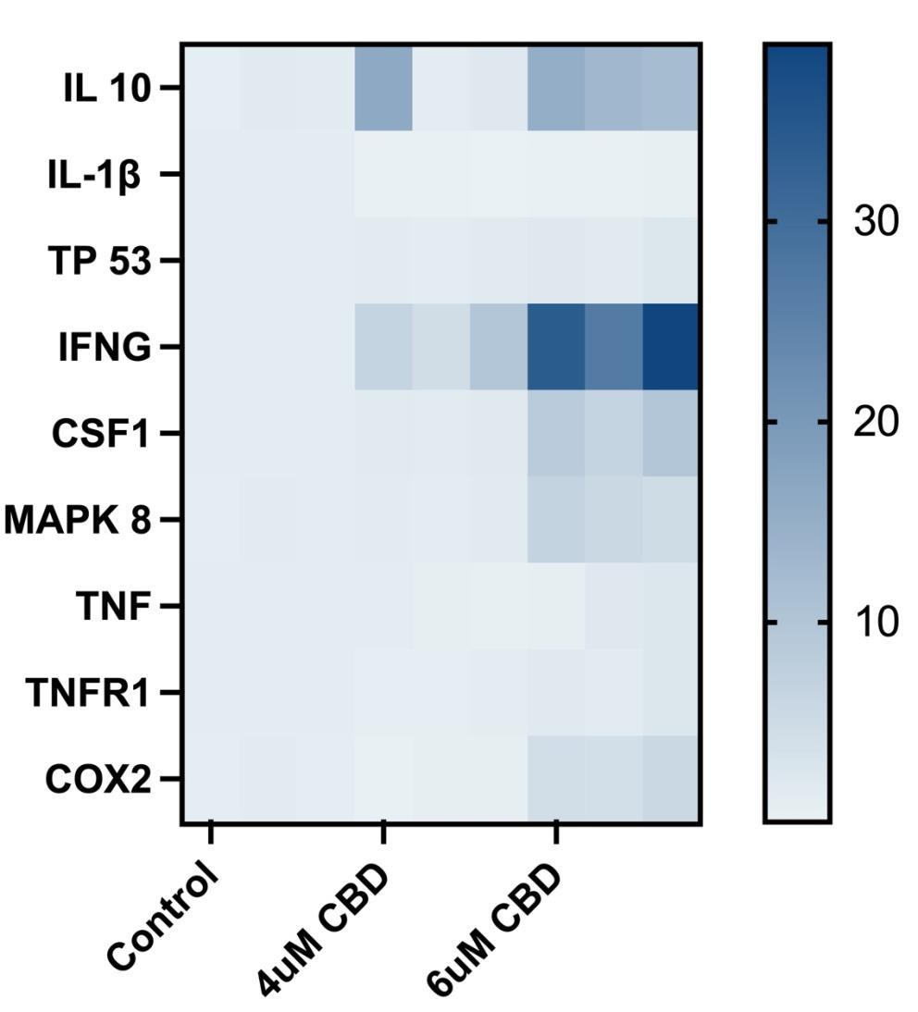

42

**B.**

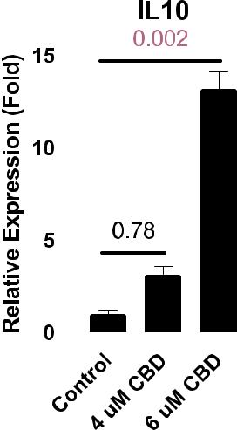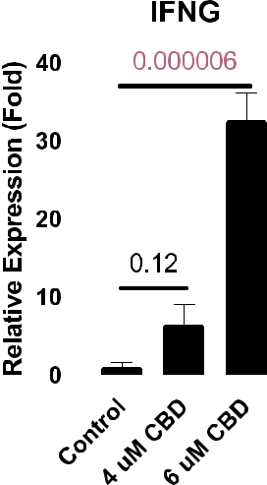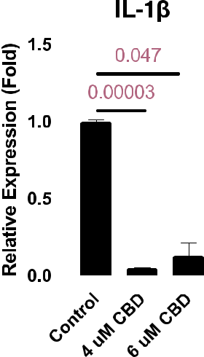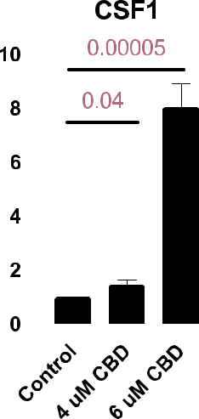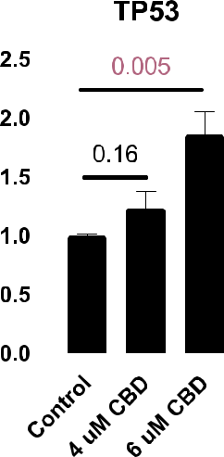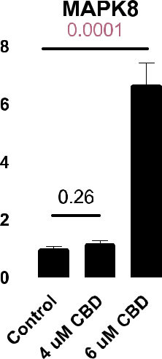

43

Figure 4. Heatmap(A) and relative gene expression level(B) of targeted inflammatory mediators in Caco-2 cells with 24h CBD treatment. The relative expression of the genes was determined using the △△Ct method, and statistical analysis was conducted based on the △Ct values. To identify differences between the control and treatment groups, an unpaired t-test was used. All experiments were performed in three replicates, and the data are present mean ± SEM.

**5.3 CBD increase the expression of Serotonin receptors**

In our study, we analyzed the expression of several serotonin receptors (TPH, SLC6A4,

HTR2A, HTR1D, HTR2C, and HTR4) using real-time PCR (Applied Biosystems®). We

conducted unpaired t-tests to compare the differences between the control group and the

CBD treatment group.

The heatmap of CBD treatment showed that the expression of TPH, SLC6A4, HTR2A,

HTR1D, HTR2C and HTR4 were increased after treated with CBD (Figure 5A). TPH and

HTR2C was significantly increased in both treatment groups compared to the control

group (Figure 5B, p-value were 0.002 and 0.0001, 0.02 and 0.03). HTR2A, HTR1D, and

SCL5A4 were also significantly increased at the concentration of 6µM (Figure 5B, p-value

were 0.0006, 0.03, and 0.01, respectively).

44

Tryptophan hydroxylase (TPH) is an enzyme that related to synthesis of serotonin. The expression of TPH was significantly increased after treated with CBD, suggesting that CBD has the potential to modulate the synthesis of serotonin. Additionally, CBD has been found to increase the expression of serotonin receptors, further indicating its potential role in modulating the serotonin system.

Our study suggests that cannabidiol (CBD) may play a multifaceted role in inhibiting colorectal cancer (CRC) progression through the regulation of serotonin biosynthesis and the Wnt signaling pathway. We observed an increase in the expression of Tryptophan hydroxylase (TPH), a rate-limiting enzyme in serotonin biosynthesis, and serotonin receptors such as HTR2A, HTR1D, HTR2C, and HTR4, indicating an increase in serotonin synthesis which may modulate downstream signaling pathways involved in cell proliferation and apoptosis. The expression of SLC5A4, a serotonin transporter, may also influence these processes by regulating serotonin availability. Furthermore, we found changes in the MAPK/ERK and PI3K/AKT pathways, potentially implicating serotonin receptors in inducing CRC cell apoptosis.

45

**A.**

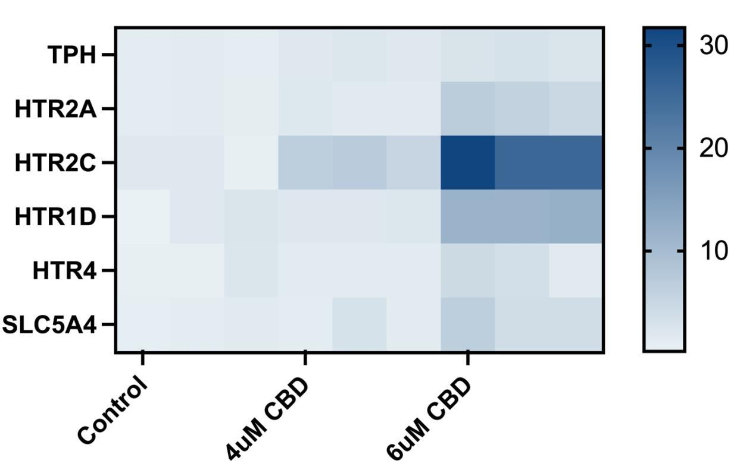

46

**B.**

**TPH**

|  |  |  |  |  |  |  |  |  |  |  |  |  |  |  |  |  |  |  |  |  |  |  |  |  |  |  |  |
| --- | --- | --- | --- | --- | --- | --- | --- | --- | --- | --- | --- | --- | --- | --- | --- | --- | --- | --- | --- | --- | --- | --- | --- | --- | --- | --- | --- |
| **(Fold)** | **3** |  |  |  |  |  |  |  |  |  |  |  |  |  | 0.0001 | | | | | | | | |  |  |  |  |
|  |  |  |  |  |  |  |  |  |  |  |  |  |  |  |  |  |  |  |  |  |  |  |  |  |  |
|  |  |  |  |  |  |  |  |  |  |  |  |  |  |  |  |  |  |  |  |  |  |  |  |  |  |
|  |  |  |  |  |  |  |  |  |  | 0.002 | | | | | | | | |  |  |  |  |  |  |  |  |
| **Expression** |  |  |  |  |  |  |  |  |  |  |  |  |  |  |  |  |  |  |
| **2** |  |  |  |  |  |  |  |  |  |  |  |  |  |  |  |  |  |  |  |  |  |  |  |  |  |  |
|  |  |  |  |  |  |  |  |  |  |  |  |  |  |  |  |  |  |  |  |  |  |  |  |  |  |  |
|  |  |  |  |  |  |  |  |  |  |  |  |  |  |  |  |  |  |  |  |  |  |  |  |  |  |
| **Relative** | **1** |  |  |  |  |  |  |  |  |  |  |  |  |  |  |  |  |  |  |  |  |  |  |  |  |  |  |
|  |  |  |  |  |  |  |  |  |  |  |  |  |  |  |  |  |  |  |  |  |  |  |  |  |
| **0** |  |  |  |  |  |  |  |  |  |  |  |  |  |  |  |  |  |  |  |  |  |  |  |  |  |  |
|  |  |  |  |  |  |  |  |  |  |  |  |  |  |  |  |  |  |  |  |  |  |  |  |  |  |  |
|  |  |  |  |  |  |  |  |  | **l** | | | | |  |  |  | **D** | | |  |  |  | **D** | | |  |  |
|  |  |  |  |  |  |  |  | **o** | | |  |  |  |  |  |  |  |  |  |  |  |
|  |  |  |  |  |  | **t** | | |  |  |  |  |  |  |  | **B** | | | |  |  |  | **B** | | |  |  |
|  |  |  |  |  |  |  | **r** | |  |  |  |  |  |  | **C** | |  |  |  |  |  | **C** | | | |  |  |
|  |  |  |  | **n** | | | |  |  |  |  | **M** | | |  |  |  | **M** | |  |  |
|  |  |  | **o** | | |  |  |  |  |  |  |  |  |  |  |  |  |  |  |  |  |  |
|  | **C** | | |  |  |  |  |  | **u** | | | | |  |  |  | **u** | | | | |  |  |  |  |  |  |
|  |  |  |  |  |  |  |  | **4** | |  |  |  |  |  |  |  | **6** |  |  |  |  |  |  |  |  |  |  |
|  |  |  |  |  |  |  |  | **HTR1D** | | | | | | | | | | | | | |  |  |  |  |  |  |
| **(Fold)** | **15** | | |  |  |  |  |  |  |  |  |  |  |  |  |  | 0.03 | | | | | | |  |  |  |  |
|  |  |  |  |  |  |  |  |  |  |  |  |  |  |  |  |  |
|  |  |  |  |  |  |  |  |  |  |  |  |  |  |  |  |  |  |  |  |
|  |  |  |  |  |  |  |  |  |  |  |  |  |  |  |  |  |  |  |  |  |
| **Expression** | **10** | | |  |  |  |  |  |  |  |  |  |  |  |  |  |  |  |  |  |  |  |  |  |  |  |  |
|  |  |  |  |  |  |  |  |  |  |  |  |  |  |  |  |  |  |  |  |  |  |  |  |
|  |  |  |  |  |  |  |  |  |  |  |  |  |  |  |  |  |  |  |  |  |  |  |  |  |
| **Relative** | **5** | | |  |  |  |  |  |  |  |  |  |  | 0.53 | | | | | |  |  |  |  |  |  |  |  |
|  |  |  |  |  |  |  |  |  |  |  |  |  |  |  |  |  |  |
|  |  |  |  |  |  |  |  |  |  |  |  |  |  |  |  |  |  |  |  |  |
| **0** | | |  |  |  |  |  |  |  |  |  |  |  |  |  |  |  |  |  |  |  |  |  |  |  |  |
|  |  |  |  |  |  |  |  |  |  |  |  |  |  |  |  |  |  |  |  |  |  |  |  |
|  |  |  |  |  |  |  |  |  |  |  |  |  |  |  |  |  |  |  |  |  |  |  |  |  |
|  |  |  |  |  |  |  |  |  |  |  | **l** | | |  |  |  |  | **D** | | | |  | **D** | | |  |  |
|  |  |  |  |  |  |  |  |  | **o** | | | | |  |  |  |  |  |  |  |
|  |  |  |  |  |  |  |  | **r** | | |  |  |  |  |  |  | **B** | | |  |  |  | **B** | | |  |  |
|  |  |  |  |  |  |  |  | **t** | | |  |  |  |  |  |  |  |  |  |  |  |
|  |  |  |  |  |  |  | **n** | |  |  |  |  |  | **M** | | **C** | | | |  |  |  | **C** | | |  |  |
|  |  |  |  |  | **o** | | |  |  |  |  |  |  |  |  |  |  | **uM** | | |  |  |  |  |  |
|  |  |  | **C** | | |  |  |  |  |  |  | **u** | | |  |  |  |  |  |  |  |  |  |  |
|  |  |  |  |  |  |  |  |  | **4** | | | |  |  |  |  | **6** | | | |  |  |  |  |  |  |  |
|  |  |  |  |  |  | **SLC5A4** | | | | | | | | | | | | | | | |  |  |  |  |  |  |
| **(Fold)** | **8** |  |  |  |  |  |  |  |  |  |  |  |  |  |  |  | 0.01 | | | | | |  |  |  |  |  |
|  |  |  |  |  |  |  |  |  |  |  |  |  |  |  |  |  |  |  |  |
|  |  |  |  |  |  |  |  |  |  |  |  |  |  |  |  |  |  |  |  |  |
|  |  |  |  |  |  |  |  |  |  |  |  |  |  |  |  |  |  |  |  |  |  |
| **Expression** | **6** |  |  |  |  |  |  |  |  |  |  |  |  |  |  |  |  |  |  |  |  |  |  |  |  |  |  |
|  |  |  |  |  |  |  |  |  |  |  |  |  |  |  |  |  |  |  |  |  |  |  |  |  |  |
|  |  |  |  |  |  |  |  |  |  |  |  |  |  |  |  |  |  |  |  |  |  |  |  |  |  |
| **4** |  |  |  |  |  |  |  |  |  | 0.31 | | | | | | |  |  |  |  |  |  |  |  |  |  |
|  |  |  |  |  |  |  |  |  |  |  |  |  |  |  |  |  |  |  |  |
|  |  |  |  |  |  |  |  |  |  |  |  |  |  |  |  |  |  |  |  |  |
| **Relative** | **2** |  |  |  |  |  |  |  |  |  |  |  |  |  |  |  |  |  |  |  |  |  |  |  |  |  |  |
|  |  |  |  |  |  |  |  |  |  |  |  |  |  |  |  |  |  |  |  |  |  |  |  |  |  |
|  |  |  |  |  |  |  |  |  |  |  |  |  |  |  |  |  |  |  |  |  |  |  |  |  |  |  |
|  | **0** |  |  |  |  |  |  |  |  |  |  |  |  |  |  |  |  |  |  |  |  |  |  |  |  |  |  |
|  |  |  |  |  |  |  |  | **l** | | | | |  |  |  | **D** | | |  |  |  | **D** | | |  |  |
|  |  |  |  |  |  |  |  |  |  |  |  |  |  |  |  |  |
|  |  |  |  |  |  |  |  | **o** | | |  |  |  |  |  |  |  |  |  |  |  |
|  |  |  |  |  |  |  | **r** | |  |  |  |  |  |  |  | **B** | | | |  |  |  | **B** | | |  |  |
|  |  |  |  |  |  | **t** | | |  |  |  |  |  |  |  |  |  |  |  |  |
|  |  |  |  | **n** | | | |  |  |  |  | **M** | | | **C** | |  |  |  | **M** | | **C** | | | |  |  |
|  |  |  | **o** | | |  |  |  |  |  |  |  |  |  |  |  |  |  |  |  |  |  |
|  | **C** | | |  |  |  |  |  | **u** | | | | |  |  |  | **u** | | | | |  |  |  |  |  |  |
|  |  |  |  |  |  |  |  | **4** | |  |  |  |  |  |  |  | **6** |  |  |  |  |  |  |  |  |  |  |

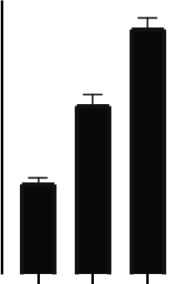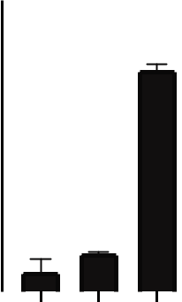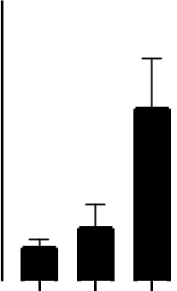

**HTR2A**

1. 0.0006

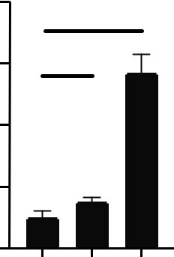

**6** 0.14

**4**

**2**

**0**

|  |  |  |  |  |  |  |  |  |
| --- | --- | --- | --- | --- | --- | --- | --- | --- |
|  |  |  | **l** |  |  | **D** | **D** |  |
|  |  | **o** | |  |  |  |
|  |  | **t** |  |  | **B** | | **B** |  |
|  |  | **r** |  |  | **C** |  | **C** |  |
|  | **n** | |  | **M** | **M** |  |
| **o** | |  |  |  |  |  |
| **C** |  |  | **u** | |  | **u** |  |  |
|  |  | **4** | |  |  | **6** |  |  |

**HTR2C**

**40**



0.03



**30**

1. 0.02



|  |  |  |  |  |  |  |  |  |  |
| --- | --- | --- | --- | --- | --- | --- | --- | --- | --- |
| **10** |  |  |  |  |  |  |  |  |  |
|  |  |  |  |  |  |  |  |  |
| **0** |  |  |  |  |  |  |  |  |  |
|  |  |  | **l** |  |  | **D** | **D** |  |
|  |  |  |  |  |  |  |
|  |  |  | **o** | |  |  |  |
|  |  |  | **t** |  |  | **B** | | **B** |  |
|  |  |  | **r** |  |  | **C** |  | **C** |  |
|  |  | **n** | |  | **M** | **M** |  |
|  | **o** | |  |  |  |  |  |
| **C** | |  |  | **u** | |  | **u** |  |  |
|  |  |  | **4** | |  |  | **6** |  |  |



|  |  |  |  |  |  |  |  |  |  |  |  |  |  |  |  |
| --- | --- | --- | --- | --- | --- | --- | --- | --- | --- | --- | --- | --- | --- | --- | --- |
|  |  |  | **HTR4** | | | | | | |  |  |  | |  | |
| **4** |  |  |  |  |  |  |  | 0.49 | | | |  | |  | |
|  |  |  |  |  |  |  |  | |
| **3** |  |  |  |  |  |  |  |  |  |  |  |  | |  | |
|  |  |  |  | 0.98 | | | |  |  |  |  | |  | |
|  |  |  |  |  |  |  |  | |  | |
| **2** |  |  |  |  |  |  |  |  | |  | |
|  |  |  |  |  |  |  |  |  |  |  |  | |  | |
|  |  |  |  |  |  |  |  |  |  |  |  | |  | |
| **1** |  |  |  |  |  |  |  |  |  |  |  |  | |  | |
|  |  |  |  |  |  |  |  |  |  |  |  | |  | |
| **0** |  |  |  |  |  |  |  |  |  |  |  |  | |  | |
|  |  |  |  | **l** | | | **D** | | | **D** | |  | |
|  |  |  |  |  |  | |
|  |  |  |  | **o** | | | |  | |
|  |  |  | **t** | |  |  |  | **B** | |  | **B** | |  | |
|  |  |  | **r** | |  |  |  | **C** | |  | **C** | |  | |
|  |  | **n** | |  |  | **M** | | **M** |  | |
|  | **o** | |  |  |  |  |  |  |  | |  | |
| **C** | |  |  |  | **u** | | | **6** | | **u** |  |  | |  | |
|  |  |  |  | **4** | |  |  |  |  |  | |  | |

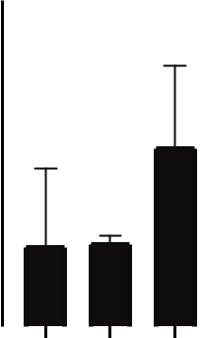

47

Figure 5. Heatmap(A) and relative gene expression level(B) of targeted serotonin receptors in Caco-2 cells with 24h CBD treatment. The relative expression of the genes was determined using the △△Ct method, and statistical analysis was conducted based on the △Ct values. To identify differences between the control and treatment groups, an unpaired t-test was used. All experiments were performed in three replicates, and the data are present mean ± SEM.

**5.4 Effect of CBD on the Expression of Wnt Targeted Genes and Other Signaling Pathways in Caco-2 Cells**

We investigated the effect of CBD treatment on the expression of Wnt signaling response in Caco-2 cells. We measured the expression levels of Wnt targeted genes APC2, CCND1, CTNNB1, AKT1, WISP1, FZD7, GSK3β and AXIN2, as well as the expression of Wnt signaling inhibitor gene SFRP2, using real-time PCR analyses (Applied Biosystems®). The differences between the control group and the treatment group were compared using unpaired t-tests.

The heatmap of CBD treatment indicated that the expression of several Wnt targeted genes was suppressed, including APC2, CTNNB1, AKT1, AXIN2, and FZD7 (Figure 7A). The expression of GSK3β was significantly increased at the concentration of 6µM (Figure 7B, p-value of 0.02). The expression of APC2 was significantly suppressed at both concentrations of CBD (Figure 7B, p-values were 0.002 and 0.000003). The expression

48

of CTNNB1, AKT1, AXIN2, and FZD7 was also significantly suppressed after CBD treatment (Figure 7B, p-values were 0.003 and 0.01, 0.03 and 0.007, 0.04 and 0.36, 0.063 and 0.00002). Additionally, the expression of Wnt inhibitor gene SFRP2 was significantly promoted after CBD treatment (Figure 7B, p-value was 0.045). The expression of Wnt signaling downstream gene WISP1 was significantly increased at the concentration of 6µM (Figure 7B, p-value was 0.01).

This research indicates that cannabidiol (CBD) may play a crucial role in inhibiting the Wnt signaling pathway, which is essential for the proliferation and metastasis of colorectal cancer (CRC) cells. We observed that CBD treatment led to increased expression of SFRP2, a known inhibitor of the Wnt pathway, and decreased expression of key Wnt pathway components such as CTNNB1 (encoding β-catenin), AKT1, and FZD7. These alterations suggest potential suppression of Wnt signaling, possibly contributing to reduced cell proliferation and tumor growth in CRC. Additionally, we found elevated levels of WISP1, a complex modulator of Wnt signaling, and decreased expression of APC2 and AXIN2, which are typically involved in the degradation of β-catenin. These changes may lead to β-catenin accumulation, a common feature in CRC. Our findings underscore

49

CBD's potential therapeutic value in CRC, warranting further investigation into its role in

modulating Wnt signaling and other relevant pathways.

**A.**

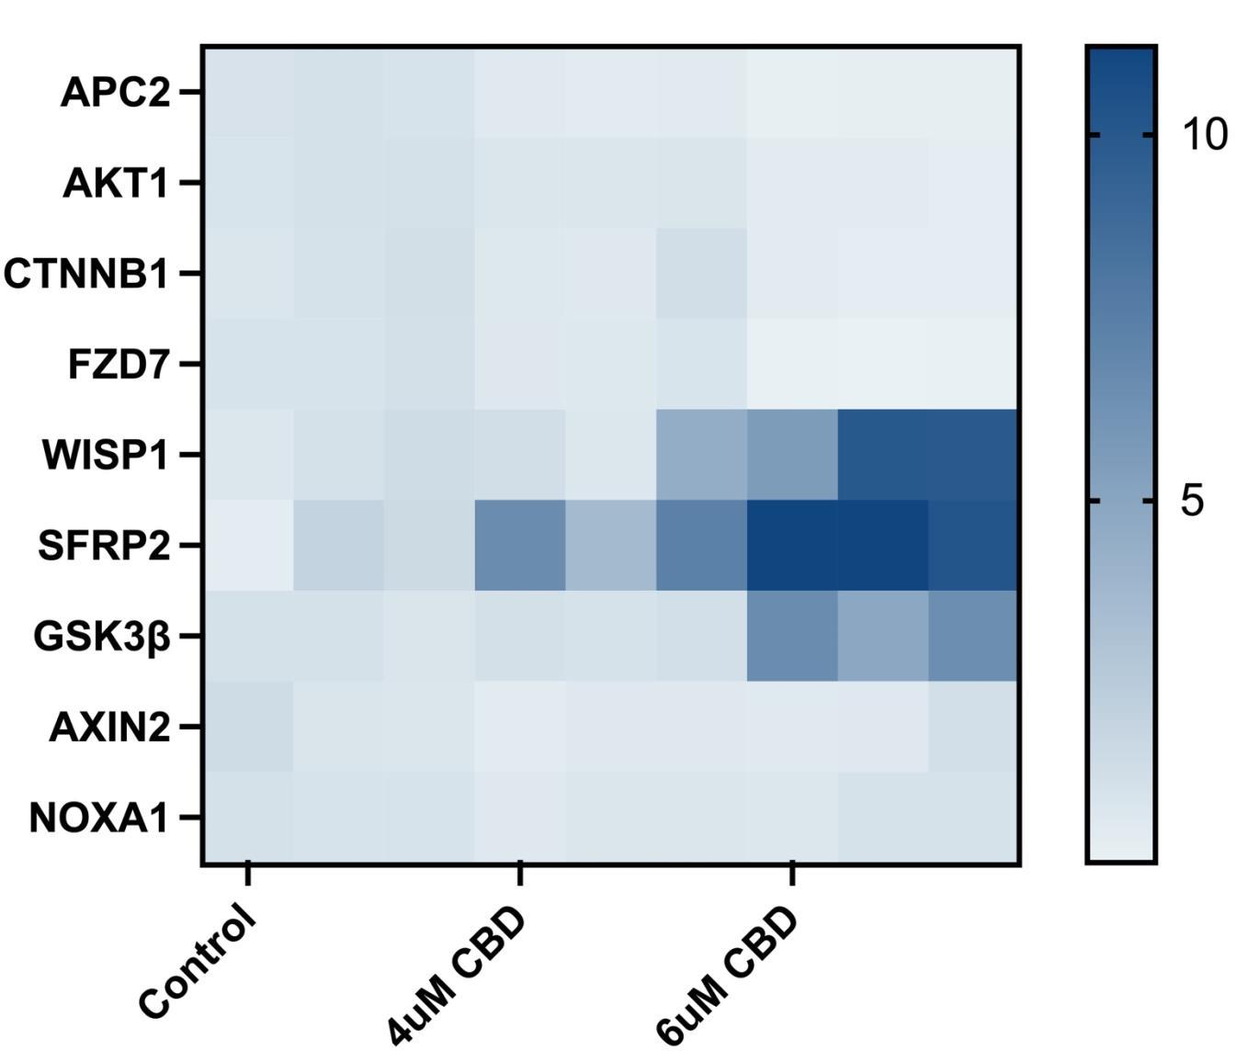

50

**B.**

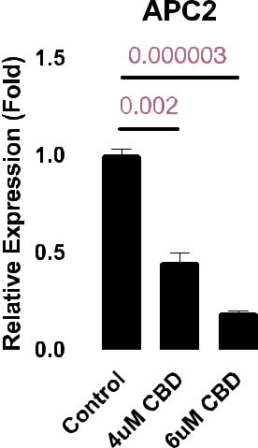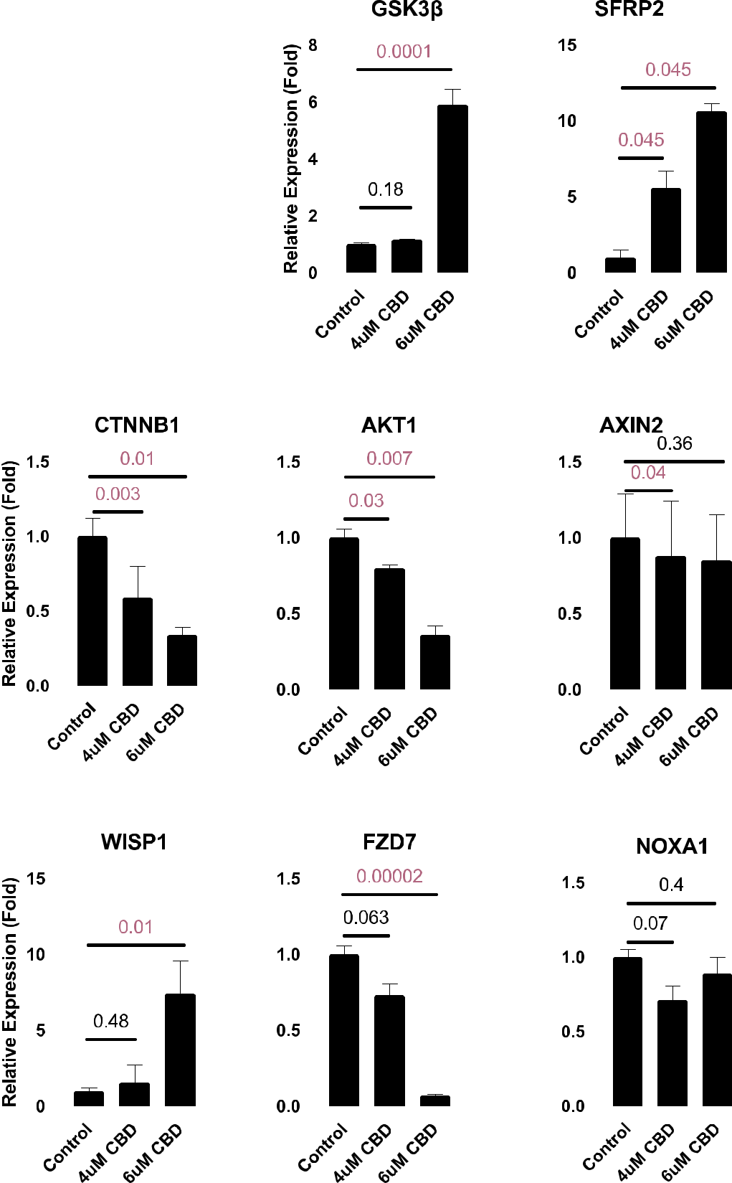

51

**C.**

|  |
| --- |
| **P-GSK/GAPDH ratio** |

|  |  |  |  |  |  |  |  |  |
| --- | --- | --- | --- | --- | --- | --- | --- | --- |
|  | **P-GSK/GAPDH** | | | | | |  | |
| **1.0** |  | 0.01 | | | |  | |  | |
|  |  | |
|  |  | | |  |  |  | |  | |
| **0.8** | 0.04 | | | |  |  | |  | |
|  |  |  |  |  |  | |  | |
|  |  |  |  |  |  | |  | |
|  |  |  |  |  |  | |  | |
| **0.6** |  |  |  |  |  |  | |  | |
|  |  |  |  |  |  | |  | |
| **0.4** |  |  |  |  |  |  | |  | |
|  |  |  |  |  |  | |  | |
| **0.2** |  |  |  |  |  |  | |  | |
|  |  |  |  |  |  | |  | |
| **0.0** |  |  |  |  |  |  | |  | |
|  |  |  |  |  |  | |  | |

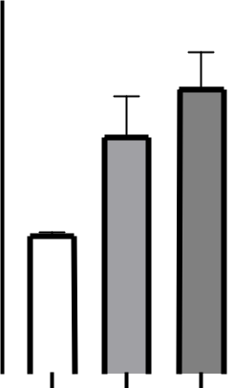

|  |  |  |  |  |  |  |  |  |
| --- | --- | --- | --- | --- | --- | --- | --- | --- |
|  |  |  | **l** |  |  | **D** | **D** |  |
|  |  | **o** | |  |  |  |
|  |  | **r** |  |  | **B** | | **B** |  |
|  |  | **t** |  |  |  |
|  | **n** | |  | **M** | **C** | **M** | **C** |  |
| **o** | |  |  |  |  |  |
| **C** |  |  | **u** | |  | **u** |  |  |
|  |  | **4** | |  |  | **6** |  |  |

**PPAR Gamma/GAPDH**

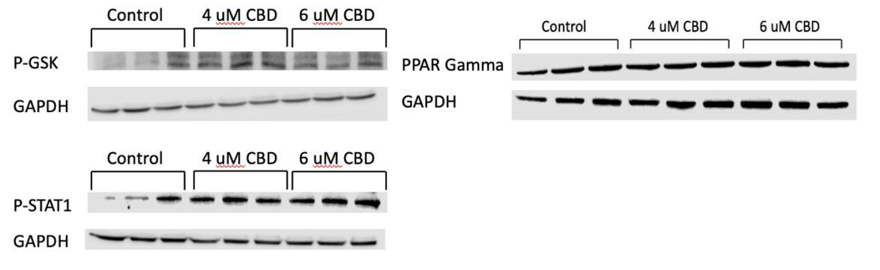

|  |  |  |  |  |  |  |  |
| --- | --- | --- | --- | --- | --- | --- | --- |
| **ratio** | **2.5** |  |  |  |  |  |  |
| 0.02 | | | |  |  |
|  |  |  |
|  |  |  |  |  |  |  |
|  |  |  |  |  |  |  |
| **Gamma/GAPDH** | **2.0** |  |  |  |  |  |  |
|  |  |  |  |  |  |
| **1.5** |  |  |  |  |  |  |
| 0.06 | | |  |  |  |
|  |  |  |  |
| **1.0** |  |  |  |  |  |  |
|  |  |  |  |  |  |
|  |  |  |  |  |  |
| **0.5** |  |  |  |  |  |  |
| **PPAR** |  |  |  |  |  |  |
|  |  |  |  |  |  |
| **0.0** |  |  |  |  |  |  |
|  |  |  |  |  |  |

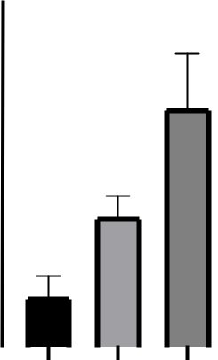

|  |  |  |  |  |  |  |  |
| --- | --- | --- | --- | --- | --- | --- | --- |
|  |  | **ol** | |  | **D** | **D** |  |
|  |  | **r** |  | **B** | | **B** |  |
|  |  | **t** |  |  |
|  | **n** | | **M** | **C** | **M** | **C** |  |
| **o** | |  |  |  |  |
| **C** |  | **4** | **u** |  | **u** |  |  |
|  |  |  |  | **6** |  |  |

**P-STAT1/GAPDH**

|  |  |  |  |  |  |  |  |  |  |  |  |  |  |  |  |  |
| --- | --- | --- | --- | --- | --- | --- | --- | --- | --- | --- | --- | --- | --- | --- | --- | --- |
| **ratio** | **1.5** |  |  |  |  |  |  |  | 0.005 | | | |  | |  | |
|  |  |  |  |  |  |  |  | |  | |
|  |  |  |  |  |  |  |  |  | |  | |
|  |  |  |  |  |  |  |  |  |  |  |  |  | |  | |
|  |  |  |  |  |  |  | 0.03 | |  |  |  |  | |  | |
| **P-STAT1/GAPDH** | **1.0** |  |  |  |  |  |  |  |  |  |  | |  | |
|  |  |  |  |  |  |  |  |  |  |  |  | |  | |
| **0.5** |  |  |  |  |  |  |  |  |  |  |  |  | |  | |
|  |  |  |  |  |  |  |  |  |  |  |  | |  | |
|  |  |  |  |  |  |  |  |  |  |  |  |  | |  | |
|  | **0.0** |  |  |  |  |  |  |  |  |  |  |  |  | |  | |
|  |  |  |  | **l** | | |  | **D** | | | **D** | |  | |
|  |  |  |  |  |  |  | |
|  |  |  |  | **o** | | | |  |  | |
|  |  |  |  | **r** |  |  |  |  | **B** |  |  | **B** | |  | |
|  |  |  |  | **t** |  |  |  |  |  |  |  | |
|  |  |  | **n** | |  |  |  | **M** | **C** |  | **M** | **C** | |  | |
|  |  | **o** | |  |  |  |  |  |  |  |  | |  | |
|  | **C** | |  |  |  | **u** | | | **6** | **u** | |  |  | |  | |
|  |  |  |  | **4** | | |  |  |  |  |  |  | |  | |

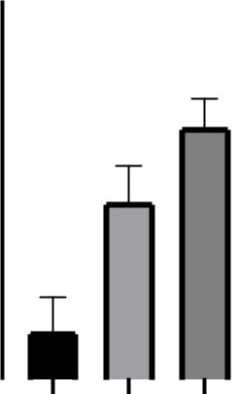

52

Figure 6, Heatmap(A) and relative gene expression level(B) of genes related to Wnt signaling pathway in Caco-2 cells with 24h CBD treatment. The expressions of protein related to different signaling pathways(C). The relative expression of the genes was determined using the △△Ct method, and statistical analysis was conducted based on the △Ct values. To identify differences between the control and treatment groups, an unpaired t-test was used. All experiments were performed in three replicates, and the data are present mean ± SEM.

53

**CHAPTER 6**

**DISCUSSION**

Colorectal cancer is a major cause of cancer-related deaths globally. Early detection of CRC can significantly increase the five-year survival rate, making prevention essential. Promoting effective prevention methods and regular screening tests are crucial in reducing the incidence and mortality rates of CRC. As a result, an effective way of prevention of CRC is of great importance.

CBD, a non-psychoactive cannabis extract, has been studied for its potential therapeutic benefits, including CRC. One area of interest is its influence on serotonin, a neurotransmitter that regulates physiological functions. Studies have shown that CBD can exert anti-cancer effects through multiple mechanisms, such as modulating the immune response, inhibiting cell proliferation, and inducing apoptosis in cancer cells. CBD has also been found to target key signaling pathways implicated in CRC, such as the Wnt signaling pathway. By affecting these processes, CBD may contribute to the suppression

54

of tumor growth and progression, offering a promising avenue for CRC treatment and management.

The discussion that follows will delve into the multifaceted effects of CBD on CRC, with a focus on how it modulates the immune response, serotonin system and Wnt signaling pathway in the context of CRC. By dissecting these interactions, we aim to shed light on the potential mechanisms underlying CBD's therapeutic effects and its implications for CRC treatment and management.

Previous studies have found that cannabinoids have potential in preventing the syndrome of cancer cachexia by regulating immune cytokines. They discovered that cannabinoids could alter the expression of six cytokines, which could potentially serve as a biomarker to monitor the therapeutic effects of cannabinoids in cachexia associated with CRC (Ng et al. 2023). In our study, we monitored the changes in immune cytokines after treatment with cannabidiol. Our results revealed increased expression of IL10, CSF1, IFNG, TP53, and an enzyme, MAPK8, while IL1β expression was found to be decreased in CRC (Figure 4B). These findings suggest complex immune regulation within the CRC microenvironment that can influence disease progression and patient outcomes.

55

In this investigation, IL10, an anti-inflammatory cytokine, was found to increase. IL10 plays a role in suppressing immune responses and has been associated with reduced anti-tumor immunity in several cancers, including CRC. The increased expression of IL10 observed in our study may contribute to immune evasion by cancer cells, thereby promoting tumor growth and progression.

CSF1, a growth factor involved in macrophage differentiation, has been implicated in the recruitment and polarization of tumor-associated macrophages (TAMs). TAMs often display pro-tumorigenic functions, supporting tumor growth, angiogenesis, and immune suppression. The upregulation of CSF1 in CRC suggests a potential role for TAMs in disease progression.

Interferon gamma (IFNG), or IFN-γ, is predominantly generated by activated T cells and natural killer cells. Interestingly, lower levels of IFNG have been significantly associated with stage 4 CRC(Ganapathi et al. 2014). Our study identified an upregulation in IFNG expression. An elevated level of IFNG can contribute to the mediation of both innate and adaptive immunity, which are crucial for the body's defense against disease. Furthermore,

56

IFNG has the potential to downregulate the Wnt signaling pathway, which is often implicated in tumor growth and progression(Wang et al. 2015). Conversely, our study found decreased expression of the pro-inflammatory cytokine IL1β in CRC. This reduction may contribute to an overall immunosuppressive TME, facilitating tumor growth and progression.

TP53, a well-known tumor suppressor, has also been implicated in immune regulation. Its upregulation in our study could indicate a potential role in modulating the immune response to CRC, although the exact mechanisms remain to be determined.

MAPK8, a kinase involved in various cellular processes, including inflammation and immune responses, was found to be upregulated in CRC. This increase could contribute to immune regulation within the CRC microenvironment, although further research is required to understand its specific implications.

These findings highlight the intricate immune regulation within the CRC microenvironment, which can influence disease progression and patient outcomes. The expression of key immune mediators, including IL10, CSF1, IFNG, TP53, MAPK8, and IL1β, may serve as

57

potential therapeutic targets for modulating the immune response in CRC. Further research is needed to understand the specific roles of these mediators in CRC and their potential for therapeutic intervention.

Tryptophan hydroxylase (TPH) is a rate-limiting enzyme in serotonin biosynthesis. Changes in TPH expression can lead to altered serotonin levels, which may influence the activity of serotonin receptors and downstream signaling pathways involved in cell proliferation and apoptosis. In our study, we observed an increasing trend in the expression of TPH as shown in Figure 5B, indicating an increase in serotonin synthesis. Serotonin is a neurotransmitter that affects emotion, behavior, and cognition, and its effects on cancer pathogenesis have been studied extensively. In the context of colorectal cancer (CRC), serotonin plays a dual role. While it may protect against the early stages of CRC, it can also support its progression to more advanced stages. (Kannen et al. 2020). The upregulation of TPH, as observed in our study, suggests an increase in serotonin synthesis, which may modulate the activity of various serotonin receptors such as HTR2A, HTR1D, HTR2C, and HTR4, thereby influencing their downstream signaling pathways. By influencing the activity of serotonin receptors, the increase in serotonin synthesis may

58

contribute to the inhibition of CRC progression, ultimately resulting in the suppression of tumor growth and metastasis.

SLC5A4 is a serotonin transporter that is responsible for the reuptake of serotonin from the extracellular space, thus regulating its availability. Altered expression of SLC5A4 may influence serotonin levels and the subsequent activation of serotonin receptors, potentially affecting the signaling pathways involved in cell proliferation, migration, and survival in CRC cells.

Serotonin receptors, such as HTR2A, HTR1D, HTR2C, and HTR4, can modulate intracellular signaling pathways that regulate cell proliferation, differentiation, and survival. In our study, the expression of HTR2A, HTR1D, HTR2C, and HTR4 showed an increase trend after CBD treatment, as shown in Figure 5B. The upregulation of these receptors by CBD may lead to changes in the activation of downstream signaling pathways, such as the MAPK/ERK and PI3K/AKT pathways, which could result in reduced cell proliferation and enhanced apoptosis in CRC cells. As illustrated in Figure 4B, MAPK8 expression is increasing, while AKT1 expression is decreasing, as depicted in Figure 6B.

59

These observations may indicate that serotonin receptors can induce CRC cell apoptosis through the modulation of MAPK/ERK and PI3K/AKT pathways.

The Wnt signaling pathway plays a crucial role in the proliferation and metastasis of cancer cells, including colorectal cancer (CRC). It regulates CRC metastasis through epithelial-mesenchymal transition (EMT), a biological process that enhances the migratory capacity of cells. Recent studies have shown that cannabidiol (CBD) can inhibit EMT and suppress the activation of the Wnt signaling pathway in various CRC cell models, such as HCT116, SW620, and DLD-1(Feng et al. 2022). Our research, which focuses on Caco-2 cells, supports these findings, demonstrating that the Wnt signaling pathway is indeed inhibited.

Wnt signaling is a critical pathway involved in the development and homeostasis of numerous human tissues, including the colon. Dysregulation of the Wnt signaling pathway has been implicated in the pathogenesis of various cancers, particularly CRC.

In normal colon tissue, the Wnt signaling pathway is tightly regulated to ensure proper cell growth and differentiation. The pathway is activated when Wnt ligands bind to Frizzled

60

receptors and co-receptors, such as LRP5/6, on the cell surface. This binding leads to the stabilization and nuclear translocation of β-catenin, a key component of the Wnt pathway. In the nucleus, β-catenin interacts with transcription factors, such as TCF/LEF, to activate the expression of Wnt target genes, which are involved in cell proliferation, differentiation, and survival. Our research indicates that CBD has the potential to modulate the Wnt signaling pathway, contributing to the suppression of CRC progression.

In colorectal cancer (CRC), the Wnt signaling pathway is frequently dysregulated due to mutations in key components, such as the APC (adenomatous polyposis coli) gene, which normally acts as a negative regulator of β-catenin levels(Novellasdemunt, Antas, and Li 2015). Mutations in APC result in the accumulation of β-catenin in the cytoplasm and nucleus, leading to the activation of Wnt target genes and uncontrolled cell growth. Our study found that the expression of APC2 is significantly suppressed, which could lead to the accumulation of β-catenin. The accumulation of β-catenin can also be caused by AXIN2, which serves as a crucial negative regulator of the Wnt signaling pathway by promoting the degradation of β-catenin. As indicated in Figure 6B, the gene expression of AXIN2 is decreased, which is indicative of the accumulation of β-catenin.

61

In addition to APC mutations, alterations in other components of the Wnt pathway, such as Wnt target genes CTNNB1, AKT1, FZD7 and WISP1, can also contribute to the dysregulation of the Wnt signaling pathway in CRC. CTNNB1 encodes the β-catenin protein, a central component of the Wnt signaling pathway. In our study, we observed a decrease in CTNNB1 expression (Figure 6B). This reduction in CTNNB1 expression may inhibit Wnt signaling by lowering the levels of β-catenin available for nuclear translocation and transcriptional activation, which can result in decreased cell proliferation, migration, and invasion in CRC. Several studies have demonstrated the potential of targeting CTNNB1 through RNA interference or small molecule inhibitors to suppress tumor growth and induce apoptosis in CRC cell lines and animal models.

AKT1, a serine/threonine kinase, plays a pivotal role in regulating cell survival, proliferation, and metabolism. AKT1 can directly phosphorylate and inactivate glycogen synthase kinase 3 beta (GSK-3β), a crucial kinase responsible for the phosphorylation and degradation of β-catenin. Consequently, AKT1 activation leads to the stabilization of β-catenin and promotes Wnt signaling. In our study, we observed a significant decrease in AKT1 expression following CBD treatment, as shown in Figure 6B. This finding suggests that AKT1 inhibition could be one of the mechanisms through which CBD

62

suppresses the Wnt signaling pathway in CRC. Decreased expression or activity of AKT1 can inhibit Wnt signaling by allowing GSK-3β to phosphorylate and target β-catenin for degradation(Novellasdemunt et al. 2015). As depicted in Figure 6C, p-GSK-3β accumulated in Caco-2 cells treated with CBD. Inhibition of AKT1 has previously been shown to reduce cell proliferation, migration, and invasion, and to promote apoptosis in CRC cell lines and animal models. Targeting AKT1 with small molecule inhibitors or RNA interference strategies has shown p romise in preclinical studies and early-phase clinical trials for CRC.

FZD7 is known to be involved in both the canonical Wnt/β-catenin signaling pathway and non-canonical Wnt pathways. In the canonical pathway, binding of Wnt ligands to FZD7 and its co-receptor, low-density lipoprotein receptor-related protein 5/6 (LRP5/6), results in the inhibition of β-catenin degradation, thereby promoting Wnt signaling(Larasati et al. 2022). Overexpression of FZD7 has been reported in various cancers, including CRC, and is associated with tumor progression, metastasis, and poor prognosis. After treatment with CBD, the expression of FZD7 showed a decreasing trend, as depicted in Figure 6B. A reduction in FZD7 expression may inhibit Wnt signaling by decreasing the availability of Wnt receptors on the cell surface, leading to diminished activation of downstream

63

signaling components, such as Dishevelled (Dvl) proteins and β-catenin. Consequently, reduced FZD7 expression may suppress tumor growth, cell proliferation, migration, and invasion, and promote apoptosis in CRC.

We also observed an increase in WISP1 (WNT1 Inducible Signaling Pathway Protein 1) expression in Caco-2 cells after treatment with CBD (Figure 6B). WISP1, a member of the CCN family of matricellular proteins, is known to play a role in the modulation of the Wnt signaling pathway. The relationship between WISP1 and the Wnt signaling pathway is complex, with WISP1 being involved in both canonical and non-canonical Wnt signaling mechanisms. WISP1 can interact directly with cell surface receptors like integrins and heparan sulfate proteoglycans, activating intracellular signaling cascades, including the Wnt pathway. A reduction in WISP1 expression could limit these interactions, thereby dampening the activation of Wnt signaling. Additionally, WISP1 has been reported to interact with Wnt ligands, influencing their activity. Lower levels of WISP1 may reduce its capacity to modulate Wnt ligands, resulting in altered Wnt signaling. The observed increase in WISP1 expression after CBD treatment in our study suggests a potential link between WISP1 and the effects of CBD on CRC cells. Understanding the precise

64

relationship between WISP1 and the Wnt signaling pathway, particularly in the context of CBD treatment, requires further investigation.

In our study, we observed an increase in SFRP2 expression in Caco-2 cells following treatment with CBD for 24 hours. SFRP2 (Secreted Frizzled-Related Protein 2) is a secreted protein belonging to the SFRP family, which plays a role in modulating the Wnt signaling pathway. The primary mechanism of SFRP2 involves its ability to bind directly to Wnt ligands, preventing them from interacting with their cell surface receptors, such as Frizzled (FZD) and low-density lipoprotein receptor-related proteins 5/6 (LRP5/6). By sequestering Wnt ligands, SFRP2 effectively inhibits Wnt signaling, leading to a reduction in β-catenin-dependent transcriptional activity.

The observed increase in SFRP2 levels suggests that CBD may potentially induce cell apoptosis in CRC cells by inhibiting the Wnt signaling pathway. The upregulation of SFRP2, a negative regulator of Wnt signaling, could contribute to the suppression of cell proliferation and tumor growth, ultimately promoting apoptosis in CRC cells. These findings indicate that CBD may have therapeutic potential in the treatment of CRC by modulating the Wnt signaling pathway through the upregulation of SFRP2.

65

Interestingly, CBD can not only affect CRC by changing the expression of serotonin receptor directly, it can also influence CRC by changing immune system that induced by serotonin. The crosstalk between serotonin and immune system is an interesting topic. Serotonin has a significant impact on various immune system. Serotonin signaling can activate and stimulate T cell proliferation, support B cell development, enhance natural killer cell cytotoxicity, and promote macrophage polarization towards the M2 phenotype while inhibiting M1 polarization. Studies suggest that blood serotonin levels correlate with the body's inflammatory state and the Th1/Th2 balance. Serotonin also modulates cytokine secretion, and T cells have a functional serotonergic system. Patients with major depressive disorder have high levels of pro-inflammatory cytokines and low levels of anti-inflammatory cytokines, which can be reversed by treatment with SSRIs, indicating the role of serotonin in cytokine secretion modulation(Wu et al. 2019).

Additionally, serotonin has been shown to be related to the Wnt signaling pathway. Studies have shown that serotonin can modulate the activity of the Wnt signaling pathway by influencing the expression and function of various components of the pathway. For example, serotonin has been shown to upregulate the expression of β-catenin, a key

66

component of the Wnt pathway, in certain cell types. Additionally, serotonin has been shown to modulate the activity of other components of the pathway, such as the Wnt receptors FZD and LRP, and downstream signaling molecules.

In conclusion, our study has provided compelling evidence highlighting the potential role of cannabidiol (CBD) in modulating key signaling pathways implicated in colorectal cancer (CRC) progression. Our data demonstrated that CBD treatment could inhibit the Wnt signaling pathway, a crucial driver of CRC metastasis, by modulating the expression of key pathway components such as APC2, AXIN2, and CTNNB1. Additionally, our results indicated that CBD could influence serotonin signaling by altering the expression of Tryptophan hydroxylase (TPH) and serotonin receptors such as HTR2A, HTR1D, HTR2C, and HTR4, thereby potentially inhibiting CRC progression.

Moreover, we observed that CBD treatment could induce changes in the expression of immune-related genes, including IL6, TNF, COX2, CCL2, NFKB1, NFKB2, and PTGS2, suggesting that CBD may also modulate inflammation, an important factor in CRC progression. Importantly, our results showed that CBD could increase the expression of

67

SFRP2, a known negative regulator of the Wnt signaling pathway, further supporting the potential of CBD as a therapeutic agent in CRC.

Our findings provide a new understanding of the molecular mechanisms underlying the anti-cancer effects of CBD in CRC, particularly its influence on the Wnt and serotonin signaling pathways, as well as its impact on inflammation. This study broadens the existing knowledge base and opens new avenues for the potential use of CBD as a therapeutic agent in CRC. However, further in-depth studies are needed to fully elucidate the precise mechanisms of CBD action in CRC and to validate these findings in preclinical and clinical settings.

68

**APPENDIX A**

**TABLE OF PERFORMED ASSAYS AND EXPERIMENTAL DESIGN**

69

|  |  |  |  |  |  |  |  |  |  |  |
| --- | --- | --- | --- | --- | --- | --- | --- | --- | --- | --- |
| Experiment | Cell line | Design | | |  |  |  | Dosage | Time |  |
|  |  |  |  |  | |  |  |  |  |  |
|  |  | Control group (non-treatment) | | | |  | - | | 24 hours |  |
| MTT Assay | Caco2 |  |  |  |  |  |  |  |  |  |
| Experimental group |  |  | CBD treatment |  |  | 0~32 μM | 24 hours |  |
|  |  |  |  |  |  |  |
|  |  |  |  |  |  |  |  |
|  |  |  |  |  | |  |  |  |  |  |
| Real-time |  | Control group (non-treatment) | | | |  | - | |  |  |
| Caco2 |  |  |  |  |  |  |  | 24 hours |  |
| PCR |  |  |  |  |  |  |  |  |
| Experimental group |  |  | CBD treatment | 4μM, 6μM, |  | Value based on MTT |  |
|  |  |  |  |  |  |
|  |  |  |  |  |  |  |
|  |  |  |  | 8μM |  | assay |  |  |
|  |  |  |  |  |  |  |  |  |
|  |  |  |  |  | |  |  |  |  |  |
| Western |  | Control group (non-treatment) | | | |  | - | | 24 hours |  |
| Caco2 |  |  |  |  |  |  |  |  |  |
| blot |  |  |  |  |  |  |  |  |  |
| Experimental group | |  | CBD treatment | 4μM, 6μM, | | Value based on MTT | 24 hours |  |
|  |  |  |
|  |  |  |  |
|  |  |  | 8μM |  | assay |  |
|  |  |  |  |  |  |  |  |  |
|  |  |  |  |  |  |  |  |  |  |  |

Table 1. Experimental Design

70

**APPENDIX B**

**TABLE OF PRIMERS USED FOR REAL-TIME PCR ANALYSIS**

71

|  |  |  |  |  |
| --- | --- | --- | --- | --- |
| Pathway | Genes | Forward Primer | Reverse Primer |  |
|  |  |  |  |  |
| Cancer-related | *IL10* | GACTTTAAGGGTTACCTGGGTTG | TCACATGCGCCTTGATGTCTG |  |
| inflammation |  |  |  |  |
| *IL1β* | ATGATGGCTTATTACAGTGGCAA | GTCGGAGATTCGTAGCTGGA |  |
|  |  |  |  |  |
|  | *IFNG* | TCGGTAACTGACTTGAATGTCCA | TCGCTTCCCTGTTTTAGCTGC |  |
|  |  |  |  |  |
|  | *TNF* | CCTCTCTCTAATCAGCCCTCTG | GAGGACCTGGGAGTAGATGAG |  |
|  |  |  |  |  |
|  | *CSF1* | TGGCGAGCAGGAGTATCAC | AGGTCTCCATCTGACTGTCAAT |  |
|  |  |  |  |  |
|  | *TP53* | CAGC ACAT GACG GAGG TTGT | TCAT CCAA ATAC TCCA CACG C |  |
|  |  |  |  |  |
|  | *MAPK8* | TGTG TGGA ATCA AGCA CCTT C | AGGC CTCA TCAT AAAA CTCG TTC |  |
|  |  |  |  |  |
|  | *COX2* | CTGG CGCT CAGC CATA CAC | CGCA CTTA TACT GGTC AAAT CCC |  |
|  |  |  |  |  |
| Wnt-signaling | *AXIN2* | CAACACCAGGCGGAACGAA | GCCCAATAAGGAGTGTAAGGACT |  |
| pathway |  |  |  |  |
| *AKT1* | AGCG ACGT GGCT ATTG TGAA G | GCCA TCAT TCTT GAGG AGCA AGT |  |
|  |  |  |  |  |
|  | *CTNNB1* | AAAG CGGC TGTT AGTC ACTG G | CGAG TCAT TGCA TACT GTCC AT |  |
|  |  |  |  |  |
|  | *WISP1* | TGCT GTAA GATG TGCG CTGA G | ACAC TCCT ATTG CGTA CCTG G |  |
|  |  |  |  |  |
|  | *SFRP2* | ACGG CATC GAAT ACCA GAAC A | CTCG TCTA GGTC ATCG AGGC A |  |
|  |  |  |  |  |
| Serotonin | *GSK3β* | GGCA GCAT GAAA GTTA GCAG A | GGCG ACCA GTTC TCCT GAAT C |  |
| receptors and |  |  |  |  |
| *TPH* | ACGTCGAAAGTATTTTGCGGA | ACGGTTCCCCAGGTCTTAATC |  |
| enzyme |  |  |  |  |
| *HTR2A* | CTTTGTGCAGTCTGGATTTACCT | ACTGATATGGTCCAAACAGCAAT |  |
|  |  |  |  |  |
|  | *HTR2C* | CTAATTGGCCTATTGGTTTGGCA | CCACCATCGGAGGTATTGAAAA |  |
|  |  |  |  |  |
|  | *SLC6A4* | ATGGAGACGACGCCCTTGA | CTGTAGAACTCCGTTTTCCTGAC |  |
|  |  |  |  |  |
|  | *HTR4* | CTCACGTTTCTCTCGACGGTT | AGCAGATCCGCAAAAGCAAGA |  |
|  |  |  |  |  |
|  | *HTR1D* | CTCCAACAGATCCCTGAATGC | CCTGGTGAGTAAGATGGTGGT |  |
|  |  |  |  |  |
|  | *GAPDH* | GGAGCGAGATCCCTCCAAAAT | GGCTGTTGTCATACTTCTCATGG |  |
|  |  |  |  |  |

Table 2. Primers of targeted genes and GAPDH

72

**REFERENCES**

Aiello, Paola, Maedeh Sharghi, Shabnam Malekpour Mansourkhani, Azam Pourabbasi Ardekan, Leila Jouybari, Nahid Daraei, Khadijeh Peiro, Sima Mohamadian, Mahdiyeh Rezaei, Mahdi Heidari, Ilaria Peluso, Fereshteh Ghorat, Anupam Bishayee, and Wesam Kooti. 2019. “Medicinal Plants in the Prevention and Treatment of Colon Cancer.” *Oxidative Medicine and Cellular Longevity* 2019:1– 51. doi: 10.1155/2019/2075614.

Atreya, Raja, and Markus F. Neurath. 2005. “Involvement of IL-6 in the Pathogenesis of Inflammatory Bowel Disease and Colon Cancer.” *Clinical Reviews in Allergy & Immunology* 28(3):187–96. doi: 10.1385/CRIAI:28:3:187.

Becker, Christoph, Massimo C. Fantini, Christoph Schramm, Hans A. Lehr, Stefan Wirtz, Alexei Nikolaev, Ralf Kiesslich, Samuel Huber, Hiroaki Ito, Norihiro Nishimoto, Kazuyuki Yoshizaki, Tadamitsu Kishimoto, Peter R. Galle, Manfred Blessing, Stefan Rose-John, and Markus F. Neurath. n.d. “TGF-␤ Suppresses Tumor Progression in Colon Cancer by Inhibition of IL-6 Trans-Signaling.”

Berdyshev, E. V. 2000. “Cannabinoid Receptors and the Regulation of Immune Response.” *Chemistry and Physics of Lipids* 108(1–2):169–90. doi:

10.1016/S0009-3084(00)00195-X.

Berger, Miles, John A. Gray, and Bryan L. Roth. 2009. “The Expanded Biology of

Serotonin.” *Annual Review of Medicine* 60(1):355–66. doi:

10.1146/annurev.med.60.042307.110802.

Bertrand, Paul P., and Rebecca L. Bertrand. 2010. “Serotonin Release and Uptake in the Gastrointestinal Tract.” *Autonomic Neuroscience* 153(1–2):47–57. doi:

10.1016/j.autneu.2009.08.002.

Bridgeman, Mary Barna, and Daniel T. Abazia. n.d. “Medicinal Cannabis: History, Pharmacology, And Implications for the Acute Care Setting.” 9.

73

Burt, Randall W. 2000. “Colon Cancer Screening.” *Gastroenterology* 119(3):837–53.

doi: 10.1053/gast.2000.16508.

Cappell, Mitchell S. 2005. “From Colonic Polyps to Colon Cancer: Pathophysiology, Clinical Presentation, and Diagnosis.” *Clinics in Laboratory Medicine* 25(1):135– 77. doi: 10.1016/j.cll.2004.12.010.

Cappell, Mitchell S. 2008. “Pathophysiology, Clinical Presentation, and Management of

Colon Cancer.” *Gastroenterology Clinics of North America* 37(1):1–24. doi:

10.1016/j.gtc.2007.12.002.

Chakrabarti, Sakti, Carrie Y. Peterson, Deepika Sriram, and Amit Mahipal. 2020. “Early Stage Colon Cancer: Current Treatment Standards, Evolving Paradigms, and Future Directions.” *World Journal of Gastrointestinal Oncology* 12(8):808–32. doi: 10.4251/wjgo.v12.i8.808.

Coogan, Patricia F., Brian L. Strom, and Lynn Rosenberg. 2009. “Antidepressant Use and Colorectal Cancer Risk.” *Pharmacoepidemiology and Drug Safety* 18(11):1111–14. doi: 10.1002/pds.1808.

Edgar, Alan D., Robert Levin, Christos E. Constantinou, and Louis Denis. 2007. “A Critical Review of the Pharmacology of the Plant Extract of *Pygeum Africanum* in the Treatment of LUTS: Pharmacology of *Pygeum Africanum*.” *Neurourology and Urodynamics* 26(4):458–63. doi: 10.1002/nau.20136.

Feng, PanFeng, LongXun Zhu, Jing Jie, PengXiang Yang, Nan Sheng, XiangFan Chen, and Xia Chen. 2022. “Cannabidiol Inhibits Invasion and Metastasis in Colorectal Cancer Cells by Reversing Epithelial–Mesenchymal Transition through the Wnt/β-Catenin Signaling Pathway.” *Journal of Cancer Research and Clinical Oncology*. doi: 10.1007/s00432-022-04265-x.

Ganapathi, S. K., A. D. Beggs, S. V. Hodgson, and D. Kumar. 2014. “Expression and DNA Methylation of TNF, IFNG and FOXP3 in Colorectal Cancer and Their Prognostic Significance.” *British Journal of Cancer* 111(8):1581–89. doi:

10.1038/bjc.2014.477.

74

Gershon, Michael D., and Jan Tack. 2007. “The Serotonin Signaling System: From Basic Understanding To Drug Development for Functional GI Disorders.” *Gastroenterology* 132(1):397–414. doi: 10.1053/j.gastro.2006.11.002.

Gonsiorek, Waldemar, Charles Lunn, Xuedong Fan, Satwant Narula, Daniel Lundell, and R. William Hipkin. n.d. “Endocannabinoid 2-Arachidonyl Glycerol Is a Full Agonist through Human Type 2 Cannabinoid Receptor: Antagonism by Anandamide.”

Grávalos, Cristina, Ignacio García-Escobar, Pilar García-Alfonso, Javier Cassinello, Diego Malón, and Alfredo Carrato. 2009. “Adjuvant Chemotherapy for Stages II,

1. and IV of Colon Cancer.” *Clinical and Translational Oncology* 11(8):526–33. doi: 10.1007/s12094-009-0397-8.

Grivennikov, Sergei I. 2013. “Inflammation and Colorectal Cancer: Colitis-Associated Neoplasia.” *Seminars in Immunopathology* 35(2):229–44. doi: 10.1007/s00281-012-0352-6.

Harewood, Rhea, Kate Wooldrage, Emma C. Robbins, James Kinross, Christian von Wagner, and Amanda J. Cross. 2022. “Adenoma Characteristics Associated with Post-Polypectomy Proximal Colon Cancer Incidence: A Retrospective Cohort Study.” *British Journal of Cancer* 126(12):1744–54. doi: 10.1038/s41416-022-01719-4.

Howlett, Allyn C. 2002. “The Cannabinoid Receptors.”

Jass, J. 2004. “Hyperplastic Polyps and Colorectal Cancer: Is There a Link?” *Clinical Gastroenterology and Hepatology* 2(1):1–8. doi: 10.1016/S1542-3565(03)00284-2.

Kannen, Vinicius, Michael Bader, Juliana Y. Sakita, Sergio A. Uyemura, and Jeremy A. Squire. 2020. “The Dual Role of Serotonin in Colorectal Cancer.” *Trends in Endocrinology & Metabolism* 31(8):611–25. doi: 10.1016/j.tem.2020.04.008.

Kannen, Vinicius, Dalila L. Zanette, Cleverson R. Fernandes, Frederico R. Ferreira, Tassiana Marini, Milene C. Carvalho, Marcus L. Brandão, Jorge Elias Junior, Fernando M. Mauad, Wilson A. Silva, Helga Stopper, and Sérgio B. Garcia.

2012. “High-Fat Diet Causes an Imbalance in the Colonic Serotonergic System

75

Promoting Adipose Tissue Enlargement and Dysplasia in Rats.” *Toxicology Letters* 213(2):135–41. doi: 10.1016/j.toxlet.2012.06.014.

Knapen, Daan G., Jacco J. de Haan, Rudolf S. N. Fehrmann, Elisabeth G. E. de Vries, and Derk Jan A. de Groot. 2023. “Opportunities on the Horizon for the Management of Early Colon Cancer.” *Critical Reviews in Oncology/Hematology* 183:103918. doi: 10.1016/j.critrevonc.2023.103918.

Larasati, Yonika, Cédric Boudou, Alexey Koval, and Vladimir L. Katanaev. 2022. “Unlocking the Wnt Pathway: Therapeutic Potential of Selective Targeting FZD7 in Cancer.” *Drug Discovery Today* 27(3):777–92. doi:

10.1016/j.drudis.2021.12.008.

Logan, Catriona Y., and Roel Nusse. 2004. “THE WNT SIGNALING PATHWAY IN DEVELOPMENT AND DISEASE.” *Annual Review of Cell and Developmental Biology* 20(1):781–810. doi: 10.1146/annurev.cellbio.20.010403.113126.

Loke, Mun Fai, Eng Guan Chua, Han Ming Gan, Kumar Thulasi, Jane W. Wanyiri, Iyadorai Thevambiga, Khean Lee Goh, Won Fen Wong, and Jamuna Vadivelu. 2018. “Metabolomics and 16S RRNA Sequencing of Human Colorectal Cancers and Adjacent Mucosa” edited by A. Ahmad. *PLOS ONE* 13(12):e0208584. doi: 10.1371/journal.pone.0208584.

Markowitz, Sanford D., Dawn M. Dawson, Joseph Willis, and James K. V. Willson. 2002. “Focus on Colon Cancer.” *Cancer Cell* 1(3):233–36. doi: 10.1016/S1535-6108(02)00053-3.

Martínez-Martínez, Esther, Irene Gómez, Paloma Martín, Antonio Sánchez, Laura Román, Eva Tejerina, Félix Bonilla, Antonio García Merino, Antonio García de Herreros, Mariano Provencio, and Jose M. García. 2015. “Cannabinoids Receptor Type 2, CB2, Expression Correlates with Human Colon Cancer Progression and Predicts Patient Survival.” *Oncoscience* 2(2):131–41. doi:

10.18632/oncoscience.119.

Mccoy, Kathleen L., Marina Matveyeva, Steven J. Carlisle, and Guy A. Cabral. 1999. “Cannabinoid Inhibition of the Processing of Intact Lysozyme by Macrophages: Evidence for CB2 Receptor Participation.” 289.

76

Mukhopadhyay, Bani, Kornel Schuebel, Partha Mukhopadhyay, Resat Cinar, Grzegorz Godlewski, Keming Xiong, Ken Mackie, Martin Lizak, Qiaoping Yuan, David Goldman, and George Kunos. 2015. “Cannabinoid Receptor 1 Promotes Hepatocellular Carcinoma Initiation and Progression through Multiple Mechanisms.” *Hepatology* 61(5):1615–26. doi: 10.1002/hep.27686.

Naito, Yoshitaka, Kazuya Saito, Kenichi Shiiba, Akio Ohuchi, Katsunori Saigenji, Hiroshi Nagura, and Haruo Ontani. n.d. “CD8+ T Cells Infiltrated within Cancer Cell Nests as a Prognostic Factor in Human Colorectal Cancer.” 4.

Ng, Shang-Kok, Dai-Jung Chung, Li-Chun Chang, Cong-Kai Luo, Si-Han Jwo, Yau-Hsuan Lee, Jr-Shiuan Lin, Chun-Hao Wang, and Tzu-Tang Wei. 2023. “The Protective Effect of Cannabinoids against Colorectal Cancer Cachexia through Modulation of Inflammation and Immune Responses.” *Biomedicine & Pharmacotherapy* 161:114467. doi: 10.1016/j.biopha.2023.114467.

Novellasdemunt, Laura, Pedro Antas, and Vivian S. W. Li. 2015. “Targeting Wnt Signaling in Colorectal Cancer. A Review in the Theme: Cell Signaling: Proteins, Pathways and Mechanisms.” *American Journal of Physiology-Cell Physiology* 309(8):C511–21. doi: 10.1152/ajpcell.00117.2015.

O’Mahony, S. M., G. Clarke, Y. E. Borre, T. G. Dinan, and J. F. Cryan. 2015. “Serotonin, Tryptophan Metabolism and the Brain-Gut-Microbiome Axis.” *Behavioural Brain Research* 277:32–48. doi: 10.1016/j.bbr.2014.07.027.

Oseghale, Ikalo David, and Godwin Mmaduabuchi Ikokwu. n.d. “Colonoscopy: A Diagnostic Test for Early Colon Cancer Diagnosis.” 7(1).

Peyravian, Nadia, Sapna Deo, Sylvia Daunert, and Joaquin J. Jimenez. 2020. “Cannabidiol as a Novel Therapeutic for Immune Modulation.” *ImmunoTargets and Therapy* Volume 9:131–40. doi: 10.2147/ITT.S263690.

Reigstad, Christopher S., Charles E. Salmonson, John F. Rainey Iii, Joseph H. Szurszewski, David R. Linden, Justin L. Sonnenburg, Gianrico Farrugia, and Purna C. Kashyap. 2015. “Gut Microbes Promote Colonic Serotonin Production through an Effect of Short‐chain Fatty Acids on Enterochromaffin Cells.” *The FASEB Journal* 29(4):1395–1403. doi: 10.1096/fj.14-259598.

77

Romano, Barbara, Francesca Borrelli, Ester Pagano, Maria Grazia Cascio, Roger G. Pertwee, and Angelo A. Izzo. 2014. “Inhibition of Colon Carcinogenesis by a Standardized Cannabis Sativa Extract with High Content of Cannabidiol.” *Phytomedicine* 21(5):631–39. doi: 10.1016/j.phymed.2013.11.006.

Rubin, Deborah C., Anisa Shaker, and Marc S. Levin. 2012. “Chronic Intestinal Inflammation: Inflammatory Bowel Disease and Colitis-Associated Colon Cancer.” *Frontiers in Immunology* 3. doi: 10.3389/fimmu.2012.00107.

Russo, Ethan B., Andrea Burnett, Brian Hall, and Keith K. Parker. 2005. “Agonistic Properties of Cannabidiol at 5-HT1a Receptors.” *Neurochemical Research* 30(8):1037–43. doi: 10.1007/s11064-005-6978-1.

Sakita, Juliana Y., Michael Bader, Emerson S. Santos, Sergio B. Garcia, Stefania B. Minto, Natalia Alenina, Mariângela O. Brunaldi, Milene C. Carvalho, Thiago Vidotto, Bianca Gasparotto, Ronaldo B. Martins, Wilson A. Silva, Marcus L. Brandão, Caio A. Leite, Fernando Q. Cunha, Gerard Karsenty, Jeremy A. Squire, Sergio A. Uyemura, and Vinicius Kannen. 2019. “Serotonin Synthesis Protects the Mouse Colonic Crypt from DNA Damage and Colorectal Tumorigenesis.” *The Journal of Pathology* 249(1):102–13. doi: 10.1002/path.5285.

Sanders, Matthew, A. 2011. “Colon Cancer Stem Cells: Implications in Carcinogenesis.”

*Frontiers in Bioscience* 16(1):1651. doi: 10.2741/3811.

Sarrouilhe, Denis, and Marc Mesnil. 2019. “Serotonin and Human Cancer: A Critical

View.” *Biochimie* 161:46–50. doi: 10.1016/j.biochi.2018.06.016.

Schilling, Susanne, Rainer Melzer, and Paul F. McCabe. 2020. “Cannabis Sativa.” *Current Biology* 30(1):R8–9. doi: 10.1016/j.cub.2019.10.039.

Schneider, Marlon R., Andreas Hoeflich, Jürgen R. Fischer, Eckhard Wolf, Bernard Sordat, and Harald Lahm. 2000. “Interleukin-6 Stimulates Clonogenic Growth of Primary and Metastatic Human Colon Carcinoma Cells.” *Cancer Letters* 151(1):31–38. doi: 10.1016/S0304-3835(99)00401-2.

Schulz, Manon D., Çiğdem Atay, Jessica Heringer, Franziska K. Romrig, Sarah Schwitalla, Begüm Aydin, Paul K. Ziegler, Julia Varga, Wolfgang Reindl, Claudia Pommerenke, Gabriela Salinas-Riester, Andreas Böck, Carl Alpert, Michael

78

Blaut, Sara C. Polson, Lydia Brandl, Thomas Kirchner, Florian R. Greten, Shawn W. Polson, and Melek C. Arkan. 2014. “High-Fat-Diet-Mediated Dysbiosis Promotes Intestinal Carcinogenesis Independently of Obesity.” *Nature* 514(7523):508–12. doi: 10.1038/nature13398.

Seltzer, Emily S., Andrea K. Watters, Danny MacKenzie, Lauren M. Granat, and Dong Zhang. 2020. “Cannabidiol (CBD) as a Promising Anti-Cancer Drug.” *Cancers* 12(11):3203. doi: 10.3390/cancers12113203.

Sermet, Sera, Jinpeng Li, Anthony Bach, Robert B. Crawford, and Norbert E. Kaminski. 2021. “Cannabidiol Selectively Modulates Interleukin (IL)-1β and IL-6 Production in Toll-like Receptor Activated Human Peripheral Blood Monocytes.” *Toxicology* 464:153016. doi: 10.1016/j.tox.2021.153016.

Sikander, Arbab, Saroj Kant Sinha, Kaushal Kishor Prasad, and Satya Vati Rana. 2015. “Association of Serotonin Transporter Promoter Polymorphism (5-HTTLPR) with Microscopic Colitis and Ulcerative Colitis.” *Digestive Diseases and Sciences* 60(4):887–94. doi: 10.1007/s10620-014-3482-y.

Sui, Hua, Hanchen Xu, Qing Ji, Xuan Liu, Lihong Zhou, Haiyan Song, Xiqiu Zhou, Yangxian Xu, Zhesheng Chen, Jianfeng Cai, Guang Ji, and Qi Li. n.d. “Cancer Metastasis by Regulating Axin1/β-Catenin/MMP-7.”

Tanaka, T., M. Narazaki, and T. Kishimoto. 2014. “IL-6 in Inflammation, Immunity, and Disease.” *Cold Spring Harbor Perspectives in Biology* 6(10):a016295–a016295. doi: 10.1101/cshperspect.a016295.

Waldner, Maximilian. 2006. “Colon Cancer and the Immune System: The Role of Tumor Invading T Cells.” *World Journal of Gastroenterology* 12(45):7233. doi:

10.3748/wjg.v12.i45.7233.

Wan, Minjie, Lili Ding, Dong Wang, Jiawen Han, and Pujun Gao. 2020. “Serotonin: A Potent Immune Cell Modulator in Autoimmune Diseases.” *Frontiers in Immunology* 11:186. doi: 10.3389/fimmu.2020.00186.

Wang, Lu, Yan Wang, Zhiyu Song, Jiahui Chu, and Xianjun Qu. 2015. “Deficiency of Interferon-Gamma or Its Receptor Promotes Colorectal Cancer Development.”

79

*Journal of Interferon & Cytokine Research* 35(4):273–80. doi:

10.1089/jir.2014.0132.

Wu, Hera, Travis H. Denna, Jordan N. Storkersen, and Valerie A. Gerriets. 2019. “Beyond a Neurotransmitter: The Role of Serotonin in Inflammation and Immunity.” *Pharmacological Research* 140:100–114. doi:

10.1016/j.phrs.2018.06.015.

Yano, Jessica M., Kristie Yu, Gregory P. Donaldson, Gauri G. Shastri, Phoebe Ann, Liang Ma, Cathryn R. Nagler, Rustem F. Ismagilov, Sarkis K. Mazmanian, and Elaine Y. Hsiao. 2015. “Indigenous Bacteria from the Gut Microbiota Regulate Host Serotonin Biosynthesis.” *Cell* 161(2):264–76. doi:

10.1016/j.cell.2015.02.047.

80