## THE IMPACT OF BUREAUCRACY ON PUBLIC SERVICE DELIVERY: A STUDY OF KUMASI METROPOLITAN ASSEMBLY

# ABSTRACT

Kumasi has fast been growing into a big metropolis. Daily, it receives a very large number of people who come to transact businesses, attend workshops, conferences, seminars, funerals and other forms of functions. Businesses have rapidly sprang up over the last ten years, thereby bringing pressure on the few and available social amenities, as well as public service provided by the Kumasi Metropolitan Assembly (KMA).

KMA is the local administrative authority mandated to provide services for accelerated development and does this through bureaucratic procedures outlined by Max Weber. However, its bureaucratic machineries rather than fuelling development programmes through public service delivery is said to have hindered the growth expected due to excessive bureaucratization of business processes, coupled with corruption.

This study was therefore to, identify bureaucratic challenges that the Assembly encounters in service delivery and the extent to which these challenges impact on services to the people of the metropolis. It is also to develop measures to minimise excessive bureaucracy in the working process of officials of the Assembly. It employed structured, unstructured and interviews questionnaires to solicit views from respondents about the impact of bureaucracy on service delivery.

The study revealed among others that even though there is a clear practice of division of labour, departments lack technical equipment to effectively coordinate their activities, thereby resulting in delays in meeting the expectation of clients. Also, there was an overwhelming agreement to the fact that the Assembly‟s low productivity, due to excessive bureaucracy could negatively impact on the performance of the central government. The study concluded by recommending that KMA should be made to go through bureaucratic reforms and offer its staff regular training programmes on customer care and satisfaction. It is also to provide adequate offices to enhance service delivery.

## TABLE OF CONTENT

TITLE PAGE **I**

DECLARATION **II**

DEDICATION III

ACKNOWLEDGEMENT **IVI**

ABSTRACT **V**

TABLE OF CONTENT. VII

LIST OF TABLES. IX

LIST OF FIGURES. XII

LIST OF ABBREVIATION. XIII

CHAPTER ONE 1

* 1. INTRODUCTION… 1
  2. Background of Study. 1
  3. Statement of the Problem… 4
  4. The Purpose of the Study 7
  5. Objective of the Study 9
  6. Research Question… 9
  7. Limitation of the Study 9
  8. Organisation of the Study 10

CHAPTER TWO 11

* 1. LITERATURE REVIEW… 11
  2. Introduction… 11
  3. Pre-Colonial Bureaucracy 11
  4. Colonial Bureaucracy in Gold Coast… 12
  5. Max Weber's Bureaucratic Model… 14
  6. Criticisms of Bureaucracy 19
  7. Bureaupathology and Technocracy 22
  8. The New Public Management System… 23
  9. Marketing of Public Services… 25
  10. Roles of MMDAs in Service Delivery 28

CHAPTER THREE 30

* 1. Research Methodology 30
  2. Introduction… 30
  3. Profile of Study Organisation… 30
  4. Research Methods and Design… 34
  5. Research Instrument employed… 35
  6. Data Collection… 35
  7. Data Handling and Analysis 35

CHAPTER FOUR… 36

* 1. Data Presentation and Analysis… 36
  2. The Social and Demographic Background of KMA staff… 36
  3. Division of Labour and coordination of work in Departments… 39
  4. Effects of Rules and Regulations on Service Delivery 41
  5. Authority Structure, Communication and Service Delivery 44
  6. Separation of Official duties from Private Affairs… 46
  7. Consideration of Technical Competence in Employment and Promotion… 48
  8. Bureaucracy and Public Service Delivery 50
  9. Social and Demographic Background of Clients/Customers… 56
  10. Clients Perception of Bureaucracy and Public Service Delivery 59

CHAPTER FIVE… 72

* 1. Findings, Recommendations and Conclusion 72
  2. Introduction… 72
  3. Findings… 72
     1. Division of Labour and departmental co-operation… 72
     2. Effects of Rules and Regulations on Service Delivery 73
     3. Authority Structure and information dissemination… 73
     4. Consideration of Technical Competence in Employment and Promotion… 73
     5. Bureaucracy and Public Service Delivery 74
  4. Recommendations… 75
     1. Division of Labour and departmental co-operation… 75
     2. Effects of Rules and Regulations on Service Delivery 76
     3. Authority Structure and information dissemination… 76
     4. Consideration of Technical Competence in Employment and Promotion… 76
     5. Bureaucracy and Public Service Delivery 77
  5. Conclusions… 77

REFERENCES 79

APPENDICES… 83

**LIST OF TABLES**

Table 3.4(a) Distribution of respondents for the study 35

Table 4.1(a) Ages of respondents from the KMA 36

Table 4.1(b) Gender of respondents from the KMA 37

Table 4.1(c) Educational background of respondents from the KMA 37

Table 4.1(d) Key positions in KMA 38

Table 4.2(a) Departments of the KMA 39

Table 4.2(b) Coordination of activities in the departments 40

Table 4.2(c) Coordination of activities and productivity 40

Table 4.2(d) Are departments equipped to carryout functions 40

Table 4.3(a) Established procedures for service delivery 41

Table 4.3(b) Importance of rules and regulations in service delivery 41

Table 4.3(c) Effect of rules and regulations on favouritism 42

Table 4.3(d) Effect of rules and regulations on initiative and innovations 42

Tables 4.3(e) Are KMA staff held accountable for ineffectiveness? 42

Table 4.3(f): Following procedures that delay service delivery 43

Table 4.4(a) Leadership style in KMA 44

Table 4.4(b) Is information dissemination from MCE slow? 44

Table 4.4(c) Strong coordination of activities between senior and junior staff 44

Table 4.5(a) Commitment of KMA staff to public service delivery 46

Table 4.5(b) Fairness in public service delivery by KMA staff 46

Table 4.5(c) Favouritism characterises staff upgrading and promotion 46

Table 4.6(a) Is employment based on competitive recruitment? 48

Table 4.6(b) Procedure for promotion in KMA 48

Table 4.6(c) Is KMA equipped with required managerial and technical skills? 48

Table 4.6(d) Perception on fixed salaries 49

Table 4.7(a) KMA officials and awareness that citizens are clients 50

Table 4.7(b) Staff information and awareness about programmes 51

Table 4.7(c) Is KMA well equipped to impact on development? 52

Table 4.7(d) Response to public outcry 52

Table 4.7(e) KMA needs administrative reforms 53

Table 4.7(g): Effect of inadequate salary and remuneration on service delivery 54

Table 4.7(i): KMA solicits public views to enhance service delivery 55

Table 4.7(j): Public satisfaction of service delivery 56

Table 4.8(a) Age group of clients 56

Table 4.8(b) Gender distribution of clients 57

Table 4.8(c) Educational background of clients 57

Table 4.8(d) Occupation of clients 57

Table 4.8(e) Length of stay in Kumasi 58

Table 4.9(a) Services obtained from the KMA 59

Table 4.9(b) Is the KMA well equipped to function well? 59

Table 4.9(d): Processes and procedures in KMA and service delivery 60

Table 4.9(f): Official friendliness in service delivery 62

Table 4.9(g): Level of client‟s satisfaction in service delivery 62

Table 4.9(h): Time taken to deliver service 63

Table 4.9(j): Absence of KMA officials slows or halts service delivery 64

Table 4.9(k): KMA staff accept citizens as clients 65

Table 4.9(n) Effect of working environment on service delivery 67

Table 4.9(p) Effect of low salaries and remuneration service delivery 67

Table 4.9(r): Does KMA solicit public opinion on service delivery? 69

Table 4.9(s): The public is not satisfied with level of service delivery 69

Table 4.9(t): How would you recommend the Assembly to others? 70

Table 4.9(u): Overall rating of service delivery 71

## LIST OF FIGURES

Figure 3.3 A diagram showing KMA administrative structure 33

Figure 4.4(d) A figure showing expedition of information dissemination in KMA 45

Figure 4.5(d) A pie chart showing whether staff absence affects service delivery 47

Figure 4-6 (e) Political interference in staff recruitment 50

Figure 4.7 (f) Poor working environment affects service delivery 54

Figure 4.7 (h) Public reactions to service delivery and image of central government 55

Figure 4.9(c) A pie chart showing relevance of rules and regulations 60

Figure 4.9(e) A bar graph showing rules/regulations equal attention to clients 61

Figure 4.9 (i) A pie chart showing degree of favouritism in service delivery 63

Figure 4.9(l) A bar graph showing whether KMA needs administrative reform 65

Figure 4.9(m) A figure showing political influences in recruitment 66

Figure 4.9(q) Customer perception of service delivery and central government 68

## LIST OF ABBREVIATION

1. ECG: Electricity Company of Ghana
2. IRS: Internal Revenue Service
3. KMA: Kumasi Metropolitan Assembly
4. PEF: Private Enterprise Foundation
5. PSM: Public System Management
6. NGO: Non-governmental Organisations
7. MPSR: Ministry of Public Sector Reforms
8. SSNIT: Social Security National Insurance Trust
9. VAT: Value Added Tax
10. MMDA: Metropolitan, Municipal and District Assemblies
11. PNDC: Provisional National Defence Council
12. PURC: Public Utility and Regulatory Commission
13. GPHC: Ghana Population and Housing Census

## CHAPTER ONE INTRODUCTION

* 1. **Background to the Study**

In private-sector business environment, a customer will continue to purchase and consume a given product or service depending on the level of satisfaction derived from such a product and affordability in terms of price. Thus, maintaining high quality in products or services is an essential factor for the survival and growth of both public and private sector organisations.

Organisations all over the world are faced with the challenges of customer satisfaction and retention, which necessitate the application of series of management principles in order to remain in business. The need for quality service delivery appears to have been appreciated by businesses in the private sector. However, their counterparts in the public sector are not perturbed by the quality of services delivered and have for ages, remained unchanged, probably due to the fact that, public-sector organisations do not normally face the threat of competition by rivals providing similar services. This attitude gives bureaucracy a bad name, as evidenced by poor services offered by many of these public institutions. In order to win public confidence and make expected socio- economic gains, governments have introduced administrative reforms in the public/ civil services.

Bureaucracy is a type of formal administration with the characteristics of division of labour, rules and regulation, hierarchy of authority, impersonality of social relationships

and technical competence, etc. The essence of bureaucracy is to enable large organisations to be managed, to achieve efficiency and be more accountable to the people. In other words, bureaucracy is the coordination of organisational activities for effective, efficient and economical provision of services by public and private organisations.

Max Weber refers to bureaucracy as the ideal and rational type of administration useful for achievement of positive results. He however notes the dysfunctions of bureaucracy due to excessive application of its guiding principles by office holders. Indeed excessive bureaucracy negatively impacts on social and economic development especially in poor countries. Merton (1957) mentions that excessive bureaucracy makes public organisations more arthritic and self-serving, less able to achieve their core missions, and less responsive to service users are; nepotism. It is characterised by red tapeism, excessive paper work, fear of innovation, poor customer service, duplication of working procedures, strict adherence to procedures, weak management practices, low moral, etc.

In order to survive the challenges posed in a highly competitive environment, many businesses, especially private organisations have shifted focus and are de- bureaucratising their administrative processes for better service delivery.

For any country to develop, it is very imperative for its government to provide goods and services that the private sector does not usually venture into, especially water, sanitation, waste disposal, road, health, housing, education, electricity, etc. These

services, according to World Bank Report (1997), are usually those that the private

sector does not want to provide or those that people cannot afford the price at the given market value (Oyelaran-Oyeyinka, 2006).

When public institutions fail to meet the expectations of consumers in service delivery, the ripple effects result in grave consequences on political, social and economic growth of a state. According to Private Enterprise Foundation (PEF) (2008), the quality of utility service delivered to the private sector is generally poor and this results increasingly in businesses incurring huge unplanned costs.

Public services as referred to by PEF are water, electricity, waste management, health, housing, business registration and road networks. Further to this, making sure they reach the people and places they are intended to for social and economic growth. However, issues that resurrect public displeasure are the manner in which these services are delivered by public institutions concerned. Complaints from clients/consumers are that public officials are not responsive and mishandle businesses and people who approach them for services.

In Ghana for instance, it is very disappointing seeking the supply of water and electricity for domestic or industrial use. Consumers have to go through numerous bureaucratic channels before approval is given and in most cases, corrupt officials demand facilitation fees to hasten processes. Passport acquisition, registration of lands, law enforcement and judicial processes, health services, investment promotion, business registration, salary and pension processes have all been couched in cumbersome procedures that

leave clients frustrated in their quest for services. In some cases, consumers abandon

pursuit of these services in midstream, due to delays and other forms of bureaucratic insensitivities.

The bottlenecks associated with service delivery have made bureaucracy very unpopular to the people, because excessive bureaucracy inhibits productivity and contributes to loss of large revenues to the government. The PEF emphasized that in spite of the on- going public sector reforms, including the issuing of service charters by public sector agencies; the quality of public service delivery remains unsatisfactory, being very bureaucratic, cumbersome and open to petty corruption.

The recent increase in electricity and water rates by Public Utility Regulatory Commission (PURC) was fiercely resisted by businesses, labour unions and the general public, with reasons that service delivery by these service providers does not merit the increments. Thus they (consumers) can expect a high level of satisfaction in products or services provided by public organisations. .

## Statement of the problem

As the second largest city in Ghana, Kumasi is the hub of multi-ethnic settlement and nationals from other countries are engaged in diverse economic activities that thrive on services available in the metropolis. The increasing numbers of private businesses, coupled with well-established industries, required that the Metropolitan Assembly should provide services that are fast, timely and affordable. To provide services that are timely, fast and affordable, local authorities have to do away with rigid administrative

practices.

Wise et al (1993) quoting March & Olsen (1989), state that demands for institutional reform suggest that public bureaucracies are too complex, centralized and rigid, as well as too little oriented toward the needs of citizens. This further suggests that a time has come for local authorities to reform their bureaucracy in service delivery.

According to Sarji, (1996), the primacy of the customer of public service dictates that the Civil Service provides services that are responsive to the needs of its primary customer and the public. The standards of service should be stipulated in line with customer expectations for efficient, fast and friendly services. Consumer concerns are for reliability, credibility, accessibility and timelines in service delivery (PSM, 2003).

The KMA is the pivot of public service delivery in the Kumasi metropolis. It is the basic unit of public administration. It is established as a monolithic structure, assigned the responsibility of maintaining law and order, public security and safety, provision of safe and clean environment and development administration support needed for economic take-off and creating wealth in the metropolis. It is the responsibility of the KMA to provide services such as registration of births, marriages, divorces and deaths. It issues licences, registers businesses and building permits to estate developers. Its consumers consist of;

* + 1. investors,
    2. NGOs,
    3. estate developers,
    4. corporate bodies like banks, insurance companies, etc
    5. traders and others engaged in commerce
    6. churches and other religious bodies
    7. individuals, landlords and tenants
    8. Government organisations and institutions such as ECG, SSNIT, IRS, VAT SERVICE, etc which operate in the metropolis.

As an ideal institution for providing public services, KMA‟s quality of services has been characterized by numerous administrative procedures that do not project the ideals of a responsive administration. Administrative lapses in the Assembly can be traced to excessive application of rules, regulations, procedures, methods, stringent policies and decisions, poor attitude towards work, bribery and corruption. Administrative structures, rules and regulations that are to be implemented to make public service meet client satisfaction are procedurally oriented, inflexible, and apathetic to the needs of service consumers. It services, consumers have time and again began to question the effectiveness of KMA‟s bureaucracy. According to PEF report (2008), government payments go through as many as 13 steps at the minimum, involving several different officials acting in different capacities. Payment procedures tend to be rather unintelligible, non-transparent, unpredictable, cumbersome and full of excessive delays.

Excessive bureaucratic practices; are seen in the following:

* + - 1. delay of clients and waste clients‟ precious time and effort;
      2. frustration of clients in their desire to invest;
      3. payment of bribes or gifts or tips;
      4. abandonment of service half stream;
      5. provision of inadequate, incorrect and inefficient service;
      6. discrimination of clients in service delivery;

Almere Gemeente (2005) observed that obtaining building permit from the KMA takes far too long, as documents and files need to go through the whole organisation before the permit can be granted. This results in erection of unauthorized structures on waterways, the massive development of slums, limited supply of social amenities, increase in crime and other social vices, bribery and corruption, lack of faith in the Assembly and the government, low revenue generation, etc.

The issue that is of much concern to this study is that public service delivery in KMA has become very bureaucratic to the extent that consumers of public services in the Assembly have become frustrated. Consequently some useful investments in the metropolis are abandoned or suspended. Job creation has slowed down and, unemployment and under-employment are on the increase leading to all forms of social vices and under-development.

## The Purposes of the study

In the traditional Weberian bureaucratic administration, public organisations are allocated with the responsibility of maintaining law and order, collection of revenue, and provision of service. Customer satisfaction was not considered an overwhelming priority. However, a contemporary organisation is required to make client satisfaction its primary objective.

It is generally accepted that public institutions most of the time, refuse to accept that they have consumers who need to be cared for and satisfied. Even though they accept that they have consumers, public institutions do not see the need to be accountable to them. Again, these institutions think they have no competitors and do not see it necessary to deliver timely and quality service to attract target consumers.

This research is intended to find out whether or not KMA has a client or consumer orientation and therefore has the desire to overcome or avoid bureaucratic tendencies that hinder good service delivery to consumers.

The time has come for public organisations especially Metropolitan, Municipal and District Assemblies (MMDAs) to minimise and harmonise bureaucratic tendencies with the view to becoming market-oriented and consumer-focused in public service deliveries.

This research is intended to emphasise that consumers of KMA services have the right to demand the best from KMA, its bureaucrats and technocrats. Therefore KMA officials should not hide behind rules, regulations, procedures, methods and bye-laws to delay services and engage in corrupt practices. The use of excessive bureaucracy belongs to the past.

The study seeks to assess bureaucratic barriers to public service delivery in public organisations because the barriers make these organisations uncompetitive in the fast

changing world. It ends by making recommendations to public service providers especially MMDAs to make their services competitive.

## Objective of study

The objectives of this study are to;

1. identify bureaucratic bottlenecks that hinder public service delivery in KMA
2. determine the impact of excessive bureaucracy on target consumers
3. find ways and means by which bureaucracy can be harmonised to improve public service delivery to consumers of the metropolis.

## Research Questions

The questions addressed by this research are;

1. what are the bureaucratic challenges which consumers encounter in service delivery at KMA?
2. to what extent does bureaucratic principles impact on service delivery to consumers?
3. how can KMA use bureaucracy to improve service delivery and ensure consumers satisfaction and care?

## Limitations of the study

The research was limited to impact of bureaucracy because it seems bureaucracy is doing more harm than good in service delivery. It is also limited to KMA, because the

researcher is resident in Kumasi and data collection will not delay and will be less expensive.

It is limited to KMA also because, in the Assembly;

* there is so much discrimination in service delivery to consumers
* service delivery delays consumers investments;
* consumers who cannot afford the delay have to pay bribes, which is not the best;
* KMA is one of the Assemblies accused of excessive bureaucracy in service delivery for which something should be done.

## Organisation of the Study

The study has been organized into five chapters. Chapter one discusses the background, the problem of the study, the purpose and objectives, research questions and limitations of the study.

Chapter two reviews the relevant literature on bureaucracy, public services and consumer satisfaction. Chapter three gives a profile of KMA and the methodology adopted for data collection. It mentions the research population, sampling techniques used in selecting respondents as well as research instruments. Chapter four presents the primary and secondary data and analyses them to find out if they answer the research questions and achieves the objectives set. Chapter five provides the findings and conclusions drawn from the data presented and analysed form which the relevant recommendations are made

## CHAPTER TWO LITERATURE REVIEW

* 1. **Introduction**

Even though Max Werber is described as the father of bureaucracy, the practice of bureaucracy is old as the world itself. Every society has experienced it. It prevails in every society that has social organisations such as a family, club, association, church, community and business organisation.

In a family and church for example, leadership, authority, hierarchical organisation of positions, division of labour, defined allocation of task, execution of tasks in accordance with laid down rules, regulations, procedures, methods, conventions customs and traditions prevail. The bureaucrats are those who are assigned roles duties and responsibilities to perform certain jobs and deliver certain services to the members.

Bureaucracy is adopted to provide services in social organisation to ensure orderly and timely delivery and achieve efficiency and effectiveness.

## Pre-Colonial bureaucracy

Bureaucracy in Africa is not new. It was practised in the various kingdoms, states and city-states by Kings; Emperors, chiefs and sub-chiefs. The Pre-colonial traditional bureaucracy in the Gold Coast for example was seen in the following:

* + 1. traditional or charismatic leadership which was appointive or selective on the basis of birth and age lineage;
    2. authority system derived from positions or statuses;
    3. exercise of authority and function on the basis of laid down tradition, cultural norms, policies, rules and regulations;
    4. allocation of portfolios, tasks and duties determined by one‟s skills, competence, experience, courage and exploits;
    5. authority and power resided in the traditional head and his council of elders who were the principal bureaucrats;
    6. rules, regulations,laws,traditions and customs were used as instrument for social engineering and delivery of public services;
    7. the administrative set-up was organised and structured in a way that portrays hierarchies, chain of command, unity of command and span of control;
    8. transparency, accountability and responsibility were extracted from office holders where offered services;
    9. office holders were not paid salaries but were rewarded in kind;
    10. office holders had security of tenure until they died or were dismissed for incompetence or any other reason (Adu-Gyamfi, 2003).

## Colonial Bureaucracy in the Gold Coast

In the Gold Coast, the colonialists were the first to introduce formal bureaucracy in administration. At the top of the administrative hierarchy was the colonial governor who represented the monarchy and the Prime Minister as head of administration and government. He was assisted by the Colonial Secretary, Chief Commissioners, other Secretaries and Directors of Administration as well as a cream of civil servants for

provision of public services. The Bureaucrats were mainly white officers within the various Departments.

There was respect for leadership and authority. Division of labour and specialisations prevailed in land and geological survey works and construction, law and order, defence, fire fighting, transportation, etc. Within central and local government departments and units tasks were allocated to officers in accordance with knowledge, qualification, skills and experience. Job performance was basically routine and in accordance with laid down rules, regulations, procedures and methods.

Positions were hierarchically organised and chain of command, unity of command and span of control were emphasised for achievement of objectives in service delivery. Promotions and rewards were primarily given on merit. Civil Servants enjoyed security of tenure and they enjoyed retirement benefits.

The colonial bureaucracy was a transplant of the British bureaucracy and was intended to achieve efficiency and effectiveness in service delivery to the top bureaucrats and politicians in UK and the Gold Coast.

Nukunya (2001) notes that colonial bureaucrats were great authoritarians, as the District Commissioner was the embodiment of the law with local intermediaries, who indulged in unacceptable bureaucratic practices against local inhabitants. It therefore adopted rigidity, inflexibility, extortions and other negative bureaucratic practices in

administration.

## Max Weber’s Bureaucratic Model

Max Werber characterised bureaucracy as a system of administration where, for the purpose of achieving efficiency, an organisation‟s operations for achievement of results are guided by laid down rules, regulations, procedures and methods. It is a system where emphasis is placed on legal-rational leadership, knowledge, qualification and experience as the criteria for selection into organisations. Positions which are hierarchically organised are determined by knowledge, qualification, skills and experience. Rewards and promotions are awarded on merit.

As a sociologist Werber was interested in social organisations such as the family, community, society, the state and social structure. His concern was how to ensure cohesion in social organisations and achieve set objectives through efficiency.

Legal Rational

Knowledge, qualification

Stakeholder acceptance

Output Input ratio

Quantifiable, unquantifiable

Leadership

Authority

Legitimacy

Efficiency

Objectives and results

## Source: Researcher’s own model of Weber’s Bureaucracy

In the view of Weber, achievement of objectives and results in organisations are as a result of the following:

* + 1. legal-rational leadership, legitimate and imbued with authority;
    2. hierarchical ordering of positions;
    3. division of labour and specialisations;
    4. well-defined allocation of tasks ;
    5. compliance with laid down rules, regulations, procedures and methods in execution of tasks;

From Weber‟s concept an organisation is efficient in achieving objectives such as service delivery if and only if it is bureaucratic, that is:

1. it has a legal-rational leader;
2. positions are hierarchically organised;
3. division of labour and specialisation is emphasised;
4. tasks assigned to employees are on merit that based on knowledge, qualification, output, productivity and performance;
5. tasks are performed in accordance with laid down rules, regulations, procedures and methods.

Indeed, the pursuance of these requirements makes organisations too mechanistic rather than organic. It makes output the ultimate objective of an organisation in service delivery and not how the service is delivered or the motivation of the service provider.

Max Werber‟s model of bureaucracy can be described as a means of achieveing organisational efficiency and effectiveness in service delivery. Its catch words are leadership, authority, division of labour and specialisation, hierarchy, functional

specificity, rules, regulations, procedures, methods and runtime job performance. The

underlying assumption of Weber‟s model is that authority which provides legitimacy to an organisation system is legal rational rather than traditional or charismatic.

Organisational theorists have variously commented on Weber‟s concept of bureaucracy. Thompson (1961) characterises bureaucratic organisations as those composed of highly elaborate hierarchy imposed upon highly elaborate division of labour. Hall (1962) in attempt to highlight the definition of bureaucracy gave the following characteristics of a bureaucratic organisation or administration:

1. a well-defined hierarchy of authority;
2. division of labour based on specialisation by function;
3. a system of rules addressing the rights and obligations of position holders in an organisation;
4. inter-personal relationships that are impersonal;
5. selection and promotion based upon technical skills and competence.

Commenting on the nature of bureaucracy, Blau (1956) states that it is through formalised system that an organisation maximises efficiency in administration. Enticed by a Blau‟s proposition, Heady (1996) makes the point that every organisation must be bureaucratic in order to achieve efficiency. He gives the following characteristics of bureaucracy:

1. it exhibits a hierarchical arrangement of positions;
2. it uses specialization and professionalism;
3. it abides by operational rules and regulations;
4. commitment to rationality is a means to an end

Chapman (1959) on his part says bureaucracy has structural and behavioural characteristics and, reduces the structural characteristics into, hierarchy, specialization or differentiation of task, competence or qualification for positions, rules, regulations, procedures and methods.

These structural characteristics according to Chapman provide stability, cohesion, direction and continuity for achievement of organisational goals. The other positive side of the structural characteristics are systematic ordering of work, specialised job performance and achievement of efficiency. However the negative features of the structural characteristics are routine job performance, refusal to change and innovate and emphasis on leadership, positions, knowledge and qualification which make organisations and personnel resistant to change.

Chapman mentions behavioural characteristics of bureaucracy as legal-rational leadership, legitimacy, discipline, honesty and efficient achievement of results.

The positive traits associated with Werber‟s behavioural characteristics as outlined by Chapman are traits of objectivity, independence, neutrality and consistency. The negative side of the behavioural characteristics, however, are inflexibility, rigidity and indiscretion in achievement of objectives and service delivery.

According to Adu-Gyamfi (2003), bureaucracy is used to describe officials in an organisation and what they do and how they do it, particularly how bureaucrats and

technocrats perform tasks according to laid down procedures, methods, rules and regulations. It is used to describe a management and administrative system in which superior officers in an organisation exert power and authority in the implementation of policies and decisions to achieve set objectives. It is also used to describe rational organisation structure characterised by legal-rational leadership, hierarchy and functional specificity. Lastly bureaucracy is used to describe the nature of administration of an organisation

Giving practical insights about public bureaucracies in Ghana, especially in the civil service, Adu-Gyamfi (ibid) gives the following descriptions:

1. office holders are personally free in performing their official duties subject to compliance with laid down rules, regulations, procedures and methods;
2. tasks of officers are defined within the spheres of their knowledge, qualification, skills and experience and, no one officer performs duties of another officer;
3. the office is held by a free contractual relationship;
4. the office and tasks constitute a career;
5. office holders are remunerated on fixed salaries graded according to rank, qualification and experience;
6. officers enjoy security of tenure and right to pension with benefits;
7. officers are subject to systematic discipline and control in the performance of their duties.

From Weber‟s bureaucracy, modern organisational theory has come out with terms such as chain of command, unity of command, span of control and functional specificity in provision of services to consumers.

## Criticisms of Bureaucracy

From his own perspective Werber was aware of the likely dysfunctionality associated with his bureaucratic model and predicted the following:

* + 1. conflict of interest of bureaucrats;
    2. nepotism and abuse of bureaucratic power and authority;
    3. corruption and other forms of exploitations;
    4. political in-fighting;
    5. appropriations of positions and resources.

Kernaghan and Sergel (1999) posit that Weber was very much concerned about organisational cohesion and efficiency rather than concern for welfare and well-being of service providers and service consumers.

Looking at bureaucracy in contemporary public service in Ghana, Adu-Gyamfi (2005) criticises Weber‟s concept of bureaucracy as being responsible for the following:

1. lack of initiative, creativity and innovation in public service delivery in organisations such as Ghana Education Service, Town and County Planning Department, Department of Birth and Death Registry, Land Title Registry and the Controller and Accountant-General‟s Department due to excessive adherence

to laid down rules, regulations, procedures and methods;

1. emergence of espirit de corps, self-egoism and ritualism instead of team work;
2. delays in service delivery to customers by public agencies such as Customs, Excise and Preventive Service, the Registrar-General‟s Department, Ghana Investments Promotions Centre,etc;
3. centralisation of strategic investment services by top public officers;
4. rigidity and inflexibility of middle class public servants leading to exploitation of the consumer in service delivery.

Comparing both private and public bureaucracies Teofilovic (2002) posits that bureaucracy in both sectors are process-oriented and rule-based but the private sector adopts flexible workplace structures and encourages creativity and experimentation to maximise efficiency and productivity not only due to competition but also to satisfy consumers. The public sector on the other hand continues to hold on strongly to traditional bureaucratic norms of rigidity, inflexibility and red tapeism. Teofilovic describes the Canadian public bureaucracy as anachronistic and outdated that cannot withstand the pressures of the competitive market place.

According to Okafor (2005) dysfunctionality of Nigerian bureaucracy has historical antecedent. He traces poor performance of the Nigerian bureaucracy to the following:

1. bureaucratic inflexibility and rigidity inherited from colonial administration;
2. quick Africanisation of the civil service in which inexperienced and less qualified native officials were recruited into various job positions;
3. the desire of early politicians for complete nationalisation of the public bureaucracy to fulfil campaign promises and to solve unemployment problems; recruitments based on political, family, ethnic and religious considerations;
4. inadequate office space and other administrative infrastructure at independence;
5. over-staffing and poor remunerations which encouraged corruption and moonlighting

Examining negative bureaucratic tendencies among public bureaucrats and technocrats in Ghana, Owusu (2005) mentions that worsened Ghanaian economy of the period 1970 to early 1980s has lead to adoption of certain anti-social behaviours among public bureaucrats, in particular:

1. extortion and corruption in service delivery;
2. lateness and absenteeism in which consumers bear the blunt;
3. intentional delays in service delivery under the cloak of compliance with existing rules and procedures;
4. over-centralisation of strategic public functions in one or few officials.

Boakye Sarpong (1998) is of the view that deficiencies in public service deliveries are as a result of the following:

1. lack of attention paid to the welfare and well-being of middle and lower class service providers;
2. inadequate contact between the top and middle management in policy implementation and evaluation;
3. poor communication network between service providers and service consumers;
4. excessive secrecy that deny middle and lower level management the relevant feedback for policy reviews and re-adjustments;
5. non-recognition of dedicated and hard work;
6. undermined moral tone.

## Bureaupathology and Technocracy

Bureaupathology and technocracy are any form of attitude and behaviour among the bureaucrats and technocrats in MDAs and MMDAs which obstruct progress, achievement of public objectives and customer care and satisfaction. Peter Self (1997) describes bureaupathology and technocracy as negative administrative behaviours of professionals and experts in organisation which thwart achievement of public goals and delivery of quality public service to consumers. Modibo OCran (1978) says these are administrative pathologies by which public servants, while misconceiving their powers, functions and responsibilities, act ultra vires, in bad faith, out of malice or even with ill- motives, thereby exhorting image, tips, importance and cash benefits from service consumers. He describes bureaupathology and technocracy as phenomena by which public servants use their statuses, positions and authority to carnally procure for themselves some benefits from investors, contractors, consultants and suppliers.

Modibo (ibid) sees bureaupathology in a form of “under-organisation” by which a Chief Director, CEO, etc centralises “attractive” functions and authority in himself when consumers require services. In another sense Modibo sees bureaupathology in “over- organisation” rules and regulations which minimises the speed in public service

delivery. Peter Self (1997) calls bureaupathology and technocracy two administrative evils in public service delivery. He calls them evils because,

* + 1. they are arbitrary due to the use of discretionary power;
    2. they violate economic, social and political rights of consumers of public service;
    3. they sabotage government socio-economic and political programmes to the disadvantage of constituents;
    4. they delay services delivery to strategic investors and other consumers;
    5. they are associated with ritualism and self-egoism of professional and expects.

Modibo abhors bureaupathology because, to him, it is associated with:

1. bureaucratic insensitivity;
2. misuse of administrative power and discretion;
3. lack of concern for customers plights;
4. lack of customer focus;
5. misuse of monopoly in service delivery;
6. bribery and corruption.

## The New Public Management System

Traditionally governments have focused on MDAs, State Owned Enterprises (SOEs) and regulatory agencies in public service delivery. These government institutions have tended to use traditional public administration system which employs rigid bureaucratic norms in service delivery. To-day there is a carrion call on the entire public sector to be client-focused and market oriented in service delivery. A new paradigm shift has

become necessary because of the changing world economic environment, global

pressure for nations to enhance their competitiveness in order to attract foreign investments, increasing expectations of consumers that there will be improvements in service quality and that they will pay economic price devoid of corruption and delays.

The New Public Management System (NPMS) which calls for adoption of Alternative Service Delivery (ASD) is the new focus recommended in public service delivery. It is accepted world-wide that the public sector also has consumers who need to be cared for and satisfied, hence the call for adoption of ASD.

ASD will make the public sector pursue the following:

* + 1. satisfaction of consumer needs and wants more efficiency, effectively, economically and timely;
    2. improvement of quality of services delivered to consumers;
    3. adherence of consumer focus principles;
    4. reduction of inflexibility, rigidity and other forms of bureaupathology in service delivery;
    5. involvement of consumers in service delivery system design and packaging;
    6. focus on consumer relationship management.

ASD requires the adoption of private sector initiatives and practices. Public Managers will have no choice but to embrace entrepreneurship, managerialism and quasi-market mechanisms contrary to the view of Osborne and Gaebler (1992) that, „state organisations should steer and not to row‟ when it comes to investments and meeting consumer demands.

The adoption of ASD calls for new bureaucratic values among public managers and their subordinates. These values are transparency, accountability, responsibility, stewardship, fairness, equity, creativity, innovation, teamwork, loyalty and decentralisation which provide customer care and satisfaction. This means that public servants should avoid conflict of interest, selfishness, political partisanship and moonlighting. They should place the citizens, consumers and the government at the top of their work rather than the desire to enrich themselves at the expense of their principal stakeholders.

## Marketing of Public Services

Kotler and Zaltman (1971) argue that, social marketing is relevant in delivery of public services. According to them social marketing involves planning what services to provide, designing and packaging them to satisfy consumer needs and wants, communicating the services to target users and providing it timely at an affordable price. In supporting the view of Kotler and Zaltmar, Tony Proctor (2005) says since public organisation exist to provide services to their consumer they need to create stakeholder values and in particular the value of their consumers.

MMDAs are not profit oriented but they need to generate enough Internally Generated Funds (IGFs) to execute more projects. This means they need to adopt social marketing to sell their policies; bye-law, decisions and services to enable them generate more IGFs. Based upon this Chapman & Cowdell (1988) recommend that Local Authorities need to subject their services to competitive forces of the market place and bring the standard of service quality more in line with customer demands.

Cousins (1990) states that in the1990s, the European public sector started to see clientele as consumers and therefore applied marketing tools and strategic marketing planning while minimising bureaucracy in service provision. Burton (1999) suggests that as the global economy worsens public organisations should use marketing to secure their continued existence and as the world economy shrinks and central government grants to Local Authorities decrease in value and quantum, competitive service delivery should be embraced by them for generation of more IGFs.

In Ghana, MDAs and MMDAs exist to give the public what they need and want in education, health, sanitation, environment protection, leisure, recreation, peace, security, etc. At another level MDAs and MMDAs exist to speak on behalf of citizens and residents on issues such as

* + 1. threat to plans and buildings;
    2. threat to peace and security;
    3. threat to nuisance especially noise;
    4. threat to environmental pollution and degradation.

Based on the needs to satisfy needs and wants, Kotler & Zaltman (2001) argues that the public sector need to adopt marketing practices, strategic management and quality management and shift form excessive bureaucracy.

Bean and Hussey (1997) also argue that there was an era when the public sector saw itself as a monopoly provider, a sector offering free service and sector offering service even when their customers did not need these services. That era is gone forever. Eliott

de Saez (2002) says that in the contemporary time the real issue about service delivery is what constitutes the best way to offer value to the user. This view makes Gilmore (2003) suggest that instead of using excessive bureaucracy in service delivery, public sector should use a set of marketing tools and activities to shape the nature of its service to customers.

In the view of Eliott de Saez (ibid) it has become necessary for public organisation to de-emphasize bureaucracy and in the interest of their customers apply 7Ps in service delivery. The 7Ps are:

1. people who officer services should have the skill, knowledge, attitude and behaviour in service delivery;
2. the product, that is, the service should be well packaged, branded and of the highest quality;
3. the price should be such that it should not increase as a results of delays, waste of time, tips and corruption;
4. physical evidence in the sense of information provide through leaflets, websites, newsletters, etc.
5. promotion in the form of publicity, advertising, public relations and sales promotion;
6. process in the form of input-output system, mechanisms involved in the delivery of services, policies, procedures, quality management, etc;
7. place which refers to where the service is located, where it can be assed by consumers, working hours, availability and convenience.

The 7Ps will ensure that the service meets consumer needs and wants, cost to the consumer is reduced the service is communicated to the consumer and the service is convenient to the consumer.

Tony Proctor (ibid) says public servants have not been able to sell public sector enough but hide behind bureaucracy service delivery. They have been too task-oriented instead of being market oriented.

## Roles of MMDAs in Service Delivery

Local Government Act, Act 462 (1993) assigned to MMDAs including KMA the following roles:

* + 1. over-all development of their jurisdictional areas;
    2. formulation and execution of plans, programmes and strategies for effective mobilisation of resources necessary for development;
    3. promotion and provision of support for productive activities and development;
    4. provision of basic infrastructure, municipal works and services;

To perform the above roles, the law charges each MMDA to set up the following;

1. Development Planning Sub-Committee;
2. Works Sub-Committee;
3. Social Service Sub-Committee;
4. Finance and Administration Sub-Committee;
5. Justice and Security Sub-Committee

Under the law, MMDAs are charged for provision of the following:

1. general amenities such as roads, bridges, gutter, toilets, bathhouses, etc;
2. fire fighting services
3. basic education including provision of school buildings, furniture and residential accommodation;
4. community health and sanitation including provision of clinics, health posts, liquid and solid wastes disposals;
5. stool land management and administration;
6. social amenities such as community centres, leisure centres, sports and games fields;
7. registration of births, marriages, divorces and deaths;
8. legal arbitration of litigations, disputes and violence;
9. maintenance of law and order.

## CHAPTER THREE RESEARCH METHODOLOGY

* 1. **Introduction**

This chapter deals with the methods and designs that were used during the research work. The tools and techniques that were used to collect the data, the study population that the sample size was taken from and the statistical tools that were used to analyse data collected from the field.

## Profile of study Organisation

The Kumasi metropolis is the second largest city in Ghana with a population of 1,017,000 and a growth rate of 3.1. It is currently projected to about 1.6 million in 2006 and expected to continue to grow at about 5 percent per annum. By virtue of its geographical position and its road connections, Kumasi constitutes probably the most important centre in the country. Its markets constitute the point of arrival and departure of goods produced locally as well as in neighbouring countries (GPHC, 2002).

The Kumasi Metropolitan Assembly (KMA) constitutes the highest political authority and is the representative of the government to the people of Kumasi. It guides, directs and supervises all other administrative authority in the city. It is divided into ten administrative Sub-Metro Council and Town Councils. It has 24 Town Councils and 419 Unit Committees. The Assembly is made up of 87 members of which 60 are elected and 27 are government appointees.

The local government Act 462, 1993 and Local Government Legislative LI 1614, 1989 established MMDAs including the Kumasi Metropolitan Assembly to manage local affairs and provide services. The KMA was empowered by the law with legislative responsibilities to make policies, including the rules and bye-laws, which give legal effects to decisions. The Assembly, in respect of the laws, is a planning authority as well to mobilise resources from the metropolis to undertake development projects.

The Kumasi Metropolitan Assembly is headed by the Metropolitan Chief Executive, who is assisted by bureaucrats and technocrats in the formulation and implementation of policies and bye-laws in the delivery of services.

The departments of the KMA include Finance and Administration, Planning, Budget, Works, Legal, Estate, Health, Finance, Internal Audit, Waste Management, Town and Country Planning, Social Welfare, Community Development, and Education. Each department plays an operational and coordinating or consenting role in support of service delivery and decentralized development activities of the Assembly.

The major economic activities in the metropolis are trade and commerce and industry. Commercial activity revolves around wholesaling and retailing with banking and non- banking financial institutions offering support services. Kumasi boasts of a large number of small scale businesses such as; hairdressing, dressmaking, spare parts sales, woodworking, basket weaving, etc, which contribute immensely to the economy of the metropolis. Agriculture is practiced on a limited scale, and involves crop farming in the

peri-urban areas as well as animal production in sheep/goats, cattle, poultry and fish farming.

It provides customers and the general public services including the following:

* + 1. provision of street light;
    2. cleaning of gutters and street drains, solid and liquid waste control;
    3. registration of births, deaths, marriages and divorces;
    4. registration of businesses and issuing of licences to business operators
    5. building and management of markets, toilets and bathrooms;
    6. management of cemeteries, control of funerals and other social activities;
    7. issuing of building permits, town planning and land valuation;
    8. settlement of disputes between tenants and landlords and other contesting parties;
    9. maintenance of law and order against all forms of nuisance, especially noise, riots and demonstrations;

## KMA Administrative Structure

Metropolitan Coordinating Director

Other Depts

Death and Birth Registry

Metropolitan Engineer

Chief Internal Auditor

Deputy Metro.

Coordinating Director

Metropolitan Chief Executive

Director of Finance and Administration

Director of Waste Mgt

Dept of Environment and Health

Dept of Legal Service

The other Departments are Urban Roads, Public Relations, Customer Complaints Unit, Planning and Budgeting, Internal Audit and Procurement Unit

## Figure 3.3 A Diagram showing KMA Administrative Structure

* 1. **Research methods and design**

The sampling technique used was the non-probability sample method under which convenience sampling method was used in selecting respondents. The sample was carefully chosen to encompass all the elements involved on the topic. Convenience sampling was used in selecting respondents who are staff and clients of the Assembly. The KMA consists of various departments with a total workforce of 1,338. A total of 150 questionnaires were administered to staff in various departments of the Assembly. Out of the number, 83 were recovered and 72 questionnaires were found to have been suitably answered for the study. Also, 100 questionnaires were served on clients of the Assembly with 80 recovered and analysed.

The population in the survey consisted of civil servants in all the Departments of the Assembly as well as the Metropolitan Chief Executive, Assembly Members and consumers who use service provided by KMA.

In all, 152 respondents consisting staff from KMA and consumers such as contractors, suppliers, consultants, traders, building developers, students, unemployed, etc, were sampled. Respondents were informed that whatever information they should provide for the research would be treated confidential. The researcher went to the field to obtain requisite information and findings from questionnaires for interpretation and analysis.

## Table 3.4 (a) Distribution of respondents in the study

|  |  |  |  |
| --- | --- | --- | --- |
| Gender | Frequency | Percentage | Cumulative Percentage |
| Staff of KMA | 72 | 47-4 | 47.4 |
| Clients of KMA | 80 | 52.6 | 100 |
| Total | 152 | 100 |  |

**Source: Researcher’s field work, 2010**

## Research instrument employed

The instrument used for the collection of data was structured and unstructured questionnaires. The research questionnaires were designed to elicit responses on the background information on respondents as well as vital issues bothering on the research questions.

## Data collection

The questionnaires and interviews dwelt on impact of bureaucracy on public service delivery. The primary data was obtained through the use of questionnaires administered to respondent, consisting of staff and consumers of public services. The secondary were data collected from various sources which includes text books, journals and papers

## Data handling and analysis

The questionnaires collected were sorted into those from staff respondents and those from members of the public. They were coded with numeric values in order to group them for analysis. The questionnaires were again sorted, collated and recorded.

Statistical tools consisting of SPSS and Microsoft Excel were used in analysing the final data collected.

## CHAPTER FOUR

**DATA PRESENTATION AND ANALYSIS**

This chapter gives a highlight of responses received from respondents as a result of questionnaires administered and interviews conducted to solicit information about the impact of bureaucracy on services provided by KMA to consumers in the metropolis.

These responses were analysed through the use of tables, bar graphs and pie charts, to depict the demographic characteristics, bureaucratic variables that influence service delivery, as well as the views, and opinions of respondents on service delivery by the assembly.

A total of 152 respondents suitably participated in this research. It is made up 72 staff from the KMA and 80 from the public made up of clients, who consume KMA services.

## The impact of social and demographic characteristics of respondents Table 4.1(a): Ages of respondents from KMA

|  |  |  |  |
| --- | --- | --- | --- |
| Age | Frequency | Percentage | Cumulative Percentage |
| 18-30 | 23 | 31.9 | 31.9 |
| 31-40 | 23 | 31.9 | 63.9 |
| 41-50 | 9 | 12.5 | 76.4 |
| 51-60 | 17 | 23.6 | 100.0 |
| Total | 72 | 100.0 |  |

**Source: Researcher’s field work, 2010**

## Table 4.1(b): Gender of respondent from KMA

|  |  |  |  |
| --- | --- | --- | --- |
| Gender | Frequency | Percentage | Cumulative Percentage |
| M | 48 | 66.7 | 67.7 |
| F | 24 | 33.3 | 100 |
| Total | 72 | 100 |  |

**Source: Researcher’s field work, 2010**

## Table 4.1(c): Educational background of respondent

|  |  |  |  |
| --- | --- | --- | --- |
| Educational Qualification | Frequency | Percentage | Cumulative Percentage |
| Secondary | 16 | 22.2 | 22.2 |
| Polytechnic | 26 | 36.1 | 58.4 |
| Degree and above | 30 | 41.6 | 100 |
| Total | 72 | 100 |  |

**Source: Researcher’s field work, 2010**

## Table 4.1(d): Key positions in KMA

|  |  |  |  |
| --- | --- | --- | --- |
| Position | Frequency | Percentage | Cumulative Percentage |
| Deputy solicitor | 1 | 1.4 | 1.4 |
| Accounts Officers | 17 | 23.6 | 25 |
| Dev. Planning officers | 2 | 2.8 | 27.8 |
| Assistant planning Officers | 2 | 2.8 | 30.6 |
| ICT officers | 3 | 4.2 | 34.8 |
| Budget Analyst | 1 | 1.4 | 36.2 |
| Clerical Officers | 19 | 26.3 | 62.5 |
| Environmental Health Officers | 5 | 6.9 | 69.4 |
| Estate officer | 1 | 1.4 | 70.8 |
| Secretary | 9 | 12.5 | 83.3 |
| Senior personnel officer | 1 | 1.4 | 84.7 |
| Solid waste manager | 1 | 1.4 | 86.1 |
| Typists | 10 | 13.9 | 100.0 |
| Total | 72 | 100.0 |  |

**Source: Researcher’s field work, 2010**

Tables 4.1(a) to 41(d) depict that the minimum age groups were 18-30 years and the maximum was 51-60 years respectively. The age groups 18-30 and 31-40 had the highest frequencies of 23 each, which represent 31.9% respectively. The tables also show the gender distribution of KMA staff who participated in this research, which is 48 males and 24 females representing 66.7% and 33.3% respectively. The educational qualifications of respondents reveal that those possessing University degree had the highest frequency of 30 which is 41.7% and 22.3% represents Secondary school

graduates with the frequency of 16. The table shows a pool of experts that provide

services to people through coordinated activities from various departments; legal, accounting, planning, information communication technology, environmental health, waste management, etc. This group of youthful administrators is likely to embrace any change and innovation in service delivery while harmonising bureaucracy.

## Division of labour and coordination of work activities Table 4.2(a): Departments of the KMA

|  |  |  |  |
| --- | --- | --- | --- |
| Department | Frequency | Percentage | Cumulative Percentage |
| Admin | 21 | 29.2 | 29.2 |
| Audit | 2 | 2.8 | 31.9 |
| Legal | 1 | 1.4 | 33.3 |
| Planning | 5 | 6.9 | 40.3 |
| Budget | 2 | 2.8 | 43.1 |
| Works | 8 | 11.1 | 54.2 |
| Estate | 2 | 2.8 | 56.9 |
| Health | 5 | 6.9 | 63.9 |
| Finance | 19 | 26.4 | 90.3 |
| Waste Management | 6 | 8.3 | 98.6 |
| Town and country planning | 1 | 1.4 | 100.0 |
| Total | 72 | 100.0 |  |

**Source: Researcher’s field work, 2010**

## Table 4.2(b): Coordination of activities in departments

|  |  |  |  |
| --- | --- | --- | --- |
| Response | Frequency | Percentage | Cumulative Percentage |
| Yes | 71 | 98.6 | 98.6 |
| No | 1 | 1.4 | 100.0 |
| Total | 72 | 100.0 | Total |

**Source: Researcher’s field work, 2010**

## Table 4.2(c): Coordination of activities and productivity

|  |  |  |  |
| --- | --- | --- | --- |
| Response | Frequency | Percentage | Cumulative Percentage |
| Yes | 30 | 41.7 | 41.7 |
| No | 42 | 58.3 | 100.0 |
| Total | 72 | 100.0 |  |

**Source: Researcher’s field work, 2010**

## Table 4.2(d): Departments and resources for service deliver

|  |  |  |  |
| --- | --- | --- | --- |
| Response | Frequency | Percentage | Cumulative Percentage |
| Yes | 25 | 34.7 | 34.7 |
| No | 47 | 65.3 | 100.0 |
| Total | 72 | 100.0 |  |

**Source: Researcher’s field work, 2010**

Tables 4.2a to 4.2d, show the departments that put into action policies of the KMA for political, social and economic development in the metropolis. Out of the 72 respondents, 29.2% represents Administration, 26.4% from Finance and 1.4% from Legal departments. Ninety-eight percent (99%) of the respondents agree that the function of their departments depends on contributions from others as 1% thinks

otherwise. However, 58.3% of respondents think this interdependence does not positively influence productivity, whereas 41.7% think it does. As to whether these departments are well-equipped to carry out their functions, 34.7% responded positively; as 65.3% think departments of the Assembly do not have the required logistics to facilitate service delivery.

## Effects of rules/regulations on service delivery

**Table 4.3(a): Established procedures for service delivery**

|  |  |  |  |
| --- | --- | --- | --- |
| Response | Frequency | Percentage | Cumulative Percentage |
| Yes | 64 | 88.9 | 88.9 |
| No | 8 | 11.1 | 100.0 |
| Total | 72 | 100.0 |  |

## Source: Researcher’s field work, 2010

**Table 4.3(b): Importance of rules and regulations in service delivery**

|  |  |  |  |
| --- | --- | --- | --- |
| Response | Frequency | Percentage | Cumulative Percentage |
| Yes | 70 | 97.2 | 97.2 |
| No | 2 | 2.8 | 100.0 |
| Total | 72 | 100.0 |  |

## Source: Researcher’s field work, 2010

**Table 4.3(c): Rules and regulations to eliminate favouritism**

|  |  |  |  |
| --- | --- | --- | --- |
| Response | Frequency | Percentage | Cumulative Percentage |
| Yes | 29 | 40.3 | 40.3 |
| No | 43 | 59.7 | 100.0 |
| Total | 72 | 100.0 |  |

## Source: Researcher’s field work, 2010

**Table 4.3(d): Effects of rules and regulations on initiative and innovations**

|  |  |  |  |
| --- | --- | --- | --- |
| Response | Frequency | Percent | Cumulative Percentage |
| Yes | 49 | 68.1 | 68.1 |
| No | 23 | 31.9 | 100.0 |
| Total | 72 | 100.0 |  |

## Source: Researcher’s field work, 2010

**Table 4.3(e): Staff accountability for ineffectiveness**

|  |  |  |  |
| --- | --- | --- | --- |
| Responses | Frequency | Percent | Cumulative Percentage |
| Yes | 36 | 50.0 | 50 |
| No | 36 | 50.0 | 100.0 |
| Total | 72 | 100.0 |  |

## Source: Researcher’s fieldwork, 2010

Tables 4.3(a) to 4.3(e) show responses from staff of the Assembly on partnership amongst departments and the effect of laid down rules, regulations, procedures, methods, etc, on service delivery. Out of the 72 respondents, 64 of them agree that features of established procedures, methods, etc exist to direct their ways of working, with the remaining 8 respondents not aware of any such procedure. Seventy (70)

respondents said rules and regulation are very relevant and provide guidelines to effectively discharge projects and programmes of the Assembly.

Bureaucracy is intended to meet the need of society at large, but not selected few. In this vein public institutions must not be selective when dealing with clients, but to follow due process as required. Forty-three (43) respondents still believe that some clients are given preferential treatment in service delivery, whilst 29 remaining respondent were of the view that favouritism is not countenanced in the assembly‟s business. Working according to laid down procedures, according to 23 does not prevent them from making other decisions on the job. However, 49 respondents think that procedures prevent them from making other decisions. Respondents were equally divided on whether non-performing employees are held accountable for their ineffectiveness or poor performance.

## Table 4.3(f): Following procedures that delay service delivery

|  |  |  |  |
| --- | --- | --- | --- |
| Responses | Frequency | Percentage | Cumulative Percentage |
| Yes | 44 | 61.1 | 61.1 |
| No | 28 | 38.9 | 100 |
| Total | 72 | 100 |  |

**Source: Researcher’s field work, 2010**

In Table 4.3(f), Forty-four (44) respondents from the table above do agree that there are some working procedures, methods, which are meticulously followed, but are irrelevant and delay service delivery. The remaining 28 do not think procedures and methods in running administrative activities lead to delay of service.

## Authority structure, communication and service delivery

**Table 4.4(a): Type of leadership in KMA**

|  |  |  |  |
| --- | --- | --- | --- |
| Leadership style | Frequency | Percentage | Cumulative Percentage |
| Autocratic | 16 | 22.2 | 22.2 |
| Democratic | 56 | 77.8 | 100 |
| Total | 72 | 100 |  |

## Source: Researcher’s field work, 2010

**Table 4.4(b): The speed in communication from MCE**

|  |  |  |  |
| --- | --- | --- | --- |
| Response | Frequency | Percentage | Cumulative Percentage |
| Yes | 30 | 41.7 | 41.7 |
| No | 42 | 58.3 | 100 |
| Total | 72 | 100 |  |

## Source: Researcher’s field work, 2010

**Table 4.4(c): Strong coordination of activities between senior and junior staffs**

|  |  |  |  |
| --- | --- | --- | --- |
| Response | Frequency | Percentage | Cumulative Percentage |
| Yes | 53 | 73.6 | 73.6 |
| No | 19 | 26.4 | 100 |
| Total | 72 | 100 |  |

## Source: Researcher’s field work, 2010

Tables 4.4(a) to 4.4(c), show that KMA is hierarchically arranged and headed by the MCE, who directs the day-to-day administration of the Assembly. Bureaucracy is characterised by legal-rational leadership, legitimate and imbued with authority which has direct impact on service delivery. Those who think the leadership style is autocratic

consist of 22.23% of the 72 respondents and 77.8% sees it as democratic. Information flow from the Municipal Chief Executive (MCE), according 41.7% of respondents is slow. However, 58.3% see information dissemination from the MCE very expeditious. In respect of coordination between senior officials and junior officials, 73.6% said it is strong, whereas 26.4% did not see it that strong.

## Figure 4.4(d): The speed in information dissemination amongst departments

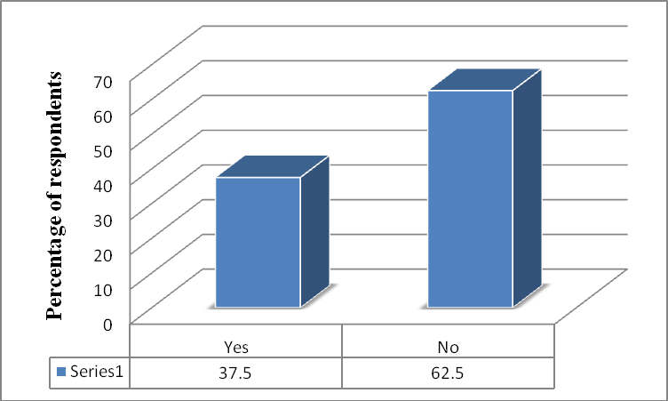

**Source: Researcher’s field work, 2010**

Figure 4.4(d) reveals that with information dissemination 62.5% stated that procedures outlining sending and receiving instructions are not cumbersome, but 37.5% saw them cumbersome. For those who said, the information flow is cumbersome, in their view service delivery is likely to be slow and indeed delay services to strategic investors and other consumers.

## Separation of official duties from private affairs

**Table 4.5(a): Degree of commitment of KMA Staff to the public**

|  |  |  |  |
| --- | --- | --- | --- |
| Response | Frequency | Percentage | Cumulative Percentage |
| Yes | 16 | 22.2 | 22.2 |
| No | 56 | 77.8 | 100.0 |
| Total | 72 | 100.0 |  |

## Source: Researcher’s field work, 2010

**Table 4.5(b): Fairness in public service delivery by KMA staff**

|  |  |  |  |
| --- | --- | --- | --- |
| Response | Frequency | Percentage | Cumulative Percentage |
| Yes | 57 | 79.2 | 79.2 |
| No | 15 | 20.8 | 100.0 |
| Total | 72 | 100.0 |  |

## Source: Researcher’s field work, 2010

**Table 4.5(c): Favouritism in staff upgrading and promotion**

|  |  |  |  |
| --- | --- | --- | --- |
| Response | Frequency | Percent | Cumulative Percent |
| Yes | 13 | 18.1 | 18.1 |
| No | 59 | 81.9 | 98.6 |
| Total | 72 | 100.0 |  |

## Source: Researcher’s field work, 2010

Tables 4.5(a) to 4.5(c) represent the inter-personal relationships that are impersonal and one of the key principles outlined in bureaucracy. Of the 72 respondents 56 do not agree with the view that KMA officials are serving themselves instead of the public. The remaining 16 respondents agree with this view. A public official is to serve all and

sundry without preference to one above the other and in accordance with working procedures and method. Fifty-seven (57) respondents said they can use their office to facilitate service delivery to known than to those they don‟t know. However, 15 respondents will follow due processes and treat all equally. Majority of respondent representing 59 revealed that laid down procedures are followed in upgrading staff, whilst the remaining 13 are of the view that procedures are breached to favour others.

## Figure 4.5(d): A Pie chart showing whether staff absence affects service delivery

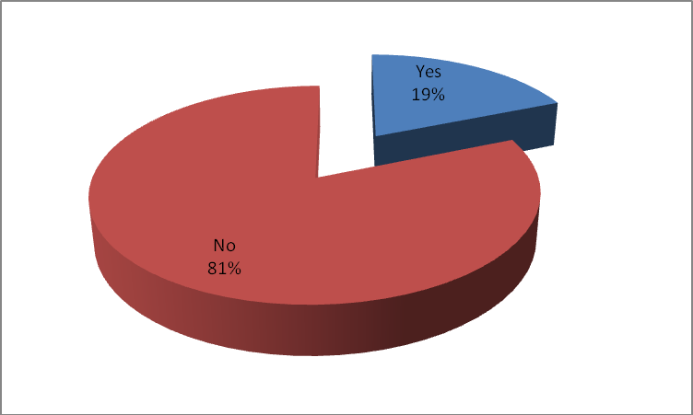

**Source: Researcher’s field work, 2010**

Figure 4.5(d) shows the continuity of work process in the absence of an employee through sickness, leave or transfer. Fifty-eight (58) respondents said work processes are not affected by the absence of an official, whilst 15 said the absence of an employee on particular schedule could bring service delivery to a halt.

## Consideration of technical competence in employment and promotion

**Table 4.6(a): Competitive recruitment and its relevance in KMA**

|  |  |  |  |
| --- | --- | --- | --- |
| Response | Frequency | Percentage | Cumulative Percentage |
| Yes | 34 | 47.2 | 47.2 |
| No | 7 | 9.7 | 56.9 |
| Not always | 31 | 43.1 | 100.0 |
| Total | 72 | 100.0 |  |

## Source: Researcher’s field work, 2010

**Table 4.6(b): Procedure outlined for promotion in KMA**

|  |  |  |  |
| --- | --- | --- | --- |
| Response | Frequency | Percentage | Cumulative Percentage |
| Merit | 46 | 63.9 | 63.9 |
| Long service | 26 | 36.1 | 100 |
| Total | 72 | 100.0 |  |

## Source: Researcher’s field work, 2010

**Table 4.6(c): Managerial and technical skills in KMA**

|  |  |  |  |
| --- | --- | --- | --- |
| Response | Frequency | Percentage | Cumulative Percentage |
| Agree | 56 | 77.8 | 77.8 |
| Disagree | 16 | 22.2 | 100 |
| Total | 72 | 100 |  |

## Source: Researcher’s field work, 2010

**Table 4.6(d): Perception on fixed salaries**

|  |  |  |  |
| --- | --- | --- | --- |
| Response | Frequency | Percentage | Cumulative Percentage |
| Yes | 22 | 30.6 | 30.6 |
| No | 50 | 69.4 | 100 |
| Total | 72 | 100 |  |

## Source: Researcher’s field work, 2010

The tables 4.6(a) to 4.6(d) show that out of the 72 respondents, 34 of them are of the view that employment is based on competitive recruitment. However, 7 of the respondents stated that it does not followed required procedures, whilst 31 of the remaining are of the view that there were times when competitive selection processes were considered and times when they were ignored. In respect promotion 46 respondents said it was based on merit whilst the remaining 26 indicated that long service. Fifty-six (56) respondents agreed with the assertion that the assembly is equipped with the managerial and technical skills to effectively carry out service delivery to the general public. The remaining 16 respondents disagreed with this assertion. In response to being paid fixed salaries as colleagues on the same level, 22 respondents saw nothing wrong with it, whilst 50 stated that, it stifles individual‟s effort at increasing productivity.

## Figure 4.6(e): Political interferences in recruitment

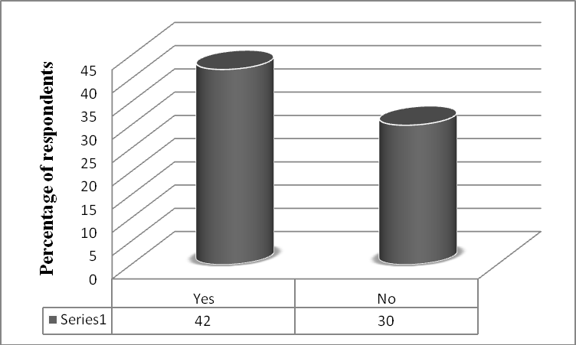

**Source: Researcher’s field work, 2010**

Figure 4.6(e) shows that 42 respondents see political interference as a major player in recruitment/employment into the KMA, as 30 do not see it that way. Those who stated that some staff had the opportunity through political “connections” added that it affects the quality of service delivery since such persons are incompetent and contribute to low productivity.

## Bureaucracy and public service delivery

**Table 4.7(a): KMA officials and concern for citizens as clients**

|  |  |  |  |
| --- | --- | --- | --- |
| Response | Frequency | Percentage | Cumulative Percentage |
| Yes | 46 | 63.9 | 68.7 |
| No | 26 | 36.1 | 100.0 |
| Total | 72 | 100.0 |  |

## Source: Researcher’s field work, 2010

**Table 4.7(b): Staff involvement in KMA/ government policies**

|  |  |  |  |
| --- | --- | --- | --- |
| Response | Frequency | Percentage | Cumulative Percentage |
| Through memos sent out to all departments | 42 | 58.3 | 58.3 |
| Staff durbars | 17 | 23.6 | 81.9 |
| Department meetings | 1 | 1.4 | 83.3 |
| Durbar | 1 | 1.4 | 84.7 |
| MCE manifesto, workshops | 3 | 4.2 | 88.9 |
| Public discussions on radio | 1 | 1.4 | 90.3 |
| Assembly meetings | 6 | 8.3 | 98.6 |
| Seminars and workshops | 1 | 1.4 | 100 |
| Total | 72 | 100 |  |

## Source: Researcher’s field work, 2010

Tables 4.7(a) and 4.7(b) show that 46 respondents believe that citizens are their clients whilst 26 remaining do not. As to whether development programmes are explained to staff of the assembly, 42 said that the assembly explains programmes to them through, memos dispatched to all departments with the remaining stating that it is done through seminars, department meetings, staff durbars and workshops, among others. This shows that development programmes and other administrative issues are widely circulated.

## Table 4.7(c): Is KMA well equipped to impact on development

|  |  |  |  |
| --- | --- | --- | --- |
| Response | Frequency | Percentage | Cumulative Percentage |
| Yes | 22 | 30.6 | 30.6 |
| No | 50 | 69.4 | 100 |
| Total | 72 | 100 |  |

**Source: Researcher’s field work, 2010**

## Table 4.7(d): KMA officials’ response to Public outcry

|  |  |  |  |
| --- | --- | --- | --- |
| Response to public outcry against concerning delay | Frequency | Percent | Cumulative Percent |
| Assembly has limited financial support | 17 | 23.6 | 23.6 |
| Citizen are not ready to pay taxes to the assembly | 10 | 13.9 | 37.5 |
| Public must be made aware of assembly‟s budget and inadequacies | 7 | 9.7 | 47.2 |
| KMA has done very well | 10 | 13.9 | 61 |
| KMA must speed up approval and completion of projects | 3 | 4.2 | 65.2 |
| Unnecessary bureaucracy in KMA administration. | 25 | 34.7 | 100 |
| Total | 72 | 100.0 |  |

**Source: Researcher’s field work, 2010**

Tables 4.7(c) and 4.7(d) show responses to the assembly‟s ability to create the needed environment for social and economic development within the metropolis, 30.6% were

confident of the assembly‟s capabilities, on the other hand, 69.4% do not think the assembly is well equipped to create that enabling environment. However, reacting to public out cry against delay in providing solutions to socio-economic issues, respondents expressed the following; limited financial support for the assembly, refusal of people within the metropolis to pay levies and unnecessary bureaucracy within the assembly‟s administrative systems. Others are of the view that budget allocated to the assembly must be made public for all to know limitations of the assembly.

## Table 4.7(e): The need for administrative reforms in KMA

|  |  |  |  |
| --- | --- | --- | --- |
| Response | Frequency | Percentage | Cumulative Percentage |
| Yes | 52 | 72.2 | 72.2 |
| No | 20 | 27.8 | 100.0 |
| Total | 72 | 100.0 |  |

**Source: Researcher’s field work, 2010**

Table 4.7(e) shows findings in answer to the question that seeks to understand how respondents assess current administrative processes, whether there is the need for reforms. In support of administrative reforms majority of respondents suggested better remuneration, computerization of working processes, staff capacity building, employment of more qualified personnel, yearly training programmes, personnel reshuffle and transfer, creation of better working environment whereas 27.8% do not see any need for a reform.

## Fig 4.7(f): A Figure showing effect of poor working environment on service delivery

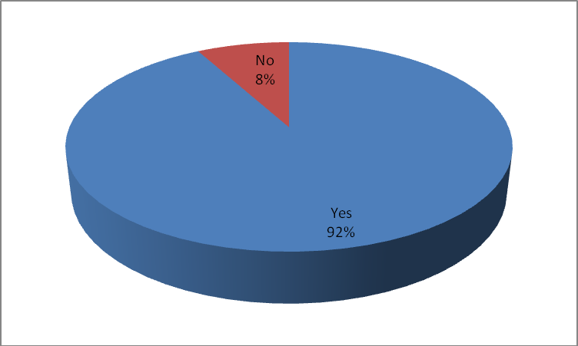

**Source: Researcher’s field work, 2010**

Figure 4.7(f) shows the distribution that explains respondents views on lack of adequate and descent working environment and their effects on quality and effectiveness of work. Ninety percent (92%) of respondents said poor working environment affect service delivery.

## Table 4.7(g): Effect of inadequate salary and remuneration on service delivery

|  |  |  |  |
| --- | --- | --- | --- |
| Response | Frequency | Percentage | Cumulative Percentage |
| Yes | 66 | 91.7 | 91.7 |
| No | 6 | 8.3 | 100 |
| Total | 72 | 100 |  |

**Source: Researcher’s field work, 2010**

Table 4.7(g) shows the effect of inadequate salary and remunerations on quality and effectiveness of service delivery. Sixty-six (66) respondents said salary and remuneration directly influence quality and effectiveness of service delivery in KMA.

They are of the view that excessive bureaucracy by some KMA officials are intended to extort money from consumers, due to low remuneration.

## Figure 4.7(h): Public reactions to KMA impact on government

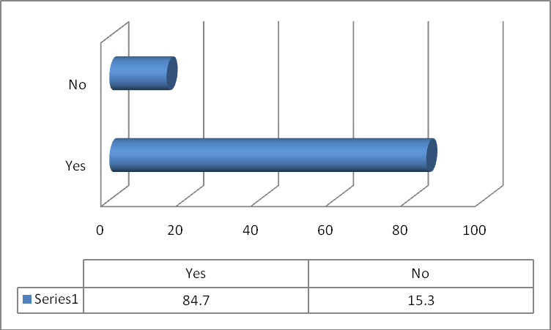

**Source: Researcher’s field work, 2010**

Figure 4.7(h) shows whether public resentments of poor service delivery negatively affect the image of government, 84.7% said the Assembly poor service directly affects the image of the KMA and the central government, whereas 15.3% do not see any relationship.

## Table 4.7(i): KMA solicits public views to enhance service delivery

|  |  |  |  |
| --- | --- | --- | --- |
| Response | Frequency | Percentage | Cumulative Percentage |
| Yes | 51 | 70.8 | 76.1 |
| No | 21 | 29.2 | 100 |
| Total | 72 | 100.0 |  |

**Source: Researcher’s field work, 2010**

Table 4.7(i) seeks the views on whether the assembly solicits views from the public to enhance service delivery. Fifty-one (51) respondents said the KMA solicits public input in its administration, whilst the remaining 21 respondents share a different view.

## Figure 4.7(j): Public satisfaction of service delivery

|  |  |  |  |
| --- | --- | --- | --- |
| Response | Frequency | Percentage | Cumulative Percentage |
| Agree | 42 | 58.3 | 58.3 |
| Disagree | 30 | 41.7 | 100 |
| Total | 72 | 100 |  |

**Source: Researcher’s field work, 2010**

Table 4.7(j) explains the assertion that the public is not satisfied with the level of service delivery from the assembly. Forty-two (42) respondents confirmed this public perception, as the remaining 30 disagree with it. A section of respondent alluded the cause of this to low staff motivation in salary, poor infrastructure, inadequate funds received by the assembly, refusal of people within the metropolis to pay taxes (more especially property rates), among other reason.

## Social and demographic background of clients/customers Table 4.8(a): Age groups of clients

|  |  |  |  |
| --- | --- | --- | --- |
| Age | Frequency | Percentage | Cumulative Percentage |
| 18 – 30 | 29 | 36.3 | 36.3 |
| 31 – 40 | 13 | 16.3 | 52.6 |
| 41 – 50 | 26 | 32.5 | 85.3 |
| 51 – 60 | 12 | 15 | 100 |
| Others | 0 | 0 | 100 |
| Total | 80 | 100 |  |

**Source: Researcher’s field work, 2010**

## Table 4.8(b): Gender distribution of clients

|  |  |  |  |
| --- | --- | --- | --- |
| Gender | Frequency | Percentage | Cumulative Percentage |
| Male | 44 | 55 | 55 |
| Female | 36 | 45 | 100 |
| Total | 80 | 100 |  |

**Source: Researcher’s field work, 2010**

## Table 4.8(c): Educational background of clients/customers of the Assembly

|  |  |  |  |
| --- | --- | --- | --- |
| Qualifications | Frequency | Percentage | Cumulative Percentage |
| Primary | 13 | 16.3 | 16.3 |
| Secondary | 22 | 27.5 | 43.8 |
| Polytechnic | 13 | 16.3 | 60.1 |
| University | 19 | 23.8 | 83.9 |
| None | 13 | 16.3 | 100 |
| Total | 80 | 100 |  |

**Source: Researcher’s field work, 2010**

## Table 4.8(d): Occupation of clients/customers

|  |  |  |  |
| --- | --- | --- | --- |
| Occupation | Frequency | Percentage | Cumulative Percentage |
| Businessman | 16 | 20 | 20 |
| Trading | 25 | 31.3 | 51.3 |
| Public Servant | 12 | 15 | 66.3 |
| Student Farmer | 7  10 | 8.8  12.5 | 75.1  87.6 |
| Unemployed | 10 | 12.5 | 100 |
| Total | 80 | 100 |  |

**Source: Researcher’s field work, 2010**

## Table 4.8(e): Length of stay in Kumasi

|  |  |  |  |
| --- | --- | --- | --- |
| Response | Frequency | Percentage | Cumulative Percentage |
| Less than 1 year | 7 | 8.8 | 8.8 |
| l - 5 years | 32 | 40 | 48.8 |
| 6 - 10 years | 16 | 20 | 68.8 |
| More than 11 years | 25 | 31.3 | 100 |
| Total | 80 | 100 |  |

**Source: Researcher’s field work, 2010**

Tables 4.8(a) to 4.8(e) show the socio-demographic characteristics of the respondents and their frequencies. The age group of 18-30 has the highest frequency of 29 respondents and 51-60 was the lowest with 12 respondents. Out of the 80 respondents, 44 were males and 36 females. Sixty-seven (67) respondents had formal education ranging from primary, secondary and tertiary. The remaining 13 had no formal education. Apart from the 63 respondent who are involved in various vocations, the rest 17 are students and unemployed. Thirty-two (32) respondents indicated having been resident in Kumasi for the period of l-5 years and formed the highest frequency, which is followed by 25 respondents with more than 11 years and the lowest frequency is 7, which is less than l year.

## Clients’ Perception of Bureaucracy and public service delivery Table 4.9(a): Types of services obtained from the KMA

|  |  |  |  |
| --- | --- | --- | --- |
| Types of services | Frequency | Percentage | Cumulative Percentage |
| Business operating permit | 19 | 23.8 | 23.8 |
| Store License | 15 | 18.8 | 42.6 |
| Building permit | 16 | 20 | 62.6 |
| Death/Birth/Burial certificates | 12 | 15 | 77.6 |
| Marriage certificate Other | 12  6 | 15  7.5 | 92.6  100 |
| Total | 80 | 100 |  |

**Source: Researcher’s field work, 2010**

Table 4.9(a) shows the types of services respondents obtained from the KMA and the bases for the assessment of this research. The highest frequency is 19 and their interaction with the assembly was to obtain permit to operate their businesses with the rest as follows; building permits, store license, marriage certificate, birth/death/burial certificate and other services.

## Table 4.9(b): Technical capability of departments to discharge timely services

|  |  |  |  |
| --- | --- | --- | --- |
| Response | Frequency | Percentage | Cumulative Percentage |
| Yes | 10 | 12.5 | 12.5 |
| No  Do not know | 55  15 | 68.8  18.8 | 81.3  100 |
| Total | 80 | 100 |  |

**Source: Researcher’s field work, 2010**

Table 4.9(b) represents the response of clients of KMA in connection with the technical capability of the assembly to discharge its obligations. Out of the 80 respondents 55

said the KMA is not well equipped to function, 10 said the assembly has the capacity to perform well. Some respondents blamed the ineffectiveness of the assembly on lack of expertise, equipment and political appointment of MCEs.

## Figure 4.9(c): Relevance of rules, regulations and procedures in service delivery

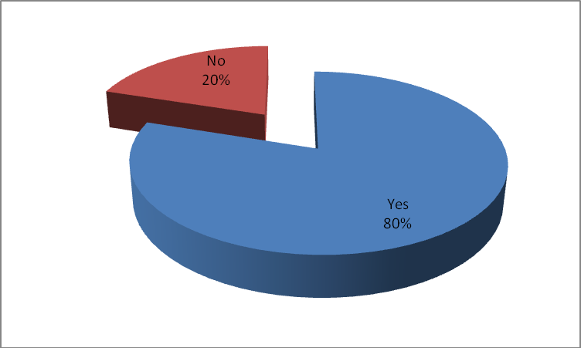

**Source: Researcher’s field work, 2010**

Figure 4.9(c) shows that the greater number of respondents representing 80% is of the view that rules and regulations are necessary to direct the conduct and ways of working of KMA officials. However, the remaining 20% do not think they are necessary.

## Table 4.9(d): Reponses to whether service delivery is procedurally delayed

|  |  |  |  |
| --- | --- | --- | --- |
| Response | Frequency | Percentage | Cumulative Percentage |
| Yes | 63 | 78.8 | 78.8 |
| No | 17 | 21.2 | 100 |
| Total | 80 | 100 |  |

**Source: Researcher’s field work, 2010**

Table 4.9(d) shows the perception of clients about procedures that outlined processes of service delivery and their relevance. Forty-three (63) respondents said KMA officials do follow detailed administrative procedures which are not relevant and therefore delay service delivery. According to respondents, some of these procedures lead to corruption, bribery and extortion. The remaining 17 do not see any delay in procedures in service delivery.

## Figure 4.9(e): A Bar graph showing whether clients are treated equally.

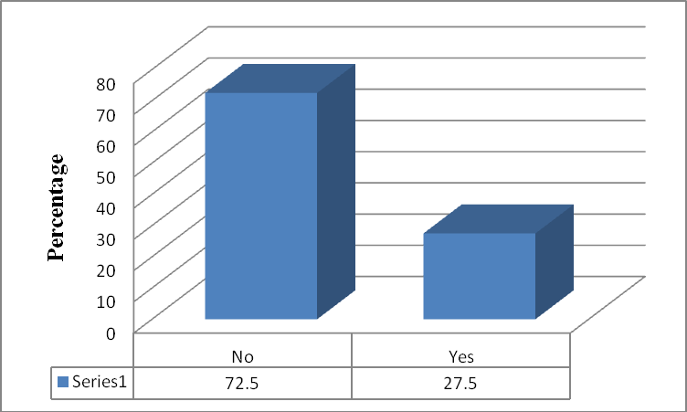

**Source: Researcher’s field work, 2010**

Figure 4.9(e) according to the graph, 58 respondents representing 72.5% agree that where rules and regulation are strictly followed, favouritism and discrimination in service delivery are minimised. Yet, rules, regulations, procedures and methods have not served their purposes in the KMA. On the other hand 27.5% made up of 22 respondent said rules and regulations have worked effectively that no client given preferential treatment.

## Table 4.9(f): KMA staff show of courtesy and friendliness to clients/customers.

|  |  |  |  |
| --- | --- | --- | --- |
| Response | Frequency | Percentage | Cumulative Percentage |
| Yes | 34 | 42.5 | 42.5 |
| No | 46 | 57.5 | 100 |
| Total | 80 | 100 |  |

**Source: Researcher’s field work, 2010**

Table 4.9(f) shows the views of respondents about friendliness and responsiveness of KMA employees. Thirty-four (34) respondents have attested to the fact that KMA staff show courtesy and friendliness to their customers/clients, whilst the remaining 46 did not agree with this. This confirms undue delays clients encounter in registrations and collection of permits for personal or business purposes.

## Table 4.9(g): The degree of customer satisfaction in service delivery

|  |  |  |  |
| --- | --- | --- | --- |
| Response | Frequency | Percentage | Cumulative Percentage |
| Very Satisfied | 12 | 15 | 15 |
| Satisfied | 16 | 20 | 35 |
| Dissatisfied | 23 | 28.8 | 63.8 |
| Very dissatisfied | 29 | 36.3 | 100 |
| Total | 80 | 100 |  |

**Source: Researcher’s field work, 2010**

Table 4.9(g) shows that majority of clients representing 52 are not satisfied with the level of customer satisfaction KMA provided. The remaining 28 were dissatisfied with services rendered.

## Table 4.9(h): Responses of respondent about delays in service delivery

|  |  |  |  |
| --- | --- | --- | --- |
| Response | Frequency | Percentage | Cumulative Percentage |
| Strongly agreed | 9 | 11.3 | 11.3 |
| Agree | 13 | 16.3 | 27.6 |
| Disagree | 22 | 27.5 | 55.1 |
| Strongly disagree | 36 | 45 | 100 |
| Total | 80 | 100 |  |

**Source: Researcher’s field work, 2010**

Table 4.9(h) shows responses to the question seeking to know whether respondents are satisfied with duration of service delivery. Fifty-eight (58) respondents forming majority were of the view that they were unnecessarily delayed.

## Figure 4.9(i): A Pie chart showing the degree of favouritism in service delivery

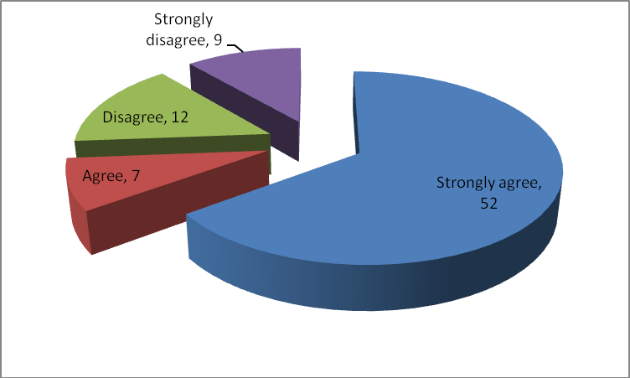

**Source: Researcher’s field work, 2010**

Figure 4.9(i) shows that 52 respondents strongly agree with the perception that one cannot be expeditiously attended to if one doesn‟t know any official of the Assembly.

However, the lowest number of 9 respondents said favouritism does not play any role in service delivery.

## Table 4.9(j): KMA bureaucrat’s absence from duty affects service delivery

|  |  |  |  |
| --- | --- | --- | --- |
| Response | Frequency | Percentage | Cumulative Percentage |
| Strongly agreed | 38 | 47.5 | 47.5 |
| Agree | 16 | 20 | 67.5 |
| Disagree | 11 | 13.8 | 81.3 |
| Strongly disagree | 15 | 18.8 | 100 |
| Total | 80 | 100 |  |

**Source: Researcher’s field work, 2010**

Table 4.9(j) represents responses to whether the absence of any official probably as a result of sickness, leave, transfer, or death could affect the process of service delivery. Thirty-eight (38) respondents said the absence of an official at KMA can delay service delivery. Since some staff would not like their colleagues continue works they are doing, due to personal interest and selfish gains. Fifteen (15) respondents strongly disagree, thereby indicating that an absentee official‟s duties are taken over by another.

## Table 4.9(k): KMA staff treatment of the public as clients

|  |  |  |  |
| --- | --- | --- | --- |
| Response | Frequency | Percentage | Cumulative Percentage |
| Strongly agree | 6 | 7.5 | 7.5 |
| Agree | 7 | 8.8 | 16.3 |
| Disagree | 19 | 23.8 | 40.1 |
| Strongly disagree | 48 | 60 | 100 |
| Total | 80 | 100 |  |

**Source: Researcher’s field work, 2010**

Table 4.9(k) represents the views of respondents as to whether staff of KMA are aware that businessmen, traders, corporate institutions, students, unemployed, etc are their clients/customers. Sixty-seven (67) representing “disagree” and “strongly disagree” which forms 83.8% of clients who responded to this study, do not think that staff know that members of the public are client of the Assembly and very vital to the success of KMA‟s development programmes.

## Figure 4.9(l): A figure showing whether or not KMA needs administrative reforms.

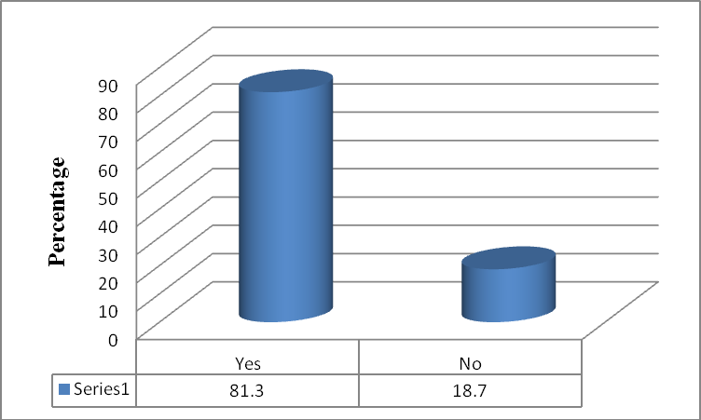

**Source: Researcher’s field work, 2010**

Figure 4.9(l) shows that 81.3% respondents would wish to see administrative reforms in KMA. As part of the reforms, respondents suggested recruitment of qualified staff, relocation of the assembly‟s head office, reduction in political influence in the area of employment, supply of modern electronic equipment and training of staff to use them, better salary and remuneration for staff, increase in the assembly‟s common fund to meet demand, supply of machines and tools, etc.

## Figure 4.9(m): Political influences in appointments and service delivery

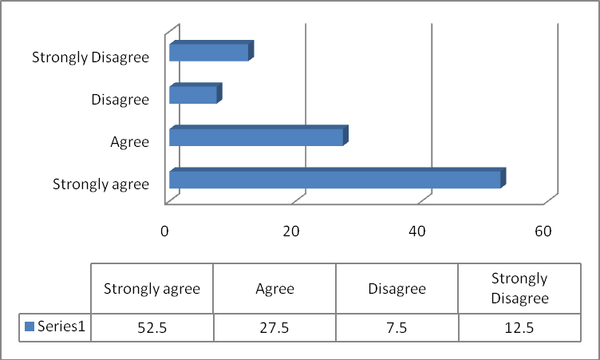

**Source: Researcher’s field work, 2010**

Figure 4.9(m) shows only 20% of respondents “disagree and strongly disagree” with the views that staff who were appointed to the KMA through political leanings and “connections” perform poorly, thus contributing to poor service delivery. However, the rest 80% blamed the Assembly‟s poor performance to political influences in employment/recruitment. Adding that persons with strong political “connections” do not respect authority and do not think they can be punished for non-performance.

## Table 4.9(n): Effect of working environment on service delivery

|  |  |  |  |
| --- | --- | --- | --- |
| Response | Frequency | Percentage | Cumulative Percentage |
| Yes | 68 | 85 | 85 |
| No | 12 | 15 | 100 |
| Total | 80 | 100 |  |

**Source: Researcher’s field work, 2010**

Table 4.9(n) shows the effects of lack of adequate and decent working environment on quality and effectiveness. Sixty-eight (68) respondents making 85% said that poor service delivery comes about as a result of poor working environment, whilst the remaining 12 respondents representing 15% do not see any relation. Respondents suggested renovation and expansion of all offices will motivate the staff to improve their service delivery.

## Table 4.9(p): Customers views on staff remuneration and service delivery

|  |  |  |  |
| --- | --- | --- | --- |
| Response | Frequency | Percentage | Cumulative Percentage |
| Strongly agreed | 57 | 71.3 | 71.3 |
| Agree | 12 | 15 | 86.3 |
| Disagree | 4 | 5 | 91.3 |
| Strongly disagree | 7 | 8.7 | 100 |
| Total | 80 | 100 |  |

**Source: Researcher’s field work, 2010**

In the view of customers as shown in Table 4.9(p) inadequate salary and remuneration of KMA staff affect the quality and effectiveness of service delivery. About 71.3% of respondents strongly agree to the view that low remuneration has negative effects on

service delivery. They however suggested that some officials create opportunities for extortion and other favours, due to low remunerations.

## Figure 4.9(q): Effect of customers’ perception on central government

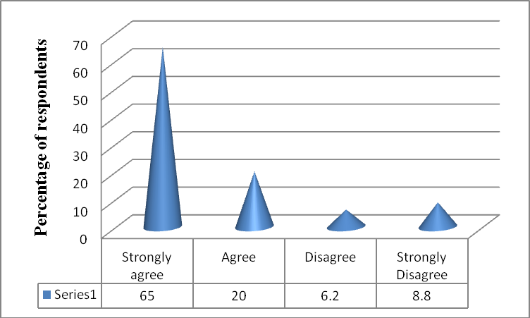

**Source: Researcher’s field work, 2010**

Figure 4.9(q) reveals the impact of KMA‟s performance on a ruling government. Fifty- two (52) respondents representing 65% said the poor performance of the KMA directly affect the popularity and image of the central government, whilst 5 respondents representing 8.8% strongly disagree with the assertion. Respondents indicated that cumbersome administrative procedures resulting in corruption, affect profitability and growth of businesses. This could eventually lead to the collapse of businesses and affect popularity of ruling government, which might be blamed for bad socio-economic policies.

## Table 4.9(r): Does the KMA solicit public views on service delivery?

|  |  |  |  |
| --- | --- | --- | --- |
| Response | Frequency | Percentage | Cumulative Percentage |
| Yes | 19 | 23.8 | 23.6 |
| No | 61 | 76.2 | 100 |
| Total | 80 | 100 |  |

**Source: Researcher’s field work, 2010**

From Table 4.9(r) above, sixty-one (61) respondents stated that the assembly does not solicit consumer and public views, whilst the remaining 19 agreed with the view. To those who said that the Assembly solicits views, indicated that constituents channel their disapprovals of the Assembly‟s performance through their Assembly Members. Some also indicated that radio discussions address issues concerning the Assembly‟s service delivery.

## Table 4.9(s): Customers views on quality of services offered by KMA

|  |  |  |  |
| --- | --- | --- | --- |
| Response | Frequency | Percentage | Cumulative Percentage |
| Agree | 66 | 82,5 | 82.5 |
| Disagree | 14 | 17.5 | 100 |
| Total | 80 | 100 |  |

**Source: Researcher’s field work, 2010**

Table 4.9(s) represents respondents‟ views on whether or not they are satisfied with the quality of services offered by the KMA. Sixty-six (66) respondents said they did not get the care and satisfaction, whilst the remaining 14 disagree with the view. Some of the disaffections were that there are many bottlenecks hindering swift flow of service

delivery by which consumers incur more cost in terms of time and money in getting the service.

## Table 4.9(t): How would you recommend the assembly to others?

|  |  |  |  |
| --- | --- | --- | --- |
| Response | Frequency | Percentage | Cumulative Percentage |
| Excellent | 9 | 11.3 | 11.3 |
| Very good | 12 | 15 | 26.3 |
| Good | 39 | 48.8 | 75.1 |
| Fair | 20 | 25 | 100 |
| Total | 80 | 100 |  |

**Source: Researcher’s field work, 2010**

Table 4.9(t) shows the views of respondent on the extent to which they evaluate the performance of the KMA to merit any recommendation to others. Nine (9) respondents would recommend the KMA for excellent performance, 12 saw the Assembly to have performed very good, with 39 stating that staff performance could be rated as good. However the rest 20 respondent noted that KMA can be rated to have performed fairly. These results show that the KMA has to develop a better strategy in its service delivery so as to meet the satisfaction of clients/consumers.

## Table 4.9(u): Overall rating of service delivery

|  |  |  |  |
| --- | --- | --- | --- |
| Response | Frequency | Percentage | Cumulative Percentage |
| Excellent | 5 | 6.3 | 6.3 |
| Very good | 9 | 11.3 | 17.6 |
| Good | 22 | 27.5 | 45.1 |
| Fair | 25 | 31.3 | 76.4 |
| Poor | 19 | 23.8 | 100 |
| Total | 80 | 100 |  |

**Source: Researcher’s field work, 2010**

Table 4.9(u) shows how respondents rated the Assembly after having obtained its services. Out of the 80 respondents, 25 of them representing the highest frequency said KMA and its staff did fairly and the lowest which 5 gave an excellent rating.

## CHAPTER FIVE FINDINGS/CONCLUSION AND RECOMMENDATIONS

* 1. **Introduction**

Under the 1992 Constitution and by PNDC Law 207 (1993) and Act 462 (1993) Metropolitan, Municipal and District Assemblies were established as legal pivot for political, administrative and legislative authorities to partner the central government in public service delivery for national development.

However, MMDAs are encountering bureaucratic challenges making delivery of public services below expectations and satisfaction of stakeholders, especially consumers of public services. Indeed the Assembly faces problems such as; inadequate financial support to implement socio-economic policies, lack of skilled manpower to drive Assemblies‟ goals, poor office environment with archaic equipment, etc.

## Findings

* + 1. **Division of labour and coordination of work activities**

The study identified that majority of staff of KMA, forming 99% of respondent accept the fact that departments work together for collective goals. This realisation, however, does not translate into productivity, according to 58.3% of staff. One other contributory factor to this negative trend is lack of modernised equipment in the departments, which 65.3% respondents from the Assembly and 68.8% from the public, respectively suggest hamper the efforts of the Assembly.

## Effects of rules and regulations on service delivery

Rules and regulations in an organisation are to delineate the public servant from personal considerations in work activities on behalf of the organisation. Staff who took part in the study and forming 88.9% agree that work activities of the Assembly are guided by rules, methods, procedures, regulations, etc. This was confirmed by 80% of clients, who think they are very relevant to operations. However, 72.5% of clients rules, regulations, procedures, were excessively or selfishly applied by staff of the Assembly.

## Authority structure and information dissemination

Results from the study indicated that 77.8% were of the view that the MCE‟s leadership style is democratic, which involves all in participatory approach in meeting the Assembly‟s objectives. On the other hand, the remaining 22.2% think the MCE demonstrates autocratic administrative qualities. It is a serious indictment on the Assembly to have 41.7% of respondent stating that communication between the MCE and the departments has not been that expeditious.

* + 1. **Consideration of technical competence in employment and promotion** According to Oyelaran-Oyeyinka (2006), the civil servant must be competent, effective and efficient in order to be able to implement government policies. Findings from the study show that only 34 staff out of 72 has confidence in the selection processes into the Assembly. The remaining forming majority has no confidence, confirming Boakye- Sarpong‟s (1998) assertion that widespread practice of politicised recruitment were reported in developing nations bureaucracy. Notwithstanding this, 56 respondents

asserted that the Assembly has the needed managerial and technical skills to discharge service to the general public.

## Bureaucracy and public service delivery

The administrative processes presupposes that a positive relationship between the administrator and his clientele members of the public who enjoy his services (Boakye- Sarpong, 1998). Even though 63.9% of respondents from the Assembly indicated knowing that citizens are their clients. On the other hand, over 80% of clients were of the view that staff of the Assembly do not have customer satisfaction as a major concern. According to majority of clients/customers, who interacted with the Assembly to acquire services such as; business operating permit, store license, building permit, death/birth/burial certificates, etc, services are procedurally delayed for selfish reasons. Further to this, staff are unfriendly and lack customer care. This therefore culminated in over 80% of clients‟ poor rating for the Assembly.

The Local Government Act 462, 1993 and Legislative Instrument LI 1614, 1989 assigned to MMDAs including the KMA the roles of overall development of their jurisdictional areas, formulation and execution of plans, programmes and strategies for effective mobilisation of resources necessary for development, among others. Despite this enormous legal support for the KMA, respondents from both sides think a ruling government stands to be blamed for poor performance in service delivery by the Assembly.

There was an overwhelming call for administrative reforms within the KMA in other to enhance service delivery for increase growth in socio-economic development of the metropolis. This is confirmed by 72.2% of staff, who suggested as part of the reforms, better remuneration, computerisation of working processes, staff capacity building, employment of more qualified staff, yearly training programmes, regular personnel reshuffle and transfer, provision of better working environment (refurbishment of offices and supply of furniture), etc. On the part of clients and as a way of reform suggested; the strong political influence in employment must be done away with, so that competent qualified persons should be employed through due processes, relocation of the Assembly‟s offices to a better and spacious premises, training of staff in customer care, increase in the Assembly‟s Common Fund to meet demand, among others.

## Recommendations

Based on the findings and conclusions drawn from the research data and analysis these recommendations are made for consideration by KMA and the central government.

## Division of labour and departmental co-operation

The study identified that departments do not effectively coordinate activities for timely delivery of services, partly caused by lack of equipment and selfish behaviours on the part of some staff. To correct these anomalies, KMA should resource all departments with required equipment and discipline staff whose activities bring the Assembly into disrepute.

## Effects of rules and regulations on service delivery

For the purpose of achieving efficiency, an organisation‟s operations for achievement of results are guided by laid down rules, regulations, procedures and methods. However, these were excessively used by staff, suggesting that periodic review of procedures, methods, rules and regulations would go a long way by removing barriers and reformulation of acceptable practices for expeditious service delivery.

It was very evident that private sector bureaucracy adopts flexible workplace structures and encourages creativity and experimentation to maximize efficiency and productivity. These strategic directions would positively impact on KMA‟s operations if taken as part of the reforms.

## Authority structure and information dissemination

Information should be easily and accurately communicated to staff of the Assembly when they need it. The Assembly‟s productivity would be hampered if policies are slow in reaching staff.

* + 1. **Consideration of technical competence in employment and promotion** Recruitment of staff based on political affiliation, family, ethnic and religious should be eschewed. The situation where inexperience and less qualified persons were recruited into various job positions must be a thing of the past, if the Assembly wants to significantly enhance its operations.

## Bureaucracy and public service delivery

Staff of the Assembly should be periodically trained in line with the tenets of New Public Management System which specifies the following; improvement of quality of services delivered to consumers; adherence to consumer focus principles; reduction of inflexibility, rigidity and other forms of bureaupathology in service; involvement of consumers in service delivery system design and packaging, etc. This will boost the confidence of clients/customers who are dissatisfied with the Assembly‟s performance in service delivery.

As a public institution empowered by law to promote and provide support for productive activities and development (community health and sanitation, maintenance of law and order, general amenities such as roads, bridges, basic education and infrastructure) public participation in the Assembly‟s programme is very vital to the successful implementation of its policies. It is in this vein that feedbacks on the Assembly‟s performance are crucial and public input into policy formulation and implementation necessary in advancing development of the metropolis.

## Conclusion

Public service delivery is the implementation of services and making sure they are timely delivered to people and places they are intended to. If the private sector is the engine of growth, then the public sector is the fuel needed to propel that engine to function profitably. However, the general view on public service delivery has not be

satisfactory with complaints of excessive bureaucratic procedures intended to extort

money from prospective clients, thereby stalling social and economic development, deepening the suffering of the people. The negative impacts of bureaupathology, as a result of ineffective civil/public institutions are too costly to quantity in monetary terms. Until government pursue a strong public sector reforms, setting measurable objectives, disciplining corrupt public servants and reprimanding ineffective institutions, bureaucracy shall only be a word in the dictionary.

## REFERENCES

**Adu-Gyamfi O (2003)**, The Nature and Scope of Public Sector Administration and Management in Ghana, University Printing Press, KNUST, Kumasi.

**Adu-Gyamfi O (2005)**, Introduction to Public Sector Administration in Ghana, University Printing Press, KNUST, Kumasi.

**Almere Gemeente (2005)**, Summary of the visit of the Almere Councils to Accra and Kumasi, <http://www.samenwerk.nl/files_contents/Report_april_2005_english_version.pdf> (accessed 2010 May 10)

**Bean J and Hussey L (1997)**, Marketing Public Sector Services, HP Publications, London

**Blau Peter M (1956)**, Bureaucracy in Modern Society, Nwe York, Random

**Boakye-Sarpong Kwame, (1998)** Bureaucracy and Development in the Emerging Nations: An Ecological Approach

Institute of African Studies: Research Review Vol. 14 No. 1 1998: 1-15

**Chapman Brian (1959)**, The Profession of Government, London, George Allen & Unwin

**Chapman D and Cowdell T (1998)**, The New Public Sector Marketing, Lonndon,: Financial Times

**Corubolo, E. with Mattingly, M. (1999)**, 'Peri-urban profiles: Kumasi (Ghana)', paper produced for the research project on Strategic Environmental

Planning and Management for the Peri-urban Interface, Development Planning Unit, University College London (available from [www.ucl.ac.uk/dpu/pui](http://www.ucl.ac.uk/dpu/pui)) (accessed 2010 April 6)

**Cousins L (1990)**: Marketing of Services, London Hiereman

**Elliott de Saez Eileen (2002)**, Marketing Concepts for Libraries and Information Services, Facet Publishing, London.

Ghana Population and Housing Census (2002)

**Gilmore A. (2003)**, Service Marketing and Management, Sage Publications Ltd, London.

**Hall Richard (1962)**, Intra Organisational Structural Variation: Application of Bureaucratic Model, Administrative Science Quarterly No 7

**Heady Ferrel (1996)**, Public Administration, A Comparative Perspective, 5th Edition, New York

**Kernaghan K. And Sergel D. (1999)**, Public Administration in Canada, 4th Edition, Ontario

**Kotler P and Zaltman G (1971)** Social Marketing: An Approach to Planned Social Change, Journal of Marketing, Vol 35

## Kotler P and Zaltman G (1971) Marketing in the Public Sector

<ftp://ftp.pearsoned-ema.com/HPE_Samples/SampleChapters/9780273708094.pdf>

(accessed 2010 December 15)

**Kumasi Metropolitan Assembly (2006-2009)**, Development Plan for Kumasi Metropolitan Area.

**Merton K. Robert, (1957)** Social **Theory and Social Structure**. Glencoe, IL: Free Press, (pp. 195-206)

<http://media.pfeiffer.edu/lridener/courses/MERTONR2.HTML>(accessed 2010 March 8)

**Modibo Ocran, Tawiah (1978)** Law in Aid of Development, Ghana Publishing Corporation, Accra.

**Newman M. David, (1997)** Sociology: Exploring the Architecture of Everyday Life. Duke University Press

**Nukunya G.K.(2001)** Tradition and Change in Ghana: Introduction to Sociology. Ghana University Press.

**Okafor E. E. (2205)** Public Bureaucracy and development in Nigeria: A critical Overview of Impediments to Public Service Delivery <http://www.codesria.org/links/Publications/bulletin3_05/Okafor>(accessed 2009 July 4)

**Osborne David and Gaebler Ted (1992)**, Reinventing Government, Addison Wesley Publishing Co, Ontario Canada.

**Owusu Francis (2005)** On Public Organizations in Ghana:

What Differentiates Good Performers from Poor Performers? <http://www.public.iastate.edu/~fowusu/Public%20Orgs%20in%20Ghana.pdf>(accessed 2009 October 12)

**Oyelaram-Oyeyinka, Rosamund Naduvi Ibiyemi, (2006)** Government and Bureaucracy: Leadership in Nigeria‟s Public Service. The case of the Lagos State Civil Service (1967-2005). Universitaire Pers Maastricht.

<http://arno.unimaas.ni/show.cgi?tid=5663>(accessed 2010 January 29)

**Private Enterprise Foundation** <http://www.pefghana.org/index.php?option=subcontent&Menid=6&Itemid=25> (accessed 2010 June 10)

**Proctor Tony (2007)**, Public Sector Marketing, Bell and Bain Limited Glasgow

**Public Systems Management ( 2003)**, The Commonwealth of Learning Study Kit

**Self Peter (1997)**, Administrative Theories and Politics, 2nd Edition, George Allen & Unwin, London

**Teofilovic Nada, (2002)** The Reality of Innovation in Government <http://www.innovation.cc/peer-reviewed/reality.pdf>(accessed 2010 February 16)

**Thompson V.A. (1961)** Modern Organisation, Alfred A. Knopf Inc. New York Weber Marx, (1978). Economy and Society: An Outline of Interpretive Sociology, edited by Guenther Roth and Claus Wittich. University of California Press.

**Wise Charles and Amna Erik (1993)** New Managerialism in Swedish Local Government. [http://www.tidsskrift.dk/visning.jsp?markup=&print=no&id=99211](http://www.tidsskrift.dk/visning.jsp?markup&print=no&id=99211) (accessed 2010 December 12)

## Appendix 1

**THE IMPACT OF BUREAUCRACY ON PUBLIC SERVICE DELIVERY; A STUDY OF KUMASI METROPOLITAN ASSEMBLY.**

This study is being conducted with the view to understanding the effectiveness of the coordinating principles, upon which the system of bureaucracy is built. As the world begun to experience change as a result of industrialisation, the principles of bureaucracy were postulated as a leverage and facilitator of the expected change to the world of business and public administration. The ultimate goal is to understand the extent to which bureaucracy impacts on public service delivery. Your honest opinion is hereby solicited in the answers to the following questions. This is in fulfillment of Executive Master of Public Administration from the Faculty of Distance Learning, Kwame Nkrumah University of Science and Technology. Your participation is entirely voluntary and all information collected for this study will be treated as confidential. Thanks for your co-operation. The efforts you put into filling of the questionnaires is very much appreciated.

## QUESTIONNAIRE

**SECTION (A): SOCIAL AND DEMOGRAPHIC BACKGROUND**

1. Age of respondents: a. 18-30 [ ] b. 31-40 [ ] c. 41-50 [ ] d. 51-60 [ ]

1. Sex of respondent: a. Male [ ] b. Female [ ]
2. Qualification: a. Primary [ ] b. Secondary [ ] c. Polytechnic [ ] d. University [ ]

4. Position……………………………………………………………………

1. How long have you been engaged with KMA? A. less than 1 yr [ ] b. 2-5 yrs [ ]

c. 6-9 yrs [ ] d. 10-14 yrs [ ] e. 15 or more years [ ]

## SECTION (B): DIVISION OF LABOUR AND COORDINATION OF ACTIVITIES.

1. Please indicate your department;
   1. Administration [ ] b. Audit [ ] c. Legal [ ] d. Engineering [ ]

e. Planning [ ] f. Budget [ ] g. Works [ ] h. Estate [ ]

i. Health [ ] j. Finance [ ] k. Waste Management [ ] l. Transport [ ]

m. Education [ ] n. Social Welfare [ ] o. Community Development [ ]

p. Town & Country Planning [ ]

1. Does the function of your department depend on partnership with other departments within the KMA? A. Yes [ ] b. No [ ]
2. Do you think this partnership collectively produce the desired efficiency and increase in productivity? A. Yes [ ] b. No [ ]
3. Does your department have the technical capacity required to carryout its functions? A. Yes [ ] b. No [ ]
4. What changes will you want for your department for better performance?

…..……………………………………………………… …………………

……………..………………………………………………………………….

## SECTION (C): GENERAL RULES AND THE PRINCIPLE OF INNOVATION.

1. Are there established procedures to guide every office as to the way of working?
   1. Yes [ ] b. No [ ]
2. Do you think it is necessary to have these rules and regulations directing your conduct and ways of working? a. Yes [ ] b. No [ ]
3. Do you follow detailed procedures, which to you are not relevant and delay processes?
   1. Yes [ ] b. No [ ]
4. Does working according to rules and regulations eliminate favouritism?
   1. Yes [ ] b. No [ ]
5. Does the following of detailed procedure in your work prevent you from making other decision (innovation) relating to your work? a. Yes [ ] b. No [ ]
6. In KMA, is an employee held accountable for working behaviours resulting in low productivity? a. Yes [ ] b. No [ ]

**SECTION (D): AUTHORITY STRUCTURE & COMMUNICATION FLOW**

1. How do you see the command structure of the KMA?
   1. Authoritarian [ ] b. Democratic [ ]
2. Do you think information flow from the MCE is slow in reaching you?
   1. Yes [ ] b. No [ ]
3. Do you think procedures in place in sending/receiving information relating to official duties to MCE & other superior are cumbersome? a. Yes [ ]

b. No [ ]

1. Do you think there is a strong coordination between senior management and junior staff? A. Yes [ ] b. No [ ]
2. What are some of the problems encountered in the administrative processes?

………………………………………………………………………………

………………………………………………………………………………………

………………………………………………………………………………………

**SECTION (E): SEPERATION OF OFFICIAL DUTIES FROM PRIVATE AFFAIRS**

1. It is often said that public officials in this establishment serve their own interest rather than that of the public. Is this true? a. Yes [ ] b. No [ ]
2. Would you treat someone you know differently in service delivery than another person that you do not know? a. Yes [ ] b. No [ ]
3. Can a staff be upgraded without considering laid down procedures? a. Yes [ ]

b. No [ ]

1. Can the absence (sick/leave, etc) of a staff in KMA bring service delivery processes to a halt? a. Yes [ ] b. No [ ]

**SECTION (F): TECHNICAL COMPETENCE IN EMPLOYMENT AND PROMOTION**

1. Is employment based on competitive recruitment system? a. Yes [ ] b. No [ ]

c. Not always [ ]

1. Does political interference play any significant role in employment in this establishment?
   1. Yes [ ] b. No [ ] c. Not really [ ]
2. Promotion in this institution is based on, a. merit [ ] b. long service [ ]
3. KMA is equipped with required managerial and technical skills to effectively carry out service deliveries to the general public? a. Agree [ ] b. Disagree [ ]
4. You are paid a fixed salary as other colleagues on the same grade; do you think it is fair?
   1. Yes [ ] b. No [ ]
5. I will appreciate any further comments you would like to be considered in this section.……………………………………………………………………………

……………………………………………………………………………………

……………………………………………………………………………………

……………………………………………………………………………………

……………………………………………………….

## SECTION (G): BUREAUCRACY AND PUBLIC SERVICE DELIVERY

1. What does the word “bureaucracy” mean to you?………………………………

………………………………………………………………………………………..

1. In KMA, does everyone believe that citizens are their clients?
   1. Yes [ ] b. No [ ]
2. Are development objectives of the KMA explained to you? a. Yes [ ] b. No [ ]
3. If yes, please give a brief note on how the assembly relays objectives to you?…………….…………………………………………………………………

……………………………………………………………………………………

…………

1. Do you believe in the assembly‟s ability to impact on social and economic development of the metropolis? a. Yes b. No
2. If No, what do you think must be done to equip the KMA?…………………

……………………………………………………………………………………….

……………………………………………………………………………………….

1. What is your answer to the cry of the public against delays from KMA in providing solutions to social and economic

issues?………….…………………………………………………….………….

……………………………………………………………………………………

……………………………………………………………………………………

……………………

1. Do you think KMA needs administrative reforms for better service delivery?
   1. Yes [ ] b. No [ ]
2. What do you suggest as inputs for these reforms?……………………………….

……………………………………………………………………………………

……………………………………………………………………………………

……………………

1. Do you think lack of adequate and decent working environment affect quality and effectiveness of work? a. Yes [ ] b. No [ ]
2. Inadequate salary and remuneration affect the quality and effectiveness of service delivery? a. Yes [ ] b. No [ ]
3. Does the public reaction for poor services negatively impact on the government? a Yes [ ] b. No [ ]
4. The KMA solicits views from the people to enhance service delivery and impact on social and economic development? a. Yes [ ] b. No [ ]
5. Do you agree with public‟s perception that service delivery in private businesses is better than KMA? A. Yes [ ] b. No [ ]
6. The public is not satisfied with the level of service deliveries given to them?
   1. Agree [ ] b. Disagree [ ]

## Appendix 2

**THE IMPACT OF BUREAUCRACY ON PUBLIC SERVICE DELIVERY; A STUDY OF KUMASI METROPOLITAN ASSEMBLY.**

This study is being conducted with the view to understanding the effectiveness of the coordinating principles, upon which the system of bureaucracy is built. As the world begun to experience change as a result of industrialisation, the principles of bureaucracy were postulated as a leverage and facilitator of the expected change to the world of business and public administration. The ultimate goal is to understand the extent to which bureaucracy impacts on public service delivery. Your honest opinion is hereby solicited in the answers to the following questions. This is in fulfilment of Executive Master of Public Administration from the Faculty of Distance Learning, Kwame Nkrumah University of Science and Technology. Your participation is entirely voluntary and all information collected for this study will be treated as confidential. Thanks for your co-operation. The efforts you put into filling of the questionnaires is very much appreciated.

QUESTIONNAIRE

## SECTION ONE

1. Age of respondents: a. 18-30 [ ] b. 31-40 [ ] c. 41-50 [ ] d. 51-60 [ ]

1. Sex of respondent: a. Male [ ] b. Female [ ]
2. Qualification: a. Primary b. Secondary [ ] c. Polytechnic [ ] d. University [ ]
3. What is your profession: a. Trading [ ] b. Public Servant [ ] c. Student [ ] d. Farmer [ ] e. Unemployed [ ]
4. How long have you been resident in Kumasi? a. Less than 1 year [ ] b. 1-5 years [

] c 6-10 years [ ] d. more than 11 years [ ]

## SECTION TWO BUREAUCRACY AND SERVICE DELIVERY

1. What kind of services have you obtained from the KMA? …………………
2. Which department(s) do you engage with in your need for service? ………………….
3. Does the department have the technical capacity required to discharge its functions?

a. Yes [ ] b. No [ ]

1. Do you think it is necessary to have rules and regulations directing the conducts and ways of working of KMA officials? a. Yes [ ] b. No [ ]
2. Do officials of KMA follow detailed procedures, which to you are not relevant and delay processes? a. Yes [ ] b. No [ ]
3. Does working according to rules and regulations eliminate favouritism? a. Yes [ ]
   1. No [ ]
4. Were KMA officials friendly? a. Yes [ ] b. No [ ]
5. How satisfied are you with the customer service you received? a Very satisfied [

] b. Satisfied [ ] c. Dissatisfied [ ] d Very dissatisfied [ ]

1. The time it takes to approve my request is satisfactory. a Strongly agree [ ] b. Agree [ ] c. Disagree [ ] d. Strongly disagree [ ]
2. Service delivery by public officials at the KMA is facilitated depending on whom you know? a Strongly agree [ ] b. Agree [ ] c. Disagree [ ] d. Strongly disagree [ ]
3. The absence of an official (leave/sick/death/transfer) in the KMA slow or halt service delivery. a Strongly agree [ ] b. Agree [ ] c. Disagree [ ] d. Strongly disagree

[ ]

1. Officials of the KMA believe that citizens are their clients? a Strongly agree [ ] b. Agree [ ] c. Disagree [ ] d. Strongly disagree [ ]
2. Do you think KMA needs administrative reforms for better service delivery? a. Yes [ ] b. No [ ]
3. Political interference in employment can be blamed for poor service delivery? a Strongly agree [ ] b. Agree [ ] c. Disagree [ ] d. Strongly disagree [ ]
4. Do you think lack of adequate and decent working environment affect quality and effectiveness of work? a. Yes [ ] b. No [ ]
5. Inadequate salary and remuneration affect the quality and effectiveness of service delivery?

a. Strongly agree [ ] b. Agree [ ] c. Disagree [ ] d. Strongly disagree [ ]

1. Does the public dislike for KMA services negatively impact on the government? a Strongly agree [ ] b. Agree [ ] c. Disagree [ ] d. Strongly disagree [ ]
2. The KMA solicits views from the people to enhance service delivery and impact on social and economic development? a. Yes b. No
3. Do you agree with public‟s perception that service delivery in private businesses is better than KMA? A. Yes b. No
4. The public is not satisfied with the level of service deliveries given to them?

a. Agree b. Disagree

1. How likely are you to recommend the assembly to others? a. Excellent [ ] b. Very good[ ] c. Good [ ] d. Fair [ ]
2. How would you rate the overall quality of your relationship with the assembly? Would you say it is … a. Excellent [ ] b. Very good [ ] c. Good [ ] d. Fair [ ]

e. Poor [ ]

1. What recommendations will you make for better service delivery from the KMA?

……………………………………………………………………………………………

……………………………………………………………………………………………

……………………………………………………………………………………………

……………………………………………………………………………………………

…………………….