THE IMPACT OF ACADEMIC ACHIEVEMENT AND STUDY HABITS OF HIGHER SECONDARY STUDENTS IN NIGERIA
Abstract
Purpose: Study habits have been the most important predictor of academic achievement and play a special role in the academic achievement of students. The aim of this study was to investigate the impact of academic achievement and study habits of secondary school students.
Materials and methods: This cross-sectional study was carried out on 300 students of Uyo high school. The samples were randomly assigned to the study. Conclusion: The status of study habits was at moderate level for most students. Therefore, it is recommended to consider and assess students’ study habits at the time of entry into the school, in addition, specific training should be offered to students in order to help them learn or modify study habits to increase their academic achievements.
CHAPTER ONE
INTRODUCTION
1.1 BACKGROUND TO THE STUDY
In the field of education & psychology, learning has been discovered all over the world to be a highly complex problem. Several researchers have tried to explain it differently and the description of each is partially true. Over the years, researches on factors that influence academic performance of students have attracted the interest of not only researchers but concern of teachers, counselors, psychologists, and school administrators as well. Study method is the knowledge and application of effective study skills or techniques by students
The term study habit refers to the way in which students’ study either systematically, efficiently or inefficiently. In line with what has been said above, we can deduce that good study habit will definitely yield positive academic performances and achievement and also inefficient or poor study habit leads to academic failure. Students’ attitude and study habit towards any subject has been described as a function of passion coupled with their belief on that particular which has a long way to go on their academic performances.
In Nigeria, many factors have been highlighted to influence the ability of students to cultivate effective and efficient study habit. Such factors include; state of health, motivation, anxiety and state of mind, conducive and suitable environment for studying, availability of textbooks and well equipped libraries. In a research carried out by (Nuthana & Yenagi, 2009) the causes of poor academic performance among Nigeria students were thoroughly examined. In which some of these factors identified include; low student’s intellectual ability, achievement motivation, lack of goals, low self-esteem, low socio-economic status of the family, poverty and poor study habit as a major factor.
A survey was carried out in some selected schools in Nigeria to identify some major causes of low academic performances in students. Some of the problems identified include inadequate teachers, problem of inadequate facilities in the school, problems caused by poor parental background, unfavorable government policies and low educational sector funding (Ajila and Olutola 2007). Likewise, Ichado (1998) also dispute environment from which the student comes from play a major role in influencing study habits which invariably affect academic performance. The concept of study habit is broad as it combines nearly all other sub-topics under it such as study attitude, study method, and study skill. In a research conducted by Allport (1960), it was argued that attitude toward study by drafting a good study pattern can greatly contribute to students’ academic performance. Successful learners all over the world are said to have adopted positive attitude towards study and are time conscious over what they have to do.
According to Hussain (2000) study habit refers to predispositions which students have developed towards private readings through a period of time. According to him, study habit is a gateway to successful achievement in studies.
A research was carried out by Morahan (1999), he found out that male and female have different ways of studying (study habit). In this study, he discovered that the male student took up courses that have more of logic and sciences while female student were attracted to simpler courses and such it is in line with their passion which require different study habit and might have a positive effect on academic performance of students. Positive academic performance and achievement depends upon the student’s ability to schedule his time, the plan of his study, the habit of concentration, note –taking, mental review, over learning, the judicious application of whole and part method massed and distributed learning and so on. In other words, positive academic performance is a function of proper study habits and skills. Since study habits are an important factor in learning, it becomes necessary to investigate into its nature.

1.2 STATEMENT OF PROBLEM
The problems associated with study habits might have a major effect on a student’s academic performances, it is believed that everyone has a different study habit and it is important to find out the best personal way to study. Studying with friends has a long way to go in student’s study habits, it has a positive influence in which they discuss what have been read together but also has a negative effect in which they might not read but discuss throughout the stipulated time for reading which boils down to time wastage.
A very good and conducive environment encourages students study habit and might have positive impact of their academic achievements but students reading in an unfavorable environment might find it difficult to study which might affect their academic achievements. Students with financial constraints might also find it difficult to perform excellently well in their academics

1.3 Purpose and Objectives of the study

1.3.1 Purpose of Study
The purpose of the research was to assess the study habits of students and its impact of academic achievement.

1.3.2 Specific objectives
The specific objectives were as follows:
- To examine the factors that affect study habits practiced by students in Nigeria.
- To determine the frequency to which student use the library.

To ascertain the relationship between study habit and academic achievement of students in Nigeria

1.4 Research questions
The objectives were achieved by finding answers to the following research questions:
- What are the study habits among students in Nigeria?
- How often do students use the library?
- Is there a relationship between (Students’) study habits and academic achievement?

1.5 SIGNIFICANCE OF STUDY
The following are the significance of this study:
The outcome of this study will help students in understanding the effect on study habit and study environment on their academic performance and helps in serving as a guide for a positive result.
This research will also serve as a resource base to other scholars and researchers interested in carrying out further research in this field subsequently, if applied will go to an extent to provide new explanation to the topic.
1.6 SCOPE/LIMITATIONS OF STUDY
This study on the impact of study habit on academic performance of students will cover various approaches to study and its effect on the academic performance of students.
Financial constraint- Insufficient fund tends to impede the efficiency of the researcher in sourcing for the relevant materials, literature or information and in the process of data collection (internet, questionnaire and interview).
Time constraint- The researcher will simultaneously engage in this study with other academic work. This consequently will cut down on the time devoted for the research work.

1.7 DEFINITION OF TERMS
Study: application of the mind to the acquisition of knowledge, as by reading, investigation or reflection
Habit: an acquired behavior pattern regularly followed until it has become almost involuntary.
Performance: the accomplishment of a given task measured against preset known standards of accuracy, completeness, cost and speed
Students: a person formally engaged in learning, especially one enrolled in a school or college

CHAPTER TWO

LITERATURE REVIEW

2.1 Conceptual framework

Study Habits
Mace (2002) defined study as a systematic acquisition of knowledge and an understanding of facts and principles that calls for retention and application. Thomas and Robinson (1990) emphasized that the learner needs to use a systematic discipline and purposive approach to study. Effective study consists of a conscious sequential series of inter-related steps and processes. Okorodudu (1995) asserted that, study involves the total of all behavioral patterns (addition, verbal, psychomotor, emotional) determined purpose and enforced practices that the individual adapts in order to learn and achieve competence.
Study habit is the daily routine of students with regards to their academic duties and responsibilities. Each student has his own study habits varying on his preferences with the place and time of studying, skills in studying and more. Studying not only prepares a student to excel in a class but it also reinforces the essons already taught. Studying reawakens the lessons and reading materials. Studying is merely reviewing and committing to memory new information.

2.2 Study Habits Techniques
Most students do not know how to study probably because they are not aware of what techniques to apply in the study situation or they study at odd times and in odd places. Hills and Ballow (2000) had an understanding of this deficiency in students approach to study and they developed a comprehensive study skill manual for students. Effective study cannot be acquired without the application of these techniques and methods. Some of which include test preparation, note-taking, time consideration, library use, organizing material in a study and choosing a good study environment among others. How-to-study.com (2009) recommended some tips in improving study habits and suggested that the student should try not to study all the subjects in just a period. It also added that if you try to do too much studying at one time, you will tire and your studying will not be very effective. Space the work you have to do over shorter periods of time. Taking short breaks will restore your mental energy.

Additionally, Mark E. Thompson (2005) undoubtedly affirmed to Mark Crilly’s (2000) study that other students are able to balance social activities with good study habits. A diversion from studies will alleviate stress and help prevent from becoming fatigued. He said that a student should make sure that he must take a break for an hour after studies to meet with friends, to play some cards. For this way, that student will find concentration when he does study, if he plans a social activity afterwards. A student must find a comfortable and quiet niche, and study for two or three hours, taking intermittent 10 minute breaks every 45 minutes or so. Making friends with whom you share similar study habits, and share a table or a study space with them would be a best way in developing study habits as what Mark said.

De Escobar (2011) listed good study habits among which are:
- Prioritize your tasks
- Do your homework at school
- Clutter free study place
- Involve yourself in sports/arts/clubs/societies
- Prepare for tests ahead of time

In addition, Fleming (2010) highlights great study habits and these include:
- Write down every assignment
- Communicate with your teacher
- Know your dominant learning style
- Establish a study zone at home/school
- Take fabulous note

Many students suffer low grade in schools because of bad study habits (see Jato et. al., 2014). Williamson (2010) posited that some negative study habits are difficult to break and can seriously affect students grades. She suggested that to break the bad study habits students should:

- Set a schedule
- Get rid of distractions
- Get enough sleep
- Study soon after class
- Teach others

2.2.1. Study Environment
Where one studies has an important effect on one's efficiency because the location and all of its characteristics are stimuli. It has been suggested by Osa-Edoh and Alutu (2012), that the study environment should be well ventilated, noise-free and well lighted room or open place with a desk and a chair. Ruch (1995) wrote on the need to consider the type of chair and desk used for study. These should allow the individual to maintain an erect and comfortable sitting posture. The study desk should be spacious enough for the books and materials but should contain only what one needs at a time. Hepher (1990) emphasized the need for abundance of fresh air in the study environment to avoid unnecessary fatigue.

Hills and Ballow (2000) pointed out that glaring light could cause eye strain and headaches. In effect, light should not shine directly on the table or reading desk. Taking to consideration a rural setting where students have to study under locally made lamps and hurricane lanterns, these should be adjusted well enough to reduce light intensity or place at a considerable distance away from the reading desk. It has been observed that some people cannot study without music, Hills and Ballow (2000) agree that music is good if it does not constitute noise in itself or when used to neutralize other external noise.

2.2.2 Time Management
Determining time limits for study sets the immediate goal for completing one’s work within specific time limits and also helps one to resist recreational distraction (Robinson, 1990). As regards time planning, Hills and Ballow (2000) suggests the use of work diary. The work diary allocates time for every subject. Organizing time in this way helps to minimize worry and indecision that may arise in case of any extra work that has to be slotted in, the diary should be planned on the basis of needs and purposes; allocating adequate time to each task so that no particular task consume more time than necessary.

2.2.3 Note-taking
This is one of the activities that are believed to aid studying and consequently academic success. Note-taking when properly done, involves not only reading and writing or listening to lessons and jotting down points but also requires concentration and reading out for necessary facts. It may not be as easy as it seem to be to the observer. It involves the thought and hearing ability of the individual. Note-taking may have detrimental effect for students who are slow in listening efficiency. In view of this, Derville (1998) suggested certain aids for effective note-taking in the form of short abbreviations. These abbreviations would be helpful to the slow writer. Care need to be taken to see that only relevant ideas are included in a note, whether it is in a lesson or from a text book.
Okorodudu (2000) emphasized that unless a student has an exceptional memory, it is difficult to master and recall accurately all the main points and relevant details in a study material by merely reading it.

2.2.4 School Library Use
Jato et. al,. (2014) explains that students use and process information better with the help from a school librarian. School librarians guide students through their reading and research process as well as helping them to choose books that fit their interests. School library is very important in shaping students’ habit as regard reading for leisure, to pass examinations and to obtain information on different aspects of life (George, 2011). Thus, a school library cannot be separated from the school – parent institution and expect all round development of the students (Jato, et. al,. 2014).

However, Jato, et. al. ( 2014) believes that most students do not know how to study probably because they are not aware of what techniques to apply in the study situation or they study at odd times and in odd places. Hills and Ballow (2000) developed comprehensive study skills. Effective study cannot be acquired without the application of these skills and methods. Some of which include reading, note-taking, time consideration, organizing material in a study and choosing a good study environment among others.

2.3 Study Skills
There is little doubt that no two people study the same way, and it is a near certainty that what works for one person may not work for another. However, there are some general techniques that seem to produce good results. No one would argue that every subject that you have to take is going to be so interesting.

2.3.1 The SQ3R method
The SQ3R method has been a proven way to sharpen study skills. SQ3R stands for Survey, Question, Read, Recite, and Review.
Survey - get the best overall picture of what you're going to study before you study it in any detail.
Question - ask questions for learning. The important things to learn are usually answers to questions. Questions should lead to emphasis on the what, why, how, when, who and where of study content. Ask yourself questions as you read or study. As you answer them, you will help to make sense of the material and remember it more easily because the process will make an impression on you. Those things that make impressions are more meaningful, and therefore more easily remembered.
Read - Reading is not running your eyes over a textbook. When you read, read actively. Read to answer questions you have asked yourself or questions the instructor or author has asked. Always be alert to bold or italicized print. The authors intend that this material receive special emphasis. Also, when you read, be sure to read everything, including tables, graphs and illustrations. Often times tables, graphs and illustrations can convey an idea more powerfully than written text.
Recite - When you recite, you stop reading periodically to recall what you have read. Try to recall main headings, important ideas of concepts presented in bold or italicized type, and what graphs, charts or illustrations indicate. Try to develop an overall concept of what you have read in your own words and thoughts. Try to connect things you have just read to things you already know. When you do this periodically, the chances are you will remember much more and be able to recall material for papers, essays and objective tests.
Review - A review is a survey of what you have covered. It is a review of what you are supposed to accomplish, not what you are going to do. Rereading is an important part of the review process. Reread with the idea that you are measuring what you have gained from the process. During review, it's a good time to go over notes you have taken to help clarify points you may have missed or don't understand. The best time to review is when you have just finished studying something. Don't wait until just before an examination to begin the review process. Before an examination, do a final review. If you manage your time, the final review can be thought of as a "fine-tuning" of your knowledge of the material.

2.3.2 PQRST Method of Studying
The PQRST stands for Preview, Question, Read, Self-recitation & Test.
Preview an assignment by scanning it. Read the chapter outline at the beginning of the chapter. Pay attention to the headings of the sections and subsections. Read the summary. The point is to get an idea of the main topics and sections of the chapter.
Question yourself by making questions of the headings of each section and subsection.
As you read the assignment, look for the answers to the questions you have made.
Self-Recitation requires that you try to remember the main points of each section and that you say them out loud (if possible) to yourself.
You test yourself after you have finished the entire chapter.

2.3.3 KWL studying method
KWL method it is composed of only three stages that reflect a worksheet of three columns with the three letters:
What we  Know | what we  Want to know | what we  Learned

Know. Think first about, then list, what you know about the topic before studying. This advanced organizer provides you with a background to the new material, building a scaffold to support it. Before looking at the text, think of keywords, terms, or phrases about the topic, either in your class or a study group. Record these in the K column of your chart until you cannot think of more.

Will or Want. The second stage is to list a series of questions of what you want to know more of the subject, based upon what you listed in K. Preview the text’s table of contents, headings, pictures, charts etc. List some thoughts on what you want, or expect to learn, generally or specifically. Turn all sentences into questions before writing them down. They will help you focus your attention during reading. List the questions by importance.

Learned. The final stage is to answer your questions, as well as to list what new information you have learned. Either while reading or after you have finished. List out what you learn as you read, either by section, or after the whole work, whichever is comfortable for you. Create symbols to indicate main ideas, surprising ideas, questionable ideas, and those you don’t understand.

2.3.4 The Human Memory Graph
The Human Memory curve describes how we retain or get rid of information that we take in. Day 1-At the beginning of the lesson, you go in knowing nothing, or 0%. At the end of the lecture you know 100% of what you know. Day 2- If you have done nothing with the information you learned in that lesson, didn't think about it again, read it again, etc. you will have lost 50%-80% of what you learned. Day 7- We remember even less. Day 30- We retain about 2%-3% of the original lesson. This nicely coincides with midterm exams, and may account for feeling as if you've never seen this before in your life when you're studying for exams - you may need to actually re-learn it from scratch.

However, if within 24 hours of getting the information, you decide to look at the study material, you can only spend 10 minutes to raise the curve almost to 100% again. A week later (day 7), it only takes 5 minutes to "reactivate" the same material, and again raise the curve. By day 30, your brain will only need 2-4 minutes to give you the feedback.
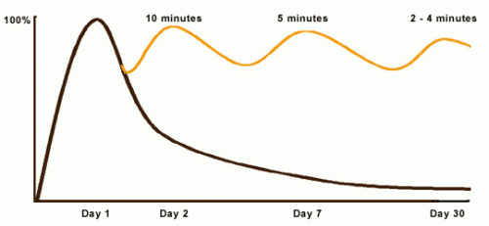
Figure 2.3.4
Source: CASA at: http://casa.tamucc.edu

2.3.5 The Human Attention Span
The human attention span is at 30% after 45 minutes. Mostly, that is the length of one class for schools below university level. In universities it is increased to one hour or more. You can improve your attention span by increasing the time slowly, but it is better to take a short break (~5 minutes) after about an hour of focused study. The short break will allow you to regain about 90% of your attention span.
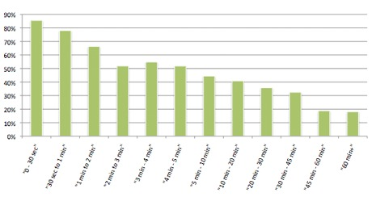
Figure 2.3.5
Source: Savage (2011)

2.4 Academic Performance
Research findings have revealed that there is a strong connection between the students' study habits and their academic performance. Good study habits lead to good academic performance but bad and defective study habits result to poor academic performance. Moghadam and Cheraghian (2008) corroborated the assertion and posited that academic performance is affected by a lot of factors; study habit is one of them. De Escobar (2011) observed that students need to be familiar with the relation of good study habits and academic achievement to accomplish great success in any level of education.

Jato et. al. (2014) argued that efficient study habits can strengthen writing. They stated further that study habits are particularly important for students, whose needs include time management, note taking, the elimination of distractions, and assigning high priority to study. Good study habits are study techniques that enhance the students to realize their full potentials

The extent of student's studying in academics may be on the grades a student earns. It is believed that a grade is a primary indicator of such study. If learners earn high grades it is concluded that they may also have effectively studied hard while low grades indicates lesser and poor study.

CHAPTER THREE

RESEARCH METHODOLOGY

3.1 Research Design
This study used the quantitative approach to allow the reporting of summary results in numerical terms across many repetitions of answers. This study tried to find out the study habit of form 1, 3 and 4 students at Uyo high school according to their Time Management, Study Environment, Test Preparation, Note Taking, Library Use and Academic Performances.

3.3 Sample Size and Sampling Technique
The sample size of one hundred and ten (110) students was drawn from Uyo high school which is located in Uyo high school. This represents a (1.2 %) of the entire Uyo student population of about10000. The sample size is supported by Babbie, (2005). He is of the opinion that for a population of 1000 and above, a sample size of 10-20% is acceptable. The population was sampled through a simple random sampling procedure to avoid biasness. Form one and three contributed thirty four (34) each while form four contributed thirty seven (37) respondents.

3.4 Data Collection Methods and Instruments
Data was collected using a self-developed survey questionnaire. There were some open-ended questions as well. The research questionnaire was described in terms of time management, note taking, test preparation, study environment, student examination performance and library use. The test questionnaire had at least five questions for each indicator. The respondents chose from always, often, sometimes, and never. Putting a check on the corresponding box was based on the study habits that they are experiencing.

1 – Always
The respondents have outstanding study habits in terms of study environment; time management; note taking; test preparation; library use; and study consultations.

2 – Often
The respondents have average study habits in terms of study environment; time management; note taking; test preparation; library use; and study consultations.

3 – Sometimes
The respondents have fair study habits in terms of study environment; time management; note taking; test preparation; library use; and study consultations.

4 – Never
The respondents have poor study skills in terms of study environment; time management; note taking; test preparation; library use; and study consultations.

The researcher personally administered the questionnaires to the respondents and provided them with clear instructions on how to answer. The respondents answered questionnaires within the school campus and the questionnaires were retrieved on the same day of the administration.

To improve the reliability and validity of the research instrument, the questionnaire was pilot-tested on similar but smaller sample group from Uyo high school section in the first month of 2020. Observed errors, corrections and re-wordings discovered were effected and incorporated into the main instrument.

3.6 Data Analysis
Data that was extracted from the questionnaires was classified, organized and tabulated accordingly. The analysis and interpretation of data assisted in formulating findings, conclusions and recommendations. For the purposes of analysis and interpretation, statistical tool, Microsoft excel was used. The researcher used Microsoft excel to easily enter and create graphical or visual representation of data. It was also simple in making inferences.

CHAPTER FOUR

FINDINGS AND DISCUSSIONS

4.1 Findings
4.2.1 Factors affecting study habits of the respondents
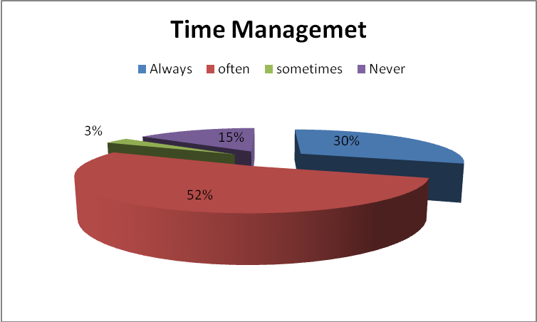
Figure 1.1. Study Habits According to Time Management
Figure 1.1 presents the level of study habits according to time management. Majority of the respondents have average study habits in terms of managing of time. 30% have excellent study habits, 15% have a weak study habits and 3% have fair study habits.
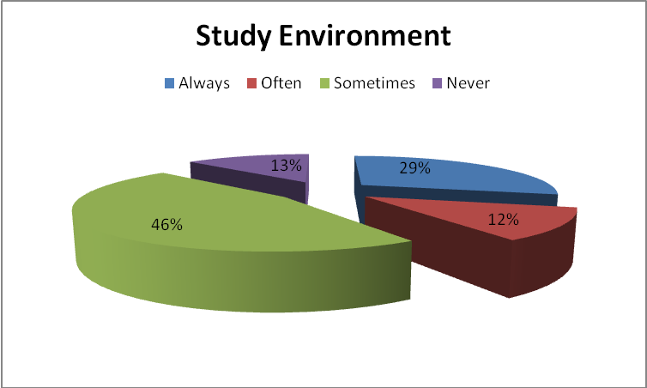
Figure 1.2 Study Habits According to Study Environment
Figure 1.2 presents the level of study habits according to study environment. 46% of the respondents have fair study habits in terms of study environment. 29% have excellent study habits, 13% have a weak study habits and 12% have average study habits.
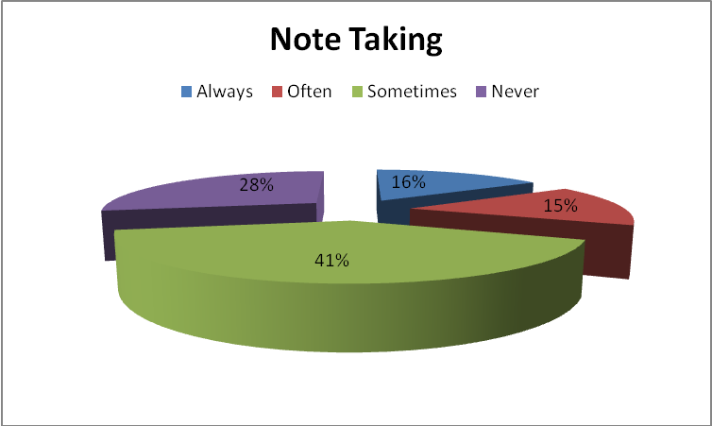
Figure 1.3. Study Habits According to Note Taking
Figure 1.3 presents the level of study habits according to note taking. It illustrates that half of the respondents had fair time to take down notes, re-read notes or summarizes lessons and important stuff in a passage. 32% have no habit of taking down notes.
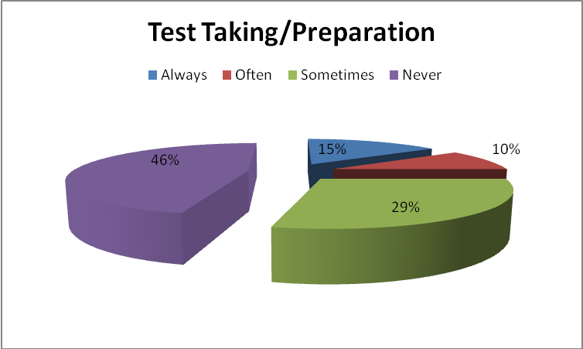
Figure 2.4. Study Habits According to Test Preparation
Figure 1.4 presents the level of study skills according to test preparation. It illustrates that majority of the respondents have no time to review and get ready for the examinations; Only 16% of the respondents have an absolute time to prepare and have necessary skills to write examinations.
- 2. 2. The frequency to which student of Uyo use the library.
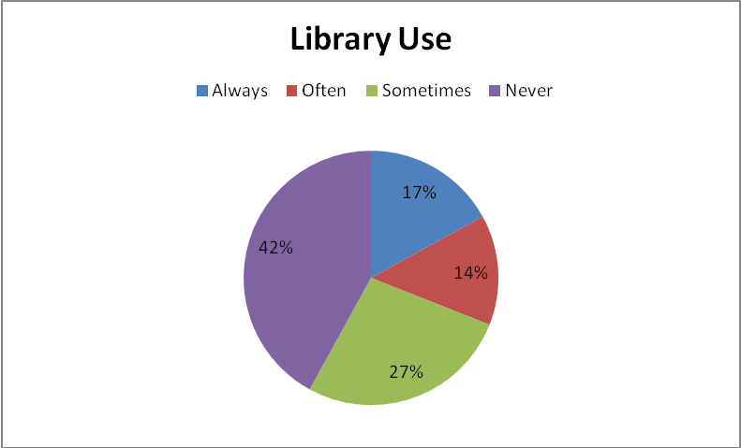
Figure 2.1: Study Habits According to Library Use
Figure 2.1 presents the level of study habits according to library use. It illustrates that almost half of the respondents have poor library usage. 27% have a fair habit; 17% have an excellent habit in library use; the remaining has an average library use.
4.2.3. The relationship between the study habits of the respondents and student examination performance.
Table 3.1: Students’ academic performance.

Score
Subject Less than 40 40-59 60-69 70-79 80 & above Total
F % F % F % F % F % F %
Biology 29 37.14 40 38.10 11 10.48 7 6.67 8 7.62 105 100
Mathematics 54 51.43 23 21.90 13 14.29 8 7.62 7 6.67 105 100
P/Science 36 34.29 35 33.33 16 15.24 11 10.48 7 6.67 105 100
Chichewa 12 11.43 36 34.29 29 27.62 19 18.10 9 8.57 105 100

English 36 34.29 35 33.33 20 19.04 7 6.67 7 6.67 105 100
Social & Dev. 37 35.24 35 33.33 14 13.33 10 9.52 9 8.57 105 100

Table 3.1 reveals that 38.10% of the respondents scored between 40 - 59 marks in Biology. 7.62% of the respondents scored between 80 and above. In Mathematics, 51.43% of the respondents scored less than 40 marks and only 6.67% respondents scored between 80 and above. 34.29% of the respondents scored less than 40 marks in Physical Science and 6.67% of the respondents scored between 70 and above. In Chichewa, 34.29% of the respondents scored between 40 - 59 marks and only 8.57% scored between 80 and above. 34.29% of the respondents scored less than 40 marks in English and only 6.67% of the respondents scored 80 and above. In Social and Development Studies, 35.24% of the respondents scored between less than 40 marks and only 8.57% scored between 80 and above.

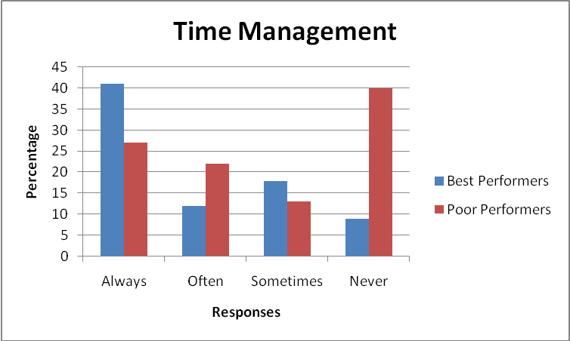
Figure3.1. Study Habits According to Time Management in Terms of Performance
In Figure 3.1, illustrates that the percentage in terms of time management, the best performers has highest percentage on always which got 41%. It only means that best performers have excellent study habits in terms of performance. In poor performers, the highest percentage is on never, which means that the respondents have weak percentage in terms of performance.

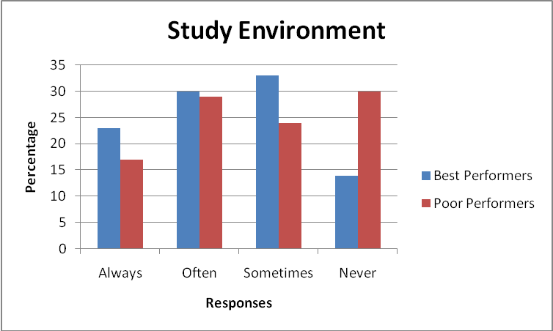
Figure3.2.Study Habits According to Study Environment in Terms of Performance
In figure 3.2, it illustrates that majority of the best performers have average and fair study habits and poor performers have average and poor study habits with regards to study environment.

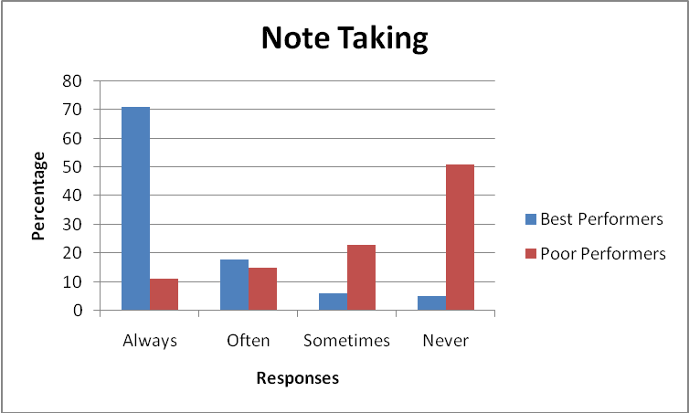
Figure3.3.Level of Study Skills According to Note Taking in Terms of Performance
In figure 3.3, it illustrates that majority of the best performers have excellent habits of note taking while majority of poor performers have weak note taking habits.
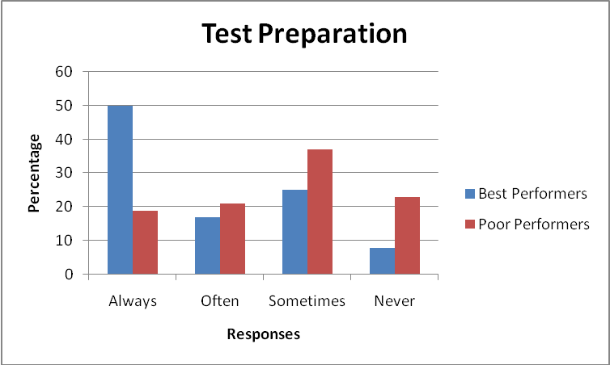
Figure3.4. Study Habits According to Test Preparation in Terms of Performance
Figure 3.4 illustrates that majority of best performers have excellent test preparation habits and majority of poor performers have fair test preparation habits.

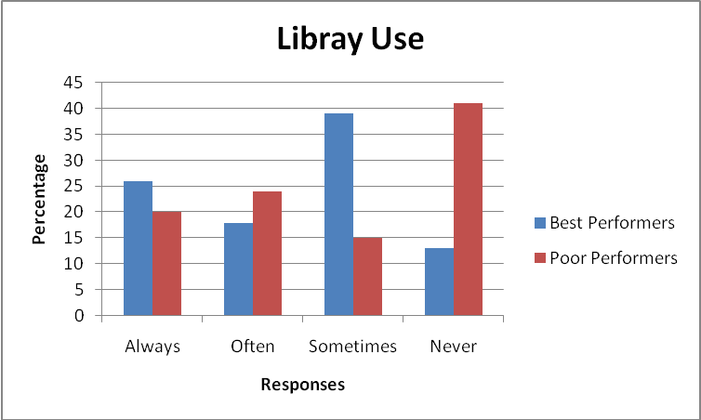
Figure 3.5.Level of Study Skills According to Library Use in Terms of Performance
In figure 3.5, it illustrates that majority of the best performing students have sometimes study habits in library use. In poor performing students the percentage on never is the highest which means that these students have poor library usage.

4.3 Discussions of the Findings

4.3.1 Study habits in terms of study environment, time management, note taking and test preparation
The purpose of this study was to ascertain the factors influencing study habits and how these habits affect the academic achievement of students in different subjects at Uyo . The result on the first four figures (figure 1.1 – 1.4) show low levels of study habits among students of Uyo secondary School in terms of time management, test preparation, note taking and study environment. Based from their responses, it was revealed that the students do not have conducive study environment, efficient time management skills, effective test-taking/preparation techniques and they fail to take down notes. Similar results were identified by Nouhi et al. (2008) as students’ weakness in study. The findings were also noted in the study of Aquino (2011) and Nagaragu (2004). It was suggested by Sarwar et al. (2009) that student should draw up a time table for study which enables the learner to organize his/her study effectively. Furthermore, a study by Nagaraju (2004) found that students usually do not devote sufficient time to their studies and seldom have proper study habits.

4.3.2 Study habits in terms of library use
The results (figure 1.6) also revealed that there was poor use of the library. There was no library hour on the school time table. Students did not use the school library regularly nor spent quality time in the library. The irregular use of the school libraries by the students of secondary schools could lead to poor scores in test and examination. Dent (2006) reported that a study conducted by Lance (2000) showed that students that used school library regularly had 18 percent higher achievement tests scores than their counterparts without a school library. The findings of Acido (2010) also revealed that two students who scored above average in reasoning skills studied regularly.

4.3.3 Impact of study habits on student academic performance
The academic performance of the respondents as shown in table 3.1 was poor. The poor academic performance of the students could be attributed to the failure of the students to manage time (figure 1.1). Good use of time improves academic achievement. Most students did not have timetable and where they had study time tables, they could not strictly follow it. Another reason is that students studied in places where there were distractions and disturbances (Figure 1.2). Good environment, studying with others, studying and discussing with friends and classmates make learning easy. This is also in agreement with the findings of Koko, (1999), that poor academic achievement or failure is a consequence of poor study habits. In addition, students did not use the school library regularly nor spent quality time in the library (Figure 1.5). Students also did not have enough time to prepare for examinations according to (Figure 1.4). The study also revealed that most students study hard a day before the actual day of writing examinations. Demola (2012) reported that ‘Facebook, Yahoo, Twitter, MySpace, English Premier League, European Football Leagues among other things have taken over the time students could have used for reading and studying. Asagwara (2000) has also confirmed that acquiring good study habits comes by means of a regular repeated process and that the study attitude and strategies that a learner adopts in the process of acquiring knowledge, skills and experience enhance their academic achievement. The technique used for effective studying should be done with every amount of thoroughness and concentration (Memory 2001).

A discrepancy in study habits between high and low-achieving students was also noted in figures 3.1 – 3.5 which showed that high achievers have high levels of study habits in test preparation, note taking and time management while low-achieving students has average to poor levels of study habits. This is in agreement to Yu (2010) who found out that high-achieving students had a more positive attitude toward study in that they detected and reacted positively to the favorable aspects of the situation they found themselves in, while the low-achieving students tended to be fault-finders, reacting to the negative aspects of study such as distractions and minor annoyances. The high-achieving students accepted the restrictions and conformed to the demands made upon them, while the low achievers appeared to lack high-level motivation. In terms of attitude towards teachers, the high achievers generally have a positive attitude towards teachers. The high achievers often say that teachers are competent, impartial and interested in their duties (Sarwar et al., 2009).

However, both high-achieving and low-achieving students seem to have same level of study habits in study environment and library use. This might be that the school does not provide best conditions necessary for students to do well in these areas.

CHAPTER FIVE

CONCLUSIONS AND RECOMMENDATIONS

5.1 Conclusions
Based on the findings, the researcher concludes that students have poor study habits in terms of time management, note taking and test preparation. He also found that the school has no conducive environment for study. Apart from classrooms which are only available for study from 6:00 PM to 8:00 PM, there is no other area where a student can use for study. The school has no woodlot or park where students can use as study area during day time. This limit the amount of time student allocates for study in a day. The study also found that there were no library periods in the school time table. The school library also opens irregularly and the school library is too small to accommodate students who would like to study in the library. These arrangements did not afford the students ample opportunity to study in the library. The responses of the respondents have shown that majority of students did not use the school libraries regularly and many others did not use the school libraries at all. Many students never study outside of the class each day, and never know what was covered in the examinations. Thus poor study habits invariably lead to poor performance among the students.

5.2 Recommendations
Based on the findings and conclusions gathered, the researcher would like to recommend the following:
1. The researcher recommends that use of study system is the best skill that will help students to have outstanding marks. One of the oldest and best-known study systems is "SQ3R"; stand for Survey, Question, Read, Recite, and Review.

2. The researcher recommends that students must use the KWL, outline, human memory graph, mapping or charting method to condense and synthesize reading, lessons and discussions.

3. There should be a library study hour on the school time table to enable the students to have a specific time to use the school library regularly. The inclusion of library study hour on the school time table would afford the students the opportunity to study more than thirty (30) minutes in the library or in their classrooms on regular basis.

4. Students should find suitable and comfortable places to study outside the class each day, especially at home or around the campus to compliment the compulsory study periods at school.

5. There is need for the students to study and cover the syllabus on each subject in order to know what will be covered in each examination.
6. There should be at least five (5) continuous tests per subject within the term to expose the students to the techniques of examinations such as time management and what is covered in the paper.

7. The amount of time used in studying must increase in order to devote more time to quality study both at school library and at home to prevent poor academic performance currently being experienced at .

8. Lastly, the researcher recommends that students must learn to manage time effectively. Make study schedule or plans and stick to it, make list of things to do and less cramming. These will help to have a good time management.

REFERENCES
Acido, M.B. (2010). High school students’ reasoning skills and their study habits and attitude toward learning. Basic Education, 4:108-117.
Aquino, L. (2011). Study habits and attitudes of freshmen students: Implications for academic intervention programs. Journal of Language Teaching and Research, Vol. 2 (5), 1116-1121
De Escobar, V. M. (2011). Good Study Habits and Academic Achievement Walk Hand in Hand. Retrieved on 4th May, 2015 from: http://EzineArticles.com/?expert=Veronica.
Demola, T. (2012). Causes of Mass-Failure in Public Examination in Nigeria. Retrieved on 15th May, 2015 from: http://www.nairaland.com/789834/causes-mass-failure-publicexamination-Nigeria.
Dent, V.F. (2006). Observations of School Library Impact at two Rural Uganda Schools. Retrieved on 4th May, 2015 from: http://www.kitengcsalibrarv.org/images/observationsarticle.pdf
Derville, L.M.T., 1998. The Use of Psychology in Teaching. London: Longman.
Douglas, M. P. (1961). Primary School Library and its Services. Paris: UNESCO.
Federal Republic of Nigeria (2004). National Policy on Education, 4th ed. Lagos: NERDC Press.
Fleming, G. (2011). 10 Great Study Habits. Retrieved on 5th May, 2015 from: http://homeworktips.about.com/od/studvniethods/tp/studvhabits.htm.
George, A. (2011). The School library in a megacity setting: The case of Lagos State. 14(1):76-86
Hallas, C.H. (2002). The Core and Training of the Mentally Retarded. Bristol: Bristol John Wright and Sons.
Hassanbeigi, A. et al. (2011). The relationship between study skills and academic performance of university students. Procedia-Social and Behavioral Sciences, Vol. 30. 1416 1424.
Hepher, H.W., (1990). Psychology Applied to Life and Work. London: Pan Books Ltd.
Hills, P.S. and Ballow, H. (2000). Effective Study Skill. Pan Books Ltd., London. Retrieved on 5th June, 2015 from: http://digitalcommons.unl.edu/libphilprac/1130
Jato, M., Ogunniyi, S. O. and Olubiyo , P.O. (2014). Study habits, use of school libraries and students’ academic performance in selected secondary schools in Ondo West Local Government Area of Ondo State. International Journal of Library and Information Science, Vol.6(4). Retrieved on 13th April, 2015 from: http://www.academicjournals.org/IJLIS.
Lance, K. (2000), How School Librarians Can help Kids Achieve Standards: The Second Colorado Study. Castle Rock, CO: Hi Willow Research and Publishing.
Mace, C.A., (2002). The Psychology of Study. Hasmondsworth: University of Penguin Book Ltd.
Maddox, H., 2002. How to Study. London: Pan Books Ltd.
Mendezabal, M. J. N. (2013). Study Habits and Attitudes: The Road to Academic Success. Open Science Repository Education. Retrieved on 13th April, 2015 from: http://www.open-science-repository.com/study-habits-and-attitudes-the-road-to-academic-success.html#sthash.mo9Lmsrf.dpuf.
Nagaraju, M.T. V. (2004). “Study Habits of Secondary School Students”. Discovery Publishing House.
Nouhi, E., Shakoori, A., & Nakhei, N. (2008). Study habits and skills, and academic achievement of students in Kerman University of medical sciences. Journal of Medicine Education Vol. 12(3, 4) 77-80
Ogunniyi SO, Adeniji MA, Jato M (2011). Availability of resources and services to students in selected private secondary schools in Ondo. West Local Government Area of Ondo State. Int. J. Libr. Sci. 4(A11):48-55.
Okorodudu, R.I., (2000). Intelligence and learning. Adolescent Psychology. Absaka: Delta State University Press.
Oladele, J.O., (2000). Fundamentals of Psychological Foundations of Education. Lagos: Johns-Lad Publishers Ltd.
Osa-Edoh, G.I. and Alutu, A.N.G. (2012). A Survey of Students Study Habits in Selected Secondary Schools: Implication for Counselling. Current Research Journal of Social Sciences 4(3): 228-234, 2012
Owusu-Acheaw, M. (2014). Reading Habits Among Students and its Effect on Academic Performance: A Study of Students of Koforidua Polytechnic. A Study of Students of Koforidua Polytechnic" (2014). Library Philosophy and Practice (e-journal). Paper 1130.
Pitan, O.O. (2013). Poor Study Habit as an Educational Problem Among University Undergraduates In The Contemporary Times And Effective Management Strategies. International Journal of Humanities and Social Science Invention, Volume 2 Issue 11. www.ijhssi.org.
Robinson, F., (1990). Principles and Procedures in Student Counselling. New York: Harper and Row,
Ruch, F.L., (1995). Psychology and Life. New York: Scot Freeman and Co.
Sarwar, M. et. al (2009). Study-orientation of high and low academic achievers at secondary level in Pakistan. Educational Research and Reviews, Vol. 4 (4), 204-207.

Questionnaire

Dear Sir,

The undersigned is currently conducting a study on the “The impact of academic achievement and study habits of higher secondary students in nigeria ”. This undertaking is part of the requirements for the ………………
In connection with this, I would like to request your approval to allow me to schedule the administration of the research. I look forward for your much needed approval on this request.

Respectfully yours,

The Researcher

FORM: _____________________________ AGE: ______________ GENDER:____________
PART A

Time Management
- I have study timetable
- Always B. Often C. Sometimes D. Never

- I stick to my study timetable
- Always B. Often C. Sometimes D. Never

- I always do my assignments on time
- Always B. Often C. Sometimes D. Never

- I regularly attend my classes?
- Always B. Often C. Sometimes D. Never
- I turn down chances for social activities or reschedule them if I know I have homework to do or a test to study for.
- Always B. Often C. Sometimes D. Never

NUMBER OF A’s, B’s, Cs and Ds A_____ B_____ C ______ D ________

Your Study Environment
- I have an area where I always go to study
- Always B. Often C. Sometimes D. Never

- My study area is free of noise and distractions
- Always B. Often C. Sometimes D. Never

- I have all study materials near me when I am studying
- Always B. Often C. Sometimes D. Never

- I find my study area comfortable
- Always B. Often C. Sometimes D. Never

- I can study for at least an hour without getting up, walking about, taking snack or TV or phone breaks
- Always B. Often C. Sometimes D. Never

- My friends leave me alone when they know I want to study
- Always B. Often C. Sometimes D. Never

NUMBER OF A’s, B’s, Cs and Ds A_____ B_____ C ______ D ________

Test Taking/Preparation Skills
- I belong to a study group
  - Always B. Often C. Sometimes D. Never

- I attend extra help sessions by the teacher
  - Always B. Often C. Sometimes D. Never

- I do not start preparing for a test a day before the exam date.
A. Always B. Often C. Sometimes D. Never

- I know what kind of tests we will take, i.e., essay, multiple choice, and how to prepare for different types of tests
  - Always B. Often C. Sometimes D. Never

- I predict what types of questions will be on the test
  - Always B. Often C. Sometimes D. Never

- I finish writing test papers in the allowed period of time
  - Always B. Often C. Sometimes D. Never

- When I have not done well on a test, I review it with the teacher and/or analyze it to see where I had problems
  - Always B. Often C. Sometimes D. Never

NUMBER OF A’s, B’s, Cs and Ds A_____ B_____ C ______ D ________

Note Taking Skills
- I manage to take notes in class, keep up with the teacher, and understand the concepts at the same time
- Always B. Often C. Sometimes D. Never

- I review my notes after each class, preferably right after class
- Always B. Often C. Sometimes D. Never

- I know what is the “important stuff” to write down and what are the cues that this is important stuff
- Always B. Often C. Sometimes D. Never

- I always make notes as I read class materials
- Always B. Often C. Sometimes D. Never

- I am good at putting class notes or notes from texts into my own words
- Always B. Often C. Sometimes D. Never

NUMBER OF A’s, B’s, Cs and Ds A_____ B_____ C ______ D ________

Library Use
- I use time between classes to study
  - Always B. Often C. Sometimes D. Never

- I use the school library from Monday to Friday
- Always B. Often C. Sometimes D. Never

- The library remains open in regulated time
- Always B. Often C. Sometimes D. Never

- I find all the books I need in the school library
- Always B. Often C. Sometimes D. Never

- The class time table has library period(s)
A. Always B. Often C. Sometimes D. Never

- The library is spacious enough to accommodate students
- Always B. Often C. Sometimes D. Never

NUMBER OF A’s, B’s, Cs and Ds A_____ B_____ C ______ D ________

PART B
Write your answers in the spaces for the questions below

- What place do you consider conducive for studying?
___________________________________________________________________________
- Do you find your school conducive for studying?
Yes __ No__
Why? _____________________________________________________________________
___________________________________________________________________________
- What are the things that prevent you from studying?
___________________________________________________________________________
- How supportive are your teachers and parents in your studies
Teachers ___________________________________________________________________
Parents/guardians ____________________________________________________________
- How important is the school library in your studies?
____________________________________________________________________________________________________________________________________________________________
Academic Performance

Using your school report put a check √ in the appropriate box

Table 2.4.1
Subject Marks | 0 - 39 | 40 -59 | 60 - 69 | 70 - 79 | 80 - 89 | 90 - 100
Biology
Mathematics
Physical Science
Chichewa
English
Social & dev. Studies
Geography

