**The Efficacy of Nanoemulsion-Based Delivery Systems to Improve Vitamin D3 Bioaccessibility and Bioavailability**

ABSTRACT

Vitamin D deficiency is an epidemic issue in all age groups in Western countries and that affects both skeletal and non-skeletal functions. Even with the wide application of food fortification, vitamin D deficiency tends to increase continuously. Being hydrophobic in nature, vitamin D has poor solubility; thereby it negatively affects its absorption and bioavailability when compared to other hydrophilic dietary compounds. The need to develop a novel strategy is of greater importance to enhance its bioavailability and thereby improving vitamin D level in the body.

In this study, lipid-based delivery of oil-in-water nanoemulsion (diameter < 200nm) was utilized to improve the bioaccessibility and oral bioavailability of vitamin D3. First, we examined the *in vitro* relative bioaccessibility of nanoencapsulated vitamin D3 using a simulated gastrointestinal system. The study results showed that nanoemulsion-based delivery system significantly increased the relative bioaccessibility by 3.94 fold when compared to the coarse emulsion (diameter >200nm), as indicated by the concentration of vitamin D3 in the mixed micelles. To evaluate the *in vivo* bioavailability of vitamin D3 an animal study was conducted. Mice were assigned randomly to three groups: vitamin D3 nanoemulsion (n=6), coarse emulsion (diameter > 200nm) (n=6) and vehicle (nanoemulsion without vitamin D3) (n=3), which is the control group. After 3-days of feeding emulsion by mixing in drinking water, the serum 25(OH)D3, a biomarker of vitamin D availability, was measured using immunoassay. We found that serum 25(OH)D3 level in animals fed with vitamin D3 nanoemulsion was significantly higher than in those animals fed with coarse emulsion (22.7 ± 1.10 ngmL-1 vs 17.92 ± 2.82 ngmL-1). It indicated that nanoemulsion improved the in *vivo* bioavailability by 28%. These results showed that the nano-based delivery systems can be utilized to improve vitamin D level, and further human studies are warranted for its application to the human population in order to improve the vitamin D status.

ACKNOWLEDGEMENTS **……………………………………………………………………...** iv

ABSTRACT **……………………………………………………………………………………….**v

LIST OF TABLES …………………………………………………………………………..........ix

LIST OF FIGURES ……………………………………………………………………………….x

CHAPTER

1. INTRODUCTION………………………………………………………………………………1

2.LITERATUREREVIEW………………………………………………………………………...3

2.1. Vitamin D and Health ………………………………………………………………..3

2.2. Vitamin D sources, digestion and its metabolism ……………………………….......4

2.2.1. Synthesis of vitamin D and its metabolites ………………………………..4

2.2.2. Factors influencing vitamin D synthesis …………………………………..5

2.2.3. Vitamin D digestion, absorption, transportation and metabolism ………...5

2.2.4 Vitamin D metabolites and its working mechanisms ……………………...7

2.2.5. Improvement of vitamin D status ………………………………………..10

2.3. Nanotechnology …………………………………………………………………….13

2.3.1. Introduction of nanotechnology and nanoemulsion ……………………...13

2.3.2. The application of nanotechnology in nutrition and health ……………...15

2.3.3. Various factors influencing nanoemulsions ……………………………...17

2.3.4. Enhance the bioavailability of nutrients and dietary bioactive components using the nano-based delivery system ………………………………………….21

2.4. Biological fate of emulsion in the digestive tract ………………………………….22

2.5. The application of nanotechnology in improving vitamin D status ………………...25

3. PURPOSE OF STUDY ………………………………………………………………………..27

vii

4. METHODS ...………………………………………………………………………………….29

4.1. Nanoemulsion fabrication and characterization……………………………………..29

4.1.1. Nanoemulsion preparation………………………………………………..29

4.1.2. Particle characterization…………………………………………………..31

4.2. In vitro Bioaccessibility……………………………………………………………..31

4.2.1. Simulated gastrointestinal model…………………………………………31

4.2.1.1. Mouth phase……………………………………………………31

4.2.1.2. Gastric phase…………………………………………………...32

4.2.1.3. Small intestine phase…………………………………………..32

4.2.2. Relative Bioaccessibility………………………………………………….33

4.3. Animal study………………………………………………………………………...34

4.3.1. Measurement of serum 25(OH)D3………………………………………..34

4.3.2 Quantitative real-time PCR ……………………………………………….34

4.4. Statistical analysis …………………………………………………………………..36

5. RESULTS ……………………………………………………………………………………..37

5.1. Particle characteristics of the emulsion ……………………………………………..37

5.2. In *vitro* lipid digestion and vitamin D Bioaccessibility …………………………….41

5.3. In *vivo* vitamin D Bioavailability …………………………………………………...44

5.4. The expression of vitamin D metabolically-related genes ………………………….45

1. DISCUSSION …………………………………………………………………………………48
2. SUMMARY & CONCLUSIONS…………………………………………………………..50 BIBLIOGRAPHY………………………………………………………………………………...51

viii

**LIST OF TABLES**

**Table** **Page**

ix

4.1. PCR primer sequences for real-time PCR analysis…………………………………………..35

**LIST OF FIGURES**

**Figure** **Page**

2.1. Schematic mechanism of the vitamin D metabolism………………………………………….9

x

2.2. Schematic representation of the mechanism of component uptake by the small intestine cells……………………………………………………………………………………………….24

4.1. Process of making oil-in-water nanoemulsion………………………………………….........30

5.1. Influence of gastrointestinal tract (GIT) phases and emusion types on the mean particle diameter (d32) of cholecalciferol-enriched oil-in water emulsions determined by an in *vitro* simulated GIT…………………………………………………………………………………….38

5.2. Influence of gastrointestinal tract (GIT) phases and emusion types on particle charge (ζ-potential) of cholecalciferol-enriched oil-in water emulsions determined by an in *vitro* simulated GIT………………………………………………………………………………………………..39

5.3. Impact of emuslion types on physical homogeneity of cholecalciferol-enriched oil-in-water emulsion. The percentage on the figure are coefficient of variation for physical chracteristics in each group. A) Homogeneity of particle size. Due to significantly high particle size for the coarse emulsion, the particle size was normalized to the mean for comparison on the figure. B) Homogeneity of particle charge. C) Digital photographs at different stages of the GIT................41

5.4. Release of FFA from emulsions under simulated small intestine conditions………………..42

5.5. Vitamin D3 concentration in raw digesta and the mixed micelles of the simulated GIT system.

1. The concentartion of vitamin D in the raw digesta and B) The concentartion of vitamin D in the mixed micelle C) Coefficient of varaiation of vitamin D concentration in various emulsion groups…………………………………………………………………………………..44

5.6. The in *vivo* bioavailability of vitamin D3. A) The concentration of vitamin D3 in plasma and B) The coefficient of variation of vitamin D3 in plasma………………………………………….45

5.7. Influence of different emulsion types on the expression of vitamin D metabolically related genes. A) The impact on expression of genes in intestinal mucosa B) The impact on expression of

xi

genes in liver tissue C) The correlation between the serum vitamin D concentration and gene

expression………………………………………………………………………………………...47

xii

CHAPTER 1

INTRODUCTION

Vitamin D is a fat-soluble vitamin that has a wide range of skeletal and non-skeletal functions. It is mainly synthesized in the skin when exposed to sunlight and it is naturally present in a few foods. Even with a fortification of foods, the vitamin D sufficiency has decreased in all age groups in Western countries (Wang et al., 2008). Suboptimal levels of vitamin D not only affect bone mineralization, but it is also related to various chronic diseases, including many types of cancers, particularly colorectal cancer (CRC). Typically, in clinical practice, supplementation is recommended to treat vitamin D deficiency (Holick et al., 2011). Because of its hydrophobic nature, vitamin D has poor solubility and thereby it negatively affects its absorption in the body, which may lead to suboptimal vitamin D status (Grossmann & Tangpricha, 2010).

Recently, due to advancements in nanotechnology, nanoemulsion-based delivery systems have been utilized to efficiently deliver hydrophobic nutrients or dietary bioactive compounds. Nanoemulsion (< 200nm in diameter) is a lipid-based delivery system, in which one immiscible liquid is dispersed in another liquid. In this study, vitamin D3, after being dissolved in corn oil, is dispersed in the aqueous phase (a mixture of buffer and emulsifier) to form an oil-in-water nanoemulsion. It has been reported that lipid-based delivery systems improve solubility, stability, water dispersibility and bioaccessibility of hydrophobic dietary bioactive compounds (Wang et al., 2012) & (Huang, Yu, & Ru, 2010). In the present study, we aim to determine whether the nano-based delivery of vitamin D3 enhances the *in vitro* bioaccessibility when compared to the coarse emulsion (>200nm in diameter) using *in vitro* simulated gastrointestinal system.

A recent *in vivo* study was performed to evaluate the influence of nanoemulsion on *in vivo* bioavailability of vitamin D2 by Salvia-Trujillo, et al., 2017. These researchers found a poor *in*

1

*vitro-in vivo* correlation, which is established through student’s t-test. This may be due to *in vivo* study, which did not monitor the serum 25(OH)D3 level to determine the vitamin D level. Instead, vitamin D2 level was analysed using a total lipid extraction from the intestine or serum followed by purification of total lipid (i.e separation of vitamin D from lipid contaminants) by soild phase chromatography. Then, the vitamin D fraction was determined using a high-performance liquid chromatography (HPLC) system. Even though HPLC with UV detection is an accepted method it was reported that this method is cumbersome, requires large sample and it is unsuitable for clinical laboratory use (Wootton Andrew, 2005) & (Hollis Bruce 2010). Therefore, in our study, after treatment with vitamin D3 nanoemulsion or the coarse emulsion, we aim to determine the *in vivo* bioavailability, by measuring the serum 25(OH)D3, a more stable and sensitive biomarker of vitamin D availability using radioimmunoassay. After completing the *in vitro* and *in vivo* studies, we hope to improve our understanding of whether nano-based delivery enhances the solubility, bioaccessibility and *in vivo* bioavailability of vitamin D3 when compared to the coarse emulsion.

In vitamin D metabolism, after fist hydroxylation in the liver, the produced serum 25(OH)D3 will be transported to the kidney by vitamin D binding protein (DBP). In the proximal renal tubule, the second hydroxylation occurs and thereby it produces 1,25(OH)2D3, a biologically active form of vitamin D (Christakos et al., 2012). During vitamin D metabolism, multiple genes such as VDR, CYP27A1, CYP2R1, TRPV6, CYP27B1 etc participate in vitamin D metabolism. Therefore, we will also examine whether the nanoemulsion-based delivery of vitamin D3 alters vitamin D metabolically related genes using real-time PCR.

CHAPTER 2

2

LITERATURE REVIEW

**2.1. Vitamin D and Health**

Vitamin D is a fat-soluble vitamin. The majority of this vitamin is synthesized when UV rays from sunlight strike the skin. It is also naturally present in a few food sources. In the U.S a small number of products are fortified with vitamin D. In clinical practice, vitamin D supplementation is recommended to reduce vitamin D deficiency and its related diseases.

Vitamin D, whether it comes from sun exposure, food, or supplementation needs to undergo two activating hydroxylations; one in the liver to produce 25(OH)D3 and the other in the kidney to synthesize the active hormonal metabolite 1,25(OH)2D3 which is responsible for activating the vitamin D receptor and subsequent changes in gene expression (Holick, M. F., 2007). Serum 25(OH)D3 is the commonly used biomarker for an assessment of vitamin D status. Several factors influence the serum 25(OH)D3 level which includes cutaneous production of vitamin D, dietary intake, absorption of vitamin D in intestine & metabolic activation and subsequent vitamin D metabolites production (Grossmann & Tangpricha, 2010).

“Vitamin D” has a wide range of functions, such as regulating calcium and phosphorous metabolism, helping in bone mineralization and demineralization, reducing inflammation, modulating cell growth, neuromuscular function and immune function. It is also involved in other extraskeletal functions. For instance, vitamin D deficiency is associated with various chronic diseases, such as cardiovascular disease, diabetes and some cancers, including colorectal cancer (CRC). Various preclinical studies in cell culture and animal models, and many epidemiological studies support the role of vitamin D as an anticancer agent.

3

**2.2. Vitamin D sources, digestion and its metabolism**

**2.2.1. Synthesis of vitamin D and its metabolites**

Vitamin D (the sunshine vitamin) is a steroid hormone synthesized in the body when the skin is exposed to ultraviolet rays B at a specific wavelength (290 to 315 nm). In sebaceous glands of the skin 7-dehydrocholesterol is synthesized and when the sun rays hit the 7- dehydrocholesterol, it undergoes photolytic ring opening and synthesizes previtamin D3. The previtamin D3 get converted to vitamin D3, called cholecalciferol, by non-enzymatic thermal isomerization. Vitamin D3 will be taken to the liver for the first hydroxylation through the blood using �-2 globulin vitamin D binding protein (DBP). In the liver, vitamin D3 will be converted down to the prohormone called 25(OH)D3 (calcidiol) by “25-hydroxylase” a cytochrome P450 enzyme. Among the various P450 enzymes, CYP2R1 and CYP27A1 play a major role in vitamin D hydroxylation at C-25.

25(OH)D3 will be then transferred to the kidney for a second hydroxylation. In the kidney 25(OH)D3 will be converted to 1,25(OH)2D3 (calcitriol), the hormonally active form of vitamin D, by the enzyme 1α(OH)ase (CYP27B1). Kidneys are the main sites for the production of 1,25(OH)2D3 by 1α(OH)ase, but recent findings (Zehnder et al., 2001), shows 1α(OH)ase (CYP27B1) is also present in extra-renal sites including normal colon cells, brain, placenta, pancreas, lymph nodes and skin, which could result in a local conversion of 25(OH)2D3 to 1,25(OH)2D3 at extra-renal sites.

The half-life period of 1,25(OH)2D3 in the blood is only about 4 to 6 hours and its synthesis is tightly controllable, whereas the half-life of 25(OH)D3 is 10 to 20 days (Van den Berg, 1997) and reflects vitamin D exposure more directly. It is interesting to note that the concentration of 1,25(OH)2D3 in serum is approximately 1000 times lower than the prohormone 25(OH)D3. 1,25(OH)2D3 binds with vitamin D receptors (VDRs) and cell membrane receptors thereby influencing the gene transcription process in many tissues of the body. It was stated that the vitamin

4

D hormone regulates more than 200 different genes either directly or indirectly (Holick, M. F., 2008).

**2.2.2. Factors influencing vitamin D synthesis**

Despite the fact that vitamin D3 is synthesized in sufficient amounts when we expose ourselves to sunlight, there are many factors that influence the amount of vitamin D3 synthesis in the body. The influencing factors are the amount of melanin pigment in the skin, type of clothing, use of sunscreen lotions, time of day, exposure duration, latitude and season of the exposure.

The people in northern part of America do not synthesize vitamin D3 during the winter season from the month of November through February (Holick et al., 2005) so they will use the stored vitamin D3 which was synthesized during the summer. They also get some vitamin D from animal origin dietary sources like liver, beef, veal, eggs, milk, cheese, butter and fatty fishes like salmon and sardines. Since the natural food sources for vitamin D are few, the artificial fortification of some foods with vitamin D was established in 1930 in order to eradicate the disease rickets. The usual foods that are fortified are cow’s milk, soymilk, tofu and margarine.

**2.2.3. Vitamin D digestion, absorption, transportation and metabolism**

As a fat-soluble compound vitamin D undergoes the same digestion process as lipids in the upper gastrointestinal tract (Tso & Fujimoto, 1991), (Borel, Caillaud, & Cano, 2015). Even though some fat digestion occurs in the mouth and stomach (10-30%) by lingual and gastric lipase (pH activity range 3-7), the predominate digestion and absorption of lipids occur in the small intestine by digestive action of pancreatic lipase (pH activity range is 4.5-7.5). Stored bile salt (amphipathic molecule) in the gallbladder gets released once the fat substance reaches the duodenum. The bile

5

salt helps in emulsification of lipids and converts bigger lipid droplets to smaller droplets called micelles. The increase in lipid surface area caused by bile emulsification assists pancreatic lipase in digestion and eventual absorption of lipids.

As a result, triglycerides are broken down into free fatty acids (FFA) and 2-monoglycerides. These compounds being lipophilic in nature enter the enterocytes easily. Inside the enterocytes, these compounds get re-esterified and form TG in the smooth endoplasmic reticulum. Then TG combines with cholesterol and phospholipids. Following that it is coated with proteins to make it water-soluble chylomicron. Chylomicron goes to the golgi body and exits the enterocytes by exocytosis. Then it reaches the lymphatic system through lacteals before it finally reaches the bloodstream (Intestinal lymph enters bloodstream without first passing through the liver). From enterocytes, some of the FFA and monoglyceride goes to portal vein blood directly.

More vitamin D3 will be incorporated both in micelles and chylomicron than the hydroxylated form (Borel, Caillaud, & Cano, 2015) but the absorption efficiency of hydroxylated forms is 3 times better than vitamin D3 (Compston et al., 1981). The reason is that vitamin D3 absorption occurs mainly through the chylomicron and is dependent upon bile salts for lymphatic absorption. On the other hand, a hydroxylated form of vitamin uses the portal vein route since these metabolites are more polar and less dependent on bile acids (Van den Berg, 1997), (Maislos & Shany, 1987) & (Borel, 2003). Vitamin D3 appearance in the blood starts only after 2hrs, whereas for hydroxylated forms, blood appearance will be much faster (half-hour) (Maislos, Silver, & Fainaru, 1981).

The main site of vitamin D absorption is in the mid intestine, which includes jejunum and ileum (Goncalves et al., 2015). It was stated that in both jejunum and ileum, a relationship was found between intraluminal vitamin D concentration and its absorption rate (Hollander et al., 1978). It was first hypothesized that vitamin D absorption occurs by a non-saturable passive diffusion process (Hollander, Muralidhara, & Zimmerman, 1978). However, recent studies using human

6

intestinal cell line Caco-2 and HEK have shown that intestinal absorption of vitamin D is not only passive but some intestinal cell membrane proteins such as SR-BI (scavenger Receptor class B type 1), CD36 (cluster determinant 36 and NPC1L1 (Niemann-pick C1-Like 1), are involved in exporting vitamin D across enterocyte membrane. These same proteins are used to absorb cholesterol and other lipophilic components. But limited data is available on how the absorption of other lipophilic components influences the rate of absorption of vitamin D through these proteins. This shift in the absorption of vitamin D from passive diffusion to absorption through these proteins depends on vitamin D concentration. At lower concentrations (dietary concentration of vitamin D), protein-mediated transport was used and at the higher concentrations (pharmacological concentration) passive diffusion was used for absorption of vitamin D. Many factors affect the rate of absorption of vitamin D, which includes the food matrix, the meal composition, digestive enzyme activity, and the transport efficiency across enterocytes (Reboul et al., 2011).

**2.2.4 Vitamin D metabolites and its working mechanisms**

Vitamin D a fat-soluble vitamin and its metabolites 25(OH)D3 and 1,25(OH)2D3 usually bind in the blood with vitamin D binding protein (DBP). Approximately, 85-87% of vitamin D metabolites bind with DBP, 12% binds with albumin and 1% are unbound. Only unbound vitamin D sterols are biologically active (Di Rosa et al., 2013).

The active metabolite of vitamin D is 1,25(OH)2D3, which functions in both autocrine and paracrine manners to signal and to modulate vitamin D function. It has been stated that 1,25(OH)2D3 increases apoptosis. And it inhibits cell proliferation, inflammation, invasion, metastasis and angiogenesis (Feldman et al., 2014).

The function of 1,25(OH)2D3 starts when 1,25(OH)2D3 binds with VDR. VDR is present in many cells of the body including kidney, adrenal, thyroid, bladder, GI tract, liver, prostate and

7

breast cells. About 3-5% of human genomes are regulated by VDR (Wang, Zhu, & DeLuca, 2012). VDR was detected in normal human colon cells. If the VDR expression is more, it stimulates cell differentiation rather than proliferation, which is required for cancer growth reduction.

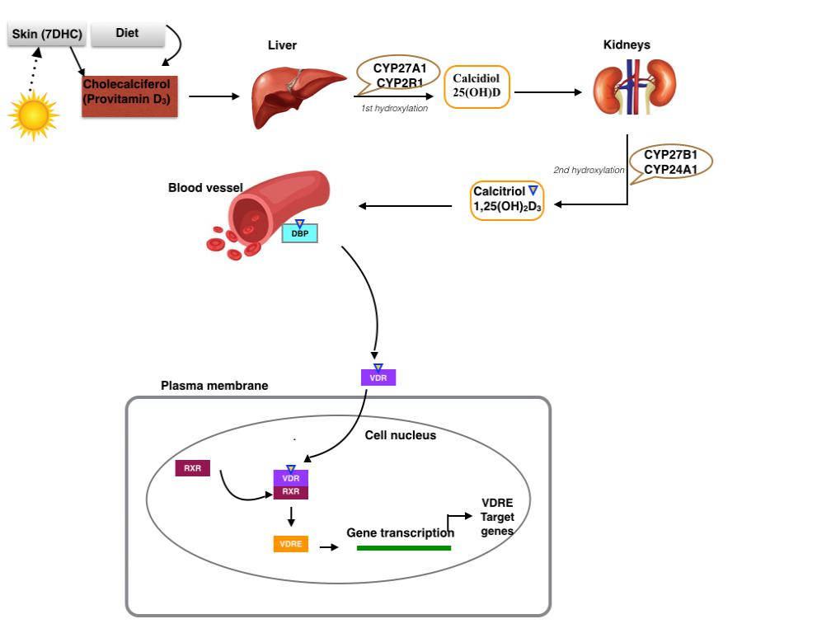

**Figure 2.1.** Schematic mechanism of the vitamin D metabolism

It has been stated that the receptor of 1,25(OH)2D3 is widely distributed in normal human tissues and mainly localized in the nucleus (Berger et al., 2016). Even though VDR is

8

predominantly present in the nucleus, some studies show that VDR gets translocated to the nucleus from cytoplasm once the ligand (1,25(OH)2D3) activates the VDR (Hansen, Binderup, Hamberg,

* Carlberg, 2001). After 1,25(OH)2D3 binds with VDR, the transcriptional activity will be regulated when 1,25(OH)2D3 -VDR binds with the Retinoid X Receptor (RXR) forming a heterodimer. The whole complex then binds with Vitamin D Responsive Elements (VDRE) in the promoter region of the target genes to initiate transcription.

VDR recruits co-modulators, which includes coactivators and corepressors. When VDRE binds with coactivator proteins, it helps open chromatin through the enzyme histone acetylase. Then the transcription process will be activated. When VDRE binds with corepressor proteins, the chromatin will be closed by recruiting the enzyme histone deacetylase and hence gene transcription will be repressed. So, depending on the type of co-modulators, the transcription process will be activated or deactivated. 1,25(OH)2D3 activates many VDR-dependent genes. Among them, CYP24A1 is particularly important because it is involved in a negative feedback loop and it catalyzes the degradation of both 1,25(OH)2D3 and 25(OH)2D3. Thus, 1,25(OH)2D3 can be self-regulated.

**2.2.5. Improvement of vitamin D status**

With few natural vitamin D food sources and fortified foods available, vitamin D intake is not sufficient is to reach an adequate vitamin D status and hence vitamin D deficiency is highly prevalent in the U.S and worldwide in most age groups (Wang et al., 2008). In the U.S it was estimated that more than 90% of the pigmented population and 3/4th of the white population are vitamin D insufficient (i.e their serum concentration 30 to <50 nmol/L or 12 to <20 ng/mL). The various reasons for vitamin D insufficiency/ deficiency (i.e their serum concentration (<30 nmol/L or <12ng/mL) in the U.S are low consumption of vitamin D fortified milk, less exposure to sun or

9

more usage of sunscreen lotion to protect the skin from sun and the increase in Body Mass Index (Looker et al., 2011), (Holick, 2007) & (Adams & Hewison, 2010).

The deficiency of vitamin D causes a metabolic bone disease called rickets in children and osteomalacia in adults (Wang et al., 2008). In Wang’s review he stated that the suboptimal level of vitamin D status is not only related to impaired bone mineral density it may also increase the risk of various chronic diseases like cardiovascular diseases, hypertension, multiple sclerosis, autoimmune diseases like type I diabetes mellitus, rheumatoid arthritis and various cancers like breast cancer, prostate cancer and colon cancer.

Institute of Medicine found that vitamin D is produced in the skin by exposure to sunlight is very challenging for finalizing its DRI values (Ross et al., 2011). But based on the assumption of no cutaneous production of vitamin D, the current RDA for vitamin D is 600IU/day for ages up to 70 years, 800 IU/day above 70 years to achieve a serum 25(OH)D3 of 20 ng/ml or 50 nmol/L. A level believed to be adequate to protect bone health in 97.5% of the population (Ross et al., 2011). Hypervitaminosis or vitamin D toxicity symptoms can occur only after extended exposure to a very high dosage level (>50,000 IU) of vitamin D (Van den Berg, 1997).

Vitamin D helps in maintaining calcium homeostasis. When blood calcium level goes down, calcium sensors in the parathyroid gland sense it and release the Parathyroid hormone (PTH). In the kidney, PTH stimulates the conversion of 25(OH)D3 to the active metabolite 1,25(OH)2D3. The 1,25(OH)2D3 activates VDR and helps increases the production of TRPV6, a vitamin D-dependent brush border membrane calcium channel, which enhances calcium absorption in the intestine.

Many studies have recommended at least 20-30 ng/ml of serum 25(OH)D3 concentration to maximize vitamin D-dependent intestinal calcium absorption, minimize PTH secretion and to maintain calcium and phosphorous homeostasis (Holick et al., 2005). But several studies have

10

suggested that the current RDA (600IU/day) is an underestimate and is not sufficient to keep a normal level of 25(OH)D3. Low vitamin D status is significantly related to all causes of death in U.S population.

Vitamin D deficiency can be improved either by vitamin D supplementation or by carefully exposing the whole body to UVB radiation since parenteral delivery of vitamin D is prohibited in the U.S (Adams & Hewison, 2010). Many researchers are showing interest in vitamin D supplementation to reduce vitamin D deficiency, insufficiency and various chronic diseases (Dawson-hughes, 2008). It was reported that the supplementation form has increased the bioavailability of bioactive compounds compared to the food matrix (Wang et al., 2012). Even with the supplementation, there are differences in bioavailability of vitamin D level. Reduction in bioavailability of vitamin D supplementation may be due to the reduction in supplement dissolution, change in vitamin D absorption in the small intestine or due to altered metabolism of vitamin D in the body.

The absorption of ingested vitamin D is relatively poor due to a highly lipophilic molecule that has naturally poor water solubility and lower oral bioavailability. A considerable amount of research has been done to identify a better method to deliver the lipophilic compound. Vitamin D is often suggested to deliver through a lipid-based delivery system. This lipid-based delivery system improves its bioaccessibility by increasing its solubility and forming mixed micelles in the small intestine (Salvia-Trujillo et al., 2013).

Among the various lipid-based systems, encapsulation of vitamin D, particularly through nanoemulsion is suggested in improving its water solubility, digestion and oral bioavailability (Guttoff et al., 2015) & (Ozturk et al., 2015). Particles in nanometer ranges (diameter < 200nm) have more advantages than conventional emulsion (micrometre sizes or diameter >200nm) because it helps reduce the incomplete dissolution of lipophilic compounds due to larger surface area and are physically stable (Yin et al., 2009). Nanoemulsion, being smaller in particle size tends to digest

11

more rapidly and easily in gastrointestinal fluids. It forms mixed micelles by rapidly solubilizing and transporting lipophilic compounds. Many recent studies indicate that smaller the particle size (nanoparticles) higher the *in vitro* bioaccessibility or absorption of lipophilic compounds (Salvia-Trujillo et al., 2013).

**2.3. Nanotechnology**

**2.3.1. Introduction of nanotechnology and nanoemulsion**

Nanotechnology is an enabling technology in which the particles are usually in nanoscale (10-9 m), with many applications in various fields. Nanotechnology is used for various reasons, but we are particularly going to focus on how to encapsulate the poorly soluble and environmentally sensitive bioactive compounds, with the aim of enhancing its bioaccessibility and oral bioavailability. It was stated that to improve the nutritional quality and stability of functional foods, encapsulating the compound would be a good option (Huang, Yu, & Ru, 2010).

Nanoencapsulation can be made accomplished by various methods, such as nanocomposite, nanoemulsification and nanostructuration (Sekhon, 2010). In this review, we will be exploring in detail about nanoemulsification process.

An emulsion consists of at least two immiscible liquids, such as oil and water, in which one liquid dispersed in the other as small spherical droplets (Fang & Bhandari, 2010). In nanoemulsions, the droplet size of the dispersed phase will be in nanosize (diameter < 200nm). The encapsulated product can be used either directly either in the liquid state or in dried form after undergoing a drying process. Emulsion technology is generally used to encapsulate bioactive compounds in aqueous solutions.

12

Nanoemulsions have very small size particles (diameter < 200nm) (Mason et al., 2006). Even though nanoemulsions are thermodynamically unstable, they become kinetically stable by using surfactants (McClements, 2012). The formation of nanoemulsions needs external energy such as microfluidizer (flow induced through a small nozzle at high pressure up to 20,000 psi). Particles in nanoemulsions are spherical in shape because of high interfacial tension. Nanoemulsions are the smallest droplets with appearance ranging from transparent to milky white. A nanoemulsion measure ranges from 20 to 200 nm in diameter. It contains oil, water and emulsifier. Usually, the oil phase is the dispersed phase (for example bioactive compound mixed in a carrier oil). The water phase or aqueous phase acts as the continuous phase. The surfactant/emulsifier (amphipathic in nature) reduces the interfacial tension between the oil phase and aqueous phase thereby increasing the stability of the emulsion (Gupta et al., 2016).

A nanoemulsion can be prepared by two different techniques i) high-energy emulsification

* ii) low-energy emulsification. High-energy emulsification method is more efficient in reducing the size of the emulsion droplets. Nanoemulsion preparation consists of two stages. In the first stage, a coarse macroemulsion is made by mixing the oil and aqueous phase together using a high-speed blender. Then this coarse emulsion will be then passed through a high-pressure homogenizer or microfluidizer to make fine nanoemulsions. The various types of nanoemulsions are oil-in-water (O/W) emulsion or water-in-oil (W/O) emulsion. Researchers have found that for lipophilic compounds an O/W emulsion is better because of its increased stability and high oral bioavailability (Guttoff, Saberi, & Mcclements, 2015).

Many researchers have found that nanoemulsion is a very good technique for encapsulating lipophilic bioactive compounds because of the following reasons: i) it is a simpler and easier technique to make nanoemulsion ii) it is physically and chemically more stable (less droplet aggregation and gravitational separation) iii) it can be formed using natural food ingredients (a good example Q-Naturale) iv) it increases the oral bioavailability (which is the main reason for oral

13

supplementation) because its smaller size helps better transportation through the cell membrane and larger surface area per volume, that increases the access for digestive enzymes like lipases v) potential toxicity might be less or insignificant for two reasons A) body makes a variety of lipases that can digest these lipids. B) food grade nanoemulsions will not be in nano-scales once they reach the small intestine due to an increase in size at gastrointestinal tract. vi) nanoemulsion increases the dispersibility of lipid-soluble bioactive compounds in water. The composition of the nanoemulsion plays an important role in lipid digestion, bioaccessibility and bioavailability of the bioactive compounds (Huang, Yu, & Ru, 2010), (Guttoff, Saberi & McClements, 2015), (Gupta et al., 2016) & (McClements, 2011).

**2.3.2. The application of nanotechnology in nutrition and health**

Nanotechnology is used in medicine and health in many ways. It is used in disease diagnosis, prevention, and treatment for effective drug delivery. The oral route is one of the ways of delivering drugs. Even though, the oral route is a non-invasive method of delivery, the efficacy of the drug’s effect can be reduced partially due to a harsh acidic environment, altering PH condition of stomach, tight monolayer of endothelial cells in intestine and filtration effect of the liver. Nano-based drug delivery can reduce these issues and can deliver the drug without any alteration (Kayser, Lemke, & Hernández-Trejo, 2005).

Some of the possible advantages of nano-based drug delivery are i) deliver the drug at appropriate dose ii) circulate for long time iii) will not lose its property iv) controlled release at a site v) greater absorption vi) protection from degradation in the gastrointestinal tract vii) better bioavailability viii) targeted delivery of drug (Institute of Food Technologist, www.ift.org).

Nanotechnology is used as an antimicrobial agent, in cancer therapy, ocular delivery, oral drug delivery, parenteral delivery, topical delivery and in cosmetics (Singh, 2015). In cancer

14

therapy, nanomedicines are used because nano-based drugs have a longer half-life period, better bioavailability, improved solubility of hydrophobic drugs, target delivery to overcome barriers and enhanced therapeutic effects (Duhem, Danhier, & Préat, 2014). Nano-based drug delivery is making use of the pathophysiological features for its own benefit. For example, in a tumor site, the permeability of blood vessels is high (leaky blood vessels) and has poor lymphatic drainage; hence the nano-based drugs Enhance Permeability and Retention rate (EPR) due to lower excretion rate. Increased EPR could increase the therapeutic effect of a drug. EPR depends on the size of nanoparticles and their surface characteristics. Nanocarriers should be bigger than 10nm and have neutral or anionic particle charge to avoid its excretion through kidney filtration (Duhem, Danhier

* Preat, 2014). Using nanoencapsulation, site-specific drugs can be delivered for intracellular infections. Advancements in nanotechnology allow ‘personalized medical treatment’ since it is more effective in treating diseases (Sahoo, Parveen, & Panda, 2007), (Srinivas et al., 2010). Nano-based delivery (topical application) of retinyl-palmitate showed improved antioxidant activity in treating skin aging (Oliveira et al., 2014).

Nanoencapsulation techniques are also used to make beverages (functional drinks) (Wang, Soyama, & Luo, 2016). Beverages can contain encapsulated functional compounds, such as lycopene, lutein, omega-3, vitamin A, vitamin D, vitamin E, phytosterols, isoflavones, probiotics and prebiotics. This technique can be used to fortify various food products such as nutritional drink and breakfast cereals with vitamins and minerals (Sozer & Kokini, 2009).

The National Institute of Health supports the development of nanotechnology (NIH Nanomedicine Roadmap initiative), but does not target nutritional research in particular (NIH, [http://nihroadmap.nih.gov/nanomedicine)](http://nihroadmap.nih.gov/nanomedicine). In the nutritional field, nanotechnology has been used to deliver bioactive components, function foods, antioxidants, vitamins, food additives, proteins, lipids, carbohydrates, dietary supplements such as polyphenols, with the aim of improving bioavailability. Recently, many studies have been carried out adding functional ingredients to foods

15

to improve their nutritional value. In general nano-based delivery improves bioavailability, stability, absorbability and functionality due to the controlled release of the core contents at the specific target site, when compared to the conventional way of delivery (Sekhon, 2010). For instance, poorly soluble phytochemicals that were encapsulated by nanotechnology had enhanced bioavailability, altering pharmacokinetics and biodistribution (Huang, Yu, & Ru, 2010).

Probiotics have also been nanoencapsulated and showed longer shelf life when incorporated in the products. This treatment was capable of changing the immune response (Vidhyalakshmi et al., 2009). The combination of probiotics and calcium improved the anti-osteoporosis effects of the treatment (Sekhon, 2010). Recently, functional foods and lipophilic bioactive compounds have been encapsulated using food grade coating materials that are ‘Generally Recognized As Safe’ (GRAS) to avoid possible negative side effects and to improve the products nutritional value (Huang, Yu, & Ru, 2010).

**2.3.3. Various factors influencing nanoemulsions**

Nanoemulsions, a kind of encapsulation technique can increase the bioaccessibility and bioavailability of bioactive compounds are influenced by several factors, such as the type of carrier oil used in nanoemulsions, a physical state of the lipid phase, size of the emulsion and nature of surfactants (Rao et al., 2013). The meta-analysis study evaluated the impact of the different vehicle on vitamin D bioavailability. The change in serum 25(OH)2D3 per average daily dose of vitamin D was compared with various studies. It was found that vitamin D in an oil vehicle has greater bioaccessibility and bioavailability than the other forms, which include powdered based vehicle, ethanol and complex matrix (Grossmann & Tangpricha, 2010).

Similarly, when beta-carotene was mixed with triglycerides bile secretion emulsifies beta-carotene better during the lipid digestion when compared to a pure form of beta-carotene (Wang et

16

al., 2012). Many studies have reported that the nature of the carrier oil has a large impact on the rate of lipid digestion and bioaccessibility.

Different carrier oils such as medium chain triglycerides (MCT), long chain triglycerides (LCT) (example: corn oil & fish oil), orange oil, and mineral oil were selected to examine the influence of carrier oil type on lipid digestion and vitamin D3 bioaccessibility. It was observed that nature of the carrier oil type plays a major role in influencing the bioaccessibility of vitamin D3 Oil-in-water nanoemulsion was prepared by homogenizing 10% (w/w) of the oil phase and 90% of the aqueous phase. The oil phase consisted of 0.1% w/w of vitamin D3 dissolved within and 99% w/w carrier oil (MCT, corn oil, fish oil, mineral oil or orange oil). Through *in vitro* digestion (simulated gastrointestinal model), the influence of carrier oil type on the rate and extent of lipid digestion was analyzed using the pH-STAT method. Due to LCT’s higher solubilization capacity for vitamin D3 and thereby forming mixed micelles, it was found that when compared to MCT the nanoemulsion made with LCT has increased bioaccessibility of vitamin D3. Therefore, it is considered as the most suitable carrier oil type for nanoemulsion of vitamin D3 (Ozturk et al., 2015) beta carotene (Salvia-Trujillo et al., 2013), (Qian, et al., 2012) and vitamin E (Yang & McClements, 2013).

In nanoemulsions of beta-carotene, even though the rate of digestibility is high and the same for both MCT and LCT, the bioaccessibility is high only for LCT (Qian et al., 2012). The reason is that micelles formed from LCT have more core space to accommodate the hydrophobic compounds when compared to MCT. In other words, the core of the micelles formed from LCT has a larger solubilization capacity (Salvia-Trujillo et al., 2013) & (Rao et al., 2013).

The solubility of lipophilic compounds depends on the effect of both endogenous solubilizing components and exogenous components, such as emulsifiers (Porter, Trevaskis, & Charman, 2007). The emulsifier helps in preventing the aggregation and flocculation by reducing the surface tension; thereby it influences the stability of the droplets in the emulsion. There are many types of emulsifiers. Among these, Q-naturale is more stable in simulated digestion and in a

17

wide range of pH (3-8) (Qian et al., 2012) & (Ozturk et al., 2015). The interfacial layer also influences the rate and extent of the lipid hydrolysis.

In fat digestion, most fats are converted into oil-in-water emulsions in the gastrointestinal tract due to mechanical energy and with the help of surfactants such as bile salts, phospholipids and proteins are either derived from the food matrix or secreted from the body. In humans, the lipid digestion starts in the stomach and the fat hydrolysis occurs due to acid-stable gastric lipase. The process of gastric lipolysis is important so that it increases the substrates availability for the action of pancreatic lipase secreted from the duodenum (Resis et al., 2008). Partially digested lipid goes from stomach to the small intestine where it is mixed with secreted bile salts and pancreatic lipase in duodenum acts on the substrates, which also contain a variety of surfactants. More surfactants will be produced during the hydrolysis of triacylglycerol (Mun, Decker, & McClements, 2007).

The presence of many surfactants usually results in competition with each other to attach to the interface. Hence, in the small intestine, the interfacial layer present around the lipid droplet becomes very complex and it can greatly influence the rate of lipid digestion. To increase lipid digestion, the action of pancreatic lipase in the small intestine should also be increased. The adsorption of lipase to the lipid droplet should be sufficient so that the enzyme can be in closer proximity to the lipid substance in the core of the droplet.

There are various substances inhibiting the action of the lipase. For instance, some emulsifiers have a higher affinity and hence they will not be easily displaced from the droplet for lipase action. A good example is tween-20, which is highly surface active. But the addition of bile replaces tween-20 from the droplet surface promoting lipase adsorption for lipid hydrolysis (Mun, Decker, & McClements, 2007). In addition to this role, bile also helps to solubilize the FFA in the interfacial layer, so it gives space for the lipase to adsorb to the droplet surface and helps increases the lipid digestion. Therefore, a sufficient amount of bile secretion (which is composed of two

18

biosurfactants, namely phospholipid and bile salts) promotes lipase action and plays a critical role in lipid digestion (Golding & Wooster, 2010).

For emulsions, it was found that the amount of FFA released from lipid digestion is more in the presence of bile than only with surfactants (Mun, Decker, & McClements, 2007). The digestion of lipids is indicated by the amount of FFA release and it was found that there was a linear relationship between bioaccessibility of bioactive compounds and FFA release in lipid digestion. (Nik, Corredig, & Wright, 2011).

The next influencing factor is particle size and particle charge. Nanoemulsions are made up of very small droplets, which have more surface area per volume, which aids the lipase action and thereby promotes increased lipid digestion. It was found that the smaller the particle size of the initial emulsion, the higher the efficiency of micelle formation and bioaccessibility of lipophilic bioactive compounds (Wang et al., 2012), (Qian et al., 2012) & (Luo, Teng, & Wang, 2012). Hence, in our study controlling the particle size helps to improve the bioaccessibility and bioavailability in vitamin D supplementation.

The nanodroplets often have an electrical charge also known as ‘particle charge’ due to ionized surfactants, minerals and ions. The nanodroplet’s charge plays a critical role in its stability and its performance in the body system. Duhem, Danhier, & Préat (2014) stated that nanoparticles should be bigger than 10nm and have neutral or anionic charged nanoparticles to avoid its excretion through kidney filtration. Nanoemulsion droplets were negatively charged (between -65 to -70mV) when they measure the charge using particle microelectrophoresis. After subjecting the vitamin D3 nanoemulsion in a simulated gastrointestinal system, the negative charge of the nanoemulsion increased due to increase in pH ; adsorption of anionic phospholipids and bile salts to the droplets surface ; and synthesis of anionic FFA during digestion of triglycerides (Ozturk et al., 2015). Due to the above reasons, the particles in the micelles were also negatively charged. The charge of the nanodroplets will be influenced by the nature of the surfactants. Even though we use neutrally

19

charged surfactants such as Tweens and Spans, the nanodroplets have a negative charge due to anionic FFA and some ionic impurities present during production.

**2.3.4. Enhance the bioavailability of nutrients and dietary bioactive components using the nano-based delivery system**

Bioaccessibility is defined as the potential for absorption of nutrients into mixed micelles (Rao et al., 2013). The bioaccessibility of vitamin D can be found by measuring the concentration of vitamin D inside the micelles (Ozturk et al., 2015), (Qian et al., 2012). It has been found that many factors, such as the concentration of the bioactive compound, bile salt, pancreatic lipase, pH and size of the droplet affect the bioaccessibility (Wang et al., 2012). It was found that bioaccessibility of beta-carotene increased with a decrease in the size of the droplets in the emulsions.

Bioavailability is the degree of nutrients absorbed and end up in systematic circulation for physiological functions (Etcheverry, Grusak, & Fleige, 2012). Bioavailability depends on the rate of solubilization, absorption and metabolism of the bioactive compound in the gastrointestinal system. Even though, both the terms bioaccessibility and bioavailability are related to each other, the entire dose that is absorbed in the intestine need not end up in systemic circulation due to various intermediate processes that are involved (Acosta, 2009). Bioavailability of the bioactive compound

1. can be calculated by the following equation (Joye, Davidov-pardo, & Julian, 2014). F= FC * FB * FA * FM; where FC = Fraction that remains active prior to digestion; FB = Fraction bioaccessible; FA = Fraction absorbed and FM = Fraction not metabolized.

Many hydrophobic bioactive components have relatively lower oral bioavailability due to poor absorption, low bioaccessibility and chemical instability. Nanoemulsions showed a higher digestion rate in the gastrointestinal tract when compared to conventional emulsions because of the

20

availability of more binding sites for attaching the digestive enzymes such as lipases (Salvia-Trujillo et al., 2016). The rate of lipolysis is 3 times higher for nanoemulsion when compared to conventional emulsion (Armand et al, 1999). It was stated that nanoemulsion of vitamin E has increased solubility and enhanced oral bioavailability when compared to natural vitamin E (Parthasarathi et al, 2016).

Nanoparticles showed better bioavailability of the core ingredients due to direct and improved uptake (intestinal absorption) of nanoparticles in the system. The smaller size particles can easily go through the cell membrane thereby increasing the concentration of the core ingredient in the plasma (bioavailability) (Huang, Yu, & Ru, 2010). A particle size below 500 nm has an increased absorption rate and bioavailability. The actual process behind increased uptake is not clearly understood, but it may be due to increased solubility of core ingredients, increased rate of mass transfer, extended retention time or increased absorption rate (Acosta, 2009).

Oil-in-water nanoemulsion of curcumin (insoluble in water) was made, using MCT as oil and Tween-20 as an emulsifier. It showed that there was a 3-fold increase in oral bioavailability of nanoemulsion of curcumin when compared to convention emulsion of curcumin. Also, for *in vivo* study, 85% of inflammation was inhibited (Huang, Yu, & Ru, 2010). Nanoencapsulation of epigallocatechin gallate and curcumin showed improved stability and oral bioavailability. (Wang, Wang, & Huang, 2009). Similarly, (Fathi, Mozafari, & Mohebbi, 2012) stated that nanoemulsion is a good way to deliver hydrophobic compounds. It improves its solubility and thereby increasing its absorption in gastrointestinal systems due to its smaller size and changes made by the surfactants. Nanodispersions of coenzyme Q10 (CoQ10), improved cellular uptake by 7-fold times when compared to traditional formulation (Peters & Brain, 2009).

21

**2.4. Biological fate of emulsion in the digestive tract**

The schematic Figure 2.2 illustrates the mechanism of component absorption in the gastrointestinal system. It was stated that the rate and extent of lipid digestion increases with the decrease in nanoemulsion size (Cerqueira et al., 2014). Once the nanoemulsion is ingested, partial digestion occurs in the mouth. Enzymes such as lingual lipase and saliva in the mouth mixes with the nanoemulsion and alters the interfacial properties. The partially digested ‘bolus’ enters the stomach, which is in an acidic condition mixed with gastric lipase (initiates lipid digestion), gastric proteases, and phospholipids for further digestion in the stomach. Due to the action of enzymes and other components, in the gastric environment, the size of the droplet will be increased due to flocculation and/or coalescence and it will no longer be in nanosize Also, it was noted that nanoemulsion are more resistant to droplet flocculation and/or coalescence when compared to conventional emulsion (Parthasarathi et al., 2016).

Then, the partially digested ‘chyme’ enters the duodenum, where most of the enzymes released to help with further digestion of lipid. Bile, produced in the liver, is released to emulsify the fat, thereby increasing the surface area for enzymes such as pancreatic enzymes to act on. In addition to bile, the bicarbonate solution is also released to increase the pH to 6 to 7. The surface-active substances such as bile salts and phospholipids present in the small intestine, might compete and replace the surface-active substances originally present in the lipid droplet (McClements & Xiao, 2012).

Due to the action of pancreatic lipase, triglycerides and diglycerides will be broken down into monoglycerides and FFA. Bile salts surround the lipid digestion products and form micelles, where the lipid digestion products are incorporated into the micelles. The bioactive lipophilic components, which are incorporated into mixed micelles, will be transported through the mucous layer and epithelial cells lining the small intestine, where they may be absorbed. The absorption of digested compounds depends on its i) solubility in GI lumen and ii) its ability to diffuse across the

22

enterocytes. The nanoemulsion-based formulation helps to overcome solubilization problem and thereby its oral bioavailability will be increased (Parthasarathi et al., 2016).

The inner region of the small intestine is covered with finger-like projections known as villi. Each epithelial cell is covered with even smaller projections known as microvilli and this helps for nutrients absorption. The absorption of nutrients in small intestine occurs either by either passive or active transport. In passive transport, the nutrients are absorbed by simple diffusion due to concentration gradient and hence it does not require any energy for transportation. In active transport, the cells use energy to absorb nutrients through specific channels on the surface of the epithelial cells even if the concentration of the nutrient is higher inside the cell when compared to outside the cell (Acosta Edgar, 2009).

Direct nanoparticle uptake, is especially common in nondigestible solid nanoparticles i.e the nanoparticles are made from indigestible oils (e.g mineral oils, hydrocarbons etc). Whereas, edible nanoemulsion (like we used in our study) are less likely to be absorbed and accumulated directly in epithelial cells since it is expected to be digested within the GI system (McClements & Xiao, 2012).

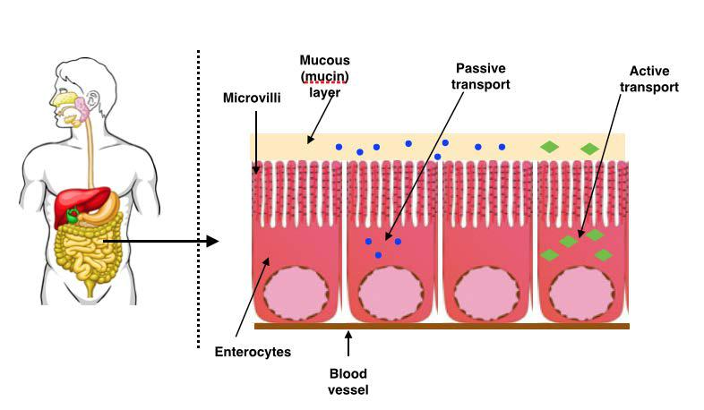

23

**Figure 2.2.** Schematic representation of the mechanism of component uptake by the small intestine cells

**2.5. The application of nanotechnology in improving vitamin D status**

Vitamin D3 is sensitive to some environmental conditions such as light, heat and oxygen. It is not stable when oxidation occurs since it might lose its function and its related benefits (Luo, Teng & Wang, 2012). Also since vitamin D3 is hydrophobic in nature, it has a lower intestinal absorption rate (Salvia-Trujillo et al., 2013) and oral bioavailability. Because of these reasons we need to entrap and encapsulate the hydrophobic vitamin D3 compound efficiently with the lipid-based delivery system. The nanoencapsulation process helps in increasing vitamin D3 stability, retaining its function and also improves its bioaccessibility (Walia et al., 2017) & (Maurya & Aggarwal 2017). In 1998, Delaurent and colleagues first reported molecular encapsulation of vitamin D by cyclodextrins to overcome the problems related to its distribution and solubility in food and drugs. In this study, the authors determined the most appropriate method to characterize vitamin D/cyclodextrins complex to understand its structure via a molecular model.

In another study, vitamin D3 was encapsulated with oil-in-water nanoemulsion to study the influence of various types of carrier oil (MCT, LCT and indigestible oil) using simulated GIT model with the goal of improving vitamin D3 bioaccessibility. It was reported that one, carrier oils have the greater impact on lipid digestion and, two, nanoemulsion prepared from LCT improved bioaccessibility when compared to nanoemulsion prepared from MCT or indigestible oils (Ozturk et al., 2015). Nanoparticle formulation showed promising *in vitro* results, but to the best of our knowledge no *in vivo* studies have been conducted (Huang, Yu, & Ru, 2010).

More recently, vitamin D2 encapsulated oil-in-water nanoemulsion was prepared to evaluate the influence of droplet size *in vitro* (using simulated GIT model) bioaccessibility study and *in vivo* oral bioavailability (rat feeding study) study. *In vitro* studies indicated that smaller lipid

24

droplets have shown improved vitamin D2 bioaccessibility when compared to larger ones. Smaller lipid droplets have better solubility, rapid digestibility and thereby it leads to rapid formation of mixed micelles. Whereas *in vivo* study reported contrasting results. This suggests that larger droplets have increased oral bioavailability when compared to smaller droplets. The author noted that even though there was a poor correlation between *in vitro* and *in vivo* study results, the particle size of encapsulated lipophilic components had greater influence on GIT absorption (Salvia-Trujillo, et al., 2017).

25

CHAPTER 3

PURPOSE OF THE STUDY

Although people can get vitamin D through sunlight exposure and from vitamin D fortified foods *e.g.* milk, in the United States as well as in other parts of the world there was a dramatic decrease in vitamin D sufficiency (Adams and Hewison, 2010) & (Looker et al., 2011). Worldwide, around 1 billion people and about 1/4 of the U.S population have vitamin D insufficiency (Serum 25(OH)D3 level between (30 to <50 nmol/L or 12 to <20 ng/mL). Around 8% of U.S population have vitamin D deficiency (<30 nmol/L or <12ng/mL) (Looker et al., 2011) & (Holick, 2007).

In addition to vitamin D’s importance in bone health, its deficiency has been associated with increased risk of a wide range of diseases, including common cancers, cardiovascular diseases, immune and inflammatory diseases (Holick, 2007). Therefore, it is important to develop new strategies to improve the vitamin D level for better public health.

Following the emergence of nanotechnology and nanomedicine (Riehemann et al., 2009), there is increasing interest in their application in nutrition and the food industry because of the unique physicochemical characteristics and biological functions associated with nanoparticles (diameter <200nm) (Huang, Yu, & Ru, 2010), (McClements and Rao, 2011) & (Srinivas et al., 2010). In this study, we will be utilizing lipid-based delivery since various studies indicated that this delivery system improves solubility, stability, water dispersibility and bioaccessibility of lipophilic dietary compounds (Guttoff, et al., 2015), (Gupta, et al., 2016) & (McClements, 2011). In the present study, we propose to evaluate to what extent the nanoemulsion of vitamin D3 can

26

improve vitamin D level in the in *vitro* bioaccessibility and *in vivo* bioavailability when compared to the coarse emulsion (diameter >200nm).

* Specific Aim 1: To determine the in *vitro* bioaccessibility of nanoemulsion of vitamin D3 using *in vitro* simulated gastrointestinal system. We hypothesize that a nanoemulsion of vitamin D3 will improve the in *vitro* bioaccessibility of vitamin D3 when compared to the coarse emulsion.
* Specific Aim 2: To determine the in *vivo* bioavailability of nanoemulsion of vitamin D3 by measuring serum 25(OH)D3 using animal models. We hypothesize that the in *vivo* bioavailability of vitamin D3 in nanoemulsion treated animals will be enhanced when compared to the coarse emulsion.

27

CHAPTER 4

METHODS

**4.1. Nanoemulsion fabrication and characterization**

4.1.1. Nanoemulsion preparation

To prepare oil-in-water nanoemulsion of vitamin D, Quillaja saponin (Q-Naturale 200V) was kindly donated by Ingredion Inc. (Westchester, IL). Vitamin D3 was purchased from Sigma– Aldrich (St. Louis, MO, USA). Corn oil (Mazola, ACH Food Companies, Inc., Memphis, TN) was purchased from a local store. Lipase, bile salts, mucin, pepsin, sodium phosphate mono and dibasic were purchased from Sigma-Aldrich (St. Louis MO, USA). All chemicals used were of analytical grade. Double distilled water was used to prepare all solutions and emulsions. High-speed mixer ((M133/1281-0, Biospec Products, Inc. Bartlesville, OK, USA)) and high-pressure homogenizer (Microfluidics M110L, Newton, MA, USA) were used to make emulsions.

We prepared oil-in-water nanoemulsion of vitamin D3 using the procedure published in (Ozturk et al., 2015). Oil-in-water nanoemulsions were formed with a 10% (w/w) corn oil phase in which vitamin D3 was dissolved at a 0.1% (w/w), resulting in a final vitamin D3 concentration of approximately 100 mg/L (or 0.1mg/ml) of the emulsion. The aqueous phase consisted of 2% (w/w) surfactant (Q-Naturale) dispersed in a buffer solution (10 mM sodium phosphate buffer, pH 7.0). The Q-Naturale 200V was reported by the manufacturer that it contained 14 wt% active saponins

28

(the remaining amount is water), and so the concentration of this surfactant is reported as an active ingredient. A macroemulsion was prepared by mixing the oil phase and the aqueous phase using a high-speed mixer for 2 min at 10,000 rpm. The macroemulsion was then passed through the high-pressure microfluidizer for three passes at 12,000 psi to make nanoemulsion (diameter <200nm). The vehicle was prepared by following the same procedure to make nanoemulsion but without vitamin D3, which is the control. Finally, the coarse emulsion (diameter >200nm) was prepared by mixing the oil phase and aqueous phase without any external particle reduction. Then, the efficacy of these three emulsions was compared.

29

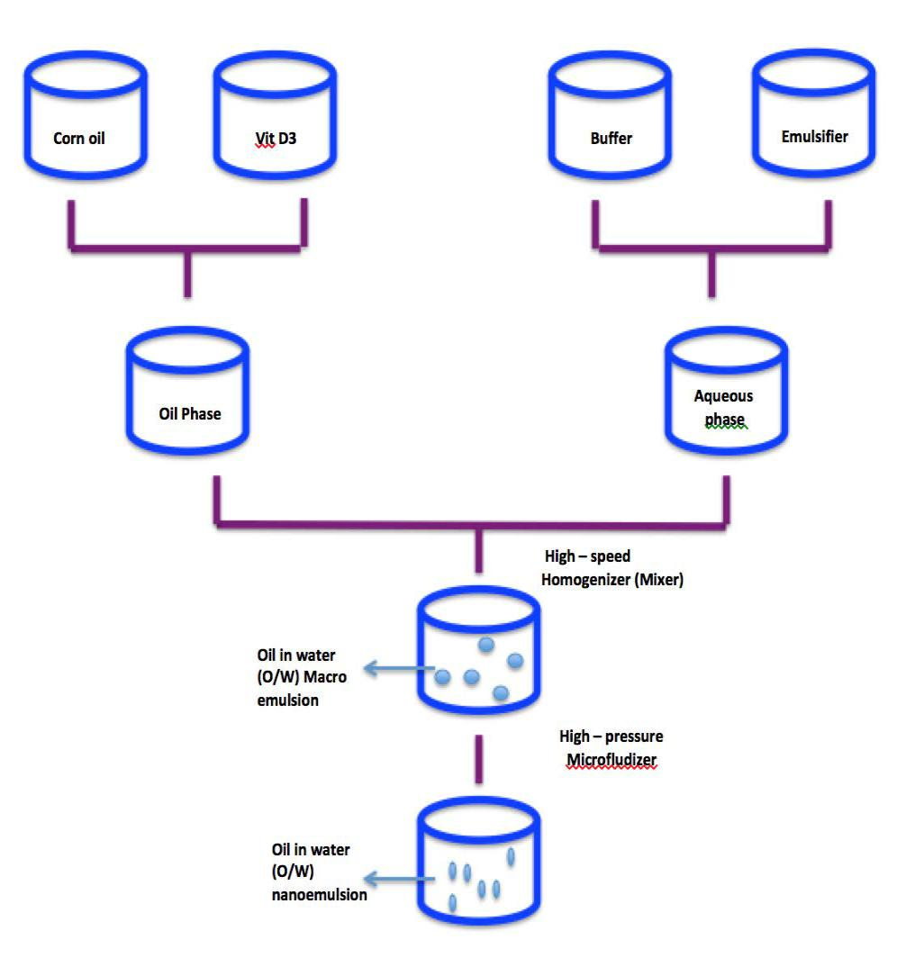

**Figure 4.1.** Process of making oil-in-water nanoemulsion

4.1.2. Particle characterization

The mean droplet diameters of the samples were measured using a laser diffraction particle size analyzer (LS 13 320, Beckman Coulter, Brea, CA, USA). The droplets charge (ζ-potentials) were measured using a dynamic light scattering instrument (Zetasizer Nano ZS, Malvern Instruments, Malvern, England). Samples were diluted in 10 mM phosphate buffer solution at the

30

proper pH to avoid multiple scattering. The particle size of each sample was represented as the surface-weighted mean diameter (d32).

**4.2. In vitro Bioaccessibility**

4.2.1. Simulated gastrointestinal model

A simulated in *vitro* gastrointestinal model was used to study the influence of the nanoemulsions on the bioaccessibility of vitamin D3. The samples were diluted 5 times in sodium phosphate buffer, leading to 2% oil and 0.002% vitamin D3. The diluted samples were subjected to digestion through in *vitro* gastrointestinal model based on the procedure published in Ozturk et al., 2015.

4.2.1.1. Mouth phase

Artificial saliva work solution (ASWS) was prepared based on previous studies (Sarkar, Goh & Singh, 2009) & (McClements & Li, 2010). A 20 ml aliquot of the diluted sample was placed in a 125 ml flask and 20 ml of ASWS containing 0.6 g mucin was added to the flask. The pH of this mixture was adjusted to 6.8 and then shaken continuously at a rate of 100 rpm in a temperature-controlled incubator (Innova Incubator Shaker, Model 4080, New Brunswick Scientific, New Jersey, USA) at 37 °C for 10 min.

4.2.1.2. Gastric phase

The simulated gastric fluid stock solution (SGFSS) was prepared by dissolving 2 g of NaCl and 7 mL of hydrochloric acid (HCl) in 1 L of double distilled water. The simulated gastric fluid work solution (SGFWS) was prepared by mixing 20 mL of SGFSS and 0.064 g of pepsin per sample 45 min before running the gastric phase. 20 mL of the mouth sample was mixed with SGFWS at a

31

1:1 volume ratio so that the final mixture contained 0.5% (w/w) oil. The pH of the sample was adjusted to 2.5. Then the mixture was kept in the shaker at 37°C and 100 rpm for 2 hours.

4.2.1.3. Small intestine phase

A pH-STAT instrument (835 Titrando, Metrohm USA Inc., Riverview, FL) was used to simulate the conditions of the small intestinal phase. 30 mL of the digesta from the gastric phase was placed in a 100 mL beaker in a water bath at 37°C and the pH was set to 7.0 using NaOH solution. 1.5 mL of salt solutions (calcium chloride - 36.7 mg/mL and sodium chloride 219.1 mg/mL) was added. Then, 3.5 mL of bile extract (53.6 mg/mL) dissolved in 10 mM sodium phosphate buffer solution was added to the sample and the pH was re-adjusted to 7.0. Afterwards, 2.5 mL of freshly prepared lipase suspension (24 mg/mL) dissolved in 10 mM sodium phosphate buffer was incorporated into the mixture and the automatic titration unit was started. The pH of the mixture was monitored and the volume of 0.1 N NaOH necessary to neutralize the FFA has released from the lipid digestion and recorded for 2 hours. The amount of FFA released was calculated using the following equation:

%FFA = 100 × VNaOH × mNaOH × mlipid

wlipid × 2

where VNaOH is the volume of NaOH used (in L), mNaOH is the molarity of the NaOH (0.1 N), mlipid is the molecular weight of corn oil (872 g/mol), wlipid is the total mass of corn oil initially present in the small intestine phase (in grams).

4.2.2. Relative Bioaccessibility

From digested samples, 10 ml was taken and centrifuged (4000 rpm for 40 min at room

32

temperature) using a bench top centrifuge (Sorvall ST8, Thermo Scientific, Tewksbury, MA). After centrifugation, the samples separated into two phases: the undigested material as the bottom layer and a clear micelle phase as a top layer. The concentration of vitamin D3 was determined based on the method used by Ozturk et al., 2015. To extract the vitamin D3 for the spectrophotometric measurements, 1 mL of the intestinal or micelle phase was diluted in 5 mL of isooctane: ethyl alcohol (1:3) and vortex it. Then, this solution was centrifuged for 10 minutes at 1750 rpm. The supernatants were used for the absorbance measurements of vitamin D3 concentrations made at 265nm wavelength using a UV–visible spectrophotometer (Ultraspec 3000 Pro Pharmacia Biotech, Biochrom Ltd., Cambridge, UK).

The standard curve was obtained by measuring the absorbance at the 265nm wavelength for various concentration of vitamin D3 dissolved in isooctane: ethyl alcohol (r2=0.9996).

The relative bioaccessibility (RBA) was determined using the following equation:

RBA(%) = Cnanoemulsion 100

Ccoarse emulsion

where Cnanoemulsion is the concentration of vitamin D3 in miceller phase of nanoemulsion and

Ccoarse emulsion is the concentration of vitamin D3 in miceller phase of coarse emulsion.

**4.3. Animal study**

4.3.1. Measurement of serum 25(OH)D3

*In vivo* study was conducted to investigate the bioavailability of nanoemulsion of vitamin D3. The protocol was approved by the Institutional Animal Care and Use Committee of the University of Massachusetts, Amherst. The C57BL/6 mice were purchased from Jackson Laboratory, Bar Harbor, ME. 15 mice were randomly assigned to three groups: 6 mice, 6 mice and

33

3 mice were assigned to nanoemulsion group, coarse emulsion group and vehicle group, respectively.

The final concentration of 0.1mg/ml of an oil-in-water nanoemulsion of vitamin D3 was diluted to 1000 times to reach our target of 0.1ug of vitamin D /ml. [Target: Mice need to feed with 5000IU of vitamin D3 /kg of diet; chow diet contains 1000 IU/kg so the remaining 4000 IU/kg should be from treatment. Mice consume 5g of diet/day, hence 20IU (0.5 ug) should be given in the treatment. Mice consume 5ml of water per day, so 0.5ug/5ml i.e 0.1ug of vitamin D3/ml of water is the target treatment]. The treatment was given by mixing the emulsion in their drinking water and they were allowed to have free access to it. After 3 days, the mice were sacrificed and the blood was drawn to measure serum 25(OH)D3 (calcidiol) by the Radioactive immune assay Double antibody method using manufacturer’s protocol (DiaSorin The diagnostic Specialist, USA). Various body parts such as liver, small intestinal cells and kidneys were harvested to analyze the various levels of vitamin D3 related gene expressions using quantitative real-time PCR.

4.3.2. Quantitative real-time PCR

From the harvested tissue samples, total RNA was isolated with TRIzol® using the manufacturer’s protocol (Life Technologies, Grand Island, NY). The concentrations of total RNA were determined spectrophotometrically (NanoDrop Lite, ThermoFisher Scientific, Waltham, MA). cDNA was synthesized from 1 µg of total RNA using the protocol from Takara’s PrimeScriptTM RT reagent kit (Takara Bio USA, Inc, CA, USA). Real-time PCR was performed on the ViiA™ 7 Real-Time PCR System (Applied Biosystems, Foster City, CA) utilizing the following thermal cycling conditions: 95ºC for 10 min, followed by 40 cycles of 95ºC for 15 s and 60ºC for 60 s. Primer sequences were designed by qPrimerDepot (NCI/NIH) and listed in Table 4.1.

34

**Table 4.1. PCR primer sequences for real-time PCR analysis**

|  |  |  |  |  |  |  |  |  |
| --- | --- | --- | --- | --- | --- | --- | --- | --- |
|  |  |  |  | F | AGCCCTAAGCACGGGAAG | |  | |
|  |  | **VDR** | |  |  |  | |  | |
|  | R | GCTCTCCTGGGAAGACTCAC | |  | |
|  |  |  |  |  |  |  | |  | |
|  |  |  |  | F | GAAGCAGAGCCGGGTGTAT |  | |  | |
|  |  | **Cyp2R1** |  |  |  |  | |  | |
|  |  |  | R | CACTTTGATGAACAAGGCATTC |  | |  | |
|  |  |  |  |  |  |  | |  | |
|  |  |  |  | F | CTATGTGCTGCACTTGCCC |  | |  | |
|  |  | **Cyp27A1** | |  |  | |  | |
|  |  | R | GCCATGCACCTGAGAGAATC | |  | |
|  |  |  |  |  |  |  | |  | |
|  |  |  |  | F | CTCAGCTTCCTGGCTGAACT |  | |  | |
|  |  | **Cyp27B1** |  |  |  |  | |  | |
|  |  |  | R | GCCATGCACCTGAGAGAATC |  | |  | |
|  |  |  |  |  |  |  | |  | |
|  |  |  |  | F | AACTGTACGCTGCTGTCACG |  | |  | |
|  |  | **Cyp24A1** | |  |  | |  | |
|  |  | R | CTCTGTTGCACTTGGGGATT | |  | |
|  |  |  |  |  |  |  | |  | |
|  |  |  |  | F | TTGATGGCAACAATCTCCAC |  | |  | |
|  |  | **GAPDH** |  |  |  |  | |  | |
|  |  |  | R | CGTCCCGTAGACAAAATGGT |  | |  | |
|  |  |  |  |  |  |  | |  | |
|  |  |  |  | F | CACAGACAAGAGTCCTGGGC |  | |  | |
|  |  | **TRPV6** | |  |  | |  | |
|  |  | R | ACATCGTTTTCTTTGGCAGC | |  | |

F – Forward ; R – Reverse

**4.4. Statistical analysis**

Data are expressed as means ± SEM. Data analysis was performed using SAS (Version 9.4, SAS Institute, Cary, NC). Comparisons between groups were made using ANOVA. For the gene expression data analysis, the expression of each gene was normalized to the housekeeping gene GAPDH (Cttarget gene-CtGAPDH). Statistical analyses were performed based on ΔCt. The relative abundance of specific bacterial taxa or relative gene expression were reported as 2−ΔΔCt, where

ΔΔCt=∆CtExperiment-∆CtControl.

35

CHAPTER 5

RESULTS

**5.1 Particle characteristics of the emulsion**

36

The physicochemical characteristics of the initial emulsion as well as at various phases (mouth, stomach and small intestine) in the simulated gastrointestinal tract (GIT) were determined in terms of mean particle diameter (d32) and ζ-potential. As expected, the initial mean particle diameter of the coarse emulsion was ≈20-fold higher than the nanoemulsion groups i.e nanoemulsion with and without cholecalciferol (Figure 5.1). No particle size difference noted between nanoemulsion with and without cholecalciferol (vehicle) which indicates that incorporation of cholecalciferol did not interfere with the formation of nanoparticles. The homogeneity of the particle size in the initial phases was significantly higher for nanoemulsion than the coarse emulsion (p<0.01), as indicated by the smaller coefficient of variation (Figure 3A).

The stability of nanoemulsions can be attributed to the effect of natural surfactant (Q-Naturale) used in this study. This highly effective emulsifier rapidly adsorbs to the surface of oil droplets during homogenization, thereby leading to small initial droplets. It forms a protective coating around the droplet surface that inhibits coalescence and flocculation through a combination of steric and electrostatic repulsion. In the previous study, this surfactant coated lipid droplets were stable against droplet aggregation in a wide range of pH conditions i.e pH 3-8 (Ozturk et al., 2014). In mouth phase and in gastric phase, there was only a slight increase in particle size of nanoemulsion groups (Figure 5.1) and the same result was reported in the previous study (Ozturk et al., 2015). The mucin present in simulated saliva may promote bridging but in the gastric phase the low pH and high ionic strength may alter the colloidal interactions between the oil droplets (Van Aken et al., 2011)

37

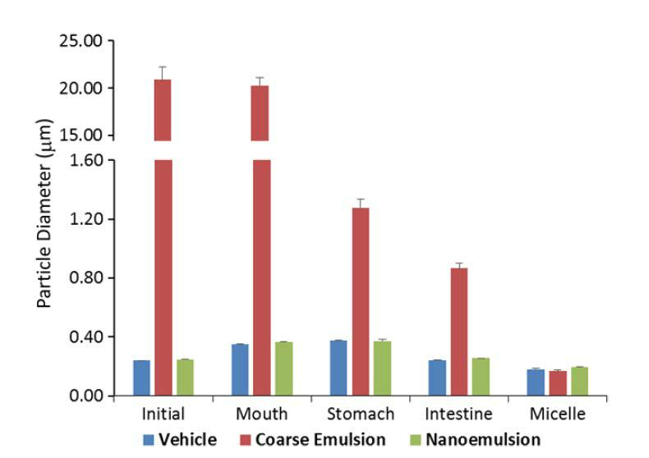

**Figure 5.1.** Influence of gastrointestinal tract (GIT) phases and emusion types on the mean particle diameter (d32) of cholecalciferol-enriched oil-in water emulsions determined by an in *vitro* simulated GIT

After the gastric phase, once the particles incubated in small intestine phase, there was an appreciable reduction in the particle size (Figure 5.1). This reduction in mean particle diameter may be due to various reasons such as lipid digestion; thereby forming mixed micelles and generation of insoluble sediments (Ozturk et al., 2015). In the micelle phase, the particle size in all three emulsion types are relatively smaller, which may be due to creaming or sedimentation of larger particles during the centrifugation process. The variation of particle sizes in the mixed micelle phase for the coarse emulsion remained higher when comparing to the nanoemulsion groups though it did not reach statistical significance (Figure 5.3A).

38

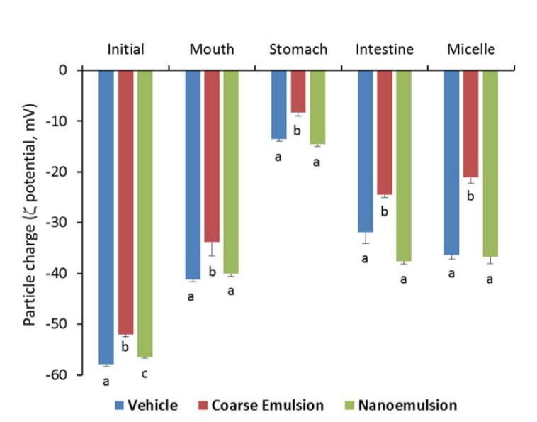

**Figure 5.2**. Influence of gastrointestinal tract (GIT) phases and emusion types on particle charge (ζ-potential) of cholecalciferol-enriched oil-in water emulsions determined by an in *vitro* simulated GIT

The electrical charge on the particles was measured at various phases of simulated GIT to provide information on interfacial characteristics (Figure 5.2). In all phases (initial, mouth, stomach, small intestine & micelle) the magnitude of negative charges for the particles in the coarse emulsion was significantly less than those particles in nanoemulsions with or without cholecalciferol (p<0.005). The pattern of the negative charge changes across all the phases was similar for all 3 groups, which is in agreement with previous studies (Ozturk et al., 2015).

The magnitude in negative electrical charge has decreased in droplets for all emulsion types after subjected to mouth phase. This may be due to salts in simulated saliva or adsorption of mucin to the surface of the lipid droplets. Moreover, after subjected to the stomach phase, the magnitude of the negative charge decreased further which may be due to the electrical characterisitics of Q-Naturale in acidic condition. After exposure to the simulated small intestinal solution, the magnitudes of the negative charge for all emulsions types increased appreciably which may be due to various reasons such as increase in pH, adsorption of anionic phospholipids & bile salts to the

39

droplets surface and synthesis of anionic FFA during digestion of triglycerides which was reported in previous study also (Ozturk et al., 2015). Unlike the particle size, the coefficient of variation for the electronic charge was not statistically different among the three groups (Figure 5.3B).

The digital photographs of the three groups across all phases are shown in Figure 5.3C, with a minimal difference for the coarse emulsion. Particularly, the coarse emulsions appeared less opaque than the nanoemulsions, which was due to the lower degree of light scattering for the larger droplets. In addition, there was evidence of a thin layer of droplets at the top of the coarse emulsions, which can be attributed to the increase in the creaming velocity with increasing droplet size.

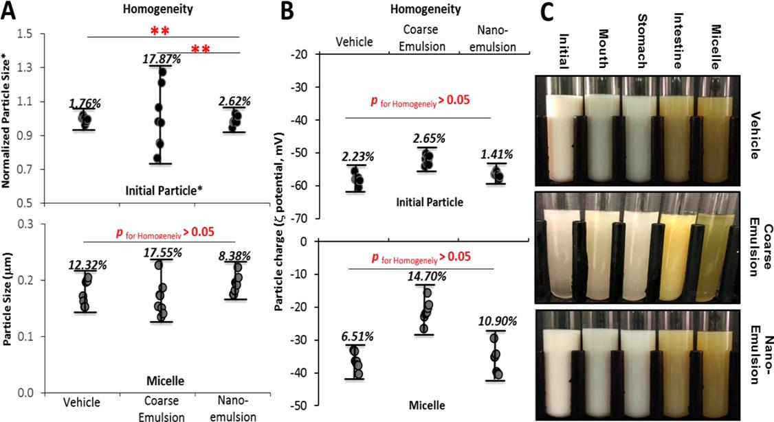

**Figure 5.3.** Impact of emuslion types on physical homogeneity of cholecalciferol-enriched oil-in-water emulsion. The percentage on the figure are coefficient of variation for physical chracteristics

40

in each group. A) Homogeneity of particle size. Due to significantly high particle size for the coarse emulsion, the particle size was normalized to the mean for comparison on the figure. B) Homogeneity of particle charge. C) Digital photographs at different stages of the GIT

**5.2. In *vitro* lipid digestion and vitamin D Bioaccessibility**

The rate and extent of lipid digestion under simulated small intestine was continuously monitored and recorded using the pH-stat method (Figure 5.4). There was a rapid FFA release for the nanoemulsion groups (nanoemulsion with and without cholecalciferol) throughout the first 10 minutes after adding lipase, which helps in breaking down triglycerides to monoglycerides and FFA. Between 10 to 120 minutes, there was a slow release of FFA or the rate of FFA release remained constant which indicates the completion of lipid digestion. The extent of release of FFA was significantly (p<0.01) higher for nanoemulsion groups than the coarse emulsion. At the end of 120 min incubation, there were only 69% of the lipids were digested for the coarse emulsion. The observed difference in the rate of and extent of lipid digestion can be attributed to differences in surface area of the systems. Nanoemulsion has a much higher surface area per unit amount of lipid than coarse emulsions, and so it assists more lipase molecules to adsorb to the surface of the droplets and thereby it increases the lipid hydrolysis.

41

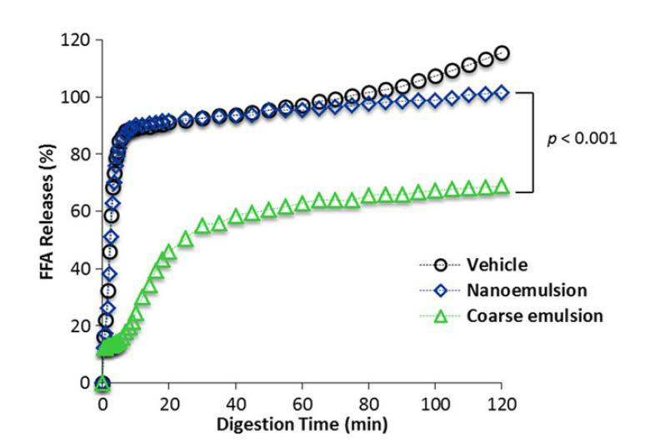

**Figure 5.4.** Release of FFA from emulsions under simulated small intestine conditions

After full digestion by simulated GIT, the bioaccessibility of vitamin D3 was determined in the total digesta and in micelle phase using solvent extraction and UV–Vis spectrophotometry. The relative viatmin D3 bioaccessibility was calculated by dividing the vitamin D3 concentration in the nanoemulsion by the vitamin D3 concentration in the coarse emulsion. The absorbance measurements were normalized to the empty vehicle control group. In intestinal total digesta, the bioaccessibility of vitamin D3 was 2.58-fold higher (p <0.01) in vitamin D3 nanoemulsion group when compared to the coarse emulsion group (Figure 5.5A). The higher bioaccessibility for encapsulated vitamin D3 nanoemulsion group was attributed to complete digestion and better solubilizing capacity due to smaller droplet size, less degradation of cholecalciferol or other losses in GIT.

In a mixed micelle, the bioaccessibility of vitamin D3 was 3.94-fold higher (p <0.01) in vitamin D3 nanoemulsion group when compared to the coarse emulsion group (Figure 5.5B), suggesting that nanoemulsification improved the incorporation of cholecalciferol into the mixed micelles. As a result, there would be a higher level of vitamin D available for intestinal epithelial

42

cell absorption. The homogeneity test showed that the coefficients of variation for the vitamin D3 concentration in the intestinal raw digesta (16.89 vs 9.21%, p=0.064) and mixed micelle (25.26 vs 9.95%, p=0.045) of the vitamin D coarse emulsion group were higher than that of the nanoemulsion group (Figure 5.5C).

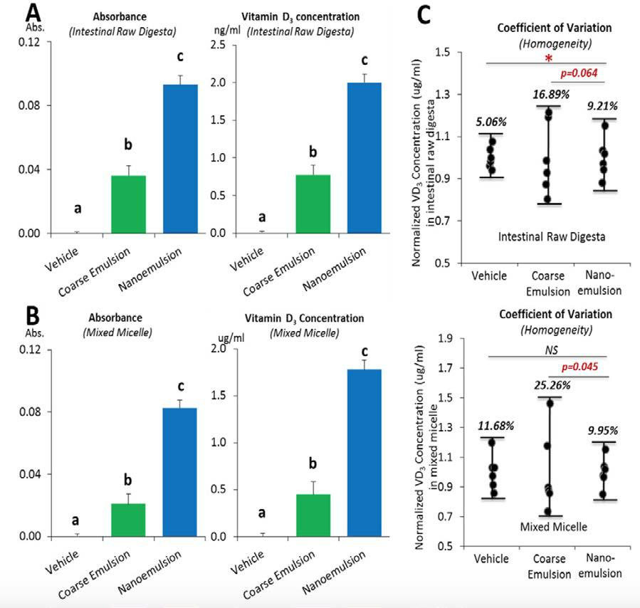

43

**Figure 5.5.** Vitamin D3 concentration in raw digesta and the mixed micelles of the simulated GIT system. A) The concentartion of vitamin D in the raw digesta and B) The concentartion of vitamin D in the mixed micelle C) Coefficient of varaiation of vitamin D concentration in various emulsion groups

**5.3. In *vivo* vitamin D Bioavailability**

After observing the improvement of in *vitro* bioaccessibility, we further examined the in *vivo* bioavailability of vitamin D in nanoemulsion or coarse emulsion using an animal study. When compared to the vehicle group (nanoemulsion without vitamin D) that has a baseline of 1000 IU/kg of vitamin D in the diet, the coarse emulsion group with the oral supplementation of cholecalciferol (4000 IU/kg equivalent) showed increase in serum 25(OH)D3 level by 36.04% but it was not statistically significant (13.1 ±0.09 vs 17.9± 2.82 ng/mL, p>0.05) (Figure 6A). Whereas, in nanoemulsion group, the oral supplementation of cholecalciferol (4000 IU/kg equivalent) showed a statistically significant increase in serum 25(OH)D3 level by 73.10% (13.1 ±0.09 vs 22.7± 1.10 ng/mL, p<0.01). Serum 25(OH)D3, which is considered as a standard single best biomarker to measure the vitamin D status (Zerwekh, 2008), this study established the correlation between in *vitro* and in *vivo* methods, which was not observed in our previous study where vitamin D2 wasused as the biomarker (Salvia-Trujillo, et al., 2017). The results from our study is consistent with the previous study which showed that the nanotechnology-based oral administration of dietary bioactive components (curcumin) or commonly used drugs (ibuprofen) were able to improve their biological functions (pancreatic cancer prevention up to tenfolds) (Grandhi et al., 2013) & (Thakkar et al., 2015). However, further studies are necessary to determine the biological consequence of improved vitamin D bioavailability by nanoemulsion. A higher coefficient of variation of the in *vivo* bioavailability (Figure 5.6B) for the coarse emulsion group was consistent with in *vitro* bioaccessibility (Figure 5.5C) and particle size (Figure 5.3A), indicating that the nanoemulsification can help to decrease the heterogeneity of vitamin D absorption.

44

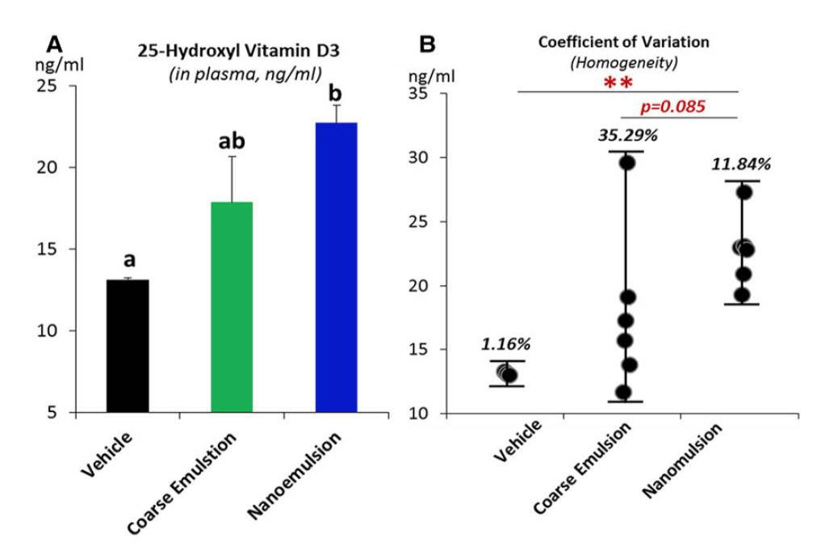

**Figure 5.6.** The in *vivo* bioavailability of vitamin D3. A) The concentration of vitamin D3 in plasma and B) The coefficient of variation of vitamin D3 in plasma

**5.4 The expression of vitamin D metabolically-realted genes**

Multiple genes such as VDR, CYP27A1, CYP2R1, TRPV6, CYP27B1 etc that are involved in vitamin D metabolism and their expression is potentially inducible by vitamin D intake. The expression of these genes was analysed using real-time PCR. We examined the expression of VDR, Cyp27A1, Cyp2R1, and Trpv6 in intestinal epithelial mucosa, VDR, Cyp27A1, and Cyp2R1 in the liver, and VDR, Cyp27B1, and Cyp24A1 in the kidney. In intestinal cells, we observed a significant increase in expression of Cyp27A1 in vitamin D nanoemulsion group when compared to the vehicle and coarse emulsion group, a significant increase in Cyp2R1 expression in the vitamin D nanoemulsion and coarse emulsion groups when compared to the vehicle group (Figure 5.7A, p < 0.05). In liver tissue, we observed a significant increase in Cyp2R1 expression in the vitamin D

45

nanoemulsion group when compared to the vehicle and coarse emulsion group (Figure 5.7B, p < 0.05). No differences were noted for the genes examined in the kidney. The expression of intestinal Cyp27A1 (p = 0.04) and liver Cyp2R1 (p = 0.057) was correlated with the serum 25(OH)D3 level (Figure 7C). In Fleet’s study, a steady decrease for the Cyp27B1 expression was observed in the kidney (Fleet at al., 2008). The non-significance for Cyp27B1 expression across the groups observed in this study might be attributed to the short feeding period in our study (3 days) compared to the rat (4 weeks) and mouse study (7 weeks) in Fleet’s studies.

Nevertheless, the increase of Cyp27A1 and Cyp2R1 in the intestine or liver samples for the vitamin D nanoemulsion or coarse emulsion groups, and correlations of their expressions with serum 25(OH)VD3 level demonstrated the response of these vitamin D metabolically-related genes with the vitamin D supplementation via nano or coarse emulsion. Particularly, the statistically significant increases of intestinal Cyp27A1 expression and liver Cyp2R1 expression in the VD nanoemulsion group compared to the coarse emulsion group indicated an improvement of VD absorption by nanoemulsion.

46

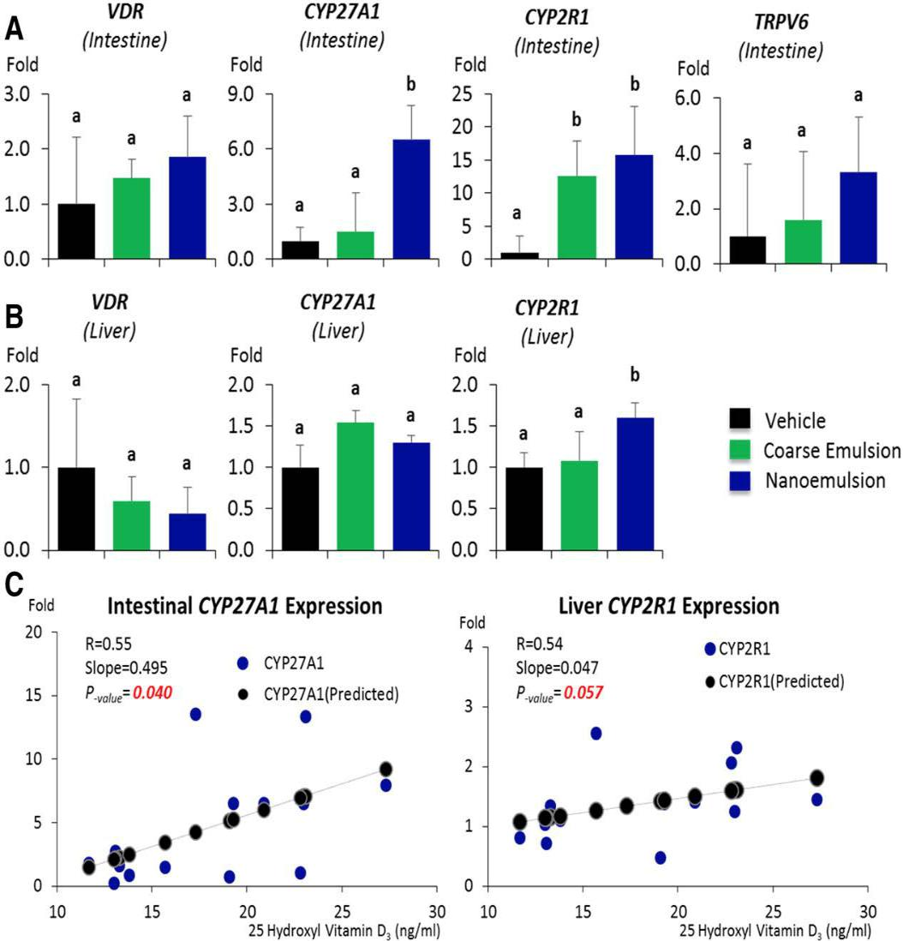

**Figure 5.7.** Influence of different emulsion types on the expression of vitamin D metabolically related genes. A) The impact on expression of genes in intestinal mucosa B) The impact on expression of genes in liver tissue C) The correlation between the serum vitamin D concentration and gene expression

47

CHAPTER 6

DISCUSSION

Vitamin D is most commonly being synthesized through sun exposure or is obtained from fortified foods. Recently, it has been reported that vitamin D sufficiency is decreasing in the United States as well as in other parts of the world (Looker et al., 2011). Therefore, innovative strategies are necessary for improving vitamin D absorption. In this thesis, a lipid-based delivery through oil-in-water nanoemulsion was utilized to improve vitamin D bioaccessibility. We demonstrated that we can improve absorption by improving vitamin D’s solubility. Also, there is number of physiochemical advantages associated with dietary nanoparticles such as greater stability, lesser aggregation, rapid digestion in GIT which can be attributed to its smaller dimension and large surface area. Our study has shown that reducing lipid nanoparticle size increases the bioaccessibility of vitamin D which is consistent with previous studies (Ozturk et al., 2015) & (Salvia-Trujillo et al., 2017). We further investigated the in *vivo* bioavailability of vitamin D in an animal study. Our results showed a significant increase in serum 25(OH)D3 through nanoemulsion-based delivery when compared to the coarse emulsion. Through these results, we established the correlation between in *vitro* and in *vivo* methods, which was not observed in a closely related previous study where vitamin D2 was used as the biomarker (Salvia-Trujillo et al., 2017). Therefore, our study results showed that nano-based oral administration of vitamin D improves both vitamin D bioaccessibility and bioavailability.

However, our study has several limitations that can be considered in future studies. First, this study demonstrated that the coarse emulsion solution was not as homogeneous as nanoemulsion. Also, in the coarse emulsion, a thin layer of creaming was formed during the course of study. The creaming made it difficult to ensure the consumption of vitamin D completely and uniformly by the animals. The relative high heterogeneity of the coarse emulsion, compared to

48

nanoemulsion, was reflected in the significantly larger coefficients of variations of the initial particle size, the in *vitro* bioaccessibility, and in *vivo* bioavailability. Future studies are required to uncover this problem, e.g., by converting the sample into powders or adding a thickening agent to inhibit creaming. Second, although the serum 25(OH)D3 is responsive to a high vitamin D supplementation level up to 20,000 IU/kg (Fleet et al., 2008), the magnitude of change in serum 25(OH)D3 at 5000 IU/kg supplementation might not reflect that at other dosage e.g., 1000 IU/kg for rodent diet. Therefore, a series of dosages of vitamin D supplementation study will be necessary for the future. Third, in our study, the feeding period of the animals lasted for three days only. Even though the peak serum 25(OH)D3 level was reached after 12 to 24 hours following the feeding, it might require more time to establish the steady serum 25(OH)D3 level in the body and to establish the expression of vitamin D related genes. Therefore, longer feeding time is recommended in future studies.

49

CHAPTER 7

SUMMARY & CONCLUSIONS

Vitamin D deficiency is increasing even with the wide use of vitamin D fortified foods. Lower vitamin D status is particularly prevalent in populations with more pigmented skin, urban residences and people live in areas with latitudes above 37 degrees in the US (Yetley, 2008). With the concept that the health benefit of vitamin D intake, similar to other fat-soluble nutrients, follows a “U” shape – with risks at both low and high levels, more practicable strategies, rather than unlimited increases of the supplemental level of vitamin D, are necessary to improve vitamin D status.

Vitamin D being hydrophobic in nature, has poor solubility and hence the lipid-based delivery of oil-in-water nanoemulsion was utilized to improve its absorption rate. In this study, we examined the influence of lipid droplet size on the in *vitro* bioaccessibility and in *vivo* bioavailability of cholecalciferol encapsulated in oil-in-water nanoemulsion.

Overall, our study demonstrated that nanoemulsification significantly improved vitamin D absorption in both in *vitro* (3.94 fold) using a simulated GIT model and in *vivo* studies as indicated by the increased serum 25(OH)D3. Also, the vitamin D nanoemulsion has significantly reduced coefficient of variation when compared to coarse emulsion, which reduced the variation in absorption of vitamin D. Even though there are several limitations in the study as described above, the results showed that nanoemulsion has the potential to be utilized in delivering the vitamin D thereby improving the vitamin D level.

50

BIBLIOGRAPHY

Acosta, E. (2009). Bioavailability of nanoparticles in nutrient and nutraceutical delivery. Current Opinion in Colloid & Interface Science, 14(1), 3–15.

Adams, J. S., & Hewison, M. (2010). Update in vitamin D. Journal of Clinical Endocrinology and Metabolism, 95(2), 471–478. http://doi.org/10.1210/jc.2009-1773

Armand, M., Pasquier, B., André, M., Borel, P., Senft, M., Peyrot, J., ... & Lairon, D. (1999).

Digestion and absorption of 2 fat emulsions with different droplet sizes in the human

digestive tract–. The American journal of clinical nutrition, 70(6), 1096-1106.

Berger, U., Wilson, P., McClelland, R., Colston, K., Haussler, M. R., Pike, J., & Coombes, R.

(2016). Tissues , 67(3), 607–613.

Borel, P. (2003). Factors affecting intestinal absorption of highly lipophilic food microconstituents (fat-soluble vitamins, carotenoids and phytosterols). Clinical Chemistry and Laboratory Medicine, 41(8), 979–994. http://doi.org/10.1515/CCLM.2003.151

Borel, P., Caillaud, D., & Cano, N. J. (2015). Vitamin D bioavailability: State of the art. Critical Reviews in Food Science and Nutrition, 55(9), 1193–1205.

Cerqueira, M. A., Pinheiro, A. C., Silva, H. D., Ramos, P. E., Azevedo, M. A., Flores-López, M. L., ... & Vicente, A. A. (2014). Design of bio-nanosystems for oral delivery of functional compounds. Food Engineering Reviews, 6(1-2), 1-19.

Christakos, S., Ajibade, D. V., Dhawan, P., Fechner, A. J., & Mady, L. J. (2012). Vitamin D:

metabolism. Rheumatic Disease Clinics, 38(1), 1-11.

Compston, J. E., Vedi, S., Ledger, J. E., Webb, A., Gazet, J. C., & Pilkington, T. R. (1981).

51

Vitamin D status and bone histomorphometry in gross obesity. The American journal of clinical nutrition, 34(11), 2359-2363.

Dawson-hughes, B. (2008). Serum 25-hydroxyvitamin D and functional outcomes in the, 88, 537–540.

Delaurent, C., Siouffi, A. M., & Pepe, G. (1998). Cyclodextrin inclusion complexes with vitamin

D3: investigations of the solid complex characterization. Chemia analityczna, 43(4), 601-

616.

Di Rosa, M., Malaguarnera, M., Zangh, A., Passaniti, A., & Malaguarnera, L. (2013). Vitamin D3 insufficiency and colorectal cancer. Critical Reviews in Oncology/Hematology, 88(3), 594– 612. http://doi.org/10.1016/j.critrevonc.2013.07.016

Duhem, N., Danhier, F., & Préat, V. (2014). Vitamin E-based nanomedicines for anti-cancer drug delivery. Journal of Controlled Release, 182, 33–44.

Etcheverry, P., Grusak, M. A., & Fleige, L. E. (2012). Application of in vitro bioaccessibility and bioavailability methods for calcium, carotenoids, folate, iron, magnesium, polyphenols, zinc, and vitamins B 6, B 12, D, and E. Frontiers in Physiology, 3 AUG(August), 1–22. http://doi.org/10.3389/fphys.2012.00317

Fang, Z., & Bhandari, B. (2010). Encapsulation of polyphenols e a review. Trends in Food Science & Technology, 21(10), 510–523. http://doi.org/10.1016/j.tifs.2010.08.003

Fathi, M., Mozafari, M. R., & Mohebbi, M. (2012). Nanoencapsulation of food ingredients using lipid based delivery systems. Trends in Food Science & Technology, 23(1), 13–27. http://doi.org/10.1016/j.tifs.2011.08.003

Feldman, D., Krishnan, A. V., Swami, S., Giovannucci, E., & Feldman, B. J. (2014). The role of vitamin D in reducing cancer risk and progression. Nature reviews cancer, 14(5), 342.

52

Fleet, J. C., Gliniak, C., Zhang, Z., Xue, Y., Smith, K. B., McCreedy, R., & Adedokun, S. A. (2008). Serum metabolite profiles and target tissue gene expression define the effect of cholecalciferol intake on calcium metabolism in rats and mice. The Journal of nutrition, 138(6), 1114-1120.

Golding, M., & Wooster, T. J. (2010). The influence of emulsion structure and stability on lipid digestion. Current Opinion in Colloid and Interface Science, 15(1–2), 90–101. http://doi.org/10.1016/j.cocis.2009.11.006

Goncalves, A., Roi, S., Nowicki, M., Dhaussy, A., Huertas, A., Amiot, M. J., & Reboul, E. (2015). Fat-soluble vitamin intestinal absorption: Absorption sites in the intestine and interactions for absorption. Food Chemistry, 172, 155–160.

Grandhi, B. K., Thakkar, A., Wang, J., & Prabhu, S. (2013). A novel combinatorial nanotechnology-based oral chemopreventive regimen demonstrates significant suppression of pancreatic cancer neoplastic lesions. Cancer prevention research.

Grossmann, R. E., & Tangpricha, V. (2010). Evaluation of vehicle substances on vitamin D bioavailability: A systematic review. Molecular Nutrition and Food Research, 54(8), 1055– 1061. http://doi.org/10.1002/mnfr.200900578

Gupta, A., Eral, H. B., Hatton, T. A., & Doyle, P. S. (2016). Nanoemulsions: formation, properties and applications. Soft Matter, 12(11), 2826–2841.

Guttoff, M., Saberi, A. H., & Mcclements, D. J. (2015). Formation of vitamin D nanoemulsion-based delivery systems by spontaneous emulsification: Factors affecting particle size and stability. Food Chemistry, 171, 117–122. http://doi.org/10.1016/j.foodchem.2014.08.087

Holick, M. F., Siris, E. S., Binkley, N., Beard, M. K., Khan, A., Katzer, J. T., … De Papp, A. E. (2005). Prevalence of vitamin D inadequacy among postmenopausal North American women receiving osteoporosis therapy. Journal of Clinical Endocrinology and Metabolism,

53

90(6), 3215–3224. http://doi.org/10.1210/jc.2004-2364

Holick, M. F. (2007). Vitamin D deficiency. New England Journal of Medicine, 357(3), 266-281.

Holick, M. F. (2008). The vitamin D deficiency pandemic and consequences for nonskeletal

health: mechanisms of action. Molecular aspects of medicine, 29(6), 361-368.

Holick, M. F., Binkley, N. C., Bischoff-Ferrari, H. A., Gordon, C. M., Hanley, D. A., Heaney, R. P., ... & Weaver, C. M. (2011). Evaluation, treatment, and prevention of vitamin D deficiency: an Endocrine Society clinical practice guideline. The Journal of Clinical Endocrinology & Metabolism, 96(7), 1911-1930.

Hollander, D., Muralidhara, K. S., & Zimmerman, A. (1978). Vitamin D-3 intestinal absorption in vivo: influence of fatty acids, bile salts, and perfusate pH on absorption. Gut, 19(4), 267– 72. http://doi.org/10.1136/gut.19.4.267

Hollis, B. W. (2010). Assessment and interpretation of circulating 25-hydroxyvitamin D and 1,

25-dihydroxyvitamin D in the clinical environment. Endocrinology and Metabolism Clinics, 39(2), 271-286.

Huang, Q., Yu, H., & Ru, Q. (2010). Bioavailability and Delivery of Nutraceuticals and Functional Foods Using Nanotechnology. Bio-Nanotechnology: A Revolution in Food, Biomedical and Health Sciences, 75(1), 593–604.

Joye, I. J., Davidov-pardo, G., & Julian, D. (2014). Nanotechnology for increased micronutrient bioavailability. Trends in Food Science & Technology, 40(2), 168–182. http://doi.org/10.1016/j.tifs.2014.08.006

Kayser, O., Lemke, a, & Hernández-Trejo, N. (2005). The impact of nanobiotechnology on the development of new drug delivery systems. Current Pharmaceutical Biotechnology, 6(1), 3– 5. http://doi.org/10.2174/1389201053167158

54

Looker, A. C., Johnson, C. L., Lacher, D. A., Pfeiffer, C. M., Schleicher, R. L., & Sempos, C. T.

(2011). Vitamin D status: United states, 2001–2006. NCHS data brief, 59(59), 1-8.

Luo, Y., Teng, Z., & Wang, Q. (2012). Development of zein nanoparticles coated with carboxymethyl chitosan for encapsulation and controlled release of vitamin D3. Journal of Agricultural and Food Chemistry, 60(3), 836–843. http://doi.org/10.1021/jf204194z

Maislos, M., & Shany, S. (1987). Bile salt deficiency and the absorption of vitamin D metabolites. Israel Journal of Medical Sciences, 23 (11), 1114 - 1117.

Maislos, M., Silver, J., & Fainaru, M. (1981). Intestinal Absorption of Vitamin D Sterols : Differential Absorption into Lymph and Portal Blood in the Rat, Gastroenterology, 1528– 1534.

Mason, T. G., Wilking, J. N., Meleson, K., Chang, C. B., & Graves, S. M. (2006). Nanoemulsions: formation, structure, and physical properties. Journal of Physics: condensed matter, 18(41), R635.

Maurya, V. K., & Aggarwal, M. (2017). Enhancing bio-availability of vitamin D by Nano-engineered based delivery systems-An overview. Int. J. Curr. Microbiol. App. Sci, 6(7), 340-353.

McClements, D. J. (2011). Edible nanoemulsions: fabrication, properties, and functional performance. Soft Matter, 7(6), 2297. http://doi.org/10.1039/c0sm00549e

McClements, D. J., & Rao, J. (2011). Food-grade nanoemulsions: formulation, fabrication, properties, performance, biological fate, and potential toxicity. Critical reviews in food science and nutrition, 51(4), 285-330.

McClements, D. J. (2012). Nanoemulsions versus microemulsions: terminology, differences, and similarities. Soft Matter, 8(6), 1719. http://doi.org/10.1039/c2sm06903b

McClements, D. J., & Xiao, H. (2012). Potential biological fate of ingested nanoemulsions:

55

influence of particle characteristics. Food & Function, 3(3), 202.

http://doi.org/10.1039/c1fo10193e

Mun, S., Decker, E. A., & McClements, D. J. (2007). Influence of emulsifier type on in vitro digestibility of lipid droplets by pancreatic lipase. Food Research International, 40(6), 770– 781. http://doi.org/10.1016/j.foodres.2007.01.007

Nik, A. M., Corredig, M., & Wright, A. J. (2011). Release of lipophilic molecules during in vitro digestion of soy protein-stabilized emulsions. Molecular Nutrition and Food Research, 55(SUPPL. 2), 278–289. http://doi.org/10.1002/mnfr.201000572

Oliveira, M. B., do Prado, A. H., Bernegossi, J., Sato, C. S., Lourenco Brunetti, I., Scarpa, M. V.,

* Chorilli, M. (2014). Topical application of retinyl palmitate-loaded nanotechnology-based drug delivery systems for the treatment of skin aging. BioMed Research International, 2014, 632570. http://doi.org/10.1155/2014/632570

Ozturk, B., Argin, S., Ozilgen, M., & McClements, D. J. (2015). Nanoemulsion delivery systems for oil-soluble vitamins: Influence of carrier oil type on lipid digestion and vitamin D<inf>3</inf> bioaccessibility. Food Chemistry, 187(APRIL), 499–506.

Ozturk, B., Argin, S., Ozilgen, M., & McClements, D. J. (2014). Formation and stabilization of nanoemulsion-based vitamin E delivery systems using natural surfactants: Quillaja saponin and lecithin. Journal of Food Engineering, 142, 57-63.

Parthasarathi, S., Muthukumar, S. P., & Anandharamakrishnan, C. (2016). The influence of droplet size on the stability, in vivo digestion, and oral bioavailability of vitamin E emulsions. Food & function, 7(5), 2294-2302.

Peters, S. E., & Brain, C. H. (2009). Benefits of a soy lecithin based nanotechnology for the animal and human food industry. ACS Symposium Series, 1007, 183–197. http://doi.org/10.1021/bk-2009-1007.ch012

56

Porter, C. J. H., Trevaskis, N. L., & Charman, W. N. (2007). Lipids and lipid-based formulations: optimizing the oral delivery of lipophilic drugs. Nature reviews.Drug Discovery, 6(3), 231– 248. http://doi.org/10.1038/nrd2197

Qian, C., Decker, E. A., Xiao, H., & McClements, D. J. (2012). Nanoemulsion delivery systems: Influence of carrier oil on  β -carotene bioaccessibility. Food Chemistry, 135(3), 1440–1447. http://doi.org/10.1016/j.foodchem.2012.06.047

Rao, J., Decker, E. A., Xiao, H., & Mcclements, D. J. (2013). Nutraceutical nanoemulsions: Influence of carrier oil composition (digestible versus indigestible oil) on  β -carotene bioavailability. Journal of the Science of Food and Agriculture, 93(13), 3175–3183. http://doi.org/10.1002/jsfa.6215

Reboul, E., Goncalves, A., Comera, C., Bott, R., Nowicki, M., Landrier, J. F., … Borel, P. (2011). Vitamin D intestinal absorption is not a simple passive diffusion: Evidences for involvement of cholesterol transporters. Molecular Nutrition and Food Research, 55(5), 691–702. http://doi.org/10.1002/mnfr.201000553

Reis, P. M., Raab, T. W., Chuat, J. Y., Leser, M. E., Miller, R., Watzke, H. J., & Holmberg, K.

(2008). Influence of surfactants on lipase fat digestion in a model gastro-intestinal

system. Food biophysics, 3(4), 370.

Ross, A. C., Manson, J. E., Abrams, S. A., Aloia, J. F., Brannon, P. M., Clinton, S. K., … Shapses, S. A. (2011). The 2011 Report on Dietary Reference Intakes for Calcium and Vitamin D from the Institute of Medicine: What Clinicians Need to Know. J Clin Endocrinol Metab , 96(January 2011), 53–58. http://doi.org/10.1210/jc.2010-2704

Sahoo, S. K., Parveen, S., & Panda, J. J. (2007). The present and future of nanotechnology in human health care, Nanomedicine:Nanotechnology, Biology and Medicine, 3(1), 20–31.

57

http://doi.org/10.1016/j.nano.2006.11.008

Salvia-Trujillo, L., Qian, C., Martin-Belloso, O., & McClements, D. J. (2013). Modulating  β -

carotene bioaccessibility by controlling oil composition and concentration in edible nanoemulsions. Food Chemistry, 139(1–4), 878–884.

Salvia-Trujillo, L., Martín-Belloso, O., & McClements, D. (2016). Excipient nanoemulsions for improving oral bioavailability of bioactives. Nanomaterials, 6(1), 17.

Salvia-Trujillo, L., Fumiaki, B., Park, Y., & McClements, D. J. (2017). The influence of lipid

droplet size on the oral bioavailability of vitamin D2 encapsulated in emulsions: an in vitro

and in vivo study. Food & function, 8(2), 767-777.

Sekhon, B. S. (2010). Food nanotechnology - an overview. Nanotechnology, Science and Applications. 3,1. http://doi.org/10.2147/NSA.S8677

Singh, N. (2015). An overview of prospective application of nanoemulsions in food, ASIO Journal of Microbiology, 1(1), 20–25.

Sozer, N., & Kokini, J. L. (2009). Nanotechnology and its applications in the food sector. Trends in Biotechnology, 27(2), 82–89. http://doi.org/10.1016/j.tibtech.2008.10.010

Srinivas, P. R., Philbert, M., Vu, T. Q., Huang, Q., Kokini, J. L., Saos, E., … Ross, S. A. (2010). Nanotechnology Research : Applications in Nutritional Sciences. The Journal of Nutrition, 140 (1), 119-124.

Thakkar, A., Chenreddy, S., Wang, J., & Prabhu, S. (2015). Evaluation of ibuprofen loaded solid lipid nanoparticles and its combination regimens for pancreatic cancer chemoprevention. International journal of oncology, 46(4), 1827-1834.

58

Tso, P., & Fujimoto, K. (1991). The absorption and transport of lipids by the small intestine.

Brain Research Bulletin, 27(3-4), 477-482.

Van Aken, G. A., Bomhof, E., Zoet, F. D., Verbeek, M., & Oosterveld, A. (2011). Differences in in vitro gastric behaviour between homogenized milk and emulsions stabilised by Tween 80, whey protein, or whey protein and caseinate. Food Hydrocolloids, 25(4), 781-788.

Van den Berg, H. (1997). Bioavailability of vitamin D. European Journal of Clinical Nutrition, 51(1), S76–S79.

Vidhyalakshmi, R., Bhakyaraj, R., & Subhasree, R. S. (2009). Encapsulation “the future of

probiotics”-a review. Adv Biol Res, 3(3-4), 96-103.

Walia, N., Dasgupta, N., Ranjan, S., Chen, L., & Ramalingam, C. (2017). Fish oil based Vitamin D nanoencapsulation by ultrasonication and bioaccessibility analysis in simulated gastro-intestinal tract. Ultrasonics sonochemistry, 39, 623-635.

Wang, P., Liu, H. J., Mei, X. Y., Nakajima, M., & Yin, L. J. (2012). Preliminary study into the factors modulating  β -carotene micelle formation in dispersions using an in vitro digestion model. Food Hydrocolloids, 26(2), 427–433. http://doi.org/10.1016/j.foodhyd.2010.11.018

Wang, T. J., Pencina, M. J., Booth, S. L., Jacques, P. F., Ingelsson, E., Lanier, K., … Vasan, R. S. (2008). Vitamin D deficiency and risk of cardiovascular disease. Circulation, 117(4), 503– 511. http://doi.org/10.1161/CIRCULATIONAHA.107.706127

Wang, T., Soyama, S., & Luo, Y. (2016). Development of a novel functional drink from all natural ingredients using nanotechnology, LWT - Food Science and Technology, 73, 458– 466. http://doi.org/10.1016/j.lwt.2016.06.050

Wang, X., Wang, Y. W., & Huang, Q. (2009). Enhancing stability and oral bioavailability of polyphenols using nanoemulsions. ACS Symposium Series, 1007, 198–212.

59

http://doi.org/10.1021/bk-2009-1007.ch013

Wang, Y., Zhu, J., & DeLuca, H. F. (2012). Where is the vitamin D receptor? Archives of Biochemistry and Biophysics, 523(1), 123–133. http://doi.org/10.1016/j.abb.2012.04.001

Wootton, A. M. (2005). Improving the measurement of 25-hydroxyvitamin D. *Clinical Biochemist Reviews*, *26*(1), 33.

Yang, Y., & McClements, D. J. (2013). Vitamin E bioaccessibility: Influence of carrier oil type on digestion and release of emulsified α-tocopherol acetate. Food Chemistry, 141(1), 473– 481. http://doi.org/10.1016/j.foodchem.2013.03.033

Yetley, E. A. (2008). Assessing the vitamin D status of the US population–. The American journal of clinical nutrition, 88(2), 558S-564S.

Yin, L. J., Chu, B. S., Kobayashi, I., & Nakajima, M. (2009). Performance of selected emulsifiers

and their combinations in the preparation of β-carotene nanodispersions. Food

Hydrocolloids, 23(6), 1617-1622.

Zehnder, D., Bland, R., Williams, M. C., Ninch, R. W. M. C., Howie, A. J., Stewart, P. M., & Hewison, M. (2001). Extrarenal Expression of 25-Hydroxyvitamin D 3 -1αHydroxylase. The Journal of Clinical Endocrinology & Metabolism, 86(2), 888–894. http://doi.org/10.1210/jcem.86.2.7220

Zerwekh, J. E. (2008). Blood biomarkers of vitamin D status–. The American journal of clinical nutrition, 87(4), 1087S-1091S.

60