THE EFFECT OF NUTRITION EDUCATION ON FEMALE EATING HABITS

ABSTRACT
The objective of this study was to explore the the effect of nutrition education on female eating habits in secondary school students, sixty adolescent girls in the age group of 12-18 years were selected randomly from two (a private and a public) secondary schools in Egor Local Government Area of Edo State. Nutrition education improved their mean nutrition knowledge scores significant (p‹0.01) from 11.17=1.42 to 19.16 =1.8 significant increase in average daily intake of all the nutrients was found among all the adolescent subjects. The average contribution of carbohydrate, protein and fat to total energy also increased after imparting nutrition education. The dietary habits were improved as the practice of meal skipping was found to significantly reduce after imparting nutrition education. Thus, nutrition education is an effective measure to bring about the favourable and significant change in adolescent nutrient intake.

ABSTRACT
CHAPTER ONE
INTRODUCTION
1.1 BACKGROUND OF THE STUDY
1.2 STATEMENT OF PROBLEM
1.3 PURPOSE OF THE STUDY
1.4 RESEARCH QUESTIONS
1.5 SIGNIFICANCE OF THE STUDY
1.6 SCOPE OF THE STUDY
1.7 LIMITATION
1.8 ORGANIZATION OF THE STUDY
Operational Definitions
CHAPTER TWO
REVIEW OF LITERATURE
Theoretical Literature Review
Nutrition and Nutrition Education
Impact of Nutrition Education On Nutritional Intake
CHAPTER THREE
RESEARCH METHODOLOGY
3.1 Teaching Methods
3.2 Research Design
3.3 Anthropometric Measurements
3.5 Statistical Analysis
CHAPTER FOUR
RESEARCH RESULTS
CHAPTER FIVE
CONCLUSION AND RECOMMENDATIONS
Conclusion
References

CHAPTER ONE
INTRODUCTION
1.1 BACKGROUND OF THE STUDY
To assist the voluntary adoption of food choices and other food- and nutrition-related behaviours that are beneficial to one's health and well-being, nutrition education can be defined as any combination of teaching tactics that are supported by environmental supports (Mahan, Escott-Stump 2021). The dissemination of nutrition education takes place across a variety of platforms and include actions on the individual, community, and policy levels (Jones and Bartletti, 2007). Dr. Isobel Contento, a preeminent figure in the field of nutrition education, is credited with authoring this definition, which has been approved by the Society for Nutrition Education and Behaviour and is used by the Society. The work of nutrition educators can be found in a variety of settings, including schools, colleges, and universities; government agencies; cooperative extension programmes; communications and public relations firms; the food industry; voluntary and service organisations; and other credible sources of information on nutrition and health education (Nicklas, Johnson, Myers, Farris, Cunningham 2021). A position statement addressing the dietary requirements of adolescents was recently released by the Nigerian Dietetic Association (ADA). In this article, it was mentioned that the health of teenagers is reliant on regular dietary intakes, and that the supply of foods that contain enough amounts of energy and nutrients was crucial for physical, social, and cognitive growth and development (Elliot, Goldberg, Moe, Defrancesco, Durham & Hix-Small 2022). Consuming a sufficient amount of nutrients during the teen years is vitally important for a variety of reasons. Because of the rapid changes that take place in a person's body, mind, and thoughts throughout this stage of life, adolescence is a particularly remarkable and distinct era (Mahan, Escott-Stump 2021). Adolescence is a stage that occurs between childhood and maturity. The period of time encapsulated by the age of adolescence is one in which a person's body is undergoing the process of transitioning into that of an adult. It is a period when the teenager is urgently trying to be socially accepted by his classmates while at the same time trying to build his own unique identity (Lulinski, 2001). Hormonal shifts that occur during puberty are responsible for the acceleration of height gain. The first year of an individual's existence is the only other moment in their life when growth is quicker than it is now (Brasel, 1982). The fact that teenagers gain up to fifty percent of their adult weight, twenty-five percent or more of their adult height, and fifty percent or more of their adult skeletal mass during this era is the root cause of the increased dietary requirements that are present at this stage (Brasel, 1982). Therefore, the teenager faces a series of significant dietary issues, which would have an influence not only on this rapid development spurt, but also on their health as adults. However, adolescents continue to be a demographic that is often ignored, difficult to assess, and challenging to communicate with. As a result, the requirements of adolescents, particularly adolescent girls, are frequently disregarded (Kurz and Johnson-Welch, 1994). At this embryonic stages, protein requirements maximum. Increased physical activity, when paired with bad eating habits and other factors such as menstruation, oral contraceptive usage, and pregnancy, lead to an accentuation of the possible risk of poor nutrition for teenagers (Nicklas, Johnson, Myers, Farris, Cunningham 2021).

1.2 STATEMENT OF PROBLEM
Poor nutritional choices and practices have been shown to increase during adolescence; the need for nutrition education becomes clear. It is important that health educators look into nutrition education and its impact on the dietary habits of adolescent females. Several studies have been conducted that show how nutrition education impacts the dietary habits of adolescents.
These studies have reviewed the effect of nutrition education on adolescent athletes and have analyzed how nutrition education impacts snack patterns.
The main nutritional problems affecting adolescent populations in particular include under-nutrition in terms of stunning and wasting. Others are deficiencies of micronutrients such as iron and vitamin a, obesity and other specific nutrient deficiencies (Kurz and Johnson-Welch, 1994).
Adolescents because they are still growing, who enter into marriage with poor nutritional status are likely to give birth to smaller infants than mature women of the same nutritional status (WHO, 1995) because of the competition for nutrients between the growing adolescent and the growing fetus (Scholl et al, 1990) andpoorer placental function (Colson, 1987). Undernourished adolescent girls and women give birth to underweight and often stunned babies. These infants are less able to learn as young children and are more likely themselves to be parents to infants with intrauterine growth.
Retardation and low birth weight. However, they are less able to generate livelihoods and are less equipped to resist chronic diseases in later life. Such lifecycle and intergenerational links demand sustained, long term ameliorative action (ACC/SCN, 2000) which this study aims to provide.

1.3 PURPOSE OF THE STUDY
- To assess the impact of nutrition education on the nutritional intake of female secondary school students.
- To educate adolescent girls about sources of nutrient and balance diet.
- To help improve the eating habits of adolescent girls.
- To serve as a guide to nutrition educators and dieticians
- To recommend nutrition education as part of the curriculum of secondary school in Nigeria.
1.4 RESEARCH QUESTIONS

The following research questions guided this study:
    - What is the level of nutrition learnt in schools in Egor L.G.A. Edo state?
    - What are the eating habits of school children with 14 and 24 years in the selected schools?
    - Do school children between 14 and 24 years in selected schools adhere to recommendations regarding nutrition when selecting what to eat?
1.5 SIGNIFICANCE OF THE STUDY
The aim of this study is to outline the importance of nutrition education to improving the nutrient intake of adolescent girls.
One particular group of interest is the adolescent female few studies have reviewed the impact of nutrition education on the dietary intakes of the average adolescent female. In the present study, the effect of a term long nutrition education class on the dietary habits of adolescent females in secondary schools in Benin City was examined. This study compared dietary intakes of female students who completed a nutrition education class to female students who did not. The findings in the present study are important in that they help nutrition educators and dietician understands if adolescent female who are provide with a one term time period will develop better eating habits than females who do not receive nutrition education.

1.6 SCOPE OF THE STUDY
This study shall be restricted to secondary school in Egor L.G.A, Edo State of Nigeria only in the realization of similar condition facing female students in other states of Nigeria. The survey shall be on nutrient intake only of adolescent girls.
Nutrition education lectures shall be held for the subjects and pamphlets and handouts shall be used to facilitate the lectures.

1.7 LIMITATION
The researcher was handicapped by both time and finances. The time was too short for a study of this magnitude. Also the non-availability of finance to enable the researcher move around was another limitation.

1.8 ORGANIZATION OF THE STUDY
The work has been divided into five chapters. Chapter one which is an introductory chapter also considers the methodology of the study, while chapter two reviews related literature. In chapter three, the method of data collection and analysis is discussed. Chapter four which presents and analyses the secondary and primary data also discusses research findings. Chapter five which is a concluding one focuses on the summary of findings, conclusions and recommendations.

Operational Definitions
Balanced diet: Is the food which has mixed food from all groups of food which has all nutrients needed for the body and must be eaten a more than two times per day.
schools: Is a place where people of different ages gain education including elementary schools and Universities.
Food: Is a composition of nutrients in the form that can be eaten and ultimately utilized by the body to provide the consumer with good health status.
Health: Is the state of being free from illness or injury.
Healthy: In good health, not diseased, Implies full strength and vigour as well as freedom from signs of disease.
Malnutrition: is a state of poor nutritional status, which is the result of inadequate or excess intake of nutrients by the body. Also can be defined as; all forms of poor nutrition, it relate to imbalances in energy and specific macro and micronutrients as well as in dietary patterns.
Nutrition: Is the end results of various process in society which end when food is eaten, followed by subsequent absorption and utilization of food nutrients by the body to provide health.
Nutrition Education: Is the process by which people gain knowledge, attitude and skills necessary for developing appropriate dietary habit.

CHAPTER TWO

REVIEW OF LITERATURE

Theoretical Literature Review
This study is guided by theories from social psychology, communication and Education. According to Harnack, Block and Lane (1997) for understanding eating behaviour Cognitive theory is applied as considers that education seldom predicts behaviour and behaviour change. In this study context youth eating behaviour and habits are investigated. For accomplishing the study the ecological theories are applied in order to describe eating habits and behaviour. Provided that behaviour is learnt, the socio learning theory and social cognitive theories are also employed in this study in order to determine how various concepts and objectives of nutritional education are understood.

Within social learning theory one has a chance for understanding the potential independent and joint influences of nutritional education, beliefs, psychosocial and environmental factors on food selection and determines challenges to effective dissemination of nutrition information (Neumark-Sztainer and Palti, 1995; Harnack, Block and Lane, 1997). Within the context of the social learning theory (SLT), nutritional education and other environmental factors influence dietary behaviour.
One of the criteria is whether the change in behavior is caused by the mere repeated presentation of a single stimulus or event or because one stimulus or event is paired with another stimulus or event.
The Social Learning Theory presents a challenge in terms of the approach needed to address barriers and factors that influence the dissemination of nutrition information for that could result in improved dietary behaviour and thereby improved health status (Chapman et al., 1995; Neumark-Sztainer and Palti, 1995; Harnack, Block and Lane, 1997). Therefore, the respondents’ environment, including lifestyle, living arrangements and age, are vital for this purpose. In this study youth education on nutrition and eating habits was investigated with a view to analyse factors related to availability of nutritious food, care for youth, social and health services, environment and sensitization on nutrition. It is assumed that these variables if well understood would contribute to enhanced nutrition education and eating habits.

Nutrition and Nutrition Education
Gropper, et al, (2016) defined nutrition as the process of getting food into your body and using it as raw materials for growth, fuel for energy, and vitamins and minerals that keep your body healthy and functioning properly. Therefore, good nutrition means a healthy diet. It gives your body the right amount of energy, enough raw materials and all of the "little helpers" you need to stay healthy (Gropper, et al, 2016). Good nutrition will also provide photochemical and antioxidants that will help keep you feeling young, looking great, and perhaps even disease-free (Gropper, et al, 2016).
Nutrition education can range from an understanding of the chemical structure of nutrients to education of low-fat cooking methods (Smolin and Grosvenor, 2013). Rogers (1983) identified three types of education about nutrition: (i) awareness (e.g., diet-disease relationships); (ii) education of principles (e.g., cholesterol is found in animal foods only, lemons are a good source of Vitamin C, high intakes of fruits and vegetables can prevent hypertension, milk contains psychotropic peptides, etc.); and (iii) how to education (e.g., how to select foods with less fat or how to read a food label accurately). Nutritional education impacts attitude and eating habits among the society (Rosebloom, Jonnalagadda and Skinner 2002). The nutritional education can be obtained from many sources including magazines, internet, and others sources.

2.2.1 Nutritional Requirements of Teenage Girls
Adequate nutrition intake is important during adolescence to insure that accelerated growth and maturation take place. The position the Nigerian Dietetics Association (ADA) has taken regarding the nutritional needs of teenagers is that “the health of children and adolescents is dependent on food intake that provides sufficient energy and nutrients to promote optimal physical, social, and cognitive growth and development” . During adolescence a person gains about twenty percent of his/her adult height and about fifty percent of his/her weight (. Adolescence is also the time in a female’s life when the majority of bone mass is built. Nutritional deficiencies that areincurred during these formative years can lead to both a loss of height and delayed sexual maturation.
The primary macronutrients include carbohydrates, proteins, and fats and are the building blocks for providing energy in the diet. Children who do not consume adequate energy and nutrients are at risk for a variety of complications including growth retardation, iron deficiency anemia, poor academic performance, and development of psychosocial difficulties.
The number of calories an adolescent needs to consume is dependent on body size, the growth rate, gender and activity level. The average fourteen- to eighteen-year- old female needs between 1,800 and 2,400 calories a day to meet her needs for growth and activity. As activity levels increase, the number of calories needed should also be adjusted.
A secondary macronutrient is calcium, which is classified as a macromineral. The National Academy of Sciences recommends that adolescent girls consume 1300 mg of calcium/day since this is the time in their lives when peak bone mass is developing.

2.2.2 Food Intake Patterns of Nigerian Teenage Girls
The typical adolescent’s diet has been described as being high in fats (saturated fat, cholesterol), sugar, and sodium while being low in calcium, iron, and fiber (3,7). Eighty- four percent of school-aged children eat more than the daily recommended intake of saturated fat, and only two percent of school age children meet the daily recommendations for all five food groups contained in the food guide pyramid (8).
The Center for Disease Control (CDC) found that 80% of young Nigerians do not consume the recommended number of servings of fruits and vegetables daily. The CDC report states that 85% of adolescent females do not consume enough calcium, and that over the last 25 years the consumption of milk (the largest source of calcium) has decreased by 36% among adolescent females. From 1978 to 1998 the average daily consumption of soft drinks has almost doubled (6 to 11 ounces) among adolescent females.
A study conducted by the CDC identified unhealthy dietary behaviors as one of the six categories of unhealthy behaviors that are linked to the leading causes of mortality and morbidity among all age groups in the United States. From these data the CDC developed the Youth Risk Behavior Surveillance System (YRBSS), which obtained information regarding a group of health behaviors commonly found amongst students grades 9-12. This study revealed:
- Only 23.9% of the students studied ate 5 or more servings/day of fruits and vegetables
- Only 18.0% drank 3 or more glasses of milk/day

- Female students were more likely than male students to drink fewer than 3 glasses of milk/day
The USDA conducted a survey called the Continuing Survey of Food Intakes by Individuals (CSFII) that studied meal and snack patterns of children along with their intake of calories, total fat, saturated fat, cholesterol, fiber, calcium, iron, and sodium. In this study, female adolescents (age 12-17 years) ate an average of 2.5 meals and 1.0 snack/day. This was the lowest rate of meal and snack consumption among the four age/gender groups specified by the study. The CSFII study also found that children in secondary schools drank less milk than children in elementary schools. Adolescent girls in the study consumed an average of only 6 cups of milk over a 3-day period. Many Nigerian adolescents have also been shown to be replacing milk with soft drinks. The USDA has stated that soft-drink consumption has increased almost 500% over the past 50 years. Adolescents get approximately 11% of their calories from soft drinks.

2.2.3 Outcomes of Poor Dietary Choices
A foundation of sound nutritional habits established during childhood and adolescence are essential for proper growth and development, reduction of chronic disease risk, and long-term quality of life. Students who are overweight and undernourished may eventually develop many health related problems including
depression, desire for isolation from others, diabetes, asthma, sleep disorders, joint problems, heart disease, high cholesterol, and cancer.

2.3 Impact of Nutrition Education On Nutritional Intake
Three key studies (3,4,5) have looked at the impact of nutrition education on nutritional intake of students. A study by Nicklas et al. focused on increasing student consumption of fruits and vegetables via a program called “Gimme 5: A Fresh Nutrition Concept for Students.” The interventions provided by this program included a media campaign, classroom workshops, modifications in school meals, and increased parental support. Prior to the development of this program, a focus group identified lack of availability and variety of fruit as well as inconsistency in taste as three major barriers to increased fruit consumption amongst students.
The main component of this dietary intervention was a fruit and vegetable- focused media campaign. Various forms of media were used to provide appealing messages and activities to the students with the hope that this would increase their awareness of the benefits of fruit and vegetable intake, reinforce concepts dealing with these issues, and promote positive attitudes toward the consumption of healthy food products. One-hour-long workshops were held in classrooms. Each workshop had a unique title: Fresh Start, Body Works, Eating for Athletic Performance and Appearance, Fresh Snax to the Max, Fast Food - Go for the Green and Microwave Magic and Other Quick Fixes. Further components of this program included subject activities which required that teachers of academic courses use fruits and vegetables in their lesson design and allowed for school meal modifications to be made which increased availability and variety of fruits and vegetables.
Results of this study indicated that daily servings of fruits and vegetables increased 14% in the intervention group, whereas no significant increase occurred in the control group (p>0.001) during the first three years of intervention. The intervention group also had significantly higher nutrition knowledge scores and awareness indicators than the control group (p<0.0001). This study provided evidence that programs like the “Gimme 5: A Fresh Nutrition Concept for Students” program, when delivered as a large multicomponent school-based health promotion campaign, could be “somewhat effective” in increasing nutrition knowledge in adolescents.
A different approach to nutrition education for females in high school was illustrated in a study by Elliot et al. Athletes who were involved in the Athletes Targeting Healthy Exercise and Nutrition Alternatives (ATHENA) program were asked to use a school based, team-centered format to promote healthy nutrition habits and effective exercise training as an alternative to other health-related behaviors that could be harmful. The objectives of the ATHENA program included the application of nutrition education and healthy exercise to reduce disordered eating habits in young female athletes and discourage these athletes from using body-shaping substances.
The “intervention” provided by this program was delivered via eight 45-minute sessions during a team’s sport season and was integrated into the team’s usual practice activities. Teams were divided into “squads” of six athletes, and one athlete from each squad was chosen to be the squad leader who led the majority of the ATHENA activities. The coaches functioned as timekeepers and facilitators. Athletes involved in
the program received workbooks and a pocket-sized nutrition education training guide. The nutrition component of the ATHENA program was focused on classifying foods as those which were high in carbohydrates, proteins, or fats defining carbohydrates as muscle “fuel” for intense exercise, and insuring that adequate protein and calcium intakes were achieved.
Results of this study indicated that the athletes who had received nutrition intervention used fewer diet pills (P<0.05) and other body-shaping substances such as amphetamines, anabolic steroids, and muscle-building supplements (P<0.05). In regard to health-related concepts like “nutrition, exercise, and beliefs,” the experimental group reported significant positive changes in dietary habits and exercise training self- efficacy. The athletes also indicated that the tracking of their protein intake increased their total protein consumption and provided a greater confidence in their strength- training skills as well as a belief that what was consumed affected their athletic performance. This study also showed that this type of program was effective for changing behavior of high school athletes and could be effective with all high school students.
A study conducted by Chapman et al. analyzed the effects of NE on high school female athletes. Dietary habits were studied by having control and experimental groups of students complete 24-hour dietary recalls before and after they participated in a nutrition education (NE) program. A pretest showed no significant difference in nutrition knowledge between the two groups; however, a posttest showed significant improvement in the nutrition knowledge of the experimental group. The results also showed that the percentage of total fat in the diet increased in the control group while
the opposite occurred in the experimental group. The overall percentage of carbohydrate consumption increased in both the experimental and control group. The experimental group’s carbohydrate intake was closer to an “optimal level” than that of the control group.

CHAPTER THREE

RESEARCH METHODOLOGY

Female students from two secondary schools in Egor local government participated in the present study. The control group (N=5) consisted of junior and senior level students who had not completed a NE class, and the experimental group consisted of junior and senior level students who had completed a NE class. Both groups were similar in age, with the mean age of the control group being 17.8 years and the mean age of the experimental group being 17.5 years. Approval for this study was obtained from the Eastern Michigan University Human Subjects Review Committee (See Appendix 1).

3.1 Teaching Methods
In the present study the NE course taught to Saline High School Students consisted of 6 units covering the following topics: Why Study Human Physiology?, How Nutrients Relate To Chemistry, The Cell, Metabolic Fuels, Nutrients and Their Uses, and Tissues, Organs, and Systems. Teaching methods included the use of lectures, handout materials, videos, and guest speakers.

3.2 Research Design
The present study was conducted over a one-week period at the end of the spring semester (2006). The experimental group of students had just completed a nutrition course. Participants in both the control and the experimental groups were
asked to complete a short survey that included questions about their daily activity status as well as a 3-day food diary.

3.3 Anthropometric Measurements
The heights and weights obtained from the students were used to determine the participants’ body mass index (BMI). Each participant’s weight was measured “without shoes on” using a Tanita NTEP Certified Weight Scale (Tanita; Arlington Heights, Illinois). Students’ heights were self-reported. BMI was calculated using the standard formula: BMI= weight (lb) / [height]² x 705.

Food Diary
Subjects were asked to maintain a 3-day food diary (two weekdays and one weekend day) in which they recorded all foods consumed. Students in both groups were given a handout (Appendix 2) that was to be used to maintain their diaries and were provided with instructions on how to record food consumption data by a registered dietitian (R.D.). These instructions were designed to help students determine serving sizes of different food groups. The three-day food diaries were obtained from all participants in the study, and food intake data were analyzed for nutrient content using a dietetic software program (Diet Analysis Plus 7.0) (12). These data were then used to determine the three-day average intake of fifty-two different macronutrients and micronutrients for each participant in the study. Food intake averages were then compared to the Dietary Reference Intake (DRI) for each nutrient for which a DRI was available.

3.5 Statistical Analysis
Data from the nutrient analysis of the three-day food diaries were analyzed using a test for equality of means, which was performed to determine t-values, degrees of freedom, significance (2-tailed), and mean difference for all variables. Differences between groups were significantly different at p<0.05.

CHAPTER FOUR

RESEARCH RESULTS

4.1 Anthropometric Measurements

Both the control and experimental groups of students were similar in terms of height and weight, with the mean height for the control group being 64.4 inches whereas for the experimental group it was 65.0 inches. The mean weight of the control group was 130.6 lbs. and 127.4 lbs. for the experimental group. The body mass index (BMI) for both groups was similar, with the control group having a mean BMI of 22.2 and the experimental group having a mean BMI of 21.4.

Macronutrients
No significant differences were found between groups for number of calories consumed or percent DRI of calories consumed. There was also no significant difference between groups in their consumption of total fat, saturated fat, monounsaturated fat, and polyunsaturated fats. Furthermore, the total amount of carbohydrates consumed was not significantly different between groups. However, dietary fiber consumption was significantly greater in the experimental group in grams of dietary fiber consumed/day and as percent DRI of dietary fiber consumed. The experimental group consumed an average of 17.8 gm of fiber/day, and the control group consumed 9.9 gm/day (See Figure 1).
Figure 1: Intake of Dietary Fiber By Students Who Did Not Receive Nutrition Education Compared to Students Who Did Receive Nutrition Education
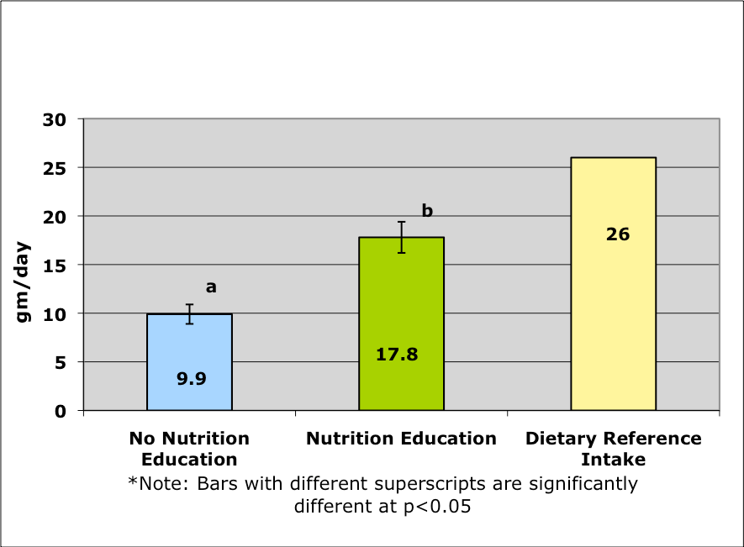

The dietary fiber intake of the control group was 38% of the DRI, and for the experimental group it was 68.7% of the DRI.

Micronutrients

Fat Soluble Vitamins

The average Vitamin A consumption for control group subjects was 527.1

g/day, and for the experimental group it was 1501.8 g/day. The experimental group consumed significantly greater (p<0.05) amounts of Vitamin A than the control group (See Figure 2).
Figure 2: Intake of Vitamin A By Students Who Did Not Receive Nutrition Education Compared to Students Who Did Receive Nutrition Education
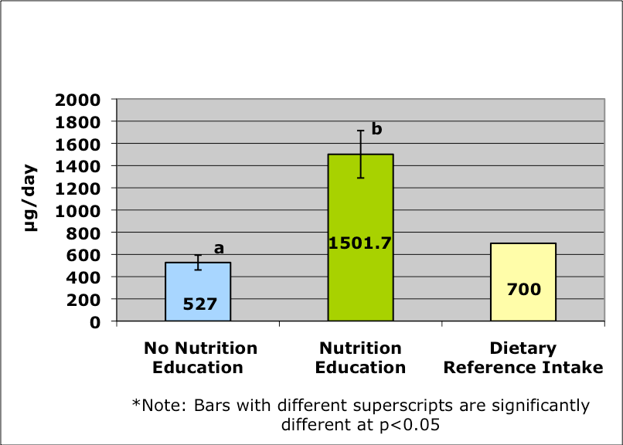

Furthermore, the study group consumed a greater amount of Vitamin A than the DRI (214.6%), whereas the control group consumed less Vitamin A than the DRI (75.4%).
Vitamin D consumption of the experimental group was significantly greater than that of the control group. The students in the experimental group consumed 4.8 g/day of Vitamin D, whereas the control group consumed 0.9 g/day (See Figure 3).
Figure 3: Vitamin D Intake of Students Who Did Not Receive Nutrition Education Compared to Students Who Did Receive Nutrition Education
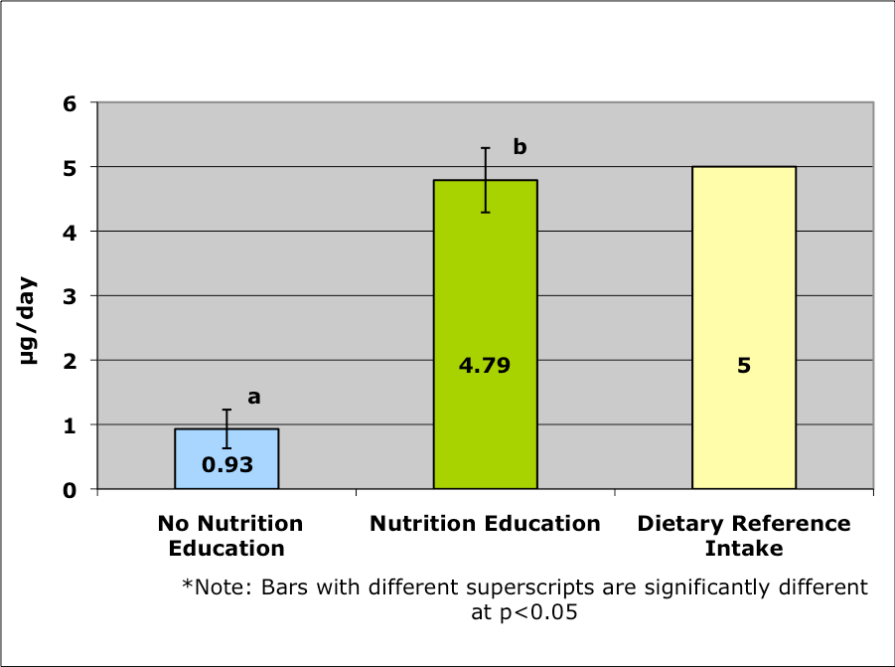

The Vitamin D intake of the control group was 18.8% of the DRI, and for the experimental group it was 95.8% of the DRI.

Water Soluble Vitamins
Students who completed a nutrition class consumed more thiamin (Vitamin B1) than students who did not enroll in any nutrition education classes. In the present study, subjects in the experimental group consumed 142% of the Vitamin B1 DRI, while the control group subjects consumed only 86%.
The present study found that students who had completed a nutrition education class consumed a significantly greater amount of riboflavin (Vitamin B2) on a daily basis
than students who did not complete the class. The control group consumed 0.85 mg/day, while the experimental group consumed 1.8 mg/day (See Figure 4).
Figure 4: Intake of Riboflavin By Students Who Did Not Receive Nutrition Education Compared to Students Who Did Receive Nutrition Education
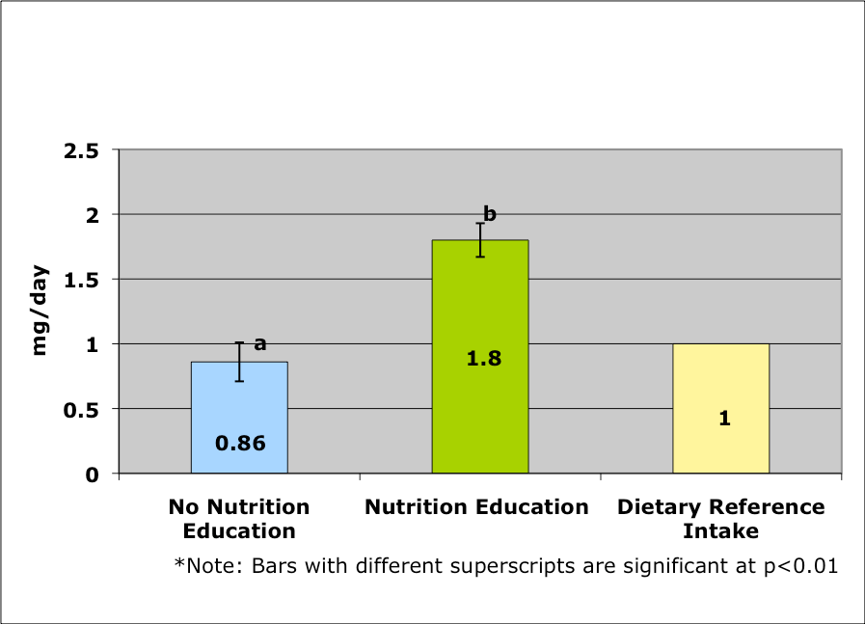

The experimental group consumed a greater amount of Riboflavin than the DRI (181.8%), whereas the control group consumed less riboflavin than the DRI (85.8%).
The experimental group consumed significantly greater amounts of niacin (Vitamin B3) (14mg/day) than the control group which consumed 9.8 mg/day (See Figure 5).
Figure 5: Intake of Niacin By Students Who Did Not Receive Nutrition Education Compared to Students Who Did Receive Nutrition Education
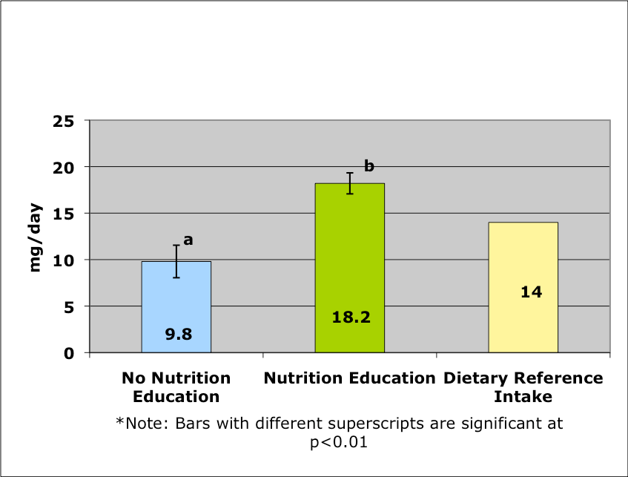

The study group consumed 129.9% of the DRI, and the control group consumed only 70.2%.
Two other B vitamins that were consumed in significantly greater amounts by the NE group were Vitamin B6 (See Figure 6) and Vitamin B12 (See Figure 7). The experimental group consumed 1.6 mg/day of Vitamin B6, or about 130.1% of the DRI, while the control group consumed only 0.6 mg, or about 48.8% of the DRI. The experimental group also consumed a significantly greater amount of Vitamin B12 than the control group. The study group consumed 4.4 g/day of Vitamin B12, while the control group consumed only 1.8 g/day.
Figure 6: Intake of Vitamin B6 By Students Who Did Not Receive Nutrition Education Compared to Students Who Did Receive Nutrition Education
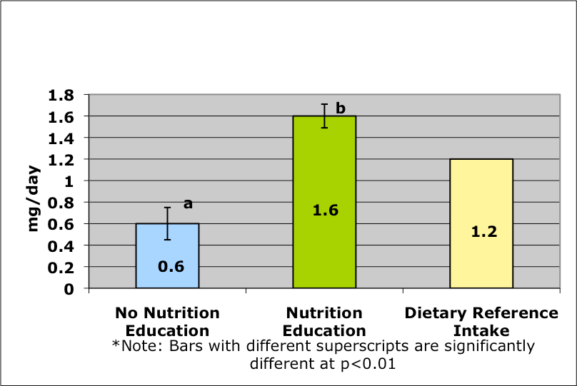

Figure 7: Intake of Vitamin B12 By Students Who Did Not Receive Nutrition Education Compared to Students Who Did Receive Nutrition Education
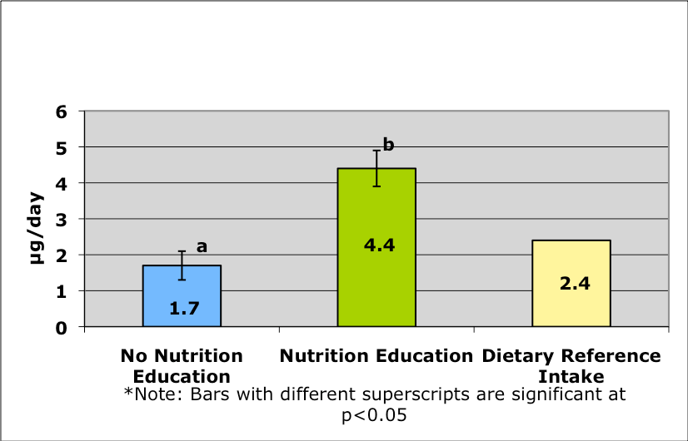

Minerals Macrominerals
The amount of calcium consumed by the experimental group was significantly (p<0.01) greater than the amount consumed by the control group. The students who received nutrition education consumed 881.2 mg/day, and students who did not receive nutrition education consumed 504 mg/day (See Figure 8).
Figure 8: Intake of Calcium By Students Who Did Not Receive Nutrition Education Compared to Students Who Did Receive Nutrition Education
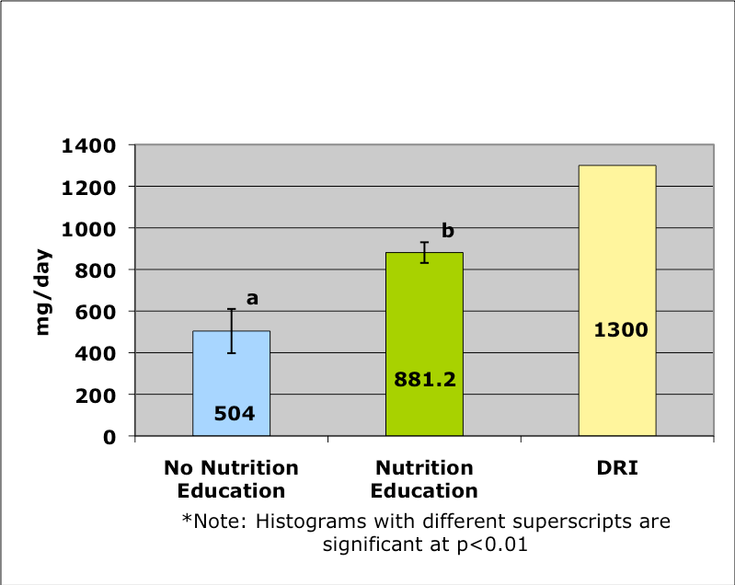

The experimental group consumed a greater percent (67.7%) of the DRI for calcium than the control group (38.6%).
In the current study, students in the experimental group consumed significantly greater amounts of magnesium than the control group. Students who had completed the nutrition education class consumed 233.3 mg/day, while students who had not received NE consumed 102.4 mg/day (See Figure 9).

Figure 9: Intake of Magnesium By Students Who Did Not Receive Nutrition Education Compared to Students Who Did Receive Nutrition Education
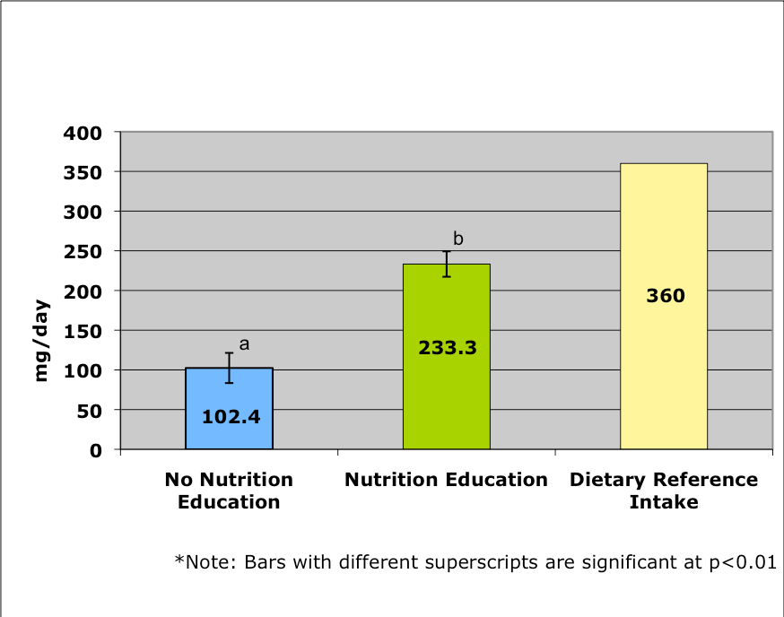

Percent DRI consumption of magnesium was also significantly different between groups. The experimental group consumed 64.7% of the DRI, while the control group consumed 27.4%.

Microminerals
Students in the experimental group also consumed significantly greater amounts of zinc than that of the control group. Students who had received NE consumed 9.7
mg/day, whereas students who did not receive NE consumed 4.8 mg/day (See Figure 10).

Figure 10: Intake of Zinc By Students Who Did Not Receive Nutrition Education Compared to Students Who Did Receive Nutrition Education
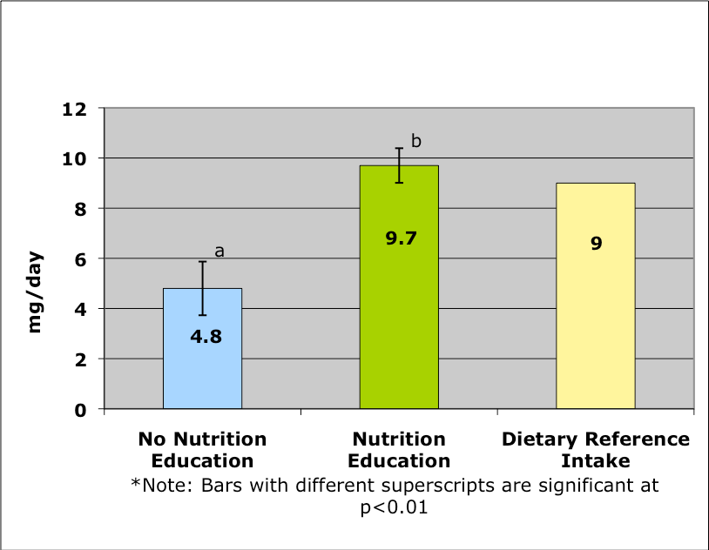
The consumption of zinc by the experimental group was significantly greater (p<0.01) than that of the control group. The students in the experimental group consumed 107.7% of the DRI, while the control group consumed only 53% of the DRI.
Chapter 5: Discussion Anthropometric Measurements
In the present study, anthropometric measurements were similar between the control group and the experimental group. There were no significant differences between groups in regard to the measurements of height and weight and the calculation of BMI. Both groups were also similar in age. This anthropometric pattern could be expected since the goal of the NE class was not to decrease weight and BMI, but to improve student eating behaviors.

Macronutrients

No significant difference in intake between the control group and the NE group was found when consumption of calories, fat, and carbohydrates were compared.
There was, however, a significantly greater amount of dietary fiber consumed by the NE group. Fiber intake is particularly important in females since Nigerian women have an estimated 5 to12% prevalence of Polycystic Ovary Syndrome (PCOS). This condition has been associated with the consumption of foods that contain a high amount of refined carbohydrates and little fiber. If not corrected, PCOS is associated with increased acne, facial hair, frontal body fat, and infertility. Adequate fiber is also beneficial to women since it plays a role in the prevention of constipation and other digestive disorders such as irritable bowel syndrome and diverticular disease.
Fiber intake has also been shown to be inversely related to breast cancer incidence.

Fat Soluble Vitamins
Vitamin A intake was higher in students who had completed the NE course.
Vitamin A is an important vitamin for females with PCOS who suffer from acne due to the fact that studies have shown that individuals with severe acne have low serum Vitamin A levels and supplementation of Vitamin A may aid in the treatment of acne. Vitamin A also plays an important role in the maintenance of normal vision, growth and development, development and maintenance of epithelial tissue, development of reproductive and embryonic tissue and immune function.
The students in the present study who received NE consumed greater amounts of Vitamin D. Vitamin D has several important roles in the body. One primary role of Vitamin D is regulation of calcium and phosphorus absorption as related to bone health. This is important in regard to women since they have a significantly greater incidence of osteoporosis than men. The role of Vitamin D is especially important during adolescent bone development since this is the period when ninety percent of peak bone mineral density (BMD) is attained. Vitamin D consumption is equally important during adulthood. Adequate Vitamin D consumption is necessary to maintain BMD. Low Vitamin D consumption has been shown to lead to decreased BMD and can increase a person’s risk for osteoporosis and ostoepenia. Vitamin D deficiency can also cause osteomalacia, which has an impact on muscle and bone pain.
Vitamin D also plays a role in females who are diagnosed with PCOS. Studies have shown that when women with PCOS are supplemented with Vitamin D and calcium, there is a normalization of menstrual cycles and an improvement in fertility. Females with PCOS also often experience insulin resistance. Vitamin D plays a
role in insulin metabolism, and low Vitamin D concentrations are often seen in hyperinsulinemic patients and type 2 diabetics. Vitamin D deficiency has been shown to be associated with the biosynthesis and release of insulin, and Vitamin D supplementation seems to improve insulin response.

Water Soluble Vitamins
Water-soluble vitamins play an important role in cellular energy metabolism. In the present study it was found that the NE group consumed significantly greater amounts of thiamin (Vitamin B1) than the control group. Thiamin plays an important role in energy metabolism and neural function. A deficiency in thiamin will eventually lead to a condition called beriberi, which includes symptoms such as mental confusion, muscle wasting, edema, peripheral neuropathy, tachycardia, and cardiomegaly.
In the present study it was found that students who received NE consumed significantly greater amounts of Riboflavin than students who did not receive NE. Riboflavin (Vitamin B2) is important for many oxidation/reduction reactions in the human body including those involving the metabolism of carbohydrates, amino acids, and lipids. Several human studies suggest that riboflavin deficiency may interfere with iron metabolism, which may have an impact on a person’s hematologic status. In these studies, correcting deficiencies in pregnant or lactating women, adult males, and school- aged children improved hematologic responses to iron supplements. Furthermore, several animal studies have confirmed that moderate riboflavin deficiency can impair iron absorption. The role of riboflavin in the development of cancer has been studied; however, conclusions have been contradictory. Several studies have shown that deficiency of riboflavin can increase the risk of cancer in certain sites of the body
whereas other studies indicate that a deficiency in riboflavin is protective due to riboflavin’s role in metabolizing certain carcinogens. A relationship between riboflavin deficiency and esophageal cancer has been identified in several epidemiologic studies; however, not all studies support these findings. A study conducted in China indicated that daily supplementation of both riboflavin and niacin over a 5-year period was effective in decreasing the incidence of esophageal cancer. Poor riboflavin status has also been implicated as a risk factor for cervical dysplasia, a precursor condition for invasive cervical cancer. This correlation may be of great interest to sexually active adolescent females in regard to the prevention of cervical cancer. Acute riboflavin deficiency has also been shown to have negative effects on fetal development.
The NE group in the present study consumed a significantly greater amount of niacin (Vitamin B3) than the control group. Niacin is required for energy metabolism. A deficiency in niacin can lead to muscular weakness, anorexia, and indigestion. Severe deficiency can lead to a condition call pellagra, which has symptoms that include dermatitis, dementia, diarrhea, tremors, and a soreness of the tongue.
Vitamin B6 was consumed in significantly greater amounts by students who received NE than students who did not receive NE in the present study. Vitamin B6 is a coenzyme that is active in the metabolism of amino acids and glycogen. The active form of Vitamin B6 is Pyridoxal phosphate (PLP), which is involved in nearly all metabolic reactions of amino acids. When there is a deficiency of PLP, symptoms include weakness, sleeplessness, and peripheral neuropathy.
Minerals Macrominerals
The NE group in the present study consumed significantly greater amounts of calcium than the control group. Dietary calcium, along with Vitamin D, is important since it increases bone density in adolescent females. During adolescence there is normally a two to four percent increase in bone mineral density/year. This results in ninety percent of “peak bone mineral density” being obtained by the end of adolescence. Adolescents who do not reach their “peak bone mineral density” have a greater risk of having bone disorders such as osteoporosis and bone fractures. Calcium intake is more important in females than males, as osteoporosis is more commonly seen in the female population.
The misconception that consuming calcium-rich foods will cause weight gain may play a role in the low consumption of calcium-rich food in adolescent females.
Heaney, Davies, and Barger-Lux reviewed six observational studies to evaluate dietary calcium’s effect on body weight and body fat. They found higher calcium intake consistently led to lower body fat or body weight and that there was a reduction of weight gain in midlife. This study also found that with each daily 300 mg increase in calcium intake there was ≈1kg (2.2 lb) decrease in body fat in children, and a 2.5-3.0 kg (5.5-6.6 lb) decrease in body weight in adults. The conclusion of this study was that increasing calcium intake by 2 dairy servings/day could significantly reduce a person’s risk for being overweight. Studies have also been conducted that show a link between calcium intake and the prevention of colon cancer. Dietary calcium has been shown to demonstrate an inhibitory effect on experimental colon carcinogenesis. A study by McCullough et al found that total calcium intake was associated with a lower colorectal cancer risk in both men and women. Even though this is a very important nutrient for adolescent females to consume, only about fourteen percent of females in the United States consume the recommended amount of calcium.
Magnesium is another macromineral which was consumed in significantly greater amounts by the NE group than the control group. A study conducted by Rodriguez- Moran and Guerrero-Romero explored the affect of oral magnesium supplementation on insulin sensitivity in type 2 diabetics. Their data showed that when type 2 diabetics with decreased serum magnesium concentrations received magnesium supplementation, they developed higher serum concentrations as well as lower serum fasting glucose concentrations and HgbA1c concentrations. It was concluded that adequate magnesium intake could help improve insulin sensitivity and metabolic control in type 2 diabetics. With the growing number of cases of type 2 diabetes in younger Nigerians, this could be of major benefit for children with type 2 diabetes.
Another important function of magnesium is that magnesium is required for bone matrix and mineral metabolism and this could also be helpful during adolescent years since this is the time when ninety percent of peak bone mineral density is built.

Microminerals
In the present study, zinc was the only micromineral that the NE group consumed in greater amounts than the control group. Zinc is involved in many different reactions in the human body including those that lead to the synthesis of carbohydrates, protein, and lipids. Deficiency of zinc has been associated with short stature, mild anemia, and a decrease in taste acuity. A study conducted by Arnold, Pinkham, and Votolato explored the effect of zinc intake on subjects who had been diagnosed with attention deficit hyperactivity disorder (ADHD). When they compared three groups of subjects - zinc-adequate, borderline zinc, and zinc-deficient - they found that dietary zinc was correlated with ADHD symptoms. This information may be useful in the treatment of adolescents who have ADHD.
In conclusion a well-taught course in NE can lead to improved nutritional habits in high school-aged students. These changes can have major health implications for young women in Nigeria. Key areas that could be positively affected include bone health, hormonal balance, glucose control, and prevention of some cancers.

CHAPTER FIVE

CONCLUSION AND RECOMMENDATIONS

Conclusion
The only factors associated with nutrition knowledge were age, with young pupils significantly demonstrating higher levels of knowledge than their older counterparts, another factor was source of information, those received information through their curriculum were knowledgeable than those who did not include nutrition knowledge in their curriculum.

According to the study done by Fahlman et al, 2008), knowledge on nutrition is highly needed for the students, venderors and cooks to make them aware of what they are supposed to provide to their customers in order to maintain their healthy bodies. It is high time now for the Government to use Social Workers at schools and colleges premises as they are responsible for the health of human beings as are counsellors, advocators, teachers, guardians, problems solver, etc.
.

5.2 Recommendations
In one of the statement FAO (2005) reported that, “The nutrition knowledge acquired throughout school life is a factor of interaction between the school curriculum, school environment, the family and community”. Thus on improving nutrition knowledge it seems that, four areas have to be considered: The Class room, curriculum, school environment the family, and the community. The study also suggested that, the most important professionals who are keen and responsible for individuals, families, and communities are Social Workers who can play a big role on advocating, counselling, teaching, coaching and providing guidance in maintaining healthy communities, raising socio-economies through heath teachings. The researcher provides the following recommendations to improve the situation:
- Nutrition education educations commonly known as health interventions should be provided to students because they have significant effect in the development of healthy eating habits. Besides, it can make them understand consequences brought by non-nutritious foods to academic performance. The emphasise at this point is to maintain the level of nutrition knowledge to all school children from Primary school up to University/College levels. Social workers have to play their roles as are doing helping professionals who can intervene with individuals, families, and communities.
- Health educators, social workers, nutritionists, administrators, reporters, politicians, etc. should consider using schools or colleges to provide nutrition education for the following reasons:
  - Schools provide safe and low-cost health service interventions

  - Schools reach a high proportion of children and adolescents.
  - Schools provide opportunities to practice healthy eating and food safety.
  - Schools can teach students how to resist unhealthy social pressures since eating is a socially learned habit that is influenced by social pressures.
  - Skilled personnel are available to provide follow-up and guidance  after appropriate training of students, teachers and other staff.
  - Nutrition interventions in schools benefit the entire community.

  - Education and healthy nutrition for girls has a positive impact on family health
- Schools and donors should consider establishing school feeding educations.
These educations are good because they increase food availability to the youth who needed. Besides, these educations decrease short-term hunger, thus enabling youth to concentrate on their studies,
- Health educators, social workers, nutritionists, administrators, reporters, politicians, etc. should ensure that nutrition education in schools always applies the tri-partite curriculum approach (i.e. link nutrition education in the classroom with learning in the school environment, home and community).

References
- Position of the Nigerian Dietetic Association: Child and Adolescent Food and Nutrition Programs. J Am Diet Assoc. 2006:106:1467-1475.
- Mahan KL, Escott-Stump S. Krauses’s Food, Nutrition, and Diet Therapy.
10th ed. Philadelphia, Pa: W.B. Saunders Company; 2000:257-269.
- Nicklas TA, Johnson CC, Myers L, Farris RP, Cunningham A. Outcomes of a high school program to increase fruit and vegetable consumption: Gimme 5 – A fresh nutrition concept for students. J Sch Health. 1998;68:248-253.
- Elliot DL, Goldberg L, Moe EL, Defrancesco CA, Durham MB, Hix-Small H. Preventing substance use and disordered eating. Arch Pediatr Adolesc Med. 2004;158:1043-1049.
- Mahan KL, Escott-Stump S. Krauses’s Food, Nutrition, and Diet Therapy. 10th ed. Philadelphia, Pa: W.B. Saunders Company; 2021:257-269.
- Nicklas TA, Johnson CC, Myers L, Farris RP, Cunningham A. Outcomes of a high school program to increase fruit and vegetable consumption: Gimme 5 – A fresh nutrition concept for students. J Sch Health. 2021;68:248-253.
- Elliot DL, Goldberg L, Moe EL, Defrancesco CA, Durham MB, Hix-Small H. Preventing substance use and disordered eating. Arch Pediatr Adolesc Med. 2022;158:1043-1049.
- Chapman P, Rames TB, Tuveson RV, Jacob M. Nutrition knowledge among adolescent high school female athletes. Adolescence. 1997;32:437-446.
- Duffy RL. Nigerian Dietetics Association Complete Food and Nutrition Guide.
3rd ed. New Jersey: John Wiley & Sons, Inc; 2006:112-115, 426-429.
- Massey-Stokes M. Adolescent nutrition: needs and recommendations for practice. The Clearing House. 2002;75:286-291.
- Albertson D. Educating the whole adolescent. Principal Leadership (High School Ed.). 2003;3:71-74.
- Center for Disease Control and Prevention. Healthy Youth Fact Sheets.
Available At: http://www.cdc.gov/HealthyYouth/nutrition/Making-It-
Happen/facts.htm. Updated March 23, 2009. Accessed May 1, 2010.
- Lin BH, Guthrie J. Nutritional Quality of Nigerian Children’s Diets. Food Review. January-April 1996:16-23.
- Lin BH, Guthrie J, Frazao E. Nigerian children’s diets not making the grade.
Food Review. 2001;24(2):8-17.
- Diet Analysis Plus [computer program]. Version 7.0. Thomson Wadsworth.
2006.
- Liepa GU, Sengupta A, Karsies D. Polycystic ovary syndrome (PCOS) and other androgen excess related conditions: can changes in dietary intake make a difference?. Nutr Clin Pract.2008;23:63-71.
- Mayo Clinic. Dietary fiber: an essential part of a healthy diet. Available at: http://www.mayoclinic.com/health/fiber/NU00033. Accessed Dec. 12, 2009.
- Baghurst PA, Rohan TE. High-fiber diets and reduced risk of breast cancer.
Int J Cancer. 1994;56(2):173-176.

- USDA resource page. United States Department of Agriculture Web site.
Available at: http://www.iom.edu/Object.File/Master/7/296/webtablevitamins.pdf. Accessed February 23, 2009.
- Grant WB, Holick MF. Benefits and requirements of vitamin D for optimal health: a review. Altern Med Rev.2005;10:94-111.
- Damore D, Robbins L, Karl T. The effects of an educational program on the calcium Intake of junior high school students. The Internet Journal of diatrics and Neonatology [serial online]. 2007;6(2). Accessed March 3, 2010.
- Mahan LK, Escott-Stump S. Krause’s Food, Nutrition, & Diet Therapy. 11th ed.
Philadelphia, Pa: W.B. Saunders Company; 2004:363-367.
- Lonsdale D. A Review of the biochemistry, metabolism and clinical benefits of thiamin(e) and Its derivatives. Evid Based Compliment and Altern Med. 2006;3(1):49-59.
- Powers HJ. Riboflavin (vitamin B-2) and health. Am J Clin Nutr.2003:77(6): 1352-1360.
- Heaney RP, Davies KM, Barger-Lux MJ. Calcium and weight: clinical studies.
J Am Coll Nutr. 2002;21(2):152S-155S.
- Pence BC. Role of calcium in colon cancer prevention: experimental and clinical studies. Mutat Res. 1993;290(1):87-95.
- McCullough ML, Robertson AS, Rodriguez C, Jacobs EJ, Chao A, Jonas C, Calle EE, Willett WC, Thun MJ. Calcium, vitamin D, dairy products, and risk of colorectal cancer in the cancer prevention study II nutrition cohort (United States). Cancer Causes and Control. 2003;14(1):1-12.
- Rodriguez-Moran M, Guerrero-Romero F. Oral magnesium supplementation improved Insulin sensitivity and metabolic control in type 2 diabetic subjects. Diabetes Care. 2003;26(4):1147-1152.
- Weaver CM, Peacock M, Johnston CC. Adolescent nutrition in the prevention of postmenopausal osteoporosis. J of Clin Endocrinol Metab. 1999;84(6):1839-1843.

