THE DESIGN AND IMPLEMENTATION OF SOFTWARE FOR AUTOMOBILE INSURANCE SCHEME IN NIGERIA

ABSTRACT
The broad objective of this study focused on the design and implementation of software for automobile insurance scheme in Nigeria.The present system of the automobile insurance companies is characterized by the manual method of operation as a result serious threat has been posed to the operation of the service and too much workload on the staffs. The manual method involves the marketing staffs moving from one location to the other to meet up with the requirement of their broker and also the files and data of their broker are stored in cabinet which are easily destroyed by rodents. With regards to this method the insurance computer application for insurance company would be developed this would have the ability to remotely connect insurance brokers in any location for them to carry out their insurance services and also their data would be stored in a secured database. The system was designed using PHP programming language for data manipulation and MySQL for data storage.

CHAPTER ONE
INTRODUCTION
1.1 Background of the Study
The goal of insurance is to give more financial stability to the end user. Every day, we face danger, whether through an accident or the loss of valued possessions. Driving an automobile is one of the most dangerous things humans do. Automobile accidents are covered in newspapers, on the radio, and on television. As established by Murdick (2015), to deal with such a risk, energy is required. Automobile insurance covers everything. Automobile insurance allows you to share your losses with those who are at risk. When many individuals are participating in this economic risk and sharing, it is most successful. Automobile insurance spreads the risk of loss among a wide number of people, reducing financial loss.
Automobile insurance firms are huge business in terms of revenue and employment since they contribute to our economy by providing various services and jobs. It protects against all types of risks and is available for all types of life, properly and health protection, decision making, and the suitable insurance plan and policy are all vital jobs in the vehicle making process. Automobile insurance firms, like banks, have statistical accounting, standards, and a large quantity of data storage and information communication. Howard & Sheth (2016) assert that manual techniques have been used in their corporate operations and activities over the years. On the other hand Hossain, & Leo (2019) assert that many issues are related with manual methods of data processing and storage, which has resulted in premature and incorrect information and report production. The project investigated how automotive insurance businesses' various business procedures and expanding variety of activities are well suited to computer applications. Computers may be used in a wide range of company tasks such as invoicing, collecting, underwriting and claims reporting, premium payments, record assembly, and policy valuation to produce accurate and trustworthy information.
1.2 Statement of the Problem
Computerization of automobile insurance schemes and policies has not been an easy task and therefore a problem. There is need to get rid of it and find a solution to it. The major concern of this study is to eradicate and take care of the problems encountered by automobile insurance companies. Handle their wide range and complicated activities of underwriting and accounts processing, modify the existing method of carrying out automobile insurance plans and polices. The impacts of software designed to solve the problems completely.
1.3 Aim and Objectives of the Study
The main aim of this study is to design and implement a computerized insurance policy and scheme for an automobile company. To achieve the stated objectives, the following specific objectives were laid out:
- Design using web based technology a system which manages the policy, scheme creation and management in the company.
- The system should be secured and can only be accessed by authorized users.
- System should have an easy to use interface
- System should be able to display list of policies, schemes and customers who are assigned to a particular scheme or policy
1.4 Justification of the Study
This study will help automobile insurance companies to address the dilemma of suffering from manual stress and take the advantages of software designed. The study will allow both organization and individual in achieving greater productivity. That is more work and able to be done in a less time while enjoying activities of higher quality and improved productivity.
The software designed in this study will help company in record keeping premium payments calculation, calculating policy values and in underwriting to code rated and issuance of policies. Employment of this study and software designed will create an avenue for rapid access to a variety of information creation and use of it. Information that is more current, more accurate and more accessible will in turn enhance in making better decision.
1.5 Methodology
Agile Software Development Methodology is chosen for the implementation of this work. Agile is the ability to create and respond to change. It is a way of dealing with, and ultimately succeeding in, an uncertain and turbulent environment. This method is chosen due to the sole reason that it responds to changes favorably. There is no need to restart a phase when a change needs to be implemented.
1.6 Significance of the Study
The main aim of using new technology of computer is to reduce unit labors requirements of each business operation and come up with a quality management and successful automation of increasing number of work functions in data processing.
This study will automatically change the information gathering and decision making behaviors of automobile insurance companies. It will assist them in the use of computer in the conversion and processing of data into meaningful information.
This study will help the automobile insurance companies in handling vast quantities of data, performing complex selection organization, manipulation and delivery output in an extremely rapid fashion to enhance faster decision making.
1.7 Scope and Limitation of the Study
The web-based software keeps record of payments calculation, policies, schemes and registered customers. It has an admin interface. The admin can create a policy, scheme and customers. Customers are assigned to a particular policy and scheme and updated at will. With this software, there is a rapid access to a variety of information. Information is current, more accurate and more accessible and in turn enhances decision making
Due to the fact that not all insurance companies are computerized this study is delimited to universal insurance company, limited Enugu.
1.8 Organization of the Study
This study is developed under five chapters. The first chapter introduces the research topic, stating the background of the intended project, statement of the problems, project objectives, its significance to the society and overall scope. The second chapter reviews related literature on sniffing. It analyses previous research works, their limitations and need for the development of better detection and prevention system. The third chapter discusses the methodology used for the project development, the limitations of the currently used detection system and reasons the intended system should be chosen over the current system. It also showcases the design processes of the new system. Chapter four showcases the actual running of the developed system. Here proper tests are done to check the strength of the developed system. The developed system is analyzed to determine its conformation with the stated objectives. Chapter five gives the summary of the project, gives the conclusion and recommends approaches for better system.
1.9 Definition of Terms
- INSURANCE: A promise of compensation for specific potential future losses in Exchange for a periodic payment. Insurance is designed to protect human lives.
- POLICY: rule that guide certain operation.
- SERVICE: A type of economic activity that is intangible is not stored and does not result in ownership. A service is consumed at the point of sale.
- COMPANY: A voluntary association formed and organized to carry on a business. Types of companies include sole proprietorship, partnership, limited.
- APPLICATION: Computer based software used to perform certain functions.
- WEB BASE: Access only from the internet
- MODERN: new age with different approach of doing things
- STRATEGY: Method applied in doing certain work

CHAPTER TWO
LITERATURE REVIEW
2.1 Description of Core Concepts of Insurance
“People seek security. A sense of security may be the next basic goal after food, clothing, and shelter. An individual with economic security is fairly certain that he can satisfy his needs (food, shelter, medical care, and so on) in the present and in the future. Economic risk (which we will refer to simply as risk) is the possibility of losing economic security”. “Historically, economic risk was managed through informal agreements within a defined community. If someone’s barn burned down and a herd of milking cows was destroyed, the community would pitch in to rebuild the barn and to provide the farmer with enough cows to replenish the milking stock. This cooperative (pooling) concept became formalized in the insurance industry. Under a formal insurance arrangement each insurance policy purchaser (policyholder) still implicitly pools his risk with all other policyholders” (Anderson and Brown, 2005).
It is good business management to protect the assets of your business (including the owners) against unforeseen events. This protection usually comes in the form of insurance. (http://www.southaustralia.bizlibraryInsurance.pdf) “Insurance is simply a devise whereby many people contribute to a pool, so that a few who suffer a loss may be compensated” (Sebiyam, 2005). It is a promise of reimbursement in the case of loss; paid to people or companies so concerned about hazards that they have made prepayments to an insurance company (http://wordnetweb.princeton.edu/perl/webwn?s=insurance). “An insurance policy may be broadly defined as a contract under which the insurer agrees, in return for a premium, to indemnify the insured for loss suffered as a result of the occurrence of specified events which cause the destruction, loss or injury of something in which the insured has an interest” (http://www.southaustralia.bizlibraryInsurance.pdf)
In law and economics, insurance is a form of risk management primarily used to hedge against the risk of a contingent, uncertain loss. Insurance is defined as the equitable transfer of the risk of a loss, from one entity to another, in exchange for payment (http://en.wikipedia.org/wiki/Insurance). “Insurance, unlike most financial products, is characterised by the reversal of the production cycle insofar as premiums are collected when the contract is entered into and claims and costs arise only if a specified event occurs” (IAIS, October 2003). Normally, only a small percentage of policyholders suffer losses. Their losses are paid out of the premiums collected from the pool of policyholders. Thus, the entire pool compensates the unfortunate few. Each policyholder exchanges an unknown loss for the payment of a known premium (Anderson and Brown, 2005)
2.1.1 Motor Insurance
Vehicle insurance is generally considered a fixed cost with respect to vehicle use (Litman, 2010). A driver faces a potential economic loss if his car is damaged. A larger possible economic risk exists with respect to potential damages a driver might have to pay if he injures a third party in a car accident for which he is responsible (Anderson and Brown, 2005). “Every car owner in Ghana is a consumer of insurance services by virtue of the law which stipulates that driving without insurance is punishable by fines, disqualification and even up to one year imprisonment” (http://ezinearticles.com/?Third-Party-Motor-Insurance-in-Ghana&id=3455506). If you drive your vehicle on the road, or leave it parked in the street, the law says that you must have motor insurance. It is a criminal offence not to insure your motor vehicle (http://adviceguide.org.ukc_motor_insurance.pdf). Hence, “in non-life category, other than car insurance, no other insurance is mandatory for the customers” (Goswami, 2007).
2.1.2 Types of Motor Insurance
- Third Party Insurance
This is the minimum amount of insurance cover that you must have by law for your vehicle. Third party insurance only covers you for damage to someone else's vehicle or property, or injury to someone else in an accident which involves your car. This includes accidents caused by your passenger. If your vehicle is damaged in the accident you will have to pay for the repairs yourself.
- Third party, fire and theft insurance
This includes third party cover and, additionally, damage to or loss of your car by fire or theft.
- Comprehensive Insurance
This includes third party, fire and theft insurance. In addition, it will also pay for repairs to your car. There is a range of extra cover that some policies provide, including:
- Cover for your own death or injury, or that of your partner or other members of your family, up to a limited amount.
- Cover for your personal belongings if they are stolen from your vehicle or damaged.
- Cover for your medical and legal expenses.
- Hiring a replacement vehicle. Source: http://adviceguide.org.ukc_motor_insurance.pdf and http://ezinearticles.com/?thirdParty-Motor-Insurance-in-Ghana&id=3455506
2.1.3 BASIC LEGAL REQUIREMENT OF INSURANCE COMPANIES
When a company insures an individual entity, there are basic legal requirements. Several commonly cited legal principles of insurance include.
- Indemnity: the insurance company indemnifies, or compensates, the insured in the case losses only up the insured’s interest.
- Insurable Interest: the insured typically must directly suffer from the loss. Insurable interest must exist whether properly insurance or insurance on a person involved.
- Utmost Good Faith: the insured and the insurer are bound by good faith, bond of honesty and fairness. Material facts must be defined
- Contribution: insurers which have similar obligations to the insured contribute in the indemnification, according to some method.
- Subrogation: the insurance company acquires legal rights to pursue recoveries on behalf of the insured; for example, the insurer may sue those liable for the insured’s loss.
- Causa proxima or (proximate cause): the cause of loss (the peril) must be covered under the insuring agreement of the policy, and the dominant cause must not be excluded.
- Mitigation: in case of any loss or casualty, the asset owner must attempt to keep loss to minimum, as if the asset was not insured.
2.2 Existing Types
Apart from the challenges of deregulation, consolidation and convergence of financial services worldwide, Radix has oozed out an innovative system of insurance software solutions provider to the clients of multi angels , providing insurance business management at a feasible cost features according to the relevant functionalities. The online insurance management system software solution is fully automated and integrated policy processing system for both personal and commercial insurance carriers. It is a scalable, reliable, but costly solution for carrying out all business-crucial insurance processing functions. They are leading insurance software solutions provider for all segments of the insurance management system software solutions helps to solve long-standing time-to market challenges. Our web based insurance management system expertise and solution can dramatically lessen the cost of policy ownership services
2.3 Web Application and Insurance Services
According to Lamba .N. (2009) in information and Web explains that the A web application is an application that is accessed by users over a network such as the internet or an intranet. The term may also mean a computer software application that is coded in browser-supported programming language (such as java script, combined with a browser-rendered marking language like HTML) and reliant on a common web browser to render the application executable. Web applications are popular due to ubiquity of web browser, and the convenience of using web browser as a client, sometimes called THIN CLIENT. The ability to update and maintain web applications without distributing and installing software on potentially thousands of client computers is a key reason for their popularity, as in the inherent support for cross-platform compatibility. Common web applications include web mainly online retail sales, online auctions, Wikis and many other functions.
An emerging strategy for application software companies is to provide web access to software previously distributed as local applications. Depending on the type of application, it may require the development of an entirely different browser-based interface, or merely adapting an existing application to use different presentation technology. These programs allow the user to pay monthly or yearly fee for use of a software application without having to install it on a local hard drive. A company which follows this strategy is known as an application service provider (ASP), and ASPs are currently receiving attention in the industry.
Security breaches on these kinds of applications are a major concern because it can involve both enterprise information and print customer data. Protecting these assets is an important part of any web application and there are some key operational areas that must be included in the development process. This includes the processes for authentication, authorization, asset handling, input, and logging and auditing. Building security into the applications from the beginning can be more effective and less disruptive in the long run.
2.3.1 Brief history on web application
In earlier computing models, e.g. in client-server, the load for the application was shared between code on the server and code installed on each client locally. In other words, an application had its own client program which served as its user interface and had to be separately installed on each user’s personal computer, an upgrade to the client side code installed on each user work station, adding to the support cost and decreasing productivity.
In contrast, the advanced of telecommunication and computerization has recently enabled large companies to use information system to transit technical and economical information among numerous computer system at differently geographical location. More technically advanced technology are expected soon in the automation of telecommunication and the linkage of computers by data transmission that will enhance the possibilities of system integration such as programmable automation of computer integrated manufacturing, unfortunately according to AUTHORD (2000) in 1985 only 5.7% of the total number of computers in the world was located in the developing countries.
To do so require the provision of up to date information that is accurate and timely information are very important in every organization if not properly adhere to when data are being gathered a typical system (Insurance Management) cannot survive without good management information system (MIS).
2.4 Summary
Insurance service can have effects on the society through the way that it changes who bears the cost of the losses and damage. On one hand it can increase fund, on the other, it can help societies and individuals prepare for catastrophes and mitigate the effects of catastrophes on both households and societies. Insurance can influence the probability of losses through moral hazard, insurance fraud, and preventive steps by the insurance company. Insurance scholars have typically used morale hazard to refer to the increase loss due to unintentional, carelessness and moral hazard to refer to increased risk due to intentional carelessness of difference. Insurers attempt to address carelessness through inspections, policy provisions requiring certain types of maintenance, and possible discounts for loss mitigation. While in theory insurers could encourage investment in loss reduction, some commentators have argued that in practice insurers had historically not aggressively pursued loss control measures-particularly to prevent disaster losses such as hurricanes-because of concerns over rate reductions and legal battles. However, since about 1996, insurers began o take a more active role in the loss mitigation, such as through building codes.
There arises the need to automate the process of vehicle insurance using web-based technologies. This technologies help mitigate against the problems arising due to manual method of management.
CHAPTER THREE
SYSTEM ANALYSIS AND DESIGN
3.1 Introduction
This section presents the analysis and design of the proposed system. The methodology for the project is analyzed. The proposed system is also discussed and reasons it is preferred of the current method is made known. The design is made using UML diagrams for clarity.
3.2 Analysis of the Existing System
The existing system is the manual method of operation. It follows the following processes
- Customer Visits an Agent and asks him to insure his vehicle.
- Agent takes the customer details and the vehicle details (i.e. RC Book, and vehicle registration papers)
- Agent forwards the Details to the Company.
- Company gives the Quotation to the agent for different coverage's.
- Agent gives the quotation amount to the customer.
- Customer as per his convenience asks to issue the policy under the coverage of his choice.
- Agent takes the cheque or cash for the policy from the customer.
- Agent gives the cheque to the company and requests them to issue the policy for the vehicle.
- Company arranges a check for the vehicle to be insured.◻ If the vehicle is in Condition and passes the test set by the insurance company the vehicle is then insured by the company.
- The policy copy is then issued to the customer and sent to the mail address.
- The agent receives the commission as set by the company after the issuance of the policy.
3.3 Analysis of the Proposed System
The proposed system presents a computerized method of operation. Here previous manual processes are replaced using computer software. The designed system reduces data redundancies, reduces the cumbersome job of maintaining several documents. It eliminates the delays in report generation, facilitates faster searching of information thus reducing time, energy and cost. The openness and transparency of the system gives assurance to the policy holders about maintaining data privacy and security.
3.4 Proposed Methodology
The success of web application is not primarily determined by technical or layout qualities. Because of high visibility and compatibility of web application, technical and layout qualities can be adopted very soon by competitors. Thus a sustainable competitive advantage can hardly be achieved through those qualities. In contrast, a decisive success factor of a web presence is seen in the link between business and marketing strategy on the one hand and web strategy on the other hand. A web embedded in and aligned with an overall marketing strategy can hardly be imitated on the short run.
The use of structural system analysis and design methodology is adopted on means for carrying the research methodology. In using the SSADM a very important factor considered is the method of data collection.
3.5 System Design
System design is the process of defining the architecture, components, modules, interface, and data for a system to satisfy specified requirement. this could also be seeing as the application of systems theory, to product development. Before the development of a software its very necessary to consider certain factors such
- Purpose of the software
- Cost of maintenances
- Customer needs
3.5.1 System Architecture
The architectural design simply models the interaction that occurs between user devices.
Network access
Computer system

Pin/ Card serial number
Database

System architecture
The computer system
The computer system must have been installed and connect to the network. Before a broker would have been able to use this service he would have bought the insurance scratch card first this contains;
Serial no and pin.
When he opens the application he is required to fill in the information of the scratch card serial no and pin this helps ensure security and allow only those who have bought the scratch card to register and carry out the process.
Network access
This helps establish a connection between the computer system and the database of the service. If there is no network connection users would not be able to access ad gain information from the database
Data base
For every information to be retrieved he information as to be stored in a database system which is a collection of related information the database helps store all the information of the insurance broker and their details. Security is also very important to all databases and the security used in this database is the admin pin and admin password.
3.6 UML Diagram
Unified Modeling Language (UML) is used extensively to illustrate the designs of the new system. UML is adopted because of its simplicity, clarity and ease of use in system designs. It also integrates easily with methodology. The designs are presented in many formats including Operation Procedure: showing how the system interacts with the user; System block diagram: showing the design modules in block form; Component Chart showing the component interfaces of the system, Sequence Diagram: showing the order of flow of processes and Deployment Diagram: showing the hardware and Interaction systems.
3.6.1 Use Case Diagram
Use case diagrams consist of actors, use cases and their relationships. The diagram is used to model the system/subsystem of an application. A single use case diagram captures a particular functionality of a system. Hence to model the entire system, a number of use case diagrams are used.

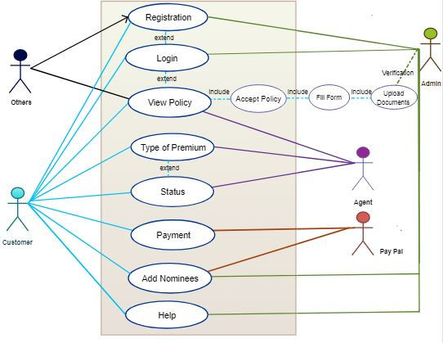
Use case diagram
3.6.2 Class Diagram
A class diagram in the Unified Modeling Language (UML) is a kind of constant structure representation that shows the structure of a framework using the system’s classes, their features, operations, strategies, characteristics and the dependencies among the classes. It depicts which class contains what data. A class diagram comes with various symbols and arrows for showing the relationships among different classes.
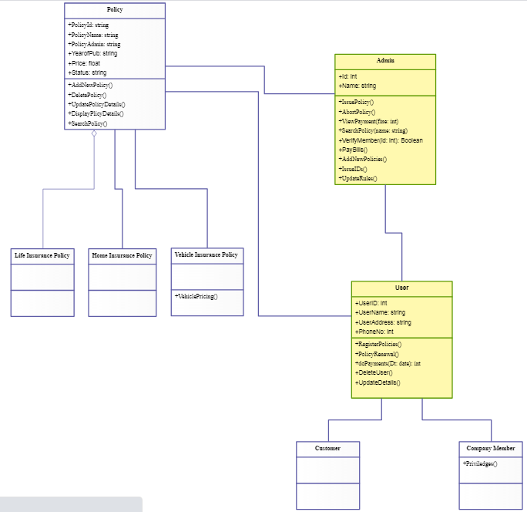
3.6.3 Activity Diagram
Activity diagrams are a form of Unified Modeling Language (UML) where graphical representations of workflow are illustrated in a step by step process and activities are represented for cycle, decision, and simultaneousness. In Activity diagrams, work flow segments can be shown in a proper system depict the business and process flow. An activity diagram represents the activities between different entities. The start point of the process flow can be shown by specific symbols and the end of flow can also be represented by using a specific end symbol. The arrows depict the stream of control between objects. Different states of objects can be represented using different structural symbols according to the project requirement.
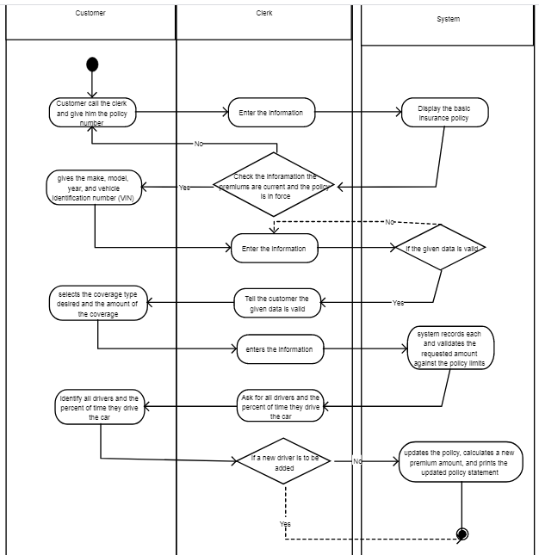
3.6.4 Sequence Diagram
A sequence diagram simply depicts interaction between objects in a sequential order i.e. the order in which these interactions take place. We can also use the terms event diagrams or event scenarios to refer to a sequence diagram. Sequence diagrams describe how and in what order the objects in a system function.
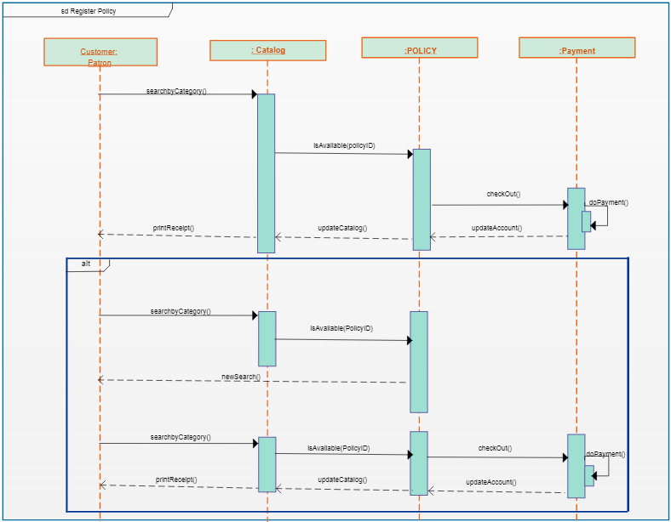
3.6.5 Data Flow Diagram
A data-flow diagram is a way of representing a flow of data through a process or a system (usually an information system). The DFD also provides information about the outputs and inputs of each entity and the process itself. A data-flow diagram has no control flow, there are no decision rules and no loops.
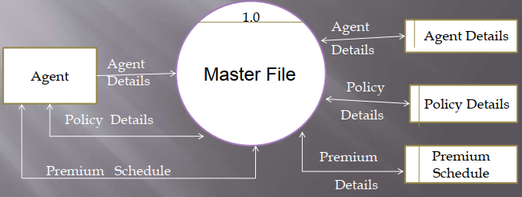

3.6.6 Entity Relationship Diagram
Entity Relationship Diagram, also known as ERD, ER Diagram or ER model, is a type of structural diagram for use in database design. An ERD contains different symbols and connectors that visualize two important information: The major entities within the system scope, and the inter-relationships among these entities.

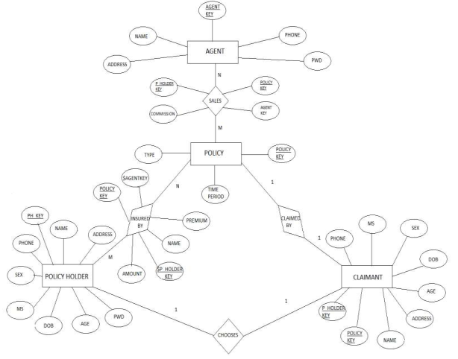
3.6.7 System Flowchart
In the flow chart diagram above a pictorial representation of the step by step approach of registration process is represented as such individuals who are using this insurance service application who have follow procedure to be enable to achieve the registration process which is a very important process for the service because it allows them get record of their policy broker and store it in their database for reference purposes
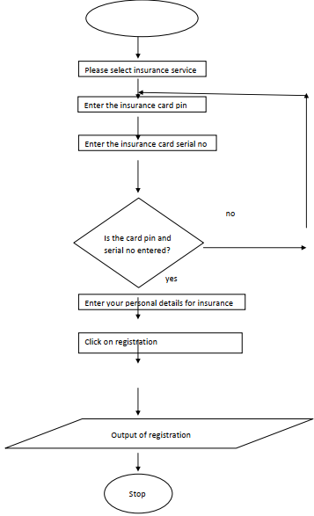

3.7 Database
3.7.1 Database table for the insurance registration
INDEX | OBJECT  TYPE | DATA  TYPE | LENGTH | OBJECT METHOD
Boker Name | Textbox | Char | 35 | Getfocus_event
Insurance  Name | Textbox | Char | 40 | Getfocus_event
Policy No | Textbox | Int | 9 | Getfocus_event
Policy Type | Combobox | Char | 30 | Selectedindex_event
Address | Textbox | Char | 110 | Getfocus_event
Next Of Kin | Textbox | Char | 29 | Getfocus_event
Expring  Date | Datepicker | String | Dd/Mm/Yy | Getfocus_event
3.7.2 Insurance card verification
name | Object type | Object  method | Char type
Card serial no | textbox | Getfocus_event | Text mode
Card pin | textbox | Getfocus_event | Password  mode

3.7.3 Life insurance
INDEX | OBJECT  TYPE | DATA  TYPE | LENGTH | OBJECT METHOD
Next of kin | TEXTBOX | CHAR | 35 | Getfocus_event
Address of  next of kin | TEXTBOX | CHAR | 40 | Getfocus_event
Bank  information | TEXTBOX | INT | 9 | Getfocus_event
Asset worth | TEXTBOX | CHAR | 30 | Getfocus_event

3.7.4 Medical insurance
INDEX | OBJECT  TYPE | DATA  TYPE | LENGTH | OBJECT METHOD
Name of DR | TEXTBOX | CHAR | 35 | Getfocus_event
Name of  patient | TEXTBOX | CHAR | 40 | Getfocus_event
Sickness  diagnosis | TEXTBOX | INT | 9 | Getfocus_event
treatment | TEXTBOX | CHAR | 30 | Getfocus_event
3.7.5 Insurance Claims Database Table
name | Object type | Object  method | Char type
Card serial no | textbox | Getfocus_event | Text mode
Card pin | textbox | Getfocus_event | Password  mode
Policy no | textbox | Getfocus_event | Text mode

INDEX | OBJECT  TYPE | DATA  TYPE | LENGTH | OBJECT METHOD
BOKER  NAME | TEXTBOX | CHAR | 35 | Getfocus_event
INSURANCE  NAME | TEXTBOX | CHAR | 40 | Getfocus_event
POLICY NO | TEXTBOX | INT | 9 | Getfocus_event
POLICY  TYPE | COMBOBOX | CHAR | 30 | Selectedindex_event
ADDRESS | TEXTBOX | CHAR | 110 | Getfocus_event
NEXT OF  KIN | TEXTBOX | CHAR | 29 | Getfocus_event
EXPRING  DATE | DATEPICKER | STRING | DD/MM/YY | Getfocus_event

CHAPTER FOUR
SYSTEM IMPLEMENTATION AND TESTING
4.1 Introduction
This chapter focuses on the implementation of the system. The features of the implementation languages used in this research- PHP and MYSQL will be discussed extensively. The system testing strategies, the target computer requirements as well as the software maintenance issues that would arise in the system would be discussed also.
4.2 Choice of Tools
The programming languages used in the implementation of this project are PHP (Hypertext Preprocessor) and MYSQL programming languages. PHP is a general purpose server side scripting language originally designed for web development to produce dynamic web pages. It has also evolved to include a command line interface capability and can be used in stand-alone graphical applications.
The following features make PHP a preferred implementation language for this project:
- PHP has its root in C and C++. PHP syntax is most similar to C and C++ language syntax, so programmers find it easy to learn and manipulate.
- PHP can run on both UNIX and windows. Hence it is compatible across various operating systems.
- PHP has powerful output buffering that further increases over the output flow. PHP internally rearranges the buffer so that the header comes before the content.
- PHP is platform independent: this is because it is parsed by the web browser hence compatibility issues do not arise when code written in PHP is ported to a different platform.
- PHP can be used with a large number of relational database management systems, runs on all of the most popular web servers and is available to many different operating systems.
- PHP is fully an object oriented programming language and its platform independence and speed on LINUX servers help to build large and complex web applications.
- PHP has also attracted the development of many frameworks that provide building blocks and design structure to promote Rapid Application Development (RAD). Some of these include cake PHP, code igniter, Yii framework and Zend framework.
- PHP IDS add security to any PHP application to defend against intrusion. PHPIDS detects cross-site scripting (XSS), SQL injection, header injection, directory traversal, remote file execution, local file execution and Denial of Service (DOS).
MYSQL is a relational database management system written in C and C++, that runs as a server providing multi user access to a number of databases. MYSQL is used basically to create a relational database structure on a server in order to store data or automate procedures. The following features make MYSQL also a preferred implementation language in this research:
- MYSQL is written in C and C++ and tested with a broad range of different compilers. It also functions on different platforms.
- It uses multi-layered server design with independent modules.
- It is designed to be fully multi-threaded using kernel threads to easily use multiple CPUs if they are available.
- It is a server/client system. The database server (MYSQL) and the arbitrary many clients (application programs) which communicates with the server to query data and save changes.
- MYSQL is designed to make it relatively easy to add other storage engines. This is useful if you want to provide an SQL interface for an in-house database.
- It provides transactional and non-transactional storage engines, uses very fast B-tree disk tables with index compression and a fast thread-base memory allocation system.
- It executes very fast joins using an optimized nested loop join; implements in-memory hash tables which are used as temporary tables.
- It implements SQL functions using a highly optimized class library that should be as fast as possible.
- It provides the server as a separate program for use in a client/server networked environment and as a library that can be embedded (linked) into stand-alone applications. Such applications can be used in isolation or in environments where no network is available.
4.3 System Requirements
System requirement are those properties or standard that must be attained by the system to aid smooth and efficient operation when used. These are often constraints that dictate whether the system will run efficiently or inefficiently. This requirement are divided into two (2) categories; hardware and software requirement.
4.3.1 Software Requirement
Software is the set of programs written to achieve a specific task and the software requirement for this operation include
- Windows operating system
- XAMPP or WAMP Server
- Web browser
4.3.2 Hardware requirement
- Computer system
- Hard disk size 40 GB and above
- Processor speed of 1.6 GHz
- Ram size of 512 mb and above
- Network connection
4.4 Testing
The purpose of testing is to discover errors. Testing is the process of trying to discover every conceivable fault or weakness in a work product. It provides a way to check the functionality of components, sub assemblies, assemblies and/or a finished product It is the process of exercising software with the intent of ensuring that the Software system meets its requirements and user expectations and does not fail in an unacceptable manner. Here the results of the test are shown with screenshots

4.4.1 Welcome Form
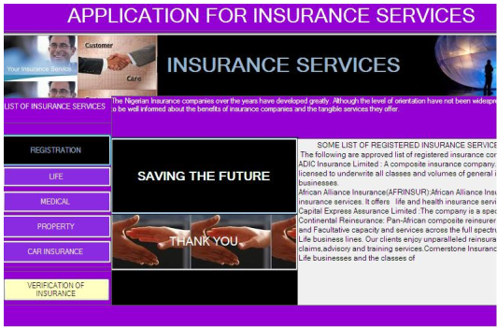
4.4.2 Insurance Service
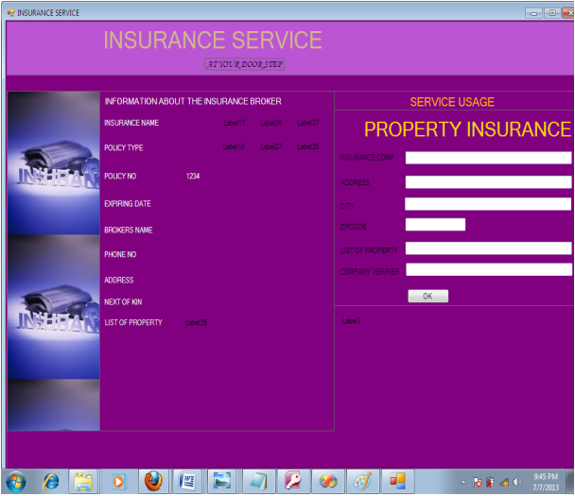
4.4.3 Registration Form
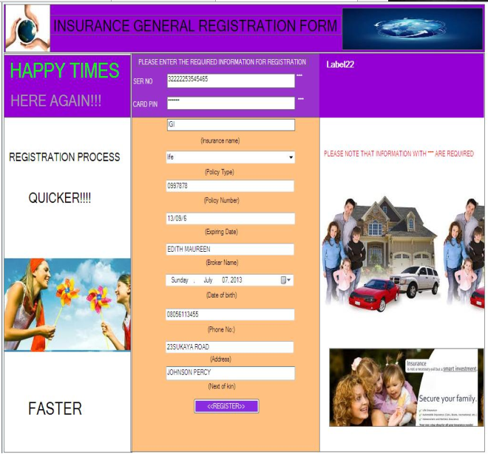

4.4.4 Life Insurance Claims
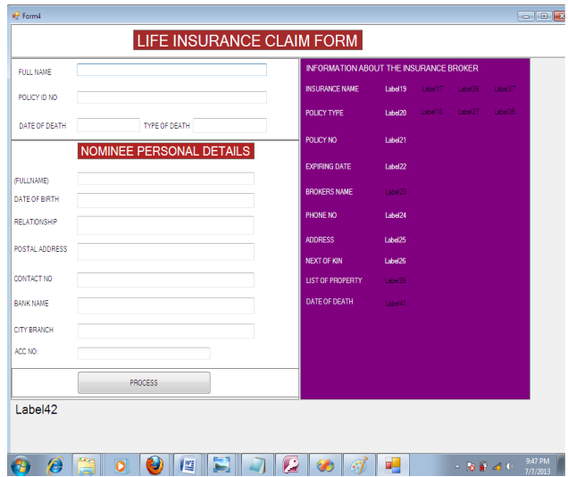

4.4.5 Car Insurance Form
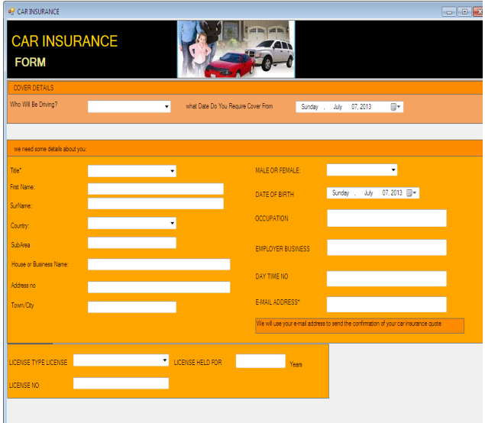

4.4.6 Verification Process
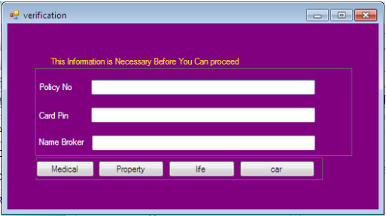

CHAPTER FIVE
SUMMARY, CONCLUSION, RECOMMENDATION
5.1 SUMMARY
The application program for insurance service was developed using the PHP. The pages in this application are very interactive and user’s friendly assisting user to achieve specific purpose was their requirement a met. This application features can be modified this helps ensure that the software continues to exist and meet up with customers services. In insurance service the method which has been used is always the form method been supplied to customers in a manual method which the customers have to feel after sometime and summit to the insurance services and the information would be filed in the cabinet. With this new trend of information for the insurance service the information are stored in the database and users can have the opportunity of remotely carrying out the registration with the help of the insurance card pin which have been purchased. The software ensures that only users that have purchased the insurance card would be allowed to register.
5.2 CONCLUSION
The application program for insurance service was developed though it was made under little consideration of database that is using MySQL. The software developed has the ability to efficiently calculate the customer’s claims after a specific expiring date. This program helps reduce the manual method and stress which is always prune to the staffs as a result of constant marketing. With this broker from anywhere around the globe can view their insurance service information apply and fill the claims forms. Nothing taste good than solving your problem from distance rather than rushing down to a specific point for the problem to be solved. With this application user’s insurance service are stored very efficiently in a secured database. Trend of information improvement in the generation has improved the quality and services of human operation just as the case of this application for insurance services has reduce the mobility rate of human and improve their standard of database storage.
5.3 RECOMMENDATION
As a result of the quality of service rendered by this software I want to make the following recommendation
- Banking sector: this application should also be used in the banking sector for their insurance services.
- Insurance companies: I mostly recommend that this software should be used by most insurance company because it increases the quality of their service and add value to their service and also save time and stress of both
customers and staffs.

REFERENCE
Anderson, J. F. & Brown, R. L. (2005). Risk and Insurance. Education and Examination of the Society of Actuaries. Retrieved from http://www.soa.orgfilespdfP-21-05.pdf.pdfAdobe Reader (Pp. 2 & 3).
Sebiyam, M. (2005). The impact of Insurance on Transport Business in Ghana: A case Study in Sunyani Municipality. (Unpublished thesis). Sunyani Polytechnic, Sunyani, Ghana. (Pp. 1 & 2)
International Association of Insurance Supervisors. (2003). Insurance core principles and methodology (Principles No. 1 October 2003). Retrieved from http://www.iaisweb.org_ tempInsurance_ core_principles_ and_ methodology.pdf.pdfAdobe Reader. (Pp. 4)
Litman, T. (2010). Distance-Based Vehicle Insurance as a TDM Strategy. Victoria Transport Policy Institute 13 December 2010. Retrieved from http://www.islandnet.com~litmandbvi.pdf.pdf – Adobe Reader
Goswami, P. (2007). Customer Satisfaction with Service Quality in the Life Insurance Industry in India. The Icfai Journal of Services Marketing, Vol. V, No. 1. Retrieved from http://www.slideshare.net/ Pradipta_India/ customer-satisfaction-with-service-quality-inthe-life-insurance-industry-in-india (pp. 2).
Homburg, C., Koschate, N., Hoyer, W.D., (2006). The Role of cognition and affect in the formation of customer satisfaction—a dynamic perspective. Journal of Marketing, 70 (3), 21–31.
Hossain, M., & Leo, S., (2019). Customer perception on service quality in retail banking in Middle East: the case of Qatar. International Journal of Islamic and Middle Eastern Finance and Management. Vol. 2 No. 4, 2009 pp. 338-350. DOI 10.1108/17538390911006386.
Howard, J. A., Sheth, J. N., (2016). The Theory of Buyer Behavior. John Wiley & Sons, New York
Authord (2000) “World Wide Web and computer information” Publisher: Simpson Media.
Chiemere .M. (2012) “Nigeria insurance Operation” publisher: City Magazine Anthony village Lagos
Dimorji(2003)”Information System and Database” publisher: World concept press England.
Landre . M (2000) “Service of Insurance “Publisher: Veez Concept Media 406 Mundal.
Martins .C. (2009) “Insurance and the Economy” Publisher: Avez Technology France.
Murdick (2015) “Management Information System (MIS)” Publisher: City Magazine Anthony Village Lagos
Richard (2009) “Electronic Application” Publisher: Simpson magazine New York
Salvador Minguijon Perez “EP 0700009Progressive Auto Insurance “(U.S. Patent 5,797,134)

APPENDIX
Source Codes
1. Policy
<html>
<head>
<title>Registration Form</title>
</head>
<body>
<link href = "registration.css" type = "text/css" rel = "stylesheet" />
<link href = "../style.css" type = "text/css" rel = "stylesheet" />
<ul>
<li style="float:right;"><a href="../index.php"> Back to homepage</a></li>
</ul>
<h2>Policy</h2>
<form name = "form1" action='modified.php' method = 'POST' enctype = "multipart/form-data" >
<div class = "container">
<div class = "form_group">
<label>Policy Number:</label>
<input type = "text" name = "Policy_Num" required pattern="[0-9]{9}"/>
<font size = "1">Enter 9 digit number.</font>
</div>
<div class = "form_group">
<label>Customer Number:</label>
<select name = "Customer_Num">
<?php
include "../connection.php";
$sql="select * from customer";
$result = mysqli_query($conn,$sql);
$i=0;
while($row=mysqli_fetch_object($result)){
$i++;
?>
<option value = "<?php echo $row->Customer_Num?>"><?php echo $row->Customer_Num?></option>
<?php } ?>
</select>
</div>
<div class = "form_group">
<label>Agent Code:</label>
<select name = "Agent_code">
<?php
include "../connection.php";
$sql="select * from agent";
$result = mysqli_query($conn,$sql);
$i=0;
while($row=mysqli_fetch_object($result)){
$i++;
?>
<option value = "<?php echo $row->Agent_code?>"><?php echo $row->Agent_code?></option>
<?php } ?>
</select>
</div>
<div class = "form_group">
<label>DOC:</label>
<input type = "date" name = "DOC" value = "" required />
</div>
<div class = "form_group">
<label>Product:</label>
<input type = "text" name = "Product" value = "" required />
</div>

<div class = "form_group">
<label>Sum Assured: </label>
<input type = "text" name = "Sum_assured" value = "" required />
</div>
<div class = "form_group">
<label>Payment Period: </label>
<input type = "text" name = "Payment_period" value = "" required />
</div>
<div class = "form_group">
<label>Insurance Period: </label>
<input type = "text" name = "Ins_period" value = "" required />
</div>
<div class = "form_group">
<label>Premium mode: </label>
<input type = "radio" name = "mode" value = "MLY" required />Monthly
<input type = "radio" name = "mode" value = "YLY" required />Yearly
<input type = "radio" name = "mode" value = "QLY" required />Quarterly
<input type = "radio" name = "mode" value = "SSS" required />Single premium
</div>
<div class = "form_group">
<input type = "submit" value = "submit"/>
</div>
<div class = "form_group">
<input type = "reset" value = "reset"/>
</div>

</div>
</form>
</body>
</html>

2. Clients
<html>
<head>
<title>Registration Form</title>
</head>
<body>
<link href = "registration.css" type = "text/css" rel = "stylesheet" />
<link href = "../style.css" type = "text/css" rel = "stylesheet" />
<ul>
<li style="float:right;"><a href="../index.php"> Back to homepage</a></li>
</ul>
<h2>Customer</h2>
<form name = "form1" action='modified.php' method = 'POST' enctype = "multipart/form-data" >
<div class = "container">
<div class = "form_group">
<label>First Name:</label>
<input type = "text" name = "First_Name" value = "" required />
</div>
<div class = "form_group">
<label>Middle Name:</label>
<input type = "text" name = "Middle_Name" value = "" required />
</div>
<div class = "form_group">
<label>Last Name:</label>
<input type = "text" name = "Last_Name" value = "" required />
</div>
<div class = "form_group">
<label>Gender: </label><input type = "radio" name = "Gender" value = "M" required />Male<input type = "radio" name = "Gender" value = "F" required />Female
</div>
<div class = "form_group">
<label>Date of Birth: </label><input type = "date" name = "DOB" value = "" required />
</div>
<div class = "form_group">
<label>Address:</label>
<input type = "text" name = "Address" value = "" required />
</div>

<div class = "form_group">
<label>Pincode: </label>
<input type = "text" name = "Pincode" value = "" required />
</div>
<div class = "form_group">
<label>Contact Number: </label>
<input type = "text" name = "Contact_Number" value = "" required pattern="[0-9]{10}" />
</div>
<div class = "form_group">
<label>Mother Name: </label>
<input type = "text" name = "Mother_Name" value = "" required />
</div>
<div class = "form_group">
<label>Mother Status: </label>
<input type = "radio" name = "Mother_Status" value = "A" required />Alive <input type = "radio" name = "Mother_Status" value = "D" required />Dead
</div>
<div class = "form_group">
<label>Father Name: </label>
<input type = "textbox" name = "Father_Name" value = "" required />
</div>
<div class = "form_group">
<label>Father Status: </label>
<input type = "radio" name = "Father_Status" value = "A" required />Alive <input type = "radio" name = "Father_Status" value = "D" required/>Dead
</div>
<div class = "form_group">
<label>Marital Status: </label>
<input type = "radio" name = "Marital_Status" value = "S" required />Single <input type = "radio" name = "Marital_Status" value = "M" required/>Married
</div>
<div class = "form_group">
<label>Spouse Name: </label>
<input type = "textbox" name = "Spouse" value = "" />
</div>
<div class = "form_group">
<input type = "submit" value = "submit"/>
</div>
<div class = "form_group">
<input type = "reset" value = "reset"/>
</div>

</div>
</form>
</body>
</html>

