**THE DESIGN AND IMPLEMENTATION OF A VIRTUAL TOUR APPLICATION FOR VISITORS**

**TABLE OF CONTENTS**

DECLARATION ii

DEDICATION iv

ACKNOWLEDGEMENTS v

TABLE OF CONTENTS vi

LIST OF TABLES x

LIST OF FIGURES xi

ABBREVIATIONS xii

ABSTRACT xiii

**CHAPTER ONE** Error! Bookmark not defined.

**INTRODUCTION** Error! Bookmark not defined.

1.1 Background to the study 1

1.2 Statement of the problem 4

1.3 Aim and objectives of the study 5

1.4 Methodology of the study 6

1.5 Scope and limitations of the study 6

1.6 Significance of the study 7

1.7 Definition of terms 7

**CHAPTER TWO** **9**

**LITERATURE REVIEW** Error! Bookmark not defined.

2.1 Introduction to virtual reality 9

2.2 Emergence of virtual reality technology 11

2.2.1 Essential components of virtual reality 13

2.2.2 Application of virtual reality (VR) system 16

2.3 Virtual reality in tourism 19

2.3.1 Virtual reality application to Nigeria tourism sector 20

2.3.2 Negative impact of virtual reality in tourism in Nigeria 21

2.4 Software development life cycle (SDLC) 22

2.5 Software development life cycle process 23

vi

2.5.1 Planning / Requirement analysis 24

2.5.2 Defining requirement 24

2.5.3 Designing the software architecture 24

2.5.4 Building or developing the product /implementation 25

2.5.5 System testing 25

2.5.6 Deployment and maintenance 26

2.6 Software development life cycle models 26

2.6.1 Waterfall model 27

2.6.2 V-Shaped model 28

2.6.3 Iterative model 29

2.6.4 Rapid application development model 30

2.6.5 Agile model 32

2.6.6 Spiral model 33

2.7 Extreme programming 35

2.8 Unified modelling language (UML) 35

2.9 Unified modelling language diagrams 36

2.10 Types of unified modelling language (UML) diagrams 36

2.10.1 Use Case diagrams 37

2.10.2 Component diagrams 37

2.10.3 Class diagrams 37

2.10.4 Composite structure 37

2.10.5 Deployment diagrams 38

2.10.6 Object diagrams 38

2.10.7 Activity diagrams 38

2.10.8 Package diagrams 38

2.10.9 State machine diagrams 39

2.10.10 Interaction diagrams 39

2.10.11 Timing diagrams 39

2.10.12 Interaction overview 39

2.10.13 Sequence diagrams 40

2.10.14 Collaboration / Communication diagrams 40

2.11 System development tools for creating virtual environments 40

2.11.1 Blender 40

vii

|  |  |  |  |  |  |  |
| --- | --- | --- | --- | --- | --- | --- |
| 2.11.2 | | C# | .................................................................................................................. | |  | 41 |
| 2.11.3 | | Unity 3D ........................................................................................................ | | |  | 41 |
| 2.11.4 | | Unreal Engine 4 ............................................................................................. | | | | 43 |
| 2.12 | Related works ..................................................................................................... | | | |  | 44 |
| **CHAPTER THREE .......................................................** | | | | | Error! Bookmark not defined. | |
| **METHODOLOGY OF THE STUDY ..........................** | | | | | Error! Bookmark not defined. | |
| 3.1 | Methods for identifying user and system requirements ..................................... | | | | | 51 |
| 3.2 | Identification of user requirements ..................................................................... | | | | | 51 |
| 3.2.1 | | | Basic user requirements ......................................................................... | | | 51 |
| 3.2.2 | | | System admin requirements ................................................................... | | | 52 |
| 3.3 | Identification of system requirements ................................................................ | | | | | 52 |
| 3.3.1 | | | Functional requirements......................................................................... | | | 52 |
| 3.3.2 | | | Non-functional requirements ................................................................. | | | 52 |
| 3.3.3 | | | Hardware | requirements ......................................................................... | | 52 |
| 3.3.4 | | | Software | requirements .......................................................................... | | 52 |
| 3.4 | System design methods ...................................................................................... | | | | | 53 |
| 3.4.1 |  | Use-case diagram .......................................................................................... | | | | 53 |
| 3.4.2 |  | Sequence diagram ......................................................................................... | | | | 60 |
| 3.4.3 |  | Activity diagram ............................................................................................ | | | | 61 |
| 3.4.4 |  | Class diagram ................................................................................................ | | |  | 61 |
| 3.4.5 |  | System architecture ....................................................................................... | | | | 61 |
| 3.5 |  | System implementation ..................................................................................... | | | | 62 |
| 3.6 | Three dimensional (3d) modelling ..................................................................... | | | | | 62 |
| 3.6.1 | | | Blender software .................................................................................... | | | 62 |
| 3.6.2 | | | Unity engine software ............................................................................ | | | 63 |
| 3.6.3 | | | C# programming language ..................................................................... | | | 63 |
| **CHAPTER FOUR ..........................................................** | | | | | Error! Bookmark not defined. | |

**RESULTS AND DISCUSSION…………………………………………………….65**

4.1 Result of the main virtual reality tour……………………………………………65

viii

4.2 Discussion of results…………………………………………………………..…74

**CHAPTER FIVE 75**

**SUMMARY, CONCLUSION AND RECOMMENDATION 75**

5.1 Summary 75

5.2 Conclusion 75

5.3 Recommendation 75

ix

|  |  |  |
| --- | --- | --- |
|  | **LIST OF TABLES** |  |
| **Table** |  | **Page** |
| 2.1 | Summary Table of some related Literature Reviewed | 47 |
| 3.1 | Use Head Mounted Display | 55 |
| 3.2 | Begin Simulation | 56 |
| 3.3 | View 3d Environment | 57 |
| 3.4 | Navigate around the Environment | 58 |
| 3.5 | End Simulation | 59 |

x

|  |  |  |
| --- | --- | --- |
|  | **LIST OF FIGURES** |  |
| **Figure** | | **Page** |
| 1.1 | Sample of a Virtual Campus | 4 |
| 2.1 | Virtual reality photograph by Guido van Nispen | 13 |
| 2.2 | Google Cardboard | 14 |
| 2.3 | VR Headset | 16 |
| 2.4 | Desktop – VR and Hand-held VR | 20 |
| 2.5 | Different phases of a typical software development life cycle | 23 |
| 2.6 | The graphical representation of water fall model | 28 |
| 2.7 | The graphical representation of V-shaped model | 29 |
| 2.8 | The graphical representation of iterative model | 30 |
| 2.9 | The diagram of Rapid Application Development (RAD) model | 32 |
| 2.10 | The graphical representation of agile process | 33 |
| 2.11 | The diagram of spiral model | 34 |
| 2.12 | Virtual reality tour participant testing the application using Oculu**s** | 43 |
| 3.1 | Use case diagram of the system | 54 |
| 3.2 | Sequence diagram for Virtual reality tour | 60 |
| 3.3 | System class diagram | 62 |
| 4.1 | View of the staircase used to access the cafeteria | 65 |
| 4.2 | View of cafeteria upon crossing the Bridge | 66 |
| 4.3 | MTU River | 67 |
| 4.4 | View of the bridge used to access the cafeteria | 68 |
| 4.5 | MTU Cafeteria | 69 |
| 4.6 | MTU Cafeteria | 70 |
| 4.7 | View of Relaxation points | 71 |
| 4.8 | Cafeteria kitchen corridor | 72 |
| 4.9 | The Slope | 73 |

xi

**ABBREVIATIONS**

CHMS

IT

RAD

SDLC

UML

VE

VIVED

VR

- College of Humanities, Management and Social sciences.

- Information Technology

- Rapid Application Development

- Software Development Life Cycle

- Unified Modelling Language

- Virtual environment

- Virtual Visual Environment Display

- Virtual Reality

xii

**ABSTRACT**

The aim of this study was to develop a Virtual tour application for mountain top university that would enable potential students and parents to explore the campus using

1. mobile head mounted display (HMD). The study identified the various user and system requirements, specified the system design and implemented the system. To identify and comprehend the current virtual reality tourism systems, a literature review was conducted. By conducting informal interviews with system users, the user and system requirements were identified. UML diagrams, like use case and class diagrams, were used to specify the system design. C#, Unity, and Blender were used to implement the system. The results of the system showed the implementation of the virtual reality environment from CHMS Junction to the Cafeteria being able to be viewed effectively with the use of head mounted display (HMDs).The study concluded that using the virtual reality system users are able to achieve a semi-realistic visual experience of mountain top university.

**Keywords: Head Mounted Display, Virtual Reality, Virtual Tour Application**

xiii

**CHAPTER ONE**

**INTRODUCTION**

**1.1 Background to the study**

The advent of the third industrial revolution that commenced in 1969 with the electronics and information technology (IT) revolution has fundamentally altered the way people live, work, tour and relate to one another worldwide. The electronics and information technology (IT) revolution has brought transformation in tremendous scale, scope and complexity that is unlike anything humankind has experience before. The new era has led the Government and business sectors of various countries to adopt new promotional initiatives for various businesses through the use of technologies that can be accessed remotely via the internet. One of these initiatives and probably one of the most significant developments in the field of information technology (IT) is virtual reality (VR). VR headset was originally intended for video games, but these days there have been diversified application of virtual reality for areas outside of video games. Nowadays, people see around 5,000 advertisements a day and it is really hard to get people’s attention (Jagannathan, 2017). Thus, VR technologies currently offer unbounded potentials in diverse fields.

Virtual reality (VR) is the computer simulation of a real or imaginary system that enables a user to perform operations on the simulated system and shows the effects in real time. It is the technology of using the computer-generated three-dimensional environment for modelling and simulation that enables a person to interact with an artificial three-dimensional (3D) visual or other sensory environment (Pahlevi, Sayono,

* Hermanto, 2021). VR is a computer-generated environment with scenes and objects that appear natural, immersing the user in their surroundings (Putrantoa,, Heriyantoa, Achmada., & Kurniawana, 2023). Virtual reality applications immerse the user in a computer-generated three-dimensional environment (often referred to as virtual environment) which simulates reality through the use of interactive devices, which send and receive information and are worn as goggles, headsets, gloves, or body suits.

According to Beck et al. (2019), the Virtual environment (VE) can be produced from real-captured photos or artificially generated images. Viewers can travel virtually and change view perspective, giving users a sense of genuineness (Slater & Sanchez-Vives, 2016). The VR headset that was originally intended for video games has proven to offer potential in other applications and many different spheres of life. Thus, VR

1

tools have been used to prepare military personnel for combat, to teach medical personnel how to perform procedures, and to facilitate engineers’ use of the product design and development cycle (Kapp & O-Driscoll, 2010).

Virtual reality applications can be used in professional development. Some disciplines already have made extensive use of virtual reality applications for training, and these applications have transformed how learning occurs in professional prep-aration programs. Virtual reality is being used at tertiary institution to stimulate learning and comprehension in conjunction with either campus or online courses. Thus, VR applications have been used to assist college students to teach academic subjects (Dickey, 2005), to acquire and practice skills (Steinkuehler, 2008), and to engage in role-playing exercises (Franklin & Arnetta, 2011). VR is often used as an educational tool that provides visitors’ enjoyable experience in tourism. VR can increase the level of interaction with museum and art galleries (Carrozzino & Bergamasco, 2010). It unbounded potentials for mass virtual visitations to actual tourism destinations.

In healthcare, virtual reality can be employed to help surgeons to develop their expertise and skills without injuring or killing the patients in real life. Because of its ability to induce the emphasised sensory and emotional experience, VR is often used by marketers in establishing the communication of emotions and experiences influencing the consumers and tourists. Moreover, the roles of such VR technologies in tourism and its management / marketing have been described in literature as capable of showing their intricate abilities to simulate real-life situations and contexts, occasionally being touted as a substitute to actual travel, making it a very powerful tool for meeting the needs of tourists or visitors to place of interest (Pestek & Sarvan, 2020). VR is also an excellent method of training athletes, especially those who participate in dangerous sports such as racing car drivers.

According to Guttentag (2010), the most valuable strength of virtual reality is its capacity to visualize spatial settings. Visualizing spatial settings is especially important in tourism, since the products offer for sale are intangible and are trust commodities that consumers cannot verify ahead of time. Thus, virtual reality can adapt as tourism tool. Putting on a virtual reality headset and comparing different destinations could therefore assist consumers in making informed judgments (Cheong, 1995). Virtual experiences can therefore provide more effective promotion for theme parks than brochures (Wan, Tsaur, Chiu, & Chiou, 2007). For the ultimate purpose of web-

2

based destination marketing is to provide tourists with travel information via a virtual experience of the place in order to entice them to visit (Huang, Backman, Backman, & Chang, 2016). Virtual reality can thus cater for the imagined experience by allowing the user to experience certain visual, aural, and, spatial features of a place without visiting the site physically.

Since the COVID-19 pandemic started spreading in early 2020, majority of jobs and various facets of business activities have been experiencing serious challenges. Thus the tourism business need to adapt to new conditions and rearrange the business model strategy so that it can survive in the new era. Thus, VR is being developed as a part of smart tourism to provide information about destinations and stimulate its attractions as a potential tourism centre. Virtual tourism features as a way of promoting and providing travel experiences using digital technology. Though few studies have shown the value of virtual reality as a commercial tool for promoting tourism in Nigeria (Balogun, Thompson, & Sarumi, 2010). The concept of virtual reality tourism was adopted during the new normal era for the purpose of strengthening and promoting brands (Pahlevi et al., 2021). VR has been seen to be universally beneficial in every segment of human activities all over the globe.

On the other hand, there is paucity of researches on virtual reality tour application and its implementation for tertiary institution visitors in Nigeria. In the framework of supporting creative tertiary institution campus, the Management of such institution ought to introduce the development of virtual reality tour application for the tertiary institution visitors. This is because VR unbounded potentials for mass virtual visitations to actual tourism destinations, and there is the notion that tertiary institution community have now become tourist destinations for visitors or prospective new students. Thus, the need for this study for the design and implementation of a virtual reality tour application for Mountain Top University visitors.

3

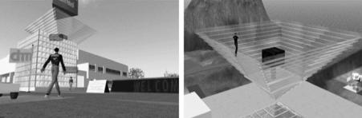

**Figure 1.1 Sample of a Virtual Campus (De Lucia, Francese, Passero, & Tortora, 2009)**

**1.2 Statement of the problem**

Over the years, it was observed that prospective students of tertiary institutions who want to sample life at a school of interest are often constrained by distance. Often Parents or Guardians are not ready to allow their children travel long distances without a guide or an adult accompanying them.Especially, when considering the peculiar situation of insecurity all over Nigeria. Parents and guardians are therefore not interested in allowing their ward to travel to campuses in order to have first-hand information about campus life. Therefore prospective students that have health issues or are physically challenged would be hindered from having a prior experience of life within a school of interest. But with the aid of virtual reality, prospective students with health issues or those that are physically challenged would be able to have an experience of life within a school from their respective homes or places of residence.

Though some universities have made attempts to provide snapshots of campus scenes which are deemed ineffective since potential tourists or visitors are unable to experience the destination in advance and to preview local attractions. However, the opportunities of VR in regard to destination marketing are found in the way in which marketing messages are targeted to specific markets, whilst capturing the attention of potential visitors and giving assistance in relevant factors identification for future travel decision-making processes (Huang, Backman, Backman, & Moore, 2013). Thus, interactive, realistic, easy and detailed VR navigations can help potential visitors in the trip-planning and activity planning processes (Pestek & Sarvan, 2020). Nevertheless, the use of VR is not yet being fully exploited for the creation of simulation environments in Nigeria tertiary institutions. There is therefore a need to adopt virtual

4

reality (VR) technologies for providing virtual tour of strategic areas of tertiary institutions in Nigeria.

Mountain Top University (MTU) is a tertiary institution in South-West, Nigeria that has many students, tourist attractions, and first time visitors. MTU has natural tourism such as the pond, and artificial tours that are continuously being developed. VR technologies can be used in provision of tourists with experience previews of sites and destinations (Samuely, 2016). In the framework of supporting creative University campus, the Management of Mountain Top University can introduce the development of virtual reality tour application for university visitors. Virtual tour application will be useful because of the notion that the University campus community have now become tourist destinations for visitors or prospective new students.

Since virtual tour can help tertiary institution's branding efforts and be directly integrated as promotional activities for the tertiary institution, a virtual reality tour of Mountain Top University's surroundings will be desirable. This will enable prospective students who are limited by distance to have a first-hand experience of MTU campus life from a distance without actually being physically present there. Moreover, Students who have some underlying health challenges like movement disabilities, severe sight problems have the opportunities to have a practical involvement in their prospective choice of school through the help of virtual reality. Overall, virtual reality (VR) navigations can help potential visitors in the trip-planning and activity planning processes prior to their visit. Hence, the need for this study of designing and implementing a virtual tour application that will give prospective visitor to Mountain Top University a perception of being physically present in a non-physical world from the College of Humanities, Management and Social sciences (CHMS) Junction to the Cafeteria.

**1.3 Aim and objectives of the study**

The aim of the study is to develop a virtual tour application that will give prospective visitor to Mountain Top University a perception of being physically present in a non-physical world from College of Humanities, Management and Social sciences (CHMS) Junction to Cafeteria with the use of virtual reality (VR) and panorama technology.

The Objectives are to

5

1. identify the user and system requirements.
2. design the system based on the user and system requirements
3. implement the system; and
4. test the system

**1.4 Methodology of the study**

The following methods will be adopted in order to completely achieve the aforementioned objectives.

1. The user requirements for the proposed system will involve using a mobile device and a Mounted Head display, also known as a VR Head-gear, but since the project is mobile based, the user will require a mobile VR Head-gear. While the System requirements for the proposed system will involve a panorama image of Mountain Top University CHMS Junction to Cafeteria sector.
2. Three dimensional (3d) model of Mountain Top University CHMS Junction to Cafeteria sector will be created with the use of blender.
3. The design of the proposed system was based on the user and system requirements with comprehensive system architecture and relevant UML diagrams such as Sequence diagram and use case diagram.
4. The Implementation of the proposed system was done using the Unity software.

**1.5 Scope and limitations of the study**

As for the scope of the study, the research work will focus on designing and implementing a virtual tour application for Mountain Top University visitors from College of Humanities, Management and Social sciences (CHMS) junction to the cafeteria.

The limitations of the study are as follows:

1. The experience is only limited to users with their headgear.
2. The system is limited to graphical modelling.
3. The system requires mobile headgear to function.
4. Users are required to move physically to gain the full experience.
5. The test case audience of this study is limited to visitors of Mountain Top University CHMS junction to the cafeteria.

6

**1.6 Significance of the study**

The importance of this study includes its contribution to existing body of knowledge on virtual reality tourism. In the current state of the world, virtual reality technology has proven to be a potent instrument that allows people to observe a world that is either known or unknowable without ever being there. This experience helps create better ideas of places. The creation of virtual tours has given tourism an upper hand everywhere in the world. The implementation of a semi-immersive virtual reality system for Mountain Top University visitor from the CHMS Junction to Cafeteria will help parents or potential students to experience the school’s environment without arriving at the campus physically. Moreover, Students can utilize virtual reality for science experiments without expensive equipment, chemicals, and other materials being purchased.

It has been observed that travelling with airplanes or cruise ships has a detrimental effect on the ecosystem and on the globe at large. According to the David Suzuki Foundation, 2% of global greenhouse gas emissions are caused by airplanes. The 2017 New York Times publication on the future of sustainable travel specifically made it big news when an American airline - JetBlue purchased 330,000 million gallons of bio-fuel that will significantly reduce greenhouse gas emissions. Some empirical studies on cruise ships have shown that the air from the ship is comparable to that of some of the world's most polluted cities such as Shanghai. Thus, cruise ship companies like Royal Caribbean has resulted to using scrubbers to reduce carbon emission. The scrubbers machines has succeeded in reducing the environmentally harmful sulfur dioxide from a ship’s exhaust system. However, employment of virtual reality tour can help reduce the rate of travelling for tourism through airplanes or cruise ships that damage the environment and impact climate change.

**1.7 Definition of terms**

The generic and conceptual definition of the following terms as used in this study on virtual reality tourism is as follows:

1. **3D modelling**: is a process of manipulating edges, vertices, and polygons in a simulated three-dimensional space to create a mathematical coordinate-based representation of any surface of an object.

7

1. **3D**: Three dimensional
2. **Emotional involvement:** Emotional involvement refers to the subjective assessment of the imaginative and emotional responses to 3D virtual tourism environments.
3. **Flow experience:** Flow experience refers to the experience of feeling in control, totally focused, aroused curiosity, and intrinsically interested within a virtual tourism site.
4. **Head Mounted Display**: Head-mounted display or HMD is a device worn over your head. It features a display in front of one or both of your eyes. The display streams data, images and other information in front of the wearer's eye(s).
5. **Second Life: in VR refers to** a web-based 3D virtual world created by Linden Lab in 2003 for people to socialize and participate in a virtual community, offering a variety of different forms of applications in entertainment, marketing, business, education, non-profit and healthcare.
6. **Software Development Life Cycle**: Software development life cycle is the time required for such activities as defining, developing, testing, delivering, operating, and maintaining the software or the system.
7. **Virtual environment**: This is an environment which is perceived through a device known as a Virtual Reality headset or a Mounted head display.
8. **Virtual reality headset**: allow users to experience virtual reality content instead of their actual surroundings, such as a 360-degree VR environment, a video game, or a 360-degree movie that allows users to spin and gaze about just like they would in the real world.
9. **Virtual reality**: is a computer generated experience that submerges the common user to the point in which he believes that he is in another world, place or space.
10. **Virtual worlds:** It refers to a synchronous, persistent network of people, represented as avatars, facilitated by networked computers.
11. **Virtual**: Virtual often refers to something that can be accessed online through a computer or other device. It is the digitally replicated version of something real or a digital reproduction of the genuine thing. A virtual object is one that does not have a physical presence. Virtual objects cannot be touched physically and are not real.

8

**CHAPTER TWO**

**LITERATURE REVIEW**

**2.1 Introduction to virtual reality**

Virtual Reality (VR) has different meanings for different people. In general, the definition of VR can be from the technological perspective or the psychological perspective. From the technological perspective, VR is a collection of diverse technologies with interactive means (Coelho et al., 2006). Specifically, VR integrates a set of multiple media in a three-dimensional environment such as audio, text, video, image, and so on. Therefore, VR can be defined from the technological perspective as a three-dimensional computer generated environment, which integrates diverse technologies, updates in real time, and allows human interaction through various input/output devices (Boud, Haniff, Baber, & Steiner, 1999). From the psychology perspective, VR was defined as a particular type of interaction experience with the synthetic world which offers the people a feeling of immersion which is not a technological component but a result of the interaction between man and environment (Coelho et al., 2006). It is the psychological sense of “being there” in the environment generated by VR (Lee, Wong, & Fung, 2010).

Consequently, Mifflin (2001) defined VR as the computer simulation of a real or imaginary system that enables a user to perform operations on the simulated system and shows the effects in real time. While Agnes (2003) defined VR as the computer-generated simulation of three-dimensional images of an environment or sequence of events that someone using special electronic equipment may view, as on a video screen, and interact with in a seemingly physical way. But Putrantoa,, Heriyantoa, Kennya , Achmada., & Kurniawana (2023) defined VR as a computer-generated environment with scenes and objects that appear natural, immersing the user in their surroundings. VR system can be divided into two different types: game-oriented VR such as World of Warcraft, and socially-oriented VR such as Second Life (Papagiannidis, Bourlakis,

* Li, 2008). Game-oriented VR has precise rules and regulations, limiting the availability of certain activities exclusively for specific characters while socially-oriented VR grant their users practically unlimited freedom and options to create their characters and to engage in virtual activities (Nagy & Koles, 2014).

9

VR is the use of a computer-generated three-dimensional environment that the user may explore and engage with in actual time, replicating either one of the user's five senses (Gutierrez, Vexo, & Thalmann, 2008). It replicates a person's physical presence in both the real and virtual worlds. VR is a fully immersive, captivating, interactive alternative reality experience in which the user is completely engaged in the setting. Users may touch and feel synthetic things in the surroundings, creating the impression that they are genuine. The Users may utilize typical input devices like a keyboard and mouse or multimodal equipment like a wired glove, and omni-directional treadmill to engage with the virtual world. As a result, participant engage with real-time virtual three dimensional (3D) objects in a natural and intuitive manner, experiencing them as real and learning to comprehend, analyse, and communicate with them. The difference of VR from the traditional multimedia lies in its interactive characteristic (Riva, Waterworth, & Waterworth, 2004). A virtual reality system involves the interaction between the two layers of user interface (hardware and software) and how they relate to writing virtual worlds.

The virtual environment is made up of a database of scenes with different geometric representations and features that the user would notice while in the environment. The graphics and simulation engines employed determine the format of these representations. The graphic engine is in charge of creating the picture or view that the participant will see in the virtual reality environment. This is primarily accomplished by taking into consideration the scene database as well as the user's current location and orientation in the VR environment, as determined by the user's head and body movement. The simulation engine's job is to keep an artificial yet realistic-looking world alive, supported, and imitated. It is in charge of monitoring the activity in the surroundings, managing changes over time, and responding to the user's actions and gestures. It also covers any interactions or rendering performance of programmed objects, as well as physical simulation. The user interface, which is part of the internal components, serves as a bridge between the virtual environment, simulation engine, and graphics engine and the user's input and output devices

Virtual reality replicates environments with realistic images and sounds. In virtual reality, technologies are used to create a 3D environment which users experience through sensory perception, physical movement, and text or speech communication. The most significant aspect of every virtual reality system is the human to computer to

10

human interaction loop. The user is given a head-mounted display, a tracker, and, if desired, a manipulation device, such as a wand or a three dimensional (3D) mouse. As the person conducts activities like walking and rotating his head to alter his perspective, the computer receives a description of the user's behaviour as an input from the input devices. The computer processes information in real time and provides the relevant result or output to the user via output screens. In conclusion, immersion and interaction are considered as the most important and the most widely accepted main characteristics of VR. Immersion focus on likeliness and multiple simulations of the environment, while interaction focuses on the natural interaction in VR environment and interpersonal interaction between different users.

**2.2 Emergence of virtual reality technology**

Many people think of virtual reality (VR) as a futuristic technology associated with science fiction movies, television series, and novels. However, most people already have experienced today’s virtual reality applications, perhaps by playing a computer video game, engaging in a simulated experience at a museum, viewing an artificial three-dimensional (3D) action movie at a local theatre, or using an augmented reality travel app on a Smartphone to navigate a new city. The VR headset that was originally intended for video games has proven to offer potential in other applications. In the past few years there has been a transition from describing potential benefits of adopting VR technology and the experimental and simulation testing of prototypes to the development of actual VR applications in many aspects and sectors of our everyday lives.

Sutherland (1965), the father of computer graphics, put forward the basic thoughts and classical description of VR at first. He then created the first Helmet-Mounted Displays (HMD) and head tracking system in 1968, which was the embryonic stage of VR. In 1980s, some typical VR systems began to appear gradually. For example, the VIEW system developed by NASA’s Virtual Planetary Laboratory included the devices like data gloves and head trackers. More so, Virtual Visual Environment Display (VIVED) was developed at NASA Ames in 1984 using a stereoscopic monochrome head-mounted display. VIVED was intended to enable a person to explain and visualize their digital lives in 3D space to others (Fisher, McGreevy, Humphries, & W. Robinett, 1987).

11

Lanier (1989), for the first time, proposed the term “Virtual Reality” and developed the VR technology to be relevant products, promoting the development and application of VR. Since 1990s, with the continuous development of technology, the simulation and emulation environments based on VR extended to border areas from the pure research in laboratory. Although VR has emerged for more than half a century, but with the industrialization and commercialization of VR technology in past two decades, 2016 was considered as the Year of VR technology because many giant companies shift sights to the development and application of VR, pushing VR into a new stage of comprehensive development. The advancement of computer software and hardware has led to the advancement and enhancement of virtual reality technologies and applications. According to experts' forecasts, by the year 2020 the number of active VR users will reach 171 million people, and the market will grow to $70 billion (González-Rodríguez, Díaz-Fernández, & Pino-Mejías, 2020; Voronkova, 2018).

Virtual reality applications can be classified along a continuum of (a) true virtual reality, (b) mixed reality, and (c) augmented reality (Milgram, Takemura, Utsumi, & Kishino, 1994). A true virtual reality tool offers a wholly artificial world to create an immersive experience for the user. A mixed reality tool integrates the artificial world with the real one (such as a physical space) to enhance an experience for the user. But an augmented reality tool incorporates some elements of an artificial world into the real world to add information. To create 360° panoramic views, real-world spherical panorama 360° photos and videos are stitched together.

Nowadays practical applications of VR technology have spanned many fields and disciplines including pilot training, industrial applications, education, engineering, architectural design, medical practice, gaming, various sports, warlike simulation, and many more (Hui-Zhen & Zong-Fa, 2013; Kim, Wang, Love, Li, & Kang, 2013). It also provides for the visualization of potential design adjustments. The benefit of adopting VR for walk-throughs rather than CG animations is that the viewer is not limited to certain route, but she/he may freely explore the virtual design. Figure 2.1 presents a sample of virtual reality photograph by Guido van Nispen.

12

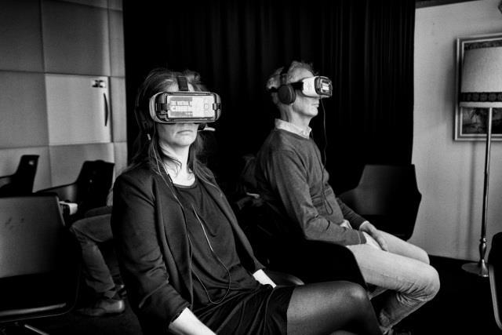

**Figure 2.1: Virtual reality photograph by Guido van Nispen**

**2.2.1** **Essential components of virtual reality**

Through the development of technology and the increasing number of applications based on VR, the main characteristics of VR has been explored and discussed by many researchers. The most widely acknowledged concepts of all came from Burdea and Coiffet (2003), who used three “I”s to identify the main characteristics of VR technology: Immersion, Interaction, and Imagination. Immersion refers to the immersive experiences of being there in the virtual environment with computer-generated 3D images. Immersion mainly comes from multiple representations and sensory simulations, from visual perception to auditory, tactile, olfactory, gustatory, and motion perception. Immersive experience may also be induced by the second characteristic of VR—Interaction, which means that VR system can detect users’ input signals and make response immediately. Imagination refers to means provided by VR technology for people to learn the world and imagine the things that do not exist in the real world, increasing perceptual and rational knowledge.

VR system therefore consists of virtual environment, graphics engine, simulation engines, user interface, user inputs and user outputs. The virtual environment, graphics engine, simulation engines, and user interface are internal components of the virtual reality system, whereas user inputs and outputs are external

13

components. Currently there are several virtual reality peripherals such as Google Cardboard, Daydream, Oculus Rift, HTC Vive, Sony PlayStation VR that can be discussed as follow:

1. **Google cardboard:** Google Cardboard is now the simplest and most economical VR system. His concept is basic: the mobile devices screen is used, in this case: smartphones based in Android iOS, divided with two scenes so that the mobile phone is inserted into a viewfinder, which can be cardboard, that has two lenses through which you can see the screen of mobile phone and provides the basic stereoscopic vision for virtual immersion.

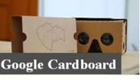

**Figure 2.2: Google Cardboard**

1. **Daydream :** The evolution of Cardboard is Daydream. Google Daydream is an enhanced VR platform from Google for compatible mobile devices (Daydream Ready) from the version 7.x of Android (also known as Nougat). For it, they have put new VR headsets on the market called DayDream View which has a remote control that allows participant to control the device and the visualization. The VR environment is designed for immersive reproduction of 360-degree audiovisual content.
2. **Oculus Rift:** Oculus Rift are the reference VR headsets, it was the consumption of virtual reality. In 2009, Palmer Luckey designed the first prototype, called The Rift that he carried out a demonstration of its potential along with John Carmark with a modified version of Doom 3. From then on, a campaign was launched in Kickstarter for the first mass wear VR headsets that were widely accepted, which was the final takeoff of this device. Nowadays, the latest version of the Oculus Rift is composed of a series of elements, along with the VR headsets, that allow participant to get a much better immersion experience than the one obtained with the first device. These elements are: (a) VR headsets or viewfinder with two state-of-the-art monitors and customized

14

optics; (b) Touch controllers that allow user interaction through these controls showing some arms on the scene that provide a greater sense of reality; (c) also incorporates two sensors with an infrared mesh to capture hand movement, as do other devices such as LeapMotion or Kinect.

* 1. **HTC Vive:** After the initial success of Oculus Rift, and other major companies in the world of technology and video games, two large companies - HTC and Valve - came together to compete with Oculus in this emerging market. The first VR headsets that emerged from this collaboration were called VIVE PRE and were offered to video game developers. The policy of these companies is open, and the community has therefore had a great influence on the penetration of this device in the VR video game sector. The HTC Vive has two OLED screens and its field of view is 110 degrees. They come with two controls, as well as the Oculus Rift and two laser devices for motion detection, that detect the movement of the controls and the VR headsets.
  2. **Sony Playstation VR:** Finally, there is another great company that has insisted on the creation of its own virtual reality headsets, focused on the world of entertainment and video games. This company is Sony and has launched the Playstation VR. These VR headsets do not come with specific controls and motion sensors but take advantage of the technology that comes with the console to offer an immersive experience. These technological elements are the controls of the console and the second-generation camera that have taken to the market. Unlike the previous two, these VR headsets have a 5.7-inch OLED display with FullHD resolution, refresh rate of up to 120Hz and a field of view of 110 degrees. They can be connected to a PC using specific drivers.

Nevertheless in accordance with Sherman and Craig (2018), virtual reality system is made up of four fundamental elements, which are:

1. **Virtual world:** A virtual world is a world that is created by a computer. The virtual world is made up of items and spatial principles. Those items and ideals are linked together via relationships. One of the goals of VR development is to achieve "total immersion," or seeing and interacting with objects in a virtual world in the same way that one sees and interacts with real-world objects.
2. **Mounted Head Display:** The mounted head display (MHD) has been used by VR developers to display the virtual environment to the user. The MHD was previously been employed in military aircraft as an information display. A virtual image in front of the eyes is provided by displays and imaging optics mounted on a headset

15

in an MHD. This design in the VR domain gives the user a perspective of the virtual environment while filtering off the user's actual world.

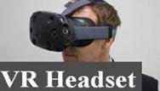

**Figure 2.3: VR Headset**

1. **Sensory Feedback:** This aspect enables the user to arrive at a reasonable outcome depending on the user's input. The outcome of the sensitivity is also dependent on the user's location, activity, and navigation.
2. **Interactivity:** This fourth element is in charge of bringing the virtual

environment to life and expressing it. It enables the user to interact with virtual world items.

These four components virtual world, mounted head display, sensory feedback, and interactivity form the foundation of a computer-based VR system (Sherman & Craig, 2018).

**2.2.2** **Application of virtual reality (VR) system**

Virtual reality (VR) continues to evolve over time since its emergence and it has been applied in many areas, such as education, marketing, entertainment, heritage preservation and accessibility (Guttentag, 2010). Thus, VR can be used as an educational tool in tourism. VR can provide visitors enjoyable experience, increase the level of interaction, and stimulate learning and comprehension in tertiary institution, museum and art galleries (Anderson et al., 2010; Carrozzino & Bergamasco, 2010).

Virtual reality's biggest strength is its capacity to visualize spatial settings (Guttentag, 2010). For instance, several museums already launched online virtual tours for visitors, especially for remote visitors. VR is especially suitable for museum and cultural heritage sites (Carrozzino & Bergamasco, 2010). Museums such as the Louvre museum, Palace museum, and Smithsonian national museum of natural history apply virtual reality (Louvre Museum, 2020; Palace Museum, 2020; Smithsonian, 2020).

16

More so, VR can be used to market and promote a tourism destination effectively by offering potential visitors a deeper assessment of the destination without actually being there, which would influence visitors’ decision-making process in choosing a destination. VR experience had a positive and significant effect on behavioural intentions towards a destination (Marasco et al., 2018; Rahimizhian et al., 2020), and it can greatly increase the likelihood of future visitation (Gibson & O’Rawe,

2018).

Virtual Reality can also be used to enhance the ‘virtual accessibility’ and provide an alternative form of access for the general public if the destinations are far away, expensive, and dangerous to visit (Guttentag, 2010). Such effect of VR is especially important during the period pandemic, due to various level of international, regional, and local travel bans or restrictions. Hence, during the Corona Virus pandemic, virtual tourism was an entertainment activity for people to relieve pressure when people are required to stay at home.

Advertisement using VR has proved to have a greater marketing effect than using brochures or pictures (Yeh et al., 2017). Due to the complexity and interaction of the content, virtual experiences provided more effective promotion for theme parks than brochures (Wan, Tsaur, Chiu, & Chiou, 2007). Aside from being a marketing tool, virtual reality can be used as a stand-alone entertaining tourism product, especially for theme parks such as Star Wars & Secrets of the Empire at Disney, VR Park in Dubai, and VR Star Theme Park in Guizhou, China (Junyu et al., 2021).

Virtual reality is often used in educational institutions. For instance, during the COVID-19 pandemic elementary Schools and tertiary Institutions were compelled to close in large numbers due to the corona virus disease. This issue could easily be resolved with the introduction of affordable virtual reality technology, which could also open up an infinite number of new teaching and learning modalities. In a virtual environment, both teachers and students had no difficulty teaching and learning. Virtual reality technology can enable students perform chemical experiments without being constrained by lack of cash for expensive supplies and also could allow students perform chemical experiments without being physically present due to the corona virus pandemic. With virtual reality, history and language students can both travel through time and discover new cultures.

17

In healthcare, virtual reality is employed to help surgeons to develop their expertise and skills without endangering patients or injuring or killing them in real life, virtual reality enables surgical simulations and allows medical students and residents to learn from their mistakes safely in a setting that closely resembles reality. Virtual reality technology also offers significant financial savings for professionals in the arts, design, and marketing. For instance, before deciding to produce a product or design, the organisation can test it in a setting that mirrors the real world. It is the most economical technique to determine whether the design is visually and physically pleasing.

Sports and entertainment are other areas where VR is used. Virtual reality can be useful for both sports enthusiasts and sportsmen. It is an excellent method of training for athletes, especially those who participate in dangerous sports. For instance, if race car driver trains with virtual reality experiences, the driver can be far better prepared for the G-force of driving at such high speeds and learn diverse tricks. Many broadcasters have started experimenting with providing VR live sporting events as part of their sports marketing strategy. VR live sporting event is less expensive when compare with going to the stadium, and this may even enable more fans to attend a game. The advantages of giving virtual reality experiences become clearer after COVID-19 prompted the cancellation of so many live games.

The military can potentially benefit from the use of virtual reality. A number of nations train their military personnel using VR technology. Through drills and simulations, it better equips military personnel to deal with risky situations. VR may be utilised to generate flight simulators for pilots as well as vehicle and combat simulations for other military branches.

The field of mental health care can also benefit from virtual reality. Post-traumatic stress disorder (PTSD) is treated with virtual reality. To help the brain interpret traumatic memories as past threats rather than present threats, PTSD treatment methods frequently involve addressing unpleasant memories. Virtual reality event simulations are a safe and effective approach to do this and may lead to significant advances in the treatment of post-traumatic stress disorder (PTSD).

Moreover, VR could possibly aid in the preservation of the heritage, especially the threatened sites (Guttentag, 2010). VR is able to offer realistic and immersive experience for visitors and an alternative form of access, and therefore can potentially curtail the actual visitations that might pose a threat and damage to the heritage (Arnold,

18

2005; Refsland et al., 2000; Paquet & Viktor, 2005). Lastly, VR is also helpful for the people with disability to enhance their ‘virtual accessibility’ (Siriaraya et al., 2014; Stendal, 2012).

Notwithstanding the tremendous benefits derivable from the application of virtual reality system, Researchers have asserted that VR simulations will be effective only to the extent that the situation is perceived as analogous to the real world activity task, and skills are repeatedly practiced (Dieker, Rodriguez, Lignugaris/Kraft, Hynes,

* Hughes, 2014). Moreover, some ethical issues around VR such as the negative effects it might have on health level will need to be investigated, discussed and sorted out.

**2.3 Virtual reality in tourism**

Many of the recent innovations such as VR platforms, devices and content production tools enable the evolution of VR. VR has the capability to create realistic and navigable virtual environments. As such, VR involves the use of computer modelling and simulation that enables a person to interact with an artificial three-dimensional (3D) visual or other sensory environment (Pahlevi et al., 2021). VR technologies nowadays offer unbounded potentials for mass virtual visitations to actual tourism destinations. The intangible properties of tourism, as a service, constantly remind the marketers that there is a need to continuously innovate the forms of visual imagery with the objective to promote a positive destination image (Griffin et al., 2017).

Because of VR system ability to induce the emphasised sensory and emotional experience, VR is often used by marketers in establishing the communication of emotions and experiences that will influence the consumers and tourists. VR abilities to simulate real-life situations and contexts have occasionally being touted as a substitute to actual travel, making it a very powerful tool for meeting the needs of tourists.

VR is the technology using the computer-generated 3D environment often referred to as “virtual environment” for exploration (Guttentag, 2010). The real-time simulation of one or more of the five senses of the user is often a result of navigation through this virtual environment and interaction with it (Gutierrez et al., 2008). Virtual reality applications immerse the user in a computer-generated three-dimensional environment (often referred to as virtual environment) which simulates reality through the use of interactive devices, which send and receive information and are worn as

19

goggles, headsets, gloves, or body suits. According to Slater and Sanchez-Vives (2016) viewers can travel virtually and change view perspective, which gives users a sense of genuineness. In virtual reality the user is immersed in a three-dimensional environment and interact with them rather than observing a screen in front of them (Alewi, 2022).

Virtual tourism promotion can be designed through the concept of tourism by showing videos guided by tourism guides.

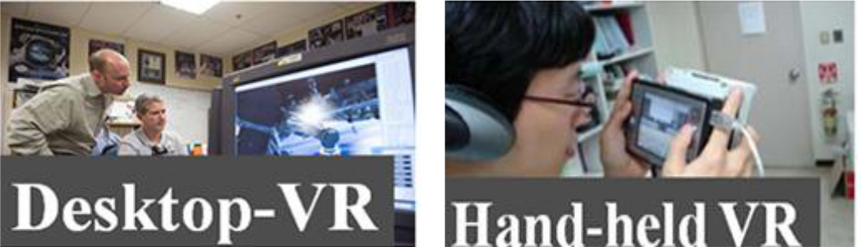

**Figure 2.4: Desktop – VR and Hand-held VR**

**2.3.1 Virtual reality application to Nigeria tourism sector**

Virtual reality is considered a very valuable tool in tourism policy creation as well as in the planning processes (Cheong, 1995).. One of the topics noted in adopting VR as a management and planning tool in the tourist sector is the suggested integration of geographic information systems (GIS) and virtual reality (VR) over the internet to improve management and marketing of the tourism industry (Guttentag, 2010). The influence of virtual reality on tourism seems to be immense, but the six major areas where VR has a significant impact are planning, management, marketing, entertainment, education, and historic preservation (Guttentag, 2010).

Thus, the areas and circumstances that have prompted the adoption or application of virtual reality (VR) in the Nigerian tourist business are:

1. Accessibility to inaccessible areas

Frequent attack by the Boko-haram terrorist group have made it difficult to enter remote places such as Yankari National Park and Sambisa Forest in the northern region. Instead of physically visiting such places, visitors and tourists may remain in another area inside Nigeria to experience the rich flora, wildlife, and other natural elements in these locations with the use of virtual reality.

20

1. Bridging Barrier and Fears

Travel has become less common as technology and virtual worlds progress. VR eliminates the stress, procedures, and travel bottlenecks that come with actual travel (Cheong, 1995). Tourists and vacation holiday makers can save time and money through the usage of VR. Meanwhile, for certain visitors, especially tourists who are unable to travel owing to health challenges, VR could be safer, cheaper, and more convenient for them. Considering that Nigeria socio- political realities and security situation are not pleasant enough to attract visitors, VR usage can avail tourists the opportunity to virtually explore the rich cultural heritage of various locations in Nigeria.

Balogun et al. (2010) spoke in support of virtual reality for tourist attractions and historical sites in Nigeria's Osun State in his study. Using VR will both promote these sites and also help to preserve the historical heritages of the people in such communities (Balogun et al., 2010).

**2.3.2 Negative impact of virtual reality in tourism in Nigeria**

Osun's tourism and historical sites have advocated in favour of VR application, but Balogun et al. (2010), examined what the local communities stand to benefit when tourists or visitors visit via VR. The study of Balogun et al. (2010) discovered that historic landmarks might benefit by its been showcase by virtual reality, but the economic benefits may be lost. The monetary revenue from tourists and visitors may help in the conservation of historical heritage. According to Balogun et al. (2010), how much of an economic impact would tourism have if VR reality replaced actual visits?

In order to appreciate tourism's benefits, people must experience them themselves. Cheong (1995) cautioned about the disadvantages of adopting VR in the tourist business. The study stated that many nations would surely express their concerns if virtual reality is to be established as a successful application in tourism because many countries, particularly those in the developing world and other emerging countries, depend heavily on tourist money (Cheong, 1995). Tourists naturally love genuine experiences, so it is in the best interest developing and emerging countries to draw more people to their tourist sites (Nicolaides, 2014). Increased visitor spending and foreign investment in tourism infrastructure benefit the host country's economy and the quality of life of the locals. Those nations that dependent on tourists could suffer greatly if virtual reality were to replace tourism, since fewer and fewer visitors would visit those

21

countries over time (Cheong, 1995). Therefore, it will be worrisome for a nation like Nigeria that is looking forward to tourism to rejuvenate its economy to venture into VR without due consideration. For the introduction of VR will rob Nigeria of tangible revenue from actual tourism

**2.4** **Software development life cycle (SDLC)**

In the field of systems development, one is not expected to pick up a project without sketching a picture of what the expected end product should be. The project manager heading a team of developers is tasked with the responsibility of not only highlighting the roles of individual team members but also establish a relationship with the user of the system, to understand and manage their expectations of the system. This implies that they had to apply a reliable software methodology, known as Software Development Life Cycle (SDLC). A SDLC process contains a complete plan for describing how to design, develop, maintain and increase the efficiency of a software product (Kazim, 2017**)**. Ergasheva and Kruglov (2007) defined Software Development Life Cycle (SDLC) as a time required for activities that include defining, developing, testing, delivering, operating, and maintaining the software or the system. The Software Development Life Cycle (SDLC) is a framework that outlines the activities that must be completed at each stage of the software development process (Khan, Shadab, & Khan, 2020). The SDLC process describes the methodologies which improves overall software quality and development process (Kazim, 2017).

Software Development Life Cycle is the collection of steps that are to be followed for the systematic development, design, and maintenance of the software projects. It is a constant process that begins the minute a choice is taken to commence a project and ends when the system is ready for deployment. The Software Development Life Cycle also ensure that all the user requirements are fulfilled with the least amount of resource consumption (Barjtya, Sharma, & Rani, 2017). SDLC is used majorly in several engineering fields, and industrial fields as a framework to help manage, plan, and control the process of developing a system. It is a continuous process that starts from the moment a decision has been made to launch a project, to when the system has met the user requirements and is ready to be deployed. In that context, project managers or software team leads are frequently seen using this methodology as a guide to ensure the development and design of a modern, high-quality system that

22

meets and exceeds the customers' expectations while remaining cost-conscious and delivery is within the originally stated time frame. Hence, the team's productivity and the quality of the software are both dependent on the efficiency with which software metrics are defined and analysed throughout the SDLC.

**2.5** **Software development life cycle process**

A Software development life cycle (SDLC) process contains a complete plan for describing how to design, develop, maintain and increase the efficiency of a

software product. Software development life cycle process describes the methodologies which improves overall software quality and development process. There are several stages in the software development life cycle, but they can be summarised into six (6) key processes involved in the formation of systems. These six stages of a typical software development life cycle are Planning / requirement analysis, Defining requirement, Designing the software architecture, Building or developing the product, Testing the system, and Deployment and maintenance. Figure 2.5 shows the different phases of a typical software development life cycle (SDLC) which can be explained as follows.

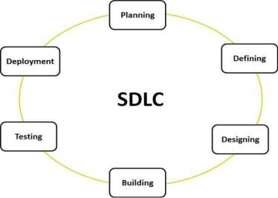

**Figure 2.5: Different phases of a typical software development life cycle**

23

**2.5.1** **Planning / Requirement analysis**

A software development lifecycle (SDLC) begins with planning and requirement analysis phase. Planning and requirement analysis is the most vital and basic phase of every life cycle process. In this case, the goal is to understand and describe exactly what the system's end users need. One of the most important stages in the SDLC is this one, since it lets the project manager get a feel of the system's expectations and manage those expectations realistically before implementation. Planning and requirement analysis is completed by the senior members after holding meeting(s) with the customer or owner of the software system. This guarantees that everyone participating in the system's development knows the scope of the task and how each of the criteria is to be achieved. Quality assurance requirement, risk identification and feasibility report are the main outcomes of this phase.

**2.5.2** **Defining requirement**

When planning and requirement analysis is completed then the next phase is the detailed definition of the requirements, documentation of these requirements and getting verification from the customer. System architects and developers work together to create a high-level system architecture that satisfies the specified objectives at the next stage of the development life cycle. Specific details of the design and any downsides (budget liabilities, time restrictions) are provided to system stakeholders.

Each of these elements is examined to find the optimal design strategy to tackle the issue. The output of this phase is the software requirement specification (SRS) document which contains all the requirements of product to be designed and developed (Scacchi, 2001)

**2.5.3** **Designing the software architecture**

Software requirement specification (SRS) is used as input in this phase. The software requirement specification (SRS) would be used to design the architecture of the software product which is being developed (Software Testing Help, 2021). This phase of the SDLC lays out the specifications, features, and procedures that will be needed to meet the functional needs of the proposed system. Iinitially more than one architecture would be designed and then reviewed by important stakeholders according to criteria like risk assessment, robustness, design modularity, time and cost. Thereafter the best design is selected

24

**2.5.4** **Building or developing the product /implementation**

The next phase in the development life cycle is to build the real system once the system design has been produced and authorized by the system stakeholders. The preceding phase's result is used as the basis for the system's implementation. Keeping in mind what the customer requested, the programmers begin developing source code or reusing existing components from the prior system. Depending on the kind of system being created, each member of the team plays a specific role; while the front-end developer creates the user interface, the back-end developer creates the logic that connects that interface to the server and the database (Bindia, 2019). There is no need for more than one developer to work on a tiny project. When there is a great amount of work, tasks are delegated to various people depending on their ability level. Each team member's development should be monitored in order to guarantee that the modules will all work together in the end. As a result of this stage, the program code is generated as a result.

**2.5.5 System testing**

In order to offer a finished product, the system must first be put together and tested in a testing environment. Additionally, testing is performed to ensure that the system functions properly and is free of bugs, as well as to determine whether or not the programmers followed the approved design template from phase two, and finally, testing ensures that the system meets all of its intended users' needs and can serve the intended purpose for which it was built. A test plan is designed and conducted on a computer to ensure that the system works properly. As long as the outcomes of the test run match the expected ones, the system is deemed implemented. Among the several methods for evaluating software are the black-box and white-box test approaches.

There must be unit testing in the case of a large system that is broken down into various components and delegated to different people. In unit testing, a white-box test is used. Code, such as a collection of one or more computer modules, and the control data, usage processes, and operating procedures that go with them, may be evaluated to see whether they are fit for use (Kolawa & Huizinga, 2007). The usability and performance of the system are looked at after each component has been made and tested to the fullest extent possible.

25

**2.5.6 Deployment and maintenance**

This is the final stage of the SDLC process where the system is handed over to the user or client for them to launch. Before the system is deployed, an acceptance test is conducted against the requirement parameters given to the developers to verify and validate that it satisfies those requirements as stated by the user. To assist the organisation using the system, it is expected that there is documentation on how to effectively use the system throughout the entire process. Although a form of training would be done by the developers for the users, the documentation would be provided as a guide for them on how to use the system. When function and non-functional requirements are tested and validated then the software is deployed in the customer’s environment.

If some problems are faced in the customer’s environment, then solve these problems in maintenance phase. Also some enhancement can be done in this phase if user is not fully satisfied. At the maintenance stage, the system developers will provide the organisation with an operator/user document that describes how to use the system, what error messages indicate, and so on, and a system document that provides the specifics of the system architecture. Once the system has been deployed, a maintenance team is usually assigned to the client’s organization for procedural system check-ups and to attend to whatever issues that might occur during the deployment of the system.

This group offers user input, as well as consultation and assistance to customers while they are using the product. They also ensure that the system's components that need to be upgraded are updated without putting the system at risk of security breaches.

**2.6** **Software development life cycle models**

Software development life cycle models convey the impression of an abstract representations of the software development process. Software development life cycle models are therefore an integral part of software engineering field whose goal is to create high-quality software that satisfies an organisation’s requirements, at a reasonable cost, and timely. Every SDLC model is made up of several stages, each of which must be understood in order to determine the sequence of the steps and what each step basic requirements are. The most difficult task in software development life cycle models is the identification of the model that is suitable for the structure of an

26

organisation. Thus, every organisation must comprehend the model and its real-time application so that users can relate to, understand, and discover how it works.

As aforementioned, software development model is a representation of the complete software development process. SDLC model clearly outlines the major activities that will guide the software development team (Jiujiu, 2018). Each of the models follows a sequence of steps of the life cycle to fully ensure the success of the software development process. There are thus many general models for software processes, some of which are: Waterfall model, V-shaped Model, Iterative model, Agile model, Spiral model, and Rapid application development (RAD) model (Kazim, 2017; Olaiya, 2021). These general models for software processes are discussed as follow:

**2.6.1 Waterfall model**

The waterfall model of the software development life cycle is the most widely used. Many government and non-profit organisations have used it, making it one of the oldest models still in use. The linear sequential SDLC model was initially introduced by Winston Royce in 1970 and is also known as the Waterfall Model since it is so linear in nature. Workflow may be characterised as a downward flow of processes via a set of stages, each of which must be completed in order to create the system correctly (Youssef, 2012). This method necessitates a step-by-step approach, with each phase being completed before moving on to the next. One way to think of it is as an iterative process that may be repeated indefinitely until it is perfected. Plan-driven processes, such as the waterfall model, need meticulous planning and scheduling before any work can begin. This model consists of six primary steps, which are; requirement analysis; system design; implementation; testing; deployment; and maintenance. Each phase has a specific deliverable and review process. Phases are processed and completed one at a time and it does not go on to the next phase until the previous phase is done (Thakur, Singh, & Chaudhary, 2015). However, waterfall model is not fit for projects where requirements are changed frequently. Figure 2.6 shows the graphical representation of water fall model as follow.

27

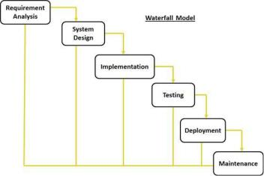

**Figure 2.6: The graphical representation of water fall model.**

**2.6.2** **V-Shaped model**

In V-Model, the processes occur in a sequential order in V-shape. It is an expansion of waterfall model, with each phase of V-Model, a testing phase is associated. Its means every single phase in this connect with a testing phase. Incorporating testing functionality throughout the project development process rather than at the end, results in more efficient project development (Barjtya, Sharma, & Rani, 2017). Therefore, the aim of the project cannot be obscured since a test strategy has been established before any source code is produced. The focus of the test plan is to meet the functionality requirements that have been specified (Sujit & Pushkar, 2013).

The V-Model is therefore a very controlled and disciplined model where the validation phases are the one side of the V and the verification are on the other side, while the coding phase joins the validation phases and verification as presented in Figure 2.7.

The creation of a V-shaped model, like a waterfall model, starts with the requirements phase. However, the next steps may only be implemented when the previous step have been duly completed. An integration test plan of the V-shaped model is developed at the high-level phase to test the software system's components and their ability to function together. The actual software components are designed at the low-level design stage, as well as a unit test (Munassar & Govardhan, 2010). The implementation phase occurs when all of the program code has been written. Following

28

the completion of the code, the execution path continues down the right side of the V, where the previously produced test plans are now applied. The V-shaped model can be used where an accurate product testing is required for a project and for small and mid-size projects, where the requirements have been strictly predefined. However, the major disadvantages of the V-shaped model are that it is not flexible, and it is not suitable for complex and object oriented projects. The risks and uncertainty is high. Figure 2.7 presents the graphical representation of the V-shaped model

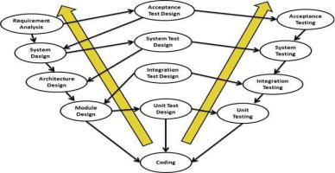

**Figure 2.7: The graphical representation of V-shaped model**

The validation phases are the one side of V and the verification on the other, coding phase joins these two phases as shown in Figure 2.7. Thus, the verification phase in the V-shaped model involves requirements analysis, system design, architectural design, module design, and coding phase. While the validation phases in the V-shaped model involves unit testing, integration testing, system testing, and acceptance test.

**2.6.3** **Iterative model**

The iterative model also called an incremental model, is a design approach that is based on feedback and evaluation of the previous model that was deployed to users, which is subsequently used to produce a newer version of that same system. A restricted set of criteria is used to begin the iterative process, which produces a little version of the product or system with each iteration and it continues until a final version is generated. In this way, the requirements are not completely established up front (Kazim,

29

2017). It is important to note that each iteration adds new functionality to the product or system and continues to do so until the entire process is completed, the changes that have been made increase the performance of the system. The main idea behind this technique is to create a system in smaller chunks at a time (increments), allowing software engineers to benefit from what has been learned during the creation of previous parts or versions of the system (Abdullahi & Ogwueleka, 2017).

Unlike the Waterfall and V-shaped model, the requirements in the iterative model do not need to be completely stated before development. The major advantages of the iterative model compared to other models is that there is a working version of the application early in the process, which makes it less expensive to effect changes (Barjtya, Sharma, & Rani, 2017). Moreover, the iterative model makes risk identification and milestone management easy, while project progress can be measured.

The disadvantages of the iterative model are that it engulfs much resources and management, and correction of a problem in one unit would require correction in all units. Thus, project progress depends upon risk analysis. Figure 2.8 presents the graphical representation of iterative model.

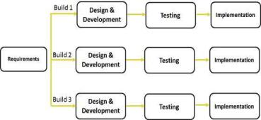

**Figure 2.8: The graphical representation of iterative model.**

**2.6.4** **Rapid application development model**

The Rapid Application Development (RAD) model depends upon prototyping and iterative development, no need for specific planning. The process of writing the software itself involves the planning required for developing the product. A prototype is a working model which is functionally equal to a component of the product. The five

30

phases involve in RAD are business modelling, data modelling, process modelling, application generation, testing and turn over.

1. **Business modelling**: The business model for the product under development is designed in terms of flow of information and the distribution of information between various business channels. A complete business analysis is performed to find the vital information for business, how it can be obtained, how and when is the information processed and what are the factors driving successful flow of information.
2. **Data modelling:** The information gathered in the business modelling phase is reviewed and analysed to form sets of data objects vital for the business. The attributes of all data sets is identified and defined. The relation between these data objects are established and defined in detail according to its relevance to the business model.
3. **Process modelling**: The data object sets defined in the Data Modelling phase is converted to establish the business information flow needed to achieve specific business objectives as per the business model. The process model for any changes or enhancements to the data object sets is defined in this phase. Process descriptions for adding, deleting, retrieving or modifying a data object are given.
4. **Application generation**: The actual system is built and coding is done by using automation tools to convert process and data models into actual prototypes.
5. **Testing and turn over:** The overall testing time is reduced in RAD model as the prototypes are independently tested during every iteration. However, the data flow and the interfaces between all the components need to be thoroughly tested with complete test coverage. Since most of the programming components have already been tested, it reduces the risk of any major issues. Figure 2.9 presents the diagram of Rapid Application Development (RAD) model.

31

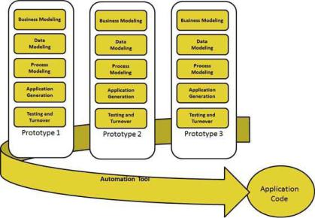

**Figure 2.9: The diagram of Rapid Application Development (RAD) model**

**2.6.5** **Agile model**

Agile SLDC model is a combination of the iterative and incremental processes. It is an hybrid model that combines the iterative and incremental approaches by dividing software into apparatus and delivering a working model of a component at the end of each cycle. Agile model of software process is a group of software development methods where requirement and solution evolves through the collaboration between self-organising and cross-functional teams (Harish & Syan, 2012). It concentrates on process adaptability and customer satisfaction by rapid delivery of working software product. Agile method breaks software product into small incremental builds. These incremental builds are completed in iterations. In each iteration development team works on the planning, requirement analysis, design, coding, unit testing and acceptance testing. After each iteration, the product is tested to determine whether it is acceptable or not.

The model generates updated releases, each of which contains some incremental updates. At the end of iteration, a working build is submitted to the customer and stakeholders. Agile model ensures that every software project are handled differently and different exiting methods apply on it, based on product requirements. In agile

32

model, tasks are divided into different time boxes based features. Then iterative approach is used and a working product is delivered at the end of iteration. These iterations are continuous till the final software version with all the features, is delivered.

The agile method is mostly used when the users need dynamic change and when there is less cost for the changes implemented due to the numerous iterations. The model can also be used when initial planning is required to start the project (Bindia, 2019). Some of the common agile software development methods are scrum, crystal approaches, feature-driven development and Extreme programming (XP). Figure 2.10 presents the graphical representation of agile process:

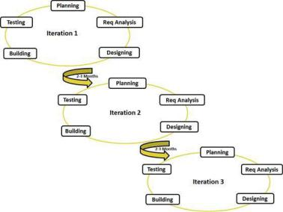

**Figure 2.10: The graphical representation of agile process**

**2.6.6 Spiral model**

A spiral model is a step-by-step approach that emphasises risk analysis. Boehm introduced it in 1988 as a risk-driven development process paradigm. Rather than a series of operations, this software process may be depicted as a spiral. The spiral model develops a system using a periodic technique. A software project repeatedly passes through each cycle of the spiral, where the baseline of the spiral starts in the planning

33

phase and requirement is gathered and risk is assessed. Subsequent spirals then build on the baseline spiral. While the needs are obtained during the planning phase.

According to Sujit and Pushkar (2013) a procedure is conducted in the risk analysis phase to identify risk and alternative solutions. After the risk analysis phase, a prototype is created. The engineering phase produces software, which is then tested after the phase.

Before moving on to the next spiral, the client can assess the project's output with data in the evaluation phase (Munassar & Govardhan, 2010). Some benefits of using the spiral model include easy and effective monitoring of project, There is a high amount of risk analysis, therefore it is easy to avoid risks, In spiral model, development process is divided into parts and risky parts are developed early which help better management. The spiral model can be applied to projects where the constraint on budget and risk evaluation is important, where requirements are complex, and there is need to clarify evaluation. It is therefore good for large and mission-critical projects.

The disadvantages of this model include, that it can be costly, and the success of the project is dependent on the risk analysis phase. The spiral model does not work well with smaller projects. Figure 2.11 presents the diagram of spiral model.

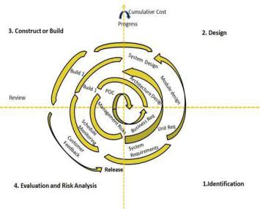

**Figure 2.11: The diagram of spiral model**

34

**2.7** **Extreme programming**

Extreme Programming (XP) is a methodology for Agile software development. It is a lightweight, efficient, and adaptable software development process that was created to meet the unique needs of small teams developing software in the face of ambiguous and shifting requirements. Extreme Programming (XP) is an iterative software development process that seeks to produce higher-quality software and assist in finding the best solution. The goal of XP is to establish ideals and principles that will influence team behaviour. Extreme programming is a style of agile software development that emphasises short development cycles and frequent delivery cycles.

These short development cycles and frequent delivery cycles are intended to boost software productivity and quality through the use of specialized procedures that focus on building checkpoints for the acceptance and satisfaction of client expectations.

According to Wu (2015), the model's fundamental concepts include a set of beliefs, rules, and methods for rapidly building high-quality software that adds value to the client in the shortest amount of time possible. According to Beck (2000), and Lippert and Roock (2001), the XP technique is meant to meet the requirements of a competent small team of fewer than ten developers co-located with the client and 32 developing non-critical software using object-oriented technologies. Typically, an XP project results in a software project in which software development begins immediately, virtually no documentation artefact is created (except for “user stories” written on index cards), and the project proceeds iteratively, with daily prototypes created with the direct input and occasionally assistance of stakeholders until the desired effect is achieved.

**2.8** **Unified modelling language (UML)**

Unified Modelling Language (UML) was first introduced in the late 1990s, as an evolution of the object-oriented programming language. Its origin is an intersection of the three popular methodologies of the 1980s and 1990s; which are the Booch method, Rum-baugh’s Object-Modeling Technique (OMT), and Jacobson’s ObjectOriented Software Engineering (OOSE). The unified modelling language (UML) is a standard general-purpose modelling language in the object-oriented software engineering discipline. The first version of UML (UML 1.x), was officially adopted and standardized by the Object Management Group (OMG) in the year 1997.

35

UML is a graphical language for visualizing, describing, constructing, and documenting software-intensive system artefacts. It provides a standard way to write a system's blueprints, which include both conceptual and concrete elements like business processes and system functions, as well as programming language statements, database schemas, and reusable software components (Padmanabhan, 2012).

According to Keng (2010), UML 1.x defines nine diagramming techniques: Class diagram, Object diagram, Component diagram, Deployment diagram, Use Case diagram, State-chart diagram, Activity diagram, Sequence diagram, and Collaboration diagram (Booch, Rumbaugh, & Jacobson, 2005). While the UML 2.x defines thirteen diagram techniques. The most recent version of the unified modelling diagram is the UML 2.5.1 version.

**2.9** **Unified modelling language diagrams**

Unified Modelling Language (UML) diagram is a graphical representation of a model in a system that partially signifies its design and implementation. Thus, UML diagrams are classified into three different views, which are - Structural diagrams, Behavioral diagrams, and Interaction diagrams. The components that must be present in the system are specified in the structural diagrams. Structural diagrams include class diagrams, component diagrams, deployment diagrams, object diagrams, composite structure, and package structure. Behavioural diagrams are diagrams that depict a system's behaviour and they are used to describe its functionality. The Behavioural diagrams include; Activity diagrams, State machines, Use case Diagrams, Interaction models. Interaction diagrams depict the flow of control and data among the components of the system under consideration. Basically, interaction diagrams include sequence diagrams, interaction overview, timing diagrams, communication/collaboration diagrams. Overall, the following diagrams are part of the diagrams defines in the UML 2.5.1 version.

**2.10** **Types of unified modelling language (UML) diagrams**

The unified modelling language (UML) diagrams span across the structural view, behavioural view and interaction view. In total, there exist about fourteen types of UML diagrams; which are:

36

**2.10.1 Use Case diagrams**

Use case diagrams model the functionality of a system using actors and use case. A use-case model is a representation of a system's intended functions and its surroundings. Use case diagrams basically represent the relationship between actors, use case and system. The internal and external agents are known as actors. The actors and their objectives are expressed as use cases. Thus, use case diagram is used to represent a dynamic behaviour and the diagrams model any relationships between those use cases. Basically use case diagrams represent the relationship between actors, use case and system. It also acts as a contract between the developer and the consumer.

**2.10.2 Component diagrams**

Unified Modelling Language (UML) component diagrams is used to model the physical aspects of a system. These physical aspects are elements such as executables, libraries, files, documents, and so on that resides in a node. Component diagrams show how a system is split into modules called component and also shows the dependencies among the components.

**2.10.3 Class diagrams**

Unified Modelling Language (UML) class diagrams describes the structure of a system by showing the system’s classes, their attributes, and the relationships among the classes. It shows the system's classes, properties, and connections among the classes to illustrate the structure of the system. Unified modelling language (UML) class diagrams scrutinise requirements in the form of a conceptual/analysis model, analyse domain concepts in the form of a domain model, and depicts the detailed design of object-oriented or object-based software.

**2.10.4 Composite structure**

A composite structure diagram is a UML structural diagram that contains classes, interfaces, packages, as well as their relationships that provides a logical view of all or part of a software system. It depicts the internal structure of a structured classifier or collaboration (including parts and connectors). This diagram is similar to a class diagram in that it allows you to go into greater detail when describing the internal structure of multiple classes and showing how they interact. Inner classes and parts can be graphically represented, as well as associations between and within classes.

37

**2.10.5 Deployment diagrams**

The hardware used in system implementations, as well as the execution environments and artefacts deployed on the hardware, are described. A UML deployment diagram depicts the configuration of run-time processing nodes as well as the components that reside on them. The physical aspects of an object-oriented system are modelled using deployment diagrams, which are a type of structure diagram. According to Creately (2021) deployment diagrams are frequently used to represent the static deployment view (topology of the hardware) perspective of a system.

**2.10.6 Object diagrams**

Unified modelling language (UML) object diagram is a type of class diagram that shows the precise status of a system at a particular moment in time. Object diagram is often perceived as a subset of a communication diagram or class diagram. An object diagram focuses on the characteristics of a group of objects and how they interact. it comprises of objects and their connections.

**2.10.7 Activity diagrams**

Unified modelling language (UML) activity diagrams are visual representations of activities or graphical representations of step-by-step workflows actions and activities. Activity diagrams depict the workflow from start to finish, highlighting the numerous decision paths that exist in the progression of events concerning an activity. activity diagrams can be used to describe situations in which parallel processing is possible during the execution of some tasks.

**2.10.8 Package diagrams**

Unified modelling language (UML) package diagram is a form of structural diagram. It depicted the arrangement and organisation of model elements in a middle to large scale project. Package diagrams can depict both the structure and dependencies between sub-systems or modules, as well as different perspectives on a system, such as a multi-tiered or multi-layered application model. Package diagrams are often structural diagrams that show how various model elements are grouped and arranged in the form of packages.

38

**2.10.9 State machine diagrams**

Unified modelling language (UML) state machine diagram, also known as a state diagram, is a kind of behavioural diagram that illustrates object transitions in the unified modeling language (UML). The state machine diagram portrays the many states that an item in a system may be in. State diagrams are used to explain the behaviour of an application. State machine diagrams often keep track of the software activities of a system.

**2.10.10 Interaction diagrams**

An interaction is a behaviour that consists of a sequence of messages delivered among a group of objects inside a context in order to achieve a purpose. Interaction is a phrase that refers to a collection of messages that are sent between entities to accomplish specific tasks in the system. A message is a description of communication between the sender and receiver objects that deliver information necessary for an action success. The messages and the lifeline are the most important parts of the interaction diagram. The interaction diagram depicts the combination of the activity and sequence diagrams. It shows how the model's various entities interact with one another. Interaction diagram can use any classifier feature that it has access to.

**2.10.11 Timing diagrams**

Timing diagrams is a subset of the interaction diagram in which the emphasis is on temporal limitations. Timing diagrams depict the sequence of events and their corresponding consequences on states and property values. Unified modelling language (UML) timing diagrams can be used to demonstrate method execution profiling or scenarios involving concurrency (Padmanabhan, 2012). In timing diagrams time is measured horizontally from left to right.

**2.10.12 Interaction overview**

Unified modelling language (UML) interaction Overview shows the flow of activity across diagrams while also providing an overview of the flow of control of the interactions. Interaction overview exhibit a control flow with nodes containing interaction diagrams which portray how a collection of fragments could be launched in different circumstances.

39

Interaction overview display a control flow with nodes containing interaction diagrams that demonstrate how a collection of fragments could be launched in different circumstances. The nodes in interaction overview diagrams represent interaction usage or interactions that show the overall flow of control.

**2.10.13 Sequence diagrams**

Sequence diagrams is a type of unified modelling language (UML) interaction diagram that depicts how processes communicate with one another and in what sequence. Sequence diagrams contain object / class that shows the object/class involved in the interaction and messages that portray an exchange between the objects and execution occurrence that demonstrate how the object is executing the object life line.

Sequence diagrams is most of the time used as part of a use-case realisation to portray how objects interact to complete all or part of a use case's action

**2.10.14 Collaboration / Communication diagrams**

Unified modelling language (UML) collaboration / communication diagrams is yet another approach to demonstrate how objects interact to carry out the functionality of a use case or a subset of a use case. A collaboration diagram depicts the interactions between objects in terms of sequence messages, where each message sent between the objects is assigned a number (Er. Singh & Dr. Sidhu, 2018). Communication diagrams on the other hand are meant to highlight the links between items rather than the interactions of objects across time, as sequence diagrams do.

**2.11 System development tools for creating virtual environments**

Another fundamental element for the development of a platform for the creation of virtual environments has been to choose the right base tool that already exists and is freely available. There are currently several frameworks for the creation of applications and games that recreate virtual scenarios in two and three dimensions. This study discusses Blender, C# and Unity Engine as the technologies or system development tools that can be used to implement virtual reality.

**2.11.1 Blender**

Blender, is a software designed created by Ton Roosendaal for modelling, lighting, animation, video editing, rendering and creation of virtual scenarios that also

40

has its own physics and scripting engine, which allows the creation of video games. It is a free software since 2002, under GPLv2 license, and is widely used by the 3D design community, and maintained by numerous volunteer developers. It has extensive documentation, a multitude of tutorials and books, but very focused on modelling and design in general. But this, in general, leaves aside the development of video games, since it is not its main purpose, and use. It supports for virtual reality devices is in development, and has to resort to external plugins or blender adaptations, such as BlenderVR, to achieve somewhat more robust support. Even so, its use is primarily intended for editing and modelling in virtual reality

The 3D computer graphics toolkit Blender is free and open-source and is used to make animated movies, visual effects, artwork, 3D-printed models, motion graphics, interactive 3D apps, virtual reality, 3D modelling, UV mapping, texturing, rendering, motion graphics, video editing, and compositing are among Blender's features.

**2.11.2 C#**

The C# (pronounced C sharp) is a multi-paradigm programming language that may be used for any purpose. Object-oriented (class-based) and component-oriented programming can all be done with C# thanks to its support for a wide range of types of programming, including imperative, declarative, functional, and generic. With the approval of Ecma (ECMA-334) and ISO/IEC (ISO/IEC 23270) in 2002 and 2003, Microsoft's C# programming language became an international standard. The.NET Framework and Visual Studio, both of which were exclusive Microsoft products at the time of their introduction, included C#. Microsoft did not have any open-source products at the time. Mono, an open-source project that provides a cross-platform compiler and runtime environment for the C# programming language, launched in 2004. Since then, there have been several open-source alternatives to Microsoft's Visual Studio Code, such as Roslyn and the Unified.NET Platform, which support C# and are freely available across multiple platforms. Mono also became a part of Microsoft, although it was not integrated into .NET

**2.11.3 Unity 3D**

Unity 3D on the other hand, was announced in June 2005 at Apple Inc.'s Worldwide Developers Conference as an exclusive Mac OS X game engine, was

41

initially unveiled and distributed by Unity Technologies as a cross-platform game engine. Since then, the engine has grown to support a wide range of platforms, including PC, mobile, console, and virtual reality. It is a popular choice for mobile game creation and has been utilised in titles like Pokémon Go, Monument Valley, and Call of Duty.

Independent game creators love it since it is simple to use, even for newbies. The engine may be used to develop 3D and 2D games, as well as interactive simulations and other types of experiences. Besides video games, the engine has been used in the film and automobile sectors, as well as in architecture, engineering, construction, and the US military.

Unity 3D is a framework for the creation of application and video games 2D/3D, with strong support from major technology and software partners such as Facebook, Google, Intel, Microsoft, Nintendo, Samsung, Sony and so on, which has a great acceptance and success stories, both by independent developers (Monument Valley, Crossy Road, Temple Run, and so on), and by large companies, such as EA, Square Enix, Ubisoft, Eidos, and so on. It has great support for virtual reality peripherals, both native and external using 3rd party SDKs such as Oculus Rift, HTC Vive/ SteamVR, Ximmerse, Leap Motion, Google Cardboard/Daydream, and so on.

In addition, unity 3D allows you to export to a wide range of platforms, including Windows, Linux, MacOS, Android, iOS, PlayStation 4, XBox One. Also, the IDE can be extended through a specific API for the creation and support of plugins, which allows to extend its functionality and adjust it to the needs of each developer and/or project. The Unity 3D personal license allows for free and unlimited use for personal or educational development. It is also free for commercial use as long as the annual income does not exceed $100,000 (Lombardo et al., 2018). The strength of Unity 3D is its extensive documentation, a large and growing community, along with a large asset store where you can find all kinds of high quality resources, both free and paid.

42

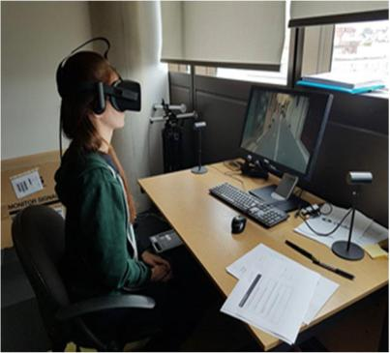

**Figure 2.12: Virtual reality tour participant testing the application using Oculus**

**2.11.4 Unreal Engine 4**

Unreal Engine 4 is a 3D game development framework with a more powerful and professional finishing engine, more geared towards AAA projects and companies, such as Square Enix, THQ, Sony Interactive Entertainment, Bandai Namco, etc, and an IDE more focused on designers than developers. Like Unity 3D, it can export to a wide range of systems, including Windows, MacOS, Android, iOS, PlayStation 4, Xbox One, and also has extensive support for virtual reality peripherals such as Oculus Rift, HTC Vive/SteamVR and Daydream. Besides, Unreal Engine 4 incorporates a VR Editor, which allows participant to design 3D scenarios using virtual reality headsets to design the VR within the VR. However, both the documentation and community of Unreal Engine 4 is smaller, and its asset store is much smaller and more expensive than Unity3D, which is a higher handicap.

43

**2.12 Related works**

Zhang, Liu, Kang, and Al-Hussein (2020) developed virtual reality applications for the built environment to find out the research trends and opportunities. The objective of the study is to systematically gain an in-depth understanding of research trends as well as reveal challenges and opportunities for future research in the area. To achieve this objective, the study synthesised the state-of-the-art in VR applications for the built environment by a mixed quantitative-qualitative review method. The study observed that substantial efforts devoted to VR-related applications in the architecture, engineering, and construction (AEC) industry over the last decades, had resulted in a vast, diverse, and fragmented body of knowledge. The study further found out that virtual reality advanced capabilities of immersive and interactive visualization.

Lemonia et al. (2020) created a system for 360-degree (360°) immersive video applications for Head Mounted Display (HMD) devices. A testbed application that provides an immersive interactive virtual tour of the historical district of the Greek island of Crete's capital city of Rethymno was developed. The study used a set of design principles for 360° immersive video virtual tours and conducted user trials on the testbed application. The system thus engaged experiential media solutions in cultural heritage education. The study discovered that while using virtual reality (VR) headsets, users frequently experience nausea or motion sickness and this has additional consequences on tasks involving moderate motion.

Pahlevi, Sayono, and Hermant (2021), designed a virtual tour to promote tourism during the pandemic. The study employed a research and development methodology in sequence by carrying out product analysis for future products; creating prototypes; expert validation and revision; small-scale field trials and product revisions; and field tests and finished product. The study found out through the field test results that users of virtual reality product can learn more about tourism-related activities, which makes it useful for assisting tourism promotion during the pandemic. In addition, the study discovered that virtual reality design can be used as a marketing communication tool.

Paszkiewicz et al (2021) published an article which listed the key benefits and drawbacks of VR-based education that could influence its application and user profile. A model of a training station using VR technology was created based on the suggested research methods that enable the realisation of training sessions in the area of

44

firefighting activities in a controlled production machine. The study demonstrated how training in a virtual environment might enhance participants' abilities and knowledge.

The study found out that creating and implementing suitable VR training programs lowers expenses while improving the productivity and safety of the employees.

Junyu et al. (2021) studied the potential of virtual tourism in the recovery of tourism industry during the COVID-19 Pandemic in China. The research explored how virtual tourism can aid the recovery of tourism industry during and after the pandemic. The exploration applied a mixed-methods approach. The results show that the use of virtual tourism can be partially explained by the theory of planned behaviour.

Moreover, virtual tourism was discovered to have a strong influence on people’s on-site destination choices and can be used as an effective marketing tool to promote destinations and a platform to sell souvenirs and products. Overall, the qualitative data suggested virtual tourism help in promoting sustainable tourism by reducing unnecessary greenhouse gas emissions from transportation and enhancing ‘virtual accessibility’ especially for the elderly and disabled people with limited mobility.

The research work of Alewi (2022) on virtual reality system tour of Mountain Top University allows prospective students and parent to view the schools premise with the use a mobile head mounted display (HMD). The study identified the various user and system requirements, specified the system design and implemented the system. The study employed informal interviews as research instrument. The system design was specified using UML diagrams; such are use case diagram and class diagram. The implementation of the system was done using C#, unity software and blender software.

The results of the system showed the implementation of the virtual reality environment for Mountain Top University admin section being viewed effectively with the use of head mounted display (HMDs). The study found out that using virtual reality system enables users (especially prospective visitors) to achieve a semi-realistic visual experience of Mountain Top University.

The study of Putrantoa, Heriyantoa, Achmada, & Kurniawana (2023) addressed the determination of the current state of virtual reality applications in sports. The study aims at determining insights into the current state of virtual reality applications in sports. A systematic search was performed in the most influential scientific electronic databases (such as Google Scholar) between 2010 to 2022. The study found out that the

45

most popular method to implement VR in sports education and training is using a head-mounted display (HMD) combined with a motion capture system. It was also observed that there was a significant increasing pattern of VR application in sports education and training.

The findings or results of the studies of some authors and scholars in related literature are presented in Table 2.1 as follows:

46

|  |  |  |  |  |  |  |  |  |  |  |  |  |  |  |  |  |  |  |  |  |
| --- | --- | --- | --- | --- | --- | --- | --- | --- | --- | --- | --- | --- | --- | --- | --- | --- | --- | --- | --- | --- |
|  | **Table 2.1:Summary table of some related literature reviewed** | | | | | |  |  |  |  |  |  |  |  |  |  |  |  |  |  |
|  |  |  |  |  | |  | | |  | |  |  |  |  | |  |  |  |  |  |
| **S/N** |  | **Author’s** | **Year** | **Title of Document** | | **Problem Addressed** | | | **Method Used** | | **Results** |  |  | **Remarks** | |  |  |  |  |  |
|  |  | **Name** |  |  |  |  |  |  |  |  |  |  |  |  |  |  |  |  |  |  |
|  |  |  |  |  | |  |  |  |  | |  |  | |  |  | | | |  | |
| 1. |  | Lemonia, A | 2020 | Design methodology | | Challenges | that | occur | Structured question- | | The study | discovered | | The | evaluation | | | | results | |
|  |  |  |  | for 360° immersive | | when using 360° video | | | naires | was | that while using virtual | | | indicated | |  | that | |  | the |
|  |  |  |  | video | applications: | applications | | VR | employed. |  | reality (VR) | | headsets, | methodology | | |  | followed | | |
|  |  |  |  | the case study of a | | headsets for virtual tour | | |  |  | users |  | frequently | for the design of the 360° | | | | | | |
|  |  |  |  | cultural | heritage |  |  |  |  |  | experience | nausea or | | immersive | | |  |  | video | |
|  |  |  |  | virtual tour | |  |  |  |  |  | motion sickness and this | | | Rethymno virtual tour led | | | | | | |
|  |  |  |  |  |  |  |  |  |  |  | has |  | additional | to | high | | level | | | of |
|  |  |  |  |  |  |  |  |  |  |  | consequences | | on tasks | engagement perceived by | | | | | | |
|  |  |  |  |  |  |  |  |  |  |  | involving |  | moderate | the | participants. | | | |  | The |
|  |  |  |  |  |  |  |  |  |  |  | motion. |  |  | immersion | | | level | |  | was |
|  |  |  |  |  |  |  |  |  |  |  |  |  |  | satisfying | |  |  |  |  | with |
|  |  |  |  |  |  |  |  |  |  |  |  |  |  | participants | | |  | feeling | | |
|  |  |  |  |  |  |  |  |  |  |  |  |  |  | comfortable | | | throughout | | | |
|  |  |  |  |  |  |  |  |  |  |  |  |  |  | the experience. | | | |  |  |  |
|  |  |  |  |  |  |  |  |  |  |  |  | | |  | | | | | | |
| 2 |  | Zhang, Y., Liu, | 2020 | Virtual | reality | Research | trends | and | Mixed | research | The study found out that | | | The study synthesized the | | | | | | |
|  |  |  | applications for the | | opportunities of virtual | | | method | of both | virtual reality advanced | | | state | of | the | art of | | | VR |
|  |  | H., Kang, S. C., |  |
|  |  |  | built | environment: | reality applications for | | | quantitativeand | | capabilities |  | of | technology for | | | | the | | built |
|  |  | Al-Hussein, M. |  |  |
|  |  |  | Research trends and | | the built environment | | | qualitative | review | immersive |  | and | environment | | |  |  |  | and |
|  |  |  |  |  |  |  |  |
|  |  |  |  | opportunities. | |  |  |  | was adopted. | | interactive |  |  | exposing | | its | | research | | |
|  |  |  |  |  |  |  |  |  |  |  | visualization. | |  | needs, which | | | | can | serve | |
|  |  |  |  |  |  |  |  |  |  |  |  |  |  | both | academia | | | |  | and |
|  |  |  |  |  |  |  |  |  |  |  |  |  |  | industry | | in |  | terms | | of |
|  |  |  |  |  |  |  |  |  |  |  |  |  |  |  |  |  |  |  |  |  |

47



3

4

|  |  |  |  |  |  |  |  |  |  |  |  |  |  |  |  |  |  |  |  |  |  |
| --- | --- | --- | --- | --- | --- | --- | --- | --- | --- | --- | --- | --- | --- | --- | --- | --- | --- | --- | --- | --- | --- |
|  |  |  |  |  |  |  |  |  |  |  |  |  |  |  |  |  |  |  | promoting |  | VR |
|  |  |  |  |  |  |  |  |  |  |  |  |  |  |  |  |  |  |  | applications for the built | | |
|  |  |  |  |  |  |  |  |  |  |  |  |  |  |  |  |  |  |  | environment. | |  |
| Pahlevi, | A, | S; | 2021 | Design | of | a virtual | Challenges of engaging | | | | The study | | found | The study further found | | | | |  |  |  |
| Sayono, | J. | & |  | tour as a solution for | | | in physical | | tourism | | that users of virtual | | | out | that | virtual reality | | |  |  |  |
| Hermanto, | | Y. |  | promoting | | the | during the | |  |  | reality | product can | | advanced capabilities of | | | | |  |  |  |
| A. L |  |  |  | tourism sector in the | | | pandemic | |  |  | learn | more | about | immersive | | |  | and |  |  |  |
|  |  |  |  | pandemic period | | |  |  |  |  | tourism-related | | | interactive | | |  |  |  |  |  |
|  |  |  |  |  |  |  |  |  |  |  | activities, | | which | visualization. | | |  |  |  |  |  |
|  |  |  |  |  |  |  |  |  |  |  | makes | it useful for | |  |  |  |  |  |  |  |  |
|  |  |  |  |  |  |  |  |  |  |  | assisting | | tourism |  |  |  |  |  |  |  |  |
|  |  |  |  |  |  |  |  |  |  |  | promotion | | during |  |  |  |  |  |  |  |  |
|  |  |  |  |  |  |  |  |  |  |  | the pandemic. | | |  |  |  |  |  |  |  |  |
| Paszkiewicz | | et | 2021 | VR |  | education | The area of firefighting | | | | Digital | methods | | The study found out that | | | | | Students | with | physical |
| al. |  |  |  | support | system: A | | activities that | |  |  | (VR) and traditional | | | creating | |  |  | and | limitations | and | learning |
|  |  |  |  | case study of digital | | | should | be carried | | out | methods (a sheet of | | | implementing | | | suitable | | challenges | shouldn't be | |
|  |  |  |  | circuits design | | | during | the | hazard | | paper, a simulator of | | | VR | training | | programs | | excluded from the survey | | |
|  |  |  |  |  |  |  | arising | from | | the | 2D logic circuits) | | | reduced | | expenses, | | as | at all since it’s a VR | | |
|  |  |  |  |  |  |  | operation | | of | a |  |  |  | well | as | improved | | the | Education |  | Support |
|  |  |  |  |  |  |  | numerically controlled | | | |  |  |  | productivity and safety | | | | | System |  |  |
|  |  |  |  |  |  |  | production machine | | |  |  |  |  | of the employees. | | | |  |  |  |  |
|  |  |  |  |  |  |  |  |  |  |  |  |  |  |  |  |  |  |  |  |  |  |



48



5

6

7

|  |  |  |  |  |  |  |  |  |  |  |  |  |  |  |  |  |  |  |  |  |  |  |  |
| --- | --- | --- | --- | --- | --- | --- | --- | --- | --- | --- | --- | --- | --- | --- | --- | --- | --- | --- | --- | --- | --- | --- | --- |
| Junyu, |  | L., | 2021 | The potential | | of | Factors | | influencing | | | The study employed | | The study | | | discovered | | virtual tourism | | | can | help |
| Xiao, |  | X., |  | virtual tourism in the | | | people’s | | acceptability | | | mixed-methods | | that | virtual | | | tourism | promote | | sustainable | | |
| Zixuan, |  | X., |  | recovery | of tourism | | in |  |  |  |  | approach |  | (which can be partially | | | | | tourism | |  |  |  |
| Chenqi, | W., | |  | industry | during | the | using | virtual | | tourism | |  |  | explained | | |  |  | by reducing unnecessary | | | | |
| Meixuan, Z., & | | |  | COVID-19 | |  | during the pandemic in | | | | |  |  | by the theory of planned | | | | | greenhouse gas emissions | | | | |
| Yang, Z. |  |  |  | Pandemic. | |  | China and how | | |  |  |  |  | behaviour) has a strong | | | | | from transportation | | | |  |
|  |  |  |  |  |  |  | virtual tourism can aid | | | | |  |  | influence | | on | | people’s | and | enhance | | ‘virtual | |
|  |  |  |  |  |  |  | the recovery of tourism | | | | |  |  | on-site |  |  | destination | | accessibility’ | |  | especially | |
|  |  |  |  |  |  |  | industry | | during | | and |  |  | choices and can be used | | | | | for | the elderly | | | and |
|  |  |  |  |  |  |  | after |  |  |  |  |  |  | as an |  |  |  |  | disabled | |  |  |  |
|  |  |  |  |  |  |  | the |  | COVID-19 | | |  |  | effective marketing tool | | | | | with limited mobility. | | | | |
|  |  |  |  |  |  |  | pandemic. | |  |  |  |  |  | to promote destinations | | | | |  |  |  |  |  |
|  |  |  |  |  |  |  |  |  |  |  |  |  |  | and a platform to sell | | | | |  |  |  |  |  |
|  |  |  |  |  |  |  |  |  |  |  |  |  |  | Souvenirs and products. | | | | |  |  |  |  |  |
| Alewi, O. P. | |  | 2022 | Design |  | and | How | to help | | potential | | Systematic | review | The study found out that | | | | | The |  |  | outcome | |
|  |  |  |  | implementati on of a | | | visitors in the trip- | | | | | method | was | using the virtual reality | | | | | demonstrated | |  |  | that |
|  |  |  |  | virtual | reality | tour | planning | | and | activity | | employed |  | system |  | enables users | | | Mountain Top University | | | | |
|  |  |  |  | system for | |  | planning | | processes | | to |  |  | (especially | | | prospective | | could | easily | conduct a | | |
|  |  |  |  | MTU environment | | | Mountain | |  | Top | |  |  | visitors) | | to |  | achieve a | virtual reality tour. | | | |  |
|  |  |  |  |  |  |  | University | | using | | VR |  |  | semi-realistic | | | | visual |  |  |  |  |  |
|  |  |  |  |  |  |  | and |  | panorama | | |  |  | experience of Mountain | | | | |  |  |  |  |  |
|  |  |  |  |  |  |  | technology. | | |  |  |  |  | Top University. | | | | |  |  |  |  |  |
| Putrantoa, J. S, | | | 2023 | Implementation | | of | The study addressed the | | | | | A systematic search | | The study found out that | | | | | It was observed that there | | | | |
| Heriyantoa, |  | J., |  | virtual | reality | | determination | | | of | the | of | scientific | the | most | |  | popular | was | a | significant | | |
|  |  |  |  |  |  |  |  |  |  |  |  |  |  |  |  |  |  |  |  |  |  |  |  |



49



Achmada, K.

S.,

Kurniawana, A.

technology for sports

education and training:

Systematic

literature review.

current state of virtual reality applications in sports



electronic databases

(e.g., Google Scholar) between 2010 to 2022 was employed

method to implement VR in sports education and training is using a head-mounted display (HMD) combined with a motion capture system.

increasing pattern of VR application in sports education and training.

50



**CHAPTER THREE**

**METHODOLOGY OF THE STUDY**

This chapter establishes the research procedures to be applied in achieving the objectives stated in the introductory chapter of this study. The methodology discusses the research methods for identifying system and user requirements, the system design methods to be employed, and the system implementation method to be adopted in a virtual tour application for Mountain Top University’s visitors from the College of Humanities, Management and Social sciences (CHMS) junction to the Cafeteria of the University.

**3.1** **Methods for identifying user and system requirements**

The user and system requirements of the software system will be identified in this study by using a systematic review method for identifying user and system requirements. In the course of development of the virtual tour application system, the user requirements to be employed include the basic user requirements and the system admin requirements. While the research method that will be adopted for identification of system requirements in this study includes functional requirements, non-functional requirements, hardware requirements, and software requirements.

**3.2** **Identification of user requirements**

The method for identification of user requirements will address the basic user’s requirements and system admin requirements.

**3.2.1** **Basic user requirements**

The basic users of this system are the potential students, potential staff, potential external examiners, parents to the existing students, investors and potential visitors of these stakeholders (students, staff, external examiners, investors). These users view the same interface but can elect to perform the same operations or different operations on the interface. The users can view the VR world with the use of the mobile head mounted display.

51

**3.2.2** **System admin requirements**

The system admin can register and assign roles to the users (potential students, potential staff, potential external examiners, parents to the existing students, investors and potential visitors of these stakeholders (students, staff, external examiners, investors)). The system admin has the privilege of viewing all the interaction on the interface.

**3.3** **Identification of system requirements**

This sub-division discusses the functional and non-functional requirements of the system being developed. It also addresses the hardware and software requirements for the development of the system.

**3.3.1** **Functional requirements**

The functional requirements describe the services the software must offer.

These include:

i. Users should be able to tour round the environment.

ii. Users should be able to view the VR world in a 360-degree perspective.

**3.3.2** **Non-functional requirements**

The non-functional requirements specify criteria that can be used to judge the operation of the system. The non-functional requirements of the system include:

i. Usability: the system will be implemented in such a way that the user would be able to operate it independently or with little assistance.

1. Response time / speed: Immediately response to the request made to the system and the system ability to display the correct output.

**3.3.3 Hardware requirements**

The mobile phone require for the VR tour should be an android phone or iPhone device, that have a minimum of 4GB memory, a minimum of 32GB storage space, a display of 1080 pixels, good battery life, and a mobile VR head gear.

**3.3.4 Software requirements**

The software requires to implement the VR tour includes; Blender, Unity engine, Windows operating system from 8 and above, C# programming language, three dimensional (3d) model of Mountain Top University environment.

52

**3.4** **System design methods**

The system design methods will employ relevant Unified Modeling Language (UML) diagrams such as use-case diagram, sequence diagram, class diagram, and activity diagram. The system architecture will also be designed and discussed in this sub-section. The UML diagrams to be used in designing the system portray the various functions that are available on the system and how they will be employed by the users of the system.

**3.4.1** **Use-case diagram**

A use-case model is a representation of a system's intended functions and its surroundings.

Use case diagrams model the functionality of a system using actors and use case. The actors and their objectives are expressed as use cases and the diagram model any relationships between those use cases. Use case diagram is used to represent the dynamic behaviour. It also acts as a contract between the developer and the consumer.

Basically use case diagrams represent the relationship between actors, use case and system. The use case diagram in Figure 3.1 presents users of the system and the various actions that they can perform on the system. System boundary is portrayed using rectangle that contains use cases. Actors are placed outside the system's boundaries. In Figure 3.1 the different roles of the actors, and conditions for each actor to perform the various activities and for those activities to be termed as successful will be discussed.

Table 3.1 illustrates the assigned role use case for one user. The User mounts the head mounted display, and then is able to view the VR world and navigate through.

While Table 3.2 narrates the user use case, for which the user is the actor. In Table 3.3 the 3d environment use case is portrayed. The user will be able to view the environment in a 360-degree view with an indicator. Table 3.4, describes the navigation around the environment use case. The user will navigate or tour around the 3d environment from one point to another point and then stops. While Table 3.5 depicts the end simulation use case, when the user is able to end the tour.

53

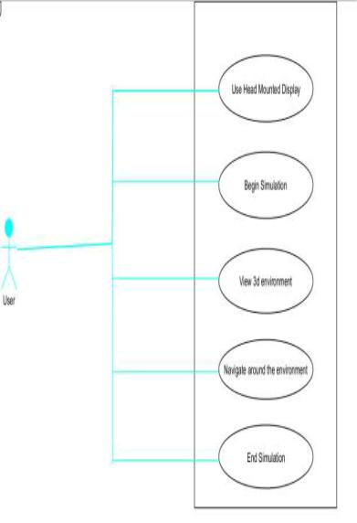

**Figure 3.1 : Use case diagram of the system**

54

**Table 3.1 : Use Head Mounted Display**

|  |  |
| --- | --- |
| Use case Name | Use Head Mounted Display |
|  |  |
| Actors | User |
|  |  |
| Flow of Events | • User put on the head mounted display |
|  | • User manoeuvres to the begin simulation interface |
|  |  |
| Entry Condition | User must possess a mobile head mounted display and a |
|  | mobile phone fitted together |
|  |  |
| Exit Condition | The user able to view the interface successfully |
|  |  |
| Quality | User must fit the head mounted display on at all times during |
| Requirements | the simulation |
|  |  |

55



**Table 3.2 : Begin simulation**

|  |  |
| --- | --- |
| Use case Name | Begin Simulation |
|  |  |
| Actors | User |
|  |  |
| Flow of Events | • User interacts with the start simulation button |
|  |  |
| Entry Condition | User must possess a mobile head mounted display and a mobile phone |
|  | fitted together |
|  |  |
| Exit Condition | The user able to commence the VR simulation successfully |
|  |  |
| Quality | User must fit the head mounted display on at all times during the |
| Requirements | simulation |
|  |  |

56





**Table 3.3 : View 3d environment**

|  |  |
| --- | --- |
| Use case Name | View 3d environment |
|  |  |
| Actors | User |
|  |  |
| Flow of Events | User tours around the virtual environment |
|  |  |
| Entry Condition | User must possess a mobile head mounted display and a mobile phone |
|  | fitted together |
|  |  |
| Exit Condition | The user able to view simulation successfully |
|  |  |
| Quality | User must fit the head mounted display on at all times during the |
| Requirements | simulation |
|  |  |

57





**Table 3.4 : Navigate around the environment**

|  |  |
| --- | --- |
| Use case Name | Navigate around the environment |
|  |  |
| Actors | User |
|  |  |
| Flow of Events | User tours around the virtual environment |
|  |  |
| Entry Condition | User must possess a mobile head mounted display and a mobile phone |
|  | fitted together |
|  |  |
| Exit Condition | The user able to tour round the simulation successfully |
|  |  |
| Quality | User must fit the head mounted display on at all times during the |
| Requirements | simulation |
|  |  |

58





**Table 3.5 : End simulation**

|  |  |
| --- | --- |
| Use case Name | End simulation |
|  |  |
| Actors | User |
|  |  |
| Flow of Events | • User simulation experience will be bought to an end |
|  |  |
| Entry Condition | User must possess a mobile head mounted display and a mobile phone |
|  | fitted together |
|  |  |
| Exit Condition | The user able to tour round the simulation successfully |
|  |  |
| Quality | User must fit the head mounted display on at all times during the |
| Requirements | simulation |
|  |  |

59



**3.4.2** **Sequence diagram**

Sequence diagrams will be used to depict how processes communicate with one another and in what sequence. Sequence diagrams contain object/class that shows the object/class involved in the interaction and messages that portray an exchange between the objects and execution occurrence. It shows the internal component and the user involved in the process. Sequence diagrams will be used to portray how objects interact to complete all or part of a use case's action.

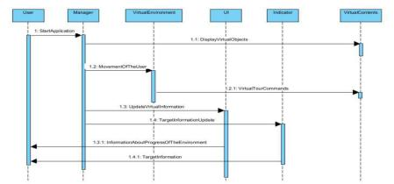

**Figure 3.2 : Sequence diagram of the virtual reality tour**

Figure 3.2 describes the activity of the virtual reality tour. When the User sends a request to the manager the application starts, the manager sends a request to the VirtualContents which stores all virtual objects to display the virtual objects (the 3d objects). The manager sends a request to the VirtualEnvironment which enables the user to be ready to move when the VirtualEnvironment requests a virtual Tourcommand which allows the user to tour round the environment. The Manager requests from the User Interaction (UI) which then updates the information of the environment during interaction. Thereafter, the manager requests from the indicator which then updates any information about any target or object. The indicator responds to the user and allows the user to view any target.

60

**3.4.3** **Activity diagram**

Activity diagram is visual representations of steps, actions, and activities. It is graphical representations of how things work and what they look like. Activity diagram shows the process from beginning to end, illustrating the many choice routes that exist as the activity unfolds. It describes the flow of activity of the system.

Activity diagram will be used to characterize scenarios in which parallel processing is feasible while certain tasks are being completed.

Once a user requests to log in, if the request was successful, the user logs in to their account in the specific roles. If the login was unsuccessful, the user is prompted to try again. Whenever a user successful log in, the user will be able to perform assign roles.

**3.4.4 Class diagram**

Unified Modelling Language (UML) class diagrams describes the structure of a system by showing the system’s classes, their attributes, and the relationships among the classes. It illustrates the relationship between the system entities and the attributes of each of these entities represent columns of the tables that they model in the system.

The class diagram contains methods that are used for performing different operations and objects of the class. It shows the system's classes, properties, and connections among the classes to illustrate the structure of the system. The user class comprises properties that define the user of the system (potential students, potential staff, potential external examiners, parents to the students, investors and potential visitors to these stakeholders). Figure 3.3 presents the system class diagram.

**3.4.5** **System architecture**

The software requirement specification employed as input to design the system architecture of the software product which is being developed. Initially more than one architecture will be designed and thereafter reviews by important stakeholders according to criteria like risk assessment, robustness, design modularity, time and cost.

The best design will then be selected for the software architecture. The system software architecture can be documented with the structural diagrams.

61

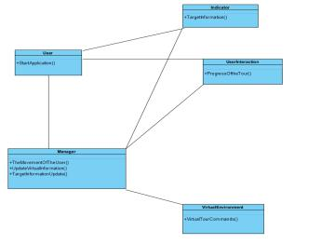

**Figure 3.3 : System class diagram**

**3.5** **System implementation**

The system was implemented using several technologies and languages. System implementation was accomplished with the use of third dimensional (3d) Modelling.

**3.6** **Three dimensional (3d) modelling**

The three dimensional (3d) model will be implemented using Blender Software, while Unity engine software, and C# will be used for the arrangement of 3d objects and tour system.

**3.6.1 Blender software**

Blender software designed and created by Ton Roosendaal for modelling, lighting, animation, video editing, rendering and creation of virtual scenarios was used in creating Mountain Top University 3d model. Blender has extensive documentation, and generally very focused on modelling and design. Its 3D computer graphics toolkit is free and open-source. The 3D computer graphics toolkit Blender can be used to make animated movies, visual effects, artwork, 3D-printed models, motion graphics, interactive 3D apps, virtual reality, 3D modeling, UV mapping, texturing, rendering, motion graphics, video editing, and compositing. It was used primarily for editing and

62

modelling virtual reality of Mountain Top University tour from College of Humanities, Management and Social sciences (CHMS) junction to the cafeteria.

**3.6.2** **Unity engine software**

The unity engine software was used for the implementation of the touring system and the functionalities of the system. This is because unity engine has great support for virtual reality peripherals, both native and external using 3rd party SDKs such as Oculus Rift, HTC Vive/ SteamVR, Ximmerse, Leap Motion, Google Cardboard/Daydream, and so on. In addition, it allows people to export it to a wide range of platforms, including Windows, Linux, MacOS, Android, iOS, PlayStation 4, XBox One. Also, unity engine software IDE can be extended through a specific API for the creation and support of plugins, which allows extension of its functionality and its adjustment to the needs of each developer and/or project. Moreover, Unity 3D personal license allows for free and unlimited use for personal or educational development (Lombardo et al., 2018).

Unity 3D is a framework for the creation of application and video games 2D/3D, with strong support from major technology and software partners such as Facebook, Google, Intel, Microsoft, Nintendo, Samsung, Sony and so on. The unity engine software was initially used to develop 3D and 2D games, as well as interactive simulations and other types of experiences. Besides video games, the engine has been used in the film and automobile sectors, as well as in architecture, engineering, construction, and the United States military. Unity engine software has great support for virtual reality peripherals, both native and external using 3rd party SDKs such as Oculus Rift, Leap Motion, Google and so on. The strength of Unity 3D includes its extensive documentation, a large and growing community, along with a large asset store where you can find all kinds of high quality resources for free or payment.

**3.6.3** **C# programming language**

The C# programming language will be used for implementing some parts of the system, with scripts used for the interaction and user interface. C# is a multi-paradigm programming language that can be used for any purpose. Due to its support for a wide range of programming, object oriented (class-based) and component-oriented programming can all be done with C#. Basically, C# programming language supports a wide range of programming, including imperative, declarative, functional, and

63

generic. Moreover, there are several open-source alternatives to Microsoft's Visual Studio Code, such as Roslyn and the Unified.NET Platform, that support C# and are freely available across multiple platforms.

64

**CHAPTER FOUR**

**RESULTS AND DISCUSSION**

This chapter covers the Virtual Reality Tour system's result and provides a description of the results obtained. This section covers the end result of the system implemented with the use of Unity, C# and the models were implemented using **-** blender. Additionally, the result will be a mobile application and deployed as an android application.

**4.1 Result of the main virtual reality tour**

Figure 4.1 shows the result of the bridge used to access the cafeteria. Figure 4.2 shows a view of looking back from the point of ascending the access bridge. Figure 4.3 shows the result of MTU river and an overview of the school’s cafeteria. Figure 4.4 shows the result of the bridge. It shows the view of the access bridge upon descent before crossing the river in order to make ascent to the cafeteria. Figure 4.5 shows the view of the front of the cafeteria upon ascending the access bridge. Figure 4.6 shows the view of the kitchen which lies on the right. Figure 4.7 shows results of the front of the relaxation points which is located in front of the cafeteria Figure 4.8 shows the view of the kitchen corridor upon accessing the cafeteria. Figure 4.9 shows a view of the slope at the point of ascending the access bridge from thr kitchoen corridor.

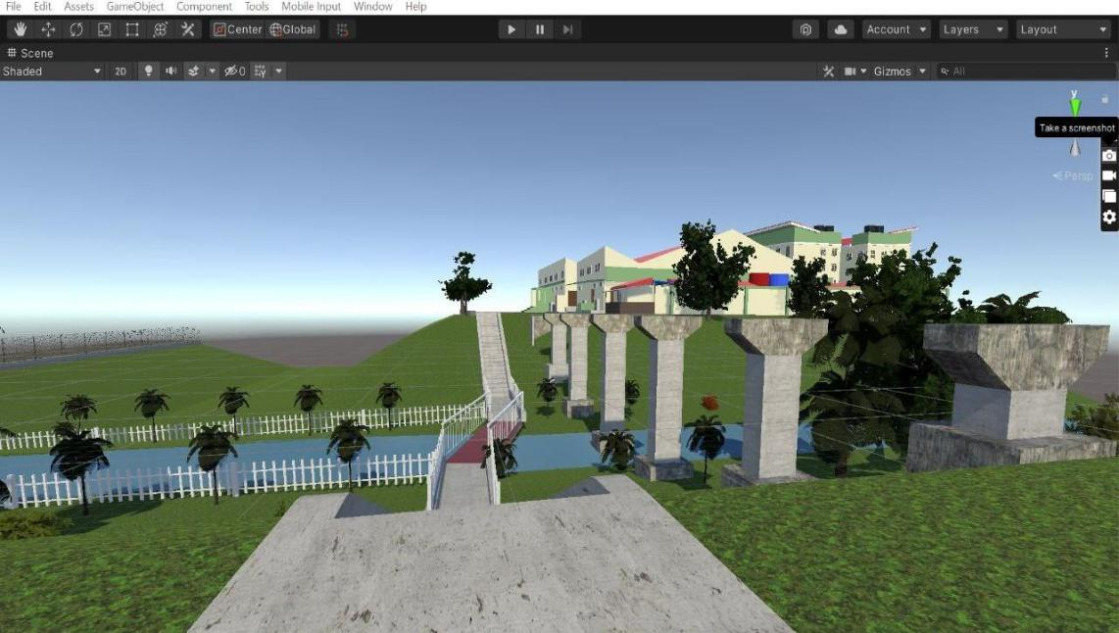

**Figure 4. 1 View of the staircase used to access the cafeteria**

65

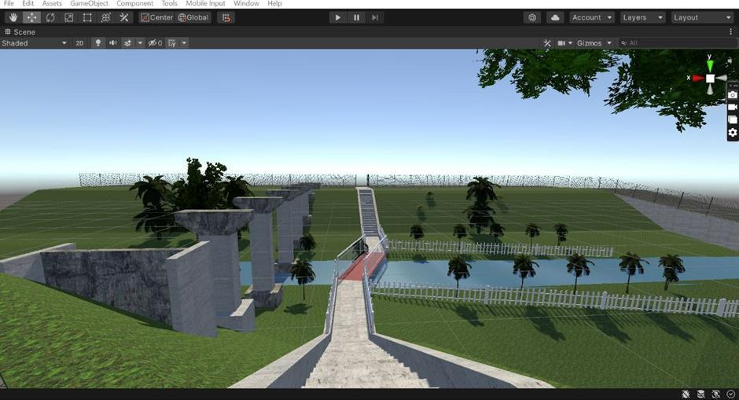

**Figure 4.2: View of cafeteria upon crossing the Bridge**

66

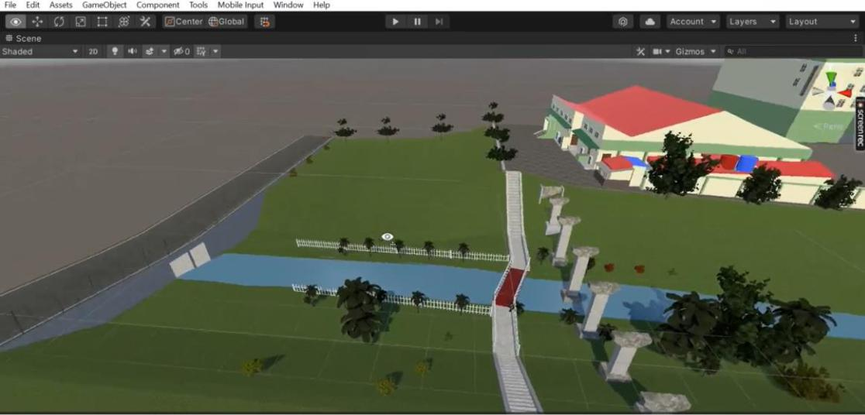

**Figurre 4.3: MTU River**

67

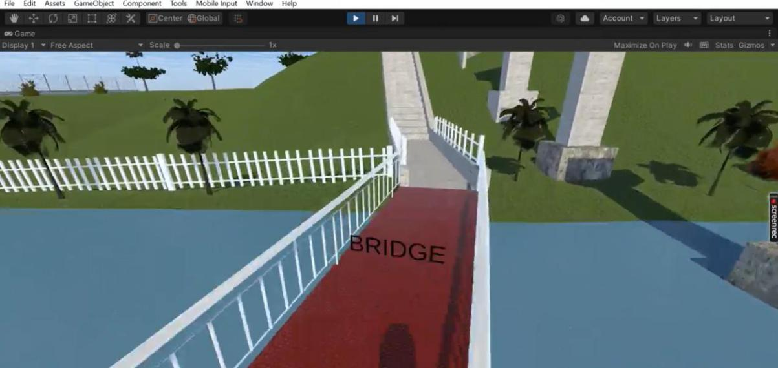

**Figure 4.4: View of the bridge used to access the cafeteria**

68

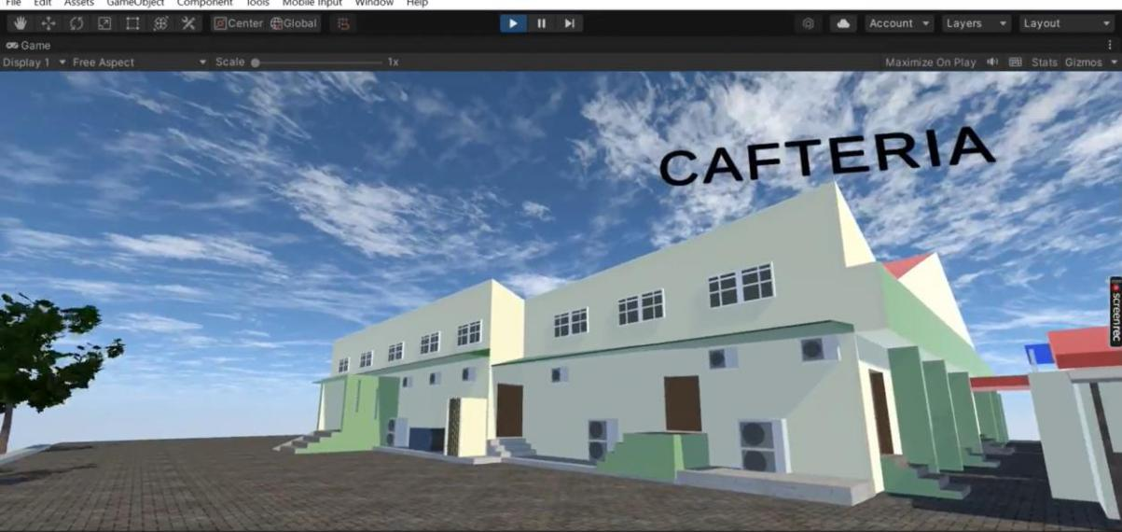

**Figure 4.5 : MTU Cafeteria**

69

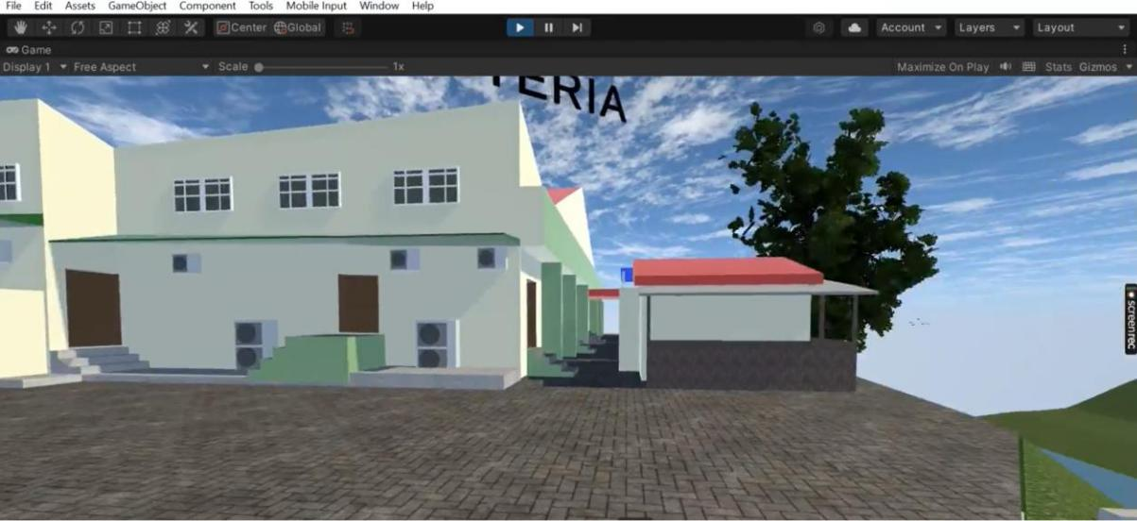

**Figure 4.6 : MTU cafeteria**

70

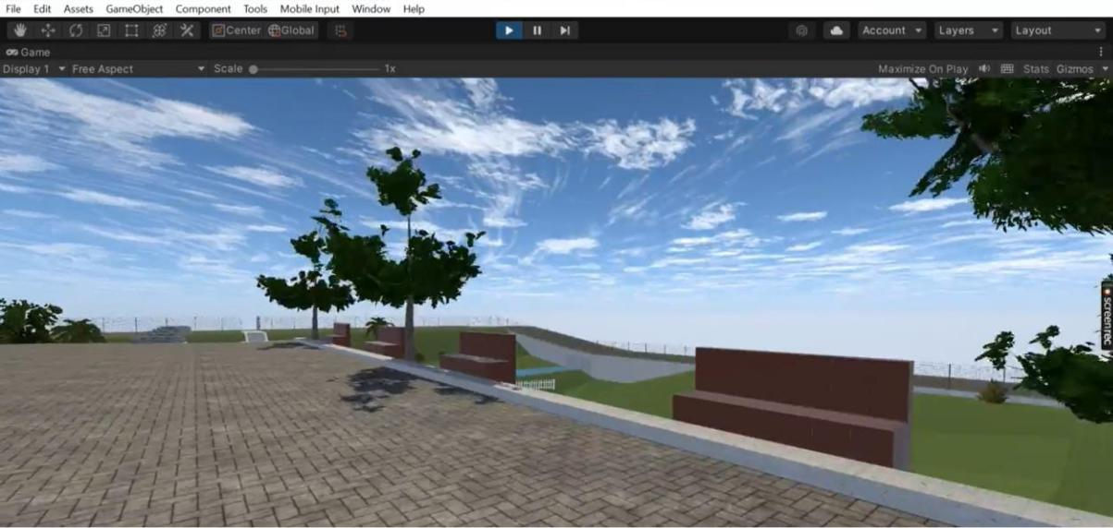

**Figure 4.7 : View of Relaxation points**

71

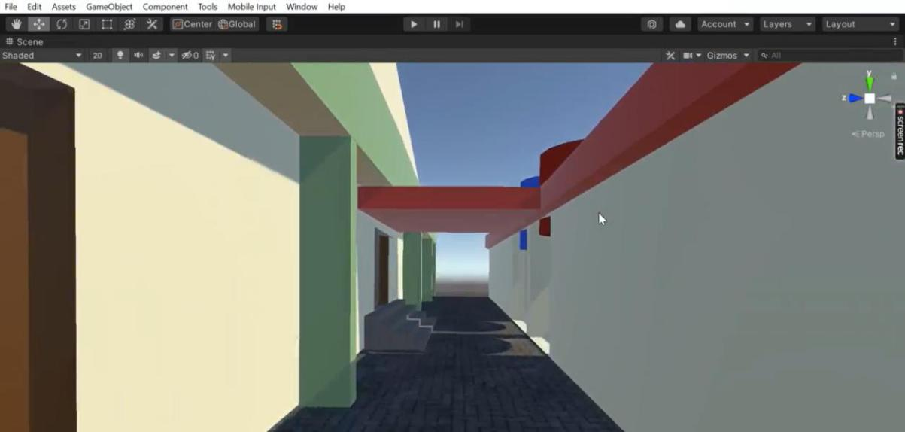

**Figure 4.8 : Cafeteria Kitchen corridor**

72

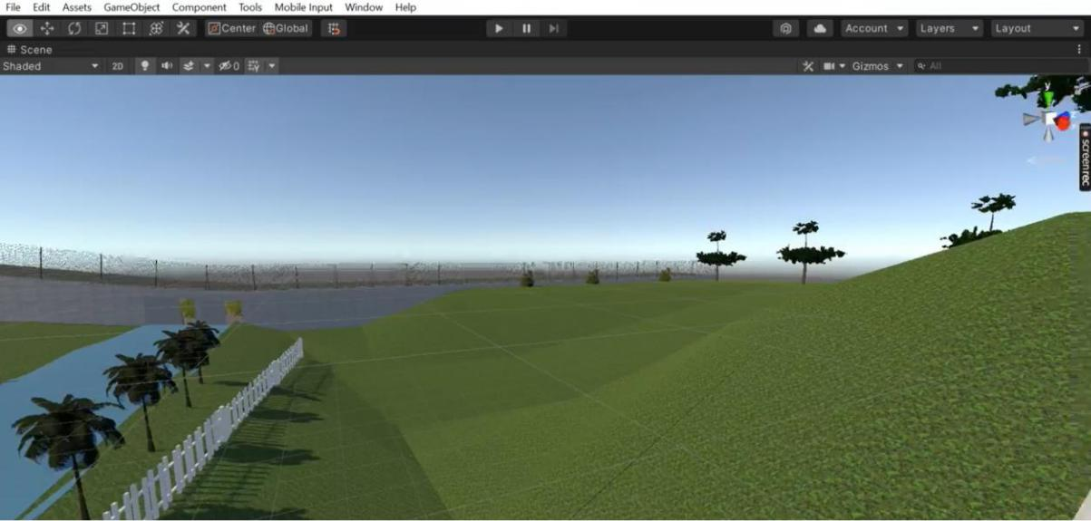

**Figure 4.9 The Slope**

73

**4.2** **Discussion of results**

Based on the objectives that were initially stated for this study, the result of the study on the topic Virtual Tour Application presented an expected result. The system definition was aided by the results of user and system requirements. The result showed that implementing a virtual tour application for mountain top university was definitely feasible. Hence it is safe to say that the result of this system presents a solution to the virtual reality tour system for mountain top university.

74

**CHAPTER FIVE**

**SUMMARY, CONCLUSION AND RECOMMENDATION**

**5.1** **Summary**

This study developed a Virtual tour application that enables users to explore CHMS junction to Mountain Top University cafeteria using a mobile phone and headgear which will tour the user around the school giving them a perspective of how it looks. The user and system requirements that were necessary to be met by the system were identified alongside the software and hardware requirements of the system during this study. The requirements were also specified using UML diagrams such as use case diagram, sequence diagrams, and a class diagram for user requirement and system modeling respectively. The system was developed using C# and unity engine and the model of the school was done using blender software.

**5.2** **Conclusion**

In conclusion, this study has designed and implemented a Virtual reality tour application that addresses the problems of users wanting to know what the university looks like. The study was able to identify the various constraints that characterized this process and by this define the system and user requirements. In order to match the expected functions of the proposed system, the designs of this system were also sufficiently detailed with pertinent UML diagrams. This study also demonstrated that it is possible to design a virtual reality tour application for mountain top university.

**5.3** **Recommendation**

The study recommends that additional work should be done in this area to incorporate different features, and also add other sectors of the university such as female hostels and to also update the system from a mobile application to a standalone virtual reality system in order to accept larger updates.

75

**References**

Abdullahi, Y. E., & Ogwueleka, F. N. (2017). A software system development life cycle model for improved students’ communication and collaboration. *International Journal of Computer Science and Engineering Survey (IJCSES*), 8(4), 1-10

Agnes M. (2003). *Webster's new world college dictionary*. New York: John Wiley & Sons Incorporated.

Alewi, O. P (2022). Design and implementation of a virtual reality tour system for MTU environment. Unpublished B.Sc Project, Mountain Top University, Ibafo, Ogun State, Nigeria.

Anderson, E. F., McLoughlin, L., Liarokapis, F., Peters, C., Petridis, P., & de Freitas, S.

(2010). Developing serious games for cultural heritage: A state-of-the-art review. Virtual Reality, 14(4), 255–275. https://doi.org/10.1007/s10055-010-0177-3

Arnold, D. (2005). Virtual tourism – A niche in cultural heritage. In M. Novelli (Ed.), Niche

tourism: Contemporary issues, trends, and cases (pp. 223–231). Routledge.

<https://doi.org/10.4324/9780080492926>

Balogun, V., Thompson, A., & Sarumi, O. A. (2010). A 3D Geo-Spatial virtual reality system

for virtual tourism. The Pacific Journal of Science and Technology, 601-609.

Barjtya, S., Sharma, A., & Rani, U. (2017). A detailed study of software development life

cycle (SDLC) models. *International Journal of Engineering and Computer Science*, 6(7), 22097-22100. doi:10.18535/ijecs/v6i7.32.

Beck, K. (2000). *Extreme programming explained: Embrace change*. MA: Addison

Wesley

Longman, Inc.

Beck, J., Rainoldi, M., & Egger, R. (2019). Virtual reality in tourism: A state-of-the-art review. Tourism Review, 74(3), 586–612. <https://doi.org/10.1108/tr-03-2017-0049>

76

Bindia, T. (2019). A review on models of software development life cycle. *CITS*, 3, 60-

68.

doi:10.31058/j.data.2019.34002.

Booch, G., Rumbaugh, J., & Jacobson, I. (2005). The unified modeling language user guide

(2nd ed.). MA: Addison Wesley

Boud, A. C., Haniff, D. J., Baber, C., & Steiner, S. J. (1999). Virtual reality and augmented

reality as a training tool for assembly tasks. *In Proceedings of IEEE International Conference on Information Visualization,* 32–36.

Burdea, G. C., & Coiffet, P. (2003). Virtual reality technology . Wiley

Carrozzino, M., & Bergamasco, M. (2010). Beyond virtual museums: Experiencing immersive virtual reality in real museums. Journal of Cultural Heritage, 11(4), 452– 458.

<https://doi.org/10.1016/j.culher.2010.04.001>

Cheong. R. (1995). The virtual threat to travel and tourism. *[Tourism](https://www.cabdirect.org/cabdirect/search/?q=do%3a%22Tourism+Management%22)*

*[Management](https://www.cabdirect.org/cabdirect/search/?q=do%3a%22Tourism+Management%22)*16(6),

417-427.

Coelho, C., Tichon, J. G., Hine, T. J., Wallis, G. M., & Riva, G. (2006). Media presence and

inner presence: The sense of presence in virtual reality technologies (pp. 25–45). From

Communication Topresence: Cognition, emotions and culture towards the ultimate communicative experience.

Creately (2021, July 8). The easy guide to UML deployment diagrams. Retrieved from creately.com: <https://creately.com/blog/diagrams/deployment-diagramtutorial/>

De Lucia, A., Francese, R., Passero, I., & Tortora, G. (2009). Development and evaluation of

a virtual campus on Second Life: The case of Second DMI. *Computers & Education*, 52(1), 220– 233.

77

Dickey, M. D. (2005). Brave new (interactive) worlds: A review of the design affordances

and constraints of two 3D virtual worlds as interactive learning environments.

*Interactive Learning Environments, 13*(1-2), 121-137.

Dieker, L. A., Rodriguez, J. A., Lignugaris/Kraft, B., Hynes, M., & Hughes, C. (2014). The

potential of simulated environments in teacher education: Current and future possibilities. *Teacher Education and Special Education, 37*(1), 21-33.

Er. Singh, D., & Sidhu, H. S. (2018, June). A scrutiny study of various unified modeling language (UML) diagrams, software metrics tool and program slicing technique. *Journal of Emerging Technologies and Innovative Research (Jetir),* 5(6), 254-262.

Ergasheva, S., & Kruglov, A. (2007, January). Software development life cycle early phases

and quality metrics: A systematic literature review. *Information Technologies, Telecommunications and Control Systems*, 1694(2020).Doi:10.1088/1742-6596/1694/1/012007

Fisher, S. S., McGreevy, M., Humphries, J., & Robinett, W (1987). Virtual environment display system, *Proceedings of the 1986 workshop on Interactive 3D graphics*, pp.77-87.

Franklin, T., & Arnetta, L. (2011). Digital games and simulations in teacher preparation.

*Journal of Technology and Teacher Education, 19*(3), 239-242.

Gibson, A., & O’Rawe, M. (2018). Virtual reality as a travel promotional tool: Insights from

a consumer travel fair. In T. Jung, & M. C. tom Dieck (Eds.), Augmented reality and virtual reality: Empowering human, place and business (pp.93–107). Springer International Publishing. <https://doi.org/10.1007/978-3-319-64027-3_7>

González-Rodríguez, M. R., Díaz-Fernández, M. C., & Pino-Mejías, M. Á. (2020). The impact of virtual reality technology on tourists’ experience: a textual data analysis*. Soft Computing.* doi:10.1007/s00500-020-04883-y

78

Griffin, T., Giberson, J., Lee, S.H., Guttentag, D., Kandaurova, M., Sergueeva, K. and Dimanche, F. (2017). Virtual reality and implications for destination marketing”, Travel

and tourism research association. *Advancing Tourism Research Globally*, 29.

Guttentag, D. A. (2010). Virtual reality: Applications and implications for tourism. *Tourism*

*Management*, 31(5), 637-651.

Gutierrez, M., Vexo, F., & Thalmann, D. (2008). *Stepping into Virtual Reality*. London:

Springer Science & Business Media.

Harish, R., & Syan, M. (2012). Ananlysis of agile and traditional approach for software development. *International Journal of Latest Trends in Engineering and Technology*, 1(4), 1-3.

Huang, Y. C., Backman, S.J., Backman, K. F., & Moore, D. (2013). Exploring user acceptance of 3D virtual worlds in travel and tourism marketing. Tourism Management, 36, 490–501.

Huang, Y. C., Backman, K. F., Backman, S. J., & Chang, L. L. (2016). Exploring the implications of virtual reality technology in tourism marketing: An integrated research framework. *International Journal of Tourism Research*, 116-128.

Hui-Zhen, R., & Zong-Fa, L. (2013). Application and prospect of the VR technology in

college ideological education. *Intelligent Systems Design and Engineering Applications Fourth International Conference* 125–128.

Jagannathan, S.

(2017).

**Virtual-reality-future-immersive-learning-**

**development.** Opgehaald

van blogs.worldbank.org: [https://blogs.worldbank.org/publicsphere/virtual-reality-future-immersive-learning-development](https://blogs.worldbank.org/publicsphere/virtual-reality-%20%20%20%20%20%0d%20%20%20%20%20%20%20%20%20%20%20future-immersive-learning-development)

Jiujiu, Y. (2018). Research process on software development model. IOP conference series.

*Materials Science and Engineering*. IOP Publishing Ltd.

doi:10.1088/1757-899X/394/3/032045.

79

Junyu, L., Xiao, X., Zixuan, X., Chenqi, W., Meixuan, Z., & Yang, Z. (2021). The potential

of virtual tourism in the recovery of tourism industry during the COVID-19 pandemic, Current Issues in Tourism, DOI: 10.1080/13683500.2021.1959526

Kapp, K. M., & O’Driscoll, T. (2010). *Learning in 3D: Adding a new dimension to enterprise*

*learning and collaboration.* San Francisco: Pfeiffer.

Kazim, A. (2017). A study of software development life cycle process models. *International*

*Journal of Advanced Research in Computer Science*, 8 (1), 15-23

Khan, M., Shadab, S., & Khan, F. (2020). Empirical study of software development life cycle

and its various models. *International Journal of Software Engineering* (IJSE), 8(2), 16-26.

Kim, M. J., Wang, X., Love, P., Li, H., & Kang, S. (2013). Virtual reality for the built environment: A critical review of recent advances, *Journal of Information Technology in Construction (ITcon),* 18, 279-304, http://www.itcon.org/2013/14

Kolawa, A., & Huizinga, D. (2007). Automated defect prevention: Best practices in software

management. Wiley-IEEE Computer Society Press, 75

Lanier, J. (1989). Virtual reality: A status report Cyberarts: *Exploring Art and technology.* 272–279

Lee, E. A. L., Wong, K. W., & Fung, C. C. (2010). How does desktop virtual reality enhance

learning outcomes? A structural equation modeling approach. *Computers & Education*, 55(4), 1424–1442.

Lemonia, A. (2020). Design methodology for 360° immersive video applications: The case study of a cultural heritage virtual tour.

Lippert, M., & Roock, S. (2001). Adapting Xp to complex application domains. *European*

80

*Software Engineering Conference*, 8th Edition

Lombardo, J. M., López, M. A., García, V. M., López, M., Cañadas, R., Velasco, S., & León, M (2018). PRACTICA. A virtual reality platform for specialized training oriented to improve the productivity. *International Journal of Interactive Multimedia and Artificial Intelligence*, 5(4), 94 -101.

Louvre Museum. (2020). Online tours of Louvre Museum <https://www.louvre.fr/en/visites->en-ligne

Marasco, A., Buonincontri, P., van Niekerk, M., Orlowski, M., & Okumus, F. (2018). Exploring the role of next-generation virtual technologies in destination marketing. Journal of Destination Marketing & Management, 9, 138–148. <https://doi.org/10.1016/j.jdmm.2017.12.002>

Mifflin H. (2001). *The American heritage dictionary*. New York City: Dell Publishing Company

Milgram, D., Takemura, H., Utsumi, A., & Kishino, F. (1994). Augmented reality: A class of

displays on the reality-virtuality continuum. *Telemanupulator and Telepresence Technologies*, *2351*, 284-292.

Moskowitz, C. (2017, July 13). **rules-needs-vr-data-analytics.** Opgehaald van readwrite.com: <https://readwrite.com/2017/07/13/rules-needs-vr-data-analytics-dl1/>

Munassar, N. M., & Govardhan, A. (2010). Comparison between five models of software. *International Journal of Computer Science Issues (Ijcsi)*, 7(5), 94-101.

Nagy, P., & Koles, B. (2014). The digital transformation of human identity towards a conceptual model of virtual identity in virtual worlds. Convergence: *The International Journal of Research into New Media Technologies*, 1354856514531532.

Novak-Marcincin, J., Kuzmiakova, M., & Beloushy, K. A. (2009). VR technologies and

virtual manufacturing in manufacturing engineering. *Scientific Bulletin Series C,* 23(100).

Olaiya, O. O. (2021). A QR-code-based identity management system for monitoring hostel

81

residents. Unpublished B.Sc Project, Mountain Top University, Ibafo, Ogun State, Nigeria.

Padmanabhan, B. (2012). Unified modeling language (UML) overview. EECS810.

*Principles of Software Engineering*, 1-10.

Pahlevi, A, S; Sayono, J. & Hermanto, Y. A. L. (2021). Design of a virtual tour as a solution

for promoting the tourism sector in the pandemic period. *International Conference on Art, Design, Education and Cultural Studies (ICADECS)*, Social Sciences, 368–374.DOI 10.18502/kss.v5i6.9226

Palace Museum. (2020). 360 virtual tour of the Palace Museum. <https://pano.dpm.org.cn/>

Papagiannidis, S., Bourlakis, M., & Li, F. (2008). Making real money in virtual worlds:

MMORPGs and emerging business opportunities, challenges and ethical implications

In metaverses. *Technological Forecasting and Social Chan*ge, 75(5), 610–622.

Paquet, E., & Viktor, H. (2005). Long-term preservation of 3-D cultural heritage data related

to architectural sites. ISPRS 3D virtual reconstruction and visualization of complex architectures.

Paszkiewicz A, Salach M, Strzałka D, Budzik G, Nikodem A, Wójcik H, Witek M.

(2021).

VR education support system: A case study of digital circuits design. **Energies**, 15(1), 277. https://doi.org/10.3390/en15010277

Pestek, A., & Sarvan, M. (2020). Virtual reality and modern tourism*. Journal of Tourism*

*Futures, 7(2), 245–250.* doi:10.1108/jtf-01-2020-0004

Putrantoa, J. S, Heriyantoa, J., Achmada, K. S., Kurniawana, A. (2023). Implementation of

virtual reality technology for sports education and training: Systematic literature review.

*Procedia Computer Science,* 216, 293–300.

82

Rahimizhian, S., Ozturen, A., & Ilkan, M. (2020). Emerging realm of 360-degree technology

to promote tourism destination. *Technology in Society*, 63, 101411.

<https://doi.org/10.1016/j.techsoc.2020.101411>

Refsland, S. T., Ojika, T., Addison, A. C., & Stone, R. (2000). Virtual heritage:

Breathing

new life into our ancient past. IEEE MultiMedia, 7(2), 20–21.

<https://doi.org/10.1109/MMUL.2000.848420>

Riva, G., Waterworth, J. A., & Waterworth, E. L. (2004). The layers of presence: A bio-

cultural approach to understanding presence in natural and mediated environments.

*CyberPsychology & Behavior*, 7(4), 402–416.

Samuely, A. (2016). Hilton checks in virtual reality push via 360-degree video experience,

available at: www.mobilemarketer.com/cms/news/video/22759.html (accessed 30

March

2023)

Scacchi, W. (2001). *Encyclopedia of Software Engineering (2nd Ed.).* New York: John Wiley

and Sons Inc.

Sherman, W. R. & Craig, A. B (2018). *Understanding virtual reality: Interface, application*

*and design (2nd ed.)*. Illinois: Elsevier Science

Siriaraya, P., Ang, C. S., & Bobrowicz, A. (2014). Exploring the potential of virtual worlds in

engaging older people and supporting healthy aging. Behaviour & Information Technology, 33(3), 283–294. <https://doi.org/10.1080/0144929X.2012.691552>

Software Testing Help. (2021, May 30). SDLC (Software Development Life Cycle) Phases,

Process, Models. Retrieved from Software Testing Help:

<https://www.softwaretestinghelp.com/software-development-life-cycle-sdlc/>

83

Smithsonian. (2020). Online virtual tour of the Smithsonian national museum of natural history. <https://naturalhistory.si.edu/exhibits/virtual-tour>

Slater, M., & Sanchez-Vives, M. (2016). Enhancing Our Lives with Immersive Virtual Reality. *Frontiers in Robotics and AI, 3*, 1- 47.

Steinkuehler, C. (2008). Massively multiplayer online games as an educational technology:

An outline for research. *Educational Technology, 48*(1), 10-21.

Stendal, K. (2012). How do people with disability use and experience virtual worlds and ICT:

A literature review. *Journal for Virtual Worlds Research*, 5(1).

doi:10.4101/jvwr.v5i1.6173

Sujit, K. D., & Pushkar, D. (2013). Software development life cycle analytical comparison

and survey on traditional and agile methodology. National Monthly Refereed *Journal of Research in Science and Technology*, 2(8), 22-30.

Sutherland, I. E. (1965). The ultimate display: From Wagner to virtual reality. *Multimedia*

*Information Processing Techniques*, 2, 506-508

Thakur, A., Singh, D., & Chaudhary, V. (2015). Comparing various SDLC models on the basis of available methodology. *International Journal of Modern Engineering Research (IJMER)*, 5(3), 34-39.

Voronkova, L. P. (2018) Virtual tourism: On the way to the digital economy. *IOP Conf.*

*Ser.:*

*Mater. Sci. Eng.* **463** 042096

Wan, C.-S., Tsaur, S.-H., Chiu, Y.-L., & Chiou, W.-B. (2007). Is the advertising effect of

virtual experience always better or contingent on different travel destinations? *Information Technology & Tourism*, 45-54.

Wu, S. J. (2015). Improvement on quality testing project of SI software based on agile scrum

84

mode. Southwest Petroleum University.

Yeh, C.-H., Wang, Y.-S., Li, H.-T., & Lin, S.-Y. (2017). The effect of information presentation modes on tourists’ responses in internet marketing: The moderating role of

emotions. *Journal of Travel & Tourism Marketing*, 34(8), 1018–1032.

[https://doi.org/10.1080/10548408.2016.1276509.](https://doi.org/10.1080/10548408.2016.1276509)

Youssef, B. (2012). A simulation model for the waterfall software development life cycle.

*International Journal of Engineering & Technology (iJET)*, 2(5). Retrieved from <http://ietjournals.org/archive/2012/may_vol_2_no_5/255895133318216.pdf>

Zhang, Y., Liu, H., Kang, S. C., Al-Hussein, M. (2020). Virtual reality applications for the

built environment: Research trends and opportunities. *Automation in Construction*, 118, 1-19. 103311. https://doi.org/10.1016/j.autcon.2020.103311

85