**THE DESIGN AND CONSTRUCTION OF FM RADIO TRANSMITTER**

***ABSTRACT***

*An FM transmitter is an electronic device which, with the aid of an antenna, produces radio waves. The transmitter itself generates a radio frequency alternating current, which is applied to the antenna. When excited by this alternating current, the antenna radiates radio waves. Frequency modulation (FM) transmitter generates the radio waves by varying the radio signal's frequency slightly. FM transmitter is basically a VHF colipits oscillator capable of transmitting sound or music to any standard FM receiver. The circuit works on a D.C source which makes it for a pure rectification. FM transmitter also has a capacitor microphone which picks up very weak sound signals. This FM transmitter was designed using transistors and other component such resistor, inductor and capacitors. This project transmits frequency on 100MHz± 5%. The transmitting distance is l00metres. It is powered with 9volts D.C battery using suitable F.M receiver tuned to the transmitting frequency of this project. F.M Transmitter can be used as cordless microphones, mobile phone and for public address purposes. The distant of transmission is limited to 100m and fixed frequency of transmission, away from all other radio station. This gives best range and least interference. The antenna is attached to the outside of the transmitter, as in portable devices such as cell phones, walkie-talkies, and garage door openers. In more powerful transmitters, the antenna may be located on top of a building or on a separate tower, and connected to the transmitter by a feed line, that is a transmission line.*

**CHAPTER ONE**

**INTRODUCTION**

**1.1 BACKGROUND OF THE STUDY**

Information transmission is very vital to human life just as the early men used sticks to produce sound which indicates the location of each other as they wander about also down to the middle era when town crises come into play for the same information propagation to be transmitted from one point to another with the aid of radio communication which necessities the application of radio transmitter and receiver.

Frequency modulation (FM) is a technique for wireless transmission of information where the frequency of a high frequency carrier is changed in proportion to message signal which contains the information (Chen, 2002). FM was invented and developed by Edwin Armstrong in the 1920’s and 30’s. Frequency modulation was demonstrated to the Federal Communications Commission (FCC) for the first time in 1940, and the first commercial FM radio station began broadcasting in 1945 (Mohn, 2007).

A radio transmitter is device whose major function is to send information (intelligence) from one point to another in most cases the information to be transmitted are voice music and code signals. However the transmission of radio signal is done with the aid of electrical resonance this is when the frequency of the receiver is equal to the incoming one from the transmitter resonance is observed which is the totality of radio communication, frequency modulation (FM) transmitter is less distorted than other wave bands like amplitude modulation and short wave band. The frequency on the tuning dial ranges from 88MHZ to 108MHZ (Louis, 2008).

In telecommunications and signal processing, frequency modulation (FM) is the encoding of information in a carrier wave by varying the instantaneous frequency of the wave. This contrasts with amplitude modulation, in which the amplitude of the carrier wave varies, while the frequency remains constant.In analog frequency modulation, such as FM radio broadcasting of an audio signal representing voice or music, the instantaneous frequency deviation, the difference between the frequency of the carrier and its center frequency, is proportional to the modulating signal. In radio transmission, an advantage of frequency modulation is that it has a larger signal-to-noise ratio and therefore rejects radio frequency interference better than an equal power amplitude modulation (AM) signal. For this reason, most music is broadcast over FM radio.However, the concept of FM is essential to a wide gamut of radio frequency wireless devices and is therefore worth studying (“The Future of Radio”, 2008).

**1.2 STATEMENT OF THE PROBLEM**

The comparatively low cost of equipment for an FM broadcasting station, resulted in rapid growth in the years following World War II. Because of overcrowding in the AM broadcast band and the inability of standard AM receivers to eliminate noise, the tonal fidelity of standard stations is purposely limited. FM does not have these drawbacks and therefore can be used to transmit music, reproducing the original performance with a degree of fidelity that cannot be reached on AM bands. FM stereophonic broadcasting has drawn increasing numbers of listeners to popular as well as classical music, so that commercial FM stations draw higher audience ratings than AM stations. The integrated chip has also played its part in the wide proliferation of FM receivers, as circuits got smaller it became easier to make a modular electronic device called the “Walkman”, which enables the portability of a tape player and an AM/FM radio receiver. This has resulted in the portability of a miniature FM receiver, which is carried by most people when travelling on long trips. Listeners are most interested in easily being able to select radio stations to have better sound quality and audibility and to increase accessibility for people with visual and auditory impairments. Listeners also want a wider range of radio channels over the whole country. Consumers’ needs must be met hence the need for advancements in the field of radio broadcast. This project work will explain the process of designing and constructing of an FM transmitter (“The Future of Radio”, 2008).

**1.3 OBJECTIVE OF THE STUDY**

The objective of this project is:

1. To review some modern digital technologies that has been developed for effective FM signal generation.
2. To show the design and components of a FM transmitter
3. To show the construction process of an electronically operated system known as FM transmitter capable of transmitting a frequency modulated signal.

**1.4 SCOPE OF THE STUDY**

This project work covers the design and construction of FM transmitters for quality audio transmission and explains some of the modern trends in FM signal generation, highlighting their prospects. It also covers the advantages these technologies offer over traditional radio broadcasting and brings to light various distinguishing features possessed by these technologies.

**1.5 SIGNIFICANCE OF THE STUDY**

The project signifies a lot in the electronic communication system which telecommunication is the vital aspect which is usually demonstrated through radio communication system the frequency modulation transmitter is applied in a lot of instance frequency modulation is used in FM radio stations scattered all over the country whose advantage is paramount compared to its counterpart AM modulation frequency modulation transmitted is equally used in a miniaturized from as wireless morpheme.

**1.6 DEFINITION OF TERMS**

**FM** - Frequency Modulation

**VHF** - Very High Frequency (30MHz to 300MHz)

**UHF** - Ultra High Frequency (300MHz to 3GHz)

**VFO** - Variable Frequency Oscillator

**VCO** - Voltage Controlled Oscillator

**PLL** - Phase Locked Loop

**Oscillator** - device that generates a frequency

**CHAPTER TWO**

**LITERATURE REVIEW**

**2.1 FM THEORY**

Angle and amplitude modulation are techniques used in communication to transmit data or voice over a particular medium, whether it be over wire cable, fibre optic or air (the atmosphere). A wave that is proportional to the original baseband (a real time property, such as amplitude) information is sued to vary the angle or amplitude of a higher frequency wave (the carrier)

*Carrier = A Cos φ(t)*

*Φ(t) = 2πfc t + α*

Where A is the amplitude of the carrier and Φ(t) is the angle of the carrier, which constitutes the frequency (fc) and the phase (α) of the carrier. Angle modulation varies the angle of the carrier by an amount proportional to the information signal. Angle modulation can be broken into 2 distinct categories, frequency modulation and phase modulation (Mohn, 2007).

**2.1.1 PHASE MODULATION (PM)**

Angle modulation in which the phase of a carrier is caused to depart from its reference value by an amount proportional to the modulating signal amplitude.

**2.1.2 FREQUENCY MODULATION (FM)**

Angle modulation in which the instantaneous frequency of a sine wave carrier is caused to depart from the carrier frequency by an amount proportional to the instantaneous value of the modulator or intelligence wave (Kelly, 2010).

Phase modulation differs from Frequency modulation in one important way. Take a carrier of the form A Cos (ωct + θ) = Re {A.ej(ωct + θ)}

PM will have the carrier phasor in between the + and – excursions of the modulating signal. FM modulation also has the carrier in the middle but the fact that when you integrate the modulating signal and put it through a phase modulator you get FM, and if the modulating wave were put through a differentiator before a frequency modulator you get a phase modulated wave. This may seem confusing at this point, but the above concept will be reinforced further in the sections to follow.

**METHOD OF FREQUENCY MODULATION**

Angle modulation is the proper term for modulation by changing the instantaneous frequency or phase of the carrier signal. True FM and phase modulation are the most commonly employed forms of analogue angle modulation.There are two methods namely direct and indirect. In direct method, frequency modulation is obtained by varying the frequency of an oscillator. If either the capacitance or inductance of an L C oscillator tank is varied FM of some form will result and is the variation is made directly proportional to the voltage supplied by the modulation circuits true FM will be obtained. The direct modulator has the disadvantages of being based on an LC oscillator which is not stable enough for broadcast purposes (Correy, 2012).

**DIRECT FM AND INDIRECT FM**

Direct FM (true Frequency modulation) is where the frequency of an oscillator is altered to impose the modulation upon the carrier wave. This can be done by using a voltage-controlled capacitor (Varicap diode) in a crystal-controlled oscillator or frequency synthesizer. The frequency of the oscillator is then multiplied up using a frequency multiplier stage, or is translated upwards using a mixing stage, to the output frequency of the transmitter. The amount of modulation is referred to as the deviation, being the amount that the frequency of the carrier instantaneously deviates from the center carrier frequency (<http://en.wikipedia.org/wiki/fm> radio transmitters).

Indirect FM employs a varicap diode to impose a phase shift (which is voltage-controlled) in a tuned circuit that is fed with a plain carrier. This is termed phase modulation. In some indirect FM solid state circuits, an RF drive is applied to the base of a transistor. The tank circuit (LC), connected to the collector via a capacitor, contains a pair of varicap diodes. As the voltage applied to the varicaps is changed, the phase shift of the output will change.

Phase modulation is mathematically equivalent to direct Frequency modulation with a 6dB/octave high-pass filter applied to the modulating signal. This high-pass effect can be exploited or compensated for using suitable frequency-shaping circuitry in the audio stages ahead of the modulator. For example, many FM systems will employ pre-emphasis and de-emphasis for noise reduction, in which case the high-pass equivalency of phase modulation automatically provides for the pre-emphasis. Phase modulators are typically only capable of relatively small amounts of deviation while remaining linear, but any frequency multiplier stages also multiply the deviation in proportion (Renee, 2013).

And if the variation is made directly proportional to the voltage supplied by the modulation circuits true FM will be obtained. The direct modulators have the disadvantages of being based on an LV oscillator, which is not stable enough for broadcast purpose. This requires stabilization of the modulator with attendant circuit complexity: this method is called INDIRECT METHOD (Singh, 2009).

**2.1.3 DIFFERENCES OF PHASE OVER FREQUENCY MODULATION**

The main difference is in the modulation index, PM uses a constant modulation index, whereas FM varies (Max frequency deviation over the instantaneous baseband frequency). Because of this the demodulation S/N ratio of PM is far better than FM. The reason why PM is not used in the commercial frequencies is because of the fact that PM need a coherent local oscillator to demodulate the signal, this demands a phase lock loop, back in the early years the circuitry for a PLL couldn’t be integrated and therefore FM, without the need for coherent demodulation was the first on the market. One of the advantages of FM over PM is that the FM VCO can produce high – index frequency modulation, whereas PM requires multipliers to produce high – index phase modulation. PM circuitry can be used today because of very large scale integration used in electronic chips, as stated before to get an FM signal from a phase modulator the baseband can be integrated, this is the modern approach taken in the development of high quality FM transmitters (Mohn, 2007).

For miniaturization and transmission in the commercial bandwidth to be aims for the transmitter, PM cannot be even considered, even though Narrow Band PM can be used to produce Wide Band FM.

**2.2 FM TRANSMITTER DESIGN THEORY**

A radio transmitter design has to meet certain requirements. These include the frequency of operation, the type of modulation, the stability and purity of the resulting signal, the efficiency of power use, and the power level required to meet the system design objectives (Rudolf and Sheets, 2001). High-power transmitters may have additional constraints with respect to radiation safety, generation of X-rays, and protection from high voltages (Rudolf and Sheets, 2001).

Typically a transmitter design includes generation of a carrier signal, which is normally (Rudolf and Sheets, 2001) sinusoidal, optionally one or more frequency multiplication stages, a modulator, a power amplifier, and a filter and matching network to connect to an antenna. A very simple transmitter might contain only a continuously running oscillator coupled to some antenna system. More elaborate transmitters allow better control over the modulation of the emitted signal and improve the stability of the transmitted frequency. For example the Master Oscillator-Power Amplifier (MOPA) configuration inserts an amplifier stage between the oscillator and the antenna. This prevents changes in the loading presented by the antenna from altering the frequency of the oscillator (Chen, 2002). The transmitter is designed to take a signal in the audio range (20-Hz – 20-kHz) and prepare it for transmission through the air. A signal path for the transmitter is depicted in Figure 1. Two modulation stages perform the up-conversion. The VCO (implemented through the LM566) converts the base-band signal into the frequency of a square wave. With only a DC input, the VCO is set to output at exactly 300-kHz. To control both the DC level and the maximum AC variation at the VCO input, an audio amplifier is placed between the VCO and the audio source. Following the VCO, the mixer up-converts the VCO output to the transmission frequency at 24.3-MHz. A crystal provides the mixer with its 24-MHz local oscillator reference (Kelly, 2010). The mixer output can technically be used for transmission, but it is generally too weak to be sent far. A power amplifier that provides 20-dB of power gain is placed between the mixer and the antenna to boost the actual output. Since power is the primary concern at this stage, impedance matching between the mixer and the power amplifier is needed to minimize transfer loss. With adequate output power, this transmitter is able to send signals out to decent distances (Correy, 2011).



**Figure 1. Stages of FM transmitter.**

**2.3 CHARACTERIZATION OF FM TRANSMITTER**

**2.3.1 AUDIO INPUT**

Also referred to as Audio Frequency (AF) which usually is around 20Hz20KHz. This can be either CD player, computer, tape, microphone or just about any other audio device. The audio signal should have as good characteristics and quality as possible. Connectors from Audio Source to the Audio Limiter should also be of a better quality to make sure that there isn't any noise coming to the audio stages of a transmitter (yellow blocks) (Chen, 2001).

**2.3.2 VCO**

The transmitter is able to output near 5-dBm power across a 50-Ω load. Since the antenna has approximately 50- impedance (as measured on the network analyzer and SWR meter), almost all of the 5-dBm is transmitted. We must differentiate between the system’s input and output bandwidth, because the VCO translates voltages into frequency. The input bandwidth was found to be all of the audio range (20-Hz – 20-kHz); all signals within this range could be amplified by the audio amplifier and then converted by the VCO. The lower bound of 20-Hz is tight because DC blocking capacitors prevent operation closer to DC, but the upper bound of 20-kHz is much looser. The output bandwidth, on the other hand, is limited by the VCO. When the VCO is centered at 300-kHz, its square wave output can swing between 250-kHz and 350-kHz. Thus, the output bandwidth is 100-kHz (listed as the system bandwidth in Table 1) and remains unchanged going through the mixer and power amplifier stages (Chen, 2001).

In order to output at 5-dBm, the system consumes 711-mW of power. At this rate of usage, a 200-hrmA⋅ 9-V battery can be exhausted in 2.5-hours. Clearly, the power amplifier uses the bulk of the power, a necessary but seemingly wasteful drain.

Distortion never became a serious issue with the transmitter, as long as the audio source was limited to 200-mV amplitude and the VCO input was limited to 500-mV amplitude. These constraints kept the audio amplifier THD less than 5% and the VCO output stably within 100-kHz of 300-kHz center frequency (Kitchen, 1993).

|  |  |  |
| --- | --- | --- |
| **S/N** | **DESCRIPTION** | **VALUE** |
| 1. | Output Power | 5 –dBm (across 50-Ω load) |
| 2. | System Bandwith | 100 – kHZ (3 – dB cutoffs) |
| 3. | 9-V Battery Life | 2.5hours = 150 minutes |
| 4. | Transmittable Audio Range | 20Hz – 20kHz |

**Table 1: Standard quantities for FM transmitter**

**2.3.3** **AUDIO AMPLIFIER**

The function of the audio amplifier is two-fold:

1. To bias the DC level of the VCO input at 7-V so there is maximum frequency swing on both sides of 300-kHz, and
2. To limit the AC amplitude of the VCO input to 500-mV. Proper DC biasing is accomplished using a 10-Ωk potentiometer acting as a voltage divider.

Since the largest audio signal we applied had a 200-mV amplitude, we chose to set the gain of the amplifier at 3-dB center frequency to 300-kHz. Other values of capacitance and resistance could also be used to achieve the 300-kHz center, but they caused nonlinear frequency shifts at the VCO input in response to linear changes at the input voltage, as discovered in Lab 2. Figure 3 shows the frequency behavior of the VCO through a range of input voltages. Based on this test, we chose a DC bias of 7-V at the input to take full advantage of the linear region. The frequency-to-voltage sensitivity k of the VCO is measured to be 67-kHz/V, lower than predicted. A typical input (400-Hz 400-mV amplitude sinusoid) produces the output depicted in Figure 4, where we can see the bandwidth is close to 100-kHz and the peak output power is -10-dBm (Carr, 1997).

**2.3.4 MIXER**

The mixer correctly up-converted the 300-kHz signal from the VCO to 24.3-MHz. Unfortunately, in the process, the mixer did not provide the 14-dB of conversion gain promised by the specification sheet. Instead, the mixer attenuated the signal by 2-dB. We were careful to select coupling capacitors at the input and output to represent low impedance at 300-kHz and 24.3-MHz, respectively, but beyond that, we could had no other design control over the mixer circuit. We accepted this unexpected loss and focused our energies on the power amplifier (Chen, 2002).

**2.3.5 OSCILLATOR**

Just as the name implies oscillator oscillates or generates a carrier frequency (88-108MHz). Oscillator can generate various types of frequencies and may be used for many different purposes. It can be found in most of the electronic devices and in our case it is found in all FM transmitters and receivers as well. A simple one transistor FM transmitter is in fact nothing else but an oscillator and a modulator. An output power of one transistor oscillators found in these transmitters is often very small, 50mW or below. If such transmitter does not have at least a separator or an amplifier then in that case this oscillator is very prone to frequency drifts. A single touch to its antenna may cause a slight frequency change (Mohn, 2007).

**Oscillator Types:**

1. **VFO (Variable Frequency Oscillator)** - An oscillator whose output frequency can be changed by adjusting a variable inductor or variable capacitor.

2. **VCO (Voltage Controlled Oscillator)** - An oscillator whose output frequency is controlled or changed by an application of external voltage. VCO uses varicap diode that changes the capacitance as different levels of voltage are applied.

3. **PLL (Phase Locked Loop)** - A circuit that synchronizes a frequency of VCO with a frequency of a reference oscillator by using a comparison of phase between the two signals. PLL takes a frequency of VCO, divides it into a lower frequency which can be compared with a stable reference oscillator. Then amplifiers are used to send an appropriate voltage back to the VCO to keep the desired frequency stable.

4. **Crystal Oscillator -** Oscillator that uses a crystal to generate a frequency.

**2.3.6 POWER AMPLIFIER**

The power amplifier is designed to supply up to 20-dB of gain to compensate for the weak mixer output. Other than the basic Gali-5 amplifier, there is an RF choke branch consisting of a 30- inductance in series with a 67-HμΩ resistance (multiple discrete components had to be used to achieve these values). To ensure maximum power transfer between the mixer and the power amplifier, the matching network was used. The network transforms the output impedance of the mixer (including a 1.8-nF coupling capacitor) into approximately 50-. Additional matching was unnecessary, since both the input and output impedances of the Gali-5 were measured on the network analyzer to be very close to 50-ΩΩ (Renee, 2013).

**2.3.7 ANTENNA**

Antenna is an equally important element of every transmitter because it is used to dispatch or radiate the signal of the transmitter. You may have a powerful amplifier, but if you have a poor antenna only a fraction of that signal's strength will transmitted to the air. Transmitter's amplifier should always be matched with the antenna by using variable capacitors to achieve maximum signal performance. Avoid running a long antenna cables form your amplifier to an antenna to minimize the power lose, and if you have no choice use better quality antenna cables (Mohn, 2007).

**2.4 FM TRANSMITTER LIMITATIONS**

The major drawbacks experienced by FM transmitters are noise and frequency control

**2.4.1 FREQUENCY CONTROL**

This arises from the presence of frequency synthesizers (oscillators). Due to limited bandwidth, it is necessary for the carrier frequency of a radio transmitter to be as exact as possible. Issues relating to this include:

* **Poor Frequency Accuracy:** The transmitter must be on exact frequency that the receiver is expecting it to be. This is primarily determined by the master reference oscillator.
* **Undesired Spurious Generation:**The synthesizer must also minimize spurious signals which corrupt the transmitted signal and make receiver demodulation difficult.

**2.4.2 NOISE**

Noise is typically narrow spikes of voltage with lots of harmonics and other high frequency components that add to a signal, interferes with it and sometimes completely obliterates the signal information (Carr, 1997).

FM systems are generally better at rejecting noise than AM systems. Poor designs results in excessive Phase Noise, a “smearing” of the Transmitter Local Oscillator signal that the Receiver interprets as noise, making accurate demodulation difficult and a corresponding high probability of error. Noise can also result from poor power supply regulation and/or filtering (Ferrara, 2014).

**2.5 FM TRANSMITTER OPTIMIZATIONS**

Having discussed the drawbacks of an FM transmitter, techniques employed in mitigating them include:

* Use of Limiter Circuits
* Pre-emphasis
* Phase Locked Loop (PLL)

**2.5.1 USE OF LIMITER CIRCUITS**

Limiter circuits can be embedded into FM transmitters to deliberately restrict the amplitude of received signals. This is based on the fact that FM signals have constant modulated carrier amplitude. Any amplitude variations occurring on the FM signal are effectively clipped by these circuits. This amplitude variation in turn does not affect the information content of the FM signal, since it is contained solely within the frequency variations of the carrier.

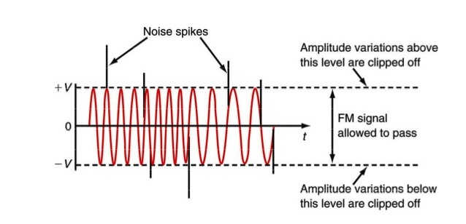

**Fig. 2 – Graphical representation of Limiter circuits**

**2.5.2 PRE – EMPHASIS**

Noise can interfere with an FM signal and particularly with the high frequency components of the modulating signal. This technique is used to overcome these high Limiter circuits can be embedded frequency noises. A simple high – pass filter can serve as a transmitter’s pre-emphasis circuit. A sample pre-emphasis circuit is shown below:

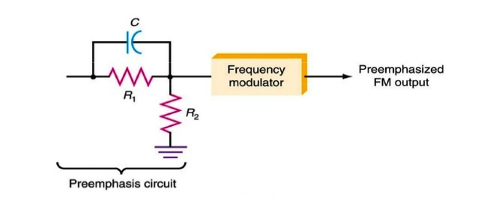

**Fig. 3 – Diagram representing pre – emphasis circuit**

**2.4.3 PHASE LOCKED LOOP (PLL)**

PLL is basically a closed loop frequency control system whose functioning is based on the phase sensitive detection of phase difference between the input and output signals of the controlled oscillator according to Mohn (2007). It is used to lock the central frequency of a transmitter to a stable crystal reference frequency. A basic phase locked loop consists of three (3) elements:

* **Phase Comparator:** this circuit block within the PLL compares the phase of two signals and generates a voltage according to the phase difference between the two signals.
* **Loop Filter:** This filter is used to filter the output from the phase comparator in the PLL. It is used to remove any components of the signals of which the phase is being compared from the VCO line. It also governs many of the characteristics of the loop and its stability.
* **Voltage Controlled Oscillator (VCO):** the voltage controlled oscillator is the circuit block that generates the output radio frequency signal its frequency can be controlled and swung over the operational frequency band for the loop.

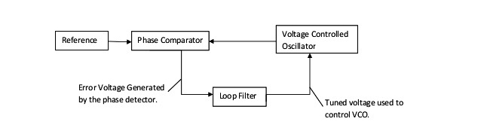

**Fig. 4 – Block diagram of a VCO**

**2.5 FM TRANSMITTER CIRCUIT PRINCIPLE**

FM transmission is done by the process of audio pre amplification, modulation and then transmission. Here we have adapted the same formula by first amplifying the audio signal, generating a carrier signal using an oscillating and then modulating the carrier signal with the amplified audio signal. The amplification is done by an amplifier, whereas the modulation and carrier signal generation is done by an variable frequency oscillator circuit. The frequency is set at anywhere between the FM frequency range from 88MHz to 108MHz. The power of the FM signal from the oscillator is then amplified using a power amplifier to produce a low impedance output, matching that with the antenna (Louis, 2008).

**2.6 THEORY BEHIND FM TRANSMITTER CIRCUIT**

Audio signal from the microphone is very low level signal, of the order of mill volts. This extremely small voltage needs to be first amplified. A common emitter configuration of a bipolar transistor, biased to operate in class A region, produces an amplified inverted signal (Correy, 2011).

Another important aspect of this circuit is the colpitt oscillator circuit. This is a LC oscillator where energy moves back and forth between the inductor and capacitor forming oscillations. It is mainly used for RF application.

When this oscillator is given a voltage input, the output signal is a mixture of the input signal and the oscillating output signal, producing a modulated signal. In other words, the frequency of the oscillator generated circuit varies with the application of an input signal, producing a frequency modulated signal.

**CHAPTER THREE**

**CONSTRUCTION**

**3.1 HARDWARE CONSTRUCTION AND IMPLEMENTATION**

Some of the items used for the construction were bought from different manufacturers. For instance the transmitter casing, the 9volt battery and the condenser microphone were bought alongside other materials. The construction followed several steps.

**STEP 1:**

The process starts by choosing the positive line in the vero board and connecting the positive terminal of the microphone in series with the2.2kresistor and connect the other sodto the positive line in the vero board.

**STEP 2:**

The next is the biasing of the transistor Q1 (BC547), this done by connecting the base of Q1 to the positive sod of the microphone, connect the emitter sod to the common or ground.

**STEP 3:**

Then the collector sod which is connected to the tank circuit i.e. the 30pF capacitor, the inductor and the antenna and they are biased against the collector sod and the positive.

**STEP 4:**

Next is the biasing of collector emitter sod, this is by connecting 30pF capacitor across the collector and the emitter sod of Q1.

**STEP 5:**

The 203μF capacitor across the power which across the positive and negative (common),and finally connect the 9volt battery to the circuit; make sure the battery is connected correctly.

**3.2 CIRCUIT DIAGRAM OF FM TRANSMITTER AND CIRCUIT ANALYSIS**

It is very important to know the working principle behind every device or machine and the method used.

This circuit uses a fixed circuit on the tank circuit to create the operating frequency due to lack of trimmer capacitor. This is clearly shown in the diagram below. For best performance the circuit should be built on a PC board with all components fitted close to each other. The photo below shows the circuit using a coil etched on the board. Using normal cable wire for the coil is totally unsuitable. It does not have a high charge Q and the range is very poor. The board cannot be touched as the capacitance of your body causes the circuit to drift. A wound coil will improve the stability considerably. See photos below.

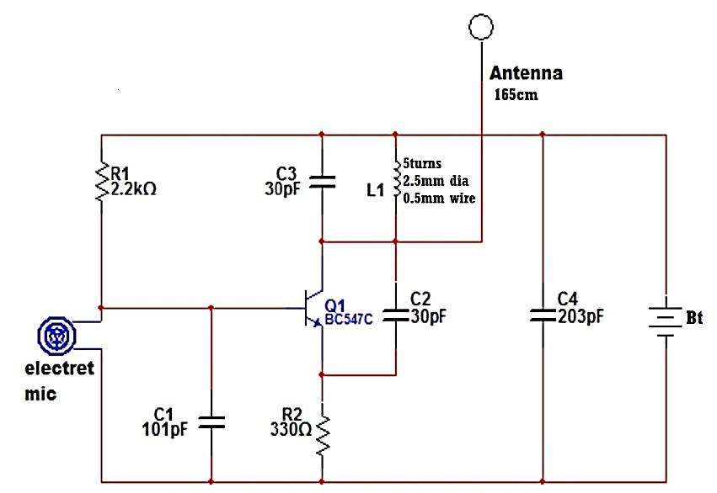

**Fig. 5 - The Transmitter Circuit Diagram**

To improve the sensitivity of the above circuit a transistor can be added but a trimmer capacitor must be added also to the tank circuit to control the bands. This transistor will make the electrets microphone more sensitive. The electrets microphone contains a Field Effect Transistor and you can consider it to be a stage of amplification. That's why the electrets microphone has a very good output.

A further stage of amplification will give the bug extremely good sensitivity and you will be able to pick up the sound of a pin dropping on a wooden floor.

Many of the 1 transistor circuits over-drive the microphone and this will create a noise like bacon-and-eggs frying. The microphones used in this circuit require a load resistor of 56k for a 9volt supply and 47kk for a 6volt supply. The voltage across the microphone is about 400mV to 700mV. It will produce an audio waveform of about 2-30mV.

Only a very simple self-biasing common-emitter stage is needed for the audio amplifier. This will give a gain of approximately 90 for a 9volt supply, see the picture below.

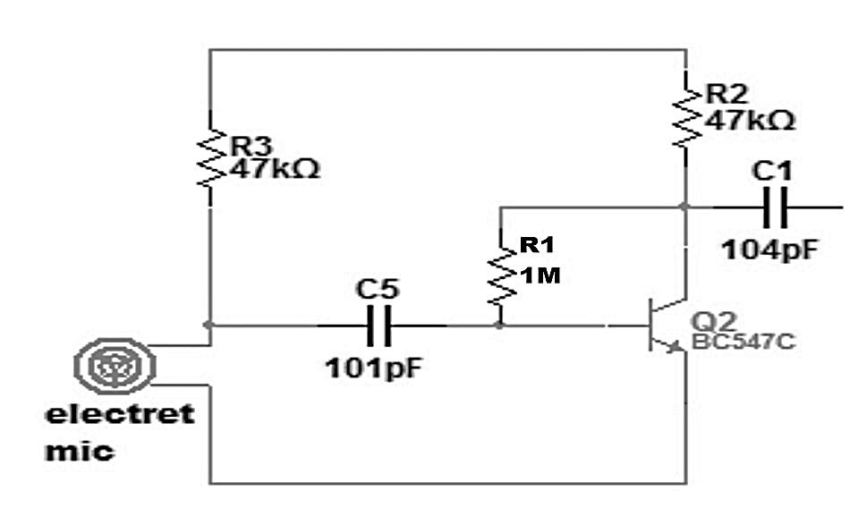

**Fig. 6 - Self-Biasing Common-Emitter Stage**

The next circuit shows this audio amplifier, added and the trimmer capacitor added to the previous transmitter circuit. This circuit is the best design using 2 transistors on a 9volt supply. The circuit takes about 8mA and produces a range of about 200 - 400metres if the right components are used.

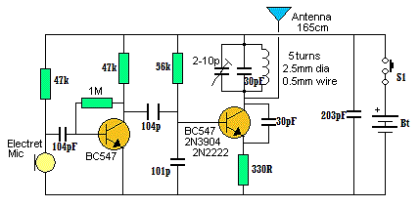

**Fig. 7 - The FM Transmitter Circuit with the Added Audio Amplifier Section**

1. The tank circuit has a fixed 39p and is adjusted by a 2-10p trimmer. The coil is stretched to get the desired position on the band and the trimmer fine tunes the location.

2. The microphone coupling is a 22n ceramic. This value is sufficient as its capacitive reactance at 3-4 kHz is about 4k and the input to the audio stage is fairly high, as noted by the 1M on the base.

3. The 104μF between the audio stage and oscillator is needed as the base has lower impedance as noted by the 47k base-bias resistor.

4. The 203μF across the power rails is needed to keep the rails "tight." Its impedance at 100MHz is much less than one ohm and it improves the performance of the oscillator enormously.

5. The coil in the tank circuit is 5 turns of enameled wire with air core. This is much better than a coil made on a PC board and is cheaper than a bought inductor. The secret to long range is high activity in the oscillator stage. The tank circuit (made up of the coil and capacitors across it) will produce a voltage higher than the supply voltage due to the effect known as "collapsing magnetic field" and this occurs when the coil collapses and passes its reverse voltage to the capacitor. The antenna is also connected to this point and it receives this high waveform and passes the energy to the atmosphere as electromagnetic radiation.

When the circuit is tightly constructed on a PC board, the frequency will not drift very much if the antenna is touched. This is due to the circuit design and layout as well as the use of large-value capacitors in the oscillator. If low value capacitors are used, the effect of your body has a greater effect on changing the frequency.

**3.3 CIRCUIT PARTS AND TOOLS USED IN CONSTRUCTION**

**3.3.1 Needle Nose or Pin Plier**

Usually called “snipe nose” pliers, these are for bending component leads, holding of tiny components etc. Figure 2.1 shows an image ofPin Plier. If you put a strong rubber band across the handles the pliers make a convenient holder for parts such as switches which you solder the contacts.

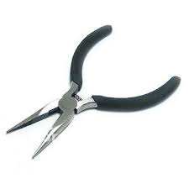

**Fig. 8 - A pin plier**

**(source: http://www.aliexpress.com/pin-pliers.html)**

**3.3.2 Screw-Driver**

This contains two set of screw drivers a star and a flat head screws which are used for dismounting and coupling of equipment. The flat head is also used for scraping away excess flux and dirt between tracks.

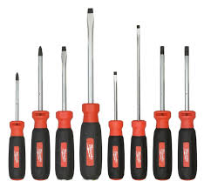

**Fig. 9 - A set screw-driver**

**(source: www.milwaukeetool.com/screwdrivers)**

**3.3.3 Vero Board**

The vero-board was used for holding components such as capacitors, resistors, transistors, and diodes. They were held on the board through the use of soldering iron and solder as shown in Figure 2.3.

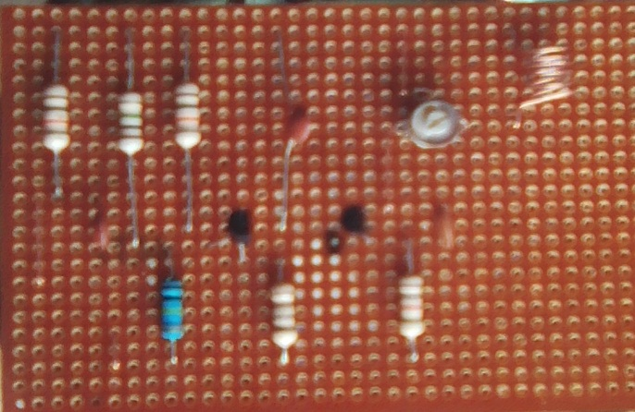

**Fig. 10 - A vero board**

**(source:** [**www.google.com/vero-board-circuits**](http://www.google.com/vero-board-circuits)**)**

**3.3.4 Soldering Iron**

For electronic work the best type is one powered by main electricity (230 V in Nigeria). It should have a heatproof cable for safety. This is sown in Figure 2.4 below. The iron’s power rating used in this project work is 60 W and it is fitted with a small bit of 2 to 3 mm diameter.

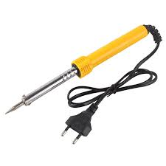

**Fig. 11 -Soldering iron**

**(source: www.m.aliexpress.com/soldering+iron)**

**3.3.5 Soldering Iron Stand**

A soldering iron stand is one of the equipment used in holding the soldering iron in a safe place. The stand includes a sponge which can be dampened for cleaning the tip of the iron as shown in Figure 2.5 below.

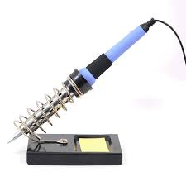

**Fig. 12 - Soldering iron Stand**

**(source:www.seeedstudio.com/solderingironstand.html)**

**3.3.6 De-soldering Pump (Solder Sucker)**

This a tool for removing solder when de-soldering a joint to correct a mistake or replace a component. See Figure 13.

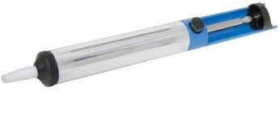

**Fig. 13 - De-soldering pump**

**(source:www.banzaimusic.com/desoldering-pump.html)**

**3.3.7 Solder Reel or Solder**

This is used for holding two or more component terminal together with the help of soldering iron. See figure 14. The best size for electronics is 225wg (5wg- standard wire gauge)

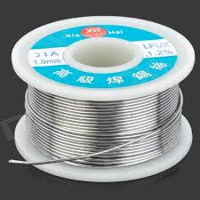

**Fig. 14 - A solder reel or solder**

**(source: www.maplin.co.uk/solder-reel)**

**3.3.8 Side Cutters**

For trimming component leads close to the circuit board and also use in cutting wires etc. See figure 15 below.



**Fig. 15 - Side cutter**

**(source: www.toolstop.co.uk/side-cutter)**

**3.3.9 Multi-meter**

A multi-meter or a multi-tester, also known as a VOM (Volt-Ohm meter or Volt-Ohm-milliammeter), is an electronic measuring instrumentthat combines several measurement functions in one unit. A typical multi-meter would includebasicfeatures such as the ability tomeasure voltage, current,and resistance Analog multimeters use a micro ammeter whose pointer moves over a scale calibrated for all the different measurements that can be made. Digital multimeter (DMM, DVOM) display the measured value in numerals, and may also display a bar of a length proportional to the quantity being measured, as shown in figure 16 below. Digital multimeters are now far more common but analog multimeters are still preferable in some cases, for example when monitoring a rapidly varying value.

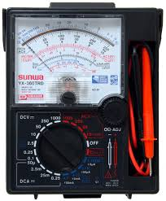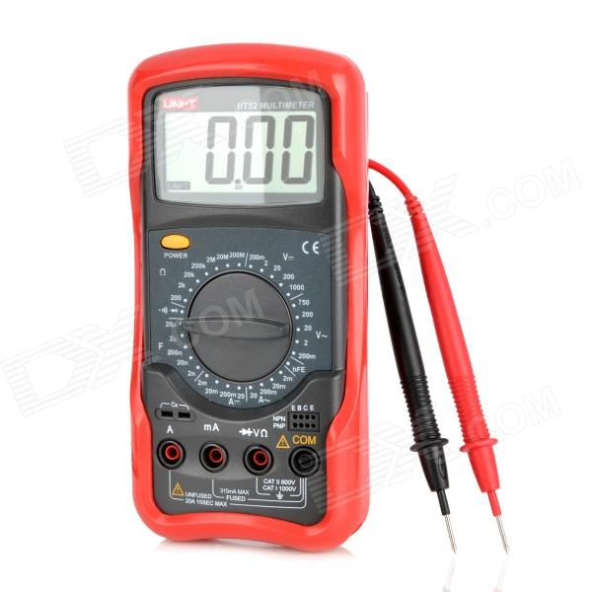

**Fig. 16 - (a) Analog Multimeter (b) Digital Multimeter**

(source:www.thomasnet.com/multimerter)

**3.3 COMPONENT LIST**

The materials used are listed below:

1. Resistors
2. Capacitors
3. Casing
4. Vero-board
5. Wire
6. Connector wire
7. Switch
8. 9volt battery

**CHAPTER FOUR**

**ANALYSIS AND DISCUSSION OF RESULTS**

**4.1 TESTING**

To test the workability of the constructed transmitter, the following procedures were followed:

**STEP 1:**

I turned on the transmitter and test if there is any voltage flowing through the transmitter circuit using a multi-meter, place the red test lead to the VΩ jack and the black to the COM.

**STEP 2:**

I set the rotator switch at desired DC voltage position.

**STEP 3:**

Then connect the test leads across the source or load by placing the red test lead to the positive and the black to the common, read the voltage on the screen of the multi-meter.

**STEP 4:**

To know if the constructed transmitter is working or transmitting, you need a frequency counter but in case of no frequency counter you can also use a multi-meter. First turn the rotatory switch to the DC position, connect the black test lead to the common and red to the antenna and read it on the meter if the circuit is working properly the meter will read the same as supply voltage or will be little beat greater than supply voltage, but if the meter did not read at all check connection and measure voltage again.

1. Get a FM receiver set the receiver to a clear part, around 60Mhz to 108Mhz nowturn on the transmitter and rotate the trimmer capacitor little by little until it catch thetransmitting signal, make sure you move the aerial around to get the strongest signal.
2. Finally, if the signal is weak try a length of wire attached to the antenna to see if that improves the performance remember that there is a premium length for the antenna. A longer wire doesn't autocratically work better. Try hanging the antenna straight up or down. Generally the transmitter antenna works better if it is in roughly the same plane as the receiver antenna.

**4.2 RESULTS**

**CHAPTER FIVE**

**SUMMARY AND CONCLUSION**

**5.0 COST ANALYSIS**

|  |  |  |  |
| --- | --- | --- | --- |
| **S/N** | **ITEM** | **QUANTITY** | **PRICE (N)** |
| 1. | Resistors |  |  |
| 2. | Capacitors |  |  |
| 3. | Casing |  |  |
| 4. | Vero-board |  |  |
| 5. | Wire |  |  |
| 6. | Connector wire |  |  |
| 7. | Switch |  |  |
| 8. | 9volt battery |  |  |
| 10. | Transportation |  |  |
| 11. | Miscellaneous |  |  |
|  | **TOTAL** | |  |

**5.1 PROBLEMS ENCOUNTERED**

One of the problems encountered was getting the necessary components to complete this project work here in Abraka, Delta State, we went as far as Warri, Obiaruku, Agbor and even Benin to get some of the components also one of the issues presented was that the drill was broken repeatedly, phenolic plate had to get back to you in error and was removed bad pulse copper.

For the coil only had to squeeze more hoops to send the same signal but without much noise.As for the trimmer, did not know that it changes the impedance of the metal, so it was necessary to align with a plastic screwdriver.These are the main problems we encountered.

**5.2 RECOMMENDATION**

The process in which this project took me through has made me see some areas in which the design can be upgraded and further study carried out to improve the quality of the FM transmitter and these areas include:

1. I recommend that a FM Transmitter with LCD that will show the frequency in the transmitter operates on should be researched into.

**5.3 CONCLUSION**

Block-by-block design and construction of the FM transmitter and receiver was the right approach. I became familiar with the benefits and limitations of each stage and could optimize them individually in the first few weeks. When integration occurred, the firsthand knowledge of the separate blocks became an invaluable part of debugging.

The goal of this project was to create an FM transmitter, which transmits, it redundancy, a signal or sound to an FM receiver, without the need for cables.This goal was achieved and the signal produced can be heard on stations already occupied with a frequency, i.e. to listen to our sound emitted at the transmitter, we search the FM band station or frequency that is free or empty.

**REFERENCES**

“FM broadcasting in the United States” <http://en.wikipedia.org/wiki/FM> broadcasting in the USA

“Phase-Locked Loop Tutorial, PLL” <http://www.sentex.ca/~mec199/gadgets/pll/pll.html>

“The Future of Radio”. The Swedish Radio and TV Authority, 2008

Ackermann, J. (2013). “TARR: Tomorrow’s Ham Radio Technology Today”.

Correy, D. (2011). “HD Radio: What it is and What it is not”, <http://abot.com/od/hdradio/a/aa092706a.htm>

David Chen (2002) Design and Construction of FM Transmitter and Receiver - Final Report http://ww1dc53e8f_2.pdf

Durant., L. (2006) “HD Radio: A Viable Alternative to Satellite?” October, 2006

Ferrara D. (2014). “Advantages and Disadvantages of HD Radio” USA.

Groome B. (2014). HD Radio (I.B.O.C.)”.

<http://circuit-zone.com/?cat=fm_transmitters>

http://www.electronics-diy.com/intro_txfm.php

Carr Joseph, J.(1997). Microwave and Wireless Communication Technology, Newnes, 1997 ISBN 0750697075 page 339-341

Kelly C.W. (2010). “HD – Radio: Real World Results in Asia”, USA.

Kelly, C.W. (2010). Digital HD Radio AM/FM Implementation Issues”, USA.

Louis, E.F. (2008). Principles of Electronic Communication Systems. McGraw – Hill, USA

Pappenfus, Bruene and Schoenike (1964). Single sideband principles and circuits McGraw-Hill, 1964, chapter 6

Reene, C. (2013). An Industrial White Paper: HD Radio. Practical Science Publishing House, Malaysia.

Ronald Kitchen (1993). RF Radiation Safety Handbook, Butterworth Heinemann 1993, ISBN 0 7506 1712 8 Chapter 10some spread spectrum systems use pulses or sets of orthogonal wave forms.

Rudolf F. Graf, William Sheets (2001). Build Your Own Low-Power Transmitters: Projects for the Electronics Experimenter Newnes, 2001 ISBN 0750672447, page 2

Russell Mohn, (2007). “A Three Transistor Discrete FM Transmitter,” ELEN 4314 Communications Circuits – Design Project, pp. 1, April 2007

Singh, V. (2009). “A Seminar on HD Radio”, EC Department

Swarna Kumara, T.U.M. et al., “A Mini Project on Simple FM-Transmitter”.