THE DESIGN AND CONSTRUCTION OF A MICROCONTROLLER BASED DOT MATRIX ADVERT DISPLAY

CHAPTER ONE

INTRODUCTION

The purpose of this project is to produce a narrative description of the design and construction of a microcontroller based dot matrix advert display. Firstly computer aided design is the modeling of physical system on Computers allowing both interactive and automatic analysis of design variant and the expression of design in a form suitable for manufacturing. This follows by explaining the microcontroller based dot matrix advert display as a device which is fast gaining wide acceptance and application in the present days due to its ability to provide a very high precision timing. The dot matrix advert display can be describe as an electro-mechanical system for processing information in which the information is represented by physical quantities, which are so constrained to take only discrete values that can be referred to as binary signals.

In this design we have implored the use of both hardware and software to bring about the entire project. The hardware components are solely coordinated by the AT89S51 micro controller chip while the C- programming language is used to program the chip.

1.1 OBJECTIVE OF THE PROJECT DESIGN

Depending on ones intention, microcontroller based dot matrix advert display system have many aims and objectives.

For instance, this one in particular aims at displaying a moveable coded letters that says ‘UNIVERSITY CAFETERIA”

Also microcontroller based dot matrix advert display system can be used to control the traffic misunderstanding among motorists especially in junctions. This is achieved by displaying stop, get ready, or move. Some traffic control electronic system displays symbols or color that represents the stated commands above

Moreover, microcontroller based dot matrix advert display system is used in electronic scoreboard during football matches to display when a goal is scored, also to display the name of that player who scored the goal. Above all, this system has contributed a lot in boosting advertisement.

1.2 PREAMBLE

Micro controller programmable Dot matrix information display system, is a system electronically designed and constructed, that is used to display different information to the view of the masses. The information to be displayed could be diagrams, symbols, letters, colors, numbers, codes, etc depending on what is needed at a particular place and time. This without doubt, has made life easier for the people in different ways; however micro-controller, which is the heart of this system, can be described thus: A micro controller is a computer. All computers, whether we are talking about a personal desktop computer you are using is a general – purpose computer that can run any of thousands of programs. Micron-controllers are special purpose computers. Micro controllers do one thing well. There are a number of other common characteristics that define micro controllers. If a computer matches a majority of these characteristics, then you can call it a micro controller,

  - Micro controllers are embedded inside some other device (often a consumer product) so that they can control the features or actions of the product. Another name for a micro controller, therefore, is embedded controller

  - Micro controllers are dedicated to one task and run one specific program. The program is stored in ROM (read – only memory) and generally does not change. Micro controllers are often low power devices. A desktop computer is almost always plugged into a wall socket and mighty consumes 50 watts of electricity. A battery-operated micro controller might consume 50 milliwatts.

  - A micro controller has a dedicated input device and often (but not always) has a small LED or LCD display for output. A micro controller also takes input from the device it is controlling and controls the device. Meanwhile the use of a micro-controller to implement an electronic display system design made up of LEDs connected in common cathode matrix form is referred to as micro-controller based programmable dot matrix information display system. This project design is a welcome compliment that displays ‘UNIVERSITY CAFETERIA’
1.3 JUSTIFICATION OF THE PROJECT
Due to the various problems encountered in the manual/analog design and construction of signposts for advertisement, there is every need for an automated electronic display system that will solve this problem. This will ensure that viewers get the adequate information that is displayed in good and attractive colors. The though the manual/analog way of displaying information to the view of the people is still targeted viewer are attracted. The height in which advertisement in Nigeria have attained will be maintained if some of its design/construction operation is computerized (Micro controller based information display) especially the one’s that has to do with bigger companies. This will also maintain the good relationship between the company and its numerous customers.

1.4 SCOPE OF THE PROJECT

This project can serve in any aspect of life this project (microcontroller based dot matrix advert display) is based on a computer aided design. .

In the implementation of this project, the scopes that I shall concentrate more on are: the architecture of the microcontroller port interface, multiplexing the data port control sequence and algorithm of the traffic light. The features of the

AT89S51 were exploited to achieve the desired sequence of operation of this project.

1.5 CONSTRAINTS

One of the obvious constraints I had in the course of this project was the scarcity of sometimes outright unavailability of some of the required components in the markets. Since scarcity is followed by a hike in price, when such components were even found, they were out rightly expensive. Another major constraint I had was time constraints. I had a relatively short time to source out materials from net, libraries, etc, fully understand the underlying principles and come up with a design that would work. As a result, I had to forgo pleasure and even leisure in order to achieve this.

1.6 BLOCK DIAGRAM OVERVIEW
The entire project given as an overview is shown in diagrammatically in Fig 1. Below

..

Fig 1.0: Block Diagram Overview of the project

As the name implies, this project is micro-controller based, hence a micro-controller called AT89c51 is employed to serve the purpose with RAM and some other discrete components that are to be discussed later. In other to reduce the risk and complications involved in using only discrete components the project is made up some integrated circuits.

Meanwhile, this project, microcontroller based dot matrix advert display system has sub units such as:

- The mains unit.

- The power supply unit

- The switching and timing unit

- The address generators unit

- The memory unit/ Micro-controller

- The drivers unit

Fig 1.1 the block diagram of project

1.7 PROJECT REPORT ORGANIZATION

Six chapters were covered in the course of design and development of this project. The chapters and their contents are as follows:

Chapter one is the introductory chapter that gives the aim, scope and justification for the project. This part shows the significant and the justification of this project that is the literature review of microcontroller dot matrix advert display system and its components reviewed, also the history of the project and its uses were discussed. Chapter Two is literature review. It deliberates on different related works done by several authors with dates. It also discusses on the limitations of some of these works.

In chapter three, I discussed the practical system analysis based on what a microcontroller based dot matrix advert display system will do when fully constructed and installed. Also discussed is the requirement analysis, which is all the information, gathered form a wide research on microcontroller based dot matrix advert display board, data analysis, system design approaches, top-down, bottom-up, choice of design approaches, data flow arrangement and the system flow chart are also discussed. Chapter four deals with the design/preliminary design of how the system will achieve its function, all these are illustrated here in form of circuit diagram to show how the main system is linked to the sub system or the modules. Also discussed here is the user interface design that comprises the input design and the output design. The software design and implementation is also discussed in this chapter. The choices of programming language, soft-hard, and sub-system implementation is also discussed here. In chapter five I discussed the system testing and the appropriate software testing strategy to achieve the expected result and the actual. The performance evolution is also analyzed here. Also discussed is the system testing and integration, how the components were tested. The reference evaluation and cost analysis is also discussed here. Finally the summary of this project is discussed in detail in chapter six. The contributions of the project, achievements, and problems for further enhancement, development and advanced discussions on this topic

CHAPTER TWO

LITERATURE REVIEW

this chapter will give an insight into the meaning microcontroller based dot matrix advert display system, ways by which it could be achieved, here some discrete components such as resistors, capacitors and transistors with integrated circuits (IC) were used to make this work and it’s wiring easier to understand. By the end of this chapter, one would stand a better chance of having an understanding of what microcontroller based dot matrix advert display system is all about, taking all the components used one after the other.

2.1 ORIGIN/HISTORY OF THE PROJECT

The project, Micro-controller based dot matrix information display system began as commercial electronic publishing (electronic display) which started in the mid-1970s with the development of databases of scientific, legal, and business information. These were used mainly by information specialists in large companies and universities, and ran on mainframe computers or minicomputers.

Few small businesses or people at home used any form of electronic publication, since the information itself was too specialized, and the software and hardware needed to access it were too expensive. The consumer market for electronic publishing (electronic display) really began with the development of GUIs and the CD-ROM in the late 1980s. Some industry commentators expected that CD-ROM publishing would revolutionize the publishing industry, but the market for CD-ROMs has been slow to develop. With the exception of encyclopedia and journal publishing, the changes to the publishing industry brought about by electronic publishing have been fairly limited so far. Some designers who adopted the new technology as soon as it appeared found that the market was too small, and consequently they had to scale down their electronic-publishing activities.

Designers who were initially too conservative, however, have found it hard to catch up in such areas as reference, where electronic display could have benefited them. Although most designers own the rights to a great deal of text and images, these are often not held in digital format and have to be changed into machine-readable form before being published electronically. Text and images must then be marked up with some form of tagging, so that they can be accessed and manipulated.

2.2 TEHNOLOGY OF DOT MATRIX DISPLAY

2.2.1 Optics and lighting

In the mid 1990s, cost-effective traffic light lamps using light-emitting diodes (LEDs) were developed; prior to this date traffic lights were designed using incandescent or halogen light bulbs. Unlike the incandescent-based lamps, which use a single large bulb, the LED-based lamps consist of an array of LED elements, arranged in various patterns. When viewed from a distance, the array appears as a continuous light source.

LED-based lamps (or 'lenses') have numerous advantages over incandescent lamps; among them are:

- Much greater energy efficiency (can be solar-powered).

- Much longer lifetime between replacements, measured in years rather than months. Part of the longer lifetime is due to the fact that some light is still displayed even if some of the LEDs in the array are dead.

- Brighter illumination with better contrast against direct sunlight, also called 'phantom light'.

- The ability to display multiple colours and patterns from the same lamp. Individual LED elements can be enabled or disabled, and different colour LEDs can be mixed in the same lamp

- Much faster switching.

- Instead of sudden burn-out like incandescent-based lights, LEDs start to gradually dim when they wear out, warning transportation maintenance departments well in advance as to when to change the light. Occasionally, particularly in green LED units, segments prone to failure will flicker rapidly beforehand.
The operational expenses of LED-based signals are far lower than equivalent incandescent-based lights.
2.3 USES OF THE PROJECT

microcontroller based dot matrix advert display system, can be used in several applications depending on what the designer has in mind to achieve, however the project can be used as board or sign posts for advertisement which would be perfect for retail stores, hotels/motels banks. It could also it can be used as electronic scoreboard in sports events e.g. football, it also useful in controlling traffic in some busy junctions etc.

2.4 ADVANTAGES OF THE DESIGN

- It is very easy to operate since it just has a plug and play mode.

- It is energy saving(requires just 10watts)

- The LED is slim(1 inch depth) and very light.

- It is maintenance free.

- It has a long life span

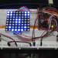

fig 2.0 a dot matrix display

2.5 TYPES OF DOT MATRIX DISPLAY

- Static mode

- Flashing mode

- Right to left

- Left to right

- Bottom to top

- Top to bottom

- Slide show.

- Twinkle wipe

2.6 FEATURES OF THE PROJECT

CHAPTER THREE

DESIGN PROCESS AND IMPLEMENTATION

The section introduces some basic steps and general consideration taken ahd also the electronic component used.

3.1 THE MAINS UNIT

This could be referred to as the power generator unit. Thus it is the only unit that supplies the whole system with power through the power supply unit. In Nigeria [PHCN] designed and constructed this unit.

According to their specifications, the domestic household ratings of ac power, voltage and current are 220/240v and 12/13 Amp respectively. Meanwhile these specifications are assumed and used to power the display board.

3.2 THE POWER SUPPLY UNIT

Electronic components can be described as low power consuming appliances, and as a result requires step down transformers and other power normalizing circuitry to operate. This rationing unit, do the work of supplying all other sub units the amount of voltages and currents they needed respectively. This unit is made up of a step down 15volts from 223-/240volts of mains unit. Although we did not design this transformer, from the specifications or rating transformer, it is a step down type that steps the voltage down to 15volts. In other words it is a step down transformer with ratings of 15volts, 2Amps. The voltage is then rectified using four diodes to ensure full wave rectification.

After rectification, the voltage is filtered to remove all the ripples in it before connecting it to the load. This filtering action is achieved using one, 16v1000uf electrolytic capacitor. This filters the voltage after which the 15v is rationed to the loads using a regulator and direct connection. The direct connection is made to the lamps (LEDs); this is because LEDs needs as much as 15v to operate, while a 5volt regulator (7805) is used to regulate the voltage down to 5volts for the integrated circuits and other subunits.

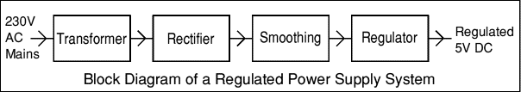

Fig 3.0 Block diagram of power supply unit

3.2.1 TRANSFORMER

Moreover, for an ideal transformer the input power is always equal to the output power but because of losses incurred such as core losses, and eddy current losses, the input power is higher than the output power.

Mathematically; Pp = Ps

Where P=IV

Thus Vp Ip = VsIs

Or Pp = Losses + Ps

Thus a step down transformer steps the voltage down from 240V to 15V.

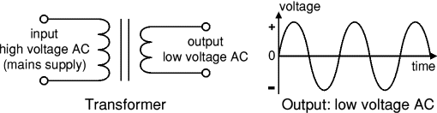

FIG 3.1 Transformer and its output.

3.2.2 RECTIFIERS

Rectifiers are circuits made up of diodes mainly, which converts ac to dc signal. Diodes allow current to flow only in one direction. In this project the rectifier used is made up of four diodes that converts ac to dc signal. Also it is a full wave bridge rectifier.

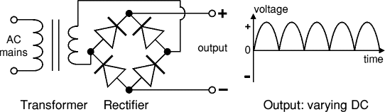

Fig 3.2 circuit diagram of a full wave rectifier

3.2.3 FILTERS

Filters are said to be smoothers. Thus a filter smoothes the dc rectified dc voltage to ensure proper dc voltage supply to the system.

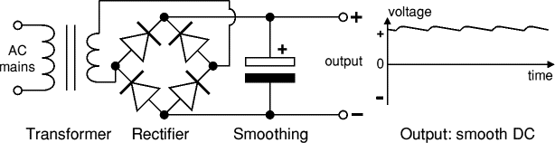

Fig 3.3 circuit diagram of a power supply+ filter

3.2.4 REGULATOR

Regulator can be viewed as a dc steady state voltage shaper. Depending on the value of voltage needed to enter a respective circuit after rectification and filtration, a regulator is used to reduce the value of the supply to the needed value.

For the 5v dc supply needed in some subunits of this system, the correct size and value of the regulator needed is 7805. this is to avoid damages as a result of excessive voltage.

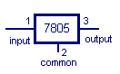

Fig 3.4 symbol of 7805 regulator

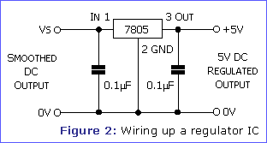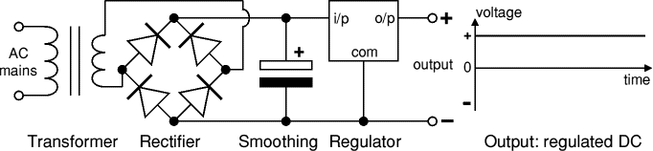

Fig:3.5 Voltage Regulator and output wave form of regulated voltage

3.3 THE ADDRESS GENERATOR’S UNIT

Address generator’s unit, as the name implies is the unit that generates the addresses. This unit is solely made up of 4bits binary counters known as 74LS138. The counters generate the addresses as the clock system unit triggers them.

The rate of operations of these counters is determined by this clock system (switching and timing unit). 74LS138 is enabled if and only if G1=1, G2A=0, G2B=0

table 3.0

3-to-8 decoder/demultiplexer truth table:

|Select

GL G1 G2 | C B A | Y0 Y1 Y2 Y3 Y4 Y5 Y6 Y7

-----------|-----------|---------------------------

X X 1 | X X X | 1 1 1 1 1 1 1 1

X 0 X | X X X | 1 1 1 1 1 1 1 1

-----------| -----------|----------------------------

0 1 0 | 0 0 0 | 0 1 1 1 1 1 1 1

0 1 0 | 0 0 0 | 1 1 1 1 1 1 1 1

0 1 0 | 0 0 0 | 1 1 1 1 1 1 1 1

0 1 0 | 0 1 0 | 1 1 1 1 1 1 1 1

--------------- -------------- ----------------------------

0 1 0 | 1 0 0 | 1 1 1 1 1 1 1 1

0 1 0 | 0 0 1 | 1 1 1 1 1 1 1 1

0 1 0 | 0 1 0 | 1 1 1 1 1 1 1 1

0 1 0 | 0 1 1 | 0 1 1 1 1 1 1 1

---------------- ------------------------ -----------------------------------

0 1 0 | 1 0 0 | 1 1 1 1 0 1 1

0 1 0 | 1 0 1 | 1 1 1 1 0 1 1

0 1 0 | 1 1 0 | 1 1 1 1 1 0 1

0 1 0 | 1 1 1 | 1 1 1 1 1 1 1 0

--------------- ------------ ------------------------------------------

1 1 0 | X X X| Output corresponding to stored

| | address 0; all others 1

3.4 THE MEMORY UNIT/ MICRO-CONTROLLER

After the address has been generated, they are sent to the memory unit (Random Access [RAM]) through the address bus of the RAMs. This unit constitutes of 128 x 8-bit internal RAM, since the unit functions as the memory storage unit of the generated addresses, it sends the addresses generated in form of patterns of display through the data bus to the drivers. This pattern of display is achieved by how the Micro-controller is reprogrammed,

Features of AT89c51 micro controller:

- 4k Btes of In-System Reprogram-able Flash Memory

- Endvance: 1,000 write/Erase Cycles

- Full Static Operation: 0 HZ to 24 MHZ

- Thredevel Program Memory Lock

- 128x 8-bit Internal RAM

- 32 Programmable I/O Lines

- two 16-bit Timer/Channel

- Six interrupt Sources

- Programmable Serial Channel

- Low power Idle and Power-down Modes
3.4.1 DESCRIPTION
The AT89c51 is a low-power, high-performance CMOS 8-bit micro-controller with 4k bytes of Flash programmable and erasable read only memory (PEROM). The device is manufactured using high density nonvolatile memory technology and is compatible with the industry-standard MCS-51 instruction set and pin out. The on-chip Flash allows the program memory to be reprogrammed in system or by a conventional nonvolatile memory programmer.

By combining a versatile 8-bit CPU with Flash on a monolithic chip, the AT89c51 is a powerful microcontroller, which provides a highly flexible and cost-effective solution to many embedded control application

3.5 THE DRIVERS UNIT

In the drivers unit, which is constituted of BC547NPN transistors and 1k resistors thereby, serves as drivers that drive the data which has been transformed to different patterns of display from the data bus of the Chips to the display unit (LEDs).

3.5.1 TRANSISTOR

Transistors are electronic devices that are used as amplifiers, oscillators, or switches in control, and computer systems. A transistor consists of small layers of silicon or germanium that have been doped, or treated with impurity atoms, to create n-type and p-type semiconductors. The diagram shows the structure of various kinds of transistors

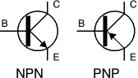

Fig:3.6 symbol of npn and pnp transistors

3.5.2 LIGHT EMITTING DIODES (LEDs)

LEDs emit light when an electric current passes through them.

Colours of LED

LEDs are available in red, orange, amber, yellow, green, blue and white. Blue yellow, green and red LEDs are much more expensive than the other colours, however we made use of green, red and blue in the project design. The semiconductor material determines the colour of an LED, not by the colouring of the ‘package’ (the plastic body). LEDs of all colours are available in uncoloured packages that or which may be diffused (milky) or clear (often described as ‘water clear’). The coloured packages are also available as diffused (the standard type) Or transparent.

Tri-colour leds

The most popular type of tri-colour LED has a red and a green LED combined in one package with three leads. They are called tri-colour because mixed red and green light appears to be yellow and this is produced when both the red and green LEDs are on.

BI-COLOUR LEDS

A bi-colour LED has two LEDs wired in ‘inverse parallel’ (one forwards, one backwards) combined in one package with two leads. Only one of the LED can be it at one time and they are less useful than the tri-colour LEDs described above.

3.5.3 SIZES, SHAPES AND VIEWING ANGLES OF LEDS

LEDs are available in a wide variety of sizes and shapes. The ‘standard’ LED has a round cross-section of 5mm diameter and this is probably the best type for general use, but 3mm round LEDs are also popular.

Round cross-section LEDs are frequently used and they are very easy to install on boxes by drilling a hole of the LED diameter, adding a spot of glue will help to hold the LED if necessary. LED clips are also available to secure LEDs in holes. Other cross-section shapes include square, rectangular and triangular.

As well as a variety of colours, sizes and shapes, LEDs also vary in their viewing angle. This tells you how much the beam of light spreads out. Standard LEDs have a viewing angle of 600 but others have a narrow beam of 300 or less.

^{3.6 DESIGN PROCESS:}

A micro-controller based project design process is characterized by the following;

- ^{Definition of task}

- ^{Requirements}

- ^{Factor that influence choice}

In defining a task, every design comes from an idea or a problem that requires a solution. Questions may be generated on what exactly that is required to be achieved and the feasibility of the ideas as regards to the implementation.

If these questions are analyzed critically with tangible solutions to the problem, a development of this idea into a reality is the next step.

Requirements for design process have to be considered once an idea has been established. The need to determine whether or not the idea requires a PC or not, depending on the complexity of the circuitry, or whether the circuits to be designed needs to make a complex decision or deal with complex data.

The compare these factors with topic with IC’s (AND gates) which two inputs when high logic changes outputs. Preferably, a micro-controller will be the best option based on the circuits to be designed with less hardware connections and flexibility. Writing a program that performs a desired function accesses the ability of the micro-controller. However, it came to our thought that among all the components used here the one that consumes the highest power is the Light Emitting Diodes (LEDs), which need as much as 15-volt to glow and draw as maximum as 2-ampere of current. As a result if this, I decided to use 15-volts, 2-ampere rated transformer for this design. After the voltage is stepped down 15-volts using a transformer, a full wave rectifier circuit was designed using four Diodes (IN4001). This value of Diodes is used here because from the specification of voltage/Diode rectifying data book, this value is adequate for lower voltages, say 0-24 volt. The load current of the rectifier is given as follows;

^{Idc = 21m/3.1}

When 1m = maximum current = 2 amp

Idc = load current which is in dc form after recification.

Hence idc = 2*3 / 3.14 =4/3.14, idc = 1.27 amps

Therefore 1.27amps is the maximum load current that can be drawn in the whole system. Also it is known that after rectification, the same voltage (15-volts) continues to flow into the filter. As a result the load voltages 15-volts

Thus Vdc = Load voltage = 15volts.

^{And Vdc = 21m*RL / 3.14}

^{RL = Load resistance}

^{RL = 47.13/4}

^{RL = 11.78* 3.14 = 1.78}

From this, it is obvious that V = IR = 1.27 * 1.27

After rectification in power supply, we applied a filter circuit (capacitor) with valve 1000uf for ripple free power supply. The filtering circuit smoothens out A.C ripples in the output voltage and current. A 16-volt, 1000uf, electrolytic capacitor was carefully selected and used to match 15-volts output in the filiter.

3.7 PRELIMINARIES OF THE DESIGN

In every design, especially an electronic design, there is always the need to do a preliminary or a prototype work on the project in view this is to ensure compatibility in the components required referring to art 1.4 above. However in this project I designed a prototype of it using a breadboard, in this my aim was just to make an LED blink using the Micro-controller (AT89c51).

3.7.1 MAKING A LED BLINK WITH AT89c51 MICRO-CONTROLLER

Step 1: The first step is to build the circuit. At this point I was already familiar with the parts used. (2 resistors, 3 capacitors, 1LED). We then put these parts together using breadboard. Vcc = 5V and Gnd = 0V. The only thing I want to do with this project is to make the LED blink. By doing this, I will be able to learn the basic process of compiling a program written in assembly language program I am going to use.

^{Step 2:}

Compiling the Code: Move the assembly language program (<Ledtest.asm>) to the directory where you have TASM

<tasmint.exe>. we Bring up a DOS prompt, change to the directory where the TASM files are, and complie the code using the command

tasm-51 ledtest.asm ledtest.hex.

this will create a file called ledset.hex

close the DOS prompt window now.

^{Step 3:}

Downloading the code to the Micro controller. I made sure the serial cable and the power supply are connected to the PG302 programmer.

We now Run PG302<software. Tm>. Form the setup Menu, select the type of device (micro controller) you are using.

^{Then press PROGRAM DEVICE.}

^{Press BROWSE.}

Find ledtest.hex and click on it (single click).

^{Press OK to select the file.}

Press OK to program the file into the micro controller.

Now the program should be loaded into the micro controller.

Make sure the power is off for the circuit you have built.

Turn on the power to the circuit. The LED starts blinking, and then I noticed I have successfully built my prototype micro controller project.

^{3.8} ^{DETAIL OF DESIGN}

The control programs for the AT89c51 come in two flavours: host system-dependent and host system-independent. System dependency results from the use of software timing loops to enforce required delays, the duration of which will vary between host systems running at different speeds.

The timer is reconfigured when the control program is invoked and restored to its original state before the program terminates. In order to guarantee that the program is not exited before the timer configuration is restored, the CTRL-C and CTRL-BREAK keys reusable.

This means that the program cannot be aborted except by specifying the exit option at the main menu or by rebooting the system. The timer control code is provided as an 8086 assembly language module, which is linked with the complied contol program. The granularity of the timer is 0.838 microseconds, but the minimum practical delay is system- and software dependent. The timer code ensures that the delay produced will not be of shorter duration than disabled.

The control programs provided for the AT89c51 system independent. The programmer circuitry consists of the host interface and switch able power supplies. The host under software control generates the signal sequencing and timing required for programming. A 40-pin ZIF socket is provided for programming the AT89C51; the 20-pin ZIF socket accommodates the AT89c51.

Note that the power and ground connections and bypass capacitors required by the TTL devices are not shown on the schematic. Power for the programmer circuitry and the AT89c51 is provided by a fixed five-volt supply. A second supply provides either five or twelve volts, selectable, for use during programming. The addition of a transistor to the output of the variable supply provides a resistor values utilized in the variable power supply circuit were determined usingthe equations presented in the LM317 voltage regulator data sheet.

The host software accommodates power supply ramp rates. The programmer is connected to the host with a 25-conductor ribbon cable. To minimize the effect on signal integrity, the length of the cable should be as short as possible, preferably not exceeding three feet.

^{3.8.1} MICRO-CONTROLLER PIN DESCRIPTIONS:

^{ALE/PROG}

Pulse is skipped during each access to external Data Memory. If desired, ALE operation can be disabled by stting bit 0 of SFR location 8EH. With the bit set, ALE is active only during a MOVX or MOVC instruction. Otherwise, the pin is weakly pulled high. Setting the ALE-disable bit has no effect if the micro-contoller is in external execution mode.

^{PSEN}

Program store Enable is the read strobe to external pro-gram memory. When the AT89c51 is exexuting code from external program memory, PSEN is activated twice each machine cycle, except that two PSEN activations are skipped during each access to external data memory.

^{EA/VPP}

External Access Enable. EA must be strapped to GND in order to enable the device to fetch code from external program memory locations starting at 000H up to FFFH. Note, however, that if lock bit 1 is programmed, EA will be

^{Internally latched on reset.}

EA should be strapped to V CC for internal program executions. This pin also receives the 12-volt programming enable volt-age (VPP) during Flash programming, for parts require 12-volt VPP.From the diagram shown above, pin 40 is connected to Vcc, while pin 20 is the ground pin.Pin 9 is the reset pin, which must be connected to Vcc through a 10μF capacitor for CMOS version.

^{XTAL1}

Input to the inverting oscillator amplifier and input to the internal clock operating circuit.

^{XTAL2}

Output from the inverting oscillator amplifier.

^{Pin Configuration of AT89C51}

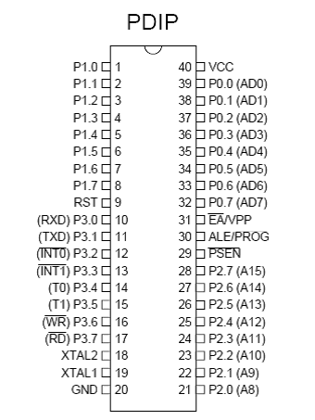

fig 3.7 micro-controller pin configuration

The AT89C51 microcontroller is an 8- bit unit containing programmable counters, or serial port, internal ROM and RAM, and parallel I/O ports.

It has four I/O ports, Port 0, port 1, port2 and port 3. Any part can be used as input and output part depending on how it was programmed.

^{Port 0}

Port 0 is an 8-bit open drain bi-directional I/O port. As an output port, each pin can sink eight TTL inputs. When 1s are written to port 0 pins, the pins can be used as high-impedance inputs.

Port 0 can also be configured to be the multiplexed low-order address/data bus during accesses to external program and data memory. In this mode, P0 has internal pull-ups.

Port 0 also receives the code bytes during Flash programming and outputs the code bytes during program verification. External pull-ups are required during program verification.

^{Port 1}

Port 1 is an 8-bit bi-directional I/O port with internal pull-ups. The Port 1 output buffers can sink/source four TTL inputs. When 1s are written to Port 1 pins, they are pulled high by the internal pull-ups and can be used as inputs. As inputs, Port 1 pins that are externally being pulled low will source current (IIL) because of the internal pull-ups. In addition, P1.0 and P1.1 can be configured to be the timer/counter 2 external count input (P1.0/T2) and the timer/counter 2 trigger input (P1.1/T2EX), respectively, as shown in the following table.

Port 1 also receives the low-order address bytes during Flash programming and verification.

^{Port 2}

Port 2 is an 8-bit bi-directional I/O port with internal pull-ups. The Port 2 output buffers can sink/source four TTL inputs. When 1s are written to Port 2 pins, they are pulled high by the internal pull-ups and can be used as inputs. As inputs, Port 2 pins that are externally being pulled low will source current (IIL) because of the internal pull-ups. Port 2 emits the high-order address byte during fetches from external program memory and during accesses to external data memory that uses 16-bit addresses (MOVX @ DPTR). In this application, Port 2 uses strong internal pull-ups when emitting 1s. During accesses to external data memory that uses 8-bit addresses (MOVX @ RI), Port 2 emits the contents of the P2 Special Function Register.

Port 2 also receives the high-order address bits and some control signals during Flash programming and verification.

^{Port 3}

Port 3 is an 8-bit bi-directional I/O port with internal pull-ups. The Port 3 output buffers can sink/source four TTL inputs. When 1s are written to Port 3 pins, they are pulled high by the internal pull-ups and can be used as inputs. As inputs, Port 3 pins that are externally being pulled low will source current (IIL) because of the pull-ups. Port 3 also serves the functions of various special features of the AT89C51, as shown in the following table.

Port 3 also receives some control signals for Flash programming and verification.

^{Port} ^{Pin Alternate Functions}

^{P3.0} ^{RXD (serial input port)}

^{P3.1} ^{TXD (serial output port)}

^{P3.2} ^{INT0 (external interrupt 0)}

^{P3.3} ^{INT1 (external interrupt 1)}

^{P3.4} ^{T0 (timer 0 external input)}

^{P3.5} ^{T1 (timer 1 external input)}

^{P3.6} WR (external data memory write strobe)

^{P3.7} RD (external data memory read strobe)

^{EA/VPP}

External Access Enable. Pin 31 (EA/VPP) must be connected to Vcc only of the microcontroller will use its internal RAM and ROM, otherwise EA must be strapped to GND in order to enable the device to fetch code from external program memory locations starting at 0000H up to FFFFH. Note, however, that if lock bit 1 is programmed, EA will be internally latched on reset.

^{3.8.2} ^{System Reset}

Reset is an input pin. A high on this pin for two machine cycles while the oscillator is running resets the device. The reset enables the system to always return to a default state. Pin 9 of the microcontroller was used as the reset pin. In this design, the internal reset circuit was used; hence pin 9 was connected to Vcc through a capacitor as shown in the figure below:

^{Fig 3.8 System reset circuit}
^{3.8.3} ^{OSCILLATOR CHARACTERISTICS:}

XTAL1 and XTAL2 are the input and output, respectively, of an inverting amplifier, which can be configured for use as an on-chip oscillator; either a quartz crystal or ceramic resonator may be used. To drive the device from an external clock source, XTAL2 should be left unconnected while XTAL1 is driven as shown in Figure 2. There are no requirements on the duty cycle of the external clock signal, since the input to the internal clocking circuitry is through a divide-by-specifications must be observed.

Idle Mode In idle mode, th CPU puts itslf to sleep while all the on-chip peripherals remain active.

The mode is invoked by software. The content of the on-chip RAM and all the special functions registers remain unchanged during this mode. The idle mode can be terminated by any enabled interrupt or by a hardware reset. It should be noted that when idle is terminated by a hardware reset algorithm takes control. On-chip hardware inhibits access to the port pins is not inhibited. To eliminate the possibility of an unexpected write to a port pin when idle is terminated by reset, the instruction following the one that invokes idle should not be one that writes to a port pin or to external Memory.

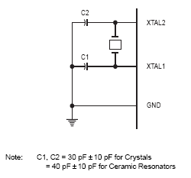

fig 3.9 micro-controller with crystal oscillator

^{3.9} ^{SOFTWARE DESIGN}

Software, are computer programs; instructionos that cause the hardware, the machines to do work. Software as a whole can be divided into a number of categories based on the type of work done. The two primary software categories are operating systems (system software), which control the workings of the computer, and application software, which addresses the multitude of tasks for which people use computers.

Application software performs word processing, database management, and the like. Two additional categories that are neither system nor application software, and language software, which provide programmers with the tools they need to write programs. In addition to these task-based categories, several types of software are described based on their method of distribution.

^{3.9 .1 SOFTWARE DEVELOPMENT}

Software development involves series of steps or is a set of activities that are necessary to be taken for the development of reliable and maintainable software. It is of great importance because hardware design cannot be used in micro-controller based systems without dependable software. A typical micro-controller development systems (MDS) includes; VDU, Registers, RAM, which serves as a store for the PROM programmer.

Software systems are a term used to describe a program that is provided by the manufacture to aid the development of user (application) programs. These include programs that convert assembly language into machine code (assembler), or high-level language into machine code (interpreter or compiler).

It also includes programs that facilitate program modification (editor). The computer aided development methodology, which is essential for software development, is summarized below.

- ^{TEXT EDITOR:}
This is a kind of word processor that is used to in programming. After keying in the program codes using the input device, and the program is displayed on the VDU, the Text editor can be used to check and correct errors in the program in the program. In a nutshell, the text editor is used to edit the program after it has been written.

- ^{TRANSLATOR}
There are two types of translators, assembler and complier. An assembler translates assembly language in the form of mnemonic (memory aids) into machine code. A good feature of assemblers is creating a list that shows the machine code and the assembly language of the program side by side. A complier on the other hand translates a high-level language into machine code.

- ^{LINKER/LOCATOR}
This is used to join the different modules that make up the program together in the correct sequence and this is to be bound to addresses. The linker/locator pair works together to coordinate between the separate modules for smooth program execution.

- ^{LOADER}
The loader aids in loading an object code into RAM.

- ^{TESTING}
After the program is written, it was tested; it was tested; this involves executing the program with selected inputs called test cases, the result of the test is used to decide whether or not the program is functioning as desired.

- ^{DEBUGGING}
This involves detecting out and removing errors in the program.

^{3.10} ^{DEVELOPMENT PROCESS}

In writing the software for this project a modular approach was employed. This made it easier to check for errors and debug the program. Three major tools were used in the development process; the A51 assembler was used to translate from the source code into the object code. The L51 was employed to link the program while the Ohs51 did the conversion from binary to Hex. The choice of assembly language is because it makes a program small and enhances faster execution. High-level language is complex.

^{3.11} ^{PROGRAM ENTRY AND EDITING}

After the design of the software, a text editor is employed to enter the source code into the disk file. As noted earlier, the text editor also functions to correct error in the program.

^{3.12} ^{ASSEMBLING AND LINKING}

After the source of the monitor has been transformed into object codes for the micro-controller (AT89c51), the assembler (A51) then produces an object file and a listing file. These two files generally represent the result of the assembly.

Furthermore, after assembling process the linker (L51) processes the different object modules and binds all selectable module to specific address locations in the memory. It also joins references between modules are resolved. Finally it summarizes listing files which shows the comprehensive results of the of the link/locate operation.

^{3.13} ^{SYSTEM CONTROL PROGRAM STEPS}

The operation of the microcontroller based remote control dot matrix advert display system is summarized as follows;

when powered on the cascaded LED it displays “UNIVERSITY CAFETERIA”

Indirect addressing; this involves looking for the memory location whose address is contained in another location (usually HL registers).

^{Eg. MOV A, M}

This means load the A register with the contents of the memory location whose address is specified in HL register. Call for LED display: this is a subroutine that is used to display an instruction. First two registers R1 and R2 and used. There has to be call for the screen buffer then the in-counter registers which is for registers, the memory location id being moved into an accumulator, then the accumulator converts to machine code for the display.

A call decoder that is software instruction is done which converts the machine code into dot matrix display equivalent. The ports are enabled through a subroutine of call delay for the display. This makes the micro-controller to delay for LED display to light up.

^{3.14} ^{SOFTWARE FOR THE PROGRAMMER}

Software for the programmer is downloaded from the Atmel BBS 4080-436-4309. The programmer is controlled by software running host. The AT89c51 have dedicated control programs, which were written in Microsoft Assembly.

All programmer control programs are invoked from the DOS command line by entering the program name followed by LPT1* or “LPT2” to specify parallel port one or two, respectively. If the parallel port is not specified, the program will respond with an error message. The control programs are menu-driven, and provide the following functions:

Chip Erase: Clear code memory to all ones. The successful operation of this function is not automatically verified.

Program from File: Write the contents of the specified file into device memory. The user is prompted for the file name, which may require path and extension.

The file is expected to contain binary data; hex files are not accepted. The first byte in the file is programmed into the first location in the device. Successive bytes are programmed into successive locations until the last location in the device has been programmed or until the data in the file has been exhausted. Programming occurs regardless of the existing contents of device memory; s blank check is not automatically performed after programming, the contents of device memory are not automatically verified against the file data. This is done because timing is enforced by software; the programming status information provided by DATA RDY/BSY is not utilized. The control program provides no visual indication that programming is in progress. The main menu is redisplayed when programming is complete.

^{Verify against File.}

Compare the contents of code memory against the contents of the specified file. The user is prompted for the file name, which may require path and extension.

The file is expected to contain binary data; hex files are not accepted. The first byte in the file is compared into the first location in the device. Successive bytes are compared to successive locations until the last location in the device has been compared or until the data in the file has been exhausted. Locations that fail to compare are displayed by address, with the expected and actual byte contents. If there are no compare failures, nothing is displayed.

Save to File: Copy the contents of device memory to the specified file.

The user is prompted for the file name, which may require path and extension. The number of bytes in the resulting file is the same as the number of memory locations in the device.

^{Blank Check}

Verify that the contents of device memory are ones. Only pass of fail is reported; the addresses and contents of failing locations are not displayed.

^{Read Signature:}

Read and display the contents of the signature bytes. The number of signature byte and their expected contents varies between devices. Refer to the device data sheet for additional information.

^{Write Lock Bit 1}

^{Write Lock Bit 2}

^{Write Lock Bit 3}

Set the indicated lock bit. Note that the AT89c51 contain only two lock bits. The state of the lock bits cannot be verified by direct observation.

^{Exit}

Quit the programmer control program.

^{Table 4.0 MNEMONICS}

^{MNEMONIC} ^{DESCRIPTION} ^{DATE} ^{OSCILLATOR PERIOD}

^{INC} ^{direct Increment} ¹ ¹²

^{INC@Ri} ^{Increment indirect RAM} ¹ ¹²

^{DEC A} ^{Decrement Accumulatro} ¹ ¹²

^{DEC Rn} ^{Decrement Register} ¹ ¹²

^{DEC direct} ^{Decrement direct byte} ² ¹²

^{INC @Ri} ^{Decrement indirect RAM} ¹ ¹²

^{INC @DPTR} ^{Increment Data Pointer} ¹ ²⁴

^{MUL AB} ^{Multiply A and B} ¹ ⁴⁸

^{DIV AB} ^{Divide A and B} ¹ ¹²

DA A Decimal Adjust Accumulator ¹ ¹²

^{LOGICAL OPERATIONS}

^{ANL} A,Rn AND Register to Accumulator ¹ ¹²

^{ANL} A, direct AND direct byte to Accumulator ² ¹²

^{ANL} A@Ri AND indirect RAM to Accumulator ¹ ¹²

LOGICAL OPERATIONS CONTD BYTE OSCILLATO RPERIOD

^{ANL} A,#data AND immediate data Accumulator ² ¹²

^{ANL} direct,A AND Accumulatro to direct byte ³ ²⁴

^{ORL} A,Rn OR register to Accumulator ² ¹²

^{ANL} direct,#data AND immediate data to direct ¹

^{ORL} A,direct OR direct byte to Accumulator ² ¹²

^{ORL} A,@Ri OR indirect RAM to Accumulator 1 ¹²

^{ORL} A,#data OR immediate data to Accumulator ² ¹²

^{OR} direct,A OR Accumulator to direct byte ² ¹²

^{ORL} direct,#data OR immediate data to Accumulator ³ ²⁴

^{XNL} A,Rn Exclusive – OR register to Accumulator ¹ ¹²

^{XNL} A, direct Exclusive-OR direct byte to Accumulator ² ¹²

^{XNL} A,@Ri Exclusive –OR indirect RAM to Accumulator 1 ¹²

^{XNL} A,#data Exclusive-OR immediate data to Accumulator 2 ¹²

^{XNL} direct,A Exclusive-OR Accumulator to direct byte ² ¹²

^{XNL} direct,#data Exclusive-OR immediate data to direct byte 3 24

^{CLR} ^{A Clear Accumulator} ¹ ¹²

^{CPL} ^{A Complement Accumulator} ¹ ¹²

^{RL} ^{A Rotate Accumulator left} ¹ ¹²

^{RR} ^{A Rotate Accumulator right} ¹ ¹²

^{RRCA} A Rotate Accumulator right through the carry1 ¹²

SWAP A Swap nibbles within the Accumulator ¹ ¹²

^{DATA TRANSFER}

^{MOV} ^{A, Rn register to Accumulator} ¹ ¹²

^{MOV} A, direct Move direct byte to Accumulator ² ¹²

^{MOV} A,@Ri Move indirect RAM to Accumulator ¹ ¹²

^{3.15} ^{SOFT TO HARD DESIGN}

PROGRAMMING THE MICRO-CONTRLLER (AT89c51)

The AT89c51 is normally shipped with the on-chip Flash memory array in the erased state (that is, contents = FFH) and ready to be programmed. The programming interface accepts either a high-voltage (12-volt) or a low-voltage (VCC) program enable signal. The low-voltage programming mode provides a convenient way to program the AT89c51 inside the user’s system, while the high-voltage programming mode is compatible with conventional third-party.

^{3.16} ^{FLASH OR EPROM PROGRAMMER.}

The AT89c51 is shipped with either the high-voltage or low-voltage-programming mode enabled. The AT89c51 code memory array is programming byte-by-byte in programming mode. To program the non-blank byte in the on-chip Flash Memory, the entire memory was erased using the Chip Erase mode. Programming Algorithm:

Before programming the AT89c51, the address, data and control signals are set up according to the Flash-programming mode. The following steps are taken to program the flash (AT89c51).

  - Input the desired memory location on the address lines.

  - Input the appropriate data byte on the lines.

  - Activate the correct combination of control signals

  - Raise EA/V PP to 12V for the high-voltage programming mode.

  - Pulse ALEPROG once to program a byte in the Flash array or the lock bits. The byte-write cycle is self-timed and typically takes no more than 1.5ms. repeat step1 through 5, changing the address and data for the entire array or until the end of the object file is reached.
Data Polling: The AT89c51 features Data Polling to indicate the end of a write cycle. During a write cycle, an attempted read of the last byte written will result in the complement of the written datum on PO.7.Once the write cycle has been completed, true data are valid on all outputs, and the next cycle may begin. Data Polling may begin any time after a write cycle has been initiated.
Ready/Busy: The progress of byte programming can also be monitored by the RDY BSY output signal. P3.4 I pulled low after ALE goes high during programming to indicate BUSY. P3.4 is pulled high again when programming is done to indicate READY. Program Verify: if lock bits LB1 and LB2 have not been programmed, the programmed code data can be read back via the address and data lines for verification.

The lock bits cannot be verified directly. Verification of the lock bits is achieved by observing that their features are enabled.

Chip Erase: The entire Flash array is erased electrically by using the proper combination of control signals and by holding ALE/PROG low for 10 ms. The code array is written with all 1’s. the chip erase operation must be executed before the code memory can be reprogrammed. Reading the Signature Bytes: the signature bytes are read by the same procedure as a normal verification of locations 030H, 031H, and 032H, except that P3.6 and P3.7 must be pulled to logic low.

^{3.17} USING A PERSONAL COMPUTER TO PROGRAM THE AT89C51

This application describes a personal computer-based programmer for the AT89c51 Flash-based Micro-controllers. The programmer supports all flash memory micro-controller functions, including code read, code write, chip erase, signature read, and lock bit write. When used with the AT89c51 write, chip erase, and lock bit write may be performed at either five or twelve volts, as required by the device. Devices sporting a – 5 suffix (7805) are intended for operation at five volts, while devices lacking the suffix operate at the standard twelve volts. The programmer connects to an IBM PC- compatible host computer through one of the host’s parallel ports. An integral power supply and external, wall-mounted transformer produce required operating voltages. The 8951 can be programmed using a device programmer PG302.

AT89C51 micro-controller operates at 11.0592 MHZ Two serial RS-232 ports with true RS-232 drivers and DB9 connection to PC compatible computers, DB9M serial port connector emulating the PC compatible serial port.

On-board contrast port 8192 byte (8k) EEPROM for storage of programs or configuration information, On-board power supply with a wide input range and including +5 and +12 volt outputs.

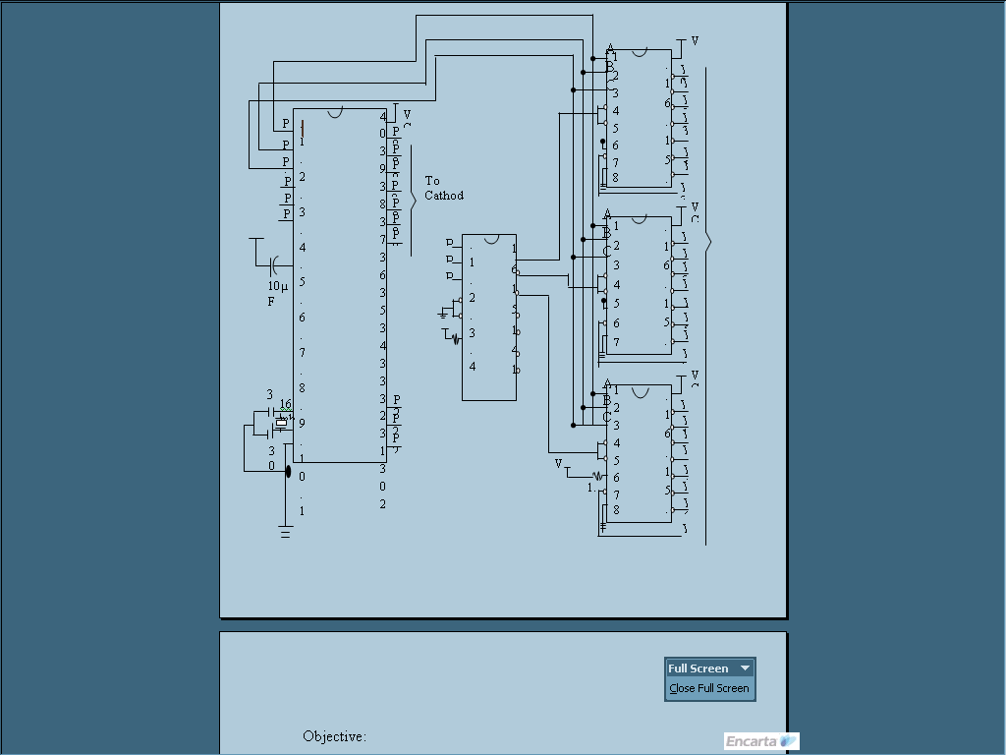

Fig3.10: circuit diagram (1) of micro-controller based dot matrix information display board.

^{CHAPTER FOUR}

^{METHODOLOGY}

The detailed method of operation involved in this project is what this chapter emphasized on. It is noted that the project is Micro-controller based, with some discrete components. However taking the method of operation sequentially.

However, the project consist of several units (refer to chap2 above), dot matrix simply means an array of light emitting diodes arranged in matrix form for instance 5 by 7 matrix., hence making a total of 35 lines i.e. 5 rows and 7 columns. Power is supplied via the power supply unit (PSU).

The cathode of the LEDs is connected together making all common cathode connection. NPN (BC547) Transistor are connected as drivers between the LEDs and the micro-controller, this acts as buffers to the LEDs, address generators (74LS138) were used to generate address to the micro-controller, they are 8 in number, the anodes of the LEDs are connected to the Y outputs of the 74LS138 (y0 y1 y2 y3 y4 y5 y5 y6 y7) is used to provide the address generating action. Transistor switches are used to drive the data from the memory in form of pattern to the LEDs that glow and show the information as programmed. Transistors of the same value, BC547 NPN transistors are connected in parallel to the data lines of the RAMs. These transistors are connected to the data bus through their base terminals, and through a uniform value of resistor, while the LEDs are connected through the controller terminals of the transistors and the emitter terminals are all grounded.

^{4.1} ^{INFORMATION GATHERING}

Micro-controller based programmable dot matrix information display system is a project programmed and designed with the help of some special available materials; I consulted a lot of textbooks to make sure it worked.

The internet is also a very useful tool too, in other to achieve this mission. It is a well-known fact that a project of this nature requires a wide research; my consultation to one Engr. Eloka Ugwu was also helpful.

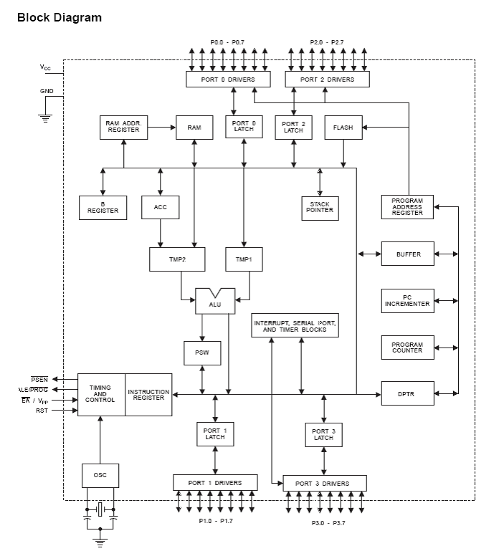

Fig4.0: Internal block diagram of Microcontroller AT89C51.

^{4.2} ^{DATA ANALYSIS}

Data Analysis is the processing of data to extract useful information and reveal significant patterns. A general set of data can otherwise appear meaningless or, at the least, obscure. There are many different ways in which such analysis can be performed, but most of them involve the production of graphs and charts.

Data analysis is important in many fields, ranging from Engineering to the natural sciences. Data to be used in this project is based on what I need to achieve, that is to display a moveable texts, which means there is need for software that can handle that kind of operation, I employed Assembly language for that purpose.

^{4.2.1} READING A TABLE OF TECHNICAL DATA FOR LEDS

Supplier’s catalogues usually include tables of technical data for components such as LEDs. These tables contain a good deal of useful information in a compact form but they are difficult to understand if you are not familiar with the abbreviations used. The table below shows typical data for some 5mm diameter rounds LEDs with diffused packages (plastic bodies). Only three columns are important and these are shown in bold. Please see below for explanations of the quantities.

TABLE 4.0 TABLE OF TECHNICAL DATA FOR LEDS.

^{Type} | ^{Colour} | ^{I}_{F}  Max. | _{VF}  Typ. | _{VF}  Max. | _{VR}  Max. | _{Luminous}  Intensity | _{Viewing}  Angle | Wavelength
_{Standard} | _{Red} | _{30Ma} | _{1.7V} | _{2.1V} | _{5V} | _{5mcd @}  10mA | ₆₀⁰ | ^{660nm}
^{Standard} | ^{Bright} | ^{30mA} | ^{2.0V} | ^{2.5V} | ^{5V} | ^{80mcd @} | ⁶⁰⁰ | ^{625nm}
 | ^{Red} |  |  |  |  | ^{10mA}
^{Standard} | ^{Yellow} | ^{30mA} | ^{2.1V} | ^{2.5V} | ^{5V} | ^{32mcd@}  10mA | ⁶⁰⁰ | ^{590nm}
^{Standard} | ^{Green} | ^{25mA} | ^{2.2A} | ^{2.5V} | ^{5V} | ^{32mcd@}  10mA | ⁶⁰⁰ | ^{565nm}
^{High intensity} | ^{Blue} | ^{30mA} | ^{4.5v} | ^{5.5v} | ^{5v} | ^{60mcd@}  20mA | ⁵⁰⁰ | ^{430nm}
^{Super bright} | ^{Red} | ^{30mA} | ^{1.85V} | ^{2.5V} | ^{5V} | ^{500mcd@}  20mA | ⁶⁰⁰ | ^{660nm}
^{Low current} | ^{Red} | ^{30mA} | ^{1.7V} | ^{2.0V} | ^{5V} | ^{5mA@}  2mA | ⁶⁰⁰ | ^{625nm}

^{IF max.} Maximum forward current, forward just means with the LED connected correctly.

^{VF typ.} Typical forward voltage, VL in the LED resistor calculation. This is about 2V, except for blue and white LEDs for which it is about 4V.

^{VF max.} ^{Maximum forward voltage.}

^{VR max.} ^{Maximum reverse voltage}

You can ignore this for LEDs at the corrected the correct way round.

^{Luminous} Brightness of the LED at the given current, mcd= milicandel

^{Intensity}

^{Viewing angle} Standard LEDs have a viewing angle of 600, others emit a narrower beam of about 300

^{Wavelength} The peak wavelength of the light emitted, this determines the colour of the LED.

4.2.2 CALCULATING THE LED RESISTOR VALUE

An LED must have a resistor connected in series to limit the current through the LED, otherwise it will burn out almost instantly.

The resistor value, R is given by:

^{Vs = supply voltage}

VL =LED current (usually 2V, but 4V for blue and white LEDs)

I = LED current (e.g. 20mA), this must be less than the maximum permitted value.

If the calculated value is not available we choose the nearest standard resistor value which is greater, so that the current will be a little less than you chose. In fact you may wish to choose a greater resistor value to reduce the current (to increase battery life for example) but this will make the LED less bright. If the supply voltage Vs=9V, and you have a red LED (VL =2V), requiring a current I = 20mA =

^{0.020A}

R= (9V – 2V) /0.02A = 35oΩ, so choose 390Ω (the nearest standard value which is greater).

Working out the LED resistor formula using Ohm’s law Ohm’s law says that the resistance of the resistor, R = V/I, where: V= voltage across the resistor (= Vs –VL in this case)

I= the current through the resistor

^{So R = (Vs – VL) /I}

4.2.3 CALCULATING THE LOAD CURRENT OF THE RECTIFIER

The load current of the rectifier is given as follows;

^{Idc = 21m/3.14}

Where Im=maximum current drawn =2 amp

Idc=load current which is in dc form after rectification.

Hence Idc = 2*2/3.14, Idc = 1.27 amps

Therefore 1.27 amps is the maximum load current that can be drawn in the whole system. Also it is known that after rectification, the same voltage (15-volts) continues to flow into the filter. As a result the load voltage is 15-volts.

Thus Vdc = Load voltage = 15volts.

^{And Vdc = 2 Im*RL /3.14}

^{RL = Load resistance.}

^{RL = 3.14 Vdc /2 Im = 3.14}

^{RL =47.13/4}

^{RL = 11.78* 3.14 = 1.78}

From this, it is obvious that V = IR = 1.27 * 1.78

Components connected to the Micro controller for complete configuration includes:

- 110592 OR 12.0 MHZ Crystal oscillator.

- ^{305 Capacitors.}

- ^{10uF Capacitors.}

- ^{1k Resistors}

- ^{330ohm Resistors}

- ^{LEDs}

- ^{Jumper wires}

^{4.3 SYSTEM DESIGN APPROACHES}

the system’s name is micro-controller based programmable dot matrix information display system, firstly in my design approach, after purchasing the required components, I constructed the power supply unit thereafter I wrote software software program and compiled it into the virgin micro-controller I purchased, this I did with the help of a personal computer. Lastly I did the final connection on the Vero board.

^{4.3.1} ^{TOP – DOWN}

The first chapter, which is the introduction dwells on the insight of the project, that is, it gives a clear understanding of what micro-controller based programmable dot matrix information display system is all about. Also treated was the scope and history of the project.

Then the chapter two dwells on the literature review, giving an insight of various stages of the project, taken each stage one at a time. Chapters three and four deals with the main method and design processes, which are the heartbeat of this project. In chapter five and six, I analyzed system testing and finally summarized them with a conclusion. The latter part of this write up includes the reference and the appendix.

^{4.3.2} ^{BOTTOM-UP}

The latter part of this write up includes, the reference and the appendix, reference provides the various textbooks I consulted to help me complete the write up, appendix gives an explanation on the acronyms that I used. I chapter five and six, I analyzed system testing and finally summarized them with a conclusion.

Then the chapter two dwells on the literature review, giving an insight of various stages of the project, taken each stage one at a time. The first chapter, which is the introduction dwells on the insight of the project, that is, it gives a clear understanding of what microcontroller based remote control dot matrix advert display board is all about. Also treated was the scope and history of the project.

^{4.4} ^{CHOICE OF DESIGN APPROACHES}

My choice of design depends mainly on what I expect to achieve at the end, questions might be generated on what exactly is required to be achieved and the feasibility of the idea as regards to the implementation. If these questions are analyzed critically with tangible solutions to the problem, a development of this idea into a reality is the next step.

Requirements for design process have to be considered once an idea has been established. However, it came to my thought that among all the components used here the one that consumes the highest power is the Light Emitting Diodes (LEDs), which need as much as 15-volt to glow and draw as maximum as 2-ampere rated transformer for this design. The factors that influence choice of components is based on where the idea is best suited and cost. We used 7805 regulator in the power supply because of the low voltage consumption of the components, in other to limit risk of damage or component failure; also I employed the service of AT89c51 micro-controller because of its availability. I used assembly language programming in other to ease mnemonic understanding, 74LS138 address generator was used because of its compatibility with the micro-controller. Most micro-controllers (such as a normal 8051 or 8751) cannot handle the current required to turn an LED on and off but the ATNMEL part (8951) has this capability.

^{4.5} ^{DATA FLOW ARRANGEMENT}

The data flow arrangement of this project is as fol

^{lows:}

  - ^{Power supply}

  - ^{Crystal oscillator}

  - ^{Transistors}

  - ^{LEDs}

  - ^{Address generators.}

  - ^{Micro-controller (AT89c51)}

^{4.6} ^{SYSTEM FLOWCHART}

^{Fig4.1 System Flow chart}

^{CHAPTER FIVE}

^{SUMMARY AND CONCLUSION}

This project, microcontroller based dot matrix advert display system was designed to represent a sign post, which says “UNIVERSITY CAFETERIA’’

all steps I took in the design of this project was accomplished by taken each unit at a time in the design process, as I stated earlier that the project is made up of several sub units.

The power supply unit was the first unit I designed before other sub units followed suit. However microcontroller based remote control dot matrix advert display to display vital information in a more fancied digital and colored form can not be over emphasized. Hence companies and corporate organizations have taken advantage of this.

^{5.1} ^{SUMMARY OF ACHIEVEMENT}

My achievement is that I have now got the knowledge about how micro-controller can be used to design a beautiful project of this nature. Also I realized the reason why assembly language is better preferred to a more complex and complicated C-language. In the design of a micro-controller based project like this one.

^{5.2} PROBLEMS ENCONUTERED AND SOLUTION

There are both major and minor difficulties encountered during the design of this project.

^{Major:}

- NONAVAILABILITY FACTOR: I find it very difficult to get the appropriate micro-controller for this project. This made me to walk extra mile by making a special order that costs me much than I estimated

- The unsteady power supply: there was unsteady power supply and when supplied, the case of very low voltage. This actually put some delay in finishing the work within the project duration. However, I hired generator to complete the work thereby spending more than I planned to. MINOR:

- LACK OF FINANCE: The basic requirements for designing a project like this is cost intensive that I could afford presently. To this effect, the design of this of this project was limited to what I can control.

- COMPONENT FAILURE: The LEDs failed most times, including the capacitors and transistors, this happened during soldering, because these components cannot withstand very high temperature. Hence I replaced them with good ones.

- PROGRAMMING PROBLEM: The PG302 programmer was not easy to come by, this made me to travel far a distance, in fact there was problem of getting the real instruction set for the AT89c51 so I had to consult the data book for Atmel corporation micro-controller products.

- SHORT CIRCUIT: there was too much short-circuiting, which resulted in the loss of some components. Hence I trouble-shoot and removed the affected ones only to replace them with new ones.

- SOLDERING: soldering was a problem of its own, I mistook the anode of the LEDs to the cathode on the course of soldering, this interrupted current flow, hence I made corrections where necessary and then re-soldered.
5.3 SUGGESTIONS FOR FURTHER IMPORVEMENT
This project can further be improved to generate report on daily, weekly, monthly and yearly basis that this project could not do due to time constrain.Take an example, if the project were constructed to have an interface with PC it would be better.

^{5.4} ^{CONCLUSION}

Dot matrix information display is all about the distribution of information and entertainment in dot matrix format, usually including software that allows viewers to interact with text, symbols and images. Most forms of information can be published electronically by way of dot matrix information display, The advent of microcontroller have made it easier for us to display information in this format in a unique way.

^{REFERENCES}

B. BORAT (1997) –A course in digital processing, Wiley 6th edition ARIE VAN STAVEREN AND ARTHUR ROERMOND (2000)__ structured electronic design, springer publishers, 5th edition.

J. LIM AND A. OPPENHEIM (1988) __ advanced topics in digital processing. Prentice Hall limited, New Delhi 2nd edition.

EDWARD ROLL TUFT (1990) ___ Principles of information display, graphic press, 3rd edition.

TAKIS C. KESPARIS (2003)___ electrical and computer engineering, central Florida USA, 7th edition.

JOSEPH GREENFIELD (1999) ___ digital electronic design Oxford University press 4th edition.

MCGRAW-ARCHER (2000) ___ advanced digital electronics, oxford University press, 2nd edition.

ENCARTA ENCYCLOPEDIA/PREMIUM 2004.

^{APPENDIX 2:}

^{ACRONYMS AND THEIR MEANINGS}

^{ALE} ^{access latch enable}

^{AMP} ^{ampere}

^{BSY} ^{busy}

^{CMOS} complementary metal-oxide semi-conductor

^{CTRL} ^{control}

^{CPU} ^{central processing unit}

^{DOS} ^{disc operating}

^{EA} ^{external access enable}

^{GND} ^{ground}

^{Ip} ^{primary current}

^{Is} ^{secondary current}

^{LED} ^{light emitting diode}

^{LCD} ^{liquid crystal diode}

^{P} ^{power}

^{Pp} ^{primary power}

^{Ps} ^{Secondary power}

^{PSEN} ^{program store enable}

^{PEROM} programmable and erasable read only memory

^{PSU} ^{power supply unit}

^{RAM} ^{Random access memory}

^{RST} ^{reset}

^{RDY} ^{ready}

^{TTL} ^{transistor-transistor logic}

^{Vp} ^{primary voltage}

^{Vs} ^{secondary voltage}

^{Vin} ^{input voltage}

^{Vout} ^{output voltage}

^{VDU} ^{video display unit}

^{X-FORMER} ^{transformer}

^{XTAL} ^{crystal}

