TEXTURE CHARACTERIZATION OF STROKE LESIONS IN NON-CONTRAST COMPUTED TOMOGRAPHY IMAGES OF NIGERIAN PATIENTS

ABSTRACT

The aim of this study was to characterize stroke lesions and normal brain tissue in computed tomography (CT) images of Nigerian patients using statistical texture descriptors, and to identify the class of texture descriptor that is most suitable for computer-aided diagnosis of stroke. Non-contrast CT images of 164 stroke patients were obtained in contiguous slices from the base of the skull to the vertex from two private radiodiagnostic centres. Initially, two experienced radiologists blinded to each other, visually inspected the images to identify and categorize the lesions into ischaemic and haemorrhagic subtypes. Four regions of interest (ROIs) were selected on each CT image that demonstrated the lesion; two each represented the lesion and normal tissue respectively. Statistical texture descriptors of co-occurrence matrix, run-length matrix, absolute gradient and histogram, representing spatial distribution of grey levels in the images were calculated. Raw data analysis was carried out to identify the best parameters that discriminated between normal brain tissue and stroke lesions. Three parameters in each texture class discriminated between normal brain tissue, ischaemic and haemorrhagic stroke lesions. Artificial neural network (ANN) and k-nearest neighbour (k-NN) algorithms were used to classify the ROIs into normal tissue, ischaemic and haemorrhagic lesions using the radiologists’ identification and categorization as the gold standard. The classification of ROIs was compared with the radiologists’ categorization of lesions and normal tissues, and further analyzed using the receiver operating characteristic curve to establish the sensitivity and specificity of ANN and k-NN in identifying stroke lesions. The discriminating co-occurrence matrix parameters were sum average parameters namely S1-1 SumAverg with feature value of - 3.54 to 4.35, S1-0 SumAverg -4.19 to 4.39 and S0-1 SumAverg -3.87 to 4.30. For the run-length matrix, short run emphasis in the horizontal, 135⁰ and 45⁰ directions with feature values of -9.08 to 2.27, -9.61 to 2.13 and -9.13 to 2.16 were the discriminating features. The discriminating absolute gradient-derived parameters were gradient non-zeros with feature value of -14.33 to 0.83, gradient variance -2.71 to 4.00 and gradient mean -3.96 to 2.58. For the histogram class, the mean with feature value of -1.77 to 2.59,

Page | 17
90 percentile -1.83 to 2.19 and 99 percentile -1.99 to 1.91 were the discriminating parameters. The ANN achieved a sensitivity of 0.637, specificity 0.753, false positive rate (FPR) 0.247, and false negative rate (FNR) 0.363 with the co-occurrence matrix. With the run-length matrix it achieved a sensitivity of 0.544, specificity 0.607, FPR 0.393, and FNR 0.456 while with the absolute gradient it achieved a sensitivity of 0.546, specificity 0.586, FPR 0.414, FNR 0.454. With the histogram it achieved a sensitivity of 0.947, specificity 0.962, FPR 0.038, and FNR 0.053. The k-NN achieved a sensitivity of

0.644, specificity 0.759, false FPR 0.241, and FNR 0.356 with the co-occurrence matrix. With the run-length matrix it achieved a sensitivity of 0.481, specificity 0.676, FPR 0.324, and FNR 0.519 while with the absolute gradient it achieved a sensitivity of 0.445, specificity 0.651, FPR 0.349, and FNR 0.555. With the histogram it achieved a sensitivity of 0.929, specificity 0.955, FPR 0.045, and FNR 0.071. The histogram-based classification was significantly better than other statistical texture descriptors using the ANN and k-NN (p < 0.05). The histogram class of texture features also showed the highest sensitivity and specificity in classification of brain tissue and therefore is adjudged most suitable for computer-aided diagnosis of stroke. The results suggest that histogram-derived features can be used in computer-aided diagnosis of stroke on non contrast brain CT and can improve diagnosis.

Page | 18
CHAPTER ONE

INTRODUCTION

1.1 BACKGROUND OF THE STUDY

Medical imaging is a rapidly developing branch of modern medicine. It has in the past few decades evolved into a highly sophisticated diagnostic tool. It has improved the study of human internal anatomy and to an extent physiology and detection of pathologies which were previously impossible. The field has kept pace with other rapidly developing branches of medicine. At this stage of its development, detection of lesions and their interpretation is becoming an automated computer-aided process. It can now be safely said that machine vision has become an emerging part of radiology and imaging in medicine. Stoitsis et al. (2006) stated that advances in medical imaging technology and computer science have greatly enhanced the interpretation of medical images and contributed to early diagnosis. The bases for computer aided diagnosis (CAD) in radiology are medical image processing and artificial intelligence.

Cerebrovascular accident (CVA) or stroke, accounts for a significant proportion of neurological disorders seen in Nigerian hospitals (Ojini et al., 2003). Its incidence in Nigeria and other sub-Saharan African countries is on the increase (Myles et al., 2007). It carries high morbidity and mortality statistics in industrialized countries (Wolf et al., 1978; Gorelick, 1995; Sudlow and Warlow, 1996; Warlow, 1998) and Africa

Page | 19
(Osuntokun, 1994). Stroke is the third most common cause of death worldwide after heart disease and cancer. It is reported to be the leading neurological cause of death in Africa (Howlett, 2012). The World Health Organization (WHO) (1988) defined stroke as a rapidly developing clinical syndrome of focal or global disturbance of cerebral function presumably of vascular origin, lasting longer than 24 hours unless interrupted by surgery or death. Other definitions of stroke have been derived from that of the World Health Organization. For instance, Holmes and Mirsa (2004), defined it as a focal neurological deficit lasting more than 24 hours and often preceded by transient ischaemic attack (TIA) in 10 - 15 per cent of the cases. Stroke occurs when blood supply to the brain is disturbed. This results in brain cells being starved of oxygen and consequently, some cells die while others are left damaged. Brain cells being permanent in nature, achieve only very limited recovery, leaving the patient with a permanent disability. A stroke may be due to infarction (ischaemic stroke) in 80 per cent of the cases or haemorrhage in the remaining 20 per cent. There are a variety of processes involving blood vessels which may lead to luminal compromise and cerebral ischaemia (Reeves and Swenson, 2008). Haemorrhagic stroke is usually associated with uncontrolled and longstanding hypertension. Clinically, ischaemic stroke presents as a focal neurological deficit of sudden onset, but there may be a step-like progression with headaches, complete loss of consciousness and vomiting as common signs and symptoms, unless the brainstem is involved (Holmes and Mirsa, 2004). Clinical presentation of haemorrhagic stroke varies according to the site, type and location of the bleed. Headaches, vomiting, focal neurological deficit and decreased level of consciousness are the characteristic signs and symptoms and there may be quick progression to coma (Holmes and Mirsa, 2004).

`

Page | 20
The clinical diagnosis of stroke and its subtyping is notoriously inaccurate (Chukwuonye et al., 2015; Sheta et al., 2012; Imarhiagbe and Ogbeide, 2011; Khan and Rehman, 2005). Neuroimaging is therefore essential for accurate diagnosis. Stroke remains one of the most important clinical diagnosis for which patients are referred to the radiology department for emergency imaging because timely and accurate diagnosis is critical in the management of patients (Mullins, 2006). Previous studies have highlighted the time-critical nature of ischaemic stroke diagnosis (Burnette et al., 1999; Jager, 2000; Tegos et al., 2000; Kidwell et al., 2000; Lev and Nichols, 2000; Keris et al., 2001; Burnette and Nesbit, 2001;). Ischaemic stroke has a narrow therapeutic window in the first few hours following stroke ictus and a dramatic rise in haemorrhage complications thereafter.

Non contrast head computed tomography (NCCT) has been suggested as the mainstay for early stroke diagnosis because CT scanners are more widely available in the communities and may be accessed much more easily (Mullins, 2006) than magnetic resonance imaging (MRI). This scenario is true of the Nigerian society and many other African countries because of the increasing utilization of CT. Computed tomography examinations are not only cheaper than MRI, they are also faster to perform. Thus, taking the time-critical nature of early stroke diagnosis into consideration, NCCT is the preferred first line imaging tool. Computed tomography is also considered to be very sensitive to early stroke and in most instances can provide information required to make decisions during emergencies (Chawla et al., 2009).

Page | 21
Computed tomography and other neuroimaging procedures will however not benefit the patient until the images have been accurately interpreted. For visual analysis and interpretation of stroke CT images, the radiologist seeks to identify affected areas of the brain by examining the dissimilarity between the left and right cerebral hemispheres. The challenges associated with visual interpretation of stroke CT images in Nigeria include the dearth of neuroradiologists (Atalabi et al., 2013) and the human errors of interpretation and diagnosis. Errors in visual interpretation result from poor technique, failures of perception, lack of knowledge and misjudgments (Robinson, 1997). Additional errors can come through the transmission of the radiologist’s visual impression, via non-visual means to the referring clinician (Sabih et al., 2010).

Visual interpretation can be improved upon by texture analysis which will make it possible for automated computer-aided approach to be used as a second opinion for clinicians especially in equivocal cases. Automatic method of stroke detection follows the same pattern as visual analysis and interpretation used by radiologists. Chawla et al. (2009) adopted this method in their study of automatic detection and classification of stroke from CT images of the brain. The method they used was based on the observation that the occurrence of stroke disturbs the natural contra-lateral symmetry of a CT slice. Accordingly, they were able to characterize stroke as a distortion between the two halves of the brain in terms of tissue density and texture distribution (Chawla et al., 2009). Some clinical applications of automatic detection and classification of stroke in CT images using texture analysis have been proposed notably by Bhat and Singh (2012) and Oliveira et al. (2009). Recently, Devi and Rajagopalan (2013) also proposed a method of segmenting stroke and non-stroke regions in magnetic resonance images and obtained

Page | 22
encouraging results. Computer-aided diagnosis, also referred to as automated diagnosis, is not a common clinical application for stroke and other human diseases because there appear not be agreement on the best approach to it. The texture parameters and decision algorithms to be used are still subjects of debate. The present study is aimed at evaluating the relative accuracies of the four classes of statistical texture descriptors in automatic detection of stroke. The methods of automated diagnosis in medical imaging are anchored on texture analysis of medical images and artificial intelligence.

Artificial intelligence (IA) simulates the human brain or recreates it electronically. It is defined as the study and design of intelligent agents (Poole et al., 1998), where an intelligent agent is a system that perceives its environment and takes actions that maximize its chances of success (Luger and Stubblefield, 2004; Russel and Norvig, 2003; Poole et al., 1998). The simplest intelligent agents are programs written to solve specific problems. More complicated intelligent agents include human beings and organization of human beings such as a firm or a team. Artificial intelligence is based on the central characteristic of human beings; intelligence – the sapience of Homo sapiens. The human intelligence can be so precisely described that it can be simulated by a machine. The tools utilized in solving problems using artificial intelligence include search and optimization, logic, probabilistic methods for uncertain reasoning, classifiers and statistical learning methods and neural networks (Kapoor et al., 2015).

One very important stage in medical image processing leading to CAD is image texture analysis. Texture analysis of a medical image is the measurement of the quantitative

Page | 23
parameters that constitute the image of a supposed lesion or normal tissue. This has the advantages of helping clinicians make accurate diagnosis and monitor disease processes under treatment. The analysis of texture parameters is a useful way of increasing the information obtained from medical images (Castellano et al., 2004).

Four approaches are recognized in texture analysis and these are structural, model-based, transform and statistical approaches (Castellano et al., 2004; Materka and Strzelecki, 1998). The statistical approach to texture analysis is more popular with researchers involved in application of texture analysis in medicine because it yields an enormous amount of data and thus richer texture, so to speak. According to Ojala and Pietikäinen (2004), statistical methods analyze the spatial distribution of grey level values by computing local features at each point in the image and deriving a set of statistics from the distribution of local features. The reason behind this is the fact that the spatial distribution of grey values is one of the defining qualities of texture (Srinivasan and Shobha, 2008). The statistical method describes the spatial distribution of grey levels and their patterns. Statistical texture descriptors are made up of the grey level co-occurrence matrix, grey level run-length matrix, absolute gradient and histogram classes.

Grey level co-occurrence matrix describes the relative positions of pairs of pixels with the same grey-level intensity while grey level run-length matrix describes the consecutive occurrence of pixels with the same grey-level intensity in particular directions. Absolute gradient calculates parameters related to variation of pixel grey-level values across an image, and the histogram represents the calculated grey-level

Page | 24
distributions in an image. The different statistical approaches to texture analysis have advantages and disadvantages when applied to clinical situations. The co-occurrence matrix assesses texture on a pixel by pixel basis and allows for discrimination of images that are visually inseparable. It is computationally intense and gives rise to a large number of texture features. Therefore, there must be a mechanism to select the relevant features (Tuceryan and Jian, 1998). The co-occurrence matrix has been the most popular texture feature used for development of computer-aided detection and classification of lesions (Rajini and Bhavani, 2013; Zhang and Wang, 2007; Kabara et al., 2003). The run-length matrix is a third order histogram. It describes the number of consecutive pixels in a given direction having the same grey level intensity. Because the grey levels in the images are numerous calculating run-length matrix parameters may actually reduce texture information. Absolute gradient describes the spatial variation in grey level values across an image. It is a rather simple concept. It is usually used to emphasize contours or boundaries in images (Catellano et al., 2004). The histogram approach to texture is another simple concept. It is the count of pixels in an image that possess a given grey level value (Castellano et al., 2004). Many researchers and students are comfortable with the histogram method because of their familiarity with the histogram in lower level mathematics and statistics courses. In this study, the statistical approach to texture was adopted because the methods involved are versatile and also to compare the different statistical approaches to texture analysis.

The incidence of stroke in Nigeria and other sub-Saharan African countries is on the increase (Myles et al., 2007). Factors responsible for this increased incidence include change in diet, increase in cigarette smoking and alcohol consumption, inadequate

Page | 25
exercise, increase in prevalence of obesity, and increase in other non-communicable diseases like hypertension and diabetes mellitus (Chukwuonye et al., 2013). In addition to the increasing incidence of stroke, the ratio of neuroradiologist to stroke patients in our locality is not encouraging. The aim of this study was to characterize and classify stroke lesions on non-contrast CT images using the four groups of statistical texture parameters. We also sought to cross-validate the classification with radiologist’s visual categorization identification of stroke lesions. This was to identify the most accurate statistical texture descriptor that may be used for computer aided diagnosis and classification of stroke lesions which would improve diagnosis and enhance patient management.

1.2 STATEMENT OF PROBLEM

There is increasing incidence of stroke in sub-Saharan Africa (Myles et al., 2007) which has resulted from increased incidence of its predisposing factors (Chukwuonye et al., 2013). Stroke poses a diagnostic challenge to clinicians practicing in our locality. Clinical diagnosis using the different weighted clinical scoring methods like Siriraj Stroke Score (Poungavarin et al., 1991; Chukwuonye et al., 2015; Rahman and Jamal, 2015;), Besson Stroke Score (Besson et al., 1995) and Allen Stroke Score (Nouira et al., 2009) is often inaccurate and thus radiological diagnosis is necessary. Computed tomography diagnosis is performed by the radiologist by visual inspection of CT images to identify the affected areas of the brain, the stroke type and quantify the extent of the lesion. The CT diagnosis is challenged by the dearth of neuroradiologists with experience in stroke detection and pitfalls due to human errors. Delays in obtaining fast, accurate and reliable diagnosis have led to high mortality from stroke, especially subarachnoid haemorrhage (Kowalski et al., 2004). The time-critical nature of stroke

Page | 26
diagnosis therefore necessitates a simple, fast and reliable computer-aided automated process. There are no reliable data locally on texture parameters to construct algorithms for automatic detection and classification of stroke.

There has not been any holistic evaluation of the statistical approaches to texture analysis previously. There is no previous study aimed at producing an automatic detection and classification system for stroke lesions that included all the classes of statistical texture features for comparison of their performances in classification. It is therefore not clear which statistical texture descriptor is most suitable for computer-aided diagnosis of stroke.

The previously proposed methods lack generalization because they were based on data from a small number of patients and limited amount of data, focused mainly on ischaemic stroke and employed only one or two classes of texture features. With fewer participants in the studies and limited focus, it is possible that the classification algorithm may not have been comprehensive enough to detect all the possible cases of stroke.

1.3 OBJECTIVES OF THE STUDY

The main objective of the study was to characterize stroke lesions in NCCT of Nigerian patients using statistical texture parameters and identify the best statistical texture descriptor that will discriminate between stroke lesions and normal tissues as a preliminary stage in the development of an automatic detection system for stroke.

Page | 27
The specific objectives were to:

- use statistical texture descriptors to analyze non-contrast computed tomography images of stroke lesions in Nigerian patients and identify the texture parameters that differentiate between normal brain tissue and stroke lesions using raw data analysis (RDA),

- use artificial neural network (ANN) and k-nearest neighbour (k-NN) algorithms to classify brain tissue on non-contrast brain CT as normal, ischaemic and haemorrhagic using the obtained statistical texture features as the input data,

- cross validate the classifications of brain tissue using ANN and k-NN with radiologists’ visual identification and categorization of stroke lesions and normal brain tissue using receiver operating characteristic (ROC) curve analysis,
- to compare the accuracy of artificial neural network and k-nearest neighbour algorithms in classification of brain tissue of stroke patients, and
- to determine the sex, age and anatomical distributions of stroke lesions in the patients.

1.4 SIGNIFICANCE OF THE STUDY

The result of this study will establish the best statistical texture descriptor that could be used in building automatic stroke identification and classification on NCCT of the brain. The result will also identify the algorithm more suitable for classification of brain tissue on NCCT of the brain. It will also provide the required database for computers to identify and classify lesions due to stroke, according to subtype on NCCT images which is hoped would improve diagnosis.

Page | 28
The result will also serve as documentation for texture analysis of medical image research in general and CT images of stroke in particular which will be of immense benefit for future studies in the subject area especially in Nigeria.

1.5 SCOPE OF THE STUDY

The study was limited to patients who were clinically diagnosed to have had stroke and underwent NCCT examination of the brain in the CT suites of two private radiodiagnostic centres in Onitsha, Anambra State and Ibadan, Oyo State, Nigeria. The two radiodiagnostic centres received referrals from the teaching hospitals in both localities. The patients were referred from the teaching hospitals and peripheral private hospitals in both localities. The study also included chronic stroke patients who had follow-up NCCT of the brain following a recurrence. The data collection for the study lasted from May, 2013 to April, 2014. Other neuroimaging modalities relevant to stroke were not included in the study.

Page | 29

CHAPTER TWO

REVIEW OF RELATED LITERATURE

2.1 CONCEPTUAL REVIEW

2.1.1 INTRODUCTION

Image texture is a rather difficult term to define. There is no standard or unified definition of image texture, but it is easily perceived by humans and is believed to be a rich source of visual information about the nature and three-dimensional shape of physical objects. Generally speaking, textures are complex visual patterns composed of entities, or sub-patterns that have characteristic brightness, colour, slope, size, e.t.c (Materka and Strzelecki, 1998). Texture is also defined as a similarity grouping in an image (Rosenfeld and Kak, 1982). Also, Ong and Khoo (2009) defined texture as properties that represent the surface or structure of an object and, is defined as something consisting of mutually related elements. According to Castellano et al. (2004), texture of images refers to the appearance, structure and arrangement of the parts of an object within the image. Medical images are mostly monochromatic, and therefore texture of digital medical images is considered to be the distribution of grey-level values among the pixels of a given region of interest in the image. In this regard, texture is composed of randomness, periodicity, directionality and orientation of the composite elements making up the structure of the object.

Page | 30
Texture analysis is applied to digital images or analogue images that have been converted to digital format using appropriate image digitizers. A digital image is made up of numerous rectangular picture elements called pixels as illustrated in figure 1. Taking into account what is obtainable in modern medical imaging in which volume rendition is feature, the three-dimensional equivalent of the pixel is the voxel; more technically referred to as volume element. A pixel or a voxel usually has a grey-level value which defines it (Johnson, 2006).
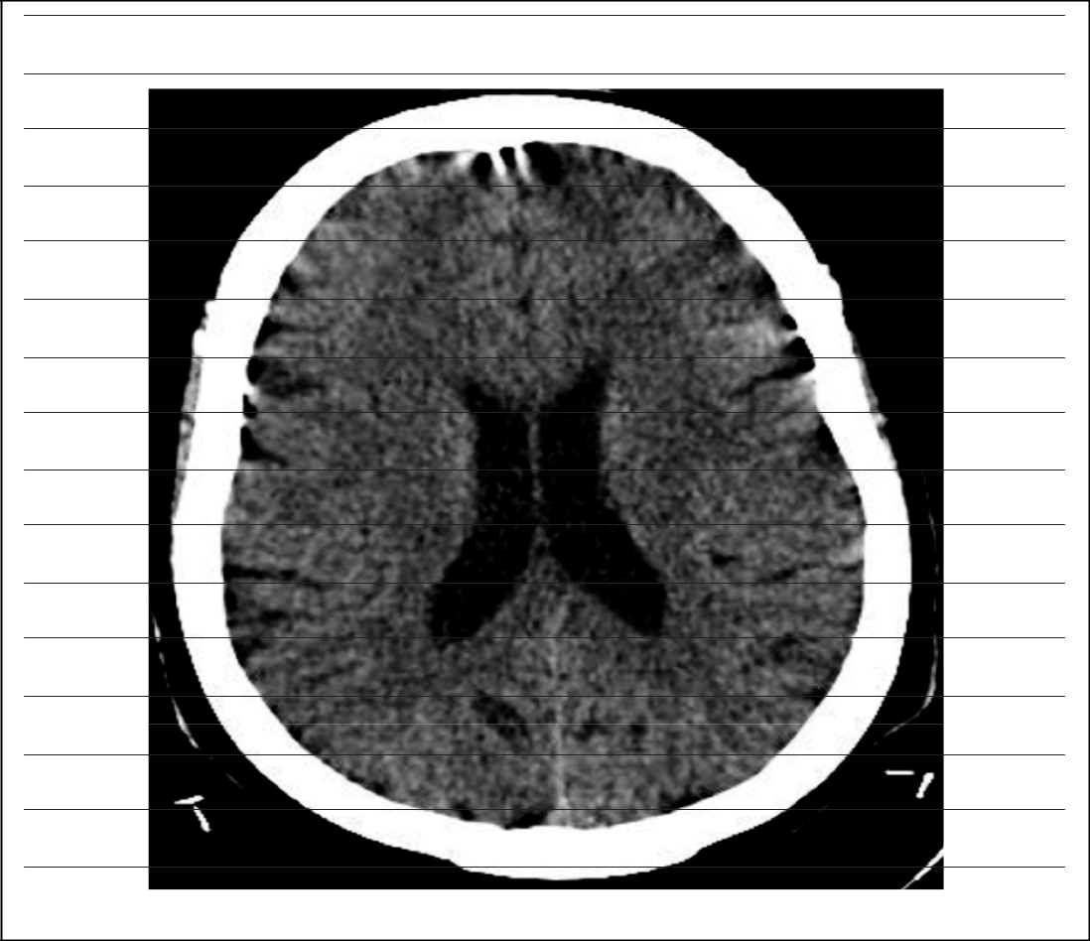

Figure 1: Diagrammatic illustration of the pixel concept of digital medical images using a cranial CT

Figure1: Diagrammatic illustration of the pixel concept of digital medical images using a cranial CT

Page | 31
Modern medical imaging modalities such as digital radiography systems, ultrasound, CT and MRI are digital in nature and their images are amenable to quantitative texture analysis. Fortunately, analogue medical images can now be digitized and, thus, can be subjected to texture analysis. Texture analysis is tremendously versatile and can elicit objective information to support clinical decision making. Such information can be used as a second opinion to the radiologists’ visual inspection and interpretation of radiological images. Texture analysis describes a wide range of techniques that enable the quantification of the grey-level patterns, pixel interrelationships, and spectral properties of an image. The term texture provides us with a vocabulary to describe the variation in surface intensity or patterns, including some that are imperceptible to the human visual system (Kassner and Thornhil, 2010).

Texture analysis was initially developed for the assessment of aerial photographs (Kaizer, 1955; Darling and Joseph, 1968). The first medical applications of texture analysis appeared thereafter (Hall et al., 1971; Chen and Fu, 1974; Lerski et al., 1979), though it was slow in gathering clinical interest.

Four approaches are recognized in texture analysis, namely structural, model-based, transform and statistical approaches (Materka and Strzelecki, 1998; Castellano et al., 2004). In the structural approach to texture, texture is represented by well-defined primitives. For instance, a square object is represented in terms of the straight lines or the primitives that form its border (Castellano et al., 2004). The structural method is a simple concept and provides a good symbolic description of the image (Materka and Strzelecki,

Page | 32
1998) but the major disadvantage is that it is not a very powerful way of describing texture. The model-based approach to texture analysis assumes that knowing the grey-level intensity value of one pixel, the grey-level intensity values of other neighbouring pixels can be deduced. In this way, there is an attempt to fit an image texture to a mathematical model. The main disadvantage of the model-based approach to texture analysis is the complexity involved in the computations to estimate the model parameters. In the transform approach to texture, the texture of an image is analyzed in a different space usually the frequency or the scale space. The advantage of this approach is the ease with which it can be adjusted to the problem in question (Castellano et al., 2004).

2.1.2 THE CONCEPT OF TEXTURE AND ANALYSIS OF TEXTURE

Texture is a very difficult term to define precisely. This is because there is no unified definition of texture. Every definition that has been used has rather aimed at relating it to the area of its application. The non-existence of a universally agreed-upon definition of texture is a fact acknowledged by both Gonzalez and Woods (2008), and Nailon (2010). In general texture can be defined as a descriptor that provides measures of properties such as smoothness, coarseness and regularity (Gonzalez and Woods, 2008). For medical images, Castellano et al. (2004) defined texture of images as the appearance, structure and arrangement of the parts of an object within the image. The concept of texture as a quantitative measure is applied only to digital images which are made up of numerous rectangular picture elements (pixels) as illustrated in figure 1.

Page | 33
Perhaps in consideration of this technicality, Castellano et al. (2004) attributed the texture concept in a digital image to the distribution of grey-level values among the pixels of a given region of interest in the image. This definition is in agreement with that of Nailon (2010) which referred to texture as spatial variation of pixel intensities in an image. In order to understand texture better, it is important to draw an analogy from the way the human visual system perceives scenes. The human eye sees what we call scene as sets of objects in various relations to each other, in spite of the fact that ambient illumination is likely to vary from one object to another – and over the various surfaces of each object – and in spite of the fact that there will be secondary illumination from one object to another (Davies, 2008). Texture has components called texels, which are notional uniform micro-objects which are placed in an appropriate way to form any particular texture. The placing may be random, regular, directional, and so on, and there may be a degree of overlap in some cases (Davies, 2008). From the foregoing, texture in very simple physical concept that describes the randomness, periodicity, directionality and orientation associated with the placement of the composite elements making up an object’s structure.

Texture analysis is an aspect of imaging science which analyses pixel intensity variations or its spatial distribution on a pixel-by-pixel scale to unravel patterns which may not be perceptible to the human visual system. According to Castellano et al. (2004), texture analysis is in principle a technique for evaluating the position and intensity of signal features, that is pixels and their grey-level intensities in digital images. Texture features are, in fact, mathematical parameters computed from the distribution of pixels, which characterize the texture type and thus the underlying structure of the objects shown in the

Page | 34
image (Castellano et al., 2004). Texture analysis is employed in image classification, segmentation and synthesis. It also plays a very vital role in computer-aided detection or diagnosis or more broadly machine vision.

There are free and commercially available softwares for performing texture analysis of digital images such as MaZda®, Matalab tool box MTEX®, and LaboTex®. The software with very wide and diverse application is MaZda® (Szczypiński et al., 2009) and this has been very popular in analyses of medical images. It is a software package for two-dimensional and three-dimensional texture analysis. It provides a complete path for quantitative analysis of image textures, including computation of texture features, procedure for feature selection and extraction, algorithm for data classification and image segmentation tools. The software was originally written for magnetic resonance image texture analysis but is now being applied in analysis of other textured images, including x-ray and camera images. The software has been utilized in numerous researches in diverse applications and has proven to be an efficient and reliable tool for quantitative image analysis, even in more accurate and objective medical diagnosis (Szczypiński et al., 2009). MaZda® has been successfully used for texture analysis of computed tomography (CT) images of acute ischaemic stroke patients (Oliveira et al., 2009) and it is the software that was used in computing statistical texture features of brain CT images analyzed in this thesis.

2.1.3 METHODS OF TEXTURE ANALYSIS

According to Materka and Strzelecki (1998), there are four major issues in texture analysis. These issues are:

Page | 35
- Feature extraction: to compute a characteristic of a digital image able to numerically describe its texture properties;

- Texture discrimination: to partition a textured image into regions, each corresponding to a perceptually homogeneous texture (leads to image segmentation);

  - Texture classification: to determine to which of a finite number of physically defined class (such as normal or abnormal tissue) a homogeneous texture region belongs;

  - Shape from texture: to reconstruct three-dimensional surface geometry from texture information.

Extraction of texture parameters is the first stage in texture analysis and the results from this stage are used for the remaining three stages. According to Materka and Strzelecki (1998), approaches to texture analysis are categorized into structural, statistical, model-based and transform methods. These approaches are herewith described briefly.

2.1.3.1 THE STRUCTURAL METHODS

In this method, texture is represented by well-defined primitives. In other words, a square object is represented in terms of the straight lines or the primitives that form its border (Castellano et al., 2004). To describe texture using the structural approach one must first define the primitives (microtexture) and then the placement rules. Primitives are the parts from which texture is composed. Note well that primitives may be tonal; that is grey levels. Haralick (1979) described tonal primitives as regions of an image with

Page | 36
tonal properties. The advantage of structural methods is that they provide a good symbolic description of the image (Materka and Strzelecki, 1998) but the disadvantage is that it is not a very powerful way describing texture.

2.1.3.2 THE STATISTICAL METHODS

The statistical approach to texture analysis uses grey-level distribution within an image to describe texture. This approach provides better discrimination between classes than structural or transforms methods. It is the most widely used method in medical applications. By computing local features at each point in the image and deriving a set of statistics from the distributions of the local features, statistical methods can be used to analyze the spatial distribution of grey values (Pham, 2010). Based on the number of pixels defining the local feature, statistical methods can be classified into first-order (one pixel), second-order (pair of pixels) and higher-order (three or more pixels) statistics (Pham, 2010). The difference between these classes is that the first-order statistics estimate properties (e.g. average and variance) of individual pixel values by waiving the spatial interaction between image pixels, but the second-order and higher-order statistics estimate properties of two or more pixel values occurring at specific locations relative to each other (Pham,2010). According to Nailon (2010), in the first-order statistical texture analysis, information on texture is extracted from the histogram of image intensity. This approach measures the frequency of a particular grey level at a random image position and does not take into account correlations, or co-occurrences, between pixels. In the second-order statistical texture analysis, information on texture is based on the probability of finding a pair of grey levels at random distances and orientations over an entire image. Extension to higher-order statistics involves increasing the number of variables studied (Nailon, 2010).

Page | 37

A detailed description of some statistical methods of texture analysis is given the subsequent sections of this thesis. Also, the mathematical formulae of the statistical texture features calculated in this study are listed in appendix I.

2.1.3.2.1 The Co-occurrence Matrix (COM)

The co-occurrence matrix is a second-order histogram that analyzes the grey-level distribution of pairs of pixels (Castellano et al., 2004). In grey-level co-occurrence matrix method, the probability of finding a pixel with a defined grey level (i) at a defined distance (d) and defined angle (α) from another pixel with defined grey level (j) is calculated. So, the co-occurrences of pixel pairs are calculated in vertical, horizontal and two diagonal directions, as well as distances up to 5 pixels. An essential feature of this arrangement is that each pixel (p) has eight nearest neighbours connected to it except when the pixel is located at the periphery as shown in figure 2. A very simple illustration of grey level co-occurrence matrix as relative positions of pixels of the same grey level intensities is shown in figure 3. In this illustration, the reference pixel (X) is of the same grey level value with the pixels X₁ in horizontal direction for inter-pixel distance of 1, X₂ in vertical direction for inter-pixel distance of 2, X₃ in 45⁰ diagonal direction for inter-pixel distance of 3, and X₄ in 135⁰ diagonal direction for inter-pixel distance of 3.

Page | 38

135^{O} | 90^{O} |  | 45^{O}
6 | 7 | 8
5 | P | 1 | ₀O
4 |  | 2
 | 3
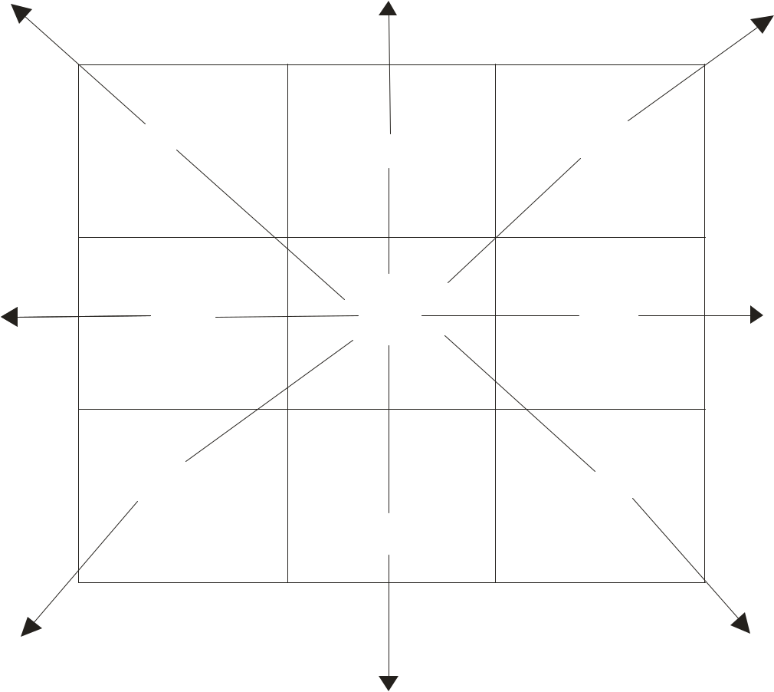

Figure 2: Diagrammatic illustration of pixel relationships in co-occurrence matrix

- co-occurrence matrix is produced in each direction (α), for each inter-pixel distance (d), with the matrix dimension being equal to the number of intensity levels. It therefore means that the process becomes computationally intense and the number of grey levels in an image would undergo a rescaling and re-binning procedure to reduce the range of

Page | 39
pixel values contained within an image (Waugh, 2014). A complete list of co-occurrence matrix parameters is shown in table 1.
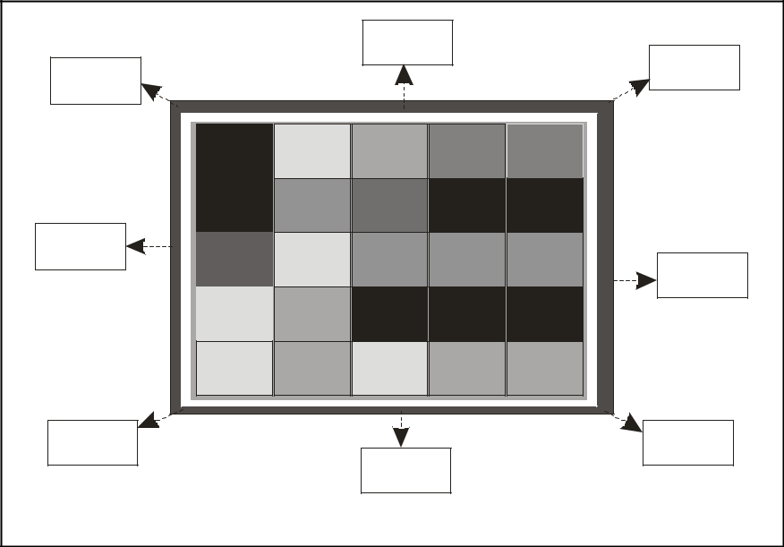

 | 90 | 0 | 45 0
1350
 | X₂ |  | X3
1800 | X |  |  |  | 0
 | X | 1 |  |  | 0
 | X | X | 180
 |  |  | X4
45 | 0 |  | 135 | 0
 | 90 0 |  | 135

Figure 3: Diagrammatic illustration of the grey level co-occurrence matrix concept of texture computation

Page | 40
Table 1: Statistical texture parameters computed in this study

CATEGORY | FEATURES | NUMBER OF
 |  | CALCULATED
 |  | PARAMETERS
Co-occurrence Matrix | Angular second moment, | 220
(COM) | Contrast, Correlation, Sum
 | of squares, Inverse
 | difference moment, Sum
 | average, Sum variance,
 | Sum entropy, Difference
 | variance, Entropy and
 | Difference entropy
 | (calculated in 4 directions
 | and up to inter-pixel
 | distance of 5)
Run-length Matrix (RLM) | Fraction of image in runs, | 20
 | Grey-level non-uniformity,
 | Run-length non-uniformity,
 | Long run emphasis, and
 | Short run emphasis
 | (calculated in 4 directions)
Absolute Gradient (Gr) | Gradient mean, Gradient | 5
 | variance, Gradient
 | skewness, Gradient kurtosis
 | and Gradient nonzero
Histogram | Mean, Variance, Skewness, | 9
 | Kurtosis, Percentile 01,
 | Percentile10, Percentile 50,
 | Percentile 90 and Percentile
Total | 99. | 254


2.1.3.2.2 The Run-length Matrix (RLM)

The grey-level run-length matrix is a higher order statistical method of texture feature

extraction. The run-length matrix aims to calculate the number of consecutive pixels in a

given direction that have the same grey-level intensity. As Nailon (2010) puts it, the run-

length is the number of pixels in a particular direction with the same grey-level intensity

value. A coarse texture will therefore be dominated by relatively long runs where as a

fine texture will be populated by much shorter runs (Nailon, 2010). The features

Page | 41
derivable from the run-length matrix in four different directions; horizontal, vertical, and two diagonals are listed in table 1. The grey level run-length matrix is illustrated in figure 4 which shows a run-length of 4 pixels in a 45⁰ diagonal direction as similarly done previously by Waugh (2014).
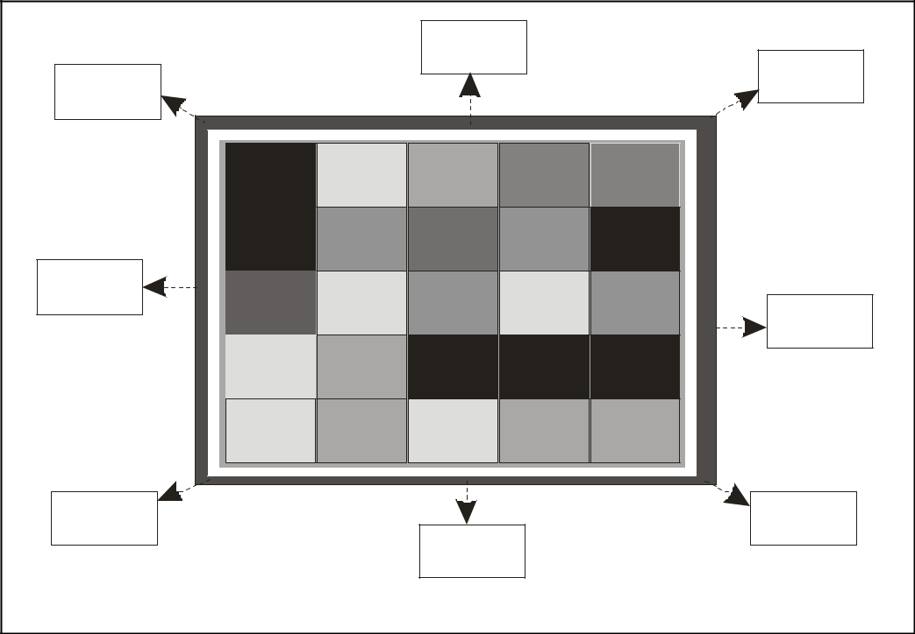

 | 90 | 0
1350 |  | 45 0
 |  | 4
 |  | 3
1800 | 2 | 1800
 | 1
45 | 0 | 135 | 0
 | 90 0 | 135

Figure 4: Diagrammatic illustration of the grey level run-length matrix concept of texture computation

The run-length emphasis describes a number of consecutive pixels with the same grey level value. It could be suitably termed long or short run emphasis as described by Tang (1998). The run-length and grey level non-uniformity describe the disorderliness in pixel and pixel grey level runs. The fraction of image in runs simply refers to run percentages.

Page | 42
That is, the ratio of total number of runs in the image to the total number of pixels in the image expressed as percentage (Tang, 1998).

The run-length method of texture analysis was first introduced by Galloway (1975) but it has not gained acceptance as an efficient way of calculating texture (Tang, 1998). It is therefore not popular among researchers working to develop diagnostic tools for medical applications.

2.1.3.2.3 The Absolute Gradient (Gr)

The gradient of an image measures the spatial variation of grey-level values across the image (Castellano et al., 2004). This method evaluates the relationship of variations in grey-level intensity values across neighbouring pixels as shown in figure 5 according to illustration by Waugh (2014). A high gradient is produced when there is abrupt change; from extreme pixel grey-level intensity value to another extreme grey-level intensity value. Conversely, a low gradient is produced in gradually changing pixel grey-level intensity values. The five features derivable from absolute gradient are listed in table 1.


High gradient Low gradient

Figure 5: Diagrammatic illustration of the gradient concept of texture computation

Conventionally, only the magnitude of the gradient is taken into consideration (Castellano et al., 2004). The direction of variation, whether it is positive or negative is irrelevant, and hence the term “absolute gradient”.

Page | 43
The gradient non-zeros is the number of pixels in an image with grey level value greater than zero and the gradient variance is the deviation of absolute pixel grey level value from the mean, while the gradient mean is the average variation of pixel grey level value across the image (Materka and Strzelecki 1998). The absolute gradient as a method of texture analysis finds application in accentuating the boundaries of an image (Castellano et al., 2004) and is therefore a very useful tool in edge enhancement.

2.1.3.2.4 The Histogram

This is a first-order statistical analysis and uses pixel occurrence probability to calculate texture. It does not consider the spatial relationships, and correlations, between pixels (Nailon, 2010) and these limit its application. The main advantage of the histogram is its simplicity by the use of standard descriptors such as mean and variance to characterize texture data but such descriptors do not provide sufficiently high discriminative power. The features derivable from the histogram are mean, variance, skewness, kurtosis, percentile 01, percentile 10, percentile 50, percentile 90 and percentile 99 as shown in table 1.
2.1.3.3 THE MODEL-BASED METHODS

In the model-based texture analysis there is an attempt to fit an image texture to a computational (mathematical) model. For MaZda® texture analysis software, the model used is referred to as the auto-regressive model (ARM). In this model, an assumption that knowing the grey-level intensity value of one pixel, the grey-level intensity values of other neighbouring pixels can be deduced holds. In a more formal way, Castellano et al. (2004) stated that the ARM assumes a local interaction between image pixels such that pixel grey-level value is a weighted sum of the grey-level values of the neighbouring pixels. The main disadvantage of the model-based approach to texture analysis is the complexity involved in the computations to estimate the model parameters. According to

Page | 44
Materka and Strzelecki (1998), other models of texture aside ARM are Markov random field (MRF) and fractal models.

2.1.3.4 THE TRANSFORM METHODS

The texture of an image is analyzed in a different space which may be the frequency or the scale space. The methods are based on Fourier (Bracewell, 1999), Gabor (Qian and Chen, 1993) or wavelet transform (Walnut, 2001). The wavelet transform is the most widely used because of the ease with which it can be adjusted to the problem at hand (Castellano et al., 2004). The wavelets represent a technique that analyzes the frequency content of an image with different scales of that image. This analysis yields a set of wavelet coefficients corresponding to different scales and to different frequency directions (Castellano et al., 2004). In computing wavelet transform of an image, each pixel is related to a set of numbers called wavelet coefficients which describe the frequency content of the image at that point over a set of scales.

2.1.4 TEXTURE ANALYSIS OF MEDICAL IMAGES

Texture analysis of medical images remained without much clinical interest until 1998 when it took a giant leap. This was when MaZda®, a computer program for calculating texture parameters (features) in digitized images was developed. The software has been under development since 1998, to satisfy the needs of the participant of COST B11 European Project “Quantitative Analysis of Magnetic Resonance Image Texture” and the subsequent COST B21 “Physiological Modeling of Magnetic Resonance Image Formation (Materka, 1998). According to Szczypinski et al. (2009) MaZda® is a software package for 2D and 3D image texture analysis and provides a complete path for quantitative analysis of image texture including computation of texture features, procedures for feature selection and extraction, algorithm for data classification, various data visualization and image segmentation tools. The software was originally developed

Page | 45
in 1996 at the Institute of Electronics, Technical University of Lodz (TUL), Poland, for texture analysis of mammograms (Materka et al., 2006). The software has been further developed and made more versatile to be used in analysis of other textured image. It has been found to be efficient and reliable for quantitative image analysis even in more accurate and objective medical diagnosis. There has also been non-medical application in food industry to assess food product quality (Szcypinski et al., 2009). Other computer softwares that are used for texture analysis of digital images are MATLAB®, Scilab® (Gonzales et al., 2004; Galda, 2011) and LaboTex®. Scilab® is available to users free (i.e freeware) while MATLAB® is commercially available. These three softwares were not used for this thesis and will not have any further mention after now.

The medical importance of texture analysis cannot be over-emphasized. This is expressed by the opinion of Castellano et al. (2004) who said that it is a useful way of increasing the information obtained from medical images. They noted that it was an active and ongoing field of research with applications ranging from the segmentation of specific anatomical structures and the detection of lesions, to differentiation between pathological and healthy tissues in different organs. The differentiation between pathological and healthy tissues implies that texture parameters obtained from medical images form the basis for computer-aided diagnosis. They noted the challenging nature of texture analysis as it involves an ensemble of mathematical computations performed with the data contained within the images. Just recently, Waugh (2014) demonstrated that texture analysis can be used in patients undergoing neoadjuvant chemotherapy treatment of breast cancer to indicate whether the patient will respond well or not. The results of her study appeared to correlate well with the final pathological outcome.

Page | 46
2.1.5 ROLE OF TEXTURE ANALYSIS IN COMPUTER AIDED DIAGNOSIS

According to Jiang et al. (1999), texture analysis of medical images has attracted many investigators particularly for the purpose of developing computer-aided diagnosis system, which is becoming more and more prevalent due to its ability to increase the precision and accuracy of characterization by radiologists. The importance of a CAD system to the diagnostic process is well captured by the opinion of Tourasis (1999). According to him, the diagnostic interpretation of medical images is a multifaceted task. Its objective is the accurate detection and precise characterization of potential abnormalities - a crucial step toward the institution of effective treatment. Achieving this goal relies on the radiologists’ successful integration of two distinct processes namely the process of image perception leading to the recognition of unique image patterns and the process of reasoning to identify the relationships between perceived patterns and possible diagnosis. Both processes depend heavily on the radiologists’ empirical knowledge, memory, intuition, and diligence. The radiologists’ approach is not error-free as, according to Robinson (1997) there are well, documented errors and variations in the human interpretation of clinical images. The summary of the foregoing is as stated by Stoitsis et al. (2006) that CAD provides a computer output as a second opinion in order to assist physicians in the detection of abnormalities, quantification of disease progress and differential diagnosis of lesions. According to Stoitsis et al. (2006), one important feature of the generic architecture of the CAD system is feature extraction (texture analysis). Thus, texture analysis is the fundamental basis of CAD at its present stage of development. Stoitsis et al. (2006) further demonstrated the usefulness of feature extraction as the basis for CAD. They demonstrated the usefulness of texture features as the basis for computer-aided diagnosis of carotid atherosclerosis from B-mode

Page | 47
ultrasound images and the differential diagnosis of focal liver lesions from CT images by obtaining satisfactory results in their experiments.

Julesz et al. (1973) and Julesz (1978) pointed out that although human visual system can discriminate between different morphologic information such as shape and size, there is evidence that the human visual system has difficulty in the discrimination of textural information that is related to higher-order statistics or spectral properties of an image. The human visual system if unaided has a limited number of grey levels it can tell apart. Thus, texture analysis can potentially augment the visual skills of the radiologist by extracting image features that may be relevant to the diagnostic problem but that are not necessarily visually extractable (Tourassi, 1999). He further explained that by using image texture analysis as the preprocessing step in CAD schemes, the input generation process is automated and, therefore, is reproducible and robust. Although useful to the diagnostic process, Tourassi (1999) warns, that texture analysis is not a panacea for the diagnostic interpretation of radiologic images. The pursuit of texture analysis is based on the hypothesis that the texture signature of an image is relevant to the diagnostic problem at hand. A major drawback is that the effectiveness of texture analysis is bound by the type of algorithm that is used to extract the meaningful textural features.

According to Kassner and Thronhill (2010), while reviewing applications of texture analysis in neurologic MR imaging, texture features may complement the macrotexture information already used by radiologists, such as organization of lesions within normal

Page | 48
brain parenchyma. They illustrated the potential clinical role of texture analysis in MR diagnosis and characterization of brain tumors, epilepsy and multiple sclerosis.

2.1.6 DECISION MAKING IN COMPUTED AIDED DIAGNOSIS

Texture analysis is the fundamental basis of computer-aided diagnosis in radiology and is therefore indispensible to the process (Stoitsis et al., 2006). The main problem with calculated texture is that it produces an avalanche of outputs, especially co-occurrence matrix. The outputs need to be reduced to a manageable level so that precise information which could be used for decision making can be obtained from further analysis. Using the MaZda® software, feature reduction is achieved by using the Fisher coefficient, classification error combined with the correlation coefficient and mutual information (Tourassi et al., 2001; Materka et al., 2006). Another method is the selection of optimal feature subsets with minimal classification error of 1-nearest neighbour (1-NN) classifier (Dash and Liu 1997; Duda et al., 2001). The Fisher coefficient selects features by reducing intra-group variance and maximizing inter-group difference (Plata, 2006). If the above methods do not reduce the features sufficiently initially, further reduction is carried out by transforming the original features into a new feature space with lower dimensionality (Szczypiński et al., 2009). This method is called feature extraction or projection (Jian et al., 2000) and can be achieved in MaZda® using principal component analysis (PCA), linear discriminant analysis (LDA), non-linear discriminant analysis (NDA) (Krzanowski, 1988; Hecht-Nielsen, 1989; Fukunaga, 1991; Mao and Jian, 1995; Duda et al., 2001;) and raw data analysis (RDA).

Page | 49
Artificial intelligence tools used for automated decision making in computer-aided diagnosis include different algorithms provided by different computer softwares. The Waikato Environment for Knowledge Analysis (WEKA) version 3.6.11 is a useful data mining software equipped with many classification algorithms. It is a landmark system in data mining and machine learning (Piatetsky-Shapiro, 2005). The software was developed because of the perceived need for a unified workbench that would allow researchers easy access to the state-of-art techniques in machine learning (Hall et al., 2009).

Two methods of decision making or classification in computer-aided diagnosis popular with researchers are the artificial neural networks (ANN) and k-nearest neighbour (k-NN). The ANN and k-NN algorithms are part of the resources provided in the WEKA software. Both algorithms perform supervised classifications, implying that the classification is under the guidance of a human being. In supervised classification, the user selects sample pixels in an image that he considers representative of specific classes and then initiates the software to use these training sets as references for the classification of other pixels in the image. The artificial neural networks are relatively crude electronic networks of “neurons” to simulate the neural structure of the human brain. They literally imitate the decision making process of human brain. The network processes records one at a time and “learns” by comparing the classification of each record with the known actual classification of the record. The errors from the initial classification of the first record is then fed back into the network and used to modify the network’s algorithm while the iterative processes go on and on. Thus, the network “learns” and can be trained for improved performance (Gurney, 1997).

Page | 50
A multilayer feed-forward neural network has one or more hidden layers. The function of neurons in the hidden layer is to arbitrate between the input and the output of the neural network. The input feature vector is fed into the source nodes in the input layer of the neural network. The neurons of the input layer constitute the input signals applied to the neurons in the hidden layer. The output signals of the hidden layer can be used as inputs to the next hidden or output layer. Finally, the output layer produces the output result and terminates the neural computing process (Chen et al., 1999).

The k-nearest neighbour is a non-parametric method used for classification and regression (Altman, 1992). In the k-NN algorithm, the training data set is stored, so that classifying a previously unclassified (new) record is by comparing it to the most similar records in the training data set. Simply put, in the k-NN classification algorithm, a database in which data points are separated into several separate classes is used to predict the classification of a new data point. The dataset are assumed to be in space and classification is by achieved assigning the new data point to its closest neighbour. It is a rather simple and versatile concept (Thirumuruganathan, 2010).

2.1.7 STROKE

Cerebrovascular diseases include some of the most devastating disorders such as stroke and cerebral vascular abnormalities (Smith et al., 2001). A stroke or cerebrovascular accident is an abrupt onset of a neurologic deficit that is attributable to a focal vascular cause. Stroke is a major health issue in Nigeria and the rest of Africa and the world (Howlett, 2012). It is a major cause of death and neurological disability in adults. It imposes a heavy emotional and financial burden on the family of the patient and society

Page | 51
(Komolafe et al., 2007). The annual incidence of stroke in high income countries is 2 – 3 per 1000 persons and the prevalence reaches 0.5 to >1% of the population in age groups older than 65 years (Howlett, 2012). Ogun et al. (2005) reported that over a 10-year period, stroke constituted 2.4% of all emergency admissions in a south western Nigeria teaching hospital. Prior to this study, Ojini and Danesi (2003) had reported that stroke was the commonest cause of neurological admissions at the Lagos University Teaching Hospital. In south eastern Nigeria, epidemiological data are not well established. This notwithstanding, stroke incidence in Nigeria and other sub-Saharan African countries is on the increase (Myles et al., 2007). Factors responsible for this increased incidence include change in diet, increased cigarette smoking and alcohol consumption, inadequate exercise, increase in prevalence of obesity, as well as increase in other non-communicable diseases like hypertension and diabetes mellitus (Chukwuonye et al., 2013).

Stroke is caused by a sudden loss of blood circulation to an area of the brain, resulting in a corresponding loss of neurologic function performed by that part of the brain. In a broad sense, strokes are classified as either ischaemic or haemorrhagic; with ischaemic stroke being the far commoner type. Strokes due to cerebral ischaemia account for 85% of cases (Martin, 1996; El Khamlichi, 2001). In Nigeria, cerebral ischaemia accounts for 64%, intracerebral haemorrhage for 19% and subarachnoid haemorrhage for 6% of all strokes (Osuntokun et al., 1979). Ischaemic stroke is caused by thrombosis or embolism (of various origins), sickle cell disease, human immunodeficiency virus, vasculitis and venous sinus thrombosis, while haemorrhagic stroke results from uncontrolled

Page | 52
hypertension, ateriovenous malformations of the brain, brain tumuors, trauma to the brain and amyloid (Howlett, 2012).

Timely and accurate diagnosis of ischaemic stroke is especially important to reduce the severity of neurological damage by stroke. Previous studies have highlighted the time-critical nature of the diagnosis. Cerebral ischaemia has a narrow therapeutic window following stroke ictus and a dramatic rise in haemorrhagic complications thereafter (Warach, 2000; Laloux, 2001; Sunshine et al., 2001; McCullough et al., 2001; Heiss et al., 2001; Lev et al., 2001A; Lev et al., 2001B).

2.1.8 IMAGING FOR STROKE DIAGNOSIS

The initial diagnosis of stroke is based on entirely clinical concepts and laboratory studies, including brain imaging are used to support the diagnosis. The clinical manifestations of stroke are highly variable because of the complex anatomy of the brain and its vasculature (Smith et al., 2005). Because of the varying nature of clinical presentations of stroke, the possibility of other cerebral lesions mimicking stroke, and the time-critical nature of stroke diagnosis, especially cerebral infarction, imaging is usually required to support clinical diagnosis and institute timely and appropriate interventions (Mullins, 2006). Clinical diagnosis has been reported to have a substantially high error rate and neuroimaging is recommended to confirm or refute clinical diagnosis (Sheta et al., 2012; Imarhiagbe and Ogbeide, 2011; Onwuekwe et al., 2008; Khan and Rehman, 2005). Although MRI is more sensitive for detection of lesions affecting the central nervous system (CNS), CT is quicker, more widely available and therefore, is a

Page | 53
pragmatic choice for the initial evaluation of patients with suspected acute stroke, haemorrhage, intracranial or spinal trauma (Dillon, 2005).

Computed tomography is preferred over MRI for early stroke diagnosis because it is faster, more readily available and sensitive to early stroke (Chawla et al., 2009) but the recognition of stroke affected areas in CT images during the early hours of symptom onset can be difficult and highly dependent on the ability of the examiner (Reed et al., 2001; Wardlaw et al., 1999). So, a method needs to be devised to augment the visual skills of the neuroradiologist in arriving at an accurate diagnosis in acute stroke. The method being advocated at the moment is texture analysis which could be used for automatic detection of stroke affected areas of the brain.

In non-contrast CT ischaemic stroke is recognized as an area of hypodensity in the brain tissue as shown figure 6 (Mullins, 2006). Haemorrhagic stroke is characterized by bleed in to brain tissue. A haemorrhagic stroke is recognized as an area of hyperdensity representing intracerebral haemorrhage as shown in figure 7 (Howlett, 2012).

Page | 54
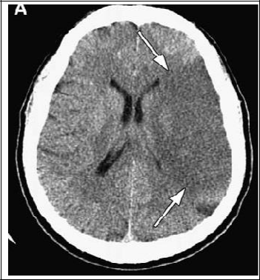

Figure 6: Acute left cerebral infarct (ischaemic stroke) resulting from the occlusion of the left middle cerebral artery (Mullins, 2006).
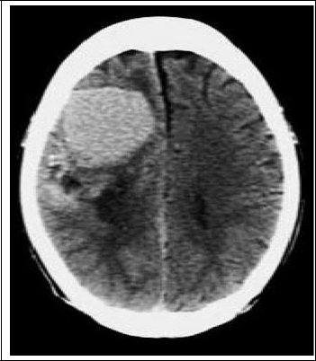

Figure 7: Right intracerebral haemorrahage on non-contrast CT typified by its hyperdense appearance (Howlett, 2012).

Page | 55
2.1.9. COMPUTED TOMOGRAPHY

Computed tomography was first put into clinical use in the early 1970s, but the journey that lead to its invention dates back to early 1920s. At that time, the term, “tomography” meaning body section radiography was already known. Tomography originated from the Greek word “tomos” meaning section and “graphe” meaning write. Tomography continued to be practiced in its crude form until 1967 when Godfrey Newbold Hounsfield while investigating pattern recognition and reconstruction techniques using the computer stumbled on something that revolutionized medicine in general and medical imaging in particular (Seeram, 2009). From his experiment, Hounsfield deduced that if x-ray beams were passed through an object from all directions and measurements were made of all the x-ray transmissions, information about the internal structures of the body could be obtained. This information would be presented to the radiologist in form of pictures that would show three-dimensional representations (Seeram, 2009). This was a huge improvement over the planar conventional radiographs and older crude tomograms. The outstanding feature of CT is that very small differences in x-ray absorption values can be visualized. Compared to conventional radiography, the range of densities recorded increased from approximately 20 with standard film to 2000 or more with CT. The density resolution is such that not only can fat be distinguished from other soft tissues but gradations of density within soft tissues can also be recognized (Armstrong and Wastie, 1987). Because of its exceptionally good image resolution, CT is used for neuroimaging to diagnose various brain lesions including stroke.

Computed tomographic imaging technology had advanced from the “1-slice step and shoot” to “multi-slice spiral or helical” capabilities which came into operation in the

Page | 56
1990s (Hu, 1999; Flohr and Ohnesorge, 2007). In helical mode, data are continuously acquired while the patient is simultaneously transported at a constant speed through the gantry (Hu, 1999). The term multi-slice refers to the ability of a scanner to acquire data from multiple slices per rotation. This is made possible by the used of cone shaped beams and multiple rows of detectors.

2.2 THEORETICAL REVIEW

Texture analysis is a type of image processing and is applied in diverse areas of interest to man including medicine. It forms the basis of machine vision and especially computer-aided diagnosis in diagnostic imaging. An extensive search for relevant theories existing in texture analysis yielded no results.

2.3 EMPIRICAL REVIEW

2.3.1 CLINICAL APPLICATIONS OF TEXTURE ANALYSIS

Texture analysis is a very challenging and emerging branch of medical imaging and has attracted many investigators with a view to developing computer-aided diagnostic tools for various medical imaging modalities and diseases. Some notable clinical applications that have been proposed include the “brain stroke classification based on multilayer perceptron using watershed segmentation and Gabor filter” (Devi and Rajagopalan, 2013), “classification of stroke using texture analysis on CT images” (Bhat and Singh,
2012), “automatic medical image classification and abnormality detection using k-nearest neighbour” (Ramteke and Khachane, 2012), “automatic diagnosis of abnormal tumor region from brain computed tomography images using wavelet based statistical texture features” (Padma and Sukanesh, 2011) and “texture analysis of computed tomography images of acute ischaemic stroke patients” (Oliveira et al., 2009). Other studies are “a method for automatic detection and classification of stroke from brain CT

Page | 57
images” (Chawla et al., 2009), “analysis of texture patterns in medical images with application to breast imaging” (Megalooikonomou et al., 2007), and “characterization of stroke lesions using a histogram-based data analysis including diffusion- and perfusion-weighted imaging” (Grzesik et al., 2000). The foregoing shows that there has been very keen interest in texture analysis of stroke images and its clinical application.

Kassner et al. (2009) demonstrated the usefulness of texture analysis of post contrast T1-weighted MR images in the prediction of haemorrhagic transformation in acute ischaemic stroke. They evaluated 34 acute ischaemic stroke patients within 3.5 ± 1.5 hours after stroke. T1-weighted MR images were acquired 19 ± 7 minutes post contrast injection. Haemorrhagic transformation was determined by follow-up scans at 24 - 27 hours. Post contrast images were evaluated for visual evidence. Four second-order textural features were extracted for each patient and receiver operating characteristics (ROC) curves were constructed for visual evidence and textural features, with haemorrhagic transformation as the main outcome measure. Result show that there were significant differences in f2 (contrast) and f3 (correlation) between haemorrhagically transformed patients and non-haemorrhagically transformed patients. Receiver operating characteristics analysis indicated that f₂ and f₃ textural features were the only two significant predictors of haemorrhagic transformation in acute ischaemic stroke. In conclusion, texture analysis of post contrast T1-weighted images may be superior to visual evidence of enhancement for the prediction of haemorrhagic transformation.

Page | 58
In ultrasound imaging, Chen et al. (1999), texture information in sonograms of solid breast nodules enabled the classifications of the nodules as benign or malignant using the artificial neural network classification tool. Their results show that based on texture information, the accuracy of neural network for classifying malignancies, was 95%, the sensitivity was 98%, the specificity was 93%, the positive predictive value was 89% and the negative predictive value was 99%. An earlier study by Garra et al. (1993) using co-occurrence matrix-derived texture features and linear Bayesian classifier reported figures that suggest that analysis of ultrasound image textures will markedly reduce the number of biopsies performed for benign lesions.

Mala and Sadasivam (2005) had in their work used a CAD scheme to classify diffuse liver diseases from CT images using wavelet-based texture parameters. The liver image was extracted from CT abdominal images using adaptive threshold and morphological processing. Orthogonal wavelet transform was applied on the liver to get the horizontal, vertical and diagonal details. The statistical texture parameters such as mean, standard deviation, contrast, entropy, homogeneity and angular second moment were extracted from these details. The eighteen features extracted were used to train the probabilistic neural network to classify the liver either as fatty or cirrhotic. The proposed system was tested for 100 images and produced an accuracy of 95%.

Bernasconi et al. (2000) demonstrated the usefulness of texture analysis in clinical environment when they studied texture analysis as a means of detecting focal cortical dysplasia (FCD) on MR images. They concluded that texture analysis of MRI improves

Page | 59
the visual detection of FCD, even in cases where no lesions were obvious in pre-operative MRI. Miles et al. (2009) pointed out the potential setback for adoption of textures analysis of CT images in broad clinical practice. They noted that for texture analysis to be adopted in clinical practice, the chosen methodology must be insensitive to variations in image acquisition parameter. This is also true of other imaging modalities other than CT.

Waugh et al. (2015) demonstrated the usefulness of texture analysis in classification of primary breast cancer. Using co-occurrence matrix parameters on MR images they showed that entropy features can differentiate between histological and immunohistochemical subtypes of breast cancer. Thus, the differing entropy features between breast cancer subtypes translate to differences in lesion heterogeneity. Entropy is a co-occurrence matrix parameter concerned with heterogeneity of an object.

2.3.2 TEXTURE ANALYSIS OF STROKE IMAGES

Chawla et al. (2009) proposed an automated method to detect and classify stroke into acute infarct, chronic infarct and haemorrhage at the slice level of non-contrast CT images. The method was based on the observation that the presence of stroke disturbs the natural contra lateral symmetry of a CT slice. Thus, they accordingly characterized stroke as a distortion between the two halves of the brain in terms of tissue density and texture distribution. Histogram-based comparison and wavelet energy-based texture information were used for classification of stroke in the study.

Page | 60
Przelaskowski et al. (2009) also proposed stroke slicer as computer-aided diagnosis tool that allows extraction and enhancement of direct early ischaemic sign - subtle hypodense local tissue damage. Hypo-attenuation of selected CT scan areas was visualized distinctly in a form of semantic maps. Moreover, brain tissue texture was characterized, analyzed and classified in multi-scale domain to detect the areas of ischaemic event. The experimental verification of stroke slicer was concentrated on diagnostic improvement in clinical practice by using semantic maps and additional information for interpretation procedure. The results of the study indicated possible improvement of diagnostic output for the really challenging problem of early CT-based ischaemic stroke detection.

Oliveira et al. (2009) demonstrated the usefulness of texture analysis in diagnosis of acute ischaemic stroke. In a pilot study, they analyzed the CT brain images of 5 patients and 5 control subjects and compared the results by discriminant analysis. The CT brain images were analyzed based on four grey level co-occurrence matrix parameters namely contrast (C), angular second moment (ASM), sum of squares (SS) and sum variance (SV). Contrast refers to the relative difference between grey values of different objects in the image while the angular second moment refers to uniformity of the image (Oliveira et al., 2009). Sum of squares and sum variance are similar concepts and both refer to how much the grey level values differ from the mean (Oliveira et al., 2009). Other co-occurrence matrix parameters are sum average which refers to the average pixel grey level value in the image and entropy parameters which refer to the measure of spatial disorder in grey level distributions (Gebejes and Huertas, 2013; Soh and Tsatsoulis, 1999; Haralick et al., 1973). The results showed differences between the texture parameters of the control group and patient tissues as well as between lesional and non-

Page | 61
lesional tissues of patients. The results suggest that texture analysis can be a useful tool to help neurologists in early assessment of ischaemic stroke and quantification of the extent of the affected areas.

2.4 SUMMARY

The literature reviewed thus far indicate that texture analysis of medical images is the basis for most attempts to have computer-aided diagnosis in clinical medical imaging. Computer-aided diagnosis system complements the visual interpretation of clinicians and offers help where lesional changes are subtle and imperceptible to the human visual system. Some of the attempts at developing computer-aided diagnostic tool for stroke utilized some statistical texture parameters but the best image texture descriptor has not been identified. It is therefore difficult to suggest the best statistical texture class for creating computer-aided diagnostic tool for stroke. This study therefore aimed to characterize stroke lesions of Nigerian patients seen in non contrast CT images of the brain according statistical texture features. On the basis of these texture features, the lesions will be classified as ischaemic and haemorrhagic based on computed texture parameters using artificial neural network and k-nearest neighbour classification algorithms and then cross validated with radiologist’s interpretation. This will help us to identify the most accurate statistical texture descriptors for computer-aided diagnosis which would improve diagnosis and enhance patient management, particularly in an environment where there is shortage of radiologists.

Page | 62
CHAPTER THREE

PATIENTS AND METHODS 3.1 RESEARCH DESIGN

A prospective, cross sectional design that targeted patients clinically diagnosed with stroke and who underwent non contrast CT investigation of the brain was adopted for the study. The research design and protocol was approved by the Research Ethics Committee of Nnamdi Azikiwe University Teaching Hospital, Nnewi, Anambra State, Nigeria (Appendix II).

3.2 TARGET POPULATION

The study targeted patients that were clinically diagnosed with stroke drawn from hospitals located in and around the chosen areas of study, who were referred to undergo NCCT of the brain as part of the investigative management of their condition.

3.3 LOCATION OF STUDY

The study was carried out in two locations namely Onitsha, Anambra State in southeastern Nigeria and Ibadan, Oyo State in southwestern Nigeria. Two privately owned radiodiagnostic centres, namely Onitsha Medical Diagnostic Centre and Me Cure Ibadan were used for the study. The centres were chosen to ensure adequacy of patients because the centres have been noted for receiving high number of stroke patients referred for CT.

3.4 SAMPLE SIZE DETERMINATION

The minimum sample size required for this study was determined using the Taro Yamene’s formula for a finite population:

Page | 63
(Uzoagulu, 2011).

Where;

n = Sample size

N = Number of patients clinically diagnosed with stroke that underwent NCCT study of the brain in the two radiodiagnostic centres in previous one year; May, 2012 to April, 2013.

e = The level of precision or confidence level required.

So,

= 137

Within the period; May, 2012 and April, 2013, a total 208 patients with clinically diagnosed stroke underwent non contrast CT of the brain in the two centres and thus a minimum sample size of approximately 137 was calculated as shown above.

3.5 PATIENT SELECTION

A total of 164 clinically diagnosed stroke patients that were referred to the two radiodiagnostic centres for CT scan and that met the inclusion criteria for the study were enlisted in the study to improve on its precision.

Page | 64
3.5.1 INCLUSION CRITERIA

- Patients clinically diagnosed with stroke at the Nnamdi Azikiwe University Teaching Hospital (NAUTH), Nnewi, Anambra State, University College Hospital (UCH) Ibadan, Oyo State and peripheral private and public hospitals in these two states.

- Patients clinically diagnosed with stroke and underwent non contrast CT of the brain at the two selected private radiodiagnostic centres.
- Patients in whose CT images stroke lesions were identified by the radiologist.

- Patients who met criteria i – iii and consented to participate in the study.

All the participating patients directly or indirectly through their relatives, expressed willingness to participate in the study by signing an informed consent form before enlistment in the study (see appendix III).

3.6 EQUIPMENT AND SOFTWARES USED They include the following:

- A 4-slice helical Toshiba AsteionTM CT scanner with 512 x 512 reconstruction matrix manufactured by Toshiba Medical Systems Corporation and a 2-slice Philips MX8000 DualTM CT scanner also with 512 x 512 reconstruction matrix manufactured by Philips Medical Systems. The CT scanners were used to carry out non contrast studies of the patients’ brains.

- DatamaxTM digital video discs (DVDs) to copy the CT images from the scanners.

- An HP 2000TM laptop with 64-bit Windows 7 operating system used to view the images and perform texture analysis.
Page | 65
- MedisynapseTM and MicrodomTM DICOM viewers.

- MaZda® texture analysis software version 4.7 for performing texture analysis on the images. The software was developed at the Institute of Electronics, Technical University of Lodz (TUL), Poland.

- Free trial version of MedCalc® statistical software for biomedical research (MedCalc Software, Acacialaan 22, B-8400 Ostend Belgium).
- The Waikato Environment for Knowledge (WEKA) version 3.6.11 data mining software (Hamilton, New Zealand) used for image classification.

3.7 PATIENT DATA AND IMAGE ACQUISITION

The enlistment of patients in the study, collection of data and acquisition of CT images commenced in May, 2013 and ended in April, 2014. The patients after being clinically diagnosed with stroke in the hospitals were referred to undergo NCCT of the head to confirm or rule out the disease as the cause of their signs and symptoms.

On arriving the radiodiagnostic centre, the patient or his/her relatives were approached and the study explained to them. The researcher through the request form identified the provisional diagnosis necessitating the scan. If it was stroke, an appeal was made to the patient or his/her relatives to enlist in the study. If the response was affirmative, an informed consent form was signed by the patient or his/her relatives (see appendix III). There was no financial reward for participating in the study. Demographic data of the patient such as age and gender were thereafter obtained and documented. The approximate time interval between the onset of symptoms and head CT examination was ascertained and documented.

Page | 66
Non contrast CT images of the brain were obtained using the CT machine, Toshiba Asteion™ in one centre (figure 8). In the second centre, a Philips MX8000 Dual™ CT scanner was used for the same purpose. Scans were obtained at 0.5mm to 1mm contiguous sections from the base of the skull to the vertex. The scan parameters used were exclusively chosen by the attending radiographer in each centre.
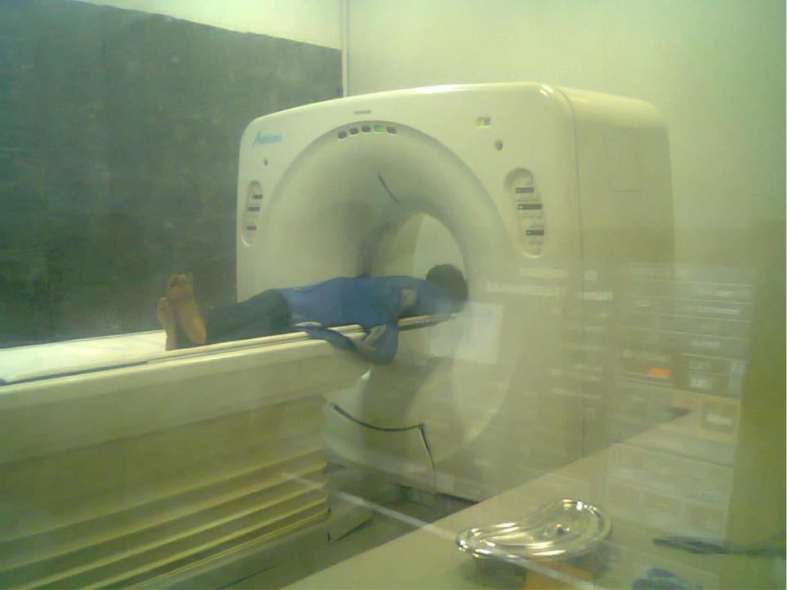

Figure 8: Cranial scan being conducted on a patient with Toshiba Asteion CT scanner

The images were transferred from the CT archive to a DVD and then loaded into an HP 2000™ laptop for viewing using either Medysynapse™ or Microdom™, both DICOM viewing softwares.

Page | 67
3.8 RADIOLOGICAL REPORTING OF THE IMAGES

The CT images obtained were visually inspected and reported by a team of two radiologists with experiences in CT diagnosis of stroke. The first radiologist had five-year post-qualification experience as a consultant radiologist while the second had seven years post-qualification experience. Both radiologists reported on the images independently and were blinded to each other. The reports included in the study were those in which the two radiologists were in agreement for the presence of stroke, the subtype and anatomical location of the lesions. The reports that indicated no radiological signs of abnormality and those that indicated neurological abnormalities mimicking stroke were excluded from the study.

The anatomical locations of the lesions were identified and the lesions categorized as ischaemic or haemorrhagic lesion by the two radiologists as shown in figures 9 and 10. The radiologist’s reports contained the patient’s name, identification number, age, sex, provisional diagnosis and radiological diagnosis, which contained details such as type of stroke lesions identified, their number, anatomical locations of the lesions and geographic extent in the brain.

Page | 68
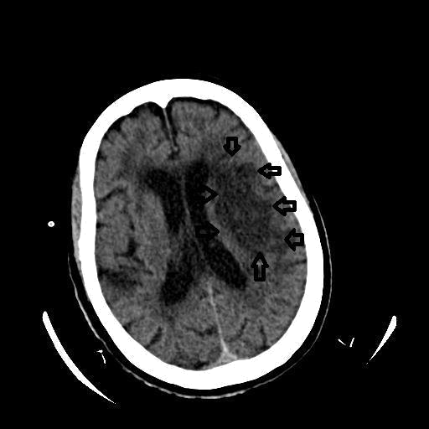

Figure 9: A non contrast CT image of the brain showing left cerebral ischaemia (arrows). Note there is a small area of ischaemia on the right parietal lobe

Page | 69
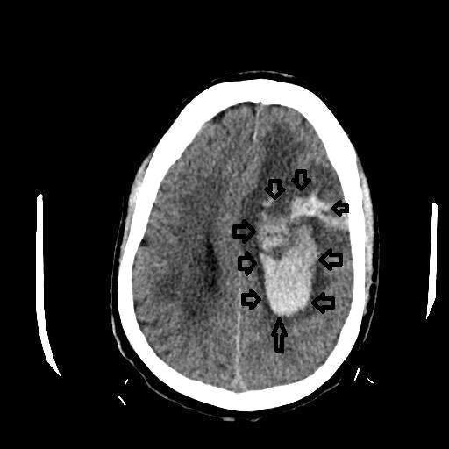

Figure 10: A non contrast CT image showing left cerebral haemorrhage (arrows). Note there is marked compression of the right and left ventricles.

3.9 TEXTURE ANALYSIS OF STROKE CT IMAGES

Texture analysis of stroke CT images was done using the MaZda® texture analysis

software. All the images in which lesions appeared were loaded into the computer

program and analyzed. Four regions of interest (ROIs) in each CT image that

demonstrated the lesions were selected for analysis. Two ROIs each represented the

lesion and normal tissue brain tissue as shown in figure 11. The lesioned brain tissue

Page | 70
contained ROI 1 and RO1 2 while the adjacent normal brain tissue contained ROI 3 and ROI 4 as shown in figure 11.
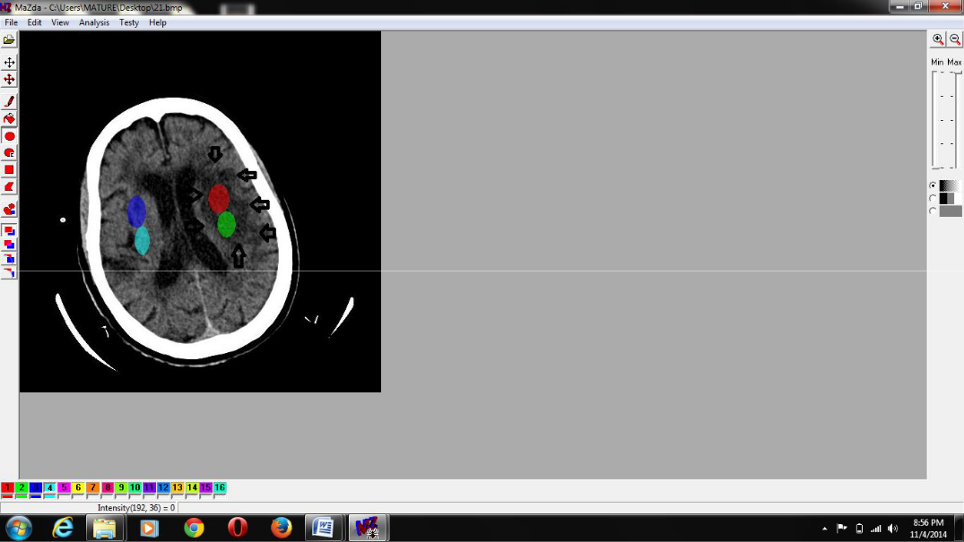

Figure 11: Illustration of the method of selection of region of interest (ROI). Note that ROI 1 (red) and ROI 2 (green) are on ischaemic tissues on the left cerebral hemisphere while ROIs 3 and 4 (blue and sky blue) are on normal tissues on right cerebral hemisphere

Precaution was taken to ensure that machine settings which differed between cases did not affect the image during texture analysis. This was achieved by normalizing the image. Normalization process literally changes the range of pixel grey level values of different images so that they appear to have been obtained with the same machine settings. This is called image consistency. The method of normalization prior to texture analysis was the ±3 sigma method selected from the program functions. Statistical texture parameters for the four ROIs were computed using the MaZda® version 4.7

Page | 71
program and facilities of Department of Medical Physics, Ninewells Hospitals and Medical School, National Health Service (NHS), Tayside, Dundee DD1 9SY, Scotland. Grey level co-occurrence matrices were computed for inter-pixel distances; d = 1, 2, 3, 4, 5 pixels and in the directions; θ = 0⁰, 45⁰, 90⁰, and 135⁰ for a total of 20 matrices for each ROI. Run-length matrix was computed for each of the ROI in four directions, namely horizontal, vertical and two diagonals. Absolute gradient and histogram features were computed as well. The output of each class of descriptors computed for each CT image was saved as a file in Microsoft Excel for further analysis. The list and mathematical formulae for statistical texture descriptors computed are shown in appendix I.

3.10 STATISTICAL ANALYSES

Statistical analyses were carried out in three stages. The first stage was the analysis of epidemiological data of stroke lesions and anthropometric characteristics of the patients. In the second stage the lesioned brain tissue for which texture parameters were calculated were divided according lesion types. The discriminating texture features in each of the statistical texture descriptors were obtained by raw data analysis (RDA). In the third stage, the normal brain tissue and lesions from which statistical texture parameters were computed were then classified by artificial neural network and k-nearest neighbour algorithms as normal tissue, haemorrhagic or ischaemic tissues. The computed statistical texture parameters were the input data for brain tissue classification. The classifications were then cross validated with the radiologist’s report as gold standard using the receiver operating characteristic (ROC) curve analysis.

Page | 72
The MedCalc® statistical software for biomedical research was used for statistical analysis. Raw data analysis of computed statistical texture parameters was performed with MaZda®, and classification of brain tissue with WEKA 3.6.11. Statistical significance was considered at p < 0.05.

3.10.1 FEATURE REDUCTION

In order to reduce the computed texture parameters to only the ones useful for further analyses and eliminate redundant data the Fisher coefficient was used. The Fisher coefficient reduced the intra-group variance and maximized the inter-group difference. It is a feature of the MaZda® texture analysis software.

3.10.2 FEATURE EXTRACTION

The texture feature computation reports on the selected ROIs saved in Microsoft Excel files were loaded into MaZda®, first according to lesion type and in combined lesion form and raw data analysis was performed on them. The best discriminating texture parameters in each statistical texture class were extracted through the raw data analysis and displayed in a three-dimensional (3D) feature space. The process also classified the ROIs as that of normal tissue, ischaemic or haemorrhagic lesions using the best discriminating texture parameters in each class of statistical texture descriptors. In this process the ROIs in space were picked one at a time and assigned a class to which it belonged with the radiologist’s interpretation taken as the expected ideal outcome.

Page | 73
3.10.3 ARTIFICIAL NEURAL NETWORK AND k-NEARES NEIGHBOUR

CLASSIFICATIONS

- multilayer feed-forward neural network and k-nearest neighbour algorithm were used to classify the stroke lesions according to type. For the purpose of classifying ROIs into normal brain tissue, ischaemic and haemorrhagic lesions using the k-nearest neighbour algorithm, a value of 1 was chosen for k. The Waikato Environment for Knowledge Analysis (WEKA) version 3.6.11 data mining software was used to perform these classifications. Both algorithms were trained by creating a model on retrospective data before applying them to a test data.

The performance of the neural network and k-nearest neighbour algorithms in classifying the ROIs as normal brain tissue or lesioned, and according lesion type was cross validated with the radiologist’s. The accuracy, sensitivity, specificity, positive predictive value and negative predictive value were determined from the ROC curves plotted. The parameters from ROC analysis were calculated according the formulae stated by Fawcett (2006) as shown in appendix iv.

Page | 74
CHAPTER FOUR

RESULTS

4.1 ANALYSIS OF STATISTICAL TEXTURE PARAMETERS OF BRAIN

TISSUES AND FEATURE EXTRACTION

The raw data analysis discriminated between the various ROIs as normal brain tissue, ischaemic stroke lesion or haemorrhagic stroke lesions. The classifications of the ROIs obtained in the discrimination are shown in the following 3D feature space diagrams. In the diagrams in figures 12 – 15, ischaemic lesion is represented by 1, haemorrhage by 2 and normal brain tissue by 3.
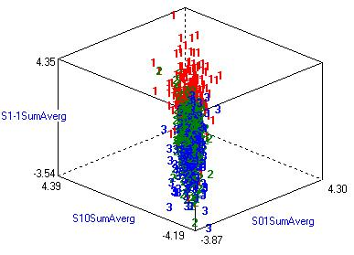

Figure 12: Distribution of the ROIs in 3D feature space using data obtained from the co-occurrence matrix parameters

Page | 75
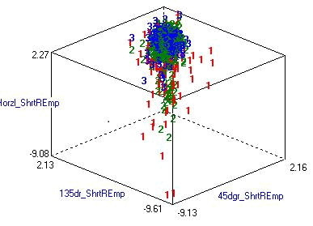

Figure 13: Distribution of the ROIs in 3D feature space using data obtained from the run length matrix parameters
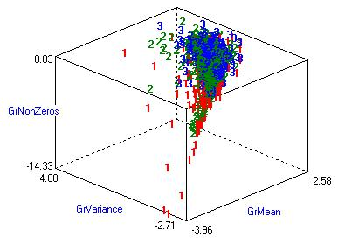

Figure 14: Distribution of the ROIs in 3D feature space using data obtained from the absolute gradient parameters

Page | 76
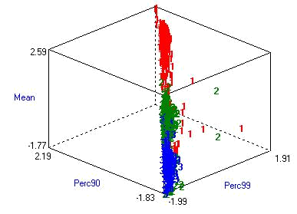

Figure 15: Distribution of the ROIs in 3D feature space using data obtained from the histogram parameters

The discriminating co-occurrence matrix parameter were sum average parameters namely S1-1 SumAverg with feature value of -3.54 to 4.35, S1-0 SumAverg -4.19 to 4.39 and S0-1 SumAverg -3.87 to 4.30, as shown figure 12. For the run-length matrix, short run emphasis in horizontal, 135⁰ and 45⁰ directions with feature values of -9.08 to 2.27, -9.61 to 2.13 and -9.13 to 2.16 respectively were the discriminating parameters as shown figure 13. The discriminating absolute gradient-derived parameters were gradient non-zeros with feature value of -14.33 to 0.83, gradient variance -2.71 to 4.00 and gradient mean -3.96 t0 2.58 as shown in figure 14. For the histogram class the mean with feature values of -1.77 to 2.59, 90 percentile -1.83 to 2.19 and 99 percentile -1.99 to 1.91 were the discriminating parameters as shown in figure 15.

Page | 77
The result of the raw data analysis shows that histogram class of statistical descriptors was the most accurate in discriminating between normal brain tissue, ischaemic lesion and haemorrhagic lesions as shown in table 2 and illustrated in figure 15. The classification of the ROIs using histogram data was 92.14% accurate.

Table 2: Classification accuracy of the ROIs by raw data analysis

Total Number of | Number of | Number of | Accuracy (%)
ROIs | Correctly | Misclassified ROIs
 | Classified ROIs
 | Grey Level Co-occurrence Matrix
1364 | 818 | 546 | 59.9


Grey Level Run-length Matrix

1284 524 760 40.81

Absolute Gradient

1284 592 692 46.11

Histogram

1260 1161 99 92.14

The correctly classified ROIs were 1161 out of 1260 using histogram derived parameters as shown in table 2. The outcome of classifications with other texture descriptors is also shown in table 2. Compared to other class of texture descriptors, histogram was significantly more accurate in classifying brain tissue (p < 0.05).

Page | 78
4.2 CLASSIFICATION OF THE BRAIN TISSUE

The results of the classification of brain tissue of the patients consisting of normal brain

tissue and stroke lesions from which the ROIs were chosen are as follows.

4.2.1 THE CLASSIFICATION USING ARTIFICIAL NEURAL NETWORK

The results of classification using artificial neural network method, and co-occurrence

matrix, run length matrix, absolute gradient and histogram-based texture features are as

stated hereafter. The ROC curves have been plotted with sensitivity on vertical axes and

false positive rate on horizontal axes.

Table 3: Receiver operating characteristic analysis of artificial neural network classification of brain tissue based on co-occurrence matrix parameters

Evaluation |  | Tissue/Lesion Type
Parameters | Normal | Haemorrhage | Ischaemia | Weighted Average
Kappa statistic |  |  |  | 0.406
Sensitivity or | 0.708 | 0.648 | 0.450 | 0.637
true positive
rate (TPR) or
Recall
True negative | 0.613 | 0.905 | 0.872 | 0.753
rate (TNR) or
Specificity
False positive | 0.387 | 0.095 | 0.128 | 0.247
rate (FPR) or
Fall- out
False negative | 0.292 | 0.352 | 0.550 | 0.363
rate (FNR)
Positive | 0.645 | 0.741 | 0.477 | 0.639
predictive value
(PPV) or
Precision
Negative | 0.830 | 0.828 | 0.106 | 0.721
predictive value
(NPV)
F1-Measure | 0.675 | 0.691 | 0.464 | 0.636
Area under | 0.710 | 0.831 | 0.784 | 0.761

ROC curve
(AUROCC)

Page | 79
Statistics in table 3 show the performance co-occurrence matrix parameters in classifying stroke lesions according to type and normal brain tissue. The performance is illustrated by the shape of ROC curves in figures 16, 17 and 18.
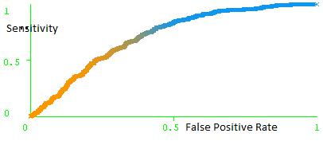

Figure 16: Receiver operating characteristic curve for artificial neural network identification of normal brain tissue based on co-occurrence matrix parameters
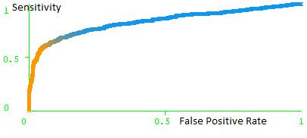

Figure 17: Receiver operating characteristic curve for artificial neural network identification of haemorrhagic stroke lesions based on co-occurrence matrix parameters

Page | 80
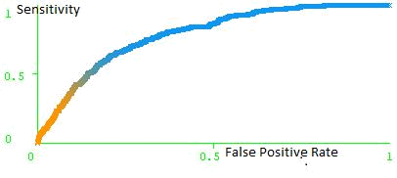

Figure 18: Receiver operating characteristic curve for artificial neural network identification of ischaemic stroke lesion based on co-occurrence matrix parameters

Table 4: Receiver operating characteristic analysis of artificial neural network

classification of brain tissue based on run-length matrix parameters

Evaluation |  | Tissue/Lesion Type
Parameters | Normal | Haemorrhage | Ischaemia | Weighted Average
Kappa statistic |  |  |  | 0.168
Sensitivity or | 0.889 | 0.321 | 0.057 | 0.544
true positive
rate (TPR) or
Recall
True negative | 0.277 | 0.902 | 0.973 | 0.607
rate (TNR) or
Specificity
False positive | 0.723 | 0.098 | 0.027 | 0.393
rate (FPR) or
Fall- out
False negative | 0.111 | 0.679 | 0.943 | 0.456
rate (FNR)
Positive | 0.547 | 0.565 | 0.372 | 0.514
predictive value
(PPV) or
Precision
Negative | 0.514 | 0.836 | 0.937 | 0.694
predictive value
(NPV)
F1-Measure | 0.677 | 0.409 | 0.098 | 0.474
Area under | 0.632 | 0.663 | 0.652 | 0.646
ROC curve
(AUROCC)


Page | 81
Statistics in table 4 show the performance of run-length matrix (RLM) parameters classifying stroke lesions according to type as well as normal brain tissue. This is further illustrated by the ROC curves in figures 19, 20 and 21.
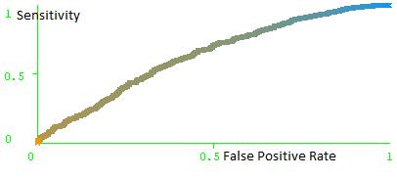

Figure 19: Receiver operating characteristic curve for artificial neural network identification of normal brain tissue based on run-length matrix parameters
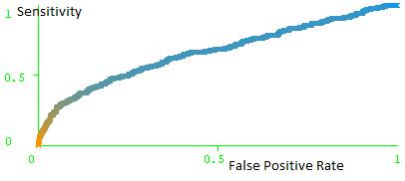

Figure 20: Receiver operating characteristic curve for artificial neural network identification of haemorrhagic stroke lesions based on run-length matrix parameters

Page | 82
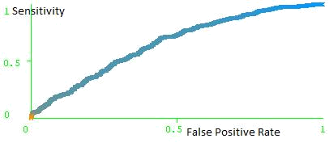

Figure 21: Receiver operating characteristic curve for artificial neural network identification of ischaemic stroke lesion based on run-length matrix parameters

Table 5: Receiver operating characteristic analysis of artificial neural network

classification of brain tissue based on absolute gradient parameters

Evaluation |  | Tissue/Lesion Type
Parameters | Normal | Haemorrhage | Ischaemia | Weighted Average
Kappa statistic |  |  |  | 0.155
Sensitivity or | 0.888 | 0.347 | 0.021 | 0.546
true positive
rate (TPR) or
Recall
True negative | 0.221 | 0.917 | 0.994 | 0.586
rate (TNR) or
Specificity
False positive | 0.779 | 0.083 | 0.006 | 0.414
rate (FPR) or
Fall- out
False negative | 0.112 | 0.653 | 0.979 | 0.454
rate (FNR)
Positive | 0.533 | 0.619 | 0.500 | 0.550
predictive value
(PPV) or
Precision
Negative | 0.446 | 0.940 | 0.978 | 0.694
predictive value
(NPV)
F1-Measure | 0.666 | 0.445 | 0.041 | 0.467
Area under | 0.551 | 0.714 | 0.660 | 0.621
ROC curve
(AUROCC)

Page | 83
The statistics shown in table 5 indicate the performance of absolute gradient parameters in classification of normal brain tissue and stroke lesions according to type using the artificial neural network. The result is also expressed by the ROC curves in figures 22, 23 and 24.
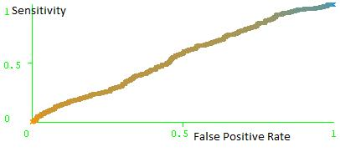

Figure 22: Receiver operating characteristic curve for artificial neural network identification of normal brain tissue based on absolute gradient parameters
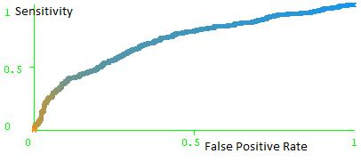

Figure 23: Receiver operating characteristic curve for artificial neural network identification of haemorrhagic stroke lesions based on absolute gradient parameters

Page | 84
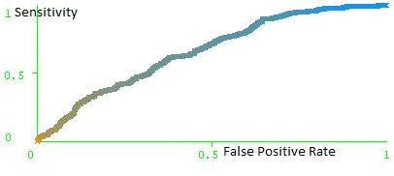

Figure 24: Receiver operating characteristic curve for artificial neural network

identification of ischaemic stroke lesions based on absolute gradient parameters

Table 6: Receiver operating characteristic analysis of artificial neural network

classification of brain tissue based on histogram parameters

Evaluation |  | Tissue/Lesion Type
Parameters | Normal | Haemorrhage | Ischaemia | Weighted Average
Kappa statistic |  |  |  | 0.914
Sensitivity or | 0.971 | 0.949 | 0.888 | 0.947
true positive
rate (TPR) or
Recall
True negative | 0.937 | 0.989 | 0.983 | 0.962
rate (TNR) or
Specificity
False positive | 0.063 | 0.011 | 0.017 | 0.038
rate (FPR) or
Fall- out
False negative | 0.029 | 0.051 | 0.112 | 0.053
rate (FNR)
Positive | 0.938 | 0.971 | 0.936 | 0.947
predictive value
(PPV) or
Precision
Negative | 0.953 | 0.857 | 0.050 | 0.693
predictive value
(NPV)
F1-Measure | 0.955 | 0.960 | 0.911 | 0.947
Area under | 0.979 | 0.986 | 0.977 | 0.980

ROC curve

(AUROCC)

Page | 85
The statistics in table 6 show the performance of histogram-based texture features in classification of stroke lesions according to type and normal brain tissue using the artificial neural network algorithm. The accuracy of detection was 94.68% while kappa, sensitivity, positive predictive value, F1-measure and area under ROC curve exceeded 0.9 for normal brain tissue, haemorrhagic and ischaemic stroke lesions. The shapes of ROC curves in figures 25, 26 and 27 which represent these results were near perfect.
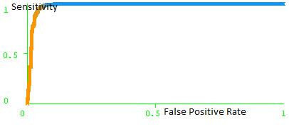

Figure 25: Receiver operating characteristic curve for artificial neural network identification of normal brain tissue based on histogram parameters
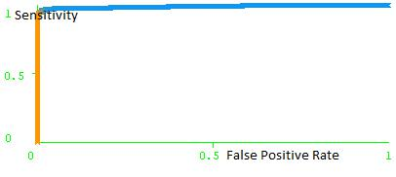

Figure 26: Receiver operating characteristic curve for artificial neural network identification of haemorrhagic stroke lesions based on histogram parameters

Page | 86
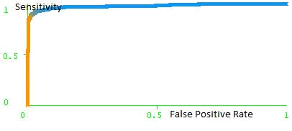

Figure 27: Receiver operating characteristic curve for artificial neural network identification of ischaemic stroke lesions based on histogram parameters

Table 7: Comparison of performance of the texture descriptors in artificial neural network classification

Class of Texture | Weighted ROC Analysis Parameters
Descriptors | Sensitivity | Specificity | FPR | AUROCC
Co-occurrence matrix | 0.637 | 0.753 | 0.247 | 0.761
Run-length matrix | 0.544 | 0.607 | 0.393 | 0.646
Absolute gradient | 0.546 | 0.586 | 0.414 | 0.621
Histogram | 0.947 | 0.962 | 0.038 | 0.980
Remark | p < 0.05 | p < 0.05 | p < 0.05 | p < 0.05


The histogram-based artificial neural network classification achieved significantly higher weighted sensitivity, specificity and larger area under the ROC curve than the other three classes of texture descriptors (p < 0.05) as shown in table 7 above. The false positive rate
Page | 87
for histogram-based classification was also significantly lower than that for the other

three classes of texture descriptors (p < 0.05) as shown in table 7.

4.2.2 THE CLASSIFICATION USING K-NEAREST NEIGHBOUR

The results of classification using the k-nearest neighbour (KNN) method, and co-

occurrence matrix, run length matrix, absolute gradient and histogram-based texture

features are as stated hereafter. The ROC curves have been plotted with sensitivity on the

vertical axes and false positive rate on horizontal axes.

Table 8: Receiver operating characteristic analysis of k-nearest neighbour classification

of brain tissue based on co-occurrence matrix parameters

Evaluation |  | Tissue/Lesion Type
Parameters | Normal | Haemorrhage | Ischaemia | Weighted Average
Kappa statistic |  |  |  | 0.416
Sensitivity or | 0.728 | 0.640 | 0.447 | 0.644
true positive
rate (TPR) or
Recall
True negative | 0.629 | 0.888 | 0.885 | 0.759
rate (TNR) or
Specificity
False positive | 0.371 | 0.112 | 0.115 | 0.241
rate (FPR) or
Fall- out
False negative | 0.272 | 0.360 | 0.553 | 0.356
rate (FNR)
Positive | 0.660 | 0.705 | 0.504 | 0.641
predictive value
(PPV) or
Precision
Negative | 0.822 | 0.596 | 0.197 | 0.707
predictive value
(NPV)
F1-Measure | 0.692 | 0.671 | 0.474 | 0.641
Area under | 0.686 | 0.763 | 0.669 | 0.705

ROC curve
(AUROCC)

Page | 88
Table 8 shows the performance of co-occurrence matrix derived texture parameters in classification of stroke lesions and normal brain tissue using the k-NN algorithm. The ROC curves in figures 28, 29 and 30 also further describe the results in table 8.
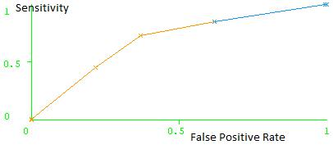

Figure 28: Receiver operating characteristic curve for k-nearest neighbour identification of normal brain tissue based on co-occurrence matrix parameters
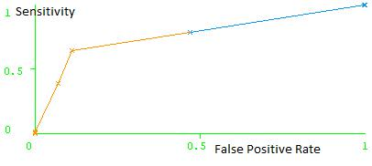

Figure 29: Receiver operating characteristic curve for k-nearest neighbour identification of haemorrhagic stroke lesions based on co-occurrence matrix parameters

Page | 89
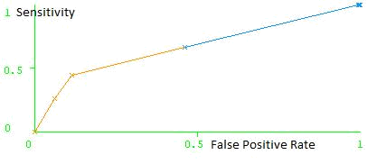

Figure 30: Receiver operating characteristic curve for k-nearest neighbour identification

of ischaemic stroke lesions based on co-occurrence matrix parameters

Table 9: Receiver operating characteristic analysis of k-nearest neighbour classification

of brain tissue based on run-length matrix parameters

Evaluation |  | Tissue/Lesion Type
Parameters | Normal | Haemorrhage | Ischaemia | Weighted Average
Kappa statistic |  |  |  | 0.162
Sensitivity or | 0.590 | 0.408 | 0.330 | 0.481
true positive
rate (TPR) or
Recall
True negative | 0.547 | 0.783 | 0.826 | 0.676
rate (TNR) or
Specificity
False positive | 0.453 | 0.217 | 0.174 | 0.324
rate (FPR) or
Fall- out
False negative | 0.410 | 0.592 | 0.670 | 0.519
rate (FNR)
Positive | 0.562 | 0.428 | 0.348 | 0.477
predictive value
(PPV) or
Precision
Negative | 0.819 | 0.185 | 0.131 | 0.694
predictive value
(NPV)
F1-Measure | 0.576 | 0.418 | 0.339 | 0.479
Area under | 0.569 | 0.601 | 0.575 | 0.579
ROC curve
(AUROCC)

Page | 90
In table 9 the performance of run-length matrix derived texture parameters in classification of stroke lesions and normal brain tissue using the k-NN algorithm is shown. The shapes of ROC curves in figures 31, 32 and 33 are representative the results shown in table 9. The areas under the ROC curves are just above 0.5.
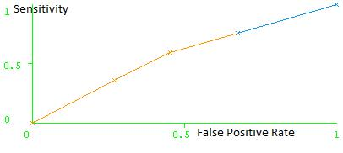

Figure 31: Receiver operating characteristic curve for k-nearest neighbour identification of normal brain tissue based on run-length matrix parameters
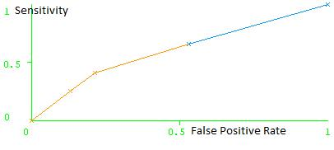

Figure 32: Receiver operating characteristic curve for k-nearest neighbour identification of haemorrhagic stroke lesions based on run-length matrix parameters

Page | 91
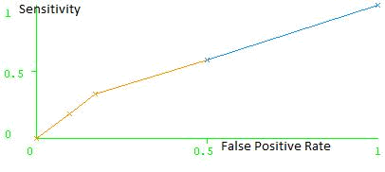

Figure 33: Receiver operating characteristic curve for k-nearest neighbour identification

of ischaemic stroke lesions based on run-length matrix parameters

Table 10: Receiver operating characteristic analysis of k-nearest neighbour classification

of brain tissue based on absolute gradient parameters

Evaluation |  | Tissue/Lesion Type
Parameters | Normal | Haemorrhage | Ischaemia | Weighted Average
Kappa statistic |  |  |  | 0.109
Sensitivity or | 0.512 | 0.417 | 0.326 | 0.445
true positive
rate (TPR) or
Recall
True negative | 0.506 | 0.800 | 0.789 | 0.651
rate (TNR) or
Specificity
False positive | 0.494 | 0.200 | 0.211 | 0.349
rate (FPR) or
Fall- out
False negative | 0.488 | 0.583 | 0.674 | 0.555
rate (FNR)
Positive | 0.509 | 0.448 | 0.304 | 0.447
predictive value
(PPV) or
Precision
Negative | 0.810 | 0.385 | 0.193 | 0.708
predictive value
(NPV)
F1-Measure | 0.511 | 0.432 | 0.315 | 0.446
Area under | 0.502 | 0.611 | 0.565 | 0.546
ROC curve
(AUROCC)

Page | 92
Table 10 shows the performance of absolute gradient texture parameters in classification of stroke lesions according to type and normal brain tissue using the k-NN algorithm. The shapes of ROC curves in figures 34, 35 and 36 illustrate the results shown in table 10. The areas under the ROC curves are just above 0.5.
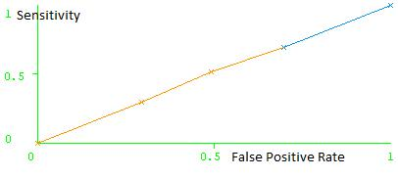

Figure 34: Receiver operating characteristic curve for k-nearest neighbour identification of normal brain tissue based on absolute gradient parameters
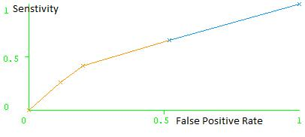

Figure 35: Receiver operating characteristic curve for k-nearest neighbour identification of haemorrhagic stroke lesions based on absolute gradient parameters

Page | 93
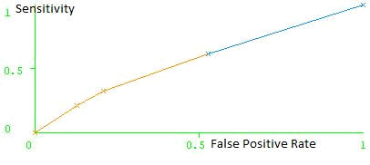

Figure 36: Receiver operating characteristic curve for k-nearest neighbour identification

of ischaemic stroke lesions based on absolute gradient parameters

Table 11: Receiver operating characteristic analysis of k-nearest neighbour classification

of brain tissue based on histogram parameters

Evaluation |  | Tissue/Lesion Type
Parameters | Normal | Haemorrhage | Ischaemia | Weighted Average
Kappa statistic |  |  |  | 0.885
Sensitivity or | 0.954 | 0.944 | 0.853 | 0.929
true positive
rate (TPR) or
Recall
True negative | 0.934 | 0.983 | 0.966 | 0.955
rate (TNR) or
Specificity
False positive | 0.066 | 0.017 | 0.034 | 0.045
rate (FPR) or
Fall- out
False negative | 0.046 | 0.056 | 0.147 | 0.071
rate (FNR)
Positive | 0.934 | 0.957 | 0.878 | 0.928
predictive value
(PPV) or
Precision
Negative | 0.949 | 0.273 | 0.029 | 0.693
predictive value
(NPV)
F1-Measure | 0.944 | 0.950 | 0.865 | 0.928
Area under | 0.944 | 0.963 | 0.909 | 0.942
ROC curve
(AUROCC)

Page | 94
The statistics in table 11 show the performance of histogram-based texture features in classification of stroke lesions according to type and normal brain tissue using the k-nearest neighbour classification algorithm. The accuracy of classification was 92.86% while kappa, sensitivity, positive predictive value, F-measure and area under ROC curve for normal brain tissue, haemorrhagic and ischaemic stroke lesions were close to unity. The shapes of corresponding ROC curves in figures 37, 38 and 39 illustrate the results in table 11.
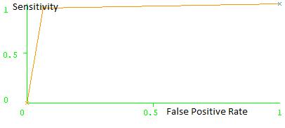

Figure 37: Receiver operating characteristic curve for k-nearest neighbour identification of normal brain tissue based on histogram parameters
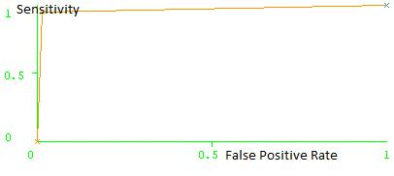

Figure 38: Receiver operating characteristic curve for k-nearest neighbour identification of haemorrhagic stroke lesions based on histogram parameters

Page | 95
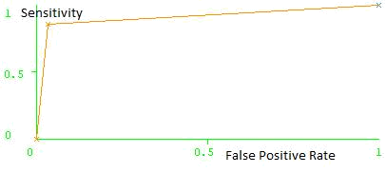

Figure 39: Receiver operating characteristic curve for k-nearest neighbour identification of ischaemic stroke lesions based on histogram parameters

Table 12: Comparison of performance of the texture descriptors in k-nearest neighbour classification

Class of Texture | Weighted ROC Analysis Parameters
Descriptors | Sensitivity | Specificity | FPR | AUROCC
Co-occurrence matrix | 0.644 | 0.759 | 0.241 | 0.705
Run-length matrix | 0.481 | 0.676 | 0.324 | 0.579
Absolute gradient | 0.445 | 0.651 | 0.349 | 0.546
Histogram | 0.929 | 0.955 | 0.045 | 0.942
Remark | p < 0.05 | p < 0.05 | p < 0.05 | p < 0.05

The histogram-based k-nearest neighbour classification achieved significantly higher weighted sensitivity, specificity and larger area under the ROC curve than the other three classes of texture descriptors (p < 0.05) as shown in table 12. The false positive rate for

Page | 96
histogram-based classification was also significantly lower than that for the other three classes of texture descriptors (p < 0.05) as shown in table 12.

4.3 COMPARISON OF THE ARTIFICIAL NEURAL NETWORK AND k-

NEAREST NEIGHBOUR IN CLASSIFICATIONS OF BRAIN TISSUE Comparison of classifications by artificial neural network and k-nearest neighbour algorithms yielded mixed pattern of results with data acquired from co-occurrence matrix, run-length matrix and absolute gradient as shown in table 13. With co-occurrence matrix there was no difference in sensitivity, specificity and false positive rate between artificial neural network and k-nearest neighbour (p > 0.05) as shown in table 13. However, the area under ROC curve was larger with artificial neural network (p = 0.000). With data from run-length matrix, sensitivity, false positive rate and area under ROC curve were greater in artificial neural network classification (p = 0.000) while specificity was lower compared with k-nearest neighbour classification (p = 0.000). The exact pattern observed in the run - length matrix was also observed in absolute gradient as shown in table 13. There was no difference in sensitivity, specificity, false positive rate and area under ROC curve between artificial neural network and k-nearest neighbour classifications with data from histogram (p > 0.05).

Page | 97
Table 13: Comparison of artificial neural network and k-nearest neighbour in classification of brain tissue

CLASSIFICATION SENSITIVITY SPECIFICITY FPR AUROCC ALGORITHM

 | Co-occurrence Matrix
ANN | 0.637 | 0.753 | 0.247 | 0.761
k-NN | 0.644 | 0.759 | 0.241 | 0.705
Remark | p = 0.703 | p = 0.715 | p = 0.715 | p = 0.000*
 | Run-length Matrix
ANN | 0.544 | 0.607 | 0.393 | 0.646
k-NN | 0.481 | 0.676 | 0.324 | 0.579
Remark | p = 0.001* | p = 0.000* | p = 0.000* | p = 0.000*
 | Absolute Gradient
ANN | 0.546 | 0.586 | 0.414 | 0.621
k-NN | 0.445 | 0.651 | 0.349 | 0.546
Remark | p = 0.000* | p = 0.001* | p = 0.001* | p = 0.000*
 |  | Histogram
ANN | 0.947 | 0.962 | 0.038 | 0.980
k-NN | 0.929 | 0.955 | 0.045 | 0.942
Remark | p = 0.061 | p = 0.378 | p = 0.378 | p = 0.373


Page | 98
4.4 THE SEX, AGE AND ANATOMICAL DISTRIBUTIONS OF STROKE LESIONS AMONG THE PATIENTS

A total of 164 patients aged between 32 and 85 years whose non contrast CT images of the brain revealed stroke lesions were included in the study. The mean age of the patients was 60.0 ± 12.4 years. More than half (58.6%, n = 96) were males while the remainder, (41.4%, n = 68) were females as shown in table 14. There were significantly more males presenting for CT scan due to stroke (p = 0.002).

Table 14: Sex and age distribution of stroke lesions among the patients
Variable |  |  | Lesion Type |  |  |  | Total
 | Ischaemia |  | Haemorrhage |  | Mixed
 |  |  |  | Sex
Male | 41 | (25%) | 49 | (29.9%) | 6 | (3.7%) | 96 | (58.6%)
Female | 31 | (18.9%) | 34 | (20.7%) | 3 | (1.8%) | 68 | (41.4%)
Total | 72 | (43.9%) | 83 | (50.6%) | 9 | (5.5%) | 164 (100%)
 |  |  | Age (years)
31-40 | 3 (1.8%) |  | 4 (2.4%) |  | 1 | (0.6%) | 8 (4.9%)
41-50 | 13 | (8%) | 24 | (14.6%) | 0 | (0%) | 37 | (22.6%)
51-60 | 21 | (12.8%) | 19 | (11.6%) | 1 | (0.6%) | 41 | (25%)
61-70 | 17 | (10.4%) | 21 | (12.8%) | 4 | (2.4%) | 42 | (25.6%)
70 and above | 18 | (10.9%) | 15 | (9.1%) | 3 | (1.8%) | 36 | (21.9%)
Total | 72 | (43.9%) | 83 | (50.6%) | 9 | (5.5%) | 164 (100%)


Page | 99
Table 14 also shows that slightly more than half of the patients (50.6%, n = 83) had haemorrhagic stroke while 43.9% (n = 72) had ischaemic stroke and 5.5% (n = 9) had both stroke subtypes co-occurring. Patients older than 40 years were most affected as shown in table 14.

A total of 233 stroke lesions consisting of 44.6% (n = 104) ischaemia and 55.4% (n = 129) haemorrhage were seen on the CT images as shown in table 15.

Table 15: Lesions type and anatomical location of stroke lesions
Anatomical |  |  | Lesion Subtype |  | Total
Location | Ischaemic |  | Haemorrhage
Basal ganglia | 4 (1.7%) |  | 12 | (5.2%) | 16 | (6.8%)
Intra-ventricular | 0 |  | 34 | (14.6%) | 34 | (14.6%)
Sylvian fissure | 10 | (4.3%) | 4 (1.7%) |  | 14 | (6.0%)
Pons | 1 (0.4%) |  | 5 (2.1%) |  | 6 (2.5%)
Midbrain | 0 |  | 9 (3.9%) |  | 9 (3.9%)
Thalamus | 15 | (6.4%) | 2 (0.9%) |  | 17 | (7.3%)
Frontal lobe | 7 (3.0%) |  | 7 (3.0%) |  | 14 | (6.0%)
Parietal lobe | 26 | (11.2%) | 3 (1.3%) |  | 29 | (12.4%)
Occipital lobe | 15 | (6.4%) | 15 | (6.4%) | 30 | (12.9%)
Temporal lobe | 6 (2.6%) |  | 13 | (5.6%) | 19 | (8.2%)
Basal cistern | 0 |  | 3 (1.3%) |  | 3 (1.3%)
Cerebrum | 20 | (8.6%) | 22 | (9.4%) | 42 | (18.0%)
(Extensive
involvement)
Total | 104 (44.6%) |  | 129 (55.4%) |  | 233 (100%)


Page | 100
The lesions were located in different anatomical regions of the brain as shown in the table. Ischaemic stroke affected the parietal lobe more than any other part of the brain (11.2%, n = 26) while haemorrhagic stroke affected the ventricles more (14.6%, n = 34). The cerebra were extensively affected in equal proportion by ischaemia and haemorrhage (8.6%, n = 20 vs 9.4%, n = 22).

Table 16: Distribution of lesions according to their numeracy in patients

Number of lesions per patient | Frequency | Total Number of lesions
One | 108 (65.9%) | 108
Two | 47 (28.7%) | 94
Three | 7 (4.3%) | 21
Five | 2 (1.2%) | 10
Total | 164 (100%) | 233


According to table 16 above, only one stroke lesion was seen in non contrast CT images of 65.9% (n = 108) patients while 28.7% (n = 47) had two lesions, 4.3% (n = 7) three lesions each and only 1.2% (n = 2) had five lesions respectively.

Page | 101
CHAPTER FIVE

DISCUSSION, LIMITATIONS, SUMMARY OF FINDINGS AND CONCLUSION

5.1 DISCUSSION

5.1.1 Introduction

Medical image analysis techniques play very important roles in several radiological interpretations. In general, the applications involve the automatic extraction of texture features from images which are then used for a variety of classification tasks, such as distinguishing normal tissue from abnormal tissue (Pham, 2010).

5.1.2 ANALYSIS OF BRAIN TISSUE USING STATISTICAL TEXTURE

PARAMETERS

In this study, parameters of the four statistical texture descriptors were computed using MaZda® for the selected ROIs chosen from stroke lesions and adjacent normal brain tissue. The whole process involved computation of statistical texture parameters, feature selection or reduction and raw data analysis to extract features that most differentiate normal brain tissue from stroke lesions.

In this study, the features extracted grey level co-occurrence matrix that best distinguished normal brain tissue from lesioned brain tissue, namely ischaemic and haemorrhagic stroke lesions, were sum average parameters namely S1-1 SumAverg, S1-0 SumAverg, and S0-1 SumAverg. Using these parameters to classify brain tissue during the raw data analysis showed that the percentage of misclassified ROIs was quite high. This translates to poor accuracy and suggests that grey level co-occurrence matrix may

Page | 102
not be best suited for classification of brain tissue in stroke patients. The shortcoming of grey level co-occurrence matrix is that it produces many texture features some of which are unsuitable for classification. If measures are not taken to reduce the number of features before classification, then the statistical model will better reflect the noise or random error than the underlying data (Zhang et al., 2008). There are many approaches to feature reduction or selection but in this study feature subsets were selected based on the Fisher criterion. The Fisher method of feature selection or reduction aims to reduce intraclass differences and maximize interclass differences. In this way the best discriminating statistical texture features were deduced and confirmed with raw data analysis. In a related study, Oliveira et al. (2009) evaluated non contrast brain CT images of 5 acute ischaemic patients and 5 normal subjects. They computed four co-occurrence matrix parameters, namely; angular second moment (ASM), sum of squares (SS), contrast (C), and sum variance (SV) for lesioned and non-lesioned tissues. Using box and whisker plots they reported that ASM was best at discriminating between lesioned and non-lesioned brain tissue and between brain tissue of patients and normal subjects. This is markedly different from the result of present study which suggests that sum average parameters are the best discriminating parameters. The difference might be due to the nature of the studies. While the previous study investigated acute ischaemic stroke in five patients and compared the texture of the stroke images with the texture of normal brain tissue in five normal volunteers, the present study evaluated many stroke images comprising both ischaemic and haemorrhagic strokes. Also, the methods of isolating the discriminating features were different. While whisker and box plots were used in the previous study, the raw data analysis was used in the present study.

Page | 103
In another related study, Kabara et al. (2003) carrying out texture analysis of intracerebral haemorrhage identified three co-occurrence matrix parameters namely variance, correlation and sum average as being the features with highest separations between normal brain tissue and haemorrhage. The result partly supports what was identified as the most discriminative texture parameters between normal brain tissue and stroke lesions. In the present study sum average parameters were identified as the most discriminative co-occurrence matrix parameters.

Aside co-occurrence matrix parameters, other statistical texture features were computed and evaluated in this study. The best run-length matrix feature to discriminate between normal brain tissue, ischaemic and haemorrhagic stroke lesions was short run emphasis (ShrtREmp) in 45⁰, 135⁰ and horizontal directions. Considering the result obtained in this study, more than half of data obtained from run-length matrix were misclassified thereby confirming the assertion of Tang (1998). This suggests that it may not be suitable for medical applications, which always demand high accuracy. The run-length method of texture analysis was first introduced by Galloway (1975) but it has not gained acceptance as an efficient way of calculating texture (Tang, 1998). Previous studies on texture analysis of stroke lesions using run-length matrix features were not seen for comparison with the present study.

For the absolute gradient features, gradient non-zeros, gradient variance and gradient mean were best discriminators. The results obtained in this study show absolute gradient features performed poorly in tissue discrimination and as such should not be used to distinguish between different stroke lesions and normal brain tissue. However, they find

Page | 104
application in accentuating the boundaries of an image as Castellano et al. (2004) opined and therefore are useful in edge enhancement.

The histogram-derived parameters namely the mean, percentile 90 and percentile 99 were the best discriminators. They achieved very high accuracy in discriminating between normal brain tissue, ischaemic and haemorrhagic stroke lesions. According to the result of a previous study, histogram features when used with Radial Basis Function of Nerve Network (RBFNN) achieved accuracies of over 80% in classification of brain tissue (Zhang and Wang, 2007). Histogram measures the frequency of occurrence of the different grey-scale patterns throughout the image by moving in steps of one pixel across the image. This approach is attractive for its conceptual simplicity. The findings in this study regarding the histogram texture features could only be compared with one previous report by Zhang and Wang (2007) as it was the only one that could be retrieved. This shows that it is not popular with researchers working on texture analysis of brain CT images. However, it is highly accurate for discrimination between normal brain tissue and lesions, and between ischaemic stroke and haemorrhagic stroke lesions as the present study suggests.

5.1.3 CLASSIFICATION OF BRAIN TISSUE

The results of ROC curve analysis of artificial neural network and k-nearest neighbour classifications of brain tissue based on data obtained from statistical methods of texture analysis show that histogram-based features fared better than the rest. A classification accuracy of over 90% was achieved, and the weighted average sensitivity, specificity and area under ROC curve of almost unity were recorded for both artificial neural network and k-nearest neighbour. Correspondingly the false positive rate (referred to as fall-out in

Page | 105
machine learning) and false negative rate in both methods were very low. Sensitivity and specificity are important measures of the diagnostic accuracy of a test (Akobeng, 2006). A diagnostic test with high sensitivity is useful in ruling out a disease condition when the test result is negative. Correspondingly, a diagnostic test with high specificity is useful in ruling in a disease condition when the test result is positive. The foregoing explanation of the importance of sensitivity and specificity in diagnostic test performance can be applied to the present study which was aimed at being used for automatic detection of stroke lesions.

Similar studies have been carried out in the past with good outcomes. Chawla et al. (2009) carried out classification of stroke lesions into acute infarct, chronic infarct and haemorrhage on non contrast brain CT. The researchers used histogram-based comparison and wavelet energy-based texture information to classify stroke lesions. Also, Oliveira et al. (2009) showed that texture analysis can possibly help in detection of acute ischaemic stroke lesions and thus identify potentially affected areas even if they are not visually perceptible. Padma and Sukanesh (2011) proposed a method for automatic diagnosis of abnormal tumor regions present in CT images using wavelet-based statistical texture features. Using support vector machine (SVM) for classification of brain tissue, they obtained a classification accuracy of 96%. Zhang and Wang (2007) also extracted texture features from CT images and using inductive learning techniques and Radial Basis Function Neural Network (RBFNN), were able to classify brain tissue as normal and abnormal with high accuracy.

Page | 106
The importance of texture analysis as a step in building computer-aided schemes has also been demonstrated in these studies. Chen et al. (1999) extracted texture features from sonograms of solid breast nodules. With artificial neural network classification they reported 95% accuracy, in classification of nodules as malignant or benign. The sensitivity was 98%, specificity 93%, positive predictive value 89% and negative predictive value 99%. Also, Garra et al. (1993) carried out texture analysis of ultrasound images of breast lesions. The researchers extracted co-occurrence matrix texture features from the images and used linear Bayesian classifier for classification. Their results indicate that texture analysis may reduce the number of biopsies done for benign lesions. Mala and Sadasivam (2005) proposed a computer-aided diagnosis scheme to classify diffuse liver diseases using wavelet-based texture features and probabilistic network for classification. The outcome was a classification accuracy of 95%.

In this study, comparison of artificial neural network and k-nearest neighbour classifications of brain tissue showed that histogram data achieved the same classification performance with both algorithms. This implies that either of the two algorithms can be used for classification and therefore may be used in real clinical situations. Histogram method of texture analysis is a rather simple concept and may be found attractive by many researchers with a view of developing computer-aided diagnostic softwares.

The results of previous attempts to deploy texture analysis in building automatic abnormality detection system are quite similar to the results of this study. The
Page | 107
classification accuracy, sensitivity, and specificity levels are about the same with those of previous studies. The present database could be used in building a computer-aided diagnosis tool for stroke based on content-based image retrieval similar to that proposed by Yuan et al. (2011).

The computer tries to emulate the radiologist’s visual inspection and interpretation of brain CT images or any other image it has been presented with depending on the case under investigation. Classification is typically accomplished by using a decision or discriminant function (Kassner and Thornhill, 2010). In this study supervised classification was carried out using artificial neural network (Tzacheva et al., 2003; Georgiadis et al., 2008), and k-nearest neighbour (Cover and Hart, 1967).

The performance of artificial neural network and k-nearest neighbour algorithms in classifying brain tissue in non contrast brain CT into normal, ischaemic and haemorrhagic lesions was evaluated with the receiver-operating characteristic (ROC) curves. In the ROC curve analysis, the classification of data points as belonging to normal brain tissue, ischaemic stroke or haemorrhagic stroke was cross validated with the radiologist’s identification of stroke lesions and normal brain tissue. The ROC curve analysis was devised by Britain to assess the performance of their radar detectors in identifying incoming German planes during the Second World War. So it started as an application in physical science but is now popularly used in biomedicine. Receiver-operating characteristic curves are used to compare the diagnostic performance of two or more laboratory or diagnostic tests (Griner et al., 1981). Also, according to Zweig and

Page | 108
Campbell (1993) and Metz (1978), the ability to discriminate diseased cases from normal cases is evaluated using ROC curve analysis.

5.1.4 COMPARISON OF ARTIFICIAL NEURAL NETWORK AND k-

NEAREST NEIGHBOUR CLASSIFICATIONS OF BRAIN TISSUE

Comparison of classifications by artificial neural network and k-nearest neighbour algorithms yielded a mixed pattern of results with data acquired from co-occurrence matrix, run-length matrix and absolute gradient. With data from the histogram texture descriptor, there was no difference in the results of ROC analysis of the classifications using the artificial neural network and k-nearest neighbour.

5.1.5 THE SEX, AGE AND ANATOMICAL DISTRIBUTIONS OF STROKE LESIONS AMONG THE PATIENTS

Stroke remains a leading neurological cause of morbidity and mortality, and as such is a public health concern in Nigeria and globally. In view of its outstanding importance, many countries worldwide make great deal of effort to keep accurate and up-to-date epidemiological statistics on stroke.

The present study was carried out in two radio-diagnostic centres located in southeast and southwest of Nigeria where suspected stroke patients undergo cranial CT examination. Like the previous studies of Alkali et al. (2013), Obiako et al. (2011), Salawu et al. (2009), Onwuchekwa and Onwuchekwa (2009), and Onwuekwe et al. (2008), there was male gender preponderance in the distribution of victims. In this study, the mean age of the patients was similar to the one previously reported by Sheta et al.

Page | 109
(2012) and Imarhiagbe and Ogbeide (2011). The reports showed that stroke incidence is increased in the sixth decade of life and after.

In Nigeria there has not been a coordinated attempt to keep statistical data on stroke. As a result no reliable epidemiological statistics exist on stroke in the country. Most studies conducted on stroke in Nigeria are hospital-based which expectedly excluded stroke cases that did not present to the hospitals. The best attempt at providing community-based statistics on stroke was that of Danesi et al. (2007) which put the overall crude prevalence of stroke at 1.14 per 1,000 persons. The study was conducted in an urban community in Lagos. Earlier, according to Osuntokun (1977), the report of a Stroke Registry in Ibadan gave the incidence of stroke as 26 per 100,000 populations in 1977.

Previous studies on stroke that involved use of CT had reported a preponderance of ischaemic stroke over haemorrhagic stroke (Sheta et al., 2012; Salawu et al., 2009; Onwuchekwa and Onwuchekwa, 2009; and Khan and Rehman, 2005). Unlike in previous studies, this study showed there were more cases of haemorrhagic stroke than ischaemic stroke but the reason for this is not known. Also, in the previous studies there were no reported cases of co-morbidity with the two stroke sub-types in any of the patient in a single CT study but there were a few of such cases in the current study. What this finding suggests is that the two stroke sub-types may have occurred simultaneously or within a very short interval of each other before the patient presented for CT. It may also be that some ischaemic brain tissue may have undergone haemorrhagic transformation just before the CT examination and thus presented like it was

Page | 110
intracerebral haemorrhage ab initio. It should be noted that late presentation for CT investigation is a characteristic feature of stroke in a Nigerian teaching hospital (Onwuchekwa and Onwuchekwa, 2009) and this was also encountered in the present study.

This study shows that the most frequently affected parts of the brain by stroke were the ventricles by haemorrhage, parietal lobe by mostly ischaemia, occipital lobe equally by both ischaemia and haemorrhage and, in extensive geographic involvement, the cerebra equally by both ischaemia and haemorrhage. Overwhelming majority of the lesions found in this study were single-occurring but some were multiple and did not exceed five. However, Onwuchekwa and Onwuchekwa (2009) reported the frontal and parietal lobes as being most frequently affected by stroke but there was no indication of stroke sub-type in this case. Their study like the present one also showed that majority of the patients had just one stroke lesion identified on CT.

5.2 LIMITATIONS OF THE STUDY

The following factors may affect a generalization of the result of this study. So, its use should be with the following points in mind:

- This was conducted in two radiodiagnostic centres and conditions there may not reflect the actual clinical situation as the patients were carefully selected. Other confounding conditions that may present in an actual clinical setting were part of the study.

- Sensitivity and specificity levels in this study were high, but not 100%, implying that a computer-aided scheme can make mistakes. This study recognizes this fact,

Page | 111
but it did not consider how the mistaken cases may be identified. As Krupinski (2004) warned, “sensitivity is rarely 100% especially because of the wide variability in lesion and background appearance”. It may be the case that majority of the computer-aided detection schemes may never be trained with enough cases to “see” all possible variations of a given target lesion. Even for those scheme that use artificial neural networks and continue to learn with each successive case they analyze, sensitivity of 100% may not be achieved (Krupinski, 2004). Thus, computer-aided detection systems should be used with caution and it ideally should not completely replace visual inspection and interpretation. Such systems are meant to complement visual inspection and interpretation. Heavy reliance on computer-aided detection system to detect and classify lesions may alter the normal search and decision-making processes (Krupinski, 1997).

- Only stroke cases confirmed at CT were evaluated in this study. Clinical mimics of stroke were not included and therefore it is not possible to tell if this method can distinguish stroke from its clinical mimics.

- The post-ictal intervals before CT imaging were not captured and thus the result of this study cannot be used to explain the changes in CT appearance of stroke lesions with time.

5.3 RECOMMENDATION FOR FURTHER STUDY AND THE FUTURE

DIRECTION OF THE RESEARCH

In view of the findings of this study, a larger scale study in an actual clinical environment is recommended. Such a study should evaluate the performance of this proposed automatic method of detecting and classifying stroke lesions and compare with radiologist’s visual interpretation. It should also include the changes in CT appearance of

Page | 112
stroke lesions with the passage of time. This chronological sub-typing will be crucial to identifying hyperacute, acute and chronic stroke lesions on CT. This will help neurologists to estimate the post-stroke neurological deficit that should be expected in any individual case.

5.4 SUMMARY OF FINDINGS

- The raw data analysis shows the histogram parameters were 92.14% accurate in identifying normal brain tissue and stroke lesions.
- The co-occurrence matrix parameters that discriminated between normal brain tissue and stroke lesions were sum average parameters, namely S1-1 SumAverg with a feature value of -3.54 to 4.35, S1-0 SumAverg -4.19 to 4.39 and S0-1 SumAverg -3.87 to 4.30.

- The run-length matrix parameters that discriminated between normal brain tissue and stroke lesions were short run emphasis in horizontal, 135⁰ and 45⁰ directions with feature values of -9.08 to 2.27, -9.61 to 2.13 and -9.13 to 2.16 respectively.

- The absolute gradient-derived parameters that discriminated between normal brain tissue and stroke lesions were gradient non-zeros with a feature value of - 14.33 to 0.83, gradient variance -2.71 to 4.00 and gradient mean -3.96 t0 2.58.

- The histogram parameters that discriminated between normal brain tissue and stroke lesions were the mean with a feature value of -1.77 to 2.59, 90 percentile - 1.83 to 2.19 and 99 percentile -1.99 to 1.91.

- The ANN classified brain tissue using the radiologist’s identifications of the lesions as gold standard, and achieved a sensitivity of 0.637, specificity 0.753, false positive rate (FPR) 0.247, and false negative rate (FNR) 0.363 with the co-occurrence matrix parameters.

Page | 113
- The ANN classified brain tissue using the radiologist’s identifications of the lesions as gold standard, and achieved a sensitivity of 0.544, specificity 0.607, FPR 0.393, and FNR 0.456 with the run-length matrix parameters.

- The ANN classified brain tissue using the radiologist’s identifications of the lesions as gold standard, and achieved a sensitivity of 0.546, specificity 0.586, FPR 0.414, FNR 0.454 with the absolute gradient parameters.

- The ANN classified brain tissue using the radiologist’s identifications of the lesions as gold standard, and achieved a sensitivity of 0.947, specificity 0.962, FPR 0.038, and FNR 0.053 with the histogram parameters.

- The k-NN classified brain tissue using the radiologist’s identifications of the lesions as gold standard, and achieved a sensitivity of 0.644, specificity 0.759, false FPR 0.241, and FNR 0.356 with the co-occurrence matrix parameters.

- The k-NN classified brain tissue using the radiologist’s identifications of the lesions as gold standard, and achieved a sensitivity of 0.481, specificity 0.676, FPR 0.324, and FNR 0.519 with the run-length matrix parameters.

- The k-NN classified brain tissue using the radiologist’s identifications of the lesions as gold standard, and achieved a sensitivity of 0.445, specificity 0.651, FPR 0.349, and FNR 0.555 with the absolute gradient features.

- The k-NN classified brain tissue using the radiologist’s identifications of the lesions as gold standard, and achieved a sensitivity of 0.929, specificity 0.955, FPR 0.045, and FNR 0.071 with the histogram parameters.

- The histogram-based classifications were the most accurate using both the ANN and k-NN (p < 0.05) and therefore the histogram texture descriptor is most suitable for building computer-aided diagnostic system for stroke.

Page | 114
- Ischaemic stroke affected the parietal lobe most while haemorrhagic stroke affected the ventricles most.

5.5 CONCLUSION

This study has established histogram-derived texture features as being most accurate and therefore suitable for automatic detection and classification of stroke lesions using artificial neural network and k-nearest neighbour classifiers. The results recorded with co-occurrence matrix, run-length matrix and absolute gradient features were not accurate enough to be recommended for use in automatic detection and classification of stroke. The results obtained in this study suggest that computer-aided diagnostic tool for stroke diagnosis utilizing histogram-derived texture features would be the most ideal.

Page | 115
REFERENCES

Akobeng AK (2006). Understanding diagnostic tests 1: sensitivity, specificity and

predictive values. Acta Paediatrica; 96: 338-341.

Alkali NH, Bwala SA, Akano AO, Ogugua O, Alabi P, Ayeni OA (2013). Stroke risk

factors, subtypes and 30-day case fatality in Abuja, Nigeria. Nigerian Medical Journal; 54 (2): 129-135.

Altman NS (1992). An introduction to kernel and nearest neighbour nonparametric

regression. The American Statistician; 46 (3): 175-185.

Armstrong P, Wastie ML (1987). Diagnostic imaging. 2nd edition. Oxford: Blackwell

Scientific Publications. Pp. 1-11.

Atalabi OM, Adekanmi AJ, Bamgboye EA (2013). The state of radiology subspecialty

training in the West African sub region: the residents’ perspective.

West African Journal of Radiology; 20 (2): 69-73.

Bernasconi A, Antel S, Bernasconi N, Dubeau F, Oliver A, Andermann F, Collins DL,

Arnold DL (2000). Texture analysis of MRI assists in the detection of focal cortical dysplastic lesions. Proc. Intl. Soc. Mag Reson. Med. 8: 667.

Besson G, Robert C, Hommel M, Perret J (1995). Is it clinically possible to distinguish

nonhaemorrhagic infarct from haemorhagic stroke? Stroke; 26:1205–1209.

Page | 116
Bhat P, Singh M (2012). Classification of stroke using texture analysis on CT images.

International Journal of Soft Computing and Engineering; 2 (3): 527-530.

Bracewell R (1999). The Fourier transform and its applications. 3rd edition. New York:

McGraw-Hill.

Burnette WC, Nesbit GM, Barnwell SL (1999). Intra-arterial thrombolysis for acute

stroke. Neuroimaging Clinic of North America; 99: 491-508.

Burnette WC, Nesbit GM (2001). Intra-arterial thrombolysis for acute ischaemic stroke.

European Radiology; 11: 626-634.

Castellano G, Bonilha L, Li LM, Cendes F (2004). Texture analysis

of medical

images. Clinical Radiology; 59 (12): 1061-1069.

Chawla M, Sharma S, Swansiwamy J, Kishore LT (2009). A method for automatic

detection and classification of stroke from brain CT images. EMBC 2009 Report No: IIIT/TR/2009/188. Centre for Visual Information Technology, International Institute of Information Technology, Hyderabad 500 032, India.

Chen DR , Chang RF, Huang YL (1999). Computer-aided diagnosis applied to

ultrasound of solid breast nodules by using neural networks. Radiology; 213:

407-412.

Chen YP, Fu KS (1974). Recognition of x-ray picture patterns. IEEE Trans Syst Man

Cybern; 4: 145-156.

Page | 117

Chukwuonye II, Ohagwu KA, Uche EO, Chuku A, Nwanke RI, Ohagwu CC, Ezeani IU,

Nwabuko CO, Nnoli MA, Oviasu E, Ogah SO (2015). Validation of Siriraj stroke score in southeast Nigeria. International Journal of General Medicine; 8: 349-353.

Chukwuonye II, Chuku A, John C, Ohagwu KA, Imoh ME, Isa SE, Ogah SO, Oviasu E

(2013). Prevalence of overweight and obesity among adult Nigerians – a systematic review. Diabetes, Metabolic Syndrome and Obesity: Targets and Therapy; 34 (1): 104-109.

Cover TM, Hart PE (1967). Nearest neighbour pattern classification. IEEE Transactions

on Information Theory; 13: 21-27.

Danesi M, Okubadejo N, Ojini F (2007). Prevalence of stroke in an urban, mixed-income

community in Lagos, Nigeria. Neuroepidemiology; 28: 216-223.

Darling EM, Joseph RD (1968). Pattern recognition from satellite altitudes. IEEE Trans

Syst Sci Cybern; 4: 38-47.

Dash M, Liu H (1997). Feature selection for classification. Intelligent Data Analysis; 1

(3): 131-156.

Davies ER (2008). Introduction to texture analysis. In: Mirmehdi M, Xie X, Suri J (eds.).

Handbook of texture analysis. London: Imperial College Press. Pp. 1 - 31.

Page | 118
Devi CA, Rajagopalan SP (2013). Brain stroke classification based on multilayer

perceptron using watershed segmentation and Gabor filter. Journal of Theoretical and Applied Information Technology; 56 (2): 410-416

Dillon WP (2005). Neuroimaging in neurologic disorders In: Kasper DL, Fauci AS,

Longo DL, Braunwald E, Hauser SL, Jameson JL (eds.) Harrison’s principles of internal medicine 16th edition. New York: McGraw-Hill Medical Publishing Division. Pp. 2350-2357.

Duda R, Hart PE, Stork DG (2001). Pattern classification 2nd edition. New York: John

Wiley and Sons.

El Khamlichi AMD (2001). African neurosurgery: current situation, priorities and needs.

Neurosurgery 48: 1344-1347.

Fawcett T (2006). An introduction to ROC analysis. Pattern Recognition Letters 27 (8):

861-874.

Flohr T, Ohnesorge B (2007). Multi-slice CT technology. In: Ohnesorge BM, Flohr TG,

Becker CR, Knez A, Reiser MF. Multi-slice and dual-source CT in cardiac imaging – principles, protocols, indications, outlook. 2nd edition. New York: Springer Berlin Heidelberg. Pp.41-67.

Fukunaga K (1991). Introduction to statistical pattern recognition. New York: Academic

Press.

Page | 119
Galda HJ (2011). Image processing with scilab and image processing design toolbox.

Available at: www.d.umn.edu/˜snorr/ee5351s14/ImProcTut.pdf

Galloway MM (1975). Texture analysis using grey level run lengths. Comput. Graphics Image Process, 4: 172–179.

Garra BS, Krasner H, Horii SC, Ascher S, Muk SK, Zeman RK (1993). Improving the

distinction between benign and malignant breast lesions: the value of sonographic

texture analysis. Ultrasound Imaging; 15: 267-285.

Gebejes A., Huertas R. (2013). Texture characterization based on grey-level co-occurrence matrix. Second International Conference. Section: Artificial Intelligence and Image processing. Conference of Informatics and Management Sciences, March, 25. - 29. Pp. 375-378.

Georgiadis P, Cavouras D, Kalatzis I, Daskalakis A, Kagadis GC, Sifaki K, Malamas M,

Nikiforidis G, Solomou E (2008). Improving brain tumor characterization on MRI by probabilistic neural networks and non-linear transformation of textural features. Computer Methods and Programs in Biomedicine; 89: 24-32.

Gonzalez RC, Woods RE (2008). Digital image processing. Third edition. New Delhi:

PHI Learning Private Limited. Pp. 827-860.

Gonzalez RC, Woods RE, Eddins SL (2009). Digital image processing using MATLAB.

Second edition. USA: Gatesmark Publishing. Pp. 1-12.

Gorelick PB (1995). Stroke prevention. Arch Neurol 52: 347-355

Page | 120
Griner PF, Mayewski RJ, Mushlin AI, Greenland P (1981). Selection and interpretation

of diagnostic tests and procedures. Annals of Internal Medicine; 94: 555-600.

Grzesik A, Bernarding J, Braun J, Koennecke H, Wolf KJ, Tolxdorff T (2000).

Characterization of stroke lesions using a histogram-based data analysis including diffusion- and perfusion-weighted imaging. Proceedings of SPIE Conference, Medical Imaging: Physiology and Function from Multidimensional Images 23 (April 20. 2000). San Diego CA, USA. Volume 3978. Edited by Chen C and Clough AV. Doi: 10.1117/12.383408.

Gurney K (1997). An introduction to neural networks. London: University College

London. Pp. 13-16.

Hall M, Frank E, Holmes G, Pfahringer B, Reutmann P, Witten IH (2009). The WEKA

data mining software: an update. SIGKDD Explorations; 11 (1): 10-18.

Hall EE, Kruger RP, Dwyer SJ, Hall DL, Mclaren RW, Lodwick GS (1971). A survey

of preprocessing and feature extraction techniques for radiographic images.

IEEE Transactions on Computers; 20: 1032-1044.

Haralick RM., Shanmungam K., Dinstein I. (1973). Textural features of image classification. IEEE, 3: 610-621.

Haralick RM (1979). Statistical and structural approaches to texture. Proceedings of the

IEEE 67 (5): 786-804.

Hecht-Nielsen R (1989). Neurocomputing. Addison-Wesley.

Page | 121
Heiss WD, Forsting M, Dienner HC (2001). Imaging in cerebrovascular disease.

Current Opinion in Neurology; 14: 67-75.

Holmes JE, Mirsa RR (2004). A - Z of emergency radiology. New York: Cambridge

University Press. Pp. 15-17.

Howlett WP (2012). Neurology in Africa: clinical skills and neurological disorders.

Kilimanjaro Christian Medical Centre, Tanzania and Centre for International Health, University of Bergen, Norway. (Accessed on 12/09/2012 at https://bora.uib.no.) Pp. 101-115.

Hu H (1999). Multi-slice helical CT: scan and reconstruction. Medical Physics 26 (1): 5-

18.

Imarhiagbe FA, Ogbeide E (2011). Clinical-imaging dissociation in strokes in a southern

Nigerian tertiary hospital: review of 123 cases. Nigerian Journal of Hospital

Practice; 8 (1-2): 3-7.

Jager HR (2000). Diagnosis of stroke with advanced CT and MR imaging. British Medical Bulletin; 56: 318-333.

Jian AK, Duin RPW, Mao J (2000). Statistical pattern recognition: a review. IEEE

Transactions on Pattern Analysis and Machine Intelligence; 22 (1): 4-37.

Page | 122
Jiang Y, Nishikawa RM, Schmidt RA, Metz CE, Giger ML, Doi K (1999). Improving

breast cancer diagnosis with computer-aided diagnosis. Academic Radiology; 6:

22-33.

Johnson S (2006). Stephen Johnson on digital photography. Ist edition. United Kingdom:

O’Reilly Media Incorporated. ISBN: 0-596-52370-X

Julesz B (1978). Visual discrimination of textures with identical third-order statistics.

Biological Cybernetics; 31: 137-140.

Julesz B, Gilbert EN, Shepp LA, Frish HL (1973). Inability of humans to discriminate

between visual features that agree in second-order statistics- revisited.

Perception; 2: 391-405.

Kabara SA, Gabbouj M, Dastidar P, Cheikh FA, Ryymin P, Laasonen (2003). CT image

texture analysis of intracerebral haemorrhage. Proceedings of Finnish Symposium on Signal Processing, FINSIG 2003, Tampere, Finland. Pp. 190-194

Kaizer H (1955). A quantification of textures on aerial photographs. Technical Note 121, AD 69484. Boston: Boston University Research Laboratory.

Kapoor C, Yadav A, Adlakha A (2015). Introduction to artificial intelligence.

International Journal for Research in Applied Science and Engineering Technology; 3 (4): 1001-1005.

Page | 123
Kassner A, Liu F, Thornhill RE, Tomlinson G, Mikulis DJ (2009). Prediction of

haemorrhagic transformation in acute ischaemic stroke using texture analysis of postcontrast T1- weighed MR images. Journal of Magnetic Resonance Imaging; 30 (5): 933-941.

Kassner A, Thronhill RE (2010). Texture analysis: a review of neurologic MR imaging

applications. American Journal of Neuroradiology; 31: 809-816.

Keris V, Rudnicka S, Vorona V, Enina G, Tilgale B, Fricbergs J (2001). Combined

intraarterial / intravenous thrombolysis for acute ischaemic stroke. American Journal of Neuroradiology; 22 (2): 352-358.

Khan J, Rehman A (2005). Comparison of clinical diagnosis with computed tomography

in ascertain type of stroke. Journal of Ayub Medical College Abbottabad; 17 (3).

Downloaded from www.ayubmed.edu.pk on 19/10/2014.

Kidwell CS, Villablanca JP, Saver JL (2000). Advances in neuroimaging of acute stroke.

Current Atherosclerosis Reports; 2 (2): 126-135.

Komolafe MA, Komolafe EO, Fatoye F, Adetiloye V, Aasaleye C, Famurewa O,

Mosaku S, Amusa Y (2007). Profile of stroke in Nigerians: a prospective clinical

study. African Journal of Neurological Sciences; 26 (1): 5-13.

Kowalski RG, Claassen J, Kreiter KT, Bates JE, Ostapkovich ND, Connolly ES, Mayer

SA (2004). Initial misdiagnosis and outcome after subarachnoid haemorrhage.

Journal of American Medical Association; 291 (7): 866-869.

Page | 124
Krupinski EA (1997). An eye-movement study on the use of CAD information during

mammographic search. Presented at the Seventh Far West Perception Conference, Tuscon, Arizona October 16 – 17.

Krupinski EA (2004). Computer-aided detection in clinical environment: benefits and

challenges for radiologists. Radiology; 231 (1): 7-9.

Krzanowski W (1988). Principles of multivariable data analysis. Oxford: Oxford University Press

Laloux P (2001). Intravenous rtPA thrombolysis in acute ischaemic stroke. Acta

Neurologica Belgica; 101: 88-95.

Larose DT (2005). Discovering knowledge in data: An introduction to data mining.

United States: John Wiley and Sons Inc. Pp. 90-106.

Lerski RA, Barnett E. Morley P, Mills PR, Watkinson G, MacSween RNM (1979).

Computer analysis of ultrasonic signals in diffuse liver disease. Ultrasound in Medicine and Biology; 5 (4): 341-350.

Lev MH, Nichols SJ (2000). Computed tomographic angiography and computed

tomographic perfusion imaging of hyperacute stroke. Topics in Magnetic Resonance Imaging; 11:2 73-287.

Page | 125
Lev MH, Segal AZ, Farkas J, Hossain ST, Putman C, Hunter GJ, Budzik R, Harris GJ,

Buonanno FS, Ezzeddine MA, Chang Y, Koroshetz WJ, Gonzalez RG, Schwamm LH. (2001). Utility of perfusion-weighted CT imaging in acute middle cerebral artery stroke treated with intra-arterial thrombosis: prediction of final infarct volume and clinical outcome. Stroke; 32 (9): 2021-2028.

Lev MH, Farkas J, Rodriguez VR, Schwamm LH, Hunter GJ, Putman CM, Rordorf GA,

Buonanno FS, Budzik R, Koroshetz WJ, Gonzalez RG (2001). CT angiography in rapid triage of patients with hyper acute stroke to intraarterial thrombolysis: accuracy in the detection of large vessel thrombus. Journal of Computer Assisted Tomography; 25 (4): 520-528.

Luger G, Stubblefield W (2004). Artificial intelligence: structures and strategies for

complex problem solving (5th edition). Benjamin Cummings. ISBN 0-8053-4780-

- Available at: http://www.cs.unm.edu

Mala K, Sadasivam V (2005). Automatic segmentation and classification of diffuse liver

disease using wavelet based texture analysis and neural network. INDICON Annual IEEE: 216-219.

Mao J, Jian A (1995). Artificial neural networks for feature extraction and multivariate

data projection. IEEE Transactions of Neural Networks; 6: 296-316.

Materka A, Strzelecki M, Szcypinski P (2006). MaZda manual. Available at:

http://www.eletel.p.lodz.pl/mazda/download/mazda_manual.pdf)

Page | 126
Materka A, Strzelecki M (1998). Texture analysis methods - a review. Technical

University of Lodz, Institute of Electronics, COST B11 report, Brussels. Available online at: http://www.eletelop.lodz.pl/program/cost/pdf_1.pdf

Martin BM (1996). Cerebrovascular disease: epidemiology, history, examination and

differential diagnosis. Medicine International 10: 35-41.

McCullough LD, Beauchamp NB, Wityk R (2001). Recent advances in the diagnosis and

treatment of stroke. Survey of Ophthalmology; 45 (4): 317-330.

Megalooikonomou V, Zhang J, Kontos D, Bakic PR (2007). Analysis of texture patterns

in medical images with application to breast imaging. Proceedings of SPIE Conference, Medical Imaging: Computer-Aided Diagnosis (March 30, 2007). San Diego CA, USA. Volume 6514: Edited by Giger ML and Karssemeijer N. Doi: 10.1117/12.713605.

Metz CE (1978). Basic principles of ROC analysis. Seminars in Nuclear Medicine; 8:

283-298.

Miles KA, Ganeshan B, Griffiths MR, Young RCD, Chatwin CR (2009).Colorectal

cancer: texture analysis of portal phase hepatic CT images as a potential marker

of survival. Radiology; 250: 444-452.

Myles DC, Girish M, Charles PW (2007). Accuracy of the Siriraj and Guy’s hospital

stroke scores in urban South Africans. Stroke; 38: 62-68.

Page | 127
Nailon WH (2010). Texture analysis methods for medical image characterization. In:

Mao Y (ed.). Biomedical imaging. Rijeka, Croatia: InTech. Pp. 75-100. Nouira S, Boukef R, Bouida W, Marghli S, Dridi Z, Benamou S, Frih M, Gamra H

(2009). Accuracy of two stoke scores in the diagnosis of stroke subtype in a multicentre cohort study. Annals of Emergency Medicine; 53 (3): 373-378.

Obiako OR, Oparah SK, Ogunniyi A (2011). Prognosis and outcome of acute stroke in

the University College Hospital Ibadan, Nigeria. Nigerian Journal of Clinical Practice; 14 (3): 359-362.

Ogun SA, Ojini FI, Ogungbo B, Kolapo KO, Danesi MA (2005). Stroke in southwest

Nigeria: a 10-year review. Stroke; 36: 1120-1122.

Ojala T, Pietikäinen M (2004). Texture classification. Machine Vision and Media

Processing Unit, University of Oulu, Finland. Available at

http://hompages.inf.edu.ac.uk/rbf/CVonline/LOCAL_COPIES/OJALA1/texclas.htm

Ojini FI, Danesi MA (2003). Pattern of neurological admissions at the Lagos University

Teaching Hospital. Nigerian Journal of Clinical Practice; 5: 38-41.

Oliveira MS, Fernandes PT, Alvelar WM, Santos SRM, Castellano G, Li LM (2009).

Texture analysis of computed tomography images of acute ischaemic stroke patients. Brazilian Journal of Medical and Biological Research; 42 (11): 1076-1099.

Page | 128
Ong H, Khoo H (2009). Improved texture classification using grey level co-occurrence

probabilities with support vector machines post-processing. European Journal of Scientific Research; 36 (1): 56-64.

Onwuchekwa RC, Onwuchekwa AC (2009). Computerized tomography of the brain

findings in stroke patients at the University of Port Harcourt Teaching Hospital.

West African Journal of Radiology; 16 (1): 25- 31.

Onwuekwe IO, Ezeala-Adakibe BA, Ohaegbulam SC, Chikani MC, Amuta J, Uloh HN

(2008). Stroke mimics – a study of CT images in Nigerian African stroke patients. Journal of Neurological Sciences (Turkish); 25 (3): 148-154.

Osuntokun BO (1994). Epidemiology of stroke in blacks. Hypertens Res 17 Suppl 1: S1-

10.

Osuntokun BO (1977). Stroke in the Africans. African Journal of Medical Sciences; 6:

39-53.

Osuntokun BO, Bademosi O, Akinkugbe OO, Oyediran AB, Carlisle R (1979).

Incidence of stroke in an African city: results from Stroke Registry Ibadan,

Nigeria, 1973-1975. Stroke 10: 205-207.

Padma A, Sukanesh R (2011). Automatic diagnosis of abnormal tumor region from brain

computed tomography images using wavelet based statistical texture features. International Journal of Computer Science, Engineering and Information Technology; 1 (3).

Page | 129
Pham TA (2010). Optimization of texture feature extraction algorithm. A Master of Science thesis submitted to Delft University of Technology, Netherlands. P. 8.

Piatetsky-Shapiro G (2005). KDnuggets news on SIGKDD service award. Available at:

http://www.kdnuggets.com/news/2005/ni3/2i/html

Plata S (2006). A note on Fisher’s correlation coefficient. Applied Mathematics Letters;

19: 499-502.

Poungavarin N, Viriyavejakul A, Kpomontric C (1991). Siriraj stroke score and

validation study to distinguish supratentorial intracerebral haemorrhage from infarction. British Medical Journal; 302:1565–1567.

Poole D, Mackworth A, Goebel R (1998). Computational intelligence: a logical

approach. New York: Oxford University Press. ISBN 0-19-510270-3

Przelaskowski A, Ostrek G, Sklinda K, Walecki, Jozwiak R (2009). Stroke slicer for CT-

based automatic detection of acute ischaemia. Advances in Soft Computing; 57:

447-454.

Qian S, Chen D (1993). Discrete Gabor transform. IEEE Transactions on Signal

Processing; 41: 2429-2438.

Rahman A, Jamal Q (2015). Comparison of Siriraj stroke score with computerized

tomography in the type of the stroke among Pakistani population. Neurology 84 (14 Suppl.) P. 1.078.

Page | 130
Rajini NH, Bhavani R (2013). Computer aided detection of ischaemic stroke using

segmentation and texture features. Measurement; 46 (6): 1865-1874. Ramteke RJ, Khachane MY (2012). Automatic medical image classification and

abnormality detection using k-nearest neighbour. International Journal of Advanced Computer Research; 2 (4) 6: 190-196.

Reed SD, Camer SC, Blough DK, Meyer K, Jarvik JG (2001). Treatment with tissues

plasminogen activator and inpatient mortality rates for patients with ischaemic stroke treated in community hospitals. Stroke; 32 (8): 1832-1840.

Reeves AG, Swenson RS (2008). Cerebrovascular disorders. In: Swenson RS (ed.).

Disorders of the nervous system: a primer. Accessed 27/9/2016 at https://www.dartmouth.edu/~dons/index.html

Robinson PJA (1997). Radiology’s Achilles’ heel: error and variation in the

interpretation of the Roentgen image. The British Journal of Radiology; 70:

1085-1098.

Rosenfeld A, Kak AC (1982). Digital picture processing volume 1 (second edition).

Orlando, Florida USA: Academic Press Incorporated. Pp. 53-69.

Russel SJ, Norvig P (2003). Artificial intelligence: a modern approach (2nd edition).

Upper Saddle River, New Jersy: Prentice Hall. ISBN 0-13-790395-2.

Page | 131
Sabih D, Sabih A, Sabih Q, Kahn AN (2010). Image perception and interpretation of

abnormalities; can we believe our eyes? Can we do something about it? Insights Imaging (Online). Doi: 10.1007/s13244-010-0048-1

Salawu F, Umar I, Danburam A (2009). Comparison of two hospital stroke scores with

computerized tomography in ascertaining stroke type among Nigerians. Annals of African Medicine; 8 (1): 14-18.

Seeram E (2009). Computed tomography: physical principles, clinical applications and

quality control 3rd edition. St. Louis, Missouri: W.B. Saunders Company /

Elsevier. Pp. 1-28.

Sheta YS, Al-Gohary AA, El-Mahdy M (2012). Accuracy of clinical sub-typing of stroke

in comparison to radiological evidence. British Journal of Science; 6 (2): 1-7.

Smith WS, Johnston CS, Easton DJ (2005). Cerebrovascular diseases. In: Kasper DL,

Fauci AS, Longo DL, Braunwald E, Hauser SL, Jameson JL (eds.). Harrison’s principles of internal medicine 16th edition. New York: McGraw-Hill Medical Publishing Division. Pp. 2372-2393.

Soh LK., Tsatsoulis C. (1999). Texture analysis of SAR sea ice imagery using grey level co-occurrence matrices”, IEEE Transactions on Geoscience and Remote Sensing, volume 37.

Srinivasan GN, Shobha G (2008). Statistical texture analysis. Proceedings of the World Academy of Science, Engineering and Technology. 36: 1264-1269.

Page | 132
Stoitsis J, Ioannis V, Stavroula GM, Spyretta G, Alexandra N, Konstantina SN. (2006).

Computer aided diagnosis based medical image processing and artificial intelligence methods. Proceedings of the 3rd International Conference on Imaging Technologies in Biomedical Sciences - Innovation in Nuclear and Radiological Imaging: from Basic Research to Clinical Application. Nuclear Instruments and Methods in Physics Research Section A; 569 (2): 591-595.

Sudlow CLM, Warlow CP (1996). Comparing stroke incidence worldwide: what makes

studies comparable? Stroke 27: 550-558.

Sunshine JL, Bambakidis N, Tarr RW, Lanzieri CF, Zaidat OO, Suarez JI, Landis DM,

Selman WR (2001). Benefits of perfusion MR imaging relative to diffusion MR imaging in the diagnosis and treatment of hyperacute stroke. American Journal of Neuroradiology; 22 (5): 915-921.

Szcypiński PM, Strzelescki M, Materka A, Klepaczko A (2009). MaZda – a software

package for image texture analysis. Computer Methods and Programs in Biomedicine; 94 (1): 66-76.

Tang X (1998). Texture information in run-length matrices. IEEE Transactions on

Image Processing, 7 (11): 1602-1609.

Tegos TJ, Kalodiki E, Sabetai MM, Nicolaides AN (2000). Stroke: pathogenesis,

investigations and prognosis - part II of III. Angiology 51 (11): 885-894.

Page | 133
The WHO MONICA project principal investigators (1988). The World Health

Organization MONICA Project (monitoring trends and determinants in cardiovascular disease): a major international collaboration. Journal of Clinical Epidemiology; 41: 171-184.

Thirumuruganathan S (2010). A detailed introduction to k-nearest neighbour (KNN)

algorithm. Accessed 27/09/2016 at https://saravananthirumuruganathan.wordpress.com

Tourassi GD, Frederick ED, Markey MK, Floyd CE (2001). Application of the mutual

information criterion for feature selection in computer-aided diagnosis. Medical Physics; 28 (12): 2394-2402.

Tourassi GD (1999). Journey toward computer-aided diagnosis: role of Image texture

analysis. Radiology; 213: 317-320.

Tuceryan M, Jain AK (1998). Texture analysis. In: Chen CH, Pau LF, Wang PSP (Eds).

Handbook of pattern recognition and computer vision (second edition).

Singapore: World Scientific Publishing Company. Pp. 207-248.

Tzacheva AA, Najarian K, Brockway JP (2003). Breast cancer detection in gadolinium-

enhanced MR images by static region descriptors and neural networks. Journal of Magnetic Resonance Imaging; 17: 337-342.

Uzoagulu AE (2011). Practical guide to writing research project reports in tertiary institutions (New edition). Enugu: Cheston Nigeria Limited. Pp. 57-58.

Page | 134
Walnut DF (2001). An introduction to wavelet analysis. Boston,Massachusetts:

Birkhauser.

Warach S (2001). New imaging strategies for patient selection for thrombolytic and

neuroprotective therapies. Neurology; 57 (5 Suppl 2): S48-52.

Wardlaw JM, Dorman PJ, Lewis SC, Sandercock PA (1999). Can stroke physicians and

neuroradiologists identify signs of early cerebral infarction on CT? Journal of Neurology, Neurosurgery and Psychiatry; 67: 651-653.

Warlow CP (1998). Epidemiology of stroke. Lancet 352 (Suppl 3): S1111-S1114.

Waugh SA (2014). The use of texture analysis in breast magnetic resonance imaging.

Doctoral thesis submitted to University of Dundee, Scotland. Available online at:

http://discovery.dundee.ac.uk/portal/en/theses/. Accessed on 01/10/2014.

Waugh SA, Purdie CA, Jordan LB, Vinnicombe S, Lerski RA, Martin P, Thompson AM

(2015). Magnetic resonance imaging texture analysis classification of primary breast cancer. European Radiology (Epub ahead of print). PMID: 26065395. Available at: http://www.ncbi.nlm.nih.gov/pubmed/26065395 (Accessed 15/10/2015).

Wolf PA, Kannel WB, Dawber TR (1978). Prospective investigations: the Framingham

study and the epidemiology of stroke. Adv Neurol. 19: 107-120.

Page | 135
Yuan K, Tian Z, Zou J, Bai Y, You Q (2011). Brain CT image database building for

computer-aided diagnosis using content-based image retrieval. Information Processing and Management; 47 (2): 176-185.

Zhang W, Wang X (2007). Feature extraction and classification for human brain CT

images. Proceedings of the Sixth International Conference on Machine Learning and Cybernetics, Hong Kong, 19-22 August, 2007.

Zhang J, Tong L, Wang L, Li N (2008). Texture analysis of multiple sclerosis: a

comparative study. Magnetic Resonance Imaging; 26 (8): 1160-1166.

Zweig MH, Campbell G (1993). Receiver-operating characteristic (ROC) plots: a

fundamental evaluation tool in clinical medicine. Clinical Medicine; 39: 561-577.

Page | 136
Appendix I

THE FORMULAE FOR STATISTICAL TEXTURE FEATURES

CO-OCCURRENCE MATRIX-DERIVED PARAMETERS

Angular Second Moment:
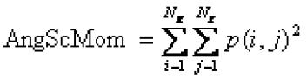

Contrast:
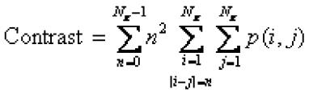

Correlation:
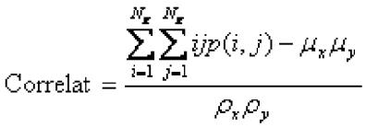

Sum of Squares:
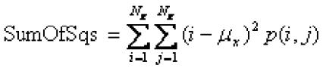

Inverse Difference Moment:


Sum Average:
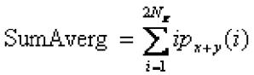

Where,
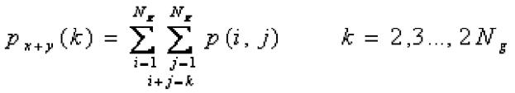

Page | 137

Sum Variance:
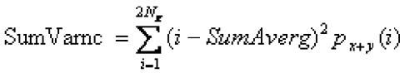

Sum Entropy:
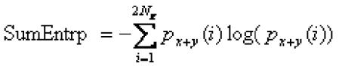

Difference Variance:
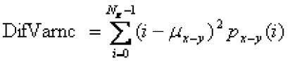

Where,

μ:_{x-y} is is a mean value of difference distribution p_{x-y}:
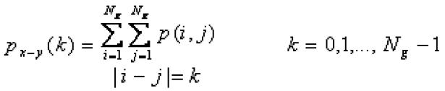

Entropy:
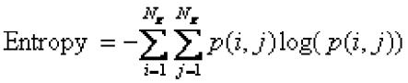

Difference Entropy:
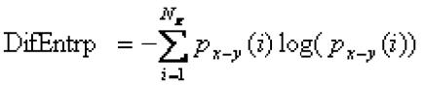

RUN LENGTH MATRIX-BASED PARAMETERS Fraction of Image in Runs:
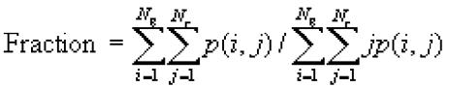

Grey Level Non-Uniformity:

Page | 138
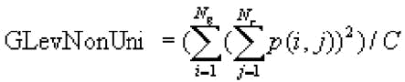

Run Length Non-Uniformity:
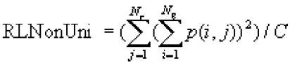

Long Run Emphasis:


Short Run Emphasis:
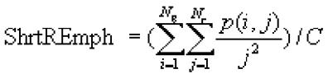

The coefficient C is defined as:
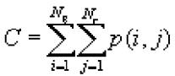

GRADIENT-BASED PARAMETERS

Gradient Mean:
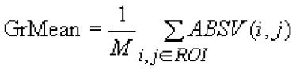

Gradient Variance:
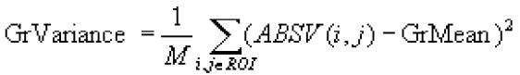

Gradient Skewness:


Gradient Kurtosis:
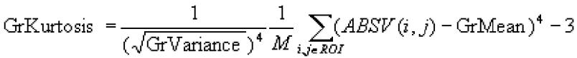

Page | 139
Where ROI is a region of interest

Gradient Nonzero:

Percentage of non-zero ABSV matrix elements (Grads>0)

HISTOGRAM-BASED FEATURES:
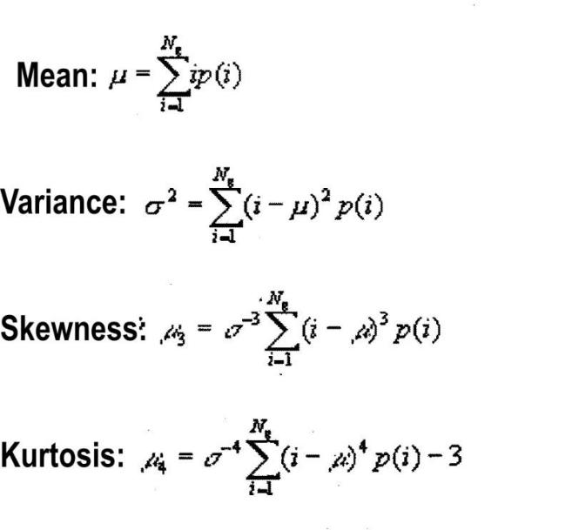

Page | 140
Appendix II

ETHICAL APPROVAL FOR THE STUDY
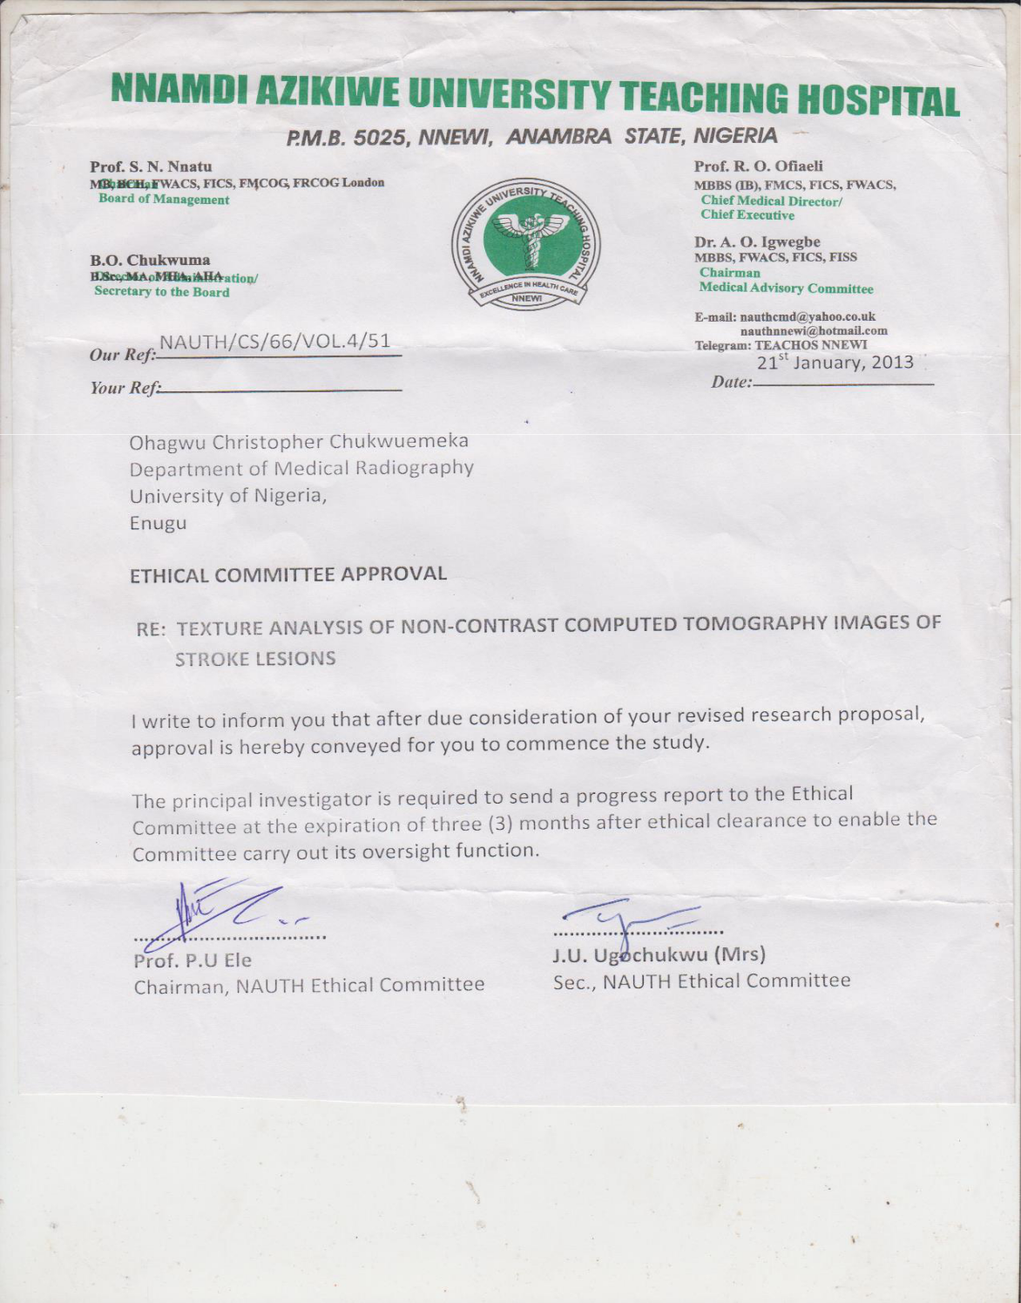

Page | 141
Appendix III

INFORMED CONSENT FORM

TITLE OF STUDY: TEXTURE CHARACTERIZATION OF STROKE LESIONS IN NON-CONTRAST COMPUTED TOMOGRAPHY IMAGES OF NIGERIAN PATIENTS

INVESTIGATOR: OHAGWU, CHRISTOPHER CHUKWUEMEKA; DEPARTMENT OF MEDICAL RADIOGRAPHY AND RADIOLOGICAL SCIENCES, FACULTY OF HEALTH SCIENCES AND TECHNOLOGY, COLLEGE OF MEDICINE, UNIVERSITY OF NIGERIA ENUGU CAMPUS, ENUGU STATE, NIGERIA.

FINANCIAL SPONSORSHIP: This research project is partially sponsored by the Tertiary Education Trust Fund (TETFund).

PURPOSE OF THE RESEARCH

Cerebrovascular accident is a major public health issue in Nigeria and poses a diagnostic challenge to clinicians practicing in an environment where neuroradiologists with experience in stroke detection are in short supply. Diagnosis of ischaemic stroke is usually very challenging. This is especially true at the hyperacute stage; a few hours after stroke ictus. At this stage the hypodense lesion representing brain tissue ischaemia is usually subtle and difficult to appreciate on visual inspection. Previous studies suggest that texture analysis can improve diagnostic yield of CT images in acute ischaemic stroke. There is also a very wide variation in the appearance of ischaemic lesion from the acute stage to the chronic stage. There has not been any study on texture parameters of ischaemic lesions on other stages of ischaemic stroke other than acute.

Page | 142
A neuroradiologist identifies brain infarct on NCCT as a hypodense lesion and haemorrhage due to vessel rupture as a hyperdense lesion. There are usually changes in the hypodense lesion due to ischaemia with passage of time often resulting in complex appearance. The complex nature of the ischaemic lesion may lead to misdiagnosis. A computer cannot on its own identify these lesions and classify them accordingly. The result of this study will provide a means for computers to be used to identify and classify lesions due to ischaemic stroke on NCCT images. The result will be a first step towards computer-aided diagnosis of stroke in our locality.

PROCEDURES INVOLVED IN THE STUDY

You (the patient) will undergo NCCT of the head as required by your doctor. Images will be obtained using a CT machine at 0.5mm to 1mm contiguous sections from the base of the skull to the vertex. The images will be transferred onto a DVD and then loaded into a laptop computer for viewing using DICOM viewing software. Your demographic data such as age, gender and occupation/profession will be obtained and documented. The interval between the onset of symptoms and head CT examination will be ascertained and documented.

The CT images obtained will be visually inspected by a team of radiologists. The affected parts of the brain will be identified and classified as ischaemic or haemorrhagic lesion. Texture analysis of lesional and non-lesional tissues will then be carried out on images of patients. Two regions of interest (ROIs) will be defined for each patient. The lesioned brain tissue will be defined as ROI 1 and the RO1 2 will be chosen to be non-lesioned brain tissue in the contra lateral cerebral hemisphere. Texture parameters for the two ROIs will be computed using the MaZda program.

Page | 143
COMPENSATION

There shall be no financial compensation for you in this study.

VOLUNTARY PARTICIPATION

Your participation in this study is entirely voluntary. There shall be no form of discrimination if you do not participate. You can withdraw from the study at any time you want.

RISKS

There is no other risk associated with participating in the study except those associated with ionizing radiation from CT. Ionic contrast medium is not going to be injected into you.

BENEFITS

The CT investigation requested by your doctor will be used for your management. The result of this study will help in making stroke diagnosis easier.

CONFIDENTIALITY

All information obtained in the course of this study will be treated with absolute confidentiality. The name of the participant (patient) will not be mentioned. The participants will be identified by a system of numbers. The CT images will be analyzed for texture information and then deleted from the computer. No other person will have access to this computer except me. It is pass worded. Note that another soft copy and the hardcopy will be handed over to your doctor even before I get a soft copy for analysis.

Page | 144
CONTACT INFORMATION:

OHAGWU, CHRISTOPHER CHUKWUEMEKA (THE STUDENT)

Department of Radiography and Radiological Sciences

Faculty of Health Science and Technology

College of Medicine

University of Nigeria Enugu Campus

Phone Number: +23407061195362

E-mail: cc.ohagwu@unizik.edu.ng

PROF. K.K AGWU (THE SUPERVISOR)

Department of Radiography and Radiological Sciences

Faculty of Health Science and Technology

College of Medicine

University of Nigeria Enugu Campus

Phone Number: +23408038972387

E-mail: kenagwu2000@yahoo.com

DR B.O IGBINEDION (CONSULTANT RADIOLOGIST)

Radiology Department

University of Benin Teaching Hospital, Benin City

Page | 145
Edo State, Nigeria

Phone Number: +2348034045844

E-mail: igbins2@yahoo.com

DR. HAMEED MOHAMMED (CONSULTANT RADIOLOGIST)

Radiology Department

Benue State University Teaching Hospital, Makurdi

Benue State, Nigeria

Phone Number: +2348035701344

E-mail: drhameed2001@yahoo.com

ETHICS AND RESEARCH COMMITTEE

Nnamdi Azikiwe University Teaching Hospital, Nnewi

Anambra State.

CERTIFICATE OF CONSENT

I have read the above information (or it has been read to me). I have had the opportunity to ask questions about it and any questions that I have asked have been answered to my satisfaction.

- I consent voluntarily to take part in this research

- I do not consent to participate in this research

Name of participant:……………………………………………………

Signature of participant:………………..Date:………………………...

Page | 146
APPENDIX IV

FORMULAE FOR CALCULATING ROC PARAMETERS

Where;

TP = True positive cases

TN = True negative cases

P = Positive cases

N = Negative cases

FP = False positive cases

FN = False negative cases

T = Threshold parameter

AUROCC = Area under ROC curve

Page | 147

