**TERRORISM AND IT'S IMPLICATIONS ON GLOBAL SECURITY IN THE 21ST CENTURY (A CASE STUDY OF NIGERIA)**

**ABSTRACT**

The literature on terrorism highlights the significant roles that religion, cultures of origin, and environmental factors play in the emergence of terrorist groups on a global scale. Terrorists employ acts of violence and intimidation to instill fear and coerce individuals and governments into furthering their religious, political, and ideological objectives. Nigeria witnessed the emergence of Boko Haram, a highly dangerous jihadist group, in the early 2000s. Their primary objective was to promote Islamization within the country. In 2009, it initiated violent attacks in Nigeria, the largest economy in Africa, and currently holds a significant portion of territory in the northeastern region. Boko Haram pledged its loyalty to the Islamic State of Iraq and Syria (ISIS) in its pursuit of establishing a caliphate. There is ample evidence to suggest that the Nigerian government has struggled to effectively counteract its aggressive tendencies. Although the literature on the Boko Haram-ISIS alliance in Nigeria has some gaps, it does not fully explore the nature and complexity of this relationship. This dissertation aims to address the lack of research on the collateral consequences and global security threats associated with such a coalition. It will provide an in-depth analysis of the strengths and limitations of existing literature, utilising the Global Terrorism Database and qualitative secondary data analysis from 2000–2020. The research will explore the anomic situation in Nigeria and the resulting instability caused by the breakdown of social norms. This can be achieved by applying anomie and strain theories. The data findings will provide valuable insights for criminological policies and future research recommendations for the Nigerian securitization solution.

Keywords: Terrorism, Boko Haram, ISIS, Islam, security, coalition, the Nigerian military

**TABLE OF CONTENTS**

**CHAPTER**

**INTRODUCTION**

Background and Significance

Research Objectives

Research Purpose Statement

Research Problem Statement

Definition of Term

**LITERATURE REVIEW**

Defining Terrorism

History Behind the Evolution of Terrorism

The Almajiri

Rise of ISIS

The Alliance

The Nigerian Military

The Military Funding

Overview of Theoretical Perspectives

Theory of Anomie

Strain Theory

Contemporary Strain Theory

General Strain Theory

Containment Theory

Collateral Consequences of Boko Haram and ISIS Terrorist

Alliance in Nigeria

International and Local Terrorist Indexes

Ideology of Religion

Leadership

Internally Displaced Persons

Education

Impact on Education

Corruption

Poverty

Terrorism and Poverty

Fulani Herdsmen/Bandits

Quest for Ethnic Self-Determination

The Southeastern Region: Indigenous People of Biafra

The Niger Delta Region (South-South): Movement for the

Emancipation of the Niger Delta (MEND)

The Southwestern Region: The Oodua People’s Congress

Gaps in Research

**3. METHODOLOGY**

Case Study Research

Research Participants

Data Collection /Sampling Procedure

Research Instruments

Research Questions

Qualitative Data Analysis Procedure

**4. PRESENTATION AND ANALYSIS OF FINDINGS**

**5. DISCUSSION**

Limitations

Recommendation for Future Research

Policy Recommendation

Conclusion

**REFERENCES**

**LIST OF TABLES**

**Table Page**

1. Ten Countries Most Affected by Terrorism (2015)

2. Nigeria’s Landmark Events Between 1914-1999

3. Boko Haram Historical Timelines

4. Global Terrorist Groups

**LIST OF FIGURES**

**Figure Page**

1. Nigeria’s Political Contention 18

2. Key Terrorist Groups in Africa

3. Nigerian Poverty Graph Source: (Statista, 2021)

4. Number of Deaths by Terrorism

5. Nigeria Military Expenditure Between 2008 and 2019

6. Global Terrorism Index 2020

7. Terrorism Index in African Countries 2019

8. Number of Deaths by Terrorism

9. Number of Terror-related Deaths in African Countries Between 2007 and 2019

10. Number of Deaths in the Countries Most Impacted by Terrorism in 2019

11. Deadly Terrorist Attacks in the Northeastern Region of Nigeria (Nigerian Northern States Most Affected by Boko Haram’s Deadly Attacks 2011–2021)

12. Number of Internally Displaced Persons in Nigeria

13. Enrollment Rate in Private and Public Lower Secondary School in Nigeria as of 2018

14. Poverty Headcount Rate in Nigeria as of 2019, by State

Figure Page

Six Geopolitical Zones in Nigeria, Their States, and Their

Economic Activities

**CHAPTER 1**

**INTRODUCTION**

Terrorism poses a significant global security challenge, particularly in Sub-Saharan Africa. Numerous militant and terrorist organisations have emerged, transforming the continent into a hub of violent terrorist actions. In recent years, Northeastern Nigeria has been plagued by extremist terrorist activities, with Boko Haram emerging as one of the most lethal jihadist groups in the region. Boko Haram has emerged as the dominant terrorist group in Nigeria, with a staggering number of over 5 million internally displaced persons, kidnappings, and fatalities. Boko Haram's affiliation with ISIS has granted it access to significant resources within the global terrorist network (Ndinojuo, 2018). According to a study conducted by the University of Maryland for the American government, Boko Haram-related deaths surpass those caused by al Qaeda in Iraq, the Maoists in India, and al-Shabab and al Qaeda Arabian Peninsula (Aghedo & Eke, 2013). The existing literature indicates that the Nigerian government has been unable to effectively combat these acts of terrorism. Although extensive research, articles, and presentations have been conducted on the terrorist activities of Boko Haram and ISIS, there remains a lack of understanding regarding the extent to which the alliance with ISIS has influenced Boko Haram's actions in Nigeria. This dissertation aims to address the lack of research on the collateral consequences and global security threats associated with such an alliance.

Terrorism is a highly contentious concept that sparks intense debate. Ronczkowski (2018) highlights the significant factors contributing to the emergence of terrorist groups in the modern world, including religion, cultures of origin, and environmental impact. Terrorism is a highly aggressive form of aggression. The perpetrators employ acts of violence or make violent threats in order to instill fear and intimidate individuals and governments, all in pursuit of their religious, political, and ideological objectives. Boko Haram surfaced in the early 2000s, and the intensity of its attacks is among the most severe witnessed worldwide (Thurston, 2018). So, what exactly is terrorism? How should we approach this issue? What data do we need to collect and how should we analyse it? What specific aspects are we trying to uncover, and why do criminologists continue to find terrorism investigation important (Ronczkowski, 2018)?

The U.S. Federal Bureau of Investigation (FBI), the U.S. Department of State (DoS), and the U.S. Department of Defence (DoD) provide commonly cited definitions of terrorism. The FBI has provided a clear definition of terrorism, which involves the unlawful utilisation of force and violence to instill fear or coerce a government, civilian population, or any group that supports political or social goals. The DoS has provided a clear definition of terrorism, stating that it involves violent or dangerous acts against individuals. These acts would be considered criminal if committed within the United States and are intended to intimidate or coerce civilians, influence government policy through intimidation or coercion, or impact government conduct through assassination or kidnapping. According to the DoD, terrorism is defined as the deliberate use of violence or the threat of violence to instill fear, with the aim of pressuring governments or societies to align with certain political, religious, or ideological objectives (Ronczkowski, 2018). The African Union (formerly known as the Organisation of African Unity [OAU], 1999, p. 207) has provided a comprehensive definition of terrorism. According to their definition, terrorism refers to any act that violates the criminal laws of a state party and poses a threat to the life, physical well-being, or freedom of individuals. It also includes acts that result in severe injury or death to individuals or groups, as well as those that cause damage to public or private property, natural resources, or cultural heritage. Boko Haram meets all the criteria to be classified as a terrorist group, as they have gained global recognition through their affiliation with ISIS. According to Phillip Zimbardo, terrorism revolves around the manipulation of fear (cited in Bongar, 2007, p. 3). In his 2001 work, Onwudiwe emphasises the unjustifiable nature of the terror that takes the lives of innocent people.

**Background and Significance**

Between 2000 and 2020, Nigeria experienced a significant rise in terrorist activities, resulting in the displacement of over 5 million people in northeastern Nigeria. The attacks by Boko Haram started in 2003 when the followers of the radical leader Mohammed Yusuf moved to remote areas of Yobe State and engaged in frequent clashes with local authorities. In 2009, the group initiated an uprising in northeastern Nigeria following clashes with the security authorities of Maiduguri state. Throughout this intense confrontation, which spanned approximately 5 days, it is reported that more than 800 individuals lost their lives. Yusuf was captured by the Nigerian military and later transferred to the police. Unfortunately, he passed away while in custody (Mike, 2015).

After the 2009 military assault that led to Yusuf's death, the Boko Haram terrorist group remained inactive for approximately a year. After the assault, Abubakar Shekau, the leader of BH, managed to escape to the neighbouring country of Chad or Sudan, despite being reportedly shot in the leg. It was predicted by researchers that there would be a resurgence of violence, particularly due to the prevalent issues of extreme poverty, corruption, inadequate education, and limited employment opportunities for young people. The terrorist group crisis took on a notorious dimension when they began carrying out suicide bombing attacks, utilising a large number of frustrated Almajiri to perpetrate the violence. The Boko Haram crisis in the northeast is greatly influenced by poverty. The connection between poverty and terrorism is highlighted by the low socio-economic indicator of the region (Mike, 2015; Olanrewaju, 2019). In 2009, Boko Haram pledged their loyalty to ISIS. The group carried out a series of violent attacks on military formations and unarmed citizens, with one of their most notorious acts being the abduction of approximately 300 secondary school girls in Chibok, located in Nigeria's remote northeast (Mike, 2015).

This case study aims to raise global awareness of the violent terrorist activities in Nigeria, the most populous nation in Africa. This information will greatly benefit the federal government of Nigeria, researchers, NGOs, human rights activist groups, and private and public security agencies. It will enhance their overall understanding of the alliance between the two world's deadliest terrorist groups. Additionally, it will offer valuable insights for policymakers, with potential implications for both Nigerian and global securitization solutions. This case study is likely to generate more interest in Nigeria's current state of insecurity, enhance understanding of terrorism-related issues, and highlight areas for future research.

**Research Objectives**

The main objective of this case study is to examine the implications of terrorism in Nigeria on global security. Specifically, this study will:

1. Analyze the ideology of religion, the origin of culture, and the Almajiri syndrome among northern Nigerian youths, seeing as the terrorist group exploit these stress-induced societal issues and preys on the vulnerable as potential recruits with promises of economic deliverance;
2. Review the role of poverty in the fight and struggle between Boko Haram and the Federal government of Nigeria;
3. Examine poverty as a strain and struggle among the youth who are potential recruits for the terrorist groups; and
4. Determine the response of the Nigerian military to terrorist activities in the northeastern part of the country and assess the role of policymakers in the issue of terrorism.

**Research Purpose Statement**

This case study aims to analyse terrorist insurgencies in Nigeria, specifically focusing on the Boko Haram and ISIS terrorist alliance and its global security threat. The study also explores the collateral consequences associated with this alliance. The case study centres around the years 2000–2020. This piece provides a comprehensive analysis of the history of terrorism, delving into the specific religious, political, and social objectives that have propelled the rise of Boko Haram. Additionally, it sheds light on the global security implications that extend beyond the borders of Nigeria. I delve into Boko Haram's radicalization process and recruitment strategies, analysing how potential recruits are persuaded to embrace the extremist ideology. The relevance of the ideology's origin in distinguishing between homegrown and international terrorism is insignificant; the crucial factor lies in the location where it is embraced (Southers, 2013). This qualitative case research aims to offer a historical analysis of terrorism in Nigeria, shedding light on the alliance between the world's two deadliest jihadist groups. It also explores the collateral consequences, such as economic hopelessness, extreme poverty among the Almajiris, loss of faith in the social contract with the State, and the impact of corrupt leadership. Furthermore, it highlights the global security threat posed by this terrorist alliance.

The research has primarily focused on these groups individually, with little attention given to their deadly jihadist alliance. This study delves into the Nigerian security situation, going beyond the current governmental strategies. It explores the relevance of this local story in the context of the broader global security threat, examining its meanings and operations. I delve into different definitions and analyse the economic, religious, political, and social consequences of these conflicts from criminological and criminal justice viewpoints. The purpose, along with suggestions, is to consider the potential policy implications as measures to prevent terrorism in its early stages.

**Research Problem Statement**

The problem addressed in this case study is the ongoing insurgency by the Boko Haram and ISIS terrorist alliance in Nigeria, which poses a significant global security threat with far-reaching consequences. The initial successes achieved by ISIS in their jihadist endeavours in Iraq and Syria are widely recognised as innovative and appealing to these destructive alliances, particularly in their efforts to gain influence in Nigeria, Africa's most populous state (Culp, 2019). The brutal killings and destruction of property in northeastern Nigeria serve as a stark reminder of the harsh realities of life. Despite the Nigerian government's claims of victory over Boko Haram, recent events paint a different picture when assessing the country's ongoing terrorist security challenges from 2000 to 2020. Nigeria has been ranked as the third-most terrorised country in the Global Terrorism Index (GTI), following Afghanistan and Iraq. In addition to this, citizens in Nigeria face the unfortunate situation of having to pay tolls in order to access their farmlands. State and federal legislators have expressed deep concern over the ongoing raids and the disregard for human lives, as the country's northeastern region has tragically witnessed an estimated 5 million deaths. Despite the well-written analysis, numerous questions persist regarding the effectiveness of the Nigerian government's strategies in addressing these severe criminal activities, economic devastation, and the resulting hardships faced by the citizens, especially during the ongoing economic recession. In addition, it is evident that the Nigerian military has yet to demonstrate their true readiness to combat the terrorists who have seized control of numerous villages in the northeastern region. Some people believe that the Nigerian government's military responses to the consequences of terrorism within the country are reminiscent of a dangerous game of Russian roulette, with the lives and livelihoods of millions at risk. I aim to expand the current understanding of the alliance between Boko Haram and ISIS, focusing on the potential consequences of their collaboration and the global security implications. The text delves into the exploration of various societal issues such as religion, unemployment, and the Almajiri syndrome among northern Nigerians. It highlights how terrorist groups take advantage of these problems, targeting vulnerable individuals and offering them false promises of relief from their social and economic struggles.

**Definition of Terms**

**Al Qaeda in Iraq (AQI):** This is a jihadist group in Iraq founded by Abu Musah al Zarqawi; it would later become the Islamic State of Iraq and later known as the Islamic State of Iraq and al-Sham, or ISIS. It refers to itself now only as the Islamic State.

**Al Qaeda in the Islamic Maghreb (AQIM):** This Qaeda affiliate operates in the Sahara and Sahel regions of North Africa.

**Almajiri:** A representation of students who leaves their parents for Qur’anic education.

**Ansar Bayt al Maqdis (ABM):** A jihadist group that arose following the Arab Spring in Egypt’s Sinai region. It has declared its territory in Sinai to be a province of ISIS.

**Al Shabab:** A group affiliated with al Qaeda with its base in Somali.

**Boko Haram:** This fundamentalist jihadi group in Nigeria, which took shape in northeastern Nigeria in the early 2000s, attracted support for its belief that Western-style education means “Boko,” in Hausa, which is evil and legally forbidden by the Islamic religion. The forbidden act is an Islamic legal term for Haram, in Hausa and Arabic. (Thurston, 2017)

**Caliph:** He is a ruler of the Muslim community and political successor of Muhammad.

**Caliphate:** This political-religious state is led by a caliph.

**Eid al-Fitr:** This is the last day of Ramadan, the Islamic month of fasting and religious reflection.

**Islamic Army of Iraq:** A former Iraqi Sunni Arab insurgency group formed during the 2003 invasion. After the withdrawal of American troops in 2011, the group demilitarized and formed a political opposition group.

**Islamic State (I.S.):** This is the name of ISIS after it declared itself a caliphate.

**Jihad:** This means a struggle or striving in Islam.

**Shariah:** Shariah is the Islamic moral code and religious law. There are huge disagreements among Muslims about how Shariah fits into modern life. ISIS and AQ-affiliated groups embrace a harsh interpretation, but there are differences in the details for these two groups.

**Sunnah:** This is the recorded tradition of Prophet Muhammad.

**Sunni Islam:** This is the largest branch of Islam. It is often referred to as mainstream or orthodox Islam.

**CHAPTER 2**

**LITERATURE REVIEW**

**Defining Terrorism**

In Chapter 1, there has been a great deal of debate surrounding the term "terrorism," as scholars have not been able to agree on a single definition or adopt a specific word to describe it. Akanni (2004) states that Nigerians have been subjected to various forms of terrorism and terrorist attacks, particularly in the northeast. Consequently, the citizens are now living in a climate of fear, regardless of their religious beliefs. Terrorism has become a strategic method to swiftly capture the attention of a target audience. This is a worldwide issue involving calculated and organised acts of violence intended to cause destruction, harm, and fear among vulnerable individuals. The purpose is to bring attention to certain demands that may be challenging to achieve through regular political means. Akpor-Robaro and Lanre-Babalola (2018) argue that terrorism can escalate into an insurgency when a group of individuals, whether known or unknown, carries out organised and sophisticated activities to seize and dominate a specific area with a population, resulting in political, social, and economic upheaval, often without a clear objective. The dissident groups are rising up to protest what they perceive as unfavourable government policies.

According to Ronczkowski (2018), there are three frequently referenced definitions of terrorism provided by the FBI, DoS, and DoD. These definitions are as follows:

* The FBI defines terrorism as the illegal use of force and violence to intimidate or coerce a government, the civilian population, or any segment in pursuit of political or social objectives.
* The definition of DoS involves engaging in violent or dangerous acts that would be considered criminal if committed within U.S. jurisdiction. The purpose of these acts is to intimidate or coerce a civilian population, influence government policy through intimidation or coercion, or impact government conduct through assassination or kidnapping.
* The DoD definition describes the deliberate use of violence or the threat of violence to instill fear, coerce, or intimidate governments or societies in order to achieve goals that are typically political, religious, or ideological.
* The African Union has provided a definition of terrorism that encompasses acts that violate the criminal laws of a State Party and have the potential to harm individuals, groups, or cause damage to property, natural resources, or cultural heritage.

Ronczkowski (2018) suggests that terrorism can vary depending on the perspective, goals, and timeframe of the researchers attempting to define it. He emphasised the importance of not fixating on a single, all-encompassing definition of terrorism, but rather on comprehending its various components. This definition refers to a deliberate form of violence carried out by non-state groups or undercover individuals, with the aim of influencing a specific audience. Ronczkowski also mentioned that international terrorism, such as the collaboration between Boko Haram and ISIS, refers to acts of terrorism that span across multiple countries or involve residents from different nations. Ronczkowski emphasised that terrorist activities are intended to convey a message. These activities are tactics used by individuals who are aware of the tendency for media outlets to focus on sensational and tragic events. These activities encompass a wide range of actions, such as assassinations, bombing, arson, sabotage, hostage taking, property damage, and anarchy.

Martin (2017) emphasised the importance of perspective in defining terrorism. Understanding the sources of terrorism is crucial in order to effectively define and address this complex issue. In order to identify those steps, it is crucial to have a clear understanding of the role of extremism as a central aspect of all terrorist behaviour. People who stand against the views or violent actions of extremist groups, often find themselves as the victims or targets of these groups. It is only natural for them to perceive these groups as terrorists. On the other hand, the individuals for whom the group is advocating and on whose behalf the terrorist war is being waged often view them as freedom fighters, even if their tactics do not align with the values of the people they claim to represent. Martin observed that radical Islamists often perceive themselves as Mujahidin (holy warriors) or Shaheed (martyrs), driven by a deep commitment to obeying God's will rather than embracing Western concepts of freedom. Martin emphasised that scholars often discover the complex nature of defining terrorism, as different perspectives can lead to contrasting interpretations of individuals as either terrorists or freedom fighters.

Stern and Berger (2015) argue that the distinction between terrorism, insurgency, and war is often unclear. The definition of terrorism, according to Stern and Berger, is an act or threat of violence against noncombatants with the intention of seeking revenge, instilling fear, or exerting influence over an audience. Stern and Berger define terrorism as the use of violence by nonstate actors against noncombatants in order to achieve a political objective or convey a message. Hoffman (2017) argues that the definition of terrorism in the widely accepted contemporary usage of the term is inherently political. This text also delves into the realm of power: the relentless quest for power, the attainment of power, and the use of violence to bring about political transformation. It has been widely acknowledged by scholars that the term "political" plays a significant role in defining terrorism and the actions that facilitate terrorist acts.

**History Behind the Evolution of Terrorism**

The understanding of the history behind the evolution of terrorism is crucial as it offers valuable insights into the growth of terrorism and its current prominence in society (Ronczkowski, 2018). The concept of terrorism emerged during the Reign of Terror in revolutionary France during the late 1700s. It can be traced back to the Enlightenment Period of the 18th century. The French citizens' violent acts during the Reign of Terror were attributed to their revolutionary leader, Maximilien Robespierre. By the mid-1800s, the term began to be used to refer to individuals who engaged in violent revolutions against governments. In the early 1900s, the name was used in the United States to describe labour organisations and anarchists. Ronczkowski explains that following World War II, the term became linked to nationalist groups who were rebelling against European domination. France and England were significantly impacted in the 1940s–1950s due to their colonial settlements on different continents, particularly Africa.

In the 1940s, the State of Israel was established in the Middle East. The transition from Ottoman rule to British colonial rule in Palestine, known as the Balfour Declaration of 1917, included a promise to establish a Jewish homeland in Palestine (Ronczkowski, 2018, p. 20). The British's failure to fulfil their promise led to the Jews resorting to urban terrorism and forming the Irgun Zvai Leumi (national military organisation) in order to oust the British. Terrorist attacks in Africa had a significant impact on the French due to their struggle against colonialism in Algeria by the National Liberation Front (NLF), while the Mau targeted the English colonies in Kenya. The terrorist activities persisted until 1948 when Israel was acknowledged as a nation. However, this did not bring an end to the ongoing conflicts in the Middle East for Israel. The rise of the Palestinian Liberation Organisation (PLO) further intensified the struggles between Israel and non-Arabs in the region.

The Middle East conflict continues to persist, leading to the emergence of left-wing groups that have redefined the concept of terrorism. History reveals that the Sicarii were identified as a radical Jewish Zealot terrorist group that engaged in combat against the Roman Empire (66–70 AD) through a range of tactics, such as carrying out dagger attacks on perceived enemies in broad daylight. The individuals they aimed to target included Greek residents in Judea, Roman leaders, and even moderate Jews who were suspected of being Roman allies. The Sicarii zealots were driven by a singular objective: to overthrow Roman control, as they believed that this would pave the way for the arrival of their Messiah (Onwudiwe, 2007).

History reveals that nationalist movements or nationalism played a significant role in the radicalization of individuals who later turned to terrorism, particularly during the 19th and early 20th centuries. This phase of terrorism was described as a period where nationalists fought for the independence of citizens living under colonial rule. They employed various methods, including acts of terrorism, to accomplish their objectives (Onwudiwe, 2001). Onwudiwe highlighted the fact that criminology has not fully incorporated historical issues such as colonialism, imperialism, and neocolonialism as systems of domination in his discussion on terrorism (p. 64). These issues were crucial in criminology's efforts to understand terrorism and develop effective countermeasures.

The evolution of terrorism is evident in the shifting approaches and styles adopted by terrorist groups throughout history. From the social upheaval of the Russian Revolution to the present day, terrorism has adapted to reflect the changing dynamics of society (Ronczkowski, 2018). Today, terrorism is often linked to various groups such as Hezbollah, al Qaeda, Boko Haram, al Shabab, the Islamic State in Iraq, Levant (ISIL), and the Islamic State (I.S.). The last two are often referred to as ISIS by the media and many people. These groups have the ability to operate independently, regardless of their location, and consist of individuals who are religious extremists with a propensity for violence (Ronczkowski, 2018). The potential ramifications of a terrorist alliance between Boko Haram in Nigeria and ISIS are concerning. This alliance could have far-reaching consequences, as it would provide Boko Haram with the global platform they need to pursue their goal of establishing a Caliphate in Africa's largest economy. Table 1 presents the top 10 countries currently facing significant terrorism challenges. Nigeria ranks third on this list, following the Middle Eastern countries. This ranking suggests the precarious state of Nigeria, which is on the verge of collapse. For a detailed overview of Nigeria's key historical events between 1914-1999, please refer to Table 2.

**Table 1**

Ten Countries Most Affected by Terrorism (2015)

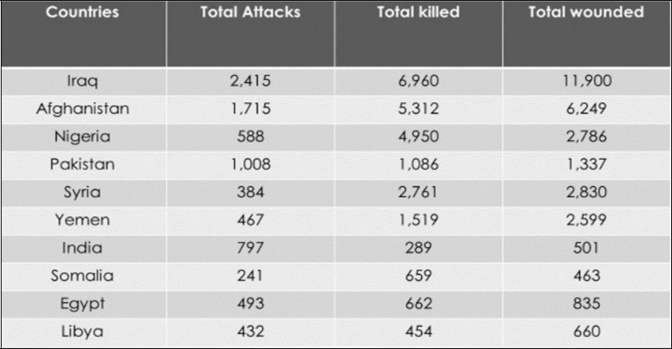

**Table 2**

**Nigeria’s Landmark Events Between 1914-1999**

|  |  |
| --- | --- |
| Dates | Landmark Events |
|  |  |
| 1914 | Amalgamation by the British colonialist represented by Governor-General Lord |
|  | Fredrick John Dealtry Lugard (1858–1945) |
|  | Spouse: Flora Shaw, Lady Lugard (1902–1925) |
|  |  |
| 1960 | Independence from British Government (Union Flag lowered and the Green, White, |
|  | Green Flag raised) |
|  |  |
| 1967 | Nigerian/Biafran civil war |
|  |  |
| 1970 | No victor, no vanquished (rehabilitation, reconstruction, and reintegration—3Rs). |
|  |  |
| 1999 | Democratically elected government following years of military rule |
|  |  |

Nigeria is a sovereign country in West Africa that shares borders with Niger, Chad, Cameroon, and the Benin Republic. Nigeria gained its independence as a federation on October 1, 1960. Nigeria went through a civil war (1967–1970) that had a devastating impact on the young nation. Following the events, the nation experienced a series of both military and democratically elected leaders.   
  
 In 1999, the country achieved a stable democracy. The 2015 presidential election marked a historic moment for the nation as incumbent President Goodluck Jonathan lost re-election to the current president, Muhammadu Buhari. Nigeria is a diverse multinational state with over 250 ethnic groups and about 500 distinct languages, each with their own unique cultures. Nigeria is home to three major ethnic groups: the Hausa-Fulani in the north, the Yoruba in the west, and the Igbo in the east. These groups, with their diverse religious affiliations, make up more than 60% of the country's population.   
  
 Varella (2020) states that Nigeria has the highest population in Africa. The population of this country exceeded 200 million people in 2019 and is expected to continue growing steadily in the coming decades. The real GDP per capita is around US$1,950.90, placing it as the 166th largest economy in the world. According to Varella, the projected number of people could potentially reach 400 million by 2050. Over the past 50 years, Nigeria has experienced a significant increase in its population. The demographics of Nigeria are characterised by a significant young population. In 2018, the median age of the population was 18.4 years, indicating that a large portion of the people are under the age of 19. Lagos, with a population of over 14 million, holds the title of being the largest city in Nigeria and in all of Sub-Saharan Africa. Abuja, Nigeria's capital, had a population of around half a million people in 2020, making it the 15th largest city in Nigeria.   
  
 Osaghae and Suberu (2005) argue that Nigeria is a country with a complex mix of individuals, each with their own unique ethnic, religious, regional, and subethnic identities. These identities often intersect and overlap, leading to violent conflicts within the country. The development of regional cleavages and identities in Nigeria can be attributed to the structures established during the colonial era for state formation. The divisions within the three central regions, which were initially administered separately by colonialists, became even more complex and intricate after they were amalgamated in 1914.

Figure 1

Nigeria’s Political Contention

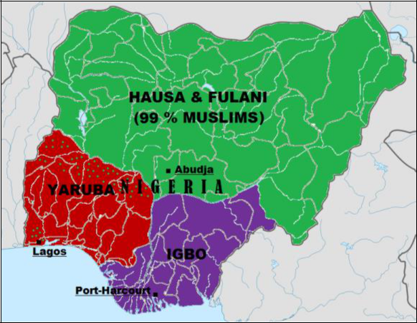

Source: Religius and Ethnic map of Nigeria.png. (2020, October 15). Wikimedia Commons, the free media repository.

Campbell (2013) made a compelling case for Nigeria's significance as a strategic partner to the United States, highlighting its large population and abundant natural resources. Nevertheless, Nigeria has unfortunately experienced widespread alienation and fragmentation, leading to its current status as one of the most religious and violent countries in the world. The Boko Haram-related terrorist incidents have revealed the shocking magnitude of officially sanctioned violence, which in turn highlights the weaknesses of Nigerian government institutions, as discovered by Campbell.

The exact time when Boko Haram began is not specified. The report highlights the group's origins in 1995, led by Malam Abubakar Lawan, and its subsequent name changes from Ahlul Sunnah Wal Jama’ah Hijra to the Nigerian Taliban Yusufiyyah sect to Boko Haram. The sect initiated its first attacks in 2003 in Kanama and Geidam Yobe State in northeastern Nigeria. According to Sule et al. (2018), Boko Haram is viewed from various perspectives, including as a political uprising, a religious group, a social movement, or a purely criminal affair.

**Table 3**

**Boko Haram Historical Timelines**

|  |  |  |
| --- | --- | --- |
| YEAR | KEY EVENTS |  |
| 1999/2000 | The push for Sharia laws by northern politicians under President Olusegun | |
|  | Obasanjo began, and 12 northern states later adopted some form of Sharia | |
|  | criminal laws. |  |
| 2003 | Boko Haram began taking shape when followers of the group’s radical leader | |
|  | Yusuf clashed with constituted authorities and retreated into remote areas in | |
|  | Yobe. |  |
| 2009 | Under Yusuf’s leadership, Boko Haram launched an uprising in Nigeria’s | |
|  | northeastern part clashing with Maiduguri security agencies. Within the 5 days | |
|  | that these violent clashes lasted, over 800 people were killed. Yusuf was later | |
|  | captured by security forces and shot dead while in police custody. | |
| 2010 | After more than a year in hiding, Boko Haram re-emerged with a series of | |
|  | coordinated assassinations and a prison raid under the leadership of Yusuf’s | |
|  | deputy, Shekau. |  |
| 2011 | Boko Haram claimed responsibility for the suicide car bomb attack on the | |
|  | United Nations Headquarters in the Nigerian capital city of Abuja that killed 23 | |
|  | people. |  |
| 2012 | Boko Haram’s new leader, Shekau, claimed responsibility for a series of | |
|  | coordinated assaults and bomb attacks that killed over 185 people in Kano, | |
|  | Nigeria’s second-largest city. | |
| 2013 | President Goodluck declared a security emergency in three northeastern states | |
|  | after Boko Haram seized territory in remote areas of the region. | |
| 2014 | Boko Haram attacked the northeastern town of Chibok and kidnapped 276 girls | |
|  | from their dormitories; this terrorist act led to global outrage. | |
| 2015 | January 2015 | This attack was one of the worst ever Boko Haram attacks |
|  |  | on the town of Baga in northeastern Nigeria that left |
|  |  | perhaps up to 2,000 people dead. |
|  | January 31, 2015 | Regional offensive targeting Boko Haram takes shape, |
|  |  | and the Chadian military aircraft bomb the Nigerian town |
|  |  | of Gamboru, held by Boko Haram. |
|  | March 7, 2015 | Boko Haram pledged allegiance to ISIS. |
|  | March 28, 2015 | Nigeria held Presidential elections won by exmilitary |
|  |  | ruler Major General Buhari (Rtd.) |
|  | May 2015 | The Nigerian military claimed to have freed over 700 |
|  |  | people held as hostages. These included women and |
|  |  | children, but it was unclear if the hostages included those |
|  |  | kidnapped from Chibok. |
|  | May 29, 2015 | President Buhari was sworn in as Nigeria’s new president. |

Source: Boko Haram: Inside Nigeria’s Unholy War. Source: Smith, Mike (2015). I. B.

Tauris.

During President Olusegun Obasanjo's era in 1999, a group of 12 northern State politicians, led by Zamfara State Governor Ahmad Sani Yerima, advocated for the implementation of Sharia law as the primary legal system for civil and criminal matters. Many people believed that these laws were enforced in a selective manner (Smith, 2015). Between 2000 and 2003, Boko Haram emerged as a result of clashes between followers of the radical cleric Yusuf and the authorities. This occurred in parts of northern Nigeria, particularly in Yobe, Adamawa, Kano, and Borno States. The group took shape when Yusuf's supporters retreated to a remote area in Yobe state. The Boko Haram insurgency later spread to other countries in the Chad Basin, including Cameroon, Chad, Niger, and the rest of Nigeria. There is a shared sense of crisis among these West African states. In addition, it is worth noting that although this insurgency in Nigeria may not be as widely discussed as other acts of terrorism around the world, it gained significant global recognition from 2007 to 2015 (Orock, 2019; Smith, 2015).

The exact origin of Boko Haram has been a subject of debate among historians. Some theories suggest that the sect may have been influenced by the Maitatsine riots in the 1980s. At the time of its formation, Boko Haram did not have a specific name. The local population used various descriptions to refer to its members, depending on their own perceptions of where they operated. The group was founded in Maiduguri in 2002 by Yusuf, initially as a religious complex consisting of a school and mosque. However, it soon became apparent that there were other hidden objectives at play. It later provided a fertile environment for Islamic fundamentalists to cultivate their jihadist followers (Amao, 2020). The name Boko Haram is derived from the Hausa word "Boko," meaning book, and the Arabic word "haram," which signifies something forbidden, ungodly, or sinful. The phrase "book is immoral" is used to convey the idea that Western education is considered blasphemous, sacrilegious, or ungodly and should be prohibited (Adesoji, 2011).   
  
 The Boko Haram uprising in Nigeria in July of 2009, led by Yusuf, marked the start of a significant period characterised by ongoing religious violence in the Nigerian State. Campbell (2013) states that Yusuf's group initially emerged as a small and peripheral faction within the larger Islamic protest movement in the northeast region of the country. The members of this group were typically known for their nonviolent approach. Campbell argues that Boko Haram's shift from a small, peaceful group to a violent campaign was influenced by the Nigerian security service's use of brutality. There were previous religious groups that attempted to impose their religious ideology on the Nigerian secular state before Boko Haram emerged. The dedication of the sect's soldiers played a significant role in expanding the influence of Islamic revivalism in Nigeria. The uprising led to the tragic loss of approximately 800 lives in just five days. During this violent event, Yusuf was apprehended and fatally shot by the Nigerian police (Adesoji, 2010; Mike, 2015). After his death, a culture of violence began to emerge. According to Thurston (2017), the new leader, Shekau, presented civilians with a clear ultimatum: either adopt their version of Islam or suffer the consequences of violence.   
  
 Aghedo and James (2013) argued that the Nigerian State has heavily relied on repressive measures to handle the Boko Haram violence. These measures include arrests, detentions, proscription of the group, declaration of emergency rule in certain areas of the north, and the use of force against the sect's members. Many astute observers and analysts of the region advocated for conciliatory measures, such as poverty alleviation, mass literacy promotion, dialogue, and amnesty with pay. Pérouse de Montclos (2014) suggests that the Boko Haram group's movement is still shrouded in mystery, lacking substantial evidence to support various claims about its true agenda. Following the abduction of the 300 Chibok schoolgirls in Borno state in April 2014, the incident has received significant coverage in the international media. Boko Haram has been depicted as having a negative stance towards women, Christianity, education, and being involved in acts of terrorism.   
  
 According to Smith (2015), the kidnapping of nearly 300 girls from their school in northeast Nigeria was a horrific event that brought global attention to an insurgency that had caused widespread destruction and violence. Many people were concerned that Nigeria was on the brink of another civil war. According to Smith, in order to fully comprehend the factors that contributed to the violent actions of a group of young men, such as suicide bombings, kidnapping, and mass killings, it is necessary to delve into the intricate history of Nigeria, rather than solely focusing on the formation of Boko Haram. According to Smith, the situation in West Africa regarding Islam and corruption has greatly hindered the development of the continent's largest oil producer, largest economy, and most populous nation, leaving many of its citizens in extreme poverty.   
  
 Boko Haram in Nigeria stands out not only for its criminal activities, but also for the sectarian nature of its agenda. This differs significantly from the dynamics of resource-driven localised violent conflicts between different ethnic groups in Plateau state or the ethnic claims of insurgent groups like the O’odua People’s Congress (OPC), the Movement for the Emancipation of the Niger Delta (MEND), and the Movement for the Actualization of the Sovereign State of Biafra (MASSOB). The Nigerian government made several attempts to negotiate with the Boko Haram group, but unfortunately, these efforts did not yield much success:

In September 2011, former president Obasanjo held talks in Maiduguri with Boko Haram members, with the participation of Shehu Sani, a senator from the northeast and human rights activist. The conditions for Boko Haram's ceasefire encompassed the cessation of arrests and killings, compensation for the families of members who lost their lives at the hands of security forces, and the prosecution of the police officers accountable for Yusuf's death (Pérouse de Montclos, 2014).   
  
 In March 2012, Boko Haram withdrew from indirect talks with the government. In addition, Dr. Ibrahim Datti Ahmed, president of the National Supreme Council on Sharia, decided to step down as a facilitator, citing a lack of sincerity on the government's part. In media reports of June 2012, a round of talks mediated by Islamic scholar Sheikh Dahiru Usman Bauchi came to a halt due to interference from government elements and a change of heart from Boko Haram.   
  
 Reports emerged in August 2012 of undisclosed negotiations taking place in Saudi Arabia, spearheaded by Vice-President Namadi Sambo. According to Abu Muhammed, these were associated with a counterfeit Boko Haram faction.   
  
 In November 2012, a group claiming to be associated with Boko Haram outlined five conditions for resolving the conflict, which included identifying the mediators for dialogue. The individuals named as potential mediators were Alhaji Shettima Ali Mongunu, Senator Bukar Abba Ibrahim, General Buhari (Rtd.), Ambassador Gaji Galtimari, and Barrister Aisha Wakil (and her husband). The special adviser on media and publicity, Reuben Abati, praised the offer as a positive development during President Goodluck's regime.   
  
 In April 2013, the president established a 26-member committee led by Special Duties Minister Kabiru Tanimu Turaki to investigate the possibility of granting an official pardon to Boko Haram members. The committee's report suggested the formation of an advisory committee to continue the dialogue with members who are willing to cooperate. In July 2013, Shekau disputed the assertions made by Minister Kabiru Turaki regarding a ceasefire agreement.   
  
 The government evaluated the option of engaging in negotiations with Boko Haram to secure the release of the 276 kidnapped Chibok schoolgirls (see Figure 2) in May 2014. However, this possibility was ultimately dismissed, and no agreement was reached for the release of Boko Haram detainees. In February 19, 2018, an additional 110 schoolgirls were abducted by Boko Haram from Government Girls Science and Technical College (CGSTC) in Dapchi, situated in Yobe State, in northeast Nigeria, approximately 170 miles from Chibok. In March 2018, the Nigerian military managed to rescue only 104 of these girls.

**Figure 2**

**Key Terrorist Groups in Africa**

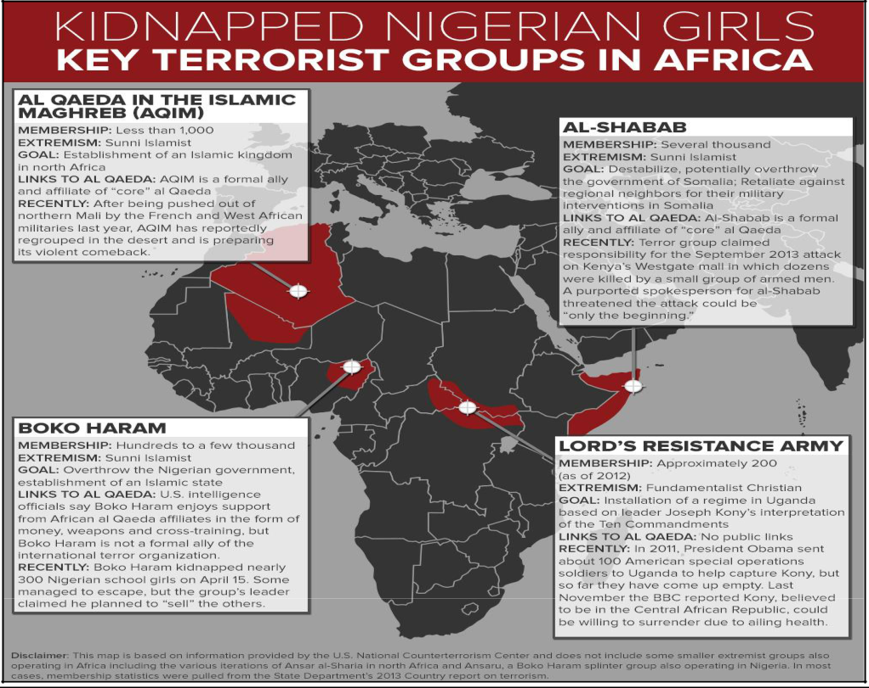

Source: ABC News. (2019). African Terrorist Groups - Infographic. ABC News.

In December 2020, more than 300 Nigerian schoolboys were abducted from their school in Katsina state, with Boko Haram claiming responsibility for the incident. It served as a stark and unfortunate reminder of the events surrounding the Chibok and Dapchi schoolgirls' kidnapping. The Nigerian government acted promptly and successfully secured the release of all the schoolboys. By the end of 2020, a tragic event brought the Boko Haram terrorist group into the global spotlight, resulting in the loss of countless lives. Regrettably, there are still approximately 112 Chibok girls who remain in captivity. In addition, there is still a Dapchi schoolgirl named Leah Sharibu who remains in captivity. She bravely refused to renounce her Christian faith and unfortunately, she has been subjected to a life of slavery by Boko Haram.

Figure 2 illustrates the various regions in the African continent where different terrorist groups have gained control and are working towards establishing a caliphate. In Nigeria, where Boko Haram operates, they have increased their numbers by recruiting young boys known as Almajiris, who are taught Islamic ideology and doctrines as a way of life.

**The Almajiri**

The Almajiris pose a significant challenge to the Nigerian government, particularly in their impact on the socioeconomic development of the northeastern region. They can also serve as a breeding ground for potential recruits into the notorious Boko Haram terrorist group. The UN Convention on Child Rights defines a child as anyone under the age of 18 (The Convention on the Rights of the Child: The children’s version, UNICEF). The convention, established in 1989, outlined a series of declarations aimed at enhancing the quality of life for children across the globe. The declaration outlines several fundamental rights, such as the right to education, health care, love and care, adequate food, and shelter. Taiwo (2013) explains that the term "Almajiri" was coined by Sheikh Abba Aji, a respected Islamic scholar based in Maiduguri. It is derived from the Arabic word "Al-Muhajir," which refers to someone who seeks Islamic knowledge. The foundation of this event was the migration of the Prophet Mohammed from Mecca to Medina, with the emigrants known as Al-Muhajiroun accompanying him. The emigrants in Medina lacked any means of livelihood. However, due to the prophet's fraternity, they were given opportunities to learn various trades and vocations as apprentices. In return for their services, they were compensated by their hosts.

There are young children in Nigeria, particularly in the northern part, who are homeless, poor, neglected, and maltreated, and can often be found begging for food and alms on the streets. The Almajiri are young children who leave their parents to pursue Qur'anic education. The term "Almajiri" is derived from the Arabic word "Almuhajirun," which refers to migrants. This practice involves sending young boys to neighbouring villages, towns, or cities to receive Qur'an education from experienced Islamic scholars known as Malams (Yusha'u et al., 2013). It is a traditional method commonly observed in the Hausa/Fulani community. According to Zakir (2014), the practice of Almajiri is a significant form of child abuse in northern Nigeria.

Aghedo and Eke (2013) argue that the rise of Boko Haram can be attributed to the youth bulge syndrome, which has led to the availability of inexpensive foot soldiers, particularly among the Almajirai. This group of Quranic pupils is not only the largest population of out-of-school children in the country, but also poses a significant challenge to achieving national and international conventions and protocols regarding children, such as education for all objectives and the millennium development aims. Additionally, they present a significant risk to our nation's security. The Almajiri phenomenon in northern Nigeria highlights the dire African youth crisis, revealing the deep-rooted issues within the systemic structures.   
  
 Taiwo (2013) referenced a recent report which stated that there were over 10 million Almajiris on the streets of northern Nigeria. Their future looks bleak without formal education. This condition has been allowed to persist by the Nigerian government and people of the north, possibly due to the benefits they have gained from it. Their belief system revolves around the idea that educating a large number of individuals leads to the empowerment of everyone. However, this mindset also fosters competition and threatens the privileged positions of some. As a result, these children are often neglected and subjected to various forms of mistreatment. This endeavour to safeguard their autocratic, feudal lifestyle and the fight to maintain their political class has resulted in the creation of this contemporary monstrosity. The Almajiri system of education has a significant negative impact, as it essentially results in child labour. Almajiri should support their mallams in providing for themselves and their families. Consequently, they are left with no choice but to rely on begging in order to sustain themselves and support the mallams. Some parents found the Almajiri system to be a convenient way to lessen the responsibility of raising their children. The Almajiri phenomenon has led to the recruitment of large numbers of Muslim children into various antisocial activities. They are often forced into begging, hawking, and wandering. According to Yusha’u et al. (2013), the Boko Haram group frequently utilised this source to find new recruits. Aghedo and Eke (2013) made a valid point that the Boko Haram Islamic fundamentalist sect recruits a significant number of individuals from the Almajiri demographic cohort. Below is Figure 3, which shows the poverty graph of Nigeria. In 2019, the unemployment rate was recorded at 6.1%.

**Figure 3**

**Nigerian Poverty Graph Source: (Statista, 2021)**

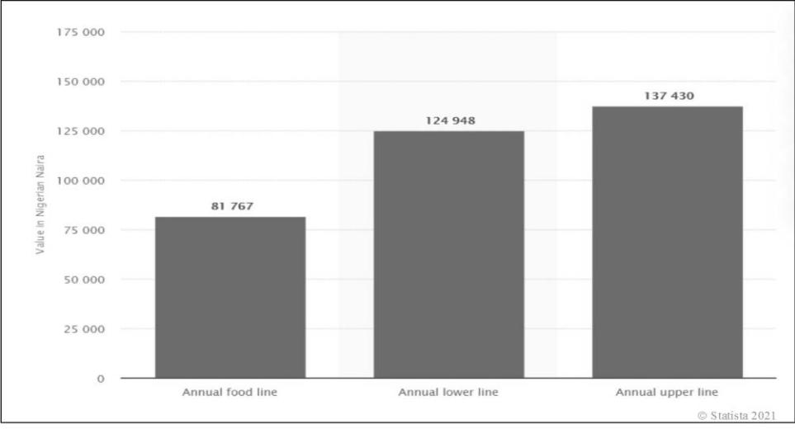

**Rise of ISIS**

ISIS has employed ruthless tactics since the onset of its conflict. In early 2014, the international community was taken aback by the sudden and unexpected rise of a relatively unknown Sunni insurgent group. This group managed to capture large portions of territory in northern Iraq, including major cities such as Mosul and Tikrit. This unidentified Sunni group transformed into ISIS with the aim of establishing a caliphate. International fighters were successfully inspired by ISIS to join their movement, attracting volunteers from Africa, Europe, and the United States. The group's primary objective was for these volunteers to return to their countries and engage in domestic jihads. Similar to al Qaeda in the past, ISIS has motivated various insurgent groups to declare their loyalty to the goal of establishing a pan-Islamic state. In 2015, Boko Haram in northeastern Nigeria and the bordering region declared their allegiance with a political agenda of establishing an Islamic state (Martin, 2017, 2018).

Culp (2019) explains that ISIS's formation and development can be traced back to the ideological approach advocated by Abu Musab al Zarqawi (Tawhid wal Jihad) in Iraq during the early 2000s. Zarqawi trained numerous radicals who later participated in the Iraq insurgency during the American intervention. Culp also stated that since ISIS declared their caliphate in June 2014, there has been a significant increase in terrorist attacks in the West. These attacks have been carried out by individuals (lone wolves) or groups like Boko Haram, who are either inspired by jihadist ideology or have sworn allegiance to ISIS. ISIS has been actively working to extend its influence and authority beyond the borders of Syria and Iraq. ISIS has declared the establishment of wilayats (provinces) in Afghanistan/Pakistan, Algeria, the Caucasus region of Russia, Egypt, Libya, Saudi Arabia, Yemen, and West Africa, and has also conducted attacks in several neighbouring countries (Gartenstein-Ross et al., 2016). Gartenstein-Ross et al. state that ISIS has effectively utilised its propaganda machinery to expand its influence into new regions. The group has implemented a strong messaging campaign in various countries to gain support from potential allies, such as regional jihadist groups, political Islamists, and local Sunnis, while also using intimidation tactics against their adversaries.

According to Ogbogu (2015), ISIS sees accepting Boko Haram as an ideological proxy as a way to establish a presence in a region with favourable conditions for religious radicalization and recruitment. The Almajiris and many unemployed youths in northeastern Nigeria present a significant pool for potential recruits. According to Gartenstein-Ross (2018), there is a lack of research in academia regarding the ability of terrorist groups to learn from each other and how they adopt each other's methods. It is important to thoroughly examine and understand the potential impact of ISIS on the future of global Islamic terrorism. The existing body of research on international terrorism and the evolution of ISIS is extensive and covers various aspects such as political, security, and economic repercussions. However, there is a noticeable gap in the literature when it comes to understanding how ISIS may have influenced the Islamic transnational threat, the potential implications of this influence, and the future of terrorism. In addition, the majority of studies on terrorism have primarily focused on the present state of terrorism. However, there is a distinct emphasis on studies that examine the future of terrorism, with a particular focus on al Qaeda. Parida (2007) argues that terrorism poses a continuous and significant danger to human rights, as well as regional and global peace and security.

**Table 4**

**Global Terrorist Groups**

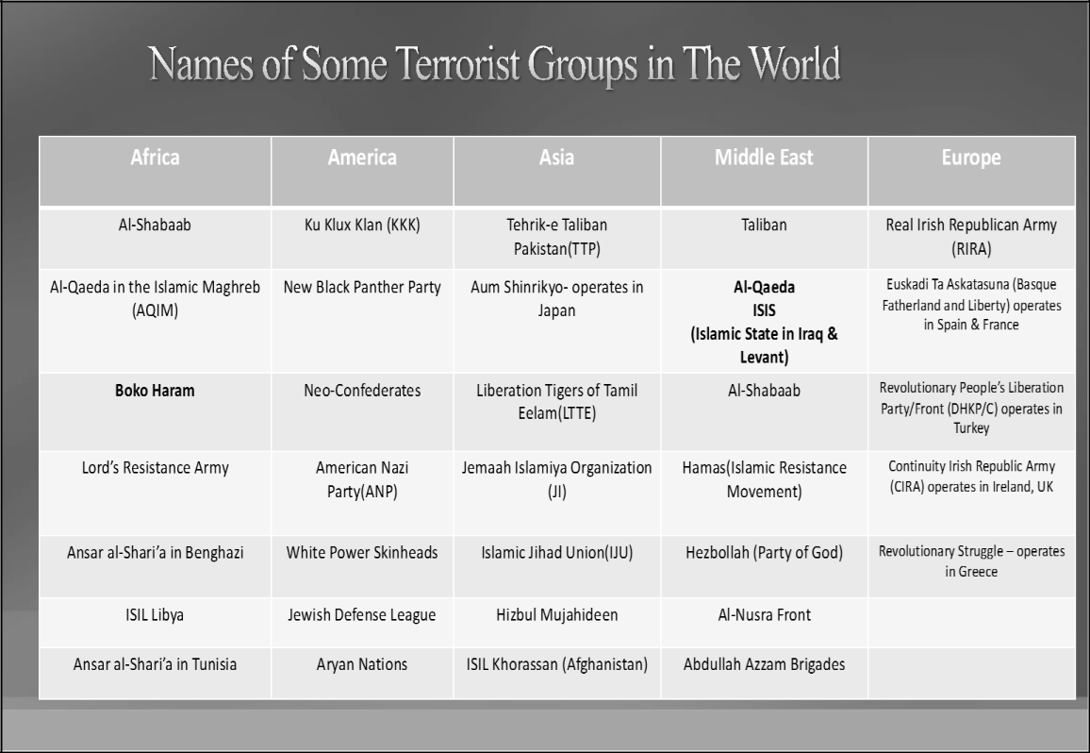

**The Alliance**

There is a significant amount of literature available on the topics of terrorism, Boko Haram, and ISIS. Nevertheless, there remains a significant lack of literature regarding the collaboration between these two highly dangerous jihadist organisations. The potential global security threat and collateral consequences could rapidly transform Nigeria, the most populous nation in Africa, into a caliphate. I aim to make a valuable contribution to the ongoing research on terrorist groups and African security, specifically focusing on Nigeria. The existing research on African security-related issues has primarily focused on acts committed by various terrorist groups such as al Shabab, Boko Haram, ISIL Libya, and the Lord's Resistance Army (see Table 4). However, there is a lack of in-depth qualitative research on the alliance between Boko Haram and ISIL, and the subsequent global threat it poses. This study offers valuable insights into the multifaceted response to the insurgency, encompassing political, religious, and military dimensions. It highlights the lack of collaboration between Muslim and Christian leaders in addressing the issue.   
  
 Recently, Nigeria has unfortunately been plagued by numerous acts of terrorism. The northeastern part of Nigeria is facing numerous challenges, including poverty, high youth unemployment, corrupt leadership, religious ideologies, cultural influences, environmental impacts, and underdevelopment. These issues have been extensively discussed by scholars. According to Ndinojuo (2018), the societal structure in northern Nigeria played a significant role in the success of Maitatsine and Yusuf in attracting followers. This society was characterised by the prevalence of a state-sponsored Islamic education system, resulting in the establishment of the Almajiri institution. This institution created a situation where young individuals became itinerant and homeless students of the Koran and Arabic studies. In the north, a group of enthusiastic young individuals emerged, easily influenced and controlled by what they believed to be religious scholars and authorities. It was observed that Islamic fundamentalists capitalised on the deep-rooted aversion of the northern society towards Western education. They manipulated the emotions of unemployed youths, using them as a breeding ground for violent rebellion against the established authority.   
 The brutal nature of communal conflicts is evident in the devastating collateral damage caused by Boko Haram. The intense and devastating communal clashes caused by Boko Haram have primarily occurred in Nigeria's northeastern regions, particularly in Adamawa, Borno, Maiduguri, and Yobe States. The combat readiness and complexity of Boko Haram and ISIL embolden them to launch attacks on host communities, resulting in the destruction of food and cash crops. The alliance strengthens the group, enabling them to confront and potentially engage with well-protected authorities equipped with advanced military convoys (Nte, 2016, p. 27).   
  
 The actions of these Boko Haram groups can be labelled differently depending on the prevailing dictum or cliché regarding terrorism. Some may view them as acts of terrorism, while others may see them as revolutionary or freedom fighting. Scholars and social thinkers have increasingly turned their attention to the issue of terrorism, particularly after the events of 9/11. This is because terrorism has become a subject of significant interest within criminological inquiry. Orehek and Vazeou-Nieuwenhuis (2014) argue that the incidence of terrorism is on the rise due to technological advances that make it easier for terrorists to attract attention and create emotional impact. Hence, it is worth mentioning that the Nigerian government is confronted with a considerable challenge as they are tasked with responding responsibly to these acts of terrorism. It is crucial for Nigerian policymakers to have a deep understanding of the historical facts surrounding terrorism in order to effectively combat its modern and brutal nature (Onwudiwe et al., 2016).   
  
 Thurston (2018) highlighted the importance of understanding key aspects of Nigerian politics in order to comprehend the complexities of terrorism in Nigeria. These aspects include cutthroat elections, pervasive corruption, severe inequality, violence, and impunity in conflict management approaches. Thurston also pointed out that Boko Haram refers to itself as Jama’a Ahl as-Sunna Li-da’wa wa-al-Jihad, signifying their dedication to spreading the teachings of the Prophet and engaging in Jihad. The term Boko Haram translates to the prohibition of Western education in the Hausa language. The movement expresses its strong opposition to what it sees as foreign and un-Islamic influences in the region. In the period of 2009-2018, Boko Haram experienced significant growth in terms of territory. Amao (2020) identified two main factors contributing to this resurgence. Firstly, the emergence and unchecked influence of the I.S. backed-Islamic State West Africa Province (ISAWP) as a splinter sect within the Boko Haram camp. Secondly, the Nigerian military faced challenges of underfunding and inadequate equipment. Amao further highlighted that during this time, Boko Haram carried out its initial significant act of violence in Nigeria. Their aim was to promote an ideology that opposes Western education and to establish an Islamic caliphate in West Africa. Opinions have remained divided on the conflict's fundamental cause and the most appropriate response to the insurgency. However, there is unanimous agreement on the Nigerian State's casualty figure and the stigma it carries. The Boko Haram terrorist activities, backed by ISIS, have had a devastating impact on Nigeria's northeast, resulting in the loss of countless lives and destruction of properties. This situation has resulted in over 7.1 million individuals depending on humanitarian aid, with 2.4 million people being displaced (with the majority, 80%, in Borno state). As a result, an estimated 232,000 Nigerian refugees have been created between May 2011 and May 2019 (Amao, 2020).

**Figure 4**

**Number of Deaths by Terrorism**

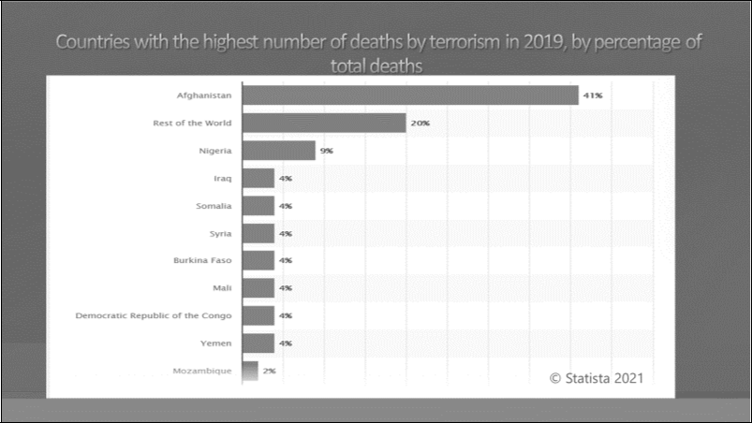

According to Adesoji (2010), the Boko Haram uprising that occurred in July 2009, with assistance from ISIS, represented an additional stage in the recurring trend of violent uprisings, rioting, and disruptions that Nigeria has become accustomed to. Adesoji further stated that the situation might not have been as dire as it was, considering the religious sensitivity of Nigerians, the heterogeneous composition of Nigerian society, and the protracted military rule that concluded in 1999, during which a substantial portion of the population was highly militarised. Adesoji expressed concern over the coercive endeavour of Islamic fundamentalists to impose their religious ideology on a Nigerian society that is constitutionally recognised as secular. Furthermore, Adesoji reaffirmed that prior to the Boko Haram uprising, violent endeavours to impose a religious ideology on a secular Nigerian society had not occurred. The first was the Maitatsine rebellion of 1980–85. The aforementioned endeavours have effectively expanded the reach of Islamic revivalism within the nation. Recent occurrences demonstrate that the Boko Haram group's resistance, the rapidity and proliferation of its military organisation, the conviction of its leadership, and the membership's support all attest to an extraordinary dedication to the cause, in spite of the vicious suppression of previous endeavours. There is a widespread belief that the current iteration of Boko Haram is capable of engaging a modern state in a military duel. However, the Boko Haram insurgency garnered significant attention due to its promotion of Islamic revivalism and challenge to the legitimacy of a state; furthermore, its inception constituted a condemnation of the Nigerian State and its leaders. The apparent lack of competence became evident through recurrent incidents of various forms of violence, notwithstanding the state's consistent assurances to monitor and protect the lives of its citizens.

This religious ideology serves as the foundation for the partnership between these two terrorist organisations. As stated by Ogbogu (2015), ISIS gains a foothold in a region where social, political, and economic conditions are favourable for religious radicalization and recruitment by utilising Boko Haram as an ideological proxy. According to Ogbogu, the connections between the two terrorist organisations developed when Boko Haram recognised and imitated ISIS; this is considered to be the genesis of cooperation between the two groups. Additionally, he asserted that Boko Haram's videos demonstrate that the group has significantly upgraded its media outlet, incorporating superior production quality and graphics, much like the videos produced by the ISIS media wing. Ogbogu additionally contended that Boko Haram could potentially enhance its recruitment efforts and broaden its allure by associating with ISIS. Particularly prevalent in northern Nigeria, the region is a breeding ground for Boko Haram recruits due to its high unemployment, illiteracy, and lack of essential amenities.

**The Nigerian Military**

Consistent with the growing body of evidence that the military is ineffective in eradicating terrorism in the region, the Nigerian military's response to Boko Haram's terrorist activities follows this pattern. Push, pull, and personal characteristics are the three analytical frameworks that classify the numerous factors that contribute to radicalization (Onapajo & Ozden, 2020). The structural flaws in a society that propel individuals to violent extremism are accounted for by push factors. Illiteracy, political exclusion and marginalisation, poor governance, poverty and unemployment, state repression, and vast socioeconomic inequality are some of the instances that constitute the fundamental causes. Comprehending these elements is an essential component in the deradicalization procedure. Deradicalization primarily focuses on the most extreme form of radicalism, as its objective is to alter an individual's violent-inclined convictions, notwithstanding their lack of physical involvement in violent acts (Onapajo & Ozden, 2020). The military operations in relation to the governments' assertions of Boko Haram's defeat have been the subject of scrutiny in numerous studies (Onuoha et al., 2020). Conversely, the high success rate of the Boko Haram insurgency can be attributed to soldiers' mutiny, desertion from war fronts, and low morale, as supported by empirical evidence. Therefore, notwithstanding the increase in the budget allocated to the security sector from approximately US$1.44 billion in 2009 to US$2.81 billion in 2018, the Nigerian military-led counterinsurgency operation continues to encounter substantial and noteworthy security obstacles (Onuoha et al., 2020).

Joshua et al. (2021) assert that Nigeria attained its independence in 1960 and transitioned to republicanism in 1963, upon the abdication of the Queen of England as Nigeria's monarch. From 1963 to 1966, when the military seized political authority in a coup d'état, the First Republic was in effect. Nigeria was beset by a civil conflict that began in July 1967 and continued until January 1970. The Nigerian civil conflict was among the earliest in Africa. Globally, the level of destruction and its effects on civilians were astounded (Falola et al., 2018). The Second Republic (182-Armed Forces & Society 47(1)) lasted from 1979 to 1983, beginning in 1979 when the military again transferred political authority to a democratically elected government. The military regime that seized power in 1993 and subsequently made a commitment to transfer political authority to a democratically elected government in an inconclusive transition marked the end of the Third Republic (1991–1993). This deadlock resulted in the military maintaining authority despite purported insecurities within its ranks. Since May 29, 1999, when the military commanders in charge of affairs transferred political authority to a democratically elected government, the Fourth Republic has been in effect. Additionally, Joshua et al. (2021) noted that insecurity in Nigeria had emerged as a substantial obstacle. The endeavours undertaken to mitigate insecurity exacerbate it, rendering its investigation all the more intriguing. As a result, the military's engagement in internal security has exacerbated the issue of insecurity by virtue of its unprofessional methodology and frequent intentionalization of harm towards the civilian population, which is its responsibility to safeguard.   
  
 As stated by De Montclos (2020), Nigeria has been unable to defeat the Boko Haram group since 2009, notwithstanding the establishment of the Multinational Joint Task Force (MNJTF), an antiterrorist coalition comprising Cameroon, Niger, and Chad, in 2015. However, the terrorist organisation has opted to retreat into so-called "super-camps," which has effectively granted it unrestricted access to territory beyond urban centres. Conversely, the conflict against Boko Haram resembles a rather archetypal instance of asymmetric warfare from this vantage point. De Montclos argued that in northeastern Nigeria, where there are no frontlines, the insurgents control the countryside. Concurrently, governmental forces are fortified within urban areas and venture forth exclusively in sizable convoys of armoured vehicles. In an effort to avert ambushes, government security forces initially opened fire upon urban crowds before transitioning to cover in the forest. It initiated its expansion into rural regions subsequent to the declaration of emergency in June 2013. In the Nigerian context, the administration led by President Buhari asserted that the military effectively vanquished the authentic Boko Haram faction in 2015. Since then, certain authorities have posited that the resilience of Boko Haram fighters could be attributed to a transformation in a jihadist nebula—one that destabilises the region in service of the Islamic State Daesh rather than for territorial control.   
  
 Nonmilitary approaches are increasingly being advocated as an alternative or supplementary strategy to effectively address the escalating problem of terrorism and insurgency, according to Mac Ginty & Richmond (2013). There is substantial evidence to support the claim that nonmilitary approaches, such as reintegration programmes, political negotiations, deradicalization, and disengagement, are more effective at addressing the root causes of terrorism and establishing lasting peace. This dissertation centres on the international security concern posed by the coalition forged between Boko Haram and the ISIS terrorist organisation within Nigeria. The objective is to demonstrate that the partnership between the two most lethal terrorist organisations has engendered an anomie in Nigeria, which has severe repercussions that are schivring one of the continent's foremost oil-producing countries. The aforementioned concerns, which have the potential to incite unrest and violence, have brought to light deficiencies in security measures within the Nigerian security services and the government's abhorrent failure to adequately address the unintended repercussions of the jihadist organisations' alliance.

**The Nigeria Military Funding**

As shown in Figure 5, Nigeria's military expenditures remained relatively stable at approximately 0.5 percent of the country's gross domestic product (GDP), with the highest expenditure occurring in 2011 (0.58%) and the lowest occurring in 2014 (0.41%). International defence expenditures average 2.2% of gross domestic product.

**Figure 5**

**Nigeria Military Expenditure Between 2008 and 2019**

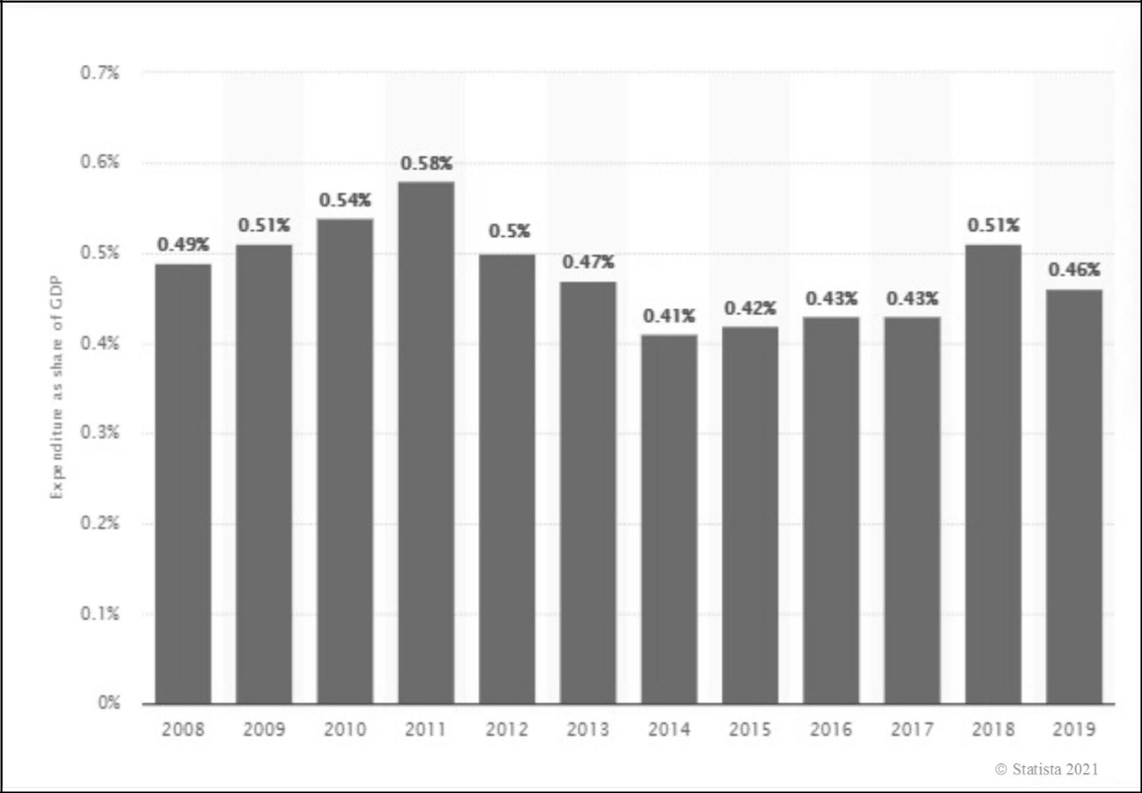

Military expenditures have been highest in the United States and China (Statista, 2021). The purpose of this case study is not to compare the military expenditures of various nations, but rather to statistically ascertain and substantiate with empirical data the funding allocated to Nigeria's military in response to the terrorist activities backed by Boko Haram and ISIS within the country.

**Overview of Theoretical Perspectives**

**Theory of Anomie**

Anomie can be defined as a condition characterised by a lack of societal regulation over the expectations or behaviours of its members (Durkheim, 1965). Boko Haram's and ISIS's ongoing terrorist attacks against diverse Nigerian communities can be elucidated by a number of criminological theories. Nonetheless, the theoretical framework that directs this dissertation is indistinguishable from economic inequality and the collapse of social norms or rules associated with anomie. Williams and McShane (2014) assert that anomie, a construct within positivist theory, is intricately linked to the works of two prominent theorists: Robert K. Merton (1910–2003) and Emile Durkheim (1858–1917). Considered one of the forefathers of criminology, Durkheim coined the phrase "labour division in society" in 1893. According to Williams and McShane, Durkheim was preoccupied with society. As a reaction to the classical school of thought that humans were rational and free in a contractual society, it underwent an organisational transformation. Inequality, according to Durkheim, is an inevitable and natural consequence of the human condition and is associated with social problems such as crime, unless social norms or standards are violated. Such disruptions were referred to as "anomie" by Durkheim to indicate that industrialization was the cause of these changes in his society (Bernard et al., 2016).

Anomie, according to Williams and McShane (2014), is the collapse of social norms and the absence of conditions in which those norms govern the behaviour of society's members. They interpreted it as a term used to characterise a deregulated state of society. In this circumstance, norms dictate how individuals ought to respond to one another's malfunctions, resulting in a normless environment in which no one knows what to anticipate. Furthermore, a deregulated society is frequently accompanied by deviant behaviour that generates an environment characterised by disorder. Williams and McShane argued that Merton's theoretical framework regarding anomie theory constituted a theory of deviance in which a society is imagined that prioritises the establishment of meticulously planned routes to achieve well-defined objectives for its members.

As one of several variants of radical Islamism to have emerged in northern Nigeria, Agbiboa (2013) argues that Boko Haram's ideology is profoundly rooted in traditional Islamism. Following conflicts with the state's security agency in Bauchi State tasked with enforcing a recently enacted law mandating the use of crash helmets by motorcyclists nationwide, the group initiated a comprehensive insurgency. Boko Haram members disobeyed this regulation. Agbiboa posits that the extensive destructive operations carried out by Boko Haram, which have had far-reaching consequences outside of Nigeria and are supported by their alliance with ISIS, have undoubtedly engendered a psychological toll that surpasses the tangible harm inflicted.

Bernard et al. (2016) posit that anomie theory may serve as a foundational framework for elucidating criminal activities and a range of deviant behaviours. Walsh (2000) argued that criminal behaviour is released under anomie conditions, which transpire at a lower threshold for certain individuals. It is impossible for a society to exist in which individuals do not deviate to some degree from the collective type; inevitably, some will adopt a criminal disposition (p. 1,086). Durkheim accurately noted this. According to Bernard et al. (2016), Durkheim explicitly stated in one of his works ("Suicide," 1951) that crime and criminality are motivated by an insatiable desire for resources (such as riches, status, and prestige). By means of its laws, the moral standards of any society serve to restrain this egocentric pursuit of self-interest.

Bernburg (2002) asserts that anomie theory has consistently been regarded as a conceptual instrument frequently employed to comprehend the interplay between cultural influences, societal structures, and deviant behaviours. Bernburg argued that individuals' objectives are defined and sanctioned by shared cultural values (e.g., the current situation involving Boko Haram and the ISIS alliance). Bernburg further posits that individuals experience tremendous pressure to achieve their ambitions while simultaneously encountering lax normative constraints on lawful methods to accomplish these predetermined objectives, which he referred to as "institutionalised anomic theory." Even though it was published in 1938, Merton's theory of anomie is still regarded as one of the most influential criminological theories. According to Merton, the social inequality that hinders individuals in the lesser strata of society from achieving their desired financial success is antithetical. According to Merton, when citizens are overly pressured or expected to attain economic success without the corresponding social structure being universally accessible, it strains certain demographic groups of society and encourages many to engage in deviant behaviour. As an element of strain theory, this anomic circumstance is frequently denoted (Williams & McShane, 2014).

**Strain Theory**

According to Tibbetts and Hemmens (2009), all strain theories highlight frustration as a causal factor in criminal behavior-related issues. Tibbetts and Hemmens posited that the evolutionary trajectory of Merton's strain theory was significantly impacted by Durkheim's theoretical framework. In contrast to Durkheim's contention that anomie stemmed primarily from a society undergoing too rapid a transition in order to maintain regulatory control over its citizens, Merton equated anomie with an excessive emphasis on wealth objectives over conventional means in the United States. Merton's structural model gained significant traction as a prominent perspective in criminological thought and a frequently referenced theory of crime in the field.

According to Bernard et al. (2016), Merton's strain theory serves as an American-specific adaptation of Durkheim's anomie theory, with an additional emphasis on social conditions. As Merton's strain theory elucidates, the culture of any given society establishes particular objectives that it considers worthy of pursuit, and these objectives differ across cultures. For instance, the most prominent cultural objective of American society is the acquisition of affluence, which is correlated with a high social status. Bernard et al. (2016) elaborated on the way in which strain theory explains the high crime rate in American society through cultural argumentation, revealing a form of cultural imbalance in which individuals are expected to conform to established norms or methods in pursuit of cultural objectives. The terms "conformity," "innovation," "ritualism," "retreationism," and "rebellion" were applied to these modifications. They impose significant burdens on individuals who are unable to attain these cultural and societal objectives through lawful methods such as diligence, integrity, and learning. It also demonstrates that strain impacts various social classes, but that those in the lower class, where the social structure severely restricts the ability to amass wealth, are disproportionately impacted. Notwithstanding the apparent homogeneity among the diverse societal class structures, this creates an environment in which all individuals are compelled to amass wealth despite the existence of a feeble coalition to devise means of doing so.

According to Bernard et al. (2016), the purpose of strain theory is to address the particular issue of acute pressure resulting from the mismatch between culturally imposed objectives and structured opportunities, rather than to provide an explanation for the various deviant behaviours that are prohibited by law at some point.

According to the findings of Adelaja et al. (2018), a substantial portion of northern Nigeria is beset by unemployment, destitution, and limited economic opportunities. It is unsurprising that certain inhabitants of Borno, Adamawa, and Yobe (BAY States), the regions where Boko Haram has focused the majority of its attacks, held the steadfast conviction that terrorism in their respective states originated from extreme political ideology, unemployment, poverty, and economic hardship. It was asserted that the foundations of Boko Haram lay in the ire of the government (institutionalised structures), feeble governance, and the arbitrary actions of security personnel. Many in the lower class, particularly the Almajiris, who distrusted the government, were burdened by these matters. They felt obligated to the terrorist organisation that they regarded as their liberators.

**Contemporary Strain Theory**

According to Williams and McShane (2014), at the outset, anomie or strain theory was perceived as a structural theory preoccupied with the consequences of cultural transformations and social inequality. They believed that as more contemporary theories emerged, criminologists would devise a variety of approaches to apply strain theory to processual or individual levels as opposed to the events themselves.

**General Strain Theory**

One of the most prominent contemporary strain theories is attributed to Agnew (2006), who argued that traditional strain theories frequently focus on obstacles to positively valued objectives, i.e., the incapability to attain one's own wants and needs. Agnew additionally posited that these strains might entail the attainment of objectives that are highly esteemed, such as financial success, social standing, or independence. They may potentially involve the depletion of assets or other positively valued stimuli. As a result of these tensions, particular individuals or groups in the community developed feelings of inadequacy and resorted to criminal activity as a means of escaping the stress.   
  
 In northern Nigeria, armed groups such as the Almajirai, Yan Tauri, Yan Daba, Yan Banga, and Yan Dauka Amarya, which consist of street boys (unemployed youths), have transformed certain regions, including Kano State, into hotspots. The majority of these groups are the result of individuals' inclination to use violence as a coping mechanism for the stress that is typical during the years of structural adjustment. Boko Haram is adamant that all obstacles to their cherished objective be eradicated, and they do not consider violence to be a deviation from their Islamic principles; rather, they regard it as a justifiable method to achieve their noble end. In numerous ways, general strain theory expanded upon traditional strain theory in criminology. It emphasises the actual or anticipated inability to attain a positively valued objective, the elimination of positively valued stimuli, and the presentation of negative stimuli. Furthermore, the theory identifies particular significant aspects of strain that have been examined in empirical studies: the frequency, severity, length, and combination of straining incidents (Adesoji, 2011; Agnew, 1992; Campbell, 2014; Williams & McShane, 2014).

**Containment Theory**

The attribution of containment theory, which is alternatively known as control theory, goes to Walter Cade Reckless. His endeavour was to reconcile a number of concepts derived from alternative theories into a more universally accepted framework concerning crime and delinquency. The subject matter encompasses various elements and is predominantly concerned with self-concept, its associated processes, and functions (Mutchnick et al., 2009). The self-concept serves as a buffer against external influences by providing an accurate or inaccurate perception of oneself. It also provides an explanation for deviant and conforming behaviour. It possesses two reinforcing components: an internal and external control system that empowers an individual to resist deviance or opposition to societal norms. Reckless's emphasis on interior containment posits that individuals possess self-concepts that are formed during their youth, similar to how the Boko Haram terrorist organisation moulds the Almajiris into mallams of their ideological convictions. Additionally, he described a variety of pressures and pulls towards deviant behaviour that each person encounters. The propensity of an individual to engage in delinquent behaviour is exclusively determined by the strength of their inner and exterior containment. Due to its comprehensive nature, containment theory is considered an ideal framework for elucidating illicit behaviour and delinquency. On the contrary, there are those who believe it has garnered more interest as a theory of delinquency. They contend that the theory's main merit is its integration of sociological concepts from the Chicago tradition and psychodynamic approaches of the time (Gibbons, 1976, as cited in Mutchnick et al., 2009, p.131). Control theorists posit that individuals would inherently engage in criminal behaviour if left unsupervised. Therefore, criminal behaviour occurs due to the fact that the motivations for criminality outweigh the barriers that prevent individuals from abstaining from such actions (Bernard et al., 2016). The persistent acts of violence perpetrated by Boko Haram provide compelling evidence of the efficacy of different theoretical frameworks in addressing criminal activity in society.

**Collateral Consequences of Boko Haram and ISIS Terrorist Alliance in Nigeria**

The destructive effects of terrorist acts are not confined to Nigeria; rather, they have a global reach. Scholars argued that the emergence of the new face of terrorism occurred in the wake of September 11th (Olanrewaju, 2015). Terrorist activities function as outlets for propaganda and statement-making, as the perpetrators are cognizant of the media's propensity to sensationalise and magnify lamentable occurrences. Media reportage serves as a platform through which one can articulate the physical capabilities of individuals as well as the probable psychological repercussions of their actions (Ronczkowski, 2018). The inhumane manifestations of terrorism are as diverse as its definitions. Whether the intention is to downplay the gravity of the situation or to ascertain the motivations behind a terrorist act, understanding the mechanisms of terrorism aids the general public in recognising and categorising significant terrorist occurrences. Understanding the various causes of terrorism is thus a critical component in establishing a precise definition of terrorism and acts of terrorism. Every instance of terrorism is motivated by an entrenched ideology marked by radicalism and intolerance. Additionally, perspective is a crucial element in defining terrorism. Those who oppose the violent actions of an extremist group or who identify with the group as terrorists may come under its focus. Advocates of the group, on the other hand, would regard them as liberation fighters despite the fact that their methods are not in line with such an ideology. Terrorism can therefore be defined in a variety of ways, including as the threat or deliberate infliction of harm upon members of a target group with the intention of manipulating the psychological state of observers in a way that the attackers believe will further their agenda or ideology (Martin, 2018; Ronczkowski, 2018; Shanahan, 2016).

The current state of insurgencies and violent terrorist attacks across multiple regions of Nigeria is concerning. Certain schools of thought are concerned that this could result in the nation's disintegration. The government's insufficient reaction and its incapability to regulate the disruptive operations of these extremist organisations facilitated the emergence of ultra-religious terrorist organisations such as Boko Haram (Joshua, 2020). The emergence of the Boko-Haram insurgency in Nigeria signified the continuation of a recurring trend of violent rebellion, civil unrest, and disruptions (Olanrewaju, 2015). The region most severely impacted by Boko Haram's activities has been the northeastern part of the country, which has suffered catastrophic losses of life and property. The justification for the Islamic indoctrination of Boko Haram members is provided by the sect's declaration in its manifesto that it is dedicated to the Islamization of Nigeria through the enforcement of Sharia law. The group is predicated on a spiritual ideology that serves as a foundation for recruitment and inspires its members to take action. An example of this is the Almajiris, who were purposefully bred in Islamic institutions, where they were raised, protected, conditioned to be submissive and loyal to a single authority, and prepared to be released upon the rest of society (Maiangwa et al., 2012).

A comprehensive examination of the Boko Haram and ISIS terrorist alliance in Nigeria during the specified time period (2000-2020) reveals a soothy shadow that looms over the nation's political environment. Many consider the absence of visionary leadership, corruption, and a failure of governance masked as an interethnic struggle for political power and prosperity to be Nigeria's most pressing problems. As stated by Ogbogu (2015), Boko Haram holds all individuals or collectives, including Muslims, accountable to death if they fail to conform to their anti-Islamic convictions. Additionally, Ogbogu asserted that Boko Haram could potentially increase its recruitment efforts and broaden its appeal by associating with ISIS. There is a suspicion that a considerable number of Almajiris in northern Nigeria are being radicalised or indoctrinated through the establishment of Islamic institutions in opposition to Western-style education.

**International and Local Terrorist Indexes**

On numerous fronts, the collateral effects of Boko Haram's alliance with ISIS could be examined. Politically speaking, Boko Haram has elevated the global prominence of ISIS. Particularly in northern Nigeria, the elevated levels of unemployment, poverty, illiteracy, and lack of fundamental amenities create a conducive environment for the recruitment of Boko Haram members. Furthermore, ISIS gains a foothold in a region where social, political, and economic conditions are favourable for religious radicalization and recruitment by utilising Boko Haram as an ideological proxy (Ogbogu, 2015). Furthermore, in its capacity as an insurgent organisation engaged in hostilities, ISIS aspires to conquer new territories militarily. In contrast to numerous alternative jihadist organisations, such as the Taliban, which aspire to govern and control territory within a limited area, ISIS establishes an Islamic Caliphate through the fusion of insurgent governance and expansionist territorial aspirations. ISIS requires an enormous amount of personnel to accomplish its territorial expansion objective on a global scale. Merely placing one's boots on the ground is insufficient. In order to prevail, ISIS requires a committed combatant corps that is amenable to self-denial (Gates & Podder, 2015). ISIS endeavours to attain international acclaim, and Nigeria serves as a formidable stronghold within the African continent. The global and African fatality tolls attributable to terrorist activities are depicted in Figures 6 and 7, respectively.

**Figure 6**

**Global Terrorism Index 2020**

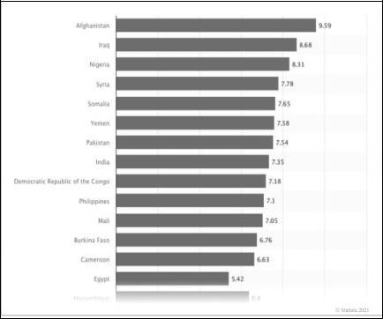

Figure 6 illustrates that Nigeria has one of the highest levels of terrorism threat in the world and in Africa. In 2019, Nigeria had a terrorism index of 8.6, the highest in Africa. It ranked second globally in terms of terrorist-related deaths, following Afghanistan. Somalia, Congo, and Mali also had high terrorism threat indexes. The Statista 2021 report (Figure 6) provides an empirical analysis of Nigeria's ranking in the Global Terrorism Index (GTI) in 2020. The report confirms that terrorism has been widespread in Nigeria, with the ISIS-backed Boko Haram group being primarily responsible for Nigeria's undesirable position on the African terrorism index. Nigeria maintains the unenviable third position globally, after Afghanistan and Syria, on the global terrorist index (Statista, 2021).

**Figure 7**

**Terrorism Index in African Countries 2019**

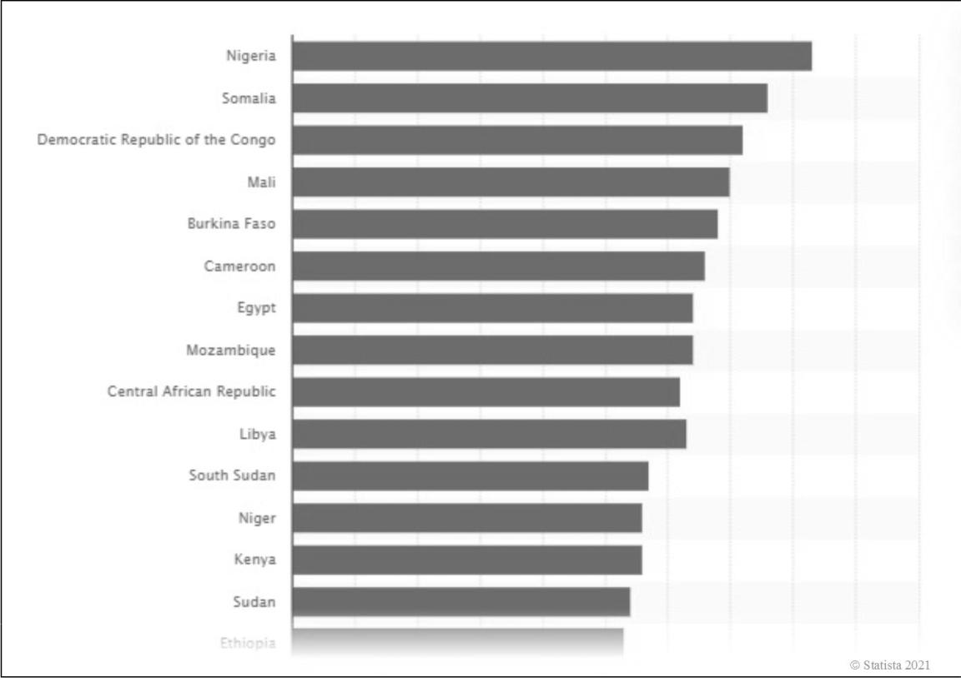

**Figure 8**

**Number of Deaths by Terrorism**

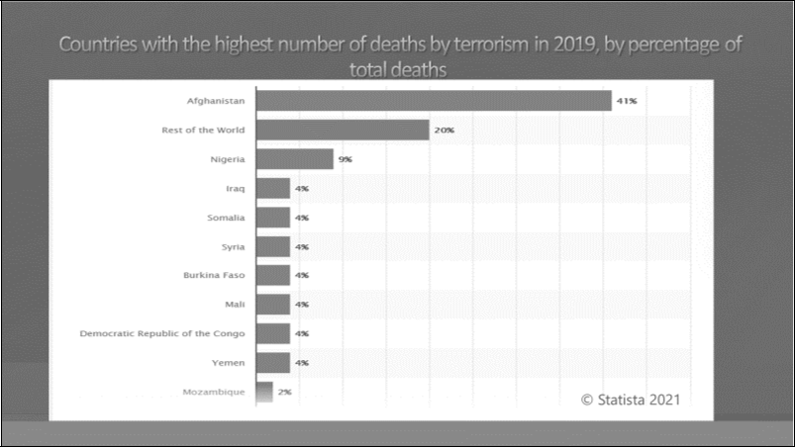

Figure 8 displays the countries most affected by terrorism worldwide, ranked by the highest number of deaths as of 2019, presented as a proportion of total deaths. Notably, Nigeria has a higher rate of terrorist activity at 9% compared to Iraq, Somalia, and Syria, which are each placed at 4%. In 2019, Nigeria was placed third globally, following Afghanistan, in terms of the percentage of deaths caused by terrorist actions, with a rate of 9%. Nigeria is ranked as the third most terrorised country worldwide, primarily due to the insurgencies of Boko Haram, which is supported by ISIS. The purpose of this case study is not to do a comparison between terrorised countries or analyse the percentage of deaths caused by terrorism. Instead, it aims to provide statistical evidence, using empirical data, of the global security threat posed by the alliance between Boko Haram and ISIS in Nigeria (Statista, 2021).

**Figure 9**

**Number of Terror-related Deaths in African Countries Between 2007 and 2019**

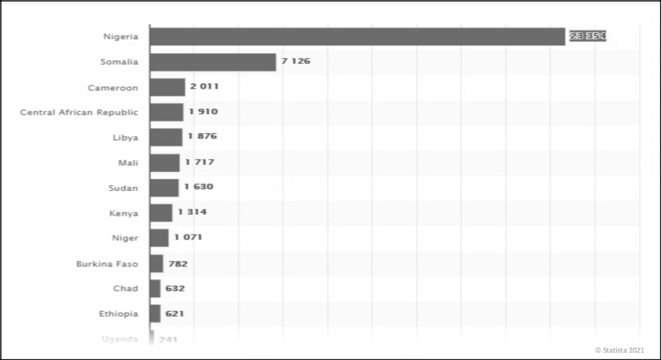

Figure 9 illustrates that Nigeria has been the most severely impacted country in Africa in terms of fatalities caused by terrorism. From 2007 to 2019, Nigeria experienced 23,354 deaths resulting from over 4,000 terrorist attacks. While several radical groups operate in Nigeria, Boko Haram stands out as the most lethal terrorist organisation and the sole affiliate of the Islamic State (ISIS). Figure 8 further supports the research's objective of providing empirical evidence and raising awareness about the endemic terrorist situation in Nigeria, which has the potential for devastating consequences if not addressed by a unified global security force (Statista, 2021).

**Figure 10**

**Number of Deaths in the Countries Most Impacted by Terrorism in 2019**

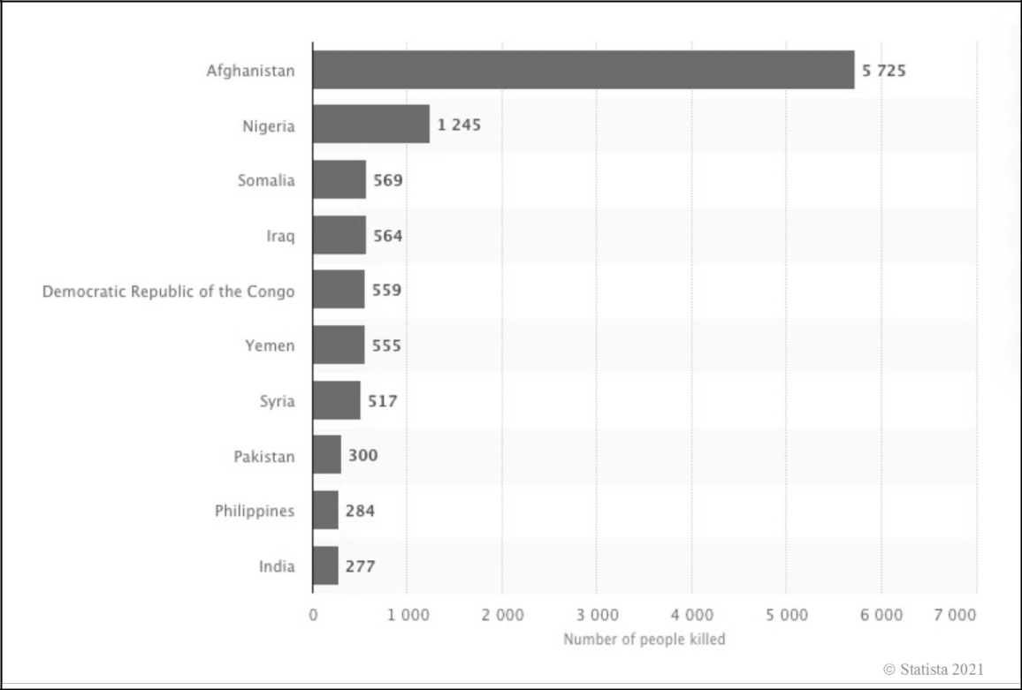

Figure 10 displays the worldwide ranking of Nigeria, which has had 1,245 deaths due to terrorism. Nigeria is second on the list, with Afghanistan occupying the top position with 5,725 fatalities. This diagram illustrates the global importance and influence of the collaboration between Boko Haram and ISIS in Nigeria

**Figure 11**

**Deadly Terrorist Attacks in the Northeastern Region of Nigeria (Nigerian Northern States Most Affected by Boko Haram’s Deadly Attacks 2011–2021)**

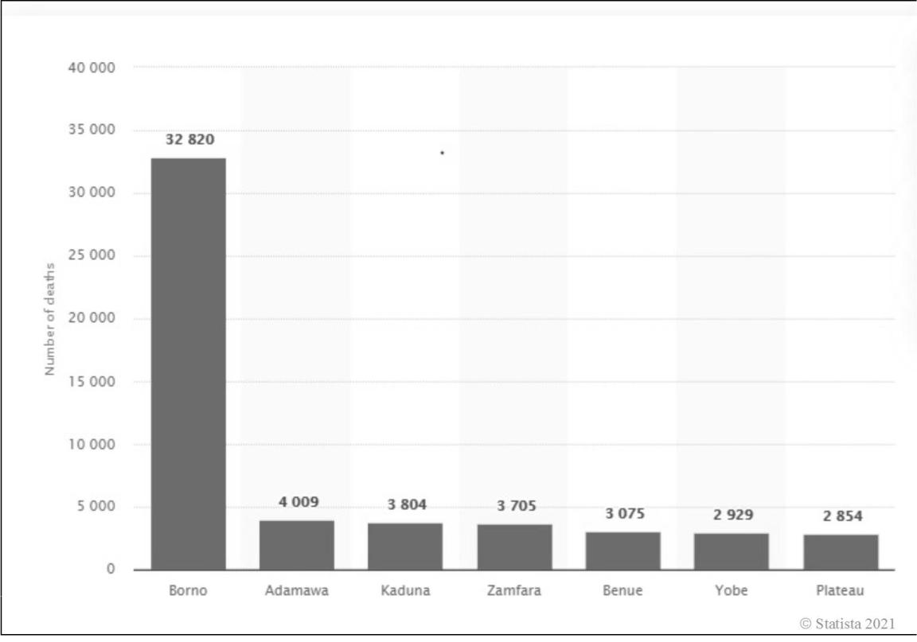

According to Figure 11, throughout the period starting from 2011 when terrorist actions in Nigeria were at their highest, Boko Haram was accountable for a significant number of fatalities in the country. Nigeria is the country that is most affected by the terrorist group's attacks, which is an unfavourable situation. Figure 10 depicts the states in the northeast together with the corresponding number of deaths caused by terrorism. Borno emerges as the state facing the highest level of threat. In the past decade, Boko Haram has been responsible for around 32,800 fatalities only inside this particular state. However, out of all the numerous incidents, the global media attention was only significant for the news regarding the abduction of 276 female students from Chibok secondary school in Borno in 2014. According to Statista (2021), there are presently 112 girls who remain unaccounted for, and it is thought that six students have lost their lives.

**Ideology of Religion**

The religious ideology has become religious extremism a pivotal concern for the international world. Terrorism is perceived as a form of political violence motivated by a strong conviction that a supernatural authority has sanctioned and mandated acts of terrorism to promote the superiority of a certain faith. For several extremists, this ideology has become obligatory as it offers a comprehensive perspective that gives them a distinct sense of direction (Martin, 2017, 2018). Following the events of 9/11, there was an increased emphasis in the Western world on Islam, which is one of the fastest-growing religions worldwide and has approximately 1.3 billion followers (Ronczkowski, 2018). According to Ahmed (2015), Islam is a comprehensive system of guidelines for living. The origin of this being is not artificial, but rather it is derived from our creator, Allah. Islam is an Arabic term denoting complete relinquishment and obedience to a transcendent deity known as "Allah." Islam is a monotheistic religion that believes in an afterlife and worships Allah as the eternal, omnipotent, omniscient, and omnipresent deity. A person who embraces Islam and adheres to its principles and practices is referred to as a Muslim or a submitter, as they surrender themselves to Allah. The Islamic faith adheres to a set of rituals that facilitate the manifestation of their religious beliefs. These views are founded upon five primary components. The first element is the Shahadah, which is a declaration of one's allegiance. The second foundational element is the regular ritual of daily prayers, commonly referred to as Salat. The third obligation is the yearly charitable duty of a Muslim, referred to as Zakat. The fourth pillar is the Saum, which is the month of fasting (Ramadhan), occurring during the ninth month of the Islamic lunar calendar. The fifth pillar of Islam is the Hajj, which is a pilgrimage to Mecca that is typically undertaken by Muslims at some point in their lives (Denny, 2015; Ronczkowski, 2018). These pillars are often regarded as transformative in guiding individuals to live according to the principles of Islam as a religious worldview.

Olanrewaju (2015) asserted that the Salafists perceive themselves unequivocally as agents of change, seeking to establish a pure Islamic worldview that has been tainted by Western influences and the beliefs of other Muslim factions such as the Sufis and the Shiites. The Taliban and al Qaeda are other extremist groups that adhere to this ideology. Boko Haram is categorised into this branch of Islamic fundamentalism based on its ideological convictions, stated objectives, chosen targets, and undertaken actions. Olanrewaju additionally asserted that Boko Haram's objective is to enforce Sharia rules throughout all Nigerian states as a result of their philosophy that opposes Western education. Thus, due to the shared ideology of Boko Haram and other Salafi Jihadist organisations, it is anticipated that they will probably seek guidance from established groups like al Qaeda in the Maghreb to acquire knowledge on perpetrating further acts of terror and establishing a Caliphate in Nigeria.

**Leadership**

The persistent issue of terrorism is rooted in the failure of the Nigerian state to provide adequate leadership in effectively confronting Boko Haram militants. The lack of leadership is one of the contributing factors that is causing Nigeria to move towards becoming a failing state. The breakdown of institutions and government capacity to ensure the safety of citizens' lives and property can be attributed to a failure in leadership (Joshua & Olanrewaju, 2016). Silva (2016) posits that leadership is a notion that is continually developing and changing over time. Leadership can be succinctly described as the dynamic process of interactive influence, wherein individuals within a given setting willingly accept someone as their leader in order to collectively achieve a shared objective. The essential requirements of housing, security, food, and excellent education are universally important, including in Nigeria, notwithstanding the presence of terrorist operations. Globalisation is inevitable due to the continuous advancements in technology and the widespread dissemination of knowledge in the digital age. These developments erode the barriers and divisions between countries, allowing for the sharing of solutions to major security concerns such as terrorism (Goldsmith et al., 2003).

According to Awofeso and Odeyemi (2014), the concept of "leadership" has been defined in various ways, making it challenging to establish a precise and universally accepted definition. Describing leadership comprehensively is a tough task due to its use in various aspects of life. One could define it as the capacity to instill assurance and garner backing from individuals whose skill and dedication influence achievement. When portrayed in its political thread, leadership denotes the team of humans that run the public affairs of a given political territory. Leadership roles and opportunities can be found in various contexts such as the home, workplace, and religious settings, and it is common for certain groups to anticipate a strong leadership presence. Leadership is crucial for exhibiting superior governance, as it motivates an organised collective to execute strategies and achieve objectives, so fostering societal progress. The discussion on Nigeria's peaceful future is intricately linked to the inadequacy of governance and leadership (Nicholas-Omoregbe et al., 2016).

Nigeria possesses a plentiful supply of both human and material resources that are crucial for the progress and growth of the nation. Nigeria nowadays is a diverse amalgamation of numerous ethnic groups that extend across multiple geographical regions (Falola et al., 2018). The 1999 Constitution of the Federal Republic of Nigeria established a framework for democratic governance that follows a presidential system of government, rather than a parliamentary one. It includes a two-chamber National Assembly, consisting of the Senate and the House of Representatives. Additionally, it organises Nigeria as a Federal Republic (Wehner, 2002). Governing a society is an immense undertaking, particularly in Nigeria and other countries with an unpredictable sociopolitical and economic climate (Dike, 2014).

Nigeria appears to be trapped in a state of poverty, corruption, and underdevelopment, with deteriorating infrastructure. However, it initially showed great potential for leading Africa towards progress and was expected to help other countries overcome challenges such as underdevelopment, economic dependency, crises, moral bankruptcy, and lack of effective leadership. Nevertheless, ever since achieving political autonomy from the British in 1960, Nigeria has persistently followed a trajectory that aligns with the characteristics of calamitous, feeble, and immature nations. Therefore, it is undeniable that Nigeria is suffering from inadequate governance and a complex, widespread corruption that has grown increasingly prevalent and detrimental (Imhonopi & Ugochukwu, 2013).

**Internally Displaced Persons**

According to its constitution, a fundamental goal of the Nigerian state is to establish a fair and democratic society in which every individual has the right to engage in the process of governing. The constitutional declaration assumes that all citizens possess the entitlement to reside and engage in their lawful enterprises without any apprehension of coercion, bias, marginalisation, or compulsory eviction, regardless of their location within the nation. Nevertheless, the presence of local factors such as the Boko Haram and ISIS insurgency has resulted in the displacement of people within the country, known as internally displaced persons (IDPs), who extend beyond the borders of Nigeria. The repercussions of this have a significant influence on the broader global community. The issue is a worldwide puzzle (Akume, 2015).

Nigeria now holds the third position in terms of the number of internally displaced persons (IDPs), with 6.5 million IDPs. It is preceded by Syria, which has 6.5 million IDPs, and Colombia, which has 5.7 million IDPs. The internally displaced persons (IDPs) of Nigeria have been affected by tribal conflicts, insurgencies, religious conflicts, natural disasters, and various other factors. The unprecedented escalation and proliferation of internally displaced persons (IDPs) throughout the country can be attributed to the escalating frequency of terrorist acts orchestrated by Boko Haram/ISIS, which have compelled numerous victims to evacuate their homes (Amuda, 2019).

An adverse outcome of the Boko Haram and ISIS insurgency in Nigeria, particularly in the northeastern states, since 2009, in addition to insecurity, poverty, hunger, property destruction, and loss of life, has been the remarkable increase in internally displaced persons (IDPs). Excluding displacements induced by natural events such as flooding and community confrontations, the Boko Haram insurgency was responsible for 85.68% of these occurrences. These statistics validate that insurgency has predominantly caused the internal displacement of people, particularly in Borno, Adamawa, and Yobe States. These states have been the focal point of insurgent activity in northeastern Nigeria since 2009 (refer to Figure 11). The recurring terrorist acts of Boko Haram have resulted in significant loss of life, destruction of property, and disruption of the economy in certain regions. The residents, compelled to escape, are densely packed into camps as internally displaced persons (IDPs) in the Maiduguri metropolis. Numerous individuals reside with inadequate host families in the urban area under extremely difficult circumstances without privacy, basic hygiene, and amenities. The current problem can be attributed to inadequate governance and religious extremism, which is marked by acts of bombing, kidnapping, and the deliberate devastation of life and property (Raji et al., 2021).

**Figure 12**

**Number of Internally Displaced Persons in Nigeria**

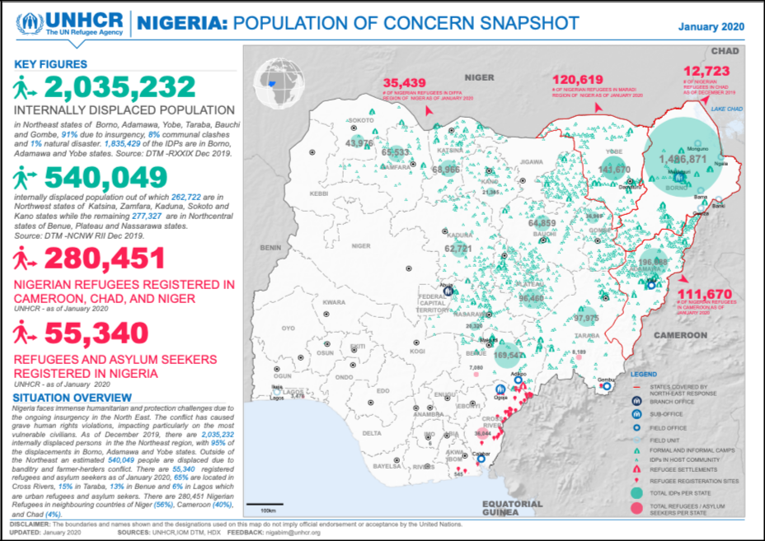

According to Abdulazeez and Oriola (2018), Boko Haram mostly focused on attacking private individuals and their belongings between 2009 and 2014, accounting for 35% or 429 occurrences. According to their documentation, more than half (5,640 deaths) of Boko Haram's killings are directed towards private persons and properties, while the police are their second primary target (17% or 213 incidents). Boko Haram has caused the displacement of 2 million individuals, with 44,800 refugees seeking shelter in Cameroon, around 15,000 people seeking safety in the Republic of Chad, and over 105,000 individuals being forced to leave their homes and relocate to Diffa and other locations in neighbouring Niger. Additionally, there are other internally displaced persons (IDPs) who currently dwell in different regions around Nigeria. According to Abdulazeez and Oriola (2018), there were around 36 officially recognised internally displaced persons (IDP) camps in Borno State in 2015. Furthermore, IDP camps are present in the states of Adamawa, Yobe, Bauchi, Plateau, Kano, and Gombe, as well as in Abuja (refer to Figure 12).

Internally displaced persons (IDPs) are expressing worry that camp officials, including staff from the State Emergency Management Agency (SEMA), security officers, representatives of IDPs, and supervisors from the National Emergency Management Agency (NEMA), are deliberately withholding and stealing assistance items from them. As a result of the prevailing instability, particularly in northeastern Nigeria, the internally displaced persons (IDPs) are not provided with three daily meals. Furthermore, the presence of food in the camp stores does not guarantee the provision of regular meals. According to participants, breakfast is often served at most camps between 12 and 1 p.m. Skipping lunch often leads to having dinner after a late breakfast. Malnutrition is a common occurrence among internally displaced persons (IDPs). Abdulazeez and Oriola (2018) observed a rise in criminal activities within IDP camps due to the significant increase in the number of relatives and friends of camp authorities who enter the camps shortly before political leaders or dignitaries visit. The clandestine intention of this programme is to provide camp administrators with a sufficient number of bodies in order to substantiate the exaggerated figures of internally displaced persons (IDPs) they report, hence justifying the budgetary allocations and material assistance received from the government. These fraudulent schemes involve the utilisation of fictitious internally displaced persons (IDPs) (Abdulazeez & Oriola, 2018).

**Education**

An important consequence of terrorism in Nigeria is the complete breakdown of the educational system, particularly in the northeast region. This is particularly true in northern Nigeria, where the Boko Haram gang, supported by ISIS, maintains control. The escalation of the conflict between Nigerian security forces and Boko Haram has exacerbated the existing lack of development and regional disparities, particularly in the realm of education, between the northern and southern regions. Children, youths, and women are the most vulnerable and impacted demographic groups. Boko Haram use several tactics, like as abduction, suicide bombings, sexual violence against women, and the enlistment of young men like the Almajiris, to carry out their deadly activities (Ojo, 2020). Boko Haram is rooted on a certain Islamic educational ideology that strongly opposes Western civilization and its intellectual impact. Nigeria's persistent standing in the third position in worldwide terrorist effect rankings is unsurprising, as indicated by Figure 4 (Akwara, 2020; Nnam et al., 2020).

In Nigeria, the pursuit of high-quality or simply fundamental education, especially in the northern region, has become a harrowing ordeal for several families since the escalation and radicalization of Boko Haram activities over 10 years ago. Numerous terrorist incursions have had a significant impact on the education sector, resulting in the partial closure of schools and the loss of lives and property. The Chibok girls' kidnapping by Boko Haram stands out as the most prominent terrorist strike on the Nigerian educational system, garnering worldwide attention. On April 15, 2014, a distressing event took place at the Government Secondary School in Chibok, Borno State, Nigeria. A total of 276 female students were abducted, compelled into sexual slavery, and coerced into adopting Islamic beliefs and teachings (Nnam et al., 2020). The abductees, their relatives, Nigerians, and the global community have been permanently affected by the distressing experience of these kidnappings (Ngwama, 2014).

There have been ongoing incidents of abducting school students, particularly when these actions are compensated with significant ransom money. Additional imitative insurgent factions, such as the Fulani herdsmen or bandits, have surfaced in Nigeria, engaging in what appears to be a lucrative enterprise of abducting individuals. The Boko Haram insurgency hinders the administration of education. The targeting or attacking of educational institutions can result in substantial and widespread harm and secondary repercussions. Maintaining the operation of these institutions is frequently challenging because of the apprehension of retaliatory assaults by terrorist organisations (Medugu, 2017). Joshua and Olanrewaju (2016) acknowledged the significance of emphasising that Boko Haram primarily targets Western education, resulting in education being severely impacted by the group's violent acts. The terrorist actions of Boko Haram have exacerbated the educational disparity between the northern and southern regions. The northern region continues to face significant disadvantages. The terrorist attacks had a profound psychological impact on both the surviving teachers and students, which would inevitably affect their ability to teach and learn without appropriate therapeutic support (Medugu, 2017).

**Impact on Education**

The objective of this case study was to examine and evaluate the effects of the Boko Haram and ISIS terrorist insurgency on the process of socialisation, specifically in the field of education, in northeastern Nigeria, using empirical data. The impact on education in northeast Nigeria is shown in the significantly low educational attendance rate of 37.8% (Statista, 2021). The graph depicted in Figure 13 illustrates the gross enrollment rate, which evaluates the enrollment rates of students of all ages, as opposed to the net enrollment rates that only consider students within the statutory age range for a certain educational level. In 2018, the gross enrollment rate in middle schools in Nigeria stood at 54.4%. The states in the southern region recorded the highest percentages, with 52.5% for males and 59.8% for females. The highest rates were observed in Nationwide, Imo, and the Federal Capital Territory (FCT). Nevertheless, the data indicate that there were significant disparities between the northern and southern states.

**Figure 13**

**Enrollment Rate in Private and Public Lower Secondary School in Nigeria as of 2018**

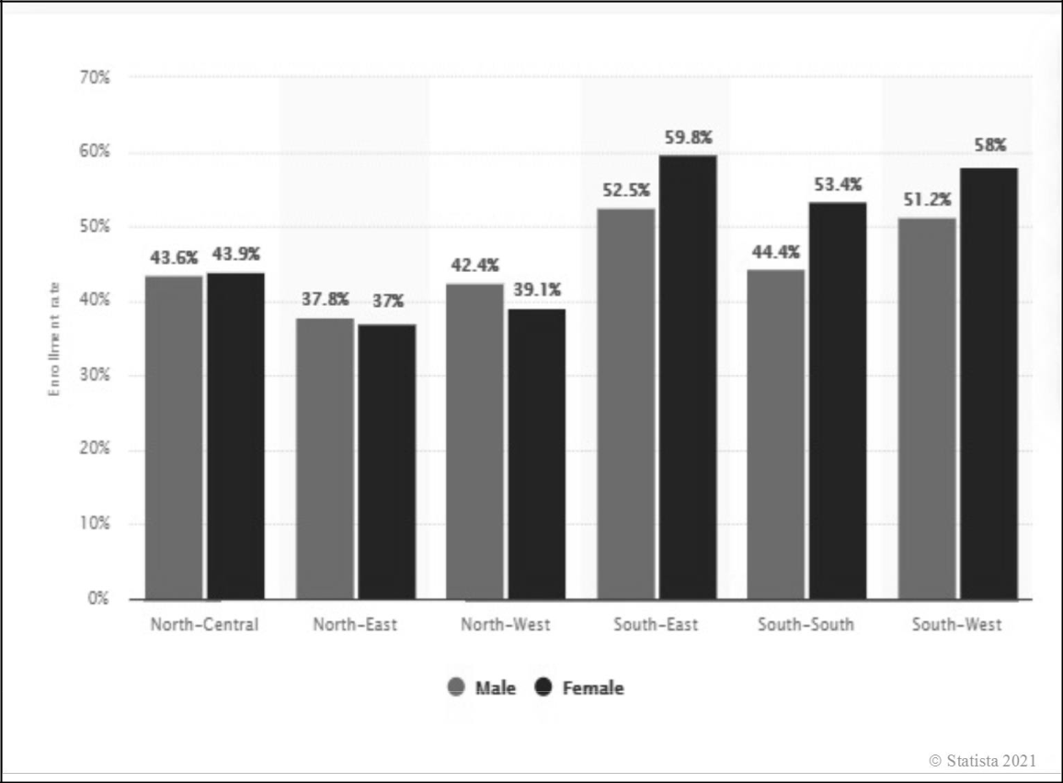

Male enrollment rates in the northeastern states were 37.8%, while female enrollment rates were 37%. The primary aim of this case study is not to make a comparison between the genders of students enrolled in different parts of Nigeria, but rather to demonstrate, using actual data, the influence of the alliance between Boko Haram and ISIS on education in northeastern Nigeria (Statista, 2021).

**Corruption**

Defining "corruption" poses certain challenges, particularly when considering its measurement or modelling. In his work, Jain (2001) defined corruption as the misuse of public office for personal benefit, in a manner that goes against the established rules. According to Evans and Kelikume (2019), numerous researchers have argued that the current violent extremism in Nigeria is a direct result of long-standing corruption and governmental negligence. According to Heywood and Rose (2015), corruption leads to a decline in bureaucratic effectiveness, diminishes tax revenues, poses a threat to political authority, and is fundamentally immoral. Ademu (2013) defines corruption as the act of introducing inappropriate transactions to manipulate the ethical trajectory of events and manipulate judgements and positions of trust. It comprises the actions of individuals who engage in informal, extra-legal, or illegal activities to expedite matters. These individuals can be categorised as the doers (i.e., givers) and the receivers.

Corruption is a commonplace word in the language of every Nigerian citizen. Corruption is widespread in the home, street, associations, groups, public and private bureaucratic organizations, traditional institutions, and even religious institutions. The collapse of the Nigerian traditional institutions, failure of public enterprises, decay and inefficiency of our public service, and the failure of private entrepreneurs to function in our society as agents of change, growth, and development are considered consequences of corruption in our community and body polity. Corruption in all its consequences is a social problem. The causes of corruption are well beyond any individual or institution; it affects society (Bassey et al., 2013). As widespread as corruption is in many countries, very little is understood about what triggers corruption to be greater in one situation than another (Treisman, 2000). Awofeso and Odeyemi (2014) contended that from the outset of Nigeria’s independence attainment, successive sets of the nation’s political leaders and decision-makers at all levels of public life have established systemic corrupt acts and abusive behavior in the country and have thus severely constrained the nation’s development potentials. The Boko Haram and ISIS alliance, which has been (re)christened ISIS-West Africa (ISWA), has changed the northeast to a theater of war. States like Sokoto, Zamfara, Kaduna, and Kastina have become a rendezvous for bandits, marauders, kidnappers, and a host of hoodlums. It has been argued that the current security challenges were the results of corruption strewn in Nigerian state managers’ minds (Ojo, 2020).

**Poverty**

The society holds diverse definitions and opinions regarding the identification of individuals or groups that should be categorised as being in poverty. Gabe (2013) argued that poverty in the United States and worldwide is typically defined for statistical purposes. This definition is based on whether individuals, as categorised by social statistics, have a family income below the poverty threshold. An anomic state arises when there is an unequal emphasis on the aims and methods of attaining financial success (which leads to escaping poverty) within a society. In the absence of reasonable access to these socially acceptable avenues of achieving success, individuals within that community will endeavour to explore alternative methods of attaining financial independence. Merton's strain theory refers to these ways as "modes of adaptation" (Williams & McShane, 2004, p.82).

The stark poverty in Nigeria is a paradox when compared to the plentiful human and physical resources in the country. It is particularly concerning that despite the substantial allocation of people and financial resources to poverty reduction by successive governments, there has been no apparent achievement in this endeavour (Apata et al., 2010). Poverty in Nigeria is an undeniable and pervasive phenomenon that affects the entire country and is characterised by its severity. It portrays a scarcity of sustenance, garments, instruction, lodging, and other fundamental necessities. Unemployment plays a crucial role in exacerbating poverty in Nigeria. The presence of unemployment-induced poverty has a tendency to elevate the crime rate and degree of violence inside the country. The main driving force behind the engagement of unemployed Nigerian youth, particularly in the northeast, in acts of terrorism, armed banditry, kidnapping for ransom, computer fraud, and other criminal activities is poverty (Ucha, 2010). These jobless young individuals were frequently singled out as potential candidates for terrorist organisations like as Boko Haram. By 2008, Boko Haram had formed their own institutions, including the Shura Council, implemented a basic welfare system, created employment opportunities, and distributed microfinance loans to members for initiating entrepreneurial endeavours aimed at reducing economic inequality (Walker, 2018).

According to Evans and Kelikume (2019), the income distribution in Nigeria exhibits a significant degree of skewness, indicating that a majority of the population resides in poverty. The authors asserted that Nigeria suffers from inadequate governance and that poverty plays a crucial role in fueling Boko Haram extremism. Hence, poverty is a clear and direct catalyst for the rise in terrorism. The collaboration between Boko Haram and ISIS has taken advantage of the poverty, particularly in the northeast region, by offering entrepreneurial loans to young people (possible recruits) as an incentive for joining their organisation. Botha and Abdile (2019) identified poverty, work possibilities provided by Boko Haram, life frustration, and lack of education as crucial factors influencing individuals' choice to join Boko Haram.

**Terrorism and Poverty**

Figure 14 illustrates that in 2019, the Nigerian states of Sokoto and Taraba had the most large fraction of the population living below the poverty line. The poverty rate is substantially greater in most of the northern than in the southern states. The south and southwestern states have the lowest poverty rates recorded. In Lagos, this figure was 4.5%, the lowest rate in Nigeria (see figure 14). Individuals are deemed poor in Nigeria when they earn less than 137.4 thousand Nigerian naira (approximately 361 U.S. dollars) each year. Overall, about 40.1% of the population lives in poverty.

**Figure 14**

**Poverty Headcount Rate in Nigeria as of 2019, by State**

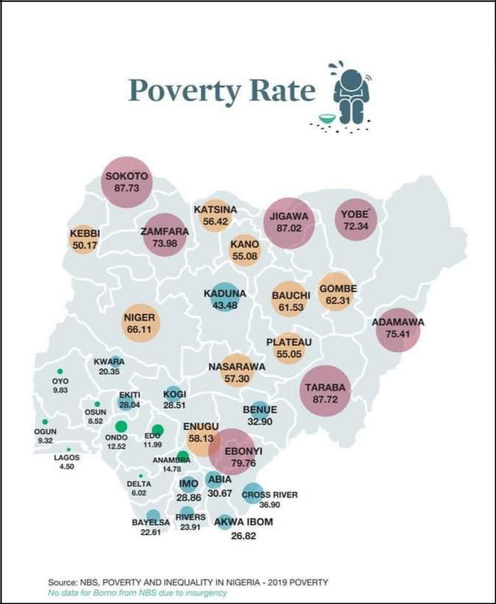

Source: NBS, Poverty and Inequality in Nigeria-2019 Poverty

Figure 14 does not aim to compare poverty rates among Nigerian states. Instead, its purpose is to provide empirical evidence and raise awareness about the severe impact of the ongoing terrorist insurgency on the inhabitants, particularly in the northeast region.

Fulani Herdsmen/Bandits

An adverse outcome of terrorist actions in Nigeria is the effect it has on Fulani herdsmen, who are livestock ranchers. Based on the research conducted by Akpor-Robaro and Lanre-Babalola (2018), the majority of Fulani herdsmen (99.9%) adhere to the Islamic faith and lead either fully nomadic or partially nomadic lifestyles. They have lived in this manner since the early Islamic jihads up till the present day. Historically, the Fula ethnic group, from which Fulani herders descend, has a cultural tradition centred around fighting and conquest as a means of securing their livelihood and survival.

The Fulani make a substantial contribution to the Nigerian economy. Ajibefun (2018) states that they are the leading producers of goats, sheep, and cattle, which serve as the main sources of meat and cost-effective animal proteins consumed by Nigerians. Okeke (2014) contended that the progressive migration of the Hausa-Fulani people towards the south is the primary cause of the persistent ethno-religious disputes in the Central states of Nigeria, particularly in Plateau, Nasarawa, and Benue States. According to Akpor-Robaro and Lanre-Babalola (2018), it is possible that the Fulani herders are essentially Boko Haram disguised in a different form. The Islamic terrorist sect aims to further their objectives by invading the southern region of the country, an area that conventional military have been unable to access. The most pressing issue in the ongoing development is the rampant pillaging, sexual assault, homicide, and abduction of civilians perpetrated by the Fulani herdsmen. Ajibefun (2018) asserted that Nigeria is facing a significant internal security challenge encompassing economic, political, and environmental aspects. The nation's stability has been significantly influenced by each dimension, with the Fulani herdsmen appearing to play a big role in many variables that may be traced back to them. The persistent assaults on the civilian population by the Fulani have necessitated the enactment of a legislation prohibiting open grazing in certain states, such as Benue, located in the northcentral area (Ojo, 2020).

According to Olaniyan and Yahaya (2016), the Fulani perceive cattle herding as a financially rewarding occupation that is demanding, arduous, and tiring, rather than an enjoyable pursuit. Cattle serve several functions, such as producing milk and beef, facilitating cattle breeding and enhancing livestock aesthetics, as well as serving as carriers and generating cash. According to the writers, the Fulani have engaged in cattle raiding for a significant period of time as a cultural tradition that demonstrates their skill and replenishes their diminished livestock. It is often devoid of military presence. Nevertheless, the ongoing wave of rustling is characterised by a significant presence of military forces and poses a grave threat to life. Essentially, the illicit economy serves as a channel for the trafficking of stolen cattle and generates substantial amounts of money. The herders' cash-based mode of commerce has been recognised as a means of financing for terrorist organisations in northern Nigeria. The Nigerian government has shown a comparatively sluggish and mostly responsive approach to addressing this developing security problem. In 2014, a deliberate and coordinated campaign was launched to suppress the insurgency (Olaniyan Yahaya, 2016). However, several ethnic and regional groups view the Nigerian State's reactive approach to the various security challenges as a contributing factor to their desire for self-determination.

**Quest for Ethnic Self-Determination**

The desire for self-determination among ethnic national groups is a common occurrence in world politics, and Nigeria is no exception. Various ethnic groups have consistently pursued self-determination, a matter that has gained more significance since the United Nations Charter of 2007 officially acknowledged the right of ethnic minorities to self-determination (Johnson & Olaniyan, 2017). Nigeria is located in the western region of Africa. The region is characterised by a high population density and significant diversity. As of 2019, it has a population exceeding 200 million, making it the largest in Africa. The population include individuals practicing Christianity, Islam, and various other religious affiliations. Following Nigeria's independence from Britain in 1960, the country has seen a greater duration of military rule compared to civilian rule (Asuni, 2009; Varella, 2020). According to many researchers, Nigeria is home to around 350 distinct ethnic groups, each with their own unique cultures and beliefs. According to Salawu (2010), Nigeria is a multi-ethnic nation-state with more than 400 ethnic groups and several religious sects, a characteristic that has persisted since its independence. Salawu stated that Nigeria has faced challenges with ethnicity and varied anxieties primarily caused by ethno-religious conflicts in various communities. Nigeria can be accurately characterised as one of the most polarised nations in Africa (Osaghae & Suberu, 2005).

Guichaoua (2010) states that Nigeria has had persistent challenges in addressing the issue of national unity, as it seeks to integrate its ethnically and religiously diverse population into a single federal state. Three dominant ethnic groups, including the Hausa-Fulani in the northern region, the Yoruba in the southwest, and the Igbo in the eastern region, collectively make up 50% of the population. Minority communities primarily reside in the Middle Belt or the coastal Niger Delta region (south-south). Membership in ethnic groups is typically determined by attributed factors such as shared history, ancestry, language, race, religion, culture, and territory (Ukiwo, 2005). However, it is important to note that these factors may not always be present in every ethnic group. Ukiwo argued that ethnicity is a tool utilised and strengthened by elites who are based in specific regions, in order to gain control over the government and the wealth that comes with it. Common Nigerians harboured no animosity towards each other; it was the privileged class that orchestrated their division and incited them against each other. The demand for self-determination from prominent ethnic and minority groups is increasing rapidly inside the Nigerian political system, particularly due to the progressive spread of terrorist operations from the northeastern region towards the southern region. Anugwom (2000) posited that ethnicity refers to the phenomenon where a cohesive group of individuals, regardless of their size, exhibit distinct cultural and linguistic characteristics that set them apart from neighbouring groups, forming the foundation for their sense of unity and engagement with others. The Boko Haram and ISIS coalition in Nigeria identifies themselves as a separate entity dedicated to the Islamization of the entire Nigerian nation.

**The Southeastern Region: Indigenous People of Biafra**

The Igbo ethnic group of southeastern Nigeria made an attempt to secede from the Nigerian state in 1967 by declaring the Biafra Republic. Prior to that statement, extensive attempts were made to satisfy all parties involved, but unfortunately, none of them proved successful. The secession attempt led to a devastating 3-year war (1967–1970) that caused immense loss of life and widespread destruction of property and the environment (Johnson & Olaniyan, 2017). Even after more than 50 years since the civil war, the healing process for the wounds, particularly among the Igbos, is still ongoing. According to Ugorji (2017), the early 2000s saw the emergence of renewed calls for the independent state of Biafra. This social crusade, known as the Movement for the Actualization of the Sovereign State of Biafra (MASSOB), was initiated by Ralph Uwazuruike, a skilled lawyer, and quickly captured the public's attention as a nonviolent movement. MASSOB's activities have resulted in several clashes with law enforcement, leading to the arrest of its leader on multiple occasions. However, in contrast to Boko Haram, it did not receive much attention from the international media or the global community.

Nnamdi Kanu, a Nigerian-British man residing in London and born in 1970 at the end of the Nigeria-Biafra war, expressed doubts about the ability of MASSOB to achieve the desired independence of Biafra. He chose to utilise the dynamic platforms of social media and online radio (Radio Biafra) to motivate countless pro-Biafra independence activists, supporters, and sympathisers towards his Biafran mission (Ugorji, 2017). Nnamdi Kanu's approach revolutionised the scene when he founded the Indigenous People of Biafra (IPOB) in 2012. The primary goal was to revive the aspiration for an autonomous state of Biafra in the southeastern region of Nigeria. IPOB gained prominence in 2015, focusing on activism through social media, a website, and the launch of Radio Biafra. This led to significant support, sympathisers, and international attention for the Biafran struggle.

The majority of IPOB's members consist of young individuals from the Igbo ethnic group in Nigeria and abroad. The group's leader, Nnamdi Kanu, was arrested in October 2015 and charged with treason. Despite court injunctions for his release, the Nigerian government persisted in unlawfully detaining him (Chiluwa et al., 2020). According to Chiluwa et al., Kanu's detention resulted in numerous protest marches. Prior to a series of killings, these protests and confrontations with state security forces prompted the Nigerian government to designate IPOB as a terrorist organisation. Kanu jumped bail (while facing charges of treasonable felony) when he was released on health grounds in April 2017. Unfortunately, shortly after his release, the Nigerian security forces invaded his family home. In June 2021, he was re-arrested in collaborative security schemes with the Kenyan authorities (Chiluwa et al., 2020). The government's decision to label IPOB as a terrorist group has inadvertently amplified the pro-Biafra message and increased the group's visibility on the global stage. Nevertheless, the group is not associated with the same acts of kidnapping, bombing, or targeting women and children as Boko Haram. Their ideology starkly contrasts with that of the Boko Haram ISIS alliance, as they assert their pursuit of ethnic self-determination.

**The Niger Delta Region (South-South): Movement for the Emancipation of the Niger Delta (MEND)**

Nigeria is organised into six geopolitical zones, each consisting of six states, as seen in Figure 14. The south-south zone comprises the states of Akwa Ibom, Bayelsa, Cross River, Delta, Edo, and Rivers, arranged in an east to west direction. The phrase Niger Delta typically represents these states, with the exception of Cross River, all of which are involved in oil production. Consequently, it extended its scope to encompass Imo, Abia, and Ondo states due to their status as oil-producing regions. The Niger Delta encompasses nine states and is home to over 140 distinct ethnic groups. These states serve as the primary source of economic prosperity for Nigeria, although they still lack essential living facilities and fail to adequately address poverty among their population (Asuni, 2009).

The prolonged period of disregard and scarcity despite abundant natural resources, coupled with the indifference of consecutive administrations and the exploitation by oil corporations, had resulted in a volatile environment marked by demonstrations, unrest, and disputes in the Niger Delta region of Nigeria by the late 1990s. 80% of the country's foreign profits are generated by this region. The issues in the Niger Delta are evident through multiple manifestations, including acts of militancy, the abduction of hostages, the kidnapping of oil workers, the destruction of oil and gas equipment, and the deliberate disruption of oil production activities.

**Figure 15**

**Six Geopolitical Zones in Nigeria, Their States, and Their Economic Activities**

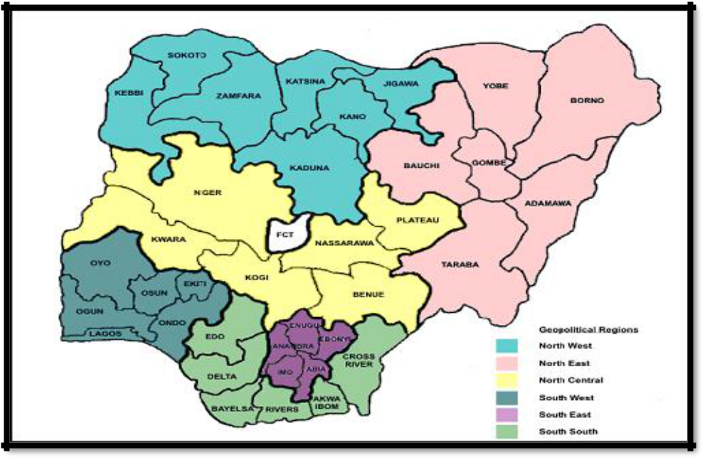

Source: jlukmon. (2017, February 9). How many geopolitical zones are in Nigeria? List. ABOUT NIGERIANS. https://aboutnigerians.com/how-many-geopolitical-zones-are-in-nigeria-list/

The prominent militant organisations in the area include the Movement for the Emancipation of the Niger Delta (MEND), under the leadership of Henry Okah; the Niger Delta Vigilante Force (NDVF), led by Ateke Tom; the Niger Delta People's Volunteer Force (NDPVF), led by Alhaji Asari Dokubo; as well as the Bush Boys, the Martyrs Brigade, and various others. Certain militants, such Dokubo and Tom Polo, have presented themselves as advocates for freedom. These militant groups arose as advocates for their communities in order to combat the avarice and exploitative practices of the Federal government and oil firms (Ogbonnaya & Ehigiamusoe, 2013; Asuni, 2009).   
The political instability of Nigeria during the previous decades can be attributed, in part, to its unique political economy, which is influenced by the abundant natural resources found in the Niger Delta region. Guichaoua (2010) argues that Nigeria's harsh controlling techniques and opaque management of the oil rent have hindered the establishment of harmonious political and redistributive institutions, notwithstanding the country's federal democracy. The failure of successive Nigerian governments to address this issue exacerbated enmity within the region, severely hampering the economy. Ogbonnaya and Ehigiamusoe (2013) observed that hostage-taking and kidnapping swiftly emerged as the primary operational endeavours of numerous terrorist factions in the area. The militants' operational proficiency, along with the advanced nature of their weaponry, has rendered any attempts to control them ineffective. Several inquiries revolve around the origin of the terrorists' firearms and the means through which they acquire military expertise or combat training. Several experts have claimed that the militancy in the region has taken on various criminal aspects instead of remaining a genuine battle for the region's liberation. As the problem in the Niger Delta was being managed, the Boko Haram insurgency emerged, carrying out bombings and killings mostly in the northeastern region, which became the centre of their terrorist actions. The Nigerian military has faced a considerable security problem due to the terrorist operations, particularly because of the sophisticated armament available to these groups.

**The Southwestern Region: The Oodua People’s Congress**

The Oodua People's Congress (OPC), located in the southwestern region, is one of the prominent revolutionary groups that has emerged in response to Nigeria's current condition of insecurity, with the aim of achieving self-determination. As per Guichaoua's (2010) research, the OPC derives its name from Oduduwa. He was the legendary progenitor of the Yoruba people. OPC is a prominent ethnic militia in present-day Nigeria. It was established in August 1994 among contrasting conditions: the unfulfilled commitments of democratic change and the severe suppression of political dissent during the extremely corrupt and oppressive military regime led by General Sani Abacha. Frederick Fasehun, who possessed a high level of education in the medical field, initially engaged in activism related to labour unions and human rights before assuming a leadership role within his ethnic community. The OPC holds significant influence in the states where the Yorubas are the dominant demographic, including Lagos, Edo, Ekiti, Ogun, Osun, Oyo, Ondo, Kwara, and Kogi states. The objectives of OPC, as stated in its constitution, have a distinct nationalist flavour, emphasising the importance of safeguarding the Yoruba cultural and social heritage. The primary political objective of the OPC is to convene a Sovereign National Conference in order to revise the Federation's regulations with the aim of granting more autonomy to the regions (Guichaoua, 2006, 2010). Olarinmoye (2010) said that the OPC originated as a Yoruba socio-cultural group led by Fasehun, who was seen as the moderate faction willing to engage in conversation with the government. However, due to ongoing criticism of the government's handling of the security problem and the demand for regional self-governance, Fasehun was apprehended and incarcerated by the military regime under the leadership of General Sani Abacha.

The OPC's new leadership, led by Gani Adams as Fasehun's deputy, swiftly transformed into a militant faction, adopting a more assertive strategy and embracing vigilantism as a means to address the escalating national insecurity. Aidonojie and Egielewa (2020) contended that the internal security measures implemented by the Federal government are inadequate and ineffectual in addressing the occurrence of criminal activities. In times of great urgency, it becomes necessary to take extreme actions. On January 9, 2020, the governors of southwestern Nigeria took decisive action to address the increasing instability in the region. They established a specialised internal security force called the Amotekun, with the aim of combating criminal activities. The purpose of this regional security organisation was to supplement the efforts of the Nigerian police and generate employment prospects for young individuals in the southwestern region. Today, Sunday Adeniyi Adeyemo, also referred to as Sunday Igboho, has emerged as the prominent figure advocating for the establishment of a Yoruba nation. Following the successful establishment of a security organisation in the southwest, other regions witnessed the formation of similar security outfits, such as the Eastern Security Network (ESN). The Federal government of Nigeria has heavily criticised and attacked some regional security organisations that were founded to protect against Boko Haram terrorist assaults. The government classifies these outfits as illegitimate security agency and advocates for their disbandment.

**Gaps in Research**

Boko Haram's terrorist activities in northeastern Nigeria have resulted in a conflict zone where several casualties have occurred. There is a limited amount of research available on the secondary effects of Boko Haram's pledge of loyalty to ISIS in March 2015, which includes the associated risks to global security. Adesoji (2010) suggests that the issue of Islamic fundamentalism is more deeply ingrained than the Nigerian government's attempts to tackle it. To effectively address the threat posed by the Boko Haram terrorist operations, it is imperative to confront the underlying causes of poverty, unemployment, and inadequate social infrastructure by broad and far-reaching measures. Botha et al. (2017) discovered substantial empirical evidence that supports the primary historical, political, social, economic, and religious ideology elements that still motivate and mobilise Boko Haram. These issues include corruption, unemployment, disparities in resource distribution, political and economic systems, radical religious interpretations and intolerance, limited education, historical conflicts between Muslims and Christians, and unreliable sources of funding. Culp (2019) suggested that future studies should broaden their scope by examining the writings, speeches, and acts of other similar Islamic transnational terrorist organisations.

In addition, future research should incorporate the techniques proposed by a jihadist strategist who emerged after the 9/11 attacks, in order to assess their potential influence on defining ISIS's approach to terrorism. This method aims to establish a connection between terrorism strategists and terrorist organisations, enabling them to get access to new territorial targets. The acceptance of Boko Haram's loyalty by ISIS encapsulates a few of these techniques.

According to the literature, the Nigerian government has been unsuccessful in repelling the coalition's aggression. This dissertation aims to address such deficiency. This study, driven by its exceptional nature, will employ the fundamental notions of anomie and strain. Additional theoretical theories will be analysed to reflect the instability associated with Boko Haram's affiliation with ISIS, the devastation of Nigeria's northeastern region, and the alarming spread to other areas of the country.

**CHAPTER 3**

**METHODOLOGY**

**Case Study Research**

This dissertation presents a comprehensive case study and analysis of academic research focused on the insurgency of Boko Haram, a terrorist group operating in Nigeria. The main concerns are related to the ideology of terrorism, the effects of terrorism on education, economy, and poverty in Nigeria, the risks associated with reintegrating former Boko Haram members, the response of the Nigerian military, and the role of religiosity in attracting potential recruits worldwide. This dissertation study utilised the qualitative technique for the case study, and no hypothesis was necessary. The implementation of the case study application enhanced the understanding of terrorist insurgencies in Nigeria. The application of this study also aimed to comprehend the intricate characteristics of terrorism perpetrated by individuals affiliated with the Boko Haram group in Nigeria, as well as identify potential avenues for future research. The qualitative research design approach employed in this case study involved gathering pertinent data from sources such as Google Scholar, the Texas Southern University e-library, and the Global Terrorism Database. The collected information was then analysed, and the findings were reported in a systematic manner. In the field of ethnography, the complete group of people who share a culture can be seen as a case. However, the main goal of ethnography is to understand the functioning of that culture (Creswell & Poth, 2016). Creswell and Poth (2016) define case study research as a methodology that considers a case study as its primary approach. Case study is a qualitative research method in which the researcher examines specific, real-world systems or situations.

According to Yin (1984), case study research is a method of empirical investigation that examines a recent occurrence within a factual framework, particularly when the borders between the phenomenon and context are not well-defined. This type of research also relies on numerous sources of data. Yin (2014) states that case study research encompasses investigations that focus on real-life problems, current circumstances, and the collaboration between Boko Haram and ISIS terrorists, all of which align with this definition. This case study research utilised and compared data extracted from relevant secondary sources, such as articles, journals, and books, which were utilised as supporting evidence for the study. This study also examined the social and economic effects observed in the northern regions of Nigeria, which have a primarily Muslim population, in comparison to their southern counterparts. The focus was also placed on documented instances of violence and violent assaults carried out by Boko Haram, resulting in numerous fatalities in the northern and Middle belt regions of Nigeria.

Existing academic writing and research provide an analysis of the evolution of Boko Haram over the past two decades (2000-2020), illustrating its transformation into a resilient insurgency. I conducted an analysis of the variables, including the stated loyalty to ISIS, that played a significant role in Boko Haram's swift ascent, its capability to seize extensive land, and its domination over numerous urban areas in northeast Nigeria.

This research is characterised by its focus on the ongoing terrorist actions in Nigeria. It utilises pertinent secondary data obtained from reputable sources such as Google Scholar, ProQuest, library search engines of different universities, and the Global Terrorism Index (GTI). This entails a methodical assessment of social occurrences through the interpretation of extensive qualitative data collects and communications (Schreier, 2012; Neuendorf & Kumar, 2015). Yin (2009) states that the data will be analysed using an embedded analytic approach, focusing on a specific component of the case under consideration. My objective was to examine the methodologies employed by previous researchers in studying terrorism and highlight important topics, procedures, and interactions that warrant further examination (particularly the collaboration between Boko Haram and ISIS) and their significant influence on the Nigerian political landscape.

**Research Participants**

This research project did not involve any research participants or population. This study primarily examines the cooperation between two of the most lethal terrorist organisations in the world, Boko Haram and ISIS, during a period of two decades (2000–2020). The coalition formed by these factions has caused immense destruction in the northeastern region of Nigeria and is rapidly spreading over the entire country. Due to the Nigerian government's inadequate measures in preventing the probable destruction of the country, this alliance poses collateral repercussions that endanger world security.

**Data Collection /Sampling Procedure**

The case study utilised secondary data sources such as journal papers, books, and government publications spanning from 2000 to 2020 as the main data for research analysis. The primary sources of data were the Global Terrorism Database (GTD), which is the most crucial database in the field of counter-terrorism, Google scholar, Texas Southern University e-library, and the Global Terrorism Index (GTI) report, which provides a comprehensive analysis of global trends and patterns in terrorism. The GTI report acquires its data from the GTD, which is currently the most authoritative data source on terrorism. The GTD is unique since it has systematically and fully classified data about 170,000 terrorist occurrences. The GTI (2018) generates a composite score that allows for the ordinal ranking of countries based on the impact of terrorism. This score assists research organisations in extracting insights from unstructured or qualitative sources such as journals, papers, surveys with open-ended questions, social media, and web material. A comprehensive examination of a wide variety is necessary.

For this case study, sampling did not need face-to-face interviews or solicitation of participants. The research dissertation proposal was assigned the protocol number 1641. The study was granted exemption from the full committee review of the Institutional Review Board (IRB) at Texas Southern University. This exemption was possible because the study is based on secondary research and does not require consent. Hence, the study processes satisfy the criteria for exemption as defined by Federal regulation 45 CFR 46.104(d)(4), and it was officially granted exemption.

**Research Instruments**

This dissertation research is a focused study of a single case, employing a qualitative methodology, and does not necessitate the formulation of a hypothesis. The initiative excluded the use of human participants, animal models, radioactive materials, and recombinant DNA. The study employed secondary data derived from articles, scholarly journals, and books to address five research inquiries. The research topics investigate the alliance and collaboration outcomes of the two most feared terrorist organisations worldwide, Boko Haram and ISIS. The case study's inquiries also examined education and poverty, while analysing the Nigerian governments' efforts to combat the threat of terrorism. Ultimately, it examined the potential structural flaws in the reintegration procedures for former Boko Haram militants. These are the four core research questions:

**Research Questions**

**RQ1:** What impact does the insurgence of the Boko Haram and ISIS alliance have on the agents of socialization (education) in Nigeria?

**RQ2:** Does poverty impact the recruitment of foot soldiers for terrorist activities in Nigeria?

**RQ3:** How effective has the Nigerian military’s response been in curtailing the terrorist attacks orchestrated by the Boko Haram–ISIS alliance?

**RQ4:** What are the structural deficiencies in the risk assessment reintegration processes for former Boko Haram members?

**Qualitative Data Analysis Procedure**

The case study research methodology, which is a qualitative approach, allows the researcher to thoroughly investigate a specific real-life system or multiple systems over time. This involves collecting detailed and comprehensive data from various sources, describing the case(s), and providing a descriptive analysis of the themes involved (Creswell & Poth, 2016). This study used a qualitative research methodology to investigate the indirect repercussions of terrorism, specifically focusing on the global security risk posed by the partnership between Boko Haram and ISIS. The text elucidates that the intricate causal connections in real-life interventions often surpass the capabilities of surveys or experimental procedures.

**CHAPTER 4**

**PRESENTATION AND ANALYSIS OF FINDINGS**

The objective of this case study was to identify and analyse the persistent terrorist insurgency in Nigeria spanning from 2000 to 2020. Another objective was to analyse the implications of Boko Haram and ISIS as a global security menace. The chapter discusses the conclusions of this case study, which were derived from the four research questions formulated and based on the literature reviews conducted on the dissertation issue. The researcher's capacity to address the research inquiries is of utmost importance in raising awareness about the dissertation issue being studied. Furthermore, it is an opportunity to unveil a fresh outlook on the investigated subject. Lastly, it provides support for the discussion, research, and policy suggestions parts of this dissertation's final chapter.

**RQ1: What impact does the insurgence of the Boko Haram and ISIS alliance have on the agents of socialization (education) in Nigeria?**

The primary study inquiry focused on examining the influence of the partnership between Boko Haram and ISIS terrorists on socialisation agents, namely education, in Nigeria. This case study dissertation establishes a direct correlation between the detrimental effects of Boko Haram's terrorist actions, with the support of ISIS, on Nigeria's educational system and the low rate of enrollment in both private and public lower secondary schools, particularly in the northern region (refer to Figure 13). The research have shown that the Boko Haram conflict negatively affects the administration of education. The Chibok girls' kidnapping by Boko Haram stands out as the most prominent terrorist strike on the Nigerian school system, garnering international recognition. On April 15, 2014, a group of 276 female students from Government Secondary School in Chibok, Borno State, Nigeria, were abducted and subjected to sexual slavery. They were also compelled to adopt Islamic beliefs and teachings (Nnam et al., 2020). The kidnappings inflicted lasting damage on the abductees, their families, the Nigerian population, and the worldwide community (Ngwama, 2014).

In 2018, the Boko Haram terrorist group kidnapped 110 schoolgirls, aged 11-19 years, from the Government Girls Science and Technical College in Dapchi, Nigeria, similar to the Chibok girls' ordeal. Subsequently, all the female individuals were freed, with the exception of Leah Sheribu, a young Christian girl who steadfastly declined to embrace Islam. The targeting or attacking of educational institutions can result in substantial and widespread harm and secondary repercussions. Maintaining the operation of these institutions is frequently challenging due to the apprehension of retaliatory assaults by terrorist organisations (Medugu, 2017). According to Joshua and Olanrewaju (2016), it is crucial to highlight that Boko Haram primarily targets Western education. Terrorist groups have severely impacted education by their violent activities. The terrorist actions of Boko Haram have exacerbated the educational disparity between the northern and southern regions.

The surveys also indicated that the northern regions continue to face significant educational disadvantages, with the lowest enrollment rates of 37.8% for males and 37% for females. The terrorist attacks clearly had a profound influence on the teaching and learning capacities of both surviving teachers and pupils, due to the psychological trauma they endured. This damage can only be mitigated with appropriate therapy tools (Medugu, 2017). The primary objective of this study was not to do a comparative analysis of the influence of insurgencies on agents of socialisation in the three main regions of Nigeria. Instead, the aim was to provide statistical evidence of the impact of terrorism on education using empirical data. The empirical studies reviewed have verified the substantial influence of the Boko Haram and ISIS terrorist insurgencies on schooling.

**RQ2: Does poverty impact the recruitment of foot soldiers for terrorist activities in Nigeria?**

The second study inquiry focuses on the influence of poverty on the enlistment of individuals for terrorist operations in Nigeria. The majority of the literature examined and existing empirical evidence corroborate the connection between poverty and terrorist insurgencies in Nigeria. Williams and McShane (2004) argue that when a society does not evenly emphasise both the goals and the methods of obtaining financial success and escaping poverty, it creates a state of anomy. In the absence of equitable opportunities to access these socially sanctioned avenues of achievement, individuals within that community would strive to explore alternative paths to attain economic independence. Merton's strain theory refers to these ways as "modes of adaptation." It is particularly concerning that despite the substantial allocation of people and financial resources to poverty reduction by successive governments, there has been no apparent achievement in this endeavour (Apata et al., 2010).

The main driving force behind the engagement of unemployed Nigerian youth, particularly in the northeast, in acts of terrorism, armed banditry, kidnapping for ransom, online fraud, and other forms of fraudulent activity is poverty (Ucha, 2010). These jobless young individuals were frequently singled out as potential candidates for terrorist organisations like as Boko Haram. By 2008, Boko Haram had built their own institutions, such as the Shura Council, and implemented a basic welfare system. They also offered employment opportunities and granted microfinance loans to members, enabling them to initiate entrepreneurial endeavours aimed at reducing economic inequality (Walker, 2018). The NBS 2019 poverty and inequality report confirmed that the states of Sokoto and Taraba in Nigeria have the highest percentage of their people living below the poverty line. The majority of northern states have a significantly higher poverty rate, with Sokoto state having the highest rate at 87.73%, while Lagos state in the south has the lowest percentage at 4.5%. This disparity can be attributed to the terrorist actions of Boko Haram. According to Botha and Abdile (2019), poverty, the employment prospects offered by Boko Haram, life frustration, and lack of education are identified as crucial factors that contribute to individuals' choice to join Boko Haram. This case study, which includes a thorough examination of existing literature, establishes a strong correlation between the elevated poverty rate and the occurrence of insurgencies, particularly in the northeastern region of Nigeria (refer to Figure 14).

**RQ3: How effective has the Nigerian military’s response been in curtailing the terrorist attacks orchestrated by the Boko Haram–ISIS alliance?**

The third research question of this case study focused on evaluating the efficacy of the Nigerian military's efforts to suppress the terrorist activities carried out by the Boko Haram-ISIS alliance. The majority of the literature reviewed provided evidence that the Boko Haram terrorist activities have resulted in significant loss of lives, destruction of property, and disruption of the economy in the affected regions. Empirical studies have confirmed that the Nigerian government has made substantial investments in military resources to combat terrorism. However, Onuoha et al. (2020) argue that despite the increase in the security sector budget from approximately US$1.44 billion in 2009 to US$2.81 billion in 2018, the military-led counterinsurgency operation in Nigeria still encounters significant funding obstacles.   
  
 According to Mac Ginty & Richmond (2013), there is a growing trend of promoting nonmilitary methods as a viable solution to effectively combat the escalating issue of terrorism and insurgency. Studies suggest that nonmilitary approaches, such as political negotiations, deradicalization efforts, disengagement initiatives, amnesty programmes, and reintegration schemes, are more effective in addressing the root causes of terrorism and achieving long-lasting peace. This case study effectively established a direct correlation between the continuous escalation of Boko Haram terrorist activities, including bombings, kidnappings, and extensive loss of lives and property, particularly in the northeastern region of Nigeria, and the Nigerian government's deficient governance, insufficient allocation of funds to the military, and reactive military strategies (Raji et al., 2021).   
  
 Thus far, the endeavours to mitigate insecurity have instead exacerbated it. The military's participation in domestic security has exacerbated instability as a result of their unskilled and unprofessional methods. According to De Montclos (2020), Nigeria has been unable to overcome the Boko Haram organisation since 2009, even though an antiterrorist coalition called the Multinational Joint Task Force (MNJTF) was formed in 2015 with Cameroon, Chad, and Niger. Instead, it retreated into fortified encampments, so allowing the terrorist organisation to freely operate in the northeastern region of Nigeria. The figure below displays the military expenditure to gross domestic product (GDP) ratio of Nigeria from 2009 to 2019. In 2019, Nigeria allocated approximately 0.46% of its gross domestic product to military expenditures.

**RQ4: What are the structural deficiencies in the risk assessment reintegration processes for former Boko Haram members?**

The fourth and last study inquiry pertains to the structural inadequacies in the risk assessment reintegration procedures for former members of the Boko Haram terrorist group. The reintegration processes of community members who have committed offences are crucial for maintaining public safety and provide a chance for coordinated efforts by security authorities. Based on the literature examined in this case study, radicalization is driven by several elements that may be categorised into three analytical frameworks: push, pull, and personal qualities. Push factors elucidate the inherent flaws within a society that compel individuals to adopt violent extremism. These aspects can be attributed to the strain theory, which serves as the primary guiding hypothesis in this work. Their examples are sometimes referred to as the underlying factors, encompassing issues such as poor governance, poverty and unemployment, significant socio-economic disparities, lack of education, political marginalisation and exclusion, and government repression. Gaining comprehension of the aforementioned aspects is an essential component of the deradicalization process. Deradicalization primarily focuses on addressing the most extreme form of radicalism, with the goal of altering the violent ideologies held by individuals, even if they have not yet participated in any physical acts of violence (Onapajo & Ozden, 2020). Nevertheless, Botha and Abdile (2019) argued that Boko Haram members' disengagement or loss of faith in the organisation should not be equated with their deradicalization. Even those who have been abducted and coerced into joining the organisation, without being originally radicalised or recruited, necessitate psychiatric support upon their reintegration into their families and the wider community.

**CHAPTER 5**

**DISCUSSION**

The main objective of this case study was to identify and analyse the persistent terrorist insurgency in Nigeria from 2000 to 2020. The primary objective was to analyse the connection between Boko Haram and ISIS and the resulting worldwide security risk. The prevailing instability in Nigeria has significantly burdened its diverse government security services, as a multitude of societal problems have led to a sense of surrender due to their failure to effectively employ coercion and suppression to quell the insurgencies. Rather than the anticipated removal of the Boko Haram terrorist groups, this circumstance has resulted in the revival of terrorist operations, particularly in the northeastern region of the country. This chapter encompasses an analysis of the results, constraints, and a concise overview of the study, followed by suggestions for future research and policies, prior to reaching a conclusion.

The terrorist activities have caused immense grief to countless unemployed youths who may have lost confidence in their government's capacity to safeguard their lives and properties. These young individuals, such as the Almajiris, are lured, indoctrinated, and manipulated into joining terrorist organisations by being promised personal liberation. They have become a fertile source of potential recruits for various parties to employ as infantry in their pursuit of establishing control over the broader community in order to achieve their political, religious, and ideological objectives. The Nigerian government has attempted to employ rehabilitation programmes in order to disengage these young individuals from radical ideologies. However, they have encountered challenges due to the social adaptation difficulties faced by the reintegrated former combatants. The communities continue to regard them as perilous individuals who are not welcome to reintegrate into their midst (Onapajo & Ozden, 2020). Enhancing transparency and fostering community engagement through public enlightenment programmes would have a beneficial effect on the government's efforts to curb these terrorist attacks. In August 2021, terrorists launched an attack on the Nigerian Defence Academy (NDA), a prestigious military school in northern Nigeria, resulting in the loss of lives of high-ranking military officials. This is one of the numerous instances of security breaches that happen every Friday. Government institutions such as the NDA, which allow the public to attend Jumaat prayers, experience infiltration by terrorist elements who regularly visit the officer's mess, gather intelligence on military operations, and plot attacks on susceptible targets. The government typically labels these terrorist elements as bandits or unknown gunmen, a practice that is perceived as the Nigerian government's indifferent approach to addressing terrorism-related matters. The government's seemingly indifferent position must be altered in order to suppress the insurgencies, as the bravery and competence of the Nigerian military personnel in several international peacekeeping endeavours have never been questioned. The primary challenge lies in effectively implementing policies and enhancing the limited military resources to counter terrorist organisations operating within Nigeria. Nigerian authorities can demonstrate selflessness by ensuring that allocated monies for arms procurement are directed towards acquiring the necessary military resources, rather than being misappropriated. The absence of transparency and accountability around the acquisition of military gear and software has hindered efforts to eliminate terrorist operations in Nigeria.

**Limitations**

It is crucial to acknowledge that this dissertation may not have addressed all the topics pertaining to acts of terrorism carried out by Boko Haram as a terrorist organisation in Nigeria. A notable constraint of this case study is the complexity and difficulty in empirically studying themes related to terrorism due to the absence of a definitive definition of terrorism or a clear understanding of what constitutes a terrorist. The definition of terrorism varies depending on the researcher's perspective, objectives, and the specific time period they are studying (Ronczkowski, 2018). Terrorism can occur not only in aberrant circumstances or foreign systems, but also in typical institutions and unexpected scenarios. Bagaji et al. (2012) have characterised it as both a strategic manoeuvre and a deliberate scheme, a criminal act and a sacred obligation, a justifiable response to oppression, and an unforgivable atrocity. According to the common saying, an individual who is considered a terrorist by one person may be seen as a freedom fighter by another.   
  
 This research mostly relies on secondary sources to gain knowledge and in-depth understanding of the global security danger posed by the partnership between Boko Haram and ISIS in Nigeria. Obtaining original data on terrorism directly from terrorists is extremely complex, hazardous, and costly, therefore firsthand information/statistics on the crime are frequently gathered, categorised, and regulated by government security services. These necessary steps implemented by the government and its security services, however understandable, provide challenges for researchers in obtaining firsthand statistical data to empirically report these instances to the scientific community.

**Recommendation for Future Research**

Subsequent research should conduct a comparative and analytical examination of terrorist operations carried out by Boko Haram and ISIS-affiliated factions after the year 2020 across all 36 Nigerian states, including the federal capital territory, Abuja. The objective is to identify effective measures that may be implemented to diminish or eliminate these acts of terrorism and enhance public safety. Further research can investigate matters pertaining to resource control in the three primary areas of Nigeria, which frequently serve as a catalyst for ensuring equity and fairness in the allocation of the nation's income derived from natural resources. Ultimately, one might do a comparative examination of West African nations, where ISIS-supported terrorist organisations persistently strive to build a caliphate within the African continent.

**Policy Recommendation**

**Community Engagement and Religiosity.** There is no straightforward and singular answer that will put a stop to these acts of terrorism. However, it is crucial to highlight that the expected policy proposals would help avert the same problems that caused the Nigerian civil war from 1967 to 1970. Undoubtedly, there has been a prevailing atmosphere of increasing discontent and complete lack of confidence in the Nigerian government in recent years due to distressing accounts of widespread corruption among the elite, social injustice, exploitation of the general population, and the inability to provide the promised benefits of democracy (Onapajo & Ozden, 2020). Furthermore, in order to tackle the increasing public frustration and ongoing terrorist operations carried out by Boko Haram, it is imperative for the government to implement community engagement. The establishment of a multidisciplinary force of the military, police, civil defence agencies, nongovernmental agencies, and community leaders across the 36 states and 774 local government areas is necessary to effectively combat these terrorist groups.

**High Skills Training for Youths.** Encouraging the participation of young individuals in government training programmes that need advanced skills will significantly help in reducing the inclination to join terrorist organisations. O’Connor (2009) states that terrorists employ a threefold approach consisting of investigation, preparation, and execution in their modes of operation. These phases can be thwarted through timely identification, exploration, and monitoring with active community involvement. The government should engage the community in these collaborative counter-attack efforts, primarily to acquire intelligence and foster confidence amongst local security services and organisations (Onwudiwe et al., 2016).

**Reintegration Supervisory Programs.** The implementation of operation safe corridor and the establishment of the Countering Violent Extremism agency, known as the National Security Corridor, with the aim of preventing recruitment and mobilisation into Boko Haram, as well as rehabilitating defectors under the guidance of a psychologist, is a positive and strategic move. The programme categorised Boko Haram terrorist defectors into three distinct groups based on their level of risk: low-risk, medium-risk, and high-risk defectors. The initial two categories employed disengagement, rehabilitation, and reintegration strategies, whereas the high-risk defectors were subject to prosecution. It is necessary to evaluate these processes, which refer to various supervisory models, in order to conform to international standards and customise them to suit the Nigerian system. Criminal justice professionals, social workers, and trauma counsellors should engage in collaboration with health and security organisations to facilitate the reintegration of former Boko Haram terrorist members. Specifically, all the models for supervised reintegration should be focused on the period after prosecution. To determine the appropriate duration for fully reintegrating high-risk defectors, the unit or group of experts does not have to start from scratch; they can become deeply involved with the Nigerian National Orientation Agency (NOA). The primary objective of the NOA is to enhance public consciousness, effectively alter attitudes, values, and behaviours, precisely and enough disseminate information, and adequately rally citizens to do actions that would foster public tranquilly and concord. The media business should fulfil its role as vigilant overseers by actively practicing people-centered and impartial investigative journalism.

**Military.** This case study clearly demonstrates that Nigeria's military's authoritarian and reactive approach towards the Boko Haram terrorist group is failing to achieve the desired containment outcomes. The continuous devastation continues to claim several lives and destroy countless properties. The proficiency of the Nigerian military has consistently been unquestionable, seen through their commendable demonstrations of bravery in both international and domestic deployments. However, policymakers should promptly conduct a comprehensive evaluation of military strategies, such as cross-border cooperation, training, and allocation of software and hardware resources, in order to effectively tackle the underlying factors behind these acts of terrorism. There is a significant discrepancy in the reintegration of repentant Boko Haram terrorists into security agencies, such as the military, as they undergo minimum scrutiny and evaluation. The lack of strictness in the processes of reintegrating Boko Haram militants into security agencies has made these agencies more vulnerable to outside attacks, facilitated by insiders who collaborate with the attackers.

**Religion.** The literature clearly demonstrates that religion plays a prominent part in the indoctrination of prospective recruits into the Boko Haram terrorist organisation. Religious leaders should be held responsible for their involvement in radicalising susceptible young individuals through religious indoctrination. There should be no lenient or exempt treatment when dealing with any religious leader discovered to be an explicit advocate of religious extremism. Religious leaders should genuinely advocate for tolerance, peaceful coexistence among communities, and the primacy of state laws over religious dogma. The government ought to involve religious leaders in the procedures of deradicalizing and reintegrating former Boko Haram members into the community.

**Resource Control.** The Nigerian economy heavily relies on the petroleum industry to generate foreign earnings and ensure long-term growth. The source of these abundant natural riches is the Niger Delta region of the country. However, the host communities only receive a meagre 13% allotment from the federal government's earnings. The Nigerian government should reassess the existing framework of the 13% resource control derivative in order to incorporate principles of equity, justice, and fairness. The Nigerian government implemented the Petroleum Industry Act (PIA) which includes enhanced incentives for investment in the gas sector. Implementing a 10-year tax exemption for mainstream investments is a positive and progressive move. It is expected that this tax break will establish a stronger structure to stimulate economic expansion in the Nigerian oil and gas sector.

**Conclusion**

This case study further underscores the necessity of conducting empirical research prior to formulating and executing policy regarding the intricate matter of terrorism, specifically in relation to addressing the Boko Haram terrorist organisation in Nigeria. Within a period of 20 years (2000-2020), a faction of religious fanatics has taken advantage of government shortcomings and evolved into one of the most aggressive terrorist organisations globally. World leaders should collectively support the Nigerian state in preventing terrorist operations to avoid an uncontrollable tragedy, in the interest of global security. The Nigerian government should reexamine the proposals put forth by the Oputa group, which were submitted in 2002. An important assessment highlighted the necessity for regions to effectively oversee their resources and actively contribute to the central pool, thereby reducing the federal monopoly and prioritising decentralisation. This realignment will foster robust competition among different regions, including the cocoa sector in the western region, tin, zinc, gold, and groundnut pyramids in the northern region, and oil and gas resources in the southern region. The decentralisation and administration of these natural resources could be the desired solution for all ethnic groups to effectively govern their limited resources amongst the abundance inside their local area.

**REFERENCES**

Abdulazeez, M. A., & Oriola, T. B. (2018). Criminogenic patterns in the management of Boko Haram’s human displacement situation. Third World Quarterly, 39(1), 85– 103.

Ademu, W. A. (2013). Eradicating corruption in public office in Nigeria. Interpersona:

An International Journal on Personal Relationships, 7(2), 311–322.

Adesoji, A. (2010). The Boko Haram uprising and Islamic revivalism in Nigeria. Africa Spectrum, 45(2), 95–108.

Adesoji, A. O. (2011). Between Maitatsine and Boko Haram: Islamic fundamentalism and the response of the Nigerian State. Africa Today, 57(4), 99–119.

Adelaja, A. O., Labo, A., & Penar, E. (2018). Public opinion on the root causes of terrorism and objectives of terrorists: A Boko Haram case study. Perspectives on Terrorism, 12(3), 35–49.

Agbiboa, D. E. (2013). No retreat, no surrender: Understanding the religious terrorism of Boko Haram in Nigeria. African Study Monographs, 34(2), 65-84.

Aghedo, I., & James Eke, S. (2013). From alms to arms: the Almajiri phenomenon and internal security in northern Nigeria. Korean Journal of Policy Studies, 28.

Agnew, R. (1992). Foundation for a general strain theory of crime and delinquency. Criminology, 30(1), 47–88.

Agnew, R. (2006). General strain theory: Current status and directions for further research. Taking stock: The status of criminological theory, 15, 101–123.

Ahmed, S. (2015). What is Islam? Princeton University.

Aidonojie, P., & Egielewa, P. (2020). Criminality and the media: Perception and legality of the Amotekun Security Agency in Nigeria. International Journal of Comparative Law and Legal Philosophy (Ijocllep), 1(3).

Ajibefun, M. B. (2018). Social and economic effects of the menace of Fulani herdsmen crises in Nigeria. Journal of Educational and Social Research, 8(2), P.133.

Akanni, A. A. (2014). History of terrorism, youth psychology, and unemployment in Nigeria. Journal of Pan African Studies, 7(3), 65–66.

Apata, T. G., Apata, O. M., Igbalajobi, O. A., & Awoniyi, S. M. O. (2010). Determinants of rural poverty in Nigeria: Evidence from small holder farmers in south-western Nigeria. International Journal of Science and Technology Education Research, 1(4), 85–91.

Akpor-Robaro, M. O. M., & Lanre-Babalola, F. O. (2018). Nomadic Fulani herdsmen turn terrorists? Exploring the situation and the security implications for Nigeria. IOSR Journal of Humanities and Social Science, 23(7).

Akume, A. T. (2015). The question of internally displaced persons (IDPs) in Nigeria: A reflection on present realities. Journal of Third World Studies, 32(1), 221–244.

Amao, O. B. (2020). A decade of terror: Revisiting Nigeria’s interminable Boko Haram insurgency. Security Journal, 1–19.

Amuda, Y. J. (2019). Application of WAQF property as a financial instrument for the internally displaced persons (IDPs) in Nigeria. Journal of Legal, Ethical and Regulatory Issues, 22, 1–11.

Anugwom, E. E. (2000). Ethnic conflict and democracy in Nigeria: The marginalisation question. Journal of Social Development in Africa, 15(1), 61–78.

Asuni, J. B. (2009). Understanding the armed groups of the Niger Delta (pp. 1–27). Council on Foreign Relations.

Awofeso, O., & Odeyemi, T. I. (2014). The impact of political leadership and corruption on Nigeria’s development since independence. Journal of Sustainable Development, 7(5), 240–253.

Bagaji, A. S. Y., Etila, M. S., & Ogbadu, E. E. (2012). Boko Haram and the recurring bomb attacks in Nigeria: Attempt to impose religious ideology through terrorism? Cross-Cultural Communication, 8(1), 33–41.

Bassey, A. O., Abia, R. P., Attah F., & Bassey, U. A. (2013). Corruption as a social problem and its implication on Nigerian society: A review of anticorruption policies. Mediterranean Journal of Social Sciences, 4(1).

Bernburg, J. G. (2002). Anomie, social change, and crime. A theoretical examination of institutional‐anomie theory. British Journal of Criminology, 42(4), 729–742.

Bernard, T. J., Snipes, J. B., & Gerould, A. L. (2016) Vold’s theoretical criminology (7th ed.). Oxford University.

Botha, A., Ewi, M., Salifu, U., & Abdile, M. (2017). Understanding Nigerian citizens’ perspectives on Boko Haram. Institute for Security Studies Monographs, 2017(196), 1–112.

Botha, A., & Abdile, M. (2019). Reality versus perception: Toward understanding Boko Haram in Nigeria. Studies in Conflict & Terrorism, 42(5), 493–519.

Breckenridge, J.N., Zimbardo, P.G.: The strategy of terrorism and the psychology of mass-mediated fear. In: Bongar, B., Brown, L.M., Beutler, L.E., Breckenridge, J.N., Zimbardo, P.G. (eds.) Psychology of Terrorism, pp. 117–131. Oxford University Press, New York City (2007)

Campbell, J. (2013). Nigeria: Dancing on the brink. Rowman & Littlefield.

Campbell, J. (2014). Boko Haram: Origins, challenges, and responses. NOREF Policy Brief, 1.

Chiluwa, I., Taiwo, R., & Ajiboye, E. (2020). Hate speech and political media discourse in Nigeria: The case of the indigenous people of Biafra. International Journal of Media & Cultural Politics, 16(2), 191–212.

Creswell, J. W., & Poth, C. N. (2016). Qualitative inquiry and research design: Choosing among five approaches. Sage.

Culp, R. B. (2019). Expert perspectives on how the Islamic state potentially shaped the future of Islamic transnational terrorism: An exploratory study.

Denny, F. (2015). An introduction to Islam. Routledge.

Dike, V. E. (2014). Leadership and the Nigerian economy. Sage Open, 4(1), 2158244014523792.

de Montclos, M. A. P. (2020). The Nigerian military response to Boko Haram: A critical analysis. African Conflict and Peacebuilding Review, 10(2), 65–82.

[Durkheim, E. (1897/1951). Suicide A study in sociology. New York The Free Press. -](https://www.scirp.org/(S(351jmbntvnsjt1aadkposzje))/reference/ReferencesPapers.aspx?ReferenceID=406667) [References - Scientific Research Publishing (scirp.org)](https://www.scirp.org/(S(351jmbntvnsjt1aadkposzje))/reference/ReferencesPapers.aspx?ReferenceID=406667)

Evans, O., & Kelikume, I. (2019). The impact of poverty, unemployment, inequality, corruption and poor governance on Niger Delta militancy, Boko Haram terrorism and Fulani herdsmen attacks in Nigeria. International Journal of Management, Economics and Social Sciences, 8(2), 58–80.

Falola, T., Genova, A., & Heaton, M. M. (2018). Historical dictionary of Nigeria. Rowman & Littlefield.

Gabe, T. (2013). Poverty in the United States: 2012. Congressional Research Service Report to Congress. Washington, DC: Congressional Research Service; 2013 Gates, S., & Podder, S. (2015). Social media, recruitment, allegiance, and the Islamic State. Perspectives on Terrorism, 9(4), 107–116.

Gartenstein-Ross, D. (2018). Spike in African terrorism highlights the importance of jihadist innovation. National Security Network. [https://warontherocks.com](https://warontherocks.com/)

Gartenstein-Ross, D., Barr, N., & Moreng, B. (2016). The Islamic State’s global propaganda strategy. International Centre for Counter-Terrorism—The Hague. [https://www.icct.nl](https://www.icct.nl/)

Gibbons, D.C., in 1976. Delinquent behavior (2nd ed.). Prentice-Hall.

Goldsmith, M., Greenberg, C., Robertson, A., & Hu-Chan, M. (2003). Global leadership: The next generation. Financial Times.

Guichaoua, Y. (2006). The making of an ethnic militia: The Oodua People’s Congress in Nigeria. Centre for Research on Inequality, Human Security and Ethnicity.

Guichaoua, Y. (2010). How do ethnic militias perpetuate in Nigeria? A micro-level perspective on the Oodua People’s Congress. World Development, 38(11), 1657– 1666.

Heywood, P. M., & Rose, J. (2015). Curbing corruption or promoting integrity? Probing the hidden conceptual challenge. In Debates of corruption and integrity (pp. 102– 119). Palgrave Macmillan.

Hoffman, B. (2017). Inside terrorism. Columbia University.

Imhonopi, D., & Ugochukwu, M. U. (2013). Leadership crisis and corruption in the Nigerian public sector: An albatross of national development. Journal of the African Educational Research Network, 13(1), 78–87.

Jain, A. K. (2001). Corruption: A review. Journal of Economic Surveys, 15(1), 71–121. Johnson, I., & Olaniyan, A. (2017). The politics of renewed quest for a Biafra Republic in Nigeria. Defense & Security Analysis, 33(4), 320–332.

Joshua, S., & Olanrewaju, F. O. (2016). The impact of terrorism on education: The north-eastern Nigerian experience. Journal of International Politics and Development, 14(1 & 2), 59–74.

Joshua, S., Gberevbie, D., & Onor, K. (2021). Building security through insecurity: The Nigerian military and counter-violence campaigns in the fourth republic. Armed Forces & Society, 47(1), 177–200. <https://doi.org/10.1177/0095327X20934005>

Mac Ginty, R., & Richmond, O. P. (2013). The local turn in peace building: A critical agenda for peace. Third World Quarterly, 34(5), 763–783.

Maiangwa, B., Uzodike, U. O., Whetho, A., & Onapajo, H. (2012). “Baptism by fire”: Boko Haram and the reign of terror in Nigeria. Africa Today, 59(2), 41–57.

Martin, G. (2017). Understanding terrorism: Challenges, perspectives, and issues. Sage.

Martin, G. (2018). Essentials of terrorism: Concepts and controversies. Los Angeles:Sage.

Marietu, T., & Olarewaju, I.O (2009) Resource conflict among farmers and Fulani herdsmen: Implications for resource sustainability, African Journal of Political Science and International Relations, 3(9), 360–364.

Medugu, P. Z. (2017). The effect of Boko Haram activities on educational development in Madagali local government area of Adamawa State. International Journal of Academic Research and Development, 2(1), 14–23.

Merton, R. (1938). Social structure and anomie. American Sociological Review, 3(5), 672–682. <http://www.jstor.org/stable/2084686>

Mutchnick, R. J., Martin, R., & Austin, W. T. (2009). Criminological thought: Pioneers past and present (1st ed.). Pearson.

Ngwama, J. C. (2014). Kidnapping in Nigeria: An emerging social crime and the implications for the labour market. International Journal of Humanities and Social Science, 4(1), 133–145.

Nnam, M. U., Ugwuoke, C. O., Njemanze, V. C., & Akwara, F. A. (2020). Boko Haram terrorism and human security in Nigeria: Matters arising. Journal of Aggression, Maltreatment & Trauma, 29(10), 1257–1278.

Neuendorf, K. A., & Kumar, A. (2015). Content analysis. The International Encyclopedia of Political Communication, 1–10.

Nicholas-Omoregbe, O. S., Kehinde, O. J., Imhonopi, D., & Evbuoma, I. K. (2016). Good governance and leadership: Pathway to sustainable national development in Nigeria. Journal of Public Administration and Governance, 6(1), 35–49.

Nte, T. U. (2016). Fulani herdsmen and communal conflicts climate change as precipitator, International Journal of Political and Administrative Studies, 2(1), 26–32.

Ndinojuo, B.E. (2018). Mitigating the menace of Boko Haram: The media conundrum, Journal Studi Komunikasi, 2(2). http://doi.org/10.25139/jsk.v2i2.743

O’Connor, T. (2009). Bringing terrorists to justice: Investigation and adjudication. Indo American.

Ogbogu, J. (2015). Analyzing the threat of Boko Haram and the ISIS alliance in Nigeria. Counter Terrorist Trends and Analyses, 7(8), 16–21.

Ogbonnaya, U. M., & Ehigiamusoe, U. K. (2013). Niger delta militancy and Boko Haram insurgency: National security in Nigeria. Global Security Studies, 4(3).

Ojo, J. S. (2020). Governing “ungoverned spaces” in the foliage of conspiracy: Toward (re) ordering terrorism, from Boko Haram insurgency, Fulani militancy to banditry in northern Nigeria. African Security, 13(1), 77–110.

Okeke, O. E. (2014). Conflicts between Fulani herders and farmers in central and southern Nigeria: Discourse on proposed establishment of grazing routes and reserves. An International Journal of Arts and Humanities, 3(1), 66–84.

Olaniyan, A., & Yahaya, A. (2016). Cows, bandits, and violent conflicts: Understanding cattle rustling in northern Nigeria. Africa Spectrum, 51(3), 93–105.

Olarinmoye, O. (2010). The subaltern encounters the state: OPC-state relations 1999– 2003. In Encountering the Nigerian state (pp. 139–154). Palgrave Macmillan.

Olanrewaju, J. (2015). Globalization of terrorism: A case study of Boko Haram in Nigeria. International Journal of Politics and Good Governance, (6), 1–22.

Olanrewaju, J. S. (2019). Terrorism and its socio-economic impacts on Nigeria: A study of Boko-Haram in the north east (Doctoral dissertation, Kwara State University [Nigeria]).

Onapajo, H., & Ozden, K. (2020). Non-military approach against terrorism in Nigeria: Deradicalization strategies and challenges in countering Boko Haram. Security Journal, 1–17.

Onwudiwe, I. D. (2001). The globalization of terrorism. Ashgate.

Onwudiwe, I. D. (2005). Defining terrorism, racial profiling, and demonization of Arabs and Muslims in the USA. Community Safety Journal, 4(2), 4–11.

Onwudiwe, I. D. (2007). The place of criminology in the study of terrorism: implications for homeland security. African Journal of Criminology and Justice Studies: AJCJS, 3(1), 50.

Onwudiwe, I. D., Tsado, L., Ejiogu, K. U., McGee-Cobbs, R. E., and Okoye, I. (2016) In defense of the Nigerian homeland, African Social Science Review, 8(1), article 5. http://digitalscholarship.tsu.edu/assr/vol8/iss1/5

Onuoha, F. C., Nwangwu, C., & Ugwueze, M. I. (2020). Counterinsurgency operations of the Nigerian military and Boko Haram insurgency: Expounding the viscid manacle. Security Journal, 1–26.

Orock, R. (2019). Rumours in War: Boko Haram and the politics of suspicion in French-Cameroon relations. The Journal of Modern African Studies, 57(4), 563–587.

Orehek, E., Vazeou-Nieuwenhuis, A. (2014). Understanding the terrorist threat: Policy implications of a motivational account of terrorism. Policy Insights from the Behavioral and Brain Sciences, 1, 248–255.

Osaghae, E. E., & Suberu, R. T. (2005). A history of identities, violence, and stability in

Nigeria (Vol. 6). Centre for Research on Inequality, Human Security and Ethnicity, University of Oxford.

Parida, P. K. (2007). Globalisation, relative deprivation, and terrorism: An analysis. India Quarterly, 63(4), 122–154.

Pérouse de Montclos, M. A. (2014). Nigeria’s interminable insurgency? Addressing the Boko Haram crisis. London: Chatham House.

Raji, S., Adekayaoja, F. A., Agaku, E. A., Akujobi, J., & Hamzat, A. A. (2021). North-eastern Nigeria: Assessing the response capacity of National Emergency Management Agency to the plights of internally displaced persons. Heliyon, e07274.

Religius and Ethnic map of Nigeria.png. (2020, October 15). Wikimedia Commons, the free media repository. Retrieved 19:15, November 11, 2021 from https://commons.wikimedia.org/w/index.php?title=File:Religius_and_Ethnic _map_of_Nigeria.png&oldid=490773200.

Ronczkowski, M. R. (2018). Terrorism and Organized Hate Crime: Intelligence Gathering, Analysis, and Investigations (4th ed.). CRC Press, Taylor & Francis Group.

Reckless, W. C. (1961). New theory of delinquency and crime. Federal Probation, 25(4), 42–46.

Salawu, B. (2010). Ethno-religious conflicts in Nigeria: Causal analysis and proposals for new management strategies. European Journal of Social Sciences, 13(3), 345– 353.

Shanahan, T. (2016). The definition of terrorism. Routledge Handbook of Critical Terrorism Studies. London and New York: Routledge, 103-113.

Silva, A. (2016). What is leadership? Journal of Business Studies Quarterly, 8(1), 1-5.

Southers, E. (2013). Homegrown violent extremism. Elsevier, Inc.

Smith, M. (2015). Boko Haram: Inside Nigeria’s unholy war. I. B. Tauris.

Schreier, M. (2012). Qualitative content analysis in practice. Sage. Stern, J., & Berger, J. M. (2015). ISIS: The state of terror. HarperCollins. Sule, B., Sambo, U., & Tal, M. K. (2018). Islamic militants and insurgency in northeastern Nigeria: A comparison of the ideology and methodology of Maitatsine and Boko Haram. e-Academia Journal, 7(2).

Tanui, D. J. (2020). Counter-Terrorism Financing: The Case of the Islamic State (ISIS) (Doctoral dissertation, New Jersey City University).

Taiwo, F. J. (2013). Transforming the Almajiri education for the benefit of the Nigerian society. Journal of Educational and Social Research, 3(9), 67.

Thurston, A. (2017). Boko Haram: The history of an African jihadist movement (Vol. 65). Princeton University.

Tibbetts, S. G., & Hemmens, C. (2009). Criminological theory: A text/reader. Sage.

Treisman, D. (2000). The causes of corruption: A cross-national study. Journal of Public Economics, 76(3), 399–457.

Ucha, C. (2010). Poverty in Nigeria: Some dimensions and contributing factors. Global Majority E-Journal, 1(1), 46–56.

Ugorji, B. (2017). Indigenous people of Biafra (IPOB): A revitalized social movement in Nigeria. International Center for Ethno-Religious Mediation.

Ukiwo, U. (2005). The study of ethnicity in Nigeria. Oxford Development Studies, 33(1), 7–23.

Varrella, S. (2020). Demographics of Nigeria. <https://www.statista.com/topics/6477/demographics-of-nigeria/#dossierSummary__chapter6>

Walker, A. (2018). “Eat the heart of the infidel”: The harrowing of Nigeria and the rise of Boko Haram. Oxford University.

Walsh, A. (2000). Behavior genetics and anomie/strain theory. Criminology, 38(4), 1075–1108.

Wehner, J. (2002). Parliament and the power of the purse: The Nigerian constitution of 1999 in comparative perspective. Journal of African Law, 46(2), 216–231.

Williams, F. P., & McShane, M. D. (2004). Criminological theory (4th ed.). Prentice-Hall.

Yin, R. K. (1984) Case study research. Sage.

Yin, R. K. (2014) Case study research. Design and method (5th ed.). Sage. Yusha’u, M. A., Tsafe, A. K., Babangida, S. I., & Lawal, N. I. (2013). Problems and prospects of integrated Almajiri education in northern Nigeria. Scientific Journal of Pure and Applied Sciences, 2(3), 125–134.

Zakir, A., Abubakar, U., Lawal, U. S., Imrana, H., Habibu, I. T., Hassan, I. H., & Harande, M. M. (2014). The practice of Almajiri: Prospect and socio-medical challenges in the northern part of Nigeria. Journal of African Studies and Development, 6(7), 128–131.