Sonographic Assessment of the Size and Parenchymal Echo Texture of the Spleen among Sickle Cell Disease Patients at University of Nigeria Teaching Hospital, Ituku-Ozalla, Nigeria

Abstract
Regional variations in splenic size and spleen parenchymal echo-texture among sickle cell disease (SCD) patients have been documented in various publications. The objectives of this study were to: determine and compare the spleen size of SCD patients with those of the control; characterize the spleen parenchymal echo-texture of SCD patients; and ascertain the relationships of age, height and weight with the spleen sizes of SCD patients and the controls.
This was a cross sectional prospective study conducted at the SCD clinics and radiation medicine department of the University of Nigeria Teaching Hospital (UNTH), Ituku-Ozalla, Enugu, between September, 2012 and November, 2013. Ethical approval was obtained from the hospital's Health Ethics Committee, and informed consent was obtained from each subject prior to the commencement of the study. Convenience sampling technique was used to enlist 103 stable SCD subjects and 103 healthy age matched control subjects that were aged 2 - 58 years. Aloka ST-550 - 3500 real time ultrasound machine with 3.5 MHz and 5 MHz probes was used to scan the enlisted subjects. Trans-abdominal longitudinal scan of the spleen was carried out on the selected subjects. The largest inter-polar distance of the spleen was measured as the length, while the longest distance between diaphragmatic surface of the spleen and the splenic hilum was measured as the width. The parenchyma echo texture of each spleen was scrutinized, and characterized based on the following criteria: normal; fine hyper echoic; coarse hyper echoic; fibrotic scar littered; infarction/abscess littered; and calcification littered parenchyma. Relationship between the mean spleen sizes and age, height, and weight of the subjects were determined using Pearson's correlation coefficient.
The mean spleen sizes of SCD patients (97.67 ± 39.61 mm for spleen length and 47.28 ± 20.68 mm for spleen width) were generally larger than those of the controls (80.84 ± 16.89 mm for spleen length and 39.38 ± 9.39 mm for spleen width) (p < 0.05). Parenchymal echo-textures of the spleens in SCD patients revealed normal spleen parenchyma (8.74%); fibrotic scar littered parenchyma (21.36%); infarction/abscess littered parenchyma (2.91%); calcification littered

parenchyma (4.85%); fine hyper echoic parenchyma (19.42%); and coarse hyper echoic parenchyma (19.42%), while normal spleen parenchyma was visualized in all the control subjects. There were negative correlations between mean spleen sizes and age (r = -0.13), height (r = -0.17), and weight (r = -0.06) among SCD subjects, whereas there were positive correlations between mean spleen sizes and age (r = 0.63), height (r = 0.85), and weight (r = 0.83) in the control subjects.
The results of this study suggest that inclusion of routine sonographic evaluation of the spleen in the management of patients with SCD will be very useful.

Table of contents

Title Page | - - - - - - i
Approval Page | - - - - - - ii
Dedication | - - - - - - iii
Acknowledgement | - - - - - - iv
Abstract | - - - - - - vi
Table of Contents | - - - - - - viii
List of Tables | - - - - - - xi
List of Figures | - - - - - - xii

Chapter One: Introduction

1.1 | Background of | the Study | - - - | 1
1.2 Statement of the Problem |  |  | - - - | 4
1.3 Purpose of the Study |  |  | - - - | 5
1.4 Significance of the Study |  |  | - - - | 5
1.5 Scope of the Study |  |  | - - - | 6
1.6 Operational Definition of Terms |  |  | - - - | 6

Chapter Two: Literature Review

  - Normal Spleen Sizes in different Climes - - 9
  - Sizes of Spleens of Sickle Cell Disease Patients in Different Geographical Areas Compared to
those of Controls - - - - 12
  - Complications of Persistent Splenomegaly
into Adulthood - - - - 14
  - Appearances of the Spleens of the Sickle
Cell Disease Patients in different Climes - 16
  - Anatomy, Embryology, and Physiology of the Spleen 21
Chapter Three: Research Methodology
3.1 Research Design - - - - - 26
3.2 Duration - - - - - - 26
  - Target Population - - - - - 26
  - Sampling Technique and Procedure - - 26
  - Sample Size - - - - - 26
  - Subject Selection Criteria for the Sicklers - 27
  - Subject Selection Criteria for the Controls - 28
  - Ethical Clearance / Informed Consent - 29
  - Equipment - - - - - 29
  - Scanning Techniques - - - - - 37
  - Precautions - - - - - - 45
  - Statistical Methods for Data Analysis - - 46

Chapter Four: Results

4.1 | Tables | - - - - - - | 47
4.2 | Figures | - - - - - - | 57

Chapter Five: Discussion and Conclusion
  - Discussion and Implications of the Results - 68
  - Demographic Characteristics of the Data - 68
  - Assessment of Spleen Sizes in SCD and HbAA 70
  - Shrunken Spleen, Auto-Splenectomy, and
Persistence of Splenomegaly into Adult Age - 71
  - Comparison of the Mean Spleen Sizes of the Stable SCD Patients and the Healthy HbAA Controls - 74
  - The Effects of Age, Height, and Weight on the Sizes of Spleen of the Stable Sickle Cell
Disease Patients and Healthy Controls - 75

  - Characterization of the Appearances of the Spleen of the Sickle Cell Disease Patients
and those of the Controls - - - - 76
  - Conclusion - - - - - 77
  - Recommendations - - - - - 78
  - Limitations of the Study - - - - 79
  - Areas for Further Studies - - - - 79
References - - - - - - - 80
Appendix - - - - - - 87

List of Tables
Table 1: Intra- and inter-rater reliability of sonographic measurements of spleen size. Table 2: Demographic characteristics of all the study subjects (HbSS, HbSC and HbAA). Table 3: Mean spleen sizes by age group in sickle cell disease patients and controls.
Table 4: Mean spleen sizes of the SCD patients by age compared with those of the controls.

Table 5: Mean spleen sizes of the sickle cell disease patients generally compared to those of the controls.
Table 6: Comparison of the effects of age, height and weight on the spleen sizes of the stable SCD patients and healthy controls.
Table 7: Characterization of the spleen appearances in the sickle cell disease patients.

Table 8a: Normal limits of spleen length with respect to age among controls of the present study.

Table 8b: Frequency Distribution of "mild" splenomegaly, "moderate splenomegaly", "marked" splenomegaly, and shrunken spleen in the present study.
Table 9: Age distribution of auto-splenectomy and shrunken spleen among SCD patients.

List of Figures
Figure 2.1: The internal structure of the spleen.

Figure 3.1: Samples of "Alkaline Cellulose Acetate Haemoglobin Electrophoresis" results.

Figure 3.2: Malaria parasite test result using "CareStartTM Malaria HRP2" strips.

Figures 3.3(a-b): A typical normal spleen parenchyma echo textures.

Figures 3.3(c, k, l, m): Shrunken and calcified spleen parenchymas.

Figure 3.3d: The spleen with fine and hyper echoic parenchyma echo texture.

Figure 3.3e: A mildly enlarged spleen with coarse and hyper echoic parenchyma echo texture.

Figure 3.3f: The spleen with fibrotic scar littered parenchyma.

Figures 3.3(g, h, i, j): Spleens with areas of infarction/abscess littering the parenchyma. Figure 3.3n: A small, wrinkled remnant spleen al-most buried in abdominal adhesions Figure 4.1 - 4.7: The trend of spleen sizes in the SCD patients and in the controls.

CHAPTER ONE

INTRODUCTION

Background of the Study

Sickle cell disease (SCD) is an autosomal recessive genetic disorder of the blood characterized by red blood cells (RBCs) that assume abnormal, rigid and sickle shapes. This condition stimulates high blood viscosity, low oxygen affinity in RBCs, vaso-occlusions, especially in the tiny blood vessels, ischaemias, acute pains, infarctions and fibrosis of dependant tissues. SCD is among the inborn errors of metabolism that has no known cure. It is associated with pathologic consequences of chronic and life-long illnesses. Patients with SCD often have different forms of sickle cell crises (Aldrich et al., 1998).

The provisional agenda item 11.4 as reported by the secretariat of the fifty-ninth World Health Assembly (WHO, 2006) said that sickle cell disease (SCD) was a common genetic condition that was globally wide-spread. Oguejiofor (1999) opined that SCD was a disease of the black race, and warned that millions of Nigerians might be affected if properly investigated. But, WHO (2006) found that SCD was particularly common among people whose ancestors come from sub- Saharan Africa, India, Saudi Arabia, and Mediterranean countries emphasizing that migration raised the frequency of the gene in American and European continents. Oguejiofor (1999) suggested that the “Ogbanjes” of the South-eastern Nigeria and the “Abicus” of the South- western Nigeria were probably undiagnosed sickle cell disease individuals.
This World body (WHO, 2006) opined that 5% of the world’s population carried genes responsible for SCD. They estimated the frequency of sickle cell trait in West African countries like Ghana and Nigeria to be 15% to 30%.. World Health Organization (2006) observed that Sickle cell gene was common in Africa because the sickle cell trait conferred some resistance to falciparum malaria infection during the critical period of early childhood, and that the frequency

of the carrier state determined the prevalence of SCD at birth. This world body noted that it was only inheritance of a single abnormal gene - sickle cell trait - which offered protection against malaria, and that inheritance of two abnormal genes (sickle cell disease) conferred no such protection. Hence, they warned that malaria was a major cause of ill-health and death in children with SCD.
This Assembly found that each year about 300,000 infants were born with major haemoglobin (Hb) disorders, SCD, globally, out of which about 200,000 cases occurred in Africa, and 150,000 of these children were born annually in Nigeria alone. They opined that SCD contributed the equivalent of 5% of under-five deaths on the African continent, more than 9% in West Africa, and up to 16% of under-five deaths in individual West African countries like Nigeria. This world body found that half of those with SCD usually die by the age of 5 years in sub-saharan Africa from infections such as malaria, pneumococcal sepsis, and anaemia.
Haemoglobinopathy, abnormality of the haemoglobin of the red blood cells, is a genetic disorder including sickle cell disease and thalassaemia. Sickle cell disease is a qualitative genetic disorder in which there is alteration in the normal globin chain, while thalassaemia refers to a quantitative haemoglobin disorder in which there is reduced or even absent synthesis of normal globin chains (Lanzkowsky et al., 2011; Dorland et al., 2009; Desai et al., 2004; Oguejiofor, 1999). Of the organs like liver, spleen, gallbladder, kidneys, and bone marrow, that are mainly affected by the acute and chronic complications of SCD, the spleen experiences the insult first. This is due to its peculiar anatomy and physiology - it has narrow blood vessels and filters the systemic blood (de Montalembert et al., 2008; Stuart et al., 2004; Steimberg et al., 1995). The spleen played a prominent role in the early discovery of SCD, hence, there was early belief that splenic involvement was responsible for repeated attacks of abdominal pains in the sickle cell disease patients. This erroneous early belief culminated in the wrong early definition of SCD as a familial and hereditary defect of the spleen (Desai et al., 2004).

Okoye et al (2005) opined that spleen responded to different pathologic states such as fever and sickle cell disease by dimensional changes. The fifty-ninth World Health Assembly of WHO, 2006, concluded that there was need to develop models of care appropriate to the management of sickle cell disease in Sub-Saharan Africa in which Nigeria held dominance because of her large population. This model of care will be based on constant monitoring, early detection of crises, and early presentation to the specialist treatment centers. Early monitoring and detection are enhanced by ultrasonography of the Spleen (Curry, 1995). Regional variations in splenic size and spleen parenchymal echo-texture among sickle cell disease (SCD) patients exist in different publications. No such study has been documented from this locality. The present study therefore aims at sonographic evaluation of the sizes and parenchymal echo-textures of the spleen among SCD patients at University of Nigeria Teaching Hospital, Ituku-Ozalla, Enugu. Information from this study will add to the pool of knowledge on SCD and enhance the management of such patients in this region.

Statement of the Problem

Spleen is the most affected organ in sickle cell disease (Olatunji et al., 2001), because of its peculiar anatomy and physiology - it possesses tiny blood vessels and it is the largest organ of the reticulo-endothelial system that filters the entire human blood - (Steimberg et al., 1995). This is why it receives the insults of these clinical conditions earlier than the other vulnerable body organs (Stuart et al., 2004).
There are variations in the results of splenic size determined in both normal populations and in sickle cell disease (SCD) patients in related previous studies done in Nigeria, Africa and in some Caucasian environments (Ahmed Al-Salem et al., 1998; Olatunji et al., 2001; Awotua-Efebo et al., 2004; Mohanti et al., 2004; Babadoko et al., 2012). In those studies, authors differ on the probable features of SCD like the frequency and percentage of auto-splenectomy, incidence of shrunken spleen, trend of splenomegaly, persistence of splenomegaly into various adult ages, and

the age range of maximum spleen size. They also disagree in the degree of spleen parenchymal anomalies such as infarctions, abscesses, fibrotic scars, calcifications, and tumors, in sickle cell disease.
The results of previous works done on splenic size assessment show that the presence and degree of spleen features in sickle cell disease condition are regional (Olatunji et al., 2001; Awotua- Efebo et al., 2004; Mohanti et al., 2004; Babadoko et al., 2012; Eze et al., 2013). And no such study has been documented in our own locality, Enugu, South east Nigeria.

Purpose of the Study

To assess the sizes and parenchymal echo-textures of the spleens in the different hypothetical age groups of sickle cell disease patients in our environment.

Specific Objectives of the Study

- To determine the sizes of the spleens of the sickle cell disease patients in apparently stable condition and those of the healthy controls in different age groups.
- To compare the sizes of the spleens of the sickle cell disease patients in apparently stable condition with those of apparently healthy controls.
- To ascertain the relationships of age, height, and weight with the splenic sizes of stable sickle cell disease patients and healthy controls.
- To characterize the parenchymal echo-texture of the spleens of the sickle cell disease patients in apparently stable condition.
- To determine the trends of splenomegaly and the frequency of auto-splenectomy among sickle cell disease patients in apparently stable condition.

Significance of the Study

- Information from the present study will add to the pool of knowledge on SCD, and increase the quality of management of such patients in our locality, Enugu.
- Variations in sizes and parenchymal echo-texture of spleens may be used to predict crisis among SCD patients.
- Implementation of the recommendations of this study will enhance the early detection of acute and chronic complications of SCD such as acute splenic sequestration crisis, hyper-splenism, massive splenic infarction and marked splenic abscess, and their early presentation to specialist centers.
- This study will assist the clinicians that manage SCD patients to know when to carry out surgical splenectomy, which is a sure treatment for acute splenic sequestration crisis, hyper- splenism, massive splenic infarction and marked splenic abscess.
- Knowledge of the common sonographic appearances of spleen of sickle cell disease patients in our environment would be used to predict a case of sickle cell disease in unscreened individuals.

Scope of the Study

This study covers SCD patients, of all age groups and sexes, who are in stable condition, that are being managed in the sickle cell clinics of University of Nigeria Teaching Hospital (UNTH), Ituku – Ozalla, Enugu. Some apparently healthy subjects on referral for routine abdomino-pelvic ultrasound examination in radiation medicine department of UNTH will be included too. These healthy subjects will serve as control.

Operational Definition of Terms

- Sickler. This refers to a person living with sickle cell disease (Desai et al.,2004).

- Sickle cell patient. Is a person living with sickle cell disease (Oguejiofor,1999).

- Sickle cell disease (SCD). This is a general and non-specific term for a group of autosomal, recessive, genetic abnormality of the blood (Steimberg et al.,1995).
- Autosomal. This refers to non-sex cells (Dorland, 2009).

- Recessive. This is a gene that does not dominate/manifest in a group of another allele (Stedman,2006).
- Genetics. Means inheritance.

- Allele. Is one of two or more alternative forms of a gene occurring at a particular chromosomal locus (Stedman.,2006).
- Sickle cell. This refers to a cell that is shaped like a sickle.

- Sickle cell anaemia (SCA). Is a specific name for a type of sickle cell disease in which the patients red blood cells assume various abnormal shapes under low oxygen supply (Wellems et al.,2009).
- Red blood cell. This is one of the cells in the human blood that is responsible for the red colour of the human blood (Hillman et al.,2005).
- Haemoglobin (Hb). Is a protein constituent of red blood cells that makes the red blood cells red, and distributes oxygen in the body (Hillman et al.,2005).
- Spleen. Is a secondary lymphoid, intra-abdominal organ .

- Polymerization. This refers to an aggregation or crowding together of tissues like sickled red blood cells.
- Homozygous. Means same or similar, two identical genes.

- Heterozygous. Is two non-identical genes (one normal and one abnormal).

- Compound heterozygous. Two non-identical, abnormal genes (two different types of abnormal genes )-(Claster et al., 2003).
- Sickle cell carrier. This refers to a heterozygous person.

- Sickle cell trait. Existence of one normal and one abnormal genes in blood.

- Vaso-occlusive. Is obstruction of any blood vessel.

- Ischaemia. Refers to a deficiency of blood supply.

- Infarction. Means death of tissues due to blocking of their arterial blood supply .

- Infarct. Refers to a localized dead tissue.

- Sickling. Is formation of sickle cells or abnormally shaped cells in the human blood.

24 Acute chest syndrome. Is a type of sickle cell crises characterized by fever, chest pain, hard breathing, and pulmonary infiltrate on chest x-ray (Stuart et al., 2004).
- Aplastic crises. Is a type of sickle cell crises characterized by acute anaemia as a result of temporary cessation of erythropoiesis (Platt, 2008).
- Splenic sequestration. Is a sudden increase in size of spleen (Desai et al., 2004).

- Stroke. Refers to a cessation of blood supply to, or hypoxia of, brain tissues.

- Hypoxia. Is deficiency of oxygen supply.

- Cholelithiasis. Means stone in the gall bladder .

- Cholecystitis. Is inflammation of the gall bladder.

- Hyposplenism. Is deficient functioning of the spleen.

- Priapism. Abnormally sudden and painful erection of the penis.

- Massive splenic infarction. This refers to splenic infarction involving more than half the size of the spleen (Charache et al.,1995).
- Abicus . Is a term in the south western part of Nigeria that refers to those infants that die regularly and cyclically after birth in the same families.
- Ogbanje. Is also a term in the south eastern region of Nigeria that represents the newborns that die shortly and repeatedly after birth in the same families too.

CHAPTER TWO

LITERATURE REVIEW

2.1 Normal Spleen Sizes in Different Climes.

A study by Okoye et al (2005) established an ultrasound normogram of spleen dimensions for adult Nigerians. They studied 250 adult Nigerian subjects that met their inclusion criteria, and recorded their splenic length, width, and thickness. They found out that splenic length for both sexes ranges from 9.9 – 11.5cm with a mean of 10.9 ± 0.7cm, splenic width ranges from 6.0 – 7.5cm with a mean of 7.0 ± 0.4 and splenic thickness ranges from 4.0 – 4.5cm with a mean of 4.2
± 0.2cm. They observed that a statistical significant difference (p < 0.05) existed between males and females in splenic length, width, and weight. They also found a good correlation between splenic length and age, splenic width and age, splenic length and subjects height, splenic weight and subjects weight. Okoye et al (2005) recorded no racial differences in splenic sizes, and observed that spleen length and width attained maximum sizes at 39 years of age in males and 49 years of age in females. Also, Okoye et al (2005) noted that maximum splenic weights occurred in the 4th decades in Nigerians compared to 2nd decades in Caucasians from the works of Bisset et al (1999) and Tamayo et al (2001). They opined that established population specific splenic normograms offered a more reliable standard for detecting minimal changes in splenic sizes that could predicate early splenic pathology.
In a similar work to determine normal spleen dimensions in a healthy collegiate athletic population in University of Kentucky (USA), Hosey et al (2006) studied 631 division 1 collegiate athletes from one university. They found that mean splenic length was 10.65 ± 1.55cm and width was 5.16 ± 1.21cm; men had larger spleens than women (p < 0.001) and white subjects had larger spleens than their African – American counterpart (p < 0.001). They observed that a previous history of infections had no significant effect on spleen sizes, and that more than 7% of athletes

had large baseline spleen size which could pass for splenomegaly but they were normal and healthy athletes. Hosey et al (2006) concluded that there was a wide range of normal spleen size among collegiate athletes, and that a single ultrasound examination for determination of splenomegaly was of limited value in this population. They advised that setting an absolute cut- off point in defining splenomegaly might be insensitive because of the wide range of normal values encountered.
Spielmann et al., 2005, concurred with most of the above views of Hosey et al., 2006, but they observed that application of any spleen size standard chart on very tall individuals might be inapplicable and misleading because the result of their study on spleen size in tall healthy athletes showed normal upper limits of spleen length that was significantly higher than the upper limits of normal range in both males and females. The results of their evaluation of spleen size in tall healthy athletes recorded 11.4 ± 1.7 cm (range, 8.2-16.1 cm) as the mean spleen length in males, and 10.3 ± 1.3 cm (range, 7.9 - 13.9cm) as the mean spleen length in females. 31.7% of the males studied had spleen length greater than 12cm, with 13.4% of these men having spleen length larger than 13cm. 12.8% of the females they studied had spleen length higher than 12cm. They opined also that all splenic measurements correlated best with the body height than with body weight.
A related work done by Zainab et al (2010) was aimed at determining normal range of spleen sizes in an adult African population, and equating these to published data to determine any correlation with ethnicity. Three hundred and seventy-four African adults, without conditions that could lead to splenic abnormalities, were evaluated with ultrasonography, and splenic length, width, and thickness were recorded with splenic volume calculated. Splenic sizes were correlated with age, gender, height, weight, and body mass index. They observed that mean spleen volume was 120cm³, and that this correlated with spleen width (r = 0.85), thickness (r = 0.83), and length (r = 0.80); men had a larger spleen volume than women. There was no correlation between spleen volume and age, weight, height, or body mass index. They inferred that mean spleen volume in

African adults was smaller than data from Western sources, and that this could not be explained by differences in body habitus.
In a similar study, Ogbeide et al., 2011, found 11.1 cm (± 0.9) and 4.4 cm (± 0.5) as the mean splenic length and width respectively for asymptomatic adult males; and 10.1 cm (± 0.7) and 4.o cm (± 0.4) being the mean spleen length and width respectively of asymptomatic adult females. They opined that there was no statistical significant correlation between age and spleen sizes, and that the mean spleen sizes of males were statistically significantly different from that of the females. Uduaka et al., 2013, agreed with some of the above findings in their work in the southern part of Nigeria differing only in the spleen sizes. They recorded 9.82 ± 1.82 cm for males and 9.12 ± 1.22 for females as mean spleen length; while, 9.23 ± 1.52 cm was the mean spleen length of the pooled study subjects. They opined that the spleens of the subjects they studied were significantly smaller compared to those of the caucasians.
A sonographic biometry of spleen among school age children by Eze et al., 2013, covered 947 apparently healthy subjects (496 boys and 451 girls) aged 6 - 17 years, and was aimed at determining normal limits of the spleen sizes in relation to age, sex, and somatometric parameters. Incidentally, this work was done in Nsukka, south east, Nigeria, where spleen sizes (spleen length and spleen width) of school age children were measured and recorded. They recorded 91.03 ± 10.72mm as mean spleen length and 47.63 ± 5.21mm as mean spleen width of the entire population studied. Eze et al (2013) found no statistical significant difference in mean spleen sizes between males and females, and they discovered a strong correlation of age, height, weight, body surface area (BSA) with spleen sizes, with body mass index (BMI) correlating moderately with spleen sizes. They opined that spleen length and width could be used as growth parameters in school age children, and that height best correlated with the spleen dimensions. Hence, they advised that height should be used when determining normal spleen sizes in any children population in south east Nigeria. They suggested a prediction model where spleen length

could be deduced from 0.518 x height (cm) + 18.29 and spleen width could be determined from

0.242 x height (cm) + 13.65 in remote locations where ultrasound facility was not readily available.
Dhingro et al., 2010, recorded mean spleen length of 6.99 (± 1.36) cm for the pooled study subjects where 7.06cm was for males and 6.88 cm was for females in a certain Indian children population that had one month - 12 years age range. Konus et al., 1998; Megremis et al., 2004; Dhingro et al., 2010; and Tanna et al., 2012, concurred with most of the findings of Eze et al., 2013. But, Megremis et al., 2004, observed that the 58 children whose height and weight were outside the normal ranges of growth parameters still had their mean spleen sizes within the normal range. Tanna et al., 2012, found 7.17 cm (± 0.18) as mean spleen length of healthy children in 2 - 6 years age group, and 10.38 cm (± 0.67) as mean spleen length for stable sickle cell disease children in the same 2 - 6 years age range. They recorded also 8.76 cm (± 0.41) as the mean spleen length for healthy children within 7 - 11 years age group, and 12.62 cm (± 1.69) as mean spleen length for the stable sickle cell disease patients in the same 7 - 11 years age range. Hence, they concluded that the spleen length of stable sickle cell disease patients exceeded that of healthy subjects (controls) by 2 cm in the paediatric age range of one month - 12 years.

Sizes of Spleens of Sickle Cell Disease Patients in Different Geographical Areas.

The spleen reacts to different pathologic states by dimensional changes – splenomegally or splenic recession. Causes of these dimensional changes in spleen are: circulatory disorders such as hypertension, infections like malaria, connective tissue anomaly, blood disorders such as sickle cell disease (SCD), lipid storage disorder, infiltration, tumors, and trauma (Sutton et al., 1995; Okoye et al., 2005; Keith et al., 2010). Ahmed et al (1998) evaluated splenic sizes in Saudi Arabian patients with SCD in various age groups. They determined the frequency of auto- splenectomy, the effect of fetal haemoglobin on persistence of splenomegaly, and discussed the effects of persistent splenomegaly in these Saudi Arabian patients with SCD. They studied 363

randomly selected Saudi Arabian SCD patients (340 SCA and 23 sickle ß – thalassaemia) in chronic status, aged 1 – 60 years, without sedation. Transverse and longitudinal splenic diameters were recorded, and splenic index was calculated from these dimensions. They observed that 24 (6.6%) patients – 8 below 20 years – had auto-splenectomy and 43 (11.8%) patients had marked, massive splenomegaly (Splenic index > 120 cm²). Patients with splenomegaly had higher fetal haemoglobin (Hbf) level, their mean Hbf was 22.2% relative to mean Hbf of 14.6% in auto- splenectomy patients. This is a significant difference with P-value of 0.0169 which confirmed the effect of Hbf on persistence of splenomegaly in Saudi patients with sickle cell disease. They found that splenic index (SI) was maximum at 40 years of age followed by gradual decline, thus, confirming persistence of splenomegaly into older age group.
Ahmed et al (1998) opined that three pathologic effects of persistence of splenomegaly were: chronic hypersplenism characterized by erythropenia, leucopenia, and thrombocytopenia; acute splenic sequestration crisis; and splenic abscess. They concluded that ultrasonography was a simple, safe, reliable, accurate, and repeatable method of assessing splenic size in SCD patients as it entailed no radiation. They advised that patients with persistent splenomegaly should be followed closely to detect any early complication that could necessitate surgical splenectomy. Keith et al (2010) advised that splenectomy could be life-saving in splenomegaly caused by a rapid turnover of erythrocyte like in SCD, and cautioned that accessory spleen, if observed, should also be removed to prevent persistence of symptoms that indicated splenectomy. This is because the accessory spleen will take over the activities of the surgically removed enlarged normal spleen.
Olatunji et al (2001) examined autosplenectomy in patients with SCA, and determined the relationship between age, steady state packed cell volume(PCV), and spleen size. Longitudinal, transverse and coronal diameters of the spleen were measured ante mortem using ultrasound in 98 adult SCA patients aged 3 – 47 years and compared to those of 48, age – and sex – matched

healthy control subjects. They observed that mean longitudinal and coronal diameters, and surface area of the spleen were found to be higher in SCA patients relative to those of control group. Longitudinal diameters increased continuously with age while coronal diameter decreased after 30 years, and no significant correlations were found between splenic sizes, PCV, and number of crisis per year. The general belief that SCA patients suffer anatomical autosplenectomy was not confirmed by this study. However, Olatunji et al (2001) attributed this to the effect of malaria and improved clinical care.

Complications of Persistent Splenomegaly into Adulthood in SCD Patients.

Ali–Hassan et al (2002) reported their experiences with 8 (4 males and 4 females) cases of massive splenic infarction (MSI) in patients with SCA in eastern province of Saudi Arabia where splenomegaly as well as preserved splenic function persisted well into adulthood. This was a retrospective and descriptive work where the hospital records of patients with diagnosis of SCA and massive splenic infarction were retrospectively reviewed, and analyzed according to age, sex, presentation on admission, precipitating factors, investigations, management and outcome. In 2 patients, the diagnosis was difficult and percutaneous splenic aspiration under ultrasound guidance was used to differentiate MSI from sepsis/abscess. All the patients survived and were managed conservatively, but 3 patients had surgical splenectomy while 2 developed autosplenectomy with time, and the remaining 3 continued to live with persistent, asymptomatic, congestive splenomegaly with MSI. They concluded that MSI was a rare and unique complications of SCA in the eastern province of Saudi Arabia; MSI was caused by persistence of splenomegaly and preservation of splenic function into adulthood. These SCA patients were predisposed to hypersplenism, splenic sequestration crisis and splenic abscess. They warned that, though MSI could be managed conservatively, the possibility of splenic abscess should be kept in mind.

Gorg et al (2003) retrospectively described the clinical and ultrasound spectrum of spontaneous rupture of the spleen. Fourty-one patients were selected from documented 670 patients with focal splenic lesions based on no clinical history of trauma; and ultrasound evidence of splenic rupture that was characterized by free blood in abdomen, sub-capsular haematoma and intra-parenchyma bleeding. They observed thus: spleen size was normal in 8 (19.5%) patients; moderate splenomegaly in 12 (29.3%) patients; high grade splenomegaly in 10 (24.4%) patients; and 11 (26.8%) patients had massive splenomegaly. Additional focal splenic lesions were found in 22 (53.6%) patients with 17 (41.5%) patients having splenic infarction, 4 (9.68%) patients had splenic metastasis, and 1 (2.42%) patient had nodular lymphoma involvement of the spleen. They also noted free intra-abdominal blood in 13 (31.7%) cases, sub-capsular haematoma in 20 (48.8%) cases, and intra-parenchyma bleeding in 23 (56.1%) cases. Gorg et al (2003) concluded that spontaneous splenic rupture was a rare event in patients with various underlying diseases, and this spontaneous splenic rupture was associated with varying degrees of splenomegaly, and had male dominance.
McCarville et al (2011) evaluated baseline abdominal ultrasound in infants with SCA, and examined the potential relationships among ultrasound results and clinical, nuclear medicine and laboratory data. Standardized abdominal sonography was done on 116 girls and 87 boys with SCA in 14 institutions, and resulting images were centrally reviewed by one radiologist who assessed and measured the spleen, kidneys, gallbladder, and common bile duct. They observed that mean spleen volume (108 ± 47ml) was significantly greater than published normal control values (30 ± 14ml: p < 0.0001) and there was no correlation between spleen volume and function. Hence, McCarville et al (2011) inferred that sonographic spleen volume did not reflect function in infants with SCA. Lanzkowsky (2011) concurred this and opined that splenectomy indicated for other reasons should not be differed for fear of overwhelming infections, increase in intra-vascular sickling and perhaps thrombotic phenomenon.

Awotua-Efebo et al (2004) did a study to determine any relationship between malaria parasitemia, parasite density, and presence/size of the spleen using abdominal ultra-sonography in stable SCA subjects aged 6 – 15 years. This prospective study was on 100 consecutive SCA patients and 100 age- and sex-matched healthy haemoglobin AA (HbAA) controls with no malaria symptoms. The presence of malaria parasite in blood and parasite density was determined using thick blood film, while splenic status was by abdominal ultrasound. They observed the following: presence of auto-splenectomy and splenomegaly were 20% and 27% respectively in SCA patients relative to 0% and 4% respectively in HbAA controls; 30% SCA patients and 34% controls had malaria parasitemia. A significant difference in parasite density existed between SCA patients and HbAA controls (P < 0.05). Parasite densities were relatively higher among SCA patients with splenomegaly and normal spleen sizes compared to SCA patients with auto- splenectomy. They concluded that the prevalence of malaria parasitemia and malaria parasite density were lower in healthy SCA patients than in HbAA controls, and opined that auto- splenectomy might be a positive adaptation in SCA patients with effective innate immunity to malaria.
Sonographic evaluation of abdominal organs in sickle cell crisis in Western orissa, India, was executed by Mohanty et al (2004). This study evaluated the various spectrum of abdominal sonographic findings involving the liver, spleen, gallbladder and kidneys. Fifty SCD patients with acute symptoms of sickle cell crisis, of either sex (36 males and 14 females) and different age groups (3 – 48 years), who met the inclusion criteria were selected for this study. Standard views were obtained with the patients in supine, right and left lateral decubitus positions. Their main observations were: hepatomegaly (72%); splenomegaly (64%); cholelithiasis (22%); splenic infarctions (22%); splenic calcifications (10%); autosplenectomy (8%). Ten percent of patients had spleen > 17cm in length and one splenic infarction patient developed a large abscess within the spleen. Mohanty et al (2004) conclusively opined that real time ultrasonography was a standard screening procedure in all cases of SCD patients for the assessment of the pathologic

changes occurring in the abdominal organs. This opinion was based on their firm belief that ultrasonography was cheap, easy, accurate, readily accessible and non-invasive.

Appearances of Spleens of Sickle Cell Disease Patients.

The spleen reacts to different pathologic states by changes in the appearance of splenic parenchyma. Causes of these parenchymal echogenicity changes in spleen are: circulatory disorders such as hypertension, infections like malaria, connective tissue anomaly, blood disorders such as sickle cell disease (SCD), lipid storage disorder, infiltration, tumors, and trauma (Sutton et al, 1995; Ming-jen et al, 2005).
Ming-Jen Chen et al (2005) evaluated typical ultrasonic characteristics of a wide range of splenic lesions of 103 patients ( 47 men and 56 women) retrospectively. They classified those splenic abnormalities into accessory spleen in 5 patients; true cysts in 22 patients; pseudo-cysts in 9 patients; splenic calcifications and gamna-gandy bodies in 10 patients. Cavernous haemangiomas were found in 15 patients, abscess in 8 patients, lymphomas in 8 patients, metastatic tumours in 5 patients, splenic infarctions in 10 patients, and haematomas and rupture in 11 patients. Pseudo- cysts, splenomegaly, splenic calcifications and gamna-gandy bodies, splenic abscess, haemangiomas, splenic infarctions, haematomas and spontaneous rupture of spleen were observed to be associated with SCD. They inferred that ultrasound was a widely available, non- invasive and useful means of diagnosing splenic abnormalities; and advised that ultrasonic splenic characteristics should be combined with clinical data to make accurate diagnosis that would be confirmed pathologically.
A retrospective narrative study by Ahmed (2006) reviewed the indications and complications of splenectomy done on 134 children with SCD in his hospital in Eastern Province of Saudi Arabia. The medical records of all children who had splenectomy at the hospital were retrospectively analyzed into age at splenectomy, sex, Hb electrophoresis, indications for splenectomy, and pre- operative investigations. Other analysis were type of surgery; spleen weight, histology, peri-

operative management, and post-operative complications. One hundred and seventy children with various haematologic disorders had splenectomy. One hundred and thirty-four of these had SCD (118 with SCA and 16 had sickle-ß-thalassaemia). Recurrent acute splenic sequestration crisis was indication for splenectomy in 103 (76.9%) patients (61 boys, 42 girls) aged 1 – 13 years, with hypersplenism in 18 (13.4%), splenic abscess in 7 (5.2%), and Massive splenic infarction was the indication in 2 (1.5%). He observed also that mean HbF level was 20.5% (range 9.2% - 39.6%) in these SCD patients that had splenectomy, and 8 (6%) patients developed post-operative complications. There was no mortality. Ahmed (2006) concluded that given good peri-operative management, splenectomy in children was safe and beneficial in treating splenic abscess, reducing the patients transfusion requirements, eliminating the risk of recurrent acute splenic sequestration crisis and eliminating the discomfort and mechanical pressure of the enlarged spleen. Hence, he advised that abdominal ultrasound should be done routinely pre-operatively for all children with SCA undergoing splenectomy.
A comprehensive narrative study by Paterson et al (1999), titled pattern-oriented approach to splenic imaging in infants and children, was aimed at enhancing differential diagnosis of splenic abnormalities. Varieties of imaging modalities – computed tomography, magnetic resonance imaging, ultrasound, and technetium 99m scintigraphy – were used to evaluate the spleen, and splenic abnormalities were categorized and recorded. They observed that the imaging appearance of the paediatric spleen depended on the patient’s age and the modality used; and concluded that diagnosis of splenic diseases required familiarity with the spectrum of radiologic patterns of splenic involvement.
Ahmed H. Al-Salem (2011) reviewed splenic complications of sickle cell anaemia (SCA) and the role of splenectomy in 173 children in his domain, eastern province of Saudi Arabia. He opined that splenectomy was mainly a valuable tool in managing splenic sequestration crisis, hypersplenism, massive splenic infarction and splenic abscess, which were fallouts of persistence

of splenomegaly into adulthood in his region. He defined acute splenic sequestration crisis (ASSC) as a sudden onset of anaemia, splenomegaly, evidence of active bone marrow, with splenomegaly regressing immediately after blood transfusion; and defined hypersplenism as a condition where the spleen was chronically enlarged without regression after blood transfusion. He observed that ASSC was the commonest indication for splenectomy in the cases he reviewed as 144 (83%) children had splenectomy for ASSC, and hypersplenism was the second commonest indication for splenectomy with 18(10.4%) children having splenectomy because of hypersplenism. Ahmed H. Al-Salem (2011) recorded that splenic abscess was very rare in patients with SCA because of their tendency to have early auto-splenectomy, and that splenic infarction secondary to vaso-occlusion was common in patients with SCA with three of the reviewed children having massive splenic infarction. He believed that massive splenic infarction and splenic abscess had similar clinical presentation, radiological and sonographic features, and could only be differentiated by the fact that massive splenic infarction could be treated conservatively ultimately leading to auto-splenectomy.
Rusheke et al., 2013, studied the abdominal organs of 152 SCA patients with ultrasound in Muhimbili national hospital, Tanzania, and recorded 108 (71%) normal spleen, 30 (20%)
splenomegaly, 13 (9%) shrunken spleen, 14 (10%) auto-splenectomy, 6 (4%) hypoechoic parenchyma lesions. Splenomegaly was higher in children age group, while auto-splenectomy and shrunken spleen were more in the adult ages, and the incidence of splenomegaly was not sex biased. Bakhieta Ibrahim Attalla (2010) evaluated the type and prevalence of abdominal sonographic abnormalities in 90 children with SCA in Sudan, and found 62.2% sonographic abnormal findings in spleen. This was further analyzed into 15 (17.9%) splenomegaly, 5 (6%) shrunken spleen, 6 (6.6%) hyper echoic lesions littered parenchyma with splenomegaly, 7 (7.8%) hypo echoic lesions littered parenchyma, 43 (47.8%) auto-splenectomy where 14% of it occurred at 6 months with 58% occurring at 2 years and 70% at 6 years. He observed splenomegaly in the first year of life, which was followed by vascular occlusions, repetitive local infarctions, auto-

splenectomy common in sickle cell anaemia (SCA) with loss of splenic function by age five. He opined that, though, splenomegaly might on rare occasions persist in SCA patients, such spleens were always nonfunctional, densely fibrotic and calcified. However, he cautioned that clinical disappearance of the spleen did not imply atrophy since splenomegaly might recur in some patients during inter current illness.
In a similar study, Ali et al., 2008, studied 102 SCD patients in Antakya state hospital, Turkey, and recorded 34 (33.33%) splenomegaly, 38 (37.25%) auto-splenectomy, 7 (6.86%) hypo echoic parenchyma lesions, 5 (4.90%) shrunken and calcified spleen, 1 (0.96%) coarse and hyper echoic parenchyma, and 3 (2.90%) accessory spleen. They concurred with most of the views of Bakhieta Ibrahim Attalla (2010) above. Papadaki et al., 2003, similarly investigated the spectrum and prevalence of abdominal ultrasound (US) findings in 105 Greek SCD patients and recorded 48.6% splenomegaly, and 30.8% shrunken spleen, while agreeing with most of the findings of Bakhieta Ibrahim Attalla (2010). A related work in children with SCA in Sokoto, North Western Nigeria, by Ma'aji et al., 2012, studied 71 children with SCA and recorded only 15 (21.1%) splenomegaly and 3 (4.2%) auto-splenectomy.
Sutton et al (1995) and Curry et al (1995) observed that normal spleen appeared homogeneous in texture, very smooth and medium grey in colour, the same or less echogenic than the liver sonographicaly. While Keith et al (2010) observed that in sickle cell disease condition, spleen was enlarged, dark purple in colour and soft, with a smooth surface, thin capsule, and thin inconspicuous trabeculae in infancy and childhood. Later, the spleen appeared smaller, firm, nodular with depressed scars, and had small, or occasionally massive infarcts that are spherical or wedge shaped in adolescent age. Finally, the same spleen was reduced to a small, wrinkled remnant often buried in adhesions in adulthood. This was contrary to the observation of Steimberg et al (1995) that spleen was usually infarcted before the end of childhood in individuals suffering from SCA.

Sutton et al (1995) and Hofer (1999) observed that visualization of the spleen via ultrasonogaphy was often restricted by adjacent gas-filled bowels and left lung, and overlying ribs. Hofer (1999) advised that for restriction from gas in the bowels and lung, the patient should be asked to release his breath from full inspiration until a good image of the spleen was produced.
There was scanty information on the appearances of spleen of sickle cell disease populations in the literatures reviewed, and there was no work done on the appearances of spleen of sickle cell disease patients in this locality. Studies on the size of spleen of both normal subjects and SCD patients reviewed showed significant variations in size of spleen, and differences of opinion on the features of spleen of sickle cell disease patients like auto-splenectomy, splenomegaly, persistence of splenomegaly, and the age range of maximum spleen size. However, these works concurred that in SCD patients, spleen sizes and features of spleen parenchyma in sickle cell disease condition vary from region to region, hence the need for this study. This study is expected to highlight the merits of routine sonography of spleen of sickle cell disease patients who have not undergone splenectomy for early signs and symptoms of acute and chronic complications of sickle cell disease. This will ensure enhanced quality of clinical care to SCD patients, and improved quality and quantity of life of SCD patients in our environment.

The Theoretical Frame Work of the Study

The Spleen: Anatomy, Embryology, and Physiology 2.5.1: Gross Anatomy
Spleen is a large, vascular lymphatic organ that lies in the upper left part of the abdominal cavity, lateral to and between the cardiac end of the stomach and left hemi-di-aphragm (Stedman, 2006; Dorland, 2009). The spleen is intra peritoneal in location, and is the largest mass of lymphoid tissue in the reticulo-endothelial system (Betty et al., 1995). It is ovoid or semi lunar in shape and generally smooth in contour with a convex superior surface and a concave inferior surface. The

spleen has a smooth diaphragmatic surface and is entirely covered by the peritoneum except at the hilum, where all vessels enter and leave (Betty et al., 1995; Stephanie et al., 2011).
The spleen is the size of a fist. Though its size varies in response to infection and other stress, the adult spleen should not exceed 12cm - 13cm in length (longest superior to inferior diameter,) 7cm-8cm in largest transverse diameter (longest anterior to posterior diameter), 3cm-4cm in thickness (largest distance between the superior or diaphragmatic surface of the spleen and its hilum) (Stephanie et al., 2011). The long axis of the spleen is in the line of the tenth rib, and its lower pole does not usually extend beyond the mid-axillary line. Spleen's posterior location gives it the protection of the ribs, hence, it is usually not palpable unless it is pathologically enlarged (Betty et al., 1995; Hofer, 1999; Stephanie et al., 2011).
The splenic hilum is attached by peritoneum to the posterior abdominal wall via the phrenico- splenic and spleno-renal ligaments, and to the greater curve of the stomach through the gastro- splenic ligament. The gastro-splenic ligament is composed of two layers of dorsal mesentery, which separate the lesser sac posteriorly from the abdominal cavity (greater sac) anteriorly (Stephanie et al., 2011).
The splenic vein exits the hilum and courses along the gastro-lienal ligament to its confluence with the superior mesenteric vein to form the portal vein. the splenic artery, which originates at caeliac trunk of the aorta, courses between the layers of the lieno-renal ligament and branches into five or more smaller arteries before entering the hilum (Curry et al., 1995; Moore et al., 2010).
Curry et al (1995) and Sutton et al (1995) observed that normal spleen appeared homogeneous in parenchyma echo texture, very smooth and medium grey in colour, the same or less echogenic than the liver parenchyma sonographically.
    - Relations of the Spleen

The anatomical relations of the spleen are as follows.

- Superior relations: Left hemi-diaphragm, left ventricle of the heart and left lung.

- Posterior-lateral relations: Costo-diaphragmatic recess of the pleura (costo-phrenic angle), diaphragm, and the ninth, tenth and eleventh ribs.
- Anterior-medial relations: Body and fundus of the stomach, tail of the pancreas, left colic flexure.
- Inferior relations: Left kidney.

    - Internal Structure of the Spleen

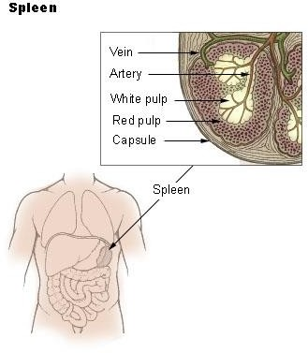

Figure 2.1 The internal structure of a spleen showing its two main sections: white pulp and red pulp (Online Wikipedia, The free Encyclopedia)
The splenic wall is made up of a delicate, fibroelastic capsule which projects into the splenic pulp (parenchyma) as inwards extensions (trabeculae) that support the organ, and incoming and outgoing vessels. The spleen is composed of red and white pulp interwoven with connective

tissue (splenic cords). The red pulp consists of blood vessels (splenic sinusoids) which filter the blood of old and defective blood cells and micro-organisms. The white pulp is inside the red pulp, and consists of little foci of lymphoid tissues (Ryan et al., 2011; Moore et al., 2010; Hofer et al., 1999; Wynn et al., 1993).
    - Variants of the Spleen

- Splenomegaly: The condition where the spleen has increased in size. The enlargement of the spleen begins with a rounding of of its normal crescentic (ovoid) configuration and can progress to the so-called "giant spleen" (massively enlarged spleen). This massively enlarged spleen can touch the left hepatic lobe and this is referred to as "kissing phenomenon" (Ryan et al., 2011; Moore et al., 2010; Hofer et al., 1999; Wynn et al., 1993).
- Accessory spleen: Reaches various sizes, and are generally located at either the splenic hilum, lower splenic pole, near the pancreatic tail, small intestinal mesentery, or in the greater omentum. It is also called splenules or splenunculi. It is usually difficult to differentiate accessory spleen from enlarged lymph nodes (Ryan et al., 2011; Moore et al., 2010; Hofer et al., 1999; Wynn et al., 1993).
- Polysplenia: Several small rudimentary splenic bodies.

- Wandering Spleen: A rare condition characterized by abnormally lax, deficient or long splenic attachment ligament, which allows the spleen free movement in the abdomen (Ryan et al., 2011; Moore et al., 2010; Hofer et al., 1999; Wynn et al., 1993).
    - : Embryology

Embryology of the spleen begins at about the 5th week of embryonic development (Ryan et al., 2011; Sadler, 1995). It arises from a mass of mesenchymal cells located between the layers of the dorsal mesentery, between the aorta and the stomach (Ryan et al., 2011). These mesenchymal cells differentiate into two types of cells - reticular and primitive free cells - which resemble adult

lymphocytes. The spleen is at this stage connected to the body wall in the region of the left kidney by the lieno-renal ligament and to the stomach by the gastro-lienal ligament (Ryan et al., 2011; Sadler, 1995).
As the stomach rotates to the right along its longitudinal axis during development, the spleen and the dorsal mesentery are carried to the left along with the greater curvature of the stomach (Ryan et al., 2011). The splenic cords harbor the primitive free cells that mature into white pulp late in fetal development. The splenic cords house also reticular cells, which do not develop until after birth when primary fetal blood cell formation ceases. These reticular cells develop into red pulp post-natal (Ryan et al., 2011; Sadler, 1995). Fetal spleen is normally quite lobulated. By the 5th and 6th month of gestation, the spleen begins to assume its normal, smooth, ovoid, adult shape and functions. A portion of the spleen may be adherent to the anterior surface of the left kidney, giving rise to a "bare area of the spleen", analogous to the bare area of the liver (Ryan et al., 2011; Hofer et al., 1999; Sadler, 1995).
    - Physiology

The physiology of the Spleen are:

- Reticulo-endothelial function: (i) Production of phagocytes, lymphocytes, plasma cells, as well as antibodies. (ii) Storage of iron, metabolites, platelets, erythrocytes, et cetera.
- Organ function: (i) Erythrocyte or red blood cell surface maturation. (ii) Reservoir of body essentials. (iii) Culling or removal of nuclei from the passing red blood cells. (iv) Pitting or removal of senescent or abnormal red blood cells. (v) Disposal of degenerating, senescent and abnormal erythrocytes. (vi) Regulation of platelets and leukocytes life span.

CHAPTER THREE

RESEARCH METHODOLOGY

Research Design

This is a cross-sectional study.

Duration

This is a hospital based study carried out from September, 2012, to November, 2013.

Target Population

The sickle cell disease (SCD) patients were drawn from adult and paediatric sickle cell clinics of University of Nigeria Teaching Hospital, Ituku-Ozalla, Enugu. Both male and female patients with SCD who were in stable condition were enlisted. Apparently healthy subjects with normal genotype, HbAA, on referrals from general out-patient department of University of Nigeria Teaching Hospital, Ituku-Ozalla, Enugu, to Radiation Medicine department of the hospital for routine abdominal check ultrasound were enlisted as controls.

Sampling Technique

A convenience sampling technique was used to enlist sickle cell disease patients and apparently healthy control subjects that met the selection criteria for the study.

Sample Size

Olatunji et al (2001) did a similar study using 98 adult SCD patients and 48 control subjects at University of Ilorin Teaching Hospital, Ilorin. The expected yearly population of SCD patients in both the adult and paediatric sickle cell clinics of University of Nigeria teaching hospital (UNTH), Ituku-Ozalla, was 120. A convenience sample of 103 study subjects were enlisted each

from the SCD patients group and from the control group using “Yaro Yamane’’ (Yamane - 1967 : 886) formula for a finite population (Uzoagulu, 2011). The formula is given as:
n = N/1+N (e)2

Where:

n = the sample size

N = the finite population

e = level of significance (or limit of tolerable error, or level of precision) 1 = unity (a constant)
Annual population of sickle cell disease patients in UNTH adult and paediatric sickle cell clinics was 120, and e = 0.05;
Then, n = 120/1+120(0.05)2 = 120/1+120( 0.0025)

= 120/1+0.3 = 120/1.3 = 92

Hence, sample size for this work was approximated to 103 sickle cell disease subjects and 103 control subjects.

3.6(a) Subject Selection Criteria for the SCD Subjects (HbSS & HbSC) Inclusion Criteria
- All the SCD subjects enlisted for this research were screened by positive sickling test and confirmed with haemoglobin (Hb) – electrophoresis genotypic laboratory test.
- SCD subjects aged 2 years and above and of both sexes were included.

- Paediatric and adult sickle cell disease subjects in stable condition with no crisis in the past three months, and no history of fever or any other clinical condition that would affect spleen size were enlisted.

Exclusion Criteria

  - Any SCD subject that had surgical splenectomy in the past was excluded.

  - All sickle cell carriers (HbAS) were excluded.

  - All sickle cell disease subjects that had crisis in the past three months, as well as those that were treated of malaria and other feverish conditions in the past four weeks were excluded.
  - All the sickle cell disease subjects below 2 years of age were excluded to prevent any persisting fetal haemoglobin (HbF) from affecting the result of the study.
  - All the sickle cell disease subjects that were not registered and managed in UNTH were excluded.
  - All those sickle cell disease subjects that showed any form of reluctance to participate in any form, especially by refusing to fill and sign the consent form were excluded.

3.6(b) Subject Selection Criteria for the Controls (HbAA) Inclusion Criteria
- All the control subjects selected for this study were screened by positive sickling test and confirmed to have normal genotype (HbAA) with haemoglobin (Hb) electrophoresis genotypic laboratory test.
- Control subjects were confirmed negative for malaria parasite. This is because malaria is the most common cause of fever in our environment that may influence the spleen size.

Exclusion Criteria

  - Pregnant women, breast feeding mothers, and women that had abortion in the past six months were excluded from the study.
  - All SCD patients and sickle cell carriers (HbAS) were excluded from the controls.

  - All the normal genotype (HbAA) subjects that had positive malaria test, as well as those that were treated of malaria and other ailments that could influence spleen size in the past four weeks were excluded from the study.

  - Those controls who had any history of surgery in the past twelve months, and surgical splenectomy were excluded from the study.
  - Any control subject that expressed any form of reluctance to participate, especially by refusing to fill and sign the consent form was excluded.
  - Those control subjects with any history of chronic ailment, and acute conditions of recurrent nature were excluded from the study.
  - Any control subject with any history of blood transfusion was excluded from the control group.

Ethical Clearance/Informed Consent

The study protocol was approved by the Health Ethics Committee of UNTH, Ituku-Ozalla, Enugu, by a written and duly signed Ethical Clearance (see appendix 1).
Informed consent was obtained from each study subject - both SCD subjects and control subjects
- by way of duly signed consent form before data collection was carried out. A sample of the consent form to be duly signed by either the study subject or any of the parents (for very young children), and counter signed by a witness and the principal researcher is included as appendix 6.

Equipment

  - Ultrasound Equipment

The sonographic examinations were carried out with Aloka ST-550 – 3500, a high resolution, real time ultrasound scanner with high accuracy of measurements, manufactured in October, 2005 by Aloka Company Ltd based in Hannover, Germany. This machine had a 3.5MHz and 5 MHz probes. All measurements were obtained with the onscreen electronic callipers of the ultrasound unit. Images were all captured via the unit's freeze frame capacity.

Laboratory Equipment for Genotype Determination

Genotype screening was initially done with a sickling test technique where a drop of peripheral blood mixed with two drops of 2% sodium metabisulphite on a slide was covered with a cover slip and sealed with petroleum jelly. This slide was removed from the cover slip and examined under a microscope after 15 minutes. The confirmatory test was carried out via cellulose acetate electrophoresis at alkaline PH - also called alkaline electrophoresis method. This method used haemoglobin electrophoresis equipment which consists of a power supply tank (transformer tank) and a gel box. Cellulose acetate paper was the support medium at a PH of 8.4 - 8.9. The power supply tank was a kind of transformer tank that connected the mains current to the gel box through two wires that were connected to the positive and negative terminals of the gel box. The gel box housed the alkaline buffer solution that was maintained at 8.4 - 8.9 PH. The blood specimen was lysated and serum formed above the sediment erythrocytes was discarded. Drops of the sediment red blood cells were now applied on a straight line along one end of buffer soaked sheet of cellulose acetate paper corresponding to the negative terminal of the gel box.
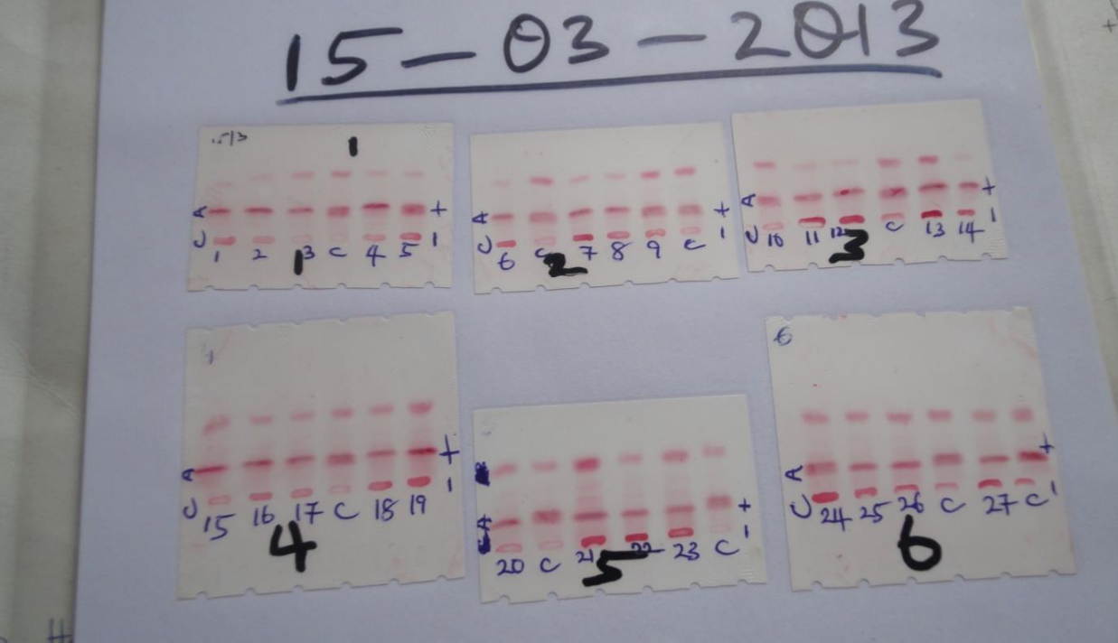

Figure 3.1(a): These are sheets of cellulose acetate paper used for genotype testing. The numbers 1 - 27 represents subjects sediments erythrocytes specimen. These subjects specimens were applied in drops in a straight line at one end of the cellulose acetate paper (point of application) labelled C for cathode above, together with a control specimen (HbAS) that was applied at intervals of three subjects' specimens. The point of application labelled C above corresponds to the negative terminal of the gel box, while the positive terminal of the gel box (labelled A for anode above) corresponds to the result area or row where readings are taken.
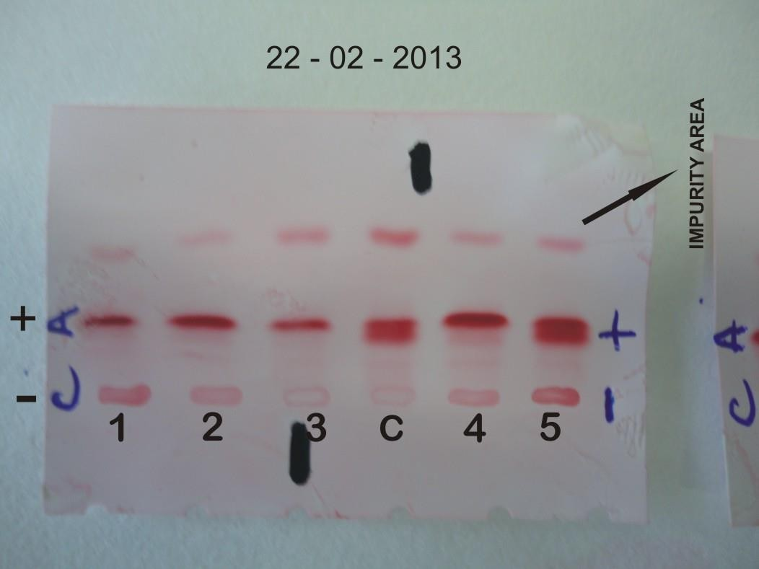

Figure 3.1(b): A magnified image of cellulose acetate paper which is the support medium showing the results of the genotype tests. The control (HbAS) labelled "c" above at the point of application produces a double band of A and S haemoglobins with the A band on top of the S band. This is consistent with an already established principle that haemoglobin A is more attracted to the positive pole (anode), while the S haemoglobin is attracted to the negative pole (cathode).

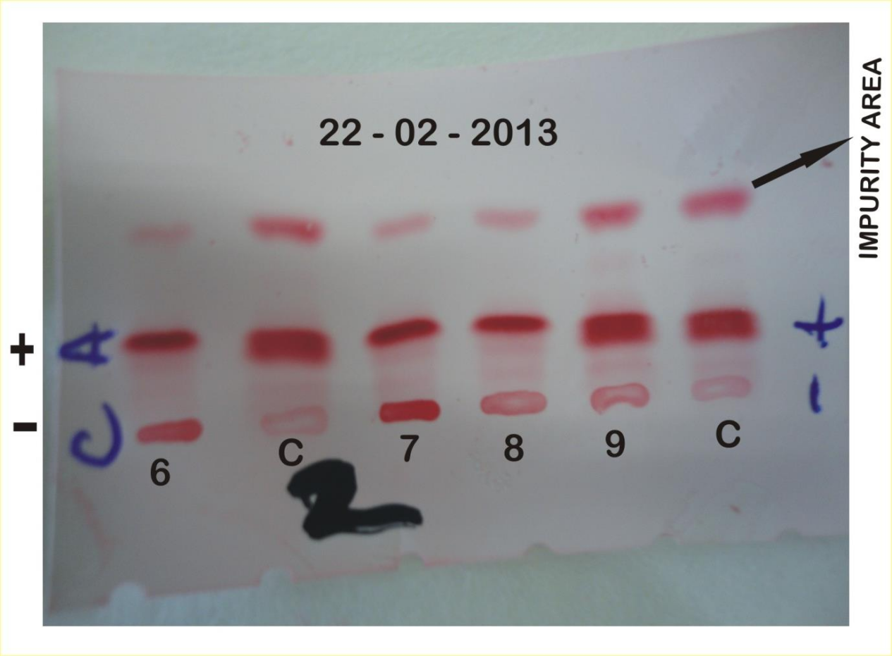

Figure 3.1(c): Another magnified image of a sheet of cellulose acetate paper with genotype test results. + = Positive terminal of the gel box corresponding to the result area where readings are taken; while, - = negative terminal of the gel box corresponding to the point of application of the erythrocyte specimen.

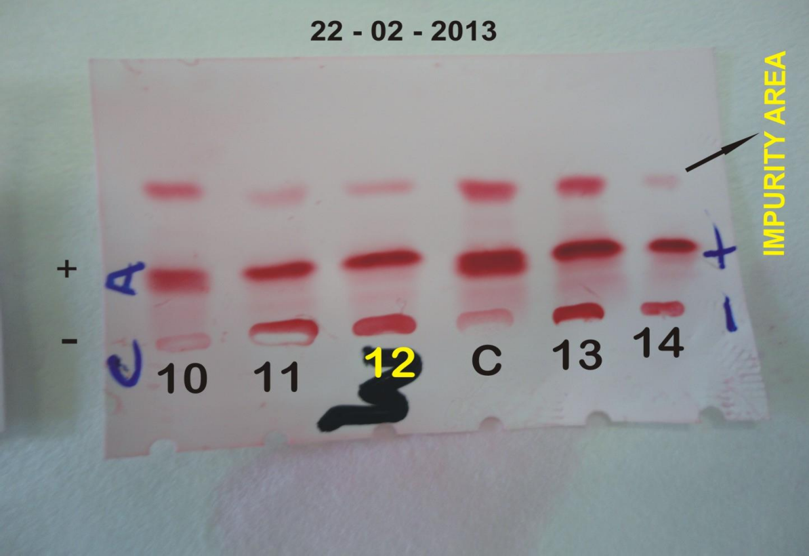

Figure 3.1(d): Another magnified image of a sheet of cellulose acetate paper with genotype test results. The impurity area is the region where all the impurities of the specimen move up to during the heating phase of the gel box.

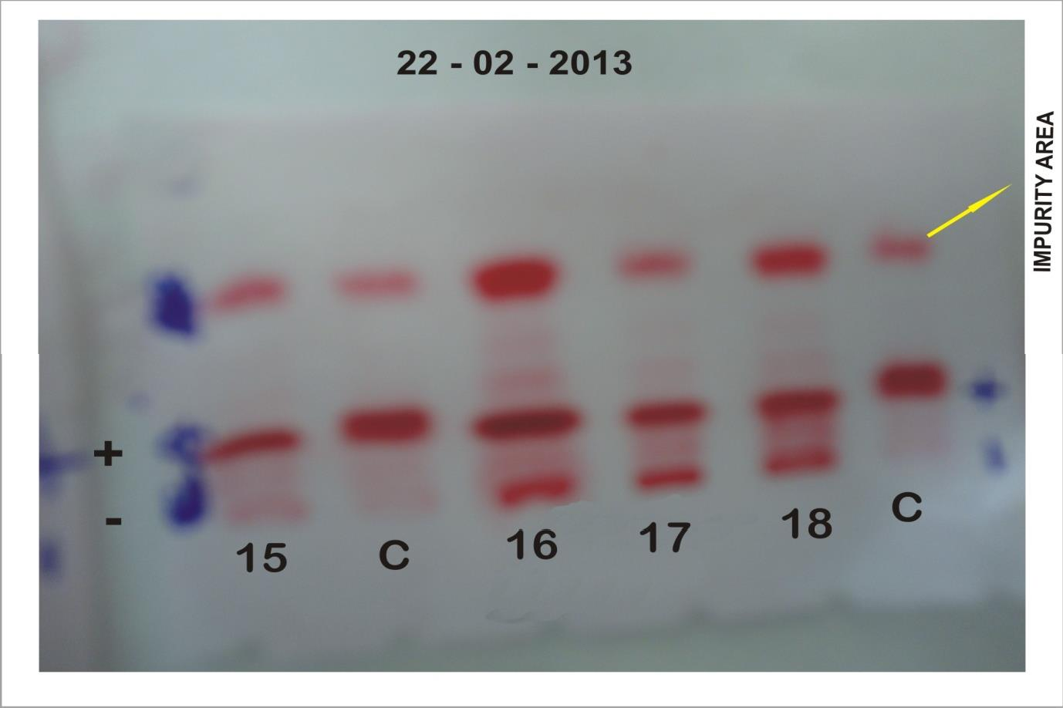

Figure 3.1(e): Another magnified image of a sheet of cellulose acetate paper with genotype test results.
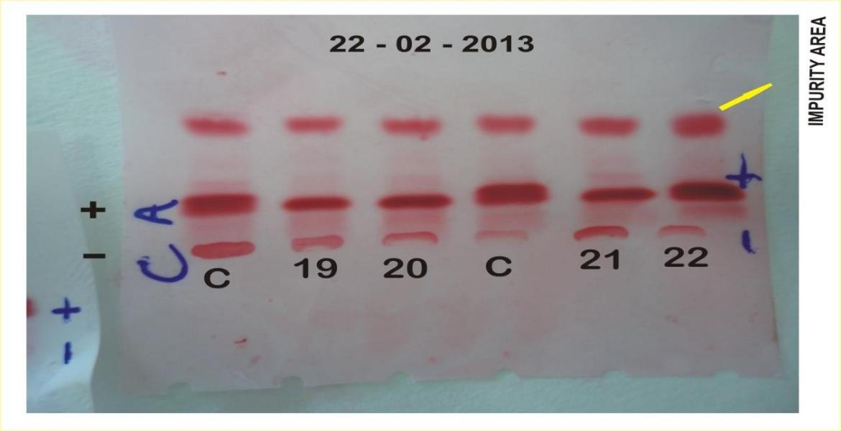

Figure 3.1(f): Another magnified image of a sheet of cellulose acetate paper with genotype test results.

The SCD and control study subjects were also screened for malaria parasite as this is the common cause of fever in our locality, and the common cause of crises among sickle cell disease patients in our region. The screening was done with "CareStart^{tm} Malaria HRP2".
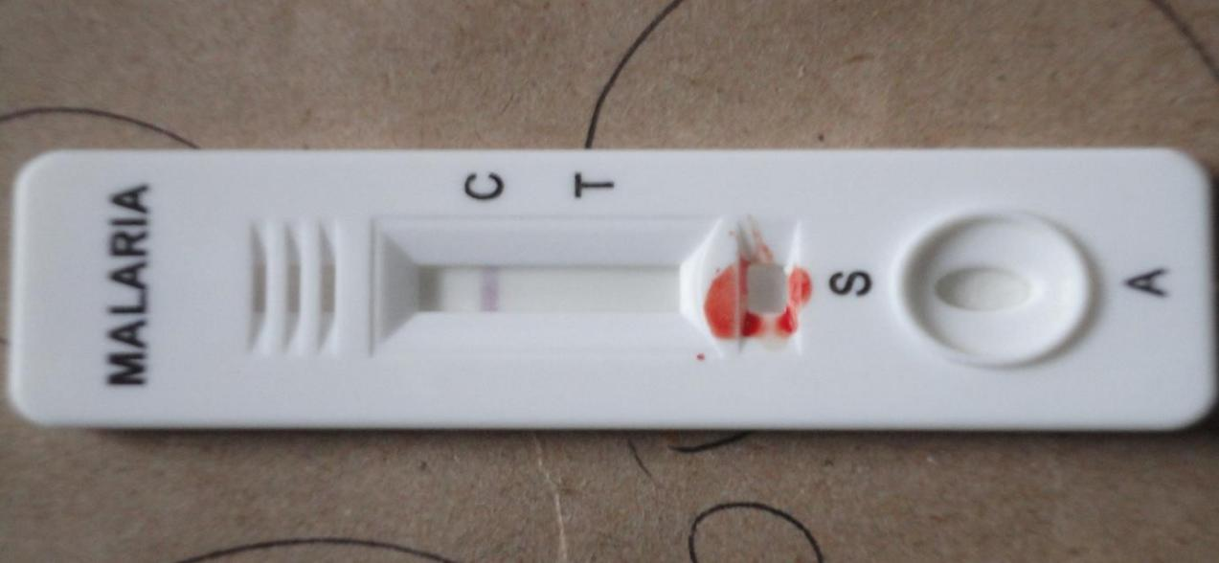

Figure 3.2(a): The test strip shows that the subject has no malaria parasite in his or her blood.

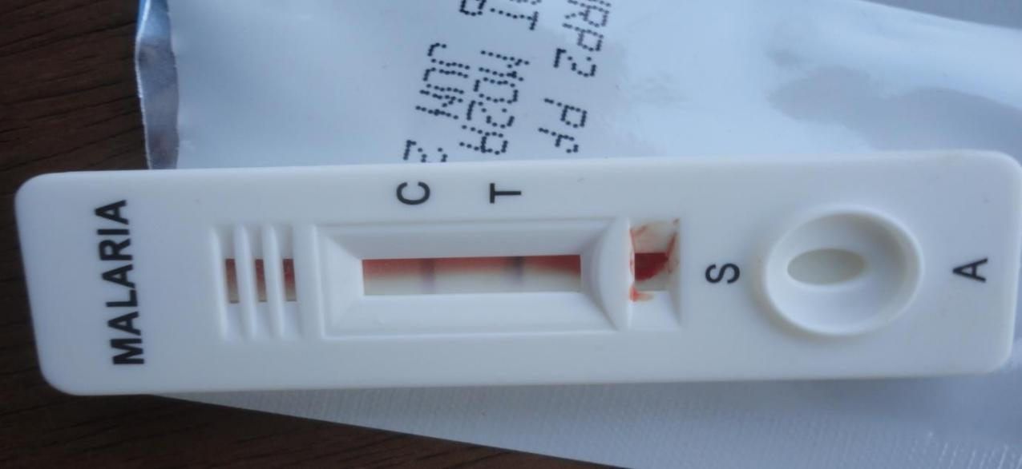

Figure 3.2(b): This test strip shows that the subject is positive for malaria parasite, hence, was excluded from the study.

Scanning Technique

    - Observer Variability Study (Pilot Study)

A pilot study was done by two competent sonographers each with 11 years experience, and one skilled consultant Radiologist with 11 years experience too. Twenty-five subjects were conveniently enlisted for this trial scan irrespective of their genotype status. Each of the examiners scanned each of the enlisted subjects three times in the same position, using the same ultrasound machine without being biased of previous measurements . Three separate and clear views of the spleen were consecutively produced by each examiner, from which three values of spleen length and width were recorded. The mean of each three values for spleen length and spleen width was determined and used as the final data. These trial scans were used to determine intra-observer and inter-observer variations (intra- and inter-rater reliability) prior to the main study.

Main Study

Prior to the main scanning, the age, sex, marital status, genotype status, folder number, blood pressure, temperature, pulse rate, clinical diagnosis, as well as height and weight of each subject were determined and recorded. Each of the participants was positioned in either supine, right posterior oblique, or right lateral decubitus position for better visualization of the spleen free of superimpositions, distortions, blurrings, and other interferences. This is because of differences in body habitus and to ensure minimal discomfort to the study subjects (Lindsay, 1996; Hofer et al., 1999; Keith et al., 2010; Ryan et al., 2011). The transducer was placed in the inter costal space of either the 9th and 10th ribs, or the 10th and 11th ribs parallel to the costal ribs to avoid interfering acoustic shadows from the ribs. A clear longitudinal view of the spleen showing both poles, phrenic surface of the spleen, and the splenic hilum adjacent to the upper pole of the left kidney was demonstrated (Lindsay, 1996; Hofer et al., 1999; Keith et al., 2010; Stephanie et al., 2011). The largest inter-polar distance of the spleen was measured as the length, while the longest

distance between diaphragmatic surface of the spleen and the splenic hilum was measured as the width (Lindsay, 1996; Hofer et al., 1999; Keith et al., 2010). Three separate values of spleen length and width were measured consecutively in each subject, and their mean value was used as the final data for each subject. Only one consultant Radiologist with 11 years post-qualification experience in abdominal-sonography and who had been working with the Aloka ST-550 - 3500 ultrasound unit since 2008 did the scan.
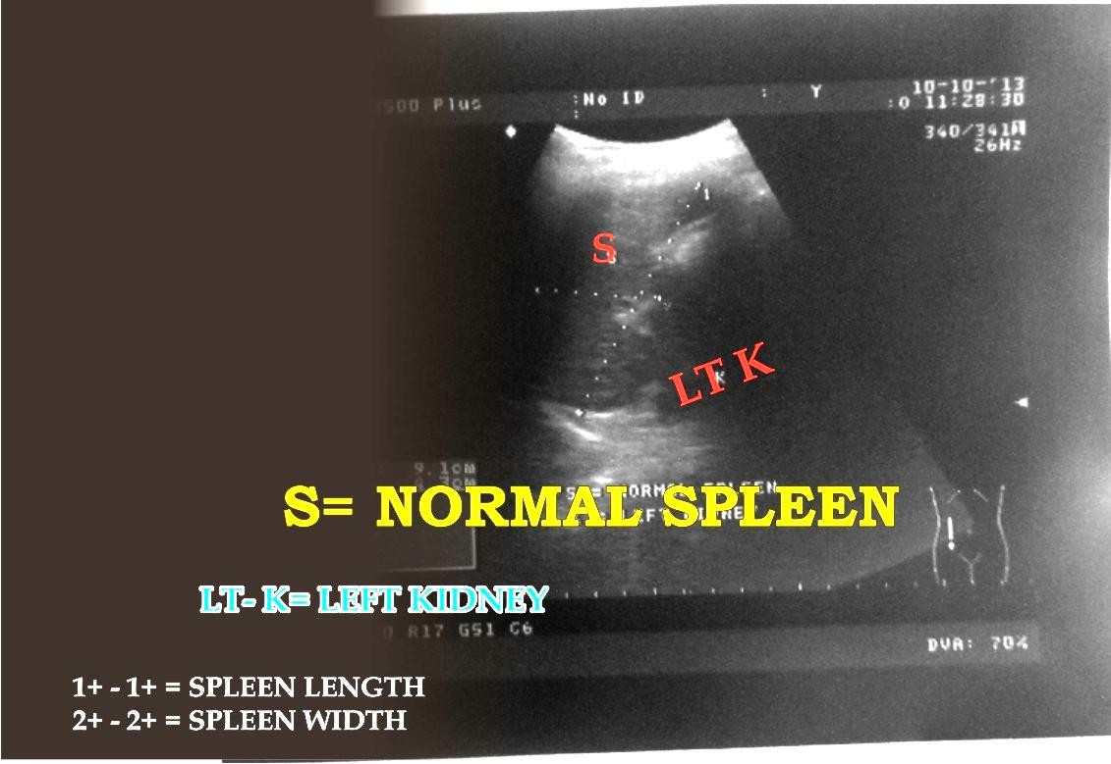

Figure 3.3 a: A typical normal spleen parenchyma of an apparently healthy 31 years old female control..

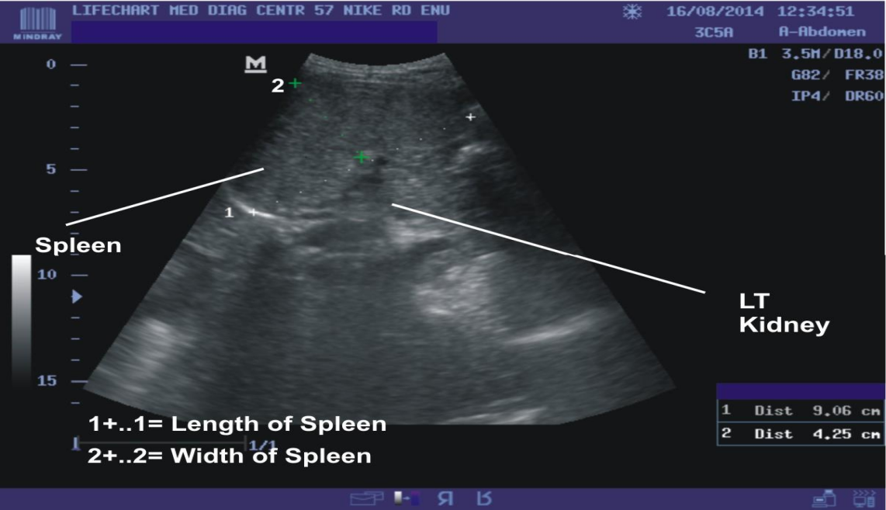

Figure 3.3 b: A mildly enlarged but normal spleen parenchyma of a 21years old male sickle cell disease study subject. Compared to figure 3.3 a, there is mild increase in parenchuma echogenicity.
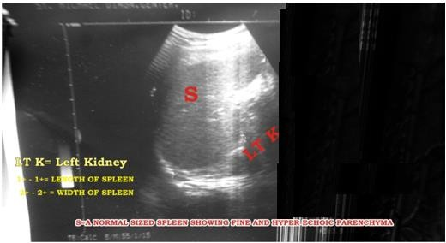

Figure 3.3 c: A mildly enlarged spleen of a 10 year old male sickle cell disease patient with fine and hyper echoic parenchyma echo texture.

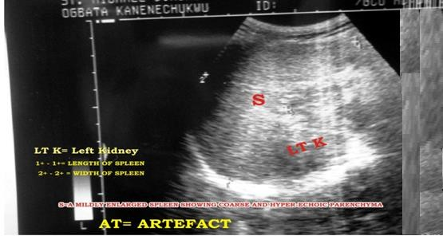

Figure 3.3 d: The spleen of a 13 year old male patient with sickle cell disease that was moderately enlarged, with coarse and hyper echoic parenchyma echo texture may be due to numerous fibrotic scars littering the parenchyma.
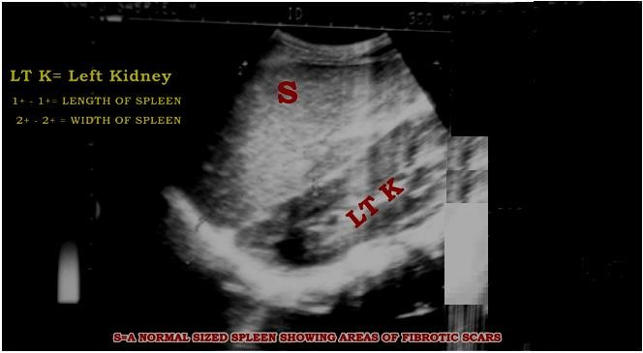

Figure 3.3 e: The spleen of a 9 year old female SCD patient that is moderately enlarged with increased parenchymal echogenicity that suggest fibrotic scars/strands littering the parenchyma.

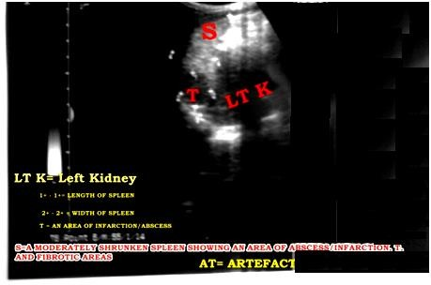

Figure 3.3 f: The spleen of an 18 year old female patient with SCD. This spleen is moderately reduced in size (shrunken spleen) with a remarkable area of splenic cyst which may be suggestive of infarction/abscess at the superior pole of the spleen, and areas of fibrotic scars at the lower pole.
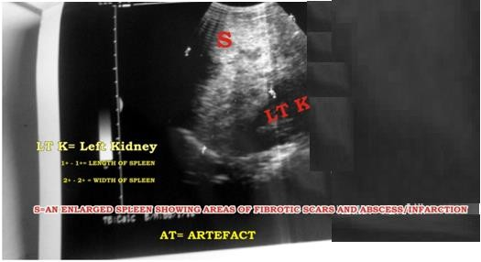

Figure 3.3 g: The spleen of a 24 year old male patient with SCD which has parenchymal nodules of variable sizes which may suggest Abscess or Infarction littered parenchyma.

.

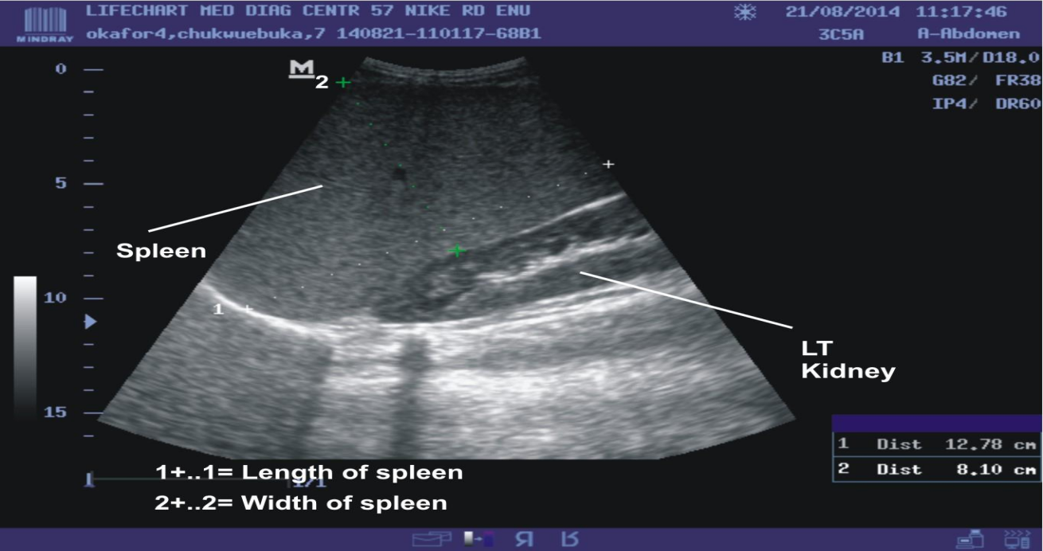

Figure 3.3 k: A grossly enlarged spleen of a 7 years old SCD patient which was too big to enter into the image frame. The superior aspects of the spleen were demonstrated showing a homogeneous and coarse increase in parenchyma echogenicity, with miliary hypoechoic nodules that may suggest early infarctions

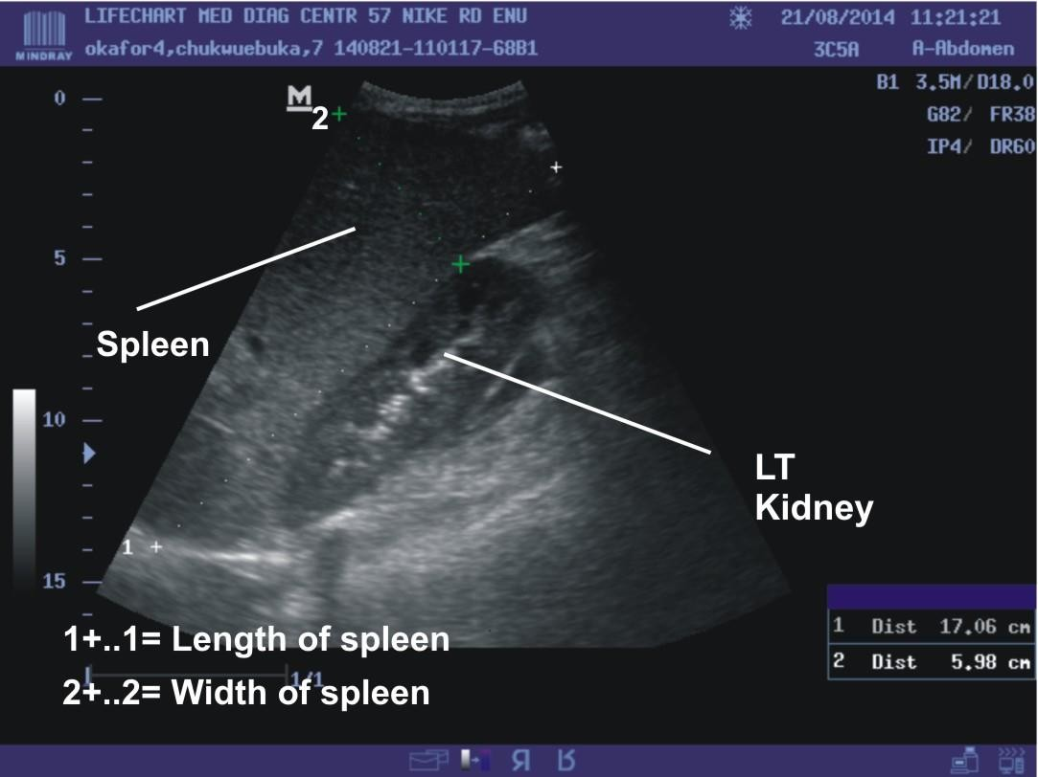

Figure 3.3 L: The inferior pole aspects of the same spleen in figure 3.3 k above showing a much darker inferior pole which may suggest imminent segmental infarction/abscess.

Precautions

If the image quality of the spleen was still compromised by gases in the left costo-phrenic angle and bowel loops at full inspiration and expiration, the patient was advised to release his or her breath slowly while scanning was in progress until a good image quality of spleen was obtained (Hoffer,1999). Right lateral decubitus and various degrees of right posterior oblique positions were adopted where it was difficult getting a full view of the spleen in supine position. Patients were in a fasting state for at least 6 hours, and took a liter of water just before the scan so as to reduce bowel gas shadows and eliminate fundal gas shadows respectively. These scans were preferably done in the early morning hours and without sedation. This was to ensure steady state of all abdominal organs, reduced bowel gas and minimize movements from these visceral organs. All the scans were done by one experienced and skilled consultant Radiologist to minimize inter- observer variations. Measurements (spleen length and width) were made when a full and clear view of the spleen was seen, free of distortions, maskings, blurrings and superimpositions, and with the superior and inferior poles together with the splenic hilum well demonstrated. During the main scan, the consultant Radiologist produced three separate views of the spleen consecutively with spleen length and width measured on each view and recorded. The mean of each of the three measurements was determined and used as the final authentic data. This was to minimize intra- observer variations.

Method of Data Analysis

- All the statistical computations on the data were carried out with the computer software SPSS version 16.0 by SPSS Inc; Chicago, Illinois, USA..
- Intra-class Correlation Coefficient was used to determine the inter- and intra-observer variability.
- Demographic characteristics of age groups such as sex, marital status and genotype were classified with frequency - percentage table.
- Descriptive statistics was used to analyze the ages, height, and weight of all the selected subjects, and results were reported as means and standard deviations of the means.
- The sizes of the spleen - spleen length and spleen width - of the study subjects and the controls were determined or analyzed as the means and standard deviations of the means in the different age groups using descriptive statistics.
- Student's t-test was used to compare the mean spleen sizes (spleen length and spleen width) in each of the age groups of both the study subjects and the healthy controls for any difference.
- Student's t-test was also used to compare, generally, the mean spleen length and mean spleen width of the study subjects with those of the controls.
- Pearson's correlation coefficient (r) was used to determine the relationship between age, height, weight and the mean spleen sizes (mean spleen length and mean spleen width) in both the study subjects and the controls. The level of significance was taken at 5% (0.05).
- Frequency - Percentage table was used to characterize the splenic parenchyma echo texture of the study subjects.
- The trend of splenomegaly and the frequency of auto-splenectomy were presented with the frequency - percentage table.

CHAPTER FOUR
RESULTS
4.1: Tables

Table 1: Intra- and Inter-rater reliability of Sonographic measurements of spleen size.

Observer | Intra- and Inter-rater reliability (Intra class correlation coefficient at 95% C.I.)
 | Variables | F | Lower bound | Upper bound | Intra-class Correlation values
INTRA-OBSERVER,
Sonographer 1 | Length | 25 | 0.88 | 0.97 | ICC (3, 2, 1) = 0.94
 | Width | 25 | 0.54 | 0.89 | ICC (3, 2, 1) = 0.76
Sonographer 2 | Length | 25 | 0.86 | 0.95 | ICC (3, 2, 1) = 0.92
 | Width | 25 | 0.52 | 0.87 | ICC (3, 2, 1) = 0.74
Sonographer 3 | Length | 25 | 0.89 | 0.98 | ICC (3, 2, 1) = 0.95
 | Width | 25 | 0.55 | 0.90 | ICC (3, 2, 1) = 0.77
INTER-OBSERVER,
All Sonographers | Length | 25 | 0.70 | 0.91 | ICC (3, 2, 1) = 0.83
 | Width | 25 | 0.28 | 0.73 | ICC (3, 2, 1) = 0.52

C.I. = Confidence Interval : F = Frequency : ICC = Intra class correlation coefficient ICC (3, 2, 1) = Intra class correlation coefficient between the first, second, and third measurements obtained by each sonographer, otherwise called intra observer error or variation; and between the first measurements obtained by all the sonographers (inter observer error or variation).
This table shows very minimal variation among the three consecutive values of the spleen length and width measured by each of the sonographers in each of the subjects selected for the pilot study (low intra-observer error or variation). The differences in the values of the spleen length and width measured by the three sonographers independently in the selected subjects for the pilot study were not statistically significant

Table 2: Demographic characteristics of the subjects(HbSS, HbSC & HbAA)

Variables |  | Stable SCD Patients |  | Healthy HbAA Controls
 |  | Frequency | Percentage,% | Frequency | Percentage,%
AG (years) | 2 - 6 | 17 | 16.50 | 17 | 16.50
 | 7 - 11 | 20 | 19.42 | 19 | 18.45
 | 12 - 16 | 13 | 12.60 | 14 | 13.59
 | 17 - 21 | 13 | 12.60 | 13 | 12.60
 | 22 - 26 | 19 | 18.45 | 18 | 17.48
 | 27 - 31 | 8 | 7.80 | 8 | 7.80
 | 32 and above | 13 | 12.60 | 14 | 13.59
 | Total | 103 | 100.00 | 103 | 100.00
Sex | Male | 48 | 46.60 | 56 | 54.40
 | Female | 55 | 53.40 | 47 | 45.60
 | Total | 103 | 100.00 | 103 | 100.00
Marital status | Single | 97 | 94.20 | 94 | 91.30
 | Married | 6 | 5.80 | 9 | 8.70
 | Total | 103 | 100.00 | 103 | 100.00
Genotype sta. | HbSC | 2 | 1.90 | - | -
 | HbSS | 101 | 98.10 | - | -
 | HbAA | - | - | 103 | 100.00
 | Total | 103 | 100.00 | 103 | 100.00

AG (years) = Age groups in years : Genotype sta. = Genotype status

HbSC = Compound Heterozygous Sickle Haemoglobin SC. HbSS = Homozygous Sickle Haemoglobin SS or Sickle Cell Anaemia. : HbAA = Homozygous Haemoglobin AA or the Normal Genotype : SCD = Sickle Cell Disease
In this table, there is a match in frequency of the sickle cell disease patients and the normal genotype controls.

Table 3: Mean spleen sizes by age group in sickle cell disease patients and the control groups.

Age ranges (years) | Genotype Status | Spleen Length (cm) |  |  | Spleen Width (cm)
 |  | Mean | Frequency | SD | Mean | Frequency | SD
2 - 6 | SCD | 85.35 | 17 | 19.52 | 43.00 | 17 | 9.73
 | HbAA | 55.53 | 17 | 8.08 | 26.71 | 17 | 6.42
 | Total | 70.44 | 34 | 21.11 | 34.85 | 34 | 11.59
7 - 11 | SCD | 113.95 | 20 | 37.37 | 53.60 | 20 | 16.57
 | HbAA | 70.89 | 19 | 7.65 | 35.84 | 19 | 5.93
 | Total | 92.97 | 39 | 34.66 | 44.95 | 39 | 15.32
12 - 16 | SCD | 113.50 | 12 | 41.11 | 54.58 | 12 | 23.67
 | HbAA | 78.93 | 14 | 6.92 | 36.21 | 14 | 4.92
 | Total | 94.88 | 26 | 32.82 | 44.69 | 26 | 18.61
17 - 21 | SCD | 90.45 | 11 | 49.12 | 42.27 | 11 | 24.12
 | HbAA | 90.85 | 13 | 12.90 | 42.38 | 13 | 3.84
 | Total | 90.67 | 24 | 33.70 | 42.33 | 24 | 16.15
22 - 26 | SCD | 94.20 | 10 | 47.79 | 46.90 | 10 | 28.54
 | HbAA | 94.67 | 18 | 8.73 | 46.83 | 18 | 6.27
 | Total | 94.50 | 28 | 28.45 | 46.86 | 28 | 17.21
27 - 31 | SCD | 59.80 | 5 | 26.40 | 27.40 | 5 | 17.07
 | HbAA | 94.00 | 8 | 11.93 | 49.38 | 8 | 8.00
 | Total | 80.85 | 13 | 24.81 | 40.92 | 13 | 16.07
32 and ab | SCD | 97.00 | 4 | 40.64 | 51.50 | 4 | 26.21
 | HbAA | 92.43 | 14 | 9.83 | 44.64 | 14 | 7.25
 | Total | 93.44 | 18 | 19.21 | 46.17 | 18 | 13-04
Total | SCD | 97.67 | 79 | 39.61 | 47.28 | 79 | 20.68
 | HbAA | 80.84 | 103 | 16.89 | 39.38 | 103 | 9.39
 | Total | 88.15 | 182 | 30.11 | 42.81 | 182 | 15.79

HbAA = Homozygous Haemoglobin AA or the Normal Genotype. SCD = Sickle Cell Disease : SD = Standard Deviation
This table shows a rapid increase in mean spleen sizes of sickle cell disease patients from 2 - 6 years age group with a peak at 12 - 16 years age group, beyond which there is sharp decline in spleen size to 27 - 31 years age group followed by an increase again. The mean spleen sizes of the normal genotype controls show a gradual increase from 2 - 6 years age group to peak at 27 - 31 years age group.

Table 4: Mean spleen sizes of the sickle cell disease patients by age compared with those of the controls.

AGC  in yrs | Genot.  Status | Spleen Length in Centimeter |  |  |  |  | Spleen Width in Centimeter
 |  | F | M | SD | t-v | p-v | F | M | SD | t-v | p-v
2 - 6 | SCD | 17 | 85.35 | 19.52 |  |  | 17 | 43.00 | 9.73
Versus |  |  |  |  | 5.82 | 0.00 |  |  |  | 5.76 | 0.00
2 - 6 | HbAA | 17 | 55.53 | 8.08 |  |  | 17 | 26.71 | 6.42
7 - 11 | SCD | 20 | 113.95 | 37.37 |  |  | 20 | 53.60 | 16.57
Versus |  |  |  |  | 5.04 | 0.00 |  |  |  | 4.50 | 0.00
7 - 11 | HbAA | 19 | 70.90 | 7.65 |  |  | 19 | 35.84 | 5.93
12- 16 | SCD | 12 | 113.50 | 41.11 |  |  | 12 | 54.58 | 23.67
Versus |  |  |  |  | 3.11 | 0.01 |  |  |  | 2.84 | 0.02
12- 16 | HbAA | 14 | 78.93 | 6.92 |  |  | 14 | 36.21 | 4.92
17- 21 | SCD | 11 | 90.45 | 49.12 |  |  | 11 | 42.27 | 24.12
Versus |  |  |  |  | -0.03 | 0.98 |  |  |  | -0.02 | 0.99
17- 21 | HbAA | 13 | 90.85 | 12.90 |  |  | 13 | 42.38 | 3.84
22- 26 | SCD | 10 | 94.20 | 47.79 |  |  | 10 | 46.90 | 28.54
Versus |  |  |  |  | -0.04 | 0.98 |  |  |  | 0.01 | 0.99
22- 26 | HbAA | 18 | 94.67 | 8.73 |  |  | 18 | 46.83 | 6.27
27- 31 | SCD | 5 | 59.80 | 26.40 |  |  | 5 | 27.40 | 17.07
Versus |  |  |  |  | -3.23 | 0.04 |  |  |  | -3.18 | 0.04
27- 31 | HbAA | 8 | 94.00 | 11.93 |  |  | 8 | 49.38 | 8.00
32 + | SCD | 4 | 97.00 | 40.64 |  |  | 4 | 51.50 | 26.21
Versus |  |  |  |  | 0.41 | 0.84 |  |  |  | 0.92 | 0.64
32 + | HbAA | 14 | 92.43 | 9.83 |  |  | 14 | 44.64 | 7.25

AGC in yrs = Age groups being compared in years : Genot. status = Genotype status. F = Frequency : M = Mean : SD = Standard Deviation : t-v = t-value : P-v = P-value
HbAA = Homozygous Haemoglobin AA or the Normal Genotype SCD = Sickle Cell Disease
This table shows that the mean spleen sizes of sickle cell disease patients are significantly larger than those of the controls in the 2 - 6 years, 7 - 11 years, and 12 - 16 years age groups. However, there is no statistical significant difference in mean spleen sizes between the sickle cell disease patients and the controls above 17 years of age excluding 27 - 31 years group. There is a negative significant difference in the 27 - 31 years age group, where the mean spleen sizes of the controls are found to be larger than those of the SCD subjects.

Table 5a: Mean spleen length of the sickle cell disease patients compared to that of the controls.

 | Gen. Status | Frequency | Mean | Stand. Dev. | t-value | p-value
Spleen Length in Centimeter | SCD | 79 | 97.67 | 39.61
 |  |  |  |  | 3.88 | P = 0.00
 | HbAA | 103 | 80.84 | 16.89
Spleen Width in Centimeter | SCD | 79 | 47.28 | 20.68
 |  |  |  |  | 3.44 | P = 0.00
 | HbAA | 103 | 39.38 | 9.39

Gen. Status = Genotype Status : Stand. Dev. = Standard Deviation. HbAA = Homozygous Haemoglobin AA or the Normal Genotype. SCD = Sickle Cell Disease.
Generally, the overall mean spleen length and width of the sickle cell disease patients are statistically larger than those of the controls as is shown in this table.

Table 6: Comparison of the effects of age, height, and weight on the spleen sizes of the stable sickle cell disease patients and healthy control subjects.

 |  | Age in Years |  |  | Height in Centimeter(cm) |  |  | Weight in kilogram (kg)
Variab. | Gen. | r-value | p-value | Res. | r-value | p-value | Res. | r-value | p-value | Res.
Spleen  Length | SCD | -0.14 | 0.23 | NS | -0.15 | 0.18 | NS | -0.08 | 0.50 | NS
 | HbAA | 0.67 | 0.00 | S | 0.90 | 0.00 | S | 0.87 | 0.00 | S
Spleen  Width | SCD | -0.12 | 0.29 | NS | -0.19 | 0.09 | NS | -0.05 | 0.69 | NS
 | HbAA | 0.60 | 0.00 | S | 0.80 | 0.00 | S | 0.79 | 0.00 | S

Res. = Results : NS = Not Significant : S = Significant : Variab. = Variables HbAA = Homozygous Haemoglobin AA or the Normal Genotype : Gen. = Genotype SCD = Sickle Cell Disease.
This table shows negative Correlation between mean spleen sizes and the age, height, and weight of the sickle cell disease patients; and positive correlation between mean spleen sizes and the age, height, and weight in the healthy controls.

Table 7: Characterization of the Spleen parenchymal echo texture in the Sickle cell disease patients.
Spleen Parench. Appear. | Age Ranges in Years
 | 2 | - 6 | 7 | - | 11 | 12 | - 16 | 17 | - 21 | 22 | - 26 | 27 | - 31 | 32 ⁺ |  | Total
 | F | % | F | % |  | F | % | F | % | F | % | F | % | F | % | F | %
Normal | 4 | 3.88 | 4 | 3.88 |  | 1 | 0.97 | - | - | - | - | - | - | - | - | 9 | 8.74
Coarse hyper- echoic | 1 | 0.97 | 7 | 6.80 |  | 4 | 3.88 | 3 | 2.91 | 2 | 1.94 | 1 | 0.97 | 2 | 1.94 | 20 | 19.42
Fine hyper- echoic | 9 | 8.74 | 4 | 3.88 |  | 3 | 2.91 | 2 | 1.94 | 1 | 0.97 | - | - | 1 | 0.97 | 20 | 19.42
Fibrotic scar littered | - | - | - | - |  | 3 | 2.91 | 6 | 5.83 | 4 | 3.88 | 2 | 1.94 | 1 | 0.97 | 16 | 15.53
Infarction/ Abscess littered | - | - | 1 | 0.97 |  | - | - | - | - | 2 | 1.94 | - | - | - | - | 3 | 2.91
Calcificatio n littered | - | - | - | - |  | 1 | 0.97 | 3 | 2.91 | 4 | 3.88 | 3 | 2.91 | - | - | 11 | 10.68
Total |  |  |  |  |  |  |  |  |  |  |  |  |  |  |  | 103 | 100

F = Frequency : % = Percentage : 32⁺ = 32 years and above.
Normal = Normal Spleen Parenchyma Echo Texture : Auto-Splenectomy = Absence of Spleen.
This table shows various spleen parenchyma echo textures of the sickle cell disease patients studied.

Table 8a: Normal limits of spleen length with respect to age among the controls of the present study
Age groups in Years | Longitudinal Length of Spleen in millimeter
 | Frequency | Minimum | Maximum | Mean | Stand. Deviat.
2 - 6 | 17 | 38.00 | 68.00 | 55.53 | 8.08
7 - 11 | 19 | 56.00 | 90.00 | 70.89 | 7.65
12 - 16 | 14 | 72.00 | 92.00 | 78.93 | 6.92
17 - 21 | 13 | 70.00 | 119.00 | 90.85 | 12.90
22 - 26 | 18 | 75.00 | 111.00 | 94.67 | 8.73
27 - 31 | 8 | 71.00 | 113.00 | 94.00 | 11.93
32 and above | 14 | 79.00 | 104.00 | 92.43 | 9.83

Table 8b: Estimation of ''mild'' splenomegaly, ''moderate'' splenomegaly, ''marked'' splenomegaly and shrunken spleen
 | Longitudinal Length of  Spleen in Millimeter |  |  | Estimation of Mild Splenomegaly, Moderate Splenomegaly, Marked  Splenomegaly and Shrunken Spleen
Age  groups in Years | Suggested limits of norm. |  |  | Mild Splen. |  | Moderate Splen. |  | Marked Splen. |  | Shrunken Splee.
 | Lower  - most | Mean | Upper  - most | Freq. | % | Freq. | % | Freq. | % | Freq. | %
2 - 6 | 30.00 | 60.00 | 80.00 | 1 | 0.97 | 4 | 3.88 | 1 | 0.97 | - | -
7 - 11 | 35.00 | 65.00 | 100.00 | 4 | 3.88 | 5 | 4.85 | 5 | 4.85 | - | -
12- 16 | 40.00 | 75.00 | 110.00 | - | - | 3 | 2.91 | 5 | 4.85 | 1 | 0.97
17- 21 | 60.00 | 90.00 | 120.00 | - | - | - | - | 2 | 1.94 | 3 | 2.91
22- 26 | 70.00 | 100.00 | 130.00 | - | - | 1 | 0.97 | 2 | 1.94 | 4 | 3.88
27- 31 | 70.00 | 100.00 | 130.00 | - | - | - | - | - | - | 3 | 2.91
32 ⁺ | 60.00 | 95.00 | 130.00 | - | - | - | - | 1 | 0.97 | - | -
Total |  |  |  | 5 | 4.85 | 13 | 12.62 | 16 | 15.53 | 11 | 10.68

Age gr.(ys) = Age groups in years : Sple & Spleno = Splenomegaly : % = Percentage : F = frequency : SD = Standard Deviation.
Table 8a above shows the limits of the values of spleen length among the normal genotype controls in each age group adopted for the present study, together with their corresponding means. The suggested limits of normal values in spleen length in table 8b above were deduced from table 8a above, and supported by the results of the studies done by Eze et al (2013), Udoaka et al (2013), and Okoye et al (2005) in the region of the present study; and bolstered also by their similarity with the findings of Tanna et al (2012) and Dhingra et al (2010) in Indian paediatric population, and Megremis et al (2004) in Greece.

Table 9: Age distribution of auto-splenectomy and shrunken spleen among sickle cell disease patients in Enugu
Age groups In Years | Sex | Auto - Splenectomy |  | Shrunken | Spleen
 |  | Frequency | Percentage | Frequency | Percentage
2 - 6 | Male | - | - | - | -
Female |  | - | - | - | -
7 - 11 | Male | - | - | - | -
Female |  | - | - | - | -
12 - 16 | Male | - | - | - | -
Female |  | 1 | 0.97 | 1 | 0.97
17 - 21 | Male | 2 | 1.94 | 2 | 1.94
Female |  | - | - | 1 | 0.97
22 - 26 | Male | 7 | 6.80 | 1 | 0.97
Female |  | 2 | 1.94 | 3 | 2.91
27 - 31 | Male | 1 | 0.97 | 2 | 1.94
Female |  | 2 | 1.94 | 1 | 0.97
32 and above | Male | 4 | 3.88 | - | -
Female |  | 5 | 4.85 | - | -
Total |  | 24 | 23.30 | 11 | 10.68

From this table, there are 24(23.30%) cases of auto-splenectomy and 11(10.68%) incidence of shrunken spleen.

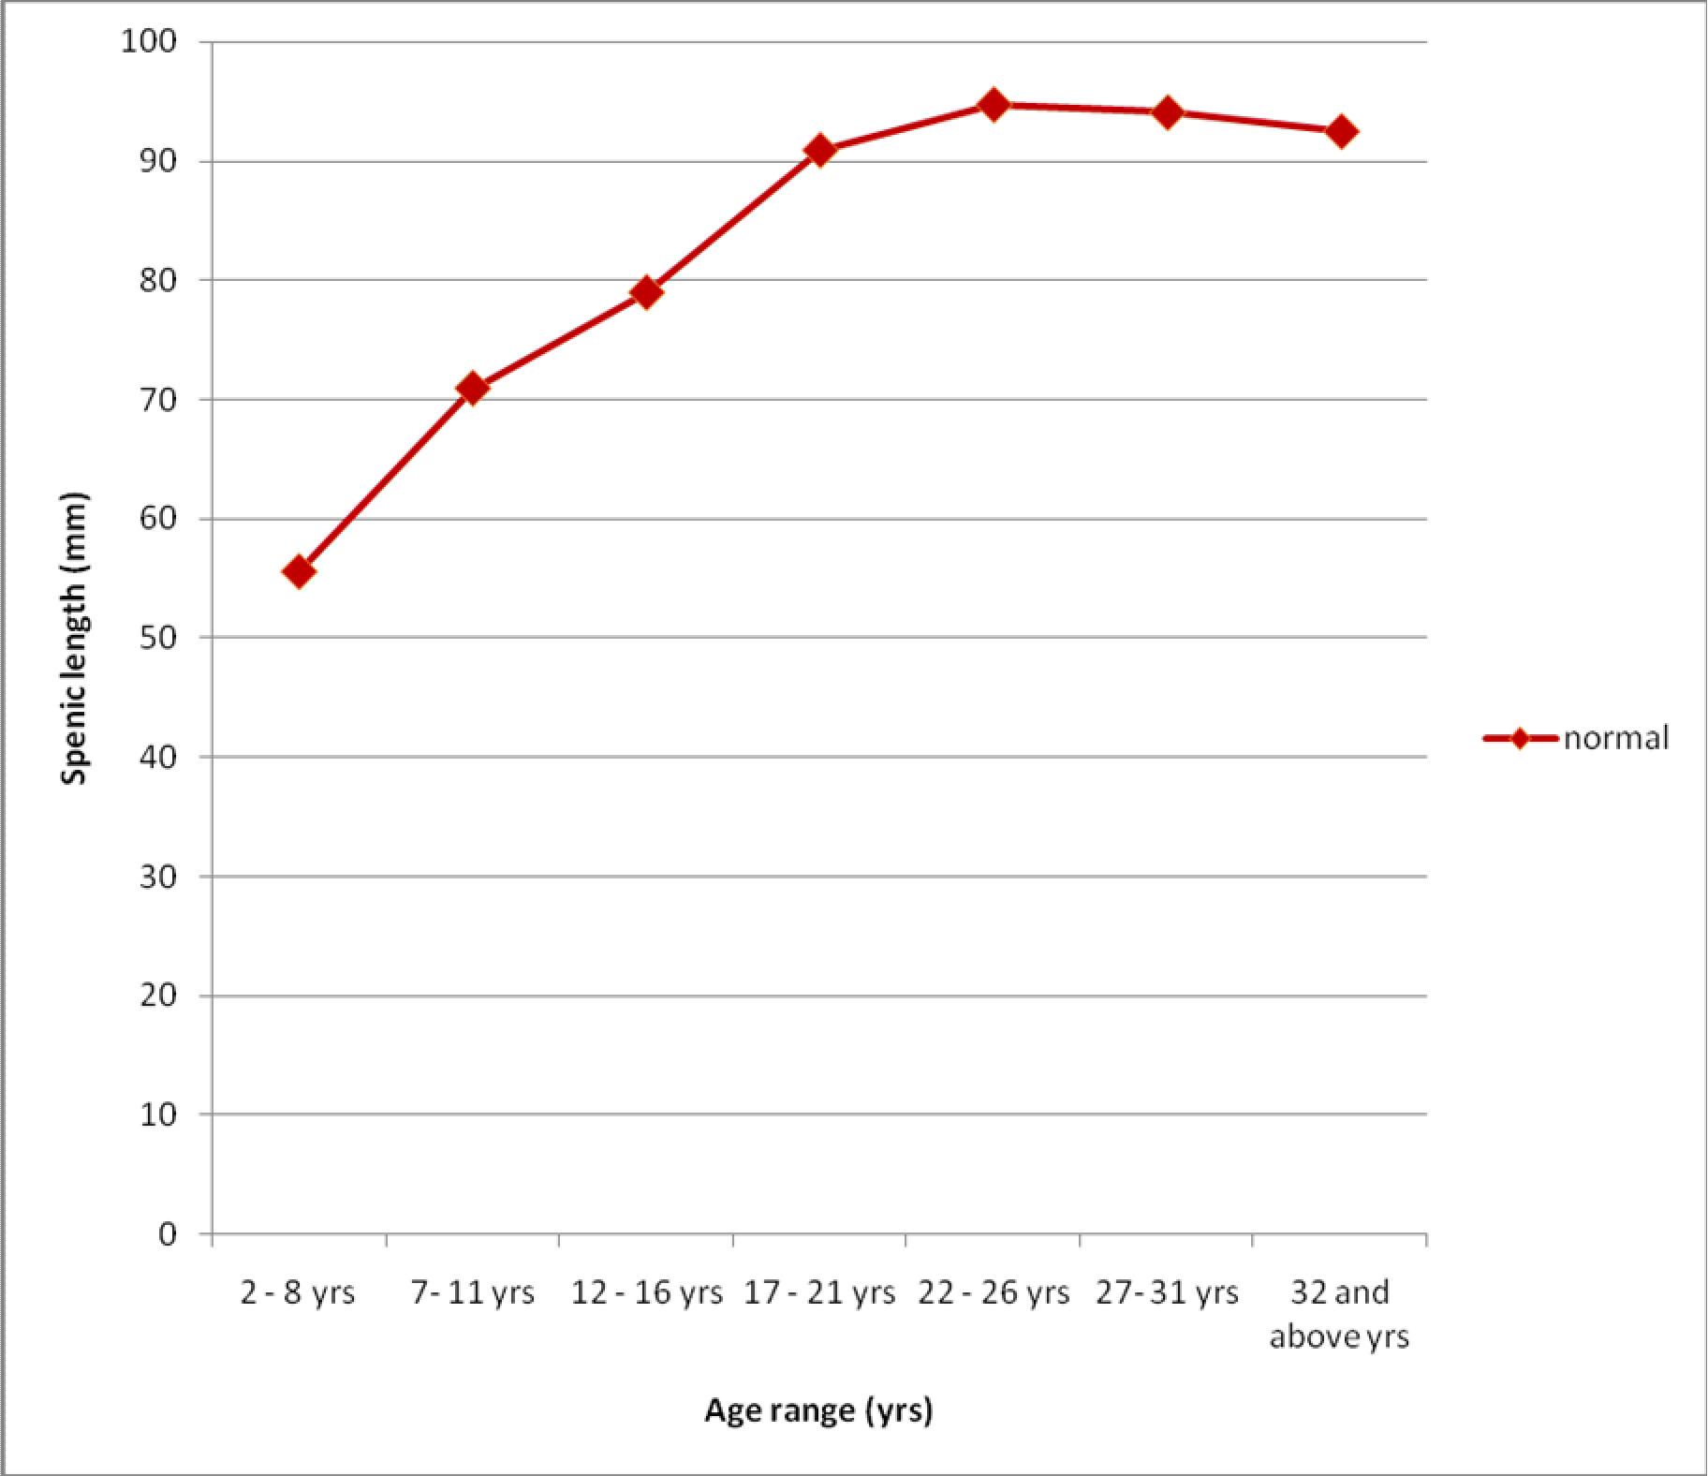

Figure 4.1a: This graph shows the trend of the spleen length among the normal genotype controls of the present study with respect to age. There is a gradual increase in spleen length from 2 - 6 years age group to 22 - 26 years age group, beyond which there is a plateau between 22 - 26 years age group and 27 - 31 years age group. There is finally a gradual decline in spleen length at 32 years and above age group.

120.00 

Dot/Lines s

SPLEEN_LENGHT_in_
mm

100.00





 
 
  

 
  

  
   


  


  





80.00





60.00 



  
 
 

 
 

 
 
 















40.00


2- 6 yrs 7-11 yrs 12-16 yrs 17 -21 yrs 22-26 yrs 27 - 31 yrs 32 above
Age_range

Figure 4.1b: This is a scatter plot of the graph in figure 4.1(a) above showing the frequency and position of spleen lengths within the mean area of each age group (the relationship of mean spleen length and the age groups in the controls).

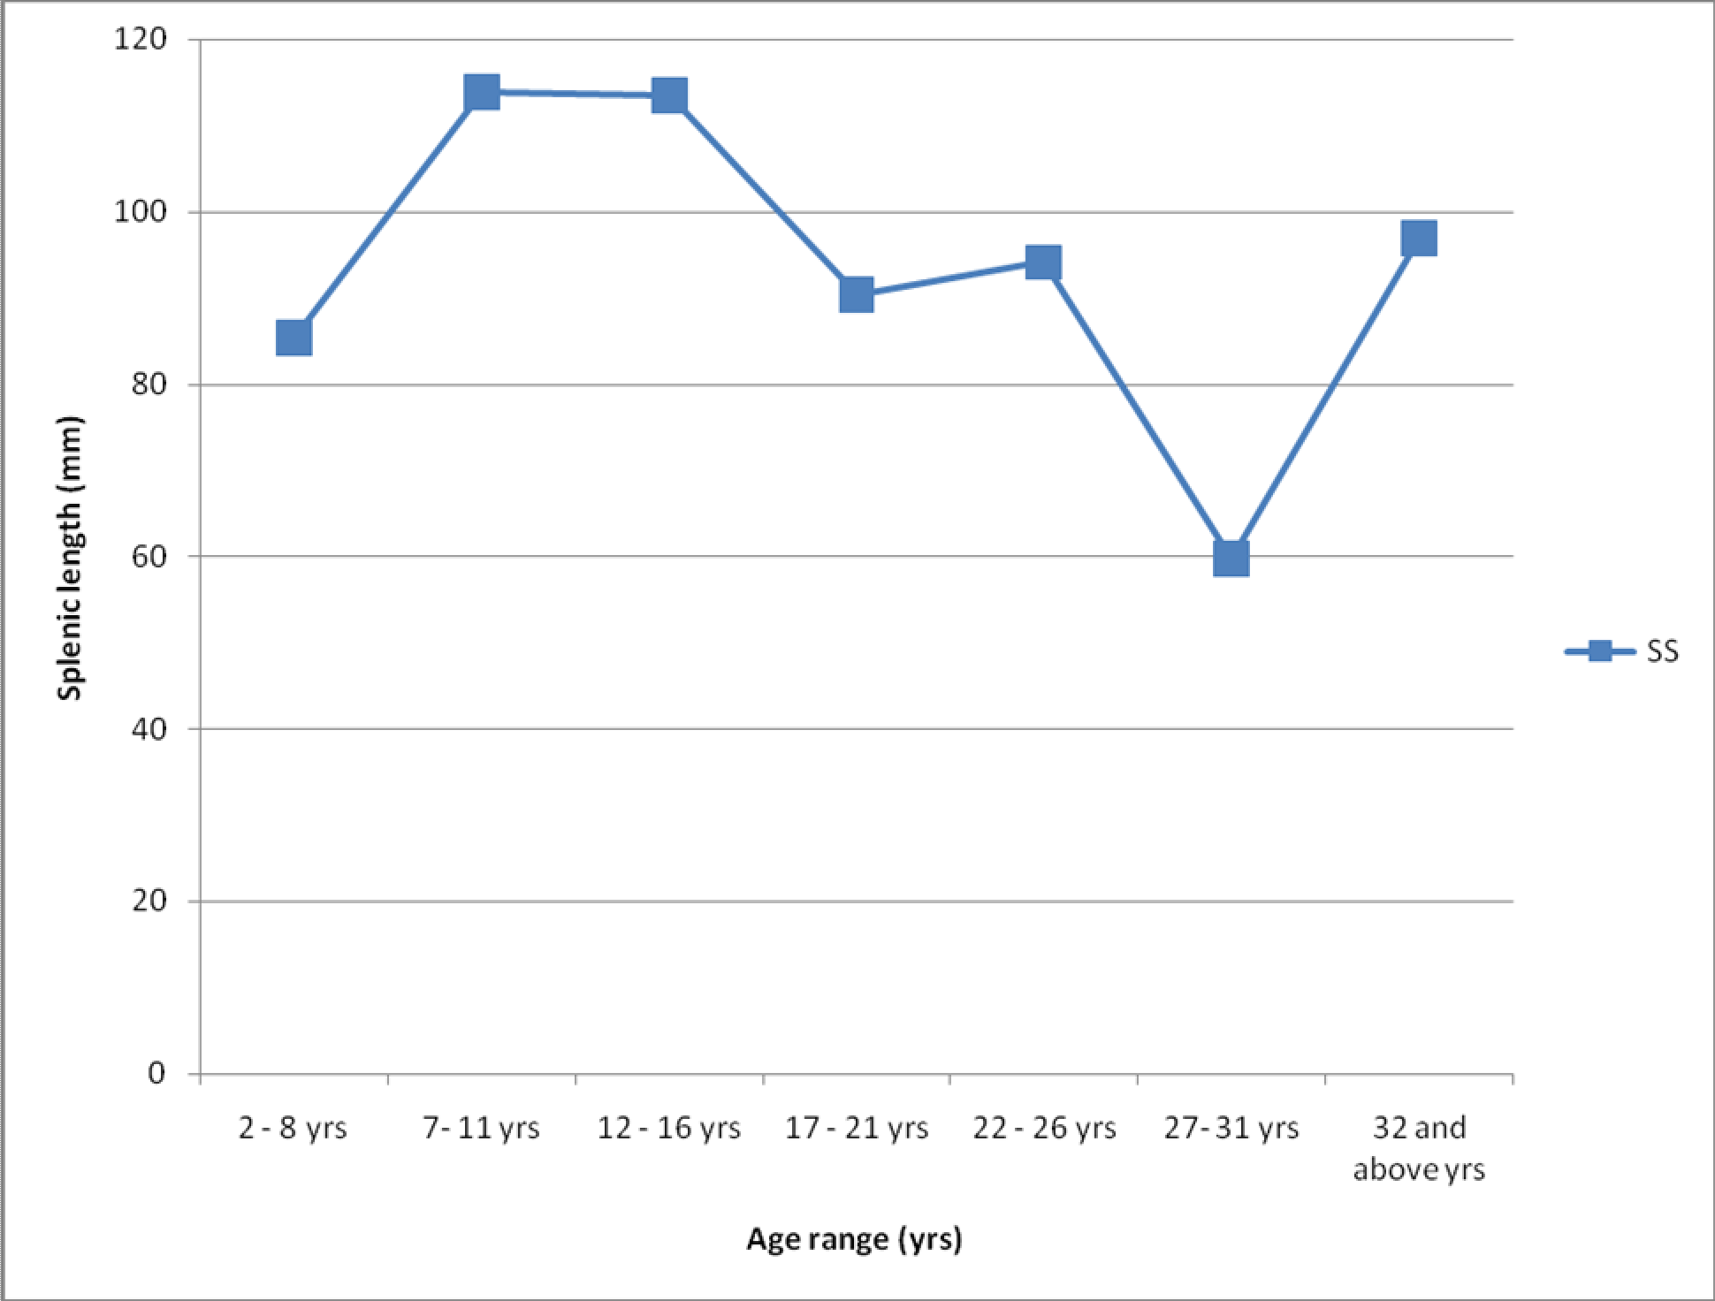

Figure 4.2(a): This graph shows the trend of the spleen length among the sickle cell disease subjects of the present study. A haphazard or undulating variation in spleen length is the relationship between spleen length and the age groups of the SCD subjects.

200.00




































































150.00
SPLEEN_LENGHT_in_mm

100.00

50.00

2- 6 yrs 7-11 yrs 12-16 yrs 17 -21 yrs 22-26 yrs 27 - 31 yrs 32 above
Age_range

Figure 4.2(b): This is a scatter plot of the graph in figure 4.2(a) above.

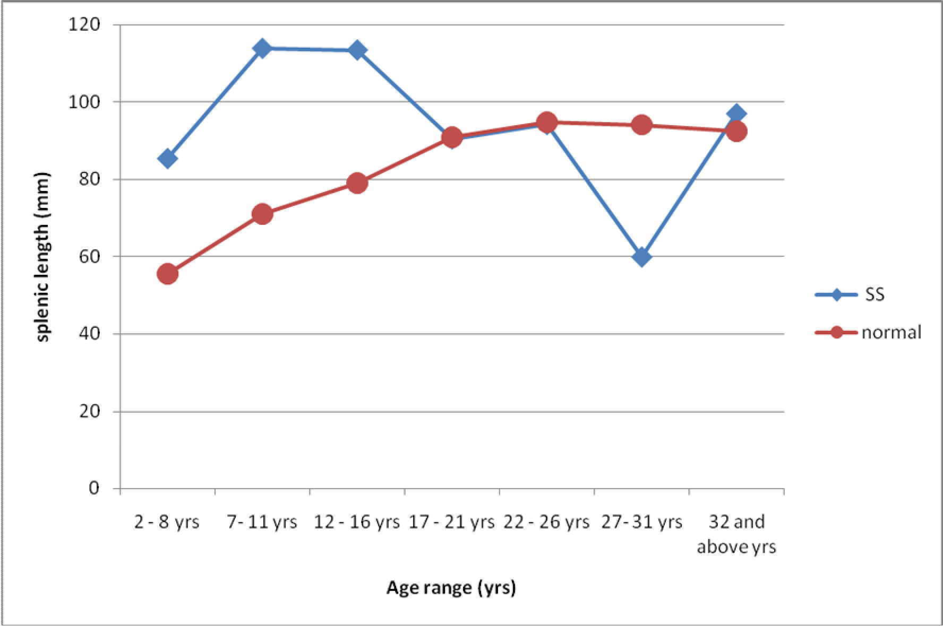

Figure 4.3 Figure 4.1 (a) and Figure 4.2 (a) compared. That is, this figure is a comparison of the trends of the spleen lengths of sickle cell disease patients and those of the controls with respect to age. There is a correspondence of variation in spleen length among sickle cell disease patients and the controls between 17 - 21 years age group and 22 - 26 years age group. This implies that the mean spleen lengths of SCD patients and those of the controls experience similar gradual increase in size between 17 - 21 years and 22 - 26 years age groups.

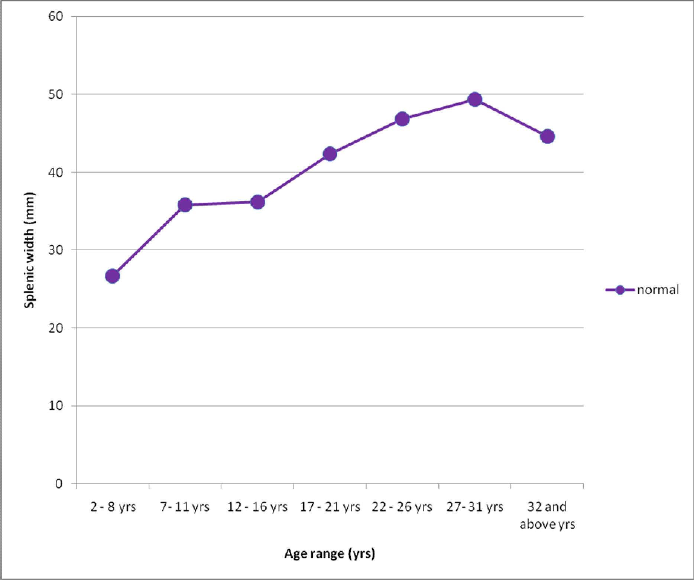

Figure 4.4(a): This graph shows the trend of spleen width with respect to age in the healthy controls of this study. There is a gradual increase in size of spleen width of controls from 2 - 6 years age group to 7 - 11 years age group, beyond which there is a plateau between 7 - 11 years age group and 12 - 16 years age group, and another gradual increase from 12 - 16 years age group to 27 - 31 years age group, and finally a decline.

60.00























































































50.00

40.00
SPLEEN_WIDTH_in_mm

30.00

20.00

2- 6 yrs 7-11 yrs 12-16 yrs 17 -21 yrs 22-26 yrs 27 - 31 yrs 32 above
Age_range

Figure 4.4(b): This is a scatter plot of the graph in figure 4.4(a) above, and it shows the frequency and arrangement of the mean spleen width of the controls existent in the mean areas of each age group.

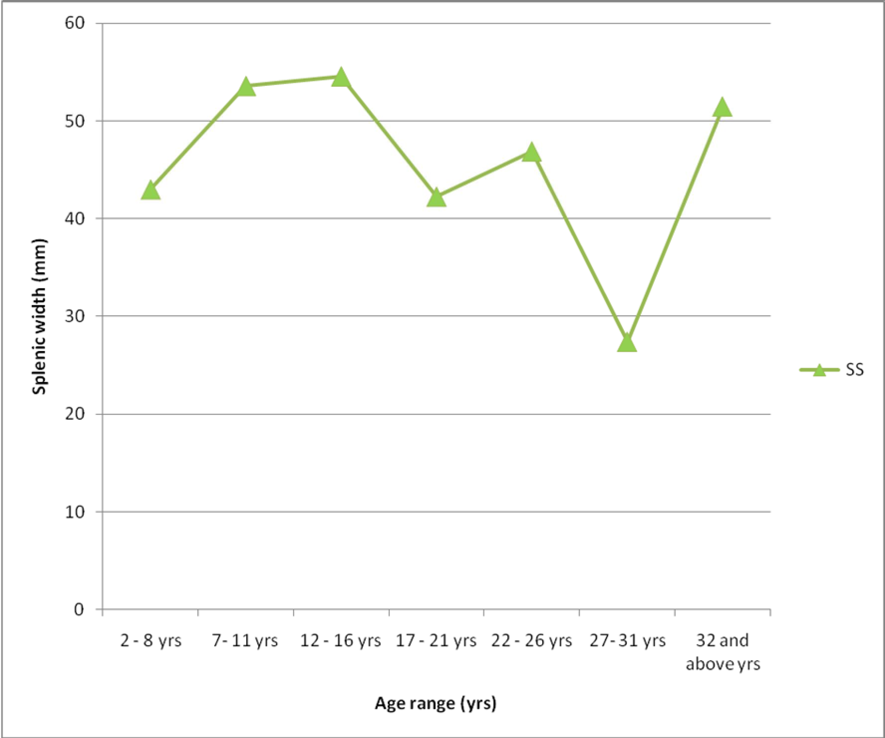

Figure 4.5(a): This graph shows the trend of variation in spleen width with respect to age among the sickle cell disease patients. The haphazard or undulating variation in spleen width of SCD subjects is clearly demonstrated here.

80 .00


















































































60 .00
SPLEEN_WIDTH_in_mm

40 .00

20 .00

2- 6 yrs 7-11 yrs 12 -16 yrs 17 -21 yrs 22 -26 yrs 27 - 31 yrs 32 a bove
Age_range

Figure 4.5(b): This is a scatter plot of the graph in figure 4.5(a) above. This explains better the relationship between the spleen width and age in the sickle cell disease subjects of this study.

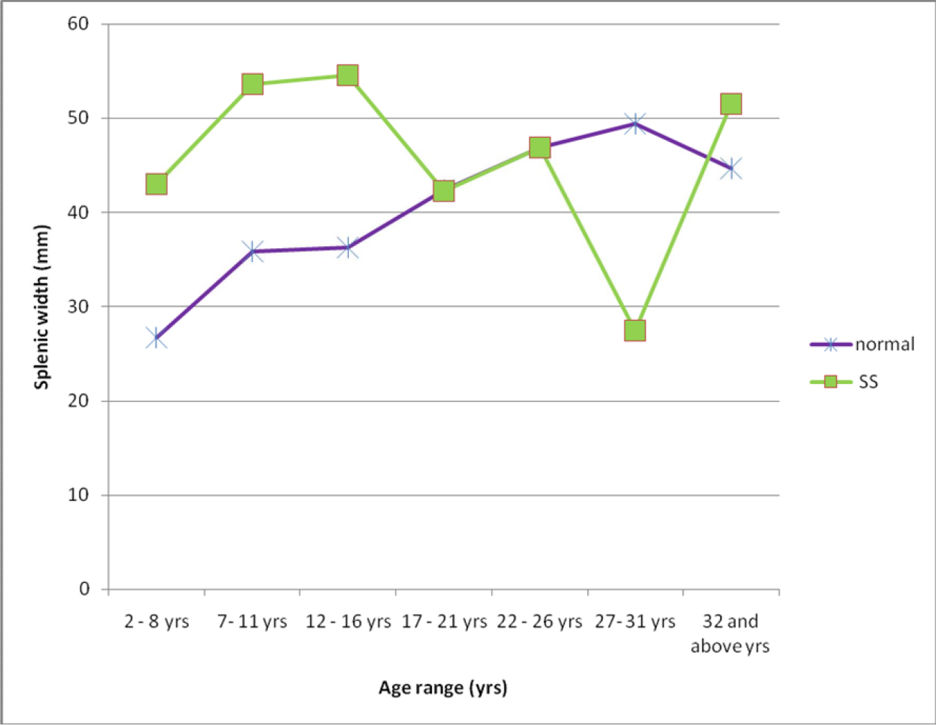

Figure 4.6: Figure 4.4(a) and figure 4.5(a) are compared here. That is, the trend of mean spleen width of both patients with SCD and controls are compared with similar variation in size seen between 17 - 21 years age group and 22 - 26 years age group.

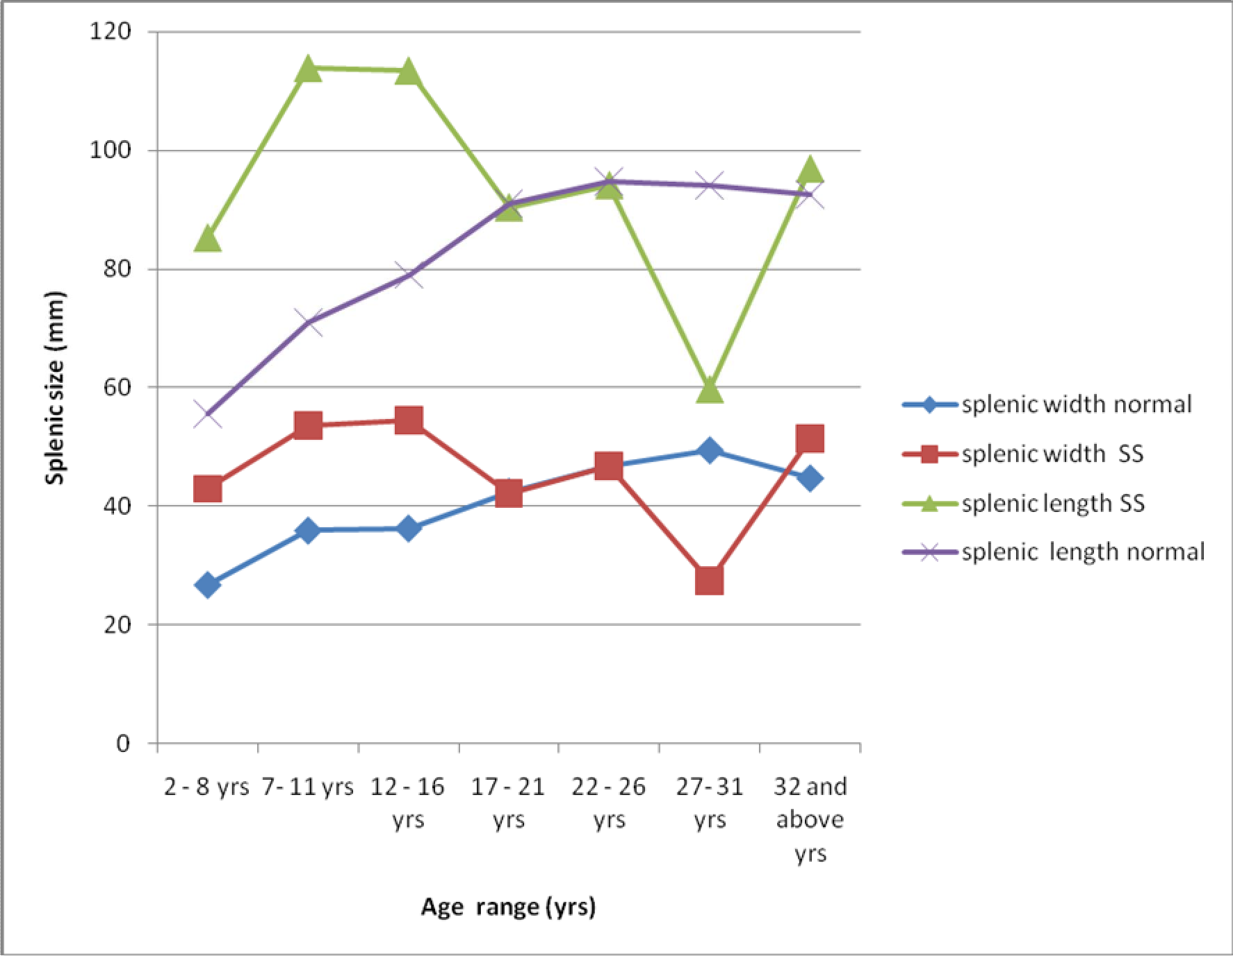

Figure 4.7: This graph compares the overall spleen sizes (spleen length and spleen width) of sickle cell disease subjects with those of the control subjects.

CHAPTER FIVE

DISCUSSION AND CONCLUSION

Discussion and Implications of Results

The dynamic nature of the imaging techniques in radiology, particularly with ultrasonography has opened up a new approach to the study of various organs of the body especially the spleen, the most common and early organ to be affected in sickle cell anaemia (Ahmed, 2011 ; Olatunji et al., 2001). Ultra-sonography is a method of choice in the study of the pathologies, and determination of position, shape, size, and volume of most organs of the body like the spleen due to its simplicity of use and less stress it poses to the patient (Olatunji et al., 2001).
Many scholars in the Caucasian environment and few in our clime have done many studies on spleen of sickle cell disease (SCD) patients with different results, some of which are contradictory. This work found two varieties of SCD (Sickle-haemoglobin C or HbSC and Homozygous sickle haemoglobin or HbSS) in our locality, Enugu, and presented the parenchyma echo textures and sizes of the spleen of the SCD patients in stable health, in Enugu, Nigeria.

Pilot Study

The results of the pilot study show that the differences between the mean spleen sizes of the three different measurements by the same observer, and between the three observers were statistically not significant. Measurement of the spleen by a competent sonographer using a high quality ultrasound machine and proper technique is reliable. This is shown by the low inter- and intra- observer errors of the pilot study (P > 0.05). This concurs well with the observation of Eze et al., 2013.

Demographic Characteristics of the Subjects

A total of 103 sickle cell disease (SCD) patients - 101 (98.1%) HbSS and 2 (1.9%) HbSC - with a mean age of 18.2 ± 11.8 years (range 2 - 58 years), and made up of 48 (46.6%) males and 55 (53.4%) females were studied. The controls involved 103 healthy (HbAA) subjects with mean age of 18.6 ± 12.4 years (range 2 - 58 years); males were 56 (54.4%) and females were 47 (45.6%). Ninety-seven (94.2%) were single and 6 (5.8%) were married among the SCD patients while 94 (91.3%) were single and 9 (8.7%) were married in the control subjects. Mean height was
143.3 ± 33.0 cm (range 30 - 186 cm) and mean weight was 41.4 ± 18.6 kg (range 10 - 77 kg) in the SCD subjects. The control subjects had mean height of 144.2 ± 38.7 cm (range 46 - 188 cm) and mean weight of 50.0 ± 23.7 kg (range 9 - 85 kg). These gave a pooled frequency of study subjects to be 206; 104 (50.5%) males and 102 (49.5%) females, 15(7.3%) married and 191 (92.7%) single. Mean height of the pool was 143.8 ± 35.9 cm (range 30 - 188 cm); mean weight was 45.7 ± 21.7 kg (range 9 - 85 kg); and mean age of the entire study subjects was 18.4 ± 12.1 years (range 2 - 58 years).
The demographic features of this study compare well with that of Babadoko et al (2012) that studied 74 sickle cell disease patients with a mean age of 23.2 ± 5.3 years (range 10 - 52 years) and 20 controls with a mean age of 22.7 ± 12.4 years (range 20 - 24 years). The minimal difference in mean age could be due to the fact that Babadoko and colleagues studied mainly the adult sickle cell disease patients. Awotua-Efebo et al (2004) studied 100 sickle cell disease children with mean age of 10.5 ± 2.8 years (range is 6 - 15 years), and 100 matched healthy (HbAA) controls. Of the 100 SCD children they studied, 51 (51%) were males and 49 (49%) were females. The mean age of the present study differed significantly from that of Awotua- Efebo and colleagues probably because they studied only pediatric SCD patients. The work of Olatunji et al (2001) involved 98 adult and pediatric SCD patients, and was made up of 47 (47.96%) males and 51 (52.04%) females. Though the age range (3 - 47 years) was comparable to

that of the present study (2 - 58 years), their mean age (13.9 ± 7.4 years) was significantly different from that of the present study which is 18.2 ± 11.8 years. This may be because 69 (70.41%) of their SCD patients were within 3 - 15years age range, while only 29 (29.59%) were in the adult age range. The present study involved 50 (48.54%) SCD patients within 2 - 16 years age range and 53 (51.46%) SCD patients in the adult age range.

Assessment of Spleen Size of the Sickle Cell Disease Patients and the controls

The sickle cell disease (SCD) group in this study had a rapid increase in mean spleen size from 2

- 6 years age group to 7 - 11 years group. A plateau was formed between 7 - 11 years and 12 - 16 years groups before the mean spleen size diminished rapidly towards 17 - 21 years group and thereafter rose gradually to the 22 - 26 years age group. There was a sharp decline in mean spleen size from 22 - 26 years group to 27 - 31 years group, followed by an unexpected rapid rise in mean spleen size towards the 32 years and above age group. This undulating variations in mean spleen sizes in these age groups of the sickle cell disease patients may be explained by the following: the immune status of the neonates, infants and children is very low compared to that of adults which implies that they are more vulnerable to the acute and chronic complications of sickle cell condition. These acute and chronic complications of sickle cell disease multiply sickling activities in the blood as well as the quantity of sickled red blood cells. These increase rapidly the physiologic activities of the spleen and ultimately enlarge the spleen in the 2 - 6 years, 7 - 11 years, and 12 - 16 years age groups. Precisely, the largest spleen size was recorded at 18 years of age among the sickle cell disease patients in this study.
There was appreciable and rapid reduction in size of the spleen of the SCD patients above 18 years with the largest number of auto-splenectomy and shrunken spleen recorded within the 18 - 33 years age range. This could be responsible for the sharp decline in mean size of spleen of the sickle cell disease patients in this study from 12 - 16 years age group to 27 - 31 years age group. This implies that, in our clime, the spleen of patients with SCD increases rapidly in size from

early age and peaks at 18 years, and generally declines sharply to either a shrunken state or auto- splenectomy. However, very few SCD patients within 32 years and above age group were observed to have spleen, but, their spleens were all in moderate or marked splenomegaly category. This might have caused the observed rapid increase in mean spleen size above 27 years of age.
This trend is not consistent with the finding of Olatunji et al (2001) in Ilorin Teaching Hospital, Nigeria, that recorded increase in spleen sizes among sickle cell disease patients from early age with peak at 30 years, beyond which significant reduction in size of spleen occurred. This inconsistency could be as a result of ethnic variations. Though Olatunji and colleagues studied sickle cell disease patients within 3 - 47 years age range, 85 (86.73%) of their 98 study subjects were under 20 years, the age range of maximum spleen size in the present study. The paltry 13 (13.27%) sickle cell disease patients above 20 years age range in their study could have been in the class of those that were observed to have marked splenomegaly in the present study.
Other related works by Mohanty et al (2004) and Ahmed Al-Salem et al (1998) in Western Orissa, India, and Eastern province of Saudi Arabia respectively showed that the spleen size increased and peaked at 40 years, and sometimes persisted well into adult ages with minimal reduction in size. The presence of less severe Arabian-Indian haplotype in their area of study compared to the benign haplotype in Nigeria may be the cause as suggested by Babadoko et al (2012). Nigeria has only HbSS and HbSC varieties of sickle cell disease, while Saudi-Arabia has HbSS and sickle haemoglobin associated with alpha-thalassaemia.
The trend in our healthy control showed gradual and persistent increase in spleen sizes from early ages up to adult ages. Actually, mean spleen sizes of the healthy control become larger than that of the sickle cell disease patients in the 21 - 31 years age range because auto-splenectomy and shrunken spleen were common among SCD patients in this age range.

Shrunken Spleen, Auto-Splenectomy and Persistence of Splenomegaly into Adult Age

Normal limits of spleen length with respect to age among the controls of the present study together with those from the studies done by Eze et al., 2013; Udoaka et al (2013); Tanna et al., 2012; Ogbeide et al (2011); Dhingra et al., 2010; Okoye et al (2005); and Megremis et al (2004) were used to sift out and classify the abnormal mean sizes of the spleens of the sickle cell disease patients in stable condition. In the present study, splenomegaly was defined as when the long axis of the spleen was longer than the upper or 95th percentile in each age group. Splenomegaly was defined as mild when the long axis of the spleen exceeded the upper limit of normal in each age group by less than 10%, moderate when the measurement was 10% to 20%, and gross when the measurement exceeded the upper limit of normal by more than 20% (Babadoko et al., 2012). Shrunken spleen was defined when the long axis of the spleen was less than the 5th percentile or lower limit of normal in each age group (Babadoko et al., 2012). Auto-splenectomy was defined as non-visualization of the spleen in the entire abdomen (Babadoko et al., 2012).
A total of 24 (23.30%) auto-splenectomy cases were found among the sickle cell disease patients in the present study. The entire cases of auto-splenectomy were found at 14 years and above age range. It did not show any sexual bias. The total frequency of auto-splenectomy of this study significantly differs from that recorded by Babadoko et al (2012), which found 41(55.4%) cases. This discrepancy may be because of regional differences and, perhaps, because Babadoko and his colleagues did not include paediatrics in their study. The present study involved 50% paediatric and 50% adult sickle cell disease patients with a mean age of 18.2 ± 11.8 years, while Babadoko et al (2012) studied adult SCD patients with a mean age of 23.2 ± 5.3 years where auto- splenectomy were mainly found in the present study. This result contradicts the work of Olatunji et al (2001) that recorded no auto-splenectomy cases. This difference may have come from differences in ethnicity. This result of our study is also similar to the findings of Awotua-Efebo et al (2004), which recorded 20% of auto-splenectomy. This study differs somehow with the

findings of Ahmed et al (1998), and Mohanty et al (2004), who visualized 6.6% auto- splenectomy and no auto-splenectomy respectively in Eastern province of Saudi Arabia and Western Orissa in India respectively. This could be because of the differences in gene haplotype between Saudi Arabia and Nigeria plus the fact that Mohanty et al studied sickle cell disease patients in crises state.
The present study found 11(10.86%) cases of shrunken spleen. This finding differs minimally from the 8% shrunken spleen seen by Mohanty et al (2004), in western orissa. This mild variation may be explained by the differences in gene haplotype between Saudi Arabia and Nigeria, as well as the fact that they studied SCD patients in crises condition. Our 10.86% incidence of shrunken spleen is much lower than the 31% cases of shrunken spleen recorded by Babadoko et al (2012). This discrepancy might be as a result of differences in region and from the fact that Babadoko and colleagues studied only the adult sickle cell disease patients. However, a significant difference exists between the sample size of the present study which is 103 and that of Babadoko et al (2012) which is 74. This difference in sample size may not have contributed to the substantial variation in incidence of shrunken spleen observed in these two studies.
Generally, this study found 34 (33.01%) cases of splenomegaly: 5 (4.85%) were mild; 13 (12.62%) were moderate, while 16 (15.53%) were marked or gross splenomegaly. The present study shows that splenomegaly occurs more in children. This may probably be because children are associated with low body immunity and hence, are more susceptible to some of the acute complications of sickle cell disease that trigger off more sickling activities and more number of abnormal red blood cells. These lead to more physiologic activities in the spleen and consequently more incidence of splenomegaly.
The 33.01% incidence of splenomegaly recorded in the present study is significantly much higher than the finding of only 3(4.05%) cases of splenomegaly by Babadoko et al (2012). This may, perhaps, be because of differences in region and the fact that they studied only the adult sickle

cell disease patients that are more associated with shrunken spleen and auto-splenectomy. However, our finding is similar to the 27% splenomegaly recorded by Awotua-Efebo et al (2004). This finding of 34 (33.01%) splenomegaly in the present study is significantly lower than 65% and 64% cases of splenomegaly recorded respectively by Ahmed et al (1998) and Mohanty et al (2004) in Saudi Arabia. This may possibly be because of differences in clime and gene haplotype between Nigeria and Saudi Arabia.

Comparison of the Mean Spleen Sizes of the Stable SCD Patients and the Healthy HbAA Controls
The mean spleen sizes of sickle cell disease patients were significantly larger than those of the controls in the children age groups (P = 0.01). This may be due to low body immunity with resultant high susceptibility to the acute complications of sickle cell condition. These will lead to high sickling activities, large quantity of abnormal erythrocytes, and an overwhelming pressure on the spleen. The spleen will consequently experience an abnormal increase in size while trying to sequestrate these large abnormal red blood cells.
There was no statistical significant difference in the mean spleen sizes of the sickle cell disease patients and those of the controls in the 17 - 21 years and 22 - 26 years age groups (P = 0.98). This might be because in these age groups, the spleens of sickle cell disease patients have undergone a lot of fibrosis and infarctions with consequent reduction in their sizes. They now assume similar size with the controls. At 27 - 31 years age group, the spleens of the sickle cell disease patients experienced so much reduction in size and auto-splenectomy that the mean spleen sizes of the controls were much larger (P = 0.04). Notably, there is no statistically significant difference in mean spleen sizes of sickle cell disease patients and the healthy controls above 32 years of age. Above 32 years of age, most of the spleens of patients with SCD may have experienced auto-splenectomy; there is no shrunken spleen here, and the few remaining spleens are either moderately or grossly enlarged. This may be due to the fact that the splenic tissues of

individuals suffering from chronic erythrocyte breakdown (e.g., in malaria and other hemolytic diseases) might be permanently hypertrophied and the spleen becomes greatly enlarged.
Generally, the mean spleen sizes of the sickle cell disease patients in this study were statistically significantly larger relative to those of the healthy controls (P = 0.001 for spleen length, and
0.002 for spleen width). This is similar to the findings of Olatunji et al (2001). This result of the present study concurs with the finding of Tanna et al., 2012, which observes that at any age, the spleen sizes of the abnormal spleen group exceed by at least 2cm that of the normal spleen group. Their work was on a pediatric Indian population of 0 - 12 years age range. Awotua-Efebo et al., 2004, working on 6 - 15 years age range, agreed that the spleen sizes of sickle cell anaemia patients were significantly greater than those of the controls. However, this result disagrees with the finding of Babadoko et al (2012), which recorded a significantly lower mean spleen sizes in SCD subjects relative to those of their control subjects. This may be due to ethnic differences and perhaps due to the large number of adult SCD patients they studied. Their study yielded 55.4% auto-splenectomy and 31% shrunken spleen, which reduced spleen sizes of the SCD subjects to a significantly lower figure relative to those of the controls. Also, the age range of their controls (20-24 years) is the age range of maximum spleen size in the controls of the present study. Hence, the mean spleen sizes of their controls were expectedly higher than those of their SCD subjects.

The Effects of Age, Height, and Weight on the Size of Spleen of the Stable Sickle Cell Disease Patients and Healthy Controls
This study shows no statistically significant correlations between subject age and mean spleen sizes (P = 0.23, r = -0.1) among the sickle cell disease patients. This is consistent with the findings of Udoaka et al (2013) of weak and negative relations between subject physical data (age and BMI) and spleen sizes, and the observations of Ogbeide et al (2011) that showed no significant correlation between age and spleen sizes in either sex in an endemic tropical

environment. However, this result of the present study is contrary to the findings of significant correlation between age and spleen sizes by Ahmed et al (1998) in Saudi patients with sickle cell disease, Olatunji et al (2001) in Ilorin, Nigeria, and Tanna et al (2012) in a paediatric Indian population. The discrepancy may be ascribed to differences in ethnicity, clime and haplotype. This study shows also a statistically no significant correlation between subject height and mean spleen sizes (P = 0.18, r = -0.2); and between subject weight and mean spleen sizes (P = 0.50, r =
-0.1) in the sickle cell disease patients. This might be as a result of numerous sickling activities, vaso-occlusions, ischaemias, infarctions and fibrosis characteristic of the sickle cell condition. These findings of the present study disagree with those of Tanna et al (2012) in a certain Indian population, and Ogbeide et al (2011) in an endemic tropical environment in Nigeria. This may be because of variations in clime and ethnicity. Babadoko et al (2012), Bakhieta et al (2010), Ali- Hassan et al (2002), Olatunji et al (2001) and Ahmed et al (1998) did not carry out correlation of spleen sizes and subjects somatometric parameters like Height and weight.
A statistically significant correlation exists between subject age and mean spleen sizes (P = 0.00, r = 0.67) among the healthy control subjects. Also, a significant relationship was seen between subjects height and mean spleen sizes (P = 0.00, r = 0.90), and between subjects weight and mean spleen sizes (P = 0.00, r = 0.87) in the healthy control subjects. This may be due to the fact that the controls did not have any health problem that may affect spleen size. These findings of the present study are consistent with the findings of Eze et al (2013), Udoaka et al (2013), Tanna et al (2012), Dhingra et al (2010), Okoye et al (2005), Spielmann et al (2005) and Megremis et al (2004).
Considering the body parameters in the present study, height showed the strongest correlation with the spleen sizes, followed by weight and age. Compared with width, the spleen length or longitudinal diameter showed the highest correlation with the body parameters. These are also the opinions of other authors above.

Characterization of the Parenchymal Echo textures of the Spleens of the Sickle Cell Disease Patients and those of the Healthy Controls
This study characterized the parenchymal echo textures of the spleens of the stable sickle cell disease patients into the following groups: Normal parenchyma; Coarse and hyper echoic parenchyma; Fine and hyper echoic parenchyma; Fibrotic scar littered parenchyma; Infarction/Abscess littered parenchyma; calcified parenchyma. This study found only 9 (8.74%) normal spleen parenchyma echo texture among the sickle cell disease patients which is significantly smaller than 53 (53.0%) normal spleen parenchyma echo texture which Awotua- Efebo et al (2004) recorded among their own sickle cell disease patients. This discrepancy could be as a result of differences in technique; this study sifted out coarse hyper echoic and fine hyper echoic spleen parenchyma echo textures from the normal spleen parenchyma echo textures. Awotua-Efebo et al (2004) may have lumped these fine differences in spleen parenchyma echo texture together as normal spleen parenchyma echo texture.
This study recorded also 22 (21.36%) fibrotic scar littered parenchyma, 3 (2.91%) infarction or abscess littered parenchyma, 5 (4.85%) calcified parenchyma echo textures. The frequencies of infarction/abscess littered parenchyma and calcified spleen parenchyma recorded by this study are significantly smaller than those of Mohanty et al (2004). This may be due to the fact that they studied sickle cell disease patients in crisis condition who are more disposed to more of these abnormal parenchyma echo texture, and, perhaps, due to differences in clime. Nothing was reported by Mohanty et al(2004) on fibrotic scar littered parenchyma. However, these results of the present study agree with those of Ali et al., 2008, in their study of abdominal organs of patients with SCD in Turkey; and disagree with those of Papadaki et al., 2003, among Greek sickle cell disease patients. This may be due to differences in clime.

Conclusion

Generally, spleens of the sickle cell disease (SCD) subjects were significantly larger in size than those of the normal genotype (HbAA) subjects in the present study. The spleens of the SCD patients had undulating variation in size, while those of the normal genotype (HbAA) subjects experienced gradual variation in size. Age of maximum spleen size was 18 years in SCD patients, and 30 years in normal genotype subjects.
Maximal frequencies of shrunken spleen and auto-splenectomy were recorded in the 21-29 years age range in this study. However, few sickle cell disease patients above 30 years did not have auto-splenectomy, but, their spleens were all markedly enlarged in this study. There was no sex bias in the frequency of complications of sickle cell disease found in this study such as auto- splenectomy, shrunken spleen, calcifications and fibrosis of spleen parenchyma, infarction, abscess, fine and coarse spleen parenchyma echo texture.
There was negative correlation between age, height, weight and spleen sizes among sickle cell disease patients in this study; while a strong correlation existed between age, height, weight, and spleen sizes in the normal genotype (HbAA) subjects. The sickle cell disease patients in the present study had varying abnormal spleen parenchyma echo texture such as fine and hyper echoic parenchyma, coarse and hyper echoic parenchyma, infarction/abscess littered parenchyma, calcified parenchyma, and fibrotic scar littered parenchyma, while all the normal genotype (HbAA) subjects studied had normal spleen parenchyma echo texture.
Homozygous sickle haemoglobin (HbSS) or sickle cell anaemia and sickle-haemoglobin C (HbSC) disease were the two varieties of sickle cell disease in our locality, Enugu, Nigeria. Sickle cell anaemia was predominant. The results of this study suggest that inclusion of routine sonographic study of the spleen in the management of SCD patients will be very useful.

Recommendations

- All genotype screening done with positive sickling test and found to be positive should be followed up with haemoglobin (Hb) electrophoresis test to determine the variety of sickle cell disease the subject has because this study found sickle cell anaemia (HbSS) and sickle haemoglobin C (HbSC). Sickle haemoglobin C is less severe compared to sickle cell anaemia.
- Measurements made on abdominal organs by a competent and experienced sonographer using a good ultrasound machine, and proper technique are reliable. This is indicated by the low inter- and intra-observer errors of the pilot study.
- Routine abdominal sonographic examination should be made part of the clinical care given to all sickle cell disease patients. This is to rule out splenomegaly among the sicklers. If splenomegaly is present, the clinician may carry out other laboratory tests for any possible complication like acute splenic sequestration, hyper-splenism, abscess, or infarction.
- Routine abdominal ultrasound investigation could also be used to detect any impending crisis, based on the size of the spleen and the splenic parenchyma echo texture, in the sickle cell disease patients.

Limitations of the Study

Illiteracy and ignorance of most sickle cell disease patients and their guardians delayed the data collection. A lot of time was spent explaining the nature and essence of this study to some of the patients with SCD and their guardians before they gave their consent to participate. Some finally declined to be educated and to participate.

Areas for Further Study

- Sonographic assessment of the size and parenchymal echo texture of the spleen of sickle cell disease patients in crisis state in Enugu.

- Sonographic evaluation of the entire abdominal organs of sickle cell disease patients in stable condition and in crisis state in Enugu.
- Malaria parasite density and splenic status by ultrasonography in stable sickle cell disease patients in Enugu.

REFERENCES

Ahmed H. Al-Salem (2011). Splenic Complications of Sickle Cell Anemia and the Role of Splenectomy. ISRN Haematology. 57(13) : 321 - 330.
Ahmed H. Al-Salem (2006). Indications and Complications of Splenectomy for Children with Sickle Cell Disease. Saudi Arabia Journal of Pediatric Surgery. 41:1909-15.
Ali Balci, Sinem Karazincir, Ozlem Sangun, Edip Gali, Turgay Daplan, Cihangir Cingiz,

Ertugrul Ejilmez (2008). Prevalence of Abdominal Ultrasonographic Abnormalities in Patients with Sickle Cell Disease. Special Journal of the Turkish Society of Radiology. 14(3) : 133 - 137.
Awotua-Efebo O., Alikor E. A. D., Nkanginieme K. E. O. (2004). Malaria Parasite Density and Splenic Status by Ultrasonography in Stable Sickle Cell Anaemia (HbSS) Children. Nigerian Journal of Medicine. 13(1) : 23 – 27.
Ali Hassan Al Jama, Ahmed Hassan Al Salem, Ibrahim Abdalla Al Dabbous (2002). Massive Splenic Infarction in Saudi Patients with Sickle Cell Anemia: a Unique Manifestation. American Journal of Hematology. 69: 205 - 209.
Ahmed H. Al-Salem, Prabhakar Bhamidipati, Ali Al Jam’a, Ibrahim Al Dabbous (1998). Sonographic Assessment of Spleen Size in Saudi Patients with Sickle Cell Disease. Annals of Saudi Medicine. 18(3) : 217 – 219.
Aldrich T.K., Nagel R.L. (1998). Pulmonary Complications of Sickle Cell Disease. In : Reynolds H.Y., Bone R.C., Dantzker D.R., George R.B., Matthay R.A. Pulmonary
And Critical Care Medicine. 6th ed. St. Louis . Mosby ; PP 1 – 10.

Audrey L. Spielmann, David M. Delong, Mark A. Kliewer (2005). Sonographic Evaluation of Spleen Size in Tall Healthy Athletes. American Journal of Roentgenology. 184 : 45 - 49.

Babadoko A.A., Ibinaye P.O., Hassan A., Yusuf R., Ijei I.P., Aiyekomogbon J., Aminu S.M., Hamidu A.U. (2012). Autosplenectomy of Sickle Cell Disease in Zaria, Nigeria: an Ultrasonographic Assessment. Oman Medical Journal. 27(2) : 121 - 126
Bakhieta Ibrahim Attalla (2010). Abdominal Sonographic Findings in Children with Sickle Cell Anamia. Journal of Diagnostic Medical Sonography. 26(6) : 281 - 285.
Bhavna Dhingra, Suvasini Sharma, Devendra Mishra, Reema Kumari, Ravindra Mohan Pandey, Shailendra Aggarwal (2010). Normal Values of Liver and Spleen Size by Ultrasonography in Indian Children. Indian Pediatrics.47 : 487 - 494.

Charache S., Terrin M.L., Moore R.D. et al (1995). Effect of Hydroxyurea | on | the
Frequency of Painful Crises in Sickle Cell Anaemia. Investigators | of | the

Multicenter Study of Hydroxyurea in Sickle Cell Anaemia. North England Medical Journal. 332(29) : 1317 – 22.
Claster s., Vichinsky E.P. (2003). Managing Sickle Cell Disease. British Medical Journal.

327 : 1151 – 5.

Curry R.A, Tempkin B.B. (1995). The Spleen. Ultrasonography : An Introduction to Normal Structure and Functional Anatomy. 1st ed. London . W.B.Saunders 1995 ; 9:136 – 43.
C.V.Mosby Co, St. Louis. 1973; 20; Cited in Desai D.V., Hiren Dhanani (2004). Sickle Cell Disease : History and Origin. The Internet Journal of Haematology. 1 (2).
Chestnut D. (1994). Perception of Ethnic and Cultural Factors in the Delivery of Services in the Treatment of Sickle Cell Disease. Journal of Health and Social Policy.5: 236.
Dorland W.A.N. (2009). Spleen. Dorland’s Pocket Medical Dictionary. 28th ed. Philadelphia.

Elsevier Saunders 2009 ; 780.

de Montalembert M (2008). Management of Sickle Disease. British Medical Journal. 337 : a1397.
Desai D. V., Hiren Dhanani (2004). Sickle Cell Disease : History and Origin. The Internet Journal of Haematology. 2 : 47
Embury S. H., Hebbel R. P., Narla M, Steinberg M. H. (1996). The Spleen. Sickle Cell

Disease : Basic Principles and Clinical Practice. 1st ed. New York. Lippincott – Raven 1996 ; 13 : 430 – 448.
Eckman J., Platt A.(1997). Sickle Cell Trait. The Sickle Cell Information Center; Sickle Cell Foundation of Georgia. 1997.
Eze C.U., Agwu K.K., Ezeasor D.N., Ochie K., Aronu A.E., Agwuna K.K., Nwadike I.U. (2013). Sonographic Biometry of Spleen among School age Children in Nsukka, Southeast, Nigeria. African Health Sciences. 13(2) : 384 - 395.
Fifty-Ninth World Health Assembly (2006). Sickle Cell Anaemia - Report by the Secretariat.

World Health Organization. A59/9 : Provisional Agenda Item 11.4 : 1 - 5.

Gorg C., Colle J., Gorg K., Prinz H., Zugmaier G.,(2003). Spontaneous Rupture of the Spleen: Ultrasound Patterns, Diagnosis and Follow-up. British Journal of Radiology. 76: 704- 11.
Graham R. S. ( 1992 ). The Spleen . Sickle Cell Disease. 2nd ed. London . Oxford University Press 1992 ; 10 : 135 – 52 .
Hofer M. (1999). Spleen. Ultrasound Teaching Manual : the Basics of Performing and Interpreting Ultrasound Scans. 2nd ed. New York. George Thiene 1999; 6: 47 – 9.

Henderson J., Dziewulski P.(2008). Case Report of Sickle Cell Crises after Wearing a Pressure Garment. British Medical Journal. 2008 ; 337 : a 2776 .
Hosey R.G., Mattacola C.G., Kriss V., Armsey T., QuarlesJ.D., Jagger J. (2006). Ultrasound Assessment of Spleen Size in Collegiate Athletes. British Journal of Sports Medicine. 40: 251-4.
Hillman S.R., Ault A.K., Rinder M.H. (2005). Common Haemoglobinopathies. Haematology in Clinical Practice . 4th ed. London . M C Graw – Hill 2005 ; 11 : 198.
Jadavji T., Prober C.G.(1985). Dactylitis in a Child with Sickle Cell Trait. Canadian Medical Association Journal. 132(7) : 814 – 5.
Lindsay T. D. (1996). Anatomy of the Spleen. Functional Human Anatomy. 1st ed. Manchester .

Mosby 1996 ; 17 : 492.

Lanzkowsky P. (2011). Sickle Cell Anaemia. Manual of Paediatric Haematology. 5th ed. Ohio .

Academic press 2011; 1:1, 6:200 – 31.

Ming-Jen Chen, Ming-Jer Huang, Wen-Hsung Chang, Tsang-En wang, Horng-Yuan Wang,

Cheng-Hsin Chu, Shee-Chan Lin, Shou-Chuan Shih (2005). Ultrasonography of Splenic Abnormalities. World Journal of Gastroenterology. 11(26) : 4061 - 4066.
Mohanty J., Narayan J.V.S., Bhagat S., Panda B.B., Satpathi G., Saha N.(2004). Sonological

Evaluation of Abdominal Organs in Sickle Cell Crisis in Western Orissa. Indian Journal of Radiology and Imaging. 14 : 247 - 251.
McCarville Beth M., Zhaoyu luo, Xiangke Huang, Renee C. Rees, Zora R. Rogers, Scott T. Miller, Bruce Thompson, Ram Kalpatthi, Winfred C. Wang (2011). Abdominal Ultrasound with Scintigraphy and Clinical examination in Infants with Sickle Cell Anemia: Baseline Data from the Baby Hug Trial. American Journal of Roentgenology. 196(6): 1399-1404.

Ma'aji S.M., Jiya N.M., Saidu S.A., Danfulani M., Yunusa G.H., Sani U.M., Jibril B., Musa A., Gelel H.I., Baba M.S., Bello S. (2012). Trans-abdominal Ultra-sonographic Findings in Children with Sickle Cell Anaemia in Sokoto, North Western Nigeria. Nigerian Journal of Basic Clinical Sciences. 9(1) : 14 - 17.
Manchikanti A., Grimes D.A., Lopez L.M., (2007). Steroid Hormones for Contraception in Women with Sickle Cell Disease. Cochrane Database System. Rev. 2007. 2 : CD006261.
Marina G. Papadaki, Antonios C. Kattamis, Irene G. Papadaki, Damianos G. Menegas, Theano

P. Georgakopoulou, Anna Mavrommati-Metaxotou, Christos A. Kattamis (2003).

Abdominal Ultrasonographic Findings in Patients with Sickle-Cell Anemia and Thalassaemia Intermedia. Pediatric Radiology of Greece. 33(8) : 515 - 521.
Moore K. L., Arthur F. D., Anne M.R..A. (2010). The Spleen. Clinically Oriented Anatomy.

7th ed. New York. Lippincott Williams and Wilkins (2010); 27 : 263 - 281.

Nita A. Tanna, Ambiye M.V., Vilpa A. Tanna, Himanshu A. Joshi. (2012). Ultrasonic Measurement of Splenic Size of Normal and Comparison with various Medical Disorders Involving Spleen in Paediatric Indian Population. National Journal of Integrated Research in Medicine. 3(4) : 65 - 75.
Ogbeide Ehimwenma, Marchie Tobechukwu Tagbo (2011). Determination of Normal Dimension of the Spleen by Ultrasound in an Endemic Tropical Environment. Nigerian Medical Journal. 52(3) : 198 - 203
Oguejiofor G. C. (1999). Fundamentals of sickle cell disease. First edition. Enugu . Uchenna press; 1 : 1 – 14.

Okoye I.J., Agwu K.K., Ochie K.(2005). Sonographic Splenic Sizes in Normal Adult Nigerian Population. West African Journal of Radiology. 12(1): 37 – 47.
Olatunji A.A., Olatunji P.O. (2001). Splenic Size Determination in Sickle Cell Anaemia: an Ultrasonographic Study. East African Medical Journal. 78(7): 366 – 369.
Oznur L. Konus, Aysegul Ozdemir, Alaaddin Akkaya, Gonca Erbas, Haci Celik, Sedat Isik (1998). Normal Liver, Spleen, and Kidney Dimensions in Neonates, Infants, and Children: Evaluation with Sonography. American Journal of Roentgenology. 171 : 1693 - 1698.
Platt O.S. (2008). Hydroxyurea for the Treatment of Sickle Cell Anaemia. North England Medical Journal. 358(13) : 1362 – 9.
Rodney R., Pflanzer R. (1992). The Red Blood Cells. Human Physiology. 2nd ed. Philadelphia.

Saunders 1992; 23 : 586 – 91.

Ryan R., Michelle M.C.N., Eustace S. (2011). The Spleen. Anatomy for Diagnostic Imaging.

3rd ed. Toronto . Elsevier 2011; 7: 192 – 3.

Sutton D. (1995). Liver And Spleen. A Concise Textbook of Clinical Imaging. 2nd ed.

Missouri. Mosby 1995 ; 26 : 499 – 505.

Stedman T. L. (2006). Spleen. Stedman’s Medical Dictionary. 28th ed. Maryland. Lippincott Williams And Wilkins 2006 ; 1810.
Steinberg M.H., Barton F., Castro O. (2003). Effects of Hydroxyurea on Mortality and Morbidity in Adult Sickle Cell Anaemia : Risks and Benefits up to 9 Years of Treatment. Journal of the American Medical Association; (13) : 1645 – 51.
Savitt T.L., Goldberg M.F. (1989). Herrick’s 1910 Case Report of Sickle Cell Anaemia ; the Rest of the Story. Journal of the American Medical Association. 261 (2) : 266 – 71.

Stuart M.J., Nagel R.L. (2004). Sickle Cell Disease. Lancet. 2004 ; 364 (9442) : 1343 – 60.

Sadler T.W. (1995). Embryology of Human Spleen. Langman’s Medical Embryology . 7th ed.

Marylan. Williams And Wilkins 1995 ; 14 : 248 – 50.

Stylianos D. M., Ioannis G. V., Amalia M. T. (2004). Spleen Length in Childhood with US : Normal Values Based on Age, Sex, and Somatometric Parameters. Radiology 2004.
231(1) : 129 - 134

Turner R.J. (1995). The Spleen as Part of RET. Immunology : a Comparative Approach. 2nd ed. England. John Wiley And Sons 1995 ; 6 : 21.
Udoaka A.I., Enyi C., Agi C.E, (2013). Sonological Evaluation of the Liver, Spleen and the Kidneys in an Adult Southern Nigerian Population. Asian Journal of Medical Sciences. 5(2) : 33 - 38.
Uzoagulu A. E. (2011). Determination of Sample Size. Practical Guide to Writing Research Project Reports in Tertiary Institutions. 2nd ed. Enugu. Cheston 2011;6: 57.
Vinay K., Abul K.A., Fausto N. (2004). Autosomal Recessive Disorders. Pathologic Basis of Diseases . 7th ed. Philadelphia. Saunders (2004);11: 151, 1011.
Wynn K., Elson M. L. (1993). The Splenic Anatomy. The Anatomy coloring Book. 2nd ed.

Philadelphia. Addison – Wesley 1993; 9 : 83 – 7 .

Wellems T.E., Haton K., Fairhurst R.M.(2009). The Impact of Malaria Parasitism : from Corpuscles to Communities. Journal of Clinical Investigation. 119(9) :2496 – 505.
Zainab Mustapha, Abdulrahman Tahir, Maisaralu Tukur, Mohammed Bukar, Wai-Kit

Lee, (2010). Sonographic Determination of Normal Spleen Size in an Adult African Population. European Journal of Radiology. 75(1): 33 – 35.

Appendix 1
Hospital Ethical Clearance Certificate
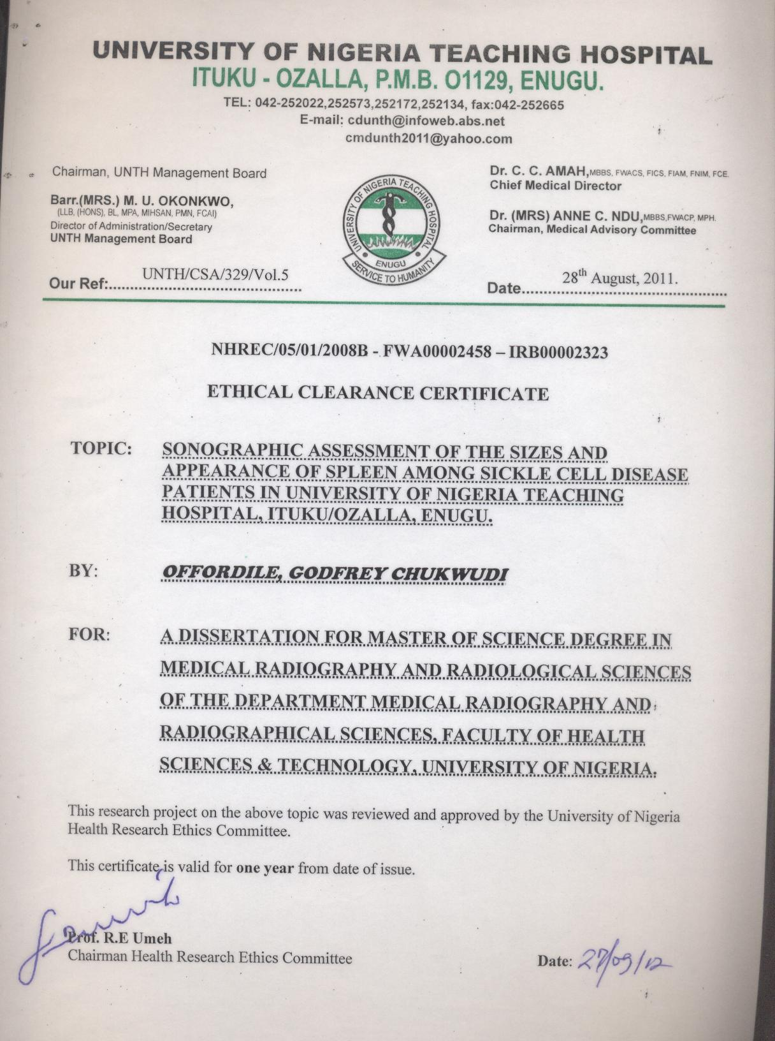

Appendix 2
Letter of Acceptance of Co-supervision by Dr. Agwuna K.K.
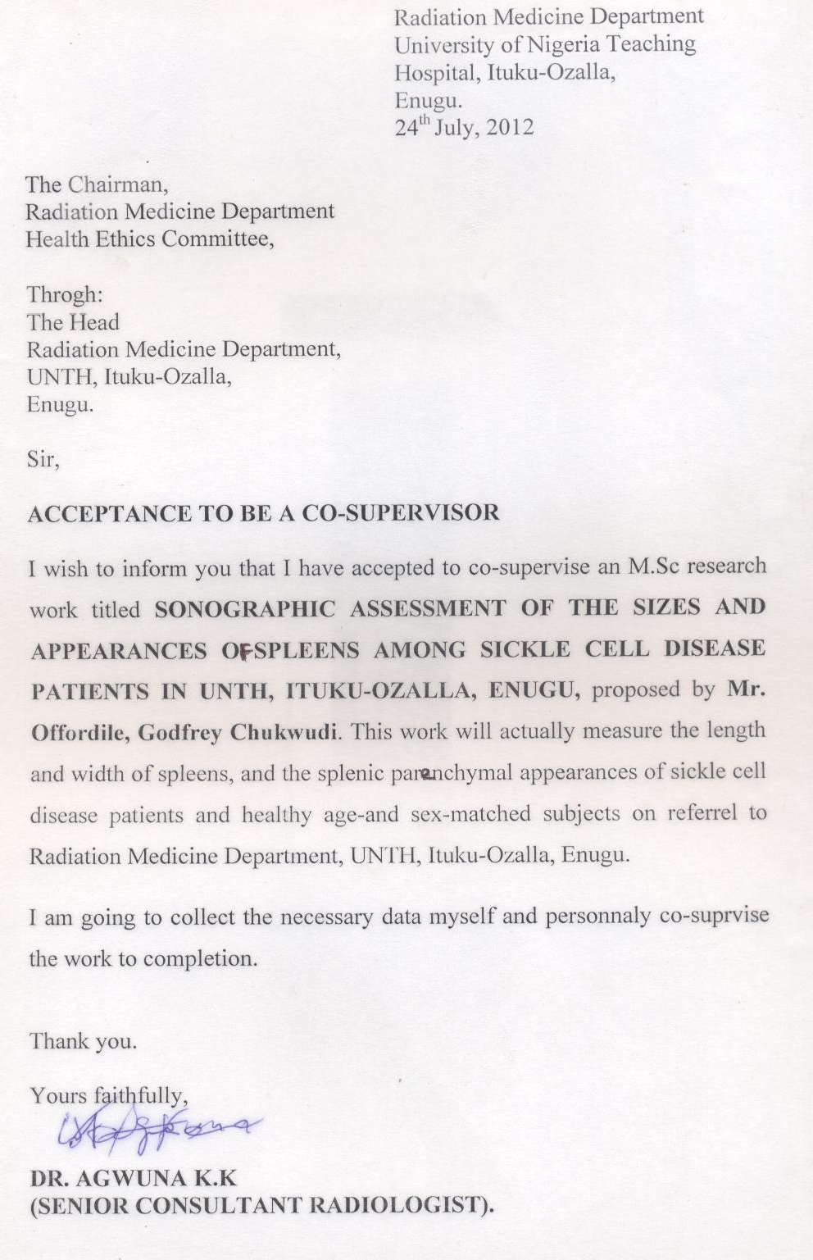

Appendix 3

Radiation Medicine Department Ethical Clearance Certificate
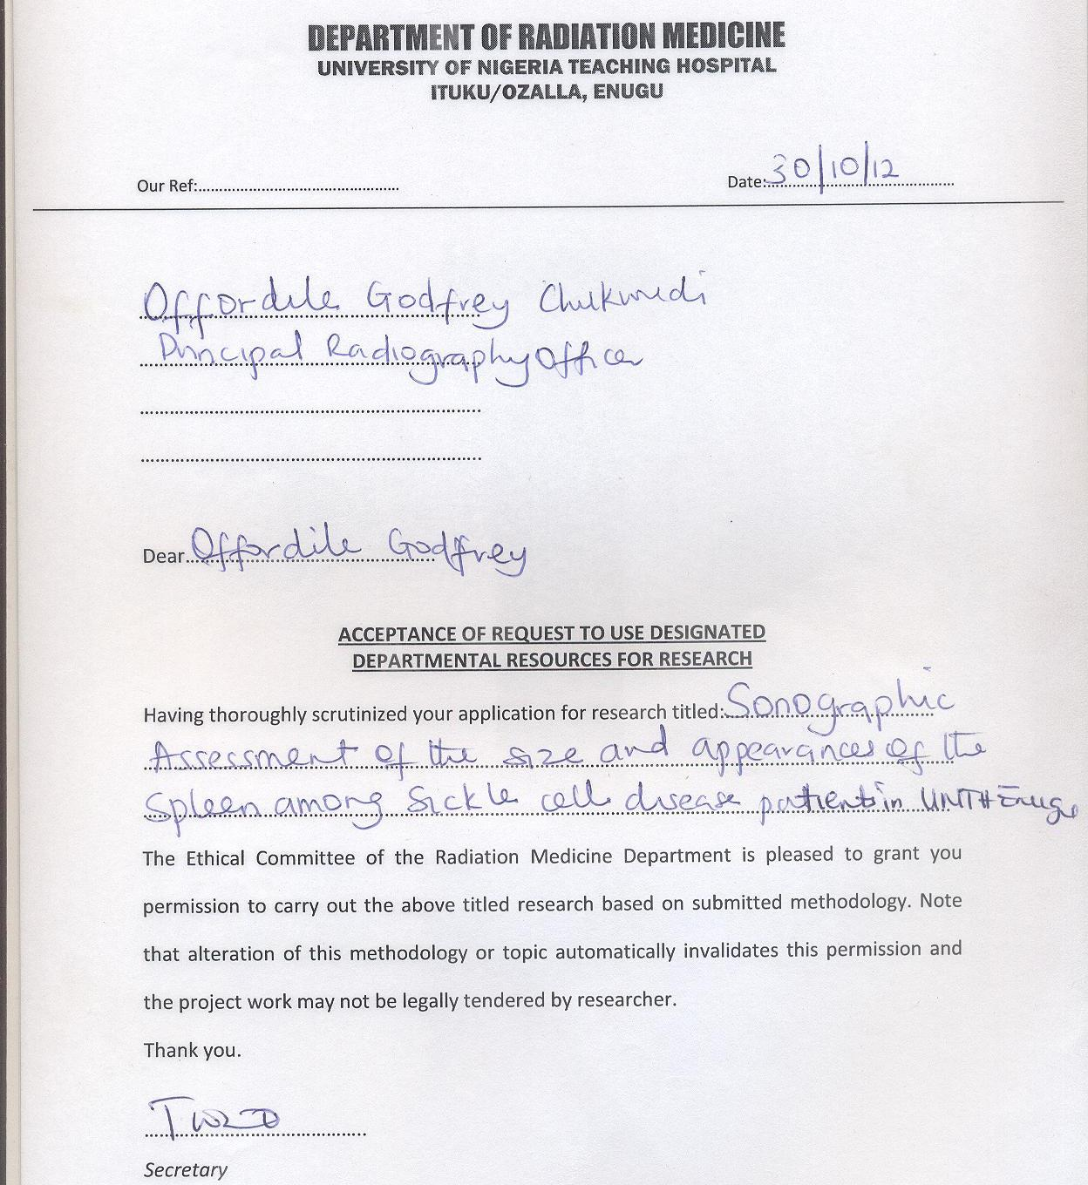

Appendix 4

Letter of Acceptance of Co-Supervision by Dr. Sunday Ocheni
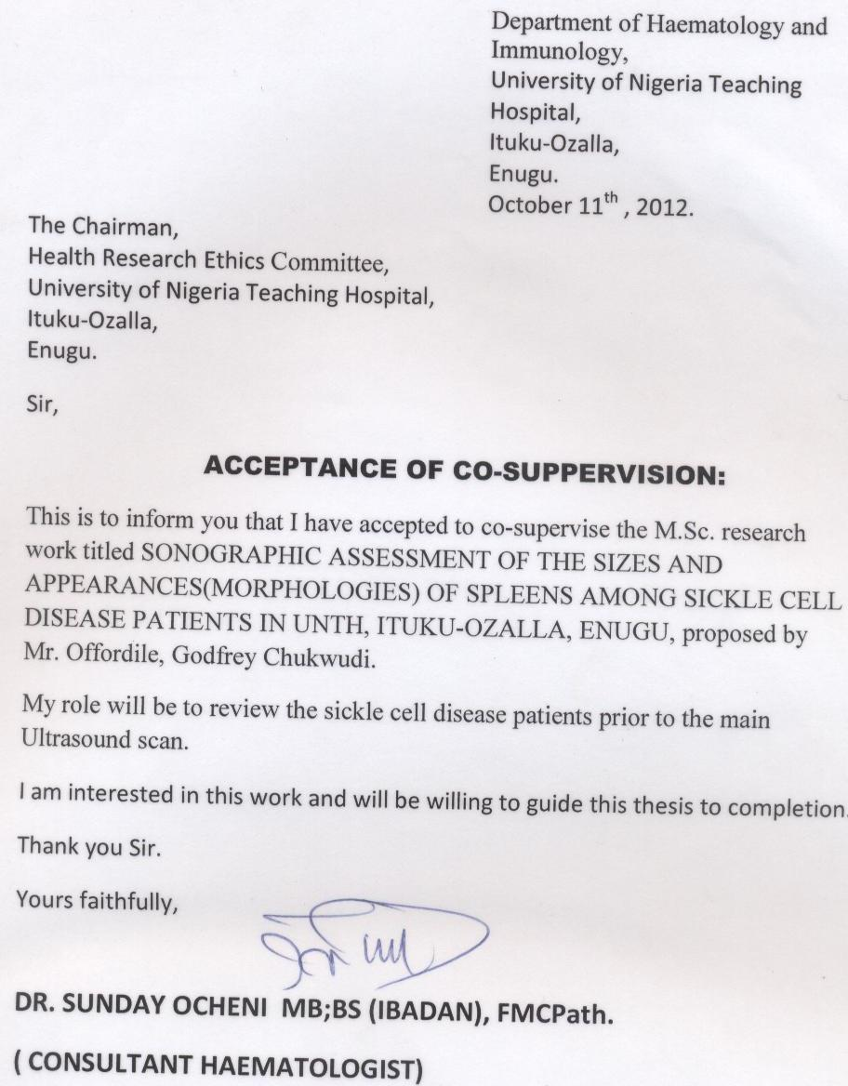

Appendix 5
Medical Form (Patients Request Form)
MEDICAL FORM
ASK FOR OFFORDILE, GODFREY CHUKWUDI IN RADIOLOGY DEPT
OR PHONE: 08052347994, 07081821913.
NAME:............................................................................................................

AGE:.....................................................................

SEX:......................................................................

MARITAL STATUS:...............................................................

DATE:......................................................................................

GENOTYPE:............................................................................

PATIENTS' HOSPITAL FOLDER NUMBER:...............................................

OTHERS:........................................................................................................

DETAILED CLINICAL HISTORY:................................................................

........................................................................................................................

........................................................................................................................

........................................................................................................................

........................................................................................................................

........................................................................................................................

........................................................................................................................

........................................................................................................................

........................................................................................................................

........................................................................................................................ ANY COMPLICATION NOW:.......................................................................

Appendix 6

Consent Form

CONSENT FORM
Dear Sir/Madam,

Please, I am a PG student ( Reg.No. PG/M.Sc/09/53665 ) from the department of Medical Radiography and Radiological Sciences, Faculty of Health Sciences and Technology, College of Medicine, University of Nigeria, Enugu Campus.
I am carrying out a research on SONOGRAPHIC ASSESSMENT OF THE SIZE AND APPEARANCES OF THE SPLEEN AMONG SICKLE CELL DISEASE PATIENTS IN UNIVERSITY OF NIGERIA TEACHING HOSPITAL , ITUKU-
OZALLA, ENUGU. You have been selected to participate in this study.

Participation in this study is purely voluntary, and you are free to agree or disagree participation at any stage of the programme without any repercussion on the quality and result of sonographic investigation being carried out on you. No inducement or persuasion will be used to elicit your consent to participate.
Your height, blood pressure, and weight will also be measured. Finally, minimal ultrasonic examination of your upper abdominal organs, will be carried out quickly. You may be asked to assume different positions in the course of the investigation.
You are not going to encounter any risk and embarrassment in the course of this study.
This study is purely for academic purpose and any information obtained from you will be treated with the strictest confidence.

The Researcher and the research team will be available every time and throughout the course of this investigation to answer any question relating to this study and your comfort. You can always reach the principal Researcher via 07081821913 or 08052347994, or at the department of Radiation Medicine, UNTH, Ituku-Ozalla, Enugu, at any time you want clarification even after the examination.
RESPONDENT : I have read and understood the above ( or had some-one read and explained the entire study to me). All the gray areas have also been clarified. I fully understand the nature, risk and benefits of the study and hereby willingly consent to take part in it.

-
Name and Signature of Respondent

Date

-
Name and Signature of Researcher

Date

Name and Signature of Witness

Date
-

-

Appendix 7
AKWUKWO NKWENYE
Oga/Madam,
Biko, abum nwa akwukwo nke n'achu nta nzere mmuta PG na ngalaba Radiografi nke mahadum nke ala anyi nke di na Enugu. Akala m bu PG/M.Sc./09/53665.
Anam eme nchoputa banyere iji ihe nyocha ana akpo 'Ultrasound' mata ka ihe na anyocha obara mmadu nke di na ime afo mmadu ana akpo 'spleen' ha na ogologo ya na etiti, guyekwere etu ahu ya si diri n'ime afo ndi na anya nnukwu onya ufu ime aru ana akpo 'sickle cell disease' bukwa ndi na anara ogwugwo na ulo ogwu nkuzi nke ala anyi di na agbataobi Ituku na Ozala na 'Enugu'. Aroputago gi isonye na nchoputa nkea nke isi okwu ya bu igosi uru di na iji ihe nyochaa bu 'Ultrasound' na enyocha ime afo ndi nnukwu onya ufu ime aru ana akpo 'sickle cell disease' ji iji we mata mgbe onya ana atulo anya ya na esikari na nnukwu onya aputa na amalite. Nkea ga enyere aka ihu na ana elekota ndi onya 'sickle cell disease' anya nke-oma iji nyere ha aka ibi ogologo ndu na ndu di nma.
Isonye na emume nchoputaa bu nke imanye mmadu n'adilo na ime ya ma oli. Obu eziokwu na aroputago gi, mana inwere ikike isi na ichoro ma obu na ichoghi isonye na oge obuna dighi nma bido ugbua ganye na emume nchoputaa abia na njedebe. Ma ikwenyere ma obu na ikwenyeghi agaghi enwe ihe oghom oga ebutere gi banyere ihe obuna ichoro ka emere gi.
Iga aza ajuju edeputala na obobo akwukwo aga enye gi nke ga enyere anyi aka imata aha gi, ma ibu nwoke ma ibu nwanyi, aro one idi, ma ilugo nwunye ma obu na ilubeghi, ihe kpatara ijiri bia ulo ogwu, ma onwere nnukwu onya yaburu gi mgbe na eteghi aka, ya na ndi ozo. Aga elelekwa ka ogologo gi na ibu gi ha. Emesie nkea, aga eji ihe nyochaa bu 'Ultrasound' nyocha afo gi ebe mgbago nile nkeoma, mana ebe ukwu gi agaghi eso.
Onweghi ihe nsogbu ma obu ihe ihere ga esi na emume nchoputaa we daputa. Oge oga enwe na ihe nfialu ndi ozo agaghi akali udi nke ana ahu banyere ihe nyochaa.

Ihe emume nchoputaa bu maka nani inweta nzere akwukwo. Ihe aga achoputa na emumea agaghi abu nke aga eji mere ihe akuko, ma obu nke ga egosi ma oli onye esinanya welu choputaya.
Onye na eme nchoputaa na ndi na enyere ya aka ga ano nso oge nile ganye na nchoputaa abia na isi njedebe iji welu zaa ajuju obula inwere gbasara ihe nchoputa nkea ma obu gbasara odi na nma gi. Inwekwere ike ikpoturu onye isi nyochaa site na igwe okwu nke akaraya bu ndia : 07081821913 ma obu 08052347994, ma obu ibiakwute ya na ngalaba nnukwu ulo ogwu nkuzia ana eme nyocha nkea mgbe obula ichoro obulugodi na emeche emume nchoputaa.
Nkpebi : Agugo m ma ghotakwa ihe ndia nile edele ( ma obu, onwego onye guru ma kowakwara m nke-oma ihe nile gbasara ihe emume nchoputaa). Ihe omimi nile di na emumea bu nke akowakwara m nke oma. Aghotalum ka aga esi me nchoputaa ya na uru na oghom di na ya, ma muwa kwenyesiri ike iso we me emume nchoputaa na enweghi nmanye obula.
Daalu.

Aha na mkpusi edemede aka onye choro isonye

Na ubochi taa

Aha na mkpusi edemede aka onye na eme nchoputaa

Na ubochi taa

Aha na mkpusi edemede aka onye aka-ebe

Na ubochi taa

Appendix 8

Pilot Study Raw Data

S/N | Sonographer A Results(mm) |  |  |  |  | Sonographer B Results(mm) |  |  |  |  | Sonographer C Results(mm)
 | Vr | 1st | 2nd | 3rd | Mn. | Vr | 1st | 2nd | 3rd | Mn. | Vr | 1st | 2nd | 3rd | Mn.
1 | L W | 92  53 | 96  48 | 91  49 | 93  50 | L W | 90  46 | 98  51 | 100  47 | 96  48 | L W | 100  49 | 90  48 | 95  59 | 95  52
2 | L W | 105  52 | 110  48 | 106  47 | 107  49 | L W | 109  56 | 114  52 | 116  63 | 113  57 | L W | 105  55 | 113  54 | 115  50 | 111  53
3 | L W | 99  58 | 97  50 | 104  51 | 100  53 | L W | 95  43 | 102  44 | 94  54 | 97  47 | L W | 91  53 | 100  51 | 103  46 | 98  50
4 | L W | 112  63 | 130  62 | 118  67 | 120  64 | L W | 117  71 | 125  70 | 115  66 | 119  69 | L W | 111  72 | 120  67 | 120  59 | 117  66
5 | L W | 120  55 | 108  60 | 111  53 | 113  56 | L W | 101  47 | 108  46 | 112  54 | 107  49 | L W | 109  61 | 107  50 | 117  48 | 111  53
6 | L W | 105  65 | 110  56 | 106  56 | 107  59 | L W | 97  60 | 106  64 | 106  59 | 103  61 | L W | 100  55 | 106  58 | 109  67 | 105  60
7 | L W | 139  75 | 127  70 | 124  65 | 130  70 | L W | 131  64 | 124  70 | 123  73 | 126  69 | L W | 124  80 | 131  71 | 132  65 | 129  72
8 | L W | 119  52 | 109  57 | 111  50 | 113  53 | L W | 106  60 | 110  61 | 114  50 | 110  57 | L W | 109  45 | 117  54 | 119  63 | 115  54
9 | L W | 112  51 | 101  49 | 102  62 | 105  54 | L W | 100  54 | 103  60 | 109  53 | 104  59 | L W | 98  60 | 103  56 | 105  55 | 102  57
10 | L W | 112  51 | 107  45 | 108  45 | 109  47 | L W | 101  55 | 93  48 | 91  50 | 95  51 | L W | 96  60 | 103  57 | 107  42 | 102  53
11 | L W | 90  62 | 91  65 | 107  66 | 96  61 | L W | 88  60 | 97  59 | 91  55 | 92  58 | L W | 90  63 | 97  61 | 98  53 | 95  59
12 | L W | 100  42 | 110  56 | 99  52 | 103  50 | L W | 88  76 | 92  78 | 93  71 | 91  75 | L W | 95  49 | 100  46 | 102  40 | 99  45
13 | L W | 119  53 | 116  55 | 107  61 | 114  56 | L W | 104  57 | 106  59 | 111  49 | 107  55 | L W | 102  46 | 113  45 | 112  44 | 109  45
14 | L W | 108  39 | 101  42 | 100  48 | 103  43 | L W | 102  56 | 100  50 | 95  47 | 99  51 | L W | 87  35 | 94  45 | 95  40 | 92  40
15 | L | 107 | 109 | 96 | 104 | L | 103 | 107 | 108 | 106 | L | 96 | 105 | 105 | 102

 | W | 47 | 52 | 63 | 54 | W | 52 | 62 | 60 | 58 | W | 60 | 58 | 50 | 56
16 | L W | 100  43 | 99  51 | 104  44 | 101  46 | L W | 100  67 | 107  57 | 108  59 | 105  61 | L W | 97  59 | 99  60 | 86  49 | 94  56
17 | L  W | 113  54 | 112  61 | 111  62 | 112  59 | L  W | 100  40 | 110  38 | 111  45 | 107  41 | L  W | 94  57 | 106  60 | 106  45 | 102  54
18 | L W | 121  65 | 110  70 | 105  72 | 112  69 | L W | 103  57 | 105  58 | 110  65 | 106  60 | L W | 104  48 | 109  49 | 111  62 | 108  53
19 | L W | 118  60 | 126  62 | 119  67 | 121  63 | L W | 121  65 | 119  67 | 114  75 | 118  69 | L W | 108  67 | 113  65 | 121  57 | 114  63
20 | L W | 104  67 | 103  58 | 108  61 | 105  62 | L W | 104  54 | 103  55 | 111  59 | 106  56 | L W | 95  56 | 100  55 | 120  51 | 105  54
21 | L W | 112  44 | 115  66 | 103  64 | 110  58 | L W | 108  68 | 116  67 | 112  60 | 112  65 | L W | 89  64 | 95  54 | 98  56 | 94  58
22 | L W | 121  43 | 113  52 | 114  55 | 116  50 | L W | 105  54 | 115  57 | 119  63 | 113  58 | L W | 115  60 | 120  58 | 125  47 | 120  55
23 | L W | 105  63 | 107  52 | 115  56 | 109  57 | L W | 111  62 | 115  64 | 116  57 | 114  61 | L W | 98  59 | 106  58 | 111  51 | 105  56
24 | L W | 127  65 | 125  67 | 120  72 | 124  68 | L W | 135  62 | 126  67 | 123  69 | 128  66 | L W | 126  70 | 130  68 | 137  57 | 131  65
25 | L W | 103  45 | 95  50 | 96  52 | 98  49 | L W | 97  36 | 100  43 | 109  38 | 102  45 | L W | 101  54 | 110  53 | 110  49 | 107  52

Appendix 9
Raw Data From Sickle Cell Disease - HbSS - Subjects

S/N | SEX | AGE  (yrs) | GENO TYPE | HT  (cm) | WT  (kg) | BP  mmHg | SPLEEN LENGTH(MM)  1st 2nd 3rd mean |  |  |  | SPLEEN WIDTH(MM)  1st 2nd 3rd mean |  |  |  | SPLEEN APPEARANCES
1 | M | 22 | HbSS | 173 | 55 | 110/80 | 110 | 120 | 115 | 115 | 45 | 40 | 47 | 44 | Fine & Hyper ECHOIC.
2 | M | 19 | " | 170 | 64 | 100/70 | 145 | 150 | 152 | 149 | 88 | 95 | 93 | 92 | Coarse & Hyper ECHOIC
3 | F | 33 | " | 163 | 60 | 120/70 | 71 | 62 | 65 | 66 | 36 | 38 | 31 | 35 | "
4 | M | 19 | " | 158 | 50 | 120/80 | 55 | 62 | 60 | 59 | 43 | 41 | 36 | 40 | "
5 | M | 28 | " | 165 | 59 | 120/80 | AU | TO | SP | LE | NE | CT | O | MY | NO SPLEEN
6 | M | 26 | " | 170 | 47 | 100/70 | AU | TO | SP | LE | NE | CT | O | MY | NO SPLEEN
7 | F | 33 | HbSC | 168 | 67 | 110/80 | 154 | 146 | 159 | 153 | 95 | 90 | 82 | 89 | Coarse & Hyper ECHOIC
8 | F | 20 | HbSS | 158 | 44 | 90/50 | 75 | 88 | 83 | 82 | 32 | 24 | 37 | 31 | Fine & Hyper ECHOIC
9 | F | 22 | " | 166 | 58 | 70/50 | AU | TO | SP | LE | NE | CT | O | MY | NO SPLEEN
10 | M | 40 | " | 158 | 51 | 120/70 | AU | TO | SP | LE | NE | CT | O | MY | NO SPLEEN
11 | F | 37 | " | 168 | 58 | 100/70 | 99 | 95 | 109 | 101 | 44 | 58 | 48 | 50 | Fine & Hyper ECHOIC
12 | M | 26 | " | 175 | 63 | 110/70 | AU | TO | SP | LE | NE | CT | O | MY | NO SPLEEN
13 | F | 13 | " | 71 | 30 | 100/60 | 50 | 54 | 58 | 54 | 24 | 20 | 25 | 23 | Fibrotic Scar Littered
14 | F | 9 | HbSC | 72 | 48 | 110/60 | 191 | 192 | 187 | 190 | 89 | 94 | 93 | 92 | Coarse & Hyper ECHOIC
15 | F | 22 | HbSS | 156 | 45 | 120/80 | 58 | 54 | 59 | 57 | 38 | 37 | 33 | 36 | Fibrotic Scar Littered
16 | F | 2 | " | 30 | 10 | 110/60 | 83 | 84 | 79 | 82 | 40 | 36 | 41 | 39 | NORMAL
17 | F | 18 | " | 165 | 51 | 100/70 | 72 | 68 | 73 | 71 | 25 | 29 | 30 | 28 | Fibrotic Scar Littered
18 | F | 16 | " | 72 | 58 | 105/60 | 137 | 132 | 139 | 136 | 87 | 74 | 82 | 81 | NORMAL
19 | F | 2 | " | 32 | 11 | 70/50 | 104 | 106 | 99 | 103 | 60 | 70 | 56 | 62 | Coarse & Hyper ECHOIC
20 | M | 21 | " | 172 | 51 | 110/70 | 31 | 38 | 36 | 35 | 22 | 26 | 30 | 26 | Fibrotic Scar Littered
21 | M | 26 | " | 186 | 60 | 100/70 | 72 | 67 | 74 | 71 | 23 | 19 | 33 | 25 | Fibrotic Scar Littered
22 | F | 3 | " | 95 | 13 | 100/60 | 126 | 136 | 122 | 128 | 66 | 56 | 52 | 58 | Fine & Hyper ECHOIC
23 | F | 7 | " | 132 | 24 | 110/60 | 93 | 88 | 95 | 92 | 43 | 38 | 45 | 42 | Fibrotic Scar Littered
24 | F | 8 | " | 124 | 21 | 100/60 | 107 | 105 | 100 | 104 | 55 | 48 | 53 | 52 | NORMAL
25 | F | 20 | " | 161 | 58 | 110/80 | 90 | 100 | 86 | 92 | 37 | 41 | 51 | 43 | Fibrotic Scar

 |  |  |  |  |  |  |  |  |  |  |  |  |  |  | Littered
26 | M | 35 | " | 174 | 50 | 140/100 | 64 | 71 | 69 | 68 | 33 | 35 | 28 | 32 | Fibrotic Scar  Littered
27 | F | 24 | " | 165 | 60 | 105/60 | 62 | 55 | 60 | 59 | 30 | 28 | 23 | 27 | Fibrotic Scar  Littered
28 | F | 11 | " | 145 | 36 | 100/60 | 124 | 120 | 116 | 120 | 62 | 54 | 58 | 58 | Fine & Hyper  ECHOIC
29 | F | 3 | " | 98 | 13 | 100/60 | 73 | 74 | 69 | 72 | 46 | 50 | 51 | 49 | NORMAL
30 | F | 17 | " | 162 | 41 | 120/71 | 46 | 42 | 56 | 48 | 28 | 14 | 18 | 20 | Fibrotic Scar  Littered
31 | M | 24 | " | 176 | 74 | 120/80 | 154 | 152 | 147 | 151 | 84 | 82 | 77 | 81 | Coarse & Hyper  ECHOIC
32 | M | 20 | " | 175 | 58 | 120/70 | 95 | 102 | 100 | 99 | 53 | 48 | 55 | 52 | Fine & Hyper  ECHOIC
33 | M | 30 | " | 180 | 71 | 130/90 | 85 | 80 | 87 | 84 | 41 | 48 | 46 | 45 | Fibrotic Scar  Littered
34 | M | 9 | " | 126 | 26 | 110/70 | 128 | 118 | 114 | 120 | 63 | 53 | 49 | 55 | NORMAL
35 | M | 24 | " | 168 | 51 | 120/80 | AU | TO | SP | LE | NE | CT | O | MY | NO SPLEEN
36 | F | 12 | " | 140 | 38 | 100/60 | 133 | 143 | 129 | 135 | 68 | 72 | 82 | 74 | Fine & Hyper  ECHOIC
37 | F | 7 | " | 122 | 19 | 90/60 | 59 | 63 | 64 | 62 | 39 | 38 | 34 | 37 | NORMAL
38 | M | 18 | " | 161 | 40 | 130/95 | 78 | 64 | 68 | 70 | 21 | 17 | 31 | 23 | Coarse & Hyper  ECHOIC
39 | F | 40 | " | 161 | 54 | 130/90 | AU | TO | SP | LE | NE | CT | O | MY | NO SPLEEN
40 | M | 10 | " | 129 | 25 | 100/70 | 59 | 63 | 67 | 63 | 42 | 38 | 34 | 38 | NORMAL
41 | F | 5 | " | 122 | 18 | 90/70 | 60 | 59 | 55 | 58 | 30 | 29 | 25 | 28 | Fibrotic Scar  Littered
42 | F | 10 | " | 134 | 25 | 100/70 | 114 | 124 | 110 | 116 | 48 | 44 | 58 | 50 | Fine & Hyper  ECHOIC
43 | M | 11 | " | 131 | 25 | 100/70 | 166 | 164 | 159 | 163 | 54 | 59 | 61 | 58 | Fibrotic Scar  Littered
44 | F | 11 | " | 127 | 23 | 110/60 | 69 | 83 | 73 | 75 | 43 | 53 | 39 | 45 | Fibrotic Scar  Littered
45 | M | 4 | " | 105 | 17 | 100/60 | 69 | 65 | 70 | 68 | 35 | 30 | 34 | 33 | NORMAL
46 | F | 16 | " | 156 | 37 | 110/70 | 86 | 91 | 93 | 90 | 40 | 45 | 47 | 44 | Fibrotic Scar  Littered
47 | M | 11 | " | 130 | 19 | 100/60 | 139 | 141 | 134 | 138 | 57 | 55 | 50 | 54 | Coarse & Hyper  ECHOIC
48 | F | 10 | " | 131 | 28 | 100/60 | 63 | 67 | 68 | 66 | 24 | 29 | 28 | 27 | Infarction/Abscess  Littered
49 | M | 4 | " | 110 | 17 | 100/60 | 56 | 61 | 63 | 60 | 37 | 32 | 39 | 36 | Shrunken &  Calcified
50 | M | 18 | " | 176 | 49 | 120/80 | AU | TO | SP | LE | NE | CT | O | MY | NO SPLEEN
51 | M | 4 | " | 104 | 14 | 90/50 | 85 | 84 | 80 | 83 | 47 | 42 | 46 | 45 | NORMAL
52 | M | 5 | " | 109 | 17 | 100/60 | 62 | 67 | 66 | 65 | 28 | 29 | 24 | 27 | Fibrotic Scar  Littered

53 | M | 8 | " | 126 | 21 | 100/60 | 108 | 112 | 104 | 108 | 42 | 46 | 50 | 46 | Coarse & Hyper  ECHOIC
54 | M | 19 | " | 166 | 48 | 120/70 | AU | TO | SP | LE | NE | CT | O | MY | NO SPLEEN
55 | M | 27 | " | 173 | 54 | 130/90 | 26 | 34 | 30 | 30 | 6 | 14 | 10 | 10 | Shrunken &  Calcified
56 | M | 25 | " | 176 | 70 | 120/80 | AU | TO | SP | LE | NE | CT | O | MY | NO SPLEEN
57 | F | 28 | " | 153 | 53 | 110/60 | AU | TO | SP | LE | NE | CT | O | MY | NO SPLEEN
58 | M | 22 | " | 174 | 53 | 130/80 | AU | TO | SP | LE | NE | CT | O | MY | NO SPLEEN
59 | M | 34 | " | 176 | 65 | 120/80 | AU | TO | SP | LE | NE | CT | O | MY | NO SPLEEN
60 | F | 6 | " | 108 | 15 | 100/60 | 109 | 114 | 116 | 113 | 44 | 49 | 51 | 48 | Fine & Hyper  ECHOIC
61 | F | 9 | " | 136 | 24 | 110/70 | 106 | 99 | 104 | 103 | 52 | 45 | 50 | 49 | Fine & Hyper  ECHOIC
62 | F | 2 | " | 90 | 12 | 100/60 | 94 | 95 | 90 | 93 | 38 | 39 | 34 | 37 | Fine & Hyper  ECHOIC
63 | F | 5 | " | 98 | 16 | 110/70 | 104 | 109 | 111 | 108 | 48 | 53 | 55 | 52 | Fine & Hyper  ECHOIC
64 | F | 16 | " | 156 | 49 | 100/70 | 34 | 29 | 33 | 32 | 13 | 8 | 12 | 11 | Shrunken &  Calcified
65 | F | 12 | " | 130 | 33 | 100/60 | 119 | 127 | 123 | 123 | 47 | 51 | 43 | 47 | Fine & Hyper  ECHOIC
66 | F | 14 | " | 162 | 44 | 110/70 | AU | TO | SP | LE | NE | CT | O | MY | NO SPLEEN
67 | F | 23 | " | 166 | 60 | 100/70 | AU | TO | SP | LE | NE | CT | O | MY | NO SPLEEN
68 | M | 32 | " | 179 | 71 | 120/80 | AU | TO | SP | LE | NE | CT | O | MY | NO SPLEEN
69 | M | 27 | " | 178 | 59 | 100/70 | 38 | 39 | 34 | 37 | 13 | 14 | 9 | 12 | Shrunken &  Calcified
70 | M | 25 | " | 180 | 63 | 120/90 | AU | TO | SP | LE | NE | CT | O | MY | NO SPLEEN
71 | F | 28 | " | 175 | 65 | 120/80 | AU | TO | SP | LE | NE | CT | O | MY | NO SPLEEN
72 | F | 18 | " | 140 | 34 | 100/60 | 216 | 206 | 202 | 208 | 90 | 80 | 76 | 82 | Fibrotic Scar  Littered
73 | M | 3 | " | 86 | 13 | 90/50 | 95 | 100 | 99 | 98 | 49 | 44 | 48 | 47 | Fine & Hyper  ECHOIC
74 | M | 9 | " | 115 | 18 | 100/60 | 129 | 130 | 125 | 128 | 58 | 59 | 54 | 57 | Coarse & Hyper  ECHOIC
75 | F | 22 | " | 164 | 46 | 110/70 | 122 | 118 | 123 | 121 | 73 | 77 | 78 | 76 | Infarction/Abscess  Littered
76 | M | 22 | " | 172 | 57 | 110/60 | AU | TO | SP | LE | NE | CT | O | MY | NO SPLEEN
77 | F | 10 | " | 128 | 28 | 100/60 | 98 | 103 | 105 | 102 | 60 | 65 | 67 | 64 | Coarse & Hyper  ECHOIC
78 | F | 4 | " | 108 | 16 | 100/60 | 90 | 76 | 80 | 82 | 53 | 39 | 43 | 45 | Fine & Hyper  ECHOIC
79 | F | 2 | " | 87 | 12 | 90/60 | 85 | 86 | 81 | 84 | 48 | 49 | 44 | 47 | Fine & Hyper  ECHOIC
80 | M | 4 | " | 99 | 16 | 100/60 | 74 | 78 | 88 | 80 | 37 | 41 | 51 | 43 | Fine & Hyper  ECHOIC

81 | M | 4 | " | 103 | 16 | 90/60 | 82 | 68 | 72 | 74 | 43 | 29 | 33 | 35 | Fine & Hyper  ECHOIC
82 | M | 7 | " | 132 | 20 | 90/60 | 80 | 90 | 76 | 82 | 31 | 41 | 27 | 33 | Fine & Hyper  ECHOIC
83 | F | 50 | " | 165 | 53 | 130/90 | AU | TO | SP | LE | NE | CT | O | MY | NO SPLEEN
84 | F | 39 | " | 167 | 62 | 110/80 | AU | TO | SP | LE | NE | CT | O | MY | NO SPLEEN
85 | M | 21 | " | 176 | 60 | 120/80 | 76 | 80 | 90 | 82 | 22 | 26 | 36 | 28 | Fibrotic Scar  Littered
86 | M | 26 | " | 182 | 77 | 120/80 | 25 | 30 | 29 | 28 | 7 | 12 | 11 | 10 | Shrunken &  Calcified
87 | F | 10 | " | 136 | 34 | 100/70 | 123 | 113 | 109 | 115 | 61 | 51 | 47 | 53 | Coarse & Hyper  ECHOIC
88 | M | 16 | " | 148 | 41 | 110/70 | 73 | 75 | 68 | 72 | 32 | 27 | 34 | 31 | Fibrotic Scar  Littered
89 | F | 12 | " | 141 | 37 | 100/60 | 130 | 134 | 135 | 133 | 55 | 59 | 60 | 58 | Coarse & Hyper  ECHOIC
90 | F | 23 | " | 132 | 40 | 110/80 | 159 | 157 | 152 | 156 | 92 | 85 | 90 | 89 | Coarse & Hyper  ECHOIC
91 | F | 29 | " | 166 | 60 | 110/70 | 68 | 54 | 58 | 60 | 19 | 23 | 33 | 25 | Fibrotic Scar  Littered
92 | M | 23 | " | 166 | 55 | 130/90 | 137 | 144 | 142 | 141 | 60 | 67 | 65 | 64 | Infarction/Abscess Littered
93 | F | 28 | " | 167 | 63 | 110/70 | 96 | 82 | 86 | 88 | 43 | 53 | 39 | 45 | Coarse & Hyper  ECHOIC
94 | M | 13 | " | 146 | 35 | 100/60 | 143 | 139 | 153 | 145 | 90 | 76 | 80 | 82 | Coarse & Hyper  ECHOIC
95 | F | 14 | " | 134 | 37 | 100/70 | 147 | 151 | 161 | 153 | 85 | 71 | 75 | 77 | Coarse & Hyper  ECHOIC
96 | F | 26 | " | 178 | 56 | 110/80 | 41 | 37 | 51 | 43 | 25 | 15 | 11 | 17 | Fibrotic Scar  Littered
97 | M | 8 | " | 128 | 28 | 110/60 | 139 | 146 | 144 | 143 | 74 | 76 | 69 | 73 | Coarse & Hyper  ECHOIC
98 | F | 7 | " | 132 | 26 | 100/60 | 192 | 185 | 190 | 189 | 85 | 90 | 92 | 89 | Fibrotic Scar  Littered
99 | F | 37 | " | 166 | 61 | 120/80 | AU | TO | SP | LE | NE | CT | O | MY | NO SPLEEN
100 | M | 14 | " | 148 | 38 | 100/70 | 163 | 153 | 149 | 155 | 60 | 62 | 55 | 59 | Fine & Hyper  ECHOIC
101 | F | 54 | " | 167 | 58 | 120/70 | AU | TO | SP | LE | NE | CT | O | MY | NO SPLEEN
102 | M | 12 | " | 143 | 30 | 110/60 | 128 | 132 | 142 | 134 | 66 | 62 | 76 | 68 | Coarse & Hyper  ECHOIC
103 | M | 58 | " | 169 | 62 | 120/90 | AU | TO | SP | LE | NE | CT | O | MY | NO SPLEEN

Appendix 10

Raw Data From Normal Genotype - HbAA - Subjects

S/N | SEX | AGE  (yrs) | GENO TYPE | HT  (cm) | WT  (kg) | BP  mmHg | SPLEEN LENGTH (MM)  1st 2nd 3rd mean |  |  |  | SPLEEN WIDTH (MM)  1st 2nd 3rd mean |  |  |  | SPLEEN APPEARANC ES
1 | M | 23 | HbAA | 175 | 81 | 110/80 | 95 | 100 | 99 | 98 | 42 | 47 | 46 | 45 | NORMAL
2 | M | 10 | " | 135 | 30 | 110/70 | 66 | 62 | 76 | 68 | 37 | 33 | 47 | 39 | "
3 | M | 10 | " | 141 | 33 | 110/80 | 70 | 68 | 63 | 67 | 36 | 38 | 40 | 38 | "
4 | M | 23 | " | 171 | 62 | 110/80 | 87 | 92 | 91 | 90 | 45 | 50 | 49 | 48 | "
5 | M | 23 | " | 183 | 73 | 120/80 | 91 | 87 | 92 | 90 | 43 | 39 | 44 | 42 | "
6 | F | 30 | " | 177 | 61 | 110/80 | 92 | 91 | 87 | 90 | 48 | 47 | 43 | 46 | "
7 | F | 26 | " | 162 | 57 | 110/80 | 84 | 89 | 88 | 87 | 29 | 34 | 33 | 32 | "
8 | M | 7 | " | 129 | 28 | 110/70 | 63 | 58 | 65 | 62 | 31 | 26 | 33 | 30 | "
9 | M | 28 | " | 178 | 83 | 140/95 | 116 | 114 | 109 | 113 | 66 | 64 | 59 | 63 | "
10 | M | 21 | " | 171 | 64 | 120/90 | 95 | 102 | 100 | 99 | 46 | 53 | 51 | 50 | "
11 | M | 26 | " | 167 | 67 | 120/90 | 91 | 86 | 93 | 90 | 39 | 34 | 41 | 38 | "
12 | F | 26 | " | 159 | 54 | 115/80 | 83 | 73 | 69 | 75 | 56 | 46 | 42 | 48 | "
13 | M | 26 | " | 175 | 83 | 120/80 | 108 | 113 | 112 | 111 | 55 | 60 | 59 | 58 | "
14 | M | 4 | " | 75 | 16 | 100/70 | 64 | 56 | 60 | 60 | 33 | 25 | 29 | 29 | "
15 | F | 10 | " | 142 | 32 | 110/70 | 69 | 67 | 62 | 66 | 41 | 39 | 34 | 38 | "
16 | M | 22 | " | 174 | 61 | 120/80 | 84 | 88 | 92 | 88 | 41 | 45 | 49 | 45 | "
17 | F | 19 | " | 163 | 64 | 110/70 | 68 | 64 | 78 | 70 | 47 | 43 | 57 | 49 | "
18 | F | 28 | " | 171 | 73 | 110/80 | 97 | 95 | 90 | 94 | 49 | 47 | 42 | 46 | "
19 | M | 21 | " | 172 | 65 | 120/80 | 100 | 105 | 107 | 104 | 37 | 42 | 44 | 41 | "
20 | F | 12 | " | 142 | 34 | 110/90 | 71 | 67 | 81 | 73 | 30 | 26 | 40 | 32 | "
21 | F | 21 | " | 167 | 64 | 120/90 | 108 | 98 | 94 | 100 | 48 | 38 | 34 | 40 | "
22 | F | 20 | " | 167 | 58 | 110/80 | 96 | 100 | 92 | 96 | 50 | 42 | 46 | 46 | "
23 | F | 20 | " | 163 | 57 | 110/70 | 78 | 82 | 83 | 81 | 40 | 44 | 45 | 43 | "
24 | M | 21 | " | 186 | 71 | 110/80 | 94 | 98 | 108 | 100 | 36 | 40 | 50 | 42 | "
25 | F | 11 | " | 151 | 39 | 110/80 | 91 | 93 | 86 | 90 | 45 | 47 | 40 | 44 | "
26 | M | 8 | " | 129 | 26 | 110/70 | 82 | 74 | 78 | 78 | 52 | 44 | 48 | 48 | "
27 | M | 10 | " | 142 | 32 | 120/80 | 69 | 73 | 74 | 72 | 40 | 44 | 45 | 43 | "
28 | F | 8 | " | 130 | 26 | 110/70 | 77 | 79 | 72 | 76 | 35 | 37 | 30 | 34 | "
29 | M | 6 | " | 117 | 22 | 110/70 | 71 | 74 | 69 | 68 | 38 | 31 | 36 | 35 | "
30 | M | 4 | " | 82 | 15 | 100/60 | 52 | 57 | 62 | 57 | 24 | 28 | 32 | 28 | "
31 | F | 12 | " | 145 | 36 | 100/70 | 75 | 79 | 71 | 75 | 38 | 42 | 34 | 38 | "
32 | F | 12 | " | 144 | 33 | 110/80 | 67 | 71 | 81 | 73 | 23 | 27 | 37 | 29 | "
33 | F | 29 | " | 165 | 68 | 110/70 | 88 | 92 | 93 | 91 | 32 | 36 | 37 | 35 | "
34 | F | 4 | " | 79 | 14 | 100/60 | 57 | 59 | 52 | 56 | 29 | 31 | 24 | 28 | "
35 | M | 5 | " | 96 | 19 | 110/60 | 56 | 60 | 64 | 60 | 27 | 31 | 35 | 31 | "
36 | M | 27 | " | 170 | 70 | 120/90 | 104 | 106 | 99 | 103 | 55 | 57 | 50 | 54 | "
37 | M | 4 | " | 80 | 17 | 110/60 | 60 | 53 | 58 | 57 | 32 | 25 | 30 | 29 | "
38 | F | 16 | " | 164 | 67 | 110/80 | 71 | 75 | 79 | 75 | 28 | 32 | 36 | 32 | "
39 | M | 17 | " | 167 | 60 | 110/80 | 94 | 96 | 89 | 93 | 42 | 44 | 37 | 41 | "
40 | M | 18 | " | 180 | 63 | 120/90 | 122 | 115 | 120 | 119 | 51 | 44 | 49 | 48 | "
41 | F | 14 | " | 157 | 48 | 110/80 | 88 | 92 | 96 | 92 | 41 | 45 | 49 | 45 | "
42 | M | 16 | " | 171 | 67 | 120/90 | 88 | 98 | 84 | 90 | 41 | 51 | 37 | 43 | "
43 | M | 54 | " | 175 | 63 | 120/80 | 90 | 85 | 89 | 88 | 47 | 42 | 46 | 45 | "
44 | F | 7 | " | 122 | 24 | 110/70 | 62 | 66 | 67 | 65 | 31 | 35 | 36 | 34 | "
45 | F | 5 | " | 99 | 19 | 100/60 | 62 | 66 | 58 | 62 | 33 | 37 | 29 | 33 | "
46 | F | 14 | " | 164 | 84 | 110/80 | 85 | 78 | 83 | 82 | 41 | 34 | 39 | 38 | "
47 | M | 31 | " | 182 | 76 | 110/70 | 104 | 108 | 118 | 110 | 45 | 49 | 59 | 51 | "
48 | M | 58 | " | 173 | 73 | 120/80 | 78 | 88 | 74 | 80 | 32 | 42 | 28 | 34 | "
49 | M | 50 | " | 170 | 70 | 110/80 | 86 | 78 | 82 | 82 | 45 | 37 | 41 | 41 | "
50 | M | 2 | " | 64 | 11 | 100/60 | 48 | 52 | 62 | 54 | 20 | 24 | 34 | 26 | "
51 | F | 4 | " | 76 | 18 | 110/60 | 61 | 63 | 56 | 60 | 29 | 31 | 24 | 28 | "
52 | F | 28 | " | 153 | 55 | 120/70 | 79 | 65 | 69 | 71 | 44 | 30 | 34 | 36 | "
53 | F | 4 | " | 81 | 17 | 110/60 | 55 | 59 | 69 | 61 | 23 | 27 | 37 | 29 | "
54 | F | 3 | " | 70 | 13 | 100/60 | 55 | 57 | 50 | 54 | 29 | 31 | 24 | 28 | "
55 | F | 11 | " | 138 | 34 | 110/70 | 83 | 69 | 73 | 75 | 41 | 27 | 31 | 33 | "
56 | F | 37 | " | 160 | 69 | 120/80 | 84 | 88 | 92 | 88 | 31 | 35 | 39 | 35 | "
57 | F | 40 | " | 176 | 80 | 120/90 | 99 | 100 | 95 | 98 | 53 | 54 | 49 | 52 | "
58 | F | 3 | " | 73 | 12 | 110/70 | 65 | 51 | 55 | 57 | 38 | 24 | 28 | 30 | "
59 | F | 22 | " | 166 | 59 | 120/80 | 85 | 89 | 90 | 88 | 40 | 44 | 45 | 43 | "
60 | M | 28 | " | 171 | 67 | 110/80 | 93 | 94 | 89 | 92 | 49 | 50 | 45 | 48 | "

61 | M | 9 | " | 129 | 28 | 110/80 | 78 | 71 | 76 | 75 | 39 | 32 | 37 | 36 | "
62 | M | 11 | " | 136 | 31 | 100/60 | 73 | 78 | 80 | 77 | 33 | 38 | 40 | 37 | "
63 | M | 9 | " | 130 | 30 | 110/80 | 72 | 82 | 68 | 74 | 35 | 45 | 31 | 37 | "
64 | M | 32 | " | 182 | 80 | 120/80 | 106 | 99 | 104 | 103 | 59 | 52 | 57 | 56 | "
65 | M | 39 | " | 178 | 70 | 110/80 | 96 | 101 | 103 | 100 | 39 | 44 | 46 | 43 | "
66 | F | 11 | " | 138 | 34 | 110/70 | 74 | 78 | 70 | 74 | 31 | 35 | 27 | 31 | "
67 | M | 22 | " | 173 | 67 | 110/80 | 96 | 91 | 95 | 94 | 55 | 50 | 54 | 53 | "
68 | F | 17 | " | 156 | 47 | 100/80 | 74 | 79 | 81 | 78 | 40 | 45 | 47 | 44 | "
69 | M | 16 | " | 181 | 71 | 110/70 | 90 | 92 | 85 | 89 | 40 | 42 | 35 | 39 | "
70 | M | 2 | HbAA | 67 | 10 | 100/70 | 46 | 32 | 36 | 38 | 21 | 7 | 11 | 13 | "
71 | M | 22 | " | 174 | 67 | 110/80 | 92 | 97 | 99 | 96 | 39 | 44 | 46 | 43 | "
72 | M | 25 | " | 181 | 77 | 120/80 | 102 | 103 | 98 | 101 | 54 | 55 | 50 | 53 | "
73 | F | 21 | " | 172 | 62 | 120/80 | 78 | 86 | 82 | 82 | 34 | 42 | 38 | 38 | "
74 | F | 13 | " | 154 | 40 | 100/70 | 72 | 77 | 79 | 76 | 29 | 34 | 36 | 33 | "
75 | F | 7 | " | 128 | 26 | 100/70 | 58 | 68 | 54 | 60 | 33 | 43 | 29 | 35 | "
76 | F | 50 | " | 164 | 83 | 120/80 | 90 | 104 | 94 | 96 | 44 | 58 | 48 | 50 | "
77 | M | 10 | " | 135 | 34 | 110/80 | 52 | 57 | 59 | 56 | 16 | 21 | 23 | 20 | "
78 | F | 33 | " | 178 | 68 | 120/70 | 105 | 107 | 100 | 104 | 40 | 42 | 35 | 45 | "
79 | M | 42 | " | 182 | 62 | 110/80 | 86 | 93 | 91 | 90 | 32 | 39 | 37 | 36 | "
80 | M | 9 | " | 130 | 30 | 100/70 | 62 | 67 | 69 | 66 | 32 | 37 | 39 | 36 | "
81 | F | 5 | " | 90 | 19 | 100/60 | 63 | 73 | 59 | 65 | 28 | 38 | 24 | 30 | "
82 | F | 3 | " | 65 | 12 | 100/70 | 49 | 63 | 53 | 55 | 22 | 36 | 26 | 28 | "
83 | M | 2 | " | 48 | 10 | 100/60 | 40 | 44 | 45 | 41 | 12 | 16 | 17 | 15 | "
84 | M | 37 | " | 170 | 85 | 120/90 | 92 | 102 | 88 | 94 | 53 | 63 | 49 | 55 | "
85 | F | 22 | " | 172 | 85 | 120/90 | 97 | 105 | 101 | 101 | 47 | 55 | 51 | 51 | "
86 | M | 29 | " | 177 | 74 | 120/80 | 90 | 94 | 104 | 96 | 49 | 53 | 63 | 55 | "
87 | M | 25 | " | 172 | 70 | 110/80 | 100 | 103 | 95 | 99 | 51 | 53 | 46 | 50 | "
88 | F | 26 | " | 157 | 57 | 100/60 | 85 | 92 | 90 | 89 | 40 | 47 | 45 | 44 | "
89 | M | 24 | " | 184 | 73 | 120/80 | 104 | 108 | 118 | 110 | 49 | 53 | 63 | 55 | "
90 | F | 9 | " | 136 | 34 | 110/70 | 75 | 77 | 70 | 74 | 34 | 36 | 29 | 33 | "
91 | F | 21 | " | 166 | 66 | 100/80 | 78 | 83 | 82 | 81 | 40 | 45 | 44 | 43 | "
92 | M | 24 | " | 188 | 73 | 110/80 | 95 | 99 | 100 | 98 | 43 | 47 | 48 | 46 | "
93 | M | 17 | " | 163 | 56 | 120/80 | 88 | 89 | 84 | 87 | 45 | 46 | 41 | 44 | "
94 | M | 13 | " | 152 | 39 | 110/70 | 72 | 86 | 76 | 78 | 34 | 48 | 38 | 40 | "
95 | F | 12 | " | 145 | 37 | 100/80 | 73 | 74 | 69 | 72 | 31 | 32 | 27 | 30 | "
96 | M | 27 | " | 179 | 72 | 110/80 | 94 | 95 | 90 | 93 | 48 | 49 | 44 | 47 | "
97 | F | 24 | " | 179 | 81 | 120/80 | 97 | 104 | 102 | 101 | 45 | 52 | 50 | 49 | "
98 | M | 22 | " | 180 | 84 | 120/80 | 95 | 96 | 91 | 94 | 44 | 45 | 40 | 43 | "
99 | F | 35 | " | 148 | 66 | 120/80 | 80 | 82 | 75 | 79 | 42 | 44 | 37 | 41 | "
100 | M | 14 | " | 152 | 46 | 110/70 | 69 | 83 | 73 | 75 | 31 | 45 | 35 | 37 | "
101 | F | 8 | " | 129 | 32 | 110/80 | 68 | 72 | 64 | 68 | 33 | 37 | 29 | 33 | "
102 | F | 16 | " | 160 | 65 | 120/80 | 83 | 85 | 78 | 82 | 40 | 42 | 35 | 39 | "
103 | M | 2 | " | 53 | 13 | 100/70 | 40 | 45 | 44 | 43 | 11 | 16 | 15 | 14

