SONOGRAPHIC ESTIMATION OF GESTATIONAL AGE BY PLACENTAL THICKNESS AMONG PREGNANT WOMEN IN ENUGU, NIGERIA

ABSTRACT

Gestational age (GA) estimation is an important aspect of routine obstetrics scanning. Fetal parameters like femur length, biparietal diameter head circumference and abdominal circumference have many pit falls especially as pregnancy advances in age. Hence, there is need to estimate GA with placental thickness especially in the second and third trimesters when other fetal parameters may not be reliable. The aim of this study was to assess placental thickness as a sonographic index for estimating GA in the second and third trimester and thus determine the normal range of values of placental thickness. It was also aimed at determining if there is a racial difference in placental thickness. Six hundred and twenty seven (627) pregnant women with GA between 14 and 41 weeks were studied prospectively by ultrasound. Aloka Prosound 350 plus ultrasound machine with 3.5MH_{Z} sector probe was used to scan the subjects. The placental thickness was obtained by measuring the anterior posterior diameter of the placenta at the level of insertion of the umbilical cord in a transabdominal longitudinal scan. The last menstrual period (LMP) of the women were recorded and fetal parameters which include FL, BPD, HC and AC were also measured and all of them were used to estimate the GA. There was a good positive relationship between GA and placental thickness (r = 0.910). Reference graph and tables for estimating GA using placental thickness were obtained. Placental thickness increases in a fairly linear manner as GA increases. A maximum mean placental thickness of 42 ± 2.9mm was recorded at 39weeks. There was a significant statistical difference between the results of this study when compared with previous work done in the Indian population (p < 0.05). This difference was not noted in similar work done in Nigeria. There was a high positive relationship between placental thickness and FL (r = 0.994), BPD (r = 0.993), HC (r = 0.960) and AC (r = 0.995). Regression analysis yielded this equation PT = 8.494 + 0.177FL + 0.172BPD + 0.001HC

- 0.083AC which shows the relationship between placental thickness and the fetal parameters. Results suggest that placental thickness may be used to estimate GA in the second and third trimesters when other fetal parameters may not be reliable.

5
TABLE OF CONTENTS

Title Page… … ...... |  | … | .. | … | … | .. | … | i
Approval Page… | ….... | .. | ….. |  | … | ….. |  | ii
Acknowledgement… … .... |  | .. | ….. |  | … | ….. |  | iii
Abstract… … ...... |  | … | .. | … | … | .. | … | iv
Table of Contents… … .... |  | .. | ….. |  | … | ….. |  | vi
List of Tables… | ….... | .. | ….. |  | … | ….. |  | ix
List of Figures… | ….... | .. | ….. |  | … | ….. |  | x

CHAPTER ONE: INTRODUCTION

1.1 | Background of the Study… | ….. | .. | .. | ….. |  | … | 1
1.2 | Statement of the Problem… … .. |  | .. | .. | ….. |  | … | 4
1.3 | Purpose of the Study… | ….. | .. | .. | ….. |  | … | 5
1.4 | Significance of the Study… … .. |  | .. | .. | ….. |  | … | 5
1.5 | Scope of the Study… … .... |  | .. | … | .. | … | … | 6
1.6 | Hypothesis… … ...... |  | … | .. | … | … | .. | 6
1.7 | Operational Definition of Terms… … |  | .. | .. | .. | … | .. | 6

6
CHAPTER TWO: LITERATURE REVIEW

2.1 | Theoretical Frame Work… | … | .. | .. | .. | … | .. | … | 8
2.2 | Empirical Review… … | .. | .. | .. | … | .. | … | … | 12
2.21 | Placental Thickness as GA Indicator… |  |  | .. | … | … | … | … | 12
2.22 | Relationship between Placental Thickness and Growth Parameters… |  |  |  |  |  |  | … | 15
2.23 | Relationship between Placental Thickness and Fetal Anomaly… |  |  |  |  |  | … | … | 17

CHAPTER THREE: RESEARCH METHODOLOGY

3.1 | Research Design… | …...... |  | ….. |  | … | … | 21
3.2 | Equipment… … | .. | ....… | .. | … | ….. |  | 21
3.3 | Duration of Study… | …...... |  | ….. |  | … | … | 21
3.4 | Study Population… | …...... |  | ….. |  | … | … | 21
3.5 | Sample Size/Sampling Technique… … .. |  |  | .... |  | ….. |  | 21
3.6 | Subject Selection Criteria… … .... |  |  | .. | … | .. | … | 22
3.7 | Ethical Clearance/ Informed Consent….. |  |  | ….. |  | … | … | 23
3.8 | Scanning Technique… |  | ….... | .. | … | .. | … | 23
3.9 | Statistical Analysis… … ...... |  |  | ….. |  | … | … | 26

7
CHAPTER FOUR: RESULTS… |  |  | …........ |  |  |  |  |  | 27
CHAPTER FIVE: DISCUSSION AND CONCLUSION
5.1 | Discussions and Implication of Results… |  |  | .. | … | … | … | … | 47
5.2 | Conclusion… … ...... |  |  | … | .. | … | ….. |  | 52
5.3 | Recommendation… … .... |  |  | .. | ….. |  | … | … | 53
5.4 | Limitations of the Study… | ….. |  | .. | .. | … | .. | … | 53
5.5 | Areas of Further Studies… .... |  |  | .. | ….. |  | … | … | 53
 | References… … ...... |  |  | … | .. | … | ….. |  | 54
 | Appendix I… .... | … | … | .. | ….. |  | …. | … | 58
 | Appendix II… … ...... |  |  | … | .. | … | ….. |  | 59
 | Appendix III… … ...... |  |  | … | .. | … | ….. |  | 60
 | Appendix IV… … ...... |  |  | … | .. | … | ….. |  | 62

8
LIST OF TABLES

Table 1: Distribution of placental thickness according to gestational age obtained by FL, BPD, HC and AC.

Table 2: Distribution of placental thickness according to gestational age obtained by patient’s LMP.

Table 3: Correlation of placental thickness with gestational age obtained from FL, BPD, HC and AC.

Table 4: Correlation of placental thickness with gestational age obtained from patient’s LMP.

Table 5: Relationship between placental thickness and gestational age and its predicted model equations.

Table 6: Correlation of placental thickness with FL, BPD, HC and AC.

Table 7: Relationship between gestational age, FL, BPD, HC and AC.

Table 8: Regression analysis showing the relationship between placental thickness and FL, BPD, HC and AC.

Table 9 Test for observer variation in placental thickness measurement

9
LIST OF FIGURES

Figure 1: Sonogram showing the normal appearance of the placenta and the point of insertion of the umbilical cord.

Figure 2: Schematic drawing showing the normal appearance of the placenta and the point of insertion of the umbilical cord.

Figure 3: A sonogram showing the placenta and the point insertion of the umbilical cord

Figure 4: Schematic drawing showing the placenta and the point of insertion of the umbilical cord

Figure 5: A histogram showing the relationship between the observed and predicted values in the combined trimester.

Figure 6: A P-P plot showing the relationship between the observed and expected values in the combined trimester.

Figure 7: The relationship between placental thickness and gestational age in the second trimester.

Figure 8: The relationship between placental thickness and gestational age in the third trimester.

Figure 9: The relationship between placental thickness and gestational age in the combined trimester.

Figure 10: The relationship between placental thickness and femur length.

Figure 11: The relationship between placental thickness and biparietal diameter.

Figure 12: The relationship between placental thickness and head circumference.

Figure 13: The relationship between placental thickness and abdominal circumference.

10
CHAPTER ONE

INTRODUCTION

1.1 Background of the Study

The placenta is an organ that connects the developing fetus to the mother. The placenta performs respiratory, excretory, nutritional and endocrine functions for the fetus. It transfers gases, such as oxygen and carbondioxide, waste products like urea, nutrients like glucose and hormones between the maternal and fetal circulation (Kelvin, 1994). In addition, the placenta protects the fetus from immune attack by the mother and induces maternal blood flow to the placenta. A portion of the placenta membrane called the placental barrier protects the fetus by prohibiting some harmful micro organism from entering fetal circulation (Betlye, 2008).

The placenta has both fetal and maternal portions. The fetal portion of the placenta consists of villi of the chorion frondosum. A branch of an umbilical artery enters each villus and ends in a capillary plexus from which the blood is drained by a tributary of the umbilical vein. The maternal portion of the placenta is formed by the decidua placentalis containing the intervillous space. The uterine arteries and veins pass to and from the intervillous space through the basal plate and the stratum spongiosum and the boundary layer. The fetal and maternal blood currents traverse the placenta, the former passing through the blood vessels of the placental villi and the latter through the intervillous space. The two currents do not intermingle, being separated from each other by the delicate walls of the villi. Nevertheless, the fetal blood is able to absorb, through the walls of the villi, oxygen and nutritive materials from the maternal blood, and give up to the latter its waste products. The blood, so purified, is carried back to the fetus by the umbilical vein (Sadler, 2004). The placenta develops at the implantation site at about the fifth

11
week of gestation and by the ninth or tenth week the diffuse echo texture of the placenta is clearly apparent at sonography. The fully formed placenta is approximately 2.3cm in thickness at the insertion of the placenta and the average weight at birth is 500g (Kelvin, 1994).

Determination of gestational age is important because it gives an idea about the fetal growth and development during pregnancy and whether a fetus can live outside the uterus. The estimation of pregnancy dates is important for the mother, who wants to know when to expect the birth of her baby, and for her health care providers, so that they may choose the times at which to perform various screening tests and assessments, such as serum screening, assessment of maturity, and induction of labour for postdates pregnancies (Max, 2010). Determination of gestational age is also important because it provides valuable information regarding expected or potential problems and directly affects the medical treatment plan for the baby (Neil, 2009). The events of prenatal development usually occur at specific gestational ages. The gestational timing of a toxin exposure or infection can be used to predict the potential consequences to the fetus. From the foregoing; emphasis is therefore laid on gestational age assessment. Gestational age was initially estimated using only the woman’s last menstrual period (LMP) and clinical methods like uterine size assessment, time of quickening/initial perception of fetal movement and fundal height. These methods have many limitations; for instance, in using LMP to estimate gestational age (GA), irregular menstrual periods or women who cannot remember the first day of their last menstrual period and normal variation from the average ovulation date pose limitations. Fundal height introduces up to 8weeks variation in the second and third trimester GA (Robin, 2007), while initial perception of fetal movement vary greatly among women.

Presently, ultrasonography is seen as an effective way of dating pregnancy (Rubby et al., 1998). Gestational sac was the first ultrasound biometric parameter to be used. Later in 1973, Robins

12
introduced the use of crown rump length (CRL). This was followed by the use of other parameters like head circumference (HC), abdominal circumference (AC), femur length (FL), and biparietal diameter (BPD). CRL is more accurate when used to measure GA in the first trimester. It is most accurate between 7 and 13weeks (Woo, 2006). It has an accuracy range of ± 4days. CRL has a limitation that its accuracy reduces if measurement is taken when the fetus is temporally stretching (straightening) and also as the pregnancy advances due to difference in growth rate. Mean gestational sac diameter is an effective way of measuring GA between 5 and 6 weeks with an accuracy of ± 5 days. This cannot be used as the pregnancy advances (Kariki et al., 2006). Davis et al., (1993) noted that there is a racial and sex dependence in BPD, HC, AC, and FL as black fetuses had a significant longer FL than white fetuses. He also noted that males have longer BPD, HC, and AC than females. Lubsky et al, (2006) noted that male fetuses have a significant longer HC, and larger BPD when compared to females. They also noted in 2007 that fetuses in breech position have a significant lower BPD when compared to HC. Some differences are also observed in fetal abnormalities like low birth weight for example Gianluigi et al., (2002) noted a reduction in FL in dwarfism, while Kyle et al., (2007) found a decrease in AC, and HC and an increase in BPD in autism especially in multiplex autism.

Hence, there is need to use a biometric parameter that may be used to establish fetal anomaly and can also be used to estimate GA. Placenta is very easy to identify sonographically and some studies like Hoddick et al., (1985), Eluchala et al., (2004) and Ohagwu et al., (2008) have shown that there is a linear increase in placental thickness with gestational age. Studies like Anupama et al., (2001) and Mital et al., (2011), conducted in India showed that the maximum placental thickness at 39 weeks is 37.5mm. Another study on placenta thickness done by Yuranga, (2011), showed that at no gestational age was the placental thickness greater than 40.0mm. He concluded

13
that any value above 40.0mm indicates placentomegaly. Benirschike and Kanfmann (1990) noted that placental thickness above 40mm is associated with maternal diabetes mellitus, fetal hydrops, or intrauterine infection. A study carried out in Markudi Nigeria by Ohagwu et al., (2008) showed that the maximum placental thickness at 39 weeks is 45.1mm. A significant difference seems to exist between the report of Ohagwu et al., (2008) and previous literature by Anupama et al., (2001) and Mital et al., (2011), Yuranga, (2011) on the normal maximum placental thickness. Reasons stated for these discrepancies by Ohagwu et al., (2008) include probable thicker placenta in Negros or observer errors. They recommend that similar study should be carried out in the same race.

The reviewed literatures indicate that placental thickness appears to be a good biometric parameter for gestational age estimation hence the need for this study. The aim of this study is to estimate GA from placental thickness in normal singleton gestation in the second and third trimesters for pregnant women in Enugu Nigeria and thus determine if there is a racial dependence in placental thickness values.

1.2 Statement of Problem

- Late detection of fetal anomalies and hence inaccurate estimation of gestational age has been noted in conditions like dwarfism, macrocepalus and microcephalus, using some indices like FL, BPD and HC for estimating gestational age (Gianluigi et al., 2002). Hence there is need to try other indices that may give a better pointer to fetal anomaly.

- There are marked variations in the accuracy of many biometric parameters used for estimating GA (Kariki et al., 2006). There is need for more accurate methods to determine gestational age especially as pregnancy advances in age.

14
- There seems to be a racial difference in placental thickness values in previous literatures (Ohagwu, et al., 2008). Thus the need to embark on this study.

1.3 Purpose of Study

General objectives

To determine gestational age by the use of placental thickness measurements among pregnant women in Enugu.

- To establish the normal range of values of placental thickness for various gestational ages in the second and third trimesters.
- To estimate gestational age in the second and third trimesters using placental thickness as a biometric parameter.
- To determine if there is a racial dependence in placental thickness values.

- Fetal abnormalities have been associated with a relative increase or decrease in placental thickness (Malati et al., 2010). Therefore knowing the normal range of values of placental thickness for each gestational age will help in early detection of fetal abnormality associated with changes in placental thickness.
- Placental thickness can be used as a sonographically derived parameter for estimating gestational age when there are doubts that other parameters may give inaccurate gestational age.
- Placenta is easy to identify sonographically and measurement of its thickness and correlation with gestational age will be ideal in a busy ultrasound clinic.

15
1.5 Scope of Study

The study was carried out at university of Nigeria teaching hospital Ituku/Ozalla, Enugu, Nigeria.

1.6 Hypothesis

H₀: There is no correlation between gestational age and placental thickness.

H₁: There is a correlation between gestational age and placental thickness.

1.7 Operational Definition of Terms

Placenta: The placenta is an organ that connects the developing fetus to the uterine wall to allow nutrient uptake, waste elimination and gas exchange via the mother’s blood supply. The placenta is referred to as the fetal lung. The fully formed placenta is a red discoid structure approximately 2-3cm in thickness at the insertion of the umbilical cord. The average weight at term is 500g² (Kevin, 2003; Sadler, 2004).

Umbilical Cord: This is also called the birth cord or funiculus umbilicomalis. It is the connecting cord from the developing embryo or fetus to the placenta. It contains two arteries and a vein. The umbilical vein supplies the fetus with oxygenated, nutrient rich blood from the placenta. Conversely, the umbilical arteries return the deoxygenated, nutrient depleted blood. The cord, which is up to 60 cm long, ceases to function after birth and is clamped and cut about 2·5 cm from the infant’s abdominal wall. The stump shrivels and falls off within two weeks, leaving a scar which forms the umbilicus (Sadler, 2004).
Gestational Age: This is the age of the embryo or foetus. It is the time measured from the first day of the woman's last menstrual cycle or from 14 days before conception (fertilization) to the current date. It is measured in weeks and days. A normal pregnancy can range from 38 to 42 weeks (Neil, 2009; John, 2004).

16
Ultrasonography: This is a radiological procedure that uses high-frequency sound waves greater than 20KHz to scan the body part, creating a picture (sonogram) of the body part imaged (Robin et al., 2007).
Pregnancy: The period from conception to birth when a woman carries a developing foetus in her uterus. Pregnancy is typically broken into 3 periods or trimesters. Childbirth is usually about 38weeks after conception in women who have a menstrual cycle length of 4 weeks. This is approximately 40weeks from the last menstrual period. The world health organization defines term for delivery as between 37 to 42 weeks (Williams, 2007).
Second Trimester: This is referred to as weeks 13-28 of the pregnancy. At this trimester movement of the fetus often referred to as quickening can be felt. The placenta fully functions at this time and the fetus makes insulin and urinates. The reproductive organs can be distinguished. Third Trimester: This is between 26-40 weeks. Here the fetus gains up to 28g per day. The woman’s belly will transform in shape as the belly drops due to the fetus turning in a downwards position ready for birth. The fetus begins to move regularly and is felt by the woman.

Obstetric Ultrasonography: The application of medical ultrasonography to obstetrics in which sonography is used to visualize the embryo or fetus in its mother’s uterus (womb). The procedure is often a standard part of prenatal care, as it yields a variety of information regarding the health of the fetus as well as regarding the progress of the pregnancy.

17
CHAPTER TWO

LITERATURE REVIEW

2.1 Theoretical Frame Work

Sonograhic Anatomy of the Placenta

The placenta is closely related to the foetus and the mother; it acts like a mirror reflecting the statues of both the mother and the foetus (Karthikejan et al., 2012). The placenta has a characteristic granular echo pattern with strong echo pattern, the strong echo patter emanates from the chorionic plate. After 27 weeks, strong echo representing calcification may appear, this is a normal physiological process (Spirit et al., 2005). The placenta has an inner and outer surface. The inner boarder of the placenta against the uterine wall has the combine hypoechoic myometrium and interposed basilar layer- hypoechoic band called the decidus basalis. The outer boarder around the amniotic fluid chorionic plate (chorioamnotic membrane) is a bright specular reflector.

Normal placental shape is a single round disk with a central cord insertion (Holzman et al., (2007). The placental position can be either posterior, anterior, right lateral, left lateral, fundal or a combination. The placenta is usually one in number in a singleton pregnancy and in monochorionic monoamnotic, monochorionic diamnotic and dichorionic diamnotic multiply pregnancies. The placenta can be double in number in dichorionic diamnotic pregnancy.

18
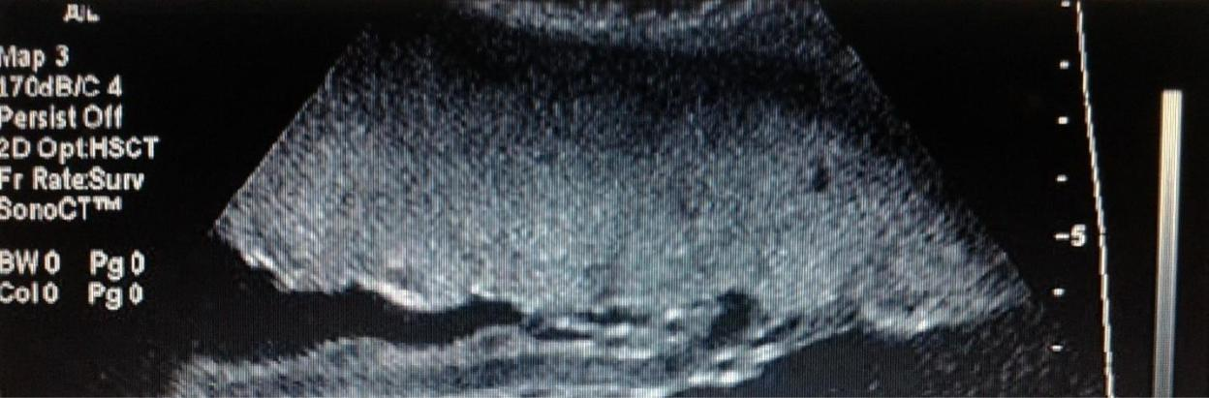

P

PI

UC
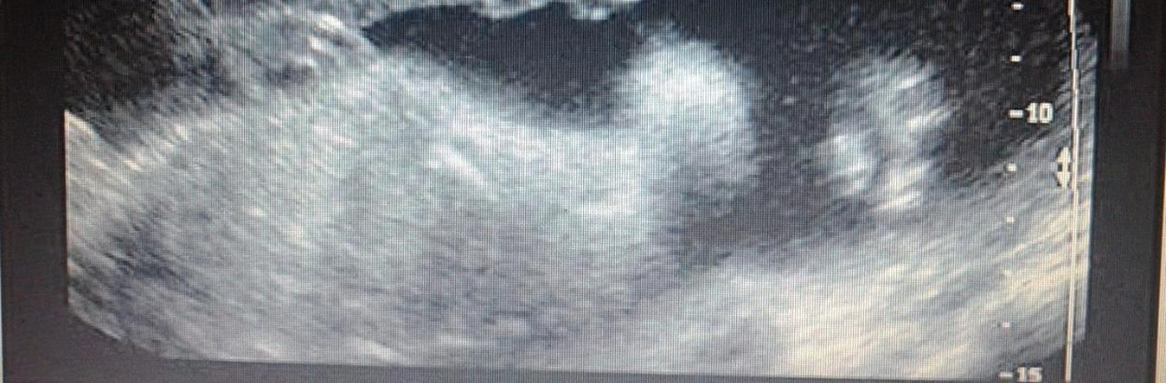

F

Figure 1: Sonogram showing the normal appearance of the placenta and the point of insertion of the umbilical cord. (P = Placenta, PI = Point of insertion of the umbilical cord, UC = Umbilical cord, F = Fetus). Image courtesy of Holzman et al., (2007).

19
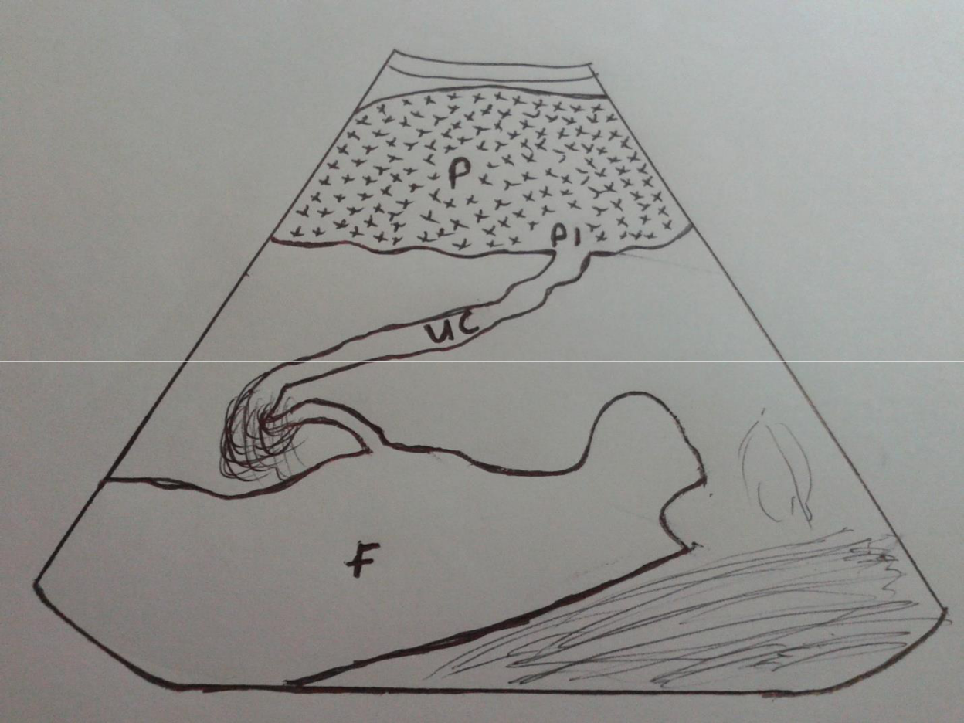

Figure 2: Schematic showing the normal appearance of the placenta and the point of insertion of the umbilical cord. (P = Placenta, PI = Point of insertion of the umbilical cord, UC = Umbilical cord, F = Fetus).

The normal placenta increases in size and echogenicity as pregnancy progresses. In the first

trimester, the growth of the placenta is more rapid than the fetus. After the first trimester at

approximately 17 weeks, the placenta weight increases throughout normal gestation and

correlates with birth weight (Holzman et al., (2007). In the 8th week, the early placenta is visible

sonographically as a generalized thickening around the gestational sac. Between 10 – 12 weeks,

diffuse granular texture of the placenta is clearly apparent sonographically. Chorionic plate is

usually seen as an echogenic line in the fetal surface of the placenta. Basal plate cannot be

20
identified sonographically unless it becomes calcified near term. The incidence of placental calcification increases exponentially with increasing GA, beginning at about 29 weeks. More than 30% of placentas show more degree of calcification after 33 weeks.

Sonographic Criteria Used for Placenta Grading

Grade 0: Smooth chorionic plate without indentation, homogenous echotexture, it is most common in first and early second trimester (8 – 20 weeks).

Grade I: Small diffuse intraplacental calcification randomly dispersed within the substance of the placenta, subtle indentation of the chorionic plate, it is most common in mid second and early third trimester (18 – 29 weeks).

Grade II: Large calcification in a dot-dash configuration along the basilar plate, large indentation along the chorionic plate, it is most common in third trimester (30 weeks to delivery).

Grade III: Irregular calcified indentation of the placenta extending from the basilar plate to the chorionic plate. It is usually not seen until 35 weeks though most commonly seen from 39 weeks to post date.

The placenta has a principle influence on fetal growth. The placenta may be the first organ to manifest changes of disease in pregnancy. Placental features may have a role in screening for pregnancy complications. Abnormalities in placental growth may precede abnormalities in fetal growth (Anna et al., 2012). Placental thickness is the easiest placental dimension to measure.

21
2.2 Emperical Review

Accurate measurement of placental thickness may be a useful ancillary parameter for gestational age estimation and evaluation of placenta morphology. Although several studies on placenta parameters have been carried out in Caucasian population, very few studies were seen in Africa and Nigeria population in available literatures reviewed.

2.2.1 Placental Thickness as GA Indicator

Ohagwu, et al., (2008) in Makurdi, Nigeria measured the placental thickness at the point of insertion of the umbilical cord. They found a maximum mean placental thickness of 45.1 ± 6.4mm at 39 weeks gestation. They also reported a fairly linear increase in mean placental thickness with gestation age.

Mital et al., (2002) carried out a study in Jaipur India titled ‘placental thickness: a sonographic parameter for estimating gestational age of the fetus. They measured the placental thickness at the point of insertion of the umbilical cord and observed that the placental thickness gradually increased from 15mm at 11 weeks of gestation to 37.5mm at 39 weeks. From the 22nd week to the 35th week of gestation the placental thickness coincided almost exactly with the gestational age in weeks.

A study conducted in an Indian population by Karthikegan et al., (2012) investigated the relationship between placenta thickness and foetal growth parameters in normal singleton pregnancies not complicated by maternal or fetal abnormalities. They noted a strong positive correlation between placenta thickness and gestational age. A mean placenta thickness of 16.5mm, 23.78mm, 35.81mm was obtained at the first, second and third trimesters respectively.

22
They noted a maximum placenta thickness of 42.2mm at 38 weeks. However this study was limited by the low no of subjects used for the study ie. 211 subjects.

A study to evaluate gestational age with the help of placenta thickness was conducted by Tiwari A and Chandnani K (2013). They assessed the relationship between placenta thickness and gestational age. They estimated fetal age using CRL, BPD, HC, and AC. Placenta thickness was measured at the point of insertion of the umbilical cord. They noted that placenta thickness gradually increased from 15mm at 11 weeks to 36.3mm at 39 weeks. From 22 weeks to 35 weeks GA coincided almost exactly with GA in weeks. They concluded that placenta thickness is a good parameter for estimation of GA especially in the late second and early third trimester.

Ravi N and Pruthvi (2013) conducted a correlative study of placental thickness with respect to gestational age and fetal weight. They assessed the growth pattern of placenta with advancing GA. They found out that placenta thickness increases with GA from 11.4mm at 11 weeks to 36.5mm at 40 weeks. They noted that from 11 to 36 weeks, placenta thickness almost matches GA in weeks thereafter (37-40 weeks) it was lowered by 1mm to 3mm. They also noted that at no stage of the pregnancy was placenta thickness greater than 38mm, placenta thickness did not vary in relation to location and fetal weight increases as placenta thickness increases.

Betty et al., (2013) conducted a study with the aim of correlating placental thickness with the ultrasonographic GA in normal and IUGR pregnancies in late second trimester and third trimester. They divided the subjects into 2 groups; group A includes subjects with placenta weight less than 2500g and group B includes subjects with placenta weight more than 2500g. They found a positive correlation between placenta thickness and GA in both groups. They also noted that placenta thickness is lower in group A between 26 and 27 weeks and between 30 and

23
31 weeks. They concluded that placenta thickness measured at the point of insertion of the umbilical cord can be used as an accurate sonographic indicator for assessment of GA in singleton pregnancies.

Elsafi et al., (2014) conducted a study on the normal placenta thickness in second and third trimester in Sudan women in other to predict the growth of fetus. They recorded a mean range of 18mm to 24mm and 25mm to 45mm in second and third trimester respectively. A maximum placenta thickness of 45mm at 40 weeks and a minimum placenta thickness of 25mm at 24 weeks 6 days were noted in the third trimester and a maximum placenta thickness of 24mm at 22 weeks and a minimum placenta thickness of 18mm at 14 weeks were noted in the second trimester. They noted a linear relationship between GA, BPD and FL. There was also a linear relationship with maternal age. They concluded that placenta thickness is of a great value in prediction of fetal health and growth parameters sonographically.

A pilot study carried out by Anna et al (2012) to determine normal placental thickness in second trimester and to determine if the measured thickness should be adjusted for GA. They noted a mean placenta thickness of 24.6 ± 7.29mm. They noted that the placenta thickness in anterior placenta is less than the thickness in posterior or fundal placenta. Anterior placenta is approximately 7mm thinner than posterior or fundal placenta. Therefore placenta position needs to be considered when determining GA with placenta thickness. They concluded that an anterior placenta of >33mm and a posterior placenta of 40mm should be considered abnormally thick. This study was limited by the few subject (114) used for the study though it is a pilot study, so generalization may not be made based on the outcome of this study.

24
A correlation between placenta thickness and fetal age among pregnant women in Sudan was made by Arafa et al., (2014). They investigated placenta thickness as parameter for estimating GA in singleton pregnancies in third trimester. Two different persons scanned each subject, this removes the case of observer variation and further authenticates the measurement obtained. They noted a strong positive correlation between placental thickness, FL and BPD but not AC. They recorded a mean placenta thickness of 34.25 ± 3.86. Their study was limited by few no of subjects (110) used for the study. They suggested that more studies are required to establish if there is need to bring out tables for different nationalities.

Mumal et al., (2014) carried out a research on ultrasonographic measurement of placenta thickness and its correlation with GA in Indian population. They determined the normal range of placenta thickness in third trimester and correlated it GA. They noted that the placenta thickness increases till 38 weeks after which it decreases. A mean placenta thickness of 3.90 ± 1.1cm was recorded. The maximum obtained was 7.5cm. They concluded that the use of placenta thickness to estimate GA can be ventured into. However the study was limited by the few subjects used

- and the measurements were obtained by a single observer so there is a possibility of observer bias.

2.2.2 Relationship between Placental Thickness and Growth Parameters

Ohagwu, et al., (2008) studied the relationship between placental thickness and growth parameters in normal Nigerian fetuses. They found significant positive correlation between placental thickness and, BPD and AC in the second and third trimesters with both parameters having identical relationship with placental thickness. They concluded that placental thickness has a strong positive correlation with BPD and AC.

25
Placental thickness tends to gradually increase with gestational age in a linear fashion according to Yuranga, (2011) in his work on placental thickness. Placenta thickness increases approximately by 1mm per week. He concluded that placental thickness can be a useful sonographic parameter for estimating gestational age. The maximum thickness considered normal at any stage in pregnancy is often taken at 40.0mm. Placental thickness above this value falls under the spectrum of placentomegaly.

Carolyn et al., (2005) studied placental measurements derived from digital images in order to evaluate their association with birth weight and gestational age. They analyzed the novel chorionic plate morphometric parameters captured on digital image of gross placenta. They concluded that placental growth contributes to 34% of gestational age variance and 63% of birth weight variance.

Pregnant women with singleton pregnancies between 8 and 20 weeks of gestation were studied by Tongsong and Boonyanurak, (2004). Placental thickness was measured perpendicularly through the thickest part of the placenta on transabdominal scans. They concluded that they have derived a normogram for placenta thickness and they also derived a mathematical equation relating gestational age with placenta thickness. Placental thickness (in mm) = gestational age (in weeks) × 1.04-5.6(0.82). Gestational age can thus be estimated by substituting measured placental thickness in this equation.

Dombrowski et al., (1994) developed and validated a GA independent model of birth weight based on the square root of placenta weight. The model is; birth weight (W) =0.071multiplied by placental weight squared (P²) (W=0.071 ×P²). The model has similar accuracy when stratified according to gender and ethnicity.

26
2.2.3 Relationship between Placental Thickness and Fetal Anomaly

Sensitivity and specificity in detecting affected pregnancies by measuring mean placental thickness was studied by Ghosh et al., (1994). They measured the placental thickness by ultrasound at 10-21 weeks' gestation in 231 at-risk pregnancies. They found the sensitivity to be 72% which later increased to 95% after 12 weeks and by 18 weeks it reached 100% without change in specificity. They concluded that selection of pregnancies at risk by measurement of placental thickness will reduce the number of invasive diagnostic procedures.

Jauniaux et al., (1994) studied the incidence of abnormal placental ultrasonographic findings in an unselected obstetric population and determined the usefulness of simple measurements of placental size. Significant correlations were found in uncomplicated pregnancies between gestational age and placental thickness, circumference, and volume and also between fetal abdominal and placental circumferences. They concluded that there is an association between abnormal placental development, ultrasonographic appearances, and subsequent abnormal fetal growth or hypertensive disorders of pregnancy.

Characterization of ultrasound placenta images using regression analysis was done by Malathi, (2010). The placenta was localized in longitudinal section and its anteroposterior thickness measured at the level of insertion of the umbilical cord. He noted that the placentae were roughly oval or rounded in shape in all groups except the placenta complicated by gestational diabetes mellitus. Mean central thickness was found to increase significantly in placenta complicated by gestational diabetes mellitus. He concluded that there is a significant increase in thickness, area and diameter in the case of placentae complicated by diabetes and also in case of intra uterine growth retardation.

27
Elchalal et al., (2000) established the correlation of sonographically thick placenta with perinatal mortality and morbidity. They found out that there is a linear increase of placental thickness which correlates with gestational age throughout pregnancy. No correlation however was found between placental thickness and maternal age or parity. The incidence of perinatal mortality was significantly higher among gravidae with thick placenta. Birth weight is comparatively more in thick placenta group and less in thin placenta group. The incidence of fetal anomalies was more in the thick-placenta group. They concluded that sonographically thick placenta is associated with increased perinatal risk with increased mortality related to fetal anomalies and higher rates of both small for gestational age and large for gestational age infants at term.

Placental thickening in women with primary cytomegalovirus infection during pregnancy was evaluated by Rento et al., (2006). The study included 92 women with primary cytomegalovirus infection during pregnancy and 73 cytomegalovirus seropositive pregnant women without primary cytomegalovirus infection. Programmed placental ultrasound evaluations were performed from 16 to 36 weeks of gestation. They found out that for both women with and without diseased fetuses or newborns, receipt of hyperimmune globulin after primary cytomegalovirus infection was associated with statistically significant reductions in placental thickness. They concluded that primary maternal cytomegalovirus infection and fetal or neonatal disease are associated with sonographically thickened placentas, which respond to administration of hyperimmune globulin.

Alexandre, (2000) studied the functions of the placenta. He found that between 25th – 27th weeks of gestation, the placenta produces serotonin that the fetal brain needs in order to develop normally in the early formative months of pregnancy. This serotonin in fetus is responsible for

28
the development of the neurons in the brain. He concluded that the placenta provides signals to the brain. These signals regulate early development of the fetal brain cortex.

Leung et al., (2000) tried to determine if the placental size is disproportionately increased in the large for gestational age infants in pregnancies complicated by impaired glucose tolerance. They found that the infant body mass index (BMI) and placental weight showed a significantly increasing trend from the small for GA to the large for GA. Also the maternal BMI before pregnancy and at delivery were significantly higher in the large for GA group. There was no significant difference in the placental weight to birth weight ratio. They concluded that placenta is unlikely to be the cause of the large for GA infants rather the maternal size appears to be the major determinant of birth weight percentile.

Effect of plasmodium falciparum infection of the placenta, assessed by placental histology on the fetus after birth was studied by Melba et al., (2010). They found out that infants who were exposed to either past chronic or acute placental malaria during pregnancy had significantly lower weight for age, weight for length, and body mass index when compared to infants born to mothers who were not diagnosed with placental malaria.

Morphology of the placenta and its relation to low birth weight was studied by Virupaxi et al., (2011). Placental weight and volume were analyzed. They found out that both placental weight and volume were significantly smaller in placenta of small for GA infants. Also they made a statistical correlation between birth weight to placental weight and between birth weight to placental volume.

Walter et al., (2011) studied the effect of maternal characteristics and serum pregnancy associated plasma protein A (PAPP-A) in the prediction of birth weight. They noted a significant

29
association between placental volume, placenta size, and PAPP-A. He concluded that measurement of placental volume and serum PAPP-A can improve the prediction of small for gestational age and large for gestational age neonates provided by maternal characteristics alone.

Placenta growth from first to second trimester of pregnancy in SGA fetuses and pre-eclampsia pregnancies was compared to normal fetuses by Hafner et al., (2000). They calculated the placental volume, neonatal birth weight and birth centile in the 1199 women studied. The occurrence of pre-eclampsia were recorded and correlated with placental growth. They found out that if SGA goes with pre-eclampsia both placental volume and growth at 12 weeks is reduced. Pre-eclampsia placenta grows rapidly from 12-16 weeks, and then stops growing normally between 16 and 22 weeks. They stated that because of the heterogeneous growth of placenta between 12- 22 weeks this method cannot be used for clinical use. Rather it has given information on placental physiology and underlying unfavorable fetal outcome.

There is need to assess placental thickness in our locality so as to compare it with previous literatures to determine the normal range of values of placental thickness for normal pregnancies in our locality. The result of this study will then be compared to the previous literatures.

30
CHAPTER THREE

RESEARCH METHODOLOGY

3.1 Research Design: This is a cross sectional prospective study.

3.2 Equipment: Aloka Prosound 350 plus ultrasound machine with 3.5MH_{Z} sector probe by Aloka manufactured in 2005 was used for this study.
3.3 Duration of Study: The study was carried out for a period of 10 months from May 2012 to February 2013.

3.4 Study Population: The population comprised of pregnant women attending antenatal clinic in university of Nigeria teaching hospital, Ituku/Ozalla, Enugu state of Nigeria, during the period of study.

3.5 Sample Size/Sampling Technique: Convenience sampling technique was used. This is because only women that fall into the inclusion criteria in the study population within the time of study were included in the study.

The sample used for the study was calculated using the following formula

Sample size: | = |  |  | (Yamane, 1973)
…….Sample size
N……Population size
e…….Percentage error |  |  | (Percentage error at 95% level of confidence = 0.05)

31
Using the total number of patients who attended antenatal checkup in the Obstetrics department of University of Nigeria Teaching Hospital between May 2012 to Februarys 2013, a population of 2640 was obtained, (see Appendix I).

3.6 Subject Selection Criteria:

Inclusion criteria

The following subjects were included because placental thickness maintains its normal anatomy and physiology in the absence of fetal and maternal abnormalities.

- Known last menstrual period (LMP)

- Viable singleton cyesis

- No history of diabetes mellitus

- No history of previous adverse fetal outcome

- No history of intrauterine growth retardation

- No co-existing uterine or adenexal mass

- No placental mass or anomaly

- No fetal mass or anomaly

- Placenta which can be distinguished from the myometrium

- No history of immune or non-immune hydrops

- No hydroamnios

- No pregnancy induced hypertension

Exclusion criteria

These subjects were excluded because placental thickness increases or decreases in these cases.

32
- Subjects with pregnancy induced hypertension

- Subjects with diabetes mellitus

- Subjects with intrauterine growth retardation

- Subjects with hydrops fetalis

- Subjects with congenital malformation

- Subjects with twins gestation

3.7 Ethical Clearance/ Informed Consent: Ethical clearance was obtained from UNTH ethical committee while informed consent was obtained from subjects before the study commenced (See appendix II).

3.8 Scanning Technique: Participants were scanned with a full bladder in a supine position. Transabdominal longitunal scan of the placenta was performed. The placental thickness was obtained by measuring the anterior posterior diameter of the placenta at the level of insertion of the umbilical cord (Mital et al., 2002). Gestational age was also obtained by measuring fetal parameters such as BPD, FL, AC, and HC. Subjects were scanned once during the study at second or third trimester.

33
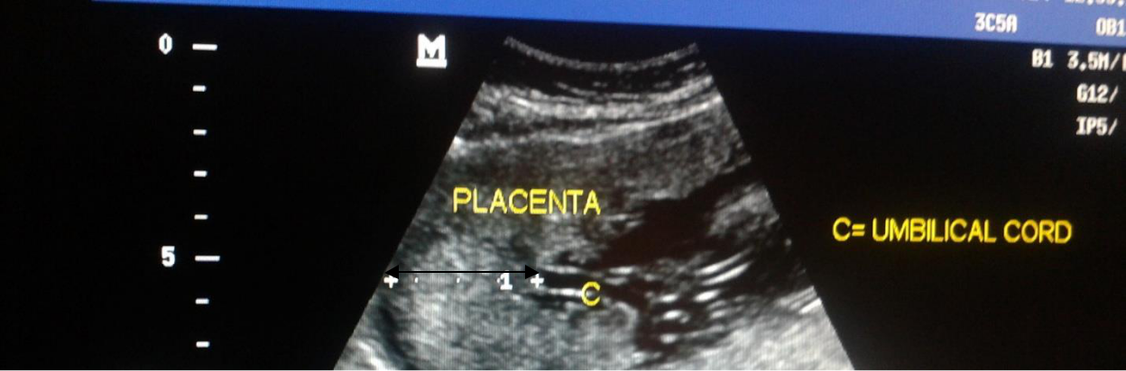

UW

PT PI

P
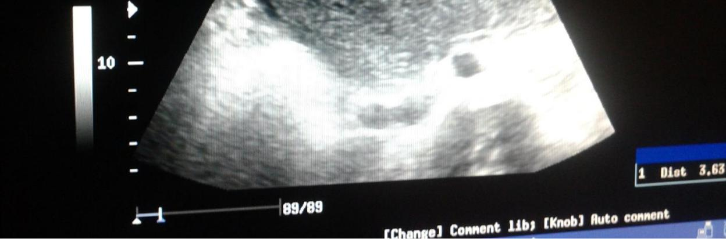

AF ^{F}

Figure 3: A sonogram showing the placenta and the point insertion of the umbilical cord

UW: Uterine wall

PT: Placental thickness (indicated by the black arrow and the white measured distance)

PI: Point of insertion of umbilical cord

AF: Amniotic fluid

- Umbilical cord

- Fetus

- Placenta

34

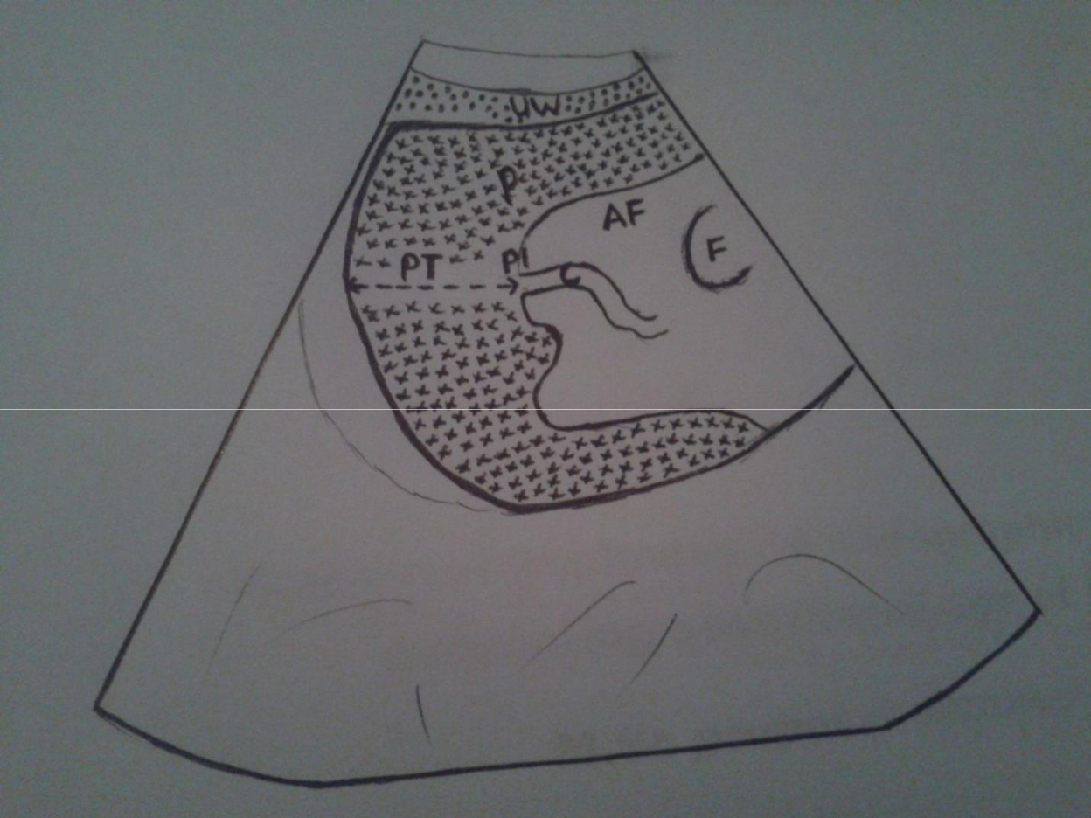

Figure 4: Schematic drawing showing the placenta and the point of insertion of the umbilical cord

UW: Uterine wall

PT: Placental thickness (indicated by the black arrow)

PI: Point of insertion of umbilical cord

AF: Amniotic fluid

- Umbilical cord

- Fetus

- Placenta

35
3.9 Statistical Analysis: Data was analyzed using Microsoft TM statistical software package for social sciences (SPSS) version 15.0. The nomogram for placental thickness was established using descriptive statistics. The relationship between placental thickness and gestational age was established using Pearson correlation and regression analysis.

36
CHAPTER FOUR

RESULTS

Table 1 shows the distribution of placental thickness according to GA obtained by combination of FL, BPD, HC and AC parameters in the second and third trimesters. This shows that in the second trimester, the mean placental value increased from 17.9 ± 1.6mm to 29.6 ± 2.8mm with a mean placental thickness of 23.2 ± 2.8mm. In the third trimester, the mean placental thickness increased from 29.4 ± 2. 6mm to 41.3 ± 4.6mm with a mean placental thickness of 36.1 ± 3.6mm. This shows that placental thickness increases with increase in gestational age.

Table 1: Distribution of Placental Thickness According to Gestational Age Obtained by Combination of FL, BPD, HC and AC Parameters.

SECOND TRIMESTER (14 – 26 weeks)

Gestational age | No of cases | Minimum | Maximum | Mean placental
(Weeks) |  | placental | placental | thickness with
 |  | thickness (mm) | thickness (mm) | standard
 |  |  |  | deviation(SD)
14 | 20 | 16 | 22 | 17.9 | ± 1.6
15 | 21 | 12 | 25 | 18.2 | ± 3.9
16 | 25 | 14 | 25 | 19.0 | ± 3.2
17 | 22 | 18 | 21 | 19.8 | ± 1.1
18 | 18 | 17 | 24 | 20.7 | ± 2.6
19 | 21 | 20 | 29 | 23.7 | ± 3.1
20 | 21 | 17 | 29 | 23.4 | ± 2.7
21 | 20 | 17 | 30 | 24.3 | ± 2.6
22 | 20 | 20 | 28 | 24.1 | ± 2.7
23 | 20 | 17 | 32 | 26.4 | ± 3.2
24 | 17 | 18 | 31 | 27.3 | ± 3.4
25 | 22 | 21 | 38 | 27.8 | ± 3.2
26 | 21 | 26 | 39 | 29.6 | ± 2.8
Total | 247
 | Overall Mean placental thickness =23.2 ± 2.8mm
 |  | THIRD TRIMESTER (27 – 41 weeks)
27 | 20 | 24 | 32 | 29.4 | ± 2.6
28 | 25 | 25 | 37 | 30.8 | ± 3.0
29 | 28 | 26 | 39 | 31.4 | ± 3.1
30 | 23 | 24 | 41 | 32.2 | ± 4.4
31 | 30 | 28 | 41 | 34.0 | ± 3.2
32 | 37 | 28 | 41 | 34.4 | ± 3.1
33 | 36 | 29 | 47 | 36.7 | ± 4.4
34 | 33 | 30 | 45 | 36.8 | ± 3.2
35 | 21 | 30 | 43 | 37.3 | ± 2.8
36 | 37 | 30 | 47 | 38.3 | ± 4.2
37 | 37 | 33 | 49 | 39.4 | ± 3.8
38 | 24 | 32 | 49 | 41.4 | ± 4.9
39 | 20 | 37 | 45 | 42.0 | ± 2.9
40 | 21 | 35 | 45 | 41.3 | ± 4.6
Total | 379

Overall Mean placental thickness = 36.1 ± 3.6mm

37
Table 2 shows the distribution of placental thickness according to GA obtained by subject’s LMP in the second and third trimesters. This shows that in the second trimester, the mean placental value increased from 17.7 ± 1.8mm to 28.8 ± 2.6mm with a mean placental thickness of 23.1 ± 2.8mm. In the third trimester, the mean placental thickness increased from 30.0 ± 2.4mm to 41.1

- 4.5mm with a mean placental thickness of 38.9 ± 3.9mm. This shows that placental thickness increases with increase in gestational age.

Table 2: Distribution of Placental Thickness According to Gestational Age Obtained by Subject’s LMP.

 |  | SECOND TRIMESTER (14 – 26 weeks)
Gestational age | No of cases | Minimum | Maximum | Mean placental
(Weeks) |  | placental | placental | thickness with standard
 |  | thickness (mm) | thickness (mm) | deviation (SD)
14 | 15 | 16 | 22 | 17.7 | ± 1.8
15 | 20 | 12 | 25 | 19.1 | ± 3.9
16 | 24 | 12 | 25 | 18.5 | ± 2.9
17 | 27 | 15 | 24 | 19.3 | ± 2.0
18 | 21 | 17 | 25 | 20.7 | ± 2.4
19 | 19 | 20 | 29 | 24.1 | ± 2.6
20 | 21 | 20 | 29 | 23.6 | ± 2.7
21 | 16 | 17 | 28 | 23.3 | ± 3.0
22 | 22 | 19 | 30 | 24.7 | ± 2.6
23 | 20 | 20 | 31 | 25.3 | ± 3.1
24 | 17 | 18 | 32 | 26.4 | ± 3.8
25 | 24 | 26 | 38 | 29.0 | ± 2.7
26 | 27 | 24 | 39 | 28.8 | ± 2.6
Total | 248
 | Overall Mean placental thickness = 23.1 ± 2.8mm
 |  | THIRD TRIMESTER (27 - 41 weeks)
27 | 26 | 24 | 34 | 30.0 | ± 2.4
28 | 25 | 24 | 36 | 30.5 | ± 3.2
29 | 32 | 25 | 39 | 31.7 | ± 3.2
30 | 20 | 25 | 39 | 31.8 | ± 3.4
31 | 33 | 29 | 41 | 34.7 | ± 3.4
32 | 28 | 28 | 40 | 34.6 | ± 3.1
33 | 34 | 29 | 47 | 36.8 | ± 4.6
34 | 33 | 30 | 42 | 35.7 | ± 3.5
35 | 26 | 35 | 45 | 38.3 | ± 2.8
36 | 36 | 30 | 49 | 38.5 | ± 4.4
37 | 37 | 33 | 49 | 39.1 | ± 4.0
38 | 30 | 32 | 48 | 41.5 | ± 4.1
39 | 16 | 33 | 47 | 40.3 | ± 4.0
40 | 21 | 35 | 45 | 41.1 | ± 4.5
Total | 376
 | Overall Mean placental thickness = 38.9 ± 3.9mm


38
Correlation between Gestational Age and Placental Thickness H₀: There is no correlation between gestational age and placental thickness.

H₁: There is a correlation between gestational age and placental thickness.

Table 3 shows that placental thickness has a strong correlation with gestational age in the second, third and combined trimesters. This relationship is shown by their r values of 0.791, 0.706 and 0.910 respectively. In all the trimesters, the p value is less than 0.01. This means that the correlation is significant. Therefore, H₀ is rejected and H₁ is accepted.

Table 3: Correlation of Placental Thickness with Gestational Age Obtained by Combination of Fetal FL, BPD, HC and AC Parameters.

 |  | TRIMESTERS
 | SECOND | THIRD | COMBINED
Pearson Correlation | r = 0.791 | r = 0.706 | r = 0.910
Coefficient
P- values | P<0.01 | P<0.01 | P<0.01
Number of | n = 268 | n = 392 | n = 660
measurements (n)


39
Table 4 shows that placental thickness has a strong correlation with gestational age in the second, third and combined trimesters. This relationship is shown by their r values of 0.789, 0.681 and 0.907 respectively. In all the trimesters, the p value is less than 0.01.

Table 4: Correlation of Placental Thickness with Gestational Age Obtained by Patient’s LMP.

 |  | TRIMESTERS
 | SECOND | THIRD | COMBINED
Pearson Correlation | r = 0.789 | r = 0.681 | r = 0.907
Coefficient
P- values | P<0.01 | P<0.01 | P<0.01
Number of | n = 273 | n =387 | n = 660
measurements (n)

40
Table 5 shows that placental thickness has a strong linear relationship with gestational age. This strong relationship is shown by the p value of 0.000 showing that the relationship is significant (p < 0.05). The R² values show that the model fits well. The combined trimester has the highest R² values indicating that it is the best fit model comparatively. The F statistics shows that this relation is very significant and that variations in gestational age explain to a large extent the variations in placental thickness. Model equation for estimating GA for any known placental thickness was obtained.

Table 5: Relationship between Placental Thickness and Gestational Age and its Predicted Model Equations

 |  |  | TRIMESTERS
 | SECOND |  |  | THIRD | COMBINED
Parameters | Value | Sig (p- | Value | Sig (p- | Value | Sig (p-
 |  | value) |  | value) |  | value)
R | 0.791 | 0.000 | 0.706 | 0.000 | 0.910 | 0.000
_{R}2 | 0.624 | 0.000 | 0.498 | 0.000 | 0.827 | 0.000
F | 444.821 | 0.000 | 388.656 | 0.000 | 3154.579 | 0.000
K (constant) | 3.614 | 0.000 | 3.354 | 0.088 | 4.015 | 0.000
GA | 0.982 | 0.000 | 0.977 | 0.000 | 0.959 | 0.000
Model | y = 0.982(PT) + 3.614 |  | y = 0.977 (PT) + 3.354 |  | y = 0.959(PT) + 4.015
equation


41
Figure 5 was obtained during the regression analysis. It shows the relationship between the observed values (values obtained from the data collected) and the predicted value (the values predicted by the model). The shape of the histogram obtained from the plot approximately follows the shape of the normal curve. It shows the normality of the model in the combined trimester.
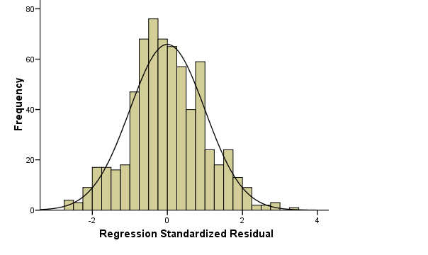

of placental thickness

Figure 5: A Histogram Showing the Relationship between the Observed and Predicted Values in the Combined Trimester.

42
Figure 6 shows a normal P-P plot of regression standardized residual. This was obtained during regression analysis. The graph plotted the expected cumulative probability obtained from the predicted model against the observed cumulative probability obtained from the observed values.

Expected Cumulative

Probability of placental thickness

 |  |  |  |  |  |  |  |  |  |  |  |  |  |  |  |  |  |  | 35
1.0 |  |  |  |  |  |  |  |  |  |  |  |  |  |  |  |  |  | 28 |  | 34
1.0 |  |  |  |  |  |  |  |  |  |  |  |  |  |  |  |  |  | 33 | 35 | 29
 |  |  |  |  |  |  |  |  |  |  |  |  |  |  |  |  | 23³¹ |  | 35
 |  |  |  |  |  |  |  |  |  |  |  |  |  |  |  |  | 37³⁷ |  |  | 33
 |  |  |  |  |  |  |  |  |  |  |  |  |  |  |  | ³⁶36 |  | 37
0.8 |  |  |  |  |  |  |  |  |  |  |  |  |  |  |  | 3232 |  | 37³⁷
 |  |  |  |  |  |  |  |  |  |  |  |  |  | 22₂₉ |  |  | 32 | 3636
 |  |  |  |  |  |  |  |  |  |  |  |  |  | 28 |  | 22 | 3638
 |  |  |  |  |  |  |  |  |  |  |  |  | 34
0.6 |  |  |  |  |  |  |  |  |  | 19³⁶36¹⁶ |  |  |  |  |  | 3429
 |  |  |  |  |  |  |  |  |  | 37 |  | 36 |  | 36 | 16
 |  |  |  |  |  |  |  |  |  |  | 26 |  |  | 36 | 41
 |  |  |  |  |  |  |  |  | 29 30 |  |  |  | 19
 |  |  |  |  |  |  | 18 |  | 36 |  |  |  | 26³⁶
 |  |  |  |  |  |  |  |  |  |  | ²³30
0.4 |  |  |  |  |  |  | 17 |  | 18 | 29
0.4 |  |  |  |  |  | 44 |  |  | 31
 |  |  |  |  | 20 | 44 | 20 |  | 3836
 |  |  |  |  | 20 | 17 | 20 | ⁴⁴17
 |  |  |  | 37 |  | 17
0.2 |  |  | 3118 |  |  | 17 20
0.2 |  | 42 |  |  | 3830
27 |  |  |  |  | 31 |  | 20
24 |  | 39 |  | 41
 |  | 20
25 | 25 |  | 28 |  | 47
29³⁸₄₇ 2948⁴²
0.0
0.0 |  |  |  |  | 0.2 |  |  |  | 0.4 |  |  |  | 0.6 |  |  |  | 0.8 |  |  | 1.0
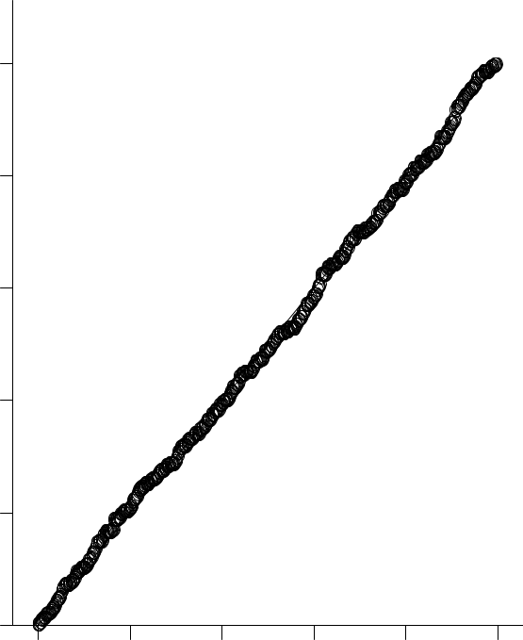

Observed Cumulative Probability of placental thickness

Figure 6: A P-P plot Showing the Relationship between the Observed and Expected Values in the Combined Trimester.

43

Figure 7 is a scatter diagram of GA against placental thickness in the second trimester. It shows that placental thickness increases in a linear fashion with increase in gestational age in the second trimester. Gestational age in the second trimester for different placental thickness can be extrapolated from this graph.
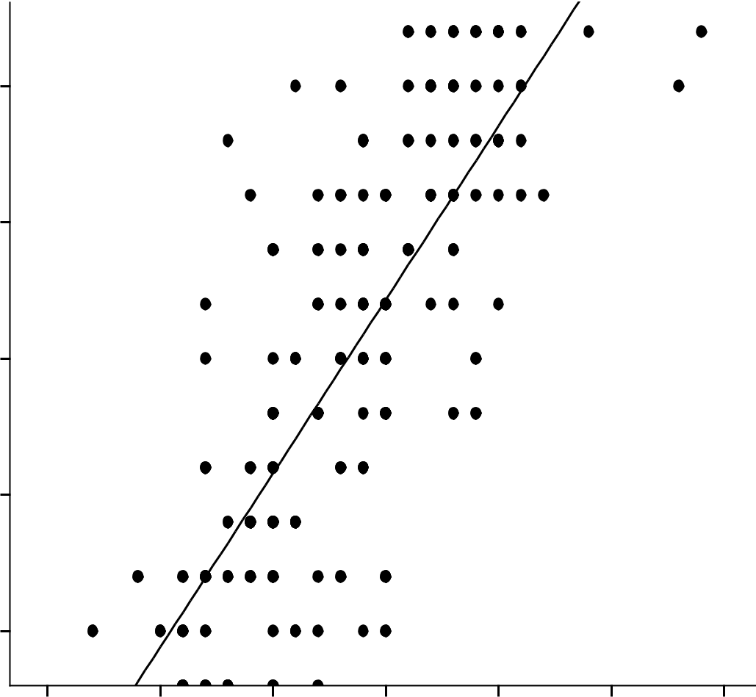

 | 25.00
(weeks) | 22.50
AGE | 22.50
GESTATIONAL | 20.00
 | 17.50
 |  |  |  |  |  | R Sq Linear = 0.626
 | 15.00
 | 10.00 | 15.00 | 20.00 | 25.00 | 30.00 | 35.00 | 40.00
 |  |  | PLACENTAL_THICKNESS |  |  | (mm)

Figure 7: The Relationship between Placental Thickness and Gestational Age in the Second Trimester

44
Figure 8 is a scatter diagram of GA against placental thickness in the third trimester. It shows that placental thickness increases in a linear fashion with increase in gestational age in the third trimester. Gestational age in the third trimester for different placental thickness can be extrapolated from this graph.
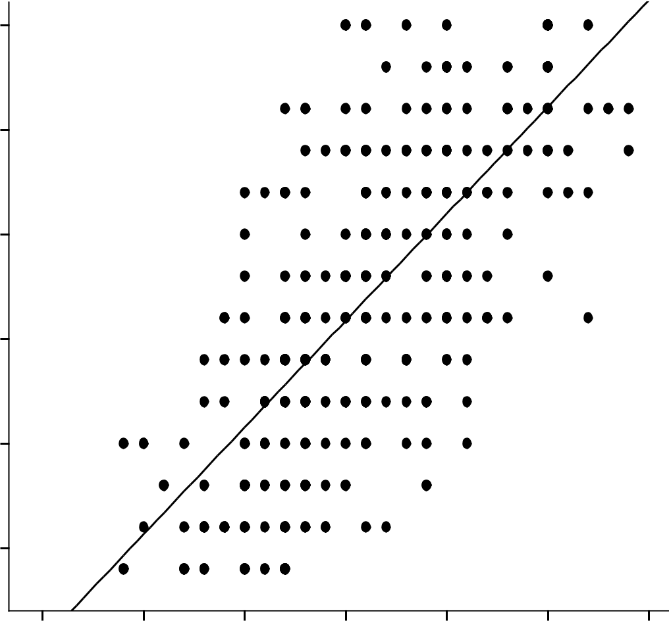

 | 40.00
(weeks) | 37.50
AGE | 35.00
_
GESTATIONAL | 32.50
 | 30.00
 |  |  |  |  |  | R Sq Linear = 0.499
 | 27.50
 | 20.00 | 25.00 | 30.00 | 35.00 | 40.00 | 45.00 | 50.00

PLACENTAL_THICKNESS (mm)

Figure 8: The Relationship between Placental Thickness and Gestational Age in the Third Trimester

45
Figure 9 is a scatter diagram of GA against placental thickness in the combined trimester. It shows that placental thickness increases in a linear fashion with increase in gestational age in the combined trimester. This can be used as a reference graph for estimating GA using placental thickness in the second and third trimesters.
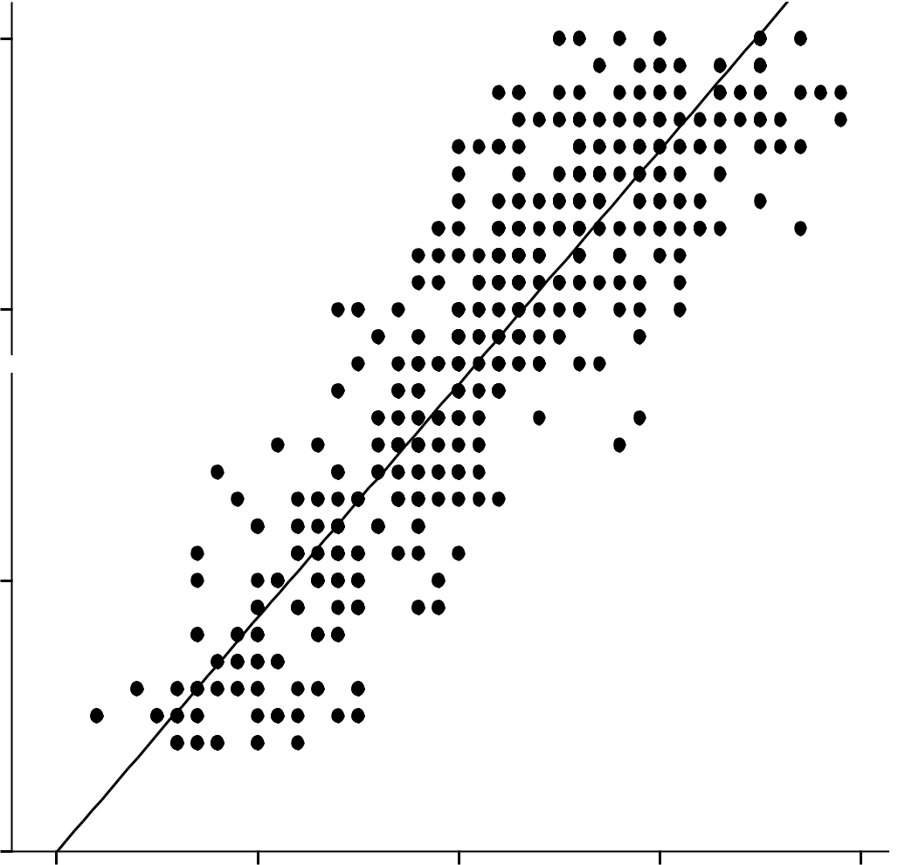

 | 40.00
(weeks)
GESTATIONAL AGE | 30.00
GESTATIONAL AGE | 20.00
 |  |  |  |  | R Sq Linear = 0.827
 | 10.00
 | 10.00 | 20.00 | 30.00 | 40.00 | 50.00

PLACENTAL_THICKNESS (mm)

Figure 9: The Relationship between Placental Thickness and Gestational Age in the Combined Trimester.

46
Table 6 shows that there is no statistical significant difference in both second and third trimester

between this work and the report of Ohagwu et al., in a similar Nigerian population; this is

shown by its significant value of 0.05 and 0.75 respectively.

Table 6: Mean Placental Thickness Values from Present Study Compared with the Value Obtained from Previous Literature (Nigerian Population)

 |  |  |  |  | t test for equality of mean
Work | Mean | Std. | t | Degree of | Significance | Mean | Standard
 |  | Deviations |  | Freedom |  | Difference | Error
 |  |  | SECOND TRIMESTER |  |  |  | Difference
Ukoha | 24.16 | 4.92 | -2.14 | 24 | 0.05 | -3.52 | 1.65
Ohagwu | 27.68 | 4.12
et al |  |  | THIRD TRIMESTER
Ukoha | 37.85 | 4.3 | -1.85 | 26 | 0.75 | -3.14 | 1.69
Ohagwu | 40.99 | 4.6
et al


47
Table 7 shows that in the second trimester, there is no statistical significant difference between

this work and the report of Mital et al., in Indian population; but a statistical significant

difference exist in the third trimester. This is shown by its significant value of 0.24 and 0.04

respectively.

Table 7: Mean Placental Thickness Values from Present Study Compared with Value Obtained from Previous Literature (Indian Population)

 |  |  |  |  | t test for Equality of Mean
Work | Mean | Std. | t | Degree of | Significance | Mean | Standard
 |  | Deviations |  | Freedom |  | Difference | Error
 |  |  | SECOND TRIMESTER |  |  |  | Difference
Ukoha | 24.16 | 4.25 | 1.19 | 25 | 0.24 | 1.68 | 1.40
Mital et al | 22.48 | 2.83
 |  |  | THIRD TRIMESTER
Ukoha | 37.85 | 4.3 | 2.07 | 25 | 0.04 | 3.20 | 1.55
Mital et al | 34.65 | 3.6


48
Table 8 shows the relationship between placental thickness and the other fetal parameters used for estimating GA in this study (FL, BPD, HC, and AC). Pearson’s correlation analysis showed that FL, BPD, HC, and AC have a strong correlation with placental thickness.

Table 8: Correlation of Placental Thickness with FL, BPD, HC and AC.

 | FL | BPD | HC | AC
Pearson | r = 0.994 | r = 0.993 | r = 0.960 | r = 0.995
Correlation
Coefficient
P- values | P < 0.01 | P < 0.01 | P < 0.01 | P < 0.01
Number of | 27 | 27 | 27 | 27

measurements (n)

49
Table 9 shows that femur length, biparietal diameter, head circumference, abdominal circumference and placental thickness increases with increase in gestational age.

Table 9: Relationship between Gestational Age, FL, BPD, HC, AC and Placental Thickness.

GA | FL (mm) | BPD (mm) | HC (mm) | AC (mm) | PLACENTAL
(Weeks) |  |  |  |  | THICKNESS
 |  |  |  |  | (mm)
14 | 13 | 25 | 90.7 | 77.6 | 17.9 | ± 1.6
15 | 17.9 | 28 | 110 | 89.7 | 18.2 | ± 3.9
16 | 20.3 | 32 | 122.2 | 104 | 19.0 | ± 3.2
17 | 25 | 61 | 142 | 111 | 19.8 | ± 1.1
18 | 26 | 40 | 150 | 126 | 20.7 | ± 2.6
19 | 29 | 45 | 163 | 135 | 23.7 | ± 3.1
20 | 32.5 | 47.2 | 176 | 146 | 23.4 | ± 2.7
21 | 35.2 | 50 | 191 | 154 | 24.3 | ± 2.6
22 | 38 | 54 | 188 | 174 | 24.1 | ± 2.7
23 | 40 | 57 | 212 | 180 | 26.4 | ± 3.2
24 | 47.9 | 59 | 231 | 194 | 27.3 | ± 3.4
25 | 44 | 61 | 232 | 200 | 27.8 | ± 3.2
26 | 48 | 65.9 | 239 | 219 | 29.6 | ± 2.8
27 | 50 | 67.5 | 247 | 223 | 29.4 | ± 2.6
28 | 53 | 70 | 257 | 237 | 30.8 | ± 3.0
29 | 56.2 | 72 | 266 | 247 | 31.4 | ± 3.1
30 | 57 | 75 | 275 | 255 | 32.2 | ± 4.4
31 | 60 | 78 | 383 | 268 | 34.0 | ± 3.2
32 | 62 | 80 | 291 | 286 | 34.4 | ± 3.1
33 | 64.4 | 87.6 | 305 | 289 | 36.7 | ± 4.4
34 | 65.6 | 85 | 308 | 305 | 36.8 | ± 3.2
35 | 68.8 | 86.8 | 319 | 309 | 37.3 | ± 2.8
36 | 71 | 89.1 | 321 | 324 | 38.3 | ± 4.2
37 | 74.2 | 92.6 | 330 | 332 | 39.4 | ± 3.8
38 | 75.7 | 96.8 | 333 | 337 | 41.4 | ± 4.9
39 | 76 | 96.2 | 339 | 353 | 42.0 | ± 2.9
40 | 79 | 97 | 340 | 357 | 41.3 | ± 4.6


50

Table 10 shows that FL, BPD, HC and AC have a linear relationship with placental thickness. Model equations relating the biometric fetal parameters with placental thickness were established by the regression analysis.

Table 10: Regression Analysis Showing the Relationship between Placental Thickness and FL, BPD, HC and AC.

 | Model | Value | Sig (p-value) | Model Equation
1 | R | 0.994 | 0.000 | Y = a + bX₁
 | Constant | 11.139 | 0.000 | PT = 11.139 + 0.381 X₁
 | FL | .381 | 0.000
2 | R | 0.994 | 0.000 | Y = a + b₁X₁ + b₂X₂
 | Constant | 10.344 | 0.000 | PT = 10.344 + 0.300 X₁ +0.073
 | FL | 0.300 | .083 | X₂
 | BPD | 0.073 | .629
3 | R | 0.994 | 0.000 | Y = a + b₁X₁ + b₂X₂ + b₃X₃
 | Constant | 10.379 | 0.000 | PT = 10.379 + 0.301 X₁ +0.083
 | FL | 0.301 | .089 | X₂ + -0.003X₃
 | BPD | 0.083 | .594
 | HC | -0.003 | .714
4 | R | 0.996 | 0.000 | Y = a + b₁X₁ + b₂X₂ + b₃X₃+ b₄
 | Constant | 8.494 | 0.000 | X₄
 | FL | -0.177 | .430 | PT = 8.494 + -0.177X₁ +
 | BPD | 0.172 | .224 | 0.172X₂ + 0.001X₃ + 0.083X₄
 | HC | 0.001 | .935
 | AC | 0.083 | .008


Where

a = Constant, X₁ = FL, X₂ = BPD, X₃ = HC, X₄ = AC.

51
It can be seen from Figure 10 below that placental thickness increases as femur length increases. This can be used to extrapolate femur length especially when there is difficulty in sonographically estimating femur length either due to unsharpness or foreshortenings of the femur bone.
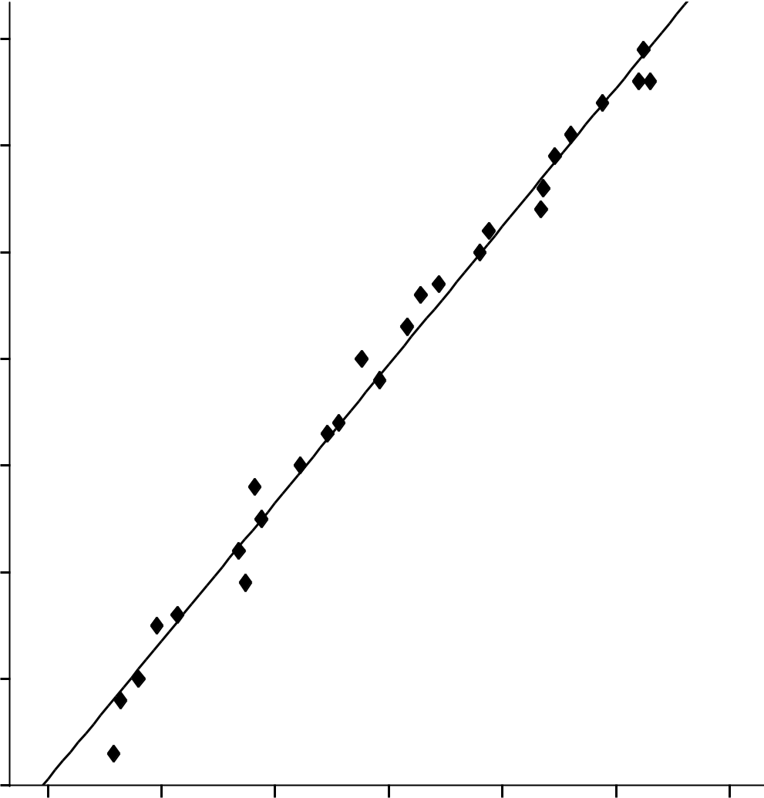

 | 80
 | 70
 | 60
(mm) | 50
FL
 | 40
 | 30
 | 20 |  |  |  |  | R Sq Linear = 0.988
 | 10
 | 15.0 | 20.0 | 25.0 | 30.0 | 35.0 | 40.0 | 45.0

PLACENTA_THICKNESS (mm)

Figure 10: The Relationship between Placental Thickness and Femur Length.

52
It can be seen from Figure 11 below that placental thickness increases as biparietal diameter increases. This can be used to extrapolate biparietal diameter especially when there is difficulty in sonographically estimating biparietal diameter either due to abnormal shape of fetal head, fetal position or machine factor.
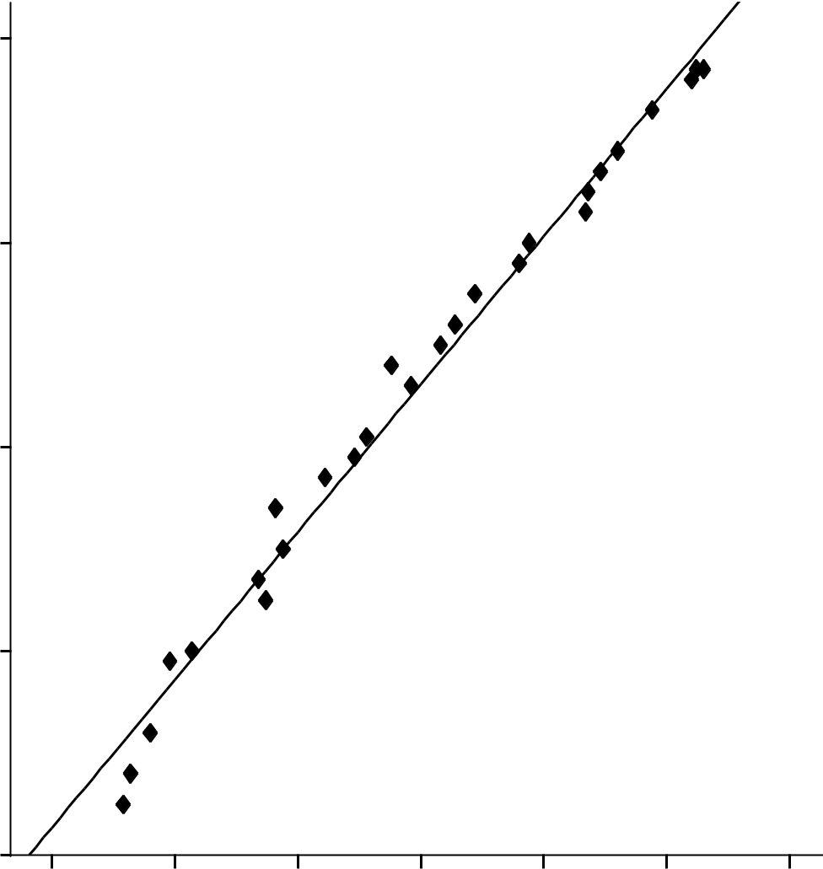

 | 100
 | 80
(mm)
BPD | 60
 | 40
 |  |  |  |  |  | R Sq Linear = 0.987
 | 20
 | 15.0 | 20.0 | 25.0 | 30.0 | 35.0 | 40.0 | 45.0

PLACENTA_THICKNESS (mm)

Figure 11: The Relationship between Placental Thickness and Biparietal Diameter

53
It can be seen from Figure 12 above that placental thickness increases as head circumference increases. This can be used to extrapolate head circumference especially when there is difficulty in sonographically estimating head circumference either due to fetal position or machine factor.
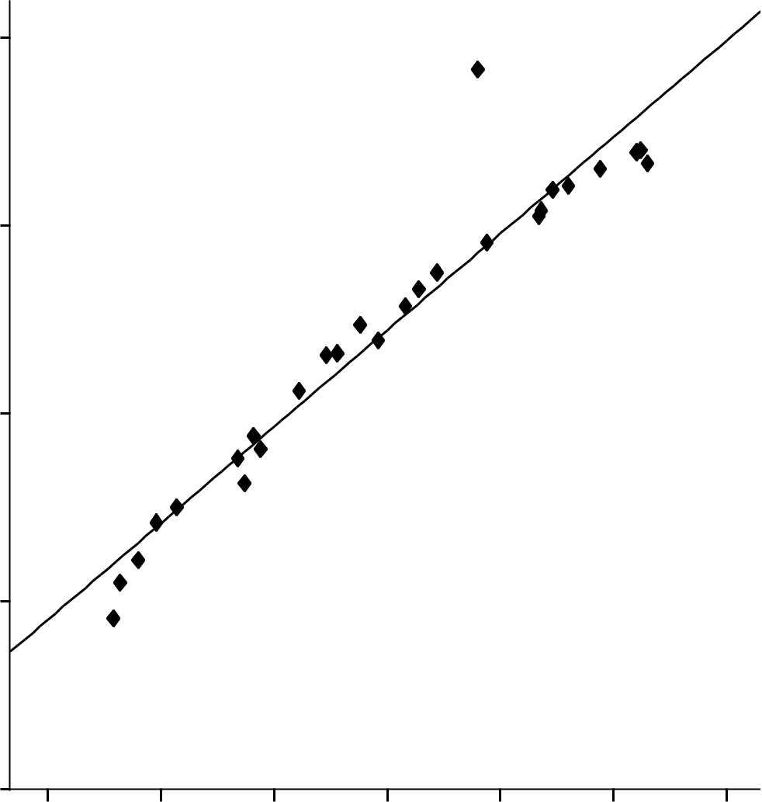

 | 400
 | 300
(mm)HC | 200
 | 100
 |  |  |  |  |  | R Sq Linear = 0.921
 | 0
 | 15.0 | 20.0 | 25.0 | 30.0 | 35.0 | 40.0 | 45.0

PLACENTA_THICKNESS (mm)

Figure 12: The Relationship between Placental Thickness and Head Circumference.

54

Figure 13 shows the linear relationship between placental thickness and abdominal circumference. This relationship is very important because abdominal circumference is important for estimating fetal weight. So when there is difficulty in estimating the abdominal circumference, it can be extrapolated from the graph.
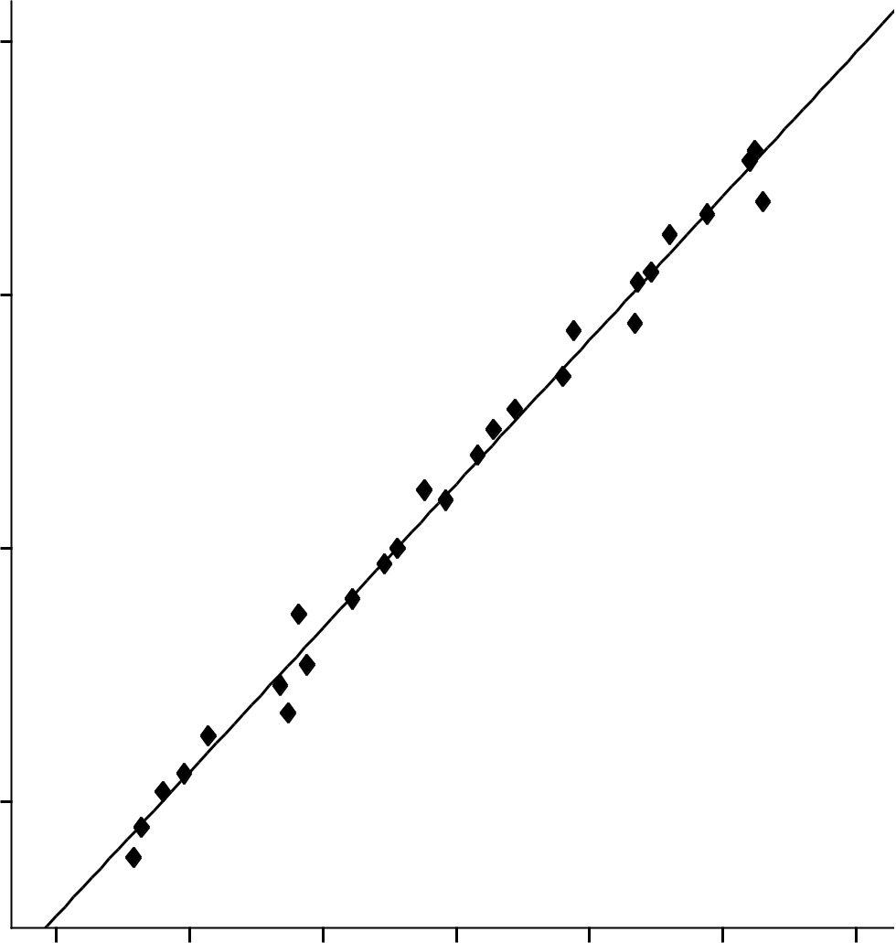

400
300
(mm)
AC
200
100 |  |  |  |  | R Sq Linear = 0.991
15.0 | 20.0 | 25.0 | 30.0 | 35.0 | 40.0 | 45.0

PLACENTA_THICKNESS(mm)

0

Figure 13: The Relationship between Placental Thickness and Abdominal Circumference.

55
Table 10 shows that there is no statistically significant observer variation in placental thickness value measurements made. This is shown by a significant value of 0.385.

Table 10 Test for Observer Variation in Placental Thickness Measurement

Pair

Placental thickness


Mean


-0.20


Paired Differences

Standard Standard


Deviation Error Mean

1.01 0.22


t

-0.89


Df

19

Sig


0.385


measurement observer one

and two

56

CHAPTER FIVE

DISCUSSION AND CONCLUSION

5.1 Discussion and Implications of Results

Diseases and abnormalities affecting the fetus can be indicated by an abnormal size of the placenta during the second and third trimester (Elsafi et al., 2014). Accurate measurement of placental thickness may be a useful ancillary parameter for gestational age estimation and evaluation of placenta morphology. Although several studies on placenta parameters have been carried out in Asian and Caucasian population, very few studies were seen in African population in the reviewed available literature.

Normogram for Placental Thickness Measurement

Tables and reference curves for placental thickness values at different gestational ages in the second and third trimesters were generated. They showed that there is a linear increase in placental thickness with gestational age. In the second trimester, a mean placental thickness of 23.2 ± 2.9mm was obtained while in the third trimester a mean placental thickness of 36.4 ± 3.7mm was obtained. In this study the mean placental thickness of 42 ± 2.9 mm was obtained at 39 weeks of gestation. This is close to the value reported by Ohagwu et al., (2008) who reported a mean placental thickness of 45 ± 6.4mm at 39 weeks of gestation. Similar study done in Sudan by Elsafi et al., (2014), reported a maximum placenta thickness of 45mm at 40 weeks. This is in line with the result of this present study. The result of this study is above the value reported by Mital et al., (2002) and Anumpama et al., (2001), Tiwari et al., (2013), and Ravi. N and Pruthvi (2013) who conducted similar work in India. Mital et al., (2002) reported a mean placental thickness of 37.5mm at 39 weeks gestation, Anumpama et al., (2001), reported that placenta

57
thickness in mm matches GA in weeks from 27 to 33 weeks. Tiwari et al., (2013) reported that placenta gradually increased from 15mm at 11weeks to 36.3mm at 39 weeks. Ravi. N and Pruthvi (2013) reported that placenta gradually increased from 11.4mm at 11 weeks to 36.5mm at 40 weeks. The result of this study also differs from a similar work done in Australia by Anna et al., (2012), they reported an anterior placenta >33mm or a posterior placenta >40mm should be considered abnormally thick. Mumal et al., (2014) reported a mean placenta thickness of 3.90

- 1.1cm in third trimester and a maximum placenta thickness of 7.5cm at 38weeks. Karthikejan et al., (2012) noted a mean placenta thickness of 35.81mm in third trimester and a maximum placenta thickness of 42.2mm at 38weeks. This implies that there is probably, a racial difference in placental thickness.

There was a fairly consistent increase in placental thickness from 14 weeks to 39 weeks of gestation after which the placental thickness gradually decreased in the 40th week in the present study. This implies that placental thickness increases linearly and attains its maximum thickness at 39 weeks of gestation. The maximum placental thickness obtained during the course of this study is 47mm. The result of this work also disagrees with the work of Hoddick et al (1985), Yuranga, (2011), Anna et al., (2012), Benirschike and Kanfmann (1990) who reported that at no stage of pregnancy was the normal placenta greater than 40.0mm in thickness. This implies that placenta is normally thicker in Nigerian population when compared to Indian and Caucasian populations. This normal increased placental thickness was also noted in Sudanese population according to Elsafi et al., (2014). Graph of GA against placental thickness obtained shows the linear relationship between gestational age and placental thickness in the combined trimester and can serve as a reference graph for estimating GA in both second and third trimesters. These

58
findings imply that placental thickness increases as a function of GA. Hence this can be used to estimate gestational age in the second and third trimesters.

Placental Thickness and Gestational Age Obtained from Patient’s LMP

Pearson correlation coefficient of 0.775, 0.656, 0.901 for the second, third and combined trimesters respectively were obtained. This shows that there is a significant positive relationship between the gestational age obtained from patient’s LMP and placental thickness. This result when compared with gestational age obtained using other fetal parameters has a lower positive relationship. This difference may be attributed to the limitation of using LMP for estimating GA which includes irregular menstrual periods and normal variation from average ovulation date.

Placental Thickness and Gestational Age Obtained from Other Fetal Parameters

Reinstatement of null and alternative hypotheses, and the analysis that was performed for the testing the hypothesis.

H₀: There is no correlation between gestational age and placental thickness.

H₁: There is a correlation between gestational age and placental thickness.

Pearson's product-moment correlation and regression was compute to measure the relationship between gestational age and placental thickness. The data were examined to ensure normal distribution, homogeneity of variances, and linearity. To test the assumptions of residuals, P-P plots were generated as displayed in Figure 1. The residuals of the outcomes were normally distributed. To test the assumptions of equal variances, scatterplots of the residuals were generated and equal variances were shown. Linearity was shown by means of scatterplots.

59
Pearson correlation and regression analysis showed that there is a significant positive relationship between the gestational ages obtained from other fetal parameters such as FL, BPD, HC, AC in second, third and combined trimesters. P values of < 0.05 were obtained during correlation in all the trimesters and a significant R² value of 0.00 was obtained during the regression analysis in all the trimesters. This implies that the correlation is significant and that placental thickness and gestational age are linearly related. The histogram plot obtained during regression analysis in this study is very close to the shape of the normal curve which was superimposed on the histogram. This shows that the model predicted by the regression analysis fits well. A P-P plot was further used to assess the normality of the predicted model. The figure obtained shows that the line obtained from the plot is very close to 45 degrees line superimposed on the plot. This further affirms the fact that the predicted model is well fit. Therefore the model equations produced by the regression analysis is valid.

The null hypothesis H₀ was rejected and the alternate hypothesis H₁ accepted. These findings suggest that placental thickness increases as a function of GA and thus can be a good predictor of gestational age in both second and third trimester.

The regression analysis yielded the following linear equations of the relationship between gestational age (y) in weeks and placental thickness (PT) in mm.

In the second trimester, y = 0.982 (PT) + 3.614, in the third trimester, y = 0.977 (PT) + 3.354 and in the combined trimester, y = 0.959 (PT) + 4.015.

With these equations, GA(y) can be obtained by substituting the measured placental thickness (PT) in these equations.

60
Relationship between Placental Thickness and Other Fetal Parameters

When femur length, biparietal diameter, head circumference, and abdominal circumference were correlated with placental thickness, values of 0.994, 0.993, 0.960, and 0.995 were obtained respectively. This shows that there is a significant positive relationship between these fetal parameters and placental thickness. This is in line with the reports of Arafa et al., (2014), Elsafi et al., (2014), Ohagwu et al., (2008) and Karthikejan et al., (2012) who reported similar positive relationship between these fetal parameters and placental thickness. Reference graphs for the relationship between placental thickness and FL, placental thickness and BPD, placental thickness and HC, placental thickness and AC were obtained. In case of doubt in measuring these biometric fetal parameters during sonographic examinations, reference can be made to this graphs if the placental thickness has already been measured. Regression analysis yielded this equation for the relationship; PT = 8.494 + 0.177FL + 0.172BPD + 0.001HC + 0.083AC. This equation shows the linear relationship between placental thickness and the four biometric fetal parameters normally used in measuring GA.

This relationship between placental thickness and other fetal parameters is very important because subnormal placental thickness for any gestational age may be the earliest indication for fetal growth retardation.

Placental Thickness Values Obtained in this Study and Values Reported by Other Related Literatures.

Differences in the values of placental thickness obtained in this study and that reported by other related literatures were noted. The values obtained in this study were statistically compared with the values reported by some of the related literatures reviewed during the course of this research.

61
The mean placental thickness obtained from this study, the report of Ohagwu et al., (2008) and the report of Mital et al., (2002) was statistically compared for any significant variation in the results. No significant statistical difference was found between the mean placental thickness values obtained in this study and the values reported by Ohagwu et al., (2008) in both second and third trimester. A significant statistical difference was observed only in third trimester, in the mean placental thickness reported by Mital et al., (2002) and the values obtained in this study. The variation in placental thickness values obtained by this study and that reported by Mital et al., (2002) can be attributed to racial factor. It can be presumed that placenta is normally thicker in Nigerians than in Indians.

The difference in the value obtained in this study and that, reported by Ohagwu et al (2008) who conducted a similar work in the same country Nigeria may be attributed to geographical difference or probably observer error. Ohagwu et al (2008) carried out their research in the Northern part of Nigeria while this present study was carried out in the Eastern part of Nigeria.

5.2 Conclusion

Placental thickness increases as a function of GA and has a linear relationship with gestational age. Reference graphs and model equations for estimating GA in the second and third trimester for a known value of placental thickness was generated. The result of this study shows that placenta is thicker in Nigerian population when compared to Indian and Caucasian population.

A significant relationship was found between placental thickness and other fetal biometric parameters like femur length, biparietal diameter, head circumference and abdominal circumference. Placental thickness values below the normal, predicted by the graph may be an early sign of intrauterine growth retardation.

62
Placental thickness appears to be a good parameter for estimating GA and for detecting intrauterine growth retardation.

5.3 Recommendations

- This study suggest that placenta thickness measurement should be included in routine obstetrics scan so as to detect suboptimal placenta thickness which may be an early sign of intrauterine growth retardation so that surveillance and medical measures may be instituted at an early stage.
- Placental thickness measurement should be used as a biometric parameter to estimate gestational age especially when other fetal biometric parameters are in doubt.

- Measurement of placental thickness should be used to assess fetal growth and well being.

5.4 Limitation of the Study

Some placenta has their point of insertion of the umbilical cord almost at the edge of the placenta thereby giving a low value of placenta thickness.

5.5 Areas for Further Studies

- Sonographic assessment of placenta thickness in high risk pregnancies

- Sonographic assessment of the distance from the edge of placenta to the point of insertion of the umbilical cord.

63
REFERENCES

Anna Lee, Michael Bethune, Richard Hiscolk (2012). Placental thickness in second trimester; A pilot study to determine the normal range. Journal of Ultrasound in Medicine; 31(2): 213-218.

Anupama J, Kumar G, Agarwal U (2001). Placenta thickness – a sonographic indicator of gestational age. Journal of obstetrics and gynecology of India; 51(3): 48-9.

Arafa Ahmed, Alrashid Rahim, Hamid Osman, Ala Abdl Elgyoum, Aman Eizaki (2014). The correlation between placenta thickness and fetal age among the pregnants in Sudan. Journal of Applied Medical Sciences;2(ID): 395-398.

Ballard JL, Khoury JC, Wedig K. (1991). New Ballard Score expanded to include extremely premature infants. Journal of Pediatrics; 119:417-423.

Benirschke K and Kaufmann P. Pathology of the human placenta. 2nd Edition. New York:
Spring-Verlag, 1990.

Betlye Wilson (2008). Sonogragraphy of the placenta and umbilical cord. Radiologic Technologist; 79(4).

Betty Mathai, Subhash Singh, Pramod Nittala (2013) . Placental thickness: its correlation with ultrasonographic gestational age in normal and IUGR pregnancies in the late second and third trimester. Journal of obstetrics and gynecology of India; 63(4): 230-233.

Bigitta W, David J, Sarah C, Pauline W, Melba S, Palmero, Olubukola O, Ebrima T, Maorianna S, Hilton W, Sarah R, Katre C (2010). Effect of placental malaria on birth weight. Malaria Journal; 9: 16-17.

Carolyn MS, Elizabeth M, John MT, Barbara E, John CP, David AS (2005). Measures of placental growth in relation to birth weight and gestational age, American journal of epidemiology; 162(10): 991-998.

Davis R.O, Ctter G. R, Goldenbrg R.L, Hoffman H. J, Cliver S. P, Brumfield C. G, (1993). Fetal biparietal diameter, HC, AC, FL; a comparism by race and set. Journal of reproductive medicine; 38(3): 201-6.

Dombrowski M P, Berry S M, Hurd W W, Saleh A A. Chik L, Sokol R J (1994). A gestational age model of birth weight based on placental size. Neonatology; 66(1): 56-64.

Elchalal U, Ezra Y, Levi Y, Bar-Oz B, Yanai N, Intrator O, and Nadjari M (2000). Sonographically thick placenta: a marker for increased perinatal risk: a Prospective cross-sectional study. World Applied Sciences Journal 21: 268-272.

Elsafi Ahmed Abdalla Balla, Magdolem Siddig Ahmed, Caroline Edward Ayad, Abdelmoneim Saeed Ahmed (2014). Prediction of fetal growth by measuring the placental thickness using ultrasonography. Journal of gynecology and obstetrics; 2(2): 26-31.

64
Evans M L, Zandor I E, Qureshi F, Buder H, Quizz M H, Nader H C (1988). Ultrasonographic diagnosis and fetal pathology of larger mesomelic dwarfism. American journal of medical genetics. 31(4): 15-20.

Ghosh.A, Tang. M. H, Lam. Y. H, Fung. E, and Chan. V (1994).Ultrasound measurement of placental thickness to detect pregnancies affected by homozygous α-thalassaemia-1. The lancet. 344: 988-989.

Gianluigi P, Kypros N, Renato X, Philippe J (2002). Diagnosis of fetal abnormalities the 18-23 weeks scan. Handbook of fetal abnormalities. Pento Ximanes publishers, ISU09 Educational Committee Centrus.

Guyton and Hall (2006).Textbook of medical physiology 11th edition, Churchill Livingstone, London: P 1042.

Hafner E, Metazenbauer M, Hofinger D, Munkel M, Gassner R, Schuter K, Dillinger-Paller B, Phillp K (2000). Placental growth from first to second trimester of pregnancy in SGA-fetuses and pre- eclamptic pregnancies compared to normal fetuses. Journal of obstetrics and gynecology of India; 50(6): 32-36.

Harvey Marcovitch (2005). Black’s medical dictionary 41st edition A & C Black publishers limited, London: P 902.

Hoddick W K, Mahony B S, Callen P W, Filly R A (1985). Placental thickness. Journal of ultrasound in medicine;4(9):479-82.

Holzman Jennifer, Ivica Zaland, Marguerite Lisa Batholomew (2007). Ultarsound of the placenta. Donald School Journal of Ultrasound; 1(4): 47-60.

Jauniaux E, Ramsay. B, Cambell. S (1994). Ultrasonographic investigation of placental morphologic characteristics and size during the second trimester of pregnancy. American journal of obstetrics and gynecology;170:130-7.

John Goldenring (2004). Distinguishing between "calendar gestational age" and "developmental gestational age"Medlineplus medical encyclopedia; 73-103.

Kariki D B, Sharmqa U K, Rauniyar R K. (2006) . Study of the accuracy of commonly used fetal parameters of estimating GA. Journal of the Nepal Medical association; 45(162): 233-237.

Karthikejan T, Ramesh Kuma, Subramaniam Johnson, Prabbu K (2012). Placental thickness and its correlation to gestational age and foetal growth parameter, a cross sectional ultrasonographic study. Journal of Clinical and Diagnostic Research; 6(10): 1732-1735.

Kevin P. Hanretty (2003). Obstetrics illustrated. 6thedition,ChurchillLivingstone Endiburgh: pp 9-12.

Kyle H, Anne K, Molly D, Erin DB, Barent P, William M, Janet EL (2007). A retrospective fetal ultrasound study of the brain size in Autism. Biological psychiatry journal; 62(9): 1048-1055.

65
Leung T. W and Lao T. T (2000). Placental size and large for GA infants in women with abnormal glucose tolerance in pregnancy. Diabetic medicine; 17: 48-52

Lubsky M, Mickova L, Prochazka M, Dzvinenk P, Mala K, Gzek L, Janout V (2006). Discrepancy of ultrasound biometric parameters of the head (HC, BPD) and femur length in the relation to set of the fetus and duration of pregnancy. Ceska gynekol journal; 71(3): 169-172.

Lubsky M, Mickova L, Prochazka M, Dzvinenk P, Mala K, Gzek L (2007). Discrepancy of ultrasound biometric parameters of the head (HC, BPD) in breech presented fetuses. Biomed;151(2): 323-326.

Malathi. G, Shanthi. V(2010). Thickness based characterization of ultrasound placenta images using regression analysis. International Journal of Computer Applications; 3 (7): 0975-8887.

Mital P, Hooja N, Mehndiratta K (2002). Placental thickness: a sonographic parameter for estimating gestational age of the fetus. Indian Journal of Radiology and Imaging; 12:553-4.

Mumal Nagawani, Sharma P.K, Urmila Singh, Anita Rani, Seema Mehrotra (2014). Ultrasonographic measurement of placenta thickness and its correlation with gestational age, a cross sectional ultrasonographic study. International Journal of Advanced Research; 2(6): 354-360.

Neil K. Kaneshiro, Susan Storck, Redmond Washington (2009). Gestational age. Medline plus;7:22-25.

Ohagwu, C C, Abu P O, Udoh B E (2009). Placental thickness: A sonographic indicator of gestational age in normal singleton pregnancies in Nigerian women. Internet Journal of Medical Update; 4(2):9-14.

Ohagwu, C C, Abu P.O, Ezeokeke U O and Ugwu A C (2008). Relationship between placental thickness and growth parameters in normal Nigerian foetuses. World Applied Sciences Journal; 4 (6): 864-868.

Ravi N, Pruthvi I (2013) . Correlative study of placental thickness with respect to gestational age and fetal weight by ultrasonological evaluation. Journal of Evolution of Medicine and Dental science; 3(2): 227-234.

Renato La Torre, Giovanni Nigro, Manuela Mazzocco, Best Ai M, Stuart Adler P (2006). Placental enlargement in women with primary maternal cytomegalovirus infection is associated with fetal and neonatal disease. Clinical infectious disease; 43 (8): 994-1000.

Rudy E. Sabbagha (2000). Diagnostic ultrasound applied to obstetrics and gynaecology. 2nd edition Wilhot publishers: pp 91-111.

Sadler T W (2004).Langman’s medical embryology.9thedition.Baltomore, MD: Lippincolt
Williams and Wilkins: pp 117-48.

66
Spirit BA, Oliphant M, Gottlieb RH, Gordon LP (1990). Prenatal sonographic evaluation of short limb dwarfism: an algorithmic approach. Radiographics; 10(2): 217-36.

Spirit Bevely, Kagan Eugene, Rozanska Richard (2005). Sonographic anatomy of the normal placenta. Journal of Clinical Ultrasound; 7(3): 204-207.

Tiwari A, Chandnani K (2013). A study to evaluate gestational age with the help of placenta thickness. Internal Journal of Reproduction Contraception Obstertrics and Gynaecology; 2(4): 503-505.

Tongsong, T. and Boonyanurak, P (2004). Placental thickness in the first half of pregnancy.Journal of Clinical Ultrasound; 32: 231–234.

Virupaxi R D, Potturi B R, Shirol V S, Desais S P, Hukkari V P (2011). Morphology of placenta and its relationship with small for dates babies in 950 live births. Recent research in science and technology; 3(2): 123-126.

Walter P, Ranjit A, Themistoklis D, Atina V, Kypros H (2011). Placental volume at 11 – 13 weeks GA in the prediction of birth weight percentile. Fetal diagnosis and therapy; 10: 1159-1162.

Williams D G (2007). Calculating your dates: gestation, conception and due dates. Journal of American pregnancy association; 2:14-21.

Woo Joseph (2006). “Why and when ultrasound is used in pregnancy?” Obstetric ultrasound; 7:

5-27.

YurangaWeerakkody (2011). Placental thickness. Obstetrics and Gynaecology radiopaedia; 16:67-70.

67

APPENDIX I

The sample used for the study was calculated using the following formula

Sample size: | = |  |  | (Yamane, 1973)
…….Sample size
N……Population size
e…….Percentage error |  |  | (Percentage error at 95% level of confidence = 0.05)

Using the total number of patients who attended antenatal checkup in the Obstetrics department of University of Nigeria Teaching Hospital between May 2012 to Februarys 2013, a population of 1920 was obtained.

N = 1920

e = 0.05

⁼

= 1920/1+1920(0.05)² = 1920/1+1920(0.0025) = 1920/1+4.8 = 1920/5.8 = 331.03

= 331

68
APPENDIX II
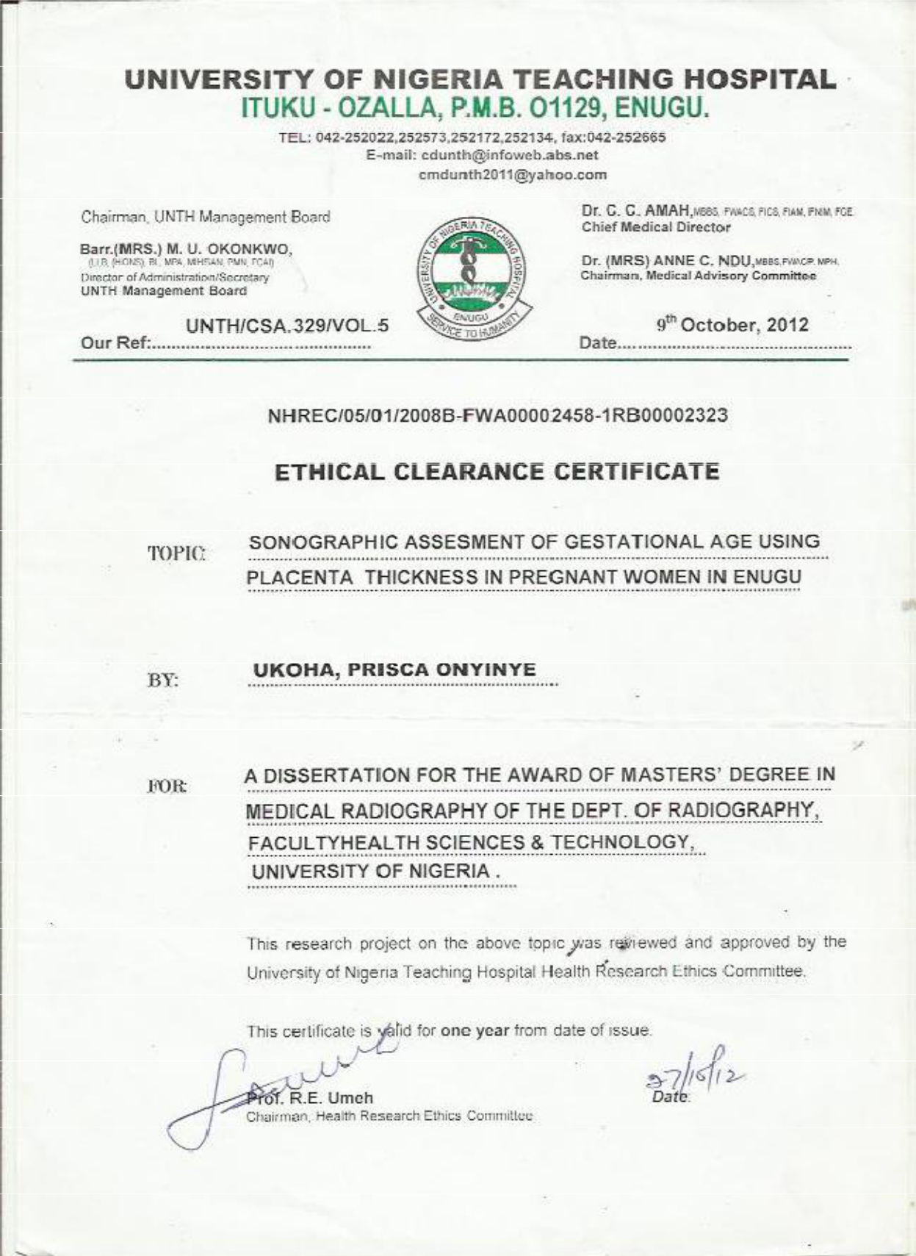

69
APPENDIX III

CONSENT FORM
SONOGRAPHIC ESTIMATION OF GESTATIONAL AGE BY PLACENTA THICKNESS AMONG PREGNANT WOMEN IN ENUGU, NIGERIA

- INTRODUCTION

You have been selected to participate in a study on this topic: sonographic estimation of gestational age by placenta thickness among pregnant women in Enugu, Nigeria.

The information contained in this study will be helpful in estimating (more correctly) the gestational age of pregnancies especially in the second and third trimester.

The study among other things will help to identify placenta abnormalities which could be an easy pointer to fetus at risk or fetal anomaly. This will help the doctors to take prompt decision for better management of such cases.

- VOLUNTARY NATURE OF PARTICIPATION

Participation is completed voluntary. Although you have been selected, you are free to give consent or do otherwise.

- STUDY PROCEDURE/RISK

The participant will be interviewed and then scanned using the ultrasound equipment. It has been established that ultrasound study is safe for both the foetus and the mother.

IV COST

There is no additional cost/charge for participating in this study. Once you volunteer, the study becomes part of the normal obstetric scan which you have already paid for.

V CONFIDENTIALITY

All information obtained will be treated as confidential. The identity of the participants will not be required.

VI FEEDBACKS

The researcher can be contacted at Department of Medical Radiography and Radiological Sciences, UNEC or at Radiation Medicine Department, UNTH, Ituku/Ozalla, Enugu.

YOUR RESPONSE

I have read and understood the above (or someone has read and explained the study to me). I understood the nature and benefits of the study and hereby give my consent to participate.

----------------------------------

Signature of the participant

Date________________

Thank you

70
FỌMU NKWETE

SONOGRAPHIC ESTIMATION OF GESTATIONAL AGE BY PLACENTA THICKNESS AMONG PREGNANT WOMEN IN ENUGU, NIGERIA

I MBIDO

I so na ndi aghọr ọ, ndi ga eso na nch ọputa nke isi okwu ya bu: iji igwe ọrturasandi were mata afọ ole nwa ebu n’ afọ di site n’ ima ka ihe n’eso nwa ha n’etiti umu nwanyi Enugu State Nigeria.

Ihe a ga enwete na nchọputa nkea ga enye aka iji mee ka ana amata ọnwa na abali ole nwa ebu n’ afọ di, ọkachasi site na ọnwa nke anọ wee rue na ọnwa nke iteghete.

Ihe nchọputa a ga enye aka iji chọputa mgbe placenta adighi ka o kwesiri. Nkea ga arutu aka na nwata ebu n’ afọ nwere ike inwe nsogbu. E nwekwara ike ichọputa ọtutu ọnọdu n’ adighi mma nke nwa ebu n’afọ. Ihe nchọputa a nwekwara ike inye aka ichọputa afọ ime ọbola nwere ike inwe nsogbu. Nkea ga enyere ndi dọkita aka iji were bid n’ oge mara ihe ha nwere ike ime iji gbochi maọbu kwusi ọnọdu ọjọ ahu.

II ONYE ỌBULA CHỌRỌ ISO, GA EME NKEA N’ ENWEGHI MMANYE ỌBULA

Iso na nchọputa a bu nke ọbula chọrọ isọ ga eme n’ enweghi mmanya ọbula. N agbanyeghi na iso na ndi aghọputara, I nwere ikikere iso maọbu jukwa isọ na nchọputa a.

III USORO NCHỌPUTA/ ỌGHỌMU

A ga aju onye ọbula kwenyere iso ufọdu ajuju. A ga enwete ihe ndi ọzọ achọrọ mgbe a ga eme nlele afọ ime. Igwe nke a ga eji nene afọ ime bu nke ndi oyibo kpọrọ ọrturasandi. Onwe beghi ihe mekpa ahu ọbula nke achọputagoro igwe ọrturasandi na enwe n’ebe nwa ebu n’ afọ maọbu nne ya nọ.

IV UGWỌ

Onweghi ego ọbula onye ga esonye na nchọputa a ga akwu. Sọsọ ego tesiti ọrturasandi nke onye ahu kwugoro bu ihe aturu anya n’ aka gi.

V IHE ỌHA AGAGHI ANU

Onweghi onye ọzọ a ga ekpughere ihe achọputara n’ ahu onye obula ga eso na nchọputa. Agaghi achọ aha onye ga esonye.

VI NZAGHACHI

A ga enwete onye na ahazi ihe nchoputa a na Department of Medical Radiography and Radiological Sciences, UNEC maọbu na Radiation Medicine Department, UNTH, Ituku/Ozalla, Enugu.

AZIZA GI

- guọla mu, ma ghọtakwa ihe edere (maọbu mmadu agọrọla mu ma kọwakwara mu ihe edere). A ghọtara mu udiri nchọputa bun kea ma matakwa uru din a nchọputa nkea. E kwenyere mu na mu ga eso na ndi aga eji mee nchoputa a.

---------------------------------------

Akara ejiri mara onye na esonye

Deeti_________________________ Daalu

71

72
 |  |  |  | APPENDIX IV
 |  | DATA COLLECTED FOR THE RESEARCH
 |  | PATIENT'S | GA BY |  |  |  |  | GA by Fetal | PLACENTA
S/N | SCAN DATE | LMP | LMP | FL | BPD | HC | AC | parameter | THICKNESS
1 | 06/04/2012 | 24/09/2011 | 36 | 36 | 36 | 35 | 36 | 36 | 47
2 | 06/04/2012 | 15/11/2011 | 38 | 38 | 39 | 39 | 39 | 39 | 43
3 | 06/04/2012 | 31/10/2011 | 33 | 32 | 33 | 33 | 33 | 33 | 47
4 | 06/04/2012 | 10/09/2011 | 35 | 35 | 35 | 34 | 35 | 35 | 43
5 | 06/04/2012 | 14/09/2011 | 38 | 38 | 39 | 38 | 39 | 39 | 45
6 | 06/04/2012 | 15/02/2011 | 18 | 18 | 17 | 18 | 17 | 18 | 19
7 | 06/04/2012 | 27/09/2011 | 38 | 38 | 39 | 39 | 39 | 38 | 38
8 | 18/06/2012 | 31/01/2012 | 20 | 20 | 21 | 21 | 20 | 20 | 21
9 | 18/06/2012 | 01/03/2012 | 23 | 23 | 24 | 24 | 24 | 23 | 31
10 | 18/06/2012 | 28/09/2011 | 38 | 38 | 38 | 36 | 39 | 38 | 44
11 | 18/06/2012 | 13/09/2011 | 38 | 39 | 38 | 40 | 41 | 39 | 41
12 | 18/06/2012 | 01/12/2011 | 36 | 35 | 36 | 35 | 35 | 36 | 36
13 | 18/06/2012 | 19/10/2011 | 34 | 32 | 35 | 35 | 35 | 34 | 36
14 | 07/09/2012 | 03/07/2012 | 18 | 18 | 16 | 17 | 18 | 17 | 18
15 | 07/09/2012 | 16/11/2011 | 25 | 26 | 26 | 25 | 26 | 26 | 26
16 | 07/09/2012 | 04/07/2012 | 14 | 14 | 13 | 14 | 15 | 14 | 18
17 | 07/09/2012 | 01/10/2012 | 26 | 26 | 28 | 26 | 25 | 27 | 28
18 | 07/09/2012 | 10/09/2011 | 36 | 35 | 36 | 37 | 37 | 36 | 40
19 | 07/09/2012 | 26/09/2011 | 37 | 36 | 39 | 37 | 37 | 37 | 38
20 | 07/09/2012 | 12/04/2011 | 32 | 32 | 32 | 30 | 30 | 32 | 32
21 | 07/09/2012 | 11/05/2011 | 35 | 35 | 36 | 34 | 34 | 35 | 37
22 | 07/09/2012 | 01/09/2012 | 26 | 26 | 27 | 26 | 26 | 27 | 27
23 | 07/09/2012 | 14/11/2011 | 34 | 32 | 33 | 30 | 31 | 32 | 34
24 | 07/11/2012 | 13/12/2012 | 22 | 21 | 22 | 21 | 23 | 21 | 25
25 | 07/11/2012 | 15/10/2012 | 14 | 13 | 14 | 13 | 14 | 14 | 16
26 | 07/11/2012 | 27/10/2012 | 15 | 15 | 14 | 14 | 15 | 14 | 17
27 | 07/11/2012 | 10/10/2012 | 13 | 14 | 14 | 13 | 14 | 14 | 20
28 | 07/11/2012 | 25/10/2012 | 15 | 14 | 13 | 14 | 15 | 14 | 20
27 | 07/11/2012 | 19/10/2012 | 14 | 13 | 14 | 14 | 14 | 14 | 16
30 | 07/11/2012 | 15/12/2012 | 22 | 21 | 22 | 22 | 23 | 22 | 24
31 | 07/11/2012 | 20/11/2012 | 19 | 20 | 19 | 19 | 21 | 19 | 22
32 | 07/11/2012 | 24/11/2012 | 19 | 19 | 18 | 19 | 19 | 19 | 22
33 | 07/11/2012 | 11/06/2012 | 17 | 17 | 18 | 17 | 17 | 17 | 20
34 | 07/11/2012 | 12/07/2012 | 21 | 22 | 21 | 21 | 21 | 21 | 25
35 | 07/11/2012 | 02/07/2012 | 22 | 23 | 22 | 21 | 23 | 22 | 26
36 | 16/07/2012 | 21/11/2011 | 34 | 34 | 34 | 32 | 33 | 34 | 39
37 | 16/07/2012 | 20/02/2012 | 21 | 20 | 22 | 20 | 21 | 21 | 23
38 | 16/07/2012 | 15/11/2011 | 35 | 34 | 35 | 31 | 34 | 35 | 41
39 | 16/07/2012 | 29/11/2011 | 33 | 33 | 34 | 31 | 34 | 33 | 32
40 | 16/07/2012 | 12/01/2011 | 33 | 33 | 32 | 33 | 32 | 33 | 35
41 | 16/07/2012 | 10/01/2011 | 37 | 37 | 37 | 34 | 36 | 37 | 40
 |  |  |  |  |  |  |  |  | 73

42 | 16/07/2012 | 11/06/2011 | 36 | 36 | 37 | 36 | 35 | 37 | 40
43 | 16/07/2012 | 17/01/2012 | 26 | 26 | 26 | 25 | 25 | 26 | 30
44 | 16/07/2012 | 01/01/2012 | 28 | 28 | 28 | 27 | 27 | 28 | 28
45 | 16/07/2012 | 16/01/2012 | 26 | 25 | 26 | 26 | 26 | 26 | 27
46 | 16/07/2012 | 17/10/2011 | 35 | 35 | 37 | 35 | 33 | 36 | 41
47 | 16/07/2012 | 12/01/2011 | 34 | 34 | 34 | 31 | 33 | 34 | 35
48 | 16/07/2012 | 14/11/2011 | 37 | 36 | 38 | 34 | 34 | 36 | 37
49 | 16/07/2012 | 23/11/2011 | 35 | 34 | 35 | 33 | 34 | 35 | 35
50 | 16/07/2012 | 21/11/2011 | 35 | 35 | 35 | 33 | 33 | 35 | 36
51 | 16/07/2012 | 11/08/2011 | 37 | 37 | 38 | 33 | 35 | 37 | 35
52 | 16/07/2012 | 12/11/2011 | 33 | 33 | 32 | 33 | 34 | 33 | 36
53 | 16/07/2012 | 11/11/2011 | 36 | 35 | 37 | 37 | 35 | 36 | 39
54 | 16/07/2012 | 02/12/2012 | 23 | 23 | 23 | 22 | 22 | 23 | 23
55 | 16/07/2012 | 11/11/2011 | 36 | 36 | 35 | 36 | 35 | 36 | 32
56 | 16/07/2012 | 13/12/2011 | 31 | 30 | 33 | 30 | 32 | 31 | 35
57 | 20/08/2012 | 01/01/2012 | 37 | 37 | 35 | 36 | 36 | 36 | 36
58 | 20/08/2012 | 12/03/2011 | 37 | 36 | 38 | 37 | 37 | 37 | 38
59 | 20/08/2012 | 30/11/2011 | 38 | 37 | 38 | 37 | 37 | 38 | 43
60 | 20/08/2012 | 01/11/2012 | 31 | 30 | 32 | 30 | 33 | 31 | 36
61 | 20/08/2012 | 03/09/2012 | 24 | 24 | 24 | 23 | 23 | 24 | 30
62 | 20/08/2012 | 01/03/2012 | 33 | 35 | 32 | 30 | 33 | 33 | 33
63 | 20/08/2012 | 23/12/2011 | 35 | 36 | 36 | 35 | 35 | 36 | 37
64 | 20/08/2012 | 20/03/2012 | 22 | 22 | 23 | 21 | 22 | 22 | 28
65 | 20/08/2012 | 23/04/2012 | 15 | 15 | 15 | 14 | 14 | 15 | 16
66 | 20/08/2012 | 16/02/2012 | 27 | 27 | 26 | 27 | 27 | 27 | 32
67 | 20/08/2012 | 18/01/2012 | 31 | 30 | 31 | 33 | 29 | 31 | 32
68 | 20/08/2012 | 12/03/2011 | 38 | 38 | 38 | 37 | 38 | 38 | 40
69 | 20/08/2012 | 01/11/2012 | 32 | 31 | 33 | 33 | 33 | 32 | 33
70 | 20/08/2012 | 01/07/2012 | 32 | 33 | 32 | 32 | 33 | 32 | 34
71 | 20/08/2012 | 30/11/2011 | 39 | 39 | 40 | 39 | 39 | 39 | 37
72 | 20/08/2012 | 30/04/2012 | 16 | 15 | 16 | 15 | 14 | 16 | 17
73 | 20/08/2012 | 29/11/2011 | 39 | 38 | 39 | 37 | 40 | 39 | 37
74 | 09/05/2012 | 15/04/2012 | 26 | 28 | 26 | 26 | 24 | 27 | 27
75 | 09/05/2012 | 04/08/2012 | 24 | 24 | 25 | 24 | 22 | 24 | 28
76 | 09/05/2012 | 15/04/2012 | 26 | 28 | 26 | 26 | 25 | 26 | 27
77 | 09/10/2012 | 11/03/2012 | 36 | 36 | 36 | 36 | 35 | 36 | 39
78 | 09/10/2012 | 01/05/2012 | 36 | 33 | 36 | 35 | 35 | 35 | 36
79 | 09/10/2012 | 12/05/2011 | 31 | 31 | 32 | 30 | 29 | 31 | 33
80 | 09/10/2012 | 11/06/2011 | 36 | 35 | 36 | 35 | 37 | 36 | 37
81 | 09/10/2012 | 11/08/2011 | 32 | 33 | 32 | 29 | 31 | 32 | 32
82 | 09/10/2012 | 12/01/2011 | 32 | 32 | 32 | 34 | 32 | 32 | 36
83 | 09/10/2012 | 12/01/2011 | 31 | 31 | 33 | 30 | 29 | 31 | 31
84 | 09/10/2012 | 11/07/2011 | 35 | 34 | 34 | 33 | 35 | 34 | 35

74

85 | 09/10/2012 | 12/09/2011 | 35 | 34 | 35 | 31 | 34 | 34 | 35
86 | 09/10/2012 | 21/11/2011 | 33 | 32 | 35 | 33 | 34 | 33 | 34
87 | 09/10/2012 | 29/11/2011 | 32 | 33 | 32 | 29 | 31 | 32 | 31
88 | 17/09/2012 | 21/01/2012 | 32 | 32 | 31 | 30 | 32 | 32 | 36
89 | 17/09/2012 | 18/01/2012 | 34 | 36 | 33 | 34 | 34 | 34 | 35
90 | 17/09/2012 | 21/21/2011 | 38 | 38 | 39 | 37 | 38 | 38 | 40
91 | 17/09/2012 | 16/01/2012 | 34 | 34 | 35 | 32 | 32 | 34 | 35
92 | 20/09/2012 | 21/02/2012 | 33 | 34 | 33 | 33 | 33 | 33 | 40
93 | 20/09/2012 | 04/10/2012 | 27 | 29 | 27 | 27 | 27 | 28 | 29
94 | 20/09/2012 | 25/04/2012 | 25 | 24 | 25 | 25 | 20 | 25 | 27
95 | 22/09/2012 | 06/10/2012 | 23 | 24 | 23 | 22 | 23 | 23 | 30
96 | 22/09/2012 | 03/01/2012 | 38 | 38 | 37 | 37 | 36 | 37 | 40
97 | 22/09/2012 | 17/05/2012 | 26 | 26 | 25 | 26 | 26 | 26 | 39
98 | 22/09/2012 | 25/05/2012 | 25 | 25 | 24 | 24 | 26 | 24 | 30
99 | 22/09/2012 | 05/10/2012 | 28 | 27 | 28 | 29 | 27 | 27 | 32
100 | 22/09/2012 | 22/12/2011 | 42 | 41 | 42 | 41 | 40 | 40 | 38
101 | 22/09/2012 | 24/06/2012 | 21 | 21 | 20 | 20 | 21 | 20 | 17
102 | 22/09/2012 | 23/02/2012 | 39 | 38 | 38 | 39 | 38 | 38 | 33
103 | 22/09/2012 | 29/04/2012 | 29 | 29 | 29 | 29 | 29 | 29 | 33
104 | 22/09/2012 | 06/12/2012 | 23 | 22 | 23 | 23 | 24 | 23 | 27
105 | 22/09/2012 | 03/01/2012 | 37 | 37 | 38 | 38 | 37 | 37 | 35
106 | 22/09/2012 | 03/02/2012 | 37 | 37 | 37 | 38 | 38 | 37 | 33
107 | 22/09/2012 | 27/05/2012 | 25 | 25 | 25 | 25 | 25 | 25 | 29
108 | 26/09/2012 | 05/07/2012 | 28 | 28 | 28 | 28 | 28 | 28 | 28
109 | 26/09/2012 | 06/07/2012 | 24 | 25 | 24 | 24 | 24 | 24 | 27
110 | 26/09/2012 | 05/06/2012 | 29 | 28 | 29 | 28 | 28 | 28 | 31
111 | 26/09/2012 | 28/03/2012 | 34 | 34 | 33 | 34 | 34 | 34 | 37
112 | 26/09/2012 | 20/05/2012 | 27 | 26 | 25 | 26 | 26 | 26 | 29
113 | 26/09/2012 | 07/09/2012 | 20 | 19 | 19 | 18 | 19 | 19 | 28
114 | 26/09/2012 | 20/03/2012 | 36 | 35 | 33 | 35 | 35 | 34 | 41
115 | 26/09/2012 | 05/06/2012 | 29 | 28 | 29 | 30 | 25 | 29 | 31
116 | 26/09/2012 | 05/12/2012 | 28 | 27 | 27 | 27 | 27 | 27 | 32
117 | 26/09/2012 | 21/04/2012 | 28 | 30 | 29 | 30 | 29 | 29 | 35
118 | 10/02/2012 | 02/12/2012 | 33 | 34 | 34 | 37 | 34 | 34 | 45
119 | 10/02/2012 | 04/05/2012 | 25 | 24 | 24 | 24 | 23 | 24 | 29
120 | 10/02/2012 | 20/01/2012 | 36 | 37 | 36 | 37 | 35 | 36 | 42
121 | 10/02/2012 | 10/09/2012 | 38 | 38 | 38 | 38 | 38 | 38 | 48
122 | 10/02/2012 | 17/01/2012 | 36 | 38 | 38 | 37 | 38 | 38 | 49
123 | 10/02/2012 | 01/12/2012 | 37 | 39 | 37 | 38 | 39 | 38 | 45
124 | 10/03/2012 | 15/03/2012 | 28 | 28 | 28 | 28 | 28 | 28 | 28
125 | 10/03/2012 | 06/10/2012 | 16 | 15 | 16 | 15 | 15 | 15 | 12
126 | 10/03/2012 | 22/02/2012 | 32 | 31 | 29 | 31 | 31 | 30 | 38
127 | 10/03/2012 | 04/10/2012 | 25 | 25 | 25 | 25 | 25 | 25 | 27

75

128 | 10/03/2012 | 25/02/2012 | 31 | 30 | 30 | 31 | 31 | 30 | 39
129 | 10/03/2012 | 02/06/2012 | 35 | 35 | 34 | 35 | 35 | 34 | 36
130 | 10/03/2012 | 04/05/2012 | 25 | 27 | 27 | 25 | 25 | 26 | 34
131 | 10/03/2012 | 18/04/2012 | 24 | 23 | 23 | 24 | 24 | 23 | 32
132 | 10/03/2012 | 03/09/2012 | 29 | 31 | 30 | 30 | 30 | 30 | 36
133 | 10/03/2012 | 02/09/2012 | 33 | 34 | 33 | 34 | 34 | 33 | 36
134 | 10/03/2012 | 03/10/2012 | 29 | 31 | 30 | 33 | 31 | 31 | 35
135 | 10/03/2012 | 13/02/2012 | 32 | 33 | 30 | 32 | 32 | 32 | 40
136 | 10/03/2012 | 24/02/2012 | 31 | 31 | 31 | 32 | 30 | 31 | 31
137 | 10/03/2012 | 02/08/2012 | 36 | 36 | 36 | 37 | 39 | 37 | 43
138 | 10/03/2012 | 20/01/2012 | 38 | 38 | 38 | 38 | 40 | 38 | 45
139 | 10/04/2012 | 03/07/2012 | 30 | 30 | 30 | 32 | 30 | 31 | 33
140 | 10/04/2012 | 06/07/2012 | 17 | 17 | 17 | 17 | 17 | 17 | 20
141 | 10/04/2012 | 20/06/2012 | 17 | 15 | 16 | 15 | 16 | 16 | 16
142 | 10/05/2012 | 05/05/2012 | 22 | 21 | 22 | 21 | 22 | 21 | 25
143 | 10/05/2012 | 04/05/2012 | 22 | 22 | 23 | 22 | 22 | 22 | 24
144 | 10/05/2012 | 04/04/2012 | 22 | 23 | 23 | 22 | 22 | 22 | 26
145 | 10/05/2012 | 22/04/2012 | 24 | 23 | 22 | 22 | 23 | 22 | 26
146 | 10/05/2012 | 28/04/2012 | 23 | 22 | 22 | 22 | 23 | 22 | 20
147 | 10/05/2012 | 04/02/2012 | 22 | 22 | 21 | 22 | 23 | 22 | 23
148 | 10/05/2012 | 04/04/2012 | 22 | 21 | 22 | 22 | 22 | 22 | 22
149 | 10/05/2012 | 29/06/2012 | 14 | 15 | 14 | 14 | 14 | 14 | 17
150 | 10/05/2012 | 16/06/2012 | 16 | 14 | 15 | 14 | 14 | 14 | 18
151 | 10/05/2012 | 25/06/2012 | 15 | 15 | 16 | 15 | 15 | 15 | 16
152 | 10/05/2012 | 28/02/2012 | 32 | 31 | 32 | 33 | 30 | 32 | 34
153 | 10/08/2012 | 01/11/2012 | 38 | 38 | 38 | 37 | 38 | 38 | 32
154 | 10/08/2012 | 01/06/2012 | 31 | 32 | 31 | 31 | 34 | 33 | 36
155 | 10/08/2012 | 04/09/2012 | 26 | 26 | 26 | 28 | 26 | 26 | 30
156 | 10/08/2012 | 17/03/2012 | 29 | 31 | 29 | 29 | 29 | 29 | 33
157 | 10/08/2012 | 23/03/2012 | 28 | 29 | 27 | 28 | 28 | 28 | 36
158 | 10/08/2012 | 07/07/2012 | 13 | 14 | 15 | 15 | 15 | 14 | 16
159 | 10/08/2012 | 20/12/2011 | 33 | 35 | 34 | 35 | 33 | 34 | 40
160 | 10/08/2012 | 20/06/2012 | 15 | 16 | 16 | 16 | 16 | 16 | 25
161 | 10/08/2012 | 19/02/2012 | 33 | 34 | 32 | 33 | 33 | 33 | 42
162 | 10/08/2012 | 01/12/2012 | 38 | 38 | 36 | 39 | 38 | 37 | 44
163 | 10/08/2012 | 03/01/2012 | 31 | 32 | 31 | 31 | 30 | 31 | 33
164 | 10/08/2012 | 16/02/2012 | 33 | 34 | 32 | 34 | 33 | 33 | 42
165 | 10/08/2012 | 01/10/2012 | 38 | 38 | 37 | 40 | 38 | 38 | 43
166 | 10/09/2012 | 17/03/2012 | 29 | 28 | 29 | 29 | 29 | 29 | 30
167 | 10/09/2012 | 01/07/2012 | 39 | 38 | 38 | 40 | 38 | 38 | 43
168 | 10/09/2012 | 01/12/2012 | 39 | 38 | 35 | 38 | 38 | 37 | 39
169 | 10/09/2012 | 21/01/2012 | 37 | 37 | 37 | 38 | 37 | 37 | 39
170 | 10/09/2012 | 05/02/2012 | 22 | 23 | 21 | 22 | 23 | 22 | 24

76

171 | 10/09/2012 | 15/04/2012 | 26 | 26 | 25 | 24 | 24 | 25 | 28
172 | 10/09/2012 | 06/10/2012 | 18 | 18 | 18 | 18 | 18 | 18 | 20
173 | 10/09/2012 | 25/02/2012 | 32 | 33 | 33 | 34 | 33 | 33 | 36
174 | 10/09/2012 | 19/02/2012 | 33 | 34 | 33 | 34 | 33 | 33 | 43
175 | 10/09/2012 | 25/03/2012 | 29 | 28 | 27 | 29 | 28 | 28 | 29
176 | 10/10/2012 | 21/02/2012 | 34 | 33 | 33 | 34 | 33 | 33 | 42
177 | 10/10/2012 | 02/12/2012 | 35 | 35 | 33 | 35 | 35 | 34 | 37
178 | 10/10/2012 | 21/02/2012 | 34 | 34 | 33 | 35 | 32 | 33 | 42
179 | 10/10/2012 | 06/11/2012 | 17 | 18 | 18 | 18 | 18 | 18 | 17
180 | 10/10/2012 | 27/06/2012 | 15 | 14 | 15 | 15 | 16 | 15 | 15
181 | 10/10/2012 | 21/04/2012 | 25 | 24 | 25 | 25 | 23 | 24 | 30
182 | 10/10/2012 | 21/02/2012 | 33 | 33 | 32 | 33 | 32 | 32 | 30
183 | 10/10/2012 | 15/02/2012 | 34 | 35 | 32 | 35 | 34 | 34 | 34
184 | 10/10/2012 | 02/10/2011 | 35 | 35 | 35 | 36 | 35 | 35 | 37
185 | 10/11/2012 | 02/03/2012 | 35 | 35 | 36 | 35 | 38 | 36 | 45
186 | 10/11/2012 | 15/03/2012 | 29 | 33 | 32 | 33 | 33 | 32 | 32
187 | 10/11/2012 | 04/01/2012 | 28 | 29 | 28 | 28 | 28 | 28 | 25
188 | 10/11/2012 | 02/07/2012 | 36 | 37 | 36 | 37 | 36 | 36 | 39
189 | 10/11/2012 | 02/12/2012 | 35 | 35 | 32 | 35 | 34 | 34 | 40
190 | 10/11/2012 | 25/04/2012 | 25 | 24 | 23 | 24 | 25 | 24 | 31
191 | 10/11/2012 | 22/02/2012 | 34 | 34 | 33 | 35 | 35 | 34 | 41
192 | 10/12/2012 | 03/03/2012 | 32 | 32 | 30 | 32 | 32 | 31 | 35
193 | 10/12/2012 | 28/05/2012 | 20 | 20 | 20 | 20 | 21 | 20 | 24
194 | 10/12/2012 | 03/07/2012 | 31 | 32 | 32 | 33 | 32 | 32 | 38
195 | 10/12/2012 | 22/02/2012 | 34 | 34 | 34 | 34 | 34 | 34 | 42
196 | 10/12/2012 | 05/07/2012 | 23 | 23 | 27 | 22 | 27 | 25 | 23
197 | 10/12/2012 | 02/01/2012 | 36 | 38 | 38 | 38 | 37 | 38 | 43
198 | 10/12/2012 | 22/01/2012 | 37 | 38 | 37 | 37 | 38 | 37 | 45
199 | 10/12/2012 | 14/06/2012 | 17 | 18 | 17 | 17 | 18 | 17 | 21
200 | 10/12/2012 | 27/03/2012 | 28 | 29 | 27 | 28 | 29 | 28 | 34
201 | 10/12/2012 | 03/12/2012 | 30 | 31 | 30 | 32 | 32 | 31 | 39
202 | 10/12/2012 | 22/06/2012 | 16 | 17 | 16 | 16 | 16 | 16 | 14
203 | 10/12/2012 | 03/02/2012 | 32 | 30 | 32 | 33 | 32 | 32 | 38
204 | 10/12/2012 | 14/04/2012 | 39 | 38 | 38 | 39 | 40 | 38 | 35
205 | 01/11/2012 | 21/01/2012 | 39 | 39 | 39 | 39 | 41 | 39 | 45
206 | 11/01/2012 | 23/05/2012 | 24 | 23 | 23 | 23 | 22 | 23 | 25
207 | 11/01/2012 | 21/01/2012 | 40 | 40 | 38 | 41 | 42 | 40 | 36
208 | 11/05/2012 | 30/01/2012 | 40 | 39 | 39 | 41 | 42 | 40 | 45
209 | 11/05/2012 | 02/04/2012 | 38 | 38 | 38 | 38 | 39 | 38 | 40
210 | 11/05/2012 | 26/01/2012 | 37 | 32 | 37 | 37 | 33 | 35 | 39
211 | 11/05/2012 | 28/04/2012 | 38 | 38 | 37 | 37 | 40 | 38 | 39
212 | 11/05/2012 | 07/04/2012 | 18 | 18 | 20 | 18 | 19 | 19 | 25
213 | 11/05/2012 | 17/07/2012 | 16 | 15 | 17 | 16 | 16 | 16 | 23

77

214 | 11/05/2012 | 03/05/2012 | 39 | 39 | 39 | 40 | 39 | 39 | 40
215 | 11/05/2012 | 30/05/2012 | 23 | 22 | 23 | 22 | 23 | 23 | 25
216 | 11/05/2012 | 06/06/2006 | 22 | 20 | 22 | 21 | 22 | 21 | 30
217 | 11/05/2012 | 23/03/2012 | 33 | 32 | 32 | 33 | 36 | 33 | 40
218 | 11/05/2012 | 13/03/2012 | 34 | 33 | 34 | 34 | 34 | 34 | 37
219 | 11/05/2012 | 28/04/2012 | 28 | 30 | 30 | 29 | 29 | 30 | 24
220 | 11/05/2012 | 29/02/2012 | 36 | 37 | 35 | 38 | 41 | 37 | 36
221 | 11/05/2012 | 25/04/2012 | 28 | 29 | 30 | 29 | 29 | 29 | 30
222 | 11/05/2012 | 16/03/2012 | 34 | 32 | 33 | 34 | 34 | 33 | 32
223 | 11/07/2012 | 17/04/2012 | 29 | 29 | 29 | 30 | 29 | 29 | 30
224 | 11/07/2012 | 21/03/2012 | 34 | 29 | 32 | 32 | 32 | 32 | 32
225 | 11/07/2012 | 21/07/2012 | 16 | 16 | 16 | 16 | 16 | 16 | 23
226 | 11/07/2012 | 19/07/2012 | 16 | 16 | 17 | 16 | 18 | 16 | 17
227 | 11/07/2012 | 14/07/2012 | 17 | 15 | 17 | 17 | 17 | 16 | 18
228 | 11/07/2012 | 07/06/2012 | 18 | 17 | 18 | 18 | 17 | 16 | 25
229 | 11/07/2012 | 17/07/2012 | 16 | 16 | 16 | 17 | 17 | 16 | 20
230 | 11/07/2012 | 22/07/2012 | 16 | 16 | 17 | 17 | 16 | 16 | 17
231 | 11/07/2012 | 07/10/2012 | 17 | 16 | 16 | 16 | 17 | 16 | 19
232 | 11/07/2012 | 07/12/2012 | 17 | 17 | 17 | 17 | 16 | 17 | 21
233 | 11/07/2012 | 03/09/2012 | 36 | 37 | 35 | 37 | 34 | 36 | 32
234 | 11/07/2012 | 13/03/2012 | 35 | 35 | 35 | 34 | 37 | 35 | 39
235 | 11/07/2012 | 18/04/2012 | 30 | 28 | 29 | 30 | 28 | 29 | 26
236 | 11/07/2012 | 22/04/2012 | 30 | 29 | 29 | 31 | 30 | 30 | 25
237 | 11/07/2012 | 27/06/2012 | 20 | 20 | 19 | 20 | 20 | 20 | 29
238 | 11/07/2012 | 04/03/2012 | 32 | 32 | 34 | 34 | 33 | 33 | 32
239 | 11/07/2012 | 30/03/2012 | 33 | 33 | 30 | 31 | 33 | 32 | 41
240 | 11/09/2012 | 05/11/2012 | 26 | 25 | 24 | 26 | 25 | 25 | 28
241 | 11/09/2012 | 19/03/2012 | 33 | 33 | 34 | 34 | 33 | 33 | 39
242 | 11/09/2012 | 05/05/2012 | 26 | 26 | 25 | 26 | 25 | 25 | 27
243 | 11/09/2012 | 17/04/2012 | 29 | 29 | 28 | 30 | 29 | 29 | 39
244 | 11/09/2012 | 13/05/2012 | 25 | 25 | 25 | 25 | 25 | 25 | 31
245 | 11/09/2012 | 22/02/2012 | 37 | 36 | 35 | 38 | 37 | 36 | 40
246 | 11/09/2012 | 17/04/2012 | 29 | 29 | 28 | 28 | 29 | 28 | 32
247 | 11/09/2012 | 20/06/2012 | 20 | 20 | 21 | 20 | 21 | 20 | 24
248 | 11/09/2012 | 15/07/2012 | 16 | 16 | 16 | 16 | 17 | 16 | 17
249 | 11/09/2012 | 28/02/2012 | 36 | 36 | 35 | 36 | 36 | 36 | 46
250 | 11/09/2012 | 22/03/2012 | 33 | 33 | 33 | 33 | 33 | 33 | 29
251 | 11/09/2012 | 05/11/2012 | 26 | 24 | 24 | 24 | 26 | 25 | 28
252 | 11/09/2012 | 19/03/2012 | 33 | 33 | 34 | 34 | 33 | 33 | 40
253 | 11/09/2012 | 05/05/2012 | 26 | 26 | 25 | 26 | 25 | 25 | 27
254 | 11/09/2012 | 17/04/2012 | 29 | 29 | 28 | 30 | 29 | 29 | 39
255 | 11/09/2012 | 13/05/2012 | 25 | 25 | 25 | 25 | 25 | 25 | 31
256 | 11/09/2012 | 04/07/2012 | 29 | 29 | 28 | 28 | 29 | 28 | 37

78

257 | 11/09/2012 | 20/06/2012 | 20 | 20 | 21 | 20 | 21 | 20 | 24
258 | 11/09/2012 | 15/07/2012 | 16 | 16 | 16 | 16 | 17 | 16 | 17
259 | 11/09/2012 | 28/02/2012 | 36 | 36 | 35 | 36 | 36 | 36 | 42
260 | 11/09/2012 | 22/03/2012 | 33 | 33 | 33 | 33 | 33 | 33 | 29
261 | 11/12/2012 | 23/06/2012 | 21 | 20 | 20 | 20 | 21 | 20 | 21
262 | 11/12/2012 | 03/06/2012 | 36 | 35 | 36 | 37 | 37 | 36 | 40
263 | 11/12/2012 | 30/05/2012 | 24 | 24 | 24 | 24 | 23 | 24 | 24
264 | 11/12/2012 | 05/07/2012 | 27 | 29 | 27 | 26 | 29 | 28 | 27
265 | 11/12/2012 | 07/02/2012 | 19 | 19 | 19 | 18 | 19 | 19 | 28
266 | 11/12/2012 | 07/08/2012 | 19 | 18 | 17 | 19 | 20 | 19 | 22
267 | 11/12/2012 | 07/02/2012 | 19 | 18 | 19 | 19 | 19 | 19 | 20
268 | 11/12/2012 | 07/12/2012 | 18 | 19 | 18 | 18 | 19 | 19 | 22
269 | 11/12/2012 | 07/05/2012 | 19 | 19 | 18 | 19 | 19 | 19 | 25
270 | 11/12/2012 | 31/07/2012 | 15 | 18 | 15 | 15 | 15 | 15 | 25
271 | 11/12/2012 | 26/07/2012 | 16 | 17 | 15 | 15 | 14 | 15 | 15
272 | 11/12/2012 | 30/07/2012 | 15 | 14 | 15 | 15 | 16 | 15 | 22
273 | 11/12/2012 | 29/06/2012 | 20 | 20 | 20 | 20 | 20 | 20 | 21
274 | 11/12/2012 | 20/07/2012 | 17 | 17 | 17 | 17 | 17 | 17 | 21
275 | 11/12/2012 | 03/07/2012 | 36 | 37 | 35 | 36 | 35 | 36 | 31
276 | 11/12/2012 | 16/02/2012 | 39 | 38 | 38 | 39 | 38 | 38 | 36
277 | 13/11/2012 | 04/02/2012 | 26 | 27 | 26 | 26 | 25 | 26 | 29
278 | 13/11/2012 | 29/03/2012 | 33 | 32 | 33 | 33 | 33 | 33 | 33
279 | 13/11/2012 | 17/05/2012 | 26 | 26 | 26 | 26 | 27 | 26 | 28
280 | 13/11/2012 | 28/05/2012 | 28 | 27 | 28 | 28 | 27 | 28 | 28
281 | 13/11/2012 | 04/10/2012 | 31 | 32 | 31 | 30 | 30 | 31 | 29
282 | 13/11/2012 | 27/05/2012 | 29 | 29 | 28 | 29 | 30 | 29 | 26
283 | 13/11/2012 | 04/06/2012 | 32 | 31 | 32 | 33 | 33 | 33 | 40
284 | 14/11/2012 | 02/02/2012 | 41 | 39 | 37 | 40 | 41 | 40 | 45
285 | 14/11/2012 | 30/04/2012 | 29 | 30 | 30 | 31 | 29 | 30 | 25
286 | 14/11/2012 | 13/06/2012 | 22 | 23 | 23 | 22 | 23 | 23 | 19
287 | 14/11/2012 | 24/03/2012 | 34 | 32 | 34 | 35 | 33 | 34 | 40
288 | 14/11/2012 | 13/06/2012 | 22 | 22 | 24 | 22 | 22 | 22 | 28
289 | 14/11/2012 | 20/06/2012 | 21 | 21 | 23 | 22 | 22 | 22 | 24
290 | 14/11/2012 | 06/12/2012 | 22 | 22 | 24 | 22 | 21 | 22 | 20
291 | 14/11/2012 | 16/06/2012 | 22 | 21 | 22 | 22 | 23 | 22 | 24
292 | 14/11/2012 | 19/07/2012 | 17 | 17 | 18 | 17 | 17 | 17 | 19
293 | 14/11/2012 | 13/07/2012 | 18 | 17 | 16 | 17 | 17 | 17 | 20
294 | 15/11/2012 | 03/12/2012 | 35 | 35 | 37 | 36 | 37 | 36 | 38
295 | 19/11/2012 | 18/07/2012 | 18 | 19 | 19 | 18 | 19 | 19 | 20
296 | 19/11/2012 | 03/08/2012 | 37 | 39 | 35 | 37 | 37 | 37 | 38
297 | 19/11/2012 | 05/04/2012 | 29 | 29 | 29 | 30 | 31 | 30 | 31
298 | 19/11/2012 | 05/05/2012 | 29 | 28 | 30 | 31 | 29 | 29 | 28
299 | 19/11/2012 | 05/07/2012 | 28 | 29 | 28 | 28 | 28 | 29 | 32

79

300 | 19/11/2012 | 29/07/2012 | 16 | 16 | 17 | 16 | 17 | 16 | 18
301 | 20/11/2012 | 03/07/2012 | 37 | 37 | 37 | 37 | 38 | 37 | 38
302 | 20/11/2012 | 25/03/2012 | 34 | 36 | 35 | 35 | 36 | 36 | 30
303 | 20/11/2012 | 29/05/2012 | 25 | 24 | 23 | 24 | 24 | 24 | 28
304 | 20/11/2012 | 03/07/2012 | 37 | 36 | 37 | 37 | 37 | 37 | 46
305 | 20/11/2012 | 04/12/2012 | 32 | 33 | 31 | 34 | 32 | 32 | 38
306 | 20/11/2012 | 19/04/2012 | 33 | 33 | 35 | 35 | 34 | 34 | 33
307 | 20/11/2012 | 15/08/2012 | 14 | 14 | 15 | 14 | 14 | 14 | 18
308 | 20/11/2012 | 18/08/2012 | 14 | 13 | 15 | 14 | 14 | 14 | 18
309 | 20/11/2012 | 31/07/2012 | 16 | 15 | 17 | 16 | 18 | 17 | 18
310 | 20/11/2012 | 18/07/2012 | 18 | 18 | 17 | 17 | 16 | 17 | 21
311 | 20/11/2012 | 28/07/2012 | 17 | 17 | 18 | 18 | 17 | 17 | 21
312 | 20/11/2012 | 23/07/2012 | 17 | 16 | 17 | 18 | 17 | 17 | 19
313 | 20/11/2012 | 25/07/2012 | 17 | 17 | 17 | 17 | 17 | 17 | 20
314 | 21/11/2012 | 05/03/2012 | 29 | 28 | 30 | 29 | 28 | 29 | 30
315 | 21/11/2012 | 25/05/2012 | 36 | 37 | 34 | 35 | 38 | 36 | 39
316 | 22/11/2012 | 06/08/2012 | 23 | 23 | 24 | 23 | 22 | 23 | 28
317 | 22/11/2012 | 26/07/2012 | 17 | 19 | 17 | 16 | 16 | 16 | 20
318 | 22/11/2012 | 08/11/2012 | 15 | 14 | 16 | 15 | 15 | 15 | 25
319 | 22/11/2012 | 17/06/2012 | 21 | 22 | 21 | 21 | 22 | 21 | 27
320 | 22/11/2012 | 19/07/2012 | 17 | 17 | 18 | 17 | 18 | 17 | 20
321 | 22/11/2012 | 27/05/2012 | 25 | 25 | 25 | 26 | 25 | 25 | 30
322 | 22/11/2012 | 04/01/2012 | 33 | 32 | 33 | 33 | 33 | 33 | 38
323 | 22/11/2012 | 08/03/2012 | 16 | 14 | 14 | 15 | 14 | 14 | 18
324 | 22/11/2012 | 08/05/2012 | 16 | 17 | 15 | 15 | 15 | 15 | 21
325 | 22/11/2012 | 08/11/2012 | 15 | 18 | 14 | 14 | 15 | 15 | 12
326 | 22/11/2012 | 07/12/2012 | 19 | 20 | 19 | 19 | 18 | 19 | 29
327 | 22/11/2012 | 30/06/2012 | 21 | 18 | 19 | 20 | 19 | 19 | 25
328 | 22/11/2012 | 07/08/2012 | 20 | 18 | 20 | 19 | 19 | 19 | 20
329 | 22/11/2012 | 07/10/2012 | 19 | 20 | 29 | 18 | 19 | 19 | 25
330 | 22/11/2012 | 26/05/2012 | 25 | 25 | 25 | 26 | 24 | 25 | 27
331 | 22/11/2012 | 19/07/2012 | 17 | 17 | 17 | 17 | 18 | 17 | 20
332 | 22/11/2012 | 25/07/2012 | 16 | 15 | 16 | 16 | 16 | 16 | 22
333 | 22/11/2012 | 03/07/2012 | 37 | 36 | 36 | 36 | 38 | 36 | 42
334 | 22/11/2012 | 04/01/2012 | 33 | 34 | 33 | 33 | 33 | 33 | 40
335 | 22/11/2012 | 03/07/2012 | 37 | 37 | 36 | 37 | 38 | 37 | 40
336 | 22/11/2012 | 04/01/2012 | 33 | 34 | 32 | 34 | 34 | 33 | 40
337 | 22/11/2012 | 08/06/2012 | 16 | 16 | 16 | 16 | 16 | 16 | 25
338 | 22/11/2012 | 27/06/2012 | 21 | 22 | 21 | 21 | 22 | 21 | 25
339 | 22/11/2012 | 06/10/2012 | 24 | 24 | 24 | 23 | 24 | 24 | 30
340 | 26/11/2012 | 08/05/2012 | 15 | 16 | 16 | 15 | 16 | 15 | 21
341 | 26/11/2012 | 03/06/2012 | 37 | 37 | 37 | 37 | 36 | 37 | 45
342 | 26/11/2012 | 18/08/2012 | 15 | 18 | 15 | 15 | 15 | 15 | 17

80

343 | 26/11/2012 | 31/07/2012 | 17 | 15 | 15 | 15 | 14 | 15 | 16
344 | 26/11/2012 | 13/08/2012 | 15 | 16 | 15 | 15 | 15 | 15 | 21
345 | 26/11/2012 | 15/08/2012 | 15 | 14 | 15 | 16 | 15 | 15 | 24
346 | 26/11/2012 | 07/03/2012 | 20 | 21 | 20 | 20 | 20 | 20 | 29
347 | 26/11/2012 | 13/04/2012 | 32 | 32 | 32 | 31 | 32 | 32 | 36
348 | 26/11/2012 | 08/06/2012 | 16 | 16 | 17 | 16 | 16 | 16 | 18
349 | 26/11/2012 | 03/02/2012 | 38 | 38 | 38 | 39 | 39 | 38 | 44
350 | 26/11/2012 | 14/04/2012 | 32 | 32 | 32 | 33 | 30 | 32 | 32
351 | 26/11/2012 | 03/08/2012 | 37 | 37 | 37 | 36 | 37 | 37 | 34
352 | 26/11/2012 | 27/05/2011 | 26 | 26 | 26 | 26 | 26 | 26 | 31
353 | 26/11/2012 | 05/04/2012 | 29 | 29 | 27 | 28 | 29 | 28 | 32
354 | 26/11/2012 | 25/03/2012 | 35 | 35 | 34 | 36 | 34 | 35 | 40
355 | 26/11/2012 | 21/08/2012 | 14 | 14 | 14 | 14 | 15 | 14 | 22
356 | 26/11/2012 | 25/04/2012 | 30 | 31 | 30 | 30 | 30 | 30 | 33
357 | 26/11/2012 | 14/03/2012 | 36 | 36 | 35 | 36 | 36 | 36 | 40
358 | 26/11/2012 | 19/04/2012 | 33 | 33 | 33 | 33 | 34 | 34 | 33
359 | 27/11/2012 | 29/02/2012 | 38 | 38 | 37 | 37 | 39 | 37 | 42
360 | 27/11/2012 | 22/03/2012 | 36 | 37 | 35 | 37 | 35 | 36 | 36
361 | 27/11/2012 | 25/04/2012 | 31 | 32 | 31 | 32 | 32 | 32 | 29
362 | 27/11/2012 | 06/04/2012 | 25 | 25 | 25 | 26 | 25 | 25 | 28
363 | 27/11/2012 | 29/06/2012 | 22 | 23 | 22 | 21 | 22 | 22 | 22
364 | 27/11/2012 | 25/05/2012 | 27 | 28 | 27 | 28 | 26 | 28 | 33
365 | 27/11/2012 | 19/07/2012 | 19 | 21 | 21 | 20 | 20 | 21 | 24
366 | 27/11/2012 | 04/05/2012 | 34 | 34 | 36 | 36 | 36 | 35 | 36
367 | 27/11/2012 | 21/05/2012 | 26 | 25 | 28 | 25 | 26 | 27 | 30
368 | 27/11/2012 | 21/06/2012 | 23 | 23 | 25 | 23 | 23 | 24 | 24
369 | 27/11/2012 | 05/08/2012 | 29 | 29 | 28 | 28 | 29 | 28 | 30
370 | 27/11/2012 | 04/03/2012 | 34 | 34 | 33 | 33 | 34 | 33 | 32
371 | 27/11/2012 | 07/05/2012 | 21 | 21 | 21 | 20 | 21 | 21 | 28
372 | 27/11/2012 | 25/02/2012 | 40 | 39 | 39 | 39 | 39 | 39 | 40
373 | 27/11/2012 | 24/02/2012 | 40 | 39 | 39 | 38 | 40 | 39 | 45
374 | 27/11/2012 | 16/03/2012 | 37 | 36 | 36 | 36 | 36 | 36 | 36
375 | 27/11/2012 | 06/02/2012 | 26 | 26 | 26 | 26 | 26 | 26 | 30
376 | 27/11/2012 | 16/06/2012 | 24 | 24 | 23 | 23 | 24 | 24 | 26
377 | 27/11/2012 | 28/03/2012 | 35 | 35 | 34 | 35 | 35 | 34 | 35
378 | 27/11/2012 | 13/06/2012 | 24 | 24 | 24 | 24 | 25 | 24 | 26
379 | 27/11/2012 | 03/11/2012 | 38 | 37 | 35 | 37 | 37 | 36 | 32
380 | 27/11/2012 | 13/07/2012 | 19 | 19 | 19 | 19 | 20 | 19 | 29
381 | 27/11/2012 | 25/04/2012 | 31 | 31 | 31 | 31 | 30 | 31 | 41
382 | 27/11/2012 | 29/06/2012 | 22 | 22 | 21 | 22 | 22 | 21 | 25
383 | 27/11/2012 | 05/10/2012 | 29 | 29 | 28 | 29 | 29 | 28 | 32
384 | 27/11/2012 | 24/04/2012 | 31 | 31 | 31 | 32 | 32 | 31 | 36
385 | 27/11/2012 | 16/07/2012 | 19 | 19 | 19 | 19 | 20 | 19 | 25

81

386 | 28/11/2012 | 27/05/2012 | 32 | 32 | 31 | 32 | 31 | 32 | 38
387 | 28/11/2012 | 25/04/2012 | 33 | 30 | 33 | 33 | 31 | 32 | 36
388 | 28/11/2012 | 25/06/2012 | 28 | 29 | 28 | 28 | 25 | 28 | 32
389 | 28/11/2012 | 17/08/2012 | 15 | 15 | 16 | 14 | 15 | 15 | 21
390 | 28/11/2012 | 23/08/2012 | 14 | 15 | 15 | 16 | 15 | 15 | 16
391 | 28/11/2012 | 19/08/2012 | 15 | 15 | 16 | 15 | 14 | 15 | 16
392 | 28/11/2012 | 08/03/2012 | 17 | 17 | 16 | 18 | 17 | 17 | 19
393 | 28/11/2012 | 08/12/2012 | 16 | 18 | 15 | 18 | 17 | 17 | 19
394 | 28/11/2012 | 06/08/2012 | 25 | 24 | 26 | 25 | 26 | 25 | 27
395 | 28/11/2012 | 31/05/2012 | 26 | 25 | 25 | 25 | 26 | 25 | 28
396 | 28/11/2012 | 15/08/2012 | 15 | 17 | 15 | 15 | 15 | 15 | 17
397 | 28/11/2012 | 05/04/2012 | 38 | 36 | 37 | 39 | 39 | 38 | 41
398 | 28/11/2012 | 30/06/2012 | 30 | 28 | 30 | 32 | 30 | 30 | 33
399 | 28/11/2012 | 07/06/2012 | 21 | 21 | 21 | 21 | 21 | 21 | 17
400 | 12/03/2012 | 21/05/2012 | 28 | 28 | 28 | 27 | 28 | 28 | 28
401 | 12/03/2012 | 02-May | 31 | 31 | 32 | 30 | 30 | 31 | 34
402 | 12/03/2012 | 15/04/2012 | 33 | 33 | 32 | 32 | 32 | 32 | 33
403 | 12/03/2012 | 28/06/2012 | 23 | 23 | 25 | 23 | 24 | 24 | 24
404 | 12/03/2012 | 23/06/2012 | 24 | 24 | 23 | 23 | 24 | 24 | 18
405 | 12/03/2012 | 23/05/2012 | 28 | 28 | 29 | 29 | 29 | 29 | 28
406 | 12/03/2012 | 18/06/2012 | 24 | 23 | 24 | 23 | 24 | 24 | 29
407 | 12/03/2012 | 13/06/2012 | 24 | 24 | 24 | 24 | 25 | 24 | 30
408 | 12/03/2012 | 27/04/2012 | 30 | 30 | 29 | 30 | 31 | 30 | 31
409 | 12/04/2012 | 05/01/2012 | 31 | 32 | 30 | 33 | 31 | 32 | 32
410 | 12/04/2012 | 19/07/2012 | 20 | 20 | 20 | 20 | 20 | 20 | 25
411 | 12/04/2012 | 30/05/2012 | 27 | 26 | 28 | 27 | 27 | 27 | 24
412 | 12/04/2012 | 24/03/2012 | 36 | 34 | 35 | 36 | 35 | 35 | 33
413 | 12/04/2012 | 16/07/2012 | 20 | 20 | 20 | 20 | 21 | 20 | 24
414 | 12/04/2012 | 20/05/2012 | 27 | 28 | 30 | 29 | 29 | 29 | 30
415 | 12/04/2012 | 20/07/2012 | 20 | 20 | 20 | 20 | 21 | 20 | 25
416 | 12/04/2012 | 26/07/2012 | 19 | 21 | 21 | 20 | 19 | 20 | 23
417 | 12/04/2012 | 22/07/2012 | 20 | 20 | 20 | 20 | 21 | 20 | 23
418 | 12/04/2012 | 14/07/2012 | 21 | 22 | 20 | 21 | 21 | 21 | 24
419 | 12/04/2012 | 31/07/2012 | 18 | 18 | 18 | 18 | 18 | 18 | 19
420 | 12/04/2012 | 17/07/2012 | 20 | 18 | 18 | 17 | 19 | 18 | 24
421 | 12/04/2012 | 29/07/2012 | 19 | 19 | 18 | 18 | 18 | 18 | 24
422 | 12/04/2012 | 30/07/2012 | 18 | 18 | 18 | 17 | 18 | 18 | 23
423 | 12/05/2012 | 24/06/2012 | 29 | 29 | 29 | 29 | 26 | 29 | 33
424 | 12/05/2012 | 03/12/2012 | 38 | 36 | 38 | 40 | 38 | 38 | 33
425 | 12/05/2012 | 15/04/2012 | 33 | 31 | 33 | 32 | 31 | 32 | 34
426 | 12/05/2012 | 15/03/2012 | 37 | 39 | 36 | 36 | 38 | 37 | 36
427 | 12/05/2012 | 08/01/2012 | 18 | 18 | 18 | 17 | 19 | 18 | 23
428 | 12/05/2012 | 04/03/2012 | 26 | 28 | 27 | 28 | 27 | 27 | 24

82

429 | 12/05/2012 | 17/04/2012 | 33 | 32 | 30 | 32 | 32 | 32 | 32
430 | 12/05/2012 | 05/01/2012 | 31 | 30 | 32 | 32 | 30 | 31 | 31
431 | 12/07/2012 | 25/01/2012 | 39 | 38 | 39 | 39 | 41 | 39 | 40
432 | 12/11/2012 | 21/06/2012 | 30 | 29 | 30 | 32 | 33 | 30 | 36
433 | 12/12/2012 | 13/06/2012 | 31 | 31 | 31 | 32 | 32 | 31 | 36
434 | 14/12/2012 | 21/02/2012 | 41 | 37 | 41 | 41 | 38 | 40 | 47
435 | 14/12/2012 | 25/04/2012 | 36 | 36 | 36 | 36 | 35 | 36 | 32
436 | 14/12/2012 | 26/04/2012 | 36 | 35 | 37 | 36 | 32 | 36 | 39
437 | 14/12/2012 | 28/04/2012 | 36 | 35 | 36 | 38 | 37 | 37 | 35
438 | 15/12/2012 | 02/06/2012 | 36 | 36 | 34 | 37 | 37 | 36 | 41
439 | 15/12/2012 | 03/12/2012 | 31 | 31 | 30 | 32 | 32 | 31 | 39
440 | 15/12/2012 | 27/06/2012 | 15 | 17 | 16 | 16 | 16 | 16 | 14
441 | 15/12/2012 | 04/01/2012 | 28 | 29 | 27 | 28 | 29 | 28 | 34
442 | 15/12/2012 | 05/11/2012 | 22 | 23 | 20 | 21 | 23 | 21 | 24
443 | 15/12/2012 | 06/04/2012 | 19 | 20 | 19 | 19 | 20 | 20 | 25
444 | 15/12/2012 | 03/01/2012 | 32 | 33 | 31 | 33 | 32 | 32 | 28
445 | 17/12/2012 | 14/03/2012 | 31 | 31 | 31 | 32 | 31 | 31 | 32
446 | 17/12/2012 | 02/10/2012 | 35 | 35 | 36 | 35 | 37 | 36 | 40
447 | 17/12/2012 | 05/03/2012 | 29 | 28 | 30 | 29 | 28 | 29 | 30
448 | 19/12/2012 | 04/12/2012 | 28 | 27 | 28 | 28 | 28 | 28 | 29
449 | 19/12/2012 | 21/03/2012 | 30 | 29 | 29 | 30 | 27 | 29 | 31
450 | 19/12/2012 | 23/02/2012 | 34 | 32 | 33 | 36 | 33 | 33 | 36
451 | 22/12/2012 | 21/01/2012 | 39 | 39 | 39 | 39 | 39 | 40 | 45
452 | 22/12/2012 | 20/02/2012 | 35 | 35 | 35 | 35 | 35 | 35 | 36
453 | 22/12/2012 | 26/02/2012 | 35 | 34 | 35 | 37 | 35 | 35 | 37
454 | 22/12/2012 | 15/04/2012 | 27 | 26 | 28 | 27 | 25 | 27 | 28
455 | 23/12/2012 | 01/11/2012 | 25 | 24 | 25 | 25 | 24 | 25 | 27
456 | 23/12/2012 | 02/07/2012 | 37 | 36 | 38 | 38 | 36 | 37 | 41
457 | 23/12/2012 | 15/03/2012 | 31 | 33 | 30 | 32 | 33 | 32 | 40
458 | 23/12/2012 | 05/12/2012 | 23 | 23 | 23 | 23 | 23 | 23 | 22
459 | 23/12/2012 | 07/01/2012 | 16 | 16 | 17 | 17 | 16 | 16 | 19
460 | 23/12/2012 | 02/02/2012 | 37 | 37 | 36 | 37 | 38 | 37 | 45
461 | 23/12/2012 | 03/01/2012 | 33 | 33 | 33 | 34 | 32 | 33 | 41
462 | 23/12/2012 | 14/02/2012 | 36 | 35 | 36 | 35 | 35 | 35 | 30
463 | 23/12/2012 | 02/03/2012 | 37 | 37 | 37 | 37 | 37 | 37 | 36
464 | 24/12/2012 | 06/01/2012 | 30 | 29 | 30 | 30 | 29 | 30 | 30
465 | 24/12/2012 | 14/04/2012 | 27 | 27 | 28 | 28 | 26 | 27 | 31
466 | 24/12/2012 | 20/05/2012 | 22 | 22 | 21 | 21 | 22 | 21 | 24
467 | 24/12/2012 | 27/03/2012 | 30 | 30 | 29 | 29 | 28 | 29 | 32
468 | 24/12/2012 | 02/07/2012 | 37 | 37 | 35 | 37 | 37 | 36 | 41
469 | 24/12/2012 | 15/03/2012 | 31 | 32 | 32 | 32 | 31 | 32 | 38
470 | 24/12/2012 | 05/11/2012 | 22 | 23 | 22 | 22 | 22 | 22 | 26
471 | 24/12/2012 | 20/03/2012 | 31 | 30 | 30 | 31 | 31 | 30 | 34

83

472 | 25/12/2012 | 02/08/2012 | 36 | 34 | 36 | 36 | 35 | 35 | 36
473 | 25/12/2012 | 02/07/2012 | 36 | 34 | 36 | 36 | 35 | 35 | 37
474 | 25/12/2012 | 04/09/2012 | 28 | 29 | 31 | 31 | 29 | 30 | 33
475 | 25/12/2012 | 04/07/2012 | 28 | 29 | 29 | 28 | 28 | 28 | 30
476 | 25/12/2012 | 22/03/2012 | 31 | 32 | 30 | 30 | 31 | 31 | 39
477 | 25/12/2012 | 05/11/2012 | 23 | 24 | 22 | 23 | 24 | 23 | 27
478 | 25/12/2012 | 03/11/2012 | 32 | 34 | 32 | 32 | 32 | 32 | 38
479 | 25/12/2012 | 06/07/2012 | 20 | 21 | 20 | 20 | 22 | 20 | 20
480 | 25/12/2012 | 16/06/2012 | 19 | 19 | 19 | 19 | 20 | 19 | 20
481 | 26/12/2012 | 18/05/2012 | 23 | 23 | 23 | 23 | 23 | 23 | 23
482 | 26/12/2012 | 03/02/2012 | 34 | 33 | 35 | 35 | 33 | 34 | 36
483 | 26/12/2012 | 03/06/2012 | 32 | 32 | 32 | 33 | 31 | 32 | 36
484 | 26/12/2012 | 03/01/2012 | 32 | 32 | 31 | 32 | 32 | 32 | 33
485 | 26/12/2012 | 15/02/2012 | 34 | 34 | 35 | 34 | 34 | 34 | 34
486 | 26/12/2012 | 16/04/2012 | 27 | 27 | 27 | 27 | 27 | 26 | 30
487 | 26/12/2012 | 05/07/2012 | 24 | 25 | 26 | 25 | 25 | 25 | 21
488 | 26/12/2012 | 02/08/2012 | 37 | 38 | 37 | 39 | 37 | 38 | 45
489 | 26/12/2012 | 22/03/2012 | 31 | 30 | 32 | 32 | 31 | 31 | 37
490 | 26/12/2012 | 05/03/2012 | 25 | 27 | 26 | 27 | 26 | 26 | 30
491 | 26/12/2012 | 04/01/2012 | 30 | 32 | 30 | 31 | 31 | 32 | 34
492 | 26/12/2012 | 07/07/2012 | 17 | 17 | 18 | 17 | 17 | 17 | 19
493 | 26/12/2012 | 04/01/2012 | 31 | 31 | 32 | 31 | 30 | 31 | 34
494 | 26/12/2012 | 03/03/2012 | 35 | 35 | 34 | 35 | 35 | 34 | 40
495 | 26/12/2012 | 22/07/2012 | 19 | 19 | 19 | 19 | 20 | 19 | 22
496 | 26/12/2012 | 16/02/2012 | 37 | 37 | 36 | 37 | 38 | 37 | 36
497 | 26/12/2012 | 07/01/2012 | 18 | 18 | 18 | 18 | 18 | 18 | 20
498 | 26/12/2012 | 05/10/2012 | 25 | 25 | 25 | 25 | 26 | 25 | 27
499 | 26/12/2012 | 07/01/2012 | 18 | 18 | 18 | 18 | 18 | 18 | 20
500 | 26/12/2012 | 19/03/2012 | 32 | 33 | 32 | 32 | 34 | 32 | 34
501 | 26/12/2012 | 29/01/2012 | 40 | 40 | 40 | 42 | 42 | 40 | 40
502 | 30/12/2012 | 23/04/2012 | 25 | 25 | 26 | 25 | 24 | 25 | 38
503 | 30/12/2012 | 26/02/2012 | 36 | 34 | 36 | 35 | 33 | 35 | 37
504 | 20/12/2012 | 23/04/2012 | 36 | 38 | 36 | 36 | 38 | 37 | 40
505 | 20/12/2012 | 23/04/2012 | 37 | 35 | 37 | 37 | 38 | 37 | 40
506 | 20/12/2012 | 27/04/2012 | 36 | 36 | 35 | 37 | 37 | 36 | 40
507 | 20/12/2012 | 20/06/2012 | 26 | 28 | 26 | 26 | 25 | 26 | 30
508 | 21/12/2012 | 23/05/2012 | 31 | 29 | 31 | 31 | 30 | 30 | 32
509 | 26/12/2012 | 06/08/2012 | 29 | 29 | 28 | 29 | 26 | 28 | 30
510 | 13/21/2012 | 15/04/2012 | 37 | 37 | 36 | 38 | 38 | 37 | 40
511 | 01/03/2013 | 21/06/2012 | 30 | 29 | 30 | 32 | 33 | 30 | 36
512 | 01/03/2013 | 25/02/2012 | 40 | 40 | 41 | 41 | 38 | 40 | 35
513 | 01/03/2013 | 20/04/2012 | 37 | 38 | 37 | 36 | 42 | 37 | 37
514 | 01/03/2013 | 04/05/2012 | 34 | 32 | 34 | 34 | 32 | 33 | 30

84

515 | 01/03/2013 | 25/07/2012 | 23 | 23 | 23 | 23 | 19 | 23 | 24
516 | 01/03/2013 | 27/04/2012 | 37 | 37 | 35 | 37 | 37 | 36 | 33
517 | 01/03/2013 | 25/07/2012 | 23 | 23 | 23 | 23 | 23 | 23 | 29
518 | 01/04/2013 | 20/04/2012 | 38 | 35 | 38 | 39 | 40 | 38 | 48
519 | 01/04/2013 | 07/03/2012 | 26 | 27 | 26 | 26 | 25 | 26 | 31
520 | 01/04/2013 | 20/06/2012 | 17 | 15 | 16 | 15 | 16 | 16 | 16
521 | 01/04/2013 | 30/04/2012 | 35 | 35 | 36 | 36 | 38 | 36 | 43
522 | 01/04/2013 | 04/12/2012 | 38 | 36 | 41 | 40 | 39 | 39 | 39
523 | 01/07/2013 | 28/07/2012 | 23 | 23 | 24 | 23 | 23 | 23 | 25
524 | 01/07/2013 | 20/05/2012 | 34 | 34 | 34 | 34 | 34 | 34 | 32
525 | 01/07/2013 | 09/04/2012 | 18 | 17 | 18 | 18 | 16 | 18 | 24
526 | 01/07/2013 | 07/05/2012 | 27 | 27 | 28 | 27 | 27 | 28 | 34
527 | 01/07/2013 | 27/09/2012 | 17 | 17 | 18 | 17 | 17 | 17 | 19
528 | 01/07/2013 | 08/02/2012 | 25 | 25 | 25 | 25 | 28 | 25 | 27
529 | 01/07/2013 | 08/04/2012 | 25 | 25 | 24 | 28 | 26 | 26 | 29
530 | 01/07/2013 | 07/12/2012 | 26 | 26 | 26 | 26 | 26 | 26 | 28
531 | 01/07/2013 | 06/01/2012 | 31 | 31 | 31 | 32 | 29 | 31 | 38
532 | 01/07/2013 | 04/03/2012 | 31 | 31 | 32 | 31 | 30 | 31 | 33
533 | 01/07/2013 | 06/10/2012 | 31 | 29 | 31 | 31 | 29 | 30 | 41
534 | 01/07/2013 | 24/06/2012 | 29 | 29 | 29 | 29 | 29 | 29 | 33
535 | 01/08/2013 | 22/03/2012 | 33 | 33 | 34 | 33 | 31 | 33 | 33
536 | 01/08/2013 | 05/05/2012 | 35 | 36 | 35 | 35 | 36 | 36 | 36
537 | 01/08/2013 | 20/06/2012 | 29 | 29 | 31 | 29 | 31 | 30 | 31
538 | 01/11/2013 | 26/04/2012 | 37 | 37 | 37 | 36 | 40 | 37 | 34
539 | 01/11/2013 | 22/04/2012 | 38 | 37 | 37 | 38 | 34 | 37 | 45
540 | 01/11/2013 | 17/04/2012 | 38 | 38 | 39 | 39 | 41 | 39 | 40
541 | 01/11/2013 | 17/05/2012 | 34 | 32 | 34 | 34 | 34 | 34 | 36
542 | 01/11/2013 | 07/09/2012 | 27 | 27 | 30 | 29 | 29 | 29 | 30
543 | 01/11/2013 | 07/04/2012 | 27 | 26 | 28 | 27 | 27 | 27 | 30
544 | 01/11/2013 | 20/06/2012 | 29 | 30 | 28 | 30 | 28 | 29 | 30
545 | 01/11/2013 | 15/06/2012 | 30 | 29 | 30 | 31 | 31 | 30 | 35
546 | 01/11/2013 | 15/06/2012 | 30 | 29 | 31 | 31 | 30 | 30 | 27
547 | 01/11/2013 | 06/11/2012 | 31 | 31 | 31 | 31 | 29 | 31 | 32
548 | 01/11/2013 | 13/06/2012 | 30 | 30 | 30 | 31 | 31 | 31 | 32
549 | 01/11/2013 | 21/06/2012 | 29 | 30 | 29 | 29 | 27 | 29 | 31
550 | 01/11/2013 | 16/06/2012 | 31 | 31 | 31 | 30 | 31 | 31 | 33
551 | 15/01/2013 | 06/02/2012 | 32 | 32 | 32 | 33 | 33 | 32 | 33
552 | 15/01/2013 | 20/07/2012 | 25 | 25 | 25 | 25 | 21 | 25 | 26
553 | 15/01/2013 | 21/05/2012 | 34 | 34 | 31 | 34 | 34 | 33 | 33
554 | 15/01/2013 | 07/11/2012 | 28 | 28 | 28 | 28 | 26 | 28 | 33
555 | 15/01/2013 | 29/06/2012 | 29 | 29 | 29 | 30 | 26 | 29 | 30
556 | 18/01/2013 | 06/01/2012 | 33 | 33 | 34 | 33 | 34 | 33 | 35
557 | 18/01/2013 | 24/09/2012 | 17 | 17 | 17 | 18 | 17 | 17 | 20

85

558 | 18/01/2013 | 21/09/2012 | 17 | 17 | 16 | 17 | 17 | 17 | 20
559 | 18/01/2013 | 26/09/2012 | 17 | 18 | 18 | 17 | 17 | 17 | 21
560 | 18/01/2013 | 22/09/2012 | 17 | 18 | 17 | 18 | 18 | 18 | 24
561 | 18/01/2013 | 16/09/2012 | 18 | 16 | 18 | 18 | 18 | 18 | 20
562 | 18/01/2013 | 14/09/2012 | 18 | 19 | 18 | 17 | 19 | 18 | 17
563 | 18/01/2013 | 17/09/2012 | 18 | 18 | 17 | 18 | 18 | 18 | 23
564 | 18/01/2013 | 22/05/2012 | 35 | 34 | 35 | 36 | 35 | 35 | 40
565 | 18/01/2013 | 22/05/2012 | 34 | 34 | 34 | 35 | 33 | 34 | 39
566 | 18/01/2013 | 18/06/2012 | 30 | 30 | 31 | 32 | 30 | 31 | 31
567 | 21/01/2013 | 07/01/2012 | 29 | 30 | 28 | 29 | 28 | 29 | 35
568 | 22/01/2013 | 06/06/2012 | 33 | 33 | 32 | 34 | 33 | 33 | 37
569 | 25/01/2013 | 18/06/2012 | 31 | 31 | 31 | 31 | 30 | 31 | 31
570 | 25/01/2013 | 05/10/2012 | 37 | 35 | 37 | 38 | 38 | 37 | 39
571 | 25/01/2013 | 05/04/2012 | 38 | 35 | 38 | 40 | 39 | 38 | 47
572 | 25/01/2013 | 24/05/2012 | 35 | 34 | 36 | 35 | 34 | 35 | 38
573 | 25/01/2013 | 06/01/2012 | 34 | 32 | 33 | 35 | 35 | 34 | 36
574 | 25/01/2013 | 08/09/2012 | 24 | 21 | 22 | 22 | 22 | 22 | 20
575 | 25/01/2013 | 22/05/2012 | 34 | 35 | 34 | 33 | 35 | 34 | 30
576 | 25/01/2013 | 22/07/2012 | 26 | 26 | 27 | 27 | 26 | 26 | 30
577 | 25/01/2013 | 09/02/2012 | 20 | 21 | 22 | 22 | 22 | 21 | 22
578 | 25/01/2013 | 08/02/2012 | 25 | 26 | 26 | 26 | 23 | 26 | 28
579 | 25/01/2013 | 20/07/2012 | 28 | 26 | 26 | 26 | 26 | 26 | 26
580 | 25/01/2013 | 06/10/2012 | 32 | 32 | 31 | 31 | 31 | 31 | 28
581 | 25/01/2013 | 09/01/2012 | 21 | 22 | 22 | 21 | 21 | 21 | 22
582 | 26/01/2013 | 05/06/2012 | 37 | 36 | 37 | 36 | 38 | 37 | 40
583 | 26/01/2013 | 07/11/2012 | 28 | 27 | 30 | 29 | 29 | 29 | 34
584 | 26/01/2013 | 06/12/2012 | 32 | 31 | 32 | 32 | 31 | 32 | 33
585 | 26/01/2013 | 26/06/2012 | 29 | 30 | 29 | 29 | 27 | 29 | 30
586 | 26/01/2013 | 06/05/2012 | 32 | 32 | 32 | 33 | 31 | 32 | 34
587 | 26/01/2013 | 27/05/2012 | 34 | 35 | 34 | 33 | 35 | 34 | 40
588 | 28/01/2013 | 26/09/2012 | 18 | 19 | 18 | 18 | 18 | 18 | 20
589 | 28/01/2013 | 28/09/2012 | 18 | 17 | 18 | 18 | 19 | 18 | 17
590 | 28/01/2013 | 25/09/2012 | 18 | 18 | 17 | 17 | 19 | 18 | 19
591 | 28/01/2013 | 10/05/2012 | 17 | 15 | 15 | 15 | 15 | 15 | 15
592 | 28/01/2013 | 10/03/2012 | 17 | 16 | 17 | 16 | 16 | 16 | 19
593 | 28/01/2013 | 10/11/2012 | 16 | 16 | 16 | 17 | 16 | 16 | 17
594 | 28/01/2013 | 16/10/2012 | 15 | 17 | 15 | 15 | 15 | 15 | 20
595 | 28/01/2013 | 08/10/2012 | 24 | 24 | 24 | 22 | 20 | 23 | 28
596 | 28/01/2013 | 07/08/2012 | 30 | 29 | 29 | 31 | 30 | 30 | 30
597 | 29/01/2013 | 10/12/2012 | 16 | 16 | 16 | 16 | 16 | 16 | 20
598 | 29/01/2013 | 06/01/2012 | 30 | 29 | 30 | 30 | 29 | 30 | 30
599 | 29/01/2013 | 06/10/2012 | 34 | 32 | 34 | 35 | 33 | 33 | 35
600 | 29/01/2013 | 20/06/2012 | 37 | 37 | 37 | 37 | 39 | 37 | 49

86

601 | 29/01/2013 | 17/05/2012 | 36 | 34 | 36 | 36 | 35 | 35 | 40
602 | 29/01/2013 | 28/05/2012 | 34 | 34 | 34 | 34 | 34 | 34 | 35
603 | 02/04/2013 | 06/08/2012 | 34 | 34 | 33 | 35 | 33 | 34 | 35
604 | 02/04/2013 | 07/08/2012 | 30 | 28 | 30 | 32 | 28 | 30 | 31
605 | 02/04/2013 | 22/05/2012 | 37 | 38 | 37 | 36 | 39 | 37 | 37
606 | 02/04/2013 | 09/05/2012 | 19 | 19 | 19 | 18 | 19 | 19 | 25
607 | 02/04/2013 | 22/09/2012 | 21 | 20 | 19 | 19 | 18 | 19 | 24
608 | 02/04/2013 | 19/09/2012 | 20 | 20 | 19 | 18 | 19 | 19 | 20
609 | 02/04/2013 | 29/08/2012 | 23 | 23 | 22 | 22 | 21 | 22 | 20
610 | 02/04/2013 | 25/02/2012 | 40 | 40 | 41 | 41 | 38 | 40 | 35
611 | 02/04/2013 | 09/09/2012 | 22 | 23 | 23 | 20 | 22 | 22 | 28
612 | 02/04/2013 | 09/04/2012 | 22 | 22 | 22 | 22 | 21 | 22 | 26
613 | 02/04/2013 | 27/10/2012 | 14 | 14 | 13 | 14 | 15 | 14 | 18
614 | 02/04/2013 | 15/10/2012 | 16 | 14 | 15 | 14 | 14 | 14 | 18
615 | 02/04/2013 | 29/10/2012 | 14 | 13 | 15 | 14 | 14 | 14 | 18
616 | 02/04/2013 | 20/09/2012 | 20 | 20 | 20 | 20 | 20 | 20 | 21
617 | 02/04/2013 | 17/09/2012 | 20 | 20 | 20 | 20 | 21 | 20 | 24
618 | 02/04/2013 | 16/09/2012 | 20 | 20 | 20 | 20 | 21 | 20 | 25
619 | 02/04/2013 | 24/09/2012 | 19 | 21 | 21 | 20 | 19 | 20 | 23
620 | 02/05/2013 | 21/09/2012 | 20 | 20 | 20 | 20 | 21 | 20 | 23
621 | 02/05/2013 | 02/02/2012 | 41 | 39 | 37 | 40 | 41 | 40 | 45
622 | 02/05/2013 | 09/10/2012 | 21 | 22 | 22 | 21 | 21 | 21 | 22
623 | 02/05/2013 | 09/09/2012 | 21 | 22 | 20 | 21 | 21 | 21 | 24
624 | 02/05/2013 | 09/11/2012 | 21 | 22 | 21 | 21 | 22 | 21 | 25
625 | 02/05/2013 | 24/09/2012 | 19 | 21 | 21 | 20 | 20 | 21 | 24
626 | 02/05/2013 | 11/12/2012 | 13 | 14 | 15 | 15 | 15 | 14 | 16
627 | 02/05/2013 | 27/08/2012 | 23 | 22 | 23 | 23 | 24 | 23 | 27
628 | 02/05/2013 | 20/08/2012 | 24 | 24 | 24 | 22 | 20 | 23 | 28
629 | 02/05/2013 | 30/08/2012 | 23 | 23 | 24 | 23 | 22 | 23 | 28
630 | 02/05/2013 | 28/08/2012 | 23 | 24 | 22 | 23 | 24 | 23 | 27
631 | 02/05/2013 | 14/05/2011 | 38 | 38 | 39 | 38 | 39 | 39 | 45
632 | 02/06/2013 | 15/05/2011 | 38 | 39 | 38 | 40 | 41 | 39 | 41
633 | 02/06/2013 | 05/08/2012 | 39 | 39 | 39 | 39 | 41 | 39 | 45
634 | 02/06/2013 | 08/04/2012 | 27 | 26 | 28 | 27 | 27 | 27 | 30
635 | 02/06/2013 | 08/02/2012 | 27 | 27 | 28 | 28 | 26 | 27 | 31
636 | 02/06/2013 | 16/08/2012 | 26 | 25 | 28 | 25 | 26 | 27 | 30
637 | 02/06/2013 | 27/07/2012 | 28 | 27 | 28 | 29 | 27 | 27 | 32
638 | 02/06/2013 | 25/07/2012 | 28 | 27 | 27 | 27 | 27 | 27 | 32
639 | 02/06/2013 | 16/08/2012 | 26 | 28 | 26 | 26 | 24 | 27 | 27
640 | 02/06/2013 | 14/08/2012 | 26 | 26 | 28 | 26 | 25 | 27 | 28
641 | 02/06/2013 | 31/07/2012 | 27 | 27 | 26 | 27 | 27 | 27 | 32
642 | 02/06/2013 | 05/10/2012 | 39 | 39 | 39 | 39 | 39 | 40 | 45
643 | 02/06/2013 | 05/08/2012 | 39 | 39 | 39 | 39 | 39 | 40 | 45

87

644 | 02/06/2013 | 05/01/2012 | 40 | 40 | 38 | 41 | 42 | 40 | 36
645 | 02/07/2013 | 11/07/2012 | 13 | 14 | 14 | 13 | 14 | 14 | 20
646 | 02/07/2013 | 05/01/2012 | 40 | 40 | 38 | 41 | 42 | 40 | 36
647 | 02/07/2013 | 30/04/2012 | 40 | 39 | 39 | 41 | 42 | 40 | 45
648 | 02/07/2013 | 290/4/2012 | 40 | 39 | 39 | 41 | 42 | 40 | 45
649 | 02/07/2013 | 25/04/2012 | 41 | 39 | 37 | 40 | 41 | 40 | 45
650 | 02/07/2013 | 30/04/2012 | 40 | 40 | 41 | 41 | 38 | 40 | 35
651 | 02/07/2013 | 18/04/2011 | 42 | 41 | 42 | 41 | 40 | 40 | 38
652 | 02/07/2013 | 05/01/2012 | 40 | 40 | 40 | 42 | 42 | 40 | 40
653 | 02/07/2013 | 25/10/2012 | 15 | 15 | 14 | 14 | 15 | 14 | 17
654 | 02/08/2013 | 26/04/2012 | 41 | 37 | 41 | 41 | 38 | 40 | 47
655 | 02/08/2013 | 16/05/2011 | 38 | 38 | 39 | 39 | 39 | 39 | 43
656 | 02/08/2013 | 05/11/2012 | 39 | 39 | 39 | 40 | 39 | 39 | 40
657 | 02/08/2013 | 05/02/2012 | 40 | 39 | 39 | 38 | 40 | 39 | 45
658 | 02/08/2013 | 17/05/2012 | 38 | 38 | 39 | 39 | 41 | 39 | 40
659 | 02/08/2013 | 05/10/2012 | 39 | 38 | 39 | 39 | 41 | 39 | 40
660 | 02/08/2013 | 11/01/2012 | 14 | 13 | 14 | 13 | 14 | 14 | 16

88

