SONOGRAPHIC ASSESSMENT OF RENAL PARENCHYMAL AND MEDULLARY PYRAMID THICKNESSES AMONG HEALTHY CHILDREN IN SELECTED SCHOOLS IN ENUGU, NIGERIA

TABLE OF CONTENT
CHAPTER ONE: INTRODUCTION
1.1 Background of the study- - - - - - - - 1
1.2 Statement of the problem. - - - - - - - 4
1.3 Objectives of the study - - - - - - - - 5
1.3.1 General objectives- - - - - - - - 5
1.3.2 Specific objectives - - - - - - - - 5
1.4 Significance of the study - - - - - - - 5
1.5 Scope of the study - - - - - - - - 6
1.6 Research hypotheses- - - - - - - - - 6
1.7 Operational definition of terms - - - - - - - 6
CHAPTER TWO: LITERATURE REVIEW
2.1.0 Theoretical background of the study - - - - - - 8
2.1.1 Embryonic development of the kidneys - - - - - 8
2.1.2 Gross anatomy of the kidneys - - - - - - - 9
2.1.3 Normal sonographic appearance of the kidney - - - - 11
2.2.0 Empirical literature review - - - - - - - 14
2.2.1 Renal size assessment by ultrasonography - - - - - 15
2.2.2 Relationship between parenchymal thickness and renal function - - 15
6

2.2.3 Relationship between parenchymal thickness and renal length - - 17
2.2.4 Relationship between renal size and age - - - - - 17
2.2.5 Renal parameters variations - - - - - - 17
2.2.6 Renal medullary pyramid thickness - - - - - - 19
2.3 Assessment of renal parenchymal and medullary thicknesses - - 19
CHAPTER THREE: RESEARCH METHODOLOGY
3.1 Research design - - - - - - - - 21
3.2 Equipment - - - - - - - - - 21
3.3 Study duration - - - - - - - - - 21
3.4 Study population - - - - - - - - 21
3.5 Subjects recruitment- - - - - - - - - 21
3.6 Sampling technique - - - - - - - 21
3.7 Sample size - - - - - - - - - 22
3.8 Inclusion criteria - - - - - - - - 22
3.9 Exclusion criteria - - - - - - - - 22
3.10 Subject preparation - - - - - - - - 22
3.11 Scanning technique - - - - - - - - 22
3.12 Reliability of measurements (pilot study) - - - - - 24
3.12 Informed consent/ethical clearance - - - - - - 25
3.13 Statistical analysis - - - - - - - - 25
CHAPTER FOUR: RESULTS
4.0 Results - - - - - - - - - - 26
CHAPTER FIVE: DISCUSSION AND CONCLUSION
5.1 Discussion - - - - - - - - - 52
5.2 Conclusion - - - - - - - - - 57
7

5.3 Recommendations - - - - - - - - 58
5.4 Limitation of the study - - - - - - - 58
5.5 Areas for further studies - - - - - - - 59
References - - - - - - - - - - 60
Appendices - - - - - - - - - - 66

LIST OF TABLES
Table 1: Age distribution and frequency of the subjects - - - - 26
Table 2: Comparison of males’ and females’ renal parameters - - - 28
Table 2a: Comparison of males’ and females’ renal length by age- - 28
Table 2b: Comparison of males’ and females’ renal parenchymal
thickness by age - - - - - - - 29
Table 2c: Comparison of males’ and females’ renal medullary pyramid
8

thickness by age - - - - - - - 30
Table 2d: Comparison of males’ and females’ renal medullary pyramid
thickness to parenchymal thickness ratio by age - - - 31
Table 3: Comparison of right and left renal parameters by age - - - 33
Table 3a: Comparison of right and left renal length and parenchymal
thickness by age - - - - - - - 33
Table 3b: Comparison of right and left renal medullary pyramid thickness and
renal medullary pyramid thickness to parenchymal thickness
ratio by age - - - - - - - 34
Table 4: Overall mean and standard deviation of age, somatometric and renal
Parameters of the subjects - - - - - - 35
Table 5a: Distribution of kidney length with corresponding renal parenchymal and
medullary pyramid thicknesses - - - - - - 36
Table 5b: Distribution of kidney length with corresponding ratio of renal medullary
pyramid thickness to parenchymal thickness - - - - 36
Table 6: Comparison of mean renal parameters in this study (Nigerian population
with Kadioglu’s study (Turkish population) - - - - 43
Table 7a: Normogram of right renal parenchymal thickness from the study population
by age - - - - - - - - - - 44

Table 7b: Normogram of right renal parenchymal thickness from the study population by

grouped age - - - - - - - - 45
Table 8a: Normogram of left renal parenchymal thickness from the study population
by age - - - - - - - - - - 46

9

Table 8b: Normogram of left renal parenchymal thickness from the study population by

grouped age - - - - - - - - 46

Table 9a: Nomogram of right medullary pyramid thickness from the study Population by age

- - - - - - - - 48

Table 9b: Nomogram of right medullary pyramid thickness from the study Population by

grouped age - - - - - - - - 49
Table 10a: Nomogram of left medullary pyramid thickness from the study
Population by age - - - - - - - - 50
Table 10b: Nomogram of left medullary pyramid thickness from the study
Population by grouped age - - - - - 50

LIST OF FIGURES
Figure 1a: Medio-lateral obliquity of the kidneys - - - - - 10
Figure 1b: posterior-anterior obliquity of the kidneys - - - - 10
Figure 2: Kidneys, ureters and associated blood vessels- - - - - 11
Figure 3a: Sonogram of the longitudinal section of the kidney of an infant in prone
position - - - - - - - - - 12
Figure 3b: Diagram of the longitudinal section of the kidney in prone position - 13
Figure 4a: Transverse section of the right kidney in supine position - - 13
10

Figure 4b: Diagram of the transverse section of the right kidney in supine position 14
Figure 5: Sonogram of the liver and right kidney in longitudinal section- - 14
Figure 6: Assessment of RPT at the upper pole, lower pole, and mid-segment
of the kidney - - - - - - - - 20
Figure 7a: Sonogram of the longitudinal section of the kidney showing the measure-
ment of renal parenchymal and medullary pyramid thicknesses- - 23
Figure 7b: A kidney sketch showing how renal parenchymal and medullary pyramid
thicknesses were measured on the long section of the kidney- - 23
Figure 8: Relationship between renal parenchymal and medullary pyramid thicknesses
with age - - - - - - - - - 37
Figure 9: Relationship between renal parenchymal and medullary pyramid thicknesses
with height- - - - - - - - - 38
Figure 10: Relationship between renal parenchymal and medullary pyramid thicknesses
with weight- - - - - - - - - 39

Figure 11: Relationship between renal parenchymal and medullary pyramid thicknesses
with BMI - - - - - - - - 40
Figure 12: Relationship between renal parenchymal and medullary pyramid thicknesses
with BSA - - - - - - - - 41
Figure 13: Relationship between renal parenchymal and medullary pyramid thicknesses
with kidney length- - - - - - - - 42
Figure 14: Percentile curve for right renal parenchymal thickness from the study
population- - - - - - - - - 45
Figure 15: Percentile curve for left renal parenchymal thickness from the study
population- - - - - - - - - 47
Figure 16: Percentile curve for right renal medullary pyramid thickness from the
study population - - - - - - - - 49
11

Figure 17: Percentile curve for left renal medullary pyramid thickness from
percentile of the studied population - - - - - 51

ABSTRACT
Renal parenchymal thickness (RPT) and renal medullary pyramid thickness (MPT) are important renal size parameters and there is no existing ultrasound normogram for RPT and MPT among children in our locality. Thus, this study was aimed at establishing normal values for RPT and MPT among children in Enugu metropolis; establishing the relationship between RPT and MPT with age, height, body weight, body mass index (BMI) and body surface area (BSA) among the subjects; establishing the relationship between RPT and MPT with Kidney length (KL) among the subjects, determining the normal values of renal medullary pyramid thickness to renal parenchymal thickness (MPT/RPT) ratio in children, and comparing the values of RPT and MPT obtained in this study with that from a previous study in Turkish population. The study was a prospective cross sectional study conducted in schools in Enugu metropolis in which 512 children who met the inclusion criteria were studied. Renal assessment was carried out using Chison digital ultrasound equipment, model 8100 with 3.5 and 5MHz transducer frequencies. The RPT and MPT were measured at the mid section of the kidney. The mean right and left RPT and MPT were (12.62 ± 1.67 and 7.10 ± 0.92)mm and (12.81 ± 1.7 and 7.23 ± 0.94) mm respectively. The right and left RPT correlated strongly with age, height, weight, and BSA but moderately with BMI. A moderate positive correlation was observed between MPT and age, height, weight and BSA. However, a weak correlation was observed between MPT and BMI. Thus, normograms of RPT and MPT in relation to age could be useful for the assessment of the kidneys in children.

15
CHAPTER ONE

INTRODUCTION

1.1 Background of the Study

Renal diseases usually cause morphological as well as morphometric changes in the kidney which could be temporary or permanent according to the etiopathogenesis of the primary disease (Dixit et al., 1994). Most times the renal parenchymal thickness may be affected leading to a reduction or an enlargement in the overall renal size. Clinician also used a reduction in renal parenchymal thickness and changes in renal medullary pyramid papilla to grade hydronephrosis in children (Kadioglu, 2010; Flogelova, 2014). Therefore, knowledge of normal renal parenchymal and medullary pyramid thicknesses is a very important criterion in the diagnosis and follow-up of renal diseases (Kadioglu, 2010; Njeze et al., 2011).

The renal parenchyma consist of renal cortex and medullary pyramid which can be assessed using ultrasonography (US), computed tomography (CT) or magnetic resonance imaging (MRI). Although CT and MRI offer a more accurate and precise method of assessing renal parenchymal thickness and volume (Widjaja et al., 2004; Kang et al, 2007, Kaplon, et al., 2009), the cost and time involvement in MRI and the high dose of radiation in CT make them not to be the technique of first line of choice. Renal ultrasound scan is a simple non-invasive method for estimating renal size and volume in vivo and has many advantages over other imaging methods. These include the use of non-ionizing radiation, little or no patient preparation, medication or injection of contrast media. It is also readily available, cheap and easily reproducible. Also no sedation is required for uncooperative patients. Where the facility is available, Doppler ultrasound scan of the renal vessels can also be important in the diagnosis of renal artery stenosis and renovascular disease. It is also useful in the assessment of intra renal haemodynamics in different pathological conditions (Kang et al., 2010).

16
The kidneys have a dominant role in controlling both the volume and concentration of body fluids. Renal functional capacity is mostly determined by the basic functional unit of the kidney, the nephron. The nephron consists of a glomerulus and well-developed loop of Henle. The morphological and vascular organizations of nephrons enable mammals to produce urine that is significantly more concentrated than their own plasma (Al-Kahtani et al., 2004). Some of these nephrons, “long looped nephrons,” are characterized by an extended renal medullary papilla that reflects the great length of the loop of Henle. The maximum length of the loop of Henle is directly proportional to renal medullary pyramid thickness (Beuchat, 1996; Al-Kahtani et al., 2004). The volume of each kidney reflects renal mass, which contains more than one million microscopic nephrons existing in the renal parenchyma (O'Neill, 2000; Ermanta et al., 2004). Glomerular filtration rate (GFR) which is the volume of fluid filtered from the renal glomerular capillaries into the Bowman’s capsule per unit time (Gupta, 2006) is equal to the total filtration rates of the functioning nephrons in the kidney and this correlates with renal parenchymal thickness (Ermanta et al., 2004; Kaplon et al, 2010).

The measurement of renal parenchymal thickness provide a more accurate estimation of renal function compared to the one-dimensional measurement of renal length (O'Neill, 2000; Ermanta et al., 2004) because not the whole kidney is filled with nephrons but the parenchyma. However, renal length is the most commonly used quantitative measure of renal size but it was considered to be an insufficient independent indicator of chronic renal disease (Okoye et al., 2006) because some kidneys with normal length may have thin parenchyma which is noted to have poor prognosis after renal biopsy (Rogers et al., 1994; Okoye et al., 2006). Renal volume is used less frequently as a measure of renal size because it requires multiple measurements and observer error may be high (Emamian et al., 1993; Kadioglu, 2010, Brennan and Kandasamy, 2013). Renal parenchymal thickness which consist the functional unit of the kidney is another useful renal parameter which can be use for better

assessment of kidney function in addition to renal length as proven by CT studies (Kaplon et 17
al., 2009; Ramaswamy et al., 2013). Renal parameters as obtained by ultrasound have been found to correlate well with the measurements obtained with CT scan (Larson et al., 2000; Kaplon et al., 2009) and these have also been shown to correlates with somatic parameters in a number of past studies (Dixit et al., 1994; Buchholz et al., 2000; Weisenbach et al., 2001; Zuzuareegui et al., 2009; Ganesh et al., 2010).

The renal medullary pyramid may be compressed in early phase of hydronephrosis and the parenchyma may be completely thinned out in severe cases due to atrophy (Chapman et al., 2012). Hydronephrosis grading at present, is based on the degree of dilation of the pelvis and calyces but this does not indicate the degree of renal parenchymal involvement. The new criteria for grading of hydronephrosis by the European Society of Uroradiology and the European Society of Pediatric Radiology emphasize on renal parenchymal thickness measurement and follow up. Changes in the renal medullary pyramid papilla are observed in hydronephrosis (Kadioglu, 2010), thus, the normal range of renal parenchymal and medullary pyramid thicknesses could be important parameters in grading hydronephrosis (Kadioglu, 2010).

A lot of studies on kidney morphometrics have been done in children which include renal length and volume and normograms have been established (Dixit et al., 1994; Weisenbach et al., 2001; Zuzuarregui et al., 2009; Ganesh et al., 2010), but few studies are on renal parenchymal thickness (Kadioglu, 2010) and scanty on renal medullary pyramid measurements (Kadioglu, 2010). The available literatures on renal parenchymal and medullary pyramid thicknesses were also carried out in the Caucasian population and none has yet been done in our children population. Since there is racial variations in kidney dimensions (Buchholz et al., 2000), there is a need to assess the differences that may be existing in renal parenchymal and medullary pyramid values among different populations and to establish normative values for our children population which may serve as reference for our population study.

1.2 Statement of the Problem

Chronic renal diseases usually cause thinning of renal parenchyma. The degree of atrophy depends on the severity of the disease (Samuel et al, 2011). Knowledge of normal value of renal parenchymal thickness is very important for the assessment of renal disease (Chen et al., 2002; Chen et al., 2005).

Renal medullary pyramids are usually compressed in hydronephrosis; therefore, the assessment of renal medullary pyramid thickness may be important in the grading of hydronephrosis.

Normal ultrasound values for pole to pole kidney length are well established for both adults and children (Chen et al., 2005; Kadioglu, 2010), but they are not sufficient to be used as an independent parameter for the assessment of renal diseases because kidney with normal length may have thin parenchyma which has been noted to have poor prognosis after renal biopsy (Rogers et al., 1994; Okoye et al., 2006).

Estimation of renal growth can accurately be done by measuring the renal volume, which also correlates well with height, weight and total body surface area (Buchholz et al., 2000), but it is a complex measurement and also time consuming with high intra and inter- observer variations (Emamian et al., 1993; Kadioglu, 2010; Brennan and Kandasamy, 2013). Therefore, a less complex parameter with less observers’ variation is required.

There is racial variation in renal parameters (Buchholz et al., 2000; Saeed et al., 2012), thus, there is a need to establish the possible variations in renal parenchymal and medullary

19
pyramid thicknesses among different population and to generate a specific normograms for the population under study.

1.3 Objectives of the Study

1.3.1 General objective

To establish the normal range of values for renal parenchymal and medullary pyramid thicknesses in children.

1.3.2 Specific Objectives

- To establish normal values for renal parenchymal and medullary pyramid thicknesses (RPT and MPT) among children in Enugu, Nigeria.
- To establish the relationship between renal parenchymal and medullary pyramid thicknesses with age, height, body weight, body mass index (BMI) and body surface area (BSA) among subjects

- To establish a relationship between renal parenchymal and medullary pyramid thicknesses with renal length among the study subjects.
- To determine the normal value of renal medullary pyramid thickness to parenchymal thickness ratio in children.
- To compare the renal parameters obtained in the present study (Nigerian population) with those obtained from Turkish population.

- Renal parenchymal thickness (RPT) is usually reduced or increase in some renal diseases. This study will provide a range of normal values RPT and MPT which will serve as a reference for the assessment of renal parenchyma in children.

- Values obtained for renal parenchymal and medullary pyramid thicknesses may serve as basis for grading hydronephrosis in children.

20
- The renal parenchymal and medullary pyramid thicknesses values so obtained will also serve for reference for further studies.

1.5 Scope of the Study

The study covered children of ages one to seventeen years in Enugu metropolis in crèche, nursery, primary and secondary schools. The examination was carried out in the various schools in which they attend.

1.6 Research Hypotheses

Null Hypotheses

- H_{o}: There is no relationship between renal parenchymal and medullary pyramid

thicknesses with age, height, body weight, body mass index and body surface area.

H₁: There is a relationship between renal parenchymal and medullary pyramid thicknesses with age, height, body weight, body mass index and body surface area.
- Ho: There is no relationship between renal parenchymal and medullary pyramid thicknesses with kidney length.
H1: There is a relationship between renal parenchymal and medullary pyramid thicknesses with kidney length.

- H_{o}: There is no difference in RPT and MPT values among different populations.

H₁: There is a difference in RPT and MPT values among different populations.

1.7 Operational Definition of Terms

Renal parenchymal thickness: A perpendicular distance between outer margin of the kidney and the margin of the bright central echo (renal sinus) passing through the middle of the renal pyramid at the middle third of the kidney on longitudinal section.

Renal medullary pyramid thickness: A perpendicular distance between the boundary of the renal cortex and the medullary pyramid (base of pyramid) to the margin of renal sinus (apex of the renal pyramid) at the middle third of the kidney on longitudinal section.

21
Children: The description of children in this study was according to The Nigerian Child Right Act, 2003. That is people of age seventeen years down to new born.

Healthy children: Children who do not have any history of renal disease, renal tract infection or any other renal abnormalities discovered at the time of scan.

Renal parenchymal echogenicity: the appearance of the renal parenchyma on ultrasound Body mass index: provides objective criteria of size to enable an estimation to be made of an individual’s level or risk of morbidity and mortality. The BMI is calculated by dividing a person’s weight by the square of his or her height (kilograms/metres square). Acceptable BMIs in adults range from 20 to 25 and any figure above 30 characterizes obesity. The assessment in children and adolescents is done with the aid of a chart. Morphology: appearance, form or texture

Morphometric: has to do with dimension or size

22
CHAPTER TWO

LITERATURE REVIEW

2.1.0 Theoretical Background of the study

The kidneys are important excretory organs involve in the excretion of the end product of metabolism and excess water. Both of these actions are essential to the control of concentration of various substances in the body fluid, example, maintaining electrolytes and water balance approximately constant in the tissue fluids. The kidneys also have endocrine functions which include producing and releasing erythropoietin which affects red blood cells formation, rennin which influences blood pressure, 1, 25-hydroxycholecaciferol, which is involved in the control of calcium metabolism and is a derivative of vitamin D, which perhaps modifies the action of parathyroid hormone and various other soluble factors with metabolic action (Guyton and Hall, 2006).

2.1.1 Embryonic Development of the Kidneys

Embryonically, the urinary system develops from the nephrogenic cord which is part of the urogenital ridge. The kidneys have three sets of development which are: the pronephroi, the mesonephroi and the metanephroi. The pronephroi are rudimentary non functional kidneys which appear in human embryos as early in the fourth week of gestation (Moore and Persaud, 2008). They are represented by few cell cluster and tubular structure in the neck region. The pronephric ducts run caudally and open into the cloaca. After the degeneration of the pronephroi, the pronephric ducts persist to give rise to the next sets of the kidneys - the mesonephroi. The mesonephroi are large, elongated excretory organs that appear late in the fourth week of gestation (Moore and Persaud, 2008). They function as interim kidneys for approximately four weeks until the permanent kidneys (the metanephroi) develop. The mesonephroi consist of glomeruli and tubules (Moore and Persaud, 2008). The metanephroi begin to develop early in the fifth week of gestation and start functioning approximately four weeks later (Moore and Persaud, 2008).

23
The kidneys develop from intermediate mesoderm under the timed or sequential control of a growing number of genes (Longo et al, 2012). The transcription of these genes is guided by morphogenic cues that invite two ureter buds to each penetrate bilateral metanephric blastoma, where they induce primary mesenchymal cells to form early nephrons. The two ureteric buds emerge from posterior ducts and mature into separate collecting systems that eventually form renal pelvis and ureter. Induced mesenchyme undergoes mesenchymal transcription to form comma-shaped bodies at the proximal end of each ureteric bud leading to the S-shaped nephrons that cleft and enjoin with penetrating endothelial cell derived from sprouting angioblasts. These penetrating cells form capillaries with surrounding mesangial cells that differentiate into a glomeruli filter for plasma water and solute (Longo et al, 2012).

The ureteric buds branch and each branch produce a new set of nephrons. The number of branching events ultimately determines the total number of nephrons in each kidney. There are approximately 400,000 to 2,000,000 glomeruli in each kidney at term in a normal birth weight (Moore and Persaud, 2008) and as few as 225,000 in low birth weight (Longo et al, 2012). At term, nephron formation is complete. The increase in kidney size after birth results mainly from the elongation of the proximal convoluted tubules as well as increase of interstitial tissue, but functional maturation of the kidney and increase rate of filtration occur after birth (Moore and Persaud, 2008).

2.1.2 Gross Anatomy of the Kidneys

The kidneys in the fresh state are reddish-brown. They are situated in the retroperitoneum on each side of the vertebral column and are surrounded by adipose tissue. They are located obliquely with the upper pole pointing medially and posteriorly while the lower pole points laterally and anteriorly (fig 1a and 1b).

24
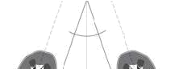

Medial
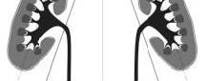

Lateral

Lateral

Figure 1a: medio-lateral obliquity of the kidneys

Source: Tuma et al (2010), genitourinary ultrasound


Anterior

Lower pole
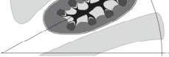

Upper pole

Posterior

Figure 1b: posterio-anterior obliquity of the kidneys

Source: Tuma et al (2010, genitourinary ultrasound

The upper pole is at the level of the12th tharocic vertebra and the lower pole is at the level of the 3rd lumbar vertebra. The right kidney usually lies slightly inferior to the left owing to the

position of the liver. Approximately, the kidneys measure about 10 - 12cm in length, 5cm in width, and 2.5cm in thickness and weighs about 150g in men and 135g in female (Moore and Dalley, 2006).

The kidneys are beans shape structures with a smooth convex contour anteriorly, posteriorly and laterally. The medial surface is concave known as the hilum. The hilum is continuous with the central cavity called the renal sinus complex which contains the blood vessels and pelvicalyceal pyramids which are surrounded by the cortex (column of Bertin), (fig 2).

Inferior vena cava
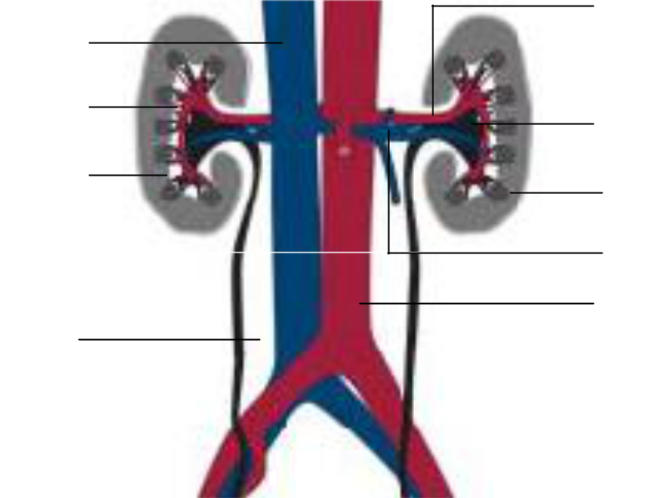

Column of Bertin

Renal cortex

Ureter

Left renal artery

Renal sinus complex

Medullary pyramid

Left renal vein

Abdominal aorta

The kidney, adrenal gland and perirenal fat are surrounded by a fascia layer called “the Gerota’s fascia”. Both kidneys are supply and drain by the right and left arteries and veins.

2.1.3 Normal Sonographic Appearance of the Kidney

Sonographically, the kidney is seen to consist of a central highly echogenic core called the renal sinus surrounded by a comparatively less echogenic layer called the renal parenchyma.

The renal sinus occupies about one third of the kidney (Palmar, 2007). On longitudinal view, the kidney appears as oval-shaped structure with a central renal sinus surrounded by the parenchyma (fig 3a and 3b). On transverse view, the kidney appears as C-shape (fig 4a and 4b)

The renal medullar (pyramids) are less echogenic compare to the surrounding cortex which appear less or equal to the liver and spleen echogenicity (fig 5). Renal medullary pyramids are easily observed in children and young adult but may not be well appreciated in adults. The Gerota’s fascia and perinephric fat are seen as bright echo surrounding the kidney and adrenal gland. Measurements of kidney size on ultrasound is relatively less than those made on radiography and are more accurate (Palmar, 2007).

2.2.0 Empirical Literature Review

Unilateral or bilateral changes in kidney size and/or morphology are manifested by much renal pathology and are important parameters in clinical evaluation and management of patients with kidney diseases (Saeed et al., 2012). Serial measurement of renal size provides information regarding disease progression or stability (Schlesinger, 1991; Larson et al.,
2000). Ultrasonography is now the first line of choice for the assessment of renal pathology. The non ionizing radiation employed and its wide availability makes serial renal measurements and monitoring of renal disease possible.

2.2.1 Renal size Assessment by Ultrasonography

Renal assessment on ultrasonography can be carried out by measuring the renal length, renal volume, cortical volume or thickness. The most accurate of these is provided by the renal volume (Saeed et al., 2012). A short pole to pole renal length usually allows chronic renal failure to be easily distinguished from acute renal failure with normal or enlarged values. Kang et al (2007) stated that renal length and volume are important parameters for clinical assessment of patients with diabetes or renal artery stenosis and to differentiate between chronic and acute renal failure. This is usually done for decision making in biopsy and to predict post transplantation allograft function (Carrico and Zerin, 1996; Kang et al., 2007). However, assessment of renal function using renal length can be erroneous because renal parenchyma may be compensated with increase in peripelvic fat even in reduced parenchyma with advance age (Roger et al., 1994). In addition, Okoye et al., (2006), observed that the efficiency of renal length in the decision for renal biopsy may be insufficient when used in isolation because a kidney with normal length may have thin parenchyma.

2.2.2 Relationship between Renal Parenchymal Thickness and Renal Function Kaplon et al (2009) demonstrated the relationship between renal parenchymal thickness and renal function in chronically obstructed renal units (ORU) in 52 adult patients. In the study, renal parenchymal thickness was measured using computed tomography scan. Obstructed renal units were compared with the corresponding non obstructed renal units (NORU). Measurements were taken from the upper and lower poles and in the mid section of the kidney and the mean of these measurements were referred to as renal parenchymal thickness. Renal parenchymal thickness ratio in their study was referred to as the ratio of the chronically

30
obstructed renal units’ parenchymal thickness to the non obstructed renal units’ parenchymal thickness. Renal parenchymal thickness was found to correlates with renal function. Renal function was determined using Mag-3 lasix Renogram (nuclear renography).

The reported mean parenchymal thickness was 1.82 cm and 2.25 cm in the ORUs and NORUs respectively. The correlation of renal parenchymal thickness ratio with renal function was reported also (r = 0.48, p > 0.001). According to them renal parenchymal thickness ratio of 0.68cm correlated with 20% renal function. The linear regression equation was computed as ‘Renal Function = 0.48 + 0.80RPT ratio’. They concluded that renal parenchymal thickness is a useful parameter for making surgical decision.

Yang et al., (2002) also studied the relationship between renal parenchymal thickness and renal function using ^{99m}Tc- labeled diethylenetriaminepenta acetic acid sinctigraphy on 50 children with unilateral moderate or severe hydronephrosis. They observed that post operative renal recovery was negatively correlated with renal parenchymal thickness (r = - 0.62, p > 0.0009). That is thicker parenchyma at the time of operation was seen to recover slower than thin parenchymal thickness. This means that renal function in moderate hydronephrosis (with thicker parenchyma) is not greatly affected as in severe hydronephrosis (with thinner parenchyma). Therefore, parenchymal thickness may to be an indicator of the degree of renal function in post operative renal recovery.

Yang et al, (2002) classified hydronephrosis based on the degree of parenchyma involvement. By their classification severe hydronephrosis was referred to parenchymal thickness of ≤ 3mm or renal function of less than 30%. Parenchymal thickness of 3-5 mm or renal function of 30- 40% was moderate, while ≥ 5mm parenchymal thickness or renal function of ≥ 40% was seen as mild hydronephrosis. This is a typical use of parenchymal thickness in the grading of hydronephrosis which is in line with the European Society of Urology and

European Society of Pediatric Radiology system of classification of hydronephrosis. 31
Parenchymal thickness thus plays a major role in the monitoring and follow-up of renal pathology. It therefore, necessitates the need for a normogram for our population.

2.2.3 Relationship between Renal Parenchymal Thickness and Renal Length

Renal parenchymal thickness is said to have a positive linear correlation with renal length with a correlation coefficient of 0.64 on both right and left at p > 0.001(Roger et al, 1994). Similar result was obtained by Okoye et al., (2006) with a correlation coefficient of 0.76 and 0.77 on right and left kidneys respectively though they observed a significant fluctuation in renal length above 11cm.

2.2.4 Relationship between Renal Size and Age

Renal size is reported to increase gradually in children up to 16 years (Kadioglu, 2010), a decrease was noted after the sixth decade of life (Raza et al., 2010; Saeed et al., 2012) while renal size was not affected by increase in age between the third and sixth decade of life (Saeed et al., 2012). A gradual increase but zig zag relationship was reported to exist between renal parenchymal thickness, medullary pyramid thickness and age in children (Kadioglu, 2010) while no significant relationship was noted between parenchymal thickness and age in adults (Raza et al., 2010). In new born, the least parenchyma thickness is said to be about 8mm (Kadioglu, 2010).

2.2.5 Renal Parameters Variations

The left kidney is noted to be greater than the right kidney in length, width, volume, parenchymal thickness and cortical thickness (Roger et al., 1994; Okoye et al., 2006; Adibi et al., 2008; Raza et al., 2011; Saeed et al., 2012). Kadioglu (2010) noted this difference in parenchymal thickness particularly at the age 8 months, 4 years and 13 years while medullary pyramid thickness was noted to be greater in younger children than in older ones with the left medullary pyramid slightly thicker than the right at the age of 9 months, 4 years and 9 years.

32
Most authors noted a significant difference between the males and females’ kidney sizes with the males’ kidney greater than the females (Buchholz et al., 2000; Adibiet al., 2008; Raza et al., 2011; Saeed et al., 2012). Gourtsoyiannis et al. (1990) noted no difference in renal parenchymal volume in the two genders while Saeed et al., (2012) noted no significant difference in renal length.

A survey by Raza et al. (2010) on 4035 adults of age 18 years and above shows a correlation between renal size and height, weight, total body area, and body mass index (p > 0.01). They noted that the strongest correlation was found between renal volume and total body surface area. This was also observed by Saeed et al; (2012). In that study renal length was observed to show a positive correlation with subject’s height (r = 0.352 (right) and 0.412 (left); p > 0.01). Similar observation was made between renal length and body weight with the correlation coefficient of 0.385 and 0.417 for the right and left kidneys respectively (p < 0.01). A weak correlation according to the study was noted between renal length and BMI (0.192 (right) and 0.211 (left); p > 0.01). Gourtsoyiannis et al, (1990) reported that the major reason why there is a difference in males and females kidney size is because males have greater body size than women. The disparity between males and females renal size was eliminated when they divided the value of renal parenchymal thickness by the mid transverse diameter of the first lumbar vertebrate. They concluded that the differences in males and females renal size is not a function of age but rather body build.

Height, weight, BMI and BSA are factors which affect renal size and the entire factors have a direct relationship with race (Kang et al, 2012). Saeed et al (2012) reported a significant variation in kidney length among different populations. Smaller kidney size (average kidney length of 9.1-9.9cm) was seen in the Indian population (Sahni et al., 2001). Buccholz et al. (2000) and Saeed et al. (2012) independently reported kidney length of 10.4cm and 9.80-10.0cm in Pakistan population respectively. Larger kidney size (kidney lengths averaging

33
10.3 – 10.6 cm) was observed in the Nigerian population by Okoye et al, (2005) and similar results was seen in the Mexican population. The difference was attributed to the variations in body size. Thus, races with larger body size were seen to exhibit larger renal size with respect to those with small body size.

2.2.6 Renal Medullary Pyramid Thickness

Renal medulla is the portion of the parenchyma which is cone shaped. It contains the loops of Henle which serve in urine concentration. However, not much has been written on it. Most of the studies on renal medulla were carried out in aves (Oscar, 2005) and mammals (Beuchat, 1990). Alkahtani et al, (2004) in their study on mammals proposed that medullary pyramid thickness and, therefore, the length of the loop of Henle, increased with body mass but the thickness of the medulla relative to the size of the kidney reduces with body size and that the relative thickness of the medulla accounted for only 59% of the variability among species in concentrating ability, indicating that there are other morphological or physiological factors that significantly influence urine concentrating ability.

Kadioglu (2010) in his study shows that renal medullary pyramid thickness is greater in younger children (small body size) than in older ones (bigger body size) and that the left renal medullary pyramid thickness was slightly thicker than the right.

2.3 Assessment of Renal Parenchymal and Medullary Pyramid Thicknesses

There is no standard method of assessing renal parenchymal thickness both on ultrasound and other imaging modalities. Most researchers measure renal parenchymal thickness at three different portions (upper pole, lower pole and mid segment of the kidney) and the mean is taken as renal parenchymal thickness (Okoye et al., 2006; Kaplon et al., 2009; fig 6). However, others used a more complicated measurement (Gourtsoyiannis et al., 1990) which may be very difficult to apply clinically.

34
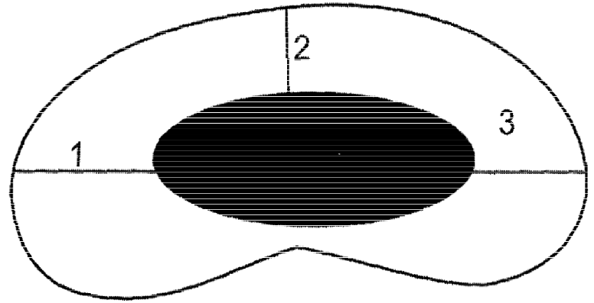

Figure 6: Assessment of RPT at the upper pole, lower pole and mid segment of the kidney

Source: Okoye et al, (2006)

A simple method of measuring renal parenchymal and medullary pyramid thicknesses was described by Tuma et al, (2010). According to them renal parenchymal thickness is being measured from the tip of the pyramid to the surface of the renal cortex at the mid portion of the kidney (Fig. 7a and 7b). This method was adopted by Kadioglu (2010). The normal range of renal parenchymal thickness is said to be 14-18mm (Tuma et al., 2010) in adults. Renal parenchymal and medullary pyramid thicknesses are particularly important when monitoring transplanted kidney or in monitoring of the process of chronic diffuse diseases of the renal parenchyma.

Since renal size is influenced by age and somatometric parameters which vary from one population to another, renal parenchymal and medullary pyramid thicknesses should be studied in line with these factors. An indigenous normogram is also necessary for the assessment of renal parenchymal and medullary pyramid thicknesses in our population. A search of the literature revealed no reports on the normative values of renal parenchymal thickness and medullary pyramid thickness in children using ultrasound in our locality. This therefore, necessitates the study.

35
CHAPTER THREE

RESEARCH METHODOLOGY

3.1 Research Design

This was a prospective cross sectional study

3.2 Equipment

A real time grey-scale Chison digital ultrasound system, model 8100 with a curvilinear trans-abdominal probe of 3.5 and 5MHz was used for the evaluation of the kidneys. The choice of the probe frequencies was to give adequate penetration and resolution to the retroperitoneal located kidneys in both older and younger children respectively. All sonographic measurements were taken using the electronic calipers of the ultrasound machine. Weight was taken using a weighing scale with a capacity of 0 to 180 kilograms and height measurements was taken with a meter rule of 0 to 200 centimeters capacity.

3.3 Study Duration

The study was carried out from September 2012 to August, 2013.

3.4 Study Population

The study covered school children of age one to seventeen years.

3.5 Subject Recruitment

All the subjects involved in this study were recruited from crèche, nursery, primary and secondary schools.

3.6 Sampling technique

A convenience sampling method was adopted for the selection of the subjects for this study. Schools who gave their approval were selected and subjects who met the inclusion criteria and whose consents were given by their parents were included in the study.

36
3.7 Sample Size

Sample size was determined using Yamane’s formula for determination of sample size in a finite population (Yamane 1967; appendix 3). The sample size for the study was 512 children.

3.8 Inclusion Criteria

- Children with no urinary tract symptoms or underlying kidney diseases

- Children of age one to seventeen years.

- Children with no history of malignancy

- Children with clear renal outline during the scan

- Upper urinary tract abnormalities

- Urologic surgery

- Abnormality detected during the scan such as hydronephrosis, dysplastic kidney or solitary kidney.

3.10 Subjects Preparation

Ultrasonographic assessment of upper urinary tract may not require prior preparation. The subjects did not undergo the routine ultrasound preparation except being screened using a questionnaire to exclude children who did not meet the inclusion criteria and by an experienced sonographer to exclude children with renal abnormality. The exclusion of abdominal preparation was done purposefully in order to gain subjects’ cooperation.

3.11 Scanning Technique

All the subjects were examined first on supine position for general abdominal survey. Ultrasound gel was generously applied for good ultrasound transmission. Longitudinal, transverse and oblique scans were performed using different planes. The subjects were then 37
put in prone position for the measurement of renal parameters. This position was preferred in order to avoid excess bowel gas which was common among the subjects and also to maintain a uniform standard of assessment both for the very young and the grown up children. Renal length was taken on the long section of the kidney from the lower to the upper pole (fig 7b). Renal parenchymal thickness was obtained between the cortex perirenal fat interface (capsule) and the sinus/medullary pyramid apex interface at the mid portion of the kidney (Tuma et al., 2010; fig 7b). Measurements were taken three times and the mean of the three measurements were recorded as renal parenchymal thickness. All the subjects were examined by the same sonographer.
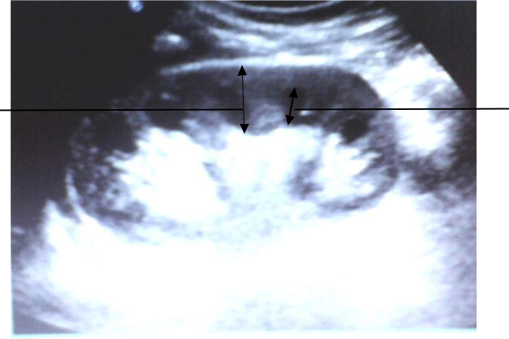

Renal | Renal medullary
parenchymal | Renal medullary
parenchymal | pyramid
thickness | pyramid
thickness | thickness
 | Renal sinus

Fig 7a: Sonogram of longitudinal section of kidney showing the measurement of renal parenchymal and medullary pyramid thicknesses
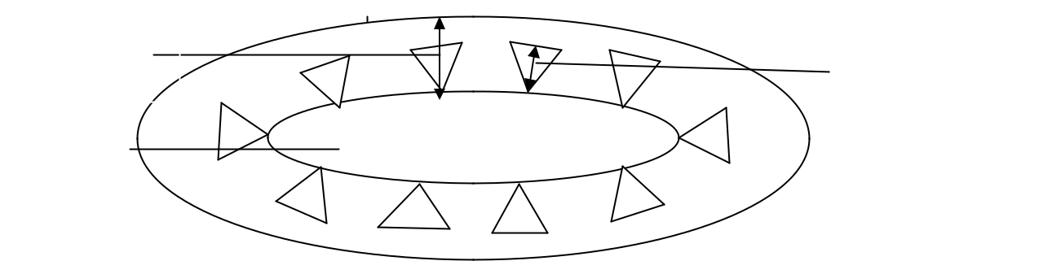

Renal

parenchymal

thickness

Renal sinus

Renal medullary

pyramid thickness

Fig 7b: A kidney sketch showing how renal parenchymal and medullary pyramid thicknesses were measured on the long section of the kidney

Renal medullary pyramid thickness was measured as the distance between the apex and the base of the pyramid at the mid portion of the kidney (Tuma et al., 2010; fig 7b). All measurements were obtained on static ultrasound image using electronic calipers at the time of scanning. Measurements were also taken three times and the mean of the three measurements were recorded as renal medullary pyramid thickness.

Weight was taken with the subject barefooted, standing erect on a weighing scale with the feet together in such a way that the body weight was equally distributed and the pointer got to a rest on the scale. The value was read directly from the calibration on the scale in kilograms. Height was taken with the subject standing erect with bare feet, backing the meter rule which was held vertically from the floor. The heels were together touching the meter rule and eyes looking forward. A ruler was placed on the vertex to enable accurate reading of the value from the meter rule. The calibration was in centimeters.

3.12 Reliability of Measurements (Pilot Study)

Prior to the main study, twenty randomly selected subjects underwent independent sonographic scans to determine the intra and inter-observer variations in the measurement of RPT and MPT. Inter-observer variation was carried out by two sonographers who took the measurements of RPT and MPT independently using the same sonographic equipment on the first day. Renal parameters which include kidney length, renal parenchymal and medullary pyramid thicknesses were taken three times. The mean of the three measurements were recorded for the respective renal parameters. For safety purpose, though ultrasound is generally regarded as a safe modality, we had to ensure that there was adequate time interval between the scanning procedures of each sonographer to avoid any possible heating effect on the subjects. On the second day, the subjects were again examined by one of the sonographers and the measurements were compared with those obtained on the first day by the same sonographer for intra-observer variations.

39
The t-test analysis for equality of mean was used to determine the intra and inter-observer variations in the measurements of renal parameters and there was no significant difference (p
- 0.05) in RPT and MPT measurements obtained within and between sonographers (appendix

4).

3.13 Informed Consent/Ethical Clearance

Ethical Clearance was obtained from the University of Nigeria Teaching Hospital, Enugu Ethical Committee. Informed consent was also obtained from the school authorities and parents of subjects involved.

3.14 Statistical Analysis

Descriptive statistics such as mean, standard deviation and percentiles were calculated for RPT and MPT for both kidneys for all age groups. Pearson's correlation and regression analysis were used to determine the relationship between renal parenchymal thickness and medullary pyramid thickness with age, height, body weight, body mass index, and body surface area. The relationship between renal parenchymal and medullary pyramid thicknesses with kidney length was also determined using correlation and regression analyses. The ratio of renal medullary pyramid thickness to parenchymal thickness was determined in relation to all age group and its’ relationship with renal length, subject’s height, weight, body mass index and body surface area were carried out using Pearson correlation analyses. Body surface area was calculated using Haycock’s formula giving as: BSA (m²) = 0.024265 x Height (cm)^{0.3964} x Weight (kg)^{0.5378} (Haycock et al., 1978). Body Mass Index was calculated with the formula- Weight (kg) / Height (m)². The t-test for two samples assuming equal variance analysis was carried out to assess gender differences in renal parameters. The same analysis was also carried out to assess right and left renal parameters for statistical differences. The values of renal parameters generated in the study was compare with the previous study to assess inter populations’ differences using t-test analysis for equality of mean.

40
CHAPTER FOUR

RESULTS

A total number of 512 subjects who met the inclusion criteria were studied. Two hundred and

sixty two (51.2%) of the participants were males while two hundred and fifty (48.8%) were

females (table 1). Children of age 12 years had the highest number of participants

constituting 10.2%, while the least number was from age 2 years old (3.5%; table 1).

Table 1: Age distribution and frequency of the subjects
Age |  |  | Frequency
(year) | Males | Percentage | Females | Percentage | Total | Percentage
1 | 8 | 1.56 | 12 | 2.34 | 20 | 3.9
2 | 11 | 2.15 | 7 | 1.37 | 18 | 3.5
3 | 7 | 1.37 | 12 | 2.34 | 19 | 3.7
4 | 14 | 2.73 | 13 | 2.54 | 27 | 5.3
5 | 19 | 3.71 | 12 | 2.34 | 31 | 6.1
6 | 17 | 3.32 | 12 | 2.34 | 29 | 5.7
7 | 24 | 4.69 | 18 | 3.52 | 42 | 8.2
8 | 21 | 4.10 | 14 | 2.73 | 35 | 6.8
9 | 13 | 2.54 | 10 | 1.95 | 23 | 4.5
10 | 14 | 2.73 | 15 | 2.93 | 29 | 5.7
11 | 18 | 3.52 | 21 | 4.10 | 39 | 7.6
12 | 28 | 5.47 | 24 | 4.69 | 52 | 10.2
13 | 20 | 3.91 | 23 | 4.49 | 43 | 8.4
14 | 11 | 2.15 | 15 | 2.93 | 26 | 5.1
15 | 10 | 1.95 | 16 | 3.13 | 26 | 5.1
16 | 17 | 1.95 | 15 | 2.93 | 32 | 6.3
17 | 10 | 1.95 | 11 | 2.15 | 21 | 4.1
 | 262 | 51.17 | 250 | 48.83 | 512 | 100.00


41
To find out if there are gender differences in KL, RPT, MPT and MPT/RPT ratio hypotheses were stated as follows:

H_{o}: there is no statistical significant genders difference in KL, RPT, MPT and MPT/RPT ratio.
H1: there is statistical significant genders difference in KL, RPT, MPT and MPT/RPT ratio.

The “t” test for two samples assuming equal variance was used to test for the differences between the males and females renal parameters. The result revealed no significant difference (p > 0.05) between the males’ and females’ KL (table 2a). Renal parenchymal thickness also shows no significant difference between both genders (p > 0.05; tables 2b). No significant difference was noted between the male and female MPT (p > 0.05; table 2c). Same result was obtained between males’ and females’ MPT/RPT ratio (p > 0.05; table 2d). The null hypothesis was accepted.

42
Table 2: comparison of males’ and females’ renal parameters by age

Table 2a: Comparison of males’ and females’ renal length by age

43
Table 2b: Comparison of males’ and females’ renal parenchymal thickness by age

44

Table 2c: Comparison of males’ and females’ renal medullary pyramid thickness by age

45

Table 2d: Comparison of males’ and females’ renal medullary pyramid thickness to parenchymal thickness ratio by age

46
To find out if there is significant difference between the right and left measured renal parameters, hypotheses were formulated as follows:

H_{o}: There is no statistical significant difference between the left and right KL, RPT, MPT and MPT/RPT ratio.
H1: There is statistical significant difference between the right and left KL, RPT, MPT and MPT/RPT ratio.

The “t” test for two samples assuming equal variance was used to test for mean differences between the right and left renal parameters.

The analysis showed a slight difference between the right and left KL (table 3a; p < 0.05) with the left KL being a little longer than the right KL in all age groups. Slight differences were also observed between the right and left RPT (table 3a; p < 0.05). The left RPT was slightly thicker than the right RPT across all age groups. Similar result was seen between the right and left MPT (table 3b; p < 0.05) with the left being slightly thicker than the right across all age groups. Since the differences were not statistically significant, the null hypothesis was not rejected.

Comparison of right and left renal medullary pyramid to parenchymal thicknesses ratio shows no significant statistical difference across age groups (table 3b; p > 0.05), thus the null hypothesis was accepted.

47
Table 3: comparison of right and left renal parameters by age

Table 3a: Comparison of right and left renal length and renal parenchymal thickness by age

48
Table 3b: Comparison of right and left renal medullary pyramid thickness and renal medullary pyramid thickness to parenchymal thickness ratio by age

49
The overall subjects’ mean kidney length, renal parenchymal thickness, renal medullary

pyramid thickness, renal medullary pyramid to parenchymal thickness ratio, age, height,

weight, body mass index, and body surface area were examined and the overall means are

shown in table 4.

Table 4: Overall mean and standard deviations of age, somatometric and renal parameters of

 |  | the subjects
Variables | N | Mean | Std Deviation
Age (years) | 512 | 9.5 | 4.5
Height (Cm) | 512 | 136.8 | 24.9
Weight (Kg) | 512 | 35.7 | 17.1
BMI (Kg/m²) | 512 | 17.7 | 3.5
BSA ( m²) | 512 | 1.15 | 0.38
Rt KL (mm) | 512 | 84.16 | 11.28
Lt KL (mm) | 512 | 85.94 | 11.52
Rt RPT (mm) | 512 | 12.62 | 1.67
Lt RPT (mm) | 512 | 12.81 | 1.73
Rt MPT (mm) | 512 | 7.10 | 0.92
Lt MPT (mm) | 512 | 7.23 | 0.94
Rt MPT/RPT | 512 | 0.57 | 0.02
Lt MPT/RPT | 512 | 0.57 | 0.02


Analyses were also carried out to assess the distribution of RPT, MPT and MPT/RPT ratio

with respect to kidney length (table 5a and 5b). The RPT and MPT were noted to increase

gradually with increase in KL. However, MPT/RPT ratio showed a random distribution. The

analysis was done independently for each kidney.

50
Table 5a: Distribution of kidney lengths with corresponding renal parenchymal and

medullary pyramid thicknesses

Kidney | Mid | Rt | Lt | Rt | ±Std | Lt | ±Std | Rt | ±Std | Lt | ±Std
Length | Class | kidney | kidney | RPT | (mm) | RPT | (mm) | MPT | (mm) | MPT | (mm)
(mm) |  | (N) | (N) | (mm) |  | (mm) |  | (mm) |  | (mm)
60.0-65.0 | 62.5 | 12 | 8 | 10.45 | 0.67 | 10.63 | 1.19 | 5.65 | 0.70 | 5.88 | 0.75
65.0-70.0 | 67.5 | 42 | 36 | 10.62 | 0.79 | 10.58 | 0.87 | 6.08 | 0.70 | 6.00 | 0.77
70.0-75.0 | 72.5 | 56 | 49 | 11.31 | 1.00 | 11.41 | 0.84 | 6.38 | 0.92 | 6.36 | 0.90
75.0-80.0 | 77.5 | 65 | 65 | 11.66 | 1.25 | 11.58 | 1.09 | 6.69 | 1.12 | 6.79 | 1.07
80.0-85.0 | 82.5 | 64 | 59 | 12.20 | 1.23 | 11.93 | 1.11 | 6.96 | 1.00 | 6.93 | 0.99
85.0-90.0 | 87.5 | 54 | 52 | 12.87 | 1.61 | 13.25 | 1.34 | 7.09 | 0.95 | 7.33 | 1.04
90.0-95.0 | 92.5 | 65 | 65 | 13.55 | 1.40 | 13.42 | 1.45 | 7.85 | 0.92 | 7.72 | 0.94
95.0-100.0 | 97.5 | 67 | 70 | 14.31 | 1.54 | 14.20 | 1.43 | 7.82 | 0.91 | 7.91 | 0.96
100.0-105.0 | 102.5 | 70 | 68 | 14.47 | 1.18 | 14.94 | 1.34 | 8.01 | 0.89 | 8.32 | 1.05
105.0-110.0 | 107.5 | 16 | 32 | 15.44 | 1.21 | 15.12 | 1.29 | 8.61 | 0.73 | 8.24 | 0.73
110.0-115.0 | 112.5 | 1 | 8 | 17.00 | 0.00 | 16.00 | 1.41 | 9.00 | 0.00 | 8.84 | 0.83


Table 5b: Distribution of kidney lengths with corresponding ratio of renal medullary pyramid

thickness to parenchymal thickness

Kidney | Mid | Rt | Lt | Rt | ±Std | Lt | ±Std
Length | Class | kidney | kidney | MPT/RPT |  | MPT/RPT
(mm) |  | (N) | (N)
60.0-65.0 | 62.5 | 12 | 8 | 0.54 | 0.05 | 0.56 | 0.06
65.0-70.0 | 67.5 | 42 | 36 | 0.57 | 0.06 | 0.57 | 0.07
70.0-75.0 | 72.5 | 56 | 49 | 0.57 | 0.08 | 0.56 | 0.07
75.0-80.0 | 77.5 | 65 | 65 | 0.57 | 0.07 | 0.59 | 0.07
80.0-85.0 | 82.5 | 64 | 59 | 0.57 | 0.07 | 0.58 | 0.08
85.0-90.0 | 87.5 | 54 | 52 | 0.56 | 0.07 | 0.55 | 0.07
90.0-95.0 | 92.5 | 65 | 65 | 0.58 | 0.06 | 0.58 | 0.06
95.0-100.0 | 97.5 | 67 | 70 | 0.55 | 0.06 | 0.57 | 0.06
100.0-105.0 | 102.5 | 70 | 68 | 0.55 | 0.07 | 0.56 | 0.07
105.0-110.0 | 107.5 | 16 | 32 | 0.56 | 0.06 | 0.56 | 0.05
110.0-115.0 | 112.5 | 1 | 8 | 0.53 | 0.00 | 0.55 | 0.03
 |  |  |  | 51


To test the relationship between RPT, MPT, MPT/RPT ratio and age, hypotheses were stated as follows:

H_{o:} There is no relationship between RPT, MPT, MPT/RPT ratio and age.

H_{1:} There is a relationship between RPT, MPT, MPT/RPT ratio and age.

Correlation analysis carried out revealed a strong positive linear correlation between renal parenchymal thickness and age (r = 0.779 for right and r = 0.776 for left; fig 8). A moderate positive linear correlation was observed between renal medullary pyramid thickness and age (r = 0.633 on the right and 0.610 on the left; fig 8). Therefore, the null hypothesis was rejected. The linear regression equations were as follows: Rt RPT = 0.3236 x age + 9.7123; Lt RPT = 0.3354 x age + 9.7999; RT MPT = 0.1745 x age + 5.5316, and Lt MPT = 0.1787 x age + 5.6350.
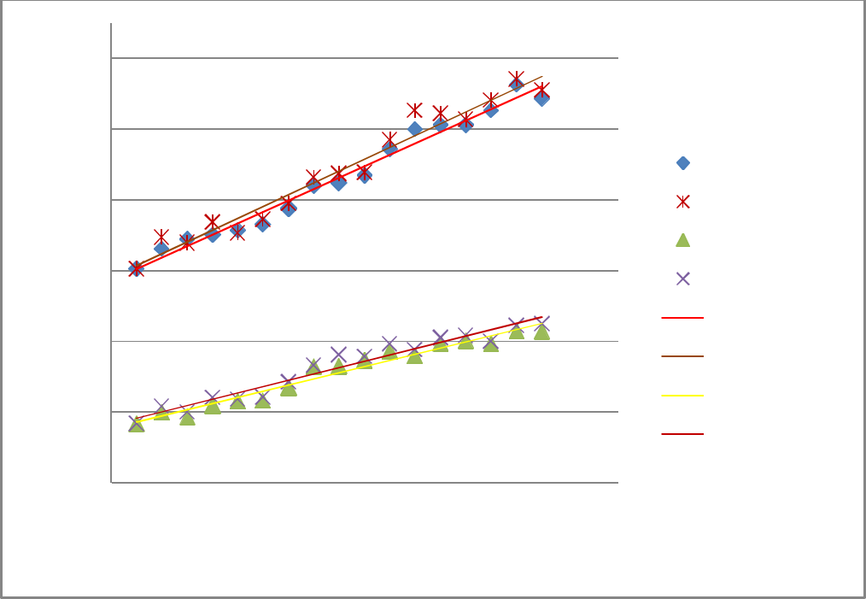

Renal parameters (mm)

16
 | Rt RPT = 0.3236 x age + 9.7123
14 | R² = 0.9789
14 |  |  | Lt RPT = 0.3354 x age + 9.7999
 |  |  |  |  | Rt RPT
12 |  |  | R² = 0.9641 |  | Lt RPT
 |  |  |  |  | Rt MPT
10 | Rt MPT = 0.1745 x age x + 5.5316 |  |  |  | Lt MPT
 |  |  |  |  | Linear (Rt RPT)
8 | R² = 0.9594 |  |  |  | Linear (Rt RPT)
8 |  |  |  |  | Linear (Lt RPT)
6 |  |  |  |  | Linear (Rt MPT)
6 |  | Lt MPT = 0.1787 x age + 5.6350 |  |  | Linear (Lt MPT)
4 |  |  | R² = 0.9513
0 | 5 | 10 | 15 | 20

AGE (YEARS)

Fig 8: Relationship between renal parenchymal and medullary pyramid thicknesses with age

A very weak negative insignificant correlation was noted between renal medullary pyramid to parenchymal thickness ratio and age (r = -0.063 for right and -0.055 for left).

52

Pearson correlation was carried out to test the hypotheses:

H_{o:} There is no relationship between RPT, MPT, MPT/RPT ratio and height.

H_{1:} There is a relationship between RPT, MPT, MPT/RPT ratio and height.

The result shows a strong positive linear correlation between height and renal parenchymal thickness (r = 0.798 (right); 0.801 (left); fig 9) and a moderate positive and linear correlation between renal medullary pyramid thickness and height (r = 0.678 and 0.673 for right and left kidneys respectively), thus, the null hypothesis was rejected. The regression equations are shown as follows: RT RPT = 0.0552 x Height + 5.3459; Lt RPT = 0.0569 x Height + 5.3195; RT MPT = 0.0292 x Height + 3.1959, and Lt MPT = 0.0303 x Height + 3.2009
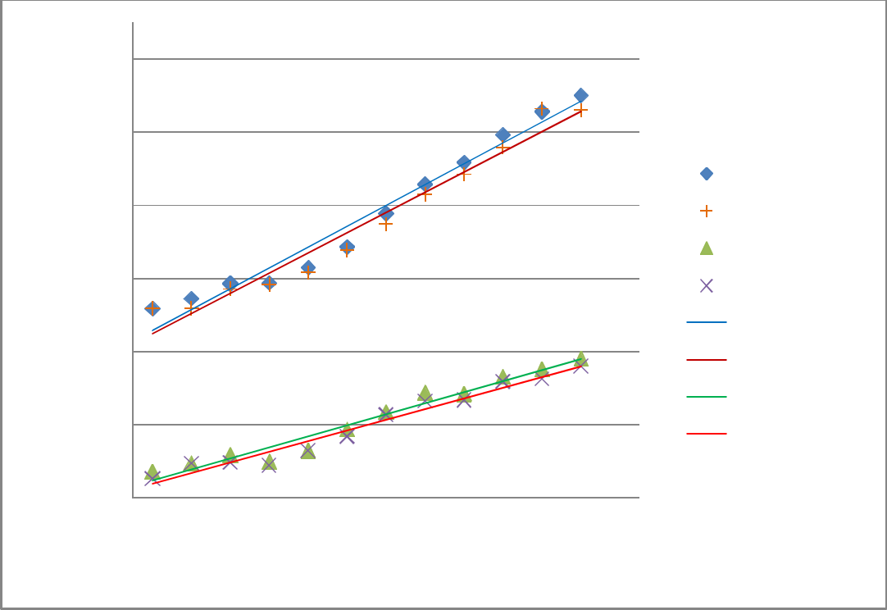

Renal parameters (mm)

17

RT RPT = 0.0552 x height+ 5.3459

R² = 0.9637
15

 |  |  |  |  |  |  | Lt RPT
13 |  |  |  | Lt RPT = 0.0569 x height + 5.3195 |  |  | Rt RPT
 |  |  |  |  |  |  | LT MPT
 |  |  |  |  | R² = 0.9692 |  | LT MPT
11 |  |  |  |  |  |  | Rt MPT
11 |  | RT MPT = 0.0292 x height + 3.1959 |  |  |  |  | Rt MPT
 |  |  |  |  |  |  | Linear (Lt RPT)
9 |  |  | R² = 0.9656 |  |  |  | Linear (Lt RPT)
9 |  |  |  |  |  |  | Linear (Rt RPT)
 |  |  |  |  |  |  | Linear (LT MPT)
7 |  |  | Lt MPT = 0.0303 x height + 3.2009 |  |  |  | Linear (Rt MPT )
5 |  |  |  |  | R² = 0.9617
70 | 90 | 110 | 130 | 150 | 170 | 190
 |  |  | Height | (cm)

Fig 9: Relationship between renal parenchymal and medullary pyramid thicknesses with height

A very weak insignificant negative correlation was observed between the ratio of renal medullary pyramid to parenchymal thickness and height (r = -0.054 (right); -0.048 (left).

53

Pearson correlation was also carried to test the following hypotheses:

H_{o:} There is no relationship between RPT, MPT, MPT/RPT ratio and weight.

H_{1:} There is a relationship between RPT, MPT, MPT/RPT ratio and weight.

The comparison of renal parenchymal thickness with weight shows a strong positive linear correlation (r = 0.790 (right); 0.792 (left), fig 10). Renal medullary pyramid thickness correlated moderately with weight (r = 0.635 and 0.629 for right and left respectively, fig 10). The null hypothesis was rejected. The linear regression equations are as shown below. Rt RPT = 0.0726 x weight + 10.116; Lt RPT = 0.08 x weight + 10.06;

Rt MPT = 0.0294 x weight + 6.0791; and Lt MPT = 0.0288 x weight + 6.2507
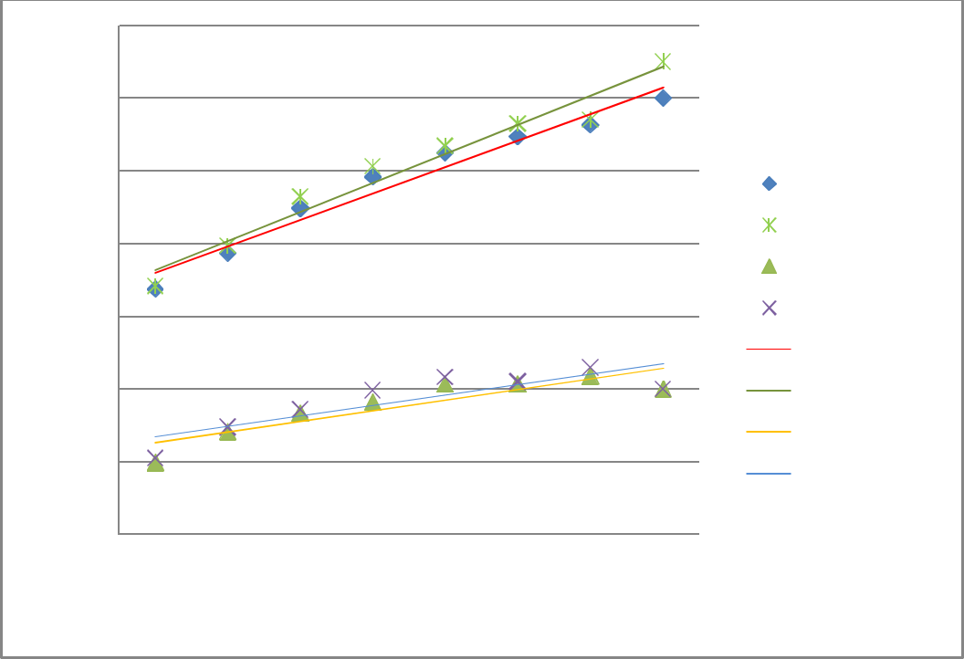

Renal parameters (MM)

18
16 | RT RPT = 0.0726 x weight + 10.116
16 | R² = 0.9623
14 |  | Lt RPT = 0.08 x weight+ 10.06 |  |  | Rt RPT
12 |  |  | R² = 0.9607 |  | Lt RPT
12 |  |  |  |  | Rt MPT
10 | RT MPT = 0.0294 x weight+ 6.0791 |  |  |  | Lt MPT
10 |  | R² = 0.792
 |  | R² = 0.792 |  |  | Linear (Rt RPT)
8 |  |  |  |  | Linear (Lt RPT)
6 |  | LT MPT = 0.0288 x weight+ 6.2507 |  |  | Linear (Rt MPT)
6 |  |  |  |  | Linear (Lt MPT)
6 |  |  | R² = 0.728 |  | Linear (Lt MPT)
4
10 | 30 | 50 | 70 | 90

WEIGHT (KG)

Fig 10: Relationship between renal parenchymal and medullary pyramid thicknesses with weight

On the other hand, renal medullary pyramid to parenchymal thickness ratio shows a weak and insignificant negative correlation with weight (r = -0.097 and -0.090 on right and left respectively).

54

Analysis was also carried out to test the following hypotheses using Pearson correlation analysis:

H_{o:} There is no relationship between RPT, MPT, MPT/RPT ratio and BMI.

H1: There is a relationship between RPT, MPT, MPT/RPT ratio and BMI.

Renal parenchymal thickness was noted to have a moderate positive correlation with body mass index (r = 0.546 (right); 0.543 (left); fig 11) and weak positive correlation was noted between renal medullary pyramid thickness and body mass index (r = 0.396 (right); 0.394 (left); fig 11). The null hypothesis was rejected. The linear regression equations are: Rt RPT

- 0.1857 x BMI + 9.6793; Lt RPT = 0.1852 x BMI + 9.5615; Rt MPT = 0.0756 x BMI +

6.0053; and Lt MPT = 0.0764 x BMI + 5.8782
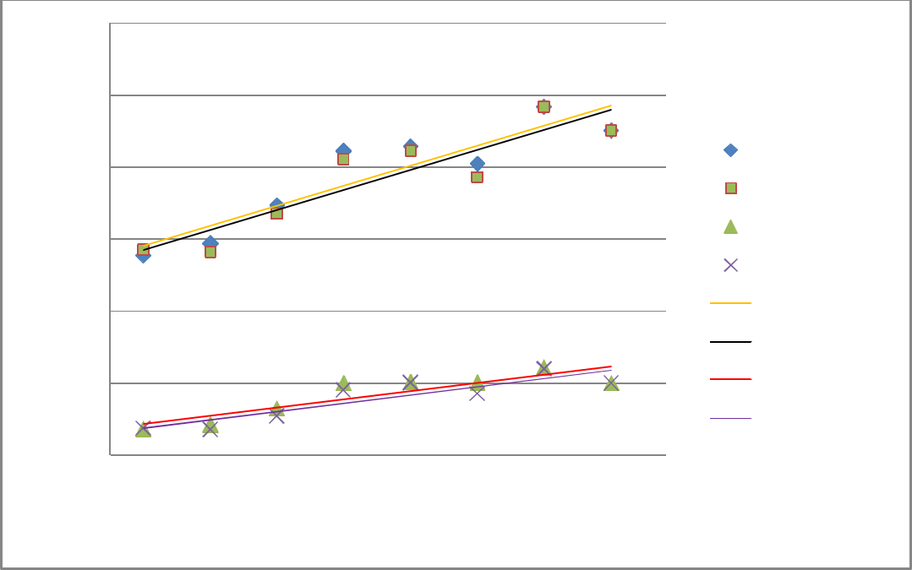

Renal parameters (mm)

18

RT RPT = 0.1852 x BMI+ 9.5615
R² = 0.8275
16
14 |  |  |  |  |  | Lt RPT
14 |  |  |  |  |  | Rt RPT
12 |  |  |  |  |  | Lt MPT
12 |  |  | Lt RPT= 0.1857 x BMI + 9.6793 |  |  | Rt MPT
 |  |  | R² = 0.8365 |  |  | Rt MPT
 |  |  |  |  |  | Linear (Lt RPT )
10 |  |  |  |  |  | Linear (Lt RPT )
10 | RT MPT = 0.0764 x BMI + 5.8782
 |  |  |  |  |  | Linear (Rt RPT)
 | R² = 0.7884 |  |  |  |  | Linear (Rt RPT)
8 | R² = 0.7884 |  |  |  |  | Linear (Lt MPT)
 |  |  | Lt MPT = 0.0756 x BMI + 6.0053 |  |  | Linear (Rt MPT)
6 |  |  |  | R² = 0.7805
10 | 15 | 20 | 25 | 30 | 35

BMI (KG/M²)

Figure 11: Relationship between renal parenchymal and medullary pyramid thicknesses with BMI

A weak negative correlation was observed between renal medullary pyramid to parenchymal thickness ratio and body mass index (r= -0.127 (right); -0.123 (left).

55

To test the relationship between RPT, MPT, MPT/RPT ratio and BSA, the following hypotheses were formulated follows and analysis was carried out using Pearson correlation. H_{o:} There is no relationship between RPT, MPT, MPT/RPT ratio and BSA.
H1: There is a relationship between RPT, MPT, MPT/RPT ratio and BSA.

A strong positive correlation was noted between renal parenchymal thickness and body surface area (r = 0.807 (right); 0.810 (left); fig 12). While renal medullary pyramid thickness shows moderate correlation with body surface area (r = 0.659 (right); 0.655 (left); fig 8). The null hypothesis was rejected. The regression equations were as shown below:

Rt RPT = 3.7058 x BSA + 8.5013; Lt RPT = 4.0242 x BSA + 8.3708; Rt MPT = 1.9142 x BSA + 4.9483; and Lt MPT = 1.9092 x BSA + 5.0836
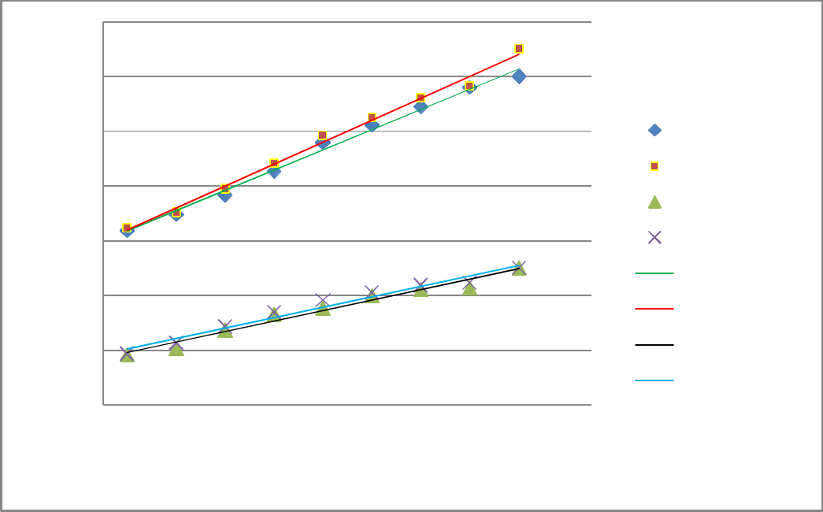

Renal parameters (mm)

18
16 | RT RPT = 3.7058x + 8.5013
14 | R² = 0.993 |  |  |  | Rt RPT
12 |  |  | Lt RPT = 4.0242x + 8.3708 |  | Lt RPT
12 |  |  | R² = 0.9928 |  | Rt MPT
10 | RT MPT = 1.9142x + 4.9483 |  |  |  | Lt MPT
 |  |  |  |  | Linear (Rt RPT)
8 | R² = 0.9719 |  |  |  | Linear (Rt RPT)
8 |  |  |  |  | Linear (Lt RPT)
6 |  | LT MPT= 1.9092x + 5.0836 |  |  | Linear (Rt MPT)
 |  |  |  |  | Linear (Lt MPT)
4 |  |  | R² = 0.97 |  | Linear (Lt MPT)
0.4 | 0.9 | 1.4 | 1.9 | 2.4

BSA (m²)

Figure 12: Relationship between renal parenchymal and medullary pyramid thicknesses with BSA

There was a very weak negative correlation between renal medullary pyramid thickness to parenchymal thickness ratio and body surface area (r = -0.088 (left); -0.077 (right).

Pearson correlation was done to test the relationship between studied renal parameters and kidney length

56

H_{o:} There is no relationship between RPT, MPT, MPT/RPT ratio and KL.

H_{1:} There is a relationship between RPT, MPT, MPT/RPT ratio and KL.

Analysis shows a strong positive correlation between renal parenchymal thickness and kidney length (r = 0.752 on the right and 0.767 on the left; fig 13). A moderate correlation was observed between kidney length and renal medullary pyramid thickness (r = 0.618 (right); 0.623 (left); fig 13). The null hypothesis was rejected. The regression equations were as follows: Rt RPT = 0.1239 x KL + 2.2364; Lt RPT = 0.1133 x KL + 3.0893; Rt MPT = 0.0635 x KL + 1.7316; Lt MPT = 0.0594 x KL + 2.1043
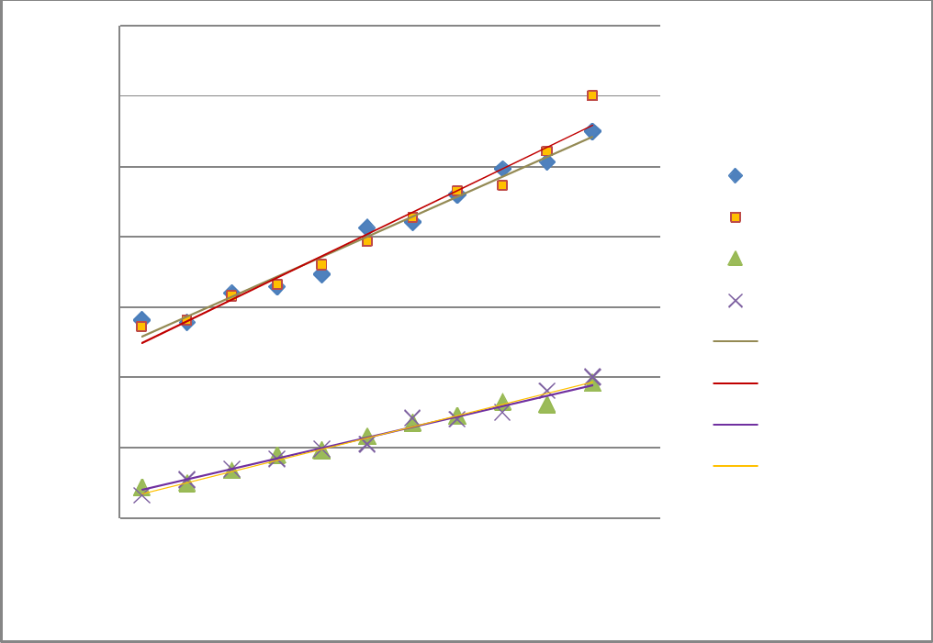

Renal parameters (mm)

19
17
RT RPT = 0.1239 x KL + 2.2364
15 | R² = 0.9701 |  |  |  |  |  | Lt RPT
13 |  |  |  |  |  |  | Rt RPT
13 |  |  | Lt RPT= 0.1133 x KL + 3.0893 |  |  |  | Lt MPT
11 |  |  |  | R² = 0.9784 |  |  | Rt RMT
 | RT MPT = 0.0635 x KL + 1.7316 |  |  |  |  |  | Linear (Lt RPT)
9 |  |  |  |  |  |  | Linear (Rt RPT)
9 |  | R² = 0.9831 |  |  |  |  | Linear (Rt RPT)
 |  |  |  |  |  |  | Linear (Lt MPT)
7 |  |  |  |  |  |  | Linear (Lt MPT)
7 |  |  | LT MPT = 0.0594 x KL + 2.1043 |  |  |  | Linear (Rt RMT)
5 |  |  |  | R² = 0.9869
60 | 70 | 80 | 90 | 100 | 110 | 120

Kidney length (mm)

Figure 13: Relationship between renal parenchymal and medullary pyramid thicknesses with kidney length

A very weak insignificant negative correlation was noted between renal medullary pyramid thickness to parenchymal thickness ratio and kidney length (r = -0.068 on the right and -0.084 on the left).

57

The following hypotheses were tested for population difference in renal parameters using the “t” test for equality of mean.

H_{o}: There is no significant difference in KL, RPT, MPT and MPT/RPT ratio values among different populations.
H1: There is a significant difference in KL, RPT, MPT and MPT/RPT ratio values among different populations.

Comparison of our mean kidney length (Nigerian population) with the Turkish population (Kadioglu’s study, data on appendix 8) shows no significant statistical difference (t = 0.2, p > 0.05) and the null hypothesis was accepted. However, there was a significant difference in the two populations’ mean renal parenchymal thickness, renal medullary pyramid thickness and renal medullary pyramid thickness to parenchymal thickness ratio with the Turkish population renal parameters being greater than Nigeria’s population parameters (table 6, p > 0.05). The null hypothesis was rejected.

Table 6: Comparison of mean renal parameters in this study (Nigerian population) with Kadioglu’s study (Turkish population)

Variable Turkey Nigeria


(mm) (N = 292) (N = 512)
t-test for equality of means
Calculated Critical t- Mean Standard
t-value value for two difference Error

tail test

Lt KL | 86.12±12.03 | 85.94±11.53 | 0.200 | 1.746 | 0.16 | 0.80
Rt KL | 84.56±11.88 | 84.21±11.35 | 0.515 | 1.746 | 0.35 | 0.69
Lt RPT | 13.44±1.65 | 12.82±1.50 | 4.922 | 1.746 | 0.62 | 0.13
Rt RPT | 12.95±1.65 | 12.62±1.65 | 1.820 | 1.746 | 0.32 | 0.18
Lt MPT | 7.87±0.92 | 7.24±0.93 | 5.000 | 1.746 | 0.63 | 0.13
Rt MPT | 7.52±1.12 | 7.10±0.90 | 2.847 | 1.746 | 0.42 | 0.15
Lt MPT/RPT | 0.59±0.93 | 0.57±0.02 | 2.265 | 1.746 | 0.02 | 0.01
Rt MPT/RPT | 0.58±0.04 | 0.57±0.02 | 1.701 | 1.746 | 0.02 | 0.01


58

Since there was no gender difference in renal parenchymal thickness, the normogram for right renal parenchymal thickness was generated from the combine males’ and females’ data. The RT RPT values for the 3rd to 97th percentiles for each age group were calculated and normal ranges were given (table 7a and 7b). It was necessary to generate separate normograms for right and left parenchymal thicknesses because a slight difference was noted between the right and left RPT, with the left RPT being consistently thicker than the right RPT across all age groups. For easy application in the clinic, RPT was grouped into five age groups (table 7b) and the values for mean and 3rd to 97th percentiles were generated since the differences in RPT between close ages was not significant.

Table 7a: Normogram of right renal parenchymal thickness from the study population by age

Age | RT RPT | ₃rd | ₅th | 10th | 25th | 50th | 75th | 95th | ₉₇th
(years) | Range (mm) | %tile | %tile | %tile | %tile | %tile | %tile | %tile | %tile
 |  | (mm) | (mm) | (mm) | (mm) | (mm) | (mm) | (mm) | (mm)
1 | 8.98-12.03 | 9.00 | 9.00 | 9.34 | 10.00 | 10.05 | 10.88 | 11.00 | 12.00
2 | 9.30-12.00 | 9.35 | 9.40 | 9.89 | 10.01 | 10.61 | 10.94 | 11.00 | 12.00
3 | 9.35-12.00 | 9.40 | 9.67 | 10.00 | 10.45 | 10.86 | 11.00 | 11.05 | 12.31
4 | 9.30-12.00 | 9.47 | 9.68 | 10.08 | 10.46 | 11.00 | 11.50 | 11.65 | 12.50
5 | 9.60-14.50 | 9.93 | 10.00 | 10.11 | 10.54 | 11.14 | 12.00 | 12.00 | 13.70
6 | 9.90-14.50 | 10.00 | 10.12 | 10.34 | 11.00 | 11.31 | 12.00 | 12.50 | 13.86
7 | 10.00-14.70 | 10.10 | 10.30 | 10.45 | 11.00 | 11.74 | 12.25 | 12.57 | 14.00
8 | 10.01-14.80 | 10.50 | 10.92 | 11.00 | 12.00 | 12.40 | 13.00 | 13.01 | 14.55
9 | 10.00-15.00 | 10.66 | 11.00 | 11.25 | 12.03 | 12.48 | 13.00 | 13.78 | 15.00
10 | 10.05-15.20 | 10.61 | 11.00 | 11.39 | 12.20 | 12.69 | 13.20 | 14.00 | 15.00
11 | 10.30-16.00 | 10.98 | 11.30 | 12.00 | 13.00 | 13.44 | 14.00 | 14.28 | 15.89
12 | 11.00-16.05 | 11.00 | 11.50 | 12.00 | 13.00 | 13.81 | 14.66 | 15.00 | 16.00
13 | 10.97-16.30 | 11.08 | 12.00 | 12.44 | 13.06 | 14.12 | 14.82 | 15.00 | 16.00
14 | 11.05-16.80 | 11.75 | 12.00 | 12.50 | 13.38 | 14.14 | 15.00 | 16.00 | 16.66
15 | 12.00-17.00 | 12.00 | 12.25 | 12.72 | 13.70 | 14.54 | 15.20 | 16.30 | 16.81
16 | 13.00-17.40 | 12.88 | 13.00 | 13.24 | 14.00 | 15.25 | 16.00 | 17.00 | 17.00
17 | 13.30-18.01 | 13.50 | 13.60 | 14.00 | 14.57 | 15.30 | 16.00 | 17.00 | 17.88


59
Table 7b: Normogram of right renal parenchymal thickness from the study population by age

 | group
Age | RT RPT | ₃rd | ₅th | 10th | 25th | 50th | 75th | 95th | 97th
(years) | Range (mm) | %tile | %tile | %tile | %tile | %tile | %tile | %tile | %tile
 |  | (mm) | (mm) | (mm) | (mm) | (mm) | (mm) | (mm) | (mm)
1 - 3 | 8.98-12.00 | 9.25 | 9.36 | 9.74 | 10.15 | 10.51 | 10.94 | 11.02 | 12.10
4 - 6 | 9.30-12.00 | 9.80 | 9.93 | 10.18 | 10.67 | 11.15 | 11.83 | 12.05 | 13.35
7 - 9 | 10.00-15.00 | 10.42 | 10.74 | 10.90 | 11.68 | 12.21 | 12.75 | 13.12 | 14.52
10-13 | 10.05-16.30 | 10.92 | 11.45 | 11.96 | 12.82 | 13.52 | 14.17 | 14.47 | 15.72
14-17 | 11.05-18.01 | 12.53 | 12.71 | 13.12 | 13.91 | 14.81 | 15.55 | 16.56 | 17.09


Percentile curves for right parenchymal thickness show a gradual increase with respect to

age. No fluctuations were observed in the values of RT RPT with increase in age from the 3rd

to 97th percentiles (fig 14). This indicates that renal parenchymal thickness increases with

age among the children population.
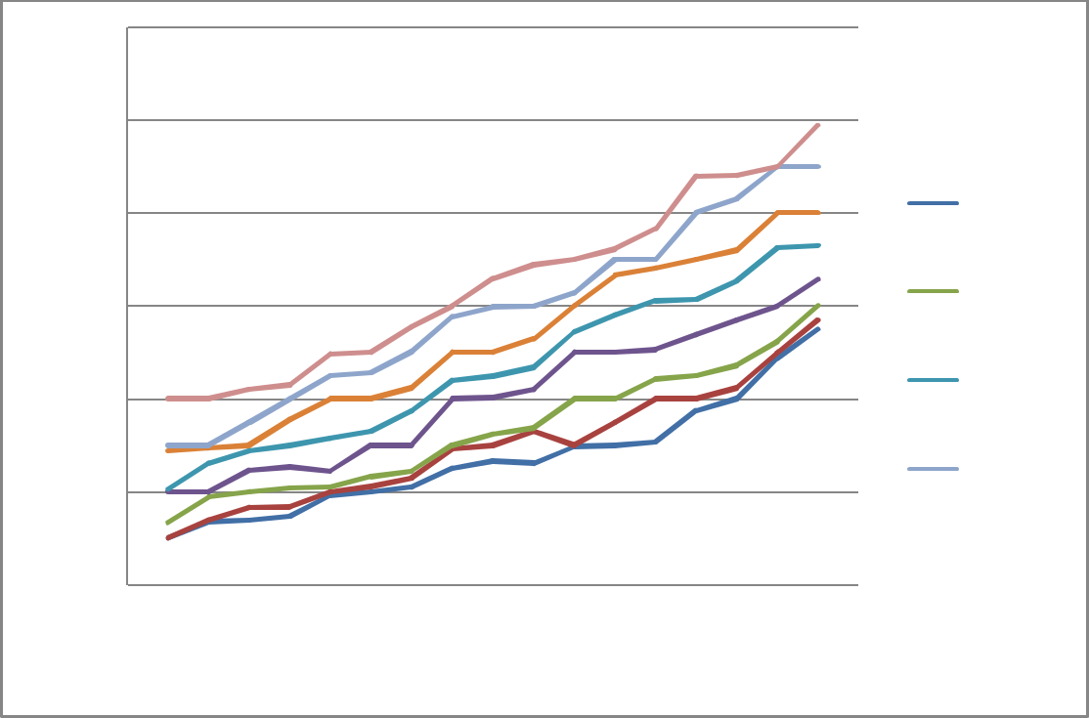

 | 20
 | 18
(mm) | 16
(mm) | 14
RT RPT | 14
 | 12
 | 10
 | 8

0 5 10 15

AGE (YEARS)

3rd %tile

5th %tile

10th %tile

25th %tile

50th %tile

75th %tile

95th %tile

97th %tile

Fig 14: Percentile curve for right renal parenchymal thickness from 3rd to 97th percentile of the studied population

60

A normogram was also generated for left renal parenchymal thickness from the combine data of males, and females’ measurements from 3rd to 97th percentiles and the normal range were given for each age group (table 8a). Table 8b shows left parenchymal thickness in relation to the grouped age.

Table 8a: Normogram of left renal parenchymal thicknesses from the study population

Age | Lt RPT Range | ₃rd | ₅th | 10th | 25th | 50th | 75th | 95th | 97th
(years) | (mm) | %tile | %tile | %tile | %tile | %tile | %tile | %tile | %tile
 |  | (mm) | (mm) | (mm) | (mm) | (mm) | (mm) | (mm) | (mm)
1 | 9.00-13.20 | 9.00 | 9.35 | 9.48 | 10.00 | 10.50 | 11.00 | 12.00 | 13.00
2 | 9.20-13.00 | 9.35 | 10.00 | 10.06 | 10.22 | 10.78 | 11.00 | 12.22 | 13.00
3 | 9.26-14.00 | 9.50 | 10.00 | 10.48 | 10.72 | 10.95 | 11.55 | 12.77 | 13.15
4 | 9.33-14.00 | 9.50 | 10.02 | 10.55 | 10.98 | 11.06 | 12.00 | 13.00 | 13.55
5 | 9.70-14.20 | 10.00 | 10.38 | 10.67 | 11.00 | 11.27 | 12.00 | 13.00 | 13.68
6 | 9.93-14.70 | 10.08 | 10.47 | 10.70 | 11.00 | 11.45 | 12.04 | 13.40 | 13.76
7 | 10.05-15.00 | 10.45 | 10.78 | 10.96 | 11.40 | 11.89 | 12.50 | 13.60 | 14.02
8 | 10.08-15.00 | 10.65 | 11.00 | 11.00 | 12.00 | 12.63 | 13.00 | 14.00 | 14.37
9 | 10.06-15.20 | 10.70 | 11.10 | 12.00 | 12.22 | 12.74 | 13.05 | 14.00 | 14.66
10 | 10.04-16.00 | 10.83 | 11.04 | 12.00 | 12.60 | 12.76 | 13.50 | 14.19 | 14.98
11 | 10.40-16.00 | 11.00 | 11.45 | 12.68 | 13.00 | 13.69 | 14.33 | 14.90 | 15.20
12 | 11.00-16.00 | 11.03 | 12.00 | 12.69 | 13.00 | 14.52 | 14.98 | 15.30 | 15.68
13 | 11.00-16.50 | 11.70 | 12.10 | 13.00 | 13.42 | 14.44 | 15.00 | 15.50 | 15.78
14 | 11.20-17.0 | 11.90 | 12.25 | 13.00 | 14.00 | 14.27 | 15.40 | 16.08 | 16.86
15 | 12.10-17.00 | 12.18 | 13.00 | 13,70 | 14.10 | 14.81 | 16.00 | 16.65 | 17.00
16 | 13.23-18.00 | 13.31 | 13.55 | 14.00 | 15.00 | 15.10 | 16.00 | 17.20 | 17.70
17 | 13.31-18.00 | 13.33 | 14.00 | 14.56 | 15.00 | 15.41 | 16.05 | 17.56 | 18.00


Table 8b: Normogram of left renal parenchymal thickness from the study population by age

 | group
Age | RT RPT | ₃rd | ₅th | 10th | 25th | 50th | 75th | 95th | 97th
(years) | Range (mm) | %tile | %tile | %tile | %tile | %tile | %tile | %tile | %tile
 |  | (mm) | (mm) | (mm) | (mm) | (mm) | (mm) | (mm) | (mm)
1 - 3 | 9.00-14.00 | 9.28 | 9.78 | 10.01 | 10.31 | 10.74 | 11.18 | 12.33 | 13.05
4 - 6 | 9.33-14.70 | 9.86 | 10.29 | 10.65 | 10.99 | 11.26 | 12.01 | 13.13 | 13.66
7 - 9 | 10.05-15.20 | 10.60 | 10.96 | 11.32 | 11.87 | 12.50 | 12.85 | 13.87 | 14.35
10-13 | 10.04-16.50 | 11.14 | 11.65 | 12.59 | 13.01 | 13.85 | 14.45 | 14.97 | 15.41
14-17 | 11.20-18.00 | 12.68 | 13.20 | 13.82 | 14.53 | 14.90 | 15.86 | 16.87 | 17.39
 |  |  |  | 61
Percentile curve shows a gradual increase in the values of left renal parenchymal thickness with respect to age from the 3rd to 97th percentiles (fig 15). No fluctuations were noted.
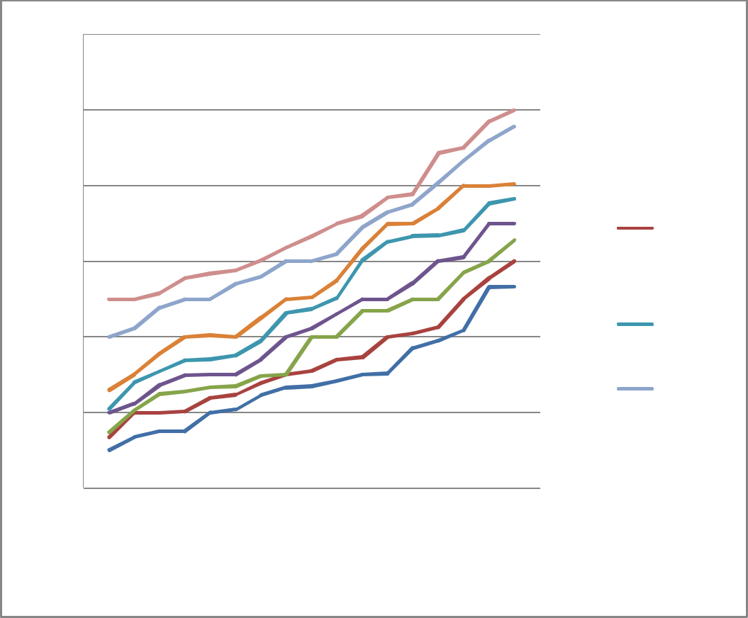

Lt RPT (mm)

20

18

16

14

12

10

8

0 5 10 15

AGE (YEARS

3rd %tile

5th %tile

10th %tile

25th %tile

50th %tile

75th %tile

95th %tile

97th %tile

Fig 15: Percentile curves of left renal parenchymal thickness from 3rd to 97th percentile of the studied population

62

The normogram for right renal medullary pyramid thickness was generated from the combine

data from males’ and females’ measurements because no gender difference in MPT was

noted. The 3rd to 97th percentiles were calculated and normal ranges were given for each age

(table 9a). It was necessary to generate separate normograms for right and left medullary

pyramid thicknesses because the left MPT was consistently thicker than the right though the

difference was not significant. For easy application, MPT was also grouped (fig 9b) because

the difference in MPT for closely related ages was not significant.

Table 9a: Normogram of right renal medullary pyramid thickness from the study population

Age | RT MPT | ₃rd | ₅th | 10th | 25th | 50th | 75th | 95th | 97th
(years) | Range | %tile | %tile | %tile | %tile | %tile | %tile | %tile | %tile
 | (mm) | (mm) | (mm) | (mm) | (mm) | (mm) | (mm) | (mm) | (mm)
1 | 4.50-6.60 | 4.79 | 4.98 | 5.00 | 5.00 | 5.47 | 6.10 | 6.60 | 6.6
2 | 4.60-7.00 | 4.89 | 4.99 | 5.00 | 5.08 | 5.88 | 6.50 | 7.00 | 7.00
3 | 4.90-7.40 | 4.95 | 5.00 | 5.22 | 5.40 | 6.06 | 6.50 | 7.00 | 7.28
4 | 5.00-8.00 | 5.10 | 5.20 | 5.48 | 5.55 | 6.17 | 6.68 | 7.48 | 7.87
5 | 5.00-8.00 | 5.18 | 5.32 | 5.50 | 5.90 | 6.30 | 6.70 | 7.94 | 8.00
6 | 5.00-8.20 | 5.28 | 5.41 | 5.50 | 6.00 | 6.32 | 6.90 | 7.95 | 8.20
7 | 5.00-8.70 | 5.32 | 5.50 | 5.51 | 6.05 | 6.69 | 7.48 | 8.50 | 8.67
8 | 5.10-9.20 | 5.66 | 5.90 | 6.00 | 6.12 | 7.11 | 7.89 | 8.80 | 9.00
9 | 5.50-9.50 | 5.80 | 5.94 | 6.00 | 6.50 | 7.29 | 7.99 | 9.00 | 9.00
10 | 5.90-9.60 | 5.90 | 6.00 | 6.22 | 6.80 | 7.45 | 8.00 | 9.10 | 9.00
11 | 5.90-9.80 | 5.95 | 6.00 | 6.57 | 7.00 | 7.59 | 8.03 | 9.07 | 9.50
12 | 6.00-9.90 | 6.00 | 6.00 | 6.78 | 7.00 | 7.71 | 8.06 | 9.34 | 9.78
13 | 6.00-10.00 | 6.08 | 6.31 | 6.80 | 7.30 | 7.92 | 8.20 | 9.34 | 9.85
14 | 6.30-10.00 | 6.45 | 6.58 | 6.82 | 7.53 | 7.94 | 8.30 | 9.50 | 9.95
15 | 6.00-10.00 | 6.68 | 6.93 | 7.00 | 7.68 | 7.98 | 8.70 | 9.55 | 10.00
16 | 6.90-10.00 | 6.99 | 7.00 | 7.30 | 7.91 | 8.22 | 9.00 | 9.90 | 10.00
17 | 7.30-10.00 | 7.39 | 7.40 | 7.80 | 8.00 | 8.41 | 9.50 | 10.00 | 10.00


63
Table 9b: Normogram of right renal medullary pyramid thickness from the study population

 | by age group
Age | RT MPT | ₃rd | ₅th | 10th | 25th | 50th | 75th | 95th | 97th
(years) | Range (mm) | %tile | %tile | %tile | %tile | %tile | %tile | %tile | %tile
 |  | (mm) | (mm) | (mm) | (mm) | (mm) | (mm) | (mm) | (mm)
1 - 3 | 4.30-7.40 | 4.88 | 4.99 | 5.07 | 5.16 | 5.80 | 6.37 | 6.87 | 6.96
4 - 6 | 5.00-8.20 | 5.19 | 5.31 | 5.49 | 5.82 | 6.26 | 6.76 | 7.79 | 8.02
7 - 9 | 5.00-9.50 | 5.59 | 5.78 | 5.84 | 6.22 | 7.03 | 7.79 | 8.77 | 8.89
10-13 | 5.90-10.00 | 5.98 | 6.08 | 6.59 | 7.03 | 7.67 | 8.07 | 9.21 | 9.53
14-17 | 6.30-10.00 | 6.88 | 6.98 | 7.23 | 7.78 | 8.14 | 8.88 | 9.74 | 10.00

Right renal medullary pyramid thickness was seen to increase gradually from the 3rd to 97th

percentiles (fig16). No fluctuations were also noted.
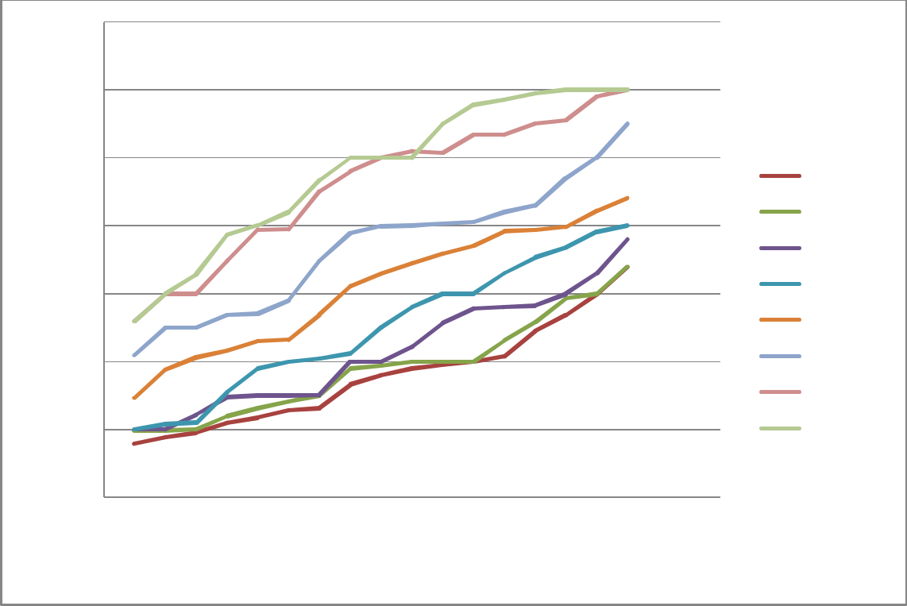

RT MPT (mm)

11

10

9
 |  |  |  | 3rd %tile
8 |  |  |  | 5th %tile
8 |  |  |  | 10th %tile
7 |  |  |  | 25th %tile
7 |  |  |  | 50th %tile
6 |  |  |  | 75th %tile
 |  |  |  | 95th %tile
5 |  |  |  | 97th %rile
4
0 | 5 | 10 | 15 | 20

AGE (YEARS)

Fig 16: Percentile curve for right renal medullary pyramid thickness from 3rd to 97th percentile of the studied population

64

The normogram for left renal medullary pyramid thickness was also generated from the combine data from males’ and females’ measurements from 3rd to 97th percentiles. Normal ranges of MPT for each age group were also given (table 10a and 10b).

Table 10a: Normogram of left renal medullary pyramid thickness from the study population

Age | Lt MPT | ₃rd | ₅th | 10th | ₂₅th | 50th | ₇₅th | ₉₅th | ₉₇th
(years) | range (mm) | %tile | %tile | %tile | %tile | %tile | %tile | %tile | %tile
 |  | (mm) | (mm) | (mm) | (mm) | (mm) | (mm) | (mm) | (mm)
1 | 4.79-7.00 | 4.87 | 4.99 | 5.00 | 5.20 | 5.66 | 6.00 | 6.80 | 7.00
2 | 4.80-7.50 | 4.91 | 5.08 | 5.38 | 5.70 | 6.01 | 6.20 | 7.50 | 7.39
3 | 4.85-7.70 | 4.98 | 5.09 | 5.42 | 5.70 | 6.14 | 6.90 | 7.64 | 7.52
4 | 4.85-8.00 | 5.00 | 5.15 | 5.44 | 5.95 | 6.39 | 7.00 | 8.00 | 8.00
5 | 5.00-8.10 | 5.02 | 5.20 | 5.51 | 6.00 | 6.48 | 7.00 | 8.06 | 8.10
6 | 5.00-8.20 | 5.08 | 5.20 | 5.60 | 6.02 | 6.58 | 7.45 | 8.10 | 8.20
7 | 5.00-8.80 | 5.12 | 5.21 | 5.68 | 6.30 | 6.85 | 7.53 | 8.47 | 8.71
8 | 5.50-9.10 | 5.80 | 5.87 | 5.94 | 6.30 | 7.31 | 8.00 | 9.00 | 9.10
9 | 5.67-9.60 | 5.92 | 6.00 | 6.00 | 6.80 | 7.56 | 8.00 | 9.08 | 9.27
10 | 5.70-9.89 | 6.00 | 6.00 | 6.52 | 7.00 | 7.61 | 8.10 | 9.13 | 9.63
11 | 6.00-10.00 | 6.13 | 6.32 | 6.56 | 7.00 | 7.76 | 8.25 | 9.30 | 9.80
12 | 6.00-10.00 | 6.18 | 6.72 | 7.00 | 7.20 | 7.92 | 8.80 | 9.50 | 9.90
13 | 6.09-10.20 | 6.23 | 6.78 | 7.00 | 7.30 | 7.99 | 8.93 | 9.79 | 10.00
14 | 6.25-10.73 | 6.65 | 6.81 | 7.10 | 7.90 | 8.09 | 9.00 | 9.87 | 10.18
15 | 6.50-10.80 | 6.75 | 7.00 | 7.30 | 8.00 | 8.15 | 9.00 | 10.00 | 10.20
16 | 7.00-10.90 | 7.37 | 7.46 | 7.41 | 8.11 | 8.33 | 9.08 | 10.00 | 10.25
17 | 7.70-11.00 | 7.82 | 7.90 | 8.00 | 8.20 | 8.49 | 9.50 | 10.25 | 10.90


Table 10b: Normogram of left renal medullary pyramid thickness from the study population

 | by age group
Age | LT MPT | ₃rd | ₅th | 10th | ₂₅th | ₅₀th | ₇₅th | ₉₅th | ₉₇th
(years) | Range (mm) | %tile | %tile | %tile | %tile | %tile | %tile | %tile | %tile
 |  | (mm) | (mm) | (mm) | (mm) | (mm) | (mm) | (mm) | (mm)
1 - 3 | 4.79-7.70 | 4.92 | 5.05 | 5.27 | 5.53 | 5.94 | 6.37 | 7.51 | 7.30
4 - 6 | 4.85 -8.20 | 5.03 | 5.18 | 5.52 | 5.99 | 6.40 | 7.15 | 8.05 | 8.10
7 - 9 | 5.00-9.60 | 5.61 | 5.69 | 5.87 | 6.47 | 7.24 | 7.84 | 8.85 | 9.03
10-13 | 5.70-10.20 | 6.14 | 6.46 | 6.77 | 7.13 | 7.82 | 8.52 | 9.43 | 9.83
14-17 | 6.45-11.00 | 7.15 | 7.29 | 7.49 | 8.05 | 8.27 | 9.15 | 10.03 | 10.38
 |  |  |  | 65

Percentile curve for left medullary pyramid thickness also shows increase in the values of MPT from the 3rd to 97th percentiles of the population (fig 17). This indicates increase in renal medullary pyramid thickness with age among the children population
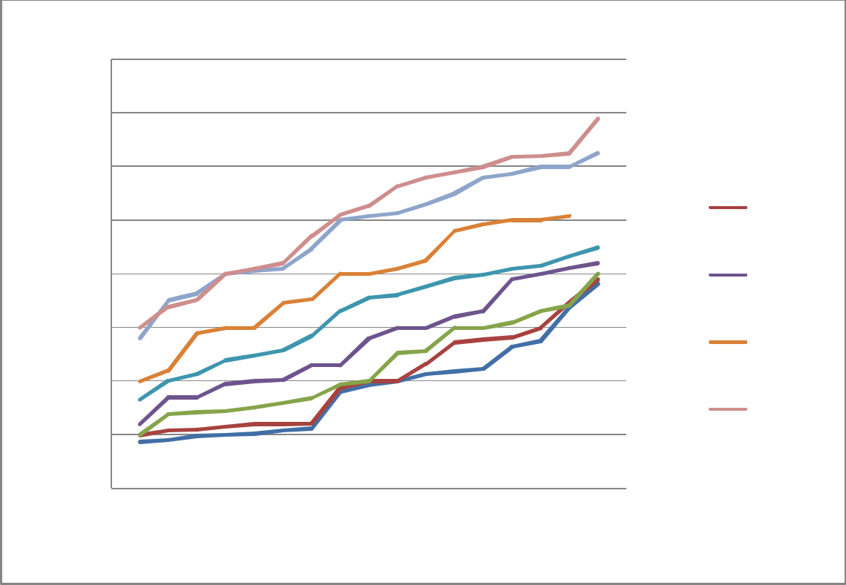

Lt MPT (mm)

12

11

10

9

8

7

6

5

4

0 5 10 15

AGE (YEARS)

3rd %tile

5th %tile

10th %tile

25th %tile

50th %tile

75th %tile

95th %tile

97th %tile

Fig 17: Percentile curve for left renal medullary pyramid thickness from 3rd to 5th percentile of the studied population

66

CHAPTER FIVE

DISCUSSION AND CONCLUSION

5.1.0 Discussion

Ultrasound is an invaluable modality in the assessment of renal pathology. Its availability, low cost, use of non-ionising radiation and easy technique makes it the modality of first line of choice in the assessment of renal pathology. More so, accurate and reliable measurements are obtainable with good experience and changes in renal parenchyma in renal pathology are also well appreciated. Ultrasonography is approximately 90% specific and sensitive in the detection of hydronephrosis and is very effective in the assessment of renal parenchyma (Longo et al, 2012).

Research has shown that ‘an intrinsic paucity in the number of functioning nephrons predisposes to the development of renal disease and this may be associated with development of hypertension in adulthood’ (Longo et al, 2012). The number of nephrons in the renal parenchyma is related to the overall thickness and volume of the parenchyma (Dixit et al, 1994). It has also been observed that the measurement of renal parenchymal thickness provides a more accurate estimation of renal function compared to the one-dimensional measurement of renal length (O'Neill, 2000; Ermanta et al., 2004). However, there is no standard guideline for assessing renal parenchymal thickness as different authors employ different methods. In this study, RPT and MPT were measured at a single point at the mid portion of the kidney perpendicular to its longitudinal axis in accordance with Kadioglu, (2010) and Tuma et al, (2010). This was to obtain a simple parameter which can be reproducible and with low observers error.

The blunting of the apices of the pyramid occurs in hydronephrosis. The renal papillae eventually become cupped (Kumar et al, 2004) and if left untreated may obliterate the

67
pyramid and cortex may be thinned out. Thus, clinicians may use changes in the renal papilla and measurement of renal parenchymal thickness to grade hydronephrosis.

5.1.1 Reliability of renal medullary pyramid and parenchymal thicknesses measurements
Renal medullary pyramid and parenchymal thicknesses were observed to show low intra and inter observers’ variations. This was a major setback in renal volume (Saeed et al, 2012) even though it was noted to be the best estimator of renal size. Renal parenchymal and medullary pyramid thicknesses measurements were simple one dimensional measurement each and are highly reproducible in our study. This implies that where serial monitoring of renal growth is involved RPT and MPT may give a reproducible result.

5.1.2 Normal values of renal parenchymal and medullary pyramid thicknesses in children

The mean values of renal parenchymal thickness were 12.62 ± 1.67 and 12.81 ± 1.73mm while the mean renal medullary pyramid thicknesses were 7.10 ± 0.92 and 7.23 ± 0.94mm on the right and left kidneys respectively. These were observed to be significantly higher and lower for the extreme age groups (that is age one, two, fifteen to seventeen years). Thus, renal parenchymal and medullary pyramid thicknesses were grouped into five unequal age intervals so as to obtain more accurate information for the study parameters. The mean of each class can easily be applicable for clinical studies. Also, the percentiles gotten from the study may be very important for follow up studies.

5.1.3 Comparison of renal parenchymal and medullary pyramid thicknesses in males and females
A comparison of male and female renal parenchymal and medullary pyramid thicknesses revealed no significant difference in this study. This may be because there is no significant

difference in male and females’ build in children until adulthood and renal size is greatly 68
influence by this factor (Saeed et al, 2012). However, there was a slight difference between the right and left RPT and MPT with the left being thicker than the right. This is in agreement with the previous study on children population (Kadioglu, 2010). According to Moore and Dalley (2006), a disparity between the left and right kidney length of more than 2cm is usually pathologic and this of course may be statistically significant. This may also be applicable to RPT and MPT as the left RPT and MPT were only slightly thicker than the right RPT and MPT across all age groups in normal children in the present study.

5.1.4 Relationship between renal medullary pyramid and renal parenchymal thicknesses with age

Renal parenchymal thickness had a positive correlation with age in this study. This agrees with previous studies (Kadioglu, 2010; Saeed et al, 2012). The positive correlation indicates an increase in renal parenchymal substance in children with growth (Hassan et al, 2012) as observed also in other organs. This finding is contrary to what was observed in adults where there is a gradual decrease in renal parenchymal thickness with advancing age especially in the seventh decade of life (Raza et al, 2010; Hussein et al, 2010; Saeed et al, 2012) due to gradual loss of renal parenchymal substance. This observation is also contrary to what was noted during the 3rd to 6th decades in adults where renal parenchymal thickness was found to remain unchanged (Saeed et al, 2012). Goutsoyianis et al, (1990) had earlier demonstrated a negative correlation between renal parenchymal thickness and age in adult healthy subjects where they observed about 10% loss of renal substance at every decade of life with a higher rate occurring at 6th and 7th decades. Thus, the renal parenchymal thickness in this children population exhibits an opposite characteristic growth pattern, showing a gradual increase (gain of renal substance) and may be very useful in the assessment of renal growth in children in post operative renal recovery.

69
Renal medullary pyramid thickness was also observed to show a gradual increase with increasing age but the ratio of renal medullary pyramid thickness to parenchymal thickness (MPT/RPT) was seen to be fairly constant showing no correlation with age. On the contrary, a zigzag pattern of growth was observed in both renal medullary pyramid and parenchymal thicknesses by Kadioglu, (2010). This may be attributed to larger sample size in the present study.

5.1.5 Relationship between renal medullary pyramid thickness and renal parenchymal thickness with height, weight, BMI, and BSA

Renal size is a function of body size as observed in renal length (Ganesh, 2010) and volume (Ermanta et al, 2004). Renal parenchymal thickness exhibits the same relationship . In this study, renal parenchymal thickness was noted to have a positive correlation with height, weight, BMI and BSA. Medullary pyramid thickness also shows positive correlation with all the somatometric parameters. In children there is continuous growth in all the organs till when growth ceases at adulthood. Height, weight, BMI, and BSA increase equally as a child grows and are known factors that influence renal size. Therefore, the assessment of renal parenchymal and medullary pyramid thicknesses should not only be done with respect to a child’s age but also to somatometric parameters.

5.1.6 Relationship between renal parenchymal and medullary pyramid thicknesses with renal length
The relationship between RPT and KL shows a positive linear correlation. This observation is in line with the findings of Okoye et al, (2006) in an adult Nigerian population. The relationship may be changed in the cases of severe hydronephrosis (Zerin and Blen, 1994; Deng et al, 2010) such that renal parenchymal thickness becomes thinned out while renal length increases. Thus, the assessment of renal length would not reveal much about the working condition of the kidney in severe hydronephrosis and in such case renal parenchymal

70
thickness becomes more relevant. In chronic kidney disease, both renal parenchymal thickness and renal length may be reduced (Rogers et al, 1994) or the parenchymal thickness may be significantly reduced while renal length may be within normal limit (Rogers et al, 1994). According to Morghazi et al., (2005), renal cortex may become thinned in chronic renal disease which may result in a reduction in renal parenchymal thickness and this they said correlates with tubular atrophy in histology. The essence of carrying out an investigation is to make early diagnosis of a pathological condition and understanding the relationship between kidney length and renal parenchymal thickness will improve early diagnosis of renal pathology on ultrasound. Therefore, the assessment of both renal parameters is important during renal ultrasound scan. In adult, significant fluctuation were noted in the relationship between renal parenchymal thickness and renal length at renal length greater than 11cm (Okoye et al, 2006). However, such observation was not made in our study. This may be due to the constant growth of the kidney during childhood.

Renal medullary pyramid thickness also was noted to increase with renal length. Renal medullary pyramid is usually prominent in children; therefore, the assessment of this important parameter may be useful for early detection of renal changes in pathological conditions in children on ultrasound.

5.1.7 Renal medullary pyramid thickness to parenchyma thickness ratio

Though renal medullary pyramid thickness and renal parenchyma thickness show gradual increase with age, height, weight, BMI and BSA, no such observation was made in renal medullary pyramid thickness to parenchyma thickness ratio (MPT/RPT) in the study. However, negative insignificant correlations were observed between renal medullary pyramid thickness to parenchyma thickness ratio and the above parameters. This negative relationship between renal medullary pyramid thickness to parenchymal thickness ratio, age and somatometrics may be a pointer to the fact that medullary pyramid thickness insignificantly

71
reduces as growth progresses while the cortex becomes thicker. This maybe confirms by the statement ‘renal medullary pyramid thickness is thicker in young children than in older ones’ Kadioglu 2010. The mean renal medullary pyramid thickness to parenchymal thickness ratio was approximately equal 0.57 on the right and left kidneys and this may be important in assessment of renal parenchymal involvement especially in unilateral renal pathology.

5.1.8 Racial differences in renal parenchymal and medullary pyramid thicknesses Inter racial variations were noted in renal medullary pyramid and parenchymal thicknesses. Nigerian population shows a smaller renal medullary pyramid and parenchymal thicknesses but similar kidney length compared to the Turkish population. However, this comparison may not be very accurate since assessment was done at different subjects’ positions (contralateral for Turkish population and prone for Nigerian population). More so, the sample sizes were not equal.

5.2 Conclusion

Assessment of renal parenchymal and medullary pyramid thicknesses at the middle third of the kidney on longitudinal section by ultrasound has a low intra and inter-observers’ variations. These measurements can, therefore, be adopted for routine used in clinical sonographic practice as the above finding suggests that they are reliable, reproducible and simple to measure. There was no significant difference in RPT and MPT between male and female in this study whereas there was a slight difference between the right and left RPT and MPT with the left being thicker than the right. Renal parenchymal and medullary pyramid thicknesses also showed a positive correlation with age, height, weight, BMI and BSA in children. Normal ultrasound values for RPT and MPT in relation to age were established and can serve as baseline reference values which could be useful for the assessment of renal pathology in the studied population.

72
5.3 Recommendations

- This study suggests that renal parenchymal and medullary pyramid thicknesses should be assessed during renal ultrasound examination.

- Renal parenchymal and medullary thicknesses should be examination using the reference normogram for a given population, because there is a significant difference in renal size among different populations.

- The use of renal parenchymal and medullary thicknesses for the assessment of renal size should always be together with renal length and not in isolation.
- The normogram generated from this study should be used to assess the renal parenchyma only when assessment is done in prone position since there was no assessment for statistical differences in renal parameters obtained in prone position and other positions except when it has been proven.

5.4 Limitations of the study

This study had some short comings which included relatively small sample size. This occurred because most of the schools and parents were unwilling to give their consent for their wards to participate in the exercise. Majority of children especially those in age one to four years were uncooperative thereby making a lot of them to be excluded from the study which further reduced the sample size. Furthermore, no laboratory examination was carried out to assess kidney function. This was avoided purposefully in order to gain subjects cooperation. It is also important to note that only 2 experienced sonographers with 11 years and 5 years of experience in abdominal sonography were involved in this study to determine the intra and inter operator variability in RPT and MPT measurements. This may have biased our results as inexperienced sonographers may have poor reproducibility in the measurements of these renal parameters. Increase in the sample size and the use of many experienced and inexperienced sonographers for the pilot study would have added more credibility to the results.

73
5.5 Areas for Further Study

- Evaluation of renal parenchymal and medullary pyramid thicknesses in paediatric renal pathology in comparison with normal paediatric subjects

- A comparative assessment of renal parenchymal and medullary pyramid thicknesses in supine and prone positions
- Assessment of renal parenchymal and medullary thicknesses in post operative renal recovery

74
REFERENCES

Adibi A, Emami N A, Salehi H, Matinpour M (2008). Renal cortical thickness in adult with normal renal function measured by ultrasonography Iranian Journal of Radiology, 5(3): 163 – 166.

Al-Kahtani M A, Zuleta C, Caviedes-Vidal E, and Garland T (jnr) (2004). Kidney mass and relative medullary thickness of rodents in relation to habitat, body size and phylogeny, Physiological and Biochemical Zoology; 77(3):346-65.

Beuchat C A, (1996). Structure and concentrating ability of the mammalian kidney:

correlations with habitat. American Journal of Physiology 271:R157–R179.

Brennan S, and Kandasamy Y. (2013). Renal parenchymal thickness as a measure of renal growth in low birth weight infants versus normal birth weight infants, ultrasound in Medicine and Biology, 39:2315-20

Buchholz N P, Abbas F, Biyaban S R, Javed Q, and Talati J (2000). Ultrasonographic renal size in individuals without known renal disease, Journal of Pakistan Medical Association, 50(1):12-6

Carrico C W and Zerin J M (1996). Sonographic measurement of renal length in children:

does the position of the patient matter? Pediatric Radiology; 26(8):553-5.

Chapman A B, Blost J E, Torres V E, Guay – Woodford L, and Tybae K (2012). Kidney volume and functional outcomes in autosomal dominant polycystic kidney disease, Clinical Journal of the American Society of Nephrology, www.cjasn.17: 479-86.

Chen J J, Mao W, Steinhardt (2005). MrNomogram: a web based multivariable paediatric

renal nomogram, Journal of Paediatric Urology: 171(5): 436-8.

Chen J J, Pugach J, Patel M, Luisiri A, and Steinhardt (2002). The renal length: a

multivariable approach, Journal of Paediatric Urology, 168 (5): 149 – 158.

75
Deng G, Jun-Jie S, Pa Wang, Jia-Cong M (2010). Renal parenchyma thickness and urinary protein level in patients with ureteropelvic junction obstruction after nephropathy, International Journal of Urology, 17(3): 250-3.

Dixit P R, Sahai S B, Garg A, and Chowdhury (1994): Norms for renal parenchyma volume in Indian children. Indian Paediatrics 31(1) 1059-1064

Emamian SA, Nielsen MB, Pedersen JF, Ytte L (1993). Sonographic kidney dimension: correlation with age, sex and habitus in 665 adult volunteers, American Journal of Roentgenology, 160:83-86

Ermanta H C, Elysanti O M, Windhu P (2004). Body surface area as the predictor of renal parenchymal volume in healthy adult, Folia Medica Indonesian 40(3): 112-120
Flogelova H. (2014). Renal parenchymal thickness in children with solitary functioning kidney, Paediatric Nephrology 29(2): 241-248

Ganesh R, Vasanthi T, Lalitha J, Rajkumar J, Muralinath S (2010). Correlation of renal length with somatic Variables in Indian children, Indian Journal of Pediatrics, 77(3) 326-328

Gourtsoyiannis N, Prassopoulos P, Carvouras D, Pantelidis (1990). The thickness of rnal parenchyma decreases with age: A CT of 360 patients, American Journal of Reontgenology, 155:541-544

Gupta L C and Sahu U C (2007). Diagnostic ultrasound, Jaypee Brothers Medical Ltd, New Delhi, pp 90 – 92.

Guyton A. C and Hall J. E (2006). Textbook of medical physiology, Elsevier Inc. Philadelphia, Pennsylvania, 11th, 307-309
Hassan S M N,Waheeda N, Mansur k, Mohsin K, Rafiqul A (2012). Corticomedullary index of human kidney, Bangladesh Journal of Anatomy 10(1):20-22

76
Haycock G B, Schwartz G J, Wisotsky D H (1978). Geometric method for measuring body surface area: A height-weight formula validated in infants, children and adults. Journal of Pediatrics; 93:62-6.

Hussein A A, Salim A, Jameel A (2010). Anatomical study of aging on human kidney by ultrasound, Tirkrit Medical Journal, 161(1): 60-64.

Kadioglu A, (2010). Renal measurements, including length, parenchyma thickness and medullary pyramid thickness in healthy children: what are the normative ultrasound values? American Journal of Roentgenology, 194:509-515.

Kang Y K, Young J L, Chulpark S, Yong-soo K, and Bum S C (2007). A comparative study of methods of estimating kidney length in kidney transplantation donor, Nephrology Dialysis Transplantation, 22: 2322-2327

Kaplon D M, Lasser M S, Sigman M, Haleblian G E, and Pareek G (2009). Renal Parenchyma Thickness: A Rapid Estimation of Renal Function on Computed Tomography, Clinical Urology: International Brazilian Journal of Urology. 35 (1): 3-8.

Kumar V, Abbas A. K, Fauston N, and Aster J. C. (2004). Robbins and Cotran pathologic basis of disease, Thompson press Ltd, Elsevier India private Ltd, India., 8th Ed, pg 961-2.

Larson D B, Meyers M L, O'Hara S M. (2011). Reliability of renal length measurements made with ultrasound compared with measurements from helical CT multiplanar reformat images. American Journal of Roentgenology; 196: 592-597

Longo D. L, Kasper D. L, Jameson J. L, Fauci A. S, Hauser S. L, and Loscalzo J (2012) Harrison’s principle of internal medicine, Mc Graw Hill Medicine, United States of America, 18th Ed; pg 2396, 2398-9.

77
Moghazi S, Jones E, Schroepple J, Arya K, McClellan W, Hennigar RA, O'Neill WC (2005). Correlation of renal histopathology with sonographic findings, Kidney International, 2005, 67(4):1515-20.

Moore K. L. and Dalley A. F, (2006): Clinically oriented anatomy, Lippincott William and Wilkins, 530 Walnut Street, Philadelphia. 5thed, 244-5
Moore K and Persaud T. V. N. (2008). The developing human: clinically oriented embryology, Elsevier Indian Pvt. Limited. New Delhi, india, 8th ed, 244-246
Njeze N R., Onodugo O D, Ezeofor S, Okeke D O (2011). The effect of advancing age on renal length in South Eastern Nigerians, West African Journal of Radiology, 18(1): 16-18, ISSN-1115-3474.

Okoye I J, Agwu K K, and Eze C U (2006). Relationship between sonographic renal length and renal parenchymal thickness in normal adult, Southeast, Nigerian, West African Journal of Medicine, 25(3): 231-234.

O'Neill WC, (2000). Sonographic evaluation of renal failure; American Journal of Kidney Diseases 35: 1021-1037

Oscar W J (2005). Relative thickness of the renal medulla in birds, Journal of morphology, 142(3) 277-284

Palmar P. E. S (2007). Manual of diagnostic ultrasound, World Health Organization Library, Geneva, Switzerland, pp154-155 ISBN 92-4-154461-9

Ramaswamy K, Marien T, Mass A, Stifelman M, and Shah O (2013). Simplified approach to estimating renal function based on computerized tomography, the Canadian Journal of Urology 20(4): 6833-6839.

78
Raza M, Amina H, Imran M K (2011). Ultrasonography assessment of renal size and its correlates with body mas index in adults without known renal disease, Journal of Ayub Medical College Abbottabad 23(3): 64 -68

Roger S D, Beale A M, Cattell W R, Webb J (1994). What is the value of measuring renal parenchymal thickness before renal biopsy? Clinical Radiology, 49:45-49.

Saeed Z, Waseem M, Raza S, Adil S, Iffat Y, Syed A (2012). Sonographic assessment of renal dimensions in adults and its correlates, International journal of collaborative research on internal medicine and public health 4:1626-1641

Sahni D, Jit I, Sodhi L (2001). Weight and measurements of kidneys in northwest Indian Adults, American Journal of Human Biology; 13: 726-32

Samuel J, Rahul R, Andreea A, Wassin K, Jafar A, Nana G, Edward L, Deborah A B, and Charles O C (2011); Determinants and functional significance of renal parenchymal volume in adults. Clinical Journal of American Society of Nephrology 6: 70-76. www.cjasn.org. DOi: 102215/CJN.00030110.

Schlesinger A E, Hernandez RJ, Zerin JM, Marks TI, Kelsch RC (1991). Inter-observer and intraobserver variations in sonographic renal length measurements in children, American Journal of Roentgenology, 156; 1029 – 1032.

Tuma J, Trinkler F, Zat’ura F, and Novakova B (2010): Genitourinary ultrasound, EFSUMB

– European course book, University of Kosice UPJS Slovakia, Switzerland. www.kosmos-design.co.uk/EFSUMB-ECB/ecb-ch09-urogenital.pdf

Weisenbach J, Horvath M, Jeges S, Adamovich K, Huszart (2001). Normal percentiles of Kidney size in children as measured by ultrasonography. Orv Hetil 142(2) 71-74

Widjaja E, Oxtoby J W, Hale T L, Jones P W, Harden P N and McCall W (2004); Ultrasound measurement of renal length versus low dose CT volume in predicting kidney glomerular filtration rate, British Journal of Radiology, 77:759-764.

www.indianpediatrics.net/sep1994/1059.pdf

79
Yang Y, Shijun J, and Guogui Z (2002). Evaluation of renal function in children with moderate or severe hydronephrosis after operation, Chinese Medical Journal, 115(1): 123-125.

Zerin J M and Blane C E. (1994). Sonographic assessment of renal length in children: a

reappraisal. Pediatric Radiology, 24: 101-106.

Zuzuarregui P J R, Mallios R, Murphy J (2009). The effect of obesity on kidney in a healthy paediatric population, Pediatric Nephrology 24(10):2023-2027

