**DEDICATION**

This report is dedicated to Almighty Allah who protects, guide and spare my life throughout my Student Industrial Work Experience Scheme (SIWES) programme. Glory is to Almighty Allah.

**AKNOWLEDGEMENT**

I show my sincere appreciation to my parents, my supervisor and my friends Na’ada shall, Jubril Abdullahi an Azeez Olatudun for their support during my industrial training programme. I also appreciate the school management and department of electrical engineering management for giving me the golden opportunity to participate in the SIWES programme.

**ABSTRACT**

This report really explained my experience in Student Industrial Work Experience Scheme (SIWES).The report is based on Information Communication Technology (ICT), It covers satellite communication, VSAT TECHNOLOGY (how satellite communicate with the earth station), advantages and disadvantages of satellite communication, Local Area Network (LAN) and brief history and description of my place of establishment.

**TABLE OF CONTENT**

Dedication...........................................................................................................ii

Acknowledgement.............................................................................................iii

Abstract..............................................................................................................IV

List of figures....................................................................................................vii

**CHAPTER ONE**

Introduction.......................................................................................................1

Background........................................................................................................3

Objectives of SIWES..........................................................................................4

**CHAPTER TWO**

Description of place of establishment................................................................5

Location and brief history of place of establishment..........................................7

Objectives of place of establishment..................................................................8

Organogram.........................................................................................................9

Various department of the place of establishment and function........................10

**CHAPTER THREE**

Satellite communication.....................................................................................11

Satellite transponder...........................................................................................11

Uplink and downlink...........................................................................................12

Earth station.........................................................................................................12

Footprint and EIRP...............................................................................................13

VSAT....................................................................................................................14

VSAT component.................................................................................................15

Installation of a VSAT..........................................................................................15

Tools used in installing a VSAT...........................................................................16

How to install Vsat...............................................................................................17

How to configure a modem..................................................................................18

**CHAPTER FOUR**

How to design a simple Local Area Network (LAN)...........................................21

How does a VSAT network works.......................................................................24

VSAT troubleshooting..........................................................................................25

Advantages of satellite communication................................................................27

Disadvantages of satellite communication...........................................................28

Features and benefit...............................................................................................28

**CHAPTER FIVE**

Summary................................................................................................................29

Problems encountered............................................................................................30

Suggestion for the improvement of the scheme.....................................................30

Conclusion..............................................................................................................31

Recommendation....................................................................................................32

**LIST OF FIGURE**

Figure.1 (Galaxy earth station)...............................................................................12 Figure.2.0 (Footprint)..............................................................................................13 Figure.2.1 (EIRP).....................................................................................................13 Figure.3.0 (Vsat outdoor unit)..................................................................................14 Figure.3.1 (Vsat indoor unit)....................................................................................14 Figure.4.0 (C-band)....................................................................................;..............16 Figure.4.1 (Ku-band).................................................................................................16 Figure.5.0 (Compass).................................................................................................17 Figure.5.1 (Tool kit)...................................................................................................17 Figure.5.2 (Spectrum analyzer)..................................................................................17 Figure.5.3 (Crimping tool).........................................................................................17 Figure.6 (Modem)..................................................................................................... 18 Figure.7.0 (Router)......................................................................................................21

Figure.7.1 (Network switch)........................................................................................21 Figure.7.2 (Laptop computer)......................................................................................21 Figure.7.3 (Ethernet cable)...........................................................................................21 Figure.8 (Local Area Network)....................................................................................22

Figure.9 (Vsat Network)...............................................................................................24 Figure.10 (Troubleshooting process)............................................................................26

**CHAPTER ONE**

**INTRODUCTION**

In the earlier stage of science and technology education in Nigeria, students were graduating from their respective institutions without technical knowledge or working experience. It was in this view that student undergoing science and technology related course were mandated for Student Industrial Work Experience Scheme (SIWES) in different institution. In the view of widening their horizon so as to enable them to have technical knowledge or working experience before graduating from their various institution.

The student industrial work experience scheme (SIWES) was establish by the Industrial Training Found ITF in 1973 to enable student of tertiary institution to have basic technical knowledge of industrial work base on their course of study before the completion of their programme in their respective institution.

The importance of SIWES is that the scheme covers all science and technological based student in monotechnics, polytechnics and universities in Nigeria resulting in a high population of student which is easily manage because of the public and private industries that partake in the scheme. SIWES enable industrial known how in their field of study particularly in technology based courses. It also enable students experience the application of theoretical knowledge in solving real life problems.

BODIES INVOLVED IN THE MANAGEMENT OF SIWES

The bodies involve are: Federal Government, Industrial Training Found (ITF), other supervising agencies are: National University Commission (NUC), National Board of Technical Education (NBTE), Nation Council for Colleges of Education (NCCE). The functions of the agencies above include the following:

* Ensure adequate founding of the scheme.
* Ensure SIWES and accredit SIWES unit in the approved institution
* Formulate policies and guidelines for participating bodies and institutions as well as appointing SIWES coordinator and supporting staff
* Supervise student at their place of attachment and sign their log-book and ITF forms
* Vet and process student log-book and forward same to ITF Area office
* Ensure payment of Allowances for student and supervisors.

Therefore the success or otherwise of the SIWES depend on the efficiency of the Ministries, ITF, Institutions employers of labour and general public involved in articulation and management of the programme. Thus the evaluation of SIWES in tertiary institution in meeting up with the need of the establishment of the programme is necessary.

**BACKGROUND**

The Student Industrial Work Experience Scheme (SIWES) was introduce through the curriculum of Nigeria tertiary institution in 1947, as one of the programme to be carried out by Industrial Training Found (ITF).

The Industrial Training Found (ITF) was established under the decree no 47 of 8th October 1971. This organization was mandated to see that industries were closely associated with technical education in and in turn to policy making by 1947, the Federal Government of Nigeria under the leadership of Yakubu Gowan Rtd established SIWES to care for the training of student for man power development for industrial sector toward the national drive industrialization. In Nigeria the duration of SIWES ranges from three month to one year depending on the institution and course of study in particular.

**OBJECTIVES OF SIWES**

The Student Industrial Work Experience Scheme which was established by the Industrial Training Found in 1973 here by has the following objectives;

* To provide an avenue for student in higher institution of higher learning to acquire industrial skills and experience during their course of study.
* Prepare students for industrial work station that they are likely to meet after graduation.
* Expose student for work methods and techniques in handling equipment and machineries that may not be available in their various institutions.
* Provide student with opportunities to apply their educational knowledge in real world situations there by bridging the gap between theory and practical.
* To create an opportunity for social interaction with different categories of students in different institutions thereby encouraging everlasting friendship.
* To prepare student for some future challenges.

**CHAPTER TWO**

DESCRIPTION OF PLACE OF ESTABLISHMENT (GALAXY BACKBONE PLC)

Galaxy backbone is a public enterprise of the federal government incorporated in2006 with the primary mandate of setting up and operating a unified Information and Communication Technology (ICT), in formation platform that address the connectivity and other technical imperative for Ministries Department Agencies (MDA) of the federal government. The co was also change with operating a nationwide network backbone to help to facilitate rural communities toward the realization of their goal.

To fully achieve its mission and business objectives, galaxy is committed to operate as a commercial entity by leveraging it existing assets to extend product and services offering to the market place. Galaxy offers a full range and enhances quality of service designed to meet the challenges facing the various sector, public and private of the Nigeria economy.

VISSION

Our vision is to be the leading enabler of digital inclusion of the Nigeria economy.

MISSION

Our mission is to drive national development through the provision of pervasive ICT infrastructure and services to public institutions, under-served communities and other stakeholders.

VALUES

* Initiative and innovation
* Passion and commitment to excellent result
* Accountability and integrity
* Customer centric
* Team work.

SERVICES

Getting a reliable internet services at cost efficient prices have been difficult for most organisation, low-cost service providers have offered poor services both in quality of the link and in response to resolve customer(s) issues when they arise. Higher quality service providers are so costly that it has become uneconomical to secure more than a fraction of the desired internet bandwidth. Typically no more than 512k for a large capacity.

With this GALAXYBACKBONE Plc. have been able to sufficiently offer the following services at low cost effective prices;

* High quality internet services for both public and private sectors.
* Video conferencing
* Interactive distance learning
* Web hosting
* Mail services etc

LOCATION AND BRIEF HISTORY OF ESTABLISHMENT

Galaxy backbone plc is located at no 61, Adetokumbo Ademola Crescent, Wuse 2, Abuja, Nigeria.

In 2004, a federal executive council member observed the increasing proliferation of desperate IT works and asset across federal government MDA, and sought to streamline this effort by constituting for the harmonization of the IT infrastructure initiative. Following the recommendation of federal executive council committee on the harmonization of government, IT infrastructure asset, president of the federal republic of Nigeria directed that a company be established to consolidate and integrate all the disparate existing government owned network into single holistic government wide network based on the presidential directives. Galaxy backbone was incorporated in 2006 as a public limited liability company. In order to fully achieve it mission and execute it mandate, the company shall operate as a commercial entity even though its 100% wholly own by the federal government of Nigeria.

**OBJECTIVES OF GALAXY BACKBONE**

Galaxy backbone plc is expected to achieve the following objectives;

* Support attainment of digital inclusion for all, by providing connectivity to rural and underserved community in the country.
* Avoid duplication of resources save cost and make best use of available resources.
* Provision of required ITC infrastructure platform to support the government reform programme.

**VARIOUS DEPARTMENTS OF THE ESTABLISHMENT AND THEIR FUNCTION**

Galaxy backbone has the following department with their functions

NETWORK OPERATING CENTER (NOC):

* They monitor network traffic and make sure the network is up always
* They help in creating and commissioning a site for vsat customers
* Diagnosed problems and remotely fixed them, escalate fault incident or commissioning problems to NOC manager when unable to resolve within one hour
* Weekly backup of hub components
* Help in assigning bandwidth to customers depending on what the customer requested for.

IP IMPLIMENTATION:

* They help in assigning IP address for all the customers
* Help in configuration of IP phones for their customers
* Help in configuring a router for the Vsat customers

FIELD SUPPORT:

* They went to site and help in the installation of a vsat for the vsat customers.
* They help in configuration of a satellite modem
* They help to solve customer problems when ever any issue arises.

DATA CENTER:

* They deal with security issues
* They create an e-mail for all galaxy staff
* They help to resolve internal problems that occur within the company

**CHAPTER THREE**

**SATELLITE COMMUNICATION**

A communication satellite is an electronic device specialized wireless receiver transmitter, receiving radio waves from one location and transmitting them to another location that is launched by a rocket and placed in an orbit around the earth.

Satellites are of different type based on their orbit around the earth. We have the low earth orbit (LEO), the medium earth orbit (MEO) and the geostationary orbit (GEO). The LEO satellites are about as big as the size of a car. Since 1993 satellite has been classified by weight.

|  |  |
| --- | --- |
| Size | Weight(Kg) |
| Pico sat | Less than 1 |
| Nano sat | 1-10 |
| Micro sat | 10-100 |
| Small sat | 100-1000 |
| Standard sat | More than 1000 |

Different kinds of satellite are used in different situations for different purposes but they all have a great deal of equipment inside them. The geostationary earth orbit satellite are been used for communication.

**SATELLIITE TRANSPONDER**

The most important of a telecom satellite is the transponder. The word transponder is compounded from Transmitter and responder. This is a piece of electronic equipment inside the satellite that act like a microwaves repeater, which receives, amplifies and re-transmitted the incoming signal back to earth in to it footprints. Each transponder support a small portion of total operational frequency bandwidth also known as space segment of the satellite. Common transponder bandwidths are 36MHz and 54MHz.

**UPLINK AND DOWNLINK**

Before you can communicate with a satellite there must be a transmission from the earth station to the satellite and transmission from the satellite to the earth station. Transmission from the earth station to the satellite is called *uplink*, while transmission from the satellite to the earth station is called *downlink*.

EARTH STATION

The earth station provides the communication link to a communication satellite. The earth station is usually an antenna or satellite dish that include a low-noise amplifier, a down link converter as well as electronic receiver. The antenna itself can vary in size, shape, diameter, and azimuth, elevation fixed or tracking. It is important that technician appreciate the theoretical aspect of antenna, in other to react effectively when the earth station has to be re-position. Galaxy backbone plc earth station is as shown below.

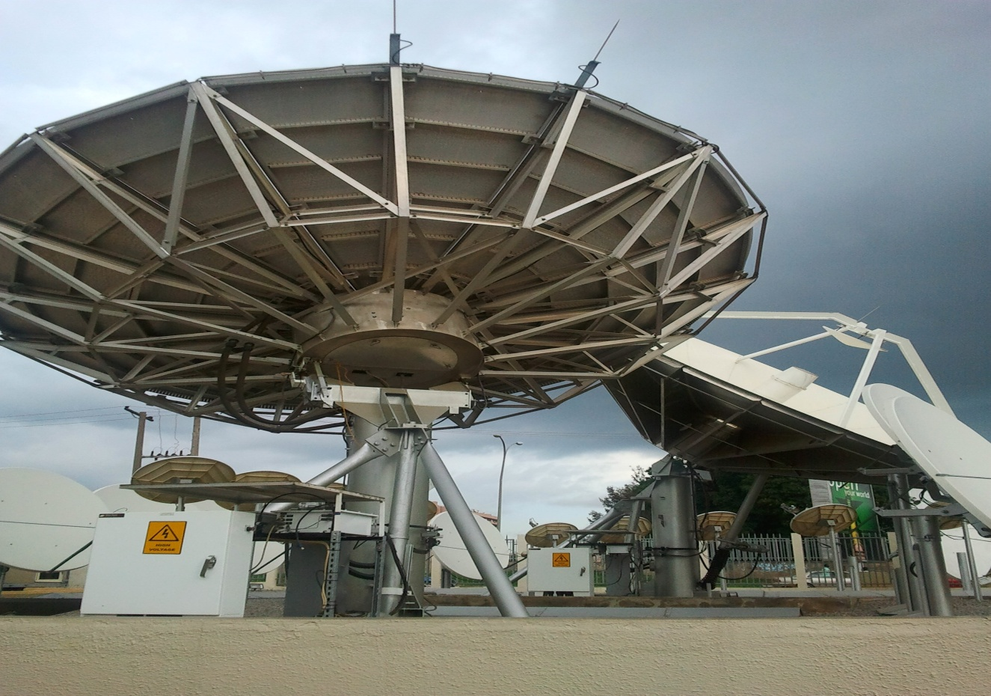

Fig.1 Galaxy earth station

**FOOTPRINT AND EIRP**

The footprint is the geographical area toward which a satellite directs it signal or conversely the area from which the satellite is visible on the surface of the earth. The measure of the signal strength of this footprint is the Effective Isotopic Radiated Power (EIRP) express in decibel. It is important to note that there is an inverse relationship between the EIRP and the antenna diameter, the higher the EIRP the smaller the required dish.

A station which is located near the centre of the footprint will have an advantage in the receive signal compared to another beam satellite. The diagram for footprint and EIRP are shown below.

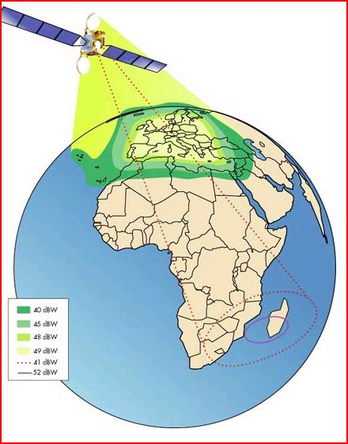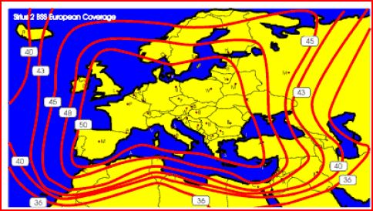

Fig.2.1 EIRP

Fig.2.0 Footprint

A footprint

Satellite can be used for network communication, weather forecasting, internet access and global positioning system. One way to communicate across satellite network is through VSAT.

VSAT

VSAT is a device known as an earth station that is used to receive satellite transmission. VSAT stands for very small aperture terminal and refers to receive-transmit terminals install at disperse site, connecting to a central hub via a satellite using small dishes. The major of the VSAT is the antenna along with the attached low-noise blocker (LNB) which receives satellite signal and block up converter (BUC) which send signals make up the VSAT outdoor unit (ODU), which is one of the component of the a VSAT station.

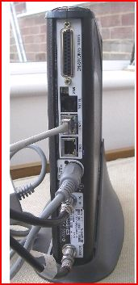 The second component of VSAT earth station is the indoor unit (IDU). The indoor unit is like a modem that contain receiver and transmitter boards and an interface to communicate with the user existing in house equipment, LAN services, PCs, TV kiosk etc. The indoor unit is connected to the outdoor unit with a pair of cable.

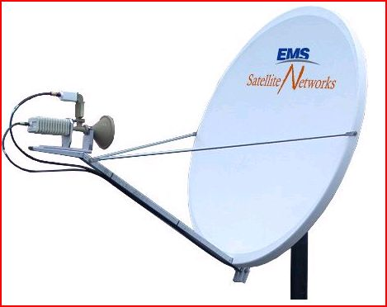

Fig.3.1 VSAT indoor unit

Fig.3.0 VSAT outdoor unit

The key advantage of a VSAT earth station versus a typical terrestrial network connection is that VSAT are not limited by the reach of buried cable.

A VSAT earth station can be placed any were as long as it has an un-obstructed view of the satellite. VSAT are capable of sending and receiving all sort of video, data and audio content at the same high speed regardless of their distance from terrestrial switching offices and infrastructure.

VSAT COMPONENT

As discuss earlier the VSAT consist of two main components which are the outdoor unit and the indoor unit.

OUTDOOR UNIT: the outdoor unit includes the dish and the feed arm which holds the active component i.e. the transmitter and the receiver these are picture below;

* Dish: it is made up of a fibre glass with an embedded wire mesh. The dish help to reflect the signal coming from the satellite to the LNB, the dish varies in diameter and size.
* Feed arm: these help to hold the electronic component of the VSAT like the LNB and BUC.
* LNB: These stands for low noise block converter, it serves as the receiver. It is used to amplify and convert frequency out route signal receive by the antenna for input into the modem via the sat in cable.
* BUC: these stands for block up converter and also serves as transmitter. It is used to translate frequency and power amplifies in route signal from the modem and out put them to the satellite.

INDOOR UNIT: the indoor unit is the modem that supplies dc power to the LNB and BUC. It also transmit the in route signal and receive the out route signal. Both out route (received) and in route (transmit) signal operate at L-band between the modem and outdoor electronics.

INSTALLATION OF A VSAT

Installation of a VSAT can be a challenge unless the installer has a considerable experience in performing the task. The installer has to look for a very good site in which the topography is good.

There are different type of dish the installer can use in installing a VSAT depending on what task he want it to perform. Different dish has its own unique characteristic, advantages and disadvantages. The most common type of dish used today is the *c-band* and*ku-band* satellite dish. The diagrams are shown bellow.

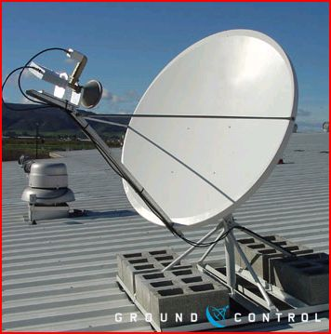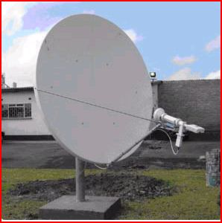

Fig.4.1 C-band

Fig.4.0 ku-band

c-band

C-BAND

The c-band satellite dish is a bigger dish of about 2.4m with a smaller frequency of about 500MHz. It signal cannot be affected by a weather but hav the problem of interference.

KU-BAND

The ku-band is a smaller dish of about 1.2m in diameter with a higher frequency of about 2500MHz. It does not have the problem of interference but it signal can be affected by a weather, most especially rainfall which can lead to lost of signals.

TOOLS USED IN INSTALLING A VSAT

The following tools can help in the installation of VSAT

* COMPASS: these tool help to determine the direction that the antenna will point i.e. the azimuth.
* INCLINOMETER: these tool help to determine the angle the antenna will point i.e. the elevation
* CRIMPING TOOL: these tool is used in cutting and making a lan cable.
* SPECTRUM ANALYZER: This tool is used for finding the proper satellite peaking and in setting cross polarization.
* SPANNERS AND SCREWDRIVERS.

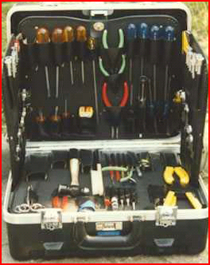

Fig.5.0 Compass

Fig.5.1 Tool kit

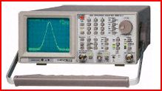

Compass

Fig.5.3 Crimping tool

Fig.5.2 Spectrum analyzer aanalyzer

HOW TO INSTALL A VSAT

* Look for a site of good topology were you will mount your dish. Then assemble your vsat and make sure the antenna is align at the centre of the dish.
* The antenna is made up of the outdoor unit which consist of the BUC and LNB.
* Fixed one coaxial cable to LNB (Rf in) of the outdoor unit, and fixed the other end of the cable to the receiving port (sat in) of the indoor unit.
* Also fixed another coaxial cable to BUC (Rf out) of the outdoor unit, and the other end to the transmitting port (sat out) of the indoor unit.
* Plug in an Ethernet cable to the LAN port of your indoor unit and the other end to your computer

Then you proceed to antenna tracking. Tracking enable you to find the proper satellite peaking by adjusting your antenna to get a good signal strength.

Note the indoor unit which is the modem have to be fully configure before you can communicate across the internet.

HOW TO CONFIGURE A MODEM (THE INDOOR UNIT)

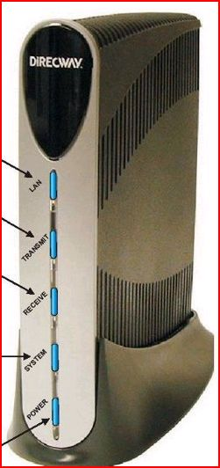\

Fig.6 Modem

The indoor unit has five indicators as shown above the LAN, transmit, receive, power and system. All the indicators will be on when the modem is fully configured and is functioning properly. The following are steps in configuring a modem;

* Power on the modem and the computer, connect one end of Ethernet cable to your computer and the other end to the modem
* 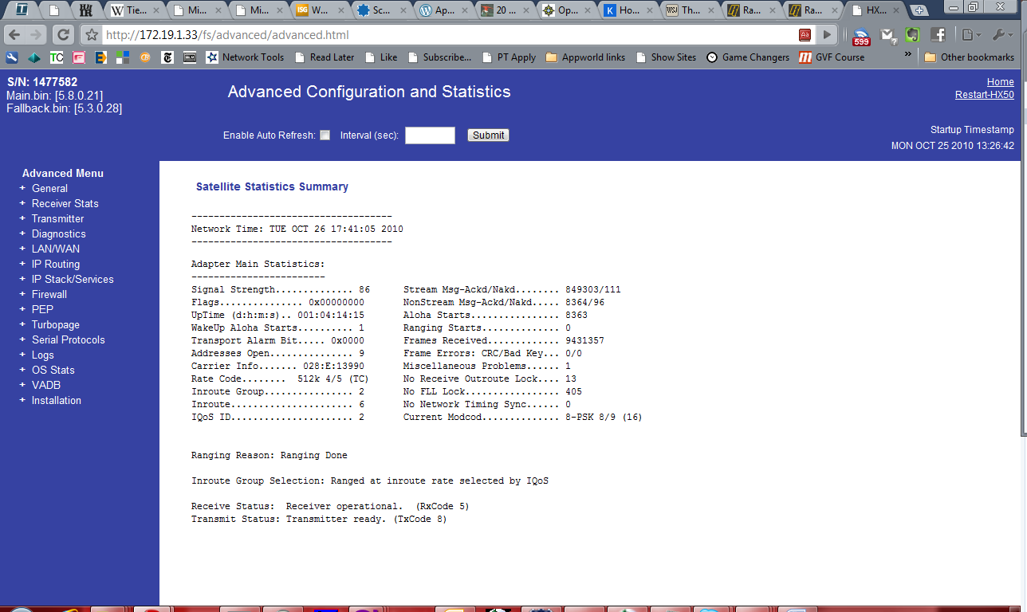Log on into the modem by typing in the default IP address which is 192.268.0.1 into the web browser. These will take you to the modem home page as shown bellow.
* Click on installation at the left hand side of the page, go to setup, then click on manual commission which will display a page that will enable you fill in some parameters like the satellite parameters, vsat parameters, lan parameters etc and click on save. The parameters will be provided by your service provider.
* Then your modem will download some software, and then by this time all the modem indicator would have been on.
* You have successfully configured your modem which will now take you to the status page. The status page must indicate a green button as shown in the next page. Then you can now design your own Local Area Network which will be discussed in the next chapter.

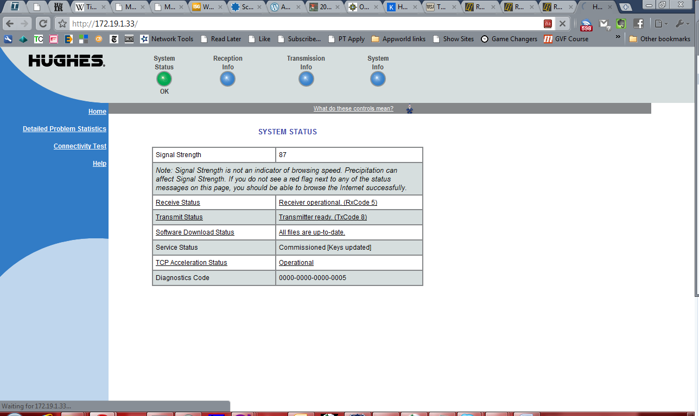

Modem status page

**CHAPTER FOUR**

HOW TO DESIGN LOCAL AREA NETWORK (LAN)

A local area network or LAN is a group of interconnected computers that can share data among one another. Always LAN are set up using Ethernet cables connecting Ethernet card install on each computer to a hub switch or router. These joining devices must have enough port on it, so that all computers to be connected to the LAN be plug into it. A LAN may be but need not by definition provide access to internet.

REQUIREMENT OF A LAN

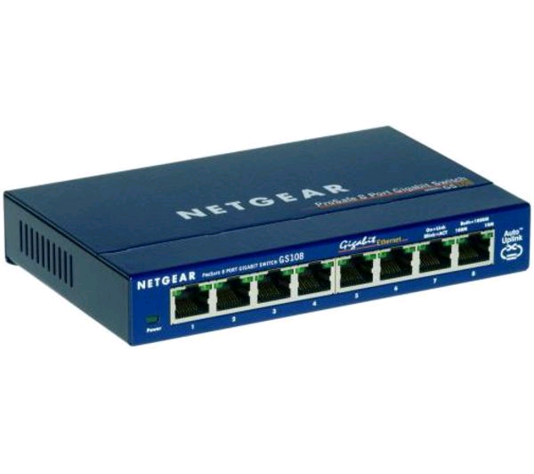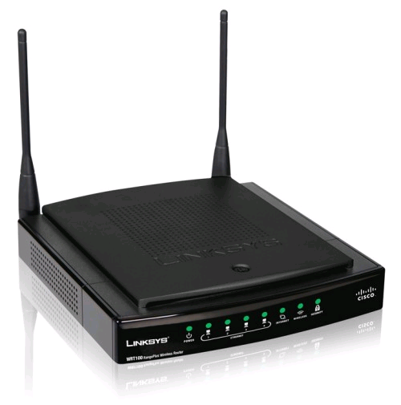Below are the devices you will need to design your Local Area Network:

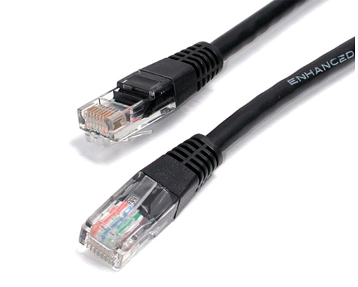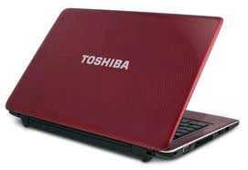

Fig.7.1 Network switch

Fig.7.0 Router

Ethernet cable

Fig.7.3 Ethernet cable

Fig.7.2 Laptop computer

* Service provider: this are the company that provide internet service i.e. allow you to have access to internet
* Network card: it is an expansion board or interface that makes your computer connect to the internet. Network card usually come with modern PCs were you plug in your LAN cable.
* Router: a router is a device that forward data packet along a network. A router is connected to at least two networks, commonly two LANs. Routers are located at gateways i.e. place were two or more network connect.
* Network switch: This is a small hardware device that joins multiple computers together within one local area network.
* Ethernet cable: these are used to connect network device such as modem, router, switches and computer. It transmits data using some internet protocol and usually comes with eight pins.

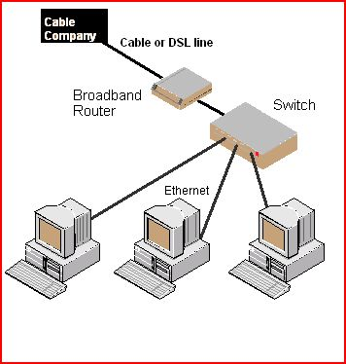INSTRUCTIONS

Fig.8 Local Area Network

Connect an Ethernet cable to the wall jacket provided by your service provider to your router, then connect another Ethernet cable from your router to your switch. The switch has many port in which you will connect an Ethernet cable to your computer depending on the number of computer you want to be connected. Then you can start browsing with your computer. Note your router and computer has to be configured be for you can start browsing the internet.

**CONFIGURING THE COMPUTER**

Turn on all the computers, run the network wizard on each computer. To access the wizard go to the start menu and click on “network” or ”network connections” depending on if you are running window xp or vista thins may be label differently but under network connection there should be button for sharing internet connection or setting up a network that open the network wizard. The wizard will take you through a relatively simple process and configure the computer for networking.

**CONFIGURING THE ROUTER**

Connect the serial connector to your computer and the other end to the console port on the router. Power on your router, wait for the stop scrolling through the screen. You will be prompted by the following message.

Would you like to enter the initial configuration dialog? [yes/no] if you enter no, you will be prompted to terminate the auto install and configure the router manually. The first set of instruction are for configuring the host name, a password and IP address of the on the local internet interface. At the prompt issue the following command.

Router>enable

Router#configure terminal

Router(config)# hostname type the name you want for the router

Router(config)# enable secret type your password

Router(config)# fastethernet 0/0

Router(config-if)# IP address type your IP address

Router(config)#no shutdown

Router(config)# fastethernet 0/1

**HOW DOES A VSAT NETWORK WORKS**

A Vsat network has 3 components:

* A central hub (earth station)
* The central satellite
* Unlimited number of Vsat earth station in various location.

The Vsat as already describes are the devices used in remorsed locations to provide location to the precise site through the network hub. Content typically originate at the hub. It is also equipment and software used to control the satellite network are located.

In the simplest configuration,outbound information(from the hub to the Vsat) is up to the communication satellites transpondeswhich receives it, amplifies it and beams it back to earth for reception by the remotes Vsats.The remote Vsat send information in bound ( from the vsat to the hub) via the same satellite transponder to the hub station.

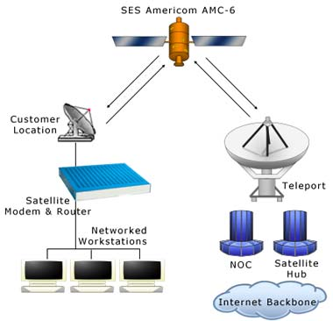

Fig.9 Vsat Network

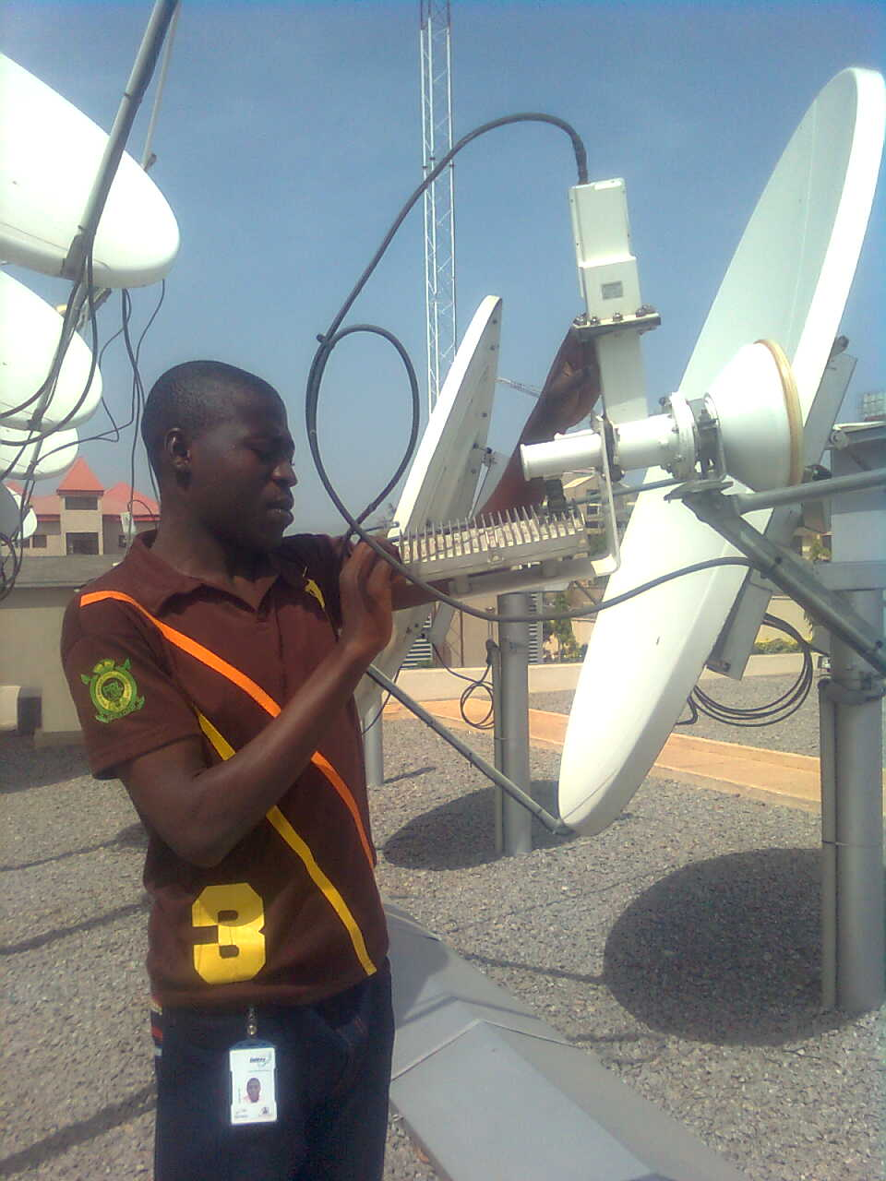**VSAT TROUBLESHOOTING**

Running a satellite communication network is quite a challenge, a huge amount of extremely remotely located pieces of equipment has to play together to ensure satisfaction of the customer who is expecting a highly reliable end to end data connection. However, equipment can breakdown or can be incorrectly setup, a thunderstorm can cause poor signal quality from a ground station. The example illustrates the complexity that the satellite communication faces.

**THE TROUBLE SHOOTING PROCESS**

The satellite communication troubleshooting process is similar to troubleshooting in many other domains. It can decomposed in the following

* Fault detection: identifying that some part of the network has a problem(yet not knowing what the problem is)
* Diagnosis creation : investigation of the problem, to identify the route cause (what is the problem)
* Solution deployment : once the root cause of the problem has been identified a solution has to be deployed in to the system

SOLUTION

DEPLOYMENT

DIAGNOSIS

CREATION

FAULT

DETECTION

Fig.10 troubleshooting process

Some problems that are likely to occur in a VSAT network and their suggested solution are as follows;

* Transmit light not on: if the transmitting light of the modem is off that means the modem is not sending any data to the satellite

Likely causes

Cable not properly fixed into BUC of the antenna and the transmit port of the modem

Bad BUC

Suggested solution

Ensure tight connection

Change BUC

* Receive light not on: these means that the modem is not receiving any signal from the satellite

Likely causes

Cable not properly connected to the LNB of the antenna and the receive port of the modem

Bad LNB

Suggested solution

Ensure tight connection

Change LNB

* Poor signal quality: if you are having a poor signal in your network it can cause your link to be slow

Likely causes

Antenna not pointing to exact direction

Poor weather

Suggested solution

Point your antenna to the right direction

Wait for a clear weather

**ADVANTAGES OF SATELLITE COMMUNICATION**

Once in orbit and operation the quality of service provided by satellites is exceptionally high and far more reliable than the terrestrial links. The following are the advantages of satellite communication.

* High reliability i.e. no dug up cable
* Cost are independent of distance or location
* Services can be provided directly to users facility
* Wide area of coverage is readily available
* Customers may choose network topology it prefers
* Rapid access to undeveloped area
* It can carries a larger bandwidth i.e. amount of data.

**DISADVANTAGES OF SATELLITE COMMUNICATION**

Disadvantages of satellite communication are the unfamiliarity with the technology. Below are some of the technical disadvantages of satellite communication.

* Losses breakdown: each satellite launch ends in either success or failure i.e. no middle way.
* In orbit failure: after a successful launch or operation, it is possible to lose contact or face mechanical or electrical problems.
* The signal can be affected by weather.

**FEATURES AND BENEFITS**

* Scalable, high performance internet protocol IP system that provide high bandwidth forward and return channels
* Enable broadband internet access by leveraging the unique advantages of satellite-based network in providing point to point transmission
* Guaranteed information rate for each network location
* Lower-cost terminal because fewer hardware component are needed.

**CHAPTER FIVE**

**SUMMARY**

The vsat entire network has got a satellite main hub with an antenna measuring as to11meter segment. Vsat configuration is made up of two segment, were one segment is known as earth segment. This segment has equipment both at the central hub and at remote location. The other segment is known as the space segment. Vsat space segment is linked to and from the satellite.

Satellite segment in the sky serves as a radio frequency repeater, when vsat send information to the satellite in the sky, it received, amplify the information and retransmit on a higher frequency. As the information is being transmitted, much of the work is being done in the ground were the hub control and regulate the entire operation of the communication network.

A hub in vsat network consist of network management system which accumulate data on the system giving the system health check and providing billing information. For vsat network to operate it has to be in a position of geostationary orbit, which is relatively high from the ground normally around 38,800Km from equator

There has to be a remote terminal which consist of two unit one placed outdoor directly connected to the satellite while one placed indoor and connected to users devices. When connecting the vsat network, the central hub is located near the user’s main office or at the central location was the host computer is. The hub normally enables the connection via satellite of all the vsat terminals within the network and any other communication from host to the vsat

**PROBLEMS ENCOUNTERED**

During my six month SIWES program, I have encountered the following problem in my place of attachment;

* There are fewer staff in my place of attachment, thereby making them too busy to attend to the IT students.
* The working hour is too long thereby making me not to have time for myself in engaging in other activities.
* The IT student are not restricted to a particular work, work are assign to the coppers and staff.

**SUGGESTION FOR THE IMPROVEMENT OF THE SCHEME**

* The company should employ more staff in other to be able to attend to the IT student in other to improve their skills.
* The company should at least trained the IT student for a particular work, instead of sitting down idle. This will make them to be more serious and punctual.

**CONCLUSION**

The engineering discipline is practical in nature and mainly hinged on experience. Hence there is a great need for any student aspiring to be a professional engineer to have some forms of work experience while studying at school, in a reputable engineering firm to his/her course of study

The SIWES program has exposed me to practical work, which enable me to relate what I learnt in school to real world situation.

**RECOMMENDATIONS**

As a result of difficulties experience during the six months SIWES program, I will like to recommend the following changes:

* The ITF should make monthly allowance available for students, so as to put end to financial difficulties that may arise as a result of transportation problem
* The institution must confirm that each student partake in the industrial training program, by making sure that they pay every student a visit before the end of the program
* The institution and ITF should help the student to get the place of attachment, so that the program will commence as planned.