**CHAPTER ONE**

**1.0 INTRODUCTION**

The student industrial work experience scheme (SIWES) is appreciable skill program, which forms part of the approved minimum academic standard in the various degree programs for all the universities. The scheme bridges the gap existing between theory and practice of the engineering and technology, sciences agriculture, medical and other professional education programs in the Nigerian tertiary institution. It is aimed at exposing and equipping student to the real life working experience. The training lasted for six (6) months, which involve the students, universities and the industries. SIWES was established by the federal Government of Nigeria and is jointly coordinated by the Industrial Training Fund (ITF) and National University Commission (NUC).

**1.1 AIM AND OBJECTIVE OF SIWES**

SIWES is aimed at providing skills for student in their various fields. Some of the various objectives why the program was put in place are:

1. To provide an avenue for student in institution of higher learning to acquire skill and experiences in their course of study.
2. To prepare student for the industrial work situation they are to meet after graduation.
3. To expose student to work methods and techniques in handling equipment and machinery that may not be available in their institution.
4. To make the transition from the school to the world of work easier, and enhances students contact for later Job placement.
5. To provide student with an opportunity to apply their knowledge in real work situation thereby bridging the gap between theory and practice.
6. To enlist and strengthen employers involvement in the entire education process and prepare students for employment after graduation.

1.2 **DESCRIPTION OF THE ESTABLISHMENT OF THE ATTACHMENT**

The establishment is called Ad’mas I.T PLACE; it is an information and communication technology company with broad expertise in ICT consultancy. Ad’mas Digital Technologies ltd (RC 365322) is a Nigerian based telecommunications and technology conglomerate in co-operated in 1999 and offering a wide range of automated and integrated solution in broad spectrum of computers and telecommunication technology. This large technology-oriented corporation is on record to be the cheapest source for high quality goods and services and has a high reputation for performance in customization, distribution and after-sales services of laptop, desktops, printers, software and all kinds of system accessories, security gadgets and communication equipment’s supplies, maintenance, software development, training and software customization.

1.3 **OBJECTIVES AND VISION OF AD’MAS IT PLACE**

1. To serve as a catalyst for both individual and collective development through the provision of cutting edge technological server’s solution, resources and guidance.
2. To produce professionals in this era of global technologies.
3. To offer a wide range of automated and integrated solution in broad spectrum of computer and telecommunication.
4. To build bridges between need and the solution.
5. Ad’mas IT PLACE is position to offer unique and innovative solution to client in terms of technologies.
6. Our vision is to become the leading full-service information and communication technology.

**1.4 COMPANY’S AREA OF SPECIALIZATION**

With a team of seasoned computer Engineers and Programmers with proven track records in computer and communication business, the company offers the following wide areas of specialization

1. Repairs, Assembling and Maintenance of computers
2. Sales and Lease of all up-to date Computers, Computer peripherals and other consumables
3. Sales of Photocopying and Fax Machines
4. Software Development and Maintenance
5. Computer Networking and Maintenance
6. VSAT Installation and Maintenance, Radio and other communication equipment
7. Internet and E-mail Services
8. Training Services

**1.5 DEPARTMENTS IN THE COMPANY**

1. Computer repair and maintenances department
2. Networking department
3. Software development department
4. Sales department
5. Internet café
6. Web design department
7. Computer appreciation department
8. Desktop Publishing department

**1.6 ORGANIZATIONAL CHART OF AD’MAS IT PLACE**

BOARD OF DIRECTORS

BRANCH MANAGER

MANAGING DIRECTOR

HOD TRAINING

ADMIN MANAGER

MARKETING MANAGER

PURCHASE AND SALES MANAGER

ACCOUNT/OPERATION

CASHIER

SALES OFFICERS

student

EXECUTIVES

**CHAPTER TWO**

**2.0 INDUSTRIAL EXPERIENCE**

**HARDWARE SECTION (DEPARTMENT)**

**2.1 HARDWARE:** Hardware is the physical equipment needed for a computer to function proper.

**2.2** **HARDWARE COMPONENTS** Hardware comprise of the following components:

**CASE**: This is also called a tower or housing, it is the box that encloses many of the parts (components) discussed below.

**POWER SUPPLY:** This is used to connect all of the part of the computer to electrical power. You can found it at the back of the computer.

[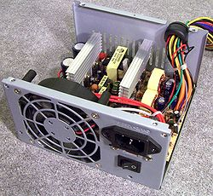](http://en.wikipedia.org/wiki/File:PSU-Open1)

**FAN:** A fan is needed to disperse significant amount of heat that is generated by the electrically powered parts in a computer it prevent over heating of the various electronic components.

**MOTHERBOARD:** This is a large electronic board that is used to connect the power supply to various/other electronic parts and to hold these parts in place on the computer. The computer memory (RAM) and processor are attached to the motherboard. On the motherboard you also see the BIOS (Basic Input and Output System) chip that is responsible for some fundamental operation of the computer such as linking hardware and the software. Motherboards also contain small battery that looks like a watch battery and the chips that work it to store the system time and other computer settings.

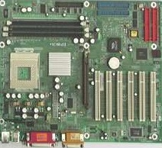

**Motherboard**

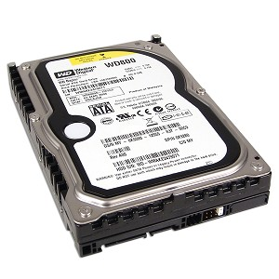**DRIVES:** This are devices used for long time storage of information. The main storages for a computer is the internal hard drive (also called a hard disk).

Hard drive

**CARDS:** Cards is used to describe important tools that allow your computer to connect and communicate with various output devices. The term card is used because these items are relatively flat, we the sound card, video card, a network card and a modem.

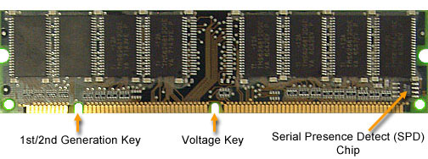**RAM:** Ram is abbreviation for Random Access Memory. It is a short term memory that is used to store documents while they are being processed. Also note that the amount of RAM in a computer is one of the factors that affect the speed of a computer.

**Ram**

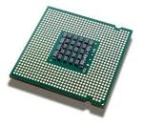**PROCESSOR:** Processor is the main ‘brain’ of the computer system. It performs instructions and calculation that are needed and managed a flow of information through a computer. Processors are continually evolving and becoming faster and more powerful. It is measured in MHz (megahertz) or GHz (gigahertz).

Processor

**PERIPHERAL HARDWARE:** This is names that are applicable to computer components that are not found within the components case. This includes input devices such as a mouse and microphone which carries information from the computer users to the processor, and speaker, which display or transmits information from the computer to the user.

**2.3 MAINTENANCE**

Maintenance is a process of taking necessary precautionary and correcting measures to prevent the computer from breaking down. We also use: precautionary maintenance and correcting maintenance in maintain a hardware.

**2.3.1 Precaution maintenance:** this has to do with the process of taking necessary preventive measures and putting in place the required resources to prevent a computer from breaking down. There are some common hardware problems that can be avoided or at least made less frequent by taking particular preventive measures with computer which are:

**2.3.2 Dust control**: Dust is very harmful for computer part-excess dust can cause mechanical failures, particularly on computer components with moving parts. We minimize dust in a computer lab which is an important part in computer maintenance.

2.3.3 **Preventive measures of dust effect**

* Computer should be regularly dusted (wiped with a dry cloth or duster).
* When a computer is opened for others repairs, the dust that has built up inside the case should be blown out using blower etc.

**2.3.4 Heat control:** When noticed that computer parts precisely CPU, produce a large amount of heat while operating, it is important that this heat is dissipate so that the computer is not damaged by overheating.

**2.3.5 Preventive measures of heat effect**

* A laptop computer should not be left running for any length of time on a soft surface (like a sofa) that conforms around it.
* A desktop computer case should not be used while in an enclosed cabinets.
* It is ideal that computer lab temperature should be kept low, using air conditional is also good option since the windows can be kept close to minimize dust.

**2.3.6 Surge protection:** At times, electrical supply does not have a uniform (well controlled) voltage. Voltage is also due to surges that occur; voltage surge can be very damaging to computers and electrical components.

**2.3.7 Preventive measures of surge effect**

* Purchase protecting power (adapter) strips, these devices contain 4 outlet that are protected by a fuse that is shown in case of a power surge.
* Install a surge compressor where the main power enters a computer lab.
* Finally, use an uninterruptable power supply (U.P.S).

**2.4 CORRECTIVE MAINTENACE:** this involve taten necessary trouble-shooting steps against any computer software and hardware problem, corrective maintenance have to do with troubleshooting which involve the use of human intelligence, deductive reasoning and the use of diagnosing tools to identify isolate faulty components.

**2.5 BASIC LAPTOP PROBLEMS I EXPERINED IN THE INDUSTRY (AD’MAS) AND THEIR POSSIBLE SOLUTION.**

In using a computer, there is a coup of additional issues to be aware of, that can affect the computer lifespan.

The once I have experienced so far and their possible solutions are:

**2.5.1 Computer doesn’t turn on at all:** when you plug the AC adapter into the laptop, there are no light turning on at all, even when the power button is pushed no lights we say that the laptop is dead because it makes no sounds and no indication of light.

**Possible problem/solution**

* The AC adapter failed and battery has no charge left. In this case test the AC adapter with a voltmeter. If it’s dead, it should be replaced with new one.
* DC jack failed and the motherboard doesn’t receive any power from the adapter in this case the DC jack has to be replaced.
* Motherboard failed, the motherboard has to be replaced, if not too expensive otherwise get ready to buy a new computer.

**2.5.2 Blank screen:** in most cases, I experienced that when laptop is booted (turns on), the power IED light will come up, cooling fan works but nothing appears/displayed on the screen i.e. the screen is completely black and blank.

**Possible problem/solution**

* This can be memory failure; it is possible that one of the memory modules failed. In this case I try resetting memory modules to make sure they are making good contact with the slot. I can also text the laptop with another memory modules if it does not help,
* I remove the hard drive, DVD drive, wireless card, keyboard etc. in other to disassemble the laptop to bare minimum and test again if it still does not turn on mostly likely the motherboard have failed or processor

**2.5.3 Laptop makes noise while running:** when you turn on your computer and everything works fine, but (except) it makes some constant noise or rattling noise.

**Possible problem/solution**

* In most case this noise comes from the cooling fan or hard drive (takes a closer look at the cooling fan and observe).
* If the fan does not spin but the laptop makes noise probably it’s from the hard drive so replacing the hard drive is to be considered.
* Bad key-board can also cause the noise which will result to change of key-board.

**2.5.4 Battery not charging properly:** It might be that battery has stopped charging properly or it does not charge at all or it charges only when the AC adapter is adjusted inside the power connector. **Possible problem/solution**

* Failed battery (bad battery), I replaced the battery.
* Failed DC power connector. i.e. if it charges well when the AC is been adjusted.

**2.5.5 Some keyboard keys stopped working: Possible problem/solution**

* Most likely it might be that there is stuck keys on the keyboard, which will result to changing / replacing of the keyboard.
* But I also open the keyboard and dust it properly before replacing decision is carried.

**SOFTWARE SECTION/DEPARTMENT**

**2.6 SOFTWARE:** Computer software instrument that has been programmed to allow a computer to process information. The categories of software I have come across are:

* Operating system
* Utility software
* Productive software

**2.7 OPERATING SYETEM:** These programs are installed in the computer system to manage and coordinate the activities of the hardware components e.g window xp, vista, window 8, window 7, window 10 etc.

**2.7.1 MAJOR FUNCTIONS OF AN OPERATING SYSTEM**

* Resource management: the resource management of an operating system allocates resources such as CPU time, main memory, secondary storage and input and output device for use.
* Data management: the data management function of an operation system govern the input and output of the data and their location, storage, and retrieval
* Job/ task management: task management is responsible for schedule, control and monitoring of jobs submitted for execution to attain the most efficient processing.

**2.7.2 INSTALLATION OF OPERATING SYSTEM**

Installation of operating system was one of the key things I did during my industrial attachment. Install various operating systems such as window 7, vista, xp and Linux (ubuntu), below is the step in installing window 7 operating system.

* **Note:** before installing operating system, it is advisable to backup all important files saved on the hard drive.

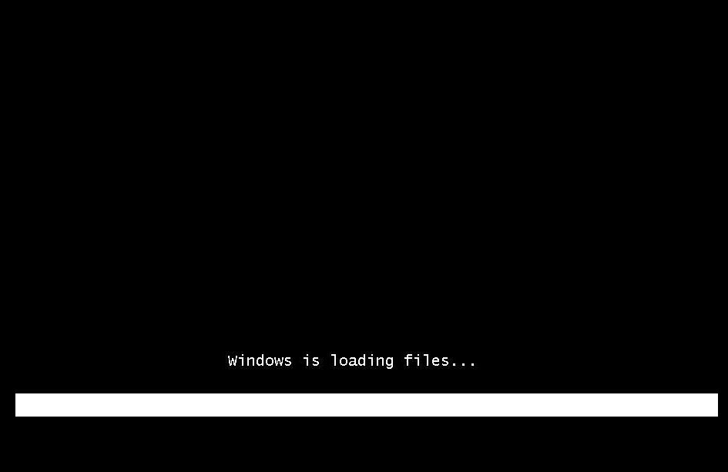**Step one:** Make sure the computer is working properly; the peripherals and motherboard are connected and installed properly. Start up your computer and use one of the function keys depending on the computer product to change the bios configuration by simple making your CD ROM the first Device on the boot other of the computer if you are using a CD reboot the computer so it read from the CD ROM, not of hard disk.

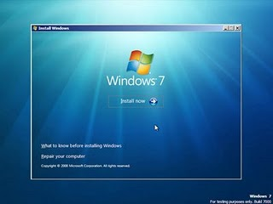**Step two:** Click the installation button and follow the instructions. You also have an to acknowledge open source project licenses, custom installation and finally the partition step where you choose size of hard drive memory where the operation system will be written to.

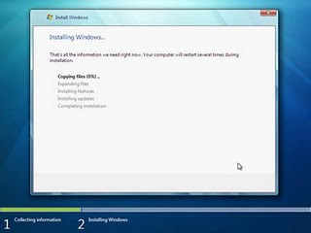**Step three**: installation begin properly here setup copies archives over for extraction and installation on the hard drive. During this process the computer shut down restart and continue

**Step four:** Here window 7 start service restarting is also present at this process window product key installation is required, network selection and date and time can be set

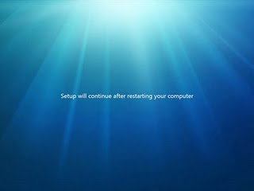

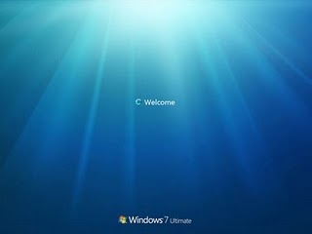**Step five:** window 7 installation is complete follow the instruction. This step is where you do the following computer name, users control account name and password and all various settings. Window is ready for use.

**2.8 UTILITY SOFTWARE:** These are bread categories of programs that allow a computer to perform task that aren’t part of the OS, but are still practical and useful. Example tera-copy, Nero etc.

**2.9 PRODUCTIVE SOFTWARE:** This is a program that perform standard office computer task like word processing, presentation, spreadsheet and database software all graphs software are all common example of productive programs.

**2.10 Steps I used when installing utility/productivity system.**

* I boot computer.
* I insert the CD or DVD (it might be mega or word office etc.) into the CD-drive.
* I allow it to load, after few minutes; I open/click on my computer or window+E.
* In that environment, I locate the Disk and opened it, and then I choose any program I want to install from the CD.
* I click on the program to be installed, it load, accepts the policy after going through it.
* Then I click on next continually when prompt on screen.
* I repeat the step 6 in order program I wish to install.

**2.11 Tips I used for uninstalling software.**

The following steps are used for software un-installation:

* I make sure that the software I wish to remove is not vital for the function of the computer, if not sure, I asked to co-workers or search the internet to learn more about the software.
* Once I am sure that I want to remove the software, I go to the start menu and select control panel. (Note: in window xp click on the choice for add/remove programs. In window vista, click on the program then select uninstall the program.
* After clicking on the control panel, a list of software will appear, I choose the program that I want to uninstall or remove (guild through the removal steps appears).
* If not prompted to do so, I restore the computer after completing the removal processes when the computer restart, I click the list of programs again to make sure the desired program was fully removed.

In summary, I observed that to install software is easier than uninstalling.

**2.12 HOW TO DISTINQUISH A SOFTWARE ISSUE FROM HARDWARE ISSUE.**

I experience that it is not always easy to know the source of a computer program/ but determining whether the problem is from hardware or software will help to give a computer lab manager some direction for action in trouble shooting and repair.

**Tips I use to distinguish between hardware problems from a software problem.**

* I make sure I reduced possible “external” problem before proceeding. This means unplugging any external devices (such as scanner etc.) and I remove CD or DVD disk from their drives.
* Where there is any loud noise or smote when the problem just appeared (occurred)? Then it is a probably a **hardware problem**, with most likely culprit being the power supply unit.
* Is the computer entirely dead? Or is the screen blank these faults are probably due to **hardware problem** also.
* Does the computer produce a series of beeps? This is a code that can be used to distinguish some **hardware problems.**
* Does the computer produce error information after it has booted or only when some programs are opened? This could be a cause of **software problems.**
* Finally, I opened my control panel any device either hardware or software that has a problem will have a warning symbol next to it, I double click on the device detail or recommendation will appear.

**NETWORKING SECTION/DEPARTMENT**

**2.13 NETWORKING:** In the world of computer, networking is the practice or linking two or more computing devices together for the purpose of sharing data. Network is built with a mix of computer hardware and software.

**2.14 TEARMS/DEVICES WE USED IN NETWORKING:**

**Server:** In general, a server is a computer that provides shared resources to network users (client). Servers are typically powerful computers that run the software that controls and maintained the network.

**Network interface card:** The network interface card (NIC), is the expansion card one installs in a computer to connect, or interface, a computer to the network (i.e. NICs are used to connect PCs to the network). This device provides the physical, electrical, and electronic connections to the network media. NICs are either an expansion card or built in to the computer motherboard.

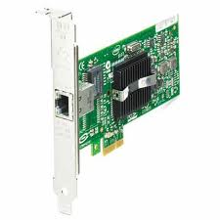NICs come in three basic varieties: 8bits, 16bits and 32bits. The larger the number of bits that transfer to the NIC, the faster the NIC can transfer data to the network cable.

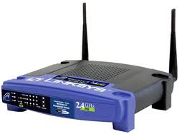**Router:** This is a specialized network device that determines the next point to which it can forward a data packet towards the ultimate destination of the packet.

**Gateway:** This device is placed at a network node and interface with another network that uses different protocols.

**Switch:** This device allocate traffics from one network segment to certain lines (intended destination (s)) which connect the segment to another work segment. Switch splits the network traffic and sends it to different destination to all system on the network.

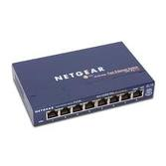

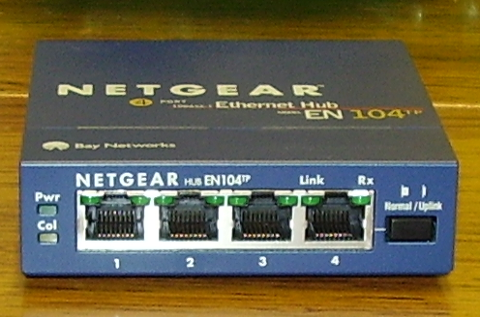**Hub:** This device connects multiply Ethernet segments, making them act as a single segment when using a hub, every attached device shares the same broadcast domain and the same collision domain. Therefore, only one computer connected to the hub is able to transmit at a time. Depending on the network topology the hub provide a basic IOSI mode connection among the network objects (workstations, servers etc.) bandwidth which is shared among all the objects in contrast to switches which provide a connection between individuals nodes can be supported by hub.

**2.15 TYPES OF NETWORKING I HAVE ENCOUNTERD.**

Computer networks can be characterized by their size as well as their purposes. The size of a network can be expressed by the geographical area they occupy and the numbers of computers that are part of the network. Network can cover anything from a handful of devices within a single room to millions of devices spread across the entire globe. Some of the different networks I have experienced based on size are:

**Personal Area Network (PAN):** Pan is a computer network around an individual within a single building. It can be in a small office or residence.

**Local Area Network (LAN):** LAN consists of a computer network a single sit, typically an individual office building. A LAN is useful for sharing of resources. **Note: network resources** are other peripheral devices that are shared on a network such as printers, flash drives, CD-ROM, scanner etc. **Metropolitan Area Network (MAN):** It is consists of a computer network across an entire city, collage campus or small region. **Note that**: a MAN is larger than a LAN. The combination of both network forms a CAMPUS AREA NETWORK (CAM). **WIDE AREA NETWORK (WAM):** WAM occupied a very large area, such as countries or entire world. WAM contain multiple smaller networks just as mentioned above.

As I have studied, I can summaries that network provides great flexibility, such as:

* Sending document to printer in an office.
* Watch movies from an online streaming server to your TV.
* All forms of network resources are been shared including accessing the internet.

**2.16 NETWORK TOPOLOGY**

Network topology is also known as physical topology refers to the configuration of connected devices on a network. Network topologies are categories into the following basic types;

**Star Topology;** This topology all the computer are connected to a single hub through a cable the hub is the control node all other modes are connected to the node.

**Mesh topology:** This forms a ring as each computer is connected to another computer, with the last one connected to the first two neighbors for each device.

**Ring Topology:** This forms a ring as each computer is connected to another computer, with the last one connected to the first two neighbour for each devices

**Tree Topology:** It has a root node and all other node is connected to it forming a hierarchy, it is also called hierarchical topology.

**Bus Topology:** in this topology, all station is attached to a single cable. When a station sends a message, it is broadcast down in both directions. Terminators at the end of the cable prevent the signal from reflecting back to the sender.

**2.17 NETWORK CABLING**

The three primary cables that I have come across are:

* Coaxial cable
* Twisted-pair (unshielded and shielded)
* Fiber-Optic cable

Just as I have learnt, these cables are able to:

* To transmit data and information from computer to other devices viz.
* To transmit voice. All these transmit-ion are been done due to their respective capacity or capability in speed and in terms of security.
* The data sent is been carried in form of more related pulse of light or electronic signals.

**2.18 HOW TO MAKE CABLE FOR TRANSMISSION STRIAGHT THROUGH/ CROSSOVER CABLING (Configuration of Registered jack (Rj) 45)**

**Materials needed**

1. Cat 5 cable - One can buy a 1000 feet roll of Cat 5 cable at computer stores and industry supply houses for somewhere between 6 and 10 cents a foot, depending on the quality Check to make sure that the color-coding on the wires is easily recognizable.

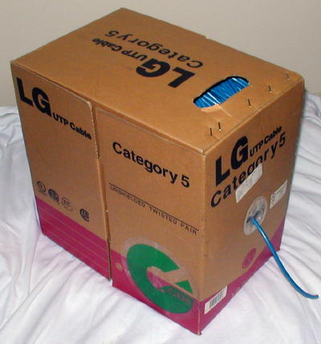

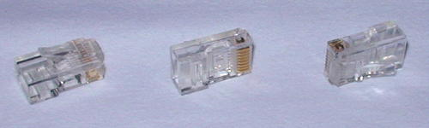RJ-45 connectors - They usually come in bags of 50, 100 etc. Pay attention to the type of RJ-45 connector you get and make sure it is intended for the type of Cat5 wire you're using. There are two different kinds of RJ-45 connectors, depending on whether you use them with solid or stranded wire cable. Using the wrong kind with the wrong cable will most likely result in a bad connection.

1. Crimping tool - While this is the expensive part of making your own cables, it's only a one-time startup cost. A good crimping tool has a pair of wire cutters built in, as well as a blade to strip insulation. It also might support crimping of other connectors such as RJ-11.

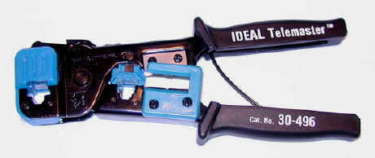

1. Diagonal Cutter Pliers - You'll need a pair of these to cut the wires in case the crimper doesn't come with a built-in wire cutter. Cutting, Stripping, and Sorting the Wires

Cut a piece of Cat 5 as long as you need. When you cut, remember the old saying:

Measure twice, cut once. Make sure the cut on each end is clean and straight.

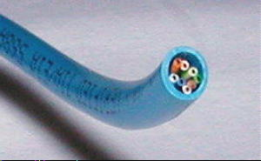

Strip about an inch of the insulation off the cable. Cut it back nice and square. Some crimping tools such as the one used here, come with a built-in wire stripper. You put the cable in to a stop on one side of the cutter. It will cut the jacket the right length to make a perfect crimp. It is extremely important that you only cut the plastic insulation/jacket and not the wire. Damaging 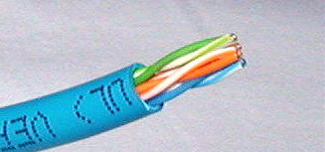one of the 8 wire, even if you just nick it or partially cut it, will ruin your cable.

1. 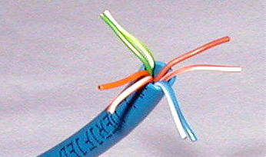Untwist the wires. You'll notice that there are 4 pairs of multi-colored wires inside. Sort the pairs by color. You should end up with wires color coded as follows: blue/blue-white, orange/orange-white, green/green-white, and brown/brown-white.

Now align the wires in the following order from left to right. The order is important since there is a wiring standard defined by the Telecommunications Industry

Get the wires lined up and nice and straight. Then clip off the top millimeter so that they are all the same length and stick out about half an inch from the insulated part.

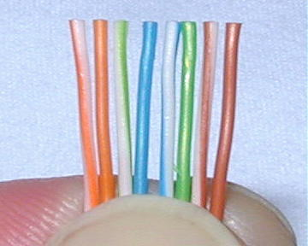

**2.19 TO CONFIGURE A NETWORK: Steps taken:**

Step1. I write clicked on the network icon.

Step2. I clicked on open network and sharing center.

Step3. From the task pan bar, I clicked on changing advanced sharing setting

Step4. I turn on all network option e.g. I turn on network discoveries.

Step5. I turn on file and printer sharing, I turn on all sharing in order to communicate with everyone in the network.

Step6. Finally, I turn off password protection sharing then I clicked on save

**SETTING UP AN INTERNET PROTOCAL (IP) ADDRESS** Steps taken:

**Step1**. I right clicked on the network icon on the taskbar.

**Step2**. I clicked on open network and sharing center

**Step3**. I changed adapter of my choice.

**Step4.** From the environment that appears I clicked on properties.

**Step.5** I double clicked on the use of the following IP addresses, I clicked on subordinate mask.

**Step6**. Finally, I clicked on okay and closed all open windows.

**2.0 WIRELESS HOST COMPUTER CONFIGURATION:**

Here is the way you configure ad hoc wireless setting on host computer, so that other computers can connect to it wirelessly and directly:

* Go to Start and right click on Network and then click Properties.
* Network and Sharing Center window will appear, click on Set up a connection or network.

**Note: The other way to do it is by going to Start -> Connect to -> click on Set up a connection or network.**

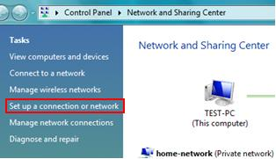

* Set up a connection or network window will appear, select Set up a wireless ad hoc (computer-to-computer) network option, and then click next.
* Set up a wireless ad hoc network window will appear, this window will briefly explain what an ad hoc wireless network is. Click next after the reading.
* 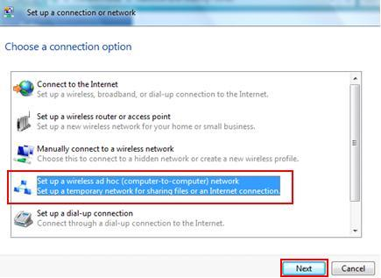On this wireless network configuration window, one can type in the network name (SSID), security type (encryption) and security key. One can set up the ad hoc connection without the authentication first, and then enable the encryption (WEP, WPA2, etc) once it worked. The encryption should be enabled, if not every nearby computer can connect to this network. Click next again.

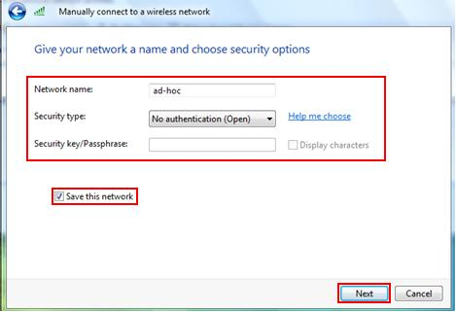Note: You can click save this network to save it as wireless network profile. If not, the network setting will not be saved.

* The next window will tell you that the ad hoc network is ready to use with connection setting. Click Close to finish the setup.
* Back to you Network and Sharing Center, click on Manage Wireless networks, you will see the

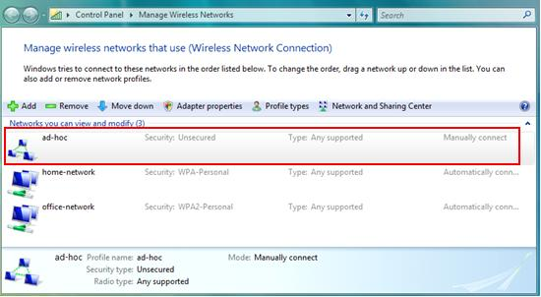 New created ad-hoc network and it's ready to be connected.

Note: Please note this ad-hoc is tagged as Unsecured since there is no encryption enabled, so don’t forget to enable the encryption once it worked.

Client Computer Configuration:

**You can then use other client computers to connect to the ad hoc wireless network.**

* Go to Start and click on Connect to.
* Connect to a network window will appear. This window will show all available connections, which are dial-up, VPN and wireless connections, but your focus is on ad hoc wireless connection. Scroll down the list and select the ad-hoc wireless network and click Connect button.
* Note: You will be prompted if you connect to unsecured wireless network, click Connect Anyway to connect for this case.

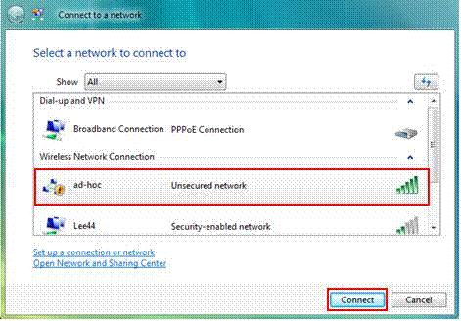

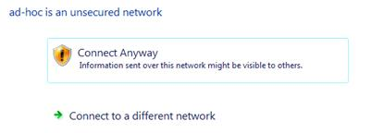

* Once you get connected, you will see following message. You can then tick on save this network

and Close the window. You can then ping other computers to ensure it's working.

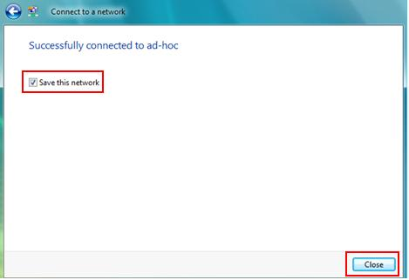

**PROGRAMING SECTION (DEPARTMENT)**

**2.21 HTML:**

HTML stands for **H**yper**t**ext **M**arkup **L**anguage, and it is the most widely used language to write Web Pages.

* **Hypertext** refers to the way in which Web pages (HTML documents) are linked together. Thus, the link available on a webpage is called Hypertext.
* As its name suggests, HTML is a **Markup Language** which means you use HTML to simply "mark-up" a text document with tags that tell a Web browser how to structure it to display.

Originally, HTML was developed with the intent of defining the structure of documents like headings, paragraphs, lists, and so forth to facilitate the sharing of scientific information between researchers.

Now, HTML is being widely used to format web pages with the help of different tags available in HTML language.

**HTML Tags:** As told earlier, HTML is a markup language and makes use of various tags to format the content. These tags are enclosed within angle braces **<Tag Name>**. Except few tags, most of the tags have their corresponding closing tags. For example, **<html>**has its closing tag**</html>**and **<body>**tag

has its closing tag **</body>**tag etc

**LESSTHAN <P> GRATER THAN**

ELEMENT

|  |  |
| --- | --- |
| **Tag** | **Description** |
| <html> | This tag encloses the complete HTML document and mainly comprises of document header which is represented by <head>...</head> and document body which is represented by <body>...</body> tags. |
| <head> | This tag represents the document's header which can keep other HTML tags like <title>, <link> |
| <title> | The <title> tag is used inside the <head> tag to mention the document title. |
| <body> | This tag represents the document's body which keeps other HTML tags like <h1>, <div>, <p> etc. |
| <h1> | This tag represents the document's body which keeps other HTML tags like <h1>, <div>, <p> etc. |
| <p> | This tag represents a paragraph. |
| **<b>, <i>, <li>, <ul>, <ol>etc** | Bold, italic, list, unordered list, ordered list |

With the help of HTML Tags a web page can be easy created.

**2.22 CASCADING STYLE SHEETS**

C.S.S explains how HTML elements are to be displayed on screen, web browsers etc

C.S.S controls a layer of multiple web page all at once also external sheets are been stored in CSS files.

**USE OF C.S.S**

We use C.S.S to define style for your documents, including the design, layout and variations in display for different devices and screen sizes. You can place your **C.S.S** in the <head> of a documents with an embedded style sheet, or attached a separate files he defines your styles with an external style sheet. To link an external style sheet to your documents you simply add a link to the style sheet in the <head> of the documents.

When a user displays a web page, the users browsers loads style information along with the content of the page.

When a user prints a web page, you can provide different style information that makes printed page easy to read.

**In general, we use html to describe the content of the documents, not its style while we use C.S.S to specify the documents style, not its content**

**CHAPTER THREE**

**SKILLS ACQUIRED AND CHALLENGES ENCOUNTERD**

**3.0 TECHNICAL SKILLS ACQUIRED** Below are list of skills I acquired during my **industrial training** at ADMAS IT PLACE

* Deep knowledge of hardware repair and maintenance.
* Computer assembly and maintenance.
* Ability to create a website with the help of CSS and HTML.
* Troubleshooting hardware and software problems.
* Installing and configuring the peripheral components and drives.
* Installing software’s and application to user’s standard.
* Managing and maintaining the servers, PC’s, routers and switches.
* Configuring, managing and maintaining network equipments.
* Deep knowledge of sharing of data/network resources.

**3.1 SOCIAL AND FUNCTIONAL SKILLS ACQUIRED**

* Enhanced communication skills.
* Ability to identify and solve problems.
* Decision making, critical thinking, organizing and planning.
* Ability to work with team.
* Enhanced teaching and effective learning skills
* Good customers services orientation skill

**3.2 PERSONAL INPUT TO THE COMPANY (ADMAS IT PLACE)**

* Teaching and assisting students. (Clients) through their lessons.
* Assist in marketing and publication.
* Running of errands to boost activities in the workplace.
* Check and work on colleague’s computer when they are not responding.
* Attending to customers in photocopying, scanning, laminating of documents and snapping of passport photograph.

**3.3 CHALLENGES ENCOUNTERD**

* Difficulty in seeking for IT attachment.
* Lack of transportation.
* Lack of good facilities for networking and computer maintenance.
* I was not paid either by SIWES or the place of my attachment.
* There are no standard equipments for learning and practical.
* The company lacks proper SIWES orientation on how to train student.

**CHAPTER FOUR**

**RECOMMENDATION AND CONCLUSION**

**3.4 CONCLUSION**

In respective of the challenges encountered in this SIWES program**,** there were many things that I have experienced and learned during the six (6) months of my industrial training at ADMAS I.T PLACE the whole period was very educating, interesting and instructing. Through this training I was able to gain new insight and more comprehensive understanding about the real industry working condition and practice. It has provided me the opportunities to develop and improve my soft and functional skills. All of this valuable experience and knowledge that I have gained were not only acquired through direct involvement in task given but also through other aspect of the training such as work observation, interaction with colleagues, superior, and other people related to the field. From what I have undergone, I am very sure that industrial training program has achieved its entire primary objectives. This program has also prepared student to face the real working life. As a result of the program, now I am more confidence to build my future career.

**3.5 RECOMMENDATION:**

* School should provide a place of attachment for student.
* Student should be paid monthly in their place of attachment by the SIWES body.
* Supervisor should always visit student monthly in their various places of attachment.
* School should always rehearse with industries, firm and companies were the student is doing his/her industrial training to check and improve their facilities.
* School should organize a seminal for student place of attachment (the industry) to enable effective training of student.
* Despite the challenges encountered I still wish to recommend my place of attachment (ADMAS IT PLACE) for schools and student who are yet to undergo their IT.