**INDUSTRIAL INTERNSHIP FINAL REPORT**

**CHEMICAL ENGINEERING PROGRAMME**

**VERIFICATION STATEMENT**

I hereby verify that this report was written by **Ahmad Syafiq b. Zahid** and all

information regarding this company and the projects involved are **NOT** confidential.

………………………………

(Plant Supervisor’s Signature)

Name : Tn. Haji Amirruddin Baba

Designation : Process Safety Management Manager

Host Company : PETRONAS Penapisan (Melaka) Sdn. Bhd.

Date : 09/07/2010

EXECUTIVE SUMMARY

The Industrial Internship Programme is to expose Universiti Teknologi PETRONAS (UTP) students to the working world so that they can relate theoretical knowledge to its application in the industry. From the programme, students will also develop skills in work ethics, communication, management and etc. Furthermore, it will establish close relationship between the industry and UTP.

The company that the author has been assigned to for the internship was, starting from 14th December 2009 until 9th July 2010. Throughout the industrial internship program, author has been assigned to Process Safety Management (PSM), Technology Department.

This final report is a representation of the details of task and assignments carried out during the period of attachment with PP(M)SB. It also entails the experiences gained and various lessons learnt as an intern in Process Safety Management.

The major portion of the report is on the projects and activities itself. The first section is a brief introduction to PP(M)SB, the training objectives and the scope of work done. The next section describes the main activities and projects done during the training period and the following section discusses mainly on the lessons learned and experiences gained from the internship programme.

In conclusion, the collaboration between UTP and PP(M)SB has made the internship programme a success in achieving the University’s objectives of producing well-rounded graduates with industrial experience. Throughout this training, immense knowledge was acquired and all the challenges and barriers were taken as a yardstick of how much was the learning.

ACKNOWLEDGEMENT

First and foremost, I would like to extend my gratitude to my dedicated plant supervisor, Tuan Haji Amirruddin Baba, who has given me his full support and guidance throughout my attachment period in PETRONAS Penapisan (Melaka) Sdn. Bhd. It has been a great privilege to undergo my internship under his supervision. Apart from imparting his technical knowledge especially on process-wide, the most invaluable lesson was his vast amount of working experience.

Heartfelt appreciation is extended to all the PSM staffs in the office, En. Syed Faiz, En.Abdus Salam, Pn.Najah, Pn.Mariam , Pn.Natasya and Pn. Kamariah. Their assistance and guidance are truly appreciated. Without them, it would have been difficult for me to comply with the working environment.

Special thanks are given to Universiti Teknologi PETRONAS authorities who have put a lot of effort towards contributing in making the industrial internship program a great success. This industrial internship has given me some exposure of the real working environment and also the engineering field.

Apart from that, an honorable mention goes to my family members and friends who have been supporting me throughout my internship programme. All of their efforts in ensuring the success and completion of this programme are really appreciated. Also, to my UTP supervisor, Dr. Lemma Dendena Tufa, thank you for your fine supervision in allowing me to achieve an outstanding performance for my industrial internship.

Last but not least, thank you to PETRONAS Penapisan (Melaka) Sdn. Bhd. for their willingness to accept me in undergoing my industrial internship programme. I would also like to thank them for their generosity in providing me all the facilities and technical expertise in making this programme successful.

TABLE OF CONTENT

**VERIFICATION STATEMENT ……………………………………………............. i**

**EXECUTIVE SUMMARY …………………………………………………………... ii**

**ACKNOWLEDGEMENT ………………………………………………….………… iii**

**CHAPTER 1: INTRODUCTION ……………………………………………..……… 1**

1.1 Brief Description of Host Company …………………………………….......1

1.2 Objectives of Industrial Internship ……………………………………….....3

1.3 Scope of Work, Tasks and Projects Undertaken During Internship …….......3

**CHAPTER 2: PROJECT AND MAIN ACTIVITIES………………………………..**

2.1 Main Tasks and Project……………………………………………………..

2.1.1 Developing Chemical Reactivity Matrix in PP(M)SB……………

2.1.2 Overview on PETRONAS Second Refinery Phase 1 (PSR 1)

and PETRONAS Second Refinery Phase 2 (PSR 2)……………..

2.1.3 Plant Familiarization………………………………………………

2.1.4 Involvement in HAZOP Study…………………………………….

2.1.5 Understanding on Process Safety Management (P.S.M.)…………

* 1. Training Involved…………………………………………………………..

2.2.1 Confined Space Entry (CSE) Training……………………………

2.2.2 Lock Out/Tag Out (LOTO) Training……………………………..

2.2.3 Authorized Gas Tester (AGT) Training…………………………..

2.2.4 Plant Information (PI) System Training………………………….

2.3 Events and Activities……………………………………………………….

2.3.1 Capability Forum 2010…………………………………………….

2.3.2 Visit to the Jetty, Storage and Distribution Unit…………………

2.3.3 Stock Take Exercise FY 2009/2010…………………………….

**CHAPTER 3: LESSON LEARNT AND EXPERIENCE GAINED……………….**

3.1 Teamwork and Individual Activities………………………………………

3.2 Safety Awareness…………………………………………………………

3.3 Leadership and Management Skills……………………………………….

3.4 Presentation / Communication Skills…………………………………….

**CHAPTER 4: DISCUSSION AND RECOMMENDATION………………………**

4.1 Recommendation to Universiti Teknologi PETRONAS………………….

4.1.1 Training Schedule……………………………………………….

4.1.2 Theory versus real practice……………………………………….

4.1.3 Plant Supervisor Briefing by UTP Lecturer………………………

4.2 Recommendation to Host Company………………………………………..

4.2.1 Intern’s Personal Protective Equipment (PPE)……………………

4.2.2 Frequency of Report………………………………………………

4.2.3 Facilities…………………………………………………………..

**CHAPTER 5: CONCLUSION………………………………………………………..**

**REFERENCES………………………………………………………………………..**

**APPENDICES………………………………………………………………………….**

**LIST OF FIGURES**

Organizational Chart of Technology Department ……………..…………………………

Mapping on Crude Distillation Unit ……………………………………………………

Basic Chemical Search ………………………………………………………..

Reactivity Worksheet …………………………………………

Compatibility Chart ………………………………...

Hazard Summary …………………….

Potential Gases …………………………………………………...

Chemical Intrinsic Hazards ……………………………………………...

Example of a Chemical Reactivity Matrix on Unit 11 Crude Distillation Unit / CDU…..

Result of the potential reaction (water and kerosene)……..…

PSR 1 Block Flow Diagram ………………………………………….

PSR 2 Block Flow Diagram ………………………………………………

Simplified Flow Diagram on Unit 11 Crude Distillation Unit …………………..

The Relationship between Process Safety Management and Occupational Health Safety…

Unit 11 Block Flow Diagram ………………………………………………………….

Problems with structured packing………………………………………………………..

Position of Packing Support……………………………………………………………..

Problems with heat exchangers…………………………………………………………..

Problems with condensers………………………………………………………………..

HAZOP Sample Worksheet……………………………………………………………….

**LIST OF TABLES**

Main Tasks/Project during Industrial Internship ……..………………………………….

List of Chemicals/Materials and its designated colour …...

Nominal Plant Production for PSR 1……………………….

Nominal Plant Production for PSR 2………………………………………..

Typical Operating Cases for Unit 11 Crude Distillation Unit………………….

Components and their respective cutpoints in the Crude Tower. ……………………….

HAZOP Workshops Involvement ……………………………………………...

Process Safety Management Aspects …………………………...

List of product produce in PP(M)SB ………………………..

Process Units in Area 1 Sweet Hydroskimming ………………………………………

Process Units in Area 2 Sour Hydroskimming ……………………………………..

Process Units in Area 3 Sour Conversion ……………………………………………

HAZOP Deviation Matrix……………………………………………………………..

HAZOP Standard Guide Words………………………………………………………

CHAPTER 1: INTRODUCTION

**1.1 BRIEF DESCRIPTION OF HOST COMPANY**

**1.1.1 PETRONAS Penapisan Melaka Sdn. Bhd**

Petronas Penapisan (Melaka) Sdn. Bhd., PP(M)SB, which is located in Sungai Udang, is the second refining complex consisting of two crude refining trains, namely Petronas Second Refinery Phase 1 (PSR-1) and Petronas Second Refinery Phase 2 (PSR-2). PSR-1 is wholly owned by PETRONAS and was incorporated in 1987. PSR-2, which is incorporated in 1991, is operated by the Malaysian Refining Company (MRC), which is a joined venture between PETRONAS and Conoco Philips with PETRONAS holding 53% of the share.

PSR-1 was commissioned in April 1994 processing a design capacity of 100,000 barrels per stream day (BPSD) of local sweet crude (crude with sulfur content less than 0.5 wt %). Five years later, PSR-2 was commissioned to process 100,000 BPSD of Middle East sour crude (crude with sulfur content more than 2.5 wt %). With the vision to be the Best Refinery in Asia Pacific Region, PP(M)SB – MRC currently processes a combined capacity of more than 200,000 BPSD of crude exceeding the original intended design capacity and continues to serve the local and international market.

**1.1.2 Significance of PSR-1 and PSR-2**

The basic structure of the refinery consists of five areas:

Area 1: Sweet Hydroskimming

Area 2: Sour Hydroskimming

Area 3: Sour Conversion

Area 4: Storage and Distribution

Area 5: Utilities and Sulfur Complex

PSR-1 is a Sweet Hydroskimming Refinery, assigned as Area 1. Feedstock to this train consists of 75% local crude and 25% condensates coming from Terengganu and Bintulu.

Products from PSR-1 include liquefied petroleum gas (LPG), petrochemical naphtha (PCN), gasoline, kerosene and low sulfur waxy residue (LSWR).

PSR-2 however is a Sour Full Conversion Refinery which comprises of Area 2: Sour Hydroskimming and Area 3: Sour Conversion. Sour crude fed to the sour train include Dubai crude from UAE, Masila from Yamen, Arabian Light and Heavy from Saudi Arabia and Oman crude just to name a few. There are instances when sweet Tapis crude from Terengganu is also fed into the unit. Products from PSR-2 include LPG, PCN, gasoline, kerosene, sulfur, fuel oil, asphalt and coke.

Area 4: Storage and Distribution on the other hand is a common facility for both PSR-1 and PSR-2. The unit handles storage, intermediate, blendstock and final product tankage. Effluent Treating System (ETS) is also a part of this area.

Area 5 plays a vital role in providing LP, MP, HP steam, cooling water, nitrogen and fuel gas S into sulfur is also supply to the whole refinery. Not only have that, the conversion of sour gas H2 facilitated.

Progress has been made since the commissioning of PSR-2 allowing PP(M)SB for more options in choosing the type of feed crude to process and thus extending their market to foreign buyers. Since PSR-2 was built after PSR-1, PSR-2 is imminently more sophisticated in terms of technology. Although both phases have certain units in common, there are some facilities provided for PSR-2 that were not included in PSR-1. For example, PSR-2 has a hydrogen plant which caters for the hydrogen demand coming from the deep conversion units. Although only PSR-1 is wholly owned by PETRONAS, PSR-2 operations are also in line with the mission and vision of PP(M)SB.

**1.2 OBJECTIVES OF INDUSTRIAL INTERNSHIP**

**1.2.1 University Objectives**

At the end of the industrial internship at the respective company, student will be able:

* To integrate theory with practice
* To introduce students to work culture and industrial practices
* To give opportunity for students to work with industrial practitioners
* To expose students to potential employers
* To acquaint UTP students with industry and its programmes

**1.2.2 Individual Objectives**

The following are my objectives to be achieved throughout the industrial internship:

* To be exposed to the working environment and experience first hand the working life of an engineer
* To gain valuable experience working with industrial practitioners
* To improve my soft skills especially when dealing with colleagues and superiors
* To apply theoretical knowledge to real life engineering problems through guidance of experienced engineers

**1.3 SCOPE OF WORK, TASKS AND PROJECTS UNDERTAKEN DURING**

**INTERNSHIP**

* + 1. **Department Attached**



Figure 1: Organizational Chart of Technology Department

Being attached Process Safety Management in Technology Department was a priceless yet unforgettable experience under the supervision of Process Safety Management Manager, Tuan Haji Amirruddin Baba.

The scope of tasks and projects given, therefore, was mostly related to process safety, whereby the main project entitled “Development of Chemical Reactivity Matrix in PP(M)SB” has played a major contribution to Process Safety Management. Not only that, my participation in HAZOP and HAZID sessions was highly encouraged.

* + - 1. **Functionality of the Section Attached**

Process Safety Management ( P.S.M ), supports the Production Department by applying management principle and system to identified, understand and control process hazard.

CHAPTER 2: PROJECT AND MAIN ACTIVITIES

**2.1 MAIN TASKS ANS PROJECT**

|  |  |
| --- | --- |
| **Main Tasks / Project** | **Title** |
| Project | **Developing Chemical Reactivity Matrix in PP(M)SB** |
| Task 1 | **Overview on PSR 1 and PSR 2** |
| Task 2 | **Plant Familiarization** |
| Task 3 | **Involvement on Hazard and Operability (HAZOP) Study** |
| Task 4 | **Understanding on Process Safety Management (P.S.M)** |

Table 1: Main Tasks/Project during Industrial Internship

**2.1.1 DEVELOPING CHEMICAL REACTIVITY MATRIX IN PP(M)SB.**

**INTRODUCTION**

Chemical Reactivity Matrix is one of the essential tools (mitigation method) in mitigating uncontrolled chemical reaction. It consists of:

* Chemicals/materials that are used in a process area
* Result of the potential mixing (reaction)
* Explanation on the potential reaction
* Chemical Safety Data Sheet (CSDS) involves
* Piping and Instrumentation Diagram (P&ID) involves

**PROBLEM STATEMENT**

PP(M)SB has a vast usage of chemicals and materials but does not comprise a Chemical Reactivity Matrix (CRM). Thus, this could create a potential hazard to people, property or the environment.

**OBJECTIVE**

To develop Chemical Reactivity Matrix for PP(M)SB as part of Process Safety Information requirement.

**IMPORTANCE**

* To gather data and information from various division in PP(M)SB to a single system.
* To meet the Process Safety Information (PSI) requirement in implementing a CRM.
* As a continuous effort as continuous improvement and materials being made in PP(M)SB.

**METHODOLOGY**

1. Compilation of data. The data that were being compile are:
   * 1. Piping and Instrumentation Diagram (P&ID)
     2. Chemical Safety Data Sheet (CSDS)
     3. Chemical List
     4. Quantitative Risk Assessment (QRA) Study Input on Material
2. Line tracing and mapping. Do the line tracing on P&ID and map to the QRA Study Input on Material to identify the chemical/material in the process line.
   * 1. List of the chemicals/materials and its designated colour:

|  |  |  |
| --- | --- | --- |
| As Per P&ID | Most Suitable* | Colour in P&ID |
| Crude | C8 |  |
| Kerosene | C10 |  |
| LSWR | C20 |  |
| AGO | C16 |  |
| AGO | C14 |  |
| Diesel STR Vapor | C12 |  |
| Heavy Naphtha | C8 |  |
| Kerosene Vapor | C8 |  |
| Crude OVHD Vapor | C6 |  |
| STAB OVHD Liquid | C4 |  |
| Medium Naphtha | C7 |  |
| STAB OVHD Vapor | C3 |  |
| DEIC5 Reflux | C5 |  |
| Diesel STR Vapor | C14 |  |

Table 2: List of Chemicals/Materials and its designated colour

* + 1. Example on line tracing and mapping on Unit 11 Crude Distillation Unit CDU:

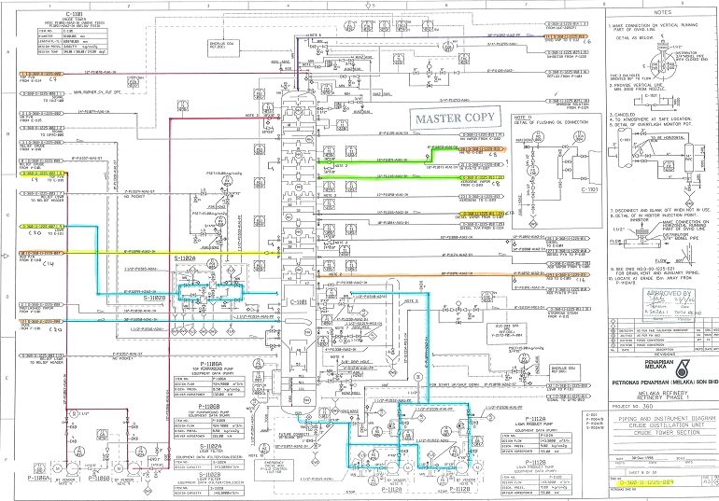

Figure 2: Mapping on Crude Distillation Unit

1. Construction on compatibility and reactivity. Do the reaction using Chemical Reactivity Worksheet version 2.0.2 (CRW2). C:\Documents and Settings\Ahmad Syafiq\Desktop\FINAL REPORT INTERN\CRW2 simbol.bmp
   * 1. Insert the chemical/material name in the search column.

( Example taken on water / hydrogen reaction.)

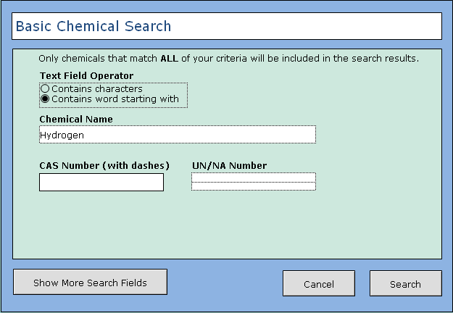

Figure 3: Basic Chemical Search

* + 1. React with chosen chemical/material:

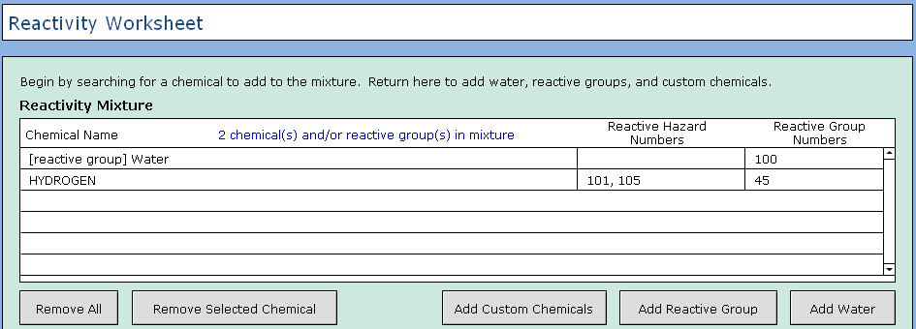

Figure 4: Reactivity Worksheet

* + 1. Take data from the compatibility chart and the explanation:

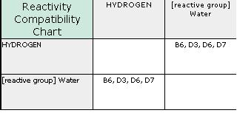

Figure 5: Reactivity Compatibility Chart

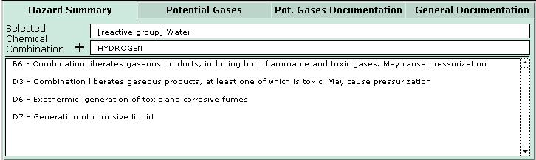

Figure 6: Hazard Summary

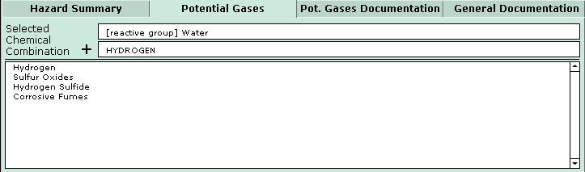

Figure7: Potential Gases

D:\KenC Files\PPMSB\Documentation.JPG

**Inorganic Reducing Agents / Water:**

**1, 2-DIMETHYLHYDRAZINE** is highly flammable. The compound fumes upon exposure to air. It is soluble in water with evolution of heat.

**CHROMOUS CHLORIDE** is stable in dry air, but oxidizes rapidly in moist air or standing water with liberation of Hydrogen, [Merck, 11th ed., 1989]. It is soluble in water.

**LITHIUM FERROSILICON** is flammable. The chemical reacts with water or moisture in the air to form corrosive lithium hydroxide and flammable hydrogen gas. The heat may be sufficient to ignite the hydrogen generated [AAR 1991].

**PHOSPHORUS**, WHITE when exposed to air emits a green light and gives off white fumes. Ignites at 30°C in moist air, higher temperatures are required for ignition in dry air [Merck 11th ed. 1989]. The reactivity of phosphorus with oxygen or air depends on the allotrope of phosphorus involved and the conditions of contact, white (yellow) phosphorus being by far more reactive. White phosphorus readily ignites in air if warmed, finely divided or under conditions where the slow oxidative isotherm cannot be dissipated. Contact with finely divided charcoal or lampblack promotes ignition, probably by the absorbed oxygen. Contact with amalgamated aluminum also promotes ignition [Mellor 1940 and 1971].

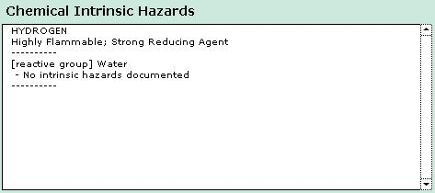

Figure 8: Chemical Intrinsic Hazards

1. Development of matrix. Using Microsoft Excel as a tool on developing the matrix.

The matrix consists of four elements that are:

* + 1. Chemical Name based on P&ID
    2. Chemical Name based on QRA Study Input on Material
    3. The designated colour of the chemical
    4. Result of the reaction

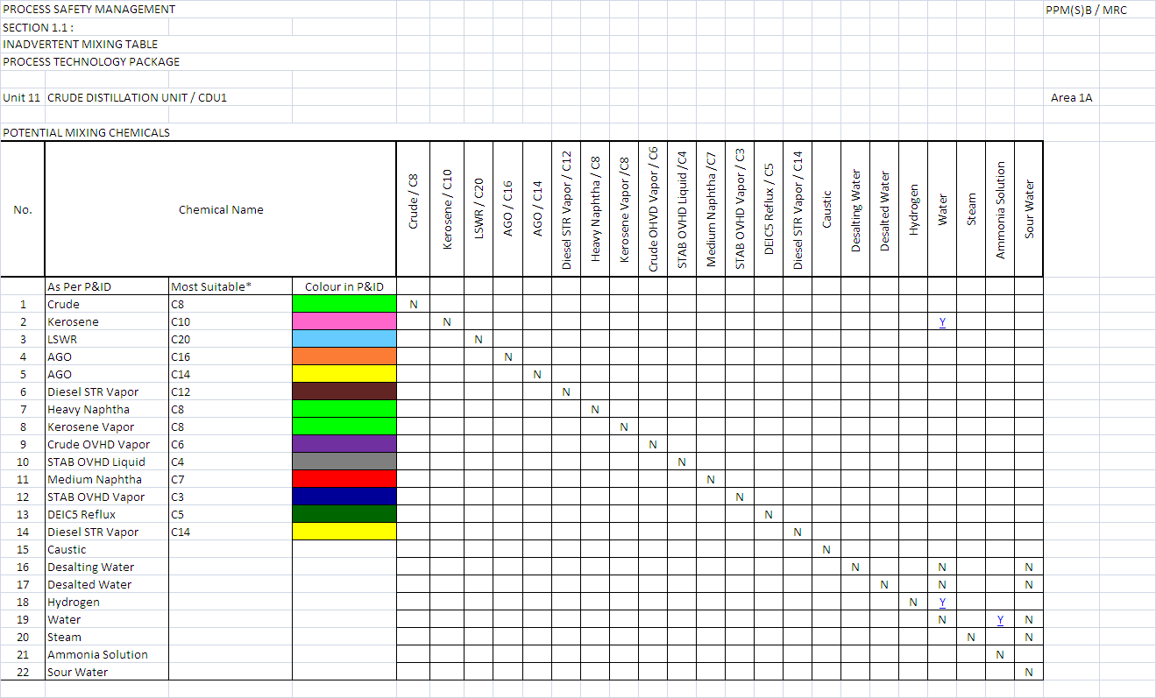

Figure 9: Example of a Chemical Reactivity Matrix on Unit 11 Crude Distillation Unit / CDU

1. Documentation of the findings and results. There are five element that are being documented for every potential reaction:
   * 1. Reactivity Compatibility Chart
     2. Hazard Summary
     3. Potential Gases
     4. Potential Gases Documentation
     5. Chemical Intrinsic Hazard

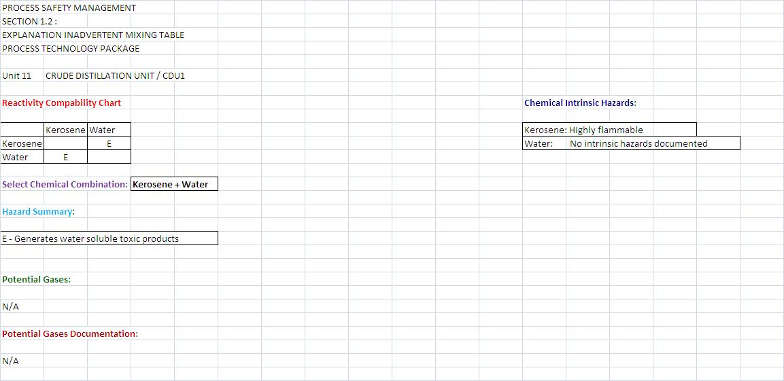

Figure 10: Result of the potential reaction (water and kerosene).

**RESULT**

A Chemical Reactivity Matrix (CRM) system complete with all the data needed for reference of chemical reactivity hazards in the refinery.

**CHALLENGES**

* Some chemicals or materials are not documented yet in the Refinery Management System (RMS) under Chemical Safety Data Sheet (CSDS).
* As the data are form different divisions, the data collection take a lot of time.
* Inadequate data or information, need justification and clarification form supervisor.

**2.1.2 OVERVIEW ON PETRONAS SECOND REFINERY PHASE 1 (PSR 1) AND PETRONAS SECOND REFINERY PHASE 2 (PSR 2).**

**INTRODUCTION**

Do an overview study on PSR 1 and PSR 2 based on particular aspects.

**OBJECTIVE**

To familiarize with all the necessary information needed to work in the refinery.

**SCOPE**

There are seven aspects of this study:

* PSR 1 Background and Block Flow Diagram
* PSR 2 Background and Block Flow Diagram
* Name of the unit and respective numbering
* Process Description
* Function of the process unit
* Main equipment
* Feed and product specification

**RESULT**

* 1. **PSR 1 Background:**
* PSR 1 processes local sweet feedstock (sulfur < 0.5wt %) for the design capacity of 100, 000 BPSD utilizing hydroskimming configuration (sweet train).
* Feedstocks used are:

1. Tapis Light Crude
2. Miri Light Crude
3. Terengganu Condensate
4. Bintulu Condensate

* The main process units at PSR 1 include:

Unit 11 Crude Distillation Unit & Condensate Fractionator Unit

Unit 12 Naphtha Hydrotreating Unit

Unit 13 Catalytic Reformer Unit

Unit 14 Saturated Gas Concentration Unit

Unit 15 Sour Water Treatment Unit

Unit 16 Heavy Naphtha / Kerosene Treating Unit

Unit 17 Mercury Removal Unit

* PSR 1 is divided into two areas for operating convenience.
* PSR 1 includes area 1A and area 1B

**Area 1A Area 1B**

Unit 11 CDU Unit 12 NHT

Unit 14 SGCU Unit 13 CRU/CCR

Unit 15 SWSU

Unit 16 HN/KTU

Unit 17 MRU

* Nominal Plant Production:

|  |  |
| --- | --- |
| **UNIT** | **BPSD** |
| Atmospheric Crude Distillation | 75 000 |
| Condensation Distillation Unit | 25 000 |
| Catalytic Reformer Unit | 20 000 |
| Naphtha and Kerosene Treater | 4 000 / 18 750 |
| Sour Water Stripper | - |
| Mercury Removal Unit | 23 700 |

Table 3: Nominal Plant Production for PSR 1

**1.2 PSR 1 Block Diagram:**

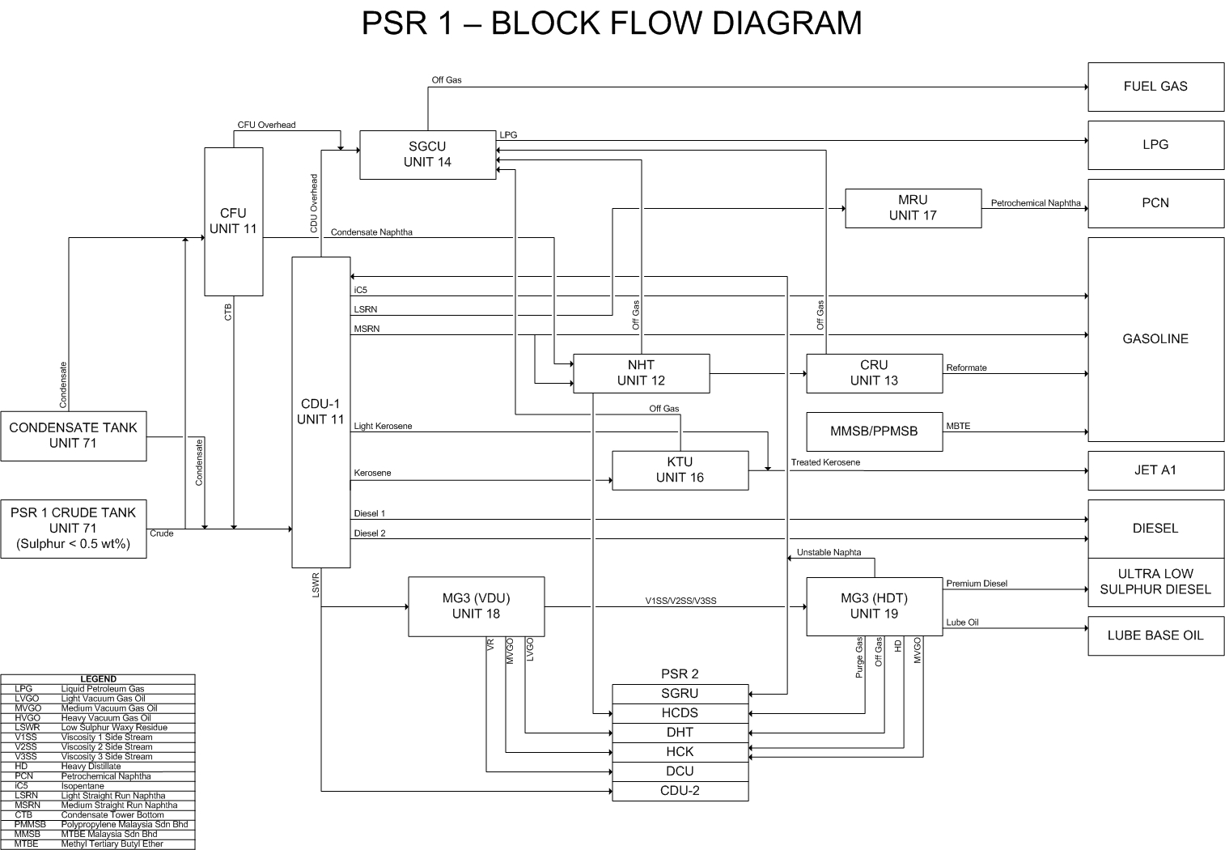

Figure 11: PSR 1 Block Flow Diagram

**2.1 PSR 2 Background:**

* PSR 2 processes up to 70% sour feedstock (sulfur>2.5wt %), mainly Middle East crude, for the design capacity o f 100,000 barrels per day (BPSD) utilizing complex conversion configuration (sour train).
* The main process units at PSR 2 include:

Unit 21 Crude and Vacuum Distillation Units

Unit 22 Naphtha Hydrotreating Unit

Unit 23 Catalytic Reforming Unit with Continuous Catalyst Regenerator

Unit 24 Saturated Gas Recovery Unit

Unit 25 C6 Isomerization Unit

Unit 26 LPG Treating Unit

Unit 27 Naphtha Treating Unit

Unit 28 Kerosene Treating Unit

Unit 29 Distillate Hydrotreating Unit

Unit 30 Hydrocraker Unit

Unit 32 Delayed Coker Unit

Unit 39 Hydrogen Production Unit

* PSR 2 is divided into four areas.
* PSR 2 includes area 2A, area 2B, area 3A and area 3B:

**Area 2**

**Area 2A Area 2B**

Unit 21 CDU & VDU Unit 22 NHT

Unit 24 SGRU Unit 23 CRU & CCR

Unit 26 LTU Unit 29 DHT

Unit 27 NTU Unit 25 C6 ISOM

Unit 28 KTU

**Area 3**

**Area 3A Area 3B**

Unit 30 HCK Unit 32 DCU

Unit 39 HPU

Hydrogen Collection & Distribution System

* Nominal Plant Production:

|  |  |
| --- | --- |
| **UNIT** | **CAPACITY** |
| Crude Distillation Unit | 100,000 BPSD |
| Vacuum Distillation Unit | 42, 000 BPSD |
| Naphtha Hydrotreating Unit | 35, 000 BPSD |
| Catalytic Reforming Unit with Continuous Catalytic Regenerator | 26, 000 BPSD |
| Saturated Gas Recovery Unit | Not applicable |
| C6 Isomerization Unit | 9, 000 BPSD |
| LPG Treating Unit | 8, 500 BPSD |
| Naphtha Treating Unit | 15, 250 BPSD |
| Kerosene Treating Unit | 13, 800 BPSD |
| Distillate Hydrotreating Unit | 35, 000 BPSD |
| Hydrocraker Unit | 26, 500 BPSD |
| Delayed Coker Unit | 21, 000 BPSD |
| Hydrogen Production Unit | 13, 000 BPSD |

Table 4: Nominal Plant Production for PSR 2

**2.2 PSR 2 Block Flow Diagram:**

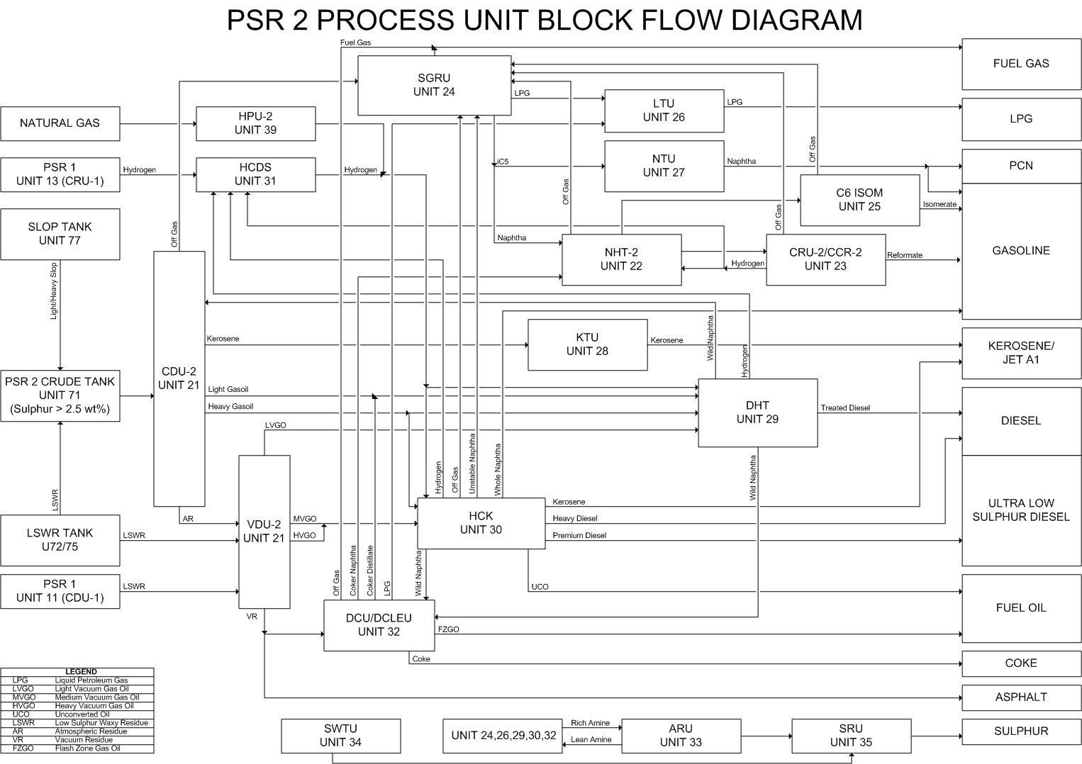

Figure 12: PSR 2 Block Flow Diagram

**Overview of a particular process unit:**

This is an example of the overview study on Unit 11 Crude Distillation Unit / CDU.

* CDU consist of a crude section ( 75 000 barrels/day ) and a condensate section

( 25 000 barrels/day ).

* Feed and product:

Feed: Product:

1. Bintulu condensate i- Off gas and LPG
2. Tapis crude ii- Isopentane
3. Terengganu condensate iii- Light Naphtha

iv- Condensate Naphtha

v- Medium Naphtha

vi- Heavy Naphtha

vii- Kerosene

viii- Diesel

ix- AGO

x- LSWR

* Main equipment:

1. condensate tower
2. condensate stabilizer
3. crude tower
4. crude stabilizer
5. naphtha splitter
6. deisopentanizer

* Process Description:

The CDU unit’s performance depends on the adjustment of the cut point between light naphtha and medium naphtha. The nominal cut points between these two products can be adjusted between 70°C and 92°C. As such, the CDU is designed to perform under two different cases which are the Base Case ( 70°C Cut ) and the Alternate Case ( 92°C ).

After the crude in-line mixing project in the year 2000, the crude section has been running at 120% feed throughput ( 90 000BPSD ). The capacity of the condensate section and the crude section depends on its operating cases. Two typical cases are as follows:

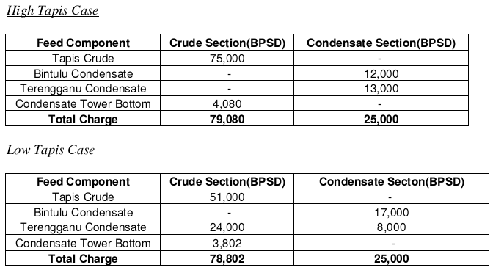

Table 5: Typical Operating Cases for Unit 11 Crude Distillation Unit

* Main equipment and function:

**Preheat train**

Preheat train’s main task is to maximize heat recovery from other streams, such as crude and condenser tower pumparounds, heat the feed to 180-200°C before entering the furnace heater, F-1101. This allows for savings in fuel gas at the furnace and utility consumption for cooling. There are 4 pre-desalter heat exchanger and 7 post-desalter heat exchanger.

**Desalter**

Crude contains salt and base sediments that can cause corrosion, catalyst poisoning, and heat exchanger fouling. This typical salt content in crude is 1 pound salt for every 1000 barrels of crude. Desalter are use to remove these salt and base sediments.

**Pre- Flash Drum**

In the pre-flash drum, light hydrocarbon in crude vaporize due to the sudden drop in the pressure ( from 18.5kg/cm² to 6.5kg/cm² ). This is the most economical way to flash charge since heat is not required.

**Furnace**

The furnace is used to heat the feed up to 340ºC. Heating mediums used are fuel gas and combustion air from the atmosphere.

**Crude Tower**

Two phase crude feed from the pre-flash drum ( in the from of vapor and liquid ) enters the crude tower and is separated into different products according to their boiling points. Reflux and boiling are used to enhance separation efficiency. Side strippers and dryers are used to recover products at their specific cut-points.

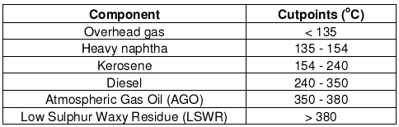

Table 6: Components and their respective cutpoints in the Crude Tower.

**Overhead systems**

Overhead vapor leaves the crude tower at 106ºC and is then condensed to liquid at 40ºC. This liquid stream is then split into the reflux feed and stabilizer feed. Non-condensables are compressed in a compressor and is send to the stabilizer as well as to the crude tower condenser as spillback. This is to control the overhead receiver pressure.

**Stabilizer**

Stabilizer is essential as it is used to produce LPG with < 1mol% of C5 and to produce naphtha.

**Splitter**

Splitter separates naphtha from the stabilizer bottom into light naphtha and medium naphtha.

**De-isopentanizer**

De-isopentanizer reduces the vapour pressure of light naphtha from the splitter by removing isopentane. Isopentane is used in gasoline blending.

**Pumparounds**

Pumparounds are product streams, from the crude and condenser towers, recycled back as feed into these towers to condense vapour that would otherwise have gone to the lighter cuts thus regulating internal reflux. Since the vapour load in the tower is reduced, a smaller tower diameter is required. As a result, smaller trays are required in the tower. Pumparounds are also used to recover heat from the product stream to the feed stream.

**Strippers ( Heavy Naphtha, Kerosene, Diesel and AGO )**

Strippers are used to remove light components from each product to adjust their flash point. Light components will vapourize due to heat absorbed if the stripper is used with a reboiler.

**AGO and Diesel dryers**

Water contained in the diesel and AGO is eliminated by flashing under vacuum conditions ( 0.2 kg/cm2 ) since water will flash at a lower temperature if compared to either diesel or AGO.

**Condensate Tower**

Similar to the crude tower, the condensate tower also has a pumparounds system, side strippers and a pre-heat train. The condensate tower has three product streams which are the overhead gas stream, the condensate naphtha stream and the condensate tower bottom.

**Condensate stabilizer**

Condensate stabilizer removes light ends ( LPG ) in the overhead products from the condensate tower before sending it to the de-isopentanizer.

**2.1.3 PLANT FAMILIARZATION**

**INTRODUCTION**

Do line tracing and make a simplified diagram on the unit.

**OBJECTIVE**

To familiar with:

* Process areas
* Equipments used
* Sequences of the equipments
* Flow of the material in the process line

**METHODOLOGY**

First Part: Line tracing on process units.

Line tracing is an activity which we go to a specific unit and follow the process

line as per P&IDs.

Second Part: Make a simplified diagram on a particular unit using suitable software tool.

( using Microsoft Visio ).

**RESULT**

This is an example of the simplified flow diagram on Unit 11 Crude Distillation Unit / CDU.

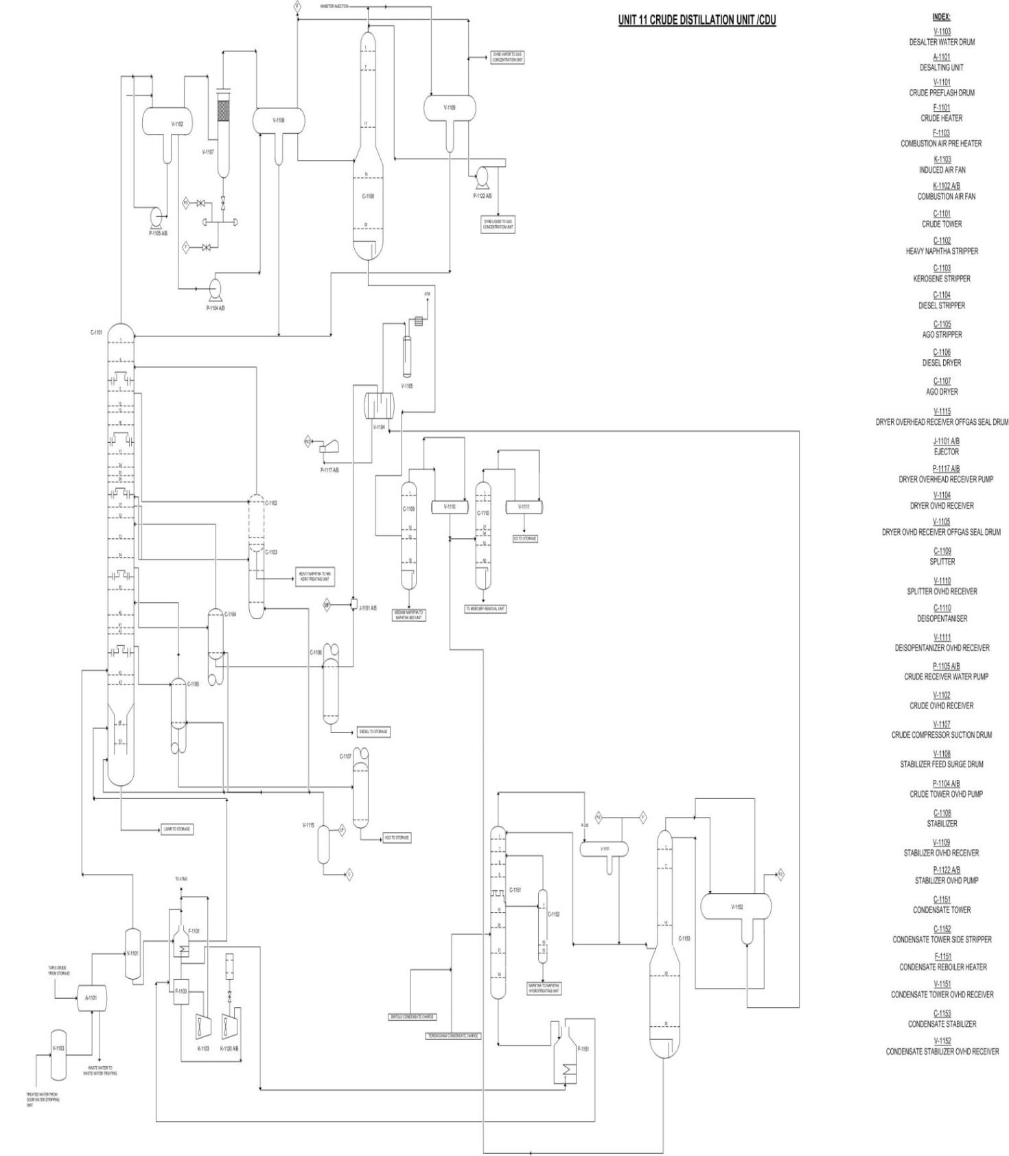 Figure 13: Simplified Flow Diagram on Unit 11 Crude Distillation Unit

**2.1.4 INVOLVEMENT IN HAZOP STUDY**

**Background of HAZOP Study:**

HAZOP study is a procedure used to review the design and operation of a hazardous process facility. It is used to identify all causes of deviations from normal safe operation which could lead to any safety hazard or operability problem. Once identified, the team considers the causes and consequences of the problem, and recommends changes or further study to overcome it.

Shown in Table 5 are the HAZOP workshops I have been involved in as a scriber:

|  |  |  |
| --- | --- | --- |
| **No.** | **Unit** | **Title** |
| 1. | H2 Collection & Distribution System | Purge Gas from Unit 29 and Unit 19 Causing Overpressure on 31UZA-171 |
| 2. | Vacuum Distillation Unit | New jumper line from UCO rundown Hydrocracker to offspec line from Unit 72 heading to Unit 18 including new Flow Indicator (18-FI-XX) |
| 3. | Hydrocracker | Furnace (F- 30230) Refractory Dry Out  ( off-line ). |

Table 7: HAZOP Workshops Involvement

**Workshop 1: HAZOP Study on Purge Gas from Unit 29 and Unit 19 Causing Overpressure on 31UZA-171**

Purpose of the study:

To discuss the hazard of the overpressure in 31UZA-171. The purge gas from Unit 29 (DHT) and Unit 19 (MG3) will be sent to Unit 31. This will cause overpressure if the 31UZA-171 trip off and will close the valve preventing the purge gas flow. This will cause overpressure

**Workshop 2: HAZOP Study on New jumper line from UCO rundown Hydrocracker to offspec line from Unit 72 heading to Unit 18 including new Flow Indicator (18-FI-XX**)

Purpose of the study:

To identify process and operational hazards for the installation of new jumper line from UCO rundown Hydrocracker to offpec line from Unit 72 heading to Unit 18 including new Flow Indicator ( 18-FI-XX ).

**Workshop 3: Furnace (F- 30230) Refractory Dry Out ( off-line ).**

Purpose of the study:

To provide necessary guidelines for safe and smooth refractory dry out activities of combine stage reactor feed furnace F- 30230 in Hydrocracker. In the discussion, there are five main steps on doing the dry out for F- 30230:

* Preparation part
* Steam Purging
* Lighting up the pilot burner
* Temperature increment strategy
* Temperature reduction

**2.1.5 UNDERSTANDING OF PROCESS SAFETY MANAGEMENT (P.S.M)**

PP(M)SB refineries handle hazardous materials (i.e. hydrocarbons) in large quantities that have the potential for major incidents, the consequences of which may rival those of natural disasters in terms of loss of life, injury and damage to property. Process Safety Management (PSM) is the application of risk based management principles to ensure adequate controls are identified, developed, implemented and maintained so as to provide for the safe operation of such facilities.

*Process Safety Management is defined as the application of management principles and systems to the identification, understanding, and control of process hazards to prevent process-related injuries and incidents.”[1]*

**Objectives of Process Safety Management:**

* To minimize the likelihood of major hazard accident from occurring
* To establish comprehensive, robust and sustainable systems, practices and competencies for managing Process Safety
* To ensure necessary mitigation and emergency preparedness mechanisms are in place in the event that an accident does happen

PSM focuses on the prevention of catastrophic incidents related to the manufacturing process and process materials; the word catastrophic basically means accidents such as fires, explosions, releases, etc. PSM does not directly deal with occupational health or safety issues, or with environmental aspects.

PSM is focused on the low frequency/high consequence events, which typically require the application of different identification and analysis tools to occupational hazards and are outside of the normal working experience of staff. The high consequence nature of PSM type events also requires a more detailed examination of the dependability of control measures.

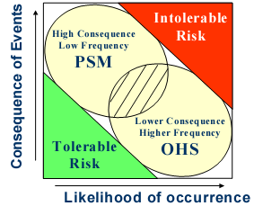

Figure 14: The Relationship between Process Safety Management

and Occupational Health Safety

**Process Safety Management Aspects:** In meeting the objectives mentioned earlier, Process Safety Management has implemented eight aspects as shown in Table 8.

|  |  |
| --- | --- |
| **Aspects** | **Objectives** |
| **Management of Change** | To ensure that a proper level of review is applied to prevent adverse effects from changes being made. MOC ensures that safety of the installation and its personnel is not compromised by inadequate evaluation of hazards related to change. |
| **Process Safety Information** | To ensure that suitable and sufficient information is maintained on equipment and systems to allow HSE risks to be identified and managed. This means that all relevant information, on all relevant equipment and systems. What is relevant depends upon a needs assessment. |
| **Process Hazard Analysis** | To evaluate the risks associated with process hazards, assess the performance of safeguards in-place, and make recommendations to ensure risks are managed within tolerable levels. |
| **Pre-Activity Safety Review** | To ensure the planned activity is thoroughly  reviewed before its commencement so as to  Pre-Activity Safety Review prevent/minimize adverse side-effects. |
| **Operating Procedure** | To provide clear instructions on how to consistently conduct work activities such that risks are managed to an acceptable level. |
| **Mechanical Integrity** | To manage the integrity of facilities through the application of effective inspection, maintenance and operational strategies reflecting predictive, risk-based assessment of facility deterioration. |
| **Design Integrity** | To ensure that equipment and systems are  designed, constructed and commissioned such  that risk are maintained at ALARP (as low as reasonably practicable) |
| **Proprietary & Licensed**  **Technology Assessment** | To confirm that Proprietary and Licensed  Technology is specified, designed, configured, commissioned, operated and maintained through adequate and effective risk management in the context in which it is installed. |

Table 8: Process Safety Management Aspects

* 1. **TRAINING INVOLVED**
     1. **Confined Space Entry (CSE) Training**

Date: 13 January 2010

Venue: Old Learning Centre

Objective: To educate trainees about the necessary precautionary measures that needs to be taken when dealing with confined spaces.

This training was conducted by Mr. Kamaruzzaman for operators, contractors and trainees from UTP. In this training we were introduced to various confined space that exist in this refinery for example columns, vessels, heat exchangers, tanks and furnaces. The reason why these equipments are classified as confined space is because it causes the following problem.

* Deficiency (Asphyxiation)/Excess (Explosion) of Oxygen
* Flammable material
* Toxic material (noxious)
* Electrical/Mechanical hazards
* Physical hazards (slip/trip)
* Inert conditions
* Pyrophoric (self ignition)

The two most important people that are responsible during Confined Space Entry (CSE) is the Entrant and the Hole Watcher. The entrant is the person whom is going to enter the confined space which in this case is us. During CSE, the entrant has to make sure space is empty and ventilated, know the hazards posed, follow Work Permit conditions, stand in contact with Hole Watcher, immediately evacuate if asked and also CSE trained. The next person vital during CSE is the Hole Watcher because the hole watcher has to monitor the condition surrounding the confined space before, during and after the operation, make sure to be alert to the entrant, must be able to warn the entrant of the safety regulations pertaining entry and must be able to summon entrant and give out rescue call in case of emergency

* + 1. **Lock Out/Tag Out (LOTO) Training**

Date: 3 February 2010

Venue: Old Learning Centre

Objective: To educate trainee the systematic way of controlling and also the consequences improper handling

This training was also conducted by Mr. Kamaruzzaman, personnel from Health Safety and Environment (HSE) Department. This training shed light to us about what is LOTO. LOTO is a systematic way of controlling energy. These energies can be caused by force caused by the motion of an object (e.g. process material flow when valve opened) and force stored in an object that is not moving. Some of the energies present in the process site includes electrical, hydraulic, pneumatic, pressurized liquid and gases, kinetic, potential and radiation energy. If proper LOTO is not done, the particular equipment will not be serviced or maintained. It may even cause harm and death.

* + 1. **Authorized Gas Tester (AGT) Training**

Date: 3 February 2010

Venue: Old Learning Centre

Objective: To ensure trainee has the basic knowledge on providing information regarding the type and relative quantity of hazards present at working parameters.

AGT is aimed at having a standardized approach to evaluate the presents, quantity and the potential hazard of contaminates using appropriate monitoring equipment. The main few reasons of conducting AGT is to provide information regarding the type and relative quantity of hazards present, evaluate CSE or Hot Work conditions, PPE Selection, evaluate purging/cleaning/flushing techniques performed by operations, assess efficiency of ventilation controls, and determine need for Medical Monitoring.

* + 1. **Plant Information (PI) System Training**

Venue: Muzaffar Syah Room (New Learning Center)

Date: 19 February 2010

Below are the summary of the training.

*What is a PI System*

* *It is a real time database system developed by OSI Inc.*
* *Facility to collect, store, manage and serve the process data to the users.*
* *Data are retrieved by connecting the data sources with the PI Node Interface. Then PI Node Interface sends the data to the PI server.*

*Functional Group of PI System*

* *The visuals – Deliver info for meaningful, better business decisions*
* *The analytics – Turn valuable real-time data into actionable information*
* *The server – Gather, organize, distribute and store data from many sources*

*Components of PI System*

* *System Administrator – Supervise, maintain and provide technical support to the users*
* *Hardware – Comprises of servers, which are dedicated machines which provides service to client*
* *Interface – Programming application that provides 2 way communication to access a system*
* *PI Clients Application – Program that run on PC or system that connects PI server to perform*

The theory part of the presentation was until lunch time. Then later after lunch break, we were taught how to use PI ProcessBook. All in all, it was a day filled with knowledge and learning.

* 1. **Events and Activities**
     1. **Capability Forum 2010**

Capability Forum is an Exhibition being organized every year. All the departments are involved in this forum. The aim of Capability Forum is to showcase what has been done for the past year. To achieve this, each and every department will prepare an exhibition to show what has been happening in their department. For this year, Technical Services Department (TSD) and Process Safety Management Department (PSM) joined together to put up a booth. My task is to prepare a trailer for two process safety movie, ‘One Night in Bhopal’ and the other one is ‘BP Texas’. Other than that, I also have to make a poster for the movies. I also involved in creating the PSM ‘Wheel of Fortune’ together with PSM staffs.

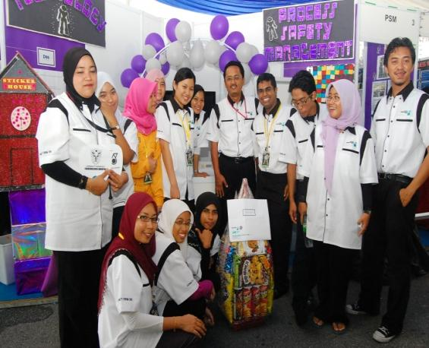 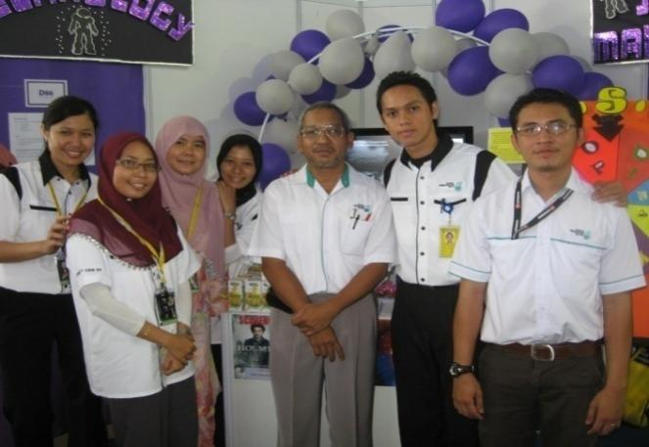

Some of the necessary tasks that were done were as follow:

* + Preparation of the flash game ‘Who Wants to be a Millionaire’ & ‘Sticker House’
  + Decorations of the booths
  + Purchase and wrapping of merchandises, souvenirs and gift bags
  + Ushering the visitors that visited our booth

Capability forum was from 21st April 2010 to 22nd April 2010. Some of the activities that were lined up in our booth were as follow:

* Microscopic viewing of oil eating microorganisms
* Who Wants to be a Millionaire Game (General knowledge and process skills will be tested)
* Wheel of Fortune (Simple questions on safety aspects will be asked)
* Movies viewing (Chemical blasts at Bhopal and BP Texas – Quiz at the end)

At the end of the 2 days, we won the **‘Most Creative Booth’ award.**

* + 1. **Visit to the Jetty, Storage and Distribution Unit**

I and TSD trainees were given the opportunity to visit the jetty for a day to observe the process of berth and un-berth of Bunga Kelana-8 .Sungai Udang port is under different jurisdiction than in PPMSB thus requiring special authorization to enter the jetty. The jetty consists of:

1. 2 ocean berths (OB).
2. 4 coastal berths (CB).
3. LPG berth.
4. Marine crafty jetty (facility for tug boat and mooring gang).
5. Bulk cargo jetty (export coke and sulphur).

The distance between OB1 to LPG is 2.1 km. At the jetty there are also equipments such as:

1. Loading arm; OB (16”), CB (8” and 10”) and LPG berth (6” and 8”).
2. Fire fighting equipments with source of water from the sea.
3. Centralized foam unit consisting foam tank, foam pump and foam proportioning unit.

BK-8 is a crude carrier from Bintulu that carries condensate and crude from eastern Malaysia region. We were able to meet the captain of the ship were he told the basic operation inside the ship. The ship consists of only 28 crews including the captain. The ship facilities are complete where there are gymnasium, kitchen, TV room and bed rooms. The crews will be on board for the 4 months and have a holiday for another 4 months. The ship is also navigated via GPS at open sea and maritime drawing near coastal area. The process of berth and un-berth requires assistance of tug boat since the ship is not allowed to turn on their engines.

* + 1. **Stock Take Exercise FY 2009/2010**



The Stock Take Exercise FY09/10 took place at PP(M)SB Warehouse from 16th – 18th March 2010. The Annual stock taking exercise is part of Standard Accounting Practice, which is being followed by PP(M)SB/MRCSB and PETRONAS Group wide. The main purpose of this exercise is to confirm the quantitative compliance between physical materials kept and SAP data.

CHAPTER 3: LESSON LEARNT AND EXPERIENCE GAINED

* 1. **Teamwork and Individual Activities**

Teamwork is one of the most important elements in carrying out given tasks. Collecting data (i.e. Chemical Reactivity Matrix) for example required information and data from various divisions. Discussions were held, as well as consulting the more experienced engineers in order to solve the problems encountered. Any updates regarding the project were informed to my supervisor in order to avoid any miscommunication as we want the project to be as want we have planned. The HAZOP and Operability Review Workshops are other great examples of discussion involving teamwork as it deals with people from different discipline for instance mechanical engineering, inspection, electrical and safety officers. Not only that, individual skills have been enhanced through working independently on the task or project at hand. Plus, all the data or information required was sought after independently. However, in some cases, help and guidance were required from the other engineers.

* 1. **Safety Awareness**

When I first entered this refinery, I was cautioned that working in a refinery is like working in a time bomb. From that expression, it gave me an impression that this is a very hazardous place. Apart from that, involvement in Revamp and Turnaround (RETA) 2009/2010 has given me the necessary exposure towards the various hazards posed by these units towards a catastrophic incident. So, we were given Safety Induction at the first day of induction and various safety training like Confined Space Entry Training, Lock Out/Tag Out (LOTO) Training, Authorized Gas Tester (AGT) Training and also International Ship and Port Facility Security (ISPS) Code Compliance and Implementation Training were also conducted prior to actions related to these areas.

* 1. **Leadership and Management Skills**

Leadership skill was instilled in a more indirect manner. During my involvement and participation in the workshops and meetings, I was able to observe first-hand how the discussions were organized and conducted within a group of people.

Management skills in terms of time and financial management have improved, thanks to the exposure during the internship. Punctuality and being able to prioritize and delegate work are important in order to carry out every task successfully. Good time management has allowed the completion of all the technical tasks within the allocated time and provided the time at hand to participate in various activities.

In line with one of the industrial internship objectives (i.e. to introduce students to the work culture), this internship has provided a good perspective of what the ‘working world’ may be. Having to undergo the industrial internship quite far from home, it has taught me to appreciate and realize the importance of good financial management, even from now.

* 1. **Presentation/Communication Skills**

Throughout my 8 months of Industrial Internship Training at Petronas Penapisan (Melaka) Sdn. Bhd., there were many projects that were given to me and many of these projects required me to meet various personnel that were involved or in-charge of various units that I was working on. These meetings cultivated my communication skills professionally where I learnt how to communicate with fellow colleagues and also my superiors. Apart from that, I also had few presentations regarding to my projects and due to the frequency of these presentations, I managed to upgrade my level of presentation with constant help from my superiors and friends.

CHAPTER 4: DISCUSSION AND RECOMMENDATION

**RECOMMENDATIONS TO UNIVERSITI TEKNOLOGI PETRONAS**

**4.1.1 Training Schedule**

It is found that the flow of the internship did not correspond with the Training Schedule planned initially. However, this is to be expected and it has been a more satisfying journey to be able to carry out all the tasks and participate in the activities as stated in this report. Not having to depend too much to the schedule has given ample amount of time in completing the tasks and to learn at a comfortable pace. It is hoped that it remains where not too much emphasize is put on the schedule and that it should be general, allowing room for unexpected assignments

**4.1.2 Theory versus real practice**

There is a huge difference between what is learnt in the classroom and what is actually happening in the industry. Hardly any in-depth knowledge studied in the university was put to great use. Often new information has to be dug and searched. Although this is a good learning process, it raises the question of the validity course taken in the university.

However, there is some small portion of information used during the period here; it is often the simple correlations studied in the first couple of years in the university. This is because most calculations performed are spreadsheet based by keying in inputs.

Therefore, it is suggested that the university provide relevant topics incorporating more practical based studies, where students are able to attain a vivid picture and grasp the information studied in class.

**4.1.3 Plant Supervisor Briefing By UTP Lecturer**

Since 70% of the total internship marks is allocated to the Plant Supervisor, it is recommended that at the beginning of the program, a briefing should be done by the UTP lecturer to the Plant Supervisor on how to conduct the student assessment. This is to ensure that the supervisor fully comprehends on the criteria of the evaluation.

Furthermore, UTP could explain to the Host Company on what is expected from the Industrial Training along with the objectives of the program. This will make it easy for the Host Company to allocate the right tasks to the student in order to achieve these objectives.

During the briefing, UTP could nominate a student as a representative to communicate between UTP and the Host Company and also to inform the student on the progress of the attachment such as the visits’ date and the lecturers who will be visiting.

**4.2 RECOMMENDATIONS TO HOST COMPANY**

**4.2.1 Intern’s Personal Protective Equipments (PPE)**

Some discomfort was experienced with the personal protective equipments given. It was rather uncomfortable to move around in oversized coveralls and old safety glasses, which were not clear due to scratches. Thus, it is recommended that the Technical Training Unit provides PPEs that are in good condition.

**4.2.2 Frequency of Report**

Currently, the trainees are required to submit report on weekly basis. Sometimes, some of the projects which are given requires long span of time in researching and analysis. So, sometimes, the same routine is recorded in that particular week or not much has been done in that week. So, in order to avoid redundancy in work, I suggest monthly report can be submitted instead weekly ones.

**4.2.3 Facilities**

Although some of the students were supplied with computers and extension numbers, not all of them are fortunate enough to have these facilities. It is recommended that all students are provided with computers and also email addresses so that they can make use of their time to do some plant monitoring and access any updates regarding their projects from the engineers. They are also able to complete their weekly and detailed reports, projects and obtain information easily from the DCS server. Email services are important in communicating with UTP personnel and colleagues. Trainees can convey message effectively by email to PP(M)SB staff if they have any problem or need information immediately.

CHAPTER 5: CONCLUSION

Throughout the eight months undergoing my industrial internship at PETRONAS Penapisan Melaka Sdn. Bhd, I have gained valuable experience in terms of working as a team, soft skills and communication skills and also time management. Furthermore, I’ve obtained an overview of the application of theoretical knowledge into practice in the industry, which is in line with one of the University’s objectives. This internship is not only an important platform, but also, acts as an excellent exposure in introducing me to the work culture and industrial practices rather than spending most of the time learning the theory in classes.

The experience as a near-to-be chemical engineer has expanded my mindset and skills as a whole. It has influenced a great part in personal growth, maturity, ways of thinking, and working as well as general knowledge. Furthermore, the opportunity to work with various kinds of people from different disciplines and experience levels has allowed good social skills development and has improved my soft skills. In addition, the chance to work with people from different cultures has made my experience even more enriching.

Overall, the industrial internship is a success in producing well-rounded graduates and has been a priceless experience, fulfilling its objectives to integrate theory with practice and to introduce students to work culture and industrial practices under the guidance of experienced engineers. This programme should be continued and improved from time to time so that it will be more beneficial to the future generation of UTP.

REFERENCES

1. Ahmad Syafiq B. Zahid, *Weekly Report and Logbook for Industrial Internship Training*; 2010
2. Norman P. Lieberman/Elizabeth T. Lieberman, *Working Guide to Process Equipment*, 2003, 2nd Edition, McGraw Hill International
3. Robert H. Perry/Don W. Green, Perry’s *Chemical Engineer Handbook*, 1998, 7th Edition, McGraw Hill International
4. Center for Chemical Process Safety of the American Institute of Chemical Engineering. 2000. Guidelines for Chemical Process Quantitative Risk Analysis
5. PSR-1 Equipment Manual Vol. 131
6. PSR-2 Equipment Manual Vol. 137
7. Det Norske Veritas (DNV) Process Industry HAZOP Leader Training Manual, Melaka 28th January to 6 February 2003 prepared for PP(M)SB
8. *UTP Industrial Internship Guidelines*; July 2009

APPENDICES

**APPENDIX A:** Developing Chemical Reactivity Matrix in PP(M)SB.

**APPENDIX B:** Overview on PETRONAS SECOND REFINERY PHASE 1 (PSR 1)

and PETRONAS SECOND REFINERY PHASE 2 (PSR 2).

**APPENDIX C:** Involvement in HAZOP Study.

**APPENDIX D:** Pictures

**APPENDIX A**

**DEVELOPING CHEMICAL REACTIVITY MATRIX IN PP(M)SB.**

|  |  |
| --- | --- |
| **No.** | **Chemical Name** |
| **1.** | Asphalt |
| **2.** | Atmospheric Gas Oil |
| **3.** | Coke |
| **4.** | Equinas 4 |
| **5.** | Equinas 6 |
| **6.** | Equinas 10 |
| **7.** | Etro 4 rev128-07-2008 |
| **8.** | Etro 6 rev128-07-2008 |
| **9.** | Etro 8rev128-07-2008 |
| **10.** | Etro 8.5 rev2 |
| **11.** | Etro 10 rev1 28-07-2008 |
| **12.** | Export Diesel |
| **13.** | Export Kero-DPK |
| **14.** | Export Reformate |
| **15.** | High Sulfur Fuel Oil |
| **16.** | Jet A1 |
| **17.** | Kinetic 4 |
| **18.** | Kinetic 6 |
| **19.** | Kinetic 10 |
| **20.** | Light Sulfur Fuel Oil |
| **21.** | Liquefied Petroleum Gas LPG |
| **22.** | Low Sulphur Waxy Residue |
| **23.** | M500 |
| **24.** | Mogas ULG 88 |
| **25.** | Mogas ULG 92 |
| **26.** | Mogas ULG 95 |
| **27.** | Mogas ULG 97 |
| **28.** | PetroChemical Naphtha PCN |
| **29.** | Premium Diesel 50 ppm |
| **30.** | Premium Diesel 500 ppm |
| **31.** | Premium Diesel - 8 ppm |
| **32.** | Sulfur - liquid |
| **33.** | Sulfur – solid |

Table 9: List of product produce in PP(M)SB

**APPENDIX B**

**OVERVIEW ON PETRONAS SECOND REFINERY PHASE 1 (PSR 1) AND PETRONAS SECOND REFINERY PHASE 2 (PSR 2).**

**1. PROCESS AREA AND THEIR RESPECTIVES PROCESS UNITS IN PP(M)SB**

AREA 1 SWEET HYDROSKIMMING ( PSR 1 )

|  |  |  |
| --- | --- | --- |
| **AREA 1A – CDU 1** | | |
| **Unit No.** | **Unit Name** | **Abbreviation** |
| **11** | CRUDE DISTILLATION UNIT | CDU 1 |
| **14** | SATURATED GAS CONCERNTRATION UNIT | SGCU |
| **15** | SOUR WATER TREATING UNIT | SWTU |
| **16** | KEROSENE AND HEAVY NAPHTHA TREATING | KTU |
| **17** | MERCURY REMOVAL UNIT | MRU |
| **AREA 1B – CRU 1** | | |
| **12** | NAPHTHA HYDROTREATING UNIT | NHT |
| **13-1** | CATALYTIC REFORMING UNIT | CRU 1 |
| **13-2** | CONTINUES CATALYST REGENERATION | CCR 1 |
| **AREA MG3 – LUBE BASE OIL** | | |
| **18** | VACUUM DISTILATION UNIT | VDU1 |
| **19** | MOBILE DEWAXING UNIT | MDW |
| **72** | MG 3 INTERMEDIATE TANK |  |

Table10: Process Units in Area 1 Sweet Hydroskimming

AREA 2 SOUR HYDROSKIMMING ( PSR 2 )

|  |  |  |
| --- | --- | --- |
| **AREA 2A – CDU 2** | | |
| **Unit No.** | **Unit Name** | **Abbreviation** |
| **21-1** | CRUDE DISTILATION UNIT | CDU 2 |
| **21-2** | VACUUM DISTILATION UNIT | VDU 2 |
| **24** | SATURATED GAS CONCERNTRATION UNIT | SGCU |
| **26** | LPG TREATING UNIT | LTU |
| **27** | NAPHTHA TREATING UNIT | NTU |
| **28-1** | KEROSENE TREATING UNIT | KTU |
| **28-2** | CAUSTIC NEUTRALISATION UNIT | CNU |
| **AREA 2B – CRU 2** | | |
| **22** | NAPHTHA HYDROTREATING UNIT | NHT 2 |
| **23-1** | CATALYTIC REFORMING UNIT | CRU 2 |
| **23-2** | CONTINUES CATALYST REGENERATION | CCR 2 |
| **25** | C6 ISOMEREZATION | C6 ISOM |
| **29** | DISTILLATION HYDROTREATING UNIT | DHT |

Table 11: Process Units in Area 2 Sour Hydroskimming

AREA 3 SOUR CONVERSION ( PSR 2 )

|  |  |  |
| --- | --- | --- |
| **AREA 3A – HCK** | | |
| **Unit No.** | **Unit Name** | **Abbreviation** |
| **30** | HYDROCRACKER UNIT | HCK |
| **31** | H2 COLLECTION & DISTRIBUTION SYSTEM | HCDS |
| **39-1** | HYDROGEN PRODUCTION UNIT | HPU 1 |
| **39-2** | HYDROGEN PRODUCTION UNIT | HPU 2 |
| **AREA 3B – CRU 2** | | |
| **32-1** | DELAYED COKER UNIT | DCU |
| **32-2** | DELAYED COKER LIGHT END UNIT | DCLEU |

Table 12: Process Units in Area 3 Sour Conversion

**2. UNIT 11 CRUDE DISTILLATION UNIT / CDU 1 BLOCK FLOW DIAGRAM**

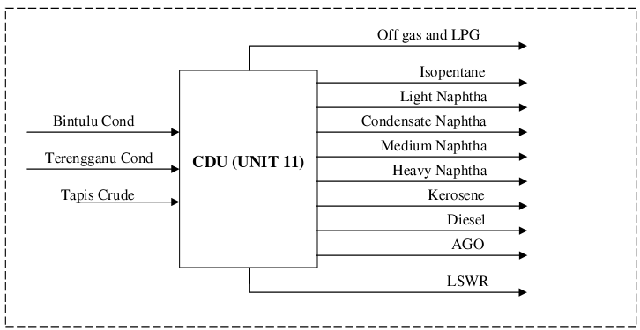

Figure 15: Unit 11 Block Flow Diagram

**APPENDIX C**

**INVOLVEMENT IN HAZOP STUDY**

**HAZOP DEVIATION MATRIX**

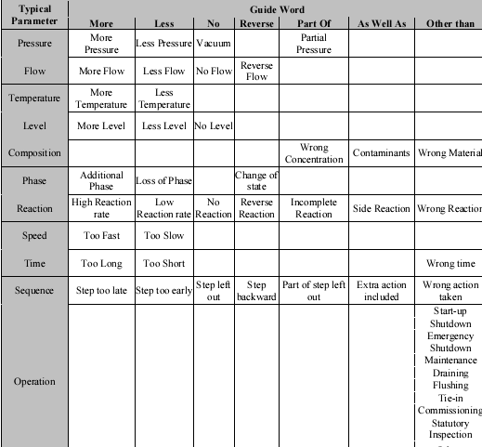

Table 13: HAZOP Deviation Matrix

(Deviation = Guide Word + Parameter)

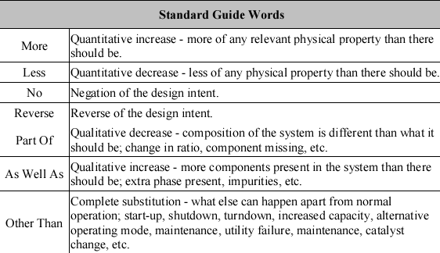

Table 14: HAZOP Standard Guide Words

**HAZOP GUIDELINES**

Step 1: Divide System into Nodes

The first step in the HAZOP study is to divide the system under review into manageable sizes called nodes. A node is defined as a segment of the system which has distinct design intent. A node would typically comprise of one major equipment (vessels, etc.), associated minor equipment (pumps, valves, etc.), instrumentation, and other ancillary equipment.

Use of nodes would allow the study to progress in a sequential manner without repetition of the possible causes. The team leader shall identify the nodes before the HAZOP team convenes. This will help him/her estimate the time required to complete the study. The team leader then assigns the respective technologist to prepare the design intent information of each node for the meeting.

Step 2: Define Nodes

Each node must be defined by describing its design intent. A design intent provides specific information on how the node will be operated under design conditions (describes parameters such as pressure, temperature, flowrate, level, etc.). It provides basic understanding of the node to ensure effective evaluation.

At the start of the meeting, the technologist shall brief the team on the overall schematic of the system and the design intent of each node.

*Example 1: Node definition - The centrifugal compressor K-1111 is designed to compress propane at 1,000 kmol/h. It is designed to run at 14 degrees Celsius and 5 barg (suction) and 35 degrees Celsius and 15 barg (discharge). It is equipped with high discharge pressure and low oil pressure trip system. Two PSVs are provided which is vented to the flare*.

Step 3: Select Parameter

A parameter characterizes the design intent of each node. For each node, the team shall list down the applicable parameters.

*Example 2: The parameters which characterize the node in example 1 are: flow, pressure, temperature, gas composition or density, compressor speed, etc*.

Step 4: Create Deviations

Identifying deviations are the key to the HAZOP process. Deviations are departure from the design intent and are identified by the systematic combination of the following guideword to each parameter:

For each Parameter, the team leader shall guide the team by applying the guidewords to create deviations. Not all of the above guidewords may be applicable to each parameters, e.g., only the guidewords “more” or “less” may be applicable to temperature.

Step 5: Brainstorm Possible Cause for Deviation

For each deviation, the team shall brainstorm all possible causes for the deviation. Be specific in the description of possible causes by specifying tag numbers. A failed safeguard can be a cause, e.g., a faulty check valve, faulty pressure controller, etc.

Avoid double jeopardy scenarios, e.g., failure of two independent safeguards at the same time, e.g. failure of level controller and low level alarm at the same time.

To avoid duplication, only consider causes that originate from within the node being studied, or one node upstream or downstream of the node.

When identifying causes, focus on the following categories in decreasing probability:

• Human error

• Equipment failure

• External events

If there is no possible cause, then indicate the deviation as “Not Possible” and proceed to the next guideword.

Step 6: List Worst Credible Consequences

The consequences of each cause of the deviation must be discussed in detail. The consequence statement shall consist of the initial system response to the worst credible consequence. Consider consequence to its furthest applicable extent upstream or downstream of the node under study.

*Example 3: Storage tank T-1111 overflows to secondary containment resulting in pool fire, damage to the tank, loss of product, and escalation of pool fire.*

If the consequence is not a concern, then fill in the consequence column as “Not a perceived hazard” and proceed to the next guideword.

Step 7: List and Analyze Adequacy of Existing Safeguards

For each possible cause and consequence, analyze the existing safeguards. The safeguards can be within or outside the node (upstream or downstream). Look for these three types of safeguards:

• *Prevention* - prevents deviation from happening (e.g., check valves, SOP)

• *Detection* - detects causes or consequences (e.g., alarms)

• *Mitigation* - controls or lessens the consequences (e.g., ERP, relief, trip system)

Availability of preventive safeguard shall be the preferred option. However, preventive safeguards can be prohibitive in terms of cost and/or design, which necessitate the need for detective or mitigative safeguards. When analyzing the safeguards, safeguards, which require human intervention, shall be minimized to minimize probability of human error.

Adequacy of existing safeguards are determined by considering the probable failure rate of the existing safeguards, and also the potential consequences of any failure, and if sufficient layer of protection exists. For example, low level in a vessel is safeguarded by a level control system, failure of which will be detected by a low level alarm. If a low level alarm is inadequate, then a low level trip switch may be recommended, etc.

Step 8: Recommendations of Potential Safeguards

Recommendations for additional controls are made if the HAZOP team feels that the existing safeguards are inadequate. Recommendations shall address the hazards by preventing the cause of the hazards. If prevention is not possible or is prohibitive (in terms of design or cost), then recommendations shall address the hazards by either reducing its severity or likelihood.

Recommendations can take the form of closed or open action actions.

**Closed action** shall be made when the team agrees to the solution which is within their level of competency.

**Open action**, which calls for further work outside the HAZOP study, shall be made for cases where the situation is complex and the solution is not obvious. The team can offer the preferred solution whilst giving the responding engineer scope to study alternatives.

Where possible, try to minimize open action recommendations.

Recommendations shall be specific, concise, and stand-alone. This is to ensure understanding by the action parties who may not necessarily be in the HAZOP team. Each recommendation must explain the elements of what, where, and why.

*Example 4: Closed action – “It is understood that the vent to the flare and fuel gas systems at P-1111 (which is meant for P-1111 start-up) are being used to manually control level in V-1111 which can cause liquid carryover to the flare and fuel gas systems. To ensure consistent operator response to the high level in V- 1111, ensure that the operating procedure and operator training make it clear that use of the vent lines to the flare and fuel gas systems at P-1111 to manually control level in V-1111 is not permissible”.*

*Example 5: Open action – “Because the control valve associated with 11-FC001 is fully opened and its bypass cracked open, it is recommended that the mechanism for improving the flow control is studied. This may involve internal modification or resizing of the control valve”.*

**HAZOP WORKSHEET**

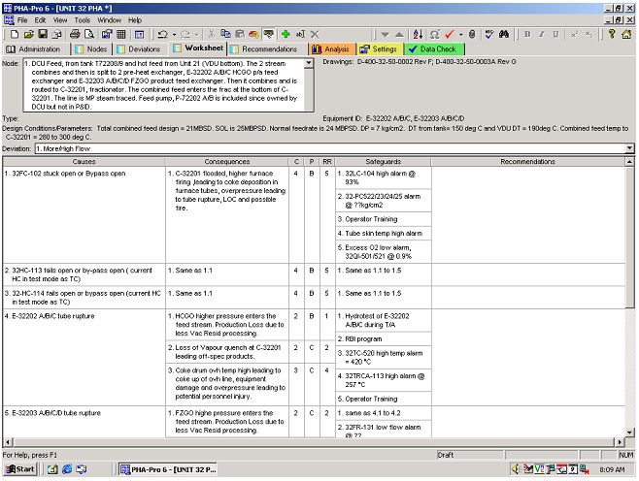

Figure 16: HAZOP Sample Worksheet

**APPENDIX D**

**PICTURES**

**APPENDIX E1 – PSR-1 Slop Tank Area**

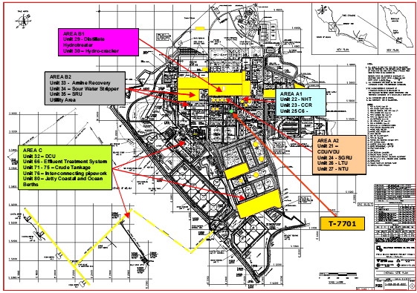

**APPENDIX E2 – Area 1: Sweet Hydroskimming**

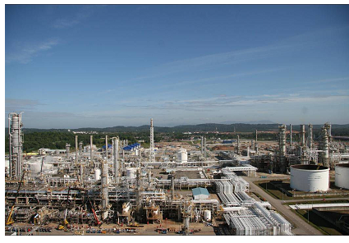

Aerial view of Unit 11 (Crude Distillation Unit) and Unit 14 (Saturated Gas Concentration Unit

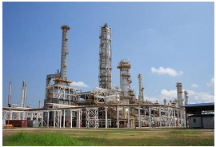 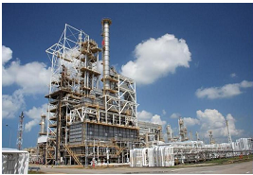

Crude Distillation Unit Catalytic Reforming Unit

**APPENDIX E3 – Area 2: Sour Hydroskimming**

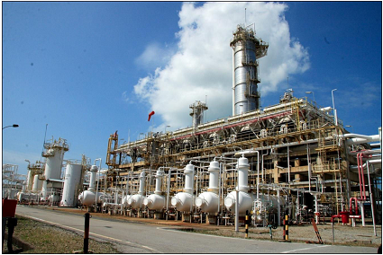

Saturated Gas Recovery Unit

**APPENDIX E4 – Area 3: Sour Conversion**

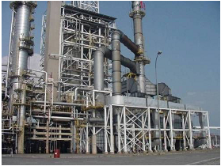 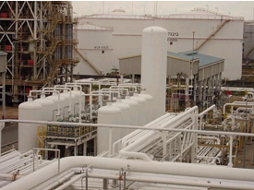

Delayed Coker Unit H2Collection and Distribution System

**APPENDIX E5 – Area 4: Storage and Distribution**

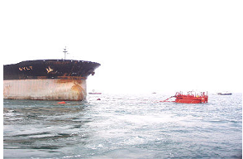 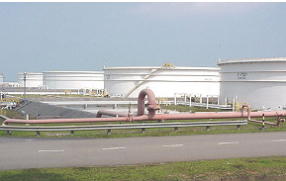

Single Point Mooring Tank Farm

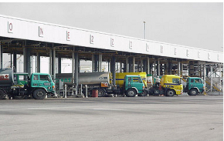 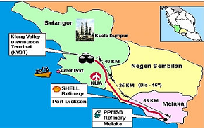

Tank Truck Loading Rack Multi Product Pipeline

**APPENDIX E6 – Area 5: Utilities and Sulphur Complex**

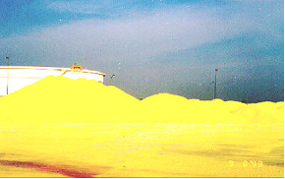 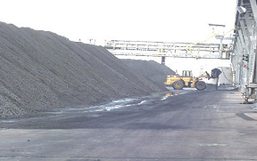

Tank Truck Loading Rack Coke Handling Facility