**PHARMACOGNOSTIC AND ANTIMICROBIAL STUDIES ON THE LEAF EXTRACTS OF *CARISSA EDULIS* VAHL. (APOCYNACEAE) AND *SENNA ALATA***

## L. (FABACEAE) USED IN THE MANAGEMENT OF SKIN INFECTIONS

**BY**

## BEATRICE NAWAYA JENSON

**DEPARTMENT OF PHARMACOGNOSY AND DRUG DEVELOPMENT, FACULTY OF PHARMACEUTICAL SCIENCES,**

## AHMADU BELLO UNIVERSITY ZARIA

**SEPTEMBER, 2018**

**PHARMACOGNOSTIC AND ANTIMICROBIAL STUDIES ON THE LEAF EXTRACTS OF *CARISSA EDULIS* VAHL (APOCYNACEAE) AND *SENNA ALATA***

## L. (FABACEAE) USED IN THE MANAGEMENT OF SKIN INFECTIONS

**BY**

## Beatrice Nawaya JENSON, (B. Tech Botany, 2011, MAUTECH) P14PHPD8002

**A THESIS SUBMITTED TO THE SCHOOL OF POSTGRADUATE STUDIES, AHMADU BELLO UNIVERSITY, ZARIA**

## IN PARTIAL FULFILLMENT OF THE REQUIREMENTS FOR THE AWARD OF

**MASTERS DEGREE IN PHARMACOGNOSY DEPARTMENT OF PHARMACOGNOSY AND DRUG DEVELOPMENT,**

## FACULTY OF PHARMACEUTICAL SCIENCES AHMADU BELLO UNIVERSITY,

**ZARIA, NIGERIA**

## SEPTEMBER, 2018

## Declaration page

I declare that the work in this dissertation entitled Pharmacognostic and Antimicrobial Studies on the Leaf extracts of *Carissa edulis* Vahl. (Apocynaceae) and *Senna alata* L. (Fabaceae) used in the Management of Skin Infections has been carried out by me in the Department of Pharmacognosy and Drug Development, Faculty of Pharmaceutical Sciences. The information derived from literature has been duly acknowledged in the text and a list of references provided. No part of this dissertation was previously presented for another higher degree or diploma at this or any other institution.

Beatrice Nawaya Jenson

Signature Date

## Certification page

This dissertation entitled PHARMACOGNOSTIC AND ANTIMICROBIAL STUDIES ON THE LEAF EXTRACTS OF *CARISSA EDULIS* VAHL. (APOCYNACEAE) AND *SENNA ALATA* L. (FABACEAE) USED IN THE MANAGEMENT OF SKIN INFECTIONS by

Beatrice Nawaya JENSON, meets the regulations governing the award of the degree of Master of Science in Pharmacognosy of the Ahmadu Bello University, and is approved for its contribution to knowledge and literary presentation.

|  |  |  |
| --- | --- | --- |
| Prof. Hajara Ibrahim |  |  |
| Chairman, Supervisory Committee | Signature | Date |

|  |  |  |
| --- | --- | --- |
| Dr. U. H. Danmalam |  |  |
| Member, Supervisory Committee | Signature | Date |

|  |  |  |
| --- | --- | --- |
| Prof. Hajara Ibrahim |  |  |
| Head, Department of Pharmacognosy | Signature | Date |
| & Drug Development |  |  |

Prof. S. Z. Abubakar Dean, School of Postgraduate Studies Signature Date Ahmadu Bello University Zaria

## Dedication

This dissertation is dedicated to Almighty God, my husband and my lovely children.

## Acknowledgement

I am grateful to Almighty God, for making it possible for me to complete my Master of Science degree programme. I am indebted to my supervisors Professor Hajara Ibrahim and Dr. U. H. Danmalam for their untiring efforts, enormous contributions, supervision, guidance and supports during the research.

I appreciate the positive contribution of Prof. J. O. Ehimidu, Mr. Ezekial Dangana of Department of Pharmaceutics and Pharmaceutical Microbiology, ABU, Zaria. My appreciation also goes to Mr Tunkat Jilang of Institute of Human Virology Abuja, for his help and assistance during my research work.

My sincere appreciation goes to my husband, siblings, parents and in-laws for their supports and encouragements during the programme. I also acknowledge my colleagues Jeremiah Celestine, Peter Balami, Maimunah Mohammad, Rashydah Ahmed, Bashir Miko, Ayeni Emmanuel, Tani Yerima, and some of my senior colleagues Nuhu Aliyu and Khadijat Imam for their love and support during the course work and research year, and also to those that are not mentioned here due to limited space, but their efforts are duly acknowledged. I say thank you all.

## Abstract

*Carissa edulis* and *Senna alata* are plants found in Nigeria and some other tropical countries. In Nigeria, *C. edulis* and *S. alata* are used for the treatment of various ailments and diseases. In traditional medicine *C*. *edulis* is used for the treatment of skin infections, abdominal problems, headache and sexually transmitted diseases, while *S. alata* is also used in the treatment of several infections such as ringworm, parasitic skin diseases, convulsion, gonorrhoea, heart failure, and abdominal pains. Evaluation of the fresh leaf, dried powdered leaves and extracts of *C. edulis* and *S. alata* were carried out to determine its macroscopic and some physicochemical parameters. The extracts of the leaves were obtained by successive extraction with hexane, ethyl acetate and methanol using Soxhlet apparatus, the phytochemical screening and antimicrobial activity of the extracts were carried out. Phytochemical screening of leaf extracts of *C. edulis* and *S. alata* revealed the presence of alkaloids, anthraquinones, saponins, tannins, triterpenes, steroids, flavonoids and carbohydrates. The antimicrobial activities of the hexane, ethyl acetate and methanol extracts of *Carissa edulis* and *Senna alata* were tested on six clinical isolates of *Aspergillus fumigatus, Candida albicans, Trichophyton mentagrophytes, Escherichia coli, Staphylococcus aureus* and *Streptococcus pyogenes*. The results showed that the methanol extracts of the plants have the highest activity in (both) the two plants. The hexane extract of *C. edulis* was active on only two bacteria which are *E. coli* and *S. aureus* MIC 50mg/ml. The ethyl acetate extract of *C. edulis* was active on only two fungi which are *C. albicans* and *T. mentagrophytes* MIC 50mg/ml*.* While the methanol extract of *C. edulis* was active on *E. coli* MIC 12.0mg/ml, *S. aureus* MIC 25mg/ml, and *S.pyogenes* MIC 50mg/ml and two of the fungi that were tested on which are *C. albicans* and *T. mentagrophytes* MIC 25.0mg/ml and 50mg/ml. The hexane extract of *S. alata* was not active on either of the fungi or bacteria that were tested on, the ethyl acetate extract of *S. alata* was active on all the three bacteria that were tested on, and two of the fungi which are *A. fumigatus* and *T.*

*mentagrophytes* MIC 50mg/ml. While the methanol extract of *S. alata* was active on all the three bacteria (*E. coli* MIC 12.0mg/ml, *S. aureus* MIC 6.25mg/ml, and *S.pyogenes* MIC 100.0mg/ml), and the three fungi (*A. fumigatus* MIC 100.0mg/ml, *C. albicans* 25mg/ml and *T. mentagrophytes* MIC 12.5mg/m). The methanol extract of *Senna alata* was further fractionated and the fractions obtained were tested on the same organisms and the results showed less activity compared to the crude extract, this indicates the activity to be due to many compounds of different polarity.

## Table of Contents

Declaration page iii

Certification page iv

Dedication v

Acknowledgement vi

Abstract vii

Table of Contents ix

List of Figures xii

List of Tables xiii

List of Plates xv

List of Appendices xvii

List of Abbreviation and Symbols xviii

CHAPTER ONE

* 1. INTRODUCTION 1
  2. Background of the Study 1
  3. Pharmacognostic Evaluation of Medicinal Plant 2
  4. Description of Carissa edulis 3
  5. Taxonomical classification of Carissa edulis 4
  6. Description of Senna alata 6
  7. Taxonomical classification of Senna alata 6
  8. Statement of Research Problem 8
  9. Justification of the Study 8
  10. Aim and Objectives 9
      1. General aim 9
      2. Specific objectives 9
  11. Research Hypothesis 9

CHAPTER TWO

2.0 LITERATURE REVIEW 10

2.1.3 Reported Biological Activities of Carissa edulis 11

2.2.3 Reported Biological Activities of Senna alata 16

* 1. Skin Infections in Humans 18
     1. Fungal Skin Infections 19
     2. Bacterial Skin Infection 20
     3. Some Current Standard Drugs used for Skin Infections 21
  2. Some Herbal Drugs or Remedies sed for Skin Infection 21
     1. Cannabis sativus (Hemp, Ganja) 22
     2. Aloe vera (Barbados aloe) 22
     3. Portulaca oleraceae (Purslane) 22
     4. Lawsonia inermis (Henna) 22
     5. Euphorbia walachii 23
  3. Some Common Home Remedies for Fungal Skin Infection 23
     1. Apple cider vinegar (Malus pumila, Malus domestica) 23
     2. Garlic (Allium sativum) 23
     3. Tea tree oil (Melaleuca spp) 24
     4. Coconut oil (Cocos nucifera) 24
     5. Herbal teas 24

CHAPTER THREE

* 1. MATERIALS AND METHODS 25
  2. Materials, Chemicals, Equipment, Solvents, Reagents/Solutions 25
     1. Reagents and Solvents 25
     2. Materials and equipments 25
  3. Collection, Identification and Preparation of Plant Material 26
  4. Macroscopic Studies of C. edulis and S. alata Leaves 26
     1. Experimental design 26
  5. Determination of Physicochemical Constants of the Powdered Leaves of C. edulis and S. alata 26
     1. Determination of moisture content 27
     2. Determination of total ash value 27
     3. Determination of acid-insoluble ash 28
     4. Determination water soluble ash 28
  6. Extractive Values 28
     1. Water extractives value 28
     2. Ethanol extractive value 29
  7. Extraction of the Leaves of C. edulis and S. alata 29
  8. Phytochemical Screening of the Leaf Extracts of C. edulis and S. Alata 31
     1. Test for carbohydrates 31
     2. Test for tannins 31
     3. Test for anthraquinones 32
     4. Test for flavonoids 33
     5. Test for saponins 33
     6. Test for cardiac glycosides 34
     7. Test for steroids/triterpenes 34
     8. Test for alkaloids 35
  9. Fractionation of the Methanol Extract of Senna alata and Carissa edulis 35
  10. Thin Layer Chromatographic Profile of Carissa edulis and Senna alata Leaf Extracts 37
  11. Determination of Antimicrobial Activity of the Leaf Extracts of Carissa edulis and Senna alata

on some Fungi and Bacteria that causes Skin Infection 37

* + 1. Preparation of the materials. 37
    2. Antimicrobial activity testing for plant extracts 38
    3. Determination of minimum inhibitory concentration (MIC) of leaf extracts 38
    4. Determination of minimum bactericidal/fungicidal concentration (MBC/MFC) of leaf

extracts 39

CHAPTER FOUR

* 1. RESULTS 40
  2. Macroscopic Features of C. edulis and S. alata Leaves 40
  3. Physicochemical Constants of Powdered Leaves of C. edulis and S alata 40
  4. Percentage Yield from Extraction of the Powdered Leaves of C. edulis and S. alata 41
  5. Phytochemical Constituents 51
  6. Thin Layer Chromatographic Profiles of Carissa edulis and Senna alata Methanol Extract 56
  7. Thin Layer Chromatographic Profiles of *Senna alata* Methanol Fractions 59
  8. Antimicrobial Assay 75

CHAPTER FIVE

5.0 DISCUSSION 88

CHAPTER SIX

* 1. SUMMARY, CONCLUSION AND RECOMMENDATION 95
  2. Summary 95
  3. Conclusion 96
  4. Recommendations 97

REFERENCES 98

APPENDIX 110

## List of Figures

Figure 2.1 Some chemical compounds isolated from of *Carissa edulis* 13

Figure 2.2 Some chemical compounds isolated from *Senna alata* 17

Figure 3.1 Schematic chart for the extraction of *Carissa edulis and Senna alata* leaves 30

Figure 3.2 Schematic chart for the fractionation of *Senna alata* methanol extract 36

## List of Tables

* 1. Macroscopic Features of *C. edulis* and *S. alata* Leaf 42
  2. Physicochemical Constants of *C. edulis* and *S. alata* Leaf Powder 49
  3. Mass and percentage yield for the extracts of *C. edulis* and *S. alata* 50
  4. Phytochemical Constituents of Leaf Extracts of *C. edulis* and *S. alata* 55
  5. Chromatographic Analysis of Methanol extract of *Carissa edulis* and *Senna alata*

sprayed with *P-Anisaldehyde* 56

* 1. Chromatographic analysis of fraction „A‟ (Pet. ether from *S. alata* methanol extract) sprayed with general and specific detecting reagents 60
  2. Chromatographic analysis of fraction „B‟ (Aqueous from *S. alata* methanol extract) sprayed with general and specific detecting reagents 62
  3. Chromatographic analysis of fraction „C‟ (n-Butanol from *S. alata* methanol extract) sprayed with general and specific detecting reagents 66
  4. Chromatographic analysis of fraction „D‟ (BuOH from *S. alata* methanol extract)

sprayed with general and specific detecting reagents 69

* 1. Chromatographic analysis of fraction „E‟ (Aqueous from *S. alata* methanol extract) sprayed with general and specific detecting reagents 72
  2. : Zones of Inhibition Produced by Hexane, Ethyl acetate and Methanol Extracts of

*Carissa edulis* and *Senna alata* and Standard Antimicrobial agent in MHA (mm) 76

* 1. : Zones of Inhibition Produced by Hexane, Ethyl acetate and Methanol Extracts of

*Carissa edulis* and *Senna alata* and Standard Antimicrobial agent in SDA (mm) 77

* 1. : Minimum Inhibitory Concentration (MIC) *Carissa edulis* and *Senna alata* extracts)

and Standard Antimicrobial Agent against Test Bacteria (mg/ml) 78

* 1. : Minimum Inhibitory Concentration (MIC) of *Carissa edulis* and *Senna alata*

extracts and Standard Antimicrobial Agent against Test Fungi (mg/ml) 79

* 1. : Minimum Bactericidal Concentration (MBC) of *Carissa edulis* and *Senna alata*

extracts and Standard Antimicrobial Agents against Test Bacteria 80

* 1. : Minimum Fungicidal Concentration (MFC) of *Carissa edulis* and *Senna alata*

extracts and Standard Antimicrobial Agents against Test Fungi 81

* 1. : Zones of Inhibition Produced by *Senna alata* Methanol Fractions and Standard Antimicrobial Agents in MHA (mm) 82
  2. : Zones of Inhibition Produced by *Senna alata* Methanol Fractions and Standard Antimicrobial Agents in SDA (mm) 83
  3. : Minimum Inhibitory Concentration (MIC) of *Senna alata* Methanol Fractions and Standard Antimicrobial Agents against Test Bacteria 84
  4. : Minimum Inhibitory Concentration (MIC) of *Senna alata* Methanol Fractions and Standard Antimicrobial Agents against Test Fungi 85
  5. : Minimum Bactericidal Concentration (MBC) of *Senna alata* Methanol Fractions and Standard Antimicrobial Agents against Test Bacteria 86
  6. : Minimum Fungicidal Concentration (MFC) of *Senna alata* Methanol Fractions and Standard Antimicrobial Agents against Test Fungi 87

## List of Plates

Plate (IA) Picture of *Carissa edulis* leaf in its natural habitat 5

Plate (IB) Picture of *Senna alata* leaf in its natural habitat 7

Plate (IIA) Picture of *Carissa edulis* in its natural habitat before collection 43

Plate (IIB) Picture of *Carissa edulis* fresh leaf after collection 44

Plate (IIC) Picture of *Carissa edulis* single fresh leaf after collection 45

Plate (IID) Picture of *Senna alata* in its natural habitat before collection 46

Plate (IIE) Picture of *Senna alata* fresh leaf after collection 47

Plate (IIF) Picture of *Senna alata* single fresh leaf after collection 48

Plate (III) A: Chromatogram of *Carissa edulis* Methanol extract developed in Butanol:

Acetic acid:Water (10:1:1) sprayed with *P-Anisaldehyde* reagent 58

Plate (III) B: Chromatogram of *Senna alata* Methanol extract developed in Butanol: Acetic acid:Water (8:1:1) sprayed with *P-Anisaldehyde* reagent 58

Pates (IV) A, B, C Chromatographic analysis of fraction „A‟ (Pet. ether *S. alata* methanol extract) sprayed with *P-Anisaldehyde,* Liebermann-Burchard and Aluminium

chloride detecting reagents 61

Plates (IV) D and E Chromatographic analysis of fraction „A‟(Pet. ether *S. alata* methanol extract) sprayed with Ferric chloride and Borntragers detecting reagents 62

Plates (V) A, B, C Chromatographic analysis of fraction „B‟ (Aqueous *S. alata* methanol extract)) sprayed with *P-Anisaldehyde,* Liebermann-Buchard and Aluminium

chloride detecting reagents 64

Plate (V) D Chromatographic analysis of fraction „B‟ (Aqueous *S. alata* methanol extract) sprayed with Borntragers detecting 65

Plates (VI) A, B, C Chromatographic analysis of fraction „C‟ (n-Butanol *S. alata* methanol extract) sprayed with *P-Anisaldehyde,* Liebermann-Burchard and Aluminium

chloride detecting reagents 67

Plate (VI) D Chromatographic analysis of fraction„C‟(n-Butanol *S. alata* methanol extract) sprayed with Borntragers detecting reagents 68

Plates (VII) A, B, C) Chromatographic analysis of fraction „D‟ (BuOH) sprayed with *P- Anisaldehyde,* Liebermann-Burchard and Aluminium chloride detecting reagents 70

Plates (VII) D and E Chromatographic analysis of fraction „D‟ (BuOH *S. alata* methanol extract) sprayed with Ferric chloride and Borntragers detecting reagents 71

Plates (VIII) A, B, C Chromatographic analysis of fraction „E‟(Aqueous *S. alata* methanol extract) sprayed with *P-Anisaldehyde,* Liebermann- Burchard and Aluminium

chloride detecting reagents 73

Plates (VIII) D and E Chromatographic analysis of fraction „E‟(Aqueous *S. alata* methanol extract) sprayed with Ferric chloride and Borntragers detecting reagents 74

## List of Appendices

Appendix I 110

Appendix II 118

Appendix III 126

Appendix IV. 139

Appendix V. 141

Appendix VI 142

## List of Abbreviation and Symbols

μg/ml: microgram per milliter mg/ml: milligram per milliliter

MBC: Minimum Bactericidal Concentration MIC: Minimum Inhibitory Concentration MFC: Minimum Fungicidal Concentration

## CHAPTER ONE

## INTRODUCTION

## Background of the Study

Herbal medicine or phytomedicine is recognized as the most common form of alternative medicine (Ogbonnia *et al*., 2011). The World Health Organization (WHO) estimates that 80% of the world‟s population relies on these “alternative” plant-based medicines as their primary medical intervention especially in the developing countries. In developed countries where modern medicines are predominantly used, interest in the use of natural product is on the increase (Kroll and Shaw, 2003; Ogbonnia *et al*., 2008).

Over the years, the use of herbs in the treatment of illnesses has been very successful and its historic usage has been useful in drug discovery and development. Herbal prescriptions and natural remedies are commonly employed in developing countries for the treatment of various diseases, this practice being an alternative way to compensate for some perceived deficiencies in orthodox pharmacotherapy (Sofowora, 1989; Zhu *et al*., 2002).

The popularity and availability of the traditional remedies have generated concerns regarding the safety, efficacy and responsibility of practitioners using traditional remedies (Chan, 1995). Herbal remedies are considered safer and less damaging to the human body than synthetic drugs (Alam *et al.,* 2011).

Olapade (2000) reported that traditional medicine has higher benefits than other health care systems, as it is cheaper, readily available and could cure permanently. However, the lack of standardization has been a major concern regarding use of herbal medicines (Angell and Kassier, 1998; NIEHS, 1998).

## Pharmacognostic Evaluation of Medicinal Plant

Pharmacognosy is the study of medicines derived from natural sources, mainly from plants. It basically deals with standardization, authentication and study of natural drugs. Most of the research in pharmacognosy has been done in identifying controversial species of plants, authentication of commonly used traditional medicinal plants through morphological, phytochemical and physicochemical analysis. The importance of pharmacognosy has been widely felt in recent times. Unlike taxonomic identification, pharmacognostic study includes parameters which help in identifying adulteration in dry powder form. This is again necessary because once the plant is dried and made into powder form, it loses its morphological identity and easily prone to adulteration.

Pharmacognostic studies ensure plant identity, lays down standardization parameters which will help in the detection and prevention of adulterations. Such studies will help in authentication of the plants and ensures reproducible quality of herbal products leading to guarantee in the safety and efficacy of natural products (Sumitra, 2014).

Pharmacognostic evaluation includes the macroscopic, microscopic, physicochemical, fluorescence and phytochemical studies of whole plant parts or powdered drug. Herbal raw material shows a number of problems when quality and authentication aspects are considered. This is because of the nature of herbal parts, ingredients and different phytochemicals present in crude drugs (WHO, 2011). To ensure quality of herbal medicines, proper control of starting raw material is very important. The physicochemical evaluation includes qualitative and quantitative tests, assays and instrumentation analysis. Qualitative and quantitative chemical tests include the presence or absence, quantity, number, values and identification of various phtyochemicals like flavonoids, glycosides, saponins, alkaloids etc. (Brain and Turner, 1975; Harborne, 1992; Evans, 2002).

Standardization of crude drug is a system that ensures a predefined amount of quantity, quality, and therapeutic effect of ingredients in each drug (Zafar *et al.,* 2005). Standardization of herbal formulations is essential in order to assess the quality of drugs, based on the concentration of their active principles, and *in-vitro*, *in-vivo* parameters. The quality assessment of herbal formulations is of paramount importance in order to justify their use acceptability in modern system of medicine (Satheesh *et al.,* 2011).

* 1. **Description of *Carissa edulis***

*Carissa edulis* (Vahl.) belongs to the family Apocynaceae. This family consists of about 250 genera and 2000 species, which are closely allied to the Asclepiadaceae (Hutchinson and Dalziel, 1963). The plant is native in many countries such as Australia, Cambodia, Cameroon, Eritrea, Ethiopia, Ghana, Guinea, Japan, Kenya, Nigeria, Saudi Arabia, Senegal, South Africa, Sudan, Tanzania etc. Many members are woody climbers found in the tropics and subtropics (Evans, 2009). It was formerly known as *C. pubescence* (Irvine, 1961).

Several classes of chemical constituents have been isolated from the genus *Carissa* (Dharani, 2010), such as, sesquiterpenes, cardiac glycosides, phenolic compounds and lignans (Kirira *et al.,* 2006; Wang and Likhitwita, 2009). Others from *Carissa edulis* include 2- hydroxyacetophenone (Bentley and Brackett, 1984), phenolic compounds, insoluble proanthocyanidins, lignans; sesquiterpenes of the eudesmane and germacrane derivatives, sterols, tannins, cardiac glycosides and flavonoids (Nedi *et al.,* 2004; Achenbach *et al.,* 1983; 1985).

In addition, there were six volatile compounds from the root of *C. edulis* and have been analyzed by GC/MS (Moudachirou *et al.,* 1998). The Fruit (ripe and unripe), and flowers of *Carissa edulis* are edible. The plant is commonly known among Hausa people in Northern Nigeria as 'cizaki' and in Somalia as 'adishawel' (Gbile, 1980; Oliver, 1996).

The English name of the plant is carisse, Arabic num-num, other common names include; 'endelkoring-noeminoem' (Africana), 'agam' (Tigrigna and Amharic), 'emir' (Arabic) (Sofowora, 1986). *C. edulis* has many traditional uses; its fruit is edible, while its pungent root is used in Ethiopia for a variety of medicinal purposes. These include the treatment of chest complaints (Hailu *et al.,* 2005), rheumatism (Giday, 2001), headache, gonorrhea, syphilis, rabies and as a diuretic (Hailu *et al.,* 2005; Addis *et al.,* 2001). It is commonly added to the meat soup to enhance taste (Gachathi, 1989). Thus there are no adverse effects that have ever been reported on *C. edulis* as herbal medicines. The folkloric uses of *C. edulis* in Kenya include fever, sickle cell anaemia and hernia (Yako, 1992; Ibrahim, 1997). The picture of *C. edulis* leaf in its natural habitat is shown in plate IA below.

* 1. **Taxonomical classification of *Carissa edulis***

Kingdom: Plantae Order: Gentianales Family: Apocynaceae Genus: *Carissa*

Species: *Carissa edulis* (Forssk.) Vahl (Burkill, 1995).

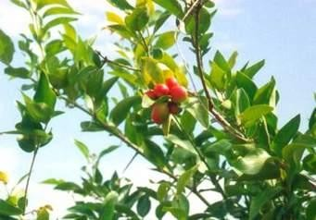

**Plate (IA) Picture of *Carissa edulis* leaf in its natural habitat** (Wikipedia, 2016)

* 1. **Description of *Senna alata***

*Senna alata* Linn (Fabaceae) is an ornamental shrub, which grows well in forest areas of West Africa. It is an erect, perennial, shrubby legume which grows up to 6 feet tall. It has dark green even pinnately compound leaves which have orange rachis on stout branches. Each leaf has16-28 leaflets measuring 2-4 inches alternating bilateral in arrangement. Leaves are oblong in shape and are evergreen (Watson and Dallwitz, 1992). *Senna alata* is indigenous to several regions of the world such as Africa and South America. It has compound yellowish-green leaves (Yakubu *et al.,* 2010).

It thrives in sunny and moist areas and produces a characteristic offensive smell. Ethnopharmacological studies have shown that the leaves of the plant (*S. alata*) have been used in the treatment of digestion-related ailments such as constipation, abdominal pain and liver diseases (Hennebelle *et al.,* 2009). The picture of *S.alata* leaf in its natural habitat is shown in plate IB below.

* 1. **Taxonomical classification of *Senna alata***

Kingdom: Plantae Order: Fabales Family: Fabaceae Genus: *Senna* Mill.

Species: *Senna alata* (L) Roxb. (Burkill, 1995)

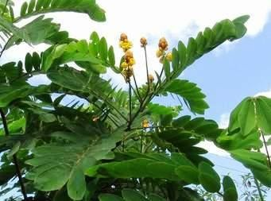

**Plate (IB) Picture of *Senna alata* leaf in its natural habitat** (Wikipedia, 2016)

## Statement of Research Problem

Skin infection is a disease which involves the skin. Many people experience a skin disease at some point in their lives, since the skin is the body's largest organ and it is more exposed, it greatly increased its risk of becoming diseased or damaged. Examples of skin diseases are eczema, rashes, measles, chicken pox, small pox, pimples (Tahir, 2012).

Plants are still the most important source of the world pharmaceuticals and medical products which are frequently used in the cure of various skin diseases. At present thousands of people are suffering from various types of skin diseases, spreading day by day all over the world due to radiation effects, climatic change and a lot of side effects of synthetic drugs (Tahir, 2012). There is high resistance to the current existing drugs use in the treatment of microbial skin infections, Plants are the cheapest and safer alternative sources of antimicrobials (Sharif and Banik, 2006; Doughari *et al.*, 2007).

## Justification of the Study

Natural plants products are a rich source used for centuries to treat various ailments. The use of phytochemical constituents as drug therapy to treat skin diseases has been traditionally effective. There is high resistance to the current existing drugs use in the treatment of microbial infections, and also some of the current existing drugs are toxic (Sharif and Banik, 2006). Medicinal plants usage as therapeutics in the management of different ailment locally differs from society to society. There is no sufficient scientific report for the use of *Carissa edulis* and *Senna alata* leaves for the treatment of skin infections. Traditional healing systems around the world that utilize herbal remedies are an important source for the discovery of new antibiotics (Okpekon *et al.*, 2004), some traditional remedies have successfully been used against antibiotic-resistant strains of bacteria (Kone *et al.*, 2004). Drug discovery must

be a continuing process if effective chemotherapeutic agents against the rapidly increasing drug resistant bacteria and fungi are to be obtained. It is therefore very necessary to search for more plants as antibiotic or therapeutics agents. As a result there is need to establish the pharmacognostic identification and evaluation of the plants as crude drug and also to test for the use of the drug in the treatment of skin disease.

## Aim and Objectives

## General aim

The aim of this research work is to carry out phytochemical and antimicrobial studies on *Carissa edulis* and *Senna alata* leaves to provide scientific basis in the use of the plants to treat skin infections.

## Specific objectives

1. To establish macroscopic features and physicochemical parameters for identification of

*Carissa edulis* and *Senna alata* leaves

1. To fractionate and develop the thin layer chromatographic profile of the most active extract between the two plants.
2. To establish the antimicrobial activity of *Carissa edulis* and *Senna alata* leaves extracts and the fractions on some selected fungi and bacteria that are associated with skin infection.

## Research Hypothesis

Tradomedicinal uses suggest that *Carissa edulis* and *Senna alata* leaves may contain some bioactive compounds that can be used to treat skin infections.

## CHAPTER TWO

## LITERATURE REVIEW

## Family Apocynaceae

Apocynaceae is a family of [flowering plants](https://en.wikipedia.org/wiki/Flowering_plant) that includes [trees](https://en.wikipedia.org/wiki/Tree), [shrubs](https://en.wikipedia.org/wiki/Shrub), [herbs](https://en.wikipedia.org/wiki/Herb), and [vines,](https://en.wikipedia.org/wiki/Vine) commonly known as the dogbane family (Endress and Bruyns, 2000). Members of the family are native to [Europe](https://en.wikipedia.org/wiki/Europe), Asia, Africa, Australia and [American](https://en.wikipedia.org/wiki/Americas) [tropics](https://en.wikipedia.org/wiki/Tropics) or [subtropics](https://en.wikipedia.org/wiki/Subtropics), with some temperate members (Simpson, 2010). Many species are tall trees found in [tropical rainforests](https://en.wikipedia.org/wiki/Tropical_rainforest), but some grow in tropical dry environments, also [perennial](https://en.wikipedia.org/wiki/Perennial_plant) herbs from [temperate zones](https://en.wikipedia.org/wiki/Temperate_zone) occur. Many of these plants have milky [latex,](https://en.wikipedia.org/wiki/Latex) and many species are [poisonous](https://en.wikipedia.org/wiki/Poison) if ingested (Endress and Bruyns, 2000). Some genera of Apocynaceae, such as [*Adenium*](https://en.wikipedia.org/wiki/Adenium), have milky latex apart from their sap, and others, such as [*Pachypodium*](https://en.wikipedia.org/wiki/Pachypodium), have clear sap and no latex. The family includes [annual plants,](https://en.wikipedia.org/wiki/Annual_plant) [perennial herbs,](https://en.wikipedia.org/wiki/Perennial_plant) [woody shrubs,](https://en.wikipedia.org/wiki/Shrub) [trees,](https://en.wikipedia.org/wiki/Tree) or [vines](https://en.wikipedia.org/wiki/Vine_(botany)) (Simpson, 2010). [Leaves](https://en.wikipedia.org/wiki/Leaf) are ([simple](https://en.wikipedia.org/wiki/Simple_(leaf))) and may appear one at a time (singly) with each occurring on alternating sides of the stem ([alternate](https://en.wikipedia.org/wiki/Alternate_(leaf))), but usually occur in pairs or in [whorls.](https://en.wikipedia.org/wiki/Whorls_(botany)) When paired, they occur on opposite sides of the stem (opposite), with each pair occurring at an angle rotated 90° to the pair below it ([decussate](https://en.wikipedia.org/wiki/Decussate)), there is no [stipule](https://en.wikipedia.org/wiki/Stipule) (a small leaf-like structure at the base of the leaf stem), or stipules are small and sometimes fingerlike (Simpson, 2010).

* + 1. **Characteristic of Genus *Carissa***

Different species of *Carissa* grow as shrubs or trees, attaining respective heights of 2 to

10m tall, they bear smooth, sharp thorns that are formidable, the thorns may be simple, as in *Carissa spinarum*, dichotomously forked as in *Carissa bispinosa*, or dichotomously branched as in *Carissa macrocarpa*. The leaves are a rich, glossy, waxy green, smooth, simple, entire and elliptic to ovate or nearly lanceolate. They are 2–8 cm long, partly depending on the species, and generally are thick and leathery. In suitable climates some species flower

through most of the year. The flowers are nearly sessile, 1–5 cm diameter, with a five-lobed white or pink-tinged corolla. They may be solitary or borne in clusters in an umbel or corymb. The fruit is a plum-like berry in shape. In colour they vary according to species. The young fruit are green, turning red when ripe in some species, whereas others turn a glossy purple-black (Rai and Misra, 2005). Seeds of *Carissa* have short viability so it need to be sown just after extraction from fruits, vegetative propagation by twig cuttings does not often show rooting. So, germplasms of the wild species are being maintained at various field gene banks (Rai and Misra, 2005). Also, micropropagation techniques are being work upon to grow *Carissa* plantlets without any phenotypic aberrations and for mass production (Rai and Misra, 2005).

## Ethnobotany and Biological Properties of Genus *Carissa*

Several species of the genus *Carissa* have a long history of use in traditional systems of medicine, *C. edulis* is used traditionally for the treatment of headaches, chest complaints, rheumatism, gonorrhoea, syphilis, rabies and as a diuretic (Nedi *et al.,* 2004). *C. carandas* (Karanda) is used as stomachic, antidiarrheal, anthelmintic and cooling agent in Ayurvedic medicine formulations in India (Meena *et al.,* 2009).

Apart from its traditional medicinal uses *Carissa* possesses different pharmacological activities, which include; Anticonvulsant (Hedge *et al.,* 2009), antidiabetic (Itankar *et al.,* 2011) and antihyperlipidemic (Sumbul and Ahmed, 2012) properties. Phytochemical analysis revealed the presence of terpenoids (Begum *et al.,* 2013), alkaloids (Naing, 2011).

* + 1. **Reported Biological Activities of *Carissa edulis***

The plant *C. edulis* is reported in traditional medicine as a good source of medicine for treatment of skin infections, ectoparasitic diseases, abdominal problems, headache and sexually transmitted diseases (Omino, 1993).

In pharmacological studies, *C. edulis* exhibited antiviral (Tolo *et al.,* 2006 and Tolo *et al.,* 2010), anticonvulsant (Jawaid *et al.,* 2011 and Ya„u *et al.*[*,* 2008), antiplasm](http://www.sciencedirect.com/science/article/pii/S1878535214000070#b0145)odia[l (Kirira *et*](http://www.sciencedirect.com/science/article/pii/S1878535214000070#b0150) *al.,* 2006 and Koch *et al.,* 2005), antimicrobial (Ibrahim *et al.,* 2005), analgesic (Ibrahim *et al.,* 2007), diuretic (Mekaconnen and Urga, 2004), as well as hypoglycaemic activity (El-Fiky *et al.,* 1996).

Previous researches on the leaves and fruits of the plant yielded the presence of carbohydrates, tannins, flavonoids, saponins, cardiac glycosides, terpenes and steroids (Ibrahim and Bolaji 2002, Ibrahim *et al.,* 2005).

Some of the chemical compounds that have been identified from *C. edulis* include carissone, germacranol, scopoletin, isofraxidin, carrisanol, catalponol as seen in figure 2.1 below

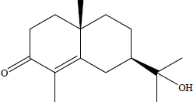 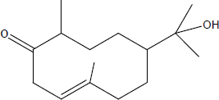

Carissone Germacranol

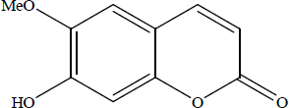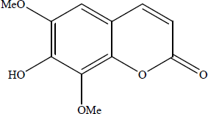

Scopoletin Isofraxidin

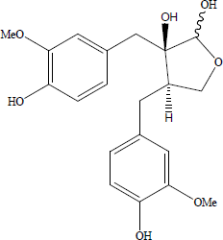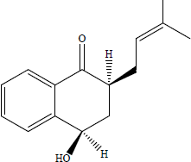

Carissanol Catalponol

**Fig. 2.1 Some chemical compounds isolated from *Carissa edulis*** *(*Al-youssef and Hassan, 2014)

## The Family Fabaceae

The Fabaceae or Leguminosae commonly known as the legume, pea, or bean family, are a large and economically important [family](https://en.wikipedia.org/wiki/Family_(biology)) of [flowering plants](https://en.wikipedia.org/wiki/Flowering_plant) (Christenhusz and Byng, 2016). It includes [trees](https://en.wikipedia.org/wiki/Tree), [shrubs,](https://en.wikipedia.org/wiki/Shrub) and [perennial](https://en.wikipedia.org/wiki/Perennial_plant) or [annual](https://en.wikipedia.org/wiki/Annual_plant) [herbaceous plants,](https://en.wikipedia.org/wiki/Herbaceous_plant) which are easily recognized by their [fruit](https://en.wikipedia.org/wiki/Fruit) ([legume](https://en.wikipedia.org/wiki/Legume)) and their compound, [stipulated](https://en.wikipedia.org/wiki/Stipule) leaves. Many legumes have characteristic flowers and fruits, the family is widely distributed, and is the third-largest [land](https://en.wikipedia.org/wiki/Land_plant) [plant](https://en.wikipedia.org/wiki/Land_plant) family in terms of number of species, behind only the [Orchidaceae](https://en.wikipedia.org/wiki/Orchidaceae) and [Asteraceae](https://en.wikipedia.org/wiki/Asteraceae), with about 751 genera and some 19,000 known species (Judd *et al.,* 2002). The five largest of the genera are [*Astragalus*](https://en.wikipedia.org/wiki/Astragalus) (over 3,000 species), [*Acacia*](https://en.wikipedia.org/wiki/Acacia)(over 1000 species), [*Indigofera*](https://en.wikipedia.org/wiki/Indigofera) (around 700 species), [*Crotalaria*](https://en.wikipedia.org/wiki/Crotalaria) (around 700 species) and [*Mimosa*](https://en.wikipedia.org/wiki/Mimosa) (around 500 species), which constitute about a quarter of all legume species (Christenhusz and Byng, 2016). Fabaceae is the most common family found in tropical rainforests and in dry forests in America and [Africa](https://en.wikipedia.org/wiki/Africa) (Burnham and Johnson 2004).

Recent molecular and morphological evidence supports the fact that the Fabaceae is a single [monophyletic](https://en.wikipedia.org/wiki/Monophyly) family (Lewis, 2005). This point of view has been supported not only by the degree of interrelation shown by different groups within the family compared with that found among the Leguminosae and their closest relations, but also by all the recent [phylogenetic studies](https://en.wikipedia.org/wiki/Phylogenetics) based on [DNA](https://en.wikipedia.org/wiki/DNA) sequences (Lewis *et al.,* 2005)

The fabaceae have a wide variety of [growth forms](https://en.wikipedia.org/wiki/Habit_(biology)) including trees, shrubs or herbaceous plants or even vines. The herbaceous plants can be annuals, [biennials](https://en.wikipedia.org/wiki/Biennial_plant) or perennials, without basal or terminal leaf aggregations. The leaves are usually [alternate](https://en.wikipedia.org/wiki/Phyllotaxis) and compound. Most often they are even or odd-[pinnately](https://en.wikipedia.org/wiki/Pinnate) compound (e.g. [*Caragana*](https://en.wikipedia.org/wiki/Caragana) and [*Robinia*](https://en.wikipedia.org/wiki/Robinia)respectively), often trifoliate (e.g. [*Trifolium*](https://en.wikipedia.org/wiki/Trifolium), [*Medicago*](https://en.wikipedia.org/wiki/Medicago)) and rarely [palmately](https://en.wikipedia.org/wiki/Glossary_of_leaf_shapes) compound (e.g. [*Lupinus*](https://en.wikipedia.org/wiki/Lupinus)), in the Mimosoideae and the Caesalpinioideae commonly bipinnate (e.g. [*Acacia*](https://en.wikipedia.org/wiki/Acacia), [*Mimosa*](https://en.wikipedia.org/wiki/Mimosa)). They

always have [stipules,](https://en.wikipedia.org/wiki/Stipule) which can be leaf-like (e.g. [*Pisum*](https://en.wikipedia.org/wiki/Pisum)), thorn-like (e.g. [*Robinia*](https://en.wikipedia.org/wiki/Robinia)) or be rather inconspicuous, leaf margins are entire or, occasionally, [serrate](https://en.wikipedia.org/wiki/Leaf#Terminology), both the leaves and the leaflets often have wrinkled [pulvini](https://en.wikipedia.org/wiki/Pulvinus) to permit [nastic movements](https://en.wikipedia.org/wiki/Nastic_movements), in some species, leaflets have evolved into [tendrils](https://en.wikipedia.org/wiki/Tendril) (e.g. [*Vicia*](https://en.wikipedia.org/wiki/Vicia)) (Judd *et al.,* 2002).

The Fabaceae have an essentially worldwide distribution, being found everywhere except Antarctica and the high arctic (Stevens, 2006). The trees are often found in tropical regions, while the herbaceous plants and shrubs are predominant outside the tropics (Judd *et al.,* 2002).

## Characteristic of Genus *Senna*

*Senna* includes herbs, [shrubs,](https://en.wikipedia.org/wiki/Shrub) and [trees](https://en.wikipedia.org/wiki/Tree). The leaves are [pinnate](https://en.wikipedia.org/wiki/Pinnate) with opposite paired leaflets. The [inflorescences](https://en.wikipedia.org/wiki/Inflorescence) are [racemes](https://en.wikipedia.org/wiki/Raceme) at the ends of branches or emerging from the leaf axils. The flower has five [sepals](https://en.wikipedia.org/wiki/Sepal) and five usually yellow [petals](https://en.wikipedia.org/wiki/Petal). There are ten straight [stamens.](https://en.wikipedia.org/wiki/Stamen) The stamens may be different sizes, and some are [staminodes.](https://en.wikipedia.org/wiki/Staminode) The fruit is a [legume](https://en.wikipedia.org/wiki/Legume) pod containing several seeds (Lewis, 2005). *Senna,* is a large [genus](https://en.wikipedia.org/wiki/Genus) of [flowering plants](https://en.wikipedia.org/wiki/Flowering_plant) in the legume [family](https://en.wikipedia.org/wiki/Family_(biology)) [fabaceae,](https://en.wikipedia.org/wiki/Fabaceae) and the subfamily [caesalpinioideae](https://en.wikipedia.org/wiki/Caesalpinioideae) (LPWG, 2017). This [diverse](https://en.wikipedia.org/wiki/Biodiversity) genus is [native](https://en.wikipedia.org/wiki/Indigenous_(ecology)) throughout the [tropics,](https://en.wikipedia.org/wiki/Tropics) with a small number of [species](https://en.wikipedia.org/wiki/Species) in [temperate](https://en.wikipedia.org/wiki/Temperate_climate) regions. The number of species is estimated to be from about 260 to 350 (Marazzi, 2006).

## Ethnobotany and Biological Properties of Genus *Senna*

Historically, Egyptian *Senna (*[*S. alexandrina*](https://en.wikipedia.org/wiki/Senna_alexandrina)) was used as a [laxative](https://en.wikipedia.org/wiki/Laxative) in the form of *Senna* pods, or as [herbal tea](https://en.wikipedia.org/wiki/Herbal_tea) made from the leaves (Leung *et al.* 2011). *Senna* is considered to be a [bowel](https://en.wikipedia.org/wiki/Bowel) stimulant on the [myenteric plexus](https://en.wikipedia.org/wiki/Myenteric_plexus) of the [colon](https://en.wikipedia.org/wiki/Colon_(anatomy)) to induce [peristaltic](https://en.wikipedia.org/wiki/Peristaltic) contractions and decrease water absorption from inside the colon, effects that would provide relief from [constipation](https://en.wikipedia.org/wiki/Constipation) (Leung *et al.* 2011).

*Senna* or its [extracted](https://en.wikipedia.org/wiki/Extract) sennosides, alone or in combination with [sorbitol](https://en.wikipedia.org/wiki/Sorbitol) or [lactulose,](https://en.wikipedia.org/wiki/Lactulose) have been evaluated for treatment of constipation in children and the elderly. Some studies showed limited evidence for efficacy (Wald, 2016).

* + 1. **Reported Biological Activities of *Senna alata***

It is locally used in Nigeria in the treatment of infections, which include ringworm, parasitic skin diseases (Palanichamy *et al.,* 1990). The leaves are reported to be useful in treating convulsion, gonorrhoea, heart failure, abdominal pains, and oedema, it is also used as a purgative (Ogunti *et al.,* 1993).

A study in Malaysia (Ibrahim and Osman, 1995) reported that ethanolic extract of the *Senna* plant showed high activity against dermophytic fungi. Several studies have been conducted to provide scientific basis for the efficacy of the plant use in herbal medicine (Akinsinde *et al.,* 1995; Akinyemi *et al.,* 2000).

The juice of fresh leaves of *Senna alata* is universally recognized by local healers as a remedy for parasitic skin disease and is used in the treatment of many skin condition by simply rubbing the crushed leaves either alone or mixed with oil on the skin (Oliver-Bever, 1986).

Some of the chemical compounds that have been identified from *S.alata* include Rhein, chrysophanic acid, ellagitannin, adenine, xanthone and emodol as seen in figure 2.2 below

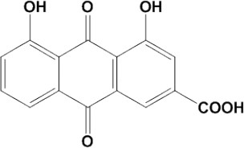 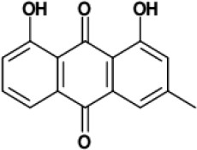

Rhein Chrysophanic acid

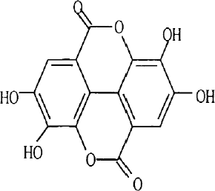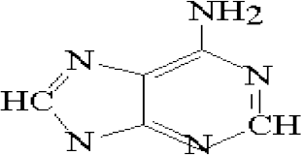

Ellagitannin Adenine

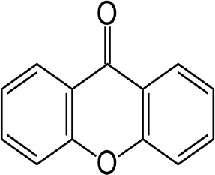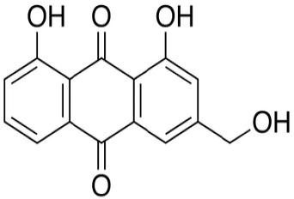

Xanthone Emodol

**Fig. 2.2 Some chemical compounds isolated from *senna alata*** (Sasidharan *et al.,* 2011)

## Skin Infections in Humans

The skin covers the organs, tissues, bones, and muscles of the body. An important function of the skin is to protect the body from infection. Skin diseases occur worldwide and amount to approximately 34% of all occupational diseases encountered (Abbasi *et al.,* 2010). It affects people of all ages from neonates to the elderly and constitutes one of the five reasons for medical consultation (Marks and Miller 2006). Skin diseases have been of major concern due to their association with the Human Immunodeficiency Virus and Acquired Immune Deficiency Syndrome (HIV/AIDS) (Njoronge and Bussmann, 2006).

Tschachler *et al.,* (1996) stated that more than 90% of HIV infected individuals develop skin and mucosal complications at some stage during the disease. Although mortality rates for skin diseases are relatively low, they impact significantly on the quality of life and are often persistent and difficult to treat. Skin ailments present a major health burden in both developed and developing countries (Kingston *et al.,* 2009). Skin infections can be caused by a wide variety of germs, fungi, and bacteria. Symptoms can vary in severity, in some cases infections can spread beyond the skin and into the bloodstream. The three main causes of a skin infection are bacteria, viruses, and fungi (Tahir, 2012).

Several factors can increase a person‟s risk of developing a skin infection. A decreased immune system can be caused by an illness or a side effect of medication. This can increase the chances of a skin infection. In addition, fungi often grow in warm, moist environments. Wearing sweaty or wet clothes can be a risk factor for skin infections. A break or cut in the skin may allow bacteria to get into the deeper layer of the skin. Socio-economic environments such as household overcrowding play an enormous part in the spread of skin infections (Hay *et al.,* 2006).

Furthermore, hot and humid climatic conditions exacerbate skin infections. These factors are particularly problematic in Sub-Saharan Africa where it was found that over 78 million people were infected with *Tinea capitis* (a superficial skin infection affecting the scalp) (Hay *et al.,* 2002).

## Fungal Skin Infections

Fungal infections of the skin are very common and include athlete's foot, jock itch, ringworm, sporotrichosis, and yeast infections (Drake *et al.,* 1996).

*Tinea pedis* (athlete's foot) majority of athlete‟s foot cases are caused by a variety of fungi all belonging to a group called dermatophytes, which also causes jock itch and ringworm. The fungi thrive in closed, warm, moist environments and feed on keratin, a protein found in hair, nails, and skin (Drake *et al.,* 1996).

[Ringworm](http://www.webmd.com/skin-problems-and-treatments/ss/slideshow-ringworm) is characterized by a red ring of small blisters or a red ring of scaly skin that grows outward as the infection spreads. Though children are especially susceptible to catching ringworm, it can affect adults as well. Ringworm is caused by a fungus that grows on the skin. Once the fungus is established, it spreads out in rings. The centre of the ring may clear up, while a new ring of infection develops at the edge of the old ring. Children are most likely to get ringworm. Ringworm of the scalp can spread from child to child when children share hats, combs, or brushes. Ringworm of the body can be spread on towels, clothing, or sports equipment (Drake *et al.,* 1996).

Yeast infection is caused by the overgrowth of a type of yeast called *Candida*, usually *Candida albicans*. This yeast is normally found in small amounts in the human body. But certain medicines and health problems can cause more yeast to grow, particularly in warm, moist body areas. This can be uncomfortable and sometimes dangerous (Hay, 1999).

Sporotrichosis is an infection of the skin caused by a fungus, *Sporothrix schenckii*. This fungus is related more closely to the mold on stale bread or the yeast used to brew beer than to bacteria that usually cause infections. The mold is found on rose thorns, hay, sphagnum moss, twigs, and soil. The infection is more common among gardeners, nursery workers, and farmers who work with roses, moss, hay, and soil. Once the mold spores move into the skin, the disease takes days or even months to develop (Hay *et al.,* 2002).

*Aspergillus fumigatus* is a ubiquitous filamentous fungus that is considered a major opportunistic human pathogen mainly infecting immune-suppressed patients, it is a [fungus](https://en.wikipedia.org/wiki/Fungus) of the genus [*Aspergillus*,](https://en.wikipedia.org/wiki/Aspergillus) and is one of the most common *Aspergillus* species to cause disease in individuals with an [immunodeficiency](https://en.wikipedia.org/wiki/Immunodeficiency) (Dagenais and Keller 2009).

*Trichophyton* is a [genus](https://en.wikipedia.org/wiki/Genus) of [fungi,](https://en.wikipedia.org/wiki/Fungi) which includes the [parasitic](https://en.wikipedia.org/wiki/Parasitic) varieties that cause [tinea,](https://en.wikipedia.org/wiki/Tinea) including [athlete's foot](https://en.wikipedia.org/wiki/Athlete%27s_foot), [ringworm,](https://en.wikipedia.org/wiki/Ringworm) [jock itch,](https://en.wikipedia.org/wiki/Jock_itch) and similar infections of the nail, beard, skin and scalp, The [anthropophilic](https://en.wikipedia.org/wiki/Anthropophilic) varieties cause forms of [dermatophytosis,](https://en.wikipedia.org/wiki/Dermatophytosis) that is, fungal infection of the skin. They are keratinophilic: they feed on the [keratin](https://en.wikipedia.org/wiki/Keratin) in nails, hair, and dead skin (Degreef, 2008).

## Bacterial Skin Infection

Some bacteria live on normal skin and cause no harm, such as some *Staphylococcus* species, *Corynebacterium* spp. While some bacteria invade normal skin, broken skin from [eczema/dermatitis](http://www.dermnetnz.org/dermatitis/dermatitis.html) or [wounds](http://www.dermnetnz.org/reactions/wounds.html) (causing [wound infection](http://www.dermnetnz.org/bacterial/wound-infection.html)). Bacteria, like [viruses,](http://www.dermnetnz.org/viral/) may also sometimes result in [exanthemas](http://www.dermnetnz.org/viral/exanthem.html) (rashes). The most common bacteria to cause skin infections are *Staphylococcus aureus* and *Streptococcus pyogenes* (Kumar *et al.,* 2007).

Common bacterial skin infections include cellulitis, erysipelas, impetigo, folliculitis, furuncles and carbuncles. Cellulitis is an infection of the dermis and subcutaneous tissue that

has poorly demarcated borders and is usually caused by *Streptococcus* or *Staphylococcus* species. Erysipelas is a superficial form of cellulitis with sharply demarcated borders and is caused almost exclusively by *Streptococcus.* Impetigo is also caused by *Streptococcus* or *Staphylococcus* and can lead to lifting of the stratum corneum resulting in the commonly seen bullous effect. Folliculitis is an inflammation of the hair follicles. When the infection is bacterial rather than mechanical in nature, it is most commonly caused by *Staphylococcus*. If the infection of the follicle is deeper and involves more follicles, it moves into the furuncle and carbuncle stages and usually requires incision and drainage (Kumar *et al.,* 2007).

Minor bacterial infections may resolve without treatment. However, persistent and serious bacterial infections are treated with antibiotics. Humans are natural hosts for many bacterial species that colonize the skin as normal flora. *Staphylococcus aureus* and *Streptococcus pyogenes* are infrequent resident flora, but they account for a wide variety of bacterial pyodermas. Predisposing factors to infection include minor trauma, pre-existing skin disease, poor hygiene, and rarely, impaired host immunity (Quave *et al.,* 2008).

## Some Current Standard Drugs used for Skin Infections

Antifungal agents: Oral antifungal drugs include [fluconazole](https://www.webmd.com/drugs/mono-5052-FLUCONAZOLE%2B-%2BORAL.aspx?drugid=3780&drugname=fluconazole%2Boral) and [itraconazole.](https://www.webmd.com/drugs/2/drug-128-2179/itraconazole-oral/itraconazole---oral/details) These drugs can be used to treat more severe [fungal infections.](https://www.webmd.com/content/article/117/112607.htm) Terbinafine is an oral antifungal medicine that may be used to treat fungal infections of the nails. Antibiotics like erythromycin, ciprofloxacin, tetracycline and dicloxacillin are used to treat many skin conditions (Anonymous, 2017).

## Some Herbal Drugs or Remedies used for Skin Infections

Natural drugs from the plants are gaining popularity because of several advantages such as often having fewer side-effects, better patient tolerance, being relatively less expensive and

acceptable due to a long history of use. Besides herbal medicines provide rational means for the treatment of many diseases that are obstinate and incurable in other systems of medicine. For these reasons several plants have been investigated for treatment of skin diseases ranging from itching to skin cancer (Tabassum and Hamdani, 2014).

* + 1. ***Cannabis sativus (*Hemp, Ganja*)***

The powder of the leaves serves as a dressing for wounds and sores. Ganja is externally applied to relieve pain in itchy skin diseases. Hemp seed oil is useful for treatment of eczema and host of other skin diseases like dermatitis, seborrhoeic dermatitis/cradle cap, varicose eczema, psoriasis, lichen planus and acne rosacea. By using hemp seed oil, the skin is strengthened and made better able to resist bacterial, viral and fungal infections. Crushed leaves are rubbed on the affected areas to control scabies (Olsen *et al.,* 2001).

* + 1. ***Aloe vera* (Barbados aloe)**

*Aloe vera* has shown very good results in skin diseases and it is often taken as health drink. It is also found effective in treating wrinkles, stretch marks and pigmentations. It also seems to be able to speed wound healing by improving blood circulation through the area and preventing cell death around a wound (Kim *et al.,* 2010).

* + 1. ***Portulaca oleraceae* (Purslane)**

The herb possesses natural cooling properties that soothe the skin, relieving it of skin inflammations and rashes during scorching heat. Burns and skin eruptions like boils and carbuncles can be treated with an effective concoction of the leaves. Topical application of the aqueous extract on to the skin is effective as antibacterial and antifungal (Leung, 1996).

* + 1. ***Lawsonia inermis* (Henna)**

Henna is a traditionally used plant of Middle-East that is applied on hands and feet. In the traditional system of medicine, leaf paste is applied twice a day, on the affected parts to cure

impetigo (Kingston *et al.,* 2009). In a study, clinical improvement in the patients suffering from hand and foot disease due to use of capecitabine, an anti-cancer drug, with use of henna revealed anti-inflammatory, antipyretic and analgesic effects of henna.( Yucel and Guzin, 2008).

### Euphorbia walachii

Juice of *E. walachii* is used to treat warts and skin infections (Tantray *et al.,* 2009). A study, conducted on various species of *Euphorbia*, *E. hirta*, exhibited best antioxidant activity. The plant extracts showed more activity against Gram-positive bacteria and fungi. The best antimicrobial activity was shown by *E. tirucalli*. The study supported the folkloric use of *E. hirta* and *E. tirucalli* against some skin diseases caused by oxidative stress or by microorganisms (Chanda and Baravalia, 2010).

## Some Common Home Remedies for Fungal Skin Infection

* + 1. **Apple cider vinegar (*Malus pumila, Malus domestica*)**

Apple cider vinegar is a common treatment for any kind of fungal infection. Due to the presence of [antimicrobial properties,](https://www.top10homeremedies.com/kitchen-ingredients/10-health-benefits-of-apple-cider-vinegar.html) apple cider vinegar helps kill the fungus causing the infection. Plus, its mild acidic nature helps prevent the infection from spreading and promotes speedy recovery (Leung, 1996).

* + 1. **Garlic (*Allium sativum*)**

Garlic is a useful antifungal agent and hence very [effective for any type of fungal infection.](https://www.top10homeremedies.com/kitchen-ingredients/top-10-health-benefits-of-garlic.html) It also has antibacterial properties that play a key role in the recovery process (Shams- Ghahfarokhi *et al.,* 2006).

* + 1. **Tea tree oil (*Melaleuca spp*)**

Tea tree oil has natural antifungal compounds that help kill the fungi that cause skin infections. Plus, its antiseptic qualities inhibit the spread of the infection to other body parts (Tayel and El-Tras, 2009)

* + 1. **Coconut oil (*Cocos nucifera*)**

Coconut oil works as an effective remedy for any type of fungal infection due to the presence of medium-chain fatty acids. These fatty acids work as natural fungicides to kill the fungi responsible for the infection (Leung, 1996).

## Herbal teas

The tannins in tea can help kill the fungi responsible for fungal infections. Plus, tea has antibiotic and astringent properties that help get rid of the symptoms of a fungal infection like the burning sensation, swelling and skin irritation (Renu, 2010).

## CHAPTER THREE

## MATERIALS AND METHODS

## Materials, Chemicals, Equipment, Solvents, Reagents/Solutions

## Reagents and Solvents

Acetic acid, Anisaldehyde (Sigma-Aldrich, St. Lous, MO, USA), Butanol, Chloroform ( JHD, AR; Lobal Chem, India), Dragendorff‟s, Egg lecithin, Ethyl acetate (JHD, AR; Lobal Chem, India), Ferric chloride, Glycerol, Hexane (JHD, AR; Lobal Chem, India), Hydrochloric acid, Libermann-Bucchard reagent, Methanol ( JHD, AR; Lobal Chem, India), Mueller Hinton Agar (MHA), Mueller Hinton Broth, Normal saline, Sabouraud Dextrose Agar (SDA), Sabouraud Dextrose Broth, Sodium Hypochlorite, Sudan Red Solution, Tween 80

## Materials and equipments

Ash less filter paper (24pieces), Autoclave, Compound microscope (Fisher Scientific, UK), Desiccator, Disposable syringes, Filter papers (24pieces), Glass Slides (12 pieces) and Cover slips (12pieces), Electronic Balance, Incubator, Laboratory glass wares (Funnel, Conical flask, Beakers, Measuring cylinder), Mechanical shaker (Stuart Scientific Flask Shaker, Great Britain), Oven, Glass Petri dishes (200 pieces), Photographic camera, TLC plates, TLC tanks (Uni kit® TLC Chromatank® , Shandon, Germany), UV lamp, Water bath (HHS, Mc Donald Scientific International).

## Clinical isolates used

Bacteria;

*Escherichia coli Staphylococcus aureus*

*Streptococcus pyogenes*

Fungi;

*Aspergillus fumigatus Candida albicans Trichophyton mentagrophytes*

## Collection, Identification and Preparation of Plant Material

The plants leaves were collected in the month of August 2016 from Kudingi forest, in Zaria local government area of Kaduna State and was taken to the Herbarium unit of the Department of Botany, Ahmadu Bello University, Zaria for proper identification and authentication and a voucher number (601 for *Carissa edulis* and 1236 for *Senna alata*) were given. The leaves of the plants collected was dried under shade at room temperature, powdered by grinding with motar and pestle and was stored in an air tight container until required for use.

* 1. **Macroscopic Studies of *C. edulis* and *S. alata* Leaves**

## 3.3.1 Experimental design

Pharmacognostic studies of leaves of *C. edulis* and *S. alata* were carried out by examining the macroscopical and organoleptic characteristics of the leaves in order to establish some Pharmacopoeia standards of the plants.

## Determination of Physicochemical Constants of the Powdered Leaves of *C. edulis*

**and *S. alata***

The physicochemical parameters of the powdered leaf of the plants were carried out according to the method outlined by (Evans, 2009; WHO 2011).

## Determination of moisture content

The moisture content was determined by “Loss on drying” method (gravimetric determination). Air-dried leaf (3.00 g) was poured in a dried and weighed crucible using Electronic Balance. The crucible was transferred into a hot air sterilizing oven, which was set at 105 0C. After one hour, the crucible containing the powdered plant was removed, placed in a desiccator over phosphorous pentoxide under atmospheric pressure at room temperature. After 30 minutes in the desiccator, the weight of the powder and crucible were quickly determined and the crucible returned to oven. The heating and weighing was repeated until a constant weight was obtained and noted. Three determinations were conducted and the average was taken as the moisture content of the plant material (M1) (Evans, 2009; WHO 2011). The moisture content from the fresh leaf to a dried constant weight was also carried out using thesame method above and the average taken as (M2). The moisture content (loss of weight) was calculated using the formula:

Moisture content (%) = 𝐼𝑛𝑖𝑡𝑖𝑎𝑙 𝑊𝑒𝑖𝑔 𝑕𝑡 𝑜𝑓 𝑃𝑜𝑤𝑑𝑒𝑟 −𝐹𝑖𝑛𝑎𝑙 𝑊𝑒𝑖𝑔 𝑕𝑡 𝑜𝑓 𝑃𝑜𝑤𝑑𝑒𝑟

𝐼𝑛𝑖𝑡𝑖𝑎𝑙 𝑊𝑒𝑖𝑔 𝑕𝑡 𝑜𝑓 𝑃𝑜𝑤𝑑𝑒𝑟

𝑋 100

## Determination of total ash value

A platinum crucible was heated red hot, cooled in a desiccator and quickly weighed. Exactly (2 g) of the air-dried leaf powder was weighed into the crucible and heated in a furnace until it became white, indicating absence of carbon and was then cooled in a desiccator and weighed. The procedure was repeated three times to obtain average value (Evans, 2009; WHO, 2011). The total ash content of the air-dried powder was calculated in percentage using the formula:

Ash Value (%) = 𝑊𝑒𝑖𝑔 𝑕𝑡 𝑜𝑓 𝑅𝑒𝑠𝑖𝑑𝑢𝑎𝑙 𝐴𝑠𝑕

𝑂𝑟𝑖𝑔𝑖𝑛𝑎𝑙 𝑊𝑒𝑖𝑔 𝑕𝑡 𝑜𝑓 𝑃𝑜𝑤𝑑𝑒𝑟

𝑋 100

## Determination of acid-insoluble ash

To the crucible containing the total ash, 25 ml of dilute hydrochloric acid was added and covered with a watch glass and boiled gently for 5 minutes. Hot water (5 ml) was used to rinse the cover glass into the crucible. The insoluble matter was collected on an ashless filter paper and washed with hot water until the filtrate was neutral. This was then transferred back to the crucible and dried on a hot plate and ignited to a constant weight. The residue was allowed to cool in a desiccator for 30 minutes and quickly weighed (Evans, 2009; WHO 2011). The acid insoluble ash was calculated as follows:

Acid insoluble Ash (%) = 𝑊𝑒𝑖𝑔 𝑕𝑡 𝑜𝑓 𝑅𝑒𝑠𝑖𝑑𝑢 𝑎𝑙 𝐴𝑠𝑕

𝑂𝑟𝑖𝑔𝑖𝑛𝑎𝑙 𝑊𝑒𝑖𝑔 𝑕𝑡 𝑜𝑓 𝑃𝑜𝑤𝑑𝑒𝑟

𝑋 100

## Determination water soluble ash

The process was repeated as above in the total ash, to the crucible containing the total ash, 25 ml of water was added and boiled for 5 minutes. The insoluble matter was collected in a sintered glass crucible. It was then washed with hot water and ignited to a constant weight. The weight of the residue was subtracted from the weight of the total ash (Evans, 2009; WHO 2011). The water soluble ash of air dried powder was calculated using the formula:

Water Soluble Ash (%) = 𝑊𝑒𝑖𝑔 𝑕𝑡 𝑜𝑓 𝑇𝑜𝑡𝑎𝑙 𝐴𝑠𝑕−𝑊𝑒𝑖𝑔 𝑕𝑡 𝑜𝑓 𝑅𝑒𝑠𝑖𝑑𝑢𝑎𝑙 𝐴𝑠𝑕

𝑂𝑟𝑖𝑔𝑖𝑛𝑎𝑙 𝑊𝑒𝑖𝑔 𝑕𝑡 𝑜𝑓 𝑃𝑜𝑤𝑑𝑒𝑟

𝑋 100

## Extractive Values

## Water extractives value

The air-dried, coarsely powdered plant (5g) was macerated in 100 ml of Chloroform-water in 500 ml closed round bottom flask and then shook frequently for the first 6 hours using shaker. It was then allowed to stand for 18 hours and filtered immediately. 25 ml of the filtrate was evaporated to dryness in a tarred, flat bottomed, shallow dish and dry at 105oC to

constant weight. The procedure was repeated three times and in each case determining the weight of the dried extract (Evans, 2009; WHO 2011). The percentage water extractive value was calculated using the formula:

Water Extractive Value (%) = 𝑊𝑒𝑖𝑔 𝑕𝑡 𝑜𝑓 𝑟𝑒𝑠𝑖𝑑𝑢𝑒 𝑖𝑛 25𝑚𝑙 𝐸𝑥𝑡𝑟𝑎𝑐𝑡 x 4 𝑋 100

𝑂𝑟𝑖𝑔𝑖𝑛𝑎𝑙 𝑊𝑒𝑖𝑔 𝑕𝑡 𝑜𝑓 𝑃𝑜𝑤𝑑𝑒𝑟

## Ethanol extractive value

The procedure above was repeated with ethanol in place of water and the percentage ethanol extractive value was calculated using the following formula:

Ethanol Extractive Value (%) = 𝑊𝑒𝑖𝑔 𝑕𝑡 𝑜𝑓 𝑟𝑒𝑠𝑖𝑑𝑢𝑒 𝑖𝑛 25𝑚𝑙𝐸𝑥𝑡𝑟𝑎𝑐𝑡 𝑥 4

𝑂𝑟𝑖𝑔𝑖𝑛𝑎𝑙 𝑊𝑒𝑖𝑔 𝑕𝑡 𝑜𝑓 𝑃𝑜𝑤𝑑𝑒𝑟

𝑋 100

* 1. **Extraction of the Leaves of *C. edulis* and *S. alata***

Extraction of the plant material was done using the method described by (Kokate, *et al.,* 2003). The pulverized plant material (1 kg) was extracted with n-hexane, ethyl acetate and methanol successively in a Soxhlet apparatus (Figure 1). The extract obtained was concentrated via rotary evaporator to recover some solvent and final evaporation to dryness of the extracts was done via the water bath after which each extract was weighed and stored in desiccator for subsequent use. The percentage yield was calculated using the formula:

Yield of extracts (%) = Weight of total extract

Weight of powdered material

X 100

1kg of powdered leaf of *Carissa edulis* (CE) or *Senna alata* (SA)

Extracted with hexane (5L)

n- Hexane Extract (HE) (CE) 41.98g, (SA) 13.44g

**5.0**

Marc

Extracted with ethyl acetate (5L)

Ethyl acetate Extract (EE) (CE) 37.42g, (SA) 33.72g

Marc

Extracted with methanol (5L)

Methanol Extract (ME) (CE) 142.08g, (SA) 98.34g

Marc

**Fig. 3.1 Schematic chart for the extraction of *Carissa edulis and Senna alata* leaves.**

(Kokate, *et al.,* 2003).

* 1. **Phytochemical Screening of the Leaf Extracts of *C. edulis* and *S. alata***

The leaf extracts (HE, EE and ME) were subjected to phytochemical screening in order to identify the phytochemical constituents present in each of them (Sofowora, 2008; Evans, 2009).

## Test for carbohydrates

1. **Molisch’s Test:** To 0.5g of the extracts (hexane, ethyl acetate and methanol) was separately dissolved in 5 ml of distilled water each and filtered. The filtrate was treated with 2 drops of alcoholic α-naphthol solution in a test tube, followed by 1ml of concentrated H2SO4 down the side of the test tube. Formation of the violet ring at the junction indicates the presence of carbohydrates (Evans, 2009).
2. **Fehling’s Test 1:** To 0.5 g of the extracts (hexane, ethyl acetate and methanol) were separately dissolved in 5 ml of distilled water each and filtered. The filtrates were hydrolysed with dilute HCl, neutralized with alkali and heated with mixture of equal volume of Fehling‟s A & B solutions. Formation of brick red precipitate indicates the presence of combined reducing sugars (Evans, 2009).
3. **Fehling’s Test 2:** To 0.5 g of the extracts (hexane, ethyl acetate and methanol) were separately dissolved in 5 ml of distilled water each and filtered, 2mls of the filtrates was added equal volume of Fehlings solution A and B and boiled in a water bath for two minutes, a brick red precipitates indicates the presences of free reducing sugar (Evans, 2009).

## Test for tannins

1. **Ferric Chloride Test:** To 0.5g of the extracts (hexane, ethyl acetate and methanol) were dissolved in 5 ml of water each and filtered. Two drops of ferric chloride solution was added to the filtrate. Appearance of blue-black (hydrolysable tannins) or green or blue-green (condensed tannins) precipitate indicates the presence of tannins (Evans, 2009).
2. **Lead sub-acetate test:** To 0.5g of the hexane extract, 2 ml of ethanol was added followed by three drops of lead sub-acetate solution; appearance of whitish-yellow precipitate indicates the presence of tannins. The procedure above was repeated for ethyl acetate and methanol extracts (Evans, 2009).
3. **Goldbeater’s skin test:** To the extract (1g) was dissolved in 10ml of water, The gold- beater skin was soaked in 2 % HCl and rinsed with water and transferred to the extract for 5 minutes. The skin was then removed, washed with water and placed in 1% solution of ferrous sulphate and observed for brown or black colour on the skin indicate the presences of tannin. (Evans, 2009).

## Test for anthraquinones

1. **Bontrager test:** To 0.5 g of the hexane extract, 10 ml of chloroform was added and shaken. This was then filtered and 5 ml of 10% ammonia solution was added to the filtrate. The presence of pink or cherry red colour in the upper layer indicates the presence of anthracenes. The procedure above was repeated for ethyl acetate and methanol extracts (Evans, 2009).
2. **Modified Borntrager’s test:** To 0.5 g of the (hexane, ethyl acetate and methanol) was boiled with 10 ml of aqueous sulphuric acid and filtered while hot. The filtrate after cooling to room temperature was shaken with 5ml chloroform, the chloroform layer was separated and half of its volume, 10% ammonium hydroxide was added. A pink, red or violet colouration in the ammonia phase (upper phase) is an indication for the presence of combined anthracene or anthraquinone derivatives (Evans, 2009).

## Test for flavonoids

1. **Shinoda test:** To 0.5g of the (hexane, ethyl acetate and methanol) each was dissolved in water, 2ml of 50% methanol. Pieces of magnesium chips and 3 drops of hydrochloric acid was added, a pink, rose or red colouration indicated the presence of flavonoids (Evans, 2009).
2. **Sodium hydroxide test:** To 0.5 g of the (hexane, ethyl acetate and methanol) was dissolved in water and filtered. 2 ml of 10% aqueous sodium hydroxide solution was then added. The solution was observed for the presence of yellow colour. A change in colour from yellow to colourless on addition of dilute hydrochloric acid was used as an indication for the presence of flavonoids (Evans, 2009).

## Test for saponins

1. **Frothing test:** To 0.5g of the hexane extract was dissolved in 10 ml of water and shaken vigorously for 30 seconds and allowed to stand for one hour, the occurrence of frothing column of honey comb-like of at least 1 cm in height and persisting for at least 30 minutes indicates the presence of saponins. The procedure above was repeated for ethyl acetate and methanol extracts (Sofowora, 2008).
2. **Haemolysis test:** Two ml of sodium chloride (1.8% solution in distilled water) was added to two test tubes A and B. 2ml of distilled water were added to test tube A, 2 ml of the hexane extract was added to test tube B. five drops of blood was added to each tube and the tubes were inverted gently to mix the contents. Haemolysis in tube B containing the hexane extract but not in tube A (i.e. control), indicated the presence of saponins in the extract. The procedure above was repeated for ethyl acetate and methanol extracts (Brain and Turner, 1975).

## Test for cardiac glycosides

1. **Keller-Killiani test:** To 0.1g of the hexane extract was dissolved in glacial acetic acid containing ferric chloride and one ml of sulphuric acid was added to the solution. The appearance of reddish-brown colouration at the interphase indicates the presence of deoxy- sugar. The procedure above was repeated for ethyl acetate and methanol extracts (Sofowora, 2008).
2. **Kedde’s test:** To 0.1 g of the hexane extract was treated with 1 ml of 2% solution of 3, 5- di-nitro-benzoic acid in 95% alcohol. The solution was made alkaline by the addition of 5% NaOH. The presence of purple-blue colour indicates the presence of cardenolides. The procedure above was repeated for ethyl acetate and methanol extracts (Evans, 2009).

## Test for steroids/triterpenes

1. **Liebermann-Burchard test:** One ml of acetic anhydride was added to 0.1g of the hexane extract dissolved in one ml of chloroform. Concentrated sulphuric acid was then added gently by the side of the test tube to form lower layer and at the junction of the two liquids, formation of reddish brown or violet brown ring, the upper layer bluish green or violet indicates the presence of steroids or triterpenes. The procedure above was repeated for ethyl acetate and methanol extracts (Sofowora, 2008).
2. **Salkowski test:** Two ml of chloroform was added to 0.1g of the hexane extract and one ml of concentrated sulphuric acid was carefully added to the side of the test tube to form a lower layer. A reddish brown coloration at the interphase indicated the presence of steroidal nucleus. The procedure above was repeated for ethyl acetate and methanol extracts (Sofowora, 2008).

## Test for alkaloids

To (1.0 g) of the Hexane extract was stirred with 20 ml of 1% aqueous hydrochloric acid on water bath and filtered. The filtrate was basified with concentrated NH4OH and extracted with chloroform. The chloroform layer was then extracted with 5 ml of 1% HCl. The aqueous layer was divided into four portions for the following tests: To the first portion, 1 ml of freshly prepared Dragendorff‟s reagent was added drop-wise and observed. To the second portion 1 ml of Mayer‟s reagent was added drop-wise and observed. To the third, 1 ml of Wagner‟s reagent was also added. The fourth portion was used as control. Appearance of orange-red, yellowish or cream colour and brown or reddish–brown precipitates respectively indicates the presence of alkaloids. Ethyl acetate and methanol extracts were treated similarly (Evans, 2009).

* 1. **Fractionation of the Methanol Extract of *Senna alata* and *Carissa edulis***

The method described by (Woo *et al.,* 1980) was used to fractionate the methanol extract of *Senna alata*, the fractionation was done to separate the various components in the crude extracts as extracted from the powdered leaf. 30g of the extract was used. The method involves defatting initially with petroleum ether followed by extraction with hydro alcoholic solution. Butanol was added to the water residue and the mixture shaken vigorously. The two distinct layers were separated and 1% potassium hydroxide (KOH) solution was added to the butanol residue and gently shaken. The butanolic portion contains the saponin-rich portion. The KOH solution (alkaline fraction) was neutralise with dilute hydrochloric acid (HCl) and then partitioned with n-butanol. The n-butanol fraction was removed and concentrated and tested for the presences of flavonoids. As shown in the flowchart in figure 2 below.

Dried powdered leaves of *Senna alata*

Extracted successively using (soxhlet)

p

ojkjn

n-hexane and ethyl acetate

Marc

Methanol Extraction (soxhlet)

MeOH

Marc

H2O ether (1: 1)



H2O

Pet. Ether Fraction (A)

n − Butanol

H2O Fraction(B)

n-Butanol

1% KOH

KOH

HCI BuOH (1:1)

BuOH Fraction (D)

Aqueous Fraction (E)

BuOH Fraction (C)

## Fig. 3.2 Schematic chart for the fractionation of *Senna alata* methanol extract

(Woo *et al.,* 1980)

* 1. **Thin Layer Chromatographic Profile of *Carissa edulis* and *Senna alata* Leaf Extracts**

TLC plates of 20 × 20 cm coated with silica gel 60 F254 were used and one way ascending technique was employed for the analysis. The extracts were dissolved in the initial extraction solvent. The plates were cut into size of 5×10 cm and spots were applied manually on the plates using capillary tube after which plates were dried and developed using Hexane: Ethyl acetate (9:1), Chloroform:Ethyl acetate:Methanol:Water (8:15:4:1), Butanol - Acetic acid - Water (10:1:1), (8:1:1) as the case may be in chromatographic tank. Developed plates were sprayed using general detecting reagent (*p*-Anisaldehyde/H2SO4) and specific detecting reagents (Ferric chloride, Liebermann-Burchard, Dragendoff and Aluminium chloride) and heated at 110ºC where applicable. Number of spots, colours and retardation factors (Rf values) for each of the spots were determined and recorded (Gennaro, 2000; Stahl, 2005).

## Determination of Antimicrobial Activity of the Leaf Extracts of *Carissa edulis* and

***Senna alata* on some Fungi and Bacteria that causes Skin Infection.**

The test organisms used for the analysis were clinical isolates of bacteria and fungi that were obtained from Microbiology laboratory, Ahmadu Bello University Teaching Hospital, Shika, Zaria.

## Preparation of the materials.

The culture media used for the analysis were Mueller Hinton Agar (MHA), Mueller Hinton Broth (MHB), Sabouraud Dextrose Agar (SDA) and Sabouraud Dextrose Broth (SDB). All media were prepared according to manufacturer‟s instruction and sterilized by autoclaving at 121 °C for 15 minutes (EUCAST, 2000; Azoro, 2002; Alikwe *et al.* 2013).

## Antimicrobial activity testing for plant extracts

The standardized inoculum was prepared using normal saline for both the bacteria and fungi, the spore suspension was prepared with normal saline and 0.05% tween 80, and the isolates were flooded on sterilized Mueller Hinton agar plates for bacteria and Sabouraud dextrose agar plates for the fungi. Four wells were punch on each inoculated agar plate with a sterile cork borer of 6 mm diameter. The wells were properly labelled according to different concentrations of the extract prepared which were 100, 50, 25 and 12.5 mg/ml respectively. Each well was filled up with 100µL of the extract aseptically. Positive controls were set up using Ciprofloxacin as a standard control for bacteria and fluconazole as a standard control for fungi. Negative control was also set up.

The inoculated plates with the extract were allowed to stay on the bench for one hour this was to enable the extract to diffuse in the agar. The plates of Mueller Hinton agar were incubated at 37 °C for 24 hours while the plates of Sabouraud dextrose agar were incubated at 30 °C temperature for 4days.

At the end of incubation period, the plates were observed for any evidence of inhibition which appeared as a clear zone that is completely devoid of growth around the wells (zone of inhibition).

The diameter of the zones were measured using a transparent ruler calibrated in millimetre and the results was recorded (Azoro, 2002; Alikwe *et al.* 2013).

## Determination of minimum inhibitory concentration (MIC) of leaf extracts

The minimum inhibitory concentration of the extract was determined by using two fold serial dilution method with melted Mueller Hinton agar and melted Sabouraud dextrose agar were used as a diluent. The agar dilution method involves the incorporation of double strength concentrations of the extract into a double strength of agar medium (molten agar medium),

using doubling dilutions starting from (100, 50, 25, 12.5, 6.25, 3.25, 1.56, 0.78, 0.39, 0.19 mg/ml) followed by the inoculation of a standardized microbial inoculum onto the agar plate surface on a sterile filter paper disc. The MIC end point was recorded as the lowest concentration of the extract that completely inhibits growth after 24 hours incubation period at 37 °C for bacteria and 4 days incubation period at 30 °C for the fungi (EUCAST, 2000).

## Determination of minimum bactericidal/fungicidal concentration (MBC/MFC) of leaf extracts

The result from the minimum inhibitory concentration (MIC) was used to determine the minimum bactericidal/fungicidal concentration (MBC/MFC) of the extract. A sterilized wire loop was used to pick up the filter paper disc which showed no sign of growth and was placed in a test tube containing MHB or SDB prepared with 0.3% egg lecithin and 1% tween 80 with a clear turbidity. The test tubes were covered and incubated at 37 °C for 24 hours and 30 °C for 4 days for the bacteria and fungi respectively.

At the end of the incubation period, the tubes were observed for the presence or absence of growth using turbidity as a criterion, the tubes that had no visible sign of growth (turbidity) were considered to be the minimum bactericidal/fungicidal concentration (MBC/MFC) and the result was recorded (EUCAST, 2000).

## CHAPTER FOUR

## RESULTS

* 1. **Macroscopic Features of *C. edulis* and *S. alata* Leaves**

The macroscopy and organoleptic observations showed that *C. edulis* leaf has a pleasant odour and a slightly bitter taste, with smooth and soft surface. The leaf height ranges between

6.20 ± 0.20 cm, leaf width 3.10 ± 0.4 cm. The *C. edulis* leaf has an ovate shape, with acute apex, reticulate vennation and opposite leaf arrangement as seen in plates IIA, IIB, IIC and Table 4.1 below.

The macroscopy and organoleptic observations showed that *S. alata* is a green leaf with an unpleasant odour and a slightly bitter taste, it has smooth and soft surface. The leaf height ranges within 7.00 ± 0.20 cm, leaf width 2.30 ± 0.30 cm. The *S. alata* leaf has oblong shape with obtuse apex, reticulate vennation and opposite leaf arrangement as seen in plates IID, IIE, IIF and Table 4.1 below

* 1. **Physicochemical Constants of Powdered Leaves of *C. edulis and S alata***

The result of average moisture content using loss on drying method to a constant weight for the dried powdered leaf was calculated to be (M1 10.11±0.29% and 8.10±0.10%) for *C. edulis* and *S. alata* and for the fresh leaf was (M2 79.57±0.37% and 86.59±0.34%) for *C. edulis* and *S. alata* respectively, the percentage yield of total ash, acid insoluble and water soluble matter were recorded as 9.16±0.17%, 2.13±0.06% and 4.10±0.10% for *C. edulis* and 8.08±0.10%, 1.31±0.03%, 3.16±0.09% for *S. alata*. The solvent extractive values obtained were 19.86±0.07%, 18.40±0.23% for *C. edulis* and 17.30±0.06%, and 16.30±0.33% for *S. alata* for alcohol and water respectively (Table 4.2).

* 1. **Percentage Yield from Extraction of the Powdered Leaves of *C. edulis* and *S. alata*** One kilogram (1 kg) each of the powdered Leaves of *C. edulis* and *S. alata* were extracted in order of increasing polarity with n-hexane, ethyl acetate and methanol using Soxhlet apparatus, the percentage yield is represented in the table 4.3 below.

**Table 4.1 Macroscopic and Organoleptic Features of *C. edulis* and *S. alata* Leaf**

|  |  |  |
| --- | --- | --- |
| Macroscopic and organoleptic  features | Physical characteristics  *C. edulis* Leaf | Physical characteristics  *S. alata* Leaf |
| Colour | Green leafy | Green leafy |
| Odour | Pleasant | Unpleasant |
| Taste | Slightly bitter | Slightly bitter |
| Appearance/texture  Petiole | Smooth and soft  Petiolate | Smooth and soft  Petiolate |
| Leaf size | Average | Average |
| Leaf width (cm) | 3.1± 0.4 | 2.3± 0.30 |
| Leaf height (cm) | 6.2 ± 0.20 | 7.0± 0.20 |
| Leaf shape | ovate | oblong |
| Apex | Acute | Obtuse |
| Vennation  Leaf arrangement | Reticulate  Opposite | Reticulate  Opposite |

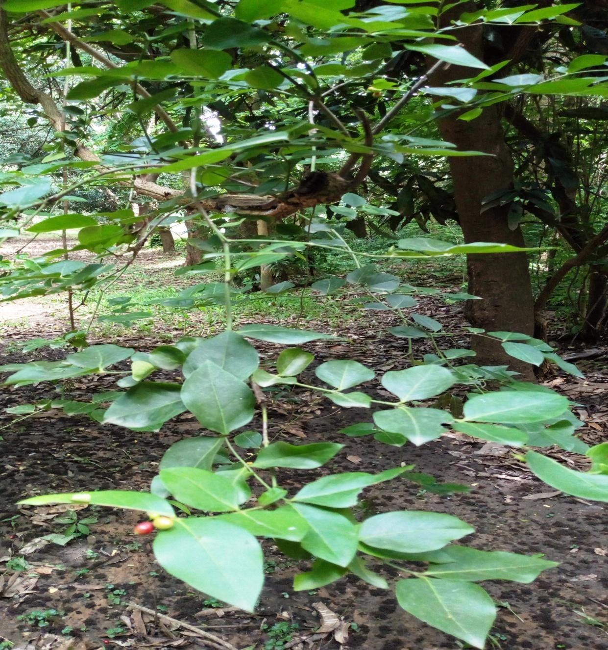

## Plate (I1A) Picture of *Carissa edulis* in its natural habitat before collection

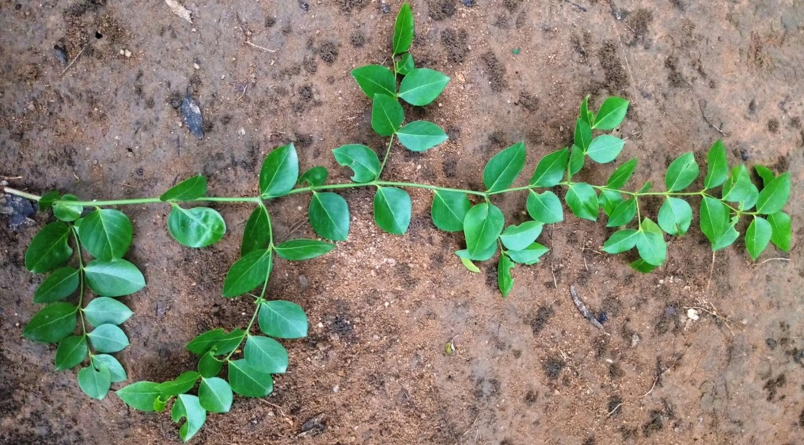

**Plate (I1B) Picture of *Carissa edulis* fresh leaf after collection**

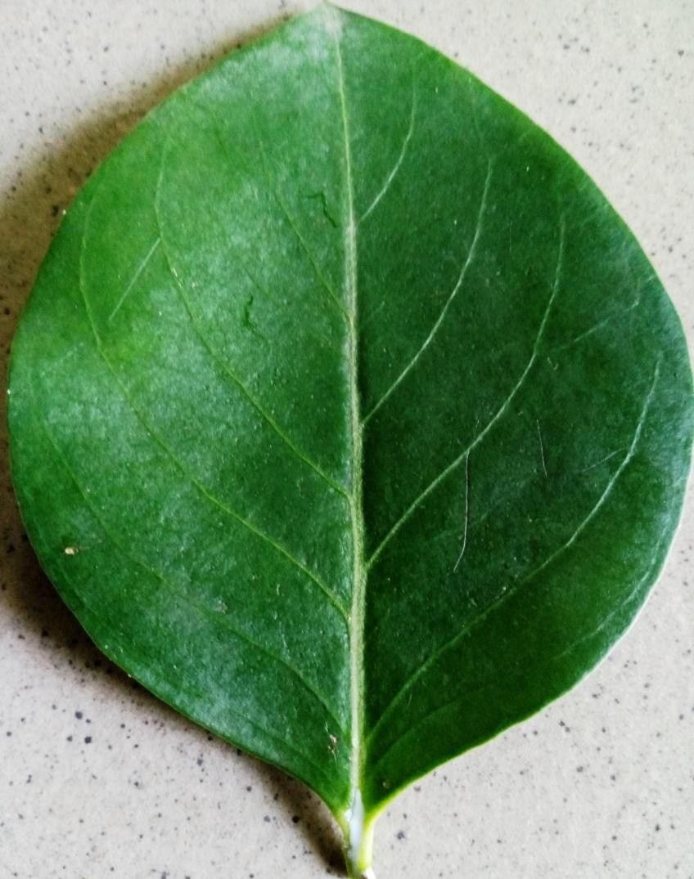

**Plate (I1C) Picture of *Carissa edulis* single fresh leaf after collection**

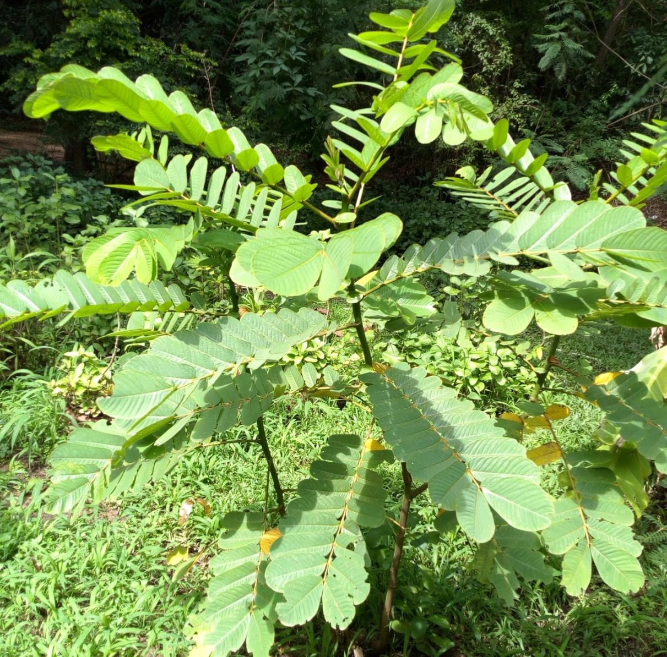

## Plate (IID) Picture of *Senna alata* in its natural hbitat before collection

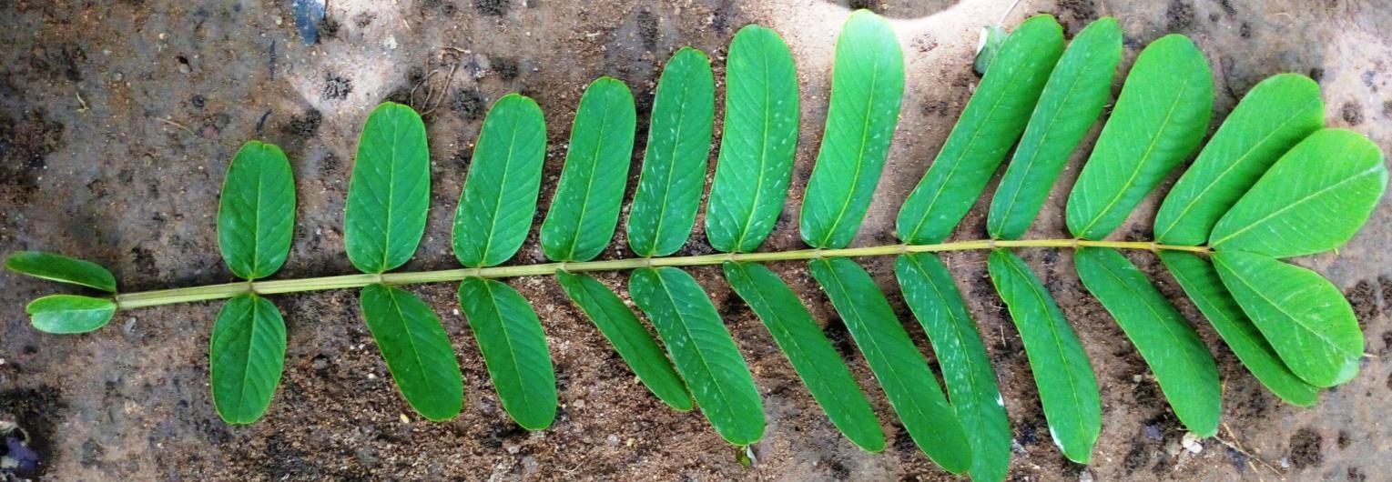

**Plate (IIE) Picture of *Senna alata* fresh leaf after collection**

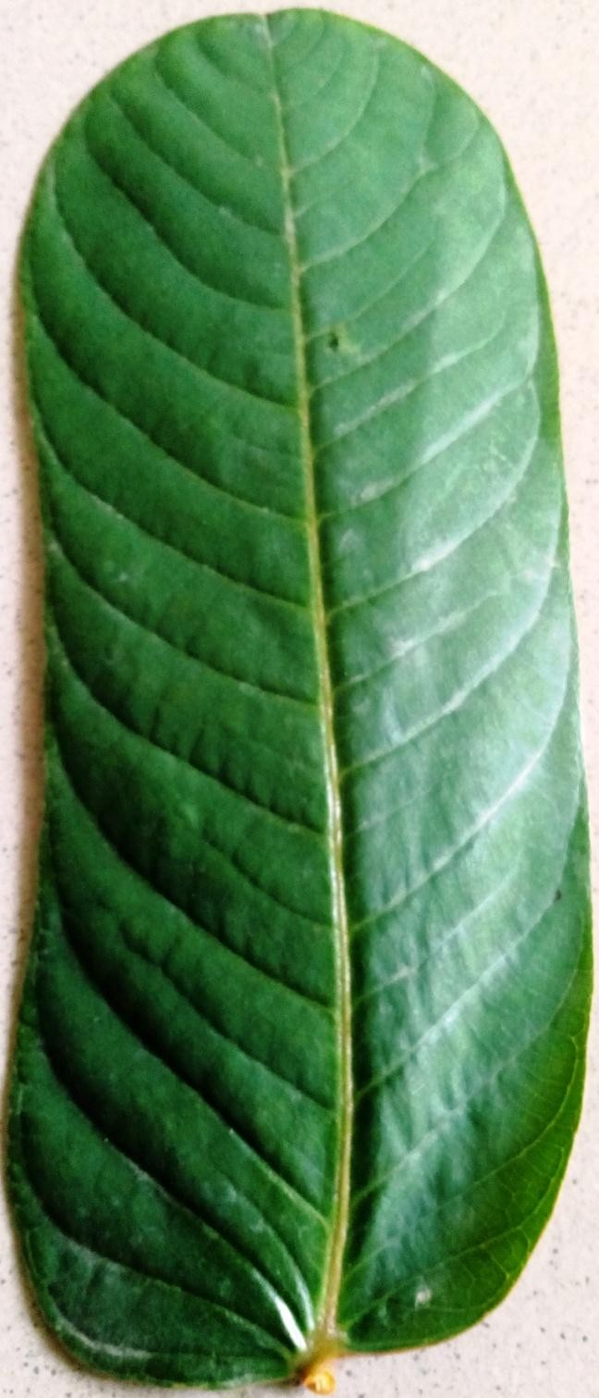

## Plate (IIF) Picture of *Senna alata* single fresh leaf after collection

**Table 4.2 Physicochemical Constants of *C. edulis* and *S. alata* Leaf Powder**

|  |  |
| --- | --- |
| **Parameters Values (%) ± SD**  ***C. edulis S. alata*** | |
| Moisture content (M1) 10.11±0.29  Moisture content (M2) 79.57±0.37 | 8.10 ± 0.10  86.59±0.34 |
| Total ash value 9.16±0.17 | 8.08 ± 0.08 |
| Acid Insoluble ash 2.13±0.06 | 1.31 ± 0.03 |
| Water Soluble ash 4.10±0.10 | 3.16 ± 0.09 |
| Ethanol Extractives 19.86±0.07 | 18.40 ± 0.23 |
| Water Extractives 17.30±0.06 | 16.30± 0.33 |

Values (% w/w) are means ±SD (Standard deviation) of three determinations Key

M1 = moisture content of the dried powdered leaf to a constant weight M2= moisture content of the fresh leaf to a constant weight

**Table 4.3 Percentage yield for the Extracts of *Carissa edulis* and *Senna alata***

|  |  |  |  |  |  |
| --- | --- | --- | --- | --- | --- |
| S/No. | Extract | *Carissa edulis* | | *Senna alata* | |
|  |  | Weight (g) | % yield | Weight (g) | % yield |
| 1 | Hexane | 41.98 | 4.20 | 13.44 | 1.3 |
| 2 | Ethyl acetate | 37.42 | 3.70 | 33.72 | 3.4 |
| 3 | Methanol | 142.08 | 14.20 | 98.34 | 9.8 |

## Phytochemical Constituents

The preliminary phytochemical screening of the n-hexane, ethyl acetate and methanol extracts of *C. edulis* and *S. alata* was carried out and the results described below.

## Test for carbohydrates

The three extracts were used to test for the presence of carbohydrate

## Molisch’s test

This is a general test for carbohydrate, a violet ring at the common surface of the liquid (Molisch‟s reagent and the extracts) and a dull violet precipitate when the mixture of the liquids was shaken indicated the presences of carbohydrates. The ethyl acetate and methanol extracts gave this positive result.

## Fehling’s test

The Feling‟s test for free and combined reducing (a brick red precipitate) was positive for ethyl acetate and methanol extracts of the plants except for the hexane extract. This indicated the presences of free and combined reducing sugar.

## Test for tannins

1. **Ferric chloride test**

Tannins give blue-black or green coloured precipitates with ferric chloride (Evans, 2009). The ethyl acetate and methanol extracts gave green to greenish black colour indicating the presences of tannins.

## Lead sub-acetate test

The ethyl acetate and methanol extracts gave brown precipitate of different shade indicating the presences of tannins. Tannins are precipitated by heavy metals, in this case precipitated by lead.

## Goldbeater’s skin test

The ethyl acetate and methanol extracts gave brown to black colour on the skin indicating the presences of tannins, the test was positive for the both plants.

## Test for saponins

1. **Frothing test**

Persistent honey-comb froth which lasted for more than 30 mins was observed with methanol extracts, this indicated the presences of saponin in the extract, negative result was obtained with the hexane and ethyl acetate extracts of the two plants.

## Haemolysis test

Haemolytic test for saponins produce haemolysis with the methanol extracts while the hexane and ethyl acetate extracts did not, indicating the presences of saponins in the plants.

## Test for anthraquinone derivative (Borntrager’s tests)

No bright pink colour was observed with the different extracts of *C. edulis,* this indicated the absences of anthraquinones in the plant, but there was a positive result for the methanol extract of *S. alata.* Ethyl acetate and hexane extracts gave negative results.

## Test for cardiac glycosides

Positive results were obtained with the ethyl acetate and methanol extracts of the plants with Keller-Killiana, and Kedde tests, with reddish-brown precipitate and a purple-blue colour, this indicated the presences of cardiac glycosides in the plant. The result was negative for the hexane extracts.

## Test for flavonoids

The various tests carried out for this class of compounds are:

## Sodium hydroxide test

A yellow colour indicated the presences of flavonoids. This was observed with the ethyl acetate and methanol extracts while the hexane gave a negative result.

## Ferric chloride test

A greenish colour was obtained with the ethyl acetate and methanol extracts, indicating the presences of a phenolic nucleus. This test is applicable to both test for tannins and flavonoids.

## Shinoda test

Ethyl acetate and methanol extracts of the plants gave positive test (a red colour) which confirmed the presences of flavonoids,

## Test for terpenes and steroids

A redish or redish violet ring and green upper solution was obtained for Liebermann- Burchnard test, this indicated the presence of terpenes in all the three extracts of the plant. A positive result (a reddish brown or brownish ring) was obtained with Salkowski‟s test

indicating the presences of steroids in all the three extracts of the two plants. The intensity of the colours varied in the three extracts as hexane was found to have the highest quantity.

## Test for alkaloids

Various test for alkaloids were carried out but all gave negative results for *C. edulis* extracts, no precipitates were obtained, while an orange-red, cream colour and reddish-brown precipitate was observed for the methanol and ethyl acetate extracts of *S. alata* which indicated the presences of alkaloid in the plant.

The summary of all the phytochemical tests are given in table 4.4 below.

**Table 4.4 Phytochemical Constituents of Leaf Extracts of *C. edulis* and *S. alata***

|  |  |  |  |  |  |  |
| --- | --- | --- | --- | --- | --- | --- |
| **TEST** | **INFERENCE *C. edulis*** | | | **INFERENCE *S. alata*** | | |
|  | **HE** | **EE** | **ME** | **HE** | **EE** | **ME** |
| **Carbohydrates** |  |  |  |  |  |  |
| Molischs test | - | + | + | - | + | + |
| Fehlings test | - | + | + | - | + | + |
| **Tannins** |  |  |  |  |  |  |
| Ferric chloride test | - | + | + | - | + | + |
| Lead acetate test | - | + | + | - | + | + |
| Goldbeaters skin test | - | + | + | - | + | + |
| **Anthraquinones** |  |  |  |  |  |  |
| Borntragers test | - | - | - | - | + | + |
| Modified borntragers test | - | - | - | - | + | + |
| **Flavonoids** |  |  |  |  |  |  |
| Shinoda test | - | + | + | - | + | + |
| Sodium hydroxide test | - | + | + | - | + | + |
| **Saponins** |  |  |  |  |  |  |
| Froth test | - | - | + | - | - | + |
| Haemolysis test | - | - | + | - | - | + |
| **Cardiac glycosides** |  |  |  |  |  |  |
| Keller-kilani test | - | + | + | - | + | + |
| Kedde test | - | + | + | - | + | + |
| **Steroids/Triterpenes** |  |  |  |  |  |  |
| Liebermann-Burchard test | + | + | + | + | + | + |
| Salkowski test | + | + | + | + | + | + |
| **Alkaloids** |  |  |  |  |  |  |
| Dragendorff test | - | - | - | - | + | + |
| Mayers test | - | - | - | - | + | + |
| Wagners test | - | - | - | - | + | + |

Key – HE = Hexane extract, EE = Ethyl acetate extract, ME = Methanol extract (- = Absent) (+ = Present)

* 1. **Thin Layer Chromatographic Profiles of *Carissa edulis* and *Senna alata* Methanol**

## Extract

Plates (III A and B) showed the chromatogram of methanol extracts of *Carissa edulis* and *Senna alata* in butanol: acetic acid: water (10:1:1) and (8:1:1) visualized with *p*- Anisaldehyde/H2SO4, it revealed a clear separation with 7 for *Carissa edulis* and 9 were seen for *Senna alata.* The various colours are; blue, brown, orange, pink, purple and yellow. As seen in Table 4.5

**Table 4.5 Chromatographic Analysis of *Carissa edulis* and *Senna alata* Methanol extract**

**sprayed with *P-Anisaldehyde.***

|  |  |  |  |  |
| --- | --- | --- | --- | --- |
| **Extract** | **Solvent System** | **No. of Spots** | **Colour of Spots** | **Rf values** |
| CME | B:A:W (10:1:1) | 7 | Brown | 0.03 |
|  |  |  | Brown | 0.16 |
|  |  |  | Yellow | 0.37 |
|  |  |  | Yellow | 0.55 |
|  |  |  | Orange | 0.65 |
|  |  |  | Purple | 0.80 |
|  |  |  | Brown | 0.95 |
| SME | B:A:W (8:1:1) | 9 | Brown | 0.04 |
|  |  |  | Brown | 0.10 |
|  |  |  | Brown | 0.18 |
|  |  |  | Brown | 0.26 |
|  |  |  | Yellow | 0.31 |
|  |  |  | Purple | 0.50 |
|  |  |  | Blue | 0.57 |
|  |  |  | Pink | 0.66 |
|  |  |  | Yellow | 0.78 |

Key = CME*- Carissa edulis* Methanol Extract SME-*Senna alata* Methanol Extract

B:A:W-Butanol Acetic acid Water (Mobile phase) Adsorbent **-** Pre coated Silica gel plates

5

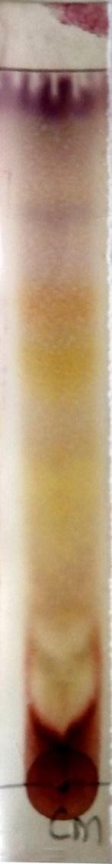

SF

0.9

0.80

0.65

0.55

0.37

0.16

0.03

SL

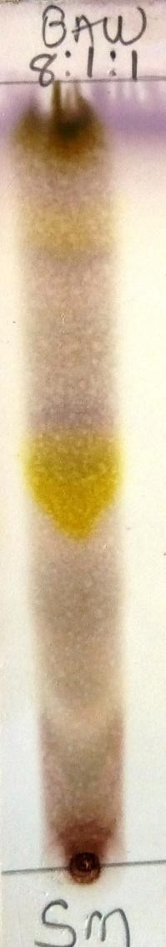

SF

0.78

0.66

0.57

0.50

0.31

0.26

0.18

0.10

0.0

SL

4

(III) A (III) B

**Plate (III) A: Chromatogram of *Carissa edulis* Methanol extract developed in Butanol: Acetic acid: Water (10:1:1) sprayed with *P-Anisaldehyde* reagent**

## Plate (III) B: Chromatogram of *Senna alata* Methanol extract developed in Butanol: Acetic acid: Water (8:1:1) sprayed with *P-Anisaldehyde* reagent

**Adsorbent - Pre coated Silica gel plates SL-Start line**

## SF-Solvent front

* 1. **Thin Layer Chromatographic Profiles of *Senna alata* Methanol Fractions** Plates (IV A, B, C, D and E) showed the chromatogram of fraction „A‟ (pet. ether) which was positive to Liebermann-Buchard reagent indicating the presence of triterpernoid/steroids, aluminum chloride (which was observed under UV light at 365nm after spraying the plate) which indicated the presence of phenolic compounds and flavonoids, ferric chloride which indicated the presence of tannins and borntragers reagent which indicated the presence of anthraquinone. The chromatogram of fraction „B‟ (aqueous) and „C‟ (n-butanol) i.e plates (V and VI A, B, C, D) was positive to borntragers and aluminum chloride (which was observed under UV light at 365nm after spraying the plate). This revealed the presence of anthraquinones, phenolic compounds, and flavonoids respectively. The chromatogram of fraction „D‟ (BuOH) and „E‟ (HCl) i.e plates (VII and VIII A, B, C, D, E) was positive to Liebermann-Burchard, ferric chloride, borntragers and aluminum chloride (which was observed under UV light at 365nm after spraying the plate). This indicated the presence of triterpernoid/steroids, tannins, anthraquinone, flavonoids and phenolic compounds as seen in tables (4.6, 4.7, 4.8, 4.9 and 4.10).

## Table 4.6 Chromatographic analysis of fraction ‘A’ (Pet. ether from *S. alata* methanol extract) sprayed with general and specific detecting reagents.

|  |  |  |  |  |
| --- | --- | --- | --- | --- |
| **Detecting Reagents** | **Solvent System** | **No.of Spots** | **Colour of Spots** | **Rf Values** |
| P-Anisaldehyde | H:E (9:1) | 8 | Blue, Purple, Blue, Violet, Green, Blue, Blue,Violet | 0.10,0.23,  0.28, 0.40,  0.50, 0.65,  0.71,0.93 |
| Liebermann- Burchard | H:E (9:1) | 7 | Green,Purple, Purple, Violet, Pink, Pink, Pink | 0.11,0.23,  0.28,0.40,  0.50,0.83,  0.93 |
| Alluminium chloride* | H:E (9:1) | 7 | Orange, Pink, Pink, Purple, Blue, Blue, Blue | 0.07, 0.10,  0.28,0.39,  0.40, 0.65,  0.93 |
| Ferric chloride | H:E (9:1) | 1 | Blue-black | 0.10 |
| Bontragers | H:E (9:1) | 4 | Green, Pink, Orange, Pink | 0.10,0.36,  0.40, 0.65 |

Key = H:E- Hexane:Ethyl acetate (Mobile phase) Adsorbent **-** Pre coated Silica gel plates

* = viewed under UV flourescence

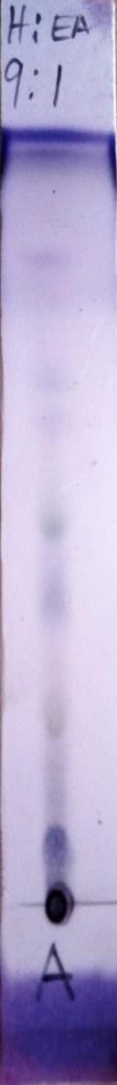 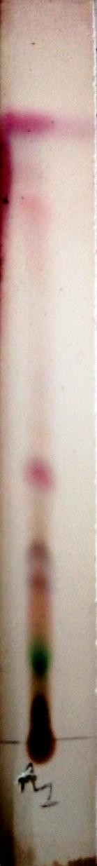 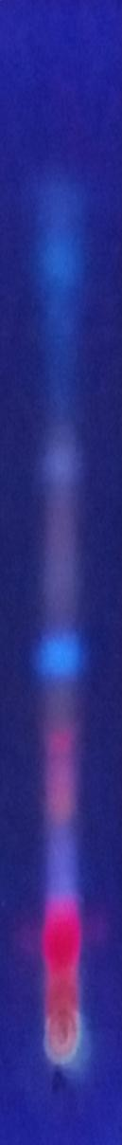

1. A (IV) B (IV) C

|  |  |  |  |  |
| --- | --- | --- | --- | --- |
|  | SF | SF |  | SF |
|  | 0.93 |  |  |
| 0.93 | 0.83 |  | 0.93 |
| 0.71 |  |  |  |
| 0.65 |  |  | 0.65 |
| 0.50 | 0.50 |  |  |
| 0.40 | 0.40 |  | 0.40 |
| 0.28 | 0.23 | 0.28 | 0.39 |
| 0.23 |  |  | 0.28 |
| 0.10 | 0.11 |  |  |
| SL |  |  | 0.10 |
|  |  | SL |  | 0.07 |
|  |  |  |  | SL |

## Pates (IV) A, B, C) Chromatographic analysis of fraction ‘A’ (Ether, from *S. alata* methanol extract) sprayed with *P- Anisaldehyde,* Liebermann-Burchard and Aluminium, chloride detecting reagents.

**Solvent system Hexane: Ethyl acetate (9:1) Adsorbent - Pre coated Silica gel plates**

## SL-Start line

**SF-Solvent front**

0.10

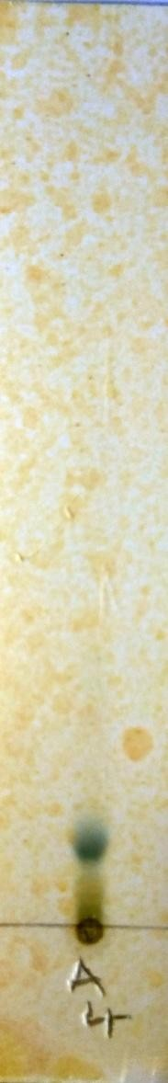

SF

SL

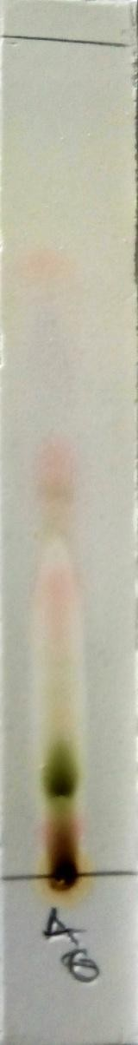

SF

0.65

0.40

0.36

0.10

SL

* 1. D (IV)E

## Plates (IV) D and E) Chromatographic analysis of fraction ‘A’ (Pet. ether from *S. alata* methanol extract) sprayed with Ferric chloride and Borntragers detecting reagents. Solvent system

**Hexane: Ethyl acetate (9:1)**

## Adsorbent - Pre coated Silica gel plates SL-Start line

**SF-Solvent front**

## Table 4.7 Chromatographic analysis of fraction ‘B’ (Aqueous from *S. alata* methanol extract) sprayed with general and specific detecting reagents.

|  |  |  |  |  |
| --- | --- | --- | --- | --- |
| **Detecting Reagents** | **Solvent System** | **No.of Spots** | **Colour of Spots** | **Rf Values** |
| P-Anisaldehyde | B:A:W (10:1:1) | 5 | Brown, Brown, Brown, Yellow, Pink, | 0.12,0.27,  0.36,0.50,  0.64, |
| Liebermann- Burchard | B:A:W (10:1:1) | 4 | Brown, Brown, Brown, Yellow | 0.12, 0.27,  0.36, 0.50 |
| Alluminium chloride* | B:A:W (10:1:1) | 2 | Blue, Blue | 0.12, 0.50 |
| Bontragers | B:A:W (10:1:1) | 2 | Yellow, Pink | 0.50, 0.60 |

Key

Solvent system- B:A:W- Butanol:Acetic acid:Water Adsorbent **-** Pre coated Silica gel plates

* = viewed under UV flourescence

.64

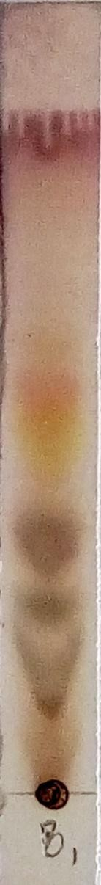

SF

0.64

0.50

0.36

0.27

0.12

SL

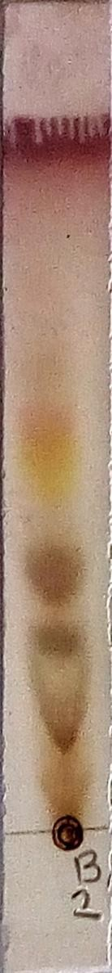

SF

0

0.36

0.27

0.12

SL



SF

0

0

SL

.50

.50

* 1. A (V) B (V) C

## Plates (V) A, B, C) Chromatographic analysis of fraction ‘B’ (Aqueous from *S. alata* methanol extract) sprayed with *P- Anisaldehyde,* Liebermann-Buchard and Aluminium chloride detecting reagents.

**Solvent system - Butanol: Acetic acid: Water (10:1:1) Adsorbent - Pre coated Silica gel plates**

## SL-Start line

**SF-Solvent front**

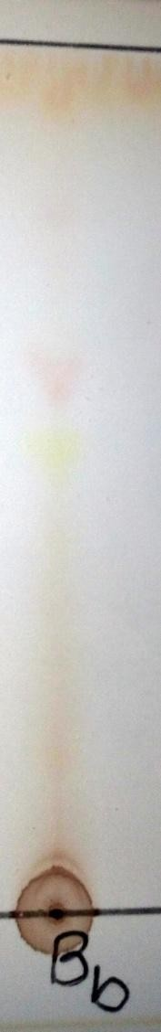

SF

0.60

0.50

SL

* + 1. D

## Plate (V) D) Chromatographic analysis of fraction ‘B’ (Aqueous from *S. alata* methanol extract) sprayed with Borntragers detecting reagents.

**Solvent system - Butanol: Acetic acid: Water (10:1:1) Adsorbent - Pre coated Silica gel plates**

## SL-Start line

**SF-Solvent front**

## Table 4.8 Chromatographic analysis of fraction ‘C’ (n-Butanol from *S. alata* methanol extract) sprayed with general and specific detecting reagents.

|  |  |  |  |  |
| --- | --- | --- | --- | --- |
| **Detecting Reagents** | **Solvent System** | **No.of Spots** | **Colour of Spots** | **Rf Values** |
| P-Anisaldehyde | C:E:M:W (8:15:4:1) | 4 | Green, Purple, Blue, Purple | 0.50,0.59,  0.68, 0.83 |
| Liebermann- Burchard | C:E:M:W (8:15:4:1) | 6 | Yellow, Orange Green ,Purple, Green, Orange | 0.10, 0.50,  0.55, 0.59,  0.65, 0.95 |
| Alluminium chloride* | C:E:M:W (8:15:4:1) | 5 | Blue, Pink Orange, Yellow Orange | 0.10, 0.50,  0.59, 0.77  0.95 |
| Bontragers | C:E:M:W (8:15:4:1) | 5 | Yellow, Pink, Orange, Yellow  Green | 0.10, 0.50,  0.55,0.59,  0.68 |

Key

Solvent system - C:E:M:W- Chloroform:Ethyl acetate:Methanol:Water Adsorbent **-** Pre coated Silica gel plates

* = viewed under UV flourescence

SF

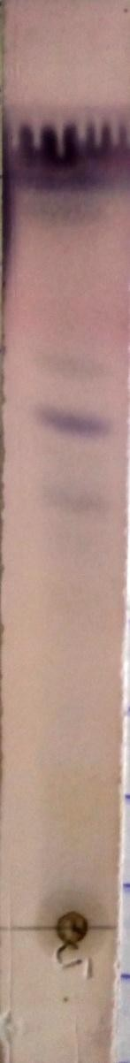

SF

0.8

0.68

0.59

0.50

SL

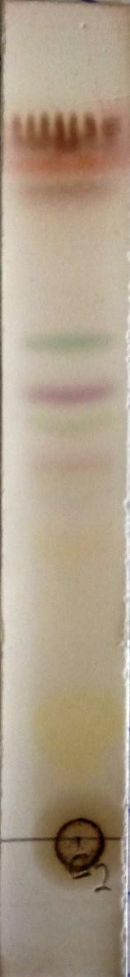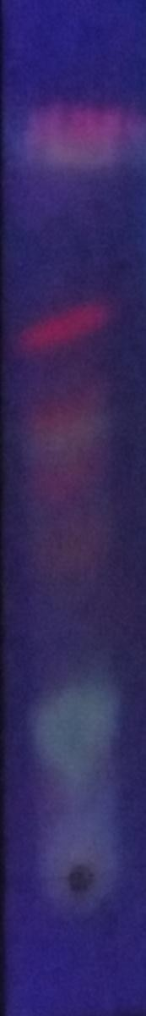

SF 0.95

3 0.95

0.65

0.59

0.55

0.50

0.77

0.59

0.50

0.10

0.10

SL SL

`

* + 1. A (VI) B (VI) C

## Plates (VI) A, B, C) Chromatographic analysis of fraction ‘C’ (n-Butanol from *S. alata* methanol extract) sprayed with *P-Anisaldehyde,* Liebermann-Burchard and Aluminium chloride detecting reagents.

**Solvent system - Chloroform: Ethyl acetate: Methanol: Water (8:15:4:1) Adsorbent - Pre coated Silica gel plates**

## SL-Start line

**SF-Solvent front**

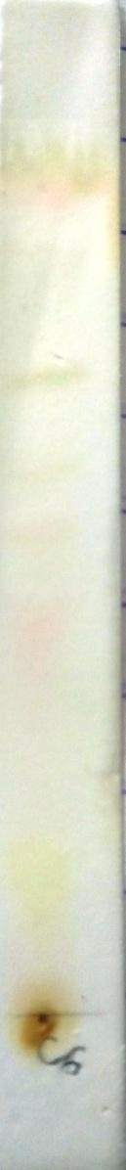

SF

0.68

0.59

0.55

0.50

0.10

SL

* + - 1. D

## Plate (VI) D) Chromatographic analysis of fraction ‘C’ (n-Butanol from *S. alata*

**methanol extract) sprayed with Borntragers detecting reagents.**

## Solvent system - Chloroform: Ethyl acetate: Methanol: Water (8:15:4:1) Adsorbent - Pre coated Silica gel plates

**SL-Start line**

## SF-Solvent front

**Table 4.9 Chromatographic analysis of fraction ‘D’ (BuOH from *S. alata* methanol extract) sprayed with general and specific detecting reagents.**

|  |  |  |  |  |
| --- | --- | --- | --- | --- |
| **Detecting Reagents** | **Solvent System** | **No.of Spots** | **Colour of Spots** | **Rf Values** |
| P-Anisaldehyde | C:E:M:W (8:15:4:1) | 4 | Orange, Orange, Purple, Yellow | 0.10,0.39,  0.47, 0.90 |
| Liebermann- Burchard | C:E:M:W (8:15:4:1) | 4 | Orange, Yellow, Purple, Yellow | 0.10,0.39,  0.47,0.90 |
| Alluminium chloride* | C:E:M:W (8:15:4:1) | 4 | Blue, Orange, Blue, Blue | 0.10,0.39,  0.47,0.90 |
| Ferric chloride | C:E:M:W (8:15:4:1) | 1 | Blue-black | 0.90 |
| Bontragers | C:E:M:W (8:15:4:1) | 3 | Orange, Pink, Yellow | 0.10,0.38,  0.88 |

Key

Solvent system - C:E:M:W- Chloroform:Ethyl acetate:Methanol:Water Adsorbent **-** Pre coated Silica gel plates

* = viewed under UV flourescence

0



SF

0.90

0.47

0.39

0.1

SL

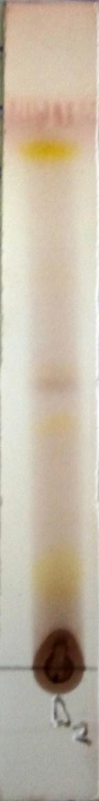

SF

0.90

0.47

0.39

0.10

SL

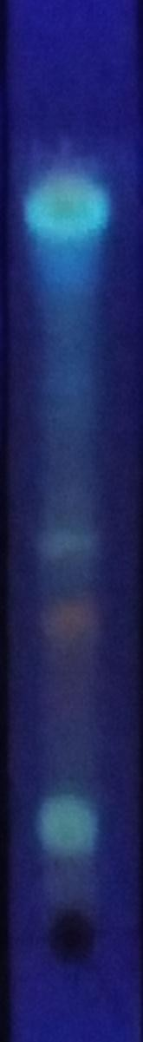

SF

0.90

0.47

0.39

0.10

SL

* + - 1. A (VII)B (VII)C

## Plates (VII) A, B, C) Chromatographic analysis of fraction ‘D’ (BuOH from *S. alata* methanol extract) sprayed with *P- Anisaldehyde,* Liebermann-Burchard and Aluminium chloride detecting reagents.

**Solvent system Chloroform - Ethyl acetate: Methanol: Water (8:15:4:1) Adsorbent - Pre coated Silica gel plates**

## SL-Start line

**SF-Solvent front**

8

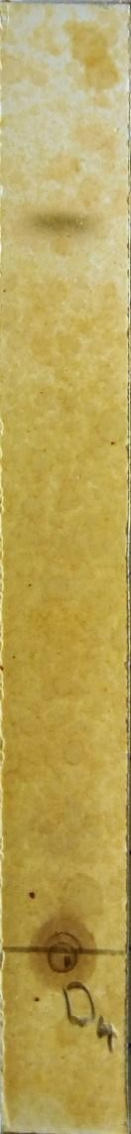

SF

SL

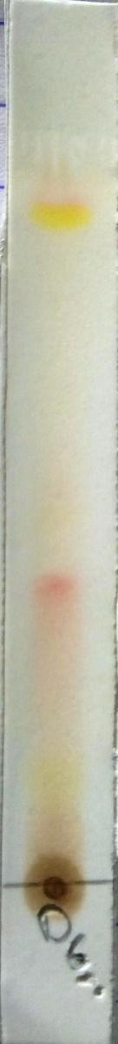

SF

0.8

0.38

0.10

SL

0.90

* + - * 1. D (VII)E

## Plates (VII) D and E) Chromatographic analysis of fraction ‘D’ (BuOH from *S. alata* methanol extract) sprayed with Ferric chloride and Borntragers detecting reagents.

**Solvent system - Chloroform: Ethyl acetate: Methanol: Water (8:15:4:1) Adsorbent - Pre coated Silica gel plates**

## SL-Start line

**SF-Solvent front**

## Table 4.10 Chromatographic analysis of fraction ‘E’ (Aqueous from *S. alata* methanol extract) sprayed with general and specific detecting reagents.

|  |  |  |  |  |
| --- | --- | --- | --- | --- |
| **Detecting Reagents** | **Solvent System** | **No.of Spots** | **Colour of Spots** | **Rf Values** |
| P-Anisaldehyde | B:A:W (10:1:1) | 4 | Brown, Brown, Yellow, Yellow | 0.10,0.19,  0.49, 0.85 |
| Liebermann- Burchard | B:A:W (10:1:1) | 3 | Orange, Orange, Yellow | 0.13, 0.19,  0.46 |
| Alluminium chloride* | B:A:W (10:1:1) | 2 | Blue, Blue | 0.45, 0.85 |
| Ferric chloride | B:A:W (10:1:1) | 1 | Blue-black | 0.46 |
| Bontragers | B:A:W (10:1:1) | 5 | Orange, Yellow, Red, Yellow | 0.19,0.50,  0.83, 0.85 |

Key

Solvent system - B:A:W- Butanol:Acetic acid:Water (Mobile phase) Adsorbent **-** Pre coated Silica gel plates

* = viewed under UV flourescence

SF 0.85

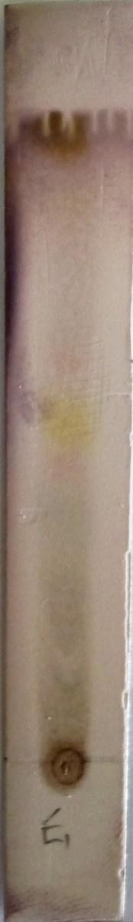

SF

0.85

0.49

0.19

0.10

SL

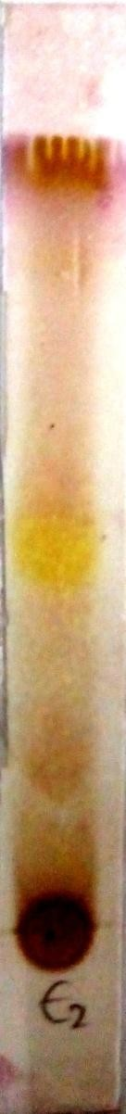

SF

0.46

0.19

0.10

SL



0.45

SL

* + - * 1. A (VIII) B (VIII) C

## Plates (VIII) A, B, C) Chromatographic analysis of fraction ‘E’ (Aqueous from *S. alata* methanol extract) sprayed with *P- Anisaldehyde,* Liebermann- Burchard and Aluminium chloride detecting reagents.

**Solvent system Butanol - Acetic acid: Water (10:1:1) Adsorbent - Pre coated Silica gel plates**

## SL-Start line

**SF-Solvent front**

5

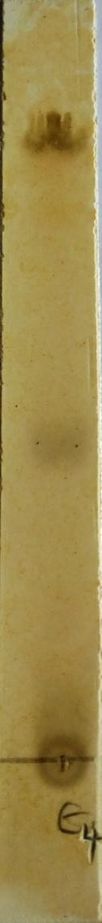

SF

0

SL

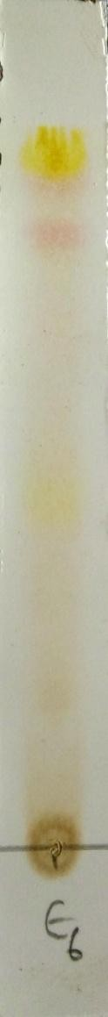

SF

0.8

0.83

0.50

0.19

SL

.46

(VIII) D (VIII) E

## Plates (VIII) D and E) Chromatographic analysis of fraction ‘E’ (Aqueous from *S. alata* methanol extract) sprayed with Ferric chloride and Borntragers detecting reagents.

**Solvent system Butanol - Acetic acid: Water (10:1:1) Adsorbent - Pre coated Silica gel plates**

## SL-Start line

**SF-Solvent front**

## Antimicrobial Assay

The antimicrobial activities of the hexane, ethyl acetate and methanol extracts of *Carissa edulis* and *Senna alata* were tested on six clinical isolates of *Aspergillus fumigatus, Candida albicans, Trichophyton mentagrophytes, Escherichia coli, Staphylococcus aureus* and *Streptococcus pyogenes*. From the results obtained, methanol extracts of *C. edulis* had higher activity compared to the hexane and ethyl acetate extracts, with MIC value of 12.0mg/ml for *E. coli*, 25.0mg/ml for *S. aureus*, 50.0ml/ml for *S.pyogenes* 25mg/ml for *C. albicans* and 50mg/ml for *T. mentagrophytes*. In the case of *S. alata* the methanol extract also had higher activities compared to the hexane and ethyl acetate extracts with MIC value of 12.5mg/ml for *E. coli*, 6.25mg/ml for *S. aureus*, 100.0ml/ml for *S.pyogenes* and *A. fumigatus,* 25mg/ml for *C. albicans,* and 12.50mg/ml for *T. mentagrophytes*, It was also observed that the higher the concentration, the higher the activities of the extract. While *E.coli* was the most sensitive to the extract of *C.edulis* with MIC value of 12.5mg/ml and *A. fumigatus* was not sensitive to all the extracts of *C.edulis.* In the case of *Senna alata, S. aureus* was found to be most sensitive than all the organisms with MIC of 6.25Mg/ml. *A. fumigatus* and *S. pyogenes* were least sensitive with MIC of 100Mg/ml.

The results of the zones of inhibition, minimum inhibitory concentrations and the minimum bactericidal/fungicidal concentrations for the hexane, ethyl acetate and methanol extracts for *S. alata* and *C. edulis,* and for the fractions obtained from the Methanol extract of *Senna alata* were presented in the tables 4.11, 4.12, 4.13, 4.14, 4.15, 4.16, 4.17, 4.18, 4.19, 4.20, 4.21, 4.22

and appendix III below.

## Table 4.11: Zones of Inhibition Produced by Hexane, Ethyl acetate and Methanol Extracts of *Carissa edulis* and *Senna alata* and Standard Antimicrobial agent in MHA (mm)

|  |  |  |  |  |  |  |  |
| --- | --- | --- | --- | --- | --- | --- | --- |
| **Organisms** | **HE**  **10mg/100µL** | | **EE**  **10mg/100µL** | | **ME**  **10mg/100µL** | | **CF**  **1.0µg/10µL** |
|  | **CE** | **SA** | **CE** | **SA** | **CE** | **SA** |  |
| *E. coli* | 13 | 0 | 0 | 15 | 20 | 19 | 27 |
| *S. aureus* | 18 | 0 | 0 | 13 | 18 | 25 | 30 |
| *S. pyogenes* | 0 | 0 | 0 | 8 | 12 | 6 | 21 |

Key

HE = Hexane Extract

EE = Ethyl acetate Extract ME = Methanol Extract

CF = Ciprofloxacin 10 µg/ml CE = *Carissa edulis*

SA = *Senna alata*

MHA = Muellar Hinton Agar

## Table 4.12: Zones of Inhibition Produced by Hexane, Ethyl acetate and Methanol Extracts of *Carissa edulis* and *Senna alata* and Standard Antimicrobial agent in SDA (mm)

|  |  |  |  |  |  |  |  |
| --- | --- | --- | --- | --- | --- | --- | --- |
| **Organisms** | **HE**  **10mg/100µL** | | **EE**  **10mg/100µL** | | **ME**  **10mg/100µL** | | **FL**  **2.5µg/100µL** |
|  | **CE** | **SA** | **CE** | **SA** | **CE** | **SA** |  |
| *A. fumigatus* | 0 | 0 | 0 | 9 | 0 | 11 | 13 |
| *C. albicans* | 0 | 0 | 9 | 0 | 19 | 15 | 27 |
| *T. mentagrophytes* | 0 | 0 | 12 | 10 | 14 | 21 | 33 |

Key

HE = Hexane Extract

EE = Ethyl acetate Extract ME = Methanol Extract

FL = Fluconazole 25 µg/ml CE = *Carissa edulis*

SA = *Senna alata*

SDA = Sabouraud Dextrose Agar

**Table 4.13: Minimum Inhibitory Concentration (MIC) of *Carissa edulis* and *Senna alata***

## extracts and Standard Antimicrobial Agent against Test Bacteria (mg/ml)

|  |  |  |  |  |  |  |  |
| --- | --- | --- | --- | --- | --- | --- | --- |
| **Organisms** | **HE**  **mg/ml** |  | **EE**  **mg/ml** | | **ME**  **mg/ml** |  | **CF**  **µg/ml** |
|  | **CE** | **SA** | **CE** | **SA** | **CE** | **SA** |  |
| *E. coli* | 50.00 | >100.00 | >100.00 | 25.00 | 12.00 | 12.50 | 0.31 |
| *S. aureus* | 50.00 | >100.00 | >100.00 | 25.00 | 25.00 | 6.25 | 0.16 |
| *S. pyogenes* | >100.00 | >100.00 | >100.00 | 100.00 | 50.00 | 100.00 | 1.25 |

Key

HE = Hexane Extract

EE = Ethyl acetate Extract ME = Methanol Extract

CF = Ciprofloxacin 10 µg/ml CE = *Carissa edulis*

SA = *Senna alata*

**Table 4.14: Minimum Inhibitory Concentration (MIC) of *Carissa edulis* and *Senna alata***

## extracts and Standard Antimicrobial Agent against Test Fungi (mg/ml)

|  |  |  |  |  |  |  |  |
| --- | --- | --- | --- | --- | --- | --- | --- |
| **Organisms** | **HE**  **mg/ml** |  | **EE**  **mg/ml** | | **ME**  **mg/ml** |  | **FL**  **µg/ml** |
|  | **CE** | **SA** | **CE** | **SA** | **CE** | **SA** |  |
| *A. fumigatus* | >100.00 | >100.00 | >100.00 | 50.00 | >100.00 | 100.00 | 5.00 |
| *C. albicans* | >100.00 | >100.00 | 50.00 | 100.00 | 25.00 | 25.00 | 0.63 |
| *T. mentagrophytes* | >100.00 | >100.00 | 50.00 | 25.00 | 50.00 | 12.50 | 0.63 |

Key

HE = Hexane Extract

EE = Ethyl acetate Extract ME = Methanol Extract

FL = Fluconazole 25 µg/ml CE = *Carissa edulis*

SA = *Senna alata*

## Table 4.15: Minimum Bactericidal Concentration (MBC) of *Carissa edulis* and *Senna alata* extracts and Standard Antimicrobial Agents against Test Bacteria

|  |  |  |  |  |  |  |  |
| --- | --- | --- | --- | --- | --- | --- | --- |
| **Organisms** | **H E**  **mg/ml** |  | **E E**  **mg/ml** | | **M E**  **mg/ml** | | **CF**  **µg/ml** |
|  | **CE** | **SA** | **CE** | **SA** | **CE** | **SA** |  |
| *E. coli* | >100.00 | >100.00 | >100.00 | 50.00 | 25.00 | 25.00 | 1.25 |
| *S. aureus* | 100.00 | >100.00 | >100.00 | 50.00 | 50.00 | 25.00 | 0.31 |
| *S. pyogenes* | >100.00 | >100.00 | >100.00 | >100.00 | 100.00 | >100.00 | 2.50 |

Key

HE = Hexane Extract

EE = Ethyl acetate Extract ME = Methanol Extract

CF = Ciprofloxacin 10 µg/ml CE = *Carissa edulis*

SA = *Senna alata*

## Table 4.16: Minimum Fungicidal Concentration (MFC) of *Carissa edulis* and *Senna alata* extracts and Standard Antimicrobial Agents against Test Fungi

|  |  |  |  |  |  |  |  |
| --- | --- | --- | --- | --- | --- | --- | --- |
| **Organisms** | **H E**  **mg/ml** | | **E E**  **mg/ml** | | **M E**  **mg/ml** | | **FL**  **µg/ml** |
|  | **CE** | **SA** | **CE** | **SA** | **CE** | **SA** |  |
| *A. fumigatus* | >100.00 | >100.00 | >100.00 | >100.00 | >100.00 | >100.00 | 10.00 |
| *C. albicans* | >100.00 | >100.00 | >100.00 | >100.00 | 50.00 | 50.00 | 1.25 |
| *T. mentagrophytes* | >100.00 | >100.00 | 100.00 | 50.00 | 100.00 | 25.00 | 2.50 |

Key

HE = Hexane Extract

EE = Ethyl acetate Extract ME = Methanol Extract

FL = Fluconazole 25 µg/ml CE = *Carissa edulis*

SA = *Senna alata*

## Table 4.17: Zones of Inhibition Produced by *Senna alata* Methanol Fractions and Standard Antimicrobial Agents in MHA (mm)

|  |  |  |  |  |  |
| --- | --- | --- | --- | --- | --- |
| **Organisms** | **FB**  **10mg/100µL** | **FC**  **10mg/100µL** | **FD**  **10mg/100µL** | **FE**  **10mg/100µL** | **CF**  **1.0µg/100µL** |
| *E. coli* | 6 | 8 | 12 | 12 | 27 |
| *S. aureus* | 0 | 20 | 18 | 8 | 31 |
| *S. pyogenes* | 0 | 0 | 5 | 0 | 21 |

Key

FB = Fraction B (Aqueous) FC = Fraction C (n-Butanol) FD = Fraction D (BuOH) FE = Fraction E (Aqueous)

CF = Ciprofloxacin 10 µg/ml MHA = Muellar Hinton Agar

## Table 4.18: Zones of Inhibition Produced by *Senna alata* Methanol Fractions and Standard Antimicrobial Agents in SDA (mm)

|  |  |  |  |  |  |
| --- | --- | --- | --- | --- | --- |
| **Organisms** | **FB**  **10mg/100µL** | **FC**  **10mg/100µL** | **FD**  **10mg/100µL** | **FE**  **10mg/100µL** | **FL**  **2.5µg/100µL** |
| *A. fumigatus* | 0 | 9 | 10 | 7 | 12 |
| *C. albicans* | 0 | 0 | 13 | 9 | 26 |
| *T. mentagrophytes* | 10 | 8 | 15 | 17 | 34 |

Key

FB = Fraction B (Aqueous) FC = Fraction C (n-Butanol) FD = Fraction D (BuOH) FE = Fraction E (Aqueous) FL = Fluconazole 25 µg/ml

SDA = Sabouraud Dextrose Agar

## Table 4.19: Minimum Inhibitory Concentration (MIC) of *Senna alata* Methanol Fractions and Standard Antimicrobial Agents against Test Bacteria

|  |  |  |  |  |  |
| --- | --- | --- | --- | --- | --- |
| **Organisms** | **FB**  **mg/ml** | **FC**  **mg/ml** | **FD**  **mg/ml** | **FE**  **mg/ml** | **CF**  **µg/ml** |
| *E. coli* | 100.00 | 50.00 | 50.00 | 50.00 | 0.16 |
| *S. aureus* | 100.00 | 6.25 | 12.50 | 50.00 | 0.16 |
| *S. pyogenes* | >100.00 | >100.00 | 100.00 | >100.00 | 1.25 |

Key

FB = Fraction B (Aqueous) FC = Fraction C (n-Butanol) FD = Fraction D (BUOH) FE = Fraction E (Aqueous) CF = Ciprofloxacin 10 µg/ml

## Table 4.20: Minimum Inhibitory Concentration (MIC) of *Senna alata* Methanol Fractions and Standard Antimicrobial Agents against Test Fungi

|  |  |  |  |  |  |
| --- | --- | --- | --- | --- | --- |
| **Organisms** | **FB**  **mg/ml** | **FC**  **mg/ml** | **FD**  **mg/ml** | **FE**  **mg/ml** | **FL**  **µg/ml** |
| *A. fumigatus* | >100.00 | 50.00 | 50.00 | 50.00 | 6.25 |
| *C. albicans* | >100.00 | 100.00 | 50.00 | 50.00 | 1.56 |
| *T. mentagrophytes* | 50.00 | 50.00 | 12.50 | 6.25 | 3.13 |

Key

FB = Fraction B (Aqueous) FC = Fraction C (n-Butanol) FD = Fraction D (BUOH) FE = Fraction E (Aqueous) FL = Fluconazole 25 µg/ml

## Table 4.21: Minimum Bactericidal Concentration (MBC) of *Senna alata* Methanol Fractions and Standard Antimicrobial Agents against Test Bacteria

|  |  |  |  |  |  |
| --- | --- | --- | --- | --- | --- |
| **Organisms** | **FB**  **mg/ml** | **FC**  **mg/ml** | **FD**  **mg/ml** | **FE**  **mg/ml** | **CF**  **µg/ml** |
| *E. coli* | >100.00 | 100.00 | 100.00 | 1000.00 | 5.00 |
| *S. aureus* | >100.00 | 25.00 | 25.00 | 100.00 | 1.25 |
| *S. pyogenes* | >100.00 | >100.00 | >100.00 | >100.00 | 2.50 |

Key

FB = Fraction B (Aqueous) FC = Fraction C (n-Butanol) FD = Fraction D (BUOH) FE = Fraction E (Aqueous) CF = Ciprofloxacin 10 µg/ml

## Table 4.22: Minimum Fungicidal Concentration (MFC) of *Senna alata* Methanol Fractions and Standard Antimicrobial Agents against Test Fungi

|  |  |  |  |  |  |
| --- | --- | --- | --- | --- | --- |
| **Organisms** | **FB**  **mg/ml** | **FC**  **mg/ml** | **FD**  **mg/ml** | **FE**  **mg/ml** | **FL**  **µg/ml** |
| *A. fumigatus* | >100.00 | 100.00 | 100.00 | 100.00 | 12.50 |
| *C. albicans* | >100.00 | >100.00 | 100.00 | >100.00 | 50.00 |
| *T. mentagrophytes* | 100.00 | 100.00 | 25.00 | 50.00 | 50.00 |

Key

FB = Fraction B (Aqueous) FC = Fraction C (n-Butanol) FD = Fraction D (BUOH) FE = Fraction E (Aqueous) FL = Fluconazole 25 µg/ml

## CHAPTER FIVE

## 5.0 DISCUSSION

The macroscopy and organoleptic observations showed that *C. edulis* leaf is green in colour and has a pleasant odour, slightly bitter taste, with smooth and soft surfaces. The leaf height ranges between 6.20 ± 0.20 cm, leaf width 3.10 ± 0.4 cm. The *C. edulis* leaf has an ovate shape, with acute apex, reticulate vennation and opposite leaf arrangement.

The macroscopy and organoleptic observations showed that *S. alata* is a green leaf with an unpleasant odour and a slighty bitter taste, it has smooth surfaces. The leaf height ranges between 7.00 ± 0.20 cm, leaf width 2.30 ± 0.30 cm. The *S. alata* leaf has an oblong shape with obtuse apex, reticulate vennation and opposite leaf arrangement.

The Physicochemical constants are useful criteria to judge the identity and purity of crude drug (WH0, 2011). It also indicates presence of various impurities like carbonate, oxalate and silicate in plant materials (Kaneria and Chanda, 2011). Quantitative evaluation is an important parameter in setting standard of crude drugs and the physical constant parameters could be useful in detecting any adulterant in the drug. Moisture content of the dried powdered leaf to a constant weight (M1 10.11±0.29% and 8.10±0.10% for *C. edulis* and *S. alata*) is not high which indicated less chances of microbial degradation of the drug during storage. The percentage moisture content of fresh leaf of *C. edulis* collected was (69.04±0.24%) which was further dried to a constant weight and was found to contain (10.53±0.23%) moisture. Fresh leaf of *S. alata* collected had (76.03±0.47%) moisture which was further dried to a constant weight and was found to contain (10.87±0.76%) moisture. Therefore, percentage moisture content of fresh leaf of *C. edulis* and *S. alata* to a dried constant weight (M2 79.57±0.37% and 86.59±0.34%) represent the total moisture content of the plant leaf. The general requirement of moisture content in crude drug is that, it should not

be more than 14% (B. H. P, 1990) and the value obtained in this research work was within the acceptable range. Moisture is considered an adulterant because it adds weight as well as the fact that excess moisture is conducive for the promotion of mold and bacterial growth (WHO, 2011).

Total ash value (9.16±0.17% and 8.08±0.08% for *C. edulis* and *S. alata*) represents both the physiological and non-physiological ash from the plant. The non-physiological ash is an indication of inorganic residues after the plant drug is incinerated. The acid insoluble ash values (2.13±0.06% and 1.31±0.03% for *C. edulis* and *S. alata*) obtained in this study indicated that the plants were in good physiological condition and it contained little extraneous matter such as sand, silicate and soil. The total ash value is used as criteria to judge the identity and purity of drugs (WHO, 1996; Prasad *et al*., 2012).

Estimation of extractive values determines the amount of the active constituents in a given amount of plant material when extracted with a particular solvent. The extractions of any crude drug with a particular solvent yield a solution containing different phyto-constituents. The compositions of these phyto-constituents depend upon the nature of the drug and the solvent used. It also gives an indication whether the crude drug is exhausted or not (Tatiya *et al.,* 2012).

This study indicated that the ethanol had higher extractive value of (19.86±0.07% and 18.40±0.23% for *C. edulis* and *S. alata*) compared to water which had extractive value of (17.30±0.06% and 16.30±0.33% for *C. edulis* and *S. alata*) kept under the same conditions. Ethanol penetrates more easily into the cellular membrane to extract the inter-cellular ingredients from the plant material (Wang, 2010).

Powdered leaves of *Carissa edulis* and *Senna alata* were extracted with n-hexane, ethyl acetate and methanol solvents in order of increasing polarity in a Soxhlet apparatus with the

aim of separating its components on the basis of polarity. The result of this study revealed that methanol had the highest yield in both plants which was followed by n-hexane then ethyl acetate for *C. edulis* while for *S. alata* ethyl acetate have higher yield than hexane as seen in (Table 4.3).

Preliminary phytochemical screening gives a brief idea about the qualitative nature of active phytochemical constituents present in plant extracts, which would help the future investigators regarding the selection of the particular extract for further investigation or isolation of the active principle (Mishra *et al.,* 2010).

Phytochemical screening of leaf extracts of *C. edulis* revealed the presence of carbohydrates, tannins, flavonoids, saponins, cardiac glycosides, steroids and triterpenes this is in line with the work of ( Ibrahim and Bolaji 2002, Ibrahim *et. al.,* 2005, Ibrahim *et. al.,* 2010).

Phytochemical screening of leaf extracts of *S. alata* revealed the presence of alkaloids, anthraquinone, saponins, tannins, terpenes, steroids, flavonoids, and carbohydrates this is in line with the work of Owoyale *et al.*, (2005).

It has been observed that antimicrobial activity of the two plants is associated with the presence of some chemical components such as phenols, tannins, saponins, alkaloids, steroids, and flavonoids. The effectiveness of *S. alata* against skin diseases was also reported (Makinde *et al.*, 2007).

The phytochemical components such as alkaloids, anthraquinones, saponins, tannins, terpenes, steroids and flavonoids, present in the plants have been investigated for antifungal potency (Owoyale *et al.*, 2005).

The information on the presence or absence and the type of phytochemical constituents especially the secondary metabolites are useful taxonomic keys in identifying a particular species and distinguishing it from a related species, thus helping in the delimitation of taxa (Jonathan and Tom, 2008). Each plant family, genus, and species produces a characteristic mix of these chemicals, and they can sometimes be used as taxonomic characters in classifying plants (Biology Encyclopaedia, 2015)**.**

Thin layer chromatographic analysis of methanol extracts of *Carissa edulis* and *Senna alata* leaves and methanol fractions of *Senna alata* in different solvent systems at different ratios gave various degrees of separations. The chromatogram of methanol extracts of *Carissa edulis* and *Senna alata* in butanol: acetic acid: water (10:1:1) and (8:1:1) solvent system visualized with *p*-Anisaldehyde/H2SO4 revealed a clear separation with 7 and 9 spots of various colours; blue, brown, orange, pink, purple and yellow were revealed. The successful separation of bio-molecules by chromatographic technique depends upon suitable solvent system which needs an ideal range of partition coefficient (k) for each target compounds (Ito, 2005). The chromatogram of fraction „A‟ was positive to Liebermann-Buchard reagent which revealed the presence of triterpernoid/steroids, aluminum chloride (which was observed under UV light at 365nm after spraying the plate) which indicated the presence of phenolic compounds and flavonoid, ferric chloride indicated the presence of tannins and borntragers reagent. The chromatogram of fraction „B and C‟ was positive to Liebermann-Buchard, aluminum chloride reagent (which was observed under UV light at 365nm after spraying the plate) and borntragers. This revealed the presence of triterpernoid/steroids, phenolic compounds, flavonoids and anthraquinone respectively. The chromatogram of fraction „D and E‟ was positive to Liebermann-Buchard, ferric chloride, borntragers and aluminum chloride reagent (which was observed under UV light at 365nm after spraying the plate). This

revealed the presence of triterpernoid/steroids, phenolic compounds, flavonoids and anthraquinone respectively. The chrotograms of fraction C and D yielded more uniform spots and can be use as a chromatographic fingerprint of this extract. The presence of these compounds supports the traditional use of the plant in treatment of skin infections. Thin layer chromatographic analysis is a simple and cheap method for detection of plant active constituents due to its good selectivity and sensitivity of detection providing convincing results (Patra *et al.,* 2012), hence considered a reliable technique for qualitative phytochemical screening of plant active constituents.

The antimicrobial activities of the hexane, ethyl acetate and methanol extracts of *Carissa edulis* and *Senna alata* were tested on six clinical isolates of *Aspergillus fumigatus, Candida albicans, Trichophyton mentagrophytes, Escherichia coli, Staphylococcus aureus* and *Streptococcus pyogenes* using a method described by Alikwe *et al.* (2013) with slight modifications. From the results obtained, methanol extracts of *C. edulis* had the highest activities against most of the organisms among the three extracts, thus justify the use of the plant to treat skin infections in traditional medicine. In the case of *S. alata* the methanol extract also had the highest activities against most of the organisms among the three extracts thus justifies the use of *S. alata* in the treatment of ringworm and skin diseases in traditional medicine. It was also observed that the higher the concentration, the higher the activities of the extract. While *E.coli* was the most sensitive to the methanol extract of *C. edulis* MIC 12.5mg/ml and *A. fumigatus* was not sensitive to all the extracts of *C.edulis.* In the case of *Senna alata, S. aureus* was found to be most sensitive than all the organisms MIC 6.25mg/ml.

*A. fumigatus* and *S. pyogenes* were least sensitive MIC 100mg/ml.

The antimicrobial activity of the methanol extract could be attributed to the presence of secondary metabolites such as tannins terpenoids, alkaloids, flavonoids, etc., which have been found *in vitro* to have antimicrobial properties (Sule *et al*., 2010, Anosike *et al.,* 2012). Saponins were also reported as a good antifungal secondary metabolite (Onwuliri and Wonang, 2004, 2005; Sule *et al.*, 2010).

Plants are rich in a wide variety of secondary metabolites such as tannins terpenoids, alkaloids, flavonoids, etc., which have been found *in vitro* to have antimicrobial properties (Sule *et al*., 2010, Anosike *et al.,* 2012).

A wide range of compounds such as saponins, steroids, phenols and tannins are found to be present in the plant and therefore may be responsible for the antimicrobial action.

The method described by (Woo *et al.,* 1980) was used to fractionate the methanol extract of *Senna alata*, the fractionation was done to separate the various components in the crude extracts as extracted from the powdered leaves, five fractions were obtained at the end, fractions “A-E”. The method involves defatting initially with petroleum ether which was labelled as fraction “A” followed by extraction with n-butanol, the butanol and water residue was mixed and shaken vigorously. The two distinct layers were separated and 1% potassium hydroxide (KOH) solution was added to the butanol residue and gently shaken. The aqueous layer was labelled fraction “B” while the butanolic portion contains the saponin-rich portion which was labelled as fraction “C”. The KOH solution (alkaline fraction) was neutralise with dilute hydrochloric acid (HCl) and then partitioned with n-butanol. The n-butanol fraction was collected and concentrated and tested for the presences of flavonoids which was the fraction “D”. And the aqueous layer was also concentrated and dried and labelled fraction “E”. The fractions were also tested for amtimicrobial activities. The fractions were having

less antimicrobial activity on the organisms that was tested against compared to the crude extract, this could be as a result of synergistic effects of the compounds present in the plant.

## CHAPTER SIX

* 1. **SUMMARY, CONCLUSION AND RECOMMENDATIONS**

## Summary

Some pharmacognostic standards of *Carissa edulis* and *Senna alata* leaf were established and these data could be used as a diagnostic tool for the standardization and proper identification of the plants.

The research began with the macroscopic and organoleptic examination of *C. edulis* and *S. alata* leaf, followed by the successive extraction of the dried powdered leaves using solvent of different polarities, (hexane, ethyl acetate and methanol) in a soxhlet apparatus.

The physicochemical parameters (%w/w) of *C. edulis* and *S. alata* leaf were found to be as follows; Moisture content M1 (10.11±0.29% and 8.10±0.10% for *C. edulis* and *S. alata*) for dried leaf, and M2 (79.57±0.37% and 86.59±0.34%) for fresh leaf, total ash values (9.16±0.17% and 8.08±0.08% for *C. edulis* and *S. alata*), acid insoluble ash values (2.13±0.06% and 1.31±0.03% for *C. edulis* and *S. alata*), water soluble ash values (4.10±0.10% and 3.16±0.09% for *C. edulis* and *S. alata*), ethanol extractive values (19.86±0.07% and 18.40±0.23% for *C. edulis* and *S. alata*), and water extractive values (17.30±0.06% and 16.30±0.33% for *C. edulis* and *S. alata*) respectively.

Phytochemical sreening of the leaf extracts of *C. edulis* revealed the presence of some secondary metabolites namely tannins, flavonoids, saponins, cardiac glycosides, steroids and triterpenes.

Phytochemical screening of the leaf extracts of *S. alata* revealed the presence of some secondary metabolites namely tannins, flavonoids, cardiac glycosides, saponins, alkaloids, anthraquinones, steroids and triterpenes.

The antimicrobial activities of the hexane, ethyl acetate and methanol extracts of *C. edulis* and *S. alata* and methanol fraction of *S. alata* were tested on six clinical isolates of *A. fumigatus, C. albicans, T. mentagrophytes, E. coli, S. aureus* and *S. pyogenes*.

From the results obtained, methanol extracts of *C. edulis* and *S. alata* have the highest activities against most of the organisms compared to the other extracts. Methanol extracts of

*C. edulis* was most active on *E.coli* MIC value of 12.5mg/ml, *S. aureus* and *C. albicans* have MIC value of 25mg/ml, while *S. pyogenes* and *T. mentagrophytes* have MIC value of 50mg/ml, *A. fumigatus* was not sensitive to all the extracts of *C.edulis*. The methanol extract of

*S. alata* was most active on *S. aureus* than all the organisms MIC of 6.25mg/ml, *C. albicans* MIC of 25mg/ml, *E. coli* and *T. mentagrophytes* MIC of 12.5mg/ml while *A. fumigatus* and *S. pyogenes* were least sensitive MIC of 100mg/ml.

The fractions obtained from the methanol extract of *S. alata* were also tested for amtimicrobial activities on thesame organisms. Fraction B was moost active on *T. mentagrophytes* MIC value of 50mg/ml, fraction C was most active on *S. aureus* MIC value of 6.25mg/ml, fraction D was most active on *S. aureus* and *T. mentagrophytes* MIC value of 12.5mg/ml while fraction E was most active on *T. mentagrophytes* MIC value of 6.25mg/ml. The fractions were found to have less antimicrobial activity compared to the crude extract, this could be as a result of synergistic effects of the compounds present in the plant.

## Conclusion

The present study had established:

Macroscopic and physical constants of the powdered leaves of *Carissa edulis* and *Senna alata* leaf**,** and these are important diagnostic features which could serve as a basis for the identification and authentication of the plant.

The phytochemical and chromatographic analysis of the plants indicated the presence of phenolic compounds, tannins, flavonoids, saponins, cardiac glycosides, steroids and triterpenes which may be responsible for the antimicrobial activity of the plants.

The methanol extract of *Carissa edulis* and *Senna alata* leaves possess better antimicrobial activity compared to the hexane and ethyl acetate extracts implying, it can be useful in antiseptic and disinfectant formulation. The plants may be useful in the development of drugs for the treatment of skin infections.

The result in this study show that the leaves of *Carissa edulis* and *Senna alata* have both antibacterial and antifungal properties hence agrees with the traditional use of this plant in Nigeria to treat bacterial and fungal infections of the skin.

## Recommendations

Further work needs to be done to determine, identify, purify and quantify the antimicrobial compounds within this plants and also to determine its full spectrum of efficacy.

There is need for more research on the antimicrobial activity of the extracts against a wider range of bacteria, and fungi to determine its full spectrum of activity.

It is not common to have commercial antibiotics with antifungal and antibacterial effectiveness, this report reveals the need to concentrate on the possibility of searching for active phytochemical constituents in these plants.

## REFERENCES

Abbasi, A. M., Khan, M. A., Ahmad, M., Zafar, M., Jahan, S. and Sultana, S. (2010) Ethnopharmacological application of medicinal plants to cure skin diseases in folk cosmetics among the tribal communities of North-West Frontier Province, *Pakistan. Journal of Ethnopharmacol.128: 322-335. 10.1016/j.jep.2010.01.052.*

Abubakar, K., Abubakar, M. R., Ugwah-Oguejiofor, J. C., Muhammad, A. A., Usman, M. and Mshelia, H. E. (2015) Antidiarrhoel Activity of the Saponin and Flavonoid Fractions of *Anacadium occidentale* leaves in albino rats. *Advancement in Medicinal Plant Research vol 3(1), Pp 23-28.*

Achenbach, H., Weibal, R. and Addac-mensah, I. (1983). Lignins from *Carissa edulis.*

*Phytochemistry,* ***24****: 2325-2328.*

Achenbach, H., Weibal, R. and Addac-mensah, I. (1985). Sesquiterpenes from *Carissa edulis, Phytochemistry,* ***24****: 1056-1067.*

Addis, G., Abebe, D. and Urga, K. (2001). A survey of traditional medicinal plants in Shirka district, Arsi Zone, Ethiopia. *Ethiopian Pharmaceutical Journal 19, 30-47.*

Adedayo, O., Anderson, W. A., Moo-Young, M., Snieckus, V., Patil, P. A. and Kolawole, D.

O. ( 2001)*.* Phytochemistry and antibacterial activity of *Senna alata* flower*.journal of Pharmaceutical Biology;* 39 (6): 408–412

Akinyemi, K. O., Coker, A. O., Bayagbon, C., Oyefoju, A. O., Akinside. K. A. and Omonigbehin, E. O. (2000). Antibacterial screening of five Nigerian medicinal plants against *S.typhi* and S. *paratyphi. Journal of the Nigerian Infection Control Association*. 3:1-4.

Alam, M. B, Hossain, M. S, Chowdhury, N. S, Mazumder, M. E. and Haque, M. E. (2011). In vitro and in vivo antioxidant and toxicity evaluation of different fractions of *Oxalis corniculata* Linn. *Journal of Pharmacology and Toxicology*. **6**:337-348.

Alikwe, P. C., Ohimain, E. I., Zige D. V., and Angaye, T. N. (2013). Antibacterial activity of ethanol extract of the defatted seed and seed coat of *Moringa oleifera*. *IOSR Journal of Pharmacy and Biological Sciences. 8(1) 38-41.*

Al-youssef, H. and Hassan, W. (2010). Phytochemical and biological studies of the

aerial parts of *Carissa edulis* growing in Saudi Arabia. *Biosciences*, *Biotechnology Research Asia,*7(2), 635-646.

Al-youssef, H. and Hassan, W. (2014). Chemical constituents of *Carissa edulis* Vahl.

*Arabian Journal of Chemistry,* V (1), in press*.*

Angell, M. and Kassierr, J.P. (1998). Alternative medicine, the risk of untested and unregulated remedies. *N English Journal Med*; 339:839-841.

Anosike, C. A., Ogili O. B., Nwankwo, O. N. and Eze, E. A. (2012). Phytochemical screening and antimicrobial activity of the petroleum ether, methanol and ethanol

extracts of *Ceiba pentandra* stem bark. *Journal of Medicinal Plants Research*. 6(46), pp. 5743- 5747.

Anonymous, (2017) <https://www.drugs.com/condition/skin-or-soft-tissue-infection.html> Micromedex

Atiqur Rahman, M., Mossa, J. S., Al-Said, M.S. and Alyahya, M.A. ( 2003). *Saudi Journal of Biological Sciences, 10(2): 158- 67.*

Atiqur Rahman, M., Mossa, J.S., Al-Said, M.S. and Al- Yahya, M.A. (2004). *Fitoterapia*, 75: 149-161.

Audu, B. (1994). Traditional Medicinal Uses of *Carissa edulis.* (Oral Communication). Department of Pharmacognosy and Drug Development, Ahmadu Bello University, Zaria

Azoro, C. (2002) Antibacterial activity of crude extracts of *Azadirachta indica* on *Salmonella typhi. World Journal of Biotechnology*; 3;347-357

Bank, W. (2002) *World Development Indicators.* Washington (DC): World Bank

Bentley, M. D. and Brackett, S. R. (1984) 2-hydroxyacetophenone: principal root volatile of the East African medicinal plant, *Carissa edulis. Journal of Natural Products,* 47, 1056-1057.

Biology Encyclopedia (2015). Secondary Metabolites in Plants *-* Biology Encyclopedia, Inc. pp. 379.

Brain, K. R. and Turner, T. D. (1975). The Practical Evaluation of Phytopharmaceuticals. pp 4, 36.

Breman, J. G., Measham, A. R., Alleyne, G., Claeson, M., Evans, D. B. and Jha, P. A. (2006) Washington (DC): Musgrove, 707-721.

British Herbal Pharmacopoeia (1990). *British Herbal Medicine Association*. Bournemouth: Dorset. 1st edition. Vol.1. pp 1-2.

Burkill, H.M., (1995). The useful plants of West Tropical Africa. 2nd Edition. Volume 3.

Royal Botanic Gardens, Kew, Richmond, United Kingdom. p857.

Burnham, R. J. And Johnson, K. R. (2004). ["South American palaeobotany and the origins of](https://www.ncbi.nlm.nih.gov/pmc/articles/PMC1693437) [neotropical rainforests"*.*](https://www.ncbi.nlm.nih.gov/pmc/articles/PMC1693437) *Philosophical Transactions of the Royal Society B: BiologicalSciences.* ***359*** *(1450):15951610.* [*doi*](https://en.wikipedia.org/wiki/Digital_object_identifier)*:*[*10.1098/rstb.2004.1531*](https://doi.org/10.1098/rstb.2004.1531)*.* [*PMC*](https://en.wikipedia.org/wiki/PubMed_Central) [*169343*](https://www.ncbi.nlm.nih.gov/pmc/articles/PMC1693437)

[*7*](https://www.ncbi.nlm.nih.gov/pmc/articles/PMC1693437) [*PMID*](https://en.wikipedia.org/wiki/PubMed_Identifier) [*15519975*](https://www.ncbi.nlm.nih.gov/pubmed/15519975)*.*

Chanda, S. and Baravalia, Y. (2010). Screening of some plant extracts against some skin diseases caused by oxidative stress and microorganisms. *African Journal of Biotechnology*. ;9:3210–7.

Christenhusz, M. J. And Byng, J. W. (2016). ["The number of known plants species in the](http://biotaxa.org/Phytotaxa/article/download/phytotaxa.261.3.1/20598) [world and its annual increase"*.*](http://biotaxa.org/Phytotaxa/article/download/phytotaxa.261.3.1/20598) *Phytotaxa. Magnolia Press.* **261** (3): 201– 217. [doi](https://en.wikipedia.org/wiki/Digital_object_identifier):[10.11646/phytotaxa.261.3.1](https://doi.org/10.11646/phytotaxa.261.3.1)

Collins, C. H., Lyne, P. M. and Grange, J. M. (1995) Microbiological methods (7th edition).

Butterwort – Heinemann Ltd. Britain;175-190.

Dagenais, T. R. And Keller, N. P. (2009). Pathogenesis of *Aspergillus fumigatus* in invasive aspergillosis. *Clinical Microbialogy*. 447-465

Dalziel, J. M. (1956) 'The useful Plants of Tropical West Africa' Crown Agent, London. pp.612.

Degreef, H. (2008) Clinical forms of Dermatophytosis ( Ringworm Infection) *Clinical Microbiology.*

Dharani, N. and Yenesew, A. (2010) Medicinal plants of East Africa: An illustrated guide. Publisher – Najma Dharani; in association with Drongo Editing & Publishing. ISBN 978-9966-05-167-168. Districts of Kenya . *Journal of Ethnopharmacology, 106: 403- 407.*

Doughari, J. H., El-mahmood, A. M. and Manzara, S. (2007). Studies on the antibacterial activity of root extracts of *Carica papaya* L. *African Journal of Microbiology*. Res. 37- 41.

Drake, L. A., Dinehart, S. M. and Farmer, E. R., (1996). Guidelines of care for superficial mycotic infections of the skin: Onychomycosis. Guidelines/Outcomes Committee. American Academy of Dermatology. *Journal of American Academy of Dermatology. 34: 116-121.*

Eggeling, W. J., Willian, J. and Ivan, R. D. (2000). The Indigenous Trees of the Uganda Protectorate. The Government Printer Entebbe, Uganda and Crown Agents for the Colonies, MB, London, S W 1. Pp. 130-132.

El-Fiky, F. K. (1996). Effect of *Luffa aegyptiaca* (seeds) and *Carissa edulis* (leaves) extracts on blood glucose level of normal and streptozotocin diabetic rats. *Journal of Ethnopharmacology* 50, 43-47.

Endress M. E. and Bruyns P. V. (2000). "A revised classification of the Apocynaceae s.l*.".*

*The Botanical Review.* ***66*** *(1):* 1–56. [doi](https://en.wikipedia.org/wiki/Digital_object_identifier)*:*[10.1007/BF02857781*.*](https://doi.org/10.1007/BF02857781)

European Committee for Antimicrobial Susceptibility Testing. EUCAST, (2000) Definitive document. Terminology relating to the methods for the determination of susceptibility of bacterial to antimicrobial agents. *Clinical Microbiology Infection;(9):503-509*

Evans, W. C. (2002). “Trease and Evans Pharmacognosy”, 15th edition, W.B. Saunders Ltd., London, 191-393.

Evans, W. C. (2009).„„Trease and Evans pharmacognosy‟‟, 16th edition, W.B.Saunders Ltd., London, Pp. 10 – 11.

Gachathi, N. F. (1989) Kikuyu Botanical Dictionary of Plant Names and Uses, African Medical and Research Foundation.

Gbile, Z, (1980). Vernacular Names of Nigeria Plants (Hausa). Printed by the Federal Department of Forestry, Lagos. Pp 7.

Gennaro, A. R., (2000). Remington- The Science and Practice of Pharmacy*.* 20th (ed.), Vol**.**

**1**. Lippincott Williams and Wilkins, Maryland, U.S.A. pp. 606-609.

Ghani, A. (1990): Introduction to Pharmacognosy. Ahmadu Bello University, press ltd. First edition Pp 187.

Giday, M. (2001). An ethnobotanical study of medicinal plants used by the Zay people in Ethiopia. CMB: Skriftserie 3, 81-99.

Graca, J., Cabral, V., Santos, S., Lamosa, P., Serra, O. and Molinas, M. (2015). Partial depolymerization of genetically modified potato tuber periderm reveals intermolecular linkages in suberin polyester. *Phtochemistry* 117: 209-219.

Gupta, M. K., Sharma, P. K., Ansari, S. H. and Lagarkha, R. (2006) Pharmacognostical evaluation of *Grewia asiatica* fruits. *International Journal of Plant Science*; 1 (2): 249-251.

Hahn-Deinstop, E. (2007). Applied Thin Layer Chromatography: Best Practice And Avoidance of Mistakes. 2nd Revised and Enlarged Edition, Germany. Pp. 35-85.

Hailu, T., Endris, M., Kaleab, A., Tsige, G., (2005). Antimicrobial activities of Ethiopian medicinal plants used in the treatment of skin disorders. *Journal of ethnopharmacology*; 100 168-175

Harborne, J. B. (1992) Phytochemical methods. A guide to modern technique of plant analysis. Chapman and Hill, London. 279.

Hay, R. J. (1999). The management of superficial candidiasis. *Journal of American Academy Dermatology*, 40: (6 Pt 2): S35-S42.

Hay, R., Bendec, S. E., Chen, S., Estrada, R., Haddix, A., McLeod, T. (2002). Skin diseases. Disease Control Priorities in Developing Countries. 2nd edition. Edited by: Jamison DT,

Hegde K, Joshi AB (2009) Hepatoprotective effect of Carissa carandas Linn root extract against CCl 4 and paracetamol- induced hepatic oxidative stress. Ind J Exp Biol 47:660–667

Hennebelle, T., Weniger, B., Joseph, H., Sahpaz, S. and Bailleul, F. (2009) *Senna alata*.

*Fitoterapia 80: 385–393 4.*

Hutchinson, J. and Dalziel, J. M. (1963). Flora of West Africa. Vol. II Crown Agents

Ibrahim H., Abdurrahman, E. M., Shok, M., Ilyas, N., Musa, K. Y.and Ukandu I. (2007). Comparative analgesic activity of the root bark, stem bark, leaves, fruits and seeds of *Carissa edulis* VAHL (Apocynaceae) *African Journal of Biotechnology*; **6** (10): 1233-1235.

Ibrahim, D. and Osman, H. (1995) Antimicrobial Activity of *Cassia alata* from Malaysia.

*Journal of ethnopharmacology 45 (3): 151-156.*

Ibrahim, H., (1997). Pharmacognostic and biological (analgesic activity) studies of *Carissa edulis* Vahl. PhD. Thesis. Ahmadu Bello University, Zaria, Nigeria, pp. 232.

Ibrahim, H., Bolaji, R. O., Abdurahman, E. M., Shok, M., Ilyas, N. and Habib, A. G. (2005). Preliminary phytochemical and antimicrobial studies of the leaves of *Carissa edulis* Vahl. *Chemi Class Journal,* V (2), 15-18.

Idu, F. E., Orosaye, C. I., Igeleke, S. E., Omonigho, O. E. and Ayinde, B. A. (2006). Preliminary investigation on the phytochemistry and antimicrobial activity of *Senna alata* L. leaves. *Journal of Applied Sciences* 6(11): 2481-2485.

Itankar PR, Lokhande SJ, Verma PR, Arora SK, Sahu RA, Patil AT (2011) Antidiabetic potential of unripe Carissa carandas Linn. fruit extract. J Ethnoph armacol 135:430– 433

Ito Y. (2005). Golden Rules and Pitfalls in Selecting Optimum Conditions for High-Speed Counter Current Chromatography. *Journal of Chromatography,* 1065, 145-168

Irvine, F. R. (1961). Woody Plants of Ghana. Oxford University Press. London. pp 616-618.

Irwin H. S., and Barneby R. C. (1982). [The American *Cassiinae: A synoptical revision of*](http://antbase.org/ants/publications/nybg/Cassiinae%20pt%201%20NY-Botanical_gardens_Vol.%2035_1%20-%20Copy.pdf)[*Leguminosae tribe Cassieae subtribe Casiinae in the New World, Part 1*](http://antbase.org/ants/publications/nybg/Cassiinae%20pt%201%20NY-Botanical_gardens_Vol.%2035_1%20-%20Copy.pdf) *(PDF)*.

Jawaid, T., Argal, S. and Singh S. (2011). *Journal of Pharmaceutical Research*. 4; 1138- 1140

Jonathan, G. and Tom, J. M. (2008). Secondary metabolites and the higher classification of angiosperms. Dept of Botany, Univ. of Texas, Austin, TX 78712, USA. [*Nordic*](http://www.researchgate.net/journal/1756-1051_Nordic_Journal_of_Botany)[*Journal of Botany*](http://www.researchgate.net/journal/1756-1051_Nordic_Journal_of_Botany)(Impact Factor: 0.6). 03/2008; **3**(1):5 - 34. DOI: 10.1111/j.1756- 1051.1983.tb01442.x

Judd, W. S., Campbell, C. S., Kellogg, E. A., Stevens, P. F. and Donoghue, M. J. (2002). Plant systematics: a phylogenetic approach, Sinauer Axxoc, 287-292. [ISBN](https://en.wikipedia.org/wiki/International_Standard_Book_Number) 0- 87893-403-0.

Kaneria, M., and Chanda, S. (2011). Phytochemical and Pharmacognostic Evaluation of the Leaves of *Psidium guajava* L (Mrytaceae). *Journal of Pharmacognosy*; 3 (23): 41-45.

Kebenei, J. S., Naalut, P. T. and Sabah, S. (2011) *International Journal of Applied Research in Natural Prod*ucts 4; 1-5

Kim, J., Lee I., Park, S., and Choue, R. (2010). Effects of *Scutellariae* radix and *Aloe vera* gel extracts on immunoglobulin E and cytokine levels in atopic dermatitis NC/Nga mice. *Journal of Ethnopharmacology*; 132:529–32.

Kingston, C., Jeeva, S., Jeeva, G. M., Kiruba, S., Mishra, B. P., and Kannan, D. (2009) Indigenous knowledge of using medicinal plants in treating skin diseases in Kanyakumri district, Southern India. *Indian Journal of Traditional Knowledge.*

*;*8:196–200.

Kirira, P. G., Rukungo, G. M., Wanyonyi, A. W., Gathinwa, J. W., Muthaura, C. N., Omar, S. A., Tolo, F., Mungai, G. M. and Ndiege, I. O. (2006). Anti-plasmodial activity and toxicity of extracts of plants used in traditional malaria therapy in Meru and Kilifi

Koch, A., Amez, P. T., Pezzuto, J. and Soejarto D. (2005). *Journal of Ethnopharmacology.*

101; 95-99

Kokashi, C. J., Kokashi, R. J. and Sharma, M. (1958) Fluorescence of powdered vegetable drugs in ultra-violet radiation. *Journal of American Pharmaceutical Association; 47:715-717.*

Kokate, C. K. (2003). “Practical Pharmacognosy”, 3rd Edition, Vallabh Prakashan, New Delhi, India.pp. 107-127.

Kone, W. M., Kamanzi, A. K., Terreaux, C., Hostettmann, K., Traore, D. and Dosso, M. (2004). Traditional medicine in North Cote-d‟Ivoire screening of 50 medicinal plants for antibacterial activity. *Journal of Ethnopharmacology*. 93: 43-49.

Kroll, D. J. and Shaw, H. S. (2003). Complementary and Alternative Medicine (CAM): relevance to laboratory medicine. *Clinical Laboratory International. 27(3):14-6.*

Kumar, V., Abbas, A. K., Fausto, N. and Mitchell, R. N. (2007). Robbins Basic Pathology (8th ed.). Saunders Elsevier. pp. 843 ISBN 978-1-4160-2973-1

Leung, A. Y.(1996) Foster's Encyclopedia of Common Natural Ingredients used in Foods, Drugs and Cosmetics.2nd ed. Wiley-Interscience Publication

Leung, L., Riutta, T., Kotecha, J. And Rosser, W. (2011). ["Chronic constipation: An](http://www.jabfm.org/content/24/4/436.long) [evidence- based review"*.*](http://www.jabfm.org/content/24/4/436.long) *The Journal of the American Board of Family Medicine.* **24** (4): 436–51. [doi](https://en.wikipedia.org/wiki/Digital_object_identifier)*:*[10.3122/jabfm.2011.04.100272](https://doi.org/10.3122/jabfm.2011.04.100272)*.* [PMID](https://en.wikipedia.org/wiki/PubMed_Identifier) [21737769](https://www.ncbi.nlm.nih.gov/pubmed/21737769)*.*

Lewis, G. (2005). Legumes of the World. Royal Botanic Gardens, Kew: Richmond, England.

[ISBN](https://en.wikipedia.org/wiki/International_Standard_Book_Number) 978-1-900347-80-8

Lewis G., Schrire B., Mackinder B. and Lock M. (2005). (eds.) Legumes of the world. The Royal Botanic Gardens, Kew, Reino Unido. 577 pages. 2005. [ISBN](https://en.wikipedia.org/wiki/International_Standard_Book_Number) 1-900347-80-6.

Macedo, C. S., Capelletti, S. M., Mercedante, M. C., Padovani, C .R. and Spadella C. T. (2002). Role of Metabolic.

Makinde, A. A., Igoli, J. O., Amal, L. T., Shaibu, S. J. and Garbal, A. (2007). Antimicrobial activity of *Cassia alata*. *African Journal of Biotechnology*, 6:1509-1510.

Maxwell, T. and Oliver, D. (1868). Flora of Tropical Africa 1: 218-219.

Marazzi, B. (2006). "Phylogenetic relationships within Senna (Leguminosae, Cassiinae) based on three chloroplast DNA regions: patterns in the evolution of floral symmetry and extrafloral nectaries". *American Journal of Botany.* **93** (2): 288–303. [*doi*](https://en.wikipedia.org/wiki/Digital_object_identifier):[*10.3732/ajb.93.2.288*](https://doi.org/10.3732/ajb.93.2.288). [*PMID*](https://en.wikipedia.org/wiki/PubMed_Identifier) [*21646190*](https://www.ncbi.nlm.nih.gov/pubmed/21646190).

Marks J.G. and Miller J. (2006) Lookingbill and Marks‟ Principles of Dermatology. ISBN no.

1416031855. 4th ed. Elsevier Inc;

Meena AK, Bansal P, Kumar S (2009) Plants-herbal wealth as a potential source of ayurvedic drugs ants-herbal wealth as a potential source of ayurvedic drugs. Asian J Tradit Med 4:4

Mekaconnen, N. And Urga, K. (2004). Diuretic effect of crude extracst of *Carissa edulis* in rats *Journal of Ethnopharmacology*. 95; 57-61

Mishra, S. B., Mukerjee, A., and Vijayakumar, M. (2010). Pharmacognostic and Phytochemical Evaluation of Leaves Extract of *Jatropha curcas* Linn. *Journal of Pharmacognosy.* **2**:9-14.

Mohiddeen, S., Sasikala, E. and Arun A. (2005) Pharmacognosy of *Cassia alata* Linn- Leaves.

*Ancient science of life.*

Moudachirou, M., Abel Ayedoun, M., Gbenou, J. D., Garneau, F. X., Gagnon, H. and Jean,

F. I. (19980. Essential oil of *Carissa edulis* Vahl. From Benin. *Journal of Essential Oil Research,* 10(2), 195-196*.*

Nedi, T., Mekonnen, N., and Urga, K. (2004). Diuretic effect of the crude extracts of *Carissa edulis* in rats*. Journal of Ethnopharmacology 95, 57-61.*

NIEHS. News: herbal health. Environ Health Perspect (1998); 106:A590-2. Web resource. [http://en.](http://en/) Wikipedia.org/wiki/Aloe vera. Retrieved January 5, 2015.

Njoronge, G. N. and Bussmann, R. W. (2006) Ethnotherapeutic management of skin diseases among the Kikuyus of Central Kenya. *Journal of Ethnopharmacology.* 10.1016/j.jep.2006.11.025.

Nwafor, P. A., Okwuasaba, F. K. and Binda, L. G. (2000). Antidiarrhoeal and antiulcerogenic effect of methanol extract of *Asparagus pubescens* root in rats. *Journal of Ethnopharmacology*, 72 (2), 421-427.

Ogbonnia, S. O., Mbaka, G. O., Anyika, E. N., Emordi, J. E. and Nwakakwa, N. (2011). An evaluation of acute and subchronic toxicities of a Nigerian polyherbal tea remedy. *Pakistan Journal of Nutrition*; 10:1022-8. pp. 115-127.

Ogbonnia, S., Adekunle, A. A., Bosa, M. K. and Enwuru, V.N. (2008). Evaluation of acute and subacute toxicity of *Alstonia congensis* Engler (Apocynaceae) bark and *Xylopiaa ethiopica* (Dunal) A. Rich (Annonaceae) fruits mixtures used in the treatment of diabetes. *African Journal of Biotechnology, 7: 701-705.*

Ogunti, E. G. and Elujoba, A. A. (1993) Laxative activity of *Cassia alata. Fitoterapia*, 64(5): 437-439.

Okpekon, T. Y., Gleye, C., Roblot, F., Loiseau, P., Bories, C., Grellier, F., Frappier, F., Laurens, A. and Hocquemiller, R. (2004) Anti-parasitic activities of medicinal plants used in Ivory Coast. *Journal of Ethnopharmacology*. 90: 91-97.

Olapade, O. (2000). The use of herbs in alternative health care delivery in Nigeria. Paper delivered at the symposium organized by the National Association of Botany Students, Obafemi Awolowo university, Ile-Ife. pp 6.

Oliver, B. (1996). Medicinal Plants in Nigeria. Published as private edition by the Nigeria College of Arts, Science and Technology. pp 52,

Olsen D. L., Raub W., Bradley C., Johnson M., Macias J. L. and Love V. (2001). The effect of *aloe vera* gel/mild soap versus mild soap alone in preventing skin reactions in patients undergoing radiation therapy. Oncol Nurs Forum;28:543–7.

Omino, E. A. and Kokwaro J. O. (1993). Ethnobotany of Apocynaceae Species in Kenya.

*Journal of Ethnopharmacology.* 4: 167-180.

Onwuliri, F. E. and Wonang, D. L. (2004). Biochemical and antimicrobial studies of *Zingiber officiale* and *Allum sativum* on selected microorganisms. B.Sc. Thesis, Department of Botany, University of Jos, Nigeria, pp: 59.

Onwuliri, F. C. and Wonang, D. L. (2005). Studies on the combined antibacterial action of ginger (*Zingiber officinale* L.) and garlic (*Allium sativum* L.) on some bacteria. *Nigerian Journal of Botany.* 18: 224-228.

Owoyale, J. A., Olatunji, G. A. and Oguntoye, S. O. (2005). Antifungal and antibacterial activities of an ethanolic extract of *Senna alata* leaves. *Journal of applied sciences and. environmental Management*. 9: 105-107

Owoyele, B. V., Abioye, A. I. R., Owoyele, A. L., Ameen, M. O., Owemidu, I. O. and Adewusi M. O. (2015). Effects of the ethanolic extract of *Bulbbostylis coleotricha* (Hochst. Exa. Rich.) on inflammation in adult wister rats. *Nigerian Journal of Natural Products and Medicine*. Vol. 19. 1118-6267.

Pal, R., Kulshreshtha, D. and Rastoqi, R. P. (1975*).* A new lignan from *Carissa carandas Phytochemistry* 14: 2302-3.

Palanichamy, S. and Nagaraj, S. (1990) Antifungal activity of *Cassia alata* leaf extract.

*Journal of ethnopharmacology* 29 (3): 337340*.*

Patra, J. K., Gouda, S., Sahoo, S. K., Thatoi H. N. (2012). Chromatography Separation, NMR Analysis and Bioautography Screening of Methanol Extract of *Excoecaria agallocha*

L. from Bhitarkanika, Orissa, India. *Asian Pacific Journal of Tropical Biomedicine*

S50- S56

Prasad, S. K., Laloo, D., Sahu, A. N., and Hemalatha, S. (2012). Cytomorphological and physiochemical evaluations of *Cryptocoryne spiralis* (Retzius) Wydler. *Journal of Herbs, Spices, and Medicinal Plant.* 8: 304-307.

Quave, C. L., Pieroni, A. and Bennett, B. C. (2008). Dermatological remedies in the traditional pharmacopoeia of Vulture-Alto Bradano, inland southern Italy*. Journal of Ethnobiology,* 4: 5-10.1186/1746-4269-4-5.[PubMed CentralView Article](http://www.ncbi.nlm.nih.gov/pmc/articles/PMC2275234)[PubMed](http://www.ncbi.nlm.nih.gov/entrez/query.fcgi?cmd=Retrieve&db=PubMed&dopt=Abstract&list_uids=18254949)

Randell, B. R. and B. A. Barlow. (1998). *Senna*. pp 89-138. In: A. S. George (executive editor). *Flora of Australia* volume 12. Australian Government Publishing Service: Canberra, Australia.

Rai R., Misra K. K. (2005) Micropropagation of Karonda (Carissa carandas) through shoot multiplication. Sci Hort 103: 227–232

Rai S. K., Mallavarapu G. R., Rai S. P., Srivastara S., Sing D., Mishra R., and Kuma S. (2005) Constituents of the ﬂower oil of Carissa opaca growing in the Aravalli mountain range at New Delhi. Flavour Fragr J 21:304–305

Richard, S. and Irwin, J. M. (2010). Manual of intensive care medicine (5th ed.). Philadelphia: wolters Kluwer Health/Lippincott Willims and Wilkins. P. 54.

Rickert, K., Marttinez, R. R. and Martinez, T. T. (1999). Pharmacist knowledge of common herbal preparations. *Proc West Pharmacological Society*; 42:1-2.

Sasidharan, S., Chen, Y., Saravanan, D., Sundram, K. M., and Latha, L. Y. (2011) Extraction, Isolation an Characterization of Bioactive Compounds from Plants Extract, *African Journal of Traditional, Complementary and Alternative*

*medicines,* 8:1-10.

Satheesh, M. N., Kumud, U. and Asha, B. (2011). Phytochemical screening and standardization of poly herbal formulation for *Dyslipidemia*. *Indian Journal of Physiology and Pharmacology*, 3(3).

Sen, S., Chakraborty, R., De, B. and Mazumder, J. (2009). Plants and Phytochemicals for peptic ulcer: *An overview of pharmacognosy review* 3(6) pp 270-279.

Shams-Ghahfarokhi, M. (2006) in vitro antifungal activities of *Allium cepa*, *Allium sativum*

and ketoconazole against some pathogenic yeast and dermatophytes. *Fitoterapia* 77()

Sharif, M. D. and Banik, G. R. (2006). Status and Utilization of Medicinal Plants in Rangamati of Bangladesh. *Research Journal of Agriculture and Biological Sciences* 2(6): 268-273.

Shiksharthi, A. R., and Mittal, S. (2011) *Senna alata*: Phytochemistry, Traditional Uses and Pharmacological Properties: A Review, *International Journal of Recent Advances in Pharmaceutical Research*, 4: 6-15.

Shoback, E., David, G. and Gardner, D. (2011). “Chapter 17” Green plants basics and clinical endocrinology (9th edition). New York McGraw-Hill Medical.

Simpson, M. G. (2010). ["Plant Systematics"](https://www.elsevier.com/books/plant-systematics/simpson/978-0-08-092208-9)*.*, 2nd. Ed. Academic Press, Elsevier.

[ISBN](https://en.wikipedia.org/wiki/International_Standard_Book_Number) 9780123743800

Sofowora, A. (2008). Medicinal Plants and Traditional Medicine in Africa. Spectrum Books Limited, Ibadan, Nigeria. 3rd Edition. Pp. 200-202.

Sofowora, A. (1993). Screening plants for Bio-active agents. In: Medicinal plants and Traditional medicine in Africa. 2nd Ed. Spectrum Books Ltd, Sunshine House, Ibadan, Nigeria, pp. 134-156.

Sofowora, A. (1989). Medicinal plants and traditional medicine in Africa. Ibadan, Nigeria: Spectrum Books.

Sofowora, A. (1986). The State of medicinal Plants Research In Nigeria. 1st Edition.

University Press Ltd Ife Nigeria. pp 338.

Siddiqi R, Naz S, Ahmad S, Sayeed SA (2011) Antimicrobial activity of the polyphenolic fractions derived from Grewia asiatica,Eugenia jambolana and Carissa carandas. Int J Food Sci Technol 46:250–256

Stahl, E. (2005). Thin Layer Chromatography: A Laboratory Handbook. Springer India Private Limited, New Delhi, India pages: 1041.

Stevens, P. F. (2006). ["Fabaceae".](http://www.mobot.org/MOBOT/Research/APweb/orders/fabalesweb.htm#Fabaceae) Angiosperm Phylogeny Website. Version 7 May 2006.

Retrieved 28 April 2008*.*

Sule, W. F., Okonko, I. O., Joseph, T. A., Ojezele, M. O., Nwanze, J. C., Alli, J. A., Adewale, O. G. and Ojezele O. J. (2010). In-vitro antifungal activity of *Senna Alata* Linn. Crude leaf extract. *Advances in Applied Science Research*, 1 (2): 14-26.

Sumbul S, Ahmed SI (2012) Anti-hyperlipidemic activity of Carissa carandas (Auct.) leaves extract in egg yolk induced hyperlipidemic rats. J Basic Appl Sci 8:40–50

Sumitra, C. (2014). Importance of pharmacognostic study of medicinal plants: An overview,

*Journal of Pharmacognosy and Phytochemistry*; 2 (5): 69-73.

Tabassum N. and Hamdani M. (2014) Plants used to Treat Skin Diseases. Pharmacognosy Review8(15):52-60

Tahir, M. (2012). Indigenous knowledge for treating skin disease in Madhya Pradesh (india).

*Life science leaflets* 4: 69-74.

Tantray, M. A., Tariq, K. A., Mir, M. M., Bhat, M. A., and Shawl, A. S. (2009). Ethnomedicinal survey of shopian, Kashmir (J and K), India. *Asian Journal of Traditional Medicine; 4:1–6.*

Tatiya, A, Surana, S, Bhavsar, S, Patil, D, Patil, Y. (2012). Pharmacognostic and preliminary phytochemical investigation of *Eulophia herbacea* Lindl. Tubers (Orchidaceae). *Asian Pacific Journal of Tropical Disease*; Vol. 2 (1): pp: 50-55.

Tayel, A. A. and El-Tras W. F. (2009) Posibility of Fighting Food Borne Bacteria by Egyptian Folk Medicinal Herbs and Spices Extracts. *The Journal of the Egyptian Public Health association.* 84 (1-2) 21-32

The Legume Phylogeny Working Group (LPWG) (2017). ["A new subfamily classification of](http://www.ingentaconnect.com/contentone/iapt/tax/2017/00000066/00000001/art00004) [the Leguminosae based on a taxonomically comprehensive phylogeny"*.*](http://www.ingentaconnect.com/contentone/iapt/tax/2017/00000066/00000001/art00004)[*Taxon*](https://en.wikipedia.org/wiki/Taxon_(journal))*.* **66** (1): 44–77. [*doi*](https://en.wikipedia.org/wiki/Digital_object_identifier):[*10.12705/661.3*](https://doi.org/10.12705/661.3).

Tolo, F. M., Rukuga, G. M., Muli, F. W., Nijagi, E. N. M., Njue, W., Kumon, K., Mungai, G.

M., Muthaura, C. N., Muli, J. M., Keter, L. K., Oishi, E., Kofi-Tsekpo, M. W., (2006). Anti-viral activity of the extracts of a Kenyan medicinal plant *Carissa edulis* against herpes simplex virus. *Journal of Ethnopharmacology* 104, 92-99.

Trease, E. and Evans, W.C. ( 2004). Pharmacognosy. Williams Charles Evans 15th ed.

Saunders Publisher London, pp. 137-440.

Tschachler, E., Bergstresser, P. R, Stingl, G. (1996) HIV-related skin diseases. Lancet. , 348: 659-663. 10.1016/S0140-6736(96)01032-X.

Vost, F. A. D., Naghavi, M., L., Michaud, C., Ezzati, M., Shibuya, K., Salomon, J. A. and Abdallas, A. V. ( 2012). “Years lived with disability (YLDS) for 1160 sequelae of 289 diseases and injuries 1990-2010: a systematic analysis for the global burden of disease study 2010”. *Lancet* 380(9859). 2163-96.

Wang, G. X. (2010): In vivo anthelmintic activity of five alkaloids from *Macleaya microcarpa (maxim)*. Fedde against Dactylogyrus intermedius in *carassius auratus*. *Veterinary Parasitology* 171: 305 – 313.

Wang, T. R. and Likhitwita, Y. K., (2009). Helvetica Chemica Acta, 92: 1217-23.

Wald, A (2016). "Constipation: Advances in Diagnosis and Treatment". *JAMA.* 315 (2): 185–

91*.* [doi](https://en.wikipedia.org/wiki/Digital_object_identifier)*:*[10.1001/jama.2015.16994](https://doi.org/10.1001/jama.2015.16994)*.* [PMID](https://en.wikipedia.org/wiki/PubMed_Identifier) [26757467*.*](https://www.ncbi.nlm.nih.gov/pubmed/26757467)

Watson, L. and Dallwitz, M. J. (1992). The families of flowering plants.. Descriptions and Illustrations, Identification and Information Retrieval. Version: 14th February 2008, [http://www.ars-grin.gov2/cgi-bin/npg/htm/gnlist.](http://www.ars-grin.gov2/cgi-bin/npg/htm/gnlist)

Wikipedia, (2016). Useful Tropical Plants; Tropical Plants Database: Retrieved from [www.tropicalplants.info/viewtropical.](http://www.tropicalplants.info/viewtropical)

World Health Organization (2011). Quality Control Methods for Medicinal Plants. WHO, Geneva, Switzerland, pp. 31.

Woo , S. W., shin, H. H. And Kang, K. S. (1980) Chemistry and Pharmacology of Flavon-C- Glycosides from *Zizyphus* seeds. *The Korean Journal of Pharmacognosy,* 11(3&4): 141-1

Ya‟u, J., Yaro, A. H., Abubakar, M. S., Anuka, J. A. and Hussaini, I. M. (2008). Anticonvulsant activity of *Carissa edulis* (Vahl) (Apocynaceae) root bark extract. *Journal of Ethnopharmacology.*; 120**:** 255–258.

Yako, H. Y., (1992). Medicinal Treatment of Sickle Cell Anaemia. (Oral Communication). Department of Pharmacognosy and Drug Development, Ahmadu Bello University, Zaria.

Yakubu, M. T., Adeshina, A. O., Oladiji, A. T., Akanji, M. A., Oloyede, O. B., Jimoh, G. A., Olatinwo, A. W. and Afolayan, A. J*.* (2010)*.* Abortifacient potential of aqueous extract of *Senna alata* leaves in rats*. Journal of Reprod Contracep 21(3):163-*

*177.*

Yucel, I. and Guzin, G. (2008) Topical henna for capecitabine induced hand-foot syndrome. Invest New Drugs. ;26:189–92. [[PubMed](https://www.ncbi.nlm.nih.gov/pubmed/17885735)] Prevention of Fungal Infection. [http://www.slideshare.net/icsp/prevention-of-fungal-infections.](http://www.slideshare.net/icsp/prevention-of-fungal-infections) The Dermatophytes.(1995) *Clinical Microbiology Reviews, p. 240-259, vol. 8.*

Zafar, R., Panwar R., and Sagar-Bhanu P. S. (2005). Herbal drug Standardization: *The Indian Pharmacist*; 4(36):21-25.

Zhu, M., Lew, K. T. and Leung, P. (2002). Protective effects of plants formula on ethanol induced gastric lesions in rats. *Phytother Res; 16:276-80.*

## APPENDIX I

1. **Determination of moisture content of powdered leaf of *Carissa edulis* (M1)**

3g of the powdered plant material was used

|  |
| --- |
| Description 1 2 3 |
| Constant weight of crucible (g) 49.82 38.80 49.82  Initial weight of powder (g) 52.82 41.80 52.82  Final weight of powder 52.52 41.51 52.19  Loss in weight (g) 0.30 0.29 0.32  Moisture content (%) 10.00 9.67 10.67 |
| Average mean (%) 10.10 |

Sample calculation

% Moisture content = Initial Weight of Powder −Final Weight of Powder

Initial Weight of Powder

X 100

% Moisture content = (52.82 −52.52)

52 .82

X 100

# = 10.00 %w/w

1. **Determination of moisture content of fresh leaf of *Carissa edulis* (Ma)**

50g of the fresh plant material was used

|  |
| --- |
| Description 1 2 3 |
| Initial weight of fresh leaf (g) 50.00 50.00 50.00  Final weight of fresh leaf (g) 15.31 15.71 15.42  Loss in weight (g) 34.69 34.29 34.58  Moisture content (%) 69.38 68.58 69.16 |
| Average mean (%) 69.04 |

Sample calculation

% Moisture content = Initial Weight of leaf −Final Weight of leaf

Initial Weight of leaf

X 100

% Moisture content = (50.00−15.31)

50.00

X 100

# = 69.38 %w/w

## Determination of moisture content of powdered leaf of *Carissa edulis* (from the

**fresh leaf Mb)**

3g of the powdered plant material was used

|  |
| --- |
| Description 1 2 3 |
| Constant weight of crucible (g) 20.74 25.02 70.65  Initial weight of powder (g) 23.74 28.02 73.65  Final weight of powder 23.43 27.71 73.22  Loss in weight (g) 0.31 0.31 0.33  Moisture content (%) 10.30 10.30 10.00 |
| Average mean (%) 10.53 |

Sample calculation

% Moisture content = Initial Weight of Powder −Final Weight of Powder

Initial Weight of Powder

X 100

% Moisture content = (23.74 −23.43)

23.74

X 100

# = 10.30 %w/w

Therefore:

%moisture content of the fresh plant leaf to a constant dried weight M2 =

% moisture content of the fresh leaf (Ma) + % moisture content of dried powder from the fresh leaf (Mb)

%moisture content of the fresh plant leaf to a constant dried weight M2 = 69.38 + 10.30

= 79.68 %w/w

1. **Determination of Ash Value of powdered leaf of *Carissa edulis***

|  |
| --- |
| Description 1 2 3 |
| Constant weight of crucible (g) 49.82 38.80 38.80  Weight of crucible and content (g) 51.82 40.08 40.08  Weight of crucible and Ash (g) 50.00 38.98 39.99  Weight of Ash (g) 0.18 0.18 0.19  Ash Value (%) 9.00 9.00 9.50 |
| Average mean (%) 9.16 |

## Sample calculation

Ash value = weight of Ash

Initial weight of drug

𝑋 100

Ash Value = 0.18

2

𝑋 100

# = 9.0 %w/w

## Determination of Acid insoluble Ash of powdered leaf of *Carissa edulis*

|  |
| --- |
| **Description** 1 2 3 |
| Constant weight of crucible (g) 49.82 38.80 49.82  Weight of crucible and Acid insoluble ash (g) 49.86 38.84 49.86  Weight of Acid insoluble ash (g) 0.04 0.044 0. 044  Acid Insoluble Ash Value (%) 2.0 2 .2 2.2 |
| Average mean (%) 2.13 |

**Sample calculation**

Acid Insoluble Ash value = weight of acid insoluble ash

Initial weight of drug

𝑋 100

Acid Insoluble Ash value = 0.04

2

𝑋 100

# = 2.0 %w/w

1. **Determination of water soluble Ash of powdered leaf of *Carissa edulis***

|  |
| --- |
| Description 1 2 3 |
| Constant weight of crucible (g) 49.82 49.82 38.80  Weight of crucible and Ash (g) 49.64 49.64 38.61  Weight of Ash (g) 0.18 0.18 0.19  Weight of water Insoluble ash (g) 0.1 0.1 0.104  Weight of water soluble ash (g) 0.08 0.08 0.09  Water soluble Ash Value (%) 4.0 4.0 4.3 |
| Average mean (%) 4.10 |

Sample calculation

Water soluble Ash value = Wt of total ash − Wt of Water Insoluble Ash

Initial weight of drug

𝑋 100

Water soluble Ash value = (0.18 −0.10)

2

= 4.0 %w/w

𝑋 100

## Determination of alcohol – soluble extractive value of powdered leaf of *Carissa edulis*

4 g of the powdered was used in 100 ml of 90% ethanol

|  |
| --- |
| **Description** 1 2 3 |
| Constant weight of dish (g) 50.10 50.56 50.38  Weight of dish and content after heating (g) 50.29 50.76 50.58  Alcohol extractive content (g) 0.198 0.20 0.19  Alcohol extractive Value (%) 19.8 20.0 19.8 |
| Average mean (%) 19.86 |

Sample calculation

Alcohol extractive value = Wt of dish & 𝑐𝑜𝑛𝑡𝑒𝑛𝑡 𝑎𝑓𝑡𝑒𝑟 𝑕𝑒𝑎𝑡 (g)− Constant wt .of dish (g) X 4

Initial weight of drug

𝑋 100

Alcohol extractive value = (50.30 −50.10) X 4

4

𝑋 100

= 19.8 %w/w

## Determination of water–soluble extractive value of powdered leaf of *Carissa edulis*

4 g of the powder was used in 100 ml of water.

|  |
| --- |
| **Description** 1 2 3 |
| Constant weight of dish (g) 50.10 50.56 50.38  Weight of crucible and content after heating (g) 50.27 50.73 50.55  Water extractive content (g) 0.174 0.173 0.172  water extractive Value (%) 17.40 17.30 17.20 |
| Average mean (%) 17.3 |

Sample calculation

Water extractive value = Wt of dish & 𝑐𝑜𝑛𝑡𝑒𝑛𝑡 𝑎𝑓𝑡𝑒𝑟 𝑕eat (g)− Constant wt .of dish (g) X 4

Initial weight of drug

𝑋 100

Water extractive value = (50.27 −50.10) X 4

4

= 17.00 %w/w

𝑋 100

## APPENDIX II

1. **Determination of moisture content of powdered leaf of *Senna alata* (M1)**

3g of the powdered plant material was used

|  |
| --- |
| Description 1 2 3 |
| Constant weight of crucible (g) 49.82 38.80 49.82  Initial weight of powder (g) 52.82 41.80 52.82  Final weight of powder 52.58 41.55 52.58  Loss in weight (g) 0.24 0.25 0.24  Moisture content (%) 8.0 8.3 8.0 |
| Average mean (%) 8.10 |

Sample calculation

% Moisture content = Initial Weight of Powder −Final Weight of Powder

Initial Weight of Powder

X 100

% Moisture content = (52.82 −52.58)

52.82

X 100

# = 8.0 %w/w

## Determination of moisture content of fresh leaf of *Senna alata* (Ma)

50g of the fresh plant material was used

|  |
| --- |
| Description 1 2 3 |
| Initial weight of fresh leaf (g) 50.00 50.00 50.00  Final weight of fresh leaf (g) 11.56 12.01 12.38  Loss in weight (g) 38.44 37.99 37.62  Moisture content (%) 76.88 75.98 75.24 |
| Average mean (%) 76.03 |

Sample calculation

% Moisture content = Initial Weight of leaf −Final Weight of leaf

Initial Weight of leaf

X 100

% Moisture content = (50.00−11.56)

50.00

X 100

# = 76.88 %w/w

## Determination of moisture content of powdered leaf of *Senna alata* (from the

**fresh leaf Mb)**

3g of the powdered plant material was used

|  |
| --- |
| Description 1 2 3 |
| Constant weight of crucible (g) 24.34 24.34 20.74  Initial weight of powder (g) 27.34 27.34 23.74  Final weight of powder 27.01 27.02 23.44  Loss in weight (g) 0.33 0.32 0.30  Moisture content (%) 11.00 10.67 10.00 |
| Average mean (%) 10.56 |

Sample calculation

% Moisture content = Initial Weight of Powder −Final Weight of Powder

Initial Weight of Powder

X 100

% Moisture content = (27.34 −27.01)

27.34

X 100

# = 11.00 %w/w

Therefore:

%moisture content of the fresh plant leaf to a constant dried weight M2 =

% moisture content of the fresh leaf (Ma) + % moisture content of dried powder from the fresh leaf (Mb)

%moisture content of the fresh plant leaf to a constant dried weight M2 = 76.88 + 11.00

= 87.88 %w/w

1. **Determination of Ash Value of *Senna alata* powdered leaves**

|  |
| --- |
| Description 1 2 3 |
| Constant weight of crucible (g) 49.82 38.80 38.80  Weight of crucible and content (g) 51.82 40.08 40.08  Weight of crucible and Ash (g) 49.98 39.97 39.96  Weight of Ash (g) 0.16 0.17 0.16  Ash Value (%) 8.00 8.25 8.00 |
| Average mean (%) 8.10 |

Sample calculation

Ash value = weight of Ash

Initial weight of drug

𝑋 100

Ash Value = 0.16

2

𝑋 100

= 8.0 %w/w

## Determination of Acid insoluble Ash of powdered leaf of *Senna alata*

|  |
| --- |
| **Description** 1 2 3 |
| Constant weight of crucible (g) 49.82 38.80 49.82  Weight of crucible and Acid insoluble ash (g) 38.83 38.83 49.85  Weight of Acid insoluble ash (g) 0.026 0.027 0. 02  Acid Insoluble Ash Value (%) 1.30 1.35 1.30 |
| Average mean (%) 1.32 |

Sample calculation

Acid Insoluble Ash value = weight of acid insoluble ash

Initial weight of drug

𝑋 100

Acid Insoluble Ash value = 0.026

2

𝑋 100

# = 1.30 %w/w

## Determination of water soluble Ash of powdered leaf of *Senna alata*

|  |
| --- |
| Description 1 2 3 |
| Constant weight of crucible (g) 49.82 49.82 38.80  Weight of crucible and Ash (g) 49.88 49.88 38.86  Weight of Ash (g) 0.060 0.064 0.063  Weight of water Insoluble ash (g) 0.03 0.032 0.033  Weight of water soluble ash (g) 0.08 0.08 0.09  Water soluble Ash Value (%) 3.0 3.2 3.3 |
| Average mean (%) 3.17 |

Sample calculation

Water soluble Ash value = Wt of total ash − Wt of Water Insoluble Ash

Initial weight of drug

𝑋 100

Water soluble Ash value = (0.06 −0.03)

2

= 3.0 %w/w

𝑋 100

## Determination of alcohol – soluble extractive value of powdered leaf of *Carissa edulis*

4 g of the powdered was used in 100 ml of 90% ethanol

|  |
| --- |
| **Description** 1 2 3 |
| Constant weight of dish (g) 50.10 50.56 50.38  Weight of dish and content after heating (g) 50.28 50.75 50.56  Alcohol extractive content (g) 0.184 0.188 0.180  Alcohol extractive Value (%) 18 40 18.80 18.00 |
| Average mean (%) 18.40 |

Sample calculation

Alcohol extractive value = Wt of dish & 𝑐𝑜𝑛𝑡𝑒𝑛𝑡 𝑎𝑓𝑡𝑒𝑟 𝑕𝑒𝑎𝑡 (g)− Constant wt .of dish (g) X 4

Initial weight of drug

𝑋 100

Alcohol extractive value = (50.28 −50.10) X 4

4

𝑋 100

= 18.0 %w/w

## Determination of water–soluble extractive value of powdered leaf of *Carissa edulis*

4 g of the powder was used in 100 ml of water.

|  |
| --- |
| **Description** 1 2 3 |
| Constant weight of dish (g) 50.10 50.56 50.38  Weight of crucible and content after heating (g) 50.26 50.72 50.55  Water extractive content (g) 0.16 0.16 0.17  water extractive Value (%) 16.00 16.00 17.00 |
| Average mean (%) 16.3 |

Sample calculation

Water extractive value = Wt of dish & 𝑐𝑜𝑛𝑡𝑒𝑛𝑡 𝑎𝑓𝑡𝑒𝑟 𝑕eat (g)− Constant wt .of dish (g) X 4

Initial weight of drug

𝑋 100

Water extractive value = (50.26 −50.10) X 4

4

= 16.00 %w/w

𝑋 100

## APPENDIX III

**Table 1 Zones of Inhibition Produced by Hexane, Ethyl acetate and Methanol**

**extracts for C*arissa edulis* in (mm)**

|  |  |  |  |  |  |
| --- | --- | --- | --- | --- | --- |
| Concentrations | Oganisms | Hexane | Ethyl acetate | Methanol | Control |
|  |  |  |  |  | CF/FL |
| 100mg/ml | *E. Coli* | 13 | 0 | 20 | 27 |
|  | *S. aureus* | 18 | 0 | 18 | 30 |
|  | *S. pyogenes* | 0 | 0 | 12 | 21 |
|  | *A. fumigatus* | 0 | 0 | 0 | 13 |
|  | *C. albicans* | 0 | 9 | 19 | 27 |
|  | *T. mentagrophytes* | 0 | 12 | 14 | 33 |
| 50mg/ml | *E. Coli* | 10 | 0 | 18 | 27 |
|  | *S. aureus* | 16 | 0 | 16 | 30 |
|  | *S. pyogenes* | 0 | 0 | 10 | 21 |
|  | *A. fumigatus* | 0 | 0 | 0 | 13 |
|  | *C. albicans* | 0 | 5 | 17 | 27 |
|  | *T. mentagrophytes* | 0 | 7 | 9 | 33 |
| 25mg/ml | *E. Coli* | 8 | 0 | 15 | 27 |
|  | *S. aureus* | 11 | 0 | 10 | 30 |
|  | *S. pyogenes* | 0 | 0 | 9 | 21 |
|  | *A. fumigatus* | 0 | 0 | 0 | 13 |
|  | *C. albicans* | 0 | 0 | 10 | 27 |
|  | *T. mentagrophytes* | 0 | 0 | 7 | 33 |
| 12.5mg/ml | *E. Coli* | 0 | 0 | 10 | 27 |
|  | *S. aureus* | 9 | 0 | 6 | 30 |
|  | *S. pyogenes* | 0 | 0 | 7 | 21 |
|  | *A. fumigatus* | 0 | 0 | 0 | 13 |
|  | *C. albicans* | 0 | 0 | 5 | 27 |
|  | *T. mentagrophytes* | 0 | 0 | 0 | 33 |

Key

CF = Ciprofloxacin 10 µg/ml FL = Fluconazole 25 µg/ml

**Table 2 Minimum Inhibitory Concentration (MIC) for *Carissa edulis* extracts**

|  |  |  |  |  |  |  |  |  |  |  |
| --- | --- | --- | --- | --- | --- | --- | --- | --- | --- | --- |
|  |  |  |  |  | Hexane extract | | |  |  |  |
| ORGANISMS |  | CONCENTRATION (Doubling dilution of 100mg/ml) | | | | | | | |  |
|  | 1 | 2 | 3 | 4 | 5 | 6 | 7 | 8 | 9 | 10 |
| *E. coli* | - | - | + | + | + | + | + | + | + | + |
| *S. aureus* | - | - | + | + | + | + | + | + | + | + |
| *S. pyogenes* | + | + | + | + | + | + | + | + | + | + |
| *A. fumigatus* | + | + | + | + | + | + | + | + | + | + |
| *C. albicans* | + | + | + | + | + | + | + | + | + | + |
| *T. mentagrophytes* | + | + | + | + | + | + | + | + | + | + |

|  |  |  |  |  |  |  |  |  |  |  |
| --- | --- | --- | --- | --- | --- | --- | --- | --- | --- | --- |
|  |  |  |  | Ethyl acetate extract | | | |  |  |  |
| ORGANISMS |  | CONCENTRATION (Doubling dilution of 100mg/ml) | | | | | | | |  |
|  | 1 | 2 | 3 | 4 | 5 | 6 | 7 | 8 | 9 | 10 |
| *E. coli* | + | + | + | + | + | + | + | + | + | + |
| *S. aureus* | + | + | + | + | + | + | + | + | + | + |
| *S. pyogenes* | + | + | + | + | + | + | + | + | + | + |
| *A. fumigatus* | + | + | + | + | + | + | + | + | + | + |
| *C. albicans* | - | - | + | + | + | + | + | + | + | + |
| *T. mentagrophytes* | - | - | + | + | + | + | + | + | + | + |

|  |  |  |  |  |  |  |  |  |  |  |
| --- | --- | --- | --- | --- | --- | --- | --- | --- | --- | --- |
|  |  |  |  |  | Methanol extract | | |  |  |  |
| ORGANISMS |  | CONCENTRATION (Doubling dilution of 100mg/ml) | | | | | | | |  |
|  | 1 | 2 | 3 | 4 | 5 | 6 | 7 | 8 | 9 | 10 |
| *E. coli* | - | - | - | - | + | + | + | + | + | + |
| *S. aureus* | - | - | - | + | + | + | + | + | + | + |
| *S. pyogenes* | - | - | + | + | + | + | + | + | + | + |
| *A. fumigatus* | + | + | + | + | + | + | + | + | + | + |
| *C. albicans* | - | - | - | + | + | + | + | + | + | + |
| *T. mentagrophytes* | - | - | + | + | + | + | + | + | + | + |

|  |  |  |  |  |  |  |  |  |  |  |
| --- | --- | --- | --- | --- | --- | --- | --- | --- | --- | --- |
|  |  |  | Control (Ciprofloxacin/Fluconazole) | | | | | |  |  |
| ORGANISMS | CONCENTRATION (Doubling dilution of 10µg/ml and 25µg/ml) | | | | | | | | | |
|  | 1 | 2 | 3 | 4 | 5 | 6 | 7 | 8 | 9 | 10 |
| *E. coli* | - | - | - | - | - | - | + | + | + | + |
| *S. aureus* | - | - | - | - | - | - | - | + | + | + |
| *S. pyogenes* | - | - | - | - | + | + | + | + | + | + |
| *A. fumigatus* | - | - | + | + | + | + | + | + | + | + |
| *C. albicans* | - | - | - | - | - | + | + | + | + | + |
| *T. mentagrophytes* | - | - | - | - | - | + | + | + | + | + |

Key

- = No growth observed

+ = Positive growth observed (1-10) = Concentrations

## Table 3 Minimum Bactericidal/Fungicidal Concentration (MBC/MFC) for

***Carissa edulis* extracts**

|  |  |  |  |  |  |  |  |  |  |  |
| --- | --- | --- | --- | --- | --- | --- | --- | --- | --- | --- |
|  |  |  |  |  | Hexane extract | | |  |  |  |
| ORGANISMS |  | CONCENTRATIONS (Doubling dilutions of 100mg/ml) | | | | | | | |  |
|  | 1 | 2 | 3 | 4 | 5 | 6 | 7 | 8 | 9 | 10 |
| *E. coli* | + | + | + | + | + | + | + | + | + | + |
| *S. aureus* | - | + | + | + | + | + | + | + | + | + |
| *S. pyogenes* | + | + | + | + | + | + | + | + | + | + |
| *A. fumigatus* | + | + | + | + | + | + | + | + | + | + |
| *C. albicans* | + | + | + | + | + | + | + | + | + | + |
| *T. mentagrophytes* | + | + | + | + | + | + | + | + | + | + |

|  |  |  |  |  |  |  |  |  |  |  |
| --- | --- | --- | --- | --- | --- | --- | --- | --- | --- | --- |
| Ethyl acetate extract | | | | | | | | | | |
| ORGANISMS |  | CONCENTRATION (Doubling dilution of 100mg/ml) | | | | | | | |  |
|  | 1 | 2 | 3 | 4 | 5 | 6 | 7 | 8 | 9 | 10 |
| *E. coli* | + | + | + | + | + | + | + | + | + | + |
| *S. aureus* | + | + | + | + | + | + | + | + | + | + |
| *S. pyogenes* | + | + | + | + | + | + | + | + | + | + |
| *A. fumigatus* | + | + | + | + | + | + | + | + | + | + |
| *C. albicans* | + | + | + | + | + | + | + | + | + | + |
| *T. mentagrophytes* | - | + | + | + | + | + | + | + | + | + |

|  |  |  |  |  |  |  |  |  |  |  |
| --- | --- | --- | --- | --- | --- | --- | --- | --- | --- | --- |
|  |  |  |  |  | Methanol extract | | |  |  |  |
| ORGANISMS |  | CONCENTRATION (Doubling dilution of 100mg/ml) | | | | | | | |  |
|  | 1 | 2 | 3 | 4 | 5 | 6 | 7 | 8 | 9 | 10 |
| *E. coli* | - | - | - | + | + | + | + | + | + | + |
| *S. aureus* | - | - | + | + | + | + | + | + | + | + |
| *S. pyogenes* | - | + | + | + | + | + | + | + | + | + |
| *A. fumigatus* | + | + | + | + | + | + | + | + | + | + |
| *C. albicans* | - | - | + | + | + | + | + | + | + | + |
| *T. mentagrophytes* | - | + | + | + | + | + | + | + | + | + |

|  |  |  |  |  |  |  |  |  |  |  |
| --- | --- | --- | --- | --- | --- | --- | --- | --- | --- | --- |
|  |  |  | Control (Ciprofloxacin/Fluconazole) | | | | | |  |  |
| ORGANISMS | CONCENTRATION (Doubling dilution of 10µg/ml and 25µg/ml) | | | | | | | | | |
|  | 1 | 2 | 3 | 4 | 5 | 6 | 7 | 8 | 9 | 10 |
| *E. coli* | - | - | - | - | + | + | + | + | + | + |
| *S. aureus* | - | - | - | - | - | - | + | + | + | + |
| *S. pyogenes* | - | - | - | + | + | + | + | + | + | + |
| *A. fumigatus* | - | + | + | + | + | + | + | + | + | + |
| *C. albicans* | - | - | - | - | + | + | + | + | + | + |
| *T. mentagrophytes* | - | - | - | + | + | + | + | + | + | + |

Key

- = No growth observed

+ = Positive growth observed (1-10) = Concentrations

## Table 4 Zones of Inhibition Produced by Hexane, Ethyl acetate and methanol extracts for *Senna alata* in (mm)

|  |  |  |  |  |  |
| --- | --- | --- | --- | --- | --- |
| Concentrations | Oganisms | Hexane | Ethyl acetate | Methanol | Control |
|  |  |  |  |  | CF/FL |
| 100mg/ml | *E. Coli* | 0 | 15 | 19 | 27 |
|  | *S. aureus* | 0 | 13 | 25 | 30 |
|  | *S. pyogenes* | 0 | 8 | 6 | 21 |
|  | *A. fumigatus* | 0 | 9 | 11 | 12 |
|  | *C. albicans* | 0 | 0 | 15 | 27 |
|  | *T. mentagrophytes* | 0 | 10 | 21 | 34 |
| 50mg/ml | *E. Coli* | 0 | 12 | 15 | 27 |
|  | *S. aureus* | 0 | 10 | 21 | 30 |
|  | *S. pyogenes* | 0 | 0 | 0 | 21 |
|  | *A. fumigatus* | 0 | 0 | 10 | 12 |
|  | *C. albicans* | 0 | 0 | 9 | 27 |
|  | *T. mentagrophytes* | 0 | 8 | 19 | 34 |
| 25mg/ml | *E. Coli* | 0 | 9 | 10 | 27 |
|  | *S. aureus* | 0 | 0 | 20 | 30 |
|  | *S. pyogenes* | 0 | 0 | 0 | 21 |
|  | *A. fumigatus* | 0 | 0 | 0 | 12 |
|  | *C. albicans* | 0 | 0 | 0 | 27 |
|  | *T. mentagrophytes* | 0 | 0 | 12 | 34 |
| 12.5mg/ml | *E. Coli* | 0 | 0 | 0 | 27 |
|  | *S. aureus* | 0 | 0 | 8 | 30 |
|  | *S. pyogenes* | 0 | 0 | 0 | 21 |
|  | *A. fumigatus* | 0 | 0 | 0 | 12 |
|  | *C. albicans* | 0 | 0 | 0 | 27 |
|  | *T. mentagrophytes* | 0 | 0 | 0 | 34 |

Key

CF = Ciprofloxacin 10 µg/ml FL = Fluconazole 25 µg/ml

## Table 5 Minimum Inhibitory Concentration (MIC) for *Senna alata* extracts

|  |  |  |  |  |  |  |  |  |  |  |
| --- | --- | --- | --- | --- | --- | --- | --- | --- | --- | --- |
|  |  |  |  |  | Hexane extract | |  |  |  |  |
| ORGANISMS |  | CONCENTRATION (Doubling dilution of 100mg/ml) | | | | | | | |  |
|  | 1 | 2 | 3 | 4 | 5 | 6 | 7 | 8 | 9 | 10 |
| *E. coli* | + | + | + | + | + | + | + | + | + | + |
| *S. aureus* | + | + | + | + | + | + | + | + | + | + |
| *S. pyogenes* | + | + | + | + | + | + | + | + | + | + |
| *A. fumigatus* | + | + | + | + | + | + | + | + | + | + |
| *C. albicans* | + | + | + | + | + | + | + | + | + | + |
| *T. mentagrophytes* | + | + | + | + | + | + | + | + | + | + |

|  |  |  |  |  |  |  |  |  |  |  |
| --- | --- | --- | --- | --- | --- | --- | --- | --- | --- | --- |
|  |  |  |  | Ethyl acetate extract | | | |  |  |  |
| ORGANISMS |  | CONCENTRATION (Doubling dilution of 100mg/ml) | | | | | | | |  |
|  | 1 | 2 | 3 | 4 | 5 | 6 | 7 | 8 | 9 | 10 |
| *E. coli* | - | - | - | + | + | + | + | + | + | + |
| *S. aureus* | - | - | - | + | + | + | + | + | + | + |
| *S. pyogenes* | - | + | + | + | + | + | + | + | + | + |
| *A. fumigatus* | - | - | + | + | + | + | + | + | + | + |
| *C. albicans* | - | + | + | + | + | + | + | + | + | + |
| *T. mentagrophytes* | - | - | - | + | + | + | + | + | + | + |

|  |  |  |  |  |  |  |  |  |  |  |
| --- | --- | --- | --- | --- | --- | --- | --- | --- | --- | --- |
|  |  |  |  | Methanol extract | | | |  |  |  |
| ORGANISMS |  | CONCENTRATION (Doubling dilution of 100mg/ml) | | | | | | | |  |
|  | 1 | 2 | 3 | 4 | 5 | 6 | 7 | 8 | 9 | 10 |
| *E. coli* | - | - | - | - | + | + | + | + | + | + |
| *S. aureus* | - | - | - | - | - | + | + | + | + | + |
| *S. pyogenes* | - | + | + | + | + | + | + | + | + | + |
| *A. fumigatus* | - | + | + | + | + | + | + | + | + | + |
| *C. albicans* | - | - | - | + | + | + | + | + | + | + |
| *T. mentagrophytes* | - | - | - | - | + | + | + | + | + | + |

|  |  |  |  |  |  |  |  |  |  |  |
| --- | --- | --- | --- | --- | --- | --- | --- | --- | --- | --- |
|  |  |  | Control (Ciprofloxacin/Fluconazole) | | | | | |  |  |
| ORGANISMS | CONCENTRATION (Doubling dilution of 10µ/ml and 25 µ/ml) | | | | | | | | | |
|  | 1 | 2 | 3 | 4 | 5 | 6 | 7 | 8 | 9 | 10 |
| *E. coli* | - | - | - | - | - | - | - | + | + | + |
| *S. aureus* | - | - | - | - | - | - | - | + | + | + |
| *S. pyogenes* | - | - | - | - | + | + | + | + | + | + |
| *A. fumigatus* | - | - | - | + | + | + | + | + | + | + |
| *C. albicans* | - | - | - | - | - | + | + | + | + | + |
| *T. mentagrophytes* | - | - | - | - | + | + | + | + | + | + |

**Table 6 Minimum Bactericidal/Fungicidal Concentration (MBC/MFC) for**

***Senna alata* extracts**

|  |  |  |  |  |  |  |  |  |  |  |
| --- | --- | --- | --- | --- | --- | --- | --- | --- | --- | --- |
|  |  |  |  |  | Hexane extract | |  |  |  |  |
| ORGANISMS |  | CONCENTRATIONS (Doubling dilutions of 100mg/ml) | | | | | | | |  |
|  | 1 | 2 | 3 | 4 | 5 | 6 | 7 | 8 | 9 | 10 |
| *E. coli* | + | + | + | + | + | + | + | + | + | + |
| *S. aureus* | + | + | + | + | + | + | + | + | + | + |
| *S. pyogenes* | + | + | + | + | + | + | + | + | + | + |
| *A. fumigatus* | + | + | + | + | + | + | + | + | + | + |
| *C. albicans* | + | + | + | + | + | + | + | + | + | + |
| *T. mentagrophytes* | + | + | + | + | + | + | + | + | + | + |

|  |  |  |  |  |  |  |  |  |  |  |
| --- | --- | --- | --- | --- | --- | --- | --- | --- | --- | --- |
| Ethyl acetate extract | | | | | | | | | | |
| ORGANISMS |  | CONCENTRATION (Doubling dilution of 100mg/ml) | | | | | | | |  |
|  | 1 | 2 | 3 | 4 | 5 | 6 | 7 | 8 | 9 | 10 |
| *E. coli* | - | - | + | + | + | + | + | + | + | + |
| *S. aureus* | - | - | + | + | + | + | + | + | + | + |
| *S. pyogenes* | + | + | + | + | + | + | + | + | + | + |
| *A. fumigatus* | + | + | + | + | + | + | + | + | + | + |
| *C. albicans* | + | + | + | + | + | + | + | + | + | + |
| *T. mentagrophytes* | - | - | + | + | + | + | + | + | + | + |

|  |  |  |  |  |  |  |  |  |  |  |
| --- | --- | --- | --- | --- | --- | --- | --- | --- | --- | --- |
|  |  |  |  | Methanol extract | | | |  |  |  |
| ORGANISMS |  | CONCENTRATION (Doubling dilution of 100mg/ml) | | | | | | | |  |
|  | 1 | 2 | 3 | 4 | 5 | 6 | 7 | 8 | 9 | 10 |
| *E. coli* | - | - | - | + | + | + | + | + | + | + |
| *S. aureus* | - | - | - | + | + | + | + | + | + | + |
| *S. pyogenes* | + | + | + | + | + | + | + | + | + | + |
| *A. fumigatus* | + | + | + | + | + | + | + | + | + | + |
| *C. albicans* | - | - | + | + | + | + | + | + | + | + |
| *T. mentagrophytes* | - | - | - | + | + | + | + | + | + | + |

|  |  |  |  |  |  |  |  |  |  |  |
| --- | --- | --- | --- | --- | --- | --- | --- | --- | --- | --- |
|  |  |  | Control (Ciprofloxacin/Fluconazole) | | | | | |  |  |
| ORGANISMS | CONCENTRATION (Doubling dilution of 10µ/ml and 25 µ/ml) | | | | | | | | | |
|  | 1 | 2 | 3 | 4 | 5 | 6 | 7 | 8 | 9 | 10 |
| *E. coli* | - | - | - | - | - | + | + | + | + | + |
| *S. aureus* | - | - | - | - | - | - | + | + | + | + |
| *S. pyogenes* | - | - | - | + | + | + | + | + | + | + |
| *A. fumigatus* | - | - | + | + | + | + | + | + | + | + |
| *C. albicans* | - | - | - | - | - | - | + | + | + | + |
| *T. mentagrophytes* | - | - | - | + | + | + | + | + | + | + |

Key

- = No growth observed

+ = Positive growth observed (1-10) = Concentrations

## Table 7 Zones of Inhibition Produced by *Senna alata* Methanol fractions B-E (mm)

|  |  |  |  |  |  |  |
| --- | --- | --- | --- | --- | --- | --- |
| Concentrations | Oganisms | Fractions | |  |  | Control |
|  |  | B | C | D | E | CF/FL |
| 100mg/ml | *E. Coli* | 6 | 8 | 12 | 12 | 27 |
|  | *S. aureus* | 0 | 20 | 18 | 8 | 31 |
|  | *S. pyogenes* | 0 | 0 | 5 | 0 | 21 |
|  | *A. fumigatus* | 0 | 9 | 10 | 7 | 12 |
|  | *C. albicans* | 0 | 0 | 13 | 9 | 26 |
|  | *T. mentagrophytes* | 10 | 8 | 15 | 17 | 34 |
| 50mg/ml | *E. Coli* | 0 | 7 | 11 | 10 | 27 |
|  | *S. aureus* | 0 | 16 | 11 | 6 | 31 |
|  | *S. pyogenes* | 0 | 0 | 0 | 0 | 21 |
|  | *A. fumigatus* | 0 | 0 | 7 | 0 | 12 |
|  | *C. albicans* | 0 | 0 | 9 | 0 | 26 |
|  | *T. mentagrophytes* | 7 | 5 | 12 | 14 | 34 |
| 25mg/ml | *E. Coli* | 0 | 0 | 8 | 5 | 27 |
|  | *S. aureus* | 0 | 10 | 8 | 0 | 31 |
|  | *S. pyogenes* | 0 | 0 | 0 | 0 | 21 |
|  | *A. fumigatus* | 0 | 0 | 7 | 0 | 12 |
|  | *C. albicans* | 0 | 0 | 0 | 0 | 26 |
|  | *T. mentagrophytes* | 0 | 0 | 8 | 11 | 34 |
| 12.5mg/ml | *E. Coli* | 0 | 0 | 0 | 0 | 27 |
|  | *S. aureus* | 0 | 0 | 0 | 0 | 31 |
|  | *S. pyogenes* | 0 | 0 | 0 | 0 | 21 |
|  | *A. fumigatus* | 0 | 0 | 0 | 0 | 12 |
|  | *C. albicans* | 0 | 0 | 0 | 0 | 26 |
|  | *T. mentagrophytes* | 0 | 0 | 0 | 0 | 34 |

Key = Fraction

B - (Aqueous) C - (n-Butanol)

D - (BuOH)

E - (HCl)

CF- Ciprofloxacin 10µ/ml FL- Fluconazole 25µml

## Table 8 Minimum Inhibitory Concentration (MIC) for *Senna alata* fractions B-E

|  |  |  |  |  |  |  |  |  |  |  |
| --- | --- | --- | --- | --- | --- | --- | --- | --- | --- | --- |
|  |  |  |  | FRACTION B (Aqueous) | | | | |  |  |
| ORGANISMS | CONCENTRATION (Doubling dilution of 100mg/ml) | | | | | | | | | |
|  | 1 | 2 | 3 | 4 | 5 | 6 | 7 | 8 | 9 | 10 |
| *E. coli* | - | + | + | + | + | + | + | + | + | + |
| *S. aureus* | - | + | + | + | + | + | + | + | + | + |
| *S. pyogenes* | + | + | + | + | + | + | + | + | + | + |
| *A. fumigatus* | + | + | + | + | + | + | + | + | + | + |
| *C. albicans* | + | + | + | + | + | + | + | + | + | + |
| *T. mentagrophytes* | - | - | + | + | + | + | + | + | + | + |

|  |  |  |  |  |  |  |  |  |  |  |
| --- | --- | --- | --- | --- | --- | --- | --- | --- | --- | --- |
|  |  |  |  | FRACTION C (n-Butanol) | | | | |  |  |
| ORGANISMS | CONCENTRATION (Doubling dilution of 100mg/ml) | | | | | | | | | |
|  | 1 | 2 | 3 | 4 | 5 | 6 | 7 | 8 | 9 | 10 |
| *E. coli* | - | - | + | + | + | + | + | + | + | + |
| *S. aureus* | - | - | - | - | - | + | + | + | + | + |
| *S. pyogenes* | + | + | + | + | + | + | + | + | + | + |
|  |  | - | + | + | + | + | + | + | + | + |
| *A. fumigatus* | - |  |  |  |  |  |  |  |  |  |
| *C. albicans* | - | + | + | + | + | + | + | + | + | + |
| *T. mentagrophytes* | - | - | + | + | + | + | + | + | + | + |

|  |  |  |  |  |  |  |  |  |  |  |
| --- | --- | --- | --- | --- | --- | --- | --- | --- | --- | --- |
|  |  |  |  | FRACTION D (BUOH) | | | |  |  |  |
| ORGANISMS | CONCENTRATION (Doubling dilution of 100mg/ml) | | | | | | | | | |
|  | 1 | 2 | 3 | 4 | 5 | 6 | 7 | 8 | 9 | 10 |
| *E. coli* | - | - | + | + | + | + | + | + | + | + |
| *S. aureus* | - | - | - | - | + | + | + | + | + | + |
| *S. pyogenes* | - | + | + | + | + | + | + | + | + | + |
| *A. fumigatus* | - | - | + | + | + | + | + | + | + | + |
| *C. albicans* | - | - | + | + | + | + | + | + | + | + |
| *T. mentagrophytes* | - | - | - | - | + | + | + | + | + | + |

|  |  |  |  |  |  |  |  |  |  |  |
| --- | --- | --- | --- | --- | --- | --- | --- | --- | --- | --- |
|  |  |  |  | FRACTION E (HCl) | | | |  |  |  |
| ORGANISMS | CONCENTRATION (Doubling dilution of 100mg/ml) | | | | | | | | | |
|  | 1 | 2 | 3 | 4 | 5 | 6 | 7 | 8 | 9 | 10 |
| *E. coli* | - | - | + | + | + | + | + | + | + | + |
| *S. aureus* | - | - | + | + | + | + | + | + | + | + |
| *S. pyogenes* | + | + | + | + | + | + | + | + | + | + |
| *A. fumigatus* | - | - | + | + | + | + | + | + | + | + |
| *C. albicans* | - | - | + | + | + | + | + | + | + | + |
| *T. mentagrophytes* | - | - | - | - | - | + | + | + | + | + |

|  |  |  |  |  |  |  |  |  |  |  |
| --- | --- | --- | --- | --- | --- | --- | --- | --- | --- | --- |
|  |  |  | Control (Ciprofloxacin/Fluconazole) | | | | | |  |  |
| ORGANISMS | CONCENTRATION (Doubling dilution of 10µ/ml and 25 µ/ml) | | | | | | | | | |
|  | 1 | 2 | 3 | 4 | 5 | 6 | 7 | 8 | 9 | 10 |
| *E. coli* | - | - | - | - | + | + | + | + | + | + |
| *S. aureus* | - | - | - | - | - | - | + | + | + | + |
| *S. pyogenes* | - | - | + | + | + | + | + | + | + | + |
| *A. fumigatus* | - | - | + | + | + | + | + | + | + | + |
| *C. albicans* | - | - | - | - | + | + | + | + | + | + |
| *T. mentagrophytes* | - | - | - | - | + | + | + | + | + | + |

Key

- = No growth observed

+ = Positive growth observed (1-10) = Concentrations

## Table 9 Minimum Bactericidal/Fungicidal Concentration (MBC/MFC) for

***Senna alata* fraction B-E**

|  |  |  |  |  |  |  |  |  |  |  |
| --- | --- | --- | --- | --- | --- | --- | --- | --- | --- | --- |
|  |  |  |  | FRACTION B (Aqueous) | | | | |  |  |
| ORGANISMS | CONCENTRATIONS (Doubling dilutions of 100mg/ml) | | | | | | | | | |
|  | 1 | 2 | 3 | 4 | 5 | 6 | 7 | 8 | 9 | 10 |
| *E. coli* | + | + | + | + | + | + | + | + | + | + |
| *S. aureus* | + | + | + | + | + | + | + | + | + | + |
| *S. pyogenes* | + | + | + | + | + | + | + | + | + | + |
| *A. fumigatus* | + | + | + | + | + | + | + | + | + | + |
| *C. albicans* | + | + | + | + | + | + | + | + | + | + |
| *T. mentagrophytes* | - | + | + | + | + | + | + | + | + | + |

|  |  |  |  |  |  |  |  |  |  |  |
| --- | --- | --- | --- | --- | --- | --- | --- | --- | --- | --- |
|  |  |  |  | FRACTION C (n-Butanol) | | | | |  |  |
| ORGANISMS | CONCENTRATION (Doubling dilution of 100mg/ml) | | | | | | | | | |
|  | 1 | 2 | 3 | 4 | 5 | 6 | 7 | 8 | 9 | 10 |
| *E. coli* | - | + | + | + | + | + | + | + | + | + |
| *S. aureus* | - | - | - | + | + | + | + | + | + | + |
| *S. pyogenes* | + | + | + | + | + | + | + | + | + | + |
| *A. fumigatus* | - | + | + | + | + | + | + | + | + | + |
| *C. albicans* | + | + | + | + | + | + | + | + | + | + |
| *T. mentagrophytes* | - | + | + | + | + | + | + | + | + | + |

|  |  |  |  |  |  |  |  |  |  |  |
| --- | --- | --- | --- | --- | --- | --- | --- | --- | --- | --- |
|  |  |  |  | FRACTION D (BUOH) | | | |  |  |  |
| ORGANISMS | CONCENTRATION (Doubling dilution of 100mg/ml) | | | | | | | | | |
|  | 1 | 2 | 3 | 4 | 5 | 6 | 7 | 8 | 9 | 10 |
| *E. coli* | - | + | + | + | + | + | + | + | + | + |
| *S. aureus* | - | - | - | + | + | + | + | + | + | + |
| *S. pyogenes* | + | + | + | + | + | + | + | + | + | + |
| *A. fumigatus* | - | + | + | + | + | + | + | + | + | + |
| *C. albicans* | - | + | + | + | + | + | + | + | + | + |
| *T. mentagrophytes* | - | - | + | + | + | + | + | + | + | + |

|  |  |  |  |  |  |  |  |  |  |  |
| --- | --- | --- | --- | --- | --- | --- | --- | --- | --- | --- |
|  |  |  |  | FRACTION E (HCl) | | | |  |  |  |
| ORGANISMS | CONCENTRATION (Doubling dilution of 100mg/ml) | | | | | | | | | |
|  | 1 | 2 | 3 | 4 | 5 | 6 | 7 | 8 | 9 | 10 |
| *E. coli* | - | + | + | + | + | + | + | + | + | + |
| *S. aureus* | - | + | + | + | + | + | + | + | + | + |
| *S. pyogenes* | + | + | + | + | + | + | + | + | + | + |
| *A. fumigatus* | - | + | + | + | + | + | + | + | + | + |
| *C. albicans* | + | + | + | + | + | + | + | + | + | + |
| *T. mentagrophytes* | - | - | + | + | + | + | + | + | + | + |

|  |  |  |  |  |  |  |  |  |  |  |
| --- | --- | --- | --- | --- | --- | --- | --- | --- | --- | --- |
|  |  |  | Control (Ciprofloxacin/Fluconazole) | | | | | |  |  |
| ORGANISMS | CONCENTRATION (Doubling dilution of 10µ/ml and 25 µ/ml) | | | | | | | | | |
|  | 1 | 2 | 3 | 4 | 5 | 6 | 7 | 8 | 9 | 10 |
| *E. coli* | - | - | + | + | + | + | + | + | + | + |
| *S. aureus* | - | - | - | - | + | + | + | + | + | + |
| *S. pyogenes* | + | + | + | + | + | + | + | + | + | + |
| *A. fumigatus* | + | + | + | + | + | + | + | + | + | + |
| *C. albicans* | - | - | + | + | + | + | + | + | + | + |
| *T. mentagrophytes* | - | - | + | + | + | + | + | + | + | + |

Key

- = No growth observed

+ = Positive growth observed (1-10) = Concentrations

## APPENDIX IV

**TLC plates with no relevant spot**

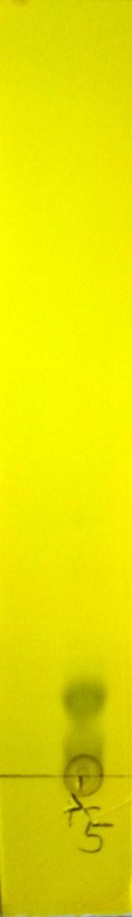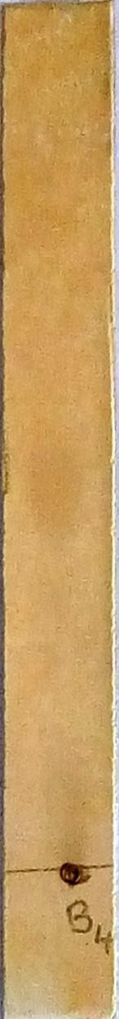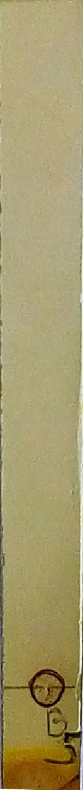

## Plate 1 Plate 2 Plate 3

**Plate 1** chromatographic analysis of fraction „A‟ (Pet. ether) sprayed with Dragendorrf‟s detecting reagents. Solvent system-Hexane: Ethyl acetate (9:1)

**Plate 2** hromatographic analysis of fraction „B‟ (Aqueous) sprayed with Ferric chloride detecting reagents. Solvent system-Butanol: Acetic acid: Water (10:1:1)

**Plate 3** chromatographic analysis of fraction „B‟ (Aqueous) sprayed with Dragendorrf‟s detecting reagents. Solvent system-Butanol: Acetic acid: Water (10:1:1)

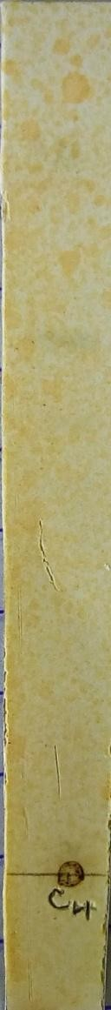 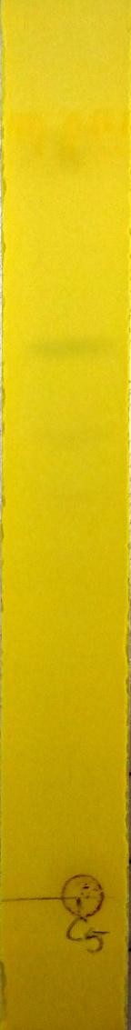 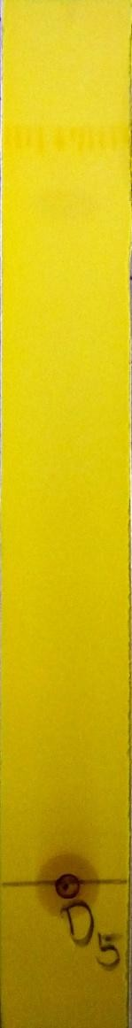 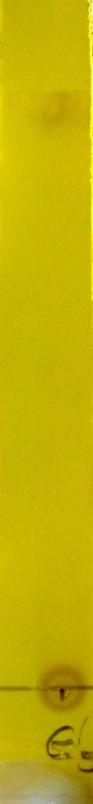

## Plate 4 Plate 5 Plate 6 Plate 7

**Plate 4** chromatographic analysis of fraction „C‟ (n-Butanol) sprayed with Ferric chloride,detecting reagents. Solvent system-Chloroform: Ethyl acetate: Methanol: Water (8:15:4:1)

**Plate 5** chromatographic analysis of fraction „C‟ (n-Butanol) sprayed Dragendorrf‟s detecting reagents. Solvent system-Chloroform: Ethyl acetate: Methanol: Water (8:15:4:1)

**Plate 6** chromatographic analysis of fraction „D‟ (BuOH) sprayed Dragendorrf‟s detecting reagents. Solvent system-Chloroform: Ethyl acetate: Methanol: Water (8:15:4:1)

**Plate 7** chromatographic analysis of fraction „E‟ (HCl) sprayed Dragendorrf‟s detecting reagents. Solvent system Solvent system Butanol: Acetic acid: Water (10:1:1)

## APPENDIX V

**Various solvent sytems tried for the TLC Methanol extracts *Carissa edulis* and *Senna alata***

Butanol:Acetic acid:Water (8:1:1), (10:1:1), (5:5:2), Ethyl acetate:Methanol:Water (10:1:1) , Chlorofoam:Ethylacetate:Methanol (5:5:1)

Chlorofoam:Ethylacetate:Methanol:Water (8:15:4:1)

## Fraction A (Pet. ether)

Hexane (100%),

Hexane: Ethyl acetate (9:1), Hexane: Ethyl acetate (7:3), (8:2)

**Fraction B (Aqueous) and E (HCl)** Butanol:Acetic acid:Water (10:1:1) Fraction C (n-Butanol) and D (BuOH) Chlorofoam:Methanol (8:2)

Ethyl acetate: Methanol (9:1) Chlorofoam:Ethylacetate:Methanol:Water (8:15:4:1)

Butanol:Acetic acid:Water (8:1:1), (10:1:1), (5:5:2),

## APPENDIX VI

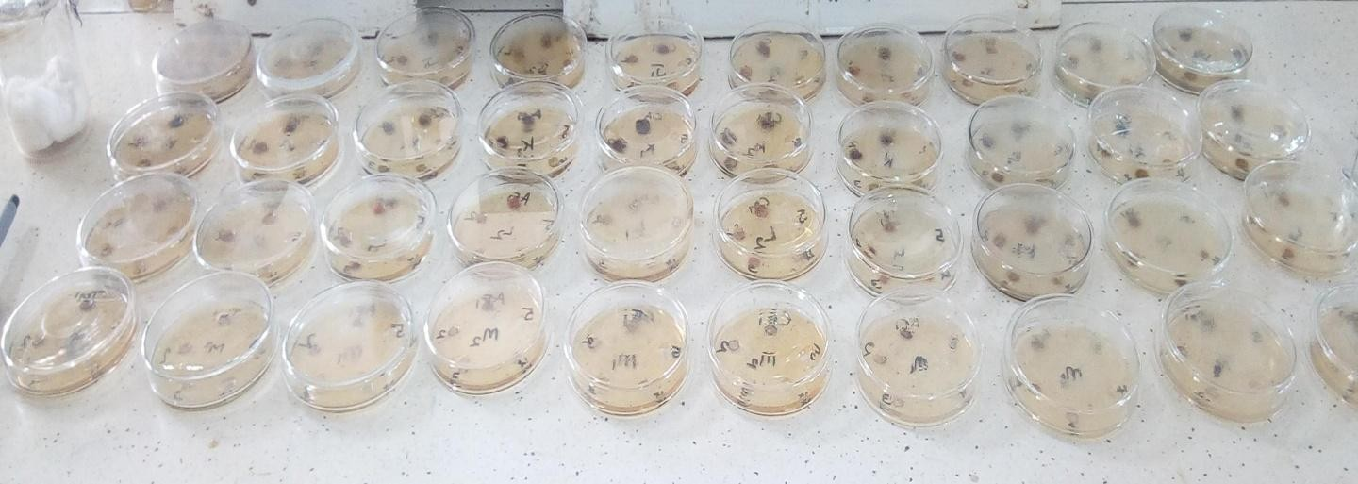

Plate 1: The organisms and extracts before incubation

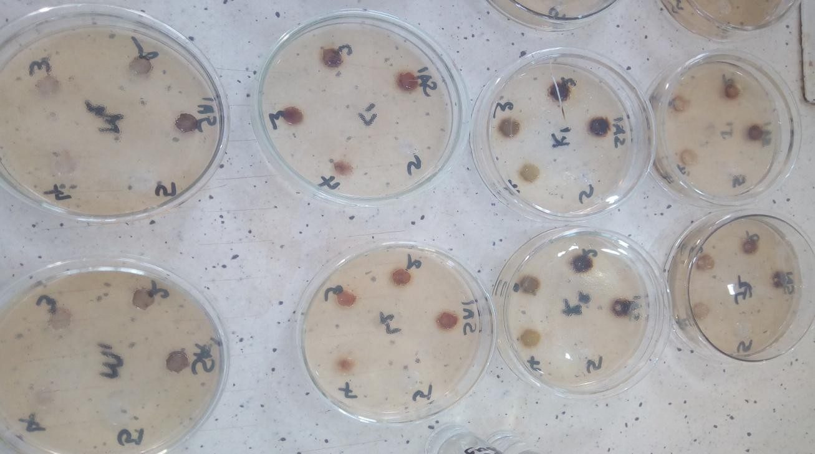

Plate 2: *S. aureus* before incubation

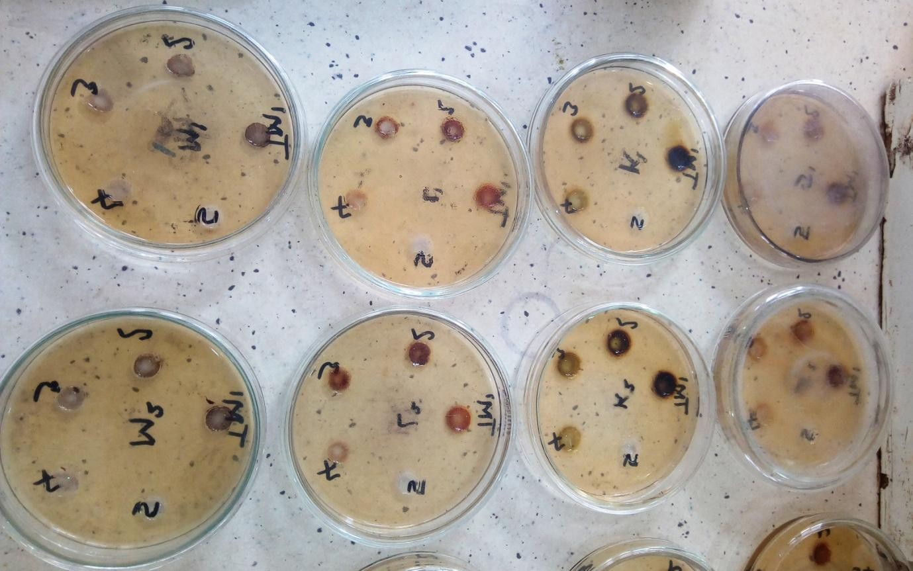

Plate 3: *T. mentagrophytes* before incubation

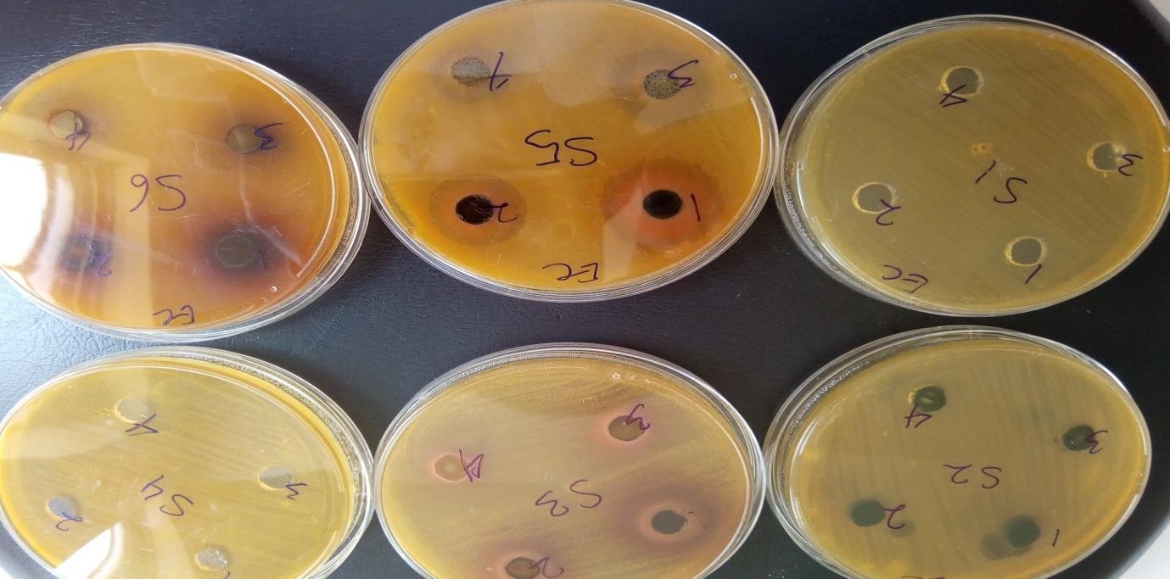

Plate 4: *E. coli* showing zones of inhibition

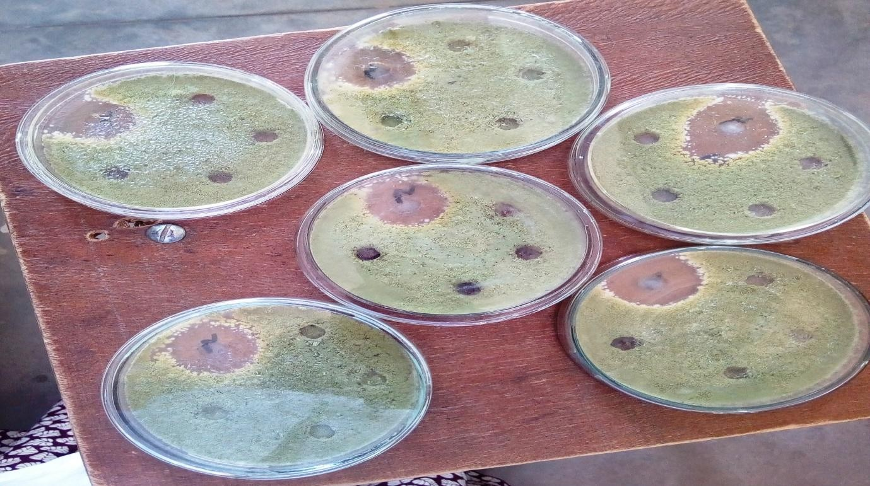

Plate 5: *A. fumigatus* showing zones of inhibition

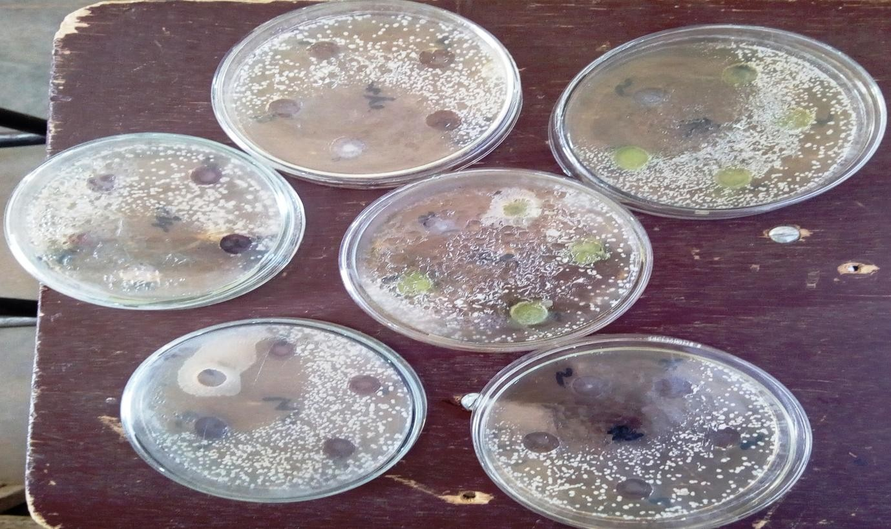

Plate 6: *C. albicans* showing zones of inhibition

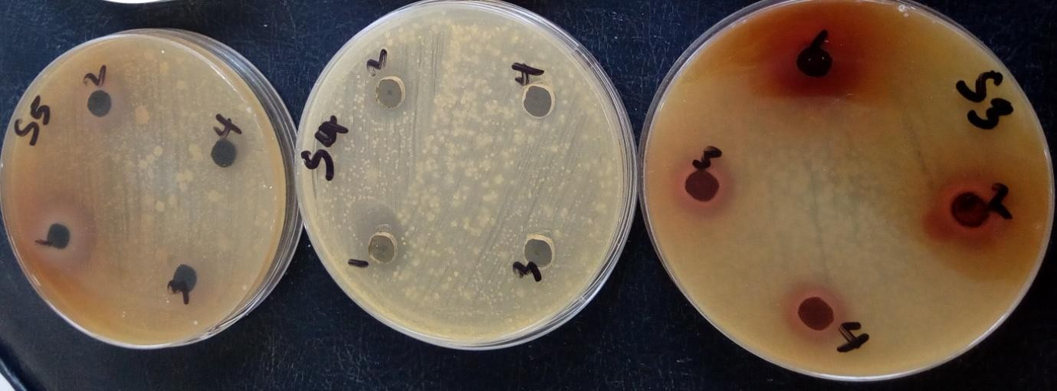

Plate 7: *S.pyogenes* showing zones of inhibition

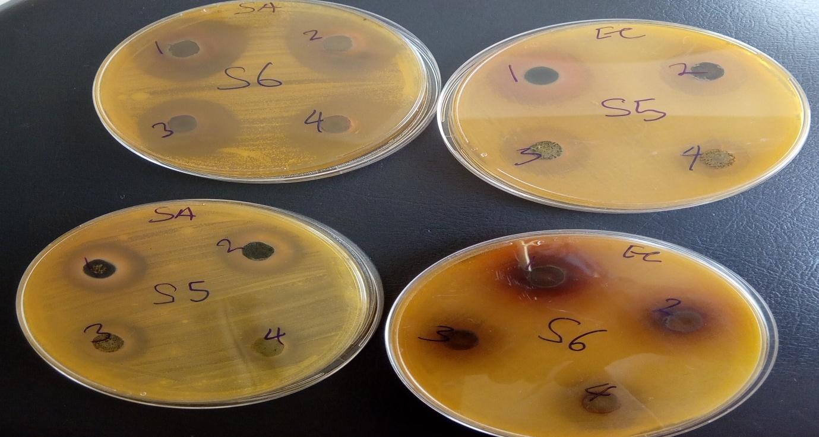

Plate 8: *E. coli* and *S. aureus* showing zones of inhibition

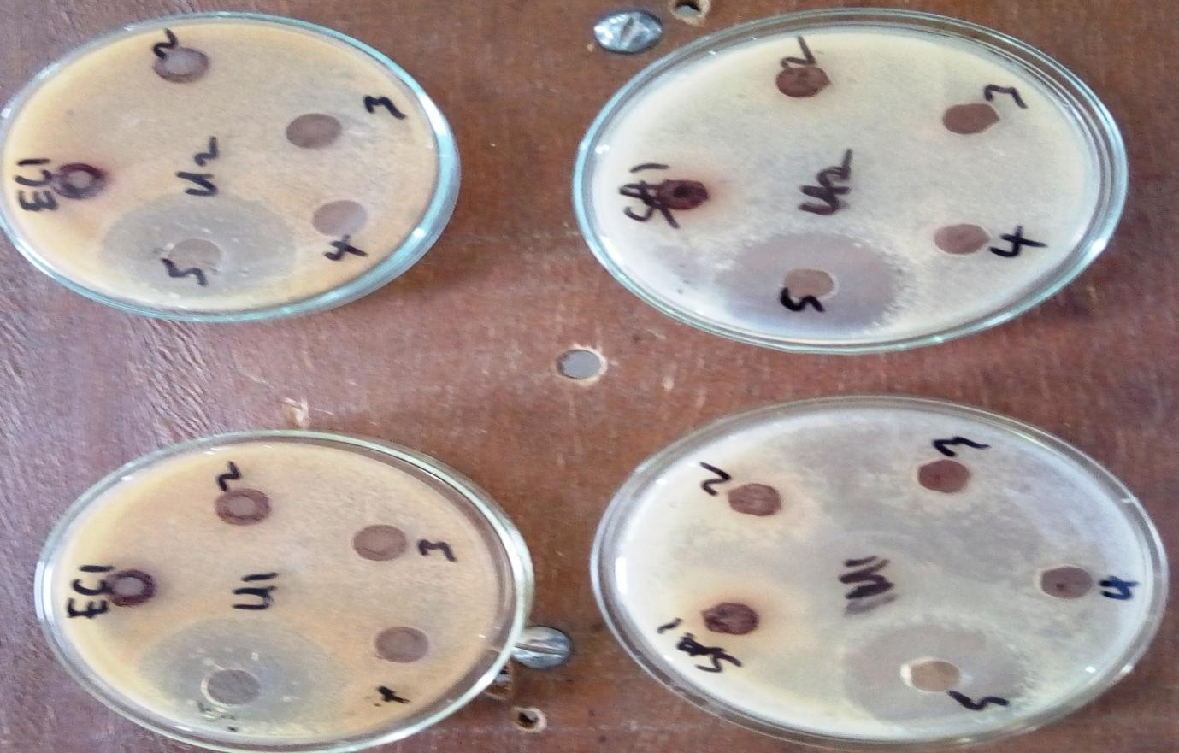

Plate 9: *E. coli* and *S. aureus* showing zones of inhibition

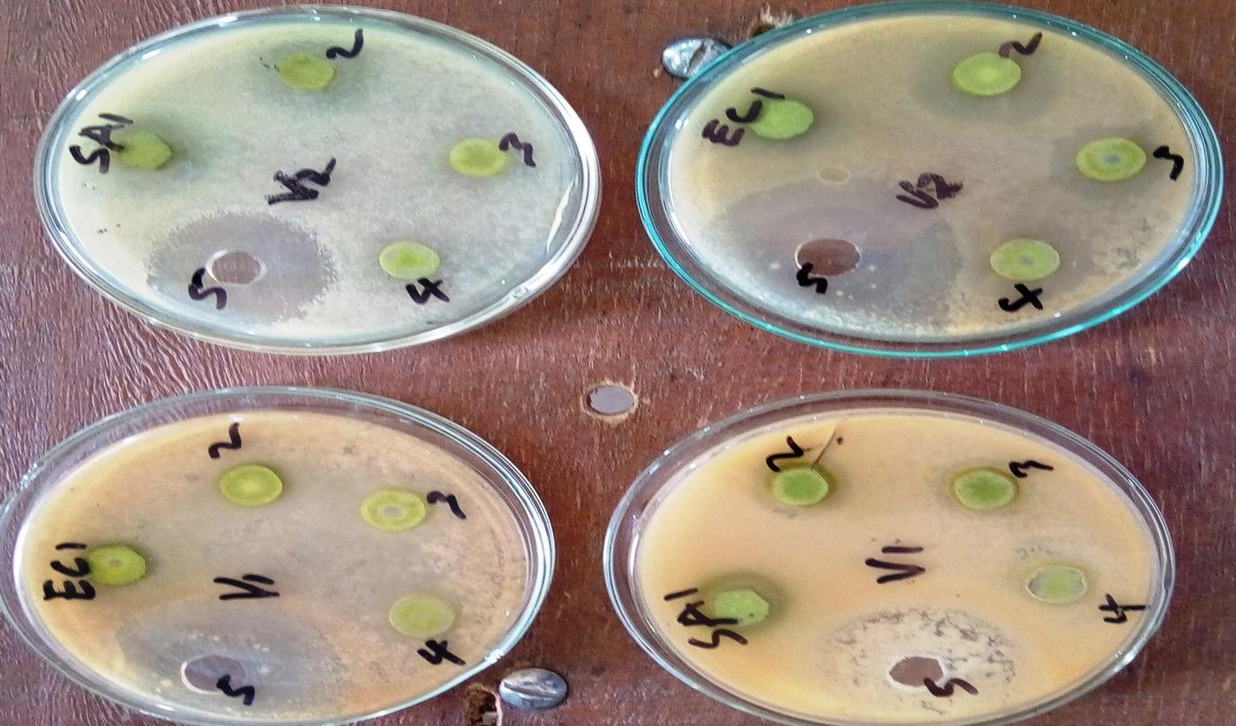

Plate 10: *E. coli* and *S. aureus* showing zones of inhibition