**ONLINE ANONYMITY COUNSELOR**

**TABLE OF CONTENTS**

**DECLARATION ii**

CERTIFCATION iii

**DEDICATION iv**

**ACKNOWLEDGEMENTS v**

**ABSTRACT vi**

**LIST OF FIGURES** **Error! Bookmark not defined.**

**CHAPTER ONE 1**

1.1 BACKGROUND OF STUDY 1

1.2 STATEMENT OF PROBLEM 2

1.3 AIM AND OBJECTIVE 3

1.4 METHODOLOGY OF THE STUDY 3

1.5 JUSTIFICATION OF STUDY 3

1.6 SIGNIFICANCE OF STUDY 4

1.7 SCOPE AND LIMITATION OF STUDY 4

1.8 DEFINITION OF TERMS 5

**CHAPTER TWO 6**

2.1 Background of the study 7

2.2 Counseling system 8

2.2.1 Face to Face 9

2.2.2 Online Counseling 9

2.3 Types of Counseling System 10

2.3.1 Psychoanalytic 10

2.3.2 Cognitive Counseling 10

2.3.3 Humanistic Counseling 11

2.3.4 Behavioral Counseling 11

2.4 Existing Online Counseling System 12

2.4.1 Betterhelp 12

2.4.2 Teen counseling 12

2.4.3 ReGain 13

2.5 Limitation of Online Counseling System 14

2.6 Technologies Used in Online Counseling 15

2.6.1 Instant Messaging (IM) 15

2.6.2 Video Conferencing 16

2.6.3 Email 17

2.6.4 Chatroom 17

2.7 Related Works 18

2.8 Merit and Demerit of Existing System 20

2.8.1 Merit of existing system 20

2.8.2 Demerit of existing system 21

viii

**CHAPTER THREE 22**

3.1 Introduction 23

3.2 Method used 23

**3.3 Tools and techniques 25**

3.3.1 Programming language 25

3.3.2 Software 26

3.3.3 Hardware 26

3.4 Requirement specification 26

3.4.1 Functional requirement for counselor and counselee 26

**3.4.2 Non-Functional Requirement Specification 27**

3.5 System design 27

3.5.1 Application architecture 27

3.5.2 Use case diagram 29

3.5.3 Activity Diagram 29

3.5.4 Control Flow Diagram 32

3.5.5 Entity Relationship Diagram 34

**CHAPTER FOUR 36**

4.1 Introduction 36

4.2 Development platform configuration 36

4.3 Hardware Requirement 36

ix

4.4 Software Components 36

4.4.1 The front end: 36

4.4.2 The Back End: 37

4.5 Database implementation 38

4.6 Result of The Frontend Implementation 40

**The User Interface Design 40**

**CHAPTER FIVE 44**

5.1 Introduction 44

5.2 Impact of project on the mountain top community 44

5.3 Future enhancement 44

5.4 Limitations 45

5.5 Conclusion 45

References 46

x

|  |  |  |
| --- | --- | --- |
|  | **LIST OF FIGURES** |  |
| Figure 3.1: Waterfall Model |  | 24 |
| Figure 3.2: The architecture for Online counseling system | | 27 |
| Figure 3.3: UML Use Case Diagram of the system | | 28 |
| Figure 3.4: Activity diagram |  | 29 |
| Figure 3.5: Control diagram of online counseling system | | 30 |
| Figure 3.6: Entity Relationship Diagram of online counseling system | | 31 |
| Figure 4.1: MySQL database implementation | | 35 |
| Figure 4.2: Homepage | ` | 36 |
| Figure 4.3.: Login Page |  | 37 |
| Figure 4.4: Register page |  | 37 |
| Figure 4.5: Message page |  | 38 |

**CHAPTER ONE**

**1.1** **BACKGROUND OF STUDY**

One of the difficult phases of individualization involves teenagers being exposed to certain social-economic roles and behavior, the change of exploring and establishing themselves to the adult identity. According to (Treatment, 2022) shows 4% of all adolescent between the age of 12 to 17 had a serious mental health problem, the increase in rapid brain development, drastic hormonal changes often occur during this phase, they are likely to encounter lowered impulse control, couple with heightened risk-taking behavior. Problematic behavior may emerge, and that they might become coy although they do not know how to fully express how they genuinely feel as they transition to adulthood. Counseling in teenagers is a valuable opportunity that almost every parent could perhaps consider, or can be his or her teen counselor if that authorizes, to help them develop a better understanding of themselves, possibilities, and behavioral patterns with others during this developmental phase. Counselling is a chatting therapy that permits people to talk about their dilemmas with experienced experts in a serene and secure manner. Individuals' interpretations of counselling may differ. However, in general, it is the process by which you discuss your issues in detail, either with the intention of resolving them or of thoroughly exploring your thoughts (Mohar, 2021).

Furthermore, teenagers are resistant to this opportunity, primarily due to a fear of being judged by family members or peer group. The idea of their conversation with their counselor being disclosed to their guidance because they're often known to be tightlipped and assume each interaction to be confidential and allowed to share only with their authorization. Privacy is our concern about our accessibility to others is related to our concern about the extent to which we are known to others, the extent to which others have physical access to us, and the extent to

1

which we are the subject of others' attention (Gavison, 1980). Mental health online counselling is a type of counseling that operates online rather than in individual. Professional licensed counselors are trained on how to use mobile based technological advancement and individual also is flexible with the use of gadget to seek counseling. In most scenarios online counseling is simply referred to web counseling, E-counseling, tele therapy which is majorly accessed through emails, real time chat and video conferencing. Statistics shows increasing percentage of counselee has replaced traditional face to face section to an online counseling session.

The emerge of covid19 and the pandemic gave a new turn to counseling prove the telehealth or distance counseling using the audio and video technology allows counselors to reach out to counselee across a wide geographical area, although the global pandemic raises questions on how professional duties and regulation have changes the effectiveness of telehealth and whether the mental health pandemic will occur after the virus has subsided, however, the spread of Covid-19 has increase the demand for counseling (Writter's, 2021).

**1.2** **STATEMENT OF PROBLEM**

To create a web-based program to reduce manual work for managing details via the internet, specifically, to increase the number of students seeking counseling due to a low or even no number of students wanting to visit the counselor's office despite the various types of uncomfortable situations commonly faced on a daily basis that should be addressed.

Questionnaires that were distributed show that a high majority of students want to identify their dilemma with someone who has more experience and seek professional help without being recognized until trust amongst themselves and the counselor is defined. In this way, the school counselor will be of excellent service and relief to the student.

2

**1.3** **AIM AND OBJECTIVE**

The overall goal is to create a platform that would improve, enhance and refine traditional techniques of counseling and keeping track of record.

The specific objective is to:

1. To create a web based online counseling system majorly using php and html
2. To design a system that will be able to indicate the number of times a user log in, date and time a message was sent using php
3. To implement a system that will enable storing and retrieval of information easy using the system database
4. Then testing the system using a network device.

**1.4** **METHODOLOGY OF THE STUDY**

The aforementioned system was implemented using different software. The system application was programmed on visual studio code and is run on xampp. The frontend was programmed using HTML, PHP and CSS it will be a web-based system.

The system will be practically tested among end users to be explored among system to check the performance and user experience in the entire community of Mountain Top University.

**1.5** **JUSTIFICATION OF STUDY**

Directly or indirectly counseling is one of the oldest practices dated back to 9th century and has been modified by professionals as a career which generated the use of technological advancement to improve counseling making it accessible by end users from any remote location.

3

**1.6** **SIGNIFICANCE OF STUDY**

Prior to the improvement of information and communication technology and the numerous benefit that comes with it. This study will be of great experience to teenagers, basically student who have been seeking for other form of counselling on campus, counseling system in comparison to other methods and approaches of counseling system will be of great relevance and relief.

1. A web-based application which will be user friendly
2. It will Improve the existing system workload
3. It will create awareness of the most common problem of student on campus
4. It will help student identify their problem and how to solve them

**1.7** **SCOPE AND LIMITATION OF STUDY**

The proposed online counseling system is presented to the end users, preferably, a student in need of counseling to be able to perform counseling through visual platforms, irrespective of their remote location end users can participate in counseling sessions at any given time. The counseling system is created, developed and presented to the end users to improve the manual method of counseling. The aforementioned system will be a web-based application that is programmed using HTML, CSS, PHP as the major programming language. The following are the system limitation;

1. Users would need internet connection to be able use this system
2. Poor communication skill
3. Little or no knowledge on how to operate gadget

4

* 1. As the number of student's increases counseling process becomes more and more difficult.

1. Limited attention to counselee if there are many people on the system to be counseled

**1.8** **DEFINITION OF TERMS**

**Online counseling:** is a type of online therapeutic mental health assistance that is frequently provided. Instead of traditional face-to-face encounters, highly skilled counsellors and clients seeking counseling services communicate via computer assisted methods.

**Web-based:** Any program that is accessible via a network connection utilizing HTTP and does not already reside in a device's memory is referred to as an application. Any application that runs often within an internet browser is a web-based application. Web-based applications can also be intranet, where processing is done on a cloud host via the network before it is presented to the user.

**Chat room:** is a specialized digital network where people can connect with one another over the Internet, usually in text format only, and one that is focused on a specific subject. Chat rooms allow users from any location to join in, making them an ideal solution for conferences between multiple people. The real time interaction doesn't require users to sit close to a conference system speaker, making it more comfortable. Plus, text-based chat can be downloaded and saved for future reference.

**Instant messaging (IM):** kind of message interaction where two people converse simultaneously using laptops or mobile devices in an online chatroom. 6 Users can communicate with one another simultaneously and in instantaneously thanks to the program, which provides a real link between them.

5

**Counselors**: is a professional who aids individuals in better future and potential remedies to issues that cause mental anguish; they also work to enhance connection and resilience, build consciousness, and encourage change in behavior and maximum psychological health. **Teenagers:** is a person aged between 13 and 19 years.

**E-mail:** messages sent and received by computer systems across a network. Internet users on a system can transmit information, images, audio, and animations to one another via an e-mail system.

**Anonymity:** Anonymity refers to circumstances when the identification of the individual is concealed. Though technically accurate, namelessness, according to some authors, does not adequately convey the issues that are most crucially at question in situations involving anonymity. A individual must be quasi, unavailable, or undetectable in order for this notion to make logical sense.

**Online counseling:** is a type of online therapeutic mental health assistance that is frequently provided. Instead of traditional face-to-face encounters, highly skilled counsellors and clients seeking professional help connect via virtual learning technologies.

**Html:** Using the systematic form of Hypertext Markup Language, text files can be tagged to produce font, color, visual, and hyperlink effects on the Internet sites.

**CSS:** CSS style language called Cascading Style Sheets is used to dictate how a content produced in a markup language like HTML is displayed.

**PHP:** (Hypertext Preprocessor) is a popular overall, accessible scripting language that is excellent for creating websites and can be integrated into HTML.

6

**CHAPTER TWO**

**LITERATURE REVIEW**

**2.1** **Background of the study**

The framework of online or electronic counseling systems as the internet has become the major service, application, information, content and opportunity the evolution of modern technology brought diversity in the counseling method and statistics (Irwan, Gustlentledina, & Yenny, 2020). (Dattani, Ritchie, & Max Roser, August 2021) 10.7% of people globally live with emotional imbalance. Mental health disorder is critical and complex and can take different form, data presented showed in accordance with the WHO’s international Classification of Disease (ICD-10) apply specific definition and incorporated in different form including depression, anxiety, bipolar, eating disorder and schizophrenia in the preceding year statistics show 41.4 million adult in the USA got treatment for mental illness or psychotherapy, although, women are double the number of men seeking or have received mental health treatment in the previous year, 22% of women receiving some type of mental health treatment or counseling are those between the age of 18 and 44 years, moreover, medication to treat mental health disorder is prescribed to older adult (Elflein., 2002).

The emerge of Covid-19 and the pandemic gave a new turn to counseling (Writter's, Covid-19 And The Crucial Rof Counselors , August 5, 2021) prove the telehealth or distance counseling using the audio and video technology allows counselors to reach out to counselee over a large spatial, although the global pandemic raises questions on how professional duties and regulation have changes the effectiveness of telehealth and whether the mental health

7

pandemic will occur after the virus has subsided, a growing Covid-19 outbreak has increase the demand for counseling.

Research shows that about 4% of adolescent between the age of 12 to 17 had experience serious health problem and have been given non medication treatment, however, in general 5% of teen has experience mood disorder within the age of 18 years, nevertheless. Recent studies show that as many as 15%-18% of teens have experienced a mood disorder by 18, mood disorder is those that have adverse effect on people’s mood and emotions and also include depression, bipolar disorder and less known illness like dysthymia. 25.1% of teen experience anxiety disorder within the age of 13 to 18 years old, 80% of teens diagnosed with anxiety and 60% of teen diagnosed with depression do not get treatment or counseling also research shows teens involved in anxiety and depression are mostly female teens and they rapidly develop depression more than male and some teen are more at risk for anxiety and depression such as abused and neglected teen, teen with critical chronic illness, physical conditions and teen with untreated mental illness and addiction to drug or alcohol. Moreover, the use of technology among teen has improve the mental health as 75% of teen own a mobile phone, 72% of teen use text message as channel of communication and 73% of teen have used social media or networking site (Dr. Jesus Perez, 2022).

**2.2** **Counseling system**

Counselling is a pragmatic relationship largely defined by the application of one or more psychological theories and an acknowledged set of effective communication to clients' deeply personal concerns, problems, or aspirations, as modified by experience, intuition, and other interpersonal factors (Feltharn & Dryden, 1993). Its overarching ethos is one of facilitation instead of advice or restraint. It can last for a short time or a long time, take place in an

8

organizational or highly confidential practice setting, and may or may not coincide with practical, clinical, and other wellbeing issues.

It is both a distinct activity performed by people willing to take on the roles of counsellor and client, as well as an emerging profession. It is a service sought by people in distress or confusion who want to discuss and resolve their issues in a relationship that is more disciplined and highly classified than friendship, and possibly less stigmatizing than helping relationships provided in traditional medical or psychiatric settings. However, counseling is theoretically based counselors use a variety diverse conceptual perspectives, such as structural, intellectual, affective, behavioral, and approaches Individuals, groups, and families can all benefit from these theories (Gladding, 2004). There are two major ways counseling can be conducted:

**2.2.1 Face to Face**

Counselling occurs when a counsellor meets with a client in a private and confidential setting to discuss a problem the client is having, distress they may be feeling, or their lack of goal and purpose, or discontent with life by attentively listening, the counsellor can tend to understand the client's significant problems, perspective and assist them in viewing things quite evidently, perhaps from a different vantage point. Counseling is a way of facilitating choice or change, as well as curbing confusion it does not entail giving coaching a client or encouraging them to adopt a specific action counsellor never pass judgment or take advantage of their clients (Charles, 2022)

**2.2.2** **Online Counseling**

Like traditional in-person counseling, is a psychological service delivered via online mediums such as mobile apps, video conferences, text messages, email, or any platform where a

9

conversation can take place virtually. Some people may feel more comfortable discussing topics such as their feelings, personal issues, and goals over the internet over face to face compare to something as intimate and personal as mental health. Patients can receive therapy remotely from any location, and some counselors are more likely to provide therapy outside of normal business hours (Kamran, 2022). Because of the increased convenience and accessibility, more people can seek therapy, and therapists can expand their practice and offerings.

**2.3** **Types of Counseling System**

According to (Wilson, 2012) denotes the various form of counseling as follows:

**2.3.1 Psychoanalytic**

Despite the fact that the approach has progressed over the years, psychodynamic or psychoanalytic techniques have their roots in Papa Psychoanalysis himself, Sigmund Freud. The central concept is that in order to understand someone's problem, a counselor must first explore and comprehend that person's mind.

This includes not only feelings and emotions, but also delving into things that may be buried in the subconscious and unconscious, such as past (and presumably neglected) traumas, as well as discovering potentially negative connections and drives that may be influencing current-day problems. Psychodynamic counseling seeks to assist patients in becoming aware of the various aspects of their minds and personalities, achieving mental balance, and realizing their hidden motivating factors.

**2.3.2 Cognitive Counseling**

10

Reality therapy and acceptance therapy are two types of cognitive counseling that aim to align a patient's thinking with reality. It is presumed that when thinking and reality are out of sync, psychological and emotional problems arise as a result, cognitive counselors challenge patterns of thinking and attempt to align them with reality so that patients can find exact solutions to existing problems.

**2.3.3 Humanistic Counseling**

Humanistic counseling is built on the hypothesis that each individual is distinctive and has space for emotional and psychological growth. Humanistic methods, rather than focusing on life events, assess the patient's reactions to these occurrences and how they affect their feelings.

The major aim of this aspect of counseling is to make the patient become aware of how their reactions to certain scenario can affect them. Humanistic counselors teach patients how to work through problems and find their own solutions.

**2.3.4** **Behavioral Counseling**

Patients who are having difficulties with disruptive behavior, such as eating disorders or anxiety attacks, may benefit from behavioral counseling. According to this method, a person's conduct is influenced by their environment, and the problem will remain as long as the patient remains in a surrounding that perpetuates or motivates it. Examining previous learning is essential in behavioral counseling because, if the behavior was learned, it can be unlearned, or so the theory goes.

Behavioral counselors may use various types of counseling therapy to help patients change their behavior, but the end goal is the same.

11

**2.4** **Existing Online Counseling System**

**2.4.1 Betterhelp**

Betterhelp is a psychotherapy industry. Alon Matas and Danny Bragonier started the company in 2013. It is a paid online counseling system that cost about $80 to $100 weekly, with about 12,000 LPCs, LCSWs and LMFTs. It’s a platform that offers convenient and affordable methods of access quality counseling session remotely from any geographical area; its service is run after a therapist preference such as gender and specification. Betterhelp then match you with a therapist from the 12,000 therapists (Lindberg, 2022). They are numerous ways to gain access with a therapist on betterhelp, synchronous sessions can be held via phone calls, video chat and live messaging, they also offer unlimited message in a secure chat room so help and guidance are accessible in between regularly schedule session. You can access better help through the website and mobile app that is compatible for IOS and android. There specialized area is:

Anxiety

Depression Addiction Parenting

Relationship Religion

**2.4.2** **Teen counseling**

Teen counseling is a safe platform accessible through website and mobile app which is compatible for iOS and Android device, its membership cost $60 and $80 per week, it is platform where parent and teens between the age of These frequently provide assistance and

12

guidance to young people aged 13 to 19 challenges year. Major or minor questions are asked in that process to help identify the issues that need to be addressed; teen is then matched with an appropriate counselor. Most issues addressed by teen include stress, depression, school challenges, family conflicts, sexuality and eating disorder. You communicate to therapist via video conferencing, phone calls, live text chat and secure email messaging. However, communication between teen and therapist are kept confidential except for situation regarding self-harm and abuse. They specialized on areas like

Anxiety Bullying Depression

Eating Disorder

Anger (Lindberg, 2022)

**2.4.3** **ReGain**

ReGain is online therapy platform that is best for couples and specifically designed to address relationship issues. It was founded in 2016, it is a paid online counseling system that cost about $60 to $80 weekly. If its couple or on your own. The process starts by answering questions about your relationship, issues you want to address and what your counselor preference are. Partners can share a joint account or get signed up alone and then invite your partner in a later time. Its appointment time is in live session which are held through telephone or video conferencing ReGain website or mobile app and currently the ReGain platform doesn’t support 3-way call so couple have to be on the same location, ReGain matches clients with a therapist from a staff of about 5000+ professional licensed therapist. They solely specialized on:

13

|  |  |  |  |  |
| --- | --- | --- | --- | --- |
|  | Relationship (Lindberg, 2022) | |  |  |
| **2.5** | **Limitation of Online Counseling System** | | |  |
|  |  |  |  |  |
| Limitation |  | Specification | Cons | Improvement (YES/NOT YET) |
|  |  |  |  |  |
| Nonverbal cues |  | Eye contact, facial | Do not allow | NOT YET |
|  |  | expression, kinesics | effective flow of |  |
|  |  | (body movement), | communication |  |
|  |  | haptics(touch), | between counselor |  |
|  |  | chronemics(time), | and client |  |
|  |  | props and physical |  |  |
|  |  | appearance |  |  |
|  |  |  |  |  |
| Verbal cues |  | Words and phrases | Inability to decipher | NOT YET |
|  |  | such as Pay keen | if a counselee is |  |
|  |  | attention, listen, let’s | actively paying |  |
|  |  | review, what you | attention |  |
|  |  | need to know |  |  |
|  | |  |  |  |
| Technological difficulties | | Hardware failure, | Loss of information | NOT YET |
|  |  | software bugs, delay | in the database |  |
|  |  | in responds |  |  |
|  | |  |  |  |
| Confidentiality and security | | Breaches, hackers | Threats to individual | YES. In our research we intent |
|  |  |  | if information | on improving confidentiality, |
|  |  |  | provided is really | privacy and security of end user |
|  |  |  | meant to be private | using a robust password to verify |
|  |  |  |  |  |

14

registered users on the system



However, according to (Clinic, 2022) online counseling is not strongly recommended in the following:

If you are in a conflict condition, or if you are seriously depressed. If you have catastrophic or long-term mental health issues.

If you have a psychological condition and/or are having psychotic episodes like hallucinations, paranoia, or delusions.

If you participate in potentially hazardous behavior, such as exorbitant alcohol or drug use.

**2.6** **Technologies Used in Online Counseling**

**2.6.1 Instant Messaging (IM)**

The exchange of near-real-time messages via a single package or software application is known as instant messaging (IM). In contrast to chatrooms, where many users participate in multiple and complex conversations, IM sessions are typically held between two users in a private, back-and-forth mode of communication, the ability to see whether a friend or colleague is able to connect through the selected service is a basic component of many instant messenger clients. This ability is referred to as presence, many IM clients have added a feature for functionalities such as sharing files and photo sharing within an IM session as technology has advanced the proximity of message exchange distinguishes instant messaging from email. IM is also session-based, with a visible outcome Individual messages are frequently brief since IM is designed to imitate in-person interactions. Email, however, is typically written in a more formal, letter-like style. Instant messaging is a kind of real-time communication between web users. It is an

15

immediate, efficient, a flexible and substitute for email for both enterprise and consumer users, instant messaging is significantly quicker than email and more prompt than other forms of asynchronous communication users can IM from a variety of devices other than their phone (Lutkeuich & Scarpati, 2022). However, you must take caution when using IM systems because you never fully understand who is on the other end, online links can be included within messages in IM systems. This is quite risky the links you accept may lead you to fraudulent web. (Rountree, 2011).

**2.6.2** **Video Conferencing**

As envisioned in 1910, video telephony is expected to be available in 2000. Videoconferencing and video teleconferencing are the two-way or dynamic routing receipt and dispersal of audio and visual signals by individuals at various locations for real-time communication (McGraw-Hill, January 9, 2010). A videophone is telephony with a built-in camera and screen that allows for simultaneous audio and visual conversation. In a videoconference, this technology is utilized for an administrative or group gathering as opposed to scheduled meetings (Mulbach et al, 1995)

Although audio-only and text communication are more widely used in everyday communications, useful applications include sign language transmission for deaf and speech-impaired people, distance education, telemedicine, and overcoming mobility issues. It is also used in business and corporate settings. It is also employed in enterprises and commercial settings to expedite seminars and events, commonly between parties with pre-existing relationships. In order to deliver video links and higher-quality audio than the mobile telephone network at a portion of the cost of sending sophisticated equipment or hiring a commercial facility, businesses are beginning to leverage computer technology like Viber. Although cinematic feature of today operates on phones using modern communication between the different networks and

16

contemporary phone networks use digitally packet technologies, more widely used cinematographic technologies use the Online services rather than the conventional landline telephone network.

**2.6.3 Email**

Electronic mail (also known as e-mail) is a practice of sending electronic mail (messages) between individuals. Email was once thought of as the electronically (digital) equivalent of, or a substitute for, mail when "mail" only referred to paper mail (thus the prefix e- + mail).

Eventually, email became a pervasive (very popular) source of information, to the extent that having email account is frequently treated as a fundamental and essential part of many processes in most countries, including business, commerce, government, education, entertainment, and other geometries of daily life. The channel is email, and each message sent via email is referred to as an email (mass/count distinction). Email communicates via computer networks, primarily the Internet, as well as local area networks. Today's email systems operate on a store-and-forward model.

**2.6.4 Chatroom**

Group chat, often known as a chat room or chatroom and also referred to as GC, is a phrase used to represent any type of synchronous conferencing, and occasionally asynchronous conferencing as well. As a direct consequence, the term can refer to any technology, ranging from highly interactive visual social settings to actual internet conversation and interaction with strangers (like web forums). The first conversation was exploited by the US government.

17

The United States government used the first chat system in 1971 Murray Turnoff, a young PhD graduate from Berkeley, developed it, and it was first used throughout President Nixon's wage-price freeze under Project Delphi. The system, known as EMISARI, would connect ten regional offices in a real-time online chat known as the party line It has been used until 1986 (Subramanian, 2021) A chat room's main function is to allow individuals to interact with one another through writing. Statistically speaking, the capacity to hold discussions with several individuals at once distinguishes chat rooms from instant messaging programs, which are more commonly designed for one-on-one communication, users in a chat room are typically connected via a shared internet or other similar connection, and chat rooms cover a wide range of topics, file sharing and webcams are now partly attributable to advances in technology.

**2.7** **Related Works**

The design and creation of a remote cognitive behavioral therapist that was aimed at improving user awareness of emotional situation in computer mediated communication and making informed decision on action to recommend to the involved user during the conversation , this involves conversation the mood and emotion of user, the technological perspective of the virtual counseling system VCS was deployed into application server on a distant server that employs a module that can recognize emotions in text to perform its operations, messaging and to detect mood by accessing the API in the cloud for reading data traced to the users (Angelo, Francesco,

* Perente, September 2021) . The major objective of the VCS was to generate an emotion driven advice to users in a communication channel, Watson Tempo Meter by IBM was the first asset employed during this project to tone the tone analyzer and used as a linguistics analysis to detect emotions and language tone in written text accessed through SDK provided by IBM. The

18

second asset employs for mood detection was through a low wearable device in the VYVO smart watch accessing through VYVO API’S.

The design of a counseling framework based on the operational principle of a rule based expert system (Mahoney & Mooney, 1994) that will involve the use of intelligent computer system, electronic interaction with careers counselors through computer hardware and software on a client server which is a web-based system. He also introduced approaches for the certainty factor representing knowledge that can range from -1 to +1 to represent how rule increase or decrease. Hence -1 represent total mistrust (incorrect) and +1 certainty facto shows absolute certainty (Irwan, Gustlentledina, & Yenny, 2020).

The implementation of a psychotherapy by an Agile software development to help reduce the increase of mental health problem from fostering by Asia sent overseas a web counselor was developed in associated with a clinic, the system was evaluated by considering the results in order to form a questionnaire and the factual psychotherapy was developed using a statistical method. Health service is made available to the Japanese-by-Japanese professionals the project was more focused to China and Taiwan (Chieko, Yasunori, Takaaki, & Kensei, May 2011). This system helps counselor to provide consultation via web and does not limit the time.

The result of the system evaluation showed that demands for original function outside the system design are high under the system that has a crystal purpose.

The design and creation of a practical digital counselor control system the project was used to approach for the control of psychotherapy of both private and work place life problem of employee in Malaysia, they developed and evaluated it by the Employee Need Assessment Inventory (ENAI) (Kota Samarahem, 2013). The project was internet based divided into 3 phases

19

* System Requirement
* System Design
* Development and formative evaluation The system 3 tier
  + Employer
  + Employee
  + Counselor

According to (Emmanuel, Erkki, & Marjatta, 2014) discovered different technologies in counseling aside the use of Email, Video conferencing, chat, and text messaging questionnaire and interview was were used to asked student about their life stories data collected was analyzed. Digitalization of real-life situation in form of game was said to be a useful resource in sensitized and expose student to other realities of life.

**2.8** **Merit and Demerit of Existing System**

**2.8.1** **Merit of existing system**

**Availability for those with limited mobility:** Individuals who are disabled or housebound can access online therapy, in accessing mental health care, mobility can be a major issue, because you can typically book online therapist to participate from the convenience of your own location.

**A more accessible stance to recovery:** The internet has made psychotherapy readily accessible; people may feel more at ease discussing physical health issues with friends and family, but they may not feel exactly the same way about discussing equally important mental health issues. Lot of individuals solving prejudice easier associated with mental health issues in the past.

20

**2.8.2 Demerit of existing system**

**Confidentiality, privacy, and unreliable technology:** The confidentiality of your personal information is a major concern in psychotherapy, but online treatment further into difficulty. Since data is sent online and security breaches and cyberattacks are growing in importance, confidentiality is just as crucial in psychotherapy as it is in other methods of providing service. Problems with technology can however make it challenging to receive therapy when you require it. (Cherry, 2022).

**Lack of response to crisis situations:** Because online therapists are geographically separated from their clients, it’s trivial for them to respond quickly and effectively when a crisis occurs. If a client is suicidal or has experienced a chaotic incident, it could be challenging, if not impossible, allowing the psychotherapist to provide hands-on support (Cherry, 2022).

**Overlooks body language:** The psychotherapist cannot interpret your nonverbal cues, speech cues or countenance reactions if you use text-based therapy. These signals are frequently quite telling and provide the therapist with a more complete picture of your feelings, thoughts, moods, and behaviors. While some delivery methods, including videoconferencing and telephony technologies, can provide a more complete image of the circumstance, they frequently lack the intricacy and empathy that real-world interactions provide (Cherry, 2022).

**Not appropriate for serious psychiatric illnesses:** E-therapy can be beneficial in a variety of situations; however, it is ineffective for people who require strong direct treatment or in-person assistance. Online therapy, for example, may not be actually recommended whenever you have a major drug problem or more extreme or intricate symptoms of a psychological disorder, plan

21

also includes more in-person treatments or treatments. Because the range of psychotherapy is limited, it may not be effective in more difficult issues (Cherry, 2022).

Hypothetically, various discussions denote the major working of a psychotherapy is the ability to receive and respond to message. The reviewed systems did remarkably great, moreover, respond time, confidentiality and privacy needs to be considered.

In our research we intent on improving confidentiality, privacy and security of end user using a robust password to verify registered users on the system and to improve the responds to client using a questionnaire that contain information of the most common mental health problem stating the likely feedback and respond of a counselor in each section.

22

**CHAPTER THREE**

**METHODOLOGY AND SYSTEM ANALYSIS**

**3.1** **Introduction**

Methodology is the philosophical framework within which study is conducted out or the basis upon which study is originally established (Allan & Randy, 2022). This chapter demonstrates the methodology used in building the system, the tools and techniques, requirement analysis, the proposed model of the system, the architecture diagram. This chapter also talks about the system design, the use case diagram, activity diagrams, entity-relationship diagram and control diagram of the system would use.

**3.2** **Method used**

**Waterfall methodology**

The waterfall model, also known as a linear- sequence life cycle model, was the initial process model to be developed. It is exceptionally simple to use and grasp. A waterfall paradigm requires that each process be finished in its entirety before moving on to the next. This kind of software development paradigm is typically utilized for projects that are modest in scope and have defined specifications (Dutta, 2021).

23

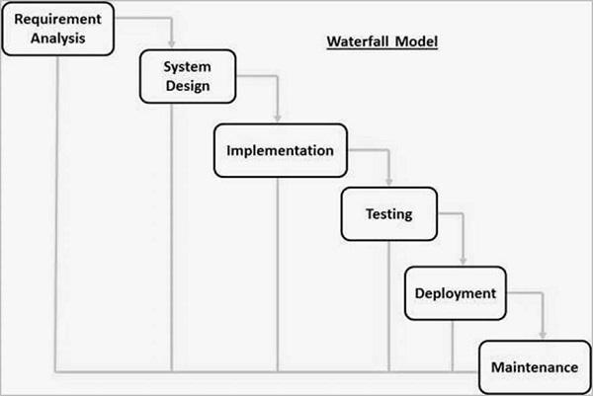

**Figure 3. 1 Waterfall model diagram (TutorialPoints, 2022)**

24

**Advantages of waterfall**

This model is straightforward and simple to grasp and apply. It is simple to operate owing to the model's rigidity

Specific deliverables and a review procedure are included at each stage.

Phases are handled and finished one at a time in this model the phases do not mix.

For subtasks, the waterfall methodology is effective with well-defined requirements.

**Disadvantages of waterfall**

As soon as a program enters the testing phase, it is extremely difficult to alter anything that was poorly thought out during the concept phase.

Unavailable technology is created until the end of the life cycle. Not suitable for complex or object-oriented projects.

Unsuitable for projects with a high to quite elevated danger of requirement change.

**Why waterfall is best for this project?**

Waterfall model is best for this project because it’s suitable for smaller projects with well-defined deliverables that could be defined from the start.

**3.3** **Tools and techniques**

In this project, the following tools are going to be made use of to build the online counseling system:

**3.3.1** **Programming language**

1. PHP
2. SQL

25

1. HTML, CSS AND PHP

**3.3.2 Software**

1. XAMMP
2. Visual Studio

**3.3.3 Hardware**

1. HP Laptop 8GB RAM

**3.4** **Requirement specification**

**3.4.1** **Functional requirement for counselor and counselee**

1. The user must be able to sign up for an account
2. The user should be able to Log in
3. The user should be able to view the questionnaire
4. The user should be able to send message
5. The user must be capable of receive message
6. The user should be able to confirm message was successfully sent
7. The user should be able logout

The following are the functional requirements for the system administrator and counselor

Administrator / Counselor:

1. Should be able to log in to the system
2. Should be able receive message
3. Should be able to send message
4. Should be able to know the number of counselees logged in

26

1. Should be able know the category of questionnaire viewed

**3.4.2** **Non-Functional Requirement Specification**

1. The password of the users will not be displayed in special character but in text
2. The system will work on any device
3. The system will be user friendly

**3.5** **System design**

System design is the process of developing a system's fundamental parts, such as its design, modules, and components, as well as the connections between those elements and the content that flows through that system (Odhiambo, 2018). The aim is to provide required well defined data and information about system.

**3.5.1 Application architecture**

Application architecture is the interaction of applications with entities such as middleware, databases, and other applications. Application architectures typically adhere to widely accepted software design principles, but might not be official technical standards (Ferguson, 2021). The diagram below displays the application architecture of the online counseling system.

27

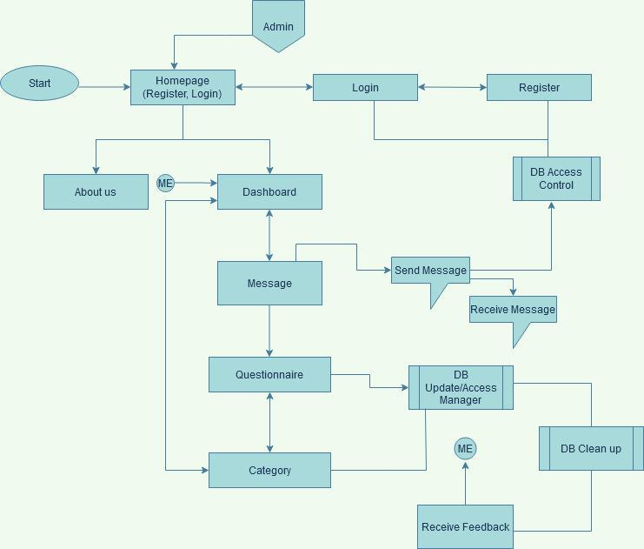

**Figure 3. 2 The architecture diagram for online counseling system*.***

28

**3.5.2** **Use case diagram**

In system analysis, a use case is a tool for locating, explaining, and arranging system needs. (Brush, 2020). However, Using a use case diagram to describe the actions that occurs between the users and the system.

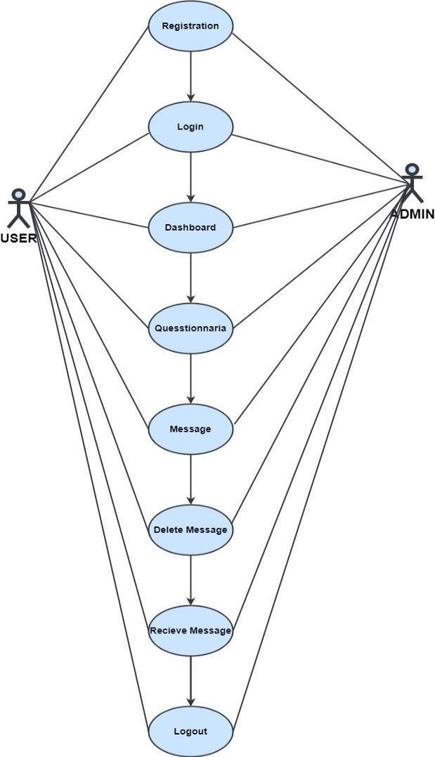

**Figure 3.3 UML Use Case of the system**

**3.5.3** **Activity Diagram**

29

Activity diagram shows the activities, states, between tasks, shifts and states, activity diagrams explain how synchronization of tasks occurs in order to provide a service and the events required to complete a task, how the events in a single use case interact with one another, how a group of use cases collaborate making a design flow for an organization.

30

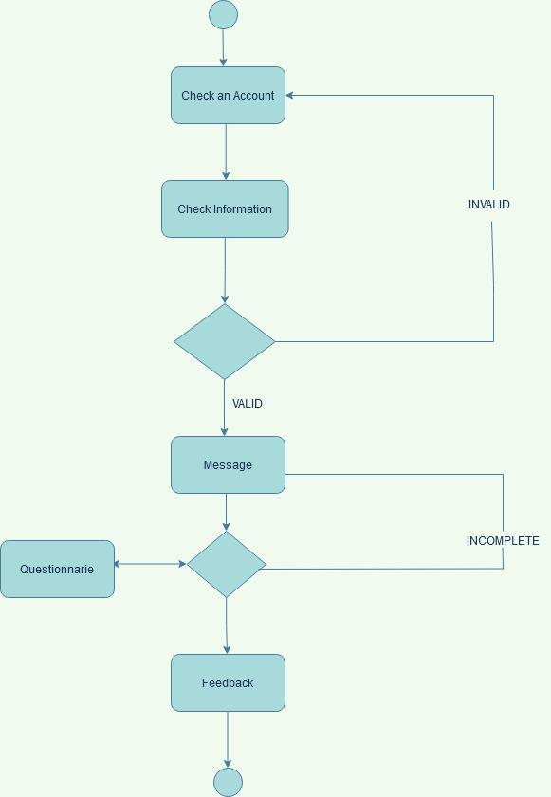

**Figure 3.4 Activity Diagram**

31

**3.5.4 Control Flow Diagram**

Using a control flow diagram, we can to illustrate the detail process. It shows where the control cycle begins and finishes, as well as potential bifurcation in another direction, given certain situations.

32

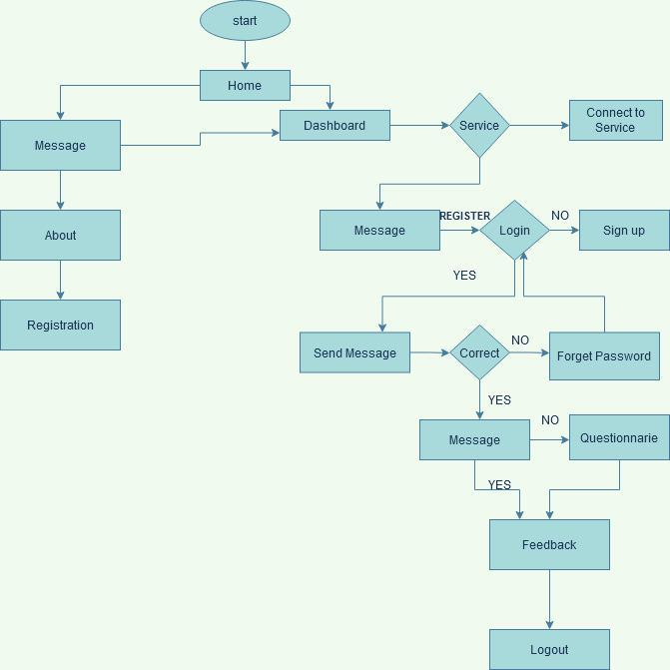

**Figure 3.5 Control Diagram of the online counseling system**

33

**3.5.5** **Entity Relationship Diagram**

Using an entity relationship diagram to depict the structural design of a database. The results are shown in table that will be employed in the database for system functionality are depicted in the image below.

34

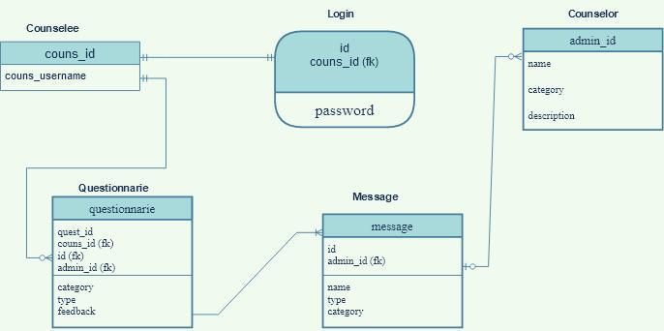

**Figure 3.6 Entity Relationship Diagram of online counselling system**

35

**CHAPTER FOUR**

**IMPLEMENTATION AND SYSTEM DESIGN**

**4.1** **Introduction**

This section will present the actual user interface, the process of development of the main features.

**4.2** **Development platform configuration**

The configuration of a development platform has an effect on the creation of a system. The system must be built appropriately in order to build a high-quality, error-prone system. The platform is composed both software and hardware. Platform configuration entails configuring the necessary software and hardware.

**4.3** **Hardware Requirement**

The hardware used to develop the system is listed below;

1. Intel core i7 processor
2. 8GB Ram
3. 1Tb Hard drive

**4.4** **Software Components**

**4.4.1 The front end:** Front end development is the front facing part of the web which can be viewed on web browsers. The technique of generating HTML, CSS, and PHP for a website or Web application such that a user can view and interact with them directly is known as front end development. The front-end technologies used for this application include:

36

1. HTML: The acronym for HTML is Hyper Text Markup Language, which is the common markup language for documents designed to display in the web browser. HTML is usually used alongside other technologies such as Cascading Style Sheet (CSS) and scripting Language such as JavaScript. HTML is a semantic markup language that specifies the layout of a website. HTML includes elements which are called HTML tags which are the components of Web pages. Tags such as <input/> and <img/> directly introduce one-page contents into the page.

HTML creates documents that are structurally logical for word like paragraphs, headings, links and other items making it a markup language, rather than a programming language

1. CSS: Cascading Style Sheets (CSS) is a language for creating style sheets to describe the appearance styling a markup-language-written document. Although the language is most commonly used to update the style of HTML and XHTML web pages and user interfaces, although it may be applied to any type of XML document, including plain XML, SVG, and XUL. CSS, in addition to HTML and JavaScript, is a foundational technology used by the majority of websites to build aesthetically appealing webpages, user interfaces for online apps, and user interfaces for many mobile applications. (Wikipedia). This separation can increase content accessibility, give greater autonomy and mobility in the definition of presentation characters, allow many websites to exchange layout by providing the appropriate CSS in a separate.CSS file, and minimize structural content complexity and repetition.

**4.4.2 The Back End:** The host is the back end server code that handles client requests and contains the logic to provide the relevant data back to the client. The database, which will

37

persistently store all of the data for the application, is also part of the back end. This application's back-end code includes the following:

1. PHP: PHP also known as Hypertext Preprocessor is a server-side integrated programming language in HTML. It serves to handle dynamic content, session tracking, databases, and even to create full e-commerce sites. PHP scripts can only be run on servers that have PHP installed. The computer accessing the PHP script requires a web browser only. The difference between PHP and client language like HTML is, PHP codes runs on a server while HTML codes are render on a web browser.
2. MYSQL: Using structured query language, MySQL is a relational database management system (RDBMS) that is free and open source (SQL). It is a component of the popular LAMP platform, which consists of Linux, Apache, My SQL, and PHP. My SQL database is currently accessible on the most popular operating systems. It is compatible with BSD Unix, Linux, Windows, and Mac OS. My SQL is used by Wikipedia and YouTube. Every day, these sites handle millions of searches. My SQL comes in two varieties: My SQL server system and My SQL embedded system.

**4.5** **Database implementation**

The online counseling system would need a database to store all the order details, counselor details and counselee details to be able to work effectively. MySQL would be used to implement the database. MySQL was used because installation and setup is a simple task, It is a free software, and also inexpensive to maintain. MySQL Workbench would use a visual user interface make developing the database simple. The figure below shows the database implementation for online counseling system.

38

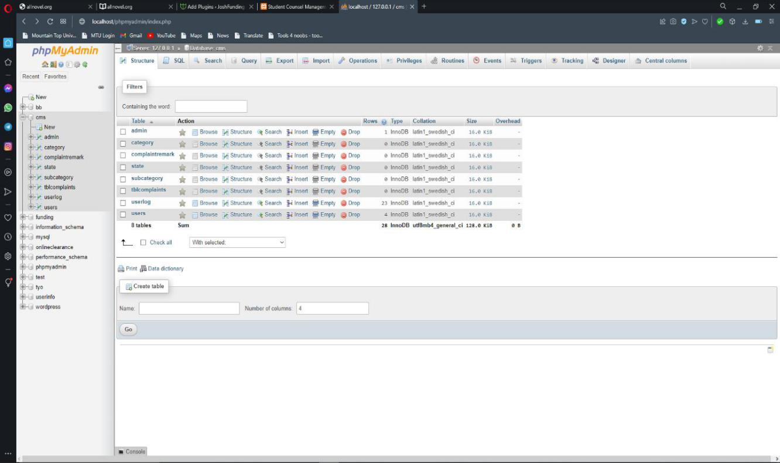

**Figure 4.1: MySQL database implementation**

39

**4.6** **Result of The Frontend Implementation**

**The User Interface Design**

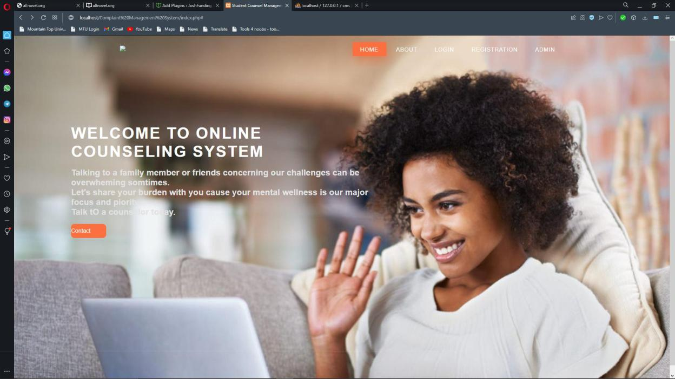

**Figure 4.2: Homepage**

40

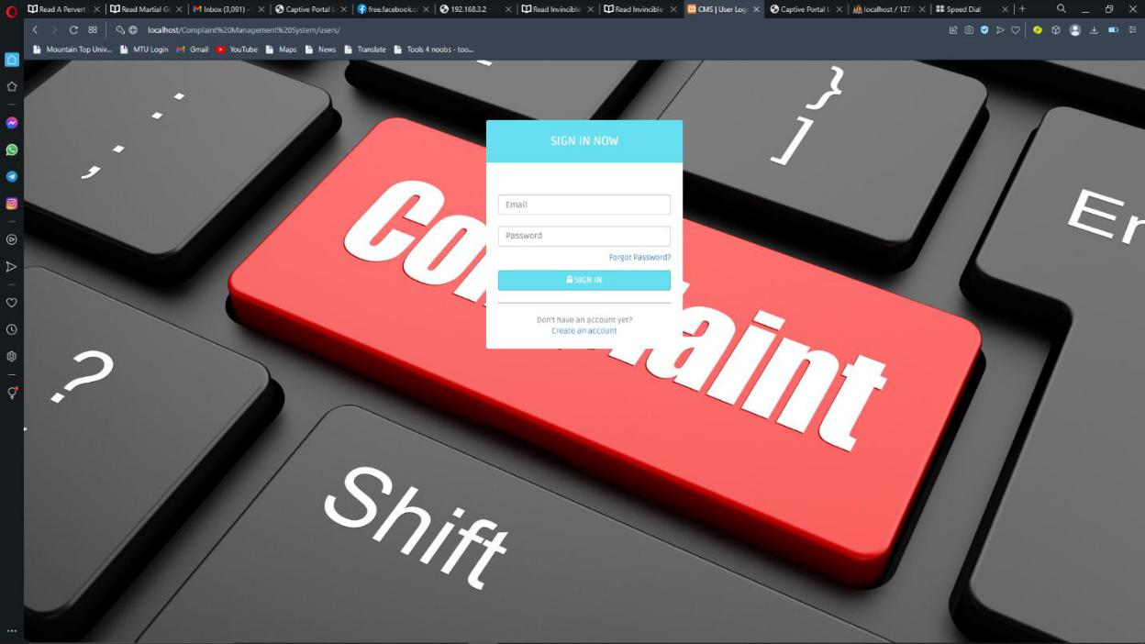

Figure 4.3: Login

41

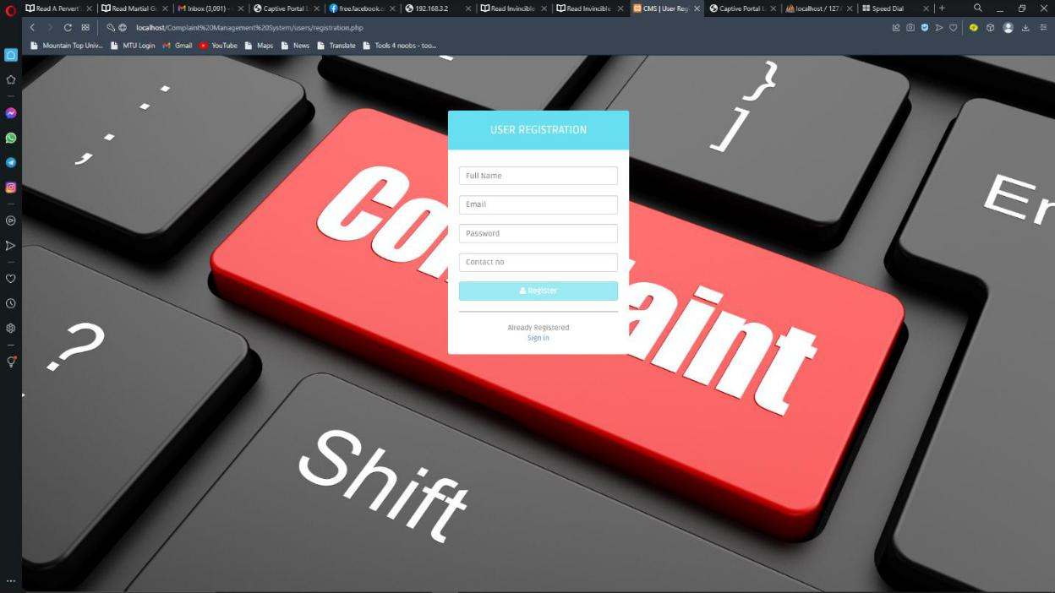

Figure 4.4: Register Page

42

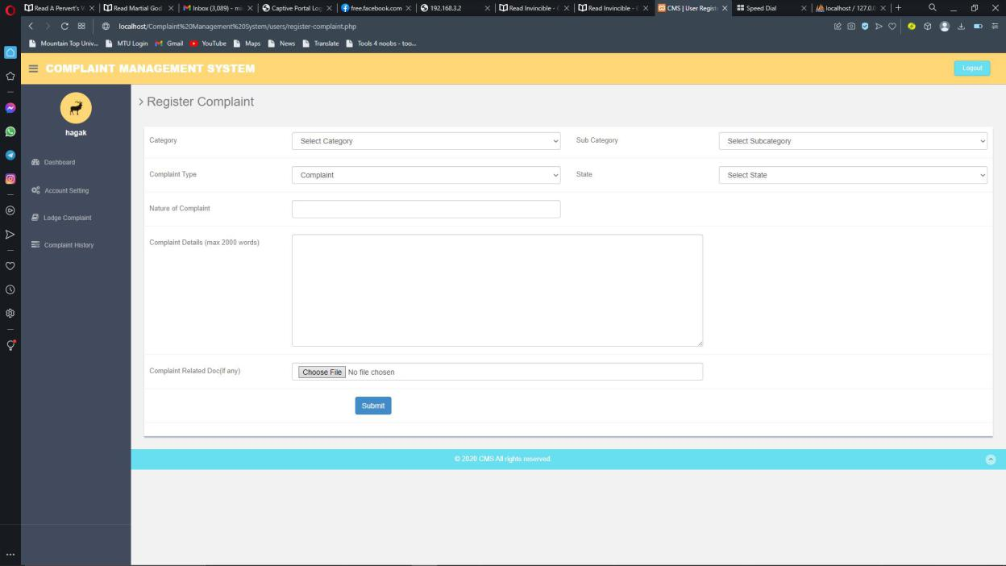

**Figure 4.5: Message Page**

43

**CHAPTER FIVE**

**DISCUSSION, CONCLUSION, AND RECOMMENDATIONS**

**5.1 Introduction**

The purpose of this chapter is to describe the objective evaluation of the project, the limitations and obstacles faced during its development, potential future plans to improve the project, and recommendations for future online counseling system initiatives.

**5.2** **Impact of project on the mountain top community**

The online counseling system introduces a new method of counseling on campus. Online counseling system which will buttress the manual counseling method. The online counseling system will allow the student to reach out to counselors remotely from any location on campus.

It would also assist counselor in keeping track of counselee information through the system database. The system's reports would also assist counselor in identifying the most common problem experience by students on campus. For example, if the counselor notices continual message on a particular problem the means of tackling the problem generally or addressing it publicly to all student will be setup.

**5.3** **Future enhancement**

The following are the possible improvement to the online food ordering system.

1. Creating an application system
2. Increasing more options to speed up response

44

1. Set up a notification system to alert counselee when their message is replied. Whenever there is no internet connection, use Firebase Cloud Messaging instead.

**5.4** **Limitations**

1. Insufficiency of time.
2. No stable internet connection

**5.5** **Conclusion**

Counseling has been improved with the introduction of online counseling as a buttress to traditional face-to-face therapy. The diversion between the online counseling systems is the introduction of technology serving as a mediating tool to help solve problems. The online counseling system allows counselee register online, login to an account, and send message to a counselor. The counselor will be able to see the message on the screen and give constructive feedback. This technique eliminates the requirement for a counselee to walk to the counselor’s office. The benefit is that it creates effective and efficient ways of storing data and information online.

45

References

Allan, A., & Randy, L. (2022). *Writing the Winning Thesis or Dissertation.A Step-by-Step Guide.*

Corwin Press, California.

Angelo, G., Francesco, O., & Perente, M. (September 2021). An Emotional-driven Virtual Counseling Syste in Computer Mediated Communication. *Journal of Ambient Intelligence and Humanized Computing*.

Brush, K. (2020, Feburary). Methodoogies, Software Development.

Charles, J. (2022). *Counseling Solution.* 3 Hill Rise Upminster Essex RM14 2RA.

Cherry, K. (2022, May 16). The Pros and Cons of Online Therapy.

Chieko, k., Yasunori, S., Takaaki, G., & Kensei, T. (May 2011). Development of Online Counseling System and Usability Evaluation. *Journal of Emerging Technologies in Web Intelligence 3(2)*.

Clinic, T. S. (2022). *Thestresslessclinic*. Retrieved from thestresslessclinic:

https://thestresslessclinic.co.uk/services/online/online-counselling-the-limitations/

Dattani, S., Ritchie, H., & Max Roser. (August 2021). *Mental Health*.

Dr. Jesus Perez, P. (2022, January 27). Teen Mental Health Facts and Statistics. *Adolescent Wellnes Academy*.

Dutta, G. (2021). Waterfall Model.

Elflein., J. ( 2002, May 6). Mental health treatment or counseling among U.S adult 2002-2020.

Emmanuel, A. K., Erkki, S., & Marjatta, V.-R. (2014). E-Counseling Implementation: Student Life Stories and Counseling Technology in Persperctive. *International Journal of Education and Development using Information and Communication Technology*, Volume10, Issue 3. ppt 32-48.

Feltharn, & Dryden. (1993). *Dictionary of Counselling:.*

Ferguson, K. (2021, October). Application Architecture.

Gavison, R. (1980). Privacy and the Limits of Law. *The Yale Law Journal Vol. 89, No. 3.*, p. p.

423.

Gladding, S. (2004). *Counseling: A Comprehensive Profession (5th edition).* Upper Saddle. Irwan, A., Gustlentledina, A. H., & Yenny, D. (2020). Framework E-Counseling System Career

For Counselr And Student Using Certainty. *Technology Research vol 9 issue 02*.

Kamran. (2022, June 26). Types of Medical Care.

Kota Samarahem, S. (2013). *Development Of a Usable Counseling Management System.*

Lindberg, S. (2022, April 27). Best Online Therapy Services.

46

Lutkeuich, B., & Scarpati, J. (2022, January 11). Instant Messaging.

Mahoney, J., & Mooney, R. (1994). Mehod For Refining Certainty Factor Rule Bases In Making Learning Preceedings. pp 170-180.

McGraw-Hill, 2. ( January 9, 2010). McGraw-Hill Concise Encyclopedia of Engineering.

Videotelephony,. *Retrieved from the FreeDictionary.com website*.

Mohar, B. ( 2021, August 25). Become a Career Counsellor.

Mulbach et al. (1995). PG. 291.

Odhiambo, D. (2018, September 24). System Design in Software Development.

Rountree, D. (2011). Network Security. *Security for Microsoft Windows System Administrators*.

Subramanian, R. (2021). "CSDL | IEEE Computer Society". *www.computer.org*.

Treatment, P. (2022). *Teen Treatment Statistics .*

TutorialPoints. (2022). SDLC- WaterFall Model.

Wilson, D. T. (2012, July 12). *career in psychology*. Retrieved from learn the different types of counseling specialties: https://careersinpsychology.org/types-of-counseling/

Writter's, S. (2021, August 5). Covid-19 And The Crucial Rof Counselors.

Writter's, S. (August 5, 2021). Covid-19 And The Crucial Rof Counselors . *Counseling Degree*.

47