**MODELLING AND SIMULATION OF THE SPREAD OF HBV DISEASE WITH INFECTIOUS LATENT**

**CHAPTER ONE**

**1.0 INTRODUCTION**

**1.1 BACKGROUND OF STUDY**

The spread of the HBV in Nigeria has posed a lot of threat to health and well being citizens in Nigeria. It is evident that about a third of the world’s population, approximately 2 billion people gets infected with hepatitis B virus in their life time. About 360 million people remain chronically infected carriers of the disease, most of whom are unaware of their HBV status and about 20% - 30% of whom will eventually die from chronic sequel. The prevalence of HBV infection varies from country to country, depending upon a complex behavioral, environmental and host factors. Chronic HBV can lead to hepatocellular carcinoma after 20 years among persons with chronic HBV infection; the risk for premature death from cirrhosis or hepatocellular carcinoma is 15% - 25%.

Hepatitis B is a disease that is characterized by inflammation of the liver and is caused by infection by the hepatitis B virus. According to (WHO, 2002) stated that hepatitis may be caused by drugs or viral agents; these viral agents include the hepatitis A, B, C, D, E, F, G and H viruses. Hepatitis B is one of the world’s most serious health problems. More than a billion people around the world have serological indicators of past or present infection with hepatitis B virus (HBV).

According to (White and Fenner (1994), Platkov et al (2001), Carriapa et al (2004), Fernandez et al (2006), Onuzulike and Ogueri (2007)) in their research stated that Over 300 million people are chronic carriers of the virus. The fast spread of HBV shows that is very communicable.

It is evident according to (WHO, 2002) that HBV infection can be transmitted from mother to child (vertical), contact with an infected person (horizontal transmission), sexual contact (homosexual and heterosexual transmission) with infected partners, exposure to blood or other infected fluids and contact with HBV contaminated instruments

HBV control measures include vaccination, education, screening of blood and blood products; and treatment (CDC, 2005).

According to (Anderson and May, 1991) stated that epidemiological models help to capture infection or disease transmission mechanisms in a population in a mathematical frame-work in order to predict the behavior of the disease spread through the population.

**1.2 STATEMENT OF PROBLEM**

What really instigated the study was the massive spread of HBV in Nigeria and most of the African countries. Several efforts has been put in place by the federal government of Nigeria and world health organization (WHO) through the ministry of health in Nigeria to combat HBV.

Secondly mathematicians all over the world have come with up with several model to help solve the model and simulate the spread of HBV; there have been a lot of failed model.

**1.3 AIMS AND OBJECTIVES OF STUDY**

The main aim of the research work is evaluate the modeling and simulation of the spread of HBV with infectious latent. Other specific objectives of the study include:

1. To find the existence and uniqueness of the solution to the model
2. To carry out sensitivity analysis on Ro to ascertain which parameter that is most sensitive and that should be targeted by way of intervention.
3. To examine the local stability of the model equation using the modified implicit function theorem

**1.4 RESEARCH QUESTION**

The study came up with research questions so as to ascertain the above stated objectives. The research questions are stated below as follows:

1. How to find the existence and uniqueness of the solution to the model?
2. How to carry out sensitivity analysis on Ro to ascertain which parameter that is most sensitive and that should be targeted by way of intervention?
3. How to perform the local stability of the model equation using the modified implicit function theorem?

**1.5 SIGNIFICANT OF STUDY**

The study on modeling and simulating of the spread of HBV disease with infectious latent will be of immense benefit to the ministry of health of Nigeria, the World health organization (WHO) and other researchers that wishes to carryout similar research on the above topic as it will discuss the local stability of the model equation using the modified implicit function theorem and also sensitivity analysis on Ro to ascertain which parameter that is most sensitive and that should be targeted by way of intervention

**1.6 SCOPE OF STUDY**

The study on modeling and simulation of the spread of HBV disease with infectious latent will cover the areas of local stability of the model equation and implicit function theorem

**1.7 DEFINITION OF TERMS**

**HBV**: Hepatitis B virus is a viral infection that attacks the liver and can cause both acute and chronic disease. The virus is transmitted through contact with the blood or other body fluids of an infected person.

**REFERENCES**

Abraham, O. J. (2004). Sero-prevalence of hepatitis B virus infection in South-West Nigeria. M.Sc. Thesis, Department of Virology, University of Ibadan. Alfonseca, M., Martinez-Brawo, M.T and Torrea, J. L. (2000). Mathematical models for the analysis of hepatitis B and AIDS epidemics, Simulation Council Inc. USA. Ameh, E.J.(2009) .The basic reproduction number: Bifurcation and Stability, PGD project at AIMS. Anderson, R.M. and May, R.M. (1991). Infectious diseases of humans: Dynamics and Control. Oxford University Press. Anderson, R.M. and May, R.M.(1992). Directly transmitted infectious diseases: Control by vaccination, Science, Vol. 215, pp 1053-1060. Carriappa, M.M., Jayaram, B.J., Bhalwar, C.R., Praharaj, A., Mehta, V and Kpur, L. (2004). Epidemiological differentials of hepatitis B carrier state in the army: a community-based sero-epidemiological study MJAFI, vol. 60, no.3. CDC (2005). Centre for prevention and control of diseases. CDC (2006). Centre for prevention and control of diseases. Castillo-Chavez, C. Feng, C. and Huang, W. (2002). On the computation of R0 and its role on global stability. J. Math. Biol. 35:1-22. Diekmann, O., Heesterbeek, J. A. P. and Metz, J. A. J. (1990). On the definition and the computation of the basic reproduction ratio R0 in models for infectious diseases in heterogeneous populations. J. Math. Biol. 28: 365-382. Edmunds, W.J., Medley, G.F., Nokes, D.J., Hall, A.J., and Whittle, H.C. (1993). The influence of age on the development of the hepatitis B carrier state. Proc. R. Soc. London. B 253, 197-201.

**CHAPTER TWO: REVIEW OF RELATED LITERATURE**

**2.0 INTRODUCTION**

This chapter gives an insight into various studies conducted by outstanding researchers, as well as explained terminologies with regards to the modeling and simulating of the spread of HBV disease with infectious latent.

The chapter also gives a resume of the history and present status of the problem delineated by a concise review of previous studies into closely related problems

**2.1 HERPATITIS**

“Hepatitis” means inflammation of the liver. The liver is a vital organ that processes nutrients, filters the blood, and fights infections. When the liver is inflamed or damaged, its function can be affected. Heavy alcohol use, toxins, some medications, and certain medical conditions can cause hepatitis. However, hepatitis is most often caused by a virus. In the United States, the most common types of viral hepatitis are Hepatitis A, Hepatitis B, and Hepatitis C

**2.2 HERPATITIS B VIRUS**

Hepatitis B can be a serious liver disease that results from infection with the Hepatitis B virus. Acute Hepatitis B refers to a short-term infection that occurs within the first 6 months after someone is infected with the virus. The infection can range in severity from a mild illness with few or no symptoms to a serious condition requiring hospitalization. Some people, especially adults, are able to clear, or get rid of, the virus without treatment. People who clear the virus become immune and cannot get infected with the Hepatitis B virus again. Chronic Hepatitis B refers to a lifelong infection with the Hepatitis B virus. The likelihood that a person develops a chronic infection depends on the age at which someone becomes infected. Up to 90% of infants infected with the Hepatitis B virus will develop a chronic infection. In contrast, about 5% of adults will develop chronic Hepatitis B. Over time, chronic Hepatitis B can cause serious health problems, including liver damage, cirrhosis, liver cancer, and even death.

**2.3 CAUSES OF HERPATITIS B VIRUS**

HBV, a DNA virus transmitted percutaneously, sexually, and perinatally, affects 1.25 million persons in the United States and 350 to 400 million persons worldwide. HBV infection accounts annually for 4000 to 5500 deaths in the United States and 1 million deaths worldwide from cirrhosis, liver failure, and hepatocellular carcinoma.2-6 Viral proteins of clinical importance include the envelope protein, hepatitis B surface antigen (HBsAg); a structural nucleocapsid core protein, hepatitis B core antigen (HBcAg); and a soluble nucleocapsid protein, hepatitis B e antigen (HBeAg). Serum HBsAg is a marker of HBV infection, and antibodies against HBsAg signify recovery. A serum marker of active viral replication, HBeAg, is accompanied by serum levels of HBV DNA that are 100,000 to 1 million IU per milliliter or higher. HBV relies on a retroviral replication strategy (reverse transcription from RNA to DNA),7 and eradication of HBV infection is rendered difficult because stable, longenduring, covalently closed circular DNA (cccDNA) becomes established in hepatocyte nuclei and HBV DNA becomes integrated into the host genome (Fig. 1). Progression from acute to chronic HBV infection is influenced by the patient’s age at acquisition of the virus; age is also related to a dichotomy in the clinical expression of HBV infection between high-prevalence (e.g., Asian) and low-prevalence (e.g., Western) countries (Fig. 2). In the Far East, where HBV infection is acquired perinatally, the immune system does not recognize a difference between the virus and the host, and high-level immunologic tolerance ensues. The cellular immune responses to hepatocyte-membrane HBV proteins that are associated with acute hepatitis do not occur, and chronic, usually lifelong infection is established in more than 90% of persons who are infected. In contrast, in the West, most acute HBV infections occur during adolescence and early adulthood because of behaviors and environments that favor the transmission of bloodborne infections, such as sexual activity, injection-drug use, and occupational exposure. In immunocompetent adults, a strong cellular immune response to “foreign” HBV proteins expressed by hepatocytes results in clinically apparent acute hepatitis, which, in all but approximately 1% of persons infected, affects clearance of the infection. Immunologic tolerance to HBV established during perinatal infection is profound and lifelong, but not complete; a low level of liver injury occurs and accounts for up to a 40% lifetime risk of death from liver disease among men.9 This risk is lower among women.9 A so-called immune-tolerant phase occurs in the early decades of life, with negligible HBV-associated liver injury despite high-level HBV replication. An immune-clearance phase occurs in the later decades of life with active liver disease. This categorization of phases reflects relatively higher immunologic tolerance early and relatively lower tolerance later in the natural history of chronic HBV infection acquired early in life. Such categorization, however, does not explain the presence of substantial liver injury and fibrosis during the apparent immune-tolerant period in some patients or the presence of necroinflammatory quiescence during the immune-clearance phase later in the course of chronic HBV infection. The HBeAg status distinguishes two additional categories of chronic HBV infection. HBeAgreactive chronic HBV infection is accompanied by high-level HBV replication, and spontaneous seroconversion from HBeAg-positive to antibody (antiHBe)–positive infection coincides with a reduction in HBV replication and clinical improvement.13-15 HBeAg-negative chronic HBV infection, in which precore or core-promoter gene mutations preclude or reduce the synthesis of HBeAg, accounts for an increasing proportion of cases.16 Patients with HBeAg-negative chronic HBV infection tend to have progressive liver injury, fluctuating alanine aminotransferase (ALT) activity, and lower levels of HBV DNA than patients with HBeAg-reactive HBV infection; however, they cannot have treatment-induced HBeAg seroconversion, a durable response that may permit the discontinuation of antiviral therapy.

**2.4 EFFECTS OF DETECTION AND TREATMENT OF LATENT HEPATITIS B INFECTION ON TRANSMISSION DYNAMICS OF HEPATITIS B DISEASE**

Hepatitis B virus is the most common cause of cirrhosis and hepatocellular carcinoma in the world today. Of approximately 2 billion people who have been infected with HBV worldwide, more than 350 million, or about 5% of the world’s population are chronic carriers, and with an annual incidence of more than 50 million (Khan et al 2007 & Patel et al 2004 ). Hepatitis B virus accounts for 500,000 to 1.2 million death per year. Compartmental mathematical models have been widely used to gain insight into the spread and control of emerging and re-emerging human disease dating back to the pioneering work of Bernoulli in 1760 and likes of Ross, Kermack and McKendrick and others (Anderson et al 1982, 1991). The study of infectious diseases has been transformed by the use of mathematical models to gain insight into the dynamics of epidemics, to identify potential public health interventions, and to assess their impact (McCluskey et al 2003). Mathematical models were useful in informing policy during the foot and mouth disease outbreak in the United Kingdom in 2001, during the Severe Acute Respiratory Syndrome (SARS) outbreak in 2003 and in recent planning of responses to potential smallpox or pandemic influenza outbreak. In this paper, we propose an SVEIR model to understand the effect of detection and treatment of hepatitis B at latent stage on the transmission dynamics of the disease. We solved the system of ordinary differential equation and obtain our disease free equilibrium. Stability analysis was carried out on the disease free equilibrium using Routh-Hurtwitz Theorem.

**2.4.1 Model Formulation**

As with any modeling endeavor, various assumptions about the underlying biology must be made. At this stage, we wish to clearly state some assumptions

1. We assume that throughout the duration of the vaccines efficacy, latent Hepatitis B is completely undetectable.
2. We also assume that the birth and mortality rate are equal.
3. We assume that the efficacy of the vaccines wanes out at the rate.

ω Individuals enters the population with a recruitment rate of π . The natural mortality rate is denoted by μ . A proportion, c, of individuals entering the population are vaccinated as infants and hence enter the vaccinated class, V. the remaining proportion, c−1 , enter the susceptible class, S. the efficacy of the vaccines used in the vaccines used in the vaccination wanes over time at the rate of ω and result in the movement of individuals from the vaccinated class to the susceptive class. We use the frequency-dependent description of disease transmission, with transmission coefficient .β We assume that assume that, upon infection with hepatitis B, an individual can either progress quickly to active hepatitis B or develop a latent infection and progress slowly to active hepatitis B. we denote the classes of latently infected and infected individuals by E and I respectively. The probability of a random individual exhibiting fast progression to active hepatitis B is denoted by.ρ latent infections progress slowly to active disease at the rate .ν We assume that individuals in the latent hepatitis class moves to removed class at the rate τ when treated. We also assume that active hepatitis B disease clears at the rate γ

**Model Equations**

$\frac{ds}{dt}$**= (1-c)  - $\frac{BSI}{N}$ + wV -µv………………….1**

$\frac{dv}{dt}$**= C -wv - $\frac{ρβvi}{n}$-µv………………………..2**

$\frac{dE}{dt}$**=(1- $ρ$) $\frac{βsI}{N}$-VE + $ρ\frac{βEI}{N}$-µE –τE ………….3**

$\frac{dI}{dt}$**=vE + $ρ$ $\frac{BEI}{N}$ + $ρ$ $\frac{BSI}{N}$ + $ρ$ $\frac{BVI}{N}$- µI –γI …..4**

$\frac{dR}{dt}$**= γI - µR + τE ……………………………5**

**2.5 TRANSMISSION OF BLOOD-BORNE PATHOGENS IN THE HEALTH CARE SETTING**

**Modes of Blood-Borne Pathogen Transmission**

In the health care setting, blood-borne pathogen transmission occurs predominantly by percutaneous or mucosal exposure of workers to the blood or body fluids of infected patients. Occupational exposures that may result in HIV, HBV, or HCV transmission include needlestick and other sharps injuries; direct inoculation of virus into cutaneous scratches, skin lesions, abrasions, or burns; and inoculation of virus onto mucosal surfaces of the eyes, nose, or mouth through accidental splashes. HIV, HBV, and HCV do not spontaneously penetrate intact skin, and airborne transmission of these viruses does not occur.

**Epidemiology of Blood Contact**

To understand the nature, frequency, and prevention of percutaneous injuries and mucocutaneous blood contacts among HCWs, prospective observational studies have been performed in different patient care settings. The percentage of procedures with at least one blood contact of any type ranged from 3% of procedures performed by invasive radiology personnel in a study in Dallas, Tex., to 50% of procedures performed by surgeons in a study in Milwaukee, Wisc. The percentage of procedures with at least one injury caused by a sharp instrument also varied widely, from 0.1 to 15%. These differences may be related to variations in study methods, procedures observed, and precautions used by the workers performing the procedures.

Several of these studies assessed specific risk factors for injury or exposure. For example, of the 99 percutaneous injuries observed by Tokars et al. during 1,382 operations in five different surgical specialties (general, orthopedic, gynecologic, trauma, and cardiac), most (73%) were related to suturing. Rates were highest (10%) during gynecologic surgeries. Panlilio et al. found in their study of blood contacts during surgery that risk factors for blood contacts by surgeons included performing an emergency procedure, patient blood loss greater than 250 ml, and surgery duration greater than 1 h. In their study of dental procedures, Cleveland et al. found that most percutaneous injuries sustained by dental residents occurred extraorally and were associated with denture impression procedures.

Retrospective studies and surveys have also shown high rates of blood contact among HCWs in different patient care settings. Tokars et al. found that among 3,420 participants at the American Academy of Orthopaedic Surgeons annual meeting, 87.4% of surgeons surveyed reported a blood-skin contact and 39.2% reported a percutaneous blood contact in the previous month. In a retrospective survey by O'Briain in 1991, 56% of 36 resident and staff pathologists reported that they had sustained a cut or needlestick injury in the preceding year. In this study, pathologists reported 72 injuries, corresponding to a rate of one injury for every 37 autopsies performed and one injury for every 2,629 surgical specimens handled. An anonymous national survey of certified nurse-midwives by Willy et al. found that 74% had soiled their hands with blood, 51% had splashed blood or amniotic fluid in their faces, and 24% had sustained one or more needlestick injuries in the preceding 6 months. Among 550 medical students and residents in Los Angeles, Calif., who were surveyed anonymously by O'Neill et al., 71% reported exposures to patients' blood and body fluids during the preceding year. In a recent study of third- and fourth-year medical students in San Francisco, Calif., by Osborn et al., 12% reported an exposure to infectious body substances over the 7-year study period, from 1990 to 1996. There is evidence among some groups of HCWs, such as dentists, that rates of exposure are decreasing over time, temporally associated with increased awareness and compliance with the practice of standard precautions.

**2.6** **DETECTION AND DIAGNOSIS OF BLOOD-BORNE PATHOGEN INFECTIONS**

An understanding of the detection and diagnosis of HIV, HBV, and HCV infection is vital for the appropriate management and care of HCWs exposed to or infected with bloodborne viruses

**Detection and Diagnosis of HIV Infection**

After initial primary infection with HIV, there is a window period prior to the development of detectable antibody. In persons with known exposure dates, the estimated median time from initial infection to the development of detectable antibody is 2.4 months; 95% of individuals develop antibodies within 6 months of infection. Among HCWs with a documented seroconversion to HIV, 5% tested negative for HIV antibodies at >6 months after their occupational exposure but were seropositive within 12 months. The two antibody tests commonly used to detect HIV are the enzyme immunoassay (EIA) and the Western blot. An HIV test result is reported as negative when the EIA result is negative. The result is reported as positive when the EIA result is repeatedly reactive and when the result of a more specific, supplemental confirmatory test, such as the Western blot, is also positive. Once an individual develops an antibody response, it usually remains detectable for life. HIV infection for longer than 6 months without detectable antibody is uncommon.

Direct virus assays (e.g., PCR for HIV RNA) are sensitive methods for the detection of HIV infection. However, problems with laboratory contamination, false-positive rates, and increased costs limit their routine use. While PCR for HIV RNA is approved for use in established HIV infection, its reliability in detecting very early infection has not been determined. At present, the false-positive and false-negative rates of PCR are too high to warrant a broader role for it in routine postexposure management.

**Detection and Diagnosis of HBV Infection**

The incubation period for acute hepatitis B ranges from 45 to 160 days, with an average of 120 days. Exposure to HBV can lead to an acute infection which may result in a chronic infection. Acute hepatitis B resembles other forms of viral hepatitis and cannot be distinguished based on history, physical examination, or serum biochemical tests.

The diagnosis of acute HBV infection is confirmed by the demonstration in serum of hepatitis B surface antigen (HBsAg), which appears well before onset of symptoms and before development of antibody to hepatitis B core antigen (anti-HBc), and immunoglobulin M (IgM) antibody to HBc, which appear at approximately the same time as symptoms. The presence of IgM anti-HBc indicates recent HBV infection, usually within the preceding 4 to 6 months. The presence of hepatitis B e antigen (HBeAg) in serum correlates with HBV replication, high titers of HBV, and infectivity. Persons who are positive for HBeAg typically have 108 to 109 HBV particles per ml of blood. In persons who resolve acute HBV infection, antibody to HBsAg (anti-HBs) develops and indicates immunity. The persistence of HBsAg for 6 months after the diagnosis of acute HBV is indicative of progression to chronic HBV infection.

Anti-HBc indicates prior infection and lasts indefinitely. In persons who respond to the hepatitis B vaccine, anti-HBs is the only antibody that is elicited. Persons with chronic infection who have mutations in the precore region of the HBV genome that prevent the expression of HBeAg but allow the expression of infectious virus have been described. High titers of HBsAg can be observed in these persons even though they are HBeAg negative. The prevalence of these precore mutations in persons in the United States is unknown.

**2.7** **RISK OF OCCUPATIONAL TRANSMISSION OF HBV FROM PATIENTS TO WORKERS**

**Risk of HBV Infection Postexposure**

The probability of HBV transmission after an occupational exposure is dependent upon the concentration of infectious virions in the implicated body fluid, the volume of infective material transferred, and the route of inoculation (e.g., percutaneous or mucosal).

HBV is present in high titers in blood and serous fluids, ranging from a few virions to 109 virions per ml. The virus is present in moderate titers in saliva, semen, and vaginal secretions. The titer in semen and saliva is generally 1,000 to 10,000 times lower than the corresponding titer in serum. Other body fluids such as urine and feces contain very low levels of HBV unless contaminated with blood.

One of the most common modes of HBV transmission in the health care setting is an unintentional injury of an HCW from a needle contaminated with HBsAg-positive blood from an infected patient. The average volume of blood inoculated during a needlestick injury with a 22-gauge needle is approximately 1 μl (V. M. Napoli and J. E. McGowan, Letter, J. Infect. Dis. 155:828, 1987), a quantity sufficient to contain up to 100 infectious doses of HBV. The risk of transmission after a needlestick exposure to a nonimmune person is at least 30% if the source patient is HBeAg positive but is less than 6% if the patient is HBeAg negative. Blood from patients with HBsAg titers below the threshold of detection using routine serologic tests is rarely infectious. While overt percutaneous injuries are efficient modes of HBV transmission, other less-obvious exposures may also lead to occupationally acquired HBV infection. In a case series of HBV-infected HCWs, fewer than 10% recalled a specific percutaneous injury, while 29 to 38% recalled caring for an HBsAg-positive patient within 6 months prior to their onset of illness (A. K. R. Chaudhuri and E. A. C. Follet, Letter, Br. Med. J. 284:1408, 1982).

HBV Seroprevalence among PatientsThe risk of acquiring HBV is related to the prevalence of HBV infection in the patient population with which the HCW works. Patients who are HBsAg positive, either from acute or chronic infection, are potential sources of infection. Patients who are acutely infected may not be recognized since acute infection is symptomatic in only 10% of children and 30 to 50% of adults. Chronic HBV infection is often asymptomatic. HCWs who work in settings with patient populations with a relatively high prevalence of HBV infection, such as urban and tertiary-care hospitals (which more commonly serve groups at high risk for HBV infection, such as injecting drug users), have been shown to be at greater risk of occupational HBV infection than those who work in rural or community hospitals.

Prior to the implementation of guidelines for hepatitis B prevention, patients in hemodialysis centers had high rates of HBV infection, which posed an increased risk for workers in this setting. However, between 1976 and 1993, the annual incidence of HBV infection decreased from 3.0 to 0.1% among hemodialysis patients and from 2.6 to 0.02% among staff members. Outbreaks of HBV infection in hemodialysis centers rarely occur today. When these outbreaks do occur, they are most often traced to failure to implement recommended infection control practices.

**Trends in the Incidence of Occupationally Acquired HBV Infection**

The number of HCWs infected annually with HBV in the United States is estimated from data reported to the CDC Viral Hepatitis Surveillance Program (VHSP). Annual estimates are derived by applying the proportion of people who acquired HBV occupationally in the health care setting in a given year as reported to the VHSP to the estimated number of HBV infections that occurred in that same year. For example, the CDC estimates that in 1985 about 12,000 HCWs became infected with HBV. This figure is derived from the proportion of people who acquired HBV occupationally in the health care setting in 1985 (6% of patients in the Viral Hepatitis Surveillance Program reported employment in a medical or dental field for 6 months prior to date onset of illness, and two-thirds of these patients were estimated to work in settings with potential exposure to blood or body fluids) and the estimated number of HBV infections that occurred in the United States in 1985 (300,000).

The incidence of HBV infection among HCWs has decreased substantially since the early 1980s. The estimated number of HBV infections among HCWs declined from 17,000 (386 per 100,000) in 1983 to 400 (9.1 per 100,000) in 1995. The estimated incidence of HBV infections among HCWs in 1983 was about threefold higher than the incidence of HBV infections in the general U.S. population (122 per 100,000) and declined by 1995 to more than fivefold lower than the incidence in the general U.S. population (50 per 100,000).

The absolute decline in the number of HBV infections among HCWs is attributed to the implementation of standard precautions in health care settings, including the increasing use of barrier precautions and personal protective devices and increasing levels of hepatitis B vaccination coverage among HCWs.

**HBV Prevalence among HCWs**

Prior to the availability of the hepatitis B vaccine, numerous cross-sectional surveys showed that HCWs had a three- to fivefold higher seroprevalence of HBV infection than the general U.S. population. Prevalence rates of HBV infection of 13 to 18% have been demonstrated among surgeons, and infection rates up to 27% have been demonstrated among dentists and oral surgeons. By comparison, about 4% of first-time blood donors in the United States during the 1970s had serological markers of HBV infection.

Prevalence of previous infection with HBV has been found to increase with increasing age and to be directly related to the number of years employed as an HCW. HCWs with frequent blood or needlestick exposures have a twofold higher prevalence of HBV infection than other HCWs. Physicians and dentists in specialties that involve frequent blood or needlestick exposure (e.g., obstetrician-gynecologists, pathologists, and oral surgeons) have a significantly elevated risk of HBV infection compared to specialists with less-frequent blood or needlestick exposure (e.g., pediatricians and psychiatrists)

**CHAPTER THREE**

**RESEARCH METHODOLOGY**

**3.0 INTRODUCTION**

This chapter is designed to describe the procedures adopted in this research. The procedures involve the following:

Formulation of the model, the existing model, the assumption of the existing model, variables and parameters of the existing model, equation of existing model and the extended model.

**3.1 FORMULATION OF THE MODEL EQUATIONS**

**3.1.1** **The Existing Model**

We begin our model formulation by introducing the model by Zou et al (2009). We, first, present the parameters and assumptions of the existing model

**3.1.2 Assumptions of the Existing model**

The following are the assumptions of the existing model by Zou et al (2009):

1. The population is compartmentalized into the proportions of susceptible individuals, latent individuals L(t) acutely infected individuals (I(t) chronic carriers C(t) vaccinated individuals V(t) and the recovered individuals R(t) all at time
2. The population is homogeneous
3. Influx into the population is by birth only,
4. exit out of the population is by natural and HBV-related mortality only,
5. The vaccinated individuals do not acquire permanent immunity,
6. the newborns to carrier mothers infected at birth proceed to carrier state immediately

**3.3 VARIABLES AND PARAMETERS OF THE EXISTING MODEL**

The population is partitioned into six compartments described as follows: S(t)=proportion of the susceptible individuals at time t

L(t) = proportion of the latent individuals at time t

I(t) = proportion of the acutely infected individuals at time t

C(t)= proportion of the chronic carriers at time t

R(t)= proportion of the recovered individuals at time t

V(t) = proportion of the vaccinated individuals at time t

The following are the parameters of the existing model:

µ = birth rate,

µ0 = natural mortality rate

µ1`= HBV-related mortality rate

w = proportion of births without vaccination,

(1-w) = proportion of births vaccinated,

V = proportion of births vertically infected,

Ψ = rate of waning vaccine-induced immunity

σ = rate of moving from latent state to acute state,

β = transmission coefficient,

γ = ate of moving from acute to other compartments,

q = average probability that an individual fails to clear an acute infection and develops to carrier state,

qγ1= rate of moving from acute to carrier,

(1-q) γ1 = rate of moving from acute to recovered class,

γ2 = rate of moving from carrier to immune

γ3= vaccination rate of the susceptible individuals,

ᶓ = reduced transmission rate relative to acute infection by carriers.

The following is a flow diagram for the existing model



Figure 1: Flow diagram of HBV transmission dynamics for the existing model

* 1. **THE EQUATIONS OF THE EXISTING MODEL**

Using the above assumptions, parameters and flow diagram, Zou *et al* (2009) derived the following model equation





**3.5 THE EXTENDED MODEL**

We shall use the following assumptions and flow diagram to derive the extended model used in this work.

* + 1. **Assumptions of the Extended Model**

In addition to the assumptions by Zou *et al* (2009), we make the following assumptions:

1. The chronic carriers are treated at the rate  Acute infections are not subjected to antiviral treatment because of possibility of relapse and resistance (WHO, 2001),
2. The newborns to carrier mothers infected at birth, first, enter the latent class (Mehmood, 2011),
3. The treated individuals recover (O’Leary *et al,* 2008).

The flow diagram for the existing model is now amended to obtain the flow diagram for the extended model as follows:



**Figure 2: Flow diagram of HBV transmission dynamics for the extended model**

* 1. **3.5.2 Equations of the Extended Model**

The infected newborns are now moved to the second equation instead of the fourth equation in the existing model. Also, chronic individuals are now treated at a rate  and this is incorporated in the last term in the fourth equation.

Based on the above assumptions, parameters and flow diagram, we extend the model by Zou *et al* (2009) as follows:



Because the models are in terms of proportions

for all time t

The model is defined in the subset  of  where



**REFERENCES**

Abraham, O. J. (2004). Sero-prevalence of hepatitis B virus infection in South-West Nigeria. M.Sc. Thesis, Department of Virology, University of Ibadan. Alfonseca, M., Martinez-Brawo, M.T and Torrea, J. L. (2000). Mathematical models for the analysis of hepatitis B and AIDS epidemics, Simulation Council Inc. USA. Ameh, E.J.(2009) .The basic reproduction number: Bifurcation and Stability, PGD project at AIMS. Anderson, R.M. and May, R.M. (1991). Infectious diseases of humans: Dynamics and Control. Oxford University Press. Anderson, R.M. and May, R.M.(1992). Directly transmitted infectious diseases: Control by vaccination, Science, Vol. 215, pp 1053-1060. Carriappa, M.M., Jayaram, B.J., Bhalwar, C.R., Praharaj, A., Mehta, V and Kpur, L. (2004). Epidemiological differentials of hepatitis B carrier state in the army: a community-based sero-epidemiological study MJAFI, vol. 60, no.3. CDC (2005). Centre for prevention and control of diseases. CDC (2006). Centre for prevention and control of diseases. Castillo-Chavez, C. Feng, C. and Huang, W. (2002). On the computation of R0 and its role on global stability. J. Math. Biol. 35:1-22. Diekmann, O., Heesterbeek, J. A. P. and Metz, J. A. J. (1990). On the definition and the computation of the basic reproduction ratio R0 in models for infectious diseases in heterogeneous populations. J. Math. Biol. 28: 365-382. Edmunds, W.J., Medley, G.F., Nokes, D.J., Hall, A.J., and Whittle, H.C. (1993). The influence of age on the development of the hepatitis B carrier state. Proc. R. Soc. London. B 253, 197-201.

**CHAPTER FOUR**

**4.0 SIMULATION RESULTS AND DISCUSSION**

In this chapter we study numerically the behaviour of the system. The system of linear ordinary differential Equations (1)-(4) is been solved numerically by using the software package XPPAUTO and using the following parameter set from the literature, *b*  0.015, **  0.000025,**  6,**  4. Also we simulate our system for two different states one if *R*0  1 and the other one when *R*0  1 we found that, disease has a thre-shold level *Pc* for the reproductive number *R*0 to be under one in value which the disease to die out. If the vaccination value *p* is not sufficient then *R*0 stays above one in value and the disease becomes endemic.

The first result of our simulations confirms that the disease free equilibrium is globally asymptotically stable when 0 R ≤ 1 . On the other hand if 0 R > 1 there is a stable endemic solution. Here we present a sample of the results obtained in these simulations. We give a sample of the effect of considering the transition rate between latent and susceptibles. Also we give a bifurcation diagram of the infected population against the vaccination rate p . Figure 1(a) shows that when 0 R ≤ 1 the values of the infected population I t( ) tends to its disease free equilibrium values. Figure 1(b) shows that when the vaccination fails to force the basic reproduction number to be less than one in value the disease fires up and approaches an endemic level. This result is obtained for the case that the vaccination rate p = 0.5 . Figure 2 studies numerically the behaviour of the system in response to changes in p, the vaccination rate. We use the basic idea that, sectioning the endemic stable equilibrium solutions by looking at Poincaré sections and plotting the sections of the endemic equilibrium solutions against the vaccination value p to obtain the number

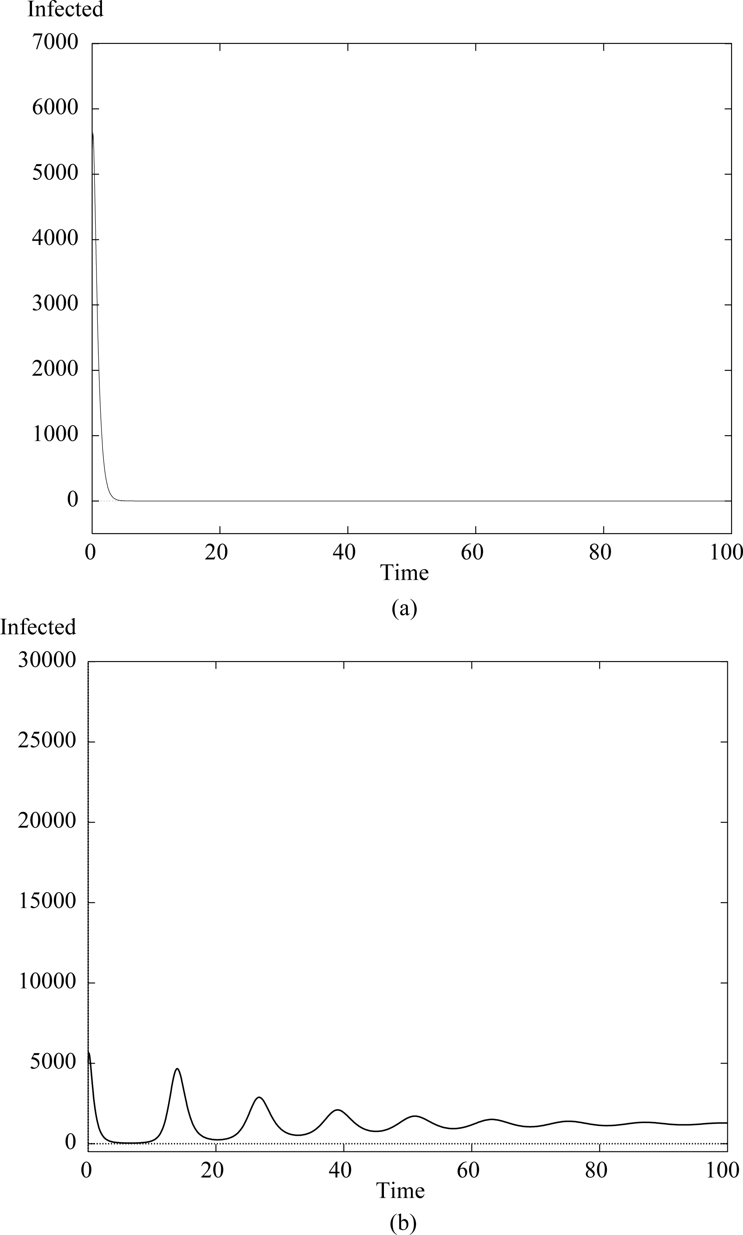

Figure 1. The number of infected population against time corresponding to parameter values of HBV (a) when the vaccination rate (p = 0.96) which is large enough so that, R0 < 1 and (b) when the vaccination rate, p = 0.5, is not sufficient enough to keep R0 < 1.

of points in each section. These points represent the period of the stable long term periodic solution of our model. We have taken the simulation parameters for all of the bifurcation diagrams presented here as stated above and the total population size N was 1,000,000. Figure 2 represents the bifurcation diagram for HBV with two transmission rates for the infected and the susceptibles. This figure shows that at small values of vaccination parameter the disease has a periodic solution of period one year. Increasing the value of p produces a two year periodic further increases generate a series of period doubling solutions until the behaviour of the system appears to become aperiodic and possibly chaotic. However, increasing the vaccination rate more forces the infected number to drop down until approaching zero at p ≈ 0.96 . Figure 2 represents the number of infected population against time corresponding to parameter values of HBV when 0 R > 1 . The black line plots the infected against time when, the latent are infectious. In this case, there is another contact rate β2 between susceptibles and latent. The black line shows that, there is an endemic solution which is going up rapidly. This solution has some peaks which look to be periodic of long period. The red line plots the infected against time when infectivity of the latent is ignored 2 β = 0 . The red line in Figure 2 shows that there are some peaks which have larger tops than the black one but, the line has small values all over the whole diagram. The green line represents the case that, there is a total isolation of the infected persons 1 β = 0 . The green line shows the smallest peaks in the diagram. These peaks decay smoothly to be almost steady state.

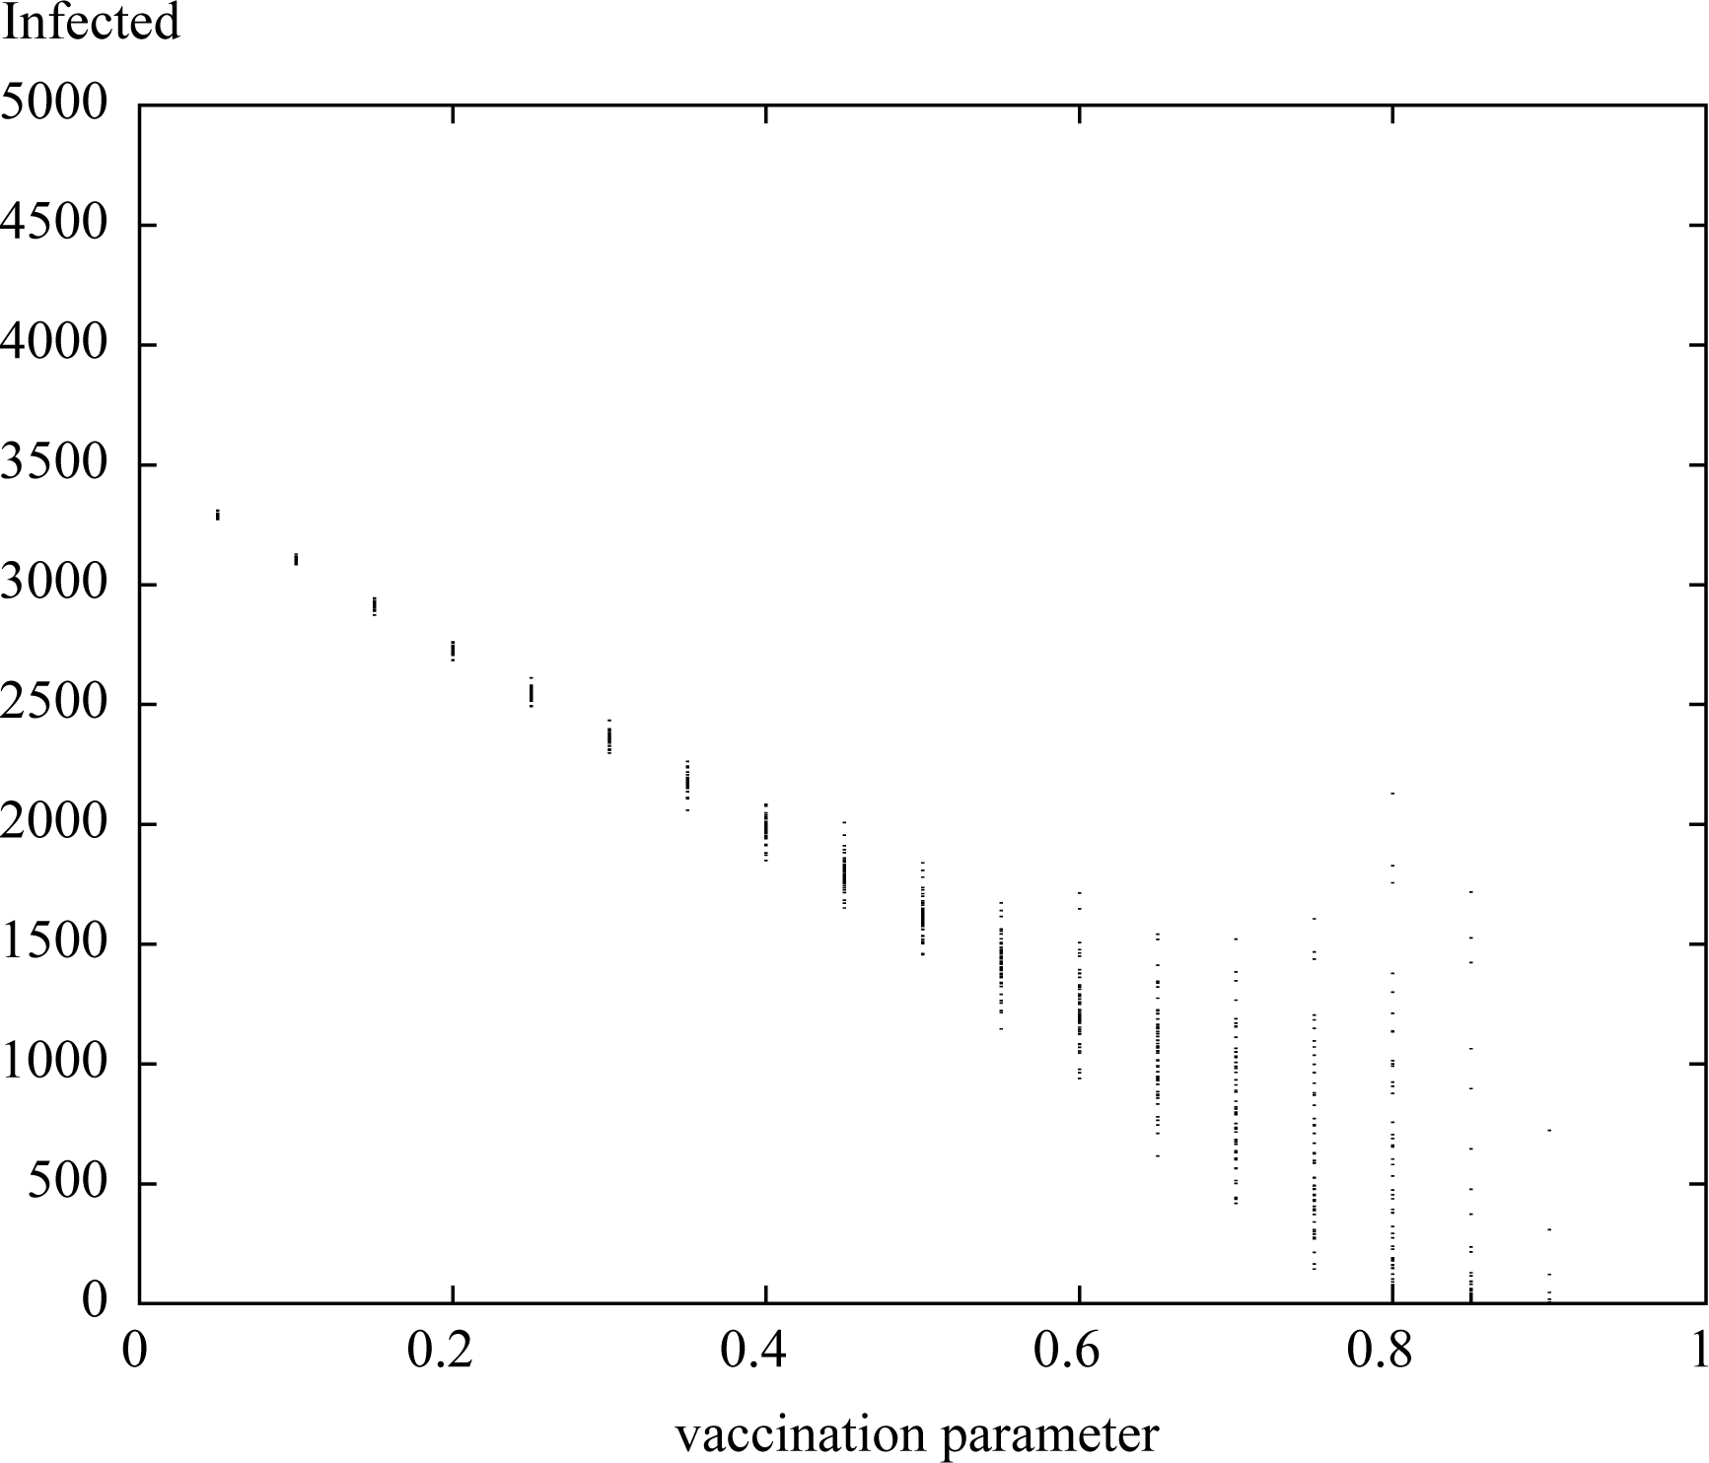

Figure 2. The bifurcation diagrams of HBV parameter values of the number of infected against vaccination parameter p.

**CHAPTER FIVE**

**SUMMARY AND CONCLUSION**

This paper research work investigates the effect of using another way of producing new cases. This way is the fact that latent persons can pass the disease into susceptibles. Also, vaccination of all newborns, at a constant rate, has been considered. It is documented that vaccination strategies are applied worldwide to vaccinate children in the early ages. For example, in China an effective vaccination program has been established for newborn babies since the 1990s, which has reduced chronic HBV infection in children. Unfortunately, the incidence of hepatitis B is still increasing. This means that the vaccinated proportion is large enough to force the reproduction number to be less than one in value. Therefore, to control HBV infection vaccination, strategies need a treatment scheme as another leg to have a better control strategy for the disease. The first result of this paper comes from the stability analysis of the DFE of our model. We find that the DFE is locally asymptotically stable when R0, the basic reproduction number, is less than one. If R0 exceeds one, then the DFE point is unstable. When 0 R > 1 , there exists another equilibrium point which is the endemic point P SEIR ( , ,, ) ∗ ∗ ∗∗ ∗ ≡ . We deduced that if 0 R > 1 , then P SEIR ( , ,, ) ∗ ∗ ∗∗ ∗ ≡ is globally asymptotically stable for the system (1)-(4). We used Liapunov’s direct methods to prove this result. Simulation results of our model have been conducted for HBV parameter set using different vaccination parameter values. From these results, we find that there is a critical ratio Pc = 96% approximately, from which all the newborns must be vaccinated. This value is the sufficient condition to reduce susceptible number to be less than a critical value SC. This forces the basic reproduction number R0 to be less than one in value and the disease dies out.

**REFERENCES**

Abdulrahman, S., Akinwande, N.I., Awojoyogbe, O.B. and Abubakar, U.Y. (2013) Sensitivity Analysis of the Parameters of a Mathematical Model of Hepatitis B Virus Transmission. Universal Journal of Applied Mathematics, 1, 230-241. [2] Saher, F., Rahman, K., Quresh, J.A., Irshad, M. and Iqbal, H.M. (2012) Investigation of an Inflammatory Viral Disease HBV in Cardiac Patients through Polymerase Chain Reaction. Advances in Bioscience and Biotechnology, 3, 417-422. http://dx.doi.org/10.4236/abb.2012.324059 [3] Centers for Disease Control and Prevention (2012) http://www.cdc.gov/hepatitis/HBV [4] Moneim, I.A., Al-Ahmed, M. and Mosa, G.A. (2009) Stochastic and Monte Carlo Simulation for the Spread of the Hepatitis B. Australian Journal of Basic and Applied Sciences, 3, 1607-1615. [5] Li, G. and Jin, Z. (2005) Global Stability of an SEI Epidemic Model with General Contact Rate. Chaos, Solitons and Fractals, 23, 997-1004.

Li, G. and Jin, Z. (2005) Global Stability of a SEIR Epidemic Model with Infectious Force in Latent, Infected and Immune Period. Chaos, Solitons and Fractals, 25, 1177-1184. http://dx.doi.org/10.1016/j.chaos.2004.11.062 [7] Li, G., Wang, W. and Jin, Z. (2006) Global Stability of an SEIR Epidemic Model with Contact Immigration. Chaos, Solitons and Fractals, 30, 1012-1019. http://dx.doi.org/10.1016/j.chaos.2005.09.024 [8] Li, X. and Fang, B. (2009) Stability of an Age-Structured SEIR Epidemic Model with Infectivity in Latent Period. Applications and Applied Mathematics: An International Journal (AAM), 4, 218-236. [9] Kapur, J.N. (1990) Mathematical Models in Biology and Medicine. Affiliated East-West Press, New Delhi. [10] Korobeinikov, A. and Wake, G.C. (2002) Lyapunov Functions and Global Stability for SIR, SIRS, and SIS Epidemiological Models. Applied Mathematics Letters, 15, 955-960. http://dx.doi.org/10.1016/S0893-9659(02)00069-1 [11] Zhuo, X. (2011) Global Analysis o f a General HBV Infection Model. IEEE International Conference on Systems Biology (ISB), Zhuhai, 2-4 September 2011, 978-1-4577-1666-9/11. [12] Wiah, E.N., Dontwi, I.K. and Adetunde, I.A. (2011) Using Mathematical Model to Depict the Immune Response to Hepatitis B Virus Infection. Journal of Mathematics Research, 3, 157-116. http://dx.doi.org/10.5539/jmr.v3n2p157 [13] Zou, L., Zhang, W. and Ruan, S. (2010) Modeling the Transmission Dynamics and Control of Hepatitis B Virus in China. Journal of Theoretical Biology, 262, 330-338. http://dx.doi.org/10.1016/j.jtbi.2009.09.035 [14] Greenhalgh, D. and Moneim, I.A. (2003) SIRS Epidemic Model and Simulations Using Different Types of Seasonal Contact Rate. Systems Analysis Modelling Simulation, 43, 573-600. http://dx.doi.org/10.1080/023929021000008813 [15] Kimbir, A.R., Aboiyar, T., Abu, O. and Onah, E.S. (2014) Simulation of A Mathematical Model of Hepatitis B Virus Transmission Dynamics in the Presence of Vaccination and Treatment. Mathematical Theory and Modeling, 4, 44-59.