**Live Well Springfield – A Community Transformation Movement:**

**Evaluation of the Live Well Springfield Website**

ABSTRACT

The Live Well Springfield (LWS) movement is a collaborative effort of partner organizations in Springfield, Massachusetts. The project promotes healthy living by increasing knowledge and awareness of food and physical activity. A key LWS strategy was the creation of a website to function as an information hub. In addition to local event and health information, the website features 16 narratives depicting residents practicing healthy lifestyle choices, designed to encourage community engagement. To date, there has been no evaluation of the website’s reach and effect.

A mixed methods approach, surveys and focus group discussions, was designed to collect data from people who live, work, or attend school in Springfield. Focus group participants were recruited in person at Springfield Community College, via recruitment posters (distributed at STCC), and through email requests from a previously compiled list of residents willing to be contacted. A website evaluation survey was developed using eHealth research constructs and the Expectation-Confirmation Model (ECM). This survey measured users’ perceived quality and satisfaction with the website. The survey was accessible via the livewellspringfield.org homepage, the LWS Facebook page, and emailed directly to potential respondents. The validated eHealth Literacy Scale (eHEALS) was incorporated into the survey and focus group sessions to assess self-reported skills for using eHealth resources. Each hour-long focus group (*n*=5 and *n*=6, respectively) was video/audio recorded and fully transcribed. Focus group transcripts were analyzed to thematically organize responses to narratives and fact-based health messages and assess the appeal, relevance, effectiveness, perceived purpose, and appropriateness. Survey data was analyzed to produce frequencies, descriptive statistics, and correlations.

A mean eHEALS score of 4.22 of 5.00 (*SD*=0.83) was calculated from 36 responses, suggesting this sample felt very knowledgeable and confident using eHealth resources. Health Literacy Advisor (HLA) software was used to analyze an aggregate of all narratives, resulting in a Fry-based reading grade level of 8.4. On a five-point Likert scale, mean satisfaction with the website was 4.71 (*SD*=0.53), and mean likelihood to return was 4.76 (*SD*=0.51).

Content analysis of focus group transcripts resulted in 184 responses coded for one or more themes. The largest proportion of responses (40.2%) related to effectiveness. One third of these effectiveness-related responses were negative toward the fact-based examples. Although the narratives were greatly preferred in both groups, all respondents made comments or agreed with suggestions to have both affective narratives and strictly fact-based health messages accessible, regardless of initial preferences. Results and interpretations will be reported to LWS partners to inform potential revisions of the website revisions and contribute to ongoing activities of the LWS initiative.

**TABLE OF CONTENTS**

Page

ACKNOWLEDGEMENTS iv

ABSTRACT v

LIST OF TABLES xi

LIST OF FIGURES xiii

CHAPTER

1. INTRODUCTION TO E-HEALTH 1

2. LITERATURE REVIEW 4

2.1. eHealth Literacy 10

2.1.1. Prevalence of Limited eHealth Literacy 13

2.1.2. Factors Associated with Limited eHealth Literacy 15

2.2. Conceptual Models and Tools for Evaluating eHealth Resources 17

2.2.1. Measurement of eHealth Literacy – The eHealth Literacy

Scale (eHEALS) 18

2.2.2. Measuring Readability of eHealth Content (The Health

Literacy Advisor) 20

2.2.3. Technology Acceptance Model (TAM & extended TAM) 21

2.2.4. Expectation-Confirmation Model (ECM) 24

2.3. Constructs for Evaluation of eHealth 25

2.3.1. Perceived Usefulness 26

2.3.2. Perceived Ease of Use 26

2.3.3. Perceived Quality of Information 27

2.3.4. Perceived Relevance 28

2.3.5. Knowledge Expectation 29

2.3.6. Knowledge Confirmation 30

vii

|  |  |  |  |
| --- | --- | --- | --- |
|  |  | 2.3.7. User Satisfaction with eHealth Resources ................................... | 30 |
|  |  | 2.3.8. Engagement ................................................................................ | 31 |
|  | 2.4. | Message Characteristics and Message-style Preference ............................ | 32 |
|  |  | 2.4.1. Message Appeal ........................................................................... | 34 |
|  | 2.5. | Opportunities for Future Research ............................................................. | 37 |
| 3. | PURPOSE OF STUDY ...................................................................................... | | 39 |
| 4. | RESEARCH QUESTIONS AND SPECIFIC AIMS.............................................. | | 41 |
| 5. | METHODS......................................................................................................... | | 43 |
|  | 5.1. | Study Population and Recruitment ............................................................. | 43 |
|  | 5.2. | Quantitative Methods ................................................................................. | 45 |
|  | 5.3. | Quantitative Measures ............................................................................... | 47 |
|  | 5.3.1. Readability ........................................................................................ | | 47 |
|  | 5.3.2. Full Length Survey ............................................................................ | | 48 |
|  | 5.3.3. Short-online Version of the Survey .................................................... | | 50 |
|  | 5.3.4. Demographic Questionnaire .............................................................. | | 50 |
|  | 5.3.5. E-Health Literacy Scale (eHEALS) .................................................... | | 51 |
|  | 5.4. | Qualitative Methods ................................................................................... | 51 |
|  | 5.5. | Qualititative Measures ................................................................................ | 54 |
|  | 5.6. | Human Subjects Protection ........................................................................ | 55 |
|  | 5.7. | Data Analyses ............................................................................................ | 56 |
|  | 5.7.1. Quantitative Analyses ........................................................................ | | 56 |
|  | 5.7.2. Qualitative Analyses .......................................................................... | | 59 |
| 6. | RESULTS .......................................................................................................... | | 63 |
|  | 6.1. | Quantitative Results .................................................................................... | 63 |
|  | 6.1.1. Demographics ................................................................................... | | 64 |

viii

6.1.2. Readability of LWS Content 67

6.1.3. eHEALS Ratings of eHealth Literacy 68

6.1.4. Perceived Usefulness of LWS.org 70

6.1.5. User Satisfaction with LWS.org 72

6.1.6. Perceptions of LWS Stories 72

6.1.7. Correlation of Quantitative Data 74

6.2. Qualtitative Results 76

6.2.1. Readability of Health Message Examples 77

6.2.2. Results of Qualitative Content Analysis 78

6.2.3. Message Appeal 79

6.2.4. Relevance 82

6.2.5. Effectiveness 85

6.2.6. Perceived Purpose 89

6.2.7. Appropriateness 90

6.2.8. Suggestions 92

7. DISCUSSION 94

7.1. Interpretation of Results 94

7.1.1. Discussion of Quantitative Results 94

7.1.2. Discussion of Qualitative Results 96

7.2. Limitations and Strengths 99

7.2.1. Limitations 99

7.2.2. Strengths 102

7.3. Implications and Future Research 104

7.3.1. Key Findings and Recommendations for LWS 106

ix

APPENDICES

A. eHEALS: eHEALTH LITERACY SCALE 161

B. FOCUS GROUP GUIDE 163

C. ONLINE SURVEY CONSENT FORM 178

D. FOCUS GROUP CONSENT FORM 180

E. WEBSITE EVALUATION SURVEY QUESTIONS - LONG VERSION 182

F. WEBSITE EVALUATION SURVEY QUESTIONS - SHORT VERSION 191

G. INSTITUTIONAL REVIEW BOARD APPROVAL 195

H. HEALTH MESSAGE COMPARISION BOOKLET FOR FOCUS GROUPS 196

REFERENCES 199

x

**LIST OF TABLES**

Table Page

1. Readability of LWS Stories 108

2. Readability of Non-narrative LWS Web Pages 109

3. eHEALS mean ratings by survey population 110

4. Response frequencies of eHEALS items one and two 110

5. Response frequencies of eHEALS items three through nine 111

6. Perceived usefulness (PU) frequencies among all survey responses 111

7. Open-ended responses of useful content and features 112

8. Weighted average ratings of satisfaction and likelihood to return 112

9. User satisfaction frequencies for combined sample 112

10. Frequency of responses for perceptions of LWS stories 113

11. Quotes related to message appeal for *Running the Numbers* 114

1. Quotes related to message appeal for *Diet and Exercise as a Prescription*

*for Diabetes* 115

13. Quotes related to message appeal for *Family First* 116

14. Quotes related to message appeal for *Pre-diabetes in Adolescents* 116

15. Quotes related to relevance for *Running the Numbers* 117

1. Quotes related to relevance for *Diet and Exercise as a Prescription for*

*Diabetes* 119

17. Quotes related to relevance for *Family First* 120

18. Quotes related to relevance for *Pre-diabetes in Adolescents* 121

19. Quotes related to effectiveness for *Running the Numbers* 121

1. Quotes related to effectiveness for *Diet and Exercise as a Prescription for*

*Diabetes* 123

21. Quotes related to effectiveness for *Family First* 125

22. Responses to *Pre-diabetes in Adolescents* related to effectiveness 126

xi

23. Responses to *Running the Numbers* related to perceived purpose ............... 127

1. Responses to *Diet and Exercise as a Prescription for Diabetes* related to

perceived purpose 128

25. Responses to *Family First* related to perceived purpose 129

26. Responses to *Pre-diabetes in Adolescents* related to perceived purpose 130

27. Responses to *Running the Numbers* related to appropriateness 132

28. Responses to *Family First* related to appropriateness 132

29. Responses to *Pre-diabetes in Adolescents* related to appropriateness 132

30. Responses illustrating group dynamics 133

1. Suggestions made during discussion of message 1A – *Running the*

*Numbers* 135

1. Suggestions made during discussion of message 1B – *Diet and Exercise*

*as a Prescription for Diabetes* 136

33. Suggestions made during discussion of message 2A – *Family First* 137

1. Suggestions made during discussion of message 2B – *Pre-diabetes in*

*Adolescents* 138

35. Frequencies of general perceptions – narrative vs. fact-based messages 140

36. Proportion of responses by theme 141

xii

**LIST OF FIGURES**

Figure Page

1. Technology Acceptance Model (TAM) 142

2. Expectancy Confirmation Model (ECM) 142

3. Lily Model of eHealth literacy 143

4. Conceptual model of LWS eHealth evaluation 144

5. Survey data collection model 145

6. Data collection methods 145

7. Conceptual model of focus group data analysis 146

8. Dual-processing via Elaboration Likelihood Model (ELM) 146

9. Perceived usefulness of specific website content 147

10. Mean satisfaction and likelihood to return. 147

11. Focus group discussion procedure and scores for message 1A 148

12. Focus group discussion scores for message 1B 149

13. Focus group discussion scores for message 2A 150

14. Focus group discussion scores for message 2B 151

xiii

**CHAPTER 1**

**INTRODUCTION TO E-HEALTH**

Since the full commercialization of the Internet in 1995, the quantity and speed of publically available information has increased at a tremendous, seemingly exponential, rate (Leiner et al., 2009). Health information is one of the most commonly sought after domains of information that Internet users report searching for. According to a Pew Internet research study, 59% of all adults in the U.S. looked online for health information during 2012 (Fox and Duggan, 2013). Health information is distributed from a wide variety of sources for many different purposes, and targeted toward many different audiences across the fields of business commerce, news, arts and entertainment, medicine and science, and education. An estimated seven million health-related queries are searched on the Web every day (Eysenbach and Köhler, 2002). Furthermore, data from the Health Information National Trends Survey (HINTS) indicate that, after physicians, consumers rank the Internet as the second most trustworthy source of health information, (Hesse et al., 2009; Frisch et al., 2013).

In the late 1990s, the term “eHealth” was coined by industry leaders and marketing professionals in reference to any type of website, computer program, or tele-communication technology designed to deliver health information or services more effectively and efficiently than with traditional in-person verbal methods (Jolly, 2011). It has become an accepted expression despite the lack of an agreed-upon clear or precise definition (Oh et al., 2005; Norman, 2011; Potter et al., 2012). One of the more comprehensive definitions describes eHealth as an intersection of medical informatics, public health and business services, delivered via the Internet (Eysenbach, 2001). This definition suggests that eHealth exceeds mere information to include attitudes or beliefs,

1

and that this corresponding paradigm encourages healthcare, technology, and communication practitioners to contribute to a global healthcare network (Eysenbach, 2001).

A vast majority of research supports the continued use of consumer-based eHealth resources, and cites potential benefits for improving the health and healthcare of individuals (Eysenbach and Köhler, 2002; Korp, 2006; Bodie and Dutta, 2008; Lefebvre et al., 2010; Collins et al., 2012). The Live Well Springfield (LWS) initiative is one community’s endeavor to contribute to and benefit from the aforementioned global healthcare network. LWS is a collaborative effort comprised of partner organizations in Springfield, Massachusetts. The initiative promotes healthy living by increasing knowledge and awareness of food and physical activity. A key strategy of the LWS initiative was the design and development of a program website. In addition to posting local event and health information, the website features stories and videos that depict residents practicing healthy lifestyle choices.

The LWS website was created to promote a “movement for healthy living,” and publicize information regarding access to and awareness of healthy food and physical activity options for Springfield residents (Live Well Springfield, 2014). In addition to creating the website, other LWS efforts include operating mobile farmer’s markets, planning the acquisition of a full line grocery store, initiating rowing and biking programs on the Connecticut River, and completing a comprehensive Bike and Pedestrian Plan for the city. Hence, the main objective of the LWS website is a call to action over the Internet. In this regard, the LWS is unique compared to other health-related websites, such as those which support weight loss, offer information about chronic disease care, or manage medical records. The LWS website is a product of a two-year, $1.2 million CDC-funded Community Transformation Grant, and therefore was developed to promote

2

health and increase awareness and involvement in programs and events throughout the city of Springfield.

Live Well Springfield’s call to action aims to empower Springfield residents to retrieve health information, apply newly acquired knowledge, engage in healthy behaviors, and seek involvement in community health events (Korp, 2006). The website prominently expresses the community action goals of the LWS initiative, but it also promotes public health at the individual level. Research has reported concerns about the quality of information available on the Internet (Eysenbach and Köhler, 2002, Griffiths and Christensen, 2005; Powell et al., 2011). These concerns have led to concerted efforts to assess the quality of e-health information and to create quality standards for Internet health sites (Korp, 2006; Powell et al., 2011).

Therefore, evaluating characteristics and qualities of the website using measures and analyses that have been validated in other eHealth studies may prove useful for increasing user satisfaction and intentions to continue using the site. The readability of eHealth content and associations with the applicable literacy skills of consumers is a valid concern that requires further research and possible policy consideration. Individuals are inherently required to apply some degree of health literacy skill each and every time an eHealth resource is used, and thus literacy is discussed in detail in chapter 2.1. In addition to measuring the readability of content and the eHealth literacy skills of LWS website users, this study identified practical ways to increase user engagement and overall satisfaction with the website and materials. Increasing exposure to health content and use of LWS health resources may directly influence residents’ intentions to change health behaviors.

3

**CHAPTER 2**

**LITERATURE REVIEW**

The body of literature reviewed in this chapter stresses the importance of assessing the perceived quality, user satisfaction, readability, and effects of message style of health information on the Internet. User satisfaction and perceived quality are important predictors of consumers’ intentions to continue using an eHealth resource (Koo et al., 2011). Perceived quality has been defined and measured variably across studies, both qualitatively and quantitatively (Bhattacherjee, 2001; Griffiths and Christensen, 2005; Harland and Bath, 2007; Bai et al., 2008; Koo et al., 2011; Tao et al., 2012). Nearly all of these eHealth studies have focused on evaluating the extent to which health information/resources meet users’ expectations and can be used for their intended purposes. Hence, the construct of usefulness has been considered a predictor of user satisfaction and/or perceived quality in most eHealth evaluation studies (Hsu et al., 2004: Leslie et al., 2005; Lankton and Wilson, 2006; Lee, 2010; Lefebvre et al., 2010; Hardiker and Grant, 2011; Koo et al., 2011; Mohamed et al, 2011; Chou et al., 2012). Furthermore, the concept of user satisfaction has been considered a mediating factor of overall eHealth quality and user engagement, which in turn have been used to predict users’ intentions to continue use of eHealth resources (Hsu et al., 2004: Leslie et al., 2005; Lankton and Wilson, 2006; Kim and Chang, 2007; Lee, 2010; Sutcliffe et al., 2010; Koo et al., 2011; Chou et al., 2012).

Qualitatively, the constructs satisfaction and quality have been measured using focus groups, usability tests, and in-depth interviews by assessing users’ perceptions of site appeal, engagement with content, and intentions continue use (Bhattacherjee, 2001; Eysenbach and Köhler, 2002; Hsu, 2004; Glasgow, 2007). One randomized control trial

4

sought to objectively assess the quality of web-based health information by collecting and analyzing paradata from Web servers, which included log-in time stamps, initiation and/or completion of online surveys, and loading the first page of Web sessions (Couper et al., 2010). However, the vast majority of primary research that has measured quality and user satisfaction has relied on surveys to quantify the measures (Zhang et al., 2001; Rice, 2006; Kim and Chang, 2007; Bai et al., 2008; Holden and Karsh, 2010; Lefebvre, 2010; Koo et al., 2011; Wong, 2012; Vosbergen et al., 2014).

Only one study assessed the validity of a website ranking tool, Google PageRank, which automatically generates quality rankings enabling users to compare health websites (Griffiths and Christensen, 2005). This cross-sectional study compared results of Google PageRank with scores generated from a validated, manual rating tool, DISCERN, which was developed by a panel of health information experts to allow average consumers to evaluate written health information (Charnock et al., 1999; Griffiths and Christensen, 2005). A selection of 24 mental health and depression websites were ranked based on site characteristics, evidence-based content quality (as measured by evidence-based depression guidelines), and user satisfaction using both tools plus an evidence-based gold standard as a reference (Griffiths and Christensen, 2005). The evidence-based quality score produced by the gold standard method correlated fairly strongly with Google PageRank (*r*=0.59, *p*=0.002), but not as strongly as it did with the DISCERN ratings for both consumers (*r*=0.62, *p*=0.001) and health professionals (*r*=0.80, *p*<0.001) (Griffiths and Christensen, 2005). So, the authors concluded that Google PageRank shows promise as an automatic indicator of quality, but manual rating tools developed by health professionals was superior (Griffiths and Christensen, 2005).

5

In addition to perceived quality and user satisfaction, evaluating the readability of web content is of particular importance for eHealth providers and researchers (Carbone and Zoellner, 2012). An abundance of research has been conducted to specifically define health literacy and expound upon the association between the health literacy levels of individuals and their health behaviors and health outcomes (Schwartzberg et al., 2005; Baker, 2006; Kutner, 2006; Keselman et al., 2008; Huizinga et al., 2009; Berkman et al., 2010; Paasche-Orlow et al., 2010; Parker and Ratzan, 2010; Sarkar et al., 2010; Carbone and Zoellner, 2012; Griffey et al., 2014). Title V of the Patient Protection and Affordable Care Act of 2010 describes health literacy as an individual’s capacity to acquire, read, understand, and apply basic health information for making healthful decisions (Nielsen-Bohlman et al., 2004). E-Health literacy then refers to an individual’s capability to find, comprehend, evaluate and utilize relevant health information, whether written or spoken, via the Internet or other electronic media (Norman and Skinner, 2006b).

In order for the information or message of eHealth content to be received, interpreted and have the desired effect on intended recipients, eHealth providers must consider the readability of each piece of health literature they write and distribute. A number of formulas have been validated to measure the readability of textual passages (which are described in detail in section 2.2.2 of this document). The readability of a piece of writing is most commonly stated as the grade level of education that is required to fully comprehend the entire selection. For example, the prototype of the *5 a Day, the Rio Grande Way*, a nutrition education website for at-risk populations in the South WestU.S., scored at about the 6th grade level when evaluated by the Flesch-Kincaid readability scoring function in Microsoft Word 2000 (Zimmerman et al., 2003). Therefore, assessing how well the readability scores of eHealth content match the health (or

6

eHealth) literacy levels of target audiences may be a valuable method for evaluating eHealth resources (Zhang et al., 2001; Carbone and Zoellner, 2012), although no published studies were found that compared these two measurements for a particular eHealth resource. Further, no published studies were discovered that use measurements of eHealth literacy and readability to compare with perceived quality and satisfaction data.

Assessing end user’s perceptions of quality is essential to evaluating the efficacy of services or materials within any eHealth categories. A recent review (Hardiker and Grant, 2011) indentified four main types of eHealth services: health information on the Internet; custom-made online health information; online support; and telehealth. For the purposes of this study, only literature related to health information on the Internet has been reviewed in regards to research on perceived quality, user satisfaction, readability and health literacy of target audience, and effects of message style on information processing. The resulting body of literature is still quite broad, and eHealth information sources include corporate and organizational websites (e.g., hospitals and universities); national, state, and local government public health websites; specialty concern and intervention websites (e.g., weight loss and diabetes care); and blogs and social media websites. Content areas and features overlap between all of these eHealth resources, but similar features are prominent among eHealth websites, and thus the bulk of quality, readability, and message appeal measurements pertain specifically to text-based health information and photos.

According to a national survey of 3,014 U.S. adults (roughly 59% of the entire U.S. adult population), about 74% of Internet users (roughly 59% of the entire U.S. adult population) searched for health information online during 2012 (Fox and Duggan, 2013). Among adults, those who searched the most were between the ages of 18-49, women,

7

and college graduates (Fox, 2006). Analytics and paradata (information of site visit and duration) collected by individual health websites support these findings (Couper et al., 2010). However, evaluations of eHealth websites often use different methodology, test different predictor variables, and use different measurement instruments. This is a complication resulting from the broad range of eHealth websites that exist and the numerous academic and business sectors that share interests in researching their efficacy.

Theoretical modeling offers a means to narrow the focus and provide clear direction for researchers and evaluators of eHealth resources. Validated theoretical models can be used to predict users’ perceptions and behavioral intent (e.g., intention to continue using the eHealth resource). The six models that have been most often applied to eHealth include (1) the social cognitive theory (SCT) (Hsu et al., 2004; Norman and Skinner, 2006a), (2) the theory of planned behavior (TPB) (Hsu et al., 2004), (3) the expectation-disconfirmation theory (EDT) (Hsu et al., 2004; Lankton and Wilson, 2006),

1. the expectation-confirmation model (ECM) (also referred to in literature as expectation-confirmation theory, or ECT, but, herein referred to as ECM) (Hsu et al., 2004; Lankton and Wilson, 2006; Lee, 2010; Koo et al., 2011; Chou et al., 2012), (5) the diffusion of innovations (DOI) (Hsu et al., 2004), and (6) the technology acceptance model (TAM) (Hsu et al., 2004; Kim and Chang, 2007; Holden et al., 2010; Mohamed et al., 2011). This study focused on ECM and TAM since these two models (through extensions and variations) specifically considered the effects of user satisfaction and perceived quality on engagement with and continued use of eHealth resources (Bhattacherjee, 2001; Davis et al., 1989). Both the TAM (Davis et al., 1989) and ECM (Lee, 2010) are presented graphically in this document, Figure 1 and Figure 2 respectively.

8

Findings from studies that have measured perceived quality suggest that the construct be included in prospective eHealth evaluations (Hsu et al., 2004; Griffiths and Christensen, 2005; Harland and Bath, 2007; Koo et al., 2011; Tao et al., 2012). In addition to perceived quality, user satisfaction, and readability, studies of eHealth usage consistently suggest a continued need to assess the engagement properties of eHealth resources (Leslie et al., 2005; Couper et al., 2010; Lefebvre et al., 2010; Sutcliffe et al., 2010; U.S. Dept. of Health and Health Services, 2010; Hardiker and Grant, 2011; Ricciardi et al., 2013). The concept and construct of engagement has been defined and operationalized quite differently among various eHealth studies, and for the most part it has been treated as a moderating or mediating factor corresponding to the acceptance or use of an eHealth resource, i.e., the more engaging a health website is, the more it will be used (Kim and Chang, 2007; Lefebvre et al., 2010; Chou et al., 2012).

The current study contributes to existing eHealth research on perceived quality, using ECM and TAM as explanatory guides. Additionally, this study investigated the potential effects that eHealth literacy and readability have on engagement and information processing. Though definitions of eHealth engagement are numerous and conflicting, results of the initial eHealth Engagement Scale study demonstrated adequate internal reliability for both subscales, Cronbach *α*=0.878 for Involving and 0.805 for Credible (Lefebvre et al., 2010). Using two questionnaires, participants rated 12 descriptors on a 5-point Likert scale, while visiting three randomized eHealth content areas which included nutrition, physical activity, cancer screening, and smoking cessation. Therefore, the construct of credibility was also incorporated into this study to help assess website quality. In turn, the results of this evaluation may help to illustrate the effectiveness and persuasiveness of specific health content featured on the LWS website.

9

**2.1. E-Health Literacy**

A functional level of literacy is required for an individual to benefit from any written or spoken message. The Workforce Investment Act of 2013 – Title III, section 303.13 – defines literacy as “an individual’s ability to read, write, and speak in English, compute, and solve problems, at levels of proficiency necessary to function on the job, in the family of the individual, and in society” (S. 1356--113th Congress, 2013). As information and technology become more widely available, the traditional concept of literacy (i.e., an individual’s ability to read) has expanded to consider oral, numerical, and contextual competencies as essential.

According to the previous definition, the type and level of literacy necessary for an individual to benefit from a message depends on the content and context of that message. Therefore, comprehension and application of health content presented in the context of electronic media (e.g., the Internet) requires adequate electronic-health literacy, or eHealth literacy. However, to understand health-related content in any context requires an individual to have an adequate level of health literacy skill. Title V of the Patient Protection and Affordable Care Act of 2010 describes the term health literacy as an individual’s capacity to find, interpret, understand, and apply basic health information for making healthful decisions (Nielsen-Bohlman et al., 2004).

Placed in various contexts, deciphering a written or spoken message such as a doctor’s order, a medicine’s dosage instructions or dietitian’s advice require the recipient to make use of his or her health literacy skills. While literacy in general is aptly considered a competency of an individual, the collective literacy level of a community can have major implications for the overall health of that community. Since LWS is a public health initiative, it is fitting that this evaluation study assess the extent to which the LWS website offers opportunities to integrate health literacy practices that aim to

10

improve the lives of individual Springfield residents, which hypothetically help improve the community as a whole (Pleasant et al., n.d.).

When health content is communicated via the Internet, health literacy, computer literacy, and eHealth literacy become simultaneously relevant (Norman and Skinner, 2006b; Bodie and Dutta, 2008). Therefore, in order for users of the LWS website to access and make use of featured health information, they must exercise a functional degree of eHealth literacy. Engagement with eHealth material requires a unique skill set, which includes the capacity to seek, find, understand, and evaluate health information from electronic sources (Norman and Skinner, 2006b). Most importantly, having a higher level of eHealth literacy skill allows individuals to use practical health knowledge to address or solve a relevant health issue (Stellefson et al., 2011).

Health literacy measurement tools and screening aids for clinicians such as the Rapid Estimate of Adult Literacy in Medicine (REALM) (Davis et al., 1993) and the Test of Functional Health Literacy in Adults (TOFHLA) (Parker et al., 1995) have been widely used to assess health literacy. However, these tools have been primarily studied in context of the healthcare system, and have not been proven applicable for evaluating eHealth resources (Nutbeam, 2008; Nielsen-Bohlman et al., 2004). E-Health literacy, while not as extensively studied, ties together elements of computer literacy and health literacy (Bodie and Dutta, 2008). Norman and Skinner’s Lily Model (Figure 3) posits that eHealth literacy is a form of meta-literacy, combining many different literacy skills beyond just health literacy or numeracy (Norman and Skinner, 2006b; Norman, 2011). This Lily Model encompasses six unique types of literacy: traditional (literacy and numeracy), information, media, health, computer, and scientific (Norman and Skinner, 2006b; Neter and Brainin, 2012).

11

The eHealth literacy scale (eHEALS) was developed to measure how knowledgeable, comfortable, and confident consumers feel about their own ability to find, evaluate, and apply eHealth information to personally relevant health problems (Norman and Skinner, 2006a). The first version and experimental administration of eHEALS used an eight item questionnaire (with two additional items recommended by the original developers) in a randomized intervention trial evaluating Web-based eHealth programs using a sample of 664 Canadian adolescents (Norman and Skinner, 2006a; Neter and Brainin, 2012). The initial internal consistency reliability and factor analysis resulted in a Cronbach alpha (*α*) coefficient of 0.88, suggesting a tight fit among all eight items (Norman and Skinner, 2006a). However, test-retest reliability analysis showed more modest stability among the same sample over time (Pearson correlation *r* = 0.68 at baseline, and *r*=0.40 at the 6-month follow-up) (Cortina, 1993; Norman and Skinner, 2006a).

Further study with eHEALS in diverse populations continued to demonstrate that

the scale reliably and consistently captured the eHealth literacy concept, and thus

validated the tool’s potential for evaluating consumers’ perceived comfort, confidence,

and skill in using the Internet and Web-based applications for health information

(Norman and Skinner, 2006a). In a nation-wide random-digit-dial telephone survey

(*n*=4,286) of Israeli adults (18 years and older), six items from the original eHEALS were

used to assess eHealth literacy as part of a larger study on technology disparity (i.e., the

digital divide) (Neter and Brainin, 2012). Analysis of internal consistency for the six items

resulted in a Cronbach alpha coefficient of 0.86, suggesting adequate reliability (Neter

and Brainin, 2012). In two studies of a Dutch translation of the eHEALS, internal

consistency reliability was clearly demonstrated in both a sample of patients with

rheumatic disease (*n*=189; *α*=0.93), and in a stratified sample of the Dutch population

12

(*n*=88; *α*=0.92) (Van der Vaart et al., 2011). An 8-item Chinese translation of eHEALS (C-eHEALS) was administered as part of a psychometric evaluation of sixth grade students in Taiwan (*n*=216), and was found to have reliable internal consistency with a Cronbach alpha coefficient of 0.92 (Koo et al., 2012). Internal consistency analysis from

1. cross-sectional survey of 18-year-old German students (*n*=327) utilizing a German translation of eHEALS (G-eHEALS) showed adequate reliability with a Cronbach alpha calculations of 0.877 for the Information-Seeking eHEALS and 0.828 for the Information-Appraisal eHEALS (Soellner et al., 2014). The Japanese translation was evaluated in an Internet-based cross-sectional survey (*n* = 3,000) (Mitsutake et al., 2011). The resulting Cronbach alpha of 0.93 (*p*<0.01), and test-retest reliability of *r*=0.63 (*p*<0.01) demonstrated the J-eHEALS was appropriate for assessing eHealth literacy in the sample population (Mitsutake et al., 2011).

Based on test-retest reliability findings in these eHEALS studies, the eHEALS is

considered a useful tool for evaluating individual’s eHealth literacy skills within various resource contexts (Norman and Skinner, 2006a). This study incorporated the eHEALS (Appendix A) into a survey distributed online (Appendix E), and also as an isolated paper survey which was distributed and completed by all eleven focus group participants. The nine-item eHEALS measurement made up the third section of the user-perception survey, following a series of questions specific to evaluation of the LWS web content and a section of demographic questions (Appendix A). Since this study utilized the previously validated eHEALS tool, results were interpreted in respect to all of aforementioned types of literacy described by the Lily Model (Norman and Skinner, 2006b).

**2.1.1. Prevalence of Limited eHealth Literacy**

Half of U.S. adults do not possess adequate health literacy skills required to read and use health-related messages (Nielsen–Bohlman et al., 2004; Zarcadoolas et al.,

13

2009). Combined with Internet access inequalities and differences in computer literacy associated with lower socioeconomic status and education attainment, and it can be deduced that opportunities for improved health outcomes associated with using eHealth resources are not equally distributed (Norman and Skinner, 2006; Bodie and Dutta, 2008; Neter and Brainin, 2012). Since the inception of eHealth, researchers, policy makers, and consumer product developers have been concerned about reach and affect on medically underserved audiences and the link between health disparities and Internet access (Keselman et al., 2008). Indeed, the Institute of Medicine (IOM) reported that populations who need health information the most are the ones that lack access, knowledge, and skills necessary to benefit from Internet health resources (Nielsen-Bohlman et al., 2004).

In the absence of a universally accepted method for measuring eHealth literacy, the prevalence of low or limited eHealth literacy can only be inferred for the sample populations with which research has been conducted. Among these have been Canadian students (Norman and Skinner, 2006a), Israeli adults (Neter and Brainin, 2012), patients with rheumatic disease in the Netherlands (Van der Vaart et al., 2011), Chinese and German adolescents (Koo et al., 2012; Soellner et al., 2014), and college students aged 17 to 26 at various colleges and universities around the world (Stellefson et al., 2011). In every sample except the adolescent Chinese students, correlations between individual items and the eHEALS scale were significant at *p* < .001 (Norman and Skinner, 2006a; Neter and Brainin, 2012; Van der Vaart et al., 2011; Stellefson et al., 2011; Koo et al., 2012; Soellner et al., 2014). The current study’s use of eHEALS marked the second known study to test eHEALS in a U.S. sample (Stellefson et al., 2011).

14

The eHEALS study with Israeli adults delineated the median score of the scale (3.4) to create two groups: those with a high mean eHealth literacy score (≥3.4); and those with a low mean eHealth literacy score (≤3.39) (Neter and Brainin, 2012). The use of eHEALS in this study used a similar method to categorize respondents into groups of limited or adequate eHealth literacy skills. However, studies with eHEALS show relatively little variation of mean item scores among the different sample populations, and thus a reference eHEALS score defining a threshold of low eHealth literacy has yet to be established (Collins et al., 2012). So, although this study did not intervene to directly alleviate issues related to limited health literacy among Springfield residents, the readability of the LWS website and eHealth literacy of a small sample was examined and elucidated.

**2.1.2. Factors Associated with Limited eHealth Literacy**

The negative health consequences for individuals with lower levels of eHealth literacy may be inferred from research on general literacy and health literacy. A systematic review of health literacy instruments conducted in 2012 suggested an inverse association between an individual’s health literacy capability and effectiveness of healthcare system use (Collins et al., 2012). Results of primary studies with elderly persons (Baker et al., 2007), emergency room patients (Herndon et al., 2011), and users of an online diabetes intervention (Sarkar et al., 2010) suggest that individuals with low literacy skills use fewer preventive services and less health information technology. These studies show that low literacy is associated with a poorer overall health status and greater risk of death (Collins et al., 2012).

Norman and Skinner’s Lily Model of eHealth literacy, described earlier, identifies the core components of eHealth literacy, but does not consider how social and cultural norms affect individuals’ efficacy regarding using eHealth use (Norman and Skinner,

15

2006b; Chan and Kaufman, 2011). Additionally, the Lily Model does not explain the cognitive mechanisms by which low literacy prevents comprehension and adoption of health messages. Only one published study experimentally employed methods of cognitive task analysis (CTA) to measure the number of barriers experienced while performing eHealth-related tasks in the categories of remembering, understanding, applying, analyzing, evaluating and creating (Chan and Kaufman, 2011). The conceptual framework synthesized in the study combined the Lily Model with an additional model, Bloom’s taxonomy of educational objectives, to explain variation in task performance across a range of cognitive tests (Chan and Kaufman, 2011). The theoretical framework and methodology of CTA were applied to analyze the complexity of information-seeking and decision-making using Web-based consumer eHealth, and thus can be used to identify and explain literacy obstacles and inform the development of solution policies (Chan and Kaufman, 2011).

Results from the CTA found that all 20 participants experienced some difficulty completing most tasks on a website designed for consumers without some assistance (Chan and Kaufman, 2012). While only basic frequencies and descriptive statistics were reported, the study on CTA and eHealth literacy empirically demonstrated some of the challenges individuals report in obtaining, processing, and comprehending health information because of differences in cognitive processing (Chan and Kaufman, 2012). The implications of this study on cognitive eHealth literacy demands indicate the need for more research in this area to assess potential health consequences and identify possible improvements to eHealth design to alleviate comprehension complexity (Chan and Kaufman, 2011). Other research suggests that a lack of general literacy or computer literacy skills, or both, may result in decreased self-efficacy when Internet users fail to find information they desire (Bodie and Dutta, 2008; Collins et al., 2012). The Integrated

16

Model of eHealth Use (IMeHU) presented by Bodie and Dutta describes eHealth literacy as a utility as well as a facilitator of an individual’s ability and motivation to use the Internet to benefit from health information (Bodie and Dutta, 2008). The model posits that individuals with limited eHealth literacy may lack motivation, or explicitly choose not to seek health resources on the Internet due to low self-efficacy and poor outcome expectations (Bodie and Dutta, 2008).

Although the access gap for providing health resources, Internet-based or otherwise, may be narrowing, health literacy has emerged as a fundamental barrier to providing such health information to medically underserved and other audiences (Nielsen-Bohlman et al, 2004). The prevalence of low and limited health literacy is perceived as a primary obstacle that needs to be addressed to reduce health disparities (Nielsen-Bohlman et al, 2004). Therefore, measuring and studying eHealth literacy levels of specific populations may be a valuable formative step in developing effective eHealth resources. This study measured the eHealth literacy of a sample of Springfield residents to determine how understandable and relevant health content on the LWS website is perceived to be. Since most eHealth resources primarily contain written text, analyzing both users’ eHealth literacy levels and the readability of site content produced results that were compared, though indirectly because of limitations in measurement. Interpretations of these results are discussed in detail in the final chapter of this document.

**2.2 Conceptual Models and Tools for Evaluating eHealth Resources**

Constructs derived from two principal theoretical models have been rigorously applied to the study of eHealth evaluation. Most notably, the technology acceptance model (TAM) (Davis et al., 1989) outlined the theoretical rationale for adapting perceived usefulness (PU) and perceived ease of use (PEOU) into independent variables. The

17

expectation-confirmation model (ECM) conceptualizes eHealth evaluation via identification of knowledge expectations and subsequent confirmations pre and post use, respectively (Bhattacherjee, 2001). These four variables (PU, PEOU, knowledge-expectation, and knowledge-confirmation) have been studied individually to predict users’ intentions to engage in and continue to using eHealth resources. To date, however, neither model has proven more effective over the other in predicting eHealth users’ intentions to engage and continue use with a resource. Therefore, the user-perception survey used for this study incorporated constructs of TAM, ECM, and the eHealth Engagement Scale (Lefebvre et al., 2010).

Synthesizing the two theoretical models and measures informed the development of a new tool to measure user satisfaction, perceived quality, intention to use, and intention to continue use of eHealth websites. The major concepts and constructs tested in studies of the eHealth Engagement Scale, TAM, and ECM were considered in the development of the user-perception survey. To measure eHealth literacy, the eHEALS (Norman and Skinner, 2006a) was slightly modified for inclusion into the online survey (section 3 of the website evaluation survey, Appendix E), and is discussed in detail in the following section.

**2.2.1. Measurement of eHealth Literacy – the eHealth Literacy Scale (eHEALS)**

One key factor that has been neglected in eHealth evaluation studies is measurement of eHealth literacy levels of intended users. The readability of specific pieces of eHealth information is equally as important for researchers to measure, in order to compare the effectiveness of eHealth resources regarding the eHealth literacy skills of target audience members (discussed in the following section). To date, studies of eHealth literacy have only used self-reports to assess eHealth literacy and other descriptive statistics (Norman and Skinner, 2006a; Collins et al., 2012). Most eHealth

18

literacy studies have been either cross-sectional (Powell et al., 2011; Koo et al., 2012; Neter and Brainin, 2012), systematic review (Sutherland, 2005; Stellefson et al., 2011; Carbone and Zoellner, 2012; Collins et al, 2012), part of relatively short eHealth interventions, e.g., baseline to 6-month follow-up (Norman and Skinner, 2006a), or short duration cohorts (Sarkar et al., 2010). Associations between readability of eHealth content and limited eHealth literacy skills of users have yet to be empirically assessed using validated comparative methods to demonstrate effects on individual health outcomes (Bodie and Dutta, 2008).

Only one measurement tool specific to eHealth literacy has been thoroughly studied and tested for reliability: the eHealth Literacy Scale (eHEALS) (Norman and Skinner, 2006a). The original eHEALS consisted of eight statements for respondents to select the degree to which they agree or disagree with their own eHealth literacy ability on a 5-point Likert scale (Norman and Skinner, 2006a; Collins et al., 2012). The first study with the eHEALS was validated in a youth population as part of a single session, randomized intervention trial evaluating Web-based eHealth programs (Norman and Skinner, 2006a; Collins et al., 2012). The eHEALS has been used since in a variety of settings, with diverse population and cultural groups (including adolescent students, college students, adults, and hospital patients) and has been used and translated in multiple languages (English, French, Dutch, Mandarin, Hebrew, Arabic, and German) (Bodie and Dutta, 2008; Stellefson et al., 2011; Van der Vaart et al., 2011; Koo et al., 2012; Neter and Brainin, 2012; Soellner et al., 2014).

The 8-item eHEALS with two supplementary items pertaining to general perceptions of eHealth usefulness and importance, recommended for inclusion by the developers, is presented as Appendix A of this document (Norman and Skinner, 2006a).The 8-item measure of eHealth literacy has performed consistently across

19

settings and populations in eight separate studies from 2006 to 2014. Of the seven

eHEALS studies that have analyzed and reported internal consistency, all have found

satisfactory results; mean Cronbach alpha score of 0.91, with a range of 0.86 to 0.93

(Norman and Skinner, 2006a; Mitsutake et al., 2011; Van der Vaart, 2011; Koo et al.,

2012, Neter and Brainin, 2012; Soellner et al., 2014). The sample of 189 patients with

rheumatic disease, and the stratified sample of 88 Dutch residents also demonstrated

significant correlations between eHealth literacy score and quantity of Internet use

(*p*=0.001 and *p*=0.02, respectively) (Van der Vaart, 2011). However, while the internal

consistency of eHEALS is high, studies testing eHEALS have failed to demonstrate

significant correlations between eHealth literacy score and age, education, and actual

performance with eHealth resources (Van der Vaart, 2011). Therefore, further research

to develop a self-report instrument that correlates strongly with people’s actual eHealth

literacy skills is warranted (Van der Vaart, 2011; Collins et al., 2012).

**2.2.2. Measuring Readability of eHealth Content**

National policy guidelines in the U.S. advise that consumer health materials be written at approximately the eighth grade level (Nielsen-Bohlmen et al., 2004; Keselman, 2008). Readability indices, such as the Simple Measure of Gobbledygook (SMOG), Gunning Fog Index (GFI), and Flesch–Kincaid Index (FKI) have been used to assess health documents (Friedman and Hoffman-Goetz, 2006; Stossel et al., 2012). These indices use mathematical formulas to assign a reading grade level to a passage of text based on the number and complexity of the words included. In general, formulas assess the complexity of individual words by the number of letters and grammatical difficulty is measured by the length of each sentence (Stossel et al., 2012). The Health Literacy Advisor™ (HLA) is a software add-in that works within Microsoft Word to allow users to highlight and analyze grade reading levels of a full document or a selection of text. HLA

20

allows users to choose a combination of one to six different electronic readability indices, including those mentioned above (“The Health Literacy Advisor,” n.d.). The HLA is the only software product currently on the market that scrubs a document, ignoring phone numbers, URLs, headings, and bullets, prior to calculating readability (“The Health Literacy Advisor,” n.d.). The HLA also dutifully rewards writers for achieving a 6th grade reading level by generating a “Reads Easy” stamp to identify a passage of writing that is deemed appropriate for the general public (“The Health Literacy Advisor,” n.d.).

Most readability studies with eHealth resources have found a majority of content to be written at the ninth grade level or above (Eysenbach and Köhler, 2002). The Institute of Medicine (IOM) found that above-average language skills in a general population do not necessarily translate to widespread functional understanding of health messages, or medical information (Nielsen-Bohlmen et al., 2004). The IOM Health Literacy report also stated that health education and literacy are not necessarily addressed by the same strategies used to improve general education and language skills (Nielsen-Bohlmen et al., 2004). Therefore, improving a population’s health literacy is more challenging than improving its general literacy. This challenge is further complicated when health messaging is communicated via electronic media (e.g., the Internet). In order to effectively measure the readability of each content page of LWS.org, HLA software was utilized in this study to test multiple readability measures, including the Fry readability formula (“The Health Literacy Advisor,” n.d.).

**2.2.3. Technology Acceptance Model (TAM and Extended TAM)**

The Technology Acceptance Model (TAM) is a conceptual model designed to explain the process by which consumers adopt a new technology (Figure 1). TAM has been applied to evaluation studies of eHealth resources with varying results over the past 20 years. The theory of technology acceptance proposed in TAM states that

21

individuals must perceive new technology as useful or easy to use in order to accept it (Davis et al., 1989). There have been multiple theoretical extensions of TAM, but the original model was developed using principles of the theory of reasoned action (TRA) and the theory of planned behavior (TPB), and the first TAM also incorporated the constructs of perceived usefulness (PU) and perceived ease of use (PEOU) to explain behavioral intentions (Davis et al., 1989). In a longitudinal study of 107 MBA students’ intentions to use a word-processing program after a 14 week exposure, PU and PEOU were found to positively correlate (Davis et al., 1989). At the end of the intervention, intention was directly affected by usefulness (PU) alone (*p*<0.001) (Davis et al., 1989). Ease of use (PEOU) only affected intention indirectly through usefulness (PU), but this effect was also significant (*p*<0.01) (Davis et al., 1989). Results of this initial TAM study suggest that PU may be a major determinant of people's intentions to use computer software.

Early studies of TAM neglected any explicit attempt to measure perceived relevance or importance of the technology to the end user. The inherent value of the resource or material being evaluated was merely implied by assessing how useful end-users perceived it be. An extended version (TAM2) was therefore developed and has been applied in four longitudinal studies of software usage among business employees (Venkatesh and Davis, 2000). Although this application of TAM2 assessed job relevance in settings where information system use was both voluntary (study 1, *n*=48, and study 2, *n*=50) and a mandatory job requirement (study 3, *n*=51, and study 4, *n*=51), neither this version, nor any subsequent versions of TAM have incorporated assessments of relevance to personal values (Venkatesh and Davis, 2000). To assess user satisfaction of eHealth resources, the original TAM was deemed inadequate, and thus an extended TAM was developed to assess customer satisfaction and post-customer satisfaction

22

through a random email-delivered questionnaire (*n*=250) with Korean adults (Kim and Chang, 2007). Within the framework of TAM, the outcome variables of user satisfaction and post-use satisfaction are always dependent on either PU or PEOU. Within the context of eHealth, the results related to satisfaction with the Korean health website suggest that PU has a stronger effect (path analysis coefficient =2.06, *p*<0.05) on satisfaction than PEOU (no significant association) (Kim and Chang, 2007). This unique finding may be explained in part by users' inherent value of health information, which may outweigh the need for PEOU, thus reducing its effect on intended use. Kim and Chang’s research suggests that measurements of perceived quality and satisfaction are incomplete without considering PU and PEOU within the context of eHealth engagement and expectation-confirmation. Therefore, there is an evident need for further research to help explain how PU and PEOU mediate perceived quality and user satisfaction with eHealth resources.

In a study conducted by Mohamed et al. in 2011, researchers tested a variation of TAM developed specifically to assess acceptance of eHealth, called e-HTAM. The e-HTAM provides a conceptual framework that includes technological factors, such as eHealth technology design, which can include website design and structure. Results of the study (Mohamed et al., 2011) indicate that PEU (*r*=0.438, *p*=0.001), PU (*r*=0.420, *p*=0.001), positively influence intentions to use eHealth resources. The results confirmthose previous studies of TAM2 (Venkatesh and Davis, 2000). However, the only outcome measured by e-HTAM in this study was intention to use. Other critical factors, such as user satisfaction and perception of quality, were left to be inferred from results of intention to use eHealth technology.

The results of a study using the TAM-2 questionnaire (the “modified TAM”) with a sample of 121 elderly men and women demonstrated effectiveness in evaluating

23

acceptance of four technologic health products (Wong et al., 2012). The TAM-2 questionnaire significantly (*p*<0.001) demonstrated the strengths and limitations of three of the four medical information systems (Wong et al., 2012). Although Wong and colleagues refer to the telehealth alternatives as eHealth resources, they were all stand-alone hardware. Therefore, the results of the TAM-2 study are not necessarily applicable to evaluations of eHealth websites. Considering key variables related to website browsing, which include engagement, relevance and credibility, even new extensions of TAM do not appear comprehensive enough to evaluate web-based eHealth resources.

**2.2.4. Expectation-Confirmation Model**

A seminal research study in information systems and decision sciences tied together theoretical constructs of PU and PEOU of TAM with user expectation and confirmation, as well as user satisfaction, from ECM (Bhattacherjee, 2001). This is the earliest study found to have blended and extended these widely accepted models to explain how PU and PEOU influence user satisfaction. Although no previous study has compared TAM with ECM for predicting continued use, ECM is more comprehensive because it includes the post-acceptance variables of satisfaction and confirmation. Findings from this study suggest that satisfaction with and PU of a website directly influence continued use of an information system and that satisfaction results when an expectation is confirmed, and the level of confirmation is positively associated with PU (Bhattacherjee, 2001). Analysis of 122 complete cross-sectional field surveys with online banking users showed satisfaction with information systems use to be the strongest predictor of users' continuance intention (*R2*=0.32), while PU was found to be a significant but weaker predictor of users’ intentions to continue (*R2*=0.09) (Bhattacherjee, 2001).

24

The expectation-confirmation model (ECM) has proven effective in predicting user satisfaction and perceived quality when eHealth content has been factual information. A survey of 198 respondents at the National Cancer Information Center of South Korea found that knowledge expectation together with knowledge confirmation and perceived usefulness significantly affected end user satisfaction (*p*<0.001; *p*<0.001; *p*<0.001 respectively) (Koo et al., 2011). Fact-based and statistical messages workthrough cognitive mechanisms of the receiver’s brain to elicit an understanding of the information that either leads to acceptance and endorsement, or rejection of the message. Cognitively understanding and accepting a message is thought to lead to self-endorsement of the message, and thus a greater potential for an individual to engage in the health behavior promoted through the message. The Expectation-Confirmation Model (ECM) has been well studied to help explain how personal expectations and confirmations of knowledge attainment effect a user’s engagement level with an eHealth resource (Hsu et al., 2004; Lankton and Wilson, 2006; Lee, 2010; Koo et al., 2011; Chou et al., 2012). For instance, in a study of a web-based learning program, data from 363 continuing education students demonstrated that satisfaction had the most significant effect on users’ intention toward continued use (*β*=0.518, *p*<0.001) (Lee, 2010). This study found the construct of perceived usefulness to have the second most significant effect on intended continuance after user satisfaction (*β*=0.208, *p*<0.05) (Lee, 2010).

**2.3. Constructs of eHealth Evaluation**

The next eight subsections (2.3.1. through 2.3.8.) describe each of the key constructs of eHealth evaluation that have been identified through extensive literature review. These constructs have be operationalized and measured in this study. Refer to Figure 4 and Figure 5 for conceptual models that illustrate associations between these key constructs.

25

**2.3.1. Perceived Usefulness (PU)**

As noted earlier, perceived usefulness (PU) is one of two major constructs of the original and extended TAM (Venkatesh and Davis, 2000; Kim and Chang, 2007; Mohamed et al., 2011). Evaluation studies using TAM have found PU to be a valuable construct for predicting initial use with information systems such as websites (Venkatesh and Davis, 2000). Perceived usefulness has been predominantly measured using questionnaires (Kim and Chang, 2007; Wong et al., 2012). Results of PU on intention to continue use with eHealth resources, in particularly, have suggested significant and positive correlations (*p*<0.001) (Mohamed et al., 2011). Therefore, the construct of PU was incorporated as an independent variable to be quantitatively assessed in this study (Figure 4, Figure 5, Appendix E, and Appendix F).

**2.3.2. Perceived Ease of Use (PEOU)**

Perceived ease of use (PEOU) has been defined as the degree to which a user believes a particular resource will be intuitive and effortless to use (Davis et al., 1989). Empirical evaluation studies have operationalized the construct of PEOU to demonstrate effects on user satisfaction, and direct effects on intention to use eHealth resources (Venkatesh and Davis, 2000; Kim and Chang, 2007; Mohamed et al., 2011; Koo et al., 2011; Wong et al., 2012). Like perceived usefulness (PU), PEOU has been predominantly measured using questionnaires for evaluating eHealth resources (Kim and Chang, 2007; Mohamed et al., 2011; Wong et al., 2012). Results from a study in the UK using an online questionnaire based on the e-HTAM (*n*=27) suggested that PEOU positively influenced users’ intention to use the resource directly (*r*=0.438, *p*=0.001) (Mohamed et al., 2011). Another eHealth usage study collected and analyzed questionnaires with a random national sample of Korean adults aged 18 to 49 (*n*=250), and found PEOU only to affect usage intention through a positive effect on PU,

26

(significant at *α*=0.05) (Kim and Chang, 2007). In this evaluation study, the construct of PEOU was incorporated as an independent variable to be quantitatively assessed through four specific survey items. Therefore, the analytical procedures employed in this study explored the effects of both PEOU and PU on users’ intention to continue use of the LWS website.

**2.3.3. Perceived Quality of Information**

In the conceptual model of this study (Figure 4), perceived quality is considered a factor that mediates effects of perceived usefulness (PU), perceived ease of use (PEOU), and confirmations of knowledge expectations on user satisfaction and intention to continue use with the LWS website. Perceived quality of information is a construct that research of eHealth engagement specifically shows to be positively correlated with intention to continue use (Lefebvre et al., 2010). Therefore, the full user-perception survey included a section of five items which directly and indirectly (through credibility and relevance) measured the perceived quality of information on the LWS website. Recent eHealth evaluation studies support the idea that users’ perceptions of information quality are directly attributed to individual perceptions of the source’s credibility (O’Grady et al., 2009; Hu and Sundar, 2010; Tao et al., 2012). The construct of credibility was operationalized through two specific survey items within the section assessing information quality. Both survey items regarding credibility of information were utilized to test correlation with perceived quality. Hence, credibility was considered a secondary variable which worked to assess the key variable of information quality (see Figure 4 and Figure 5).

Evaluating the quality of information on health websites has been well documented and researched. For instance, a mixed methods study that compared eHealth experiences of healthcare workers and business professionals (*n*=196) found

27

significant differences in how consumers in different fields rate quality attributes of websites: visual appeal, level of information detail, relevancy of information, ease of navigating site, and completeness of information (*p*≤0.006 for all attributes) (Tao et al., 2012). In relation to eHealth information, all of the preceding attributes are considered contributing factors to consumers’ perception of quality of information (Tao et al., 2012).

**2.3.4. Perceived Relevance**

Relevancy is cited as an important factor in rating the quality of eHealth information in studies of computer software quality rating tools (Griffiths and Christensen, 2005; Harland and Bath, 2007). These studies describe relevance as a subjective measure, and even use the term interchangeably with ‘quality’ in respect to judging information (Griffiths and Christensen, 2005; Harland and Bath, 2007). However, perceived relevance as a unique factor has not been otherwise investigated in eHealth evaluations. As illustrated in Figure 5, the measurement of relevance has utility in predicting the willingness or degree to which recipients of health messaging are motivated or persuaded to re-engage with health materials or contemplate behavior change (Griffiths and Christensen, 2005; Harland and Bath, 2007; Bodie and Dutta, 2008; Lefebvre et al., 2010).

The LWS marketing and website design has strongly emphasized stories told by Springfield residents. The general concept of message relevancy was part of the LWS marketing team’s rationale, as discussed at their meetings regarding website design. The theoretical connection between relevancy and perceived usefulness (PU) has been cited in eHealth research (Mohamed et al., 2011; Tao et al., 2012). However, a message written predominantly in one style, either affective or didactic, may elicit conflicting responses and different degrees of relevance within the reader. This has not been explicitly measured in eHealth evaluations.

28

**2.3.5. Knowledge Expectation**

According to ECM, expectation is a pre-use variable for predicting satisfaction with an information system (e.g., a website) (Oliver, 1980; Bhattacherjee, 2001). In this regard, it is difficult to accurately assess expectation as an independent variable with a one-time measurement, such as an online survey. A few studies have measured user expectations among diverse health resources, including a survey among users of e-learning programs at an out-patient clinic in Taipei, Taiwan (Chou et al., 2012). Analysis of 281 completed questionnaires from outpatients at the regional-teaching showed intention to continue e-learning usage was significantly related to patients’ education level, expectation, perceived performance, confirmation and satisfaction (Chou et al., 2012). Similarly, analysis of 163 completed baseline surveys and 111 follow-up responses from users of an e-health resource developed by a large U.S. healthcare provider, pseudonymously named *MyHealth*, showed expectation had a positive effect on performance (*β*=0.50, *p*<0.001) but no significant effect on satisfaction (*β*=-0.06, *p*>0.05) (Lankton and Wilson, 2006).

In a study of the perceived quality and user satisfaction with the “knowledge-intensive” Korean National Cancer Center website, knowledge expectation had a positive effect on knowledge confirmation (*β*=0.27, *p*<0.001) (Koo et al., 2011). Although significant, the study did not report any direct effect of knowledge expectation on perceived quality or satisfaction with the website. Therefore, the four survey items used to measure knowledge expectation were mirrored and rephrased as items to measure knowledge confirmation. Responses to knowledge expectation items were analyzed through the effect of knowledge confirmation on user satisfaction and perceived quality. As indicated by ECM (Figure 2), the utility of knowledge expectation is dependent on the measurement of knowledge confirmation, and therefore the two constructs were

29

combined into one cell of the models presented in Figures 4 and 5 (Bhattacherjee, 2001; Lee, 2010).

**2.3.6. Knowledge Confirmation**

Confirmation of a previously formed expectation has been found to be a powerful predictor of user satisfaction with an information system (Bhattacherjee, 2001; Hsu et al., 2004; Lankton and Wilson, 2006; Lee, 2010; Koo et al., 2011; Chou et al., 2012).

Theoretically, eHealth consumers who both form expectations for knowledge gain prior to using an eHealth resource and also confirm their expectations after using the resource will be more satisfied and therefore more likely to use the eHealth resource again (Lee, 2010). The results of an empirical evaluation of South Korea’s National Cancer Information Center’s website (*n*=198) suggested that knowledge confirmation had a greater effect on satisfaction (*p*<0.001) than both knowledge expectation and perceived usefulness (Koo et al., 2011). The results of structural equation modeling showed positive and significant associations between information quality, information presentation, and website attractiveness and knowledge confirmation (*β*=0.24, *p*<0.001; *β*=0.29, *p*<0.001; *β*=0.18, *p*<0.001, respectively) (Koo et al., 2011). The current study’s use of ECM for creating a self-report measurement tool was predicated on ECM’s treatment of expectation-confirmation as a distinct factor rather than an implicit component of a disconfirmation measure (Spreng and Page, 2003).

**2.3.7. User Satisfaction with eHealth Resources**

User satisfaction was the second mediating variable investigated by this evaluation study. Studies utilizing TAM and ECM have investigated the effects of user satisfaction on users’ intentions to continue use of eHealth resources (Hsu et al., 2004; Lankton and Wilson, 2006; Kim and Chang, 2007; Lee, 2010; Holden et al., 2010; Koo et al., 2011; Mohamed et al., 2011; Chou et al., 2012) with consistent positive results.

30

Conceptually, satisfaction has a direct effect on users’ intentions to continue using an eHealth resource (see Figure 5), and may influence perceived quality as well. In the current study, the construct of satisfaction was operationalized and measured directly via one survey item. However, the effects of all directly measured variables on user satisfaction were analytically tested for correlation. Additionally, qualitative data of pertaining to satisfaction with were assessed through open-ended questions included on the focus group guide (Appendix B).

**2.3.8. Engagement**

Today's consumers of digital information are continuously presented decisions about what technologies to invest their time and focus on based on how they make them feel (O’Brien and Toms, 2010). Some researchers have suggested that a resource’s efficiency, effectiveness, or potential to satisfy is not as important an assessment as how well it is able to engage users and provide them with a positive experience (Bannon, 2005; Overbeeke et al., 2005). Health websites, however, have the potential value and functional purpose of providing useful information. Therefore, the elements of engagement that were of interest in designing the current study were primarily those that work through increasing perceptions of quality. Capturing a measurement of engagement, even if indirectly, may be critically important in at least two phases of eHealth evaluation: 1) during initial use of eHealth resource, and 2) upon return to the eHealth resource, i.e., re-engagement.

In an assessment of user engagement with eHealth content, Lefebvre and colleagues adapted a scale from commercial advertising research to specifically assess user engagement with eHealth content (Lefebvre et al., 2010). The researchers developed and tested the eHealth Engagement Scale to test a prototype of the Healthfinder website, http://healthfinder.gov, for the Office of Disease Prevention and

31

Health Promotion at the Department of Health and Human Services (Lefebvre et al., 2010). The objective of healthfinder.gov is to provide information for people who are interested in changing specific health behaviors; it therefore shares some similarity with the LWS website. The results of the eHealth Engagement Scale on a sample of 230 respondents showed fairly strong internal reliability between the factors in the category of credibility (*α*=0.805) (Lefebvre et al., 2010). The researchers describe eHealth engagement as a process by which users become motivated to make behavior modifications as a result of their involvement with electronic health content (Lefebvre et al., 2010).

Since eHealth resources, like the LWS website, are often visited to find relevant health information, the current study focused on the information and presentation quality (i.e., aesthetics) to assess engagement, over other factors tested in the eHealth Engagement Scale (e.g., attention-grabbing, stimulating, and surprising) (Lefebvre et al., 2010). Overall, engagement has been defined variably depending on domain of study, sample population, mode of communication and data collection (e.g., in-person, data collections/records, Internet, or telephone). Therefore, relying solely on the eHealth Engagement Scale would not be comprehensive enough to investigate intentions for continued use (Lefebvre et al., 2010). Although the design of the current study only allowed for inferences of user engagement to be made from measurements of independent variables, the predicted level of engagement may be useful in explaining users’ intentions to continue using the LWS website (see Figures 4, 5, and 6).

**2.4. Message Characteristics**

This evaluation assessed the extent to which the LWS website is providing Springfield residents with materials that match their preferences, specifically in terms of message characteristics, e.g., message style or message argument style. The stories

32

featured on the LWS website are narratives. It can be intuitively assumed that when the argument style of a health message matches the reader’s preference, the likelihood the reader will agree with and contemplate the message’s argument will be higher. However, the qualitative portion of this study provided an opportunity to test the extent to which readers’ message style preference actually effects their perceptions of message persuasion, i.e., effectiveness. No one definition of narrative has been universally accepted by researchers, but there is usually consensus that narratives can have persuasive effects on readers (Hinyard and Kreuter, 2007). Through two focus group discussions, Springfield residents evaluated both LWS narratives and fact-based alternatives to share perceptions and feelings of relevance, effectiveness, and appropriateness. The methodology is explained in detail in chapter 5 of this manuscript.

Live Well Springfield assembled a marketing team to interview Springfield residents, and write and produce stories of real individuals engaging in healthful behaviors. The website, http://livewellspringfield.org, features stories and respective photos of Springfield residents to promote healthy eating and physical activity across the city of Springfield. The public health initiative works by simultaneously mentioning and highlighting local resources and businesses which provide residents opportunities to purchase healthy foods (example, farmers markets and mobile markets), and safe places to engage in physical activity (example, Pioneer Valley Riverfront Club/River walk, pedestrian/bike routes, and the Dunbar YMCA). In this regard, the Live Well Springfield marketing team is employing and relying on narrative persuasion to influence the choices and behaviors of Springfield residents who are exposed to these messages. Narrative persuasion refers to the attitudinal and behavioral effects of story-based forms of communication that are not primarily argument based or explanatory, or do not explicitly advocate a position (Green and Brock, 2000; Banerjee and Greene, 2012).

33

Findings from a prospective digital storytelling project with Alaskan Native students suggest that feelings of relevance may occur when a recipient values the storyteller’s subjective viewpoint (Wexler et al., 2012; Freire, 1970; Racicot-Matta et al., 2014). Therefore, it is theorized that receivers are more likely to elaborate on a messages that have higher relevance, and that narratives may be particularly effective in eliciting a sense of relevance (Hinyard and Kreuter, 2007; Flynn et al., 2011). The elaboration likelihood model (ELM) posits one of two modes of processing is responsible for a receiver’s acceptance of a message: central or peripheral (refer to Figure 8) (Petty and Cacioppo, 1986; Dutta-Bergman, 2006; Wilson, 2007). The information-processing explanation of ELM makes no distinction between how narratives (or messages with affective content) are processed differently than fact-based messages. According to ELM, there is a continuum where messages that are highly important are analyzed, processed and ‘elaborated’ carefully (i.e., centrally processed), while less relevant messages are processed peripherally using less effort (Hinyard and Kreuter, 2007; Flynn et al., 2011).

Research in the field of health education and health behavior distinguish the narrative and the didactic as two fundamentally different ways of coming to understand a topic (Bruner, 1986; Quintiliani and Carbone, 2005; Hinyard and Kreuter, 2007). Processing of didactic messaging relies on cognitive procedures to verify and test the empirical truth of an observation or claim (Quintiliani and Carbone, 2005; Hinyard and Kreuter, 2007). These procedures do not need to be as explicitly physical or methodical as scientific experimentation, as long as the receiver refers to concrete facts (such as statistical information) to personally judge the validity and relevance of the message, then the individual is relying on the cognitive processing (Hinyard and Kreuter, 2007).

**2.4.1. Message Appeal**

34

The LWS initiative is a public health campaign, and therefore its success depends upon the persuasiveness and impact of its health messages (Paek et al.,

2010). The extent to which the LWS marketing team considered message processing theory in their development of personal health stories of Springfield residents for the website was not documented. However, health communication literature provides justification to support the use of narratives as persuasive health messages (Bruner, 1986; Hinyard and Kreuter, 2007). Of these, the dual processing explanation of ELM is often used to explain and help predict the effects of message characteristics on health behavior outcomes. A study of 1,400 seventh and eighth grade students operationalized several concepts of ELM, including message appeal, to evaluate anti-smoking television advertisements (Flynn et al., 2011). Aside from persuasiveness, and relevance, the construct of message appeal, specifically in relation to didactic versus affective messaging, has been investigated in relatively few studies (Quintiliani and Carbone, 2005; Paek et al., 2010; Flynn et al., 2011). A study of the impact of diet-related cancer prevention messages investigated the effect of message appeal on persuasiveness and relevance with a convenience sample of 100 university employees (Quintiliani and Carbone, 2005). The authors distinguished preferred message argument style as either cognitive (information or fact-based), or affective (emotion or story based). Quantitative findings showed message preference matching positively correlated with respondent rating scores (*p*≤0.05). However, qualitative data suggested that subjects wanted more factual information regardless of their message argument preference (Quintiliani and Carbone, 2005).

Evaluations of smoking prevention campaigns demonstrate the use of ELM constructs for reaching people at higher risks of initiating in unhealthy behaviors, e.g., adolescents (Dunlop et al., 2010; Paek et al., 2010; Flynn et al., 2011). Applying ELM in

35

health promotion design may be useful in communities with relatively high prevalence of nutrition-related disease, such as obesity, type 2 diabetes, and cardiovascular disease. Therefore, evaluating the potential effects of message preference and message appeal on users of the LWS website may provide valuable insight to inform content development.

The investigation of how an established preference for a message style influences subsequent perceptions of separate health messages was a focus of this study’s design. It is intuitive to assume that participants with a strong preference for a particular message argument style, e.g., affective or cognitive (Carbone, 2005), are likely to form more generally positive perceptions of messages written predominantly in their preferred style, while forming generally negative perceptions of the alternatively styled messages. A possible explanation for how message style preference and message appeal can effectively persuade readers to contemplate the inherent argument is detailed in the elaboration likelihood model (ELM). ELM posits a message recipient is more likely to adopt a message argument when he or she processes the message centrally, rather than peripherally (Petty and Cacioppo, 1986; Dutta-Bergman, 2006; Hinyard and Kreuter, 2007). Therefore, when a recipient with a clear preference for a message style reads a message written predominantly in that style, then central processing is more likely to occur, and thus the likelihood for adoption of the message’s underlying argument would be greater. When a message recipient reads a message written in any style and experiences a general sense of enjoyment, or finds the message agreeable and satisfactory, that can be attributed to the message’s appeal for that reader. Thus the qualitative descriptor of message appeal can have an effect on a reader’s elaboration of a message. Any message, regardless of predominant style, can be found appealing given other details and the reader’s intentions and expectations.

36

Therefore, the greater message appeal a reader experiences, the more likely he or she will elaborate on the message’s argument, and potentially accept and incorporate the argument in decisions and behavior.

**2.5. Opportunities for Future Research**

In addition to the ongoing evaluation of eHealth quality, notable opportunities for future research in the area of eHealth literacy exist. For example, building off of established literature, the next logical direction for eHealth evaluation is to directly compare eHealth literacy skill measures with empirical or analytical data which show how much health information is actually sought after, found, and successfully applied to improve one’s health. In this regard, prospective cohorts utilizing multiple time-point measurements of eHealth literacy combined with randomized, controlled education intervention and clinical assessment may be helpful in demonstrating significant relationships between low eHealth literacy and increased risk of morbidity and mortality.

Effective and easy to use eHealth literacy measures will be particularly important as the extension of digital resources to the health domain is expected to create or deepen disparities between health consumers (Neter and Brainin, 2012). The digital divide between populations with Internet access and those without (i.e., the “haves” and the “have-nots”) appears to be closing in developed economies (Neter and Brainin, 2012). However, eHealth literacy hinges not on the digital divide but rather on the knowledge gap (Neter and Brainin, 2012; Baur et al., 2001; Korp, 2006). Therefore, assessing eHealth literacy in the evaluation of web-based health resources is imperative.

What may be most helpful in the development and adaptation of existing survey instruments is a comprehensive and synthesized theoretical model that applies specifically to eHealth resources, one that considers effects between all constructs of the

37

TAM, EMC, and eHealth Engagement Scale. Survey instruments comprised of items to measure constructs of TAM and ECM have been developed and tested in previous research (i.e., Koo et al., 2011), and relatively few studies have attempted to tailor theoretical models to the specific realm of eHealth (i.e., Lefebvre et al., 2010; Mohamed et al., 2011). One study specifically modified the TAM to evaluate eHealth resources, the e-HTAM, and while this model considers both socio-cultural and technological factors, it relies heavily on PEOU and PU and does not consider the effects of expectation-confirmation (Mohamed et al., 2011). Therefore, the current evaluation study incorporated constructs from all of the previously mentioned models and scales.

38

**CHAPTER 3**

**PURPOSE OF STUDY**

This project evaluated the LWS website’s effectiveness in promoting community health awareness. Website content was designed and approved by the LWS project team to be in keeping with the initiative’s main objectives: (1) opening a full-line grocery store, (2) increasing access to fresh produce, (3) increasing River Walk and Riverfront Park usage, and (4) creating a comprehensive pedestrian/bicycle plan.

The website presents multimedia-based health content to communicate the initiative’s mission and to support a call-to-action strategy which encourages residents to become involved in community health projects and events. In addition to event and health information, the website features stories that depict residents practicing healthy lifestyle choices. These narratives were designed to motivate residents to engage in healthy behaviors. To date, there has been no evaluation of the website’s reach and effect.

The findings from this evaluation study may help LWS and the city of Springfield realize the full potential of the LWS community health website by systematically identifying and explaining:

* perceived usability,
* characteristics (attributes) that correlate with user engagement,
* knowledge expectation and confirmation,
* user satisfaction, and
* intention to continue use (likelihood to return to the website).

39

This evaluation aimed to provide the LWS partner organizations and team members with useful and relevant evidence related to the use of their website. The website has potential to communicate the many diverse and equally important messages of the initiative. However, these messages may not be accepted, and have a positive impact on their intended recipients if readers do not perceive inherent value in them. Therefore, all results and findings generated from this evaluation will be presented to members of the LWS Leadership Team and Marketing Team for the potential revision of website content and features.

40

**CHAPTER 4**

**RESEARCH QUESTIONS AND SPECIFIC AIMS**

* **RQ1:** What is the readability of the LWS website?
  1. Specific Aim 1: To evaluate the readability of each page of content on the LWS website with a Fry-based reading difficulty measure using Health Literacy Advisor (HLA) software via Microsoft Word.
     + *Hypothesis 1*: The average readability level of all content pages will be at or below an eighth grade level.
* **RQ2:** What is the eHealth literacy level of selected LWS website users (as measured by eHEALS)?
  1. Specific Aim 2: To assess the eHealth literacy levels of a sample of website users.
* **RQ3:** How useful is the LWS website to users?
  1. Specific Aim 3: To assess level of perceived usefulness (PU) of the LWS website among a sample of users.
     + *Hypothesis 3a*: Users’ confirmation of expectations will be positively related to their perceived usefulness of the website.
     + *Hypothesis 3b*: Users’ satisfaction with the website will be positively related to their perceived usefulness of the LWS website

(i.e., scores of PU will correlate positively with scores of satisfaction).

* + - *Hypothesis 3c*: Users’ perceived usefulness of the LWS website will be positively related to their intention to continue using the

website.

41

* **RQ4:** How satisfied are users of the LWS website?
  1. Specific Aim 4: To assess level of satisfaction with the LWS website among a sample of users.
     + *Hypothesis 4a*: Users’ satisfaction with the website will be positively related to the extent their knowledge expectations were

confirmed (i.e., scores of knowledge confirmation will correlate positively with scores of satisfaction).

* + - *Hypothesis 4b*: Users’ satisfaction with the LWS website will be positively related to their intention to continue using the website

(i.e., scores of intention to continue use will correlate positively with scores of satisfaction).

* **RQ5:** How do participants’ perceptions of health message style relate to their perceptions of these messages effectiveness?
  1. Specific Aim 5a: To examine focus group participants’ responses to the

narrative LWS stories.

1. Specific Aim 5b: To examine focus group participants’ responses to the didactic (fact-based) message alternatives.
2. Specific Aim 5c: To assess the extent to which LWS stories meet the focus group participants’ preferences of message argument style.

42

**CHAPTER 5**

**METHODS**

1. mixed-method approach incorporating a quantitative, user-perception survey and qualitative focus group discussions was developed in accordance with constructs derived from pertinent research in the fields of eHealth evaluation and eHealth literacy. A model illustrating the mixed-method data collection procedure is presented in Figure 6.

**5.1. Study Population and Recruitment**

The study population of interest for both the user-perception survey and the focus group discussions included a sample of Springfield residents (general population), and persons who work in, attend school in, or regularly visit the city. The consent forms for both the online survey (Appendix C) and the focus group (Appendix D) explicitly stated the inclusion criteria for this project. Only persons 18 years of age and older were allowed to participate in this evaluation study. The online survey was designed to automatically end the survey when respondents self-reported as younger than 18 years of age.

Respondents of interest for the online survey were users of the Live Well Springfield website, [http://livewellspringfield.org](http://livewellspringfield.org/) (herein abbreviated as LWS.org). However, the website experienced very low usage between its official public launch in October, 2013 and the activation of the last revised version on April 16, 2014. According to Google Analytics, there were 1,781 total sessions logged during that time period by 840 unique users, with the average session lasting 4 minutes and 58 seconds, and an average of 4.46 pages viewed per session. Since the final revisions took effect on April 16, 2014, the website usage increased gradually, hosting total sessions 3,261 sessions over the next six months, nearly doubling the number of sessions from the first six months.

43

However, since traffic was relatively slow at the time of survey recruitment, recruiting focused more on bringing potential respondents directly to the website survey through paper recruitment flyers, word-of-mouth promotion, and posts on the LWS Facebook page. Hyperlinks remained on the LWS website's homepage and the LWS Facebook page to direct participants to the online survey. Both websites contained an additional message to encourage Springfield residents to take the survey. Members of the LWS Leadership Team and partner organizations were also encouraged to use word-of-mouth promotion to encourage residents to take the survey, though the extent of LWS partner recruitment was not determined.

Focus group participants were also recruited via word-of-mouth with the help of Kathy Wicks, project manager of LWS/employee of Partners for a Healthier Community. Through Kathy Wicks, Professor Lucinda Fuller of Springfield Technical Community College (STCC) agreed to distribute recruitment flyers and promote this evaluation study via word-of-mouth to students in her classes on the STCC campus. In addition, focus group participants and were recruited in-person by this author on the campus of STCC and at the Family Fun Day event at the Pioneer Valley Riverfront Club in May, 2014. Potential respondents for the online survey were also recruited at these events and in-person at the Mason Square Farmer’s Market in Springfield by providing email addresses to which the survey hyperlink was sent.

Only two focus group discussions were scheduled due to low recruitment response and time constraints. However, incentives were donated and procured to be given as gifts for focus group participants. Live Well Springfield partner Anne Richmond of Gardening the Community (GTC) donated $30 gift certificates for fresh, locally grown produce from the GTC gardens, and Synthia Scott-Mitchell of the Springfield Partners for Community Action donated $25 gift certificates for the Mason Square Farmer’s Market.

44

**5.2. Quantitative Methods**

A conceptual model outlining the survey methods is presented in Figure 5. Quantitative data was collected in the form of responses to a user-perception survey which consisted of three major sections. Section 1 assessed users’ perceptions of website functionality and content. Section 2 collected descriptive data of the survey respondents, including age range, gender, health status (self-identified), education level, race/ethnicity, income range, and purpose for visiting website. The final section of the survey was a slightly modified version of the eHealth literacy scale (eHEALS), where two of the ten items were combined into one to reduce redundancy and respondent burden. This section assessed respondents’ eHealth literacy skills for searching, understanding, and applying eHealth information. Results of the eHEALS analysis are presented in the following chapter to provide a snapshot of the self-perceived eHealth literacy skills of a sample of Springfield residents. Additionally, the readability level of the website’s major text content was assessed using Health Literacy Advisor™ (HLA) software in Microsoft Word (detailed in the following section, Qualitative Measures).

The survey was developed using constructs from a variety of theories which have been applied to eHealth evaluation (e.g., TAM, ECM, eHealth engagement, and eHealth literacy). The survey was created online with KwikSurveys, www.kwiksurveys.com. The survey was distributed and accessed online via hyperlinks on the LWS homepage and the LWS Facebook page. The survey responses were automatically stored and organized through the KwikSurvey user account (maintained by the author of this document). The survey items primarily asked respondents to rate statements or questions on a 5-point Likert scale. The scale assessed the degree to which respondents agree or disagree with a statement describing a specific attribute of the LWS website. The specific attributes reviewed were all identified as relevant constructs

45

from the previously described theories. Several multiple choice questions were also included to collect demographic data. The survey also included a few open-response questions, primarily to specify the “other” when selected from choice options. Appendix E of this document contains the full-length evaluation survey which was distributed specifically to members of the LWS Leadership Team.

A pilot survey was developed and tested with a group of six graduate students and three undergraduate students in the Department of Nutrition, two faculty members, and two community health professionals. The pilot testing collected open-ended feedback regarding the following aspects: question logic; spelling, grammar and readability; presentation and aesthetics; functionality; and timing. All feedback was considered in the editing and revision process. Some survey items were reworded, and others were removed to reduce the amount of time required to complete, which may also increase the completeness of responses. Colors, graphics, fonts and themes were also revised according to pilot test feedback, and all questions and comments of survey functionality from pilot testers were addressed prior to launching the live hyperlink.

The full-length website evaluation survey was trimmed considerably to produce an alternate specifically for use with Springfield residents. Based on input from thesis committee members, this abridged version focused primarily on collecting respondents’ perceptions of quality and satisfaction with the website. The resulting questionnaire, the short-online survey (Appendix F), was distributed online to the general public in lieu of the full evaluation survey to reduce respondent burden and increase the likelihood of collecting fully completed surveys. However, one oversight in this process was the deletion of items pertaining to expectations and confirmations, and thus theoretical implications of ECM can only be derived from responses from the LWS Leadership

46

Team (refer to Chapter 7 for full explanation of this limitation). Details of survey items are provided in the following section.

The abridged version of the website evaluation survey, i.e., the short-online survey, was made accessible from the LWS homepage and from the LWS Facebook page via hyperlinks. Also, hyperlinks were pasted into emails and sent directly to potential respondents who had previously given permission to be contacted for LWS-related inquiries. Additionally, the short-online survey was distributed to a group of residents in paper form who were participating in a LWS education workshop at the Family Resource Center on July 9, 2014.

In lei of a third focus group discussion, Live Well Springfield contacts were able to arrange for a fifteen minute survey distribution and collection period with a group of community participants at a LWS educational workshop at the Family Resource Center (FRC). This author attended the workshop to announce, explain, distribute and collect surveys in paper form to sixteen adult respondents prior to their final health education class.

**5.3. Quantitative Measures**

**5.3.1. Readability**

Reading grade levels of the all applicable pages of content on LWS.org were assessed using HLA software via Microsoft Word. The default setting utilizing the Fry readability formula was applied for the evaluation of LWS website content. The Fry-based readability index, developed by Edward Fry in 1968, assesses the reading difficulty level of selected text by calculating the average number of sentences per hundred words and the average number of syllables per hundred words (Gunning, 2003; Friedman and Hoffman-Goetz, 2006). Readability levels are determined manually by plotting these averages onto a graph where average sentence count appears on the y-

47

axis, and average syllable count on the x-axis. The reading level of the text is determined by the resulting intersection of the average number of sentences and average number of words per hundred. Fifteen consecutive areas on the chart correspond to reading grade levels according to location of intersection points (Gunning, 2003).

Although manual calculations of the Fry reading grade level typically range from one through 15, the HLA software computation produce scores ranging from one through ‘college,’ where grades 13 through 15 are combined (Gunning, 2003; Friedman and Hoffman-Goetz, 2006; “The Health Literacy Advisor,” n.d.). For statistical analysis of readability results, the grade level ‘13’ was used in place of ‘college’ to allow calculations of mean and standard deviation. Fry-based reading grade levels are a common standard by which the readability of documents can be measured, particularly healthcare publications, to ensure the understandability and accessibility of materials is maximized for the general population (Gunning, 2003). In this evaluation of LWS.org, results of the HLA readability measure were used to identify specific content that may benefit from revision, as well as to provide some insight into what may have contributed to higher than desired reading levels of specific content.

**5.3.2. Full Length Survey**

The three-section, full-length survey (Appendix E) was used to collect quantitative responses from the LWS Leadership Team exclusively. Following a three-question introduction, Section 1 consists of eight components, parts A through H, which assessed users’ perceptions by asking respondents to rate the degree to which they agree or disagree with statements corresponding to website content and functions. The introduction was designed to confirm that respondents identified as members of LWS partner organizations. Only the full-length survey included items to assess users’

48

expectations and confirmations of knowledge gain (Part E and Part D), as well as items to evaluate aesthetic characteristics of LWS.org (Part C). These full-length survey, and thus these items, were administered exclusively to the LWS Leadership Team because of their involvement, knowledge, and expert opinion of the goals and objectives of the LWS initiative.

Part A through Part H of Section 1 collected responses related to the website’s features and content. Part A examined users’ perceived quality of the site’s information with five items that assessed users’ perceptions of the accuracy, currency, relevancy, credibility, and detail of website content. Part B examined the presentation of information with four items that assess users’ perceptions of organization and placement of content, amount and clarity of information. Part C appraised the perceived attractiveness of the website’s graphics with four items that assess the color scheme, background and style, and allure.

Part D assessed users’ expectations for knowledge attainment. The four items of Part D assessed how much knowledge users expect to learn regarding healthy eating, physical activity, access to healthy foods, and availability of physical activity opportunities. These items were prefaced as, “before using the LWS website, my expectations were.” Part E appraised respondents’ confirmation of the knowledge expectations identified in Part D.

Part F is a two portion item appraised how useful respondents perceived specific website content and features to be. A checklist of LWS website content features followed the item assessing usefulness. Part G assessed the level of impact that the featured stories had on respondents with six items to evaluate relevancy, credibility, feasibility, logic, self-efficacy, and motivation related to health behavior. Part H is a single item that assessed how satisfied respondents felt with the website as a whole. All of the

49

constructs measured in Section 1 (Appendix E) were borrowed from eHealth evaluation studies (refer to Figures 6 and 8, and chapter 2.3 of this manuscript), including empirical tests of the TAM (Hsu et al., 2004; Kim and Chang, 2007; Holden et al., 2010; Mohamed et al., 2011), ECM (Hsu et al., 2004; Lankton and Wilson, 2006; Lee, 2010; Koo et al., 2011; Chou et al., 2012), and the eHealth Engagement Scale (Lefebvre et al., 2010). However, the overall survey design of this study, in terms of format and item structure, was adapted primarily from a questionnaire used to assess user perceptions (*n*=198) of quality and satisfaction with the Korean National Cancer Center’s information website (Koo et al., 2011). The questionnaire used in the evaluation of the cancer center’s website measured all of the independent variables listed in Figure 5 and chapter 2.3, except for PEOU (Koo et al., 2011). Also, the questionnaire developed by Koo and colleagues is the only known instrument designed to measure users’ expectations and confirmations of knowledge gain while using an eHealth resource, and thus these constructs were incorporated into the current study using similar survey items (Koo et al., 2011).

**5.3.3. Short-online Version of the Survey**

The development of a revised, shortened version of the website evaluation survey (Appendix F) was prompted from pilot-test feedback and the recommendations of thesis committee member. The abridged version of the website evaluation survey focused primarily on collecting data on information quality (Part A), perceived usefulness (PU) (Part B), perceptions of LWS stories (Part C), satisfaction and continuance intention (Part D).

**5.3.4. Demographic Questionnaire**

The second section of the survey collected descriptive data of the respondents, including age range, gender, health status (self-identified), education level,

50

race/ethnicity, income range, and purpose for visiting website. For focus group participants, this section was printed onto paper and titled “About You.” Demographic items were chosen to reflect a similar section in the LWS Baseline survey which was conducted with over 300 Springfield residents in 2013. An HLA readability analysis of Sections 1 and 2 combined resulted in a Fry-based reading grade level of 7, satisfactorily below the upper limit of grade 8, which is recommended for eHealth content (Eysenbach and Köhler, 2002).

**5.3.5. E-Health Literacy Scale (eHEALS)**

The final section of the survey was a slightly modified version of the eHealth literacy scale (eHEALS) (Norman and Skinner, 2006a). This section assessed the literacy aptitude of respondents regarding the search, use, and understandability of eHealth materials. For this study, the two supplementary items were included to preface the eHEALS, as recommended by the originators, in order to assess participants’ perceptions of the general usefulness and importance of the Internet for accessing health resources and making decisions about health (Norman and Skinner, 2006a). After pilot testing with a sample of students and faculty, item numbers four and five were combined, thus modifying the scale to nine items in total.

**5.4. Qualitative Methods**

A model outlining the focus group measures is presented in Figure 7. Qualitative methods were used to explore if and how health content on the LWS website could be made more effective. The LWS Marketing Team produced a collection of stories to be featured on the LWS website, in addition to other venues like a traveling art exhibit and as print advertising on city transit buses. These biographical narratives and photographs depict actual Springfield residents engaging in health-oriented behaviors. The themes are related to nutrition, physical activity, or both. The underlying rationale for producing

51

the stories as graphic and textual content pieces was two-fold: 1) perhaps other Springfield residents would better relate to or identify with the story/story-teller, and thus be more willing or motivated to engage in similar behaviors; and 2) the stories highlight the use of locally accessible prospects for physical activity and healthy food – hence their promotion may increase the awareness and use of the use of the River Walk and farmers markets. However, what was not explicitly considered in this decision was the possibility that many residents might prefer, and potentially be more motivated by, health messages that are fact-based (i.e., didactic or cognitive). The qualitative data collected from the two focus group discussions was analyzed to gain insight on the effectiveness and appropriateness of the affective stories featured on the LWS website.

Qualitative data was collected by this author via two focus groups, which met at a centralized location in Springfield, the Business Growth Center. Both group discussions was scheduled for one hour, from 6:00 to 7:00 PM. Recruitment verified participants were over age 18. Each participant signed a consent form and completed a paper version of the eHEALS questionnaire. A demographic questionnaire, comprised of all questions of Section 2 of the full-length survey, was distributed in paper form to participants of the second focus group.

Two stories featured on the LWS website were chosen and presented to focus group participants, along with equivalent, fact-based alternatives, produced by this author. A booklet containing these written messages along with introductory graphics were printed and distributed to each focus group participant. Appendix H is the full booklet of health messages used with the focus group discussions. Stories selected for this evaluation project were mainly nutritionally-focused, and represented variations in storyteller characteristics, e.g., age, gender, ethnicity, family dynamic, and health status. Adaptations of each narrative were produced to portray the underlying theme of the story

52

in a didactic, fact-based style. Participants were prompted and encouraged to share and discuss their perceptions of the narrative messages, and to also compare/contrast these with their perceptions of the fact-based versions. All images in the message comparison booklets were printed in black and white, and then the full-color images were projected via computer when the corresponding message was being discussed.

**5.4.1. Data Collection**

Each focus group was facilitated by this author and assisted by one observer, for taking notes, and one video camera operator. The observer was a student of the University who had undergone a focus group training session with the principal investigator and this author. The observer was supplied with the focus group guide and outline to become familiar with the procedure. The observer took hand-written notes of participant responses and some non-verbal behaviors which were transcribed to be analyzed in conjunction with the audio/video recording. The observer also aided in administering and collecting the demographic and eHEALS surveys (sections 2 and 3 of the full website evaluation survey, only in separate, paper form).

For both groups, signed consent forms, completed eHEALS, and completed “About You” questionnaires were all collected prior to the facilitator conducting introductions with an icebreaker activity. Explanations and brief examples were read aloud to each group, including one generic health message in a narrative style and one generic health message in a fact-based style. Both verbal examples were about the health effects of smoking cigarettes and are written in the focus group guide (Appendix B).

All participants were provided with the health message comparison booklets (Appendix H) and prompted to begin reading the first message. From there, the focus group guide was followed to facilitate discussion of LWS website content and the fact-

53

based alternatives. In particular, open-ended questions were asked to elicit participants’ perceptions of the LWS stories which are featured on the website. Attention was given to developing standardized questions that did not influence participants’ answers (Harris et al., 2009).

In addition to reading and discussing the text of each message, accompanying photos and graphics were projected onto a large screen for participants to see and read. Additionally, participants were asked to write any notes on a blank sheet of paper or on their message comparison booklets while reading and discussing. Participants were allowed to take the booklets with them at the end of the discussion.

**5.5. Qualitative Measures**

A semi-structured focus group guide (Appendix B) was developed to foster discussion among focus group participants. All members responded to express his or her individual preferences for message style. Following the introduction and discussion of message style preference, the participants were each provided with the health message comparison booklets and prompted to begin reading the first message. Participants were asked to write any notes on a blank sheet of paper or on their message comparison booklets while reading and discussing. Participants were allowed to take the booklets with them at the end of the discussion, but if they chose, they were allowed to donate their booklet with any notes to the facilitator to add to transcript data.

Two LWS narratives that depict healthy eating and nutrition were selected and presented as the “affective” messages, based on the theory of ELM that an individual’s motivation via emotional stimulations or connections are likely to increase elaboration on

1. message’s argument (Wilson, 2007). The first was *Running the Numbers*, which featured the story of Gomersindo Gomez, a middle-aged man who let his diet and exercise slip until he was diagnosed with diabetes. The second was *Family First*, a story

54

of a mother making dietary adjustments after her son was diagnosed with pre-diabetes. Fact-based alternatives were written by this author to complement the health information within each story. The fact-based versions were produced to contain and cover the same health information presented in each story, but these messages only included objective facts and statistics. Based on the focus group guide and the message comparison booklet, the presentation alternated between narrative and fact-based versions of each message.

Small focus groups of five and six participants were chosen over individual interviews because of the potential benefit that group dynamics may provide in obtaining useful information (Harris et al. 2009).For this evaluation study, the focus group discussions were developed to investigate whether initially held preferences for one style of messaging over the other would have a significant impact on the readers' perceptions of the alternative style of health messages after reading the complete message pairs.

**5.6. Human Subjects Protection**

All study procedures were approved by the University of Massachusetts Amherst Human Subjects Review Committee, Institutional Review Board (IRB), and the IRB of Springfield Technical Community College (Appendices C and D). The consent form page of the online survey contained a hyperlink for respondents to click if they choose to acknowledge and accept the terms of consent (“Next Page” button). Respondents had the option of declining by simply closing out the webpage window. Consent forms for focus group participation were distributed in-person and participants’ written signatures were obtained prior to beginning group discussions.

All participants acknowledged his or her liberty to quit the project at any time, and each participant voluntarily agreed to be video/audio recorded. Precautions to eliminate the risk of identifying participants were taken, including the use of only first names during

55

the focus group discussion, and the use of coded names with non-identifying labels for all written transcripts, data analysis and reports. Last names were only recorded on consent forms, which were kept separate from the audio/video and data at all times, and secured in a locked filing cabinet in the office of the principal investigator on the UMass campus for the duration of the project. The physical security of the video recordings was maintained by keeping the digital storage device (removable SD card), as well as all original paper survey responses in the office of the principal investigator for the duration of the project. At the completion and approval of this thesis, all files will be deleted from the SD card and the card will be reformatted to wipe it completely clean.

The following procedures for handling and storing records were used to protect the confidentiality of participants. The researchers kept all project materials, including all digital storage media and codes used for data-coding, on the campus of UMass Amherst in a locked file cabinet. All completed surveys, transcripts and response data were coded to avoid the inclusion of any personally identifying information of participants. Only members of the project team had access to the passwords and coding keys. Following the final thesis defense presentation of this study, the author may publish findings and present reports to the LWS Leadership Team. Any subsequent report or presentation will protect the identities of individual participants by excluding names and physical descriptions.

**5.7. Data Analyses**

**5.7.1. Quantitative Analyses**

Survey responses were collected, coded, and imported into a Microsoft Excel file. Basic data cleaning was performed, removing records that did not have any responses in section 1. Descriptive statistics of demographic survey data were calculated first, and presented in accordance with variable ranges specified in Appendix E, section 2. For

56

example, analysis of age was broken down into the following categories: under 18, 18-26 years old; 26-45 years old; 46-65 years old; and over 65 years old.

Frequency distributions and cross tabulations for each survey item using Microsoft Excel with the Analysis ToolPack (Excel 2007). Tests of internal reliability for survey section 1 (constructs derived from TAM, ECM, and eHealth Engagement Scale) and section 3 (eHEALS) were conducted to produce respective Cronbach alpha coefficients. In general, the closer a Cronbach alpha coefficient is to 1.0 the greater the internal consistency of the items in the scale (Gliem and Gliem, 2003). More specifically, survey items with Cronbach alpha scores of > 0.70 have adequate internal reliability, while α ≥ 0.80 suggests good internal reliability, and α ≥ 0.80 suggests excellent internal reliability between survey items (George and Mallery, 2003; Gliem and Gliem, 2003).

To address the first research question (RQ1), readability of the LWS website was measured using the Health Literacy Advisor (HLA) software. The text of each page of content and each LWS story was copied and pasted into Microsoft Word, and the HLA tool was run to calculate the corresponding Fry-based reading difficulty levels. To be consistent with established standards for eHealth literacy, the content of each page or story should be at or below an eighth grade reading level (Eysenbach and Köhler, 2002). Therefore, the grade reading level of each page or story was documented and will be included in the final report for the LWS Leadership Team. The mean level of self-reported education attainment of survey respondents and focus group participants was compared with the mean readability level of website content to assess the appropriateness of current content.

To assess the eHealth literacy levels of the sample of website survey respondents and focus group participants (RQ2), the eHEALS was distributed as part of the online survey and in paper before beginning focus group discussions. Responses to

57

the modified 9-item eHEALS were organized in an Excel spreadsheet. In addition to testing internal reliability via Cronbach alpha coefficient, mean ratings for individual item responses and for the weighted averages of eHEALS responses were calculated. Cross tabulations between mean eHEALS scores and self-reported demographic data were generated to compare eHealth literacy levels among variations in education attainment, age, gender, ethnicity/race, and income level. Results of the eHEALS and the HLA analysis were compared to identify content to consider revising.

Analysis of the eHEALS was straight forward considering survey was identical among all distributions. Previous studies of eHealth literacy using eHEALS have defined high and low eHealth literacy by using mean scores (Neter and Brainin, 2012). Thresholds of total survey scores have not been established because the total number of items used in studies differs between eight and ten items, and thus the maximum scores range from 40 to 50). The eHEALS study with Israeli adults (*n*= 4,286) delineated the median score of the scale (3.40) to create two groups: those with a high mean eHealth literacy score (≥3.40); and those with a low mean eHealth literacy score (≤3.39) (Neter and Brainin, 2012). For this evaluation, eHEALS item numbers three through nine were included in analysis of respondents’ self-perceived eHealth literacy skill because item numbers one and two merely assess respondents’ perceptions of the importance using the Internet for finding health resources.

Pearson correlation coefficients were calculated in Excel to analyze the correlation between survey items, particularly those pertaining to perceived usefulness (PU) and satisfaction (RQ3 and RQ4). To test how useful respondents perceived the LWS website to be (RQ3), mean ratings of PU survey items were calculated. Based on the 5-point Likert scale classifications and interpretation, mean PU scores between 3.1 and 4.2 suggest the LWS website is ‘somewhat useful’ on average. Mean PU scores

58

between 4.3 and 5.0 indicate the website is ‘very useful’ on average. Pearson correlation coefficients were calculated to assess the correlation strength between PU and knowledge confirmation. User ratings of PU are likely to positively correlate with ratings of knowledge confirmation (Hsu et al., 2004; Lankton and Wilson, 2006; Lee, 2010; Koo et al., 2011; Chou et al., 2012). In keeping with eHealth evaluation studies utilizing TAM (Kim and Chang, 2007; Mohamed et al., 2011; Wong et al., 2012), mean ratings of satisfaction are also likely to correlate positively with mean ratings of PU, and continuance intention.

Pearson correlation coefficients were also conducted to assess how satisfied users were with the LWS website (RQ4). Mean satisfaction ratings (part H of survey section 1; Appendix E) were calculated from survey response data. A mean satisfaction scores between 3.1 and 4.2 indicated the respondent was somewhat satisfied with the website on average. A mean satisfaction score between 4.3 and 5.0 suggested the users were very satisfied. Pearson correlation coefficients were calculated to assess the association between user satisfaction and applicable survey variables.

**5.7.2. Qualitative Analyses**

Audio and video recordings of focus group discussions were transcribed verbatim into two separate Microsoft Word documents. The completely transcribed discussion was coded first to remove participant names. Each participant was given a three-digit code name with their first initial followed by a number one or two (corresponding to which group they were part of), and another number to count them according to the order of initial responses. The transcripts were meticulously read and reviewed to identify relationships and recurring themes within the participant responses. Conventional content analysis (Hsieh and Shannon, 2005) was used to organize responses related to message style preference, relevance, and perceived effectiveness.

59

Conversational analysis was used to analyze an array of actions and emotions displayed by focus group participants, such as agreeing, debating, criticizing, joking, frowning, and using sarcasms (Onwuegbuzie et al., 2009). Conversational analysis of qualitative data helped to identify and evaluate more specific, and accurate, emergent themes of the discussion. To identify the potential emotions attached to verbal responses, audio was listened to carefully and replayed to note changes in vocal volume and tone, interrupting other participants, and video was referenced to look for facial expressions, such as smiling to indicate joking, or frowning to indicate disagreement or discontent.

Printed copies of the transcripts were reviewed by this author and faculty advisor to begin qualitative analysis. Comprehensive review and theme identification within transcripts was continued by this author to further incorporate interpretations and summaries throughout both Word documents using the commenting feature under the Review tab. All comments were reviewed and used to help clarify and interpret the direct quotes. A content analysis (Hsieh and Shannon, 2005) was conducted to organize responses about message style preference, relevance, and perceived effectiveness. Findings from the conversational analysis of focus group discussions identified the primary topics which participants highly agreed upon or shared different opinions about.

Particular emphasis was placed on assessing the match between participants’ initially stated preference for one message or another (narrative or fact-based) and their subsequent perceptions of the messages after reading through the pair of tailored health messages changed their opinion. All responses were documented, including instances when participants did not prefer one version over the other, or had no opinion of either.

To assess the perceived effectiveness of the narrative-style LWS stories in persuading health behavior change, participants’ responses to LWS stories were examined, particularly direct answers to questions regarding message effectiveness

60

(Tables 19 through 22). Additionally, full-length survey Section 1, Part G (Appendix E)/Section 1, part C of the short-online version (Appendix F) provided quantitative data to measure the appeal and persuasiveness of the LWS stories. Mean scores were calculated for each item in these parts to assess the general perception of stories, and the stories’ potential to persuade readers to participate in healthy behaviors. Pearson correlation coefficients were calculated to test associations between the stories’ effects and applicable variables, i.e., PU, satisfaction, and continuance intention (how likely the person was to continuing viewing the website).

Although no participants in either focus group were specifically asked by the facilitator to consider their initially stated preference for message style after reading and comparison of full messages began, responses that expressed general satisfaction or enjoyment with a message were counted as positive scores under the message appeal theme. The theme of message argument preference was borrowed from the study of message characteristics in cancer prevention advertising (Quintiliani and Carbone, 2005), and was applied as a sub-theme of message appeal. Each participant’s comments about message style preference were documented in accordance with specific aim 5c of RQ5 (Chapter 4), and incorporated into the focus group guide to be explicitly discussed at the beginning of each focus group discussion, before participants were prompted to read the first full message example.

This process of qualifying was continued for every response which expressed a feeling or perception associated with messaging and message style. Suggestions of any kind were coded as such, plus an additional code for the specific significance of the suggestion, e.g., any of the four major themes. Applicable responses were reviewed and coded by theme. These themes were categorized into one of the four thematic categories of message appeal, relevance, effectiveness, or appropriateness. Responses

61

fitting into more than one category were included in all that were applicable, so a single response could potentially appear in all four theme categories. These responses thoroughly reviewed and tagged with either a positive (+), negative (-), or neutral tone depending on the context and manner it was stated. These qualifications of general tone were counted within each theme category by message style, and these counts contributed to frequencies to more clearly compare the overall response perceptions. All qualified and coded responses were grouped and organized in a Microsoft Excel spreadsheet. Figure 11 illustrates the focus group discussion process, the analysis of the focus group transcripts, and the resulting quantification of response data.

Scores were calculated from the data set of theme-coded responses to easily compare the general perceptions of each message example. Neutral comments did not contribute to these scores, but were counted in the total response count to calculate the percentages of responses in each theme category. In a Microsoft Excel spreadsheet, the scoring system was designed to count all theme-based responses for each participant for each full-text message. Each cell contained all applicable response data for each participant (see Figures 11 through 14 for results that illustrate this design), where one digit was added per positive response, one digit was subtracted per negative response, and each neutral response was added as a zero to keep count. Since each cell was an independent formula, a visible zero value indicates at least one response was made (whether one neutral response or a combination summing to zero), while N/R was used to designate ‘no applicable response’ (see Figures 11 through 14).

62

**CHAPTER 6**

**RESULTS**

This chapter presents the quantitative and qualitative findings of the mixed method approach described in the previous chapter. Survey data from a purposeful sample of LWS website users, LWS Leadership Team members, and attendees of a LWS education workshop at the Family Resource Center (FRC) in Springfield are presented along with emergent themes from focus group discussions. Both the quantitative and qualitative results begin with readability assessments of website content.

**6.1. Quantitative Results**

This section presents results from the eHEALS, both variations of the website evaluation survey (full-length and shortened), and the HLA readability analysis of website content. Results of the full-length and shortened evaluation surveys were organized by survey population – online respondents, Leadership Team members, and Family Resource Center (FRC) attendees. As described previously in the Methods (Chapter 5), the eHEALS and demographic portions of the surveys were collected via four unique survey methods: short-online survey (*n*=8), short-paper survey at the FRC (*n*=11), full-length online survey for LWS Leadership Team (*n*=10), and “About You” paper survey for focus group participants (*n*=6). Only the second focus group was surveyed for demographic data via a paper survey, as the addition of a demographic survey to the focus groups was a modification to the qualitative methods which was added after the first focus group discussion. Focus group participants did not complete the website evaluation portion of the survey, however, all focus group participants did complete the eHEALS (*n*=11). The following section describes demographic characteristics of the sample of survey respondents.

63

The website evaluation surveys were distributed and collected via three methods:

1. Full-length version via a KwikSurvey hyperlink sent in emails to all members of the LWS Leadership Team (*n*=10),
2. Short-online version (*n*=8), and
3. Short-paper version administered with FRC attendees (*n*=11). Considering only sufficiently complete response records, i.e., those with at least

one response for every item section, a total of twenty nine (29) website evaluation surveys were included in final analysis. The total number of completed eHEALS included in the final analysis (*n*=36) differs from the total number of website evaluation surveys (*n*=29), because the eHEALS survey was presented as an optional continuation of the abridged online version and the paper administration with FRC attendees. Also, each focus group participant completed an eHEALS on paper (*n*=11).

**6.1.1. Demographics**

Demographic data was provided by 35 participants via four different survey samples, including all three website evaluation survey samples (which contributed 29 response records), and the “About You” questionnaire completed by participants of the second focus group discussion (which contributed six response records). Overall, age range was represented fairly evenly, however, range categories specified on the survey were quite broad (19-year spans for every age over 25 years, plus a category for over 66 years). Fourteen respondents (46%) were between the ages of 46 and 65 years. Fifteen respondents (43%) were between the ages of 26 and 45 years. No respondents were under 18 years old, and only one was over 65. On average, the youngest sample population was the short-online survey sample, and the oldest sample population was comprised of LWS Leadership Team members.

64

The majority of the 35 respondents were female (69%). More specifically, the website evaluation survey respondents tended to be mostly female (72%), while gender was represented fairly evenly among the total focus group sample (*n*=11), where 46% were male. Nine of the eleven respondents from the FRC were female (82%), thus contributing to the high proportion of female survey respondents. Sixty percent (60%) of the Leadership Team respondents (*n*=6), and 75% of the online respondents to the short survey (*n*=6), were female.

The demographic item pertaining to education attainment received 34 responses. More than half of the respondents (*n*=18, 53%) reported completion of at least four years of college. Thirty-six percent (*n*=12) reported attaining some college education, and only six percent (*n*=2) reported a high school diploma or GED as their highest level of education. A wider range of household incomes were reported among 33 responses. Household income was defined in the question as the total income from all working members living in a household. Thirty percent (*n*=10) of respondents reported annual household incomes between $35,000 and $49,999. Of the 33 total respondents, nine percent (*n*=3) reported incomes less than $15,000 per year, 12% (*n*=4) reported incomes between $15,000 and $24,999, and another nine percent reported incomes between $25,000 and 34,999. Twelve percent of respondents (*n*=4) reported incomes between $50,000 and $74,999, and another 12% reported an annual income between $75,000 and $99,999. On the upper end, 15% (*n*=5) reported incomes ≥ $100,000.

All 35 respondents identified with at least one race or ethnicity from the available options, or filled in their own response. Thirty-four percent of respondents (*n*=12) identified as White, 31% (*n*=11) identified as African American, 17% (*n*=6) identified as Hispanic or Latino, and nine percent (*n*=3) identified as Asian. One respondent was of

65

mixed-race (3%), Hispanic/Latino and White, and one respondent identified as “Black” (3%) as a fill-in response.

The survey item pertaining to awareness of the LWS website was not included in the demographic questionnaire distributed and collected during the second focus group, because this question was irrelevant for this population who was informed of the website during recruitment. Twenty-eight of the 29 possible survey respondents shared at least one response of how they became aware of the LWS website. Thirty-two unique responses were received in total, as multiple selections were allowed per individual based on an option to check all that applied. Half of the responses (50%) were written in to give examples of options “other” than those listed. Seven of these open-ended responses (44%) referred to hearing about the website at the FRC’s health education program. Twenty-five percent (25%) of written-in responses referred to involvement with the LWS Leadership Team or a partner organization (13% of all item responses). Three written-in responses (19%) referred to email and flyer solicitation/recruitment at STCC as the method by which they became aware of the website (9% of all item responses). One written response (6%) referred to ads on PVTA buses (3% of all item responses). Additionally, ten responses (31%) cited work or school as the source of announcement, three responses (9%) cited family or friends, two responses (6%) credited Internet search engine results, and only one respondent (3%) discovered LWS.org from a print or radio advertisement or public service announcement.

Regarding their purposes for visiting the LWS website, twenty-seven respondents contributed a total of 66 unique answers (including multiple selections per individual respondent). Again, this question was not included on the demographic questionnaire used with focus group participants, as visiting the website was not a focus of the qualitative methodology. Twenty responses (30%) cited community awareness as

66

a reason for using LWS.org. Fifteen responses pertained to learning about a health topic (23%), while 14 related to personal health reasons (21%), and 10 for concern for a family member’s health (15%). Of the eight optional fill-in responses (12%), six referred to using LWS.org as a part of working on the Leadership Team or partner organization (9%).

**6.1.2. Readability of LWS Website Content**

To address the first research question of this evaluation study (RQ1 in Chapter 4), the readability of each page of applicable content on the LWS website was assessed using the HLA tool via Microsoft Word. Complete details, including Fry-based reading grade levels, word counts, and paragraph counts are presented in Tables 1 and 2. In all, 47 separate web pages of the 52 total of LWS.org met the criteria to be analyzed by HLA software for readability, including the homepage. Based on word count totals of all 47 pages, there is an average of 275.7 words per page. The average number of paragraphs per page was 5.7. The average Fry-based reading grade level among all 47 pages is 9.9 (*SD*=2.30), ranging from grade 6 to college, which is as high as the HLA reports. Therefore, *hypothesis 1* cannot be accepted, since the average reading difficulty level of all LWS.org content is higher than the eighth grade level.

HLA analysis of a sub-sample of strictly narratives, *Your Stories*, resulted in an average reading level of grade eight. On the upper end, 13 pages (28%) were written at the college level. The story containing the most words was *Running the Numbers*, with 614 words within the stories text. The story titled *Eating to Live* (also appearing on the website as *Wake Up Call*, contains 12 paragraphs, which was the most of any narrative. The lowest reading grade level of all website content was grade six, of which two of the 47 pages (4%) were written at; *I'll Take the Stairs* and *This is Her Gym*. No other page of content other than these two narratives had a readability level at or below grade six. The

67

lowest reading grade level of content pages other than narratives was at grade seven, corresponding to the *Healthy Eating* and *Active Living* pages. With 33 words, *Ways to Get Involved* contains the fewest number of words of all content pages. With oneparagraph each, *Ways to Get Involved*, *Hiking Trails*, and *Join the Mailing List* have the fewest number of paragraphs.

Twelve of the non-narrative content pages are written at the college reading level, which equates to 26% of all content pages and about 39% of non-narrative content pages. While none of the narratives are written at the college grade level, 50% are written at or above the eighth grade level. Again, the HLA software tool advises users to write health literature at or below the sixth grade reading level to be comprehensible and effective for the general population, while most health literacy research cites an eighth grade level or below as acceptable (Eysenbach and Köhler, 2002).

Analysis of a sub-sample of strictly stories (*n*=16) resulted in an average reading grade level of grade 8.4 (*SD*=1.75). Comprising the higher end of reading grade level, 13 pages (28%) are written at the college level. With 614 words, *Running the Numbers* contains the most words of all pages. With 12 paragraphs, *Eating to Live* (a.k.a. *Wake Up Call*) contains the most paragraphs. Comprising the lower end of reading grade level,two pages (4%) are written at the sixth grade level (the lowest of LWS.org); *I'll Take the Stairs* and *This is Her Gym*. With 33 words, *Ways to Get Involved* contains the fewestnumber of words of any page, and with just one paragraph each, *Ways to Get Involved*, *Hiking Trails*, and *Join the Mailing List* have the fewest number of paragraphs.

**6.1.3. E-HEALS Ratings of eHealth Literacy**

To directly address the second research question of this study (RQ2), results of the eHEALS questionnaire was assessed in all survey populations, including both focus groups. Thirty-six complete responses were collected in total (*n*=36). The mean eHEALS

68

scores for items three through nine within the LWS website evaluation resulted in a range from 1.57 to 5.00. However, the maximum mean rating of 5.00 resulted on seven of the 36 eHEALS questionnaires (19%), so while the median of these eHealth literacy skill score was 4.43, adjustments were made to account for the large proportion of high self-rating of eHealth literacy skill. Therefore, three classifications were created: respondents with a mean scores ≥4.20 for the last seven item responses were considered to have high self-perceived eHealth literacy skills, respondents with mean scores <3.20 were considered to have limited eHealth literacy skills, and respondents with mean scores between 3.20 and 4.19 were considered to have moderate eHealth literacy skills. By these thresholds, 20 of all eHEALS respondents reported high eHealth literacy skills (56%), 13 reported moderate eHealth literacy skills (36%), and three reported low eHealth literacy skills (8%).

Results of the eHealth Literacy Scale survey, eHEALS (five-point Likert scale); demonstrate slight variability among the four different groups of survey respondents (Leadership Team, online respondents, focus group participants, and attendees of the Family Resource Center). Table 3 summarizes the findings of eHEALS by survey sample. Focus group participants and online respondents collectively rated their own eHealth literacy abilities slightly higher than other groups (*M*=4.30, and *M*=4.29 respectively). The LWS Leadership Team members collectively ranked lowest for self-perceived eHealth literacy skill (*M*=4.11, *SD*=0.31) The overall sample of participants perceived the Internet to be very useful for making health decisions (*M*=4.44, *SD*=0.74) The overall sample of participants perceived access to health resources on via the Internet to be very important (*M*=4.56, *SD*=0.74). On average, the overall sample perceived their own eHealth literacy skills to be highly adequate, and felt confident applying their eHealth literacy skills (*M*=4.22, *SD*=0.83).

69

Table 4 presents the response frequencies for item numbers one and two of the eHEALS, the assessment of the Internet’s usefulness and importance for accessing health resources. Table 5 presents response frequencies the remainder of eHEALS items, respondents’ self-assessment of eHealth literacy skill. Additionally, internal reliability calculation of all eHEALS response data resulted in a Cronbach alpha coefficient of 0.93, suggesting reliable internal consistency of survey items among all respondents. Broken down by specific survey sub-sample, the Cronbach alpha calculations resulted in coefficients of 0.95 for focus group eHEALS (*n*=11), 0.92 for Leadership Team responses, 0.85 for responses to the short-online survey, and 0.96 for responses from FRC attendees. All coefficient calculations suggest the eHEALS items performed adequately in measuring the desired eHealth literacy responses among these sample populations. The range of these coefficients is comparable to previous extensions of the eHEALS among various populations. However, retesting was not a method employed in this evaluation study, and therefore, these results only suggest that the eHEALS tool was appropriate to use with these participants.

**6.1.4. Perceived Usefulness of LWS.org**

Perceived usefulness (PU) of the LWS website was specifically measured with one survey item which appeared consistently on all forms of the evaluation survey. Based on a five-point Likert rating, respondents selected the statement they most agreed regarding their perception of usefulness with LWS.org after using the website. Most responses from Leadership Team members (56%) indicated that the website was “very useful” for meeting their health needs. The weighted average rating of this item from nine Leadership Team responses was 4.56 out of 5.00 (*SD*=0.73).

In contrast, none of the eight respondents of the short-online survey found LWS.org “very useful” in meeting their health needs. Seven respondents of the online

70

sample (88%) ranked the website as “useful” in meeting their health needs, with a weighted average rating of 3.75 (*SD*=0.71) for PU. The other online respondent reported “no opinion” or “not sure” about his or her perception of the website’s usefulness for meeting health needs. Of the 10 responses of PU from the sample of FRC attendees, four (40%) rated LWS.org as “very useful” for meeting their health purposes, five (50%) rated the website as “useful,” and one (10%) was “not sure” or had “no opinion.” The weighted average rating of PU among FRC respondents was 4.30 (*SD*=0.67).

Results of PU among all respondents (*n*=27) shows 59% found LWS.org “very useful,” 30% found the site “useful,” and 11% had “no opinion” or were “not sure” of the website’s usefulness in meeting their health needs. The weighted average rating of PU among all responses was 4.22 (*SD*=0.75), suggesting a very positive perception of the website’s usefulness in meeting health needs.

Additionally, survey respondents selected specific website sections or web pages that they perceived as useful from a list of 12 options. Of the 12 web pages or sections, the “other” choice allowed for open-ended fill-in responses. The actual content of written responses was not included in the quantitative analysis, however the number of “other” selections was counted and a list of “other” website features or pages perceived as useful is presented in table form (Table 7). Responses of useful website content was accumulated and averaged to compare content perceived as more useful versus less useful. Among the aggregate, the *Healthy Eating* section was perceived as the most useful, receiving 15% of all selection responses. *Healthy Eating* was also the most selected section among online respondents and FRC attendees, 19% and 14% of each sample’s responses respectively. Among the Leadership Team responses, the section perceived as most useful was *Your Stories*, obtaining 15% of the sample’s selections.

71

Figure 8 illustrates the averaged selection responses of LWS.org content perceived as useful by all respondents.

**6.1.5. User Satisfaction with LWS.org**

To address user satisfaction with the Live Well Springfield website, and the

likelihood of returning to use the website again, results of multiple items of the survey

were analyzed, specifically one item assessing user satisfaction and one item assessing

the likelihood of returning to LWS.org for a future visit. On average, the overall sample

(*n*=27) was very satisfied with LWS.org, as indicated by a mean weighted average rating

of satisfaction of 4.78 (*SD*=0.42) on a five-point Likert scale. Of the aggregate sample,

78% rated their experience with LWS.org as very satisfying, while 22% were somewhat

satisfied. On average, the 79% of the aggregate sample reported they would certainly

return to LWS.org (*M*=4.76). On average, the short-online survey respondents (*n*=8)

reported being least likely to revisit or reuse the website. The mean weighted average

rating of all short-online responses was 4.63 (*SD*=0.52), compared to 4.89 (*SD*=0.33) for

the Leadership Team responses, and 4.78 (*SD*=0.42) for the FRC respondents (Figure

9).

**6.1.6. Perceptions of LWS Stories**

Both versions of the website evaluation survey assessed users’ perceptions of the section titled *Your Stories*, which contained links to each story and images of all 16 posters. Since these stories were the focal point of the website and the overall LWS marketing strategy, the number of items in the original full-length survey was actually expanded from six to ten items in the creation of the short-online survey. Therefore, the online respondents and the FRC respondents received all ten items, while the Leadership Team only responded to six of these items. Table 10 presents the

72

frequencies of response and the Likert scale weighted average rating for each of the ten items.

Roughly 70% of all respondents (*n*=27) strongly agreed that the stories on LWS.org were designed and intended for people like themselves, In other words, 70% of respondents could strongly relate to the stories. About 22% of all respondents somewhat agreed that the stories were relevant for people like themselves. Two respondents (7%) were unsure or had no opinion of how meaningful the stories were for people like themselves. No respondents reported feeling that the LWS stories were not intended for or relevant to people like themselves.

Regarding the credibility of the storytellers, about 79% of all respondents strongly agreed that the main characters appeared trustworthy and sincere. A couple of respondents were unsure or had no opinion (7%), and the remainder (14%) had a somewhat positive perception of the trustworthiness and sincerity of the people featured in the stories. In general, both the nutrition and physical activity topics presented in the stories were regarded as important. A vast majority (90%) of respondents agreed that the nutrition topics were important, with about 67% strongly agreeing. Similarly, about 89% of respondents perceived the physical activity topics to be personally important, most strongly agreed (68%).

A vast majority (96%) of respondents agreed that the stories presented lifestyle choices and changes that were realistic and achievable, most (82%) strongly agreed. In response to a statement of the website’s appropriateness for displaying the stories, about 79% of respondents strongly agreed, and another 14% agreed somewhat that LWS.org is a good medium for presenting the stories. Results of items seven and eight were interpreted collectively to demonstrate this sample’s general preference for narrative-style health messaging. Of all responses to item eight (*n*=17), which assessed

73

the degree to which respondents preferred messages with just facts, a majority (41%) indicated they did not prefer strictly fact-based health messages of narratives, while 29% had no preference or were not sure. This response rate was fairly consistent with the results of item seven, which demonstrated that the majority (94%) of the sample preferred health messages written in the narrative style.

Item number nine assessed the effect that reading the stories had on respondents’ self-efficacy for making healthy lifestyle choices. The majority (57%) strongly agreed that they feel better able to make healthy lifestyle choices after reading these stories, while another 21% agreed somewhat. No respondents disagreed with the statement, thus no one felt worse prepared or less motivated to make healthy lifestyle choices after reading the stories. Most respondents strongly agreed (59%) to feeling more motivated to eat healthier or be more physically active after reading the stories, with an additional 17% somewhat agreeing. However, even though no responses indicated being less motivated by the stories, a substantial proportion (21%) reported having no opinion, suggesting that the stories had little or no motivational effect on these individuals. Responses to all ten items varied slightly between sample groups, but overall, the proportion of positive perceptions were quite similar. Only one of the short-online survey respondents disagreed with the statement about feeling motivated to eat healthy or be physically active after reading the stories, which reflects the fact that the stories appear to have the intended effect of motivating readers to contemplate healthy lifestyle behaviors.

**6.1.7. Correlation of Quantitative Data**

Based on the theory of ECM, confirmed expectations are thought to strongly correlate with user satisfaction and intention to continue use of an eHealth resource (i.e., likelihood of revisiting a health website). In this evaluation study, only responses from

74

the LWS Leadership Team contributed data on expectations and confirmations, since only Leadership Team members were distributed the original, full-length survey. Calculation of Pearson correlation between knowledge expectation and confirmation response data resulted in a coefficient value of +0.34, suggesting a weak positive correlation between respondents’ expectations and subsequent confirmations of knowledge gain. Correlation calculation between PU data and knowledge expectation data resulted in a Pearson correlation coefficient of +0.45, suggesting a moderate positive relationship, while a correlation coefficient of +0.14 between confirmation and PU suggests a weak positive correlation.

Although *hypotheses 3a* through *3c* can be accepted, this finding appears contrary to the intuitive assumption that confirmation of knowledge expectations would correlate more positively with PU than expectation for knowledge gain would. However, comparison of weighted average ratings between the knowledge expectation and confirmation demonstrates respondents rated perceptions of knowledge confirmation slightly lower than previously formed expectations, a decline from *M*=4.73 to *M*=4.50. This explains the more positive linear relationship between PU and expectation. To test *hypothesis 4a*, a Pearson correlation coefficient was calculated to test the correlationbetween knowledge confirmation and satisfaction. The resulting *r*=+0.13, suggests the hypothesis was correct, though much weaker than anticipated. The hypotheses made no prediction of strength of correlation, only direction or relationship.

Based on theory of TAM, PU is thought to positively correlate with users’ satisfaction with eHealth use. Therefore, correlation analysis of the larger, collective data set was performed to calculate Pearson correlation coefficients between data on PU, user satisfaction, and likelihood to return to the website. User satisfaction and PU were found to have a fairly weak positive relationship with a Pearson correlation coefficient of

75

+0.29. PU and likelihood to return to the website had a stronger, but still only moderate, linear relationship, evidenced by Pearson correlation coefficient of +0.37. Consistent with TAM theory and anticipated findings, the strongest correlation existed between user satisfaction and likelihood to return to the website. A Pearson correlation coefficient of +0.66 resulted from calculation of satisfaction and likelihood to return data, suggesting a strong linear relationship. Therefore, *hypothesis 4b* can be accepted as well.

**6.2. Qualitative Results**

There were eleven focus group participants in total, six females and five males. All participants were over the age of 18 and signed consent forms. Focus group 1 met in May, 2014 for about one hour and was comprised of three females and two males. Focus group 2 met in June, 2014 for about one hour and forty minutes. The second focus group was comprised of three females and three males. Participants names were coded by initial of first name (unless duplicated in the same group), followed by a one digit number representing the focus group attended (either 1 or 2), and followed by a one digit number to uniquely number the participant within their respective focus group. For example, K13 represents the third participant to respond in the first focus group.

Message appeal was chosen to be the primary theme within which responses were also coded specifically for message style preference. Results of both the primary theme of message appeal and the secondary theme of message style preferences were analyzed and discussed in detail below. In general, participants were grouped into three categories based on initial statements of message preference, which they shared immediately after being read the examples. Four participants initially stated a preference for fact-based health messaging over narrative-style health messaging: C11 (male), T12 (female), R14 (male), and G15 (female). All of these participants were members of the first focus group which took place on May 19th. Four participants initially stated a

76

preference for narrative health messaging over fact-based health messaging: C21 (male), S22 (female), E24 (male), and L25 (female). All of these individuals were members of the second focus group discussion which took place on June 17th. The remaining three focus group participants either stated no preference, preferring a mix of both styles, or that it depended on the situation or context, i.e., conditional preference. One of these participants was in the first focus group, K13 (female), and two were from the second focus group, A23 (female), and B26 (male).

After reading through both examples in each pair of tailored health messages, a total of five participants had expressed at least one positive perception for each of the four messages. Thus their initial preference did not completely influence their perceptions.

Comparing the number, length, and depth of responses between the two LWS narratives that were read and discussed, participants had more straight-forward and definitive opinions of *Running the Numbers*. Participants in each group generally discussed the *Family First* narrative was more thoroughly in terms of what perspective they believed the story should be written from, and what age group the target audience should be. This was especially the case in the second focus group, where two members explicitly stated a lack of connection with the family-theme, but added comments regarding the intended audience. The subsequent sections detail the findings by topic and theme category.

**6.2.1. Readability of Health Message Examples**

In order to evaluate the balance and consistency between the two LWS stories that were selected for focus group discussion and the two fact-based alternatives that were developed by this author for comparison, the HLA tool was utilized to score reading grade levels for each. The results of a second readability analysis on these two

77

narratives confirmed previous results of the readability of all content on LWS.org. Again, the narrative *Running the Numbers* contained 614 words in 10 paragraphs. HLA analysis of this text resulted in a Fry-based reading level of grade 10. The fact-based message developed by this author with comparable information, titled *Diet and Exercise as a Prescription for Diabetes*, contained 377 words in nine paragraphs. HLA analysis of thetext of this fact-based message resulted in a Fry-based reading level of grade 10.6. So, the reading grade level was higher for the fact-based alternative, but the number of total words was considerably shorter than the comparable LWS story.

The second LWS story used for the narrative message style example was *Family First*, which contained 369 words in nine paragraphs. HLA analysis of *Family First*’s text resulted in a Fry-based reading level of grade nine. The fact-based message developed to cover comparable information, titled *Pre-diabetes in Adolescents*, contained 512 words in nine paragraphs. HLA analysis of the text of *Pre-diabetes in Adolescents* resulted in a Fry-based reading level of grade 11. So, the fact-based version of comparable to *Family First* contained more text at a higher reading level, potentially effecting participants’ perceptions.

**6.2.2. Results of Qualitative Content Analysis**

All participant responses and comments were transcribed verbatim to produce two complete focus group transcript documents. Focus group transcripts were thoroughly reviewed, reorganized and coded by theme for more detailed analysis. Five primary themes were used to categorize focus group participant responses: 1) message appeal, 2) relevance, 3) effectiveness, 4) perceived purpose/ point-of-view (POV), and 5) appropriateness. As mentioned previously, message appeal and relevance were pre-determined from the review of ELM literature, while effectiveness, perceived purpose/ POV, and appropriateness emerged from review of the focus group response data. The

78

theme of message argument preference, (referred to herein as message style preference), was borrowed from a study of message characteristics in cancer prevention advertising (Quintiliani and Carbone, 2005), and categorized as a secondary theme within message appeal. Each participant’s comments about message style preference were documented in accordance with specific aim 5c of RQ5 (Chapter 4). Following the procedure of the focus group guide, message style preference was explicitly discussed and assessed at the beginning of each focus group discussion, before participants were prompted to read the first full message example.

Secondary themes, such as familiarity, empathy, and disagreement were identified and supported from review of transcripts. Satisfaction and general perception were originally considered as themes, but excluded from final analysis because all responses expressing appeal or likeability were stated in the context of at least one of the other five primary themes. The combination of these themes were used to organize key responses from participants, identify pertinent questions and concerns, and highlight what message qualities participants liked best or found most effective about narratives (LWS Stories). Content analysis of both focus group transcripts identified a total of 185 unique responses (excluding the initial statements of message style preference made prior to reading the full messages). Each response was coded for all applicable themes, including suggestions and group dynamics, and the resulting total of coded responses among across the five primary theme categories was 184. The five primary themes and corresponding results are individually described in detail below.

**6.2.3. Message Appeal**

Responses categorized under message appeal indicated how satisfying or enjoyable a particular message was perceived to be by an individual reader. A secondary theme within message appeal is message style preference, which was used

79

to refer to each participant’s initially-stated preference for either the narrative-style or the fact-based style of health message argument. Three participants did not specify a preference, and expressed either no opinion, or a conditional preference which could change depending on the purpose for which the participant was seeking the health information.

Of all responses related to the four full text health messages, there were 24 related to message appeal, which made up 13.0% of all categorized responses (refer to Table 35). Of these, 10 were positively associated with the LWS narratives. No responses of message appeal were negatively associated with the stories. There were six positive expressions and seven negative expressions of message appeal associated with the fact-based messages. In general these data suggest that participants found narratives more appealing than the fact-based alternatives. However, the participants who were more vocal overall were also some of the participants who initially stated a clear preference for the narrative style, including participant C21, who said:

*“I definitely prefer the narrative style better. I feel like it has more impact because it has the potential to reach the heart. And I think that the heart is what makes you change your attitude and more importantly your behavior. So I think that that is more powerful.”*

This participant, C21, shared five comments related to message appeal, of which two were positively associated with narratives and the other three were negatively associated with fact-based messages. Other participants, like R14, were not as forthcoming with comments, but the facilitator made efforts to ask for thoughts, feelings, clarifications, and agreement or disagreement with other comments whenever the flow of the discussion allowed. Therefore, responses as simple as a ‘yes’ or ‘no’ to the

80

facilitator’s clarification inquiry were also coded and counted. Tables 11 through 14 contain quotes related to message appeal broken down by each full text message example. Each response was categorized as positive (+), negative (-), or neutral tone depending on the context and manner it was stated.

A full comparison of positive and negative responses by focus group participant demonstrated a possible bias effect of message style preference among a few participants. Table 34 presents a matrix style overview of all response data by general tone, which also includes a score generated by counting generally positive comments and subtracting the negative comments by primary theme. Table 35 presents proportions of all responses by theme category. The health message example receiving the highest score for message appeal was *Running the Numbers*, with a score of six. There were no responses related to the message appeal of either narrative that were generally negative in tone. The full-text message with the lowest score for message appeal, i.e., weakest perceived message appeal, was the *Diet and Exercise as a Prescription for Diabetes* with a score of negative one.

No participant made a message appeal comment related to message appeal for every single full-text message discussed (Appendix H). However, message style preference may have had a slight effect on overall perceptions of each message for one participant in particular. Scores of all response themes corresponding to participant C21, who initially stated a preference for narratives, totaled 14 for narratives and -10 for fact-based messages. C21 did share positive comments for fact-based messages, but since he shared more negative responses, the corresponding scores were negative. Participant L25 also initially stated a preference for narratives, but her scores summed to zero for narratives and negative six for fact-based. So, while it is clear she did perceive the fact-based messages to be appealing, effective, relevant or appropriate, it is unclear

81

whether narratives were much better for her. Participant E24 initially stated a preference for narratives but only shared negative responses for the fact-based examples. He did not share enough positive responses for the narratives to result in positive scores. In fact, E24 did not make a single comment related to message appeal during the discussion. All other participants shared either shared positive comments for messages in both styles, or did not make responses applicable to at least one of the five primary themes. Therefore, the remainder of participant scores was more balanced across message style.

**6.2.4. Relevance**

Responses coded and categorized within the theme of relevance included those related to personal importance, or perceived importance for a family member. In total, participants made 39 references to their perceptions of relevance or importance within any of the four message examples. Overall, most participants (55%) were able to identify with at least one of the characters/story-tellers of the narrative examples (*Running the Numbers* and *Family First*). However, a few participants were able to relate to portions ofthe fact-based versions because of how important they felt the knowledge/advice was to their personal health, or to the health of someone close to them. The following example was a statement from S22 regarding the emotion she felt while reading the first fact-based message:

*“First of all, I am a visual... so I like the picture here and I love the caption, “here’s your prescription.” I like that a lot, the little diagram here, it makes sense. For me, it compelled me in a way, because I have feelings of guilt right now.”*

Familiarity and locality emerged as secondary themes within the primary theme of relevance. Emphasizing local Springfield places and business or information within

82

the stories was acknowledged by a three participants. For example, K13 shared the following comment about Gomersindo Gomez from *Running the Numbers*:

*“Because he’s local it gives it more… it mentions the Veteran’s Center, and I know where that is, and it gives more… it’s more tangible that way.”*

However, one participant (G15) specifically found the familiarity less impactful than the actual story: *"[The] story is more important than knowing the guy."* She admitted that reading about Gomersindo’s struggle and transformation was what affected her, but not necessarily being familiar with him as a story-teller from Springfield. This was the first response shared by the group after reading the first health message example, so therefore it was a quick turn-around from her initially stated preference for fact-based messages which occurred only a few minutes prior. Another participant (C11) could not directly relate with Gomersindo or his story, but implied that the story may be relevant to his father’s experience with diabetes:

*“My dad has diabetes and you know, I don’t personally think this story would… he doesn’t take care of himself, and I don’t think this story would make him take care of himself, but, you know, it’s good for him to see other people doing it, and you know, maybe if he actually met this guy it would, that might give him some motivation. But, I don’t think the story alone would do it.”*

Expressions of empathy or concern for a character or story-teller were noted by several participants. For example, C21 said the following about Gomersindo: *“I do want to know, did he ever get off the insulin?”* Another participant, S22, expressed concern forthe storyteller and simultaneously spoke about the effectiveness of this type of relevance:

83

*“And I guess you’re really getting your point across here, and I appreciated his personal story. And I could relate with it, and I’d like to see a follow up.”*

The 39 responses related to relevance comprised 21.2% of all categorized responses. Of these, 21 (53.9%) were positively associated with the LWS narratives, while three (7.7%) were negatively associated with the stories. Overall, perceptions of relevance were fairly balanced across both message styles. There were five positive and six negative expressions of relevance associated with the fact-based messages (Table 34). One negative perception that arose, however, was related to a statistic about the financial costs associated with undiagnosed pre-diabetes in adolescents, which appeared in the final fact-based message. R14 expressed his inability to relate with this particular statistic in the following way:

*“…the financial aspect, that really has no place in this particular story-line, because now you’re just feeding into a whole different persona, probably. It’s irrelevant to the other facts.”*

In contrast, a member of the other focus group (T12) explicitly expressed that she could relate to this same statistic:

*“I think, you know, it’s relevant. And I understand the cost fact that you’re talking about and stuff, and I know that things can be very costly.”*

In summary, there were 39 responses related to relevance, which made up 21.2% of all theme-based comments. Of the 26 positive responses, 21 (80.8%) were made in reference to a narrative, and the other five (19.2%) were made towards a fact-based message. Of the nine negative responses related to relevance, three (33.3%)

84

were made in reference to a narrative, and the other six (66.7%) were made towards a fact-based message. Four responses related to relevance were neutral in tone. In general, the LWS stories were perceived by this sample as easier to relate with and more relevant than the fact-based alternatives.

**6.2.5. Perceived Effectiveness**

All eleven focus group participants made verbal judgments or acknowledgments (via agreements with other participants’ comments or head nods) about the effectiveness of at least one of the health messages. The effectiveness of a message was qualitatively determined on a personal basis, as each individual attached significance to how well messages aroused and kept their interest, sparked question, wonder or contemplation, or elicited feelings of connectedness or personal relevance. Responses that allude to a message’s effectiveness through a relatable characteristic (i.e., relevance, identification, or empathy) were coded for both relevance and effectiveness. Secondary themes of effectiveness were identified through review of all participant responses, and include information quality, disagreement and confusion, universal appeal, and awareness and new knowledge.

Participants commented on the quality of the information provided by the message, including references to accuracy, credibility, usefulness, and applicability of the information. One example, made by T12, was in reference to the overall quality of the first fact-based message, *Diet and Exercise as a Prescription for Diabetes*:

*“You know, this is good information if you didn’t know a lot about, you know, diabetes and what’s going to happen if you don’t keep a good diet and exercise… so, it’s good information for people to know.”*

85

Some comments reflected participants’ disagreement with information presented or with the intent of a message in general. Other participants, such as G15 expressed confusion or misunderstanding about the meaning of a message or a portion of a message: *“…this image [a diagram showing a circular connection between a man on a treadmill, a plate of food, and a syringe of insulin – alluding to diabetes care] alone is just confusing as it is.”* In another example, B26 expressed confusion and disagreement with the statistic about drop-out rate and decreased future earnings:

*“So, I think that should be reworded somehow, a different message. And the thing about the ‘high school dropout rate is 6% higher among adolescents with diabetes compared to students without,’ doesn’t particularly tell me why they’re 6% higher. Or, why are people with diabetes earning $160,000 less in their lifetime. So, I look at that and I say, ‘gee, I must have had diabetes back then and I don’t think I earned anything less…’”*

For instance, during the second focus group, S22 talked about the introductory photo in *Family First* this way, *“I guess it doesn’t really make a difference if it is in black and white or in color in this case.”* And, A23 expressed how she felt after reading *Running the Numbers*:

*“I have someone in my family who has juvenile diabetes, and it’s really very sad to see a kid being in that situation, at such a young age. … I think even though that might be for a different age group, all the awareness is always important I think, regardless of age.”*

While discussing health messaging in general, B26 made the following analogy between realizing a song lyric and comprehending a health message:

86

*“And there may be one little sentence, or niche in either one of these stories that may turn it on. And one day you may be so relaxed, and all of the sudden you hear the same song that you’ve heard a hundred times, and that little phrase that was in there, all of the sudden you understood it. And it comes, ‘oh, that’s what he was saying. All these years and I never understood what he was saying.”*

Some participants cited gains in community awareness (e.g., learning about local health events and resources) and health knowledge (e.g., information about health issues like diabetes care), as major reasons why they thought a message was useful or effective. For example, K13 expressed the desire for the messages to feature local resources with a comment about *Running the Numbers*:

*“I think it mentions the Y… list the different Y’s, or you know, somehow to make it more… ‘Okay, here we’ve talked about this, now here’s what you can do’… you’ve got the Springfield Y, the Dunbar Y, the Wilbraham Y, or Scantic Valley. Maybe mention different diabetes programs in the area; something to make it more… You know, it’s a pretty piece, but give it more concrete.”*

Other comments were made about the overall reach and distribution of the LWS messages and stories. One respondent in particular, (C21) criticized the lack of specificity and local relevance in the second fact-based message about the incidence of pre-diabetes:

*“I couldn’t help but think about what you said earlier about the facts, that the facts are important but the facts have to give you the facts. And I find like these numbers are just so general. …Are they in Springfield? Are they in Massachusetts? …in the United States? ... in the world? ... in North America?”*

87

In total, there were 74 comments coded for effectiveness, which made up the largest proportion (40.2%) of all categorized responses. Of these, 16 were positively associated with the LWS narratives; nine were negative. There were 10 positive and 21 negative expressions about the effectiveness of the fact-based messages. Detailed responses related to effectiveness may be found in Tables 19 through 22. In general, these findings strongly suggest that participants found narratives more effective than the fact-based alternatives. However, comments on how to improve effectiveness suggested complimenting the narratives with fact-based messages for a more in-depth presentation of the information. For example, C21 stated:

*“I think that it should be a mix of the two, you know the facts are important as well, but if you have a story, an anecdote that you can put to the facts, it just makes it more meaningful.”*

Another member of the second focus group, S22, agreed with C21 and added this comment:

*“Incorporating the statistics with that, it definitely impacts the whole story.*

During the discussion of the final message in the first focus group, the facilitator asked the group to clarify what he had interpreted, that a combination of message styles could be effective for health promotion on the LWS website. To this, K13 replied:

*“I know going back to the first, first story; the story is nice, but it would be a good segue for more factual stuff to go with it. I feel the same way with the most recent one. You know, the family story’s nice, and then follow it through with the… Like I said, I can picture it on the website, you have there a little article, a little section;*

88

*you click it and then you go to the rest of the story, and there’s all your ugly facts. I think, to me that would be better than just one or the other.”*

At this time in the discussion, a total of five participants agreed that a combination of narrative and fact-based messages would be more effective than either style of message alone. Participants of the second focus group shared similar opinions.

**6.2.6. Perceived Purpose**

The perceived purpose of a message, in this context, refers to how well participants thought a message was tailored to engaging and communicating to the intended audience. Additionally, perceived purpose includes responses which describe the perspective of the message, and discuss the suitability of the point-of-view (POV) from which the message is written. Responses which described, questioned, or agreed with the intended purpose of a message (i.e., diabetes prevention through healthy eating and physical activity), or a characteristic of the target audience (e.g., older adults vs. adolescents) were coded with the perceived purpose theme. Responses that critiqued or suggested a particular POV from which the message was, or should be, written were also coded within the theme of perceived purpose. Therefore, POV was considered a secondary theme within perceived purpose. Comments that implied that the message was unsuitable, or would be ineffective for the target audience were coded as negative, such as this example:

*“I would set it up from the child’s point-of-view. You know, I mean, I understand how important the parents are, but they’re not that important.”*

89

Some responses were coded for multiple themes, as one sentence often referenced multiple perceptions or feelings such as personal importance, perceived effectiveness, and perceived purpose.

All of the eleven participants shared at least one comments or question about the intended purpose, target audience, or POV of a message. Of all responses categorized, 20.1% were coded for perceived purpose. Of all responses related to perceived purpose, 17 (46.0%) were generally positive and 11 of these positive comments (64.7%) were in reference to the perceived purpose of a fact-based message. Eight responses of perceived purpose or POV (21.6% of the theme) were generally negative. The remaining 13 responses of perceived purpose (32.5%) were neutral in tone. A large amount

(75.0%) of the negative responses related to perceived perception/POV was made in reference to fact-based messages. Similarly, most neutral responses of perceived purpose (66.7%) were made in reference to fact-based messages. In general, there was more discussion of perceived purpose among fact-based messages than the LWS narratives. Many of the responses to fact-based messages were also suggestions, and these are presented in Tables 31 through 34. Of these suggestions for perceived purpose and POV, many expressed a desire to directly link fact-based messages to the stories.

**6.2.7. Appropriateness for Website Inclusion**

The theme of appropriateness was chosen to code for any response which critiqued or judged how well a message was perceived suitable for inclusion on the LWS website. Responses or comments that mentioned a message’s fit for the Internet in general, as well as specific mentions to other media like television, were also included in this theme. During focus group discussions, the facilitator explicitly stated that the messages were designed for the Internet, specifically via the LWS.org. Most comments

90

were made in direct response to the facilitator’s inquiries about how well each message worked as a webpage on LWS.org. Comments that implied that the message was inappropriate for the target audience were coded as negative, however, most appropriateness responses were neutral in tone, like the following:

*“We always go on the Internet looking for different things whenever we have a little problem or whatever… so, you know what I mean, that would be a good place to go to, if we knew it was there.”*

From the first focus group, K13 perceived the *Running the Numbers* story and photo to be suitable for LWS.org, but added a suggestion:

*“I would see this, kind of like part of the article with the picture, and then click to follow, and then follow for more concrete facts, suggestions.”*

Overall, there were relatively few responses coded for appropriateness, only 5.4% of all coded responses. Of these ten responses, 60.0% were in reference to the final fact-based message, and primarily shared by members of the second focus group. This can be accounted for by the facilitation of the focus groups, in which the facilitator explicitly asked participants in focus group two:

*“For putting messages on a website… and Live Well Springfield does have a website and they’re going to put messages on it… what’s the best way to reach the youth?*”

All responses related to appropriateness are presented in Tables 27 through 29 (there were no applicable responses of appropriateness made in reference to *Diet and Exercise as a Prescription for Diabetes*). However, the theme of appropriateness was

91

also measured via the evaluation surveys in respect to the collective of stories on LWS.org. Item number 4 of section C in the full-length survey and item number 6 of section H of the short-online version specifically assessed the extent to which the LWS website was perceived as a ‘good’ or appropriate medium for sharing the biographical narratives.

**6.2.8. Suggestions**

Qualitative analysis of focus group data revealed general and specific suggestions for improving the effectiveness of the messages, as well as ideas about how to arrange, present, and connect messages on the LWS website. Comments detailed how messages or stories could be more engaging or impactful (i.e., more effective). However, most of these comments did not include direct judgments or critiques of the current messages. Instead, suggestions were made about what additional things participants would like to see, or thought could be effective, if incorporated into the message or website. In these instances, participant responses were classified as ‘neutral,’ and did not contribute to the quantification of the message’s effectiveness. Most suggestions did not contain positive or negative judgments of the existing message’s quality or potential, and therefore were classified simply as ‘suggestion.’ Tables 30 through 33 contain all of the suggestions shared by focus group participants by each message.

Group dynamics is a phenomenon that occurs with any group discussion, and can be analyzed to explain the influence a particular participant may have on the group, or unanimous or uneven results within one group compared to another (Onwuegbuzie et al., 2009). Both focus groups were facilitated by this author using a pre-drafted focus group guide (Appendix B), however, participants were allowed and encouraged to share thoughts and feelings freely, with the stipulation they did not interrupt or talk over

92

another participant during their responses. This free flow of group discussion produced agreements and disagreements between participants that were documented and analyzed. The following table contains quotes exemplifying group dynamics that occurred in the two focus groups. Agreement and debate were quite common in both focus group discussions, and all responses exemplifying group dynamics can be referenced in Table 34.

93

**CHAPTER 7**

**DISCUSSION**

**7.1. Interpretation of Results**

The purpose of this study was to evaluate the usefulness and engagement potential of the LWS website by assessing the perceptions of users. In particular, the stories of Springfield residents engaging in healthy lifestyle behaviors were evaluated quantitatively via specific survey items and qualitatively via guided focus group discussion. In general, participants’ subsequent responses and comments to the full text message examples suggest they overwhelmingly prefer access to both affective (narratives) and didactic (fact-based) health messages, regardless of their initially-stated preferences for one style over the other.

The reading grade level of all pages combined was almost grade 10 (*M*=9.9). The NIH Plain Language Initiative recommends that public information materials and public notices be written at the 4th-8th grade (US Department of Health and Human Services, 2013). Therefore, much of the health content of LWS.org can be simplified to increase the readability of individual stories and content pages for the general public. Revision of written content may help increase user engagement and ultimately the potential for users to adopt healthy lifestyle behaviors. While user satisfaction ratings of the website were high among survey respondents, providing direct hyperlinks to relevant fact-based information from the currently available LWS stories, as suggested by focus group participants, may increase overall usage of these materials and the website as whole.

**7.1.1. Discussion of Quantitative Results**

On average, respondents of the short-online survey were very satisfied with LWS.org (*M*=4.63/5.00), as were the respondents of the short survey at the FRC

94

(*M*=4.78) and Leadership Team members (*M*=4.90). Mean ratings of likelihood to return were 4.50 among all short-online responses, compared to 4.90 for both the Leadership Team sample and the FRC attendees. So, the online respondents were slightly less satisfied and slightly less likely to return to the website overall, and these are the participants who have most likely scrutinized the web pages and features more critically than any other participants in this study. Although a clear inference cannot be drawn due the very small sample size, the effect may have value for the LWS Leadership Team and partners in illustrating the perceived wants and needs of the target audience. On a larger scale, the satisfaction gap between LWS partners and the general public may likely widen. Therefore, identification of features and content perceived as comparatively less useful and less relevant by the general public sample indicate opportunities to improve the website. Quantitative results suggest that this sample of respondents perceived the following content pages more useful than the Your Stories pages: Healthy Eating, Fun and Fitness, and the Go Fresh Market.

As noted in the quantitative results, users’ perceptions of the LWS biographical stories were overwhelmingly positive, and provide support for the rationale that these stories can potentially motivate readers to contemplate making healthy lifestyle choices. Only one response out of 29 reflected disagreement with the statement about feeling motivated to eat healthy or be physically active after reading the stories, and it was collected from the short-online survey. This occurrence may again suggest effects from the composition and characteristics of each survey sample. Since some members of the LWS Leadership Team had a close tie to the development process and distribution of the stories, it is possible that these individuals were less likely to express negative criticism through survey responses.

95

Considering the FRC attendees completed the short evaluation surveys in person at a LWS health education workshop, and were awarded for their completion with LWS t-shirts and certificates, negative perceptions of LWS-related materials was likely to be low among this sample. However, the identities of the short-online survey respondents were even more confidential, meaning nothing was known about their previous involvement or experience with LWS other than previous attendance at a community event. Coupled with the added sense of privacy that an online survey may provide, the likelihood to receive more candid and critical responses is greater. Given this, the eight responses from the short-online survey may be the most objective and valuable information for evaluating the LWS website’s content.

**7.1.2. Discussion of Qualitative Results**

Analysis of focus group transcripts suggests that most participants preferred access to both affective (narratives) and didactic (fact-based) health messages, regardless of their initial preference for either style. Comparison of responses to each health message example revealed most comments were related to the themes of relevance and effectiveness. This can be directly attributed to the design and question content of the focus group guide, which included explicit questions to gauge participants’ feelings of relevance and thoughts of potential effectiveness (Appendix B), and guidance of the facilitator for clarification and follow-up. Overall, participants from both groups shared more straightforward and definitive opinions of *Running the Numbers* than the fact-based alternative, *Diet and Exercise as a Prescription for Diabetes*, and the other LWS story, *Family First*. In comparison, the *Family First* narrative was mostly discussed in terms of the perspective the story should be written from and what age group the target audience should be. This was particularly true in the second group, during which several participants talked about their lack of connection with the family-theme (mainly

96

the oldest male), shared their opinions about the target audience. In general, however, most focus group participants felt that messages regarding health issues relevant to certain age groups (i.e., type 2 diabetes management versus pre-diabetes control) should be written from a perspective relevant to the target age group, even more importantly, relevant to disease or health status. The choice of language, voice and tone were also perceived as important considerations for narratives and fact-based messages alike, and comments suggested these characteristics should also be tailored specifically to target audience to enhance relevance.

As noted earlier, participant responses regarding message appeal, relevance, effectiveness, and suitability for website inclusion, may be particularly useful for LWS administrators. More specifically, the strengths and weaknesses that emerged from the qualitative results, along with suggestions extrapolated from the discussion may be useful when deciding future methods for using and distributing the biographical stories. Additionally, the qualitative results offer new design and development ideas for potential health messages, as well as site layout and functionality upgrades.

Initial preference for a particular message style had some effect on participants’ perceptions and judgments of alternative health message pairs. While most participants shared at least one positive response in reference to each message, the frequency and extent of positive responses were predominantly made in reference to messages that matched their initially stated preferences. However, only eight out of the eleven participants initially identified a preference for message style; therefore, it is not possible to assume generalizability of these findings. However, analysis of message style preference and message appeal was helpful in explaining how effective the LWS stories were to the participants. For example, the *Running the Numbers* narrative message was thought to be effective to some degree by all eleven participants, including those who

97

initially stated a preference for fact-based health messaging. In contrast, neither of the fact-based alternatives received a positive effectiveness or appropriateness response from any of participants. Therefore it appears that a strictly narrative-styled message would be more effective when featured on the website than a strictly fact-based alternative. However, given the fact that all participants made at least one positive comment in response to a message styled not matched to their initially preferred style, use of strictly fact-based messages may be effective to some extent on the LWS website.

Expressions of empathy made during the discussions, including concern for the main character of *Running the Numbers*, may indirectly imply a degree of personal importance and relevance, but also may result from a sense of familiarity. Therefore, empathy or concern is a unique sub-theme of relevance that enhanced the effectiveness of the narrative-style health messages for a few participants, but did not arise as a perception when discussing the fact-based examples. This is intuitive and consistent with the design this study, which narratives would primarily engage, persuade or motivate through affective or emotional connection with readers, while fact-based messages were considered to engage, persuade or motivate readers through primarily cognitive elaboration (Quintiliani and Carbone, 2005).

Responses referring to universal appeal may imply that the participant perceived at least a portion of the message would also be appealing, interesting, compelling or valuable for most readers. These characteristics of a particular message may increase the likelihood that the reader will elaborate and centrally process the message, and thus a universal appeal can be considered a construct associated with the overall effectiveness of the message.

98

The qualitative findings illustrate participants’ responses to message quality, appeal, relevance, suitability, and engagement and persuasion potential and offer both general and specific suggestions for improving the effectiveness of health messages on the LWS website. Many of these suggestions focused on how to arrange, present, and connect health messages for maximum exposure, usability, and user satisfaction (Tables 31 through 34). Recommendations regarding use of a specific point-of-view or voice from which to write the stories and health messages were also provided. For instance, it was felt that messages related to pre-diabetes (e.g., *Family First*) should be written from the perspective of an adolescent (presumably to prevent the onset of diabetes at a later age).

The predominant number of positive responses to LWS stories, as measured by the surveys, was consistent with the general perceptions shared by focus group participants. In particular, responses to the survey item gauging the degree to which users’ agreed that LWS.org was an appropriate and effective medium for distributing and presenting the LWS stories demonstrated a high proportion of respondents (79.3%) strongly agreed, and an additional 13.8% agreed that the website was a “good way to display and share” the LWS stories. There were only 10 qualitative responses directly related to appropriateness for media, and even fewer specifically related to website content. However, there were no responses that explicitly stated the stories were not appropriate for inclusion on LWS.org. Therefore, given positive perceptions of the stories in general, the combinations of results suggest that the website is a good way to share the stories, and that the stories are a beneficial feature to include.

**7.2. Limitations and Strengths**

**7.2.1. Limitations**

99

Although the samples were purposeful, they were not truly random. Statistical significance was not calculated, but comparative statistical analyses were conducted and results do illustrate possible trends and effects (Amora, 2010). In addition, Several methodological oversights weakened the value of some results, including the inability to connect demographic data to eHEALS data from focus group participants. Therefore, eHEALS ratings could not be compared with education attainment, or other demographic data, on an individual basis. This occurred because demographic paper survey methods were developed after the first focus group meeting. When the second focus group convened, the eHEALS and “About You” questionnaires were distributed and collected separately, thus eliminating the opportunity to combine the two. Also, because the design of this study did not include any type of intervention requiring a following-up, or post assessment, Cronbach alpha calculations of survey items did not include retest scores, which are considered the standard for testing internal consistency and reliability of survey instruments. However, the Cronbach alpha scores of all eHEALS collected in this study were very high, which when compared with previous research, suggest that the survey instrument reliably assessed the eHealth literacy skills of the sample (Norman and Skinner, 2006a).

In an attempt to minimize respondent burden and maximize completeness of responses, all items to measure constructs of ECM were omitted from the final short-online survey. The negative impact of this decision was that responses from the short-online surveys from the general public did not collect any data on users’ expectations or confirmation of knowledge gain from LWS.org. Therefore, only four sections of survey items were comparable between the short-online version and the original, full-length website survey. In the end, only ten website evaluation surveys contained knowledge expectation and confirmation data to test associations with satisfaction and likelihood of

100

returning to the website, and all of these were collected from LWS Leadership Team members. Without being able to compare and analyze expectation and confirmation data from the general Springfield public and FRC attendees, no inferences can be made from the correlation analyses of ECM constructs.

In addition to online surveys, printed website surveys were administered to a group of Springfield residents at the FRC (Family Resource Center) on July 9, 2014. Fifteen minutes were allocated to conducting the survey at the beginning of a Live Well Springfield education event. Sixteen surveys were collected in total, twelve in English, and four in Spanish. Data collection at this event had several pertinent challenges. The first challenge was the lack of adequate computers or mobile devices to demonstrate the website and allow individuals respondents to read and explore the site at their leisure. During the survey administration, the website’s homepage was displayed on the wall via a projector, and two laptops were shared among two groups of three to four respondents. A few respondents were able to access the website with their personal smart phones. However, without individual access for hands-on use of LWS.org, the response rate and response quality suffered.

A second limitation was the collection of surveys from strictly Spanish speaking participants. Although a Spanish interpreter was present at the FRC to aid in administration of the consent forms and surveys (written in Spanish), the fact that the limited presentations of the website were in English may have detracted interest or impeded comprehension of both LWS.org and the survey. The four participants who completed the Spanish version of the survey all relied on a translator’s help in explaining the survey’s purpose, the details of items, and the consent forms. However, these respondents were located in separate locations around the room, and the translator spent a disproportionate amount of time with two of the four respondents. Surveys from

101

two of these four individuals were not completed and contained responses that appeared to conflict each other based on the intent and design of the survey. After administering the surveys, it was discovered that two of the Spanish surveys contained responses that contradicted one another: item C7 and item C8 (Appendix F). Two participants responded that they strongly agreed with both statements, which is a logically contradiction. Considering these complications, a decision to exclude these four Spanish survey records from the final analysis was made.

Not changing the order of full-text message examples during the focus group discussions may have resulted in slightly skewed results. The message comparison booklet remained the same for both focus group discussions, and the results from both groups demonstrated a very favorable perception of the first message, which happened to be a narrative. In both groups, more time was spent discussing the first message, and even though not a single member of the first focus group stated an initial preference for narrative-styled health messaging, many members of this group shared positive responses of the message related to message appeal, relevance, and effectiveness. Therefore, had the order been rearranged between focus groups, the effective of message order could have been investigated to determine if the first message in both was more positively perceived despite message style.

**7.2.2. Strengths**

Despite the limitations, this study had several notable strengths. A major strength was the targeted focus on examine LWS materials via LWS.org, the LWS Facebook page, and Google Analytics resources. An even greater strength was the knowledge and understanding of the LWS movement, and the rationale for the stories and the website that resulted from attending LWS Leadership Team, Marketing Team, and Evaluation Team meetings from the beginning of the project through the final evaluation. An

102

additional strength was the implementation of a comprehensive pilot test to improve the clarity, validity, and comprehension of survey items. This process resulted in the elimination of a survey item about information quality that was identified as redundant; modification to the eHEALS to combine two items into one; and omission of survey questions that were not essential to assessing satisfaction and intention to revisit the website. The revisions produced a simpler and more streamlined online survey, thus minimizing respondent burden and maximizing the likelihood of completion.

Use of a mixed-method approach allowed for the collection of concise discrete data and in-depth qualitative information about how content of LWS.org is perceived by end users and members of the LWS partner organizations. Additionally, the comments recorded during focus group discussions provided invaluable suggestions for improving the effectiveness of LWS.org resources. Conducting the focus groups in a centrally located Springfield location (the Business Growth Center at Springfield Technology Park) in the evening was beneficial to increase participant recruitment and provide a quiet, safe, and comfortable environment to read the health messages and view the corresponding graphics via a full-color projection. Having access to full video recordings of the focus groups was also strengthened of this study because it allowed for verbatim transcription and very accurate and thorough examination of qualitative themes.

Survey response data pertaining to the quality of information and perceived usefulness (PU) of LWS.org content, as well as users’ satisfaction with and likelihood of returning to the website, were directly compared between the full-length and short surveys, and provide valuable evaluation criteria from multiple sample populations. Specific design components of the survey allowed for verification of the understandability and reliability of measurements. For example, in the section assessing perceptions of the LWS stories, item numbers seven and eight served as a response validity check as

103

well as an inference of the sample’s preference for message style (see Part G on full-length survey, Appendix E; Part C on short survey, Appendix F). Results of these items demonstrated a logical and consistent understanding; a majority (94%) of respondents preferred health messages written in the narrative style, and a large proportion of respondents (41%) did not prefer strictly fact-based health messages. About a third of survey respondents (29%) reported having no preference or being unsure about message style. The results of this item pair compare similarly with focus group participants’ preferences for message style. Of the eleven focus group participants, three initially stated no preference for a message style (27%), roughly equivalent to the previously mentioned proportion of survey respondents who reported no preference or no opinion. These findings suggest the qualitative and quantitative measures utilized in this study were consistent and reliable for capturing intended data among the sample.

**7.3. Implications and Future Research**

While the review of literature suggested potential value of ECM for evaluating health content on a cognitive basis, there have not been studies to adapt ECM constructs to affective messaging. Use of affective messaging for the promotion of health-improving behavior adoption or change is commonly cited, but the major theoretical basis for its use in eHealth is primarily rooted in the Elaboration-Likelihood Model (ELM) (Figure 4). Further research to empirically evaluate an adaptation of ECM which incorporates affective expectations and confirmation of such feelings regarding exposure to eHealth information would be valuable and necessary for comprehensively evaluating the engagement potential and effectiveness of specific material. This evaluation study served as an initial step in this direction by merging key components of ECM with ELM to produce a more accurate assessment of end users’ perceptions of eHealth information. However, some survey design limitations and restraints prevented a

104

full scale assessment of ECM across the entire sample. Future research of eHealth resource evaluation may benefit from this synthesis of theoretical frameworks.

Positive correlations between PU and satisfaction (*r*=+0.29), PU and likelihood to return (*r*=+0.37), and satisfaction and likelihood to return (*r*=+0.66) from analysis of survey data support the use of constructs of TAM as well. Only a few published studies have combined elements of TAM and ECM for eHealth evaluation (Koo et al., 2011; Mohamed et al., 2011; Chou et al., 2012). Of these, none have evaluated an eHealth resource designed and tailored for a community health initiative, and none incorporated measures of eHealth literacy, readability, and constructs of ELM for mixed methods research. Therefore, the results of this LWS.org evaluation demonstrate a utility of such a synthesis for collecting and comparing pertinent quantitative and qualitative data to evaluate the appeal and effectiveness of an eHealth resource. These principles may be useful, to varying degrees, for evaluating eHealth resources designed for different populations and contexts, including medical/patient education, individual/consumer, and community and national public health initiatives such as ChooseMyPlate.gov.

Additionally, the findings of this study suggest a potential benefit of combining readability and health literacy assessments to improve the effectiveness of health messaging in public health promotion. Although the eHEALS results were not directly comparable with readability and user perception data, the overall findings of this study demonstrate the importance of continuing research in these areas, and more importantly synthesizing this research to refine health literacy and readability measures to effectively evaluate eHealth resources. Careful consideration of the potential effects that native language and culture may have on literacy and readability assessments should be given during the refinement of health literacy tools and readability software to ensure that measurements are reliable and contextually applicable.

105

**7.3.1. Key Findings and Recommendations for LWS**

Readability –

* The average reading difficulty level of all LWS.org content (*n*=47) is approximately 11th grade (*M*=10.7, *SD*=2.20)
* Average readability of LWS Stories (*n*=16) is grade 8.4
* eHEALS results suggest high level of confidence using Internet for health information –

1. High: Focus group participants (*M*=4.30, *SD*=0.11)
   1. Low: Leadership Team members (*M*=4.11, *SD*=0.31) Satisfaction and Likelihood to Return –

* Survey respondents (*n*=28) were, on average, highly satisfied and likely to return
  1. Satisfaction: *M*=4.78 (*SD*=0.53)
  2. Likelihood to Return: *M*=4.76 (*SD*=0.51) Perception of LWS stories –
* Survey results:
  1. 96.4% of respondents agreed that of respondents strongly agreed that

the lifestyle changes made by the storytellers seemed achievable and realistic (82.1% strongly agreed)

* 1. 93.1% agreed that LWS.org is a good way to share and display these stories (79.3% strongly agreed)
* Qualitative results from focus group data –
  1. 40.2% of all responses related to effectiveness

1. One third of all responses related to effectiveness (*n*=22) were negative toward the fact-based messages

106

1. *Running the Numbers* was the most positively perceived health message of the four examples
   * *Family First* was the second most positively perceived
   * The average of coded perceptions for both fact-based alternatives was slightly negative
2. Narratives were highly preferred regardless of initial message style preference
3. Many responses referred to a desire to have both styles available to meet

needs of users

* LWS stories above the eighth grade reading level can be revised to simplify phrases and terminology in accordance with the NIH plain language initiative (US Department of Health and Human Services, 2013)
* Many responses suggested directly linking stories with fact-based content pages to further support or complement each other, is preferred over just having one

style available

1. Providing users with direct access to topical content in either style may increase satisfaction and re-use

* LWS Marketing Team may find the readability and qualitative theme results useful when developing new materials for print, radio, or television

107

Table 1: Readability of LWS Stories

|  |  |  |  |  |  |  |  |  |  |  |  |
| --- | --- | --- | --- | --- | --- | --- | --- | --- | --- | --- | --- |
|  | **Story Title** | |  | **Fry Reading** |  |  | **Word** |  |  | **Paragraphs** | |
|  |  |  |  | **Level** |  |  | **Count** |  |  |  |  | |
|  |  |  |  |  |  |  |  |  |  |  |  | |
|  | **I’ll Take the Stairs** |  |  | 6 |  |  | 179 |  |  | 7 |  | |
|  |  | |  |  |  |  |  |  |  |  |  | |
|  | **This is Her Gym** | | 6 | |  | 271 | |  | 6 | |  | |
|  |  | |  | |  |  | |  |  | |  | |
|  | **A Walk of Life** |  |  | 7 |  |  | 252 |  |  | 5 |  | |
|  |  | |  | |  |  | |  |  | |  | |
|  | **Body Movin’** | | 7 | |  | 328 | |  | 7 | |  | |
|  |  | |  | |  |  | |  |  | |  | |
|  | **Get it in Gear** |  |  | 7 |  |  | 259 |  |  | 6 |  | |
|  |  | |  | |  |  | |  |  | |  | |
|  | **The Ripple Effect** | | 7 | |  | 429 | |  | 9 | |  | |
|  |  | |  | |  |  | |  |  | |  | |
|  | **Eating to Live (a.k.a. Wake Up Call)** |  |  | 8 |  |  | 430 |  |  | 12 |  | |
|  |  | |  | |  |  | |  |  | |  | |
|  | **Hate Exercise? Think Again** | | 8 | |  | 254 | |  | 7 | |  | |
|  |  | |  | |  |  | |  |  | |  | |
|  | **As the Lion Moves, So Do I** |  |  | 9 |  |  | 208 |  |  | 3 |  | |
|  |  | |  | |  |  | |  |  | |  | |
|  | **Family First** | | 9 | |  | 369 | |  | 9 | |  | |
|  |  | |  | |  |  | |  |  | |  | |
|  | **Room to Breathe** |  |  | 9 |  |  | 489 |  |  | 10 |  | |
|  |  | |  | |  |  | |  |  | |  | |
|  | **The Spices of Life** | | 9 | |  | 426 | |  | 11 | |  | |
|  |  | |  | |  |  | |  |  | |  | |
|  | **Eating Well to Live Well** |  |  | 10 |  |  | 375 |  |  | 7 |  | |
|  |  | |  | |  |  | |  |  | |  | |
|  | **Running the Numbers** | | 10 | |  | 614 | |  | 10 | |  | |
|  |  | |  | |  |  | |  |  | |  | |
|  | **A Better Balance** |  |  | 11 |  |  | 505 |  |  | 7 |  | |
|  |  |  |  |  |  |  |  |  |  |  |  | |
|  |  | |  | |  |  | |  |  | |  | |
|  | **Eat Better, Feel Better** | | 12 | |  | 268 | |  | 8 | |  | |
|  |  | |  | |  |  | |  |  | |  | |
|  | Mean (standard deviation) |  |  | **8.44** |  |  | **353.50** |  |  | **7.75** |  | |
|  |  |  |  | **(1.75)** |  |  | **(121.71)** |  |  | **(2.32)** |  | |
|  |  |  |  |  |  |  |  |  |  |  |  | |

108

Table 2: Readability of Non-narrative LWS Web Pages

|  |  |  |  |  |  |
| --- | --- | --- | --- | --- | --- |
| **Page Title** |  | **Fry Reading** | **Word** | **Paragraphs** | |
|  |  | **Level** | **Count** |  |  | |
| **Active Living** |  | 7 | 207 | 4 |  | |
| **Healthy Eating** | 7 | | 226 | 4 |  | |
|  |  | |  |  |  | |
| **Fun & Fitness** |  | 8 | 184 | 4 |  | |
| **Walking** | 8 | | 409 | 7 |  | |
|  |  | |  |  |  | |
| **Recipe Ideas** |  | 8 | 117 | 3 |  | |
| **Portion Guidelines** | 8 | | 441 | 8 |  | |
|  |  | |  |  |  | |
| **Ways to Get Involved** |  | 8 | 33 | 1 |  | |
| **Your Stories (introduction page)** | 8 | | 93 | 2 |  | |
|  |  | |  |  |  | |
| **Hiking Trails** |  | 9 | 62 | 1 |  | |
| **Get Motivated** | 9 | | 142 | 4 |  | |
|  |  | |  |  |  | |
| **Parks & Sports Fields** |  | 10 | 150 | 3 |  | |
| **The Menu Program** | 10 | | 305 | 9 |  | |
|  |  | |  |  |  | |
| **Homepage** |  | 10 | 231 | 10 |  | |
| **Just the Facts** | 10 | | 227 | 5 |  | |
|  |  | |  |  |  | |
| **Healthy Weight Loss** |  | 10 | 209 | 4 |  | |
| **Rowing & Swimming** | 11 | | 367 | 8 |  | |
|  |  | |  |  |  | |
| **Go Fresh Mobile Market** |  | 11 | 268 | 4 |  | |
| **Lunch Makeover** | 11 | | 401 | 5 |  | |
|  |  | |  |  |  | |
| **Healthy Eating** |  | 12 | 131 | 4 |  | |
| **Biking** |  | College | 257 | 7 |  | |
|  |  |  |  |  |  | |
| **Mobile Market Stops & Schedule** |  | College | 209 | 6 |  | |
| **Community Gardens & Farmers Markets** |  | College | 283 | 2 |  | |
|  |  |  |  |  |  | |
| **River Walk & Bikeway** |  | College | 230 | 3 |  | |
| **Just Food** |  | College | 545 | 7 |  | |
|  |  |  |  |  |  | |
| **Pedestrian / Bike Plan** |  | College | 460 | 3 |  | |
| **About** |  | College | 119 | 3 |  | |
|  |  |  |  |  |  | |
| **Partners** |  | College | 196 | 3 |  | |
| **Health and Health Equity Resources** |  | College | 126 | 3 |  | |
|  |  |  |  |  |  | |
| **Survey Results** |  | College | 511 | 10 |  | |
| **Join the Mailing List** |  | College | 37 | 1 |  | |
|  |  |  |  |  |  | |
| **Volunteer Opportunities** |  | College | 127 | 3 |  | |
|  |  |  |  |  |  | |

109

Table 3: eHEALS mean ratings by survey population

**eHealth Literacy Scale (eHEALS) Summary by Survey Population**



Survey Population

**Respondent Perception Categories (Item/Item Group)**



1. **Usefulness of Internet for health decisions**
2. **Importance of access to eHealth resources**
3. **Combined self-perceptions of eHealth literacy skills & efficacy** (items #3-9)



|  |  |  |  |  |  |  |  |  |  |  |  |  |  |  |  |
| --- | --- | --- | --- | --- | --- | --- | --- | --- | --- | --- | --- | --- | --- | --- | --- |
|  |  | Leadership |  | Online | |  | Focus | |  | FRC |  | Total | |  | |
|  |  | Team | Respondents | | |  | Group | |  | Attendees |  | Sample | |  | |
|  |  | Members |  | (*n*=6) | |  | Participants | |  | (*n*=9) |  | (*n*=36) | |  | |
|  |  | (*n*=10) |  |  |  |  | (*n*=11) | |  |  |  |  |  | |  | |
|  |  |  |  |  |  |  |  |  |  |  |  |  |  | |  | |
|  |  | 4.40 |  | 4.83 |  |  | 4.27 |  |  | 4.45 |  | 4.44 |  | |  | |
|  |  |  |  |  |  |  |  |  | |  | |
|  |  | (0.97) |  | (0.41) |  |  | (0.47) |  |  | (0.88) |  | (0.74) |  | |  | |
|  |  | |  | |  |  |  |  |  |  |  |  |  | |  | |
|  | 4.60 | | 4.83 | |  | 4.55 | |  | 4.38 | | 4.56 | |  | |  | |
|  | (0.97) | | (0.41) | |  | (0.52) | |  | (0.92) | | (0.74) | |  | |  | |
|  |  | |  | |  |  | |  |  | |  | |  | |  | |
|  |  | |  | |  |  | |  |  | |  | |  | |  | |
|  |  | 4.11 |  | 4.29 |  |  | 4.30 |  |  | 4.21 |  | 4.22 |  | |  | |
|  |  | (0.31) |  | (0.23) |  |  | (0.11) |  |  | (0.22) |  | (0.83) |  | |  | |
|  |  |  |  |  |  |  |  |  |  |  |  |  |  | |  | |
|  |  |  |  |  |  |  |  |  |  |  |  |  |  | |  | |

Scores reported as means of all responses within group (std dev)

Table 4: Response frequencies of eHEALS items 1 and 2



**1. How useful do you feel the Internet is in helping you make decisions about your health?**

**Responses**

**(n)**

**Very**

**useful**

**Somewhat**

**useful**

**Unsure/ No**

**opinion**

**Not very**

**useful**

**Not at all**

**useful**

**Weighted**

**Average**

**36**

55.6%

36.1%

5.6%

2.8%

0.0%

4.44

**2. How important is it for you to be able to access health resources on the Internet?**

|  |  |  |  |  |  |  |  |  |  |  |  |  |  |  |  |  |  |  |  |  |  |  |  |
| --- | --- | --- | --- | --- | --- | --- | --- | --- | --- | --- | --- | --- | --- | --- | --- | --- | --- | --- | --- | --- | --- | --- | --- |
|  |  |  |  |  |  |  |  |  |  |  |  |  |  |  |  |  |  |  |  |  |  |  |  |
|  |  | **Responses** | |  | **Very** | |  | **Somewhat** | |  | **Not sure/** | |  | **Not very** | |  | **Not** | |  | **Weighted** | |  |  |
|  |  | **(n)** | |  |  |  |  |  | **important** | |  | **Average** | |  |  |
|  |  |  | **important** | |  | **important** | |  | **No opinion** | |  | **important** | |  |  |  |  |
|  |  |  |  |  |  |  |  |  | **at all** | |  |  |  |  |  |
|  |  |  |  |  |  |  |  |  |  |  |  |  |  |  |  |  |  |  |  |  |  |
|  |  | **35** |  |  | 68.6% |  |  | 22.9% |  |  | 5.7% |  |  | 2.9% |  |  | 0.0% |  |  | 4.57 |  |  |  |
|  |  |  |  |  |  |  |  |  |  |  |  |  |  |  |  |  |
|  |  |  |  |  |  |  |  |  |  |  |  |  |  |  |  |  |  |  |  |  |  |  |  |

110

Table 5: Response frequencies of eHEALS items three through nine

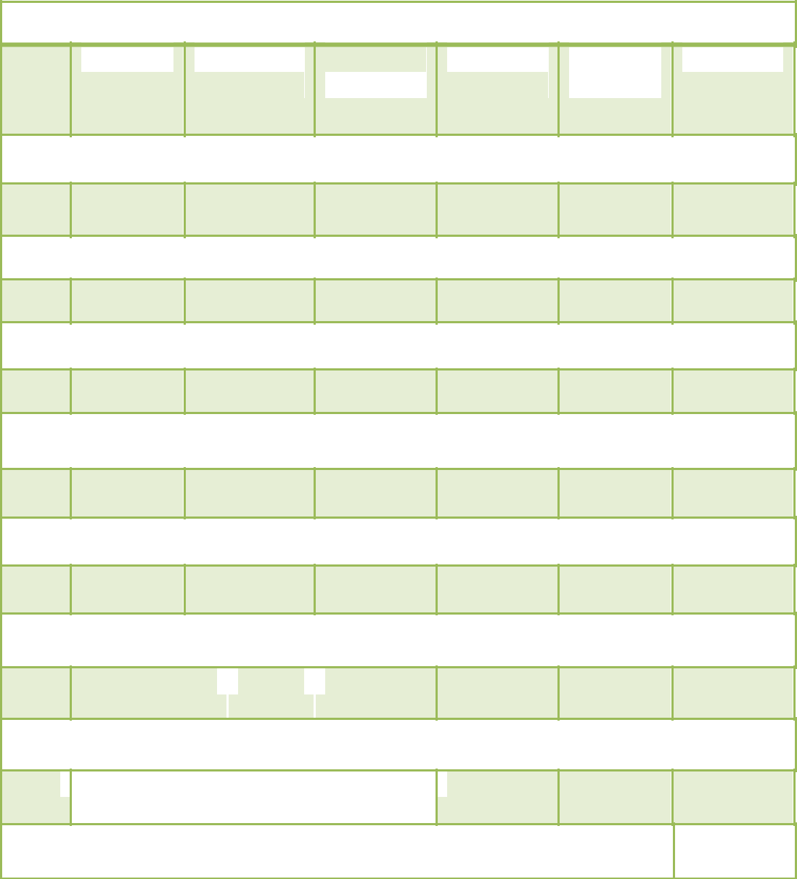

**eHEALS items 3-9:** Self-perceptions of eHealth literacy skills & efficacy

n

**Strongly**

**Agree**

**Somewhat**

**Agree**

**Not sure/**

**No opinion**

**Somewhat**

**Disagree**

**Strongly Disagree**

**Weighted**

**Average**

**3. I know what health resources are available on the Internet.**

**36**

38.9%

47.2%

11.1%

2.8%

0.0%

4.22

**4. I know where and how to find helpful health information on the Internet.**

**36**

44.4%

44.4%

8.3%

0.0%

2.8%

4.28

**5. I know how to use the Internet to answer my questions about health.**

**36**

47.2%

41.7%

5.6%

0.0%

5.6%

4.25

**6. I know how to apply the health information I find on the Internet to help me.**

**36**

44.4%

47.2%

2.8%

0.0%

5.6%

4.25

**7. I have the skills I need to evaluate the health resources I find on the Internet.**

**36**

55.6%

27.8%

5.6%

2.8%

5.6%

4.29

1. **I can tell high quality health information from low quality health information on the Internet.**

**35**

45.7%

 37.1% 

11.4%

2.9%

2.9%

4.20

**9. I feel confident in using information from the Internet to make health decisions.**

**36**

|  |  |  |  |  |  |  |
| --- | --- | --- | --- | --- | --- | --- |
|  |  | 44.4% | 33.3% | 13.9% |  |  |
|  |  |  |  |  |  |  |

2.8%

5.6%

4.08

**Mean Weighted Average of items 3-9**

(standard deviation)

**4.22**

(0.83)

Table 6: Perceived usefulness (PU) frequencies among all survey responses



**How useful is the LWS website for meeting your HEALTH needs?**

|  |  |  |  |  |  |  |  |
| --- | --- | --- | --- | --- | --- | --- | --- |
|  |  |  | **Not** |  | **Not Useful** |  |  |
|  | **Very** | **Somewhat** | **Sure/No** | **Not Very** | **for My** | **Weighted** | **Std.** |
| **Responses** | **Useful** | **Useful** | **Opinion** | **Useful** | **Purposes** | **Average** | **Dev.** |
| 27 | 37.0% | 51.9% | 7.4% | 3.7% | 0.0% | 4.22 | 0.75 |

111

Table 7: Open-ended responses of useful content and features

|  |  |  |  |  |  |  |  |
| --- | --- | --- | --- | --- | --- | --- | --- |
|  | **Sample** |  | **“Other materials or sections you find useful.”** |  | |  | |
|  |  |  | |  | |
|  | **population** |  |  |  | |  | |
|  | **Leadership Team** |  | *Billboard, posters, facebook* |  | |  | |
|  |  |  |  |  | |  | |
|  | **Leadership Team** |  | *Information about the City's Pedestrian/Bicycle plan* | |  | |
|  |  |  |  | |  | |
|  | **FRC Attendees** |  | *I like the fact that the website is local right here in Western* |  | |  | |
|  |  |  | *Mass. The people on the screen a few I actually know. So the* |  | |  | |
|  |  |  | *news I'm reading is not hard to believe or far-fetched.* |  | |  | |
|  |  |  |  |  | |  | |
|  | **FRC Attendees** |  | *Recipes & Tips* | |  | |
|  |  |  |  | |  | |
|  | **FRC Attendees** |  | *Fun & Fitness, Hiking trails* |  | |  | |
|  |  |  |  |  | |  | |

Table 8: Weighted average ratings of satisfaction and likelihood to return

**Mean Satisfaction and Likelihood to Return**

|  |  |  |
| --- | --- | --- |
| **Survey Population** | **Satisfaction** | **Likelihood to Return** |
| Leadership Team Members (n=10) | 4.89 (0.33) | 4.89 (0.33) |
|  |  |  |
| Online Respondents (n=8) | 4.63 (0.52) | 4.50 (0.76) |
| FRC Respondents (n=10) | 4.78 (0.70) | 4.90 (0.32) |
|  |  |  |
| Total Respondents (n=28) | 4.78 (0.42) | 4.79 (0.50) |
|  |  |  |

Weighted averages on 5-point Likert scale (standard deviation)

Table 9: User satisfaction frequencies for combined sample



**Considering all of the content and features, I'm satisfied with the LWS website.**

|  |  |  |  |  |  |  |  |
| --- | --- | --- | --- | --- | --- | --- | --- |
|  |  |  | **Not sure/** |  |  |  |  |
|  | **Strongly** | **Somewhat** | **No** | **Somewhat** | **Strongly** | **Weighted** | **Std.** |
| **Responses** | **Agree** | **Agree** | **opinion** | **Disagree** | **Disagree** | **Average** | **Dev.** |
| 27 | 78.8% | 22.2% | 0.0% | 0.0% | 0.0% | 4.78 | 0.42 |

112

Table 10: Frequency of responses for perceptions of LWS stories

|  |  |  |  |  |  |  |  |  |  |  |  |  |
| --- | --- | --- | --- | --- | --- | --- | --- | --- | --- | --- | --- | --- |
|  |  | ***n*** |  | **Strongly** | **Somewhat** | **Not sure/ No** | **Somewhat** | **Strongly** | **Weighted** | **Std.** |  |  |
|  |  |  | **Agree** | **Agree** | **opinion** | **Disagree** | **Disagree** | **Average** | **Dev.** |  |  |
|  |  |  |  |  |  |
|  |  |  |  |  |  |  |  |  |  |  |  |  |
|  |  | *1.* | *These stories are meant for people like me.* | | | | |  |  |  |  |  |
|  |  | | |  |  |  |  |  |  |  |  |  |
|  | 27 | | | 70.4% | 22.2% | 7.4% | 0.0% | 0.0% | 4.63 | 0.63 |  |  |
|  |  | |  |  |  |  |  |  |  |  |  |  |
|  |  | *2.* | *The people featured in the stories seem trustworthy and sincere.* | | | | | |  |  |  |  |
|  |  | | |  |  |  |  |  |  |  |  |  |
|  | 28 | | | 78.6% | 14.3% | 7.1% | 0.0% | 0.0% | 4.71 | 0.60 |  |  |
|  |  | |  |  |  |  |  |  |  |  |  |  |
|  |  | *3.* | *The nutrition topics presented are important to me.* | | | | |  |  |  |  |  |
|  |  | | |  |  |  |  |  |  |  |  |  |
|  | 18 | | | 66.7% | 27.8% | 5.6% | 0.0% | 0.0% | 4.61 | 0.61 |  |  |
|  |  | |  |  |  |  |  |  |  |  |  |  |
|  |  | *4.* | *The physical activity topics presented are important to me.* | | | | | |  |  |  |  |
|  |  | | |  |  |  |  |  |  |  |  |  |
|  | 19 | | | 68.4% | 21.1% | 10.5% | 0.0% | 0.0% | 4.58 | 0.69 |  |  |
|  |  | |  |  |  |  |  |  |  |  |  |  |
|  |  | *5.* | *The lifestyle changes made by the storytellers seem achievable and realistic to me.* | | | | | | | |  |  |
|  |  | | |  |  |  |  |  |  |  |  |  |
|  | 28 | | | 82.1% | 14.3% | 3.6% | 0.0% | 0.0% | 4.79 | 0.50 |  |  |
|  |  | |  |  |  |  |  |  |  |  |  |  |
|  |  | *6.* | *This website is a good way to share and display these stories.* | | | | | |  |  |  |  |
|  |  | | |  |  |  |  |  |  |  |  |  |
|  | 29 | | | 79.3% | 13.8% | 6.9% | 0.0% | 0.0% | 4.72 | 0.59 |  |  |
|  |  | |  |  |  |  |  |  |  |  |  |  |
|  |  | *7.* | *I prefer reading health messages that are presented as stories.* | | | | | |  |  |  |  |
|  |  | | |  |  |  |  |  |  |  |  |  |
|  | 18 | | | 55.6% | 38.9% | 5.6% | 0.0% | 0.0% | 4.50 | 0.62 |  |  |
|  |  | |  |  |  |  |  |  |  |  |  |  |
|  |  | *8.* | *I prefer messages with just facts and no story.* | | | | |  |  |  |  |  |
|  |  | | |  |  |  |  |  |  |  |  |  |
|  | 17 | | | 11.8% | 17.6% | 29.4% | 35.3% | 5.9% | 2.94 | 1.14 |  |  |
|  |  | |  |  |  |  |  |  |  |  |  |  |
|  |  | *9.* | *I feel better able to make healthy lifestyle choices after reading these stories.* | | | | | | |  |  |  |
|  |  | | |  |  |  |  |  |  |  |  |  |
|  | 28 | | | 57.1% | 21.4% | 21.4% | 0.0% | 0.0% | 4.36 | 0.83 |  |  |
|  |  |  |  |  |  |  |  |  |  |  |  |  |
|  |  |  |  |  |  |  |  |  |  |  |  |  |

*10. I feel motivated to eat healthy and/or be physically active after reading these stories.* 

|  |  |  |  |  |  |  |  |  |  |  |
| --- | --- | --- | --- | --- | --- | --- | --- | --- | --- | --- |
|  |  |  |  |  |  |  |  |  |  |  |
| 29 | | 58.6% | 17.2% | 20.7% |  | 3.4% | 0.0% | 4.31 | 0.93 |  |
|  |  |  |  |  |  |  |  |  |  |  |
|  |  |  |  |  | 113 | |  |  |  |  |

Table 11: Quotes related to message appeal for *Running the Numbers*

|  |  |
| --- | --- |
| **General** | **Responses to narrative 1A – *Running the Numbers*** |
| **Tone** |  |
|  |  |
| + | **A23:** And it’s nice to see a positive ending to the story. |
|  |  |
| + | **C21:** I think that it should be a mix of the two, you know the facts are |
|  | important as well, but if you have a story, an anecdote that you can put to |
|  | the facts, it just makes it more meaningful. |
|  |  |
| + | **C21:** I love it! I love it! I was very interested in his story. I was very moved. |
|  | I felt like I was watching a mini movie of his life! And I feel like you made a |
|  | good point, the importance to exercise… I’ve got to make changes and it |
|  | could have twofold effects on your life. So, it’s not just about the diabetes, |
|  | it’s everything else that’s connected to it too. And in the end, you know, |
|  | “find out how food and fitness can help regulate your diabetes.” And that’s |
|  | something that’s like an advertisement for good health! |
|  |  |
| + | **K13:** I am a diabetic, and I didn’t realize that the whole working out does a |
|  | lot for mental clarity. That was nice to know. I like the idea of a story |
|  | behind it more than just the facts, because I can tell you the facts, I know |
|  | the facts… I choose not to live them, but I know them. But the story I think |
|  | makes it more personal. |
|  |  |
| + | **S22:** … I like this guy’s story. It’s compelling. |
|  |  |
| + | **T12:** I like the story… not only do I know this man, but I also know how |
|  | exercising or stopping exercise can affect your health. |
|  |  |
| **Key** | **+ positive response** |
|  | **- negative response** |
|  |  |

114

Table 12: Quotes related to message appeal for *Diet and Exercise as a Prescription for Diabetes*

|  |  |  |  |  |  |
| --- | --- | --- | --- | --- | --- |
|  | **General** |  |  | **Responses to message 1B – *Diet and Exercise as a*** | |
|  | **Tone** |  |  | ***Prescription for Diabetes*** | |
|  |  |  |  |  |  | |
|  | + for message |  |  | **A23:** I would agree with the visual is kind of powerful, because I am |  | |
|  | appeal; |  |  | a right-brain learner, so symbols and visuals…. I know the writing |  | |
|  | ( - for |  |  | style with the bullets was helpful. But I think the story would be |  | |
|  | (effectiveness) |  |  | more easily remembered in terms of the overall impact than of the |  | |
|  |  |  |  | finer details of… Yeah, I would need to keep going back from time |  | |
|  |  |  |  | to time to make sure that I remember the numbers. I think that it is a |  | |
|  |  |  |  | good presentation. |  | |
| + | |  |  | **C11:** …though I liked the story, I still like this format better, as far as | |
|  |  |  |  | the bullets and the organization of it. And, I just think it’s easier to… | |
|  |  |  |  | like, you know, maybe you say you didn’t learn anything from it | |
|  |  |  |  | [*directed at K13*], but, somebody who doesn’t know these things… | |
|  |  |  |  | It’s easier for them to see the information in front of them, and get | |
|  |  |  |  | something out of it I feel like. | |
|  | - |  |  | **C21:** I just feel like ‘boo’ in comparison to the story of Gomersindo |  | |
|  |  |  |  | Gomez. As a matter of fact, this thing kind of put me to sleep. Like |  | |
|  |  |  |  | reading all of that print, I was like ‘wake me up.’ And the picture of |  | |
|  |  |  |  | the fruit and vegetables looked like pills to me, like ‘here’s your |  | |
|  |  |  |  | medication,’ is what my brain read, you know, instead of “here’s |  | |
|  |  |  |  | your prescription.” |  | |
| - | |  |  | **C21:** I just felt like it was a little too much, and a little overwhelming | |
|  |  |  |  | actually. The message is great. The information is good. I like | |
|  |  |  |  | hearing about some of the side effects, or some of the symptoms of | |
|  |  |  |  | diabetes. You know, it’s very important but in comparison, the other | |
|  |  |  |  | thing really touched me more. I read Gomersindo Gomez’s story | |
|  |  |  |  | and it made me want to go and work out. I read this and it made me | |
|  |  |  |  | want to go, ‘forget it, diabetes is too tough. I lose.’ | |
|  | |  |  |  | |
|  | - |  |  | **K13:** But, would I get anything out of this? I don’t think I would get |  | |
|  |  |  |  | anything out of this. To me, it looks like an educational piece. |  | |
|  |  |  |  |  |  | |
| - | |  |  | **L25:** If I’m looking for something to motivate me, to stay on track | |
|  |  |  |  | with what I already know, then the story’s the one to look at. | |
|  | |  |  |  | |
|  | + |  |  | **S22:** First of all, I am a visual, so I like the picture here and I love |  | |
|  |  |  |  | the caption, “here’s your prescription.” I like that a lot, the little |  | |
|  |  |  |  | diagram here, it makes sense. For me, it compelled me in a way, |  | |
|  |  |  |  | because I have feelings of guilt right now. |  | |
|  |  |  |  |  |  | |
|  | **Key** |  |  | **+ positive response** | |
|  |  |  |  | **- negative response** | |
|  |  |  |  |  |  | |

115

Table 13: Quotes related to message appeal for *Family First*

|  |  |  |  |  |  |
| --- | --- | --- | --- | --- | --- |
| **General** |  |  |  | **Responses to narrative 2A – *Family First*** | |
| **Tone** |  |  |  |  |  | |
|  |  |  |  |  |  | |
| + |  |  |  | **K13:** I was just looking to see where the recipe was. It says, “Learn how to |  | |
|  |  |  |  | make Idelia’s delicious…” I’m looking for the recipe! *[Laughter among the* |  | |
|  |  |  |  | *group]*. Where’s the recipe?! |  | |
|  |  |  |  |  |  | |
| + |  |  |  | **S22:** I appreciated the simplicity in this. Again, I like the story guideline. I | |
|  |  |  |  | love a story… | |
|  |  |  |  |  | |
| + |  |  |  | **S22:** It’s very catchy. |  | |
|  |  |  |  |  | |
| + |  |  |  | **S22:** … but I really appreciated this. And for me, I could tell, I could almost | |
|  |  |  |  | tell you the whole story and recite it back you knowing what I just read. … | |
|  |  |  |  | **Facilitator:** So, you can relate? | |
|  |  |  |  | **S22:** I can relate. | |
|  |  |  |  |  | |
| **Key** |  |  |  | **+ positive response** |  | |
|  |  |  |  | **- negative response** |  | |
|  |  |  |  |  |  | |
| Table 14: Quotes related to message appeal for *Pre-diabetes in Adolescents* | | | | | |
|  |  |  |  |  | |
| **General** |  |  |  | **Responses to message 2B – *Pre-diabetes in Adolescents*** | |
| **Tone** |  |  |  |  |  | |
|  |  |  |  |  | |
| - |  |  |  | **B26:** Basically this was a little bland. |  | |
|  |  |  |  |  | |
| - |  |  |  | **B26:** So, those numbers seem to be a little ridiculous to me. | |
|  |  |  |  |  | |
| + |  |  |  | **S22:** Let’s see, one of the things that stuck out for me, you mentioned |  | |
|  |  |  |  | $160,000 or less in a lifetime *[directed toward B26]*. I did however like the |  | |
|  |  |  |  | statistics, in that it did bring down the wages when they had been |  | |
|  |  |  |  | diagnosed or didn’t even know. |  | |
|  |  |  |  |  |  | |
| - |  |  |  | **C21:** I would much rather have the story about Larry and his mom cooking | |
|  |  |  |  | up their pozole soup … | |
|  |  |  |  |  | |
| + |  |  |  | **B26:** Now look, now that ad, that advertisement right there *[referring to the* |  | |
|  |  |  |  | *graphic on page 12]* happens to be very effective advertising for pre- |  | |
|  |  |  |  | diabetics: “Stop !” |  | |
|  |  |  |  |  |  | |
| + |  |  |  | **B26:** Would that, would that really make a difference? I don’t see… I don’t | |
|  |  |  |  | get that. I can understand the closeness, and the locale may be different, | |
|  |  |  |  | but I mean if you’re a diabetic, I mean, you got to just look at the numbers. | |
|  |  |  |  |  | |
| Neutral |  |  |  | **S22:** See I like it, always leave your audience wanting more. So, for me |  | |
|  |  |  |  | personally, you know where I stand with the story. I want to know more. |  | |
|  |  |  |  |  |  | |
| **Key** |  |  |  | **+ positive response** | |
|  |  |  |  | **- negative response** | |
|  |  |  | | |  | |
|  | 116 | | | |  | |

Table 15: Quotes related to relevance for *Running the Numbers*

|  |  |  |  |
| --- | --- | --- | --- |
| **General** |  | **Responses to narrative 1A – *Running the Numbers*** | |
| **Tone** |  |  | |
|  |  |  | |
| + |  | **A23:** I have someone in my family who has juvenile diabetes, and it’s really | |
|  |  | very sad to see a kid being in that situation, at such a young age. … I think | |
|  |  | even though that *[story]* might be for a different age group, all the awareness | |
|  |  | is always important I think, regardless of age. | |
|  |  |  | |
| + |  | **B26:** Well, I have to take this story pretty personally… this story just sort of | |
|  |  | hits me right on the nose personally. I can understand and sympathize with | |
|  |  | everything he’s saying here. | |
|  |  |  | |
| + |  | **B26:** Well, he seems familiar. Maybe it’s just the face. He has a familiar face | |
|  |  | here. | |
|  |  |  | |
| + |  | **B26:** I’m the same age and I have the same attitude, so of course it relates to | |
|  |  | me directly. The same M.O. that he has right here, you know – I used to go | |
|  |  | and exercise and was feeling better; lost weight and things like that, put on | |
|  |  | weight again: not taking the medicine as regularly as I should be, or the | |
|  |  | insulin. | |
|  |  |  | |
| Neutral |  | **C11:** … my dad has diabetes and you know, I don’t personally think this story | |
|  |  | would… he doesn’t take care of himself, and I don’t think this story would | |
|  |  | make him take care of himself, but, you know, it’s good for him to see other | |
|  |  | people doing it, and you know, maybe if he actually met this guy it would, that | |
|  |  | might give him some motivation. But, I don’t think the story alone would do it. | |
|  |  |  | |
| + |  | **C21:** … I think I know this guy. He seems so familiar to me. | |
|  |  |  | |
| + |  | **C21:** I think this story is for everybody, you know. Anybody who is mature | |
|  |  | enough to conceptualize the importance of health and the family, you can look | |
|  |  | at it from a different perspective because (you can say) ‘this is my dad.’ … So | |
|  |  | for me it’s like, ‘man, I’m reading about my dad,’ getting the perspective of | |
|  |  | how it might feel to be him. So, it can be the same thing for life, or another | |
|  |  | relative, your neighbor, or whoever. | |
|  |  |  | |
| + |  | **C21:** I think it’s a great message, and whoever’s reading it kind of reads it for | |
|  |  | themselves, from their vantage point. | |
|  |  |  | |
| + |  | **C21:** Once again it’s very personal. I think it really speaks to individuals and | |
|  |  | makes you identify someone in your family or your life, and you can find | |
|  |  | something to relate to. I mean, we all just went around the table, and there | |
|  |  | was something that everyone could relate to. Even though it is a 66-year-old | |
|  |  | Hispanic man from the community, we all related. That’s the key! It’s beautiful! | |
|  |  |  | |
| - |  | **G15:** The other side is more relevant for me… more facts than story. | |
|  |  |  | |
| Neutral |  | **G15:** This story was more important than knowing the guy or him on the | |
|  |  | treadmill, because it’s just an average, middle-aged man on a treadmill, | |
|  |  | working out. So, that didn’t affect me; his story did. | |
|  |  |  | |
|  | 117 | |

|  |  |
| --- | --- |
| **General** | **Responses to narrative 1A – *Running the Numbers*** |
| **Tone** |  |
|  |  |
| + | **G15:** The only part of the story that relates to me is that he has diabetes and |
|  | he’s Latino. And as my culture, my family, they mostly have diabetes. So, |
|  | that’s the only thing that’s really in common. |
|  |  |
| + | **K13:** Because he’s local it gives it more… it mentions the Veteran’s Center, |
|  | and I know where that is, and it gives more… it’s more tangible that way. |
|  |  |
| + | **K13:** I am a diabetic, and I didn’t realize that the whole working out does a lot |
|  | for mental clarity. That was nice to know. I like the idea of a story behind it |
|  | more than just the facts, because I can tell you the facts, I know the facts… I |
|  | choose not to live them, but I know them. But the story I think makes it more |
|  | personal. |
|  |  |
| + | **K13:** I relate because I am a diabetic. Beyond that, relating wise specifically |
|  | there’s really no relevance… |
|  |  |
| + | **L25:** I like the fact that he’s local. |
|  |  |
| Neutral | **L25:** I think the story should be moved around a little bit… to discuss, you |
|  | know, saying he is a native of Springfield, instead of all that being in the back |
|  | of the story. I think that would have a big impact on the story itself. |
|  |  |
| + | **S22:** And I guess you’re really getting your point across here, and I |
|  | appreciated his personal story. And I could relate with it, and I’d like to see a |
|  | follow up. |
|  |  |
| + | **T12:** I like the story… not only do I know this man, but I also know how |
|  | exercising or stopping exercise can affect your health. |
|  |  |
| + | **T12:** I mean, to me, like I said, not the diabetic but the high blood pressure, |
|  | but you know, I always try to like, press my daughter too, because she’s a |
|  | diabetic. |
|  |  |
| **Key** | **+ positive response** |
|  | **- negative response** |
|  |  |

118

Table 16: Quotes related to relevance for *Diet and Exercise as a Prescription for Diabetes*

|  |  |  |  |  |  |
| --- | --- | --- | --- | --- | --- |
|  | **General** |  |  | **Responses to message 1B – *Diet and Exercise as a Prescription for*** | |
|  | **Tone** |  |  | ***Diabetes*** | |
|  | |  |  |  |  | |
|  | - |  |  | **B26:** … the first one is more personal, and of course, this is also because |  | |
|  |  |  |  | we have diabetes, that’s personal. But it’s a little more rigid. |  | |
|  |  |  |  |  |  | |
| - | |  |  | **C11:** Anybody who has diabetes has heard this over and over again, but | |
|  |  |  |  | it’s really up to that person if they really want to make the change or not. | |
|  |  |  |  | And I don’t think information is really going to do it. I think, like I said with | |
|  |  |  |  | my dad… he just had his leg amputated this weekend from it…And I think if | |
|  |  |  |  | people were able to see where it really brings you, it might change their | |
|  |  |  |  | thought process…because it’s pretty ugly. | |
|  |  |  |  |  | |
|  | - (+ for |  |  | **C21:** Because they tell a story that speaks to you, and you relate to, and |  | |
|  | narratives) |  |  | you can kick it back at anytime. |  | |
|  | |  |  |  | |
| + | |  |  | **G15:** And this would also come out for like a teenager, to start, especially if | |
|  |  |  |  | they have family with diabetes… To eat more healthy, this is a simple | |
|  |  |  |  | guideline for them. | |
|  |  |  |  | **Facilitator:** So, relevant to a family member that is younger? | |
|  |  |  |  | **G15**: Yes. | |
|  | |  |  |  | |
|  | - |  |  | **K13:** But, would I get anything out of this? I don’t think I would get anything |  | |
|  |  |  |  | out of this. To me, it looks like an educational piece. |  | |
|  |  |  |  |  |  | |
| - | |  |  | **K13:** I know I keep repeating myself, but as a diabetic it’s not very relevant. | |
|  |  |  |  | For me to give it to my child, for them to understand it more, it might be | |
|  |  |  |  | relevant, but directly for me at this point in my life, it’s not relevant at all. | |
|  | |  |  |  | |
|  | + |  |  | **K13:** My mom’s at risk for pre-diabetes right now. So, I think that this would |  | |
|  |  |  |  | be a nice little, sweet blurb to give her. ...because she’s so far from that |  | |
|  |  |  |  | [referring to Gomersindo's story]. She’s not going to accept that as an |  | |
|  |  |  |  | answer. The other gentleman in the other story was… you know, he went |  | |
|  |  |  |  | bad and now he’s done good. This I think would be something good for pre- |  | |
|  |  |  |  | diabetic, so that they could… they see it and now it’s maybe a little more |  | |
|  |  |  |  | graspable than, you know, we all hear the horror stories… always hear the |  | |
|  |  |  |  | horror stories. So, it’s a nice little… ‘This is where you can start’…’These |  | |
|  |  |  |  | are the things you need to know.’ |  | |
|  |  |  |  |  |  | |
| + | |  |  | **S22:** This is a very accurate, very true, and this is the medication right here | |
|  |  |  |  | *[pointing to the photo of fruit in cups with the caption, “Here’s your* | |
|  |  |  |  | *prescription.”].* I can’t relate with the diabetes, although I had a best friend | |
|  |  |  |  | that I lost, dear to me, to diabetes. It took away his organs one by one, and | |
|  |  |  |  | I watched him deteriorate. | |
|  |  |  |  |  | |
|  | **Key** |  |  | **+ positive response** |  | |
|  |  |  |  | **- negative response** |  | |
|  |  |  |  |  |  | |

119

Table 17: Quotes related to relevance for *Family First*

|  |  |  |  |  |  |
| --- | --- | --- | --- | --- | --- |
|  | **General** |  |  | **Responses to message 2A – *Family First*** | |
|  | **Tone** |  |  |  |  | |
|  |  |  |  |  |  | |
|  | Neutral |  |  | **G15:** The picture didn’t do anything for me, I’m sorry. [*Laughter among the* |  | |
|  | (+/-) |  |  | *group*] It looks like what I do at home! And it doesn’t… |  | |
|  |  |  |  | **K13:** But that’s what it’s supposed to be! |  | |
|  |  |  |  | **G15**: But it doesn’t, you know… The image of the happy kid helping out in the |  | |
|  |  |  |  | kitchen is not working for me… because it’s a personal… it’s just, not right. |  | |
|  |  |  |  | But that’s it. |  | |
|  |  |  |  |  |  | |
| + | |  |  | **S22:** … It felt personal to me. I like this right here, “learn how to make Idelia’s | |
|  |  |  |  | delicious pozole soup.” I like that. | |
|  | |  |  |  | |
|  | + |  |  | **S22:** … but I really appreciated this. And for me, I could tell, I could almost tell |  | |
|  |  |  |  | you the whole story and recite it back you knowing what I just read. … |  | |
|  |  |  |  | **Facilitator:** So, you can relate? |  | |
|  |  |  |  | **S22:** I can relate. |  | |
|  |  |  |  |  |  | |
| - | |  |  | **B26:** Well personally, I cannot relate that well to this story. So, I’m sort of | |
|  |  |  |  | detached from this story… | |
|  | |  |  |  | |
|  | + |  |  | **C21:** … I love the fact that it mentions Van Horne Park. You know you could |  | |
|  |  |  |  | almost… I did imagine myself in the park kicking the soccer ball. I wish it had |  | |
|  |  |  |  | mentioned where that “pick your own farm” place was! I want to go by there |  | |
|  |  |  |  | and buy a piece of fruit, or vegetable. I think this is great. |  | |
|  |  |  |  |  |  | |
| + | |  |  | **L25:** Yeah, I did like the fact that she took the action and it paid off. Both of | |
|  |  |  |  | my sons are gluten-free. And we’ve seen great results from that… | |
|  |  |  |  |  | |
|  | **Key** |  |  | **+ positive response** |  | |
|  |  |  |  | **- negative response** |  | |
|  |  |  |  |  |  | |

120

Table 18: Quotes related to relevance for *Pre-diabetes in Adolescents*

|  |  |  |  |  |  |
| --- | --- | --- | --- | --- | --- |
|  | **General** |  |  | **Responses to narrative 2B – *Pre-diabetes in Adolescents*** | |
|  | **Tone** |  |  |  |  | |
|  | |  |  |  |  | |
|  | - |  |  | **R14:** …the financial aspect, that really has no place in this particular story- |  | |
|  |  |  |  | line, because now you’re just feeding into a whole different persona, probably. |  | |
|  |  |  |  | It’s irrelevant to the other facts. |  | |
|  |  |  |  |  |  | |
| + | |  |  | **K13:** I liked it because as a parent of an adolescent who is at risk for | |
|  |  |  |  | diabetes, it’d be nice to show to them, the kids. | |
|  | |  |  |  |  | |
|  | + |  |  | **T12:** I think, you know, it’s relevant. And I understand the cost fact that you’re |  | |
|  |  |  |  | talking about and stuff, and I know that things can be very costly. |  | |
|  |  |  |  |  |  | |
|  | Neutral |  |  | **C21:** Yeah, I definitely want it to be from that perspective *[local]*. | |
|  |  |  |  |  |  | |
|  | **Key** |  |  | **+ positive response** |  | |
|  |  |  |  | **- negative response** |  | |
|  |  |  |  |  |  | |
|  | Table 19: Quotes related to effectiveness for *Running the Numbers* | | | | |
|  |  |  |  |  |  | |
|  | **General** |  |  | **Responses to narrative 1A – *Running the Numbers*** | |
|  | **Tone** |  |  |  |  | |
|  | |  |  |  |  | |
|  | **+** |  |  | **B26:** I’m sorry *[L25]* and *[E24]*, I think that the way it is, is good… I like it the |  | |
|  |  |  |  | way it is; it relieves the pressure at the very end. |  | |
|  |  |  |  |  |  | |
| **+** | |  |  | **C11:** Yeah, it was a good story, and I do think the story aspect is more | |
|  |  |  |  | impactful on somebody who might be suffering from the same thing, than just | |
|  |  |  |  | the facts would be. But, like I said earlier, I think it depends what you’re | |
|  |  |  |  | looking for, you know? This is a good story if you’re looking for people who | |
|  |  |  |  | are going through the same thing that you are, and what worked for them. | |
|  | |  |  |  | |
|  | **-** |  |  | **C11:** … maybe if he actually met this guy it would, that might give him some |  | |
|  |  |  |  | motivation. But, I don’t think the story alone would do it. |  | |
|  |  |  |  |  |  | |
| **+** | |  |  | **C21:** I love it! I love it! I was very interested in his story. I was very moved. I | |
|  |  |  |  | felt like I was watching a mini movie of his life! And I feel like you made a | |
|  |  |  |  | good point, the importance to exercise… I’ve got to make changes and it | |
|  |  |  |  | could have twofold effects on your life. So, it’s not just about the diabetes, it’s | |
|  |  |  |  | everything else that’s connected to it too. And in the end, you know, “find out | |
|  |  |  |  | how food and fitness can help regulate your diabetes.” And that’s something | |
|  |  |  |  | that’s like an advertisement for good health! | |
|  | |  |  |  | |
|  | **+** |  |  | **C21:** Once again it’s very personal. I think it really speaks to individuals and |  | |
|  |  |  |  | makes you identify someone in your family or your life, and you can find |  | |
|  |  |  |  | something to relate to. I mean, we all just went around the table, and there |  | |
|  |  |  |  | was something that everyone could relate to. Even though it is a 66-year-old |  | |
|  |  |  |  | Hispanic man from the community, we all related. That’s the key! It’s beautiful! |  | |
|  |  |  |  |  |  | |
|  |  | 121 | | |  | |

|  |  |
| --- | --- |
| **General** | **Responses to narrative 1A – *Running the Numbers*** |
| **Tone** |  |
|  |  |
| **+** | **C21:** Yeah, I feel it would be highly effective. |
|  | **A23:** I agree as well. |
|  | **E24:** Yeah. |
|  |  |
| **-** | **Facilitator:** I see. So, the ending needs to be a little more directing perhaps? |
|  | **L25:** Um, connected to the story. |
|  | **E24:** Yeah, connected to the story. |
|  |  |
| **+** | **K13:** I am a diabetic, and I didn’t realize that the whole working out does a lot |
|  | for mental clarity. That was nice to know. I like the idea of a story behind it |
|  | more than just the facts, because I can tell you the facts, I know the facts… I |
|  | choose not to live them, but I know them. But the story I think makes it more |
|  | personal. |
|  |  |
| **-** | **L25:** The final paragraph I think could be a little bit stronger. Maybe if you said |
|  | something more like, learn, you know, find out how food and fitness can help, |
|  | but tie it into, do what Gomersindo did, you know. So that it’s a little more |
|  | closely tied, and not just standing out there by itself. |
|  |  |
| **+** | **R14:** … learning how to manage the diet better, as far as like, portioning, and |
|  | things like that. That’s how it would affect me. |
|  |  |
| **-** | **S22:** I feel like there should be something a little bit more in here *[pointing to* |
|  | *the space before the final line of the story]*. Because it does give you that |
|  | break like you had mentioned *[looking at B26]*, but all of the sudden it just kind |
|  | of changes, it shifts. I feel like there needs to be another little pop in there |
|  | between “I do” and “find out.” |
|  |  |
| **+** | **S22:** … I like this guy’s story. It’s compelling. |
|  |  |
| **+** | **S22:** And I guess you’re really getting your point across here, and I |
|  | appreciated his personal story. And I could relate with it, and I’d like to see a |
|  | follow up. |
|  |  |
| **+** | **T12:** I think that it would have an effect… if I was reading this and I wasn’t |
|  | taking care of myself it would definitely, you know, because I then I’m going to |
|  | go, ‘okay, wait a minute, I’ve got to do something to better my health. |
|  |  |
| **-** | **T12:** I’ve heard about Live Well and all that stuff because last year I did the |
|  | event, but I didn’t know about the website, not really. |
|  |  |
| Key | **+ positive response** |
|  | **- negative response** |
|  |  |

122

Table 20: Quotes related to effectiveness for *Diet and Exercise as a Prescription for Diabetes*

|  |  |  |  |  |  |
| --- | --- | --- | --- | --- | --- |
|  | **General** |  |  | **Responses to message 1B – *Diet and Exercise as a Prescription for*** | |
|  | **Tone** |  |  | ***Diabetes*** | |
|  | |  |  |  |  | |
|  | - |  |  | **G15:** It’s all confusing. It’s a mixed message to them. |  | |
|  | |  |  |  |  | |
| + | |  |  | **A23:** I would agree with the visual is kind of powerful, because I am a right- | |
|  |  |  |  | brain learner, so symbols and visuals…. I know the writing style with the | |
|  |  |  |  | bullets was helpful… | |
|  | |  |  |  | |
|  | - |  |  | **A23:** …But I think the story would be more easily remembered in terms of the |  | |
|  |  |  |  | overall impact than of the finer details of… Yeah, I would need to keep going |  | |
|  |  |  |  | back from time to time to make sure that I remember the numbers. I think that |  | |
|  |  |  |  | it is a good presentation. |  | |
|  |  |  |  |  |  | |
|  | Neutral |  |  | **B26:** And there may be one little sentence, or niche in either one of these | |
|  |  |  |  | stories that may turn it on. And one day you may be so relaxed, and all of the | |
|  |  |  |  | sudden you hear the same song that you’ve heard a hundred times, and that | |
|  |  |  |  | little phrase that was in there, all of the sudden you understood it. And it | |
|  |  |  |  | comes, ‘oh, that’s what he was saying.’ ‘All these years and I never | |
|  |  |  |  | understood what he was saying.’ | |
|  | |  |  |  | |
|  | - |  |  | **B26:** The first one is more personal, and of course, this is also because we |  | |
|  |  |  |  | have diabetes, that’s personal. But it’s *[Diet and Exercise as a Prescription for* |  | |
|  |  |  |  | *Diabetes]* a little more rigid. |  | |
|  |  |  |  |  |  | |
| + | |  |  | **C11:** Though I liked the story, I still like this format better, as far as the bullets | |
|  |  |  |  | and the organization of it. And, I just think it’s easier to… like, you know, | |
|  |  |  |  | maybe you say you didn’t learn anything from it [*directed at K13*], but, | |
|  |  |  |  | somebody who doesn’t know these things… It’s easier for them to see the | |
|  |  |  |  | information in front of them, and get something out of it I feel like. | |
|  |  |  |  | **K13:** Right. | |
|  | |  |  |  | |
|  | - |  |  | **C21:** I just feel like ‘boo’ in comparison to the story of Gomersindo Gomez. As |  | |
|  |  |  |  | a matter of fact, this thing kind of put me to sleep. Like reading all of that print, |  | |
|  |  |  |  | I was like ‘wake me up.’ And the picture of the fruit and vegetables looked like |  | |
|  |  |  |  | pills to me, like ‘here’s your medication,’ is what my brain read, you know, |  | |
|  |  |  |  | instead of “here’s your prescription.” |  | |
|  |  |  |  |  |  | |
| - | |  |  | **C21:** I just felt like it was a little too much, and a little overwhelming actually. | |
|  |  |  |  | The message is great. The information is good. I like hearing about some of | |
|  |  |  |  | the side effects, or some of the symptoms of diabetes. You know, it’s very | |
|  |  |  |  | important but in comparison, the other thing really touched me more. I read | |
|  |  |  |  | Gomersindo Gomez’s story and it made me want to go and work out. I read | |
|  |  |  |  | this and it made me want to go, ‘forget it, diabetes is too tough. I lose.’ | |
|  |  |  |  |  |  | |

123

|  |  |  |  |  |  |
| --- | --- | --- | --- | --- | --- |
|  | **General** |  |  | **Responses to message 1B – *Diet and Exercise as a Prescription for*** | |
|  | **Tone** |  |  | ***Diabetes*** | |
|  | |  |  |  |  | |
|  | - |  |  | **C21:** Besides the “Here’s your prescription,” there’s nothing on their about |  | |
|  |  |  |  | diet. So, have that picture and have some text about how good food is, the |  | |
|  |  |  |  | good food, how much of that can make a difference. And then have a similar |  | |
|  |  |  |  | one for the exercise. And split that up because there’s a lot of text and too |  | |
|  |  |  |  | much going on there. |  | |
|  |  |  |  |  |  | |
| - | |  |  | **C21:** *[Referring to the effectiveness of narratives]* Because they tell a story | |
|  |  |  |  | that speaks to you, and you relate to, and you can kick it back at anytime. | |
|  | |  |  |  | |
|  | - |  |  | **E24:** Yeah, maybe a compare and contrast style, as far as having… the |  | |
|  |  |  |  | message is good though, but having a… You want to reach everybody with |  | |
|  |  |  |  | diabetes, I know that’s the goal, but you kind of have to look at their lifestyles |  | |
|  |  |  |  | – what are people doing? … And I think you guys could get your message |  | |
|  |  |  |  | across though, but I mean but seeing it all just like this, I don’t know. |  | |
|  |  |  |  |  |  | |
| - | |  |  | **G15:** This image alone is just confusing as it is. | |
|  | |  |  |  | |
|  | - |  |  | **K13:** But, would I get anything out of this? I don’t think I would get anything |  | |
|  |  |  |  | out of this. To me, it looks like an educational piece. |  | |
|  |  |  |  |  |  | |
|  | Neutral |  |  | **K13:** It’s pretty factual. It’s very informative, but it’s not emotional at all. | |
|  | |  |  |  | |
|  | + |  |  | **K13:** My mom’s at risk for pre-diabetes right now. So, I think that this would |  | |
|  |  |  |  | be a nice little, sweet blurb to give her. ...because she’s so far from that |  | |
|  |  |  |  | [referring to Gomersindo's story]. She’s not going to accept that as an |  | |
|  |  |  |  | answer. The other gentleman in the other story was… you know, he went bad |  | |
|  |  |  |  | and now he’s done good. This I think would be something good for pre- |  | |
|  |  |  |  | diabetic, so that they could… they see it and now it’s maybe a little more |  | |
|  |  |  |  | graspable than, you know, we all hear the horror stories… always hear the |  | |
|  |  |  |  | horror stories. So, it’s a nice little… ‘This is where you can start’…’These are |  | |
|  |  |  |  | the things you need to know.’ |  | |
|  |  |  |  |  |  | |
| - | |  |  | **L25:** I think the graphic is too busy. I think you need to have two graphics: | |
|  |  |  |  | one for diet, and one for exercise. I like the picture when it’s in color. | |
|  | |  |  |  | |
|  | - |  |  | **L25:** If I’m looking for something to motivate me, to stay on track with what I |  | |
|  |  |  |  | already know, then the story’s the one to look at. |  | |
|  |  |  |  |  |  | |
| + | |  |  | **S22:** First of all, I am a visual, so I like the picture here and I love the caption, | |
|  |  |  |  | “here’s your prescription.” I like that a lot, the little diagram here, it makes | |
|  |  |  |  | sense. For me, it compelled me in a way, because I have feelings of guilt right | |
|  |  |  |  | now. | |
|  | |  |  |  | |
|  | + |  |  | **S22:** This is a very accurate, very true, and this is the medication right here |  | |
|  |  |  |  | *[pointing to the photo of fruit in cups with the caption, “Here’s your* |  | |
|  |  |  |  | *prescription.”].* I can’t relate with the diabetes, although I had a best friend that |  | |
|  |  |  |  | I lost, dear to me, to diabetes. It took away his organs one by one, and I |  | |
|  |  |  |  | watched him deteriorate. |  | |
|  |  |  |  |  |  | |
|  |  | 124 | | |  | |



|  |  |
| --- | --- |
| **General** | **Responses to message 1B – *Diet and Exercise as a Prescription for*** |
| **Tone** | ***Diabetes*** |

* **T12:** I feel the same way. You know, this is good information if you didn’t know a lot about, you know, diabetes and what’s going to happen if you don’t keep a good diet and exercise… so, it’s good information for people to know.

 Neutral  **T12:** But, you know, this picture here, I think I can see how this picture could maybe be confusing, but I look at that as, ‘okay, either you get injected or you eat good food and you exercise.’

|  |  |  |  |  |  |
| --- | --- | --- | --- | --- | --- |
|  | Key |  |  | **+ positive response** | |
|  |  |  |  | **- negative response** | |
|  |  | |  |  |  | |
|  | Table 21: Quotes related to effectiveness for *Family First* | | | | |
|  |  |  |  |  |  | |
|  | **General** |  |  | **Quotes related to effectiveness for narrative 2A – *Family First*** | |
|  | **Tone** |  |  |  |  | |
|  |  |  |  |  |  | |
|  | Neutral |  |  | **C21:** I think having a short version, and then to read more about the story |  | |
|  |  |  |  | ‘click here’ is good. Because you’re not presented with this big text, which on |  | |
|  |  |  |  | paper looks small, but on a website it looks, you know, it looks big. So, if it |  | |
|  |  |  |  | catches their attention, it wouldn’t catch his *[motioning toward B26],* but it |  | |
|  |  |  |  | would catch hers *[motioning toward S22].* So, she can click on it and go there, |  | |
|  |  |  |  | and he can click on the other one. But having just a few sentences, kind of |  | |
|  |  |  |  | summarizing and teasing the article, I think is a good way to do it… |  | |
|  |  |  |  |  |  | |
| - | |  |  | **E24:** Maybe point out what about their foods were unhealthy. Maybe some | |
|  |  |  |  | specifics so you can be educated on the types of foods… | |
|  |  |  |  |  | |
|  | Neutral |  |  | **G15:** It would work better for the parents of younger kids, and start doing it |  | |
|  |  |  |  | that way. |  | |
|  |  |  |  |  |  | |
| + | |  |  | **L25:** … bringing that into the story like ‘it’s possible to do it, you can do it too. | |
|  | |  |  |  | |
|  | - |  |  | **L25:** But once again the last little bit doesn’t connect to the story. |  | |
|  |  |  |  |  | |
|  | Neutral |  |  | **L25:** … maybe if there are any health benefits to the parents that might be | |
|  |  |  |  | kind of good to put in there too. | |
|  | |  |  |  | |
|  | + |  |  | **S22:** I guess it doesn’t really make a difference if it is in black and white or in |  | |
|  |  |  |  | color in this case. |  | |
|  |  |  |  |  |  | |
| + | |  |  | **S22:** It’s very catchy. | |
|  | |  |  |  | |
|  | + |  |  | **G15:** You know, that’s a good segue, that picture. |  | |
|  | |  |  |  | |
| - | |  |  | **B26:** I already said I was disconnected from this story, so it’s not going to do | |
|  |  |  |  | that much more for me. | |
|  |  |  |  | |  | |
|  |  | 125 | | |  | |

Table 22: Responses to *Pre-diabetes in Adolescents* related to effectiveness

|  |  |  |  |  |  |  |
| --- | --- | --- | --- | --- | --- | --- |
|  | **General** |  |  | **Quotes related to effectiveness for message 2B – *Pre-diabetes in*** | | |
|  | **Tone** |  |  | ***Adolescents*** | | |
|  | |  |  |  |  |  | |
|  | + |  |  | **G15:** I think the stop sign one… |  |  | |
|  |  |  |  | **Facilitator:** Would be more effective? |  |  | |
|  |  |  |  | **G15:** …Would be more effective than the other. |  |  | |
|  |  |  |  |  |  |  | |
| - | |  |  | **B26:** I thought there should be a little information on the total numbers. | | |
|  | |  |  |  | | |
|  | - |  |  | **B26:** I know it said, “1 in 400 children” there, but say ‘within a year.’ The |  |  | |
|  |  |  |  | total number should be in the advertisement; say ‘four thousand,’ ‘two |  |  | |
|  |  |  |  | thousand,’ whatever it may be there so I can, or a child can, or anyone can |  |  | |
|  |  |  |  | relate, ‘oh, so that many?’. I don’t think that they can relate to 1 in 400… |  |  | |
|  |  |  |  |  |  |  | |
| - | |  |  | **B26:** When it starts talking about the pre-diabetic situation, and it starts | | |
|  |  |  |  | talking about a ‘delay,’ I don’t think that’s quite understandable to most | | |
|  |  |  |  | people that may have diabetes. | | |
|  | |  |  |  | | |
|  | - |  |  | **B26:** So, I think that should be reworded somehow, a different message. |  |  | |
|  |  |  |  | And the thing about the” high school dropout rate is 6% higher among |  |  | |
|  |  |  |  | adolescents with diabetes compared to students without,” doesn’t |  |  | |
|  |  |  |  | particularly tell me why they’re 6% higher. Or, why are people with diabetes |  |  | |
|  |  |  |  | earning $160,000 less in their lifetime. So, I look at that and I say, ‘gee, I |  |  | |
|  |  |  |  | must have had diabetes back then and I don’t think I earned anything less… |  |  | |
|  |  |  |  |  |  |  | |
| + | |  |  | **B26:** Oh, I don’t know, that’s kind of... Now look, now that ad, that | | |
|  |  |  |  | advertisement right there *[referring to the graphic on page 12]* happens to be | | |
|  |  |  |  | very effective advertising for pre-diabetics: “Stop !” | | |
|  | |  |  |  | | |
|  | - |  |  | **C21:** As a young person I would see this and be like, ‘boring!’ You know, |  |  | |
|  |  |  |  | and not really pay any attention to it, unfortunately, because it’s good |  |  | |
|  |  |  |  | information. And in terms of the picture, I feel like it’s kind of corny. You |  |  | |
|  |  |  |  | know, it’s nice, but corny. |  |  | |
|  |  |  |  |  |  |  | |
| - | |  |  | **C21:** You cannot find a watermelon like that in Springfield. You know, you | | |
|  |  |  |  | probably can, but it doesn’t seem that way. | | |
|  | |  |  |  | | |
|  | - |  |  | **C21:** I’m sorry, one second, one second *[L25]*. I couldn’t help but think about |  |  | |
|  |  |  |  | what you said earlier about the facts *[directed toward L25]*, that the facts are |  |  | |
|  |  |  |  | important but the facts have to give you the facts. And I find like these |  |  | |
|  |  |  |  | numbers are just so general. …Are they in Springfield? Are they in |  |  | |
|  |  |  |  | Massachusetts?..in the United States?.. in the world?.. in North America? |  |  | |
|  |  |  |  |  |  |  | |
| - | |  |  | **L25:** Yeah. For this graphic *[referring to the graphic on page 12]*, I think, he | | |
|  |  |  |  | *[referring to B26]* pointed out we’ve got 1 in 400 children are diagnosed with | | |
|  |  |  |  | diabetes. …Use the numbers for the pre-diabetes there, because everything | | |
|  |  |  |  | else on there is ‘when you have pre-diabetes, how to stop diabetes.’ | | |
|  | |  |  |  | | |
|  | - |  |  | **L25:** If you want to say that diet and exercise have the biggest impact, which |  |  | |
|  |  |  |  | is what you’re trying to say in this graphic, show that diet and exercise have |  |  | |
|  |  |  |  | the biggest impact with the facts that you select. |  |  | |
|  |  |  |  |  |  |  | |
|  |  | 126 | | |  |  | |

|  |  |  |  |  |  |  |  |
| --- | --- | --- | --- | --- | --- | --- | --- |
|  | **General** | | | **Quotes related to effectiveness for message 2B – *Pre-diabetes in*** | |  | |
|  | **Tone** | | | ***Adolescents*** | |  | |
|  |  |  |  |  |  |  | |
|  | Neutral | | | **L25:** If you make sure you have resources, a links page, and that will point | |  | |
|  |  |  |  | people to the right place if they want facts, and what to do, and how to do it. | |  | |
|  |  |  |  |  |  |  | |
|  | + (- for | | | **R14:** I think it would be more effective, but at the same time, you know, the |  |  | |
|  | perceived | | | financial aspect, that really has no place in this particular story-line… |  |  | |
|  | purpose) | | |  |  |  | |
| + | |  |  | **S22:** I’m a big bullets fan. On the back here with the “good news,” I like that. | |  | |
|  |  |  |  | Would I check out the references? Yes, I would, I’d click on them. | |  | |
|  |  |  |  |  |  |  | |
|  | **Key** | | | **+ positive response** |  |  | |
|  |  |  |  | **- negative response** |  |  | |
|  |  |  |  |  |  |  | |
|  | Table 23: Responses to *Running the Numbers* related to perceived purpose | | | | | |
|  |  |  |  |  |  | |
|  | **General** | |  | **Quotes related to perceived purpose for narrative 1A – *Running the*** | | |
|  | **Tone** | |  | ***Numbers*** | | |
|  | |  |  |  |  | |
|  | + |  |  | **A23:** I have someone in my family who has juvenile diabetes, and it’s really |  |  | |
|  |  |  |  | very sad to see a kid being in that situation, at such a young age. … I think |  |  | |
|  |  |  |  | even though that [story] might be for a different age group, all the awareness |  |  | |
|  |  |  |  | is always important I think, regardless of age. |  |  | |
|  |  |  |  |  |  |  | |
| + | |  |  | **C11:** Yeah, it was a good story, and I do think the story aspect is more | | |
|  |  |  |  | impactful on somebody who might be suffering from the same thing, than just | | |
|  |  |  |  | the facts would be. But, like I said earlier, I think it depends what you’re | | |
|  |  |  |  | looking for, you know? This is a good story if you’re looking for people who | | |
|  |  |  |  | are going through the same thing that you are, and what worked for them. | | |
|  | |  |  |  | | |
|  | + |  |  | **C21:** I think this story is for everybody, you know. Anybody who is mature |  |  | |
|  |  |  |  | enough to conceptualize the importance of health and the family, you can |  |  | |
|  |  |  |  | look at it from a different perspective because (you can say) ‘this is my dad.’ |  |  | |
|  |  |  |  | … So for me it’s like, ‘man, I’m reading about my dad,’ getting the perspective |  |  | |
|  |  |  |  | of how it might feel to be him. So, it can be the same thing for life, or another |  |  | |
|  |  |  |  | relative, your neighbor, or whoever. |  |  | |
|  |  |  |  |  |  |  | |
| + | |  |  | **C21:** I think it’s a great message, and whoever’s reading it kind of reads it for | | |
|  |  |  |  | themselves, from their vantage point. | | |
|  | |  |  |  | | |
|  | + |  |  | **S22:** I just started jotting down a target audience, who to target. I put down |  |  | |
|  |  |  |  | like mental health peeps, you know, PTSD, diabetes people, weight loss |  |  | |
|  |  |  |  | winners, and persons existing with current exercise routine and healthy |  |  | |
|  |  |  |  | lifestyle choices, veterans, and exercise nuts. So, that’s kind of the audience |  |  | |
|  |  |  |  | that I found here. |  |  | |
|  |  |  |  |  |  |  | |
|  | Key | |  | **+ positive response** | | |
|  |  |  |  | **- negative response** | | |
|  |  |  |  |  |  |  | |
|  |  |  |  | 127 |  |  | |

Table 24: Responses to *Diet and Exercise as a Prescription for Diabetes* related to perceived purpose

|  |  |  |  |  |  |
| --- | --- | --- | --- | --- | --- |
|  | **General** |  |  | **Quotes related to perceived purpose for message 1B – *Diet and*** | |
|  | **Tone** |  |  | ***Exercise as a Prescription for Diabetes*** | |
|  | |  |  |  |  | |
|  | + |  |  | **G15:** And I think the younger group, younger kids might like this idea better |  | |
|  |  |  |  | than the older, and… because it’s more simple, and pointed to them than |  | |
|  |  |  |  | pointed toward adults. |  | |
|  |  |  |  |  |  | |
| + | |  |  | **G15:** And this would also come out for like a teenager, to start, especially if | |
|  |  |  |  | they have family with diabetes… To eat more healthy, this is a simple | |
|  |  |  |  | guideline for them. | |
|  |  |  |  | **Facilitator:** So, relevant to a family member that is younger? | |
|  |  |  |  | **G15**: Yes. | |
|  | |  |  |  | |
|  | + |  |  | **K13:** My mom’s at risk for pre-diabetes right now. So, I think that this would |  | |
|  |  |  |  | be a nice little, sweet blurb to give her. ...because she’s so far from that |  | |
|  |  |  |  | *[referring to Gomersindo's story].* She’s not going to accept that as an |  | |
|  |  |  |  | answer. The other gentleman in the other story was… you know, he went bad |  | |
|  |  |  |  | and now he’s done good. This I think would be something good for pre- |  | |
|  |  |  |  | diabetic, so that they could… they see it and now it’s maybe a little more |  | |
|  |  |  |  | graspable than, you know, we all hear the horror stories… always hear the |  | |
|  |  |  |  | horror stories. So, it’s a nice little… ‘This is where you can start’…’These are |  | |
|  |  |  |  | the things you need to know.’ |  | |
|  |  |  |  |  |  | |
|  | Neutral |  |  | **K13:** The first one almost feels like it was aimed at a diabetic… | |
|  |  |  |  |  | |
|  | Key |  |  | **+ positive response** |  | |
|  |  |  |  | **- negative response** |  | |
|  |  |  |  |  |  | |

128

Table 25: Responses to *Family First* related to perceived purpose

|  |  |  |  |  |  |  |  |  |
| --- | --- | --- | --- | --- | --- | --- | --- | --- |
|  |  | **General** |  |  |  | **Quotes related to perceived purpose for narrative 2A – *Family First*** | |  |
|  |  | **Tone** |  |  |  |  |  |  |
|  |  | |  |  |  |  |  |  |
|  |  | - |  |  |  | **T12:** I can read this, and I can try these at home all I want, but it’s very |  |  |
|  |  |  |  |  |  | difficult to get kids… |  |  |
|  |  |  |  |  |  |  |  |  |
|  |  | Neutral |  |  |  | **C11:** I think the message would be best for a parent to say… | |  |
|  |  |  |  |  |  | **G15:** Um hmm. [expression of agreement] | |  |
|  |  |  |  |  |  | **C11:** …that’s who makes the decision for the kids. If that’s what they want | |  |
|  |  |  |  |  |  | them to do, then they have to make the commitment also. | |  |

 Neutral  **G15:** It would work better for the parents of younger kids, and start doing it



that way.

* **C21:** I think it’s great for the whole family. You know, the mother, the father, the siblings – everybody can relate to this in some small way… And it just really speaks to the importance that the mother had to keep her family healthy. You know, for them it was a 911 emergency. And she, you know, responded to it immediately. And that was very touching.

|  |  |  |  |  |
| --- | --- | --- | --- | --- |
|  | Neutral |  | **B26:** …‘I encourage my mother now to make, or do, or whatever. Or my |  |
|  |  |  | father’s now taking us out for exercise, and walks and things like that, and we |  |
|  |  |  | do it as a family. So, from a child’s point-of-view I think it relates more, or can |  |
|  |  |  | be more effective for children who may not understand really what they have |  |
|  |  |  | and the problems it may cause, either now or later in life. |  |
|  |  |  |  |  |
|  | Neutral |  | **B26:** But if I were to take this from a family point-of-view, and since the child |  |
|  |  |  | has the problem of diabetes, I may approach this from a child or children’s |  |
|  |  |  | point-of-view, and what they think, and what they know about diabetes. And |  |
|  |  |  | maybe it can relate to other children in that situation. |  |
|  |  |  |  |  |
|  | - |  | **E24:** But with this type of message, you kind of have to go the full spectrum, |  |
|  |  |  | kind of go into to everybody’s kitchen. And so make sure there’s not one, like |  |
|  |  |  | group. |  |
|  |  |  |  |  |
|  | Key |  | **+ positive response** |  |
|  |  |  | **- negative response** |  |

129

Table 26: Responses to *Pre-diabetes in Adolescents* related to perceived purpose

|  |  |  |  |  |  |
| --- | --- | --- | --- | --- | --- |
|  | **General** |  |  | **Quotes related to perceived purpose for message 2B – *Pre-diabetes in*** | |
|  | **Tone** |  |  | ***Adolescents*** | |
|  | |  |  |  |  | |
|  | + |  |  | **A23:** This kind of goes with how parents can parent themselves in raising |  | |
|  |  |  |  | children with early diabetes… it’s kind of, the parents’ guide … |  | |
|  |  |  |  |  |  | |
| + | |  |  | **A23:** Yeah, certainly I think this would be a good message for parents. And | |
|  |  |  |  | maybe on the website, it could kind of get parents audience attracted by | |
|  |  |  |  | using the words ‘parents’ something, ‘parents, here’s something,’ ‘here’s a | |
|  |  |  |  | guide for you,’ or something. | |
|  |  |  |  |  | |
|  | Neutral |  |  | **A23:** For the young ones it may be nice to have a section that says, |  | |
|  |  |  |  | ‘prevention is better than cure.’ |  | |
|  |  |  |  |  |  | |
| + | |  |  | **B26:** I would think that it would be more tailored for the youth. | |
|  | |  |  |  | |
|  | - |  |  | **B26:** I would set it up from the child’s point-of-view. You know, I mean, I |  | |
|  |  |  |  | understand how important the parents are, but they’re not that important. |  | |
|  |  |  |  |  |  | |
|  | Neutral |  |  | **B26:** They are important in trying to get the child to maintain the weight, to | |
|  |  |  |  | exercise, to realize he’s a diabetic. But you know outside of that family is a | |
|  |  |  |  | whole new world of friends, and buddies, and relationships, and social | |
|  |  |  |  | situations, and then the stratification of the family themselves. So, that child | |
|  |  |  |  | must spend a hell of a lot more time going to school, playing ball, and out | |
|  |  |  |  | there, and a thousand other kids most have soda and chips out there and | |
|  |  |  |  | he’s got to taste one or two. | |
|  |  |  |  | *[Some laughter among the group]* | |
|  |  |  |  |  | |
|  | Neutral |  |  | **B26:** ...If we’re looking at someone who has diabetes and they know they |  | |
|  |  |  |  | have it, they’re already seeing some type of counselor, or provider, or |  | |
|  |  |  |  | medical doctor. So, these are all things that are added to the information and |  | |
|  |  |  |  | education they get from their providers. |  | |
|  |  |  |  |  |  | |
| + | |  |  | **B26:** Would that, would that really make a difference? I don’t see… I don’t | |
|  |  |  |  | get that. I can understand the closeness, and the locale may be different, but | |
|  |  |  |  | I mean if you’re a diabetic, I mean, you got to just look at the numbers. | |
|  | |  |  |  | |
|  | + |  |  | **C21:** I think that those facts about the high school leads to earnings, that |  | |
|  |  |  |  | would probably be for teenagers. You know, I think that might get their |  | |
|  |  |  |  | attention or, ‘oh man, this is serious. |  | |
|  |  |  |  |  |  | |
|  | Neutral |  |  | **C21:** The rest of it is probably for the parents, you know. | |
|  |  |  |  |  | |
|  | Neutral |  |  | **E24:** So you have to really get out and communicate to the youth. You kind |  | |
|  |  |  |  | of have to talk with them. So, you have to meet them at their schools, talk |  | |
|  |  |  |  | with them, communicate with them, see how they interact, listen to their |  | |
|  |  |  |  | lingo, and that’s how you get through. |  | |
|  |  |  |  |  |  | |
|  | Neutral |  |  | **E24:** You kind of have to talk to them, see where they’re minds are at. That | |
|  |  |  |  | way you can figure out how to address the problem. | |
|  |  |  |  | |  | |
|  |  | 130 | | |  | |

|  |  |  |  |  |  |
| --- | --- | --- | --- | --- | --- |
|  | **General** |  |  | **Quotes related to perceived purpose for message 2B – *Pre-diabetes in*** | |
|  | **Tone** |  |  | ***Adolescents*** | |
|  | |  |  |  |  | |
|  | - |  |  | **E24:** Technology is probably a problem for increasing diabetes… just like we |  | |
|  |  |  |  | were saying when we were younger we would be outside, we were playing, |  | |
|  |  |  |  | we were active, we weren’t confined to a room. |  | |
|  |  |  |  |  |  | |
| (+/-) | |  |  | **K13:** They’re a different target. This is for… | |
|  |  |  |  | **G15:** But it seems like it is more geared toward the factual, and this is the | |
|  |  |  |  | diet plan, it could tie into that quicker… than…That’s why I was looking… like | |
|  |  |  |  | we were talking about… this is more for like a pre-diabetic, or somebody | |
|  |  |  |  | who’s gaining the information. | |
|  |  |  |  |  | |
|  | Neutral |  |  | **K13:** One thing it doesn’t mention that I thought could be a better tactic is the |  | |
|  |  |  |  | amount of elementary age children who have type 2 diabetes is so prevalent |  | |
|  |  |  |  | in the Springfield area… When I heard them it was mortifying to me. … But |  | |
|  |  |  |  | this would be something good to show the children, if that’s the target |  | |
|  |  |  |  | audience. |  | |
|  |  |  |  |  |  | |
| - | |  |  | **L25:** Yeah. For this graphic *[referring to the graphic on page 12]*, I think, he | |
|  |  |  |  | *[referring to B26]* pointed out we’ve got 1 in 400 children are diagnosed with | |
|  |  |  |  | diabetes. …Use the numbers for the pre-diabetes there, because everything | |
|  |  |  |  | else on there is ‘when you have pre-diabetes, how to stop diabetes.’ | |
|  | |  |  |  | |
|  | - |  |  | **L25:** The one that’s in here *[referring to the text on page 13]* can be in there |  | |
|  |  |  |  | *[referring to the graphic on page 12]* instead of the one that we picked… |  | |
|  |  |  |  |  |  | |
| - | |  |  | **R14:** …the financial aspect, that really has no place in this particular story- | |
|  |  |  |  | line, because now you’re just feeding into a whole different persona, | |
|  |  |  |  | probably. | |
|  | |  |  |  | |
|  | + |  |  | **S22:** Yeah, um, talk about having it tailored to what audience. Before… I’ll |  | |
|  |  |  |  | say about the second paragraph, the first thing I… actually before that, I |  | |
|  |  |  |  | could see a school panel sitting here looking at this… |  | |
|  |  |  |  |  |  | |
| + | |  |  | **S22:** So, this is where I see, you know, a board of education changing their, | |
|  |  |  |  | their healthier eating habits and taking away those vendor machines, and | |
|  |  |  |  | having the adolescents be aware of how much time they’re spending… like | |
|  |  |  |  | we mentioned before the video games and watching TV. | |
|  |  |  |  |  | |
|  | **Key** |  |  | **+ positive response** |  | |
|  |  |  |  | **- negative response** |  | |
|  |  |  |  |  |  | |

131

Table 27: Responses to *Running the Numbers* related to appropriateness

|  |  |  |  |  |  |
| --- | --- | --- | --- | --- | --- |
|  | **General** |  |  | **Quotes related to appropriateness for narrative 1A – *Running the*** | |
|  | **Tone** |  |  | ***Numbers*** | |
|  | |  |  |  |  | |
|  | **+** |  |  | **T12:** We always go on the Internet looking for different things whenever we |  | |
|  |  |  |  | have a little problem or whatever… so, you know what I mean, that would be |  | |
|  |  |  |  | a good place to go to, if we knew it was there. |  | |
|  |  |  |  |  |  | |
|  | Key |  |  | **+ positive response** | |
|  |  |  |  | **- negative response** | |
|  |  | |  | | |
|  | Table 28: Responses to *Family First* related to appropriateness | | | | |
|  |  |  |  |  | |
|  | **General** |  |  | **Quotes related to appropriateness for message 2A – *Family First*** | |
|  | **Tone** |  |  |  |  | |
|  | |  |  |  | |
|  | + |  |  | **Facilitator:** Do you think it’s a good fit for the website? I see some nods… |  | |
|  |  |  |  | **C21:** Yes. |  | |
|  |  |  |  | **A23:** I think so, yeah. |  | |
|  |  |  |  |  |  | |
|  | **Key** |  |  | **+ positive response** | |
|  |  |  |  | **- negative response** | |
|  |  |  |  |  |  | |

Table 29: Responses to *Pre-diabetes in Adolescents* related to appropriateness

|  |  |  |  |  |  |
| --- | --- | --- | --- | --- | --- |
|  | **General** |  |  | **Quotes related to appropriateness for message 2B – *Pre-diabetes in*** | |
|  | **Tone** |  |  | ***Adolescents*** | |
|  |  | |  |  |  | |
|  | Neutral |  |  | **A23:** And on TV, on television… like a little clip or a documentary, |  | |
|  |  |  |  | highlighting some of the actual locals. |  | |
|  |  |  |  |  |  | |
|  | Neutral | | **B26:** See I would like the Youtube idea. And I would actually like that | | |
|  |  |  |  | because hopefully it would be a video that will stress what *[L25]* had said | |
|  |  |  |  | about the grains. Maybe we can show pictures of exactly how they react in | |
|  |  |  |  | the body, how individuals react to the body, and what would happen if you | |
|  |  |  |  | ate right versus someone who hasn’t been eating right. See and actually | |
|  |  |  |  | see it on films, see the progress of someone with diabetes, and if they | |
|  |  |  |  | changed their diet, ‘this is what can happen,’ and things like that. | |
|  |  | |  | | |
|  | Neutral |  |  | **K13:** I would see this, kind of like part of the article with the picture, and |  | |
|  |  |  |  | then click to follow, and then follow for more concrete facts, suggestions. |  | |
|  |  |  |  |  |  | |

132

|  |  |  |  |  |  |  |  |  |
| --- | --- | --- | --- | --- | --- | --- | --- | --- |
|  | **General** |  |  |  |  | **Quotes related to appropriateness for message 2B – *Pre-diabetes in*** | | |
|  | **Tone** |  |  |  |  |  | ***Adolescents*** | |
|  |  |  |  | |  |  |  |  | |
|  | (-) for |  | **C21:** And since we’re doing, since Springfield is local, have them, have their | | | | | |
|  | fact- |  | friends in the picture! That would be huge, because they’d be like, ‘look at | | | | | |
|  | based |  | me!’ ‘I’m on my picture talking about my health,’ you know. They would | | | | | |
|  | message |  | share the mess out of that. That would be everywhere. Everybody would | | | | | |
|  | 2B); |  | see that in the whole city, in the whole city. | | | | | |
|  | (+ for |  |  |  |  |  |  |  | |
|  | LWS.org) |  |  |  |  |  |  |  | |
|  |  |  |  | |  |  |  |  | |
|  | Neutral |  | **L25:** Pictures that can be posted on their channel on Facebook, linked to | | | | |  | |
|  |  |  | Twitter, pinned on Pinterest, whatever, you know, Instagram… stuff that you | | | | |  | |
|  |  |  | have a share button underneath that they can stick on their wall. Because if | | | | |  | |
|  |  |  | they, that’s the only way it’s going to be passed around. | | | | |  | |
|  |  |  |  |  |  |  |  |  | |
|  | Neutral |  | **L25:** If you make sure you have resources, a links page, and that will point | | | | | |
|  |  |  | people to the right place if they want facts, and what to do, and how to do it. | | | | | |
|  |  |  |  | |  |  |  | |
|  | Neutral |  | **A23:** Yeah, certainly I think this would be a good message for parents. And | | | | |  | |
|  |  |  | maybe on the website, it could kind of get parents audience attracted by | | | | |  | |
|  |  |  | using the words ‘parents’ something, ‘parents, here’s something,’ ‘here’s a | | | | |  | |
|  |  |  | guide for you,’ or something. | | | | |  | |
|  |  |  |  |  |  |  |  |  | |
|  | **Key** |  | **+ positive response** | | | | | |
|  |  |  | **- negative response** | | | | | |
|  |  |  | | |  |  |  | |
|  | Table 30: Responses illustrating group dynamics | | | | | | | |
|  |  | |  |  |  |  |  | |
|  | **Group** | |  |  |  |  | **Quotes Demonstrating Group Dynamics** | |
|  | **Dynamic** | |  |  |  |  |  |  | |
|  |  | | |  |  |  |  | |
|  | **Sympathy** | | |  |  |  | C11: **Anybody who has diabetes has heard this over and over again,** |  | |
|  |  |  |  |  |  |  | **but it’s really up to that person if they really want to make the** |  | |
|  |  |  |  |  |  |  | **change or not. And I don’t think information is really going to do it. I** |  | |
|  |  |  |  |  |  |  | **think, like I said with my dad… he just had his leg amputated this** |  | |
|  |  |  |  |  |  |  | **weekend from it…** |  | |
|  |  |  |  |  |  |  | Facilitator: **Wow.** |  | |
|  |  |  |  |  |  |  | C11: **…And I think if people were able to see where it really brings** |  | |
|  |  |  |  |  |  |  | **you, it might change their thought process…because it’s pretty ugly.** |  | |
|  |  |  |  |  |  |  | ***[Expressions of sympathy from the group]*** |  | |
|  | **Agreement/** | | |  |  |  | **B26:** Yeah, local is good. But when you’re doing a message, any type of | |
|  | **Counter-** | |  |  |  |  | message like this, it’s the consistency and trying to be as redundant… | |
|  | **argument** | |  |  |  |  | maybe once a week or once a day… | |
|  |  | |  |  |  |  |  | |
|  | **Agreement** | |  |  |  |  | **E24:** I second what she said. With the final statement here, it seems like |  | |
|  |  |  |  |  |  |  | in today’s society, people kind of catch on to things like this. |  | |
|  |  |  |  |  |  |  |  |  | |
|  |  |  |  | 133 | | | |  | |

|  |  |  |
| --- | --- | --- |
| **Group** |  | **Quotes Demonstrating Group Dynamics** |
| **Dynamic** |  |  |
|  |  |  |
| **Influence** |  | B26: So, we’re going to volunteer to stay later, right? |
|  |  | Facilitator: … and I’ll ask you, would anybody is willing to stay, we can |
|  |  | stay. |
|  |  | B26: We’re here. |
|  |  | Facilitator: Is that good with..? |
|  |  | B26: I’m not speaking for everyone, I’m just saying. |
|  |  | *[Laughter among group]* |
|  |  |  |
| **Debate** |  | **K13:** They’re a different target. This is for… |
|  |  | **G15:** But it seems like it is more geared toward the factual, and this is the |
|  |  | diet plan, it could tie into that quicker… than…That’s why I was looking… |
|  |  | like we were talking about… this is more for like a pre-diabetic, or |
|  |  | somebody who’s gaining the information. |
|  |  |  |
| **Debate,** |  | **B26:** I understand how important the parents are, but they’re not that |
| **Humor** |  | important. You see, I’m sorry *[directed toward the group]*… |
|  |  | *[Laughter among the group]* |
|  |  |  |
| **Debate** |  | **S22:** Let’s see, one of the things that stuck out for me, you mentioned |
|  |  | $160,000 or less in a lifetime *[directed toward B26]*. I did however like the |
|  |  | statistics, in that it did bring down the wages when they had been |
|  |  | diagnosed or didn’t even know. |
|  |  |  |
| **Humor** |  | **B26:** This picture? *[Pointing to the last graphic with the four adolescents]* |
|  |  | **C21:** Yeah. I feel like it’s just kind of phony. And those kids are not from |
|  |  | Springfield. |
|  |  | *[Laughter among the group]* |
|  |  |  |
| **Debate** |  | **B26:** Oh, I’m sorry *[L25]*. Here again, we can’t actually use those |
|  |  | numbers for pre-diabetes because we have no idea really how many pre- |
|  |  | diabetics there are… |
|  |  |  |
| **Debate** |  | **L25:** Right. Well this… |
|  |  | **B26:** So that number would not be… I mean, it’s not… pre-diabetics don’t |
|  |  | come in and say, ‘I’m pre-diabetic, but I don’t want any medicine right |
|  |  | now.’ |
|  |  | **L25:** Well, in 2006, more than 16% were diagnosed with pre-diabetes, |
|  |  | so… |
|  |  | **B26:** Yeah, alright… |
|  |  | **L25:** So we could use that. |
|  |  | **B26:** Okay, well use that. |
|  |  |  |

134

Table 31: Suggestions made during discussion of message 1A – *Running the Numbers*

**Suggestions Made During Discussion of Message 1A – *Running the Numbers***

**B26:** I hope that we’re talking about, when we say the narrative, that we have some kind of picture, or physical picture to go along with that. It doesn’t have to be something that is overly gross or anything like that, but just a flash to just sort of depict an example of what is being said.



**B26:** Yeah, local is good. But when you’re doing a message, any type of message like this, it’s the consistency and trying to be as redundant… maybe once a week or once a day, whatever it is to get the message out. The messages themselves are not as effective until that person, or some people, decide that they just might listen to it, and just may respond on it.



**E24:** I second what she said. With the final statement here, it seems like in today’s society, people kind of catch on to things like this. You kind of want to round it out a little bit. It’s a good message though, it just seems it’s just directly in; you kind of want to introduce it a little better.



**Facilitator:** I see. So, the ending needs to be a little more directing perhaps?

**L25:** Um, connected to the story.

**E24:** Yeah, connected to the story.



**K13:** I would see this, kind of like part of the article with the picture, and then click to follow, and then follow for more concrete facts, suggestions.



**K13:** I think it mentions the Y… list the different Y’s, or you know, somehow to make it more… ‘okay, here we’ve talked about this, now here’s what you can do’… you’ve got the Springfield Y, the Dunbar Y, the Wilbraham Y, or Scantic Valley. Maybe mention different diabetes programs in the area; something to make it more… You know, it’s a pretty piece, but give it more concrete.



**L25:** The final paragraph I think could be a little bit stronger. Maybe if you said something more like, learn, you know, find out how food and fitness can help, but tie it into, do what Gomersindo did, you know. So that it’s a little more closely tied, and not just standing out there by itself.



**R14:** I think the story should be moved around a little bit… to discuss, you know, saying he is a native of Springfield, instead of all that being in the back of the story. I think that would have a big impact on the story itself.



**R14:** …make sure the little scan reader directs you to where you really need to go [referring to the QR-code on the poster]. Because there was, there was the event at the Dunbar, I went to scan one and it was locked out. You know, it was just a little card… and it was supposed to have a bunch of information on it; programs and all of the different things.



**S22:** Incorporating the statistics with that *[Running the Numbers]*, it definitely impacts the whole story.

135



**Suggestions Made During Discussion of Message 1A – *Running the Numbers***

**S22:** I feel like there should be something a little bit more in here *[pointing to the space before the final line of the story]*. Because it does give you that break like you had mentioned *[looking at B26]*, but all of the sudden it just kind of changes, it shifts. I feel like there needs to be another little pop in there between “I do” and “find out.”

**T12:** People need to know what it is, you know, in order for them to use it, and continue using it.

Table 32: Suggestions made during discussion of message 1B – *Diet and Exercise as a Prescription for Diabetes*

**Suggestions Made During Discussion of Message 1B – *Diet and Exercise as a Prescription for Diabetes***

**B26:** Again, what I want to make clear is that any message pertaining to diabetes is good. It’s the repetitiveness of it… It’s like listening to a song sometimes. Sometimes you hear a song and you like it, or you don’t like it, or you didn’t understand the words.



**C21:** … besides the “Here’s your prescription,” there’s nothing on their about diet. So, have that picture and have some text about how good food is, the good food, how much of that can make a difference. And then have a similar one for the exercise. And split that up because there’s a lot of text and too much going on there.

**E24:** Yeah, maybe a compare and contrast style, as far as having… the message is good though, but having a… You want to reach everybody with diabetes, I know that’s the goal, but you kind of have to look at their lifestyles – what are people doing? … And I think you guys could get your message across though, but I mean but seeing it all just like this, I don’t know.



**L25:** I think the graphic is too busy. I think you need to have two graphics: one for diet, and one for exercise. I like the picture when it’s in color.

136

Table 33: Suggestions made during discussion of message 2A – *Family First*



**Suggestions Made During Discussion of Message 2A – *Family First***

**C11:** I think the message would be best for a parent to say…

**G15**: Um hmm.

**C11:** …that’s who makes the decision for the kids. If that’s what they want them to do, then they have to make the commitment also.

**K13:** I was just looking to see where the recipe was. It says, “Learn how to make Idelia’s delicious…” I’m looking for the recipe! *[Laughter among the group]*. Where’s the recipe?!

**G15:** It would work better for the parents of younger kids, and start doing it that way. 

**E24:** But with this type of message, you kind of have to go the full spectrum, kind of go into to everybody’s kitchen. And so make sure there’s not one, like group.

**E24:** Maybe point out what about their foods were unhealthy. Maybe some specifics so you can be educated on the types of foods…

**C21:** I think having a short version, and then to read more about the story ‘click here’ is good. Because you’re not presented with this big text, which on paper looks small, but on a website it looks, you know, it looks big. So, if it catches their attention, it wouldn’t catch his *[motioning toward B26],* but it would catch hers *[motioning toward S22].* So, she can click on it and go there, and he can click on the other one. But having just a few sentences, kind of summarizing and teasing the article, I think is a good way to do it…

**B26:** But if I were to take this from a family point-of-view, and since the child has the problem of diabetes, I may approach this from a child or children’s point-of-view, and what they think, and what they know about diabetes. And maybe it can relate to other children in that situation.

**L25:** … maybe if there are any health benefits to the parents that might be kind of good to put in there too.

**B26:** …‘I encourage my mother now to make, or do, or whatever. Or my father’s now taking us out for exercise, and walks and things like that, and we do it as a family. So, from a child’s point-of-view I think it relates more, or can be more effective for children who may not understand really what they have and the problems it may cause, either now or later in life.

137

Table 34: Suggestions made during discussion of message 2B – *Pre-diabetes in Adolescents.*



**Suggestions Made During Discussion of Message 2B – *Pre-diabetes in***

***Adolescents***

**G15:** This *[Pre-diabetes in Adolescents]* could be the follow-up to it *[Family First]*.

**R14:** …the financial aspect, that really has no place in this particular story-line, because now you’re just feeding into a whole different persona, probably. It’s irrelevant to the other facts.

**K13:** One thing it doesn’t mention that I thought could be a better tactic is the amount of elementary age children who have type 2 diabetes is so prevalent in the Springfield area… When I heard them it was mortifying to me. … But this would be something good to show the children, if that’s the target audience.

**Facilitator:** ...I’ve heard that a combination is… could be effective?

**K13:** Yes.

**Facilitator:** I mean, I’ve heard somehow in this mix… *[All participants nod in agreement]*

**K13:** I know going back to the first, first story; the story is nice, but it would be a good segue for more factual stuff to go with it. I feel the same way with the most recent one. You know, the family story’s nice, and then follow it through with the… Like I said, I can picture it on the website, you have there a little article, a little section; you click it and then you go to the rest of the story, and there’s all your ugly facts. I think, to me that would be better than just one or the other.

**C11:** Yeah, I agree.

Facilitator: Do you agree? *[Directed toward R14. He nods his head in agreement.]*

**R14:** And that way it’s not sugar-coated.

**T12:** Yeah.

**C11:** Like I said, the information is out there. Everyone’s seen it. It’s just…

**G15:** How to catch them.

**C11:** Yup.

**B26:** I thought there should be a little information on the total numbers.

**B26:** I know it said, “1 in 400 children” there, but say ‘within a year.’ The total number should be in the advertisement; say ‘four thousand,’ ‘two thousand,’ whatever it may be there so I can, or a child can, or anyone can relate, ‘oh, so that many?’. I don’t think that they can relate to 1 in 400…

**B26:** When it starts talking about the pre-diabetic situation, and it starts talking about a ‘delay,’ I don’t think that’s quite understandable to most people that may have diabetes.

**B26:** So, I think that should be reworded somehow, a different message. And the thing about the” high school dropout rate is 6% higher among adolescents with diabetes compared to students without,” doesn’t particularly tell me why they’re 6% higher. Or, why are people with diabetes earning $160,000 less in their lifetime. So, I look at that and I say, ‘gee, I must have had diabetes back then and I don’t think I earned anything less…

138

**Suggestions Made During Discussion of Message 2B – *Pre-diabetes in***

***Adolescents***

**A23:** This kind of goes with how parents can parent themselves in raising children with early diabetes… it’s kind of, the parents’ guide…



**A23:** Yeah, certainly I think this would be a good message for parents. And maybe on the website, it could kind of get parents audience attracted by using the words ‘parents’ something, ‘parents, here’s something,’ ‘here’s a guide for you,’ or something.



**B26:** I would set it up from the child’s point-of-view. You know, I mean, I understand how important the parents are, but they’re not that important.



**Facilitator:** But maybe some people want local?



**S22:** Yeah. I like the local.

**L25:** Yeah. For this graphic *[referring to the graphic on page 12]*, I think, he *[referring to B26]* pointed out we’ve got 1 in 400 children are diagnosed with diabetes. …Use the numbers for the pre-diabetes there, because everything else on there is ‘when you have pre-diabetes, how to stop diabetes.’

**L25:** The one that’s in here *[referring to the text on page 13]* can be in there *[referring to the graphic on page 12]* instead of the one that we picked…



**L25:** If you want to say that diet and exercise have the biggest impact, which is what you’re trying to say in this graphic, show that diet and exercise have the biggest impact with the facts that you select.



**E24:** So you have to really get out and communicate to the youth. You kind of have to talk with them. So, you have to meet them at their schools, talk with them, communicate with them, see how they interact, listen to their lingo, and that’s how you get through.



**E24:** You kind of have to talk to them, see where they’re minds are at. That way you can figure out how to address the problem.

**L25:** Pictures that can be posted on their channel on Facebook, linked to Twitter, pinned on Pinterest, whatever, you know, Instagram… stuff that you have a share button underneath that they can stick on their wall. Because if they, that’s the only way it’s going to be passed around.



**B26:** See I would like the Youtube idea. And I would actually like that because hopefully it would be a video that will stress what *[L25]* had said about the grains. Maybe we can show pictures of exactly how they react in the body, how individuals react to the body, and what would happen if you ate right versus someone who hasn’t been eating right. See and actually see it on films, see the progress of someone with diabetes, and if they changed their diet, ‘this is what can happen,’ and things like that.



**A23:** And on TV, on television… like a little clip or a documentary, highlighting some of the actual locals.



**L25:** If you make sure you have resources, a links page, and that will point people to the right place if they want facts, and what to do, and how to do it.

139



**Suggestions Made During Discussion of Message 2B – *Pre-diabetes in***

***Adolescents***

**A23:** For the young ones it may be nice to have a section that says, ‘prevention is better than cure.’

Table 35: Frequencies of general perceptions – narrative vs. fact-based messages

**NARRATIVES** **FACT-BASED**



1A - *Running the Numbers*

1B - *Diet and Exercise as a Prescription for*



*Diabetes*

|  |  |  |  |  |  |  |  |  |  |  |  |  |  |  |  |  |  |  |  |  |  |  |  |  |  |  |  |  |  |  |  |  |  |  |  |
| --- | --- | --- | --- | --- | --- | --- | --- | --- | --- | --- | --- | --- | --- | --- | --- | --- | --- | --- | --- | --- | --- | --- | --- | --- | --- | --- | --- | --- | --- | --- | --- | --- | --- | --- | --- |
|  |  |  |  | Pos | |  | Neg |  |  |  |  | Total | |  |  |  |  | Pos |  | Neg | | |  |  |  |  |  |  | Total |  |  |  | |  | |
|  |  |  | (+) | |  | (-) | |  | Neutral |  |  | count | |  | Score | | (+) | | (-) | |  |  |  | Neutral | | | |  | count |  | Score | |  | |
|  | **MA** |  |  | 6 |  |  | 0 |  | 0 |  | 6 | |  |  | 6 |  |  | 3 |  | 4 |  |  | 0 | | |  |  | 7 | |  | -1 |  | |  | |
|  |  |  |  |  |  |  |  |  |  |  |  |  |  |  |  |  |  | |  | |
|  |  |  |  |  |  |  |  |  |  |  |  |  |  |  |  |  |  |  | |  | |
|  | **Rel** | | 16 | |  | 1 | | 3 | | 20 | | |  | 15 | |  | 3 | | 5 | |  |  | 0 | | |  |  | 8 | | -2 | |  | |  | |
|  |  |  |  |  |  |  |  |  |  |  | |  | |
|  | **Eff** |  |  | 12 |  |  | 6 |  | 0 |  | 18 | |  |  | 6 |  |  | 6 |  | 12 |  |  | 3 | | |  |  | 21 | |  | -6 |  | |  | |
|  |  |  |  |  |  |  |  |  |  |  |  |  |  |  |  |  |  | |  | |
|  |  |  |  |  |  |  |  |  |  |  |  |  |  |  |  |  |  |  | |  | |
|  | **PP/POV** | | 5 | |  | 0 | | 0 | | 5 | | |  | 5 | |  | 3 | | 0 | |  |  | 1 | | |  |  | 4 | | 3 | |  | |  | |
|  |  |  |  |  |  |  |  |  |  |  | |  | |
|  | **App** |  |  | 1 |  |  | 0 |  | 1 |  | 2 | |  |  | 1 |  |  | 0 |  | 0 |  |  | 0 | | |  |  | 0 | |  | 0 |  | |  | |
|  |  |  |  |  |  |  |  |  |  |  |  |  |  |  |  |  |  | |  | |
|  |  |  |  |  |  |  |  |  |  |  |  |  |  |  |  |  |  |  | |  | |
|  |  |  | 40 | |  | 7 | | 4 | | 51 | | |  | 33 | |  | 15 | | 21 | |  |  | 4 | | |  |  | 40 | | -6 | |  | |  | |
|  |  |  |  |  |  |  |  |  |  |  |  |  |  |  |  |  |  |  |  |  |  |  |  |  |  |  |  |  |  |  |  |  | |  | |
|  |  |  |  |  |  |  |  | 2A - *Family First* | | | | | |  |  |  |  |  | 2B - *Pre-Diabetes in Adolescents* | | | | | | | | | | | | | |  | |
|  |  |  |  |  | |  |  |  |  |  |  |  | |  |  |  |  |  |  |  |  |  |  |  |  |  |  |  |  |  |  |  | |  | |
|  |  |  |  | Pos |  |  | Neg |  |  |  |  | Total |  |  |  |  |  | Pos |  |  |  |  |  |  |  |  |  |  | Total |  |  |  | |  | |
|  |  |  |  | (+) |  |  | (-) |  | Neutral |  |  | count |  |  | Score |  |  | (+) |  | Neg (-) | |  |  |  | Neutral | |  |  | count |  | Score |  | |  | |
|  |  |  |  |  |  |  |  |  |  |  |  |  |  |  |  |  |  |  |  |  | |  | |
|  | **MA** | | 4 | |  | 0 | | 0 | | 4 | | |  | 4 | |  | 3 | | 3 | |  |  | 1 | | |  |  | 7 | | 0 | |  | |  | |
|  | **Rel** |  |  | 5 |  |  | 2 |  | 0 |  | | 7 |  |  | 3 |  |  | 2 |  | 1 |  |  |  | | 1 |  |  |  | 4 |  | 1 |  | |  | |
|  | **Eff** | | 4 | |  | 3 | | 3 | | 10 | | |  | 1 | |  | 4 | | 9 | |  |  | 1 | | |  |  | 14 | | -5 | |  | |  | |
|  | **PP/POV** |  |  | 1 |  |  | 2 |  | 4 |  | | 7 |  |  | -1 |  |  | 8 |  | 6 |  |  |  | | 7 |  |  |  | 21 |  | 2 |  | |  | |
|  | **App** | | 2 | |  | 0 | | 0 | | 2 | | |  | 2 | |  | 0 | | 1 | |  |  | 5 | | |  |  | 6 | | -1 | |  | |  | |
|  |  |  |  | 16 |  |  | 7 |  | 7 |  |  | 30 |  |  | 9 |  |  | 17 |  | 20 |  |  |  | | 15 |  |  |  | 52 |  | -3 |  | |  | |
|  |  |  |  |  |  |  |  |  |  |  |  |  |  |  |  |  |  |  |  |  |  |  |  |  |  |  |  |  |  |  |  |  | |  | |

Key: MA = message appeal, Rel = relevance, Eff = effectiveness, PP/POV = perceived purpose/

point-of-view, App = appropriateness

140

Table 36: Proportion of responses by theme

**Response Proportions by Theme**

|  |  |  |  |  |  |  |  |  |  |  |  |  |  |
| --- | --- | --- | --- | --- | --- | --- | --- | --- | --- | --- | --- | --- | --- |
|  |  |  |  |  |  |  |  |  |  |  |  |  |  |
|  |  | **Responses** |  | **Frequency** |  | **Positive** |  | **Negative** |  | **Neutral** |  |  |  |
| **Theme** |  | **(*n*)** |  | **(%)** |  | **(%)** |  | **(%)** |  | **(%)** |  |  |  |
| Msg Appeal | 24 | | 13.0% | | 18.2% | |  | 12.7% | 3.3% | |  |  |  |
|  |  | |  | |  | |  |  |  |  |  |  |  |
| Relevance |  | 39 |  | 21.2% |  | 29.5% |  | 16.4% |  | 13.3% |  |  |  |
| Effectiveness | 74 | | 40.2% | | 29.5% | |  | 54.5% | 23.3% | |  |  |  |
| Prcv'd Purpose/ |  |  |  |  |  |  |  |  |  |  |  |  |  |
|  | 37 |  | 20.1% |  | 19.3% |  | 14.5% |  | 40.0% |  |  |  |
|  |  |  |  |  |  |  |  |
| POV |  |  |  |  |  |  |  |  |
|  |  |  |  |  |  |  |  |  |  |  |  |  |
|  |  | |  | |  | |  |  |  |  |  |  |  |
| Appropriateness | 10 | | 5.4% | | 3.4% | |  | 1.8% | 20.0% | |  |  |  |
|  |  | |  | |  | |  |  |  | |  |  |  |
| **Sum** |  | 24 |  | 13.0% |  | 18.2% |  | 12.7% |  | 3.3% |  |  |  |
|  |  |  |  |  |  |  |  |
|  |  |  |  |  |  |  |  |  |  |  |  |  |  |

141

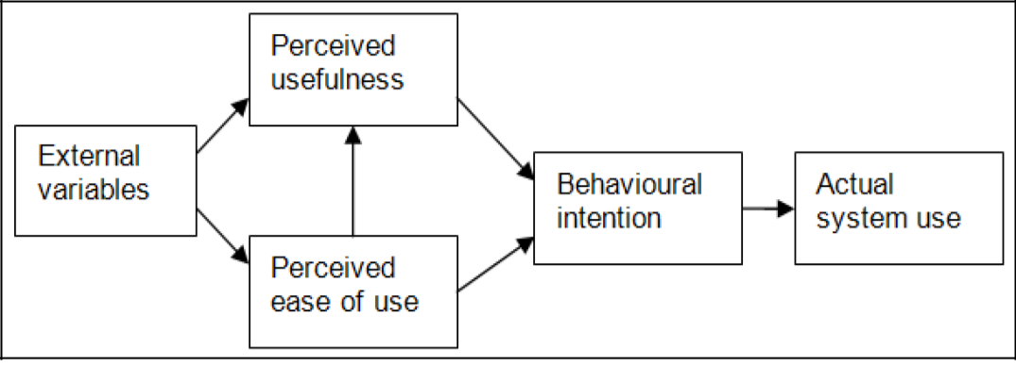

Figure 1: Technology Acceptance Model (TAM), (Davis et al., 1989)

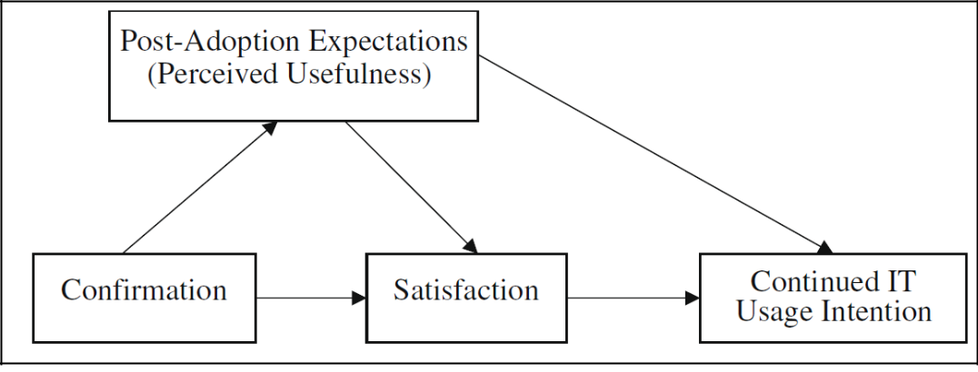

Figure 2: Expectation Confirmation Model (ECM), (Lee, 2010)

142

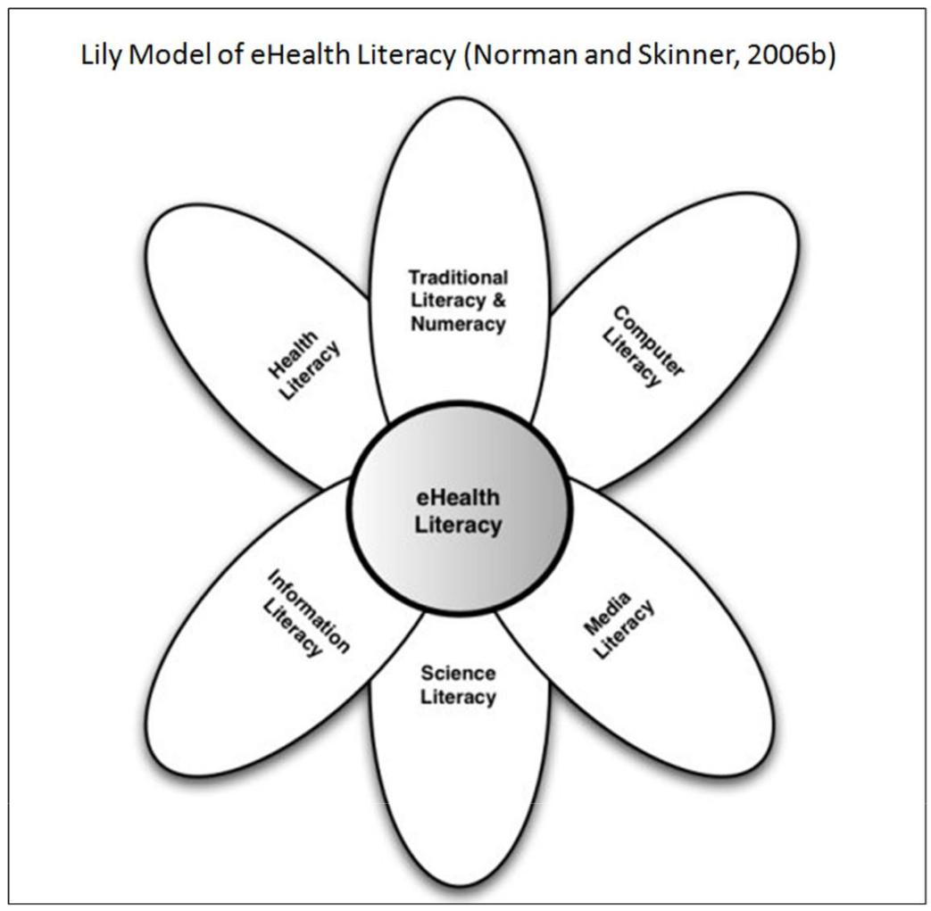

Figure 3: Lily Model of eHealth Literacy (Norman and Skinner, 2006b)

143

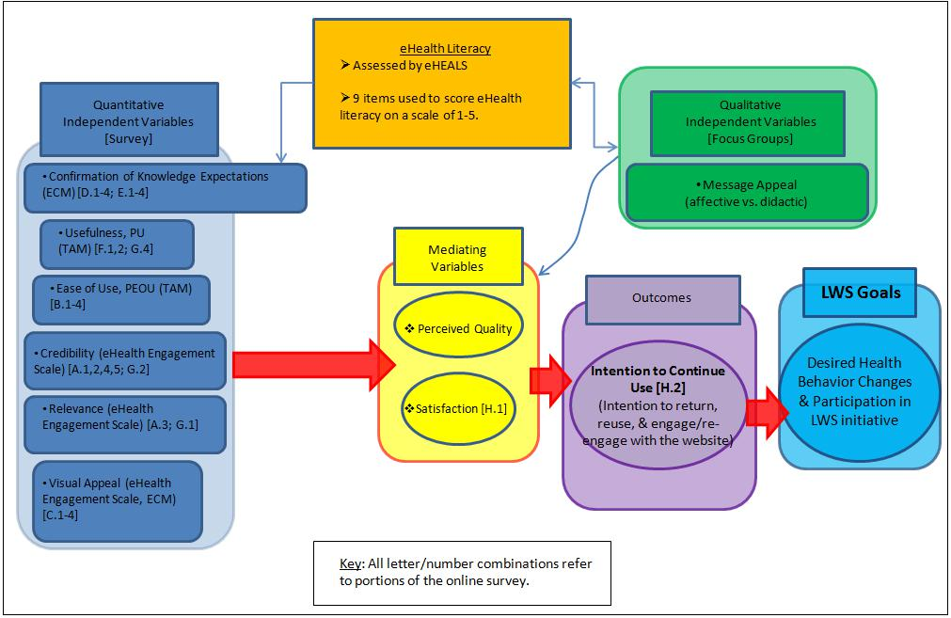

Figure 4: Conceptual model of LWS eHealth evaluation

144

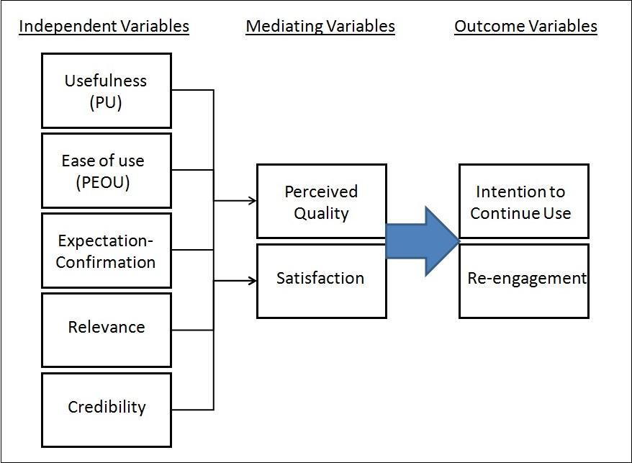

Figure 5: Survey Data Collection Model

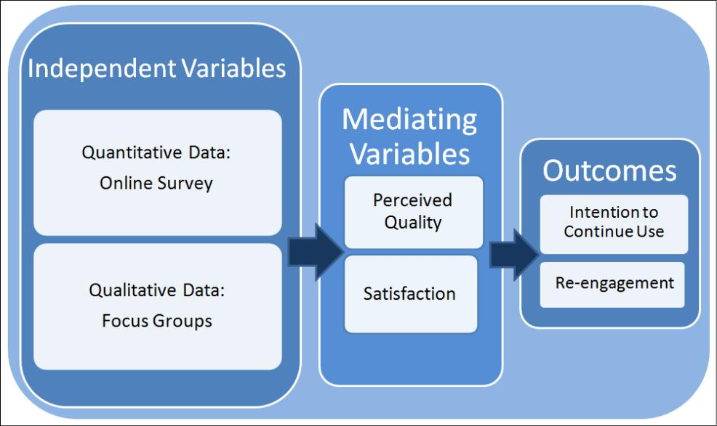

Figure 6: Data Collection Methods

145

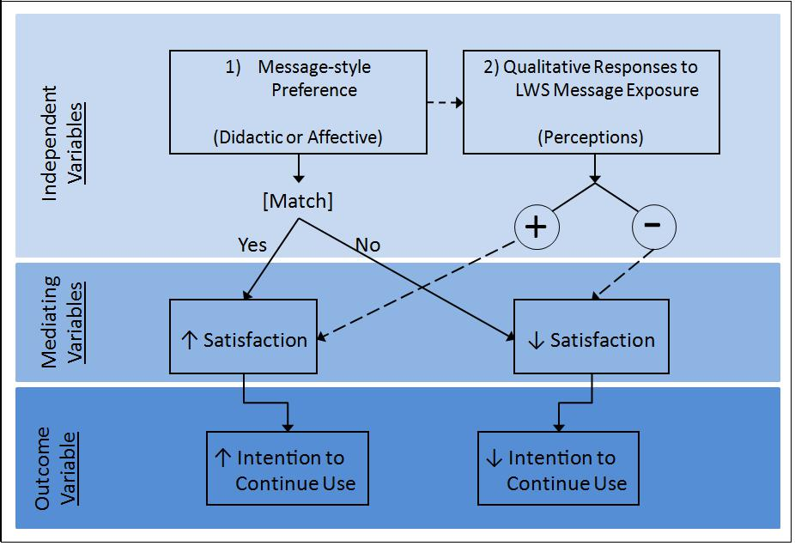

Figure 7: Conceptual Model of Focus Group Analysis

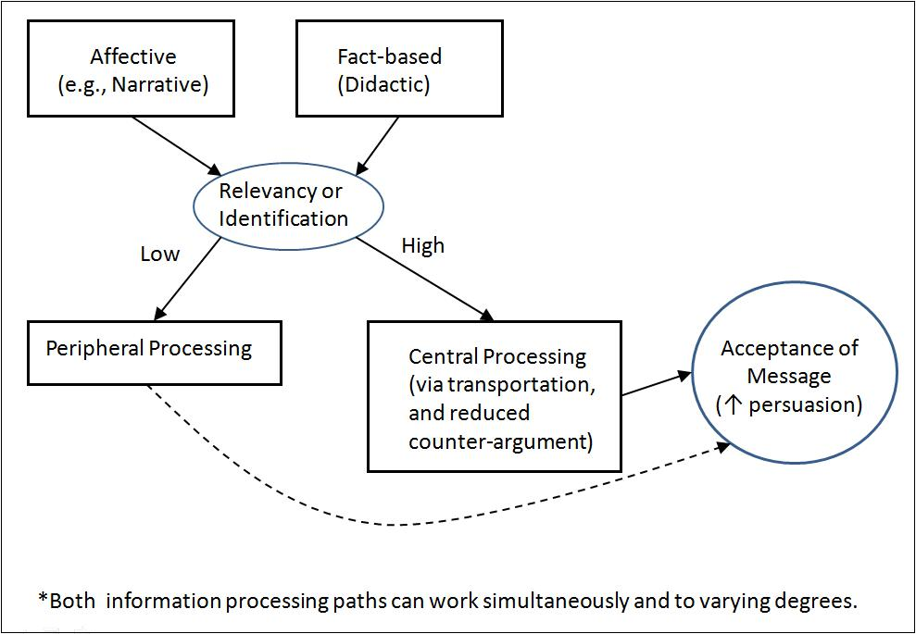

Figure 8: Dual-processing via Elaboration Likelihood Model (ELM), (adapted from Petty and Cacioppo, 1986; Dutta-Bergman, 2006; Hinyard and Kreuter, 2007)

146

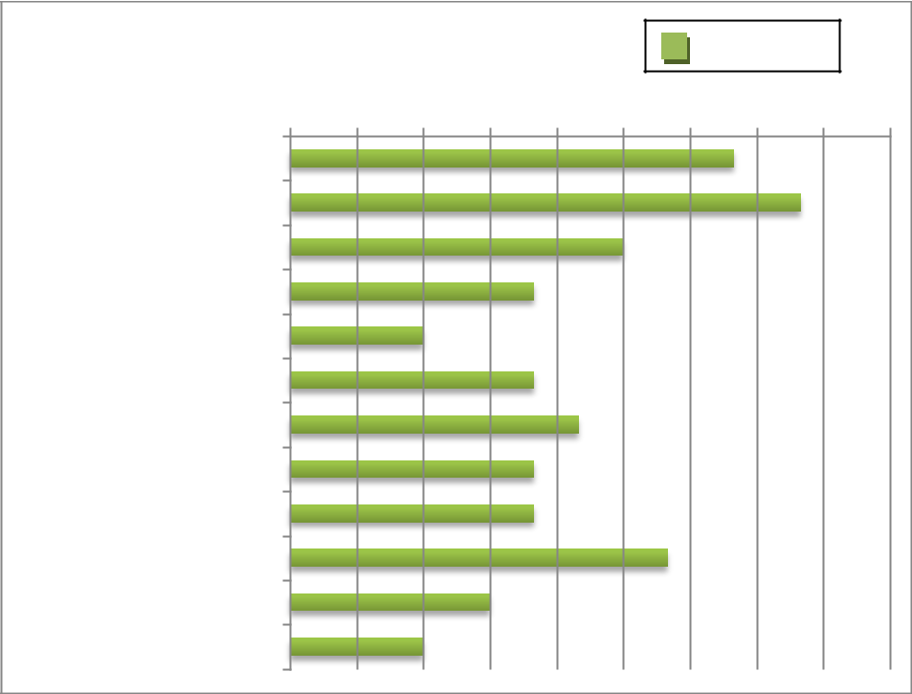

Response

|  |  |  |  |  |  |  |  |  |  |
| --- | --- | --- | --- | --- | --- | --- | --- | --- | --- |
| **Website Content** 0 | 1 | 2 | 3 | 4 | 5 | 6 | 7 | 8 | 9 |

Fun & Fitness

Healthy Eating

Go Fresh Mobile Market

Mason Sq. Food Justice

Videos

Your Stories

River Walk/ Bikeway

Pedestrian/ Bike Plan

Latest News

Calendar of Events

Just the Facts

Other

Figure 9: Perceived usefulness of specific website content

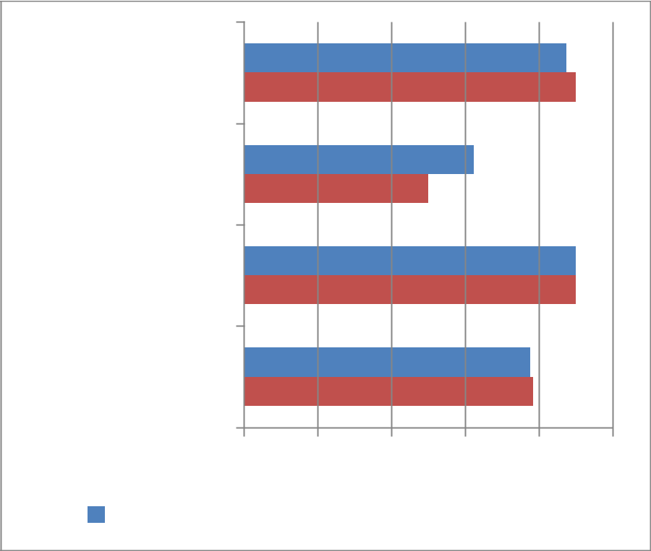

FRC Attendees

(n=9)

Online

Respondents (n=8)

Leadership Team

Members (n=10)

Total Respondent

Pool (n=27)

4.0 4.2 4.4 4.6 4.8 5.0

|  |  |  |  |
| --- | --- | --- | --- |
| Satisfaction |  | Likelihood to Return |  |
|  |  |
|  |  |

Figure 10: Mean satisfaction and likelihood to return

147

Brief examples of each message style were read to all focus group members.

Participants asked to compare and consider individual preference: Narrative vs. Fact-based

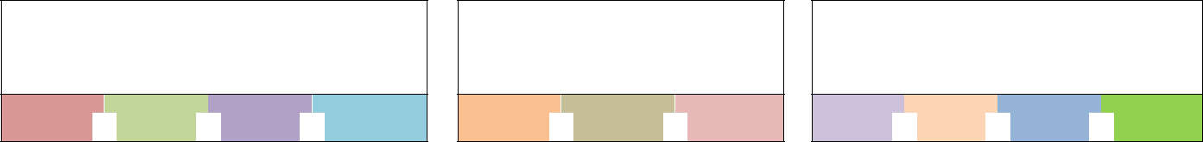

Initially stated preference for

Narrative-style Health Messages

**C21**  **S22**  **E24**  **L25**

No Preference, Neutral, or Stated Preference for Combination

**K13**  **A23**  **B26**



Initially stated preference for Fact-based Health Messages

**C11**  **T12**  **R14**  **G15**

Introduction to full written health message.

|  |  |  |  |  |  |  |  |  |  |  |  |  |  |  |  |  |  |  |  |  |  |  |  |  |  |  |  |  |  |  |  |  |  |  |  |  |  |
| --- | --- | --- | --- | --- | --- | --- | --- | --- | --- | --- | --- | --- | --- | --- | --- | --- | --- | --- | --- | --- | --- | --- | --- | --- | --- | --- | --- | --- | --- | --- | --- | --- | --- | --- | --- | --- | --- |
| **Response** |  |  |  |  |  | **Health Message 1A: Narrative - *Running the Numbers*** | | | | | | | | | | | | | | | | | | | | | | | | |  |  |  |  |  |  |  |
|  |  |  |  |  |  |  |  |  |  |  |  |
| **Category** |  |  |  |  |  |  |  |  |  |  |  |  |  |  |  |  |  |  |  |  |  |  |  |  |  |  |  |  |  |  |  |  |  |  |  |  |  |
|  |  |  |  |  |  |  |  |  |  |  |  |  |  |  |  |  |  |  |  |  |  |  |  |  |  |  |  |  |  |  |  |  |  |  |  |  |
| N/R = No |  |  |  |  |  |  |  |  |  |  |  |  |  |  |  |  |  |  |  |  |  |  |  |  |  |  |  |  |  |  |  |  |  |  |  |  |  |
| applicable |  |  |  |  |  |  |  |  |  |  |  |  |  |  |  |  |  |  |  |  |  |  |  |  |  |  |  |  |  |  |  |  |  |  |  | **Summed** |  |
| response |  | **C21** |  |  | **S22** |  |  | **E24** |  |  | **L25** |  |  |  | **K13** |  |  | **A23** |  |  | **B26** |  |  |  | **C11** |  |  | **T12** |  |  | **R14** |  |  | **G15** |  | **Score** |  |
|  |  | |  |  | |  |  |  | |  |  | |  |  | |  |  | |  |  |  | |  |  |  | |  | |  |  |  | |  |  |  |  |  |
| Msg. Appeal |  | 2 |  |  | 1 |  |  | N/R |  |  | N/R |  |  |  | 1 |  |  | 1 |  |  | N/R |  |  |  | N/R |  |  | 1 |  |  | N/R |  |  | N/R |  | 6 |  |
|  |  |  |  |  |  |  |  |  |  |  |  |  |  |  |  |  |  |  |  |  |  |  |  |  |  |  |  |  |  |  |  |  |  |  |  |  |
| Relevance/ |  |  |  |  |  |  |  |  |  |  |  |  |  |  |  |  |  |  |  |  |  |  |  |  |  |  |  |  |  |  |  |  |  |  |  |  |  |
| Personal |  | 4 |  |  | 1 |  |  | N/R |  |  | 1 |  |  |  | 3 |  |  | 1 |  |  | 3 |  |  |  | 0 |  |  | 2 |  |  | N/R |  |  | 0 |  | 16 |  |
| Importance |  |  |  |  |  |  |  |  |  |  |  |  |  |  |  |  |  |  |  |  |  |  |  |  |  |  |  |  |  |  |  |  |  |  |  |  |  |
| Effectiveness/ |  | 3 |  |  | 1 |  |  | 0 |  |  | -2 |  |  |  | 1 |  |  | 1 |  |  | 1 |  |  |  | 0 |  |  | 0 |  |  | 1 |  |  | N/R |  | 6 |  |
|  |  |  |  |  |  |  |  |  |  |  |  |  |  |  |  |  |  |  |  |  |  |  |  |  |
| Persuasiveness |  |  |  |  |  |  |  |  |  |  |  |  |  |  |  |  |  |  |  |  |  |  |  |  |  |
|  |  |  |  |  |  |  |  |  |  |  |  |  |  |  |  |  |  |  |  |  |  |  |  |  |  |  |  |  |  |  |  |  |  |  |  |  |
| Prcv'd Purpose/ |  | 2 |  |  | 1 |  |  | N/R |  |  | N/R |  |  |  | N/R |  |  | 1 |  |  | N/R |  |  |  | 1 |  |  | N/R |  |  | N/R |  |  | N/R |  | 5 |  |
|  |  |  |  |  |  |  |  |  |  |  |  |  |  |  |  |  |  |  |  |  |  |  |  |  |
| POV |  |  |  |  |  |  |  |  |  |  |  |  |  |  |  |  |  |  |  |  |  |  |  |  |  |
|  |  |  |  |  |  |  |  |  |  |  |  |  |  |  |  |  |  |  |  |  |  |  |  |  |  |  |  |  |  |  |  |  |  |  |  |  |
| Appropriate |  | N/R |  |  | N/R |  |  | N/R |  |  | N/R |  |  |  | N/R |  |  | N/R |  |  | N/R |  |  |  | N/R |  |  | 1 |  |  | N/R |  |  | N/R |  | 1 |  |
|  |  |  |  |  |  |  |  |  |  |  |  |  |  |  |  |  |  |  |  |  |  |  |  |  |
| for Website |  |  |  |  |  |  |  |  |  |  |  |  |  |  |  |  |  |  |  |  |  |  |  |  |  |
|  |  |  |  |  |  |  |  |  |  |  |  |  |  |  |  |  |  |  |  |  |  |  |  |  |  |  |  |  |  |  |  |  |  |  |  |  |

Figure 11: Focus group discussion procedure and scores for message 1A

148

|  |  |  |  |  |  |  |  |  |  |  |  |  |  |  |  |  |  |  |  |  |  |  |  |  |  |  |  |  |  |  |  |  |  |  |  |  |  |  |
| --- | --- | --- | --- | --- | --- | --- | --- | --- | --- | --- | --- | --- | --- | --- | --- | --- | --- | --- | --- | --- | --- | --- | --- | --- | --- | --- | --- | --- | --- | --- | --- | --- | --- | --- | --- | --- | --- | --- |
|  |  |  | **Health Message 1B: Fact-based - *Diet and Exercise as a*** | | | | | | | | | | | | | | | | | | | | | | | | | | | | | | | |  |  |  |  |
|  |  |  |  |  |  |  |
| **Response** |  |  |  |  |  |  |  |  |  |  | ***Prescription for Diabetes*** | | | | | | | | | | | | | | | | |  |  |  |  |  |  |  |  |  |  |  |
| **Category** |  |  |  |  |  |  |  |  |  |  |  |  |  |  |  |  |  |  |  |  |  |  |  |  |  |  |  |  |  |  |  |  |  |  |  |  |  |  |
|  |  |  |  |  |  |  |  |  |  |  |  |  |  |  |  |  |  |  |  |  |  |  |  |  |  |  |  |  |  |  |  |  |  |  |  |  |  |
| N/R = No |  |  |  |  |  |  |  |  |  |  |  |  |  |  |  |  |  |  |  |  |  |  |  |  |  |  |  |  |  |  |  |  |  |  |  |  |  |  |
| applicable |  |  |  |  |  |  |  |  |  |  |  |  |  |  |  |  |  |  |  |  |  |  |  |  |  |  |  |  |  |  |  |  |  |  |  |  | **Summed** |  |
| response |  | **C21** |  |  | **S22** |  |  | **E24** |  |  | **L25** |  |  |  | **K13** |  |  | **A23** |  |  | **B26** |  |  |  | **C11** |  |  | **T12** |  |  | **R14** |  | |  | **G15** |  | **Score** |  |
|  |  | |  |  | |  |  |  | |  |  | |  |  | |  |  | |  |  |  | |  |  | |  |  |  | |  |  | |  |  |  | |  |  |
|  |  | -2 |  |  | 1 |  |  | N/R |  |  | N/R |  |  |  | -1 |  |  | 2 |  |  | N/R |  |  |  | 1 |  |  | N/R |  |  | N/R |  | |  | N/R |  | 1 |  |
| Msg. Appeal |  |  |  |  |  |  |  |  |  |  |  |  |  |  |  |  |  |  |  |  |  |  |  |  |  |  |  |  |  |  |  |  |  |  |  |  |  |  |
| Relevance/ |  |  |  |  |  |  |  |  |  |  |  |  |  |  |  |  |  |  |  |  |  |  |  |  |  |  |  |  |  |  |  |  |  |  |  |  |  |  |
| Personal |  | -1 |  |  | 1 |  |  | N/A |  |  | 0 |  |  |  | 0 |  |  | N/A |  |  | -1 |  |  |  | -1 |  |  | N/R |  |  | N/R |  | |  | 1 |  | -1 |  |
| Importance |  |  |  |  |  |  |  |  |  |  |  |  |  |  |  |  |  |  |  |  |  |  |  |  |  |  |  |  |  |  |  |  |  |  |  |  |  |  |
| Effectiveness/ |  | |  |  | |  |  | |  |  | |  |  |  | |  |  | |  |  | |  |  |  | |  |  |  |  |  |  | |  |  |  |  |  |  |
|  | -3 |  |  | 2 |  |  | -1 |  |  | -2 |  |  |  | 1 |  |  | -2 |  |  | -1 |  |  |  | 1 |  |  | 1 |  |  | N/R |  | |  | -2 |  | -6 |  |
| Persuasiveness |  |  |  |  |  |  |  |  |  |  |  |  |  |  |  |  |  |  |  |  |  |  |  |  |  |  |  |  |  |  |  |  |  |  |  |  |  |  |
| Prcv'd Purpose/ |  |  |  |  |  | |  |  | |  |  | |  |  | |  |  |  | |  |  | |  |  |  | |  |  | |  |  | |  |  |  |  |  |  |
|  | N/R |  |  | N/R |  |  | N/R |  |  | N/R |  |  |  | 1 |  |  | N/R |  |  | N/R |  |  |  | N/R |  |  | N/R |  |  | N/R |  | |  | 2 |  | 3 |  |
| POV |  |  |  |  |  |  |  |  |  |  |  |  |  |  |  |  |  |  |  |  |  |  |  |  |  |  |  |  |  |  |  |  |  |  |  |  |  |  |
|  |  |  |  |  |  | |  |  | |  |  | |  |  |  | |  |  | |  |  | |  |  |  | |  |  | |  |  | |  |  |  | |  |  |
| Appropriate |  | N/R |  |  | N/R |  |  | N/R |  |  | N/R |  |  |  | N/R |  |  | N/R |  |  | N/R |  |  |  | N/R |  |  | N/R |  |  | N/R |  | |  | N/R |  | 0 |  |
| for Website |  |  |  |  |  |  |  |  |  |  |  |  |  |  |  |  |  |  |  |  |  |  |  |  |  |  |  |  |  |  |  |  |  |  |  |  |  |  |
|  |  |  |  |  |  |  |  | Figure 12: Focus group discussion scores for message 1B | | | | | | | | | | | | | | | | | | | |  |  |  |  |  |  |  |  |  |  |  |

149

|  |  |  |  |  |  |  |  |  |  |  |  |  |  |  |  |  |  |  |  |  |  |  |  |  |  |  |  |  |  |  |  |  |  |  |  |  |  |
| --- | --- | --- | --- | --- | --- | --- | --- | --- | --- | --- | --- | --- | --- | --- | --- | --- | --- | --- | --- | --- | --- | --- | --- | --- | --- | --- | --- | --- | --- | --- | --- | --- | --- | --- | --- | --- | --- |
| **Response** |  |  |  |  |  |  | **Health Message 2A: Narrative - *Family First*** | | | | | | | | | | | | | | | | | | | | | | |  |  |  |  |  |  |  |  |
|  |  |  |  |  |  |  |  |  |  |  |  |  |  |
|  |  |  |  |  |  |  |  |  |  |  |  |  |  |  |  |  |  |  |  |  |  |  |  |  |  |  |  |  |  |  |  |  |  |  |  |  |
| **Category** |  |  |  |  |  |  |  |  |  |  |  |  |  |  |  |  |  |  |  |  |  |  |  |  |  |  |  |  |  |  |  |  |  |  |  |  |  |
| N/R = No |  |  |  |  |  |  |  |  |  |  |  |  |  |  |  |  |  |  |  |  |  |  |  |  |  |  |  |  |  |  |  |  |  |  |  |  |  |
| applicable |  |  |  |  |  |  |  |  |  |  |  |  |  |  |  |  |  |  |  |  |  |  |  |  |  |  |  |  |  |  |  |  |  |  |  | **Summed** |  |
| response |  | **C21** |  |  | **S22** |  |  | **E24** |  |  | **L25** |  |  |  | **K13** |  |  | **A23** |  |  | **B26** |  |  |  | **C11** |  |  | **T12** |  |  | **R14** |  |  | **G15** |  | **Score** |  |
|  |  |  | |  | |  |  |  | |  |  | |  |  | |  |  |  | |  |  | |  |  |  | |  |  | |  |  | |  |  | |  |  |
| Msg. Appeal |  | N/R |  |  | 3 |  |  | N/R |  |  | N/R |  |  |  | 1 |  |  | N/R |  |  | N/R |  |  |  | N/R |  |  | N/R |  |  | N/R |  |  | N/R |  | 4 |  |
|  |  |  |  |  |  |  |  |  |  |  |  |  |  |  |  |  |  |  |  |  |  |  |  |  |  |  |  |  |  |  |  |  |  |  |  |  |
| Relevance/ |  |  |  |  |  |  |  |  |  |  |  |  |  |  |  |  |  |  |  |  |  |  |  |  |  |  |  |  |  |  |  |  |  |  |  |  |  |
| Personal |  | 1 |  |  | 2 |  |  | N/R |  |  | 1 |  |  |  | 1 |  |  | N/R |  |  | -1 |  |  |  | N/R |  |  | N/R |  |  | N/R |  |  | -1 |  | 3 |  |
| Importance |  |  |  |  |  |  |  |  |  |  |  |  |  |  |  |  |  |  |  |  |  |  |  |  |  |  |  |  |  |  |  |  |  |  |  |  |  |
| Effectiveness/ |  | |  |  | |  |  | |  |  | |  |  |  |  | |  |  | |  | |  |  |  |  | |  |  | |  |  | |  | |  |  |  |
|  | 0 |  |  | 2 |  |  | -1 |  |  | 0 |  |  |  | N/R |  |  | N/R |  |  | -1 |  |  |  | N/R |  |  | N/R |  |  | N/R |  |  | 1 |  | 1 |  |
|  |  |  |  |  |  |  |  |  |  |  |  |  |  |  |  |  |  |  |  |  |  |  |  |  |
| Persuasiveness |  |  |  |  |  |  |  |  |  |  |  |  |  |  |  |  |  |  |  |  |  |  |  |  |  |  |  |  |  |  |  |  |  |  |  |  |  |
| Prcv'd Purpose/ |  | |  |  |  | |  |  | |  |  | |  |  |  | |  |  | |  | |  |  |  | |  |  |  |  |  | |  |  | |  |  |  |
|  | 1 |  |  | N/R |  |  | N/R |  |  | N/R |  |  |  | N/R |  |  | N/R |  |  | 0 |  |  |  | 1 |  |  | -1 |  |  | 1 |  |  | 1 |  | 3 |  |
| POV |  |  |  |  |  |  |  |  |  |  |  |  |  |  |  |  |  |  |  |  |  |  |  |  |  |  |  |  |  |  |  |  |  |  |  |  |  |
|  |  | |  |  |  | |  |  | |  |  | |  |  |  | |  | |  |  |  | |  |  |  | |  |  | |  |  | |  |  | |  |  |
| Appropriate |  | 1 |  |  | N/R |  |  | N/R |  |  | N/R |  |  |  | N/R |  |  | 1 |  |  | N/R |  |  |  | N/R |  |  | N/R |  |  | N/R |  |  | N/R |  | 2 |  |
| for Website |  |  |  |  |  |  |  |  |  |  |  |  |  |  |  |  |  |  |  |  |  |  |  |  |  |  |  |  |  |  |  |  |  |  |  |  |  |
|  |  |  |  |  |  |  |  | Figure 13: Focus group discussion scores for message 2A | | | | | | | | | | | | | | | | | | | |  |  |  |  |  |  |  |  |  |  |

150

|  |  |  |  |  |  |  |  |  |  |  |  |  |  |  |  |  |  |  |  |  |  |  |  |  |  |  |  |  |  |  |  |  |  |  |  |  |  |
| --- | --- | --- | --- | --- | --- | --- | --- | --- | --- | --- | --- | --- | --- | --- | --- | --- | --- | --- | --- | --- | --- | --- | --- | --- | --- | --- | --- | --- | --- | --- | --- | --- | --- | --- | --- | --- | --- |
| **Response** |  | **Health Message 2B: Fact-based - *Pre-diabetes in Adolescents*** | | | | | | | | | | | | | | | | | | | | | | | | | | | | | | | | |  |  |  |
|  |  |  |  |
| **Category** |  |  |  |  |  |  |  |  |  |  |  |  |  |  |  |  |  |  |  |  |  |  |  |  |  |  |  |  |  |  |  |  |  |  |  |  |  |
| N/R = No |  |  |  |  |  |  |  |  |  |  |  |  |  |  |  |  |  |  |  |  |  |  |  |  |  |  |  |  |  |  |  |  |  |  |  |  |  |
| applicable |  |  |  |  |  |  |  |  |  |  |  |  |  |  |  |  |  |  |  |  |  |  |  |  |  |  |  |  |  |  |  |  |  |  |  | **Summed** |  |
| response |  | **C21** |  |  | **S22** |  |  | **E24** |  |  | **L25** |  |  |  | **K13** |  |  | **A23** |  |  | **B26** |  |  |  | **C11** |  |  | **T12** |  |  | **R14** |  |  | **G15** |  | **Score** |  |
|  |  | |  |  | |  |  |  | |  |  | |  |  |  | |  |  | |  | |  |  |  |  | |  |  | |  |  | |  |  | |  |  |
| Msg. Appeal |  | -1 |  |  | 1 |  |  | N/R |  |  | N/R |  |  |  | N/R |  |  | N/R |  |  | 0 |  |  |  | N/R |  |  | N/R |  |  | N/R |  |  | N/R |  | 0 |  |
|  |  |  |  |  |  |  |  |  |  |  |  |  |  |  |  |  |  |  |  |  |  |  |  |  |  |  |  |  |  |  |  |  |  |  |  |  |
| Relevance/ |  |  |  |  |  |  |  |  |  |  |  |  |  |  |  |  |  |  |  |  |  |  |  |  |  |  |  |  |  |  |  |  |  |  |  |  |  |
| Personal |  | 0 |  |  | N/R |  |  | N/R |  |  | N/R |  |  |  | 1 |  |  | N/R |  |  | N/R |  |  |  | N/R |  |  | 1 |  |  | -1 |  |  | N/R |  | 1 |  |
| Importance |  |  |  |  |  |  |  |  |  |  |  |  |  |  |  |  |  |  |  |  |  |  |  |  |  |  |  |  |  |  |  |  |  |  |  |  |  |
| Effectiveness/ |  | |  |  | |  |  |  | |  | |  |  |  |  | |  |  | |  | |  |  |  |  | |  |  | |  | |  |  | |  |  |  |
|  | -3 |  |  | 1 |  |  | N/R |  |  | -2 |  |  |  | N/R |  |  | N/R |  |  | -3 |  |  |  | N/R |  |  | N/R |  |  | 1 |  |  | 1 |  | -5 |  |
| Persuasiveness |  |  |  |  |  |  |  |  |  |  |  |  |  |  |  |  |  |  |  |  |  |  |  |  |  |  |  |  |  |  |  |  |  |  |  |  |  |
| Prcv'd Purpose/ |  | 1 |  |  | 2 |  |  | -1 |  |  | -2 |  |  |  | 1 |  |  | 2 |  |  | 1 |  |  |  | N/R |  |  | N/R |  |  | -1 |  |  | -1 |  | 2 |  |
|  |  |  |  |  |  |  |  |  |  |  |  |  |  |  |  |  |  |  |  |  |  |  |  |  |
| POV |  |  |  |  |  |  |  |  |  |  |  |  |  |  |  |  |  |  |  |  |  |  |  |  |  |  |  |  |  |  |  |  |  |  |  |  |  |
| Appropriate |  | -1 |  |  | N/R |  |  | N/R |  |  | 0 |  |  |  | N/R |  |  | 0 |  |  | 0 |  |  |  | N/R |  |  | N/R |  |  | N/R |  |  | N/R |  | -1 |  |
|  |  |  |  |  |  |  |  |  |  |  |  |  |  |  |  |  |  |  |  |  |  |  |  |  |
| for Website |  |  |  |  |  |  |  |  |  |  |  |  |  |  |  |  |  |  |  |  |  |  |  |  |  |
|  |  |  |  |  |  |  |  |  |  |  |  |  |  |  |  |  |  |  |  |  |  |  |  |  |  |  |  |  |  |  |  |  |  |  |  |  |
|  |  |  |  |  |  |  |  | Figure 14: Focus group discussion scores for message 2 | | | | | | | | | | | | | | | | | | |  |  |  |  |  |  |  |  |  |  |  |

151

**APPENDIX A**

**eHEALS – eHEALTH LITERACY SCALE**

**We would like to get your opinion about your experience using the Internet for health information.**

**These experiences can include anything from searching for a specific health topic to emailing with your doctor or healthcare provider.**

**Please consider all of the ways you use the Internet, for example a computer or smart phone.**

**For each statement, choose the answer that best reflects your opinion and experience *today*.**

1. How **useful** do you feel the Internet is in helping you in making decisions about your health?

|  |  |  |  |  |  |  |  |
| --- | --- | --- | --- | --- | --- | --- | --- |
|  |  | 1 | 2 | 3 | 4 | 5 | |
|  |  |  |  |  |  |  | |
|  |  | Not useful at all | Not useful | Unsure | Useful | Very Useful | |
|  |  |  |  |  |  |  | |
| 2. | How **important** is it for you to be able to access health resources on the Internet? | | | | | |
|  |  |  |  |  |  |  | |
|  |  | 1 | 2 | 3 | 4 | 5 | |
|  |  |  |  |  |  |  | |
|  |  | Not important at |  |  |  |  | |
|  |  | all | Not important | Unsure | Important | Very important | |
|  |  |  |  |  |  |  | |
| 3. | I know **what** health resources are available on the Internet | | | | |  | |
|  |  |  |  |  |  |  | |
|  |  | 1 | 2 | 3 | 4 | 5 | |
|  |  |  |  |  |  |  | |
|  |  | Strongly |  |  |  |  | |
|  |  | Disagree | Disagree | Unsure | Agree | Strongly Agree | |
|  |  |  |  |  |  |  | |
| 4. | I know **where** to find helpful health information on the Internet | | | | |  | |
|  |  |  |  |  |  |  | |
|  |  | 1 | 2 | 3 | 4 | 5 | |
|  |  |  |  |  |  |  | |
|  |  | Strongly |  |  |  |  | |
|  |  | Disagree | Disagree | Unsure | Agree | Strongly Agree | |
|  |  |  |  |  |  |  | |
| 5. | I know **how** to find helpful health information on the Internet | | | | |  | |
|  |  |  |  |  |  |  | |
|  |  | 1 | 2 | 3 | 4 | 5 | |
|  |  |  |  |  |  |  | |
|  |  | Strongly |  |  |  |  | |
|  |  | Disagree | Disagree | Unsure | Agree | Strongly Agree | |
|  |  |  |  |  |  |  | |

152

6. I know **how to use** the Internet to answer my questions about health

|  |  |  |  |  |  |  |
| --- | --- | --- | --- | --- | --- | --- |
|  | 1 | 2 | 3 | 4 | 5 | |
|  |  |  |  |  |  | |
|  | Strongly |  |  |  |  | |
|  | Disagree | Disagree | Unsure | Agree | Strongly Agree | |
|  |  |  |  |  |  | |
| 7. I know how to use **the health information** I find on the Internet to help me | | | | | |
|  |  |  |  |  |  | |
|  | 1 | 2 | 3 | 4 | 5 | |
|  |  |  |  |  |  | |
|  | Strongly |  |  |  |  | |
|  | Disagree | Disagree | Unsure | Agree | Strongly Agree | |
|  |  |  |  |  |  | |
| 8. I have the skills I need to **evaluate** the health resources I find on the Internet | | | | | |
|  |  |  |  |  |  | |
|  | 1 | 2 | 3 | 4 | 5 | |
|  |  |  |  |  |  | |
|  | Strongly |  |  |  |  | |
|  | Disagree | Disagree | Unsure | Agree | Strongly Agree | |
|  |  |  |  |  |  | |

9. I can tell **high quality** health information from **low quality** health information on the Internet

|  |  |  |  |  |
| --- | --- | --- | --- | --- |
| 1 | 2 | 3 | 4 | 5 |
|  |  |  |  |  |
| Strongly |  |  |  |  |
| Disagree | Disagree | Unsure | Agree | Strongly Agree |
|  |  |  |  |  |

10. I feel **confident** in using information from the Internet to make health decisions

|  |  |  |  |  |
| --- | --- | --- | --- | --- |
| 1 | 2 | 3 | 4 | 5 |
|  |  |  |  |  |
| Strongly |  |  |  |  |
| Disagree | Disagree | Unsure | Agree | Strongly Agree |
|  |  |  |  |  |

153

**APPENDIX B**

**FOCUS GROUP GUIDE**

**FOCUS GROUP GUIDE**

**Evaluation of LWS Website Content**

**Stories and Fact-based Alternatives**

SUPPLIES:

* **Video camera with empty SD card and extra batteries**
* **Separate audio recorder and extra batteries [use of phone or tablet as back up as well]**
* **Name tag stickers**
* **Large pad of newsprint, markers, and masking tape**
* **Consent Forms (2 copies for each participant)**
* **eHEALS survey (print outs)**
* **Discussion Guidelines (large poster sized)**
* **Health Message Comparison Booklets (8 booklets)**
* **Index cards with words/phrases**
* **Pens and Pencils**
* **Pizza, bottled water, utensils, and napkins**
* **LWS Swag (tote bags, not sure of MM coupons]**

**NOTES TO FACILITATOR:**

* **AHEAD OF TIME: Have each of the following ready as people come in:**
  + **Post the Group Discussion Guidelines, either on a wall or a board.**
  + **Have pizza, water, plates, utensils and napkins set on tables for the participants.**
* **Invite participants to put on name tags (first names only).**
* **Pause after each sentence or two. This is a lot of information!**
* **Wait for people to respond before you offer the probes. First reactions are the most important.**

154

1. **Purpose.**
   * Thank you very much for coming today. (Read the following):

“My name is _____ , and this is _____ . We’re from the University of Massachusetts

working on a project with Live Well Springfield to find out how people in Springfield feel about the LWS website.

* + We’re interested in hearing about three main things:
    1. what types of messages - you prefer to read when you’re getting health information (so, do you prefer health messages that focus just on facts, or would you rather reading about other people’s stories and hearing about their experiences as a way of learning about health topics.)
    2. We’ll be showing you a few examples of health-related messages so second thing we’re interested in is which specific messages you prefer and why.
    3. Finally, we’d like to ask how you feel about using the Internet to find and learn about health information. We’ll ask you to answer a 9-questions survey about this topic.”
* **Before we can begin, we need to make sure that you understand the purpose of this evening’s discussion, and how the information you provide will be used. (Pass out 2 consent forms to each group member).**

155

* **This a consent form that I’ll summarize to get your written permission. This is completely voluntary, so only after everyone reads, understands, and signs the forms will we begin the discussion.**
  1. **[NOTE: Pass out pens and consent forms (2 copies of each). Summarize the main points of each section.**
  2. **Do this concisely so it doesn’t take much time, but be sure to ask if there are any questions. You should have a script of the exact points you want to make and practice.]**
  3. **Collect 1 consent form from each participant (check to make sure you collect the one that’s signed; the unsigned one is for the participant)**
* **Okay, let’s start with the short survey about how you feel about using the**

**Internet to find health information.**

**[Distribute the eHEALS paper survey. Allow 3-5 minutes for questions and completion.]**

**[Collect, all of the eHEALS.]**

156

* The information you give us today will help us know how the LWS website is working – what you like most, what you like least, and suggestions for any changes so it works best for the residents of Springfield.
* You’ve probably notice that I’ve been reading from a “script.” I just use this to make sure I remember to say everything I want to say.
* [**NOTE: Hand out nametag stickers if they didn’t get one when they walked in.**] I’m going to hand out some nametags and markers. Please write your first name only.
* Let’s start with a quick ice-breaker. Please tell us your first name and a game that you liked to play as a child (and maybe still do). **[NOTE: This can be any type of game, like a recess/playground game, a sport, board game, card**

|  |  |  |
| --- | --- | --- |
| **game, or videogame] For example, I really loved** |  | **when I was young** |
| **(and so does my daughter).** |  |  |

157

**B. “Our Guidelines for the Day.” [NOTE: To be posted on a wall or board.]**

I’d like to take a minute to explain how things will work today. **The most important thing is that we want to hear all of your honest thoughts and ideas**, so there are a few things that we have to do to make sure this happens.

* **First of all, I want you to feel comfortable saying whatever you think. There are no right or wrong answers to the questions.** I will respect whatever you have to say, and I’m going to ask that you respect everyone else’s opinions as well.
* **We are interested in what everyone has to say,** so please talk one at a time.
* **Just as a reminder, we are recording our discussion today** so we don’t miss anything you have to say. So please try to remain quiet while someone else is talking.
* **Please turn off or silence your cell phones.**
* **Your participation in this discussion group is voluntary.** That means you can choose not to answer a question or you can leave at any time without any negative consequence.
* **We’re taking every precaution to keep all of the information we collect completely confidential**, so please respect the privacy of your fellow participants and do not repeat what is said here to others.
* **If you don’t understand a question, feel free to ask me to repeat it or to explain it.**
* **This group discussion will take about an hour.**

**START TAPE RECORDER: COUNT TO 10!!!!**

• **What are your questions?**

**STATE THE DATE, TIME, AND LOCATION OF THE FOCUS GROUP Okay, let’s begin!**

**NOTE: ASK ONLY 1 QUESTION AT A TIME AND GIVE PEOPLE ENOUGH TIME TO RESPOND TO EACH QUESTION.**

158

* **Now let’s talk about two different styles of messages, which one you prefer and why.**

**[NOTE: Remind them that it is alright if they have never thought about this before, they can share whatever feeling they have.]**

* One way health messages can be written is in a very straight forward language using just facts. In these types of messages, I’ll call “fact-based,” there are usually numbers and statistics to support the main idea. For example you might see a statement like:

*Smokers are more likely than nonsmokers to develop heart disease. Smoking is estimated to increase the risk of heart disease by 2 to 4 times.*

* Another way messages can be written is through a person’s experience or story. This can be a real-life story, or it can be written about a fictional character. I’ll call these types of messages narratives.” So, instead of the facts I just talked about, an example of a narrative message about smoking could be:

*Walter has been addicted to nicotine since he was a teenager and he has smoked about a pack a day for the last 50 years. Last year he was at work when he suddenly felt an awful pain in his forearms and he fell to his knees. A co-worker rushed Walter to the hospital where he was wheeled into the operating room for immediate heart surgery because Walter’s smoking habit increased his risk of heart disease by 2 to 4 times.*

* Are there any questions about these two types of health messages?

**[Allow a moment for questions; then proceed to the following question:]**

159

* Now that you’ve heard about these two types of messages, let’s talk about which type you prefer

**[Allow 1-2 minutes for discussion and note taking]**

* **Summarize key points by saying *“Okay, I hear that most of you are saying***

***you prefer” Is that right? What else?***

• ***What are some of the reasons you prefer*** ***?***

* **then proceed to presenting the first LWS story**

*(Read):*

“We’re going to look at examples of both types of messages today. I’d like to know which ones you like best and why. Even if you said just now that you prefer one style over the other in general, it’s perfectly alright to change your mind when you see the messages. We really just want to hear your opinions and your reasons.”

* **Let’s begin by looking at a narrative message. This is the story of Gomersindo Gomez, a Springfield native who was able to control his diabetes with diet and exercise.**

**[Make sure each participant receives the print-outs of messages, and check to make sure everyone is on the page of Gomersindo’s story. Also, make sure each participant has a pen to take notes.]**

“Now that you all have the message in front of you, take a few minutes to read through it. Feel free to write down any first impressions, feelings, questions or comments you have. You can use your notes when we talk as a group.”

**[Allow 3 to 5 minutes for all participants to read through the story. Make sure to project Gomersindo’s poster on the screen at this time.]**

160

* **Having read Mr. Gomez’s story…**
  1. How do you feel about this message in general?

**[Allow 1-2 minutes for discussion. Probe for further explanation when**

**appropriate and make sure everyone gets an opportunity to speak.]**

**[Depending on the response, probes/clarifiers should be asked:**

**“I’m hearing that this message makes you feel happy… hopeful… encouraged… worried about the health risks… indifferent… is that correct? What about the message makes you feel that way?”]**

1. How well can you relate with the person in this story?
   * Do you know him, or is he like anyone you know?

**[Allow 1-2 minutes for discussion. Probe when appropriate – i.e., “How**

**relevant do you feel this message is to you?”]**

**[If some participants nod, you can say: *“I see some of you nodding. Tell me more about what you’re thinking.”*]**

1. Who do you think this message is for?
   * What do you think the main purpose or intention is?

… How effective do you think it will be?

**[Allow 1-2 minutes for discussion.]**

161

1. How likely do you feel this story will influence someone’s, or *your own*, food and exercise choices?

**[Allow 1-2 minutes for discussion.]**

* 1. Do you think this message would be good to feature on the LWS website?
     + Why or why not?
* (If “yes” ask: “What makes it effective?”)
* (If “no,” ask: “What might make it more effective?”)

**[Allow 1-2 minutes for discussion.]**



**THIS IS ALL *REALLY* HELPFUL!**

162

* **Now I’d like to look at a fact-based version of the same health topic.**

**[Make sure each participant receives the print-outs of messages, and check to make sure everyone is on the page with the “Blood Sugar Control” fact-based message.]**

Now that you have the first fact-based message in front of you, take a few minutes to read through it. Again, feel free to write down any first impressions, feelings, questions or comments you have while reading.

**[Allow 3 to 5 minutes for all participants to read through the story. Make sure the “Blood Sugar Control” fact-based poster is projected on the screen at this time.]**

* **Having read through this fact-based message, I have a few questions.**

1) How do you feel about this message?

**[Allow 1-2 minutes for discussion. Probe when appropriate and make sure everyone gets an opportunity to speak.]**

2) How relevant do you feel this message is to you and your life?

**[Allow 1-2 minutes for discussion. Probe for further explanation when appropriate**

**– i.e., “How does this information relate to you or someone you know?”]**

**[If some participants nod, you can say: “I see some of you nodding. Tell me more about what you’re thinking.”]**

163

1. Who do you think this message is for?
   * What do you think the main purpose or intention is?

… How effective do you think it will be?

**[Allow 1-2 minutes for discussion.]**

1. How likely do you feel this fact-based message will influence some of *your own* food and exercise behaviors?

**[Allow 1-2 minutes for discussion.]**

1. Do you think this message would be a good one to feature on the LWS community health website?

* Why or why not?
  + (If “yes” ask: “What makes it effective?”)
  + (If “no,” ask: “What might make it more effective?”)

**[Allow 1-2 minutes for discussion.]**



**THIS IS ALL *REALLY* HELPFUL!**

164

* **I have 1 more narrative message for you to look at now. This is the story of Idelia Diaz and her son, Larry Morales; both are Springfield residents who found reasons to focus on eating healthy.**

**[Make sure each participant receives the print-outs of messages, and check to make sure everyone is on the page of the “Family First” story. Also, make sure each participant has a pen to take notes.]**

Like before, take a few minutes to take a look at the message and to write down first impressions, thoughts or questions.

**[Allow 3 to 5 minutes for all participants to read through the story. Make sure to have the correct fact-based poster on the screen at this time.]**

**Everyone ready? Okay, so let’s talk about this message:**

1) How do you feel about this message?

**[Allow 1-2 minutes for discussion. Probe for further explanation when**

**appropriate and make sure everyone gets an opportunity to speak.]**

**[Depending on the response, probes/clarifiers should be asked:**

**“I’m hearing that this message makes you feel happy… hopeful… encouraged… worried about the health risks… indifferent… is that correct? What about the message makes you feel that way?”]**

1. How well can you relate with the person in this story?
   * Do you know this family?
   * or is this like your family or another you know?

165

**[Allow 1-2 minutes for discussion. Probe for further explanation when appropriate – i.e., “How relevant do you feel this message is to you?”]**

**[If some participants nod, you can say: *“I see some of you nodding. Tell me more about what you’re thinking.”*]**

1. Who do you think this message is for?
   * What do you think the main purpose or intention is? … How effective do you think it will be?

**[Allow 1-2 minutes for discussion.]**

1. How likely do you feel this story will influence some of *your own* food and exercise behaviors?

**[Allow 1-2 minutes for discussion.]**

* 1. Do you think this message would be a good one to feature on the LWS community health website?
     + Why or why not?
* (If “yes” ask: “What makes it effective?”)
* (If “no,” ask: “What might make it more effective?”)

**[Allow 1-2 minutes for discussion.]**



**THIS IS ALL *REALLY* HELPFUL!**

166

**I HAVE JUST A FEW MORE QUESTIONS.**

* **We have one last message to look at. It focuses on the same health topic that was in the last story you looked at.**

**[Make sure each participant receives the print-outs of messages, and check to make sure everyone is on the page with the “Food choices to prevent diabetes” fact-based message.]**

1) How do you feel about this message?

**[Allow 1-2 minutes for discussion. Probe for further explanation when appropriate and make sure everyone gets an opportunity to speak.]**

2) How relevant do you feel this message is to you and your life?

**[Allow 1-2 minutes for discussion. Probe for further explanation when appropriate**

**– i.e., “How does this information relate to you or someone you know?”]**

**[If some participants nod, you can say: “I see some of you nodding. Tell me more about what you’re thinking.”]**

167

3) Who do you think this message is for?

…. What do you think the main purpose or intention is?

… How effective do you think it will be?

**[Allow 1-2 minutes for discussion.]**

1. How likely would a fact-based message like this affect your daily food and exercise choices?

**[Allow 1-2 minutes for discussion.]**

1. Do you think this message would be a good one to feature on the LWS community health website?

* Why or why not?
  + (If “yes” ask: “What makes it effective?”)
  + (If “no,” ask: “What might make it more effective?”)

**[Allow 1-2 minutes for discussion.]**

**\*\*\*\*\*\*\*\*\*\*\*\*\*\*\*\*\*\*\*\*\*\*\*\*\*\*\*\*\*\*\*\*\***

**Okay, those are all the questions I have.**

**Is there anything else that would be helpful for me to know?**

**Thank you very much! This has been really useful.**

168

**APPENDIX C**

**ONLINE SURVEY CONSENT FORM**

**University of Massachusetts Amherst**

**Project Leader(s):** Elena Carbone DrPH, RD, LDN; Jesse Mushenko BS, MS Student

**Project Title**: LWS Website Evaluation

**Funding Agency:** Centers for Disease Control and Prevention

**1. WHAT IS THIS FORM?**

This is a Consent Form. It will give you information about the project so you can decide if you want to participate.

**2. WHAT IS THE PURPOSE OF THIS PROJECT?**

The purpose of this project is to evaluate the Live Well Springfield (LWS) website, http://livewellspringfield.org, which focuses on healthy eating and physical activity. We are interested in learning how useful, relevant, and appealing the website is to you. We want to know if anything should be changed to improve the website. We also want to know if the content of the website is written in a way that best serves the Springfield community.

**3. WHO IS ELIGIBLE TO PARTICIPATE?**

People who live or work in the city of Springfield, MA and are at least 18 years old.

**4. WHAT WILL I BE ASKED TO DO?**

This project involves completing an online survey. The survey has 3 major parts. In the first section, you will be asked to read through some questions about the LWS website topics and mark which answer most closely describes your feelings about each topic. The second section will ask you some basic questions about yourself. The last section will ask your opinions about using the Internet for finding health information in general.

This survey is completely voluntary. You may skip any question, and you may stop participating at any time. None of the questions ask for your name or for any information that can potentially identify you personally. In other words, this is an anonymous survey.

1. **WHERE WILL THE PROJECT TAKE PLACE AND HOW LONG WILL IT LAST?** The survey is available online. Therefore, a computer or smart phone with Internet connection is required. Access to the survey will be available on the LWS website (http://livewellspringfield.org) and also from the LWS Facebook page. It should take you about 20 minutes to complete the entire survey.
2. **WHAT ARE THE BENEFITS OF BEING PART OF THIS PROJECT?**

You may not directly benefit from this project, but we hope that your participation will increase your knowledge and awareness of healthy eating and how to live a healthy lifestyle within your community.

1. **WHAT ARE MY RISKS OF BEING PART OF THIS PROJECT?**

There are no known risks associated with your participation in this project.

1. **HOW WILL MY PERSONAL INFORMATION BE PROTECTED?**

The following steps will be taken to protect the confidentiality of your information. Your name will not be stored on any physical hard drives; it will only be viewed from the web server to

169

assure accuracy of the final survey count. Therefore, your name and personal information will not appear on any of the digital files associated with the survey. The set of answers you provide will be coded and then saved on a USB memory card. The USB memory card will be kept in a locked office and only accessible to the project team. None of the data will be stored directly to any computer. After the project is completed, the USB memory will be completely erased and wiped clean. At the end of this project, the project team may present and/or publish their findings. Information will be summarized and you will not be personally identified in any publications or presentations.

**9. WILL I RECEIVE ANYTHING FOR TAKING PART IN THE PROJECT?**

For your participation in this project, you will be given the opportunity to enter into a drawing to win a Live Well Springfield prize pack which includes a drawstring bag, water bottle, and reusable tote bag. After completing the survey, a link to enter the drawing will become accessible.

**10. CAN I STOP BEING IN THE PROJECT?**

Completing the survey is voluntary. You do not have to take part if you do not want to. If you agree to be in the project, but later change your mind, you may drop out at any time. There are no penalties or negative effects of any kind if you decide that you do not want to participate.

**11. WHAT IF I AM INJURED?**

The University of Massachusetts does not have a program for compensating people for injury or complications related to human subject’s research. While it is not likely that an injury will occur from taking the online survey, we remind you to immediately seek assistance if necessary and call 911 for any life-threatening emergency.

**12. WHAT IF I HAVE QUESTIONS?**

You may contact the principal investigator, Dr. Elena Carbone at (413) 545-1071, or ecarbone@nutrition.umass.edu.

If you have any questions concerning your rights as a project participant, you may contact the University of Massachusetts Amherst Human Research Protection Office (HRPO) at (413) 545-3428 or humansubjects@ora.umass.edu.

**13. STATEMENT OF VOLUNTARY CONSENT**

I have read this form and agree to participate in the project described above. The general purposes and particulars of the project, as well as possible hazards and inconveniences are understood. I understand that my participation is voluntary and I can withdraw at any time.

By clicking the “Next Page” button below you are indicating that you are at least 18 years old, have read and understood this consent form and agree to participate in this research study. If you are not at least 18 years old or do not wish to participate, please close this window. You may print a copy of this page for your records.

170

**APPENDIX D**

**FOCUS GROUP CONSENT FORM**

**University of Massachusetts Amherst**

**Researcher(s):** Elena Carbone DrPH, RD, LDN; Jesse Mushenko BS, MS Student

**Project Title**: LWS Website Evaluation

**Funding Agency:** Centers for Disease Control and Prevention

**1. WHAT IS THIS FORM?**

This is a Consent Form. It will give you information about the project so you can decide if you want to participate.

**2. WHAT IS THE PURPOSE OF THIS PROJECT?**

The purpose of this project is to evaluate the Live Well Springfield (LWS) website, [http://livewellspringfield.org,](http://livewellspringfield.org/) which focuses on healthy eating and physical activity. We are interested in how useful, relevant, and engaging the website is to you. We also want to know if anything should be changed to make the website more useful. This consent is specifically to take part in a group discussion, which is one component of the evaluation project.

**3. WHO IS ELIGIBLE TO PARTICIPATE?**

People who live, work, or attend school in the city of Springfield, MA and are at least 18 years old.

**4. WHAT WILL I BE ASKED TO DO?**

You will be asked to share your thoughts and feelings about the LWS website in a small group discussion. After a brief introduction to the website, you and other members of the group will be guided to look at some of the health-related content and asked your opinions about what you saw. Following introductions, the discussion will be recorded on a digital audio/video recorder (with permission from all participants).

1. **WHERE WILL THE PROJECT TAKE PLACE AND HOW LONG WILL IT LAST?** The group discussion will take place in conference room at the Business Growth Center or at the Family Resource Center (both in Springfield) and will last about one hour.
2. **WHAT ARE MY BENEFITS OF BEING IN THIS PROJECT?**

You may not directly benefit from this project, but we hope that your participation will increase your knowledge and awareness of healthy eating and how to live a healthy lifestyle within your community.

**7. WHAT ARE MY RISKS OF BEING IN THIS PROJECT**?

There are no known risks associated with your participation in this project.

**8. HOW WILL MY PERSONAL INFORMATION BE PROTECTED?**

The following approach will be taken to protect the confidentiality of your information. You will not be referred to by full name during the group discussion, but rather only by your first name, or nick name which you introduce yourself as. The audio/video recording of the discussion will be transcribed and coded. All research data will be kept on password protected computers and only research personnel will have access to data. At

171

the end of the project, the digital files will be deleted. The project team may present and publish their findings. Information will be summarized and you will not be personally identified in any publications or presentations.

Please be advised that although the researchers will take every precaution to maintain confidentiality of the data, the nature of focus groups prevents the researchers from guaranteeing confidentiality. The researchers would like to remind participants to respect the privacy of your fellow participants and not repeat what is said in the focus group to others.

1. **WILL I RECEIVE ANY PAYMENT FOR TAKING PART IN THE PROJECT?** For your participation, you will receive a reusable LWS tote bag or drawstring bag.
2. **CAN I STOP BEING IN THE PROJECT?**

Being in this project is voluntary. You do not have to take part if you do not want to. If you agree to participate, but later change your mind, you may drop out at any time. There are no penalties or negative effects of any kind if you decide that you do not want to participate.

**11. WHAT IF I AM INJURED?**

The University of Massachusetts does not have a program for compensating people for injury or complications related to human subject’s research. While it is not likely that an injury will occur from taking the online survey, we remind you to immediately seek assistance if necessary and call 911 for any life-threatening emergency.

**12. WHAT IF I HAVE QUESTIONS?**

You may contact the principal investigator, Dr. Elena Carbone at 413-545-1071, or [ecarbone@nutrition.umass.edu.](mailto:ecarbone@nutrition.umass.edu) If you have any questions concerning your rights as a participant, you may contact the University of Massachusetts Amherst Human Research Protection Office (413-545-3428 or [humansubjects@ora.umass.edu)](mailto:humansubjects@ora.umass.edu).

**13. STATEMENT OF VOLUNTARY CONSENT**

I have read this form and agree to participate in the project described above. The general purposes and particulars of the project as well as possible hazards and inconveniences are understood. I understand that my participation is voluntary and I can withdraw at any time. This group discussion will be video/audio recorded if all members grant permission. If you do not agree to have your image and voice recorded, please let the focus group facilitator know immediately, and feel free to leave the discussion.

______________________________

Participant Name (please print)

__________

Date

______________________________

Participant Signature

_______________________________

Researcher Name (please print)

__________

Date

_______________________________

Researcher Signature

172

**APPENDIX E**

**WEBSITE EVALUATION SURVEY QUESTIONS – FULL-LENGTH VERSION**

**Introduction**

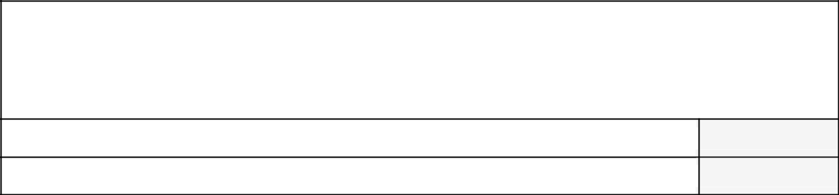

Please answer these screening questions before clicking the "next" button on the bottom right of the page.

1. Do you live in Springfield?

Yes

No

1. What is your zip code? (Please type in your 5 digit zip code in the space below)
2. Are you a member of the Live Well Springfield project team or a member of a LWS partner organization?

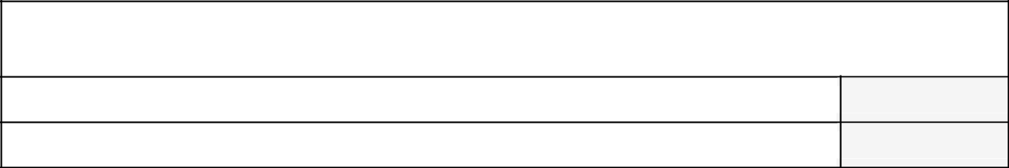

Yes

No

**Section 1: Perceptions of the Live Well Springfield Website**

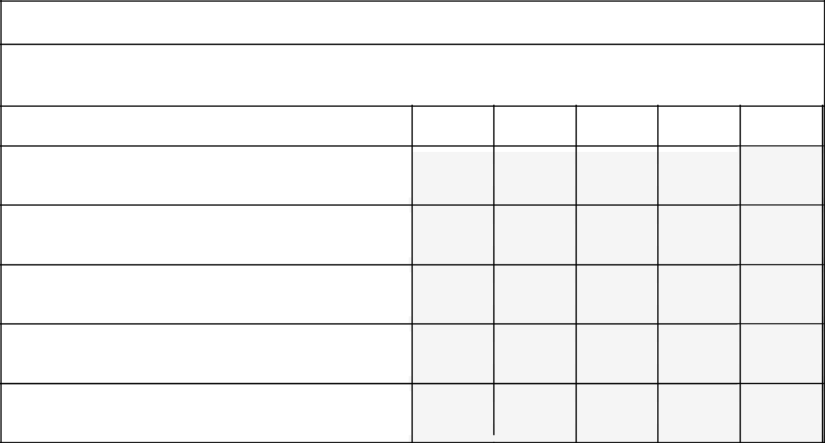

A. **Quality of Information**

Based upon your personal opinion, please indicate how much you agree or disagree each of the following statements about the LWS website.

|  |  |  |  |  |  |  |  |
| --- | --- | --- | --- | --- | --- | --- | --- |
| Strongly |  | Somewhat |  | Not sure/ |  | Somewhat | Strongly |
| Agree |  | Agree |  | No opinion |  | Disagree | Disagree |
|  |  |  |  |  |  |  |  |
|  |  |  |  |  |  |  |  |

1. The LWS website provides accurate

information.

2. The LWS website provides up-to-date

information.

3. The LWS website provides information that

is important to me (relevant to my life).

4. The information on the LWS website has

enough detail.

5. The information and content of the LWS

website is trustworthy.

173

**B. Presentation of Information**

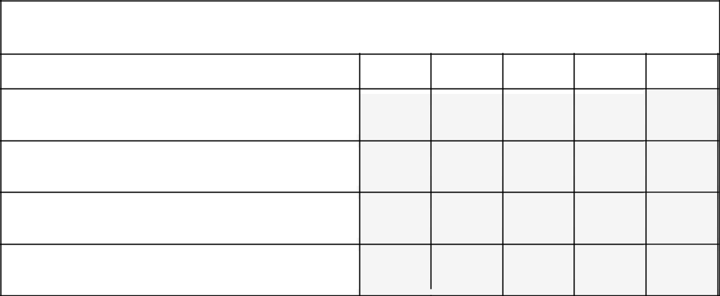

Please indicate how much you agree or disagree with each of the following statements about the way information is presented on the LWS website.

|  |  |  |  |  |  |  |  |
| --- | --- | --- | --- | --- | --- | --- | --- |
| Strongly |  | Somewhat |  | Not sure/ |  | Somewhat | Strongly |
| Agree |  | Agree |  | No opinion |  | Disagree | Disagree |
|  |  |  |  |  |  |  |  |
|  |  |  |  |  |  |  |  |

1. The category headings, menus, and links

are clearly organized.

2. Information is organized and arranged

clearly throughout the website.

3. The information presented is easy to

understand.

4. The amount of information for each topic

was just right.

**C. Attractiveness of Website**

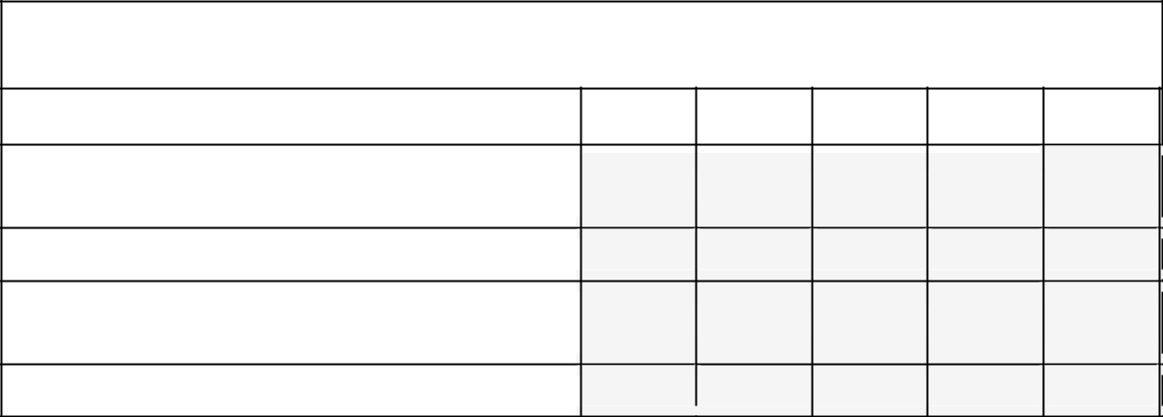

Please indicate how much you agree or disagree with each of the following statements about the visual quality of the LWS website.

|  |  |  |  |  |  |  |  |
| --- | --- | --- | --- | --- | --- | --- | --- |
| Strongly |  | Somewhat |  | Not sure/ |  | Somewhat | Strongly |
| Agree |  | Agree |  | No opinion |  | Disagree | Disagree |
|  |  |  |  |  |  |  |  |
|  |  |  |  |  |  |  |  |

1. Overall, the website’s use of color is

attractive.

2. The background style/pattern is attractive.

3. The Live Well Springfield logo is eye-

catching and attractive.

4. The website is fun to explore.

174

**D. Expectation for Knowledge**

Please indicate how much you expected to learn from the LWS website before visiting.

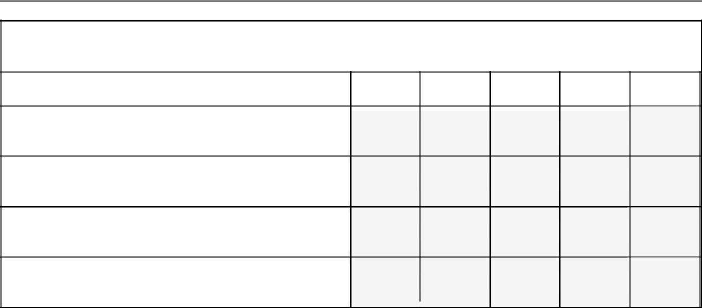

Before using the LWS website, my expectations were that:

|  |  |  |  |  |  |  |  |
| --- | --- | --- | --- | --- | --- | --- | --- |
| Strongly |  | Somewhat |  | Not sure/ |  | Somewhat | Strongly |
| Agree |  | Agree |  | No opinion |  | Disagree | Disagree |
|  |  |  |  |  |  |  |  |
|  |  |  |  |  |  |  |  |

1. Using the LWS website will increase my

knowledge of healthy eating.

2. Using the LWS website will increase my

knowledge of physical activity.

3. Using the LWS website will increase my

awareness of healthier food choices.

4. Using the LWS website will increase my

awareness of physical activity opportunities.

**E. Confirmation of Knowledge**

How much of your expectation for knowledge was met?

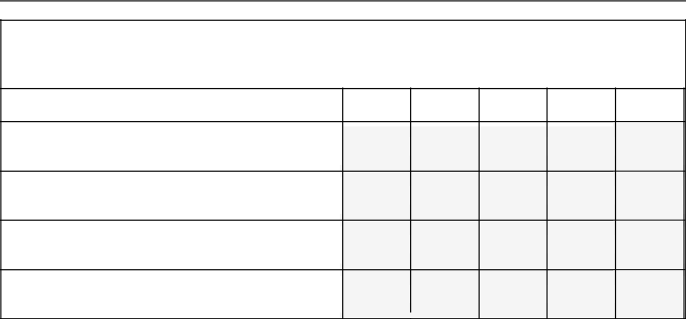

After using the LWS website, please indicate how much you feel you have learned:

|  |  |  |  |  |  |  |  |
| --- | --- | --- | --- | --- | --- | --- | --- |
| Strongly |  | Somewhat |  | Not sure/ |  | Somewhat | Strongly |
| Agree |  | Agree |  | No opinion |  | Disagree | Disagree |
|  |  |  |  |  |  |  |  |
|  |  |  |  |  |  |  |  |

1. I have learned something new about

healthy eating by using this website.

2. I have learned something new about

physical activity by using this website.

3. I have increased my awareness of healthy

food choices by using this website.

4. I have increased my awareness of physical

activity opportunities by using this website.

175

**F. Perceived Usefulness**

For meeting your needs, how useful do you think each of the following materials and sections of the website are?

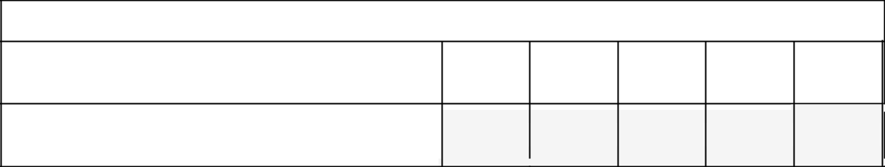

1. Please consider your personal reasons for using health websites.

|  |  |  |  |  |  |  |  |  |
| --- | --- | --- | --- | --- | --- | --- | --- | --- |
| Very |  | Somewhat |  | Not |  | Not Very | Not Useful |  |
|  |  | Sure/No |  | for My |  |
| Useful |  | Useful |  |  | Useful |  |
|  |  | Opinion |  | Purposes |  |
|  |  |  |  |  |  |  |
|  |  |  |  |  |  |  |  |  |
|  |  |  |  |  |  |  |  |  |

How useful is the LWS website for meeting

your needs?



1. Which sections and/or materials of the LWS website do you find useful? (Choose as many apply from the following list)

Recipe Ideas

Portion Guidelines (“Know your serving size”)

Mobile Market Stops & Schedule

Information about the Community Gardens & Farmers Markets (including locations and schedules)

Information about Fun & Fitness (including Walking & Biking, Hiking Trails, Rowing & Swimming, and Parks & Sports Fields)

Information about the Mason Square Food Justice Initiative (“Just Food”)

Videos

"Your Stories” – narrative accounts of healthy lifestyle changes as told by Springfield residents

Other (please specify below)

Other materials or sections you find useful - please type below.



176

**G. Impact of Stories**

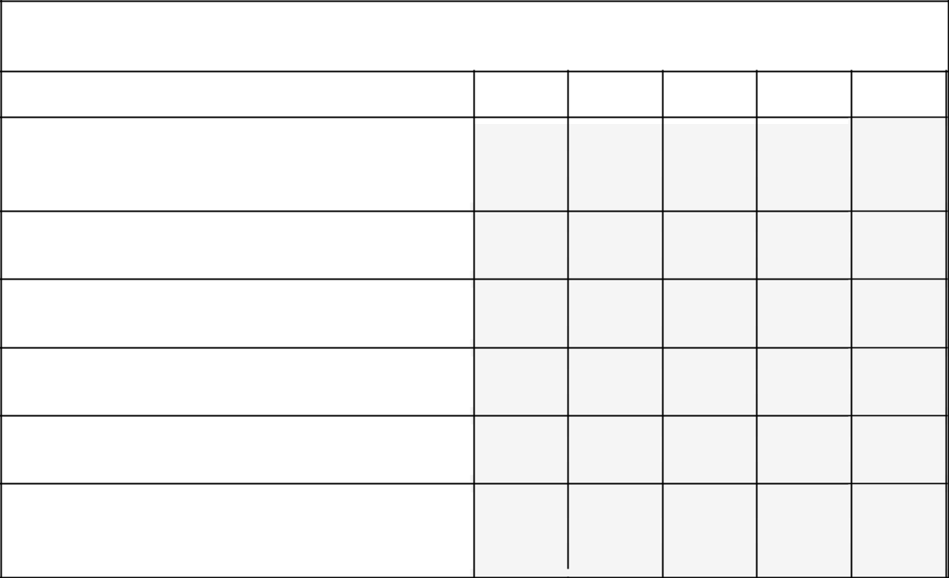

Please indicate how much you agree or disagree with the following statements about the personal stories presented on this website.

|  |  |  |  |  |  |  |  |
| --- | --- | --- | --- | --- | --- | --- | --- |
| Strongly |  | Somewhat |  | Not sure/ |  | Somewhat | Strongly |
| Agree |  | Agree |  | No opinion |  | Disagree | Agree |
|  |  |  |  |  |  |  |  |
|  |  |  |  |  |  |  |  |

1. The message of one or more of these

stories is important to me personally (is

relevant to my life).

2. The individuals featured in the stories seem

trustworthy and sincere.

3. The lifestyle changes made seem possible

and realistic to me.

4. This website is a good way to share and

display these stories.

5. I feel better able to make healthy lifestyle

choices after reading these stories.

6. I feel more likely to eat healthier and/or be

more physically active after reading these

stories.

**H. Overall Satisfaction with the website**

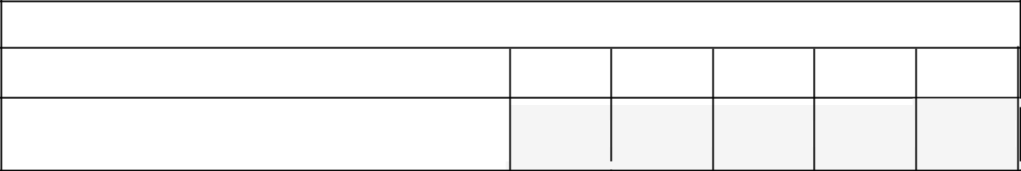

1. Please indicate how much you agree or disagree with the following statement.

|  |  |  |  |  |  |  |  |
| --- | --- | --- | --- | --- | --- | --- | --- |
| Strongly |  | Somewhat |  | Not sure/ |  | Somewhat | Strongly |
| Agree |  | Agree |  | No opinion |  | Disagree | Disagree |
|  |  |  |  |  |  |  |  |
|  |  |  |  |  |  |  |  |

Considering all of the content and features,

I'm satisfied with the LWS website.

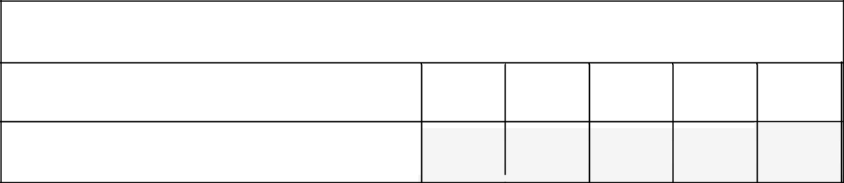

2. Do you plan to visit the LWS website again?

|  |  |  |  |  |  |  |  |  |
| --- | --- | --- | --- | --- | --- | --- | --- | --- |
| Certainly |  | Likely to |  | Possibly |  | Not likely | No |  |
|  |  |  | intention to |  |
| return |  | return |  | return |  | to return | return |  |
|  |  |  |  |  |  |  |  |
|  |  |  |  |  |  |  |  |  |
|  |  |  |  |  |  |  |  |  |

How likely are you to return to the LWS

website?

177

**Section 2: About You**

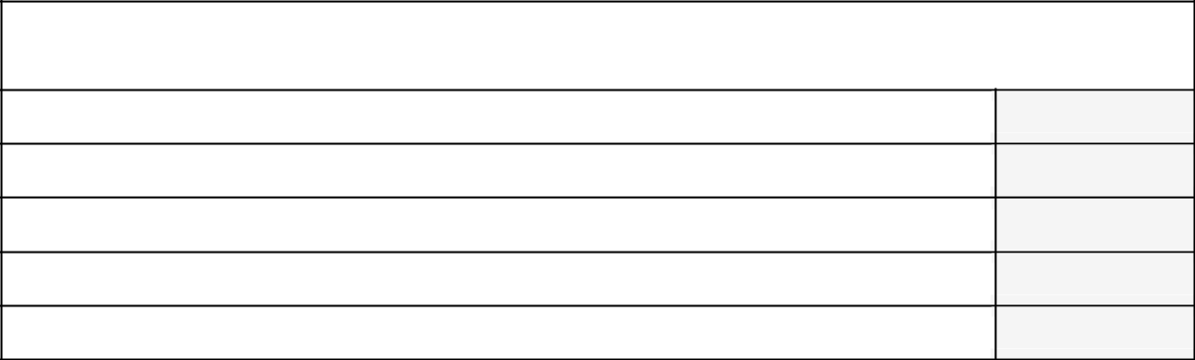

1. How did you become aware of the Live Well Springfield website? (*Please check all that apply.*)

From an Internet search

From a friend or family member

From a print or radio advertisement/PSA

Through work or school

Other (Please specify):

Please type your other answers below.

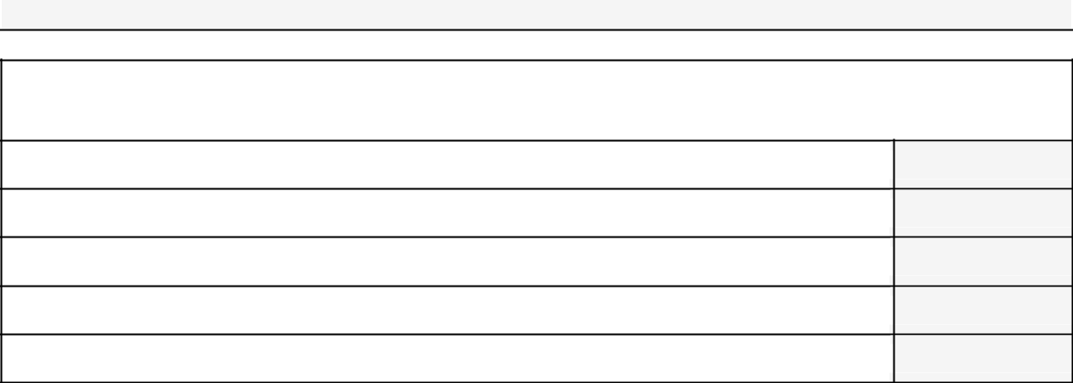

1. What best describes your purpose(s) for visiting the Live Well Springfield website? (*Please check all that apply.*)

Concern for my personal health

Concern for a family member’s health

To learn about a health topic (education)

For community awareness

Other (Please specify):

Please type your other answers below.

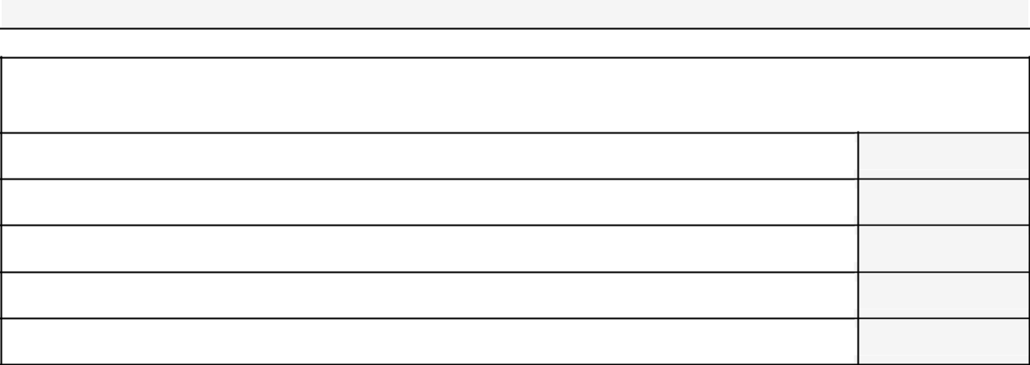

3. In general, how would you describe your health? *(Please mark* ***one****.)*

Excellent

Very good

Good

Fair

Poor

178

**Section 2: About You (continued)**

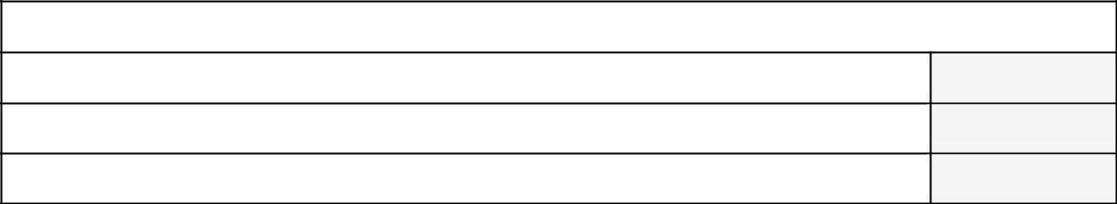

4. Please indicate your gender:

Male

Female

Other

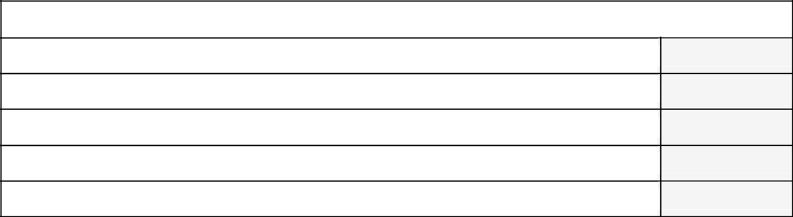

5. Please indicate your age:

Under 18

18-25

26-45

46-65

66 and over

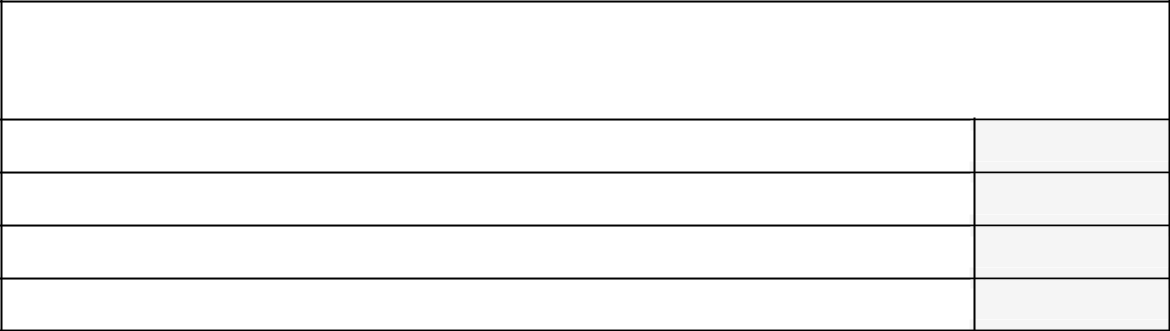

1. What is the highest grade or level of school that you have completed? *(Please mark* ***one.****)*

Did not graduate from high school

High school or vocational school graduate/GED

Some college or 2-year degree

4-year college degree or more

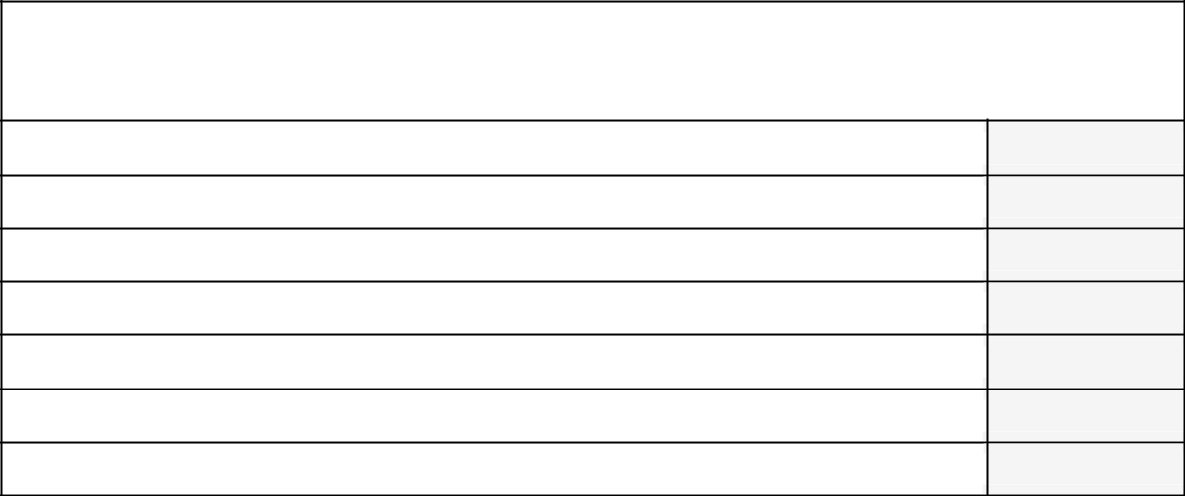

1. Please indicate the races and**/**or ethnicities you identify with. *(Please check* ***all*** *that apply.)*

Hispanic/Latino

White

African-American

Asian

Native Hawaiian or Other Pacific Islander

American Indian or Alaska Native

Other (Please specify):

179

**Section 2: About You (continued)**

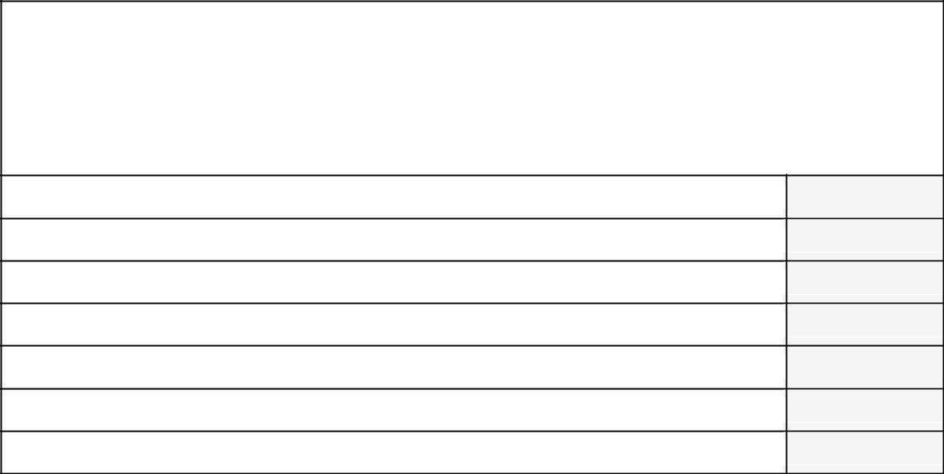

1. Which of the following categories best describes your yearly household income from all sources?

Count the income from jobs, alimony, etc. **from everyone who lives in your house**. *(Please mark* ***one.****)*

Less than $15,000

$15,000, but less than $25,000

$25,000, but less than $35,000

$35,000, but less than $50,000

$50,000, but less than $75,000

$75,000, but less than $100,000

Over $100,000

**Section 3: Health Literacy Scale**

We would like to know about your experience using the Internet for health information.

These experiences can include anything from searching for a specific health topic to emailing with your doctor or healthcare provider.

For this final section, please consider ***all*** of the ways you use the Internet (such as with a computer or smart phone).

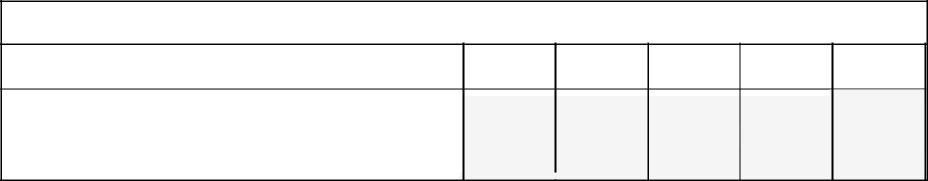

Please choose the answer that best reflects your opinion and experiences.

|  |  |  |  |  |  |  |  |
| --- | --- | --- | --- | --- | --- | --- | --- |
| Very useful |  | Somewhat Unsure/ No | | |  | Not very | Not at all |
|  |  | useful |  | opinion |  | useful | useful |
|  |  |  |  |  |  |  |  |

1. How useful do you feel the Internet is in

helping you make decisions about your

health?

180

**Section 3: Health Literacy Scale (continued)**

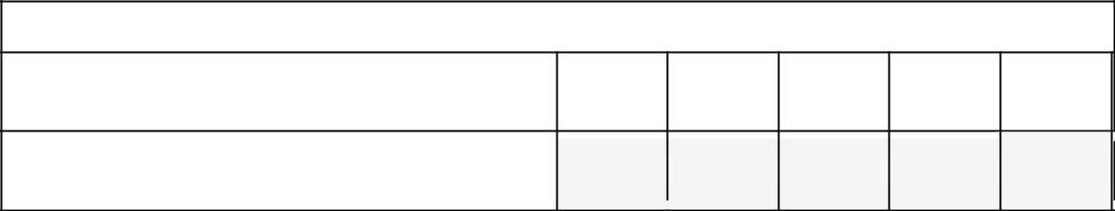

Please choose the answer that best reflects your opinion and experiences.

|  |  |  |  |  |  |  |  |  |
| --- | --- | --- | --- | --- | --- | --- | --- | --- |
| Very |  | Somewhat |  | Not sure/ |  | Not very | Not |  |
|  |  |  | important |  |
| important |  | important |  | No opinion |  | important |  |
|  |  |  | at all |  |
|  |  |  |  |  |  |  |  |
|  |  |  |  |  |  |  |  |  |
|  |  |  |  |  |  |  |  |  |

2. How important is it for you to be able to

access health resources on the Internet?

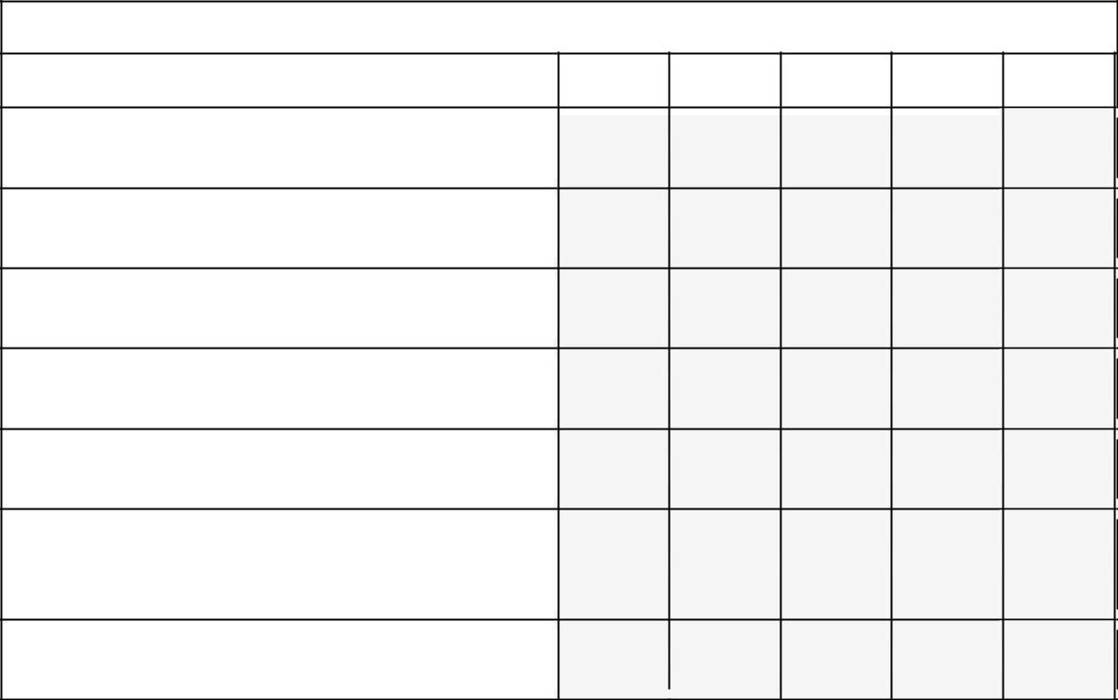

For each statement, choose the answer that best reflects your opinion and experiences.

|  |  |  |  |  |  |  |  |
| --- | --- | --- | --- | --- | --- | --- | --- |
| Strongly |  | Somewhat |  | Not sure/ |  | Somewhat | Strongly |
| Agree |  | Agree |  | No opinion |  | Disagree | Disagree |
|  |  |  |  |  |  |  |  |
|  |  |  |  |  |  |  |  |

3. I know what health resources are available

on the Internet.

4. I know where and how to find helpful health

information on the Internet.

5. I know how to use the Internet to answer

my questions about health.

6. I know how to apply the health information I

find on the Internet to help me.

7. I have the skills I need to evaluate the

health resources I find on the Internet.

8. I can tell high quality health information

from low quality health information on the

Internet.

9. I feel confident in using information from the

Internet to make health decisions.

181

**APPENDIX F**

**WEBSITE EVALUATION SURVEY QUESTIONS – SHORT-ONLINE VERSION**

**Introduction**

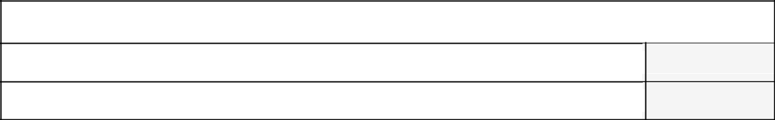

1. Do you live in Springfield?

Yes

No

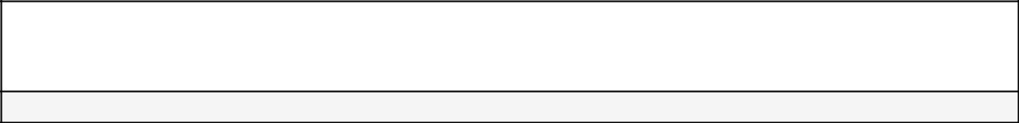

1. What is your zip code? (Please type in your 5 digit zip code in the space below)
2. Are you a member of the Live Well Springfield project team or a member of a LWS partner organization?

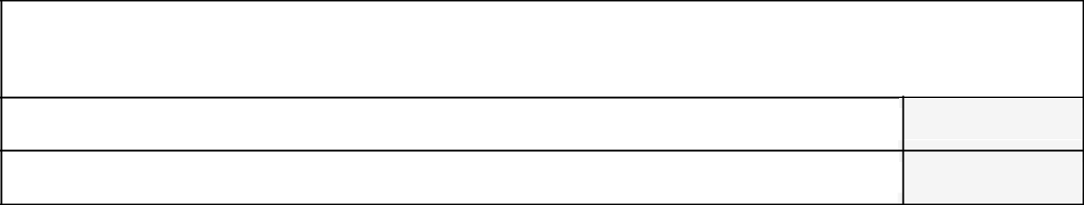

Yes

No

**Section 1: Perceptions of the Live Well Springfield Website**



A. **Website Content**

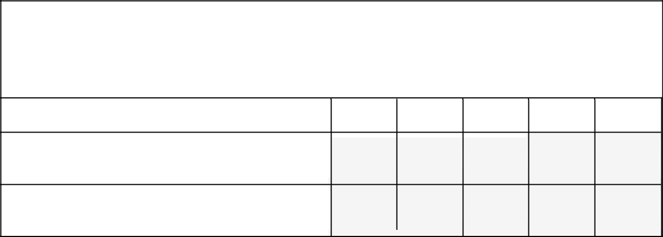

Based upon your opinion, please select how much you agree or disagree each of the following statements about the LWS website.

(Click "Next Page" when you've completed the section)

|  |  |  |  |  |  |  |
| --- | --- | --- | --- | --- | --- | --- |
| Strongly |  | Somewhat |  | Not sure/ | Somewhat | Strongly |
| Agree |  | Agree |  | No opinion | Disagree | Disagree |
|  |  |  |  |  |  |  |
|  |  |  |  |  |  |  |

1. The LWS website provides important

information.

2. Information on the LWS website is

relevant to me.

182

**B. Usefulness**

For meeting your needs, how useful do you think each of the following materials and sections of the website are?

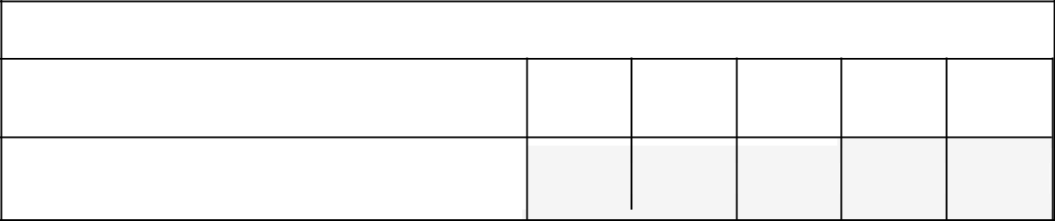

1. Please consider your personal reasons for using health websites.

|  |  |  |  |  |  |  |  |
| --- | --- | --- | --- | --- | --- | --- | --- |
| Very |  | Somewhat |  | Not | Not Very | Not Useful |  |
| Useful |  | Useful |  | Sure/No | Useful | for My |  |
|  |  | Opinion | Purposes |  |
|  |  |  |  |  |  |
|  |  |  |  |  |  |  |  |
|  |  |  |  |  |  |  |  |

How useful is the LWS website for

meeting your HEALTH needs?



1. Which sections of the LWS website do you find useful? (Select all that apply)

Fun & Fitness (including Walking & Biking, Hiking Trails, Rowing & Swimming, and Parks & Sports Fields)

Healthy Eating (including Recipe Ideas, Portion Guidelines, and Community Garden and Farmers Markets)

Go Fresh Mobile Market (stops & schedule)

Mason Square Food Justice Initiative (“Just Food”) info.

Videos

Your Stories – Springfield residents share their healthy lifestyle changes

River Walk/ Bikeway

Pedestrian/ Bike Plan

Latest News

Calendar of Events

Just the Facts

Other (please specify below)



What other sections did you find most useful? (Please type below)

183

**C. Stories**

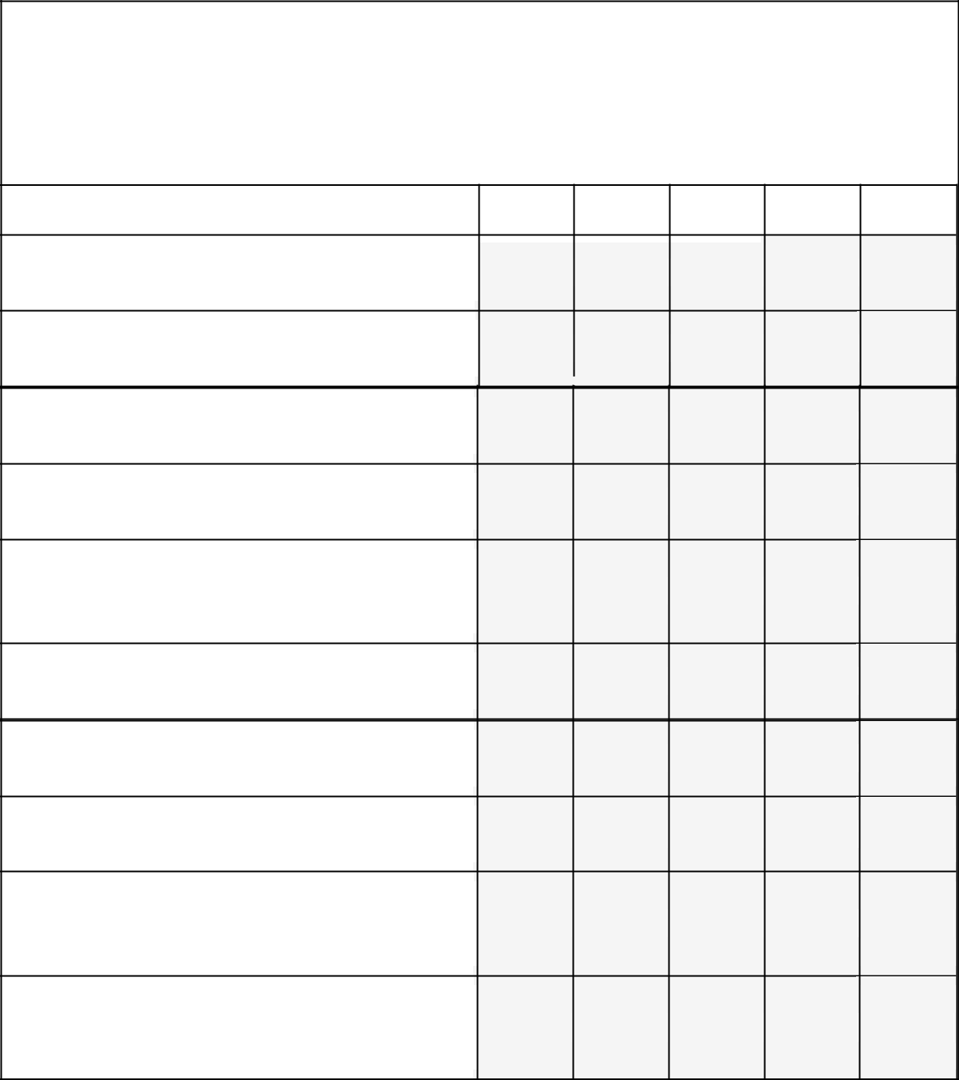

For the next 10 questions, please refer to the stories of Springfield residents.

Please mark how much you agree or disagree with the following statements.

|  |  |  |  |  |  |  |
| --- | --- | --- | --- | --- | --- | --- |
| Strongly |  | Somewhat |  | Not sure/ | Somewhat | Strongly |
| Agree |  | Agree |  | No opinion | Disagree | Agree |
|  |  |  |  |  |  |  |
|  |  |  |  |  |  |  |

1. These stories are meant for people like

me.

2. The people featured in the stories seem

trustworthy and sincere.

3. The nutrition topics presented are

important to me.

4. The physical activity topics presented

are important to me.

5. The lifestyle changes made by the

storytellers seem achievable and realistic

to me.

6. This website is a good way to share

and display these stories.

7. I prefer reading health messages that

are presented as stories.

8. I prefer messages with just facts and

no story.

9. I feel better able to make healthy

lifestyle choices after reading these

stories.

10. I feel motivated to eat healthy and/or

be physically active after reading these

stories.

184

**D. Overall Satisfaction with the website**

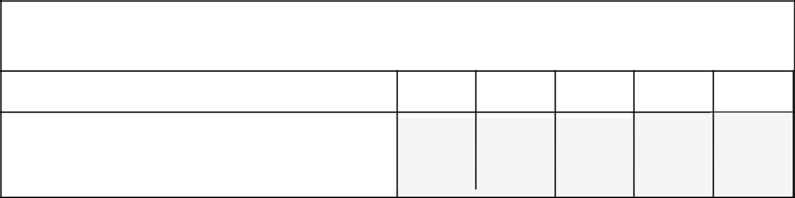

1. Please indicate how much you agree or disagree with the following statement.

|  |  |  |  |  |  |  |
| --- | --- | --- | --- | --- | --- | --- |
| Strongly |  | Somewhat |  | Not sure/ | Somewhat | Strongly |
| Agree |  | Agree |  | No opinion | Disagree | Disagree |
|  |  |  |  |  |  |  |
|  |  |  |  |  |  |  |

Considering all of the content and

features, I'm satisfied with the LWS

website.

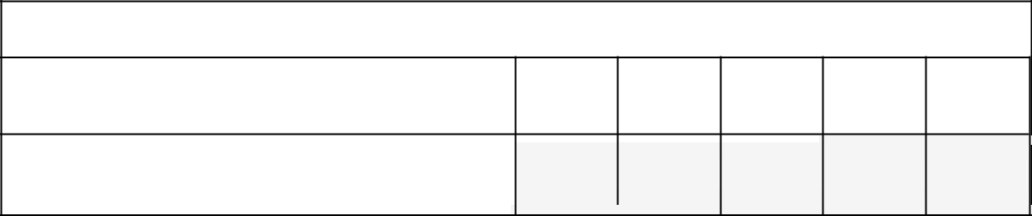

2. Do you plan to visit the LWS website again?

|  |  |  |  |  |  |  |  |
| --- | --- | --- | --- | --- | --- | --- | --- |
| Certainly |  | Likely to |  | Possibly | Not likely | No |  |
|  |  | intention |  |
| return |  | return |  | return | to return |  |
|  |  | to return |  |
|  |  |  |  |  |  |  |
|  |  |  |  |  |  |  |  |
|  |  |  |  |  |  |  |  |

How likely are you to return to the LWS

website?

185

**APPENDIX G**

**INSTITUTIONAL REVIEW BOARD APPROVAL**

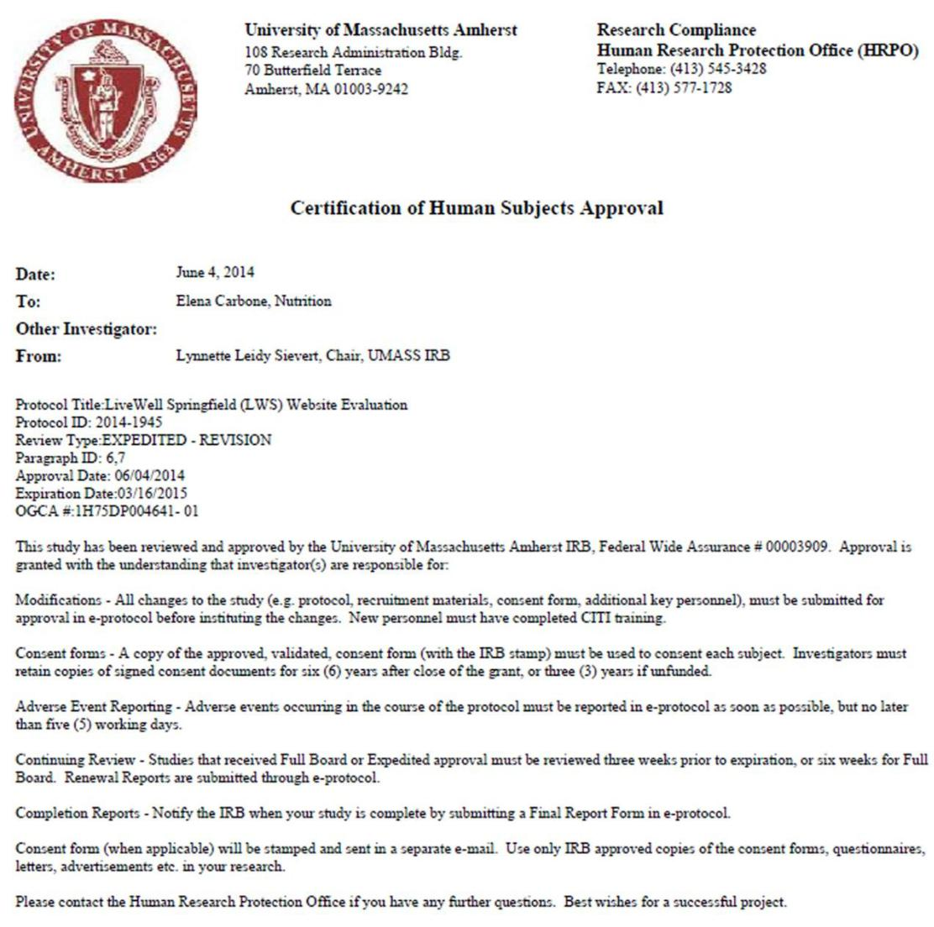

186

**APPENDIX H**

**MESSAGE COMPARISON BOOKLET**

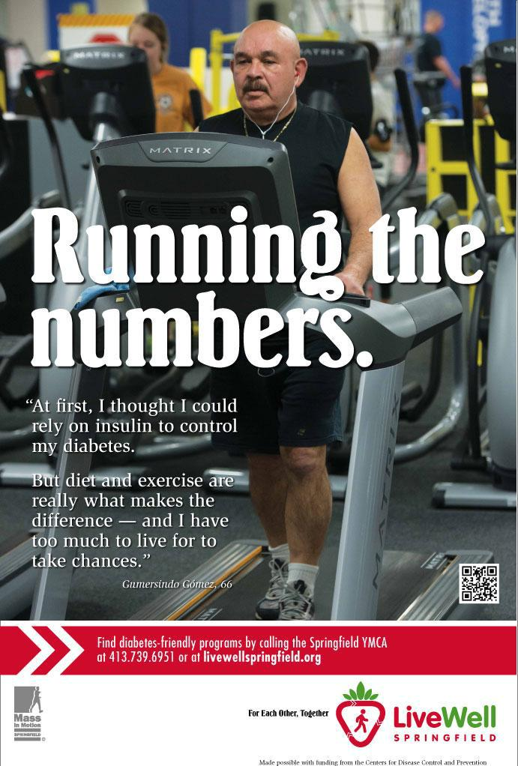

187

**Running the Numbers**

Now was the time to relax.

After 20 years of service in the U.S. Army — ten of which he spent as a drill sergeant — Sergeant Gomersindo Gómez was ready to take it easy. He had not missed a day of exercise in his professional life and looked forward to saying goodbye to the daily runs that were essential to keep up with “the youngsters” in his charge. “I decided that retirement meant the end to my exercise regimen,” he says. “Now was the time to do what I wanted to do.”

Two years later, Gomersindo found himself 65 pounds heavier and with a diagnosis of Type-2 diabetes. “I wasn’t paying attention to my health at all…and didn’t really care, honestly,” he admits.

For the next four years, Gomersindo perfunctorily checked his blood sugar levels and managed his diabetes with insulin — but did little to change his diet and activity level. “I naively thought taking insulin was enough to control my diabetes,” he says. “I was depending on my meds to let me live the way I wanted without making changes.”

In 1992, his doctors’ warnings began to get scary. Gomersindo learned that the long-term effects of diabetes included risk of heart attack and premature death, a prognosis that prompted him to take personal inventory. With a large family of children and grandchildren and a prominent role advocating for other military veterans, he decided that it was time for yet another change.

Gomersindo joined his local YMCA and began to ease back into a routine of walking and weightlifting. He also began to follow a diet recommended for diabetics and entirely eliminated alcohol from his life. The changes weren’t immediate, but proved dramatic over time. “It took me a little more than a year to notice that I was losing weight and that my numbers were improving.” He brought his weight down to 180 pounds (a weight that he maintains at 66 years of age) and his blood sugar levels began to fall consistently between 105 and 125 mg/dl. More than two decades later, he maintains a healthy diet and faithful fitness regimen.

The changes that good exercise and diet brought to Gomersindo’s life did more than bring him physical benefits. In the years following his service in the Vietnam War, Sergeant Gómez struggled to maintain good mental health. “I experienced post traumatic stress disorder (PTSD) after the war. Naturally, that made me depressed, which took me to alcohol.”

188

According to Gomersindo, regular exercise has become an instrumental way for him to achieve mental wellness. “PTSD can make you a workaholic — at least that’s what it did to me,” he admits. “I found that the time I take for exercise is also time for me to put my mind at ease, review my life, and plan where I need to make changes.” And how does he describe his mental health today? “I’m happy. Every day I wake up with purpose.”

As a passionate advocate for veterans and the executive director of the Bilingual Veterans Outreach Center in Springfield, MA, Gomersindo credits an active lifestyle and healthy diet with allowing him to do what he most loves. “My job challenges me mentally and physically, so I need to stay in shape so that I can help veterans like me get through life. Staying healthy has given me the energy I need to not retire,” he says. “Also, I wanted to be sure that I could live long enough to enjoy my grandchildren. And I do,” he says, nodding with conviction. “I do.”

Find out how food and fitness can help regulate your diabetes, and learn where you can get fresh ingredients locally for a diabetes-friendly diet.

189

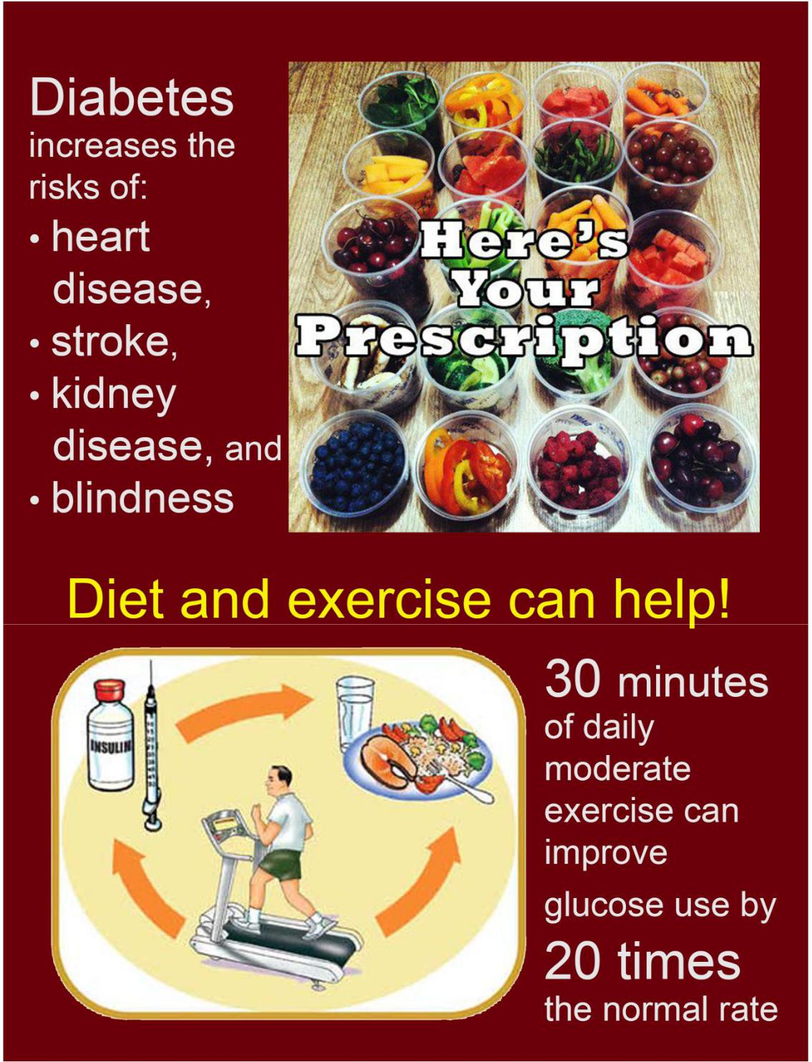

190

**Diet and Exercise as a Prescription for Diabetes**

Type 2 diabetes affects the way the body changes food to energy. In general it means that blood sugar is consistently higher than it should be. With type 2 diabetes, the body becomes resistant to a hormone called insulin that is important for controlling blood sugar. That means that blood sugar can rise beyond the safe level. The biggest lifestyle risks of type 2 diabetes are:

* excess weight gain
* lack of physical activity

Living with type 2 diabetes means that people have to make lifestyle changes, which can be very challenging. People diagnosed with type 2 diabetes:

* need to be more aware and careful about the foods they eat and beverages they drink.
* might need to take medications.

Regularly checking blood sugar levels is important to prevent them from getting dangerously high or low. When blood glucose levels drop too low a person can become:

* nervous, shaky, and confused.
* If not immediately corrected, impaired judgment, fainting and loss of consciousness can occur.

Diabetes is associated with long-term complications that affect almost every part of the body. It increases the risks of many health problems, including:

* heart disease
* stroke
* kidney disease
* blindness.

Regular exercise and a healthy diet have been shown to be more effective than relying on medication alone. It is recommended that every day adults try to eat:

* 5 to 6 ounces of whole grains
* 1 ½ to 2 cups of fruit
* 2 to 2 ½ cups of vegetables

191

People with diabetes should try to eat more high-fiber foods, like fresh fruits, vegetables, and whole wheat products. They should also try to reduce their intake of refined grain products (like white bread, pasta, and rice). Reducing added sugars and eating less saturated fat (from foods like red meat and processed snacks and desserts) can also help.

Type 2 diabetes is more likely to develop in people who are not physically active. It is recommended that adults be physically active as often as possible, this comes out to about:

* 45 minutes 5 times a week

OR

* 30 minutes 7 times a week.

This amount of activity can significantly improve blood levels. Combined with a healthy diet, the effects can be even better!

References

1. National Diabetes Information Clearinghouse. Diabetes Overview. n.d. National Institute of Diabetes and Digestive and Kidney Diseases (NIDDK), National Institutes of Health (NIH). <http://diabetes.niddk.nih.gov/dm/pubs/overview/>
2. United States Department of Agriculture. Choose MyPlate.gov. Accessed on May 18, 2014. <http://www.choosemyplate.gov/food-groups/fruits-amount.html>
3. Hordern, M. D., Dunstan, D. W., Prins, J. B., Baker, M. K., Singh, M. A. F., & Coombes, J. S. (2012). Exercise prescription for patients with type 2 diabetes and pre-diabetes: a position statement from Exercise and Sport Science Australia. Journal of Science and Medicine in Sport, 15(1), 25-31.
4. Type 2 Diabetes and Exercise. WebMD. <http://www.webmd.com/diabetes/guide/exercise-guidelines>

192

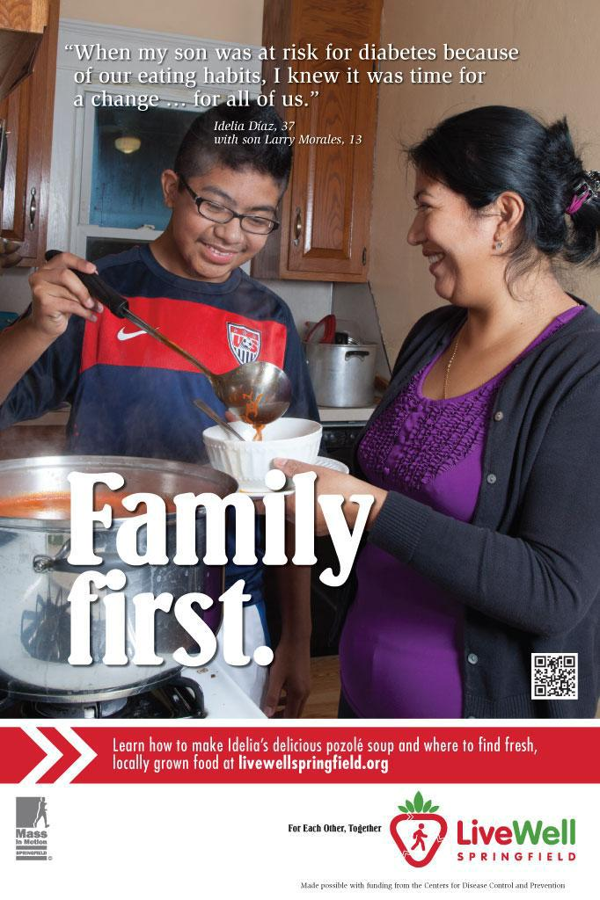

193

**Family First**

IDELIA DIAZ AND LARRY MORALES. Idelia Díaz and Mario Morales came to the U.S. from Guatemala to provide educational and career opportunities for their four children. But even though the seven-day workweek kept their head above water there was little time for anything else, including careful meal planning.

As with many families, their time crunch and limited resources caused traditional recipes and fresh produce to be replaced by fast food and snacks. But that changed when Idelia and Mario’s son Larry was diagnosed with borderline diabetes. “My children are the most cherished thing to me,” said Idelia. “I want them to grow up strong and live the best life possible.” Frightened by the diagnosis and determined to do their best for their family, Idelia and her husband took action.

First, they threw out all the food they had learned was contributing to their family’s unhealthy diet. In its place, they introduced fresh vegetables from a pick-your-own farm and the local supermarket. At first, their children made sour faces at dinnertime, but by making sure that veggies were always available, the Díazes gradually made them a staple in their home.

White bread was replaced with wheat, fried chicken with leaner options — and then came the exercise.

As part of their weekly routine, the Díazes started running together and playing family soccer games in Springfield’s Van Horn Park.

In three months, it was time for another doctor’s visit. This time, Idelia and Larry were in for good news. Their son had lost considerable weight and his blood-sugar levels were back under control: he was out of the danger zone.

And what of the changes to the family’s lifestyle? “Nobody in this house is going to eat unhealthy food again,” said Idelia. “We didn’t just make a change for Larry when he needed it; we made a change for everyone in our family.”

Idelia also admits to a side benefit. “I really like it when friends stop by and ask, “What are you guys doing to be so in shape?”” It’s not a secret, she explains to them, and proudly passes on what she’s learned.

Learn how to make Idelia’s delicious pozole soup, as well as other healthy recipes for your family.

194

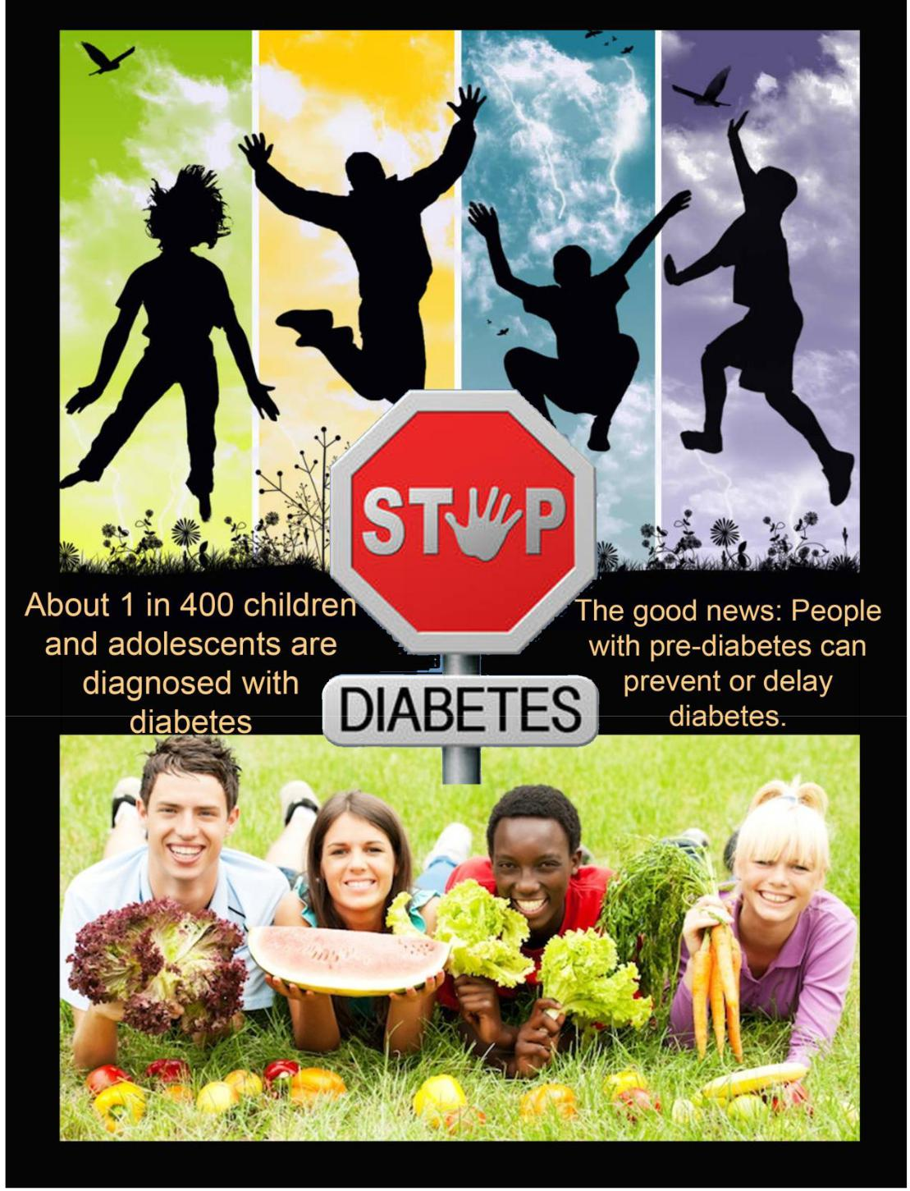

195

**Pre-diabetes in Adolescents**

Pre-diabetes happens when a person's blood sugar levels are higher than normal but not high enough to be diagnosed as diabetes. Pre-diabetes raises the risks of developing type 2 diabetes, heart disease, and stroke. People with this condition are likely to develop type 2 diabetes within 10 years, unless lifestyle adjustments are made. Here are some facts:

* About 1 in every 400 children and adolescents are diagnosed with diabetes.
* About 215,000 people under age 20 have type 1 or type 2 diabetes.
* In 2006, more than 16% of adolescents (12-19 years old) were diagnosed with pre-diabetes. That’s 4 out of 25 kids!
* Pre-diabetes is twice as likely to occur in boys than in girls, and

it occurs more than twice as often among adolescents who are overweight.

If pre-diabetes turns into diabetes the negative impacts are not just health related. Data show that young adults with diabetes achieve less in school and face worse job prospects.

Here are some more facts:

* The high school dropout rate is about 6% higher among adolescents with diabetes compared with students without diabetes.5
* The difference in education translates to about $160,000 less in lifetime earnings. 5
* Employment rates and wages also tend to be lower among young adults with diabetes.5

Diet and exercise have the biggest impact on blood sugar. There are some foods and beverages to limit, including:

* those that are high in sugar, such as candy, soda, cookies, ice cream, cake, and fruit juices
* those that are high in refined grains, such as white breads and white pasta.

Food that is popular among adolescents is often high in simple carbohydrates and low in fiber, which contributes to pre-diabetes. Food and snacks available at schools in the cafeteria and in vending machines may also add to the problem. Limited physical activity from time spent playing video games or watching TV can also contribute to pre-diabetes.

The Good News:

196

* People with pre-diabetes can prevent or delay diabetes by taking preventive measures.
* Children and adolescents with pre-diabetes have a better chance than adults to get their blood sugar under control and prevent diabetes.6
* Good nutrition can help delay or prevent the onset of diabetes.
* The USDA recommends that half of every meal should be fruits and vegetables.
  + This means about 1 ½ to 2 cups of fruit and 2 ½ to 3 cups per day for adolescents.

Other helpful nutrition tips:

* Reduce intake of red meat, meat products like deli meats and sausages, desserts, high-fat dairy like ice cream.
* Eat whole grain foods, like brown rice, whole wheat breads and cereals, instead of refined grain products.

Regular physical activity can also help control blood sugar.

Making changes to family food habits can be most effective to prevent an adolescent’s progression to type 2 diabetes. Shopping together is a good strategy for finding fiber-rich carbohydrate foods and foods with healthy, unsaturated fats, like nuts and fish.

Also, planning activities that get the whole family up and moving can be good for everyone!

197

References

1. Fast Facts – Data and Statistics About Diabetes. American Diabetes Association. Published March 2013. <http://professional.diabetes.org/admin/UserFiles/0%20-%20Sean/FastFacts%20March%202013.pdf>
2. National Diabetes Information Clearinghouse. Diabetes Overview. n.d. National Institute of Diabetes and Digestive and Kidney Diseases (NIDDK), National Institutes of Health (NIH). <http://diabetes.niddk.nih.gov/dm/pubs/overview/>
3. Li C, Ford ES, Zhao G, Mokdad AH. Prevalence of pre-diabetes and its association with clustering of cardiometabolic risk factors and hyperinsulinemia among U.S. adolescents: National Health and Nutrition Examination Survey 2005-2006. Diabetes Care. 2009;32:342-347.
4. Salas-Salvadó, J., Bulló, M., Babio, N., Martínez-González, M. Á., Ibarrola-Jurado, N., Basora, J., ... & Ros, E. (2011). Reduction in the Incidence of Type 2 Diabetes With the Mediterranean Diet Results of the PREDIMED-Reus nutrition intervention randomized trial. Diabetes care, 34(1), 14-19.
5. Fletcher, J. M., & Richards, M. R. (2012). Diabetes’s ‘health shock’to schooling and earnings:

Increased dropout rates and lower wages and employment in young adults. Health Affairs, 31(1), 27-34.

1. Orit Pinhas-Hamiel, Phil Zeitler. Prediabetes in Children and Adolescents: What Does It Mean? Medscape. Jan 02, 2013.
2. Henderson, M., Gray-Donald, K., Mathieu, M. E., Barnett, T. A., Hanley, J. A., O’Loughlin, J., ...

& Lambert, M. (2012). How are physical activity, fitness, and sedentary behavior associated with insulin sensitivity in children?. Diabetes care, 35(6), 1272-1278.

1. United States Department of Agriculture. Choose MyPlate.gov. Accessed on May 18, 2014. http://www.choosemyplate.gov/food-groups/fruits-amount.html

198

**REFERENCES**

“The Health Literacy Advisor,” Health Literacy Innovations, webpage. n.d. n.p. Available at: [http://www.healthliteracyinnovations.com/products/hla/.](http://www.healthliteracyinnovations.com/products/hla/) Accessed on May 4th, 2014.

Amora, M. (2010). Is it Right to Test For Significant Differences in Convenience Samples?. Survey Gizmo. Accessed on October 22, 2014. http://www.surveygizmo.com/survey-blog/significant-differences-and-convenience-samples/

Appel, M., & Richter, T. (2010). Transportation and need for affect in narrative persuasion: A mediated moderation model. *Media Psychology*, 13(2), 101-135.

Bai, B., Law, R., & Wen, I. (2008). The impact of website quality on customer satisfaction and purchase intentions: Evidence from Chinese online visitors. *International Journal of Hospitality Management*, 27(3), 391-402.

Baker, D. W. (2006). The meaning and the measure of health literacy. *Journal of General Internal Medicine*, 21(8), 878-883.

Baker, D. W., Parker, R. M., Williams, M. V., Clark, W. S., & Nurss, J. (1997). The relationship of patient reading ability to self-reported health and use of health services. *American Journal of Public Health*, 87(6), 1027-1030.

Banerjee, S. C., & Greene, K. (2012). ‘I quit’versus ‘I’m sorry I used’: A preliminary investigation of variations in narrative ending and transportation. *Psychology & health*, 27(11), 1308-1322.

Bannon, L. J. (2005). A human-centred perspective on interaction design. In *Future Interaction Design* (pp. 31-51). Springer London.

Berkman, N. D., Davis, T. C., & McCormack, L. (2010). Health literacy: what is it?.

*Journal of Health Communication*, 15(S2), 9-19.

Bhattacherjee, A. (2001). Understanding information systems continuance: an expectation-confirmation model. *MIS quarterly*, 351-370.

Bodie, G. D., & Dutta, M. J. (2008). Understanding health literacy for strategic health marketing: eHealth literacy, health disparities, and the digital divide. *Health Marketing Quarterly*, 25(1-2), 175-203.

Bruner, J. S. (1986). *Actual minds, possible worlds*. Cambridge, MA: Harvard University Press.

Carbone, E. T., & Zoellner, J. M. (2012). Nutrition and health literacy: a systematic review to inform nutrition research and practice. *Journal of the Academy of Nutrition and Dietetics*, 112(2), 254-265.

Centers for Disease Control and Prevention (CDC). “Health Literacy.” n.p., n.d. Web. 01 May, 2014. <http://nnlm.gov/outreach/consumer/hlthlit.html>

199

Chan, C. V., & Kaufman, D. R. (2011). A framework for characterizing eHealth literacy demands and barriers. *Journal of Medical Internet Research*, 13(4).

Charnock, D., Shepperd, S., Needham, G., & Gann, R. (1999). DISCERN: an instrument for judging the quality of written consumer health information on treatment choices. *Journal of Epidemiology and Community Health*, 53(2), 105-111.

Chou, H. K., Lin, I. C., Woung, L. C., & Tsai, M. T. (2012). Engagement in e-learning opportunities: An empirical study on patient education using expectation confirmation theory. *Journal of Medical Systems*, 36(3), 1697-1706.

Collins, S. A., Currie, L. M., Bakken, S., Vawdrey, D. K., & Stone, P. W. (2012). Health literacy screening instruments for eHealth applications: a systematic review. *Journal of Biomedical Informatics*, 45(3), 598-607.

Cortina, J. M. (1993). What is coefficient alpha? An examination of theory and applications. *Journal of Applied Psychology*, 78(1), 98.

Couper, M. P., Alexander, G. L., Zhang, N., Little, R. J., Maddy, N., Nowak, M. A., ... & Johnson, C. C. (2010). Engagement and retention: measuring breadth and depth of participant use of an online intervention. *Journal of Medical Internet Research*, 12(4).

Davis, F. D., Bagozzi, R. P., & Warshaw, P. R. (1989). User acceptance of computer technology: a comparison of two theoretical models. *Management Science*, 35(8), 982-1003.

Davis, T. C., Long, S. W., & Jackson, R. H. (1993). Rapid estimate of adult literacy in medicine: a shortened screening instrument. *Family Medicine*, 25(6), 391-395.

Dunlop, S. M., Wakefield, M., & Kashima, Y. (2009). Pathways to persuasion: Cognitive and experiential responses to health-promoting mass media messages. *Communication Research*, 37, 133–164.

Dutta-Bergman, M. J. (2006). Media use theory and internet use for health care. The Internet and health care: *Theory, Research, and Practice*, 83-103.

Eysenbach, G. (2001). What is e-health?. *Journal of Medical Internet Research*, 3(2).

Eysenbach, G., & Köhler, C. (2002). How do consumers search for and appraise health information on the world wide web? Qualitative study using focus groups, usability tests, and in-depth interviews. *British Medical Journal*, 324(7337), 573-577.

Fishbein, M., and Ajzen, I. (1975). *Belief, Attitude, Intention and Behavior: An Introduction to Theory and Research*, Addison-Wesley, Reading, MA. 53-89.

Fletcher, J. M., & Richards, M. R. (2012). Diabetes’s ‘health shock’to schooling and earnings: Increased dropout rates and lower wages and employment in young adults. *Health Affairs*, 31(1), 27-34.

200

Flynn, B. S., Worden, J. K., Bunn, J. Y., Connolly, S. W., & Dorwaldt, A. L. (2011). Evaluation of smoking prevention television messages based on the elaboration likelihood model. *Health Education Research*, 26(6), 976-987.

Fox, S. (2013). Online Health Search 2006. Washington, DC, Pew Internet & American Life Project, 2006. *Oct. Report*, 1-22.

Fox, S., & , Duggan, M. (2013). Health online 2013. Health. [http://www.pewinternet.org/files/old-media//Files/Reports/PIP_HealthOnline.pdf](http://www.pewinternet.org/files/old-media/Files/Reports/PIP_HealthOnline.pdf)

Freire, P. (1970). Pedagogy of the Oppressed (New York. *Continuum, 1*, 988.

Friedman, D. B., & Hoffman-Goetz, L. (2006). A systematic review of readability and comprehension instruments used for print and web-based cancer information. *Health Education & Behavior*, 33(3), 352-373.

Frisch, A. L., Camerini, L., & Schulz, P. J. (2013). The impact of presentation style on the retention of online health information: A randomized-controlled experiment. Health communication, 28(3), 286-293.

George, D., & Mallery, P. (2003). *SPSS for Windows step by step: A simple guide and*

*reference*. 11.0 update (4th ed.). Boston: Allyn & Bacon.

Glasgow, R. E. (2007). eHealth evaluation and dissemination research. *American journal of preventive medicine*, 32(5), S119-S126.

Gliem, J. A., & Gliem, R. R. (2003). Calculating, interpreting, and reporting Cronbach’s alpha reliability coefficient for Likert-type scales. *Midwest Research-to-Practice Conference in Adult, Continuing, and Community Education*; 2003:82–8. Available at: http://www.alumni-osu.org/midwest/proceeding.html.

Green, M. C., & Brock, T. C. (2000). The role of transportation in the persuasiveness of public narratives. *Journal of Personality and Social Psychology*, 79(5), 701.

Griffiths, K. M., & Christensen, H. (2005). Website quality indicators for consumers.

*Journal of Medical Internet Research*, 7(5).

Gunning, T. G. (2003). *Building Literacy in the Content Areas*. Allyn & Bacon.

Hardiker, N. R., & Grant, M. J. (2011). Factors that influence public engagement with eHealth: a literature review. *International Journal of Medical Informatics*, 80(1), 1-12.

Harland, J., & Bath, P. (2007). Assessing the quality of websites providing information on multiple sclerosis: evaluating tools and comparing sites. *Health Informatics Journal*, 13(3), 207-221.

Harris, J. E., Gleason, P. M., Sheean, P. M., Boushey, C., Beto, J. A., & Bruemmer, B.

(2009). An introduction to qualitative research for food and nutrition professionals.

*Journal of the American Dietetic Association*, 109(1), 80-90.

201

Herndon, J. B., Chaney, M., & Carden, D. (2011). Health literacy and emergency department outcomes: a systematic review. *Annals of Emergency Medicine*, 57(4), 334-345.

Hesse, B. W., Nelson, D. E., Kreps, G. L., Croyle, R. T., Arora, N. K., Rimer, B. K., & Viswanath, K. (2009). Trust and sources of health information: The impact of the Internet and its implications for health care providers: Findings from the first Health Information National Trends Survey. *Archives of Internal Medicine*, 165, 2618– 2624.

Hinyard, L. J., & Kreuter, M. W. (2006). Using narrative communication as a tool for health behavior change: a conceptual, theoretical, and empirical overview. *Health Education & Behavior*. 34.5: 777-792.

Holden, R. J., & Karsh, B. T. (2010). The technology acceptance model: its past and its future in health care. *Journal of Biomedical Informatics*, 43(1), 159-172.

Hsieh, H. F., & Shannon, S. E. (2005). Three approaches to qualitative content analysis.

*Qualitative Health Research*, 15(9), 1277-1288.

Hsu, M. H., Chiu, C. M., & Ju, T. L. (2004). Determinants of continued use of the WWW: an integration of two theoretical models. *Industrial Management & Data Systems*, 104(9), 766-775.

Hu, Y., & Sundar, S. S. (2010). Effects of online health sources on credibility and behavioral intentions. *Communication Research* , 37, 105–132.

Jolly, R. (2011). *The E Health Revolution: Easier Said Than Done*. Parliamentary Library.

Keselman, A., Logan, R., Smith, C. A., Leroy, G., & Zeng-Treitler, Q. (2008). Developing informatics tools and strategies for consumer-centered health communication. *Journal of the American Medical Informatics Association*, 15(4), 473-483.

Kim, D., & Chang, H. (2007). Key functional characteristics in designing and operating health information websites for user satisfaction: An application of the extended technology acceptance model. *International Journal of Medical Informatics*, 76(11), 790-800.

Koo, C., Wati, Y., Park, K., & Lim, M. K. (2011). Website quality, expectation, confirmation, and end user satisfaction: the knowledge-intensive website of the Korean National Cancer Information Center. *Journal of Medical Internet Research*, 13(4).

Koo, M., Norman, C. D., & Chang, H. M. (2012). Psychometric Evaluation of a Chinese Version of the eHealth Literacy Scale (eHEALS) in School Age Children. *International Electronic Journal of Health Education*, 15, 29-36.

Korp, P. (2006). Health on the Internet: implications for health promotion. *Health Education Research*, 21(1), 78-86.

202

Kucukarslan, S. N., & Nadkarni, A. (2008). Evaluating medication-related services in a hospital setting using the disconfirmation of expectations model of satisfaction. *Research in Social and Administrative Pharmacy*, 4(1), 12-22.

Lankton, N. K., & Wilson, E. V. (2006). Factors influencing expectations of e-health services within a direct-effects model of user satisfaction. *e-Service Journal*, 5(2), 85-111.

Lee, M. C. (2010). Explaining and predicting users’ continuance intention toward e-learning: An extension of the expectation–confirmation model. *Computers & Education*, 54(2), 506-516.

Lefebvre, C. R., Tada, Y., Hilfiker, S. W., & Baur, C. (2010). The assessment of user engagement with eHealth content: The eHealth Engagement Scale. *Journal of Computer‐Mediated Communication*, 15(4), 666-681.

Leiner, B. M., Cerf, V. G., Clark, D. D., Kahn, R. E., Kleinrock, L., Lynch, D. C., ... & Wolff, S. (2009). A brief history of the Internet. *ACM SIGCOMM Computer Communication Review*, 39(5), 22-31.

Leslie, E., Marshall, A. L., Owen, N., & Bauman, A. (2005). Engagement and retention of participants in a physical activity website. *Preventive Medicine*, 40(1), 54-59.

Live Well Springfield (LWS), webpage. n.d. n.p. Available at:

[http://www.livewellspringfield.org/.](http://www.livewellspringfield.org/) Accessed on May 1, 2014.

Massachusetts Department of Public Health. Health of Massachusetts. Boston, MA; April 2010. http://www.mass.gov/eohhs/docs/dph/communications/hom-chapter-7.pdf

Mitsutake, S., Shibata, A., Ishii, K., Okazaki, K., & Oka, K. (2011). [Developing Japanese version of the eHealth Literacy Scale (eHEALS)]. [Nihon koshu eisei zasshi] *Japanese Journal of Public Health*, 58(5), 361-371.

Mohamed, A. H. H., Tawfik, H., Norton, L., & Al-Jumeily, D. (2011, April). e-HTAM: A Technology Acceptance Model for electronic health. In *Innovations in Information Technology (IIT)*, 2011 International Conference on (pp. 134-138). IEEE.

Neter, E., & Brainin, E. (2012). eHealth literacy: extending the digital divide to the realm of health information. *Journal of Medical Internet Research*, 14(1), e19.

Nielsen-Bohlman L, Panzer AM, Kindig DA, eds. *Health Literacy: A Prescription to End*

*Confusion*. Washington, DC: National Academies Press; 2004.

Norman, C. (2011). eHealth literacy 2.0: problems and opportunities with an evolving concept. *Journal of Medical Internet Research*, 13(4).

Norman, C. D., & Skinner, H. A. (2006a). eHEALS: the eHealth literacy scale. *Journal of Medical Internet Research*, 8(4).

Norman, C. D., & Skinner, H. A. (2006b). eHealth literacy: essential skills for consumer health in a networked world. *Journal of Medical Internet Research*, 8(2).

203

Nutbeam, D. (2008). The evolving concept of health literacy. *Social Science & Medicine*, 67(12), 2072-2078.

O’Grady, L., Witteman, H., Bender, J. L., Urowitz, S., Wiljer, D., & Jadad, A. R. (2009).

Measuring the impact of a moving target: towards a dynamic framework for evaluating collaborative adaptive interactive technologies. *Journal of Medical Internet Research*, 11(2).

O'Brien, H. L., & Toms, E. G. (2010). The development and evaluation of a survey to measure user engagement. *Journal of the American Society for Information Science and Technology*, 61(1), 50-69.

Oh, H., Rizo, C., Enkin, M., & Jadad, A. (2005). What is eHealth (3): a systematic review of published definitions. *Journal of Medical Internet Research*, 7(1).

Oliver, R. L. (1980). A cognitive model of the antecedents and consequences of satisfaction decisions. *Journal of Marketing Research*, 460-469.

Onwuegbuzie, A. J., Dickinson, W. B., Leech, N. L., & Zoran, A. G. (2009). A qualitative framework for collecting and analyzing data in focus group research. *International Journal of Qualitative Methods*, 8(3), 1-21.

Overbeeke, K., Djajadiningrat, T., Hummels, C., Wensveen, S., & Prens, J. (2005). Let’s make things engaging. In *Funology* (pp. 7-17). Springer Netherlands.

Paek, H. J., Kim, K., & Hove, T. (2010). Content analysis of antismoking videos on YouTube: message sensation value, message appeals, and their relationships with viewer responses. *Health Education Research*, 25(6), 1085-1099.

Parker, R. M., Baker, D. W., Williams, M. V., & Nurss, J. R. (1995). The test of functional health literacy in adults. *Journal of General Internal Medicine*, 10(10), 537-541.

Parker, R., & Ratzan, S. C. (2010). Health literacy: a second decade of distinction for Americans. *Journal of Health Communication*, 15(S2), 20-33.

Petty, R. E., & Cacioppo, J. T. (1986). *Communication and Persuasion: Central and Peripheral Routes to Attitude Change*. 1986. Sringer-Verlag, New York, NY.

Pleasant, A., Cabe, J., Martin, L., & Rikard, R. V. (2013). A Prescription Is Not Enough: Improving Public Health with Health Literacy1. [http://www.iom.edu/.](http://www.iom.edu/) (n.d.). (Retrieved May 2014).

Potter, L. E., Purdie, C., & Nielsen, S. (2012, January). The View from the Trenches: Satisfaction with eHealth systems by a group of health professionals. In *ACIS 2012: Location, location, location: Proceedings of the 23rd Australasian Conference on Information Systems 2012* (pp. 1-9). ACIS.

Powell, J., Inglis, N., Ronnie, J., & Large, S. (2011). The characteristics and motivations of online health information seekers: cross-sectional survey and qualitative interview study. *Journal of Medical Internet Research*, 13(1).

204

Quintiliani, L. M., & Carbone, E. T. (2005). Impact of diet-related cancer prevention messages written with cognitive and affective arguments on message characteristics, stage of change, and self-efficacy. *Journal of Nutrition Education and Behavior*, 37(1), 12-19.

Racicot-Matta, C., Wilcke, M., & Egeland, G. M. (2014). Development of radio dramas for health communication pilot intervention in Canadian Inuit communities. *Health Promotion International*, dau024.

Ricciardi, L., Mostashari, F., Murphy, J., Daniel, J. G., & Siminerio, E. P. (2013). A national action plan to support consumer engagement via e-health. *Health Affairs*, 32(2), 376-384.

Rice, R. E. (2006). Influences, usage, and outcomes of Internet health information searching: multivariate results from the Pew surveys. *International Journal of Medical Informatics*, 75(1), 8-28.

S. 1356--113th Congress: Workforce Investment Act of 2013. (2013). In www.GovTrack.us. Retrieved April 16, 2014, from http://www.govtrack.us/congress/bills/113/s1356Baker DW, Wolf MS, Feinglass J, Thompson JA, Gazmararian JA, Huang J. Health literacy and mortality among elderly persons. *Arch Intern Med* 2007;167:1503–9.

Sarkar, U., Karter, A. J., Liu, J. Y., Adler, N. E., Nguyen, R., López, A., & Schillinger, D. (2010). The literacy divide: health literacy and the use of an internet-based patient portal in an integrated health system—results from the Diabetes Study of Northern California (DISTANCE). *Journal of Health Communication*, 15(S2), 183-196.

Slater, M. D., & Rouner, D. (2002). Entertainment—education and elaboration likelihood: Understanding the processing of narrative persuasion. *Communication Theory*, 12(2), 173-191.

Soellner, R., Huber, S., & Reder, M. (2014). The concept of eHealth literacy and its measurement: German translation of the eHEALS. *Journal of Media Psychology: Theories, Methods, and Applications*, 26(1), 29.

Spreng, R. A., & Page, T. J. (2003). A Test of Alternative Measures of Disconfirmation*.

*Decision Sciences*, 34(1), 31-62.

Spreng, R. A., MacKenzie, S. B., & Olshavsky, R. W. (1996). A reexamination of the determinants of consumer satisfaction. *Journal of Marketing*, 60, 15–32.

Stellefson, M., Hanik, B., Chaney, B., Chaney, D., Tennant, B., & Chavarria, E. A. (2011). eHealth literacy among college students: a systematic review with implications for eHealth education. *Journal of Medical Internet Research*, 13(4).

Stossel, L. M., Segar, N., Gliatto, P., Fallar, R., & Karani, R. (2012). Readability of patient education materials available at the point of care. *Journal of General Internal Medicine*, 27(9), 1165-1170.

205

Sutcliffe, A., Thew, S., De Bruijn, O., Buchan, I., Jarvis, P., McNaught, J., & Procter, R.

(2010). User engagement by user-centred design in e-Health. *Philosophical Transactions of the Royal Society A: Mathematical, Physical and Engineering Sciences*, 368(1926), 4209-4224.

Sutherland, L. A., Wildemuth, B., Campbell, M. K., & Haines, P. S. (2005). Unraveling the web: an evaluation of the content quality, usability, and readability of nutrition web sites. *Journal of Nutrition Education and Behavior*, 37(6), 300-305.

Tao, D., LeRouge, C. M., Deckard, G., & De Leo, G. (2012, January). Consumer Perspectives on Quality Attributes in Evaluating Health Websites. In *System Science (HICSS)*, 2012 45th Hawaii International Conference on (pp. 2675-2684).IEEE.

Updegraff, J. A., Sherman, D. K., Luyster, F. S., & Mann, T. L. (2007). The effects of message quality and congruency on perceptions of tailored health communications. *Journal of Experimental Social Psychology*, 43(2), 249-257.

US Department of Health and Human Services. Clear Communication Web page.

Revised August 23, 2013. Available at:

http://www.nih.gov/clearcommunication/plainlanguage/index.htm/. Accessed

December, 6, 2014.

Van der Vaart, R., van Deursen, A. J., Drossaert, C. H., Taal, E., van Dijk, J. A., & van de Laar, M. A. (2011). Does the eHealth Literacy Scale (eHEALS) measure what it intends to measure? Validation of a Dutch version of the eHEALS in two adult populations. *Journal of Medical Internet Research*, 13(4).

Venkatesh, V., & Davis, F. D. (2000). A theoretical extension of the technology acceptance model: four longitudinal field studies. *Management Science*, 46(2), 186-204.

Vosbergen, S., Mahieu, G. R., Laan, E. K., Kraaijenhagen, R. A., Jaspers, M. W., & Peek, N. (2014). Evaluating a web-based health risk assessment with tailored feedback: what does an expert focus group yield compared to a web-based end-user survey?. *Journal of Medical Internet Research*, 16(1).

Weber, P., & Wirth, W. (2014). When and How Narratives Persuade: The Role of Suspension of Disbelief in Didactic Versus Hedonic Processing of a Candidate Film. *Journal of Communication*, 64(1), 125-144.

Wexler, L., Gubrium, A., Griffin, M., & DiFulvio, G. (2012). Promoting positive youth development and highlighting reasons for living in Northwest Alaska through digital storytelling. Health promotion practice, 1524839912462390. Wong, A. M., Chang, W. H., Ke, P. C., Huang, C. K., Tsai, T. H., Chang, H. T., ... & Pei, Y. C. (2012). Technology acceptance for an intelligent comprehensive interactive care (ICIC) system for care of the elderly: A survey-questionnaire study. *PloS one*, 7(8), e40591.

206

Wilson, B. J. (2007). Designing media messages about health and nutrition: what strategies are most effective?. *Journal of Nutrition Education and Behavior*, 39(2), S13-S19.

Zarcadoolas, C., Pleasant, A., & Greer, D. S. (2009). *Advancing health literacy: A framework for understanding and action* (Vol. 45). John Wiley & Sons.

Zhang, P., Von Dran, G. M., Blake, P., & Pipithsuksunt, V. (2001, October). Important design features in different web site domains: An empirical study of user perceptions. In *Americas Conference on Information Systems (AMCIS)*, (Vol. 1, No. 1, pp. 77-91). Indiana University Press.

Zimmerman, D. E., Akerelrea, C. A., Buller, D. B., Hau, B., & Leblanc, M. (2003).

Integrating usability testing into the development of a 5 a day nutrition Website for at-risk populations in the American Southwest. *Journal of Health Psychology*, 8(1), 119-134.

207