**Influences of Antroquinonol and 4-Acetylantroquinonol B on Inflammatory Tumorigenesis in the MCF-7 Breast Cancer Cell Line with or without TNF-α Stimulation**

**ABSTRACT**

Breast cancer (BC) is one of the most common cancers among women worldwide that

~25% of new cancer cases diagnosed every year would be BC; moreover, ~15% of cancer

deaths per year caused by BC makes it the leading cause of cancer death among women

worldwide. To date, though the cause of a large proportion of BC are still unclear, recent

studies have revealed that a supportive breast tissue microenvironment is critical for the

development and progression of BC, especially the communication with immune cells

within breast tissue. Therefore, breast inflammatory microenvironment is currently

received a substantial attention in the prevention and treatment of BC. Research on breast

cancer immunology suggests that inflammatory mediators, estrogen and several inflammation-related tumorigenic pathways are potentially contributors for inflammatory

breast tumorigenesis. It is evidenced that elevated levels of inflammatory mediators, such

as cytokines, chemokines, prostaglandins, and enhanced estrogen production while

suffering from chronic inflammation is responsible for not only activating oncogenic

pathways, for example NF-κB, STAT3 and Wnt signaling pathways, but also reducing the

efficacy of cancer-specific immunity against tumor cells. Accordingly, targeting the

chronic inflammatory status in breast tissue has become a promising strategy for breast

cancer therapy. Recently, due to the annoying side effects accompanying by traditionally

anticancer drugs, there is an increased interest in finding out natural sources to treat BC.

Herein, we report that antroquinonol (AQ) and/or 4-acetylantroquinonol B (4-AAQB)

isolated from *Antrodia Camphorata* were able to modulate the expression of several

inflammatory mediators, IL-6 and IFN-γ in particular, and downregulate the aromatase

expression and Wnt signaling responses induced by inflammatory status. Taken together,

the present findings provide new insights into the role of AQ and 4-AAQB in inflammatory

breast tumors and also suggest them as promising candidates for breast cancer

immunotherapy.

vi

**TABLE OF CONTENTS**

**Page**

ACKNOWLEDGMENTS iv

ABSTRACT v

LIST OF TABLES x

LIST OF FIGURES xi

CHAPTER

1. INTRODUCTION 1

2. LITERATURE REVIEW 4

2.1 Breast Cancer 4

2.2 Inflammatory Microenvironment and Breast Cancer 7

2.2.1 Inflammatory Cytokines 9

2.2.2 Chemokines 13

2.2.3 Cyclooxygenase-2 and Prostaglandins 14

2.2.4 Immune Checkpoints 16

2.3 Chronic Inflammation and the Estrogen Mechanisms 18

2.3.1 Pro-tumor Immunomodulatory Effects of Estrogen 19

2.3.2 Aromatase as a Mediator Between Inflammation and Breast Tumorigenesis ..21

2.4 Inflammation and Breast Cancer: The Wnt-Signaling Pathway Connection 23

vii

|  |  |  |  |
| --- | --- | --- | --- |
| 2.4.1 | | Wnt-Signaling Pathway and Breast Cancer ...................................................... | 23 |
| 2.4.2 Inflammation Associated Tumorigenesis in Wnt-Signaling Pathway............... | | | 26 |
| 2.5 | The Prevention of Breast Cancer: With A Focus on Mushrooms .......................... | | 30 |
| 2.5.1 | | Market Trends of Mushrooms ........................................................................... | 31 |
| 2.5.2 | | Nutritional Value of Mushrooms ...................................................................... | 32 |
| 2.5.3 | | The Health Beneficial Properties of Mushrooms .............................................. | 33 |
| 2.5.4 | | Mushrooms and Breast Cancer Prevention ....................................................... | 39 |
| 2.5.5 | | *Antrodia Camphorata* ........................................................................................ | 41 |
| 2.6 | Conclusions and Perspectives ................................................................................. | | 43 |
| 3. PURPOSE OF THE STUDY ......................................................................................... | | | 45 |
| 4. MATERIALS AND METHODS ................................................................................... | | | 47 |
| 4.1 | Experimental Design ............................................................................................... | | 47 |
| 4.2 | Reagents and Chemicals ......................................................................................... | | 47 |
| 4.3 | Cell Lines and Cell Culture..................................................................................... | | 48 |
| 4.4 | Cell Viability Assays .............................................................................................. | | 49 |
| 4.5 | Quantitative Real Time PCR Analyses ................................................................... | | 50 |
| 4.6 | Statistical Analysis .................................................................................................. | | 51 |
| 5. RESULTS ...................................................................................................................... | | | 52 |
| 5.1 | Cell Viability Assay of AQ and 4-AAQB Treatment in MCF-7 Cells ................... | | 52 |
| 5.2 | Cell Viability Assay of TNF-α Treatment in MCF-7 Cells .................................... | | 52 |
| 5.3 | AQ and 4-AAQB Alter the Inflammatory Mediators Profile of MCF-7 Cells ....... | | 54 |
| 5.4 | AQ and 4-AAQB Suppress *IL6* Upregulation but Strengthen *IFNγ* Upregulation | |  |
|  | Induced by TNF-α Stimulation ............................................................................. | | 58 |
| 5.5 | AQ and 4-AAQB Inhibit the Expression of Aromatase in MCF-7 Cells ............... | | 61 |
| 5.6 | Effects of AQ and 4-AAQB on the Expression of *CD47* and Wnt Targeted | |  |
|  | Genes in MCF-7 Cells .......................................................................................... | | 63 |

viii

6. DISCUSSION 66

APPENDICES

A. TABLE OF PERFORMED ASSAYS AND EXPERIMENTAL DESIGN 80

B. TABLE OF PRIMERS USED FOR REAL-TIME PCR ANALYSIS 82

REFERENCES 84

ix

**LIST OF TABLES**

**Table** **Page**

1. Experimental design 81

2. Primers of targeted genes and GAPDH 83

x

**LIST OF FIGURES**

**Figure** **Page**

1. Breast tumor microenvironment 7

2. Chemokines & metastatic breast cancer 14

3. CD47 signaling & reduced T cell immunity 18

4. Inflammatory mediators & aromatase expression 23

5. Nutritional value of mushrooms 33

6. AQ, 4-AAQB and TNF-α reduce cell viability of MCF-7 cells 53

7. Heatmap and relative gene expression level of targeted inflammatory mediators in

MCF-7 cells with or without 24 h AQ treatment 56

8. Heatmap and relative gene expression level of targeted inflammatory mediators in

MCF-7 cells with or without 24 h 4-AAQB treatment 57

1. Gene expression levels of targeted inflammatory mediators in MCF-7 cells after TNF-
   * stimulation, and gene expression levels of *IL6*, *IFNγ* and *CCL2* after TNF-α and

AQ/4-AAQB cotreatment 60

10. Gene expression levels of aromatase in MCF-7 cells 62

11. Gene expression levels of *CD47* and Wnt targeted genes in MCF-7 cells 65

xi

**CHAPTER 1**

**INTRODUCTION**

Recent studies have indicated that within a tumor microenvironment (TME), tolerant

immune responses involved in innate and adaptive immune systems play key roles in

cancer progression (Wang et al., 2004). Prolonged and enhanced inflammatory activity

caused by different conditions, such as microbial infections, chemicals exposures,

autoimmune diseases and obesity, would lead to chronic, “smoldering” and low-grade

inflammation (Balkwill et al., 2005; Mantovani et al., 2008; Divella et al., 2016). It is now

evidenced that several immunosuppressive cells that are responsible for tolerant immunity

including regulatory T (Treg) cells and myeloid-derived suppressor cells (MDSCs) are often

found in breast tumors (Jiang et al., 2014). These cells along with soluble molecules could

induce an immunosuppressive microenvironment predisposing breast tumor development.

Recently, duo to the various side effects of anti-cancer drugs, research on complementary

and alternative medicine (CAM), which is used to help patients lessen side effects and

discomfort following conventional medicine, has risen in scientific community. According

to 2012 national health interview survey, 33.2% of US adults used CAMs, and the most

common CAM for cancer treatment in United States was the use of natural products (17.7%

1

of adults), some of which possess a variety of phytonutrients with potential benefits to

human health (NHIS, 2012). Among these natural products, mushrooms have been

considered as one of the most powerful functional foods for preventing and treating cancer

via their effective anti-cancer and immunomodulatory effects (Valverde et al., 2015).

*Antrodia Camphorata* (AC) as one of the medicinal mushrooms used in traditional

Taiwanese medicine has been reported to possess diverse health-promoting effects in

modern medicine, such as anti-microbial, anti-hepatitis B virus, anti-oxidant and especially

anti-cancer and immunomodulatory effects, attributed to the various nutraceuticals found

in AC (Geethangili et al., 2011; Lien et al., 2014). Two recently isolated compounds,

antroquinonol (AQ) and 4-acetylantroquinonol B (4AAQB), from AC mushrooms emerge

as promising anti-cancer drug candidates. Experiments conducted in various cancers

demonstrated the roles of AQ and 4-AAQB in diverse anti-cancer properties such as anti-

proliferation (Kumar et al., 2011; Lin et al., 2011), pro-apoptosis (Yu et al., 2012), anti-

invasion and metastasis (Thiyagarajan et al., 2015; Lee et al., 2015) and anti-cancer

stemness (Chang et al., 2015; Lin et al., 2017). However, the effects of these compounds

on anti-tumor immunity in breast cancer (BC) remain unclear. Our present study aims to

understand how AQ and 4-AAQB modulates mammary inflammatory microenvironment,

2

aromatase, an enzyme responsible for a key step in the biosynthesis of estrogens in women,

as well as tumorigenic Wnt pathway related genes in MCF-7 BC cells.

3

**CHAPTER 2**

**LITERATURE REVIEW**

**2.1 Breast Cancer**

BC is the most common cancer in women worldwide. Nearly 1.7 million new BC cases

were diagnosed in 2012, representing about 25% of all types of cancers in women (Ferlay

et al., 2015). BC, with a standardized mortality rate of 12.9 per 100,000, is the second

highest cause of cancer death (Ghoncheh et al., 2016). In the United States, about 12% of

women, that is 1 in 8 women, will be diagnosed with invasive BC during their lifetime.

Despite the incidence and death rates of BC in the US are both gradually decreasing for the

past two decades, BC death rates are still higher than any other cancer, besides lung cancer

(DeSantis et al., 2014).

In general, based on molecular subtypes, BC can be divided into mainly three categories:

hormone receptor-positive BC, HER2 protein-positive BC and triple-negative BC (TNBC).

Hormone receptor-positive BC is the major type among these three, and includes estrogen

receptors (ER)-positive and/or progesterone receptors (PR)-positive BC, accounting for

~70% of human BC (Spears et al., 2009). TNBC, which is ER-negative, PR-negative and

HER2-negative, is the most complex one, since it is not the hormones that facilitate cancer

4

cell growth, and currently, there is no targeted therapy specifically for its treatment (Reddy

et al., 2011). Since BC in women is prevalent worldwide, particularly in the industrialized

countries, and current treatments, including surgery combined with chemotherapy,

radiation and hormone therapy, have significant side effects, it is highly attractive to

develop dietary strategies, e.g. identifying natural medicinal compounds that have

preventive or chemopreventive capability for reducing BC risk with less adverse effects.

The cause of BC is complex and may attributes to several risk factors related to age, family

history of breast and other cancers, endogenous and exogenous hormone exposure, and

environmental and lifestyle changes. About 5 to 10% of BCs are associated with hereditary

gene mutations, and among them more than 50% of the inherited cases can be directly

linked to BRCA1 and/or BRCA2 gene mutations (Ford et al., 1998; Slavin et al., 2017).

Other factors, such as sex hormone, exposures to environmental chemicals and pollutants,

obesity, dietary factors, alcohol and tobacco are responsible for the majority of BC (Chen,

2008; Hiatt et al., 2018). By understanding the causation between these risk factors and

BC, researchers and health promotion practitioners can develop effective strategies or

policy against BC in both prevention and therapy levels.

Overview the history of BC therapy strategies, researchers tend to focus their studies on

5

tumor cell-intrinsic factors such as genetic, epigenetic properties and biology of tumor cell

*per se*. However, recent development of cancer intervention has shifted the topics toward

the whole TME (Williams et al., 2016). In fact, in 1889 Stephen Paget had already proposed

a “Seed and soil” theory for cancer development suggesting that tumors can only be formed

by neoplastic cells with a favorable and supportive environment (Paget, 1989). In general,

breast TME is composed of tumor cells, stromal cells, adipocytes, immune cells, as well as

various extracellular molecules, such as cytokines, chemokines, and growth factors,

secreted by tumor cells and surrounding cells (Place et al., 2011; Huang et al., 2017) (Figure

1). Within a breast TME, immune cells, especially macrophages, play critical roles in the

development and progression of BC (Ward et al., 2015). Therefore, breast inflammatory

microenvironment is currently received substantial attention in the prevention and

treatment of BC.

6

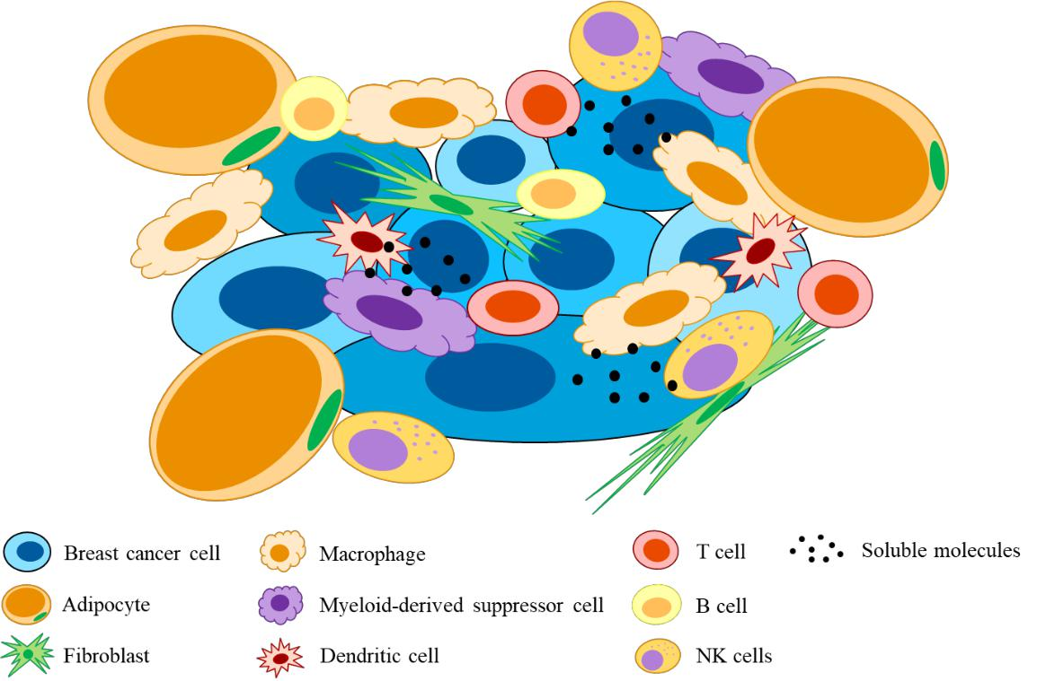

**Figure 1.** Breast tumor microenvironment

**2.2 Inflammatory Microenvironment and Breast Cancer**

The first connection between inflammation and cancers can be traced back to 19th century,

Rudolf Virchow noted that infiltrated leukocytes present within tumor tissue, and

hypothesized that “lymphoreticular infiltrate reflected the origin of cancer at sites of

chronic inflammation” (Balkwill et al., 2001). Indeed, though this idea has been

undervalued more than a century, the shift of recent cancer research from tumor cells to the

TME uncovers myriad solid evidence that describe the interaction between immune cells

and tumor cells in the microenvironment.

7

Evidence has clearly indicated that chronic inflammation with elevated serum levels of

tumor necrosis factor-alpha (TNF-α), interleukin-6 (IL-6), and C-reactive protein (CRP)

caused by obesity or other inflammatory conditions are associated with increased BC risk,

and may play an important role in tumorigenesis (Agnoli et al., 2017). Additional evidence

is the use of anti-inflammatory drugs such as nonsteroidal anti-inflammatory drugs

(NSAIDs), *e.g.* COX2 inhibitors, aspirin, ibuprofen and other NSAIDs, steroidal anti-

inflammatory drugs, *e.g.* corticosteroids, and anti-cytokine and chemokine drugs, e.g. anti-

IL-6, anti-TNF-α, and anti-CXCR4 drugs in cancer therapy, and these drugs have been

shown to be beneficial for reducing cancer incidence, improving therapy, and decreasing

mortality from cancers, including BC (Harris et al., 2003; Rayburn et al., 2009;

Grivennikov et al., 2010). These findings supported Virchow’s hypothesis, reemphasized

the importance of inflammation toward cancer progression, and significantly encouraged

the research involved in cancer immunology and its implications for cancer prevention and

therapy.

The key factors contributing to the adverse effects of inflammation on breast cancer are

transcription factors such as nuclear factor kappa-light-chain-enhancer of activated B cells

(NF-κB) and signal transducer and activator of transcription 3 (STAT3), and related

8

inflammatory cytokines such as TNF-α, IL-6 and IL-1β (Mantovani et al., 2008). In the

inflammatory microenvironment, neoplastic cells, adipocytes, stromal cells and immune

cells are all under an inflammatory status through a positive feedback loop between

transcription factors and their targeted inflammatory mediators. Therefore, the influence of

the various inflammatory molecules that secreted from all types of cells in the

microenvironment play critical roles in breast tumorigenesis and tumor progression.

**2.2.1 Inflammatory Cytokines**

**TNF- :** In an inflammatory microenvironment, the inflammatory cytokines, particularly TNF-α, IL-1β and IL-6 are most extensively studied. TNF-α was originally identified to be a cytokine inducing cell lysis, especially tumor cells (Locksley et al., 2001). Later research

discovered a wide range of effects of chronic, low dose TNF-α on tumor cells in the aspects

of cell proliferation, survival, differentiation, anti-apoptosis, angiogenesis, epithelial–

mesenchymal transition (EMT) as well as inflammatory responses (Dempsey et al., 2003;

Balkwill et al., 2009), which are mainly through the activation of NF-κB inflammatory

pathway (Wang et al., 2008; Hoesel et al., 2013). Eftekhari et al. (2017) indicated that in a

breast TME, TNF-α expression level is gradually increasing and parallel with the breast

tumor stage. To date, several studies have demonstrated the role of TNF-α in inflammation-

9

related cancers. Moore et al. (1999) showed that TNF-α knockout mice is resistant to skin

carcinogenesis caused by inflammation. In addition, Oshima et al. (2005) pointed out that

the inhibition of TNF-α related inflammation is capable of suppressing gastric tumor

progression in transgenic mice induced by cyclooxygenase-2 (COX2) and microsomal

prostaglandin E synthase-1 overexpression. The pro-tumor effects of TNF-α and TNF-α

induced other cytokines, chemokines and prostaglandins (PGs) may attribute to their acts

on different cell types in the whole TME that eventually skew it to a tumor friendly

environment (Balkwill, 2009).

**IL-1β:** Similar with TNF-α, IL-1β is capable to activate NF-κB and AP-1 by binding with

IL-1 receptors and/or toll-like receptors, promoting tumor cell survival, proliferation,

metastasis, tumor angiogenesis (Divella et al., 2016). IL-1β in a TME is shown to be

responsible for the recruitment of COX-2-expressing leukocytes and the promotion of

inflammatory angiogenesis caused by upregulating angiogenic factors such as

prostaglandin E2 (PGE2), vascular endothelial growth factor, CXC chemokines, and matrix

metalloproteinases (MMPs) (Nakao et al., 2005). Escobar et al. (2015) also indicated that

IL-1β highly expressed by metastatic ER negative BC cell, MDA-MB-231, is able to

stimulate the secretion of chemokines related to aggressive metastasis by mesenchymal

10

stem cells in a co-culture cell model.

**IL-6:** IL-6 is a pro-inflammatory cytokine that is regulated by NF-κB pathway and is also

a key modulator in cancer-related inflammation (Divella et al., 2016). IL-6 is the major

activator of STAT3 transcription factor, which is responsible for the expression of genes

related to pro-proliferation, anti-apoptosis, tumor metastasis, angiogenesis, and

immunosuppression (Yu et al., 2009). Moreover, the activation of STAT3 in various

immune cells is able to promote the maturation of immunosuppressive cells such as tumor-

associated macrophages (TAMs), MDSCs, Treg cells and T helper 17 (TH17) cells, whereas

reduce the stimulation of tumor cytotoxic cells such as TH1 cells and cluster of

differentiation (CD) 8+ T cells (Yu et al., 2009). Recent studies of IL-6 in BC have point

out its pro-tumor effects and association with poor patient outcomes (Salgado et al., 2003;

Won et al., 2013).

**Other inflammatory cytokines:** Other proinflammatory cytokines, such as interferon-γ (IFN-γ), IL-10 and transforming growth factor-β (TGF- ), is also widely studied in cancer immunology field. ***1)*** IFN-γ is regulated by transcription factor NF-κB, and would stimulate JAK/STAT1 signaling pathway. The role of IFN-γ in cancer-related inflammation

is a two-faced factor in terms of pro- and anti-tumor effects. In the tumor initiation stage,

11

IFN-γ can protect normal cells from damage, whereas during this process, it may lead to

the accumulation of oncogenic mutations, resulting in potent cancer cell transformation

(Zaidi et al., 2011). ***2)*** IL-10 in immunology is generally known as an anti-inflammatory

cytokine, but its effects in the pathogenesis of cancer is still controversial. Evidence has

suggested that IL-10 signaling alone or co-stimulation with other cytokines such as IL-2 or

IL-4 can activate either STAT3 or STAT1 according to *in vitro* or *in vivo* studies (Mannino

et al., 2015). Since STAT3 and STAT1 activation is responsible for immunosuppression

and immunostimulation respectively, IL-10 may serve as pro-tumor or anti-tumor factor

depending on the existence microenvironment. ***3)*** TGF-β also has two-faced property

toward tumor development. In normal cells, TGF-β serving as a tumor suppressor protein

can protect cells from tumor cell transformation through cell cycle inhibition, induction of

apoptosis and inhibition of cell immortalization (Lebrun, 2012). However, elevated TGF-

* secreted from tumor cells, stromal cells and immune cells in a TME can promote tumor cell progression and metastasis. In addition, TGF-β in a TME can positively contribute to tumor immunosuppression by directly or indirectly weaken function of cytotoxic T and B lymphocytes against tumor cells, allowing tumors to evade from immunosurveillance (Yu et al., 2009; Lebrun, 2012).

12

**2.2.2 Chemokines**

Chemokines are another group of molecules that are elevated in an inflammatory

environment, particularly obesity-associated inflammation. Chemokines and chemokine

receptors also play important roles in terms of their signaling greatly regulating tumor cell

migration and invasion and immune cell infiltration (Figure 2). Given the phenomenon of

immune cell infiltration in a TME, various inflammatory mediators upregulate the

expression of chemokines and chemokine receptors in immune cells as well as tumor cells.

Müller et al. (2001) found that in breast tumor cells, C-C motif chemokine receptor 7

(CCR7) and C-X-C motif chemokine receptor 4 (CXCR4) are highly expressed compared

to normal mammary epithelial cells *in vitro* and *in vivo*. Similar with the mechanisms

involved in lymphocyte trafficking, chemokine signaling also triggers actin polymerization

in breast tumor cells in order to form pseudopod and move the cells forward, resulting in

tumor cell migration and invasion to distal metastatic niches with high levels of chemokine

ligands C-C motif chemokine ligand 21 (CCL21) and C-X-C motif chemokine ligand 12

(CXCL12). On the other hand, chemokines acting as chemoattractants can attract immune

cell infiltrating to tumor site, such as CCL2 (monocyte chemoattractant protein 1, MCP-

1)-mediated macrophage recruitment in BC, and through the cytokines and chemokines

13

interaction between macrophages and tumor cells, it can further promote the maturation of

tumor-associate macrophages (TAMs) and metastatic tumor cells favorable for tumor

immune evasion, tumor angiogenesis and metastasis (Stewart et al., 2012; Tariq et al.,

2017).

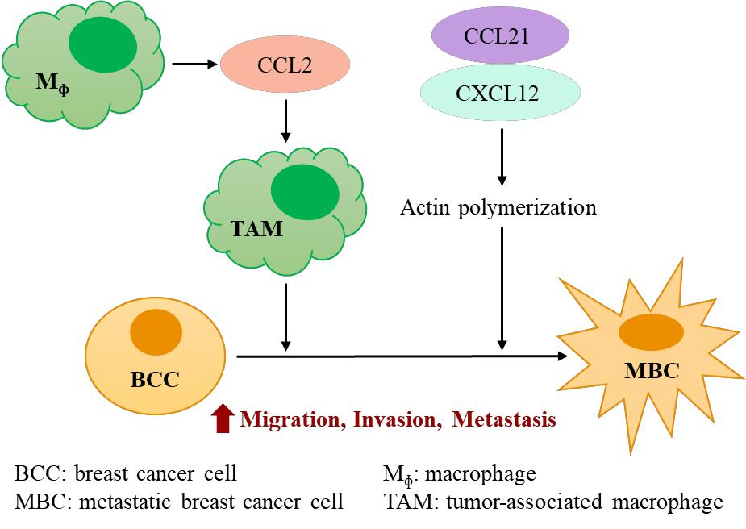

**Figure 2.** Elevated expression of chemokines & chemokine receptors promote metastatic breast cancer

**2.2.3 Cyclooxygenase-2 and Prostaglandins**

The links between cyclooxygenase (COX; also known as prostaglandin-endoperoxide

synthase, PTGS) and inflammation can be traced back to the first discovery of NSAIDs in

14

the early 1970. They were shown to be able to mitigate inflammation by inhibiting PGs

synthesis mediated by enzyme COX. Moreover, the later research on COX revealed that

its increased activity is correlated to the inflammatory status, and could be induced by

inflammatory cytokines and endotoxins (Seibert et al., 1994). There are two COX isozymes

found in human body, including COX-1 and COX-2. COX-1 is normally existed and

constitutively activated in various tissue to maintain physiological functions, for example

gastrointestinal, renal, endothelium protection and platelet aggregation, whereas, COX-2

is almost silent in normal tissue and is inducible only in the context of inflammatory stage,

including cancer-related inflammation. Recently, studies have pointed out that COX-2 is

upregulated or overexpressed in various types of cancers, such as oral, gastric, bile duct,

colorectal, head and neck, skin, prostate, breast, liver, pancreatic, bladder, lung, ovarian,

and cervical cancers (Koki et al., 2002).

The main function of COX-2 pathways is to produce prostanoids, including thromboxane

and PGs, from enzymatically conversion of arachidonic acids (Smyth et al., 2009). PGs

involve in various physiological functions in human body such as vasodilation,

bronchodilation, muscle contraction, platelet aggregation; moreover, they can greatly

contribute to advanced inflammation and tumor progression, especially PGE2. Several

15

molecular pathway involved in inflammation and tumor development directly target COX-

2 promoter, including NF-κB, STAT3 and MAPK pathways (Xiong et al., 2014; Desai et

al., 2018), and by upregulated COX-2 expression and increased production of PGE2, a

positive feedback loop can be generated between these pathways and COX-2 pathway,

further exacerbating the inflammation and tumor progression (Lin et al., 2015; Aoki, 2015).

In general, constitutive COX-2 activation and PGE2 production can potentially promote

both the initiation of breast tumorigenesis and later progression through a variety of

pathways (Harris et al., 2014; Galván et al., 2017).

**2.2.4 Immune Checkpoints**

Recently, research on the interaction between cancer cells and immune cells in terms of

effects on escaping from immunosurveillance is quite promising for cancer immunotherapy.

During inflammation, immune checkpoints, serving as regulators of various immune cell

activation, are key factors for maintaining self-tolerance, which represents the ability for

immune system to correctly identify and target foreign antigens instead of autoantigens,

avoiding autoimmune responses and tissue damage. Generally, anti-tumor immunity can

be referred to a cancer-immunity cycle with several steps, including a) releasing of cancer

cell antigens, being captured by antigen-presenting cells (APCs), and presenting cancer

16

antigen to T cells by APCs; b) activating effector T cells (Teff) against cancer cells, Teff

trafficking to tumor site, and infiltrating into tumor; c) recognizing cancer cells by binding

cancer antigen with T cell receptor, killing cancer cells, and releasing additional cancer

antigens (Chen et al., 2013). In the process of cancer-immunity cycle, the activation of Teff

would be the key step to initiate effective tumoricidal function of anti-tumor immunity. T

cell activation is not merely regulated by interaction between cancer-associated antigens

and T cell receptor, but also may co-regulated with other ligands and receptor proteins

presented on the surface of APCs and tumor cells. These proteins can be divided into two

categories, positive and negative regulators, responsible for co-stimulating or co-inhibiting

Teff function respectively (Topalian et al., 2015), and between these two membrane proteins,

negative regulators are referred to immune checkpoints.

However, this host defense mechanism is dysfunction within a TME, resulting in evasion

of tumor immunosurveillance (Pardoll, 2012). For instance, recent findings suggest that

CD47 as a pro-phagocytic signal is commonly upregulated in various tumor cells including

breast tumor (Manna et al., 2004; Chao et al., 2011), possibly through dysregulated NF-κB

and HIF-1 pathways (Lo et al., 2015; Zhang et al., 2015; Betancur et al., 2017), and

increased expression of CD47 could specifically engage with its receptor signal regulatory

17

protein α (SIRPα), generating “don’t eat me “ signals to macrophages (McCracken et al.,

2015) (Figure 3). By blocking CD47-SIRPα signal with CD47 antibody or CD47

knockdown, macrophage-mediated phagocytosis of tumor cells is retrieved (Bener et al.,

2016; Liu et al., 2017).

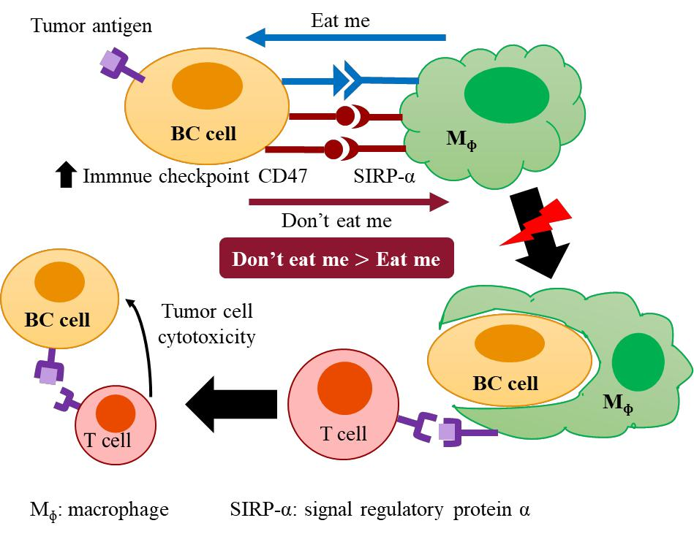

**Figure 3.** Activated CD47 signaling toward macrophage disrupts macrophage phagocytosis of breast cancer and the following T cell immunity activation

**2.3 Chronic Inflammation and the Estrogen Mechanisms**

Hormone receptor-positive cancer is the major type of BC, with approximately 70% of

18

human BCs depending on hormones and the expression of their receptors (Spears et al.,

2009). Reproductive issues such as ages at menstruating, first birth and menopause as well

as the use of hormone replacement therapy for menopause symptoms and oral

contraceptives are all established factors for BC via hormonal mechanisms (Chen, 2008).

Although it is still in its infancy, researches have demonstrated the interplay between

inflammation and hormones. The sex hormones appear to have important, but complex

effects on the body’s inflammatory response. For example, many observers have wondered

if the increase in inflammatory diseases that coincide with menopause, such as arthritis,

might be related to shifts in the balance of progesterone and estrogens, and thereby

hormones may contribute to breast tumorigenesis via the inflammatory response. However,

estrogens, by themselves, directly promotes tumorigenesis via through immunomodulatory

effects and chronic inflammation, in fact may also contribute to the development of BC via

hormonal pathways (Amadou et al., 2013; Quigley et al., 2017).

**2.3.1 Pro-tumor Immunomodulatory Effects of Estrogen**

It is the fact that the susceptible of infection and related mortality for women are generally

lower, whereas the susceptible of autoimmune disease is higher, than men, and one of the

underlying factor contributing to this difference is suggested to be female sex steroid

19

hormone, which is capable of interacting with immune system (Grossman, 1985). The

immunomodulatory effects of estrogen are two-faced, including immunosuppression and

immunostimulation, and its effects on immune function seem to be extensively dependent

on estrogen concentration, composition of estrogens and targeted cell types (Straub, 2007).

In a TME, various cell types, such as tumor cells, stromal cells as well as immune cells,

secret aromatase and estrogen, and via autocrine and/or paracrine estrogen pathways, these

hormones may promote tumor progression by weakening anti-tumor immune responses

(Rothenberger et al., 2018). Estrogen is suggested to have the ability to induce tumoricidal

M1 macrophage polarization toward immunosuppressive M2 in a TME (Gilliver, 2010;

Svensson et al., 2015). Moreover, evidence indicates that estrogen can increase the

accumulation of MDSCs in tumors and enhance their immunosuppressive activities by

estrogen receptor-mediated upregulation of STAT3 signaling (Svoronos et al., 2017);

influence CD4+ helper T cell differentiation, APCs functions and chemokines production,

by which would lead to increased TH2 cytokines production such as IL-4 and IL-10,

decreased cell-mediated TH1 immune response and impaired T cell activation (Salem,

2004); stimulate Tregs activation (Tai et al., 2008); increase T cell anergy (Polanczyk et al.,

2007; Yang et al., 2017); inhibit cytotoxic T lymphocyte- and NK cell-mediated apoptosis

against tumor cells (Jiang et al., 2006). Above-mentioned immunosuppressive effects of

20

estrogen on both innate and adaptive immune system could converge to pro-tumor

immunity, creating a tumor friendly microenvironment and promoting cancer progression.

**2.3.2 Aromatase as a Mediator Between Inflammation and Breast Tumorigenesis**

Since epidemiological studies have indicated that obesity or adiposity and its underlying

chronic inflammatory status are associated with BC risk in post-menopausal women (Rose

et al., 2010), the interaction and related molecular mechanisms among obesity,

inflammation and BC have been intensively investigated, and the increased pro-

inflammatory mediators within mammary adipose tissue are proposed as critical cellular

mechanisms (Rose et al., 2015). In an obese state, large number of macrophages infiltrate

into adipose tissue, typically being around individual adipocytes to form a “crown-like

structure” (CLS), which is a representative feature of adipose tissue inflammation and

simultaneously serve as a major contribution to proinflammatory cytokines such as TNF-

α, IL-6 and chemokine MCP-1. The mediators secreted from CLS can further recruit

additional monocytes and lymphocytes, in turn deteriorating the inflammatory process

(Rose et al., 2015; Cowen et al., 2015).

In addition to direct effects of inflammatory cytokines in the modulation of tumorigenic

pathways as described in previous sections of this review, an

21

obesity→inflammation→aromatase axis is present in the breast tissue of most overweight

and obese women (Morris et al., 2011; Rose et al., 2015; Cowen et al., 2015). In

postmenopausal women, estrogen production is mainly from enzymatic conversion of

androgen (androstenedione) into estrogen (estrone) in the adipose tissue instead of the

ovaries, which are the main sources of estrogen production in premenopausal women, and

the responsible key enzyme is called aromatase (cytochrome P450 19A1, CYP19A1). In

an obese state, the increased numbers of CLS, enhanced activation of the NF-κB

transcription factor (Hursting, 2011; Zahid et al., 2016), and increased secretion of

inflammatory mediators, such as IL-6 (Reed et al., 1992), TNF-α (Zhao et al., 1996), IL-

11, leukemia inhibitory factor, oncostatin M, insulin-like growth factor 1 (IGF-1) (Zhao et

al., 1995) and PGE2 (Richards et al., 2003), are directly associated with elevated aromatase

levels and activity in the mammary glands (Figure 4). The inflammation-aromatase axis

indicates a hormonal mechanism between inflammation and breast tumorigenesis.

22

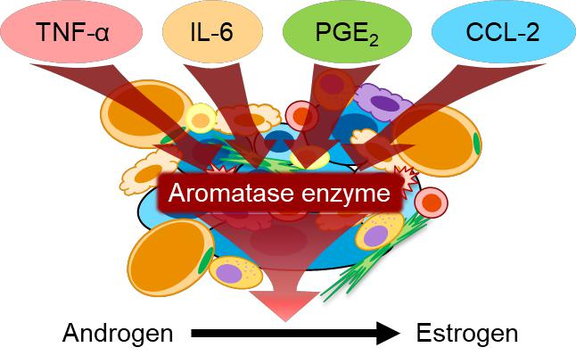

**Figure 4.** Elevated levels of inflammatory mediators during chronic inflammation stimulate aromatase expression and activity

**2.4 Inflammation and Breast Cancer: The Wnt-Signaling Pathway Connection**

While chronic inflammation plays a critical role in breast tumorigenesis, inflammatory

mediators-induced oncogenes expression also greatly involves in this causality, for

instance, the secretion of Wnt proteins and triggered signalings are one of the major

oncogenic pathways.

**2.4.1 Wnt-Signaling Pathway and Breast Cancer**

The discovery of Wnt protein is first proposed with the term “*Int-1*” (integration 1) by Roel

23

Nusse and his colleagues (1984) in the light of a research on mouse mammary tumour virus

(MMTV) infected mice and the oncogene correlated to following breast tumorigenesis.

However, the identification of this gene was actually characterized as *swaying* and *wingless*

(*Wg*) previously in both mouse and drosophila models respectively with the functions

involved in embryonic development such as cell proliferation, differentiation, and polarity

(Nusse, 2005; Klaus et al., 2008). Due to the multiple names of this gene and its related

genes, researchers renamed these gene family as *Wnt* family standing for the blend of *Wg*

and *Int* (Klaus et al., 2008). Similar with other molecular mechanisms involved in

embryonic development, mutations appeared in these pathways or their inhibitors would

lead to dysregulation of cell growth and motility control, resulting in tumorigenesis. Recent

studies have indicated that *Wnt* family in human comprises 19 proteins, and as ligands there

are three signaling pathways, one canonical and two non- canonical pathways, could be

activated by binding Wnt proteins to corresponding receptors and co-receptors, frizzled

receptor family and low-density lipoprotein-related protein 5/6, respectively (Komiya et

al., 2008).

The canonical pathway, also known as Wnt/β-catenin pathway, is thought to be the major

signaling contributing to oncogenesis. Due to the receptors binding of Wnt protein,

24

increased β-catenin accumulates in the cytoplasm, eventually translocating into nucleus

and acting as a coactivator of T-cell factor/lymphoid enhancer factor transcription factors

for upregulating Wnt targeted genes expression (Nusse, 2005), such as c-myc, axin-2, and

cyclin D1, some of whom are responsible for regulating critical cell functions, cell survival,

stem cell renewal and organogenesis for example (Komiya et al., 2008). The other two

signalings are β-catenin independent pathways, including planar cell polarity pathway and

the Wnt/Ca2+ pathway, of which’s role is primarily in regulating cell motility and polarity

and Ca2+-dependent cellular signaling via the activation of protein kinase C (PKC) and

Ca2+/calmodulin-dependent protein kinase II (CaMKII) (Seifert et al., 2007; De, 2011).

Furthermore, recent studies show that *Wnt5a* might serve as a tumor suppressor gene via

the stimulation of Wnt/Ca2+ pathway to block Wnt/β-catenin pathway through CaMKII-

mediated and calcium-sensing receptor-mediated β-catenin phosphorylation and increasing

β-catenin degradation in thyroid and colon carcinoma, respectively (Kremenevskaja et al.,

2005; MacLeod et al., 2007).

Wnt/β-catenin pathway activation is commonly found in various cancer types, and most of

the dysregulations of this pathway can be attributed to genetic mutations on signaling-

related genes, posttranslational modification of key regulators as well as the

25

downregulation of Wnt antagonists such as secreted frizzled-related protein and dickkopf

protein. The first connection between BC and Wnt/β-catenin pathway was built based on

the discovery of *Int-1*, later known as *Wnt1* (Nusse et al., 1984), and evidence showed that

the activation of *int-1* gene transcription is associated with mammary gland hyperplasia

and following breast tumorigenesis (Tsukamoto et al., 1988). Subsequently research also

suggested that similar with the effects of *Wnt1* on breast tumorigenesis, *Wnt3* and *Wnt10b*

are able to induce breast tumor development (Roelink et al., 1990; Lane et al., 1997). In

addition, stabilized β-catenin has been demonstrated as the major characteristic

contributing to tumorigenic Wnt signaling (Incassati et al., 2010); moreover, the activation

of β-catenin signaling is responsible for increased invasion and metastasis capacity for

breast tumor progression via enhanced EMT (Klauzinska et al., 2012). Despite the

deregulated Wnt/β-catenin signaling and nucleus β-catenin accumulation is widely

involved in BC development, the somatic mutations related to Wnt/β-catenin signaling,

such as *APC* , *CTNNB1* and *Axin*, in BC is rare (Yu et al., 2016); whereas, the

overexpression of Wnt corresponding receptors and epigenetic silencing of Wnt

antagonists play roles in the elevated activation of Wnt pathways (Zhan et al., 2017).

**2.4.2 Inflammation Associated Tumorigenesis in Wnt-Signaling Pathway**

26

Although the chronic inflammation status is responsible for a tumor-favorable

microenvironment, it possesses synergistic effects with other tumorigenic pathways as well;

for example, Wnt/β-catenin signaling as one of the classical collaborative pathways is

under extensively research. Since obesity play a role in breast tumorigenesis, Wnt-

signaling is evidenced to involve in tumor progression promoted by diet-induced obesity

in C57BL/6 mice model implanted with MMTV-*Wnt1* cells from transgenic mice; however,

in contrast to obese mice, lean mice showed a reduced tumor growth (Nunez et al., 2008).

To establish the causality between obesity and breast tumor, Zheng et al. (2011) found that

leptin is essential for MMTV-*Wnt1* tumor growth in transplanted mice and also involves in

the development of cancer stem cells; whereas, Wang et al. (2006) indicated that contrary

to the pro-tumor effects of leptin in Wnt-signaling, adiponectin acts as an anti-tumor factor

for BC cell line MDA-MB-231 by decreasing phosphorylation of Akt and GSK-3β, leading

to decreased accumulation of β-catenin in cytoplasm and nucleus and downregulation of

*cyclin D1* (*CCND1*) expression. In the context of obesity-related chronic inflammation,

leptin and adiponectin act as pro- and anti-inflammatory mediators, respectively; hence

their balance in mammary tissue profoundly modulates the inflammation and tumor

progression, on the other hand, both leptin and adiponectin are the intermediaries between

chronic inflammation and tumorigenic Wnt-signaling pathway.

27

In the process of inflammation-related tumorigenesis, the crosstalk between tumor cells

and stromal cells as well as the secreted molecules in the a TME greatly promotes tumor

progression, and among the interactions, Wnt-signaling also plays a role. TAM

accumulation in BC as the major link between inflammation and cancer progression is

associated with BC progression and poor patient outcomes (Obeid et al., 2013). Evidence

has suggested that Wnt-signaling is positively incorporated in the crosstalk between tumor

cells and macrophages as well as cell derived inflammatory cytokines: Kaler et al. (2009a,b)

and Oguma et al. (2008) demonstrated that macrophage-derived IL-1β and TNF-α are able

to induce the phosphorylation of GSK-3β through NF-κB-dependent and -indepentdnet

pathway, leading to elevated tumorigenic β-catenin signaling in colorectal and gastric

cancers, respectively; Liu et al. (2012) proposed that the elevated TNF-α expression from

diet-induced obesity in C57BL/6 mice is correlated to the increased phosphorylation of

GSK-3β and β-catenin stabilization; our previous study on obesity-related breast

tumorigenesis also found that the TNF-α recombinant protein is capable of increasing the

expression of active β-catenin, whereas the anti-TNF-α antibody could attenuate β-catenin

accumulation (Roubert et al., 2017); TGF-β (Wu et al., 2017) and CXCL12 (Shan et al.,

2015) are shown to be stimulators for active Wnt/β-catenin signaling, leading to enhanced

invasion and metastasis of BC via the upregulation of EMT.

28

In addition to the involvement of canonical pathway in inflammation-associated

tumorigenesis, non-canonical pathway also directly or indirectly contributes to tumor

progression. Proinflammatory cytokines such as IFN-γ (Newman et al., 2012) and TNF-α

(Shao et al., 2016) or lipopolysaccharide (LPS) (Newman et al., 2012; Shao et al., 2016)

are able to stimulate the expression of Wnt5a in macrophages, of which’s signaling is

generally participating in non-canonical pathways such as CaMKII, PKC and JNK (Shao

et al., 2016). Pukrop et al. (2006) showed that in a coculture cell model, the increased

secretion of Wnt5a by macrophage could stimulate the expression of Wnt targeted gene

MMP-7 and its regulated TNF-α secretion, leading to upregulation of MMP-2,3,9

expression within macrophages by autocrine mechanism; moreover, Wnt5a would go

through paracrine mechanism to stimulate the activation of AP-1/c-Jun signaling in MCF-

1. Taken together, Wnt5a possesses the ability to promote the invasive capacity of BC cells. Besides, macrophage-derived Wnt5a is evidenced to be endowed with proangiogenic effects by promoting the maturation of proangiogenic macrophages and the proliferation and migration of endothelial cells, and enhancing the production of pro-inflammatory cytokines as well as pro-angiogenic factors in macrophages by autocrine and paracrine mechanisms (Newman et al., 2012). Other pro-tumor effects of non-canonical pathway include the induction of proinflammatory mediators mediated by the activation of CaMKII,

29

PKC, NF-κB, and MAPK signaling, and induced insulin resistance (Shao et al., 2016).

As the evidence outline in the previous session, progressive chronic inflammation is

responsible for the elevated estrogen concentration in both local and systemic levels. It is

noteworthy that estrogen could influence Wnt-signaling pathway. Several studies have

reported that beta-estradiol treated MCF-7 would upregulate the expression of frizzled-10

(Saitoh et al., 2002), WNT2 (Katoh, 2001) and WNT5B (Saitoh et al., 2002), resulting in

the raised activation of Wnt/β-catenin signaling. In summary, Wnt-signaling pathway is not

only involved in tumorigenesis triggered by mutations or epigenetic alteration in tumor

cells, but the chronic inflammation caused upregulation of proinflammatory mediators and

estrogen level as well as the crosstalk between tumor cells and stromal cells in the whole

TME profoundly influence the activation of this pathway.

**2.5 The Prevention of Breast Cancer: With A Focus on Mushrooms**

Phytochemicals and bioactive compounds in plant-based foods are widely accepted as plant

nutrients with some specific biological functions that are beneficial to human health and

possess positive effects on various human disease. Among these foods, mushrooms are

considered as flavorful delicacies in a part of the human diet for many years across the

global. Mushrooms, technically, are classified as fungi and generally regarded as

30

vegetables because of their nutritious properties. Around the world, more than 12,000

species of mushrooms exist in nature, however, only ~20-30 species are widely accepted

as cultivated edible mushrooms (Feeney et al., 2014; Valverde et al., 2015; Rathore et al.,

2017).

**2.5.1 Market Trends of Mushrooms**

In many cultures, the extensively use of mushrooms in cuisine has been an indispensable

part for centuries, even some of the Asian cultures believe them to have medicinal value

and apply them into traditional medicine to treat various disease (Khan et al., 2013). The

global production of mushrooms had dramatically grown from less than 1 million metric

tons in 1970 to 10.7 million metric tons in 2016 (FAOSTAT, 2018). In 2016, China, Italy,

United States of America, Netherlands and Poland were the top 5 countries for the

production of mushrooms and truffles, and they were reported to produce 72%, 6%, 4%,

3% and 2% of global mushrooms and truffles (FAOSTAT, 2018). The production and sales

of mushrooms in the USA is gradually increased from $0.8 to $1.2 billion during 1997-

2017 (National Agricultural Statistics Service, USDA, 2018). The cash receipt for

mushrooms in the USA in 2016 is ranked 28th among all agricultural commodities, but

ranked 4th among vegetables (Economic Research Service, USDA, 2018). However, the

31

mushroom production in the USA is predominantly supplied for domestic utilization, and

only less than 5% of mushroom supplies exported annually (Feeney et al., 2014). In

addition to the economic value, the cultivation of mushrooms also is environmental

friendly that the required land and water for the growth of cultivated mushrooms are

relatively less than other crops, moreover, spent mushroom substrate is an excellent source

as a soil amendment for crops or a garden (Feeney et al., 2014).

**2.5.2 Nutritional Value of Mushrooms**

Long honored as a superfood with high nutritional and functional value, mushrooms

provide high protein, high fiber, abundant sources of vitamins and minerals, but low fat

contents (Mattila et al., 2001; Wang et al., 2014). Carbohydrates found in mushrooms

mainly consist of mannitol and high proportion of non-digestible polysaccharides such as

β-glucans, chitin and mannans (Cheung, 2010). One of the significant differences between

mushrooms and most vegetables is their protein content, mushrooms contain higher

proportion of protein, of which’s nutritional quality is higher than that of other plant protein,

providing all the essential amino acids for human, even some of the species possessing the

comparable protein composition with that of hen’s egg (Wang et al., 2014). In addition, the

low amount of fat is composed of high proportion of unsaturated fatty acids, such as linoleic

32

and oleic acid (Valverde et al., 2015). Mushrooms are also a good source of several

vitamins and minerals, including riboflavin (vitamin B2), niacin, folate, vitamin B12, D, E,

potassium, phosphorus, magnesium, zinc, copper and selenium (Cheung, 2010; Feeney et

al., 2014; Valverde et al., 2015). Beyond the nutritional value of mushrooms, they are able

to synthesize a bunch of biologically active components, including some bioactive

carbohydrates, proteins, lipids and secondary metabolites (Valverde et al., 2015), that

possess diverse positive effects against various human diseases. Nowadays, mushrooms

are recognized as a functional food and are getting worldwide attention on their

nutraceutical attributes and pharmacological characteristics.

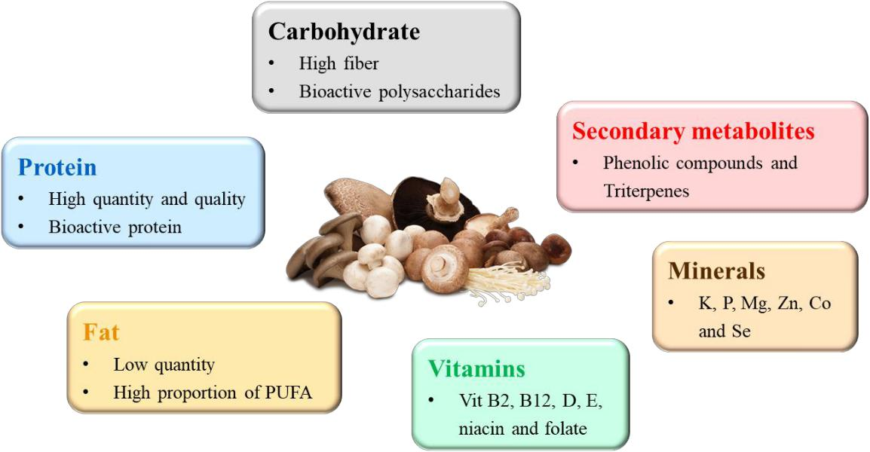

**Figure 5.** Nutritional value of mushrooms

**2.5.3 The Health Beneficial Properties of Mushrooms**

33

The health benefits of mushrooms for human, including improved cognition, autoimmune

disease, chronic disease such as asthma, obesity, diabetes, cardiovascular diseases and

cancers, are mainly discovered on the basis of previous *in vitro* experiments and *in vivo*

animal trials, and these health-promoting effects are evidenced mostly attributing to the

biological activities of mushrooms on the aspects of immunomodulation, interaction with

gut microbiota, and anti-cancer effects (Roupas et al., 2012).

**Immunomodulation.** One of the most well-known health-promoting effects of

mushrooms is their anti-inflammatory and immunomodulatory including both

immunosuppressive and immunostimulatory properties. These properties are attributed to

the wide variety of bioactive compounds in mushrooms such as bioactive saccharides,

proteins, fatty acids, vitamins and minerals, secondary metabolites including phenolic

compounds, indole compounds and terpenoids (Muszyńska et al., 2018).

*Macronutrients:* β-glucans are the most abound polysaccharides exist in mushrooms, and

researches on β-glucans indicate they possess anti-inflammatory and immunostimulatory

effects by inhibiting NF-κB, COX-2 and inducible nitric oxide synthase (iNOS) signaling

in RAW 264.7 macrophages (Ma et al., 2013) and enhancing the proliferation and

stimulation of immune cells such as macrophages and NK cells (Akramiene et al., 2007),

34

respectively. Proteins such as mushroom lectins and fungal immunomodulatory proteins

are characterized as immunoregulatory factors directly targeting immune cells for

activating both innate and adaptive immunity (Wang et al., 1996; Sze et al., 2004; Xu et al.,

2011). Polyunsaturated fatty acids, especially α-linolenic acid (ALA), are generally

considered as anti-inflammatory factors. Indeed, study conducted by Grzywacz et al. (2016)

showed that high ALA content found in *Imleria badia* play a role in the inhibition of LPS-

induced inflammatory responses in RAW 264.7 macrophages.

*Micronutrients:* antioxidative vitamins such as ascorbic acid, tocopherols as well as

carotenoids are important not only for their role in free radical scavenging, but also in

preventing inflammatory cytokines production (Grimble, 1997). Ergosterol (vitamin D

precursor) and ergocalciferol (vitamin D2) found in mushrooms are important food sources

of vitamin D, which possesses a board beneficial effects for human. Babu et al. (2014)

demonstrated that 10 weeks feeding of ultraviolet-B light (UVB)-exposed white button

(WB) mushrooms powder for Sprague-Dawley rats significantly increased the plasma total

25-hydroxyvitamin D levels, promoted innate immunity as well as improved anti-

inflammatory effects in LPS-challenged rats compared to rats feeding without VitD

enrichment (UVB exposure). Another experiment conducted by Drori et al. (2016)

35

demonstrated that in an immune-mediated hepatitis mice model, after the feeding of UVB-

exposed *Lentinula edodes* (shiitake mushroom) powder for C57B1/6 mice treated with

concanavalin A, the liver damage and plasma IFN-γ was alleviated compared to

nonenriched mushroom group. In addition, the authors also pointed out that vitamin D may

have synergistic effects with other bioactive compounds in mushroom on anti-

inflammatory activities.

*Other bioactive compounds:* phenolic compounds in mushrooms exerting anti-

inflammatory effects is partially attributed to their role as antioxidants. Caffeic acid, for

example, has been shown to attenuate vascular inflammation by inhibiting NF-κB signaling

and the expression of cell adhesion molecules, chemoattractants such as MCP-1 and IL-8

in the TNF-α-induced human umbilical vein endothelial cells (Moon et al., 2009). Indole

compounds such as melatonin and serotonin possess immunoregulatory effects including

immunostimulation and/or anti-inflammation by targeting various immune cells (Carrillo-

Vico et al., 2013; Herr et al., 2017). Triterpenes derived from *Ganoderma lucidum* are

endowed with immunomodulatory and anti-inflammatory effects by inhibiting NF-κB

signal transduction or other transduction pathways such as AP-1/ nuclear factor of activated

T-cells (NF-AT) and STAT3 signaling (Ríos, 2010; Muszyńska et al., 2018).

36

**Gut microbiota.** The microbiota inhabiting in human gastrointestinal (GI) tract is

comprised of more than 1014 microorganisms (10 times more than the number of human

cells), with over 1000 species of known bacteria encompassing more than 3 million genes

(150 times more than human genome) (Jayachandran et al., 2017). The complexity makes

gut microbiota a dynamic ecosystem that is profoundly influenced by multiple factors

through the lifetime including genotype, the mode of delivery at birth and infant feeding,

diet, lifestyle, stress and environmental exposures. A healthy and balanced gut microbiota

could contribute many benefits to the host such as strengthening gut barrier (Natividad et

al., 2013), protecting against pathogens (Bäumler et al., 2016), xenobiotic metabolism

(Claus et al., 2016), regulating host energy and immune homeostasis (Wu et al., 2012;

Rosenbaum et al., 2015); whereas, a disrupted gut microbiota would lead to various

diseases.

One of the major role of mushrooms in improving health is by providing prebiotics such

as non-digestible oligosaccharides and polysaccharides to ameliorate and maintain the

host’s gut microbiota. Recent study has shown that C57BL/6 mice feeding with 1% WB

mushrooms (1 g/100 g diet) for 2-4 weeks displayed an increased diversity of gut

microflora by increasing the *Bacteroidetes* phyla and decreasing the *Firmicutes* phyla

37

including pathogenic bacteria *Clostridia*, compared to mice feeding with control diet

(Varshney et al., 2013). Research also points out that the ratio between *Firmicutes* and

*Bacteroidetes* is intimately associated with obesity. Chang et al. (2015) demonstrated that

the consumption of the water extract of *Ganoderma lucidum* mycelium in C57BL/6 mice

feeding with high-fat diet (HFD) for 2 months showed a significant reduced weight gain

and fat accumulation by reversing HFD-induced gut dysbiosis characterized by an

increased *Firmicutes* to *Bacteroidete*s ratio.

The fact that the growth of specific gut bacteria is favored by distinct polysaccharides and

the intervention of certain polysaccharides or oligosaccharides could alter the composition

of human gut microbiota to a healthier and balanced condition (Koropatkin et al., 2012)

gives rise to a prosperous research on the field of gut microbiota and prebiotics.

Mushrooms as a potential source of prebiotic polysaccharides and oligosaccharides are

now under an extensively exploration. For example, polysaccharides derived from

*Lentinula edodes*, *Phellinus linteus*, *Trametes versicolor* and *Hericium erinaceus* are

proved to render an alteration of gut microflora that could promote host’s health

(Jayachandran et al., 2017).

**Anti-cancer effects.** The anti-cancer effects of mushrooms are largely due to the above-

38

mentioned two characteristics that are responsible for the regulation of both innate and

adaptive immune systems, leading to effective anti-cancer immunosurveillance. On the

other hand, various bioactive compounds found in mushrooms also possess diverse anti-

tumor activities such as pro-apoptosis, anti-proliferation, anti-invasion, anti-metastasis,

and anti-angiogenesis, which are dependent on the suppression of several tumorigenesis

signaling such as phosphoinositide 3-kinase (PI3K)/AKT, Wnt/β-Catenin, and NF-κB

signaling pathways (Joseph et al., 2017).

**2.5.4 Mushrooms and Breast Cancer Prevention**

The benefits of mushrooms on the prevention of BC are generally demonstrated by *in vitro*

*or in vivo* studies, as well as a limited number of epidemiological studies. Clinical

intervention trails related to oral administrations of mushrooms conducted in humans are

rare. Epidemiological studies suggested that per 1 g/day increased mushroom intake is

associated with 0.97 BC relative risk, and this correlation exists in both pre- and post-

menopausal women (Li et al., 2014). In addition, adjuvant treatments of BC with dietary

supplementation with mushrooms or mushroom extracts have shown to improve the quality

of life and survival rates of patients (Novaes et al., 2011; Eliza et al., 2012).

Myriad pre-clinical researches on biologically active substances derived from various

39

mushrooms have revealed that the anti-cancer activities of mushrooms are directly

attributed to the diverse bioactive components found in mushrooms. The major bioactive

components in mushrooms are polysaccharides, and their anti-tumor activities are

extensively addressed. For example, Lu et al. (2011) revealed that polysaccharide Krestin

extracted from *Trametes versicolor* are capable of inducing dendritic cell (DC)-mediated

TH1 immune response and stimulating cytotoxic T cells and NK cells against BC growth

in C57BL/6 mice. Jeong et al. (2012) indicated that polysaccharides extracted from WB

mushrooms are able to activate J774A.1 macrophages toward tumoricidal ones and possess

cytotoxicity against MCF-7 BC cell line. A study conducted by Shi et al. (2013) showed

that polysaccharides isolated from *Pleurotus abalonus* could induce ROS-mediated cell

apoptosis in MCF-7 cells. In addition, Alonso et al. (2013) demonstrated that

polysaccharide complexes derived from Maitake mushroom are responsible for the anti-

tumor effects, such as pro-apoptosis, anti-proliferation, anti-metastasis and improving drug

sensitivity, in MCF-7 cells.

Other bioactive compounds of mushrooms that possess anti-BC effects include lectins

(Savanur et al., 2014), terpenoids such as ganoderic acids (Jiang et al., 2008) and

ganodermanontriol (Jiang et al., 2011), and secondary metabolite panepoxydone (Arora et

40

al., 2014). The anti-BC functions of these bioactive compounds mainly relates to the

induction of apoptosis and suppression of proliferation and invasion, which are preventive

functions generally for almost all types of cancer. Specifically for BC, several previous

studies pointed out that phytochemicals extracted from WB mushrooms would block ER+

BC proliferation in *in vitro* and *in vivo* by suppressing aromatase activity (Grube et al.,

2001; Chen et al., 2006).

**2.5.5 *Antrodia Camphorata***

AC is a rare medicinal fungus parasitic on the *Cinnamomum kanehirae Hayata* (bull

camphor tree), which only grows in Taiwan. AC, also known as “*niu-chang-chih*” in

Chinese name, is commonly used in Taiwanese traditional medicine for alcohol

intoxication, diarrhea, abdominal pain, hypertension, fatigue, viral infection and liver

disease (Geethangili et al., 2011).

As other mushrooms, AC also possesses anti-inflammatory and immunomodulatory effects.

In LPS-stimulated macrophages, AC extracts were reported to suppress the enhanced

production of nitric oxide, TNF-α, IL-1β, IL-12, PGE2 as well as iNOS and COX-2 protein

expression via inhibiting NF-κB signaling pathway (Hseu et al., 2005; Rao et al., 2007)

and STAT3 signaling (Lin et al., 2017b). AC extracts and bioactive compounds found in

41

AC such as zhankuic acids and antcin K also could inhibit the production of inflammatory

mediator ROS in activated neutrophils or mononuclear cells (Shen et al., 2004a; b). In

addition, Kuo et al. (2008) demonstrated that AC extracts could enhance innate immune

response by upregulation TNF-α and IL-6 expression and polymorphonuclear neutrophils

(PMN)- and monocytes -mediated phagocytosis in diluted peripheral blood culture.

Although according to previous studies AC has been proven to have effective

immunomodulatory properties, its role in inflammatory tumorigenesis within a TME

remains unclear.

A series *in vitro* and *in vivo* experiments for identifying the anti-BC effects of fermented

culture broth of AC have suggested that it could induce tumor-specific ROS-mediated

apoptosis and cell cycle arrest against hormone receptor-positive and -negative and

HER2/neu-overexpressing BC (Yang et al., 2006; Hseu et al., 2007; Hseu et al., 2008; Lee

et al., 2012). In addition to the selective cytotoxic effects, it is able to suppress COX-2 and

HER2/neu expression and inhibit PI3K/AKT and β-catenin signaling, of which’s

upregulations are involved in cancer invasion and metastasis (Hseu et al., 2007; Lee et al.,

2012).

Recently, researchers have isolated a new group of bioactive compounds, ubiquinon

42

derivatives, including AQ and 4AAQB, from the AC mushrooms. These compounds are

shown to exhibit inhibitory effects against BC growth and metastases (Lee et al., 2015) as

well as anti-inflammatory effects (Chang et al., 2018). Their anti-tumor effects also have

been reported in hepatomas (Lin et al., 2011), brain cancer (Thiyagarajan et al., 2015),

pancreatic cancer (Yu et al., 2012), lung cancer (Kumar et al., 2011), colorectal cancer

(Chang et al., 2015; Lin et al., 2017a) and ovarian cancer (Liu et al., 2017). However, due

to limited studies, the immunomodulatory efficacy of these compounds is still not clear,

not to mention their influence on the interaction between inflammation and BC progression.

**2.6 Conclusions and Perspectives**

In the light of the concept of TME, the links between inflammation and BC progression

are well-established. Within a TME, inflammatory mediators such as cytokines,

chemokines and PGs play critical roles in promoting breast tumor growth and metastases

by suppressing anti-tumor immunity and triggering multiple oncogenic signaling pathways,

including NF-κB, STAT3 and Wnt/β-catenin signaling. On the other hand, these mediators

could also stimulate the activation of aromatase, leading to enhanced estrogen production

and contributing to BC promotion and repression of tumor immunosurveillance. AC, as a

traditional Chinese medicine in Taiwan, has been of interest in CAM research in recent

43

decades. Although there is a quite amount of evidence from pre-clinical experiments that

suggests meaningful association between AC and cancer risk, it remains unclear which

food components actually account for protection against cancer, and which cellular

processes are critically involved. Recently, new bioactive components, AQ and 4-AAQB

were isolated from AC, and have been regarded as promising bioactive compounds in

treating various cancer, including BC. A greater understanding of specific molecular targets

for AQ and 4-AAQB is fundamental to establish them as complementary and alternative

strategies for reducing cancer in humans.

44

**CHAPTER 3**

**PURPOSE OF THE STUDY**

Numerous studies have indicated that chronic inflammation acts as a risk factor as well as

tumor-promoting factor for BC development. Inflammatory mediators such as cytokines,

chemokines and PGs produced by various cells including cancer cells are proposed to be

the key regulators in BC progression through an autocrine/paracrine mechanism. Multiple

studies also indicated that these mediators could further interfere with estrogen production,

oncogene expression, and tumor immunosurveillance within a TME, leading to advanced

BC. Recently, two novel bioactive components, AQ and 4-AAQB have been isolated from

AC mushroom and are recognized as potential anti-cancer and anti-inflammatory natural

compounds; however, their effect on immunomodulation in BC is still unknown. We

therefore propose to characterize the effects of AC and 4-AAQB on the expression of BC-

related inflammatory mediators and examine their effects on the aromatase activity as well

as Wnt-signaling responses with or without the stimulation of TNF-α, one of the most

critical inflammatory cytokines in the breast TME.

**Specific Aim #1: To characterize the influences of AQ and 4-AAQB on the production**

**of inflammatory mediators in the MCF-7 BC cell line with or without TNF-α**

45

**stimulation.** Our working hypothesis is that TNF-α stimulation on MCF-7 BC cells would

deteriorate the gene expression profile of inflammatory mediators and treatment with AQ

and 4-AAQB to MCF-7 cells could improve the gene expression profile of inflammatory

mediators before and after TNF-α stimulation.

**Specific Aim #2: To examine the impact of AQ and 4-AAQB on the expression of**

**aromatase in the MCF-7 BC cell line.** Our working hypothesis is that TNF-α stimulation

on MCF-7 BC cells would upregulate the gene expression of aromatase and treatment with

AQ and 4-AAQB to MCF-7 cells could suppress the gene expression of aromatase before

and after TNF-α stimulation.

**Specific Aim #3: To examine the influences of AQ and 4-AAQB on immune-**

**checkpoint CD47 and tumorigenic Wnt-signaling downstream genes.** Our working

hypothesis is that TNF-α stimulation on MCF-7 BC cells would upregulate the gene

expression of immune-checkpoint CD47 and Wnt-signaling responses and treatment with

AQ and 4-AAQB to MCF-7 cells could inhibit the gene expression of CD47 and Wnt-

signaling responses.

46

**CHAPTER 4**

**MATERIALS AND METHODS**

Our experiment aimed to identify the role of AQ and 4-AAQB in the modulation of

inflammatory mediators as well as their associated gene expression in MCF-7 BC cells

with or without TNF-α stimulation. The appropriate doses for AQ/4-AAQB and TNF-α

treatment was first evaluated by using MTT assays. The gene expression of inflammatory

mediators, aromatase and Wnt-signaling downstream genes was measured in the treated

MCF-7 cells by using quantitative real-time PCR to determine the effects of TNF-α

stimulation and AQ/4-AAQB treatment with or without TNF-α stimulation in MCF-7 cells.

**4.1 Experimental Design**

See Table 1. in the Appendix

**4.2 Reagents and Chemicals**

The compounds antroquinonol (AQ, > 99% purity) and 4-acetylantroquinonol B (4-AAQB,

* 99% purity) were obtained from New Bellus Enterprises Co., Ltd. (Tainan, Taiwan). AQ and 4-AAQB were dissolved in dimethyl sulfoxide (DMSO, Santa Cruz Biotechnology Inc., Dallas, TX) to make 25mM and 50mM stock solutions, respectively. The stock

47

solutions were filter-sterilized and stored at -20°C in aliquots. Dulbecco's modified Eagle

medium (1X) (DMEM, Gibco™), heat-inactivated fetal bovine serum (FBS, Gibco™),

phosphate buffered saline (1X) (PBS, Gibco™), 0.25% trypsin-EDTA (1X) (Gibco™),

penicillin-streptomycin (10,000 U/mL) (Gibco™), TRIzol® reagent (Invitrogen™), high-

capacity cDNA reverse transcription kit (Applied Biosystems™) and PowerUp™ SYBR™

green master mix (Applied Biosystems™) were purchased from Thermo Fisher Scientific

Co. (Waltham, MA). DEPC-treated water was purchased from Santa Cruz Biotechnology

(Dallas, TX). 3-(4,5-Dimethyl-2-thiazolyl)-2,5-diphenyl-2H-tetrazolium Bromide (MTT,

Calbiochem®) was purchased from MilliporeSigma (Burlington, MA). MTT were

dissolved in PBS to make a 5 mg/ml stock solution. The MTT stock solution were filter-

sterilized and stored at -20°C in aliquots. Recombinant human TNF-α was purchased from

PeproTech Inc. (Rocky Hill, NJ). rhTNF-α was reconstituted in sterile double distilled

water containing 0.1% bovine serum albumin (BSA, Cell Signaling Technology Inc.,

Danvers, MA) to make a 100ng/μL stock solution and was stored at -20°C in aliquots.

**4.3 Cell Lines and Cell Culture**

Breast cancer cell line MCF-7 was obtained from American Type Culture Collection

(ATCC, Manassas, VA). MCF7 cells were maintained in DMEM supplemented with 10%

48

FBS, 100 U/mL penicillin and 100 μg/mL streptomycin and 1 mM sodium pyruvate at

37 °C in a humidified incubator containing 5% CO2. Cells were sub-cultured at 80%

conflueny, and culture medium was replaced every 72 hours.

**4.4 Cell Viability Assays**

MCF-7 cells were seeded in 96-well plates with 2×104 cells per well and incubated for 48

hours. After cell growth reached 80% confluency, cells were subsequently starved in

DMEM containing 0.5% FBS overnight. After starvation, cells were either treated with

DMEM containing 0.5% FBS and AQ/4-AAQB (0~50 µM with DMSO<0.01%) or control

medium containing 0.5% FBS for 24 hours and 48 hours or treated with medium containing

0.5% FBS and rhTNF-α (0~10 ng/mL) or rhTNF-α (0~10 ng/mL) combining with AQ/4-

AAQB (0.4 µM with DMSO<0.01%) for 24 hours. Blanks were incubated with culture

medium without seeding cells. Cell viability was determined by incubation with MTT (0.5

mg/mL) for 1 hour. Formazan crystals were dissolved in DMSO, and the absorbance was

measured by a SpectraMax microplate reader (Molecular Devices, Sunnyvale, CA) at 570

nm wavelength. The average value obtained from blanks was subtracted from average

values obtained from treatment and control groups. Cell viability was expressed as a

percentage compared to control. Experiments were performed in sextuplicate.

49

**4.5 Quantitative Real Time PCR Analyses**

RNA extract and cDNA preparation: MCF-7 cells were seeded in 6-well plates with 6×105

cells per well and incubated for 48 hours. After cell growth reached 80% confluency, cells

were subsequently starved in DMEM containing 0.5% FBS overnight. After starvation,

cells were either treated with DMEM containing 0.5% FBS and AQ/4-AAQB (0.4 µM with

DMSO<0.01%) or control medium containing 0.5% FBS for 24 hours or treated with

DMEM containing 0.5% FBS and rhTNF-α (0.2 ng/mL) or rhTNF-α (0.2 ng/mL)

combining with AQ/4-AAQB (0.4 µM with DMSO<0.01%) or control medium containing

0.5% FBS for 0.5, 1, 2, 3, 4 hours. Total RNAs from MCF-7 cells were extracted by using

TRIzol reagent (Invitrogen™) according to the manufacturer's instructions. cDNA was

synthesized from RNA samples by using high-capacity cDNA reverse transcription kit

(Applied Biosystems™).

Gene expression analysis: The expression of target genes was measured by ViiA™ 7 Real-

Time PCR System (Applied Biosystems®). Relative gene expression levels were calculated by ΔΔCt method with *GAPDH* acting as the reference gene. Statistical analyses were based on ΔCt. ΔCt is defined as Ct (target gene) – Ct (ref. gene), and ΔΔCt is defined as ΔCt (treatment) – ΔCt (control). The design of DNA primers for target genes (*IL1β*, *IL6*, *IL10*, *IFNγ*,

50

*TNF*, *TGFβ1*, *PTGS2*, *CCL2*, *CSF1*, *CYP19A1*, *CD47*, *CCND1*, *C-MYC*, *AXIN2* and

*GAPDH*) were available from PrimerBank (<https://pga.mgh.harvard.edu/primerbank/>). All

primers were ordered from Thermo Fisher Scientific (Invitrogen™ Custom DNA Oligos).

A list of the primers used can be found in Table 2. in the Appendix.

**4.6 Statistical Analysis**

All statistical analyses were performed in Excel and SAS. Statistical significances were

evaluated by unpaired *t* test, and time-dependent associations were assessed by Cochran-

Armitage test for trend. P-value < 0.05 was considered to be statistically significant.

51

**CHAPTER 5**

**RESULTS**

**5.1** **Cell Viability Assay of AQ and 4-AAQB Treatment in MCF-7 Cells**

In order to determine the appropriate treatment dosage for AQ and 4-AAQB, we treated

MCF-7 cells with AQ and 4-AAQB. After 48 hours of treatment with either of these

compounds at different concentrations (0-1.6 μM), the cell viability was measured by MTT

assay. The results showed that the reduction of cell number was in parallel with the elevated

concentration of AQ and 4-AAQB compared to untreated control (Figure 6A). Specifically,

the cell growth inhibition in 4-AAQB treatment against MCF-7 cells was greater than in

AQ treatment. Both treatment showed a modest cytotoxic response (~24%) toward MCF-

7 cells while the concentration below 0.4 μM; therefore, we decided to use 0.4 μM as our

treatment dosage for AQ and 4-AAQB in the following experiments.

**5.2** **Cell Viability Assay of TNF-α Treatment in MCF-7 Cells**

Appropriate treatment concentration for TNF-α is also determined by MTT assay. MCF-7

cells were treated with TNF-α at different concentrations (0-10 ng/mL) or treated with

TNF-α combined with 0.4 μM AQ or 4-AAQB. After 24 hours of treatment, results showed

52

that TNF-α exhibited a growth inhibitory effect on MCF-7 cells; whereas, the combination

treatment with AQ or 4-AAQB partially abrogated the inhibitory effects of TNF-α (Figure

6B). TNF-α showed a moderate cytotoxic response (~40%) at 0.2 ng/mL, while the

combination treatments exhibited a less effective cytotoxicity (~20%) with 0.2 ng/mL

TNF-α. Hence, we decided to use 0.2 ng/mL TNF-α as our treatment dosage for the

following experiments.

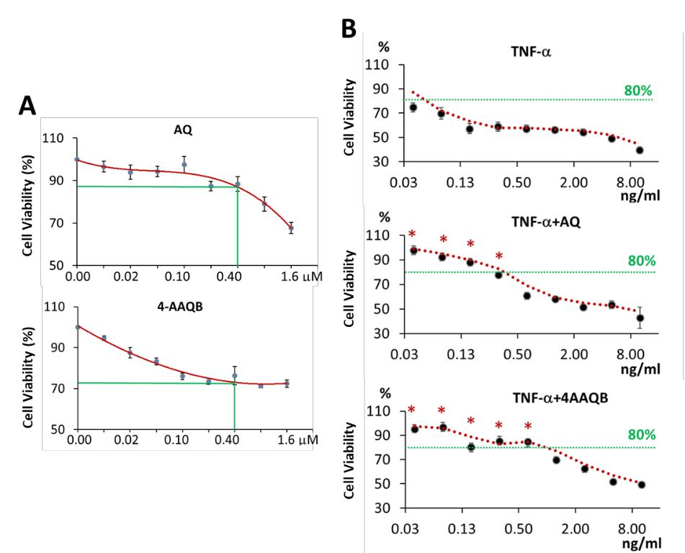

**Figure 6.** AQ, 4-AAQB and TNF-α reduce cell viability of MCF-7 cells. (A) Growth inhibitory effects of AQ and 4-AAQB against MCF-7 cells after 48 h treatment. (B) Growth inhibitory effects of TNF-α against MCF-7 cells after 24 h treatment. Cell viability is measured by MTT assay and is expressed as the percentage viability relative to the untreated control group. All experiments were performed in sixplicate and data are presented as mean ± SEM. *P < 0.05, as compared to TNF-α treatment.

53

**5.3** **AQ and 4-AAQB Alter the Inflammatory Mediators Profile of MCF-7 Cells**

To evaluate the effects of AQ and 4-AAQB on the modulation of inflammatory status in

MCF-7 cells, gene expression levels of 9 inflammatory mediators (*IL6, IL10, IL1β, IFNγ,*

*TNF, TGFβ1, PTGS2, CCL2* and *CSF1*) were measured using quantitative real-time PCR

analyses (Applied Biosystems®). Unpaired *t* tests were calculated to evaluate the

differences between control group and treatment group.

The heatmap of AQ treatment showed that the expression levels of *PTGS2, TNF, IL10,*

*CCL2, IL6* and *TGFβ1* is lower in AQ treatment group than in control group (Figure 7A).

Significantly inhibition by AQ treatment compared to control were found in the expression

levels of *IL10* (44.0%) and *PTGS2* (42.2%) (p-values were 0.026 and 0.040, respectively;

Figure 7B). The expression of *TNF, TGFβ1, CCL2* and *IL6* in AQ treatment group exhibited

a decreased trend compared to control (35.7%, 19.3%, 32.7%, respectively; Figure 7B).

Similar to the effect of AQ treatment, 4-AAQB lower down the expression levels of *TNF,*

*PTGS2, IL10, IL6, IL1β, CCL2* and *TGFβ1* as well but with a stronger suppressive effect

(Figure 8A). Compared to untreated control, the expression of *TNF, PTGS2* and *IL10* were

significantly inhibited in 4-AAQB treatment by 46.2%, 48.4%, 53.4%, respectively (p-

values were 0.002, 0.013 and 0.017, respectively; Figure 8B). The expression of *IL6* and

54

*IL1β* exhibited a decreased trend in 4-AAQB treatment compared to control (50.3% and

21.6%, respectively; Figure 8B). However, the expression level of *CSF1* was significantly

increased 19.0% after 4-AAQB treatment, which was not a case in AQ treatment group

(Figure 8B).

55

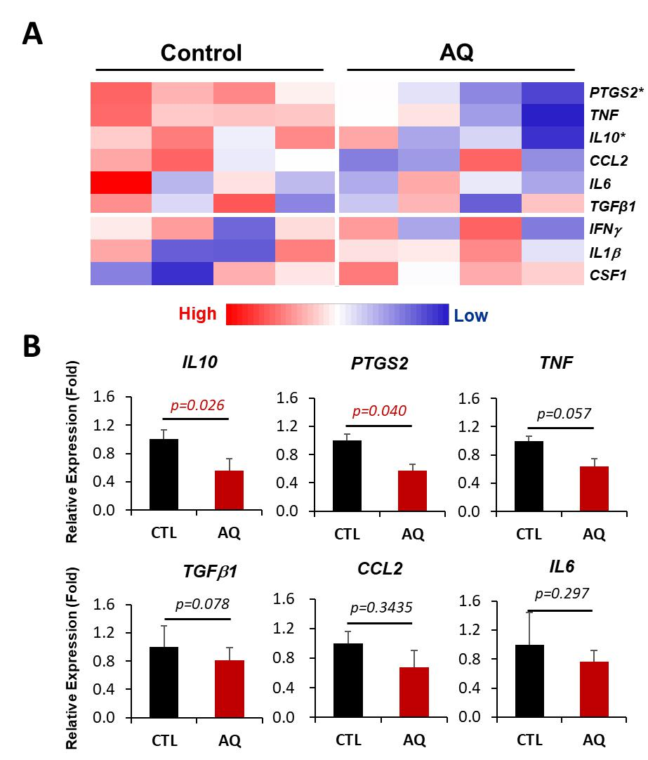

**Figure 7.** Heatmap (A) and relative gene expression level (B) of targeted inflammatory mediators in MCF-7 cells with or without 24 h AQ treatment. Relative expression was calculated by △△Ct method, and all statistical analyses were based on △Ct values. Unpaired *t* test was applied to identify the difference between control and treatment groups. All experiments were performed in tetraplicate and data are presented as mean ± SEM.

56

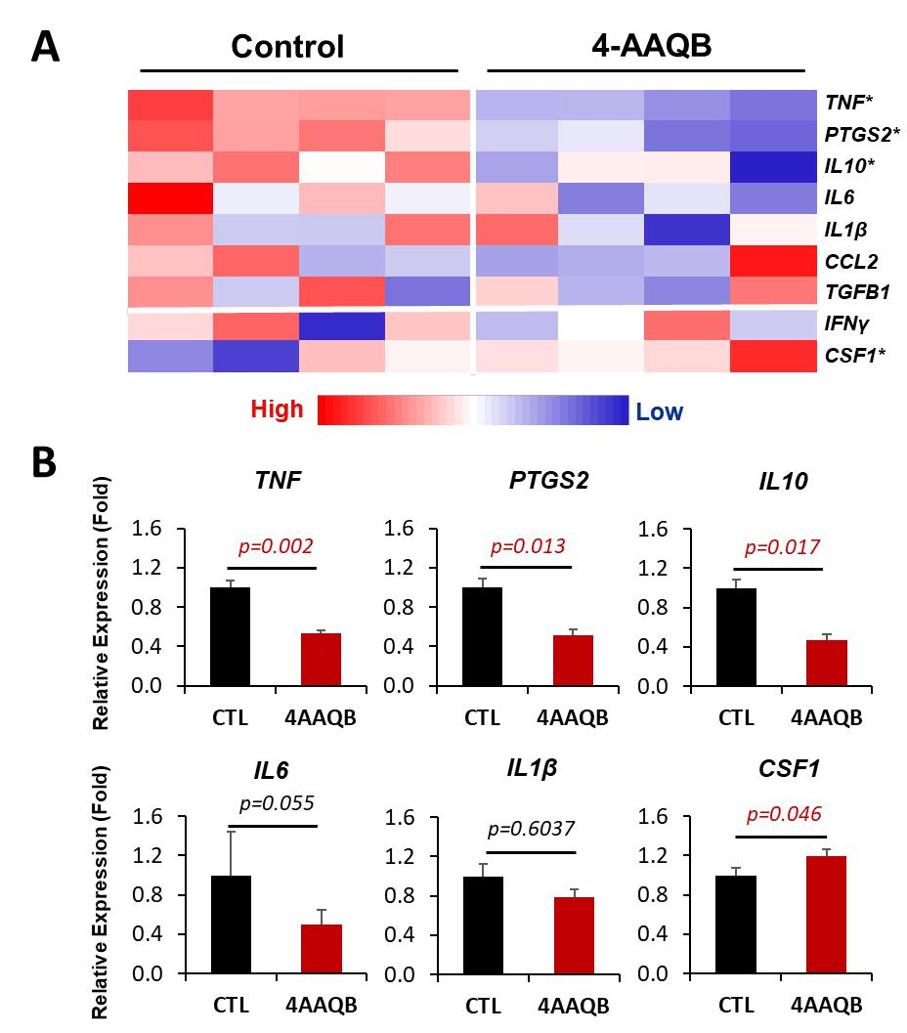

**Figure 8.** Heatmap (A) and relative gene expression level (B) of targeted inflammatory mediators in MCF-7 cells with or without 24 h 4-AAQB treatment. Relative expression was calculated by △△Ct method, and all statistical analyses were based on △Ct values. Unpaired *t* test was applied to identify the difference between control and treatment groups. All experiments were performed in tetraplicate and data are presented as mean ± SEM.

57

**5.4** **AQ and 4-AAQB Suppress *IL6* Upregulation but Strengthen *IFNγ* Upregulation**

**Induced by TNF-α Stimulation**

TNF-α as one of the most common cytokines majorly secreted by macrophages in a breast

TME was reported to be a strong inducer for the activation of inflammatory response

pathway, leading to the upregulation of a variety of inflammatory mediators. To evaluate

the inhibitory effect of AQ and 4-AAQB on the inflammatory status induced by TNF-α in

MCF-7 cells, gene expression levels of *IL6*, *IL10*, *IFNγ*, *PTGS2* and *CCL2* were measured.

Cochran-Armitage test for trend were performed to analyze the relationship between time

and expression levels; unpaired *t* tests were calculated to evaluate the differences between

control group and treatment group.

By adding rhTNF-α to stimulate MCF-7 cells, gene expression of inflammatory mediators,

including *IL10*, *PTGS2*, *IL6*, *IFNγ*, and *CCL2*, showed a time-dependent increase (p for

trend values were 0.005, < 0.0001, < 0.001, 0.035 and < 0.0001, respectively; Figure

9A~E). However, 4 hours after AQ/4-AAQB and TNF-α cotreatment, only the induced

upregulation of *IL6* was significantly suppressed up to 51.4% and 35.9% by AQ and 4-

AAQB, respectively (p-values were 0.0002 and 0.009, respectively; Figure 9F). In contrast,

the expression level of *IFNγ* was further upregulated 182.5% and 113.6% while cotreating

58

with 4-AAQB rather than with AQ for 3 and 4 hours, respectively (p-values for 3 h was

0.033, for 4 h was 0.034; Figure 9G). Moreover, AQ showed a stronger inhibitory effect

(~29.4%) on the upregulation of *CCL2* induced by TNF-α but did not achieve statistical

significance (p-value for 3 h was 0.062; Figure 9H).

59

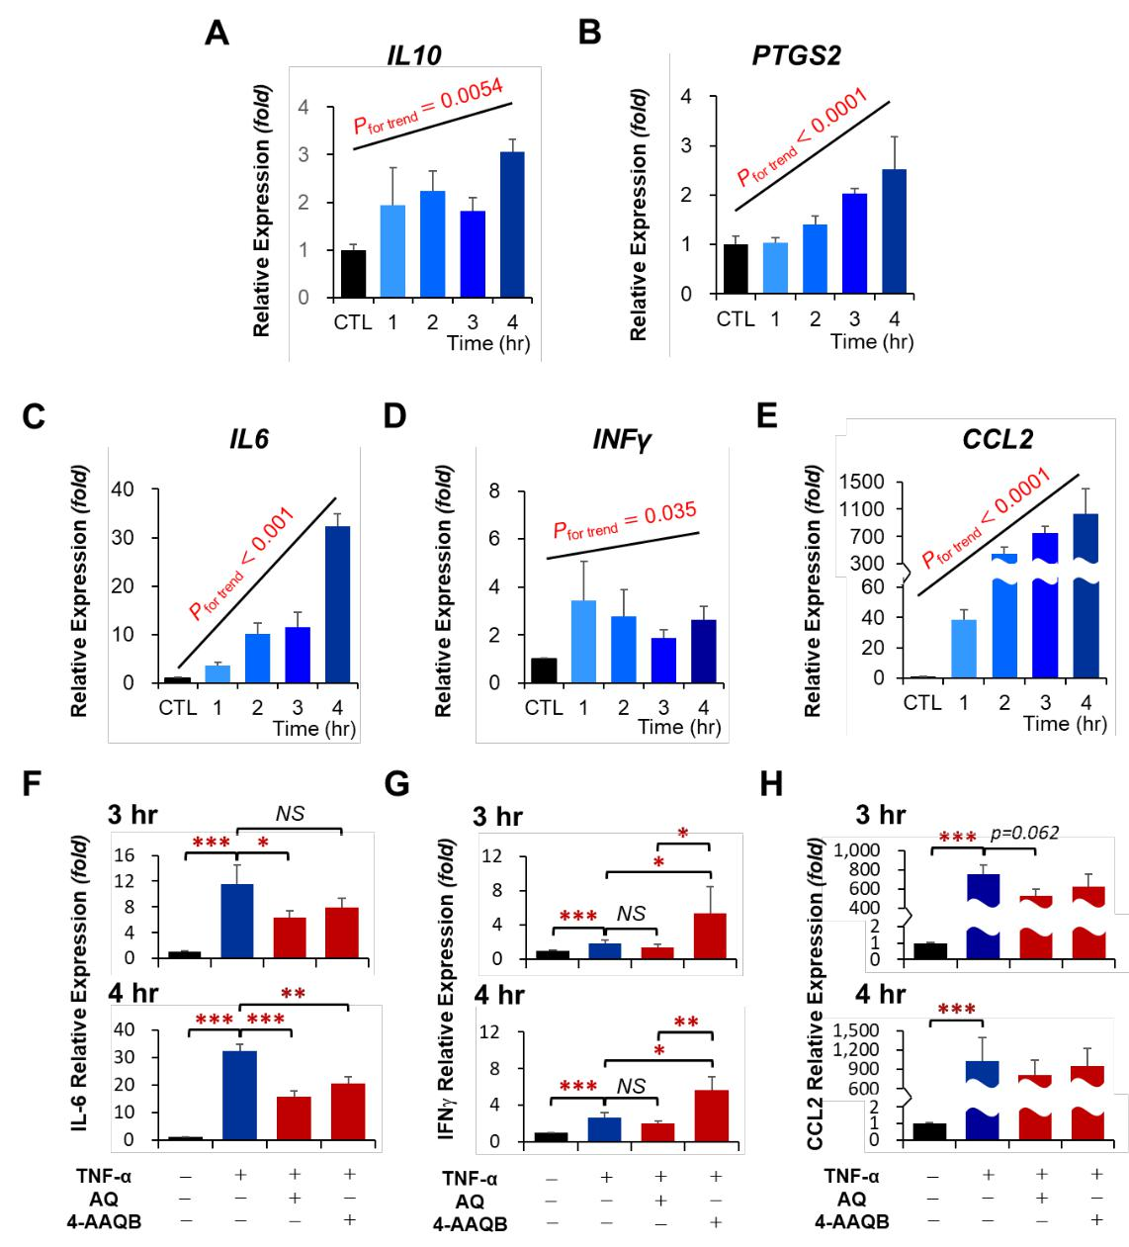

**Figure 9.** Gene expression levels of targeted inflammatory mediators in MCF-7 cells after TNF-α stimulation (A~E) Gene expression levels of *IL6* (F), *IFNγ* (G) and *CCL2* (H) after TNF-α and AQ/4-AAQB cotreatment. Relative expression was calculated by △△Ct method, and all statistical analyses were based on △Ct values. Cochran-Armitage test for trend and unpaired *t* test was applied to identify the time-dependent manner of TNF-α stimulation and difference among control and treatment groups, respectively. All experiments were performed in triplicate and data are presented as mean ± SEM. *P < 0.05, **P < 0.01, ***P < 0.001.

60

**5.5** **AQ and 4-AAQB Inhibit the Expression of Aromatase in MCF-7 Cells**

Aim to evaluate the potential effect of AQ and 4-AAQB on the production of estrogen in

breast cancer, we measured the gene expression level of aromatase (*CYP19A1*) in MCF-7

cells before and after treatment. Aromatase expression was significantly suppressed by up

to 50% in both AQ and 4-AAQB treatment groups (p-values were 0.044 and 0.036,

respectively; Figure 10A). Since TNF-α in a TME is positively correlated to the aromatase

activity (Zhao et al., 1996), our data also showed that the expression of aromatase in MCF-

7 cells was time-dependently increased after 0.2 ng/mL TNF-α induction (p for trend value

was < 0.001; Figure 10B). However, after 3 and 4 hours cotreatment with 0.4 μM 4-

AAQB, the elevated expression of aromatase induced by TNF-α was significantly inhibited

by 37.6% and 47.9%, respectively (p-values were 0.040 in 3 h treatment and 0.031 in 4 h

treatment; Figure 10C); moreover, after 4 hours cotreatment, the inhibitory effect against

TNF-α induction in 4-AAQB group was even significantly stronger than in AQ group (p-

value was 0.044; Figure 10C), which also was a similar case exhibited while only AQ and

4-AAQB treatment in MCF-7 cells (mean expression level was 0.525 and 0.471,

respectively; Figure 10A).

61

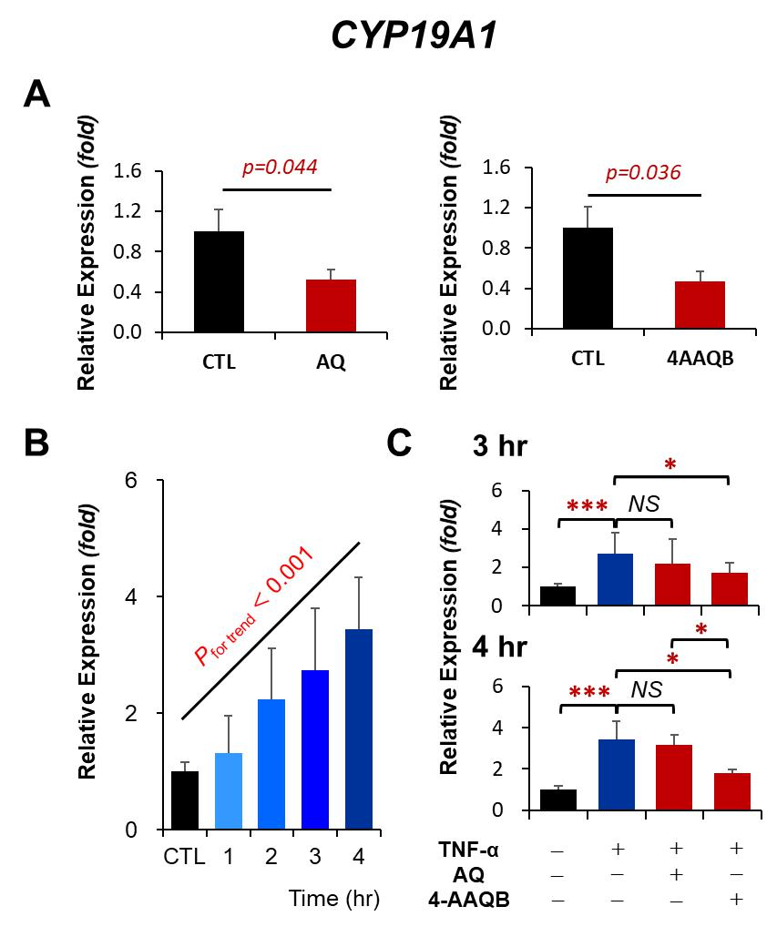

**Figure 10.** Gene expression levels of aromatase (*CYP19A1*) in MCF-7 cells after either AQ/4-AAQB treatment (A) or TNF-α treatment (B) or TNF-α and AQ/4-AAQB cotreatment (C). Relative expression was calculated by △△Ct method, and all statistical analyses were based on △Ct values. Cochran-Armitage test for trend and unpaired *t* test was applied to identify the time-dependent manner of TNF-α stimulation and difference among control and treatment groups, respectively. All experiments were performed in triplicate and data are presented as mean ± SEM. *P < 0.05, **P < 0.01, ***P < 0.001.

62

**5.6** **Effects of AQ and 4-AAQB on the Expression of *CD47* and Wnt Targeted Genes**

**in MCF-7 Cells**

To investigate the influence of AQ and 4-AAQB treatment on the expression of immune

checkpoint and Wnt signaling response in MCF-7 cells, the expression levels of *CD47* and

Wnt targeted genes *C-MYC*, *CCND1* and *AXIN2* were measured before and after treatment.

The gene expression level of *CD47* was significantly suppressed by 17.3% and 27.4% after

AQ and 4-AAQB treatment, respectively (p-values were 0.044 and 0.007, respectively;

Figure 11A); whereas, *CD47* expression was not influenced by TNF-α stimulation, either

the inhibitory effect of AQ and 4-AAQB on *CD47* expression was abrogated after TNF-α

stimulation (data not shown). The expression level of *C-MYC* was suppressed by 28.6%

and 40.3% after AQ and 4-AAQB treatment, however, data analysis only showed a

statistical significant in 4-AAQB treatment group compared to control (p-value was 0.001;

Figure 11A). *CCND1* and *AXIN2* expression showed no difference after AQ and 4-AAQB

treatment relative to control group (data not shown). On the contrary to the upregulation of

expression of inflammatory mediators and aromatase induced by TNF-α stimulation, *C-*

*MYC* expression levels was time-dependently suppressed by TNF-α (p for trend value was

<0.001; Figure 11B), and *CCND1* expression also showed a decreased trend paralleled to

63

treatment time period (p for trend value was 0.067; Figure 11B). After 3 and 4 hours of

TNF-α and AQ/4-AAQB cotreatment, only *C-MYC* expression among the three Wnt

targeted genes was further suppressed by 32.9% and 24%, respectively, after combination

treatment of TNF-α and AQ (p-values were 0.006 and 0.008, respectively; Figure 11C),

while the expression levels after combination treatment of TNF-α and 4-AAQB for 3 and

4 hours showed no difference compared to TNF-α treatment group (Figure 11C).

64

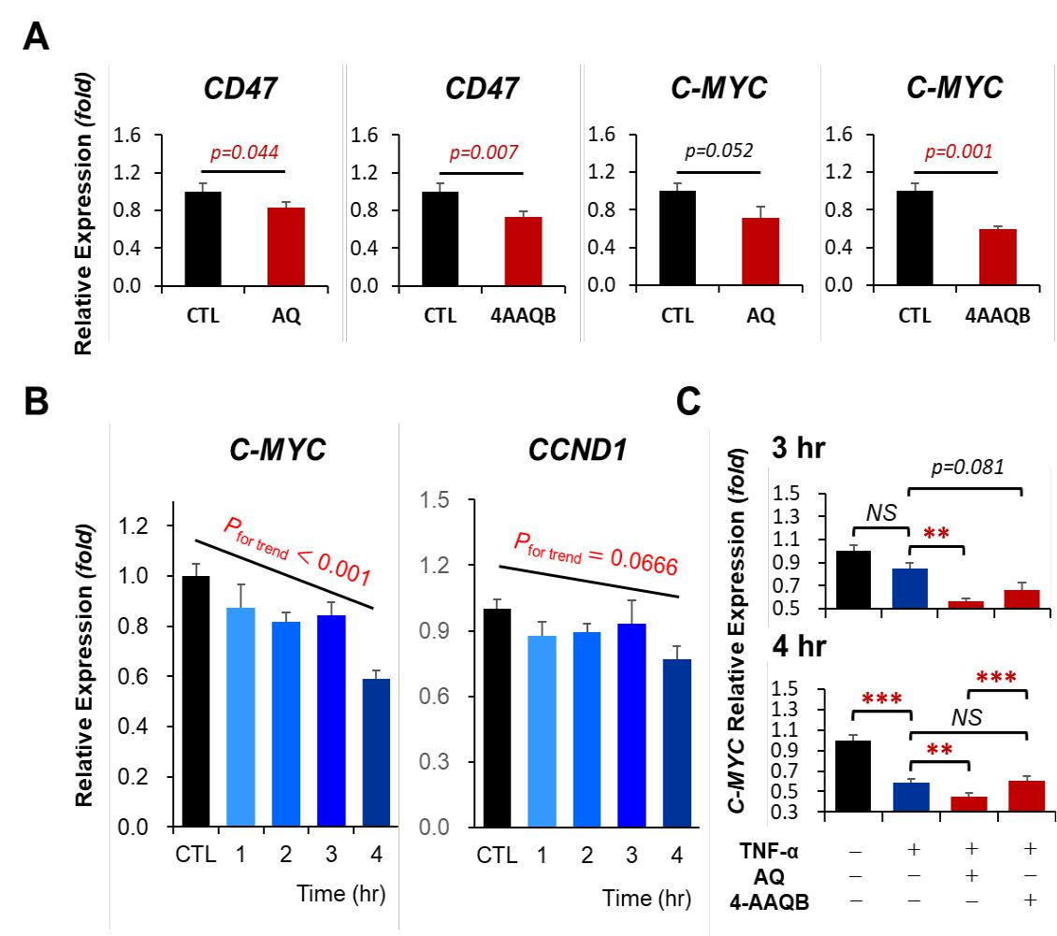

**Figure 11.** Gene expression levels of *CD47* and Wnt targeted genes in MCF-7 cells after either AQ/4-AAQB treatment (A) or TNF-α treatment (B) or TNF-α and AQ/4-AAQB cotreatment (C). Relative expression was calculated by △△Ct method, and all statistical analyses were based on △Ct values. Cochran-Armitage test for trend and unpaired *t* test was applied to identify the time-dependent manner of TNF-α stimulation and difference among control and treatment groups, respectively. All experiments were performed in triplicate and data are presented as mean ± SEM. *P < 0.05, **P < 0.01, ***P < 0.001.

65

**CHAPTER 6**

**DISCUSSION**

Breast cancer as one of the leading diseases among women globally has long been focused

on in the biomedical area. However, in most of the cases, surgery still remains the primary

treatment nowadays. Although several medical treatments including hormone therapy,

chemotherapy, targeted therapy and radiotherapy are used clinically against breast cancers,

any one of these therapies solely is not enough to treat breast cancer effectively; hence a

combination treatment strategy is recommended. Since the important role of well-

functioned immune system in anti-tumor strategy is widely studied over the past decades,

cancer immunotherapy becomes a promising adjuvant treatment for cancer therapy that

could potentially boost human immune system against cancers, including breast cancers.

As previous reviewed, a TME is under a chronic inflammatory status, and the relationship

between inflammation and cancer can be involved in two pathways, intrinsic and extrinsic

pathway (Mantovani et al., 2008). Genetic mutations of cancer-related oncogenes, tumor

suppressor genes and inflammation-related genes caused by randomly occurring or

environmental factors through the intrinsic pathways are capable of activating related

transcription factors and upregulating the expression of pro-inflammatory cytokines,

66

chemokines and some mediators such as growth factors and prostaglandins, leading to the

recruitment of immune cells to neoplastic tissue (Colotta et al., 2009). Infiltrated leukocytes

and myeloid cells further deteriorate the status by dramatically increasing the secretion of

inflammatory mediators, resulting cancer-related inflammation. On the other hand,

inflammatory status caused by obesity, infection or other disease through the extrinsic

pathway can also create an inflammatory microenvironment favorable for cancer

progression. Recent studies have pointed out inflammation greatly contributes to tumor

cell growth, angiogenesis, invasion, metastasis, as well as the immunosuppressive effects

responsible for reduced anti-tumor immunity (Mantovani et al., 2008; Allen et al., 2015).

*A. camphorata* is a medical mushroom with several evidenced biological activities

including anti-inflammatory and anti-cancer effects (Geethangili et al., 2011). AQ and its

derivative, 4-AAQB, have been reported as potent bioactive compounds providing these

health-promoting effects in AC mushroom. The aim of present study is to investigate the

inflammatory status of breast cancer and the potential role of AQ and 4-AAQB as

candidates of CAMs for using in immunotherapy in a MCF-7 breast cancer cell model. In

addition to evaluate the inflammatory mediators related to breast cancer progression, we

included immune checkpoint CD47, aromatase and Wnt signaling in our research targets.

67

In our present study, results showed that AQ possessed mild cytotoxicity against MCF-7

breast cancer cells (Figure 6A), which was similar to the effect obtained in the study

conducted by Lee et al. (2015). Furthermore, 4-AAQB treatment exhibited a stronger

growth inhibitory effect compared to AQ treatment against MCF-7 cells (Figure 6A), and

this phenomenon was also evidenced by Chang et al. (2015) that 4-AAQB showed a more

potent growth inhibitory effect against aggressive human colorectal cancer cells. Although

we did not determine the cytotoxicity of AQ and 4-AAQB in normal breast cells. Wang et

al. (2014) indicated that antroquinonol D showed no cytotoxic effect toward MCF-10A

normal mammary gland cells. However, due to the aim of present study was to investigate

the immunomodulatory effects of AQ and 4-AAQB in MCF-7 cells, we thus decided to use

a low concentration of AQ and 4-AAQB possessing relative low cytotoxicity against MCF-

7 cells as our treatment dosage. On the other hand, since higher levels of TNF-α can be

found in advanced breast cancer patients, the level of TNF-α may also positively correlated

to poor patient outcome (Anderson et al., 2004). However, treatment of TNF-α could

potentially inhibit MCF-7 cell growth even at low concentration, of which’s effect is totally

contrary to the pro-tumor properties mentioned previously (Figure 6B). Specifically to

MCF-7 cells, previous studies had pointed out that TNF-α is responsible for reduced cell

growth by induction of cell apoptosis and inhibition of cell proliferation (Burow et al., 1998;

68

Rozen et al., 1998; Lee et al., 2008); however, the inflammatory NF-κB pathway in MCF-

7 cells after TNF-α treatment remains activated (Machuca et al., 2006). Our results showed

that despite AQ and 4-AAQB could partly abolish the cytotoxic effect of TNF-α (Figure

6B), the inflammatory response induced by TNF-α was still suppressed by cotreatment

with AQ or 4-AAQB (Figure 9F).

Since tumorigenic pathways such as NF-κB and STAT3 are often involved in inflammatory

responses, tumor cells *per se* are capable of secreting inflammatory mediators. By directly

treatment of AQ or 4-AAQB to MCF-7 cells, expression of *IL10* and *COX2* (*PTGS2*) were

significantly suppressed, and *TNF* expression was also significantly inhibited by the

treatment of 4-AAQB (Figure 7 & 8). Moreover, comparing the inhibitory effects on the

expression of targeted inflammatory mediators between the treatment of AQ and 4-AAQB,

4-AAQB showed a much stronger influence (Figure 7 & 8). Among the suppressed

inflammatory mediators, IL-10 is generally considered as an anti-inflammatory cytokine

that is responsible for the resolution of host inflammatory response and its secretion is

intimately related to inflammatory responses for the purpose of keeping immune

homeostasis (Iyer et al., 2012). However, depending on the context of a microenvironment,

IL-10 could potentially serve as an immunosuppressive factor, especially in a TME.

69

Despite the anergy of T cells by IL-10 is profoundly affected in certain condition (Groux

et al., 1996), its crucial effects on M2-like macrophage polarization, reduced antigen

presenting capacity on both macrophages and tumor cells, and inhibited macrophage-

associated TH1 immune response may indirectly contribute to the escape of tumor

immunosurveillance (Fiorentino et al., 1991; Moore et al., 2001; Shiratori et al., 2017).

However, in the context of TNF-α induced upregulation of *IL10*, AQ or 4-AAQB failed to

suppress the elevated expression of *IL10* (data not shown)*.* This situation may due to the

complexity of *IL10* regulation induced by stimuli (Saraiva et al., 2010), and it is likewise

the same reason for the inconsistent results in *COX2* expression after TNF-α stimulation

(data not shown).

In the process of cancer associated inflammation, immune cell infiltration represents the

hallmark in a TME, and macrophages are the most prevalent immune cells among them.

Evidence suggest that in breast tumor tissue, macrophages can occupy more than half of

tumor mass (Obeid et al., 2013). The macrophage recruitment provides the major source

of the secretion of inflammatory mediators. Macrophage colony-stimulating factor (M-CSF,

also known as CSF-1) along with CCL2 are the key molecules triggering macrophage

recruitment to tumor site and activating M2-like macrophage polarization, which is

70

responsible for tumor cell growth, enhanced invasion, metastasis and tumor angiogenesis

as well as tumor immunosuppressive capacity (Stewart et al., 2012; Tariq et al., 2017).

However, in our results, data showed that the reduction of the expression of *CCL2* after

treatment of AQ or 4-AAQB was failed to achieve statistical significance (Figure 7 & 8),

either in both of the TNF-α and AQ/4-AAQB cotreatment groups compared to TNF-α

treatment group (Figure 9H), and even the expression of *CSF1* was significantly increased

up to about 20% after 4-AAQB treatment (Figure 8B). These evidences suggested that the

upregulation of *CCL2* is not merely attributed to certain pathway activation, in particular

NF-κB pathway in present study, same situation was involved in the regulation of *CSF1*

expression. Therefore, it is possible that AQ or 4-AAQB treatment is not able to inhibit the

recruitment of monocytes and macrophages into a breast TME; however, by altering the

inflammatory mediator profile of tumor cells and even the other immune cells and stromal

cells, the recruited macrophages are still likely to maintain their anti-tumor activity (Wang

et al., 2017).

Among the gene expression of 5 inflammatory mediators we aimed to detect in cotreatment

experiment, including *IL6, IL10, IFNγ, CCL2,* and *COX2*, only TNF-α induced *IL6*

upregulation was significantly suppressed by cotreatment of AQ or 4-AAQB (Figure 9F).

71

Although treatment of AQ or 4-AAQB to MCF-7 cells failed to significantly reduce the

expression of *IL6,* the inhibited upregulation of *IL6* stimulated by TNF-α treatment in

AQ/4-AAQB cotreatment groups demonstrated that AQ and 4-AAQB are potentially

responsible for the inhibition of TNF-α-induced *IL6* upregulation, which was mainly

through the suppression of NF-κB pathway activation. In contrast, the expression level of

*IFNγ* was further significantly elevated up to 2~3 fold in 4-AAQB and TNF-α cotreatment

group compared to TNF-α treatment group, but not in AQ and TNF-α cotreatment group

(Figure 9G). This *IFNγ* enhancement phenomenon is also possibly attributed to the

modulatory effect of 4-AAQB on NF-κB pathway. It is evidenced that NF-κB is involved

not only in the production of pro-inflammatory mediators but also in the regulation of anti-

tumor immune response (Yu et al., 2009). NF-κB family consists of five proteins, including

RelA (p65), RelB, c-Rel, p50 and p52, and among them RelA-p50 heterodimer is

considered as prototype NF-κB transcription factor, which is mainly involved in the

regulation of genes encoding oncogenes and pro-inflammatory mediators, such as IL-6, IL-

1β and COX2; whereas, the other heterodimer c-Rel-p50 is crucial for the expression of

genes related to TH1 immune response, such as IL-12, IFN-γ, CD40 and CD80. Although

a constitutive NF-κB activation is commonly found in cancer cells, a majority of the active

form is RelA-p50. Furthermore, it is strongly suggested that the activation of NF-κB partly

72

crosstalk with other transcription factors such as STAT3, by which’s activation could

persistently activate RelA-p50 but reduce c-Rel-p50 (Yu et al., 2009). Nevertheless, the

clear interactions between NF-κB and other signaling still remain to be fully studied.

Therefore, in our results, the reinforced *IFNγ* expression after TNF-α and 4-AAQB

cotreatment may potentially be via the property of 4-AAQB to interfere with the crosstalk

between NF-κB and the other activated signaling.

As breast cancer can be categorized into ER+ and ER- types, ER+ breast cancer is

profoundly and directly influenced by estrogen, which is able to regulate the mitogenic

signaling through the estrogen receptor (Quigley et al., 2017). However, the pathology of

ER- breast cancer is largely different from ER+ breast cancer, and may greatly attributed to

chronic low-grade inflammation (Amadou et al., 2013). In addition to the pro-tumor

proliferation effect of estrogen, estrogen may still serve as an immunosuppressive factor

by interfering other ER+ stromal cells or immune cells in a TME (Quigley et al., 2017).

Despite estrogen in breast tumor tissue being mainly produced locally by aromatase

enzyme expressed in stromal cells as well as breast cancer cells, previous studies reported

that aromatase expression could be further enhanced by positive feedback from estradiol

and a chronic inflammatory status (Santner et al., 1997; Kinoshita et al., 2003; Morris et

73

al., 2011). Indeed, our results showed that TNF-α treatment time-dependently increased the

expression level of aromatase in MCF-7 cells (Figure 10B); whereas AQ and 4-AAQB

treatment inhibited aromatase expression in transcriptional level (Figure 10A).

Interestingly, only TNF-α and 4-AAQB cotreatment successfully suppressed the TNF-α-

induced upregulation of aromatase expression (Figure 10C), by which meant that the

mechanisms involved in the inhibitory effect of AQ and 4-AAQB on aromatase expression

are distinct. Since a variety of inflammatory mediators and growth factors (Reed et al.,

1992; Zhao et al., 1995; Zhao et al., 1996; Richards et al., 2003) are reported to be

associated with aromatase expression, the potential molecular mechanisms could be highly

complicated and still remain nuclear. Therefore, our results might only suggest that both

AQ and 4-AAQB potentially are able to inhibit aromatase expression in breast cancer cells,

however, only 4-AAQB is responsible for the suppression of TNF-α-induced aromatase

upregulation.

Besides the connection between inflammation and estrogen mechanisms in breast cancer,

previous review also points out the importance of immune checkpoint and Wnt signaling

responses in an inflammatory breast TME. CD47 as an immune checkpoint is highly

expressed on various tumor cells, including MCF-7 breast cancer cells, compared to

74

corresponding normal cells (Willingham et al., 2012; Betancur et al., 2017); however, the

mechanisms responsible for the abnormally upregulation of *CD47* expression in cancer

cells are still poorly understood (Betancur et al., 2017). Recently, research have addressed

several transcription factors potentially contributing to the regulation of *CD47* expression.

Lo et al. (2015) found that NF-κB could regulate the transcription of CD47 gene by directly

binding to CD47 promoter, and after TNF-α stimulation, the NF-κB binding efficiency

increased. Similar results also were reported by Betancur et al. (2017) that NF-κB is

responsible for the activation of *CD47* constituent enhancer and promoter, leading to the

upregulation of CD47 in MCF-7 cells, however, the authors also mentioned that even

though NF-κB is a necessary transcription factor for the initiation of *CD47* transcription,

only for its binding is far enough to regulate the expression of *CD47.* The role of NF-κB

in *CD47* regulation might partly explain why *CD47* expression failed to be enhanced after

TNF-α stimulation (data not shown). Moreover, the possibility that CD47 inhibitory effect

of AQ and 4-AAQB might be counteracted by the elevated NF-κB stimulated by TNF-α

also elucidated the inconsistence in our results that AQ and 4-AAQB lose their ability to

inhibit *CD47* expression after cotreatment with TNF-α (data not shown).

In breast cancers, research found that Wnt/β-catenin signaling is activated among ~60% of

75

breast carcinomas (Lin et al., 2000). While a less proportion of aberrantly activated Wnt/β-

catenin signaling in breast tumors is via somatic mutations directly involved in this

pathway (Yu et al., 2016), extracellular factors might play critical roles in regulating the

activation of this oncogenic pathway. As we mentioned previously, inflammatory

mediators are capable of increasing β-catenin accumulation, leading to advanced breast

cancer development. Specific to the effect of TNF-α on Wnt/β-catenin signaling, our

previous study reported that TNF-α level in breast tissue is positively correlated to the

expression of Wnt targeted gene, *JNK1*, further, TNF-α treated breast tissues compared to

nontreated control showed a 3-fold higher expression of *CCND1* and marginal increased

expression of *AXIN2,* both of which are well-known Wnt targeted genes (Roubert et al.,

2017). In the present study, Both AQ and 4-AAQB treatment possessed the ability to

suppress *C-MYC* expression, which is downstream of Wnt/β-catenin signaling (p-values

were 0.052 and 0.001, respectively; Figure 11A). Chang et al. (2015) also pointed out that

after 4-AAQB treatment, the expression levels of *Lgr5* and *β-catenin* were dose-

dependently inhibited in DLD-1 colorectal cancer cells. However, due to the property that

*C-MYC* is targeted by multiple signaling pathways in addition to Wnt signaling, hence we

were not able to conclude that the inhibitory effect on *C-MYC* expression of AQ and 4-

AAQB was via their ability to interfere Wnt signaling pathway. Next, we treated MCF-7

76

cells with TNF-α or TNF-α combined with AQ/4-AAQB and measured the expression

levels of Wnt targeted genes, *CCND1*, *C-MYC* and *AXIN2*. Contrary to our expectation,

TNF-α treatment time-dependently suppressed *C-MYC* expression and marginally

suppressed *CCND1* expression (p for trend values were <0.001 and 0.067, respectively;

Figure 11B). Since previous studies have demonstrated that TNF-α treatment to MCF-7

cells would mitigate cell proliferation and increase cell apoptosis by decreasing the

expression levels of growth factor receptor and estrogen receptor, which are responsible

for tumor cell growth (Rozen et al., 1998; Lee et al., 2008), it is possible that the TNF-α

induced pro-tumor signaling activation, such as NF-κB and Wnt pathways, in MCF-7 cells

fail to counteract or overcome the anti-proliferation and pro-apoptosis effects; therefore,

*C-MYC* and *CCND1* expression, which profoundly mediate cell proliferation, are

suppressed in MCF-7 cells after TNF-α treatment. Furthermore, our data showed that TNF-

* and AQ cotreatment exerted stronger inhibition on *C-MYC* expression compared to 4 hours TNF-α treatment or TNF-α and 4-AAQB cotreatment (p-values were 0.008 and 0.0003, respectively; Figure 11C). On the other hand, *AXIN2* expression marginally increased by 1.2-fold higher after 3 hours of TNF-α treatment (p-value was 0.088; data not shown), and cotreatment of TNF-α and AQ successfully inhibited this elevated *AXIN2*

expression (p-value was 0.047; data not shown). Taken together, these data suggested that

77

AQ compared to 4-AAQB exerted a much powerful inhibitory effect on TNF-α induced

Wnt signaling responses.

Overall, our results thus do suggest that AQ and 4-AAQB derived from AC mushroom

possess the function to modulate the expression of inflammatory mediators potentially

responsible for generating a chronic inflammatory breast TME in MCF-7 cells. Moreover,

it seems to support our hypothesis that AQ and/or 4-AAQB both are potential compounds

for inhibiting aromatase and *CD47* expression. However, consider to Wnt signaling

responses, only AQ showed an effective inhibition on TNF-α induced upregulation of Wnt

targeted genes. Compare these two compounds, 4-AAQB seems to hold a much powerful

modulatory effects on the expression of inflammatory mediators, aromatase as well as

*CD47*, whereas, AQ may be a much effective inhibitory compound for Wnt signaling

responses. Several limitation should be taken into account while interpreting our results. 1)

Only one stimulus, TNF-α, was included in the present study. 2) Relative higher TNF-α

concentration used in treatment, since TNF-α levels in serum or breast tissue are generally

in the pg/mL range. 3) The levels of secreted inflammatory mediators were not measured.

1. Activation levels of targeted pathways, including NF-κB and Wnt signaling, were not measured. 5) Experiments were only conducted in breast cancer cells, hence the effects on

78

stromal cells or immune cells and their interaction with cancer cells remain unclear. In

order to more clearly understand the role of AQ and 4-AAQB in treating breast cancer

through their immunomodulatory effects, further experiments should be conducted. For

instance, measuring NF-κB and Wnt signaling active levels before and after treatment to

clarify the actual mechanisms and designing a co-culture model to better explore the

influence between cancer cells and other cells. Eventually, experimenting on an animal

model to thoroughly understand their effects on breast cancer in the context of an intact

breast TME. Nevertheless, our results provided promising evidence that AQ and/or 4-

AAQB derived from AC mushroom may influence the development of breast cancer via

the modulation of inflammatory mediators and inflammation-driven upregulation of

aromatase as well as Wnt signaling.

79

**APPENDIX A**

**TABLE OF PERFORMED ASSAYS AND EXPERIMENTAL DESIGN**

80

|  |  |  |  |  |  |  |  |  |
| --- | --- | --- | --- | --- | --- | --- | --- | --- |
| Experiment | Cell line |  | Design | | Dosage | | Time |  |
|  |  |  | |  |  |  |  |  |
|  |  | Control group (non-treatment) | | |  | - | 24 & 48 hours |  |
|  |  |  |  |  |  |  |  |  |
| MTT Assay 1 |  | Experimental |  | AQ treatment | 0~50 μM | | 24 & 48 hours |  |
|  |  | group |  |  |  |  |  |
|  |  |  | 4-AAQB treatment | 0~50 μM | |  |
|  |  |  |  |  |
|  |  |  | |  |  |  |  |  |
|  |  | Control group (non-treatment) | | |  | - | 24 hours |  |
|  |  |  |  |  |  |  |  |  |
|  |  |  |  | TNF-α treatment | 0~10 ng/mL | |  |  |
|  |  |  |  |  |  |  |  |  |
| MTT Assay 2 |  | Experimental |  | TNF-α + AQ | TNF-α: 0~10 ng/mL | AQ: value based on |  |  |
|  |  | treatment | MTT assay 1 | 24 hours |  |
|  |  |  |  |
|  |  | group |  |  |  |  |  |  |
|  |  |  | TNF-α + 4-AAQB | TNF-α: 0~10 ng/mL | 4-AAQB: value based |  |  |
|  |  |  |  |  |  |
|  |  |  |  | treatment | on MTT assay 1 |  |  |
|  | MCF-7 |  |  |  |  |  |
|  |  |  |  |  |  |  |  |
|  | Control group (non-treatment) | | |  | - | 24 hours |  |
|  |  |  |  |
|  |  |  |  |  |  |  |  |  |
|  |  | Experimental |  | AQ treatment | Value based on MTT assay 1 | | 24 hours |  |
|  |  | group |  |  |  |  |  |
|  |  |  | 4-AAQB treatment | Value based on MTT assay 1 | |  |
|  |  |  |  |  |
| Gene |  |  | |  |  |  |  |  |
|  | Control group (non-treatment) | | |  | - | 0.5, 1, 2, 3, 4 hours |  |
| Expression |  |  |  |  |  |  |  |  |
|  |  |  | TNF-α treatment | Value based on MTT assay 2 | |  |  |
| Analysis |  |  |  |  |  |  |  |  |
|  | Experimental |  | TNF-α + AQ | TNF-α: value based | AQ: value based on | 0.5, 1, 2, 3, 4 hours |  |
|  |  |  |  |
|  |  | group |  | treatment | on MTT assay 2 | MTT assay 1 |  |
|  |  |  | TNF-α + 4-AAQB | TNF-α: value based | 4-AAQB: value based |  |  |
|  |  |  |  |  |  |
|  |  |  |  | treatment | on MTT assay 2 | on MTT assay 1 |  |  |
|  |  |  |  |  |  |  |  |  |

Table 1. Experimental design

81

**APPENDIX B**

**TABLE OF PRIMERS USED FOR REAL-TIME PCR ANALYSIS**

82

|  |  |  |  |  |
| --- | --- | --- | --- | --- |
| Pathway | Genes | Forward Primer | Reverse Primer |  |
|  | *IL6* | ACTCACCTCTTCAGAACGAATTG | CCATCTTTGGAAGGTTCAGGTTG |  |
|  | *IL10* | GACTTTAAGGGTTACCTGGGTTG | TCACATGCGCCTTGATGTCTG |  |
|  | *IL1β* | ATGATGGCTTATTACAGTGGCAA | GTCGGAGATTCGTAGCTGGA |  |
| Cancer-related | *IFNγ* | TCGGTAACTGACTTGAATGTCCA | TCGCTTCCCTGTTTTAGCTGC |  |
| *TNF* | CCTCTCTCTAATCAGCCCTCTG | GAGGACCTGGGAGTAGATGAG |  |
| inflammation |  |
| *TGFβ1* | GGCCAGATCCTGTCCAAGC | GTGGGTTTCCACCATTAGCAC |  |
|  |  |
|  | *PTGS2* | CTGGCGCTCAGCCATACAG | CGCACTTATACTGGTCAAATCCC |  |
|  | *CCL2* | CAGCCAGATGCAATCAATGCC | TGGAATCCTGAACCCACTTCT |  |
|  | *CSF1* | TGGCGAGCAGGAGTATCAC | AGGTCTCCATCTGACTGTCAAT |  |
|  | *CCND1* | GCTGCGAAGTGGAAACCATC | CCTCCTTCTGCACACATTTGAA |  |
| Wnt-signaling pathway | *C-MYC* | GGCTCCTGGCAAAAGGTCA | CTGCGTAGTTGTGCTGATGT |  |
|  | *AXIN2* | CAACACCAGGCGGAACGAA | GCCCAATAAGGAGTGTAAGGACT |  |
| Immune checkpoint | *CD47* | AGAAGGTGAAACGATCATCGAGC | CTCATCCATACCACCGGATCT |  |
| Aromatase | *CYP19A1* | TGGAAATGCTGAACCCGATAC | AATTCCCATGCAGTAGCCAGG |  |
|  | *GAPDH* | GGAGCGAGATCCCTCCAAAAT | GGCTGTTGTCATACTTCTCATGG |  |
|  |  |  |  |  |

Table 2. Primers of targeted genes and GAPDH

83

**REFERENCES**

Agnoli C, Grioni S, Pala V, Allione A, Matullo G, Gaetano CD, Tagliabue G, Sieri S, Krogh V. Biomarkers of inflammation and breast cancer risk: a case-control study nested in the EPIC-Varese cohort. Sci Rep. 2017;7(1):12708.

Akramiene D, Kondrotas A, Didziapetriene J, Kevelaitis E. Effects of beta-glucans on the immune system. Medicina (Kaunas). 2007;43(8):597-606.

Allen MD, Jones LJ. The role of inflammation in progression of breast cancer: Friend or foe? (Review). Int J Oncol. 2015;47(3):797-805.

Alonso EN, Orozco M, Eloy Nieto A, Balogh GA. Genes related to suppression of malignant phenotype induced by Maitake D-Fraction in breast cancer cells. J Med Food. 2013;16(7):602-17.

Amadou A, Hainaut P, Romieu I. Role of obesity in the risk of breast cancer: lessons from anthropometry. J Oncol. 2013;2013:906495.

Anderson GM, Nakada MT, DeWitte M. Tumor necrosis factor-alpha in the pathogenesis and treatment of cancer. Curr Opin Pharmacol. 2004 Aug;4(4):314-20.

Aoki T. Inflammation mediates the pathogenesis of cerebral aneurysm and becomes therapeutic target. Neuroimmunol Neuroinflammation 2015;2(2):86-92.

Arora R, Yates C, Gary BD, McClellan S, Tan M, Xi Y, Reed E, Piazza GA, Owen LB, Dean-Colomb W. Panepoxydone targets NF-kB and FOXM1 to inhibit proliferation, induce apoptosis and reverse epithelial to mesenchymal transition in breast cancer. PLoS One. 2014;9(6):e98370.

Babu US, Balan KV, Garthoff LH, Calvo MS. Vitamin D₂ from UVB light exposed mushrooms modulates immune response to LPS in rats. Mol Nutr Food Res. 2014;58(2):318-28.

84

Balkwill F, Mantovani A. Inflammation and cancer: back to Virchow? Lancet.

2001;357(9255):539-45.

Balkwill F. Tumour necrosis factor and cancer. Nat Rev Cancer. 2009;9(5):361-71.

Bäumler AJ, Sperandio V. Interactions between the microbiota and pathogenic bacteria in the gut. Nature. 2016;535(7610):85-93.

Bener G, J Félix A, Sánchez de Diego C, Pascual Fabregat I, Ciudad CJ, Noé V. Silencing of CD47 and SIRPα by Polypurine reverse Hoogsteen hairpins to promote MCF-7 breast cancer cells death by PMA-differentiated THP-1 cells. BMC Immunol. 2016;17(1):32.

Betancur PA, Abraham BJ, Yiu YY, Willingham SB, Khameneh F, Zarnegar M, Kuo AH, McKenna K, Kojima Y, Leeper NJ, Ho P, Gip P, Swigut T, Sherwood RI, Clarke MF, Somlo G, Young RA, Weissman IL. A CD47-associated super-enhancer links pro-inflammatory signalling to CD47 upregulation in breast cancer. Nat Commun. 2017;8:14802.

Burow ME, Weldon CB, Tang Y, Navar GL, Krajewski S, Reed JC, Hammond TG, Clejan S, Beckman BS. Differences in susceptibility to tumor necrosis factor alpha-induced apoptosis among MCF-7 breast cancer cell variants. Cancer Res. 1998;58(21):4940-6.

Carrillo-Vico A, Lardone PJ, Alvarez-Sánchez N, Rodríguez-Rodríguez A, Guerrero JM.

Melatonin: buffering the immune system. Int J Mol Sci. 2013;14(4):8638-83.

Chang CH, Hsu CC, Lee AS, Wang SW, Lin KT, Chang WL, Peng HC, Huang WC, Chung CH. 4-Acetylantroquinonol B inhibits lipopolysaccharide-induced cytokine release and alleviates sepsis through of MAPK and NFκB suppression. BMC Complement Altern Med. 2018;18(1):108.

Chang CJ, Lin CS, Lu CC, Martel J, Ko YF, Ojcius DM, Tseng SF, Wu TR, Chen YY, Young JD, Lai HC. Ganoderma lucidum reduces obesity in mice by modulating the composition of the gut microbiota. Nat Commun. 2015;6:7489.

85

Chang TC, Yeh CT, Adebayo BO, Lin YC, Deng L, Rao YK, Huang CC, Lee WH, Wu AT, Hsiao M, Wu CH, Wang LS, Tzeng YM. 4-Acetylantroquinonol B inhibits colorectal cancer tumorigenesis and suppresses cancer stem-like phenotype. Toxicol Appl Pharmacol. 2015;288(2):258-68.

Chao MP, Majeti R, Weissman IL. Programmed cell removal: a new obstacle in the road to developing cancer. Nat Rev Cancer. 2011;12(1):58-67.

Chen DS, Mellman I. Oncology meets immunology: the cancer-immunity cycle. Immunity.

2013;39(1):1-10.

Chen S, Oh SR, Phung S, Hur G, Ye JJ, Kwok SL, Shrode GE, Belury M, Adams LS, Williams D. Anti-aromatase activity of phytochemicals in white button mushrooms (Agaricus bisporus). Cancer Res. 2006;66(24):12026-34.

Chen WY. Exogenous and endogenous hormones and breast cancer. Best Pract Res Clin Endocrinol Metab. 2008;22(4):573-85.

Cheung PCK. The nutritional and health benefits of mushrooms. Nutrition Bulletin 2010;35:292-99.

Claus SP, Guillou H, Ellero-Simatos S. The gut microbiota: a major player in the toxicity of environmental pollutants? NPJ Biofilms Microbiomes. 2016;2:16003.

Colotta F, Allavena P, Sica A, Garlanda C, Mantovani A. Cancer-related inflammation, the seventh hallmark of cancer: links to genetic instability. Carcinogenesis. 2009;30(7):1073-81.

Cowen S, McLaughlin SL, Hobbs G, Coad J, Martin KH, Olfert IM, Vona-Davis L. High-Fat, High-Calorie Diet Enhances Mammary Carcinogenesis and Local Inflammation in MMTV-PyMT Mouse Model of Breast Cancer. Cancers (Basel). 2015;7(3):1125-42.

De A. Wnt/Ca2+ signaling pathway: a brief overview. Acta Biochim Biophys Sin (Shanghai). 2011;43(10):745-56.

86

Dempsey PW, Doyle SE, He JQ, Cheng G. The signaling adaptors and pathways activated by TNF superfamily. Cytokine Growth Factor Rev. 2003;14(3-4):193-209.

Desai SJ, Prickril B, Rasooly A. Mechanisms of Phytonutrient Modulation of Cyclooxygenase-2 (COX-2) and Inflammation Related to Cancer. Nutr Cancer. 2018;70(3):350-375.

DeSantis C, Ma J, Bryan L, Jemal A. Breast cancer statistics, 2013. CA Cancer J Clin.

2014;64(1):52-62.

Divella R, De Luca R, Abbate I, Naglieri E, Daniele A. Obesity and cancer: the role of adipose tissue and adipo-cytokines-induced chronic inflammation. J Cancer. 2016;7(15):2346-2359.

Drori A, Shabat Y, Ben Ya'acov A, Danay O, Levanon D, Zolotarov L, Ilan Y. Extracts from Lentinula edodes (Shiitake) Edible Mushrooms Enriched with Vitamin D Exert an Anti-Inflammatory Hepatoprotective Effect. J Med Food. 2016;19(4):383-9.

Economic Research Service. Farm income and wealth statistics. Washington: USDA; 2018

[cited 2018 May 4]. Available from: <https://www.ers.usda.gov/>

Eftekhari R, Esmaeili R, Mirzaei R, Bidad K, de Lima S, Ajami M, Shirzad H, Hadjati J, Majidzadeh-A K. Study of the tumor microenvironment during breast cancer progression. Cancer Cell Int. 2017;17:123.

Eliza WL, Fai CK, Chung LP. Efficacy of Yun Zhi (Coriolus versicolor) on survival in cancer patients: systematic review and meta-analysis. Recent Pat Inflamm Allergy Drug Discov. 2012;6(1):78-87.

Feeney MJ, Dwyer J, Hasler-Lewis CM, Milner JA, Noakes M, Rowe S, Wach M, Beelman RB, Caldwell J, Cantorna MT, Castlebury LA, Chang ST, Cheskin LJ, Clemens R, Drescher G, Fulgoni VL 3rd, Haytowitz DB, Hubbard VS, Law D, Myrdal Miller A, Minor B, Percival SS, Riscuta G, Schneeman B, Thornsbury S, Toner CD, Woteki CE, Wu D. Mushrooms and Health Summit proceedings. J Nutr. 2014;144(7):1128S-36S.

87

Ferlay J, Soerjomataram I, Dikshit R, Eser S, Mathers C, Rebelo M, Parkin DM, Forman D, Bray F. Cancer incidence and mortality worldwide: sources, methods and major patterns in GLOBOCAN 2012. Int J Cancer. 2015;136(5):E359-86.

Fiorentino DF, Zlotnik A, Vieira P, Mosmann TR, Howard M, Moore KW, O'Garra A. IL-10 acts on the antigen-presenting cell to inhibit cytokine production by Th1 cells. J Immunol. 1991;146(10):3444-51.

Food and Agriculture Organization of the United Nations, Statistics Division (FAOSTAT). Crops Production, Mushrooms and truffles; 2018 [cited 2018 May 4]. Available from: [http://faostat.fao.org.](http://faostat.fao.org/)

Ford D, Easton DF, Stratton M, Narod S, Goldgar D, Devilee P, Bishop DT, Weber B, Lenoir G, Chang-Claude J, Sobol H, Teare MD, Struewing J, Arason A, Scherneck S, Peto J, Rebbeck TR, Tonin P, Neuhausen S, Barkardottir R, Eyfjord J, Lynch H, Ponder BA, Gayther SA, Zelada-Hedman M, et al. Genetic heterogeneity and penetrance analysis of the BRCA1 and BRCA2 genes in breast cancer families. The Breast Cancer Linkage Consortium. Am J Hum Genet. 1998;62(3):676-89.

Galván GC, Johnson CB, Price RS, Liss MA, Jolly CA, deGraffenried LA. Effects of Obesity on the Regulation of Macrophage Population in the Prostate Tumor Microenvironment. Nutr Cancer. 2017;69(7):996-1002.

Geethangili M, Tzeng YM. Review of Pharmacological Effects of Antrodia camphorata and Its Bioactive Compounds. Evid Based Complement Alternat Med. 2011;2011:212641.

Ghoncheh M, Pournamdar Z, Salehiniya H. Incidence and Mortality and Epidemiology of Breast Cancer in the World. Asian Pac J Cancer Prev. 2016;17(S3):43-6.

Gilliver SC. Sex steroids as inflammatory regulators. J Steroid Biochem Mol Biol.

2010;120(2-3):105-15.

Grimble RF. Effect of antioxidative vitamins on immune function with clinical applications.

Int J Vitam Nutr Res. 1997;67(5):312-20.

88

Grivennikov SI, Greten FR, Karin M. Immunity, inflammation, and cancer. Cell.

2010;140(6):883-99.

Grossman CJ. Interactions between the gonadal steroids and the immune system. Science.

1985;227(4684):257-61.

Groux H, Bigler M, de Vries JE, Roncarolo MG. Interleukin-10 induces a long-term antigen-specific anergic state in human CD4+ T cells. J Exp Med. 1996;184(1):19-29.

Grube BJ, Eng ET, Kao YC, Kwon A, Chen S. White button mushroom phytochemicals inhibit aromatase activity and breast cancer cell proliferation. J Nutr. 2001;131(12):3288-93.

Grzywacz A, Argasinska JG, Kala K, Opoka W, Muszynska B. Anti-Inflammatory Activity of Biomass Extracts of the Bay Mushroom, Imleria badia (Agaricomycetes), in RAW 264.7 Cells. Int J Med Mushrooms. 2016;18(9):769-779.

Harris RE, Casto BC, Harris ZM. Cyclooxygenase-2 and the inflammogenesis of breast cancer. World J Clin Oncol. 2014;5(4):677-92.

Harris RE, Chlebowski RT, Jackson RD, Frid DJ, Ascenseo JL, Anderson G, Loar A, Rodabough RJ, White E, McTiernan A; Women's Health Initiative.. Breast cancer and nonsteroidal anti-inflammatory drugs: prospective results from the Women's Health Initiative. Cancer Res. 2003;63(18):6096-101.

Herr N, Bode C, Duerschmied D. The Effects of Serotonin in Immune Cells. Front Cardiovasc Med. 2017;4:48.

Hiatt RA, Brody JG. Environmental Determinants of Breast Cancer. Annu Rev Public Health. 2018;39:113-133.

Hoesel B, Schmid JA. The complexity of NF-κB signaling in inflammation and cancer.

Mol Cancer. 2013;12:86.

89

Hseu YC, Chen SC, Chen HC, Liao JW, Yang HL. Antrodia camphorata inhibits proliferation of human breast cancer cells in vitro and in vivo. Food Chem Toxicol. 2008;46(8):2680-8.

Hseu YC, Chen SC, Tsai PC, Chen CS, Lu FJ, Chang NW, Yang HL. Inhibition of cyclooxygenase-2 and induction of apoptosis in estrogen-nonresponsive breast cancer cells by Antrodia camphorata. Food Chem Toxicol. 2007;45(7):1107-15.

Hseu YC, Wu FY, Wu JJ, Chen JY, Chang WH, Lu FJ, Lai YC, Yang HL. Anti-inflammatory potential of Antrodia Camphorata through inhibition of iNOS, COX-2 and cytokines via the NF-kappaB pathway. Int Immunopharmacol. 2005;5(13-14):1914-25.

Huang A, Cao S, Tang L. The tumor microenvironment and inflammatory breast cancer. J Cancer. 2017;8(10):1884-1891.

Hursting SD. Inflammatory talk: linking obesity, NF-κB, and Aromatase. Cancer Prev Res (Phila). 2011;4(3):285-7.

Incassati A, Chandramouli A, Eelkema R, Cowin P. Key signaling nodes in mammary gland development and cancer: β-catenin. Breast Cancer Res. 2010;12(6):213.

Iyer SS, Cheng G. Role of interleukin 10 transcriptional regulation in inflammation and autoimmune disease. Crit Rev Immunol. 2012;32(1):23-63.

Jayachandran M, Xiao J, Xu B. A Critical Review on Health Promoting Benefits of Edible Mushrooms through Gut Microbiota. Int J Mol Sci. 2017;18(9). pii: E1934.

Jayachandran M, Xiao J, Xu B. A Critical Review on Health Promoting Benefits of Edible Mushrooms through Gut Microbiota. Int J Mol Sci. 2017;18(9). pii: E1934.

Jeong SC, Koyyalamudi SR, Jeong YT, Song CH, Pang G. Macrophage immunomodulating and antitumor activities of polysaccharides isolated from Agaricus bisporus white button mushrooms. J Med Food. 2012;15(1):58-65.

90

Jiang J, Grieb B, Thyagarajan A, Sliva D. Ganoderic acids suppress growth and invasive behavior of breast cancer cells by modulating AP-1 and NF-kappaB signaling. Int J Mol Med. 2008;21(5):577-84.

Jiang J, Jedinak A, Sliva D. Ganodermanontriol (GDNT) exerts its effect on growth and invasiveness of breast cancer cells through the down-regulation of CDC20 and uPA. Biochem Biophys Res Commun. 2011;415(2):325-9.

Jiang X, Orr BA, Kranz DM, Shapiro DJ. Estrogen induction of the granzyme B inhibitor, proteinase inhibitor 9, protects cells against apoptosis mediated by cytotoxic T lymphocytes and natural killer cells. Endocrinology. 2006;147(3):1419-26.

Joseph TP, Chanda W, Padhiar AA, Batool S, LiQun S, Zhong M, Huang M. A Preclinical Evaluation of the Antitumor Activities of Edible and Medicinal Mushrooms: A Molecular Insight. Integr Cancer Ther. 2017. Advance online publication. doi: 10.1177/1534735417736861.

Kaler P, Augenlicht L, Klampfer L. Macrophage-derived IL-1beta stimulates Wnt signaling and growth of colon cancer cells: a crosstalk interrupted by vitamin D3. Oncogene. 2009a;28(44):3892-902.

Kaler P, Godasi BN, Augenlicht L, Klampfer L. The NF-κB/AKT-dependent Induction of Wnt Signaling in Colon Cancer Cells by Macrophages and IL-1β. Cancer Microenviron. 2009b;2(1):69-80.

Katoh M. Differential regulation of WNT2 and WNT2B expression in human cancer. Int J Mol Med. 2001;8(6):657-60.

Khan MA, Tania M, Liu R, Rahman MM. Hericium erinaceus: an edible mushroom with medicinal values. J Complement Integr Med. 2013;10. pii: /j/jcim.2013.10.issue-1/jcim-2013-0001/jcim-2013-0001.xml.

Kinoshita Y, Chen S. Induction of aromatase (CYP19) expression in breast cancer cells through a nongenomic action of estrogen receptor alpha. Cancer Res. 2003;63(13):3546-55.

91

Klaus A, Birchmeier W. Wnt signalling and its impact on development and cancer. Nat Rev Cancer. 2008;8(5):387-98.

Klauzinska M, Baljinnyam B, Raafat A, Rodriguez-Canales J, Strizzi L, Greer YE, Rubin JS, Callahan R. Rspo2/Int7 regulates invasiveness and tumorigenic properties of mammary epithelial cells. J Cell Physiol. 2012;227(5):1960-71.

Koki AT, Masferrer JL. Celecoxib: a specific COX-2 inhibitor with anticancer properties.

Cancer Control. 2002;9(2 Suppl):28-35.

Komiya Y, Habas R. Wnt signal transduction pathways. Organogenesis. 2008;4(2):68-75.

Koropatkin NM, Cameron EA, Martens EC. How glycan metabolism shapes the human gut microbiota. Nat Rev Microbiol. 2012;10(5):323-35.

Kremenevskaja N, von Wasielewski R, Rao AS, Schöfl C, Andersson T, Brabant G. Wnt-5a has tumor suppressor activity in thyroid carcinoma. Oncogene. 2005;24(13):2144-54.

Kumar VB, Yuan TC, Liou JW, Yang CJ, Sung PJ, Weng CF. Antroquinonol inhibits NSCLC proliferation by altering PI3K/mTOR proteins and miRNA expression profiles. Mutat Res. 2011;707(1-2):42-52.

Kuo MC, Chang CY, Cheng TL, Wu MJ. Immunomodulatory effect of Antrodia camphorata mycelia and culture filtrate. J Ethnopharmacol. 2008;120(2):196-203.

Lane TF, Leder P. Wnt-10b directs hypermorphic development and transformation in mammary glands of male and female mice. Oncogene. 1997;15(18):2133-44.

Lebrun JJ. The Dual Role of TGFβ in Human Cancer: From Tumor Suppression to Cancer Metastasis. ISRN Mol Biol. 2012;2012:381428.

92

Lee CC, Yang HL, Way TD, Kumar KJ, Juan YC, Cho HJ, Lin KY, Hsu LS, Chen SC, Hseu YC. Inhibition of Cell Growth and Induction of Apoptosis by Antrodia camphorata in HER-2/neu-Overexpressing Breast Cancer Cells through the Induction of ROS, Depletion of HER-2/neu, and Disruption of the PI3K/Akt Signaling Pathway. Evid Based Complement Alternat Med. 2012;2012:702857.

Lee SH, Nam HS. TNF alpha-induced down-regulation of estrogen receptor alpha in MCF-7 breast cancer cells. Mol Cells. 2008;26(3):285-90.

Lee WT, Lee TH, Cheng CH, Chen KC, Chen YC, Lin CW. Antroquinonol from Antrodia Camphorata suppresses breast tumor migration/invasion through inhibiting ERK-AP-1- and AKT-NF-κB-dependent MMP-9 and epithelial-mesenchymal transition expressions. Food Chem Toxicol. 2015;78:33-41.

Li J, Zou L, Chen W, Zhu B, Shen N, Ke J, Lou J, Song R, Zhong R, Miao X. Dietary mushroom intake may reduce the risk of breast cancer: evidence from a meta-analysis of observational studies. PLoS One. 2014;9(4):e93437.

Lin A, Wang G, Zhao H, Zhang Y, Han Q, Zhang C, Tian Z, Zhang J. TLR4 signaling promotes a COX-2/PGE2/STAT3 positive feedback loop in hepatocellular carcinoma (HCC) cells. Oncoimmunology. 2015;5(2):e1074376.

Lin HC, Lin MH, Liao JH, Wu TH, Lee TH, Mi FL, Wu CH, Chen KC, Cheng CH, Lin CW. Antroquinonol, a Ubiquinone Derivative from the Mushroom Antrodia camphorata, Inhibits Colon Cancer Stem Cell-like Properties: Insights into the Molecular Mechanism and Inhibitory Targets. J Agric Food Chem. 2017;65(1):51-59.

Lin IY, Pan MH, Lai CS, Lin TT, Chen CT, Chung TS, Chen CL, Lin CH, Chuang WC, Lee MC, Lin CC, Ma N. CCM111, the water extract of Antrodia cinnamomea, regulates immune-related activity through STAT3 and NF-κB pathways. Sci Rep. 2017;7(1):4862.

Lin SY, Xia W, Wang JC, Kwong KY, Spohn B, Wen Y, Pestell RG, Hung MC. Beta-catenin, a novel prognostic marker for breast cancer: its roles in cyclin D1 expression and cancer progression. Proc Natl Acad Sci U S A. 2000;97(8):4262-6.

93

Lin YW, Chiang BH. 4-acetylantroquinonol B isolated from Antrodia cinnamomea arrests proliferation of human hepatocellular carcinoma HepG2 cell by affecting p53, p21 and p27 levels. J Agric Food Chem. 2011;59(16):8625-31.

Liu M, Bamodu OA, Huang WC, Zucha MA, Lin YK, Wu ATH, Huang CC, Lee WH, Yuan CC, Hsiao M, Deng L, Tzeng YM, Yeh CT. 4-Acetylantroquinonol B suppresses autophagic flux and improves cisplatin sensitivity in highly aggressive epithelial cancer through the PI3K/Akt/mTOR/p70S6K signaling pathway. Toxicol Appl Pharmacol. 2017;325:48-60.

Liu R, Wei H, Gao P, Yu H, Wang K, Fu Z, Ju B, Zhao M, Dong S, Li Z, He Y, Huang Y, Yao Z. CD47 promotes ovarian cancer progression by inhibiting macrophage phagocytosis. Oncotarget. 2017;8(24):39021-39032.

Liu Z, Brooks RS, Ciappio ED, Kim SJ, Crott JW, Bennett G, Greenberg AS, Mason JB. Diet-induced obesity elevates colonic TNF-α in mice and is accompanied by an activation of Wnt signaling: a mechanism for obesity-associated colorectal cancer. J Nutr Biochem. 2012;23(10):1207-13.

Lo J, Lau EY, Ching RH, Cheng BY, Ma MK, Ng IO, Lee TK. Nuclear factor kappa B-mediated CD47 up-regulation promotes sorafenib resistance and its blockade synergizes the effect of sorafenib in hepatocellular carcinoma in mice. Hepatology. 2015;62(2):534-45.

Locksley RM, Killeen N, Lenardo MJ. The TNF and TNF receptor superfamilies:

integrating mammalian biology. Cell. 2001;104(4):487-501.

Lu H, Yang Y, Gad E, Wenner CA, Chang A, Larson ER, Dang Y, Martzen M, Standish LJ, Disis ML. Polysaccharide krestin is a novel TLR2 agonist that mediates inhibition of tumor growth via stimulation of CD8 T cells and NK cells. Clin Cancer Res. 2011;17(1):67-76.

Ma L, Chen H, Dong P, Lu X. Anti-inflammatory and anticancer activities of extracts and compounds from the mushroom Inonotus obliquus. Food Chem. 2013;139(1-4):503-8.

94

Machuca C, Mendoza-Milla C, Córdova E, Mejía S, Covarrubias L, Ventura J, Zentella A. Dexamethasone protection from TNF-alpha-induced cell death in MCF-7 cells requires NF-kappaB and is independent from AKT. BMC Cell Biol. 2006;7:9.

MacLeod RJ, Hayes M, Pacheco I. Wnt5a secretion stimulated by the extracellular calcium-sensing receptor inhibits defective Wnt signaling in colon cancer cells. Am J Physiol Gastrointest Liver Physiol. 2007;293(1):G403-11.

Manna PP, Frazier WA. CD47 mediates killing of breast tumor cells via Gi-dependent inhibition of protein kinase A. Cancer Res. 2004;64(3):1026-36.

Mannino MH, Zhu Z, Xiao H, Bai Q, Wakefield MR, Fang Y. The paradoxical role of IL-10 in immunity and cancer. Cancer Lett. 2015;367(2):103-7.

Mantovani A, Allavena P, Sica A, Balkwill F. Cancer-related inflammation. Nature.

2008;454(7203):436-44.

Mattila P, Könkö K, Eurola M, Pihlava JM, Astola J, Vahteristo L, Hietaniemi V, Kumpulainen J, Valtonen M, Piironen V. Contents of vitamins, mineral elements, and some phenolic compounds in cultivated mushrooms. J Agric Food Chem. 2001;49(5):2343-8.

McCracken MN, Cha AC, Weissman IL. Molecular Pathways: Activating T Cells after Cancer Cell Phagocytosis from Blockade of CD47 "Don't Eat Me" Signals. Clin Cancer Res. 2015;21(16):3597-601.

Moon MK, Lee YJ, Kim JS, Kang DG, Lee HS. Effect of caffeic acid on tumor necrosis factor-alpha-induced vascular inflammation in human umbilical vein endothelial cells. Biol Pharm Bull. 2009;32(8):1371-7.

Moore KW, de Waal Malefyt R, Coffman RL, O'Garra A. Interleukin-10 and the interleukin-10 receptor. Annu Rev Immunol. 2001;19:683-765.

95

Moore RJ, Owens DM, Stamp G, Arnott C, Burke F, East N, Holdsworth H, Turner L, Rollins B, Pasparakis M, Kollias G, Balkwill F. Mice deficient in tumor necrosis factor-alpha are resistant to skin carcinogenesis. Nat Med. 1999;5(7):828-31. Erratum in: Nat Med 1999;5(9):1087.

Morris PG, Hudis CA, Giri D, Morrow M, Falcone DJ, Zhou XK, Du B, Brogi E, Crawford CB, Kopelovich L, Subbaramaiah K, Dannenberg AJ. Inflammation and increased aromatase expression occur in the breast tissue of obese women with breast cancer. Cancer Prev Res (Phila). 2011;4(7):1021-9.

Müller A, Homey B, Soto H, Ge N, Catron D, Buchanan ME, McClanahan T, Murphy E, Yuan W, Wagner SN, Barrera JL, Mohar A, Verástegui E, Zlotnik A. Involvement of chemokine receptors in breast cancer metastasis. Nature. 2001;410(6824):50-6.

Muszyńska B, Grzywacz-Kisielewska A, Kała K, Gdula-Argasińska J. Anti-inflammatory properties of edible mushrooms: A review. Food Chem. 2018;243:373-381.

Nakao S, Kuwano T, Tsutsumi-Miyahara C, Ueda S, Kimura YN, Hamano S, Sonoda KH, Saijo Y, Nukiwa T, Strieter RM, Ishibashi T, Kuwano M, Ono M. Infiltration of COX-2-expressing macrophages is a prerequisite for IL-1 beta-induced neovascularization and tumor growth. J Clin Invest. 2005;115(11):2979-91.

National Agricultural Statistics Service. Crops, Mushrooms. Washington: USDA; 2018

[cited 2018 May 4]. Available from: <https://www.nass.usda.gov/>

Natividad JM, Verdu EF. Modulation of intestinal barrier by intestinal microbiota:

pathological and therapeutic implications. Pharmacol Res. 2013;69(1):42-51.

Newman AC, Hughes CC. Macrophages and angiogenesis: a role for Wnt signaling. Vasc Cell. 2012;4(1):13.

Novaes MR, Valadares F, Reis MC, Gonçalves DR, Menezes Mda C. The effects of dietary supplementation with Agaricales mushrooms and other medicinal fungi on breast cancer: evidence-based medicine. Clinics (Sao Paulo). 2011;66(12):2133-9.

96

Nunez NP, Perkins SN, Smith NC, Berrigan D, Berendes DM, Varticovski L, Barrett JC, Hursting SD. Obesity accelerates mouse mammary tumor growth in the absence of ovarian hormones. Nutr Cancer. 2008;60(4):534-41.

Nusse R, van Ooyen A, Cox D, Fung YK, Varmus H. Mode of proviral activation of a putative mammary oncogene (int-1) on mouse chromosome 15. Nature. 1984;307(5947):131-6.

Nusse R. Wnt signaling in disease and in development. Cell Res. 2005;15(1):28-32.

Obeid E, Nanda R, Fu YX, Olopade OI. The role of tumor-associated macrophages in breast cancer progression (review). Int J Oncol. 2013;43(1):5-12.

Oguma K, Oshima H, Aoki M, Uchio R, Naka K, Nakamura S, Hirao A, Saya H, Taketo MM, Oshima M. Activated macrophages promote Wnt signalling through tumour necrosis factor-alpha in gastric tumour cells. EMBO J. 2008;27(12):1671-81.

Oshima M, Oshima H, Matsunaga A, Taketo MM. Hyperplastic gastric tumors with spasmolytic polypeptide-expressing metaplasia caused by tumor necrosis factor-alpha-dependent inflammation in cyclooxygenase-2/microsomal prostaglandin E synthase-1 transgenic mice. Cancer Res. 2005;65(20):9147-51.

Paget S. The distribution of secondary growths in cancer of the breast. 1889. Cancer Metastasis Rev. 1989;8(2):98-101.

Pardoll DM. The blockade of immune checkpoints in cancer immunotherapy. Nat Rev Cancer. 2012;12(4):252-64.

Place AE, Jin Huh S, Polyak K. The microenvironment in breast cancer progression:

biology and implications for treatment. Breast Cancer Res. 2011;13(6):227.

Polanczyk MJ, Hopke C, Vandenbark AA, Offner H. Treg suppressive activity involves estrogen-dependent expression of programmed death-1 (PD-1). Int Immunol. 2007;19(3):337-43.

97

Pukrop T, Klemm F, Hagemann T, Gradl D, Schulz M, Siemes S, Trümper L, Binder C. Wnt 5a signaling is critical for macrophage-induced invasion of breast cancer cell lines. Proc Natl Acad Sci U S A. 2006;103(14):5454-9.

Quigley DA, Tahiri A, Lüders T, Riis MH, Balmain A, Børresen-Dale AL, Bukholm I, Kristensen V. Age, estrogen, and immune response in breast adenocarcinoma and adjacent normal tissue. Oncoimmunology. 2017;6(11):e1356142.

Rao YK, Fang SH, Tzeng YM. Evaluation of the anti-inflammatory and anti-proliferation tumoral cells activities of Antrodia camphorata, Cordyceps sinensis, and Cinnamomum osmophloeum bark extracts. J Ethnopharmacol. 2007;114(1):78-85.

Rathore H, Prasad S, Sharma S. Mushroom nutraceuticals for improved nutrition and better human health: a review. PharmaNutrition 2017;5:35-46

Rayburn ER, Ezell SJ, Zhang R. Anti-Inflammatory Agents for Cancer Therapy. Mol Cell Pharmacol. 2009;1(1):29-43.

Reddy KB. Triple-negative breast cancers: an updated review on treatment options. Curr.

Oncol. 2011;18:e173–e179.

Reed MJ, Coldham NG, Patel SR, Ghilchik MW, James VH. Interleukin-1 and interleukin-6 in breast cyst fluid: their role in regulating aromatase activity in breast cancer cells. J Endocrinol. 1992;132(3):R5-8.

Richards JA, Brueggemeier RW. Prostaglandin E2 regulates aromatase activity and expression in human adipose stromal cells via two distinct receptor subtypes. J Clin Endocrinol Metab. 2003;88(6):2810-6.

Ríos JL. Effects of triterpenes on the immune system. J Ethnopharmacol. 2010;128(1):1-14.

Roelink H, Wagenaar E, Lopes da Silva S, Nusse R. Wnt-3, a gene activated by proviral insertion in mouse mammary tumors, is homologous to int-1/Wnt-1 and is normally expressed in mouse embryos and adult brain. Proc Natl Acad Sci U S A. 1990;87(12):4519-23.

98

Rose DP, Gracheck PJ, Vona-Davis L. The Interactions of Obesity, Inflammation and Insulin Resistance in Breast Cancer. Cancers (Basel). 2015;7(4):2147-68.

Rose DP, Vona-Davis L. Interaction between menopausal status and obesity in affecting breast cancer risk. Maturitas. 2010;66(1):33-8.

Rosenbaum M, Knight R, Leibel RL. The gut microbiota in human energy homeostasis and obesity. Trends Endocrinol Metab. 2015;26(9):493-501.

Rothenberger NJ, Somasundaram A, Stabile LP. The Role of the Estrogen Pathway in the Tumor Microenvironment. Int J Mol Sci. 2018;19(2). pii: E611.

Roubert A, Gregory K, Li Y, Pfalzer AC, Li J, Schneider SS, Wood RJ, Liu Z. The influence of tumor necrosis factor-α on the tumorigenic Wnt-signaling pathway in human mammary tissue from obese women. Oncotarget. 2017;8(22):36127-36136.

Roupas P, Keogh J, Noakes M, Margetts C, Taylor P. The role of edible mushrooms in health: Evaluation of the evidence. J Funct Foods 2012;4:687–709.

Rozen F, Zhang J, Pollak M. Antiproliferative action of tumor necrosis factor-alpha on MCF-7 breastcancer cells is associated with increased insulin-like growth factor binding protein-3 accumulation. Int J Oncol. 1998;13(4):865-9.

Saitoh T, Katoh M. Expression and regulation of WNT5A and WNT5B in human cancer: up-regulation of WNT5A by TNFalpha in MKN45 cells and up-regulation of WNT5B by beta-estradiol in MCF-7 cells. Int J Mol Med. 2002;10(3):345-9.

Saitoh T, Mine T, Katoh M. Up-regulation of Frizzled-10 (FZD10) by beta-estradiol in MCF-7 cells and by retinoic acid in NT2 cells. Int J Oncol. 2002;20(1):117-20.

Salem ML. Estrogen, a double-edged sword: modulation of TH1- and TH2-mediated inflammations by differential regulation of TH1/TH2 cytokine production. Curr Drug Targets Inflamm Allergy. 2004;3(1):97-104.

99

Salgado R, Junius S, Benoy I, Van Dam P, Vermeulen P, Van Marck E, Huget P, Dirix LY.

Circulating interleukin-6 predicts survival in patients with metastatic breast cancer.

Int J Cancer. 2003;103(5):642-6.

Santner SJ, Pauley RJ, Tait L, Kaseta J, Santen RJ. Aromatase activity and expression in breast cancer and benign breast tissue stromal cells. J Clin Endocrinol Metab. 1997;82(1):200-8.

Saraiva M, O'Garra A. The regulation of IL-10 production by immune cells. Nat Rev Immunol. 2010;10(3):170-81.

Savanur MA, Eligar SM, Pujari R, Chen C, Mahajan P, Borges A, Shastry P, Ingle A, Kalraiya RD, Swamy BM, Rhodes JM, Yu LG, Inamdar SR. Sclerotium rolfsii lectin induces stronger inhibition of proliferation in human breast cancer cells than normal human mammary epithelial cells by induction of cell apoptosis. PLoS One. 2014;9(11):e110107.

Seibert K, Zhang Y, Leahy K, Hauser S, Masferrer J, Perkins W, Lee L, Isakson P. Pharmacological and biochemical demonstration of the role of cyclooxygenase 2 in inflammation and pain. Proc Natl Acad Sci U S A. 1994;91(25):12013-7.

Seifert JR, Mlodzik M. Frizzled/PCP signalling: a conserved mechanism regulating cell polarity and directed motility. Nat Rev Genet. 2007;8(2):126-38.

Shan S, Lv Q, Zhao Y, Liu C, Sun Y, Xi K, Xiao J, Li C. Wnt/β-catenin pathway is required for epithelial to mesenchymal transition in CXCL12 over expressed breast cancer cells. Int J Clin Exp Pathol. 2015;8(10):12357-67.

Shao Y, Zheng Q, Wang W, Xin N, Song X, Zhao C. Biological functions of macrophage-derived Wnt5a, and its roles in human diseases. Oncotarget. 2016;7(41):67674-67684.

Shen YC, Chou CJ, Wang YH, Chen CF, Chou YC, Lu MK. Anti-inflammatory activity of the extracts from mycelia of Antrodia camphorata cultured with water-soluble fractions from five different Cinnamomum species. FEMS Microbiol Lett. 2004a;231(1):137-43.

100

Shen YC, Wang YH, Chou YC, Chen CF, Lin LC, Chang TT, Tien JH, Chou CJ. Evaluation of the anti-inflammatory activity of zhankuic acids isolated from the fruiting bodies of Antrodia camphorata. Planta Med. 2004b;70(4):310-4.

Shi X, Zhao Y, Jiao Y, Shi T, Yang X. ROS-dependent mitochondria molecular mechanisms underlying antitumor activity of Pleurotus abalonus acidic polysaccharides in human breast cancer MCF-7 cells. PLoS One. 2013;8(5):e64266.

Shiratori H, Feinweber C, Luckhardt S, Linke B, Resch E, Geisslinger G, Weigert A, Parnham MJ. THP-1 and human peripheral blood mononuclear cell-derived macrophages differ in their capacity to polarize in vitro. Mol Immunol. 2017;88:58-68.

Slavin TP, Maxwell KN, Lilyquist J, Vijai J, Neuhausen SL, Hart SN, Ravichandran V, Thomas T, Maria A, Villano D, Schrader KA, Moore R, Hu C, Wubbenhorst B, Wenz BM, D'Andrea K, Robson ME, Peterlongo P, Bonanni B, Ford JM, Garber JE, Domchek SM, Szabo C, Offit K, Nathanson KL, Weitzel JN, Couch FJ. The contribution of pathogenic variants in breast cancer susceptibility genes to familial breast cancer risk. NPJ Breast Cancer. 2017;3:22.

Smyth EM, Grosser T, Wang M, Yu Y, FitzGerald GA. Prostanoids in health and disease. J Lipid Res. 2009;50 Suppl:S423-8.

Spears M, Bartlett J. The potential role of estrogen receptors and the SRC family as targets for the treatment of breast cancer. Expert Opin Ther Targets. 2009;13(6):665–674.

Stewart DA, Yang Y, Makowski L, Troester MA. Basal-like breast cancer cells induce phenotypic and genomic changes in macrophages. Mol Cancer Res. 2012;10(6):727-38.

Straub RH. The complex role of estrogens in inflammation. Endocr Rev. 2007;28(5):521-74.

Svensson S, Abrahamsson A, Rodriguez GV, Olsson AK, Jensen L, Cao Y, Dabrosin C. CCL2 and CCL5 Are Novel Therapeutic Targets for Estrogen-Dependent Breast Cancer. Clin Cancer Res. 2015;21(16):3794-805.

101

Svoronos N, Perales-Puchalt A, Allegrezza MJ, Rutkowski MR, Payne KK, Tesone AJ, Nguyen JM, Curiel TJ, Cadungog MG, Singhal S, Eruslanov EB, Zhang P, Tchou J, Zhang R, Conejo-Garcia JR. Tumor Cell-Independent Estrogen Signaling Drives Disease Progression through Mobilization of Myeloid-Derived Suppressor Cells. Cancer Discov. 2017;7(1):72-85.

Sze SC, Ho JC, Liu WK. Volvariella volvacea lectin activates mouse T lymphocytes by a calcium dependent pathway. J Cell Biochem. 2004;92(6):1193-202.

Tai P, Wang J, Jin H, Song X, Yan J, Kang Y, Zhao L, An X, Du X, Chen X, Wang S, Xia G, Wang B. Induction of regulatory T cells by physiological level estrogen. J Cell Physiol. 2008;214(2):456-64.

Tariq M, Zhang J, Liang G, Ding L, He Q, Yang B. Macrophage Polarization: Anti-Cancer Strategies to Target Tumor-Associated Macrophage in Breast Cancer. J Cell Biochem. 2017;118(9):2484-2501.

Thiyagarajan V, Tsai MJ, Weng CF. Antroquinonol Targets FAK-Signaling Pathway Suppressed Cell Migration, Invasion, and Tumor Growth of C6 Glioma. PLoS One. 2015;10(10):e0141285.

Thursby E, Juge N. Introduction to the human gut microbiota. Biochem J.

2017;474(11):1823-1836.

Topalian SL, Drake CG, Pardoll DM. Immune checkpoint blockade: a common denominator approach to cancer therapy. Cancer Cell. 2015;27(4):450-61.

Tsukamoto AS, Grosschedl R, Guzman RC, Parslow T, Varmus HE. Expression of the int-1 gene in transgenic mice is associated with mammary gland hyperplasia and adenocarcinomas in male and female mice. Cell. 1988;55(4):619-25.

Valverde ME, Hernández-Pérez T, Paredes-López O. Edible mushrooms: improving human health and promoting quality life. Int J Microbiol. 2015;2015:376387.

102

Varshney J, Ooi JH, Jayarao BM, Albert I, Fisher J, Smith RL, Patterson AD, Cantorna MT. White button mushrooms increase microbial diversity and accelerate the resolution of Citrobacter rodentium infection in mice. J Nutr. 2013;143(4):526-32.

Wang H, Zhang L, Yang L, Liu C, Zhang Q, Zhang L. Targeting macrophage anti-tumor activity to suppress melanoma progression. Oncotarget. 2017;8(11):18486-18496.

Wang HX, Liu WK, Ng TB, Ooi VE, Chang ST. The immunomodulatory and antitumor activities of lectins from the mushroom Tricholoma mongolicum. Immunopharmacology. 1996;31(2-3):205-11.

Wang X, Lin Y. Tumor necrosis factor and cancer, buddies or foes? Acta Pharmacol Sin.

2008;29(11):1275-88.

Wang XM, Zhang J, Wu LH, Zhao YL, Li T, Li JQ, Wang YZ, Liu HG. A mini-review of chemical composition and nutritional value of edible wild-grown mushroom from China. Food Chem. 2014;151:279-85.

Wang Y, Lam JB, Lam KS, Liu J, Lam MC, Hoo RL, Wu D, Cooper GJ, Xu A. Adiponectin modulates the glycogen synthase kinase-3beta/beta-catenin signaling pathway and attenuates mammary tumorigenesis of MDA-MB-231 cells in nude mice. Cancer Res. 2006;66(23):11462-70.

Ward R, Sims AH, Lee A, Lo C, Wynne L, Yusuf H, Gregson H, Lisanti MP, Sotgia F, Landberg G, Lamb R. Monocytes and macrophages, implications for breast cancer migration and stem cell-like activity and treatment. Oncotarget. 2015;6(16):14687-99.

Williams CB, Yeh ES, Soloff AC. Tumor-associated macrophages: unwitting accomplices

in breast cancer malignancy. NPJ Breast Cancer. 2016;2. pii: 15025.

103

Willingham SB, Volkmer JP, Gentles AJ, Sahoo D, Dalerba P, Mitra SS, Wang J, Contreras-Trujillo H, Martin R, Cohen JD, Lovelace P, Scheeren FA, Chao MP, Weiskopf K, Tang C, Volkmer AK, Naik TJ, Storm TA, Mosley AR, Edris B, Schmid SM, Sun CK, Chua MS, Murillo O, Rajendran P, Cha AC, Chin RK, Kim D, Adorno M, Raveh T, Tseng D, Jaiswal S, Enger PØ, Steinberg GK, Li G, So SK, Majeti R, Harsh GR, van de Rijn M, Teng NN, Sunwoo JB, Alizadeh AA, Clarke MF, Weissman IL. The CD47-signal regulatory protein alpha (SIRPa) interaction is a therapeutic target for human solid tumors. Proc Natl Acad Sci U S A. 2012;109(17):6662-7.

Won HS, Kim YA, Lee JS, Jeon EK, An HJ, Sun DS, Ko YH, Kim JS. Soluble interleukin-6 receptor is a prognostic marker for relapse-free survival in estrogen receptor-positive breast cancer. Cancer Invest. 2013;31(8):516-21.

Wu HJ, Wu E. The role of gut microbiota in immune homeostasis and autoimmunity. Gut Microbes. 2012;3(1):4-14.

Wu Y, Tran T, Dwabe S, Sarkissyan M, Kim J, Nava M, Clayton S, Pietras R, Farias-Eisner R, Vadgama JV. A83-01 inhibits TGF-β-induced upregulation of Wnt3 and epithelial to mesenchymal transition in HER2-overexpressing breast cancer cells. Breast Cancer Res Treat. 2017;163(3):449-460.

Xiong H, Du W, Sun TT, Lin YW, Wang JL, Hong J, Fang JY. A positive feedback loop between STAT3 and cyclooxygenase-2 gene may contribute to Helicobacter pylori-associated human gastric tumorigenesis. Int J Cancer. 2014;134(9):2030-40.

Xu X, Yan H, Chen J, Zhang X. Bioactive proteins from mushrooms. Biotechnol Adv.

2011;29(6):667-74.

Yang HL, Chen CS, Chang WH, Lu FJ, Lai YC, Chen CC, Hseu TH, Kuo CT, Hseu YC. Growth inhibition and induction of apoptosis in MCF-7 breast cancer cells by Antrodia camphorata. Cancer Lett. 2006;231(2):215-27.

Yang L, Huang F, Mei J, Wang X, Zhang Q, Wang H, Xi M, You Z. Posttranscriptional Control of PD-L1 Expression by 17β-Estradiol via PI3K/Akt Signaling Pathway in ERα-Positive Cancer Cell Lines. Int J Gynecol Cancer. 2017;27(2):196-205.

104

Yu CC, Chiang PC, Lu PH, Kuo MT, Wen WC, Chen P, Guh JH. Antroquinonol, a natural ubiquinone derivative, induces a cross talk between apoptosis, autophagy and senescence in human pancreatic carcinoma cells. J Nutr Biochem. 2012;23(8):900-7.

Yu H, Pardoll D, Jove R. STATs in cancer inflammation and immunity: a leading role for STAT3. Nat Rev Cancer. 2009;9(11):798-809.

Yu QC, Verheyen EM, Zeng YA. Mammary Development and Breast Cancer: A Wnt

Perspective. Cancers (Basel). 2016;8(7). pii: E65.

Zahid H, Simpson ER, Brown KA. Inflammation, dysregulated metabolism and aromatase in obesity and breast cancer. Curr Opin Pharmacol. 2016;31:90-96.

Zaidi MR, Merlino G. The two faces of interferon-γ in cancer. Clin Cancer Res.

2011;17(19):6118-24.

Zhan T, Rindtorff N, Boutros M. Wnt signaling in cancer. Oncogene. 2017;36(11):1461-1473.

Zhang H, Lu H, Xiang L, Bullen JW, Zhang C, Samanta D, Gilkes DM, He J, Semenza GL. HIF-1 regulates CD47 expression in breast cancer cells to promote evasion of phagocytosis and maintenance of cancer stem cells. Proc Natl Acad Sci U S A. 2015;112(45):E6215-23.

Zhao Y, Nichols JE, Bulun SE, Mendelson CR, Simpson ER. Aromatase P450 gene expression in human adipose tissue. Role of a Jak/STAT pathway in regulation of the adipose-specific promoter. J Biol Chem. 1995;270(27):16449-57.

Zhao Y, Nichols JE, Valdez R, Mendelson CR, Simpson ER. Tumor necrosis factor-alpha stimulates aromatase gene expression in human adipose stromal cells through use of an activating protein-1 binding site upstream of promoter 1.4. Mol Endocrinol. 1996;10(11):1350-7.

105

Zheng Q, Dunlap SM, Zhu J, Downs-Kelly E, Rich J, Hursting SD, Berger NA, Reizes O. Leptin deficiency suppresses MMTV-Wnt-1 mammary tumor growth in obese mice and abrogates tumor initiating cell survival. Endocr Relat Cancer. 2011;18(4):491-503.

106