**INVESTIGATING THE EFFECTIVENESS OF DEEP LEARNING MODELS FOR DETECTING AND MITIGATING CYBER-SECURITY THREATS**

**TABLE OF CONTENTS**

List of Tables

List of Figures

List of Equations

Abstract

**Chapter 1: Introduction**

Overview

Background

Problem Statement

**Chapter 2: Review and Related Work**

Machine Learning

Time Series

Related Work

Denial of Service and Brute force attacks

Web Application Attacks

Intrusion Detection Postmortem

Training a Neural Network to Mimic a Firewall

Shortcomings of existing solutions

**Chapter 3: Proposed Approach**

Overview

Data Extraction and Transformation

Data Collection

Pre-Processing

Feature Selection

Unsupervised Learning

Supervised Learning

Measurements and Evaluation

**Chapter 4: Initial Model and Preliminary Results**

System Architecture

Data Collection

Feature Selection

Pre-Processing

Unsupervised Learning Results

Supervised Learning Results

Experiments and Results

Overview

Data Collection

Pre-processing

Normalization

Unsupervised Learning Results

Rule-based Clustering

Feature Ranking

Split-level Clustering

Supervised Learning Results

Neural Network Topology

Additional observations

Implementation considerations

**Chapter 5: Conclusion and Future Work**

**References**

**TABLES**

Table 1: Source Log Files

Table 2: Dataset Definitions

Table 3: Features used for Machine Learning

Table 4: Correlation Results for Features

Table 5: Time Slot Classification Results

Table 6: Deep Learning Results

Table 7: Deep Learning Confusion Matrixes

Table 8: Dataset Definitions

Table 9: Features used for Machine Learning

Table 10: Pre-processing Times

Table 11: PAM Clustering Results

Table 12: Medoids for Dataset 1

Table 13: Medoids for Dataset 2

Table 14: Medoids for Dataset 3

Table 15: Rule-based Clustering Results

Table 16: PAM Feature Ranking

Table 17: Rule-based Feature Ranking

Table 18: Deep Learning Results using PAM Labeled Data

Table 19: Deep Learning Confusion Matrices for PAM Labeled Data

Table 20: Single Layer Topology Analysis PAM Labeling Using Dataset 1

Table 21: Single Layer Topology Analysis PAM Labeling Using Dataset 2

Table 22: Single Layer Topology Analysis PAM Labeling Using Dataset 3

Table 23: Deep Learning Results Using Rule-based Labeled Data

Table 24: Confusion Matrices for Rule-based Labeled Data

Table 25: Single Layer Topology Analysis Rule-based Labeling Using Dataset 1

Table 26: Single Layer Topology Analysis Rule-based Labeling Using Dataset 2

Table 27: Single Layer Topology Analysis Rule-based Labeling Using Dataset 3

Table 28: Layer 1 Topology Analysis Split Level Using Dataset 2

Table 29: Layer 2 Topology Analysis Split Level Using Dataset 2

Table 30: Layer 1 Topology Analysis Split Level Using Dataset 3

Table 31: Layer 2 Topology Analysis Split Level Using Dataset 3

Table 32: Layer 3 Topology Analysis Split Level PAM Dataset 3

Table 33: Layer 2 Topology Analysis Split Level PAM Dataset 3

**FIGURES**

Figure 1: Neural Network Diagram

Figure 2: Sliding Window Model

Figure 3: Detection Rate Calculation

Figure 4: Process Flow Diagram

Figure 5: Pre-processed dataset with sliding time window

Figure 6: Proposed Solution Architecture

Figure 7: Verify Log File Import

Figure 8: Active User Distribution

Figure 9: IIS Log Entry Sample

Figure 10: DHCP Log Entry Sample

Figure 11: IPS Log Entry Sample

Figure 12: Splunk Transformation Query

Figure 13: Partial Dataset Image

Figure 14: R Code to Calculate Cluster Scores

Figure 15: Clustering Confusion Matrixes

Figure 16: Cluster Scores

Figure 17: User Activity Distribution

Figure 18: HTTP POST Requests

Figure 19: MinMax Normalization

Figure 20: Effect of Normalization

Figure 21: Split-Level Clustering Process

**EQUATIONS**

Equation 1: Accuracy

Equation 2: Precision

Equation 3: Recall

**ABSTRACT**

The rise in security attacks is a concerning trend, with cyber attackers taking advantage of system vulnerabilities to pursue financial gain. The resulting loss of revenue and reputation can have significant impacts on governments and businesses alike. Signature recognition and anomaly detection are widely used security detection techniques in the field of cybersecurity. These techniques offer a robust defence. However, their capabilities are limited when it comes to identifying complex or advanced attacks. Recent research indicates the utilisation of security analytics to distinguish between typical and potentially harmful user behaviours. Our objective is to create a reliable method for identifying cyber attacks that is efficient, precise, thorough, and adaptable. A model was created and assessed by analysing multiple production log files. This model utilises security analytics to enhance current security controls and identify potentially suspicious user activity in real time. It achieves this by employing machine learning algorithms on various server-side log files. The process is highly adaptable and thorough, making it suitable for implementation in any enterprise environment. The process consists of three steps. For the initial phase, data collection and transformation are crucial. This entails pinpointing the source log files and carefully choosing a feature set from these files. After obtaining the feature set, it is converted into a time series dataset by utilising a sliding time window representation. Every data point in the dataset is assigned a label of green, yellow, or red through the utilisation of three distinct unsupervised learning techniques, including Partitioning around Medoids (PAM). The last step involves utilising Deep Learning to train and assess the model that will be utilised for identifying abnormal or suspicious activities. Through conducting experiments with datasets of different sizes and time granularity, we achieved exceptional accuracy and performance. The training and testing process for the model was impressively efficient, even when dealing with large datasets. This research presents a model for detecting cyber attacks using security analytics, laying the groundwork for future studies in this field.

**CHAPTER 1**

**INTRODUCTION**

**Overview**

Security attacks are becoming more prevalent as cyber attackers exploit system vulnerabilities for financial gain. Theft of Intellectual Property and destruction of infrastructure are additional motives resulting from industrial espionage and Nation State actors, respectively [Sood13]. Nation State actors employ the most skilled attackers with the ability to launch targeted and coordinated attacks. Sony, Stuxnet, and Anthem are recent examples of targeted attacks.

The time from a security breach to detection is measured in days [Muncaster15]. Cyber attackers are aware of existing security controls and are continually improving their attacks. To make matters worse, cyber attackers have a wide range of tools available which allow them to bypass traditional security mechanisms. Zero day exploits, Malware Infection Frameworks (MIF), Rootkits, and Browser Exploit Packs (BEP) can be readily purchased on an underground market. Attackers can also purchase personal information and compromised domains in order to launch additional attacks [Sood13]. A security breach is inevitable. Early detection and mitigation are the best defense to surviving an attack.

Security professionals employ prevention and detection techniques to reduce the risk of a security breach. In “Applying Data Mining Techniques to Intrusion Detection,” Ng. et al. define a security breach as “any action the system owner deems unauthorized”

[Ng15]. Prevention techniques focus on making attacks more difficult. Some examples of prevention techniques include: establishing a good security policy, applying recent security updates, avoiding default configurations, and establishing an effective user security education program [Garcia12]. All information security policies should adhere to the three principles of the CIA triad which are Confidentiality, Integrity, and Availability. Confidentiality is a set of rules that limits access to information. Integrity is assurance that information is trustworthy and accurate. Availability refers to the ensuring that all authorized users are able to access information systems.

Detection techniques fall into two categories, attack recognition or signature-based detection, and anomaly-based detection. Traditional security solutions such as Firewalls, Intrusion Detection Systems (IDS), and virus scanners use a signature-based approach. The signature-based approach compares a hash of the payload to a database of known malicious signatures [Razzaq14]. Signature based detection techniques monitor network traffic for ongoing attacks but fall short of detecting zero-day attacks or a variant of an existing attack, also known as a mimicry attack [Garcia12]. These techniques provide a strong defense against known attacks. However, they are by no means a sufficient guard against skilled attackers who use the latest attack methods and exploits. Hence, they can easily bypass any security controls in place [Ye05, Sood13].

Anomaly detection detects abnormal events, including those that are not yet encountered. In other words, anything abnormal is considered an attack [Ng15]. Anomaly detection requires a model of normal system behavior. False positives can occur when normal activities are detected to be irregular [Garcia12].

The Cyber Research Alliance (CRA) identified the application of Big Data Analytics to cyber security as one of the top six priorities for future cyber security research and development [Kott14]. Big Data Analytics (BDA) is the aggregating and correlating of a broad range of heterogeneous data from multiple sources, and has the potential to detect cyber threats within actionable time frames with minimal or no human intervention [Kott14]. Security Analytics is the application of Big Data Analytics to cyber security.

Security Analytics is a new trend in the industry, and interest is expected to gain momentum quickly. Finding appropriate algorithms required to locate hidden patterns in huge amounts of data is just one of the several challenges that must be overcome.

Incomplete and noisy data are additional factors that must be considered. Finally, the massive scale of enterprise security data available poses the greatest challenge to a successful Security Analytics implementation [Kott14]. Security Analytics differs from traditional approaches by separating what is normal from what is abnormal. In other words, the focus is on the action or user activity instead of the payload content or signature [Mahmood13].

**Background**

Most computer systems record events in log files [Abad03]. The type and structure of log files vary widely by system and platform. For example, weblogs are produced by web servers running Apache or Internet Information Server (IIS) among others. Operating systems, firewalls, and Intrusion Detection Systems (IDS) record event information in log files. Applications also record user activities in log files [Abad03]. Any activities performed during a security breach will most likely result in log entries being recorded in one or more log files. These attacks cannot be identified by a single log entry occurrence, but instead, can be identified through a series of entries spanning several minutes [Abad03]. The amount of data logged per system can be more than several thousand events per minute. Additionally, these files are typically distributed across the network.

In order to process and analyze the log data, they must be integrated and stored in a central location. Integrating highly heterogeneous data from multiple sources requires a massive centralized data repository [Kott13]. Such a data repository should meet the complexity requirements as defined by Big Data.

**Problem Statement**

The goal of this research is to develop a repeatable process to detect cyber attacks that is fast, accurate, and scalable. The process should evaluate multiple data sources in order to gain a comprehensive picture of user activity across multiple systems. User activity patterns undergo normal fluctuations throughout the day, and often those patterns differ from patterns that occur on weekends. The model is expected to differentiate between normal fluctuations and abnormal user activities. A deep learning algorithm is used to train a neural network to detect suspicious user activities.

This research is very closely related to one class of digital forensics which focuses on discovering evidence of criminal activity inadvertently left in log files on computer systems by hackers [Garfinkel16]. This research differs from digital forensics in that it focuses on finding malicious activity patterns and identifying criminal activity while it is occurring.

**CHAPTER 2**

**REVIEW OF RELATED WORK**

**Machine Learning**

Big Data is defined by three characteristics: volume, velocity, and variety. Volume is the size of the data stored and is measured in terabytes, petabytes, or Exabytes. Velocity is the rate at which data is generated. Variety refers to the types of data, such as structured, semi-structured, or non-structured [Mahmood13]. Structured data is data that typically reside in a database or data warehouse. Examples of unstructured data are documents, images, text messages, and tweets. Log data is considered semi-structured. In some cases, log data contains key-value pairs or is stored in CSV format. Adam Jacobs, in “The Pathologies of Big Data,” defines Big Data as “data whose size forces us to look beyond the tried-and-true methods that are prevalent at that time” [Jacobs09]. Big Data presents new challenges to searching and processing of data. These new challenges require new techniques and methods, such as data mining or Big Data analytics.

Big data analytics employs data mining techniques for extracting actionable insights from data to make intelligent business decisions [Apte03]. Commonly, the first step in Big Data analytics is Extract Transform Load (ETL) [Mahmood13]. This is a pre-processing step that transforms data into a format that is compatible with data mining algorithms [Mahmood13]. The processing or analysis step applies an algorithm, such as clustering, to the transformed data. Finally, the results are displayed on a dashboard or in a report [Apte03]. Data mining is defined as the application of machine learning methods to large datasets [Alpaydin14].

Machine learning is a subfield of artificial intelligence that allows a computer to learn using sample data without being programmed to anticipate every possible situation [Alpaydin14]. The two most common types of machine learning are supervised and unsupervised learning. Supervised learning is used when a dataset of labeled instances is available. Supervised learning is used to solve classification problems. The goal of supervised learning is to train the computer to learn to predict a value or classify an input instance accurately. Unsupervised learning is used when a labeled dataset is not available. Clustering is an unsupervised learning technique which results in grouping similar instances in clusters. Clustering is used to discover patterns in data. In some cases, clustering is performed to classify an unlabeled dataset and using the resulting classified dataset for supervised learning [Alpaydin14].

Artificial Neural Network (ANN), proposed fifty years ago, is a collection of supervised learning models inspired by the human brain. A simple neural network or multi-layer perceptron is composed of three layers; an input layer, a hidden layer, and an output layer. Each layer is composed of neurons, which are interconnected to all the neurons in the next layer. The network is trained by adjusting the weights of the neurons to minimize the error between the output neuron and the desired result [Edwards15]. A neural network (Figure 1) using a large number of hidden layers is referred to as a deep neural network and training is referred to as deep learning.

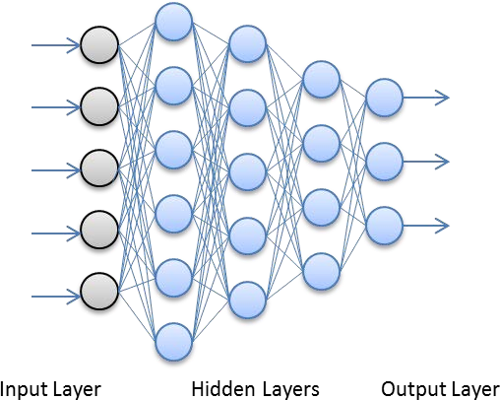

Figure 1: Neural Network Diagram

In 2006, Geoffrey Hinton and Ruslan Salakhutdinov developed techniques using multiple hidden layers. Pre-training was one such technique where the upper layers extract features with a higher level of abstraction which is used by the lower layers for more efficient classification. Unfortunately, since this technique requires billions of floating point operations, it was not computationally feasible until recently. The recent advent of technological advances in hardware caused a resurgence of interest due to the resulting improvements to performance. For example, a researcher at the Switzerland-based Dalle Molle Institute for Artificial Intelligence claims in one instance the training phase took only three days using graphic processing units (GPUs) where using CPU’s would have taken five months [Edwards15]. Deep learning works well with large datasets of labeled data [Edwards15].

**Time Series**

A time series dataset consists of continuous sequences of values or events which are typically collected at fixed time intervals. Real-time surveillance systems, internet traffic, network sensors, and on-line data collection tools generate time series data which can be mined for valuable insights. Time series datasets have several applications, such as stock market analysis, sales forecasting, process and quality control, budgetary analysis, scientific experiments, and medical treatments [Han06].

Massive amounts of data can be generated in a constantly changing environment with a large number of data sources. This presents an additional challenge when working with time series data. In addition to a multitude of data formats, high change rate, and the large volumes of data collected, time may be reported inconsistently, or data may contain noise which obscures the “truth” within the data. Correlating events across multiple sources provides a comprehensive picture of the chain of events. Synchronizing or correlating the events from multiple sources introduces additional complexity [Han06].

There are three well-known window models: landmark windows, sliding windows, and decaying windows [Zhu03]. A widow can be time-based or count based. The exponentially decaying window (or damped window) is a variant of the sliding window where older events have a lower weight than more recent events [Zhu02]. Landmark windows contain aggregated values computed between a landmark point in time and the present. An example would be the average stock price of a company since its last acquisition [Zhu03].

Sliding windows are commonly used to facilitate effective event stream processing. Instead of sampling or performing computations on all of the data, only recent data is used for making decisions, thus reducing the memory required for processing.

Aggregates are computed on the last N values and stored in the window (Figure 2). As time progresses, newer items are added, and older items are removed. The window is usually of a fixed size. Limiting the processing to recent data also prevents less relevant data from influencing statistical calculations [Zhu03].

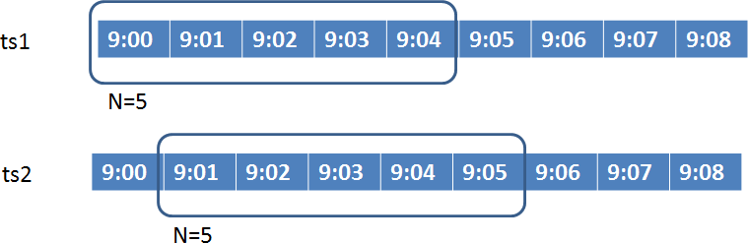

Figure 2: Sliding Window Model

The objectives of time series analysis are to forecast future values, explain how past events can impact future events, or how two time series can interact with each other. Trend analysis, similarity search, clustering, and classification are typical processes used to accomplish these objectives. Trend analysis involves identifying a trend, cyclic movement, seasonal variations, or irregular movements. Trends are depicted using a trend line over a long interval of time. Typical methods used for identifying long-term trends include the weighted average and least squares methods. Cyclic movements refer to the long term oscillations around a trend line. Seasonal variations are changes that are calendar based and typically recur, such as holidays. Irregular movements are random chance events [Han06].

Similarity search finds sequences that differ slightly from a given sequence. Additionally, similarity search can match partial sequences or the whole sequence. An example would be to find a similar performing stock. Clustering partitions time series data into groups based on similarity or a distance measure. Classification builds a model based on the time series in order to predict the label of an unlabeled time series.

**Related Work**

Many scholarly articles have been published on the topic of detecting intrusions using data mining techniques or machine intelligence [Buczak16]. The following sections are critical evaluations of recent research efforts on this topic.

**Denial of Service and Brute force attacks**

In “Applying Data Mining Techniques to Intrusion Detection,” Ng, et al. proposed an off- line solution to detect Denial of Service (DoS) and brute force password attacks [Ng15]. Their solution implements both anomaly detection and signature recognition methods.

They maintain an attack signature database as well as a normal signature database. A Clustering algorithm is used on pre-processed log data to identify multiple occurrences of similar log messages. Their tool searches the signature databases using log patterns detected while processing the log data. When the clustering algorithm detects an unusual number of event occurrences, the signature is compared to the normal log database and is ignored if found. If the signature is found in the existing attack signature database, then an alert is generated. However, if the signature is not found in either signature database, then it is presented to the user for manual classification. The initial log data was obtained from one host running the Ubuntu operating system. Attack log data was obtained by performing ICMP flood and brute force attacks against the host. A set of normal and attack patterns obtained from the initial data collection were stored in the signature database. They identified creating a real-time intrusion detection system as potential future work.

The primary shortcoming of the solution developed by Ng, et al. is that it depends on a single client log file source from one platform (Ubuntu). Additionally, it does not differentiate between events that have occurred recently or far in the past. Since their solution maintains a database of all normal activity patterns; it can only be implemented as an off-line solution. As such, it is not linearly scalable, and cannot detect suspicious user activity in real-time at an enterprise scale.

**Web Application Attacks**

Razzaq, et al. proposed a solution [Razzaq14] for detecting web application attacks by analyzing HTTP requests. The proposed solution was deployed as a web proxy that evaluates all network traffic before it is delivered to the web server. Even though the solution only analyzes the HTTP protocol, they claim it could be expanded to other protocols. Additionally, their solution only examines portions of the headers and payload of user requests. They developed an ontology model (OWL) to build rules to analyze the user request to detect web application attacks, such as SQL Injection, DNS Cache poisoning attack, and HTTP response splitting attacks. These rules are applied to all user requests by analyzing portions of the HTTP traffic before being processed by the web server. Test attack vectors consisted of SQL Injection Cross Site Scripting (XSS) attacks using an open source tool called Web Goat to simulate the attack vectors. The solution detected web application attacks with an average detection rate of 86%. The detection rate (Figure 3) is calculated using the total number of attack records (TA) and the number of false negatives (FN). A false negative is an attack vector that is classified as normal.

The performance results of the proposed system were a maximum throughput of 1400 requests per second with a maximum response time of 374 ms.



Figure 3: Detection Rate Calculation

The most significant shortcoming with Razzaq’s proposed solution [Razzaq14] is that all user traffic does not flow across a single web proxy. As a result, this solution is capable of evaluating only a small portion of user activity which would inevitably result in a security breach going unnoticed. Secondly, the solution only evaluates HTTP network traffic and is not linearly scalable due to the delay in evaluating every single user request before forwarding the request to its destination. Since most enterprise networks use Secure Sockets Layer (SSL) to encrypt the network traffic in motion, the network packets will be unreadable unless the processing occurs at an SSL termination endpoint where the traffic is decrypted. These types of issues can be easily overcome by evaluating log files created by various computer systems.

**Intrusion Detection Postmortem**

Garcia, et al. proposed an off-line solution [Garcia12] to mine client log files to identify the source of a security breach. Given a security incident has already been detected, and a set of client log files, their system will attempt to locate the exploit in one of the log files. Postmortem intrusion detection is primarily used to discover how an intruder gained access to a system, what subsystems were accessed, and what information was compromised. The solution assumes that a security breach has already occurred and bypassed the Intrusion Detection System or any other security controls in place. This solution uses a combination of anomaly detection and a classification technique called KHMM which utilizes a Hidden Markov Model (HMM) and k-means clustering. The main idea around their work is that an attack would result in a sequence of system calls being logged that would not normally appear in normal activity. Normal log data is used to create a normal behavior profile. First, the log files are shrunk by replacing repetitive sequences with a meta-symbol. The log files are then pre-processed using a sliding window containing one hundred elements, stepping through the log file one hundred elements at a time. The last step builds the normal activity model from vector sequences in each window. The resulting model is used for detection. The KHMM process is composed of three steps. First, the preprocessed input is clustered using K-means. Then the sliding window approach is used to create an HMM for each window. The last step uses an anomaly detection to compare each window with the average HMM from the previous step. If two or more consecutive abnormal windows are detected, they are marked for verification by a security analyst. The training and validation sets were composed of 32 log files from three Unix based systems (REL4, Fedora 8, and Ubuntu 9.04). The attack logs were synthetically generated using “buffer overflow” and “user to root” attacks. Experiments resulted in an average detection rate of 81.99% and false positive rate of 4.6%.

A major shortcoming of the solution proposed by Garcia et al. is that it does not detect intrusions; instead, it attempts to locate abnormal activity in a collection of client log files after a security breach has already been deemed to have occurred. Secondly, their solution can be only implemented in an off-line manner because it is not linearly scalable. This is primarily due to the fact that their solution evaluates every single user action.

Scalability can be achieved by using aggregates over time of all user activity. Their solution implements a sliding window that is based on the number of events from an individual user and slides over the user session in increments equal to the size of the window. This method allows for a user sequence to cross window boundaries. Hence this presents a likely possibility that an attack sequence will be overlooked. This issue can be resolved by sliding the window using smaller increments.

Lastly, their solution is not effective because it only considers one log source type which records individual user commands. This solution may lend itself to a low false positive rate; however, if all user activity is not captured in the log, then it is highly probable that a security breach will go unnoticed. In order to overcome this problem, multiple server source log files must be evaluated to get a complete picture of overall user activity.

**Training a Neural Network to Mimic a Firewall**

Valentan and Maly, in “Network firewall using artificial neural networks,” train a multi- layer perceptron (MLP) artificial neural network to learn the rules of a firewall from the network traffic using the back propagation method [Valentan13]. The network consisted of 3 output neurons (ALLOW, REJECT, DENY), 49 input neurons, and 13 hidden neurons. The input neurons were mapped to the binary representation of IP (32 bit), port (16 bit), and protocol (1 bit). If the activation function (sigmoid) did not fire any of the output neurons, the network assumed the network packet was malicious and dropped it. The accuracy of the neural network on the testing set was 99.79%. A training dataset was generated before each epoch. The network used a cross-validation method for training.

The generated dataset was split into two distinct sets (80% for training, and 20% for testing), the former for training, and the latter for testing. Network packets were created by randomly selecting a rule from the firewall table, and then randomly generating a network packet to match that rule. The training dataset consisted of a ratio of 4:1 DENY to ALLOW network packets. For testing, the dataset consisted of an equal ratio of DENY and ALLOW packets. The table of rules contains the associated action of ALLOW, REJECT, or DENY. The neural network is given the correct action during the training phase. The difference between the REJECT and DENY action is that DENY results in the packet being dropped with no response being sent to the source resulting in a “connection timed out” error. In the case of a REJECT action, the packet is prohibited from being sent further. However, an ICMP destination unreachable response is communicated back to the source. Evaluation of the performance of the neural network was performed by comparing the total false positives and false negatives to the total number of packets evaluated. False positives were defined as malicious packets that were allowed. False negatives were normal packets that were blocked.

Training a neural network to learn the rules of a firewall is not an effective method of detecting or deterring intruders. The success of their solution is dependent on how effective the rules are at blocking malicious traffic. Commercial firewall and intrusion detection software is a better alternative for hardening the network security posture. A neural network can supplement a commercial intrusion detection system, but must be non-intrusive, and cannot impede normal operations.

**Shortcomings of existing solutions**

The most prevalent shortcoming of all the solutions reviewed is that they only detect and prevent individual attacks and not coordinated distributed attacks [Abad03]. Many attacks are not identified by a single log source but instead discovered when correlating information from multiple log files [Abad03]. If the attack does not result in an event being logged in the log file that is being monitored, then the attack cannot be detected using existing approaches.

Scalability is another major factor in evaluating the effectiveness of a solution. In the world of Big Data, the amount of information being stored and searched can easily grow to several gigabytes very quickly [Garcia12]. Hence, a solution that does not scale linearly can result in slow detection response times or total system failure.

Additionally, a solution that evaluates raw network traffic to detect intrusions will result in overhead that will eventually inhibit the traffic being delivered to its destination promptly. Intrusion Detection Systems and Firewalls serve as protection controls to harden the security of the network. These systems should be complemented by implementing detection systems that are less intrusive.

**CHAPTER 3**

**PROPOSED APPROACH**

**Overview**

This research introduces the concept of a time slot. A time slot represents a small window in time which contains aggregate feature counts for that time interval. The time slot ts slides over a fixed window of time tw.

The proposed approach consists of five major steps (Figure 4) with the output from each step serving as the input to the subsequent step in the process. The first step in the process, Data Collection, involves identifying and extracting log files from production systems.

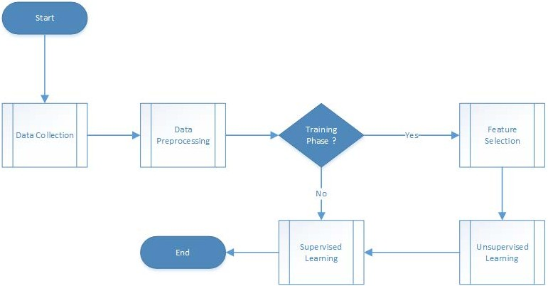

Figure 4: Process Flow Diagram

Data pre-processing is required to transform the data into a format usable by machine learning algorithms. Feature Selection is the process of identifying and selecting relevant features from the pre-processed dataset. Unsupervised learning is used to identify and learn patterns of user activity. This can be accomplished using clustering techniques.

Feature selection and unsupervised learning only need to occur for training purposes. In the Supervised Learning step, the model is trained and evaluated using a classification technique using the labeled dataset from the previous step. After the model produces acceptable results, the model is trained and can be used in production phase to detect abnormal user activity.

In this research, a log entry (or instance) is referred to as an event. The term “source” is used to refer to an instance of a log file. The term “index” is used to refer to loading and parsing a log file using a search tool. The term “source type” is used to refer to a collection of log files of the same type. For example, the source type Neptune refers to the collection of log files from the Microsoft Internet Information servers used to service requests to the Microsoft Exchange servers. Microsoft Exchange is a Windows based email system.

**Data Extraction and Transformation**

This step is composed of three sub-tasks that collectively produce the required datasets for machine learning to occur. The data collection sub-task is the process of identifying, extracting, and integrating log data from the source systems into a single repository. Pre- processing is required to reduce the size of the dataset and transform it into a sliding window representation. Feature selection, the process of identifying a set of features from the data to be used in machine learning, is only performed for initial training and evaluation of the model.

**Data Collection**

A familiarity with all available log source types is necessary for the purposes of detecting cyber attacks. Interviewing security professionals to identify a list of available source types is the first step in data collection. The available sources typically differ among organizations depending on their network architecture. However, possible source types may include email usage activity, firewall data, wireless access point (WAP) data, browser activity, physical facility access data, and Security Information and Event Management (SIEM) data [Mahmood13]. Web application log files are also prime candidates for consumption. Integrating these sources into a single repository allows us to build a comprehensive picture of user activity across multiple systems. Such a repository will allow us to gain insight into user activity that may be otherwise missed if examining the sources individually.

Understanding how any form of an attack could manifest itself in each of the source types is necessary for identifying potential attributes for feature extraction. The last step of data collection is identifying candidate features for extraction. The results of this step are needed in the pre-processing step where the feature extraction occurs.

**Pre-Processing**

Data transformation operations are used to convert the dataset into an appropriate structure to facilitate machine learning. Data aggregation and feature selection are common data transformation techniques used to obtain a reduced representation of the dataset without impacting its predictive accuracy [Han06].

The first step in pre-processing is to align the events in each of the source types by their respective time stamp and compute aggregate feature counts per unit time. The next step computes aggregate counts per time slot. A time slot has a fixed size and slides through time incrementally by one unit. For example, a time slot starting at time index t and size N will contain the count of feature occurrences starting at t and ending at t+N-1. Each row of the pre-processed dataset represents a collection of feature counts Fi for a single time slot tsj. A conceptual representation of the resulting pre-processed dataset with the sliding time window is depicted in Figure 5.

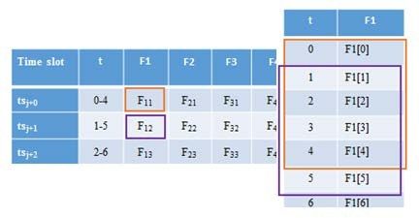

Figure 5: Pre-processed dataset with sliding time window

**Feature Selection**

A feature is an input variable or attribute that is binary, categorical or continuous in nature. The primary focus of feature selection is concerned with selecting relevant and informative features. However, other benefits exist, such as to limit storage requirements, increase calculation speed, increase predictive accuracy, and to gain an understanding of the process that generated the dataset [Guyon06].

Integrating data from multiple sources may result in a dataset containing hundreds of features some of which may be irrelevant or redundant. Redundancy can be detected by performing correlation analysis. Correlation analysis evaluates the correlation between two features. Chi-square is a common statistical method used to detect redundancy. There are other feature evaluation measures, such as Information Gain, Gain ratio, and the Gini index [Han06].

Selecting the best feature set often requires human expertise to convert raw data into a useful set of features. However, a variety of feature selection methods can be used in the absence of a subject matter expert (SME). Such methods are classified as either filters, wrappers, or embedded methods. Classical statistical methods which use correlation coefficients, such as the T-test, F-test, and chi-square, are types of filter methods used to assess variable independence. Filters calculate feature ranking based on classic statistical methods, where wrappers use the performance of a machine learning algorithm trained with the given feature subset. Embedded methods perform feature selection in the process of training, and are specific to a machine learning algorithm [Guyon06]. The hidden layers generated during training in a neural network are an example of an embedded method.

**Unsupervised Learning**

Unsupervised learning techniques are typically used when the class label of each data element in a dataset is unknown. Clustering, a type of unsupervised learning is the process of grouping similar data elements into classes or clusters. Euclidean, Manhattan, and Minkowski are common similarity measures used by clustering algorithms. There are a variety of different types of clustering techniques, including but not limited to partitioning, hierarchical, density-based, and grid-based methods.

Outlier detection is a common application of clustering. Outliers are data elements that are far from all other elements and fall outside of any cluster. In some cases, the outlier may provide more insight into a problem than the normal items. Applications of outlier detection include credit card fraud detection and monitoring of electronic commerce for criminal activities. Clustering may be used in lieu of manual classification when working with very large datasets which could be very time-consuming and prone to human error.

Clustering is highly adaptable to change and can identify distinguishing features in the dataset. However, it also has some challenges. For example, clustering a large dataset may lead to biased results. Additionally, the results can be affected by noise, outliers, or missing elements. Mixed data types introduce additional complexity.

K-means is a common partitioning algorithm which calculates the center of each cluster using the mean value of all the objects in the cluster. K-medoids is similar, but instead of using the mean for the center of the cluster, it uses objects located near the center of the cluster. Partitioning based methods must be extended when working with very large datasets.

**Supervised Learning**

Supervised learning is the process of training a machine to accurately classify an instance or predict a value based on past examples. Data classification uses a labeled set of data called a training set to train a model for prediction, and a test set for evaluation purposes. There are several algorithms available used for classification. A renewed interest in neural networks has peaked with recent technological advances in computing power. Deep neural networks are especially known to perform well with large datasets [Edwards15].

**Measurements and Evaluation**

The following performance measures were used to evaluate the effectiveness of the proposed model. Accuracy is an overall measurement. However, Recall and f-score are equally important. For example, if an alert is raised when there is no security incident in progress, the cost is likely an inconvenience, however, if a security incident goes unnoticed, the cost could be devastating depending on the nature of the incident [Alpaydin14].

Accuracy (Equation 1) is defined as the ratio of correctly classified time slots to the total number of time slots [Alpaydin14].



Equation 1: Accuracy

Precision (Equation 2) is defined as the ratio of true positives to all time slots classified as positive. For example, time slots correctly classified as normal to the total number of time slots classified as normal [Alpaydin14].



Equation 2: Precision

Recall (Equation 3) is defined as the ratio of true positives to the total number of actual positive time slots. In other words, the number of time slots classified correctly to the total actual time slots [Alpaydin14].



Equation 3: Recall

F-score is defined as the harmonic mean between precision and recall. This measure discourages models that sacrifice one measure over another [Han06].

In addition to measuring the detection performance, the training and test time was also evaluated. These measures were used to support the claim that this model is accurate, fast, and scalable.

This approach was assessed through experimentation using datasets of differing time granularity. An initial model and preliminary results using two distinct datasets are presented in the next chapter. Chapter 5 introduces additional enhancements to the model, a third dataset, and compares the results on each dataset.

**CHAPTER 4**

**INITIAL MODEL AND PRELIMINARY RESULTS**

**System Architecture**

The proposed system architecture, depicted in Figure 6, was implemented using Splunk Enterprise Edition 6.42 [Splunk17], R-Studio, and three sources which will be described in more detail in the next section. The source log files were manually loaded into Splunk using its web interface. However, a Splunk forwarder may be used to forward log files to the Splunk indexer for parsing and storing in real-time. A Splunk forwarder is also capable of receiving log data on a dedicated TCP port from high-speed appliances, such as a firewall. The Splunk search head hosts the web-based user interface and executes interactive searches and presents the results to the user.

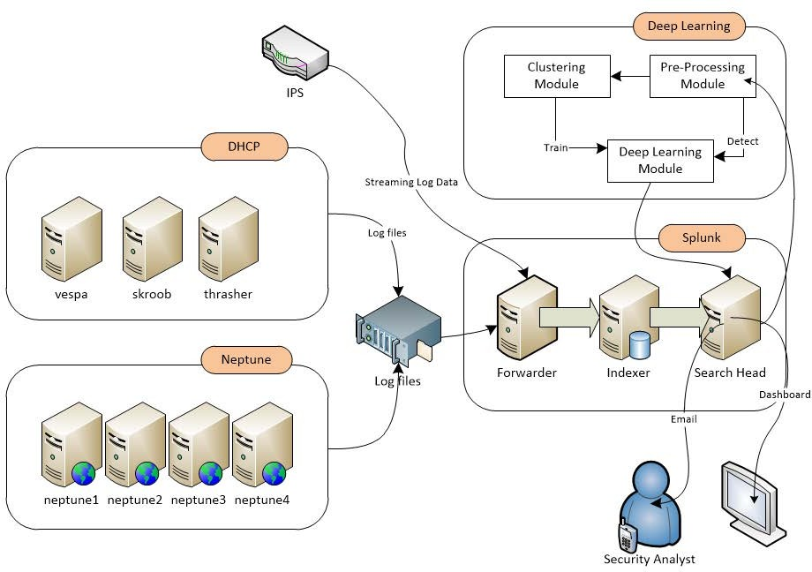

Figure 6: Proposed Solution Architecture

Splunk, a commercial log aggregation application, is used for indexing, searching, and transformation of log data. Splunk was chosen for its ease of use, fast performance, and advanced search language functionality. Loading a log file into Splunk can be initiated via drag and drop operation, and completed with just a few mouse clicks. Additionally, Splunk’s architecture makes it a primary candidate for use in an online implementation. Since Splunk requires log files to be no larger than 500 MB in size, a log file splitter utility was used to load and index the log file. Due to the massive size of the logs, the import process spanned several days. The status of the import process can be determined anytime during or after the log import process by executing the Splunk command depicted in Figure 7. This command will display the source type, first event, last event, and a total number of events logged for each source type.

| metadata type=sourcetypes | eval firstEvent = strftime(firstTime, "%m-%d-%Y %H:%M:%S") | eval lastEvent=strftime(lastTime,"%m-%d-%Y %H:%M:%S") | table sourcetype, firstEvent, lastEvent, totalCount | sort firstEvent

Figure 7: Verify Log File Import

A Splunk search command was executed to create a dataset of aggregate feature counts in one-minute intervals. This aggregated data was then exported to a CSV file, and fed into the Pre-Processing module. The Pre-Processing module converts the one-minute interval total counts to into a five-minute sliding window representation. For initial training, the data is fed into the Clustering Module where the dataset is classified and labeled. The resulting classified dataset is used by the Deep Learning module for training and testing. After the model is trained, Pre-Processed data is then fed directly into the Deep Learning

module for incident detection. The system will generate in real-time alerts and updates to dashboards when it detects abnormal activity.

**Data Collection**

The University Security Department provided a “sanitized” set of log files used for this experiment. These files were extracted from real production system logs and altered to obscure user information. The log files are listed in Table 1.

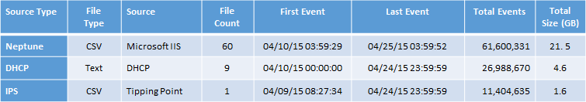

Table 1: Source Log Files

Two datasets were extracted from the integrated log files in Table 1 for the purposes of evaluating the model performance with varying parameters. These datasets are defined in Table 2. The main difference between the two datasets is the size of the dataset and its time window. Experimentation was performed using each dataset.

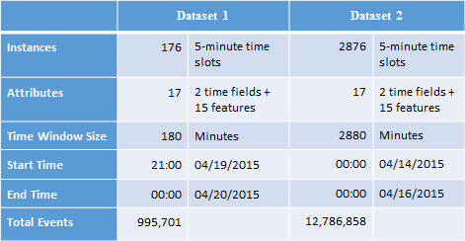

Table 2: Dataset Definitions

The datasets depicted in Table 2 were created using the time slot concept to model the data. The time slot size selected for both datasets was five minutes. Each row in the dataset contains aggregate feature counts for five minutes. For example, in three hours of log data examined, one time slot represented aggregate counts of 26,807 events. This has the effect of reducing the number of resources needed to represent all the data for each dataset drastically allowing the system to scale linearly as new log files are introduced.

The log files for this research were extracted from the source systems, compressed, and transferred to DVD media. As a result, this research method is conducted in an off-line manner. A production deployment is not in the scope of this research. However, this research can be implemented in a near real-time manner. The training and test datasets needed for this research are created using the log files and contain aggregate count values in time series.

**Feature Selection**

The features selected for machine learning are derived counts based on specific attributes from one or more log files. Selecting the individual user names or IP values as features would result in a sparse matrix which would exponentially increase the memory requirement. By examining three hours of the data collected it becomes evident that such a solution would not be linearly scalable. In one particular case, there were no more than 316 active users out of a total 2,436 possible users. Figure 8 depicts the distribution of active users for this timeframe. Similarly, approximately 50% of the possible IP addresses were active at any point during the same timeframe. Consequently, these attributes were not selected as features.

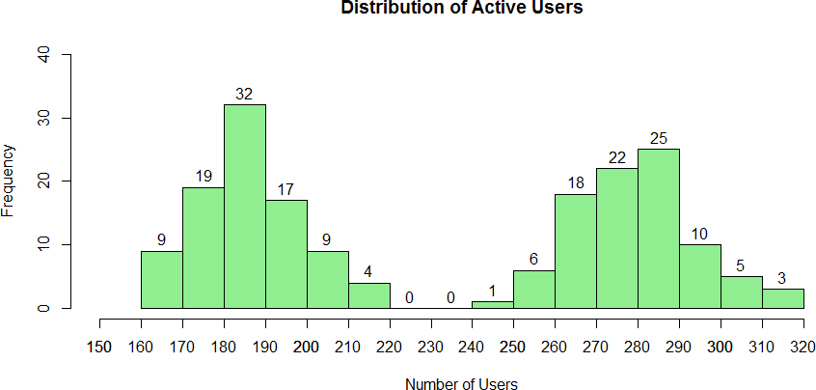

Figure 8: Active User Distribution

The features selected for this research (Table 3) were derived from aggregate values using the Neptune, DHCP, and IPS source types.

Table 3: Features used for Machine Learning

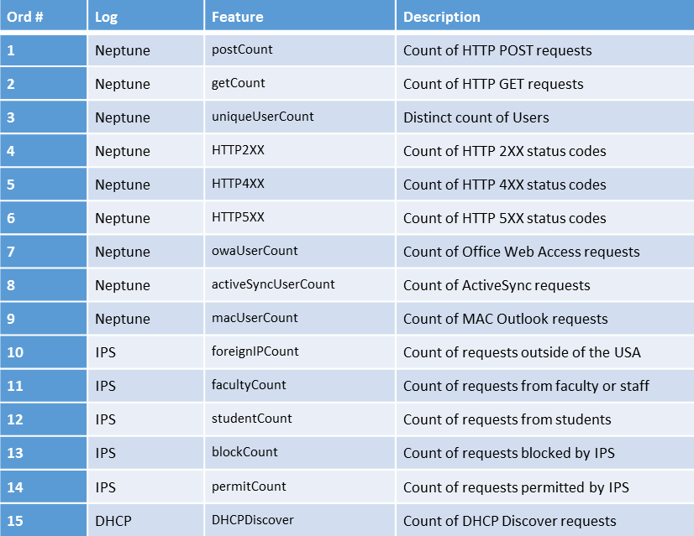

The “Neptune” source type contains event data from four Windows servers running Microsoft Internet Information Server (IIS). The structure of this source type adheres to the W3C Extended Log File standard [Hallam-Baker96]. The events contained in this source type are the result of user email activity. The features derived from this source type include the total number of HTTP POST and GET requests, the total number of successful and unsuccessful requests, the distinct count of users, and the number of Active Sync, Web Access, and MAC users. The sample event in Figure 9 depicts in bold print the portions used to derive the postCount, activeSyncUserCount, uniqueUserCount, and HTTP2XX features. The features uniqueIPCount and uniqueUserCount appear to have a strong correlation as shown in Table 4.

D:\Elfa_Data\Neptune\Raw\4\u_ex150419_x.log,293972,2015-04-19,23:59:59,139.62.192.204,***POST***,

/***Microsoft-Server- ActiveSync***/default.eas,User=User951&DeviceId=ApplDKVLK09WDVGF&DeviceType=iPad &Cmd=Ping&CorrelationID=<empty>;&ClientId=EPYTCILETMFIVQOYCFG &cafeReqId=f0cf56aa-c4b7-4474-8f5e-4ec2b0e4d895;,443,***UNFCSD\User951***,139.62.193.253, Apple-iPad3C2/1206.69,,***200***,0,0,24625,76.122.20.229

Figure 9: IIS Log Entry Sample

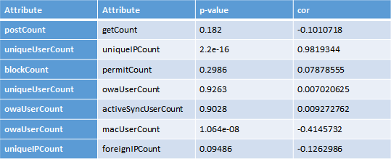

Table 4: Correlation Results for Features

The DHCP source type contains event data from three UNIX servers which process requests for the network (IP) address for hosts connecting to the network using Dynamic Host Configuration Protocol [Droms97]. The sample event depicted in Figure 10 is used to derive the feature DHCPDiscover.

Apr 19 23:59:58 thrasher dhcpd: ***DHCPDISCOVER*** from 40:25:c2:7b:d3:14 via eth0

Figure 10: DHCP Log Entry Sample

The IPS source type contains event data from the Tipping Point Intrusion Prevention System (IPS), an industry standard Intrusion Prevention System. The IPS system logs events when any network traffic matching a rule is detected. The sample event depicted in Figure 11 is used to derive the following features: blockCount, facultyCount , and foreignIPCount.

2015-04-19 23:59:34",Low,"7611: DNS Reputation",Reputation,***Block***,1,**Faculty- Staff**,139.62.200.212,34847,***199.249.119.1,53***,192,download.newnext.me

Figure 11: IPS Log Entry Sample

**Pre-Processing**

The Splunk search in Figure 12 was used to create the datasets for this research by varying earliest and latest date-time values. The results were exported into a CSV format.

index=main (sourcetype=neptune OR sourcetype=tpsms OR sourcetype=dhcp) earliest=04/19/2015:21:00:0 latest=04/20/2015:0:0:0 | eval statusCd=substr(sc_status,1,1) | iplocation DEST_IP | bucket _time span=1m | eval dhcpCMD=if(match(_raw,"DHCPDISCOVER"),"DISCOVER","") | eval userType=if(like(cs_uri_stem,"%owa%"),"OWA", if(like(cs_uri_stem,"%Microsoft-Server-ActiveSync%"),"ASYNC", if(like(cs_User_Agent,"MacOutlook%"), "MACOUTLOOK", "OTHER"))) | stats count(eval(cs_method="POST")) as postCount, count(eval(cs_method="GET")) as getCount, dc(cs_username) as uniqueUserCount, dc(OriginalIP) as uniqueIPCount, count(eval(statusCd="2")) as HTTP2XX, count(eval(statusCd="4")) as HTTP4XX, count(eval(statusCd="5")) as HTTP5XX, mode(FILTER) as primaryReason, count(eval(userType="OWA")) as owaUserCount, count(eval(userType="ASYNC")) as activeSyncUserCount, count(eval(userType="MACOUTLOOK")) as macUserCount, count(eval(dhcpCMD="DISCOVER")) as DHCPDiscover, count(eval(Country!="United States")) as foreignIPCount, count(eval(PROFILE="Faculty-Staff")) as facultyCount, count(eval(PROFILE="Dorms-Guest")) as studentCount, count(eval(ACTION="Block")) as blockCount, count(eval(ACTION="Permit")) as permitCount, mode(VLAN_NUM) as primaryVLAN by _time

Figure 12: Splunk Transformation Query

The exported CSV data is converted into a sliding window representation using an R- Script. The purpose of this step is to preserve a continuous set of temporal values as the system advances through each row in the dataset which contains the aggregate feature counts for one time slot. For example, given a time slot size of five minutes and a sixty minute time window starting at 21:00, the first row in the dataset contains aggregate feature counts for the time slot from 21:00 through 21:04. The second row contains aggregate feature counts from 21:01 through 21:05, and so forth. The start time for each subsequent time slot starts one-minute later than the previous time slot began. The time slot start and end times are included as the first two fields of each dataset as shown in Figure 13. These time fields were not used for machine learning, instead, are included in order to provide the actual time frame to a security analyst for investigation purposes.

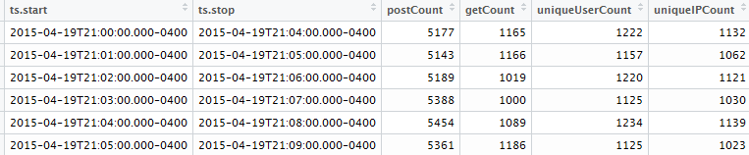

Figure 13: Partial Dataset Image

**Unsupervised Learning Results**

A classified dataset consisting of normal and abnormal activity is needed for supervised learning to occur. Classification would be extremely labor intensive due to the massive size of the log files. For example, if activity in one-time slot warranted investigation, a security analyst could potentially need to review over 30,000 log entries, thus making visual identification and classification impossible.

Generating synthetic data for abnormal activity was considered because there were no known security incidents during the timeframe the log data was collected. However, there is an inherent risk when assuming that the log data contains only normal activity. If anomalies exist in the data, the model may inaccurately classify instances, or worse ignore real security incidents. Consequently, clustering was used to identify anomalous activity within the training dataset.

The Partitioning Around Medoids (PAM) algorithm was chosen to classify the dataset into three clusters of activity. PAM was chosen because it is resistant to outliers and allows clustering of categorical values. Each cluster is classified as normal, critical, or warning, and is labeled green, red, or yellow, respectively. The cluster score is calculated from the median value of the sum of all features and is used to determine the label assigned to each cluster. R code for calculating the cluster score is depicted in Figure 14. The cluster with the lowest score was labeled green. The cluster with the highest score was labeled red, and the remaining cluster was labeled yellow.

l<-which(wbpam$clustering %in% c(1)) cluster.scores<- c(median(rowSums(tw[l,])))

l<-which(wbpam$clustering %in% c(2)) cluster.scores<-c(cluster.scores, median(rowSums(tw[l,])))

l<-which(wbpam$clustering %in% c(3)) cluster.scores<-c(cluster.scores, median(rowSums(tw[l,]))) print(cluster.scores)

Figure 14: R Code to Calculate Cluster Scores

The classification results for each dataset are shown in Figure 15. It is worth noting that all of the cluster scores resulting from Dataset 2 are lower than those from Dataset 1. The green cluster score from Dataset 2 is fifty-seven percent lower its counterpart.

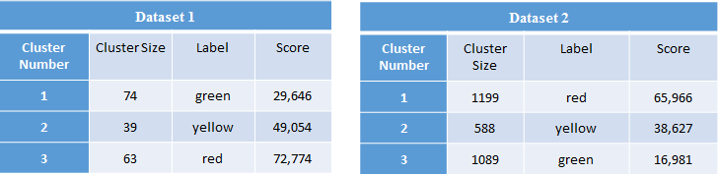

Figure 15: Clustering Confusion Matrixes

Figure 16 contains box plots depicting the difference in the scale of activity for each dataset. The Y-axis represents the sum of all features for each instance in a cluster. The normal and warning clusters in Dataset 2 overlap. Further analysis will reveal that the skewed results from the clustering Dataset 2 were due to clustering on such a large time window.

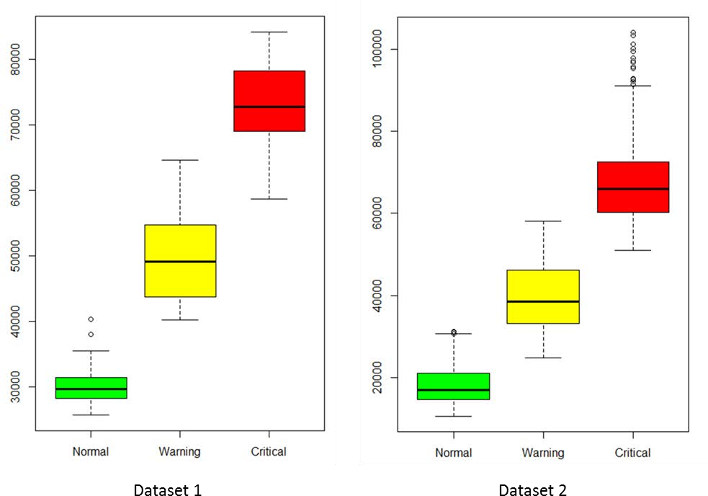

Figure 16: Cluster Scores

Typical user activity patterns appear to follow a Gaussian distribution throughout a normal business day. This is illustrated by the data from Dataset 2 in Figure 17. As a result, the peak activity times in Dataset 2 were classified as red, non-peak as green, and the transition period as yellow.

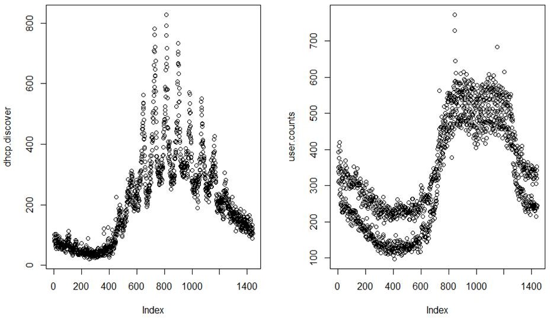

Figure 17: User Activity Distribution

Table 5 depicts the time slots color-coded according to each cluster in Dataset 1 and includes the total events, average number of events per minute (EPM), start and end times, and classification duration in minutes.

|  |  |  |  |  |  |  |  |
| --- | --- | --- | --- | --- | --- | --- | --- |
| Cluster | Beginning Time Slot | Ending Time Slot | Start Time | End Time | Duration (min) | AVG EPM | Total Events |
| Green | 1 | 16 | 21:00 | 21:20 | 20 | 1,324 | 26,474 |
| Yellow | 17 | 18 | 21:16 | 21:22 | 6 | 2,934 | 17,603 |
| Red | 19 | 34 | 21:18 | 21:38 | 20 | 5,456 | 109,111 |
| Yellow | 35 | 37 | 21:34 | 21:41 | 7 | 3,623 | 25,363 |
| Green | 38 | 83 | 21:37 | 22:27 | 50 | 1,250 | 62,501 |
| Yellow | 84 | 105 | 22:23 | 22:49 | 26 | 3,054 | 79,391 |
| Red | 106 | 108 | 22:45 | 22:52 | 7 | 4,018 | 28,123 |
| Yellow | 109 | 110 | 22:48 | 22:54 | 6 | 3,384 | 20,303 |
| Green | 111 | 115 | 22:50 | 22:59 | 9 | 2,110 | 18,991 |
| Yellow | 116 | 117 | 22:55 | 23:01 | 6 | 3,219 | 19,315 |
| Red | 118 | 152 | 22:57 | 23:36 | 39 | 5,361 | 209,096 |
| Yellow | 153 | 157 | 23:32 | 23:41 | 9 | 4,938 | 44,442 |
| Red | 158 | 166 | 23:37 | 23:50 | 13 | 5,297 | 68,858 |
| Yellow | 167 | 169 | 23:46 | 23:53 | 7 | 3,349 | 23,4438 |
| Green | 170 | 176 | 23:49 | 00:00 | 11 | 1,614 | 17,750 |

Table 5: Time Slot Classification Results

Plotting the feature postCount confirms anomalous user activity occurred during the three-hour time window, shown in the top half of Figure 18. The red line is the average of events per minute of the red clusters in Table 5. The activity above this line indicates abnormal activity. The area between the yellow and red lines is indicative of a border state between normal and abnormal activity.

The bottom chart in Figure 18 is a time chart of the feature postCount from Dataset 2 using the same boundaries as the top graph. The amount of time above the red line is notably smaller than that from Dataset 1.

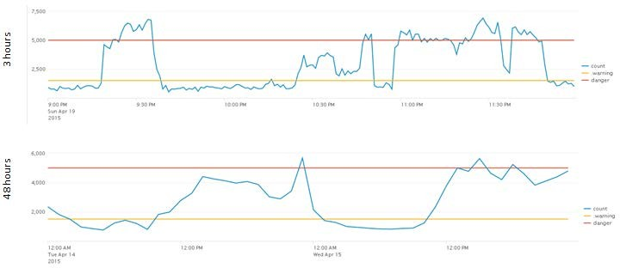

Figure 18: HTTP POST Requests

Approximately 38 percent of the user activity in Dataset 2 was classified as abnormal. If we assume user activity remains constant throughout the day, the thresholds should remain constant. However, the chart of Dataset 2 (48 hours) in Figure 18 using the same threshold for abnormal activity as Dataset 1, shows most of the activity is below the control boundary. It is apparent that the threshold for abnormal activity changes throughout the day based on user activity and the size of the time window chosen impacts the accuracy of the clustering results. In this case, a larger time window produced biased results.

Future experiments using a smaller time window and a larger period of activity are expected to result in more accurate clustering and facilitate learning routine activity patterns specific to any hour of any day of the week.

**Supervised Learning Results**

The R package “h2o” was used to train and test a neural network using the deep learning algorithm. The dataset was split into 70/30 % for training and testing, respectively, maintaining an equal proportion of each class in both the training and test sets.

The experiments conducted used one hundred epochs and the hyperbolic tangent for the activation function. Determining the optimal network topology is not a trivial task.

Therefore these experiments used a simple network topology of one hidden layer with two neurons. Table 6 depicts the overall results of the deep learning algorithm on both datasets. The larger dataset (Dataset 2) resulted in greater accuracy. The confusion matrixes for both datasets are depicted in Table 7. The accuracy of the Deep Learning algorithm was slightly less than that of the Weka Multi-Level Perceptron (MLP). The h2o deep learning algorithm was significantly faster than the Weka MLP.

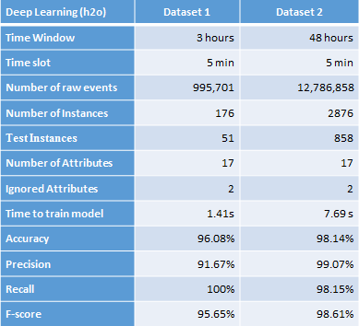

Table 6: Deep Learning Results

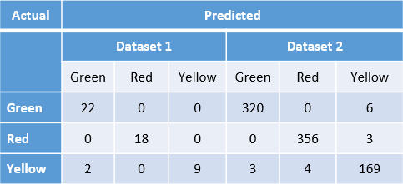

Table 7: Deep Learning Confusion Matrixes

**EXPERIMENTS AND RESULTS**

**Overview**

In the previous section, it was shown that user activity typically follows a normal distribution and can vary with the time of day. In order to account for the dynamic nature of user activity and preserve the prediction accuracy of the model, the experiments described in this section will introduce two new features and several new methods, such as normalization, rule-based clustering, split-level clustering, and topology analysis.

Finally, the model was trained and evaluated using the original datasets used in the previous section, in addition to a newly created dataset.

**Data Collection**

A third and final dataset that spans approximately two calendar weeks was created for the purposes of evaluating the model performance on a larger sample of log data. This dataset was used to train the model to learn normal activity patterns that occur at various times during the day and evaluate its performance at detecting those user activities that fall outside of the normal range. It is worth noting that the new dataset is a superset of the other two datasets (Table 8).

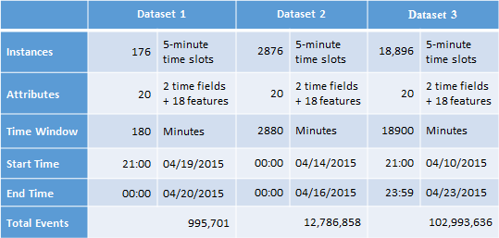

Table 8: Dataset Definitions

Each dataset is composed of one-minute feature aggregates derived from the original log files. The features used for machine learning are depicted in Table 9. The source log file of each feature is listed with its description. This is the same feature set used in the previous section, with the addition of the two new calculated fields: dhour and wday.

The purpose of introducing the new features is to model the dynamic nature of user activity over time. For example, a normally occurring pattern during the afternoon may not normally occur in the middle of the night, and hence is suspicious in nature or could be an attack.

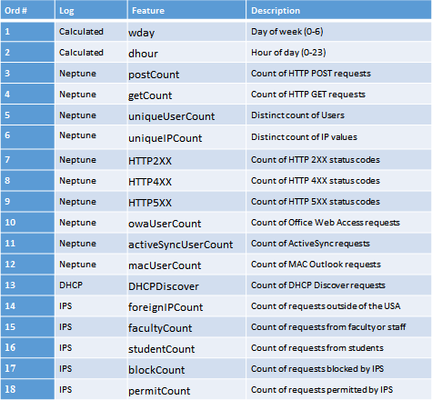

Table 9: Features used for Machine Learning

**Pre-processing**

The pre-processing module converts the datasets listed in Table 8 into a five-minute sliding window representation by summing the feature aggregates. The reason for using the sum instead of the median or mean is that the mean or median could mask a subtle fluctuation in an activity that would otherwise go unnoticed. Additionally, the pre- processing module introduces two new features which allow the neural network to accurately differentiate abnormal activity from fluctuations that may normally occur throughout the day. The new features are wday and dhour. The wday feature is the ordinal number of the calendar day of the week (0-6). The dhour feature represents the hour of the timeslot (0-23). The time required for preprocessing each dataset is listed in Table 10.

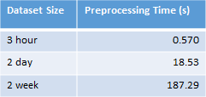

Table 10: Pre-processing Times

**Normalization**

Normalization is performed by the pre-processing module to prepare the data for machine learning. The purpose of normalization is to bring all features into a common range so that one feature does not have higher precedence than any other feature. Normalization was performed on each feature column using Min-Max normalization [Figure 19].



Figure 19: MinMax Normalization

Normalization allows for easier comparison when charting features with a different scale. Additionally, normalization can speed up the time required to train the neural network [Han06]. Normalizing the dataset preserves the shape of the feature plots as can be seen in Figure 20.

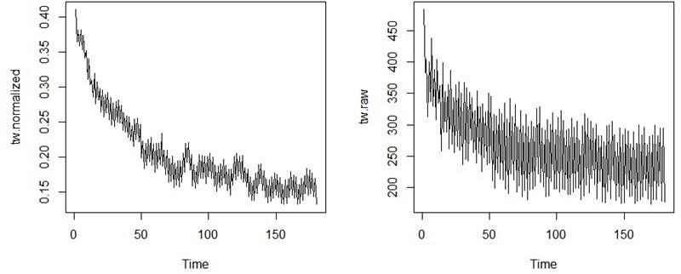

Figure 20: Effect of Normalization

**Unsupervised Learning Results**

The source log files used for this research were not known to have any intrusions at the time they were collected, and as a consequence, the datasets were not labeled. Abnormal activity patterns were discovered to exist within the data. However, there lacked a sufficient sample to train a neural network effectively. Due to the size of the log files, manual labeling of a dataset would require intensive effort. Hence, the Partitioning around Medoids (PAM) algorithm was used to create a labeled dataset with a proportional number of examples for each class. The PAM clustering results are shown in Table 11.

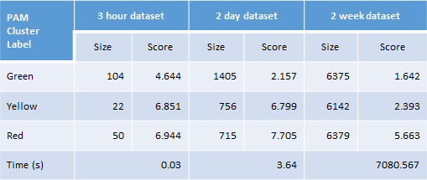

Table 11: PAM Clustering Results

Three classifications were chosen to model a common business view of user activity. The classifications green, yellow, and red were used. These classifications also reflect the criticality or urgency of activity. Normal user activity patterns are labeled green. Known attack patterns or activities that have a high sense of urgency are labeled red. Patterns that are suspicious, unknown or are a precursor to a cyber attack are labeled yellow.

Each of the datasets was partitioned into three clusters and labeled using a cluster scoring function. The cluster score was calculated by summing of the features of the cluster’s medoid. The cluster with the lowest score was labeled green. The cluster with the largest score was labeled red, and the remaining cluster was labeled yellow. The medoids for each of the datasets are shown in Tables 12, 13, and 14.

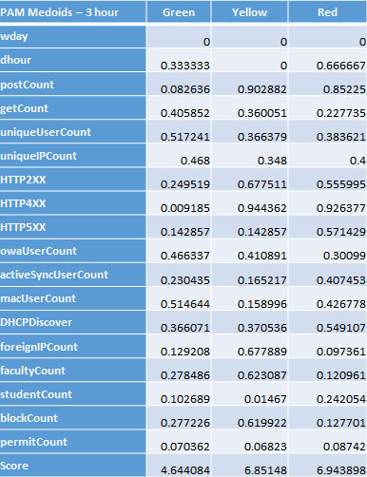

Table 12: Medoids for Dataset 1

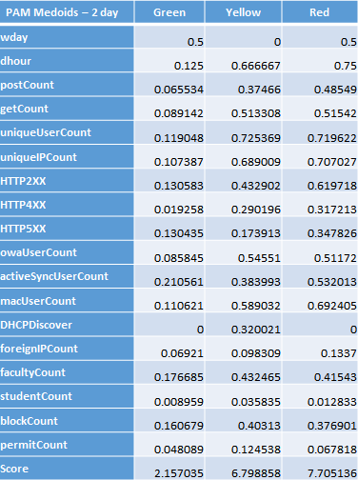

Table 13: Medoids for Dataset 2

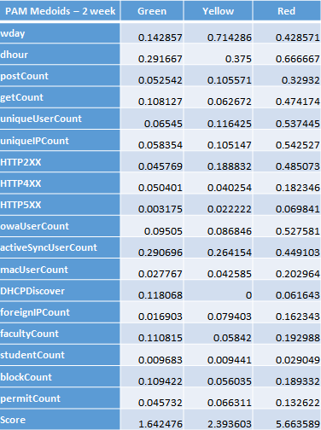

Table 14: Medoids for Dataset 3

**Rule-based Clustering**

Rule-based clustering was introduced to provide a different method of labeling data since clustering resulted in a near linear split of the data. This method attempts to fit the data to a more complex, non-linear equation which would be more representative of an attack. Additionally, a Subject Matter Expert (SME) may classify some events in the logs differently from another SME. The rule set chosen does not impact the validity of this approach, as such the rules used in this experiment could be replaced with an entirely different set and achieve similar results.

This method utilized four rules that explicitly reference features from three different log sources. The rules were derived from an interview with a security analyst from a discussion on what events could represent attacks in the logs. Using the same classifications introduced earlier, the classes were defined as follows. Instances that matched one of the rules were labeled yellow, while instances that matched more than one rule were labeled red. Instances that did not match any of the rule patterns were labeled green. The results of the rule-based classification are depicted in Table 15.

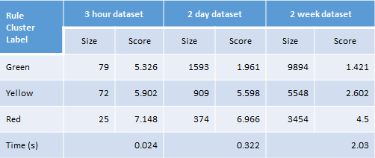

Table 15: Rule-based Clustering Results

The rules used in this method are listed below.

Rule 1: High rates of DHCP discover requests are representative of a DHCP starvation attack.

Rule 2: High connection counts to foreign IP’s with a high rate of HTTP POST requests could be a malware attack.

Rule 3: High rate of HTTP GET requests with low unique user counts could be representative of a denial of service attack.

Rule 4: High number of unauthorized attempts for access is likely to be reconnaissance for an attack.

In order to provide a proportional number of examples for each class, the quantile function was used on the feature values to establish a dynamic threshold. For example, all instances where the DHCP discover value exceeds the 75% quantile were considered an attack. This method was faster than using PAM clustering. Clustering the two-week dataset using PAM took just under two hours compared to the rule-based method which took just over two minutes. The rule-based method also resulted in a smaller proportion of non-normal examples than the PAM method. For example, using the PAM method on Dataset 3 resulted in approximately 33% of activity in each cluster. The rule-based method classified 18% of the activity as critical or red.

**Feature Ranking**

After the datasets had been labeled, the features were ranked using an Information Gain attribute evaluator using Weka. The feature ranking for the PAM clustered data is shown in Table 16. The wday feature is a constant value in the three-hour dataset. Hence it was ranked zero. Any of the features ranked zero could be dropped without impacting the accuracy of the model, however, all of the features were retained for the experiments in this research. The new features have a higher ranking in the other two datasets. The features targeted by the rule-based clustering were ranked higher than the other features as can be seen in Table 17.

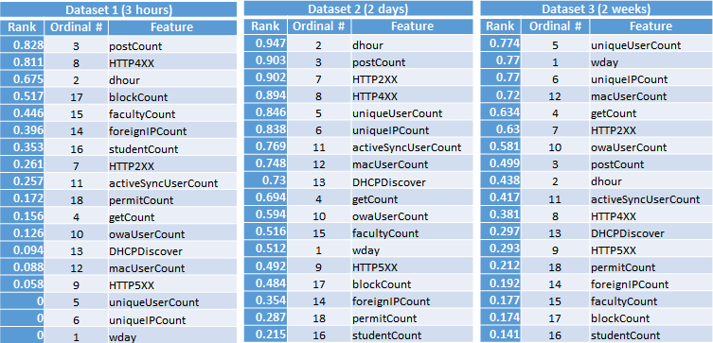

Table 16: PAM Feature Ranking

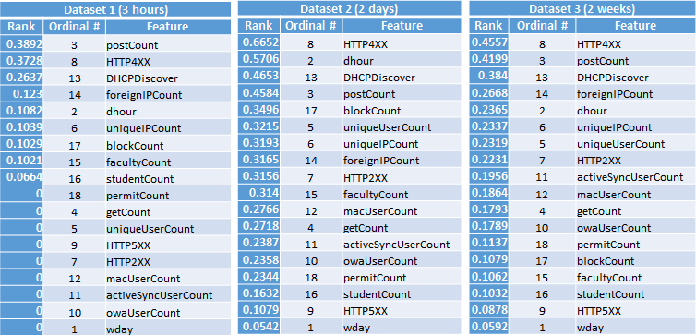

Table 17: Rule-based Feature Ranking

**Split-level Clustering**

Split-level clustering was introduced to simulate a non-linear method of classifying the dataset. PAM is used to partition the dataset into three clusters. Each of the resulting clusters is then partitioned using PAM to create three clusters which are labeled green, yellow, or red according to their respective cluster score. The resulting nine clusters are combined according to their labeled color and used to create a dataset which is then used for evaluation purposes of the deep learning algorithm using multiple hidden layers.

Figure 21 depicts the process used by the split-level clustering method.

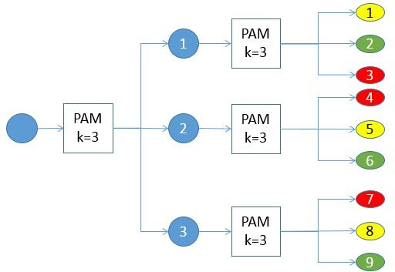

Figure 21: Split-Level Clustering Process

The split-level concept seems similar to hierarchical clustering; however it is not really for several reasons. First, the algorithm used is Partitioning among Medoids (PAM) which is a partitioning algorithm. Second, the number of clusters in hierarchical clustering is determined by the height in the tree, whereas the number of clusters is specified for PAM. There are two types of hierarchical clustering methods. Agglomerative is a bottom-up technique which starts with every instance in its own cluster, and then merges the clusters until they are all in a single cluster. Divisive, a top- down strategy, starts with all the instances in one cluster and then subdivides the cluster until each instance is in its own cluster. In the split-level method, the height is constant, and the final number of clusters is controlled by k used in the second level which should match the levels of user activity used for classification.

**Supervised Learning Results**

Supervised learning was performed using the h2o deep learning algorithm [h2o17] to train and test the model using each of labeled datasets created during unsupervised learning. The datasets were split into training and test sets comprising 70% and 30% of the data respectively. The training set was used solely to train the neural network, and the test set was reserved for testing and evaluation purposes. The parameters for the h2o deep learning algorithm are the number of epochs, the activation function, and the hidden layer topology. The hidden layer parameter is a vector containing the number of neurons for each hidden layer. The activation function used was the Hyperbolic Tangent, and the number of epochs used for this research was 1000. The optimal number of epochs was determined through experimentation using 100, 1,000, and 10,000 epochs taking into account the accuracy and time to train the model.

Deep learning tests were conducted using the PAM labeled datasets varying the number of hidden neurons from 2 to 20 in a single hidden layer. The results shown in Table 18 are from a single test on each dataset. The deep learning algorithm automatically dropped the wday feature in the three-hour dataset because the value was constant.

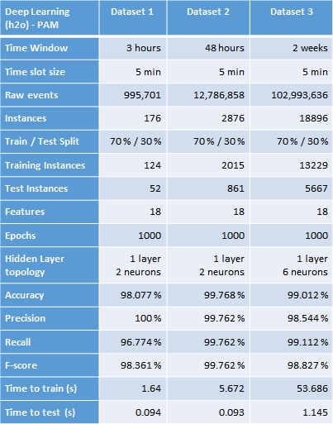

Table 18: Deep Learning Results using PAM Labeled Data

The resulting confusion matrices for each of the tests are shown in Table 19. There were no false negatives for Datasets 1 and 2. There were ten false negatives for the larger dataset where only two were classified as normal. There was only one false positive for Datasets 1 and 2. The larger dataset resulted in seventeen false positives where only four were classified as critical.

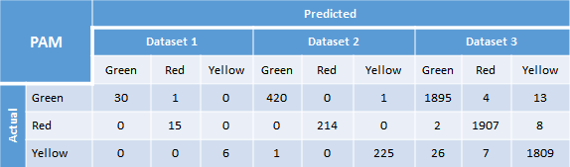

Table 19: Deep Learning Confusion Matrices for PAM Labeled Data

The single layer topology analysis in Table 20 shows the deep learning results for Dataset 1 of the various neuron configurations while holding all other parameters constant. There is no difference in performance with two, three, or four neurons. Adding a fifth neuron allowed the model to achieve 100% accuracy, precision, and recall.

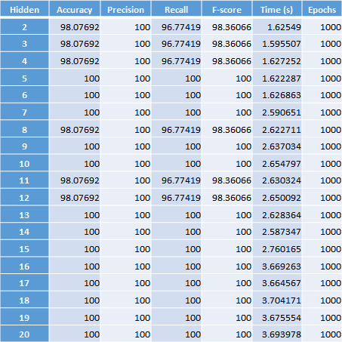

Table 20: Single Layer Topology Analysis PAM Labeling Using Dataset 1

The single layer topology analysis for Dataset 2 is shown in Table 21. Two hidden neurons produced the best accuracy for this dataset. Adding more neurons had no effect and in some cases reduced the accuracy slightly. The total time to train the model was only 5.69 seconds.



Table 21: Single Layer Topology Analysis PAM Labeling Using Dataset 2

The single layer topology analysis results for the largest dataset are shown in Table 22. Ten hidden neurons produced the highest accuracy (99.33%) and took 170 seconds to train the model. A single layer of six hidden neurons yielded an accuracy of 99.01% while only taking 54.5 seconds for training.

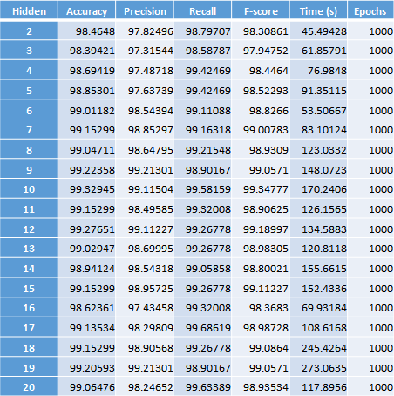

Table 22: Single Layer Topology Analysis PAM Labeling Using Dataset 3

Deep learning tests were conducted using the Rule-based labeled datasets varying the number of hidden neurons from 2 to 20 in a single hidden layer. The results shown in Table 23 are from a single test on each dataset. The time to train the model using the Rule-based labeled datasets was significantly longer than the PAM labeled datasets. For example, the largest rule-based dataset took 90.5 seconds to train compared to the comparable PAM labeled dataset which took 53.7 seconds. The accuracy of the Rule- based datasets was also lower than the accuracy with the PAM labeled datasets.

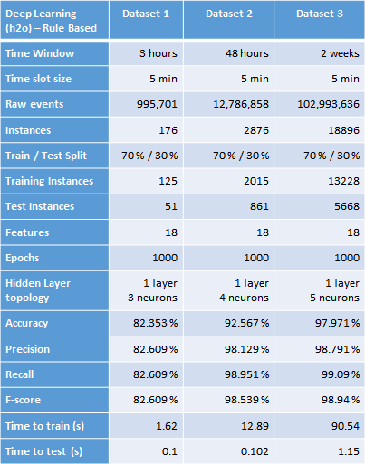

Table 23: Deep Learning Results Using Rule-based Labeled Data

The resulting confusion matrices for each of the tests are shown in Table 24. Looking at the red cluster, we can see there were no false negatives predicted for Dataset 1; thirty- nine false negatives occurred while classifying Dataset 2, and only fourteen false negatives were encountered classifying the test set of Dataset 3.

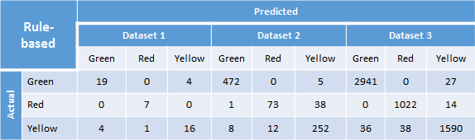

Table 24: Confusion Matrices for Rule-based Labeled Data

The single layer topology analysis in Table 25 shows the deep learning results for Dataset 1 of the various neuron configurations while holding all other parameters constant. A single hidden layer with five neurons yielded an accuracy of 84.3% while classifying the test set of Dataset 1.

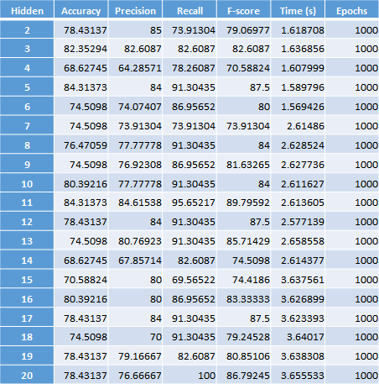

Table 25: Single Layer Topology Analysis Rule-based Labeling Using Dataset 1

The single layer topology analysis in Table 26 shows the deep learning results using Dataset 2 for the different hidden neuron configurations. The configuration using eleven neurons in the single hidden layer yielded an accuracy of 95.47% with a training time of

28.1 seconds.

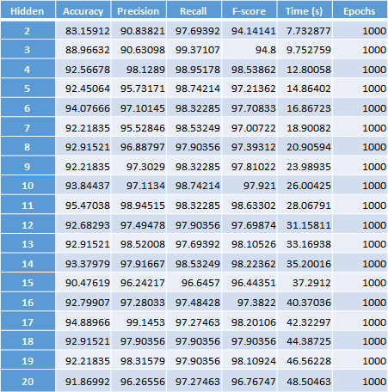

Table 26: Single Layer Topology Analysis Rule-based Labeling Using Dataset 2

The single layer topology analysis in Table 27 shows the deep learning results using Dataset 3 for the different hidden neuron configurations. The configuration using five neurons in the single hidden layer yielded an accuracy of 97.97% with a training time of 90.5 seconds.

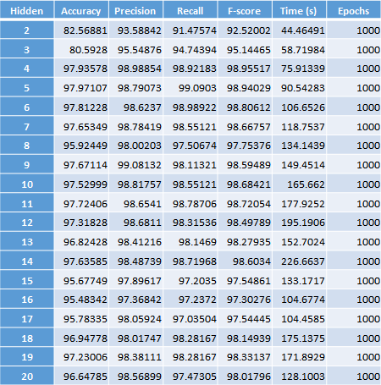

Table 27: Single Layer Topology Analysis Rule-based Labeling Using Dataset 3

**Neural Network Topology**

Defining the neural network topology must be completed prior to training. Defining the input and output layers are relatively straightforward. For the experiments conducted in this research, eighteen neurons were used for the input layer, one neuron for each feature. Three neurons were used for the output layer, one neuron for each possible classification. Generally, there is no best practice for selecting the number of hidden layers or neurons, but these values should not be arbitrarily selected [Han06]. As the number of neurons increases, the neural network’s hypothesis function becomes more complex. Using more than one hidden layer allows for implementing a more complex function on the data. An overly complex hypothesis function will learn the function of the underlying data including any noise resulting in poor generalization. This is known as overfitting. Finding the hypothesis with the minimum training error will result in the best fit. Conversely, if the hypothesis function is less complex than the data, the generalization error will be high. This is known as under-fitting. Selecting the number of hidden layers and neurons for each layer was accomplished by varying the number of hidden neurons in each layer and examining the results.

As the patterns and relationships in the data become more complex, the required number of hidden layers needed to learn a nonlinear relationship increase. In order to simulate such a nonlinear equation, testing of multiple hidden layer configurations was accomplished using the two split-level labeled datasets.

The optimal number of layers was determined by running tests on a single layer with 2 to 20 neurons. The number of neurons that produced the greatest accuracy or f-score with the least amount of training time was then held constant while varying the second layer of neurons from 2 to 20. Finally, a third hidden layer was added using the optimal number of neurons identified in the previous two runs. The layer that produced the greatest accuracy or f-score was selected as the most optimum hidden layer configuration.

The topology analysis for the first hidden layer using Dataset 2 is shown in Table 28. The configuration with 16 neurons produced an accuracy of 97.2% with a training time of 39.5 seconds.

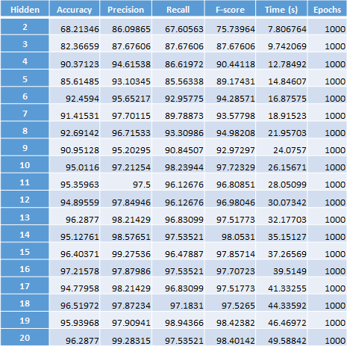

Table 28: Layer 1 Topology Analysis Split Level Using Dataset 2

The results from the next step using two hidden layers with the first layer having 16 neurons while varying the number of neurons in the second layer from 2 to 20 are shown in Table 29. The hidden layer topology of 16, 15 neurons yielded an accuracy of 97.8%. The two layer hidden layer topology is optimal because it yielded a greater accuracy than the single layer topology. The gain was 0.6% accuracy at the cost of 20 seconds of additional training time.

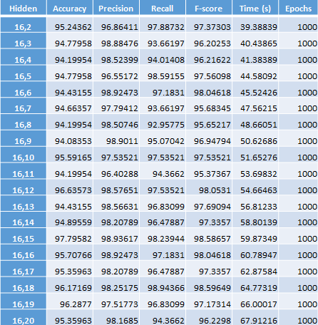

Table 29: Layer 2 Topology Analysis Split Level Using Dataset 2

The topology analysis for the first hidden layer using Dataset 3 is shown in Table 30. The configuration with 17 neurons produced an accuracy of 94.2% with a training time of 200.8 seconds. The configuration with 15 neurons produced a lower accuracy of 91.5%, but with a training time of 66 seconds.

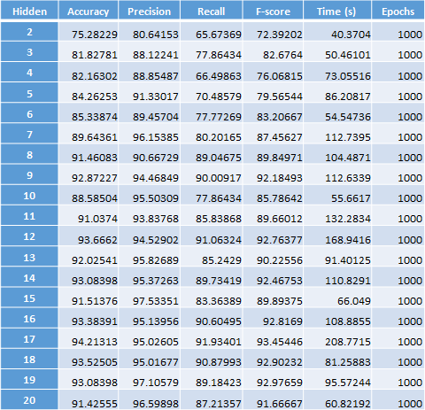

Table 30: Layer 1 Topology Analysis Split Level Using Dataset 3

The first test conducted selected the neuron configuration that yielded the most accurate results with the best time to train. The results from the next step using two hidden layers with the first layer having 15 neurons while varying the number of neurons in the second layer from 2 to 20 are shown in Table 31. The hidden layer topology of 15, 6 neurons yielded an accuracy of 95%.

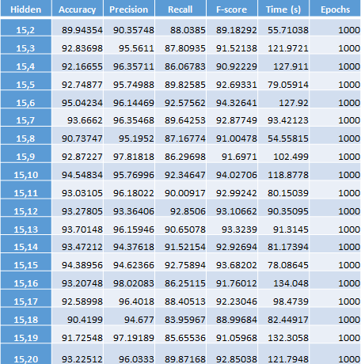

Table 31: Layer 2 Topology Analysis Split Level Using Dataset 3

The results of the third layer topology analysis with the first and second layer containing 15 and 6 neurons are displayed in Table 32. The best three layer configuration consists of 15, 6, and 12 neurons, yielding an accuracy of 93.1% and f-score of 91.8% with a training time of 199.3 seconds. The two layer hidden layer topology is optimal because it yielded a greater accuracy than both the single layer and third layer topology.

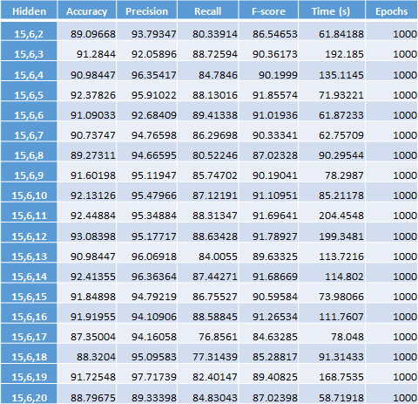

Table 32: Layer 3 Topology Analysis Split Level PAM Dataset 3

The second test used the 17 neuron configuration which yielded the most accurate results in the single layer test. Examining the results of the second layer topology analysis in Table 33, we can see a network topology configuration of two hidden layers with 17 neurons in each layer is the optimal choice yielding an accuracy of 96.3% and f-score of 96.2%. The best one layer configuration with 17 neurons was 94.2% accuracy and f-score of 93.5%. The best three layer configuration with 17, 17, and 4 neurons yielded an accuracy of 94.4% and f-score of 94.0%.

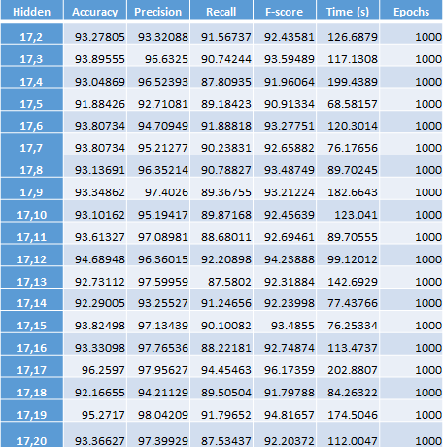

Table 33: Layer 2 Topology Analysis Split Level PAM Dataset 3

**Additional observations**

Scalability is achieved using the time slot to model the data. For example, Dataset 1 represented a total of 995,701 events in 176 instances. Time to test was 0.094 seconds using 52 instances. Dataset 2 was created from 12,786,858 events and was reduced to 2,876 instances. Time to test was 0.093 seconds using 861 instances. The number of instances increased by a factor of 16, but the time to test was faster by 0.001 seconds. Dataset 3 was comprised of 18,896 instances and represented 102,993,636 raw events. Time to test was 1.145 seconds. The time to test Dataset 3 was 12 times that of Dataset 1 where Dataset 3 was 363 times larger than Dataset 1. It is evident that increasing the amount of data increases the time to test linearly.

Including additional log files will not increase the number of instances in the dataset, but instead will only add columns equal to the number of features extracted from each log file added.

**Implementation considerations**

There are several factors that should be considered before training the model whether it is the initial training or subsequent feedback sessions. First, the security analyst will need a tool for examining or discovering suspicious patterns in the log data. The PAM clustering method used in this research does not serve as such a tool.

Additionally, each training session should use current data that contains a proportionate number of examples for each class. There are a number of methods that can be used to obtain attack training data. The easiest method is to use data gathered during a real breach. Another method is to use Honey Pots, systems which are designed to ferret out hackers and learn new methods. Logs gleaned from penetration or vulnerability scans can also be a valuable source of log attack data. Lastly, existing data can be programmatically modified to represent potential incidents or attacks.

Over time user activity patterns change, and new patterns may ensue. Also, existing features may have been overlooked, initially deemed not relevant, or introduced through the procurement of new computer system. As a result, the performance of the model will eventually degrade and become unacceptable. In this event, features should be re- evaluated for relevance prior to retraining the model with a fresh set of log data.

For subsequent training sessions, the security analyst can use logs that were manually marked as suspicious or attack through normal daily investigations. When there are a sufficient number of examples, they can be added to the initial dataset and used to retain the model.

**CHAPTER 5**

**CONCLUSION AND FUTURE WORK**

The results of the experiments conducted in this thesis demonstrate that a classified dataset with a proportional set of examples trained with the Deep Learning algorithm can accurately detect abnormal activity. This method allows for multiple log source types to be aligned using a sliding time window and provides a scalable solution which is a much- needed feature.

In a typical enterprise environment, the amount of log data processed could vary from several hundred gigabytes to a terabyte daily. The prototype developed in this research was relatively small consisting of a set of eighteen features from three different log source types totaling approximately twenty-five gigabytes in size. This research demonstrated the prototype could very accurately model low complexity data with a shallow network. However, the complexity of the data increases as more log sources and features are introduced. This research demonstrated that highly complex data could be accurately modeled using a deep neural network.

Detecting a cyber attack is just the beginning of a long, complicated investigative process. The security analyst may need to perform risk mitigation actions, such as blacklisting originating source IP’s and locking accounts. Logs files need to be examined to identify any compromised accounts, originating IP’s, and all resources accessed by the attacker. All related activities should be collected and examined several weeks or even months before the detected event. Potential areas of future work are automatic correlation and analysis of the log data from cyber attacks. Additional machine learning algorithms and analysis required for automatic correlation can put a strain on computing resources depending on the volume of data to be searched and velocity of the log data being collected. Additional areas of future work include building a distributed computing implementation such as Hadoop with terabytes of log data.

**REFERENCES**

Print Publications:

[Abad03]

Abad, C., Taylor, J., Sengul, C., Yurcik, W., Yuanyuan Zhou, & Rowe, K. “Log correlation for intrusion detection: A proof of concept.” ASCAC ’03 Proceedings of the 19th Annual Computer Security Applications Conference. December, 8, 2003, Las Vegas, NV, USA, pp. 255-264.

[Alpaydin14]

Alpaydın, Ethem. Introduction to machine learning. Cambridge, MA: MIT Press, 2014.

[Apte03]

Chid Apte. “The big (data) dig” OR/MS Today. 30.1 (Feb. 2003) pp. 24.

[Buczak16]

A. L. Buczak, and E. Guven. "A Survey of Data Mining and Machine Learning Methods for Cyber Security Intrusion Detection." IEEE Communications Surveys & Tutorials 18.2 (2016): 1153-76. Print.

[Edwards15]

Edwards, Chris. "Growing Pains for Deep Learning." Communications of the ACM, vol.

58, no. 7, July 2015, pp. 14-16.

[Garcia12]

K. A. Garcia, et al. "Analyzing Log Files for Postmortem Intrusion Detection." IEEE Transactions on Systems, Man, and Cybernetics, Part C (Applications and Reviews) 42.6 (2012): 1690-704.

[Guyon06]

Guyon, Isabelle. “Feature Extraction: Foundations and Applications.” Springer-Verlag, 2006.

[Han06]

Han, Jiawei, and Micheline Kamber. Data mining concepts and techniques. San Francisco: Morgan Kaufmann, 2006.

[Jacobs09]

Jacobs, Adam. "The Pathologies of Big Data." Queue 7.6 (2009): 10:10,10:19.

[Kott13]

Kott, A., and C. Arnold. "The Promises and Challenges of Continuous Monitoring and Risk Scoring." Security & Privacy, IEEE 11.1 (2013): pp. 90-3.

[Kott14]

Kott, Alexander, Ananthram Swami, and Patrick Mcdaniel. "Security Outlook: Six Cyber Game Changers for the Next 15 Years." Computer 47.12 (2014): 104-06.

[Mahmood13]

Mahmood, T Mahmood, T., and U. Afzal. "Security Analytics: Big Data Analytics for Cybersecurity: A Review of Trends, Techniques and Tools". 2013 2nd National Conference on Information Assurance (NCIA). December, 11 2013, Rawalpindi, Pakistan. pp. 129-134.

[Ng15]

J. Ng, D. Joshi, and S. M. Banik. "Applying Data Mining Techniques to Intrusion Detection". Information Technology: New Generations (ITNG) 2015 Proceedings of the 12th International Conference on Information Technology. April 13, 2015, Las Vegas, NV, USA. pp. 800-801.

[Razzaq14]

Razzaq, Abdul, et al. Semantic Security Against Web Application Attacks. 254 Vol.

Elsevier Inc, 2014.

[Sood13]

A. K. Sood, and R. J. Enbody. "Targeted Cyberattacks: A Superset of Advanced Persistent Threats." IEEE Security & Privacy 11.1 (2013): pp. 54-61.

[Valentan13]

Valentín, Kristián, and Michal MALY. "Network Firewall using Artificial Neural Networks." Computing & Informatics 32.6 (2013): 1312-27.

[Ye05]

Nong Ye, and T. Farley. "A Scientific Approach to Cyberattack Detection." Computer 38.11 (2005): pp. 55-61.

[Zhu02]

Y. Zhu and D. Shasha. “StatStream: Statistical monitoring of thousands of data streams in real-time.” In VLDB 2002, Proceedings of 28th International Conference on Very Large Data Bases. August 20, 2002, Hong Kong SAR, China, pp. 358-369.

[Zhu03]

Zhu, Yunyue, and Dennis Shasha. "Efficient elastic burst detection in data streams." Proceedings of the ninth ACM SIGKDD international conference on Knowledge discovery and data mining - KDD '03. August 24, 2003, Washington, DC, USA, pp. 336-345.

Electronic Sources:

[Droms97]

Droms, R., "Dynamic Host Configuration Protocol", RFC 2131, [http://www.rfc-](http://www.rfc-editor.org/info/rfc2131) [editor.org/info/rfc2131,](http://www.rfc-editor.org/info/rfc2131) last revision March 1997, last accessed March 26, 2017.

[Garfinkel16]

Simson L. Garfinkel. "Digital Forensics", American Scientist, [http://www.americanscientist.org/issues/id.16080,y.0,no.,content.true,page.1,css.print](http://www.americanscientist.org/issues/id.16080%2Cy.0%2Cno.%2Ccontent.true%2Cpage.1%2Ccss.print)

/issue.aspx, last accessed April 19, 2017.

[h2o17]

Deep Learning - H2O 3.10.4.4 documentation, [http://docs.h2o.ai/h2o/latest-stable/h2o-docs/data-science/deep-](http://docs.h2o.ai/h2o/latest-stable/h2o-docs/data-science/deep-learning.html?highlight=deep%20learning) [learning.html?highlight=deep%20learning#,](http://docs.h2o.ai/h2o/latest-stable/h2o-docs/data-science/deep-learning.html?highlight=deep%20learning) last accessed March 18, 2017.

[Hallam-Baker96]

Phillip M Hallam-Baker, Extended Log File Format, [http://www.w3.org/TR/WD-](http://www.w3.org/TR/WD-logfile.html) [logfile.html,](http://www.w3.org/TR/WD-logfile.html) last revised March 23, 1996, last accessed April 13, 2016.

[Muncaster15]

Phil Muncaster. "Hackers Spend Over 200 Days Inside Systems Before Discovery.", Infosecurity Magazine. N.p., 24 Feb. 2015, https://www.infosecurity- magazine.com/news/hackers-spend-over-200-days-inside/. Last accessed April 18, 2017.

[Splunk17]

Download Splunk Enterprise for free, [https://www.splunk.com/en_us/download/splunk-](https://www.splunk.com/en_us/download/splunk-enterprise.html) [enterprise.html,](https://www.splunk.com/en_us/download/splunk-enterprise.html) last accessed March 26, 2017.