***IN VIVO* TOXICOLOGICAL ASSESSMENT OF WATER SAMPLES FROM THREE FARM SETTLEMENTS IN *Allium cepa* AND *Drosophila melanogaster***

**ABSTRACT**

Pesticides are widely used all over the world, especially in agricultural sectors to increase food production, in order to meet up with the increasing food demand of the teeming population. However, there are concerns that pesticides might have hazardous long term or short term effects on non- target organism and also persist in the environment as residues, especially in water reservoirs. This experiment was designed to determine the presence of pesticide residue in water samples from three farm three farm settlements where pesticides are actively used and investigate potential toxicological effects of pesticide residues in a living system using *Allium cepa* and *Drosophila melanogaster* as biological models. A gas chromatography-mass spectrometry analysiswas carried out on water samples from three farm settlements in Epe, Ikorodu and Badagry areas to determine the presence and concentration of pesticides residues. Standard *Allium cepa* assay was used to assess cytogenotoxicity while both genotoxicity and neurotoxicity were assessed using RAPD and climbing assays respectively in *Drosophila melanogaster* exposed to the water sample using dietary method. The results from the GC-MS showed the presence of pesticide residue each water sample in significant amounts. The results showed presence of pesticide residues in the water sample and the water sample induced cytotoxicity, neurotoxicity and higher frequency of chromosome aberrations compared to the control. The presence of pesticide residues contributed to the toxic effects observed in *A. cepa* and *D. melanogaster.*

Keywords: *Pesticides residues, cytogenotoxicity, RAPD, neurotoxicity, Allium cepa and Drosophila melanogaster.*

vi

|  |  |  |
| --- | --- | --- |
| **TABLE OF CONTENTS** |  |  |
| Declaration ……………………………………………………………………… | i |  |
| Certification……………………………………………………………………… | ii |  |
| Dedication ……………………………………………………………………….. iii | |  |
| Acknowledgments……………………………………………………………….. iv | |  |
| Abstract………………………………………………………………………….. vi | |  |
| Table of Content………………………………………………………………….. vii | |  |
| List of Tables……………………………………………………………………... ix | |  |
| List of Figures……………………………………………………………………. x | |  |
| **Chapter One: Introduction** |  |  |
| 1.1 Background of study…………………………………………………………... | | 1 |
| 1.2 Statement of problem………………………………………………………….. | | 2 |
| 1.3 Aims and Objectives…………………………………………………………… | | 3 |
| 1.4 Significance of study ………………………………………………………… | | 3 |
| **Chapter Two: Literature Review** |  |  |
| 2.1 Introduction………………………………………………………………… | | 4 |
| 2.2 Water Pollution and Contamination………………………………………… | | 4 |
| 2.3 Toxicity ……………………………………………………………………… | | 5 |
| 2.4 Pesticides………………………………………………………………… |  | 5 |
| 2.5 Routes of Pesticides Contamination………………………………………. |  | 12 |
| 2.6 Mechanism of Action of Pesticides……………………………………… |  | 12 |
| 2.7Effects of Pesticides…………………………………………………… |  | 21 |
| 2.7.1 Dosage level of pesticides………………………………………… |  | 23 |
| 2.8 Pesticides Use in Nigeria…………………………………………………. |  | 23 |
| 2.9 Pesticide residue in Water Bodies in Nigeria………………………………. | | 24 |
| 2.10 Genetic and cytogenetic testing……………………………………………. | | 25 |
| **Chapter Three: Materials and Methods** |  |  |
| 3.1 Biological Materials…………………………………… |  | 29 |

vii

|  |  |
| --- | --- |
| 3.2 Sample collection and sampling site………………………………………… | 29 |
| 3.3 Gas Chromatography and Mass Spectrometry (GC-MS) ……………………. | 31 |
| 3.4 *Alium cepa* assay……………………………………………………………. | 31 |
| 3.4.1 Root growth inhibition test ……………………………………………. | 32 |

3.4.2 Cytogenetics of root tips of *Allium cepa…*…………………………... 32

3.5 In vivo assays in *Drosophila melanogaster* assay exposure to water samples

|  |  |
| --- | --- |
| …………………………………………….……………………………………. | 33 |
| 3.5.1 Negative geotaxis assay …………………………………………………. | 33 |
| 3.5.2Random Amplified Polymorphic Deoxyribonucleic acid (RAPD) Analysis |  |
| 3.5.2.1 DNA Extraction Procedure ………………………… | 34 |
| 3.5.2.2 Polymerase Chain Reaction (PCR)…………………… | 34 |
| 3.6 Statistical analysis……………………… | 37 |
| **Chapter Four: Results presentations and Discussion………** | **38** |
| 4.1 Gas Chromatography and Mass Spectrometry………………. | 38 |
| 4.2. *Allium cepa* assay…………………………………………… | 43 |
| 4.2.2 Cytogenetics ………………………………………………. | 44 |
| 4.2.3 Root growth inhibition result………………………………………. | 45 |
| 4.3 *Drosophila melanogaster* assay………………………………. | 46 |
| 4.3.1 Negative geotaxis results……………………………………... | 46 |
| 4.3.2 Random Amplified Polymorphic DNA (RAPD) Analysis………………. | 47 |
| 4.4 Discussion of Results………………………………………….. |  |
| **Chapter Five: Conclusion and Recommendation**…………………………………… | 49 |
| 5.1Conclusion and Recommendation………………………………………………. | 50 |

References………………………………………………………………………………… 51

viii

|  |  |  |  |  |
| --- | --- | --- | --- | --- |
|  |  | **LIST OF TABLES** |  | |
| Tables | | Page |  | |
| 2.1 | Classification of pesticides according to its toxicity level……………………. | | 7 | |
| 2.2 | Classification of pesticides based on target organisms………………………. | | 8 | |
| 2.3 | Classification of pesticides based on mode of formulation……………………. | | 9 | |
| 2.4 |  |  |  | |
| 2.5 Implications of pesticide use in humans in Nigeria……………………………. | | | 22 | |
| 2.6 | Pesticide residue concentration detected in Nigerian production commercial fields…. 26 | | |

2.7 Pesticide residue detected in crops in Nigeria………………………………………… 27

3.1 Reaction table for primers (SP2, P2, P4, OPA11, 1253, RF1) ………………………. 36

4.1 Results of GC-MS analysis to showing pesticide residue and their concentration in Ikorodu, Epe and Badagry sample water samples……………………………………………………39

4.2 Mitotic Indices and Chromosomal aberrations………………………………………….42

ix

|  |  |  |
| --- | --- | --- |
|  | **LIST OF FIGURES** |  |
| Figures | Pages |  |
| 2.1 Classification of pesticide chemicals…………………………………… | | 10 |
| 2.2 Classification of pesticides……………………………………………….. | | 11 |
| 2.3 Mode of action of organophosphorus and organocarmate insecticides………… | | 17 |
| 2.4 Mode of action of organochloride insecticides…………………………………. | | 18 |

|  |  |  |
| --- | --- | --- |
| 2.5 | Metabolic scheme for the metabolism of the organophosphorus (OP) insecticide diazinon. | |
| CYP450, cytochrome P450…………………………………………………………. | | 19 | |
| 2.6 | Compartmental flow diagram illustrating the critical tissue compartments associated with | |

absorption, distribution, metabolism, and excretion of organophosphorus (OP)

|  |  |
| --- | --- |
| insectides………………………………………………………………… | 20 |
| 3.1 Epe farm settlement stream……………………………………………………… | 30 |

3.2 Ikorodu farm settlement showing vegetable farm and borehole site surrounded by indiscriminately disposed pesticide containers…………………………………. 30

4.1 GC-MS graph results showing peak/abundance of pesticide residues present in Ikorodu (a)Epe

|  |  |
| --- | --- |
| (b) and Badagry (c) water samples……………………………………. | 40 |

4.2 Effects of the water samples (Epe, Ikorodu and Badagry) on the root growth of *Allium cepa.* (NC-negative control; PC—positive control) …………………………………………………..43

|  |  |  |
| --- | --- | --- |
| 4.3 | Normal mitotic stages and chromosomal aberrations observed in *Allium cepa* root tips exposed | |
| to Epe, Ikorodu and Badagry water samples……………………………………………46 | |
| 4.4 | Percentage frequency of flies that climbed above the 6cm during the negative geotaxis | |

experiment **p< 0.01, ***p< 0.001 ……………………………………………………………47

4.5 Illustration of PCR results from RAPD analysis showing positive results……………...48

4.6 Illustration of PCR results from RAPD analysis showing negative results…………….49

x

xi

**CHAPTER ONE**

**INTRODUCTION**

**1.1 Background of Study**

The era in world history commonly known as the green evolution paved way for the increase in the use of agrochemicals such as pesticides, fertilizers etc. Pesticides are chemicals and biological agents that limit or inhibit the action of pests (unwanted living organisms) in the environment where it is applied (Damalas, 2011). Over time, pesticide usage has increased significantly. Mahmood *et al.* (2016) estimated that 5.2 billion pounds of pesticide are used annually in the world. In Nigeria, the use of pesticide began after its introduction to the country in the 1950s due to the significant increase in the population of the country and the high demand for pesticide for high crop yield. Agricultural farms pesticide usage had a geometric increase, although pesticides are also used for industrial and domestic purposes (Asogwa and Dongo, 2009). An analysis of the amount of pesticide imported into Nigeria showed that thousands of metric tons of pesticides are used annually, this includes pesticides composed of about 135 different pesticide chemicals sold under different brands (Mazlan, 2017). Classification of pesticides based on chemical composition and structure has made the use of pesticide by local farmers easier because of their known specific effects. The use of pesticide allowed farmers to meet with high demand of crops and an economically effective way of dealing with unwanted organism that find their way into the environment for example ticks, tobacco mosaic virus, rodents, and weeds. Pesticides play an important role in agriculture because they reduce the cost of production and maintenance while mitigating product losses (Strassemeyer et al., 2017). Although pesticides have numerous benefits to humans, they also pose harmful effects which might outweighs their benefits. They have been deemed toxic not only to their target organisms alone but also to the environment and humans because of the chemical substances they contain.

Toxicity is the harmful and hazardous effects of a substance on the environment or living things, it is the injury accumulated over time in an organism or environment due to exposure to a certain substance (Krieger, 2011). Reports have shown that pesticide have high levels of toxicity due to their effects on the environment. Pesticides exposure can lead to increased neurotoxicity, cancer, and other illnesses, apart from that pesticides also cause reduction of biodiversity and changes in the chemical composition of the environment and atmosphere. The toxicological assessment of

1

pesticides and their effects has become key in determining whether a pesticide should be used or banned, for example DDT was banned in 1972 due to observations on it effects and its bioaccumulation and bio-magnification in the ecosystem. Other pesticide chemicals have been banned like DDT from being used but due to lack of proper surveillance there have been usage of DDT in Nigerian farms in conjunction with other pesticides.

Pesticide chemicals themselves are not the only thing that make them toxic, pesticides also leave residues that can persist in the environment for a significant period. Pesticides leave residues in the environment through various methods, not all pesticides sprayed hit target organisms, so the rest persist in the soil or water where they are sprayed. These pesticide residues can pollute other areas where pesticides are not used through water and agricultural runoffs, erosion and percolation which can contaminate groundwater sources. The most applied pesticides in Nigeria have been two classes of pesticides know as organophosphate and organochloride examples are Lindane, Endosulfan, DDT (dichloro-diphenyl-trichloroethane)

In Nigeria, there are indications that indiscriminate use of pesticides may contaminate surrounding water bodies, even ground water sources. These water sources act as the direct water supply of humans and animals that may live in nearby areas, they would ingest the water along with its contaminants and pollutants resulting in toxic effects. These contaminations occur through the runoff of agricultural soil, indiscriminate waste disposal of pesticide containers and applicators. Use of pesticide directly in water sources to combat aquatic pests also contribute greatly to the amount of pesticide contamination present in the water. Since water is an essential element in the cycle of life of both the environment and its component, contamination of water source is a great concern to the environment.

,

**1.2 Statement of the problem**

Pesticide residues have been discovered to have effects on the environment and the organisms living in the environment. Pesticide residues can be found in water bodies especially ones nearby areas where pesticides are applied frequently. These residues may contaminate water bodies through runoffs, or soil erosion from soil elements that contain pesticide residues. These residues still contain certain chemical properties and composition from its derivate chemical which might have mutagenic effects on the environment and the living organisms in that environment. Pesticide

2

residues have potential to cause genetic, physiological, biochemical, and behavioral changes to living organisms that are exposed to it.

**1.3** **Aims and Objectives**

This study was designed to investigate possible pesticide contamination of water sources of three farm settlement and potential genotoxicity of the water samples from the farm settlements.

The objectives of this research are:

* To determine the presence and abundance of pesticide residues in the farm settlements’ water samples using Gas Chromatography and Mass Spectrometry (GCMS)
* To assess the potential genotoxicity of the water samples using *Allium cepa* assay and
* To evaluate potential genotoxicity of the water samples using Random Amplified Polymorphic DNA (RAPD) Analysis in *Drosophila melanogaster*
* To assess neurobehavioral effect of the water samples in *Drosophila melanogaster*

**1.4** **Significance of study**

The results of this study will reveal the possible damage of pesticide residue in water from areas where pesticides are actively used. It is believed that the results of this study will encourage farmers to be more careful with the pesticides applied and inspire scientists to discover alternative methods for combatting pests that would not persist in the environment nor become hazardous to the environment and the organisms living in it.

\

3

**CHAPTER 2**

**LITERATURE REVIEW**

**2.1 Introduction**

Pesticide use in farms is a very common practice in farms all around the world. No matter the country or continent the farm is in, the use of pesticide to eliminated unwanted organisms in the farm is constant. Farms are always plagued with the problem of infestation of different pests, sometimes insects, rodents, weeds even certain microorganisms. These pests affect the farm and the life of farmers economically, some pests eat the produce on the farm while some render the produce on the farm useless whether by inhibiting the growth of the crops or by increasing their spoilage rate. Due to this issue chemical substances have been made that specifically target these unwanted organisms, pesticides. Pesticides are a mixture of compounds that target unwanted organisms. Pesticides are specific in their actions which has allowed them to be classified based on their target organisms i.e., herbicide, rodenticide, and insecticide. As technology improves these pesticides become more and more specific in their specificity, unfortunately we humans have similar receptors to the target organisms of pesticides so when we encounter these pesticides (into our bodies) they react with our systems leading to toxicity whether acute or chronic. Although the toxicity of a pesticide depends heavily on the chemical composition of the pesticide and its dosage.

**2.2 Water Pollution and Contamination**

Water is an essential renewable resource that is needed for life on earth to thrive and progress. Every area in the world needs and uses water. The earth is majorly made up of water, and that 98% of the water is sea water with freshwater being the least. Water affects the economy and physical life of the residents that inhabit the area. Freshwater especially is used in different aspects of industrial, agriculture, household chores and other day to day human activities. Water being a universal solvent can and is easily contaminated, through different route and sources; these contaminants have been divided into inorganic substances and organic substances. Due to the activities of man, it has been detected that water bodies tend to have a higher composition of certain substances than the average and it tends to have high levels of other substances that have been found toxic to the body of living organisms. In the area of agriculture, it has been reported severally that materials such as fertilizers and pesticides have been found present in water bodies near the farm environment suggesting that these materials could possibly leach into the materials and cause

4

harm. There has been a high need for water assessment of water bodies in areas close to farm and farm settlements (no reference).

**2.3 Toxicity**

Toxicity is referred to as the total damage or injury cause by a certain substance. Any substance can be considered toxic, the toxicity of a substance depends on the amount present and the effect of the amount present. If a substance is present in the wrong site, it can lead to hazardous effects due to reaction with the wrong elements. Generally, synthetic substances are found to be toxic but hormones or secretions of the body of a living organism if found in the wrong locations have toxic effects. Examples of toxic substances are pesticides nanoparticles, oil residues and others.

**2.4 Pesticides**

Pesticides are substances that are aimed at controlling the invasion of unwanted organisms (pests) which affects productivity (Otitoloju, 2018). Pesticides are substances that are used to protect the crops of both domestic and industrial agricultural production, pesticides serve as a way of eliminating unwanted plants and animals that can incur further expenses in agricultural production due to their effects (Mazlan et al, 2017). Pesticides help eradicate or visibly reduce the possibility of crop damage from pests that eat crops like beetles, ticks, some arthropods, rats and even disease vectors that can affect the growth and abundance of crops. Pesticides began being common in use in the 1930s when it showed results in eliminating unwanted organisms in ways manual methods cannot achieve. Apart from pesticides, other substances such as herbicides and insecticides are used, these ones are more specific in delivery than the general pesticides. Although numerous reports have been made stating the immediate damages of pesticides, it has been nearly impossible to eliminate it use due to the importance of eliminating pests in an effective yet cost minimalist method. Pesticides are also known as economic poisons (Don-Pedro, 2009).

**2.4.1 Types of pesticides**

Pesticides are classified into different groups based on different methods, it can be classified based on their target organism, mode of action, residue pattern, toxicity levels, the source of the substances used in the making of the pesticides, their formulation and most importantly their

5

chemical composition and structure. Each of these classifications have offered an insight into knowing how pesticides work and the effects they can have in the ecosystem in whole and parts. Classification of pesticides have made it easy for researchers to know the effect of each pesticide compound and its mode of action (Otitoloju, 2018).

**Classification based on Chemical Structure and Composition**

Under this classification there are about five to six groups of pesticides, these group are based on the chemical composition of the pesticides, the main active substance, and the structure of the pesticides chemically.

1. Organochlorines: These are pesticides that are hydrophobic in nature, they are soluble in fat (lipophilic), they contain carbon to chlorine bonds which them very persistent because these bonds are difficult to break. They tend to stay in the environment for long periods ant therefore bio-magnify and bioaccumulate at great rates. Examples of these kinds of pesticides include dichlorodiphenyltrichloroethane (DDT), which has been reported to be very harmful to humans and the ecosystem at large, in some countries like the U.S DDT is a banned pesticide. Hexachlorocyclohexane (HCH) is also in this group of pesticides, it can also be used in the treatment of lice and scabies. Chlorinated Cycloidians which was developed in 1945 after the first two mentioned, these have more toxicity and are more dangerous to use. Then there are polychloroterphenyls an example being Toxaphene which was banned in 1982.
2. Organophosphate: They are esters of phosphoric acids, they are soluble in water (hydrophilic), they are less stable than organochlorine pesticides. Examples are Dimethoate, Dichlorvos, Diazinon, Dicrotophos and Parathion. They are more toxic to animals than every other pesticide. Derived from phosphoric acid, these kinds of pesticides affect acetylcholine neurotransmitter permanently. Although they are very toxic to animals these kinds of pesticides cause the least environmental pollution as they are easily degradable (Kaur et al, 2019).
3. Carbamates: They are derivatives of carbamic acid but are very similar to organophosphate pesticides. They are easily degraded have low toxicity to mammals. Examples are Aldicarb, Propoxur, and Carbofuran.

6

1. Pyrethroids: Pesticides with chemical structures adapted from pyrethrin which can be extracted from pyrethrum flowers that grow in East African. This pesticide although it has low toxicity in mammals only a small amount is needed to eliminate pests. Examples are Phenothrin, Permethrin and tetramethrin.

There are also pesticides that are obtained from biological sources like plants (Azadiratctin from Neem extract), they are preferred due to their safety to humans. Pesticides are also classified based on their mode of action, degradability, source, formulation, and target range. World Health Organization also classified pesticides based on their human hazard, these classifications are abstract in comparison to the classification based on their chemical structure and composition.

7

**Table 2.1Classification of pesticides according to its toxicity level**

|  |  |  |  |  |  |  |
| --- | --- | --- | --- | --- | --- | --- |
| Class | Classification | | Oral (mg/kg |  | Dermal |  |
|  |  |  | b.w) |  | (mg/kg b.w) |  |
|  |  |  |  |  |  |  |
|  |  |  | Solids | Liquids | Solids | Liquids |
|  |  | |  |  |  |  |
| 1a | Extremely | | <5 | <20 | <10 | <40 |
|  | hazardous | |  |  |  |  |
|  |  |  |  |  |  |  |
| 1b | Highly |  | 5-50 | 20-200 | 10-100 | 40-400 |
|  | hazardous | |  |  |  |  |
|  |  | |  |  |  |  |
| II | Moderately | | 50-500 | 200-2000 | 100-1000 | 400-4000 |
|  | hazardous | |  |  |  |  |
|  |  |  |  |  |  |  |
| III | Slightly |  | >501 | >2001 | >1001 | >4001 |
|  | hazardous | |  |  |  |  |
|  |  |  |  |  |  |  |
| U | Unlike | to | >2000 | >3000 | -- | -- |
|  | present | acute |  |  |  |  |
|  | hazard |  |  |  |  |  |
|  |  |  |  |  |  |  |

Source; Obidike *et al* (2020).

8

|  |  |  |
| --- | --- | --- |
| **Table 2.2** | **Classification of pesticides based on target organisms** | |
|  | |  | |
| Pesticide type | | Pest | |
|  |  |  | |
| Algicide |  | Algae | |
|  |  |  | |
| Avicide |  | Birds | |
|  |  |  | |
| Fungicide |  | Fungi | |
|  |  |  | |
| Insecticide |  | Insects | |
|  |  |  | |
| Nematicide |  | Nematodes | |
|  |  |  | |
| Homicide |  | Plant weeds | |
|  |  |  | |
| Miticide |  | Mites | |
|  |  |  | |
| Rodenticide |  | Rodents | |
|  |  |  | |
| Bactericide |  | Bacteria | |
|  |  |  | |

Source; Obidike *et al* (2020).

9

**Table 2.3 Classification based on mode of formulation**

|  |  |
| --- | --- |
| Physical state | Characteristics |
|  |  |
| Emulsifiable concentrates | Do not require constant agitation prior to |
|  | application |
|  |  |
| Wettable powders | Require constant agitation prior to each |
|  | application |
|  |  |
| Granules | Obtained by mixing the active ingredient with |
|  | clay |
|  |  |
| Baits | Obtained by mixing active ingredient with |
|  | food |
|  |  |
| Dust | Not mixed with water, applied dry |
|  |  |
| Source; Obidike *et al* (2020). |  |

10

Figure 2.1 Classification of Pesticide based on Chemical compounds

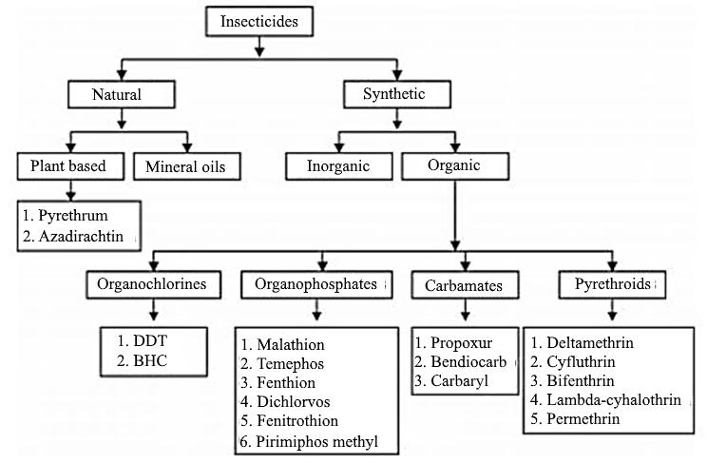

Source; Obidike *et al* (2020).

11

Figure 2.2 Classification of pesticides

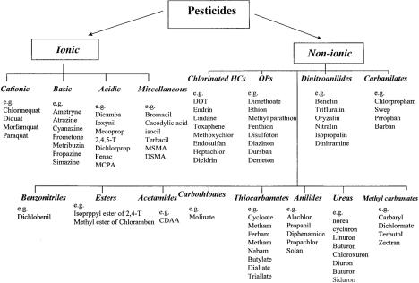

**Source;** Gevao *et al* (2000).

12

**2.5 Routes of Pesticides Contamination**

There are many routes as to which pesticides can enter the ecosystem, both in direct and indirect ways. The main method as to which pesticides enter the ecosystem is through direct application by humans in whatever needs they have. Pesticides enter the ecosystem through applications in agriculture, industrial discharge, and accidental spills. They enter the environment indirectly through water runoffs from farms, spillage in the oceans, evaporation and rainfall and other routes. These pesticide runoffs and contamination enter the environment and bio-accumulate then bio-magnify moving from one trophic level to another, becoming an environmental hazard because of their different effects on biotic and abiotic components of the ecosystem (Otitoloju, 2018).

Application drift of pesticides, which are spray droplets that move from the site of treatment during application. Depending on the size of the droplets wind carry each droplet to different areas. Pesticide residues can evaporate over time and change atmospheric compositions. Wind erosion of soils where pesticides have been applied, these soils are moved to a new environment where perhaps there are no pesticides residues and contaminate the area.

**2.6 Mechanism of Action of Pesticides**

Each pesticide has different mechanism of action based on their chemical composition. The receptors and inhibition pathways of each pesticide differ which also makes their resulting effects differ. Pesticide molecules bind to enzymes, proteins, receptors, or membranes in an organism’s body which lead to reactions that are lethal or toxic to the pests (Casida, 2008). Some pesticides have multiple target receptors which make them more efficient as they would work rapidly. For example, carbamates and organophosphorus insecticides inhibit the action of the enzyme acetylcholinesterase, and some herbicides inhibit plant protein synthesis pathways (Das, 2013). Effectiveness of pesticides also depend on the mechanism of action of this pesticide some pesticide would not work on certain organisms because receptors and enzymes the react with are not present in that organism (Das, 2013). Fipronil an insecticide of phenyl pyrazoles that is very toxic to insects, it reacts with GABAA (Gamma-aminobutyric acid) receptors and glutamate-activated chloride channels, this pesticide obstructs their channels in the neurons of mammals and insects (Zhao *et al*, 2005). Fipronil are more toxic to the insects than they are to vertebrates because of the lack of GluCl channels in mammals, although the reaction with GABAA receptors make this

13

pesticide more efficient this leads to low toxicity in mammals and lethality in arthropods (Kaur *et al*, 2019). Carbamates and organophosphate block the enzyme which act a catalase for thehydrolysis of acetylcholine a neuromediator agent, this result in the hypersensitivity of nerve endings. This effect when caused by a carbamate pesticide is reversible unlike that cause by organophosphorus pesticide which are not reversible (Dias *et al*, 2015). Carbamates are also endocrine disrupting chemicals, the affect the endocrine system by inhibiting or preventing the smooth synthesis, transportation, degradation, or metabolism of hormones (Dias *et al*, 2015). In general, the working mechanism of pesticide is to inhibit a particular biosynthesis pathway in an organism leading to loss of function of a particular tissue or organ, sometimes it leads to mortality of an organism. Some pesticide may attack more than one receptor or enzymes affecting multiple pathways in the target organism. Economical pesticide affects numerous pathways leading to multiple effects and functionality.

Table 2.4; List of pesticide compounds and their degree of environmental hazard.

|  |  |  |
| --- | --- | --- |
| Script | Environmental hazard | PAN International Indicators* |
|  |  |  |
| 1 | Very bio-accumulative | BCF >5000 or Kow logP >5 |
|  |  | (BCF values supersede Know |
|  |  | logP data) |
|  |  |  |
| 2 | Very persistent in water, soil, or sediment | Water half-life > 60 days; oils |
|  |  | or sediments half-life > 180 |
|  |  | days |
|  |  |  |
| 3 | Very toxic to aquatic organisms | Acute LC/EC50 <0,1 mg/l for |
|  |  | Daphnia species |
|  |  |  |
| 4 | Hazard to ecosystem services–Highly toxic to bees | <2 µg/bee according to U.S. |
|  |  | EPA |
|  |  |  |

Source: PAN (Pesticide Action Network) (2012).

* Abamectin⁴
* Acephate⁴
* Acrinathrin⁴
* Alancarb⁴

14

* Aldicarb⁴
* Aluminum phosphide⁴
* Amisulbrom² ³
* Azamethiphos⁴
* Azinphos-ethyl⁴
* Azinphos-methyl⁴
* Azocyclotin¹ ³
* Bendiocarb⁴
* Benfuracarb⁴
* Bensulide⁴
* Beta-cyfluthrin; Cyfluthrin⁴
* Bifenthrin⁴
* Bioresmethrin⁴
* Bromethalin¹ ³
* Bromoxynil heptanoate¹ ³
* Bromoxynil octanoate¹ ³
* Butoxycarboxim⁴
* Cadusafos² ³ ⁴
* Carbaryl⁴
* Carbofuran⁴
* Carbosulfan⁴
* Chlorantraniliprole² ³
* Chlordane¹
* Chlorethoxyphos; Chlorethoxyfos⁴
* Chlorfenapyr⁴
* Chlorfenvinphos⁴
* Chlorfluazuron¹ ³
* Chlorpyrifos**⁴**
* Chlorpyrifos-methyl⁴

15

* Climbazole⁴
* Clothianidin⁴
* Copper (II) hydroxide² ³
* Cyhalothrin⁴
* Cyhalothrin, gamma⁴
* Cyhexatin¹ ³
  + Hexaflumuron⁴
  + Imidacloprid⁴
  + Imiprothrin⁴
  + Indoxacarb⁴
  + Isopyrazam² ³
  + Isoxathion⁴
  + Lambda-cyhalothrin⁴
  + Lindane⁴
  + Lufenuron¹ ² ³
  + Malathion⁴
  + Metaflumizone¹ ² ⁴
  + Methabenzthiazuron⁴
  + Methamidophos⁴
  + Methidathion⁴
  + Methicarb⁴
  + Methomyl⁴
  + Mevinphos⁴
  + Milbemectin⁴
  + Monocrotophos⁴
  + Naled⁴
  + Nitenpyram⁴
  + Omethoate⁴
  + Oxamyl⁴

16

* Oxydemeton-methyl⁴
* Parathion⁴
* Pendimethalin¹ ²
* Permethrin⁴
* Phenthoate⁴
* Phorate⁴
* Phosmet⁴
* Phosphamidon⁴
* Pirimicarb² ³
* Pirimiphos-methyl⁴
* Prallethrin⁴
* Propoxur⁴

17

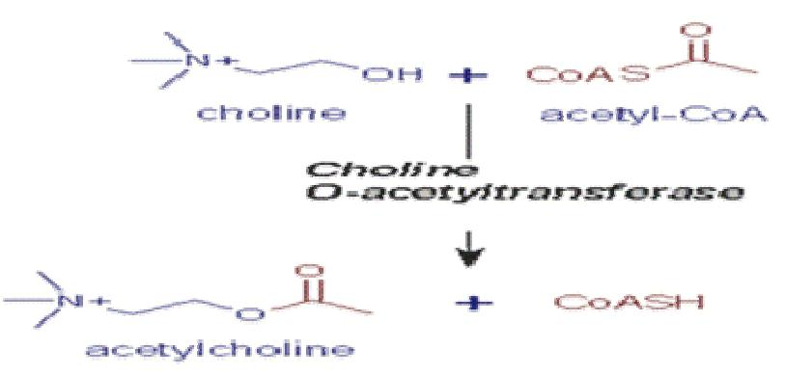

Figure 2.3 Mode of action of organophosphorus and organocarbamate insecticides Source: Das *et al* (2013).

18

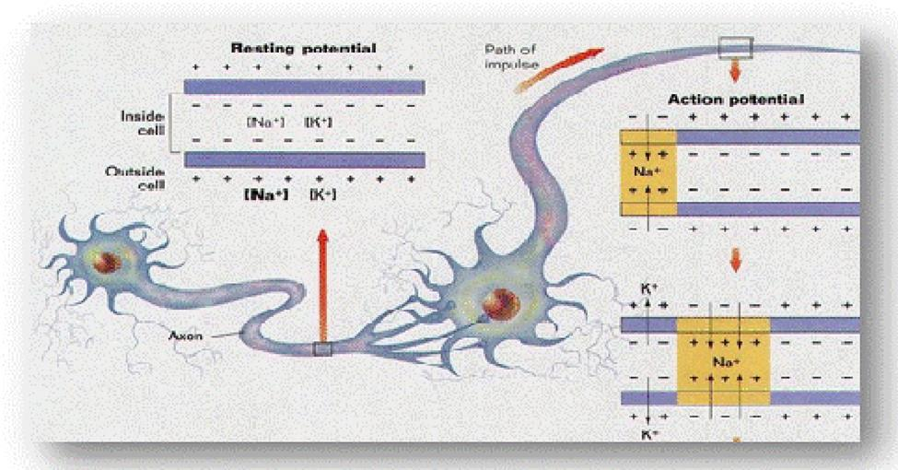

Figure 2.4 Mode of action of organochloride insecticides Source: Das *et al* (2013).

19

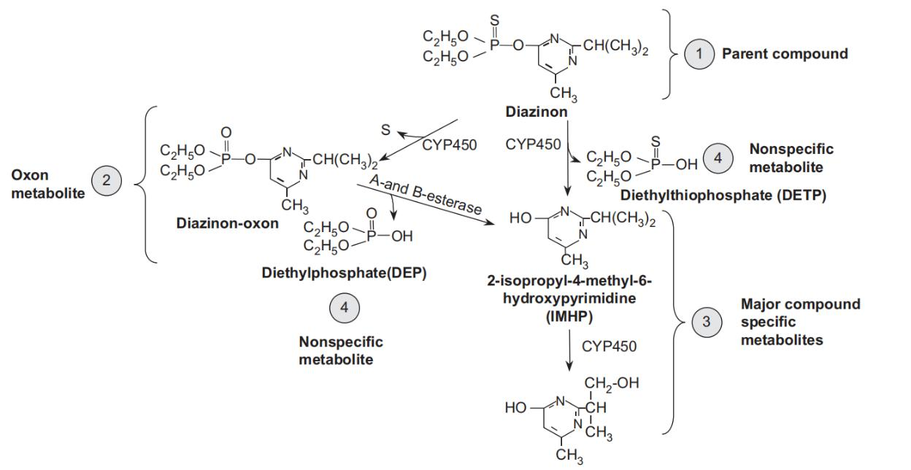

Figure 2.5 Metabolic scheme for the metabolism of the organophosphorus (OP) insecticide diazinon. CYP450, cytochrome P450.

Source; Krieger (2011)

20

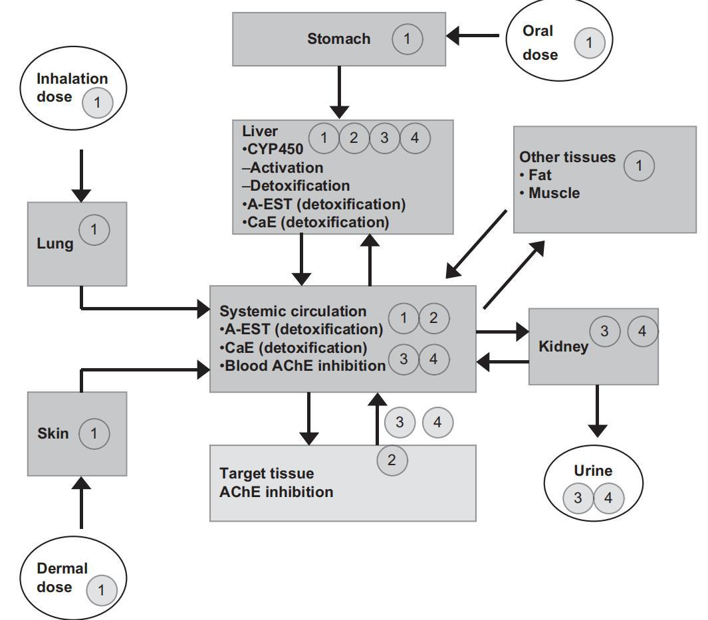

Figure 2.6 Compartmental flow diagram illustrating the critical tissue compartments associated with absorption, distribution, metabolism, and excretion of organophosphorus (OP) insecticides. The circled numbers (1 – 4) correspond to the parent compound and major metabolic products associated with metabolism of diazinon that are most likely found within each compartment. CYP450, cytochrome P450; A-EST, A-esterase. CaE, carboxylesterase; AChE, acetylcholinesterase Krieger (2011).

21

**2.7 Effects of Pesticides**

Pesticides are used in different aspects of life; due to their use they tend to bioaccumulate and bio-magnify in the ecosystem. Pesticide residue in the environment tend to react with other chemical compounds present in the atmosphere causing these pesticide compounds to degrade and turn to different chemical substances, fipronil when exposed to sunlight leads to the production of a fipronil derivate called fipronil-disulfinyl which is more toxic than fipronil and very hazardous to mammalian health (Kaur *et al*, 2019). Due the mode of action of pesticide in inhibiting certain biological pathways, pesticides play a crucial role in the health of living organisms in pesticide contaminated areas. Pesticides also affect other factors in the ecosystem apart from the living organisms, pesticides can change the chemical composition of the environment where they are actively used. Pesticides can reduce the pH level of the environment rendering the environment inhabitable for some organisms. Humans who eat fishes that inhabit pesticide contaminated water serve as a route for the bioaccumulation and persistence of pesticide in the environment (Erhunmwuse *et al*, 2012). Organochloride pesticide had been identified in certain species of tilapia fishes in the Lagos lagoon (David *et al*, 2008). Ize-iyamu *et al* (2007) postulated that the amount of pesticide in present in fishes that live in pesticide contaminated is higher than the amount of pesticide present in the water body due to pesticide affinity for fats. Since pesticides are used on crops there are lot of residues of pesticides on the crops when they are sold for human consumption, this leads to humans eating pesticide contaminated crops. Humans have some receptors like that of to that of pesticide target organisms, hence some of this pesticide molecules bind to these receptors in humans leading to toxic health effects.

22

Table 2.5 Implications of pesticide use in humans in Nigeria

|  |  |  |  |  |  |
| --- | --- | --- | --- | --- | --- |
| Pesticide | Application | Health effects | |  | |
|  |  |  | |  | |
| Chlorotoluron | Post-emergence herbicides | Cholinesterase inhibitor | |  | |
|  |  |  |  |  | |
| Cyanazine | Pre and post emergence | Increase in | adenomas | and | |
|  | herbicide | carcinomas of the kidney | | |
|  |  |  | |  | |
| 1,2 dibromoethance | Fumigant | Increase tumor | |  | |
|  |  |  | | |
| Fenoprop | Herbicide | Degeneration and necrosis of | | |
|  |  | hepatocytes | and fibroblastic | |
|  |  | proliferation |  |  | |
|  |  |  | |  | |
| Heptachlor and heptachlor | Broad spectrum insecticide | Kidney tumor | |  | |
| epoxide |  |  |  |  | |
|  |  |  | | |
| Isoproturon | Systemic herbicide | Marked enzyme induction and | | |
|  |  | liver enlargement | |  | |
|  |  |  | |  | |
| Methyl-parathion | Non-systemic insecticide and | Decreaseddiolinesterase | |  | |
|  | acaricide | activities, | sciatic | nerve | |
|  |  | demyelination, anaemia | |  | |
|  |  |  | | |
| Methoxychlor | Broad insecticide | Carcinogenic potential in liver | | |
|  |  | and testes |  |  | |
|  |  |  |  |  | |
| Molinatee | Herbicide | Impairment | of | the | |
|  |  | reproductive performance | | |
|  |  |  | |  | |
| Pyripoxyfen | Broad spectrum insecticide | Increase in liver weight | |  | |
|  |  |  |  |  | |

Source; Ezemonye *et al*, (2015)

23

**2.7.2 Dosage Level of Pesticides**

Dosage is the amount of a substance that is used to treat something, it is the amount of a substance that is present in the environment whether a living organism or the ecosystem. Dosage relates to toxicity in that the higher the dose the higher its toxicity levels. Toxicity (T) is a function of exposure (E), and E is a function of dose (c) and time (t) [T = f (E (c, t)]. Toxicity is the action or the mechanism of action in where certain chemical react with receptors and substances in a living organism leading to change in chemical and physical activity in the living organism. Toxicity can be defined as a function of T= f (E, K, D). Where “E” is exposure, “K” is toxicokinetic, and “D” is toxicodynamic. Dosage determines the amount and rate of reaction that would affect the pesticide would have on organism or environment (no reference)..

**2.8 Pesticide Use in Nigeria**

In Nigeria, 70% of its household population practice agriculture (crop planting), the federal government recorded about 5.7 million farmers in Nigeria. Agriculture is one of the main source of income to Nigeria and its individual households (Erhunmwunse *et al*, 2012). Over the years, since 1980 there has been a significant increase, with more hectares of land being used for farming day by day (Ikemefuna, 1998). Urban families have increased the amount of land used for farming in rural areas by a high percent. Due to this occupation share by a lot of Nigerians it comes as no surprise that pesticide usage in Nigeria would be on the constant increase. The use of pesticides in Nigeria happened in the 1950s to increase agricultural production while also meeting population demands (Asowga and Dongo, 2009). Nigeria noted the metric tons of pesticides comprising of about 135 pesticides chemicals which were purchased in 1983-1990 (Mazlan *et al*, 2017). Nigeria is one of the largest consumers of pesticide in Sub-Saharan Africa using about 125,000-130,000 metric tons of pesticides every year (Osibanjo, 2002). Although, most of these pesticides have been banned by NAFDAC (National Agency for Food and Drug Administration and Control) because of their effects, farmers still use these pesticides which they purchase from open markets (Mazlan *et al*, 2017). It has been discovered that about 2.2 million people in Nigeria are at risk because ofagricultural inputs (Erhunmwunse *et al*, 2012). Most of the pesticide used in Nigeria have been noted to cause numerous health effects in humans such as cancer and some temporary health changes (Mazlan *et al*, 2017). Reports made noted that 43% of pesticide applications were done by farmers while 30% were done by professional pesticide applicators and 26% were done by

24

family members (Mazlan *et al*, 2017). In Nigeria, farmers tend to abuse pesticide leading to a lot of hazardous outcomes. Pesticides are poured into rivers directly to kill fishes for human consumption, spraying of these pesticides directly on crop products to prevent molds and maggots from forming (Ojo, 2016). Some farmers mix different classes of pesticide together to save time during application (Asogwa and Dongo, 2009). Ignorance of farmers on which equipment that are to be used in pesticide applications, the dose to be applied and the amount of time to be given for pesticide degradation (Ojo, 2016). There are also other factors that contribute to the misuse and abuse of pesticide, for example application of fake pesticides bought. The actual estimate of pesticide use in Nigeria has not been reported but is known that 35% of pesticide applied are insecticides, 31% are cocoa pesticides and 65% are fungicides (Ikemefuna, 1998). The most dominating chemical classification of pesticides used in Nigeria are organochloride, organophosphates, and carbamates. Reports have shown that the deadliest forms of pesticides classified by World Health Organization (WHO) are being used in Nigeria (Ojo, 2016). The socio-economic class of Nigerian farmers also affect the way pesticides are being used in their farms, the literacy of these farmers would tell if they would know the right pesticide to apply and if a pesticide is extremely toxic (Tijani, 2006). In an analysis done by Tijani (2006), farmers do not take the right precautions when it comes to the application of pesticide and pesticide use.

**2.9 Pesticide residue in Water Bodies in Nigeria**

Persistence is the ability of a chemical to maintain its chemical components and structure over an extended period, this chemical substance is being transmitted from one area to another through environmental factors (Ojo, 2016). Pesticides are persistent chemical substances, that

can be transported through environmental elements, the particles left unused after pesticide application are referred to as pesticide residues. Residues can be classified as either bound or free residues. Bound residues are not easily extracted from the environment without the alteration of the chemical structure, while free residues can be easily extracted from the environment (Gevao *et al*, 2000). Some of these pesticide residues in the environment have reduced bioavailability anddegradation (Alexander, 1994). Pesticide residue can be found anywhere, in the soil, in water, in living organisms in the environment also in the atmosphere. These pesticide residues get to these places through various methods, through direct application of the pesticide and through indirect transmission. Persistent use of pesticides in agricultural farms have led to the environmental

25

contamination of soil, when pesticides are applied about 15% of it hit the target the remaining 85% are distributed between the soil and the atmosphere (Leonila, 2002). Pesticide residue can dissolve with runoff water or rainfall, it can also percolate through the soil reaching groundwater sources (FAO, 2000). Most pesticide pollution go unchecked in Nigeria even with underground water sources becoming one of the main ways of water supply in Nigeria (Erhunmwunse *et al*, 2012). In a survey conducted by Aikpokpodion *et al* (2010), to determine the degradation of Endosulfan insecticide in the soil in Ibadan, it was concluded that the use of Endosulfan insecticide has significant effects in the soil environment. The residue of the insecticide caused an increase in the acidity of the soil environment as well as increase in certain nutrients levels, these residues also persisted in the environment for a period of six months after application which also caused a significant reduction in the population of nematodes in the soil environment (Aikpokpodion *et al*, 2010). Pesticide residues get into water bodies through different routes for example there can be pesticide residues found in water bodies where pesticides have been used to control aquatic pests. Indirect routes like runoffs from farms where chemical pesticides are used, industrial and domestic wastes especially in homes where pesticides are used to eliminate house pests, even wrong disposal of pesticide application equipment. Akoto *et al* (2013), discovered high levels of chlorinated pesticides in certain water bodies due to high and consistent use of Lindane in fishing and Aldrin in cultivated fields close to these water bodies.

26

Table 2.6: Pesticide residue concentration detected in Nigerian production commercial fields

|  |  |
| --- | --- |
| Components Name | Concentration |
|  |  |
| Alpha BHC | 0.087 |
|  |  |
| Beta BHC | 0.095 |
|  |  |
| Gamma BHC | 0.096 |
|  |  |
| Delta BHC | 0.095 |
|  |  |
| Heptachlor | 0.101 |
|  |  |
| Aldrin | 0.094 |
|  |  |
| Heptachlor epoxide | 0.096 |
|  |  |
| Endosulphan A | 0.101 |
|  |  |
| 4,4’-DDE | 0.156 |
|  |  |
| Dieldrin | 0.169 |
|  |  |
| Endrin | 0.110 |
|  |  |
| 4,4’-DDT | 0.081 |
|  |  |
| Endosulphan B | 0.080 |
|  |  |
| 4,4’-DDD | 0.093 |
|  |  |
| Endrin aldehyde | 0.098 |
|  |  |
| Endosulphan sulphate | 0.095 |
|  |  |

Source: Dhole and Madhuli (2012)

27

Table 2.7; Pesticide residue detected in crops in Nigeria.

|  |  |  |  |  |  |
| --- | --- | --- | --- | --- | --- |
| Metabolites | MRL | Fruits | Vegetable | Tuber | Cereals |
|  | (Maximum |  |  |  |  |
|  | residue limit) |  |  |  |  |
|  |  |  |  |  |  |
| DDT | 100-5000 | 6.9 | 28.3 | 30.4 | 81 |
|  |  |  |  |  |  |
| Aldrin | 20-200 | 1.9 | 2.1 | 8.0 | 80 |
|  |  |  |  |  |  |
| Dieldrin | -------- | ------ | ------ | 32 | 312 |
|  |  |  |  |  |  |
| Heptachlor | 200 | ND | ND | ND | ND |
|  |  |  |  |  |  |
| DDE | ------ | 5.8 | 12 | 12 | 106 |
|  |  |  |  |  |  |

Source: Osibanjo (2002)

**2.10 Genetic and cytogenetic testing**

Pesticides and its residues have been known to cause several damages to the body of an organism, to discover the damage that can be done or could have been done certain assays have been developed to observe these possible effects. There are several experimental assays that have been developed to conduct research in such fields. Using the *Allium cepa* assay macroscopic and microscopic parameters are observed, macroscopic parameters include root growth inhibition, turgidness, and physio-characteristic can be observed to determine level of toxicity using certain standards (Fiskesjo, 1985). Also, microscopic parameters such as cytogenetic assay and micronuclei assay which assess and evaluate genetic damage done to the meristematic roots of the onion bulb, these test designs are accepted by various standard laboratory and governing bodies (Fiskesjo, 1985; Fiskesjo, 1994). *Drosophila melanogaster* is being used has a biological model in toxicology to assess various substances, using behavioral, genetic, and biochemical markers, mutagenicity of the fly due to the substance exposed to. Molecular techniques such as polymerase chain reaction and DNA fragmentation can be used to assess DNA damaged caused and if possible, cell damage would occur (Dolganar *et al*, 2014).

28

**CHAPTER THREE**

**MATERIALS AND METHODS**

**3.1** **Biological Materials**

The test organisms used for the experiments were,) *Drosophila melanogaster* (Fruit flies) and *Allium cepa* (Onion bulbs; 2n = 16). The Harwich strain of *D. melanogaster* used, were culturedin the biology laboratory of the Department of Biological Sciences, Mountain Top University (MTU). The first flies were donated by the Drosophila Research Training Centre Ibadan. They were fed with corn meal diet (consisting of agar, nipagin, baker’s yeast) and maintained at a room temperature of 25.2 ± 1.2 OC. The onion bulbs were purchased from Agege Market, Agege, Lagos State, Nigeria. The onions were air - dried for a period of 1-2 weeks before use.

**3.2** **Sample Collection and Sampling Site**

The test samples used in this study were water samples collected from three different geographical areas in Lagos, Nigeria. The water sample was collected from farm settlement where pesticides are actively used for farming and have long history of use of pesticides. The selected farm settlements are situated in Epe (0605780, 073313), Ikorodu (0573719, 073510) and Badagry (0485871, 0711081), which are all in Lagos State Nigeria.

The samples were collected in February during the dry season into white clean, new 5- litres plastic containers. At Epe farm settlement area, the water sample was collected from the stream at the farm area which is connected to the fishpond where fishes are reared at the farm (Fig. 3.1). At Badagry and Ikorodu (Fig. 3.2) farm settlements, water samples were collected from the borehole which is the source of water to farmers and residents in the areas. Borehole water sample collected at College of Basic and Applied Sciences MTU, served as the negative control sample. at the Mountain Top University.

29

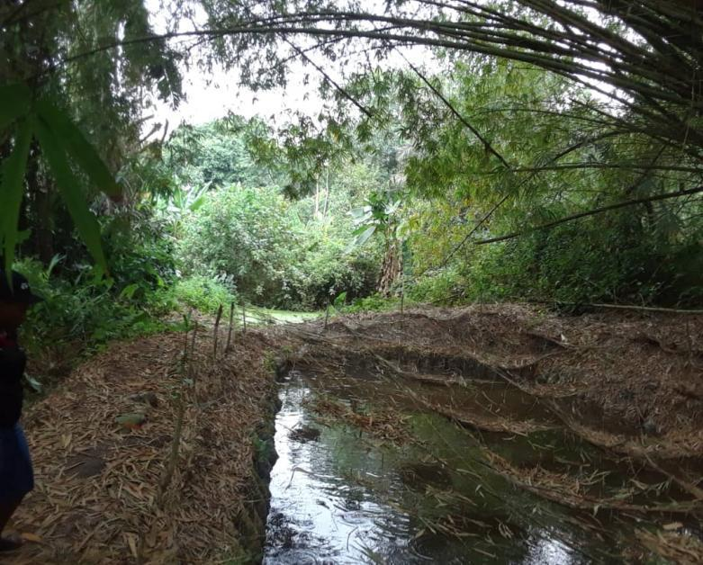

**Figure 3.1**: Epe farm settlement stream

30

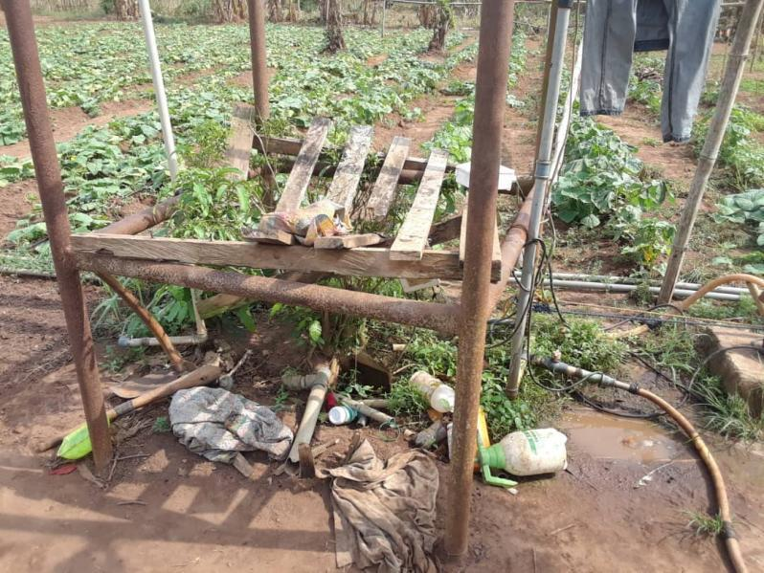

**Figure 3.2:** Ikorodu farm settlement showing vegetable farm and borehole site surrounded by indiscriminately disposed pesticide containers

**393**

**3.3 Gas Chromatography and Mass Spectrometry (GC-MS)**

GC-MS analysis of the three water samples were carried out using the Agilent 8860A gas chromatograph coupled to 5977C inert mass spectrometer with electron impact source (Agilent Technologies). The stationary phase of separation of the compounds was carried out on HP‐5 capillary column coated with 5% of Phenyl Methyl Siloxane (30 m length × 0.32 mm diameter × 0.25 μm film thickness) (Agilent Technologies). The carrier gas was helium used at a constant flow rate of 1.573 ml/min, an initial nominal pressure of 1.9514 psi and at an average velocity of 46 cm/s. One microliter of the samples were injected with 50:1 Split mode at an injection temperature of 300°C. Purge flow was 21.5 ml/min at 0.50 min with a total gas flow rate of 23.355ml/min; gas saver mode was switched on. The oven was initially programmed at 40°C (1 min), then ramped at 10°C/min to 270°C (4 min). Run time was 30.25 min with a 3 min solvent delay. The mass spectrometer was operated in electron‐impact ionization mode at 70eV with ion source temperature of 230°C, quadrupole temperature of 150°C and transfer line temperature of 280°C. Scanning of possible compounds was from m/z 50 to 550 amu at

31

2.62s/scan scan rate and were identified by comparing measured mass spectral data with those in NIST 14 Mass Spectral Library.

**3.4 *Allium cepa* assay**

Planting of Onion bulb

*Allium cepa* assay was carried out using standard methods (Fiskesjo 1985; Bakare *et al.,* 2013) by drying the bulb onions in the sun for one week or maximum two weeks for the outer layer of the onion to dry up. The dry layers of the onions were peeled, and the dried roots are cut off to allow the growth of fresh roots from the primordial ring in the onion. Before the onions were planted, they were placed in a bowl of clean water immediately after peeling to prevent the primordial ring from drying up. The experimental design comprises five groups of four onions in each group. Onions planted on borehole water sample collected from MTU served as negative control while 10 ppm lead nitrate [ Pb(NO3)2]was used as positive control. The other three groups comprise onion bulbs planted on 100 % v/v water samples from Epe, Ikorodu and Badagry farm settlements.

For each group four peeled onion bulb were planted in dark cupboard. Four transparent cups of 100 mL capacity were filled with water samples for each group and the onions bulbs were placed gently on the cup with the bottom of the onion (primordial ring) slightly touching the surface of the water. A total of 20 onion bulb were used for the five groups of water sample). The water samples were renewed every twenty- four hour. At 48 h, two onion bulbs were harvested for cytogenetic tests. The roots growing at the primordial ring of the onion bulbs were harvested by cutting the roots using a new blade from the edge of the primordial ring. The roots of the onion bulbs were first rinsed in distilled water before being fixed fixative consisting of ethanol and glacial acetic acid (3:1 respectively) for 24 hours. After fixing the root for 24 hours the roots were rinsed in distilled water and preserved in 70% ethanol for cytogenetic test.

**3.4.1 Root growth inhibition test**

After 72 hours, the remaining two onion bulbs planted on the water sample in each group were harvested. The roots from each onion bulb were immediately rinsed in distilled water and measurement of each root was taken centimeters. This was done for every root harvested for all groups, an average length is recorded and compared.

32

**3.4.2 Cytogenetics of root tips of *Allium cepa***

The harvested root tips stored in 70% ethanol were hydrolyzed by incubating in 1N HCL at 60oC for 5 minutes to breakdown cellulose. After the roots have been incubated, they were rinsed in distilled water twice and blotted on a filter paper. The roots are then placed on new and clean well labelled microscopic slides (according to sample group), the meristematic tips (whitish tips) of these roots are cut off from the main roots, the remaining parts are discarded. The meristematic tips are teased with clean needles until the particles have a paste like texture, the teased tips are stained with two drops of acetocarmine stain for 10 minutes. After 10 minutes the excess stain is blotted out with a flitter paper, a cover slip is placed on the microscopic slide at an angle of 450, the slide is kept in between a thick wad of tissue paper to remove bubbles and stain, a nail polish is applied to the edges of the cover slip to seal the cover slip to the slides. After the nail polish dries, the slide is view under a light microscope using immersion oil at x1000 magnification. 6 slides were made per each group with 4 slides being scored and recorded, 1000 cells are counted per slide taking note of chromosome aberrations both chromosomal and nuclear.

Mitotic index of diving cells was gotten by the following calculation: no of dividing cells÷ number of cells scored × 100

* Frequency of chromosomal aberrations per dividing cells was gotten by the following calculation: no of chromosomal aberrations

**3.5 *In vivo* assays in *Drosophila melanogaster* exposure to water samples**

Corn meal diet was prepared and kept in glass jars to solidify, after the solidification of the diet a toilet paper is used to clean away water from inside the jars, the fruit flies are transferred into the jars and sealed with a foam, this is to allow air to penetrate the jars for the survival of the files. After a period of ten days the old files are transferred out of the jars to allow for the emergence of new and fresh flies. For experimentation 3–4-day old flies were used for exposure.

For exposure, a 10g total diet was used for exposure, 9.8 gram of cornmeal diet was weighed into the jars, then 200 microliter of water samples were added into the jars also, after these the diet was thoroughly mixed with the water samples and pressed down. The experiment was done in triplicate for each group except for positive control which was done in duplicate. For the positive control

33

diluted pesticide that are being used at these areas were used instead of water samples. For each jar in a group 30 flies were counted after putting the flies to sleep (flies are put to sleep by putting flies in a jar without diet in cold water with ice till they are all asleep about 2-3 minutes., the flies are then kept on a cold surface with filter paper for counting). The flies exposed to these samples are left for 7 days. The flies are then collected for analysis.

**3.5.1 Negative geotaxis assay**

After exposure of flies for seven days, two jars of flies from each group were taken and 10 flies from each jar were counted into a falcon tube. A 6cm mark had been made on the falcon tube earlier. Once all the flies are awake the number of flies that go above the 6cm mark before 10 seconds time are counted and the ones remaining below are also counted and recorded. This test was done 3 times for each group.

**3.5.2 Random Amplified Polymorphic Deoxyribonucleic acid (RAPD) Analysis**

RAPD analysis was done using DNA extracted from the flies of each group DNA Extraction procedure

The DNA extraction procedure started with the addition of 100 microliters of homogenized fly mixture into a labelled 1.5ml microcentrifuge tube. 300 microliter of Lysis buffer was added to the microcentrifuge tube, the microcentrifuge was vortexed vigorously for 30 seconds. Then 10 microliters of Proteinase K. were added, then it was vortex. The mixture was incubated at 60oC for 10 minutes, then microcentrifuge tube was allowed to cool then 300 microliters of binding buffer was added the microcentrifuge tube was vortexed then centrifuged at 10000g for 1 minute. Then 200 microliter of absolute ethanol was added to the sample after which a spin column was placed into a collection tube, then the sample was transferred into the sample directly to the middle of the spin column. The sample was centrifuged at 10000g for 1 minute and flow through was discarded and the collection tube was blotted, the spin column was reinserted into the collection tube. 500 microliter of wash buffer 1 was added to the sample, the sample was then centrifuged at 10000g for 1 minute, the flow through was discarded and the collection tube. The spin column was reinserted into the collection tube and 500 microliters

34

of wash buffer 2 was added to the sample. The sample was centrifuged at 10000g for 1 minute. The flow through was discarded again and the tube was blotted on a tissue, the spin column was inserted into the collection tube. The spin column was spun dry at the highest speed for 2 minutes, the collection tube was discarded, and the spin column was inserted into a new 1.5ml microcentrifuge tube. 100 microliters of elution buffer were added into the pin column then incubated at room temperature for 1 minute. The eluted DNA was stored at -20oC for further analysis. This process was done for each group of flies, Negative, Epe, Ikorodu, Badagry and Positive.

PCR (Polymerase Chain Reaction)

The DNA extracted from the fruit flies were used for PCR analysis, the machine was programmed to go through certain cycles for a specific duration to allow the DNA to bind to the primers. The first duration was 3 minutes at 950C, then at 950C for 30 secs,370C for 30 secs, 720C for 90 seconds these cycles were repeated 40 times before the final stage of 720C for 30 minutes. The results were read in gel electrophoresis, an agarose gel of 1.8% was prepared with TBA buffer and allowed to solidify, with the gel comb inside. The solidified gel was kept in the gel tank and the PCR samples were kept into the wells in the gel created by the gel comb. The gel electrophoresis was left to run for 60 minutes before results were read. The results were read in the order which the primers were arranged; SP2, P2, RF1, OPA11, 1253, P4. The reaction table for each primer used in the PCR process used is given below:

The volume of primer to be used was calculated using:

C1V1= C2V2 = MM

V1= 6 microliters

2 x V1 = 1 x 12

Primer SP2 = 20 x V1 = 0.6 x 12

V1= 7.2/20 = 0.36

Primer RF1 = 20 x V1 = 0.6 x 12

V1= 7.2/20 = 0.36

Primer P4 = 20 x V1 = 0.6 x 12

V1= 7.2/20 = 0.36

35

Primer OPA11 = 20 x V1 = 0.6 x 12

V1= 7.2/20 = 0.36

Primer P2 = 20 x V1 = 0.6 x 12

V1= 7.2/20 = 0.36

Primer 1253= 20 x V1 = 0.6 x 12

V1= 7.2/20 = 0.36

MgCl2 = 25 x V1 = 1 x 12

V1 = 0.4

Table 3.1: Reaction table for the 6 primers used (SP2, 1253, P4, RF1, OPA11, P2)

|  |  |  |  |  |  |
| --- | --- | --- | --- | --- | --- |
| Reagents | Initial | Final | V/R | n= 6 | n = 5 |
|  |  |  | (microliters) |  |  |
|  |  |  |  |  |  |
| MM1 | 2X | 1X | 6 | 36 | 30 |
|  |  |  |  |  |  |
| SP2 | 20mM | 0.6Mm | 0.36 | 2.16 | 1.8 |
|  |  |  |  |  |  |
| MgCl2 | 25mM | 1mM | 0.48 | 2.88 | 2.4 |
|  |  |  |  |  |  |
| H2O | --- | ----- | 3.16 | 18.96 | 15.8 |
|  |  |  |  |  |  |
| DNA |  |  | 2 |  |  |
|  |  |  |  |  |  |

36

Table 3.2: Primer sequence table

|  |  |  |
| --- | --- | --- |
| Primer | Sequence | nmoles |
|  |  |  |
| SP2 | GGGCATCGGC | 68.51 |
|  |  |  |
| P4 | TTCCGAACCC | 67.22 |
|  |  |  |
| OPA11 | CAATCGCCGT | 51.95 |
|  |  |  |
| RF1 | GTAGCTGACC | 64.2 |
|  |  |  |
| 1253 | GTTCCGCCCC | 71.9 |
|  |  |  |
| P2 | GTAGCTGACG | 61.86 |
|  |  |  |

**3.6** **Statistical analysis**

Statistical analysis for the data recorded in the work was done using Microsoft Excel and Graph pad 9.4.1(681). The methods used were inferential and descriptive statistics, inferential statistics was done using One way ANOVA method at significance level of p < 0.05.

37

**CHAPTER FOUR**

**RESULTS AND DISCUSSION**

**4.1** **Gas Chromatography and Mass Spectrophotometer (GC-MS)**

The GC-MS results (Table 4.1 and Figure 4.1) showed the presence of several pesticide chemical residue in each water sample, the similar pesticide chemicals were found in each water sample all with different concentration. The water sample with the least pesticide residue present was the Epe water sample and the water sample with the highest presence of pesticide residue was the Ikorodu water sample. The Ikorodu water sample also had pesticide chemical residues with the highest concentration.

**4.2 *Allium cepa* Assay**

**4.2.1** **Root growth inhibition**

The root tips of onions planted on Badagry water sample were thicker and whiter root compared to the other test groups and control. Result of the root growth inhibition (Fig 4.2) shows that the positive control had the highest root inhibition compared to the test gest groups. Onion bulbs planted in the Epe water sample had the second highest inhibition of root growth with the Ikorodu group having the least inhibition. Each group had significant differences in the root inhibition from each other.

**4.2.2 Cytogenetics**

The different mitotic stages recorded, and the chromosomal aberrations observed are presented in Figure 4.3. There was no significant difference between the test group compared to the negative control (Table 4.2) However, there test groups had higher frequencies of chromosome aberration compared to the control. Epe group had the highest number of diving cells with Badagry having the lowest, there is no record for the root tips of the Ikorodu group because the samples were lost during the experiment. Badagry samples had more of sticky chromosomes as its chromosomal aberrations than other type of aberrations, but Epe group had the highest frequency for chromosomal aberrations.

The result for the mitotic index shows slight but not significant results, the differences between each group not being up to 0.1.

38

**Table 4.1: Results of GC-MS analysis to showing pesticide residue and their concentration in Ikorodu, Epe and Badagry sample water samples**.

|  |  |  |  |  |
| --- | --- | --- | --- | --- |
| **Compound** |  | **Concentration (mg/L)** | |  |
|  |  |  |  |  |
|  | **Ikorodu** |  | **Epe** | **Badagry** |
|  |  |  |  |  |
| alpha- Lindane | Below cal |  | Below cal | Below cal |
|  |  |  |  |  |
| Beta. - lindane | 0.06 |  | 0.01 | 0.03 |
|  |  |  |  |  |
| Gamma - Lindane | 0.07 |  | 0.03 | 0.25 |
|  |  |  |  |  |
| Delta. – Lindane | 1.42 |  | 0.17 | 2.26 |
|  |  |  |  |  |
| Endosulfan ether | 1.47 |  | 0.48 | 4.96 |
|  |  |  |  |  |
| Endrin | 0.02 |  | 0.01 | Below cal |
|  |  |  |  |  |
| Dieldrin | Below cal |  | Below Cal | Below cal |
|  |  |  |  |  |
| P,p,’ – DDT | 0.07 |  | 0.05 | 0.06 |
|  |  |  |  |  |
| Endrin | Below cal |  | Below cal | 0.03 |
|  |  |  |  |  |
| Methoxychlor | Below cal |  | Below cal | 0.07 |
|  |  |  |  |  |

39

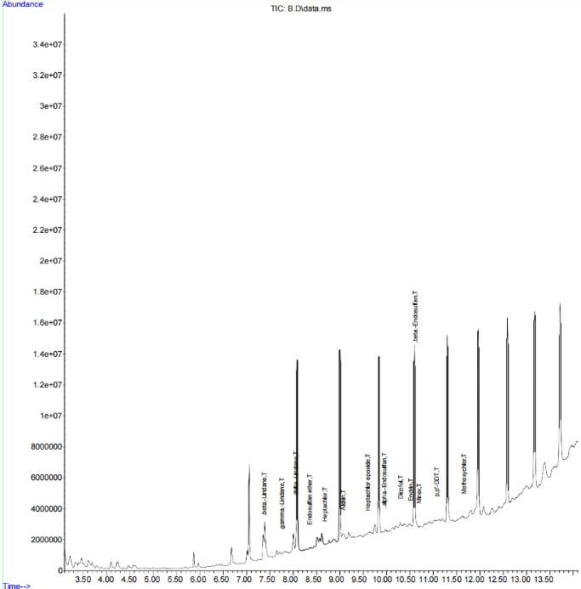

40

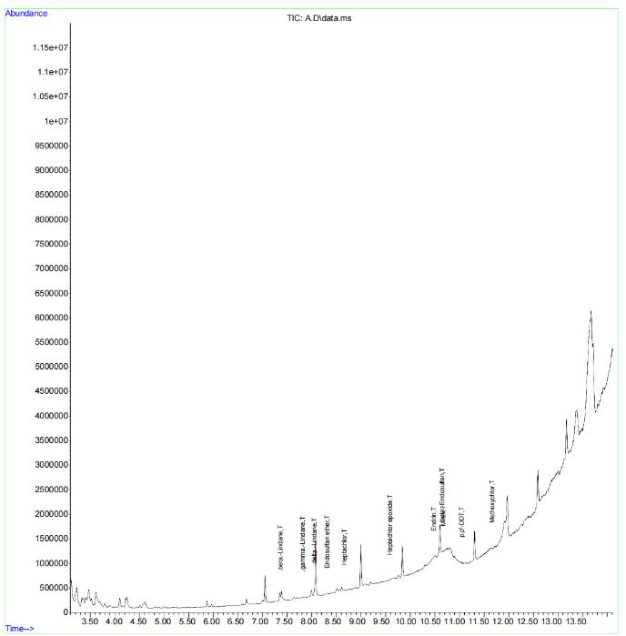

**(b)**

41

S

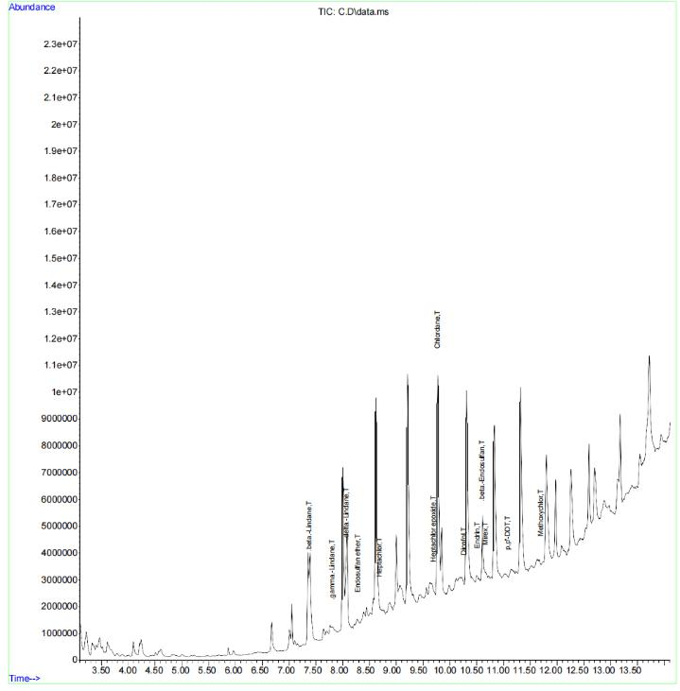

**(c)**

**Figure 4.1:** GC-MS graph results showing peak/abundance of pesticide residues present in

Ikorodu (a) , Epe (b) and Badagry (c) water samples

42

|  |
| --- |
| **Water samples** |

**PC**

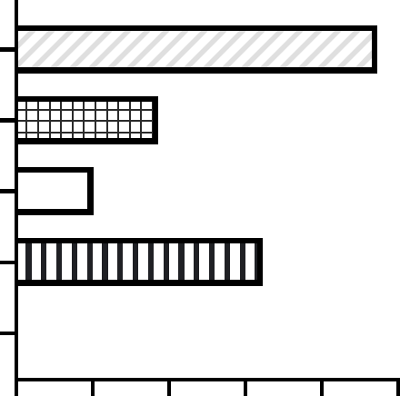

**BADAGRY**

**IKORODU**

**EPE**

**NC**

|  |  |  |  |  |  |  |
| --- | --- | --- | --- | --- | --- | --- |
| **0** | **10** | **20** | **30** | **40** | **50** | |
|  | **Percentage (%) root Inhibition** | | | | |

**Figure 4.2:** Effects of the water samples (Epe, Ikorodu and Badagry) on the root growth of *Allium cepa.* (NC-negative control; PC—positive control).

43

**Table 4.2:** Cytogenetic effects of Epe, Ikorodu and Badagry water samples on the mitotic activities and chromosomes of Allium cepa.



Mitotic indices and chromosome aberration

|  |  |  |  |  |  |  |  |  |  |  |  |  |
| --- | --- | --- | --- | --- | --- | --- | --- | --- | --- | --- | --- | --- |
| Test |  | Number | Mitotic | Mitotic | No of | No of | No of | Total | Frequency of chromosome | |  | |
| sample |  | of | index | inhibition | cells at | cells at | cells at | aberrant | aberration based on | |  | |
|  |  | diving |  | (%) | metaphase | anaphase | telophase | cells |  |  | |  | |
|  |  |  | Total cells | No of divi | |  | |
|  |  |  |  |  |  |  |  |  |  | |
|  |  | cells |  |  |  |  |  |  | scored/ | ng cells | |  | |
|  |  |  |  |  |  |  |  |  |  | |
|  |  |  |  |  |  |  |  |  |  |  | |  | |
|  | NC | 208 | 0.0525 | 0 | 34 | 24 | 23 | 41 | 0.70 | 14.70 | |  | |
|  |  |  |  |  |  |  |  |  |  |  | |  | |
|  | PC | 250 | 0.07475 | 46.11 | 26 | 41 | 13 | 55 | 1.38 | 24.38 | |  | |
|  |  |  |  |  |  |  |  |  |  |  | |  | |
| water | Badagry | 191 | 0.06250 | 61.74 | 37 | 25 | 11 | 38 | 0.93 | 19.05 | |  | |
| samples |  |  |  |  |  |  |  |  |  |  | |  | |
|  |  |  |  |  |  |  |  |  |  |  | |  | |
|  | Epe | 299 | 0.04775 | 50.72 | 38 | 32 | 17 | 56 | 1.53 | 18.39 | |  | |
|  |  |  |  |  |  |  |  |  |  |  | |  | |

44

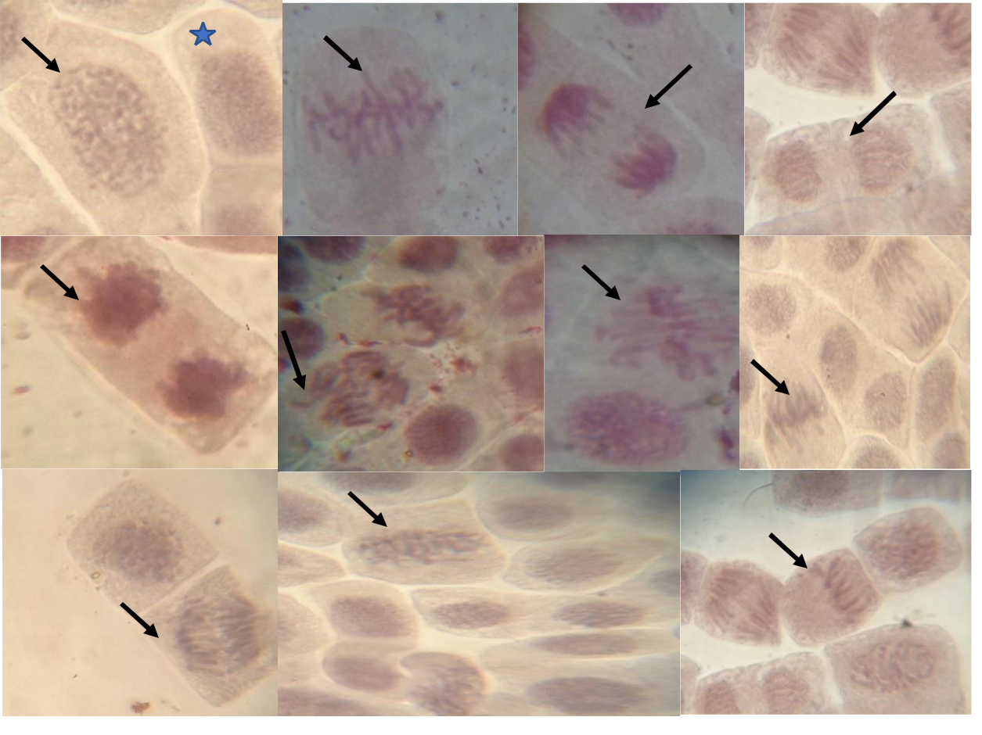

**a** **b** **c** **d**

**e** **f** **g** **h**

**i** **j** **k**

**Figure 4.3:** Normal mitotic stages and chromosomal aberrations observed in *Allium cepa* root tips exposed to Epe, Ikorodu and Badagry water samples:(a – d) normal mitotic stages: (a) prophase and interphase (star) (b) metaphase (c) Anaphase (d) Telophase (e) sticky chromosome at telophase (f) vagrant chromosome at anaphase (g) C-mitosis at metaphase; (h) unequal distribution of chromosome (i) non-disjoint chromosomes at anaphase; (j) Sticky chromosome at prophase (k) spindle fiber disturbance at metaphase.

45

**4.2 *In vivo* Animal Experiments in *Drosophila melanogaster***

**4.2.1 Negative geotaxis result**

The results shows that there were significant differences in the test groups compared to the negative control group. In terms of the flies’ locomotory signals, the negative control had the highest average of flies that passed the 6 cm mark. In the process of this experiment the flies the Epe group were more energetic than the flies of the remaining group also having the least death record while flies from Ikorodu growth were the slowest.

|  |
| --- |
| **Climing Rate (%)** |

**150**

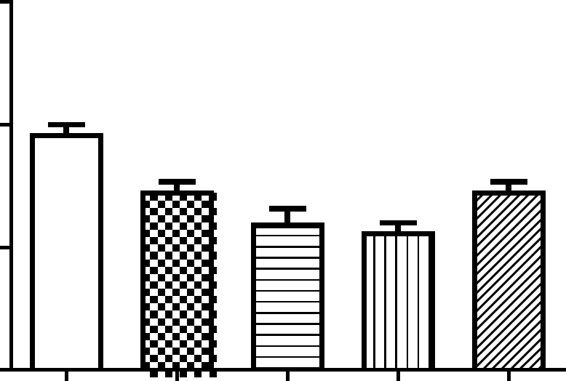

**100**

|  |  |  |  |
| --- | --- | --- | --- |
| ** |  | ** |  |
| *** | *** |  |
|  |  |

**50**

**0**

|  |  |  |  |  |  |  |
| --- | --- | --- | --- | --- | --- | --- |
| **C** |  | **E** | **U** |  | **Y** | **C** |
| **N** | **P** | | **D** |  | **R** | **P** |
|  | **E** |  | **O** |  | **G** |  |
|  |  |  | **R** | **A** | |  |
|  |  |  | **O** | **D** |  |  |
|  |  |  | **IK** | **A** |  |  |
|  |  |  |  | **B** |  |  |

**Water samples**

|  |  |  |  |  |  |
| --- | --- | --- | --- | --- | --- |
| PC |  | EP | IK | BD | NC |
|  |  |  |  |  |  |
| 8 |  | 7.66 | 7.33 | 8 | 9.66 |
|  |  |  |  |  |  |
| 7.3 |  | 7.33 | 6 | 5.66 | 7.33 |
|  |  |  |  |  |  |
|  | 46 |  |  |  |  |

**Figure 4.4:** Percentage frequency of flies that climbed above the 6cm during the negative geotaxis experiment **p< 0.01, ***p< 0.001

**4.2.2** **Random Amplified Polymorphic DNA (RAPD) Analysis**

Six primers were used in the RAPD analysis, the results of the polymerase chain reaction carried out on the *D. melanogaster* DNA showed visible band out of the six primers. The results for SP2 primer show positive results for Badagry and Positive control sample (Figure 4.5). OPA11 showed positive for the Badagry, Ikorodu and Positive control group of flies even though some bands were faint. There were no results for the remaining primers (1253, RF1, P2and P4)

47

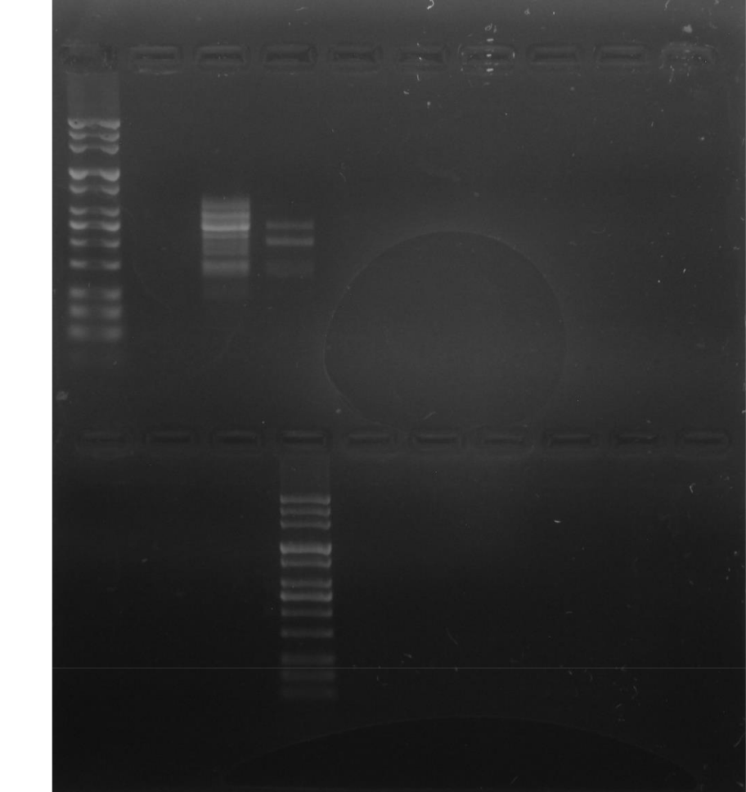

L NC PC BDIK EP NC PC

IK EP L NCPCBDIK EP

Figure 4.5: RAPD results showing bands for SP2, primer

48

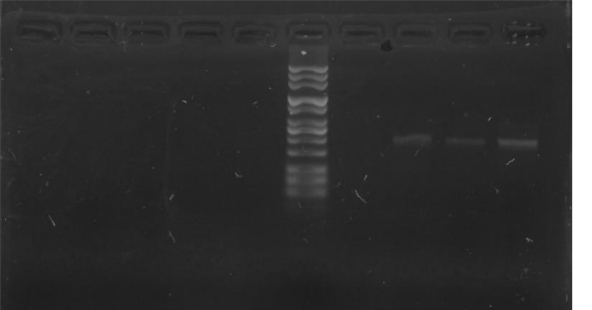

NC PC BD IK EP L NC PC BD IK

Fig 4.13: RAPD result showing bands for primer OPA11.

**4.3 Discussion**

Water acts as a form of transportation of various substances, the ability of water as a universal solvent has made it one of the most sought-after natural resources in the world. The ability of water to be a universal solvent has led to it easy contamination by foreign substances: pollution of water an overly concerning thing for the nearby environment as it can lead to easy contamination to the nearby residents. Agricultural sites have been known to lead to the contamination of nearby water bodies due to the chemicals actively used on the farm. Research has confirmed that the residues of agricultural chemicals used that contaminate nearby areas do have harmful effects on organisms exposed to them. Possibility of nearby water sources contamination of chemical residues is exceedingly high due various routes at which these residues can contaminate the water e.g., percolation. Proper assessment of toxicity of water samples in farm areas are done to evaluate the water, overtime these pesticide residues contaminated water has been found to be toxic. The experiment conducted aimed at observing possible cytogenotoxicity caused by water samples from three different farm areas.

Pesticide residues were found in the all the water samples, with some water samples being higher than the other. This is due to inappropriate application and disposal of pesticides (Ojo, 2016). The assessment of each water sample for toxicity was done with various techniques and the results were determined. The water samples showed toxic effects in various assessments. In the GC-MS analysis it was observed that the water sample with the highest pesticide residue present was the sample gotten from the Ikorodu farm

49

settlement area. This could be possible due to inappropriate pesticide waste disposal that was observed in the farm area. Pesticide containers and applicators were dumped at the borehole site of the farm which allows for easy percolation of pesticide chemicals to the ground water source.

The water samples were positive for cytotoxicity each samples showing toxic effects on the onion bulb. The samples significant effect on the root growth inhibition which was similar to the work of Radic *et al* (2010), which showed root growth inhibition on the onion bulb an effect of wastewater. Cytogenetic results from this work corroborated with the analysis done by Bakare *et al* (2012), showing similar effects on chromosomal aberrations. The chromosomal aberrations occurred due to the reaction pesticide compound have with cellular receptors of living systems, certain aberrations observed were a clear signal of toxicity and not spontaneous mutations (Fiskesjo, 1984). The effects of these water samples on fruit flies were evident in genetic activities and not in neurobehavioral activities as this samples did not affect locomotory senses, this is because the concentration of these residues was not high enough to cause locomotory damage. In the RAPD analysis, it was determined that the DNA of exposed flies had random annellation to the primers at different sight, the DNA extracted from exposed flies had similar binding patterns to that of the positive control. Similar binding patterns were observed in the work of Dolganar *et al* (2014). Further investigation is needed as the results show significant potential toxicity of the watersamples on living systems.

50

**CHAPTER 5**

**CONCLUSION AND RECOMMENDATION**

**5.1 Conclusion and Recommendation**

The evaluation of water samples with pesticide residues has shown presence of toxic effects in biological models. The harmful effects of these polluted water samples should be investigated further as water is an essential element in the ecosystem. The results gotten from this experiment has shown that even little presence of pesticide residue can lead to significant toxic effect on living system both reversible and irreversible. Previous research works have shown that chemical residues can prove to be toxic in many ways and affect different, part of the living system in a work done by Bakare *et al* (2013), it was observed that E-waste and leachate cause significant damages to the living system of *Allium cepa* and *Clarias* spp. Works done both home and abroad have shown that no matter where in the world we are chemical residues cause toxic damages to the living system especially cytogenetic toxicity. In this experiment it was observed that traces of banned pesticide compounds were found in the water samples, governing bodies especially in the environmental factor should implement more scrutiny in the pesticide compounds that are being used by farmers. Proper awareness of how pesticides should be applied and disposed should be given to all farmers and pesticide applicators as overuse of pesticides in an area contribute to the increase in pesticide contamination of water bodies and surrounding areas. Even with all the regulations of pesticide use, alternative methods should be thoroughly researched to avoid chemical toxicity. The use of bio-pesticides and virus as a method of pest elimination have shown promising results without the toxic effects that synthetic pesticides cause. More research should be carried out concerning this issue and regular assessments should be done even if alternative methods are applied.

51

**REFERENCES**

Adams, R.W. (1995) *Handbook for Pesticide Applicators and Dispensers*, 5th edn. Victoria, BC:

Environment.

Adekunle A. Bakare 1, Okunola A. Alabi, Adeyinka M. Gbadebo, Olusegun I. Ogunsuyi and Chibuisi G. Alimba, In Vivo Cytogenotoxicity and Oxidative Stress Induced by Electronic Waste Leachate and Contaminated Well Water. *Challenges* 2013, 4, 169-187;doi:10.3390/challe4020169

Adeniran, O.Y., Fafunso, M.A., Adeyemi, O., Lawal, A.O., Ologundudu, A. and Omonkhua, A.A. (2006) Biochemical effects of pesticides on serum and urinological system of rats. *Journal of Applied Sciences* 6, 668–672.

Adeyemi, D.; Anyakora, C.; Ukpo, G.; Adedayo, A. D. G. Evaluation of the levels of Organochlorine pesticide residues in Water samples of Lagos Lagoon using solid phase extraction method. *Journal of Environmental Chemistry and Ecotoxicology*, v. 3, n. 6, p. 160-166, 2011.

Adeyeye, A. & Osibanjo, O. (1999). Residues of organochlorine pesticides in fruit, vegetable, and tuber from Nigeria market. *Science Total Environment* 231:227.

Adeboyejo, O. A.; Clarke, E. O.; Olarinmoye, M. O. Organochlorine pesticides residues in water, sediments, fin and shell-fish samples from Lagos Lagoon complex, Nigeria. *Researcher,* v. 3, n. 3, p. 38-45, 2011.

Agrawal A, Pandey RS, Sharma B (2010) Water pollution with special reference to pesticide contamination in India. *J Water Res Prot* 2(5):432–448

Aikpokpodion, P.E., Lajide, L., Ogunlade, M.O., Ipinmoroti, R., Orisajo, S., Iloyanomon, C.I. & Fademi, O. (2010). Effect of Endosulfan on soil and root-knot nematodes in cocoa. *Journal of Applied Biosciences* 26, 1640- 1646.

52

Akoto, O., Andoh, H., Darko, G., Eshun, K., Osei-Fosu, P. Health risk assessment of pesticides residue in maize and cowpea from Ejura, Ghana. *Chemosphere*, v. 92, n. 1, p. 67-73, 2013.

Aktar M, Paramasivam M, Sengupta D, Purkait S, Ganguly M, Banerjee S (2009) Impact assessment of pesticide residues in fish of Ganga-river around Kolkata in West Bengal. *Environmental monitoring and assessment* **157**(1): 97-104. DOI: 10.1007/s10661-008-0518-9

Aktar W, Sengupta D, Chowdhury A (2009) Impact of pesticides use in agriculture: their benefi ts and hazards*. Interdiscipl Toxicol* 2:1–12

Anon (1993) The environmental effects of pesticide drift, Peterborough: English Nature. 9–17. Benefi ts of pesticides and crop protection chemicals. *In: Crop life America*. Available from http://www.croplifeamerica.org/crop-protection/benefi ts. Accessed Dec 22, 2014

Alexander, M., 1994. Biodegradation and Bioremediation. Academic Press, San Diego, CA. Alexander, M., 1995. How toxic are toxic chemicals in soil? *Environmental Science and Technology* 29, 2713±271

Almeida, W.F., Demello, D. & R-puga (1978). Influence of nutritional status on the toxicology of food additives and pesticides. *Galli, C.L. ed., Chemical toxicology of food, Amsterdam, Elsevier/North Holland biomedical Press*,169-184pp.

Aminu, F.O., Ayinde, I.A., Sanusi, R. A., Olaiya, A.O. (2019). Determination of Pesticide Use in Cocoa Production in Nigeria. *Canadian Journal of Agriculture and Crops*, 4(2), 101-110.

Asogwa E. U. and Dongo L. N. 2009. Problems associated with pesticide usage and application in Nigerian cocoa production: A review. *African Journal of Agricultural Research* 4 (8):675-683

Bainova, A. Dermal absorption of pesticides, toxicology of pesticides (Tech. Rep.). Geneva: World Health Organization, 1982. p. 41-53

53

Blessing Margret Obidike, Andrew Wirnkor Verla, Christian Ebere Enyoh, Evelyn Ngozi Verla, Okwara Nelson Onyekachi. Fate and Distribution of Pesticides Residues in Water Sources in Nigeria: A Review. *International Journal of Agrochemistry*. 2020; 6(2): 29–48p.

Casida JE, Durkin KA (2013) Neuroactive insecticides: targets, selectivity, resistance, and secondary effects. *Annu Rev Entomol* 58:99-117

Chavez, C.T., Hepler, R.S. & Straatsma, B.R. (1985). Methyl bromide optic atrophy. *American journal of ophthalmology,* **99,** 715-719.

Costa, C., Silva, S., Coelho, P., Roma-Torres, J., Teixeira, J.P., Mayan, O. 2007 Micronucleus analysis in a Portuguese population exposed Environ Sci Pollut Res to pesticides: preliminary survey. *Int J Hyg Environ Health* 210(3- 4):415–418

Damalas, C. A., Eleftherohorinos, I. G. (2011). Pesticide Exposure, Safety Issues, and Risk Assessment Indicators. *International Journal of Environmental Research and Public Health*, *8*(5), 1402–1419. MDPI AG. [DOI:10.3390ijerph8051402.](http://dx.doi.org/10.3390/ijerph8051402)

Daniela Morais Leme, Maria Aparecida Marin-Morales, Chromosome aberration and micronucleus frequencies in *Allium cepa* cells exposed to petroleum polluted water—A case study. *Elsevier B.*

*V. Mutation Research/Genetic Toxicology and Environmental Mutagenesis* 650 (2008) 80–86

Darko, G. A. O. Dietary intake of Organophosphorus pesticide residues through vegetables from Kumasi, Ghana. *Food Chemical Toxicology*, v. 46, 12, p. 3703- 3706, 2008

Das SK (2013). Mode of action of pesticides and the novel trends – A critical review. *Int. Res. J. Agric. Sci. Soil Sci*. 3(11):393-401

54

David A., Grace U., Chimezie A., & John Paul Unyimadu (2008). Organochlorine Pesticide Residues in Fish Samples from Lagos Lagoon, Nigeria. *American Journal of Environmental Sciences* 4(6), 649-65.

Davies, J.E., Freed, V.H. and Enos, H.F. (1982). An agrochemical approach to pesticide management: some health and environmental consideration, Miami, University of Miami, School of Medicine, 320pp.

Dhole, V., Madhuli, N. Analysis of organochlorine pesticide residues in water using GCMs. *Thermoflasher Scientific*, 2012. Available at: Access at: 27 Apr. 2017.

Ebenezer Olatunde Farombi, Amos Olalekan Abolaji, Temitope Hannah Farombi, Abiola Surajudeen Oropo, Omowunmi Abigail Owoje, Mathew Terwase Awunah, Garcinia kola seed biflavonoid fraction (Kolaviron), increases longevity and attenuates rotenone-induced toxicity in *Drosophila melanogaster*. *Pesticide Biochemistry and Physiology*, S0048-3575(17)30421-2 doi:10.1016/j.pestbp.2018.01.002

Erhunmwunse, N. O., Dirisu, A., Olomukoro, J. O. Implications of pesticide usage in Nigeria. *Tropical Freshwater Biology*, v. 21, n. 1, p. 15-25, 2012.

Ezemonye, L. I. N., Ikpetsu, T., Ilechie, I. Distribution of Diazinon in water, sediment and fish from Warri River, Niger Delta, Nigeria. *Jordan Journal of Biological Sciences*, v. 1, n. 2, p. 77-83, 2008.

Ezemonye, L., Ikpetsu, T., Tongo, I. Distribution of propoxurin in water, sediment and fish from Warri River, Niger Delta, Nigeria. *Turkish Journal of Biochemistry*, v. 34, n. 3, p. 121-127, 2009.

Ezenmonye, L. I., Ogbeidie, O. S., Tongo, I., Enuneka, A. A.; Ogbomida, E. Pesticide contaminants in *Clarias gariepinus* and *Tilapia zilli* from three rivers in Edo State, Nigeria; implications for humanexposure. *International Journal of food Contamination*, v. 1, n. 3, p. 1-8, 2015.

55

Etonihu, A. C.; Aminu, B. A.; Ambo, A. I., Etonihu, K. I. Iodine content and pesticide residues of some Nigerian food grains. *Continental Journal of Agricultural Science,* v. 5, n. 1, p. 26-32, 2011.

FAO 2006. Baseline study on the problems of obsolete pesticide stocks (2006).

http://www.fao.org/DOCREP/003/X8 639E/x8639e02.htm.

Feretti D., Zerbini I., Zani C., Ceretti E., Moretti M. & Monarca S. (2007): *Allium cepa* chromosome aberration and micronucleus tests applied to study genotoxicity of extracts from pesticide-treated vegetables and grapes. *Food Additives and Contaminants*, 24:6, 561-572

G. Afrane and A. Ntiamoah, Use of pesticides in the cocoa industry and their impact on the environment and the food chain. *In: Stoytcheva, M. (Ed.), Pesticides in the modern world - risks and benefits*. Rijeka, Croatia: In Tech Publisher, 2011

Geirid Fiskesjo, The Allium test as a standard in environmental monitoring---*Hereditas* 102: 99-112.

Lund, Sweden. ISSN 0018-0661. May 4, 1984.

Herrero, O., Martín, J. P., Freire, P. F., López, L. C., Peropadre, A., & Hazen, M. J. (2012). Toxicological evaluation of three contaminants of emerging concern by use of the Allium cepa test. *Mutation Research/Genetic Toxicology and Environmental Mutagenesis*, *743*(1-2), 20-24.

Ikeda, T., Zhao, X., Nagata, K., Kono, Y., Shono, T., Yeh, J. Z. and Narahashi, T. 2001. Fipronil modulation of gammaaminobutyric acid (A) receptors in rat dorsal root ganglion neurons. *J. Pharmacol. Exp. Ther.* 296: 914–921

Ikemefuna, P. N. Agrochemicals and the environment. *NOVARTIS Newsletter*, v. 4, n. 1, p. 2, 1998.

Inalegwu, S. 30 agrochemical products banned in Nigeria after deaths. Vanguard Nigeria, May 2008. p. 1, 14.

56

Isra Mahmood, Sameen Ruqia Imadi, Kanwal Shazadi, Alvina Gul, and Khalid Rehman Hakeem, Effects of Pesticides on Environment. Springer International Publishing Switzerland 2016 K.R. Hakeem et al. (eds.), *Plant, Soil and Microbes*, DOI 10.1007/978-3-319-27455-3_13.

Ize-Iyamu, O. K.; Asia, I. O. Concentrations of residues from organochlorine pesticide in water and fish from some rivers in Edo State. *International Journal of Physical Sciences*, v. 2, n. 9, p. 237-241, 2007.

Leonila, M.V. (2002). Impact of agrochemical on soil and water quality. National crop protection centre, university of the Philippines at Los Banos.

Macar, O. Multiple toxic effects of tetraconazole in *Allium cepa* L. meristematic cells. *Environ Sci Pollut Res* **28**, 10092–10099 (2021). <https://doi.org/10.1007/s11356-020-11584-4>

Norida Mazlan, Mohammed Ahmed, Farrah Melissa Muharam, Md. Amirul Alam Status of persistent organic pesticide residues in water and food and their effects on environment and farmers: a comprehensive review in Nigeria *Semina: Ciências Agrárias, Londrina*, v. 38, n. 3, p. 2221-2236, Jul. 2017.

Oliveira, N.G., Ramos, D.L. & Dinis-Oliveira, R.J. Genetic toxicology and toxicokinetics of arecoline and related areca nut compounds: an updated review. *Arch Toxicol* **95**, 375–393 (2021). <https://doi.org/10.1007/s00204-020-02926-9>

Olutona, G.O., Fakunle, I.A. & Adegbola, R.A. Detection of organochlorine pesticides residue and trace metals in vegetables obtained from Iwo market, Iwo, Nigeria. *Int. J. Environ. Sci. Technol.* **19**, 4201–4208 (2022). DOI[: 10.1007/s13762-021-03431](https://doi.org/10.1007/s13762-021-03431)

Oluwafemi Oluwole & Robert A. Cheke (2009) Health and environmental impacts of pesticide use practices: a case study of farmers in Ekiti State, Nigeria, *International Journal of Agricultural Sustainability*, 7:3, 153-163

Ojo, Joshua, Pesticides use and Health in Nigeria (2016). *Ife Journal of Science* vol. 18 no. 4 (2016)

57

Osibanjo, O. & Adeyeye, A. (1995). Organochlorine Pesticide Residue in Nigeria Market. Bull Environ.

Toxicol. 54, 460-465.

Osibanjo, O. & Adeyeye, A. (1997). Organochlorine Pesticide Residue in foodstuff of animal origin in Nigeria. Bull Environ. Toxicol. 58, 206-212.

Osibanjo, O. & Bamgbose, ((1991) Review of chlorinated substance in marine fish and shellfish of Nigeria. Marine Pollut. Bull., 21, 581-586.

Osibanjo, O. & Jensen, S. (1980). Ecological and environmental perspective of pesticides pollution: in Akinyele O., Omueti (Eds), proceedings conference on water pollution and pesticide residue in food.

Osibanjo, O., Biney, C., Calamari, N., Kaba, N., Mbome, I.L., Naeve, H., Ochumba, P.B.O. & Saad MAH (1994). Chlorinated Hydrocarbon substances, Flood and Agriculture Organisation Fish Report 502:2.

Osibanjo, O. Organochlorines in Nigeria and Africa. *The Handbook of Environmental Chemistry*, v. 30, n.

12, p. 321-354, 2002.

PAN 2012. Pesticides and health hazards. Facts and figures. translation of the German publication *“ Pestizideund Gesundheitsgefahren: Daten und Fakten”. Pestizid Aktions-Netzwerk*. www.pan-germany.org, Hamburg

Pimentel, D. D. 1986. Agroecology and economics. Pages 299-319 in M. Kogan, ed. *Ecological Theory and Integrated Pest Management Practice*. John Wiley & Sons, New York.

Pimentel, D., ed. 1991. *Handbook of Pest Management in Agriculture*. CRC Press, Boca Raton, FL.

58

Rajveer Kaur, Gurjot Kaur Mavi and Shweta Raghav. 2019. Pesticides Classification and Its Impact on Environment.*Int.J.Curr.Microbiol.App.Sci.*8(03):18891897.doi:https://doi.org/10.20546/ijcmas.2 019.803.22

Sandra Radić, Draženka Stipaničev, Valerija Vujčić, Marija Marijanović Rajčić, Siniša Širac, Branka Pevalek-Kozlina, The evaluation of surface and wastewater genotoxicity using the Allium cepa test, *Science of the Total Environment, Elsevier Journal*, 408 (2010) 1228–1233.

S. Jaipieam, P. Visuthismajarn, P. Sutheravut, W. Siriwong, S. Thoumsang, M. Borjan & M. Robson (2009) Organophosphate Pesticide Residues in Drinking Water from Artesian Wells and Health Risk Assessment of Agricultural Communities, Thailand, *Human and Ecological Risk Assessment: An International Journal*, 15:6, 1304-1316

Smaka-Kincl, V., Stegnar, P., Lovka, M., & Toman, M. J. (1996). The evaluation of waste, surface and ground water quality using the Allium test procedure. *Mutation Research/Genetic Toxicology*, *368*(3-4), 171-179.

Strassemeyer J, Daehmlow D, Dominic AR, Lorenz S and Golla B (2017) SYNOPS-WEB, an online tool for environmental risk assessment to evaluate pesticide strategies on field level. *Crop protection* **97**: 28-44. DOI: 10.1016/J.CROPRO.2016.11.036.

Straathoff, H. 1986. Investigations on the phytotoxic relevance of volatilization of herbicides. *Mededelingen* 51(2A):433– 438

Tingle, C. C., Rother, J. A., Dewhurst, C. F., Lauer, S. and King, W. J. 2003. Fipronil: environmental fate,

ecotoxicology, and human health concerns*. Rev. Environ. Contam. Toxicol*. 176: 1-66

Tijani, A. A. Pesticide use practices and safety issues: the case of cocoa farmers in Ondo State, Nigeria.

*Journal of Human Ecology*, v. 19, n. 3, p. 183-190, 2006.

59

William, J., Tagoe, L.; Drechsel, P., Kelderman, P., Gijzen, H.; Nyarko E. Accumulation of persistence organochlorine contaminants in milk and serum of farmers from Ghana. Environmental Research, v. 106, n. 1, p. 17-26, 2008.

Williams, B. A. Levels and distribution of Chlorinated pesticide residues in water and sediments of Tarkwa Bay, Lagos Lagoon. *Research Journal of Environmental Sciences. Toxicology*, v. 2, n. 1, p. 1-8, 2013.

World health Organization (1984a). 2, 4*-dichlorophenoxyactic acid* (2, 4-D). Geneva, Switzerland. WHO Environmental Health Criteria, No 29.

World Health Organisation (1984c). *Paraquat and Diquat*. Geneva, Switzerland. WHO Environmental Health Criteria, No 39.

World Health Organisation (1984e). *Chemical methods used the control arthropods vectors and pest of public health importance.* Geneva. Environmental Health Criteria.

World Health Organisation (1990). WHO recommended classification of pesticide by hazard and guidelines to classification 1990-1991. Unpublished WHO document WHO/PCS/90.1. Available on request from: Division of Environment Health, WHO, 1211 Geneva 27, Switzerland.

World Health Organisation (2006). WHO gives indoor use of DDT a clean bill of health for controlling Malaria. Division of Environmental Health, WHO, 1211 Geneva 27, Switzerland.

Zhao, X., Yeh, J. Z., Salgado,V. L. and Narahashi, T. 2005.Sulfone metabolite of fipronil blocks gamma aminobutyric acid- and glutamate-activated chloride channels in mammalian and insect neurons. *J. Pharmacol. Exp. Ther.*, 314: 363–373

60