**IN SILICO EVALUATION ON THE INTERACTION BETWEEN KETONE BODIES AND OBESITY-ASSOCIATED PROTEINS**

|  |  |  |  |
| --- | --- | --- | --- |
| **TABLE OF CONTENTS** | | |  |
| **DECLARATION** ........................................................................................................ | | | i |
| **CERTIFICATION** .................................................................................................... | | | ii |
| **DEDICATION** ......................................................................................................... | | | iii |
| **ACKNOWLEDGEMENTS**..................................................................................... | | | iv |
| **LIST OF TABLES**.................................................................................................... | | | ix |
| **LIST OF FIGURES**................................................................................................... | | | x |
| **ABSTRACT** ............................................................................................................. | | | xii |
| **CHAPTER ONE**........................................................................................................ | | | 1 |
| **INTRODUCTION** ................................................................................................. | | | 1 |
| **1.1** | **Background of study** ....................................................................................... | | 1 |
| **1.2** | **Statement of the Problem and objective of study** ......................................... | | 2 |
| **1.3** | **Specific objectives** ......................................................................................... | | 2 |
| **1.5** | **Significance of the Study** ................................................................................. | | 2 |
| **CHAPTER TWO**....................................................................................................... | | | 3 |
| **LITERATURE REVIEW**..................................................................................... | | | 3 |
| **2.1** | **ETIOLOGY OF OBESITY** ......................................................................... | | 3 |
| **2.1.1 Classification of Obesity** .............................................................................. | | | 4 |
| **2.1.2 Factors Mediating Obesity** .......................................................................... | | | 6 |
| **2.1.2.1** | | **Genetic Factors** ....................................................................................... | 6 |
| **2.1.2.2** | | **Epigenetics Factors** ................................................................................. | 6 |
| **2.1.2.3** | | **Environmental Factors** .......................................................................... | 7 |
| **2.1.2.4** | | **Sociocultural Factors**.............................................................................. | 7 |
| **2.1.2.5** | | **Economic Factors** ................................................................................... | 7 |
| **2.1.2.6** | | **Behavioral Factors** .................................................................................. | 8 |
| **2.2** | **PATHOPHYSIOLOGY OF OBESITY**...................................................... | | 8 |
| **2.3** | **EPIDEMIOLOGY OF OBESITY** .............................................................. | | 8 |
| **2.3.1 Global Epidemiology of Obesity** ............................................................... | | | 8 |
| **2.3.2 Epidemiology of Obesity in Nigeria** ......................................................... | | | 9 |
| **2.4** | **BIOCHEMICAL PARAMETERS IN OBESITY DETECTION** .......... | | 10 |
| **2.4.1 High Density Lipoprotein (HDL)** ........................................................... | | | 10 |
|  |  | v |  |

|  |  |  |  |  |  |
| --- | --- | --- | --- | --- | --- |
| **2.4.2** |  | **Low-Density Lipoprotein (LDL)** ............................................................ | | 11 | |
| **2.4.3** |  | **Total Cholesterol** ...................................................................................... | | 12 | |
| **2.4.4** |  | **Triglycerides** ............................................................................................. | | 13 | |
| **2.5** | **BIOMARKERS IN OBESITY** .................................................................. | | | 14 | |
| **2.5.1** |  | **Adipocyte Tissue Biomarkers** ................................................................. | | 14 | |
| **2.5.1.1** | |  | **Adipose Tissue Types** ........................................................................... | 15 | |
| **2.5.1.1.1** | | | **White Adipose Tissue** ........................................................................ | 15 | |
| **2.5.1.1.2** | | | **Brown Adipose Tissue** ....................................................................... | 15 | |
| **2.5.1.2** | |  | **Adiponectin** ........................................................................................... | 16 | |
| **2.5.1.3** | |  | **Omentin** ................................................................................................. | 19 | |
| **2.5.1.4** | |  | **Apelin** ..................................................................................................... | 19 | |
| **2.5.1.5** | |  | **Resistin** ................................................................................................... | 19 | |
| **2.5.2** | **KEY PROTEINS OF INTEREST** ......................................................... | | | 20 | |
| **2.5.2.1** | |  | **Leptin** ..................................................................................................... | 20 | |
| **2.5.2.1.1** | | | **Leptin Structure** ................................................................................ | 20 | |
| **2.5.2.2** | |  | **Ghrelin** ................................................................................................... | 23 | |
| **2.5.2.3** | |  | **Catalase**.................................................................................................. | 25 | |
| **2.5.2.4** | |  | **Superoxide Dismutase** .......................................................................... | 27 | |
| **2.5.2.5 Fat mass obesity associated protein** .................................................... | | | | 29 | |
| **2.5.2.6** | |  | **3-Hydroxy-3-Methylglutaryl-Coenzyme-A (HMG-CoA) Reductase** | |
|  |  |  | 32 |  | |
| **2.6 KETOGENIC DIET OVERVIEW** ........................................................... | | | | 34 | |
| **2.6.1** | **Types of Ketogenic Diet** .......................................................................... | | | 34 | |
| **2.6.1.1** | |  | **Atkins Diet** ............................................................................................. | 34 | |
| **2.6.1.2** | |  | **Modified Atkins Diet** ............................................................................ | 34 | |
| **2.6.1.3** | |  | **Classical Ketogenic Diet** ....................................................................... | 35 | |
| **2.6.1.4 Medium-Chain Triglyceride Ketogenic Diet (MCTKD)** .................. | | | | 35 | |
| **2.6.1.5 Low Glycemic Index Treatment (LGIT)** ............................................ | | | | 35 | |
| **2.6.2** | **Mechanism of Ketogenic Diet** ................................................................. | | | 36 | |
| **2.6.3** |  | **Ketone Bodies (Ligands)** ......................................................................... | | 39 | |
| **2.6.3.1** | |  | **Acetone** .................................................................................................. | 39 | |

vi

|  |  |  |  |  |
| --- | --- | --- | --- | --- |
| **2.6.3.2** | | **Acetoacetate** .......................................................................................... | 41 | |
| **2.6.3.3 3-β-hydroxybutyrate** ............................................................................ | | | 43 | |
| **2.7** | **KETOGENIC DIET AND OBESITY** ...................................................... | | 45 | |
| **2.7.1** | | **Ketogenic Diet Mechanism in Obesity** ................................................... | 45 | |
| **2.8** | **STANDARD DRUG COMPARATIVE**.................................................... | | 47 | |
| **2.8.1** | | **Orlistat** ...................................................................................................... | 47 | |
| **2.8.1.1** | | **Pharmacokinetics of Orlistat** ............................................................... | 48 | |
| **2.8.2** | | **Cetilistat** .................................................................................................... | 50 | |
| **2.8.2.2** | | **Pharmacokinetics of Cetilistat** ............................................................ | 50 | |
| **2.9** | **IN SILICO BIOCHEMICAL STUDY SYNOPSIS**................................. | | 52 | |
| **2.9.1** | | **In Silico Study Mechanism for Protein Structure Determination** ...... | 52 | |
| **CHAPTER THREE** ................................................................................................ | | | 55 | |
| **METHODOLOGY**.............................................................................................. | | | 55 | |
| **3.1** | **SOFTWARE AND WEBSERVERS USED** ............................................. | | 55 | |
| **3.2** | **SEQUENCE RETRIEVAL, PREPARATION AND MODELLING OF** | | |
| **THE THREE-DIMENSIONAL STRUCTURE OF THE TARGET** | | |  | |
| **PROTEINS**........................................................................................................... | | | 55 | |
| **3.3** | **MOLECULAR DOCKING SIMULATION**............................................ | | 55 | |
| **3.4** | **2D/3D MOLECULAR INTERACTION POST DOCKING** .................. | | 55 | |
| **CHAPTER FOUR** ................................................................................................... | | | 57 | |
| **RESULTS**............................................................................................................. | | | 57 | |
| **4.1** | **MOLECULAR DOCKING OF PROTEIN-LIGAND COMPLEX** ...... | | 58 | |
| **4.1** | **DISCUSSION OF RESULTS** .................................................................... | | 88 | |
| **4.2.1** | | **INTERACTION BETWEEN LEPTIN AND LIGANDS** .................... | 88 | |
| **4.2.2** | | **INTERACTION BETWEEN GHRELIN AND LIGANDS** ................ | 88 | |
| **4.2.3** | | **INTERACTION BETWEEN CATALASE AND LIGANDS** ............. | 88 | |
| **4.2.4** | | **INTERACTION BETWEEN SUPEROXIDE DISMUTASE AND** |  | |
| **LIGANDS**............................................................................................................. | | | 89 | |
| **4.2.5** | | **INTERACTION BETWEEN FAT-MASS OBESITY ASSOCIATED** | |
| **GENE AND LIGANDS**....................................................................................... | | | 89 | |
| **4.2.6** | | **INTERACTION BETWEEN *3-HYDROXY-3-METHYLGLUTARYL-*** | |
| ***COENZYME A (HMG-COA) REDUCTASE*AND LIGANDS** ......................... | | | 89 | |

vii

**CHAPTER FIVE 90**

**CONCLUSION AND RECOMMENDATION 90**

**5.1 CONCLUSION 90**

**5.2 RECOMMENDATION 90**

**REFERENCES 91**

APPENDIX 99

viii

**LIST OF TABLES**

|  |  |  |
| --- | --- | --- |
| Table 2.1 | Quetelet's BMI Classification of Weight Range of Obese Individuals | 5 |
| Table 3.1 | Ligands and Proteins used during in silico study experimental design | 56 |
| Table 4.1 | Molecular docking analysis of 6 proteins target against 2 standard drugs, 3 | 57 |
|  | ligands and 1 native ligand |  |

ix

**LIST OF FIGURES**

|  |  |  |
| --- | --- | --- |
| Figure 2.1 Schematic representation of Adiponectin biomarker | | 18 |
| Figure 2**.**2 2D and 3D representation showing leptin structure | | 22 |
| Figure 2.3 Ghrelin sequence structure | | 24 |
| Figure 2.4 3D structural illustration of catalase protein showing its binding sites | | 26 |
| Figure 2.5 3D structure of Superoxide dismutase protein | | 28 |
| Figure 2.6 | Illustration of the FTO protein structure | 31 |
| Figure 2.7 | Illustrative pathway of HMG-CoA synthesis | 33 |
| Figure 2.8 | Illustrative pathway of the ketogenic diet's mechanism of action | 38 |
| Figure 2.9 Structural representation of acetone | | 40 |
| Figure 2.10 Structural illustration of acetoacetate | | 42 |
| Figure 2.11 Structural illustration of β-hydroxybutyrate | | 44 |

Figure 2.12 Illustrative pathway ketogenic diet mechanism from glucose inhibition to ketone body

|  |  |
| --- | --- |
| activation, metabolism, treatment, and elimination process | 46 |
| Figure 2.13 illustration of orlistat chemical structure | 49 |
| Figure 2.14 Structural illustration of cetilistat | 51 |

Figure 2.15 A graphic illustration of the in-silico method used to identify target compounds

|  |  |
| --- | --- |
| involved in experimental research or design | 54 |
| Figure 4.1: 3D molecular docking complexes of leptin and acetone | 58 |
| Figure 4.2: 2D and 3D molecular docking complexes of leptin and Acetoacetate | 59 |
| Figure 4.3: 2D and 3D molecular docking complexes of leptin and beta-hydroxybutyrate | 60 |
| Figure 4.4: 2D and 3D molecular docking complexes of leptin and Orlistat | 61 |
| Figure 4.5: 2D and 3D molecular docking complexes of leptin and Cetilistat | 62 |
| Figure 4.6: 3D molecular docking complexes of ghrelin and Acetone | 63 |
| Figure 4.7: 2D and 3D molecular docking complexes of ghrelin and Acetoacetate | 64 |
| Figure 4.8: 2D and 3D molecular docking complexes of ghrelin and beta-hydroxybutyrate | 65 |
| Figure 4.9: 2D and 3D molecular docking complexes of ghrelin and Orlistat | 66 |

x

|  |  |
| --- | --- |
| Figure 4.10: 2D and 3D molecular docking complexes of ghrelin and Cetilistat | 67 |
| Figure 4.11: 3D molecular docking complexes of catalase and Acetone | 68 |
| Figure 4.12: 2D and 3D molecular docking complexes of catalase and Acetoacetate | 69 |
| Figure 4.13: 2D and 3D molecular docking complexes of catalase and beta-hydroxybutyrate | 70 |
| Figure 4.14: 2D and 3D molecular docking complexes of catalase and Orlistat | 71 |
| Figure 4.15: 2D and 3D molecular docking complexes of catalase and Cetilistat | 72 |
| Figure 4.16: 3D molecular docking complexes of Superoxide dismutase and Acetone | 73 |

Figure 4.17: 2D and 3D molecular docking complexes of Superoxide dismutase and Acetoacetate 74

Figure 4.18: 2D and 3D molecular docking complexes of Superoxide dismutase and beta-

|  |  |
| --- | --- |
| hydroxybutyrate | 75 |
| Figure 4.19: 2D and 3D molecular docking complexes of Superoxide dismutase and orlistat | 76 |

Figure 4.20: 2D and 3D molecular docking complexes of Superoxide dismutase and Cetilistat 77

Figure 4.21: 3D molecular docking complexes of Fat-mass obesity associated gene and Acetone78

Figure 4.22: 2D and 3D molecular docking complexes of Fat mass obesity associated gene and

|  |  |
| --- | --- |
| Acetoacetate | 79 |

Figure 4.23: 2D and 3D molecular docking complexes of Fat mass obesity associated gene and

|  |  |
| --- | --- |
| beta-hydroxybutyrate | 80 |

Figure 4.24: 2D and 3D molecular docking complexes of Fat mass obesity associated gene and

|  |  |
| --- | --- |
| Orlistat | 81 |

Figure 4.25: 2D and 3D molecular docking complexes of Fat mass obesity associated gene and

|  |  |
| --- | --- |
| Cetilistat | 82 |

Figure 4.26: 3D molecular docking complexes of 3-hydroxy-3-methylglutaryl-coenzyme-a

|  |  |
| --- | --- |
| (HMG-CoA) reductase interaction with Acetone | 83 |

Figure 4.27: 2D and 3D molecular docking complexes of 3-hydroxy-3-methylglutaryl-coenzyme-

|  |  |
| --- | --- |
| a (HMG-CoA) reductase interaction with Acetoacetate | 84 |

Figure 4.28: 2D and 3D molecular docking complexes of 3-hydroxy-3-methylglutaryl-coenzyme-

|  |  |
| --- | --- |
| a (hmg-coa) reductase interaction with beta-hydroxybutyrate | 85 |

Figure 4.29: 2D and 3D molecular docking complexes of 3-hydroxy-3-methylglutaryl-coenzyme-

|  |  |
| --- | --- |
| a (hmg-coa) reductase interaction with orlistat | 86 |

Figure 4.30: 2D and 3D molecular docking complexes of 3-hydroxy-3-methylglutaryl-coenzyme-

|  |  |
| --- | --- |
| a (hmg-coa) reductase interaction with Cetilistat | 87 |

xi

**ABSTRACT**

Obesity is an upsurge in body fat and is associated with a number of cardiovascular and metabolic conditions, including type-2 diabetes, atherosclerosis, dyslipidemia, hypertension, and several malignancies. In contrast to other clinical trials, nutritional intervention studies primarily emphasized dietary fat reduction over the long term. The ketogenic diet, which is high in fat and protein and very low in carbohydrates, has become one of the most researched methods for weight loss in recent years. It has also recently gained recognition as a metabolic therapy for its efficacious methods in the prevention and treatment of cancer, type 2 diabetes, obesity, and other illnesses. This study was carried out to investigate the interaction of ketogenic diet end products in vivo, the ketone bodies acetoacetate, acetone and beta-hydroxybutyrate on selected obesity related proteins including ghrelin, leptin, Fat mass and obesity-associated (FTO) protein (PDB id: 3LFM), catalase, superoxide dismutase and beta-hydroxylmethylgluatarate Co A reductase.

*In silico* docking simulations of the proteins and ligands was done using high computing tools and soft wares. The results revealed varied docking scores based on interactions between the proteins and ligands. The standard drugs and ketone bodies exhibited good docking scores for all the proteins docked, although the standard drugs had slightly higher scores in most cases except for FTO, for which the ketone bodies had higher docking scores. This implies the FTO-ketone bodies complex might activate the inhibition of fatty acid synthesis leading to reduction in stored fat. This study concludes that ketone bodies obtained from ketogenic diets may serve as an adjuvant therapy in the management of obesity with reduced risk of toxicity compared with conventional therapy.

**Keywords:** Obesity, Ketogenic diet, Ketone bodies, Protein-Ligand Biomarkers, In silico study

xii

**CHAPTER ONE**

**INTRODUCTION**

**1.1 Background of study**

Obesity, has been a pre-existing problem afore time but has been recognized as a global pandemic since the 21st century (Natalia, *et al*., 2021). Aronne, 2002 defines obesity as the anomalous, irregular or disproportionate gain of weight as a result of fat buildup in the body which adversely leads to the risk of several health related problems such as hypertension, type 2 diabetes, cardiovascular diseases and certain cancer types amongst others (Aronne, 2002; Natalia, *et al*., 2021; Williams, *et al*., 2015).

Obesity calculation is based on body mass index ≥ 30kg/m2 which is the measurement of fat buildup by dividing body mass (kg) by the square of the body height (m2) (Aronne, 2002; Kopelman, 2000). In 2016, WHO (world health organization) acknowledged that nearly 2-billion adults worldwide were measured to be overweight and 650 million of that population were found to be obese. The WHO, also estimated that 50% of the population found in Europe had preeminent body weight which could lead to obesity overtime (WHO, 2016).

Furthermore in 2002, certain rural areas in Nigeria were recorded to have a high rate of obesity at 33.7% (Ogah, 2013). Obesity mechanism, involves a complex process and certain physical and biochemical factors have been found to induce this condition some of which include unhealthy diets and eating habits, high calorie food consumption, genetic, epigenetic, and ecological factors. All these factors combined together with the lack of physical activity to burn excess body weight then lead to energy disproportion and fat deposition (William, *et al*., 2015; Lin, *et al*., 2017). Due to obesity prevalence overtime, several solutions and control measures have been brought up to ameliorate as well as control the condition. Some of these measures, include physical activity programmes, behavioral lifestyle programmes, pharmacotherapy, diet management, and in severe obese conditions bariatric surgery is recommended (Gonzalez-Muniesa, *et al*., 2017).

Caloric inhibition, a diet management scheme and nutritional strategy is the commonly used weight loss mechanism as far as diet management is concerned and this research focuses on the use of ketogenic diet which was used successfully in the therapy of epilepsy, as a control measure for obesity (Anton, *et al*., 2017; Ulamek-Koziol, *et al*., 2019).

1

Ketogenic diet is made up of an augmented fat content, minimal carbohydrate content and sufficient amount of protein content. As a result of the proportionate amount of nutrient in the diet composition, there is reduced metabolism of carbohydrate and protein but increased metabolism of fat (Kayode, *et al*., 2020).

Consequent fat breakdown and reduced carbohydrate and protein breakdown, then leads to reduced blood glucose levels and the stimulation of ketogenesis in the liver which produces increased levels of ketone bodies and fatty acids (Sanjay, *et al*., 2018; Kulaka and Polotsky, 2013). The resulting ketone bodies are then transported to the blood brain barrier to make available energy for the brain and increased levels of the ketone bodies lead to increased levels of substrates such as creatine, adenine triphosphate (ATP), and phosphocreatine that are essential in the brain (Kayode, *et al*., 2021; Sanjay, *et al*., 2018).

**1.2 Statement of the Problem and objective of study**

Obesity, is a predominant disease occurring in a yearly estimate of over 2 billion individuals as a result of excessive fat buildup and this has led to numerous health issues and conditions. With the prevalence of obesity in recent times, several control measures were proposed so as to ameliorate the condition. This study aims at exploring the efficiency of ketogenic diet generated ketone bodies in the prevention and amelioration of obesity using in silico simulations.

**1.3 Specific objectives**

1. To determine the mechanism of action by which ketone bodies might reduce obesity
2. To determine the action of ketone bodies on antioxidant proteins
3. To compare the effectiveness of standard drugs with ketone bodies based on interactions with proteins involved in obesity development

**1.5 Significance of the Study**

This study will provide information on the interaction of ketone bodies on some obesity related proteins as well as compare the docking scores of the standard drugs with the ketone bodies ligands in obesity control using in silico simulations.

2

**CHAPTER TWO**

**LITERATURE REVIEW**

**2.1 ETIOLOGY OF OBESITY**

Obesity is measured as body mass index (BMI) with BMI being greater than or equivalent to 30kg/m2. The etiology of obesity was not known intuitively but assumed despite the establishment of the thermodynamics of food metabolism. Up until the 17th century, obesity was not found in the English language taught presently and it was only used as a descriptive term for anomalous fat or corpulence.

Obesity’s impact on lifestyle and life’s quality was later recorded and appreciated in the 18th century and in the 19thcentury; it was then discovered to be the causative agent for ill health, sicknesses and diseases including hypertension, type2 diabetes, dyslipidemia, and insulin resistance. Moreover, the knowledge of obesity’s complications and high mortality documentation rate became known in the first decade of the 20th century (Garabed, 2006). In the evolution of humans, when pestilence and famine were the burden of diseases, body fat served the purpose of nature by outshining other organisms with a mechanism of storing their own food reserves and releasing it frugally for use over a long run.

These human species, stored up their fats in the adipose tissue. Adipose tissue is known to be a key player in the regulation of obesity and the stromovascular cells make up the adipose tissue structure. Adipocytes are mesenchymal cells that developed from fusiform cells; their size is a key determinant factor of adipokine emission. Obesity causes an increase in the size of adipocytes (hypertrophy), which correlates with increased secretion of macrophage inflammatory protein (MCP), which enhances macrophage infiltration and, subsequently, the efflux of various inflammatory cytokines such as tumor necrosis factor alpha (TNF-α), Interleukins1, 6,and 18. TNF-α reduces insulin sensitivity by stimulating IKK-NF-B signaling and inhibiting the 5′-AMP-activated protein kinase (AMPK) pathway (Singh and Rai, 2019). TNF-α promotes fatty acid oxidation and inhibits fatty acid metabolism by decreasing peroxisome proliferator activated-receptor (PPAr) articulation.

TNF-α reduces PPAR expression via the c-Jun N-terminal kinases (JNK) signaling pathway, but it also inhibits glucose uptake via the GLUT-4 transporter. In addition to this, cytokines, leptin, adiponectin, and resistin play roles in obesity and insulin resistance. Leptin controls appetite and

3

has a receptor in the hypothalamus. Because adiponectin is negatively regulated in obesity, it could be used as an anti-obesity adipokine. As a result, adiponectin replacement therapy in humans may be a promising target for the treatment of obesity (Achari and Jain, 2017). The predominance of obesity in industrialized and evolving nations has become alarming as more than 500 million persons are affected worldwide (Hemmingson, 2014). According to studies, increased energy input without required energy output results in either weight gain or weight loss.

Research also showed that the increase in obesity prevalence was caused by several socio-economic, environmental, behavioral, and genetic factors which led to the development of certain curative methods including diet regimes, lifestyle programmes, and surgeries depending on the obesity class, stage or elevation level (Yasmin, *et al*., 2021).

**2.1.1 Classification of Obesity**

Obesity classification based on mass index of the body is of 5 types and is demonstrated using the table below;

4

Table 2.1: Quetelet's BMI Classification of Weight Range of Obese Individuals

**Individual** **BMI range (Kg/m2)** **Obesity Class** **Disease risk rate**

**Classification**

**Underweight**

**Standard weight**

**Overweight**

**Obesity**

≤18.5 kg/m2 18.5–24.9 kg/m2 25–29.9 kg/m2 34.9 kg/m2

35–39.9 kg/m2

|  |  |
| --- | --- |
| - | Low |
| - | Low |
| - | Average |
| Class I | Very High |
| Class II | Very High |

**Morbid Corpulence** ≥39.9 kg/m2 Class III Extremely High

5

**2.1.2 Factors Mediating Obesity**

According to studies, the expansion of adipose tissue beyond proportion causes the body to look for several other means to store fat thus; obesity results not only from lack of self-control. Furthermore, not all obese people acquire obesity-related disorders since the type of adipose tissue and the location of accumulation determine the health risks. The factors mediating obesity include; genetic, epigenetic, environmental, sociocultural, and behavioral factors explained below (Saxena, *et al*., 2021).

**2.1.2.1 Genetic Factors**

Elements of energy homeostasis, such as energy intake, physical activity, Toxic effect of food (TEF), basal metabolic rate, and food intake, are linked to genetic obesity. Study focus of the genetic cause of obesity has been mostly on the Lep (ob) gene, which produces the peptide leptin, and how modification of this gene induces obesity. More than 300 genes and gene markers, as well as interactions between these genes and environmental factors, have been linked to obesity, according to genetic studies of the condition. Distinct genes regulate leptin and its receptor and mutation of these genes result in the induction of obesity and endocrine diseases, as seen in leptin-deficient mice and leptin-deficient db/db mice. The so-called leptin resistance phenomenon, which is frequently seen in patients who are obese despite high circulating levels of leptin, may in part be explained by the relative interplay between leptin synthesis and leptin receptor expression. In addition to controlling hunger and energy expenditure, leptin also directly stimulates T lymphocytes, causing them to produce more inflammatory cytokines including tumor-necrosis factor-α (TNFα) and Interlukin6 (IL6) (Mingrone and Castagneto, 2015). Obesity caused by genetics has three subdivisions, including:

* Monogenic Obesity resulting due to defect of a single gene such as leptin.
* Metabolic obesity induced by chromosomal abnormalities such as Prader-Willi syndrome
* Polygenic Obesity induced as a result of variation in more than one gene (Egbuna and Hassan, 2021).

**2.1.2.2 Epigenetics Factors**

In contrast to a gene's deoxyribonucleic acid (DNA) sequence, epigenetics refers to mitotically heritable changes that control gene activity and/or expression. DNA methylation and histone alterations are just a couple of the tissue-specific epigenetic markers. In addition to genetic influences, epigenetic markers can be programmed as early as the fetal environment and can be altered by environmental factors such as food. Thus, it is believed that the epigenome serves as a

6

flexible link between the environment and the genome (Andre and Luisa, 2013). In other words, heritable phenotypic change can occur without a change in the nucleotide sequence of the genome but rather in alterations to histone modification and DNA methylation. Through the activity of repressor proteins binding to silence sections of the DNA without changing its sequence, these two modifications modify how genes are expressed or controlled. In essence, epigenetic studies have shown that environmental exposures may have an impact on obesity-related genetic variations through their effects on histone alterations and DNA methylation (Nicolaidis, 2019).

**2.1.2.3 Environmental Factors**

According to the notion of environmental obesogens, chronic exposure to environmental elements may alter the metabolism of the body and hence damage the body's ability to regulate its energy expenditure.

For instance, smoking before and throughout pregnancy is a well-known obesogen that doubles the risk of obesity in children of school age. It is also well known that routine cigarette smoking lowers calorie intake and prevents the buildup of body fat.

The potential of the emergence of certain compounds to be competitors in our regulatory systems and covert carcinogens is multiplied by the enormous expansion in the use of agricultural settings and their massive production and disposal in the environment. The number of neurochemical or hormonal factors that make up the human body weight regulators has grown significantly in recent years thereby, increasing the likelihood of new molecules or pollutants and those that have been synthesized as hormones, consumed, and excreted will interfere with human metabolism. Many of these chemicals are currently used to increase the anabolic potency of meals, particularly steroids and antibiotics that are in storage (Nicolaidis, 2019).

**2.1.2.4 Sociocultural Factors**

The prevalence of obesity is increased ethnicity, globalization, fashion trends and majorly by poor income or revenue, according to numerous studies. Income level and obesity prevalence are found to exhibit a negative relationship. Additionally, low wealth is linked to additional obesogenic variables, such as inadequate education, lack of sporting facilities, and several others which may add up to increased incidence of obesity. Low-income areas frequently force residents to consume economical calories with poor nutritional value, amongst others.

**2.1.2.5 Economic Factors**

Increased wealth and inequality are two factors that contribute to obesity; economic expansion increases consumption, while technological evolution increases the availability of processed, less

7

expensive calories. A homemaker role is less likely to be selected in families due to economic advancements in metropolitan areas, which has decreased the amount of time spent on food preparation and increased the demand for processed goods. Genetically modified foods in advanced countries are also found to induce obesity and other health related diseases (Townsend and Scriven, 2014).

**2.1.2.6 Behavioral Factors**

The etiologies or monogenic causes behind increased energy intake, decreased energy expenditure, overeating, and several others are classified under behavioral variables. Obesity is mostly expressed through individual lifestyles and habits that interact with biological and environmental variables.

**2.2** **PATHOPHYSIOLOGY OF OBESITY**

The pathophysiology of obesity is simply explained by the fact that energy input or calories absorbed are higher than energy output through activity, physiological processes, and thermogenesis. The excess calories are then deposited in the adipose tissue’s triglycerides. The fat cells grow and have the capacity to multiply through precursor differentiation (Mingrone and Castagneto, 2015).

Also, diets high in carbs, saturated fats, and additional food components such additional sugar, salt, or preservatives when consumed, induced hyperglycemia and insulin secretion which stimulates the storage of excessive substrates as fat accumulation in adipose tissue. Chronic dietary overload induces adipocyte hypertrophy in the subcutaneous and visceral regions, which eventually causes obesity to develop. Lipids build up in extra-adipose tissues including the liver and skeletal muscles once the adipose tissues have reached their storage capacity.

Endocrine processes are altered during excessive expansion of the visceral adipose tissue thereby leading to the emission of large amounts of hormones like leptin or adiponectin and significant amounts of pro-inflammatory cytokines including interleukin-6 (IL-6), interleukin-1 (IL-1), and tumor necrosis factor- (TNF) as well as free fatty acids (FFAs), which are all involved in the complications of obesity (Charlot and Zoll, 2022).

**2.3** **EPIDEMIOLOGY OF OBESITY**

**2.3.1** **Global Epidemiology of Obesity**

8

Obesity is found to be prevalent in every continent. It was estimated by the World Health Organization in 2016 that obesity occurs in over 2billion people worldwide yearly and the overall estimate of adults between the age of 18 and more whom were overweighed as at 2016, was over 1.9 billion with 650 million being obese (WHO, 2018). Worldwide, more than 3 billion deaths and 36 million diseases yearly were recognized to be as a result of obesity and overweight in individuals (WHO, 2018; Ng, *et al*., 2014). Case studies of the condition were also done in designated countries, cities and rural areas some examples being England and wales which had an increased occurrence of obesity in 1980 with adults ranging from 8% in women and 6% in men (Kopelman, 2000).

The United States, also recorded 36.5% adults with obesity and majority being women than men (Ogden, *et al*., 2015). In Australia, the recorded distribution in 2012 of obesity in adults including men and women was said to be evenly distributed at 27.5% each. A rural region in Southeast Asia was discovered to have the least observed obesity increase in 2014. Being that obese adult men were 3% and women being 7%. Despite the ethnic and regional differences, women were found to have advanced obesity prevalence than of men worldwide. In 2015, the highest predominance of obesity and overweight were recorded in Turkey and the United States respectively. Furthermore, in Africa, the prevalence of obesity and overweight was found to have increased from 18.5% in 1980, to 34.5% in 2015.

Consequently, obesity and overweight individuals were doubled with over one-third of the global population being either one of the two. As a result of all this, Kelly, *et al*., estimated that by year 2030, the world population would be either obese or overweight due to several factors such as change in demographic and socioeconomic status, lifestyle, excessive consumption of processed foods and drinks, sex, age and many others (He, *et al*., 2017). NHANES the National Health and Nutritional Examination Survey, National center for Health Statistics of the CDC, are organizations and survey team’s setup by the United states (US) government and other countries to carry out regular searches on obesity and other health factors (Iloh, *et al*., 2011).

**2.3.2** **Epidemiology of Obesity in Nigeria**

According to several information and case studies conducted in Nigeria, the endemicity of obesity was found to be highly prevalent in adults and children with rapid increase within the last decade till date (Yoko, 2022). The epidemiology of obesity in Nigeria from researched studies in some rural and urban areas showed that it was also dominant in females than in males and were as a result of several factors including under nutrition, social and economic lifestyle and many others.

9

In a rural area in Oyo state, Egbeda precisely, the record for overweight individuals were 1.9%, 5.3% recorded in katsina state, the north-western part of Nigeria (Wahab, *et al*., 2011).

In other parts of Nigeria such as Abia state, Umuahia and the south-western parts, obesity was recorded to be 33.7% with the least ratio being documented in Kano at 0.84% as at the year 2013 (Yusuf, *et al*., 2013). In another part of Nigeria, Lagos state, the percentage of obesity was 22.2% in adults. Another study showed that Maiduguri recorded 8.1% obese individuals and the federal capital city Abuja recorded 42% in females and 15% in males respectively (Seidell and Halberstadt, 2015; Adebamowo, *et al*., 2014). Furthermore, the 2013 health survey conducted on obesity check revealed that 25% reproductive women between ages 15 and 49 were obese which could result in future health issues if not monitored. This therefore leads to the conclusion that overtime obesity has become an epidemic that needs to be systematically observed and dealt with to avoid.

**2.4** **BIOCHEMICAL PARAMETERS IN OBESITY DETECTION**

Increased cardiovascular risk, changes in lipid and lipoprotein metabolism, and oxidative stress are all linked to obesity. Obese individuals have higher cholesterol, triglycerides, low-density lipoprotein (LDL) cholesterol, apolipoprotein B, and reduced levels of high-density lipoprotein (HDL) cholesterol, among other lipid/lipoprotein abnormalities.

These abnormal lipid/lipoprotein levels are essential considering they may be the source of the elevated risk of cardiovascular disease (CVD) in obese patients. Additionally, it has been suggested that lipid changes may contribute to oxidative stress in obese people. Reactive oxygen species generation is thought to be increased in obese patients, and antioxidant defense mechanisms are thought to be diminished (Karaouzene, *et al*., 2011).Several studies have proven that the levels of serum lipids, primarily triglycerides, total cholesterol (TC), high density lipoprotein (HDL), and low-density lipoprotein (LDL), are related to adiposity, which indicates body prevalence of obesity.

**2.4.1** **High Density Lipoprotein (HDL)**

High density lipoproteins are heterogeneous lipoproteins with varying amounts of lipids, enzymes, and apolipoproteins, as well as modifications of HDL particles by lipolytic enzymes, lipid transporters, and lipid and apolipoprotein exchange with other lipoproteins and tissues. Different HDL subgroups include unique proteins or lipids, signaling distinct and different activities. Several HDL subgroups can be generated using various separation techniques; however, evaluating particles generated using different procedures is complex as each subclass comprises

10

particles with distinct features. HDL can be divided into two types based on density: small dense HDL-3, and large buoyant HDL-2, which can be further subdivided into five unique subgroups (HDL-2b, HDL-2a, HDL-3a, HDL-3b, and HDL-3c).Since different subpopulations of HDLs perform distinct roles, their heterogeneity is reflected in their functions. HDLs also exhibit various anti-atherogenic properties.

The most researched activity of HDL being its reverse cholesterol transport mechanism which works by transporting excess cholesterol from the peripheral tissues to the liver for elimination. To eliminate this excess cholesterol from the cells, specific HDL subgroups interact with different cellular receptors.

Furthermore, HDLs, particularly compact dense HDL3, have anti-inflammatory and anti-oxidant properties. HDLs protect the vascular endothelium, are anti-thrombotic and anti-infectious, and play a role in immune response modulation and glucose homeostasis control (Pirillo, *et al*., 2013). Synthesis of HDL occurs in the liver and gut, where apolipoproteins (apo) A-I are generated. Following secretion, lipid-poor apoA-I interacts with the ATP-binding cassette transporter A1 (ABCA1) integral cell membrane protein, which is extensively produced by hepatocytes and enterocytes. During contact, apoA-I obtains lipids from the cellular lipid pool, resulting in the formation of nascent HDL particles. Additional lipids and apolipoproteins are obtained from the hydrolysis of triglyceride-rich lipoproteins. This process aids in explaining the substantial inverse relationship between HDL-C and triglyceride levels frequently reported in obese individuals (Rader and Hovingh, 2014).

HDL cholesterol is further esterified by lecithin-cholesterol-acyl transferase (LCAT), resulting in developed HDL particles (Norum, *et al*., 2020). An additional mechanism for cholesteryl-ester elimination in HDL is direct liver uptake through scavenger-receptor class B type-1 (SR-BI). When SR-BI interacts with big cholesterol-rich HDL, cholesteryl-esters and free cholesterol are internalized, and cholesterol is eliminated via the bile, whilst apoA-I decomposes (Stadler and Marsche, 2020).

**2.4.2** **Low-Density Lipoprotein (LDL)**

Lipoproteins are heterogeneous complexes of lipids and a variation of proteins assembled in electrons to form a polar surface made of phospholipids, and free cholesterol enclosed and anchored by "apolipoproteins" and a hydrophobic nucleus where nonpolar lipids, cholesteryl-esters, and triglycerides are transported. High-density lipoprotein is the smallest and densest lipoprotein among them (HDL). This trait results from HDL having a larger proportion of proteins

11

than any other lipoprotein member, according to research. The liver and intestine function as the cell's producers of the essential cholesterol, which may be transported to and from the cells and organs that act as receptors owing to the ingenious construction of lipoproteins. Low-density lipoprotein (LDL), the primary carrier of cholesterol into cells, has been linked to the initiation of atherosclerosis and an increased risk of cardiovascular disease. However, when the complex interplay of cholesterol intake and elimination is disrupted, dyslipidemic diseases may possibly occur.

Modified LDL promotes endothelial damage, as well as increased production of adhesion molecules, monocyte adhesion, and macrophage differentiation. Epithelial layer space phagocytic cells take up the mutated LDL and differentiate into foam cells (Burillo, *et al*., 2017).

**2.4.3** **Total Cholesterol**

Total cholesterol or cholesterol (C27H46O) is a 27-carbon atom dense alcohol exclusively expressed in mammals. It has an amphipathic nature and is an essential component of the biological cellular membrane and lipoproteins using the ring structure referred to as Cyclopentanoperhydrophenanthrene. It is largely absorbed in the small intestine and is a precursor in various metabolic pathways, including the build-up of vitamin D, bile acids, and steroid hormones. The biliary secretion and mucosal cell turnover provide roughly 400–700mg of the total cholesterol found in the intestine.

The ratio of free to esterified cholesterol in total cholesterol is 1:3 with the unesterified form of cholesterol being largely present in the intestine hence; synthesis of mixed micelles containing unesterified cholesterol, monoglycerides, phospholipids, conjugated bile acids, and fatty acids solubilizes this form of cholesterol. After absorption into the mucosal cells, these phospholipids, cholesterol, triglycerides, and other apo proteins are reconstituted into a substantial micelle described as chylomicrons.

The lymphatics receive the chylomicrons which eventually flow into the thoracic duct and penetrate the systemic venous circulation. In order to maintain intracellular and systemic cholesterol homeostasis, receptor-mediated cellular absorption of cholesterol from plasma lipoprotein particles is essential. Intracellular free cholesterol involves three alternative metabolic effects after internalization. The rate-limiting enzyme in endogenous cholesterol synthesis, 3-hydroxy-3-methylglutaryl CoA (HMG-CoA) reductase, is inhibited by it. This characteristic assists in minimizing intracellular accumulation by decreasing the rate of intracellular cholesterol synthesis in accordance with the uptake of cholesterol from external sources (plasma

12

lipoproteins). The percentage of exogenous cholesterol that the cell can absorb is constrained by the fact that intracellular free cholesterol prevents the development of receptors that take in lipoproteins from the plasma that contain apoproteins (B100/E) (Lichtenstein,2013). Cholesteryl-ester is integrated into the lipoprotein particle's core, whereas free cholesterol is incorporated into the phospholipid monolayer surface. Low density lipoprotein particles, transport the 95% of the circulating cholesterol.

The normal range for blood total cholesterol is 150-240 mg/dl. Higher levels of cholesterol range, signifies obesity which can induce other illnesses and diseases (Kumar and Gill, 2018). An elevated risk of cardiovascular disease has historically been linked to dietary cholesterol. However, the focus changed in respect of recent evidence showing that dietary fat type affects cardiovascular disease risk indicators more than dietary cholesterol does, particularly in the short-term.

**2.4.4 Triglycerides**

Three long-chain fatty acids are esterified to glycerol to yield triglycerides, which are basic types of lipid. Two form of triglycerides being endogenous (pre β-lipoproteins) and exogenous (chylomicrons) triglycerides exist. In contrast to endogenous triglycerides, which are produced in the liver, exogenous triglycerides are derived from diet. The monoacylglycerol pathway in the intestines and the sn-glycerol-3-phosphate pathway, which predominates in the liver and adipose tissue, are the two main biosynthesis processes that are identified for triglyceride synthesis. Triacylglycerols (TGs) are therefore the body's primary energy source. In addition to being the body's primary and most reliable energy reserves, triglycerides also participate in metabolic processes that control plasma levels of free fatty acids, the rate of fatty acid oxidation, biosynthesis of other lipid molecules, and the metabolic fate of lipoproteins. Triacylglycerol body mass are majorly stored in the adipose tissue and can be synthesized by a variety of cells and organs, but in animals, the liver, intestines, and adipose tissue are the most effective. Triacylglycerols are kept in cells as cytoplasmic lipid droplets called adiposomes, which are protected by a monolayer of hydrophobic proteins and phospholipids. The blood only contains trace levels of these. To determine the prevalence of hypertriglyceridemia, the serum triglyceride concentration is measured (increased blood and serum levels of triglycerides). Because triglycerides are used to estimate low density lipoprotein cholesterol concentrations, which are possible risk factors for CAD, an increase in serum triglyceride levels may be a risk factor for coronary artery disease (CAD) (Dzoyem, *et al*., 2014).

13

**2.5** **BIOMARKERS IN OBESITY**

Biomarkers, similarly referred to as Biological markers are metabolic alterations which possess positive or negative impacts in the induction or amelioration of certain illnesses and diseases (Nimptsch and Pischon, 2016). These biomarkers, aid in determining the severity of disease conditions, provide alternative or advanced methodology to gaining more insight on the array of vascular diseases encompassing probable risk predictions, screening, analysis and prognosis. Several studies regarding the biological processes underlying the primary association between adipose tissues and chronic diseases, shows the relationship of several biomarkers with obesity (Nimptsch and Pischon, 2018). Biomarkers, contribute majorly in several areas such as providing insights on pathophysiological pathways, improvisation of public and clinical health identification of people with risks of these diseases.

Major biomarkers involved in obesity disposition include; glucose and insulin homeostasis (insulin, insulin-like growth factors, and C-peptide), Adipose Tissue Biomarkers (adiponectin, omentin, apelin, leptin, resistin, and fatty acid binding protein-4), inflammatory biomarkers (C-reactive protein, interleukin 6, and tumor-necrosis factor-α), and omics based biomarkers (Metabolites and microRNAs) (Aleksandrova, *et al*., 2018).Obesity and associated comorbidities including hypertension, diabetes, dyslipidemia and consequent circulatory diseases are linked by a number of biomarkers pathways which can either induce or inhibit reactions leading to several disorders or diseases (Efthymia and George, 2014). A case study being adipose tissue biomarkers, with increased adiposity, adipokines comprising pro-inflammatory qualities are excessively produced, while adipokines with anti-inflammatory or insulin-sensitizing properties such as adiponectin are minimal. As a result, obesity-related metabolic diseases and circulatory diseases may be facilitated by this imbalance of adipokine production.

**2.5.1** **Adipocyte Tissue Biomarkers**

Adipose tissues (adipocytes) are specialized connective tissues or endocrine organs made up of cells with lipids. Its primary purpose is to store energy as lipids. Adipocytes are enclosed by a matrix comprising blood vessels, collagen fibers, fibroblasts, and immune cells. The Brown Adipose tissues, and the White Adipose tissue, are the examples of adipose tissues coexisting in humans. Brown-adipose tissues (BAT) comprise multilocular appearance and are found mainly in human neonates and micro mammals whereas White-adipose tissues constitutes several cell types with adipocytes being the most available (Arunkumar and Sushil, 2017).

14

Given that adipose tissues are highly pathogenic in nature with increasing adiposity, the impact of abdominal adipose tissue on obesity cardio metabolic risk may become apparent. Adipocyte hypertrophy, increased macrophage recruitment, and changes in adipokine secretion profile all contribute to pro-inflammatory responses in adipose tissue dysfunction. The integral mechanism linking obesity to chronic diseases is attributed to the release of 'adipokines' by the adipose tissues. Over the past two decades, various adipokines elevated in obese conditions have been found. Adiponectin, omentin, and apelin are models of adipokines acknowledged to have anti-inflammatory and cardioprotective properties, whereas leptin, resistin, and fatty-acid-binding protein-4 are claimed to possess pro-inflammatory properties and to impair cardiovascular function (Smekal and Vaclavik, 2017). The protein and biomarkers of interest focused on during this research include leptin, ghrelin,

**2.5.1.1 Adipose Tissue Types**

**2.5.1.1.1** **White Adipose Tissue**

Subcutaneous and visceral adipose tissues are the two main categories into which white adipose tissue is typically divided into. Energy storage and insulation are WAT's two primary uses and modern investigation has demonstrated that WAT can be used to create adipocytes that produce heat in a "brown-like" manner. Numerous other variables that control the browning of WAT include cold stimulation, norepinephrine, gastrointestinal hormone, insulin, glucagon, thyroid hormone, and many others. After cold stimulation, fibroblast growth factor 21 (FGF21), a cytokine that can cause WAT browning, was also markedly increased. FGF21 is mostly produced by the liver, but it can also be produced by adipose tissue. It has the ability to accelerate thermogenesis in adipose tissue (Singh and Rai, 2019). Norepinephrine, which is released by the sympathetic nervous system terminals acts on the β-adrenergic receptors on the surface of brown adipocytes, is a crucial component of WAT browning. It promotes the expression of the uncoupling protein (UCP), which is also in charge of stimulating the absorption of Triacylglycerol (TAG) and increasing intracellular lipolysis and mitochondrial oxidation. The browning of WAT is facilitated by the 3-adrenergic receptor. In the 3-adrenergic knockout mice, stimulation of 1 and 2 can activate the creation of brown adipose tissue (BAT) (Hu and Christain, 2017). The primary regulators of adipogenesis are the PPAR1 and PPAR2 isoforms, which also control the expression of many white and brown adipose tissue genes.

**2.5.1.1.2** **Brown Adipose Tissue**

Traditionally, BAT was thought to as a thermogenic organ that protects infants and animals from hypothermia by maintaining body temperature. BAT's thermogenic capability may be used to

15

boost energy expenditure, which could have an anti-obesity impact. Several variables, such as bone morphogenic protein 7, PRDM16, Mir193b-365, orexin, fork-head Box C2, Plac8, and RIP140, control the development of BAT, however there are many regulators of brown adipocytes in humans that are still unidentified. Due to the abundance of mitochondria, the color of BAT is brown. The inner mitochondrial membrane of BAT contains a large number of UCP, which are primarily responsible for maintaining fat oxidation (Tam, *et al*., 2012).

**2.5.1.2 Adiponectin**

Adiponectin being the most prevalent circulating peptide hormone secreted by the white-adipose tissue makes up about 0.01 percent of the aggregate plasma protein and is a 30 kilo Dalton (kDa) multimeric protein. Adiponectin, possesses insulin sensitizing, anti-inflammatory, anti-atherogenic, and cytoprotective characteristics in model organisms.

The systemic effects of adiponectin in mammals are not fully understood although, three different dimers of adiponectin, including trimeric (67-kDa), hexameric (140-kDa), and elevated molecular weight form (consisting of 12–18 adiponectin monomers), are present in serum and isoform specific effects (Krasimira, *et al*., 2018). The adiponectin protein has four distinct structural components; an NH2-terminal signal region, a variable region that is species specific, a globular domain at the COOH-terminus, and a collagenous domain. In the endoplasmic reticulum, the adiponectin monomer is modified post-translationally, such by being hydroxylated and glycosylated, to carry out the synthesis. Low molecular weight trimers can be formed via hydrophobic bonding in the globular domain, and medium and high molecular weight multimers can be created through disulfide bond interactions at the level of the collagen domain (4-6 trimers). In extremely minute amounts, the globular form of adiponectin, which results from proteolytic degradation, is also present in plasma (Nguyen, 2020).

The insulin-sensitizing effects and anti-inflammatory effects of adiponectin inversely correlates with type-2 diabetes mellitus and metabolic syndromes (MetS). Weight loss and the use of medications that promote insulin sensitivity elevate plasma levels of adiponectin. The reduction of the nuclear factor kappa light chain enhancer of activated-B (NF-kB) in macrophages and monocytes results in the anti-inflammatory characteristics. Similar to this, NF-kB cell inhibition in Endocannabinoid Systems (ECs) delay atherosclerotic growth and adiponectin prevents macrophages from becoming keratinocytes and lessens low-density lipoprotein degradation (LDL) (Katsareli and George, 2014).

16

Mediation of adiponectin effects, are carried out by two distinct adiponectin receptors occurring as isoforms (AdipoR1 and AdipoR2) majorly expressed in the skeletal muscle, liver and heart. With obesity, adiponectin serum levels decrease, and they are positively correlated with insulin sensitivity. Due to these advantageous effects, adiponectin has received inordinate attention from scientists and is systematically being studied in both human and animal models.

17

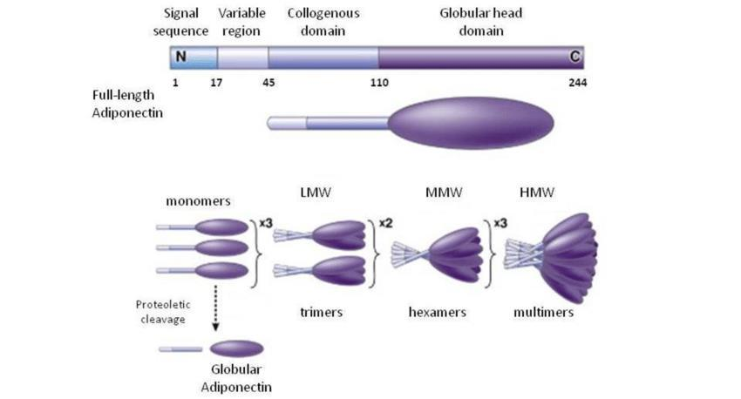

Figure 2.1: Schematic representation of Adiponectin biomarker (Sarhat and Entedhar,

2014)

18

**2.5.1.3 Omentin**

Intestinal lactoferrin receptor or Omentin is a secretory protein with 34 kilo Dalton identified by its binding capacity to the galactofuranose units in the carbohydrate chains of peptidoglycan cell wall. They play a role in innate immunity against bacteria and are articulated primarily by the Paneth cells, visceral adipose stromal-vascular cells and endothelial cells (Krasimira, *et al*., 2018). Omentin is found in the blood stream and stimulates the transportation of insulin mediated glucose in the human adipocytes as well as in initiating AKT signaling. It is coded by two genes omentin 1 and omentin 2 and is expressed more in visceral adipose tissue than subcutaneous adipose tissue (AT). Obesity is correlated adversely with body mass index (BMI), waist circumference, and insulin resistance, and positively with high density lipoprotein (HDL) and plasma adiponectin. Omentin 1 is the predominating form of adipokine circulation with its adipokine tissue gene expression and plasma levels lowered in obesity (Katsareli and Dedoussis, 2014). Although omentin secretion maintenance in the adipose tissue is not fully elucidated, Tan, *et al*., in a study using human omental adipose tissue explants, found that hyperinsulinemiasignificantly lowers omentin levels and release into conditioned media while insulin and glucose reduces omentin production and expression in visceral adipose tissue. Similar results obtained when healthy subjects received prolonged insulin-glucose infusions also showed omentin levels decreased. These results imply that insulin and glucose, either directly or indirectly, control omentin production and thus, omentin possesses the potential to modify insulin sensitivity and glucose metabolism (Halabis, *et al*., 2015).

**2.5.1.4 Apelin**

Apelin, an endogenous peptide, was discovered to be a ligand of the orphan G protein-coupled receptor APJ, hence the name APJ Endogenous Ligand. Apelin was first isolated from the stomach of a bovine. The APJ human gene (APLNR) codes for a transmembrane domain protein that is similar to the angiotensin receptor. In the transmembrane regions, both proteins share 54% identity. Angiotensin II, on the other hand, does not bind to APJ. Apelin is a catalytic angiotensin-converting enzyme-2 (ACE2) substrate in vitro. The apelin receptor contains consensus sites for palmitoylation, glycosylation, and cyclic adenosine monophosphate (cAMP) dependent protein kinase phosphorylation (Wysocka, *et al*., 2018).

**2.5.1.5 Resistin**

Adipocytes and macrophages are the main secretors of the resistin protein which gets its name from its alleviation of insulin resistance. This may be caused, by the increased hepatic glucose production as well as the reduced glucose uptake and effect on glycogen synthesis. Additionally,

19

through stimulating the immune system, it exhibits an inflammatory effect, particularly on myocytes.

**2.5.2** **KEY PROTEINS OF INTEREST**

**2.5.2.1 Leptin**

Leptin a 16 kilo Dalton (kDa) protein located on chromosome 7 of lep gene produces a 167 amino acid peptide and it is an anorexigenic hormone derived from adipose tissue. It regulates lipid metabolism by stimulating lipolysis and inhibiting lipogenesis. Leptin communicates the peripheral metabolic status (energy storage) to the hypothalamic regulatory centers via an absorption transport system across the blood-brain barrier. Leptin inhibits appetite-stimulating neuropeptides while increasing anorexigenic alpha-melanocyte-stimulating hormone, cocaine- and amphetamine-regulated transcript, and corticotropin-releasing hormone. It plays a crucial role in controlling food intake, energy expenditure, and neuroendocrine function. Children with leptin and leptin receptor genetic defects have severe early-onset obesity. In non-insulin dependent diabetes mellitus individuals, leptin gene mutation leads to increased food consumption, elevated insulin, and severe obesity.

Leptin insufficiency, although uncommon in humans, causes severe obesity due to increased food intake, decreased energy expenditure, and the emergence of hyperinsulinemia. In contrast, giving leptin to people or animals with leptin deficiency causes a decrease in unhealthy eating and obesity. High-fat diet leading to leptin resistance, is caused by limitation to the hypothalamus site of action. This drastically reduces peripheral leptin's efficacy to initiate hypothalamic signaling. The primary binding protein for leptin in human circulation, is the soluble leptin receptor which also controls leptin bioavailability. Cancers associated with obesity may also be affected by leptin and the soluble leptin receptor. According to epidemiological research, one of the key mediators of the link between abdominal adiposity and weight increase and colon cancer is the soluble leptin receptor.

**2.5.2.1.1** **Leptin Structure**

The dimensions of leptin, consists an elongated molecule, roughly 20, 25, and 45 A. It is made up of a left-hand twisted helical bundle of four antiparallel a-helices (A, B, C, and D), two long crossover links (AB and CD), and one short loop (BC). A slightly higher compared fold in the four-helix bundle creates a two-layer packing of the antiparallel helix pairs A and D against B and C. Leptin's structure displays a lot of uncovered hydrophobic residues. These residues appear to play a significant role in receptor binding in some cases. Additionally, the hydrophobic nature of

20

the surface increases the molecule's propensity for self-association and aggregation. Selected changes at a few of these residues can result in more soluble molecules that maintain the high potency of the natural hormone while removing any inadequacies. According to the leptin molecule's structure, Glu 100 is located on the molecule's surface with its side chain pointing toward the solvent. As a result, replacing the exposed Trp with Glu at this location appears to lessen inter - molecular hydrophobic interactions and increase the protein's solubility.

21

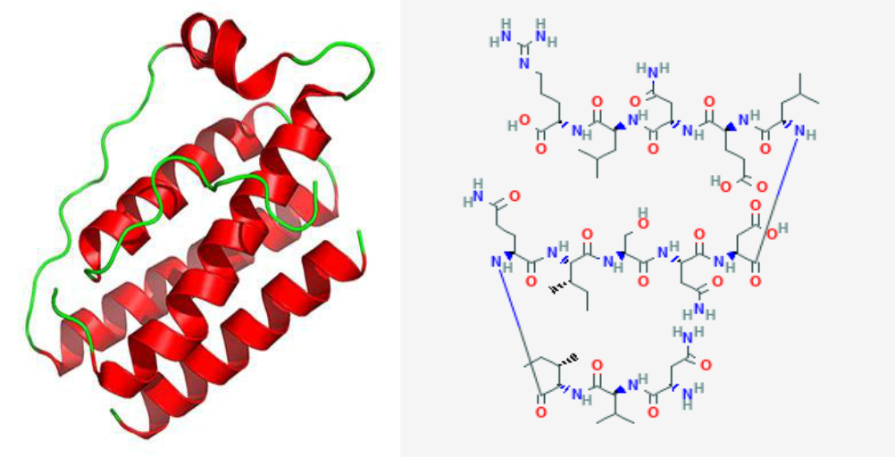

Figure 2.2: 2D and 3D representation showing leptin structure (Zhang, 2005)

22

**2.5.2.2 Ghrelin**

Ghrelin is an orexigenic peptide released primarily by the stomach that acts on hypothalamus neurons with ghrelin receptors to exert central metabolic effects. Serving as the G-protein-coupled growth hormone receptor (GHSR) natural's stimulant in addition to regulating food intake and appetite, ghrelin acts as crucial component in the regulation of growth hormone secretion. Ghrelin stimulates food intake in humans through both peripheral and central pathways including the stomach, the HPAL, and the hypophysis. Ghrelin appears to be a feeding initiator, with peak serum levels prior to food administration and decreasing levels afterwards. Because ghrelin administration increases adiposity, it may have a long-term impact on energy balance its levels rise during fasting and are decreased postprandially, in response to dietary intake. Human obesity is associated with lower postprandial ghrelin suppression, and fasting ghrelin levels and BMI are significantly related. Serum ghrelin levels are lower in obese individuals compared to normal weight individuals and often increase with obesity decrease, showing a negative relationship with high BMIs. Ghrelin stimulates brain regions involved in hedonic and motivational responses to food signals. In the VTA and the NAc of the ventral striatum, dopamine neurons are activated leading to enhanced dopamine turnover (Bhattacharya, *et al*., 2020).

Evidence showing that inhibiting ghrelin receptors in the VTA reduces appetite suggests that, the effects on reward processing in the mesolimbic dopaminergic pathway may be a crucial component of ghrelin's orexigenic action (Zhang, *et al*., 2014).The primary structure and amino acid residues sequence of ghrelin comprises of 28 residues with an octanoyl group attached to Ser-3, making this the focus of structural investigations. The N-terminal tetrapeptide Gly-Ser-Ser (n-octanoyl)-Phe-COOH is the active core needed for the human GHSR's ligand efficacy. Long before ghrelin, its natural ligand GHSR, a seven Trans membrane helix G-protein-coupled receptor, was recognized (Kukol, 2007).

Two polymorphisms in humans have been identified; Arg-51-Gln and Leu-72-Met. Allelic frequencies are equivalent between obese patients and controls for both polymorphisms. Although the polymorphism may impact ghrelin's activities, obese patients with the Met-72 allele developed obesity earlier than those homozygous for the wild-type Leu-72 allele. The Pro-Arg and Pro-Gln substitution at the ghrelin peptide's COOH-terminal processing site within its precursor protein results from the Arg-51-Gln mutation, which impairs the normal cleavage required to synthesize mature ghrelin (Takahiro, *et al*., 2012).

23

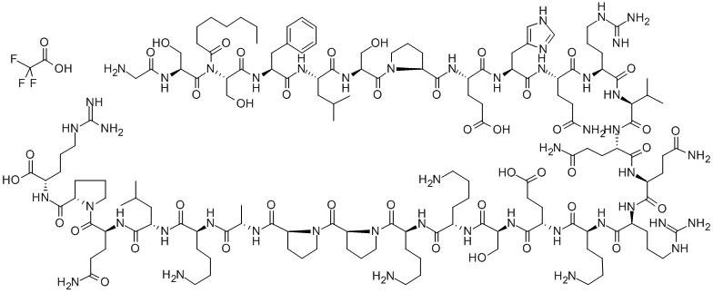

Figure 2.3: Ghrelin sequence structure (Chemicalbooks)

24

**2.5.2.3 Catalase**

These classes of enzymes are designed to catalyze the disproportionate amounts of hydrogen peroxide synthesized in vivo by certain enzymes and oxidases into single oxygen (O2) molecule and water (H2O) molecule. All aerobic organisms include catalases and, in some bacteria, catalase makes up as much as 1% of their dry weight. Large amounts of catalase are also found in erythrocytes, where they are used to neutralize the hydrogen peroxide produced by the autoxidation of oxy-hemoglobin to met-hemoglobin. Eukaryotic catalases are tetramers, with each monomer having a ferrous heme and a coupled NADPH molecule. A catalase can oxidize 2×105mol of hydrogen peroxide at a single process under optimal conditions, making it one of the enzymes with the highest known turnover rates.

Their mechanism of action of catalase parallels that of peroxidases in certain areas. A mole of water is released and a compound I-type intermediate is generated upon binding of a mole of H2O2. The native enzyme is subsequently regenerated after interacting with a second mole of H2O2 to produce a mole of oxygen. A catalases proximal ligand for the heme iron is a tyrosine residue and they do not synthesize intermediate radicals (Everse, 2013).

25

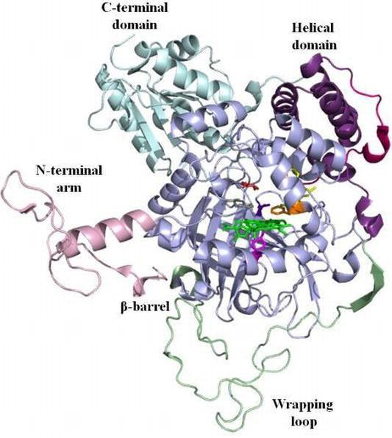

Figure 2.4: 3D structural illustration of catalase protein showing its binding sites (Karakus, 2020)

26

**2.5.2.4 Superoxide Dismutase**

Superoxide dismutase (SOD) are classes of enzymes that promote the defense mechanism of cells against reactive oxygen species (ROS) by catalyzing the oxidative deamination of superoxide radicals (O2) into oxygen molecules (O2) and hydroxyl radicals (H2O2). Individuals possess three superoxide dismutase isoforms including: extracellular superoxide dismutase (SOD3), which is encoded by chromosome 4p15, mitochondrial manganese superoxide dismutase (SOD2), and copper, cytosolic, and zinc superoxide dismutase (Cu, SOD1, and Zn SOD), which are encoded by chromosome 21q22.

The superoxide dismutase-1 (SOD1) genes possess four introns, and five exons, and are transcribed in five distinctive ways. SOD-1 a 153 amino acid protein is universally expressed and highly conserved. It is made up of two identical subunits that fuse together to create a 32 kilo Dalton (kDa) homodimer, and their active sites are positioned in opposition to one another. Significant amount of hydrogen bonds is used to stabilize the protein, which is mostly folded into an eight-strand beta-barrel. Each subunit has a copper and zinc binding site, while cysteine’s57 and 146 form a disulfide bridge that binds it all together (Siddique, *et al*., 2013). Maintenance of oxidation-reduction equilibrium is predominantly carried out by the superoxide dismutases (SODs) which also produce hydrogen peroxide by using the superoxide anion in a dismutation process, which is then further degraded by glutathione peroxidase and catalase into oxygen and water.

Superoxide Dismutase-3 (SOD3) gene overexpression induction, allows several benefits including; defense against diet-induced obesity and associated adverse effects such as fatty liver, and insulin resistance. By reducing the expression of genes linked to inflammation in adipose tissue and elevating the expression of genes for energy expenditure, superoxide dismutase inhibits obesity. Additionally, studies on mice show that gene transfer-mediated overexpression of SOD-3 may have a protective impact against the onset of obesity, as well as obesity-related insulin resistance and fatty liver, and may be a useful strategy for preventing the development of high fat diet (HFD) induced obesity (Ciu, *et al*., 2014).

An active site is positioned between an eight-stranded "Greek Key" beta-barrel and two surface loops in a typical SOD structure. Although 3D tetramer, dimer, or monomer forms of SOD are the most common biological units that exist (Li, *et al*., 1995).

27

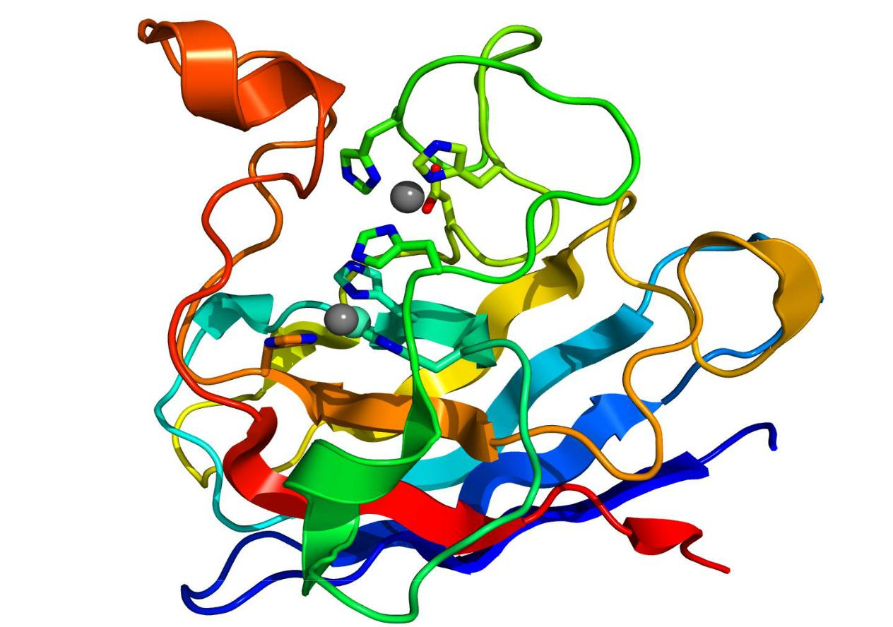

Figure 2.5: 3D structure of Superoxide dismutase protein (Protein Data Bank)

28

**2.5.2.5 Fat mass obesity associated protein**

One of the genes linked to polygenic obesity is theα-ketoglutarate-dependent di-oxygenase also known as Fat mass obesity associated protein and located on chromosome 16, was first identified via genome wide association research studies (GWAS) while primarily being investigated as one of the genes eliminated in the fused toes (Ft) of mouse mutant.

FTO has a carboxy-terminal domain with a unique fold and an amino-terminal AlkB-like domain. These two domains interact with one another, which is necessary for the catalytic activity of the FTO, according to biochemical tests. FTO's structure differs from the other AlkB members' in that it has an additional loop that encloses a fragment of the conserved jelly-roll motif. This loop exclusively competes with the unmethylated strand of the DNA duplex for binding to FTO, according to structural comparison, indicating that it plays a significant part in FTO selection against double-stranded nucleic acids. The two carbonyl oxygen atoms in 3-meT or 3-meU connect with FTO by a hydrogen bond, which allows it to identify these nucleotides from other nucleotides (Han, *et al*., 2010).

The development of adipose tissue, including adipocyte thermogenesis and differentiation, which affects fat storage and determines body size and composition, may be influenced by FTO. FTO has also been shown to affect metabolic rate, energy homeostasis, and enhance food intake. As a nucleic acid demethylase, it removes methyl groups from DNA and RNA. It also encodes for the protein linked to fat accumulation and obesity.

Its significant association with obesity in several independent populations generated extensive interest. Gender wise, an increase in body mass index (BMI) was shown to be correlated with a group of single nucleotide polymorphisms (SNPs) in the first intron of the FTO gene in both children and adults. Since these preliminary reports in 2007, the relationship has been repeatedly validated in other datasets representing various ethnicities. However, the net impact magnitude for carriers of the FTO "risk-allele" is quite minimal.

Furthermore, Genome wide association research studies were successful in locating polymorphisms in the FTO gene that, several ethnic groups strongly correlate with an increase in BMI regardless of age or gender. The totality of the available statistics indicates increased energy intake as the causative agent of the elevation in BMI, most presumably as a result of a predilection for appetizing diets and dysfunctional eating behaviors (Hess and Bruning, 2014).

*Escherichia coli* (AlkB), a bacterial DNA-demethylase, and AlkB homologues 1 and 2 (ABH1 and ABH2) in mammals are linked to fat mass obesity associated protein (FTO). The mechanism

29

underlying substrate specificity was discovered by studying the crystal structure of FTO which comprises a carboxyl-terminal domain and an amino-terminal AlkB-like domain, the interaction of which is required for catalytic activity. Compared to AlkB, Fat mass obesity associated protein has an additional loop structure in the conserved jelly-roll motif that confers selectivity towards un-methylated double-stranded nucleic acids. Recombinant FTO protein permits 3-methylthymine in single-stranded DNA and 3-methyluracil and 6-methyladenosine in single-stranded RNA, which may be the major substrates in the biological situation, to be de-methylated by a mechanism dependent on Fe-(II) and 2-oxoglutarate (Chang, *et al*., 2018).2-Oxoglutarate, also referred to as alpha-ketoglutarate, is a vital Krebs (citric acid) cycle intermediate product and a substrate for FTO. Oxalsuccinate is firstly metabolized to 2-Oxoglutarate, and subsequently converted to succinyl-CoA. However, it seems less plausible that 2-Oxoglutarate is the relationship between FTO and metabolism. For this to occur, the physiological range of 2-OG concentrations would need to be a factor in FTO's enzymatic activity so it can serve as a sensor for 2-Oxoglutarate concentrations. However, it was discovered that the 2-Oxoglutarate Km for fat mass obesity associated protein was 2.88M, more than 10-fold below therapeutic concentrations of 2-OG, which led to the conclusion that fat mass obesity associated protein is unlikely to be a sensor for 2-Oxoglutarate and to undergo physiologically significant 2-Oxoglutarate dependent regulation (Hess and Bruning, 2014).

FTO is a universal expression. However, compared to peripheral tissue, the central nervous system has substantially larger levels of FTO. The paraventricular, dorsomedial, ventromedial, and arcuate nuclei in the hypothalamus, which are involved in feeding, have been reported to have strong expressions within the brain. FTO is also thought to be involved in mRNA splicing since it mainly localizes to the nucleus and partially co-localizes with splicing factors in nuclear speckles.

30

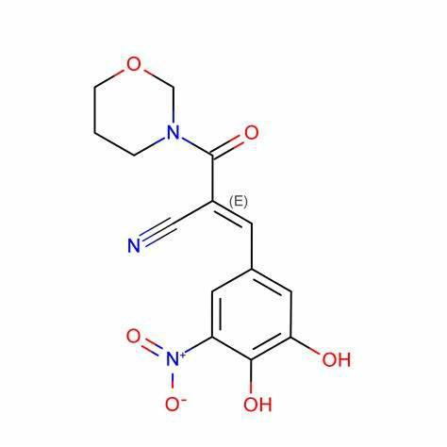

Figure 2.6: Illustration of the FTO protein structure (Protein Data Bank)

31

**2.5.2.6 3-Hydroxy-3-Methylglutaryl-Coenzyme-A (HMG-CoA) Reductase**

Statins, also known as 3-hydroxy-3-methylglutaryl-coenzyme A (HMG-CoA) reductase inhibitors, are among the most often prescribed drugs in the US. In order to effectively treat dyslipidemia, statins act on the rate-limiting step in cholesterol manufacture (the conversion of HMG-CoA to mevalonate). Statins may alter inflammation, nitric oxide generation, the coagulation cascade, and other activities via these pathways because they inhibit other mevalonate pathway downstream products. Statins may have an impact on neurologic conditions such ischemic and hemorrhagic stroke, Parkinson's disease, Alzheimer's disease, and multiple sclerosis thanks to these pleiotropic effects (Willey and Elkind, 2010).The significant protein HMG-CoA reductase of the endoplasmic reticulum comprises a catalytic site, which is housed in the cytosol, and positioned in its C-terminal section. The main enzyme of target for modulating non-sterol isoprenoid derivatives and cholesterol is HMG-CoA reductase. Both short-term and long-term biological processes control HMG-CoA reductase. The pace of gene transcription affects long-term regulation. Low cellular energy levels cause short-term regulation to take place, which involves the phosphorylation and dephosphorylation of HMG-CoA reductase as well as ER-mediated proteolysis. Its activity is decreased by phosphorylation but increased by dephosphorylation.

The rate-limiting stage in cholesterol-genesis is the two-step reduction process that converts HMG-CoA to mevalonate. HMG-CoA reductase converts cytosolic HMG-CoA to mevalonate by reducing it to an intermediate that is enzyme-bound to an aldehyde. High AMP/ATP ratios during energy deprivation induce AMP to allosterically stimulate AMP-kinase, which in turn phosphorylates HMG-CoA reductase to block it. Along with AMP, upstream protein kinases also control AMP-kinase. Dephosphorylation, which is carried out by phosphoprotein phosphatase, transforms inactive phosphorylated HMG-CoA reductase into an active state. The rate-limiting enzyme of the energy-intensive process of fatty acid synthesis, acetyl-CoA carboxylase, is also inhibited by activated AMP-kinase.

HMG-CoA reductase is likewise regulated by cyclic AMP levels. Through the activation of protein Kinase-A, which in turn phosphorylates phosphoprotein phosphatase inhibitor-1, cAMP regulates the body. PPI-1 that is activated prevents the activity of phosphoprotein phosphatase, keeping HMG-CoA reductase dormant. Increased plasma glucagon levels, such as those experienced during fasting, promote cAMP synthesis and inhibit cholesterol biosynthesis. By degradation, HMG-CoA reductase is short-term regulated. When there is an excess of cholesterol, it is decomposed through endoplasmic reticulum-associated proteolysis (Bhagavan and Ha, 2015).

32

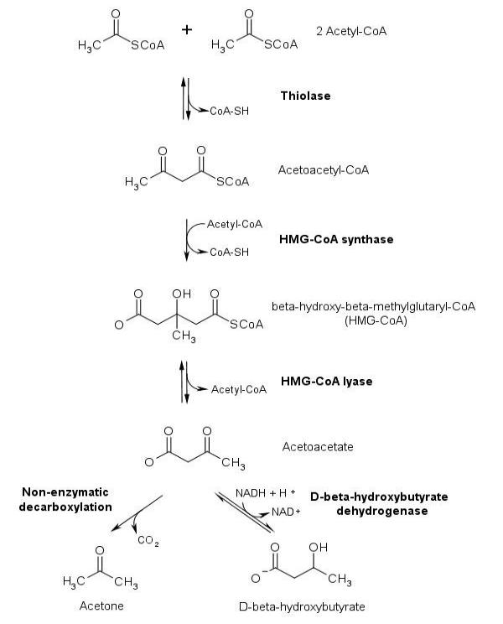

Figure 2.7: Illustrative pathway of HMG-CoA synthesis (Bhagavan and Ha, 2015)

33

**2.6** **KETOGENIC DIET OVERVIEW**

Ketogenic diet is made up of high fat content, low carbohydrate content and sufficient amount of protein content. According to studies, ketogenic diet also known as keto diet was proposed early in the 20th century by Dr. Marie, R. W. of Mayo clinic to reduce the occurrence of epileptic seizures and has since been considered to play a major therapeutic role in epilepsy. In general terms, ketogenic diet was proposed to mimic starvation without fasting. Ketosis, the resulting metabolites of ketogenic diet is induced due to an alteration in the body’s energy fuel from carbohydrate to fat and buildup of ketone bodies in the body results from the incomplete breakdown of fatty acids by the liver. Due to the release of ketone bodies and reduction in glycolytic flux, ketogenic diets are said to have neuroprotective effects. Ketogenic diet, encourages its therapeutic effects on illnesses and diseases both in human and animal models and its ability to ameliorate and subdue the effects and occurrence of certain diseases and illnesses including cancer, type-2 diabetes and epilepsy amongst others, makes it valuable in recent times (Allen, *et al*., 2014). KD consists of a fat to carbohydrate ratio of 5:1.

**2.6.1** **Types of Ketogenic Diet**

Ketogenic diets are of 5 types and, are classified based on carbohydrate restriction and can be distinguished by the comparison of their composition.

**2.6.1.1 Atkins Diet**

Dr. Robert Atkins, developed the Atkins diet to aid with weight management. His book "Dr. Atkins' Diet Revolution" from 1972 was the first to disclose the tenets of the AD. The AD diet severely restricts carbohydrate intake while permitting a moderate protein intake. A four-phase diet plan is the defining aspect of AD: phase 1 is the most restricted, allowing for less than 20 grams of carbs per day; phase 2 sees an increase to 25 to 50 grams per day; and phase 3 allows for 80 grams per day. Phase 4 (the final phase) allows for up to 100 g of carbohydrates per day and is continued until the desired bodyweight is reached. To retain the body weight loose, this phase is continued (Drabinska, *et al*., 2021).Although the ketosis condition is only noticeable during the initial phase, AD gets more relaxed as the person progresses through the stages, allowing for more carbohydrates and a wider variety of food types (Gudzune, *et al*., 2015).

**2.6.1.2 Modified Atkins Diet**

When compared to classical ketogenic diet, Modified Atkins diet was developed at Johns Hopkins Hospital as a less constrictive treatment for epilepsy. When the first phase of Atkins diet is maintained continuously without transitioning to phases that are less stringent, ketosis is

34

preserved. Contrary to Atkins diet, Modified Atkins diet was not intended to manage obesity; as a result, the only limitation is a restricted carbohydrate intake and calorie count; hydration and protein intake is not required. A more palatable diet is produced by having a fat to protein and carbohydrate ratio of roughly 1:1, a daily carbohydrate restriction of less than 20 g, and a free allowance for protein. While sugar alcohols must be incorporated, dietary fiber is not counted when measuring carbohydrates (Miranda, *et al*., 2012). Because Modified Atkins diet is characterized by simple self-administration, hospitalization during the initial period is not required.

**2.6.1.3 Classical Ketogenic Diet**

The most restrictive form of ketogenic diet is the classical ketogenic diet. In this diet, fat, protein, and carbs make up a 4:1 ratio therefore, between 80 and 90 percent of energy comes from fat, and the remaining 10 percent is made up of both the quantity of protein and carbohydrate required daily intake which is determined from the leftover calories. CKD has the highest impact on carbohydrate inhibition. To prevent glucose production from amino acid oxidation, CKD patients must maintain a lowered protein intake. Parenteral and oral formulations for babies and young children that can be adapted for use by adults have been made available. Due to the carbohydrate restriction associated with CKD, many patients find the ingestion to be inadequate. As a result, many CKD improvements have been suggested (Drabińska, *et al*., 2021).

**2.6.1.4 Medium-Chain Triglyceride Ketogenic Diet (MCTKD)**

To encourage better adherence to the diet among epilepsy patients, Huttenlocher introduced a new kind of ketogenic diet in 1971. The fundamental idea behind medium chain triglyceride diet is that medium-chain (C6–C12) triglycerides produce ketone bodies more efficiently than long-chain triglycerides do. Reason being that medium-chain fatty acids including decanoic and octanoic acids, are more effectively absorbed and transported to the liver, where they are processed through -oxidation and produce acetoacetate, acetone, and β-hydroxybutyrate. As the ketogenic potential is increased, MCTKD needs less fat intake than classical ketogenic diet to reach the same level of ketosis, and the proportion of fat to protein and carbohydrate can be decreased.

**2.6.1.5 Low Glycemic Index Treatment (LGIT)**

Low glycemic index ketogenic diet treatment, was developed in 2002 and described in 2005, as the least restrictive variety of ketogenic diet. The daily carbohydrate consumption can range from 40-60 grams however it must only consist of foods with a low glycemic index (GI) less than 50. Food items are categorized according to their glycemic index values, which are based on how

35

quickly carbs are transformed into glucose (Linkner and Humphreys, 2018). Glycemic index, is displayed on a scale of 0-100, where 100 represents pure glucose. During the LGIT regimen, low GI foods like vegetables, seeds, legumes, dairy, and meat are advised to be taken while high GI foods like rice, beer, white bread, and starchy foods must be avoided. Although there is less ketosis during LGIT than in CKD, the therapeutic neurological effects are still present. In this instance, it is proposed that blood glucose levels are more closely related to the neuroprotective effect than ketosis.

**2.6.2 Mechanism of Ketogenic Diet**

After the consumption of ketogenic diet for a minimum of 3-4 days, carbohydrate metabolism is reduced overtime leading to insufficient glycogen reserves for utilization thereby causing the body to undergo several metabolic changes. This metabolic change, results in the activation of ketogenesis in the liver which breaks down fat and makes fatty acids and ketone bodies. Fatty acids are primarily metabolized in the liver into Acetyl-CoA via mitochondrial β-oxidation, which enters the Tricarboxylic acid cycle (TCA). Acetyl-CoA is transferred to ketogenesis when fatty acid levels rise above the Tricarboxylic acid cycle's metabolic threshold. A thiolase enzyme combines two Acetyl-CoA’s to create Acetoacetyl-CoA, which is a precursor for the production of acetoacetate (ACA) and β-hydroxybutyrate (BHB).

The primary ketone body acetone is predominantly created by the spontaneous decarboxylation of acetoacetate and can be removed through the kidneys and lungs as a volatile substrate. Monocarboxylic acid transporters in the blood move acetoacetate and β-hydroxybutyrate from the vascular lumen to the brain interstitial space, where they are then taken up by glia and neurons via monocarboxylic acid transporters (MCTs). The main carrier present in the vascular endothelium is MCT-1. Both acetoacetate and β-hydroxybutyrate are carried directly into the mitochondria of neurons, where they undergo a series of enzymatic reactions to become acetyl-CoA. The β-hydroxybutyrate is transformed into acetoacetate by the enzyme D-hydroxybutyrate dehydrogenase, and acetoacetate is then transformed into acetoacetyl-CoA by the enzyme succinyl-CoA transferase. Acetoacetyl-CoA is finally transformed into two acetyl-CoA subunits by acetoacetyl-CoA-thiolase, which subsequently starts the TCA cycle (Masino and Rho, 2012). Ketolysis is required to use ketone bodies as a source of energy as a result, succinyl CoA: 3-oxoacid-CoA transferase (SCOT) and acetyl CoA acetyl-transferase are used to convert acetoacetate and 3-hydroxybutyrate back to acetyl-CoA.

36

After completing the Krebs cycle, acetyl-CoA is further oxidized, producing 22 molecules of ATP (Weber, *et al*., 2019). Overproduction of ketone bodies can lead to ketoacidosis, a disorder in which the blood pH falls near zero.

37

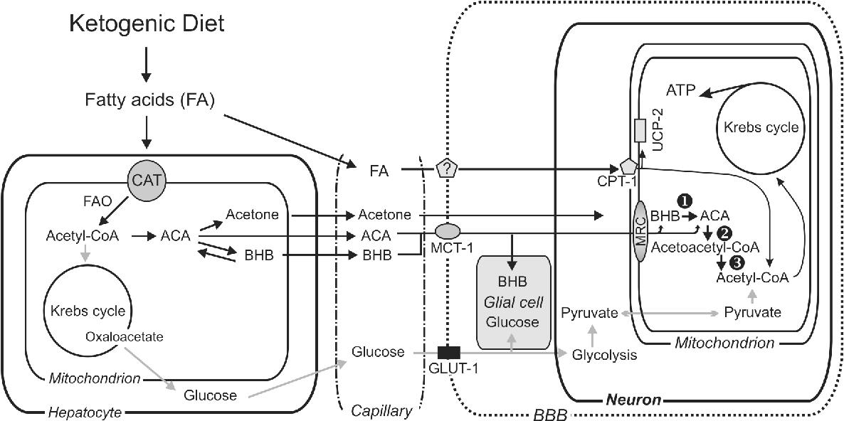

Figure 2.8: Illustrative pathway of the ketogenic diet's mechanism of action (Masino and Rho, 2012)

38

**2.6.3** **Ketone Bodies (Ligands)**

Ketone bodies are soluble complexes produced by the liver in response to decreased glucose availability in the biological system. The useable form of lipid energy derived from ketone bodies makes them capable of penetrating the blood brain barrier and supplying energy to the brain (McPherson, 2016). The percentage of fatty acids synthesized by hormone-sensitive lipase's degradation of adipose tissue triacylglycerol determines the rapid formation of ketone bodies. While glucagon has the opposite effect, insulin stimulates triacylglycerol production and storage while suppressing lipolysis (Bhagavan and Ha, 2011). These ketone bodies, are generated mainly in the hepatocytes by the mitochondria and they include; acetone, acetoacetate and 3-β-hydroxybutyrate. This research work focuses solely on the ketone bodies produced by ketogenic diet metabolism to prevent obesity using in silico study.

**2.6.3.1 Acetone**

Acetone is the most basic of ketones; it is a colorless, flammable liquid with aromatic and pungent smell. It is easily combined with ethanol, ether, methanol, esters, and water due to its polar nature. Acetone is primarily utilized in the industry as a solvent for cellulose acetate, nitrocellulose, and acetylene, as well as a raw material in the production of various organic compounds such as acetic anhydride, mesityl oxide, and methyl isobutyl ketone. It was first obtained through distillation from organic sources and chemical synthesis after which, it was obtained through fermentation with melase and several bacteria, including *Clostridium acetobutylicum*.

Acetone is exhaled during respiration and is synthesized in the human body via lipid metabolism, specifically by decarboxylation of acetoacetate. Acetone enters the air, water, and soil as a result of natural processes, is synthesized during animal and human metabolism, and is produced by anthropogenic activities. This compound is generated during oxidation processes and occurs naturally in plants and trees. The pyroleinous acid produced by dry distillation of wood contains traces of acetone. Acetone is also produced via the thermal decomposition of coal, acetate, formate, and citric acid, as well as by the dry distillation of sugars or gums with lime. Furthermore, it is produced via the dehydrogenation or oxidation of isopropyl alcohol vapor at high temperatures in the presence of catalysts. In the mitochondrial matrix, fatty acids acquired from food or lipolysis, are oxidized to produce acetyl CoA, which is then transformed into acetoacetic acid and β-hydroxybutyric acid. In healthy individuals, the removal of a carboxyl group causes extremely modest levels of acetoacetate to transform into acetone. High levels of acetone in the human body are induced by several variables including pregnancy, nursing, physical activity, dieting, famine, and alcohol use, affect acetone levels.

39

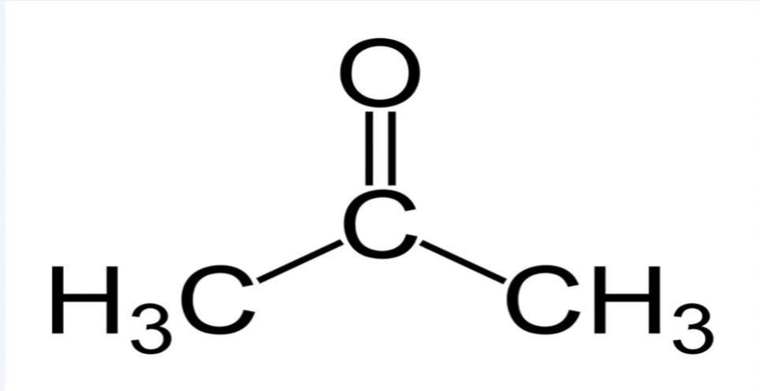

Figure 2.9: Structural representation of acetone (World of Chemicals).

40

**2.6.3.2 Acetoacetate**

The primary ketone body is acetoacetate, which is produced, metabolized, and synthesized into precursor ketone bodies during intermediate metabolism. Since acetone is responsible for the fruity, sweet odor of fetal ketoacidosis, it is significant from a therapeutic perspective. Acetone is created when acetoacetate spontaneously decarboxylates. β-Hydroxybutyric acid is generated by acetoacetate reduction. Although classified as a ketone body, biochemically it is considered an impure ketone body as the ketonic moiety has been converted to a hydroxyl group. Since β-hydroxybutyrate is biochemically quite stable, it is delivered to the tissues where it is changed back into acetoacetate by D-hydroxybutyrate dehydrogenase.

41

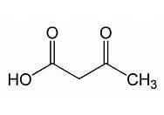

Figure 2.10: Structural illustration of acetoacetate (Drug bank).

42

**2.6.3.3 3-β-hydroxybutyrate**

D-β-hydroxybutyrate is the last metabolite derived from the oxidation of ketogenic diet. They are produced primarily in the liver and can be found in the peripheral blood and urine at increased levels. Since 3-OHB is present in acetoacetate at concentrations similar to or higher than acetoacetate, it is identified as the primary "ketone body." Under short-term fasting settings, the median plasma concentration of 3-OHB in humans reaches about 3mM, up to 6mM during prolonged starvation, and typically at least 2mM under a ketogenic diet. Monocarboxylic acid transporters (MCT) are involved in the entry of 3-OHB into cells. The transport of lactate and ketone bodies across the cell membrane is facilitated by the isoforms MCT1, MCT2, and MCT4 (Bartmann, *et al*., 2018). The condensation of acetyl-CoA and acetoacetyl-CoA into HMG-CoA by mitochondrial HMGCS2 is the rate-limiting step of ketone body production. Two nutrient-responsive mechanisms control the transcription of HMGCS2, which in turn controls the ketone body synthesis. In the first, transcription is activated by the fork-head box transcription factor FOXA2, which binds to the Hmgcs2 promoter.

Dueling hormonal signals control FOXA2, with glucagon activating it via p300 acetylation and insulin signaling inactivating it through phosphorylation and nuclear export. A second nutrient-responsive enzyme, SIRT1, in collaboration with class I or II HDACs, regulates FOXA2 de-acetylation. Peroxisome proliferator-activated receptor a (PPARa), fibroblast growth factor-21(FGF-21), and mammalian target of rapamycin complex-1 (mTORC-1) form the second pathway of Hmgcs2transcriptional regulation. Apparently the two G-protein-coupled-receptors (GPCRs) that bind short-chain fatty acids are ligands for β-OHB. Recently, it was demonstrated that β-OHB can bind to and activate the Gi/o-coupled GPCR known as Hydroxycarboxylic acid receptor-2 (HCAR2), which was initially discovered to be a nicotinic acid receptor. As a possible feedback mechanism to control the availability of the fatty acid precursors for ketone body metabolism, HCAR2 activation by β-β-OHB decreases lipolysis in adipocytes. Additionally, β-OHB binds to and inhibits the free fatty acid receptor-3 (FFAR3), a Gi/o protein-coupled receptor found in sympathetic ganglions, which lowers sympathetic activity and, as a result, the metabolic rate in mice overall. As a result, through affecting HCAR2 and FFAR3, β-OHB lowers lipolysis, sympathetic tone, and slow metabolic rate. These receptors are a component of a large family of GPCRs that play crucial roles in metabolism and metabolic illness with most of them containing ligands that are fatty acids (Newman and Verdin, 2014).

43

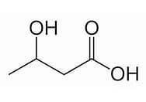

Figure 2.11: Structural illustration of β-hydroxybutyrate (PubChem)

44

**2.7 KETOGENIC DIET AND OBESITY**

According to studies, minimal carbohydrate amounts to increased fatty carbohydrate results in reduction of weight in obesity, glycemic level maintenance and parameters found in T2DM metabolism. However, most recent research on the hypothalamic neurons found in glucose sensing demonstrates that the ketone β-OHB effectively inhibits the glucose-sensing effects, particularly on the orexigenic neuropeptide during regulation of Agouti related-protein. Therefore, KD reduces risk of elevated body weight and diabetes via the many mechanisms described above.

**2.7.1** **Ketogenic Diet Mechanism in Obesity**

As the sugar levels in the blood, decrease below normal standards due to decreased glucose metabolism, ketogenic diet being taken alleviates the blood ketone levels and lower blood sugar to prevent diabetes complications after which hunger, and fats and lipids are induced to degrade ketones in the body thereby leading to ketosis. MCTs (Mid chain triglycerides) of ketogenic diet involved in ketone body synthesis as a result of their metabolic activity rate and ketone levels are degraded by lipase enzymes to medium chain TAs and transported to the mitochondria and liver where absorption takes place.

β-Oxidation and non-metabolized fat synthesis takes place rapidly hence circulating the ketone bodies into the body system. Through an upsurge in intakes of enzyme-associated acetyl-CoA, NAD+, and citric acid cycle products, adenosine triphosphate (ATP) the main energy source is produced. Oxidation of acetyl-CoA into the precursor ketone bodies (acetone, acetoacetate, and β-hydroxybutyrate) by the hydroxybutyrates and hydroxymethyl-glutaryl lyases obtained through the Krebs cycle and subsequently into the extra-hepatic tissues and blood brain barrier via the monocarboxylic transporters. Blood ketone output levels are then increased by ketogenic diet metabolism by 0.2-5mM.

When compared to glucose, ketone body cells degrade NADH to NAD+ for energy production, hence releasing freer NAD+ molecules needed for use in metabolic therapy, cell health, and other processes. Increased citrate synthase, catalase, and mitochondrial biogenesis, lowered ROS, delayed mitochondrial myopathy, and modulated Cytochrome C oxidase activities are all part of the basic mechanism of ketogenic diet. Additionally, ketogenic diet increases mitochondrial GSH and the antioxidant lipoic acid, protecting against improper DNA methylation and subsequent DNA damage. All this subsequently leads to weight reduction or inhibition of obesity in individuals (Kumar, *et al*., 2020).

45

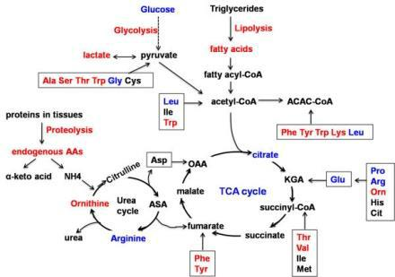

Figure 2.12: Illustrative pathway ketogenic diet mechanism from glucose inhibition to ketone body activation, metabolism, treatment, and elimination process (researchgate.net)

46

**2.8** **STANDARD DRUG COMPARATIVE**

The recommendations made by the various governmental organizations engaged in the approval of novel medicinal agents serve as a roadmap for the therapeutic applications of anti-obesity medications. As a result, several therapeutic drug models such as liraglutide, topiramate, bupropion and several others for obesity control and prevention have been brought up.

According to their method of action, anti-obesity medications can be divided into three main groups, which are as follows; Drugs that inhibit the absorption of intestinal fats, Drugs that suppress appetite including those that alter the release of neurotransmitters or interact with their receptors in the central nervous system to do so, as well as Drugs that boost thermogenesis and energy expenditure (Li, *et al*., 2013). This research focuses on orlistat and cetilistat as the standard drug used in comparison to ketogenic diet mechanism of action on obesity protein and ligand mediators.

**2.8.1 Orlistat**

Orlistat also known chemically as tetrahydrolipstain or Xenical is a drug target therapy for obesity control approved for use by the food and drug administration (FDA) and the European medicines agency (EMA). As a pancreatic and gastric lipase active site inhibitor, orlistat prevents the breakdown of triglycerides (triacylglycerol) in the gastrointestinal lumen. On the active site, it forms a covalent bond with serine residues. Due to the fact that triacylglycerol hydrolysis is a requirement for intestinal fat absorption, lipase inhibition reduces fat absorption and, thus, the body's ability to absorb fat. This explains the extensive use of orlistat in the management of obesity. Orlistat is also found to have high level specificity in lipase but does not inhibit amylase, trypsin, and chymotrypsin expressively (Furman, 2017). Patients with a body mass index of 30kg/m2 or lower who also have additional risk factors such as hypertension, diabetes, and hyperlipidemia are recommended orlistat.

Orlistat users who are obese decrease an estimated 2.9–3.4 kg weight over the course of a year, but they also frequently experience gastrointestinal side effects, impaired absorption of fat-soluble vitamins, and diarrhea. Patients who have lost at least 2.5 kg via dietary restriction and increased physical activity in the month before are advised to take orlistat for the treatment of obesity (Apovian, *et al*., 2015). It is used in conjunction with counseling, support, and recommendations for nutrition, exercise, and behavioral techniques. The average course of treatment lasts no longer than 12 months and never longer than 24 months. Individual countries have specific requirements for using it. When combined with a suitable hypocaloric diet, weight loss after a year is on the order of 8–10% on average. Reduced blood pressure (diastolic, 1.07 mmHg; systolic, 1.15 mmHg)

47

and circulating lipids (total cholesterol, 0.30 mmol/l; low-density lipoprotein (LDL) cholesterol, 0.27 mmol/l; triglycerides, 0.09 mmol/l) constitute the additional metabolic advantages of orlistat use (William, *et al*., 2020).

The fundamental incompatibilities of orlistat include cholestasis, pregnancy, and breastfeeding. The extremely prevalent effects of orlistat on the digestive system include; intestinal gas (flatus), oily spotting, bowel movements, and diarrhea.

**2.8.1.1 Pharmacokinetics of Orlistat**

Amylase, trypsin, and chymotrypsin are not significantly inhibited by orlistat at therapeutic concentrations, demonstrating a 1000-fold preference for lipase (IC500.2mM) in comparison to these other enzymes. After a single administration 1% of the dose, 800 mg, less than 5ng mL1 (0.01mM) of an oral dose is absorbed into the biological system. Clinical trials have revealed extremely minimal systemic exposure to unmodified orlistat (the recommended dose is 120 mg with each big meal). The majority (85%) of orlistat absorbed is eliminated in the feces as an integral drug, although some metabolism does occur, likely primarily in the intestinal wall, leading to two metabolites in which the four-membered lactone ring is degraded.

48

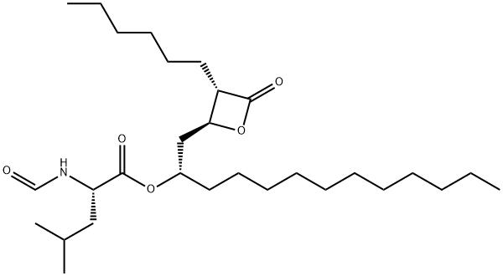

Figure 2.13: illustration of orlistat chemical structure (ChemicalBooks).

49

**2.8.2** **Cetilistat**

Another pancreatic lipase inhibitor in phase III clinical studies is cetilistat (also known as ATL-962).The Japanese Ministry of Health, Labor, and Welfare approved cetilistat in September 2013 for the treatment of obesity in patients with dyslipidemia, type-2 diabetes mellitus (T2DM) and a body mass index (BMI) of 25 kg/m2 despite receiving dietary counseling and/or exercise therapy. According to the World Health Organization, 4.5% of adults in Japan and 12% of persons aged 20 or over were obese as at 2008.Cetilistat appears to be tolerable than orlistat, and its adverse effects are minimal to moderate (Bronson, *et al*., 2014).

**2.8.2.2 Pharmacokinetics of Cetilistat**

Cetilistat inhibits pancreatic lipases in the intestines thereby preventing fat absorption and minimizing calorie absorption from diets. Cetilistat is made by condensing a hexadecylcarbonochloridate with 2-amino-5-methylbenzoic acid; various analogs were made by altering the proportions of the carbonochloridate and 2-aminobenzoic acid. However, the patent for cetilistat also outlines the synthesis of compounds with various aryl substituents and lipophilic tails. IC50 values of 15 and 136 nM for human and rat pancreatic lipases respectively are strongly inhibited by cetilistat as well as trypsin and chymotrypsin enzymes which are minimally affected by it. To validate the efficacy of cetilistat in individuals, more research is required (Fu, 2016; Bronson, *et al*., 2014).

50

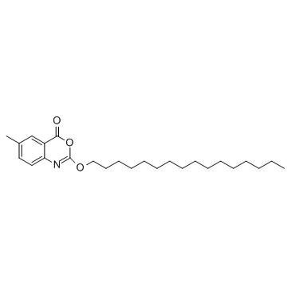

Figure 2.14: Structural illustration of cetilistat (AbMole.com)

51

**2.9** **IN SILICO BIOCHEMICAL STUDY SYNOPSIS**

Analogue computer, was first proposed in 1961 to determine the pharmacokinetics of substances and subsequently the inception of general-purpose digital computers in the 1970s, has made modelling and simulation widely used in the economic sector. Pharmacokinetic models, were created after data from these substances were collected and analyzed. This made the use of pharmacokinetics to be established in the mid-seventies (Pappalardo, *et al*., 2018). In this experimental design, the body is treated as a black box and methodological equations used for modelling the pharmacokinetic substances are used because they are found suitable for the experiment to be carried out. In due course of time, pharmacodynamics models began to evolve with significant chemical reactions and systematic knowledge in the mechanism of drug action (Francesco, *et al*., 2018).

In 1990, Beal and Sheiner refurbished pharmacokinetic approaches by applying computational and pharmaco-statistical methods to enhance drug development and distinguish dosage treatments in and post marketing settings. This led to them proposing the NONMEM software for non-linear mixed effects for pharmacokinetic modelling and pharmacodynamics data thereby initiating the inclusion of physiological knowledge in pharmacokinetic models. Case studies including feotal growth knowledge were used to research pharmacokinetics in pregnancy, biological knowledge on the effects of buoyancy on the human body was used to model drug disposition in space, and the permeability of tissue to tetrachloroethylene was included in toxicological model of lactation transfer.

In the early 2000s, two paradigms of in silico study being systems biology and the mechanistic modeling of human physiology also known as cheminformatics or bioinformatics were discovered by the research community. The term refers to computer simulation via translational modelling of diagnosis, treatment and prevention of illnesses or diseases using statistical method of analysis. It provides system level of the understanding of mechanism of disease action, treatment and prevention using peptides, ligands and biomarkers involved in the pathophysiology of these diseases (Sturla, *et al*., 2014).

Overtime, further advancements were made which led to the wide use of in silico study asides in-vitro and in-vivo for research purposes and data analysis in various economic sectors.

**2.9.1** **In Silico Study Mechanism for Protein Structure Determination**

In last decade, in silico studies including quantitative structure-activity relationship, pharmacophores, homology models, databases, and various molecular modelling approaches were developed and have been applied to drug testing and theory development which can be used for

52

virtual affinity and profiling, virtual ligand screening, delivering enrichment in identifying active molecules for the target of interest when linked with random selection or other approaches (Sacan, *et al*., 2012). Target protein or ligand needed for in silico study is first identified from the protein data bank (PDB).

In the absence of target protein in the Data bank, homology modeling is used to create a computational model of the protein's structure. The highest resolution and quality structures can be employed for later computational drug design and targeting studies if there are numerous structures that are available in the data bank. If the structures have any missing areas, these can be modeled in utilizing abinitio methods or grafted onto homologous proteins using structural alignment methods. Due to possible errors from the protein data bank, several validation and optimization technologies, including x-ray crystallography, are made available to evaluate and resolve potential defects (Sacan, *et al*., 2012).Then, using a typical protein-protein docking software platform, all-to-all docking was carried out among target protein structures and based on structural homology between the projected docking forms, the highest rated were aggregated. To determine the biological significance of protein-ligand interactions, the characteristics of produced groupings were examined.

By employing cumulative protein structure data for circuit analysis, the suggested approach to computational PPI discovery provides a viable methodology for mediating between structural investigations and systems biology (Matsuzaki, *et al*., 2009).

53

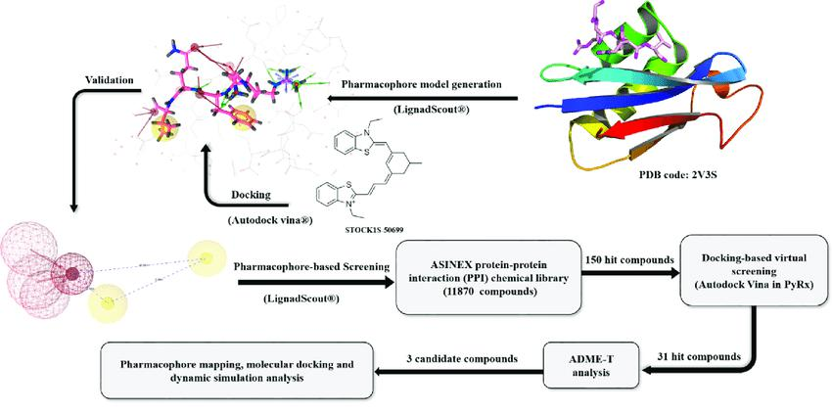

Figure 2.15: A graphic illustration of the in-silico method used to identify target compounds involved in experimental research or design (Alamri, 2020)

54

**CHAPTER THREE**

**METHODOLOGY**

**3.1 SOFTWARE AND WEBSERVERS USED**

The data retrieval and computation of the entire work design utilized Discovery Studio (DS) version 21.1, OpenBabel, Python enhanced molecular graphics tool1.3 (PyMol 1.3), PyRx, Chimera, PubChem, Protein data bank, Swiss Model, and Universal protein resource (Uniprot).

**3.2 SEQUENCE RETRIEVAL, PREPARATION AND MODELLING OF THE THREE-DIMENSIONAL STRUCTURE OF THE TARGET PROTEINS**

The X-ray crystallographic structures of the human target proteins were downloaded from Research Collaboratory for Structural Bioinformatics protein Data Bank (RCSBPDB) ([www.pdb.org](http://www.pdb.org/)), and prepared for molecular docking simulation using DS v. 21.1., and Chimera software. The proteins target not readily available on RCSB protein Data Bank, were developed via homology modelling using the Swiss model webserver and further prepared for docking analysis.

**3.3 MOLECULAR DOCKING SIMULATION**

Docking analysis was performed according to Sharma *et al*., (2019) protocol. The active binding sites of the protein targets were mapped out using the native ligand (NL) interaction and the models without native ligands were determined using Computed Atlas of Surface Topography of proteins (CASTP) webserver. Molecular docking was performed by using AutoDockVina software (Trott and Olson, 1995) in PyRx platform (GUI version 0.8).

**3.4 2D/3D MOLECULAR INTERACTION POST DOCKING**

Determination of the structural interactions of the protein-ligand complex result was performed

using Discovery Studio (DS) version 21.1 software.

55

Table 3.1: Ligands and Proteins used during in silico study experimental design.

|  |  |
| --- | --- |
| LIGANDS | Acetone, Acetoacetate, Beta-hydroxybutyrate |
|  |  |
| STANDARD DRUGS | Cetilistat, Orlistat |
|  |  |
| PROTEINS | Leptin, Ghrelin, Fat mass and obesity- |
|  | associated (FTO) protein (PDB id: 3LFM), |
|  | HMG-CoA reductase, Catalase, Superoxide |
|  | dismutase |
|  |  |

56

**CHAPTER FOUR**

**RESULTS**

Table 4.1: Molecular docking analysis of 6 proteins target with 2 standard drugs and 3 ligands



|  |  |  |  |  |
| --- | --- | --- | --- | --- |
| **SN Proteins/Ligands Orlistat** | **Cetilistat** | **Beta-** | **Acetone** | **Acetoacetate NL** |
| **(SD)** | **(SD)** | **hydroxybutyrate** | **180** | **6971017** |
| **3034010** | **9952916** | **complex 3541112** |  |  |

|  |  |  |  |  |  |  |  |  |
| --- | --- | --- | --- | --- | --- | --- | --- | --- |
| **1** | **Leptin (1AX8)** | | -4.7 | -5 | - 3.7 | -2.5 | - 3.3 | * |
| **2** | **Ghrelin (7W2Z)** | | -5.2 | -6.3 | -3.1 | -2.3 | -3 | -7.7 |
| **3** | **Catalase (IDGB)** | | -6.8 | -6.9 | -4.7 | -3.1 | -4.6 | -8.4 |
| **4** | **Superoxide** |  | -5 | -5.7 | -3.7 | -2.5 | -3.6 | * |
|  | **Dismutase** |  |  |  |  |  |  |  |
|  | **(MODELLED)** | |  |  |  |  |  |  |
| **5** | **Fat Mass** | **and** | 1 | 0.3 | -4.7 | -3.2 | -4.5 | -5.5 |
|  | **Obesity-** |  |  |  |  |  |  |  |
|  | **Associated** |  |  |  |  |  |  |  |
|  | **(3LFM)** |  |  |  |  |  |  |  |
| **6** | ***3-hydroxy-3-*** |  | -4.7 | -4.7 | -3.4 | -2.5 | -3.4 | -6 |
|  | ***methylglutaryl-*** | |  |  |  |  |  |  |
|  | ***coenzyme*** | ***A*** |  |  |  |  |  |  |
|  | ***(HMG-CoA)*** |  |  |  |  |  |  |  |

***reductase (1T02)***



1 native ligand

57

**4.1 MOLECULAR DOCKING OF PROTEIN-LIGAND COMPLEX**

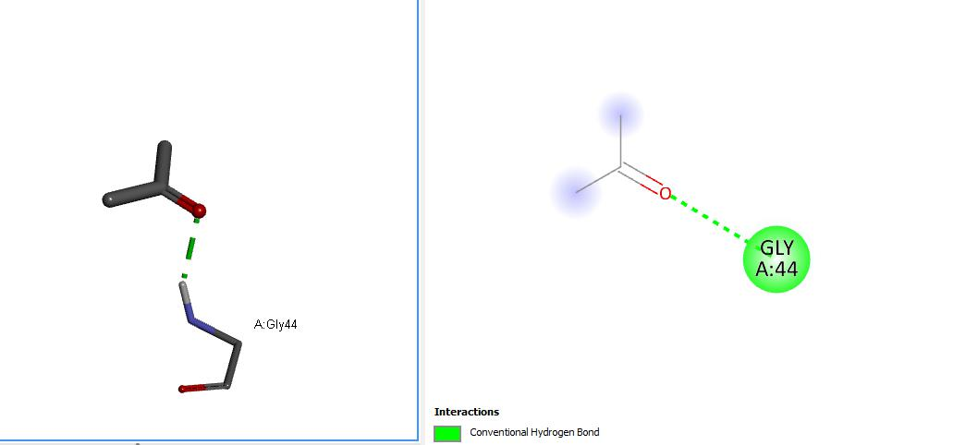

Figure 4.1: 2D and 3D molecular docking complexes of leptin and acetone

58

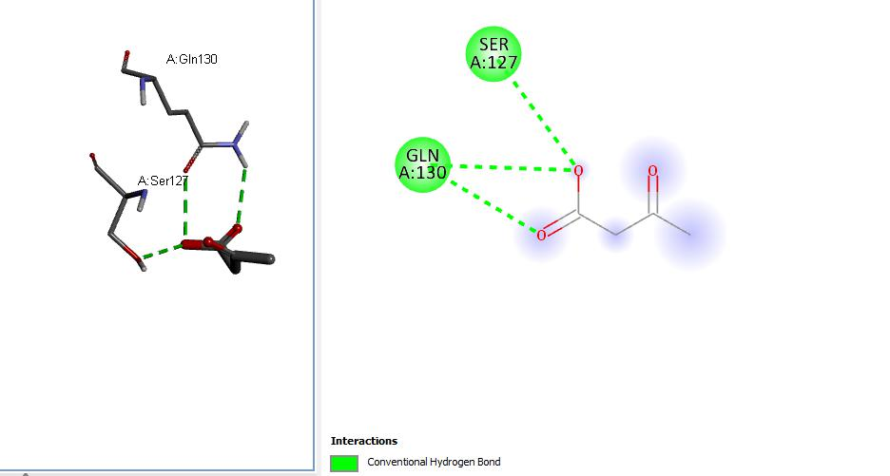

Figure 4.2: 2D and 3D molecular docking complexes of leptin and Acetoacetate

59

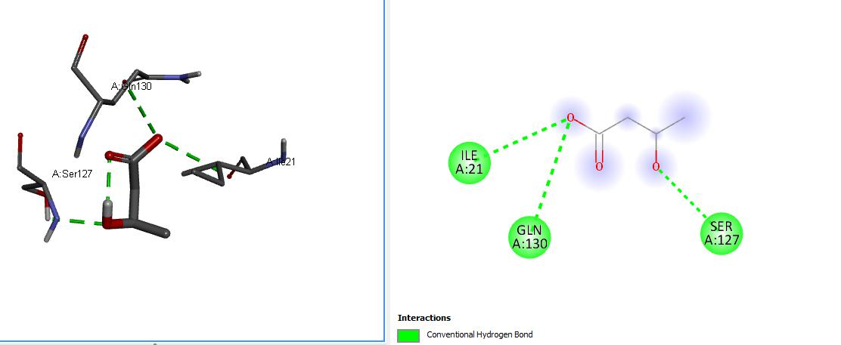

Figure 4.3: 2D and 3D molecular docking complexes of leptin and beta-hydroxybutyrate

60

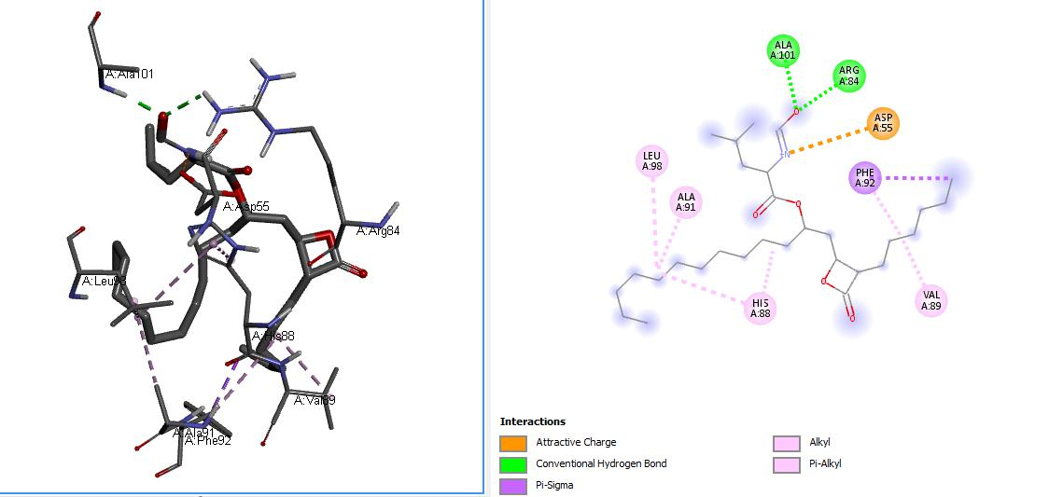

Figure 4.4: 2D and 3D molecular docking complexes of leptin and Orlistat

61

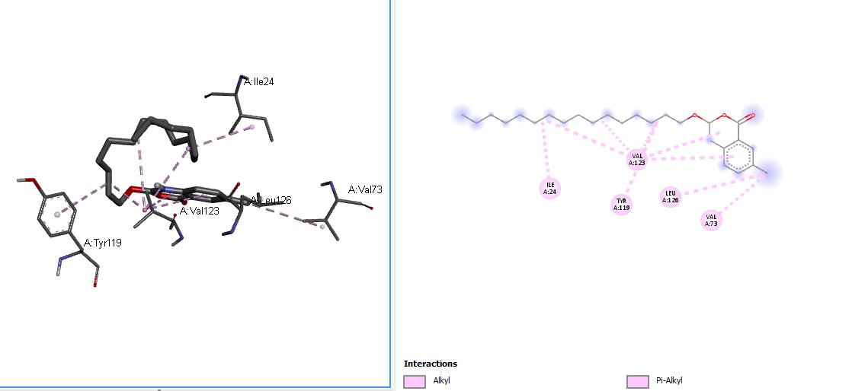

Figure 4.5: 2D and 3D molecular docking complexes of leptin and Cetilistat

62

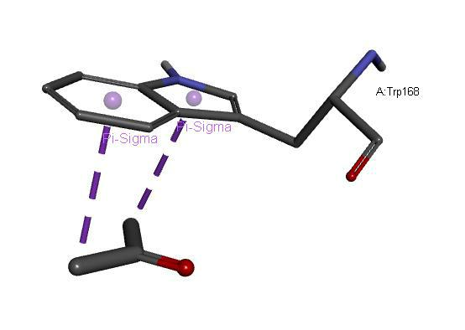

Figure 4.6: 3D molecular docking complexes of ghrelin and Acetone

63

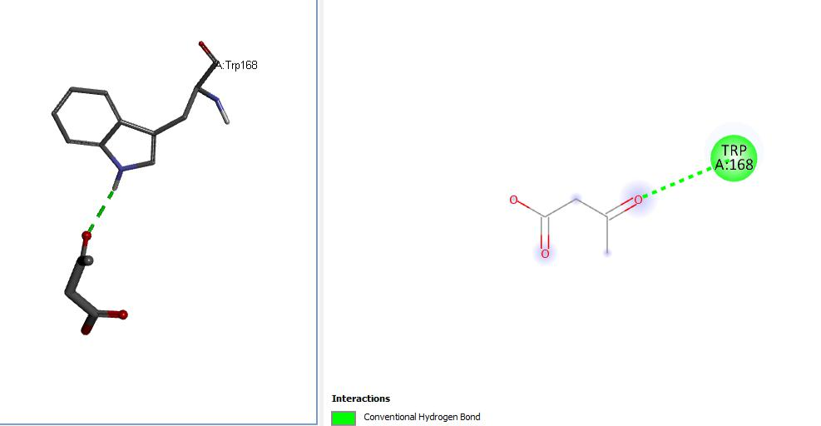

Figure 4.7: 2D and 3D molecular docking complexes of ghrelin and Acetoacetate

64

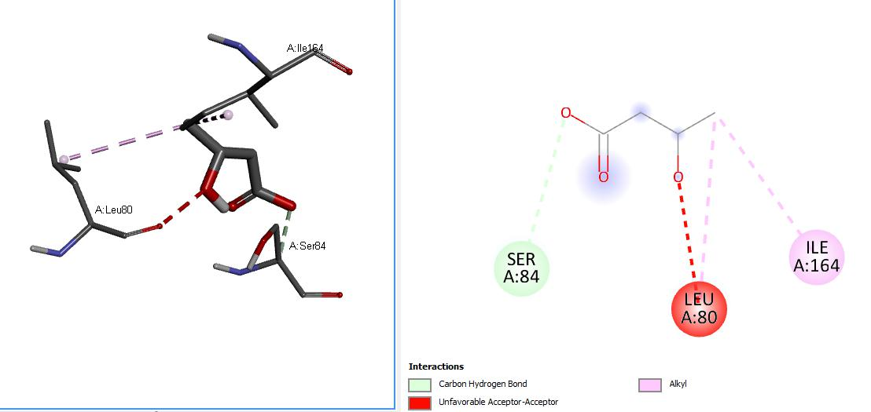

Figure 4.8: 2D and 3D molecular docking complexes of ghrelin and beta-hydroxybutyrate

65

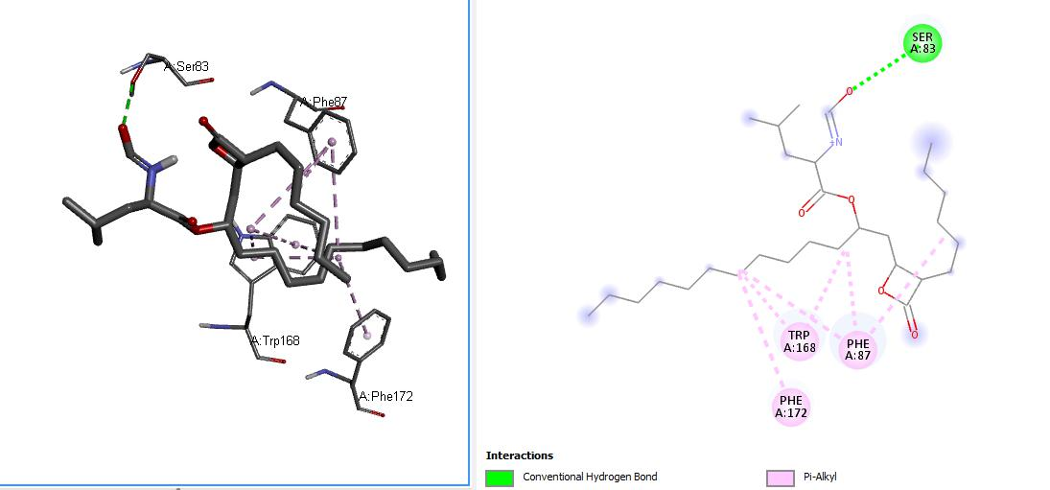

Figure 4.9: 2D and 3D molecular docking complexes of ghrelin and Orlistat

66

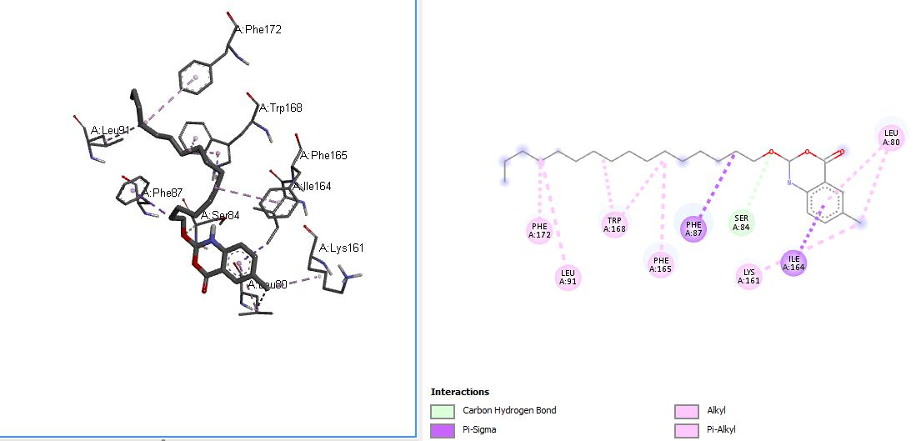

Figure 4.10: 2D and 3D molecular docking complexes of ghrelin and Cetilistat

67

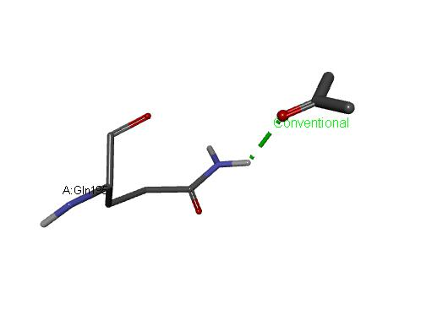

Figure 4.11: 3D molecular docking complexes of catalase and Acetone

68

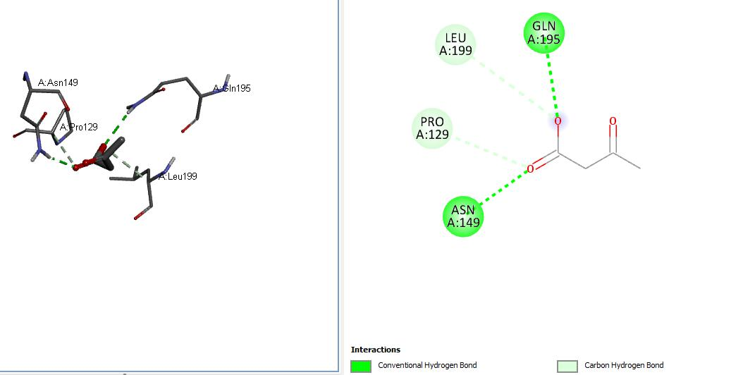

Figure 4.12: 2D and 3D molecular docking complexes of catalase and Acetoacetate

69

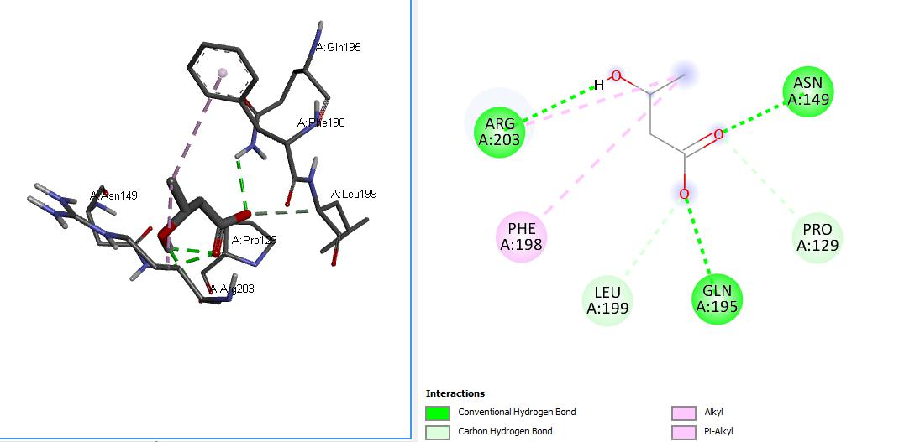

Figure 4.13: 2D and 3D molecular docking complexes of catalase and beta-hydroxybutyrate

70

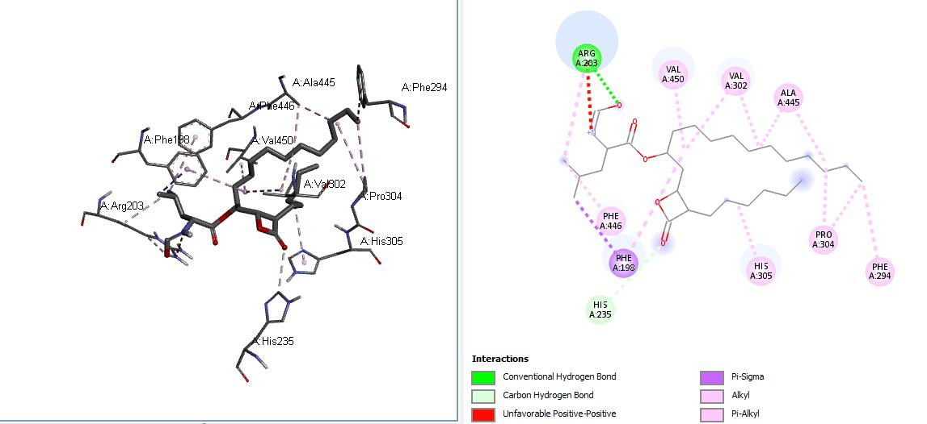

Figure 4.14: 2D and 3D molecular docking complexes of catalase and Orlistat

71

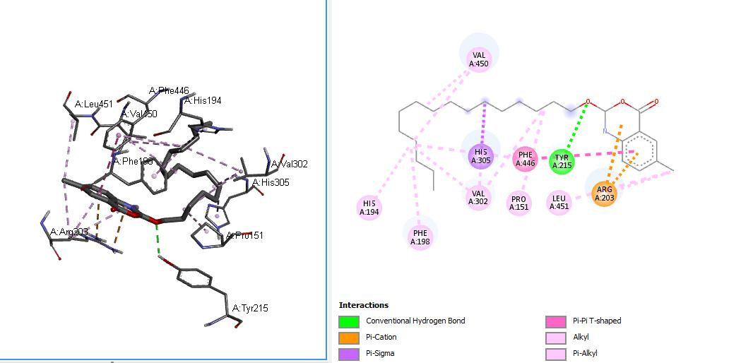

Figure 4.15: 2D and 3D molecular docking complexes of catalase and Cetilistat

72

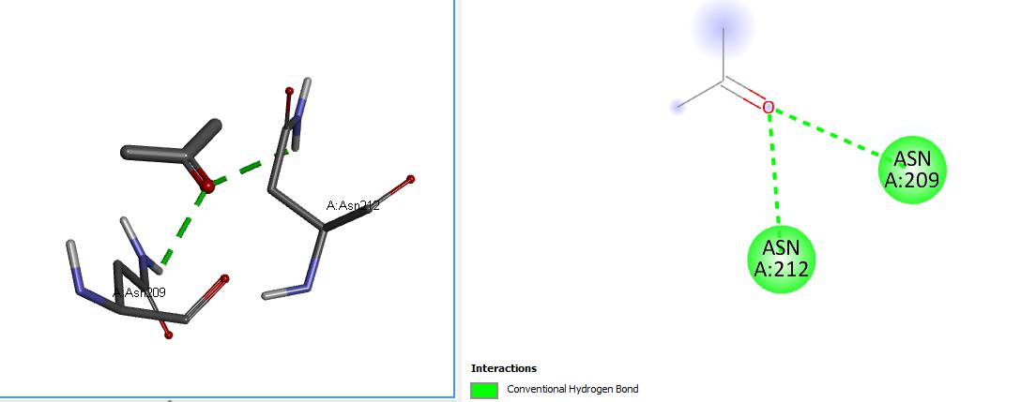

Figure 4.16: 2D and 3D molecular docking complexes of Superoxide dismutase and Acetone

73

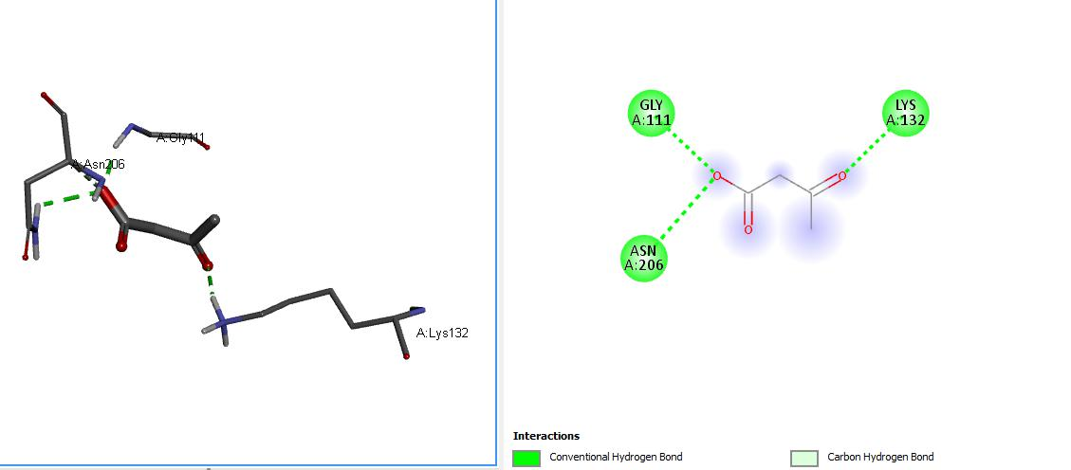

Figure 4.17: 2D and 3D molecular docking complexes of Superoxide dismutase and Acetoacetate

74

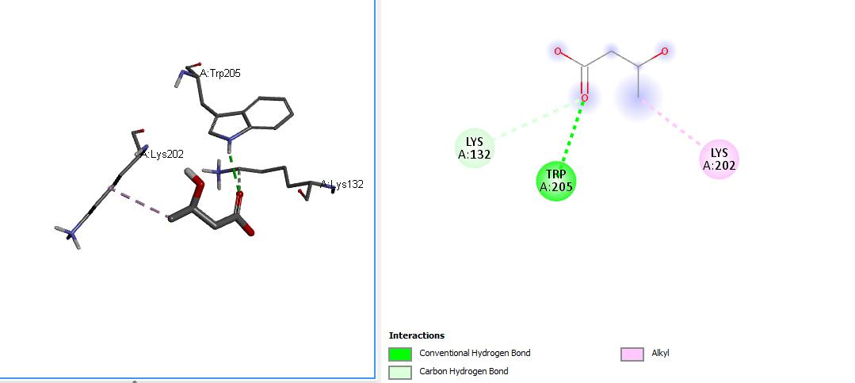

Figure 4.18: 2D and 3D molecular docking complexes of Superoxide dismutase and beta-hydroxybutyrate

75

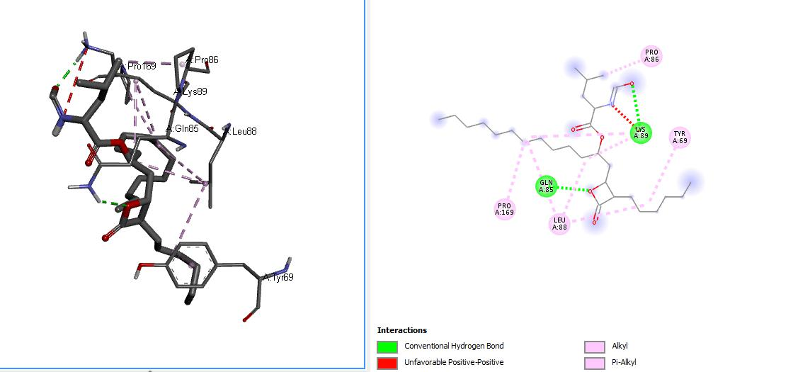

Figure 4.19: 2D and 3D molecular docking complexes of Superoxide dismutase and orlistat

76

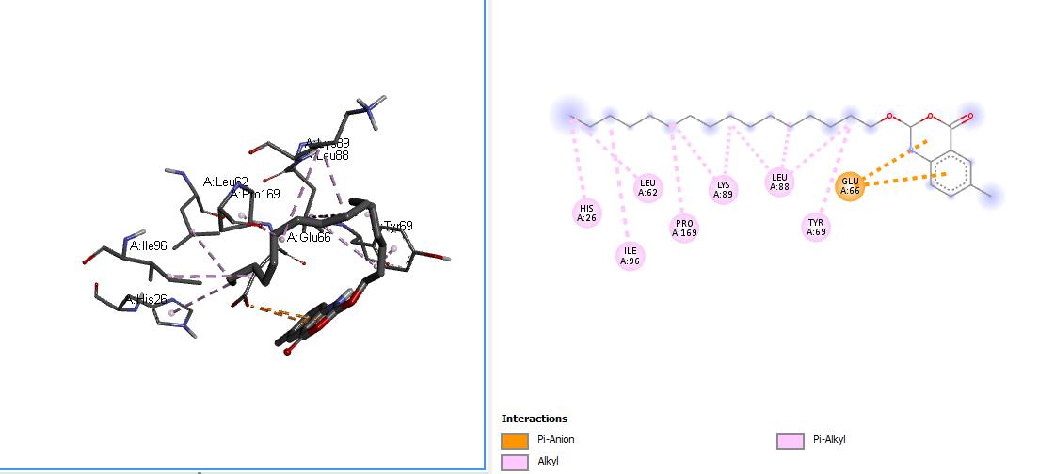

Figure 4.20: 2D and 3D molecular docking complexes of Superoxide dismutase and Cetilistat

77

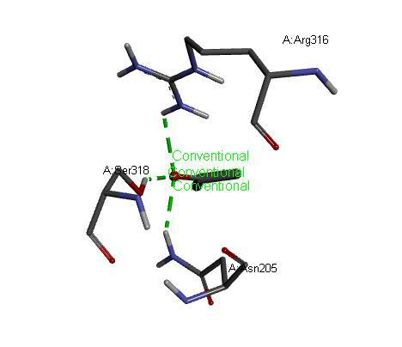

Figure 4.21: 3D molecular docking complexes of Fat mass obesity associated gene and Acetone

78

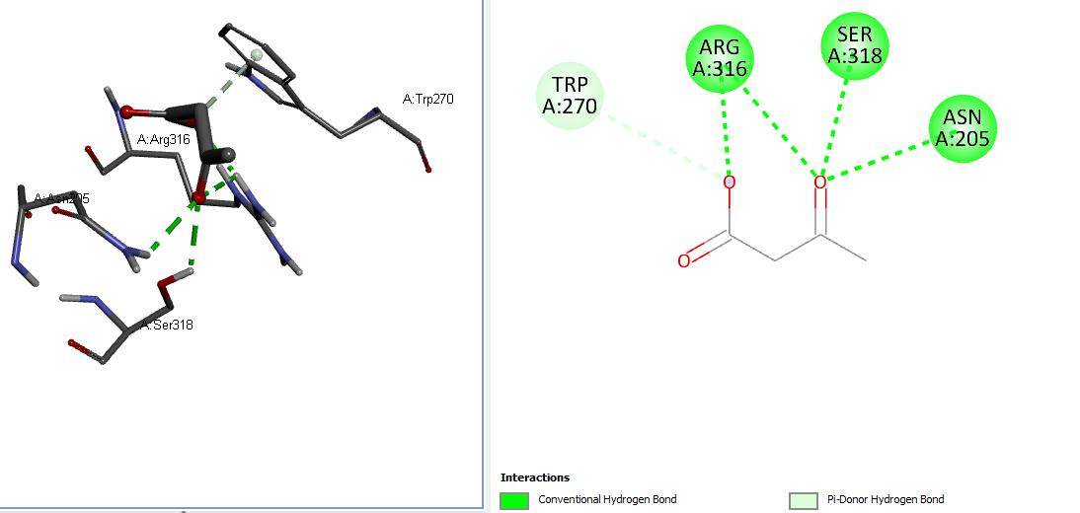

Figure 4.22: 2D and 3D molecular docking complexes of Fat mass obesity associated gene and Acetoacetate

79

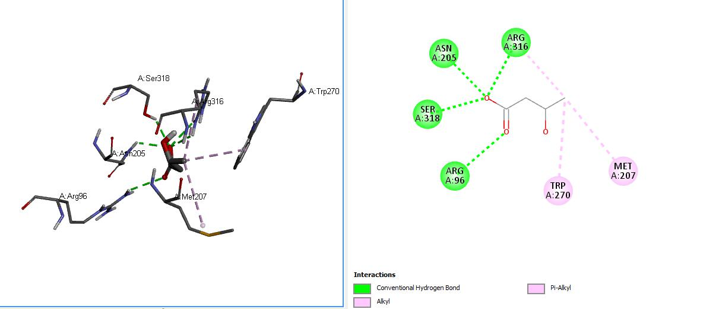

Figure 4.23: 2D and 3D molecular docking complexes of Fat mass obesity associated gene and beta-hydroxybutyrate

80

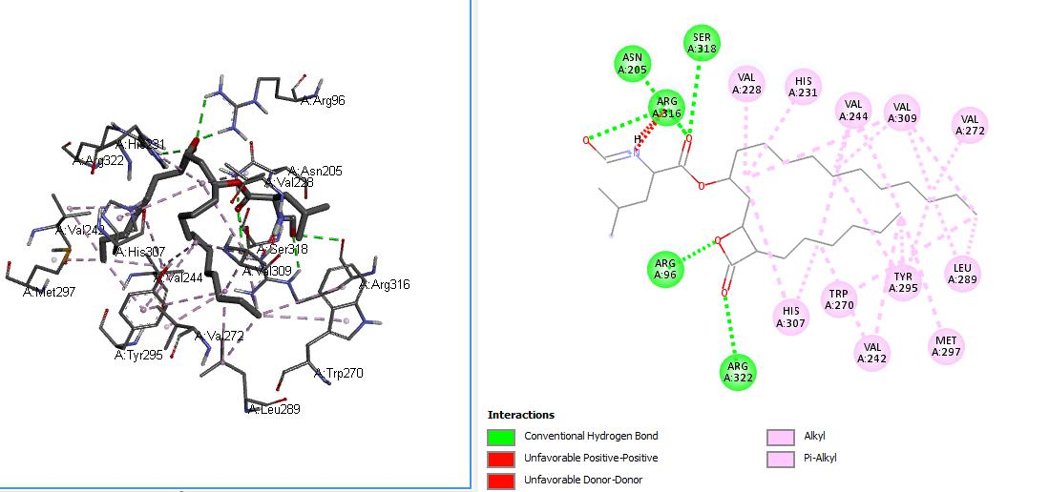

Figure 4.24: 2D and 3D molecular docking complexes of Fat mass obesity associated gene and Orlistat

81

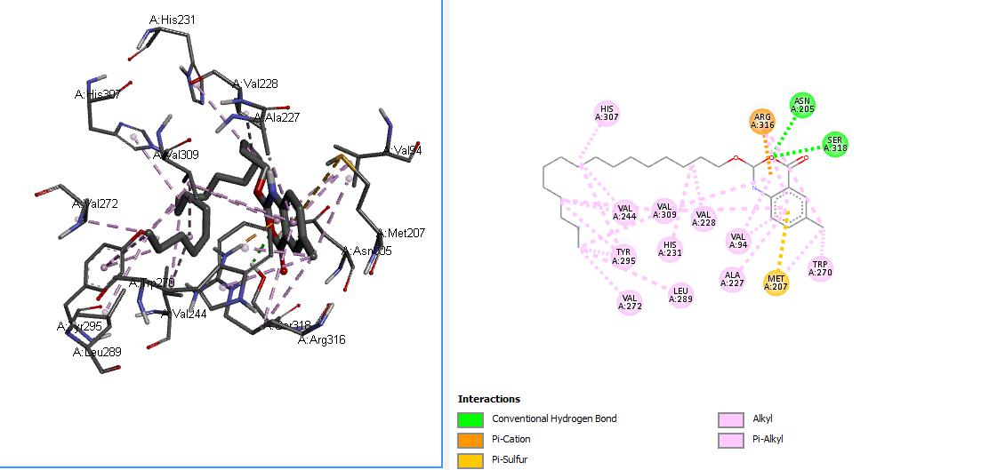

Figure 4.25: 2D and 3D molecular docking complexes of Fat mass obesity associated gene and Cetilistat

82

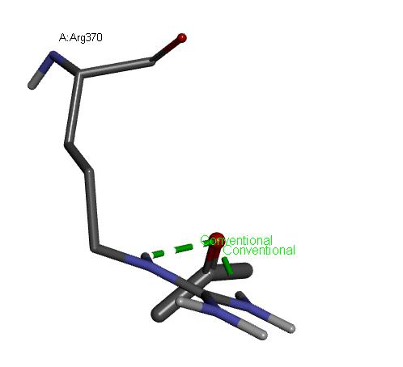

Figure 4.26: 3D molecular docking complexes of 3-hydroxy-3-methylglutaryl-coenzyme-a (HMG-CoA) reductase interaction with acetone

83

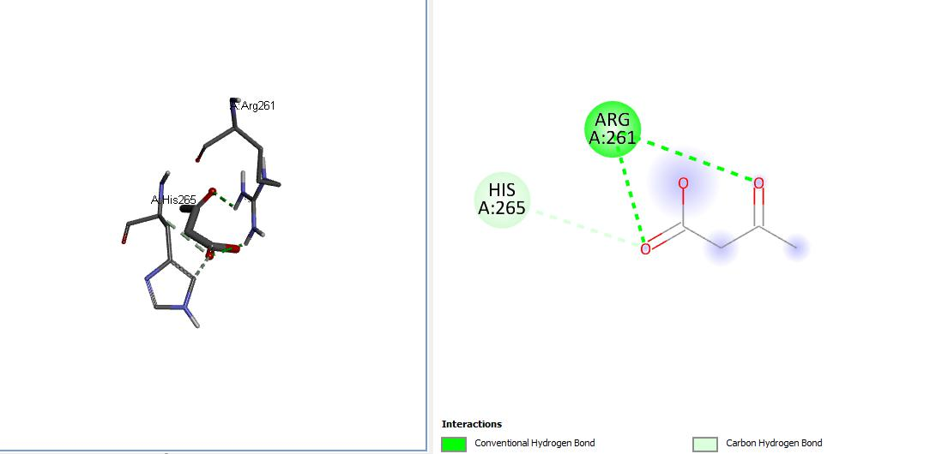

Figure 4.27: 2D and 3D molecular docking complexes of 3-hydroxy-3-methylglutaryl-coenzyme-a (HMG-CoA) reductase interaction with acetoacetate

84

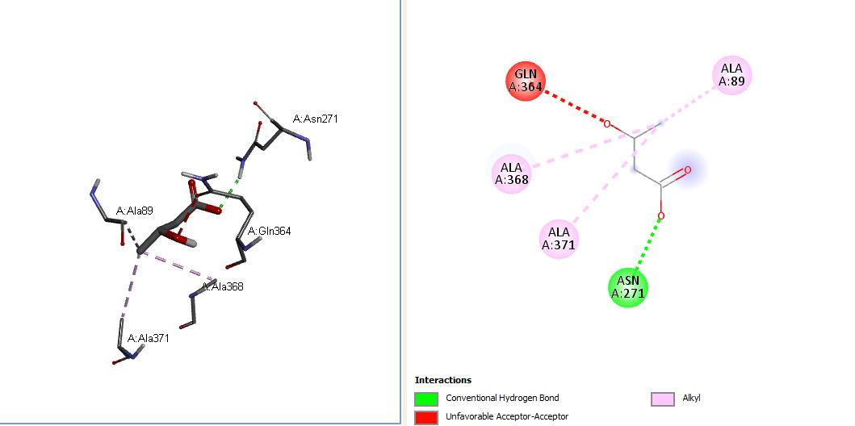

Figure 4.28: 2D and 3D molecular docking complexes of 3-hydroxy-3-methylglutaryl-coenzyme-a (HMG-CoA) reductase interaction with beta-hydroxybutyrate

85

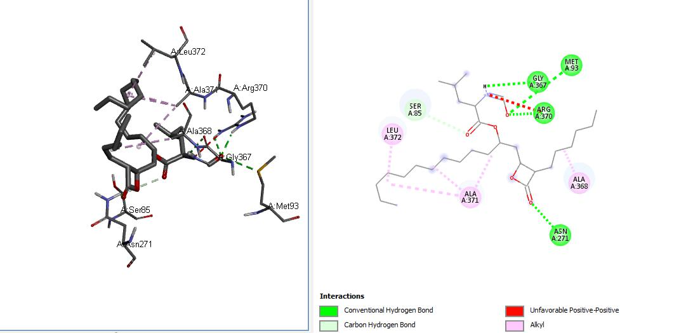

Figure 4.29: 2D and 3D molecular docking complexes of 3-hydroxy-3-methylglutaryl-coenzyme-a (HMG-CoA) reductase interaction with orlistat

86

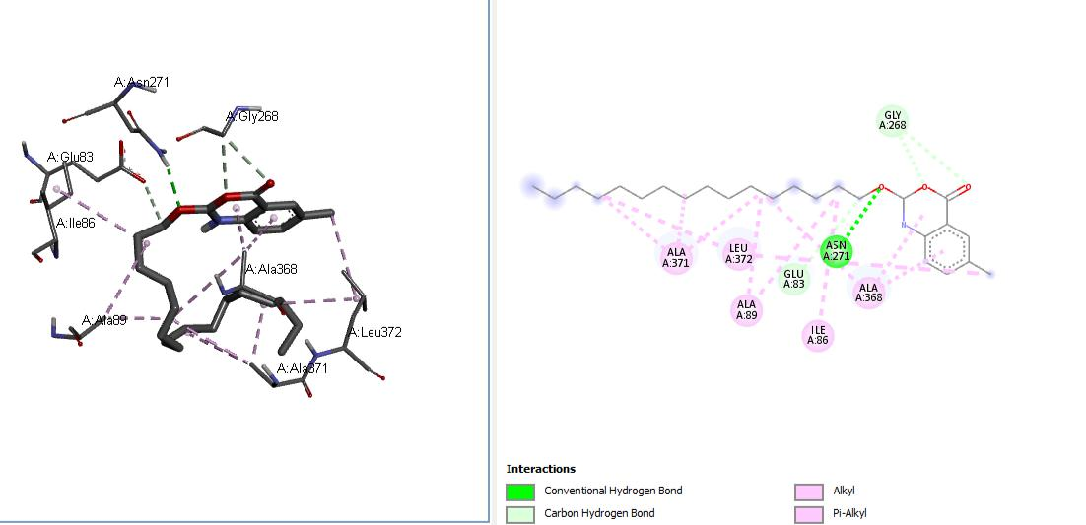

Figure 4.30: 2D and 3D molecular docking complexes of 3-hydroxy-3-methylglutaryl-coenzyme-a (HMG-CoA) reductase interaction with Cetilistat

87

**4.1** **DISCUSSION OF RESULTS**

**4.2.1** **INTERACTION BETWEEN LEPTIN AND LIGANDS**

Leptin aids hunger inhibition and energy intake-energy output balance. In the docking analysis results collated from the molecular docking of the protein, leptin was shown to exhibit a positive binding interaction with the standard drug (orlistat,-4.7,and cetilistat, -5) and ketogenic diet by-products (β-hydroxybutyrate-3.7, acetoacetate-3.3, acetone -2.5) used during this research study although, interactions were higher with standard drugs than with the ketone bodies. Therefore, the interaction between the standard drugs and ketone bodies with leptin indicates that higher levels of hunger inhibition which will culminate in weight reduction may be emanate from standard drug and ketone bodies treatment since leptin function of inhibiting hunger and inducing starvation is highly effective in obesity treatment.

**4.2.2** **INTERACTION BETWEEN GHRELIN AND LIGANDS**

Stimulation of appetite through the hypothalamic arcuate nucleus which controls food input and output is achieved by the ghrelin protein (Kojima and Kangawa, 2005). As shown in the docking analysis result collated, standard drugs (orlistat, -5.2, and cetilistat, -6.3)and ketone bodies (β-hydroxybutyrate-3.1, acetoacetate-3, acetone -2.3) exhibited positive binding interactions with the ghrelin protein with the standard drugs having increased interaction than the ketone bodies which had minimal binding interaction. This connotes that, ghrelin function with these ligands might be inhibited and thus result in the lowering of appetite and thus food consumption, leading to weight loss in individuals.

**4.2.3** **INTERACTION BETWEEN CATALASE AND LIGANDS**

The docking analysis of catalase interaction with standard drugs (orlistat, -6.8, and cetilistat, -6.9) and ketone bodies (β-hydroxybutyrate-4.7, acetoacetate-4.6, acetone-3.1) ligands exhibited a positive binding interaction with standard drugs at a higher level than ketone bodies thereby, showing that catalase function of catalyzing the disproportionate amounts of hydrogen peroxide synthesized in cells by certain enzymes and oxidases into single oxygen (O2) molecule, and water (H2O) molecule, and maintaining optimal compound levels which induce cell signaling by deactivating hydrogen peroxide are activated by the ketone bodies. This will enhance the antioxidative role of the diet and since oxidative stress has been implicated in obesity progression,

88

an enhanced cell antioxidative status by the ketone bodies will lead to the amelioration of obesity (Everse, 2013).

**4.2.4** **INTERACTION BETWEEN SUPEROXIDE DISMUTASE AND LIGANDS**

The docking analysis result of SOD which is similar to that of catalase, showed positive binding interactions with both standard drug (orlistat, -5.0, and cetilistat, -5.7) and ketone bodies (β-hydroxybutyrate -3.7, acetoacetate -3.6, and acetone -2.5), hence SOD function of promoting the defense mechanism of cells against reactive oxygen species (ROS) by catalyzing the oxidative deamination of superoxide radicals (O2) into oxygen molecules (O2) and hydroxyl radicals (H2O2) are activated in vivo by the standard drugs and ketone bodies. This will also enhance the reduction of oxidative stress thus, promoting amelioration of metabolic syndromes associated with obesity (Ciu, *et al*., 2014).

**4.2.5 INTERACTION BETWEEN FAT-MASS OBESITY ASSOCIATED GENE AND LIGANDS**

The docking analysis result collated for the fat-mass obesity associated gene interaction with standard drugs (orlistat, 1, and cetilistat, 0.3) and ketone bodies(β-hydroxybutyrate-4.7, acetoacetate-4.5,acetone -3.2), showed minimal binding interaction with the standard drugs but showed increased binding interaction with the ketone bodies ligands. This indicates that in the presence of orlistat and cetilistat in the biological system may have minimal inhibitory action against FTO, while the ketone bodies exhibit higher inhibition of FTO which will lead to the downregulation of fatty acid synthesis and storage, leading to significant reduction in body fat and obesity condition.

**4.2.6 INTERACTION BETWEEN *3-HYDROXY-3-METHYLGLUTARYL-COENZYME A (HMG-COA) REDUCTASE*AND LIGANDS**

The docking analysis result collated for the HMG-CoA reductase interaction with the standard drugs (orlistat, -4.7, and cetilistat, -4.7) and ketone bodies (β-hydroxybutyrate-3.4, acetoacetate-3.4, acetone -2.5), ligands exhibited binding interactions with the standard drugs and ketone bodies The interaction may result in inhibition of HMG-CoA reductase, hence leading to reduction in the levels of mevalonate and cholesterol synthesized *in vivo* This will consequently result in body fat reduction over a period of time.

89

**CHAPTER FIVE**

**CONCLUSION AND RECOMMENDATION**

**5.1 CONCLUSION**

The ketone bodies, showed adjuvant therapeutic effects in the amelioration of obesity due to positive interactions with obesity-associated proteins and thus, ketogenic diet are therapeutic adjuvants for weight maintenance and obesity inhibition.

**5.2 RECOMMENDATION**

Furthermore, additional toxicological studies on ketogenic diet and the standard drug comparatives are recommended to determine their adverse effects on the biological system and its organs if consumed beyond standard quantities. Also, the widespread of ketogenic diet as a natural diet therapy mechanism in obesity reduction should be incorporated into clinical trials for obese individuals.

90

**REFERENCES**

Achari, A. E., and Jain, S. K. (2017). Adiponectin, a Therapeutic Target for Obesity, Diabetes, and Endothelial Dysfunction. *International Journal of Molecular Sciences*, *18*(6), 1321.

Adeloye, D., Ige-Elegbede, J. O., Ezejimofor, M., Owolabi, E. O., Ezeigwe, N., Omoyele, C., Mpazanje, R. G., Dewan, M. T., Agogo, E., Gadanya, M. A., Alemu, W., Harhay, M. O., Auta, A., and Adebiyi, A. O. (2021). Estimating the prevalence of overweight and obesity in Nigeria in 2020: a systematic review and meta-analysis. *Annals of Medicine*, *53*(1), 495–507.

Akarolo-Anthony, S. N., Willett, W. C., Spiegelman, D., and Adebamowo, C. A. (2014). Obesity epidemic has emerged among Nigerians. *BMC Public Health*, *14*, 455.

Anton, S. D., Hida, A., Heekin, K., Sowalsky, K., Karabetian, C., Mutchie, H., Leeuwenburgh, C., Manini, T. M., and Barnett, T. E. (2017). Effects of Popular Diets without Specific Calorie Targets on Weight Loss Outcomes: *Systematic Review of Findings from Clinical Trials. Nutrients, 9*(8), 822.

Aronne L. J. (2002). Classification of obesity and assessment of obesity-related health risks. *Obesity Research*, *10 Suppl 2*, 105S–115S.

Apovian, C. M., Aronne, L. J., Bessesen, D. H., McDonnell, M. E., Murad, M. H., Pagotto, U., Ryan, D. H., Still, C. D., and Endocrine Society (2015). Pharmacological management of obesity: an endocrine Society clinical practice guideline. *The Journal of clinical endocrinology and metabolism*, *100*(2), 342–362.

Bartmann, C., Janaki Raman, S. R., Flöter, J., Schulze, A., Bahlke, K., Willingstorfer, J., and Kämmerer, U., (2018). *Beta-hydroxybutyrate (3-OHB)* can influence the energetic phenotype of breast cancer cells, but does not impact their proliferation and the response to chemotherapy or radiation. *Cancer & Metabolism, 6(1).*

91

Bhattacharya, K., Sengupta, P., Dutta, S., and Bhattacharya, S. (2020). Pathophysiology of obesity: Endocrine, inflammatory and neural regulators. *Research Journal of Pharmacy and Technology, 13*, 4469-4478.

Bhagavan, N. V., and Ha, C. E., (2011). Lipids I. *Essentials of Medical Biochemistry, 191–207.*

Bhagavan, N. V., and Ha, C.-E. (2015). Lipids II. *Essentials of Medical Biochemistry,* 299–320.

Blüher, M., (2019). Obesity: global epidemiology and pathogenesis. *Nature* *Reviews.*

*Endocrinology*, *15*(5), 288–298.

Bronson, J., Black, A., Dhar, M., Ellsworth, B., and Robert Merritt, J., (2014). To Market, To

Market—2013.*Annual Reports in Medicinal Chemistry, 437–508.*

Burillo, E., Jorge, I., Martínez-López, D., Camafeita, E., Vazquez, J., and Martin–Ventura, J. L. (2017). The Application of Proteomic Techniques in the Study of HDL Particle Characterization and Biomarker Discover*. The HDL Handbook, 231–255.*

Chang, J. Y., Park, J. H., Park, S. E., Shon, J., and Park, Y. J., (2018). The Fat Mass- and Obesity-Associated (FTO) Gene to Obesity: *Lessons from Mouse Models. Obesity.*

Charlot, A., Zoll, J., (2022). Beneficial Effects of the Ketogenic Diet in Metabolic Syndrome. *A Systematic Review.* Diabetology*,* 3(2):292-309.

Cui, R., Gao, M., Qu, S., and Liu, D. (2014). Overexpression of superoxide dismutase 3 gene blocks high-fat diet-induced obesity, fatty liver and insulin resistance. *Gene Therapy, 21(9), 840–848.*

Drabińska, N., Wiczkowski, W., and Piskuła, M. K., (2021). Recent advances in the application of a ketogenic diet for obesity management. *Trends in Food Science & Technology,* 110, 28-38.

Dzoyem, J. P., Kuete, V., and Eloff, J. N. (2014). Biochemical Parameters in Toxicological Studies in Africa. *Toxicological Survey of African Medicinal Plants,* 659–715.

Everse, J. (2013). Heme Proteins. *Encyclopedia of Biological Chemistry,* 532–538.

92

Fu, C., Jiang, Y., Guo, J., and Su, Z. (2016). Natural Products with Anti-obesity Effects and Different Mechanisms of Action. *Journal of Agricultural and Food Chemistry,* 64(51), 9571–9585.

Furman, B. L. (2017). Orlistat. *Reference Module in Biomedical Sciences.*

González-Muniesa, P., Mártinez-González, M. A., Hu, F. B., Després, J. P., Matsuzawa, Y., Loos, R., Moreno, L. A., Bray, G. A., and Martinez, J. A. (2017). Obesity. *Nature Reviews. Disease primers*, *3*, 17034.

Gudzune, K. A., Doshi, R. S., Mehta, A. K., Chaudhry, Z. W., Jacobs, D. K., Vakil, R. M., Lee, C. J., Bleich, S. N., and Clark, J. M. (2015). Efficacy of commercial weight-loss programs: an updated systematic review. *Annals of Internal Medicine*, 162(7), 501–512.

Han, Z., Niu, T., Chang, J., Lei, X., Zhao, M., Wang, Q., Cheng, W., Wang, J., Feng, Y., and Chai, J. (2010). Crystal structure of the FTO protein reveals basis for its substrate specificity. *Nature*, 464(7292), 1205–1209.

Halabis, M., Dziedzic, M., Warchulinska, J., Kaznowska-Bystryk, I. and Solski, J. (2015). Omentin - a new adipokine with many roles to play. *Current Issues in Pharmacy and Medical Sciences,*28(3) 176-180.

He, Y., Pan, A., Wang, Y., Yang, Y., Xu, J., Zhang, Y., Liu, D., Wang, Q., Shen, H., Zhang, Y., Yan, D., Peng, Z., Hu, F. B., and Ma, X. (2017). Prevalence of overweight and obesity in 15.8 million men aged 15-49 years in rural China from 2010 to 2014. *Scientific Reports*, *7*(1), 5012.

Hess, M. E., and Brüning, J. C. (2014). The fat mass and obesity-associated (FTO) gene: Obesity and beyond? *BiochimicaetBiophysicaActa (BBA) - Molecular Basis of Disease, 1842(10), 2039–2047.*

Hu, J., and Christian, M. (2017). Hormonal factors in the control of the browning of white adipose tissue. *Hormone Molecular Biology and Clinical Investigation,* 31(1).

Karaouzene, N., Merzouk, H., Aribi, M., Merzouk, S. A., YahiaBerrouiguet, A., Tessier, C., and Narce, M. (2011). Effects of the association of aging and obesity on lipids,

93

lipoproteins and oxidative stress biomarkers: *A comparison of older with young men. Nutrition, Metabolism and Cardiovascular Diseases,* 21(10), 792–799.

Karakus, Y. Y. (2020). Typical Catalases: Function and Structure. *In (Ed.), Glutathione System and Oxidative Stress in Health and Disease. Intech Open.*

Kayode, O. T., Damilare, E. R., Afolayan, O. A., and Kayode, A. A. (2020). Ketogenic Diet: A Nutritional Remedy for Some Metabolic Disorders. *J Edu, Health Sport.*10(8).

Kelly, T., Yang, W., Chen, C. S., Reynolds, K., and He, J. (2008). Global burden of obesity in 2005 and projections to 2030. *International Journal of Obesity,* 32(9), 1431– 1437.

Kojima, M., and Kangawa, K. (2005). Ghrelin: structure and function. *Physiological Reviews*, *85*(2), 495–522.

Kulak, D., and Polotsky, A. J. (2013). Should the ketogenic diet be considered for enhancing fertility? *Maturitas*, *74*(1), 10–13.

Kumar, S., Behl, T., Sachdeva, M., Sehgal, A., Kumari, S., Kumar, A., Kaur, G., Yadav, H. N., and Bungau, S. (2021). Implicating the effect of ketogenic diet as a preventive measure to obesity and diabetes mellitus. *Life sciences*, *264*, 118661.

Kumar, V., and Gill, K. D. (2018). To Estimate the Amount of Total Cholesterol in Serum. *Basic Concepts in Clinical Biochemistry: A Practical Guide, 93–95.*

Lichtenstein, A. H. (2013). Fats and Oils. *Encyclopedia of Human Nutrition, 201–208.*

Li, H.W., Lee, C., Lam, K.S., and Ho, P. (2013). Anti-Obesity Drugs for Obese Women Planning Pregnancy. *Obesity*, 423-430.

Li, Y., Huang, T. T., Carlson, E. J., Melov, S., Ursell, P. C., Olson, J. L., Noble, L. J., Yoshimura, M. P., Berger, C., Chan, P. H., Wallace, D. C., and Epstein, C. J. (1995). Dilated cardiomyopathy and neonatal lethality in mutant mice lacking manganese superoxide dismutase. *Nature Genetics*, 11(4), 376–381.

Lin, X., Lim, I. Y., Wu, Y., Teh, A. L., Chen, L., Aris, I. M., Soh, S. E., Tint, M. T., MacIsaac, J. L., Morin, A. M., Yap, F., Tan, K. H., Saw, S. M., Kobor, M. S., Meaney, M. J.,

94

Godfrey, K. M., Chong, Y. S., Holbrook, J. D., Lee, Y. S., Gluckman, P. D., and GUSTO study group (2017). Developmental pathways to adiposity begin before birth and are influenced by genotype, prenatal environment and epigenome. *BMC Medicine*, *15*(1), 50.

Masino, S. A., and Rho, J.M., (2012). Mechanisms of Ketogenic Diet Action, *Jasper ' s Basic Mechanisms of the Epilepsies,* (4thed).

Matsuzaki, Y., Matsuzaki, Y., Sato, T., and Akiyama, Y. (2009). In Silico Screening of Protein– Protein Interactions with All-To-All Rigid Docking and Clustering: An Application to Pathway Analysis. *Journal of Bioinformatics and Computational Biology,* 07(06), 991–1012.

Miranda, M. J., Turner, Z., and Magrath, G., (2012). Alternative diets to the classical ketogenic diet-Can we be more liberal? *Epilepsy Research,* 100, 278–285.

Mingrone, G., and Castagneto, M. (2015). The Pathophysiology of Obesity. *Minimally Invasive Bariatric and Metabolic Surgery,* 17–23.

Newman, J. C., and Verdin, E. (2014). Ketone bodies as signaling metabolites. *Trends in Endocrinology & Metabolism,* 25(1), 42–52.

Ng, M., Fleming, T., Robinson, M., Thomson, B., Graetz, N., Margono, C., Mullany, E. C., Biryukov, S., Abbafati, C., Abera, S. F., Abraham, J. P., Abu-Rmeileh, N. M., Achoki, T., AlBuhairan, F. S., Alemu, Z. A., Alfonso, R., Ali, M. K., Ali, R., Guzman, N. A., Ammar, W., and Gakidou, E. (2014). Global, regional, and national prevalence of overweight and obesity in children and adults during 1980-2013: a systematic analysis for the Global Burden of Disease Study 2013. *Lancet (London, England)*, 384(9945), 766–781.

Nguyen T. (2020). Adiponectin: Role in Physiology and Pathophysiology. *International Journal of Preventive Medicine,* 11(136).

Nicolaidis, S. (2019). Environment and obesity. *Metabolism,* 100, 153942.

Norum, K. R., Remaley, A. T., Miettinen, H. E., Strøm, E. H., Balbo, B., Sampaio, C., Wiig, I., Kuivenhoven, J. A., Calabresi, L., Tesmer, J. J., Zhou, M., Ng, D. S., Skeie, B.,

95

Karathanasis, S. K., Manthei, K. A., and Retterstøl, K. (2020). Lecithin:cholesterolacyltransferase: symposium on 50 years of biomedical research from its discovery to latest findings. *Journal of Lipid Research*, 61(8), 1142–1149.

Ogah, O. S., Madukwe, O. O., Chukwuonye, I. I., Onyeonoro, U. U., Ukegbu, A. U., Akhimien, M. O., Onwubere, B. J., and Okpechi, I. G. (2013). Prevalence and determinants of hypertension in Abia State Nigeria: results from the Abia State Non-Communicable Diseases and Cardiovascular Risk Factors Survey. *Ethnicity & Disease*, 23(2), 161–167.

Ogden, C. L., Carroll, M. D., Fryar, C. D., and Flegal, K. M. (2015). Prevalence of Obesity Among Adults and Youth: United States, 2011-2014. *NCHS Data Brief*, (219), 1– 8.

Pischon, T., and Nimptsch, K. (2016). Obesity and Risk of Cancer: An Introductory Overview. *Recent results in cancer research. Fortschritte der Krebsforschung. Progresdans les recherchessur le cancer*, *208*, 1–15.

Pirillo, A., Norata, G. D., and Catapano, A. L. (2013). High-Density Lipoprotein Subfractions - What the Clinicians Need to Know. *Cardiology,* 124(2), 116–125.

Rader, D. J., and Hovingh, G. K. (2014). HDL and cardiovascular disease. *Lancet (London, England)*, 384(9943), 618–625.

Ryan, K. K., Packard, A., Larson, K. R., Stout, J., Fourman, S. M., Thompson, A., Ludwick, K., Habegger, K. M., Stemmer, K., Itoh, N., Perez-Tilve, D., Tschöp, M. H., Seeley, R. J., and Ulrich-Lai, Y. M. (2018). Dietary Manipulations That Induce Ketosis Activate the HPA Axis in Male Rats and Mice: A Potential Role for Fibroblast Growth Factor-21. *Endocrinology*, 159(1), 400–413.

Sacan, A., Ekins, S., and Kortagere, S. (2012). Applications and limitations of in silico models in drug discovery. *Methods in Molecular Biology (Clifton, N.J.)*, 910, 87–124.

Sarhat, E. (2014). Study of Leptin, Adiponectin and C-Peptide with Oxidative Stress in Obese Individuals.

96

Seidell, J. C., and Halberstadt, J. (2015). The global burden of obesity and the challenges of prevention. *Annals of Nutrition & Metabolism*, *66 Suppl*2, 7–12.

Sharma, P., Joshi, T., Joshi, T., Chandra, S., and Tamta, S., (2019). In silico screening of potential antidiabetic phytochemicals from *Phyllanthusemblica* against therapeutic targets of type 2 diabetes, *Journal of Ethnopharmacology,* 284, 112268.

Siddique, T., Deng, H. X., and Ajroud-Driss, S. (2013). Motor Neuron Disease. *Emery and Rimoin’s Principles and Practice of Medical Genetics,* 1–22.

Stadler, J. T., and Marsche, G. (2020). Obesity-Related Changes in High-Density Lipoprotein Metabolism and Function*. International Journal of Molecular Sciences,* 21(23), 8985.

Sturla, S. J., Boobis, A. R., FitzGerald, R. E., Hoeng, J., Kavlock, R. J., Schirmer, K., Whelan, M., Wilks, M. F., Peitsch, M. C., (2014). Systems toxicology: from basic research to risk assessment. *Chem Res Toxicol*, 27:314-329.

Smekal, A., and Vaclavik, J. (2017). Adipokines and cardiovascular disease: A comprehensive review. *Biomedical papers of the Medical Faculty of the University Palacky, Olomouc, Czechoslovakia*, 161(1), 31–40.

Takahiro, S., Yuki, N., Yuki, S., Hideko, O., Kenji, K., Masayasu, K., (2012). Structure, Regulation and function of Ghrelin, *The Journal of Biochemistry*, Vol151(2), 119–128.

Tam, C.S., Lecoultre, V., and Ravussin, E., 2012. Brown adipose tissue mechanisms and potential therapeutic targets. *Circulation*, 125 (22), 2782–2791.

Townsend, N., and Scriven, A. (2014). Causes of obesity. *Public Health Mini-Guides: Obesity, 67–83.*

Trott, O., and Olson, A., (1995). AUTODockVINA Improving the speed and accuracy of docking with a new scoring function, efficient optimization, and multithreading. *Journal of Protein Engineerings*,8, 127-134.

97

Wahab, K. W., Sani, M. U., Yusuf, B. O., Gbadamosi, M., Gbadamosi, A., and Yandutse, M. I. (2011). Prevalence and determinants of obesity - a cross-sectional study of an adult Northern Nigerian population. *International archives of medicine*, *4*(1), 10.

Weber, D. D., Aminzadeh-Gohari, S., Tulipan, J., Catalano, L., Feichtinger, R. G., and Kofler, B. (2019). Ketogenic diet in the treatment of cancer – where do we stand? *Molecular Metabolism*.

World Health Organization. Overweight and obesity. Geneva: World Health Organization;

(2018). *Available* *from:*

*Detail/Obesity-and-Overweight*

*https://www.who.int/news-room/fact-sheets/*

Willey, J. Z., and Elkind, M. S. V. (2010). 3-Hydroxy-3-methylglutaryl–Coenzyme-A Reductase Inhibitors in the Treatment of Central Nervous System Diseases. *Archives of Neurology,* 67(9).

Williams, D. M., Nawaz, A., and Evans, M. (2020). Drug Therapy in Obesity: A Review of Current and Emerging Treatments. *Diabetes Therapy: Research, Treatment and Education of Diabetes and Related Disorders*, 11(6), 1199–1216.

Williams, E. P., Mesidor, M., Winters, K., Dubbert, P. M., and Wyatt, S. B. (2015). Overweight and Obesity: Prevalence, Consequences, and Causes of a Growing Public Health Problem. *Current Obesity Reports*, *4*(3), 363–370.

Ułamek-Kozioł, M., Czuczwar, S. J., Januszewski, S., and Pluta, R. (2019). Ketogenic Diet and Epilepsy. *Nutrients*, 11(10), 2510.

Zhang, Y., Liu, J., Yao, J., Ji, G., Qian, L., Wang, J., Zhang, G., Tian, J., Nie, Y., Zhang, Y. E., Gold, M. S., and Liu, Y. (2014). Obesity: pathophysiology and intervention. *Nutrients*, *6*(11), 5153–5183.

98

APPENDIX

Obesity: A condition classified by excessive body fat that increases the risk of health-related complications.

Body mass index: The BMI is calculated by dividing the body mass by the square of the body height and is expressed in kilograms per square metre (kg/m2).

Biochemical markers: These are molecules that are produced during the disease process, either at the initiation or during progression.

Ketogenic Diet: An augmented-fat, minimal-carbohydrate (sugar) diet that causes the body to break down fat into molecules known as ketones for energy.

In Silico: in silico experiment is one that is carried out on a computer or through computer simulation.

99