**IMPACT OF ADVERTISING ON CONSUMER PURCHASES DECISION USING NESTLE NIGERIA PLC (MILO) AS A CASE STUDY**

* **ABSTRACT**
* The aim of this project is to examine “Impact of Advertising on Consumer Purchases Decision” using Nestle Nigeria plc (Milo) as a case study, so that the relationship that exist between advertising and Milo will be analyzed. Advertising is perhaps the most conspicuous of all marketing activities this very fact has led to a widespread misunderstanding of its real scope and nature. The main objective of this study was to evaluate the impact of advertising on the consumption of “Nestle Milo” and also to find out the extend of which advertisement have succeeded in influencing the buying and consumption of Nestle Milo. Survey method was used in collecting data and this method permits the researcher to survey the respondent at their own convenience in order to find solution to problems, three (3) hypothesis were formulated and data were collected through the use of questionnaires administered. Furthermore, result obtained from the test of hypothesis show that advertising has an impact on consumer purchase decision with an impact on consumer purchase decision with a particular reference to Nestle Milo. Based on findings, it was recommended that Nestle milo Plc should improve on its advertising media, in order to have a large market share in the market of milo

# TABLE OF CONTENT

TABLE OF CONTENT i

LIST OF TABLES, PLATES AND FIGURE iii

ABBREVIATIONS iv

ACKNOWLEDGEMENTS AND DEDICATION v

ABSTRACT vi

CHAPTER ONE 1

1. INTRODUCTION 1

1.1. BACKGROUND STATEMENT 1

1.2. PROBLEM STATEMENT 9

1.3. RESEARCH OBJECTIVES / AIMS 10

1.4. SIGNIFICANCE OF STUDY 11

1.5. SCOPE OF STUDY 11

1.6. ORGANIZATION OF THE STUDY 12

CHAPTER TWO 13

2. LITERATURE REVIEW 13

2.1. INTRODUCTION 13

2.2. THEORETICAL FRAMEWORK / CONCEPTUAL FRAMEWORK 14

2.3. REVIEW OF RELATED STUDIES 21

2.4. HYPOTHESIS TO BE TESTED 28

2.5. RATIONALE FOR THE HYPOTHESIS 28

2.6. OPERATIONAL DEFINITIONS OF TERMS 29

CHAPTER THREE 30

3. METHODOLOGY 30

3.1. INTRODUCTION 30

3.2. DESIGN 31

3.3. SUBJECTS / POPULATION AND SAMPLE 32

3.4. INSTRUMENTS FOR DATA COLLECTION 34

CHAPTER FOUR 36

4. ANALYSIS AND FINDINGS 36

4.1. INTRODUCTION 36

4.2. ANALYSIS AND FINDINGS 36

CHAPTER FIVE 47

5. DISCUSSIONS AND CONCLUSIONS 47

5.1. INTRODUCTION 47

5.2. DISCUSSIONS 47

5.3. CONCLUSIONS 49

5.4. LIMITATIONS OF STUDY 49

5.5. SUGGESTIONS FOR FURTHER STUDIES 50

REFERENCES / BIBLIOGRAPHY 51

APPENDIX 57

Questionnaire 57

* **CHAPTER ONE**
* **INTRODUCTION**
* **BACKGOUND TO THE STUDY**
* A typical market is made up of people who have various need, some are buyer in the market while other are sellers, each participant in the exchange process is often confronted with the problems of searching. Every attempt to satisfy consumers’ needs and desires, is usually and most often the duty of the seller to package their product or service information for dissemination to the consumers by employing such relevant vehicle as promotional activities which is conveyed and executed through advertising. Effort is made to persuade buyers in order to act when they receive this information.
* Advertising is a basic tool of marketing most of the message In our media advertisement are through the magazines, radio, bill board, news paper, television are not merely for the sales of the advertised product, but equally to entertain, educate beside the provision of media useful and relevant information to such media and audience.
* In a developing country like Nigeria, the distribution of available goods and services depend on customers tearing habit. Advertising do often persuade people against their wish, unless they are gullible and unsophisticated.
* To some people advertising is regarded as an art, while others sees it as a science to this background, advertising unique combination of both variable. Advertising comprises the effective blending of the behavioural science such as anthropology sociology, psychology, etc then for communication arts, such as writing editing, drama, graphic, animation and photograph etc.
* Nevertheless, for a successful promotional activities advertising skill must be employed using words, pictures, slogans, jingles, colours, size and movement etc to entice the reader viewers, listeners or passer by to stop, look listen read develop interest be convinced and the taken action.
* The essential of this study is to evaluate the effect of advertising on consumer purchase decision of “Nestle Milo” hence this research work is to find out the extend to which those advertisement of Nestle Milo have succeeded in influence its consumer when making their buying decision
* **STATEMENT OF THE PROBLEM**
* In the country today, there are many food drinks, this means that the competition being witnessed in the market for beverage is very stiff just like in other market. Consequently, companies producing beverages and other products employ promotional tools in a bid to outdo their competitors. One of such tolls that could be used for this purpose is advertising.
* After taking a proper view of the beverage market, the researcher discovered that consumers preferred Nestle Milo to any of its close substitutes. The researcher became curious and decided to know what is responsible for this.
* In a situation like this when the information needed about a things is lacking a study of this nature becomes imperative, hence the study.
* Therefore, the problem, of this research work put in the question is what is responsible for the consumers performance for Nestle Milo drink in the Nigerian beverage market.

**RESEARCH OBJECTIVE**

The purpose of this study is to evaluate the impact of advertising on the consumption of “Nestle Milo” others are as follows:

To establish the extent to which advertisement have succeeded in influencing the buying and consumption of “Nestle Milo”

To identify those other factors which influences consumer in making their buying decision apart from the various advertisement of Nestle Milo

To find out if the media advertisement of nestle Milo actually have the potentials for creating brand loyalty.

**RESEARCH HYPOTHESIS**

The following hypothesis were formulated

Ho: Media advertisement of Nestle food drink do not generate brand loyalty for the Milo amongst its diversified consumers

Hi: media advertisement of nestle Milo feed drink generate brand loyalty for the Milo amongst diversified consumers

Ho: media advertisement of nestle Milo food drink do not influence the buying and consumption habit of Nestle Milo consumers

Hi: media advertisement of nestle Milo influence the buying and consumption habit of nestle Milo consumers

**SCOPE OF THE STUDY**

The research work is limited to assessing and examine in details the impact of advertising on the consumer buying decision especially on nestle Milo, with particular reference to nestle Milo group of company’s.

The scope of the study is limited to the consumer buying habit to enable the buying decisions of consumers of Nestle Milo in the process of making their choices amongst other brand. It is limited to consumers in Auchi Edo State.

**SIGNIFICANCE OF THE STUDY**

The research work is useful in the view of the researcher based on the exposure and also the management of nestle group of company’s the professions of advertising the field of mass communication on the interested members of the public and course, posterity, and to benefit from this study.

In view of the massive competition amongst the various Milo industries from keen awareness and attention beside the huge amount of money being annually budgeting on advertising by Nestle group of company, this study would tremendously help to research in deciphering whether this heavy sum of money invested on advertising by nestle group of company’s Nigeria Plc, is worth while.

In considering this research work form a scientific and empirical point of view it would aid those in the field of mass communication in knowing that most critics of advertising are them selves advertisers and indeed purchases of advertised goods and services.

**DEFINITION OF ESSENTIAL TERMS**

In order to aid our understanding of the whole work, it is important that some terms used in this work should be defined such terms are defined below:

Product: Is a thing or substance produced to use or for consumption and that might satisfy want or need. Product can also be defined as anything they can be offered to a market to satisfy a want or need.

Product can be physical goods, services, experience, events, persons, place or ideas.

**Advertising**: Is defined as any paid form of promoting publicly to increase sales.

Advertising is a non personal communication through various media by business firms, non profit organization and individuals who are in some ways identified in the advertising message and who hope to communicate the members of a particular audience.

Advertising can be define as a sponsor identified message regarding a product or organization that can be verbal or visual and is disseminated through one or more media

Message: can be defined as the symbol that advertises transmits to have audience to address for benefits purpose motivation, reason or for identification.

Appeal: can be defined as the motive use to create interest on a product or services and to stimulate a purchase.

Copy: this can be defined as a written documents prepared by an expert copy writer it is written or spoken materials of advertising communication and include the headlines, name and address of the advertiser as well as the main text of the message.

Advertising Medium: Can be defined as any means by which sales messages can be seen as a routs of channels through which the message are delivered to the target audience or consumers.

Brand Loyalty: It can be defined as a knowledge of the attributes of a particular product.

Consumer Behaviour: it can be defined as the behaviour that consumer display in searching for purchases, using evaluating and disposing of products, services and ideas which they expect will satisfy their need.

Purchases Decision: It can be defined as the process by which organization define their product/needs, for goods and services, identify and compare the supplier available to them negotiated and source of supply on some other ways arrived as agreed terms of trading, make contracts and place order and finally received the goods and services and play .

# CHAPTER TWO

# LITERATURE REVIEW

## 2.1. INTRODUCTION

This chapter is about related studies, theories and advertising communication models that form the foundation for this research. Over the years, several theories and advertising models have being developed to explain consumer purchasing decisions. These theories attempt to describe the sequence of behaviour when consumers are making purchase decisions (Hoang, 2013).

Advertising communication models are conceptual ideas that relates to the organization of sales and products and how they are marketed. Advertising must have a clear message (printed, spoken, graphical or pictorial) which is targeted at consumers or audiences with the aim of persuading them to purchase a product, service or adhering to the message it projects (Rossiter & Percy 1985).

Advertising agencies operate with these models and ideas whenever they create a concept.

The first task in promoting any new product is to create awareness that the product exists. The second is to provide enough information to enable learning about the product for the prospective customer to make an informed decision. Finally, the marketer wants to be persuasive enough to stimulate the customer's desire and motivation to satisfy his or her needs or wants by purchasing and repurchasing the product. These three personal processes of consumer behaviour; perception, learning, and motivation are extremely important to advertisers (Arens & Bovée, 1994:133-137).

## 2.2. THEORETICAL FRAMEWORK / CONCEPTUAL FRAMEWORK

Advertisers are constantly trying to define models on how advertising works. From these models, they often try to pick meaningful communication objectives (Bovee et al., 1995). These models show several phases of communication, progressing from initial awareness up to the decision to make a purchase (Jones 1986). This study therefore is to investigate the consumer purchase decision and find out if advertising is a determining factor. In order to determine the factors that influence the preferences of the millennial generation, an understanding of how consumer’s generally think and behave in buying situations is vital. Understanding consumer behaviour and knowing customers have and never will be simple. Consumers may say one thing but do another (Engel et al., 1979). These issues have led to the development of several theories to understand the consumer purchasing decision process. In other words, marketers can apply various stimuli and observe the conduct of consumers but they cannot observe the consumers’ actual thought processes. This hidden information is considered to the black box. In an attempt to obtain some understanding, marketers study consumer behaviour (Futrell, 1999). Many researchers describe consumer behaviour as the study of individuals or groups and the mental, emotional and physical processes they use to select, obtain, consume and dispose of products and services, to satisfy needs and wants and the impact that these processes have on consumer and society (Krugman, 2013).

There are numerous models trying to explain consumer behaviour. These models generally deal with various stimuli, influential factors, the decision-making process and outcomes. This study will be based on the AIDA model, the hierarchy of effect model, and the magic bullet theory (hypodermic needle).

**AIDA model**

This model was propounded by Elmo Lewis. This is an approach used by many advertisers to describe the different phases of consumer engagement with an advertisement. It basically explains the way a consumer process information they are exposed to in the media (Colley, 1984). In order for advertising communication to be successful, prospective buyers become a target for advertising messages (Rossitor and Percy, 1985). The individual must process the elements in an intended manner so that the advertising results in communication effects. This communication effect must be connected to the brand which in appropriate circumstances will produce action (Purchase of the product or service). Actions can also include a variety of desired target behaviour on the part of distributors or consumers. This behaviour can be in the form of sales enquiries, or visit to retail outlets. It identifies the stages which describe the processes a consumer goes through to become a potential customer. The stages identified by this model are; Awareness; Interest; Desire; and Action (Glowa, 2002)**.** The model depicts that; awareness will cause or attract the attention of the consumer to the product. This will further arouse the interest and possibly lead to the consumer’s desire for the product.

Advertisers believe that when the consumer gets to the stage of “desire formation” for the product; he or she is likely to take an action which the advertiser see will be purchasing the product (Lavidge and Steiner, 1961).

Different advertisers publicize advertising information differently and try to make consumers aware by getting their attention through modern communication methods. Advertisers use appealing information and images to convince consumers about the benefit they’ll get from a product and services, and how that product can help solve their problems. Therefore it is very necessary for the information to spark the consumer’s interest with a concise, brief and accurate explanation of features and benefits of the products that are being promoted (Hansen, 1972: 8-15).

The desire is created, by the use of keywords to convince the consumer that the product is what they really need. Advertisers propagate their offers and the value of their product and people are moved because of the action it projects (Jones, 1986).

This demonstrates that consumers must be aware of a product’s existence, be interested enough to pay attention to the product’s features, benefits, and develop a strong desire to have benefits from the products offerings. Thus the fourth stage (action) would come as a result of the individual’s movement through the three stages of awareness, interest and desire. Bovee et al. (1995) indicates that whatever the variety, these models are based on the assumption that people first learn something from advertising, then form feelings about the product in question. Finally, they take action (purchasing a product). This order of stages is often called the “learn-feel-do sequence” (Bovee et al., 1995). In reference to the AIDA model, advertising is aimed at generating a strong desire which can stimulate or trigger an audience to take action about a product. This clearly shows that the level of impact an advert may have on a consumer depends on the interest and desire created in the ad. This may or may not lead to an action (purchasing) towards the product being advertised.

Frequency of exposure can be a contributing factor to gradually generate consumer interest, desire and lead to action that contributes to patronage. In an effort to improve messaging and to gain the audience’s attention, advertisers create branding and moments that will resonate with target markets and motivate the audience to purchase the advertised product or service

(Abiodum, 2011). The model is shown in Figure 2 – (i).

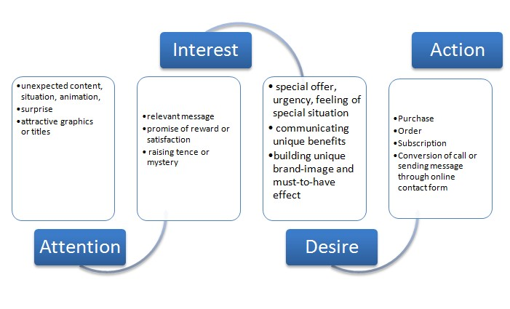

**Figure 2- (i). AIDA model**

*(Source; http://www.guerrillaonline.com/date/up-editor_1254654669976.jpg)*

### The Hierarchy of Effect Model

According to Barry (1987), the review of the advertising and marketing literature leads to the conclusion that there is not one but many hierarchy of effects (Barry, 1987: 253). William J.

McGuire (1969) is one of the proponents identified with the hierarchy of effects model. McGuire presented a paper on the topic “An information-processing Model of Advertising Effectiveness” to symposium on Behavioural and Management Science in Marketing, at the University of Chicago. He identifies the fact that it is necessary for an advertiser to place their advertising in the appropriate media. This is very important to achieve message exposure. McGuire also believes that this will give the consumer the opportunity to process the message effectively by using this theory (McGuire, 1969).

In the hierarchy of effect model, the consumer goes through a number of processes after being exposed to an advert. McGuire identifies the processes to be;

* Consumer attention (Awareness)
* Message comprehension (Knowledge)
* Message acceptance (Liking)
* Selective perception (Preference)
* Selective retention (Conviction)
* Action (Purchase)

(McGuire, 1969).

Every advertiser is keen to consumer attention. Advertising must therefore be placed strategically to stimulate the mental efforts of a consumer. The theory depicts that, the physical properties of an advert is the primary requirement to get the consumer’s attention. For broadcast-adverts, the motion and picture quality are essential. The size, columns, visibility and brightness are keen for billboards and print advertising (Sandage and Fryburger, 1967).

The time of exposure to adverts, and the consumer’s prior product knowledge is a key factor for consumer motivation and comprehension. Here the adverts enable the consumer to be able to grasp the meaning of the advertising content. Usually, adverts that have catchy phrases, and words repeated at the end frequently become easy to store in the memory (Vaughn, 1980).

If the advertising message is easy to comprehend by the consumer, message acceptance is likely to occur (Roland, 1986). The consumer will begin to develop a favourable attitude towards the product. This usually occurs when the consumer believes the information propagated in the advertisement is true and helpful to satisfying their need. There is a cognitive and physical response towards the advert. It is presumed that the achievement of this stage is positive and could lead to an action (purchasing) (Robertson, 1971). Ideally, a consumer may choose to buy Milo over Bournvita due to his or her acceptance of the products. Even though Milo and Bournvita serve the same purpose, comprehension and message acceptance in their advertisement may influence the consumer’s choice. The stages

of this model are shown in figure 2 –(ii).

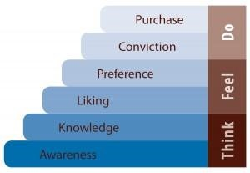

### Figure 2- (ii). Hierarchy of effect model

*(Source; http://www.marketingsavant.com/wp-content/upload/2009/06/think-feel-do_1300x207.jpg)*

After getting the public’s attention, it is necessary for the consumer to understand and interpret the advertising message as intended by the advertiser. Acceptances of Advertising messages tend to create consumer selective perception, at this stage, the consumer is likely to notice certain ads over others (Robertson, 1971). Selective retention will occur for a product design because they convince the public to pay attention to the advert. Advertisers and Advertising agencies must consider appropriate messages that can be easily comprehended, accepted and retained by their target audience. This will create, improve or maximize the impact expected on viewers (consumers) of these advertisements to relate themselves to the product being advertised.

### Magic Bullet Theory (Hypodermic needle)

This theory was propounded by Harold Laswell (1948). The theory propagates the media as a force that has direct, immediate and powerful effects on its audience. This theory depicts that the mass media are directly responsible for controlling what people think and in many ways how they behave (Defleur,2009). The metaphorical words “bullet” or “needle” used shows a literary influence of how the media directly shoots or injects information into the heads of its audience. This information are designed to trigger a desired response (Harris, 1969).

There is a powerful connection between the sender (media) and the receiver (audience). Laswell believed that the receiver at the other end of the chain is powerless to resist the power “impact” of messages sent from the media (Faris, 1952).

Defleur, with reference to the magic bullet theory describes the mass media as directly responsible for controlling what people think, and how they behave. He states that the media sway their audiences almost at will, bringing them to believe and behave in ways dictated by those who controlled their content (Defleur, 2009).

This describes the audiences’ inability to escape from messages injected or shot at them through the various media outlets. Immediate influence of the messages transmitted might not force the audience (consumer) to respond or purchase. Rather, the aim of creating awareness of the product or service in the minds of the consumers will be achieved. This can affect the individuals purchasing decision in the long run (Defleur & Dennis, 1991).

## 2.3. REVIEW OF RELATED STUDIES

Rai (2013), researched on the “impact of advertising on consumer behaviour and attitude with reference to consumer durables” for the International Journal of Management Research and Business Strategy (IJMRBS). Rai states specifically that in this information era and media world, “Advertising plays a major role in changing the behaviour and attitude of consumers.” He further explains that this change in behaviour and attitude is towards the products that are shown in advertisements. Rai believes that when a consumer is exposed to an advert, it alters the attitude with which they look at the product. In reference to the purchasing decision of the consumer, Rai indicates that “Advertising has great influence in the purchasing decision of customers for particular brands.”

The research explains how people use advertising as a guide to decide what the clothes, beverages, fragrances and durables are “right.” Rai’s research was based on two objectives. First, Rai wanted to examine the influence of advertising on attitude formation of consumers. Secondly, he was interested in determining the influence of advertising on attitude formation of consumers. In studying the attitudes of consumers, Rai observes that if a consumer notices messages for two different firm’s products, he or she judges the message content in terms of which one he or she perceives to be better. The consumer believes the better advertisement’s product will definitely have more features and so be of higher value. Rai explains that all the efforts to make an advertisement successful are centered on the sole aim of making it so effective and persuasive in a natural way so as to serve the purpose of meeting the consumer psyche in a positive manner. According to Reader’s Digest surveys cited in (Rai, 2013), a research was conducted annually since 2000 and asking respondents which brands they trusted most for several product categories. There are several national brands that have remained strong in the face of the power of the large multinationals. “These are national brands that are either old or include important national values in their advertising or both” (Rai, 2013; [www.rdtrustedbrands.com)](http://www.rdtrustedbrands.com/)

Rai in his findings concluded that advertisement worldwide influence the behaviour and attitude formation of consumers not only in India but also worldwide. The consumers of durable products have their motivational sources which are advertisements and study revealed that advertisement promotion motivates them to materialize the purchase of durables. The consumers are induced significantly by advertisements when the target is on quality and price. Purchase attitude and behavior is influenced by variety of advertisements which cover product evaluation and brand recognition (Rai , 2013).

Yelbert (2010) conducted a research on the effects of advertisement of hair products on students’ purchasing habit. She had the ultimate objective to determine whether the information provided during advertising was adequate to fully inform students about the effects of the product. Yelbert was also interested in whether students buy product because of models in advertisements. She considerably looked at the effects of advertising image on cultural perceptions of students. Yelbert’s research revealed that some people had a negative perception about advertising. They described advertising as a way of promoting inferior products to increase sales. Also, advertisers did not give full information about product her research findings indicated that many students are influenced to adopt hairstyles in advertisements. They buy a particular product due to the quality of the product portrayed in the advertisement. Yelbert concludes that advertising has a positive and negative effect on consumers. She quotes Shimp, T.A (2000) “whether consumers ultimately purchase a product depends on whether the promotion and communication variables facilitate purchasing” (Shimp, 2000; Yelbert, 2010). Yelbert found out that even though some students were influenced by advertising, others did not form their purchasing habits based on advertising. They rather had the impression that advertising was a way to deceive them and make them buy products they do not actually need (Yelbert, 2013).

Niazi et al. (2012) conducted a research on effective advertising and its influence on consumer buying behaviour (information management and business review). This research established that advertising is an effective tool to attract people and to divert their attitude positively toward a product. The research revealed that there is a moderate relationship between consumer purchase attention, environmental factors and emotional factors. If the consumer is emotionally attached with the product, he or she will prefer to patronize that product. Sometimes people change their brands just to test the other brands. Purchasing powers of people also change with a change in factors such as income level and men mostly prefer the advertisement than women according to Variawa (2010). Advertisement convinces people to use the product at least once in their lives. Celebrities used in advertising also contribute a greater positive influence on people. Mostly, people rely on advertisements rather than other sources like family, friends and reference group opinions regarding products (Bashir & Malik, 2009). Consequently, advertising has a vital role in modern age because it is a mechanism to build the behaviour of society regarding products. People get access to information and make decisions regarding product purchase (Niazi, et al., 2012: 114-119).

A survey was conducted by Source Dynamic Logic in 2009**.** The focus was on consumer behaviour to types of advertisements on television, online media outlets and magazines. The survey revealed that advertisements have modified consumer behaviour in such a way that they only go for brand favourability despite advertising awareness in every type of media.

The finding of the survey is shown in Figure 2-(iii).

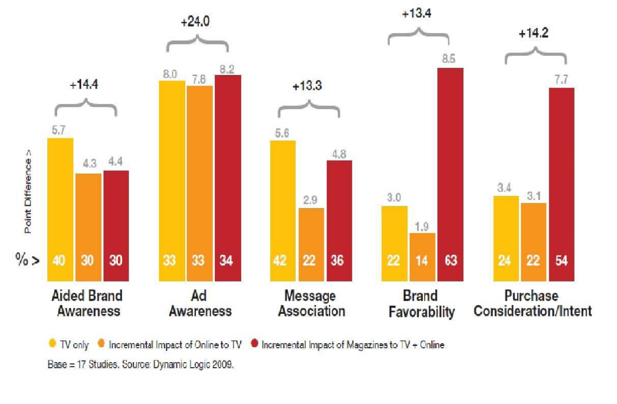

### Figure 2- (iii). Findings of survey by Dynamic Logic

*(Source: Rai, 2013: ; Dynamic Logic, 2009)*

In the sample of advertisements that was analyzed, only 5.5% were viewed as including global culture symbols compared with 25.6% in the other countries. The spread of global symbols, however, does not necessarily include homogeneity of people’s habits or values (Featherstone, 1991). In practice, notwithstanding the worldwide reach of television and the Internet, in many areas of people’s lives, in consumption or entertainment habits, be it music or sports, the people of different nations continue to have different habits, tastes, and loyalties. Instead of causing homogenization, globalization is the reason for the revival of local cultural identities in different parts of the world (Giddens, 2000).

The findings show that magazine advertisements provide great impact on purchasing behaviour of consumers. People go for purchasing according to the product value shown in advertisements in-spite of the cost of the products. As a result of this, they spend a lot more than actual value only due to the influence of advertisement.

A recent study *“The impact of point of purchase advertising on consumer buying behaviour”* by Amechi & Long (2013) reveals a connection between advertising and the point of purchase of the consumer. The study which was conducted for the Universiti Teknologi Malaysia (UTM), states that “Consumer buying behaviour in recent time is been driven by point of purchase advertising.” Existing queries on marketing communications effectiveness initiates an increase in sales volume and brand building. This study focuses on advertising strategies, medium, message, method, timing and their implications on achieving tactical marketing and sales objectives. The cause and effect relationship between point of purchase advertising and consumer purchase behaviour was established through extensive review of relevant literature. This research was aimed at providing recommendations that will aid corporate organizations enhance their advertising and marketing strategies towards increasing overall sales. According to the study, Quelch (2006) identifies point of purchase as the “most suitable place and period to communicate with consumers” since it is where they make their brand choice decisions. It is the time and place at which all elements of sale (consumer, money, and product) come together. Fitzgerald (2006) believes that the consumer’s in-store behaviour has been described in the following terms that highlight the importance of point of purchase advertising; “shoppers are explorers. They are on safari, hunting for bargains, new products and different items to add excitement to their everyday lives. Three of every four are open to new experiences as they browse the aisles of supermarkets and search for bargains at drugstores and mass merchandisers”. This translates into an opportunity to make a measurable impact just when shoppers are most receptive to new product ideas and alternative brands. Savvy marketers realize that the in-store environment is the best chance to make a difference.

Advertising itself is an element of promotion, which is one of the basic marketing concepts or one of the basic elements of the marketing mix (Perreault & McCarthy, 1997 : 40). Moe (2006) presents a broad view of the concept of advertising: He believes that we cannot fully understand the concept of advertising without seeing it from the communication and marketing perspectives. He says further that advertising touches on almost all aspects of modern society and human existence, its basic functions and roles are basically communication and marketing oriented. A critical assessment of advertising trends gives an insight into the captures and communicates the needs and wants of the modern man. “It expresses how humans have evolved from agrarian, basic existence/basic survival reality to a more sophisticated or advanced status” (Rojas-Méndez, et al., 2005).

Abiodum (2011) conducted a research on the topic “impact of advertising on sales volume of a product.” Abiodum’s main aim was to identify and demonstrate the impact of advertising on sales and profit of a business organization taking Starcomms Plc as a case study. His work also had the objective to identify how this sales volume can keep the company going. In

Abiodum’s work he states that “in a growing economy such as Nigeria, it is often very difficult to have a regular and consistent increase in the sales volume of a product because of the political and socio-economic instability in the country which directly affect the standard of living and the purchasing power of the consumers.” He identifies the fact that good advertising requires competent personnel including a number of specialists to enable it thrive in the ever dynamic and competitive business environment. Abiodum recognised the role advertising can play and states that “a growing number of companies and establishments have to embark on a nationwide advertising campaign.” His research revealed that in some cases, advertising informed by depressed consumer demand thrive by persuading the consumer on the need for consumptions. Abiodum’s work depicts and a shed light on how advertising can really affect a consumer’s buying decisions in a growing economy like that of Nigeria. It also shows how successful advertising can keep business going even in the midst of tough completion (Abiodum, 2011). Abiodum in His research examined how marketing managers determine which advertising tool will be most effective. Also he studied the advertising program of the company and a cost benefit analysis of the advertising tools employed by the company.

Abiodum in his findings explain that the role of advertising on the sales volume of a product is very important because consumers’ decisions as regards what to buy is motivated by what has been seen heard of or practically used. Advertising helps in that it carries the messages far and wide to a scatted target audience that the advertiser or producer could not have reached it at once so easily. Abiodum states that from the responses of respondents who filled his questionnaire, the organization is unrelenting in its efforts to ensure effective advertising programme for their various services and products. In the mind of the consumers, the company was also using advertising strategies suitable for the company as well as the markets in which it exists. More of the findings reveal that the advertising position of a product or service is strong in the mind of the consumer on order to encourage repeated purchase of the product, so that the competitors will not have an edge over them. This also creates brand loyalty and product differentiation.

It is clearly evident in all these studies that there is a relationship between advertising and consumer purchasing behaviour. The various findings and conclusions show that advertisers play an important role in order to change, alter or influence an individual’s choice of product and service. In Yelbert’s (2010) research, she concluded that some people perceived advertising in a negative way and therefore were not influenced by it to make their purchases. This creates the conception that advertising may have a significant impact on consumers but the concept might not absolute. The related works also show that even if advertising does not succeed in getting people to buy the product, it achieves a stage of creating awareness and attention to the product or service. Abiodum in his conclusion states that advertising has taken Starcomms Plc far in their industry and built up a strong image for the company but due to recent relent in their advertising effort, some little problems have been identified there (Abiodum, 2011).

## 

# CHAPTER THREE

# METHODOLOGY

## 3.1. INTRODUCTION

Research is a structured enquiry that utilizes acceptable scientific methodology to solve problems and create new knowledge that is generally applicable (Dawson, 2002). Scientific methods consist of systematic observation, classification and interpretation of data (Kothari, 1985).This chapter deals with methods the researcher used in gathering and analyzing data collected. As to achieve a good result of this research work, the data collected must be reliable, credible and relevant. Therefore, techniques and methods which will be convenient to use are employed under specific situations to give an accurate, valid and satisfactory analysis of data. It includes the research design, the population, the sampling technique, and the sample size. With regards to data collection procedure, the researcher relied on both primary and secondary data.

## 3.2. DESIGN

Research design refers to the way information is gathered from subjects and, in the case of experimental research, the nature of the treatments that are controlled by the investigator. This study adopts the quantitative approach of data gathering. This approach is concerned with the acquisition and interpretation of data that is presented in the form of discrete units. The data can be compared with other units by using statistical techniques (Gall et al., 1996). Quantitative research approach attempts to discover something about a large group of individuals by studying such smaller group. Unlike qualitative research, quantitative methods are those which emphasize on facts, numbers and frequencies. The respondents can represent the opinions of the whole population (Hoang, 2013). The larger group is the population and the smaller group is referred to as the sample (Gall et al., 1996). Quantitative research is based on the quantitative measurements of some characteristics. It is applicable to phenomena that can be expressed in terms of quantities. It can also be explained as fields of study that can adopt the positivist philosophy of knowing that emphasizes objectivity and quantification of phenomenon (Kumar, 2005).

## 3.3. SUBJECTS / POPULATION AND SAMPLE

To achieve good population validity, Quantitative researchers must select the sample randomly from the defined population to which they wish to generalize their results (Gall et al., 1996). The defined target population for the study was the students of the Auchi Edo State from the ages of eighteen (18) years and above. The total population (target population) of students of the Auchi Edo State was one thousand eight hundred and thirty one (1,831).

## 3.4. INSTRUMENTS FOR DATA COLLECTION

Questionnaire is the main instrument used in this study. According to the oxford leaner’s dictionary (seventh edition), “a questionnaire is a written list of questions that are answered by a number of people so that information can be collected from the answers.” This is a document that asks same questions of individuals in a sample. Thus a questionnaire is a technique of data collected where different people are asked to respond to the same set of questions in a predetermined order. It includes structured interviews and telephone questions as well as those in which the questions are answered without an interviewer present. Subjects usually record a written response to each questionnaire item Subjects can fill out the questionnaire at their convenience and answer the items in any order. They may skip questions as well as give unique responses. Questionnaires are used extensively in educational research to collect information that is not directly observable. These data collection method typically inquires about the feelings, motivations, attitudes, accomplishments and experiences of individuals. A wide range of issues can be investigated with questionnaires. Questionnaire is commonly used in quantitative research because it is a standardized highly structured and is compatible with the approach. A questionnaire often solicits respondent’s opinion about a particular topic or issue (Gall et al., 1996: 288 - 289).

The questionnaire used is very flexible. There are three basic types of questionnaire. The close-ended, open ended and a combination of both (Kumar, 2005). The questionnaire contains both close ended and open ended questions. This makes it possible to find out how many people use a product or service and what they think of it in the same form (Kumar, 2005). The close – ended questions include all possible answers or prewritten response categories. Respondents are asked to choose their answer among the options. This type of question is used to generate statistics in quantitative research. Also because these follow a set of format, most responses can be entered easily into a computer for easy analysis (Dawson, 2002). The open – ended questions allow respondents to answer in their own words. This kind of questions does not contain boxes to tick but instead leaves a blank section for respondents to write in an answer. Due to the fact that there are no standard answers to these questions, data analysis is more complex. This is because opinions are sought rather than numbers. Fewer open-ended questions were included. Whereas closed-ended questionnaires might be used to find out how many people use a product or service, open-ended questionnaires might be used to find out what people think about a service (Kothari, 1985).

The research questionnaire seeks to answer questions about;

1. Consumer perception of advertising.
2. Personal experience with advertised products.
3. Satisfaction level after purchasing and using advertised products.
4. Impact of advertisement on the consumer’s buying decision.

**ANALYSIS**

The study utilizes simple percentage and t test for descriptive statistic after collecting the responses and coding them.

# CHAPTER FOUR

# ANALYSIS AND FINDINGS

# 4.1. INTRODUCTION

In this chapter, findings and analysis of data collected with questionnaires will be presented with the aid of tables, pie charts and graphs. Microsoft Excel and SPSS were the data entry software used to assist the researcher to reach reliable and appropriate results from the responses of the questionnaire administered.

## 4.2. ANALYSIS AND FINDINGS

Sixty five (65) questionnaires were distributed randomly to sixty-five (65) final year students (Level 400) of the Auchi poly Edo State. All sixty five questionnaires were collected and there was no disqualified questionnaire. Majority of the respondents were females. There were forty-one (41) females out of the total number of sixty five (65) respondents representing sixty-three percent (63%) of the total percentage of respondents. The male respondents were twenty-four (24) out of the sixty-five respondents representing thirty-seven percent (37%) of the total number of respondents. The chart below shows the gender distribution of respondents in figure 4 – (i).

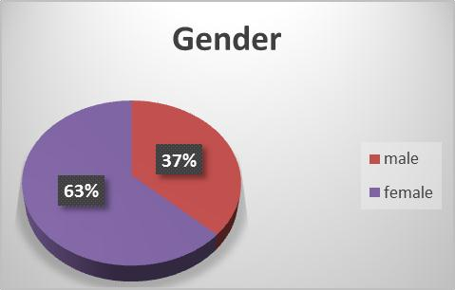

### Figure 4- (i). Gender distribution of respondents

The questionnaire provided an age range specification of eighteen to twenty-one years (18-21), twenty-two to twenty-five years (22-25), and twenty-six years and above (26 and above). Most of the respondents who were randomly selected fall between the age range of twenty-two to twenty-five years (22-25) representing sixty-nine percent (69%) of the total number. Respondents between the ages of eighteen to twenty-one years (18-21) and twentysix years and above (26 and above) both represented fifteen percent of the total number (15%). The age distribution of respondents s represented in figure 4 – (ii).

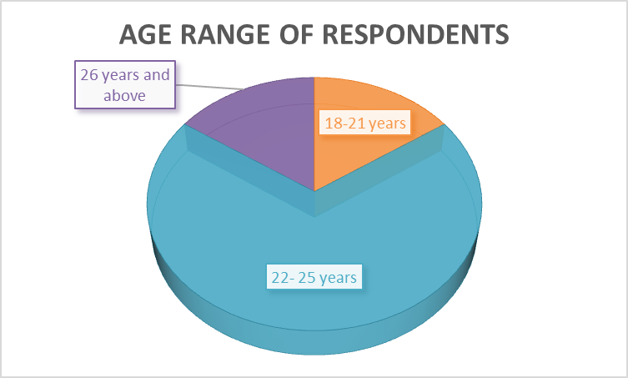

### Figure 4- (ii). Age range of respondents

Figure 4 – (iii) shows the response to question three (3) on the questionnaire distributed.

The question was “Have you ever been exposed to advertisement of any kind?” All the respondents answered “Yes” to this question. This is a clear indication that everyone is one way or the other exposed to advertisement.

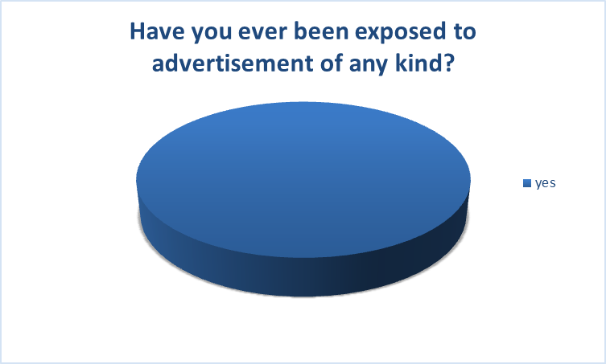

### Figure 4- (iii). Exposure to advertisement

The advertising media is the “means by which the message is communicated to the target audience” (Berkowitz et al. 1992). The fourth question was to identify which advertising medium people are usually exposed to. This was a multiple response question and therefore respondents were at liberty to choose more than one of the options provided. A total number of one-hundred and sixty four (164) were given representing two hundred and twenty four point six percent of cases (224.6%). Fifty one (51) respondents selected television representing seventy eight point five percent of cases (78.5%). Thirty four (34) respondents selected radio representing fifty two point three percent of cases (52.3%). Internet was selected twelve (12) times representing eighteen point five percent of cases (18.5%). Twelve responses were also given to newspapers representing eighteen point five percent of cases (18.5%). Billboard was selected thirty seven times representing fifty six point nine percent of cases (56.9%). This responses show that even though people may be exposed to advertisement on several media platforms, the frequency of exposure varies. The responses given indicated that most of the respondents were exposed more to advertisements on television. According to Berkowitz et al. (1992), Television is considered to be a valuable medium because “it communicates with both sight and sound” (Berkowitz, et al., 1992 : 504).

The information is illustrated in table 4 – (i).

**Which advertising Responses**

### media gets your Percent

|  |  |  |  |
| --- | --- | --- | --- |
| **attention?** | **N** | **Percent** | **of Cases** |
| Television  Radio | 51  34 | 34.9%  23.3% | 78.5%  52.3% |
| Internet | 12 | 8.2% | 18.5% |
| Newspapers | 12 | 8.2% | 18.5% |
| Billboards | 37 | 25.3% | 56.9% |
| **Total** | **164** | **100.0%** | **224.6%** |

### Table 4- (i). Medium of exposure

According to responses given to the question “which times of the day are you often exposed to advertisements?” most people are usually exposed to advertisement in the evening. This question was a multiple choice question. One hundred and sixteen (116) responses were generated from this question amounting to one hundred and seventy-eight percent (178%) of cases. Out of this total number of responses, evening was the highest with fifty (50) representing seventy six point nine percent (76.9%) of cases. Exposure to advertisement in the afternoon was second with thirty two (32) responses representing forty nine point two percent (49.2%) of cases. Morning was next with twenty eight (28) responses representing forty three point one percent (43.1%) of cases. Exposure to advertisement at late night was the least with six (6) responses representing nine point two (9.2%) of cases. This information is shown in Table 4 -(ii).

|  |  |  |  |  |
| --- | --- | --- | --- | --- |
| **Which times of the day are you often exposed advertisements?** | **to** | **Responses** |  | **Percent of Cases** |
| **N** | **Percent** |
| morning |  | 28 | 24.1% | 43.1% |
| afternoon |  | 32 | 27.6% | 49.2% |
| evening |  | 50 | 43.1% | 76.9% |
| late night |  | 6 | 5.2% | 9.2% |
| **Total** |  | **116** | **100.0%** | **178.5%** |

### Table 4- (ii). Time of exposure

Question six (6) was to indicate how often people were exposed to these advertisements.

The options to indicate the frequency range were “never”, “every day”, “2-3 times per week”, and “once in two weeks”. Every day was dominant with forty-nine (49) responses out of the total number of sixty-five (65) representing seventy-five percent (75%). Two to three times (2-3) per week was next with fifteen (15) responses representing twenty-three percent (23%). Once in two weeks was least with only one (1) response representing two percent (2%). This information is shown in figure 4 – (iv).



**75**

**%**



**23**

**%**



**2**

**%**

**how often are you exposed to these**

**advertisement?**

everyday

2

- 3 times per week

once in two weeks

### Figure 4- (iv). Frequency of exposure

Responses given to the question “Please indicate your evaluation of the advertisements you have been exposed to?” was one-hundred and ninety two (192). This was a multiple choice question giving respondents the chance to select more than one option. Majority of the respondents indicated that the advertisements they were exposed to were Attractive with forty-seven (47) responses representing seventy two point three percent of cases (72.3%). Responses for informative was forty-five (45) representing sixty nine point one percent of cases (69.2%). Choice for interesting was forty-one (41) representing sixty three point one percent of cases (63.1%). Response for entertaining was thirty-six (36) representing fifty five point four (55.4%) percent of cases. Professional had sixteen (16) responses representing twenty four point six (24.6%) percent of cases and effective was seven (7) representing ten point eight (10.8) percent of cases. This represents a total of two-hundred and ninety-five point four percent of cases (295.4%). This information is shown in table 4 – (iii) below.

### Please indicate your evaluation Responses of the advertisements you have Percent of

|  |  |  |  |
| --- | --- | --- | --- |
| **been exposed to.** | **N** | **Percent** | **Cases** |
| Attractive | 47 | 24.5% | 72.3% |
| Interesting | 41 | 21.4% | 63.1% |
| Informative | 45 | 23.4% | 69.2% |
| Professional | 16 | 8.3% | 24.6% |
| Entertaining | 36 | 18.8% | 55.4% |
| Effective | 7 | 3.6% | 10.8% |
| **Total** | **192** | **100.0%** | **295.4%** |

### Table 4- (iii). Evaluation of advertisement

The question “do you believe in advertising messages” has the objective of finding out the level of trust people have in advertising messages. Out of the sixty-five (65) respondents, forty-two (42) answered “yes” representing sixty five (65%) of the total number. Twentythree (23) people answered “no” representing thirty-five percent (35%) of the total number.

This information is shown in figure 4 – (v).

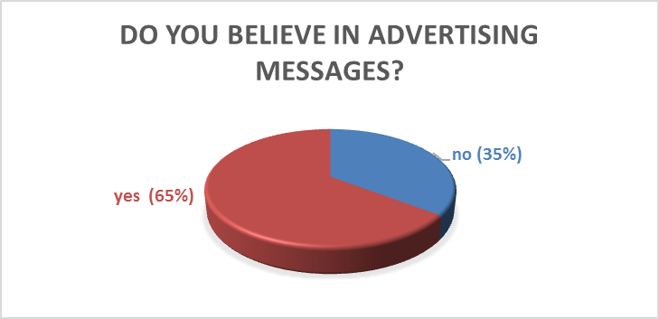

### Figure 4- (v). Believe in advertisement

Majority of the respondents including those who do not believe advertising messages consider advertising to be important. Out of the total sixty-five (65) respondents, sixty-four (64) representing ninety-eight percent (98%) answered “yes” and one (1) representing two percent (2%) answered “no” to the question “do you think advertising is important?” the data is represented in figure 4 – (vi).



**2**

**%**



**98**

**%**

**Do you think adverting is**

**important?**

no

yes

### Figure 4- (vi). Importance of advertisement

### The respondents were asked if they buy Nestle Milos solely based on advertising. Thirty-five (35) people answered “sometimes” representing fifty-three point eight percent (53.8%) of the total number. Twenty-five (25) people answered “no” representing thirty-eight point five percent (38.5%) of the total number. Four (4) people answered “most times” representing six point two percent (6.2%) of the total number. One (1) person answered “yes” representing one point five (1.5%) of the total number of respondents. This information is shown in figure 4 – (vii).

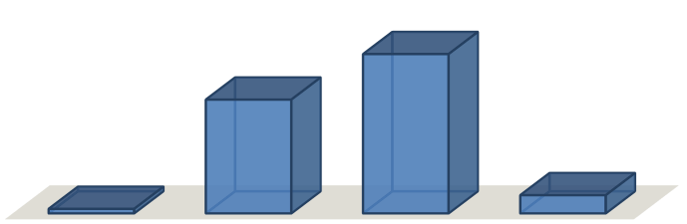

0.0

20.0

40.0

60.0

yes

no

sometimes

most times



**1.5**



**38.5**



**53.8**



**6.2**

percentage of respondents

Response

DO YOU BUY MILO BASED

SOLEY ON ADVERTISING?

### Figure 4- (vii). Purchase based solely on advertisement

The questionnaire asked people if they have purchased any Nestle Milorecently after coming across the advertisement. Twenty-eight (28) respondents answered “yes” representing forty-three percent (43%) of the total number of responses. Thirty-seven (37) respondents answered “no” representing fifty-seven percent (57) of the total number of responses given.

The data for this question is shown in figure 4 – (viii).



NO

-

57

%



YES

-

43

%

**HAVE YOU PURCHASED ANY PRODUCTS RECENTLY**

**AFTER COMING ACROSS THE ADVERTISEMENT?**

### Figure 4- (viii). Purchasing an advertised Nestle Milo

To enable the evaluation of the several reasons that inform a consumer’s choice to buy, respondents were asked about factors that influence their purchasing decision. This was a multiple choice question to give respondents the chance to select any number of answers as well as provide answers in their own words in a space provided for other specifications. The responses to this question are shown in table 4 – (iv).

|  |  |  |  |
| --- | --- | --- | --- |
| **Which of these factors influence your of purchasing of Nestle Milo?** | **N** | **Percent** | **Cases** |
| the advertisement was interesting | 26 | 26.8% | 41.3% |
| I was curious about the Nestle Milo | 23 | 23.7% | 36.5% |
| it was a familiar Nestle Milos or brand | 26 | 26.8% | 41.3% |
| I was already planning to buy that  Nestle Milo 17 | | 17.5% | 27.0% |
| Other 5 | | 5.2% | 7.9% |
| **Total 97** | | **100.0%** | **154.0%** |

### Table 4- (iv). Factors that influence purchasing

In table 4 – (iv), the total number of responses for this question is ninety seven (97). Twenty six respondents selected interesting and purchasing familiar Nestle Milos or brands. These options both represent forty one point three (41.3%) percent of cases. Twenty three people responded to purchase Nestle Milos they were curious about representing thirty six point five (36.5%) percent of cases. Seventeen respondents were already planning to buy Nestle Milo representing twenty seven (27.0%) percent of cases. Five (5) people selected other representing seven point nine (7.9%) percent of cases. The total percentage of cases is one hundred and four (154.0%). It can be seen that most people were influenced by advertisements they considered to be interesting. Also, majority of the respondents also indicated that their purchasing decision is influenced by Nestle Milos or brands they consider familiar. Respondents who specified other reasons stated factors such as recommendation from friends, packaging, the need for the Nestle Milo and quality of the Nestle Milo.

**RESEARCH HYPOTHESIS**

**Hypothesis 1:**

Ho: Media advertisement of Nestle food drink do not generate brand loyalty for the Milo amongst its diversified consumers

Hi: Media advertisement of nestle Milo food drink generate brand loyalty for the Milo amongst diversified consumers

# Table 4.7: t-test Statistics for respondents opinion

GROUP N X SD DF α t-cal t-crit P Decision

Yes. 35 63.3750 14.06886 198 0.05 3.970 1.96 0.000 Rejected

No 65 33.0000 12.34130

Table 4.7 showed a significant difference in the response whether or not Media advertisement of nestle Milo food drink generate brand loyalty for the Milo amongst diversified consumers. The mean scores are 63.3750 and 33.0000, tcal = 3.790 and t-crit = 1.96 which is less than the alpha (a) of 0.05. Therefore, the hypothesis which states that media advertisement of Nestle food drink do not generate brand loyalty for the Milo amongst its diversified consumers is rejected.

**Hypothesis 2:**

Ho: media advertisement of nestle Milo food drink do not influence the buying and consumption habit of Nestle Milo consumers

Hi: media advertisement of nestle Milo influence the buying and consumption habit of nestle Milo consumers

**Table 4.8: t-test Statistics for difference in response**

GROUP N X SD DF α t-cal t-crit P Decision

Yes. 40 58.0000 19.51290 198 0.05 2.766 1.96 0.000 Rejected

No 65 37.6250 15.09797

Table 4.8 showed a significant difference in the response of individuals on whether or not media advertisement of nestle Milo food drink influence the buying and consumption habit of Nestle Milo consumers. The mean scores are 58.0000 and 37.6250, t-cal = 2.766 and t-crit = 1.96 which is less than the alpha (a) of 0.05. Therefore, the hypothesis which states that media advertisement of nestle Milo food drink do not influence the buying and consumption habit of Nestle Milo consumers is rejected.

# CHAPTER FIVE

# CONCLUSIONS AND RECOMMENDATION

## 5.1. CONCLUSIONS

According to Cappo (2003), Advertising is not enough to capture and keep clients (p. 43). This is reflected in the findings of this research. The responses and results indicate clearly that advertising has a significant level of influence in the consumer’s decision to purchase. However, this is not absolute. Advertising may serve as a platform to inform or remind consumers of the existence of Nestle Milobut the purchase decision needs more than that. After purchase, the buyer begins evaluating the Nestle Miloto ascertain if its actual performance meets expected levels (Pride & Ferrell, 2008: 126).The consumer must be satisfied and convinced with all other factors such as packaging, Nestle Miloquality, and endorsement among others to take an action towards the Nestle Milo. Companies must improve on their services and be more concerned with giving adequate information in advertisements to be able to meet the expectations of potential customers.

## 5.3 LIMITATIONS OF STUDY

The research seeks to go as far as to identify the extent to which advertising influences the consumer. However, it was limited by factors such as;

Inadequate time.

The project submission deadline hindered the researcher’s ability to gather enough information from all relevant sources. Also, during the time of conducting this study, the researcher was engaged in other academic activities.

Lack of enough funds and resources.

This research used only sixty-five (65) respondents out of the accessible population of one hundred and six (106). This was due to the limited budget available to the researcher.

The possibility of some respondents giving false answers.

The data collected with questionnaires is what the researcher used to analyze and reach his conclusions. The disadvantage of some respondents giving untrue answers may hinder the total validation of discussions and conclusions.

## 5.5. RECOMMENDATION FOR FURTHER STUDIES

An aspect of the findings of this research based on responses given shows that people also care about purchasing Nestle Milos with a peculiar branded image. The researcher therefore suggests a study on “the impact of Nestle Milobrand image on buying behaviour.” This will help further studies to examine how people perceive branded Nestle Milos and if that actually affects their purchasing behaviour.

# REFERENCES

1. Aaker, D., Kumah, V. & Leone, R., 2012. *Marketing research.* 11th ed. s.l.:Wiley

Global Education.

1. Abiodum, A. O., 2011. *The impact of advertising on sales volume of Nestle Milo. A case study of Starcomms plc, Nigeria.* s.l.:s.n.
2. Amechi, C. U. & Long, C. S., 2013. The impact of point of purchase advertising on consumer buying behaviour. *Interdisciplinary Journal of Contemporary Research in Business,* 4(10), pp. 84-90.
3. Arens, W. F. & Bove'e, C. L., 1994. *Contemporary Advertising.* 5th ed. Burr Ridge: Richard D. Irwin Inc..
4. Barry, T. E., 1987. the Development of the Hierarchy of Effects : An Historical

Perspective. *Current Issues & Research in Advertising,* 10(2), pp. 251-255.

1. Bashir, A. & Malik, N. I., 2009. *Effects of advertisement on consumer behaviour of university students.* s.l.:s.n.
2. Belch, G. E. & Belch, M. A., 2003. *Advertising and Promotion : An integrated marketing communications perspective.* 6th ed. s.l.:The McGraw Hill Company.
3. Berkowitz, E. N., Kerin, R. A., Hartey, S. W. & Rudelius, W., 1992. *Marketing.* 3rd ed. s.l.:Richard D. IRWIN, Inc..
4. Blake, T., Nosko, C. & Tadelis, S., 2013. *Consumer heterogenety and paid search effectiveness : A large scale field experiment.* s.l.:s.n.
5. Bournstard, D. J., 2003. *Economic incentives in the purchase and use of energy-using Nestle Milos. Past practices and new developmets,* s.l.: Joint Institute for energy and environment.
6. Bove'e, C. L. & Arens, W. F., 1992. *Contemporary Advertising.* 4th ed. Homewood:

Richard D. Irwin, Inc..

1. Bove'e, C. L., Houston, M. J. & Thill, J. V., 1995. *Marketing.* s.l.:McGraw - Hill.
2. Broadbent, S., 1997. *Accountable Advertising : HAndbook for managers and analysts.* s.l.:s.n.
3. Cappo, J., 2003. *The Future of Advertising.* New York: McGraw-Hill.
4. Chung, C. & Kaiser, H. M., n.d. *Measurement of Advertising effectiveness using altenative measures of advetising exposure.* s.l.:s.n.
5. Dana VanDen Heuvel, 2009. *Marketing Savant.* [Online]

Available at: http://www.marketingsavant.com/wp-content/upload/2009/06/think-feeldo_1-300x207.jpg

[Accessed 23 January 2014].

1. Dawson, C., 2002. *Practical research methods.* New Delhi: UBS publishers and

Distribtors.

1. Defleur, M. L., 2009. *Mass Communication Theories : Explaining Origins, Processes and Effects: Allyn & Bacon Inc.*
2. Defleur, M. & Dennis, E. E., 1991. *Understanding mass communication.* 4th ed. s.l.:s.n.
3. Faris, R. E., 1952. *The instinct theory in human behaviour : Social psychology.* New York: The Roland Press compnay.
4. Featherstone, M., 2007. *consumer culture and postmodernism.* 2nd ed. London: Sage publication.
5. Futrell, C. M., 1999. *Fundamentals of Selling : Customers for Life.* s.l.:Irwin / McGaw Hill.
6. Gall, M. D., Borg, W. R. & Gall, J. P., 1996. *Educational research : An introduction.*

6th ed. s.l.:s.n.

1. Giddens, A., 2002. *Runaway world.* New York: Profile books Ltd. .
2. Glowa, T., 2002. *Advertising process models.* s.l.:s.n.
3. Guerilla Marketing Principles, 2009. *Guerillaonline.com.* [Online]

Available at: http://www.guerrillaonline.com/date/up-editor_1254654669976.jpg [Accessed 23 January 2014].

1. Hackley, C., 2005. *Advertiing and Promotion : Communicating brands.* s.l.:s.n.
2. Hansen, F., 1972. *Consumer Choive Behaviour : A Cognitive theory.* s.l.:Free Press.
3. Hanstein, S., n.d. *Defining succesful marketing communication : A follow-up of a global campaign.* Wastila: s.n.
4. Harris, E. E., 1969. *Fundamentals of philosophy.* New York: Holt, Rinehart and Wiston.
5. Hill, R. P. & Gardner, M. P., 1986. *The Buying Process : Effects of and on Consumer*

*Mood states.* New York: McGraw - Hill.

1. Hoang, A. T., 2013. *Impact of humour in advertising on consumer purchase decision.* s.l.:s.n.
2. Ingavale, D. R., 2013. Impact of advertisements on purchase decisio n of youth with reference to consumer goods.. *Advances in management,* September.6(9).
3. Issifu, A., 2009. *The effects of celebrity endorsement in TV adverts on consumer behaviour.* s.l.:s.n.
4. Jones, J. P., 1986. *What's its name? : Advertising and the concept of brands.* England:

Adleshot : Gower.

1. Jones, J. P., 2002. *The Ultimate Secretes of Advertising.* London: Sage Publications.
2. Jr, J. F. S., 1987. *Marketing and semiotics : New directions in the study of signs for sale.* s.l.:s.n.
3. Klein, N., 2000. *No Logo.* s.l.:Flamingo.
4. Kothari, C. R., 2006. *Research methods and techniques.* New Delhi: New age international Ltd.
5. Krugman, E. P., 2013. *Consumer Behaviour and Advertising Involvement : Selected works of Herbert E. Krugman.* Boston, Illinois: Routledge.
6. Kumar, R., 2005. *Research methodology : A step by step guide for beginners.* 2nd ed.

Singapore: Pearson Education.

1. Lavidge, R. J. & Steiner, G. A., 1961. A model for predictive measurements of advertising effectiveness. *Journal of Marketing,* 25(6), pp. 59-62.
2. Levin, J., 2006. *choice under uncertainty.* s.l.:s.n.
3. Loudon, L. D. & Bitta, D. A., 1993. *Consumer behaviour.* 4th ed. New York:

McGraw Hill, Inc..

1. McGuire, W. J., 1969. *An Information - Processing Model of Advertising Effcetiveness,* Chicago: Symposium on Behavioural and Management Science in Marketing.
2. Niazi, G. S. K., Siddiqui, J., Alishah, B. & Hunjra, A. I., 2012. Advertising and its influence on consumer buying behaviour. *Information Management and Business Review, 4(3), pp. 114-119.*
3. Oberholzer, R., Kock, D. d. & Walker, K., 2008. *Routes of persuation utilised in advertising appeals of South African revenue service among taxpayers in Guateng.*

Guateng: s.n.

1. Perreault, W. D. & McCarthy, J. E., 1997. *Essentials of marketing : A global managerial approach.* 7th ed. s.l.:Irwin / McGraw Hill.
2. Pope, D., 1983. *The making of Modern Advertising..* New York: Basic Books.
3. Pride, W. M. & Ferrell, O., 2008. *Marketing.* New York: Houghton Mifflin company.
4. Proctor, T., 2003. *Essentials of marketing research.* 4th ed. s.l.:Pearson.
5. Richard, V., 1980. How Advertising works : A planing model. *Journal of Advertisi g*

*Research,* October, Volume 20, p. 5.

1. Robbs, B., 2009. *Advertising,* s.l.: Microsoft Student Encarta : Microsoft Corporation.
2. Robertson, T. S., 1971. *Innovative behaviour and communication.* Holt, Rinehart and

Wiston: s.n.

1. Roland, R., 1986. *Advertising media models.* Lexington, M.A: Lexington books.
2. Rossiter, J. R. & Percy, L., 1985. Advertising communication models : NA advances in consumer research. *Association for consumer research,* Volume 12, pp. 510-524.
3. Sandage, C. & Fryburger, V., 1967. *Advertising theory and practice.* Homewood IL:

Richard D. IRWIN, Inc..

1. Sandage, C. H., 2012. *Advertising practice.* s.l.:Literary Licensing, LCC.
2. Shahid, M. I., 1991. *Mass Communication.* 2nd ed. Lahore: Caravan Press.
3. Shimp, T. A., 2003. *Advertising promotion : Supplemental Aspects of integrated marketing communications.* 6th ed. Orlando: Thompson- South western.
4. Shukar, S. A., 2011. *Antecedents and outcomes of social influences : The case study of British muslims in UK..* Cardiff: Cardiff University.
5. Tuckwell, K. J., 1992. *Canadian Advertising in action.* 2nd ed. Ontario: Prentice -

Hall Canada Inc..

1. Variawa, E., 2010. *Buying behaviour and deciion-making criteria of base of the pyramid consumers (The influence of packageging on fast moving consumer goods and customer's brand experience).* s.l.:s.n.
2. Warmke, R. F., Wyllie, E. D. & Sellers, B. E., 1977. *Consumer decision taking :*

*Guide to better living.* 2nd ed. s.l.:s.n.

1. Wray, R. D., 1990. *Advertising services.* 2nd ed. Ohio: Glencoe/McGraw Hill.
2. Yelbert, M. N. A., 2010. *Effects of advertising of hair Nestle Milos on student's purchasing habits.* Accra: s.n.