**GAS CHROMATOGRAPHY- MASS SPECTROMETRY ANALYSIS AND EFFECT OF *Amaranthus hybridus* AQUEOUS LEAF EXTRACT ON PLASMA AND HEART LIPID PROFILE IN DOXORUBICIN - INDUCED CARDIOTOXIC RAT**

|  |  |  |  |
| --- | --- | --- | --- |
|  |  | **TABLE OF CONTENTS** |  |
| **CONTENT** | | | **PAGE** |
| Declaration | | | i |
| Certification | | | ii |
| Dedication | | | iii |
| Acknowledgements | | | iv |
| Table of Contents | | | v |
| List of Tables | | | xi |
| List of Figures | | | xii |
| List of Appendices | | | xiii |
| Abstract | | | xiv |
| CHAPTER ONE | | |  |
| 1.0 | Introduction | | 1 |
| 1.1 | Statement of Problem | | 2 |
| 1.2 | Aim of study | | 3 |
| 1.3 | Objectives of study | | 3 |
| CHAPTER TWO | | |  |
| 2.0 | Literature Review | | 4 |
| 2.1 | Botanical Description of *Amaranthus Hybridus* | | 4 |
| 2.2 | Ethnobotany of Amaranthus | | 8 |
| 2.3 | Role of amaranthus in nutrition | | 8 |
| 2.3.1 | | Protein Content | 8 |
| 2.3.2 | | Micronutrient | 8 |
| 2.3.3 | | Phytochemicals Content | 8 |
| 2.3.4 | | Fibre and Anti-nutrient content | 9 |
| 2.4 | Doxorubicin | | 9 |
| 2.4.1 | | Structure and Chemistry | 10 |
| 2.4.2 | | Administration | 10 |
| 2.4.3 | | Distribution | 11 |

vi

|  |  |  |
| --- | --- | --- |
| 2.4.4 | Metabolism | 11 |
| 2.4.5 | Mechanism of action | 12 |
| 2.4.6 | Extraction | 12 |
| 2.5 Adverse effect | | 12 |
| 2.5.1 | Cardiac toxicity | 13 |
| 2.5.1.1 Acute cardiac toxicity | | 13 |
| 2.5.1.2 Chronic cardiac toxicity | | 14 |
| 2.6 Prevention of cardiac toxicity | | 15 |
| 2.7 GC-MS | | 16 |
| 2.8 Types of GC-MS | | 17 |
| 2.8.1 | Single quadruple GC-MS | 17 |
| 2.8.2 | Triple quadruple GC-MS | 17 |
| 2.8.3 HRAM GC-MS | | 17 |
| 2.9 GC-MS application | | 18 |
| 2.9.1 | Food and beverage analysis | 18 |
| 2.9.2 | Environmental analysis | 18 |
| 2.9.3 | Metabolomics | 18 |
| 2.9.4 | Oil and gas analysis | 18 |
| 2.10 Lipid profile | | 19 |
| 2.11 Types of lipid profile parameters | | 19 |
| 2.11.1 Total cholesterol | | 19 |
| 2.11.2 High-Density Lipoprotein | | 19 |
| 2.11.3 Low-density lipoprotein | | 20 |
| 2.11.4 Very-Low-Density Lipoprotein | | 20 |
| 2.11.5 Triglyceride | | 20 |
| 3.0 CHAPTER THREE: METHODOLOGY | |  |
| 3.1 Material and reagents | | 22 |
| 3.1.1 | Collection of plant material | 22 |
|  |  | vii |

|  |  |  |  |
| --- | --- | --- | --- |
| 3.1.2 | | Preparation of plant material | 22 |
| 3.1.3 | | Drug preparation | 23 |
| 3.2 | Study design | | 23 |
| 3.2.1 | | Animal study | 23 |
| 3.2.2 | | Experimental design | 24 |
| 3.2.3 | | Drug administration | 24 |
| 3.3 | Preparation of plasma | | 24 |
| 3.4 | Assay methods | | 24 |
| 3.4.1 | | Determination of cholesterol | 24 |
| 3.4.6 | | Determination of triglyceral | 25 |
| 3.4.7 | | Determination of HDL | 25 |
| 3.4.8 | | Estimation of VLDL | 25 |
| 3.4.9 | | Assessment of lipid peroxidation | 25 |
| 3.5 U.V visible spectroscopy | | | 26 |
| 3.6 | Qualitative phytochemical analysis | | 26 |
| 3.6.1 | | Tannin | 26 |
| 3.6.2 | | Alkaloid | 26 |
| 3.6.3 | | Phenol | 27 |
| 3.6.4 | | Tarpenoids | 27 |
| 3.6.5 | | Ninhydrin | 27 |
| 3.6.6 | | Anthaquinone | 28 |
| 3.6.7 | | Steroids | 28 |
| 3.8 | GC-MS analysis | | 28 |
| CHAPTER FOUR | | |  |
| 4.1 | Results and Discussion | | 29-53 |
| CHAPTER FIVE | | |  |
| Conclusion and Recommendation | | | 54 |
| 5.1 | Conclusion | | 54 |
| 5.2 | Recommendation | | 54 |

viii

|  |  |
| --- | --- |
| References | 55 |
| Appendices | 65 |

ix

|  |  |
| --- | --- |
| **LIST OF TABLES** |  |
| Table 1: scientific classification of *Amaranthus hybridus* aqueous leaf extract (AHALE) | 6 |
| Table 2: common names of *A. hybridus* | 7 |
| Table 3: identified phytochemical components present in *A. hybridus* | 30 |
| Table 4: GCMS identified phytochemical components of *A. hybridus* | 33 |

x

|  |  |
| --- | --- |
| **LIST OF FIGURES** | **PAGE** |
| Figure 2.1: Image of *A. hybridus* plant | 11 |
| Figure 2.2: Common names of *A. hybridus* | 15 |

xi

|  |  |
| --- | --- |
| **LIST OFAPPENDIX** | **PAGE** |
| Figure I: body weight of the animal model | 65 |
| Figure II: Result of HDL in the heart sample of the Animal model | 66 |
| Figure III: Result of HDL in the serum sample of the Animal model | 67 |
| Figure IV: Result of LDL in the serum sample of the Animal model | 68 |
| Figure V: Result of LDL in the heart sample of the Animal model | 69 |
| Figure VI: Result of VLDL in the serum sample of the Animal model | 70 |
| Figure VII: Result of VLDL in the heart sample of the Animal model | 71 |
| Figure VIII: Result of TRIGLYCERIDE in the heart sample of Animal model | 72 |
| Figure IX: Result of TRIGLYCERIDE in the serum sample of Animal model | 73 |
| Figure X: Result of CHOLESTEROL in the heart sample of Animal model | 74 |
| Figure XI: Result of CHOLESTEROL in the serum sample of Animal model | 75 |

xii

**LIST OF ABBREVIATIONS**

**AHALE:** *Amaranthus hybridus* aqueous leaf extract

**LDL:** Low density lipoprotein

**HDL:** High density lipoprotein

**VLDL:** Very low density lipoprotein

**GC-MS:** Gas chromatography-mass spectrometer

xiii

**ABSTRACT**

Amaranthus hybridus, which belongs to the plant family Amaranthaceae and is commonly made as a tasty vegetable delicacy in Nigeria, has been used since ancient times to treat a variety of diseases including diabetics, urinary infections, diarrhea, discomfort, and others. This study was needed by recent research on the use of plants as neutraceuticals and natural protectors against chronic diseases such as myocardial infarction, high blood pressure, diabetes, and others. The purpose of this study is to assess the lipid profile in Wistar rats' blood samples and organ (heart). Phytochemical screening and GC-MS analyses were performed on Amaranthus hybridus aqueous leaf extract (AHALE). Twenty-five albino Wistar rats (male and female but sexually separated) were divided into five groups of five rats each. Group 1 was the control, groups 2 and 3 received only doxorubicin (0.5 ml), group 4 received doxorubicin + plant extract (1.0 ml), and group 5 received only plant extract (1.0 ml). DOX was given intraperitoneally once every 48 hours for 48 hours, whereas AHALE was given orally for 14 days. The results of GC-MS analysis indicated ten bioactive components, the majority of which are aromatic tumerone (38.11%, RT 11.965), curlone (20.50%, RT 12.369), tumerone (19.3%, RT 12.006), n-hexadecarnoic acid (6.16%, RT14.979), and phytol (3.72%, RT16.401). DOX administration to rats resulted in a significant (p0.05) increase in HDL and cholesterol levels of plasma and heart, a significant decrease (p0.05) in LDL of heart, plasma VLDL level, and plasma Triglyceride level. DOX's effect on the lipid profile was reversed by treatment with A. hubridus aqueous leaf extract (AHALE). In conclusion, the results of this investigation suggest that A. hybridus aqueous leaf extract contained phytochemical components that may be responsible for A. hybridus's modulatory impact in DOX-induced cardiotoxicity.

xiv

**CHAPTER ONE**

**1.0 INTRODUCTION**

Doxorubicin poisoning has been linked to organ damage, particularly the heart (Indu et al., 2014; Afsar et al, 2017; Zilinyi et al., 2018; Ahmed et al., 2019). A variety of pathways for doxorubicin-induced cardiotoxicity have been proposed in numerous research. Among those implicated are oxidative stress, inflammation, apoptosis, protein synthesis inhibition or abnormal protein processing, mitochondrial abnormalities, and lysosomal alterations (Abdalla et al., 2016; Kwatra et al., 2016; Wang et al., 2016; Cappetta et al., 2017; Zhao and Zhang, 2017; Zilinyi et al., 2018; Alghorabi et al., 2019; Zhang et al., 2019; Wallace et al., 2020). They also include increased myocardial lipid accumulation/dyslipidaemia, damage to cell membranes and lipid peroxidation, myocardial electrolytes imbalance, changes in adenylate cyclase, Na+,K+-adenosine triphosphatase (ATPase), Ca2+-ATPase, and creatine kinase impairment (Abdalla et al., 2016; Kwatra et al. Others include endothelin-1 upregulation, doxorubicin-iron complex formation, decreased myocardial adrenergic control, autophagy dysregulation, cellular toxicity of doxorubicin metabolites, and suppression of beta-oxidation of long chain fatty acids, which results in cardiac ATP depletion (Ashour et al., 2012; Octavia et al., 2012; Zilinyi et al., 2018).

Doxorubicin-induced cardiomyopathy is frequently associated with increased plasma lactate dehydrogenase and creatine kinase activity, as well as dyslipidaemia (Indu et al., 2014; Sharma et al., 2016; Abdo et al., 2017). Doxorubicin-induced dyslipidaemia is accompanied by increased lipid accumulation (e.g., cholesterol, triglycerides, free fatty acids, and phospholipids) in the myocardium; impaired cardiac fatty acid oxidation; and significant increases in plasma total cholesterol, triglyceride, low and very low density lipoproteins, with a decrease in high density lipoprotein levels (Subashini et al., 2007; Tatlidede et al., 2009).

The electrolyte imbalance caused by doxorubicin-induced cardiotoxicity is distinguished by cardiac sodium and calcium overload (Kwatra et al., 2016). This is usually due to doxorubicin or its metabolites interfering with membrane functions such as Na+,K+-dependent ATPase activity, calcium transport, and intracellular electrolyte balance, as well as doxorubicin-induced oxidative stress (Tatlidede et al., 2009).

Numerous phytochemicals and/or bioactive compounds derived from plants have been reported to prevent or mitigate doxorubicin cardiotoxicity via antioxidation. They include allicin, ascorbic

1

acid, baicalein, carotenoids, catechin, p-coumaric acid, ellagic acid, epicatechin, epigallocatechin-3-gallate, gallic acid, isorhamnetin, kaempferol, lycopene, malvidin, naringenin, quercetin, saponins, and silymarin, all of which have been shown to exert cardioprotective effects by attenuation of doxorubicin-induced oxidative stress in the heart (Indu *et al*., 2014; Kulkarni and Swamy, 2015; Saeed *et al*., 2015; Warpe *et al*., 2015; Sahu *et al*., 2016; Abdel-Daim *et al*., 2017; Akolkar *et al*., 2017; Al-Shabanah *et al*., 2019).

Amaranthus hybridus L, also known as "Amaranth or pigweed," is an annual herbaceous plant that grows to be 1 to 6 feet tall. The leaves are alternate petioled, 3 - 6 inches long, dull green, rough, hairy, ovate or rhombic with wavy margins, and rough, hairy, ovate or rhombic with wavy margins. The flowers are small, with terminal panicles that are greenish or red. Tap root is long and fleshy red or pink in color. The seeds are small and lenticellular in shape, averaging 1 - 1.5 mm in diameter and weighing 0.6 - 1.2 g per 1000 seeds. It is a common species in landfills, cultivated fields, and barnyards. In Nigeria, A. hybridus leaves are combined with condiments to make soup (Ngoroyemoto et al., 2019; Montgomery et al., 2020). Their leaves are eaten as spinach or green vegetables in Congo (Kietlinski et al., 2014). In Mozambique and West Africa, these leaves are boiled and mixed with a groundnut sauce and eaten as a salad (Perotti et al., 2019; Paniagua-Zambrana et al., 2020). Squalene, a compound with both health and industrial benefits, has been found in high concentrations in A. hybridus (Adhikary and Pratt, 2015). Despite its use for such purposes, little is known about the nutritional and chemical composition of A. hybridus leaves. The purpose of this study is to document the gas chromatography-mass spectrometry analysis and effect of Amaranthus hybridus aqueous leaf extract on plasma and heart lipid profile in doxorubicin-induced cardiotoxic rat.

**1.1 Statement of Problem**

Natural crude extracts from plants have been used in traditional medicine to treat a variety of ailments, with Amaranthus being one of them; however, its full therapeutic potential remains unexplored. Scientific interest in Amaranthus and its health-promoting benefits has grown significantly in recent years, with numerous reviews presenting Amaranth's nutraceutical properties, composition, antioxidant properties, applications, and processing. It is widely acknowledged that amaranth has been underutilized due to a lack of knowledge about its

2

nutritional and medicinal properties. There have been few studies on the effects of Amaranthus hybridus aqueous leaf extract on the plasma and heart lipid profile of doxorubicin-induced cardiotoxicity, resulting in either limited or scant information. Against this backdrop, the current study was conducted to determine the effect of Amaranthus hybridus aqueous leaf extract on plasma and heart lipid profiles in doxorubicin-induced cardiotoxic rats.

**1.2 Aim of Study**

The aim of this study is to evaluate the chemical constituents and the impacts of *Amaranthus hybridus* aqueous leaf extract on certain biochemical parameters in doxorubicin-inducedcardiotoxic rats.

**1.3 Objectives of Study**

This study is to carried out the following:

1. To determine the phytochemical components of *Amaranthus hybridus* leaf extract by phytochemical screening and gas chromatography-mass spectrometry (GC-MS) analysis.
2. To evaluate the effect of the *Amaranthus hybridus* aqueous leaf extract on lipid profile of rats induced with doxorubicin.

3

**CHAPTER TWO**

**2.0 LITERATURE REVIEW**

**2.1 Botanical Description of *Amaranthus hybridus***

Amaranthus hybridus is a herb with an unbranched light green stem that can grow up to 1.5 m tall. The upper stem ends in an elongated panicle of spikes containing small green flowers. It has small flattened seeds that are dark brown or black in color, circular, and shiny. They are abundantly available. The alternate leaves are oval in shape and can grow to be up to 512" long and 3" across as they ascend the central stem (Tanmoy et al., 2014). The uppermost leaves are smaller, longer in length but wider in the center. It has primarily green foliage, with red tints along the margins of the leaves and elsewhere. Because the petioles are so long, the leaves droop downward (Ogwu, 2020). It originated in tropical America and has since spread throughout the tropical world. It thrives at altitudes of up to 1,300m and grows wild on moist ground, in waste places, or along roadsides. One of the most common leafy vegetables is this weedy species (Bawa et al., 2016).

**2.2 Ethnobotany of amaranths**

Ethnobotany is the study of local plant knowledge, utilization, and practices (including superstitious cultures) that have evolved over time (Bawa et al., 2016; Adekiya et al., 2019). The majority of amaranth is thought to have originated in America, where the Aztec and Inca scripts show early use, but the exact date of introduction to Nigeria is unknown. Some of Nigeria's diverse ethnic groups call almost all varieties shokoyokoto, efo, tete, arowo jeja (Yoruba), Akwukwo, inene (Igbo), Boroboro (Fulani), and Alaiyaho (Hausa). Most amaranth species found in their area are considered the same by indigenous people (Oyelola *et al*., 2014). They serve a variety of ethnological functions as medicines, dyes, home decorators, animal feed, human food, and superstitions to local gods. Amaranthus parts that have been dried and ground are used to make local drugs that can be consumed alone, mixed with water, or added to local soups.

The plant is used to treat eye, ear, and stomach problems, as well as dysentery, diarrhoea, diuretics, lactation support, anus, haemorrhoids, menstrual cycle, venereal diseases, paralysis, epilepsy, convulsion, and spasm (Oyelola et al., 2014). According to Okunlola et al. (2017), the anti-

4

inflammatory, immunomodulatory, anti-androgenic, and anthelmintic properties of Amaranthus leaves and roots are used as a laxative, diuretic, anti-diabetic, antipyretic, anti-snake venom, antileprotic, anti-gonorrhoeal, expectorant, and to relieve breathing in acute bronchitis. It is widely held in South Eastern Nigeria that consuming amaranth leaves and stems in soup will increase blood count and revitalize the body. In the same region, nursing mothers are frequently served hot amaranth soup with fish to boost their immunity. Fresh (uncooked) but mature amaranth leaves are consumed in the South Western region of Nigeria to treat mouth and stomach ulcers. The red inflorescence is used to make dyes and a traditional drink for stomach pains in some parts of Northern Nigeria. Amaranth extract is applied to boils until the purse is discharged and the wet plan is tied to Whitlow as it helps it to dry up faster in North Central Nigeria (Tanmoy et al., 2014).

5

**Table 1: Scientific classification of AHALE**

|  |  |  |  |  |  |
| --- | --- | --- | --- | --- | --- |
| Kingdom | **[Plantae](https://www.itis.gov/servlet/SingleRpt/SingleRpt?search_topic=TSN&search_value=202422)**– plants, Planta, Vegetal, plants | | | | |
| Sub kingdom | [Viridiplantae](https://www.itis.gov/servlet/SingleRpt/SingleRpt?search_topic=TSN&search_value=954898) | | – green plants | |  |
| Infra-kingdom | [Streptophyta](https://www.itis.gov/servlet/SingleRpt/SingleRpt?search_topic=TSN&search_value=846494) |  | – land plants |  | |
|  |  | |  | | |
| Super kingdom | [Streptophyta](https://www.itis.gov/servlet/SingleRpt/SingleRpt?search_topic=TSN&search_value=846494) |  | – land plants |  | |
|  |  | |  |  |  |
| Super division | [Embryophyta](https://www.itis.gov/servlet/SingleRpt/SingleRpt?search_topic=TSN&search_value=954900) | |  |  |  |
|  |  | | | | |
| Division | [Trichophyte](https://www.itis.gov/servlet/SingleRpt/SingleRpt?search_topic=TSN&search_value=846496) – vascular plants, trichophytes | | | | |
| Subdivision | [Spermatophytina](https://www.itis.gov/servlet/SingleRpt/SingleRpt?search_topic=TSN&search_value=846504) – spermatophytes, seed | | | | |
|  | plants, phanérogames | | | | |
| Class | Magnoliopsida | | | | |
|  |  | | | | |
| Superorder | Caryophyllanae | | | | |
| Order | [Caryophyllales](https://www.itis.gov/servlet/SingleRpt/SingleRpt?search_topic=TSN&search_value=19520) | | | | |
| Family | [Amaranthaceae](https://www.itis.gov/servlet/SingleRpt/SingleRpt?search_topic=TSN&search_value=20714) – pigweed, amaranths | | | | |
| Genus | *[Amaranthus](https://www.itis.gov/servlet/SingleRpt/SingleRpt?search_topic=TSN&search_value=20715)*L. – pigweed | | | | |
| Species | *Amaranthus hybridus* L. – green pigweed, | | | | |
|  | smooth amaranth, smooth pigweed, slim | | | | |
|  | amaranth | |  |  |  |

6

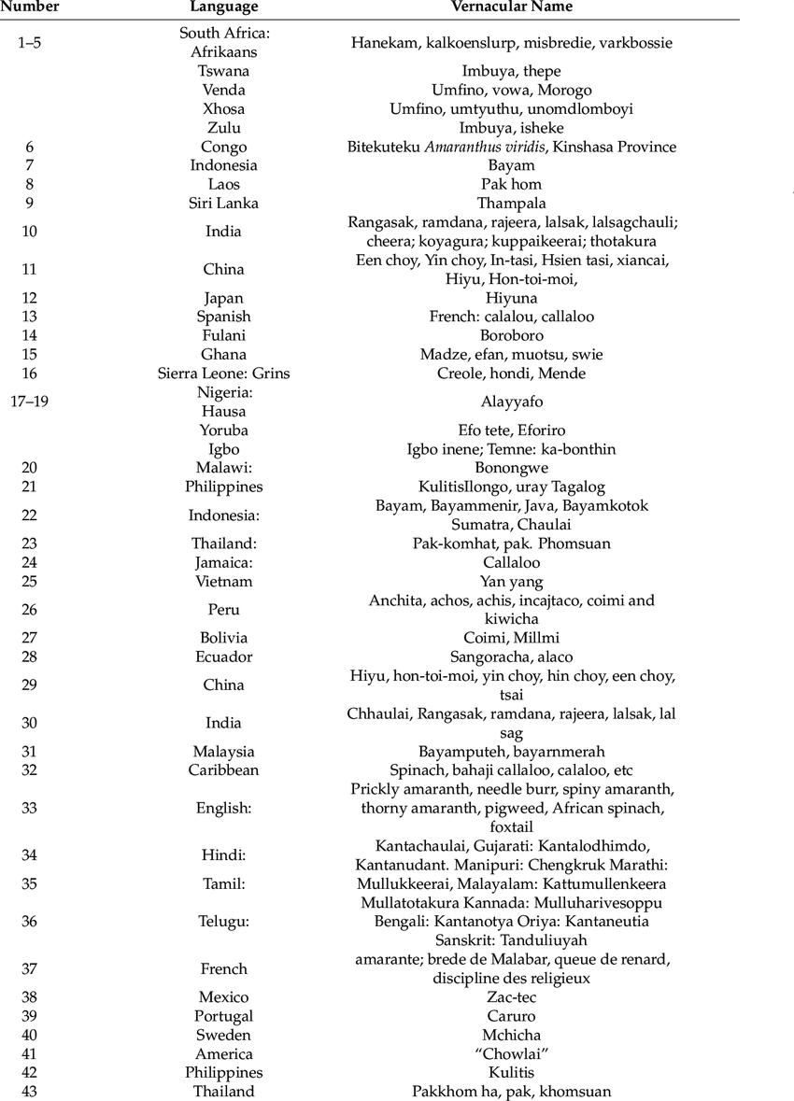

**Figure 2.2: The common names of A. hybridus**

7

**2.3 Role of amaranth in nutrition**

**2.3.1 Protein content**

Amaranthus leaves have been reported to contain 17.5 - 38.3% protein (dry weight basis), with 5% being lysine; an essential amino acid that is deficient in most cereal and tuber-based diets (Abolaji et al., 2017). Amaranthus blitum has 27% leaf protein (dry weight basis), Amaranthus hybridus has 28%, Amaranthus caudatus has 30%, and Amaranthus tricolor has 33%. 2017; Abolaji et al. Cooked leaves (not mixed with other foods) contain about 8% protein and 4% carbohydrates (Akin-Idowu et al., 2016).

The protein quality of the amaranth leaf-nutrient concentrate is excellent (as measured by amino acid composition, digestibility, and nutritional effectiveness). It is an inexpensive source of protein and dietary fiber (Tanimola *et al*., 2016). The protein has a high content of sulphur-containing amino acids (methionine, cysteine), which makes it a good combination with cereals (Adekiya *et al*., 2019).

**2.3.2 Micronutrients**

Vegetable amaranth is also a good source of vitamins, particularly provitamin A, the lack of which causes a serious nutritional deficiency in the tropics and causes blindness in thousands of children each year (Adekiya et al., 2019). The leaves are also high in vitamin C, K, and folate (Muriuki, 2015). Amaranthus spp. contains three times as much vitamin C, calcium, iron, and niacin as spinach (Abolaji et al., 2017). When compared to lettuce, it contains 18 times more vitamin A, 20 times more calcium, and 7 times more iron. Carotene and micronutrients such as sodium, copper, manganese, and chloride are abundant in amaranthus leaves (Abolaji et al., 2017).

**2.3.3 Phytochemical content**

Aside from being a good source of vitamins and minerals, amaranth also contributes to the intake of phytochemicals like phenolic compounds (Alemayehu et al., 2015) and isothiocyanates (glucosinolate group), which have strong antioxidant properties and have been linked to the prevention and suppression of diseases like cancer, arteriosclerosis, and aging (Olowoake, 2014). Previous research has shown that antioxidants are abundant in Amaranthus leaves (Musa et al.,

8

2014) and that there is a general trend towards increased antioxidant activity with increased total phenolic content in Amaranthus (Oladejo et al., 2018).

Aside from being a good source of vitamins and minerals, amaranth also contributes to the intake of phytochemicals like phenolic compounds (Alemayehu et al., 2015) and isothiocyanates (glucosinolate group), which have strong antioxidant properties and have been linked to the prevention and suppression of diseases like cancer, arteriosclerosis, and aging (Olowoake, 2014). Previous research has shown that antioxidants are abundant in Amaranthus leaves (Musa et al., 2014) and that there is a general trend towards increased antioxidant activity with increased total phenolic content in Amaranthus (Oladejo et al., 2018).

**2.3.4 Fibre and anti-nutrient content**

Vegetable amaranths are recommended as a good source of fiber for constipation patients (Olowoake, 2014). Amaranths accumulate high levels of anti-nutritional factors such as oxalates in addition to their high nutritional value. According to research, oxalate has a variety of functional roles in plants, including calcium regulation, plant protection, and metal detoxification (Beswa et al., 2016). It is well established from animal studies that oxalates present in foods interfere with calcium absorption (Oladejo et al., 2018).

Amaranth also contains phytic acid, which, while considered an antinutritional factor, is a common phosphorus storage form in seeds, tubers, and fruits (Mziray *et al*., 2001). The anti-nutritional activity is caused by the complexing of phytic acid with nutritionally essential minerals. Because of its ability to chelate divalent cationic minerals, phytic acid inhibits Ca, Fe, Mg, and Zn absorption (Olowoake, 2014). Antinutrients such as phytic acid, oxalates, pro-anthrocyanidins, tannins, and dietary fibers reduce nutrient bioavailability (Alemayehu et al., 2015).

**2.4 Doxorubicin**

Doxorubicin is an antibiotic derived from the bacterium Streptomyces peucetius. Since the 1960s, it has been widely used as a chemotherapeutic agent. Doxorubicin belongs to the anthracycline class of chemotherapeutic agents, which also includes daunorubicin, idarubicin, and epirubicin. Doxorubicin is a drug that is commonly used to treat solid tumors in both adult and pediatric

9

patients. Doxorubicin can be used to treat soft tissue and bone sarcomas, as well as breast, ovary, bladder, and thyroid cancers. Acute lymphoblastic leukemia, acute myeloblastic leukemia, Hodgkin lymphoma, and small cell lung cancer are also treated with it. The Food and Drug Administration has approved doxorubicin liposomal formulation for the treatment of ovarian cancer in patients who have failed platinum-based chemotherapy, AIDS-related Kaposi sarcoma, and multiple myeloma (Renu et al., 2018; Zhao et al., 2018; Tap et al., 2020).

**2.4.1 Structure and Chemistry**

The molecular weight of it is 579.9 daltons. The molecule is made up of three distinct sections that interact with one another. The first three rings are made up of a substituted anthraquinone structure joined to a substituted cyclohexenyl ring to form a tetracycline ring structure. The molecule's final component is the unusual amino sugar daunosamine, which is linked to C7 of the cyclohexenyl ring via a p-glycosidic linkage. Because of the methoxy group at C4 of the first ring and the two hydroxyl groups on C6 and C ll of the third ring, the molecular structure of the anthraquinone nucleus suggests that the first and third ring structures of this molecule could be involved in the majority of its chemical activities. In the case of one electron reduction producing a semiquinone, hydroxyl substitution may be the most important. The third ring's hydroxyl protons form hydrogen bonds with the second ring's quinoid oxygen. This hydroxyl substitution alters the molecular and electronic structure of the doxorubicin anthraquinone nucleus (Sun et al., 2017; Chen et al., 2019; Van der Zanden et al., 2021).

At the two excitation wave lengths, 253 and 485 nm, the fluorescence emission spectrum of doxorubicin peaks at 520 - 620 nm. The doxorubicin ultraviolet spectrum maxima in methanol are at 233, 253, 290, 477, 495, and 530 nm (Razavi-Azarkhiavi et al., 2016).

**2.4.2 Administration**

Doxorubicin is typically administered intravenously at 21-day intervals. Because of its highly pigmented, reddish appearance, the drug is easily identified in liquid form. Doxorubicin is incompatible with heparin and fluorouracil, and when combined with these drugs, it can cause precipitation. While doxorubicin can be given quickly (over 15 to 20 minutes), slowing down the administration of the liposomal formulation is recommended to reduce the risk of infusion

10

reactions. Doxorubicin should be kept refrigerated and out of direct sunlight before administration. Doxorubicin enters tissues quickly and has an elimination half-life of up to 48 hours. Doxorubicin is reduced enzymatically and must be protected before it can be eliminated via biliary excretion (Rawat et al., 2021).

**2.4.3 Distribution**

Because doxorubicin has a large number of tissue binding sites, it has a longer anti-tumor activity after a single intravenous dose and has a lower plasma concentration (Farhane et al., 2018). Doxorubicin rapidly enters the heart, kidneys, lung, liver, and spleen but does not appear to cross the blood-brain barrier (Farhane et al., 2017). When used systemically, the therapeutic efficacy of doxorubicin is determined by its penetration into sites of action such as nuclei. The density of nuclei per weight of tissue is related to the variation in drug distribution between different organs and tissues within the same organism (Terasaki et al., 2014). There are also differences in the concentration of doxorubicin in different tumor tissues after treatment (Ozols *et al*., 2017), which are dependent on the route of drug administration. According to Cummings et al. (2016), the long retention time of doxorubicin in various organs is due to the slow release of nuclear-bound drug from tissues.

**2.4.4 Metabolism**

According to Benjamin et al. (2017), doxorubicin is normally metabolized and cleared from the plasma after administration, with a mean elimination half-life of approximately 30 hours in humans (rather long compared with other cytotoxic agents). Doxorubicin and its active metabolite doxorubicinol (DOX-ol) are converted to inactive aglycones by the activity of widely distributed microsomal glycosidases. These aglycones are demethylated and conjugated to sulphate or glucuronide esters before being excreted in the bile (Bachur et al., 2016; Cummings et al., 2016). In the case of doxorubicin metabolism, Weenen et al. (2014) discovered a clear individual and species difference. They linked this to enzyme specificity and the production of doxorubicin metabolites, particularly alcohols, which are therapeutically active. Thin layer chromatography was used to separate six doxorubicin metabolites from human plasma (Benjamin et al., 2017); three aglycones and three other polar metabolites. Doxorubicinol is the most active metabolite, and both it and the parent drug could be converted to inactive deoxyaglycone. Brenner et al. (2015)

11

used thin layer and high performance liquid chromatography to detect 7-deoxyaglycone in human plasma after doxorubicin administration.

**2.4.5 Mechanism of Action**

Doxorubicin's primary mechanism of action involves the drug's ability to intercalate within DNA base pairs, causing DNA strand breakage and inhibiting both DNA and RNA synthesis. Doxorubicin inhibits the enzyme topoisomerase II, resulting in DNA damage and apoptosis induction. When combined with iron, doxorubicin causes free radical-mediated oxidative damage to DNA, limiting DNA synthesis even further. Iron chelators, such as dexrazoxane, may prevent free radical formation by limiting doxorubicin's binding to iron (Meredith and Dass, 2016; Rawat et al., 2021).

**2.4.6 Excretion**

Within five days of intravenous administration, approximately 50% of doxorubicin and its metabolites are cleared in the urine, bile, and feces. The remaining 50% appears to be absorbed by body tissues (Riggs et al., 2017; Benjamin et al., 2017). In contrast to the small urinary concentration of aglycones, the polar metabolites appear in significant concentrations in the urine, while a significant amount of parent drug is excreted unchanged (Calabresi and Parks, 2015).

**2.5 Adverse Effects**

Fatigue, alopecia, nausea and vomiting, and oral sores are all common side effects of doxorubicin treatment. There may be bone marrow suppression and an increased risk of secondary malignancy diagnoses. Extravasation of doxorubicin during intravenous administration can cause severe tissue ulceration and necrosis, which worsens over time. Doxorubicin is also associated with significant cardiac toxicity, limiting its long-term use. Doxorubicin-induced cardiac toxicity has a different mechanism of action than the drug's antitumor mechanism. It involves increased oxidative stress, down-regulation of cardiac-specific genes, and doxorubicin-induced cardiac myocyte apoptosis. Doxorubicin's acute cardiac toxicity occurs within days of drug administration and affects approximately 11% of patients who receive the drug (Farhane et al., 2017).

12

Reversible myopericarditis, left ventricular dysfunction, or arrhythmias are symptoms of acute cardiac toxicity. Doxorubicin-related arrhythmias, which can include sinus tachycardia, premature atrial and ventricular contractions, and supraventricular tachycardia, occur in up to 26% of patients who receive the therapy. Acute left ventricular dysfunction can occur in rare cases after doxorubicin administration; however, this condition is reversible. Chronic, late cardiac toxicity can occur after doxorubicin administration and is the most serious and potentially fatal side effect of doxorubicin therapy. Chronic doxorubicin cardiac toxicity affects about 1.7% of patients (Rawat et al., 2021).

Doxorubicin-induced irreversible cardiomyopathy occurs within a few months of treatment termination but has also been reported to occur up to twenty years later. Congestive heart failure is also possible. A higher cumulative drug dose, extremes of age, combination chemotherapy with other cardiotoxic drugs, pre-existing left ventricular dysfunction, hypertension, and previous radiation to the mediastinal region are all risk factors for doxorubicin-induced congestive heart failure. The 1-year mortality rate is approximately 50% when congestive heart failure develops after doxorubicin administration (Razavi-Azarkhiavi et al., 2016; Chen et al., 2019).

**2.5.1 Cardiac Toxicity**

Doxorubicin rapidly accumulates in heart muscle, causing cardiotoxicity that can be acute or chronic depending on the dose and duration of action. Nucleolar fragmentation was observed by Lampidis et al. (2011), indicating a severe toxic effect. The exact mechanism of cardiotoxicity is unknown, but it is thought to be related to changes in membrane fluidity (Goormaghtigh, et al., 2010).

**2.5.1.1 Acute Cardiac Toxicity:**

The main symptoms are mild depression of myocardial function, which depends on the dose. Within a few hours of receiving doxorubicin, atrial or ventricular arrhythmias may develop due to an increase in plasma histamine or catecholamine concentrations (Unverferth et al., 2012; Decorti et al., 2019). Acute cardiomyopathy symptoms have also included pericarditis and myocarditis. These symptoms primarily affect the elderly and disrupt normal cardiac function (Bristow et al., 1978).

13

**2.5.1.2 Chronic Cardiac Toxicity:**

Because the effects of the drug are cumulative, this type of toxicity is irreversible and dependent on the total doxorubicin dose (Minow et al., 2015). Biventricular failure, tachycardia, shortness of breath, neck vein distention, hepatomegaly, cardiomegaly, and pleural effusion are the most common clinical signs of doxorubicin cardiomyopathy (Von Hoff et al., 2017). The development of congestive heart failure is dose dependent. The doxorubicin dose rate at which there is a risk of developing congestive heart failure is approximately 500 to 550 mg doxorubicin / m2 body surface area (Belli and Piro, 2017; Minow et al., 2017; Sallan and Clavell, 2018). The latency period and risk of developing heart failure vary according to the patient's overall condition, including age; young adults are more tolerant to cumulative doses than the elderly and small children (Von Hoff et al., 2017; Brockmeier et al., 2018; Sallan and Clavell, 2018). Previous mediastinal irradiation is another factor that contributes to the development of congestive heart failure during doxorubicin treatment (Belli and Piro, 2017; Billingham et al., 2017).

Doxorubicin cardiomyopathy develops before congestive heart failure and is most severe in the left ventricle and intraventricular septum, but less so in the right ventricle and both atria (Van Vleet et al., 2018). Human myocardial tissues that develop chronic doxorubicin cardiomyopathy show vacuolar degeneration of the cardiac cells under the microscope. This is due to sarcoplasmic reticulum distention and swelling, as well as interstitial edema and myofibrillar lysis. After myocytes die, the mitochondria remain intact and degenerate (Suzuki et al., 2017). Rahman et al. (2012) described ultrastructural changes in mouse cardiac tissues after doxorubicin administration, including myofibre loss, mitochondrial damage, sarcoplasmic reticulum swelling, increased myeloid body accumulation, and some nuclear abnormalities. Mitochondrial damage is caused by either membrane lipid peroxidation, irreversible protein depletion due to polymerase inhibition, or coenzyme Q10 inhibition (a key enzyme of oxidative phosphorylation) (Ferrero *et al*., 2015; Folkers *et al*., 2017).

Cardiac tissue contains less superoxide dismutase than other tissues, making the heart more vulnerable to superoxide radical injury (Doroshow et al., 2017); cardiac tissues also have less catalase activity than other tissues (Revis and Marusic, 2018). These enzymes, along with glutathione peroxidase, are capable of removing hydrogen peroxide, a byproduct of superoxide

14

dismutase activity. It was also discovered that within 24 hours of doxorubicin treatment, glutathione peroxidase in cardiac tissue reached a nadir and took about five days to recover (Revis and Marusic, 2018; Doroshow et al., 2019).

Olson et al. (2010) discovered that doxorubicin caused an acute decrease in the reduced form of glutathione (GSH) in cardiac cells and concluded that GSH may play an important role in the protection of the heart against doxorubicin cardiotoxicity. According to Fabregat et al. (2014), doxorubicin cardiotoxicity is caused by its interaction with the SH groups of specific enzymes. They also concluded that while heart tissues have low GSH levels in comparison to others, it is still the primary SH-protecting compound in cardiocytes. As a result, heart tissues are extremely vulnerable to doxorubicin-induced radical injury. Finally, there is evidence that doxorubicin in cardiac tissues is metabolically reduced to doxorubicinol by the activity of the reductase enzyme (Von Wartburg and Wermuth, 2010). This metabolite was found to be associated with the cardiotoxicity of doxorubicin (Tacca *et al*., 2015).

**2.6 Prevention of Cardiotoxicity**

DOX's efficacy as an antineoplastic agent is dependent on tissue concentrations and/or total systemic exposure over time, rather than peak plasma concentrations (Dempsey et al., 2021). Thus, by changing the administration schedule, some of the problems associated with acute or early DOX-induced cardiotoxicity can be avoided. Instead of a single bolus of drug administered via intravenous (IV) injection every three weeks, IV delivery of DOX over 48-96 hours and lower weekly doses have been shown to reduce Congestive Heart Failure (CHF) rates (Mordente *et al*., 2017; Avila *et al*., 2018). To avoid severe CHF and morbidity, regular monitoring for clinical signs of cardiotoxicity via physical examination, x-rays, echocardiogram, electrocardiogram (EKG), endomyocardial biopsy, and radionuclide angiography is required before, during, and after DOX chemotherapy. Physical examination alone can detect more than half of DOX-dependent CHF that is early and reversible (Henriksen et al., 2018; Avila et al., 2019).

**2.7 Gas Chromatography-Mass Spectrometry (GC-MS)**

GC-MS can analyze liquid, gaseous, or solid samples. The gas chromatograph is used to effectively vaporize the sample into the gas phase and separate it into its various components using a capillary

15

column coated with a stationary (liquid or solid) phase (Hussein et al., 2017). An inert carrier gas, such as helium, hydrogen, or nitrogen, propels the compounds. As the mixture's components are separated, each compound elutes from the column at a different time depending on its boiling point and polarity. The time it takes for a compound to elute is referred to as its retention time. GC can separate complex mixtures or sample extracts containing hundreds of compounds (Garcia and Barbas, 2011).

After leaving the GC column, the components are ionized and fragmented by the mass spectrometer using electron or chemical ionization sources. Ionized molecules and fragments are then accelerated through the mass analyzer of the instrument, which is frequently a quadrupole or ion trap. Ions are separated here based on their different mass-to-charge (m/z) ratios. GC-MS data acquisition can be done in full scan mode, which covers a wide range of m/z ratios, or in selected ion monitoring (SIM) mode, which collects data for specific masses of interest (Al-Rubaye et al., 2017).

The process concludes with ion detection and analysis, with fragmented ions appearing as a function of their m/z ratios. Meanwhile, peak areas are proportional to the amount of the corresponding compound. When a complex sample is separated using GC-MS, it produces many different peaks in the gas chromatogram, and each peak generates a unique mass spectrum that can be used to identify the compound. Unknown compounds and target analytes can be identified and quantified using extensive commercially available mass spectral libraries (Carpita and Shea, 2021).

**2.8 Types of GC-MS**

Different analytical tasks necessitate distinct detection abilities. While the gas chromatography system may remain the same, depending on the level of selectivity and sensitivity required, different types of mass spectrometers may be required for different types of analyses.

**2.8.1 Single quadrupole GC-MS**

When gas chromatography is combined with a mass spectrometer with only one quadrupole, the result is commonly referred to as GC-MS. Because these systems can be operated using either

16

targeted selected ion monitoring (SIM) or untargeted full scan acquisition, GC-MS is well suited to the everyday analysis of samples requiring either targeted or untargeted analysis. Pesticide analysis in food and environmental samples, analysis of biological samples for drugs of abuse, and analysis of volatile organic compounds in water samples are examples of typical applications (Domnguez et al., 2014).

**2.8.2 Triple quadrupole GC-MS/MS**

The combination of gas chromatography and a triple quadrupole mass spectrometry system is known as GC-MS/MS. The triple quadrupole MS has a higher level of selectivity and is best suited for analyses requiring the highest sensitivity. This is frequently the case when attempting to quantify pesticides in food or environmental contaminants. In most cases, GC-MS/MS systems operate in selective reaction monitoring (SRM) mode. The SRM's high selectivity reduces interference from background ions and produces a high signal-to-noise ratio for excellent detection capability (Hernandez et al., 2013).

**2.8.3 HRAM GC-MS/MS**

A GC system can be combined with a high resolution accurate mass (HRAM) mass spectrometer to perform comprehensive characterization of samples in a single analysis with high confidence compound discovery, identification, and quantitation. These GC-MS/MS systems combine the quantitative power of a triple quadrupole GC-MS/MS with high-precision, full-scan HRAM capabilities previously only available from the most sensitive and accurate mass spectrometers. These systems are ideal for applications that require both precise targeted analysis and confident identification of unknown compounds (Pascali et al., 2018).

**2.9 GC-MS Applications**

GC-MS can be used for a wide range of applications, from detecting potentially toxic chemicals in foods to quantifying organic contaminants in water or analyzing petroleum products during oil processing.

17

**2.9.1 Food & beverage analysis**

The use of GC-MS analysis is critical to ensuring the safety and authenticity of the foods and beverages we consume. From pesticide residue determination to ingredient characterization, GC-MS systems provide manufacturers and regulatory agencies with valuable information about the safety of our food supply (Feizi et al., 2021).

**2.9.2 Environmental analysis**

GC-MS is an effective method for monitoring contaminants in the air, water, and soil. It is especially useful for determining the concentrations of volatile organic compounds (VOCs) and semi-volatile organic compounds (SVOCs), polychlorinated biphenyls (PCBs), organochlorinated pesticides, brominated flame retardants, and polycyclic aromatic hydrocarbons (PAHs) (Naz et al., 2014).

**2.9.3 Metabolomics**

Some of the sophisticated analytical technologies required for complex metabolomic analyses are provided by GC-MS. It enables researchers to delve deeper into the metabolome and obtain comprehensive coverage of metabolites in order to support research into primary and secondary metabolites in plants, animals, and microbes. As the examples below show, HRAM GC-MS is particularly well-suited to the challenge of untargeted metabolite identification (Tsikas et al., 2016).

**2.9.4 Oil and gas analysis**

GC-MS can be used to determine the energy content, CHA, SIMDIS, and H2S/organic sulfur content of natural gas and natural gas condensates at various stages of the petroleum and natural gas testing workflows. Furthermore, GC-MS analysis can be used to detect oxygenates, aromatics, BTEX compounds, and PAHs in crude oil during refinery gas analysis (RGA) and detailed hydrocarbon analysis (DHA) (Stefanuto et al., 2021).

**2.10 Lipid profile**

18

A lipid profile is a collection of blood tests used to assess cholesterol and triglyceride levels in the blood. These are simply fat deposits in the bloodstream. Lipid levels that are too high can clog the arteries, increasing the risk of heart disease and stroke. These are also to blame for unhealthful weight gain. 2014; Naz et al. A lipid profile is a snapshot of the amount of healthy and unhealthy fats circulating in the blood. High cholesterol has been linked to heart disease, obesity, diabetes, and other health problems. Those who are at a higher risk of developing these conditions or who have been diagnosed with them should have a lipid profile performed. It may be prescribed as part of a routine health check-up in many cases. A lipid profile can be used to predict the occurrence of cholesterol-related diseases. It is also used to assess the efficacy of a specific cholesterol-lowering medication/treatment and/or lipid-lowering lifestyle changes (Al-Rubaye et al., 2017).

**2.11 Types of lipid profile parameters**

The lipid profile provides valuable information on the levels of cholesterol present in the blood. It actually sheds light on these specific parameters that make up the complete cholesterol count:

**2.11.1 Total cholesterol**

The total amount of cholesterol in the blood is referred to as total cholesterol. Total cholesterol includes both low-density lipoprotein (LDL) cholesterol and high-density lipoprotein (HDL) cholesterol. Cholesterol is a waxy, fat-like substance found in all of the body's cells.

**2.11.2 High-Density Lipoprotein**

The good cholesterol is high-density lipoprotein. The higher the level of the HDL component of total cholesterol, the better. The issue is that maintaining high levels of high-density lipoprotein can be difficult. This is due to the difficulty in controlling lifestyle factors that can lower it, such as type 2 diabetes, being overweight, not getting enough exercise, and smoking.

**2.11.3 Low-density lipoprotein**

LDL cholesterol is often referred to as "bad" cholesterol because it accumulates in the walls of blood vessels, increasing the risk of health problems such as a heart attack or stroke. However,

19

cholesterol is not entirely harmful. It is required by the body to protect its nerves and to produce healthy cells and hormones. Some cholesterol is derived from food, while the liver produces more. Because it does not dissolve in blood, proteins transport it to its destination. Lipoproteins are the name given to these carriers. LDL is a tiny blob with a lipoprotein outer rim and a cholesterol center. "Low-density lipoprotein" is its full name.

**2.11.4 Very-Low-Density Lipoprotein**

LDL cholesterol is a type of very-low-density lipoprotein. However, whereas VLDL transports triglycerides (a type of fat) to the body's cells and tissues, LDL transports primarily cholesterol. The liver produces very-low-density lipoprotein (VLDL), which has a low density relative to extracellular water. VLDL is one of the five major lipoprotein groups (chylomicrons, VLDL, intermediate-density lipoprotein, low-density lipoprotein, and high-density lipoprotein) that allow fats and cholesterol to move within the bloodstream's water-based solution. VLDL is made up of triglycerides, cholesterol, and apolipoproteins in the liver. In the bloodstream, VLDL is converted to low-density lipoprotein (LDL) and intermediate-density lipoprotein (IDL) (IDL). VLDL particles range in size from 30-80 nm. Chylomicrons transport endogenous products, whereas VLDL transports exogenous (dietary) products. In the early 2010s both the lipid composition and protein composition of this lipoprotein were characterized in great detail.

**2.11.5 Triglyceride**

The triglyceride level test assists in determining the amount of triglycerides in the blood. Triglycerides are a type of fat found in the blood, also known as lipids. The results of this test assist the doctor in determining the likelihood of developing heart disease. This test is also known as a triacylglycerol test. Triglycerides are a lipid type. Triglycerides are the body's storage form for calories that aren't used right away. These triglycerides circulate in the blood, supplying energy to the muscles. After eating, extra triglycerides enter the bloodstream. Triglyceride levels may be elevated if more calories are consumed than the body requires. Triglycerides are transported through the blood by very low-density lipoproteins (VLDLs). VLDL, like low-density lipoprotein (LDL) and high-density lipoprotein (HDL), is a type of lipoprotein (HDL).

20

**CHAPTER THREE**

**METHODOLOGY**

**3.0 MATERIALS AND METHODS**

**3.1 Materials and Chemicals**

This study's reagents were all analytical grade.

**3.1.1 Apparatus Used**:

Beakers, Warring blender, Oven, Rotatory Evaporator, Burette, Spatula, Sieve, measuring cylinder, round bottom flask, Insulin syringe (1ml), Centrifuge, Lithium heparin tubes, Plain sterile tubes, Pipette, Refrigerator, Digital Vernier caliper, Volumetric flask, weighing balance, Funnel, Dropper, Test tubes, Test tube racks, Beaker, Measuring cylinder, Spatula, Water bath, Nose mask, Hand gloves, strings.

**3.1.2 Reagents Used**:

Ethanol, Distilled water, Formaldehyde, Chloroform, Sodium citrate, Sodium chloride, n-Hexane, n-Butanol, Ethyl acetate, Methanol, Pin, Micropipettes and tips.

**3.1.3 DRUG**

Doxorubicin was obtained from Alpha Pharmacy & Stores. Head office: 2B Alabi Street, Off Toyin Street, Ikeja, Lagos on the 2nd of June 2022 as at about 12:50pm

Website: [www.alphapharmacy.com.ng;](http://www.alphapharmacy.com.ng/) Phone number: 09062547022

**3.1.4 KITS**

Reagent kits for cholesterol, triglyceride and HDL concentrations evaluation were purchased from Randox Laboratories Ltd, UK.

**3.1.5 EQUIPMENT:**

Centrifuge (Heraeus Megafuge 8, Thermo Scientific), water bath (Stuart shaking bath SBS40), and Spectrophotometer.

21

**3.1.6 FEED:** Supplied by Live Stock Feeds, Km 190 Lekki - Epe Expy, opp. Mesia Filling Station Abijo, Eti-Osa 105101, Lekki

**3.2 METHODS**

**3.2.1 Collection of Plant Materials**

*Amarathus hybridus*, family Amaranthaceae, was obtained from Magodo market, Ogun state, South West, Nigeria.

**3.2.1** **Preparation of Plant Sample**

*Amaranthus hybridus* leaves were removed from its stem and were cut in small part with the aid of a kitchen knife and 1,600 g of the leaf were washed thoroughly for 5 time in a running tap water. 1,600 ml distilled water was added and blended with an electric blender. This was left to macerate for 48 hr and filtered with a three-layered white handkerchief. This process of filtration was repeated three times and combined filtrate was centrifuged at 3,000 rpm for 5 minutes to obtain a clear aqueous leaf extract which was then kept in the refrigerator at -4º C until used.

**3.3 Phytochemical Analysis**

**3.3.1 Phytochemical screening**

The Aqueous extract was tested for the presence of bioactive compounds using standard methods as described by Sofowora (1993), Trease and Evans (1989) and Harbone (1973) with slight modification.

**3.3.1.1 Test for carbohydrates (a) Fehling’s test**

The extracts, 1.0 ml was added to 2.0 ml Fehling solution and boiled for 5 min. A red precipitate indicates reducing sugar. 1.0 ml extract was added to 2.0 ml barfoed reagent and boiled for 1 min. A red precipitate indicates the presence of reducing monosaccharaides. 1.0 ml concentrated H2SO4 was carefully added and giving a reddish ring indicating presence of carbohydrate.

**(b) Molisch’s test**

In a test tube, 2 ml of plant extract was mixed with 1 ml Molisch's reagent and 5 drops of strong Sulphuric acid. The presence of carbohydrate is indicated by the formation of a purple or reddish colored solution.

22

**3.3.1.2 Test for Phlobatannins**

In a test tube, 1 mL of plant extract was mixed with 5 drops of 2% hydrochloric acid. The presence of Phlobatannins is indicated by the formation of a red-colored solution (Rohini *et al.,* 2021).

**3.3.1.3 Saponins (frothing test)**

Extract, 0.2 ml was mixed with 5.0 ml distilled water, shakes for 20 minutes, presence of persistence of foams indicates the presence of saponin.

**3.3.1.4 Flavonoid (a) Sodium hydroxide test**

Diluted NaOH 0.2 ml was added to 0.2 ml extract, gently shaken. Presence of a dirty yellowish brown precipitate indicating the presence of flavonoid.

1. **Ferric chloride test:** 0.2 ml extract was added to 10% FeCl3 and the mixture was shaken. A wooly brownish precipitate indicates the presence of flavonoid.

**3.3.1.5 Test for Tannins**

In a test tube, 1 ml of plant extract was mixed with 2 mL of 5% ferric chloride. The presence of Tannins are indicated by the formation of a dark blue or greenish black solution (Rohini *et al.*, 2021).

**3.3.1.6 Test for Alkaloids:**

In a test tube, 2 ml of plant extract was combined with 2 ml of strong hydrochloric acid and 5

Drops of Mayer's reagent. The presence of alkaloids is indicated by the formation of a green

Colored solution or a white precipitate (Rohini *et al.,* 2021).

**3.3.1.7 Test for Phenols**

In a test tube, 1 ml of plant extract was mixed with 2 ml of distilled water and 5 drops of 10%

Ferric chloride. The presence of phenols is indicated by the formation of a blue or green colored

Solution (Rohini *et al.,* 2021).

**3.3.1.8 Test for Terpenoids**

In a test tube, 0.5 ml of plant extract was mixed with 2 ml chloroform and 2 ml concentrated

Sulphuric acid. The presence of terpenoids is indicated by the formation of a reddish-brown

Colored solution (Rohini *et al*., 2021).

**3.3.1.9 Test for Steroids**

In a test tube, 1 ml of plant extract was mixed with 1 ml of chloroform and 5 drops of strong Sulphuric acid. The presence of steroids is indicated by the formation of a brown ring (Rohini *et al.,* 2021).

23

**3.3.2 Gas chromatography-mass spectrometry analysis (GC-MS)**

The GC-MS analysis was carried out using a Hewlett Packard Gas Chromatograph (Model 6890 series) equipped with a flame ionization detector and Hewlett Packard 7683 series injector, MS transfer line temperature of 250°C. The GC was equipped with a fused silica capillary column-HP-5MS (30 x 0.25 mm), film thickness 1.0 μm. The oven temperature was held at 50°C for 5 minholding time and raised from 50 to 250°C at a rate of 2°C /min, employing helium gas (99.999%) as a carrier gas at a constant flow rate of 22 cm/s. 1.0 micron of extract (1 ml dissolved in 1 ml absolute alcohol), at a split ratio of 1:30 was injected. MS analysis was carried out on Agilent Technology Network Mass Spectrometer (Model 5973 series) coupled to Hewlett Packard Gas Chromatograph (Model 6890 series) equipped with NIST14 Library software database. Mass spectra were taken at 70 eV/200°C, scanning rate of 1 scan/s. Identification of compounds was conducted using the database of NIST14 Library. Mass spectrum of individual unknown compound was compared with the known compounds stored in the software database Library (Ajayi *et al*., 2011 and 2020).

**3.4 Animal study in DOX-induced cardiotoxicity**

**3.4.1 Experimental Animals**

Twenty-five albino Wistar rats (15 male and 10 female) were provided by the Animal House, Department of Biological Sciences, Mountain Top University, Prayer City, Ogun State, Nigeria where the rats were kept in plastic cages with wire guaze lid. They were exposed to daily 12 hr light and 12 hr darkness and were fed with regular rat diet and also had unlimited access to water. They were made to acclimatized for two weeks. Animal handling procedure were in accordance with ethical guide for the care of Laboratory animals and usage based on the guidelines of the Institutional Animal Ethics Committee (IAEC) and ethical clearance was obtained from the Departmental Animal Ethical Committee, Mountain Top University.

**3.4.2 Grouping of Experimental Animals in DOX-induced cardiotoxicity**

The male animals were randomly grouped into three groups and female animals grouped into two groups of five rats per group. The grouping is as follows:

Group 1: Normal control (food + water only)

24

Group 2: DOX without treatment.

Group 3: DOX + plant extract @ low concentration (0.5 ml)

Group 4: DOX + plant extract @ high concentration (1.0 ml)

Group 5: Plant extract @ high concentration (1.0 ml)

The animals were administered 45 mg/kg body weight DOX once for 48 hr interperitoneally and thereafter, treated with plant extract daily for 14 days by oral cannula. The rats were allowed to have overnight fasting prior to the day of sacrifice.

**3.4.3 Collection of blood sample**

The blood sample was collected by ocular method into heparinized bottles which was mixed gently.

**3.4.4. Preparation of blood plasma**

The collected blood samples for assays were transferred into centrifuge tubes and centrifuged at 3,500 rpm for 10 minutes. Plasma was separated, and then stored in the refrigerator at -4oC until use for biochemical assays.

**3.4.5 Tissues Preparation**

The rats were dissected to remove the whole organs of the heart. The heart was placed in phosphate buffer saline (0.01 M; pH 7.4) and homogenized to obtain a final solution of 10% (w/v) homogenates using mortal and pestle, and Ultra Turrax homogenizer. The homogenates were centrifuged at 3,000 rpm for 15 minutes to obtain the supernatants which were separated and refrigerated at -4oC until used for biochemical assays.

**3.5 Lipid profile assay**

**3.5.1 Total cholesterol**

Procedure: Sterile test tubes were used which were labelled appropriately, 10 µl of enzyme source (heart) was transferred to the samples test tubes, 20 µl of water was added to the blank test tube and 20 µl of standard was transferred to the standard test tube. 1 ml of Reagent 1 was transferred to the sample test tubes, blank test tube and standard test tube, which the solution was combined

25

and incubated in the hot-air oven for 30 minutes at 25 ⁰C. The samples absorbance was read against the blank using UV-Visible spectroscopy (Auto-palmer Ltd, UK) at 546 nm wavelength.

Total cholesterol concentration was calculated as:

Total cholesterol concentration = Absorbance of sample x Standard concentration

Absorbance of standard

**3.5.2 Triglycleride**

Procedure: Sterile test tubes were used which were labelled appropriately, 10 µl of enzyme source (heart) was transferred to the samples test tubes, 1000 µl of water was added to the blank test tube and 1000 µl of standard was transferred to the standard test tube. 1ml of Reagent was transferred to the sample test tubes, blank test tube and standard test tube, which the solution was combined and incubated in the hot-air oven for 30 minutes at 25 ⁰C. The samples absorbance was read against the blank using UV-Visible spectroscopy (Auto-palmer Ltd, UK) at 500nm wavelength.

TRIG concentration was calculated as:

TRIG = Absorbance of sample x Standard concentration

Absorbance of standard

**3.5.3 HDL**

Procedure: Sterile test tubes were used which were labelled appropriately, 10 µl of enzyme source (heart) was transferred to the samples test tubes, 1000 µl of water was added to the blank test tube and 1000 µl of standard was transferred to the standard test tube. 1 ml of Reagent was transferred to the sample test tubes, blank test tube and standard test tube, which the solution was combined and incubated in the hot-air oven for 30 minutes at 25 ⁰C. The samples absorbance was read against the blank using UV-Visible spectroscopy (Auto-palmer Ltd, UK) at 500 nm wavelength.

HDL concentration was calculated as:

HDL = Absorbance of sample x Standard concentration

Absorbance of standard

26

**3.5.4 LDL**

LDL concentration was calculated as:

= (Total cholesterol – HDL) – (Trig/5)

**3.5.5 VLDL**

VLDL concentration was calculated as

VLDL = Trig/5

27

**CHAPTER FOUR**

**RESULTS**

**4.1 Phytochemical constituents of *Amaranthus hybridus* aqueous extract (AHALE)**

Table 4.1 shows the results of the phytochemical screening of AHALE. The aqueous extract of A. *hybridus* gave positive reactions (+ve) for the presence of alkaloids, carbohydrates, tannins,flavonoids, phlobatinins, proteins, saponins, steroids and terpenoids.

28

**Table 4.3: Results of phytochemical screening of *Amaranthus hybridus* aqueous leaf extract**

|  |  |  |
| --- | --- | --- |
| S/N | PARAMETERS | RESULT |
|  |  |  |
| 1. | Alkaloids | + |
|  |  |  |
| 2. | Carbohydrates | + |
|  |  |  |
| 3. | Tannins | + |
|  |  |  |
| 4. | Flavonoids | + |
|  |  |  |
| 5. | Phlobatinins | + |
|  |  |  |
| 6. | Proteins | + |
|  |  |  |
| 7. | Saponins | + |
|  |  |  |
| 8. | Steroids | + |
|  |  |  |
| 9. | Terpenoids | + |
|  |  |  |

(+) = indicate presence (‐) = indicate absence

29

**4.2 Gas chromatography-mass spectrometry (GC-MS) results of AHALE**

The results of the GC-MS of AHALE are presented in Figure 4.1, Table 4.2 and Figure 4.2. These show various peaks which were identified as identified as 10 different bioactive components present in AHALE. The mass spectral and molecular structures of the identified components were revealed. Major components identified by the GC-MS analysis include aromatic tumerone (38.11%, RT 11.965), curlone (20.50%, RT 12.369), tumerone (19.3%, RT 12.006), n-hexadecarnoic acid (6.16%, RT14.979) and phytol (3.72%, RT16.401).

30

Abundance

|  |  |  |  |  |  |  |
| --- | --- | --- | --- | --- | --- | --- |
|  |  |  | TIC: AmarathusHybridusExtract.D\data.ms | | | |
| 2.8e+07 |  |  |  |  |  |  |
| 2.6e+07 |  |  |  |  |  |  |
| 2.4e+07 |  |  |  |  |  |  |
| 2.2e+07 |  |  |  |  |  |  |
| 2e+07 |  |  |  |  |  |  |
| 1.8e+07 |  |  |  |  |  |  |
| 1.6e+07 |  |  |  |  |  |  |
| 1.4e+07 |  |  |  |  |  |  |
| 1.2e+07 |  |  |  |  |  |  |
| 1e+07 |  |  | 11.965 | |  |  |
| 8000000 |  |  |  |  |  |  |
|  |  |  | 12.370 | |  |  |
| 6000000 |  |  | 12.007 | |  |  |
|  |  |  |  |  |  |
| 4000000 |  |  |  |  |  |  |
| 2000000 |  |  | 9.10794.30011.267 | 13.148 | | 14.97816.402 |
|  |  |  |  | 14.619 | |
| 4.00 | 6.00 | 8.00 | 10.00 12.00 | | 14.00 16.00 18.00 20.00 22.00 | |

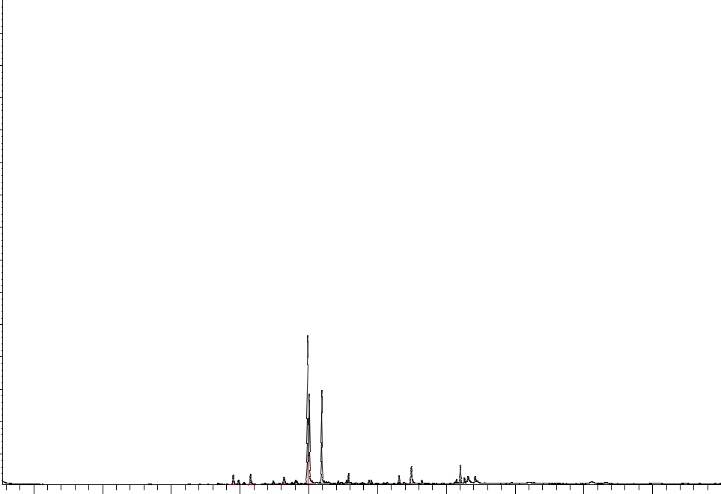

Time-->

Figure 4.1: GCMS chromatogram of *A. hybridus* Leaf extract

31

Table 4: GCMS identified phytochemical components of the aqueous leaf extract *A. Hybridus*

|  |  |  |  |  |
| --- | --- | --- | --- | --- |
| Peak | Retentions time | Library ID/ name of | % of total | Quality |
|  |  | component |  |  |
|  |  |  |  |  |
| 1. | 9.81 | Benzene | 2.81% | 97 |
|  |  |  |  |  |
| 2. | 10.30 | Cyclohexane | 2.78% | 76 |
|  |  |  |  |  |
| 3. | 11.27 | 7-methoxylmethyl-2 | 2.61% | 72 |
|  |  |  |  |  |
| 4. | 11.97 | Ar-tumerone | 38.11% | 96 |
|  |  |  |  |  |
| 5. | 12.01 | Tumerone | 19.38% | 55 |
|  |  |  |  |  |
| 6. | 12.37 | Curlone | 20.50% | 91 |
|  |  |  |  |  |
| 7. | 13.15 | 2- | 2.03% | 38 |
|  |  | Nephthalenecarboxylic |  |  |
|  |  | acid |  |  |
|  |  |  |  |  |
| 8. | 14.62 | Pentadecanoic acid | 1.91% | 95 |
|  |  |  |  |  |
| 9. | 14.98 | n-hexadecanoic acid | 6.16% | 97 |
|  |  |  |  |  |
| 10. | 16.40 | 3-octadecane | 3.72% | 46 |
|  |  |  |  |  |

32

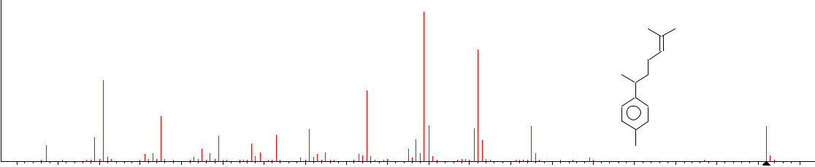

|  |  |  |  |  |  |  |  |  |  |  |  |  |  |  |  |  |  |  |  |  |
| --- | --- | --- | --- | --- | --- | --- | --- | --- | --- | --- | --- | --- | --- | --- | --- | --- | --- | --- | --- | --- |
| 100 |  |  |  |  |  |  |  |  |  |  | 119 |  |  |  |  |  |  |  |  |  |
|  |  |  |  |  |  |  |  |  |  |  |  |  |  |  |  |  |  |  |  |
|  |  |  |  |  |  |  |  |  |  |  |  | 132 |  |  |  |  |  |  |  |  |
|  |  | 41 |  |  |  |  |  |  |  | 105 |  |  |  |  |  |  |  |  |  |  |
| 50 |  |  |  |  |  |  |  |  |  |  |  |  |  |  |  |  |  |  |  |
|  |  |  |  |  |  |  |  |  |  |  |  |  |  |  |  |  |  |  |  |
|  |  |  |  | 55 |  |  |  |  |  |  |  |  | 145 |  |  |  |  |  | 202 |  |
|  |  | 39 |  |  |  | 69 | 83 | 91 |  |  |  |  |  |  |  |  |  |  |
|  |  |  |  |  |  |  |  |  |  |  |  |  |  |  |  |  |
|  | 27 |  |  |  |  |  |  |  |  |  |  |  |  |  |  |  |  |
|  |  |  | 53 |  | 65 | 77 |  | 95 |  |  |  |  |  |  |  |  |  |  |  |
|  | 31 |  |  | 58 | 71 | 81 |  | 110 |  | 128 | 141 | 152 | 159 |  |  | 187 |  |  |
| 0 |  |  |  |  |  |  |  |  |  |  |
|  |  |  |  |  |  |  |  |  |  |  |  |  |  |  |  |  |  |  |  |
| 20 | 30 | 40 | 50 |  | 60 | 70 | 80 | 90 | 100 | 110 | 120 | 130 | 140 | 150 | 160 | 170 | 180 | 190 | 200 | 210 |



(mainlib) Benzene, 1-(1,5-dimethyl-4-hexenyl)-4-methyl-



|  |  |  |  |  |  |  |  |  |  |
| --- | --- | --- | --- | --- | --- | --- | --- | --- | --- |
| 100 |  |  |  |  | 69 | |  |  |  |
|  |  |  |  |  |  |  |  |  |
|  |  | 41 |  |  |  |  |  |  |  |
| 50 |  |  |  |  |  |  |  | 93 |  |
|  |  |  |  | 55 |  |  | 77 | 91 |  |
|  |  |  |  |  |  |  |  |
|  |  | 39 |  |  |  | 71 |  |  |
|  | 27 |  | 53 | 67 | 82 |  |  |
|  | 43 |  |  |  |  |
|  |  |  |  |  |  |  |  |
| 0 | 29 | 37 |  |  |  |  |  | 89 | 99 |
|  |  |  |  |  |  |  |  |  |
| 20 | 30 | 40 | 50 | 60 |  | 70 | 80 | 90 | 100 |
| (mainlib) Cyclohexene, 3-(1,5-dimethyl-4-hexenyl)-6-methylene-, [S-(R*,S*)]- | | | | | | | | |  |



|  |  |  |  |  |  |  |  |  |  |
| --- | --- | --- | --- | --- | --- | --- | --- | --- | --- |
| 100 |  |  |  |  |  |  |  |  |  |
| 50 |  |  |  |  |  |  |  |  |  |
|  |  |  |  |  |  |  |  |  | 91 |
|  |  | 41 |  |  | 65 | 77 |  |  |  |
|  |  | 45 | 51 |  |  |  |  |
|  | 36 | 57 | 72 75 |  | 84 | 89 |
| 0 |  |  | 68 |  |
| 30 |  | 40 | 50 | 60 |  | 70 | 80 |  | 90 |



(mainlib) 7-Methoxymethyl-2,7-dimethylcyclohepta-1,3,5-triene

|  |  |  |  |  |  |  |  |  |  |  |
| --- | --- | --- | --- | --- | --- | --- | --- | --- | --- | --- |
| 109 | 120 | 133 |  |  | 161 |  |  |  |  |  |
|  |  |  |  |  |  |  | 204 |
| 112 |  |  |  |  |  |  |  |  |  |
|  | 128 |  | 147 |  |  | 175 | 189 |  |  |
|  |  |  |  |  |  |  |
|  |  |  |  |  |  |  |  |
| 110 | 120 | 130 | 140 | 150 | 160 | 170 | 180 | 190 | 200 | 210 |

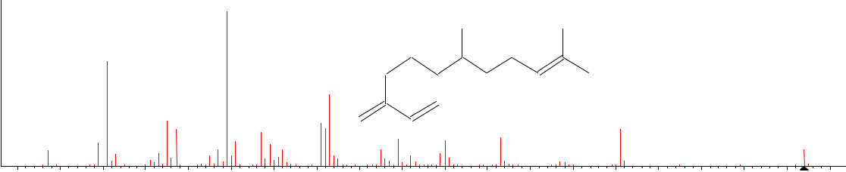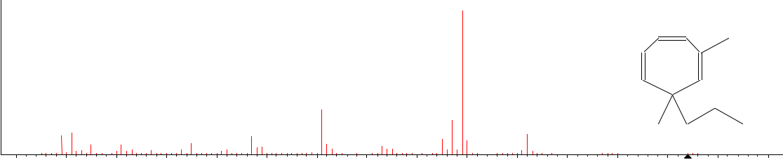

119

|  |  |  |  |  |  |  |  |  |
| --- | --- | --- | --- | --- | --- | --- | --- | --- |
|  |  | 117 |  |  |  |  | O |  |
|  |  |  |  |  |  |  |  |
|  |  | 115 | 132 |  |  |  |  |  |
| 103 107 | |  |  |  |  |  |  |
|  | 127 |  | 149 |  | 164 |  |
| 100 | 110 | 120 | 130 | 140 | 150 | 160 | 170 | 180 |

33

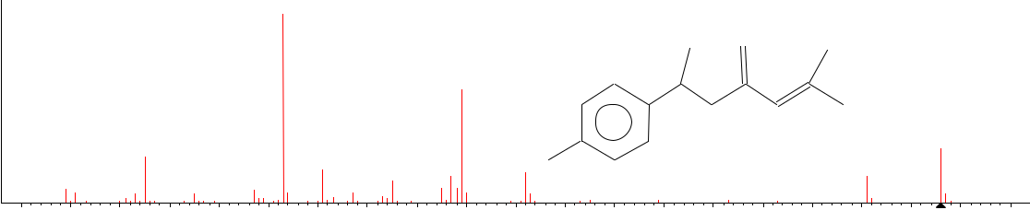

|  |  |  |  |  |  |  |  |  |  |  |  |  |  |  |  |  |  |  |  |  |  |  |  |
| --- | --- | --- | --- | --- | --- | --- | --- | --- | --- | --- | --- | --- | --- | --- | --- | --- | --- | --- | --- | --- | --- | --- | --- |
| 100 |  |  |  |  |  |  |  | 83 |  |  |  |  |  |  |  |  |  |  |  |  |  |  |  |
|  |  |  |  |  |  |  |  |  |  |  |  |  |  |  |  |  |  |  |  |  |  |  |
|  |  |  |  |  |  |  |  |  |  |  |  |  |  |  |  |  | O |  |  |  |  |  |  |
|  |  |  |  |  |  |  |  |  |  |  |  | 119 |  |  |  |  |  |  |  |  |  |  |  |
| 50 |  |  |  |  |  |  |  |  |  |  |  |  |  |  |  |  |  |  |  |  |  |  |  |
|  |  |  | 55 | |  |  |  |  |  |  |  |  |  |  |  |  |  |  |  |  |  | 216 |  |
|  |  |  |  |  |  | 91 | |  |  |  |  |  |  |  |  |  |  |  |  |  |  |
|  |  |  |  |  |  |  |  |  | 105 |  | 132 |  |  |  |  |  |  | 201 |  |  |  |
|  |  |  |  |  |  |  |  |  |  |  |  |  |  |  |  |  |  |  |  |  |
|  | 39 |  |  |  |  |  | 77 |  |  |  |  |  |  |  |  |  |  |  |  |  |  |
|  |  | 53 |  | 65 |  |  |  | 97 |  |  |  |  |  |  |  |  |  |  |  |  |
|  | 43 | 57 | 69 | 88 | 93 | 109 |  |  |  | 145 | 159 | 173 | 183 |  |  |  |  |  |
|  |  |  |  |  |  |  |  |  |  |  |
| 0 |  |  |  |  |  |  |  |  |  |  |  |  |  |
|  |  |  |  |  |  |  |  |  |  |  |  |  |  |  |  |  |  |  |  |  |  |  |
| 30 | 40 | 50 |  | 60 |  | 70 | 80 | 90 |  | 100 | 110 | 120 | 130 | 140 | 150 | 160 | 170 | 180 | 190 | 200 | 210 | 220 | 230 |



(mainlib) Ar-tumerone

|  |  |  |  |  |  |  |  |  |  |  |  |
| --- | --- | --- | --- | --- | --- | --- | --- | --- | --- | --- | --- |
| 100 |  |  |  |  |  |  |  |  |  |  |  |
|  |  |  |  |  |  |  |  |  |  | 83 |  |
| 50 |  |  |  |  |  |  |  |  |  |  |  |
|  |  |  |  | 55 |  |  |  |  | 77 |  | 91 |
|  |  |  |  |  |  |  |  |  |  | 93 |
|  |  |  |  |  |  |  |  |  |  | 85 |
|  |  | 39 |  |  |  |  |  |  |  |  |
|  | 29 | 43 | 53 |  | 65 | 69 |  | 79 |  |  |
|  |  |  | 74 | 87 |  |
| 0 |  |  |  |  |  |  |  |  |
|  |  |  |  |  |  |  |  |  |  |  |
| 20 | 30 | 40 | | 50 | 60 |  | 70 |  | 80 |  | 90 |
| (mainlib) Tumerone | |  |  |  |  |  |  |  |  |  |  |



|  |  |  |  |  |  |  |  |
| --- | --- | --- | --- | --- | --- | --- | --- |
| 100 |  |  |  |  |  |  |  |
| 50 |  |  |  |  |  |  |  |
|  |  |  |  |  |  | 83 |  |
|  |  |  | 55 |  | 77 | 91 |  |
|  | 41 |  | 65 69 |  |  |
| 0 |  | 59 |  |  | 98 |
|  |  |  |  |  |  |  |
| 30 | 40 | 50 | 60 | 70 | 80 | 90 | 100 |
| (mainlib) 2-Methyl-6-(4-methylenecyclohex-2-en-1-yl)hept-2-en-4-one | | | | | | |  |



|  |  |  |  |  |  |  |  |  |  |  |  |  |  |  |
| --- | --- | --- | --- | --- | --- | --- | --- | --- | --- | --- | --- | --- | --- | --- |
|  | 105 |  |  |  |  |  |  |  |  |  |  |  |  |  |
|  |  | 120 |  |  |  |  |  |  | O |  |  |  |  |  |
|  | 111 |  |  |  |  |  |  |  |  |  |  |  |  |  |
| 99 |  |  | 126 | 134 | 142 | 149 | 157 | 170 |  | 185 | 200 |  | 218 |  |
|  |  |  |  |  |  |  |
|  |  |  |  |  |  |  |  |  |
| 100 | 110 | 120 | 130 | | 140 | 150 | 160 | 170 | 180 | 190 | 200 | 210 | 220 | 230 |

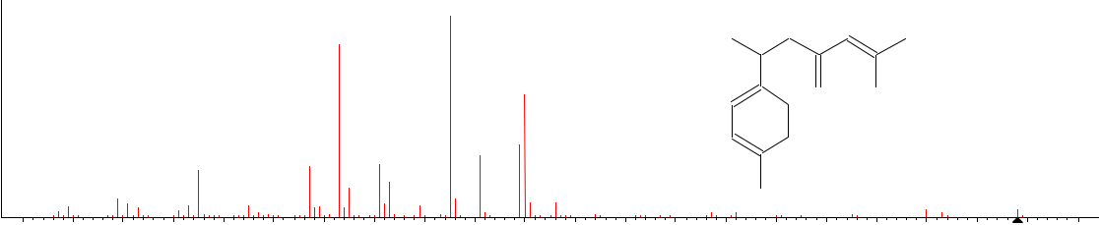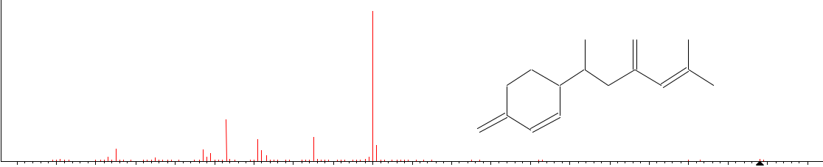

120

O

105

|  |  |  |  |  |  |  |  |  |  |  |  |  |
| --- | --- | --- | --- | --- | --- | --- | --- | --- | --- | --- | --- | --- |
| 113 |  | 128 133 |  | 145 | 162 |  |  |  | 200 |  | 218 |  |
| 110 | 120 | 130 | 140 | 150 | 160 | 170 | 180 | 190 | 200 | 210 | 220 | 230 |

34



|  |  |  |  |  |  |  |  |  |  |  |  |  |  |  |  |  |  |  |  |  |  |  |  |  |  |  |  |
| --- | --- | --- | --- | --- | --- | --- | --- | --- | --- | --- | --- | --- | --- | --- | --- | --- | --- | --- | --- | --- | --- | --- | --- | --- | --- | --- | --- |
| 100 |  |  |  |  |  | 74 |  |  |  |  |  |  |  |  |  |  |  |  |  |  |  |  |  |  |  |  |  |
|  |  |  |  |  |  |  |  |  |  |  |  |  |  |  |  |  |  |  |  |  |  |  |  |  |  |  |
|  |  |  |  |  |  |  |  |  |  |  |  |  |  |  |  |  |  |  |  |  |  |  | O |  |  |  |  |
| 50 |  |  |  |  |  |  |  | 87 |  |  |  |  |  |  |  |  |  |  |  |  |  |  |  |  |  | 270 |  |
|  |  |  |  |  |  |  |  |  |  |  |  |  |  |  |  |  |  |  |  |  | O |  |  |  |  |
|  |  |  |  |  |  |  |  |  |  |  |  |  |  |  |  |  |  |  |  |  |  |  |  |  |  |
|  |  |  | 43 |  | 55 |  |  |  |  |  |  |  |  |  |  |  |  |  |  |  |  |  |  |  |  |  |
|  |  |  |  |  |  |  |  |  |  |  |  |  |  |  |  |  |  |  |  |  |  |  |  |  |  |
|  |  |  |  |  |  | 69 | 83 |  |  |  |  |  | 143 |  |  |  |  |  |  |  |  | 227 |  |  |  |  |  |
|  |  | 29 |  |  |  |  |  | 97 | 115 | |  |  |  |  |  | 185 | | 199 |  |  | 241 |  |  |  |  |
|  |  |  |  |  |  |  |  | 129 | 139 |  | 157 | 171 | 213 |  |  |  |  |  |
|  | 15 | 34 | 46 |  |  |  |  |  |  |  |  | 149 | 221 |  | 248 | 256 |  |  |
|  |  |  |  |  |  |  |  |  |  |  |  |  |  |  |  |  |  |  |
| 0 |  |  |  |  |  |  |  |  |  |  |  |  |  |  |  |  |  |  |  |  |
|  |  |  |  |  |  |  |  |  |  |  |  |  |  |  |  |  |  |  |  |  |  |  |  |  |  |  |
| 10 | 20 | 30 | 40 | 50 | 60 | 70 | 80 | 90 | 100 | 110 | 120 | 130 | 140 | 150 | 160 | 170 | 180 | 190 | 200 | 210 | 220 | 230 | 240 | 250 | 260 | 270 | 280 |
| (mainlib) Pentadecanoic acid, 13-methyl-, methyl ester | | | | | | |  |  |  |  |  |  |  |  |  |  |  |  |  |  |  |  |  |  |  |  |  |

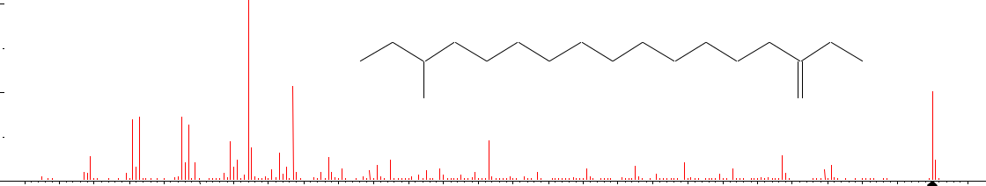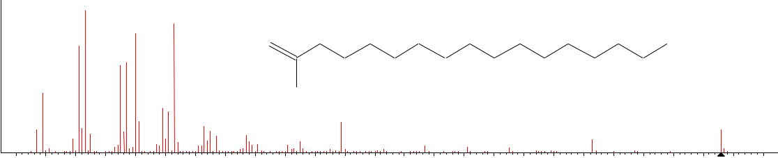

|  |  |  |  |  |  |  |  |  |  |  |  |  |  |  |  |  |  |  |  |  |  |  |  |  |  |  |  |  |  |  |
| --- | --- | --- | --- | --- | --- | --- | --- | --- | --- | --- | --- | --- | --- | --- | --- | --- | --- | --- | --- | --- | --- | --- | --- | --- | --- | --- | --- | --- | --- | --- |
| 100 |  |  | 43 |  |  |  |  |  |  |  |  |  |  |  |  |  |  |  |  |  |  |  |  |  |  |  |  |  |  |  |
|  |  |  |  |  | 73 |  |  |  |  |  |  |  |  |  |  |  |  |  |  |  |  |  |  |  |  |  |  |  |  |
|  |  |  |  |  | 60 |  |  |  |  |  |  |  |  |  |  |  |  |  |  |  |  |  |  |  |  |  |  |  |  |
|  |  |  |  |  |  |  |  |  |  |  |  |  |  |  |  |  |  |  |  |  |  |  |  |  |  |  |  |  |  |
|  |  |  | 41 |  |  |  |  |  |  | O |  |  |  |  |  |  |  |  |  |  |  |  |  |  |  |  |  |  |  |  |
|  |  |  |  |  |  |  |  |  |  |  |  |  |  |  |  |  |  |  |  |  |  |  |  |  |  |  |  |  |  |
|  |  |  |  |  | 57 |  |  |  |  |  |  |  |  |  |  |  |  |  |  |  |  |  |  |  |  |  |  |  |  |  |
| 50 |  | 29 |  |  |  |  |  |  |  | OH |  |  |  |  |  |  |  |  |  |  |  |  |  |  |  |  |  |  |  |  |
|  |  |  |  |  |  |  |  |  |  |  |  |  |  |  |  |  |  |  |  |  |  |  |  |  |  |  |  |  |
|  |  |  |  |  |  | 69 |  |  |  |  |  |  |  |  |  |  |  |  |  |  |  |  |  |  |  |  |  |  |  |  |
|  | 27 | |  |  |  |  | 83 |  |  |  |  |  | 129 | |  |  |  |  |  |  |  |  |  |  |  |  |  |  | 256 |  |
|  |  |  |  |  |  | 97 |  |  |  |  |  |  |  |  |  |  |  |  |  |  |  |  |  |  |  |  |
|  |  |  |  |  |  |  |  |  |  |  |  |  |  |  |  |  |  |  |  |  | 213 |  |  |  |  |  |
|  |  |  |  |  |  |  |  |  | 115 | |  |  |  |  |  | 157 |  |  |  |  |  |  |  |  |  |  |  |  |
|  | 25 | 31 |  |  |  |  |  |  |  | 125 | | 133 | 143 |  | 163 | 171 | 178 185 | | 194 |  | 220 227 | | 239 |  |  |  |
|  |  |  |  |  |  |  |  |  |  |  |  |  |  |  |  |
| 0 |  |  |  |  |  |  |  |  |  |  |  |  |  |  |  |  |
| 20 | 30 | 40 | 50 | 60 | 70 | 80 | 90 | 100 | 110 | 120 | | 130 | | 140 | 150 | 160 | | 170 | 180 | 190 | | 200 | 210 | 220 | 230 | 240 | 250 | 260 | 270 |
|  |
| (mainlib) n-Hexadecanoic acid | | | | |  |  |  |  |  |  |  |  |  |  |  |  |  |  |  |  |  |  |  |  |  |  |  |  |  |  |

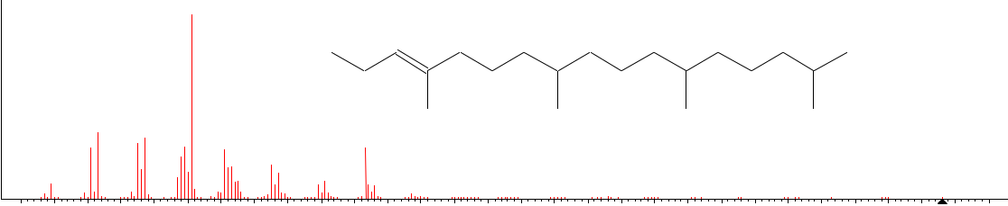

|  |  |  |  |  |  |  |  |  |  |  |  |  |  |  |  |  |  |  |  |  |  |  |  |  |  |  |  |  |  |
| --- | --- | --- | --- | --- | --- | --- | --- | --- | --- | --- | --- | --- | --- | --- | --- | --- | --- | --- | --- | --- | --- | --- | --- | --- | --- | --- | --- | --- | --- |
| 100 |  |  |  |  | 71 |  |  |  |  |  |  |  |  |  |  |  |  |  |  |  |  |  |  |  |  |  |  |  |  |
|  |  |  |  |  |  |  |  |  |  |  |  |  |  |  |  |  |  |  |  |  |  |  |  |  |  |  |  |  |
|  |  |  |  |  |  |  |  |  | HO |  |  |  |  |  |  |  |  |  |  |  |  |  |  |  |  |  |  |  |  |
| 50 |  |  |  |  |  |  |  |  |  |  |  |  |  |  |  |  |  |  |  |  |  |  |  |  |  |  |  |  |  |
|  |  | 43 |  | 57 |  |  |  |  |  |  |  |  |  |  |  |  |  |  |  |  |  |  |  |  |  |  |  |  |  |
|  |  |  |  |  | 81 |  |  |  | 123 |  |  |  |  |  |  |  |  |  |  |  |  |  |  |  |  |  |  |  |
|  |  |  |  |  |  |  |  |  |  |  |  |  |  |  |  |  |  |  |  |  |  |  |  |  |  |  |  |
|  |  |  |  |  |  |  |  | 95 |  |  |  |  |  |  |  |  |  |  |  |  |  |  |  |  |  |  |  |  |  |
|  | 29 |  |  | 63 |  |  |  |  | 111 |  |  | 137 | 149 157 164 | | | 179 | 196 | | 207 | 221 | 235 | | 249 | 263 |  | 278 |  | 296 |  |
| 0 |  |  |  |  |  |  |  |  |  |  |  |  |  |
|  |  |  |  |  |  |  |  |  |  |  |  |  |  |  |  |  |  |  |  |  |  |  |  |  |  |  |  |  |
| 20 | 30 | 40 | 50 | 60 | 70 | 80 | 90 | 100 | 110 | 120 | 130 | 140 | 150 | 160 | 170 | 180 | 190 | 200 | 210 | 220 | 230 | 240 | 250 | 260 | 270 | 280 | 290 | 300 | 310 |
| (mainlib) Phytol | |  |  |  |  |  |  |  |  |  |  |  |  |  |  |  |  |  |  |  |  |  |  |  |  |  |  |  |  |



Figure 4.2: Bioactive components identified by GC-MS

35

**4.3 Effect of AHALE on body weight in DOX-induced cardiotoxic rats**

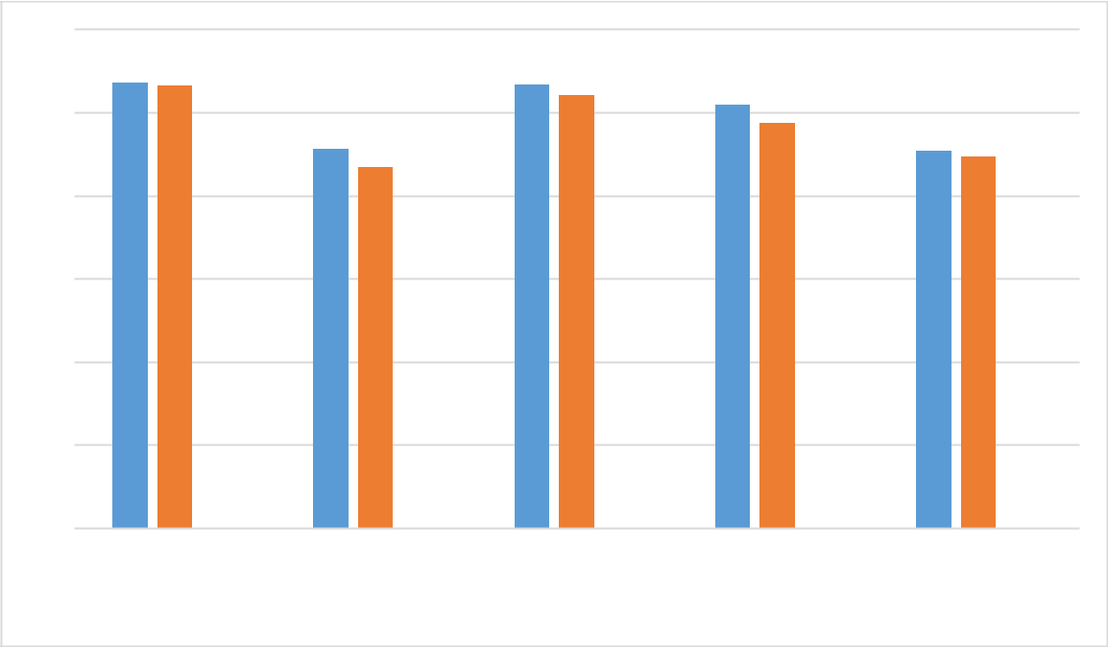

300

250

200

150

100

50

0

|  |  |  |  |  |  |  |  |  |
| --- | --- | --- | --- | --- | --- | --- | --- | --- |
| Group one | Group two | | | Group three | | | Group four | Group five |
|  |  |  |  | initial weight |  | final weight |  |  |
|  |  |  |  |  |  |  |
|  |  |  |  |  |  |  |

36

**4.4 Effect of AHALE on plasma and heart triglyceride concentrations in DOX-induced cardiotoxic rats**

Figures 4.5 and 4.6 show the effect of AHALE on the plasma and heart triglycerides levels in DOX-induced cardiotoxic rats. The rats treated with doxorubicin revealed an increased triglycerides level in the serum. The *Amaranthus hybridus* aqueous extract caused a significant decrease in the level of triglycerides in the serum of Doxorubicin - Induced cardioprotective rat when compared against other treated group. The rats treated with doxorubicin revealed an increased triglycerides level in the organ. The *Amaranthus hybridus* aqueous extract caused a significant increase in the level of triglycerides in the organ of doxorubicin - induced cardioprotective rat and the post-administration of 1 ml *Amaranthus hybridus* and doxorubicin showed decreased in triglycerides level in the organ.

37

**300**

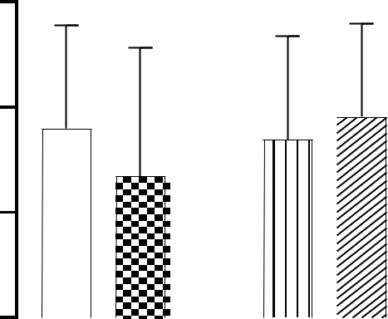

|  |  |
| --- | --- |
| **TRIG(mg/dl)** | **200** |
|  |
|  | **100** |
|  | **0** |



|  |  |  |  |  |  |  |  |  |  |  |  |  |  |  |  |  |  |  |  |  |  |  |  |  |  |  |  |  |  |  |
| --- | --- | --- | --- | --- | --- | --- | --- | --- | --- | --- | --- | --- | --- | --- | --- | --- | --- | --- | --- | --- | --- | --- | --- | --- | --- | --- | --- | --- | --- | --- |
|  |  |  |  |  |  |  |  |  |  | **l** | |  |  |  |  | **ly** | | |  |  |  | **)** | | |  |  | **)** |  |  | **ly** |
|  |  |  |  |  |  |  |  | **o** | | |  |  |  |  |  |  |  |  | **l** | |  |  |  | **l** |  |  |
|  |  |  |  |  |  |  | **t** | |  |  |  |  |  | **n** | | |  |  |  |  |  | **m** |  |  |  |  | **m** |  | **n** | |
|  |  |  |  |  |  |  | **r** | | |  |  |  | **o** | |  |  |  |  |  |  | **5** | |  |  |  | **1** | |  | **o** |  |
|  |  |  |  |  | **n** | | |  |  |  |  |  |  |  |  |  |  |  |  |  |  |  |  |
|  |  |  |  |  |  |  |  |  | **t** | |  |  |  |  |  |  | **.** | |  |  |  | **(** | |  | **x** | |  |
|  |  |  |  | **o** | | |  |  |  |  |  |  |  |  |  |  | **0** | | |  |  | **t** | |  |  |  |
|  |  |  | **c** | |  |  |  |  |  |  | **n** | |  |  |  |  |  | **(** | | |  |  | **n** | |  |  | **o** | |  |  |
|  |  | **l** | |  |  |  |  |  | **la** | | |  |  |  |  |  | **t** | |  |  |  |  |  |  |  |  |
|  | **a** | |  |  |  |  |  |  |  |  |  |  | **n** | |  |  |  |  | **a** | |  |  |  | **D** |  |  |  |
|  |  |  |  |  | **P** | | | |  |  |  |  |  |  |  |  |  | **l** |  |  |  |  |  |  |  |
|  | **rm** |  |  |  |  |  |  |  |  | **a** | | |  |  |  |  | **P** | |  |  |  |  |  |  |  |  |
|  |  |  |  |  |  |  |  |  |  |  |  | **l** | | |  |  |  |  |  |  |  |  |  |  |  |  |  |
|  |  |  |  |  |  |  |  |  |  |  | **P** | | |  |  |  |  |  | **d** | |  |  |  |  |  |  |  |  |  |
| **o** | |  |  |  |  |  |  |  |  |  | **d** | |  |  |  |  |  | **n** | | |  |  |  |  |  |  |  |  |  |  |
| **N** |  |  |  |  |  |  |  |  | **n** | | |  |  |  |  |  | **a** | | |  |  |  |  |  |  |  |  |  |  |  |
|  |  |  |  |  |  |  |  | **a** | | |  |  |  |  | **x** | | |  |  |  |  |  |  |  |  |  |  |  |  |  |
|  |  |  |  |  |  | **x** | | |  |  |  |  |  | **o** | | |  |  |  |  |  |  |  |  |  |  |  |  |  |  |
|  |  |  |  | **o** | | | |  |  |  |  |  | **D** | |  |  |  |  |  |  |  |  |  |  |  |  |  |  |  |  |
|  |  |  |  | **D** | |  |  |  |  |  |  |  |  |  |  |  |  |  |  |  |  |  |  |  |  |  |  |  |  |  |
|  |  |  |  |  |  |  |  |  |  |  |  |  |  |  |  |  |  | **GROUPS** | | | | | | | | | |  |  |  |

Normal control



Plant only



Dox and Plant (0.5ml)



Dox and Plant (1ml)



Dox only



Figure 1: Effect of *Amaranthus hybridus* extract on triglycerides level against Doxorubicin - Induced cardioprotective rat. Each value is mean ± S.E.M. (n = 5).

38

**1500**

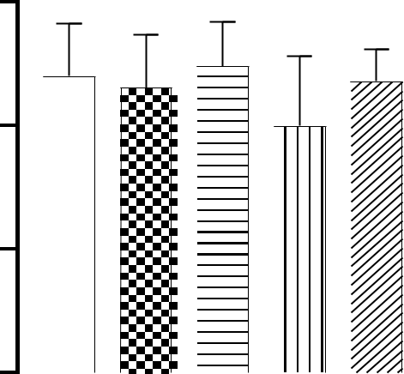

|  |  |
| --- | --- |
| **TRIG(mg/dl)** | **1000** |
|  |
|  | **500** |
|  | **0** |

|  |  |  |  |  |  |  |  |  |  |  |  |  |  |  |  |  |  |  |  |  |  |  |  |  |  |  |  |
| --- | --- | --- | --- | --- | --- | --- | --- | --- | --- | --- | --- | --- | --- | --- | --- | --- | --- | --- | --- | --- | --- | --- | --- | --- | --- | --- | --- |
|  |  |  |  |  |  |  |  | **l** | |  |  |  |  | **y** | |  |  |  |  | **)** | | |  |  | **)** |  | **y** |
|  |  |  |  |  |  |  | **o** | |  |  |  |  |  |  |  |  |  | **l** | |  |  |  | **l** |  |
|  |  |  |  |  |  |  |  |  |  |  | **l** | |  |  |  |  | **m** | |  |  |  |  | **m** |  | **l** |
|  |  |  |  |  |  | **t** | |  |  |  |  | **n** | | |  |  |  |  |  |  |  |  | **n** | |
|  |  |  |  |  |  | **r** | |  |  |  | **o** | |  |  |  |  |  | **5** | |  |  |  |  | **1** | | **o** |  |
|  |  |  |  |  | **n** | |  |  |  |  |  |  |  |  |  |  |  |  |  |  |
|  |  |  |  |  |  |  |  | **t** | |  |  |  |  |  | **.** | |  |  |  |  | **(** | |  | **x** |  |
|  |  |  |  | **o** | |  |  |  |  |  |  |  |  | **0** | | |  |  |  | **t** | |  |  |  |
|  |  |  | **c** | |  |  |  |  | **n** | |  |  |  |  | **(** | | |  |  |  | **n** | |  |  | **o** | |  |
|  |  | **l** | |  |  |  |  | **a** | |  |  |  |  | **t** | |  |  |  |  |  |  |  |  |
|  |  | **a** |  |  |  |  | **l** | |  |  |  |  | **n** | |  |  |  |  |  | **a** | |  |  |  | **D** |  |  |
|  |  |  |  |  |  | **P** | |  |  |  |  |  |  |  |  |  | **l** |  |  |  |  |  |  |
|  |  | **m** |  |  |  |  |  |  |  | **a** | |  |  |  |  |  | **P** | |  |  |  |  |  |  |  |
|  |  |  |  |  |  |  |  |  |  | **l** | |  |  |  |  | **d** | |  |  |  |  |  |  |  |
|  | **r** | |  |  |  |  |  |  |  | **P** | | |  |  |  |  |  |  |  |  |  |  |  |  |  |
| **o** | |  |  |  |  |  |  |  | **d** | |  |  |  |  | **n** | | |  |  |  |  |  |  |  |  |  |  |
| **N** |  |  |  |  |  |  |  | **n** | |  |  |  |  | **a** | | |  |  |  |  |  |  |  |  |  |  |  |
|  |  |  |  |  |  |  | **a** | |  |  |  |  | **x** | |  |  |  |  |  |  |  |  |  |  |  |  |  |
|  |  |  |  |  |  | **x** | |  |  |  |  | **o** | |  |  |  |  |  |  |  |  |  |  |  |  |  |  |
|  |  |  |  |  | **o** | |  |  |  |  | **D** | |  |  |  |  |  |  |  |  |  |  |  |  |  |  |  |
|  |  |  |  | **D** | |  |  |  |  |  |  |  |  |  |  |  |  |  |  |  |  |  |  |  |  |  |  |
|  |  |  |  |  |  |  |  |  |  |  |  |  |  |  | **GROUPS** | | | | | | | | | | |  |  |

Normal control



Plant only



Dox and Plant (0.5ml)



Dox and Plant (1ml)



Dox only



Figure 2: Effect of *Amaranthus hybridus* extract on triglycerides level against Doxorubicin - Induced cardioprotective rat. Each value is mean ± S.E.M. (n = 5).

39

**4.5 Effect of AHALE on plasma and heart HDL concentrations in DOX-induced cardiotoxic rats**

Figures 4.7 and 4.8 show the effect of AHALE on the plasma and heart HDL levels in DOX-induced cardiotoxic rats. Doxorubicin - Induced cardioprotective rat demonstrated a significant increase in the level of serum HDL. The treated rats with the plant extract only showed increase in HDL in blood. The co-administration of 0.5ml *Amaranthus hybridus* and doxorubicin showed decreased in HDL level in the serum. Doxorubicin - Induced cardioprotective rat demonstrated a significant increase in the level of organ HDL. The co-administration of 0.5ml *Amaranthus hybridus* and doxorubicin showed decreased in HDL level in the organ when compared against thecontrol groups.

40

|  |  |
| --- | --- |
|  | **0.20** |
| **HDL(mg/dl)** | **0.15** |
| **0.10** |
|  |
|  | **0.05** |
|  | **0.00** |

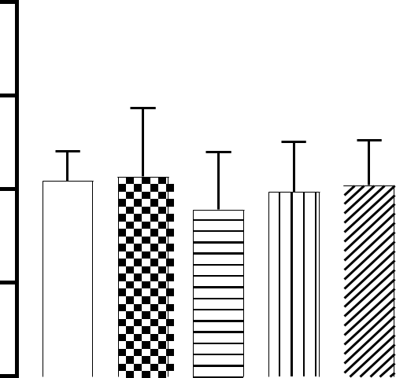

|  |  |  |  |  |  |  |  |  |  |  |  |  |  |  |  |  |  |  |  |  |  |  |  |  |  |  |
| --- | --- | --- | --- | --- | --- | --- | --- | --- | --- | --- | --- | --- | --- | --- | --- | --- | --- | --- | --- | --- | --- | --- | --- | --- | --- | --- |
|  |  |  |  |  |  |  |  | **l** | |  |  |  | **ly** | | |  |  |  |  | **)** | | |  |  | **)** | **y** |
|  |  |  |  |  |  |  | **o** | |  |  |  |  |  |  |  |  | **l** | |  |  |  | **l** |
|  |  |  |  |  |  |  |  |  |  |  |  |  |  | **m** | |  |  |  |  | **m** | **l** |
|  |  |  |  |  |  | **t** | |  |  |  |  |  |  |  |  |  |  |  |  |  |  |  | **n** |
|  |  |  |  |  |  | **r** | |  |  |  |  | **on** | |  |  |  |  | **5** | |  |  |  |  | **1** | | **o** |
|  |  |  |  |  | **n** | |  |  |  |  |  |  |  |  |  |  |  |  |  |
|  |  |  |  |  |  |  |  | **t** | | |  |  |  |  | **.** | |  |  |  |  | **(** | |  | **x** |
|  |  |  |  | **o** | |  |  |  |  |  |  |  | **0** | | |  |  |  | **t** | |  |  |
|  |  |  | **c** | |  |  |  |  | **n** | | |  |  |  | **(** | | |  |  |  | **n** | |  |  | **o** | |
|  |  | **l** | |  |  |  |  | **a** | |  |  |  |  | **t** | |  |  |  |  |  |  |  |
|  |  | **a** |  |  |  |  | **l** | |  |  |  |  | **n** | |  |  |  |  |  | **a** | |  |  |  | **D** |  |
|  |  |  |  |  |  | **P** | |  |  |  |  |  |  |  |  |  | **l** |  |  |  |  |  |
|  |  | **m** |  |  |  |  |  |  |  | **a** | |  |  |  |  |  | **P** | |  |  |  |  |  |  |
|  |  |  |  |  |  |  |  |  |  |  | **l** |  |  |  |  | **d** | |  |  |  |  |  |  |
|  | **r** | |  |  |  |  |  |  | **d** | | **P** | |  |  |  |  |  |  |  |  |  |  |  |  |
| **o** | |  |  |  |  |  |  |  |  |  |  |  | **n** | | |  |  |  |  |  |  |  |  |  |
| **N** |  |  |  |  |  |  |  | **n** | |  |  |  |  | **a** | | |  |  |  |  |  |  |  |  |  |  |
|  |  |  |  |  |  |  | **a** | |  |  |  |  | **x** | |  |  |  |  |  |  |  |  |  |  |  |  |
|  |  |  |  |  | **ox** | | |  |  |  |  | **o** | |  |  |  |  |  |  |  |  |  |  |  |  |  |
|  |  |  |  |  |  |  |  |  | **D** |  |  |  |  |  |  |  |  |  |  |  |  |  |  |
|  |  |  |  | **D** | |  |  |  |  |  |  |  |  |  |  |  |  |  |  |  |  |  |  |  |  |  |
|  |  |  |  |  |  |  |  |  |  |  |  |  |  |  | **GROUPS** | | | | | | | | | | |  |

Normal control



Plant only



Dox and Plant (0.5ml)



Dox and Plant (1ml)



Dox only



Figure 4.7: Effect of *Amaranthus hybridus* extract on HDL level against Doxorubicin - Induced cardioprotective rat. Each value is mean ± S.E.M. (n = 5).

41

**0.15**



|  |  |
| --- | --- |
| **HDL(mg/dl)** | **0.10** |
|  |
|  | **0.05** |

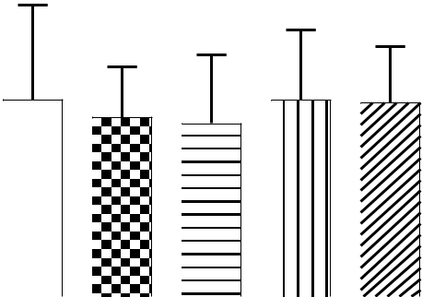

**0.00**

|  |  |  |  |  |  |  |  |  |  |  |  |  |  |  |  |  |  |  |  |  |  |  |  |  |  |  |  |
| --- | --- | --- | --- | --- | --- | --- | --- | --- | --- | --- | --- | --- | --- | --- | --- | --- | --- | --- | --- | --- | --- | --- | --- | --- | --- | --- | --- |
|  |  |  |  |  |  |  |  | **l** | |  |  |  |  | **l** | |  |  |  |  |  | **)** | | |  |  | **)** | **ly** |
|  |  |  |  |  |  |  | **o** | |  |  |  |  |  |  |  |  |  |  | **l** | |  |  |  | **l** |
|  |  |  |  |  |  | **t** | |  |  |  |  |  |  |  | **y** | |  |  |  |  |  |  |  | **n** |
|  |  |  |  |  |  |  |  |  |  |  | **n** | | |  |  |  |  | **m** | |  |  |  |  | **m** |
|  |  |  |  |  |  | **r** | |  |  |  |  | **o** | |  |  |  |  |  | **5** | |  |  |  |  | **1** | | **o** |
|  |  |  |  |  | **n** | |  |  |  |  |  |  |  |  |  |  |  |  |  |  |
|  |  |  |  |  |  |  |  | **t** | | |  |  |  |  |  | **.** | |  |  |  |  | **(** | |  | **x** |
|  |  | **l** | | **o** | |  |  |  |  |  |  | **t** | | **0** | | |  |  |  | **t** | |  |  |
|  |  |  |  |  |  | **an** | | | |  |  |  |  |  |  |  |  | **n** | |  |  | **o** | |
|  |  | **a** | **c** | |  |  | **l** | |  |  |  |  |  | **n** | | **(** | | |  |  | **a** | |  |  |  | **D** |  |
|  |  |  |  |  |  | **P** | |  |  |  |  |  |  |  |  |  |  | **l** |  |  |  |  |  |
|  |  | **m** |  |  |  |  |  |  |  |  | **a** | |  |  |  |  |  | **P** | |  |  |  |  |  |  |
|  |  |  |  |  |  |  |  |  |  |  | **l** | |  |  |  |  | **d** | |  |  |  |  |  |  |
|  | **r** | |  |  |  |  |  |  | **d** | | **P** | | |  |  |  |  |  |  |  |  |  |  |  |  |
| **o** | |  |  |  |  |  |  |  |  |  |  |  |  | **n** | | |  |  |  |  |  |  |  |  |  |
| **N** |  |  |  |  |  |  |  | **n** | |  |  |  |  |  | **a** | | |  |  |  |  |  |  |  |  |  |  |
|  |  |  |  |  |  |  | **a** | |  |  |  |  |  | **x** | |  |  |  |  |  |  |  |  |  |  |  |  |
|  |  |  |  |  |  | **x** | |  |  |  |  |  | **o** | |  |  |  |  |  |  |  |  |  |  |  |  |  |
|  |  |  |  |  | **o** | |  |  |  |  |  | **D** | |  |  |  |  |  |  |  |  |  |  |  |  |  |  |
|  |  |  |  | **D** | |  |  |  |  |  |  |  |  |  |  |  |  |  |  |  |  |  |  |  |  |  |  |

**GROUPS**

Normal control



Plant only



Dox and Plant (0.5ml) Dox and Plant (1ml) Dox only



Figure 4.8: Effect of *Amaranthus hybridus* extract on HDL level against Doxorubicin - Induced cardioprotective rat. Each value is mean ± S.E.M. (n = 5).

42

**4.5 Effect of AHALE on plasma and heart VLDL concentrations in DOX-induced cardiotoxic rats**

Figures 4.9 and 4.10 show the effect of AHALE on the plasma and heart VLDL levels in DOX-induced cardiotoxic rats. The rats treated with doxorubicin only revealed an increased VLDL level in the blood. The *Amaranthus hybridus* aqueous extract only caused a significant decrease in the level of VLDL in the serum and the co-administration of 0.5ml *Amaranthus hybridus* and doxorubicin showed decreased in VLDL level in the blood. The rats treated with doxorubicin only revealed an increased VLDL level in the organ. The *Amaranthus hybridus* aqueous extract only caused a significant increase in the level of VLDL in the organ and the co-administration of 0.5ml *Amaranthus hybridus* and doxorubicin showed increased in VLDL level in the organ

43

|  |  |
| --- | --- |
|  | **80** |
| **VLDL(mg/dl)** | **60** |
| **40** |
|  |
|  | **20** |
|  | **0** |

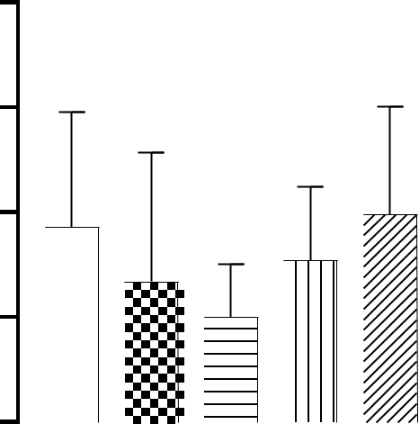

|  |  |  |  |  |  |  |  |  |  |  |  |  |  |  |  |  |  |  |  |  |  |  |  |  |  |  |
| --- | --- | --- | --- | --- | --- | --- | --- | --- | --- | --- | --- | --- | --- | --- | --- | --- | --- | --- | --- | --- | --- | --- | --- | --- | --- | --- |
|  |  |  |  |  |  | **ol** | | |  |  |  |  | **l** | |  |  |  |  |  | **)** | |  |  |  | **)** | **l** |
|  |  |  |  |  |  |  |  |  |  |  |  |  |  | **y** |  |  |  |  |  |  |  |  | **y** |
|  |  |  |  |  | **t** | |  |  |  |  |  | **n** | |  |  |  |  | **l** | |  |  |  | **l** | |
|  |  |  |  |  |  |  |  |  |  |  |  |  |  | **m** | |  |  |  |  | **m** |  | **n** |
|  |  |  |  |  | **r** | |  |  |  | **o** | | |  |  |  |  | **5** | |  |  |  |  | **1** | |  | **o** |
|  |  |  |  | **n** | |  |  |  |  |  |  |  |  |  |  |  |  |  |
|  |  |  |  |  |  |  | **t** | |  |  |  |  |  | **.** | |  |  |  |  | **(** | |  |  | **x** |
|  |  |  | **o** | |  |  |  |  |  |  |  |  | **0** | | |  |  |  | **t** | |  |  |  |
|  |  | **c** | |  |  |  |  | **n** | |  |  |  |  | **(** | | |  |  |  | **n** | |  |  |  | **o** | |
|  | **l** | |  |  |  |  | **a** | |  |  |  |  |  | **t** |  |  |  |  |  |  |  |  |
|  | **a** |  |  |  |  | **l** | |  |  |  |  |  | **n** | |  |  |  |  | **la** | |  |  |  | **D** | |  |
|  | **m** |  |  |  |  | **P** |  |  |  |  |  | **a** | |  |  |  |  | **P** | |  |  |  |  |  |  |  |
|  |  |  |  |  |  |  |  |  |  | **l** | |  |  |  | **d** | |  |  |  |  |  |  |  |
| **r** | |  |  |  |  |  |  | **d** | | **P** | |  |  |  |  |  |  |  |  |  |  |  |  |  |
| **o** |  |  |  |  |  |  |  |  |  |  |  | **n** | | |  |  |  |  |  |  |  |  |  |  |
| **N** |  |  |  |  |  | **n** | | |  |  |  |  |  | **a** | |  |  |  |  |  |  |  |  |  |  |  |
|  |  |  |  |  |  | **a** | |  |  |  |  |  | **x** | |  |  |  |  |  |  |  |  |  |  |  |  |
|  |  |  |  |  | **x** | |  |  |  |  | **o** | | |  |  |  |  |  |  |  |  |  |  |  |  |  |
|  |  |  |  | **o** | |  |  |  |  | **D** | | |  |  |  |  |  |  |  |  |  |  |  |  |  |  |
|  |  |  | **D** | |  |  |  |  |  |  |  |  |  |  |  |  |  |  |  |  |  |  |  |  |  |  |
|  |  |  |  |  |  |  |  |  |  |  |  |  |  | **GROUPS** | | | | | | | | | | | |  |

Normal control



Plant only



Dox and Plant (0.5ml)



Dox and Plant (1ml)



Dox only



Figure 4.9: Effect of *Amaranthus hybridus* extract on VLDL level against Doxorubicin - Induced cardioprotective rat. Each value is mean ± S.E.M. (n = 5).

44

|  |  |
| --- | --- |
|  | **400** |
| **VLDL(mg/dl)** | **300** |
| **200** |
|  |
|  | **100** |
|  | **0** |

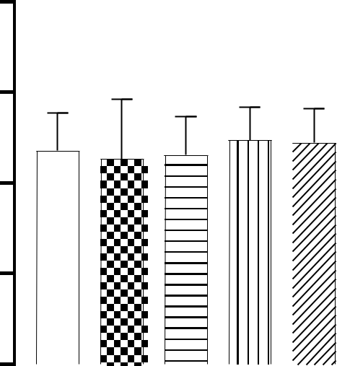

|  |  |  |  |  |  |  |  |  |  |  |  |  |  |  |  |  |  |  |  |  |  |  |  |  |  |  |  |  |  |
| --- | --- | --- | --- | --- | --- | --- | --- | --- | --- | --- | --- | --- | --- | --- | --- | --- | --- | --- | --- | --- | --- | --- | --- | --- | --- | --- | --- | --- | --- |
|  |  |  |  |  |  |  |  | **l** | |  |  |  |  | **y** |  |  |  |  |  | **)** | | |  |  |  | **l)** |  |  | **y** |
|  |  |  |  |  |  |  | **o** | |  |  |  |  |  |  |  |  | **l** | | | |  |  |  |  |  |  |
|  |  |  |  |  | **t** | |  |  |  |  | **l** | |  |  | **m** | | |  |  |  |  |  | **m** | |  | **l** | |
|  |  |  |  |  |  |  |  |  |  | **n** | |  |  |  |  |  |  |  |  |  | **n** |  |
|  |  |  |  |  | **r** | | |  |  |  | **o** | |  |  |  | **5** | |  |  |  |  |  |  | **1** | |  |  | **o** |  |
|  |  |  |  | **n** | |  |  |  |  |  |  |  |  |  |  |  |  |  |  |  |  |  |
|  |  |  |  |  |  |  |  | **t** | |  |  |  |  | **.** |  |  |  |  |  |  | **(** | |  |  | **x** |  |  |
|  |  |  | **o** | |  |  |  |  |  |  |  |  | **0** | |  |  |  |  |  | **t** | |  |  |  |  |  |
|  |  | **c** | |  |  |  |  |  | **n** | |  |  |  | **(** | |  |  |  |  |  | **n** | |  |  |  | **o** | |  |  |
|  | **l** | |  |  |  |  | **la** | | |  |  |  |  | **t** |  |  |  |  | **a** | | |  |  |  |  | **D** |  |  |  |
|  | **a** |  |  |  |  | **P** | | |  |  |  |  | **n** | |  |  |  | **l** | | |  |  |  |  |  |  |  |  |
|  | **m** |  |  |  |  |  |  |  | **a** | |  |  |  | **P** | |  |  |  |  |  |  |  |  |  |  |  |
|  |  |  |  |  |  |  |  |  |  | **l** | |  |  |  | **d** |  |  |  |  |  |  |  |  |  |  |  |
| **r** | |  |  |  |  |  |  |  | **d** | | **P** |  |  |  |  |  |  |  |  |  |  |  |  |  |  |  |  |  |
| **o** |  |  |  |  |  |  |  |  |  |  |  |  | **n** | |  |  |  |  |  |  |  |  |  |  |  |  |  |
| **N** |  |  |  |  |  |  |  | **n** | |  |  |  |  | **a** | |  |  |  |  |  |  |  |  |  |  |  |  |  |  |
|  |  |  |  |  |  | **a** | | |  |  |  |  | **x** | |  |  |  |  |  |  |  |  |  |  |  |  |  |  |  |
|  |  |  |  |  | **x** | |  |  |  |  | **o** | | |  |  |  |  |  |  |  |  |  |  |  |  |  |  |  |  |
|  |  |  |  | **o** | |  |  |  |  |  | **D** | |  |  |  |  |  |  |  |  |  |  |  |  |  |  |  |  |  |
|  |  |  | **D** | |  |  |  |  |  |  |  |  |  |  |  |  |  |  |  |  |  |  |  |  |  |  |  |  |  |
|  |  |  |  |  |  |  |  |  |  |  |  |  |  | **GROUPS** | | | | | | | | | | | | |  |  |  |

Normal control



Plant only



Dox and Plant (0.5ml)



Dox and Plant (1ml)



Dox only



Figure 4.10: Effect of *Amaranthus hybridus* extract on VLDL level against Doxorubicin - Induced cardioprotective rat. Each value is mean ± S.E.M. (n = 5).

45

**4.6 Effect of AHALE on plasma and heart cholesterol concentrations in DOX-induced cardiotoxic rats**

Figures 4.9 and 4.10 show the effect of AHALE on the plasma and heart cholesterol levels in DOX-induced cardiotoxic rats. The *Amaranthus hybridus* aqueous extract only caused a significant increase in the level of cholesterol in the serum and the co-administration of 0.5ml *Amaranthus hybridus* and doxorubicin showed increased in cholesterol level in the blood. The *Amaranthus hybridus* aqueous extract only caused a significant increase in the level of cholesterolin the organ and the co-administration of 0.5ml *Amaranthus hybridus* and doxorubicin showed increased in cholesterol level in the organ.

46

|  |  |
| --- | --- |
|  | **100** |
| **CHOL(mg/dl)** | **80** |
| **60** |
|  |
|  | **40** |
|  | **20** |
|  | **0** |

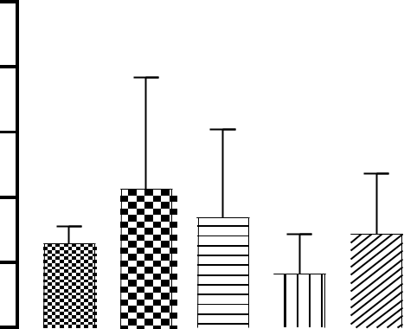

|  |  |  |  |  |  |  |  |  |  |  |  |  |  |  |  |  |  |  |  |  |  |  |  |  |  |  |  |  |  |  |
| --- | --- | --- | --- | --- | --- | --- | --- | --- | --- | --- | --- | --- | --- | --- | --- | --- | --- | --- | --- | --- | --- | --- | --- | --- | --- | --- | --- | --- | --- | --- |
|  |  |  |  |  |  |  |  |  |  | **l** | |  |  |  |  | **ly** | | |  |  |  | **)** | | |  |  | **)** |  |  | **ly** |
|  |  |  |  |  |  |  |  | **o** | | |  |  |  |  |  |  |  |  | **l** | |  |  |  | **l** |  |  |
|  |  |  |  |  |  |  | **t** | |  |  |  |  |  | **n** | | |  |  |  |  |  | **m** |  |  |  |  | **m** |  | **n** | |
|  |  |  |  |  |  |  | **r** | | |  |  |  | **o** | |  |  |  |  |  |  | **5** | |  |  |  | **1** | |  | **o** |  |
|  |  |  |  |  | **n** | | |  |  |  |  |  |  |  |  |  |  |  |  |  |  |  |  |
|  |  |  |  |  |  |  |  |  | **t** | |  |  |  |  |  |  | **.** | |  |  |  | **(** | |  | **x** | |  |
|  |  |  |  | **o** | | |  |  |  |  |  |  |  |  |  |  | **0** | | |  |  | **t** | |  |  |  |
|  |  |  | **c** | |  |  |  |  |  |  | **n** | |  |  |  |  |  | **(** | | |  |  | **n** | |  |  | **o** | |  |  |
|  |  | **l** | |  |  |  |  |  | **la** | | |  |  |  |  |  | **t** | |  |  |  |  |  |  |  |  |
|  | **a** | |  |  |  |  |  |  |  |  |  |  | **n** | |  |  |  |  | **a** | |  |  |  | **D** |  |  |  |
|  |  |  |  |  | **P** | | | |  |  |  |  |  |  |  |  |  | **l** |  |  |  |  |  |  |  |
|  | **rm** |  |  |  |  |  |  |  |  | **a** | | |  |  |  |  | **P** | |  |  |  |  |  |  |  |  |
|  |  |  |  |  |  |  |  |  |  |  |  | **l** | | |  |  |  |  |  |  |  |  |  |  |  |  |  |
|  |  |  |  |  |  |  |  |  |  |  | **P** | | |  |  |  |  |  | **d** | |  |  |  |  |  |  |  |  |  |
| **o** | |  |  |  |  |  |  |  |  |  | **d** | |  |  |  |  |  | **n** | | |  |  |  |  |  |  |  |  |  |  |
| **N** |  |  |  |  |  |  |  |  | **n** | | |  |  |  |  |  | **a** | | |  |  |  |  |  |  |  |  |  |  |  |
|  |  |  |  |  |  |  |  | **a** | | |  |  |  |  | **x** | | |  |  |  |  |  |  |  |  |  |  |  |  |  |
|  |  |  |  |  |  | **x** | | |  |  |  |  |  | **o** | | |  |  |  |  |  |  |  |  |  |  |  |  |  |  |
|  |  |  |  | **o** | | | |  |  |  |  |  | **D** | |  |  |  |  |  |  |  |  |  |  |  |  |  |  |  |  |
|  |  |  |  | **D** | |  |  |  |  |  |  |  |  |  |  |  |  |  |  |  |  |  |  |  |  |  |  |  |  |  |
|  |  |  |  |  |  |  |  |  |  |  |  |  |  |  |  |  |  | **GROUPS** | | | | | | | | | |  |  |  |

Normal control



Plant only



Dox and Plant (0.5ml)



Dox and Plant (1ml)



Dox only



Figure 4.9: Effect of *Amaranthus hybridus* extract on cholesterol level against Doxorubicin - Induced cardioprotective rat. Each value is mean ± S.E.M. (n = 5).

47

|  |  |
| --- | --- |
|  | **100** |
| **CHOL(mg/dl)** | **80** |
| **60** |
|  |
|  | **40** |
|  | **20** |
|  | **0** |

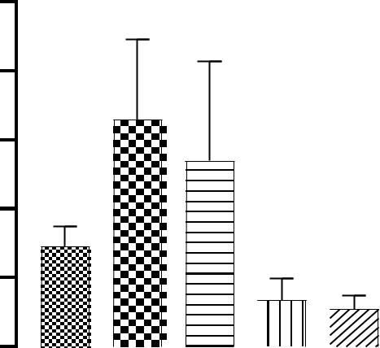

|  |  |  |  |  |  |  |  |  |  |  |  |  |  |  |  |  |  |  |  |  |  |  |  |  |  |  |
| --- | --- | --- | --- | --- | --- | --- | --- | --- | --- | --- | --- | --- | --- | --- | --- | --- | --- | --- | --- | --- | --- | --- | --- | --- | --- | --- |
|  |  |  |  |  |  |  | **l** | |  |  |  |  | **y** | |  |  |  |  | **)** | | |  |  | **)** |  | **y** |
|  |  |  |  |  |  | **o** | |  |  |  |  |  |  |  |  |  | **l** | |  |  |  | **l** |  |
|  |  |  |  |  |  |  |  |  |  | **l** | |  |  |  |  | **m** | |  |  |  |  | **m** |  | **l** |
|  |  |  |  |  | **t** | |  |  |  |  | **n** | | |  |  |  |  |  |  |  |  | **n** | |
|  |  |  |  |  | **r** | |  |  |  | **o** | |  |  |  |  |  | **5** | |  |  |  |  | **1** | | **o** |  |
|  |  |  |  | **n** | |  |  |  |  |  |  |  |  |  |  |  |  |  |  |
|  |  |  |  |  |  |  | **t** | |  |  |  |  |  | **.** | |  |  |  |  | **(** | |  | **x** |  |
|  |  |  | **o** | |  |  |  |  |  |  |  |  | **0** | | |  |  |  | **t** | |  |  |  |
|  |  | **c** | |  |  |  |  | **n** | |  |  |  |  | **(** | | |  |  |  | **n** | |  |  | **o** | |  |
|  | **l** | |  |  |  |  | **a** | |  |  |  |  | **t** | |  |  |  |  |  |  |  |  |
|  | **a** |  |  |  |  | **l** | |  |  |  |  | **n** | |  |  |  |  |  | **a** | |  |  |  | **D** |  |  |
|  |  |  |  |  | **P** | |  |  |  |  |  |  |  |  |  | **l** |  |  |  |  |  |  |
|  | **rm** |  |  |  |  |  |  |  | **a** | |  |  |  |  | **P** | | |  |  |  |  |  |  |  |
|  |  |  |  |  |  |  |  |  | **l** | |  |  |  |  |  |  |  |  |  |  |  |  |
|  |  |  |  |  |  |  |  | **P** | | |  |  |  |  | **d** | |  |  |  |  |  |  |  |  |  |
| **o** | |  |  |  |  |  |  | **d** | |  |  |  |  | **n** | | |  |  |  |  |  |  |  |  |  |  |
| **N** |  |  |  |  |  |  | **n** | |  |  |  |  | **a** | | |  |  |  |  |  |  |  |  |  |  |  |
|  |  |  |  |  |  | **a** | |  |  |  |  | **x** | |  |  |  |  |  |  |  |  |  |  |  |  |  |
|  |  |  |  |  | **x** | |  |  |  |  | **o** | |  |  |  |  |  |  |  |  |  |  |  |  |  |  |
|  |  |  |  | **o** | |  |  |  |  | **D** | |  |  |  |  |  |  |  |  |  |  |  |  |  |  |  |
|  |  |  | **D** | |  |  |  |  |  |  |  |  |  |  |  |  |  |  |  |  |  |  |  |  |  |  |
|  |  |  |  |  |  |  |  |  |  |  |  |  |  | **GROUPS** | | | | | | | | | | |  |  |

Normal control



Plant only



Dox and Plant (0.5ml)



Dox and Plant (1ml)



Dox only



Figure 4.10: Effect of *Amaranthus hybridus* extract on cholesterol level against Doxorubicin - Induced cardioprotective rat. Each value is mean ± S.E.M. (n = 5).

48

**4.7 Effect of AHALE on plasma and heart LDL concentrations in DOX-induced cardiotoxic rats**

Figures 4.11 and 4.12 show the effect of AHALE on the plasma and heart LDL levels in DOX-induced cardiotoxic rats. The co-administration of 1ml *Amaranthus hybridus* and doxorubicin showed a significant increase in LDL level in the blood when compared against the control and other treated groups. The *Amaranthus hybridus* aqueous extract only caused a significant increase in the level of LDL in the organ and the co-administration of 0.5ml and 0.1ml *Amaranthus hybridus* and doxorubicin only showed decreased in LDL level in the organ.

49

|  |  |
| --- | --- |
|  | **20** |
| **LDL(mg/dl)** | **15** |
| **10** |
|  |
|  | **5** |
|  | **0** |

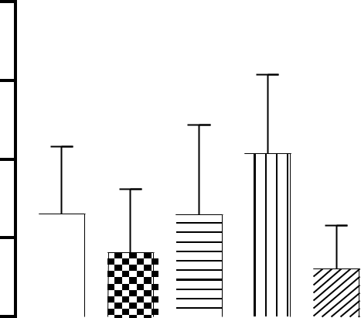

|  |  |  |  |  |  |  |  |  |  |  |  |  |  |  |  |  |  |  |  |  |  |  |  |  |  |  |  |  |
| --- | --- | --- | --- | --- | --- | --- | --- | --- | --- | --- | --- | --- | --- | --- | --- | --- | --- | --- | --- | --- | --- | --- | --- | --- | --- | --- | --- | --- |
|  |  |  |  |  |  |  |  | **l** | |  |  |  |  | **y** | | |  |  |  |  | **)** | | |  |  | **)** |  | **y** |
|  |  |  |  |  |  |  | **o** | |  |  |  |  |  |  |  |  |  | **l** | |  |  |  | **l** |  |
|  |  |  |  |  |  |  |  |  |  |  |  | **l** | |  |  |  |  | **m** | |  |  |  |  | **m** |  | **l** |
|  |  |  |  |  | **t** | | |  |  |  |  | **n** | | |  |  |  |  |  |  |  |  |  | **n** | |
|  |  |  |  |  | **r** | | |  |  |  | **o** | |  |  |  |  |  |  | **5** | |  |  |  |  | **1** | | **o** |  |
|  |  |  |  | **n** | |  |  |  |  |  |  |  |  |  |  |  |  |  |  |  |  |
|  |  |  |  |  |  |  |  | **t** | |  |  |  |  |  |  | **.** | |  |  |  |  | **(** | |  | **x** |  |
|  |  |  | **o** | |  |  |  |  |  |  |  |  |  |  | **0** | | |  |  |  | **t** | |  |  |  |
|  |  | **c** | |  |  |  |  |  | **n** | |  |  |  |  |  | **(** | | |  |  |  | **n** | |  |  | **o** | |  |
|  | **l** | |  |  |  |  |  | **a** | |  |  |  |  |  | **t** | |  |  |  |  |  |  |  |  |
|  | **a** |  |  |  |  |  | **l** | |  |  |  |  |  | **n** | |  |  |  |  |  | **a** | |  |  |  | **D** |  |  |
|  |  |  |  | **P** | | | |  |  |  |  |  |  |  |  |  |  | **l** |  |  |  |  |  |  |
|  | **rm** |  |  |  |  |  |  | **a** | | |  |  |  |  | **P** | | |  |  |  |  |  |  |  |
|  |  |  |  |  |  |  |  |  |  | **l** | | |  |  |  |  |  |  |  |  |  |  |  |  |
|  |  |  |  |  |  |  |  |  | **P** | | |  |  |  |  |  | **d** | |  |  |  |  |  |  |  |  |  |
| **o** | |  |  |  |  |  |  |  | **d** | |  |  |  |  |  | **n** | | |  |  |  |  |  |  |  |  |  |  |
| **N** |  |  |  |  |  |  |  | **n** | |  |  |  |  |  | **a** | | |  |  |  |  |  |  |  |  |  |  |  |
|  |  |  |  |  |  | **a** | | |  |  |  |  | **x** | | |  |  |  |  |  |  |  |  |  |  |  |  |  |
|  |  |  |  |  | **x** | |  |  |  |  |  | **o** | | |  |  |  |  |  |  |  |  |  |  |  |  |  |  |
|  |  |  |  | **o** | |  |  |  |  |  | **D** | |  |  |  |  |  |  |  |  |  |  |  |  |  |  |  |  |
|  |  |  | **D** | |  |  |  |  |  |  |  |  |  |  |  |  |  |  |  |  |  |  |  |  |  |  |  |  |
|  |  |  |  |  |  |  |  |  |  |  |  |  |  |  |  | **GROUPS** | | | | | | | | | | |  |  |

Normal control



Plant only



Dox and Plant (0.5ml)



Dox and Plant (1ml)



Dox only



Figure 4.11: Effect of *Amaranthus hybridus* extract on LDL level against Doxorubicin - Induced cardioprotective rat. Each value is mean ± S.E.M. (n = 5).

50

|  |  |
| --- | --- |
|  | **400** |
| **LDL(mg/dl)** | **300** |
| **200** |
|  |
|  | **100** |
|  | **0** |

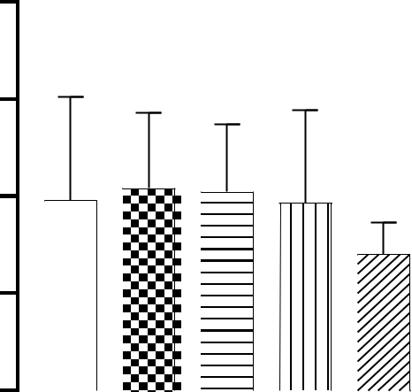

|  |  |  |  |  |  |  |  |  |  |  |  |  |  |  |  |  |  |  |  |
| --- | --- | --- | --- | --- | --- | --- | --- | --- | --- | --- | --- | --- | --- | --- | --- | --- | --- | --- | --- |
|  | **rol** | | | |  |  | **l** |  |  |  |  |  | **)** | |  |  | **)** |  | **l** |
|  |  |  |  |  |  |  | **y** | |  |  |  |  |  |  |  | **y** |
|  |  |  |  |  |  |  |  |  |  |  | **l** |  |  |  | **l** |  |
|  | **t** | |  |  |  | **n** | |  |  |  |  | **m** | |  |  |  | **m** | **n** | |
| **n** | |  |  |  | **o** | |  |  |  |  | **5** | |  |  |  | **1** | | **o** |  |
|  |  | **nt** | |  |  |  |  | **.** | |  |  |  | **(** | |  |  |  |
| **co** |  |  |  |  |  | **(** | | |  |  |  | **t** | |  |  | **x** |  |
|  |  |  | **a** | |  |  |  |  | **0** | | |  |  |  |  |  |
| **al** |  |  |  |  | **nt** | |  |  |  |  | **n** | |  |  | **o** | |  |
|  |  | **l** |  |  |  |  |  |  |  | **la** |  |  |  | **D** |  |  |
| **m** |  | **P** | |  |  | **a** | |  |  |  |  | **P** | |  |  |  |  |  |  |
|  |  |  |  | **l** | |  |  |  | **d** | |  |  |  |  |  |  |
| **or** |  |  |  | **d** | **P** | |  |  |  |  |  |  |  |  |  |  |  |
|  |  |  |  |  |  | **n** | | |  |  |  |  |  |  |  |  |  |
| **N** |  |  | **n** | |  |  | **a** | | |  |  |  |  |  |  |  |  |  |  |
|  |  | **a** | |  |  |  | **x** |  |  |  |  |  |  |  |  |  |  |  |  |
|  | **x** | |  |  |  | **o** | |  |  |  |  |  |  |  |  |  |  |  |  |
| **o** | |  |  |  | **D** | |  |  |  |  |  |  |  |  |  |  |  |  |  |
| **D** |  |  |  |  |  |  |  |  |  |  |  |  |  |  |  |  |  |  |  |

**GROUPS**

Normal control



Plant only



Dox and Plant (0.5ml) Dox and Plant (1ml) Dox only



Figure 4.12: Effect of *Amaranthus hybridus* extract on LDL level against Doxorubicin - Induced cardioprotective rat. Each value is mean ± S.E.M. (n = 5).

51

**4.8 DISCUSSION**

This experiment examined the effects of AHALE on the plasma and heart lipid profile of DOX-induced cardiotoxic rats. The *A. hybridus* plant is rich in proteins, essential amino acids, minerals, flavonoids as well as isothiocyanates and contains natural antioxidants (Arawande *et al*. 2013), which is a source of bioactive compounds such as flavonoids and phenolic compounds. The fraction and extract from *A.hybridus* exhibit antioxidant, anti-inflammatory, anti-cholestemic and cardioprotective functions (Akinsola *et al*. 2019). Current and ongoing researches have revealed *A. hybridus* is a significant plant with multifunctional applications in human nutrition, medicinesand products (Vafaie, 2016). Herbal medicine is gaining popularity among the general public due to the positive effects of herbs on health (Shaik *et al*., 2012; Ganeshpurkar and Saluja, 2018). (Ozgun *et al*., 2018). The purpose of this study was to look into the gas chromatography-mass spectrometry analysis and the effect of *Amaranthus hybridus* aqueous leaf extract on plasma and cardiac lipid profiles in doxorubicin-induced Cardiotoxic rats. Doxorubicin, also known by the brand name Adriamycin, is a chemotherapeutic medicine used to treat cancer but very toxic, which increases the total cholesterol level (LDL, VLDL, HDL, TRIG). So, when *Amaranthus hybridus* was administered it regulates lipid profile.

Administration of *Amaranthus hybridus* extract to doxorubicin-treated rats in the current investigation showed a considerable level of protection. Triglyceride, VLDL, and LDL cholesterol levels decreased, while HDL cholesterol levels were fully restored. Only the aqueous extract of Amaranthus hybridus significantly raised the organ's level of cholesterol, while co-administration of 0.5 ml of Amaranthus hybridus and doxorubicin also elevated cholesterol levels.

When doxorubicin was induced into the rat there was an increase level in the lipid profile which can lead to heart failure, then when *Amaranthus hybridus* was administered in the rat it decreases the level of LDL, VLDL, triglycerides and cholesterol while there was an increased level of HDL.

52

**CHAPTER FIVE**

**CONCLUSION AND RECOMMENDATION**

**5.1 CONCLUSION**

The findings of this study suggest that *A. hybridus* aqueous leaf extract is a good plant that can be used to regulate the lipid profile by decreasing LDL, VLDL, triglyceride, total cholesterol and increasing HDL. *A. hybridus* could thus be a good therapeutic agent and can serve as a cardioprotective agent for patient with cardio diseases (arising from cancer treatment with the use of doxorubicin) in the low income areas where there is no fund to purchase medication.

**5.2 RECOMMENDATION**

It is recommended that future research should be conducted on *A. hybridus* extract to elucidate its possible mechanisms of action with cardiac marker enzymes and to compare it with standard anti-cardiotoxic drugs if it could be a source of caring and curing of cardiotoxicity, as well find out the active compounds responsible for the observed effects.

53

**References**

Abdalla, A.N., Almaliki, W.H., Mukhtar, M.H., Anwar, F., Shahid, I., Menshawi, S.A., Alsulimani, T.S., (2016). Ameliorative influence of dietary dates on doxorubicin induced cardiac toxicity. Pharmacol. Pharm. 7, 343–353. https://doi.org/10.4236/ pp.2016.78042

Abdel-Wahab, M.H., El-Mahdy, M.A., Abd-Ellah, M.F., Helal, G.K., Khalifa, F., Hamada, F.M.A., (2003). Influence of p-coumaric acid on doxorubicin-induced oxidative stress in rat’s heart. Pharmacol. Res. 48 (5), 461–465. https://doi.org/ 10.1016/s1043-6618(03)00214.

Abdo, M.E.L.S., Osman, A.S., Khorshid, O.A., El-Farouk, L.O., Kamel, M.M., (2017). Comparative study of the protective effect of metformin and sitagliptin against doxorubicin-induced cardiotoxicity in rats. Clin. Pharmacol. Biopharm. 6, 174. [https://doi.org/10.4172/2167-065X.1000174.](https://doi.org/10.4172/2167-065X.1000174)

Abolaji, G. T., Olooto, F. M., Ogundele, D. T., & Williams, F. E. (2017). Nutritional characterization of grain amaranth grown in Nigeria for food security and healthy living. *Agrosearch*, *17*(2), 1-10.

Adekiya, A. O., Aboyeji, C. M., Dunsin, O., Asamu, F., Owolabi, A. O., Aremu, C. O., & Owolabi, I. O. (2019). Poultry manure addition affects production, plant nutritional status and heavy metals accumulation in green Amaranth (Amaranthus hybridus). *International Journal of Agriculture & Biology*, *22*(5), 993-1000.

Adekiya, A. O., Aboyeji, C. M., Dunsin, O., Asamu, F., Owolabi, A. O., Aremu, C. O., & Owolabi, I. O. (2019). Poultry manure addition affects production, plant nutritional status and heavy metals accumulation in green Amaranth (Amaranthus hybridus). *International Journal of Agriculture & Biology*, *22*(5), 993-1000.

Adhikary, D., & Pratt, D. B. (2015). Morphologic and taxonomic analysis of the weedy and cultivated Amaranthus hybridus species complex. *Systematic Botany*, *40*(2), 604-610.

Afsar, T., Razak, S., Batoo, K.M., Khan, M.R., (2017). Acacia hydaspica R. Parker prevents doxorubicin-induced cardiac injury by attenuation of oxidative stress and structural cardiomyocyte alterations in rats. BMC Compl. Alternative Med. 17, 554. https:// doi.org/10.1186/s12906-017-2061-0.

54

Ahmed, O.M., Abdul-Hamid, M.M., El-Bakry, A.M., Mohammed, H.M., Abdel Rahman, F. E.-Z.S., (2019). Effects of green tea infusion and epicatechin on doxorubicin-induced renocardiotoxicity in male albino rats. Int. J. Pharmaceut. Sci. Res. 10 (5), 1000–1014.

Ajayi, G. O., Olagunju, J. A., Ademuyiwa, O., & Martins, O. C. (2011). Gas chromatography-mass spectrometry analysis and phytochemical screening of ethanolic root extract of Plumbago zeylanica, Linn. *J Med Plants Res*, *5*(9), 1756-61.

Ajayi, G. O., Olagunju, J. A., Ademuyiwa, O., & Martins, O. C. (2020). Phytochemical investigation and antioxidant activities of methanol extract, methanol fractions and essential oil of Dillenia suffruticosa leaves. *Arabian Journal of Chemistry*, *13*(9), 7170-7182.

Akin-Idowu, P. E., Gbadegesin, M. A., Orkpeh, U., Ibitoye, D. O., & Odunola, O. A. (2016). Characterization of grain amaranth (Amaranthus spp.) germplasm in south west Nigeria using morphological, nutritional, and random amplified polymorphic DNA (RAPD) analysis. *Resources*, *5*(1), 6.

Alemayehu, F. R., Bendevis, M. A., & Jacobsen, S. E. (2015). The potential for utilizing the seed crop amaranth (Amaranthus spp.) in East Africa as an alternative crop to support food security and climate change mitigation. *Journal of Agronomy and Crop Science*, *201*(5), 321-329.

Alghorabi, A.A., Kabel, A.M., Elmaaboud, M.A.A., 2019. Doxorubicin: insights into dynamics, clinical uses and adverse effects. J. Cancer Res. Treat. 7 (1), 17–20. [https://doi.org/10.12691/jcrt-7-1-3.](https://doi.org/10.12691/jcrt-7-1-3)

Al-Rubaye, A. F., Hameed, I. H., & Kadhim, M. J. (2017). A review: uses of gas chromatography-mass spectrometry (GC-MS) technique for analysis of bioactive natural compounds of some plants. *International Journal of Toxicological and Pharmacological Research*, *9*(1), 81-85.

Anila, L., & Vijayalakshmi, N. R. (2003). Antioxidant action of flavonoids from Mangifera indica and Emblica officinalis in hypercholesterolemic rats. *Food chemistry*, *83*(4), 569-574.

Ashour, A.E., Sayed-Ahmed, M.M., Abd-Allah, A.R., Korashy, H.M., Maayah, Z.H., Alkhalidi, H., Mubarak, M., Alhaider, A., (2012). Metformin rescues the myocardium from doxorubicin-induced energy starvation and mitochondrial damage in rats. Oxid. Med. Cell. Longev. 434195. https://doi.org/10.1155/2012/434195, 2012

55

Avila, M. S., Ayub-Ferreira, S. M., de Barros Wanderley, M. R., das Dores Cruz, F., Gonçalves Brandão, S. M., Rigaud, V. O. C., ... & Bocchi, E. A. (2018). Carvedilol for prevention of chemotherapy-related cardiotoxicity: the CECCY trial. *Journal of the American College of Cardiology*, *71*(20), 2281-2290.

Avila, M. S., Siqueira, S. R. R., Ferreira, S. M. A., & Bocchi, E. A. (2019). Prevention and treatment of chemotherapy-induced cardiotoxicity. *Methodist DeBakey Cardiovascular Journal*, *15*(4), 267.

Banerjee, S. K., Sood, S., Dinda, A. K., Das, T. K., & Maulik, S. K. (2003). Chronic oral administration of raw garlic protects against isoproterenol-induced myocardial necrosis in rat. *Comparative Biochemistry and Physiology Part C: Toxicology & Pharmacology*, *136*(4), 377-386.

Bawa, J. A., Mohammed, I., Muhammad, S. G., & Liadi, S. (2016). Incidence and population of plant parasitic nematodes in green amaranth (Amaranthus hybridus L.)(Caryophyllales: Amaranthaceae) from three selected areas in Dutsin-Ma Town, Katsina State, Nigeria. *Brazilian Journal of Biological Sciences*, *3*(6), 319-330.

Beswa, D., Dlamini, N. R., Siwela, M., Amonsou, E. O., & Kolanisi, U. (2016). Effect of Amaranth addition on the nutritional composition and consumer acceptability of extruded provitamin A-biofortified maize snacks. *Food Science and Technology*, *36*, 30-39.

Cappetta, D., De Angelis, A., Sapio, L., Prezioso, L., Illiano, M., Quaini, F., Rossi, F., Berrino, L., Naviglio, S., Urbanek, K., (2017). Oxidative stress and cellular response to doxorubicin: a common factor in the complex milieu of anthracycline cardiotoxicity. Oxid. Med. Cell. Longev. 1521020. https://doi.org/10.1155/2017/1521020, 2017

Carpita, N. C., & Shea, E. M. (2021). Linkage structure of carbohydrates by gas chromatography-mass spectrometry (GC-MS) of partially methylated alditol acetates. In *Analysis of Carbohydrates by GLC and MS* (pp. 157-216). CRC press.

Chen, K., Cai, H., Zhang, H., Zhu, H., Gu, Z., Gong, Q., & Luo, K. (2019). Stimuli-responsive polymer-doxorubicin conjugate: Antitumor mechanism and potential as nano-prodrug. *Acta biomaterialia*, *84*, 339-355.

Dempsey, N., Rosenthal, A., Dabas, N., Kropotova, Y., Lippman, M., & Bishopric, N. H. (2021). Trastuzumab-induced cardiotoxicity: a review of clinical risk factors, pharmacologic

56

prevention, and cardiotoxicity of other HER2-directed therapies. *Breast Cancer Research and Treatment*, *188*(1), 21-36.

Domínguez, A. M., Placencia, F., Cereceda, F., Fadic, X., & Quiroz, W. (2014). Analysis of tomato matrix effect in pesticide residue quantification through QuEChERS and single quadrupole GC/MS. *Chilean journal of agricultural research*, *74*(2), 148-156.

Farhane, Z., Bonnier, F., & Byrne, H. J. (2017). Monitoring doxorubicin cellular uptake and trafficking using in vitro Raman microspectroscopy: short and long time exposure effects on lung cancer cell lines. *Analytical and bioanalytical chemistry*, *409*(5), 1333-1346.

Farhane, Z., Bonnier, F., Howe, O., Casey, A., & Byrne, H. J. (2018). Doxorubicin kinetics and effects on lung cancer cell lines using in vitro Raman micro‐spectroscopy: binding signatures, drug resistance and DNA repair. *Journal of Biophotonics*, *11*(1), e201700060.

Feizi, N., Hashemi-Nasab, F. S., Golpelichi, F., Saburouh, N., & Parastar, H. (2021). Recent trends in application of chemometric methods for GC-MS and GC× GC-MS-based metabolomic studies. *TrAC Trends in Analytical Chemistry*, *138*, 116239.

Garcia, A., & Barbas, C. (2011). Gas chromatography-mass spectrometry (GC-MS)-based metabolomics. In *Metabolic Profiling* (pp. 191-204). Humana Press.

Ganeshpurkar, A., & Saluja, A. K. (2018). Protective effect of catechin on humoral and cell mediated immunity in rat model. *International Immunopharmacology*, *54*, 261-266.

Heusch, G. (2016). Myocardial ischemia: lack of coronary blood flow or myocardial oxygen supply/demand imbalance?. *Circulation research*, *119*(2), 194-196.

Heusch, G. (2019). Myocardial ischemia: lack of coronary blood flow, myocardial oxygen supply-demand imbalance, or what?. *American Journal of Physiology-Heart and Circulatory Physiology*, *316*(6), H1439-H1446.

Henriksen, P. A. (2018). Anthracycline cardiotoxicity: an update on mechanisms, monitoring and prevention. *Heart*, *104*(12), 971-977.

Hernandez, F., Cervera, M. I., Portolés, T., Beltrán, J., & Pitarch, E. (2013). The role of GC-MS/MS with triple quadrupole in pesticide residue analysis in food and the environment. *Analytical Methods*, *5*(21), 5875-5894.

Hussein, H. J., Hameed, I. H., & Hadi, M. Y. (2017). Using gas chromatography-mass spectrometry (GC-MS) technique for analysis of bioactive compounds of methanolic

57

leaves extract of Lepidium sativum. *Research Journal of Pharmacy and Technology*, *10*(11), 3981-3989.

Indu, R., Azhar, T.S., Nair, A., Nair, C.K., (2014). Amelioration of doxorubicin induced cardio-and hepato-toxicity by carotenoids. J. Canc. Res. Therapeut. 10 (1), 62–67. [https://doi.org/10.4103/0973-1482.131370.](https://doi.org/10.4103/0973-1482.131370)

Kietlinski, K. D., Jimenez, F., Jellen, E. N., Maughan, P. J., Smith, S. M., & Pratt, D. B. (2014). Relationships between the weedy Amaranthus hybridus (Amaranthaceae) and the grain amaranths. *Crop Science*, *54*(1), 220-228.

Kulkarni, J.M., Swamy, A.H.M.V., (2015). Cardioprotective effect of gallic acid against doxorubicin- induced myocardial toxicity in albino rats. Indian J. Health Sci. 8 (1), 28–35. [https://doi.org/10.4103/2349-5006.158219.](https://doi.org/10.4103/2349-5006.158219)

Kwatra, M., Kumar, V., Jangra, A., Mishra, M., Ahmed, S., Ghosh, P., ... & Khanam, R. (2016). Ameliorative effect of naringin against doxorubicin-induced acute cardiac toxicity in rats. *Pharmaceutical biology*, *54*(4), 637-647.

Lüscher, B., Surbek, D., Clemençon, B., Huang, X., Albrecht, C., Marini, C., & Baumann, M. (2019). Different Pharmacological Properties of GLUT9a and GLUT9b: Potential Implications in Preeclampsia. *Cellular physiology and biochemistry*, *53*(3), 508-517.

Mathew, S., Menon, P. V. G., & Kurup, P. A. (1986). Effect of administration of carnitine on the severity of myocardial infarction induced by isoproterenol in rats. *Australian journal of experimental biology and medical science*, *64*(1), 79-87.

Meunier, M. T., Villié, F., Jonadet, M., Bastide, J., & Bastide, P. (1987). Inhibition of angiotensin I converting enzyme by flavanolic compounds: in vitro and in vivo studies. *Planta medica*, *53*(01), 12-15.

Meredith, A. M., & Dass, C. R. (2016). Increasing role of the cancer chemotherapeutic doxorubicin in cellular metabolism. *Journal of Pharmacy and Pharmacology*, *68*(6), 729-741.

Mobaraki, M., Faraji, A., Zare, M., Dolati, P., Ataei, M., Dehghan Manshadi, H.R., (2017). Molecular mechanisms of cardiotoxicity: a review on major side-effect of doxorubicin. Indian J. Pharmaceut. Sci. 79 (3), 335–344. https://doi.org/10.4172/ pharmaceutical-sciences.1000235.

58

Montgomery, J. S., Giacomini, D., Waithaka, B., Lanz, C., Murphy, B. P., Campe, R., ... & Tranel, P. J. (2020). Draft Genomes of Amaranthus tuberculatus, Amaranthus hybridus, and Amaranthus palmeri. *Genome biology and evolution*, *12*(11), 1988-1993.

Mordente, A., Meucci, E., EttoreMartorana, G., Tavian, D., & Silvestrini, A. (2017). Topoisomerases and anthracyclines: recent advances and perspectives in anticancer therapy and prevention of cardiotoxicity. *Current medicinal chemistry*, *24*(15), 1607-1626.

Muriuki, E. N. (2015). *Nutritional diversity of leafy amaranth (Amaranthus) species grown in Kenya* (Doctoral dissertation).

Musa, M., Singh, A., & Aliyu Lawal, A. (2014). Influence of priming duration on the performance of Amaranths (Amaranthus cruentus L.) in Sokoto semiarid zone of Nigeria. *International Journal of Agronomy*, *2014*.

Naz, S., Moreira dos Santos, D. C., Garcia, A., & Barbas, C. (2014). Analytical protocols based on LC–MS, GC–MS and CE–MS for nontargeted metabolomics of biological tissues. *Bioanalysis*, *6*(12), 1657-1677.

Ngoroyemoto, N., Gupta, S., Kulkarni, M. G., Finnie, J. F., & Van Staden, J. (2019). Effect of organic biostimulants on the growth and biochemical composition of Amaranthus hybridus L. *South African Journal of Botany*, *124*, 87-93.

Octavia, Y., Tocchetti, C.G., Gabrielson, K.L., Janssens, S., Crijns, H.J., Moens, A.L., (2012). Doxorubicin-induced cardiomyopathy: from molecular mechanisms to therapeutic strategies. J. Mol. Cell. Cardiol. 52 (6), 1213–1225. https://doi.org/ 10.1016/j.yjmcc.2012.03.006.

Ogwu, M. C. (2020). Value of Amaranthus [L.] species in Nigeria. In *Nutritional value of Amaranth*. London: IntechOpen.

Okunlola, G. O., Jimoh, M. A., Olatunji, O. A., & Olowolaju, E. D. (2017). Comparative study of the phytochemical contents of Cochorus olitorius and Amaranthus hybridus at different stages of growth. *Annales of West University of Timisoara. Series of Biology*, *20*(1), 43.

Oladejo, A. A., Okesola, M. A., Oyerinde, A. S., Jaiyesimi, K. F., & Kolawole, J. A. (2018). Evaluation of Goitrogenic Content of Common Vegetables in South West Nigeria. *Asian Food Science Journal*, *4*(1), 1-7.

59

Olowoake, A. A. (2014). Influence of organic, mineral and organomineral fertilizers on growth, yield, and soil properties in grain amaranth (Amaranthus cruentus L.). *Journal of Organics*, *1*(1), 39-47.

Oyelola, O., Banjoko, I., & Ajioshin, I. (2014). Nutritional content of common Amaranthus hybridus vegetable (Efo Tete) in Nigeria. *The FASEB Journal*, *28*(1), 828.Ozgun, E., Ozgun, G. S., Usta, U., Eskiocak, S., Sut, N., & Gokmen, S. S. (2018). The effect of lipoic acid in the prevention of myocardial infarction in diabetic rats. *Bratislavske lekarske listy*, *119*(10), 664-669.

Pandey, S., Ganeshpurkar, A., & Dubey, N. (2019). Hematopoietic Effect of Amaranthus cruentus Extract on Cyclophosphamide Induced Toxicity in Rats. *Pharmacognosy Communications*, *9*(4), 139-142.

Paniagua-Zambrana, N. Y., Bussmann, R. W., Echeverría, J., & Romero, C. (2020). Amaranthus caudatus L. Amaranthus deflexus L. Amaranthus hybridus L. Amaranthus retroflexus L. Amaranthus spinosus L. A maranthaceae. *Ethnobotany of the Andes*, 1-9.

Pascali, J. P., Fais, P., Vaiano, F., & Bertol, E. (2018). Application of HRAM screening and LC– MS/MS confirmation of active pharmaceutical ingredient in “natural” herbal supplements. *Forensic Science International*, *286*, e28-e31.

Perotti, V. E., Larran, A. S., Palmieri, V. E., Martinatto, A. K., Alvarez, C. E., Tuesca, D., & Permingeat, H. R. (2019). A novel triple amino acid substitution in the EPSPS found in a high‐level glyphosate‐resistant Amaranthus hybridus population from Argentina. *Pest management science*, *75*(5), 1242-1251.

Rawat, P. S., Jaiswal, A., Khurana, A., Bhatti, J. S., & Navik, U. (2021). Doxorubicin-induced cardiotoxicity: An update on the molecular mechanism and novel therapeutic strategies for effective management. *Biomedicine & Pharmacotherapy*, *139*, 111708.

Razavi-Azarkhiavi, K., Iranshahy, M., Sahebkar, A., Shirani, K., & Karimi, G. (2016). The protective role of phenolic compounds against doxorubicin-induced cardiotoxicity: a comprehensive review. *Nutrition and cancer*, *68*(6), 892-917.

Renu, K., Abilash, V. G., PB, T. P., & Arunachalam, S. (2018). Molecular mechanism of

doxorubicin-induced cardiomyopathy–An update. *European journal of pharmacology*, *818*, 241-253.

60

Saeed, N.M., El-Naga, R.N., El-Bakly, W.M., Abdel-Rahman, H.M., Salah ElDin, R.A., ElDemerdash, E., (2015). Epigallocatechin-3-gallate pre-treatment attenuates doxorubicin-induced cardiotoxicity in rats: a mechanistic study. Biochem. Pharmacol. 95 (3), 145–155. [https://doi.org/10.1016/j.bcp.2015.02.006.](https://doi.org/10.1016/j.bcp.2015.02.006)

Sahu, B.D., Kumar, J.M., Kuncha, M., Borkar, R.M., Srinivas, R., Sistla, R., (2016). Baicalein alleviates doxorubicin-induced cardiotoxicity via suppression of myocardial oxidative stress and apoptosis in mice. Life Sci. 144, 8–18. https://doi. org/10.1016/j.lfs.2015.11.018.

Sharma, M., Tuaine, J., McLaren, B., Waters, D.L., Black, K., Jones, L.M., McCormick, S.P. A., 2016. Chemotherapy agents alter plasma lipids in breast cancer patients and show differential effects on lipid metabolism genes in liver cells. PloS One 11 (1), e0148049. [https://doi.org/10.1371/journal.pone.0148049.](https://doi.org/10.1371/journal.pone.0148049)

Stefanuto, P. H., Smolinska, A., & Focant, J. F. (2021). Advanced chemometric and data handling tools for GC× GC-TOF-MS: Application of chemometrics and related advanced data handling in chemical separations. *TrAC Trends in Analytical Chemistry*, *139*, 116251.

Subashini, R., Ragavendran, B., Gnanapragasam, A., Kumar Yogeeta, S., Devaki, T., (2007). Biochemical study on the protective potential of Nardostachys jatamansi extract on lipid profile and lipid metabolizing enzymes in doxorubicin intoxicated rats. Pharmazie 62, 382–

1. [https://doi.org/10.1691/ph.2007.5.6678.](https://doi.org/10.1691/ph.2007.5.6678)

Sun, Y., Kang, C., Liu, F., Zhou, Y., Luo, L., & Qiao, H. (2017). RGD Peptide‐Based Target Drug Delivery of Doxorubicin Nanomedicine. *Drug development research*, *78*(6), 283-291.

Saravanan, G., Ponmurugan, P., Sathiyavathi, M., Vadivukkarasi, S., & Sengottuvelu, S. (2013). Cardioprotective activity of Amaranthus viridis Linn: effect on serum marker enzymes, cardiac troponin and antioxidant system in experimental myocardial infarcted rats. *International journal of cardiology*, *165*(3), 494-498.

Shaik, A. H., Rasool, S. N., Reddy, A. V. K., Kareem, M. A., Krushna, G. S., & Devi, K. L. (2012). Cardioprotective effect of HPLC standardized ethanolic extract of Terminalia pallida fruits against isoproterenol-induced myocardial infarction in albino rats. *Journal of ethnopharmacology*, *141*(1), 33-40.

Taylor, S. L., & Eitenmiller, R. R. (1986). Histamine food poisoning: toxicology and clinical aspects. *CRC Critical Reviews in Toxicology*, *17*(2), 91-128.

61

Tri, T. B., & Wilkins, J. (1978). Doxorubicin cardiomyopathy. *Annals of internal medicine*, *89*(1), 137.

Tanimola, A. R., Otegbayo, B., & Akinoso, R. (2016). Chemical, functional, rheological and sensory properties of amaranth flour and amaranth flour based paste. *African Journal of Food Science*, *10*(11), 313-319.

Tanmoy, G., Arijit, M., Tanushree, S., Jagadish, S., & Kumar, M. T. (2014). Pharmacological actions and phytoconstituents of Amaranthus spinosus Linn: a review. *Int J Pharmacogn Phytochem Res*, *6*, 405-413.

Tap, W. D., Wagner, A. J., Schöffski, P., Martin-Broto, J., Krarup-Hansen, A., Ganjoo, K. N., & Announce Investigators. (2020). Effect of doxorubicin plus olaratumab vs doxorubicin plus placebo on survival in patients with advanced soft tissue sarcomas: the ANNOUNCE randomized clinical trial. *Jama*, *323*(13), 1266-1276.

Tatlidede, E., S¸ ehirli, O., Velioglu- ˘ O¨günç, ˘ A., Çetinel, S., Yegen, ˘ B.C., Yarat, A., Süleymanoglu, ˘ S., S¸ ener, G., (2009). Resveratrol treatment protects against doxorubicin-induced cardiotoxicity by alleviating oxidative damage. Free Radic. Res. 43

(3), 195–205. [https://doi.org/10.1080/10715760802673008.](https://doi.org/10.1080/10715760802673008)

Tsikas, D., Rothmann, S., Schneider, J. Y., Suchy, M. T., Trettin, A., Modun, D., & Frölich, J. C. (2016). Development, validation and biomedical applications of stable-isotope dilution GC–MS and GC–MS/MS techniques for circulating malondialdehyde (MDA) after pentafluorobenzyl bromide derivatization: MDA as a biomarker of oxidative stress and its relation to 15 (S)-8-iso-prostaglandin F2α and nitric oxide (NO). *Journal of Chromatography B*, *1019*, 95-111.

Van der Zanden, S. Y., Qiao, X., & Neefjes, J. (2021). New insights into the activities and toxicities of the old anticancer drug doxorubicin. *The FEBS journal*, *288*(21), 6095-6111.

Varadharajan, R., Rajalingam, D., & Palani, S. (2016). GCMS/MS analysis and cardioprotective potential of Cucumis callosus on doxorubicin induced cardiotoxicity in rats. *Int J Pharm Pharm Sci*, *8*(9), 239-45.

Wallace, K.B., Sard˜ ao, V.A., Oliveira, P.J., 2020. Mitochondrial determinants of doxorubicin-induced cardiomyopathy. Circ. Res. 126 (7), 926–941. https://doi.org/ 10.1161/CIRCRESAHA.119.314681.

62

Wang, L., Chen, Q., Qi, H., Wang, C., Wang, C., Zhang, J., Dong, L., (2016). Doxorubicininduced systemic inflammation is driven by upregulation of toll-like receptor TLR4 and endotoxin leakage. Canc. Res. 76 (22), 6631–6642. https://doi.org/10.1158/ 0008-5472.CAN-15-3034.

Warpe, V.S., Mali, V.R., Arulmozhi, S., Bodhankar, S.L., Mahadik, K.R., (2015). Cardioprotective effect of ellagic acid on doxorubicin induced cardiotoxicity in Wistar rats. J. Acute Med. 5 (1), 1–8. <https://doi.org/10.1016/j.jacme.2015.02.003>

Yilmaz, S., Atessahin, A., Sahna, E., Karahan, I., Ozer, S., (2006). Protective effect of lycopene on adriamycin-induced cardiotoxicity and nephrotoxicity. Toxicology 218 (2–3), 164–171. [https://doi.org/10.1016/j.tox.2005.10.015.](https://doi.org/10.1016/j.tox.2005.10.015)

Zhao, L., Zhang, B., (2017). Doxorubicin induces cardiotoxicity through upregulation of death receptors mediated apoptosis in cardiomyocytes. Sci. Rep. 7, 44735. https:// doi.org/10.1038/srep44735.

Zhao, N., Woodle, M. C., & Mixson, A. J. (2018). Advances in delivery systems for doxorubicin. *Journal of nanomedicine & nanotechnology*, *9*(5).

Zilinyi, R., Czompa, A., Czegledi, A., Gajtko, A., Pituk, D., Lekli, I., Tosaki, A., (2018). The cardioprotective effect of metformin in doxorubicin-induced cardiotoxicity: the role of autophagy. Molecules 23, 1184. [https://doi.org/10.3390/molecules23051184.](https://doi.org/10.3390/molecules23051184)

63

**APPENDIX**

**Appendix I: Body Weights of mice (g)**

|  |  |  |  |  |  |  |  |
| --- | --- | --- | --- | --- | --- | --- | --- |
| **Selected** | **Animal body** | **Average** | **Animal** | **Average** | **Stock** | **Daily** | **Heart weight** |
| **dose** | **weight (g)** | **weight(g)** | **weight (g)** | **weight** | **solution** | **dose in** |  |
|  | **Before** | **before** | **before** | **(g)** | **(conc.)** | **Ml** |  |
|  | **administratio** | **administratio** | **sacrifice** | **Before** |  |  |  |
|  | **n** | **n** |  | **sacrifice** |  |  |  |
|  |  |  |  |  |  |  |  |
| Group 1 | T-283.52 |  | 275 |  |  |  | 0.89 |
| (normal | **B-240.10** |  | 271.59 |  | FOOD + |  | 1.18 |
| control) | H-247.00 | 267.83 | 236.58 | 266.32 | WATER |  | 0.84 |
|  | **UN-297.31** |  | 286.72 |  |  |  | 0.82 |
|  | H&T-271.24 |  | 261.70 |  |  |  | 0.77 |
|  |  |  |  |  |  |  |  |
| Group 2 | UN-226.28 |  | 218.05 |  | FOOD | 0.2 ML | 0.75 |
| (DOX- | **B&T-223.40** |  | 208.45 |  | AND | FOR | 0.73 |
| only) | R-ARM- | 228.34 | 223.75 | 216.89 | WATER | GROUP | 0.95 |
|  | 230.51 |  | 218.74 |  | + DOX | (2,3,4) | 0.84 |
|  | **H-232.42** |  | 215.49 |  |  |  | 0.71 |
|  | T-229.10 |  |  |  |  |  |  |
|  |  |  |  |  |  |  |  |
| Group 3 | T-265.72 |  | 250.49 |  |  | 0.5ml | 0.95 |
| (DOX+ | **B-293.57** |  | 287.24 |  | PLANT | 0.5ml | 0.90 |
| PLANT) | H&T-268.80 | 266.99 | 264.59 | 260.21 | LOW | 0.5ml | 0.94 |
|  | **UN-224.52** |  | 218.12 |  | CONC. | 0.5ml | 0.80 |
|  | H-282.36 |  | 280.60 |  |  | 0.5ml | 1.00 |
|  |  |  |  |  |  |  |  |
| Group 4 | **UN-224.66** |  | 221.81 |  | PLANT | 1.0ml | 0.88 |
| (DOX | T-253.42 |  | 240.30 |  | HIGH | 1.0ml | 0.86 |
| +PLANT | B-260.54 |  | 242.84 |  | CONC | 1.0ml | 0.77 |
| ) | H-266.94 | 254.62 | 265.26 | 243.90 |  | 1.0ml | 1.07 |
|  | **H&T-267.54** |  | 249.30 |  |  | 1.0ml | 0.92 |
|  |  |  |  |  |  |  |  |
|  |  |  | 64 |  |  |  |  |

|  |  |  |  |  |  |  |  |
| --- | --- | --- | --- | --- | --- | --- | --- |
| Group 5 | **B-249.84** |  | 324.15 |  | PLANT | 1.0ml | 0.69 |
| (DOX+ | H&R. L-221.2 |  | 204.68 |  | LOW | 1.0ml | 0.65 |
| PLANT) | H-219.45 |  | 199.46 |  | CONC. | 1.0ml | 0.95 |
|  | R.A-230.00 |  | 235.45 |  |  | 1.0ml | 0.78 |
|  | B&T-223.25 |  | Dead |  |  | 1.0ml | Dead |
|  | H&T-239.05 | 226.77 | 223.55 |  |  | 1.0ml | 0.65 |
|  | **H&B-211.43** |  | 192.84 |  |  | 1.0ml | 0.90 |
|  | R.L-216.40 |  | 200.55 |  |  | 1.0ml | 0.67 |
|  |  |  |  |  |  |  |  |

65