**Foundations of Memory: Effects of Organizations on the Preservation and Interpretation of the Slave Forts and Castles of Ghana**

**Abstract**

The historical understanding of a place is bent to the will of the passage of time, but is susceptible to the pressures of entities that lay claim to the space. The memory of forts and castles dispersed along the tropical shorelines of Ghana have been remembered, forgotten, and rediscovered several times over the span of five centuries. But how has their story been changed? What is privileged and created for the collective memory and what has been concealed? The buildings currently serve as memorials to the trans-Atlantic slave trade, but this understanding is complicated by the previous preservation motives and interpretations which impacted the interpretation, and therefore the collective memory, of the forts and castles. Through an examination of the institutional motivations, the changing political atmospheres, and the narratives crafted and told, the evolution of the interpretation of the buildings from the emphasis on European architectural deeply researched by the British colonial government, the post-colonial stress on the Afro-European equitable trade, to transnational transformation of the buildings into memorials to the trans-Atlantic slave trade can be determined. An examination of the development of the narrative surrounding the buildings offers a long history of the preservation of the forts and castles. But it also illuminates the interesting ways interpretations created by twentieth century organizations charged with the preservation of the buildings complicate the already complicated trans-Atlantic interpretation of the forts and castles of Ghana.

iii

**Table of Contents**

Acknowledgements ii

Abstract iii

List of Figures v

List of Abbreviations vii

Chapter 1. Introduction 1

Chapter 2. The Colonial, Post-Colonial, and Global 6

Chapter 3. The Forts and Castles of Ghana 10

Chapter 4. Model Architecture 24

Chapter 5. Pan-African Heritage and Identity Formations 36

Creating Ghanaian 37

Connecting African Diasporan 47

Chapter 6. Conclusion 60

Bibliography 65

iv

**List of Figures**

Figure 1.1 View of sea towards Elmina Castle from Cape Coast Castle 1

Figure 3.1 Map of extant forts and castle in Ghana 10

Figure 3.2 St. George’s (Elmina) Castle from Fort Saint Jago 13

Figure 3.3 Interior View of Cape Coast Castle 15

Figure 3.4 Interior View of Fort Amsterdam 17

Figure 3.5 Remains of Fort Nassau 19

Figure 3.6 Africa Through a Lens Quarters, Fort Nassau, Moru 19

Figure 3.7 Interior View of Fort William 21

Figure 4.1 Interior View of Ft. Friedrichsburg 25

Figure 4.2 Fort Keta’s Wall 27

Figure 4.3 Detailed Interior of Fort Amsterdam 31

Figure 5.1 Male Dungeon Fort Prizenstein 38

Figure 5.2 Doors of No Return 50

Figure 5.3 Elmina’s Female Dungeon 56

v

Figure 5.4 Door of No Return 57

Figure 6.1 Fort Fredenshborg Ruins 64

vi

|  |  |
| --- | --- |
| **List of Abbreviations** |  |
| GMMB ................................................................... | Ghana Museums and Monuments Board |
| MOT ............................................................................................ | Ministry of Tourism, Ghana |
| MRCGC .......................................... | Monuments and Relics Commission of the Gold Coast |
| PWD .......................................................................... | Public Works Department, Gold Coast |
| UNESCO ......................... | United Nations Education, Scientific, and Cultural Organization |
| WHC ............................................................................................. | World Heritage Committee |

vii

**Chapter 1. Introduction**

“Like the deadseeming cold rocks, I have memories within that came out of the material that went to make me. Time and place have had their say.”

- Zora Neal Hurston, *Dust Tracks on a Road*

*A warm, orange sun sets over the Gulf of Guinea as the silhouetted figures of fishermen pull their painted canoes onto the sandy shoreline. The waves break one hundred meters from the coast, yet nearby waves crash hard against a seemingly impenetrable force overwhelming the serene scene. The building has stood the test of time: existing across centuries, surviving military attacks, and lasting longer than any one entity could control it. It is a source of both memory and forgetting - a physical manifestation of a traumatic past that bears witness to its history. It disrupts the natural shoreline, protruding out from its tropical surroundings; it is isolated, yet it does not stand alone. More than twenty structures like it are dispersed across the coastline of Ghana, connected to one another by their shared historical purpose and now their monumental standing.*

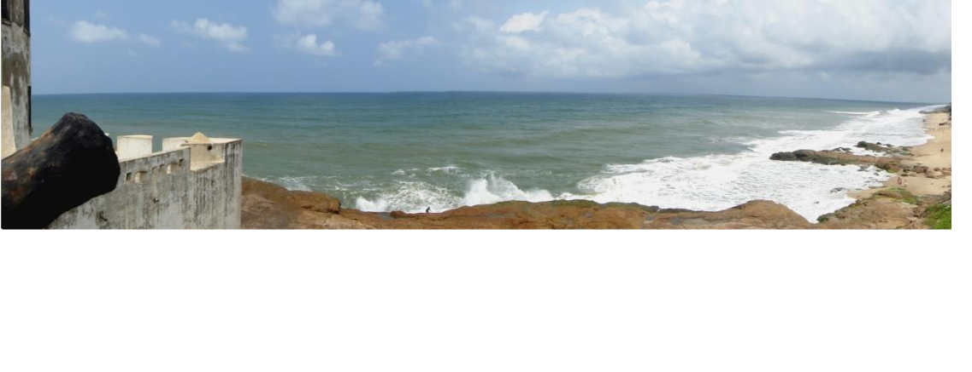

*Figure 1.1 View of the sea towards Elmina Castle from Cape Coast Castle*

*Placed strategically on a cape, this castle was built by the Dutch just 13 kilometers from the Portuguese castle nicknamed Elmina.*

1

The status of the forts and castles of Ghana varies across time as their functions develop and evolve according to official and collective memory; described by Alon Confino as “who wants whom to remember what and why,” collective memory is controlled by who owns that memory.1 More than eighty forts and castles were constructed on the Gold Coast’s sandy and rainforest covered shores across three centuries by seven different European states beginning with the Portuguese construction of Elmina Castle in 1482.2 The castles, which were a large network of buildings opposed to the smaller fort building classification, served as administrative, in addition to, trade centers for the various European entities. Most fortifications changed hands as European and Ghanaian states battled for control of the Gold Coast shoreline, all fighting for dominion over trade. However, this is not a chronological survey of who owned what. Rather, it is an analytical interpretation of the narrative surrounding these buildings that examines the formation, mission, and interpretation of three twentieth century organizations that claimed responsibility for the preservation of the historic buildings. The forts and castles perfectly encapsulate Pierre Nora’s foundational interpretation of *lieux de mémoire* because these buildings represent “a particular historical moment…where consciousness of a break with the past is bound up with the sense that memory has been torn…. in such a way as to pose the problem of the embodiment of

memory in certain sites where a sense of historical continuity persists.”3 Their emergence

1. Although I prefer the terms slave fort, slave castle, or castle-dungeon, for the purpose of this paper the buildings will be referred to with the official terminology of fort and castle so that historical emphasis is not incorrectly placed. (Richardson 2005, 617) Alon Confino, “Memory and Cultural History: Problems of Method.” *The American Historical Review* 102:2386-403.
2. Kwesi J. Anquandah, *Castles and Forts of Ghana* (Accra: Ghana Museum and Monuments Board, 1999) 10; Albert van Dantzig. *Forts and Castles of* Ghana. (Accra: Sedco, 1980) 3;Also note that at least one fort, Ft. Ruychaver, was built inland on the Ankobra River (Ibid., 27).
3. Pierre Nora, Genevieve Fabre and Robert O’Meally, edit., “Between Memory and History: Les Lieux de Memoire,” *History and Memory in African American Culture*, Oxford: Oxford University 1994, 284.

2

as memorials to the transatlantic history is a result of their violent history, which typically and “simultaneously destroys and creates history,” must be placed within trends of globalization and the proliferation of heritage in order to understand the development of their narrative.4 Furthermore, the history of the forts and castle’s preservation must also be examined in order for foundational interpretations to be examined.

The forts and castles discussed in this paper are no strangers to scholarly attention and investigation. In fact, the earliest non-commercial survey of the forts and castles is used as a primary source in this paper. A. W. Lawrence’s *Trade Castles and Forts of West Africa*, published in 1963, offers readers an architectural examination of many ofthe forts now within the bounds of Ghana. His use of historical records and architectural plans is comprehensive, but the investigation of the relationship between the structures and the towns, although brief, is an excellent source that many scholars have used as foundations for their own projects. Christopher DeCorse’s *An Archeology of Elmina: Africans and Europeans on the Gold Coast, 1400- 1900* develops Lawrence’s briefexamination of the role the castle played in the local community through an archaeological excavations conducted to discover the material culture of the now vacant land adjacent to the castle. DeCorse’s work completely reoriented the role of Elmina township and Africans within trade along the coast, proving the importance of archaeological work in understanding place. A crucial historical and architectural book published in 1980, *Forts and Castles of Ghana* by Albert van Dantzig, offers a concise and well-crafted overview of the developmental history of the forts and castles. These works provide historical context by examining the history of construction and the social

4Karl Jacoby. *Shadows at Dawn: An Apache Massacre and the Violence of History* (London: Penguin,

2009) 233.

3

life of the forts through the nineteenth century, providing with subsequent scholars with a strong historically researched source of secondary literature.

*The Grand Slave Emporium: Cape Coast Castle and British Slave Trade* and *The Door of No Return: The History of Cape Coast Castle and the Atlantic Slave Trade* by William St. Clair are extensive investigations into the actual process of transit within the trans-Atlantic slave trade, shedding light on the role of the second largest structure, Cape Coast Castle. St. Clair depicts life inside the castle at various levels of power through the use of unpublished letters and reports. In Stephanie Smallwood’s *Saltwater Slavery: A* *Middle Passage from African to American Diaspora*, the experience of the trans-Atlantic passage is depicted using Cape Coast Castle as its primary point of departure from African shores.

Many works published on diaspora memory include the forts and castles, like Bayo Holsey’s *Routes of Remembrance: Refashioning the Slave Trade in Ghana* and Ann Reed’s *Pilgrimage Tourism: of African Diasporans to Ghana.* Ann Reed’s in-depth analysis of the relationship between African Diasporans and the interpretation of the slave forts and castles questions the implementation and realities of the rhetoric surrounding the pan-African motivation for tourism. *Routes of Remembrance* thoroughly examines the collective memory of coastal Ghana’s through interviews, classroom shadowing, textbook and tour analysis. Holsey’s work concentrates on current costal perceptions of the forts and castles, while this thesis examines the historical origin of the public memory of the buildings.

4

Through the use of organizational papers, published surveys, and tour narratives and notes, the varying emphasis on historical importance can be directly correlated to institutional purpose and responses to the political climate. While a chronological approach may offer a perspective on the evolution of the different motivations, an examination of interpretation will lead to a deeper understanding of the themes that emerged as the intersections of the power of ownership, historical legacy, and political placement are understood. Two primary interpretations emerge when analyzing the motivation for the preservation of the buildings over time: architectural significance and identity formation, both have national and international implications. It is imperative to understand how and why the various organizations approached each interpretative theme differently in order to understand the current interpretation of these historic sites. Other works concerned with the history and memory of the buildings focus on present-day interpretation of these sites by investigating tour narratives and preservation methods, but do not question why these structures have been deemed worthy of preservation. 5 Before examining the different interpretive themes, a brief introduction to the twentieth organizations responsible for the buildings allows for a better understanding of how these themes are interwoven by allowing for organizational commonalities and differences to be examined.

1. See Bayo Hosley. *Routes of Remembrance: Refashioning the Slave Trade in Ghana.* Chicago: University of Chicago, 2007; Brempong Osei-Tutu, “Slave Castles, African American Activism and Ghana’s Memorial Entrepreneurism” (PhD diss., Syracuse University, 2009); Ana Reed, edit., *Pilgrimage Tourism of Diaspora Africans to Ghana*, London: Routledge, 2014.

5

**Chapter 2. The Colonial, Post-Colonial, and Global**

“As much as we live in a society of organizations, then, it seemed to me that it is as true, or even more so, that we live in a society of narratives.” Jeffrey K. Olick, *The Politics of Regret: On Collective Memory and Historical Responsibility*

*There, at the end of the road that ran through Kotokraba market and the heart of Cape Coast, stands a giant fortress; the sunlight bounces off its the white washed unsurmountable walls. A taxi driver, awaiting customers eagerly asks, “Where are you going?” while leaning on his taxi which sits on the paved road in front of massive building. I point toward the castle to decline his offer. As I walk through the main entrance past a small art market filled with woodcarvings and oil paintings peddled as souvenirs for tourists, I take a deep breathe, trying to take it all in. I had returned to this castle for the third time in my life; at first I was a tourist, then a curious undergraduate, but now a serious researcher. I knew what to anticipate and I looked for details I hadn’t noticed before like the giant UNESCO symbol on the entry wall that leads to castles open courtyard. Who will be in my tour group and what information will be told? A fellow American intern had traveled with female museum staff the previous week and was shocked at the insensitive laughter and jokes made during the discussion of rape. I wondered why I empathized with the female slave stories, when my co-workers did not. I began to question if it was even possible to empathize with the experience of people transformed into chattel through the dehumanizing process of enslavement. It was on my first tour that my interest in the forts and castles was ignited, because I questioned the*

6

*obvious role identity played in the tour. While questions of identity still remained in the forefront of my mind, I now questioned why was the castle still here, who sought to preserve it, and why? I was fascinated by the stories surrounding the ownership of the building. Outcries about the whitewashing of the walls from the African Diasporan community, plaques donated by local chiefs apologizing for Ghanaian involvement in the slave trade, and an international organization’s logo branding the building. This building was much more than a historic place; its layered history seemed so transparent. Yet, multiple complex narratives with conflicting voices created for this historic site overlapped and inundated the memory landscape resulting in chaos. How can this pandemonium subside without understanding all of the components that led to its emergence in the first place?*

To delve past the traditional history told about these sites, an investigation and analysis of the various motivations for preserving these historic structures. This is possible through an examination of the three different organizations that have taken charge of their memory. The difference in these twentieth century organization’s interpretations can be examined through an institutional case study that examines the ordinances responsible for their creation and scholarship produced by and about the organizations. The Monuments and Relics Commission of the Gold Coast (MRCGC) which serves as the flagship organization during the colonial period, the Ghana Museum and Monuments Board (GMMB) whose interpretation initially stems from a reaction to the immediate colonial past, and the United Nations Educational, Scientific and Cultural Organization (UNESCO) which pushed the narrative into the global story that is told

7

today, have disparate historical perceptions ranging from an emphasis on the architectural form to the role of the economy to the international memorialization of slavery.

Each organization had a different mission, yet their interpretations are intertwined: the MRCGC sought to protect the archaeological heritage of the Gold Coast for the British, the GMMB was formed to protect the cultural heritage of Ghana for Ghanaians, and UNESCO was created to protect the cultural and natural heritage of humanity for all of humanity. The periodization terminology (Colonial, Post-Colonial, and Global) uncomplicates the overlap found when examining the larger themes by allowing for multiple organizations, not just the aforementioned key institutions to also be addressed.

During the Colonial period, there are two documented cases of the forts and castles being deemed historically important. The Dutch noted near the end of their time in Ghana that the forts should be repaired for reasons other than maintenance, mainly architecture, but no work was actually done.6 The first preservation work done was by the Public Works Department of the British Colonial Government in the early 20th century; district commissioners were charged with “assessing the site’s condition, indicating improvements that need to be made, and prioritizing repairs” in conjunction with “three leading Natives.”7 While mainly concerned on buildings being used in some governmental capacity, a letter from Chief Amonu V to the district commissioner written on behalf of Ft. William’s state asked that “the fort is well repaired, for there are many historical objects which are known by few persons… the entrance gate was on the

1. Michel R. Doortmont. *Castles of Ghana: Historical and Architectural research on three Ghanaian forts (Axim, Butre, Anomabu)*
2. Ann Reed. *Pilgrimage Tourism*, 863.

8

Western side but where it is at present is the passage through which slaves were sent to Europe.”8 So while the first official organization charged with maintain the forts solely due to their historical importance was the MRCGC, it is important to note that physical maintenance was conducted on some buildings by the PWA and the transatlantic history associated with the forts and castles was not forgotten.

Another example of an organization that falls within the period, but is not necessarily covered in the three institutions discussed later is the Ghanaian Ministry of Tourism (MOT). Developed in 1993 in order to regulate “one of the fastest-growing sectors of the economy,” the MOT initiated the Joseph Project which provides a state based globalization effort juxtaposed to the Slave Route Project conducted by UNESCO . These projects work with one another, but are developed by separate governmental agencies and as a result their mission and implementation vary.9

The different proposed beneficiaries of the memory certainly affect the motives for preserving the forts and castles. The varying emphases of historical significance across the organizations sometimes overlap. The extreme emphasis each organization placed upon architecture, the gold trade, or the slave trade, demonstrates the evolution of the understanding of the forts and castles; it also highlights the problems that plague their memory best understood as a metaphysical tug-of-war for control of the space. So while fifteenth, sixteenth, seventeenth, eighteenth, and nineteenth Europeans struggled to control the buildings for trade purposes, these twentieth century organizations fought for control of the forts and castles interpretation.

1. Ann Reed. *Pilgrimage Tourism*. 886; this passage would later be interpreted as the “Door of No Return” which is discussed in the section on African Diasporan Identity.
2. Later discussed in the Identity Formation section..

9

**Chapter 3. The Forts and Castles of Ghana**

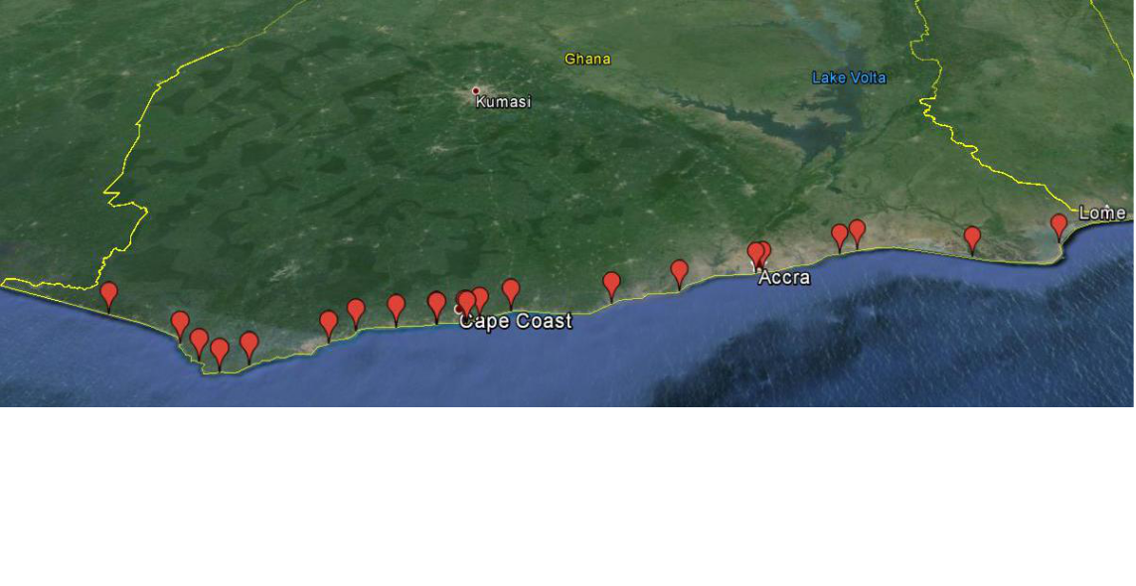

*Figure 3.1 Map of the extant forts and castles of Ghana*

*Scattered across the coastline of Ghana is the densest concentration of European fortification in sub-Sahara Africa. All built to consolidate power in trade, this map shows the location of the remaining forts and castles. See Appendix A for a detailed reference map of the extant forts and castles of Ghana.*

Although other trading fortifications were built along the west coast of Africa, historically referred to as the Guinea Coast, the concentration of buildings was densest along the Ghanaian coastline with an average of one fortification every ten miles.10 Ghana’s geological composition is responsible for the proliferation of these European structures for two different reasons; Ghana is uniquely endowed with gold, and the Ghanaian coast is rich with an abundance of capes and promontories.11 While access to trading opportunities remained the most crucial element when selecting a location for a trading post, the strategic placement on an elevated area or coastline that protruded into

1. Kwesi J. Anquandah, *Castles and Forts of Ghana* (Accra: Ghana Museum and Monuments Board, 1999)
2. The Grain Coast roughly stretched from Sierra Leone to western Ghana and was named for the export of melegueta pepper referred to as the grain of paradise. The Slave Coast is commonly used in conjunction with the coast of the Bight of Benin, which is part of the Gulf of Guinea, begins in eastern Ghana and ends in southwestern Nigeria; however due to the proliferation of plantations in the New World the boundaries of the Slave Coast seemed to expand to include all of the Gold Coast. Gold would continue to be an export but by the early eighteenth century the export to England accounted for £ 200,000.11

10

the gulf was also given great consideration due to its ideal defensive position.12 During the seventeenth and eighteenth centuries, the forts and castles built along the coast were used to facilitate the trade of black bodies. The amount of slaves from the gold coast, the fifth largest slave-exporting area, was still extremely high illustrating the amount of trade occurring along the coast. Of the estimated 12.2 million slaves shipped across the Atlantic to the Americas, 1.2 million embarked from the Gold Coast.13 The rise in competition between the different European powers, which increased over time as the New World plantation system developed, resulted in a rapid buildup of fortifications along the coast. While the slave trade is mentioned in all three institutional case studies, it becomes the secondary story to architecture and trade relationships until the memory of these sites is stretched to a global level.

Along 255 km of Ghana’s topical shoreline, twenty-three European buildings stand out compared to the vernacular buildings that surround them. They are the remnants of a once lucrative trade which shaped the entire region of West Africa. Varying in size and style, the forts and castles of Ghana now provide local communities with a revenue stream and constitute the nation’s thirds largest industry after cocoa and gold, through the tourism industry created by both the Ghanaian government and international bodies. 14 This source of tourism is built upon the memorialization and representation of the trans-Atlantic slave trade.

1. Kwesi J. Anquandah, *Castles and Forts of Ghana* (Accra: Ghana Museum and Monuments Board, 1999)
2. Emory University’s Voyages: The Trans-Atlantic Slave Trade Database (Atlanta: np, 2009). http://www.slavevoyages.org/tast/database/search.faces
3. Ferdinand de Jong, edit. *Recalling Heritage: Alternative Imaginaries od Memory in West Africa.* (Walnut Creek, CA: 2007) 73..

11

The forts and castles were the major point of departure from the Ghanaian coastline and were used to stock pile goods for ships, allowing for ships to fill their decks with cargo in days instead of weeks. Although the first forts and castles were built to facilitate the gold trade, most were eventually converted their warehouses for the emergence of a new commodity, black bodies. Over one million Africans would be shipped from the Gold Coast across 300 years, resulting in a disruption of African population growth, a hemispherical dissemination of African cultures, and the development of an increasingly prominent capitalistic economy.

These twenty-three buildings are in four various stages of preservation: tourism-driven rehabilitation, general preservation, neglected preservation, and repurposed rehabilitation. The journey to each fort and castle proved to be instrumental in understanding the variation within the preservation of the forts and castles as well as providing a small snapshot of local knowledge surrounding the sites. Elmina and Cape Coast Castles are the most accessible because of the well-developed infrastructural support provided to assure the continued growth of the tourism industry. Truly the only issue that seemed to plague the journey, in the minds of those charged with presenting the castles was creating a peddler-free space.

12

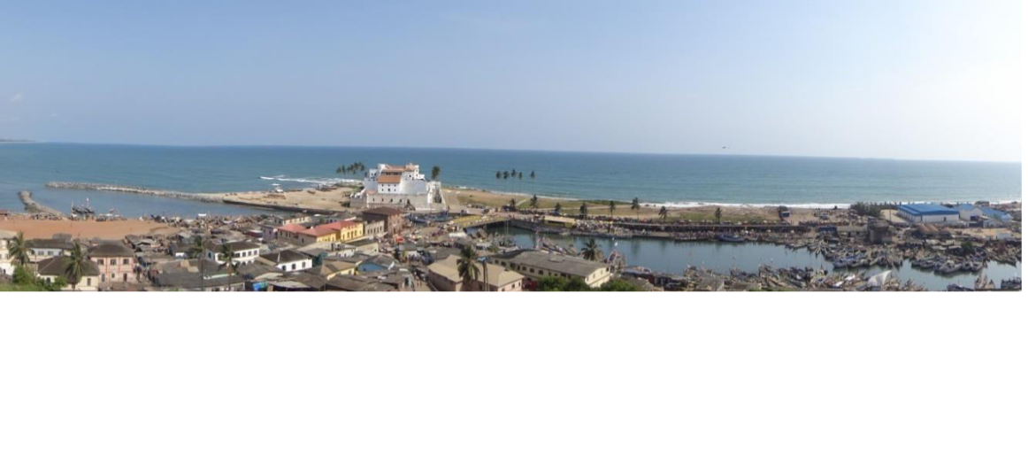

*Figure 3.2 St. George’s (Elmina) Castle from Fort Saint Jago*

*A View of St. George’s Castle and Elmina’s lagoon from the strategically placed defensive fort on top of Saint Jago Hill, the namesake of the fort (van Dantzig 16). The proximity of the castle to the town of Elmina is apparent as its spatial separation created through buffer zones.*

*The first time I travelled from Cape Coast to Elmina, I had an entirely unplanned day so I chose to walk. As I passed a group of young coconut sellers masterfully scaling trees, knocking their livelihoods from the palms, the outline of Elmina Castle began to emerge from the coastline. The fortress sparkled thanks to mid-day sun beaming down upon its whitewashed walls. I finally reached the beginnings of Elmina, a corruption of the Portuguese name for the area El Mina translated as the Mine. Although it is just a town, traffic congestion of the painted boats in the lagoon that cuts through the promontory proves that Elmina is a hub of the local fishing industry. Forced to walk along the street, I walk past old men teaching youth to mend on nets for tomorrow’s venture. I buy a quick snack of groundnuts and a water sachet from a girl just outside the wall that surrounds the castle. On the wall a sign states that only those continuing to the castle are allowed; getting to Elmina Castle is only difficult if you are a peddler trying to sell painted sea shells and beaded bracelets.* The whitewash creates a perfect contrast between a

13

cloudless, blue sky and a glimmering St. George’s Castle; surrounded by the booming fishing industry of Elmina which crowds the lagoon with brightly painted longboats, St. George’s Castle, more commonly known as Elmina Castle, triumphantly stands out amongst the sprawling local architecture and a few remaining colonial buildings. The status of the forts and castles vary from building to building as do size and style. One of the crowning jewels of the Ghanaian tourism industry, St. George’s Castle is the largest and oldest fortification. Built by the Portuguese in 1482, the original purpose of this fort is still debated; while it is agreed that it was established to gain a foothold in the West African gold trade, it has been suggested by van Dantzig that it could have also been built as a base for potential military campaigns when size of Africa was still unknown.15 Walls surround a couple of empty acres just outside the castle where archaeological excavations unearthed the untold history of the relationship between the castle and the town, as well as the everyday life of Elmina during the height of the trade.16 Subsequently, these walls that were built to protect the archaeological remains of Elmina’s integral contribution to the castle now separate the town from the historic building; in addition it has created a buffer between tourists and the local Elmina population. A 1998 State of Conservation report conducted by UNESCO sites the lack of buffer zone, which prevents “the encroachment of human settlements and activities on the areas in the direct vicinity of the World Heritage sites,” as one of three main threats to the forts and castles of Ghana.17 While the erection of this wall may have been spurred by the desire to create a buffer

1. Van Dantzig. *Forts and Castles of Ghana*. 5.
2. Christopher DeCorse, *An Archaeology of Elmina: Africans and Europeans on the Gold Coast, 1400-1900,* Washington, DC: Smithsonian Institution, 2001.
3. UNESCO, World Heritage Committee State of Conservation Documentation, *Forts and Castles, Volta Greater Accra, Central and Western Regions*, by UNESCO, 22COMVII.35, (N.p.: UNESCO WHC, 1998),http://whc.unesco.org/en/soc/2238.

14

zone in order to safeguard the buildings, many believe that this created to make tourists more comfortable.18

Although the terminology may create a grander image than the actual building, the castle is over 9,000 square meters, making it the largest in Ghana.19 Its purpose has changed over time, but has consistently been used in an administrative capacity. It began as the only trading post along the newly discovered Gold Coast, but later became a storehouse that maintained the slave populations held within its storage spaces.20 Following the end of the trans-Atlantic slave trade, the castle would become a European center of power, house a post office, a prison, the Ghanaian police training academy, and ultimately a museum which focuses on the history of Elmina.

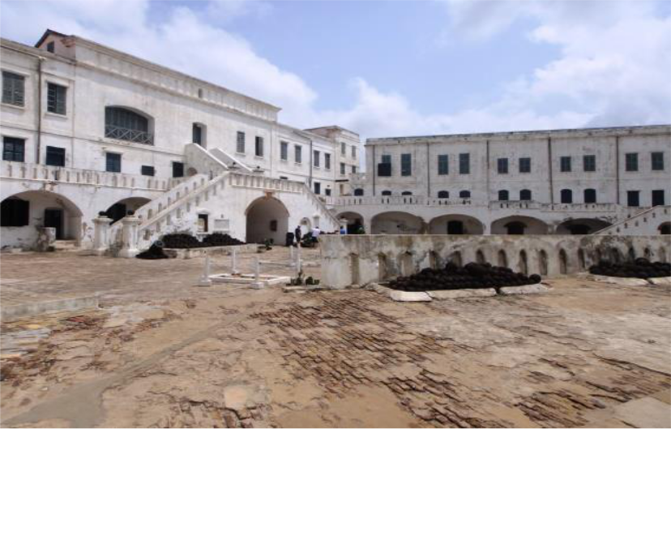

*Figure 3.3 Interior view of Cape Coast Castle*

*Although the whitewash is due for a new coat, the complete nature of Cape*

*Coast’s buildings is incredible considering its age and proximity to the sea.*

1. Brempong Osei-Tutu, “Slave Castles, African American Activism and Ghana’s Memorial Entrepreneurism” (PhD diss., Syracuse University, 2009), 66.
2. Judith Graham, “The Slave Fortresses of Ghana,” *New York Times*, November 25, 1990, accessed March 20, 2015, http://www.nytimes.com/1990/11/25/travel/the-slave-fortresses-of-ghana.html.
3. Elmina has the distinction of having an early limited role in the Gold Coast slave trade due to the Portuguese wanting to maintain the amiable gold trade relationship established and the ability to purchase slaves from Benin. (Routes of remembrance location 391, taken from Rodney 1969,14).

15

Tourists don’t travel to Elmina for the museum located within the former Dutch church that tells the history of Elmina the town, but for the tour that is offered of the castle which allows visitors to explore practically every corner of the building with a tour guide. Dark, airless cells where rebellious slaves were punished are compared to the tall, damp rooms where male slaves were housed. An open courtyard where female slaves were held and could be selected from an above balcony for the physical comforts of high ranking European officers is juxtaposed against the nearby Dutch church in the courtyard of the castle. But this well-preserved building is not typical when discussing the forts and castles; its unique position as a hub of tourism has led to its now costly, conserved state funded by the Central Region Integrated Development Programme.21

Elmina Castle’s level of preservation and representation is indicative of the tourism-driven rehabilitation preservation that surrounds the site and can be seen by tourists at three other sites: thirteen kilometers east at Cape Coast Castle the other jewel of Ghanaian tourism, 100 kilometers west at Fort St. Jago where tourism is an emerging market, and 140 kilometers west at Fort Apollonia where an Italian collaboration has converted the fort into a museum about local history and culture. Tourism has driven the large-scale, high-cost preservation methods used at this small selection of the forts and castles like buying the proper, and more expensive, paint to preserve the cannons and cannon balls.22

1. This program will be further discussed in the section on African Diasporan Identity. And while it was funded by the CRIDP, the real funding sources are the UNDP and USAID.
2. Bordoh, Ebenezer Collins. Personal interview. 15 November. 2011.

16

*Two years later, I returned to Ghana to help document the forts and castles and travelled to each site. Getting to Fort Amsterdam proved more challenging than Elmina Castle, but it was not impossible. I alighted from a bus heading from Accra to Cape Coast at Abandze, crossed the busy highway, and began to walk towards the large structure visible from the street. I was stopped as I started to climb the hill by a group of older men playing Damii; they asked where I was going and what I was doing. When I told them I wanted to tour the fort, one yelled across the street to a small boy working at a store and told him to go and fetch my guide. While I waited for my tour guide an afternoon rain began, I took refuge underneath a nearby canopy and the men continued to play while boisterously laughing and loudly shouting at one another. As I look up the hill, I can’t help but compare the imagery of Elmina, a clean, local-free, white washed building, with that of Fort Amsterdam, an open, dark façade against a grey stormy sky.*

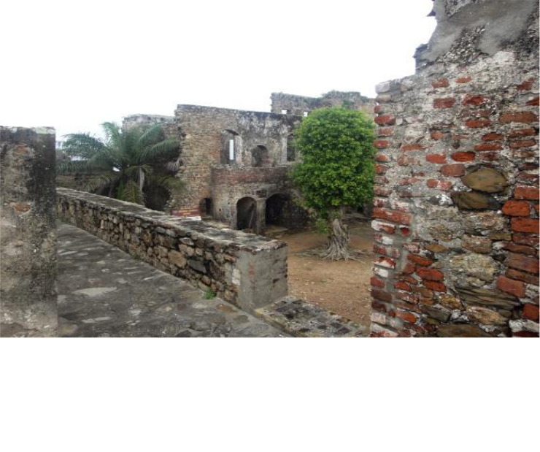

*Figure 3.4 Interior view of Fort Amsterdam*

*Portions of walls were demolished during the Dutch-Anglo war, but were rebuilt for tours.*

Thirty kilometers from Elmina on the highway that stretches across Ghana’s coast, Fort Amsterdam sits overlooking the ocean from atop a large hill. Fort Amsterdam

17

was the infamous source of rebellious Cormantin slaves; Cormantin slaves received that name from the original plan to construct the fortification in Cormantin. However, local people stole bricks at night, delaying process, so the fort was moved to Abandze. The lack of whitewash exposes the local and European stones, oyster shells, and palm oil that comprise the buildings walls which now form around an overgrown courtyard. While not quite a ruin thanks to the substantial amount of extant walls and partially collapsing staircases, this fort’s preservation and conservation sharply contrasts with that of the glimmering, complete walls of Elmina Castle. Deviating from the typical tour discussed later, the tour of Fort Amsterdam heavily emphasized the history specific to the fort; a thorough discussion of the forts contested construction, the detailed accounts of battles between European nations and their Africans allies, and a tour of the architectural layering are examples of the narrative that speaks directly to Fort Amsterdam, not to the forts and castles as a whole. While the history of the fort’s location differentiates it from the other forts and castles resulting in another narrative experience for curious travelers, the tour still focuses on the fort’s use during the trans-Atlantic slave trade. This fort’s status emblemizes the general preservation state of most fortifications along the coast; it has been actively protected and efforts are made to continue its conservation and interpretation by local representatives of the governmental body which owns the property. While ideally the positions are given to local community members, the hiring process for guardianship is unclear. At Fort Amsterdam, my tour was conducted by a recently graduated high school student as his father, who was the custodian, shadowed us. At Fort Saint Jago the son of Fort Friedrichsburg’s custodian led my tour. Both forts

18

lacked signs indicating the price of a tour illustrating the inconsistent policies of preservation, and presentation, of the forts and castles.

*My trip to Abandze followed my journey to find Fort Nassau. Located next to the Cape Coast metropolitan of Morre, Fort Nassau was one of the forts in ruins. Unsure of where the fort was, I headed towards the largest hill I could find; my travels had turned me into a landscape whisperer, I began to look for the geographic cues indicating where a fort might be found. I started weaving through dirt paths while goats and children chased after one another in between small concrete and wood homes. I spotted a large piece of a yellow brick foundation at the top of a nearby ledge. After struggling to climb up red clay, I had finally found the remains of Fort Nassau; more than the foundation, pieces of the fort protruded up from the ground sporadically. I then walked around the visible pieces which had remnants of whitewash clinging to the brick and found a white sign warning to keep off Fort Nassau, it’s state property.*

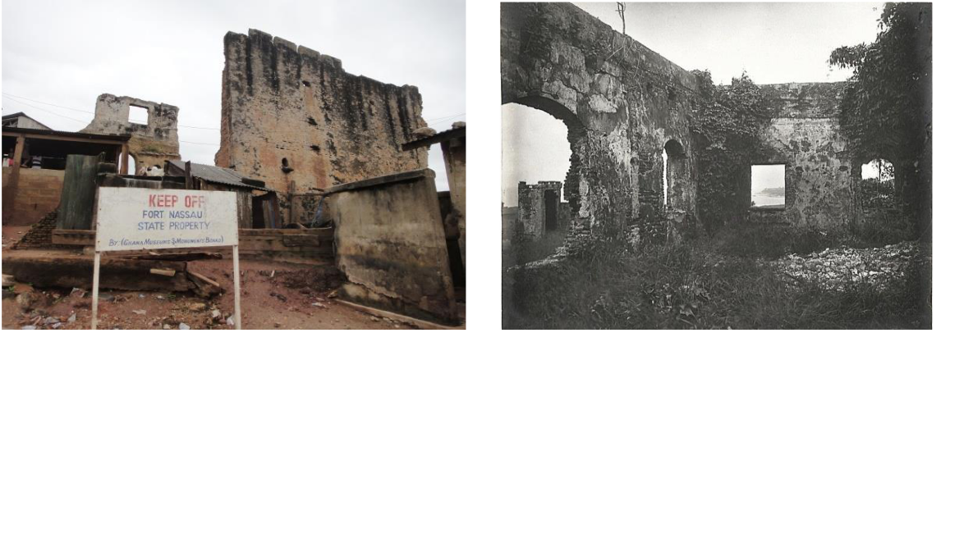

*Figure 3.5 Remains of Fort Nassau*

*A white sign warns visitors and residents that Fort Nassau is state property, but various buildings have been constructed immediately surrounding it.*

*Figure 3.6 Africa Through a Lens Quarters For Nassau, Moru*

*A photograph from the 1890s shows a significant amount of the fort intact..*

*From the National Archives UK – CO 1069/34*

19

Between Elmina Castle and Fort Amsterdam, lies an extreme case of conservation neglect; on top of eroding clay hill remnants of Fort Nassau sporadically jut into the sky. Considered to be ruins, the remains of the building have a sign noting what they are and warn against tearing the building down. Fort Nassau’s condition was worsened over time as the town of Moree began to develop in the nineteenth century when the fort because a source of building materials due its vacant appearance and lack of use. Following the end of the trans-Atlantic slave trade, these forts were either left as vacant structures or, in rarer instance, repurposed by locals. These smaller, less centrally located forts were frequently left as vacant structures due to fear of the spiritual qualities that some local communities associated with the building’s history. Tours are not given and information beyond the name of the fort is unattainable at the site; intrigued children peer out at me from underneath a nearby unfinished building, suggesting that the site is rarely visited by outsiders.

These physical state of these forts, the ones that lack tourists, illustrate the problematic way that funds are distributed across all the forts and castles; forts without a tourism base, which include the majority of the forts, lack funding resulting in the neglected preservation stage, while tourist hubs like Elmina Castle and Cape Coast constitute the majority of the GMMB’s current spending.

Accra, the capital of Ghana, with almost 3.8 million people has the largest population in the country and its sprawling expansion ranks it as the eleventh largest metropolitan in Africa and the 93rd largest in the world.23 It is the seat of Ghanaian

23“World City Populations,” World Atlas, accessed May 1, 2015, http://www.worldatlas.com/citypops.htmInsert census information.

20

government and home to two historic buildings: Osu Castle, formerly known as Fort Christiansborg, and James Fort. Both are rehabilitated and repurposed in unique ways. Most of the forts and castles have been repurposed, predominately as heritage tourism sites, but Osu Castle and James Fort are used for entirely different purposes. James Fort is one of Ghana’s forty- five prisons and because it is a prison, it is not open to the public. It has been physically preserved for its utilitarian use as a prison which began during the colonial period. Fort William in Anomabu was used as a prison during the colonial period as well, but has been repurposed for tourism since 1993. As a result of its colonial function, additional buildings were added to provide service to the inmates.24 Fort William’s current stage of preservation should qualify as general preservation as a result of its unpopularity with tourists, but its actual state of physical preservation would suggest that it has received more attention. It should be expected that James Fort would parallel Fort William following its unforeseeable closure as a prison. Osu Castle was the seat of colonial power was located at Cape Coast Castle, but moved to Accra in 1887. Its

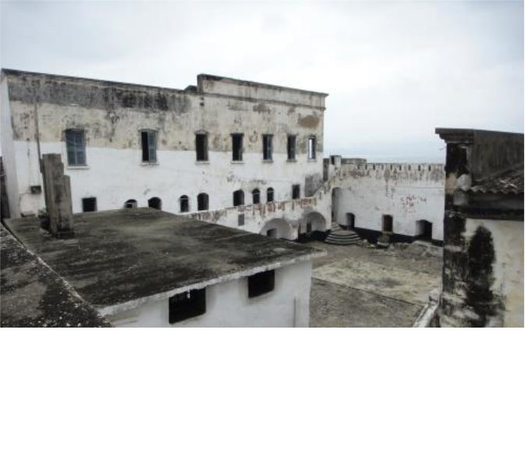

*Figure 3.7 Interior view of Fort William*

*The building with a flat roof was remodeled as the prison’s kitchen. The tour states that the building was historically used as a slave mart.*

24Fort William Tour. Fort William. Anomabu, Ghana. 10 July 2014.

21

function as the seat of government was continued when Ghana gained its independence and it was converted into the president’s residence; as a result, this fort has had the most restoration and its architectural style was greatly compromised during a modern reconstruction of its upper levels.25 This building is also closed to the public, due to its function, but it has been used as the site to discuss the current state of the forts and castles with international governments. These three buildings have been physically preserved in distinct ways due to their different repurpose roles, but are better preserved than most of the forts and castles.

Following the end of the trans-Atlantic slave trade, the forts and castles of Ghana entered into historical limbo. With the various dates of abolishment of the slave trade, beginning with the British in 1807, the amount of slaves leaving the Gold Coast rapidly decreased from 178,480 slaves from 1776 to 1800 to 4,624 slaves from 18186 to 1830.26 Caught in between their purpose as trade centers and their later iterations as memorials to that same trade, some became vacant buildings used for construction materials, others were cast aside and forgotten, and many were used by the remaining European powers still interested in laying claim to the Gold Coast. Their various physical states attest to varied nature of their histories, but what accounts for their current purpose? Their historical limbo ended upon the emergence of governmental powers that sought to preserve their memory. Now these sites are visited by various groups from African American tourists interested in pilgrimages to German non-profit volunteers to Ghanaian school groups, but the narrative is primarily concerned with thoughts of an audience

1. Implications of this repurpose are further discussed in the section on Ghanaian identity formation.
2. T.M. Reese. “’Eating’ Luxury: Fante Middlemen, British Goods, and Changing Dependencies on the

Gold Coast, 1750-1821 ” *William and Mary Quarterly*, 2009) 66(4): 851-872; Hosley. *Routes of Remembrance.* (LondonL Routledge, 2014) 427.

22

intent on learning about their trans-Atlantic slave trade pasts, made possible through the evolution of their historical narratives.27 While evolution suggests a linear progression, the historical memory constructed for and around the forts and castles of Ghana is truly a story of adaptation. The memory changes as the organizations react to the political atmosphere and national and international pressures.

1. See Reed’s *Pilgrimage* or Brempong’s dissertation for further discussion of the concept of pilgrimage

23

**Chapter 4. Model Architecture**

“Architecture is to make us know and remember who we are.”

– Sir Geoffrey Jellicoe

*My itinerary was set; I knew the coastal towns and cities where the remnants of the forts and castles were located. I was dependent upon the hospitality and generosity of my fellow travelers and the tro-tro drivers and mates to actually reach my destinations. On the way to the Brandenburg-Prussian fort, Groß Friedrichsburg, the dirt road had transformed into a muddy pit, where a large truck carrying the town’s water supplies was trapped. The driver told everyone to get out, turned the van around, and headed back towards the main road. I asked a fellow passenger how far Princesstown was: four kilometers and the only option was to walk unprotected from the high afternoon sun.*

*After navigating past the mud, the road emerged once more and I began to calculate my arrival time. A small boy passed boy on a bike much too large for his small legs. I wished him a good afternoon in Twi, and he slowed in curiosity; an obroni speaking Twi while in a Fante area would have piqued anyone's curiosity. We ran through the phrases I knew and he asked if I knew how to drive a bike. It had been a while since I last rode a bike, but I seized the opportunity to get to Princesstown faster. Jonathan masterfully hopped onto the back of the bike as I began to pedal and our conversation continued as we made our way on the relatively flat road. I asked him about his knowledge of the fort and he explained that he had gone once with his school. Houses began to line the road as we approached the town and Ghanaians on their porches stared at the odd travel*

24

*companions we made; some called out to Jonathan, others I greeted in Twi which usually resulted in laughter. Princesstown was visited by obronis from time to time as a result of the fort’s conversion into a guesthouse, but few make the “arduous” journey from the typical centers of tourism.*

*Once I climbed the hill along a beaten path and entered into the freshly macheted courtyard, the architectural distinction of Fort Friedrichsburg immediately struck me. While the journey to this fort was certainly unique, its architectural features truly distinguished it from the other buildings I had encountered. This was the sixteenth fort I had traveled to in the past three weeks and it was unlike any of the others. The stone finish contrasted with the usually whitewashed walls I had grown accustomed to seeing; the layout of the fort which used several multi-storied buildings instead of the usual one large multi-storied building, and the location on a steep hill were also incredibly different. Upon seeing its unique features like the small shuttered windows and the separated round tower, I finally realized how important architecture is to studying the forts and castles. In addition to visually understanding their layered history, architectural studies allow for the historic specificity of the forts to truly be examined.*

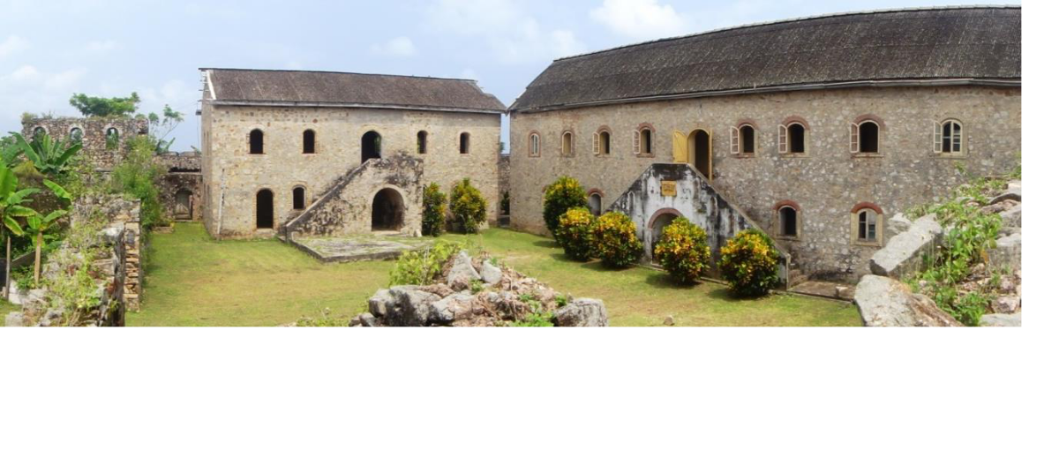

*Figure 4.1 Interior view of Fort Friedrichsburg*

*The only remaining Brandenburg-Prussian fort, Friedrichsburg’s small arched windows and symmetrical design architecturally distinguish it from the other forts and castles.*

25

The forts and castles vary in type, size, and style; these variations would be the initial catalyst for preserving the buildings. The Portuguese were the first Europeans to arrive on the Gold Coast in the mid-fifteenth century; their first permanent trading post became the trade model for all subsequent European countries including the Netherlands, England, Denmark, Portugal, Sweden, France, and Brandenburg-Prussia.28 The arrival of these other European nations spurred the innovation of new architectural styles based upon medieval fortifications, but also having to adapt to the unfamiliar environment of the Gold Coast.29 The 1979 World Heritage List extends protection to “three castles, fifteen forts in a relatively good condition, ten forts in ruins, and seven sites with traces of former fortifications.”30 A brief discussion of basic architectural distinctions is necessary when discussing the importance of architecture in the narrative surrounding the buildings. There were three different structures used as trading fortifications in Ghana: the lodge, the fort, and the castle. Lodges were small, temporary structures usually constructed from “earthen materials,” and were used while a fort was being constructed. As a result of their temporary function and construction materials there are no surviving lodges, but many were located near the sites of later fortifications.31 Most extant structures are forts that were made of brick or stone and had multiple rooms for storage, offices, and garrisons. The largest and most rarely built were castles which consisted of the same elements of a fort but on a grander scale and featured a “network of buildings” that were capable of

28 Kwesi J. Anquandah, *Castles and Forts of Ghana* (Accra: Ghana Museum and Monuments Board,

1999) 20.

1. Van Dantzig, 13.
2. UNESCO, World Heritage Status Of Conservation Report, *Forts and Castles, Volta Greater Accra, Central and Western Regions,* by WHC, 1998 (n.p.: UNESCO WHC, 1998).

31Kwesi J. Anquandah, *Castles and Forts of Ghana* (Accra: Ghana Museum and Monuments Board, 1999)

26

sustaining a much larger population.32 Both forts and castles were made from brick or stone that were usually imported due to local stone being too weak and bricks being too difficult to manufacture locally; some methods of construction included native materials and methods such as the use of oyster shells in outer walls and palm oil for waterproofing.33 Castles, in addition to their roles as a fort, were used as headquarters and were commonly paired with a defensive fort. Although it could be argued that they did help facilitate trade and were therefor built for that purpose, defensive forts were the only exceptions when discussing the universal purpose of the fortification as trade. Because of the central focus trade relations play in the overall interpretation of the site, it is important to distinguish that the vast majority of the buildings were either constructed or repurposed to facilitate in the trade of black bodies. The construction of defensive forts emerged after other European countries began to compete for control of Gold Coast trade.

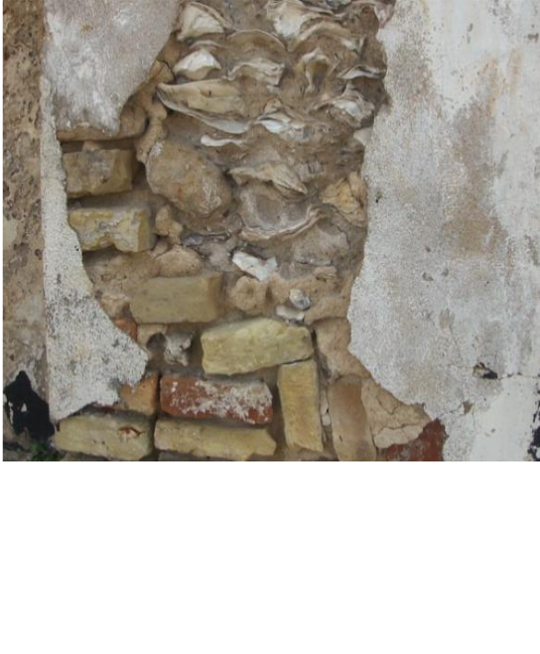

*Figure 4.2 Fort Keta’s Wall*

*An exposed wall, washed away by the sea, shows*

*the use of foreign brick and local oyster shells in*

*the building’s walls.*

1. Kwesi J. Anquandah, *Castles and Forts of Ghana* (Accra: Ghana Museum and Monuments Board, 1999),
2. A. W. Lawerence, *Trade Castles and Forts of West Africa,* (London, 1963); Notes from tour James-Ocloo Akorli, tour for Fort Prizenstein, Keta, Ghana. 9 July 2014.

27

An explanation of the variation within architectural styles and types is available within an exhibition at Cape Coast Castle; other tours of the buildings may explain the difference between a fort and castle, while some delve into more detail about the types of building material, but as a whole the narrative surrounding the architecture of the buildings is neglected. A rise in competition for control of the trade resulted in the proliferation of fortification construction along the coast of Ghana; the architectural layout depends on what time period the building is created for trade and what European entity is responsible for its construction. Meaning that the impact of what is being traded and who constructs the fortification directly impacts its architectural style. It is this diversity of architecture, most specifically the diversity of European fortification architectural style that sometimes appears in layers as the buildings exchanged hands, was the preservation catalyst for the administration of the Colony of the Gold Coast.

The first organization that charged itself with the preservation of the forts and castles for non-utilitarian purposes was the Monuments and Relics Commission of the Gold Coast (MRCGC). Monument and relics commissions were commonly established by the British Empire for its colonies as seen in Sierra Leone and South Africa, but the forts and castles are a unique case due to their size. While these government organizations created the infrastructure for current models of preservation, most were exploitative of archaeological artifacts. An unsurprising program of imperial and colonial aggression was the raiding of a colonized country’s most valuable archaeological artifacts. This practice was not limited to the marbles of the Parthenon, but occurred throughout all British holdings including Ghana. While terracotta figures from Northern Ghana, commonly referred to as Komaland, were susceptible to colonial plundering, the

28

forts and castles were saved because they were impossible to move. However, the inability to extract did not mean that the MRCGC was not interested in the buildings.34 The commission was created by an ordinance of the same name in 1945 at the request of the research department of the colonial office. The MRCGC was formed for “the preservation of antiquities and the restoration of architectural monuments.” 35 *Transactions of the Gold Coast and Togoland Historical Society* was a journal created in1952 as a conduit for the research findings of commission members.36 The commission was comprised of British archaeologists and ethnologists who taught for various universities in Ghana. These commission members were also the first to produce historical and archaeological accounts of Ghana.

MRCGC sought to preserve the forts and castles in order to save medieval European fortification architecture; certainly they also were conducting historical research about the forts, but it was mostly concerned with how land was acquired and unsurprisingly focuses on the European experience. The two sources for understanding the MRCGC’s motivation and interpretation of the forts and castles are located in the work its members produced, books and academic journals that introduced scholars to the history of Ghana, and in B.H. St. J. O’Neil’s 1951 “Report on Forts and Castles of Ghana.” Between 1952 and 1959, three different articles were published by the historical society charged with discussing and protecting the history of the Gold Coast. All three

1. The emphasis on studying architecture can also be seen in British accounts and research of medieval castles, like Kenilworth Castle, being produced in this period. However, these studies also go into great detail on the history of the places illustrating that the lack of history included in the Gold Coast studies is not indicative of the period.
2. Benjamin W. Kankpeyeng and Christopher R. DeCorse, “Ghana’s Vanishing Past: Development, Antiquities, and the Destruction of the Archaeological Record,” *African Archaeological Review* 1:2, (2004): 94.
3. The journal was renamed following Ghana’s independence to *The Transactions of the Historical Society of Ghana*.

29

concentrate on the architectural components of the forts and slight the forts’ non-military functions. The first published essay by W. J. Varley, a member of the MRCGC, states that “the nature of the trade, the rivalries it engendered, and their effects upon the history of the Gold Coast” is not in the scope of the essay because of the amount of literature already established on the topic.37 However, Varley avoids discussing the economic origins for the rise in European rivalries when explaining the evolution of the architectural features of the forts.38 Fort William in Anomabu is the focus of the second essay, but this time archaeological examination of architecture is used to understand the fort’s name. A thorough discussion of the European entities that fought for control of Anomabu, as well as a brief history of European monarchs, produces an answer to the question of why is it named Fort William; European interactions make up the bulk of the argument, but an analysis of the architectural layering is used as a primary source.39

The best example of the MRCGC’s understanding of the forts and castles is A. W. Lawrence’s 400-page monograph, complete with historical drawings and architectural plans, of the architectural development of the forts and castles of West Africa. Commonly cited by those who now study these structures, Lawrence’s in-depth analysis of the influence of medieval military fort architecture is truly the epitome of MRCGC’s historical understanding of the structures as examples of European fortification architecture. While most of these publications mention the trans-Atlantic slave trade, the emphasis on the architectural value of the sites overwhelms the interpretation

1. See van Dantzing, Lawerence, Reed, Hosley
2. W. J. Varley, “The Castles and Forts of the Gold Coast,” *Transactions of the Gold Coast & Togoland Historical Society* 1 (1952): 1.
3. M. A. Priestley, “A Note on Fort William, Anomabu,” *Transactions of the Gold Coast & Togoland Historical Society* 2 (1956): 46-48.

30

demonstrating that the MRCGC wanted to save the forts and castles for their European architecture.

Certainly an investigation of the architecture of the structures provides another historical resource; by using the buildings as material culture, the narrative created examines “the relationship between different cultural areas at a given moment.”40 However, assuming the notion of “structure as constant and history as process” in which an architectural study requires an admission of the historians influence on interpretation because the “history provides architects with a set of existing building forms and a set of factors that have enabled or restricted possibilities.”41The architecture of the forts and castles serve as a piece of material culture; it is up to the archaeologist, the historian, and interpreters to engage with the “constant structures” that offer literal layers of history. So while they may not be documents in an archive to be read, they are historical evidence to by analyzed.

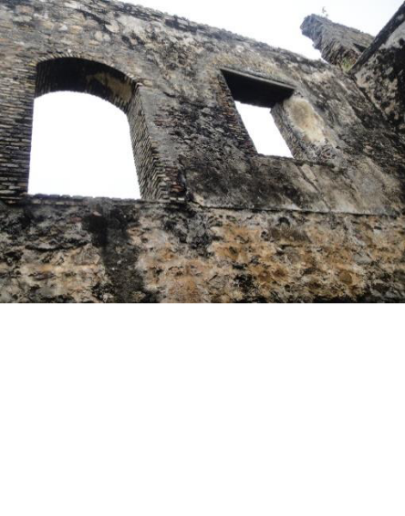

*Figure 4.3 Detailed Interior of Fort*

*Amsterdam*

*The shape of the windows vary as a*

*result of both British (rounded windows)*

*and Dutch (rectangular windows)*

*architecture being used.*

1. Sophia Psarra, *Architecture and Narrative: The Formation of Space and Cultural Meaning,* London: Routledge, 2009.
2. Sophia Psarra, *Architecture and Narrative: The Formation of Space and Cultural Meaning,* London: Routledge, 2009.

31

This architectural understanding is further elaborated upon in “Report to the

Chairman and Members of the Monuments and Relics Commission of the Gold Coast

upon the historical growth, archaeological importance, the general condition and the

present use of the castles and forts of the Gold Coast with a view to their better

preservation as ancient and historic monuments” written by Great Britain’s 1951 Chief

Inspector of Ancient Monuments, B.H.S. J. O’Neil. As a result of time constraints and

accessibility, O’Neil’s report covers nineteen of the then twenty-nine extant buildings.

Appalled at the state of disrepair, O’Neil’s report is concerned with the appearance of the

structures stating that “On a tropical shore with the blue of the sea, the yellow sand and

the green coconut palms, the staring whiteness of the building is needed to complete the

picture. It used to do so, it should do so again… the absence of whitewash which makes

Cape Coast Castle so depressing to the visitor.”42 The whitewashing of the structures has

been heatedly discussed due to the perception of the whitewash as whitewashing the

slave trade history; while the whitewash is the appropriate preservation tactic used to

protect the buildings from humidity, O’ Neil’s comment on the whitewash as a source of

beauty, not as a necessary prevention, would certainly bolster modern arguments on the

subject.43 His report details the European arrivals to the Guinea coast. It mentions that

further elaboration on the slave trade seemed unnecessary due to its discussion in

previous scholarly works, “although it was the raison d’etre of most of the forts.” 44 The

rest of his report focuses on the physical condition of the forts and castles, while also

1. Bryan Hugh St. John O’Neil, “Report on Forts and Castles of Ghana,” Accra: Ghana Museum and

Monuments Board, 1951, 3.

1. “Is the Black Man’s History Being ‘White Washed’: The Castles/Dungeons of the African Holocaust”

(1994, 48) from Routes and remembrance location 2275

1. Bryan Hugh St. John O’Neil, “Report on Forts and Castles of Ghana,” Accra: Ghana Museum and

Monuments Board, 1951, 14.

32

offering initial architectural evaluation; because the buildings exchanged hands across centuries and because they were repurposed for trading in human beings instead of gold, a layering of architecture occurs. For instance, when examining Elmina Castle traces of Portuguese, Dutch, and English architectural fortification styles can be seen, offering visual evidence of the contingent ownership of the slave castle. The forts and castles of the Gold Coast were isolated examples of European medieval forts that could not be found elsewhere due to the development, repurposing, and destruction of European forts on the European continent. It was their uniquely European architecture that served as the first motivation for their consideration as both an important historical and monumental site.

Days before Ghana’s independence, March 6, 1957, Ordinance 20 merged the MRCGC with the interim Council of the National Museum, creating the Ghana Museums and Monuments Board (GMMB).45 The forts and castles were the first sites to be proclaimed national monuments due to the age of the structures as well as the emphasis previously placed upon them by the MRCGC.46 In 1969, the GMMB was further defined by the National Museum Act which explained the duties of the board; while focused on the maintenance of museum, this act also required the board to “preserve, repair or restore any antiquity which it considered to be of national importance,” making the GMMB the official organization responsible for the preservation of the forts and castles.47 Being listed as National Monuments afforded a level of protection to the forts

45“Ghana Museums and Monuments Board,” Cultural Heritage Connections, accessed September 30, 2014, http://www.culturalheritageconnections.org/wiki/Ghana_Museums_and_Monuments_Boards.

1. National Liberation Council Decree 387 of 1969, Establishing the Duties of the Board, *National* Museum Act, section 14 (1969).
2. Henry Cleere, *Archaeological Heritage Management in the Modern World*, London: Routledge, 2005, 125; Other GMMB properties include, but are not limited to the Asante Traditional Buildings, which are

33

and castles; local authorities, usually elders and chiefs, were notified and signs were posted to remind would-be vandals that the properties belonged to the government.48 The GMMB continued to justify the preservation of the forts and castles as a result of their architectural significance which is seen in their nomination of the sites in 1979 to the World Heritage Committee (WHC) hoping to see the inclusion of Ghana on the World Heritage list.

World Heritage properties are divided into two different categories, cultural and natural, although a site can claim both. Cultural heritage sites, like the forts and castles, are defined by UNESCO as “monuments… architectural works, elements or structures of an archaeological nature,” that are either “works of man or the combination of nature and man… [with] outstanding universal value from the historical, aesthetic, ethnological or anthropological point of view.”49 Properties are selected by the World Heritage Committee from a list of state-submitted inventories of heritage, guaranteeing that sites inducted have the consent of the state in which the property is found. Funding for the preservation and management of World Heritage sites is funded from less than one percent of contributions to UNESCO, private and public foundations, the state in which the property is located, and international assistance.50 The first list was completed in 1978 and consisted of eight cultural properties; the current list has 779 cultural properties. Although it has an ambitious mission, UNESCO’s World Heritage List is an international

also inscribed on the World Heritage List; archaeological sites in northern Ghana; the Ancient Mosques of the three Northern Regions; Wa Naa’s Palace; Gwollu and Nareligu Defence Walls used to prevent enslavement; and the Old Nacrongo Catholic Cathedral.

1. Ebenezer Bordoh, e-mail message to author, November 17, 2014.
2. UNESCO, *Convention Concerning the Protection of the World Cultural and Natural Heritage* (Paris: n.p., 1972), Article 1.
3. UNESCO, *Convention Concerning the Protection of the World Cultural and Natural Heritage* (Paris: n.p., 1972), Article 16; Ibid., Article 21.

34

collection of properties that strives to encapsulate the natural and cultural experiences of mankind across the globe. The interesting element on the GMMB’s nomination form is the reasoning for the choice of cultural; the forts and castles are listed under section (IV) which claims the property is, “an outstanding example of a type of building, architectural or technological ensemble or landscape which illustrates (a) significant stage(s) in human history.”51 The justification for section iv must be attributed to the architecturally historic understanding of the forts and castles, as first argued by the GCRMC, but can also be attributed to the GMMB’s shift from architecture to the equitable relationship between Africans and Europeans that occurred prior to colonialization.

The impressive size and physical presence of the forts and castles demands an appreciation for their architecture. The initial catalyst would be the history of design and evolution of style seen in the layering of architecture. This architectural emphasis ensured that the buildings were physically preserved later allowing for their interpretation to penetrate past their stone facades to the core of their power of memory.

1. “The Criteria for Selection,” World Heritage Convention, accessed March 5, 2014, http://whc.unesco.org/en/criteria.

35

**Chapter 5. Pan-African Heritage and Identity Formations**

An examination of “who want whom to remember what and why” through an analysis of the development of the field of memory studies, the impact of globalization, and the advent and surge of heritage tourism, is a fundamental to understanding the ways

in which the commemoration of the transatlantic slave trade takes place within Africa.52 Although group memory can be traced back to the Archaic Greek, collective memory

used in a contemporary sense is typically traced to Emile Durkheim. 53 Considered to be the father of sociology, Durkheim’s discussion of commemorative rituals led to his student, Maurice Halbwach, coinage of the term collective memory in the early twentieth

century.54 By discounting the biological conception of memory and ascribing an understanding of memory within the context of society, Halbwach was able to theorize that memory is acquired through socialization and is subsequently produced and

performed in society.55 Halbwach made a crucial distinction between history and collective memory stating that “history is the remembered past to which… is no longer and important part of our lives – while collective memory is the active past that forms our

1. Alon Confino, “Memory and Cultural History: Problems of Method.” *The American Historical Review* 102:2386-403.
2. Nicolas Russell. “Collective Memory before and after Halbwachs.” *The French Review* 79: 792-804.
3. Maurice Halbwachs. *The Social Frameworks of Memory*. 1925.
4. Jan Assmann, “Collective Memory and Cultural Identity.” *New German Critique.* 65: 1995. 125-133.

36

identities.”56 This interpretation of collective memory is pivotal to the approach of commemorating the transatlantic slave trade because those memory rituals require self-identification, whether as an African, African Diasporan returning home, or an international tourist on holiday.

**Creating Ghanaian**

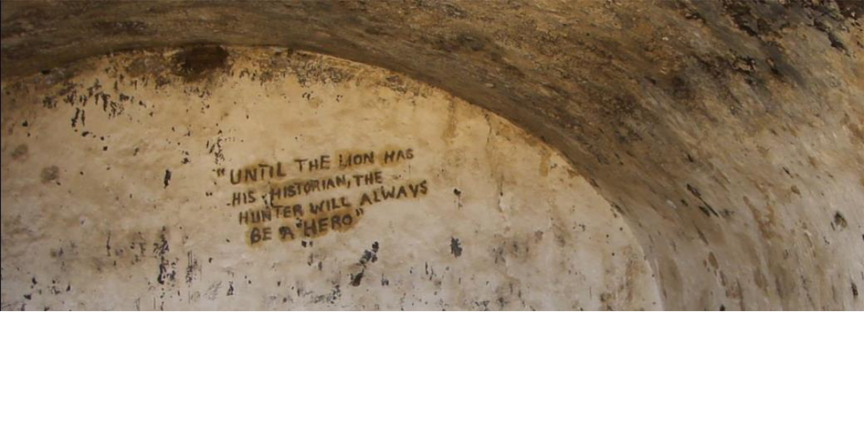

*Figure 5.1 Male Dungeon at Fort Prizenstein*

*An African porverb made famous by Nigerian novelist, Chinua Achebe, has been graffitied onto the dungeon wall reminding visitors of the often skewed narrative of history that is depicted.*

“Until the Lion has his historian, the hunter will always be a hero.”

– African proverb

*As I begin to dig into the rough, yet moist ball of kenke in front of me, my co-workers*

*from the National Museum continue my informal Twi lessons. I finally mastered common*

*greetings and responses when the librarian interrupts the conversation. “Ah! Why do you*

*learn Twi? You are in Accra and should learn some Ga!” Immediately everyone begins*

*to laugh, knowing that Ga is much more difficult to speak. I heard Twi being spoken*

*around me the most, and had previously studied another Akan dialect while in Cape*

*Coast, so navigating basic phrases wasn’t too difficult. She begins to teach me basic Ga*

1. Jeffery K. Olick. “Collective Memory: The Two Cultures.” *Sociological Theory* 17: 335.HL

37

*phrases, but I struggle with the pronunciation of good morning and she quickly gives up. Everyone then begins to discuss which language is easiest to speak; unsurprisingly each chooses their native tongue. The young workers from the National Museum of Ghana debating the simplest language over lunch served as a reminder to me of the diversity within Ghana’s borders, which contain seventy-five different ethnic groups. Despite their different linguistic and cultural upbringings the group is unified by their Ghanaian identity.*

Borders created by European colonizers defined the geographical bounds of Ghana, but the Ghanaian identity was created by the independence movement of the 1950s and the Nkrumah government. Kwame Nkrumah, the leader of the independence movement, advocate for African Unity, and the country’s first president, recognized that in order to create a successful, independent state out of an ethnically and culturally diverse Ghana, the formation of a national identity would be required. “Monuments served as a means of creating a uniform cultural identity” and perfectly encapsulated the Nkrumah government’s goal of creating an identity founded upon his motto of unity in diversity.57 Nkrumah encourage total African independence, which he saw only possible through African unity based upon African Personality. African personality theory suggests that in order to achieve the respect deserved from the international community, Africans would need to unite with one voice regardless of cultural differences.58 While this is a pan-Africanist ideology, he applied it to creating the national identity of Ghana

57 Benjamin W. Kankpeyeng and Christopher R. DeCorse, “Ghana’s Vanishing Past: Development,

Antiquities, and the Destruction of the Archaeological Record,” *African Archaeological Review* 1: 2 (June

2004): 94.

1. Harcourt Fuller *Building the Ghanaian Nation-State: Kwame Nkrumah’s Symbolic Nationalism,* London: Palgrave Macmillan, 2014, 221.

38

by highlighting the commonalities of Ghanaian experience. In the case of the forts and castles, this commonality was the experience of colonial suppression.

Fearful of the fragility of cross-cultural bonds, Nkrumah’s government sought to avoid conflict among the seventy ethnic tribes now enclosed in Ghana’s borders. So while it can be argued that the forts and castles were colonial centers in the newly created Ghanaian mind, the presence of the transatlantic roots could not truly be forgotten. Remember, in 1920 an Anomabu chief sought to preserve the structures for that history alone; however, Nkrumah’s pan-African rhetoric was “rooted in the ‘age-old’ quest for unity shared among Africans… African history that implied some sense of union in cast parts of the African continent.”59 This quest for an African history that promoted unity would certainly be crippled by an acceptance of the costal Ghanaian role in the transatlantic slave trade. To not upset the gold trade, Europeans were initially concerned about alienating their African trade partners; however once demand increased, the wars between larger, and more unified tribes also intensified resulting in a higher number of Ghanaian slaves. It is that history that the Nkrumah government sought to avoid; one that pitted Ghanaian against Ghanaian, that depended upon non-nation based alliances. Nkrumah also believed that the slave trade was used to augment African inferiority and demanded an African history of “agency and autonomy. National identity… would be based on histories of past glory.”60 The slave trade could not be ignored given its large role in the buildings’ histories; so, the perspective had to change, and the historical emphasis placed on something other than the black body.

1. The Pan-African rhetoric used by Nkrumah created both the Ghanaian and African Diasporan identity, but for now this section will only examine the Ghanaian; D. Zizwe Poe. *Kwame Nkrumah’s Contribution to*

*Pan-Africanism: An Afrocentric Analysis*. (London: Routledge, 2003) 60.

1. Hosley. *Routes of Remembrance*. 837

39

The Nkrumah government sought “to construct monuments that broke away from the colonial past and emphasized Ghana’s new found freedom and nationhood.”61 In 1969, the GMMB was further defined by the National Museum Act, which explained the duties of the board. The board consisted of ten appointed members with various backgrounds including professors of archaeology and ethnography and Members of Parliament. The preservation of the forts and castles mainly consisted of stabilizing the most-intact structures for the purpose of rehabilitation.62 In order to shed light on the importance of the buildings and to access funds for stabilization and restoration, the GMMB enthusiastically nominated the forts and castles to be inscribed upon UNESCO’s World Heritage List.63 An investigation of the 1979 World Heritage Nomination form provides insight to the GMMB’s intentions of forming national identity by preserving the forts and castles of Ghana.

The history section of the nomination form focuses on the timeline for the construction of the forts and castles, citing the Portuguese as the first to construct a fort along the coast. By focusing only on the history of Elmina Castle, the history of the competition between European nations for the coveted coastal trade connection is completely lost. While a history of each fort would result in the nomination form turning into a small book, a more general history of the establishment of European structures along the coast would convey a more holistic history and would certainly require an

1. Harcourt Fuller *Building the Ghanaian Nation-State: Kwame Nkrumah’s Symbolic Nationalism,* London: Palgrave Macmillan, 2014, 120.
2. Rehabilitation, according to the U.S. National Park Service, “acknowledges the need to alter or add to a historic property to meet continuing or changing uses while retaining the property’s historic character as it has evolved over time.” “Four Approaches to the Treatment of Historic Properties” last modified 1995, http://www.nps.gov/tps/standards/four-treatments.htm.
3. The GMMB was unable to fund preservation during the late 20th century as a result of the economic depression that most West African nations experienced.

40

explanation for the sudden increase in fortification construction requiring a discussion of the impact the trans-Atlantic slave trade.

Although the nomination occurs almost thirty years following Ghana’s independence, the GMMB highlights the trade history of the forts and castles as significant on the “basis of equality rather than… that of the colonial basis of inequality.”64 By linking the forts and castles with the equitable Afro-European trade that existed prior to British colonization, the GMMB emphasized the relationship between Africans and Europeans rather than emphasizing what is being traded; this historical reading of the buildings allows Ghanaian identity to be reinforced by the forts and castle through a shared view of inequitably colonial economy. “National histories must make the slave trade a minor addendum to the larger story of the emergence of the modern nation-state.”65 The historical justification on the WHC form also states that “the forts and castles were built to serve the trade of European chartered companies, mainly that in gold but later they also played an important role in the slave trade and in the 19th century in the suppression of that trade.”66

While certainly a post-colonial reaction, the emphasis on the equitability of the trade is entirely misplaced; three elements within this claim highlight that the GMMB’s interpretation of the structures sought to distance and hide their slave trade history in favor of promoting a national rhetoric of parity with Europeans. The most impactful stage of trade, the slave trade, is undercut in two ways. The first way the slave trade is hidden is by GMMB claiming that the buildings were used mainly for the trade of gold; this is,

1. UNESCO, World Heritage Committee Nomination Documentation, *Forts and Castles, Volta Greater Accra, Central and Western Regions*, by Ghana, 34.pdf, (N.p.: UNESCO WHC, October 1979), 7.
2. Hosley, *Routes of Remembrance*, 110.
3. UNESCO, World Heritage Committee Nomination Documentation, 5.

41

of course, incorrect. While the gold trade was the initial purpose and facilitator for European trade expansion in the region, the profitability of the slave trade resulted in the increase of European interests in Ghana. According to David Richardson, British eighteenth century trade “had exported 408,460 slaves from the Gold Coast, accounting for approximately 13 percent of their total slave exports.” 67 The gold trade is also emphasized more than the slave trade within the construction of the sentence. By placing the slave trade in the middle of the series, it is forgotten by the end of the claim. The emphasis on the gold trade over the slave trade is an example of the GMMB’s desire to eschew the discussion of the slave trade as the primary function for the forts and castles in favor of a discussion of the parity African had with European traders. While gold would always be an export, the overwhelming emphasis on the slave trade in economic and architectural terms was clearly of greater historical importance to the development of the forts and castles.

Later expanded upon, GMMB’s justification for the inclusion of the forts and castles in the World Heritage List accentuates the role of equitable commerce. Nicknamed the “shopping street of West Africa,” the forts and castles are not deemed beautiful buildings by the form, as the MRCGC had originally claimed, but their historical significance as monuments to “not only … the evils of the slave trade, but also… nearly four centuries of pre-colonial afro-european commerce” garners their significance for inscription onto the WHC list.68 The rhetorical use of “not only” illustrates the GMMB’s stance that the slave trade is not as important as the Afro-

1. David Richardson. “Slave Exports from West and West-Central Africa, 1700-1810: New Estimates of Volume and Distribution.” *The Journal of African History*, 30:1989. 13.
2. UNESCO, World Heritage Committee Nomination Documentation, 7.

42

European commerce. The terse reference to the slave trade is overwhelmed by the importance of trade in general; the newly formed nation sought to distance itself from its colonizers by emphasizing the “equitable” trade relationship between Africans and Europeans following years of European monopolization and domination of Gold Coast trade.

The Afro-European commerce claim is further transformed into an anti-colonialization statement when the four centuries of commerce are further defined by the trade’s historically significant “basis of equality rather than… that of the colonial basis of inequality.”69 Although the nomination occurs almost thirty years following Ghanaian independence, the GMMB highlights the importance of the equitability of the slave trade as the significance of the forts and castles. Some of these buildings were used during the colonial period by the British as administrative centers and were repurposed post - independence, ironically serving as economic reminders of a free trade that once existed between African and Europeans. A “free” trade based on slavery. Certainly an example of this “equitable trade” is that all of the forts and castles, except for the fort in Keta, were built with permission from the local chief which was usually gained through the purchase or rental of land to the Europeans.70 However, the consideration of this trade system as equitable is problematic when examining the international value of products traded. Most accounts of the forts and castles, in scholarly work and in the current presentation of these sites, introduce the unbalanced nature of the trade. In O’Neil’s report for the MRCGC he points out the inequalities of the gold trade, highlighting the barter trade system was exploited by the Portuguese who exchanged gold with old

1. UNESCO, World Heritage Committee Nomination Documentation, 7.
2. A. W. Lawerence, *Trade Castles and Forts of West Africa,* (London, 1963), 28.

43

clothing.71 The items Europeans brought to trade for gold are often listed as brass pots and basins, second-hand cloth, beads and wine.72 Lawrence further contextualizes this seemingly misbalanced trade by stating that, “in 1557, the Europeans sold at the rate of eight [heavy brass bracelets] to an ounce of gold.”73 This clearly demonstrates that while Europeans traded with their equal African counterparts, the trade was economically skewed in favor of the Europeans, even if African and European traders were considered equals. While difficult to empathize with the economic loss that African slave traders incurred following the suppression of the slave trade, it is obvious that the GMMB’s motivation for preservation was constituted by economically-disenfranchised post-colonial memory which purposefully inundates the horrific memory and nature of the slave trade.

The role of the forts and castles following independence provides an alternative examination of the post-colonial motivations for preserving the fortification. While most of the structures were abandoned and had subsequently become fragments of the structures they once were, Fort Christiansborg, now called Osu Castle, was converted from the colonial seat of power to the presidential home. While the choice of this castle as the seat of power was questioned by President John Kufuor because of the buildings transatlantic slave past, the recent British colonial experience overwhelms the slave trade history in the memory of Ghanaians.74 In addition to the precedent set by Kwame Nkrumah, who is now commemorated throughout the country, President John Atta Mills

1. Bryan Hugh St. John O’Neil,“Report on Forts and Castles of Ghana,” Accra: Ghana Museum and

Monuments Board, 1951, 9.

1. A. W. Lawerence, *Trade Castles and Forts of West Africa,* (London, 1963), 16.
2. A. W. Lawerence, *Trade Castles and Forts of West Africa,* (London, 1963), 16.

74“Ghana in presidential palace row,” *British Broadcasting Corporation*, December 15, 2005, accessed November 10, 2014, http://news.bbc.co.uk/2/hi/africa/4532672.stm.

44

argued that the expense of a new presidential palace was unnecessary; however, a $30 million loan from India financed President John Mahama’s move into Flagstaff House, which was renovated under Kufours administration.75

Another element in understanding how the structures’ interpretations changed involves acknowledging the constant categorization of the slave forts and castles as one body. Although commenting on the World Heritage List as a whole, Di Giovine states that, “Although each monument may have its own divergent life history, when it is re-contextualized with other like monuments under the heritage-scape’s unifying metanarrative, it becomes an ideal material manifestation of a carefully considered claim about the “universal value” of the world’s cultural diversity.” 76 Typically associated with literature, the construction of a metanarrative surrounding the buildings as seen through the current tour narratives is now being challenged by UNESCO’s emphasis on the inclusion of local perspectives. UNESCO was not the first to consider the local perspective, and the publications of the GCRMC pushed historians and archaeologists to consider the history and cultures of native ethnic groups and offered different source bases for further research. When examining the literature on the slave forts and castles, the history of the local group is briefly discussed, however the focus heavily emphasizes the construction and architecture of the structures.

When tours are available, the narrative is a skeletal framework which is then fleshed out by unique details and compelling stories. A discussion of the arrival of Europeans on the coast, the emergence of black bodies as the primary trade item, the

1. Ann Reed. *Pilgrimage Tourism.* 628.
2. Michael A. Di Giocine. *The Heritage-scape: UNESCO, World Heritage, and Tourism,* (press ) 120.

45

functional organization of the fort, the brutality of the holding process, and a conclusion that required the evocation of the "door of no return" is then personalized to the specific fort through the telling of unique features or intriguing anecdotes. There are problems with the UNESCO process of inscription that undoubtedly lead to complications in interpreting the forts and castles. While listing all the forts and castles on one nomination form makes logistical sense, and is necessary when discussing the impact of Afro-European trade, the interpretation of the forts and castles becomes generalized creating a metanarrative void of the individual histories of each site. Current UNESCO World Heritage practice considers the local perspective which will hopefully displace the totalizing narrative in order to produce an analysis of the functions of each individual fort and castle over time; Cape Coast and Elmina Castles, Fort Saint Anthony, and Fort Apollonia have already included this local narrative within the museums housed within the structures. While the local impact on the history is not considered in the GMMB’s nomination form, it is mentioned in Lawrence’s book, demonstrating that the understanding and representation of local history is not limited to UNESCO interpretations. Scholarship also reflects this trend as seen in Rosalind Shaw’s *Memories of the Slave Trade: Ritual and the Historical Imagination in Sierra Leone*; through anexamination of the everyday complexities of Sierra Leonean acceptance and denial, Shaw is able to engage with local understandings and memory in order to offer an alternative understanding of memory that demonstrates that there is more than one way to

remember.77 The development of the heritage field has led to a shift in historical scholarship as well; as more emphasis is placed on the local and individual, the once

77 Shaw, Rosalind. *Memories of the Slave Trade: Ritual and the Historical Imagination in Sierra* *Leone.*

Chicago: University of Chicago, 2002.

46

overwhelmingly broad metanarratives created to apply to sites, requires transnationalism

and the acceptance of pan-Africanist ideals. However, UNESCO’s current trend encourages local contextualization, requiring international and national narratives to exist within the same collective memory.

National identity formation based upon monuments and memorials is not unique to Ghana. However, the rewriting of the historical narrative of the forts and castles in reaction to momentous political changes is unique because it is not only the first, but the only, time that Ghanaian’s owned the collective memory of the buildings. The emphasis on the parity of pre-colonial trade along the shoreline of Ghana reminded Ghanaians of their nation’s right to demand respect from an international community. It also avoided the complicated and complicit role of Ghanaians in the slave trade by emphasizing the gold trade. The Nkrumah government’s emphasis on unity based upon diversity allowed for a Ghanaian identity to be created, but it also created an opportunity for all Africans to lay claim to this historical narrative. The pan-Africanist ideologies of Nkrumah would ultimately result in a new identity narrative founded upon the forts and castles, the African Diasporans.

**Connecting African Diasporans**

“Restless still, and unsatisfied, he turned toward Africa… amid the spawn of the slave-smuggler, sought a new heaven and a new earth.” – W. E. B. Dubois, *Souls of Black Folks*

*As I exited the plane into the dense, hot night air I am welcomed by first of countless “Akwaaba!” that will surely follow. There are three options at immigration: Foreign*

47

*Diplomat, Non-Ghanaian, and Ghanaian resident. I stand in the Non-Ghanaian line waiting for immigration to process the large crowds in front of me and begin to accept the new role I have been casted as for the remainder of my time here: obroni. I have heard several different interpretations of the word varying from the docile descriptor of foreigner to the racial differentiation of white person. It is bizarre to have to switch hats, introducing new friends with my Black heritage instead of my White heritage; I cannot escape the identity crisis, it exists on both sides of the Atlantic. It may seem odd to mention my ethnicity but in Ghana claiming that I am a “Black American” generates conversations that would otherwise be considered taboo. Discussions about racism in the United States, the inaccessible Ghanaian economy, the facades created to hide poverty or ethnic tensions between the north and south, all open up because I am more welcome than the real obronis. I am an obibini. I am Black.’*

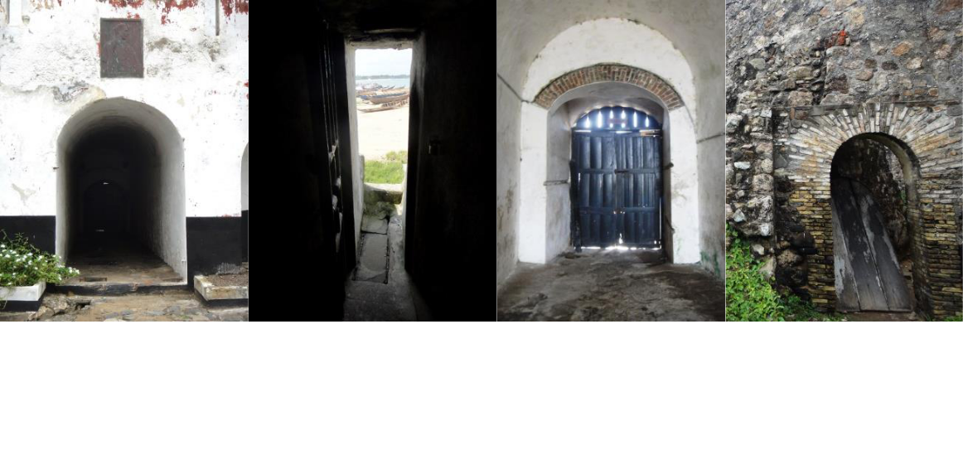

*Figure 5.2 Doors of No Return*

*Though varied in appearance, the narrative for each Door of No Return focuses on the symbolism of the last moments enslaved Africans had in Africa. Left to Right: Fort Williams, Elmina Castle, Cape Coast Castle, Fort Amsterdam*

The collective memory of the transatlantic slave trade required the creation of

two identities; the first is the African American, the second is the African Diasporan. In

48

the early twentieth century, U. B. Phillips was the first modern American historian that studied slavery utilizing sources left behind by American planters and plantation

owners.78 He argued that the plantation, which was uncritically defined, acted as an

assimilation tool for Africans to learn Western society. The hypothesis of assimilation was furthered by the sociologist E. Franklin Franzier in the 1930s and 1940s; he argued that the assimilation process, in which Africans were dominated by American planters,

stripped Africans of their social heritage upon their arrival in the New World. 79 Assimilation was inescapable, Africans would involuntarily become like their masters. In Stanley Elkins 1958 book, *Slavery: A Problem in American Institutional and Intellectual Life*, he argues that although Africans did not forget language, religion, and othercomponents of their African past, they could no longer place real meaning as a result of

geographic and temporal distance.80 An African was viewed as a slate board, wiped clean

upon arrival resulting in a childlike, damaged, Sam Bo personality.

So while it seems like the early twentieth century sought to define blacks as

devoid of any African roots, Melville J. Herskovits *The Myth of the Negro Past* published

in 1941 offered a counter argument.81 Herskovits regarded the Sam Bo personality as an ideological Southern myth; instead, he argued that certain Black American cultural

expressions like the ring shout, cuisine, and locomotion, originated from Africa. By denying the typical collective memory, that blacks were unable to sustain African culture

1. Ulrich Bonnell Phillips. *American Negro Slavery; a Survey of the Supply, Employment, and Control of Negro Laboar, as Determincd bt the Plantation Regime.* New York: D. Appleton and Co, 1918.
2. E. Franklin Frazier. *Black Bourgeoisie: The Book the Broth the Shock of Self- Revelation to Middle Class Blacks in America. .*New York: Free Press, 1957.
3. Stanley Elkins. *Slavery: A Problem in American Institutional and Intellectual Life.* Chicago: University of Chicago, 1959.
4. Melville Herskovits. *The Myth of the Negro Past*. Boston: Beacon, 1941.

49

within the Americas, Herskovits completely shifted the historical paradigm. Lorenzo Dow Turner was a Black American linguist who was first to connect the Gullah language found in along the coast of South Carolina and Georgia with African languages; he

refuted assimilation models by offering a case study of African retention.82 Joseph Holloway’s examination of *Africanisms in American Culture* was able to identify and trace Bantu culture throughout various regions while Sidney Mintz and Richard Price, who were critical of Africanism due to its lack of cultural specificity, suggested

creolization was responsible for the development of Black culture in the New World.83 Understanding the development of where Black America originated is fundamental to this historiography because without the connecting the New World with Africa, the

current collective memory would be impossible. How could homeland rhetoric be used without the African American acceptance of Africa as a cultural homeland?

Paul Gilroy’s foundational text *The Black Atlantic: Modernity and Double-Consciousness* examines the hybridity of black Atlantic culture highlighting the double

consciousness theory first established by W. E. B. Du Bois in *The Souls of Black Folks*, as well as demonstrating the influence of European philosophy on Black intellectual

thought.84 The formation of a “Black Atlantic” questions previous understandings and

backgrounds of black intellectuals though the lens of humanism and Hegelianism. Gilroy also uses case studies of black musical production to highlight his intellectual debate on

1. Lorenzo Dow Turner. *Africanisms in the Gullah Dialect*. Columbia: University of South Carolina, 1949.
2. Joseph Holloway, edit. *Africanisms in American Culture.* Bloomington: Indiana University, 2005*;* Sidney Mintz and Richard Price. *The Birth of African-American Culture: An Anthropological Perspective.* Boston: Beacon, 1976.
3. Paul Gilroy. *The Black Atlantic: Modernity and Double-Consciousness.* Cambridge: Harvard University, 1995; W. E. B. Du Bois. *The Souls of Black Folk* . Chicago: A.C. McClurg & Co, 1903.

50

the influence of American, Caribbean, African, and European cultures on black cultural

production. But most importantly, in the context of this historiography, he also examines the complexity of navigating the Black Atlantic emphasizing the importance of navigating between accessing full citizenship through national identity and accessing the

Black Atlantic through international identities like Pan-Africanism and Africentricity. It is this duality, between African American and African that is crucial to understand the

emergence of the commemoration of the transatlantic slave trade.

The origins of Pan-Africanism are commonly associated with W.E.B. Du Bois, George Padmore, and Kwame Nkrumah; however, some argue that the nineteenth century abolitionist movement led by Ottobah Cugoano and Gustavus Vassa, typically known as Oloudah Equiano, created the intellectual and ideological foundations of the

movement.85 Early twentieth century Pan-Africanism sought to challenge racial hierarchy that placed blacks as inferiors and demanded full equality for both African and African

Americans. Africans were fighting for independence while African Americans fought for full citizenship; I highlight this difference to state that pan-Africanism on the African continent focused on the importance of newly independent African states uniting politically, but within the Black Atlantic it focused on the unification of all people of

African descent. While each group was reacting to a different kind of racial oppression, the common demand for racial parity resulted in further development of a Black Atlantic

identity.

1. Imanuel Geiss. “Pan-Africanism.” *Journal of Contemporary History* 4:1969, 188.

51

In Shalmishah Tillet’s *Sites of Slavery: Citizenship and Racial Democracy in the Post-Civil Rights Imagination*, she problematizes the common narrative surrounding pan-

Africanism. While Tillet accepts the traditional argument that creates homeland rhetoric within Pan-Africanism, she argues that following the Civil Rights Era, as a result of the increase of middle-class Black Americans and the perception of Africa as politically unstable, Africa was no longer viewed as a place for African Diasporans to return home

to, but rather a place to visit one’s roots. “In less than four decades there have been more than eighty violent changes of government… Nigeria is the top of the league table with six violent changes of government followed by Sudan, Uganda, Ghana, Burundi, and Benin, each with five.”86 By recognizing that the pan-African movement has transformed, Tillet is better able to contextualize the dramatic increase of African Diasporans touring Africa, rather than emigrating to escape the inherent racial suppression found within

American society. Understanding the origin and also the development of pan-Africanism is required when discussing the commemoration and remembrance of the transatlantic slave trade because it relies heavily upon narratives that connect African Diasporans with Africa through heritage tourism.

Tourism is used to promote economic development in countries throughout the world; in 2010 the tourism industry accounted for 6.7 percent of the Ghanaian GDP and 5.9 percent of Ghanaian employment.87 Various organizations like the Ghana Heritage Conservation Trust which was created to preserve and maintain Ghana’s forest reserves,

1. *Unity and Diversity in Development Ideas: Perspectives from the UN Regional (*Bloomington: Indiana University, 2004) 275.
2. “(Re)Structuring Ghana’s Tourism Industry for Socio-Economic Development,” *Ghana* Web, December 84, 2011, accessed April 2015.

52

have emerged to preserve Ghanaian heritage through the development of tourism.88 African Diasporans are a key group targeted by Ghana’s heritage tourism industry and are legally defined as “a person whose immediate forebears have resided outside the African Continent for at least three generations but whose origins, either by documentary proof or by ethnic characteristics is African.”89 The Ghanaian government has done more than welcome black visitors compared to most developing countries by incentivizing visitors to become Ghanaian.90 Since the Immigration Act of 2000, the Right of Abode includes a person of African descent in the diaspora which allows for said persons to enter Ghana without a visa, remain indefinitely, and work without a permit. While it is easily argued that this is a strategy to increase diasporan involvement within the Ghanaian economy, Ghana is uniquely suited to offer status as homeland for diasporans due to its persistent and original alliance with Pan-Africanism as spouted by Kwame Nkrumah and the monumental symbolism of the extant forts and castles scattered across its shores.91 While Reed’s investigation into the inclusion of the African Diasporan community within Ghana shows that there are still some cultural differences that prevent the fulfillment of the “imagined community” bonded through a “shared purpose and destiny…common past and … collective biological and cultural heritage.”92

1. “Ghana Heritage Conservation Trust takes over endowment fund,” *Ghana* Web, March 3, 2014, accessed October 2014.
2. “Immigration Act, 2000 (Act 573)” Section 56, 18, http://www.ghanaiandiaspora.com/wp/wp-content/uploads/2014/02/Ghana-Immigration_act_-2000-ACT-573.pdf.
3. Debrah, Richard Kwame, “The Economic Power of Tourism,” *Modern Ghana*, 12 April 2003, http://www.modernghana.com/news/111956/1/the-economic-power-of-tourism.html.
4. Paul Ankomah, Trent Larson, Venita Roberson and Jerono Rotich, “A Creative Approach to Development: The Case for Active Engagement of African Diaspora in Ghana,” *Journal of Black Studies*, 43(2012), http://www.jstor.org/stable/23215222.
5. Ann Reed. *Pilgrimage Tourism*. 367.

53

The preliminary interpretations of the sites by the GMMB and UNESCO have drastically changed since their original designation. These changes are demonstrated in current fort and castle tour narratives and UNESCO’s Slave Route project which challenged custodians of properties associated with the trans-Atlantic slave trade to embrace the problematic history of the sites.93 Only three European nations sought to gain control of trade in the region prior to the overwhelming importance of slavery in trade, but with the emergence of plantation economies in the New World, more European competition arrived which resulted in an increase in forts along the coast. So, while the genesis for European trade expansion along the Ghanaian coast was gold, by the seventeenth century there was a lull in the gold trade that would eventually be superseded by the slave trade. While studies of the tour narratives have focused on guides’ adept ability to adapt to audience, this investigation examines what topics the tours focus on. 94

As a result of UNESCO’s Slave Route project and heritage tourism, the tours of the forts and castles almost exclusively focus on the role of the slave trade and illustrate the larger goal of the project: to demand that visitors “never forget the injustices of the trans-Atlantic slave trade.”95 Although forts and castles vary in size and shape, tours have a formulaic approach to site interpretation. Starting with a discussion of the arrival of the Europeans, tours provide visitors with brief overviews of the initial trade highlighting the inequality of the trade. The influence of UNESCO and the increase in heritage tourism caused the GMMB to completely reject their previous understanding of the history of the

1. “The Slave Route” *UNESCO Culture, Themes, Dialogue,* n.p., accessed January 2015.
2. See Edward Bruner, *Culture on Tour: Ethnographies of Travel,* Chicago: University of Chicago, 2004,

20; Ann Reed, *Pilgrimage Tourism of Diaspora Africans to Ghana,* London: Rutledge, 2014; Bayo Hosley.

*Routes of Remembrance: Refashioning the Slave Trade in Ghana.* Chicago: University of Chicago, 2007.

1. Ann Reed. *Pilgrimage Tourism*. 628.

54

forts and castles; before the GMMB emphasized how important the structures were for demonstrating the equality among Africans and Europeans, and now they highlight the inequitable value of the items traded. The Slave Route Project also aimed at re-interpreting the heritage tourism to include Northern Ghana, resulting in participants traveling to lesser known areas that are still developing their initial tourism industry.96

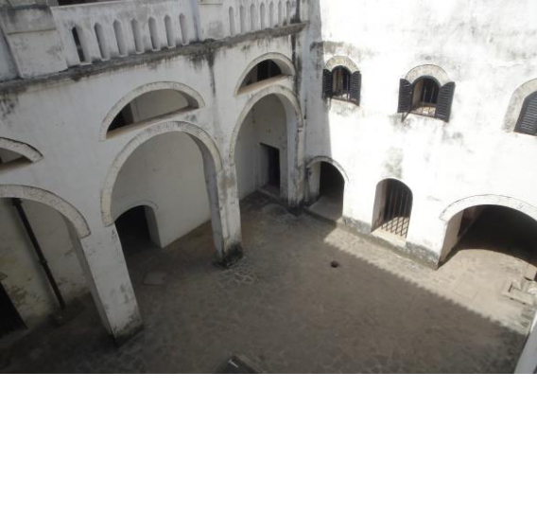

*Figure 5.3 Elmina's Female Dungeon*

*This is the view of the female dungeon taken from*

*the balcony adjacent to the governor’s bedroom,*

*aiding in the process of selecting a slave to rape.*

The tour then describes the trans-Atlantic slave trade, emphasizing the number of bodies transported across the Atlantic. Visitors are led to the male and female dungeons, where discussions of the conditions of the slaves include sanitation and nutrition, disease, punishments, and rape. During this portion of the tour, specific examples are given to highlight how the fort or castle’s architectural design resulted in the reassignment of certain storage areas for slave dungeons. The slave dungeons are separated by gender and guides discuss the mulattos produced through rape that occurred in the female dungeons as explanations for the emergence of European-founded education on the coast and European surnames among Ghanaians. Visitors are invited into the slave dungeons as a

1. Ibid, 24.

55

description of the living standards is told; visitors are told to imagine themselves trapped with X-number of people without windows, with little ventilation and zero sanitation. The visitors are reminded of the horrific journey to the fort or castle as the guide describes the horror of being confined in the dungeon from days to weeks to months at a time.

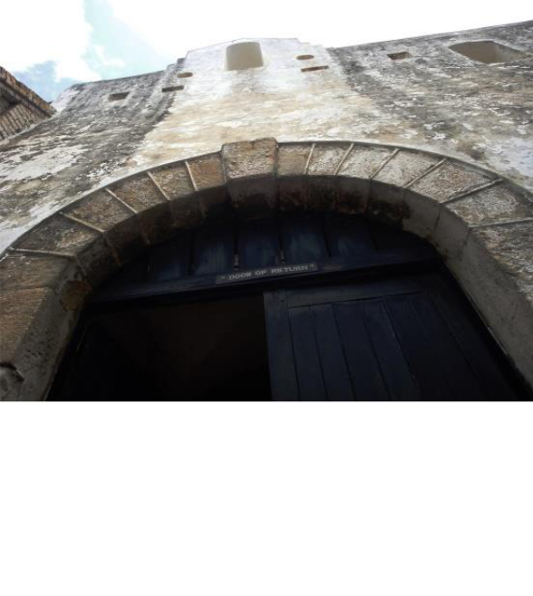

*Figure 5.4 Door of Return*

*While told to the entire group, the Door of Return*

*narrative was specifically created with the African*

*Diasporan visitor in mind.*

The tour inevitably concludes with the “Door of No Return.” The door of no return is the exit that slaves would emerge from the damp, dark dungeon spaces which they had been confined into the sunlight, only to be chained and stored in darkness again within the holds of a slave ship. The term “Door of No Return” was invented to create a connection between the past and present. “Thru the Door of No Return – The Return” was a program developed for the PANAFEST, a festival that brings Africans and African Diasporans into conversations surrounding the impact of the trans-Atlantic slave trade, by

56

African Diasporans to emphasize “the sacredness of the site”.97 PANAFEST, which is thrown bi-annually to “reconnect Africans in the diaspora with their African roots,” is celebrated in conjunction with Ghana’s annual Emancipation Day celebration.98 Reed points out “that Rawlings selected August 1 over Juneteenth for recognition in Ghana could be used as evidence that he was interested in reaching out to a wide array of diasporans,” not just African Americans.99 Depending upon the accessibility of the exit, visitors are invited to walk through the door; on the outside of the fort or castle the guide provides a brief description of the trans-Atlantic passage and plantation slave system. Guests are then invited through the “Door of Return,” allowing African Diasporans to complete the spiritual journey of their ancestors on their heritage tour. The “invented tradition” of the “Door of No Return” demonstrate that through the creation of new ceremonies groups can create “continuity with the old” in order to preserve a historic past.100 First ascribed in 1998, Cape Coast Castle’s “Door of Return” was created following the ceremony of returning two former slaves’ remain to Africa; following the coffin procession into the courtyard, “libation was poured” and the entry was renamed.101 The historical narrative of return is created by appropriating African concepts of death and African American ideals of homeland and is placed upon the exits from the forts and castles, turning the buildings into the physical manifestation of the physical and spiritual rift from Africa forced upon African Diasporans predecessors.

1. Ann Reed, *Pilgrimage Tourism of Diaspora Africans to Ghana,* London: Rutledge, 2014, 143.
2. Hosley. *Routes of Remembrance.* 58.
3. Ann Reed. *Pilgrimage Tourism.* 1110*.*
4. Eric Hobsbawm and Terence Ranger, edit. *The Invention of Tradition* , Cambridge: Cambridge University, 1983, 2; Klaus Benesch and Genevieve Fabre, *African Diasporas in the New and Old Worlds: Consciousness and Imagination*, Leiden: Rodopi, 2004, 165.
5. Ann Reed. *Pilgrimage Tourism*. 1120.

57

The tours illustrate that the role of architecture and equitable Afro-European trade have been completely consumed by the narrative of slavery; architectural focus now emphasis the diabolic redesign of the building, and the trading parity is undermined with an analytical view of the materials trade. The influence of linking the history of the forts and castles to an international history has resulted in the buildings becoming memorials to the African stage of the slave trade. The trans-Atlantic slave trade emphasis is furthered by pan-Africanist sentiments being closely tied to Ghanaian identity and the impact of encouraging African Diasporans to participate in heritage tourism.

An examination of the narratives currently found in the museums housed within Cape Coast Castle illustrates the pervading thematic interpretations of the forts and castles as monuments to architecture, affirmation of Ghana’s diverse identity, and as focal points of African Diasporan homeland identity. Although the narrative of the forts and castles ultimately shifts away from the architecture, in 1997 an exhibition entitled “The Building of Cape Coast Castle” opened in a former soldier’s barracks in Cape Coast Castle. The exhibition, which is still open, examines the history of European fortifications in Cape Coast detailing the exchange of hands, the subsequent changes made to the original Swedish fort resulting in the massive Cape Coast Castle including an examination of materials found within the building ranging from marble tiles to lime powder. The exhibition concludes with a very brief overview of the 20th century modifications of the building, noting that early utilitarian repairs were non-historical, but were of concern to O’Neil in his 1951 report on the forts and castles and later corrected. This exhibition was created four years after the Cape Coast Castle Museum opened its featured exhibition entitle “Crossroads of People, Crossroads of Trade.” This 1994

58

GMMB exhibition demonstrates the emphasis of African Diasporan narrative within the overall interpretation of the site. It provides visitors with a historical introduction to the trans-Atlantic slave trade using material culture to supplement tour narrative. After a walk through a small room designed to evoke the hull of a slave ship, the narrative continues focusing on the American slavery experience. The conditions of slavery are described on the wall while the captions of photographs tell different stories of resistance. This portion of the museum ends on an unexplained wall of famous African-Americans and highlights Kwame Nkrumah’s pan-Africanist ideals by comparing the civil rights movement in America and the Ghanaian independence movement.

Abruptly the topic shifts to an emphasis on the culture of the Fante, the largest ethnic group found within Cape Coast. It also showcases the cultural practices of ethnic groups from the Central Region, building a regional identity based upon the national conception of unity in diversity. The architecture, the trans-Atlantic slave trade, and source of identity creation are all used within the narratives of the museums housed in Cape Coast Castle, representing the intangible layering of historical interpretations. The Cape Coast Castle museum offers a narrative that includes all three major themes, but ultimately it is the overwhelming voice of the African Diasporan102 that dictates the interpretation of the structure illustrating the importance of the Pan-African identity within the interpretation of the forts and castles.

1. Not only is it focused on the African Diasporan, but more specifically the African-American, although the majority of slaves shipped from Ghana’s shores went to plantations in Central and South America.

59

**Chapter 6. Conclusion**

*I sat staring out into the sea, watching the hypnotic undulation of the waves, listening to the various German, Fante, and English conversations that were barely audible over the sound of the nearby drumming performance. I catch myself thinking about the booming tourist industry and reflecting on how this moment encapsulates the limited experience of Ghana many observe; obronis consuming a unified culture that the Ghanaian government has masterfully curated: Ghana is the epicenter of hospitality that offers an African experience through traditional drumming and dance performances. It also provides homeland rhetoric for all those African Diasporans who would dream of claiming Ghana. But this scene was more than a perfect example of a successful tourism industry is in a developing economy; this moment embodied the convenience of forgetting. In an idyllic setting where a group of children play on the shore below, it was too easy to forget that the slave castle was meters away. This forgetting is what I fear most, what happens when this historic site is nothing more than an opportunity to tell a specific story?*

*In more popular tourist hubs like Cape Coast, Elmina, Axim, and Accra, the history of the forts and castles is transmitted through tours and museums. Smaller forts along the path of cultural tourism within Ghana like Fort Apollonia or Fort Friedrichsburg also*

60

*remit the stories of the buildings through tours and museums; however, those forts that lay in ruins, off the beaten tourist path not only risk their physical erasure, but also their memory. When I arrived in Old Ningo, I asked a group of motorbike taxis where Fort Fredenshborg was located; all twelve local men didn’t know what I was talking about. It was after I described it as an old European stone building that should be located on the coast did one recall its location. As he drove me there, many Ghanaians curiously stared as we passed because an obroni was an unusual visitor to Old Ningo. He began to slow the bike as the coast began to emerge from the road covered with various shops and parked next to a field. He pointed into the field and I could see a piece of an old wall barely peeking out above the tall stalks of corn. The ruins of the fort were forgotten amongst the corn, mostly an unwanted interruption in the otherwise perfectly planted lines of corn. Was it because it was a ruin, unable to be toured explaining the various uses of spaces, that it was unknown to the drivers who should be able to easily identify major landmarks within the town? Or was it because this fort would likely never become a tourist destination due to its remote location and its “ruin” classification? There was a small canon placed next to the ivy covered arches of what was once Fort Fredenshborg, it was pointed at the sea, but was obviously placed next to the wall to prove the purpose of the crumbling building. The cannon was the only thing denoting what this ruin was; there was no sign, no guide. Fort Fredenshborg’s story had been forgotten by those who lived around it. It was nothing more than an old European building near the coast.*

61

“From what are phenomena rescued? Not just or not so much from the ill-repute and contempt into which they've fallen, but from the catastrophe when a certain form of transmission often presents them in terms of their "value as heritage "-they are rescued by exhibiting the discontinuity that exists within them. There is a kind of transmission that is a *catastrophe*.”

* Walter Benjamin, *Re the Theory of Knowledge, Theory of Progress*

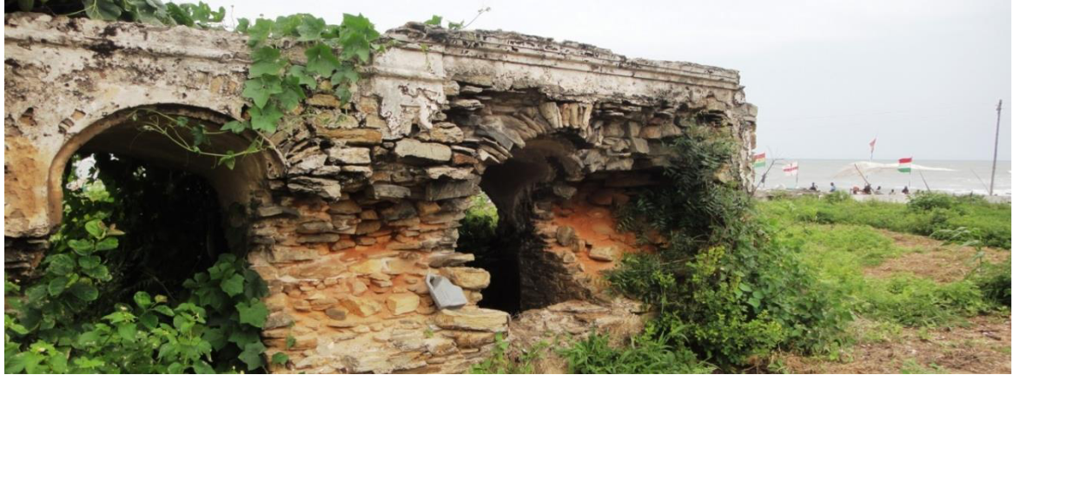

*Figure 6.1 Fort Fredenshborg Ruins*

*In the middle of a corn field near the fish market of Old Ningo, lay the remains of Ft. Fredenshborg.*

*Who* preserves not only defines *what* is preserved but *how* it is preserved. While the MRCGC, the GMMB, and UNESCO all understood that the forts and castles should be preserved, their motivations—based upon each organization’s mission—varied, resulting in different emphasizes of why the forts and castles are historically significant. It is important to remember that the present shapes past perceptions, arguable more than the past events; “they are subjective, highly selective reconstructions, dependent on the situation in which they are recalled.”103 The architectural interpretation requires an engagement of the structures history, but has primarily focused on the European builder;

103Astrid Erll*. Memory in Culture*. New York: Palgrave Macmillan, 2011. 17.

62

this interpretation should teach more than when it was built and who built it. It should teach visitors about the difficult nature of building in the tropics like the use of local and imported building materials, the relationship between the structures and the towns that further developed around them allowing for a discussion of the economies it contributed to, while also exploring the specific history of the building’s style. Not only are they superb examples of medieval European fortification, but they are a piece of material culture that should be explored to facilitate discussion of the impact these structures have had. The role of the forts in forming identity, whether through a nationalizing narrative or Pan-Africanis homeland rhetoric, should be considered when interpreting their meaning. Their meaning changes depending upon their audience and that should be taken into consideration when developing their interpretation. GMMB staff should question the varying significances of the forts and castles to a Ghanaian, or a European, or an African-American in order to create a tour or museum narrative that is not limited to one audience.

The slave forts and castles’ histories are more than stories about what happened in a place; they tell a long history of the struggle for ownership and the power of interpretation of the sites and their powerful ability to affect identity formation. Ultimately, it is a combination of these interpretations that will result in the complete preservation of these buildings, for any one emphasis alone cannot contain the significance of the forts and castles. Using this essay as a foundational investigation, the physical preservation of the forts and castles could be further researched to examine how the preservation methods varied across the organizations. Additionally, an examination of the Ghanaian perspective of the forts and castles, as well as arguments about the

63

historical disconnect that occurs between Ghanaian interpretation and African Diasporan interpretation, could lead to a better understanding of the development of interpretation. The forts and castles of Ghana have evolved from European trading posts to governmental seats to memorials of the slave trade. They have withstood the tests of time, fighting back pounding seas, and the ever changing and manipulated collective memory.

64

**Bibliography**

Paul Ankomah, Trent Larson, Venita Roberson and Jerono Rotich, “A Creative Approach to Development: The Case for Active Engagement of African Diaspora in Ghana,” *Journal of Black Studies*, 43(2012), http://www.jstor.org/stable/23215222.

Kwesi J. Anquandah, *Castles and Forts of Ghana*. Accra: Ghana Museum and Monuments Board, 1999.

Jan Assmann, “Collective Memory and Cultural Identity.” *New German Critique.* 65:

1995. 125-133.

Klaus Benesch and Genevieve Fabre, *African Diasporas in the New and Old Worlds:*

*Consciousness and Imagination*, Leiden: Rodopi, 2004.

Edward Bruner, *Culture on Tour: Ethnographies of Travel,* Chicago: University of Chicago, 2004.

Henry Cleere, *Archaeological Heritage Management in the Modern World*, London:

Routledge, 2005.

Alon Confino, “Memory and Cultural History: Problems of Method.” *The American Historical Review* 102:2386-403.

Albert van Dantzig. *Forts and Castles of* Ghana. Accra: Sedco, 1980.

Christopher DeCorse, *An Archaeology of Elmina: Africans and Europeans on the Gold*

*Coast, 1400-1900,* Washington, DC: Smithsonian Institution, 2001.

Michel R. Doortmont. *Castles of Ghana: Historical and Architectural research on three Ghanaian forts (Axim, Butre, Anomabu)*

W. E. B. Du Bois. *The Souls of Black Folk* . Chicago: A.C. McClurg & Co, 1903.

Stanley Elkins. *Slavery: A Problem in American Institutional and Intellectual Life.*

Chicago: University of Chicago, 1959.

65

Emory University’s Voyages: The Trans-Atlantic Slave Trade Database (Atlanta: np, 2009). http://www.slavevoyages.org/tast/database/search.faces

Astrid Erll*. Memory in Culture*. New York: Palgrave Macmillan, 2011.

E. Franklin Frazier. *Black Bourgeoisie: The Book the Broth the Shock of Self- Revelation*

*to Middle Class Blacks in America. .*New York: Free Press, 1957.

Harcourt Fuller *Building the Ghanaian Nation-State: Kwame Nkrumah’s Symbolic*

*Nationalism,* London: Palgrave Macmillan, 2014.

Imanuel Geiss. “Pan-Africanism.” *Journal of Contemporary History* 4:1969, 188.

“Ghana Heritage Conservation Trust takes over endowment fund,” *Ghana* Web, March 3, 2014, accessed October 2014.

“Ghana in presidential palace row,” *British Broadcasting Corporation*, December 15, 2005, accessed November 10, 2014, http://news.bbc.co.uk/2/hi/africa/4532672.stm.

“Ghana Museums and Monuments Board,” Cultural Heritage Connections, accessed

September 30, 2014,

http://www.culturalheritageconnections.org/wiki/Ghana_Museums_and_Monuments_Bo

ards.

Paul Gilroy. *The Black Atlantic: Modernity and Double-Consciousness.* Cambridge:

Harvard University, 1995.

Michael A. Di Giocine. *The Heritage-scape: UNESCO, World Heritage, and Tourism*.

Judith Graham, “The Slave Fortresses of Ghana,” *New York Times*, November 25, 1990, accessed March 20, 2015, http://www.nytimes.com/1990/11/25/travel/the-slave-fortresses-of-ghana.html.

Maurice Halbwachs. *The Social Frameworks of Memory*. 1925.

Melville Herskovits. *The Myth of the Negro Past*. Boston: Beacon, 1941.

Eric Hobsbawm and Terence Ranger, edit. *The Invention of Tradition* , Cambridge:

Cambridge University, 1983.

Joseph Holloway, edit. *Africanisms in American Culture.* Bloomington: Indiana University, 2005

Bayo Hosley. *Routes of Remembrance: Refashioning the Slave Trade in Ghana.* Chicago:

University of Chicago, 2007.

66

“Immigration Act, 2000 (Act 573)” Section 56, 18, http://www.ghanaiandiaspora.com/wp/wp-content/uploads/2014/02/Ghana-Immigration_act_-2000-ACT-573.pdf.

Benjamin W. Kankpeyeng and Christopher R. DeCorse, “Ghana’s Vanishing Past: Development, Antiquities, and the Destruction of the Archaeological Record,” *African Archaeological Review* 1:2, (2004).

Brempong Osei-Tutu, “Slave Castles, African American Activism and Ghana’s Memorial Entrepreneurism” PhD diss., Syracuse University, 2009.

Karl Jacoby. *Shadows at Dawn: An Apache Massacre and the Violence of History*.

London: Penguin, 2009.

Ferdinand de Jong, edit. *Recalling Heritage: Alternative Imaginaries of Memory in West*

*Africa.* Walnut Creek, CA: 2007.

Sidney Mintz and Richard Price. *The Birth of African-American Culture: An Anthropological*

*Perspective.* Boston: Beacon, 1976.

National Liberation Council Decree 387 of 1969, Establishing the Duties of the Board, *National* Museum Act, section 14 (1969).

Pierre Nora, Genevieve Fabre and Robert O’Meally, edit., “Between Memory and History: Les Lieux de Memoire,” *History and Memory in African American Culture*, Oxford: Oxford University 1994.

Bryan Hugh St. John O’Neil, “Report on Forts and Castles of Ghana,” Accra: Ghana Museum and Monuments Board, 1951.

Jeffery K. Olick. “Collective Memory: The Two Cultures.” *Sociological Theory* 17:

335.HL

Ulrich Bonnell Phillips. *American Negro Slavery; a Survey of the Supply, Employment, and Control of Negro Labor, as Determined by the Plantation Regime.* New York: D.Appleton and Co, 1918.

D. Zizwe Poe. *Kwame Nkrumah’s Contribution to Pan-Africanism: An Afrocentric*

*Analysis*. London: Routledge, 2003.

M. A. Priestley, “A Note on Fort William, Anomabu,” *Transactions of the Gold Coast & Togoland Historical Society* 2 (1956): 46-48.

Sophia Psarra, *Architecture and Narrative: The Formation of Space and Cultural*

*Meaning,* London: Routledge, 2009.

67

“(Re)Structuring Ghana’s Tourism Industry for Socio-Economic Development,” *Ghana* Web, December 84, 2011, accessed April 2015.

Ana Reed, edit., *Pilgrimage Tourism of Diaspora Africans to Ghana*, London: Routledge, 2014.

T.M. Reese. “’Eating’ Luxury: Fante Middlemen, British Goods, and Changing Dependencies on the Gold Coast, 1750-1821 ” *William and Mary Quarterly*, 2009) 66(4).

David Richardson. “Slave Exports from West and West-Central Africa, 1700-1810: New Estimates of Volume and Distribution.” *The Journal of African History*, 30:1989.

Nicolas Russell. “Collective Memory before and after Halbwachs.” *The French Review* 79: 792-804.

Rosalind Shaw. *Memories of the Slave Trade: Ritual and the Historical Imagination in*

*Sierra Leone.* Chicago: University of Chicago, 2002.

“The Criteria for Selection,” World Heritage Convention, accessed March 5, 2014, http://whc.unesco.org/en/criteria.

“The Economic Power of Tourism,” *Modern Ghana*, 12 April 2003, http://www.modernghana.com/news/111956/1/the-economic-power-of-tourism.html.

“The Slave Route” *UNESCO Culture, Themes, Dialogue,* n.p., accessed January 2015.

Lorenzo Dow Turner. *Africanisms in the Gullah Dialect*. Columbia: University of South Carolina, 1949.

UNESCO, World Heritage Committee State of Conservation Documentation, *Forts and Castles, Volta Greater Accra, Central and Western Regions*, by UNESCO,22COMVII.35, (N.p.: UNESCO WHC, 1998), http://whc.unesco.org/en/soc/2238.

UNESCO, World Heritage Committee Nomination Documentation, *Forts and Castles, Volta Greater Accra, Central and Western Regions*, by Ghana, 34.pdf, (N.p.: UNESCOWHC, October 1979).

UNESCO, World Heritage Status Of Conservation Report, *Forts and Castles, Volta Greater Accra, Central and Western Regions,* by WHC, 1998 (n.p.: UNESCO WHC,1998).

UNESCO, *Convention Concerning the Protection of the World Cultural and Natural Heritage* Paris: n.p., 1972.

68

*Unity and Diversity in Development Ideas: Perspectives from the UN Regional.*

Bloomington: Indiana University, 2004.

W. J. Varley, “The Castles and Forts of the Gold Coast,” *Transactions of the Gold Coast & Togoland Historical Society* 1 (1952).

“World City Populations,” World Atlas, accessed May 1, 2015, http://www.worldatlas.com/citypops.htmInsert census information.

69