**FORMULATION STUDIES OF TABLETS CONTAINING *ADANSONIA DIGITATA L.***

# MUCILAGE AS MATRIX FORMER

**BY**

# HALIMA SA’ADIYA MAHMUD

**DEPARTMENT OF PHARMACEUTICS AND PHARMACEUTICAL MICROBIOLOGY FACULTY OF PHARMACEUTICAL SCIENCES**

# AHMADU BELLO UNIVERSITY, ZARIA NIGERIA.

**FEBRUARY, 2016**

**FORMULATION STUDIES OF TABLETS CONTAINING *ADANSONIA DIGITATA L.***

# MUCILAGE AS MATRIX FORMER

**BY**

# Halima Sa’adiya MAHMUD, B.Pharm (ABU, 2002), M.Sc. Pharm. (ABU, 2009) (Ph.D/PHARM-SCI/05555/2009-2010)

**A THESIS SUBMITTED TO THE SCHOOL OF POSTGRADUATE STUDIES, AHMADU BELLO UNIVERSITY, ZARIA**

# IN PARTIAL FULFILLMENT OF THE REQUIREMENTS FOR THE AWARD OF DOCTOR OF PHILOSOPHY IN PHARMACEUTICS

**DEPARTMENT OF PHARMACEUTICS AND PHARMACEUTICAL MICROBIOLOGY FACULTY OF PHARMACEUTICAL SCIENCES**

# AHMADU BELLO UNIVERSITY, ZARIA NIGERIA.

**FEBRUARY, 2016**

# DECLARATION

I declare that the work in this Thesis entitled ―Formulation Studies of Tablets containing *Adansonia digitata L.* Mucilage as Matrix Former‖ has been carried out by me in the Department of Pharmaceutics and Pharmaceutical Microbiology, Faculty of Pharmaceutical Sciences, Ahmadu Bello University Zaria and Laboratory of Pharmaceutical Technology, Faculty of Pharmacy, Ghent University, Belgium under the supervision of Prof. A. R. Oyi (Mrs.), Dr. T.S. Allagh, Prof. Y.K.E. Ibrahim and Prof. Dr. Jean Paul Remon. The information derived from literature has been duly acknowledged in the text and a list of references provided. No part of this Thesis was previously presented for another degree or diploma at this or any other institution.

Name of Student Signature Date

# CERTIFICATION

This Thesis entitled ―FORMULATION STUDIES OF TABLETS CONTAINING *ADANSONIA*

*DIGITATA L.* MUCILAGE AS MATRIX FORMER‖ by Halima Sa‘adiya MAHMUD meets the regulation governing the award of the Doctor of Philosophy in Pharmaceutics of the Ahmadu Bello University, and is approved for its contribution to Knowledge and literary presentation.

|  |  |
| --- | --- |
| Prof. A.R. Oyi, B.Sc Pharm., M.Sc., Ph.D (Pharmaceutics)  **Chairperson, Supervisory Committee** Department of Pharm. &Pharm. Microbiology Ahmadu Bello University, Zaria | (Signature) ---------------------------  Date ---------------------- |
| Dr. T.S. Allagh, B.Sc. Pharm., M.Sc., Ph.D (Pharmaceutics)  **Member, Supervisory Committee** Department of Pharm. &Pharm. Microbiology Ahmadu Bello University, Zaria | Signature) ---------------------------  Date ---------------------- |
| Prof. Y K E Ibrahim, B.Sc. Pharm., M.Sc., Ph.D (Pharmaceutical Microbiology)  **Member, Supervisory Committee** Department of Pharm. &Pharm. Microbiology Ahmadu Bello University, Zaria | Signature) ---------------------------  Date ---------------------- |
| Prof. A.B Isah, B.Pharm., M.Sc., Ph.D (Pharmaceutics )  **Head of Department**  Department of Pharm. &Pharm. Microbiology Ahmadu Bello University, Zaria | Signature) ---------------------------  Date ---------------------- |
| Prof. Kabir Bala  **Dean, School of Postgraduate Studies**  Ahmadu Bello University, Zaria | Signature) ---------------------------  Date |

# DEDICATION

This work is dedicated to my beloved mother, Hajiya Halima Mahmud.

# ACKNOWLEDGEMENT

In the name of Allah the beneficent the merciful,

I thank almighty Allah in whose trust I put my affairs for His guidance towards the successful completion of this work. Peace and Blessings of Allah be upon His noble Prophet Muhammad (S.A.W).

I extend my profound gratitude to my able supervisors, Prof. A.R Oyi and Prof. Y.K.E Ibrahim with due appreciation for their support on the manner and how this research work came to be. I have always looked up to them in line with pharmacy profession. My other supervisor, Dr. T.S. Allagh, I appreciate too her contributions towards the successful completion of this work and also Prof. A.B Isah for his continuous encouragement and candid support.

Sincerely my limitless gratitude goes to Professor Jean Paul Remon. Indeed his efforts regarding the unending issues on my coming to laboratory of Pharmaceutical technology will continue to be appreciated. The academic father mentorship and support made me optimistic and gave me ability to prosper in my achievements.

Dr. Jurgen Vercruysse ―our professor in the lab‖ and colleague, I am grateful for the relentless support and special expertise in teaching the required techniques.

Mr. Daniel Tensy is greatly appreciated especial for his assistance in the *in vivo* studies and Ilse Dupon for her kind gesture. My friends, Irene and Cynthia; office colleagues, Fien and Anouk including all those who assisted in my achievement in Ghent, I appreciate.

My travel to Ghent though successful was a patient endeavour. I thank my parents for their encouragement, special prayers and moral support. The immeasurable support of my family members is greatly appreciated. Happy Sir El, Anna and Aisha thanks for been there from the start to finish. Mr. Suleiman D. Umar and family, I remain indebted to you.

My husband, I know this took a long time, but your sacrifice, understanding and trust allowed me to persevere. My niece Eeman and children, Mahmud, Zaynab, Ummusalma and Muhammad, your patience, endurance and hope gave me strength.

The entire staff of Department of Pharmaceutics and Pharmaceutical Microbiology and the entire staff of Laboratory of Pharmaceutical Technology Ghent, Belgium are indeed appreciated and acknowledged.

The opportunity offered me by the **Laboratory of Pharmaceutical Technology, Ghent University, Belgium** to conduct part of my research work is greatly appreciated and highly acknowledged. Most of all, the support from **Tertiary Education Trust Fund (TETFUND) and Ahmadu Bello University** for facilitating the research grant and the fellowship award granted me, are truly recognized.

# ABSTRACT

The aim of this study was to investigate the ability of *Adansonia digitata* mucilage (ADM), a hydrophilic plant polymeric material to prolong the release of Metoprolol tartarate (MPT) from matrix tablet formulations compared with semi -synthetic polymer-HPMC60SH4000 matrices. Phytochemical screening and physicochemical characterization of the extracted ADM was performed using standard and official procedures. Physicochemical tests such as simple (quantitative yield, aqueous solubility and pH tests) and analytical techniques ( viscosity tests by rotational viscometer, elemental analysis by Carbon, Hydrogen, Nitrogen (CHN) method, thermo analysis using Differential Scanning Calorimeter (DSC), functional groups determination via Attenuated Total Reflectance Fourier Infra Red (ATR-FTIR) and structure elucidation by

Carbon -13 Nuclear Magnetic Resonance (NMR). Particle characterization via Qicpic and Scanning Electron Microscopy (SEM), moisture content and sorption determination by Karl Fischer and Dynamic vapour sorption (DVS) techniques.

Phytochemical screening as well as thermo analysis revealed a level of purity in the extraction process. The mildly acidic mucilage had a low yield (3.5%) and high viscosity that increased with increasing mucilage concentration. Additionally, it was characterized by glass transition and melting temperatures of 74 °C and 173 °C respectively. Finger prints of functional groups revealed azo aromatic groups and other chemical constituents of sugars including glucose, galactose, rhamnose and sugar acids identified by NMR.

To assess its ability to cohere powdered drug particles, ADM was used as a binder in concentrations of 0.33 % with addition of surfactant, 0.5 % and 1.0 % w/w in the formulation of immediate release MPT tablets by wet granulation method of tablet manufacture. The granule micrometrics and tablet properties evaluated revealed that 0.5% w/w batch had a better binder

spread on powdered mix bed that translated into granules with good flow and particle size distribution (PSD) which corroborated well with SEM imaging as well as granule shapes and the corresponding tablets delivered MPT tablets with acceptable strength while DT did not differ significantly when surfactant was added.

Furthermore, the matrix forming potential of ADM for prolonged release action was investigated in MPT tablets compressed by direct compression in the ratios of 50/50 and 20/80 of drug polymer concentrations. The *in vitro* drug release in acid (pH 1.0) and phosphate (pH 6.8) buffers, swelling and liquid uptake studies, drug release kinetics and mechanism were studied while *in vivo* studies was carried out on 20/80 ADM matrices in dogs and the pharmacokinetic parameters relative to a marketed formulation of same strength; Slow-Lopressor® Divitab 200 mg was obtained. The matrix tablets produced had acceptable tablet quality and the release profiles of the 20/80 matrices displayed a linear and pH independent release while burst effect was only observed in the tablets with low HPMC concentration. The matrix integrity was maintained throughout *in vitro* dissolution for ADM matrices as a result of better gel strength. The drug release kinetics followed Higuchi model while the mechanism was anomalous Fickian diffusion and super case II transport as a result of the swelling effects of the polymer. Similarity factor (*f2*) showed that the *in vitro* release profiles of the 50/50 and 20/80 formulations were similar in both dissolution media used. Besides, statistically, *in vitro* MPT release from ADM and HPMC60SH4000 (20/80 drug: polymer) and *in vivo* profiles after oral administration of the test formulations to dogs did not differ significantly from the reference marketed sustained release product (P > 0.05). In conclusion, *Adansonia digitata* mucilage was found to be an excellent matrix former in prolonged release tablets of MPT that was comparable to semi- synthetic polymer of high viscosity, HPMC60SH4000.

TABLE OF CONTENT

|  |  |
| --- | --- |
| Title page…………………………………………………………………………………….......... | i |
| Declaration……………………………………………………………………………………….. | iii |
| Certification…………………………………………………………………………………….... | iv |
| Dedication ……………………………………………………………………………………….. | v |
| Acknowledgement……………………………………………………………………………….. | vi |
| Abstract………………………………………………………………………………………....... | viii |
| Table of Contents………………………………………………………………………………… | x |
| List of Tables……………………………………………………………………......................... | xv |
| List of Figures…………………………………………………………………………………….. | xvii |
| List of Plates……………………………………………………………………………………… | xix |
| List of Appendices……………………………………………………………………………….. | xx |
| Acronyms and Abbreviations……………………………………………………………………. | xxiii |
| CHAPTER ONE ........................................................................................................................... .. | 1 |
| 1.0 GENERAL INTRODUCTION................................................................................................. .. | 1 |
| 1.1 Introduction ................................................................................................................................ | 1 |
| 1.2 Polymers used in modified release delivery systems…………………………………………. | 3 |
| 1.3 Mucilages...................................................................................................................... | 4 |
| 1.4 *Adansonia digitata L*. Plant............................................................................................. | 5 |
| 1.4.1 Composition of *Adansonia digitata*..................................................................................... | 10 |
| 1.4.2 Mucilage composition.................................................................................................... | 10 |
| 1.5 Experimental drug model................................................................................................. | 11 |

|  |  |
| --- | --- |
| 1.5.1 Metoprolol tartarate.................................................................................................. | 11 |
| 1.6 Statement of research problem.......................................................................................... | 11 |
| 1.7 Justification..................................................................................................................... | 14 |
| 1.8 Hypotheses..................................................................................................................... | 15 |
| 1.9 Aim................................................................................................................................. | 15 |
| 1.9.1 Specific objectives.......................................................................................................... | 15 |
| CHAPTER TWO......................................................................................................................... | 15 |
| 2.0 Literature review............................................................................................................ | 17 |
| 2.1 Design and development of modified release dosage forms.................................................. | 17 |
| 2.2 Classification of drug delivery system................................................................................... | 19 |
| 2.2.1 Physical state of dosage form..................................................................................... | 19 |
| 2.2.2 Route of administration.............................................................................................. | 26 |
| 2.2.3 Mechanism of drug release......................................................................................... | 26 |
| 2.2.4 Drug delivery/release systems and mechanism of release............................................... | 32 |
| 2.2.5 Mathematical models describing drug release kinetic and mechanism............................ | 42 |
| 2.2.6 Similarity factor........................................................................................................ | 40 |
| 2.2.7 Components of delivery system................................................................................... | 44 |
| CHAPTER THREE.............................................................................................................. | 47 |
| 3.0 Materials and methods.......................................................................................................... | 47 |
| 3.1 Materials............................................................................................................................. | 47 |
| 3.1.1Plant Material.............................................................................................................. | 47 |
| 3.1.2 Chemicals and Reagents................................................................................................ | 47 |
| 3.1.3 Equipment................................................................................................................. | 48 |

|  |  |
| --- | --- |
| **3.2** Methods.................................................................................................................. | 50 |
| 3.2.1 Collection, Authentication and Treatment.................................................................. | 50 |
| 3.2.2 Phytochemical screening of purified ADM.................................................................. | 51 |
| 3.2.3 *Physicochemical characterization of plant materials..................................................* | 52 |
| 3.2.4 Analytical tests................................................................................................................. | 53 |
| 3.2.5 Formulation of delivery systems................................................................................. | 56 |
| 3.2.6 Evaluation of Formulated Tablets............................................................................. | 63 |
| 3.2.7 *In vivo* evaluation....................................................................................................... | 69 |
| 3.2.8 Mathematical models describing drug release kinetic and mechanism........................ | 74 |
| 3.2.9 Formulation Compatibility Studies............................................................................. | 74 |
| 3.3 Statistical analysis................................................................................................................. | 74 |
| 3.4 Similarity factor................................................................................................................... | 75 |
| CHAPTER FOUR................................................................................................................... | 76 |
| 4.0 Results............................................................................................................................ | 76 |
| 4.1 Phytochemical and Physicochemical characterization of purified A*dansonia digitata*  mucilage (ADM) …………………………………………………………………………… | 76 |
| 4.1.2 Dynamic vapour sorption studies................................................................................. | 79 |
| 4.1.3 Particle morphology by SEM........................................................................................ | 79 |
| 4.1.4 Particle characterization by Qicpic technique.............................................................. | 79 |
| 4.1.5 DSC Scans of ADM powder........................................................................................ | 84 |
| 4.1.6 Attenuated Total Reflectance Fourier Infra Red (ATR-FTIR) Spectrum of ADM........... | 84 |
| 4.1.7 Solid State Nuclear Magnetic Resonance........................................................................... | 87 |
| 4.2 Formulation studies on the various delivery systems............................................................. | 89 |

|  |  |
| --- | --- |
| 4.2.1 Evaluation of the binding property of ADM in Immediate release Metoprolol tartarate  tablets …………………………………………………………………………………….. | 89 |
| 4.2.2 Granule size analysis.......................................................................................................... | 89 |
| 4.2.3 Granule shape................................................................................................................... | 89 |
| 4.2.4 Effect of binder concentration on granule morphology via SEM....................................... | 93 |
| 4.2.5 Tablet Properties of MPT formulated with ADM as binder.......................................... | 93 |
| 4.2.6 Statistical analysis..................................................................................................... | 93 |
| 4.2.7 Evaluation of Prolonged Release MPT tablets using ADM and HPMC as matrix formers… | 97 |
| 4.2.8 *In vitro* drug release profiles of formulated matrix tablets............................................. | 99 |
| 4.2.9 Liquid uptake and Swelling studies of formulated matrix tablets..................................... | 104 |
| 4.3 Mathematical modeling of formulated matrix tablets…………………………………………. | 117 |
| 4.3.1 Prediction of complete drug release and mean rate of drug........................................ | 117 |
| 4.3.2 Compatibility studies of formulated matrix tablets...................................................... | 117 |
| 4.3.3 Statistical analysis...................................................................................................... | 117 |
| 4.3.4 Similarity factor............................................................................................................ | 123 |

|  |  |
| --- | --- |
| 4.4 *In vivo* evaluation......................................................................................................... | 126 |
| 4.5 Pharmacokinetic parameters.......................................................................................... | 128 |
| CHAPTER FIVE..................................................................................................................... | 130 |
| 5.0 Discussions....................................................................................................................... | 130 |
| CHAPTER SIX....................................................................................................................... | 149 |
| 6.0 Summary/Conclusion/Recommendation........................................................................ | 149 |
| 6.1 Summary...................................................................................................................... | 149 |

|  |  |
| --- | --- |
| 6.2 Conclusion...................................................................................................................... | 154 |
| 6.3 Recommendation ……………………………………………………………………………... | 155 |
| REFERENCES …………………………………………………………………………………… | 156 |
| TEST ON HYPOTHESES..................................................................................................... | 165 |
| APPENDICES...................................................................................................................... | 166 |

LIST OF TABLES

|  |  |
| --- | --- |
| 2.1 Examples of excipients and their in -use concentration........................................... | 25 |
| 2.2 Interpretation of diffusion release mechanism from polymeric dosage form with  varied geometry………………………………………………………………… | 41 |
| 2.3 Components of ER delivery system and examples………………………… | 45 |
| 3.1 Formula for MPT tablets formulated with various composition (%w/w) of ADM  as binder…………………………………………………………………………… | 57 |
| 3.2 Formula for MPT prolonged release tablets with either of ADM or HPMC as  matrix former…………………………………………………………………….. | 62 |
| 4.1 Phytochemical composition of crude leaf powder and extracted mucilage of *Adansonia*  *digitata*…………………………………………………………………………………. | 77 |
| 4.2 Physicochemical properties of purified *Adansonia digitata* mucilage (ADM)……… | 78 |
| 4.3 Properties of Metoprolol tartarate (MPT) granules formulated with increasing  binder concentration………………………………………………………................. | 90 |
| 4.4 Physical properties of immediate release Metoprolol tartarate (MPT) tablets……… | 95 |
| 4.5 Repeated measures analysis of variance of disintegration time for different batches of  immediate release Metoprolol tartarate (MPT) tablets…………………………………. | 96 |
| 4.6 Physical properties of formulated Metoprolol tartarate (MPT) matrix tablets with  ± Standard deviation (SD)………………………………………………………….. | 98 |
| 4.7 Release Kinetics and Mechanism of Metoprolol tartarate (MPT) transport from  matrices of ADM and HPMC60SH4000 in different ratios.................................... | 118 |
| 4.8 Prediction of complete drug release and mean rate of drug release from the  matrix tablets in dissolution media simulated................................................ | 119 |

|  |  |
| --- | --- |
| 4.9 Statistical analysis by One-way ANOVA of formulations F1 and F2 dissolution  values…………………………………………………………………………………. | 122 |
| 4.10 Similarity factors (*f2)* and difference factors (*f1)* values from comparison of same  strength of MPT of different matrices............................................................... | 124 |
| 4.11 Similarity factor (*f2)* and difference factor (*f1)* values from comparison of same  strength of MPT of same matrices in different SGF........................................... | 125 |
| 4.12 Mean pharmacokinetic parameters (±SD, n=6) after oral administration of F5  (MPT 200 mg to dogs as Slow-Lopressor Divitab®) and F1 (20:80 MPT/ADM) Matrix………………………………………………………………………….. | 129 |

TABLE OF FIGURES

|  |  |
| --- | --- |
| 2.1 Sequence of wet granulation process........................................................... | 22 |
| 2.2 Classification of drug delivery systems based on duration of drug release...... | 27 |
| 4.1 Water sorption kinetics for ADM at 21°C................................................... | 80 |
| 4.2 Moisture sorption- desorption isotherm for ADM at 21°C............................ | 81 |
| 4.3 Cumulative percent frequency distribution curve (undersize) of ADM powder via  Qicpic ...................................................................................................... | 83 |
| 4.4 Differential Scanning Calorimeter (DSC) thermograms of *Adansonia digitata*  mucilage…………………………………………………………………………….. | 85 |
| 4.5 Attenuated Total Reflectance Fourier Infra Red (ATR-FTIR) spectrum of  ADM...................................................................................................... | 86 |
| 4.6 Solid state 13C Nuclear magnetic resonance spectrum of ADM........................ | 88 |
| 4.7 Cumulative percent frequency distribution (undersize) of MPT granules  formulated with different concentrations of ADM as binder……………………. | 91 |
| 4.8 Median aspect ratio as a function of granule fraction and binder concentration… | 92 |
| 4.9 In *vitro* release profile of F1 and F2 matrix tablets in pH 1.0…………………….. | 100 |
| 4.10 *In vitro* release profile of F1 and F2 matrix tablets in pH 6.8…………………… | 101 |
| 4.11 *In vitro* release profile of F3 and F4 matrix tablets in pH 1.0.............................. | 102 |
| 4.12 *In vitro* release profile of F3 and F4 matrix tablets in pH 6.8............................. | 103 |

|  |  |
| --- | --- |
| 4.13 Percent Liquid uptake of F1 and F2 matrix tablets in Acid buffer (AB) and  Phosphate buffer (PB) as a function of time................................................ | 105 |
| 4.14 Percent Liquid uptake of F3 and F4 matrix tablets in Acid buffer (AB) and  Phosphate buffer (PB) as a function of time................................................ | 106 |
| 4.15 Percent radial swelling of F1 and F2 matrix tablets in Acid buffer (AB) and  Phosphate buffer (PB) as a function of time.............................................. | 108 |
| 4.16 Percent axial swelling of F1 and F2 matrix tablets in Acid buffer (AB) and  Phosphate buffer (PB) as a function of time................................................. | 109 |
| 4.17 Percent radial swelling of F3 and F4 matrix tablets in Acid buffer (AB) and  Phosphate buffer (PB) as a function of time............................................... | 110 |
| 4.18 Percent axial swelling of F1 and F2 matrix tablets in Acid buffer (AB) and  Phosphate buffer (PB) as a function of time................................................ | 111 |
| 4.19 Overlay of DSC thermograms of MPT (-), ADM (---); MPT and ADM binary  mix ( - -) and compact () ……………………………………………. | 120 |
| 4.20 Overlay of DSC thermograms of MPT (-), HPMC (); MPT and HPMC  binary mix (--) and compact (---) ……………………………………….. | 121 |
| 4.21 Mean plasma concentration time profile ± SD after Oral administration of  F1 (20:80 MPT/ADM) and 200 mg slow-Lopressor® (F5) matrix tablet to Dogs (n=6)…………………………………………………………………. | 127 |

LIST OF PLATES

|  |  |
| --- | --- |
| I A cluster of *Adansonia digitata* trees around a settlement.......................................... | 8 |
| II Powdered *Adansonia digitata* leaves…………………………………………………… | 9 |
| III Vankel VK 7010 dissolution system combined with a VK 8000 automatic sampling  Station…………………………………………………………………………………. | 66 |
| IV HPLC system, HITACHI la Chrom………………………………………………… | 67 |
| V Solid phase extraction of blood samples on a 10 port extraction manifold…………… | 71 |
| VI SEM images of ADM and HPMC at x1000 magnification......................................... | 82 |
| VII SEM images of MPT powder (A) granules granulated with 0.33 % (B), 0.5% (C)  and 1.0% (D) binder concentrations……………………………………………. | 94 |
| VIII Glassy (A) – rubbery (B) polymer transition of F1 matrix tablets at completion of  24 h of *in vitro* dissolution………………………………………………………… | 113 |
| IX Glassy (A) – rubbery (B) polymer transition of F3 matrix tablets at completion of  24h of *in vitro* dissolution ……………………………………………………….. | 114 |
| X Anisotropic swelling due to axial relaxation of polymer in F1 matrix tablets at  8h…………………………………………………………………………………. | 115 |
| XI Isotropic swelling of F2 tablets until 24 h resulting into loss of original shape at  8h………………………………………………………………………………… | 116 |

LIST OF APPENDICES

1. Density and flow properties of different batches of formulated Metoprolol tartarate (MPT) granules using *Adansonia digitata* mucilage (ADM) as binding agent… 166
2. Calibration curve for concentrations of Metoprolol tartarate (MPT) in pH 6.8 (phosphate buffer) 167
3. Calibration curve for concentrations of Metoprolol tartarate (MPT) in pH 1.0 (0.1 N HCL) 168
4. Mean dissolution values with standard deviation (± SD) of Metoprolol tartarate matrix tablets formulated with high (80%) concentrations of ADM and HPMC60SH4000 169
5. Mean dissolution values with standard deviation (± SD) of Metoprolol tartarate matrix tablets formulated with low concentrations (50%) of ADM and HPMC60SH4000 170
6. Percent mean values with Standard deviation ( ± SD) of Liquid uptake, Axial and Radial swellings of F1 matrices in pH 6.8 and pH 1.0… 171
7. Percent mean values with Standard deviation (± SD) of Liquid uptake, Axial and Radial swellings of F2 matrices in pH 6.8 and pH 1.0… 172
8. Percent mean values with Standard deviation (± SD) of Liquid uptake, Axial and Radial swellings of F3 matrices in pH 6.8 and pH 1.0… 173
9. Percent mean values with Standard deviation (± SD) of Liquid uptake, Axial and Radial swellings of F4 matrices in pH 6.8 and pH 1.0… 174
10. Swelling rate of formulated matrix tablets as a function of pH. 175
11. Higuchi kinetic model graphic of percent MPT released as a function of square root of time for F1 matrix tablets in dissolution media simulated… 176
12. Zero order model graphic of percent MPT released as a function of time for F1 matrix tablets in dissolution media simulated… 177
13. Higuchi kinetic model graphic of percent MPT released as a function of square root of time for F2 matrix tablets in dissolution media simulated 178
14. Zero order model graphic of percent MPT released as a function of time for F1 matrix tablets in dissolution media simulated… 179
15. Prediction of MPT release from F1 matrices using concentration (mg/L) versus time (h) in phosphate buffer (pH 6.8) with SD error bars 180
16. Prediction of MPT release from F1 matrices using concentration (mg/L) versus time (h) in acid (pH 1.0) with SD error bars 181
17. Prediction of MPT release from F2 matrices using concentration (mg/L) versus time (h) in Phosphate buffer (pH 6.8) with SD error bars 182
18. Prediction of MPT release from F2 matrices using concentration (mg/L) versus time (h) in Acid buffer (pH1.0) with SD error bars 183
19. Calibration curve for Metoprolol tartarate (MPT) plasma concentrations (ng/mL) as a function of peak area ratio of MPT relative to internal standard (IS) 184
20. Plasma concentration time profiles after oral administration of a single dose of 200 mg Metoprolol tartarate (MPT) as F1 tablet to individual dogs 185
21. Plasma concentration time profiles after oral administration of a single dose of 200 mg Metoprolol tartarate (MPT) as F5 (Slow-Lopressor 200mg Divitab) tablet to individual dogs. 186
22. Student t- test comparing significance of F5 half value duration (HVD) at 50% tmax of F5 and F1 187
23. Student t- test comparing significance of F5 Cmax and F1 Cmax 188
24. Student t- test comparing significance of F5 tmax and F1 tmax 189
25. Student t- test comparing significance of F5 AUC and F1 AUC 190
26. Protocol HPLC bepaling van MPT in plasma. 191

ACRONYMS AND ABBREVIATIONS

|  |  |
| --- | --- |
| AB | Acid buffer |
| AD | *Adansonia digitata* |
| ADM | *Adansonia digitata* mucilage |
| ANOVA | Analysis of variance |
| API | Active pharmaceutical ingredient |
| ATR | Attenuated total reflectance |
| ATR -FTIR | Attenuated Total Reflectance Fourier Transforms Infra red |
| AUC | Area under the curve |
| BSC | Biopharmaceutical Classification System |
| CHN | Carbon, Hydrogen and Nitrogen |
| CII | Case II transport |
| Cmax | Peak plasma concentration |
| CMC | Carboxyl methyl cellulose |
| CO2 | Carbon (IV) oxide |
| CP | Cross-polarization |
| CSFR | Crushing strength, friability |
| DDS | Drug delivery systems |

DF Dosage form

DR Delayed release

DSC Differential Scanning Calorimeter

DT Disintegration time

DVS Dynamic vapour sorption

E P European pharmacopoeia

ECDF Enteric coated dosage forms

EMEA European agency for the evaluation of medicinal products

ER Extended release

et al And others

EU European Union

*f1* Difference factor

F1 (20:80) MPT/ADM

F2 (20:80) MPT/HPMC

F5 Slow-Lopressor Divitab 200mg

*f2* Similarity factor

FD Fickian diffusion

FDA centre for drug administration and research

G1 0.33% ADM binder concentration with 0.1% Tween 80

|  |  |
| --- | --- |
| G2 | 0.5% ADM binder concentration |
| G3 | 1.0% ADM binder concentration |
| GI | Gastro intestinal |
| GIT | Gastro intestinal tract |
| GPC | Gel permeation chromatography |
| GRADIS | Gravity disperser |
| GRAS | Generally Regarded As Safe |
| h | Hour |
| HPC | Hydroxyl propyl cellulose |
| HPC | Hydroxyl propyl cellulose |
| HPLC | High performance liquid chromatography |
| HPMC | Hydroxyl propyl methylcellulose |
| HVD | Half value duration |
| ILVO | Institute for Agricultural and Fisheries research |
| IPA | Isopropanol alcohol |
| IRDF | Immediate release dosage forms |
| IS | Internal standard |
| IV | Intravenous |
| IVIVC | *In vitro -in vivo* correlation |

KSG *Khaya senegalensis* gum

LU Liquid Uptake

MAS Magic angle spinning

MC Methyl cellulose

MEC Minimum effective concentration

MPa Mega Pascal

MPT Metoprolol tartarate

MRDF Modified release dosage forms

ND Not determined

PB Phosphate buffer

PEG Polyethylene glycol

PEO Polyethylene oxide

pH Hydrogen ion exponent

PR Prolonged release

PRDF Prolonged release dosage form

PSD Particle size distribution

R2 Regression value or correlation coefficient

RH Relative humidity

|  |  |
| --- | --- |
| RSD | Relative standard deviation |
| SCMC | Sodium carboxymethyl cellulose |
| SEM | Scanning Electron Microscopy |
| SGF | Simulated gastric fluid |
| SPE | Solid phase extraction |
| Tg | Glass transition temperature |
| tmax | Time of peak plasma concentration |
| TR | Targeted release |
| UK | United Kingdom |
| UNCTAD | United Nations Conference on Trade and Development |
| USP | United States Pharmacopoeia |
| UV-VIS | Ultra Violet Visible |
| WHO | World Health Organization |

# CHAPTER ONE

* 1. **GENERAL INTRODUCTION**

# INTRODUCTION

Advancement in modern techniques in the area of synthesis of new compounds, structural modification of existing compounds and discovery of natural and combination of structurally related compounds has led to the development of a large number of drug products in a short time to combat diseases which prior to now remain impossible. The developed drugs (active ingredient) can only be clinically effective when incorporated into a suitable medium that enables for handling by the patient and proper delivery at the required site of action. This is mostly achieved by the addition of components of formulation called excipients. This medium in which the drug is incorporated and presented for handling is termed as a dosage form or drug delivery system (Perrie and Rades, 2010). Specifically, a dosage form is the physical form in which a drug is incorporated whereas a delivery system is a means by which the medicine releases the drug and delivers it at its target site (organ, tissue, cell or cellular organelle). Modification of drug delivery involves the application of changes to the already existing drugs in order to improve their stability, efficacy; drug safety and patient compliance.

Modified release dosage forms (MRDF) refer to those dosage forms whose release properties, release rate characteristics or location are chosen to achieve therapeutic or convenient objectives that conventional dosage forms cannot provide (USP, 2011). They are designed in such a way that control is taken away from the patient and somewhat away from the physician but placed in drug delivery systems. Basically these dosage types are either designed to provide prompt drug plasma levels maintained constant in the therapeutic range over a prolonged period (controlled released) or prompt drug release followed by prolonged gradual release within the therapeutic

range but not maintained constant (sustained release) or releases the drug when it reaches a given location (delayed and target release) (Collett and Moreton, 2007). According to Collett and Moreton (2007), an ideal modified release dosage form is that which releases its priming dose immediately after administration in order to elicit a desired therapeutic effect and release slowly, subsequent doses so as to achieve a therapeutic plasma concentration that is not constant but maintained over a long period of time. These dosage types are formulated to:

* + - provide a prolonged plasma concentration within the therapeutic range thus preventing repeated administration of drug at different time intervals.
    - increase patient compliance from a 2-3 times daily medication to a less frequent once daily dosing (Nokhodchi *et al*., 2002) most especially in chronic diseases, and
    - minimize side effects (Hosny, 1995; Maderuelo *et al.,* 2011 ) associated with repeated administration and fluctuations in plasma concentration and finally to deliver the drug at specified locations of the GI.

Limitations of the system include

* + - High cost of medication as compared to immediate release tablet dosage forms.
    - Unpredictable release pattern as there is no definite correlation between *in vivo*/*in vitro*

release (Yao and Weiyuan, 2010).

* + - Dose dumping may occur as a result of delivery system failure leading to decrease bioavailability (drug subjected to hepatic metabolism for some drugs) and increased toxicity (Nokhodchi *et al*., 2012).

Though modified release dosage forms are of much advantage in providing prolonged therapeutic action, they are not applicable to all drugs and treatment of short term disease conditions.

Modification of drug release is usually achieved by the use of physical or chemical barriers (Yihong and Zhou, 2011), which can be controlled or sustained over time. To build the barrier into per oral dosage forms, ion exchange resins; microencapsulation; coatings; waxes; plastic matrices and polymeric materials have been used. The polymers used are usually inert, hydrophobic or hydrophilic (swellable) in nature (Nokhodchi *et al*., 2012) with the drug either dispersed in a polymer matrix or enclosed in a polymer membrane.

# POLYMERS USED IN MODIFIED RELEASE DELIVERY SYSTEMS

For the development of matrix systems, hydrophobic and hydrophilic polymers or both are used. Hydrophobic polymers such as ethyl cellulose, polyethylene and polypropylene when used release the drug via diffusion following Higuchi model whereas hydrophilic polymers like methyl cellulose, (MC) hydroxyl propyl cellulose (HPC); hydroxyl methyl propyl cellulose (HPMC) and the poly methyl acrylates e.g. Eudragit RS and RL release the drug by Case II transport or by a combination of Case II transport and Fickian diffusion (Perrie and Rades, 2010). Apart from the synthetic and semi synthetic polymers, hydrophilic natural polymers obtained from plants have also been used in modifying drug release. For example, guar gum has been useful in targeting drug delivery to the colon (Krishnaiah *et al*., 2002). A combination of natural and semi synthetic polymers, *Khaya senegalensis* gum (KSG) and sodium carboxymethyl cellulose (SCMC) have also released drug via fickian diffusion and case II transport (Mahmud *et al*., 2015).

For the purpose of developing reservoir systems ethyl cellulose; Eudragit RS and RL are used as film formers. In addition, hydrophilic polymers have also been used though there is the risk of dose dumping as concern for this type of coats (Verhoeven, 2008). Polylactides and copolymers of lactic and glycolic acids are employed in the development of bioerodable matrix systems which release drug via matrix erosion.

# MUCILAGES

Mucilages are produced via normal physiological process during metabolism within the cell (intracellular formation) without any injury to the plant (Qadry and Shah, 2008). Mucilages usually are composed of several sugar monomers and do not dissolve but form slimy mass in water. They are also precipitated by organic solvents. Generally, mucilages are plant hydrocolloids that on hydrolysis yield mixtures of sugars and uronic acids (Pritam and Harshal, 2014).

Several findings on mucilage have shown that they contain polysaccharides with different components for example, Aloe vera gel contains acetylated mannan, galactan, arabinan and glucoronic acid, while Hibiscus mucilage contains L- rhamnose, D-galactose, D-galacturonic acid and D-glucoronic acid (Avinash *et al*., 2013). Mucilage from seeds of *Ziziphus mauritiana*- Jujube contains carbohydrate, reducing sugar and amino acid. *Trigonella foenum-graceum* (Fenugreek) in its seeds contains a high concentration of mucilage that is very viscous and comprises sugars of mannose, galactose and xylose types (Pritam and Harshal, 2014). Mucilage are produced from different sources and classified based on their sources. They can be obtained from plant seed (*Cassia fistula*), bark and fruit (Jujube, Okro) and also from plant leaves e.g. *Adansonia digitata* and *Aloe vera*.

1. **4 *ADANSONIA DIGITATA L.* PLANT**

*Adansonia digitata* L belongs to the Family *Bombacaceae/ Malvaceae*. It has several names in English attributed to its physical appearance such as monkey bread (fruit pulp); dead rat (hanging fruit capsule); or upside down (root like branches) tree and African Baobab. In Arabic, it is called Buhibab (Diop *et al*., 2005 cited in Viljoen (2011) meaning fruit with many seeds. Though uncertain but this is thought to be the origin of the name ‗Baobab‘ in English. In Hausa, it is popularly known as ―Kuka‖ and ―Igiose‖ in Yoruba. It is found in the hot dry savannahs of sub- saharan Africa. It also grows in populated regions as a result secondary cultivation.

Of the eight specie of *Adansonia, A. digitata* is the only one native to mainland Africa. It is a majestic plant and the largest succulent plant in the world with a height of 23 m and 10-12 m in diameter (Wicken, 1982; Chadare *et al*., 2009). The massive deciduous tree easily distinguished by its giant size and huge bottle like trunk looks swollen with short, stout tortuous branches and a thin canopy. It flowers between October and December (Watson, 2007). The flowers are prone to pollination by bats, insects and wind and rarely have a life span of a day (Ebert *et al.*, 2002; Sidibe and Williams (2002). The ever green leaves are simple and digitalised with five leaflets on each leaf hence the nomenclature ―digitalis‖. The leaves are shed during the early dry season and appear after flowering. Some of the plants produce leaves for only 3 months in a year and during the remaining year physiological processes in the trunk and branches continues utilizing water stored in its large trunk (Gebauer *et al*., 2002). This hollow trunk acts as a reservoir for the plant during drought because of its high water holding capacity.

The tree is known to have a life span of several hundred years and it is resistant to fire. Scientists estimated that it takes a Baobab tree between 8 and 23 years before it can produce seeds and after maturity ( > 60 years) it produces 160 -250 seeds per annum (UNCTAD, 2005). The seeds are

contained in a large egg like velvety hairy fruit capsule (Wickens, 1982). The seed, fruit and pulp have gained commercial interest internationally, providing an export means where the plant is cultivated hence increase pressure on the species (Sidibe and Williams, 2002). Assogdadjo *et al* (2005) noted that fruiting and quantity of seed is affected by soil type and it‘s mineral. The root system is shallow but spreads widely underground further than the height of the tree hence ability to survive in dry climate and a provision for water uptake during the heavy infrequent rains. *Adansonia digitata* is found to be among the most effective plants that prevent water loss. Though not widely cultivated, it has been used by humans for multiple purposes as food or medicine (Ebert *et al*., 2002).

As food in Northern Nigeria, the dried leaves are used in the preparation of soup called ―kuka‖. Its high thickening effect makes a little sprinkle sufficient for a large family. Because of its medicinal uses, it is referred to as the small pharmacy or chemist tree for the reason that all of its part including the leaves, bark, fruits and seeds are either useful as food or medicine (Etkin and Foss (1982) cited in De Caluwe *et al.*, 2010). This could be due to the presence of bioactive compounds like terpenes, saponins, and tannins (Ramadan, 1993). The leaves have been used in treatment of fever, urinary tract infection, internal pains, otitis media, insect bites and as a guinea worm repellent. In addition to this, it has astringent property and has also been used to check excessive sweating. When dried, the leaves are used to repel insects. The oil is used in the treatment of diarrhoea and hiccough. The fruit paste is used for swollen joint pains.. Baobab has been accepted by the Food and Drug Administration Agency as a food ingredient in the US (Addy, 2009). The plant fruit pulp due to its traditional application in cosmetic, nutrition and medicine has been approved for importation into the EU (Buchmann *et al*., 2010). Claims of

antiviral, antibacterial and nutritional properties of its various parts have been scientifically investigated (Viljoen, 2011) and are promising.

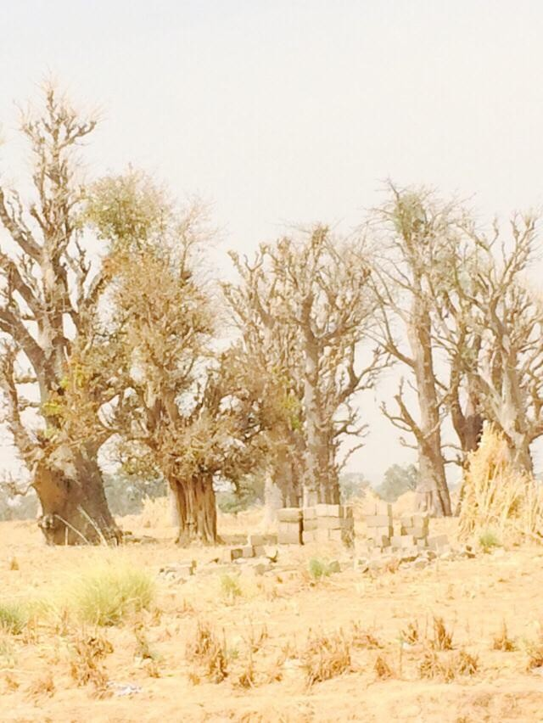

Plate I: A cluster of *Adansonia digitata* trees around a settlement

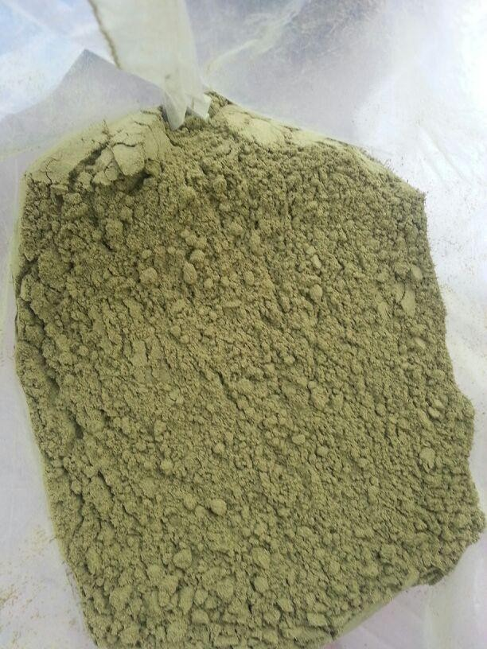

Plate II: Powdered *Adansonia digitata* leaves

* + 1. **Composition of *Adansonia digitata***

Baobab leaves are rich in good quality proteins, essential amino acids; minerals and vitamin A and have antioxidant activity. The amount of protein found by Yazzie *et al* (1994), cited in De Caluwe *et al*., (2010) constitutes 10.6 % with all common amino acids represented in different amounts. In terms of mineral composition, the leaves, contain more of iron and than calcium but when grown on alkaline soil, the leaves contain a high content of calcium. Adansonin, an alkaloid is said to be present in the leaves but this is yet confirmed in the Nigerian variety (Adegoke *et al*., 1968). Other components such as tannins, potassium tartarate, catechins and flavonic pigments were also reported to be present (Burkill, 1985). Carbohydrate is said to be the chief component of the leaves with about 60-70 %w/w followed by protein 13-15 % and lastly 4- 6 % of fat and also 11 % fibre and 16 % ash. In addition, 7 to 10 % of the dry matter of leaves is mucilage (Woolfe *et al*, 1997; Diop *et al*., 2005 cited in De Caluwe *et al* (2010).

# Mucilage composition

Of the few research works carried out on the mucilage, Mark *et al* (1977) reported that *Adansonia digitata* mucilage is acidic and contains glucose, rhamnose, galactose, galactoronic and glucoronic acids. The mucilage is also viscous at concentrations of 0.5 to 1.0 % w/v which is highest at neutral pH and can be lost when heated; nonetheless it remains a great soup thickener. Burkill (1985) further added that the mucilage is rich in uronic acids, rhamnose and other sugars. *Adansonia digitata* contains in the crude and purified mucilage a high content of protein and mineral, a very small proportion of neutral sugars rhamnose and galactose and also a high proportion of uronic acid derived from galacturonic and glucoronic acid. Baobab mucilage is further classified as a galacturonorhamnan polysaccharide which is acidic due to its high content of uronic acid (Sidibe and Williams, 2002).

# EXPERIMENTAL DRUG MODEL

* + 1. **Metoprolol tartarate**

Metoprolol tartarate (MPT) is a cardio selective beta blocker classified under the Biopharmaceutical Classification System (BSC) as a Class I drug due to its high solubility and high permeability across epithelial membranes (Ashford, 2007). It is rapidly absorbed along the GIT and present good bioavailability unless it forms complexes or undergoes pre-systemic clearance where it shows incomplete bioavailability of about 50 % (Klein and Dressman, 2006). A peak plasma concentration is reached between 1-2 hours of administration of a single dose of MPT and further eliminated within 3 to 4 hours. This necessitates frequent administration of the drug for up to 4 times daily depending on the intent of treatment (Angina pectoris & Hypertension). The frequent dosing thus produces troughs and peaks in the plasma concentration-time curve, inconveniences in dosing and possible side effect plus unintended omission of doses. The existence of a well defined relationship between plasma concentration and the beta blocking effect has been well documented where different types of controlled release formulations improved the clinical quality of MPT (Verhoeven, 2008a; Klein and Dressman, 2006).

These reasons account for the choice of MPT for remodelling into a modified prolonged release formulation using purified natural mucilage obtained from the leaves of *Adansonia digitata* plant as matrix former.

# STATEMENT OF RESEARCH PROBLEM

Drug delivery dosage forms control the pharmacological effect of the drug by influencing pharmacokinetics, site of action, duration of action, release rate and possibly side effects.

However, an ideal drug delivery dosage form should deliver the drug at its appropriate site of action for the required duration with its concentration kept within the therapeutic range to produce maximum therapeutic response. Though, this can be achieved by conventional dosage forms for a short period, it requires repeated administration to maintain the levels which may eventually lead to peaks and troughs in the plasma concentration curve with increased drug toxicity and reduced compliance.

Modification of conventional drug delivery systems are geared to the formulation of an extended/prolonged, slow release dosage form which will improve its performance such as release over a prolonged period of time or at the appropriate site in a desired concentration, keeping it within the therapeutic range and or providing maximum distribution within an organ, tissue, cell or cellular organelle. These modifications are achieved by the use of synthetic and semi synthetic polymers. Over the years, a number of natural polymers have been investigated for such purpose especially in India due to their appealing characteristics and besides, it reduces cost and problems associated with importation of the synthetic polymers.

Plant derived polymers have been useful in pharmaceutical applications due to their appealing characteristics. They are relatively less toxic, non irritant, biocompatible, biodegradable and easily go into chemical reaction. They are also inexpensive, abundant and available. These appealing characteristics that plant gums and mucilages possess have enabled them to become modified to meet the requirements of drug delivery systems and as such are able to compete with the synthetic excipient available in the market (Bhardwaj *et al*., 2000). Amelia *et al* (2010) and Shyale *et al* (2013) have advocated the use of natural polymers as replacement for synthetic polymers which are expensive, take a long time to develop; relatively toxic and may pose some environmental concerns.

Many natural polymeric materials including gums, resins and mucilages have been successfully used in modified release dosage forms e.g. guar gum, pectin, sesbania gum, mucilage from pods of *Hibiscus esculenta*, seed gum of tamarind, copal gum and gum dammar (Efentakis *et al*., 2001). Their suitability as buccal films (Pandrey *et al*., 2004) and in formulations such as matrix controlled systems and delayed release systems (Alonso *et al*., 2009) have been explored.

Furthermore, disintegrant action of the dried mucilage powder isolated from aerial part of *Salicornia fruitosa* (Rishabha *et al*., 2011) and the binder and muco-adhesive action of *Caesalpinia pulcherrim* seed mucilage on tablet formulations (Gangurde *et al*., 2012) have also been demonstrated.

Within the West African region, several works have also reported the potential applications of natural polymers in drug delivery systems. For example, Ofori- Kwakye *et al* (2015) demonstrated the usefulness of natural gums in extended release dosage forms which compared favourably with HPMC while Kamalakkannan *et al* (2015) found Kodangogu gum promising in prolonged release formulations.

In Nigeria, a number of researches have also been carried out on natural plant polymers.

Odeku *et al* (2005) investigated the use of Khaya and Albizia gums as compression coatings for colon specific drug delivery systems. Again, Odeku *et al* (2006) reported that khaya gum matrices possess acceptable mechanical and drug release properties. Several studies have also been carried out in Zaria exploring the potential use of *Khaya senegalensis* gum as modified drug release matrices (Mahmud *et al*., 2008, 2015; Oyi *et al*., 2010; Olayemi *et al*., 2010). Abdurrahman *et al* (2015) derived a swellable polymer from cashew gum that may have potential for use in controlling drug release in pharmaceutical formulations.

*Adansonia digitata* has been reported to have medicinal and nutritional properties (Viljoen *et al*., 2011). In Northern Nigeria, *Adansonia digitata* (AD) leaves is used for soup while the pulp is used as juice. The presence of mucilage in its leaves makes it slippery and gives it ability to swell. These physically observed properties when researched into may provide potentials for its use as a coating agent or a gelling matrix former and hence ability to prolong drug release. The only previous study on the pharmaceutical application of mucilage from the leaves of this plant is that of Shayle *et al* (2013) who showed that it has a potential as a suspending agent in paracetamol suspension. Until now, mucilage from the leaves of *Adansonia digitata* has not been explored for use as matrices in tablet formulations.

# JUSTIFICATION

*Adansonia digitata* leaves are abundantly available in northern Nigeria and currently not employed as a pharmaceutical excipient. It requires little capital to process it into pharmaceutical acceptable raw material hence will be a cheaper alternative to imported gums and other polymers. Furthermore, it will reduce the cost of medication, importation and importation problems associated with the use of synthetic polymers.

A positive outcome of this study will encourage the cultivation of *Adansonia digitata* plants. This will create job opportunities for the inhabitants of the areas and improve their economic base. Sandip *et al* (2012) reported that the suitability of natural gums as excipient have encouraged production of plants like guar gum and tragacanth by governments in developing countries like India.

*Adansonia digitata* mucilage can be fully characterized and its potentials as pharmaceutical excipient may be discovered and perhaps it may become a mainstay polymer in pharmaceutical industries in Nigeria.

# HYPOTHESES

* Null Hypothesis: *Adansonia digitata* mucilage (ADM) does not possess characteristics required for the formulation of a prolonged drug release tablet dosage form.
* Alternate Hypothesis*: Adansonia digitata* mucilage (ADM) is a useful natural polymer matrix in the formulation of prolonged drug release oral tablet dosage forms.

# AIM

Development of a pharmaceutical grade *Adansonia digitata* mucilage as excipient in prolonged release oral tablet dosage formulations.

# Specific objectives

Specific objectives towards achievement of this goal are:

* + - 1. Collection, authentication, purification and phytochemical screening of mucilages from

*Adansonia digitata* leaves using standard procedures.

* + - 1. Carry out phytochemical screening to determine the purity of the extract.
      2. Characterization of the physicochemical properties of purified mucilage powder such as morphology, colour pH, moisture content, moisture sorption and relative humidity, viscosity, chemical compositions etc, using appropriate techniques and instruments.
      3. Investigation of the binding ability of ADM by formulation of immediate release tablets via wet granulation method of tablet manufacture and also evaluation of produced granules and corresponding tablets.
      4. Formulation of prolonged release tablets by matrix technique using ADM and comparison with formulations of synthetic polymer HPMC of similar viscosity grade.
      5. Evaluation of the formulated tablets using both compendia and non compendia tests such disintegration, *in vivo* dissolution profiles, liquid uptake, erosion and swelling parameters.
      6. Perform *in vivo* assessment of the formulation in dogs relative to a marketed product
      7. Carry out thermo analysis and compatibility studies of the formulations using Differential Scanning Calorimeter (DSC).
      8. Use statistical tests and mathematical models to evaluate the suitability of ADM as a prolonged drug release excipient.

# CHAPTER TWO

* 1. **LITERATURE REVIEW**

# Design and development of modified release dosage forms

Basically, oral modified release dosage forms (MRDF) are developed based on recognition of a clinical need that requires constant drug release or otherwise maintained within the therapeutic range in the plasma. This per oral dosage forms are mainly delayed release and extended release (sometimes referred to as prolonged release and comprises controlled or sustained release) products formulated into suitable delivery systems. This nomenclature is somewhat arbitrary with no worldwide acceptable standard hence; the term extended release is usually interchanged with sustained/prolonged or controlled release for oral applications (Alderborne, 2007; Yihong and Deliang, 2011).

The development of oral modified release dosage form is simply by altering dissolution or absorption of the drug in the intestinal tract to achieve a predefined plasma profile. In order to control the rate of drug input from the dosage form into the systemic circulation, a design is necessary. This can only be achieved by having a clear understanding of the drug characteristics, key properties of the material used to cause alteration (rate controlling material) and the release controlling mechanisms from the dosage form (Yihong and Deliang, 2011).

Drugs to be formulated into prolonged release dosage form are required to exhibit the following characteristics;

* + 1. Dose: the drug dose should be suitably sized considering classical tablet size of 200 – 1000 mg. It should be highly potent with a low therapeutic dose. Drugs with short half- life (of between 2 and 8 hours) are not suitable because large amount of drug will be needed as the doses in prolonged release e.g. sustained release systems are multiples of single doses leading to formulation of very large dosage forms (≥ 1g/ tablet) when excipients are included.
    2. Large therapeutic range: it is desired for the drug to have a large therapeutic range. The pharmacological activity of the active compound should be related to its blood levels otherwise there is no purpose because low therapeutic range formulations can lead to increased toxicity in terms of delivery system failure, for instance, if dose dumping occurs due to loss of coating integrity or misadministration such as chewing by the patient.
    3. Good solubility: It should not have very low solubility. Drugs with low aqueous solubility (< 1 mg/ml) are associated with slow absorption as a result of their low rate of dissolution and therefore, already have a sustained release potential and thus, negate the advantage of prolonged release.
    4. Disease status: Drugs should be for long term treatment, for example, in chronic disease conditions that are managed like hypertension, arthritis, asthma etc.
    5. Stability: it should be stable throughout its transit in the GI and unaffected by degradation enzymes or GI environs, luminal and hepatic metabolism and as such should be absorbed

throughout the gut with no absorption windows (Collett and Moreton, 2007; Perrie and Rades, 2010).

# CLASSIFICATION OF DRUG DELIVERY SYSTEMS

The means by which a medicinal product releases the drug and delivers it to its site of action (delivery system) can be categorized according to its physical state, route of administration and mechanism of drug release.

# 2.1 Physical state of dosage form

This is simply the physical form in which the drug appears i.e. the dosage form. The dosage form may be liquid (suspensions, emulsions and solutions), gas (anaesthetics and aerosols) or solid (powders, granules, tablets and caplets).

*2. 2.1.1 Tablet*

Tablets are solid preparations each containing a single dose of one or more active ingredients and usually obtained by compression of uniform volumes of particles (E.P, 2005). It is a small solid compact intended to be swallowed whole, dissolved in the mouth (buccal tablets, chewed (chewable tablets); dissolved in liquid prior to swallowing (effervescent tablets) and or placed/ inserted into a body cavity (vaginal tablets) for the purpose of medication.

In its manufacture it may be compressed or moulded usually into any suitable size, shape, weight from a powder mix or granules. Typically, tablets comprise of an active ingredient(s) also called active pharmaceutical ingredient (API) and admixtures which are referred to as excipient and together both form a single dose of a medication.

An excipient is a component of the dosage form that is added to make the active drug useful and consumable as medicine. Essentially, they add to bulk volume (diluents), aid flow (glidant) decrease friction between the die wall and the punches (lubricant/adherent), bind powdered particles together to enhance granule formation or compact formation (binder) and enable fast absorption by breakage of the formed tablets into primary particles when swallowed (disintegrants). Other additives such as sweeteners, flavourants or colourants and coatings may be added to enhance tablet taste, aesthetic quality or even release (Edward and Joseph, 2005). Excipient and the API are the major components of a conventional tablet.

1. Advantages of Tablets as a Drug delivery System
   * They can easily be administered through the oral route which is the most safe and convenient way of drug administration.
   * Enhanced chemical and physical stability as compared to other dosage forms for example, liquids and semi solids
   * Convenient to handle and their preparation ensures a measure of uniform particles during compression which translates into accurate dosing of drug and consistence in quality.
   * They can be prepared in a variety of ways depending on the intended use and delivery.

That is, they may be immediate release, extended, enteric coated to release the drug at a later time after administration.

* + They are cheap, elegant and can be produced easily on a large scale.

1. Disadvantages

* The manufacturing process involves a lot of unit operations that results in material loss at each processing stage
* Poor water soluble drugs may not be completely absorbed.
* They may cause irritation to the GIT depending on their components e.g. Aspirin (Alderborne, 2007; Edward and Joseph, 2005)
  + - 1. *Tablet manufacture*

Basically, tablets are prepared either by Granulation or Direct compression

* + - * 1. Granulation
* Wet granulation

Granulation of a fine powder is a procedure used to preserve the fineness of the drug within larger particles thereby increasing its suitability for tabletting. This involves enlargement of drug and filler mixtures by wet or dry granulation processes. Typically wet granulation involves the use of binder solution to cohere the powder mix in the form of aggregates which are further compressed into tablets (Fig.2.1).

The traditional wet granulation method is performed by convective mixing followed by drying of granules. It requires the large formed granules > 1mm to be reduced either by use of a hammer mill or passage through an aperture in order to obtain granule sizes between 100 and 800 µm which are suitable for tabletting. Other granulation methods include granulation by fluidized bed apparatus which produces homogenous granules with good flow and compactibility though it is time consuming. Granulation by Spray drying is limited to use in direct compression and remain an effective means of producing spherical granules (Edward and Joseph, 2005; Alderborne, 2007).



Dry mixing of

powder ingredients

(API, diluent &

/disintegrant)

**Homogenous mix**

wet mixing

and massing of homogenous mix with binder solution

**wet mass**

screening of

wet mass through an aperture 1mm and drying

**granulation**

dry screening

100 µm - 800µm

dry mixing of

granules,lubr icant, glidant &/ disintegrant

Fig. 2.1 Sequence of wet granulation process

* Dry granulation

Dry granulation is performed by compressing the dry powder mix in a die to produce large tablet like compacts (slugging) or by compression of the powder between rotating rollers (roller compaction) to produce flaky or ribbon-like weak compacts which are further broken down in small granular particles. The process is useful for the granulation of heat and moisture sensitive ingredients.

Advantages of Granulation

* + Granulation improves the bulk density of porous powder mix and further ensures uniform die fill
  + It improves mixing homogeneity and reduces segregation
  + It also improves powder compactibility
  + It ensures uniformity in colour distribution on powder bed (Carter, 2005)
    - * 1. Direct compression

Direct compression is a tablet manufacturing method that simply involves homogeneous blending of powdered mix without granule formation or agglomeration. Generally, two operations in sequence are performed i.e. powder mixing and tabletting. This reduces production time, cost, unit operations and material loss and makes the process economical for producing large batches of tablets. In addition, the method is suitable for heat and moisture sensitive ingredients which improves the products stability. Specially designed fillers and dry binders are used for this purpose and they are quite costly as compared to those used in wet granulation. Furthermore, the method requires large powdered particles in order to avoid flow and bulk

density problems (segregation) during tablet manufacture. Direct compression is therefore suitable for soluble drugs which can be processed as coarse particles to ensure good flow and also for relatively potent drugs which are used in small quantities and mixed with coarse particles of large proportion of excipient. Tablets prepared by direct compression normally quickly dissolve due to fast rate of compact disintegration into primary particles (Alderborne, 2007; Thakkar *et al*., 2009; Thoorens *et al*., 2014). Examples of excipients in tablet formulation are shown below.

Table 2.1 Examples of excipients and their in -use concentration

|  |  |  |  |
| --- | --- | --- | --- |
| Types of excipient | Function | In use conc. | Example |
| Diluent/ filler |  |  | Lactose Sucrose Glucose Mannitol Sorbitol  Calcium phosphate Calcium carbonate Cellulose (e.g. MCC) |
| Disintegrant |  | up to 10%  1-5% | Starch Cellulose  Crosslinked polyvinyl pyrrolidine  Sodium starch glycollate Sodium carboxymethyl cellulose |
| Solution binder | Improves granule and tablet mechanical strength  Most frequently used in low concentrations from |  | Gelatin  \*Polyvinyl pyrrolidine  \*Cellulose derivatives (e.g. HPMC)  Polyethylene glycol Sucrose  Starch |
|  | 2 - 10% |
| Dry binder | Improves powder compaction during tableting | 2- 10% | Cellulose Methyl cellulose  Polyvinyl pyrrolidine Polyethylene glycol |
| Glidant | Improves flowability of powder and granules | 0.2%  < 1.0%  1 -2 % | Colloidal Silica Magnesium stearate Talc |
| Lubricant | Reduces friction during formation and ejection | 0.25 – 0.5% | Magnesium stearate Stearic acid Polyethylene glycol Sodium lauryl sulfate Sodium stearyl fumerate Liquid paraffin |
| Anti adherent | Reduce adhesion between the powder and punches and prevent powder sticking to punches |  | Magnesium stearate Talc  Starch Cellulose |

\*mostly used due to better adhesive properties. Culled from Alderborn (2007) cited in Aulton‘s Pharmaceutics

# Route of administration

This is the site through which drug enters into the body and it can be via Parenteral (Intravenous; intra muscular; intra peritoneal; intra dermal and subcutaneous), topical or oral.

The oral route is the most popular and important route from which drugs enter the body via mucosal membranes (gastrointestinal, buccal, sublingual, vaginal, and rectum). Prior to delivery through this route, considerations must be made for;

* + - * The state of the dosage forms which determines the stomach emptying times. For example liquid preparations are emptied fast while solids take longer times.
      * Differences in gastric resident time between patients and even same patient
      * The fed or fasted state of the patient and pH of the GI environment in such states. In the fasted state the stomach pH is about 1.5 to 2.0 whereas in the fed it is up to 5.0. In the small and large intestines the pH is between 4.0 and 7.0 and an average of 6.5 in the small intestine.
      * The degree of ionization of drugs and their solubility are affected by pH variations such that unionized drugs are absorbed faster than ionized drugs while ionized drugs are more soluble than unionized drugs.
      * Degradation of the drug as it transits through the liver before getting into systemic circulation thereby leading to reduced activity due to first pass metabolism (Streubel *et al*., 2000; Perrie and Rades, 2010).

# 2.2. 3 Mechanism of drug release

Basically, there are two types of classification of drug delivery systems (DDS) based on mechanism of drug release. These are described in Fig. 2.2

CLASSIFICATION OF DDS BASED ON DRUG RELEASE MECHANISM

Modified release dosage forms

**MRDF**

Immediate release dosage form

**IRDF**

Extended release

**ERDF**

Delayed release

**DRDF**

Targetted release

**TRDF**

Controlled release

**CRDF**

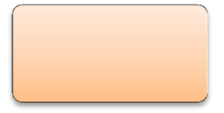

Sustained release

**SRDF**

Fig. 2.2 Classification of drug delivery systems based on duration of drug release

**Figure 1.1. Classification of Drug Delivery Systems based on Drug Release Mechanism**

* + - 1. *Immediate release dosage form*

Immediate release dosage forms (IRDF) are designed to release the drug shortly after it is administered in order to elicit fast onset of action that results into a quick therapeutic response. The speed with which this occurs depends on the type of dosage form administered. The delivery systems are designed to release drug instantly in order to achieve high plasma concentration immediately. This fast onset will occur only if the drug is soluble and dissolves readily (Sudha *et al*., 2010) so that it passes easily through the epithelial membrane to enable its absorption. Drug interactions with body receptors is mostly at molecular level thus the drug has to dissolve if it is solid into a solution for absorption to occur. For instance, preparations like injectable and infusions already exist in the liquid form and do not require dissolution and release from the dosage form hence administered directly into the systemic circulation without hindrance from any mucosal barrier and thus reach their active sites in null time. Likewise, liquid oral solutions do not need to be released from any dosage form rather; they simply mix with the gastric fluid for absorption to occur. In contradiction to this, suspensions (though in liquid form) will have to disperse into GI fluid while powders, tablets and capsules need to break up into finer aggregates that will dissolve or disperse in the GI fluid prior to absorption. Depending on the cohesiveness of the individual dosage forms, their onset of action is in the following decreasing order; intravenous solutions > oral solutions > suspension> emulsions > powders > tablets > capsules. The dissolved drug is quickly absorbed via diffusion into the systemic circulation and this quick absorption enables a peak plasma concentration (C max) to be reached in a relatively short time. Drug kinetic is via First order model, that is as soon as the drug reaches peak absorption, distribution and subsequently elimination occurs in a similar manner (Aulton, 2007; Perrie and Rades, 2010).

The time at which peak plasma concentration (tmax) is reached in an IR depicts its effectiveness. For the tmax to be prolonged it requires either more dose to be administered (risk toxicity) or an increase in frequency of administration which eventually will lead to increase patient non compliance. To prevent this, dosage forms can be formulated to release the active drug for a longer time or a much later time after administration having the drug concentration within the therapeutic range. These types of dosage forms are said to be a modification of the IRDF (Yihong and Zhou, 2011).

* + - 1. *Modified release dosage forms*

These systems are designed to modify the release of active ingredients from the DDS by prolonging the release time and duration (extended release –ER / Prolonged release PR) or by preventing release of the active drug constituents until a later time after drug administration (Delayed release -DR) in the small intestine (enteric coated dosage forms- ECDF). Furthermore, they can be designed to distribute maximally at a specified site tailored by polymers or antibodies (Targeted release- TR) for example colonic drug delivery and timed release to counter diurnal nature of some diseases like late night heart attacks and early morning arthritis. Several drugs have been formulated as prolonged release e.g. Procardia XL (Nifedipine) and Slow-Lopressor Divitab (Metoprolol tartarate), are once daily regimen in the treatment of hypertension (Yihong and Zhou, 2011).

* + - 1. *Types of modified release systems*

# Delayed Release Dosage Forms (DRDF)

As a matter of fact, delayed release is a direct opposite of immediate release after administration. However, at some point after the delivery system reaches its target area, it then becomes similar to an IRDF.

It is all about delivering or releasing the drug in the small intestine or colon at some time interval after oral drug administration. As the drug transits through the gut it is protected from degradation by the acidic environment of the stomach (e.g. erythromycins and penicillins) and the stomach is protected from irritation by the drug (e.g. Aspirin) due to the presence of protective acidic/inert polymer coating(s) on the drug surface which are either insoluble, stable or have limited solubility in the acidic segments of the GI.

In other to achieve DR, granules can be coated prior to compression into tablets and compressed tablets can also be coated; in both cases with the aid of a polymer that resist dissolution in the acidic environment of the stomach but dissolves at higher pH regions (4-7) in the small intestine. Like in IR, **tmax** and not Cmax is most important in DR and it depends on individual gastric empty. The plasma concentration curve is similar to that of an IR once the drug reaches its location of release (Collett and Moreton, 2007; Perrie and Rades, 2010).

# Extended release (ER) /prolonged release (PR)

This type of release system aims to reduce dosing frequency with its associated side effects; improves patient compliance and therapeutic outcome by prolonging the duration of drug release above the minimum effective concentration (MEC) usually from 8-12 hours (Collett and Moreton,2007). This can be achieved by the use of chemical and physical barriers to obtain

different drug release profiles (Yihong and Zhou, 2011). Basically ER formulations are either sustained or controlled release. Sustained release is usually achieved by mixing an active drug with excipients or binders that alters the drugs dissolution rate in GI or adsorption from local injection site while controlled release must include a component that can be engineered to an essential characteristic e.g. duration of drug release, rate of release or targeting and must have a duration of action longer than a day (Saltzman, 2001).

* Sustained release (SR)

This type of ER system provides prompt achievement of drug plasma levels that reduces gradually over a prolonged period of time but maintained within the therapeutic range. SR systems are able to reduce dosage frequency and control drug release by the use of suitable polymer to formulate reservoir systems (coated granules or tablets) or matrix (dissolved or dispersed drug in polymer) tablets.

The release kinetics of these extended release delivery systems is variable due to the way each of the systems releases the drug and also the nature of the rate controlling agent. The membrane/ reservoir systems release via zero order kinetics where as the matrix systems usually give a linear release as a function of square root of time – Higuchi model.

* Controlled release (CR)

This system achieves prompt drug plasma concentration which is maintained constant within the therapeutic range over a prolonged period of time independent of the biological environment of drug administration therefore controls the drug concentration in the body as well as its release. However, this does not mean that the drug reaches its target site. The aim of controlled release is to control the plasma concentration of drug itself by achieving reproducible release kinetics and

obtaining predictable plasma concentrations just like infusions but without the limitations of infusions (Attwood and Florence, 2008).Drugs used for long term treatment where plasma concentration requires to be maintained are the beneficiaries of CR. These release systems are characterized by drug release rate at a predetermined pattern over a fixed period of time say 20µg/h and not dose per tablet or dosage form for example in conventional dosage forms.

Delivery systems common to controlled release are

* + Polymer matrix diffusion controlled: drug release is via diffusion through a polymer matrix. A linear graphic of release profile as a function of square root of time is obtainable and the choice of polymer- drug mixture determines whether a sustained or controlled release is achieved. Moreover, polymers that are liquid or semi solid at room temperature or at body temperature will not produce controlled release but at best sustained release (Perrie and Rades, 2010).

# Targeted release (TR)

Drug targeting aims at distributing the drug at the appropriate site of action so as to prevent/minimize side effects and toxicity associated with drugs not binding to the desired cells, tissues or organs of required action and consequently reduce drug efficacy.

# Drug delivery/release systems and mechanism of release

The choice of type of delivery system to formulate will depend on the influence of GI structure, function of delivery system; the drug release profile and mechanism by which the delivery system releases the drug whether from a membrane or matrix system. Drug diffusion, dissolution, swelling; erosion or osmotic pressure induced are the several mechanisms involved in the release of drug from a prolonged release system. Drug release can be by one or more of the

mechanisms depending on polymer type utilized. However, the basic principle that governs these systems is that drug release is diffusion driven along a concentration gradient from a drug rich region (glassy region/reservoir/core) into a water rich region (surrounding medium).

* + - 1. *Reservoir/ Membrane system*

Reservoir also called membrane systems is usually a thin film of polymeric coat that surrounds a tablet, pellet or granule. The coated formulations are called reservoir systems, the drug in the core is the reservoir and the coat acts as the membrane. In this type of system diffusion occurs in a thin water insoluble film around the core though water soluble polymers may also be used. This type of system is used to control the release of water soluble drugs surrounded by insoluble film made porous by addition of leachable additives e.g. water soluble polymer or plasticizers.

Drug release via diffusion is in twofold. First of all, fluid influx into the delivery system occurs as comes in contact with water which dissolves the drug and builds up a concentration gradient between the core and the membrane. Secondly, the dissolved drug diffuses into the surrounding membrane and gets released.

Reservoir systems are able to produce a near zero order drug release which is favourable for the gradual sustained release. This is because the permeability of the drug through the membrane and drug concentration is not always constant as the swelling of the polymer membrane on contact with fluid may occur thereby increasing the membrane thickness/diffusion path length. For instance, when a new formulation is just made and allowed to make contact with the GI fluid, hydration of the polymer film occurs first thus increase the membrane thickness and the partition coefficient before the fluid can get contact with the core. A lag time is produced. Following on from this, an old preparation will contain some of the drug particles that may have diffused around the coat such that when immersed in fluid will immediately release some of the

drug leading to a burst effect. This two put together explain why zero order cannot be achieved but a near zero order release. Zero order is only obtainable when both permeability and drug concentration in the reservoir are constant. Development of reservoir systems requires several manufacturing steps hence costly, moreover it is structurally complex and not all drugs can be developed into reservoir, insoluble drugs for example, will not or diffuse slowly through hydrophobic membranes and besides single (monolithic) systems may lose coat integrity as a result cause dose dumping leading to increased toxicity. For this reasons matrix systems are designed to deliver such insoluble drugs (Collett and Moreton, 2007; Perrie and Rades 2010).

* + - 1. *Matrix systems*

In a matrix system the drug molecules are dispersed or dissolved homogeneously throughout a solid polymer phase. Depending on the nature of rate controlling agent, matrix systems can be divided into hydrophobic and hydrophilic systems (Collett and Moreton, 2007; Yihong and Deliang, 2011).

* + - * 1. Hydrophobic systems generally have the drug dispersed in inert matrices that allow ingress of water followed by drug dissolution and then diffusion into the surrounding medium.

These types of systems give a linear function of square root of time as described by Higuchi (1961,1963 cited in Costa and Sousa Lobo) and not zero order release. This is so because the polymer will hydrate then imbibe fluid before the drug can diffuse out. After sometime there will be a drug depleted layer created as result of drug exhaust at that point thus increasing the path length for diffusion for the remaining drug in the matrix. So drug in matrix is not constant at any given time i.e.

𝑀 =*Kt1/2* Equation 1

Where M = amount of drug released with time t and K is a constant.

For a polymer to release drug via Higuchi model in a matrix system it must not dissolve, when exposed to release medium it must not swell and drug diffusivity must remain constant during its release process. This conditions are not followed by most polymers including HPMC and utilize the diffusional exponent or power law or Korsmeyer-Peppas mechanism of drug release (‗*n*‘ based on matrix aspect ratio (diameter: length) to describe the release mechanism from such systems (Costa and Sousa Lobo, 2001; Collett and Moreton, 2007; Perrie and Rades 2010). This is shown in Table 2.2.

The focus of this research work is based on matrix systems formulated from hydrophilic natural polymers.

* + - * 1. Hydrophilic matrix/ Swellable soluble matrices

In general hydrophilic polymers are also called swellable polymers. In a delivery system they comprise a compressed mix of drug particles and a water swellable hydrophilic polymer which on contact with water hydrates, swells and forms a gel that remains intact through GI transit.

As described by Paolo *et al* (2000), Swellable polymers are responsive materials which are unintelligent as they do not respond to stimuli of pH, temperature and ionic strength rather, they respond to presence of water or biologic fluids that affect their physical characteristics and enable drug release from within their matrices.

Several polymers of semi synthetic grade (HPMC of high viscosity USP grade, Metholose and Methocel) synthetic (polyethylene oxide (PEO)) have been employed as

unintelligent swellable matrices. Further, Carbopol and natural gums such as Xanthan and guar gums which are pH sensitive have also been employed in colonic drug delivery where pH is of importance.

Design principle

The active drug and matrix former are dispersed together with glidant and lubricant to form a homogenous mix and then compressed. The compact formed hydrates in water and swells allowing fluid to diffuse in and drug to diffuse out through the hydrated matrix layer. The thickness or viscosity of this layer governs the rate of diffusion in and out and also the rate of drug release. Consequently the outer hydrated matrix becomes very dilute (gel layer) and erodes into the surrounding medium where it gradually dissolves to release the drug entrapped in the gel. Swelling controlled matrix systems have an edge over diffusion controlled matrix systems because burst effect (burst drug release) does not occur as swelling has to occur prior to drug release (Saltzman, 2001).

Polymer transition

In their glassy state, true swellable polymers restrict drug movement until the matrix comes in contact with fluid. Once in contact with fluid, the glassy (dry) matrix hydrates and swells transforming to a rubbery state due to a lowering in transition (Tg) temperature. In this case water or the fluid acts as a plasticizer (Colombo *et al*., 1996; Paolo *et al*., 2000; Perrie and Rades 2010). The individual chains of the polymer increase in size such that the end to end distances and their radius of gyration expand to a new solvated state.

This wetting and swelling process results into gel layer formation around the matrix which serves as a protective. The gel layer is exposed to several changes in its structure

and thickness as it becomes strongly entangled until it gets sufficiently hydrated by the surrounding fluid and then it relaxes and disentangles and allow for drug diffuses into the surrounding medium.

Slow gel formation however is not desirable, for instance as occurs in hydroxyl propyl cellulose (HPC), Carboxyl methyl cellulose (CMC) and Tragacanth gum. The slow gelling allows for fluid penetration into the matrix which enhances fast drug release or even matrix disintegration. They are therefore unsuitable for use as swellable matrices alone but may be used in combination with other polymers to modify swelling. For a swellable matrix to perform effectively, it requires adequate gel strength which depends on polymer concentration, chemical structure of the rubbery state and its viscosity.

Drug release and kinetics from swellable matrices

Swelling as a characteristic of swellable matrices is described by points or positions at which sudden physical changes in the matrix occur. These positions are called ―fronts‖.

Swelling front

During swelling two regions immediately form. The rubbery region where water acts as a plasticizer to lower the Tg below the experimental temperature (37º C) from the glassy region which has Tg above the experimental temperature.

Diffusion front

This is the boundary in the gel layer that separates the solid drug from the dissolved drug. Diffusion of drug during release from the matrix is dependent on its solubility, loading, drug dissolution rate and gel formation. The positions of swelling and erosion

fronts determine the gel layer thickness with time. Gel layer thickness is further defined as the distance between swelling and erosion fronts.

Erosion front

This region separates the matrix from the surrounding medium.

Drug release mechanism from swellable matrices

The movement of swelling, diffusion and erosion fronts are useful in determine drug release kinetics. The rate of liquid uptake is clearly associated with the swelling front; the diffusion front determines the rate drug dissolution while the rate of matrix dissolution/ erosion describes the erosion front. Outward movement of the erosion front occurs with matrix swelling and inward movement is suggestive of matrix dissolution. After fluid penetration the swelling front moves inward (Colombo, 1996; Balaji, 2006).

Drug release from swellable matrices is greatly influenced by presence of water/ fluid. The kinetics of drug release depends on the gel layer thickness. The gel layer has to form before any drug can be released in this type of matrix tablets. The dissolved drug moves through a gradient in the gel layer whereas the drug concentration (depends on drug loading and solubility) and gel layer thickness governs the drug flow/flux. The gel layer thickness depends on its response with the interacting solvent which translates to fluid uptake, relaxation and subsequently drug flow into the medium.

At the beginning, solvent penetration is more rapid than chain disentanglement, and a rapid build-up of gel layer thickness occurs. However, when the solvent penetrates slowly, owing to an increase in the diffusional distance, little change in gel thickness is obtained, because penetration and disentanglement rates are now similar. Thus, gel-layer

thickness dynamics in swellable matrix tablets exhibit three distinct phase. The thickness increases when solvent penetration is the fastest mechanism, and remains constant when the disentanglement and water penetration occur at a similar rate (that is swelling and erosion fronts occur simultaneously hence a linear graphic of release profile is obtainable). Finally, the gel-layer thickness decreases when the whole polymer matrix has undergone transition from glassy to rubbery state. The quasi pattern of polymer chain relaxation is thought to contribute to the anomalous behaviour in the release kinetics. For drug to be released from swellable matrices it is imperative that the gel layer forms on interaction with fluid. The net kinetics is therefore water penetration - Polymer swelling- drug dissolution/diffusion - polymer erosion/ dissolution while the mechanism remains drug diffusion through the gel layer (Paolo *et al*., 2000)

Advantages of hydrophilic matrix system

Excipient are cheap and regarded as GRAS (Generally Regarded As Safe)

They are capable of sustaining high drug loading and tolerate drugs with various physicochemical characteristics

They either dissolve or erode and therefore eliminate ghost matrix formation

The technology is well established and the manufacture is simple and performed by any tablet manufacturing methods and equipments.

It is possible to obtain a zero order, first order or a bimodal release depending on method of formulation and in- use concentration.

Disadvantages

Drug release depends largely on matrix hydration and drug in drug out mechanism

Drug release is only via a hydrated gel layer this can be problematic if one does not form

Scale up to manufacture can be problematic

May produce batch to batch variations especially with regards to natural polymeric materials

Different API may require different polymers and concentrations to obtain desired release profile (Collett and Moreton, 2007; Yihong and Deliang, 2011).

Case II transport

Case II transport describes drug release mechanism that is based on polymer swelling. When a matrix dosage form comes into contact with water it imbibes water and swells. The swelling is as a result of a change of the amorphous glassy state of the polymer to a rubbery state made easy by water which acts as a plasticizer to lower the glass transition temperature of the polymer. In this rubbery state, the polymer molecules become loose and their mobility increases leading to an increase in volume and drug diffusion from the matrix into the surrounding. Polymer swelling at this point controls the drug release.

Table 2.2 Interpretation of diffusion release mechanism from polymeric dosage form with varied geometry

|  |  |  |  |
| --- | --- | --- | --- |
| DF geometry | Release exponent ‗n‘ | values |  |
|  | FD | CII | FD & CII |
| spherical | 0.43 | 0.85 | 0.43 - 0.85 |
| Cylindrical | 0.45 | 0.89 | 0.45 - 0.89 |
| slab | 0.5 | 1.0 | 0.5 - 1.0 |

Key: DF = dosage form, FD= Fickian diffusion and CII = Case II transport (Costa and Sousa Lobo, 2001)

# Mathematical models describing drug release kinetic and mechanism

These release models are used to evaluate drug release kinetic and mechanism from modified release systems by fitting dissolution values into them.

1. Mathematical models for Zero order describes the system where the release rate from the drug is not dependent upon its concentration. It is represented by plot of cumulative drug release versus time. Using regression values, the dissolution profile is rated as zero order if R2 ≥ 0.975, near zero order if R2 ≥ 0.950 < R2< 0.975 and no zero order if R2 ≤ 0.950. The model is represented by the equation;

*Q = K0* t. Equation 2

Where *Q =* amount of drug dissolved in time, *t* and *K0* = zero order rate constant

1. First order release model proposed by Gibaldi and Feldman (1967) is used to describe absorption and elimination of some drugs. The drug release rate is dependent on concentration. This is described by a plot of log cumulative of % drug remaining in matrix versus time. The equation below represents the model.

*Log Qt = Log Q0 – K1t /2.302* Equation 3

Where *Qt* = amount of drug dissolved at time *t; Q0* = initial amount of drug in solution and *K1*= first order release constant

1. Higuchi model which describes drug release from insoluble matrices as a square root of time based on fickian diffusion. This is determined using plot of log cumulative % drug release as a function of square root of time. The model is represented by equation 1 above.
2. Korsmeyer- Peppas model derived by Korsmeyer (1983) and Peppas (1985) is used to determine the release mechanism from polymeric systems where there is uncertainty

on the mechanism or when more than one mechanism is involved. This is done using a plot of *in vitro* dissolution values obtained as log cumulative drug % released versus log of time (Costa and Sousa Lobo, 2001; Paolo *et al*., 2001; Harris *et al*., 2006). The model is represented by the equation;

𝑀𝑡 = 𝐾𝑡𝑛 Equation 4

𝑀*∞*

where,

Mt/M∞ = fraction of drug released at time t,

K= rate constant incorporating the properties of macromolecular polymeric system and the drug,

*n* = the release exponent use to characterize the transport mechanism.

# Similarity factor

The similarity factor (*f2*) is a pair wise procedure of assessing means of two dissolution data (Moore and Flanner (1996) cited in Costa and Sousa Lobo, 2001). It is defined as the logarithmic transformation of the sum squared error of differences between the test Tt and the reference product Rt

*f2* = 50 + log {[1+ (1/n) Σt=1 n(Rt−Tt)2]−0.5 x100}… Equation 5

Where *f2* is the similarity factor, n is the number of time points, Rt is the mean percent drug dissolved of reference formulation and Tt is the mean percent drug dissolved of the test formulation.

Generally, *f1* values lower than 15 (0 -15) and *f2* values higher than 50 (50 -100) show similarity of dissolution profile. Further the centre for drug administration and research (FDA) and the European agency for the evaluation of medicinal products (EMEA, 2000) suggested that two

dissolution profiles are declared similar if *f2* is between 50 and 100 (Costa and Sousa Lobo, 2001).

# Components of delivery system

The formulation components are the same for oral MDRF and only differ in the proportion, nature of polymer (hydrophilic, hydrophobic or inert) used and the method of manufacture. A description of components of the formulations is given in Table 2.3.

* Active ingredient/ drug
* Release controlling agent ( matrix/membrane formers)
* Matrix/membrane modifier (solubilizers, wicking and channelling agents)\*
* pH modifiers\*
* lubricant (sodium stearyl fumerate, magnesium stearate, etc)
* glidant (talc, colloidal silicone dioxide)
* density modifiers and supplementary coatings\* The asterisked are used only when necessary

Table 2.3 Components of ER delivery system

|  |  |  |  |  |  |  |
| --- | --- | --- | --- | --- | --- | --- |
| **Function** | | **Description** | **Concentration** | **Examples of ingredients** | | |
| Matrix formers | | Hydrophobic matrix (solid | 20- 40% | * Hydrogenated oils of vegetable, cotton seed & soy   ; microcrystalline & canauba waxes   * HPMC, HPC, SCMC, alginates & Xanthan gum, poly ethylene oxide,Carbopol, natural gums and   mucilages | | |
|  | | at room & body |  |
|  | | temperature) |  |
|  | | Hydrophilic matrix | 20-80% |
| Channeling agents | | Soluble in the GIT & leach from the formulation to create pores from which dissolved drug diffuses out. | 20-30% | Drug polyols chloride | itself, and | sugars, sodium |
| Gel modifier | | Useful in hydrophilic matrices. make allowance for fast or slow hydration, diffusion and enhance drug  release rate |  |
| Solubilizers/ modifier | pH | Enhances drug dissolution |  | Polyols, polyethylene glycols PEGs, surfactants and buffers | | |
| Glidant | | Prevent melting of lipidic polymers & punch sticking | 1-2% | Talc, | | |

|  |  |  |  |
| --- | --- | --- | --- |
|  | of hydrophilic polymers | 5-10% | colloidal silicone |
| lubricants | Lipidic polymers are self lubricating.  Reduce die wall friction, enhance flow of formulation from the hopper into the die, prevent punch sticking and reduce  interparticulate friction | |  |

# CHAPTER THREE

* 1. **MATERIALS AND METHODS**

# MATERIALS

* + 1. **Plant Material**
* *Adansonia digitata* leaves from Baobab trees

# 3.1.2. Chemicals and Reagents

* Acetonitrile, HPLC grade. (Fisher Scientific Ltd, UK)
* Bisoprolol Hemifumerate salt, (HPLC solid) (Sigma life science, Germany)
* Colloidal silicium dioxide, (BUFA, Belgium) pharmaceutical products
* Crospovidone Ph. Eur. Type A, USP/NF (Kollidon® CL), (BASF SE, Germany)
* Ethanol 97% denatured with 3% IPA, (Disolol®), (Chem.-Lab NV, Belgium)
* Hydrochloric acid, 37%w/w. (Fisher Scientific Ltd, UK)
* Hydroxyl propyl methylcellulose ( HPMC 60SH4000) Metolose® (Shin-Etsu chemicals, Japan)
* Lactose monohydrate (200µ size), (Fargon, Belgium)
* Magnesium stearate, Ph. Eur. (ABC Chemicals, Belgium)
* Methanol dry (Hydranal® ), (Sigma Aldrich, UK)
* Metoprolol tartarate EP. (Utag Almere, The Netherlands)
* Nitrogen gas
* Phosphoric acid, 85 w/w % solution in water, (Acros Organics, Belgium)
* Polysorbatum 80, Ph.Eur. (Fargon, Belgium)
* Potassium sorbate (Purum.pa ≥ 99.0% (NT) Sigma Aldrich, Germany)
* Sodium phosphate dibasic (Na2HPO4), Bioxtra ≥ 99.0%, ( Sigma Aldrich, UK)
* Sodium phosphate monobasic dihydrate (NaH2PO4.2H2O) Bio ultra ≥ 99.0%, (Sigma Life Science, Germany)
* Sodium stearyl fumerate, (Pharmatrans-sanaq AG Pharmaceutical, Switzerland)

# 3.1.3 Equipment

* 10 port extraction manifold
* Agilent VNMRS Direct Drive 400MHz spectrometer (9.4 T wide bore magnet) equipped with a T3HX 3.2 mm probe
* Attenuated Total Reflectance Fourier Transforms Infra Red Spectrometer (Thermo Fisher Scientific, Nicolet iS5 ATR FT-IR spectrometer, Erembodegem-Aalst, Belgium)
* Automated tapping machine (J. Englesman, Ludwigshafen, Germany)
* CHN Elemental analyzer with Eager 300 software
* Centrifuge (Multifuge 3S-R, Heraeus, Germany)
* Differential scanning calorimeter (DSC Q2000 V24.10, Build 122)
* DSC Universal V4.5A TA instrument software
* Digital compression force indicator (AD-4532A)
* Digital vernier caliper (Bodson, Liuk, Belgium)
* Digital weighing balance AB 204-S (Metler,Toledo ,Switzerland )
* Disintegration apparatus (PTZ E, Pharma test Hainburg, Germany)
* Dissolution Full flow filters (35 micron, Agilent technologies, USA)
* Dissolution system (VK 7010, VanKel NC, USA)
* Dissolution system automatic sampling station (VK 8000, VanKel NC, USA)
* DL35 Karl Fisher titrator (Metler Toledo, Beersel, Belgium)
* Dynamic Vapour Sorption (DVS Cahn D200, UK)
* Eccentric tablet press (Type EKO Korsch, Germany)
* Friabilator (PTF E Pharma test, Hainburg, Germany)
* Hardness tester (Sotax HT 10, Basel, Switzerland)
* Hermetic pans and Lid (A39817-03, USA)
* HPLC auto sampler (L-2200, Merck, Elite, Tokyo, Japan)
* HPLC guard column (LiChroCart® 4-4, LiChrospher® 100 CN (5 µm), Merck, Darmstadt, Germany), Florescence detector (L-7480, Merck, Hitachi, LaChrom Tokyo, Japan)
* HPLC system (Hitachi LaChrom, Tokyo, Japan)
* HPLC Isocratic solvent pump (L-7100, Merck, Hitachi LaChrom, Tokyo, Japan)
* HPLC Software package D-7000 HSM Chromatography Data Station (Hitachi Instruments, San Jose, CA, USA).
* Qicpic analyzer (QP0233, Sympatec, Germany) with GRADIS (gravity disperser for dispersion of coarse particles), 1.00 63.0 mm - M7)
* Rotational viscometer (Modular Compact Rheometer series 102, PP50, Anton Paar GmbH, Graz, Austria)
* Scanning electron microscope (Quanta 200F (FEI, Eindhoven, The Netherlands)
* Solid phase extraction (SPE) cartridges (Oasis® MCX 1cc (30mg), Waters, Brussels, Belgium)
* Turbula mixer (Turbula system schatz, Switzerland)
* Ultrasonic bath (5210 Branson, France)
* Vacuum oven (WTC Binder, Tuttingen, Germany)

# 3.3 METHODS

* + 1. **Collection, Authentication and Extraction**
       1. *Plant Collection*

Leaves of *Adansonia digitata* were plucked off from Baobab tree at Danjibga area of Zamfara State, Nigeria during the harmattan season. They were taken to the herbarium unit of the Department of Biological Sciences of Ahmadu Bello University for authentication. After identification, voucher specimens were kept in the herbarium. *Adansonia digitata* leaves were assigned voucher number **7071**.

* + - 1. *Purification/* Extraction of *Adansonia digitata* Mucilage

Aqueous extraction of the mucilage was first obtained followed by precipitation with ethanol. The crude dried leaves of *Adansonia digitata* were size reduced to fine powder using a homogenizer and sieved through 250 µm mesh. A two hundred (200.0) gram weight of the leaf powder was macerated in 4.0 L of deionised water, preserved with 0.1 % potassium sorbate and allowed to disperse for a period of 24 h at room temperature of 20 ºC. The thickened mucilage was then diluted to 10.0 L with deionised water and allowed to separate by sedimentation at 6 ºC in the refrigerator for 5 days. Thereafter, the mucilaginous supernatant was collected and filled into centrifuge tubes equally by weight and then centrifuged at 4000 x g for 20 min at 4ºC to remove the fine leave particulates from the mucilage. A total of 8.0 L of mucilage was collected and precipitated with 12.5 litres of 97% Ethanol. The precipitated mucilage was thoroughly washed with ethanol to remove chlorophyll until it formed a clear rubbery clumped material. The clump was shredded and spread on adsorbent paper to air dry before packing into beakers and sealed with perforated aluminium foils for further drying by vacuum at 40º C for 48 hours. A

total 1.2 Kg of the leaves were extracted following the above procedure and termed *Adansonia digitata* mucilage (ADM).

# Phytochemical screening of purified ADM

To ascertain the purity of the processed mucilage phytochemical tests for alkaloids, glycosides; steroids; carbohydrates; flavonoids; terpenes; amino acids; saponins; oils and fats and tannins were carried out as outlined by Trease and Evans (1983).

The following preliminary confirmatory tests for gums and mucilages were also performed as described by Jani *et al* (2009).

1. *Ruthenium test:*

A 100 mg weight of ADM was mounted on a slide with ruthenium red solution, and then observed under the microscope for change in colour which was recorded.

1. *Iodine test*

To a 100mg of ADM, one (1) ml of iodine 0.2N solution was added and the colour change observed was recorded.

1. *Test for Carbohydrates*

A few drops of Molisch reagent was added to about 2 ml of aqueous ADM dispersion in a test tube. A little quantity of conc. sulphuric acid was allowed to run down the side of the tube at an angle of 45° to form a lower layer. The colour of the solution was also noted.

# Physicochemical characterization of plant materials

* + - 1. *Percentage Yield of Purified* ADM

The dried mucilage obtained from the crude dried leaves of *Adansonia digitata* was weighed and the percentage yield was computed as given in the equation below.

% 𝑦i𝑒𝑙𝑑 = 𝖶1 × 100 Equation 6

𝖶2

Where, w1 and w2 are weights of purified mucilage and weight of crude gum leaves respectively.

* + - 1. *Organoleptic Properties of* ADM

Organoleptic properties such as colour and texture were determined as follows. Colour of powdered test samples and texture were observed with the aid of the sense organs and the findings recorded.

* + - 1. *pH determination*

A 1.0 % w/v concentration of ADM was prepared in deionized water and the pH determined using a pH meter.

* + - 1. *Determination of Apparent Viscosities of the Mucilage*

The viscosities of aqueous dispersions of ADM were measured using a rotational viscometer with a plate-plate technique applying a gap of 1 mm and performed at a constant temperature of 20º C. Concentrations of 1, 2, 3 and 4% w/v were investigated by applying varying ranges of shear rate from 0.1s-1 to 2000 s-1. Graphs of shear rate versus shear stress were plotted to determine the flow characteristics of the dispersions.

* + - 1. *Determination of Aqueous Solubility*

This determination was carried out using gravimetric analysis. One (1.0) gram quantity of ADM sample was weighed into 1.0 L of deionised water and allowed to hydrate at room temperature for 24 h. Thereafter, the dispersion was filtered through a pre weighed filter paper (Whatman size 1) of medium porosity. The residue on the filter paper was dried in an oven at 40 ºC for 24 h and the differences in weight determined as described by Nep and Conway (2010).

# Analytical tests

* + - 1. *Elemental Analysis*

Elemental analysis using Carbon, Hydrogen and Nitrogen (CHN) method attached to Eager 300 software was carried out in order to determine the elemental composition of the mucilage. A 2.655g quantity of ADM was combusted at 900 °C in presence of excess oxygen. The combustion products were separated by means of programmed temperature desorption system which measured thermal conductivity variations using K factor calibrations.

* + - 1. *Thermal Analysis by means of differential scanning calorimeter (DSC)*

A 1.4 g quantity of ADM was carefully weighed and encapsulated in hermetic pans then covered with hermetic lids in order to measure their degradation, glass transition (Tg) temperatures and melting points (Tm) using Differential scanning calorimeter connected to a Universal V4.5A TA instrument software. The DSC pan and lid were sealed with special punches and heating was performed at a rate of 10° C/ min and ramping was performed from -20 °C to 250 °C using nitrogen as purge gas.

Further, a 50/50 well triturated physical mixture of ADM sample with MPT and the individual tablet compacts formulated were encapsulated and scanned with the DSC to determine

compatibility and effect of mixture on degradation and Tg temperatures. The Thermograms of MPT, ADM, the binary mix and compacts were overlaid to detect interactions and to observe differences in characteristic temperatures.

*3.2.4.3. Attenuated Total Reflectance Fourier Transforms Infrared (ATR -FTIR) Studies*

An ATR-FTIR spectroscopy was conducted on the purified ADM powder. Spectra were recorded using an ATR FT-IR spectrometer while a diamond ATR crystal was pressed against the samples. Each spectrum was collected in the 4000 - 550 cm-1 range with a resolution of 4 cm- 1 and averaged over 128 scans.

The functional groups present were identified. An identity to the polysaccharides depending on their chemical structure and chain conformation was obtained.

* + - 1. *Carbon-13 High-Resolution Solid-State Nuclear Magnetic Resonance (NMR) studies*

Carbon-13 solid-state CP/MAS NMR spectra were acquired at ambient temperature on an Agilent VNMRS Direct Drive 400MHz spectrometer equipped with a T3HX 3.2 mm probe dedicated for small sample volumes and high decoupling powers. Magic angle spinning (MAS) was performed at 12 kHz with ceramic zirconia rotors of 3.2 mm in diameter (22 μl rotors). The aromatic signal of hexamethyl benzene was used to determine the Hartmann-Hahn condition (1H = H B1H = C B1C = 1C) for cross-polarization (CP) and to calibrate the carbon chemical shift scale (132.1 ppm). Acquisition parameters used were the following: a spectral width of 50 kHz, a 90° pulse length of 2.5 s, a spin-lock field for CP of 100 kHz, a contact time for CP of

1.5 ms, an acquisition time of 20 ms, a recycle delay time of 10 s and 25000 accumulations. High power proton dipolar decoupling during the acquisition time was set to 100 kHz.

* + - 1. *Moisture content determination*

The moisture content of ADM was determined using a Karl Fischer titrator in combination with a Metler balance. About 20 ml of methanol dry (Hydranal) used as the titrant. A 50 mg weight of ADM was transferred into the system and the percentage water content was determined. The experiment was performed in triplicate.

* + - 1. *Dynamic vapour sorption (DVS) studies*

A 4.74g quantity of ADM was placed on the DVS sample pan of an ultra microbalance with a mass resolution of ± 0.1µg. Then, ADM was dried under a stream of dry Nitrogen gas at 21 °C. Thereafter, the humidity was increased in 10 % RH steps to 100 % RH for the sorption phase and then decreased in a similar fashion for desorption phase.

* + - 1. *Particle Shape and Size Analysis by QICPIC*

The size and shape of ADM powder was evaluated using a dynamic imaging system (QICPIC with GRADIS). About 5 g of ADM was mounted on a vibratory feeder allowing the particles to fall through the fall shaft. The particles were illuminated by laser light while up to 450 images per second of clearly defined particles were viewed on a screen as they fell on to the extractor surface from where they were collected.

The different sample sizes and shapes were calculated with minimal error due to large number of counts by **Windox®** software. The cumulative frequency distribution curves, particle morphology and shape characteristics such as sphericity and aspect ratio were obtained.

* + - 1. *Surface Morphology Analysis by Scanning Electron Microscopy (SEM)*

SEM images were recorded with a Scanning electron microscope operated at an acceleration voltage of 12.5 kV. The powder was deposited onto a carbon carrier substrate. Images of ADM and other formulation additives were viewed at different magnifications.

# FORMULATION OF DELIVERY SYSTEMS

Based on the physicochemical characteristics of the purified mucilage, the following delivery systems with varying functionalities were formulated.

* + - 1. Formulation of Metoprolol tartarate (MPT) immediate release tablets using *Adansonia digitata* mucilage (ADM) as binder

A rigorous parameter was set in order to evaluate the effectiveness of ADM as binder in the formulation of immediate release tablets of MPT. This was performed by intra granular and extra granular addition of super disintegrants. Furthermore, the binder slurry displayed a tensio-active property due to which a surfactant (Tween 80) was added to batch G1 (Table 3.1).

Table 3.1 Formula for MPT tablets formulated with various composition (%w/w) of ADM as binder

%w/w batch composition

|  |  |  |  |
| --- | --- | --- | --- |
| Ingredients | G1 | G2 | G3 |
| Metoprolol tartarate | 40 | 40 | 40 |
| Lactose (200µ) | 51.17 | 51.0 | 50.5 |
| Crospovidone (intra) | 5.0 | 5.0 | 5.0 |
| ADM | 0.33\* | 0.5 | 1.0 |
| Crospovidone (extra) | 2.5 | 2.5 | 2.5 |
| Magnesium stearate | 1.0 | 1.0 | 1.0 |
| Total (%) | 100 | 100 | 100 |

Key:

G1 = 0.33%\* to the binder slurry 0.1% Tween 80 added G2 = 0.5%

G3 = 1.0 %

# Preparation of binder solution

The binder slurry was prepared by dispersing ADM powder in water sufficiently enough to allow for its hydration until a complete and uniform dispersion was obtained. This was carried out for G2 and G3 batches. With respect to batch G1, a 0.1% Polysorbate (Tween 80) was added to reduce surface tension between the powder bed and binder droplets. The resultant binder solutions were used in the formulation of tablets with composition as described in Table 3.1 above.

# Preparation of granules

The powder quantities (MPT, crospovidone (intra granular) and lactose) were dry mixed for 10 min in a Turbula mixer and then wetted with the different concentrations of binder solution to form a wet cohesive mass. The wet masses were manually passed through a 1.0 mm sieve to form the granules which were further oven dried at 40 °C for 24 h.

The dried granules were further screened through the same sieve and then stored in air tight containers until required. Further screening of granules was not done through a sieve with a smaller aperture so that the structure and composition of granules and fines did not change in order to evaluate the performance of binder on granule formation.

# Effect of binder on granule morphology via SEM

The extent to which each of the various binder concentrations affected granule formation and structural morphology was checked by performing SEM scans of the powdered drug and granules obtained from the different batches. Photomicrographs of the formed granules were compared with the results of QICPIC analysis.

# Moisture content

Moisture content of the formulated granules was determined using Karl Fischer titrator as described in 3.2.4.5 above.

# Density measurements

Tapped and bulk densities were determined as described below.

* Bulk and Tapped densities

The bulk volume (V0 ) of 30 g of granules was recorded in a 100 ml measuring cylinder as well as the volumes after 500 (V500) and 1250 (V1250) taps in an automated tapping machine. This was repeated three times according to USP (2006) specifications. The bulk density was recorded as;

𝐵𝑢𝑙𝑘 𝑑𝑒𝑛𝑠i𝑡𝑦 (𝐵𝜌) = 𝑚𝑎𝑠𝑠 𝑜ƒ 𝑝𝑜w𝑑𝑒𝑟 (g) Equation 7

𝑏𝑢𝑙𝑘 𝑣𝑜𝑙𝑢𝑚𝑒 (𝑚𝑙)

Tapped density was recorded as

𝑇𝑎𝑝𝑝𝑒𝑑 𝑑𝑒𝑛𝑠i𝑡𝑦 (𝑇𝜌) = w𝑒igℎ𝑡 𝑜ƒ 𝑝𝑜w𝑑𝑒𝑟 (g)

𝑡𝑎𝑝𝑝𝑒𝑑 𝑣𝑜𝑙𝑢𝑚𝑒 (𝑚𝑙)

.......................... Equation 8

Tapped density at V500 and V1250 were computed separately.

# Flow properties

Based on bulk and tapped density, the Hausner‘s ratio, which is a measure for the flow of the granules, was calculated according to the following equation:

𝐻𝑎𝑢𝑠𝑛𝑒𝑟 𝑟𝑎𝑡i𝑜 = 𝑡𝑎𝑝𝑝𝑒𝑑 𝑑𝑒𝑛𝑠i𝑡𝑦 Equation 9

𝑏𝑢𝑙𝑘 𝑑𝑒𝑛𝑠i𝑡𝑦

# Compressibility/ Carr’s index

Carr‘s index was computed as;

𝐶𝑎𝑟𝑟*'*𝑠 i𝑛𝑑𝑒𝑥 = 𝑇𝑎𝑝𝑝𝑒𝑑 𝑑𝑒𝑛𝑠i𝑡𝑦−𝐵𝑢𝑙𝑘 𝑑𝑒𝑛𝑠i𝑡𝑦 X100 Equation 10

𝑇𝑎𝑝𝑝𝑒𝑑 𝑑𝑒𝑛𝑠i𝑡𝑦

# Granule strength

In order to determine the effect of binder performance in terms of strength acquired by each batch of granules the method of Vercruysse *et al* (2012) was employed with some modifications. Friability of a size fraction of >150µm of 10g (*Iwt*) of the granules together 200 sphere glass beads exposed to falling shocks was determined using a friabilator rotated at a speed of 25 rpm for 10 min. The granule fraction < 150 µm and the glass beads were removed as fines and the weight retained (*Fwt*) on the sieve was recorded. Friability was calculated as percentage weight loss.

Friability % = *(I wt - F wt)/ I wt X 100* Equation 11

# Addition of extra granular excipient

To the dried granules in 3.2.5.1(b) above, crospovidone (extra granular) and magnesium stearate were added in calculated quantities (Table 3.1) and dry mixed for 2 min in a turbula mixer before compression into tablets.

# Tablet compression

Granule compression was performed using a pair of 10 mm fraction bar punches on an eccentric tablet press equipped with a digital compression force indicator at compression pressures of 1552 KgF to produce 250 mg tablets. Compressed tablets were dedusted and counted using a counter as they ejected from the die into the collector pan and then packaged until used.

* + - 1. *Formulation of prolonged release Metoprolol tartarate (MPT) tablets using Adansonia digitata mucilage (ADM) as matrix former*

Matrix system of modifying drug release simply involves mixing together in different proportion the active drug, hydrophilic polymer, glidant and lubricant (where necessary) to form a compact, pellets or matrices by the use of a suitable tabletting method. The direct compression method was employed herein.

# a. Blending of powder mix and compression

The active ingredient and hydrophilic polymer (ADM or HPMC) were mixed for 10 min using a pestle and mortar after which the glidant and lubricant were added and the powders were further mixed for 2 min.

The lubricated powder mix was compressed using a pair of 16 mm flat round bottom punches on an Erweka AR4 eccentric tablet press at compression pressures of 667 KgF (F3 & F4, 400mg MPT matrix tablets) and 1255 KgF (F1 & F2, 1000 mg MPT matrix tablets). Matrix tablets of MPT in combination with HPMC were also formulated in the same manner as described herein. The tablets produced were subjected to tablet quality assessment for modified (prolonged) release after storage for 24 h at a room temperature of 21 ºC and 30 % RH.

Table 3.2 Formula for MPT prolonged release tablets with either of ADM or HPMC as matrix former

%w/w batch composition

|  |  |  |  |  |  |
| --- | --- | --- | --- | --- | --- |
| Ingredients |  | F1 | F2 | F3 | F4 |
| Active drug | Metoprolol  Tartarate | 20 | 20 | 50 | 50 |
| matrix former | ADM | 79.4 | - | 49.4 | - |
|  | HPMC | - | 79.4 | - | 49.4 |
| Lubricant | Sodium stearyl fumerate | 0.5 | 0.5 | 0.5 | 0.5 |
| Glidant | Silicon dioxide | 0.1 | 0.1 | 0.1 | 0.1 |
| Total (%) |  | 100 | 100 | 100 | 100 |

Key:

F1= 20:80 MPT/ADM

F2 = 20: 80 MPT/HPMC F3 = 50:50 MPT/ADM F4 = 50:50 MPT/HPMC

# Evaluation of Formulated Tablets

The formulated tablets were subjected to official and non-official test methods. For the official tests, tablets were evaluated in accordance with USP, 2011 specifications.

* + - 1. *Determination of Weight variation, thickness, Diameter and Hardness tests*

Twenty (20) tablets were randomly selected and weighed individually on a digital Toledo balance and then the thickness, diameter and hardness of the individual tablets were determined using the Sotax HT 10 hardness tester connected to the digital weighing balance. The mean, standard deviation and relative standard deviation (RSD %) of the tablet weight, diameter; thickness and hardness were all calculated.

* + - 1. *Determination of tablet Tensile strength*

The equation below described by Fell and Newton (1970) was used to calculate the tablet tensile strength for tablets of 250 mg.

T = 2F/ᴨdt Equation 12

Where T; F; d and t denote tensile strength; diametral crushing strength (hardness), tablet diameter and thickness, respectively.

* + - 1. *Friability test*

Twenty six (26) tablets of 250 mg and sixteen (16) tablets of 400 mg equivalent to 6.5 g for tablets ≤ 500 mg and ten (10) tablets of 1000 mg were pre-weighed (w1) separately and transferred into the friabilator which was set to rotate at 25 revolutions per minute for 4 min. The tablets were then de-dusted and the final weight (W2) was recorded. The percentage weight loss was computed as friability below;

% Friability = W1 − W2

W1

× 100 Equation 13

* + - 1. *Disintegration test*

Six (6) tablets of the immediate release formulation were used for this test. Each tablet was placed in each of the six compartments of the basket of disintegration apparatus containing 900 ml of 0.1N HCL thermos-stated at 37 ± 0.5 °C. The time taken for each tablet to fully disintegrate and completely pass through the mesh without any palpable mass was recorded and the mean value was calculated as the disintegration time for the batch.

* + - 1. *Determination of crushing strength, friability and Disintegration time (CSFR/DT) index*

The crushing strength (CS), friability (FR) and disintegration time (DT) ratio was determined for immediate release tablets as described by Alebiowu and Adeagbo (2009).

CSFR Equation 14

DT

* + - 1. *Tablet imaging*

Images of the matrix tablets prior to, during and after dissolution taken with a digital camera (Nokia Lumia 630) were used to determine the mechanism and kinetics of drug release.

* + - 1. *SEM images of formulation and formulation ingredients*

As described in 3.2.4.8 above, scans acquired by SEM of the formulated granules, formulation ingredients including the active drug were used to determine their surface characteristics.

* + - 1. *In vitro drug release (dissolution studies)*

For the tablets formulated with *Adansonia digitata* mucilage, the *in vitro* dissolution profiles were determined as follows:

The matrix tablets (n=6) were each introduced individual into six separate dissolution vessels (USP dissolution apparatus 2). The dissolution was performed simultaneously in a VK 7010 dissolution system combined with a VK 8000 automatic sampling station (Plate III). Phosphate buffer (NaH2PO 4. 2H2O and Na2HPO4 pH 6.8) and 0.1N HCL (pH 1.0) were used as dissolution media while the speed of rotation of the paddles were set at 100 rpm and the temperature of the media (900 mL) was kept constant at 37 ± 0.5 °C. Samples of 5 mL aliquots were automatically withdrawn at 0.5, 1, 2, 4, 8, 10, 12, 16, 20 and 24 h time points without medium replacement. The samples were spectophotometrically analysed for MPT at 222nm by means of a UV-VIS double beam spectrophotometer with UV Probe Ver. 2.20 software. Phosphate buffer (pH 6.8) and 0.1N HCL (pH 1.0) were used in order to mimic the conditions of the stomach and small intestines.

As a result of interference of ADM in the absorption spectrum of MPT, dissolution samples of the formulated matrix tablets containing MPT were analysed using Raman spectrophotometer and subsequently a validated method of HPLC with florescence detection was performed.

The HPLC system (Plate IV) consisted of an isocratic solvent pump set at a flow rate of 1.1mL/min, an auto sampler set to sample 20 µL from each of the dissolution samples, a guard column 5 µm sizes, a variable wavelength florescence detector set at excitation and emission wavelengths of 275 nm and 300 nm respectively to detect MPT.

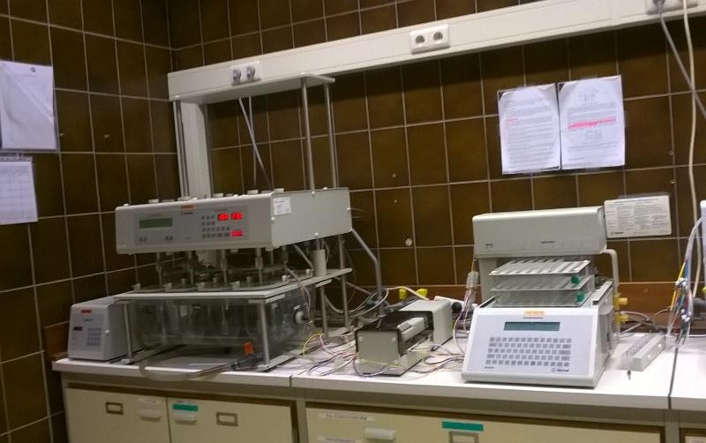

Plate III: Vankel **VK 7010** dissolution system combined with a **VK 8000** automatic sampling station

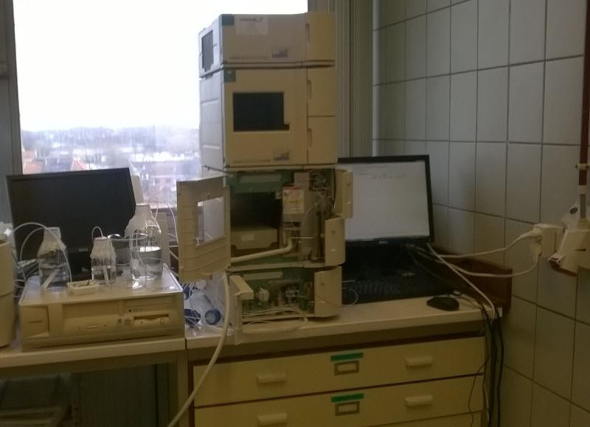

Plate IV: HPLC system, HITACHI la Chrom

The peak integrations were carried out using a software package D-7000 HSM Chromatography Data Station. A solution of 2M Sodium phosphate monobasic dihydrate (phosphate buffer), Acetonitrile and water (0.5/3.5/96; v/v/v) adjusted with drops of phosphoric acid to pH 3.0 was used as mobile phase.

For both spectrophotometric methods, concentrations of MPT were calculated from a calibration curve between 0 and 25 µg/mL. The procedure described above was used for *in vitro* dissolution of HPMC/MPT matrices. Graphics of MPT release profiles were obtained for the various concentrations used in the different matrix formulations.

* + - 1. *Liquid uptake, Erosion and Swelling studies*

As conducted in dissolution test above, the tablets were placed in the dissolution medium and removed at each dissolution time point taking note of the amount of MPT released. The tablets were also weighed after removal of excess surface fluid with a filter paper. A graph of % liquid uptake versus time was plotted.

1. Liquid uptake: This was calculated using the equation below:

% 𝐿i𝑞𝑢i𝑑 𝑢𝑝𝑡𝑎𝑘𝑒 = (𝖶𝑡−𝐷𝑡)−(𝖶i−𝐷0)

𝖶i−𝐷𝑡

X 100 Equation 15

Wt = weight of tablet at time (t) after immersion in dissolution medium W*i* =initial weight of tablet before immersion

D0 amount of drug in tablet before immersion at time (0) Dt = amount of drug in the tablet at time (t)

1. % Erosion was calculated using the differences in dried weight of the tablets after immersion and the initial dried weight at each time point taking into account amount of drug dissolved.

% 𝐸𝑟𝑜𝑠i𝑜𝑛 = (𝖶1−𝐷1)−(𝖶2−𝐷2)

𝖶1−𝐷1

...................................................Equation 16

Where,

W2 = dry weight of tablet at time (t) after contact with dissolution medium W1 = initial weight of tablets at time (0) before immersion

D1= amount of drug in the tablet at time (0) D2 = amount of drug in the tablet at time (t)

1. Swelling

The extent of swelling was determined using a digital vernier calliper. The height (axial) and diameter (radial) swelling of the matrix tablets pre and post immersion in dissolution media were measured. Graphics representing the axial and radial swelling in either of the dissolution media were plotted.

* + 1. ***In vivo* evaluation**

All procedures were performed in accordance with the guidelines and after approval by the Ethics Committee of the Institute for Agriculture and Fisheries Research (ILVO), Merelbeke, Belgium.

Of the two concentrations of ADM used as hydrophilic polymer matrices for prolonging MPT release, the 80 % matrix tablet (F1) was able to release up to 100 % MPT over 24 h while the 50% (F3) matrix formulation released 100 % MPT after 8 h. Since the aim of the work carried out is to produce a once daily prolonged release oral tablet, the F1 matrix tablets were used for *in vivo* evaluation. In order to determine MPT blood plasma levels, F1 matrix tablets were administered to six (6) dogs. The administration of MPT to dogs is considered to be safe (Fang *et al*., 2004; Lobenberg *et al*., 2005 cited in Verhoeven (2008).

To further assess the bioavailability of formulated MPT in the dogs, blood plasma level was compared with a pre- determined marketed controlled release formulation Slow- Lopressor® 200 Divitab (Vervaeck *et al*, 2013). The marketed product will be referred herein as F5.

* + - 1. *Subject and study design*

A group of mixed breed dogs (5 males and 1 female) weighing between 10.5 to 11.9 kg was used in this study.

First of all, a blank blood sample was collected prior to administration of the drug by placing an intravenous canula in the lateral saphenous. The formulated F1 prolonged release matrix tablets was administered to the dogs in a randomized order with a wash out period of 8 days.

The dogs were fasted 12 h pre- and post drug administration though water was administered without restraint. The tablet was administered with 20 ml of water and the blood samples after 0.5, 1, 1.5, 2, 4, 6, 8, 12, 24 and 36 h of administration were collected separately in dry heparinized tubes. The collected blood samples were defrosted and further centrifuged at 3000 rpm for 3 min.

* + - 1. *Metoprolol tartarate assay*

For the determination of MPT in dog plasma a validated HPLC method with fluorescence detection as describe by Vervaeck *et al* (2013) was employed. A twenty micro litre (20 µL) volume of a 2.75 µg/mL Bisoprolol hemifumerate used as the internal standard (IS), blood plasma sample (300µL) and a 4 % v/v aqueous phosphoric acid solution (320 µL) were mixed in a test tube and vortexed for 30 s. The drug and IS were extracted from this mix by the use of solid phase extraction (SPE) cartridges and a 10 port extraction manifold (Plate V).

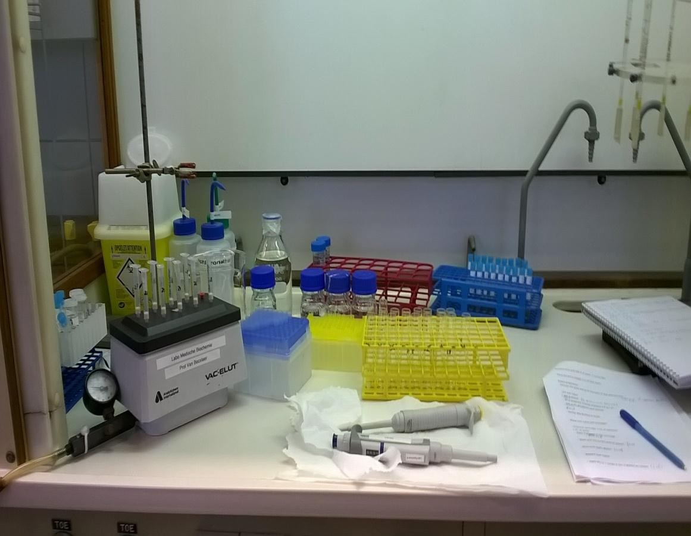

Plate V: Solid phase extraction of blood samples on a 10 port extraction manifold

The columns were conditioned with 1mL methanol and 1 mL water, after which the whole plasma samples were transferred to the column and then rinsed with 1 mL of a 2 % v/v aqueous formic acid solution followed by 1 mL solution of methanol. The rinses were discarded and then 1 mL of a 5 % v/v ammonium hydroxide was used to elute the IS and MPT. The samples were then evaporated to dryness under N2- flow and reconstituted in 150 µL HPLC water and vortexed for 30s. A 20 µL volume was injected into the HPLC system and concentrations of MPT were computed from a calibration curve.

The same procedure described above was used for the calibration curve. Various concentrations of 20 µL volumes (0.375, 0.550, 0.75, 1.5, 2.25, 3.75 and 5.25µg/mL) of MPT standard, 20 µL of IS solution and 320 µL of 4%v/v aq. phosphoric acid solution were added to 280 µL of blank plasma and extracted as described above. MPT showed a retention time of 14 min while IS was eluted only after 18 min. A full description of the protocol is attached in the appendix.

The peak area obtained for MPT and IS were used for the calculations of amount of drug absorbed per sampling time for the individual dogs. A mean plasma concentration time curve for the six dogs was then plotted; Half Value Duration (HVD) for ADM (F1) and Slow Lopressor (F5) matrices and the Retard quotient as well as the percent bioavailability (% Frel) of F1 relative to F5 were all calculated.

* + - 1. *Assessment of bioavailability parameters*

1. Relative bioavailability

In a situation where an absolute bioavailability (comparison of test drug with an IV formulation) is not obtainable, a relative bioavailability (comparison of test drug with a standard oral solution or a marketed product of known clinical efficacy) test is performed (Ashford, 2007).

So in order to assess the fraction or percentage of MPT that is absorbed intact into the systemic circulation, the formulated F1 matrix tablets was compared to the marketed product (F5) of the same strength using the below equation;

Relative bioavailability (%) = (AUCT) test

(AUCT) standard

x 100 Equation 17

where (AUCT) test and (AUCT) standard are the total areas under the plasma concentration – time curve absorbed after administration of a single dose of test (F1) and standard (F5) formulations respectively.

1. Half value duration (HVD)

Half value duration is the time span for which the plasma concentration exceeds C max (Meier *et al*., 1974). This was determined by measuring the width of the plasma concentration time curve. It provides an insight into the duration of pharmacological action exhibited by the absorbed drug and extent of its retardation.

A retard quotient (RΔ) which describes the quality of drug retardation was derived from the HVD values of the test drug relative to the standard. It enables pharmaceutical formulations with different release rates to be compared *in vivo*. The retard quotient was computed as shown below.

RΔ = Δ1/2 (retard form) = 𝐷(retard form)

…………..................................... Equation 18

Δ1/2 (normal form) HVD (normal form)

where Δ1/2 = half value duration.

# Mathematical models describing drug release kinetic and mechanism

To understand the mechanism by which MPT was released from ADM and HPMC matrices, the dissolution data were fitted into several mathematical models (zero, and first order model, Higuchi, and Korsmeyer Peppas exponential equation for swellable matrices as described in

2.1.7 and Table 2.3 above.

# Formulation Compatibility Studies

* + - 1. *Thermal analysis*

Individual and triturated physical mixture of each sample with MPT, ADM and HPMC and the individual tablet compacts formulated were encapsulated and scanned with the DSC instrument to determine compatibility and effect of mixture on degradation and Tg temperatures. The thermograms of MPT, either of ADM, HPMC and the binary mix and compacts were overlaid to detect interactions and to observe differences in thermal characteristics or similarities between ADM and HPMC formulations.

# STATISTICAL ANALYSIS

For the fact that molecular weight, concentration; shape; size and type of polymer are some of the primary factors that affect drug release from tablet matrices, statistical analysis using Graphpad prism 4 was carried out to check if mean values of the various parameters assessed were significantly different. Multiple comparison tests of Bonferroni and Newman- Keuls were also performed. Statistical analysis of the formulated matrix tablets with various concentrations of ADM and HPMC was also performed to determine the differences in drug release profile.

# SIMILARITY FACTOR

Further assessment of *in vitro* dissolution profiles were performed using Similarity factor (*f2*). This was to confirm if similarities or differences (*f1)* exist between ADM and HPMC matrix formulations. This was performed as mentioned in 2.1.8 above.

**CHAPTER FOUR**

* 1. **RESULT**
  2. **PHYTOCHEMICAL AND PHYSICOCHEMICAL CHARACTERIZATION OF PURIFIED *ADANSONIA DIGITATA* L. MUCILAGE (ADM)**

Phytochemical screening depicted in Table 4.1 revealed that some of the bioactive substances present in the crude plant leaf powder of *Adansonia digitata* were also found in the purified mucilage of ADM while others were absent.

The result of the evaluated physicochemical properties of the purified ADM as well as the elemental composition determined by the CHN method is shown in Table 4.2. The percentage composition of carbon, nitrogen and hydrogen of the samples which summed up to 41.14 % indicates that other elements are present in the remaining 58.86 %.

Table 4.1 Phytochemical composition of crude leaf powder and extracted mucilage of *Adansonia digitata*

|  |  |  |
| --- | --- | --- |
| Bioactive substances | Crude AD leaf powder | ADM |
| Mucilage | **+** | **++** |
| carbohydrates | **+** | **+** |
| Reducing sugars | **+** | **+** |
| Alkaloids | **-** | **-** |
| Glycosides | **-** | **-** |
| Steroids | **-** | **-** |
| Terpenes | **+** | **-** |
| Amino acids | **+** | **-** |
| Saponin | **-** | **-** |
| Oil & Fats | **-** | **-** |
| Tannins | **+** | **-** |

Key:

- = absent

+ = present

++ = present in large quantity

Table 4.2 Physicochemical properties of purified *Adansonia digitata* mucilage (ADM)

|  |  |
| --- | --- |
| Parameters | Results |
| Colour of crude | Green |
| Colour of purified | Cream |
| pH (21°C) | 6.07 |
| Texture | Fine |
| Percentage yield (%w/w) | 3.5 ± 0.53 |
| Viscosity (20°C) (mpas of 2% solution)  (mpas of 4% solution) | 3,160  10,000 |
| Aqueous solubility | ND |
| Unbound moisture content (%) | 16.38 ±0.24 |
| Particle size (µm) x10 | 208.14 |
| x50 | 663.57 |
| x90 | 1372.00 |
| Aspect ratio (a10) | 0.48 |
| (a50) | 0.66 |
| (a90) | 0.82 |
| Sphericity (s10) | 0.70 |
| (s50) | 0.80 |
| (s90) | 0.87 |
| Shape (SEM) | Needle like irregular elongated fibres |
| Proximate values (%) |  |
| Nitrogen | 0.64 |
| Carbon | 34.95 |
| Hydrogen | 5.55 |

**KEY: ND = Not determined**

# Dynamic vapour sorption studies

The moisture sorption kinetics for ADM sample is displayed in Fig. 4.1. The red line (dm) traces the percentage change in mass (dry) as a function of time and the blue line traces the % RH as a function of time in two runs each lasting 4000 min. During the initial drying stage the sample lost 11.16 % of its dry mass. As humidity increased, the sample water uptake increased gradually towards equilibrium until at 70 % RH when polymer mobility increased due to rapid water uptake reaching equilibrium at 98 % RH. Water loss in desorption phase was in a similar fashion.

The corresponding isotherm exhibited substantial differences (hysteresis) in moisture sorption and desorption curves between the points of hydrate formation and when the formed hydrate became irreversible (Fig. 4.2). ADM reversibly picked up water vapour up to 90 % RH while equilibration at RH ≥ 90 % resulted into irreversible hydrate formation and a water content of

35.30 %.

# Particle morphology by SEM

SEM images of ADM revealed that the particles consisted of few spherical and many elongated needled shaped structures. SEM images of ADM when aligned with those of HPMC looked similar but the latter were larger and with more discrete elongated rectangular rods (Plate VI).

# Particle characterization by Qicpic technique

The frequency distribution curve shows a multimodal distribution of particles. The powder is largely composed of moderate to large particles, exhibiting positive skewness while the cumulative frequency distribution curves of ADM powder shows a larger spread of equivalent particle diameter with 10 % of particles below 208.14 µm and 50 % below and above 663.57 µm (Fig.4.3).

DVS Change In Mass (dry) Plot

dm - dry

# 70 120

**60**

Change In Mass (%) - Dry

# 00

**50**

Target RH (%)

# 40

**30**

# 20

**10**

# 0

**-10**

**1**

**80**

**60**

**40**

**20**

**0**

**2000**

**4000**

**6000**

**8000**

**10000**

**0**

Time (min)

Fig.4.1 Water sorption kinetics for ADM at 21°C

Cycle 1 Sorp Cycle 1 Desorp Cycle 2 Sorp Cycle 2 Desorp

# 70



irreversible

hydrate

hydrate

formation

hysterisis

**60**

# 50

Change In Mass (%) - Dry

**40**

# 30

**20**

# 10

**0**

# 0 20 40 60 80 100 120

Target RH (%)

Fig. 4.2 Moisture sorption- desorption isotherm for ADM at 21°C

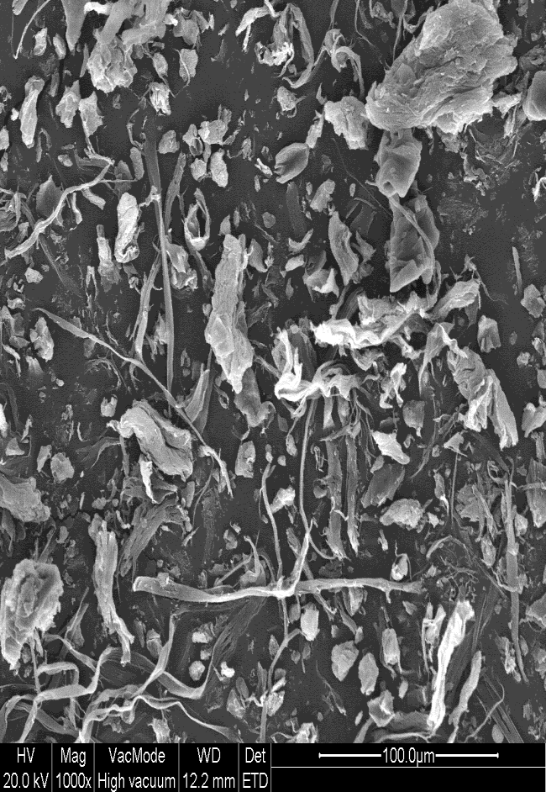

|  |  |
| --- | --- |
| ***Adansonia digitata* mucilage (ADM)** | **Hydroxyl propyl methylcellulose (HPMC)** |

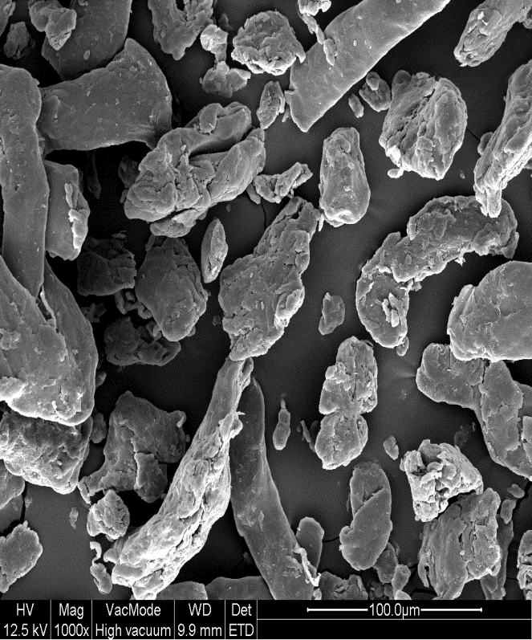Plate VI: SEM images of ADM and HPMC at x1000 magnification

Cummulative frequency distribution mean size distribution

120

0

500

1000

1500

2000

2500

100

80

**% frequency distrbution/mean**

60

40

20

0

-20

**particle size (µm)**

Fig. 4.3 Cumulative percent frequency distribution curve (undersize) of ADM powder via Qicpic

# DSC Scans of ADM powder

Fig. 4.4 shows a single endothermic broad peak of the DSC scan of ADM with a glass transition temperature (Tg) of 74 °C and melting temperature (Tm) of 173 °C. The degradation onset was at 180 °C but no maximum oxidation temperature was obtained within the ramping temperature of up to 250 °C.

# Attenuated Total Reflectance Fourier Infra Red (ATR-FTIR) Spectrum of ADM

The functional groups identified in the ATR- FTIR spectrum of ADM are absorption peaks at 633 cm-1 which depicts the presence of N-H primary amides, C = C-H bending, terminal acetylene groups; N-C=O bending, primary saturated aliphatic amides; NO2, nitroalkane and/ vinyl compounds. Absorption peaks at 1100 - 950 cm-1 indicated the presence of a thioamides N- C=S and CH3-C: aliphatic and saturated aliphatic ethers. Band stretching at 1239 cm-1 possible functional groups are C-O: carboxylic acid dimers, N-H: secondary amides, amide III; C-O-C: saturated aliphatic esters; C-O: acetic acid ester CH3COOR; Cyclobutanes and R-O-Ar (alkylthicketones). Band at 1416 cm-1 showed the possibility of presence of N=N: aromatic azo compound, C-N: primary amide, amide III band; C-O stretch and OH, carboxylic acids; CH2 in plane and O-H: primary, secondary alcohols functional groups while band at 1600 cm-1 showed the presence of N-H: primary amide, primary amine;NH2+: amine salt; CO2- : asym stretch, carboxylic acid salts; NH3+: amine salt (C=C: aromatic str) and band at 1725 cm-1 depicted C=O: stretch, different types: saturated aliphatic ketones, saturated aliphatic aldehydes, aryl esters, formates and saturated aliphatic carboxylic acid dimers as the possible functional groups present. The finger print of ADM is illustrated in Fig. 4.5 depicting the absorption peaks.

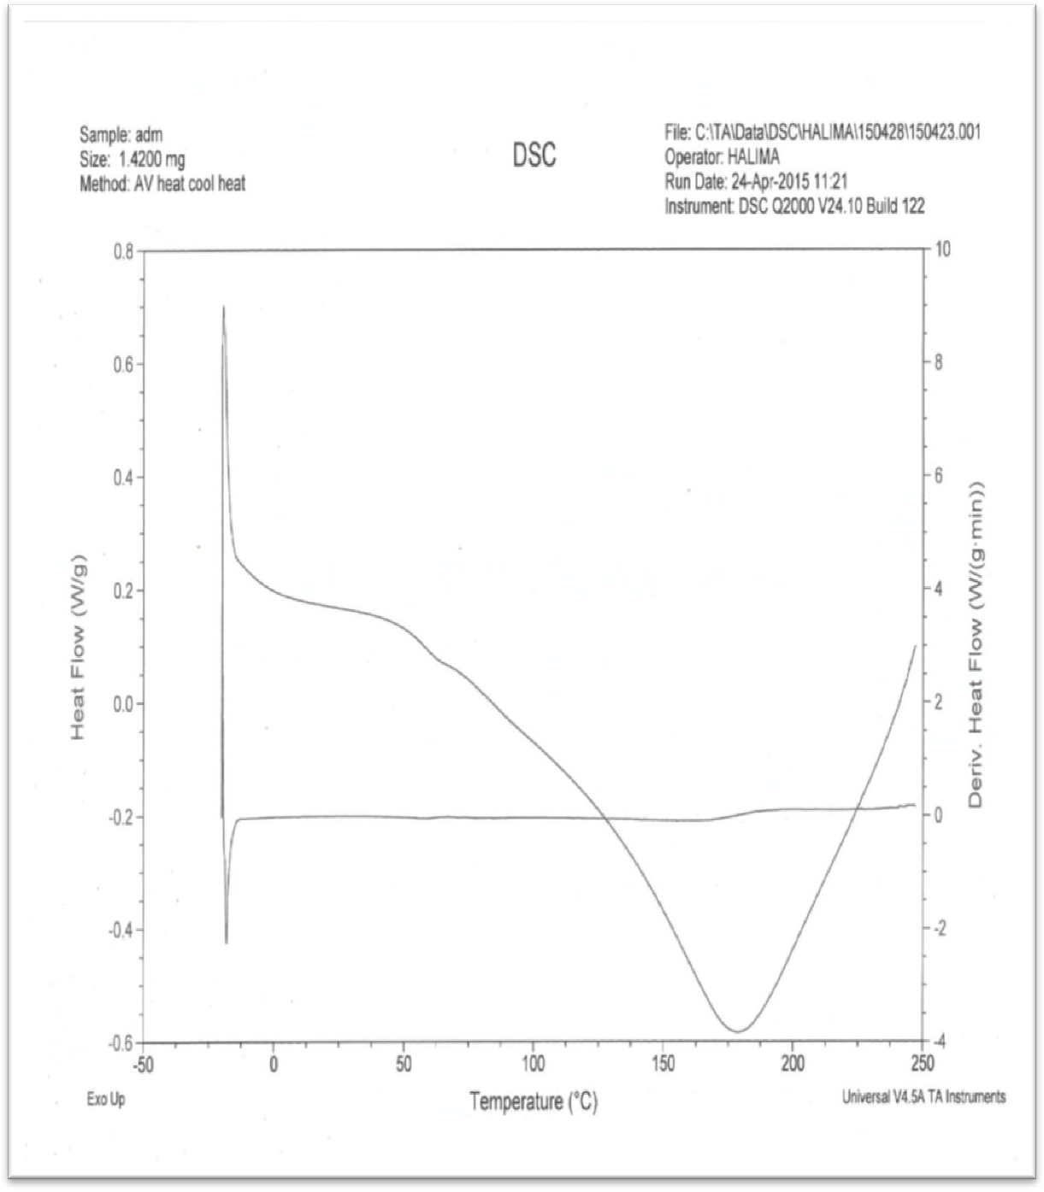

Fig. 4.4 Differential Scanning Calorimeter (DSC) thermograms of *Adansonia digitata* mucilage

Sample\_C\_ADM0001 Sample\_C\_ADM0002

0,35

0,3

0,25

0,2

0,15

0,1

0,05

0

3800

3400

3000

2600

(c2m20-10)

1800

1400

1000

600

Frequency

Fig. 4.5 Attenuated Total Reflectance Fourier Infra Red (ATR-FTIR) spectrum of ADM

# Solid State Nuclear Magnetic Resonance

The nuclear magnetic resonance (Solid) spectra of ADM obtained from the C -13 NMR analysis presented in Fig. 4.6 shows shifts in the monosaccharide elucidated in ADM. The NMR spectra showed the presence of

* + - * methyl carbon groups at 18.24 and 21.46
      * Exocyclic hydroxyl methyl groups at 62.49
      * Open –form sugar carbons bearing hydroxyl function at 71.35
      * α- anomer carbon at furanose ring closure at 81.66
      * Anomeric carbon (104.30) signifying monosaccharide of food types, and
      * Exocyclic carboxylic groups at 173.975 representing sugar acids and esters.

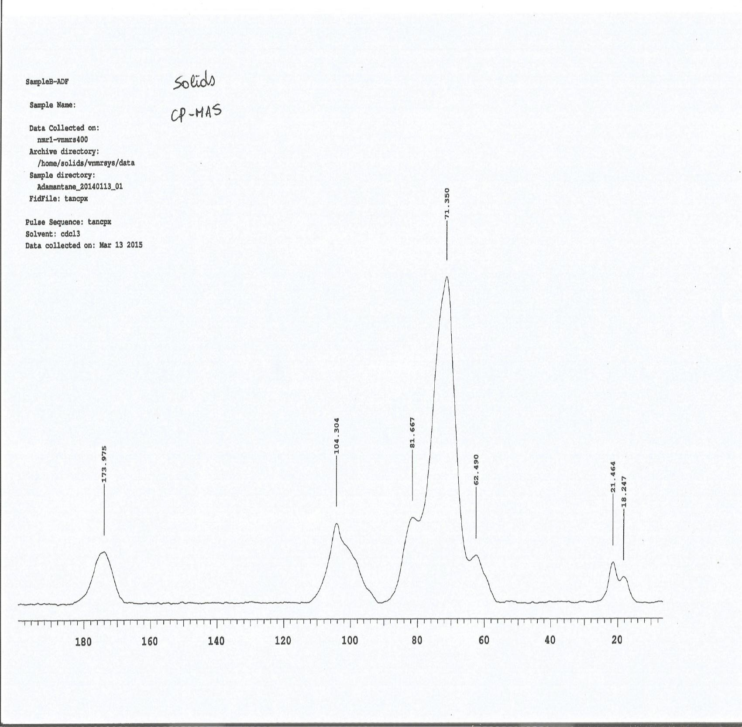

Fig. 4.6 Solid state 13C Nuclear magnetic resonance spectrum of ADM

# FORMULATION STUDIES ON THE VARIOUS DELIVERY SYSTEMS

* + 1. **Evaluation of the binding property of ADM in Immediate release Metoprolol tartarate tablets**

Results of the various granule packing and flow properties presented in Table 4.3 showed that decreasing concentration of ADM as a binder in granules led to improved granule characteristics. Granule parameters including bulk and tapped densities to test granule packing and cohesion and, Carr‘s index and Hausner‘s ratio describing granule flow as well as granule strength in terms of granule friability were all in the order of G1 > G2 > G3. Moisture content did not follow a sequential order but was < 4%.

# Granule size analysis

The granule size distribution of the various batches formulated showed G3 and G1 curves almost superimposed on each other, with the median (450 µm) particle size very close. However, the distribution pattern of G2 showed distribution of larger particle sizes, with median size of 750 µm (Fig.4.7) towards the target size of 1 mm.

# Granule shape

The shape characteristics of formulated MPT granules based on aspect ratio showed 10 % fraction of granules already have values of 0.6 while 90 % tended towards unity (Fig.4.8).

Table 4.3 Properties of Metoprolol tartarate (MPT) granules formulated with increasing binder concentration

|  |  |  |  |
| --- | --- | --- | --- |
| Parameter (mean values ± SD) | Formulations  G1 | G2 | G3 |
| Bulk density (g/cm-3) | 0.4957 ± 0.029 | 0.5028 ± 0.004 | 0.5134 ± 0.015 |
| Tapped density(g/cm-3) | 0.5336 ± 0.029 | 0.5488 ± 0.005 | 0.5923 ± 0.013 |
| Hausner‘s ratio | 1.07 ± 0.05 | 1.09 ±0.019 | 1.15 ± 0.06 |
| Carr‘s index | 7.12 ± 0.49 | 8.37 ± 1.61 | 13.25 ± 4.64 |
| Friability (%) | 13.0 | 14.3 | 18.0 |
| Moisture content (%) | 3.50 ± 0.05 | 3.30 ± 0.27 | 3.57 ± 0.36 |
| Shape factor  (Sphericity S50) | 0.8305 | 0.8128 | 0.8636 |

Key:

G1 = 0.33 % (binder plus 0.1% Tween 80) G2 = 0.5 %

G3 = 1.0 %

120



G3 (1%)

G2 (0.5%)

G1 (0.33%)

100

80

**% Cumulative frequency**

60

40

20

0

0 200 400 600 800 1000 1200 1400 1600

# Particle size (µm)

Fig. 4.7 Cumulative percent frequency distribution (undersize) of MPT granules formulated with different concentration of ADM as binder

0.9

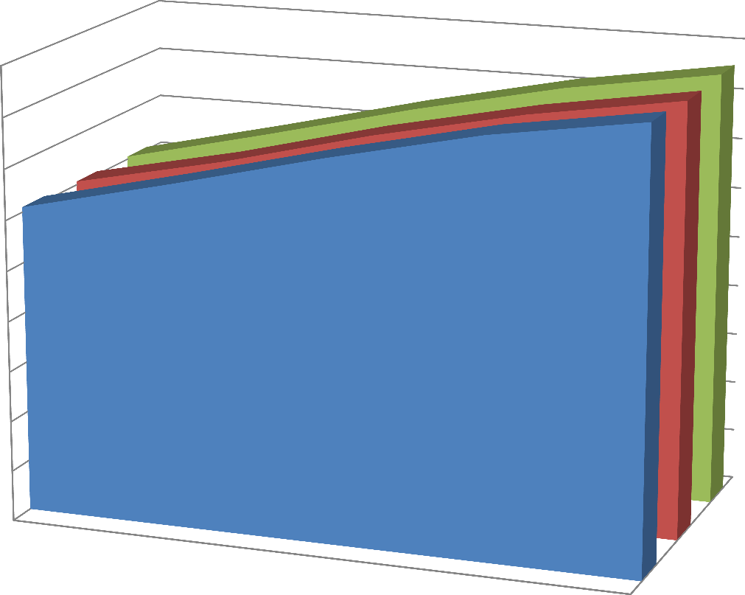

0.8

0.7

0.6

median aspect ratio

0.5

0.4

0.3

G3 (1%) G2(0.5%)

G1(0.33%)

0.2

0.1

0

a10

a25

a50

a75

a90

G1(0.33%)

G2(0.5%) G3 (1%)

Granule fractions

Fig. 4.8 Median aspect ratio as a function of granule fraction and binder concentration

# Effect of binder concentration on granule morphology via SEM

Scanning Electron Microscopy of the granules produced with varying binder concentrations are presented in Plate VII. The unwetted MPT (Image A) were elongated discrete particles while those wetted with binder concentration of 0.33 % (Image B) were intensively bonded and wetted. MPT granules wetted with 1.0 % appeared to contain more unbounded drug particles and dense agglomerated portions (image D).

# Tablet Properties of MPT formulated with ADM as binder

The properties of tablets prepared with ADM as binder presented in Table 4.4 showed that there was slight decrease in tablet weights with increasing binder concentrations. The diameter was within the nominal specifications with acceptable thickness. Values of tablet hardness, tensile strength and crushing strength friability/ disintegration time (CSFR/DT) ratio decreased with increased binder concentration while disintegration time was in the reverse order. Friability values of the three batches were < 1 % with batch G2 having the least.

# Statistical analysis

Repeated measures ANOVA (p < 0.0001) showed that there were significant differences between means of disintegration times of the tablets produced with the three ADM concentrations. However, Newman-Keuls Multiple Comparison test showed that the disintegration time of G1 are significantly different from those of G2 and G3 while those of G2 and G3 were very similar (Table 4.5).

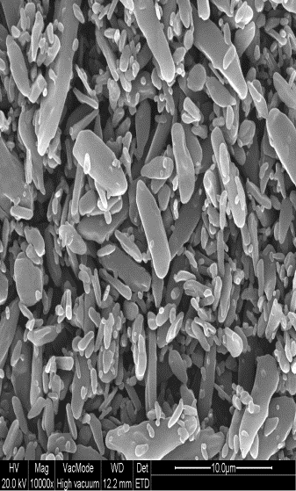 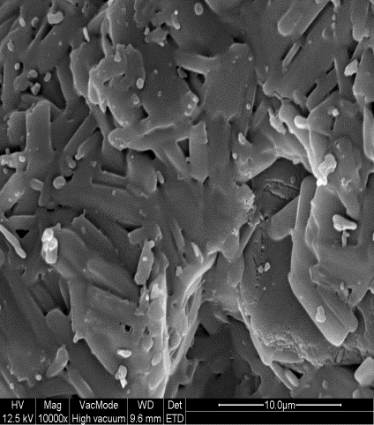

|  |  |
| --- | --- |
| A | B |
| C | G1_005  D |

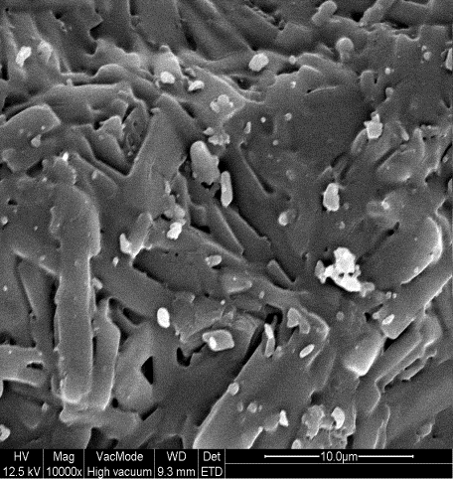Plate VII: SEM images of MPT powder (A) granules granulated with 0.33 % (B), 0.5% (C) and

1.0 % (D) binder concentrations

Table 4.4 Physical properties of immediate release Metoprolol tartarate (MPT) tablets

|  |  |  |  |
| --- | --- | --- | --- |
| Parameter | Formulations |  |  |
|  | G1 | G2 | G3 |
| Hardness (N) | 79.4 ± 11.38 | 58.2 ±18.18 | 40.8 ± 17.3 |
| Diameter (mm) |  |  |  |
|  | 10.39± 0.254 | 10.822 ± 0.224 | 11.085 ±0.340 |
| Thickness (mm) | 3.273 ± 0.046 | 3.274 ± 0.06 | 3.215 ± 0.049 |
| Weight (mg) | 249.6 ± 4.6 | 246.8 ± 4.97 | 242.5 ± 7.71 |
| Tensile strength (MPa) | 1.48 | 1.04 | 0.68 |
| Friability (%) | 0.29 | 0.24 | 0.32 |
| DT (min) | 5.395±0.119 | 5.553 ±0.037 | 6.085±0.293 |
| CSFR/DT | 4.27 | 2.52 | 2.15 |

Key:

G1= 0.33% plus 0.1% Tween 80

G2= 0.5%

G3 =1.0 %

Table 4.5 Repeated measures analysis of variance of disintegration time for different batches of immediate release Metoprolol tartarate (MPT) tablets

|  |  |  |  |
| --- | --- | --- | --- |
| Repeated Measures  ANOVA |  |  |  |
| P value | P<0.0001 |  |  |
| P value summary | \*\*\* |  |  |
| Are means signif.  different? (P < 0.05) | Yes |  |  |
| Number of groups | 3 |  |  |
| F | 31.49 |  |  |
| R squared | 0.8630 |  |  |
| Was the pairing significantly effective? |  |  |  |
| R squared | 0.1661 |  |  |
| F | 2.906 |  |  |
| P value | 0.0710 |  |  |
| P value summary | ns |  |  |
| Is there significant matching? (P < 0.05) | No |  |  |
| ANOVA Table | SS | df | MS |
| Treatment (between  columns) | 1.568 | 2 | 0.7838 |
| Individual (between  rows) | 0.3617 | 5 | 0.07234 |
| Residual (random) | 0.2489 | 10 | 0.02489 |
| Total | 2.178 | 17 |  |
| Newman-Keuls Multiple Comparison Test | Mean Diff. | q | P value |
| G1 vs G3 | -0.6900 | 10.71 | P < 0.001 |
| G1 vs G2 | -0.1583 | 2.458 | P > 0.05 |
| G2 vs G3 | -0.5317 | 8.254 | P < 0.001 |

Key;

G1 = 0.33% binder plus 0.1% Tween 80

G2 = 0.5%

G3 = 1.0%

# Evaluation of Prolonged Release MPT tablets using ADM and HPMC as matrix formers

The physical properties of the tablets produced using ADM and HPMC as matrix formers is presented in Table 4.6. At both concentrations of 80 % and 50 %, tablets produced with ADM were comparable with those using HPMC as matrix former in virtually all the parameters considered except one (hardness). At 80 % proportion, tablets produced with ADM were harder compared with those with HPMC. However, the reverse was observed when lower concentration (50 %) of ADM was used. The tablet thicknesses of the 50 % tablets were also low.

Table 4.6 Physical properties of formulated Metoprolol tartarate (MPT) matrix tablets with ± Standard deviation (SD)

|  |  |  |  |  |
| --- | --- | --- | --- | --- |
| Parameter |  | Formulations |  |  |
|  | F1 | F2 | F3 | F4 |
| Weight (g) | 996.45 ± 5.78  (0.58)\* | 994.57 ± 5.48  (0.55)\* | 400.43 ± 3.53  (0.88)\* | 398.22 ± 5.46  (1.37)\* |
| Diameter (mm) | 16.02 ± 0.05  (0.31)\* | 16.17 ± 0.05  (0.31)\* | 16.37 ± 0.47  (2.89)\* | 16.03 ± 0 .17  (1.09)\* |
| Thickness (mm) | 4.5 ± 0.28 | 4.79 ± 0.34 | 2.07 ± 0.03 | 2.33 ± 0.03 |
| Hardness (N) | 131.2 ± 24.4 | 115.5 ± 19.48 | 50.63 ± 5.06 | 102.5 ± 30.63 |
| Friability (%) | 0.07 | 0.37 | 0.36 | 0.03 |

Key:

F1 - MPT: ADM (20:80) F2 - MPT: HPMC (20:80) F3 - MPT: ADM (50:50) F4 - MPT: HPMC (50:50)

\*- Coefficient of variation

# *In vitro* drug release profiles of formulated matrix tablets

The dissolution profile of F1 and F2 matrix tablets showed pH independent drug release profile and absence of burst effect. It exhibited a linear pattern of drug release up till 24 h in both pH 1.0 (Fig.4.9) and pH 6.8 (Fig. 4.10).

Contrarily, F3 and F4 matrices release profiles depicted in Fig.4.11 and Fig. 4.12 showed pH dependent- release; prolonged (sustained) drug release for 4 h in pH 6.8 and in pH 1.0 and MPT was released continuously for 8h and 10 h from F4 and F3 matrices respectively.

120



100

80

60

**% MPT released**

F1

F2

40

20

0

0 5 10 15 20 25 30

**Time (h)**

Fig. 4.9 *In vitro* release profile of MPT from F1 and F2 matrix tablets in pH 1.0

140



0

5

10

15

20

25

30

120

100

80

**% MPT released**

60 F1

F2

40

20

0

-20

**Time (h)**

Fig. 4.10: *In vitro* release profile of MPT from F1 and F2 matrix tablets in pH 6.8

120



100

80

60

**% MPT released**

F3

F4

40

20

0

0 1 2 3 4 5 6 7 8 9

**Time (h)**

Fig. 4.11 *In vitro* release profile of MPT from F3 and F4 matrix tablets in pH 1.0

120



100

80

60

**% MPT released**

F3

F4

40

20

0

0 0.5 1 1.5 2 2.5 3 3.5 4 4.5

**Time (h)**

Fig. 4.12 *In vitro* release profile of MPT from F3 and F4 matrix tablets in pH 6.8

# Liquid uptake and swelling studies of formulated matrix tablets

* + - 1. *Liquid uptake (LU)*

Liquid uptake in phosphate buffer (PB) was higher compared with acid buffer for both F1 and F2 matrix tablets. The percentage of liquid uptake declined after 8h in F1 PB and F2 AB but was five times higher in F1 compared with F2 (Fig. 4.13).

Similarly, liquid uptake in F3 matrix tablets was more pronounced than in F4 matrices in both pH conditions (Fig 4.14). The uptake by F3 tablets in acid medium increased to a maximum at 8 h after which it declined to zero value at 24 h but in phosphate buffer, the decline after reaching maximum only decreased from 868 % to about 400 %. However, in both buffers, liquid uptake in F4 reached maxima at about 4 h which then declined to zero value at about 8 h. Generally, liquid uptake was four times higher in F3 and F4 than in F1 and F2.

900

800

700

600

**% Liquid uptake**

500

400

300

F1 AB F2 AB F1 PB F2 PB

200

100

0

0 5 10 15 20 25 30

**Time (h)**

Fig. 4.13 Percent Liquid uptake of F1 and F2 matrix tablets in Acid buffer (AB) and Phosphate buffer (PB) as a function of time

1400

0

5

10

15

20

25

30

1200

1000

800

**% Liquid uptake**

600

400

F3 AB F3 PB F4 AB F4 PB

200

0

-200

**Time (h)**

Fig. 4.14 Percent Liquid uptake of F3 and F4 matrix tablets in Acid buffer (AB) and Phosphate buffer (PB) as a function of time

* + - 1. *Radial and Axial swelling of formulated matrix tablets*

Radial swelling (measured by increased diameter) was outward, more prominent and prolonged in F1 matrix tablets compared to inward and low swelling in F2 matrix tablets (Fig.4.15). Axial swelling (increased thickness) was also more pronounced in F1 matrices than in F2 matrices in both pH conditions (Fig 4.16). Furthermore, axial swelling was higher (4 times) compared with radial swelling among the various formulations..

Radial swelling in F3 matrix tablets were also more prolonged and pronounced than in F4 matrices (Fig. 4.17). However, axial swelling was higher in F4 matrix tablets compared to F3 (Fig 4.18). In both pH conditions simulated, F3 axial swelling was 4 times higher than radial swelling while in F4, axial swelling was 20 times higher than radial swelling.

70

0

5

10

15

20

25

30

60

50

40

30 F1 PB

**% Swelling**

F1 AB

20 F2 PB

F2 AB

10

0

-10

-20

**Time (h)**

Fig.4.15 Percent radial swelling of F1 and F2 matrix tablets in ccid buffer (AB) and phosphate buffer (PB) as a function of time

250

200

150

**% Swelling**

100

F1 PB F1 AB F2 PB F2 AB

50

0

0 5 10 15 20 25 30

**Time (h)**

Fig.4.16 Percent axial swelling of F1 and F2 matrix tablets in Acid buffer (AB) and Phosphate buffer (PB) as a function of time

60

0

5

10

15

20

25

30

50

40

30 F3 AB

**% Swelling**

F3 PB

20 F4 PB

F4 AB

10

0

-10

**Time**

Fig. 4.17 Percent radial swelling of F3 and F4 matrix tablets in Acid buffer (AB) and Phosphate buffer (PB) as a function of time

450

400

350

300

250

**% Swelling**

200

150

100

F3 PB F3 AB F4 PB F4 AB

50

0

0

-50

5 10 15 20 25 30

-100

**Time (h)**

Fig. 4.18 Percent axial swelling of F1 and F2 matrix tablets in Acid buffer (AB) and Phosphate buffer (PB) as a function of time

* + - 1. Polymer transition

During the period of dissolution, the integrity of the 3-dimensional structure of the tablets formulated with high polymer concentrations (F1 & F2) and low polymer concentration (F3) remained intact until 24 h, except in texture. The initial hard and dry compact (glassy) turned into a rubbery mass (Plate VIII and Plate IX ).

In addition, transition of matrix tablets during swelling revealed anisotropic (Plate X ) and isotropic (XI) types of swelling in F1 and F2 matrices respectively at 8 h.

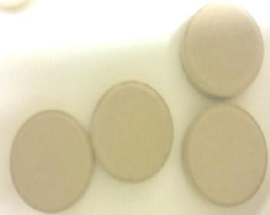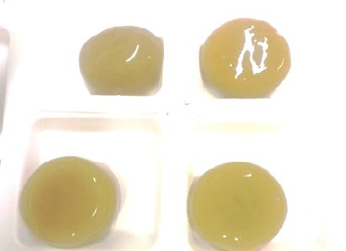

* + - * 1. glassy/dry state (B) Rubbery state

Plate VIII: Glassy (A) – rubbery (B) polymer transition of F1 matrix tablets at completion of 24 h of *in vitro* dissolution

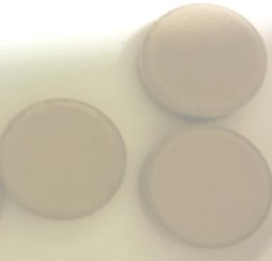 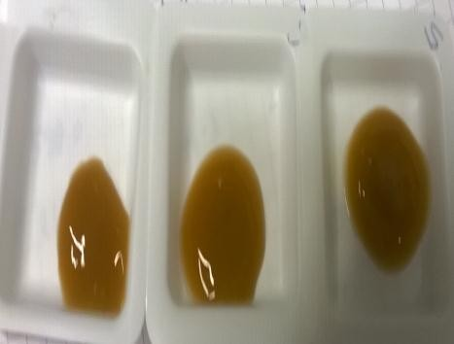

(A) glassy/dry state (B) Rubbery state

Plate IX: Glassy (A) – rubbery (B) polymer transition of F3 matrix tablets at completion of 24 h of *in vitro* dissolution

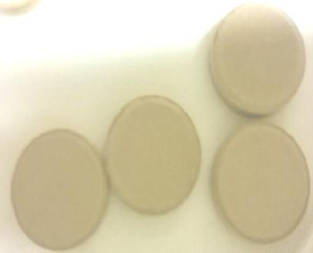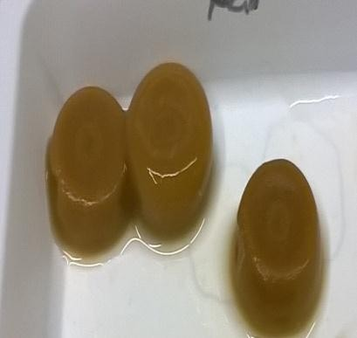Transition

Glassy/ dry tablets Rubbery elongated tablet mass Plate X: Anisotropic swelling due to axial relaxation of polymer in F1 matrix tablets at 8 h

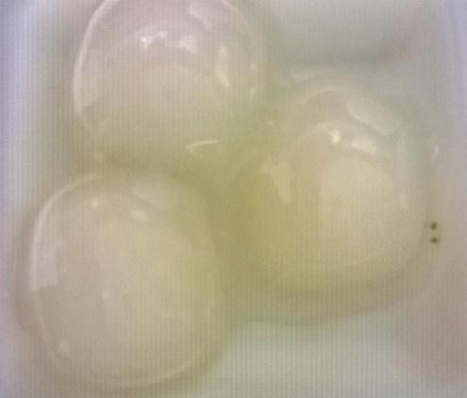Transition

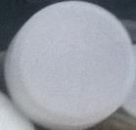

Glassy /dry tablets Rubbery mass (lost original shape) Plate XI: Isotropic swelling of F2 tablets until 24 h resulting into loss of original shape at 8 h

# MATHEMATICAL MODELLING OF FORMULATED MATRIX TABLETS

Although a multi model release kinetic was observed in the different formulations when dissolution data was fitted into the various release models, the mathematical release model with the highest regression (R2 ) value was found to be Higuchi model while the Korsmeyer-Peppas model ranged between 0.49 and 1.4 with formulations F3 in pH 1.0 as an exception. Interestingly, the *K*-constant value for First order kinetics of all the formulations was negative (Table 4.7).

# Prediction of complete drug release and mean rate of drug

Theoretical and practical (actual) percent of MPT released showed no significant difference. The theoretical rate of MPT release determined fitted into Zero order model and yielded a straight line curve as compared with F2 (Table 4.8) .

# Compatibility studies of formulated matrix tablets

Compatibility studies revealed that F1 and F2 compacts and binary mixes melted in a similar fashion yielding two endothermic peaks- a narrow initial and a broad peak before returning to equilibrium point as depicted in Fig. 4.19 and Fig.4.20.

# Statistical analysis

Statistical analysis carried out to verify similarities or difference between the purified plant extract ADM and the standard semi-synthetic polymer-(HPMC60SH4000) in the formulation of prolonged release matrix tablets using One way ANOVA (P < 0.05) showed that p = 0.9251 at (p

< 0.05) and with no post test, p > 0.05) (Table 4.9).

Table 4.7 Release Kinetics and Mechanism of Metoprolol tartarate (MPT) transport from matrices of ADM and HPMC60SH4000 in different ratios

Formulation Release model

Zero order First order Higuchi Korsmeyer- Peppas

R2 K R2 R2 R2 ‗n‘

|  |
| --- |
| -0.0817 |
| -0.0639 |

F1 ^0.9228

|  |
| --- |
| 0.8109 |
| 0.9548 |

|  |
| --- |
| 0.9899 |
| 0.9908 |

|  |
| --- |
| 0.9806 |
| 0.8269 |

|  |
| --- |
| 0.6893 |
| 1.4560 |

\*0.9564

F2

|  |
| --- |
| ^0.9120 |
| \*0.8997 |

|  |
| --- |
| -0.0832 |
| -0.0749 |

|  |
| --- |
| 0.8694 |
| 0.9021 |

|  |
| --- |
| 0.9818 |
| 0.9777 |

|  |
| --- |
| 0.9886 |
| 0.9801 |

|  |
| --- |
| 0.5775 |
| 0.6594 |

F3

|  |
| --- |
| ^0.7701 |
| \*0.9280 |

|  |
| --- |
| -0.3972 |
| -0.2290 |

|  |
| --- |
| 0.9917 |
| 0.9808 |

|  |
| --- |
| 0.8857 |
| 0.9848 |

|  |
| --- |
| 0.8659 |
| 0.8934 |

|  |
| --- |
| 0.3236 |
| 0.4924 |

F4

|  |
| --- |
| ^0.9572 |
| \*0.9900 |

|  |
| --- |
| -0.3019 |
| -0.1307 |

|  |
| --- |
| 0.9950 |
| 0.8384 |

|  |
| --- |
| 0.9934 |
| 0.9560 |

|  |
| --- |
| 0.9906 |
| 0.9340 |

|  |
| --- |
| 0.6589 |
| 0.7021 |

Key:

^= entire row represent matrix formulation conditioned in pH 1.0

\*= entire row represent matrix formulation conditioned in pH 6.8

F1 = (20:80) MPT/ ADM, F2= (20:80) MPT /HPMC,

F3= (50:50) MPT /ADM, F4= (50:50) MPT /HPMC

Zero order if R2 ≥ 0.975, near zero order if R2 ≥ 0.950 < R2< 0.975 No zero order if R2 ≤ 0.950.

Fickian diffusion: n=0.45; Case II transport: n=0.89; Fickian diffusion & case II transport: n= 0.45- 0.89

Table 4.8 Prediction of complete drug release and mean rate of drug release from the matrix tablets in dissolution media simulated

|  |  |  |  |  |  |  |  |  |  |
| --- | --- | --- | --- | --- | --- | --- | --- | --- | --- |
| Formulation | Mean rate (mg)/h | | Theoretical  % MPT  released (A) | | Actual % MPT released  (B) | | Statistics A Vs B |  |  |
|  | pH 1.0 | pH 6.8 | pH 1.0 | pH 6.8 | pH 1.0 | pH 6.8 | P value (P< 0.05) | Equation | 2  R |
| F1 | 8.8 | 7.72 | 106.3 | 92.7 | 104.9 | 96 | 0.5893 | y=9.835x  + 30.767 | 0.9528 |
|  |  |  |  |  |  |  |  | y=8.5728 x +13.816 | 0.9566 |
| F2 | 6.7 | 7.84 | 80 | 85 | 98.96 | 99.07 | 0.8975 | y= 7.447x  + 46.869 | 0.8923 |
|  |  |  |  |  |  |  |  | y=7.8437  x + 39.527 | 0.8998 |

Key;

F1 (20:80) MPT/ADM

F2 (20:80) MPT/HPMC

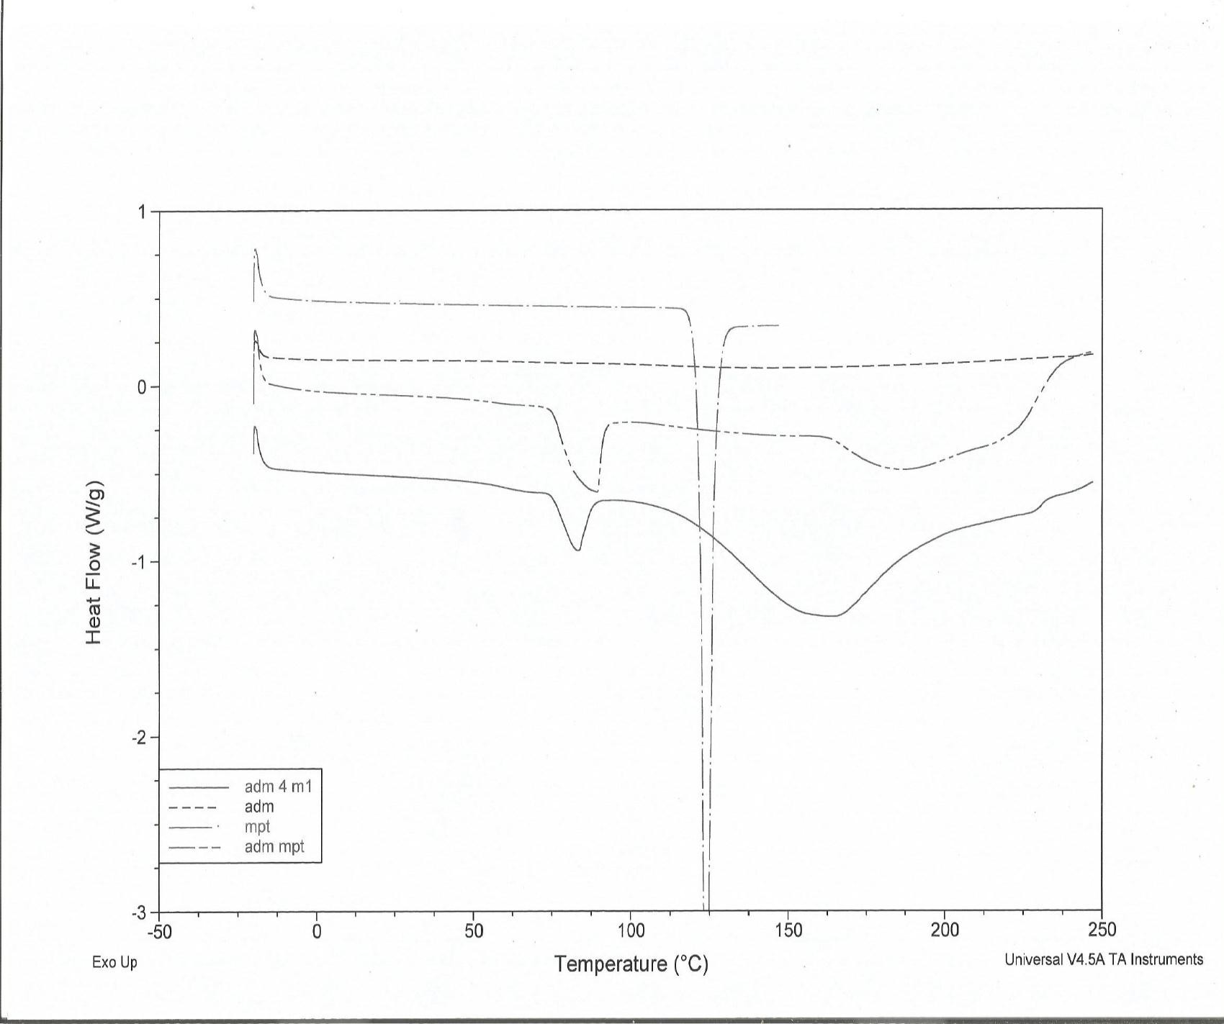

Fig. 4.19 Overlay of DSC thermograms of MPT (-), ADM (---); MPT and ADM binary mix ( - -) and compact ()

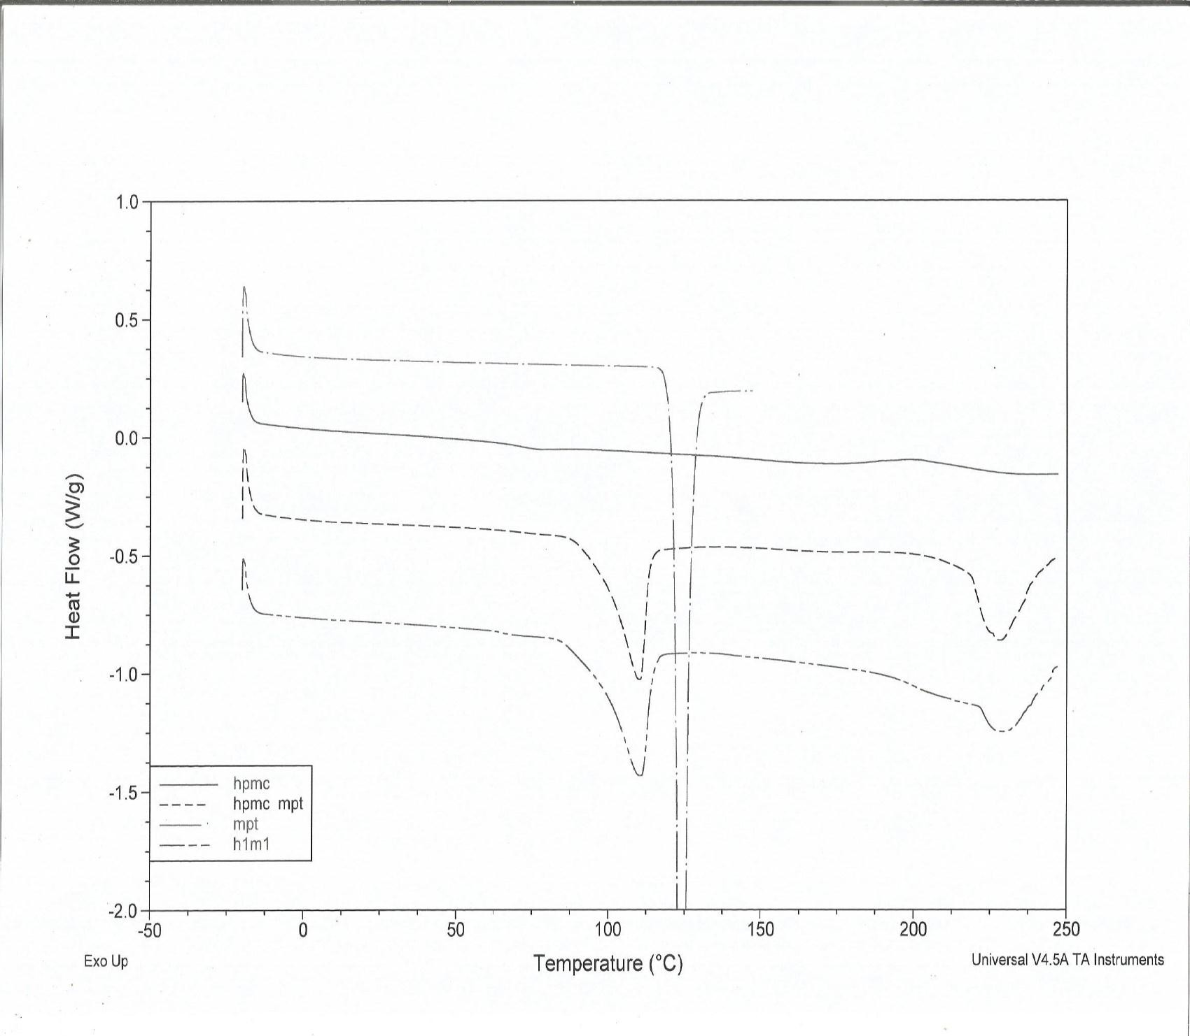

Fig.4.20 Overlay of DSC thermograms of MPT (-), HPMC (); MPT and HPMC binary mix (--) and compact (---)

Table 4.9 Statistical analysis by One-way ANOVA of formulations F1 and F2 dissolution values

|  |  |
| --- | --- |
| One-way analysis of variance |  |
| P value | 0.9251 |
| P value summary | ns |
| Are means signif. different? (P < 0.05) | No |
| Number of groups | 4 |
| F | 0.1561 |
| R squared | 0.01284 |
| Bartlett's test for equal variances |  |
| Bartlett's statistic (corrected) | 0.2074 |
| P value | 0.9764 |
| P value summary | ns |
| Do the variances differ signif. (P < 0.05) | No |
| No post tests. P > 0.05 |  |

# Similarity factor

Dissolution profiles of formulations F1 & F2 as well as F3 & F4 yielded various similarity factors (*f2) and difference factors (f1)* from comparison of same strength of MPT from different strength (Table 4.9) and same strength (Table 4.10) matrix tablets in both dissolution media utilized in the experiment.

Table 4.10 Similarity factors (*f2)* and difference factors (*f1)* values from comparison of same strength of MPT of different matrices

|  |  |  |  |  |
| --- | --- | --- | --- | --- |
|  | *Similarities* |  | *Differences* |  |
| Formulations | *f2*  *in pH 1.0* | *f2*  *in pH 6.8* | *f1*  *in pH 1.0* | *f1*  *in pH 6.8* |
| F1 Vs F2 | 74 | 51 | 4 | 14 |
| F3 Vs F4 | 72 | 60 | 5 | 7 |

Key:

F1 = (20:80) MPT/ADM F2 = (20:80) MPT/HPMC F3 = (50:50) MPT/ADM F4 = (50:50) MPT/HPMC

Table 4.11 Similarity factor (*f2)* and difference factor (*f1)* values from comparison of same strength of MPT of same matrices in different SGF

|  |  |  |
| --- | --- | --- |
|  | *Similarities* | *Differences* |
| Formulations | *f2* | *f1* |
| F1 AB *vs* F1 PB | 50 | 14 |
| F2AB *vs F2* PB | 72 | 4 |
| F3AB *vs F3* PB | 40 | 21 |
| F4AB *vs F4* PB | 44 | 15 |

Key:

F1 = (20:80) MPT/ADM F2 = (20:80) MPT/HPMC F3 = (50:50) MPT/ADM F4 = (50:50) MPT/HPMC

AB = acid buffer (pH 1.0)

PB = phosphate buffer pH (6.8)

* 1. ***IN VIVO* EVALUATION**

Results of the preceding investigations showed that F1 tablets released 100 % MPT in 24 h and was statistically not different from F2. The evaluation of MPT *in vivo* was thus necessary to understand the extent and rate of absorption. The mean plasma concentration – time profile profiles (n=6) after oral administration of F1 and F5 to dogs is presented in Fig. 4.21 whereas the Cmax, Tmax, AUC0-36 and HVDt50%Cmax which are the mean pharmacokinetic parameter are shown in Table 4.11

# Method specificity

Chromatograms of blank plasma after extraction, plasma spiked with Bisoprolol (IS) and plasma spiked with MPT showed no interference between MPT and endogenous compounds and also separation between MPT and the IS was complete with reference to the retention times of 14 min and 18 min for MPT and Bisoprolol respectively.

The rate and extent at which MPT was absorbed, distributed and eliminated in systemic circulation exemplified in dog blood plasma compared with Lopressor® (F5) is shown in Fig.

4.21. The peak plasma concentration of MPT was reached for the two drug products at same time (4 h). Area under the curve (AUC) did not differ significantly but Cmax was higher for F5 compared with F1 matrix tablets. While MPT in F5 became virtually undetectable in plasma by about 18 h. The drug was still found in the dog plasma beyond 24 h, implying that the test formulation has a more prolonged and sustained release of MPT. However, beyond 24 h, the drug was below the minimum effective concentration.

14

F5 (Slow-lopressor 200mg divitabs)

F1 (MPT20/ADM 80)

0

5

10

15

20

25

30

35

40

12

10

8

**MPT Concentration (µg/mL)\*Kg**

6

4

2

0

-2

**Time (h)**

Fig. 4.21 Mean plasma concentration time profile ± SD after Oral administration of F1 (20:80 MPT/ADM) and 200 mg slow-Lopressor® (F5) matrix tablets to Dogs (n=6)

.

# 4.3.5 Pharmacokinetic parameters

The pharmacokinetic profiles of the drugs including the relative bioavailability of the test formulation are presented in Table 4.10. The time span during which the plasma concentration exceeded Cmax, the retard quotient which describes the quality of retardation is much shorter with the reference formulation (F5) compared with the test drug (F1).

Table 4.12 Mean pharmacokinetic parameters (±SD, n=6) after oral administration of F5 (MPT 200 mg to dogs as Slow-Lopressor Divitab®) and F1 (MPT/ADM (20:80)) matrix tablets

|  |  |  |  |  |  |  |
| --- | --- | --- | --- | --- | --- | --- |
|  | Cmax (µg/mL) | Tmax (h) | AUC0-36h  (µg/mL/h) | HVDt50%  Cmax | RΔ | F rel (%) |
| F1 | 3.92 ±1. 14 | 3.16 ±1.83 | 51.66 ± 34.57 | 11.85±7.5 | 2.11 | 104.8 |
| F5 | 6.74 ± 2.53 | 3.16 ±1.83 | 49.26 ± 22.28 | 5.61± 1.3 |  |  |
| F1 Vs F5 (p < 0.05) | 0.2872 | 1.000 | 0.8716 | 0.0749 |  |  |

# CHAPTER FIVE

**5.0 DISCUSSION**

# Physicochemical characterization

A low percentage yield of *Adansonia digitata* obtained in this study is similar to the value (3.99

%) reported by Tapiwa *et al* (2015) but much lower than the 7 % obtained by Shyale *et al* (2013) probably due to the extraction method. When the method described by Shayle *et al* (2013) was employed, the extracted mucilage maintained the green colour of the leaves and yielded a very broad peak, a low melting temperature of 140 °C and decomposition temperature at 200 °C which suggests presence of impurities.

Although, separation of the mucilage from leaf particulates was quite a difficult task but a more thorough procedure that will remove completely the mucilage from the very fine particles of the macerated leaves and decrease the volume of water used for the maceration process may increase the yield and reduce solvent use in the extraction process. For instance, separation processes such as centrifugation by ultra centrifuges (bulk separation) or the use of several folds of ultra fine calico cloth followed by dehydration of the supernatant, prior to addition of a limited volume of water and final precipitation with an organic solvent may be useful in increasing the yield of ADM and thus reducing the volume of precipitating solvent required. Generally, the thoroughness of the extraction procedure is directly associated with product yield. The limitation here was the absence of an ultra centrifuge which resulted to net increase in extraction time.

The aqueous solubility of ADM could not be determined by the method of Nep and Conway (2011) as described in the text. This was because on dispersion of ADM in distilled water, already the 1 % mixture hydrated and formed a very viscous gel that was unable to pass through

the porous filter paper used. This viscous gelling nature of ADM is consistent with findings of Shah *et al* (2009) who stated that mucilages are composed of several sugar monomers and do not dissolve but form slimy mass, viscous solutions or gels in water. Further, the nature of the compounds presents in mucilage influence these properties. Linear polysaccharides occupy more space and are more viscous than highly branched compounds of the same molecular weight whereas the branched compounds form gels more easily and are more stable because extensive interaction along the chains is not possible (Jani *et al*., 2009).

Though, viscosity is not a functional character of hydrophilic matrix formers, it can be used as a qualitative property for selecting hydrophilic polymers for modified release dosage forms (Collett and Moreton, 2007)**.** The ADM mucilage displayed pseudo plastic characteristics, increasing in viscosity with increasing shear stress. Most gelling polysaccharides are known to be stiff molecules and computer simulations showed that the minimum concentration required for gel formation decreased with increased persistent length (George, 2006). Perhaps, the viscosity of ADM depends on molecular weights and conformation as a result of which it formed very viscous gelling solution as low as at 1% concentration.

ADM was found to be weakly acidic (6.07). The acidic nature of *Adansonia digitata* mucilage has earlier been reported by Mark *et al* (1977). This supports the assertion by Peter *et al* (2006) that plant mucilages are largely acidic polysaccharides. This acidic nature of ADM is an indication that it can provide protection for drugs and remains stable in the very acidic environment of the stomach, as a result of its acidic groups that will not ionize at this pH.

The relative high percentages of unbound and bound moisture contents indicated that ADM is hygroscopic. This high percentage of moisture could be due to adsorption of water molecules that may form single or more layers on the surface of the solid or due to entrapped liquid within

the capillaries of the solid as a result of which it cannot evaporate easily (Aulton, 2007). This was confirmed by water sorption studies which described the mechanism of water uptake by ADM to be, an initial surface penetration (adsorption) at a low relative humidity (RH 10 %) above which bulk penetration (absorption) dominated and as a result, slow diffusion of water from the sample during desorption occured. This resulted into entrapment of water molecules into ADM structure due to re-crystallization caused by moisture induced lowering of glass transition (Tg) of amorphous regions in the sample as observed during desorption and defined by rapid increase in molecular mobility of ADM at 70 % RH and a rapid desorption in a similar manner. As a consequence, hydrate formation occurred.

A marked hysteresis between RH 20 % and RH 80 % in the corresponding water vapour isotherm further explained the extent of water absorption. Additionally, between 80 % and 90 % RH, irreversible formation of hydrate which remained stable above 90 % RH confirmed the hydrophilicity and hygroscopic nature of ADM. Besides, stability of hydrate depends on the nature of compound, temperature and RH (Surface Measurement Systems, 2015). Buckton (2007) described a hydrate as a material while crystallizing traps molecules of water within its lattice. The irreversible nature of the formed hydrate indicated that water molecules have been incorporated into the structure of ADM and will not be released even when grinded thus may not be harmful to added formulation components.

In addition, high water content promotes biocompatibility of hydrogel due to similarities to natural composition and mechanical strength of its extracellular matrix especially those that are carbohydrate based (Todd *et al*., 2009). Moreover, *Adansonia* has been found to be among the most effective plants that prevent water loss (Ebert, 2012). Notwithstanding, ADM requires to be processed in low humidity conditions. Additional packaging material/conditions (tightly

sealed in a cool, dry place) should be used to prevent it from degradation on storage and also to improve its economic importance and industrial application.

The only technique that measures multiple values of particles is microscopy or automated image analysis of which Qicpic is an example. The procedure provided valid statistical and quality information on number and shape of particles imaged. Several modes appeared due to presence of large conglomerates or long thin fibrous particles in the frequency distribution curve of ADM, which was due to the crumbled as well as shredded nature of the mucilage when precipitated and dried respectively.

It is quite tempting to attribute a specific number for particle size distribution (PSD) such as the mean particle size to a product. However, it is not the best because a single data point ignores the width of the distribution and therefore not adequately descriptive (Horiba, 2012). So, the PSD was described by two points (x10 and x90) in addition to one of the central values (x50 median). The PSD showed that ADM constituted 10 % small particles and 90 % large particulates.

The aspect ratio of 0.82 indicated that 90 % of small particles had the highest aspect ratio which decreased as the particle sizes increased, as a result of increase in perimeter caused by the irregularity in shape as particles increase in size. A 10 % of the sample deviated from the ideal length: diameter with an aspect ratio of 0.48

Shape factors are quantities that have no dimensions but a numerical value used in image analysis to describe the shape of a particle independent of its size. They usually represent the degree of deviation from an ideal shape, in this case, a sphere. In pharmaceutical analysis, particles are assumed to be spherical in shape (Staniforth and Aulton, 2007). The shape factors are often normalized, assuming a value from 0 to 1. An ideal case will assume a shape factor of 1

while values close to 0 represent great deformation (curled fibres). The most common shape factor is the aspect ratio which is a function of the largest diameter and the smallest diameter perpendicular to it (Wojnar and Kurzydlowski, 2000). The median sphericity (another shape factor) further described 90 % of the particles tending towards unity while 10 % remained irregular. This is an indication that the particles in diameter did not deviate much from the ideal sphere. Besides, particles with similar and narrow distribution are less prone to segregation and can be considered when manufacturing tablets by direct compression where segregation may pose a problem.

Powders do not usually exist as single discrete particles but in clusters or agglomerates which could be loose or tightly bounded. Most times, they cannot be separated and the clusters may then behave as though they are a single particle. The external features of ADM primary particles which include shape characteristics such as aspect ratio and sphericity determined by Qicpic corroborated well with the SEM images that revealed elongated irregular and curled fibrous particles which when related to Qicpic image analysis can be attributed to low aspect ratio value of 0.48 and median particle diameter of 663.57 µm. These implied that the particles are relatively large with low aspect ratio and irregular. Carlson and Hancock (2006) were able to correlate data obtained from laser diffraction and SEM images of different grades of microcrystalline cellulose and found out that fine and coarse particles were well estimated by both physical techniques which supported one another. The particle sizes of HPMC were larger than those of ADM as a result of the several fold enlargements of HPMC.

Elemental analysis by the CHN method showed the presence of Carbon, Hydrogen and Nitrogen in compositions less than 100 %, an indication that other elements are present. The CHN method is a qualitative and quantitative method that determines both purity and structural composition of

synthesized compounds. The carbon and hydrogen present form the backbone of carbohydrate molecules. The nitrogen content in ADM (0.64 %) obtained indicated the presence of amino acids which have been found in plant gums in small and relatively large quantities ranging from

* 1. % in *Acacia leucoclada* to 5.6 % in *Azadirachta indica* gum. The higher the nitrogen content in the plant gum, the more insoluble gel it forms in aqueous dispersions (Anderson, 1972). This could explain the viscous and gelling nature of ADM, although it is mucilage. Furthermore, the percent composition of carbon to hydrogen and nitrogen suggested the presence of long chain of polysaccharide with a considerable amount of unsaturation due to presence of aromatic rings (Moghbel *et al*., 2015).

The isotherm of ADM (absorbed (endothermic) and produced (exothermic) energies measured as a function of temperature or time) showed ADM powder neither decomposed nor solidified into a glassy amorphous material. The observed nature of the curve (broad, concave and Tg of 74 °C) could be due to the amorphous and partially crystalline nature of ADM (Buckton, 2007). The irreversible hydrate formation showed that some regions of the material could crystallize during drying. This finding also agrees with Gill *et al*. (2010), Venkata *et al* (2012) and Vishal *et al* (2015) who observed broad curves in thermograms of polymeric materials. Moreover, partially crystalline polymers give rise to very broad melting peaks because of the size distribution of the crystallites which can melt over a wide range of temperature. Such materials are characterized by the temperature of their peak maxima. Besides, the purer the substances and the smaller the sample size, the sharper its melting temperature (Usercom, 2000; Mayda *et al*; 2006). This therefore, explains the broadness and concavity of the curves obtained in the thermograms of ADM.

Impure substances often show several peaks, this was not seen in the ADM thermograms and thus, suggested that a level of purification was achieved in the extraction stage when compared to the boiled extract of ADM. Besides, mucilage, carbohydrate, reducing sugars and polysaccharide were confirmed to be present in ADM from the preliminary phytochemical tests while other bioactive substances present in the crude leaf powder such as terpenes, amino acids, flavonoids and tannins were not found in ADM (Jani *et al*., 2009). Polysaccharides are known to contain carboxylic groups, thermal scission of which will lead to evolution of CO2 from the corresponding carbohydrate backbone and may be responsible for the thermal transition (Sunil *et al*., 2012). In addition, the high Tg above room temperature is an indication that powdered ADM will remain stable in the amorphous state at room temperature, that is, in its glassy state without conversion into crystalline phase due to lack of mobility of the molecules (Buckton, 2007). When compared to other mucilages, the Tg and Tm of ADM were close to those of Okra (Tg of 60°C and Tm of 180°C) obtained by Nurul Dhania *et al* (2014). It should be noted that this was the first time DSC scans of the purified ADM used herein was performed.

Attenuated total reflectance infra red spectroscopy offers the advantage of analysing samples directly without dilution in a few seconds. It identifies C= O, C-H and N-H groups present in a sample Carbonyl, methyl, amino and carboxylic groups were the major functional groups identified in the respective spectrum of ADM at different wavelength penetrations. Abdrurrhaman *et al* (2015) also reported presence of carboxylic acid at 1726 cm-1 frequency in cashew gum.The results of ATR-FTIR as well as elemental analysis indicated the presence of amide groups and nitrogen in ADM. Furthermore, the presence of Azo aromatic (-N=N-) groups in ADM suggested that they can be degraded in the small intestine where the enzyme

diazoreductase responsible for its degradation is present (Perrie and Thomas, 2010) and thus pose no toxicity to the body.

In relation to sugar components of the mucilage, the hydroxyl, carbonyl and methyl functional groups represent the backbone structure of carbohydrates. The presence of C= O denotes the possible presence of monosaccharide reducing sugars such as galactose, glucose and fructose which are found in foods (Davidson *et al*., 2015). C-O stretch at 1239 cm-1 represented aromatic compounds of rhamnose, galactose and galactoronic acid and the medium peak at 1725 cm-1 due to C= O may be related to galactorunic acid. This corroborates with the findings of Nurul Dhania *et al* (2014) on Okra mucilage and other literatures (Burkill, 1985; Mark *et al*., 1977) that reported the presence of these sugars in ADM.

Carbon -13 NMR confirmed the presence of these sugars in ADM structure. The presence of methyl carbon groups which denotes Rhamnose and Arabinose and exo cyclic hydroxyl methyl groups such as glucose and the open – form sugar carbons bearing hydroxyl group further indicate the presence of sugar containing compounds. The presence of alfa anomer carbon at furanose ring closure and anomeric carbon are indicative of monosaccharide of glucose, galactose and fructose types and sugar acids. These findings are in agreement with works of Mark, (1977), Burkill (1985) and Sidibe and Williams (2002) who earlier reported the presence of these types of sugar in *Adansonia digitata* mucilage.

# Properties of Formulated Immediate Release Metoprolol tartarate (MPT) Granules and Tablets

Bulk and tapped densities, flow properties described by Hausner‘s ratio and granule friability are generally affected by binder concentration.

The small differences between bulk and tapped densities of G1 and G2 showed that that they have better flow compared to G3 with larger difference (WHO, 2012) – this might be due to average granule size. Based on the Carr‘s index values, G1 and G2 batches could be classified as excellent flowing while G3 granules are good flowing (Staniforth, 2007). This was further confirmed by the values of Hausner‘s ratio which also indicated free flowing granules with less inter particulate friction.

For all batches, friability, an estimate of granule strength, was low between 13.0 and 18.0 %. However, the lowest binder concentration produced the least friable granules. Besides, more MPT dissolved in the granulating fluid due to its hydrophilic nature which may result in the formation of solid bridges after drying and consequently, improved granule strength. This is in agreement with Haaf *et al* (1985) who stated that the more dilute a binder solution, the less friable granules are produced. It further implied that the more mobile the granulating fluid (due to decrease concentration and viscosity), the better the distribution through the powder bed becomes. Consequently, on increasing the binder concentration, the contact angle (between binder drops and powder bed) increased and hindered binder spreading. Strong granules will resist mechanical stress involved in the subsequent steps before final compression thereby preventing flowability problems (Alanazi *et al*., 2010).

The larger percentage of fines or small granules present in G3 described the ineffective spreading of granulation fluid through the powder bed during the granulation process which led to inadequate bonding of particles. This indicated that a 1.0 % w/w concentration of ADM was too viscous to be used for granulation of the powdered formulation mix while reduced binder concentration to 0.33 % also yielded small sized granules resulting from dilution of the slurry and increased dissolution of MPT. The large granules of G2 batch indicated the effective

concentration to be 0.5 %, with granules sizes close to the nominal size of 1 mm shown by the median granule size distribution (x50). Though, it is rare and almost impossible to have mono sized spherical particles in pharmaceutical formulations (Staniforth and Aulton, 2007), the median sphericity and aspect ratio values which approached unity, implied that irrespective of the different binder concentration used, granules with acceptable shapes were obtained.

The role of binder concentration on granular structure and morphology in the pharmaceutical behaviour of granules and tablet as a sequence is significant. SEM micrograph of G1 which showed the uneven granule bonding and inadequate binder distribution supported the description of the granulation process where the binder solution did not spread completely on the powder bed but instead ―the drop remained a drop‖ as a result of increased contact angle and surface tension and therefore unable to bind completely the drug particles. The addition of surfactant and reduced binder concentration resulted into over wetting of mix (G3) while more discreet granules were formed with moderate binder concentration (G2).

The hardness values of the formulated tablets were within recommended values of 4 - 8 KgF. The tablet hardness, tensile strength and crushing strength friability and disintegration ratio (CSFR/DT) were in the order G1 > G2 > G3. Fischer *et al* (2009) mentioned that the mechanical properties of granules and corresponding tablets are determined by the physicochemical interaction of the substrate interfacial layer (contact angle, surface tension and binder concentration). Mechanical properties increased with increasing binder concentration until a limit above which increase in binder concentration hinders spreading thus creating weak regions in the compact that lead to reduced mechanical strength. Besides, it has the highest value for packing density and dense particles are usually less cohesive than less dense particles of the same size and shape (Staniforth &Aulton, 2007). Although, the tablet hardness was not

consistent, they were non friable, having friability values ≤ 1.0 %, implying that they will be able to withstand handling and abrasive motion when transported and hence friability test is sufficient for these set of tablets.

Weight variation and diameters of the tablets were consistent with Pharmacopoeia specifications. Though the tablets from the three batches had disintegration times of 5-6 minutes, their high values of CSFR/DT indicates a better balance between binding property and disintegration time (Alebiowu and Adeagbo, 2009). It should be noted that surfactant effect on G1 batch improved penetration of binder solution into powder bed likewise disintegration of the tablets, and statistical analysis did not reveal any significant difference between G1 and G2 at p < 0.05. Therefore batch G2 was considered as the batch that delivered tablets with acceptable mechanical strength.

# Properties of Formulated Prolonged Release Matrix Tablets of MPT

The ease, simplicity and requirement for absence of moisture due to the nature of the formulation components informed the choice of direct compression method for this aspect of the research. Furthermore, the viscous nature of ADM does not make it suitable for formulation of matrix tablets by wet granulation due to high polymer concentrations required by the technique. Although the choice of manufacturing processes such as direct blending or granulation typically does not affect product performance significantly, however exceptions do exist (Saltzman, 2001). The key formulation variables are matrix dimension and shape, polymer level and molecular weight, and drug load and solubility. Other factors such as tablet hardness, type of inactive ingredients, and processing normally play secondary roles.

Generally, tablet properties of the formulated prolonged release matrix MPT were within acceptable limits. The higher hardness values obtained with batches containing ADM as matrix compared with those formulated with HPMC might be due to the fact that ADM is less dense than HPMC, thereby allowing effective pressure transmission during compression which resulted into well knitted particles. The lower hardness obtained with Formulation F3 compared with F4 is probably due to low packing in F3 as a result of the 50:50 ADM/MPT which could affect formation of very hard compact in addition to the quantity compressed that resulted into thinner tablets.

# Effect of Binder Concentration on the release profile of MPT

In both pH environments, *in vitro* release of 100 % MPT was achieved within 24 h in Formulations F1 and F2. The pH independent release of metoprolol tartarate from F1 and F2 formulations suggested that HPMC polymer is not affected by changes in ionic strength and temperature but rather interact with fluid once they come in contact with it (Paolo *et al*., 2000). pH independent release has been shown to be a typical property of HPMC esspecially in highly soluble drugs (Esra and Taner, 2010). The linearity of drug release especially between 0.5 h and 2 hr showed that no burst release occurred. This is an indication that matrix swelling occurred prior to drug diffusion. Burst release is a peculiar characteristic of hydrophillic polymers as a result of immediate diffusion of surface drug from the matrix once it comes in contact with fluid such that drug diffusion preceeds polymer swelling. Swelling controlled matrix systems have an edge over diffusion controlled matrix systems because burst effect does not occur as swelling has to occur prior to drug release (Saltzman, 2001).

The faster drug release observed with F3 and F4 formulations could be attributed to several factors. The solubility of MPT and its loading in the matrix coupled with reduced gel layer thickness due to decrease F3 and F4 polymer concentrations, tablet shape and size (thin flat shaped) may be an explanation for the fast drug release. The increased surface area due to the reduced tablet thickness, results in increased drug diffusion resulting from high MPT solubility and loading coupled with increased polymer relaxation due to fast gel layer dilution. Generally, a decrease in tablet size normally hastens drug release due to increased surface area to volume ratio and decreased gel layer formation (Balaji, 2006). Reports by some workers has shown that higher MPT loading in fatty acid prills also yielded faster *in vitro* drug release (Verveack *et al*., 2014). On the other hand, the thickness of the gel layer in F1 and F2 matrix tablets made it difficult for dilution to occur as gel layer became more entangled and thereby retarded diffusion and consequently slowed MPT release. Likewise, with high polymer concentrations, the gel layer increases in viscosity, strength and thickness which serves as protective for the matrix against fluid penetration (Paolo *et al*., 2000). The effect of polymer concentration, viscosity or gel layer thickness and drug solubility affected the release of MPT from the formulated matrix tablets while polymer type had no effect on F1 and F2 but affected F3 and F4 as a result of increased duration of drug release observed in F3. Peppas (2000), Saltzman (2001) and Quinten *et al* (2012) also listed these factors among others that affect drug release from matrix systems.

The retention of the 3-dimensional matrix integrity of tablets formulated with ADM as transition from glassy to rubbery state occurred indicates that ADM provided a better gel strength to the matrix and drug release might be due to erosion mechanism.

# Liquid uptake and Swelling studies

The instant hydration and swelling up to 100 % in F1 and F2 formulations and 400 % in F3 and F4 formulation at first contact with dissolution fluid allowed thick gel layer formation around the matrix. Perhaps, the high proportion of highly soluble MPT may have resulted in creation of more pores and channels in the matrix structure that aided drug leaching into the dissolution medium (Quinten *et al*., 2012).

It is plausible that further liquid uptake increased matrix swelling which led to an increase in diffusion distance and a more uniform gel thickness. This allowed swelling and erosion to occur at a similar rate represented as a linear graphic in the various dissolution profiles. Increased matrix swelling in phosphate buffers in F1, F2 and F3 suggested an outward movement of erosion front while an inward movement suggested dissolution of F4 matrices as a result of which no rigid structure of the formulation was obtainable.

It is worthy of note that F1 & F2 (in both dissolution media) and F3 in acid buffer did not completely erode but remained in the rubbery state with a rigid matrix structure while the gel layer thickness decreased. This means that at the concentration employed (50/50), ADM matrices performed better than HPMC as a swellable hydrophilic matrix with regard to response to enhanced gel-layer thickness which offered more protection against fluid influx to the matrix and improved prolonged MPT release. Moreover, the gel strength can play major role in controlling drug release from hydrophilic matrices (Nokhodchi *et al*., 2012).

Despite the fact that drug release was not pH dependent, formulations F1, F2 & F3 showed more tendency of liquid uptake when the pH shifted towards neutral, that is, in phosphate buffer. This may be attributed to the fact that charge density of weakly acidic polymers depends on the pH and ionic composition of their immediate surroundings (Siegel *et al*., 1992). An alteration in pH

of the polymer environment will either cause swelling or de swelling. At low pH, poly acidic polymers will not swell because the acidic groups will be protonated and therefore unionized but as the pH increases swelling will occur due to ionization of the acidic groups.

The outward radial swelling observed in formulation F1 showed that it eroded while the inward swelling of F2 indicated dissolution around the matrix diameter. The fast dissolution of F2 around the diameter resulted in its loss of original tablet shape and this resulted into similar pattern in both axial and radial swelling (isotropic) whereas swelling was anisotropic for F1 matrices that is, more swelling along the tablet height. Similar observations during swelling with HPMC compacts have been reported (Gao *et al*., 1996 cited in Verhoeven, 2008a).

Even though F4 matrices eroded after 4 h, F3 PB also eroded after 8 h, F3 AB matrices still maintained a rigid structure during erosion, and this indicated the pH dependence of the matrices at low concentration and stability of ADM in acidic medium even when employed at a low concentration. Indeed, it implied that ADM would be suitable for use as enteric coating agent.

The observed higher axial swelling may also be attributed to the fact that the axial part of the tablet is superior in surface area while in contact with dissolution medium and also its relaxation due to effect of compression force on the axis of the tablet during manufacture (Moussa *et al*., 1996; Verhoeven, 2008a). Axial swelling showed a proof of drug retardation whereas radial swelling depicted the erosion kinetics of the formulated tablets. Swelling and erosion along the tablet thickness and diameter for up to 24 h indicated that fluid diffused into and MPT diffused out of the matrices throughout implying that there was prolonged drug release provided by rigid matrix structures.

# Drug release kinetics and Mechanism

Mathematical modelling add to the understanding of the release mechanism of drugs from dosage forms and also helps to reduce the number of experiments required to optimize formulation (Yao and Weiyuan, 2010). Higuchi model of drug kinetics predominated with regards to regression values (R2) of F1 and F2 matrix tablets in both dissolution media.. This was expected as polymer matrices have been reported to exhibit Higuchi drug release kinetics. When matrix systems, come in contact with dissolution medium, dissolution/erosion of surface drug occurs and, triggers morphological changes in the tablet matrix leading to swelling and as a result, drug/fluid diffusion path length increases due to drug depleted regions and changes in the matrix. This results into release profile of a linear graphic as a function of square root of time or a parabola as a function of time (Perrie and Thomas, 2012).

Korsmeyer and Peppas model that decided between the various fittings of release profile data into release models informed the mechanism of MPT transport to be anomalous Fickian diffusion in F1 and F2 in acid buffer medium and F2 in phosphate buffer medium whereas F1 in phosphate buffer medium yielded a Super case II type of mechanism. The Super case II mechanism of MPT release in formulation F1 in phosphate buffer medium could be explained by reference to the prominent matrix swelling observed in the phosphate buffer dissolution medium) - increased hydration and liquid uptake which led to increased drug diffusion as the matrix transformed from glassy to rubbery state. In the rubbery state, mobility of polymer molecules and gel layer become enhanced thus enabling drug diffusion into the surrounding. Thus, polymer (ADM) swelling controlled MPT release from the matrix.

Furthermore, the negative values of *K* – constant derived from First order MPT release kinetics inferred that MPT transport from the matrices was Fickian diffusional based, from a more

concentrated (glassy) region to a less concentrated (erosion) regions. This indicated that diffusion occurred along a concentration gradient (Perrie and Thomas, 2012). The net mechanism of MPT release from the various formulated matrix tablets can be said to be diffusion, swelling and erosion/dissolution.

The predicted MPT release rate and completion and the displayed linear graphic in the equation inferred a near zero order release (Harris *et al*., 2010). The percentages for release completion with regards to F1 tablets were in accordance with the USP (2011) specifications for MPT content of 90 -104 % whereas F2 deviated from the content specified. This is because, F2 originally did not display any zero order type of kinetic in its release which was used to characterize the release completion but a diffusion based Higuchi model kinetic. This is an indication that swelling did not affect drug release from F2 matrices rather MPT release was based only on drug diffusion.

Compatibility studies revealed that F1 and F2 compacts melted in a similar fashion as their binary mixes with MPT at 100 °C and 114 °C respectively, relative to the pure drug which melted at 124 °C. The endothermic peaks at these temperatures were narrower and represent improved transition temperature of MPT/ADM or MPT/HPMC mix. Further transitions that occurred in all the thermograms beyond 124 °C are indicative of melting with decomposition which is typical for many organic compounds whereas the broadened endothermic peaks could be indicative of dehydration or temperature dependent phase behaviours of partially crystalline polymers (Usercom, 2000). Wells and Aulton (2007) asserted that a change in Tm, shape and area of the endothermic peaks is due to mixing of drug with other excipient and may not be due to any detrimental effect. Moreover, these temperatures are beyond normal room temperature at which the formulation may be stored.

In order to answer the question whether the naturally sourced mucilage (ADM) used as matrix in formulation of MPT tablets (F1&F3) was comparable to the semi-synthetic polymer HPMC, in the *in vitro* and *in vivo* comparisons of data carried out.

Similarity factor (*f2*) confirmed that the release of MPT from F1 & F2 matrices in both pH conditions used as GI simulations were not different. F3 & F4 also displayed similarity in release profile but their release profiles differed from one another in the different media simulated. Generally, the similarity factors were in agreement with EMEA (2000) that specified similarity of two release profiles to have *f2* values between 50 and 100 and *f1* values to be between 0 and 15.

The prolonged *in vitro* release profile of F1 was confirmed by the slow absorption in the *in vivo* analysis. This finding is in agreement agreed with Steinijans (1990) who reported that the common use of *in vitro* release data for specifications can only be justified when the *in vitro* method is able to detect a relevant difference *in vivo* in a monotone fashion, that is, faster release *in vitro* must be parallel to faster absorption *in vivo*. Although Tmax was equal for F1 and F5, and Cmax was low in F1 compared to F5, a reduction in Cmax did not reflect decrease rate and extent of absorption of MPT because a 104 % relative bioavailability was achieved which again correlated with *in vitro* release of 100 %. This indicated a level C type of *in vitro -in vivo* correlation (IVIVC). A level C IVIVC establishes a single point relationship between a dissolution parameter and a pharmacokinetic parameter for example, AUC, Cmax or Tmax (Cardot *et al*., 2007) or a multi level C correlation when Tmax is considered. Level C correlations are useful in selecting pilot formulations in the early stage of formulation development while a multi Level C correlation can be useful in optimising the formulation.

The absence of any remains of F1 matrices in the faeces of the dogs indicated that drug diffusion along the GI was not impeded by the presence of the polymer. A retard quotient RΔ of 2.1 relative to the reference drug (F5) showed intermediate retardation. This is comparable with a relative bioavailability of 94.4 with an RΔ of 2.2 observed in dog‘s plasma after administration of mini matrices containing Xanthan gum (10 %) and MPT by Verhoeven (2008) with a high Tmax and low Cmax typical for extended release formulations. Retard quotient values of 1.0; 1.5, 2.0 and 3.0 denote no retardation, weak retardation; medium retardation with doubling of HVD and strong retardation respectively. This describes the sustained release quality of the formulation. However; there is no direct link between retard quotient and bioavailability (Meier *et al*., 1974)

Quinten *et al* (2012) also obtained relative bioavailability of 130 % after administration of injection moulded matrix tablets of 50:50 MPT/Eudragit RS to dogs. Statistical analysis of the pharmacokinetic parameters (Tmax, Cmax, AUC0-36 and HVDt50%Cmax) revealed no significant difference between the two formulations (p > 0.05).

# CHAPTER SIX

* 1. **SUMMARY/CONCLUSION/RECOMMENDATION**

# SUMMARY

Generally, oral solid dosage forms can be classified as immediate release or modified release, and they constitute the major dosage forms of pharmaceutical industries. These dosage forms are seldom discussed together though they have many components that connect them. To develop any of these dosage forms, the physicochemical and biological properties of the drug has to be understood. Furthermore, the drug itself cannot be used alone and therefore requires the addition of suitable substances that will aid its handling, packaging and delivery at required site of action in the appropriate amount and time. The added substances are called excipients, and these are the major link between immediate release and modified release. For example, an excipient in low concentration can be used as a binder in tablet formulation to hold drug particles together during granulation and to form a hard compact during compression. An increase in the quantity of this excipient can provide another function in the same dosage form by reducing the release rate of the drug and hence modified the dosage form. Thus, an understanding of the physicochemical properties of the excipient is also required.

Modified release includes targeted release (release drug at specified location) and prolonged release (also called extended release). Prolonged release dosage forms are further grouped into controlled (release drug at a predetermined rate irrespective of biological environment) or sustained (releases the drug within the therapeutic concentration maintained over a prolonged period) release. The nomenclature is however interchangeable. Drug modification simply means an alteration in release profile, site of absorption or absorption of the drug in plasma in order to

reduce dosing frequency, improve efficacy, patient compliance and safety. Having these clinical objectives in mind, alteration in release characteristics can be performed on exiting drugs or even new drugs by use of polymers which are currently the modulators of drug release used in pharmaceutical technologies today (Yihong and Deliang, 2011).

Polysaccharides including cellulose and its synthetic products are some of the polymeric material used. For example, Hydroxy propyl methyl cellulose (HPMC), Ethyl cellulose and methyl cellulose.

Recently, the research and use of natural polymers has become the trend in developing countries that have successfully used them, for example in India. The simple reason being that natural polymers derived from plant origin have appealing characteristics that can provide the functionalities offered by synthetic materials, in addition to being cost effective and abundant. There is the abundance of plants producing polymeric material in Africa and especially in Nigeria some of which have been explored and many yet to be discovered.

This study was designed to investigate the usefulness of *Adansonia digitata* mucilage (ADM) as matrix in prolonging drug release. The possibility of obtaining a new plant polymeric material in the field of drug delivery that retards drug release as semi- synthetic polymeric materials do is exemplified in this experiment.

*Adansonia digitata* mucilage (ADM) was extracted from the leaves of *Adansonia digitata* plant grown in Northern Nigeria. A well established correlation was obtained with regards physicochemical characterization of *Adansonia digitata* mucilage (ADM) based on the different techniques used. The absence of several endothermic peaks in the DSC curve indicated a level of purity in the extraction procedure used. The presence of several sugars identified by NMR and Nitrogen obtained by both elemental analysis and ATR-FTIR explained the high viscous and

gelling ability of the mucilage while moisture content and sorption provided insight into processing, packaging and storage conditions of the mucilage. In addition, the hygroscopic nature of the mucilage with high water content is an indication that it is biocompatible whereas the presence of aromatic azo functional group suggested that it is biodegradable due to the presence of diazoreductase enzyme in the small intestines that is responsible for degrading hydrophilic polymer coatings used in formulation of dosage forms.

Besides, finger prints for ADM were established based on functional group and thermal properties. The moisture sorption and thermo analysis studies provided evidence for amorphous and partially crystalline solid state properties of ADM which were illustrated as instant polymer mobility during sorption which led to re-crystallization and irreversible hydrate formation above 90 % RH. Characteristics temperatures such as glass transition (Tg) of 74 °C and melting temperatures (Tm) of 173 °C were obtained. Elongated irregular and needle like structures with defined dimensions were characterized by SEM while QICPIC determined the shape characteristics.

Excipient functionality testing proved that, even though formulation conditions were set to disrupt binding abilities by addition of extra and intra granular super disintegrants, *Adansonia digitata* mucilage (ADM) in very low concentration 0.5 % produced non friable, well formed uniformly distributed and free flowing granules of acceptable quality resulted. Moreover, the ability of ADM to deliver immediate release Metoprolol tartarate tablets with good hardness at a very low concentration makes it an appropriate binder that is economical due to its high tendency and reduced use of bulk excipient in the formulation.

Furthermore, prolonged release tablets of MPT were formulated by direct compression method of tablet manufacture because of its simplicity. The *in vitro* drug release displayed pH

independent release, that is the polymer is unaffected by variations in pH along the GI, and can be useful for delivery systems other than matrix. Even though ADM is hydrophilic in nature, it sustained high drug loading of highly soluble MPT. Contrary to most hydrophilic polymers that show a burst in drug release in the early hours of *in vitro* dissolution, no burst effect was observed. In addition, MPT release was modulated by varying ADM concentrations of 80 % and 50 % to achieve prolonged release and the matrix integrity was maintained throughout *in vitro* dissolution. This was an indication of high gel strength that protected the matrix from high fluid influx thereby controlling drug diffusion and effectively retarded MPT release.

Matrices formulated with ADM in comparison to HPMC of high concentration were similar in their *in vitro* release profiles whereas at low concentrations, ADM matrices were more effective in prolonging drug release by 8 h in acid medium as compared to HPMC matrix tablets of same concentration which retarded MPT release for only 4 h as a result of its weaker gel layer strength.

The drug release kinetics yielded a good fit in Higuchi model as expected due to the matrix technique used in the formulation. The Higuchi model graphic displayed a linear curve which indicated controlled release in swellable polymers. The mechanism of MPT release from ADM matrices was found to be anomalous Fickian and Super case II transport as a result of the swelling effects of the polymer.

The release of MPT from ADM and HPMC matrices neither differed significantly nor showed differences when statistical analysis and pair wise (similarity factor) analysis were performed. The *in vivo* bioavailability after oral administration of MPT of the test (F1) formulation to dogs revealed a slower MPT absorption over duration of 36 h and relative bioavailability of 104 %

and also did not differ significantly from the reference marketed sustained release product, Slow Lopressor® Divitab 200mg.

# CONCLUSION

*Adansonia digitata* mucilage (ADM) in its unmodified form extracted by simple techniques possessed physicochemical properties which indicated suitable excipient functionalities for use in prolonged release tablet formulations. The formulated prolonged release matrix tablets, at high concentrations employed displayed pH independent release, linear release; and at both concentrations employed showed no burst effect in ADM matrices but effective gel layer formation and strength that maintained matrix integrity throughout *in vitro* dissolution period of 24 h, although loaded with a highly soluble hydrophilic drug, Metoprolol tartarate.

Furthermore, ADM as matrix former for prolonged release oral tablet formulations was comparable both in *vitro* and *in vivo* to synthetic polymers of high grade viscosity, HPMC60SH4000 and marketed sustained release product with insignificant differences in release profile and pharmacokinetic parameters respectively.

To this end, a potential pharmaceutical excipient that can be useful as a matrix former in prolonging drug release from oral tablet formulations has been found.

# RECOMMENDATIONS FOR FURTHER WORK

Further research works may be carried out with regards the following recommendations

* + - Physicochemical characterization based on analytical technique of NMR revealed a complex mixture which proved difficult to identify clearly regarding the structure elucidation and its interpretation due to the fact that ADM is not a totally pure compound. Further chromatographic methods can be performed in order to identify in specific quantities the components of sugars present.
    - *Adansonia digitata* mucilage (ADM) can have other applications such as suspending agent, emulsifying agent and also in topical preparations e.g. gels due to its high viscosity and gelling nature at very low concentration.
    - It can also be investigated in targeting drug release to the colon or as enteric coatings because of the presence of aromatic azo group in its structure and its stability in acid pH when employed at 50 % concentration
    - Investigations on matrix formulations containing other hydrophilic drugs can be performed.
    - The highly viscous and gelling nature of ADM hindered it from passing through a 45 µm filter in order to determine its molecular weight by Size exclusion chromatography. A suitable organic solvent can be used to solubilize ADM, such that Gel permeation chromatography (GPC) can be used to determine its relative molecular weight.
    - A solvent -less extraction method that will improve ADM yield and reduce use of organic solvent can form a basis for further research work.

# REFERENCES

Abdulsamad, A., Oyi, A.R., Isah, A.B. and Odidi, I. (2015). Derivitazation of Cashew gum by esterification using citric acid and glycerol. *British Journal of Pharmaceutical Research*, 6(3): 155-165

Adegoke, E., Akinsanya, A., and Nagu, A. (1968). Studies of Nigerian medicinal plants. A preliminary survey of plant alkaloids. *Journal of the West African Science Association,* 13:13-39

Addy, R. (2009). Baobab Fruit Approved as Food Ingredient in US. Available at: <http://www.nutraingredients-usa.com/content/view/print/259574>

Alanazi, F.K. (2010). Utilization of date syrup as a tablet binder, comparative study. *Saudi Pharmaceutical Journal* (2010) 18, 81-89

Alderborn, G. (2007). Tablets and compaction. In: Aulton‘s Pharmaceutics, 3rd(Ed) *The design and manufacture of medicines*. Churchill Livingstone, Elsevier, pp 441-466

Alebiowu, G. and Adeagbo, A.A.(2009). Disintegrant properties of a paracetamol tablet formulation lubricated with co – processed lubricants. *Farmacia*, Vol. 57, 4 pp 500-510

Alonso-Sande, M., Teijeiro, D., Remunan-lopez, C. and Alonso., M.J.(2009). Glucomannan, A promising polysaccharide for biopharmaceutical purposes. *European Journal of Pharmaceutics and Biopharmaceutics*, 72(2):453-62

Amelia, M.A., Rakesh, R.D. and Shilpa N.S. (2010) Recent investigations of plant based natural gums, mucilages and resins in novel drug delivery system*, Indian Journal of Pharmaceutical Education and Research*, pp 86-99

Anderson D.M.W., Hendrie, A. and Munro, A.C. (1972). The amino acid and amino sugar composition of some plant gums. *Phytochemistry*, Pergamon press, England, vol.11, pp. 733 – 736

Ashford, M. (2007). Assessment of biopharmaceutical properties. In: Aulton‘s Pharmaceutics, 3rd( Ed). *The design and manufacture of medicines*. Churchill Livingstone, Elsevier, pp 304-323

Assogbadjo, A.E., Sinsin, B., Codjia, J.T.C. and Van Damme, P. (2005). Ecological diversity and pulp, seed and kernel production of the baobab (*Adansonia digitata*) in Benin.

*Belgian Journal of Botany* 138, 47–56

Balaji, V.K. (2006) Mechanism of drug release from matrix tablets involving moving boundaries, a thesis submitted in conformity with the requirements for the degree of Master of Science, graduate department of pharmaceutical sciences, University of Toronto, Canada.

Bhardwaj,T.R., Kanwar, M., Gupta, A. (2000). Natural gums and modified natural gums as sustained release carriers. *Drug Development and Industrial Pharmacy,* 26:1025-38

Buchmann, C., Prehsler, S., Hartl, A. and Vogl, C.R., 2010. The importance of Baobab (Adansonia digitata L.) in rural West African subsistence—suggestion of a cautionary approach to international market export of baobab fruits. *Ecology of Food and Nutrition* 49, 145–172

Buckton, G. (2007).Solid-state properties. In: Aulton‘s Pharmaceutics, 3rd(Ed) *The design and manufacture of medicines*. Churchill Livingstone, Elsevier pp110-116

Burkill, H.M. (1985).Adansonia digitata Linn. (Family Bombacacaea). *The useful plants of west tropical Africa*,Vol.1

Cardot, J.M., Beyssac, E. and Alric, M.(2007). In Vitro – In vivo Correlation: Importance of dissolution in IVIVC. *Dissolution Technologies,* pp. 15-19

Carlson,G.T and Hancock, B.C. (2006). A comparison of physical and mechanical

properties of common tableting Diluents. In: *Excipient Development for Pharmaceutical Biotechnology and Drug Delivery Systems*, pp 129-146

Carter, S.J. (2005). Powder flow and compaction. In: Cooper and Gunn‘s, 6th (Ed) *Tutorial pharmacy.* CBS Publishers &Distributors, Delhi, India, pp 214-230

Chadare, F.J., Linnemann, A.R., Hounhouigan, J.D., Nout, M.J.R., and Van Boekel, M.A.J.S. (2009). Baobab food products: a review on their composition and nutritional value*. Critical Reviews in Food Science and Nutrition* 49, 254–274

Collette, J.H. and Moreton, R.C.(2007). Modified-release per oral dosage forms. In: Aulton‘s Pharmaceutics, 3rd( Ed) *The design and manufacture of medicines*. Churchill Livingstone, Elsevier, pp 483-499

Columbo, P., Bettini, R.,Santi, P., De Asentiis, A., Peppas, N.(1996). Analysis of the swelling and release mechanisms from drug delivery systems with emphasis on drug solubility and water transport. *Journal of controlled release*, 39 (1996) 231-237

Davidson, E. A. (2015). "Carbohydrate". *Encyclopædia Britannica*

De Caluwe, E., Halamova, K.,Van Damme,P. (2010). *Adansonia digitata* L. – A review of traditional uses, phytochemistry and pharmacology. *Afrika focus* (23):11-51

Deshmukh, S.S., Katare, Y.S., Shyale,S.S., Bhujbal, S.S., Kadam, S.D., Landge, D.A. Shah,

D.V. and Pawar, J.B. (2013). Isolation and evaluation of mucilage of Adansonia digitata Linn as a suspending agent. *Journal of Pharmaceutics* Volume 2013, Article ID 379750, 4 pages <http://dx.doi.org/10.1155/2013/379750>

Diop, A.G., Sakho, M., Dornier, M., Cisse, M., Reynes, M.(2005). Le baobab africain (Adansonia digitata L.) principales caractéristques et utilisations. *Fruits*, 61, 55-69

e- European pharmacopoeia 5th Ed. Main volume 5.0

Edward, M.R. and Joseph B.S. (2005). Oral solid dosage forms. In: 21st (Ed) Remington:*The science and practice of pharmacy*.Lippincott William and Wilkins,Philadelphia. pp 889- 918

Efentakis, M. and Kouttis, A. (2001). Release of furosemide from multiple unit and single unit preparations containing different viscosity grade of sodium alginate. *Pharmaceutical Development and Technology,* 6(1):91

EMEA. (2000). Note for guidance on quality of modified release products: A: oral dosage forms. B: Transdermal dosage forms. Section I (Quality).*The European Agency for the evaluation of medicinal products Human medicines evaluation unit*, London, United Kingdom, pp 2-15

Esra, B. and Taner, S. (2010). A Design and Evaluation of Layered Matrix Tablet Formulations of Metoprolol Tartrate. *American Association of Pharmaceutical Scientist PharmSciTech*, 11(2): 563–573

Fell J.T. and Newton, J.M. (1970). Determination of tablet strength by diametral compression test. *Journal of Pharmaceutical Sciences* 59 (1970) 688–691

Fischer, F. and Bauer, S. (2009). Polyvinylpyrrolidon. Ein Tausendsassa in der Chemie. *Chemie in unserer Zeit,* 43 (6): 376–383

Gangurde AB, Perumal PK, Malpure PS (2012). Characterization of Ziziphus mauritiana Seed (JUJUBE) Mucilage for Physicochemical and Mucoadhesive Properties. *International Journal of Pharmaceutical Technology and Research* 4: 150-155

Gebauer, J., El-Siddig, K., Ebert, G. (2002). *Baobab* (*Adansonia digitata* L.): A review on a multipurpose tree with promising future in the Sudan*. Gartenbauwissenschaf*t, 67, 155- 160

George, A.V.(2006). Polysaccharides in Food Emulsion. In: *Food polysaccharides and their applications*. 2nd (Ed).CRC Press, Taylor and Francis pp 521

Gibaldi, M., and Feldman,S. (1967). Establishment of sink conditions in dissolution rate determinations-theoretical considerations and application to non disintegrating dosage forms. *Journal of Pharmaceutical Science*, 56, 1238-1242

Gill, P.1 Tahereh Tohidi M.I.and Bijan, R. (2010). Differential Scanning Calorimetry Techniques: Applications in Biology and Nanoscience. *Journal of Biomolecular Techniques*, 21:167–193

Gitanjali, M., Vishal, P. and Prakash, K. (2015). Isolation and Characterization of Bionanofibers from *Moringa Oleifera* Gum as a Platform for Drug Delivery. *Nanoscience and Nanotechnology Research, Vol. 3(1): 1-5* DOI:10.12691/nnr-3-1-1

Haaf, F., Sanner, A. and Straub, F.(1985). Polymers of N-Vinylpyrrolidone: Synthesis, characterization and Uses. *Polymer Journal* 17 (1): 143–152

Harris, M.S., Tazeen , J., Hamid, A.M and Yousuf, R.I. (2006). Evaluation of drug release kinetics from ibuprofen matrix tablets using HPMC. *Pakistan Journal of Pharmaceutical Science*, Vol. 19(2), 119-124

Horiba Scientific.(2015). A guide book to particle size analysis. Horiba instruments incorporation. [www.horiba.com/us/particle](http://www.horiba.com/us/particle)

Hosny, E.A. and Al- Angary, A.A. (1995). Bioavailability of sustained release indomethacin suppositories containing polycarbophil*, International Journal of Pharmaceutics,* 113, 209-213

Jaleh,V., Nasser T., Ali, S.E. (2006).Use of Natural Gums and Cellulose Derivatives in Production of Sustained Release Metoprolol Tablets. *Drug Delivery* [13(2),](http://www.tandfonline.com/loi/idrd20?open=13&vol_13) 113-119

Jani, G.K., Shah, D.P., Prajapati, V.D. and Jain, V.C. (2009). Gums and mucilages: versatile excipients for pharmaceutical formulations. *Asian Journal of Pharmaceutical Sciences,* 4 (5): 309-323

Kamalakkannan, V., Sivaprakash, R., Venkatraman, P., Sambath kumar, R. and Arul kumaran,

K.S.G. (2015).Design and development of sustained release matrix tablets of tramadol hydrochloride using Gum kondagogu as a Natural polymer. *Scholars Academic Journal of Pharmacy*, 4(3): 199-207

Kamatou, G.P.P., Vermaak, I. and Viljoen, A.M. (2011). An updated review of *Adansonia digitata*: A commercially important African tree. *South African Journal of Botany,* 77: 908-919

Klien, S. and Dressman,J.B.(2006).Comparison of drug release from Metoprolol modified release dosage forms in single buffer versus a pH-gradient dissolution test. *Dissolution Technologies* pp.6-12

Korsmeyer, R.W., Gurny, R., Doelker,E.M., Buri, P., Peppas,N.A. (1983). Mechanism of solute release from porous hydrophilic polymers. *International Journal of Pharmaceutics*. 15, 25-35

Krishnaiah, Y.S., Satyanarayana, V., Dinesh Kumar, B., Karthikeyan, R.S. (2002). In vitro drug release studies on guar gum-based colon targeted oral drug delivery systems of 5- fluorouracil. *European Journal of Pharmaceutical Science*, 16 (3):185-92

Kwabena, O., Kwadwo,A.M., Samuel, L.K,Noble, K. and El Boakye-Gyasi, M.(2015).

Development and evaluation of natural gum-based extended release matrix tablets of two model drugs of different water solubilities by direct compression. *Saudi Pharmaceutical Journal* <http://dx.doi.org/10.1016/j.jsps.2015.03.005>

Maderuelo, C., Zarzuelo, A. and Lanao, J.M. (2011). Critical factors in the release of drugs from sustained release hydrophillic matrices. *Journal of Controlled Release*, 154, 2-19

Mahmud H.S., Oyi, A.R., Ibrahim, Y.K.E., and Allagh, T.S. (2015).Characterization of drug release profiles of Metronidazole tablets formulated with *Khaya senegalensis* gum and sodium carboxyl methylcellulose. *World Journal of Pharmacological Research and Technology*, 3(6): 190-201

Mahmud, H.S., Oyi, A.R and Allagh, T.S. (2008). Some physicochemical properties of *Khaya senegalensis* gum*, Nigerian Journal of Pharmaceutical Sciences,* Vol. 7, No.1, pp146- 152

Mark, L.W., Martin, F.C., and Gifty, O. (1977). Studies on the mucilages extracted from okra fruits (*Hibiscus esculentus* L.) and baobab leaves (*Adansonia digitata* L.) *Journal of the Science of Food and Agriculture,* 28(6):519–529 DOI:10.11002/jsfa.2740280609

Maru, S.G., Prakash, S.B., Dharmesh, S.B., Agham, S.A., Aghera, J.N. (2012). Natural Polymer: Gums and Mucilage as Good Pharmaceutical Excipients. *Pharma Tech medica*, 1(2): 64-74

Mayda, N. A.B. and Mayda, M.K.A. (2006).High sensitivity differential scanning calorimeter (HSDSC) technique for assaying ginger oleoresin. Research votes NO: 74212. *Centre of lipids engineering and applied research*, Universiti teknologi Malaysia, Kuala Lumpur

Meier, J., Nuesch, E., and Schmidt, R. (1974).Pharmacokinetic criteria for the evaluation of retard formulations. *European Journal of clinical Pharmacology* 7, pp 429-432

Moghbel, A. and Tayebi, M. (2015). Quince Seeds Biopolymer: Extraction, drying methods and evaluation. *Jundishapur Journal of Natural Pharmaceutical Products*, 10 (3): e25392

Moussa, I.S. and Cartilier, L.H. (1996).Characterization of moving fronts in cross-linked amylase matrices by image analysis. *Journal of Controlled Release*, 42 pp 47-55

Nep, E.I. and Conway, B.R.(2010). Characterization of Grewia Gum, a Potential Pharmaceutical Excipient. *Journal of Excipients and Food Chemistry.* 1 (1):30-40

Nokhodchi, S, Norouzi Sani, M.R., Siahi-Shadbad, Lotfipoor, F. and Saeedi, M. (2002).The effect of various surfactants on the release rate of propanolol hydrochloride from HPMC- Eudragit matrices. *European Journal of Pharmaceutics and Biopharmaceutics.*54, 349- 356

Nokhodchi, A., Shaista, R., Pryia, P.and Kofi, A.(2012). The Role of Oral Controlled Release Matrix Tablets in Drug Delivery Systems. *BioImpacts*, 2(4), 175-187 doi:10.5681/bi.2012.027 <http://bi.tbzmed.ac.ir/>

Nurul Dhania, Z., Mohamed I. N., and Ali, K. (2014). The Use of *Hibiscus esculentus* (Okra) Gum in Sustaining the Release of Propanolol Hydrochloride in a Solid Oral Dosage Form. *BioMed Research Internationa*l, Hindawi Publishing Corporation, Article ID 735891, <http://dx.doi.org/10.1155/2014/735891>

Odeku O. A., Fell J. T. In-vitro evaluation of Khaya and Albizia gums as compression coatings for drug targeting to the colon. Journal of Pharmacy and Pharmacology, 57(2):163-68

Odeku, O.A. and Fell, J.T.(2006). Effects of the method of preparation on the compression, mechanical and release properties of Khaya gum matrices. *Pharmaceutical Development and Technology.* 11(4):435–441

Olayemi, O.J., Mahmud, H.S. and Apeji, Y. (2010). Effect of concentration on release of

*Khaya senegalensis* gum in chloroquine phosphate tablets*. International journal of applied pharmaceutics*, 2(3):22-26

Oyi, R., Mahmud, S., and Anwuli, O. (2010).The effect of formulation variables on the swelling capacity of *Khaya senegalensis* gum. *Indian Journal of Novel Drug Delivery,* 2(4):132- 137

Pandey, R., Khuller, G.K.(2004). Polymer based drug delivery systems for Mycobacterial infections*, Curr Drug Deliv,* 1:195-201

Paolo, C., Bettini, R., Santi, P. and Peppas N.A. (2000). Swellable matrices for controlled drug delivery: gel-layer behaviour, mechanisms and optimal performance. *Pharmaceutical Science and Technology Today*. 3(6):198–204. Doi: 10.1016/S1461-5347(00)00269-8

Paulo, C. and Sousa Lobo, J.M. (2001). Modeling and comparison of dissolution profiles.

*European Journal of Pharmaceutical Sciences* 13, pp 123-133

Peppas, N.A. (1985). Analysis of Fickian and non –Fickian drug release from polymers. *Pharmaceutica Acta Helvetiae*, 60,110-111

Perrie, Y. and Rades, T. (2010). Fast track 2nd (Ed) *Pharmaceutics – drug delivery and targeting*.

Pharmaceutical Press, London, United Kingdom. pp.1-127

Peter, A.W., Glyn, O.P., Alistair, S. and Shirley, C.C. (2006). Polysaccharides in Food Emulsion. In: *Food polysaccharides and their applications*. 2nd (Ed).CRC Press, Taylor and Francis, pp 456

Qadry, J.S., and Shah, B.S. (2008). *Shah and Qadry’s Pharmacognosy*. Ahmedabad, India [Quinten,](http://www.ncbi.nlm.nih.gov/pubmed/?term=Quinten%20T%5Bauth%5D) T., [Andrews,](http://www.ncbi.nlm.nih.gov/pubmed/?term=Andrews%20GP%5Bauth%5D) G.P., [De Beer,](http://www.ncbi.nlm.nih.gov/pubmed/?term=De%20Beer%20T%5Bauth%5D) T., [Saerens,](http://www.ncbi.nlm.nih.gov/pubmed/?term=Saerens%20L%5Bauth%5D) L., [Bouquet](http://www.ncbi.nlm.nih.gov/pubmed/?term=Bouquet%20W%5Bauth%5D), W., [Jones](http://www.ncbi.nlm.nih.gov/pubmed/?term=Jones%20DS%5Bauth%5D), D.S., [Hornsby](http://www.ncbi.nlm.nih.gov/pubmed/?term=Hornsby%20P%5Bauth%5D), P.,

[Remon](http://www.ncbi.nlm.nih.gov/pubmed/?term=Remon%20JP%5Bauth%5D), J.P and [Vervaet](http://www.ncbi.nlm.nih.gov/pubmed/?term=Vervaet%20C%5Bauth%5D), C. (2012). Preparation and Evaluation of Sustained-Release Matrix Tablets Based on Metoprolol and an Acrylic Carrier Using Injection Moulding. *American Association of Pharmaceutical Scientist Pharm SciTech*., 13(4): 1197–1211

Ramadan, A., Harraz, F.M., and El-Mougy, S.A.( 1994). Anti-inflammatory, analgesic and antipyretic effects of the fruit pulp of *Adansonia digitata*. *Fitoterapia* LXV, 418–422*.*

Rishabha M, Pranati G and Kulkarni T (2011).Applications of Mucilages in Drug Delivery – A Review. *Advances in Biological Research* 5 (1): © IDOSI Publications.

Saltzman,W.M. (2001).Controlled drug delivery. In: *Drug delivery engineering principles for drug therapy*. Oxford University Press, New York, pp 246-276

Sudha, B.S., Sridhar, B.K. and Srinatha, A. **(**2010). Modulation of Tramadol Release from a Hydrophobic Matrix: Implications of Formulations and Processing Variables. *American Association of Pharmaceutical Scientist Pharm. Sci. Tech*, 11, 433-440.

Sidibe, M., Williams, J.T. (2002). *Baobab – Adansonia digitata*. Fruits for the future 4,

*International Center for underutilized Crops*, Southampton, UK, 96 p

Siegel, R.A., Johannes, I., Hunt, A. and Firestone, B.A. (1992).Buffer effects on swelling kinetics in poly basic gels. *Pharmaceutical Research*, 9, pp 76-81

Staniforth, J.N. and Aulton, M.E. (2007). Particles size analysis. In: Aulton‘s Pharmaceutics, 3rd(Ed) *The design and manufacture of medicines*. Churchill Livingstone, Elsevier pp121- 127

Steinijans, V.W (1990).Pharmacokinetic characterization of controlled –release formulations.

*European journal of drug metabolism and pharmacokinetics*, Vol.15 No.2 PP 173-181

Streubel, A., Siepmann, .J, Dashevsky, A. and Bodmeier, R. (2000). pH-independent release of a weakly basic drug from water insoluble and soluble matrix tablets. *Journal of Controlled Release*, 67, 101-110.

Sunil, B.B. and Sudarshan, S. (2012). Thermal studies on natural polysaccharide. *Asian Pacific Journal of Tropical Biomedicine* (2012) S1031-S1035

Surface measurement systems. (2015). Dynamic Vapour Sorption for determination of hydrate formation and loss. *Surface measurement systems Ltd*.

Tapiwa, M., Joy, C. and Precious, D. (2015) .Investigations of suspending properties of Dicerocaryum *zanguebarium and Adansonia digitata* mucilage as structured vehicles. *International journal of science and research*, Vol. 4(4):1696 -1700

Thakkar, V.T., Shah, P.A., Soni, T.G., Parmar, M.Y., Gohel, M.C.and Gandhi, T.R. (2009).

Goodness-of-fit model-dependent approach for release kinetics of levofloxacin hemihydrates floating tablet. *Dissolution Technologies*, 35–39

Thoorens, G., Krier, F., Leclercq, B., Carlin, B. and Evrard, B. (2014). Microcrystalline cellulose, a direct compression binder in a quality by design environment – a review. *International Journal of Pharmaceutics*. 473 (1), 64–72

Todd, R.H. and Daniel, S.K. (2009). Hydrogels in drug delivery: Progress and challenges.

*Polymer*, 49 (2008) 1993e2007 [doi:10.1016/j.polymer.2008.01.027](http://dx.doi.org/10.1016/j.polymer.2008.01.027)

Trease, G. E. and Evans, W.C. (1983). *A Text book of Pharmacognosy* 12th (Ed), Bailler – Tindall, London: 189 -190, 363—387

UNCTAD (United Nations Conference on Trade and Development). (2005). Market brief in the European Union for selected natural ingredients derived from native species.

Adansonia digitata L. Baobab. Available at: <http://www.biotrade.org/ResourcesPublications/biotradebrief-baobab>

e- USP (United States Pharmacopoeia) (2011)

Usercom. (2000). Interpreting DSC curves. Part 1: Dynamic measurements. *Information for users of Metler Toledo thermal analysis systems*, pp1-7

Venkata, S.M., Sreenivasa, R. N., Ambedkar, S. S., and Venkata, R. M. K. (2012).

Characterization and *In Vitro* Drug Release Studies of a Natural Polysaccharide *Terminalia catappa* Gum (Badam Gum). *American Association of Pharmaceutical Scientist PharmSciTech*, 13(4): 1451–1464

Vercruysse, J.,Córdoba Díaz, D., Peeters, E., Fonteyne, M., Delaet, U.,Van Assche, I., De Beer, T., Remon, J.P. and Vervaet, C. (2012). Continuous twin screw granulation: Influence of process variables on granule and tablet quality. *European Journal of Pharmaceutics and Biopharmaceutics* 82 (2012) 205–211

Verhoeven, E. (2008a). Hot-melt extrusion as processing technique for multiparticulate dosage forms containing lipophilic and hydrophilic polymers. Faculty of Pharmaceutical Sciences, Ghent University, Belgium

Verhoeven, E., De Beer, T.R., Van den Mooter, G., Remon, J.P. and Vervaet, C.

(2008b). Influence of formulation and process parameters on the release characteristics of ethyl cellulose sustained-release mini-matrices produced by hot-melt extrusion. *European Journal of Pharmaceutics and Biopharmaceutics*, 69 (1):312-9

Vervaeck, A., Saerens, L., De Geest, B.G., De Beer, T., Carleer, R., Adriaensens, P., Remon, J.P. and Vervaet, C. (2013). Prilling of fatty acids as a continuous process for the development of controlled release multiparticulate dosage forms. *European Journal of Pharmaceutics and Biopharmaceutics* 85(2013)587-596

Watson, R. (2007). The African Baobab. *Struik Publishers*, Cape Town

Wells, J.I. and Aulton, M.E. (2007). Pharmaceutical preformulation. In:Aulton‘s Pharmaceutics,3rd( Ed). *The design and manufacture of medicines*. Churchill Livingstone, Elsevier pp 354-360

Wickens, G.E. (1982). The Baobab, Africa's upside-down tree. *Kew Bulletin* 37, 171–202 Wojnar and Kurzydlowski. (2000).Practical guide to image analysis. *ASM International*, pp 157

-160

World Health Organization .(WHO). (2012). Bulk density and tapped density of powders. *Final text for addition to The International Pharmacopoeia Document,* QAS/11.450 pp 5-6

Yao, F.and Weiyuan, J.K. (2010). Drug release kinetics and transport mechanisms of non- degradable and degradable polymeric delivery systems. *Expert Opinion on Drug Delivery*. 7(4):429-444. doi: 10.1517/17425241003602259

Yihong, Q. and Deliang, Z. (2011).Understanding design and development of modified release solid oral dosage forms. *Journal of validation technology* pp.23-32

# TEST ON HYPOTHESES

* Null Hypothesis: *Adansonia digitata* mucilage (ADM) does not possess characteristics required for the formulation of a prolonged drug release tablet dosage form.
* Alternate Hypothesis*: Adansonia digitata* mucilage (ADM) is a useful natural polymer matrix in the formulation of prolonged drug release oral tablet dosage forms
* Findings from physicochemical characterization of *Adansonia digitata* revealed that it is very viscous, it gels and hydrates immediately on contact with fluid.
* Formulation studies revealed that tablets containing 80 % ADM hydrated immediately on contact with fluid and swelled up to 589.5 % (in phosphate buffer) and 383.5 % (in acid medium) of their original weight by 8 h of contact with dissolution medium.
* Formulation studies revealed that tablets containing 50% ADM hydrated immediately on contact with fluid and swelled up to 1159.6 % (in phosphate buffer) and 868.9 % (in acid medium) of their original weight by 8 h of contact with dissolution medium.
* The key functionalities of excipients used in prolonging drug release are hydration and swelling, in addition to fast gel formation for hydrophilic swellable polymer.
* Regarding *invitro* drug release, the naturally sourced mucilage (ADM) used as matrix former in formulation of MPT tablets (F1) was comparable to the synthetic polymer HPMC60SH4000 used as matrix in formulation of MPT tablets (F2 ).

Thus, there is sufficient evidence to reject the null hypothesis (at the 0.05 level of significance). This result showed that *Adansonia digitata* mucilage (ADM) possess sufficient characteristics required for prolonged drug release from oral tablet dosage forms and therefore the Alternate hypothesis is accepted.

# APPENDIX A

Density and flow properties of different batches of formulated Metoprolol tartarate (MPT) granules using *Adansonia digitata* mucilage (ADM) as binding agent

Formulation

|  |  |  |  |  |  |  |  |  |
| --- | --- | --- | --- | --- | --- | --- | --- | --- |
|  | | | | | | | | |
|  | No. of  taps | weight(g) | Bulk  density | Tapped  density | Bulk  density | Tapped  density | Hausner's  ratio | Carr‘s  Index |
| G1 | 500 | 30 | 65 | 61 | 0.461 | 0.491 | 1.065 | 6.153 |
|  |  | 30 | 58 | 54 | 0.517 | 0.555 | 1.074 | 6.896 |
|  |  | 30 | 59 | 55.5 | 0.508 | 0.540 | 1.063 | 5.932 |
|  | 1250 | 30 | 65 | 60 | 0.461 | 0.5 | 1.083 | 7.692 |
|  |  | 30 | 58 | 54 | 0.517 | 0.555 | 1.074 | 6.896 |
|  |  | 30 | 59 | 55 | 0.508 | 0.545 | 1.072 | 6.779 |
| G2 | 500 | 30 | 60 | 55 | 0.5 | 0.545 | 1.090 | 8.333 |
|  |  | 30 | 60 | 56 | 0.5 | 0.535 | 1.071 | 6.666 |
|  |  | 30 | 59 | 56 | 0.508 | 0.535 | 1.053 | 5.084 |
|  | 1250 | 30 | 60 | 55 | 0.5 | 0.545 | 1.090 | 8.333 |
|  |  | 30 | 60 | 54 | 0.5 | 0.555 | 1.111 | 10 |
|  |  | 30 | 59 | 55 | 0.508 | 0.545 | 1.072 | 6.779 |
| G3 |  |  |  |  |  |  |  |  |
|  | 500 | 30 | 60 | 50 | 0.5 | 0.6 | 1.2 | 16.66 |
|  |  | 30 | 58.9 | 50.5 | 0.509 | 0.594 | 1.166 | 14.26 |
|  |  | 30 | 56.5 | 52 | 0.530 | 0.576 | 1.086 | 7.964 |
|  | 1250 | 30 | 60 | 50 | 0.5 | 0.6 | 1.2 | 16.66 |
|  |  | 30 | 58.9 | 50 | 0.509 | 0.6 | 1.178 | 15.11 |
|  |  | 30 | 56.5 | 52 | 0.530 | 0.576 | 1.086 | 7.964 |

KEY

G1 = 0.33% binder plus 0.1% Tween 80

G2 = 0.5%

G3 = 1.0%

**APPENDIX B**

120000000



100000000

y = 3E+07x + 5E+06 R² = 0.9862

80000000

**PEAK AREA**

60000000

40000000

20000000

0

0 0.5 1 1.5 2 2.5 3 3.5

**CONCENTRATIONS (µg/mL)**

Calibration curve for concentrations of Metoprolol tartarate (MPT) in pH 6.8 (phosphate buffer)

# APPENDIX C

120000000



y = 3E+07x + 6E+06

R² = 0.9641

100000000

80000000

60000000

**PEAK AREA**

40000000

20000000

0

0 0.5 1 1.5 2 2.5 3 3.5

**CONCENTRATIONS (µg/mL)**

Calibration curve for concentrations of Metoprolol tartarate (MPT) in pH 1.0 (0.1 N HCL)

# APPENDIX D

Mean dissolution values with standard deviation (± SD) of Metoprolol tartarate matrix tablets formulated with high (80%) concentrations of ADM and HPMC60SH4000

|  |  |  |  |  |
| --- | --- | --- | --- | --- |
|  | Formulations  F1 |  | F2 |  |
| Time (h) | pH1.0 | pH 6.8 | pH 1.0 | pH 6.8 |
| 0.5 | 6.749 ± 0.396 | 0.133 ± 0.466 | 11.447 ± 1.801 | 7.432 ± 0.880 |
| 1 | 15.454 ± 0.856 | 7.173 ± 1.070 | 16.971 ± 0.707 | 15.432 ± 2.692 |
| 2 | 24.801 ± 0.747 | 14.047 ± 2.914 | 27.384 ± 1.952 | 25.976 ± 1.993 |
| 4 | 41.285 ± 2.590 | 25.146 ± 1.972 | 44.266 ± 1.881 | 39.105 ± 7.248 |
| 8 | 63.414 ± 3.580 | 47.993 ± 3.558 | 67.291 ± 2.423 | 61.338 ± 10.176 |
| 10 | 75.083 ± 3.456 | 62.940 ± 11.920 | 74.582 ± 3.721 | 74.736 ± 4.550 |
| 12 | 74.909 ± 5.182 | 68.962 ± 6.633 | 78.422 ± 4.280 | 81.054 ± 7.069 |
| 16 | 92.698 ± 5.333 | 84.410 ± 8.272 | 86.853 ± 7.499 | 80.902 ± 0.645 |
| 20 | 104.501 ± 5.003 | 98.969 ± 13.409 | 94.681 ± 4.482 | 101.444 ± 1.040 |
| 24 | 104.658 ± 5.281 | 100.344± 11.814 | 99.655 ± 2.475 | 99.079 ± 15.826 |

KEY

F1 = (20:80) MPT/ADM F2 = (20:80) MPT/HPMC

# APPENDIX E

Mean dissolution values with standard deviation (± SD) of Metoprolol tartarate matrix tablets formulated with low concentrations (50%) of ADM and HPMC60SH4000

|  |  |  |  |  |
| --- | --- | --- | --- | --- |
|  | Formulations  F3 |  | F4 |  |
| Time (h) | pH 1.0 | pH 6.8 | pH 1.0 | pH 6.8 |
| 0.5 | 29.496 ± 1.090 | 17.057±0.772 | 26.516±5.301 | 24.317±18.597 |
| 1 | 46.211±3.029 | 27.592±2.485 | 44.260±4.458 | 27.025±5.351 |
| 2 | 76.099±1.437 | 51.388±1.5024 | 73.722±3.404 | 53.635±4.784 |
| 4 | 96.942±2.877 | 86.390±4.292 | 102.512±9.336 | 98.001±3.766 |
| 8 | 105.857±7.110 | 112.961±9.732 |  |  |
| 10 | 109.435 ±13.806 |  |  |  |

KEY

F3 = (50:50) MPT/ADM F4 = (50:50) MPT/HPMC

# APPENDIX F

Percent mean values with Standard deviation ( ± SD) of Liquid uptake, Axial and Radial swellings of F1 matrices in pH 6.8 and pH 1.0

|  |  |  |  |  |
| --- | --- | --- | --- | --- |
|  | Time (h) | Mean % Liquid  uptake | Mean % Axial  swelling | Mean % Radial  swelling |
| pH 6.8 | 0.5 | 107.86±15.03 | 41.51±11.34 | 8.91±1.21 |
|  | 1 | 160.51±10.59 | 59.72±9.66 | 14.61±1.07 |
|  | 2 | 258.92±11.95 | 95.55±2.42 | 20.79±1.86 |
|  | 4 | 421.23±18.54 | 135.31±16.5 | 25.92±4.30 |
|  | 8 | 589.53±17.95 | 177.05±17.39 | 45.44±2.88 |
|  | 24 | 483.86±337.8 | 164.87±39.71 | 42.92±20.72 |
| pH 1.0 |  |  |  |  |
|  | 0.5 | 81.30±12.14 | 27.88±5.66 | 7.66±0.66 |
|  | 1 | 123.16±4.10 | 35.08±4.02 | 9.15±0.32 |
|  | 2 | 162.32±10.98 | 66.18±4.94 | 17.63±3.88 |
|  | 4 | 257.96±17.59 | 83.60±17.44 | 19.77±6.52 |
|  | 8 | 383.50±8.96 | 92.30±59.5 | 35.51±2.98 |
|  | 24 | 457.93±21.96 | 162.17±16.36 | 39.54±6.18 |

KEY

F1= (20:80) MPT/ADM

# APPENDIX G

Percent mean values with Standard deviation (± SD) of Liquid uptake, Axial and Radial swellings of F2 matrices in pH 6.8 and pH 1.0

|  |  |  |  |
| --- | --- | --- | --- |
| Time (h) | Mean % Liquid uptake | Mean % Axial swelling | Mean % Radial swelling |
| pH 6.8 |  |  |  |
| 0.5 | 84.12±6.47 | 43.06±4.20 | 3.10±4.20 |
| 1 | 138.40±13.0 | 73.52±14.96 | 11.68±14.96 |
| 2 | 149.87±7.88 | 82.70±5.72 | 6.55±5.72 |
| 4 | 160.52±12.29 | 93.02±3.78 | 7.04±3.78 |
| 8 | 181.59±2.97 | 153.36±13.43 | 0 |
| 24 | 192.92±30.28 | 210.50±12.78 | 0 |
| pH 1.0 |  |  |  |
| 0.5 | 94.09±5.77 | 57.68±16.77 | 7.67±4.50 |
| 1 | 122.98±1.64 | 82.30±10.03 | 11.69±3.33 |
| 2 | 141.66±12.30 | 80.82±10.41 | 3.21±2.10 |
| 4 | 163.03±14.03 | 92.25±19.22 | 5.36±1.32 |
| 8 | 161.88±30.13 | 122.98±18.28 | 0 |
| 24 | 101.45±14.35 | 150.29±15.19 | 0 |

Key

F2 = (20:80) MPT/HPMC

# APPENDIX H

Percent mean values with Standard deviation (± SD) of Liquid uptake, Axial and Radial swellings of F3 matrices in pH 6.8 and pH 1.0

|  |  |  |  |
| --- | --- | --- | --- |
| Time (h) | Mean % Liquid uptake | Mean % Axial swelling | Mean % Radial swelling |
| pH 6.8 |  |  |  |
| 0.5 | 472.25±20.83 | 109.24±13.21 | 7.69±4.02 |
| 1 | 565.18±22.5 | 98.06±23.98 | 12.09±5.64 |
| 2 | 787.09±23.04 | 160.70±11.09 | 29.67±2.93 |
| 4 | 1038.61±45.31 | 163.61±11.93 | 39.85±3.47 |
| 8 | 1159.60±117.5 | 156.62±18.46 | 42.81±5.04 |
| 24 | 0 | 0 | 0 |
| pH 1.0 |  |  |  |
| 0.5 | 401.04 ±10.08 | 70.09 ±7.86 | 1.215 ±2.32 |
| 1 | 462.65 ±5.96 | 92.23 ±29.13 | 7.32 ±3.79 |
| 2 | 653.72 ±14.18 | 121.95 ±5.68 | 24.08 ±2.68 |
| 4 | 825.52 ±11.86 | 148.47 ±20.34 | 22.59 ±21.07 |
| 8 | 868.98 ±18.56 | 172.04 ±36.09 | 32.20±4.51 |
| 24 | 431.89 ±31.45 | 65.53 ±10.49 | 40.41±4.92 |

KEY

F3= (50:50) MPT/ADM

# APPENDIX I

Percent mean values with Standard deviation (± SD) of Liquid uptake, Axial and Radial swellings of F4 matrices in pH 6.8 and pH 1.0

|  |  |  |  |
| --- | --- | --- | --- |
| Time (h) | Mean % Liquid uptake | Mean % Axial swelling | Mean % Radial swelling |
| pH 6.8 |  |  |  |
| 0.5 | 345.01±8.14 | 241.12±90.58 | 0 |
| 1 | 376.65±4.41 | 240.08±98.53 | 2.64±2.55 |
| 2 | 422.66±12.37 | 293.19±126.81 | 4.67±2.89 |
| 4 | 233.64±47.96 | 145.23±162.58 | 8.47±3.55 |
| 8 | 0 | 0 | 0 |
| 24 | 0 | 0 | 0 |
| pH 1.0 |  |  |  |
| 0.5 | 315.24±30.58 | 112.02±119.92 | 9.41±9.76 |
| 1 | 394.17±32.48 | 119.11±44.55 | 6.05±745 |
| 2 | 417.85±16.99 | 166.08±66.37 | 14.68±4.13 |
| 4 | 199.10±51.90 | 43.39±75.16 | 0 |
| 8 | 0 | 0 | 0 |
| 24 | 0 | 0 | 0 |

KEY

F4 = (50:50) MPT/HPMC

# APPENDIX J

Swelling rate of formulated matrix tablets as a function of pH

|  |  |  |  |  |  |  |  |  |
| --- | --- | --- | --- | --- | --- | --- | --- | --- |
| Formulation mean weight gained | F1 |  | F2 |  | F3 |  | F4 |  |
| Time (h) | AB | PB | AB | PB | AB | PB | AB | PB |
|  | 457.73 | 636.6 | 556.36 | 479.6 | 634.6 | 761.7 | 449.6 | 518.9 |
| 0.5 | (95.7) | (109.0) | (46.7) | (55.98) | (21.9) | (47.3) | (63.6) | (7.3) |
|  | 802.03 | 1048.23 | 793.86 | 913.8 | 775.3 | 957.9 | 622.1 | 579.0 |
| 1 | (27.1) | (54.3) | (14.9) | (96.1) | (17.7) | (37.8) | (70.2) | (13.3) |
|  | 1124.97 | 1814.96 | 952.9 | 1016.4 | 1189.2 | 1436.9 | 697.7 | 697.3 |
| 2 | (79.2) | (135.1) | (96.7) | (53.6) | (32.3) | (37.1) | (43.6) | (26.1) |
|  | 1907.86 | 3071 | 1135.76 | 1117.13 | 1555.4 | 1957.8 | 297.6 | 438 |
| 4 | (133.9) | (86.6) | (115.3) | (103.2) | (35.0) | (78.8) | (102.4) | (44.7) |
|  | 2937.1 | 4697.8 | 1148.93 | 1219.4 | 1651.3 | 2231.2 |  |  |
| 8 | (93.3) | (448.1) | (232.2) | (213.0) | (23.3) | (212.7) | 0 | 0 |
|  | 3575.53 | 2577.4 | 706.56 | 1557.53 | 784.2 |  |  |  |
| 24 | (205.7) | (852.8) | (112.5) | (281.5) | (63.6) | 0 | 0 | 0 |

Key

F1 (20:80) MPT/ADM

F2 (20:80) MPT/HPMC

F3 (50:50) MPT/ADM

F4 (50:50) MPT/HPMC

AB Acid buffer pH 1.0

PB phosphate buffer pH 6.8

# APPENDIX K

F2 in pH 1.0 F2 in pH 6.8 Linear ( F2 in pH 1.0) Linear ( F2 in pH 6.8)

120.000



y

100.000

**% cumm.MPT released**

80.000

60.000

= 23.191x - 6.1639 R² = 0.9777

y = 22.069x - 1.5223 R² = 0.9818

40.000

20.000

0.000

0.000 1.000 2.000 3.000 4.000 5.000 6.000

**√ Time**

Higuchi kinetic model graphic of percent MPT released as a function of square root of time for F1 matrix tablets in dissolution media simulated

# APPENDIX L

F1.in pH 1.0

140.000



R² = 0.9228

y = 4.4894x + 7.2395

R² = 0.9564

F1 in pH 6.8 Linear (F1.in pH 1.0) Linear (F1 in pH 6.8)

y = 4.2431x + 18.985

120.000

100.000

80.000

**% cumm. MPT released**

60.000

40.000

20.000

0.000

0 5 10 15 20 25 30

**Time (h)**

Zero order model graphic of percent MPT released as a function of time for F1 matrix tablets in dissolution media simulated

# APPENDIX M

F2 in pH 1.0 F2 in pH 6.8 Linear (F2 in pH 1.0) Linear (F2 in pH 6.8)

120.000



y

100.000

**% cumm.MPT released**

80.000

60.000

= 23.191x - 6.1639 R² = 0.9777

y = 22.069x - 1.5223 R² = 0.9818

40.000

20.000

0.000

0.000 1.000 2.000 3.000 4.000 5.000 6.000

**√ Time**

Higuchi kinetic model graphic of percent MPT released as a function of square root of time for F2 matrix tablets in dissolution media simulated

# APPENDIX N

140



120

y = 3.9649x + 19.992 R² = 0.8997 PH 6.8

100

80 F2 pH 1.0

F2 pH 6.8

60 Linear (F2 pH 1.0)

Linear ( F2 pH 6.8)

40

20

0

0 5 10 15 20 25 30

y = 3.7496x + 23.597 R² = 0.8923 Ph 1.0

Zero order model graphic of percent MPT released as a function of time for F1 matrix tablets in dissolution media simulated

# APPENDIX O

250



m

th

0

5

10

15

20

25

30

y = 8.5728x + 13.816 R² = 0.9566

200

150

**MPT released (mg/L)**

100

50

ean practicall MPT released eoritical value

0

-50

**Time (h)**

Prediction of MPT release from F1 matrices using concentration (mg/L) versus time (h) in phosphate buffer (pH 6.8) with SD error bars

# APPENDIX P

250



y = 9.8355x + 30.767 R² = 0.9528

200

150

100

**Mean MPT released (mg/L)**

mean experimental MPT release

Theoritical value

50

0

0 5 10 15 20 25

**Time (h)**

Prediction of MPT release from F1 matrices using concentration (mg/L) versus time (h) in acid (pH 1.0) with SD error bars

# APPENDIX Q

250



y = 7.8437x + 39.527 R² = 0.8998

200

150

**Practical MPT released (mg/L)**

Practical MPT released

100 theoritical MPT released

50

0

0 5 10 15 20 25 30

**Time (min)**

Prediction of MPT release from F2 matrices using concentration (mg/L) versus time (h) in Phosphate buffer (pH 6.8) with SD error bars

# APPENDIX R

250



y = 7.4473x + 46.869 R² = 0.8923

200

150

**MPT released (mg/L)**

100

Practical MPT release

Linear (Practical MPT release)

50

0

0 5 10 15 20 25 30

**Time (min)**

Prediction of MPT release from F2 matrices using concentration (mg/L) versus time (h) in Acid buffer (pH1.0) with SD error bars

# APPENDIX S

4.5



y = 0.0097x + 0.6626

R² = 0.9036

4

3.5

3

**MPT concentrations (ng/mL)**

2.5

Series1

2

Linear (Series1)

1.5

1

0.5

0

0 50 100 150 200 250 300 350 400

**MPT/IS peak area**

Calibration curve for Metoprolol tartarate (MPT) plasma concentrations (ng/mL) as a function of peak area ratio of MPT relative to internal standard (IS)

# APPENDIX T

Plasma concentration time profiles after oral administration of a single dose of 200 mg Metoprolol tartarate (MPT) as F1 tablet to individual dogs

Dogs plasma concentration in µg/mL\*Kg

|  |  |  |  |  |  |  |  |  |
| --- | --- | --- | --- | --- | --- | --- | --- | --- |
| Time  (h) | Dog 1 | Dog 2 | Dog 3 | Dog 4 | Dog 5 | Dog 6 | mean | SD |
| 0 | 0.0 | 0.0 | 0.0 | 0.0 | 0.0 | 0.0 | 0.0 | 0.0 |
| 0.5 | 0.763596 | 0.810066 | 0.796109 | 0.691913 | 2.777531 | 0.394296 | 1.038919 | 0.865547 |
| 1 | 2.131853 | 2.688811 | 0.254976 | 1.765937 | 3.568118 | 1.423796 | 1.972248 | 1.129436 |
| 2 | 5.476727 | 1.954356 | 1.559729 | 2.600408 | 1.625875 | 1.689037 | 2.484355 | 1.514801 |
| 4 | 11.0641 | 1.214961 | 0.620582 | 3.202725 | 6.44851 | 1.014231 | 3.927518 | 4.113211 |
| 6 | 2.895493 | 2.03221 | 0.926976 | 5.546016 | 3.404373 | 1.024396 | 2.638244 | 1.732541 |
| 8 | 3.949735 | 1.531312 | 0.753082 | 3.195573 | 3.631773 | 1.379307 | 2.406797 | 1.346133 |
| 12 | 2.033801 | 1.217366 | 0.537056 | 1.402739 | 3.510867 | 1.470854 | 1.695447 | 1.011611 |
| 24 | 1.45049 | 0.317917 | 0.778879 | -0.04429 | 3.166266 | 0.27343 | 0.990448 | 1.185554 |
| 36 | 0.722214 | -0.12289 | 0.057239 | -0.20373 | -0.10413 | -0.21071 | 0.022998 | 0.355963 |

KEY

F1 = (20:80) MPT/ADM

# APPENDIX U

Plasma concentration time profiles after oral administration of a single dose of 200 mg Metoprolol tartarate (MPT) as F5 (Slow-Lopressor 200mg Divitab) tablet to individual dogs

Dogs plasma concentration in µg/mL\*Kg

|  |  |  |  |  |  |  |  |  |
| --- | --- | --- | --- | --- | --- | --- | --- | --- |
| Time  (h) | Dog 1 | Dog 2 | Dog 3 | Dog 4 | Dog 5 | Dog 6 | mean | SD |
| 0 | 0.0 | 0.0 | 0.0 | 0.0 | 0.0 | 0.0 | 0.0 | 0.0 |
| 0.5 | 0 | 0 | 2.180324 | 3.211353 | 0.620587 | 1.918832 | 1.321849 | 1.31529 |
| 1 | 1.358257 | 2.064047 | 4.944925 | 6.509611 | 7.577738 | 5.715498 | 4.695012 | 2.480429 |
| 2 | 4.349157 | 1.747178 | 7.423904 | 7.846715 | 7.319862 | 6.60954 | 5.882726 | 2.378264 |
| 4 | 3.754807 | 2.221965 | 8.479943 | 5.26812 | 4.648579 | 16.08688 | 6.743382 | 5.025057 |
| 6 | 3.249477 | 4.413102 | 5.223537 | 2.579211 | 2.479484 | 8.014841 | 4.326609 | 2.099548 |
| 8 | 1.851237 | 3.126353 | 4.057978 | 1.218487 | 1.77075 | 3.040111 | 2.510819 | 1.068233 |
| 12 | 0.352477 | 1.9862 | 1.518877 | 1.167716 | 0.368849 | 2.004976 | 1.233182 | 0.744489 |
| 24 | 0 | 0 | 0.595507 | 0 | 0 | 0.490222 | 0.180955 | 0.282304 |
| 36 | 0 | 0 | 0 | 0 | 0 | 0.339711 | 0.056619 | 0.138687 |

KEY

F5 = Slow- Lopressor divitab 200mg

# APPENDIX V

Student t- test comparing significance of F5 half value duration (HVD) at 50% tmax of F5 and F1

|  |  |
| --- | --- |
| Parameter | Value |
| Table Analyzed | Half value duration HVD 50% max |
| Column A | F5 |
| vs | vs |
| Column B | F1 |
| Unpaired t test |  |
| P value | 0.0749 |
| P value summary | ns |
| Are means signif. different? (P < 0.05) | No |
| One- or two-tailed P value? | Two-tailed |
| t, df | t=1.988 df=10 |
| How big is the difference? |  |
| Mean ± SEM of column A | 5.617 ± 0.5419 N=6 |
| Mean ± SEM of column B | 11.85 ± 3.089 N=6 |
| Difference between means | -6.233 ± 3.136 |
| 95% confidence interval | -13.22 to 0.7531 |
| R squared | 0.2832 |

KEY

F1 = (20:80) MPT/ADM

F5 =Slow-Lopressor 200mg Divitab

# APPENDIX W

Student t- test comparing significance of F5 Cmax and F1 Cmax

|  |  |
| --- | --- |
| Parameter | Value |
| Table Analyzed | Cmax |
| Column A | F5 |
| vs | vs |
| Column B | F1 |
| Unpaired t test |  |
| P value | 0.2872 |
| P value summary | ns |
| Are means signif. different? (P < 0.05) | No |
| One- or two-tailed P value? | Two-tailed |
| t, df | t=1.097 df=18 |
| How big is the difference? |  |
| Mean ± SEM of column A | 2.695 ± 0.8015 N=10 |
| Mean ± SEM of column B | 1.718 ± 0.3897 N=10 |
| Difference between means | 0.9774 ± 0.8912 |
| 95% confidence interval | -0.8950 to 2.850 |

KEY

F1 = (20:80) MPT/ADM

F5 =Slow-Lopressor 200mg Divitab

# APPENDIX X

Student t- test comparing significance of F5 tmax and F1 tmax

|  |  |
| --- | --- |
| Parameter | Value |
| Table Analyzed | Data 1 |
| Column A | F5 |
| vs | vs |
| Column B | F1 |
| Unpaired t test |  |
| P value | 1.0000 |
| P value summary | ns |
| Are means signif. different? (P < 0.05) | No |
| One- or two-tailed P value? | Two-tailed |
| t, df | t=0.0000 df=10 |
| How big is the difference? |  |
| Mean ± SEM of column A | 3.167 ± 0.7491 N=6 |
| Mean ± SEM of column B | 3.167 ± 0.7491 N=6 |
| Difference between means | 0.0000 ± 1.059 |
| 95% confidence interval | -2.360 to 2.360 |
| R squared | 0.0000 |

KEY

F1 = (20:80) MPT/ADM

F5 =Slow-Lopressor 200mg Divitab

# APPENDIX Y

Student t- test comparing significance of F5 AUC and F1 AUC

|  |  |
| --- | --- |
| Parameter | Value |
| Table Analyzed | t test AUC F5 vs F1 |
| Column A | AUC F5 |
| vs | vs |
| Column B | AUC F1 |
| Unpaired t test |  |
| P value | 0.8716 |
| P value summary | ns |
| Are means signif. different? (P < 0.05) | No |
| One- or two-tailed P value? | Two-tailed |
| t, df | t=0.1658 df=10 |
| How big is the difference? |  |
| Mean ± SEM of column A | 49.26 ± 9.094 N=6 |
| Mean ± SEM of column B | 52.05 ± 14.11 N=6 |
| Difference between means | -2.783 ± 16.79 |
| 95% confidence interval | -40.19 to 34.62 |
| R squared | 0.002741 |

KEY

F1 = (20:80) MPT/ADM

F5 =Slow-Lopressor 200mg Divitab

**APPENDIX Z**

**Protocol**

**HPLC bepaling van MPT in plasma**

## Calibratiecurve opstellen

* **Ontdooi** 3 blanco plasma stalen
* Maak oplossingen voor extractieprocedure:

1. **4% fosforzuur in water**: 4.7 mL sterk fosforzuur (85%) aanlengen tot 100mL met water
2. **2% formic acid in water:** 2 ml formic acid aanlengen tot 100mL met water
3. **5% NH4OH (v/v) in methanol** (uitgaande van 27-28% geconcentreerde ammoniumhydroxide): 18.52mL aanlengen tot 100mL met methanol.

* Maak een **100 mL stockoplossing van bisoprolol (IS)** door het volledig flesje te wegen, de volledige inhoud in een maatkolf van 100ml te doen en daarna het lege flesje te wegen (verschil is ongeveer 5.5 mg)
* Maak vanuit deze stockoplossing een oplossing van ongeveer **2,75 μg/ml** (= werkoplossing). (Neem hiervoor **5 mL** van de stockoplossing en leng aan tot 100 mL)
* Bereid de 7 **standaarden**, vertrekkend vanuit een **50mg/100ml stockoplossing van MPT**.

|  |  |  |  |
| --- | --- | --- | --- |
| * Standaard 1 0,375 | μg/ml | 75 | μl stock ad 100ml |
| * 2 | 0,5625 |  | 112,5 |
| * 3 | 0,75 |  | 150 |
| * 4 | 1,5 |  | 300 |
| * 5 | 2,25 |  | 450 |
| * 6 | 3,75 |  | 750 |
| * 7 | 5,25 |  | 1050 |

(***opm***: dit zijn niet de uiteindelijke concentraties, want worden verder in de procedure verdund)

* Vul **proefbuizen**
  + 280 μl blanco plasma
  + 20 μl MPT (0.375, 0.5625, 0.75, 1.5, 2.25, 3.75, 5.25 μg/ml)
  + 20 μl bisoprolol interne standaard 2.5 μg/ml
  + 320 µl 4% fosforzuur-oplossing

(voor nul-standaard: 20 µL MPT-standaard vervangen door 20 µL water)

* **Vortex** 30s (0.64 ml in totaal)
* Conditioneer cartridge: 1 mL MeOH

1 mL water

* Breng volledige staal op de cartridge
* Was met **2% formic acid** (in water). Formic acid zorgt voor optimale ionisatie. Zuren worden neutraal geladen en basen worden positief geladen (=> metoprolol blijft op kolom)
* Elueer met **100% MeOH**: Alles elueert dat via reversed phase gebonden is. Ionen blijven op de kolom gebonden.
* **Vervang proefbuisjes**
* Breng **5% (v/v) NH4OH in MeOH** op kolom. Hierbij worden basen neutraal geladen en elueert metoprolol. (Bereid de NH4OH oplossing uitgaande van de 27-28% geconcentreerde ammoniumhydroxide)
* **Evaporatie** onder N2
* **Reconstitutie** met 150 μl water → vortex 30s
* Plaats het volledige staal in een vial met insert.

## Staalvoorbereiding

* **Ontdooi** the stalen and schrijf naam van hond, datum en kleur op
* Vul **proefbuizen**
  + 300 μl plasma
  + 20 μl bisoprolol interne standaard 2,5 μg/ml
  + 320 µl 4% fosforzuur-oplossing
* **Vortex** 30s (0.64ml in totaal)
* Plaats proefbuizen en cartridges
* Conditioneer cartridge: 1 mL MeOH

1 mL water

* Breng volledige staal op de cartridge
* Was met **2% formic acid** (in water)
* Elueer met **100% MeOH**
* Vervang proefbuisjes
* Breng **5% (v/v) NH4OH in MeOH** op kolom.
* **Evaporatie** onder N2
* **Reconstitutie** met 150 μl water → vortex 30s
* Plaats volledige staal in een vial met insert.