**FISCAL AND MONETARY POLICY INTERACTIONS IN THE NIGERIAN ECONOMY- A NEW KEYNESIAN APPROACH**

**By**

**OYE, QUEEN ESTHER**

**Matriculation Number: 04AF00562**

**NOVEMBER, 2018**

**FISCAL AND MONETARY POLICY INTERACTIONS IN THE NIGERIAN ECONOMY- A NEW KEYNESIAN APPROACH**

**By**

**OYE, QUEEN ESTHER**

**Matriculation Number: 04AF00562 B.Sc, M.Sc Covenant University, Ota**

**A THESIS SUBMITTED TO THE SCHOOL OF POSTGRADUATE IN PARTIAL FULFILMENT FOR THE AWARD OF THE DEGREE OF DOCTOR OF PHILOSOPHY IN THE DEPARTMENT OF ECONOMICS AND DEVELOPMENT STUDIES, COLLEGE OF BUSINESS AND SOCIAL SCIENCES, COVENANT UNIVERSITY.**

**NOVEMBER, 2018**





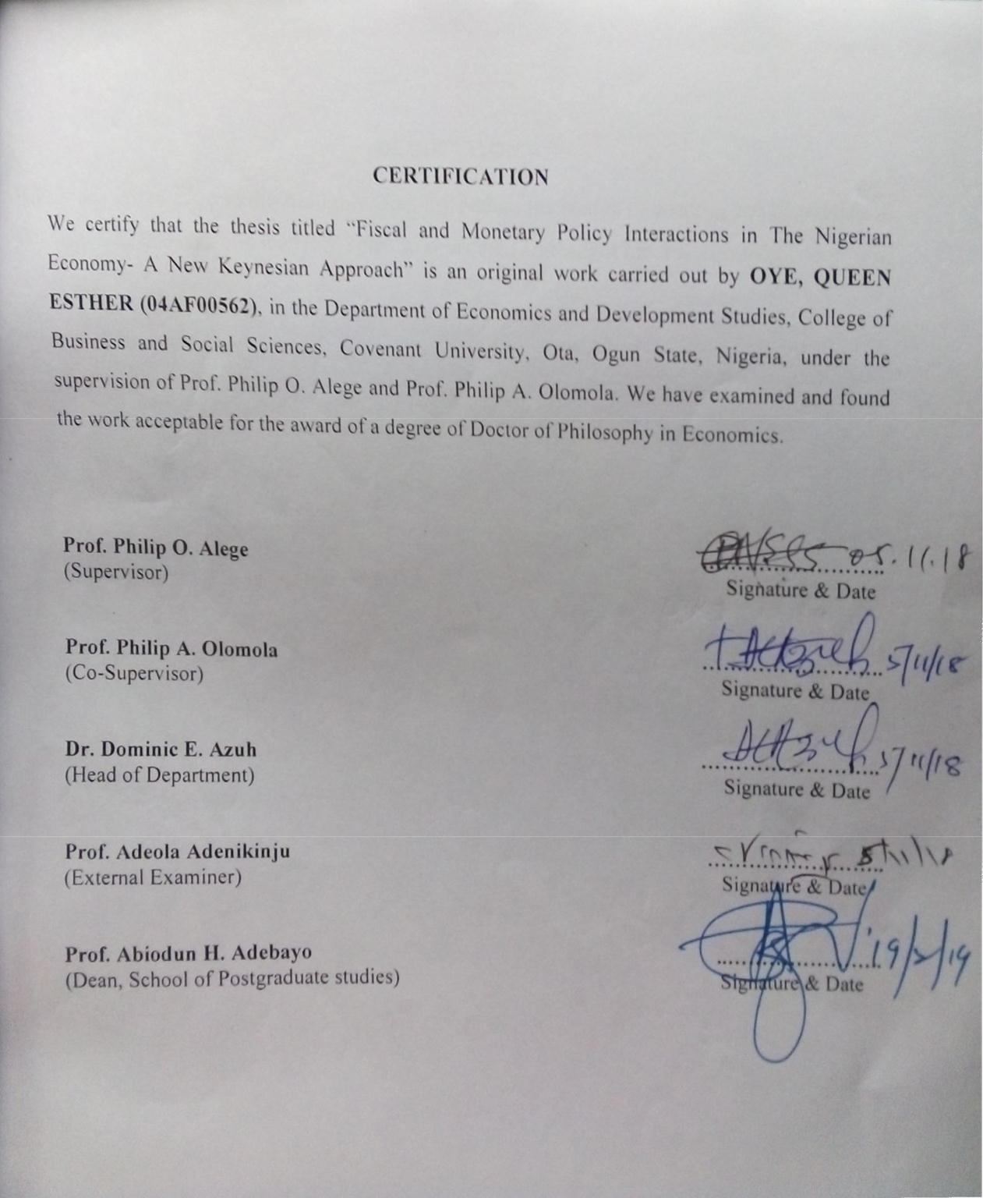

### DEDICATION

This thesis is dedicated to the Almighty God, my Father, the source of wisdom and help. His son, the beginning and end; and the Holy Spirit who inspired and taught me. I am grateful.

**ACKNOWLEDGEMENTS**

I give thanks to my Heavenly Father, who is the God Almighty for the successful completion of this thesis. I express my appreciation to several individuals that have contributed directly or indirectly, through the diverse phases of the research and writing of this dissertation. My profound gratitude goes to the Chancellor and Chairman of the Board of Regents, Covenant University, Dr. David O. Oyedepo, for the conducive spiritual and mentorship pedestal, which facilitated the success of this research work. I acknowledge the Vice-Chancellor Prof. AAA Atayero, the Deputy Vice-Chancellor, Prof. A. Williams, the Registrar, Dr. O. Oludayo and all other members of the management team of Covenant University for their commitment to Vision 10:2022 and for providing an academic-enabling environment to learn, research and write this thesis.

I acknowledge the meticulous leadership and guidance of the Dean of Postgraduate school, Prof. A.H. Adebayo, the Dean of Business and Social Sciences, Prof. Philip O. Alege and everyone that served as the College and Postgraduate school representative at my College- level presentations, including Prof. U. Uwuigbe, Dr. H. Okodua and Prof. I.S. Afolabi. I recognise your valuable contributions and efforts towards improving the quality of the thesis. Thank you very much sirs.

I particularly acknowledge my Supervisor, Prof. Philip O. Alege, for insisting on nothing but high-quality research. He also took out time to read, correct, re-read and give helpful feedbacks and instructions at each stage of the research writing. I also appreciate his role in mentoring me into the framework of Dynamic Stochastic General Equilibrium models. My profound appreciation also goes to my Co-Supervisor, Prof. A. Olomola for his good wishes, encouragement and constructive criticisms that challenged my thinking and strengthened the quality of this work. I also acknowledge erudite Professors in the Department of Economics and Development Studies, including Prof. O. Olurinola, Prof. G. Oni, Prof. S. Edo and Prof.

E. Osabuohien who tirelessly read, corrected and offered helpful comments, which motivated me to reason and write better. I also appreciate the encouragement that I received from the Head of Department, Economics and Development Studies, Dr. D. Azuh. I am grateful to you sirs.

I express my thanks to mentors and colleagues in the Department of Economics and Development Studies: Doctors H. Okodua, E. Bowale, M. Oladosu, O. Gershon, B. Ewetan,

E. Oduntan, A. Matthew, E. Urhie and others. God bless you all for your prayers, advice, constructive feedbacks and contributions at the various departmental and college presentation of this work. In addition, I acknowledge Dr. A. Adegboye of the Department of Economics, Obafemi Awolowo University whose thesis tremendously aided my understanding of DSGE modelling. I also recognise the Dynare Forum moderated by Johannes Pfeifer, Michel Julliard, Stephane Adjemian and Sebastien Villemot. They helped to address bugging simulation and estimation questions.

My special gratitude goes to my dear parents, Rev. and Pastor (Mrs.) B. Oluwatimiro for their prayers, financial and moral support all through the years of academic pursuit. I would also not fail to specially acknowledge my husband, Gbenga Oye and my children: EriOluwa and IbukunOluwa. Thank you for all that you are to me in God. I deeply appreciate your love, patience, prayers, support and sacrifices you made in the course of the Ph.D programme. I love you all.

|  |  |  |  |
| --- | --- | --- | --- |
|  | **TABLE OF CONTENTS** | **Page** |  |
| Cover Page |  |  | i |
| Title Page Acceptance Declaration Certification Dedication Acknowledgments Table of Contents List of Tables  List of Figures  List of Abbreviations List of Appendices Abstract |  |  | ii iii iv v vi vii ix xiii xv xvi  xvii  xviii |

CHAPTEONE: INTRODUCTION 1

* 1. Background of the Study 1
  2. Statement of Research Problem… 5
  3. Research Questions 7
  4. Research Objectives 7
  5. Research Hypotheses 7
  6. Scope of the Study 8
  7. Significance of study 8
  8. Method of Analysis 9
  9. Outline of the Study 9

CHAPTER TWO: LITERATURE REVIEW 10

* 1. Review of Definitional Issues 10
  2. Theoretical Review of the Literature 12
     1. Macroeconomic Theories… 12
     2. Models of Fiscal and Monetary Policy Interactions 14
  3. Methodological Review 20
     1. A-theoretic Statistical Methods 20
     2. Game Theoretic Models… 23
     3. Dynamic General Equilibrium Methods 26
  4. Estimation Techniques for NK DSGE models 35
  5. Empirical Review 38
     1. Empirical Evidence from United States and Europe 38
     2. Empirical Evidence from Asia 41
     3. Empirical Evidence from Latin America 43
     4. Empirical Evidence from Africa 44
     5. Empirical Evidence from Nigeria 45
     6. Empirical Nature of Fiscal and Monetary Policy Interactions. 46
     7. Trend in the Empirical Literature 48
  6. Summary of Identified Gaps… 60

CHAPTER THREE: STYLISED FACTS 62

* 1. Structure of the Nigerian Economy 62
  2. Monetary and Fiscal Policy in the Nigerian Economy 66
     1. Monetary Policy in Nigeria 66
     2. Fiscal Policy in Nigeria 68
     3. Monetary and Fiscal Policy Coordination in Nigeria 74
  3. Trend Analysis on Fiscal and Monetary Policy in Nigeria 75
  4. Business Cycle Facts… 86
  5. Empirical Facts on Alternative Assumptions… 89
  6. Summary of Key Issues… 94

CHAPTER FOUR: METHODOLOGY 95

* 1. Theoretical Framework 95
     1. The New Keynesian Macro-Economic Model… 95
  2. The Research Method… 100
     1. An Open Economy New Keynesian DSGE Model for Nigeria 101
     2. Solving and Estimating the Open Economy NK DSGE model… 130
     3. System of Equations to be estimated 132
     4. Data Sources and Measurements… 142
  3. Optimal Fiscal and Monetary Policy 143
     1. Ramsey Policy 144
     2. Discretionary Policy 144

CHAPTER FIVE: RESULTS AND DISCUSSION 146

5. 1 Presentation of Results… 146

* + 1. Parameter Estimates of the DSGE Model 147
    2. Impulse Response Analysis 153
    3. Variance Decomposition 157
  1. Model Diagnostic Testing 159
     1. Stability of the Model… 159
     2. Identification of the Parameter Estimates… 160
     3. Mode Check 162
     4. Univariate Convergence Statistics… 165
     5. Multivariate Convergence Diagnostic… 166
     6. Historical and Smoothed variables… 167
     7. Smoothed Shocks 168
  2. Nature of Fiscal and Monetary Policy Interactions 169
  3. Optimal Fiscal and Monetary Policy 173
  4. Implications of Findings 175

CHAPTER SIX: CONCLUSION AND RECOMMENDATIONS 177

* 1. Summary 177
  2. Major Findings of the Study 179
  3. Recommendations 179
  4. Contributions to Knowledge 182
  5. Suggestions for Future Research… 182

References… 184

Appendices… 198

### LIST OF TABLES Page

Table 2.1: Summary of Empirical Review 50

Table 3.1: Structure of the Nigerian Economy by Sectors 63

Table 3.2: Sectoral Contributions to GDP 65

Table 3.3: Oil and Non-oil contribution to GDP 66

Table 3.4: Tax Jurisdiction in Nigeria 70

Table 3.5: Expenditure Responsibilities in Nigeria 71

Table 3.6: Annual Budgets for Some Selected Years ( ~~N~~’billion) 73

Table 3.7: Average Output Growth Rate for Nigeria (percent) 76

Table 3.8: Trend in levels of Base Money, M1 and M2 (N’Million) 78

Table 3.9: Monetary Policy Stance in Some Selected Years 79

Table 3.10: Growth in Total Government Expenditure (percent) 81

Table 3.11: Fiscal Policy Stance in Nigeria in some selected years (1970- 2015) 82

Table 3.12: Correlation Matrix 83

Table 3.13: Pair wise Granger Causality Test 84

Table 3.14: Correlation Matrix 85

Table 3.15: Business Cycle Statistics on Real 86

Table 3.16: correlation with CPI 88

Table 3.17: Correlation between Fiscal and monetary policy 89

Table 3.18: Corruption Perception Index for Nigeria 90

Table 3.19: Enforcement and Monitoring of Fiscal Rules in Nigeria 92

Table 3.20: Policy Coordination in Nigeria 93

Table 4.1: Log-linear System of Equations 132

Table 4.2: Foreign Economy and other Exogenous Processes 135

Table 4.3: List of Parameters estimated 136

Table 4.4: Data Description, Measurement and Sources 143

Table 5.1: Estimates of Structural Parameters 149

Table 5.2: Estimates of Policy Parameters 151

Table 5.3: Estimates of Persistent Parameters 152

Table 5.4: Estimates of Shock Parameters 153

Table 5.7: Posterior mean variance decomposition (percent) 159

Table 5.8: Matrix of Covariance of Shocks 170

Table 5.9: Theoretical Moments 170

Table 5.10: Coefficient of Autocorrelation 171

Table 5.11: Correlation Matrix 172

Table 5.12: Correlation Matrix 172

Table 5.13: Moments of Optimal Fiscal and Monetary Policy 174

### LIST OF FIGURES Page

Figure 3.1: Inflation Rate proxied by Consumer Price Index over the period 1961-2015. 77

Figure 3.2: Trend in Total Government Expenditure 1960-2015 80

Figure 3.3: Fiscal balance as a percent of GDP (1961-2015) 81

Figure 3.4: Aggregate Indicator on Government Effectiveness in Nigeria 91

Figure 3.5: Aggregate Indicator on Control of Corruption in Nigeria 91

Figure 5.1: Impulse Response to Monetary Policy Shock 154

Figure 5.2: Impulse Response to Fiscal Policy Shock 155

Figure 5.3: Impulse Response to Output Shock 156

Figure 5.4: Impulse Response of Shock to Rent Seeking 157

Figure 5.5a: Prior-Posterior Plots 161

Figure 5.5b: Prior-Posterior Plots 162

Figure 5.6a: Mode Check Plots 163

Figure 5.6b: Mode Check Plots 164

Figure 5.6c: Mode Check Plots 164

Figure 5.7a: MCMC Univariate Diagnostics for selected parameters 165

Figure 5.7b: MCMC Univariate Diagnostics for selected parameters 166

Figure 5.8: Multivariate Convergence Diagnostic 167

Figure 5.9: Historical and Smoothed variables 168

Figure 5.10: Smoothed Shocks 169

**LIST OF ABBREVIATIONS**

CPI Consumer Price Index

DSGE Dynamic Stochastic General Equilibrium

ERGP Economic Recovery and Growth Plan

FLAC Fiscal Liquidity Assessment Committee

FMF Federal Ministry of Finance

FOC First Order Condition

FTPL Fiscal Theory of the Price Level

GDP Gross Domestic Product

GE Government Expenditure

IS-LM Investment Saving and Liquidity Preference – Money Supply

LQ Linear Quadratic

M1 Narrow Money Supply

M2 Broad Money Supply

MFPCC Monetary and Fiscal Policy Coordination Committee

MTEF Medium Term Expenditure Framework

NK New Keynesian

OECD Organisation for Economic Co-operation and Development

OLG Over Lapping Generation

OMO Open Market Operation

TFP Total Factor Productivity

TVP-VAR Time Varying Parameter-Vector Autoregression

RBC Real Business Cycle

RM Reserve Money

WGI World Governance Indicators

**LIST OF APPENDICES Page**

Appendix 1: Prior 198

Appendix 2: MCMC Univariate Diagnostics 200

Appendix 3: Dynare Code for Bayesian Estimation 203

Appendix 4: Dynare Code for Optimal Ramsey and Benevolent Government 206

Appendix 5: Dynare Code for Optimal Ramsey and Rent-seeking Government 208

Appendix 6: Dynare Code for Optimal Discretionary and Benevolent Government 210

Appendix 7: Dynare Code for Optimal Discretionary and Rent-seeking Government 212

Appendix 8: Derivation of the optimal pricing equation for the firm 214

Appendix 9: Prior-Posterior Plot 216

**ABSTRACT**

A political economy environment typified by political corruption, poor implementation of economic policy rules and weak policy coordination, can alter the fiscal behaviour of government and how it interacts with the monetary policy of the Central Bank. This study solved and estimated a Small Open Economy New Keynesian Dynamic Stochastic General Equilibrium model with a modified fiscal bloc. This is done in order to examine fiscal and monetary policy interactions under alternative assumptions of a rent-seeking government that follows discretionary policies and where no economic policy coordination exists. Its specific objectives were to assess the nature of fiscal policy interactions with monetary policy in Nigeria; examine the transmission effect of the policy interactions on output and inflation, and to investigate the optimal fiscal and monetary policy mix that guarantees economic stability in Nigeria. A first-order Taylor approximation method was used to solve the model around its deterministic steady state. Thereafter the Bayesian method, specifically the Metropolis- Hastings algorithm was used to estimate the parameters of the model. In order to derive the optimal combination of fiscal and monetary policy, the Dynare computational routines on Ramsey policy and Discretionary policy were employed. The results from this study revealed that both fiscal policy and monetary policy act as strong substitutes. This highlights the possibility of conflicts between fiscal and monetary decisions. Secondly, the overall impact of policy interaction negatively affects both inflation and output. This corroborates the lack of coordination between both policies. Moreover, it implies that stabilisation policies may be inadequate in guiding the Nigerian economy. Thirdly, the results on the optimal fiscal- monetary combination point out that politicians and bureaucrats in government should commit to policy rules. At the same time, they should implement policies that enhance the welfare of the entire citizens, not just a subset of the citizens. In addition, the study recommends among others that fiscal and monetary policies should be harmonised. For instance, the Central Bank of Nigeria and the Federal Ministry of Finance can adopt the same economic model and assumption in planning and forecasting policy targets.

Keywords: Fiscal and Monetary Policies, Policy Interactions, Optimal Policy, Rent-seeking, DSGE.

# CHAPTER ONE INTRODUCTION

# Background of the Study

Fiscal and monetary policies are the two most significant tools available to policymakers, in guiding an economy, towards attaining desired macroeconomic objectives which include high and sustainable economic growth, price stability, employment and viable external balance. The government employs fiscal tools such as spending and taxes to provide public goods, to redistribute income and stabilise aggregate demand. The Central Bank also uses interest rate, exchange rate and money supply to stabilise the price level, output and the financial system. Both policies are used for the short-term stabilisation of the economy which guarantees medium to long-term outcomes in growth and welfare (World Bank, 2014). Based on their importance, governments and central banks, the fiscal and monetary authorities respectively, are constantly faced with the task of setting the appropriate policy targets that get the economy closest to its optimal state.

However, there is a lack of consensus on the most appropriate manner that policymakers can utilize fiscal and monetary policies (Mundell, 1962; Wren-Lewis, 2011). This concern, in specific terms, whether the instruments of fiscal and monetary policies are independent or intertwined in their impact on the economy. Debates in the academic and policy-making circle, between the Keynesian and Monetarist schools of economic thought, implicitly posits fiscal and monetary policies as separable in nature, since it centred on the importance of each policy, relative to the other (Hetzel, 2013). This argument is premised on the notion that the importance and macroeconomic effect of either policy can be isolated from the other (Hallett, Libich and Stehlik, 2011). But in the literature, inquiry into this debate remains inconclusive indicating that there is no consensus on the most preferred policy regime, between monetary

and fiscal, that an economy should adopt (Mundell, 1962; Ajayi, 1974; Ajisafe and Folorunso, 2002; Musa, Asare and Gulumbe, 2013).

Policy discourse has, therefore, evolved into the proposition that fiscal and monetary policies are interdependent rather than separate (Niemann and Hagen, 2008). This proposition borders on the view that ongoing interactions exist between both policies. Policymakers belonging to this school of thought usually canvass that fiscal and monetary instruments should be combined in addressing any macroeconomic issue. The central argument, therefore, is to mix or interact fiscal and monetary policies since externalities are assumed to exist between the two policies, such that a change in one influences the stance of the other and its overall macroeconomic effect (Niemann and Hagen, 2008). In other words, the successful outcome or effectiveness of fiscal (monetary) policy depends on the stance of (monetary) fiscal policy. For instance, rising and uncontrolled budget deficits can constrain the ability of the central bank to control inflation rates. This is because rising budget deficit can induce the government to resort to seignorage revenue from the central bank. The government, in this instance, can pressure the central bank to print new money in order to finance its fiscal shortfall. Money is consequently injected into the economy and in turn, the apex bank responds by using restrictive monetary policy to control the resulting inflation.

The issue of fiscal and monetary policy interactions, therefore, has come to fore, arising from numerous theoretical and empirical contributions. Tinbergen (1952) argued that fiscal and monetary policies should be considered as a coherent entity and separately. Similarly, Theil (1957) opined that policy authorities should combine fiscal and monetary instruments in the right proportion in order to simultaneously attain desired policy outcomes. In the modern literature, Sargent and Wallace (1981), Leeper (1991), Sims (1994), Leeper and Leith (2015), highlighted the need for fiscal and monetary interactions in order to determine price level. They showed that the effectiveness of policy instruments of the Central Bank- to stabilise and control inflation- depends to a large extent, on the fiscal stance of the government. Fiscal and monetary policy interaction is also relevant in its impact on medium to long-term outcomes such as public debt (Cochrane, 2001; Niemann and Hagen, 2008) and economic welfare (Beningno and Woodford, 2004; Schmitt-Grohe and Uribe, 2007).

Furthermore, economic events like the formation of the European Monetary Union and the aftermath of the global financial crisis has sparked interest in the issue of fiscal and monetary policy interaction (Petreveski, 2013; Reserve Bank of India, 2013). The European Monetary Union (EMU), for instance, is modelled as fielding an economic policy game between several national fiscal authorities and a single central bank, the European Central Bank. The union's only apex bank is bound by the Maastricht Treaty to focus on price stability while the various fiscal authorities are subject to the Pact of Stability and Growth that sets limits on debt and deficit ratios. Both policymakers within the union, therefore, are expected to act together.

In the same vein, the global financial crisis also underscores the essence of the interrelation between the government and the Central Bank. In the aftermath of the crisis and the recession following, some advanced economies opted for expansive fiscal policy. In this regard, policymakers resorted to applying fiscal instruments in the form of bailouts and stimulus, due to the ineffectiveness of monetary policy to stimulate the economy at the Zero Lower Bound rate. The United States, in particular, injected US$125 billion in implementing the Economic Stimulus Act and US$787 billion under the American Recovery and Reinvestment Act (Kliem, Kriowoluzky and Sarferaz, 2015). The expansionary nature of fiscal stimuli has posed a challenge in the manner that inflationary and debt sustainability pressures mounted from the accompanying rise in deficits and debts. Monetary authorities are therefore concerned with the looming effect of government expanding stance on their ability to stabilise the price level. This is because government deficits and debts have the potential to constrain the central banks from achieving their primary objective of controlling the price level (Sargent and Wallace, 1981; Leeper, 1991). It is then important to find out how to fix the right monetary targets that complement such impending bleak fiscal reality (Leeper, 2013).

The concern for fiscal and monetary policy interaction in Nigeria stems from the need for policy alignment between the Central Bank of Nigeria (CBN) and the Federal Ministry of Finance (FMF). The absence of coordination between both policy authorities can constrain the effectiveness of their policies and is a potential source of instability and lower macroeconomic performance. There is evidence of weak coordination of fiscal and monetary policy in Nigeria, despite the enactment of institutions such as the Fiscal Liquidity Assessment Committee

(FLAC) and the Monetary and Fiscal Policy Coordination Committee (MFPCC) (Englama, Tarawalie and Ahortor, 2013; Oboh, 2017). The measuring rod of coordination between fiscal and monetary policy is when both policies have similar stances in the instrument of budget balances and real interest rate i.e. expansionary fiscal/expansionary monetary and tight fiscal/tight monetary (Rothenberg, 2004). Available facts, however, show that over the period 1970-2015, fiscal and monetary policies were uncoordinated across 25 years but complementary in 21 years. This depicts the weak form of policy coordination between both policies (see section 3.5)

A second argument on the need to study fiscal and monetary policy interaction is to help guide the design of a consistent set of policies that will consolidate the ongoing Economic Growth and Recovery Plan of the Federal Government at reviving the Nigeria economy after a bout of stagflation. Data from the National Bureau of Statistics (2016) reveal that the economy slipped into a recession after it contracted by -0.36 percent and -2.06 percent in 2016Q1 and 2016Q2. At the same time, the Inflation rate in Nigeria rose from an average of 12.24 percent over the period 1996-2016 to 17.6 and 18.10 percent in August and October 2016. The central bank, therefore, responded by tightening its stance. It raised the Monetary Policy Rate from 11 to 12 percent in March 2016. This was further increased to 14 percent in July 2016, in order to rein in on the rising inflationary trend. The Federal Ministry of Finance, on the other hand, pursued an easy fiscal stance. In 2016Q1 and 2016Q2, the budget deficit stood at N548.42 billion and N1090.96 billion, respectively. Policy analysts deduced that the twin problems of negative economic growth rate and rising inflation were aggravated by the conflicting and uncoordinated stances of both fiscal and monetary policy (Central Bank of Nigeria, 2017). Therefore, it becomes necessary to complement both policies in the right direction in order to curtail future recessionary episodes and consolidate the gain of the current recovery plan.

The interaction between fiscal policy and monetary policy in Nigeria is examined within a New Keynesian Dynamic Stochastic General Equilibrium (NK DSGE) framework. This framework combines standard Keynesian assumptions such as price stickiness, imperfect competition and the use of stabilisation policies, with the traditions of microeconomic foundation and general equilibrium conditions. In the tradition of micro-foundation,

macroeconomic models are usually built by aggregating the behaviour of rational microeconomic agents, i.e. households and firms. The NK DSGE model, therefore, considers the simultaneous economic interaction among households, firms, a Central Bank that sets monetary policy and a government that fixes fiscal policy, under the assumptions that optimising agents form rational expectations and the Central Bank and government each commit to policy rules among others.

Stemming from the preceding paragraphs, this thesis empirically characterises the existing nature of policy interaction in Nigeria. The thesis also gauges the effect of the policy interactions on output and inflation in Nigeria. The study, by implication, also obtains the optimal fiscal and monetary mix that should enhance the outcome of both policies and the overall macroeconomy.

# Statement of Research Problem

This study investigates fiscal and monetary policy interactions in a small open economy, New Keynesian Dynamic Stochastic General Equilibrium (NK DSGE) model where certain theoretical assumptions are altered. Several empirical studies have examined fiscal-monetary policy interactions within a DSGE model (Muscatelli, Tirelli and Trecroci, 2005; Davig and Leeper, 2009; Algozhina, 2012; Cekin, 2013; Gilksber, 2016; Chen, 2017). The DSGE framework provides an appropriate setting to investigate policy interactions. This is because it assumes ongoing interdependencies among several economic agents that includes households, firms, central bank and the government. Furthermore, the DSGE-based method is premised on theoretical assumptions that are relevant for policy analysis. It is, therefore, immuned from the susceptibility of other estimation techniques to the Lucas’ critique. However, a fallout is that some assumptions used in the DSGE models are unsuitable in the context of developing economies (Vangu, 2014). Some of these unsuitable assumptions pertain to the behaviour of government, that is, the fiscal policy bloc of the model. Several studies examining fiscal- monetary policy interactions, in this respect, have assumed rather unrealistically that government is benevolent and at the same time, commits to policy rules.

Empirical evidences such as the Corruption Perception Index (2016), World Governance Indicators (2016) and the Fiscal Rule Dataset (2017), nonetheless, show that these

conventional assumptions do not hold for a developing economy such as Nigeria. This study, therefore, abstracts from these conventional assumptions. The conventional assumption of the fiscal sector is then modified in line with political economy literature such that, the government is posited to be neither benevolent nor does it commit to a policy rule (Persson, 2001; Fragetta and Kirsanova, 2010; Miller, 2016). The government, however, is assumed to have rent- seeking tendencies and prefers to use policy discretion in maximising the welfare of a subset of the society. The modifications to the fiscal bloc can also be used to capture the weak coordination between fiscal and monetary policies in Nigeria (Englama, Tarawalie and Ahortor, 2013). It is, therefore, needful to investigate the existing policy interactions when alternative fiscal realities are explicitly modelled.

This study is, therefore, related to empirical studies that assess fiscal and monetary policy interactions in Nigeria (Chuku, 2010; Okafor, 2013; Musa *et al.*, 2013). This study nevertheless differs from them by adopting the DSGE method. However, this study is most related to Adegboye (2015). His study is one of the few studies that investigate fiscal and monetary policy interaction in Nigeria, using the New Keynesian DSGE framework. This thesis differs from Adegboye (2015) because the study considers fiscal and monetary policy interaction in the form of a fiscal rule in government spending and a Taylor rule, but leaves out the possibility of policy discretion and rent-seeking which is more related to government’s fiscal behaviour in Nigeria. Secondly, the work was silent about capturing the poor coordination that exists between fiscal and monetary policies in Nigeria, since there is empirical evidence of weak coordination in Nigeria (Englama, Tarawalie and Ahortor, 2013).

This study has consequently identified four research gaps to fill. First, there are few studies on fiscal and monetary policy interaction in Nigeria. Second, few studies have applied the DSGE method in Nigeria, even fewer are works that have used the DSGE technique to analyse fiscal and monetary policy interaction. This thesis contributes to the sparse literature on dynamic general equilibrium modelling in Nigeria which only a few researchers such as Alege (2008); Olayeni (2009); Adebiyi and Mordi (2010); Alege (2012) and Adegboye (2015) among others, have ventured into. Third, this work borrows from the political economy contributions of Persson (2001) and Miller (2016) to study fiscal and monetary policy interactions in a DSGE model where existing assumptions about the fiscal authorities are modified to capture the

political economy reality of Nigeria. Fourthly, an interaction variable is constructed in order to explicitly define fiscal-monetary policy interactions.

# Research Questions

Following the need to examine the fiscal and monetary policy interaction under alternative assumptions of a rent-seeking government that follows discretionary policies and absence of economic policy coordination, this study seeks to answer the following questions:

1. To what extent does fiscal policy interact with monetary policy in Nigeria?
2. What is the transmission effect of the policy interaction on output and inflation in Nigeria?
3. What is the optimal fiscal and monetary policy mix that guarantees output and inflation stability in Nigeria?

# Research Objectives

The broad objective of this thesis is to examine the interactions between fiscal and monetary policy under alternative assumptions. The specific objectives are to:

1. assess the extent to which fiscal policy interacts with monetary policy in Nigeria;
2. examine the transmission effect of the policy interactions on output and inflation in Nigeria; and
3. investigate the optimal fiscal and monetary policy mix for output and inflation stability in Nigeria.

## Research Hypotheses

The study tests the following hypotheses stated in both null and the alternative: H01: Fiscal policy has no interaction with monetary policy in Nigeria

H11: Fiscal policy has interaction with monetary policy in Nigeria

H02: There is no transmission effect of the policy interaction on output and inflation in Nigeria H12: There is a transmission effect of the policy interaction on output and inflation in Nigeria H03: There is no optimal fiscal and monetary policy mix for output and inflation stability in

Nigeria

H13: There is an optimal fiscal and monetary policy mix for output and inflation stability in Nigeria

# Scope of the Study

This thesis runs on two central themes: the impact of fiscal behaviour on monetary decisions and the optimal mix of fiscal and monetary policy in Nigeria. First, the study displayed some empirical facts on fiscal-monetary policy interaction in Nigeria using relevant fiscal and monetary policy targets and instrument variables such as budget deficits, public debt, money supply, interest rates and inflation rates.

The work then undertakes both positive and normative analysis. In the positive analysis, this thesis considers whether and how fiscal policy variables such as government spending, budget deficit, debt influences the Central Bank’s goal of low and stable inflation. In case of the normative study, the work draws from literature on macroeconomic policy design to conduct some sensitive policy analysis in order to determine optimal fiscal and monetary policy mix.

The study covers the period from 1961Q1 to 2016Q4. This period is regarded as sufficient in the sample for analysing fiscal and monetary policy interaction in Nigeria. The study period is also characterised by several shifts in both policies that are necessary for interaction between them. These include changes in government that can influence fiscal behaviour and the period of no independence and operational independence for the Central Bank of Nigeria.

# Significance of the Study

The attempt to examine the extent of interaction between fiscal policy and monetary policy, and the optimal manner that fiscal and monetary policy should interact, is germane on two grounds. First, it can be taken as a template to empirically guide the interaction between both policy institutions in the future, so that policymakers can formulate and plan macroeconomic targets such as inflation rates, debt levels and growth rates for the Nigerian economy.

Secondly, policymakers can also identify and quantify the transmission of fiscal actions on monetary policy and the aggregate economy. Thirdly, the work contributes to the relatively

unexplored literature on fiscal-monetary policy interactions in Nigeria, especially within the context of modelling the fiscal behaviour of government using alternative assumptions and the application of the Dynamic Stochastic General Equilibrium framework.

# Method of Analysis

The study, first, employs a-theoretical methods to explain the long-term trend and derive business cycle properties of relevant fiscal and monetary policy variables. This is in the chapter where trend analysis and preliminary stylised facts on policy interactions in Nigeria are generated.

This study then goes ahead to adopt the dynamic general equilibrium framework based on the New Keynesian school of thought in order to address the set objectives. The procedure used to analyse the dynamic stochastic general equilibrium model used includes the following: (1) write down the model (2) Derive the system of equilibrium conditions of the model (3) solve for the steady state (4) calibrate the parameters (5) solve the model by log-linear approximation

(6) Estimate the deep parameters of the model using the Bayesian method and finally, (7) simulate the model with necessary counter-factual policy experiments performed.

# Outline of the Study

This work is divided into six Chapters. Chapter one introduces the subject matter, the research problem is defined in this chapter, questions of the thesis and strategies to answering these questions are stated. Chapter two reviews the literature on Fiscal and Monetary Policy Interactions. In this chapter, conceptual, theoretical, methodological and empirical reviews are presented; research gaps stemming from the literature are also identified. In chapter three, some stylized facts on fiscal-monetary policy interactions in Nigeria are illustrated. The study's theoretical framework and methodology make up Chapter four, while the estimation results are presented in Chapter five and finally, conclusions, policy implication of findings and recommendations are made in Chapter six.

# CHAPTER TWO LITERATURE REVIEW

This chapter provides a comprehensive outline of developments in the literature on the interactions between fiscal and monetary policy. The chapter is divided into four major sections: Conceptual, Theoretical, Methodological and Empirical. In the conceptual review, definitional issues surrounding Fiscal and Monetary policy interactions are examined. Under the theoretical review, the main theories underlying the economic policy interactions are outlined and critiqued. For the methodological review, the essentials techniques of estimation are mentioned and evaluated. Finally, several empirical findings regarding fiscal-monetary policy interactions are enumerated in the empirical review.

# Review of Definitional Issues

* + 1. **Fiscal and Monetary Policy Interaction**

The idea of interactions between Fiscal and Monetary policy springs from the assumption that both policies are interrelated. This idea reflects in the writing of Tinbergen (1952) who argued that economic policy should be considered as a coherent entity that is devoid of any form of isolation. Fiscal and Monetary policies are, in this regard, interrelated in their impact on each other’s target. This is premised on the ground that there are externalities or spill-over between the instruments of both policies such that a change in one influences the stance of the other (Niemann and Hagen, 2008).

Two channels are involved in explaining the existing externalities or spill-over between both policies. The first channel runs from the influence of fiscal policy on the instruments and targets of monetary policy. This channel essentially considers the impact of government expansive stance in deficit and debt, on nominal variables such as interest rate and price level. This is because rising budget deficit can induce the government to resort to seignorage revenue

from the central bank. This means that the government can put pressure on the central bank to print new money in order to finance its fiscal shortfall. The central bank can also finance these deficits by purchasing government securities through the open market operation. These deficit financing methods inject money into the economy and in turn, the apex bank responds by using restrictive monetary policy to control the resulting inflation. Furthermore, increased deficit spending and new debt issuance raise the rate of interest, when the supply of government securities increases which lowers the price and moves the interest rate upward. The second channel concerns the externality that runs from monetary policy to fiscal policy. The rate of interest affects the real value and sustainability of government debt (Niemann and Hagen, 2008). The variability of the price level also impacts on public finances as it makes it difficult to predict and plan for the level of public finances (Algozhina, 2012).

Fiscal and monetary policies are also interacting in their overall macroeconomic impact. The Investment Saving- Liquidity Preference and Money Supply (IS-LM) models, for example, show that the fiscal and monetary policy instruments are interacting in the goods and money markets in order to influence aggregate output and interest rate. Theil (1957) also assume that a central policymaker possesses all available policy instruments and can simultaneously attain desired policy outcomes by combining these instruments in the right proportion. The works of Sargent and Wallace (1981); Cochrane (2001) and Niemann and Hagen (2008) shows that the instruments of fiscal and monetary policy are interacting to determine the price level, debt level and economic growth.

Fiscal and monetary policies can by nature, interact as substitutes or in a complementary manner in their effect on the aggregate economy. Both policies interact as substitutes when an expansionary fiscal (monetary) policy is countered by contracting monetary (fiscal) policy and as complements, when an expansionary fiscal (monetary) policy is accompanied by a corresponding expansionary monetary (fiscal) policy stance, i.e. they offset and support each other in the stabilisation of the economy. Another nature of interaction between both policies borders on Leeper (1991) classification of active and passive regimes. Both policies can interact either in a passive or active manner. For instance, an active policy authority makes its

policy decision without regards to the path of government finance while a passive authority will respond to changes in the state of fiscal debt (Leeper, 1991).

# Working definition of Fiscal and Monetary Policy Interaction

Based on the preceding section, fiscal and monetary policy interaction is defined as the interplay between both policies with resulting impact on each other’s instruments and on macroeconomic targets or outcomes.

Some assumptions guiding this working definition include:

1. There are interdependencies between both fiscal and monetary policy;
2. There is a decentralised policy environment such that the two authorities- Central Bank and Ministry of Finance- are respectively in charge of setting monetary policy and fiscal policy; and
3. Policy externalities exist between both policies such that changes in one policy induces changes in the other policy.

# Theoretical Review of Literature

This sub-section shows the underlying macroeconomic theories on the interactions between the fiscal and monetary policies. A background which summarises the major schools of thought on economic policy is presented. Thereafter, specific theories on fiscal and monetary policy interaction are outlined. They include the Monetarist Arithmetic and the Fiscal Theory of the Price Level.

# Macroeconomic Theories up to the New Keynesian School of Thought

The occurrence of the Great Depression of the 1930s in the United States and Europe sparked the paradigm shift from the classical to the Keynesian school of economic thought (Jahan, Mahmud and Papageorgiou, 2014). The classical school reflected primarily the works of Adam Smith and David Ricardo. First, they focused on the underlying factors that spawn and sustain economic growth. They postulated that an economy is able to reach its potential output or full employment level in the long run. In the instance of any distortion of the economy from its

potential output, the economy can re-adjust on its own in the long run through the price mechanism. This precludes any form of government policy. The re-adjustment capacity of the economy demonstrates their liberalist tradition. Essentially, they advocated for minimal government intervention since the economy is self-correcting. Wages and prices are also regarded as flexible and determined by the price mechanism.

John Maynard Keynes in his book, The General Theory of Employment, Interest and Money, differed in his prescription to tackling the Great Depression. Keynes drifted from the Classicals’ emphasis on aggregate supply to the concept of aggregate demand. The Classicals, going by the Say’s law, correlated the state of the economy with the level of the aggregate supply curve. Keynes, in a different manner, posited that the changes in aggregate demand can distort the actual levels of output from its potential level, creating gaps. Keynes also focused on the short run, he believed that contrary to the Classicals the economy may never attain full employment in the long run, because “in the long run we are all dead.” The economy may be unable to correct itself because prices are sticky in the short run. Keynes, therefore, advocated for the intervention of the government, specifically the use of fiscal and of monetary policy, which are termed stabilisation policies, to direct the economy to its level of potential output.

The monetarists led by Milton Friedman link in a direct proportionate manner, changes in the money supply to changes in the level of output. They opine that only money matters in an economy (Jahan and Papageorgiou, 2014). They uphold the liberalist view of the Classicals and likewise argue for minimal intervention of government in the economy. In this respect, they avoid the use of Keynesian stabilisation policy. Fiscal policy is neutral in its impact due to its crowding-out effect, while the lags associated with monetary policy can be long and destabilising. They advocate the implementation of a monetary rule in money supply such that the central bank increases the money supply at a fixed annual rate.

The New Classicals build on the ideas of the Classicals. They focus on the supply side of the economy, flexible prices and the ability of the economy to correct itself. The New Classicals propose the use of sophisticated mathematical economic models with rational agents who desire to maximise their preferences (Hoover, 2008). This school also centres its analysis on the rational expectations hypothesis, which assumes that individuals form expectations about

the future based on the information available to them, and that they act on those expectations. The New Keynesians adopts the conventional argument of sticky prices and the effectiveness of stabilisation policy in returning an economy to the level of the potential output and also incorporates the aggregate supply bloc into their model. They also adopt a mathematical model of the aggregate economy built upon microeconomic foundations (Mankiw, 2008).

# Models of Fiscal and Monetary Policy Interactions

The major theories explaining fiscal-monetary policy interaction are presented and reviewed by highlighting their similarities and differences, strengths and weaknesses as well as existing gaps. These theories underlying fiscal-monetary policy interaction are the IS-LM model, the Monetarist Arithmetic (Sargent and Wallace, 1981; McCallum, 1984) and the Fiscal Theory of Price Level (Leeper, 1991; Sims (1994, 1999); Woodford (1995, 1996, 2001). These theories, especially the Monetarist Arithmetic and Fiscal Theory of Price Level, are set within the mathematical model and rational expectation framework of the New Classical and New Keynesian schools of economic thought.

### The Investment Saving and Liquidity Preference – Money Supply (IS-LM) model

The IS-LM model is used for policy analysis to depict the manner in which fiscal and monetary policies interact to determine the level of aggregate output and interest rate. The IS curve represents equilibrium in the goods market which shows that aggregate spending is defined as the summation of private household consumption, investment spending by firms and purchases by the government. The LM curve on the other hand, represents equilibrium in the money/financial market such that real money supply equates money demand.

The two curves intersect to uniquely determine the aggregate output (Y) and interest rate (r). The interaction between fiscal and monetary policy in this model occurs whenever there is a change in one policy such that the other adjust its path to this change. For instance, when there is a change in fiscal policy such that the government increases the level of spending or lowers taxes, this affects the goods market and shifts the IS curve to the right. Mankiw (2016) notes that the central bank can respond to this change in three ways. These include holding constant the level of money supply, the interest rate and the level of output. In the case that the central bank responds by holding the level of money supply constant, the level of output in the goods

market increases as well as spilling over to the money market where the interest rate equally rises. When the central bank reacts to a change in the policy of government by keeping the rate of interest fixed, then it shifts the LM curve to the right and the level of money supply rises. This scenario is in fact further modelled in a formal manner. Finally, in the face of reacting to fiscal policy by holding the level of aggregate output unvaried, the central bank will have to shift the LM curve to the left which indicates that the volume of money in circulation reduces.

# Monetarist Arithmetic

The seminal contribution to the concept of the Monetarist Arithmetic was by Sargent and Wallace (1981). It highlights the idea that central bankers are required to regard the government’s fiscal policy, while making policy decisions. This is because government actions can render ineffective the ability of monetary authority to determine and stabilise price level in the economy. Sargent and Wallace (1981) define fiscal-monetary policy interaction as a Stackelberg game between the Central Bank and Treasury. They demonstrate that in a fiscally dominant regime, the central bank may find it difficult to control inflation since it may be unable to decide the path of money stock given the exogenously determined path of government’s budget deficit. In arriving at this conclusion, they draw on a monetarist model embedded in an Over-Lapping Generation framework. In this model, they centrally assume that the path for government deficit is exogenously determined i.e. the government is assumed to set the deficits, while the central bank controls the level of money supply and can raise revenue from money creation. In the model, fiscal and monetary policies are interacting within a consolidated government budget constraint. This constraint is an identity that links both policies. It shows that the government finances its budget deficit by issuing one-period bonds and by money creation.

The path of fiscal policy is, therefore, assumed to exogenously evolve under this form of policy game; while the central bank passively adjusts to the path of this government policy. Under this circumstance, for every deficit the government fixes, the central bank is forced to finance it through money creation, if it cannot be financed by the sale of bonds. The central bank is also constrained to finance government deficit if the economy reaches a fiscal limit where the government can no longer issue new bonds since it has accumulated a large amount of debt which it is likely to default on. The creation of money by the central bank either by printing

money or buying government securities injects money into the economy, which leads to a surge in volume of money supplied and by the monetarist quantity theory implies increases in the price level and then inflation. The solution to the constraint imposed on the central bank is an independent and conservative authority that can discipline the government by refusing to finance its deficit.

However, there have been reactions to the position of Sargent and Wallace (1981) as stated earlier in the previous paragraphs. For instance, Weil (1987) re-examines their conclusion that primary budget deficits have to be monetized i.e. central banks are restricted from selecting desired range of money supply in the face of exogenously determined budget deficits of the fiscal authorities. Weil (1987) adopts a simple monetary model nested within a fusion of the Over-Lapping Generation and Infinite-Horizon frameworks. The study assumes a monetary economy with intergenerational dynamics where new and infinitely-lived individuals continuously enter the economy. The results reveal contrasting conclusions such that when intergenerational effects are considered, there are larger chances that central banks can determine the paths of monetary policy for every given fiscal policy. By implication, the findings of Weil (1987) differs from Sargent and Wallace (1981) on grounds that the study departs from the standard OLG models and assumes real interest rates that vary. In the same vein, Darby (1984) counteracts the Sargent and Wallace (1981) assertion. The author shows that this assertion may not hold under certain conditions. The author overturns Sargent-Wallace assumption that real interest rates are higher than growth rates, and also modifies their definition of real interest rate using the after-tax values; but retains Sargent-Wallace proposition that real interest and growth rates are constant. In a model where real interest rates are lower than growth rates, Darby (1984) shows that the Sargent-Wallace may not hold.

The conclusions of Weil (1987), Darby (1984) show that the Sargent-Wallace hypothesis may hold or not depending on the underlying assumptions held or relaxed. McCallum (1984), Miller and Sargent (1984) prove this. McCallum (1984) examines the monetarist notion that government budget deficit can be non-inflationary on condition that it is funded by bond sales rather than from currency. Using a discrete time, deterministic model, the study is able to illustrate that the validity of this hypothesis depends on whether budget deficits are defined as

including interest payments or not. Specifically, the monetarist hypothesis does not hold when deficits are defined as excluding interest payments. Also, Miller and Sargent (1984) relax the Sargent-Wallace assumption of an exogenously fixed interest rate. According to the authors, the real interest rate is partly derived as a function of the ratio of interest-bearing government bonds to base money. By this, the study uses ad-hoc aggregate demand and supply equations to show that merely comparing real interest and growth rates as conducted in Darby (1984) is insufficient to predict the Sargent-Wallace hypothesis.

# Fiscal Theory of the Price Level

Even though Weil (1987), Darby (1984), McCallum (1984) contradict Sargent-Wallace hypothesis because they modify some of its assumptions, Buiter (1999) supports this hypothesis. Apart from the generalization of Sargent-Wallace hypothesis when certain of its assumptions are relaxed or modified, a second source of contradiction to this proposition is from Leeper (1991), Sims (1994), Cochrane (2001), Woodford (1995, 2001). This set of articles make up the literature on the Fiscal Theory of Price Level (FTPL)

Its proponents argue that fiscal policy is the foremost determinant of price level. Unlike the monetarists who propose that government budgets indirectly affect the price level through the seignorage- money stock channel. Woodford (1995, 1996, 2001) and others posit that government budget can have a direct impact on price level void of any monetary channel. This indicates that fiscal policy takes on an active role while monetary policy only plays a passive role in controlling the price level.

One of the key contributions to the literature on the fiscal theory of the price level is from Leeper (1991). The study shows the joint pairing of fiscal and monetary policy paths which uniquely determines equilibrium price level. In a specific manner, the study models the interaction between fiscal and monetary policy as an active and passive game. An active policy is defined as policy that fixes its path independently from variation to the budgetary condition or debt shocks while a passive policy responds to budgetary shocks and is constrained by the actions of the authority with the active policy. A unique determination of the price level, therefore, requires the pairing of an active policy with a passive policy. For instance, an active

monetary policy with a passive fiscal stance and an active fiscal policy coupled with a passive monetary policy leads to uniquely determined prices. The combination of two passive policies leads to indeterminacy of the price level, while the pairing of two active policies produces an explosive path. The fiscal policy in the proposition of the fiscalists, therefore, takes on an active path while monetary policy is passive in order to uniquely determine the price level.

It suffices to note at this point that there are several issues of contest between proponents of the Monetarist Arithmetic and the Fiscal theory of the price level. Although, the monetarist literature comprising the thoughts of Sargent-Wallace assume that there is a budget constraint on government which is an identity that must be satisfied for all paths of prices, the proponents of FTPL assumes otherwise. They opine that government budget constraint is fulfilled only for equilibrium price paths. In dealing with fiscal dominant regimes, the monetarist doctrine suggests that central banks should become independent and follow a Taylor’s rule in determining the course of monetary policy. However, Woodford (1995, 1996, 2001) argue that such recommendation is insufficient in quelling unstable price levels, since government budget surpluses have direct effects on price levels even in the face of a conservative and independent central bank. This is because the price level adjusts to maintain inter-temporal government budget balance. As a result, Woodford (1995, 1996, 2001) advocates fiscal policy as the main determinant of price levels. Furthermore, he suggests that the pairing of a Taylor rule for monetary policy with government budget deficits rule for fiscal policy is panacea to achieve low and stable inflation rates. On similar grounds, Leeper (1991); Leeper and Leith (2015) put forward that the joint movements of monetary and fiscal policies determine the price level. Leeper (1991) specifically recommends that monetary and fiscal policies are paired such that an active policy stance is accompanied by a passive one to realise a low and stable price level.

A second line of contest between FTPL and the monetarist doctrine centres on the existence of Ricardian or Non-Ricardian fiscal policy. Woodford (1995, 1996, 2001) assumes the existence of non-Ricardian fiscal policies. Under this setting, Ricardian equivalence as posited under conventional macroeconomic studies is violated and fiscal policy can have non-neutral effects on aggregate demand. Specifically, the inter-temporal government budget constraint is satisfied for some, but not all, price paths. This negates the monetarist doctrine that only

Ricardian fiscal policies exist. In addition, a third line of division between both theories rest on the instrument of monetary policy. While the monetarist considers money stock to be the instrument of monetary policy, the FTPL of Woodford (1995,1996, 2001) backs the use of nominal interest rate, since they assume a cashless economy experiencing financial innovations and have no government-backed money. Like Woodford, Sims (1994) proposes that in a rational expectation framework, fiscal policy plays a major role in price level determinacy. In the same vein, Sims (1994) advocates that interest rate rather than money stock leads to unique price paths. But, Sims’ point of departure is his assumption of an economy with frictionless market as Woodford assumes the presence of nominal rigidity.

Although authors of the FTPL critique the monetarist notion, their contributions have also been scrutinized. For instance, Christiano and Fitzgerald (2000) support their assertion, so does Cochrane (2001). Both show the plausibility of FTPL models. However, some writers such as Buiter (1999, 2002), Niepelt (2004), Kocherkalota and Phelan (1999) are pessimistic of the FTPL strand of literature. Niepelt (2004) demonstrates that the FTPL model fails to produce unique and equilibrium price paths when analysed in a different model, specifically in a cash- in-advance (CIA) constraint model with postulations of a positive interest rates and a money supply target. Furthermore, Buiter (1999, 2002) shows that the FTPL has a fundamental economic flaw. The author argues that the FTPL model confuses government budget constraints with equilibrium conditions. Just as Niepelt (2004), Buiter (1999, 2002) also argues that FTPL postulations hold only in models where monetary policy is specified as interest rates. Equilibrium price level is over-determined in models where this assumption is altered.

In summary, both theories similarly adopt the central ideology that the fiscal policy is important for price level determinacy, and are mainly concerned with short-term stabilisation issues. However, Canzoneri, Cumby and Diba (2001) surmise the major difference between the FTPL and monetarist arithmetic. While the monetarist arithmetic viewed fiscal-monetary policy interaction as a non-cooperative game between the government and its central bank and believed that coordination of fiscal-monetary policy produced Pareto improving outcomes. By contrast, the FTPL coined the problem of fiscal-monetary policy interaction as one that concerns design of the right combination of policies to provide stable economic outcomes. Other dividing themes between both theories centre on four issues: their assumptions of the

inter-temporal government budget constraint, whether fiscal policy follows a Ricardian or non- Ricardian process, using either the money stock or interest rate as a tool of monetary policy and whether government debt is nominal or real. In addition to the four theoretical issues that have been spotted, another major theoretical gap is the emphasis on stabilisation, leaving out long term issues such as debt or structural reforms. However, Cochrane (2001), Leeper and Leith (2015) comprise the few articles which consider long-term debt issues. Other theoretical gaps span across whether a consolidated government budget constraint should be prescribed in the face of a decentralised policy environment and whether the assumption of an exogenous fiscal policy holds.

In relation with the theoretical gaps identified, this study considers the strengths and defects of both theories. The thesis outlines theoretical assumptions that synchronises the best of both theories and that holds in the Nigerian context.

# Methodological Review

The existing methods that have been used by researchers to analyse the interactions between fiscal and monetary policy are categorized as a-theoretical, game theoretical and dynamic general equilibrium framework. The a-theoretical method involves pure statistical analysis of economic phenomena, while the game theoretical and dynamic general equilibrium methods are essentially computational-based techniques. Generally, computational techniques use numerical methods to solve economic models that assume that economic agents such as households, firms and policymakers, are interacting according to rules. One is usually interested in deriving equilibrium outcomes and the relevant rules underlying such interactions. In the two methods, it is assumed there are economic agents who are concerned with optimising their objective functions in the face of economic constraints. This sub-section presents a review of some studies that have employed these three methods.

# A-theoretic Statistical Methods

The a-theoretical statistical approach has been used in a number of studies to capture fiscal- monetary policy interactions. A-theoretic methods are concerned with the statistical measurement of economic phenomena without relying on economic theory. In this group of

studies, statistical measures serve as the basis for deciding the existing form of interaction between fiscal and monetary policy (Alege, 2008).

The studies by Nyamongo, Sichei and Mutai (2008), Rothenberg (2004), Montoro, Takats and Yetman (2012) began their examination of fiscal and monetary policy interaction by characterising the cyclical properties of each policy i.e. whether they are procyclical or countercyclical and each policy stance i.e. whether they are tight or loose. In this regard, the most widely adopted measure of fiscal policy in these studies is the structural or cyclically- adjusted budget balance. The cyclically-adjusted budget balance is obtained by removing the business cyclical component of the budget balance from its nominal component. On the other hand, monetary policy is captured by the real interest rate or the policy rate of the Central Bank.

Once each policy has been appropriately measured, they are thereafter characterised. For instance, Montoro, Takats and Yetman (2012) examined the cyclical properties of both policies. They estimated the correlation between the cyclical component of Real Gross Domestic Product (GDP) and the real interest rate on one hand, and the correlation between the cyclical component of Real Gross Domestic Product and budget balance as a percent of GDP on the other hand. Large and positive values of the correlation parameter imply a countercyclical fiscal/monetary policy while a negative value means that fiscal/monetary policy is procyclical. Rothenberg (2004) also investigated the nature of the policy stance. He interpreted positive values of the cyclically-adjusted budget balance as an expansionary/loose fiscal stance while negative values mean a contractionary/tight fiscal stance. Conversely, Carlson (1982) interpreted negative values of real interest rates as tight monetary policy while its positive value means that monetary policy is loose.

After characterising the cyclical properties and stance of both policies, the nature of interaction existing between both policies can then be investigated. Nyamongo, Sichei and Mutai (2008) for example, investigated policy interaction in Kenya with respect to the extent of coordination between both policies. In the study, both policies are interpreted as being coordinated when they simultaneously take on a tight/tight stance or a loose/loose stance. In a related manner, Rothenberg (2004) used the pairwise correlation statistic to examine the nature of interaction

between the policy rate of Federal Reserve and the adjusted budget balance of the United States government. The author found a statistically insignificant and negative correlation between both fiscal and monetary policy, which is interpreted as evidence of no coordination.

The a-theoretical statistical approach also includes estimation techniques that depend primarily on statistics without relying on economic theories. Relevant a-theoretic estimation techniques that have been applied in the context of research on fiscal and monetary policy interactions include Granger Causality, Cointegration and Vector Auto regression techniques. For example, Janků and Kappel (2014) used a multivariate regression analysis to examine fiscal and monetary policy interaction in countries of the Visegrad Group: the Czech Republic, Slovakia, Poland and Hungary over the period 2000Q1- 2012Q4. The authors estimated fiscal and monetary reaction functions for each country using twelve separate equations. The authors conducted unit root tests on variables used, in order to ensure stationarity and to avoid spurious regression. The result of the study showed that monetary policy has stabilising effect, such that inflation and output gap significantly respond to it both in a negative and positive manner. The fiscal policy too has stabilising effects on the economy to some extent. Furthermore, the study found that fiscal policy significantly adjusts to monetary policy in three out of the four sample countries: Czech Republic, Slovakia and Poland. This means that there is monetary dominance in these countries. However, the study left out diagnostic testing of parameter values for violation of assumptions of ordinary least square estimates.

Reade (2011) used a cointegrated VAR method to assess monetary and fiscal interactions in the United States over the period 1982Q1- 2010Q2. The author found that, monetary policy has a passive stance while fiscal policy has an active stance. Both policies are revealed to complement each other. Muscatelli, Tirelli and Trecroci (2002) estimated VAR and Bayesian VAR models for 5 OECD countries: Germany, France, Italy, the United Kingdom, and the United States, using quarterly series comprising the output gap, the inflation rate, a measure of fiscal stance and the interest rate, in order to examine fiscal and monetary policy interactions and their effects on macroeconomic targets. The authors estimated for fixed parameters in the conventional VAR technique, in order to assess whether fiscal and monetary policy interact as substitutes or complements. The study, then, estimated for time-varying policy parameters

using the Bayesian VAR model, so as to capture any regime shift in fiscal and monetary policy interactions over time. The study found asymmetry in the interaction between fiscal and monetary policies in some countries. The study also provided evidence that the nature of interdependence between fiscal and monetary policy has shifted over time.

Franta, Libich and Stehlík (2012) also used the Time Varying Parameter VAR to analyse the interactions between fiscal and monetary policies, in terms of how monetary authorities respond to government spending shocks, comparing countries with inflation targeting and non- inflation targeting regimes. The authors estimated the Bayesian VAR models comprising of five variables in output, private consumption, the short-term interest rate, government spending (consumption and investment), and government debt over the period 1980Q1–2008Q2 for the economies of Australia, Canada, Japan, Switzerland, the UK, and the U.S. The authors then obtained impulse response functions of the variables assuming a spending shock. The result of the study showed that central banks in inflation-targeting regimes can withstand not accommodating government’s spending shocks. Gerba and Hauzenberger (2014) also used the TVP-VAR to examine fiscal and monetary policy interaction in the United States. The fallout, however, of the a-theoretic approach is their susceptibility to the Lucas’ critique.

# Game Theoretic Models

Blinder (1982), Alesina and Tabellini (1987) are examples of early application of game theory models to issues on economic policy interactions. In these studies, fiscal and monetary policy can be modelled as relating in three ways: as a single, unified policy maker- who can set both fiscal and monetary targets; as independent institutions with no coordination; and in a leader- follower interaction (Blinder, 1982). Moreover, these studies use the linear-quadratic constrained optimisation technique, to analyse a policymaker who maximises a (quadratic) policy preference or minimises loss functions in policy instruments subject to economic constraints. Two important results are usually obtained: first, the policy reaction functions which is a rule that depicts how one agent responds to the action of others and then, the equilibrium policy solutions. The equilibrium solution is usually an optimal rule in specified fiscal and monetary policy variables like interest rates, money supply, government spending and deficits. Once the policy reaction functions and equilibrium solutions are computed, some

studies proceed further to estimate the parameters in these functions and simulate using a computational iterative method that converges.

Alesina and Tabellini (1987) examined fiscal and monetary policy interaction in a static- deterministic policy game that consists of three economic agents- the central bank, fiscal authority and wage setters. Using the quadratic programming and constrained optimization, the authors minimise the quadratic loss functions of both fiscal and monetary authorities as deviations of inflation and outputs from their targets. Then the authors computed the policy reaction functions of the fiscal and monetary authorities in government expenditure and money supply, under assumptions of both discretionary and rule-based policy regimes. In a related manner, Nordhaus (1994) also used a linear-quadratic programming to solve a constrained optimisation problem of a static game model. In this model, fiscal and monetary authorities seek to maximise different preferences in inflation, unemployment and potential output subject to constraints on the economy. From this, the study derived first-order conditions and computes both fiscal and monetary policy reaction function in budget deficit and real interest rate.

Bartolomeo and Gioacchino (2004) studied fiscal-monetary policy interaction in a dynamic two-stage game and within a long run (public debt) context. This contrasts with the static games of Alesina and Tabellini (1987); Nordhaus (1994). In the first stage, the authors derived equilibrium conditions, preferably the correlated equilibria. Then output from the first stage is imputed in the differential game of the second stage. In this stage, central bank and the government minimise their inter-temporal loss functions subject to government budget constraints. The introduction of government budget constraints differs from the approach of Alesina and Tabellini (1987); Nordhaus (1994) who only specify aggregate supply functions. The authors compute policy reaction functions in money supply and fiscal deficits.

Apart from the policy reaction functions computed from solving game theoretical model, the solution concept of these games is a second trend worth mentioning. The essential solution concepts are the cooperative and non-cooperative (Nash and Stackelberg). Games in the non- cooperative realm assume that the treasury and central bank optimise separate loss or preference functions. However, for the cooperative solution, the game is modelled as both

fiscal and monetary policy makers optimising on a consolidated loss or preference function subject to economic constraints. This idea of a consolidated objective function reflects the existence of fiscal and monetary policy coordination than the non-cooperative solutions.

Petit (1989) computed cooperative and non-cooperative (Nash and Stackelberg) equilibria of a differential game between treasury and the central bank. Here each policy maker is modelled as choosing optimal policy strategies by minimising a quadratic loss function subject to economic constraints defined as an econometric function comprising of a system of 20 differential equations. Just like Petit (1989), Hallett and Weymark (2007) also derive cooperative and non-cooperative solutions. The study computes optimal fiscal and monetary policy rules in expenditure and money supply using the Nash and Stackelberg solutions to a two-stage dynamic game between the government and the central bank. In the first stage, the requisite institution is designed. In the second stage, both authorities set their policy instruments, expenditure and money supply respectively, given the already designed institution in stage one. Specifically, both authorities minimise their respective loss functions. Also, Saulo, Rego and Divino (2013) solve for optimal fiscal and monetary policies paths under three coordination regimes: Nash, Stackelberg and Cooperative. In the dynamic game, both policy authorities seek to minimise their respective quadratic loss function subject to micro-founded economic constraints in IS function, Aggregate supply and the Government Budget constraint. Thereafter, the authors employ numerical simulation to calculate the loss associated with each coordination regime.

Another aspect to the game-theoretic methods is game models with micro foundations. Micro- founded objective functions and economic constraints is a relatively recent trend in the application of game theoretic models to issues of fiscal-monetary policy interaction. It involves deriving objective functions and constraint equations from a general equilibrium model comprising of preferences and technologies of a representative household and firm, alongside the budget constraint of government. It is noteworthy to emphasise micro-founded game models, since this underlying micro-structure relates to the method adopted in this study.

Adam and Billi (2008) solved a micro founded model from a New Keynesian framework. In the same vein, Dixit and Lambertini (2003b) build a social loss function micro-founded from a New Keynesian framework. Here, the two players of the dynamic stochastic game, fiscal and monetary policymakers are expected to minimise this social loss function in deviation of output and inflation from target subject to rational expectation constraint. Thereafter the authors derive separate reaction functions for the two authorities and compute Nash and stackelberg equilibria under both discretionary and commitment regimes. Then, the authors conduct a numerical simulation of their model. In the same manner, Hallett, Libich and Stehlik (2011) consider a policy game between fiscal and monetary authority over the medium term. Here both policymakers seek to maximise a quadratic policy preference function in inflation and output, subject to supply-side constraints. The preference functions are micro-founded. From the constrained optimisation, the study derives reaction function for both the fiscal and monetary sides in inflation and budget deficits, respectively. In addition, the authors solve for optimal (Nash) policy in both.

From the review above, three observable methodological trends in game theory are policy reaction functions, the type of solution concepts computed such as Cooperative, Nash, Stackelberg, Correlated, Markov-Perfect, etc; and whether the game was micro-derived or not. However, one methodological issue stands out. This borders on the most realistic approach used to model the strategic interaction between the fiscal authority and central bank. Are they involved in a cooperative game with a consolidated objective function or government budget constraint? or in a non-cooperative game, possessing differing objective functions? Or in a Markov switch between both cooperative and non-cooperative regimes. Probably, the institutional setting inherent in the macroeconomic policymaking arena will provide the hint to aid in realistic modelling of this policy game.

# Dynamic General Equilibrium Methods

These dynamic general equilibrium methods are couched within the dynamic general equilibrium framework. The framework describes that macroeconomic behaviour hinges on the interaction among microeconomic units. The assumptions of the dynamic general equilibrium method comprise economic agents such as households, firms, governments and

central banks are rational. These agents are assumed to form rational expectations of the future. The households and firms seek to maximise their preferences and technology subject to constraints, while governments and central banks interact by specifying policy rules. These agents live and make their economic decisions in a finite or infinite time horizon, and over a discrete or continuous space. Dynamic general equilibrium models fall into two major schools: The Classical Real Business Cycle and New Keynesian Dynamic Stochastic General Equilibrium models. In this section, the application of both models in studying economic policy interactions is outlined.

# Real Business Cycle Models

Real Business Cycle (RBC) models, which is a dynamic general equilibrium apparatus, stems from the contributions of Kydland and Prescott (1982); Long and Plosser (1983) and others. The model underlies a business cycle theory which emphasises real shocks, particularly, unanticipated changes in total factor productivity i.e. technology as the source of economic fluctuations. Other forms of real shocks such as government purchases, preferences and expectations are also plausible. The RBC model is also an essential methodological masterpiece. RBC models, in this respect, are built on the micro foundation of Walrasian general equilibrium, the basic neoclassical growth models of Solow (1956), Cass (1965), Koopman (1965), the Ramsey (1928) inter-temporal model and the stochastic growth model of Mirman and Brock (1972). These models, therefore, assume a representative agent framework comprising of rational and identical households and firms that have explicit objective functions which they want to maximise subject to budget and technology constraints. There is also a perfect frictionless market for labour and capital; and prices adjust instantaneously. In addition, there is little role for government regulation since markets are assumed to always clear, furthermore, the model assumes the classical dichotomy where money is regarded as neutral.

Christiano, Eichenbaum and Evans (2005), Romer (2006) critique that RBC models are unable to prove the neutrality of money, the dominance of technological shocks in explaining the cyclical trends in actual economies like the United States and that prices are taken to be flexible. Furthermore, RBC models assume in a rather unrealistic manner that there are no

forms of government regulation. An implication of these assumptions is that RBC models leave out money and monetary policy and in general, it is traditionally silent on the application of economic policies. Despite this, Rebelo (2005) notes that RBC models have been useful for policy analysis as it has been a workhorse for the study of optimal fiscal and monetary policy. Its usefulness in this regard, may be linked to some extensions to the RBC framework. RBC models, in some ad-hoc cases, have been modified to include money, government spending, imperfect competition, among others (Rebelo, 2005).

# Dynamic Stochastic General Equilibrium (DSGE) Models

DSGE Models are built on the micro-foundation and dynamic general equilibrium framework just as the RBC model. Their point of departure from RBC models is to abstract away from the Classical assumptions of frictionless markets, flexible prices and neutrality of money. The DSGE models stems from the contributions of Smets and Wouters (2003); Gali (2003); Christiano, Eichenbaum and Evans (2005); Smets and Wouters (2007). In this variant of DGE models, it is assumed that business cycle is driven by both real and nominal shocks, non-trivial effect of monetary policy, monopolistic competition, nominal rigidity etc. In the standard model, there are three agents: the household, firms and Central Banks. The household purchases goods, holds money and bonds, supplies labour to the firms and maximises its expected present value of utility. There are two types of firms: intermediate and final goods firms. The firms produce differentiated products in monopolistic competition. The central bank sets the nominal interest rate in Taylor-type rules.

The DSGE models have been used for economic policy analysis than its RBC counterpart, since it recognises a role for stabilising (fiscal and monetary) policies. It can also account for the effect of both real and nominal shocks on the economy. This study will adopt the DSGE framework based on the New Keynesian school of economic thought. Therefore, an extensive discussion of the NK DSGE framework is presented, with a focus on how NK DSGE models are solved and estimated. This is done in the context of works that have applied the NK DSGE to fiscal and monetary policy interactions.

# Solving DSGE models

DSGE models often lack an exact and closed form solution that can be cumbersome and messy with paper and pencil. Their solutions are derived by numerical methods in order to find an approximated path. In this subsection, some solution methods to solving DSGE models are presented. The discussion is due primarily to Flotho (2009); Fernandez-Villaverde, Rubio- Ramirez and Schorfheide (2016). The solution methods are generally classified into the perturbation and projection Methods. The perturbation solutions are local approximations that usually involve a Taylor series approximation of equilibrium equations around their non- stochastic steady state. Fernandez-Villaverde *et al*., (2016) argue that perturbation methods are most suitable for solving a medium-scale NK model since it is sufficiently well-behaved. Linear Quadratic method, linear approximation and second (or higher) order approximation are some perturbation methods. Projections methods on the other hand, have global solutions.

# Linear-Quadratic Technique

The Linear Quadratic method is a traditional solution to DSGE models, which begins with transforming the DSGE model into a linear-quadratic (LQ) problem such that a quadratic objective function is optimised subject to constraints that are a linear function of the state variable. This approach was used first by Kydland and Prescott (1982) who used it in solving a Real Business Cycle model. However, Judd (1996, 1998) as cited in Pierse (2006) pointed out that the method is invalid in a non-linear model which is typical of the DSGE framework. The correct approach is therefore to compute a second order approximation to the Lagrangian function.

Beningno and Woodford (2004) employed this technique to obtain optimal fiscal and monetary policy paths that determines inflation and output. The authors built a New Keynesian DSGE model comprising of household that maximises utility subject to budget constraint, firms that produce differentiated goods and a pricing equation that specifies how price level evolve. The authors restate the DSGE model in a linear-quadratic form by computing log-quadratic approximation of the household objective function around its steady state. The study also derives second-order (log) approximation of constraint equations in Philips curve and the Government Budget constraint, in order to eliminate any linear term appearing in the quadratic

objective function. Beningno and Woodford (2004) do so to arrive at a purely quadratic objective function. The next step is to minimise the quadratic loss function, resulting from the previous step, subject to log-linearised constraint equations. The Lagrange method is used, and a system of first order conditions is derived and solved in terms of inflation, output, tax and debt.

Leeper and Zhou (2013) also used the linear-quadratic technique, to solve a New Keynesian DSGE model for optimal fiscal and monetary policy. In a New Keynesian DSGE model, the authors assume a household sector that maximises objective function subject to budget constraint, a firm in monopolistic competition that produces differentiated goods using technology and sets the price. There is also a government sector with an inter-temporal budget constraint and an equilibrium condition in aggregate resource constraint. Nonlinear constraint conditions in Philips curve, consumer Euler equation and government budget constraint are derived from the model. The objective function of the household and constraint equations is then approximated to second-order to compute a purely quadratic loss function. Thereafter the loss function is minimised subject to log-linearised constraint equations in order to compute optimal fiscal and monetary policy in tax and nominal interest rate.

# First-Order Approximation

Another traditional solution is the linear approximation method, also known as the first order approximation, to solving the DSGE model. It involves a Taylor series approximation of the system of first order conditions of the DSGE model around their steady state. The DSGE model usually has a non-linear system of equilibrium conditions whose solution may be too difficult to obtain until the system is linearised using the Taylor series approximation. The method is a local approximant whose procedures are valid in the neighbourhood of the non-stochastic steady state. Linearisation can be conducted in log or levels. The first-order linear approximation is adequate when there are small shocks driving the business cycle and an interior stationary solution exists (Schmitt-Grohe and Uribe, 2004). In general, it is adequate for several economic analyses since it leads to a state-space representation of the model, which is suitable for empirical estimation and forecasting. There is, however, evidence that higher-

order approximation leads to better results, in particular for cases of economic welfare and risk analysis (Flotho, 2009; Fernandez-Villaverde *et al.,* 2016)

Leeper (1991) solved a NK DSGE model to find the fiscal and monetary policy paths that uniquely determines inflation and government real debt, using the first-order Taylor method. This method approximates equilibrium equations around the steady state. The model of the study consists of a representative household that maximises a money-in-utility function with respect to its budget constraint, government sector with its budget constraint, and stochastic linear fiscal and monetary policy rules in interest rate and taxes. Leeper (1991) initially solved the model for Euler equations and equilibrium conditions using the recursive method. The next procedure is to linearise the equilibrium equations to derive a system of equations in the endogenous variables. The system of equations is solved by iteration for decision rules and its eigenvalues are checked for unique equilibrium based on the criteria of Blanchard and Khan (1980).

In the same way, Woodford (1996) solved a New Keynesian Dynamic General Equilibrium Model using the first-order Taylor approximation of deviation of equilibrium conditions from their steady state. The equilibrium equations are derived from aggregate demand (AD) and supply (AS) blocs. The (AD) bloc contains the Euler consumption equation of households, aggregate resource constraint equation and rate of returns on bonds. Equations in optimal price level and marginal cost make up the supply bloc. In addition, stochastic processes in deficits, money supply and interest rate are also specified. Four stochastic difference equations in endogenous variables of the model are got from the linearisation. The system of difference equation is solved for unique bounded paths. The Blanchard and Khan (1980) condition of stable and unstable roots is employed to determine that at least a locally unique rational expectation equilibrium path exists.

Chadla and Nolan (2003) also linearised equilibrium conditions derived from an Overlapping Generation (OLG) Model to compute fiscal and monetary policy paths that makes inflation and output determined. The authors build a New-Keynesian type of OLG model with sticky price. The model comprises of representative household that maximises its preference subject

to its budget constraint; a supply bloc that determines price level; fiscal and monetary policy rules in taxes and interest rate such that they are defined respectively as function of debt and inflation. Finally, the model also consists of a government bloc specified by its inter-temporal budget constraint. The equilibrium conditions are derived from these components and then linearised around their deterministic steady state. The result is a system of difference equations representing the endogenous and exogenous variables of the model. Initial guesses of numeric values are imputed into the parameters of the policy functions and the model is then checked for local existence and uniqueness of equilibrium, using the state reduction algorithm of King and Watson (1997).

Leeper and Leith (2015) in a slightly different way, log-linearised the equilibrium conditions of a sticky price DSGE model around its stationary state. The system of equilibrium conditions comprises of household Euler equation, Philips curve, aggregate resource constraint, policy rules in interest rates, flow government budget constraint, exogenous fiscal surplus rule and shocks to fiscal and monetary policy. Once the equilibrium equations are log-linearised, it is reduced to a system of second-order difference equation. The Blanchard and Khan (1980) criteria of stable and unstable roots is used to ensure determinacy of equilibria in the study’s model.

# Solving System of Linear Difference Equations

The linear approximation method usually produces a system of linear stochastic difference equations in state-space form. The essence of solving DSGE models comprises in obtaining the solution to this system of equations. This solution is a feedback rule relating the current endogenous variables to the state variables of the model. The system of equations can be solved by two main methods: the eigenvector-eigenvalue decomposition and undetermined coefficients.

The eigenvector-eigenvalue decomposition was first proposed by Blanchard and Kahn (1980). It involves delineating the system into stable and unstable equations. The method provides the condition for the determinacy of a unique equilibrium such that a solution exists and is unique if and only if the number of unstable eigenvectors (i.e., the number of eigenvalues outside the

unit circle) is exactly equal to the number of non-predetermined variables Blanchard and Kahn (1980). The Blanchard and Kahn (1980) method has been developed further by others such as King and Watson (1998), King and Watson (2002), Anderson (2000), Anderson and Moore (1985), Sims (2002), Klein (2000) as cited in Flotho (2009). The method of undetermined coefficients, on the other hand, involves guessing the solution of the model, (i.e., policy functions), then find the unknown coefficients of the system of equations that matches the guessed solution.

# Second (or Higher) Order Approximation

The second (or higher) order approximation takes a second or nth-order Taylor expansion of the equilibrium conditions of DSGE models around their steady state. They are useful when considering welfare and risk measures but they often generate explosive sample paths even when the corresponding linear approximation is stable (Fernandez-Villaverde *et al.*, 2016).

Schmitt-Grohe and Uribe (2004a, 2007) computed second-order approximation to the policy function to solve for optimal fiscal and monetary policy paths from a New Keynesian type DSGE model. The NK DSGE model comprises of a household bloc that maximises objective function subject to inter-temporal budget and borrowing constraints; a single firm in a monopolistic competition and government bloc with its inter-temporal budget constraints alongside specification of fiscal and monetary policy in taxes and nominal interest rate. The authors derive equilibrium conditions in consumer Euler equation, Philips curve, fiscal and monetary policy rules, exogenous processes, among others. The studies derive decision rules in relevant endogenous variables from these equilibrium equations that are then approximated in logarithm using second-order Taylor expansion around their non-stochastic steady state. The utility (welfare) function is also log-linearised to second order. The final procedure is to maximise the quadratic welfare function subject to constraints using the Lagrange method, in order to find the policy parameters of tax and nominal interest rate equations that maximises the household welfare function.

Gnocchi and Lambertini (2016) adopted the second-order approximation algorithm of Schmitt- Grohe and Uribe (2004a) to solve a NK DSGE model with monopolistic competition and

nominal rigidity. The study’s model consists of the preferences, technology and constraints of household, firms and government usually specified in a canonical NK DSGE model. In addition, fiscal and monetary policy rules in taxes, public goods and nominal interest rate are specified. The solution to the DSGE model is a set of policy functions that are approximated to second-order. The finishing step is to maximise the household welfare function subject to constraints made of the Euler consumer equation, the technology function, public goods equation and aggregate resource constraint with the Lagrange method.

The preceding solution techniques (linearisation, log-linearisation, linear-quadratic, second- order Taylor approximation) can be termed perturbation methods using the classification of Fernadez-Villaverde, Rubio-Ramirez and Schorfheide (2016). The perturbation methods require a Taylor or Pides approximation to the equilibrium equations or policy functions. A characteristic of these solution methods is that they produce local equilibrium solutions which contrast with the global ones

# Projection Method

According to Fernadez-Villaverde *et al.,* (2016), projection methods make up a second group of solution methods to dynamic general equilibrium models. The projection method finds global solution using the global properties of functional equations to approximate solution.

Niemann and Pichler (2010) used a projection technique called monomial rule Galerkin to solve for optimal fiscal and monetary policy path in a DSGE model with monopolistic competition and sticky prices. The DSGE model comprises the household and government sectors with their preferences and constraints. The authors derived equilibrium equations in labour equation, Euler consumption equation, forward looking Philips curve, aggregate resource constraint and the government budget constraint. The model is solved for decision rules. The next procedure is to use the Lagrange method to maximise the welfare function of the individual household subject to some constraints and optimal conditions in government budget constraint, forward looking Philips curve, exogenous processes and decision rules in relevant endogenous variables. The monomial rule Galerkin method is used to numerically approximate the model to derive artificial time series and impulse responses.

Ascari, Florio and Gobbi (2016) derived global solutions using the minimal state variable algorithm. The study solves a NK DSGE model with equilibrium equations in consumer Euler equation, law of motion in inflation, flow government budget constraint, fiscal policy rule in taxes and monetary policy Taylor rule in nominal interest rate. The solution to the DSGE model is partitioned into law of motion of the pre-determined variable in debt and the non- predetermined variables. These policy functions are log-linearised and a system of quadratic equations in debt and the non-predetermined variables are derived. The mean square stability algorithm is used to verify the uniqueness and stability of the solution.

Davig, Leeper and Walker (2010) employed the monotone map method of Coleman (1991) to solve a DSGE model with sticky prices and distortions, to show how uncertainty in fiscal and monetary policy can affect equilibrium outcome. The RBC model comprises of a representative household that maximises expected utility subject to budget constraint, a firm sector made up of intermediate and final good producers and specific rule in taxes and nominal interest rates. The monotone map method is used to solve the nonlinear system of equilibrium equations through the following procedures: discretise the state space around the steady state for each state variable; specify initial set of decision rules for the exogenous variables; then substitute these decision rules into the household’s first-order conditions. Numerically integrate the exogenous variables

# Estimation Techniques for DSGE models

The estimation of DSGE models entails confronting DSGE models with observed data in order to (1) derive numerical values for parameters in the model and (2) evaluate the fit of the model. The earliest attempt to estimate these models was done by calibration. The calibration approach was popularized by Kydland and Prescott (1982). It is an informal econometric approach that involves fixing parameter values of a DSGE model based on evidence from existing micro- econometric studies and long-run data properties. The model is then simulated to obtain unconditional theoretical moments that are thereafter compared with those of actual data. Although calibration exercises are easy to conduct, the choice of parameters can be arbitrary and subjective. Furthermore, advances in computational power and the emergence of new

econometric methods have spawned a shift from calibration to more formal econometric methods (Ruge-Murcia, 2005).

The formal econometric methods of estimation include the Generalized Method of Moments (GMM), Minimum Distance Estimation based on the discrepancy between VAR and DSGE impulse response functions, Maximum Information Likelihood (ML) and Bayesian methods. These formal statistical methods are classified based on (1) whether they are classical frequentist (GMM, ML) or Bayesian. The classical econometricians make inferences using available data while their Bayesian counterparts base their inference on prior knowledge in addition to available data. Both schools also differ on their assumptions about the misspecification and lack of identification of parameters. The classical opines that the challenges of misspecification and identification cannot be overcome no matter the amount of data or computing power. The Bayesians believe otherwise. (2) Another line of difference centres on techniques with limited information (GMM, MDE) or full information (ML, Bayesian techniques). Limited information methods use a portion of the information in the DSGE model. A researcher applying this method is concerned with deriving specific moments that can be matched with data. The full Information methods on the other hand, use all the information implied in the model. It involves estimating and evaluating the likelihood function (Tovar, 2008).

The GMM estimator is computed by minimising the distance between the sample moments and the theoretical moments predicted by the model. The GMM involves estimation of a subset of equilibrium relationships such as the consumption Euler equation, NK Philips curve from the DSGE model. The method is computationally less tedious since it does not require explicit solution of the model. GMM estimators are reliable, but as limited information methods, they are less efficient than the estimators you obtain using methods of full information.

The Minimum Distance Estimation (MDE) based on the difference between VAR and DSGE models, or in other words, Impulse Response Function Matching Estimation. This estimator basically minimises the weighted distance between the empirical IRFs derived from a VAR and the theoretical IRFs obtained from the DSGE Model. One advantage of this approach

compared with full information maximum likelihood estimators of DSGE models is that it does not require the model to fit well in all dimensions but allows the user to focus on the dimension of the model that matters most to macroeconomists. However, the method can be vulnerable to stochastic singularity, that makes the asymptotic behaviour of the estimator nonstandard (Guerron-Quintana, Inouey and Kilian, 2016).

Estimating DSGE models with the Maximum Likelihood method requires the derivation and evaluation of the likelihood function of the data. ML is a full information estimator and from the moment-matching of limited information methods. Altug (1989) and Bencivenga (1992) as cited in An and Schorfiede (2006) are some early applications of this method to DSGE. A problem with ML is that the likelihood function may be very irregular and the solution algorithm might converge to a local instead of a global maximum (Mickelsson, 2015). Another is that as a frequentist method, ML is tedious to estimate and subjected to the identification and misspecification problems in DSGE models.

The Bayesian method computes a likelihood function just as the Classical maximum likelihood technique but combines the likelihood function with the specification of priors. These prior distributions can be used to impute extra information into the parameter estimation. In recent times, macroeconomists have come to prefer the Bayesian tools. The primary reason is that Bayesian techniques are able to overcome the identification and misspecification issues that frequentists have identified in DSGE models. Another reason centres on the fact that the method is a full- information estimation that analyses the complete system of equation rather than focus on a partial set of equations. A third reason is the computational advances, especially with the construction of algorithms such as the Monte-Carlo Markov Chain method. This study, therefore, has applied the Bayesian method. The procedure involves (1) use the Kalman filter to calculate the log-likelihood (2) specify priors (3) apply the Monte-Carlo Markov Chain methods especially the Metropolis-Hastings-algorithm to simulate the posterior.

(4) Inspect the properties of the posterior-distribution.

# Empirical Review

The empirical review in this section centres on studies characterising fiscal and monetary policy interactions. The inherent empirical issues are discussed within the context of spatial evidence and using relevant topical issues. Some of the issues to be enumerated include the manner of specifying the fiscal and monetary policy rules, the methods used in estimating the parameters, and the effect of the policy interactions on some macroeconomic variables such as output, inflation and debt. The section concludes with a table summarising the studies and a discussion of the empirical concerns.

# Empirical Evidence from United States and Europe

Muscatelli, Tirelli and Trecroci (2005) built and estimated a NK DSGE model with rule-of- thumb consumers that assume a non-neutral fiscal policy. The authors examined fiscal and monetary policy interactions in the United States, specifically, whether fiscal stabilisers impede or enhance an independent Central Bank. The study employed the Generalized Method of Moment (GMM) to estimate equilibrium equations derived from log-linearising the DSGE model using quarterly data over the period 1970Q1-2001Q2. The study then simulated it using the Impulse Response Function to investigate the response of output, inflation and real interest rate to shocks in the fiscal policy instruments of government spending and taxes. The study found that government spending shocks impacts positively on output while a shock to taxes has a negative impact on output and a positive effect on inflation.

Muscatelli, Tirelli and Trecroci (2005) also estimated a forward-looking Taylor rule as a function of inflation, output and lagged interest rate, over the period 1982Q1-2001Q2 and found a significant effect of both output gap and inflation on the nominal interest rate. The authors then calibrated the fiscal rules in spending and taxes both as functions of their lag and lagged output, using parameter values found from previous studies. The authors simulated the model with the estimated fiscal and monetary policy rules, computing the variance frontier. The result of the study indicated that tax rules complements a forward-looking Taylor rules than spending rules. However, the GMM Method of estimation used in the study is a Maximum Likelihood estimation method which is susceptible to the identification issues encountered

while estimating the parameters of the DSGE models. The Bayesian estimation technique, on the other hand, is able to overcome this problem.

Schmitt-Grohe and Uribe (2007) obtained the optimal fiscal and monetary policy mix that maximises economic welfare within a calibrated RBC model augmented with capital accumulation, endogenous labour supply and government spending shocks. The authors specified a fiscal rule where tax revenue correlates with debt while the monetary rule in interest rate responds to its lagged term, inflation and output. The authors calibrated their model to the United States data and numerically simulate the policy parameters in both rules. The result of the study revealed that in optimised interest rate rule, interest rate responded significantly to inflation and insignificantly to output while the optimised fiscal rule shows that tax revenue increases slowly to increase in debt. The study also calculated the welfare cost and found that the optimised rules yield negligible welfare gains. The rules obtained are called optimised simple rules which are expected to guarantee equilibrium determinacy in a model where the household utility function and equilibrium conditions are approximated to second order. These optimised simple rules are useful in conducting welfare-based analysis in order to obtain optimal fiscal and monetary policy mix.

Davig and Leeper (2009) estimated Markov-switching policy rules and also investigated the impact of government spending on the aggregate economy via the channel of fiscal-monetary policy interaction in the United States. The authors calibrated a NK DSGE model on parameters in the equations on preference, technology, price adjustment, real balances, fiscal and monetary policy rules, and government spending. All parameters except those for fiscal and monetary policy rules and government spending were obtained from previous studies. The authors estimated fiscal and monetary policy rules in taxes and interest rate using quarterly United States data over the period 1949:1 to 2008:4. The fiscal policy rule in tax depends on lagged debt-to-output ratio, output gap, government purchases-to-output ratio and shock term. The monetary policy rule in interest rate is the simple Taylor rule that is a function of inflation, output and shock term. Both policy rules are assumed to follow a Markov process, switching between active and passive states. The estimated fiscal and monetary policy rules are then embedded into the DSGE model to be solved. The result of the study indicated switches in the

fiscal and monetary policy rules between active and passive regimes. The study also found that the policy rule switches are an important determinant of government spending multipliers on the economy. The Markov-switching policy rules assumed in this study is essential to capture the dynamic and transitional nature of both fiscal and monetary policy across states and time, since both policies are in reality, transiting over time, between the passive and active state.

Yemba (2014) calibrated and simulated an open economy NK DSGE model to find the impact of optimised fiscal and monetary policy rules with government spending on welfare, real exchange and business cycle dynamics. The author solved the system of equations of the model using Sims' (2000) second-order accurate method. The study assumed a rich tax and rich Taylor rules. The rich tax rule responds to real debt, government consumption, government investment, productivity shock and inflation, while the interest rate rule is specified as a function of inflation, output gap and nominal exchange rate gap. The study further assumed that government is concerned with optimised rules. The government sets policy parameters that maximise individual’s utility. The authors of the study then calibrated the model using quarterly data for France, Germany, United Kingdom and Netherlands over the period 1977- 2007. Some parameter values are also acquired from past studies while others are arbitrarily fixed. The optimised rules were simulated to obtain the policy coefficients. The study revealed that both fiscal and monetary policy significantly responds to inflation; the optimal fiscal policy stabilises debt.

Gonzalez-Astudillo (2013) used the Bayesian technique to estimate the coefficients of fiscal and monetary policy rules within a NK DSGE model. The fiscal rule is specified as following a tax path while the monetary rule is specified in interest rate. The coefficients of the policy rules are assumed to follow a time-varying process. This is a more realistic assumption compared to constant coefficients since parameter values are expected to evolve over time due to shifts and structural breaks in the time series. The time-varying coefficients are functions of exogenous latent factors that drive the evolution of the policy rules. The author also introduced interdependence between both policies by modelling the latent factors to be serially correlated. The NK DSGE model is then log-linearised and solved using the minimum state variable approach. The author estimates the policy rules using quarterly data on inflation, debt, output

gap for the United States from 1960Q1-2008Q3. The author found switches between monetary and fiscal regimes, in both policy rules. The coefficients of the monetary rule switch frequently than the fiscal rule. The impulse response of inflation and output to a shock in tax and interest rate was presented and showed that the response of inflation and output to a fiscal and monetary shock depends on the existing regime whether monetary or fiscal.

Algozhina (2012) considered the joint interaction of fiscal and monetary policy on inflation, exchange rate, and output in Hungary, within a NK DSGE model. The model assumes two types of households, optimisers and rule-of thumb individuals. a foreign debt and specifies monetary policy rules in interest rate and foreign exchange and fiscal policy rules in public investment and public consumption. The Taylor rule is specified as a function of lagged interest rate, inflation, output, and the nominal exchange rate, while the rule for the foreign exchange intervention is that it responds to the nominal exchange rate and the rate of depreciation. The fiscal rules are defined as public consumption and public investment being related to debt and output. The author then solved the model by log-linearising its equilibrium system of equations. The parameters are calibrated using data over 1995Q1-2011Q3 for the Hungarian economy. The author obtained some parameters by estimating the relevant equations in the model. After the model had been calibrated, the impulse response functions to shocks in fiscal and monetary policy that is, public investment, public consumption and interest rate were derived. The findings of the study showed that public investment is not inflationary but boosts output while public consumption is inflationary and impacts negatively on output. This implies that public investment is welfare-enhancing while public consumption is not. The relevance of this study lies in its assumption of the existence of non-Ricardian agents which enables fiscal policy to have non-neutral effects on the economy. This current study, therefore, borrows a cue from Algozhina (2012) by also assuming the existence of non-Ricardian agents.

# Empirical Evidence from Asia

Cekin (2013) characterised whether fiscal and monetary policy follows an active or passive regime. The study investigated the effect of fiscal-monetary policy interaction on the price level in Turkey within a DSGE model. The fiscal-monetary policy interactions are explained by rules that are assumed to follow a Markov switch process. The study estimated the

coefficients in the fiscal and monetary rules. The study also estimated a Taylor rule augmented with exchange rate over the period 1988Q2-2012Q1 and fiscal rules in tax and budget deficits over 1994Q1-2012Q1. The author found that the coefficient of response of monetary policy to inflation was less than unity in one era and greater than unity in another. This means that monetary policy was passive over a period and active over another period. The study also found that fiscal policy switched from active to passive.

The next step is to impute the policy rules into the DSGE model that is linearised and solved using Sims’ condition for uniqueness and stability of equilibrium. The author also imputes the estimated parameters of the policy rules into the DGE model and numerically simulate to unearth that inflation was stable in Turkey over a specified period because fiscal and monetary authorities interacted such that an active independent central bank was complemented by a passive but disciplined fiscal sector. In a similar manner as Davig and Leeper (2009), this study proposed Markov switching policy rules in order to account for transitions in fiscal and monetary policy between the passive and active states.

Ehelepola (2014) solved for optimal simple fiscal and monetary policy rules that maximises household welfare in Sri-Lanka within a NK DSGE model. The monetary policy rule is a Taylor rule specified as nominal interest rate being a function of deviation of inflation rate from its steady state and output gap. The fiscal rule is in tax revenue as a function of government debt. The study derived a second-order approximation to the policy function of the DSGE model and also to the expected utility function of the individual agent. The next step is to calibrate the model with the economy of Sri-Lanka using parameter values from some existing studies. The study then conducted welfare analysis by comparing the welfare costs of the simple policy rules with Ramsey policies under different economic assumptions. The findings from the study indicated that optimal monetary policy responds significantly to inflation and weakly to output while the optimal fiscal policy is passive in nature and responds moderately to changes in debt.

Cebi (2011) assessed fiscal-monetary policy interaction and its stabilising role. He estimated a small scale open economy NK DSGE model which comprise of forward IS curve, Philips

curve, fiscal and monetary policy rules and government budget constraint. The monetary rule is the Taylor’s rule and the fiscal rules are specified in government spending and tax in their lagged form, output and debt. The author used Bayesian method to estimate the deep parameters of the model with data on Turkey over the sample period 2002Q1-2009Q3, in order to find the effect of fiscal and monetary policy interaction on inflation, debt and output stabilisation. The result showed that monetary policy reacted significantly to inflation but mildly reacted to the output gap. Fiscal policy also reacted actively to debt but in a passive manner to the output gap. This implies that monetary authorities stabilised inflation while the government was able to stabilise debt.

# Empirical Evidence from Latin America

Nunes and Portugal (2010) used the Bayesian method to estimate a NK DSGE model in order to characterise whether fiscal and monetary policy had a passive or active stance in the aftermath of the inflation targeting regime in Brazil. The equilibrium equations of the study’s NK DSGE model consist of the IS curve, the Government budget constraint, the NK Philips curve, monetary rule in interest rate, fiscal rules in taxes and equation of motion in debt, interest rate, supply shock, demand shock and tax revenue. The model was solved by second-order approximation to the policy function. The study then estimated the model by employing the Bayesian technique using quarterly data on output gap, inflation rate, interest rate, budget deficits and tax revenue over the period 2000Q1-2008Q4.

The results of the estimated parameters showed that the coefficient of inflation and output gap in the Taylor rule was greater than one. This means that monetary policy was active over the estimated period. The result also revealed that tax responded to debt in an insignificant manner while inflation and output gap had greater effect on it. It can then be concluded that fiscal policy was passive. The result implies the existence of monetary dominance in Brazil, in the post-inflation targeting period. However, the results obtained in this study may require reconsideration due to the adoption of the second-order approximation method that does not suit the stated objective of the study. The second-order approximation is most appropriate for optimal policy analysis which was not considered in this study.

Valdivia and Perez (2013) evaluated the effect of fiscal-monetary policy interaction on price level and economic growth during the periods 2007 – 2008 and 2009 – 2010 in seven Latin American countries: Bolivia, Brazil, Chile, Colombia, Peru, Uruguay and Venezuela. The authors specified a NK DSGE model that comprised of equations in consumption Euler equation, IS curve, Philips curve, fiscal policy rule in taxes, monetary policy rule in nominal interest rate and money supply, external sector equation, fisher equation and aggregate demand. The fiscal policy rule in taxes is defined as function of inflation and economic growth, the monetary policy rule in interest rate is specified as related to its lagged term, inflation and output, while the monetary policy rule in money supply is specified as being a function of lagged money supply, inflation and output.

The parameters in the system of equations were calibrated based on the series in consumption, gross fixed capital formation, consumer price index, monetary policy rates, trade balance, exchange rate, monetary aggregate, government spending, estimated working population, per capita GPD and GDP growth over the period 2000-2012. Some other parameter values were obtained from existing studies. The results based on impulse response functions were presented. The findings of the study highlighted the importance of coordinating fiscal and monetary policy for better economic outcomes across these countries. An evaluation of the study revealed that the study did not consider conducting any normative policy analysis that borders on optimal policy design, which is relevant in the case of developing and emerging economies.

# Empirical Evidence from Africa

Empirical studies on monetary and fiscal policy interaction in Africa within a dynamic general equilibrium framework are sparse. One of the few studies in that respect is Anas (2013).

Anas (2013) employed the Bayesian technique to estimate the effect of monetary and fiscal policy on inflation and output in Morocco within a DSGE model augmented with price and wage rigidity, and monetary and fiscal rules. The monetary rule is the simple Taylor rule while the fiscal rules are specified in government spending and taxes. The author solved the DSGE model by log-linearising its equilibrium equations which includes the monetary and fiscal

rules. The model was then estimated using the Bayesian technique with data on interest rate, real GDP, inflation and government spending over the period 1997Q1-2012Q2. The study computed impulse responses of inflation, output and other macroeconomic variables to shocks in interest rate, taxes and government spending. The result of the study revealed that a shock to interest rate lowers output and inflation, a shock to capital taxes lowers investment and output while a shock to government spending raises output. This study represents one of the few existing works on fiscal and monetary policy interaction within a DSGE model for an African economy.

# Empirical Evidence from Nigeria

Empirical studies on monetary and fiscal policy interaction in Nigeria within a dynamic general equilibrium framework are also sparse. Adegboye (2015) is one of the few studies known to the author. The study first investigated the effect of fiscal and monetary policy interaction on inflation and output in Nigeria using the Bayesian method over the quarterly period 1960-2012. The author built and solved by log-linearising an open economy NK DSGE model with two types of households (Ricardian and Non-Ricardian), firm, external sector, government, with fiscal rule in spending as function of lagged spending, lagged output gap and debt; and Taylor rule augmented with lagged interest rate and exchange rate. The author also estimated for policy parameters using the Bayesian method. The impulse response functions of the fiscal and monetary instruments to shocks in output and inflation, were then computed. The result of the study showed that monetary policy responds marginally to inflation while the fiscal policy responds positively to output gap shock but responds negatively and insignificantly to inflation.

Conversely, the impulse response function of output and inflation to positive shocks in fiscal and monetary were presented and the results showed that a shock to government spending lowers output but has no systematic impact on inflation. The positive shock to interest rate, on the other hand, lowers inflation and increases output. The next objective of the study was to solve for optimal fiscal and monetary policy rules that maximise individual welfare by maximising expected utility subject to interest rate and government spending rules. The study simulated and found that fiscal and monetary policy had significant impact on social welfare.

One assumption made in this study that may be unrelated to reality is that the Federal Government and the Central Bank of Nigeria can commit to policy rules.

# Empirical Nature of Fiscal and Monetary Policy Interactions

The nature of the interaction between fiscal and monetary policies can be characterised based on the positive or negative correlation between them. In this instance, there is a positive (negative) correlation between both policies when they act as complements (substitutes). The dynamics between fiscal policy and monetary policy can also be described using the classification of Leeper (1991). According to Leeper (1991), fiscal and monetary policies can interact as a passive and active combination.

Jawadi, Mallick and Sousa (2016) for instance characterised the existing nature of fiscal and monetary interrelation in five emerging economies. The authors found a positive correlation between fiscal and monetary policy using the Panel Vector Autoregression method. This implies that both fiscal and monetary policy interacts as complements. The study also examined the short term macroeconomic effects of fiscal and monetary policies in five emerging economies. The result showed that monetary and fiscal policies in interest rate and government spending have respectively negative and positive effects on the macroeconomy. In a different manner, Chuku (2010) estimated a Markov switching model for regime shifts in fiscal-monetary policy interactions in Nigeria over the quarterly period 1970-2008. The results showed the dynamics of fiscal and monetary policy to be negatively weak. This means that both policies act as weak substitutes. Shahid, Qayyum and Shahid (2016) also found evidence for interactions between fiscal and monetary policy after the authors calibrated and estimated a small open economy Dynamic Stochastic General Equilibrium model for Pakistan. However, Cazacu (2015) estimated a Structural VAR model for Romania and was unable to find a distinct pattern of interactions between fiscal and monetary policies over the quarterly period 2000Q1 to 2014Q2.

Gilksberg (2016), with respect to the classification of Leeper (1991), numerically investigated the joint fiscal and monetary policy rules that guarantee a unique solution to a dynamic general equilibrium model. The authors found that three forms of fiscal-monetary interactions deliver unique rational expectation equilibrium. These include active fiscal, passive monetary

combination, active monetary and passive fiscal combination and a passive fiscal and passive monetary regime. The passive fiscal-passive monetary regime is a novel finding different from Leeper (1991) conventional prescription of an active and passive combination. In the same vein, Cevik, Dibooglu and Kutan (2014) found that the fiscal and monetary policies of six Emerging European economies over the quarterly period 1995Q1 to 2010Q4, evolve as a Markov switching process between an active and passive regime. This indicates the existence of divergent forms of interaction between fiscal and monetary policies over a sample period.

Furthermore, some studies are concerned with examining the existence of fiscal or monetary dominance. This closely relates with the active-passive nature of fiscal policy and monetary policy. Ornellas and Portugal (2011), for example, estimated a dynamic stochastic general equilibrium model and find the degree of fiscal dominance to be trivial in Brazil. This implies that the Central Bank may not have to passively adjust its instruments to suit the fiscal stance of government. Janku and Kappel (2014) also employed the simple ordinary least square regression on quarterly data for Czech Republic, Slovakia, Hungary and Poland. The authors found evidence of monetary dominance in all the countries except Hungary. This depicts the existence of an active monetary policy and a passive fiscal policy.

Chen (2017), in the same manner, solved and estimated a linear DSGE model and a Markov switching model in order to characterise the dynamics between fiscal and monetary policy in the United States. The study characterised the nature of both policies as either active or passive. The study found that both policies have the most welfare enhancing impact on the economy when they interact as an active-active pair. Lima, Maka and Pumar (2012) also used a SVAR model to study the interactions between fiscal and monetary policy in Brazil. The study used two different identification schemes but produced inconsistent result in deciding the existence of fiscal dominance in Brazil.

Other studies are also concerned with empirically examining the existence or not of Sargent and Wallace (1981) hypothesis of the Monetarist Arithmetic. In this respect, they are concerned with determining how the fiscal decisions of government constrain the central bank’s ability to control domestic inflation. Kliem, Kriwoluzky and Sarferaz (2016), in this regard, estimated a Time Varying Parameter- Vector autoregressive model and a DSGE model and found that the magnitude of fiscally-induced inflation in the United States, Italy and Germany, depends

on the form of interactions existing between fiscal and monetary policies. This means that fiscally-induced inflation, which is defined as a high magnitude of cyclical relationship between fiscal stance and inflation, is likely to occur when a fiscally indisciplined government interacts with an independent Central Bank and vice-versa. The authors’ claim that the magnitude of relationship between fiscal stance and inflation is independent of the data used but on the nature of fiscal-monetary policy regime, is unconvincing, except it is verified by other researchers for the sample used or for similar economies to the United States, Italy and Germany.

Dimakou (2015) also investigated fiscal-monetary policy interaction in the face of corruption by government officials using an event study analysis on 77 developed and developing countries. The author specifically examined the impact of bureaucratic corruption in influencing the debt stance of government, and its implication in affecting how the Central Bank controls price stability. The finding of the study reiterates the fact that corrupt activities have a significant impact in affecting government’s fiscal decisions, which can undermine the price stability mandate of the central bank, even in the presence of an independent central bank. This pointed to the existence of the arguments of Fiscal Theory of Price Level in the sample countries.

# Trends in the Empirical Literature

Some of the patterns identified from the preceding empirical studies include:

First, the empirical articles can be separated under two major objectives based on whether the author(s) sought to examine fiscal and monetary policy interaction or to investigate optimal fiscal and monetary policy rules. The first set of articles is positive studies and is concerned with estimating or calibrating the parameters in the policy rules (Cebi, 2011; Muscatelli, Tirelli and Trecroci, 2005). It is also concerned with establishing the nature of interaction between both fiscal and monetary policy and to simulate the effects of policy shocks on macroeconomic variables such as inflation and output. The other set of articles is normative and it attempts to find optimised policy rules that maximises economic welfare (Ehelepola, 2014; Schmitt-Grohe and Uribe, 2007).

Second, most of the studies on fiscal and monetary policy interaction in DSGE model assume that government commit to a policy rule in both fiscal and monetary policy. Therefore, both policies are regarded as fully coordinated. Thirdly, these studies also suppose that both policymakers are benevolent and therefore concerned with setting policies targets that maximise the welfare of the whole society. The fourth empirical pattern concerns the nature of interaction between fiscal and monetary policy. Some studies found that both policies were interacting in an active-passive manner. Other found that both policies were relating as substitutes or complements

The fifth empirical concern is with respect to the macroeconomic variables that the fiscal and monetary policy rules interact with. This primarily includes: inflation rate, output gap and debt. Studies that focus on the inflation rate and/or output gaps are inferred to be concerned about short run macroeconomic outcomes while studies that focus on debt are consider the long run macroeconomic outcomes. The sixth empirical concern is that policy interaction is implicitly defined in the DSGE model. There is need to explicitly capture the existing interaction between fiscal and monetary policies. Finally, one finds sparseness in articles considering fiscal and monetary interactions within a dynamic general equilibrium model in Africa and Nigeria, compared with studies from other geographical locations such as United States and Europe.

### Table 2.1: Summary of Empirical Review

|  |  |  |  |  |  |
| --- | --- | --- | --- | --- | --- |
| **S/N** | **Author, Title and Year of Publication** | **Objective** | **Methodology** | **Result** | **Critique** |
| 1. | Muscatelli, Tirelli and Trecroci (2005). Fiscal and Monetary Policy Interactions in a New Keynesian Model with Liquidity Constraints | -To examine the extent of interaction between fiscal and monetary policy  - To assess the impact of coordinated fiscal-monetary policy on variations in output and inflation in the United States, | -NK DSGE Model  -First-order (log) approximation  -Generalized Method of Moment (GMM)  -Impulse Response Function  - DSGE model | Shocks to government spending impacts positively on output while shocks to taxes has a negative effect on output and positive on inflation | GMM is a Maximum Likelihood estimation method that presents an identification problem. This work instead will use Bayesian estimation to overcome this problem |
| 2. | Schmitt-Grohe and Uribe (2007). Optimal Simple and Implementable monetary and fiscal rules | To obtain optimal fiscal and monetary policy rules that maximises economic welfare in the United States. | -Second-order approximation  Fiscal rule Tax=f (debt) Monetary rule  Interest rate = f(lagged interest rate, inflation and output) | -Optimal interest rate responds significantly to inflation but  insignificantly to output  -Optimal tax rate has mild response to debt | The optimal rules are relevant in designing the most welfare-enhancing manner in which fiscal and monetary policy should interact. |

**Table 2.1: Summary of Empirical Review (continued)**

|  |  |  |  |  |  |
| --- | --- | --- | --- | --- | --- |
| **S/N** | **Author, Title and Year of Publication** | **Objective** | **Methodology** | **Result** | **Critique** |
| 3. | Davig and Leeper (2009). Monetary- Fiscal policy interaction and fiscal stimulus | - To estimate Markov switching monetary and fiscal policy rules  -To investigate the effect of government spending on output in presence of monetary and fiscal policy interaction | - NK DSGE model  -Monotone Map method Fiscal rule  Tax=f (lagged debt, output gap, government spending)  Monetary rule  Interest rate = f(inflation and output gap) | -Both monetary and fiscal policy switches between active and passive behaviour  -there is variation in government spending multiplier on output depending on the prevailing monetary and fiscal policy interaction | -The Markov-switching policy rules assumed in this study is essential to capture the dynamic and transitional nature of both fiscal and monetary policy across states and time, since both policies are in reality, transiting over time, between the passive and active state. This improves on the conventional static rule. |
| 4. | Nunes and Portugal (2010). Active and Passive Fiscal and Monetary Policies: An analysis for Brazil after the Inflation Targeting Regime | To examine the impact of fiscal and monetary policy interaction on inflation and output gap in Brazil | -NK DSGE Model  -Second-Order Approximation with Bayesian Technique  Monetary rule  Interest rate = f(inflation, output gap) | -Coefficient of output gap and inflation on Monetary policy rule is greater than 1 (active regime)  -Tax responded insignificantly to debt (passive regime) | The application of Second- Order approximation in this context may not be appropriate as it is most suited for welfare analysis. |

**Table 2.1: Summary of Empirical Review (continued)**

|  |  |  |  |  |  |
| --- | --- | --- | --- | --- | --- |
| **S/N** | **Author, Title and Year of Publication** | **Objective** | **Methodology** | **Result** | **Critique** |
| 5. | Ornellas and Portugal (2011) | - To assess the degree of fiscal dominance in Brazil | -Dynamic Stochastic  General Equilibrium model | -the degree of fiscal dominance to be trivial in Brazil | The robustness of this result should be verified. |
| 6. | Chuku (2010) | - to identify regime shifts in fiscal- monetary policy interactions in Nigeria over the quarterly period 1970-2008. | Markov switching model | - fiscal and monetary policy to be negatively *weak.* | - Markov policy process provides a richer insight into the dynamic of both fiscal and monetary policies over a time |
| 7. | Algozhina (2012) Monetary and Fiscal Policy Interaction in an Emerging Open Economy: A Non-Ricardian DSGE Approach | To examine the joint interaction of fiscal and monetary policy on inflation, exchange rate and output in Hungary | -NK DSGE Model  -First-Order (log) Approximation  Fiscal rule:  Public consumption/investment=f (debt deviation, output gap)  Monetary rule  Interest rate = f(lagged interest rate, inflation, output gap, nominal exchange rate) | -Public consumption is inflationary and it negatively impacts on output  -Public investment is non- inflationary and it boosts  output  -interest rate significantly contributes to inflation | The work abstracts from the assumption of Ricardian policy where fiscal policy has neutral impact on the economy by  the assumption of non- Ricardian agents. Non- Ricardian household shows that fiscal policy can have non-neutral impact on the economy |

**Table 2.1: Summary of Empirical Review (continued)**

|  |  |  |  |  |  |
| --- | --- | --- | --- | --- | --- |
| **S/N** | **Author, Title and Year of Publication** | **Objective** | **Methodology** | **Result** | **Critique** |
| 8. | Lima, Maka and Pumar (2012) | - To determine the interactions between fiscal and monetary policy in Brazil. | SVAR model | They use two different identification schemes that produce inconsistent result in deciding the existence of fiscal dominance or not in Brazil | -the shock identification scheme fails to produce a robust result. There is need for further studies to handle the inconsistency |
| 9. | Anas (2013). Monetary and Fiscal Policy in an Estimated DSGE Model for Morocco | To assess the effect of monetary and fiscal policy on macroeconomic outcomes such as inflation and output in Morocco | RBC Model  -First-Order Approximation  -Bayesian Technique Fiscal rule  Tax=f(lagged debt, government spending, inflation, output, interest rate)  Monetary rule  Interest rate = f(inflation, output gap) | -shock to interest rate impacts negatively on output and inflation  -shock to capital tax reduces investment and output  -shock to government spending raises output | -New Keynesian DSGE models are better suited for economic policy analysis when compared to the Real Business cycle models. |

**Table 2.1: Summary of Empirical Review (continued)**

|  |  |  |  |  |  |
| --- | --- | --- | --- | --- | --- |
| **S/N** | **Author, Title and Year of Publication** | **Objective** | **Methodology** | **Result** | **Critique** |
| 10. | Cekin (2013). Monetary and Fiscal Policy Interaction in Turkey: A Markov Switch Approach | -characterised monetary and fiscal policies in Turkey with Markov Switching simple policy rules for the periods before and after 2001  -To determine the effect of fiscal- monetary policy interaction on price level in Turkey | -DSGE Model  -First-Order (log) Approximation  Fiscal rule  Tax=f(government spending, output gap and lagged debt)  Budget deficit = f (lagged debt, government spending, measure of business cycle fluctuation)  Monetary rule  Interest rate = f(inflation, output gap, exchange rate) | - both monetary and fiscal policies switched over time between active and passive regimes  -active monetary policy and passive fiscal policy led to stable inflation | -The Markov switching model allows one to identify regime shifts in the nature of economic policies over time |
| 11. | Gonzalez-Astudillo (2013). Monetary-Fiscal Policy Interaction: Interdependent Policy Rule Coefficient | To determine coordinated fiscal and monetary policy rules that impact on inflation and output in the United States | -NK DSGE Model  --Bayesian Technique Fiscal rule  Tax=f(debt deviation, output gap)  Monetary rule  Interest rate = f(inflation, output gap) | -both fiscal and monetary policy switch between active and passive regimes  -shocks to both tax and interest rate reduce inflation and output in the short-run | The work shows that fiscal and monetary policy rules can be dynamic and their innovations can be modelled as being serially correlated |

**Table 2.1: Summary of Empirical Review (continued)**

|  |  |  |  |  |  |
| --- | --- | --- | --- | --- | --- |
| **S/N** | **Author, Title and Year of Publication** | **Objective** | **Methodology** | **Result** | **Critique** |
| 12. | Cevik, Dibooglu and Kutan (2014) | -To assess regime switching in fiscal and monetary policy of six Emerging European economies over the quarterly period 1995Q1 to 2010Q4 | Markov switching model | -fiscal and monetary policies evolve as a Markov switching process between an active and passive regime. | The Markov switching model is limited to alternating between two policy regimes. Other forms of regimes may exist |
| 13. | Janku and Kappel (2014) | - To determine fiscal-monetary policy interactions in Slovakia, Hungary, Czech Republic and Poland | Ordinary Least Square | evidence of monetary dominance in all the countries except Hungary. This depicts the existence of an active monetary policy and a passive fiscal policy | - The violations of the OLS assumptions ought to be tested in order to make the study result more reliable |

Table 2.1: Summary of Empirical Review (continued)

|  |  |  |  |  |  |
| --- | --- | --- | --- | --- | --- |
| **S/N** | **Author, Title and Year of Publication** | **Objective** | **Methodology** | **Result** | **Critique** |
| 14. | Yemba (2014). Tax and Monetary Policy Rules in a small open Economy with Disaggregated Government Purchases | -To assess the impact of fiscal and monetary policy rules on welfare, real exchange rate and output gap | -NK DSGE Model  -Sims (2000) Second- order approximation  Fiscal rule  Tax=f(debt, government consumption and investment, productivity shock, inflation)  Monetary rule  Interest rate= f(inflation, output gap, exchange rate gap) | -Optimised fiscal and monetary policy rules responds significantly and negatively to inflation  - Optimised fiscal rule responds most to public debt | -He makes use of a form of fiscal rule different and richer than the Taylor-type one  -optimised rules are hardly relevant in a policy environment characterised by discretionary decisions |
| 15. | Adegboye (2015). Effect of Fiscal and Monetary Policy Interactions on Inflation and Output in Nigeria | -To examine the effect of fiscal and monetary policy interaction on inflation and output in Nigeria  -To assess optimal fiscal and monetary policy that maximises household welfare | NK DSGE Model  -First-Order Approximation  -Bayesian Technique  -Impulse Response Function | -Monetary policy responds marginally to inflation.  -fiscal policy responds positively to output but is negative and insignificant to inflation.  -both fiscal and monetary policies had significant impact on social welfare. | -assumes that government and central banks commit to policy rule  This study will abstract by considering the possibility that government follows discretionary policy |

**Table 2.1: Summary of Empirical Review (continued)**

|  |  |  |  |  |  |
| --- | --- | --- | --- | --- | --- |
| **S/N** | **Author, Title and Year of Publication** | **Objective** | **Methodology** | **Result** | **Critique** |
| 16. | Cazacu (2015) | To examine fiscal and monetary policy interactions in Romania | Structural VAR model | - No distinct pattern of interactions between fiscal and monetary policies over the quarterly period 2000Q1 to 2014Q2. | This may be sensitive to the shock identification scheme adopted. Robustness of the result should be conducted |
| 17. | Dimakou (2015) | To assess fiscal-monetary policy interaction in the face of bureaucratic corruption by public officials on 77 developed and developing countries | -event study analysis  -Panel data analysis | Corrupt activities have a significant impact in affecting government’ fiscal decisions, which can undermine the Central Bank’s ability to control inflation. | The argument of this study is relevant in the context of developing economies. The Dynamic Stochastic General Equilibrium framework can also be used to examine and to provide a richer context to examine the thesis of the study |

**Table 2.1: Summary of Empirical Review (continued)**

|  |  |  |  |  |  |
| --- | --- | --- | --- | --- | --- |
| **S/N** | **Author, Title and Year of Publication** | **Objective** | **Methodology** | **Result** | **Critique** |
| 18. | Jawadi, Mallick and Sousa (2016) | To examine the macroeconomic effects of fiscal and monetary policies in five emerging economies. They also characterise the existing nature of fiscal and monetary interrelation in these economies. | Panel Vector  Autoregressive method | They find that monetary and fiscal policies have respectively, negative and positive effects on the aggregate economy. At the same time, both fiscal and monetary policy interacts as complements. | This study can also be examined using a multi- country Dynamic  Stochastic General Equilibrium model. This will help to complement the existing result |
| 19.. | Gilksberg (2016) | To investigate the joint fiscal and monetary policy rules that guarantees a unique solution to a dynamic general equilibrium model. | Numerical simulation of Dynamic General Equilibrium model | finds that three forms of fiscal-monetary interactions deliver a unique rational expectations equilibrium. These include active fiscal, passive monetary combination, active monetary and passive fiscal combination and a passive fiscal and passive monetary regime. | The passive fiscal and passive monetary regime is a novel finding different from Leeper (1991) conventional prescription of an active and passive combination. |

**Table 2.1: Summary of Empirical Review (continued)**

|  |  |  |  |  |  |
| --- | --- | --- | --- | --- | --- |
| **S/N** | **Author, Title and Year of Publication** | **Objective** | **Methodology** | **Result** | **Critique** |
| 20. | Kliem, Kriwoluzky and Sarferaz (2016) | - To examine the magnitude of fiscally- induced inflation in the United States, Italy and Germany | -Time-Varying Parameter- Vector autoregressive model  -DSGE model | fiscally-induced inflation is high when fiscally indisciplined government interacts with an independent Central Bank and vice-versa | Their claim that the magnitude of relationship between fiscal stance and inflation is independent of the data used but on the nature of fiscal-monetary policy regime, is unconvincing, except it is verified by other researchers for the sample used or for sample used for similar economies to the United States, Italy and  Germany. |
| 21. | Shahid, Qayyum and Shahid (2016) | - To examine the existence of fiscal- monetary policy interaction in Pakistan | small open economy Dynamic Stochastic  General Equilibrium model | -evidence of interaction between fiscal and monetary policy. | - |
| 22. | Chen (2017) | to characterise the dynamics between fiscal and monetary policy in the United States | a linear DSGE model and a Markov switching model | He finds that both policies have the most welfare enhancing impact on the economy when they interact as an active-active pair. | An active-active pair contrasts Leeper (1991) classification of an active- passive pairing for both fiscal and monetary policy |

**Source: Compiled by the researcher**

# 2.7 Summary of Identified Gaps in the Literature

This section presented the definitional, theoretical, methodological and empirical review of the literature on fiscal and monetary policy interactions.

In the definitional review, fiscal and monetary policy interactions in the context of this study were defined. In the theoretical review, the major theories of fiscal and monetary policy interactions were outlined and critiqued. From the methodological review, one finds that the a-theoretic, game- theoretic and dynamic general equilibrium frameworks have been used to investigate fiscal- monetary policy interactions. The empirical review showed mixed evidence on the interaction between fiscal and monetary policy and their impact on macroeconomic variables such as inflation and output gap, across different economies.

Finally, the following research gaps can be deduced from the literature reviewed:

1. The study of fiscal and monetary policy interaction in Nigeria is a nascent one. The few studies on fiscal and monetary policy interaction in Nigeria include Chuku (2010); Okafor (2013); Englama *et al.,* (2013); Musa *et al.,* (2013). Furthermore, these studies employ a-theoretic estimation techniques. For instance, Englama *et al.,* (2013); Musa, Asare and Gulumbe (2013) investigate fiscal and monetary policy interaction in Nigeria using the cointegration technique while Chuku (2010) use a Markov switch state-space method.
2. There is also sparseness in articles that examined fiscal and monetary policy interaction within micro-founded models of the dynamic general equilibrium framework in Nigeria. Adegboye (2015) is one of few studies that investigate the effect of fiscal and monetary policy interactions on inflation and output in Nigeria, within a dynamic general equilibrium framework. One reason for this sparseness is that dynamic general equilibrium modelling in Nigeria is a recent venture and only few studies such as Olekah and Oyaromade (2007), Olayeni, (2009), Alege, (2008, 2012), Garcia (2009), and Adebiyi and Mordi (2010) exist.

This study however, adapts the models used in these existing works to examine fiscal and monetary policy interactions in Nigeria. For example, Alege (2008, 2012) conducts macroeconomic policy analysis within a DSGE model. The study considers the interaction of monetary, financial and

export policies, but omits both the fiscal sector and assumptions of a small open economy that is interacting with the rest of the world. This current study will address these omissions.

1. Most studies on fiscal and monetary policy interaction in DSGE model assume that government is a benevolent entity that commits to a policy rule and that fiscal and monetary policy are fully coordinated. These assumptions may be unrealistic for a developing country such as Nigeria. These assumptions are, therefore, modified in the context of a developing economy.
2. Most studies on fiscal and monetary policy interaction in DSGE model rely on an implicit definition of policy interaction. This is because the DSGE framework provides a natural setting to consider policy interactions, since it implicitly assumes the existence of simultaneous interactions among economic agents, that is, households, firms, central bank and government. This study argues that the implicit interaction does not capture the combined effect of both policies on inflation and output. The study, however, constructs an interaction variable to explicitly capture the interrelationship between fiscal and monetary policies and to quantify the combined policy interactions.

# CHAPTER THREE STYLISED FACTS

In this chapter, stylised facts that depict the empirical regularities surrounding the interaction among major economic variables in the context of this study are presented. The chapter is divided into five sections. In Section 3.1, the structure of the Nigerian economy is examined. The fiscal and monetary policy frameworks that exist in Nigeria are outlined in Section 3.2 and thereafter, a trend and business cycle analysis on relevant fiscal and monetary variables vis-à-vis macroeconomic outcomes is performed in order to generate relevant preliminary facts in Section

3.3 and Section 3.4. In Section 3.5, empirical facts on the alternative assumptions used in this study are presented.

# Structure of the Nigerian Economy

The structure of a national economy is multifaceted. In a broad sense, it encompasses an interrelated system- institutional, demographic, geographical, etc- through which activities in an economy are coordinated (Anyanwu, 1997). But in a narrow sense, it outlines the patterns and composition of relevant sectors as they determine performance in an economy over a period. In other words, it presents the patterns and composition of consumption, employment, trade and most essentially the production base in an economy.

By production base, many national economies are divided into three: the primary, secondary and tertiary sectors. The economy of Nigeria, in the same vein, is structurally divided into these three sectors. The primary sector comprises productive activities related to natural resources and includes agriculture, mining and quarrying while productive activities in the secondary sector consists of processing primary commodities. It includes manufacturing, building and construction. Essentially, services ranging from transport, communication and finance belong to the tertiary sector. This classification is depicted in Table 3.1.

### Table 3.1: Structure of the Nigerian Economy by Sectors

|  |  |  |
| --- | --- | --- |
| Primary | Secondary | Tertiary |
| Agriculture | (c) Manufacturing  Oil Refining  Cement  Other Manufacturing Construction | Trade Services   1. Transport 2. Information and Communication 3. Utilities 4. Accommodation & Food Services 5. Finance & Insurance 6. Real Estate 7. Professional, Scientific & Technical Serv. 8. Administrative and Support Services Business Services 9. Public Administration 10. Education 11. Human Health & Social Services 12. Arts, Entertainment & Recreation 13. Other Services |
| (a) Crop Production |
| (b) Livestock |
| (c) Forestry |
| (d) Fishing |
| Industry |
| (a) Crude Petroleum & Natural  Gas |
| (b) Solid Minerals |
| Coal Mining |
| Metal Ores |
| Quarrying & Other Mining |

Source: CBN Statistical Bulletin, 2015

Just like most economies in Sub-Saharan Africa, the structure of Nigeria’s economy for most of the last five decades has been largely skewed to the primary sector activities. Since 1960, for instance, Nigeria has continued to depend heavily on the primary sector. Table 3.2 reveals that since 1960, the primary sector has continued to contribute the most to nominal Gross domestic output relative to the secondary and tertiary sectors. The primary sector which comprises Agriculture, Crude oil, Natural Gas and Solid Minerals, accounts for about 65 percent of real output and over 80 percent of government revenues. The sector accounts for over 90 percent of export earnings and 75 percent of employment. An implication of this structural trend is that

Nigeria has a narrowly diversified and externally oriented productive base that makes her vulnerable to external shocks due to volatility in prices of primary commodities in the international market.

Trends in the secondary sector comprising manufacturing and building subsectors as seen in Table

* 1. are unimpressive. Specifically, the sectoral contribution of this sector to GDP has consistently declined on average from 15.6 per cent in the 1970s to 5.7 per cent in the period, 2001-2009. This trend suggests that Nigeria has experienced a process of de-industrialization since the 1970s. Also, one may argue that structural transformation of the economy from the primary to secondary sector is slow or non-existent.

By contrast the contribution of the service sector to nominal output has been on the rise for over three decades. In the 1980s, the service sector contributed an average of 24.3 per cent rising to

29.5 per cent in the 2000s. The favourable trend can be explained by several reasons varying from the entry of telecommunications companies, the rise of information and communication technology and increased sophisticated banking and financial services among others. However, with the rebasing of the Nigerian economy in 2014, there has been a dramatic structural change in the economy. The tertiary sector in the period 2010-2015 contributed the most to real output, making up to 52.0 per cent, the primary sector followed at 36.1 per cent and the secondary sector comprising manufacturing and construction constituted the least productive sector at 11.8 per cent.

### Table 3.2: Sectoral Contributions to GDP (in percent)

|  |  |  |  |  |  |  |
| --- | --- | --- | --- | --- | --- | --- |
| **Activity Sector** | **1960-**  **1970** | **1971-**  **1980** | **1981-**  **1990** | **1991-**  **2000** | **2001-**  **2009** | **2010-**  **2015*+** |
| ***Primary sector***  **Agriculture**  **Crude oil, gas and solid minerals Total Primary**  ***Secondary***  **Manufacturing**  **Building and Construction Total Secondary**  ***Tertiary* Wholesale and Retail Trade**  **Services**  **Total Tertiary** | **55.8**  **11.3**  67.1  **6.6**  **4.8**  11.4  **12.8**  **15.3**  28.1 | **28.4**  **29.1**  57.5  **7.3**  **8.3**  15.6  **17.6**  **16.5**  34.1 | **32.3**  **41.0**  73.5  **6.1**  **2.3**  8.4  **14.5**  **9.8**  24.3 | **34.2**  **38.6**  72.8  **4.9**  **1.8**  6.7  **13.8**  **11.5**  25.3 | **40.3**  **28.4**  68.7  **3.9**  **1.8**  5.7  **14.0**  **15.5**  29.5 | **23.4**  **12.7**  36.1  **8.4**  **3.4**  11.8  **16.6**  **35.4**  52.0 |

**Sources: Sanusi (2010) and CBN Statistical Bulletin, 2015+ Note: * Re-based GDP**

Considering the structure of the Nigerian economy from the stance of the primary, secondary and tertiary sector alone is incomplete. One can also structurally divide the economy into the oil and non-oil sectors, although this is a broad classification and is liable to becloud some specific details about the economy. This classification is relevant in light of the economy’s heavy reliance on the crude oil sector. From statistics presented in Table 3.3, the oil sector contributes less to total output relative to the non-oil sector. This is due to the weak linkage of the oil sector to the other sectors of the economy, in terms of its low value-addition. The irony is that the oil sector generates more revenue for the Nigerian economy, despite its miniature contribution to total output.

### Table 3.3: Oil and Non-oil contribution to GDP (in percent)

|  |  |  |  |  |  |  |  |
| --- | --- | --- | --- | --- | --- | --- | --- |
| Activity  Sector | 1960 | 1970 | 1980 | 1990 | 2000 | 2010 | 2015+ |
| Oil sector  Non-oil sector | 0.44  99.56 | 11.04  88.96 | 21.41  78.51 | 37.46  62.54 | 32.45  67.55 | 15.88  84.12 | 9.60  90.39 |

**Sources: Sanusi (2010) and CBN Statistical Bulletin, 2015+**

# Monetary and Fiscal Policy in the Nigerian Economy

# Monetary Policy in Nigeria

Monetary policy is the combination of measures designed to control the level of money supply, interest rates and credit in an economy in tandem with the desired level of economic activity. The fundamental goals of monetary policy are attainment of low inflation and sustainable economic growth. Other objectives include full employment and stable real exchange rates. In Nigeria, The Central Bank of Nigeria (CBN) is charged with the formulation and conduct of monetary policy (Central Bank of Nigeria Act 1958, 1991 and 2007). Its monetary policy thrust is to control money supply and interest rates in order to achieve the ultimate goals of price stability and economic growth (Central Bank of Nigeria, 2011a).

Since 1959, the monetary policy of the Central Bank of Nigeria has been conducted under two divergent frameworks. These are the exchange rate targeting and monetary targeting regimes. The exchange rate framework was used between 1959 and 1974. Under this regime, the value of Nigeria’s currency was pegged to the British pound, then to the American dollars and afterwards to a basket comprising the currencies of twelve Nigeria’s major trading partners. An advantage of the exchange rate framework is that it provides an easily monitored nominal anchor to guide price stability. However, in the face of excessive monetary expansions and fiscal dominance, this framework can lead to increased inflationary pressures that erode international competitiveness and create current account imbalances (Mason, 2006). In Nigeria, the collapse of the Bretton Woods system of fixed exchange rates in 1974 and a change in strategy to demand management as a means of containing inflationary pressures and balance of payments imbalances posed challenges to the effectiveness of the exchange rate targeting framework (Central Bank of Nigeria, 2011a).

The CBN, by 1974, transited to the monetary targeting framework. The monetary targeting regime entails directly controlling monetary aggregates such as the money base in order to control inflationary pressures. It remains the current monetary policy framework of the CBN. Unlike the exchange rate targeting, the monetary targeting framework allows monetary policy to focus on internal or domestic issues (Mishkin, 2000). This framework is effective on the argument that the relationship between monetary aggregates and macroeconomic outcomes such as output and inflation is stable. In this regard, Agu (2007) demonstrates that monetary aggregates have indeed been fairly stable and is an effective tool of monetary policy in Nigeria. Furthermore, this framework has continued to be applicable because of its suitability with relatively undeveloped financial markets. Alongside the use of monetary targets, the CBN has also implicitly adopted an interest rate target. Under this framework, an interest rate serves as the anchor for setting other interest rates in the economy. However, with continued evolvement of the financial market and economic policy environments, there are indications that Nigeria may transit to an inflation targeting regime as currently used by many developed economies.

A second dimension of the monetary policy framework of the CBN can also be classified as the adoption of direct or non-market-based instruments (1974-1993) and indirect or market-based instruments (1993-date). Before the implementation of the Structural Adjustment Program in 1986 and with the existence of underdeveloped money and capital markets, monetary policy was conducted using direct control. Instruments used in this regime included credit ceilings to deposit money banks, sectoral credit allocation to priority sectors of the economy, interest rate and exchange rate control. With the introduction of the Structural Adjustment Program in 1986, there was a gradual shift to the indirect control or market-based regime. This began with the elimination of credit ceiling imposed on some banks and then, the adoption of the Open market operations in 1993 as the major instrument. Other instruments adopted under this regime include reserve requirements and discount window operations.

Following the implicit adoption of an interest rate target by the Central Bank of Nigeria, the Minimum Rediscount Rate (MRR) was adopted as the anchor rate. However, in December 2006, CBN used adopted the Monetary Policy Rate in place of the Minimum Rediscount Rate, in order to eliminate interest rate volatility and to tackle the unresponsiveness of the MRR to the policy

actions of the apex bank (CBN Monetary Policy Committee Communique No. 48, 2006). Under this framework, CBN introduced the standing deposit and lending facility that allowed Discount Houses and Deposit Money Banks that need funds to address their liquidity shortages while those with excess liquidity can deposit the funds overnight.

A third dimension to the monetary policy framework of the CBN entails the use of a short-term framework or medium-term framework. The short-term framework is an annual framework used between 1986 till 2001. In 2002, the CBN transited to a medium-term framework, which is a bi- annual framework, in the implementation of monetary policy. This most recent framework is hinged on the assumption that monetary policy actions affects ultimate economic goals with a lag. An advantage of the medium-term framework is that it addresses the challenge of time inconsistency in the implementation of monetary policy (Central Bank of Nigeria, 2015a).

Another aspect of monetary policy concerns its transmission channel to the economy. With regard to this, the major channels in Nigeria are through money aggregates and interest rate. The first channel entails setting an operating target using the base money through an intermediate target, the broad money supply (M2). Under this channel, the CBN uses the Open Market Operation (OMO) to transact financial securities with both banks and non-bank public for the purpose of influencing the ability of banks to create money. This invariably affects the level of money supplied in the economy. The second channel involves setting an anchor interest rate whose value influences expectation of the private sector and then, affects financial asset prices and exchange rate.

# Fiscal Policy in Nigeria

Fiscal policy in Nigeria is largely intertwined within fiscal federalism- an intergovernmental fiscal relationship existing among the various tiers of government. In a fiscal federalist state, there exists more than one tier of government where each has different expenditure and revenue raising powers. The various fiscal tools that are implemented are guided by the existing fiscal federalist structure, as contained in the Nigerian constitutions, development plans and specific frameworks such as the Fiscal Responsibility Act of 2007.

The various Nigerian Constitutions explicitly allocates taxation and expenditure power among the existing tiers of government. For instance, the Richard Constitution of 1946 divided Nigeria into the Northern, Western and Eastern regions alongside the Federal Government. Under this era, the Philipson Commission appointed to assign fiscal and administrative duties to the regional governments, stipulated that regional governments be entitled to revenues that included personal income tax, property tax, licenses, etc while revenue accruing to the federal government was to be shared using the derivation principle. The Philipson Commission arrangement was discarded as the Richard Constitution of 1946 was replaced by the Macpherson Constitution of 1951.

Under the Macpherson Constitution of 1951, the Macpherson Arrangements, Hicks Philipson Commission, Chick Commission and Raisman Commission were appointed respectively. Some important fiscal reviews under these regimes include the allocation of more taxing power to the regional government. The Raisman commission also created a distributable pool account where a certain per cent of federally-collected revenue was paid and shared among the regions using the sharing formula: 40 per cent to the North, 31 per cent to the East, 24 per cent to the West and 5 per cent to Southern Cameroon. The Macpherson Constitution of 1951 was replaced by the 1960 Constitution and then, the 1963 Constitution, when Nigeria became a Republic. Under the 1963 Constitution, the Binns Commission was created to review existing fiscal procedures. The Binns Commission recommended an increase of federal contribution to the distributable pool account from 30 to 35 per cent. With the creation of a fourth region, the Mid Western region, the revenue sharing formula was also reviewed.

A slight change to the federal structure occurred after the military government seized power in 1966. The four regions were transformed into a 12-state structure by General Yakubu Gowon in 1967. Under the military regimes, various decrees were promulgated to determine fiscal responsibilities and powers among the states and central government. For example, Decree No.13 of 1970 adopted population and equality of states as revenue sharing formula. Other reputable commissions adopted include the Aboyade Technical Committee on Revenue Allocation and the Okigbo Commission. Also, the current 1999 Constitution provides a framework that guide government’s fiscal actions. For instance, expenditure responsibility is assigned among the various

level of government as contained in the exclusive, concurrent legislative list, the residual list and the establishment of local government.

Tables 3.4 and 3.5 illustrate the allocation of tax and expenditure powers among the three tiers of government- Federal, State and Local- in Nigeria. It can be implied from Table 3.4 that the Federal Government collects revenue from major sources such as the Import and Excise duties, Mining rents and royalties; and the petroleum profits tax, while the State and Local Government have jurisdiction over low yielding sources. The Federal Government is, then, able to raise more revenue to meet its expenses (Anyanwu, 1999).

Table 3.4: Tax Jurisdiction in Nigeria

|  |  |  |
| --- | --- | --- |
| Federal | State | Local |
| Import Tariffs Excise duties Export duties Mining rents and royalties  Petroleum profits tax Companies income tax Capital gains tax Personal income tax Value added tax | Football pools and other betting taxes  Entertainment taxes and estate duties  Gift tax Land tax  Land registration fees Capital gains tax Personal income tax Stamp duties | Rates Tenement rate  Market and trading licenses and fees  Motor park duties Advertisement fees Entertainment tax Radio/television licenses |

Sources: Nigerian Constitution (1999), Olayiwola and Osabuhien (2011)

### Table 3.5: Expenditure Responsibilities in Nigeria

|  |  |  |  |
| --- | --- | --- | --- |
| Federal only | Federal-State  (shared) | State only | Local government only |
| -Defence  -Foreign affairs  -International trade including export marketing  -Currency, banking, borrowing, exchange control  -Use of water resources  -Shipping, federal trunk roads  -Elections  -Aviation, railways, postal services  -Business registration  -Price control, etc | -Health, social welfare  -Education (post primary/technology  )  -Culture  -Antiquities  -Monuments, archives  -Statistics, stamp duties  -Commerce, industry  -Electricity  -Research surveys | Residual power  i.e. any subject not assigned to federal or local government by the constitution | -Economic Planning  -Health services  -Land use  -Control and regulation of advertisements, pets, small businesses  -Market, public conveniences  -Social welfare, sewage and refuse disposal, registration of births, deaths  -Marriages  -Primary, adults and vocational education  -Development of agriculture and natural resources |

Source: Nigerian Constitution (1999)

A second channel by which fiscal policy in Nigeria is planned and implemented is through the Development Plans. The development plans are useful in delineating fiscal policies in Nigeria. Nigeria has, over the decades, adopted various forms of development planning ranging from long term, medium term, short range, perspective plans and rolling plans (Anyanwu, Oyefusi, Oaikhenan and Dimowo, 1997). In these plans, government projected expenditure strategies are usually outlined. Development planning in Nigeria began with the Ten-Year plan of Development and Welfare (1945-1955) and the Second Plan (1955-1960) in the colonial era. Furthermore, in the post-independence era, there have been four National Developments (1962-1968; 1970-1974, 1975-1980 and 1981-1985), five rolling plans (1990-1992,1991-1993, 1993-1995, 1994-1996 and

1997-1999), medium term plans: National Economic Empowerment and Development Strategies (NEEDS I and II) and Vision 2020 as a perspective plan. Some of the policy thrusts of these plans are summarised in Anyanwu *et al.,* (1997) as: generating significant additional revenue, diversification of the revenue base, achieve macroeconomic stability, attain job creation and employment opportunities, promote self-reliant development among others

The conduct of fiscal policy in Nigeria can also be deciphered by specific frameworks such as the Fiscal Responsibility Act of 2007. The Medium Term Expenditure Framework (MTEF) sprang from this act. The MTEF is a three-year rolling plan which articulates government’s proposed expenditure and revenue and its fiscal policy goals. It comprises a macroeconomic framework, a fiscal strategy paper, expenditure and revenue framework, consolidated debt statement and statement of contingent liability (Fiscal Responsibility Act, 2007). Furthermore, the MTEF serves as a framework for preparing the annual budgets. Some examples of MTEF include: 2009-2011, 2011-2013, 2013-2015, 2014-2016 and currently, 2015-2017. Recently, the Federal Government launched the Economic Recovery Growth Plan (ERGP), a medium- term plan for the period 2017- 2020 (Ministry of Budget and National Planning, 2017). This plan is geared towards resuscitating the Nigerian economy after a short bout of recession, investing in the human capital base of Nigeria and enhancing the global competitiveness of the nation.

Lastly, the annual budget is the fourth framework that has been used to guide fiscal policy in Nigeria. In Table 3.6, the annual budget projections for some selected years are presented.

Table 3.6: Nigerian Annual Budgets

|  |  |  |  |  |  |
| --- | --- | --- | --- | --- | --- |
| **Year** | **Thrust** | **Revenue**  **( ~~N~~’billion)** | **Expenditure ( ~~N~~’billion)** | **Fiscal deficit as**  **% of GDP** | **Debt service ( ~~N~~’billion)** |
| **2000** | -reduce inflationary trend  -provide enabling factors for private-sector led economic growth  -improve education and agricultural production  -reduce unemployment | Total revenue- 1,686  Oil revenue-  1, 340  Non-oil revenue- 345.6 | Capital expenditure- 31.6;  Recurrent expenditure- 341.53 | - | Domestic debt servicing- 100 External debt servicing- 150 |
| **2003** | Embark on a growth strategy that would achieve fiscal stability; improve non-oil sector competitiveness; reduce inflation; maintain a fiscal deficit not exceeding 2.5 percent of GDP | 685.4 | Total expenditure – 765.1  Recurrent expenditure- 508.8 Capital expenditure- 256.4 | - | External debt servicing- 252 |
| **2014** | Continuation of prudent economic management in order to build on recent economic growth to support job creation and more infrastructure | 3,730 | 4,642  Recurrent (non-debt) 2,430  Capital 1,101  Debt service 712  Statutory transfers 399 | 1.90  percent | 712 |
| **2015** | Described as “A Transition Budget”, that focuses on managing the declining revenue and transiting to a non-oil based economy. | 3,602 | Recurrent (non-debt) 2,616  Capital (including SURE P) 634  Debt service 943 Statutory transfers 412  Subsidy reinvestment program (SURE P) 103  Aggregate | 0.7 percent | 943 |
| **2017** | Budget of Economic Recovery | 4,940 | Expenditure 4,358  Recurrent- 2,980  Capital- 2,240  Total- 7.289 | 2.18  percent | 1,841.3 |

Source: Central Bank of Nigeria (2015b) and Budget Office of the Federation (2017)

# Monetary and Fiscal Policy Coordination in Nigeria

The Central Bank of Nigeria and the Federal Ministry of Finance are two independent bodies in charge of respectively conducting monetary and fiscal policy in Nigeria. However, by the Central Bank of Nigeria (CBN) Act of 2007, the CBN is granted operational independence to direct monetary policy using policy instruments and variables such as the policy rates and broad money supply. Its primary macroeconomic objective is to attain price stability. Conversely, the Federal Ministry of Finance (FMF) alongside adjunct parastatals such as the Debt Management Office (DMO) oversees fiscal policy using instruments such as taxes and expenditure, usually with the focal objective of long term economic growth and fiscal policy sustainability.

Often times conflicts and externalities arise when monetary and fiscal policy variables and targets are independently set and implemented which threatens the internal consistency in the macroeconomy and leads to suboptimal policy outcomes (Garba, 2004). As a result, there is need to harmonise both policies, necessitating the existence of both institutional and operational frameworks for harmonising these policies in Nigeria.

# Institutional Framework of Policy Coordination in Nigeria

The institutional framework creates avenue for joint decision making between the Central Bank of Nigeria and the Federal Ministry of Finance through formal or informal committees. Firstly, on a high level, the joint decision making occurs through a bilateral interaction between head of the fiscal and monetary institutions. Secondly, the joint interaction takes place with formal committee meeting. Some of them include: The Fiscal Liquidity Assessment Committee (FLAC) of the CBN, Monetary and Fiscal Policy Coordinating Committee (MFPCC) of the DMO and Cash Management Committee of the Federal Ministry of Finance. FLAC comprise of members from Federal Ministry of Finance, Debt Management Office (DMO), Office of the Accountant- General of the Federation (OAGF), Budget Office of the Federation (BOF), Nigerian National Petroleum Corporation (NNPC), Nigeria Customs Service (NCS), Federal Inland Revenue Service (FIRS), the Department of Petroleum Resources (DPR) and relevant departments of the Central Bank of Nigeria, who meet weekly to deliberate on the government fiscal operates affects CBN’s goal of price stability. FLAC has developed a database on the operations of the relevant MDAs and a

template for forecasting the Treasury’s operations as input to the Bank’s Liquidity Assessment Model (Central Bank of Nigeria, 2011b).

Secondly, the Monetary and Fiscal Policy Coordinating Committee (MFPCC) of the DMO is a bi- monthly committee meeting that was created in 2003 to handle matters relating to the way monetary activities of the CBN affects budget deficit financing and management of the public debt. This is because monetary policy decisions influences government’s capacity to finance budget deficits as it determines the cost of obtaining and servicing its debts. Her members include delegates from Federal Ministry of Finance, Budget office of the Federation (BOF), Office of the Accountant-General of the Federation (OAGF), National Planning Commission (NPC), Securities and Exchange Commission (SEC), Nigerian Stock Exchange (NSE), Pension Commission (PENCOM), Federal Inland Revenue Services (FIRS), National Insurance Commission (NAICOM), National Assembly and the Central Bank of Nigeria (CBN).

Thirdly, the Cash Management Committee of the Federal Ministry of Finance is charged to monitor and project revenue and expenditure of Federal Government. Her members meet monthly and include representatives of Office of the Accountant-General of the Federation (OAGF), Budget office of the Federation (BOF), Revenue Generating Agencies of the Government and the CBN.

# Trend Analysis on Fiscal and Monetary Policy in Nigeria

In this section, trend analyses underlying the relevant variables of this study are outlined. The trend analysis involves eye-balling the long-term data on relevant fiscal and monetary variables, using statistical tools such as tables and charts, in order to generate some statistical facts. These range from those describing macroeconomic outcomes in Nigeria, to separate facts on fiscal and monetary policies, and the interaction between both policies.

# Trend Analysis on Macroeconomic Outcomes in Nigeria

* + - 1. **Output growth rate has been fluctuating over time**

The Nigerian economy grew at an average rate of 6.22 per cent in the 60s. The average output growth rate rose to 31.05 per cent and 57.91 per cent between the periods 1971-80 and 1981-90 respectively. In the 90s however, the average growth rate in that decade declined to 2.11 per cent and later rebounded to 8.56 per cent in the period 2000-2013. At 6.22, 2.11 and 8.56 per cent, the output growth rate for three sub-periods: 1961-1970, 1991- 2000 and 2001-2013 are below the mean growth rate of the entire period 1961-2013, which stands at 20.46 per cent. On the other hand, the average growth rate for only two sub- periods:1971-80 and 1981-90 are above the mean growth rate for the entire period. This implies a mix of rise and decline in aggregate economic performance over the period 1961- 2013. The figures are presented in Table 3.7.

Table 3.7: Average Real Output Growth Rate for Nigeria (percent)

|  |  |  |  |  |  |  |
| --- | --- | --- | --- | --- | --- | --- |
| Period | 1961-  2013* | 1961-  1970 | 1971-  1980 | 1981-  1990 | 1991-  2000 | 2001-2013 |
| Average  Output Growth Rate (%) | 20.46 | 6.22 | 31.05 | 57.91 | 2.11 | 8.56 |

Source: CBN Statistical Bulletin (2011, 2013)

### There is an upward inflationary trend between 1961 and 2015

The graph on Consumer Price Inflation in Figure 3.1 shows that the average inflation rate was 4.33 per cent between 1961-1970 but trended upwards to 15.43 per cent in the 70s and 20.63 43 per cent in the 80s. The average inflation rate continued to rise, it increased to 30.60 per cent in the 1990s. However, between the period 2001 and 2015, the rate of inflation declined to 13.67 per cent. One notable reason for this decline stems from the improved macroeconomic outcomes as a result of policy choices embarked upon in that decade which came along with Nigeria’s transition from military to civilian rule.

In addition, over the period 1985-2015, the inflation rate hovered more in the double-digits than single-digit range. This implies that the Central Bank has found it rather tasking to control the price level within the desired range.

35

30

25

20

15

CPI

10

5

0

1961-1970 1971-1980

1981-1990

**Year**

1991-2000 2001-2015

**Consumer Price Inflation**

Figure 3.1: Consumer Price Inflation over the period 1961-2015. Source: World Development Indicators (2016)

# Trend Analysis on Fiscal and Monetary Outcomes in Nigeria

1. **There is a persistent rise in monetary aggregates**

There has been a persistent rising trend in monetary variables. In Table 3.8, a persistent rise in the levels of base money, narrow money and broad money is observed. All three variables skyrocketed by more than 1000 per cent in the period 1960 and 2015. This closely mirrors the extent of the volume of money which has been injected into the economy over the last five decades. This fact indicates that over the last three to five decades, the Central Bank of Nigeria implemented a loose monetary stance.

Table 3.8: Trend in levels of Base Money, M1 and M2 (N’Million)

|  |  |  |  |
| --- | --- | --- | --- |
| Year | Base Money  (N’Million) | M1  (N’Million) | M2  (N’Million) |
| 1960 | 157.05 | 217.61 | 272.40 |
| 1970 | 388.90 | 641.5 | 978.2 |
| 1980 | 4,797.5 | 9,650.7 | 15,100.00 |
| 1990 | 18,341.00 | 39,156.2 | 68,662.50 |
| 2000 | 354,674.28 | 637,731.14 | 1,036,079.55 |
| 2010 | 1,845,714.52 | 5,571,269.89 | 11,525,530.3 |
| 2015 | 5863489.2 | 7,311,652.4 | 19,172,906.7 |

Source: CBN Statistical Bulletin (2013,2015)

# The value of the Real Interest Rate is more easy than tight

The real interest rate is selected to explain the monetary policy stance in Nigeria, since it serves as an operating target that the Central Bank of Nigeria directly controls. The monetary policy stance can be tight, neutral and loose. A tight, neutral and loose monetary policy means that the real interest rate is respectively decreasing, constant and increasing. In Table 3.9, it is shown that of the 46 observations over the period 1970-2015, the monetary stance was loose/easy in 24 years and tight for 22 years. Moreover, the average for the sample period indicates a loose monetary policy stance. The loose monetary policy stance of the Central Bank, over this period, means that the CBN pursued primarily, the policy of lowering real interest rates in order to stimulate credit creation and investment borrowing in the economy. It also may reflect in a cursory manner, a loophole in the Central Bank’s attempt to combat inflationary trend.

Table 3.9: Monetary Policy Stance in Some Selected Years

|  |  |  |
| --- | --- | --- |
| Year | RIR (%) Stance | |
| 1970 | -29.27 | Easy |
| 1975 | -13.97 | Easy |
| 1980 | -3.55 | Easy |
| 1985 | 3.69 | Tight |
| 1990 | 14.65 | Tight |
| 1995 | -43.57 | Easy |
| 2000 | -10.32 | Easy |
| 2005 | -3.34 | Easy |
| 2010 | -42.31 | Easy |
| 2006 | -0.37 | Easy |
| 2013 | 10.25 | Tight |
| 2015 | 13.6 | Tight |
| Average | *-2.01* | Easy |

Source: CBN Statistical Bulletin (2015). *Easy monetary policy is associated with negative values

# Total Government Expenditure has been increasing over time

The trend in Total Government spending as shown in Figure 3.2 provides preliminary evidence of the expansionary nature of fiscal policy in Nigeria. Figure 3.2 reveals that since 1961, there has been a rising trend in Government spending pattern. For example, government expenditure stood at N163.90 million in 1961, but by 2013 and 2015, it had spiralled upwards to N 5.1 and N4.98 trillion. This reflects the increased intervention of government in the Nigerian economy and that indicates a growing government sector.

Figure 3.2: Trend in Total Government Expenditure 1960-2015 Source: CBN Statistical Bulletin (2013, 2015)

1960

1980

2000

2020

Year

0

In terms of per cent growth, Total Government Expenditure grew from 22.81 per cent in the period 1961-1970 to 38.25 per cent in the 70s. This upward trend is closely linked to revenue accrued from the oil boom of the early 1970s. In the period from 1981 to 1990, government expenditure declined to 17.68 per cent largely due to the austerity measures in the 80s. By the period 1991- 2000, Total Government Expenditure rebounded to 33.95 per cent before it reduced to 14.82 per cent over the period of 2000-2015, as shown in Table 3.10. The pattern of growth in the total Government Expenditure across the various decades, especially in the 70s and 80s, mirrors the procyclical nature of fiscal policy in Nigeria. The procyclical stance shows that the direction of government spending correlates positively with movements in oil prices and thus, oil revenue. This means that government spending rises with increased oil revenue and falls when the oil revenue dwindles.

Table 3.10: Growth in Total Government Expenditure (percent)

|  |  |  |  |  |  |
| --- | --- | --- | --- | --- | --- |
| Period | 1962-1970 | 1971-1980 | 1981-1990 | 1991-2000 | 2001-2015 |
| Average Growth in Total Government  Expenditure (%) | 22.81 | 38.25 | 17.68 | 33.95 | 14.82 |

Source: CBN Statistical Bulletin (2011, 2015)

# Nigeria has had more budget deficits than surplus

Figure 3.3 reveals that Nigeria has experienced more episodes of budget deficit than surplus over the period from 1961 to 2015. There are more points in the negative zone (beneath the straight line) than in the positive zone in Figure 3.3. An economy is deduced to have an expansionary stance when its fiscal balance is in deficit and a tight stance when its balance is in surplus. The implication of the fact displayed in Figure 3.3 is that the fiscal stance of the Nigerian government has been more expansionary than tight.

1960

1980

2000

2020

Year

0 Fiscal balance

10

20

as % of GDP

Figure 3.3: Fiscal balance as a percent of GDP (1961-2015) Source: CBN Statistical Bulletin (2011, 2015)

-10

# Nigeria has had an expansionary fiscal stance

This buttress the fact examined in the preceding Sub-section (f). The fiscal balance is considered to be a measure of the fiscal policy stance. Table 3.11, therefore, provides further evidence that fiscal policy in Nigeria can be concluded to have been easy or expansionary in its stance over the period 1970- 2015. The stances displayed in Table 3.11, for example, show that fiscal policy in 1995 alone was tight while it was easy in the other years.

Table 3.11: Fiscal Policy Stance in Nigeria in some selected years (1970- 2015)

|  |  |  |
| --- | --- | --- |
| Year | Budget deficit as % of GDP | Stance |
| 1970 | -8.62 | Easy |
| 1975 | -1.99 | Easy |
| 1980 | -3.98 | Easy |
| 1985 | -4.48 | Easy |
| 1990 | -8.27 | Easy |
| 1995 | 0.05 | Tight |
| 2000 | -2.26 | Easy |
| 2005 | -1.11 | Easy |
| 2010 | -2.04 | Easy |
| 2013 | -1.44 | Easy |
| 2015 | -1.65 | Easy |
| Average | *-3.60* | Easy |

Source: CBN Statistical Bulletin (2015). *Easy fiscal policy is associated with lower and negative values. For instance, negative fiscal balance depicts deficits which are expansionary in nature

# Trend Analysis on the Interaction between Fiscal and Monetary Policy

1. **There is positive correlation between Government Expenditure and Monetary Policy Rate**

The correlation matrix in Table 3.12 displays the correlation between fiscal and monetary policy over the period 1970-2015. The correlation coefficient linking the fiscal variable proxied by government expenditure (GE) and the monetary variable proxied by monetary policy rate (MPR) is 0.603. This means that there is a positive correlation between both variables. The positive

correlation can be interpreted that fiscal and monetary policies over the last five decades have interacted in a complementary manner. This implies that an expansionary fiscal (monetary) policy has been accompanied by a corresponding expansionary monetary (fiscal) policy.

Table 3.12: Correlation Matrix- government spending and policy rate

|  |  |  |
| --- | --- | --- |
|  | GE | MPR |
| GE | 1.0000 | 0.6030  **(0.0000)** |
| MPR | 0.6030*  **(0.0000)** | 1.0000 |

Significant values are reported in brackets ( ).

# There is bi-directional causality between Government Expenditure and Base Money

This evidence is seen in the result of the Granger Causality test on output, inflation, government expenditure and reserve money over the period 1960-2015. In the result which is reported in Table 3.13, there is a bi-directional causality between the fiscal and monetary variable that implies that both policies interacted in a way that each influences the stance of each other. A complementary VAR Granger Causality test which was also conducted on budget deficit and interest rate corroborated the existence of a bi-directional causality between the fiscal and monetary policy. The bi-directional causality between the fiscal and monetary variable shows that spill-overs exist between both policies. There are policy spill-overs or externality when one policy influences the behaviour of the other i.e. fiscal (monetary) policy influences the outcome of monetary (fiscal) policy. It can then be concluded that the policy decisions taken by the Central Bank of Nigeria is able to influence the policy decisions and outcome of the Federal Ministry of Finance, and vice- versa.

Table 3.13: Pair-wise Granger Causality Test

|  |  |
| --- | --- |
| Null Hypothesis | Probability |
| RM does not Granger Cause GE | 1.9E-6 |
| GE does not Granger Cause RM | 0.00013 |

# Trend Analysis on the Interaction between Policy and Macroeconomic Outcome in Nigeria

1. **Government Expenditure and Monetary Policy Rate are positively correlated with Output**

Table 3.14 shows that the trend in both policy variables (government expenditure and monetary policy rate) are positively and significantly correlated with output at 0.88 and 0.70, respectively. This reflects the significance of both fiscal and monetary policy in influencing the long-term outcome of output level in Nigeria.

# Government Expenditure and Monetary Policy Rate are weakly correlated with Inflation

Table 3.14 also reveal that both government expenditure and monetary policy rate are insignificantly correlated with inflation rates. The coefficient of correlation of government expenditure with inflation is negative at -0.09 while that of the monetary policy rate is positive at

0.18. This presents preliminary facts that fiscal and monetary policy variables weakly explains the trend in inflation rates in Nigeria.

Table 3.14: Correlation Matrix-Policy and Macroeconomic outcomes

|  |  |  |  |  |
| --- | --- | --- | --- | --- |
|  | GDP | INF | GE | MPR |
| GDP | 1.0000 |  |  |  |
| INF | 0.0171  **(0.9104)** | 1.0000 |  |  |
| GE | 0.8874  **(0.0000)** | -0.0855  **(0.5722)** | 1.0000 |  |
| MPR | 0.6955  **(0.0000)** | 0.1840  **(0.2210)** | 0.6030*  **(0.0000)** | 1.0000 |

Significant values are reported in brackets ( ).

# 4 Business Cycle Facts on Fiscal and Monetary Policy Interactions

Business cycle facts, that is, the statistics that explain the cyclical components of fiscal and monetary policy, are presented in this section. The business cycle statistics are obtained by applying the hp-filter technique on logged variables on Real GDP, inflation, government expenditure and base money over 1970-2015, to derive their corresponding cyclical series. Therefore, the following business cycle statistics that include Standard deviation, autocorrelation, correlation and cross-correlation are highlighted in Table 3.15.

Table 3.15: Business Cycle Statistics on Real GDP, Government Expenditure and Base Money

|  |  |
| --- | --- |
| Variables | |
| **Real GDP** | - |
| Contemporaneous Correlation | - |
| Volatility | 38.05% |
| Relative Volatility | 1 |
| Phase Shift | - |
| Autocorrelation | Not Persistent |
| **Government Expenditure** | **Countercyclical** |
| Contemporaneous Correlation | -0.058 |
| Volatility | 21.37% |
| Relative Volatility | 0.56 |
| Autocorrelation | Persistent |
| Phase Shift | Leading |
| **Base Money** | **Pro-cyclical** |
| Contemporaneous Correlation | 0.061 |
| Volatility | 23.41% |
| Relative Volatility | 0.65 |
| Autocorrelation | Not Persistent |
| Phase Shift | Lagging |

# The cyclical components of policy variables are relatively smoother than output fluctuation

The volatility of each series is known from the value of its standard deviation. The Relative Volatility is used to compare the volatility (standard deviation) of a variable with others, especially with GDP. It is defined as the volatility of a variable relative to that of the aggregate economy. It is derived by dividing the volatility of such relevant variable with the volatility of GDP. The

coefficients describing the relative volatility in Table 3.15 reveal that the cyclical fluctuations in government expenditure and reserve money are less volatile when compared to economy wide fluctuation in real GDP.

# The cyclical components of fiscal and monetary policy variables are weakly correlated with output

In Table 3.15, the coefficients of the contemporaneous correlation of fiscal and monetary policy variables (Xt) are seen to be less than 0.5. This depicts the weak association of fluctuations in policy variables with output fluctuation. It implies that fiscal and monetary policies are fairly effective for output stabilisation at the short run frequency in Nigeria. However, it can also be deduced from Table 3.15, that monetary policy has been more effective than fiscal policy, at output stabilisation, based on the comparison of the magnitude of their contemporaneous correlation coefficients (Xt ).

# Fiscal policy is countercyclical

The negative correlation between fluctuations in a variable with fluctuation in aggregate economic activity is interpreted as being countercyclical. The contemporaneous correlation between Government expenditure and GDP in Nigeria, is negative (-0.05), as shown in Table 3.15. This means that when the economy is in a recession (boom), government spending increases (decreases). The countercyclical nature of government spending in the short run differs from its procyclical stance over the long run (see section 3.3.4). One caveat to this preliminary fact is that the correlation coefficient is so close to zero (0) such that countercyclical relationship between government spending and the state of economy is trivial.

# Monetary policy is pro-cyclical

The positive correlation of fluctuations in a variable with fluctuations in aggregate economic activity is interpreted as pro-cyclicality. Base money is shown to be positively correlated with GDP in Table 3.15. This implies that when the Nigerian economy slides into a recession (boom), the Central Bank of Nigeria usually responds with a tight (easy) monetary policy. The pro-cyclical stance of monetary policy at business cycle frequency is similar to the stance found at the long run frequency (see section 3.3.4).

# The cyclical components of fiscal and monetary policy variables are fairly correlated with price level

The magnitude of the contemporaneous correlation of the cyclical component of government expenditure and base money with price level is greater when compared to their correlation with output fluctuations. In Table 3.16, the coefficient of correlation for government expenditure and base money is 0.2013 and 0.5111 as compared with those presented in Table 3.15 (0.061 and - 0.058). This implies that fiscal and monetary policy tools are more effective at price level stabilisation than at output stabilisation.

Table 3.16: correlation with CPI

|  |  |
| --- | --- |
| Cyclical components | Correlation with CPI |
| Consumer Price Inflation | 1 |
| Government Expenditure | 0.2013  **(0.1798)** |
| Base Money | 0.5111  **(0.0003)** |

Significant values are reported in brackets ( ).

# Fiscal variable and monetary variables are positively correlated

Table 3.17 shows the positive association between government expenditure and base money; and between budget deficit and real interest rate. This correlation implies that fiscal and monetary policies act as complement at business cycle frequency. This means an expansionary fiscal (monetary) policy is being accompanied by a corresponding expansionary monetary (fiscal) policy and vice-versa. The positive correlation at business cycle frequency also corresponds with the result found for the long run frequency (section 3.4.3).

Table 3.17: Cyclical Correlation between Fiscal and monetary policy

|  |  |  |
| --- | --- | --- |
|  | Base Money | Government Expenditure |
| **Government Expenditure**  **Base Money** | 0.5600*  **(0.0001)**  1 | 1  0.5600  **(0.0001)** |

Significant values are reported in brackets ( ).

# Empirical Facts on Alternative Assumptions

In this section, some empirical evidences buttressing the existence of alternative assumptions, adopted in this study are presented i.e. rent-seeking, discretionary fiscal policy and weak policy coordinated. These include:

# Rent-seeking in Nigeria

According to Martini (2014), there is existing evidence that shows that throughout Nigeria’s post- colonial history, politicians, members of government and public officials have abused their positions to extract state resources. This act has taken place through embezzlement of public funds, nepotism, cronyism, etc.

This evidence is corroborated by the low performance of Nigeria in indices such as Transparency International’s Corruption Perception Index and the World Governance Indicators. The Corruption Perception Index is presented in Table 3.18. Table 3.18 shows that between the period 2012 and 2016, Nigeria scored poorly between 25 and 28 out of 100. It indicates that there is deep corruption/rent-seeking in the country’s public sector. An implication of this index is that with deep-seated corruption, especially in the public sector, resources are highly likely to be channelled away for the development of the country, into personal use.

Table 3.18: Corruption Perception Index for Nigeria

|  |  |
| --- | --- |
| Year | Corruption Perception Index (=100) |
| 2012  2013  2014  2015  2016 | 27  25  27  26  28 |

Source: Transparency International (2016)

Furthermore, using the World Governance Indicators (WGI) which measures the quality of governance in a society and can proxy for the state of political institutions in a country, there is evidence that politicians and members of government have rarely fared well in enhancing the society’s welfare. The WGI shows how an individual country performs in six individual indicators: Voice and Accountability, Political Stability and Absence of Violence/Terrorism, Government Effectiveness, Rule of Law, Regulatory Quality and Control of Corruption. Two of the indicators (Government Effectiveness and Control of Corruption) are presented in figures 3.4 and 3.5. Government Effectiveness captures the quality of public services and the degree of its independence from political pressures, the quality of policy formulation and implementation, and the credibility of government's commitment to such policies while the Control of Corruption concerns the extent to which public power is exercised for private gain (World Governance Indicators, 2016). Figures 3.4 and 3.5 reveals that Nigeria hovers, in an unimpressive manner, between the 10-25th percentile on a scale of 0-100th, in both Government Effectiveness and Control of Corruption indicators.

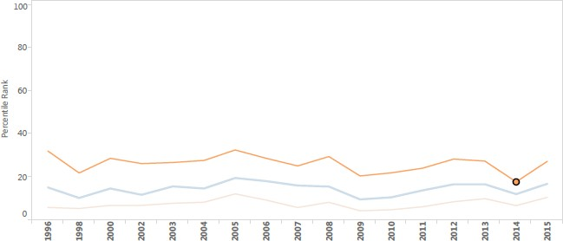

Figure 3.4: Aggregate Indicator on Government Effectiveness in Nigeria over the period 1996- 2015.

Source: World Bank’s World Governance Indicator, 2016

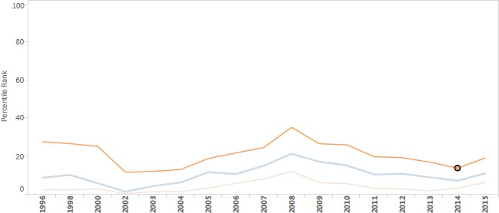

Figure 3.5: Aggregate Indicator on Control of Corruption in Nigeria over the period 1996-2015. Source: World Bank’s World Governance Indicator, 2016

# Discretionary Fiscal Policy in Nigeria

The fact that government pursues discretionary fiscal policy means two concepts. First, it means that government takes specific actions or interventions to address a particular economic situation per time. In a similar vein, it also means that government deviated or did not comply with an already laid down fiscal rule.

In Nigeria, the Fiscal Responsibility Act (2007) contains procedural and numerical fiscal rules that should guide fiscal actions. However, evidence shows that the Nigerian government has not conformed to these rules (Yelwa, 2010; Onodugo and Amujiri, 2015). This is also corroborated by the Fiscal Rule Dataset (1985-2015) of the International Monetary Fund (IMF). The dataset shows information on the use and design of fiscal rules in 96 countries, including Nigeria. It presents details on various characteristics of the fiscal rule, which include legal basis, coverage, escape clauses, enforcement procedures, key supporting institutions and monitoring of these rules. The fiscal rule data is presented in Table 3.19. It reveals that there are no existing enforcement and monitoring procedures for the fiscal rules in Nigeria. This indicates the ease with which government may deviate from the existing fiscal rules.

Table 3.19: Enforcement and Monitoring of Fiscal Rules in Nigeria

|  |  |  |  |
| --- | --- | --- | --- |
| Year | Monitoring of Compliance outside government | Formal Enforcement Procedure | Independent body monitors implementation |
| 1985  1990  2000  2005  2007  2010  2013  2014  2015 | 0  0  0  0  0  0  0  0  0 | 0  0  0  0  0  0  0  0  0 | 0  0  0  0  0  0  0  0  0 |

Source: Fiscal Rules Dataset (2017). Note: 0- Non-existing, 1- Exists

# Fiscal and Monetary Policies have been weakly coordinated

Policy is deemed coordinated when both fiscal and monetary policy take on the same policy stance. An example is when both policies take on a tight or loose stance (Nyamongo, Sichei and Mutai, 2008; Rothenberg, 2004). In Table 3.20, it is revealed that over the period 1970-2015, there is evidence that fiscal and monetary policy had more uncoordinated than coordinated stances. Fiscal and monetary policy was coordinated in 21 of the entire 46 years, while policy was seen to be uncoordinated in the remaining 25 years. This means that fiscal and monetary policy can be concluded to have been more uncoordinated than coordinated in Nigeria, and therefore, implies weak coordination. This suggests that the Federal Ministry of Finance and the Central Bank of Nigeria did not fully harmonise their policy targets and directions. Englama *et al.,* (2013) also attest to the weak state of policy coordination in Nigeria over the period 1980 to 2011.

Table 3.20: Policy Coordination in Nigeria for selected years (1970-2015)

|  |  |  |  |  |  |
| --- | --- | --- | --- | --- | --- |
| Year | Bdef | Stance | RIR | stance | Inference |
| 1970 | -8.62 | Easy | -29.27 | Easy | C |
| 1980 | -3.98 | Easy | -3.55 | Easy | C |
| 1990 | -8.27 | Easy | 14.65 | Tight | NC |
| 2000 | -2.26 | Easy | -10.32 | Easy | C |
| 2010 | -2.04 | Easy | -42.31 | Easy | C |
| 2011 | 1.97 | Tight | 5.94 | Tight | C |
| 2012 | -1.37 | Easy | 6.88 | Tight | NC |
| 2013 | -1.44 | Easy | 10.25 | Tight | NC |
| 2014 | -0.94 | Easy | 11.35 | Tight | NC |
| 2015 | -1.65 | Easy | 13.59 | Tight | NC |
| Average | *-3.60* | Easy |  | Tight | NC |

Source: CBN Statistical Bulletin (2015)

Note: *Policy is coordinated when fiscal and monetary policy are both tight or loose. NC: Not coordinated; C: Coordinated. Bdef= Budget deficit, RIR= Real Interest Rate

# Summary of Key Issues

Preliminary statistical facts describing fiscal-monetary policy interactions and alternative fiscal assumptions have been presented in this chapter. The major issues arising from these facts show that there is preliminary evidence of: (1) positive correlation, that is, complementary interactions between fiscal and monetary policies in Nigeria (2) bi-directional causality between both policies such that there is proof of ongoing interactions between fiscal and monetary policies. This means that fiscal (monetary) policy influences the stance and overall macroeconomic effect of monetary (fiscal) policy (3) positive and significant impact of both macroeconomic policies on output but an insignificant influence on the price level (4) the existence of rent-seeking, discretionary fiscal policy making and weak policy coordination. The aforementioned statistical facts are used as basis to hypothesise and construct the theoretical model in the next chapter.

# CHAPTER FOUR METHODOLOGY

The theoretical base of this study and the estimation strategy to address its primary objectives are outlined in this chapter. The Chapter has been divided into three Sections. Section 4.1 discusses the theoretical framework used in this thesis. In particular, the framework of the New Keynesian Dynamic Stochastic General Equilibrium model was outlined. Section 4.2 presents the relevant research method. The Section comprises the model specification and then the applicable estimation strategy is stated. Thereafter, the data sources and measurement are listed. In Section 4.3, the method to compute optimal fiscal and monetary policy is examined.

# Theoretical Framework

The theoretical base of this work hinges on the New Keynesian School of economic thought. The model is first presented and then, applied in the context of this study.

# The New Keynesian Macro-Economic Model

The New Keynesian model is the theoretical underpinning of this study. This school of economic thought sprang up in the 1980s after the New Classicals such as Robert Lucas and Thomas Sargent critiqued some existing traditional Keynesian ideas. For example, the Keynesians developed and estimated large scale macro econometric models that could be used to predict and forecast the impact of policy. Critics like Robert Lucas believed that the specified model lacked a theoretical foundation and that estimated parameters in such models will vary in response to changes in policy intervention. This variation implies that policy recommendation is time-inconsistent and is regarded as a potential drawback to policy analysis and forecast. Lucas argued for the formulation of structural econometric models with a strong theoretical underpinning and micro foundation that captures an economy’s structure. This requires developing models that captures the forward-

looking and optimising behaviour of economic agents in macroeconomic models to be used for policy analysis.

The work of Mankiw and Romer (1991) is regarded as one of the major contributions to the New Keynesian School. This school maintains traditional Keynesian ideas that include the existence of imperfect competition among firms and the notion of sticky prices and wages. The implications of these assumptions are that there are frictions that prevent prices and wages from adjusting quickly to shocks and market failures are possible. This necessitates the intervention of government through stabilisation policies to adjust the price mechanism and return the economy to equilibrium. The Keynesian also advise the use of stabilisation policies because monetary policy has non- neutral effects on the economy.

Based on the Lucas critique, the New Keynesian School adopts the micro foundation of the Real Business cycle (RBC) model as expounded by the New Classical, in explaining the existing macroeconomic theories of the traditional Keynesians. They also borrow from the rational expectation school which assume forward looking households and firms who make decisions based on the expectation of the future. This culminates in a methodological framework introduced by the New Classical: the dynamic general equilibrium method (DGE).

The New Keynesian Dynamic General Equilibrium Models recognise the forward looking and optimising behaviour of economic agent. They deviate from traditional assumptions of frictionless markets, flexible prices and neutrality of money. They recognise the existence of real and nominal shocks, non-trivial effect of monetary policy, monopolistic competition and nominal rigidity. In the canonical model, there are 3 economic agents: the household, firms and central banks. The household purchases goods, holds money and bonds, supplies labour to the firms and maximises its expected present value of utility. There are two types of firms: intermediate and final goods producers. The firms produce differentiated products in monopolistic competition while the Central Bank sets the nominal interest rate using Taylor-type rules.

The New Keynesian Dynamic Stochastic General Equilibrium (DSGE) model has been adopted for this study and is most appropriate to examine fiscal and monetary policy interactions since it is regarded as a workhorse for macroeconomic policy analysis and has been used by central banks

around the world for such purpose. Secondly, the model recognises a role for fiscal and monetary policy in stabilising the economy in the face of shocks. Thirdly, the DSGE model provides a natural setting to examine policy interactions since it assumes existing interdependencies among economic agents in the different sectors.

# The Standard New Keynesian DSGE Model

The NK DSGE models stem from the contributions of scholars such as Gali and Gertler (1999), Smets and Wouters (2003, 2007), Gali (2003), Christiano, Eichenbaum and Evans (2005). In these models, there are three optimising agents: households, firms and the Central Bank. The abridged model (detailed model is found in sub-section 4.2.1) entails:

**Household**: A representative household derives utility from consumption and disutility from labour, and maximises his utility function:

◎  *C*1 

Max *E* *t*   *it*  *L* 

(4.1)

0 1  *it*

*t* 0  

Where 𝐸0: Rational expectation operator

𝛽𝑡: intertemporal discount factor

𝛾: Inverse of elasticity of substitution

𝐶𝑡: Consumption

𝐿𝑡: Amount of labour supplied

subject to the inter-temporal household budget constraint (equation 4.2) which shows the total income versus their total outlay and is specified as:

𝑃𝑡𝐶𝑡 + 𝐸𝑡(𝑄𝑡 ,𝑡+1𝐷𝑡+1) ≤ 𝑊𝑡𝑁𝑡 + 𝐷𝑡 + 𝑇𝑃𝑡 + 𝐷𝑉𝑡 (4.2)

Where,

𝑊𝑡𝑁𝑡: Wage bill

𝑇𝑃𝑡: Transfer payment from government

𝐷𝑉𝑡: Dividend

𝑟𝑡: Nominal interest rate

𝐷𝑡+1: Payment at period 𝑡 + 1 from a portfolio of state contingent claims

𝐸𝑡(𝑄𝑡 ,𝑡+1): One period ahead stochastic discount factor

**Aggregate resource constraint:** It is assumed that there is no capital in the economy. Total sum of consumption (𝐶𝑡) at each period t of all individual (𝐶𝑖𝑡), therefore, equals the total sum of income (𝑌𝑖𝑡) of all individuals in the economy and it is given as follows:

*I I*

*Ct*  *Cit*  *Yit*

(4.3)

*i*1 *i*1

**Firms:** The firms produce the goods and services in the economy (𝑌𝑖𝑡) with a linear production function using labour inputs (𝐿𝑖𝑡) and technology (𝑧𝑡) such that:

*Yit*  *zt Lit*

(4.4)

The firms are also faced with a price setting decision. They follow the Calvo (1983) staggered price-setting mechanism such that while a fraction 𝜇 cannot reset their prices, the other fraction 1 − 𝜇 can. Therefore, in order to fix prices, 𝑃∗ , the firms must reset their prices by maximising their real discounted profits subject to demand such that:

𝐷,𝑡

Max Et ∑∞ (βθ)k Et,t+k Yt+k(i) [𝑃∗ − mct+k] (4.5)

k=0 𝐷,𝑡

Subject to

∗

𝑃

𝑌t+k(i) = [ 𝐷,𝑡 ]

𝑃𝑡+𝑘

−𝗌

𝑌𝑡+𝑘 (4.6)

Where,

Et,t+k : Stochastic discount factor for nominal payoffs in period t + k Yt+k(i) : Output in period t + k of good i

𝑃∗ : Fixed price that maximises real discounted profits

𝐷,𝑡

mct+k: Real marginal cost in period t + k Et : Rational Expectation Operator

Βθ: Probability that firms reset prices

**Central Bank:** The Central Bank set nominal interest rate by following a Taylor type rule where the interest rate responds to the inflation rate and output growth

Rt Rt−1 ρR

πt φπ

Yt φY

St φS

1−ρR

R

t

= [ ]

R R

[( )

π

( ) ( ) ] ε

Y S

(4.7)

Where,

Rt: Interest rate

Rt−1: lagged interest rate

πt: Inflation rate Yt: Output growth St: Exchange rate

εR: Innovation to monetary policy

t

ρR: Degree of interest rate smoothing

φπ, φY, φS: Parameters that measures the response of Central Bank to inflation, output and exchange rate. In addition, R, π, Y, S are the target values of interest rate, inflation rate, output and exchange rate.

**Exogenous Stochastic processes:** It is assumed that both real and nominal shocks perturb the economy. The shocks are modelled as autoregressive processes of lagged innovations of order one, as defined in equation (4.8):

*zt*  *zt*1  *t*

(4.8)

𝜀𝑡~ 𝑖. 𝑖. 𝑑 (0, 𝜎𝗌)

The preceding canonical model omits the fiscal sector. The model has therefore been extended to include the fiscal sector. The New Keynesian DSGE models with fiscal policy initially assumed the existence of Ricardian equivalence i.e: a passive or neutral role for fiscal policy. In these models there is lump sum taxation and the government faces an inter-temporal solvency condition (Leeper, 1991; Leeper and Leith, 2015; Sims, 1994; Bianchi and Ilut, 2016). A later variant of the New Keynesian DSGE model gives an explicit role to fiscal policy which sets a policy rule and introduces non-Ricardian fiscal effects by assuming the existence of rule of thumb households. The inclusion of rule of thumb agents engenders the non-neutral effect of fiscal policy on the

economy (Gali, Lopez-Salido, and Valles, 2007; Algozhina, 2012; Rossi, 2014). This study will include these recent features to capture the interaction between fiscal and monetary policy.

In conclusion, some of the reasons for adopting the New Keynesian model include its usefulness for policy analysis since it identifies a role for stabilising (fiscal and monetary) policies. It recognises the importance of both real and nominal shocks. It also utilizes a rich dynamic optimising and microeconomic background for analysing the decisions of economic agents. It recognises the existence of frictions, nominal rigidities and imperfect markets that underlie the dual structure of developing economies such as Nigeria. At the same time, with the apparent disequilibrium between aggregate demand and supply in the Nigerian economy, this study has adopted the NK model (Alege, 2008). The model can also be estimated and provides good policy forecast and evaluation.

# The Research Method

This thesis argues that the fiscal decision of government interacts with instruments and targets of monetary policy in Nigeria. This study is, therefore, concerned with empirically testing existing theoretical propositions for the impact that fiscal policy wields on monetary outcomes in Nigeria and vice-versa. It also examines the effect of the policy interactions on output and inflation in Nigeria. The study, therefore, investigates fiscal and monetary interactions within an Open Economy New Keynesian DSGE Model that deviates from the assumptions of a benevolent government who commits to a policy rule. In this instance, government is assumed to have rent- seeking tendencies and prefers to use policy discretion in maximising the welfare of a subset of the society (see sub-section 3.5 to prove the relevance of rent-seeking and policy discretion in Nigeria). The adopted assumptions indicate that this study considers the underlying political dimensions to economic policy.

This study captures the rent-seeking tendencies of the fiscal bloc by specifying a utility function which shows that the government benefits from both providing public goods and from rent-seeking activities that boosts its personal gains. The utility function also admits a fiscal shock and a parameter on the quality of existing political institution, which serves in a complementary manner as another proxy to capture the rent-seeking ability of the government (see equations 4.89 - 4.99

in sub-section 4.2.1). In addition, the discretionary policy of government is illustrated in this study by considering the micro-foundation of the fiscal sector, in contrast to specifying a fiscal (Taylor- type) rule. The government is assumed in this instance, to maximise its per period utility function subject to its budget constraint (Fragetta and Kirsanova, 2010).

# An Open Economy New Keynesian DSGE Model for Nigeria

1. **Structure of the Model**

The model is constructed drawing on the works of Gali and Monacelli (2005), Gali and Monacelli (2008), Gali (2008), Almeida (2010), Senbeta (2011), Rossi (2014), Miller (2016), Li and Spencer (2014) and Adegboye (2015). The study adapted the political economy assumption from Miller (2016). The remaining studies aforementioned were instrumental in constructing the Small Open Economy (SOE) NK DSGE model. The DSGE model adopted in this study comprises of five optimising agents: households, firms, the central bank, government and rest of the world, who form model-consistent expectation based on available information. The infinitely lived household decides how much units of goods to consume and labour to supply in order to maximise its lifetime utility subject to budget constraints. It is assumed that there are two types of household, the Ricardian and Non-Ricardian. Unlike the Ricardian, the Non-Ricardian agent is liquidity- constrained and lacks access to the financial market (Conen and Straub, 2005; Gali, Lopez-Salido and Valles, 2007 as cited in Torres, 2015). A large amount of Non- Ricardian consumers implies that fiscal policy is not passive as proposed in models with Ricardian equivalence (Rossi, 2014). The household also form habits in their consumption. This means that utility is time non-separable; it depends on consumption in previous period. The household sector is also assumed to supply labour to firms in a perfectly competitive labour market.

In the production sector, there are the final-good producer and the intermediate-goods producers. The final-good producer operates under a perfectly-competitive market and can re-optimise their prices. The final-good producer aggregates the goods of the intermediate firms using the Dixit- Stiglitz (1977) framework. The intermediate-goods producers are in monopolistic competition and cannot change prices. Following the Calvo (1983) sticky price setting, a fraction of the intermediate-goods firms is allowed to re-set their price. The third agent is a monetary authority,

the Central Bank of Nigeria that implements monetary policy by following a Taylor-type rule to set its policy rate. It is also posited that Nigeria is a small open economy linked to a foreign economy, which is the Rest of the World. As a small open economy, the size of the Nigerian economy is tiny and lacks a significant influence on the Rest of the World. Finally, there are some exogenous shock processes.

The fiscal authority, the Federal Government of Nigeria, is the fifth agent. In many instances, the fiscal authority is modelled to be benevolent i.e. it is concerned with the welfare of the whole society (Algozhina, 2012; Leeper and Leith, 2015; Bianchi and Ilut, 2016). It purchases from firms, issue bonds, collects lump sum taxes, and makes transfer payment to keep balanced budget. Secondly, in these studies, the government commits to a fiscal rule in spending and taxes. This present study deviates from these two assumptions, since they may not be realistic in developing economies such as Nigeria.

The study rather assumes the existence of political friction i.e. the government may be concerned with maximising the benefit of a subset of its citizen due to its rent-seeking tendencies (Miller, 2016). Secondly, it is postulated that the fiscal authority uses discretion in choosing its policy on spending and taxes. An implication is that, if the monetary authority commits to a rule while the fiscal authority relies on discretion, this can be termed a non-cooperative policy game, further implying weak or non-existing coordination between the two policies (Dixit and Lambertini, 2003). This conjecture is realistic since there is evidence of weak coordination between fiscal and monetary policy in Nigeria (Englama *et al.,* 2013). The model adopted for this study, therefore, is a Small Open Economy, Dynamic Stochastic General Equilibrium model which comprises of two types of households, firms, the monetary authority and a rent-seeking, discretionary fiscal bloc.

# The Model

In what follows, the study presents the relevant equations of the Small Open Economy, Dynamic Stochastic General Equilibrium model. Each sector is considered in order to derive its optimisation conditions.

# The households

There is a continuum of infinitely lived households 𝑗 ∈ [0,1] who decides how much units of goods to consume and labour to supply in order to maximise its lifetime utility subject to its inter- temporal budget constraints. It is made up of two types of household, where the fraction 𝜇 are Ricardian households. They are forward-looking optimisers who have access to the financial markets and own the firms in the economy. The other fraction (1 − 𝜇) are non-Ricardian households who are liquidity constrained since they can neither borrow nor own firms.

# Ricardian Households

The Ricardian consumer derives utility at time 𝑡 from consuming a composite good, 𝐶𝑡 relative to habit formation, public good 𝐺𝑡 and leisure 1 − 𝑁𝑡. There is neither saving nor investment.

𝐸𝑡 ∑*∞* 𝛽𝑡 𝑈((𝐶𝑅,𝑡 − ℎ𝐶𝑅,𝑡−1), 𝐺𝑡, 𝑁𝑡) (4.9)

𝑡=0

Equation (4.9) is stated in its explicit form in equation (4.10). The households’ objective is therefore to maximise the sum of discounted expected future utility as shown in equation (4.10) subject to the nominal budget constraint in equation (4.20):

( 1−𝜎

1−𝜌

1+𝜑

𝐸 ∑*∞*

𝛽 [(

𝑡 𝐶𝑅,𝑡−ℎ𝐶𝑅,𝑡−1)

+ 𝜒 𝐺𝑡 – 𝑁𝑡 )] (4.10)

𝑡 𝑡=0

1−𝜎

1−𝜌

1+𝜑

Where 𝐸𝑡: Rational expectation operator

𝛽𝑡: Inter-temporal discount factor

𝐶𝑅,𝑡: Private consumption of composite goods

𝐺𝑡: Consumption of public goods

𝑁𝑡: Amount of labour supplied

ℎ: Co-efficient of habit formation

𝜎: Inverse of elasticity of substitution

𝜒: Weight on public goods consumption

𝜑: Inverse on Frisch elasticity of labour supply

ℎ, 𝜎, 𝜒, 𝜑 > 0; 0 < 𝛽𝑡 < 1

Consumption,𝐶𝑅,𝑡, is a composite good which consists of domestic goods 𝐶𝐷,𝑡 and foreign goods

𝐶𝐹,𝑡. This implies that the household allocates its resources in consuming both domestically produced goods and imported goods. The composite good 𝐶𝑅,𝑡 is defined using the Dixit-Stiglitz (1977) Constant Elasticity of Substitution in equation (4.11)

1 𝑦−1

1 𝑦−1

𝑦

𝑦−1

𝐶𝑅,𝑡 ≡ [(1 − 𝛼)𝑦𝐶𝐷,𝑡

𝑦 + (𝛼)𝑦𝐶𝐹,𝑡

𝑦 ]

(4.11)

Where 𝐶𝐷,𝑡: Index of consumption of domestic goods

𝐶𝐹,𝑡: Index of consumption of foreign goods

1 − 𝛼: Degree of openness

𝛼: Home-bias parameter

𝜂: Elasticity of substitution between domestic and foreign goods

And where 𝐶𝐷,𝑡 and 𝐶𝐹,𝑡 are assumed to be Dixit-Stiglitz (1977) aggregators of individual consumption goods. They comprise of a continuum of both domestic and foreign goods given by:

𝗌−1

𝐶𝐷,𝑡 = [∫ 𝐶𝐷,𝑡 (𝑖) 𝗌 𝑑𝑖]

𝗌

𝗌−1

(4.12)

𝗌−1

𝐶𝐹,𝑡 = [∫ 𝐶𝐹,𝑡 (𝑖) 𝗌 𝑑𝑖]

𝗌

𝗌−1

(4.13)

In equations (4.12) and (4.13), parameter 𝜀 > 1 is the elasticity of substitution between different goods produced in the domestic economy.

The household decides to allocate a given level of expenditure between domestic and foreign goods. They minimise total expenditure on domestic and foreign goods in equation (4.14) Min 𝑃𝑡𝐶𝑅,𝑡 = 𝑃𝐷,𝑡𝐶𝐷,𝑡 + 𝑃𝐹,𝑡𝐶𝐹,𝑡 (4.14)

subject to equation (4.11) to yield the demand function of both the domestic and foreign goods:

𝐶𝐷,𝑡 =

(1 − 𝛼)

𝑃𝐷,𝑡

𝑃𝑡

(

−𝑦

)

𝐶𝑅,𝑡 (4.15)

𝐶𝐹,𝑡 =

(𝛼)

𝑃𝐹,𝑡

𝑃𝑡

(

−𝑦

)

𝐶𝑅,𝑡 (4.16)

Where, 𝑃𝑡: Aggregate consumer price index

𝐶𝑅,𝑡: Composite consumption index

𝑃𝐷,𝑡,𝑃𝐹,𝑡: domestic and foreign price index

𝐶𝐷,𝑡, 𝐶𝐹,𝑡: consumption index on domestic and foreign goods

The price indices PF,tand PD,t, which is the minimum expenditure at which the household can buy one unit of CD,t and CF,tare given by*:*

1

𝑃𝐷,𝑡 = [∫ 𝑃𝐷,𝑡(𝑖)1−𝗌𝑑𝑖]1−𝗌 (4.17)

and

1

𝑃𝐹,𝑡 = [∫ 𝑃𝐹,𝑡(𝑖)1−𝗌𝑑𝑖]1−𝗌 (4.18)

The aggregate price level, which is the consumer price index, is defined by aggregating equations (4.15) and (4.16) as:

1

𝑃𝑡 = [(1 − 𝛼)(𝑃𝐷,𝑡)1−𝑦 + (𝛼)(𝑃𝐹,𝑡)1−𝑦]1−𝑦 (4.19)

The household maximises utility function in equation (4.10) subject to a standard budget constraint in nominal terms. The budget constraint postulates that the household receive wages for their labour supply 𝑊𝑡𝑁𝑡 , they own the firm and receive profit in form of dividend 𝐷𝑉𝑡, they own stock of risk-free financial assets, 𝐷𝑡 and receive lump sum transfer from government 𝑇𝑃𝑡. The household use their resources to pay consumption goods 𝑃𝑡𝐶𝑅,𝑡 and to purchase portfolio of financial assets, 𝐷𝑡+1. This relation can be written as:

𝑃𝑡𝐶𝑅,𝑡 + 𝐸𝑡(𝑄𝑡 ,𝑡+1𝐷𝑡+1) ≤ 𝑊𝑡𝑁𝑡 + 𝐷𝑡 + 𝑇𝑃𝑡 + 𝐷𝑉𝑡 (4.20)

Where

𝐸 (𝑄

) ≡ 𝑄 = ( ): One period ahead stochastic discount factor

𝑡 𝑡 ,𝑡+1

1

𝑡 1+𝑖𝑡

𝑖𝑡: Nominal interest rate

𝐷𝑡+1: Payment at period 𝑡 + 1 of portfolio held at the end of period t

The Langragian function derived by maximising equation (4.10) subject to equation (4.20) is given by:

( 1−𝜎

1−𝜌

1+𝜑

𝑓 = ∑∞

𝛽 [(

𝑡 𝐶𝑅,𝑡−ℎ𝐶𝑅,𝑡−1)

+ 𝜒 𝐺𝑡 – 𝑁𝑡 )] + 𝜆 𝛽𝑡[𝑊 𝑁

+ 𝐷

+ 𝑇𝑃

+ 𝐷𝑉

− 𝑃 𝐶 −

𝑡=0

1−𝜎

1−𝜌

1+𝜑

𝑡 𝑡 𝑡 𝑡 𝑡

𝑡 𝑡

𝑅,𝑡

𝐸𝑡 (𝑄𝑡 ,𝑡+1𝐷𝑡+1)] (4.21)

The first order conditions (FOCs) with respect to consumption, labour supply and financial assets are obtained from equation (4.21) as:

The FOC with respect to consumption is derived by taking the partial derivative of 𝐶𝑅,𝑡 in equation (4.21) as:

𝜕𝑓

𝜕𝐶𝑅,𝑡

: (𝐶𝑅,𝑡

− ℎ𝐶𝑅,𝑡−1

−𝜎

) − 𝜆𝑡𝑃𝑡

= 0 (4.22)

𝜆𝑡 =

(𝐶𝑅,𝑡 − ℎ𝐶𝑅,𝑡−1)

𝑃𝑡

−𝜎

and at period 𝑡 + 1

𝜆𝑡+1 =

(𝐶𝑅,𝑡+1 − ℎ𝐶𝑅,𝑡)

𝑃𝑡+1

−𝜎

We divide the FOC on consumption at period 𝑡 + 1 by that of period 𝑡 which leads to:

𝜆𝑡+1

𝜆𝑡

= (𝐶𝑅,𝑡+1−ℎ𝐶𝑅,𝑡

𝐶𝑅,𝑡−ℎ𝐶𝑅,𝑡−1

−𝜎 𝑃𝑡

)

𝑃𝑡+1

(4.23)

The FOC with respect to labour supply is obtained by taking the partial derivative of 𝑁𝑡such that:

𝜕𝑓 :−𝑁 𝜑+ 𝜆 𝑊

= 0 (4.24)

𝜕𝑁𝑡

𝜆𝑡 =

𝑡

𝑁𝑡𝜑

𝑊𝑡

𝑡 𝑡

As usual, the FOC on financial asset is derived by taking the partial derivative of 𝐷𝑡. This yields:

𝑄𝑡 ,𝑡+1

= 𝛽 𝜆𝑡+1

𝜆𝑡

(4.25)

Substitute equation (4.23) into equation (4.25), this becomes:

𝑄 𝐶𝑅,𝑡+1−ℎ𝐶𝑅,𝑡

𝑡 ,𝑡+1 = 𝛽 (

𝐶𝑅,𝑡−ℎ𝐶𝑅,𝑡−1

−𝜎 𝑃𝑡

)

𝑃𝑡+1

(4.26)

Take expectations of both sides of equation (4.26). This becomes:

𝐶𝑅,𝑡+1−ℎ𝐶𝑅,𝑡

−𝜎 𝑃𝑡

𝐸𝑡𝑄𝑡 ,𝑡+1 = 𝛽𝐸𝑡 [( )

𝐶𝑅,𝑡−ℎ𝐶𝑅,𝑡−1

𝑃𝑡+1

] (4.27)

Where 𝐸 𝑄

≡ 𝑄 = 1 . This is substituted into equation (4.27) which can then be re-

𝑡 𝑡 ,𝑡+1

written as:

𝑡 (𝑅𝑡)

𝐶𝑅,𝑡+1−ℎ𝐶𝑅,𝑡

1 = 𝛽𝑅 𝐸 (

𝑡 𝑡

𝐶𝑅,𝑡−ℎ𝐶𝑅,𝑡−1

−𝜎 𝑃𝑡

)

𝑃𝑡+1

(4.28)

Equation (4.28) is the consumption Euler Equation. The inter-temporal consumption Euler equation is one of the two major optimality conditions for the household sector. It describes the optimal consumption of the household between the current and future period.

Equation (4.28) is log-linearised to obtain:

𝑐 − ℎ𝑐

= 𝐸 (𝑐

− ℎ𝑐

) − 1−ℎ (𝑟

− 𝐸 Π

) (4.29)

𝑅,𝑡

𝑅,𝑡−1

𝑡 𝑅,𝑡+1

𝑅,𝑡

𝜎 𝑡

𝑡 𝑡+1

Where,

Π𝑡+1 = 𝑃𝑡+1 − 𝑃𝑡

The second optimality condition is the intra-temporal consumption. It shows the marginal rate of substitution between consumption and labour supply. To derive the intra-temporal consumption equation, we combine the FOC on consumption with that of labour supply such that:

𝜆𝑡 =

𝑁𝑡𝜑

𝑊𝑡

and

𝜆𝑡 =

(𝐶𝑅,𝑡 − ℎ𝐶𝑅,𝑡−1)

𝑃𝑡

−𝜎

This becomes:

𝑁𝑡𝜑

𝑊𝑡

(𝐶𝑅,𝑡−ℎ𝐶𝑅,𝑡−1)−𝜎

=

(1+𝑐)𝑃𝑡

(4.30)

Equation (4.30) is re-arranged and yields:

𝑊𝑡 = (𝐶

− ℎ𝐶

)𝜎 𝑁 𝜑(1 + 𝑟) (4.31)

𝑃𝑡

𝑅,𝑡

𝑅,𝑡−1 𝑡

Log-linearise equation (4.31) to get the labour supply schedule for the Ricardian household. This becomes:

𝑤𝑡

− 𝑝𝑡

= 𝜎 1−ℎ

(𝑐𝑅,𝑡

− ℎ𝑐𝑅,𝑡−1

) + 𝑛𝑡

(4.32)

# Non-Ricardian Household

The liquidity constrained consumer maximises the same utility function in equation (4.10) subject to the budget constraint in equation (4.33):

𝑃𝑡𝐶𝑁𝑅,𝑡 ≤ 𝑊𝑡𝑁𝑁𝑅,𝑡 + 𝑇𝑃𝑡 (4.33)

The budget constraint postulates that the household receives only wage bills 𝑊𝑡𝑁𝑡 and lump sum transfer from the government 𝑇𝑃𝑡 and uses its income to buy consumption goods. The budget constraint takes this form since it is assumed that the non-Ricardian household cannot accumulate bonds from the financial market and cannot earn profit since they do not own firms.

The Lagrangian function is obtained by combining equations (4.10) and (4.33), to get:

( 1−𝜎

1−𝜌

1+𝜑

𝑓 = ∑∞

𝛽 [(

𝑡 𝐶𝑅,𝑡−ℎ𝐶𝑅,𝑡−1)

+ 𝐺𝑡 – 𝑁𝑡 )] + 𝜆 𝛽𝑡[𝑊 𝑁

+ 𝑇𝑃

− (1 + 𝑟)𝑃 𝐶 ]

𝑡=0

1−𝜎

1−𝜌

1+𝜑

𝑡 𝑡 𝑡 𝑡

𝑡 𝑡

(4.34)

As usual, the First order conditions with respect to consumption, labour supply and 𝜆𝑡 are obtained and stated respectively in equations (4.35) to (4.37) as:

𝜕𝑓

𝜕𝐶𝑡

: 𝜆𝑡 =

(𝐶𝑁𝑅,𝑡−ℎ𝐶𝑁𝑅,𝑡−1)−𝜎 (1+𝑐)𝑃𝑡

(4.35)

𝜕𝑓 : 𝜆

𝑡

𝜕𝑁𝑡

= 𝑁𝑁𝑅,𝑡𝜑

𝑊𝑡

(4.36)

𝜕𝑓 : 𝑊 𝑁

+ 𝑇𝑃

− 𝑃 𝐶

= 0 (4.37)

𝜕𝜆𝑡𝑡

𝑡 𝑁𝑅,𝑡

𝑡 𝑡

𝑁𝑅,𝑡

Combining the FOCs on consumption and labour supply, that is equations (4.35) and (4.36), one obtains:

𝑊𝑡 = (𝐶

− ℎ𝐶

𝜎

) 𝑁

𝜑 (4.38)

𝑃𝑡

𝑁𝑅,𝑡

𝑁𝑅,𝑡−1

𝑁𝑅,𝑡

The consumption equation for the non-Ricardian household is given by log-transforming the budget constraint in equation (4.33) to obtain:

𝑐 = 𝑊𝑁 (𝑤 − 𝑝

+ 𝑛

) + 𝑇𝑃 (𝑡𝑝 ) (4.39)

𝑁𝑅,𝑡 𝑃𝐶 𝑡 𝑡

𝑁𝑅,𝑡

𝑃𝐶 𝑡

The law of motion of the Transfer payment to non-Ricardian household is:

𝑇𝑃𝑡 = 𝜌𝑇𝑃𝑇𝑃𝑡−1 + 𝜀𝑇𝑃 (4.40)

𝑡

Equation (4.39) shows that the non-Ricardian household does not optimise but simply equates their consumption expenditure to wage income plus transfer payment from government. Furthermore, the labour supply schedule in equation (4.38) is derived as

𝑤𝑡

− 𝑝𝑡

= 𝜎 1−ℎ

(𝐶𝑁𝑅,𝑡

− ℎ𝐶𝑁𝑅,𝑡−1

) + 𝑛𝑁𝑅,𝑡

(4.41)

# The firms

Following Gali and Monacelli (2005), it is assumed that there is a continuum of identical monopolistic competitive firms 𝑗 ∈ [0,1], in the domestic economy, that produce differentiated goods using a linear production technology with labour as the only input:

𝑌𝑡(𝑗) = 𝐴𝑡𝑁𝑡(𝑗) (4.42)

Where

𝐴𝑡: Total Factor Productivity

𝑁𝑡(𝑗): Labour input for each firm

Log 𝐴𝑡 ≡ 𝑎𝑡 is assumed to evolve with an AR (1) process such that:

𝑎𝑡 = 𝜌𝑎 𝑎𝑡−1 + 𝜀𝑎

𝑡

𝜀𝑎 is the technology shock to production in the economy. It is normally distributed with mean of zero and the standard deviation is 𝜎𝗌𝑎, i.e.,𝜀𝑎 ∼ 𝑁(0, 𝜎2𝗌𝑎)

𝑡

𝑡

Let the aggregate output produced across the firms be defined as:

1

𝑌𝑡 = [∫0 𝑌𝑡(𝑗)

1−1

𝗌𝑑𝑗]

𝗌

𝗌−1

(4.43)

𝑌𝑡 is an index for aggregate domestic output which is similar to that of consumption in equation (4.11).

The intermediate firms optimise in two stages. In one stage, they take wages accrued on labour services as given. They determine the quantity of labour required in order to minimise cost. They minimise their total cost subject to the linear production technology in equation (4.42). This is stated as follows:

𝑀𝑖𝑛 𝐶 = 𝑊𝑡 𝑁

+ 𝑄𝛾 (4.44)

𝑃𝑡 𝑡

Where, 𝛾: Fixed cost, and 𝑄 is a constant where 𝑄 = 0

𝑊𝑡: Real wages

𝑃𝑡

𝑁𝑡: Amount of labor

The Langragian function is obtained as:

𝑓 = 𝑊𝑡𝑁𝑡 + 𝜆𝑡[𝑌𝑗,𝑡 − 𝐴𝑡𝑁𝑗,𝑡] (4.45)

The first order conditions with respect to 𝑁𝑡and 𝑌𝑗,𝑡 yields:

𝜕𝑓

: 𝑊

− 𝜆 [𝐴 ] = 0 (4.46)

𝜕𝑁𝑗,𝑡 𝑡

𝑡 𝑡

𝑊𝑡

𝜆𝑡 =

𝐴

𝑡

𝜕𝑓

𝜕𝑌𝑗,𝑡

: 𝜆𝑡

(4.47)

𝜆𝑡is the Lagrangian multiplier, it is the nominal marginal cost of production of the firm. This implies that:

𝑀𝐶𝑡

= 𝑊𝑡

𝐴𝑡

(4.48)

The real marginal cost is then defined as:

𝑀𝐶𝑡

= 𝑊𝑡

𝐴𝑡𝑃𝑡

(4.49)

Log-linearising equation (4.49) yields:

𝑚𝑐𝑡 = 𝑤𝑡 − 𝑝𝑡 − 𝑎𝑡 (4.50)

From the linear production function in equation (4.42), we derive the amount of labour demanded by each firm

𝑁𝑗,𝑡

= 𝑌𝑗,𝑡

𝐴𝑡

(4.51)

The aggregate amount of labour to be demanded across the firms is obtained as

𝑁𝑗,𝑡 =

𝑌𝑗,𝑡

𝐴𝑡

→ 𝑁𝑡 ≡ ∫ 𝑁𝑗,𝑡 𝑑𝑗 =

∫ 𝑌𝑗,

𝐴𝑡

𝑑𝑗

This implies that:

𝑁𝑡

= 𝑌𝑡

𝐴𝑡

(4.52)

Log-linearise equation (4.52) to get the production relation in equation (4.53) as:

𝑛𝑡 = 𝑦𝑡 − 𝑎𝑡 (4.53)

# Price setting

In the second stage of the optimisation problem of the intermediate firms, the firms are concerned with setting the optimal price for their goods. The firms in this regard, set prices following the Calvo (1983) price-setting mechanism such that at each period, 1 − 𝜃 fraction of randomly selected domestic firms set prices optimally, while the other 𝜃 fraction keep their prices

unchanged. Let 𝑝∗ represent the price chosen by firm j resetting its price in period t. 𝑝∗ is

𝑡(𝑗) 𝑡(𝑗)

assumed to be identical across all firms since they will choose the same price in any given period such that 𝑝∗ = 𝑝∗. The firms fix prices,𝑃∗, by maximising their nominal discounted profits

𝑡(𝑗) 𝑡 𝑡

subject to demand constraints such that:

Max Et ∑∞ (βθ)k Et,t+k Yt+k|t [𝑃∗ − mct+k|t] (4.54)

k=0 𝑡

Subject to

𝑃∗

𝑡

Yt+k|t = [ ]

𝑃𝑡+𝑘

−𝗌

𝑌𝑡+𝑘 (4.55)

Following several algebraic manipulations as reserved in Appendix eight, the optimisation problem from equations (4.54) and (4.55) yields the optimal pricing equation of the resetting firm such that:

𝑝∗ − 𝑝𝑡−1 = 1 − βθ ∑∞ (βθ)k Et [m̂ct+k|t + 𝑝𝑡+𝑘 − 𝑝𝑡−1] (4.56)

𝑡 k=0

Where m̂ct+k|t = mct+k|t − mc

Equation (4.56) can be re-arranged and re-written as:

𝑝∗ = 𝜇 + (1 − βθ) ∑∞ (βθ)k Et [mct+k|t + 𝑝𝑡+𝑘] (4.57)

𝑡 k=0

Where,

𝜇 = −𝑚𝑐 ≡ log

𝜀

𝜀 − 1

From equation (4.57), it can be deduced that firms set a price according to the desired mark-up over a weighted average of expected marginal cost

# Rest of the World

It is assumed that the world economy consists of a continuum of countries. Each economy is a small open one and its decisions have no significant international impact. The rest of the world is assumed to be a closed economy where domestic goods represent a negligible fraction of the world's consumption. It is also assumed that there are identical preferences across the households in both the domestic and foreign economies. The open economy relationship between the terms of trade, consumer price index inflation, the real exchange, international risk sharing and uncovered interest parity is derived. This is to obtain the open economy relations that is needful in subsequent derivation of the open economy IS curve, Philips curve and the goods market clearing conditions.

# The Law of One Price (LOP)

It is assumed that there is complete asset market, with zero arbitrage in the international market. The law of one price holds such that:

Ψ𝑡 =

𝗌𝑡𝑃∗

𝑃𝐹,𝑡

𝑡

(4.58)

LOP holds when Ψ𝑡 = 1. This becomes:

𝑃𝐹,𝑡 = 𝜀𝑡𝑃∗ (4.59)

𝑡

Where,

Ψ𝑡: Law of one price gap, LOP holds when Ψ𝑡 = 1

𝜀𝑡: Nominal Exchange rate

𝑃∗: World price index

𝑡

𝑃𝐹,𝑡: Domestic price of imported goods Log-linearising equation (4.59) yields:

𝑝𝐹,𝑡 = 𝑒𝑡 + 𝑝∗ (4.60)

𝑡

# Real Exchange Rate

The real exchange rate is defined as the ratio of the world price index to that of domestic price, which is:

𝑄𝑡 =

𝗌𝑡𝑃∗

𝑃𝐷,𝑡

𝑡

(4.61)

Where,

𝑄𝑡: Real exchange rate

𝜀𝑡: Nominal Exchange rate

𝑃∗: World price index

𝑡

𝑃𝐷,𝑡: Domestic price

The log-linearisation of equation (4.61) gives:

𝑞𝑡 = 𝑒𝑡 + 𝑝∗ − 𝑝𝐷,𝑡 (4.62)

𝑡

Terms of Trade

The terms of trade between the domestic economy and foreign economy is defined as the ratio of domestic prices (exports) to foreign prices (import). It measures the competitiveness of the domestic economy such that:

𝑆𝑡

= 𝑃𝐷,𝑡

𝑃𝐹,𝑡

(4.63)

Where

𝑆𝑡: Terms of trade

𝑃𝐷,𝑡: Price of domestic goods

𝑃𝐹,𝑡: Price of foreign goods

The log-linearisation of the terms of trade in equation (4.63) will be:

𝑠𝑡 = 𝑝𝐷,𝑡 − 𝑝𝐹,𝑡 (4.64)

# Domestic and Consumer Price Index (CPI) Inflation

The CPI Inflation is defined as the rate of change in the aggregate price index (that comprises the domestic and foreign price index) while the domestic inflation is the rate of change in the domestic price index. The log-linearisation of the Consumer Price Index, 𝑃𝑡 = (𝑃𝐷,𝑡)1−𝛼 + (𝑃𝐹,𝑡)𝛼 around a symmetric steady state where the Purchasing Power Parity holds (i.e: 𝑃𝐷,𝑡 = 𝑃𝐹,𝑡) leads to:

𝑝𝑡 = (1 − 𝛼)𝑝𝐷,𝑡 + 𝛼𝑝𝐹,𝑡 (4.65)

Simplifying further, this becomes:

𝑝𝑡 = 𝑝𝐷,𝑡 − 𝛼(𝑝𝐷,𝑡 − 𝑝𝐹,𝑡) (4.66)

Since 𝑠𝑡 = 𝑝𝐷,𝑡 − 𝑝𝐹,𝑡 from equation (4.64), substitute it into equation (4.66) to get:

𝑝𝑡 = 𝑝𝐷,𝑡 − 𝛼(𝑠𝑡) (4.67)

Using a one-period lag, equation (4.67) becomes:

𝑝𝑡 − 𝑝𝑡−1 = 𝑝𝐷,𝑡 − 𝑝𝐷,𝑡−1 − 𝛼(𝑠𝑡 − 𝑠𝑡−1) (4.68) Equation (4.68) can be re-written as:

𝜋𝑡 = 𝜋𝐷,𝑡 − 𝛼(∆ 𝑠𝑡) (4.69)

Equation (4.69) relates the CPI inflation (𝜋𝑡 = 𝑝𝑡 − 𝑝𝑡−1), domestic inflation (𝜋𝐷,𝑡 = 𝑝𝐷,𝑡 −

𝑝𝐷,𝑡−1) and the terms of trade (𝑠𝑡 = 𝑝𝐷,𝑡 − 𝑝𝐹,𝑡). It shows that the difference between the two measures of inflation is proportional to changes in terms of trade. Parameter 𝛼 is the coefficient of proportionality.

## The link between the terms of trade and the law of one price

Next, equation (4.66) 𝑠𝑡 = 𝑝𝐷,𝑡 − 𝑝𝐹,𝑡which defines the terms of trade is combined with equation (4.60) 𝑝𝐹,𝑡 = 𝑒𝑡 + 𝑝∗that depicts that the law of one price holds to give:

𝑡

𝑠𝑡 = 𝑒𝑡 + 𝑝∗ − 𝑝𝐷,𝑡

𝑡

Make 𝑒𝑡 the subject of the formula:

𝑒𝑡 = 𝑠𝑡 − 𝑝∗ + 𝑝𝐷,𝑡 (4.70)

𝑡

Next, the relationship between the terms of trade and real exchange rate is derived. The real exchange rate in equation (4.62) is imputed into equation (4.70) to give:

𝑞𝑡 = 𝑠𝑡 − 𝑝∗ + 𝑝𝐷,𝑡 + 𝑝∗ − 𝑝𝑡

𝑡 𝑡

Simplifying, this becomes:

𝑞𝑡 = 𝑠𝑡 + 𝑝𝐷,𝑡 − 𝑝𝑡

Where 𝑝𝑡 = 𝑝𝐷,𝑡 − 𝛼(𝑠𝑡) as seen in equation (4.67) is substituted into the previous equation, this becomes:

𝑞𝑡 = 𝑠𝑡 − 𝛼𝑠𝑡

𝑞𝑡 = (1 − 𝛼)𝑠𝑡 (4.71)

# International Risk Sharing

In a complete and integrated international financial market, it is assumed that there is perfect risk sharing between households in the domestic and foreign countries i.e. it is assumed that the prices of domestic and foreign bonds are the same. It is also believed that the household in the domestic

and foreign economies share similar preferences. The first order conditions on consumption (4.23) is combined with bond asset (4.25), one obtains:

𝛽 (

𝐶𝑅,𝑡+1

𝐶𝑅,𝑡

−𝜎 𝑃𝑡

)

𝑃𝑡+1

= 𝑄𝑡,𝑡+1 (4.72)

with the no-arbitrage condition

𝜀𝑡𝑄∗ = 𝜀𝑡+1𝑄𝑡,𝑡+1 (4.73)

𝑡,𝑡+1

gives

𝐶∗

−𝜎 𝑃∗

𝐶𝑅,𝑡+1

−𝜎 𝑃𝑡

𝛽 ( 𝑡+1)

𝑡

𝐶∗

𝑡 𝜀𝑡 = 𝛽 (

𝑡+1

𝑃∗

)

𝐶𝑅,𝑡

𝑃𝑡+1

𝜀𝑡+1 (4.74)

Using equation (4.61) on the real exchange rate:

𝑄𝑡 =

𝜀𝑡𝑃∗

𝑃𝑡

𝑡

Equation (4.74) becomes:

𝐶∗

−𝜎 𝑄𝑡

𝐶𝑅,𝑡+1

−𝜎

( 𝑡+1)

𝐶∗

𝑡

= (

𝑄𝑡+1

)

𝐶𝑅,𝑡

(4.75)

After re-arranging equation (4.75), it becomes:

1

𝐶𝑅,𝑡 = 𝐾𝐶∗𝑄𝑡𝜎 (4.76)

𝑡

Where 𝐾 =

𝐶𝑅,𝑡+1 𝑄 −𝜎

𝑡+1

𝐶∗ 𝑡+1

1

Log-linearise equation (4.76), that is:

𝑐 = 𝑐∗+ 1 𝑞

(4.77)

𝑅,𝑡

𝑡 𝜎 𝑡

Recall from equation (4.71) that 𝑞𝑡 = (1 − 𝛼)𝑠𝑡, then equation (4.77) becomes:

𝑐 = 𝑐∗+ 1−𝛼 𝑠

(4.78)

𝑅,𝑡

𝑡 𝜎 𝑡

Since consumers are assumed to form habits on their consumption and with world market

clearing condition 𝑦∗ = 𝑐∗, this becomes:

𝑡 𝑡

𝑐 − ℎ𝑐

= 𝑦∗ − ℎ𝑦∗ + (1−ℎ)(1−𝛼) 𝑠

(4.79)

𝑅,𝑡

𝑅,𝑡−1 𝑡

𝑡−1

𝜎 𝑡

Equation (4.77) shows a relation that links the domestic consumption (𝑐𝑅,𝑡), world consumption (𝑐∗) and the terms of trade (𝑠𝑡).

𝑡

# Uncovered Interest Parity

Under the complete international financial market, it is assumed that investors are indifferent between buying domestic or foreign bonds since the interest rates in both economies are the same. This means that returns on domestic bonds (𝑅𝑡) equals the returns on foreign bonds (𝑅∗ ) such that:

𝑡,

𝑅 = 𝑅 ( ) (4.80)

∗ 𝗌𝑡

𝑡 𝑡,

𝗌𝑡+1

Log-linearise equation (4.80) to give:

𝑟𝑡 = 𝑟∗ + 𝐸𝑡(𝑒𝑡 − 𝑒𝑡+1) (4.81)

𝑡

Re-arranging, it becomes:

𝑟𝑡 − 𝑟∗ = 𝐸𝑡∆𝑒𝑡+1 (4.82)

𝑡

This can be rewritten after combining equation (4.82) with equation (4.62) to obtain:

(𝑖𝑡 − 𝜋𝑡+1) − (𝑖∗ − 𝜋∗ ) = 𝐸𝑡∆𝑞𝑡+1 (4.83)

𝑡 𝑡+1

The expression shows that changes in the real exchange rate depends on the wedge between domestic and foreign interest rates

# Exogenous Processes in the Foreign Economy

Nigeria is assumed to be a small open economy relative to the large global economy and can barely affect large foreign economies with respect to their interest rate, inflation and output. The foreign variables are modelled as exogenous and follow AR(1) processes such that:

𝑦

∗

Foreign Output: 𝑦∗

𝑡

= 𝜌𝑦∗𝑦∗ + εt 𝑡

(4.84)

∗ ∗ 𝜋∗

𝑡 𝑡−1

Foreign Inflation:𝜋𝑡 = 𝜌𝜋∗𝜋𝑡−1 + εt 𝑡

𝑡

𝑟

∗

(4.85)

Foreign Interest rate: 𝑟∗

𝑡

= 𝜌 𝑟∗ 𝑟∗ + εt 𝑡

(4.86)

The stochastic processes,𝜀𝑖~𝑖𝑖𝑁(0, 𝜎2)

𝑡 𝑡−1

𝑡 𝑖

𝑓𝑜𝑟 𝑖 = 𝑦∗, 𝜋∗, 𝑟∗. This means that the stochastic processes of foreign output, inflation and interest

𝑡 𝑡 𝑡

rate are identically, independently and normally distributed of zero mean and variance of 𝜎2.

𝑖

# The Monetary Authority

The fourth agent in the model is now discussed. The Central Bank of Nigeria is assumed to follow a simple Taylor-type rule i.e. the Central Bank implements monetary policy using the interest rate. The CBN, under this rule, sets the interest rate by considering past value of interest rate, the deviation of inflation, output and exchange rate from target

Rt = [

R

Rt−1]ρR R

π υπ

[( )

t

π

Y υY

(

t

)

Y

e υe

( )

t

e

1−ρR

]

sr,t (4.87)

Where,

Rt: Nominal interest rate Rt−1: lagged interest rate πt: Inflation rate

Yt: Output

et: Exchange rate

sr,t: Innovation to monetary policy

ρR: Degree of interest rate smoothing

υπ, υY, υe: Parameters that measures the response of Central Bank to inflation, output and exchange rate. In addition, 𝑅, π, Y and e are the target values for interest rate, inflation rate, output and exchange rate.

The log-linearisation of equation (4.87) gives:

𝑟𝑡 = ρR𝑟𝑡−1 + (1 − ρR)[υππ̂t + υyŷt + υe∆et] + sr,t (4.88)

# The Fiscal Authority

The fiscal policy maker is assumed to commit to discretionary policy rather than rules, in making fiscal decision and is also proposed to be a rent-seeker instead of being benevolent. There is, therefore, the need to explore the micro-foundation of fiscal policy making in order to explicitly model the alternative assumptions.

**Assumption 1: Fiscal policy maker uses discretion**

The fiscal policy maker is traditionally modelled to commit to policy rules in DSGE models. This implies that government commit to a policy path and follows this path at all dates in the future, irrespective of the state of the economy (Kydland and Prescott, 1977). This definition also indicates that government implements its policy in a mechanical manner without being strategic about its decision making (Fragetta and Kirsanova, 2010). A realistic assumption however, is that the government acts strategically in order to respond to the state of the economy in each period, by aligning to discretion in its policy choices (Fragetta and Kirsanova, 2010). A policy maker, therefore, is assumed to commit to discretionary policy when he is free to alter its instrument setting to suit its own objective (Walsh, 2010).

In a more technical term, using discretionary policy means that government re-optimises every period i.e. it follows a period by period (sequential) optimisation rather than committing to a state- contingent path (Gali, 2008; Kirsanova and le Roux, 2013). In specifying the optimisation problem of the discretionary policy maker, the objective function is void of the expectations operator, since he does not commit to any future policy path but treats future values of policy instruments as given (Adam and Billi, 2007). The optimization problem of the discretionary policy maker is given as:

𝑀𝑎𝑥 𝑈𝑡(𝐺𝑡 , 𝑅𝑁𝑡)

Subject to the government budget constraint. The policy problem is to choose 𝐺𝑡 (government spending) and 𝑅𝑁𝑡(rent) period by period such that the utility function of the policy maker is maximised.

**Assumption 2: Fiscal policy maker seeks rent**

Rent-seeking is a major assumption in the field of political economy and public choice. It is defined as a situation where people derive personal benefit from the political arena (Henderson, 2008). The concept of rent-seeking is similarly adopted in the context of this study to mean that government has the tendency to channel public resources for its personal benefits including that of its close allies.

The fiscal policy maker is, therefore, modelled as being partly benevolent and partly rent-seeking. In his benevolent state, he seeks to maximise the welfare of the citizens under his jurisdiction, through the provision of public goods. This will ensure the subsequent re-election of his party and at the same time guarantee his reputation. As a rent-seeker, the fiscal policy maker wants to maximise his private returns from rent-seeking activities which includes: corruption, bribery and inefficiently designed contracts, that drains citizens’ welfare but benefits the politicians, their family members and allies (Persson, 2001; Miller, 2016). An implication of the rent-seeking assumption is that economic policy making does not rely alone on economic factor but is also influenced by political factors.

The fiscal authority is therefore assumed to enact discretionary policy in government spending, such that, the preference function is maximised subject to the government budget constraint. The fiscal authority derives utility from providing public goods and consuming rent. The functional form of the utility function is specified by taking a cue from Miller (2016), Azzimonti, Battaglini and Coate (2016), and Barseghyan, Battaglini and Coate (2013). The utility function of the fiscal policy maker is therefore specified as:

1−

𝐺

𝑀𝑎𝑥𝑖𝑚𝑖𝑠𝑒 ∑∞ 𝑡 + ln 𝑅𝑁𝑡 (4.89)

𝑡=0 1−

Subject to the nominal government budget constraint

𝑃𝑡𝐺𝑡 + 𝑟𝑡𝑃𝑡 = 𝑟𝑡𝑃𝑡 (4.90)

Where,

𝐺𝑡: Government provision of public goods

𝑅𝑁𝑡: Rent received. Rent received is defined to depend on the propensity of public office holders to seek rent and the total revenue that the government generates. It is defined as:

𝑅𝑁𝑡 = 𝑟𝑡 (4.91)

where 𝑖𝑠 the degree of rent seeking. < 0 ≤ 1; the degree of rent seeking increases as

→ 0. 𝑟𝑡 is the total government revenue

𝜁: Institutional Parameter, when 𝜁 → 1, the political institution is strong and when 𝜁 → 0, there is weak political institution.

Equation (4.89) is subject to the nominal government budget constraint (equation 4.90). The constraint shows that the total spending of government in form of rents accrued to government and allies and on the provision of public goods equals total revenue of government taxes.

𝑃𝑡𝐺𝑡 + 𝑟𝑡𝑃𝑡 = 𝑟𝑡𝑃𝑡

Where,

𝐺𝑡: Government spending

𝑟𝑡: Rent raised

𝑟𝑡: Total Revenue

𝑃𝑡: Nominal price

As usual, the Lagrangian function of the maximisation problem from equations (4.89) and (4.90) is such that:

1−

𝐺

𝑓 = ∑∞ 𝑡 + ln 𝑅𝑁𝑡 + 𝜆𝑡[𝑟𝑡𝑃𝑡 − 𝑃𝑡𝐺𝑡 − 𝑟𝑡𝑃𝑡] (4.92)

𝑡=0 1−

In the same manner, first order condition (F.O.C) of equation (4.92) is obtained as follows:

Government Spending: 𝜕𝑓 = 0: 𝐺− = −𝜆 𝑃

(4.93)

𝜕𝐺𝑡 𝑡

𝑡 𝑡

Rent: 𝜕𝑓

= 0: 1

= −𝜆 𝑃

(4.94)

𝜕𝑅𝑁𝑡

𝑅𝑁𝑡

𝑡 𝑡

𝜆 : 𝜕𝑓

= 0: 𝑟 𝑃

= 𝑃 𝐺

+ 𝑟 𝑃

(4.95)

𝑡 𝜕𝜆𝑡

𝑡 𝑡

𝑡 𝑡

𝑡 𝑡

Equations (4.93) and (4.94) are combined to give equation (4.96):

𝐺− = 1

(4.96)

𝑡 𝑅𝑁𝑡

Equation (4.96) is then re-arranged to be:

𝐺 = 𝑅𝑁

(4.97)

𝑡 𝑡

Equation (4.97) gives:

1

𝐺𝑡 = (𝑟𝑡) (4.98)

In equation (4.98), government spending policy 𝐺𝑡 at time t depends on the degree of rent seeking

(), the quality of political institution (𝜁) and government revenue. Equation (4.98) is then log-linearised as:

𝑔 = 1 (𝑟 ) (4.99)

𝑡 𝑡

**Assumption 3: There is no or weak policy coordination**

This third assumption is implicitly modelled by assuming that both fiscal and monetary authorities are adopting different policy regimes-discretion or rules. In the case of this study, the government is pursuing a discretionary regime while the Central Bank is following a rule-based regime.

# Exogenous Shock Processes

In the model adopted for this study, eleven sources of exogenous shocks are considered. They include: innovation in technology, monetary policy, government spending, foreign inflation, foreign output and foreign interest rate, tax, rent seeking, output, domestic inflation and transfer payment. The equations of these shocks can be expressed as follows:

Technology:𝑎𝑡 = 𝜌𝑎𝑎𝑡−1 + 𝜀𝑎 (4.100)

𝑡

Monetary Policy:sR = 𝜌𝑟 𝑠𝑟𝑡−1 + 𝜀𝑟 (4.101)

t 𝑡

Government Spending: sG = 𝜌𝑔𝑠𝑔𝑡−1 + 𝜀𝑔 (4.102)

t 𝑡

Tax: 𝑟𝑡 = 𝜌𝑐𝑟𝑡−1 + 𝜀𝑐 (4.103)

𝑡

Output: sy = 𝜌 𝑠𝑦 + 𝜀𝑦 (4.104)

t 𝑦 𝑡−1 𝑡

Domestic Inflation: sπD = 𝜌𝜋𝑠𝜋𝑡−1 + 𝜀𝜋𝐷 (4.105)

t 𝑡

Rent seeking: 𝑟𝑛𝑡 = 𝜌𝑟𝑛𝑟𝑛𝑡−1 + 𝜀𝑟𝑛 (4.106)

𝑡

Transfer payment: 𝑇𝑃𝑡 = 𝜌𝑇𝑃𝑇𝑃𝑡−1 + 𝜀𝑇𝑃 (4.40)

𝑡

𝑦

∗

Foreign Output: 𝑦∗

𝑡

= 𝜌𝑦∗𝑦∗ + εt 𝑡

(4.84)

∗ ∗ 𝜋∗

𝑡 𝑡−1

Foreign Inflation:𝜋𝑡 = 𝜌𝜋∗𝜋𝑡−1 + εt 𝑡

𝑡

𝑟

∗

(4.85)

Foreign Interest rate: 𝑟∗

𝑡

= 𝜌 𝑟∗ 𝑟∗ + εt 𝑡

(4.86)

Where,𝜀𝑗~𝑖𝑖𝑁(0, 𝜎2)

𝑡 𝑡−1

𝑡 𝑖

𝑓𝑜𝑟 𝑗 = 𝑎, 𝑟, 𝑦∗, 𝜋∗, 𝑟∗, 𝑔𝑡, 𝑇𝑃, 𝑟𝑛, 𝑟, 𝑦, 𝜋

𝑡 𝑡 𝑡

# Aggregation Rules

According to Adegboye (2015), the following aggregation rules for consumption and labour supply over the Ricardian and non-Ricardian households are specified. Aggregate consumption for both Ricardian and non-Ricardian agents is given by:

ct = ψ cR,t + (1 − ψ)cNR,t (4.106)

Aggregate labour supply for both Ricardian and non-Ricardian agents is given by:

nt = ω nR,t + (1 − ω)nNR,t (4.107)

Total inflation is also given by the sum of domestic inflation and foreign inflation, such that:

𝜋𝑡 = 𝜋𝐷,𝑡 + 𝜋𝐹,𝑡 (4.108)

# General Equilibrium

## Aggregate Demand Side: Goods Market Equilibrium and IS-Curve

Goods market clearing condition for the domestic economy requires that aggregate output equals aggregate domestic and foreign demands (exports) for locally produced goods such that:

𝑌 = 𝐶

+ ∫1 𝐶𝑖

𝑑𝑖 + 𝐺

(4.109)

𝑡(𝑗)

𝐷,𝑡(𝑗)

0 𝐷,𝑡(𝑗) 𝑡

𝐶𝐷,𝑡(𝑗): Domestic demand for good j produced in the domestic economy

𝐶𝑖 : Foreign demand by country i for good j produced in the domestic economy Where according to Gali (2008), 𝐶𝐷,𝑡(𝑗)and 𝐶𝑖 are defined as:

𝐷,𝑡(𝑗)

𝐷,𝑡(𝑗)

𝐶 𝑃𝐷,𝑡(𝑗)

𝐷,𝑡(𝑗) = ( 𝑃

𝐷,𝑡

−𝗌

)

𝐶 where 𝐶 ( ) 𝑃𝐷,𝑡

𝑡

𝐷,𝑡 𝐷,𝑡 = 1 − 𝛼 ( 𝑃

−𝑦

)

𝐶𝑡

and

1 𝑃

−𝗌

𝑃 −𝛾

𝑃𝑖

−𝑦

∫ 𝐶𝑖

𝑃

= ( 𝐷,𝑡(𝑗))

𝐶𝑖 where 𝐶𝑖 = (𝛼) ( 𝐷,𝑡 )

( 𝐹,𝑡)

𝐶𝑖

0 𝐷,𝑡(𝑗)

𝑃𝐷,𝑡

𝐷,𝑡

𝐷,𝑡

𝗌𝑖,𝑡𝑃𝐹,𝑡

𝑖 𝑡

𝑡

Equation (4.109) is inserted into aggregate domestic output in equation (4.110) to get the aggregate domestic and foreign demands (exports) for locally produced goods.

1

𝑌 = [∫ 𝑌

𝗌

𝗌−1 𝑑𝑗]𝗌−1 = 𝐶

+ ∫1 𝐶𝑖 𝑑𝑖 + 𝐺

(4.110)

𝑡 0

𝑡(𝑗) 𝗌

𝐷,𝑡

0 𝐷,𝑡(𝑗) 𝑡

It becomes:

𝑃

−𝑦

1 𝑃

−𝛾

𝑃𝑖

−𝑦

𝑌 = (1 − 𝛼) ( 𝐷,𝑡)

0

𝐶 + 𝛼 ∫ ( 𝐷,𝑡 )

𝐹,𝑡

( )

𝑃

𝐶𝑖 𝑑𝑖 + 𝐺

𝑡 𝑃𝑡

𝑡 𝜀𝑖,𝑡𝑃𝐹,𝑡

𝑖 𝑡 𝑡

𝑡

𝑃𝐷,𝑡

−𝑦

1 𝗌𝑖,𝑡𝑃𝐹,𝑡

𝛾−𝑦

𝑦 𝑖

= ( )

𝑃𝑡

[(1 − 𝛼)𝐶𝑡 + 𝛼 ∫0 (

)

𝑃𝐷,𝑡

𝒬𝑖,𝑡𝐶𝑡 𝑑𝑖] + 𝐺𝑡 (4.111)

𝑃 −𝑦

1 𝛾−𝑦

𝑦−1

𝑌𝑡 = ( 𝐷,𝑡)

[(1 − 𝛼)𝐶𝑡 + 𝛼 ∫ (𝑆𝑖𝑆𝑖,𝑡)

𝒬 𝜎 𝑑𝑖] + 𝐺𝑡 (4.112)

𝑃𝑡

0 𝑡

𝑖,𝑡

Log-linearising equation (4.112) yields:

𝑦𝑡 = 𝑐𝑡+𝛼𝛾𝑠𝑡+𝛼 (𝜂 −

) 𝑞 (4.113)

𝜎

1

𝑡

Equation (4.113) can be rewritten as:

𝑦 = 𝑐

+ 𝛼𝜔 𝑠

+ 𝑔

(4.114)

𝑡 𝑡

𝜎 𝑡 𝑡

Where 𝜔 is defined as:

𝜔 = 𝜎𝛾 + (1 − 𝛼)(𝜎𝜂 − 1)

Goods market clearing condition for the rest of the world is:

𝑦∗ = 𝑐∗ (4.115)

𝑡 𝑡

𝑦∗ 𝑎𝑛𝑑 𝑐∗are indices for world output and consumption

𝑡 𝑡

Where

𝑦∗ = ∫ 𝑦𝑖 𝑑𝑖

𝑡 𝑡

𝑐∗ = ∫ 𝑐𝑖 𝑑𝑖

𝑡 𝑡

Following Gali (2008) and Bergholt (2012), Equation (4.114) of the goods market clearing condition can be combined with the consumption Euler equation (4.29) to obtain the Open Economy IS Curve:

𝑦𝑡 −

𝛼𝜔

𝜎 𝑠𝑡 = 𝐸𝑡(𝑦𝑡+1 −

𝛼𝜔

𝜎 𝑠𝑡+1) −

1 − ℎ

𝜎 (𝑖 − 𝐸𝑡Π𝑡+1 − 𝜌)

𝑦𝑡 = 𝐸𝑡𝑦𝑡+1 −

1 − ℎ

𝜎 (𝑖 − 𝐸𝑡Π𝑡+1 − 𝜌) −

𝛼𝜔

𝜎 𝐸𝑡∆𝑠𝑡+1

= 𝐸𝑡𝑦𝑡+1 −

1 − ℎ

𝜎 (𝑖 − 𝐸𝑡 (Π𝐷,𝑡+1 + 𝛼∆𝑠𝑡+1) − 𝜌) −

𝛼𝜔

𝜎 𝐸𝑡∆𝑠𝑡+1

= 𝐸 𝑦 − 1−ℎ (𝑖 − 𝐸 Π

− 𝜌) − 𝛼(𝜔−1) 𝐸 ∆𝑠

(4.116)

𝑡 𝑡+1 𝜎

𝑡 𝐷,𝑡+1

𝜎 𝑡 𝑡+1

Where Θ = (𝜔 − 1)

Insert 𝑦 = 𝑦∗ + 1 𝑠

into equation (4.116) to get the open economy IS curve

𝑡 𝑡

𝜎𝛼 𝑡

𝑦 = 𝐸 𝑦

− 1−ℎ (𝑖 − 𝐸 Π

− 𝜌) − 𝛼Θ 𝐸

(∆𝑦∗ ) (4.117)

𝑡 𝑡

𝑡+1

𝜎𝛼

𝑡 𝐷,𝑡+1

𝑡 𝑡+1

Under the assumption of flexible prices, equation (4.117) is written as

𝑦 𝑛 = 𝐸 𝑦

𝑛 − 1−ℎ (𝑟 𝑛 − 𝜌) − 𝛼Θ 𝐸

(∆𝑦∗ ) (4.118)

𝑡 𝑡

𝑡+1

𝜎𝛼 𝑡

𝑡 𝑡+1

Subtract equation (4.118) from (4.117) to obtain the dynamic IS curve:

𝑦̃ = 𝐸 𝑦̃

− 1−ℎ (𝑖 − 𝐸 Π

− 𝑟 𝑛) (4.119)

𝑡 𝑡

𝑡+1

𝜎𝛼

𝑡 𝐷,𝑡+1 𝑡

# Aggregate Supply Side: Marginal Cost and Open Economy New Keynesian Philips Curve

Recall that the optimal price setting condition of the firm in equation (4.56) is given as:

𝑝∗ − 𝑝𝑡−1 = 1 − βθ ∑∞ (βθ)k Et [m̂ct+k|t + 𝑝𝑡+𝑘 − 𝑝𝑡−1]

𝑡 k=0

m̂ct+k|t = 𝑚𝑐𝑡+𝑘|𝑡 − 𝑚𝑐𝑡+𝑘

Equation (4.56) is simplified further to yield:

𝑝∗ − 𝑝𝑡−1 = βθ Et [𝑝∗ − 𝑝𝑡] + (1 − βθ)m̂ct + πt (4.120)

𝑡 𝑡+1

Dynamics of the aggregate price index

The law of motion for the aggregate price index is:

1

𝑃̅𝑡 = [𝜃(𝑃𝑡−1)1−𝗌 + (1 − 𝜃)(𝑃∗)1−𝗌]1−𝗌 (4.121)

𝑡

This becomes

(𝑃̅𝑡)1−𝗌 = [𝜃(𝑃𝑡−1)1−𝗌 + (1 − 𝜃)(𝑃∗)1−𝗌] (4.122)

𝑡

Divide equation (4.122) through by 𝑃𝑡−1

(𝑃̅𝑡)1−𝗌

𝑃𝑡−1

= (𝑃𝑡−1)1−

𝑃𝑡−1

( 1−)(𝑃∗)1−𝗌

+

𝑡

𝑃𝑡−1

(4.123)

to give

𝑝∗ 1−𝗌

Π1−𝗌 = 𝜃 + 1 − 𝜃 ( 𝑡 ) (4.124)

𝑡 𝑝𝑡−1

Log-linearise equation (4.124) to obtain

𝜋𝑡 = (1 − 𝜃)(𝑝∗ − 𝑝𝑡−1) (4.125)

𝑡

Equation (4.125) shows that the re-optimising firms usually choose a price that differs from the average price in the economy in the previous period

The optimal price setting condition in equation (4.120) is combined with the dynamics of the aggregate price level in equation (4.125) to obtain the NK Philips curve in equation (4.126):

𝜋𝐷,𝑡 = βEt [𝜋𝐷,𝑡+1] + λm̂ct (4.126)

Where λ = (1−θ)(1−βθ)

θ

Equation (4.126) shows that domestic inflation is proportional to the deviation of the marginal cost from its steady state.

### Marginal Cost

In the open-economy case, the marginal cost differs from the one derived for the closed economy. From equation (4.50), the real marginal cost for the closed economy is specified as:

𝑚𝑐𝑡 = 𝑤𝑡 − 𝑝𝐷𝑡 − 𝑎𝑡

Equation (4.50) is rewritten as:

𝑚𝑐𝑡 = (𝑤𝑡 − 𝑝𝑡)+(𝑝𝑡 − 𝑝𝐷𝑡) − 𝑎𝑡 (4.127)

Equation (4.67) which shows that the difference between the aggregate price and domestic price is proportional to the terms of trade: 𝑝𝑡 = 𝑝𝐷,𝑡 − 𝛼𝑠𝑡 and the labour supply schedule in equation (4.32): 𝑤𝑡 − 𝑝𝑡 = 𝜎𝑐𝑡 + 𝑛𝑡 is inserted into equation (4.127) to get:

𝑚𝑐𝑡 = 𝜎𝑐𝑡 + 𝑛𝑡 + 𝛼𝑠𝑡 − 𝑎𝑡 (4.128)

The next step is to insert the international risk sharing condition in equation (4.83) and the production relation in equation (4.54) into equation (4.128). This will yield:

𝑚𝑐

= 𝜎 [𝑐 ∗ + 1−𝛼 𝑠 ] + [𝑦

− 𝑎 ] + 𝛼𝑠

− 𝑎

(4.129)

𝑡 𝑡

𝜎 𝑡

𝑡 𝑡

𝑡 𝑡

With the world market clearing condition 𝑦𝑡∗ = 𝑐𝑡∗, equation (4.129) can be rewritten as:

𝑚𝑐𝑡 = 𝜎𝑦𝑡∗ + 𝑦𝑡 + 𝑠𝑡 − (1 + )𝑎𝑡 (4.130)

𝑦 = 𝑦 ∗ + 1 𝑠

is inserted into equation (4.130). This becomes:

𝑡 𝑡 𝜎𝛼 𝑡

𝑚𝑐𝑡 = (𝜎𝛼 + )𝑦𝑡 + (𝜎 − 𝜎𝛼)𝑦𝑡∗ − (1 + )𝑎𝑡 (4.131) Equation (4.131) is rewritten in the flexible price version as:

𝑚𝑐 = (𝜎𝛼 + )𝑦𝑡𝑛 + (𝜎 − 𝜎𝛼)𝑦𝑡∗ − (1 + )𝑎𝑡 (4.132) Equation (4.132) is subtracted from equation (4.131) to obtain the real marginal cost gap:

𝑚̂𝑐 = (𝜎𝛼 + )𝑦̃𝑡 (4.133)

Equation (4.133) is imputed into equation (4.126) 𝜋𝐷,𝑡 = βEt [𝜋𝐷,𝑡+1] + λm̂ct

Where λ = (1−θ)(1−βθ)

θ

in order to derive the open-economy NK Philips curve equation as

specified in equation (4.134) as:

𝜋𝐷,𝑡 = βEt [𝜋𝐷,𝑡+1] + kα𝑦̃𝑡 (4.134)

Where

kα = λ(𝜎𝛼 + ) =

(1 − θ)(1 − βθ)

θ (𝜎𝛼 + )

### Solving and Estimating the Open Economy NK DSGE model

In this sub-section, the steps to solving and estimating the DSGE model adopted for this study are presented. These involve three procedures that comprise the log-linearisation of the model, then solving a system of linear difference equations derived from the model and lastly, the Bayesian estimation of the model.

* + - 1. Log-Linearise the model

The set of equations of the DSGE model as specified in sub-section 4.2.1 are represented in a canonical form as:

𝐸𝑡{𝑓(𝑦𝑡+1, 𝑦𝑡, 𝑦𝑡−1, 𝑒𝑡} = 1 (4.135)

Where,

𝑦𝑡: Vector of endogenous variables of the model. There are current, lead and lag values of the endogenous variable

yt−1: Vector of predetermined variables

𝑒𝑡: Vector of stochastic exogenous variables, 𝑒𝑡~𝑖𝑖𝑁(0, 𝜎2)

𝑖

DSGE models often lack an exact and closed form solution that can be cumbersome and messy with paper and pencil. The solution to the DSGE model in equation (4.135) is derived by approximating the non-linear set of equations. The existing approximation methods are classified as either the Perturbation or Projection Methods. The Perturbation solutions are local approximants that usually involves a Taylor series approximation of equilibrium equations around their non- stochastic steady state. Fernandez-Villaverde, Rubio-Ramirez and Schorfheide (2016) argue that perturbation methods are most suitable for solving a medium-scale NK model since it is sufficiently well behaved. Linear Quadratic method, linear approximation and Second (or Higher) Order Approximation are some Perturbation methods. Projections methods on the other hand, have global solutions. In this study, one of the perturbation method is used, specifically, the log-linear approximation method.

The log-linear approximation method approximates the solution to equation (4.135) in terms of the log-deviations of the variables with respect to their steady state. In general, it is adequate for several economic analyses since it leads to a state-space representation of the model, which is

suitable for empirical estimation and forecasting. Log-linear solutions are easy to read, the coefficient terms are interpreted as elasticity and, in some circumstances, they can improve the accuracy of the solution (Fernandez-Villaverde, Rubio-Ramirez and Schorfheide, 2016). The procedure of log-linearising begins with finding the steady state of the model where there are no exogenous shocks and variables have no time sub-scripts such that,

{𝑓(𝑦̅, 𝑦̅,̅𝑦, 0} = 1 (4.136)

Equation (4.135) is thereafter approximated by a first-order Taylor expansion of its logarithm around the steady-state (4.136) such that,

𝐸𝑡{𝑓𝑦𝑡+1 𝑦̂𝑡+1, 𝑓𝑦𝑡 𝑦̂𝑡, 𝑓𝑦𝑡−1 𝑦̂𝑡−1, 𝑓𝑒𝑒𝑡} = 1 (4.137) Equation (4.137) is the approximated linear model.

* + 1. System of Equations to be estimated

After obtaining the optimisation result of each sector of the economy, the relevant equations to be estimated are presented in Tables 4.1 and 4.2. They are as follows:

### Table 4.1: Log-linear System of Equations

|  |  |  |  |
| --- | --- | --- | --- |
| S/N | Name | Equations | Source  Equation |
| **1.** | **Ricardian Consumption** | 𝒄𝑹,𝒕 − 𝒉𝒄𝑹,𝒕−𝟏 = 𝑬𝒕(𝒄𝑹,𝒕+𝟏 − 𝒉𝒄𝑹,𝒕)  𝟏 − 𝒉  − (𝒓 − 𝑬𝒕𝚷𝒕+𝟏)  𝝈  **Where,**  𝚷𝒕+𝟏 = 𝑷𝒕+𝟏 − 𝑷𝒕 | **4.29** |
| **2.** | **Non- Ricardian Consumption** | 𝑾𝑵 𝑻𝑷  𝒄𝑵𝑹,𝒕 = 𝑷𝑪 (𝒘𝒕 − 𝒑𝒕 + 𝒏𝑵𝑹,𝒕) + 𝑷𝑪 (𝒕𝒑𝒕) | **4.39** |
| **3.**  **4.**  **5.** | **Labour Supply schedule for Non- Ricardian Household**  **Transfer to non- Ricardian household**  **Marginal cost** | 𝝈  𝒘𝒕 − 𝒑𝒕 = 𝟏 − 𝒉 (𝒄𝑵𝑹,𝒕 − 𝒉𝒄𝑵𝑹,𝒕−𝟏) + 𝝋𝒏𝒕  𝑻𝑷𝒕 = 𝝆𝑻𝑷𝑻𝑷𝒕−𝟏 + 𝗌𝑻𝑷  𝒕  𝒎𝒄𝒕 = 𝒘𝒕 − 𝒑𝒕 − 𝒂𝒕 | **4.41**  **4.40**  **4.50** |
| **6.** | **Aggregate Consumption** | 𝒄𝒕 = 𝝍𝒄𝑹,𝒕 + (𝟏 − 𝝍)𝒄 𝑵𝑹,𝒕 | **4.106** |

|  |  |  |  |
| --- | --- | --- | --- |
| **Table 4.1 (Continued**  **)** | | | |
| S/N | Name | Equations | Equation Number |
| **7.** | **Domestic Goods Market clearing** | 𝒚 = 𝒄 + 𝑎𝑚 𝒔 + 𝒈 + 𝒔  𝒕 𝒕 𝝈 𝒕 𝒕 𝒚,𝒕  **Where**  𝑚 = 𝝈𝜸 + (𝟏 − 𝑎)(𝝈 − 𝟏) |  |
|  | **4.114** |
| **8.** | **International Risk Sharing** | (𝟏 − 𝒉)(𝟏 − 𝑎)  𝒄𝒕 − 𝒉𝒄𝒕−𝟏 = 𝒚∗ − 𝒉𝒚∗ 𝟏+ 𝒔𝒕  𝒕 𝒕− 𝝈 | **4.79** |
| **9.**  **10.** | **Domestic Inflation**  **Total Inflation** | 𝝅𝑫,𝒕 = 𝛽𝐄𝐭 [𝝅𝑫,𝒕+𝟏] + 𝐤𝑎𝒚̃𝒕 + 𝒔𝝅𝑫  **Where**  (𝟏 − 𝜃)(𝟏 − 𝛽𝜃)  𝐤𝑎 = 𝜆(𝝈𝑎 + 𝝋) = 𝜃 (𝝈𝑎 + 𝝋)  𝝅𝒕 = 𝝅𝑫,𝒕 + 𝝅𝑭,𝒕 | **4.134**  **4.108** |

**Table 4.1: Log-linear System of Equations (continued)**

|  |  |  |  |
| --- | --- | --- | --- |
| S/N | Name | Equations | Equation  Number |
| **11.** | **Terms of Trade** | 𝐬𝐭 = 𝐩𝐃,𝐭 − 𝐩𝐅,𝐭 − 𝜀𝐭  **Lag each term by one period**  𝐬𝐭 − 𝐬𝐭−𝟏 = 𝐩𝐃,𝐭 − 𝐩𝐃,𝐭−𝟏 − 𝐩𝐅,𝐭 − 𝐩𝐅,𝐭−𝟏 − 𝜀𝐭 − 𝜀𝐭−𝟏  𝐬𝐭 = 𝐬𝐭−𝟏 + 𝚷𝐃,𝐭 − 𝚷∗𝐅,𝐭 + 𝜀𝐭𝐨𝐭,𝐭 | **4.64** |
| **12.** | **Uncovered Interest Parity** | 𝒓 − 𝒓∗ = 𝑬𝒕∆𝒆𝒕+𝟏  𝒕 | **4.82** |
| **13.** | **Law of One Price Gap** | 𝒑𝑭,𝒕 = 𝒆𝒕 + 𝒑∗  𝒕  **Lag each term by one period**  𝐞𝐭 − 𝐞𝐭−𝟏 = 𝚷∗𝐭 − 𝚷𝐅,𝐭 | **4.60** |
| **14.** | **Monetary Policy Rule** | 𝒓𝒕 = 𝛒𝐑𝒓𝒕−𝟏 + (𝟏 − 𝛒𝐑)[𝑢𝛑𝛑𝐭 + 𝑢𝐲𝐲𝐭 + 𝑢𝐞∆𝐞𝐭] + 𝐬𝐫,𝐭 | **4.88** |
| **15.**  **16.** | **Fiscal Policy Decision**  **Rent seeking** | 𝟏  𝒈𝒕 = 𝒓𝒏𝒕 + 𝐬𝐠,𝐭  𝒓𝒏𝒕 = 𝝆𝒓𝒏𝒓𝒏𝒕−𝟏 + (𝟏 − 𝝆𝒓𝒏)(𝝌𝑟𝒕) + 𝐬𝐫𝐧,𝐭 | **4.99**  **4.90** |

### Table 4.2: Foreign Economy and other Exogenous Processes

|  |  |  |  |
| --- | --- | --- | --- |
| S/N | Name | Equations | Equation  Number |
| **17.** | **Foreign Output**: | 𝒚∗ = 𝝆 ∗𝒚∗ + 𝜀 𝒚∗  𝒕 𝒚𝒕 𝒕−𝟏 𝐭 𝒕 | **4.84** |
| **18.** | **Foreign Inflation** | **:**𝝅∗ = 𝝆 ∗𝝅∗ + 𝜀 𝝅∗  𝒕 𝝅𝒕 𝒕−𝟏 𝐭 𝒕 | **4.85** |
| **19.** | **Foreign Interest rate** | 𝒓∗ = 𝝆 ∗ 𝒓∗ + 𝜀 𝒓∗  𝒕 𝒓𝒕 𝒕−𝟏 𝐭 𝒕 | **4.86** |
| **20.**  **21.**  **22.**  **23.**  **24.**  **25.**  **26.**  **27.** | **Technology Monetary Policy**  **Government Spending**  **Tax Output**  **Domestic Inflation**  **Rent seeking Transfer payment** | 𝒂𝒕 = 𝝆𝒂𝒂𝒕−𝟏 + 𝗌𝒂  𝒕  𝐬𝐑 = 𝝆𝒔𝒓𝒔𝒓𝒕−𝟏 + 𝗌𝒓  𝐭 𝒕  𝐬𝐆 = 𝝆 𝒔𝒈 + 𝗌𝒈  𝐭 𝒔𝒈 𝒕−𝟏 𝒕  𝑟𝒕 = 𝝆𝑟𝑟𝒕−𝟏 + 𝗌𝑟  𝒕  𝐬𝐲 = 𝝆 𝒔𝒚 + 𝗌𝒚  𝐭 𝒔𝒚 𝒕−𝟏 𝒕  𝐬𝛑𝐃 = 𝝆𝝅𝑫𝒔𝝅𝒕−𝟏 + 𝗌𝝅𝑫  𝐭 𝒕  𝒔𝒓𝒏𝒕 = 𝝆𝒔𝒓𝒏𝒓𝒏𝒕−𝟏 + 𝗌𝒓𝒏  𝒕  𝑻𝑷𝒕 = 𝝆𝑻𝑷𝑻𝑷𝒕−𝟏 + 𝗌𝑻𝑷  𝒕 | **4.100**  **4.101**  **4.102**  **4.103**  **4.104**  **4.105**  **4.106**  **4.40** |

**:**

Table 4.3: List of Parameters estimated

|  |  |  |  |  |  |
| --- | --- | --- | --- | --- | --- |
| Symbol | Parameters | Distribution | Mean | Standard  deviation | Reference |
| H | Habit formation | Beta | 0.70 | 0.10 | Almeida (2010) |
| Sigma (𝜎) | Inverse elasticity of substitution | Normal | 3.00 | 1.00 | Cebi (2011) |
| Psi () | Share of non-Ricardian household | Beta | 0.70 | 0.10 | Value informed by Iwata  (2009) |
| alpha (𝛼) | Degree of openness | Beta | 0.40 | 0.10 | average value of trade  openness in Nigeria (1960- 2015) |
| Phi () | Inverse elasticity of labour | Normal | 4.38 | 2.00 | Adegboye (2015) |
| eta (𝜂) | Elasticity of substitution between home and foreign goods | Gamma | 11.42 | 1.00 | Adegboye (2015) |
| Theta (𝜃) | Calvo Price Stickiness | Beta | 0.50 | 0.10 | Adegboye (2015) |
| upssilon_pii (𝑢𝜋) | Taylor feedback on Inflation | Gamma | 1.50 | 0.20 | Gali and Monacelli (2005) |
| upssilon_y (𝑢𝑦) | Taylor feedback on Output | Gamma | 0.50 | 0.10 | Gali (2008) |
| upssilon_ex r (𝑢𝑒) | Taylor feedback on exchange rate | Gamma | 0.80 | 0.10 | Adegboye (2015) |
| rrho_r (𝜌𝑟) | Interest rate smoothening | Beta | 0.70 | 0.10 | Serbaniou (2012) |
| chi () | Degree of rent- seeking | Beta | 0.50 | 0.10 | Informed by data from Corruption perception  Index and World Governance Indicator |
| Zeta (𝜁) | Quality of political institutions | Beta | 0.35 | 0.10 | Informed by data from Corruption perception Index and World  Governance Indicator |
| rrho_ystar (𝜌𝑦𝑠𝑡𝑎𝑟 ) | AR(1) of foreign output | Beta | 0.70 | 0.10 | Informed by Traum and Yang (2011) to depict high persistence of shock  processes |
| rrho_a (𝜌𝑎) | AR(1) of technology | Beta | 0.70 | 0.10 | Informed by Traum and Yang (2011) to depict high persistence of shock processes |

Sources: Listed in table 4.3

Table 4.3 (continued): List of Parameters estimated

|  |  |  |  |  |  |
| --- | --- | --- | --- | --- | --- |
| Symbol | Parameters | Distribution | Mean | Standard  deviation | Reference |
| rrho_piiD (𝜌𝜋𝐷 ) | AR(1) of inflation shock | Beta | 0.70 | 0.10 | Informed by Traum and Yang (2011) to depict  high persistence of shock processes |
| rrho_sr (𝜌𝑠𝑟) | AR(1) of interest rate shock | Beta | 0.70* | 0.10 | Informed by Traum and Yang (2011) to depict high persistence of  shock processes |
| rrho_sg (𝜌𝑠𝑔) | AR(1) of  government spending shock | Beta | 0.70* | 0.10 | Informed by Traum and Yang (2011) to depict  high persistence of shock processes |
| rrho_sy (𝜌𝑠𝑦) | AR(1) of output shock | Beta | 0.70 | 0.10 | Informed by Traum and Yang (2011) to depict high persistence of  shock processes |
| rrho_srn (𝜌𝑠𝑟𝑛) | AR(1) of shock to rent seeking | Beta | 0.70 | 0.10 | Informed by Traum and Yang (2011) to depict high persistence of  shock processes |
| eps_ystar  (ε 𝑦∗)  𝑡  t | Foreign output | Inverse Gamma | 0.25** | *∞* | Arbitrarily fixed by author |
| eps_a (𝜀𝑎)  𝑡 | Technology shock | Inverse  Gamma | 0.25** | *∞* | Arbitrarily fixed by  author |
| eps_g (𝜀𝑔)  𝑡 | Government spending shock | Inverse Gamma | 0.25** | *∞* | Arbitrarily fixed by author |
| eps_r (𝜀𝑟)  𝑡 | Interest rate shock | Inverse  Gamma | 0.25** | *∞* | Arbitrarily fixed by  author |
| e_piiD (𝜀𝜋𝐷)  𝑡 | Inflation shock | Inverse  Gamma | 0.25** | *∞* | Arbitrarily fixed by  author |
| e_y (𝜀𝑦)  𝑡 | Output shock | Inverse Gamma | 0.25** | *∞* | Arbitrarily fixed by author |
| eps_rn (𝜀𝑟𝑛)  𝑡 | Shock to rent  seeking | Inverse  Gamma | 0.25** | *∞* | Arbitrarily fixed by  author |

Sources: Listed in table 4.3

The endogenous variables estimated include: Aggregate Consumption(𝐶𝑡), Ricardian Consumption (𝐶𝑅,𝑡), Non Ricardian Consumption (𝐶𝑁𝑅,𝑡), Domestic Inflation (𝜋𝐷,𝑡), Output(𝑦𝑡), Terms of trade (𝑠𝑡), Nominal Exchange Rate (𝑒𝑡), Nominal interest rate (𝑟𝑡), Fiscal Policy (𝑔𝑡),

Real Marginal cost (𝑚𝑐𝑡), Foreign Output (𝑦∗),Foreign Inflation (𝜋∗), Foreign Interest rate (𝑟∗),

𝑡 𝑡 𝑡

Technology (𝑎𝑡), Tax (𝜋𝑡), Transfer payment (𝑇𝑃𝑡), Rent seeking (𝑟𝑛𝑡), Total Inflation (𝜋𝑡), Imported Inflation(𝜋𝐹.𝑡).

The exogenous variables and shock processes estimated are: Foreign Output (εt

𝑡

𝑦∗), Technology

Shock (𝜀𝑎), Monetary Shock (𝜀𝑟), Inflation shock (𝜀𝜋𝐷), output shock (𝜀𝑦), shock to rent seeking

𝑡 𝑡

(𝜀𝑟𝑛) and Fiscal shock (𝜀𝑔).

𝑡 𝑡

𝑡 𝑡

### Solving a system of linear difference equation

The log-linear approximation method obtained as shown in the previous sub-section, usually produces a system of linear stochastic difference equations which can be cast in state-space form as:

𝐴𝑥𝑡 = 𝐵𝑥𝑡−1 + 𝐶𝑒𝑡 (138)

Where,

A, B and C: Matrices that contain the reduced-form parameters of the model

xt: Vector of endogenous variables

This equation can be solved by two main methods: the eigenvector-eigenvalue decomposition and undetermined coefficients. The eigenvector-eigenvalue decomposition was first proposed by Blanchard and Kahn (1980). This study adopts the Blanchard and Kahn (1980) method. It involves delineating the system into stable and unstable equations. The method provides the condition for the determinacy of a unique equilibrium such that a solution exists and is unique if and only if the number of unstable eigenvectors (i.e., the number of eigenvalues outside the unit circle) is exactly equal to the number of non-predetermined variables.

### Bayesian Estimation of New Keynesian DSGE

The formal estimation of DSGE models has become a vital aspect of modern macroeconomics (Fernández-Villaverde, 2009). This encompasses confronting DSGE models with observed data in order to obtain numerical values of parameters in the model. DSGE models are currently estimated using a variety of methods that include calibration, General Methods of Moments, Maximum Likelihood and Bayesian. The Bayesian method, out of the existing techniques, is preferred because of the following reasons: (1) It estimates the complete system of equations in the DSGE model as opposed to limited information method such as General Methods of Moments that focuses on estimating only specific equilibrium equations such as the consumption Euler equation. (2) It includes the use of priors which aids in the identification of parameter. (3) It can

address model misspecification by the inclusion of measurement errors in the system of equations

1. It can also be used for model comparism (Grifolli, 2013).

The Bayesian method consists of using data 𝑌𝑇 to estimate the parameters 𝜃 of a model 𝑀. The data 𝑌𝑇are observable values that are assumed to be given. The model 𝑀 hinges on economic postulation and comprises of a vector of unobservable and random parameters; a likelihood function, prior and posterior distribution. The likelihood function 𝑃(𝑌𝑇 |𝜃) is the probability the model assigns to the data given the parameters. The prior 𝑃(𝜃) captures a researcher’s subjective belief about the true value of the model’s parameters; while the posterior distribution shows the state of knowledge of 𝜃 after each update. The link among the likelihood function, prior and posterior distribution is summarised by Bayes’ Theorem. It shows that the posterior distribution is proportional to the product of the likelihood function and priors

𝑃(𝜃|𝑌𝑇) = 𝑃(𝑌𝑇|) 𝑃()

𝑃(𝑌𝑇)

(4.139)

𝑃(𝜃|𝑌𝑇) 𝖺 𝑃(𝑌𝑇|𝜃) 𝑃(𝜃) = 𝐾(𝜃|𝑌∗) (4.140) Where,

𝑃(𝜃|𝑌𝑇) : Posterior distribution

𝑃(𝑌𝑇|𝜃): Likelihood Function

𝑃(𝜃): Parameter Vector

𝑃(𝑌𝑇): Data

There are three main procedures for Bayesian estimation, these include: 1. calculate the log likelihood function, 2. Specify Priors and 3. Simulate the posterior distribution

* 1. Calculate the log likelihood function

To obtain the log likelihood function, we start with the transition and the measurement equation. The transition equation is the solution to the DSGE model, it shows that the paths of endogenous variables in time t depends on predetermined variables and innovation. The measurement equation on the other hand, links the DSGE model to data. The measurement equation shows that observable data are explained by variables of the model and by some unobservable factors i.e; measurement errors

Transition equation: 𝑌̂𝑡 = 𝐷𝑌̂𝑡−1+ 𝑒𝑡 (4.141)

Measurement equation: 𝑌∗ = 𝐹𝑌̂𝑡+𝑢𝑡 (4.142)

𝑡

Where 𝑢𝑡 and 𝑒𝑡 are innovation and assumed to be Gaussian white noise processes:𝑢𝑡~𝑁𝐼𝐷 (0, 𝜎2);𝑒𝑡~𝑁𝐼𝐷 (0, 𝜎2)

If 𝑢𝑡 , 𝑒𝑡 and 𝑌̂0, the initial condition are normally distributed, then 𝑌̂𝑡 and 𝑌∗ are also assumed to be normally distributed. The next procedure entails using the Kalman filter to derive the log likelihood function:

𝑡

L=(𝑦

|  |  |  |  |  |  |  |  |  |
| --- | --- | --- | --- | --- | --- | --- | --- | --- |
| ∗ ∗ | − 𝑇𝑛 log 2𝜋 − 1 log | − | | Σ | − 1 (  𝑦∗ | ∗ | ∗ ′ | −1  𝑦∗ ( | ∗ | 𝑦̅∗ |
|  | 2 | 2 | 2 |  |  |  |  |  |

|𝑦̅ )

𝑦 − 𝑦̅ ) Σ

𝑦 −

) (4.143)

Where

𝑦∗: whole sample data;

*n:* number of observed variables;

*T* : number of periods in the sample;

𝑦̅∗:expected value of 𝑦∗; and

Σ𝑦∗: variance-covariance matrix.

* 1. Specify Priors

In this stage, priors are specified for each parameter to be estimated. Priors give a pre-sample description of the state of knowledge of the parameter vector, 𝜃. This allows the researcher to incorporate extra information about the parameter vector 𝜃 based on their belief and which is not captured by data 𝑌𝑇. The choice of priors depends on the category of the parameters to be estimated. The categories of parameters include: a. parameters that affect the steady state of the DSGE model such as the inflation rate, real interest rate and output growth rate; and b. parameters that describe the law of motion of the exogenous shock process. Priors for steady state parameters can be derived from pre-sample averages and existing empirical studies. Priors on shock processes are also obtained from existing empirical studies.

The priors selected for each parameter are usually represented by probability distribution ranging from normal, gamma and beta distributions. Prior distribution for parameters on the real line and not- bonded are normal; for non-negative parameters could be gamma and log Normal; parameters on a bounded interval take Beta distribution.

* 1. Simulate the Posterior Distribution

The posterior distribution is the probability assigned to the parameter value after observing the data. It is an updating rule that relies on data to update a researcher’s prior belief about each model parameter:

𝑃(𝜃|𝑌𝑇) =

𝑃(𝑌𝑇|𝜃) 𝑃(𝜃)

𝑃(𝑌𝑇)

𝑃(𝜃|𝑌𝑇)is the posterior distribution.

𝑃(𝜃|𝑌𝑇) 𝖺 𝑃(𝑌𝑇|𝜃) 𝑃(𝜃) = 𝐾(𝜃|𝑌∗) Where 𝐾(𝜃|𝑌∗)is the posterior kernel Take log of both sides:

log 𝐾(𝜃|𝑌∗) = log 𝑃(𝑌𝑇|𝜃) + log 𝑃(𝜃)

= log 𝑃(𝑌𝑇|𝜃) + 𝛿ℎ=1 log 𝑃(𝜃ℎ) (4.144)

Where h is the number of parameters to be estimated

Equation (4.144) is non-linear and difficult to estimate in an analytical manner. It then becomes necessary to rely on a computational method. The Markov Chain Monte Carlo (MCMC) method specifically the Metropolis Hastling is used to simulate the posterior distribution.

The Markov Chain Monte Carlo (MCMC) method is a simulation technique that is used to generate samples from the posterior distribution based on the assumption that the samples drawn are dependent. There are two major algorithm of the MCMC method: The Gibbs Sampling algorithm and the Metropolis Hastings algorithm. The Metropolis Hastings algorithm is used in this study since it is readily available in the Dynare software. The Metropolis Hastings algorithm is used to draw samples from the posterior distribution that is unknown, that is, the researcher has limited information about the distribution. This is unlike the Gibbs sampler that requires the knowledge

of the full conditional distribution for relevant parameters to be computed. The Metropolis Hastings algorithm involves the following procedures:

1. Choose an initial arbitrary value (𝟎)
2. Draw candidate sample from the jumping distribution or proposal probability distribution
3. Compute the acceptance ratio to determine whether to accept or reject a candidate sample
4. Decide whether to accept or reject a candidate sample. The acceptance rate should be between 0.25 and 0.33 (Grifolli, 2013).
5. Repeat steps 2 to 4 N times, in order to draw N number of samples.

# Data Sources and Measurements

This study obtained data over the period 1961Q1- 2016Q4 on six observable variables: output, domestic inflation, government spending, terms of trade, and interest rate for the Nigerian economy; and foreign output for the United States since it is chosen to be proxy for the world economy. The domestic dataset for Nigeria was collected from the Statistical Bulletin of the Central Bank of Nigeria; while the set of foreign data was sourced from the World Development Indicators of the World Bank. The dataset for the study was transformed by applying the one-sided Hodrick-Prescott filter to extract the cyclical components from its trend. This is required in order to express the variables of the model as percentage deviation from their deterministic steady state value. Due to the non-availability of quarterly data and its necessity for the short-run analysis peculiar to DSGE models, the annual dataset was converted to quarterly series using the interpolation method. In addition, the interpolation method proved useful in handling the few cases of missing data. The dataset is presented in Table 4.4.

Table 4.4: Data Description, Measurement and Sources

|  |  |  |
| --- | --- | --- |
| **Variable** | **Description/Measurement** | **Source** |
| Real Gross Domestic Product (Y) | Measures the value of goods produced in  the Nigerian economy. It is expressed in N’ Billion | CBN Stat. Bulletin (2011, 2016) |
| Interest rate (R) | Measures the lending rate adjusted for  inflation. It is expressed in percentage | World Development  Indicators (2016) |
| Govt. Expenditure (G) | Captures the total spending of  the federal government in N’ Billion | CBN Stat. Bulletin  (2011, 2016) |
| Foreign GDP (Y*) | It is the value of goods produced in the economy of the United states (proxy for world economy). It is expressed in $  Billion | World Development Indicators (2016) |
| Terms of trade (S) | It is calculated as the ratio of export to  imports. | CBN Stat. Bulletin  (2011, 2016) |
| Consumer Price Inflation | This captures the domestic inflation rate in  the Nigerian economy. It is expressed in percentage | CBN Stat. Bulletin (2011, 2016) |

### Optimal Fiscal and Monetary Policy

The optimal fiscal and monetary policy is defined as the path of government spending and nominal interest rates that optimise the objective function of the policy maker given the constraints posed by the structural equations of the small open economy. There are three major methods to compute the optimal policy. They include the optimal policy under commitment, that is, Ramsey Policy, optimal policy under discretion and the optimal simple rule. In line with the objective of this study, the Ramsey policy and optimal discretionary policy are chosen. This, specifically, allows one to observe and compare the implication of rent seeking and discretion in describing the paths of the optimal fiscal and monetary policy. The Ramsey Policy and Optimal policy under discretion are

computed in this section using the Linear Quadratic approximation to the objective function and structural constraints. The calibration of the parameters is taken from Table 4.3.

### Ramsey Policy

**The problem of the Ramsey planner is to choose the interest rate and government spending** plans that minimise the welfare loss of the policy maker subject to the constraints of the small open economy. The Ramsey plan is time-invariant, that is the planner chooses the paths of fiscal policy and monetary policy instruments that it sticks with even at future dates (t+n). This makes the Ramsey solution susceptible to the time-inconsistency problem The Ramsey policymaker, therefore, seeks to minimise the deviation of the actual values of output, inflation and government spending from their target values such that:

∞

Min ∑

𝑡=0

𝜋2 + 0.5𝑦2 + 0.5𝑔2

(4.145)

Subject to the structural constraints that includes the open economy Dynamic IS curve, New Keynesian Philips Curve and Fiscal Policy decision. These are of the form:

NK Philips Curve: 𝜋𝐷,𝑡 = βEt [𝜋𝐷,𝑡+1] + kα𝑦̃𝑡

(4.134)

Where

kα = λ(𝜎𝛼 + ) =

(1 − θ)(1 − βθ)

θ (𝜎𝛼 + )

IS Curve:𝑦̃ = 𝐸 𝑦̃

− 1 (𝑟 − 𝐸 Π

− 𝑟 𝑛) (4.119)

𝑡 𝑡

𝑡+1

𝜎𝛼

𝑡 𝐷,𝑡+1 𝑡

Rent seeking government: 𝑔 = 1 (𝑟𝑛 ) (4.99)

𝑡 𝑡

Benevolent Government: 𝑔𝑡

= 𝜌𝑔

𝑔𝑡−1

+ (1 − 𝜌𝑔

)(𝑢𝑔

𝑦) + 𝜀𝑔 (4.146)

### Discretionary Policy

𝑡

The discretionary policymaker is assumed to choose the path of interest rate and government spending in every period t, based on the current state of the economy. This implies that the discretionary policymaker re-optimises his objective function in every period t. The optimal policy under discretion overcomes the time-inconsistency problem inherent in Ramsey policies.

Furthermore, it mimics actual economic policy making in the real world than the Ramsey solution. In this instance, the discretionary policymaker is concerned about minimising the per period loss function subject to constraints in the economy such that:

Min 𝜋2 + 0.5𝑦2 + 0.5𝑔2 (4.147)

Subject to the structural constraints of the form:

NK Philips Curve: 𝜋𝐷,𝑡 = βEt [𝜋𝐷,𝑡+1] + kα𝑦̃𝑡

(4.134)

Where

kα = λ(𝜎𝛼 + ) =

(1 − θ)(1 − βθ)

θ (𝜎𝛼 + )

IS Curve:𝑦̃ = 𝐸 𝑦̃

− 1 (𝑟 − 𝐸 Π

− 𝑟 𝑛) (4.119)

𝑡 𝑡

𝑡+1

𝜎𝛼

𝑡 𝐷,𝑡+1 𝑡

Rent seeking government: 𝑔 = 1 (𝑟𝑛 ) (4.99)

𝑡 𝑡

Benevolent Government: 𝑔𝑡 = 𝜌𝑔𝑔𝑡−1 + (1 − 𝜌𝑔)(𝑢𝑔𝑦) + 𝜀𝑔 (4.146)

𝑡

# CHAPTER FIVE RESULTS AND DISCUSSION

This chapter empirically addresses the three objectives of this study. The first objective analyses the empirical nature of the interactions between fiscal and monetary policies. The second objective is to examine the transmission effects of the policy interactions on macroeconomic variables such as inflation and output. Finally, the third objective considers the optimal combination of fiscal and monetary policy. The Chapter is divided into five sections. The estimation results of this study are presented in section 5.1. Model diagnostic testing on the estimated model is conducted in Section

5.2. In Sections 5.3 and 5.4, the results on the nature of fiscal and monetary policy interactions and the optimal paths of fiscal and monetary policy are presented. Finally, in Section 5.5, the main findings of this study are highlighted.

# 5.1 Presentation of Results

The results of Bayesian estimation, Impulse Response Functions and Variance Decomposition are presented in this Section. These outputs are obtained by using Dynare Version 4.5.1 on Octave

4.2.1 to run the relevant codes. The Dynare package is a pre-processor that runs on both Matlab and Octave and are used to solve and estimate Dynamic Stochastic General Equilibrium Models (Grifolli, 2013). Specifically, the Bayesian technique is used to estimate parameters from the system of equations of the New Keynesian DSGE model outlined in Chapter 4. The estimation process includes the following steps: (1) obtain the reduced form solution of the DSGE model (2) derive a state-space representation of the model which maps unobserved state variables into the observed data (3) the likelihood function of the observed data is got by applying the Kalman filter to the reduced form (4) Monte-Carlo based optimisation of the posterior kernel to obtain the posterior mode (5) a Metropolis-Hastings algorithm is used to generate 100,000 draws of 5 chains from the posterior distribution, in order to compute the posterior moments. Out of the 100, 000 draws, 30,000 draws were discarded in order to ensure convergence.

# Parameter Estimates of the DSGE Model

1. **Structural Parameter**

Table 5.1 present the estimates of the structural parameters. It shows the posterior mean of each estimated parameter alongside their prior mean. The posterior estimate of habit formation is 0.86 and is higher than its prior mean. This implies that a large share of Nigerian households slowly changes their consumption pattern following an income shock. It depicts the tendency of Nigerian households to base their current preferences on past consumption patterns. For instance, several Nigerians are likely to resort to borrowing, so as to retain their lifestyle and taste, despite the fall in their real wages. The posterior mean of habit formation is lower when compared with the estimate found by Mordi *et al.,* (2013) at 0.94.

The inverse elasticity of inter-temporal substitution,(σ), shows the magnitude by which consumption is sensitive to changes in the interest rate. The posterior mean of the inverse elasticity of inter-temporal substitution is estimated to be 1.82. The elasticity of intertemporal substitution, on the other hand, is, therefore, calculated to be 0.55. It can then be interpreted that consumption is insensitive to changes in the real interest rate in Nigeria. Increases in the real interest rate, in this instance, is not expected to induce consumers to forego current consumption for the future. This is evident in the poor saving culture among several Nigerians who prefer to spend in the present than save for the future. An exception to Nigerians' poor saving attitude is the retirement savings scheme which several Nigerian workers have been institutionally compelled to subscribe to. The retirement scheme encourages these individuals to forego present spending for future benefits. The posterior estimate of the inverse elasticity of inter-temporal substitution is clearly distinct from its prior mean at 3.00 and at the same time, it is lower than the estimated value in Cebi (2011).

The estimated value of the share of non-Ricardian households,(), at 0.703 is clearly higher than the reported estimate of 0.37 in Muscatelli, Tirelli and Trecroci (2005). The difference in the estimate of the parameter lies in the distinct economic structure between the advanced economy of the United States and the developing one of Nigeria. The result depicts the presence of a large share of liquidity constrained individuals, that is, non-Ricardian households in Nigeria. These individuals live from hand to mouth, this means that they only consume but cannot save. In Nigeria, there is a higher propensity to consume than to save. This is because many Nigerians

spend a greater proportion of their income on food, shelter and energy, with little of their income left for savings. Statistics reveal that Nigeria spends about 65 percent of its total expenditure on food alone (National Bureau of Statistics, 2012).

The posterior mean of Calvo price stickiness, (𝜃), at 0.499 is slightly lower than its prior mean. This differs from the finding of Rasaki (2017) who estimated the price stickiness parameter to be

0.71. The estimated value of Calvo price stickiness at 0.499 shows that about 50 percent of firms, do not re-optimise their prices in a given quarter. It also implies that price contracts remain fixed for about two quarters. This implies that businesses and firms in Nigeria tend to change the prices of their goods and services every six months. The frequent change in the prices of goods and services is suspected to originate from fluctuations in the prices of food and exchange rates, in the Nigerian economy.

Furthermore, the parameter estimate of the degree of openness, 𝛼, is higher than its prior mean. It shows that Nigeria has a high degree of openness to trade. Foreign trade is therefore believed to wield a good influence on the domestic economy of Nigeria. For instance, Nigeria has gained tremendously from its exports of primary products such as agricultural produce and crude oil. At the same time, imports of raw materials, manufactured goods, electronics and cars have been able to improve living conditions in the country. The posterior mean for the elasticity of substitution between home and foreign goods, (𝜂), is positive and high, such that, Nigerians are perceived to be willing to forego their consumption of local products in preference for imported goods. It shows that consumers’ preference for imported goods is high. On average, Nigerians prefer to consume imported clothes, shoes, electronics. This is suspected to be linked to the poor quality and lack of competitiveness of their locally made counterparts. This has, therefore, necessitated recent campaigns for ‘made in Nigeria’ products.

The posterior estimate of the inverse elasticity of labour, , is found to be greater than its prior mean. The inverse elasticity of labour shows the responsiveness of labour supply to changes in the wage rate. The elasticity of labour is low at 0.22 (this is calculated as 1/4.5). This depicts that the amount of labour supplied by Nigerian workers can be insensitive to changes in the wage rate. For instance, in spite of cuts in their salaries, many Nigerian workers consider the dire state of unemployment in the country and are less likely to quit their jobs.

**Table 5.1: Estimates of Structural Parameters**

|  |  |  |  |  |  |  |
| --- | --- | --- | --- | --- | --- | --- |
| Parameter | | Prior distribution | Prior mean | Posterior mean | Confidence Interval | |
| Symbol | Description |
| 5% | 95% |
| h | Habit formation | Beta | 0.70 | 0.86 | 0.799 | 0.919 |
| Sigma (𝜎) | Inverse elasticity of  substitution | Normal | 3.00 | 1.82 | 1.487 | 2.153 |
| Psi () | Share of non-  Ricardian household | Beta | 0.70 | 0.703 | 0.546 | 0.868 |
| alpha (𝛼) | Degree of openness | Beta | 0.40 | 0.62 | 0.515 | 0.735 |
| Phi () | Inverse elasticity of  labour | Normal | 4.38 | 4.50 | 1.189 | 7.717 |
| eta (𝜂) | Elasticity of substn b/w home and foreign  goods | Gamma | 11.42 | 11.44 | 9.812 | 13.026 |
| Theta (𝜃) | Calvo Price Stickiness | Beta | 0.50 | 0.499 | 0.330 | 0.667 |

# Policy Parameters

The policy parameters are those specified within the monetary policy rule and fiscal decision equations. They include the reactions of inflation, domestic output and exchange rate to changes in interest rate, the degree of rent-seeking and quality of political institutions specified in the fiscal policy equation. The result of the posterior mean of these parameters is presented in Table 5.2.

The posterior estimate of the inflation coefficient in the Taylor-type monetary policy rule, (𝑢𝜋), is

0.80 while the estimated value of the coefficients of output (𝑢𝑦) and exchange rate (𝑢𝑒𝑥𝑟) are 1.32 and 0.54. The posterior means of the three parameters in the monetary policy rule differs from their respective prior mean. The implication of the estimated value of the monetary policy parameters shows that the Central Bank of Nigeria places greater weight on economic growth than on price stability and exchange rate stability. A broader outlook of the Central Bank of Nigeria on economic growth is related to the belief that the apex bank has extended its core mandates beyond price and exchange rate stability. The apex bank has also been concerned with development finance. Evidence of their interest in development finance includes intervention funds to boost the real sector in agriculture, Micro, Small and Medium Enterprises and infrastructure. The Central

Bank of Nigeria also provided bailout funds to support states that experienced difficulty in payment of workers' salaries. Adebiyi and Mordi (2016) on the contrary, find that the Central Bank of Nigeria is primarily concerned with price stability. Another implication of the coefficient of Taylor rule reaction to inflation is interpreted in the sense of Leeper (1991). Monetary policy is active (passive) when the estimated value of the Taylor reaction to inflation, is greater (less) than one. The result observed from Table 5.2 shows that monetary policy took a passive stance over the sample period. Furthermore, the posterior value of the degree of interest rate smoothing (𝜌𝑟) shows that the lagged interest rate plays a significant role in determining the current interest rate.

The posterior mean of the proxy for rent-seeking (𝝌) is estimated to be 0.21, which shows that only 21 percent of government revenue is generated for public spending, the remaining 79 percent are suspected to be wasted or misused for corrupt and self-interested activities spending. For instance, the Minister of Information, Lai Mohammed, commented that one third of the public funds stolen by former politicians and bureaucrats between 2006 and 2013, could have provided

635.18 kilometres of road; built one ultra-modern hospital in each state of the Federation; erected 183 schools; educated 3,974 children from primary school to University; and provided 20,062 units of 2-bedroom houses, in order to ease accommodation. On the other hand, the posterior estimate of the quality of political institutions () suggests, rather puzzlingly, the existence of strong political institutions in Nigeria.

Table 5.2: Estimates of Policy Parameters

|  |  |  |  |  |  |  |
| --- | --- | --- | --- | --- | --- | --- |
| Parameter | | Prior distribution | Prior mean | Posterior mean | Confidence Interval | |
| Symbol | Description |
|  | 5% | 95% |
| upsillon_pii  (𝑢𝜋) | Taylor feedback on  Inflation | Gamma | 1.50 | 0.80 | 0.686 | 0.918 |
| upsillon_y (𝑢𝑦) | Taylor feedback on Output | Gamma | 0.50 | 1.32 | 1.209 | 1.418 |
| upsillon_exr  (𝑢𝑒) | Taylor feedback on exchange rate | Gamma | 0.80 | 0.54 | 0.451 | 0.634 |
| rrho_r (𝜌𝑟) | Interest rate smoothening | Beta | 0.70 | 0.86 | 0.840 | 0.889 |
| cchi () | Degree of rent- seeking | Beta | 0.50 | 0.21 | 0.126 | 0.277 |
| Zetta (𝜁) | Quality of political institutions | Beta | 0.35 | 0.79 | 0.716 | 0.862 |

### Persistent Parameters

Persistent parameters are coefficients of the lagged dependent variable in the autoregressive equations of order one, AR(1). The parameter values are expected to range between zero and one, such that the value at zero and one are interpreted respectively as non-persistence and persistent parameters. The degree of persistence of a parameter shows how long it takes for an economy to return to steady state after a perturbation. Parameters with a high persistence value (close to one) mean that the economy slowly adjusts to unexpected shocks, and, conversely for parameters with lower persistence values, the economy quickly returns to steady after an unexpected shock.

The results on the estimates of the persistent parameters as reported in Table 5.3, shows that all the parameters of the AR(1) process are highly persistent. Furthermore, the posterior mean of the individual persistent parameters is higher than their prior mean. An implication of this finding is that it takes a prolonged time for the Nigerian economy to adjust to the shocks listed in Table 5.3. Therefore, when macroeconomic policies are implemented, the Nigerian economy adjusts slowly to it. Adegboye (2015) also finds persistent but lower values for some of the AR(1) coefficients.

Table 5.3: Estimates of Persistent Parameters

|  |  |  |  |  |  |  |
| --- | --- | --- | --- | --- | --- | --- |
| Parameter | | Prior distribution | Prior mean | Posterior mean | Confidence Interval | |
| Symbol | Description | 5% | 95% |
| rrho_ystar  (𝜌𝑦𝑠𝑡𝑎𝑟 ) | AR(1) of foreign output | Beta | 0.70 | 0.92 | 0.881 | 0.962 |
| rrho_a  (𝜌𝑎) | AR(1) of technology | Beta | 0.70 | 0.702 | 0.548 | 0.865 |
| rrho_piiD  (𝜌𝑝𝑖𝑖𝐷) | AR(1) of inflation shock | Beta | 0.70 | 0.701 | 0.543 | 0.867 |
| rrho_sr  (𝜌𝑠𝑟) | AR(1) of interest  rate shock | Beta | 0.70 | 0.90 | 0.864 | 0.941 |
| rrho_sg (𝜌𝑠𝑔) | AR(1) of  government spending shock | Beta | 0.70 | 0.98 | 0.968 | 0.991 |
| rrho_sy (𝜌𝑠𝑦) | AR(1) of output shock | Beta | 0.70 | 0.93 | 0.900 | 0.954 |
| rrho_srn  (𝜌𝑠𝑟𝑛) | AR(1) of shock to  rent-seeking | Beta | 0.70 | 0.80 | 0.763 | 0.840 |

# Shock Parameters

Table 5.4 present the posterior estimates of the shock parameters. The size of these parameters provides a measure of the volatility of individual shocks. Table 5.4 shows that output shocks is the most volatile, with a posterior mean of 0.68. The next volatile ones are the inflation and technology shocks with posterior estimates of 0.28 and 0.23, respectively. The least volatile shocks are those of government spending, interest rate, foreign output and rent-seeking with estimated means of 0.07, 0.04, 0.03 and 0.03. It can then be deduced that output shock is the most volatile, that is, the most significant source of economic fluctuations to the Nigerian economy. On the other hand, shocks to rent seeking and foreign output, are found to be the least volatile.

Table 5.4: Estimates of Shock Parameters

|  |  |  |  |  |  |  |
| --- | --- | --- | --- | --- | --- | --- |
| Parameter | | Prior distribution | Prior mean | Posterior mean | Confidence Interval | |
| Symbol | Description | 5% | 95% |
| eps_ystar (𝜀𝑦𝑠𝑡𝑎𝑟 )  𝑡 | Foreign output | Inverse Gamma | 0.25 | 0.03 | 0.0294 | 0.0298 |
| eps_a (𝜀𝑎)  𝑡 | Technology shock | Inverse  Gamma | 0.25 | 0.23 | 0.057 | 0.427 |
| eps_g (𝜀𝑔)  𝑡 | Government  spending shock | Inverse  Gamma | 0.25 | 0.07 | 0.068 | 0.080 |
| eps_r (𝜀𝑟)  𝑡 | Interest rate shock | Inverse  Gamma | 0.25 | 0.04 | 0.030 | 0.040 |
| e_piiD  (𝜀𝑝𝑖𝑖𝐷)  𝑡 | Inflation shock | Inverse Gamma | 0.25 | 0.28 | 0.054 | 0.487 |
| e_y (𝜀𝑦)  𝑡 | Output shock | Inverse  Gamma | 0.25 | 0.68 | 0.565 | 0.791 |
| eps_rn  (𝜀𝑟𝑛)  𝑡 | Shock to rent-  seeking | Inverse  Gamma | 0.25 | 0.03 | 0.029 | 0.038 |

# Impulse Response Analysis

Impulse Response Analysis is considered in this subsection by using plots of the Impulse Response Function. The Impulse Response Function measures the reaction of endogenous variables to unexpected shocks of one standard deviation. In this study, the response of endogenous variables to monetary, fiscal, inflation and output shocks are examined.

# Monetary Policy Shock

A monetary policy shock happens when the Central Bank unexpectedly alters the policy rate. The positive monetary policy shock, in Figure 5.1, causes the nominal interest rate to fall on impact. The monetary shock impacts negatively on domestic inflation for a duration of one quarter, before its quick return to the steady state. Domestic output also falls after a positive monetary policy shock from quarter one to quarter twenty. This finding negates the a priori expectation that in the face of an accommodative monetary policy, domestic inflation ought to rise. It should also be observed that government fiscal instrument does not respond to the monetary shock. This raises the possibility of the existence of fiscal dominance.

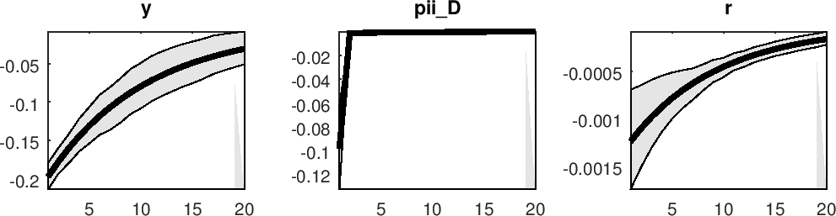

Figure 5.1: Impulse Response to Monetary Policy.

Note: y- output; pii_D-inflation and r-nominal interest rate

# Fiscal Policy Shock

A positive innovation to government spending caused government spending to increase from the first to the last quarter. Figure 5.2 shows that fiscal shock impacted negatively on domestic output from quarter one before it converged around the steady state in quarter 20. The negative impact of government spending on output is expected since the government is modelled to be involved in rent-seeking or wasteful public spending. At the same time the inflation level rise after the government spending shock. This implies that increased government spending induces upward inflationary trend, as proposed by the Monetarist arithmetic hypothesis and proponents of the Fiscal theory of price level. In response to tackling increased domestic inflation, the central bank responds by raising the nominal interest rate. An increase in the nominal interest rate from quarter one to seven can, therefore, be observed in Figure 5.2. However, from quarter 8 to 20, the nominal interest rate falls in response to the fiscal shock. The reaction of the nominal interest rate to the fiscal shock implies that from quarter 1 to 7, an unexpected increase in government spending that is, expansionary fiscal measure, triggered a contractionary monetary response. This indicates that fiscal and monetary policy interacted as substitutes over the short run, from quarter 1 to 7. Conversely from quarter 8 to quarter 20, nominal interest rate falls, that is an expansionary monetary action, in response to the positive fiscal shock. This reveals the complementary nature of interactions between fiscal and monetary policy over the medium term. It negates the findings

of Adegboye (2015) that fiscal and monetary policy acts as complements in the short term and act as substitutes in the medium term.

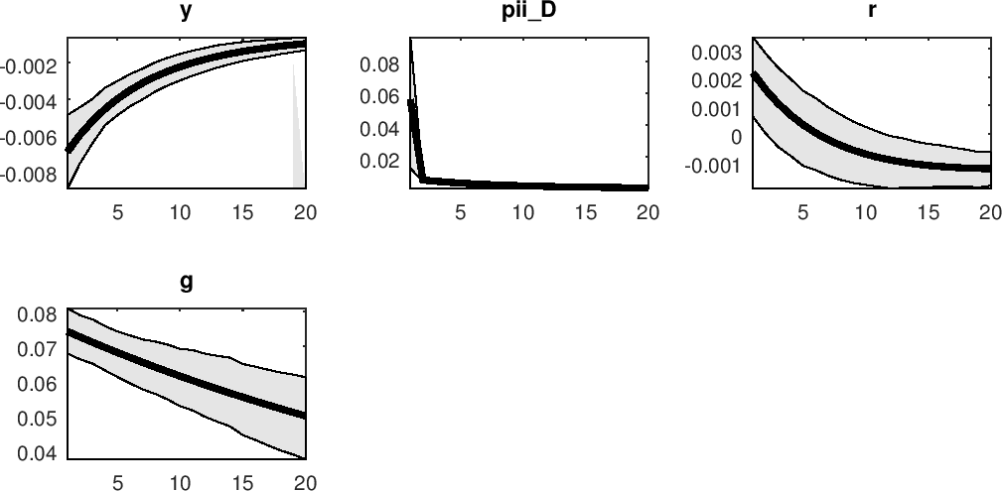

Figure 5.2: Impulse Response to Fiscal Policy Shock

Note: y- output; pii_D-inflation; r-nominal interest rate and g-government spending

### Output Shock

From Figure 5.3, a positive output shock monotonically increased the level of domestic output into the horizon but reduced the price level and nominal interest rate. The reaction of the price level is expected because a rise in the level of output implies an increased production of goods and lower unemployment level, which means that household are earning an adequate income to demand goods and at the same time, aggregate supply is increasing, this will prevent demand-pull inflation. The reduction of the price level after an output shock is also intuitively backed by the Philip’s curve which depicts a trade-off between output and inflation. In addition, the Central Bank reduces the interest rate in response to positive output shock, in order to sustain the rising output level.

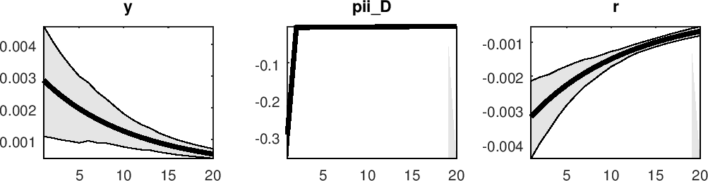

Figure 5.3: Impulse Response to Output Shock

Note: y- output; pii_D-inflation and r-nominal interest rate

# Shock to Rent seeking

Shock to rent-seeking implies an increase in the amount of rent raised. A sudden rise in the amount of wasteful spending or amount of rent raised, as seen in Figure 5.4, impacted negatively on domestic output, over a period of three quarters by 0.12 percentage points before its return to the steady state level. This shows that rent-seeking activities have an initial adverse impact on domestic output. It shows that rent-seeking activities impact negatively on the Nigerian economy but the economy quickly adjusts to it. This means that the money being stolen and misused by public office holders negatively impacts the Nigerian economy.

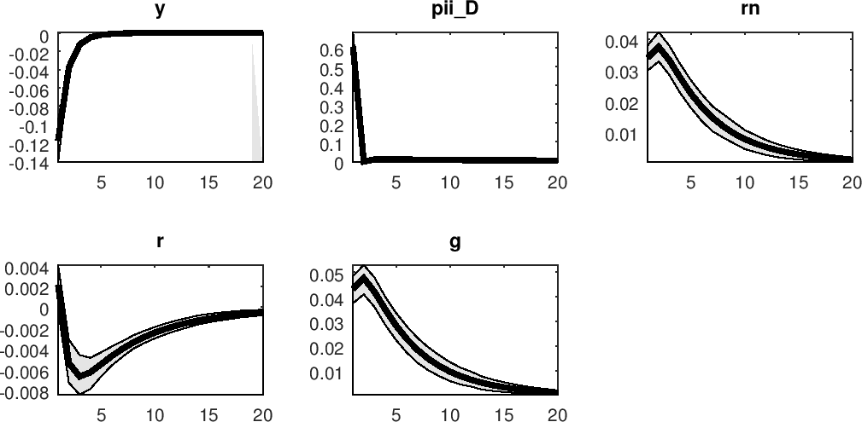

Figure 5.4: Impulse Response of Shock to Rent-Seeking

Note: y- output; pii_D-inflation; r-nominal interest rate; rn-rent seeking; g-government spending

# Variance Decomposition

The variance decomposition method considers the relative contribution of individual shocks to fluctuations in an endogenous variable. The variance decomposition presents the percentage of variance of the error that arises from the shock of the variable due to itself and other variables over a specific time horizon. It is useful in measuring the importance of a shock as a source of volatility to a macroeconomic variable. The variance decomposition of output, inflation, interest rate, rent- seeking and government spending are examined in this sub-section.

From Table 5.7, it can be observed that interest rate and foreign output shocks contribute most to variations in output at 58.86 percent and 28.99 percent, respectively. Shocks to foreign inflation, foreign interest rate, tax, rent-seeking and output itself, also respectively accounted for fluctuations in domestic output at 3.91, 2.66, 0.78, 4.72, 0.01 percent. Conversely, technology shock, transfer

payment shock and inflation shock did not trigger any variation in domestic output. It is also observed that external shocks, that is, foreign inflation, foreign interest rate and foreign output are the main sources of volatility in domestic inflation at 16.82, 36.84 and 38.77 percent. On the other hand, domestic sources of shocks such as government spending, interest rate, tax, output and rent- seeking accounted for lesser variations in domestic inflation at 0.05, 0.14, 0.54, 1.19, 5.65 percent, respectively.

The result of the variance decomposition also reveals that foreign inflation and foreign interest rate are the main perturbations to the domestic interest rate. They contributed 29.07 and 61.95 percent to variations in the nominal interest rate. Other sources of shocks such as government spending, interest rate, foreign output, tax, output and rent-seeking account for 1.31, 0.13, 1.49, 0.82, 1.06 and 4.16 percent volatility in the nominal interest rate. Domestic shocks, that is, government spending shocks and shocks to rent-seeking are the only contributor to the variations in government spending at 92.23 and 7.09 percent. The other form of shocks does not trigger fluctuations in government spending. At the same time, the volatility in rent-seeking is primarily explained by shocks to rent-seeking itself and tax revenue at 91.34 and 8.66 percent. The result reveals the importance of both foreign and domestic shocks to fluctuations in the Nigerian economy.

Table 5.7: Posterior mean variance decomposition (percent)

|  |  |  |  |  |  |
| --- | --- | --- | --- | --- | --- |
|  | Output | Domestic Inflation | Nominal Interest  rate | Government spending | Rent Seeking |
| Govt. Spending shock (eps_g) | 0.06 | 0.05 | 1.31 | 92.23 | 0.00 |
| Interest Rate shock (eps_r) | 58.8 | 0.14 | 0.13 | 0.00 | 0.00 |
| Foreign Output (eps_ystar) | 28.99 | 38.77 | 1.49 | 0.00 | 0.00 |
| Foreign Inflation (eps_piistar) | 3.91 | 16.82 | 29.07 | 0.00 | 0.00 |
| Foreign Interest rate | 2.66 | 36.84 | 61.95 | 0.00 | 0.00 |
| (eps_rstar) |  |  |  |  |  |
| Technology Shock (eps_a) | 0.00 | 0.00 | 0.00 | 0.00 | 0.00 |
| Tax Shock (eps_taxx) | 0.78 | 0.54 | 0.82 | 0.68 | 8.66 |
| Transfer payment shock | 0.00 | 0.00 | 0.00 | 0.00 | 0.00 |
| (eps_TP) |  |  |  |  |  |
| Inflation shock (e_piiD) | 0.00 | 0.00 | 0.00 | 0.00 | 0.00 |
| Output shock (e_y) | 0.01 | 1.19 | 1.06 | 0.00 | 0.00 |
| Shock to Rent seeking | 4.72 | 5.65 | 4.16 | 7.09 | 91.34 |
| (eps_rn) |  |  |  |  |  |

# Model Diagnostic Testing

The estimated model is a small-scale New Keynesian DSGE model with a system of 27 equations and 27 endogenous variables. The posterior moments of this model are computed by using the Metropolis-Hastings algorithm where 100,000 posterior draws of 5 parallel chains are generated, after the first 30,000 draws are discarded, in order to ensure convergence. In addition, the Monte- Carlo based optimisation method is used to obtain the posterior mode. In this Section, therefore, the statistical validity of the estimated model is examined. This involves presenting graphs on the numerical optimisation of the posterior kernel and the Metropolis-Hastings algorithm, in order to detect problems or build confidence in the results of the estimated model.

# Stability of the Model

This is about the existence and uniqueness of a solution to the adopted NK DSGE model. A solution exists when the number of equations equals the number of endogenous variables. In the case of this study, this condition is met such that there are 27 equations with 27 endogenous variables. The Blanchard-Kahn condition is also used to test for the existence of a unique solution to this model. The condition requires that the number of eigenvectors lying outside a unit root equals the number of forward-looking variables. The Blanchard-Kahn condition of the estimated

model is satisfied such that there are three eigenvalues larger than one in modulus as there are three forward-looking variables in the system. This depicts the existence of a unique solution for the estimated system of equations.

# Identification of the Parameter Estimates

The estimated parameters of the model are expected to be identified by the observed data. This means that the observed data provide sufficient information about the parameters. The criterion used to gauge parameter identification is the distinctness between the prior and posterior distribution such that they are not the same. Identical prior and posterior distributions imply that the concerned parameter is only weakly identified and the data is uninformative. It can also mean in a converse manner that the data provides perfectly accurate information about the parameter. Tables 5.1 to 5.4 show that the prior values are different from the posterior values for most of the estimated parameters. This is also corroborated by the plots presented in Figures 5.5a, 5.5b and in Appendix nine, which shows that the prior distribution (grey line) is distinct from the posterior distribution (black line) for most of the parameters.

Furthermore, the plots of posterior distribution (black curve) possess a near normal shape while, at the same time, the mode computed from the numerical optimization of the posterior kernel (green vertical line) is seen to be close to the peak of the posterior distribution (black curve). These two additional features justify further confidence in the output of the estimated model.

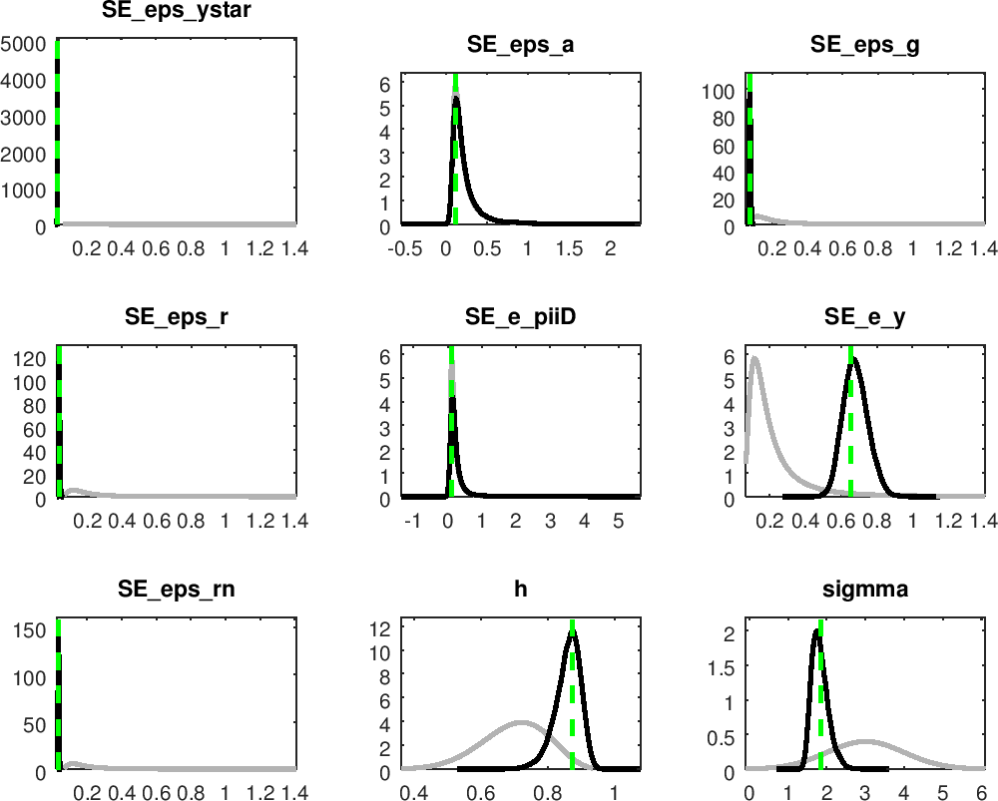

Figure 5.5a: Prior-Posterior Plots

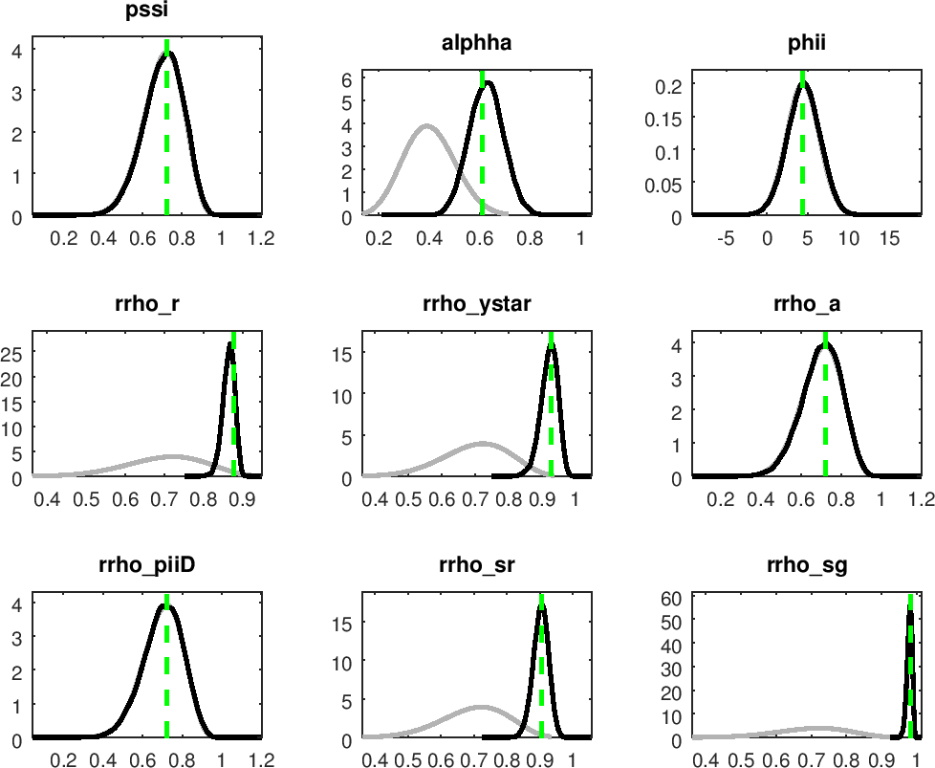

Figure 5.5b: Prior-Posterior Plots

# Mode Check

The accuracy of the Monte-Carlo based optimisation routine used in computing the posterior mode is inspected using the mode check plots. The computed mode (green line) should ideally be located at the maximum of the posterior likelihood (blue line) for each parameter. There are possible problems with the optimization routine if this is not the case. The mode plots presented in Figure

5.6 show that the estimated mode (green line) is close to the maximum of the posterior likelihood (blue line). The implication is that the optimiser was able to compute a robust maximum for the posterior mode. The deviations between the red line (posterior mode) and the blue line (likelihood function) depict the influence of the prior on the likelihood function (blue line).

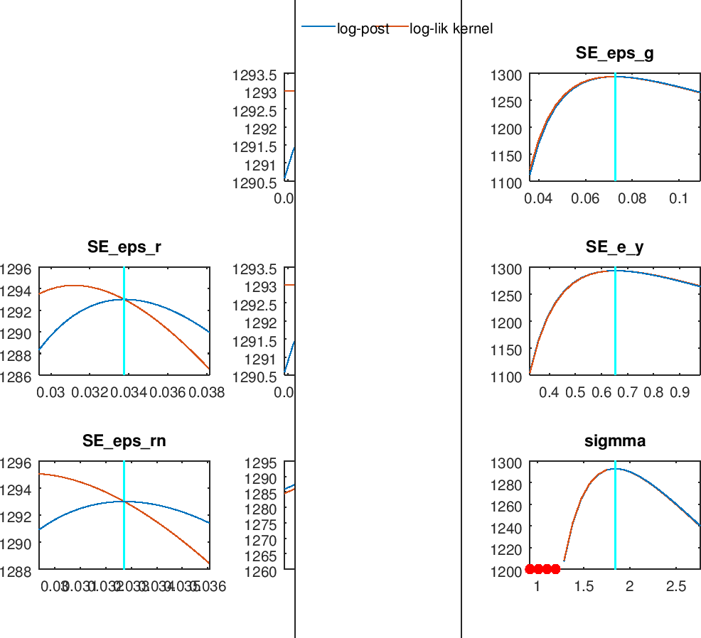

Figure 5.6a: Mode Check Plot

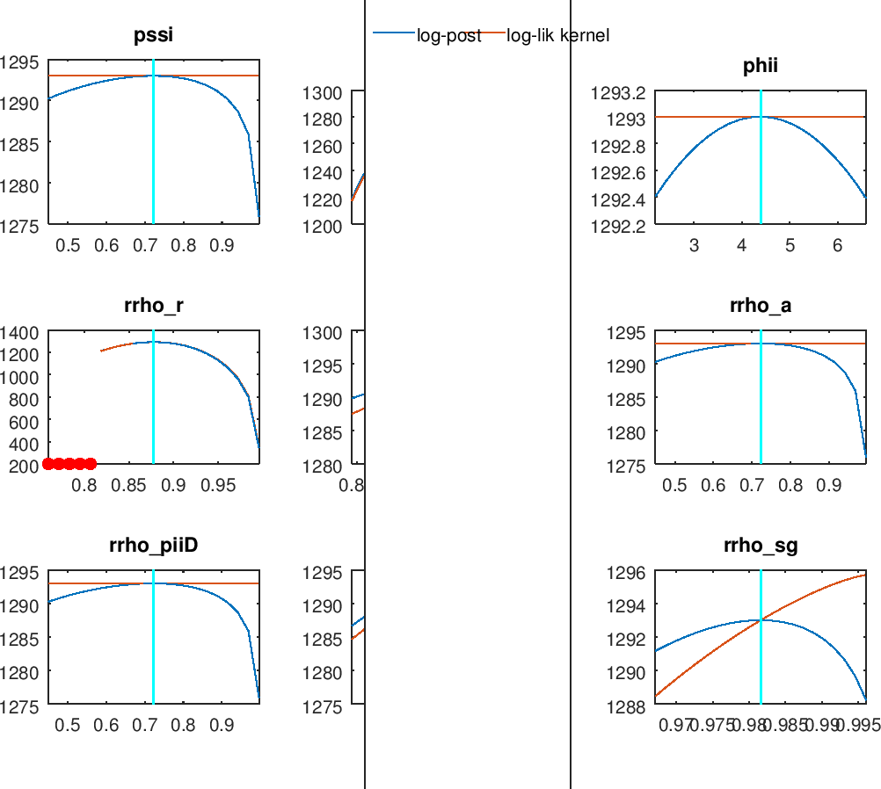

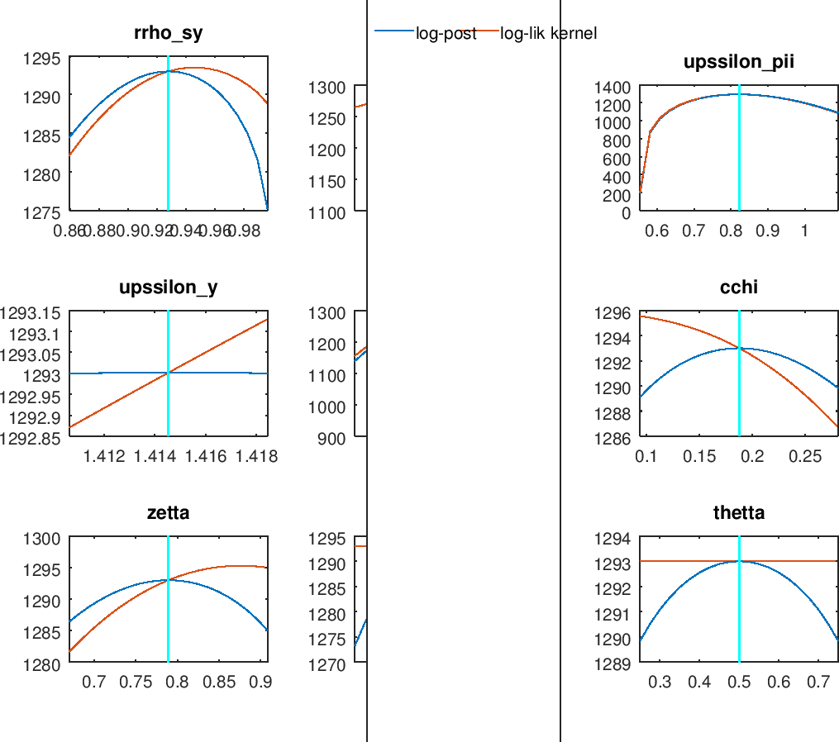

Figures 5.6b and c: Mode Check Plots

# Univariate Convergence Statistics

This is the Brooks and Gelman (1998) test used to monitor the convergence of the Metropolis- Hastings simulations. It requires that the iterations between and within the five distinct parallel chains are close and similar for the moments of individual parameters. The existence of convergence of the MH simulations can be assessed by observing the graphical output produced by Dynare. In each graph, the red line (within chain) and the blue line (between chain) should be close and stabilise horizontally for the moments, that is, the mean, variance and third moment of each estimated parameter. Figures 5.7a, b and Appendix two presents the result of the Monte Carlo Markov Chains (MCMC) univariate diagnostics and shows convergence, that is, the red and blue lines converge and are relatively stable, for most of the parameters. Grifolli (2013) highlights the convergence and stability property of the Metropolis-Hastings iterations as the primary avenue to justify the sensibility of the estimation results. This, therefore, implies that the estimated results in this study are sensible.

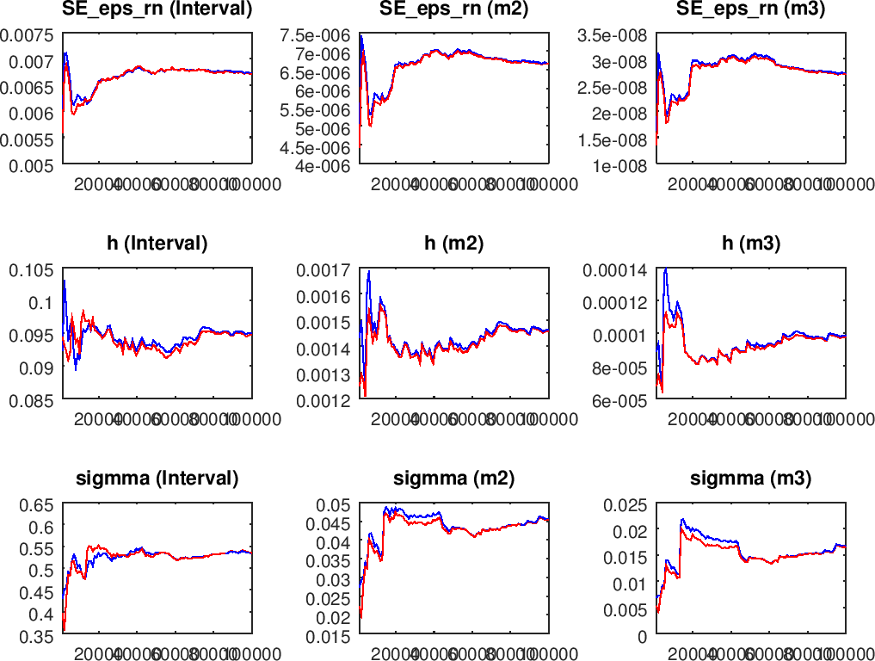

Figure 5.7a: MCMC Univariate Diagnostics for selected parameters

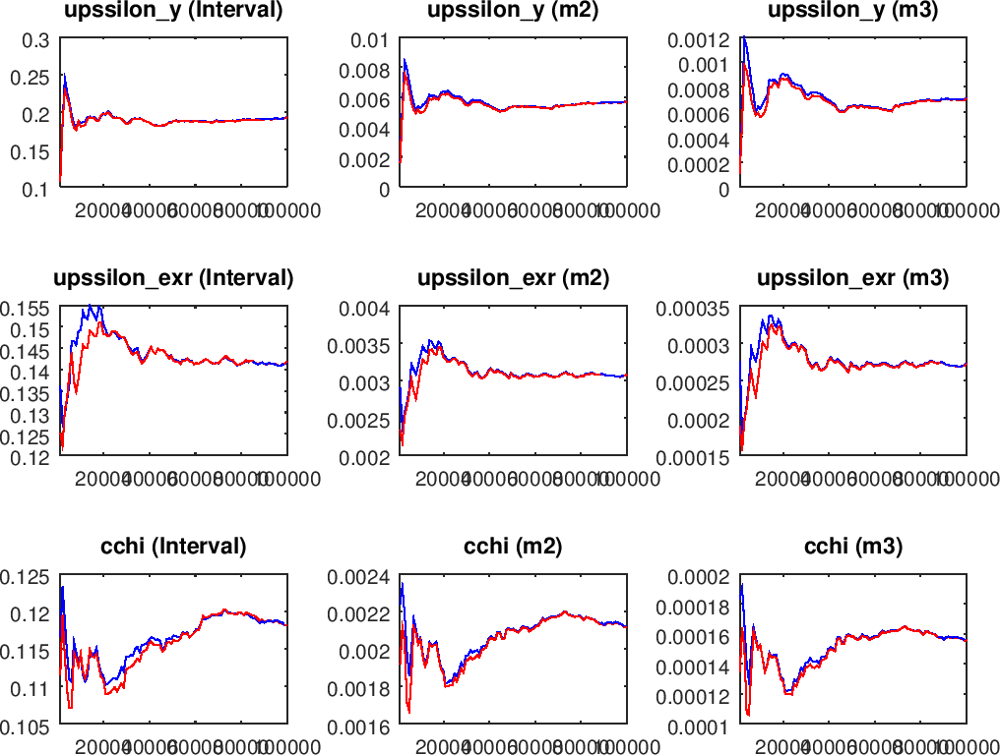

Figure 5.7b: MCMC Univariate Diagnostics for selected parameters

# Multivariate Convergence Diagnostic

This statistic is a measure of the overall convergence of the aggregate parameters in the model. Just as in the case of the univariate statistics, it is also expected that the simulations within the chains should be similar and that those between the chains should be close, for convergence to be reached. Figure 5.8 shows that the multivariate convergence for this model exists such that the red line (within chain) and the blue line (between chains) are close and flat.

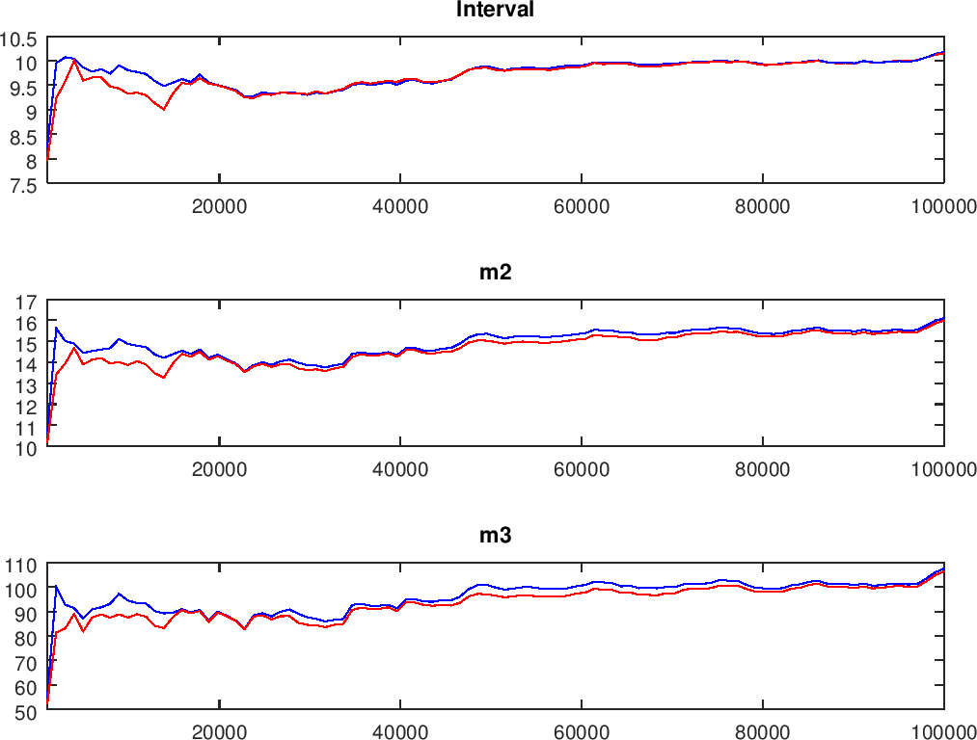

Figure 5.8: Multivariate Convergence Diagnostic

# Historical and Smoothed variables

The historical and smoothed variable graphs of the observed data are used to detect the presence of measurement errors in the estimated model. Measurement errors are absent when the actual data and the smoothed data are identical. The plot of the historical and smoothed variable displayed in Figure 5.9 shows the dotted black line (historical data) and the red line (smoothed data) overlap on each other.

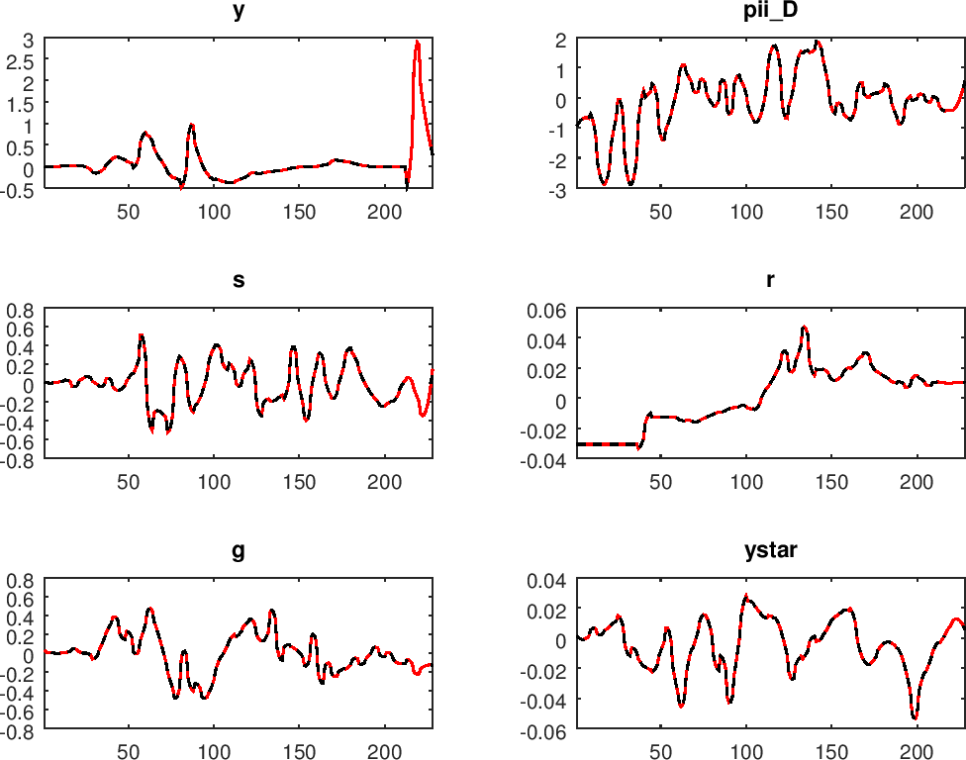

Figure 5.9: Historical and Smoothed variables

# Smoothed Shocks

The plot of the smoothed estimated shocks is expected to centre around zero. Figure 5.10 shows that the smoothed shocks processes are around zero. This is an indication of the statistical validity of the estimated model.

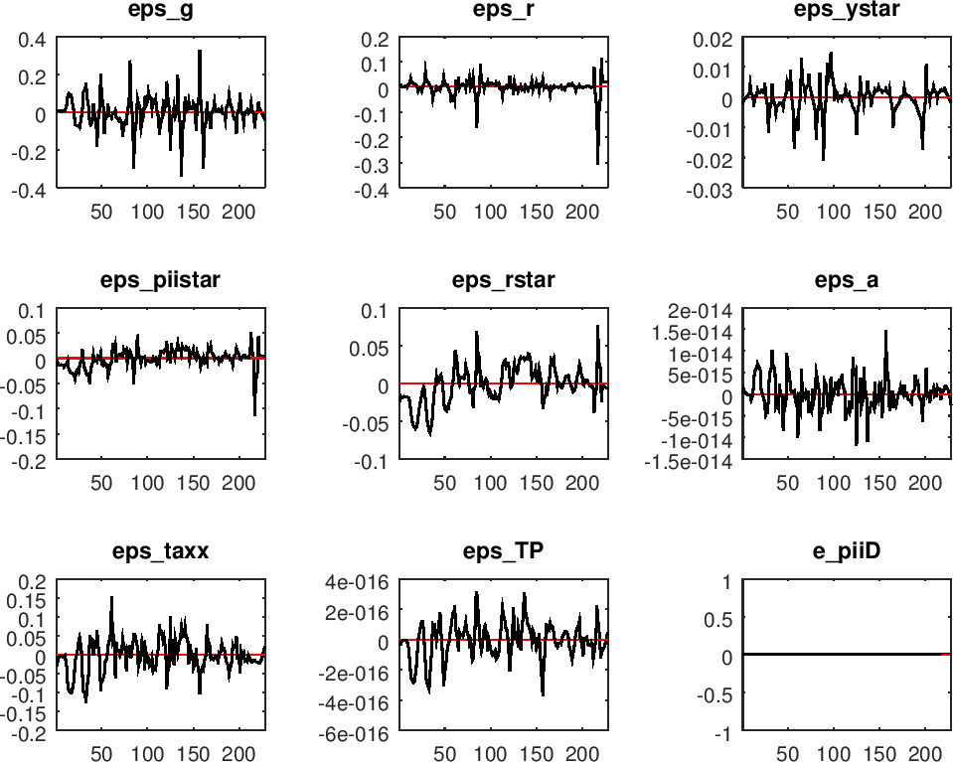

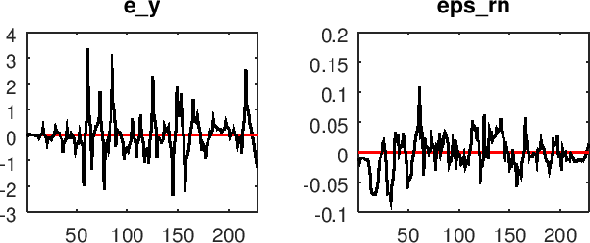

Figure 5.10: Smoothed Shocks

# 5.3 Nature of Fiscal and Monetary Policy Interactions

In this sub-section, the interactions between fiscal and monetary policy are characterised. This encompassed obtaining the direction and magnitude of the correlation between both policies. The impact of the policy interactions on macroeconomic variables such as output and inflation are also examined. To this end, numerical simulations are conducted using the First order Taylor approximation method on the system of log-linear equations. The Dynare software is used to carry out the numerical simulations. The outputs from Dynare, as presented in Table 5.8 show the matrix

of covariance of shocks. It proves the existence of no serial correlations among the shocks. Tables

5.9 and 5.10 present the theoretical moments and the coefficient of autocorrelation. These statistics are relevant to inspect the results of the numerical simulation.

Table 5.8: Matrix of Covariance of Shocks

|  |  |  |  |  |  |  |
| --- | --- | --- | --- | --- | --- | --- |
| **Shocks** | **eps_g** | **eps_r** | **e_piiD** | **e_y** | **eps_rn** | **eps_com** |
| **eps_g** | 0.010000 |  |  |  |  |  |
| **eps_r** | 0.000000 | 0.010000 |  |  |  |  |
| **e_piiD** | 0.000000 | 0.000000 | 0.010000 |  |  |  |
| **e_y** | 0.000000 | 0.000000 | 0.000000 | 0.010000 |  |  |
| **eps_rn** | 0.000000 | 0.000000 | 0.000000 | 0.000000 | 0.010000 |  |
| **eps_com** | 0.000000 | 0.000000 | 0.000000 | 0.000000 | 0.000000 | 0.010000 |

Where, eps_g: Government spending shock; eps_r: Interest rate shock; e_piiD: Inflation shock; e_y: Output shock; eps_rn: Shock to rent-seeking and eps_com: Shock to Interaction variable

Table 5.9: Theoretical Moments

|  |  |  |  |  |
| --- | --- | --- | --- | --- |
| **Variable** | **Definition** | **Mean** | **S.t.d** | **Variance** |
| y pii_D r  g ytilde rn V_com | Output Inflation Interest rate  Government Spending Output gap  Rent seeking Interaction Variable | 0.0000  0.0000  0.0000  0.0000  0.0000  0.0000  0.0000 | 1.6636  1.3052  0.1903  0.6110  11.2721  0.2023  0.2397 | 2.7676  1.7036  0.0362  0.3733  127.0592  0.0409  0.0575 |

Table 5.10: Coefficient of Autocorrelation

|  |  |  |  |  |  |  |
| --- | --- | --- | --- | --- | --- | --- |
| Variable | Definition | 1 | 2 | 3 | 4 | 5 |
| Y | Output | 0.6005 | 0.3790 | 0.2407 | 0.1528 | 0.0964 |
| pii_D | Inflation | 0.0464 | 0.0293 | 0.0202 | 0.0151 | 0.0116 |
| R | Interest rate | 0.8281 | 0.6439 | 0.4884 | 0.3659 | 0.2721 |
| G | Government  spending | 0.8132 | 0.6032 | 0.4324 | 0.3057 | 0.2149 |
| Ytilde | Output gap | 0.0219 | 0.0156 | 0.0098 | 0.0069 | 0.0051 |
| Rn | Rent seeking | 0.8264 | 0.6164 | 0.4429 | 0.3134 | 0.2204 |
| v_com | Interaction  variable | 0.7701 | 0.5464 | 0.3753 | 0.2541 | 0.1708 |

The nature of interdependence between fiscal and monetary policy is found from the direction and magnitude of the correlation between both policy variables. The correlation matrix presented in Table 5.11, obtained from the dynamic simulation of the NK DSGE model, reveals a strong but negative correlation between fiscal and monetary policy. This shows that both policies are strong substitutes. The result negates that of Chuku (2010) who conclude that fiscal and monetary policy act as weak substitutes. The Impulse Response function obtained from the Bayesian estimation as presented in Figure 5.2 also corroborates the findings of the correlation matrix. It is such that, although, fiscal and monetary policy acted as substitutes from period 1 to 7 and as complements from period 8 to 20, the magnitude of the negative interactions between both policies may have outweighed their complementary interactions. In an overall manner, over the sample period, both fiscal and monetary policies interacted, therefore, as strong substitutes. This implies that when the fiscal (monetary) policymaker implements the expansionary measure, the monetary (fiscal) authority counters this action using contractionary policy.

Table 5.11: Correlation Matrix: Interest rate and government spending

|  |  |  |
| --- | --- | --- |
| **Variables** | **Nominal Interest Rate (r)** | **Government Spending (g)** |
| **Nominal Interest Rate (r)** | 1.0000 | -0.7727 |
| **Government Spending (g)** | -0.7727 | 1.0000 |

The effect of the policy interactions on output and inflation are also discussed by examining the effect of nominal interest rate, government spending and a common interaction variable. The interaction variable is obtained by an additive function of both interest rate and government spending. It is used to approximate the existing interactions between both fiscal and monetary policies. Table 5.12 presents result that shows monetary policy has a positive correlation with output and inflation, while government spending negatively correlates with both macroeconomic variables, that is, output and inflation rate. The common interaction variable is also seen to impact negatively on both output and inflation.

**Table 5.12: Correlation Matrix- Interaction variable and Macroeconomic outcome**

|  |  |  |  |  |  |
| --- | --- | --- | --- | --- | --- |
| **Variables** | **Nominal**  **Interest Rate (r)** | **Government Spending (g)** | **Interaction**  **Variable (v_com)** | **Output (y)** | **Inflation (piiD)** |
| Nominal Interest  Rate (r) | 1.0000 |  |  |  |  |
| Government  Spending (g) | -0.7727 | 1.0000 |  |  |  |
| Interaction  Variable(v_com) | -0.7727 | 0.9677 | 1.0000 |  |  |
| Output (y) | 0.4461 | -0.3957 | -0.3273 | 1.0000 |  |
| Inflation (piiD) | 0.4847 | -0.2669 | -0.1477 | 0.6267 | 1.0000 |

# Optimal Fiscal and Monetary Policy

In this Section, the optimal Ramsey and discretionary paths of fiscal and monetary policy are numerically investigated. The optimal fiscal and monetary policy is defined as the path of government spending and nominal interest rates that minimise the welfare loss of the policymaker given the constraints posed by the structural equations of the small open economy. The welfare function of the policymaker is such that both policy makers jointly desire to minimise the deviations of actual values of inflation, output and government spending from their target values. The implication of various assumptions on the behaviour of fiscal policy such as rent-seeking, benevolent, commitment and discretionary, on the optimal paths are specifically examined.

The moments of the optimal policies under different assumptions are presented in Table 5.13. The moments are computed from dynamic simulations, specifically using the Linear Quadratic method. The Linear Quadratic approach takes a first-order Taylor approximation to the constraint equations and a quadratic approximation to the objective function. To this end, Dynare 4.5.1 routines on Ramsey and Discretionary Policy are used for the numerical simulations

### Table 5.13: Moments of Optimal Fiscal and Monetary Policy

|  |  |  |  |  |  |  |
| --- | --- | --- | --- | --- | --- | --- |
| **A. Ramsey with Benevolent Fiscal Policy (Benchmark)** | | | | | | |
| Variable | | **Standard deviation** | | **Autocorrelation** | | **Welfare Loss** |
| Government Spending | | 0.138 | | 0.700 | | 0.176 |
| Nominal Interest Rate | | 0.034 | | 0.139 | |  |
| **B. Ramsey with Rent seeking Fiscal Policy** | | | | | | |
| **Variable** | | **Standard**  **deviation** | | **Autocorrelation** | | **Welfare Loss** |
| Government Spending | | 0.297 | | 0.621 | | 0.806 |
| Nominal Interest Rate | | 0.034 | | 0.128 | |  |
| **C. Discretionary with Benevolent Fiscal Policy** | | | | | | |
| **Variable** | **Standard deviation** | | **Autocorrelation** | | **Welfare Loss** | |
| Government | 0.139 | | 0.698 | | 0.179 | |
| Spending |  | |  | |  | |
| Nominal Interest | 0.035 | | 0.165 | |  | |
| Rate |  | |  | |  | |
| **D. Discretionary with Rent seeking Fiscal Policy** | | | | | | |
| Variable | Standard deviation | | **Autocorrelation** | | **Welfare Loss** | |
| Government | 0.297 | | 0.621 | | 0.806 | |
| Spending |  | |  | |  | |
| Nominal Interest | 0.034 | | 0.128 | |  | |
| Rate |  | |  | |  | |

The Ramsey outcomes show the dynamic properties of optimal policy when policymakers commit to specified rules for current and future dates. In the benchmark model, government spending and interest rates are 13.8 and 3.4 percentage points volatile. Government spending is also found to be more persistent than the nominal interest rate. Furthermore, the welfare loss is 0.176. In comparison with the other models (B, C and D), the Ramsey policy with the benevolent government has the least volatile paths for both fiscal and monetary policy instruments. It can then be adjudged to have the most macroeconomic stable property. Table 5.13 also reveals that the

optimal policies are more volatile in models with rent-seeking assumptions. This implies that the rent-seeking tendencies of government can be a source of volatility. It can also be deduced from the table that the discretionary form of policy has a trivial impact on the sequence of optimal fiscal and monetary policy.

Furthermore, the value of the loss function of the policymakers at 0.806 is higher in models with rent-seeking assumptions than in the model with benevolent government at 0.176 and 0.179. This means model economies with rent-seeking tendencies are more welfare-reducing than those of economies with a benevolent government. In summary, the benchmark model, that is, Ramsey Policy with benevolent government has the most desirable path for optimal fiscal and monetary policy. An economic implication of this result is that the Nigerian government ought to commit to policy rules and should implement policies that are expected to maximise economic welfare for all, not just a subset of its citizens.

# Implication of Findings

A New Keynesian DSGE model has been simulated and estimated in this chapter using Dynare codes. The model is a system of 27 equations with 27 endogenous variables and coincidentally, 27 parameters were calibrated to mimic the Nigerian economy.

The main results obtained from this study include:

1. The parameter value of the reaction of inflation to the changes in interest rate (υπ) is less than one, while the reaction of output to the Taylor rule (υy) has a higher magnitude. This indicates the existence of a passive monetary policy such that the Central Bank has to adjust its policy decisions to suit fiscal behaviour. The second implication of this result is that the Central Bank has not been primarily implementing policies for price stability, but for output stability.
2. The parameter value of the degree of rent-seeking () suggests that only a trivial proportion of government expenditure was actually expended for welfare-enhancing projects, the remainder is suspected to have been wasted, misused or stolen.
3. The study also found that both fiscal and monetary policies act as strong substitutes. This means that when one policymaker implements an expansionary measure, the other counters this action

using contractionary policy. This contrasts with Chuku (2010) who used the Markov-switching model and find that fiscal and monetary policy act as weak substitutes

1. The common variable that explicitly captures the interaction between fiscal policy and monetary policy shows that the joint process of both policies has a weak but negative effect on output and inflation. This result can be interpreted in two ways. The first implication is that actual policy implementation in Nigeria that captures the rent seeking and discretionary nature of the federal government coupled with existing weak policy coordination, have sub-optimal impact on the Nigerian economy. The result also shows on the other hand, that stabilisation policies may be inadequate in influencing the outcomes of output and inflation in Nigeria.
2. The optimal fiscal and monetary policy are characterised by a regime where the fiscal policy maker is benevolent and commits to a policy rule while the Central Bank commits to its monetary policy rule. Rent seeking activities considerably reduces welfare by over 357 percent when compared with the welfare loss from a benevolent government. Therefore, rent- seeking activities have a non-trivial implication for the path of optimal fiscal and monetary policy.

**CHAPTER SIX CONCLUSION AND RECOMMENDATION**

# Summary

The renewed interest of policymakers in implementing fiscal measures towards economic stabilisation, in the aftermath of the 2008/2009 global financial crisis, has sparked attention on the issue of fiscal and monetary policy interactions. In Nigeria, policymakers are also concerned about the alignment of fiscal and monetary policy coupled with a consistent policy design. Chuku (2010); Musa *et al.,* (2013) and Adeboye (2015) have investigated the interactions between fiscal and monetary policy in Nigeria. However, existing evidence on government's fiscal behaviour shows that conventional assumptions such as benevolent spending, rule-based fiscal process and policy coordination, should be modified in line with the political economy literature (Fragetta and Kirsanova, 2010; Dimakou, 2015; Miller, 2016). This study, therefore, argued that the rent-seeking tendency of fiscal policymakers, the discretionary power of government and weak policy coordination have implications in accounting for the interaction between fiscal and monetary policies.

Following this background, the study sought to examine fiscal and monetary policy interaction under alternative assumptions of a rent-seeking government that follows discretionary policies and where no economic policy coordination exists. Its specific objectives were to assess the nature of fiscal policy interactions with monetary policy in Nigeria; examine the transmission effect of the policy interactions on output and inflation and investigate the optimal fiscal and monetary policy mix that guarantees economic stability in Nigeria. To this end, the study tested the null hypotheses that include: (1) Fiscal policy has no interaction with monetary policy in Nigeria; (2) There is no transmission effect of the policy interaction on output and inflation in Nigeria; (3) There is no

optimal fiscal and monetary policy mix for output and inflation stability in Nigeria over the quarterly period of 1961Q1 to 2016Q4.

The study hinged on the New Keynesian School of economic thought. The New Keynesian model maintains traditional Keynesian postulations such as imperfect competition and sticky prices. In addition, they propose the use of micro-founded models that assume forward-looking and optimising economic agents. The study, to this end, adopted the use of a New Keynesian dynamic general equilibrium model. Features such as habit formation, Non-Ricardian households and a discretionary rent seeking fiscal behaviour were added to the canonical New Keynesian Dynamic Stochastic General Equilibrium model, in order to adapt the model to the Nigerian economy.

To achieve the three specific objectives of the study, the Bayesian estimation method was used. In addition to it, numeric simulations based on log-linear Taylor approximation method and the linear quadratic technique were adopted. The Bayesian method was used to test the quarterly empirical data on Nigeria and the United States, over the period 1961Q1 to 2016Q4 on relevant macroeconomic policy variables. The relevant variables include the Real Gross Domestic Product, Consumer Price Index, Terms of trade, Nominal interest rate, Government Expenditure. Also, the Real Gross Domestic Product (RGDP) series for the United States was used as proxy for the foreign economy.

The Bayesian method was employed to estimate the New Keynesian Dynamic Stochastic General Equilibrium model. Numerical simulations were also used to empirically characterise the nature of policy interactions and measure the effect of this interaction on output and inflation. The dynamic simulation essentially the linear quadratic approach to Ramsey and discretionary optimal policy was used to obtain the optimal paths of both the fiscal and monetary policy. Answers found using the estimation and simulation techniques established the significance of the study. Therefore, the study was able to characterise the interrelation between both fiscal and monetary policies. Secondly, it was able to identify the transmission effects of fiscal actions on monetary policy and the aggregate economy. Consequently, this study was novel in testing the implication of alternative assumptions for fiscal-monetary policy interactions. Secondly, the study was also novel in constructing an interacting variable in order to explicitly measure the interaction between both policies.

# Major Findings of the Study

Chapters 3 and 5 are the primary source of findings in this study. Using the requisite descriptive statistics, the stylised facts established among other facts, that there is positive correlation between fiscal and monetary policy. It also found that there are indications for rent-seeking in Nigeria. In addition, fiscal and monetary policies were seen to have been weakly coordinated in Nigeria and finally, it found evidence of discretionary fiscal policy in Nigeria. The study also presented relevant estimation and simulation results. The Bayesian estimation method and numerical simulations were used to answer the first research question ‘To what extent does fiscal policy interacts with monetary policy in Nigeria?’ The results show, contrary to findings of the stylised facts that fiscal policy correlates strongly but negatively with monetary policy in Nigeria.

A numeric simulation using the log-linearisation method was used to answer the second research question ‘What is the transmission effect of the policy interaction on output and inflation in Nigeria?’ To answer this question, a common interaction variable was constructed to explicitly capture fiscal-monetary policy interactions. The study found out that the joint process of both policies had a weak but negative effect on output and inflation. Finally, a dynamic simulation applying the Linear Quadratic approximation method was employed to address the third research question ‘How should fiscal and monetary policy be optimally combined for output and inflation stability in Nigeria?’ The result showed that the optimal fiscal and monetary policy is characterised by a regime where the fiscal policy maker is benevolent and commits to a policy rule while the Central Bank commits to its monetary policy rule. Other major results from the study shows that the parameter value of the reaction of inflation to the changes in interest rate is less than one, while the reaction of output to the Taylor rule has a higher magnitude. Furthermore, a low parameter value for the degree of rent-seeking suggests a high rate of rent-seeking among politicians and bureaucrats.

# Recommendations

To reiterate the main findings: Firstly, there is a strong and negative correlation between fiscal and monetary policy; secondly, joint policy interaction has a weak but negative effect on the macroeconomy. Thirdly, the most desirable nature of fiscal and monetary policy is one where a

benevolent government commits to policy rule and where the central bank also commits to its Taylor rule.

A political economic implication of the strong and negative correlation between fiscal and monetary policies means that both fiscal policy and monetary policy act as strong substitutes. This indicates that when one policymaker implements an expansionary measure, the other counters this action using contractionary policy. It, therefore, implies that policymakers have in the past, implemented conflicting and uncoordinated fiscal and monetary measures. This can be a potential source of instability to the economy. This conflicting form of policy implementation occurred in the divergent response of the Federal Government and the Central Bank to the recent recessionary episode in 2016. In this instance, the Federal Government adopted an easy fiscal stance by increasing the amount of budget deficit, while, the Central Bank of Nigeria tightened its monetary stance by raising the Monetary Policy Rate.

The negative effect of the joint policy interaction on inflation and output implies that the overall impact of policy interaction negatively affects both long run and short run economic outcomes. Its weak effect also signals that actual policy implementation in Nigeria that captures the rent-seeking and discretionary nature of the federal government coupled with existing weak policy coordination, have sub-optimal impact on the Nigerian economy. Furthermore, the result shows that asides stabilisation policies, other measures such as structural policies are, therefore, suspected to significantly account for the outcomes in output and inflation. These structural policies include but are not limited to trade policy and financial policy. The result on the optimal fiscal-monetary combination points out that politicians and bureaucrats in government should take caution on policy reversals by committing to policy rules and at the same time, should implement policies that enhance the welfare of the entire citizens, not just a subset of the citizens.

Furthermore, the parameter estimates of the coefficients in the Taylor rule indicate the existence of a passive monetary policy regime. It means that the Central Bank has to adjust its policy decisions to suit government's fiscal decisions. The second implication of this result is that the Central Bank has not primarily implemented policies for price stability, but for output stability. This may also be viewed from the perspective that the Central Bank of Nigeria may not have adopted policy measures that effectively transmit into affecting domestic prices in the economy.

The economic implication of the high degree of rent-seeking among politicians and bureaucrats is that only a trivial proportion of government expenditure is actually expended for welfare- enhancing projects, the remainder is wasted, misused or stolen. For instance, the Minister of Information, Lai Mohammed, argued that a sizeable proportion of stolen public funds by former politicians and bureaucrats between 2006 and 2013, could have provided 635.18 kilometres of road; built thirty-six ultra-modern hospitals; erected 183 schools; educated 3,974 children from primary school to University; and provided 20,062 units of 2-bedroom houses, in order to ease accommodation.

Based on the implications of the major findings of this study, it is necessary that political economy scholars and the government consider the following measures:

* + 1. The Central Bank of Nigeria and Federal Ministry of Finance can improve existing coordination mechanisms using evidence-based planning and forecasting through the adoption of sophisticated economic models such as the Dynamic Stochastic General Models.
    2. In relation to (a), the Central Bank of Nigeria and Federal Ministry of Finance can harmonise their policy decisions by mutually adopting the same economic model and/ or assumptions to guide the planning and forecasting of their target values.
    3. The results show that stabilisation policies, that is, fiscal and monetary policy are inadequate towards guiding the macroeconomy. These policies ought to be complemented with structural policies such as trade policy and financial policy. A study considering and comparing the impact of each variant of policy is, therefore, suggested
    4. Politicians, bureaucrats and legislators alike, should evaluate policies using evidence-based models before deciding on policy reversals. Moreover, more effective and non-partisan anti-corruption programs should be adopted, in order, to discourage rent-seeking.

# Contributions to Knowledge

It is worthy of note that this study contributed to knowledge, by filling the following research gaps: Firstly, the study explicitly modelled alternative fiscal assumptions within a DSGE model for Nigeria. This is important to reflect the political economic reality of policymaking and then, explore how it affects the interaction between fiscal and monetary policy. This meant that the study adopted a political economy approach to economic policymaking. Secondly, the study constructed a common variable in order to explicitly measure the joint processes of fiscal and monetary policy interactions. This is to enable the measurement of the transmitted effect of policy interaction on both inflation and output.

In another dimension, the study also contributed to knowledge by adding to the relatively unexplored literature on fiscal-monetary policy interaction in Nigeria, especially within the context of modelling the fiscal behaviour of government using realistic assumptions and the application of the Dynamic Stochastic General Equilibrium framework in a Small Open economy environment.

# Suggestions for Further Research

In a political economy environment typified by rent-seeking, a discretionary pattern of policy actions and weak policy coordination, it is expected that these factors will be relevant in altering the overall impact of macroeconomic policies. In line with this, some parameter estimates in this study were somewhat inconsistent with Adegboye (2015), who consider fiscal-monetary policy interactions under the conventional assumptions. Future studies can, therefore, compare the results of policy interaction, using both diverging conventional and alternative assumptions. Secondly, since both fiscal and monetary policies are found to have a weak effect on the economy, future studies can investigate and compare the magnitude of structuralist policies vis-a-vis stabilisation policies.

Moreover, subsequent research can examine Markov-switching fiscal and monetary policies. This captures richer dynamics in the behaviour of these policies since it shows that policy parameters are not constant over a horizon but can vary over time. Furthermore, the Linear Quadratic method finds zero mean values for variables, therefore, the actual values of optimal policy variables cannot be measured. Hence, subsequent studies can consider optimal fiscal and monetary policy using a non-linear system of equations, in order to overcome this fallout. Finally, other researchers can

also examine the interactions between fiscal and monetary policies using data for the sub-national government such as states in the Nigerian Federation. This is because the fiscal decisions of state governments can also be significant for the aggregate economy of Nigeria.

### REFERENCES

Adams, K. and Billi, R. M. (2008). Monetary conservatism and fiscal policy. The Federal Reserve Bank Economics Research Department Working Paper 07-01. Available from: <https://pdfs.semanticscholar.org/94cc/54ef8abe1a2d9eaa95b82398d4412ee7c147.pdf>.

Adebiyi, M. A. and Mordi, C. N. O. (2010). Estimating small scale macroeconometric model (SSMM) for Nigeria: A dynamic stochastic general equilibrium (DSGE) approach. Central Bank of Nigeria Occasional Paper, 39:1-45. Available from: [https://ecomod.net/sites/default/files/document-conference/ecomod2010/1066.doc.](https://ecomod.net/sites/default/files/document-conference/ecomod2010/1066.doc)

Adebiyi, M.A. and Mordi, C.N.O. (2016). A dynamic stochastic general equilibrium (DSGE) model of exchange rate pass-through to domestic prices in Nigeria. Occasional Paper 59, Research Department, Central Bank of Nigeria. Available from: [https://www.cbn.gov.ng/out/2017/rsd/occasional%20paper,%2059%20combined.pdf](https://www.cbn.gov.ng/out/2017/rsd/occasional%20paper%2C%2059%20combined.pdf)*.*

Adegboye, A. A. (2015). Effects of fiscal and monetary policy interactions on inflation and output in Nigeria (1961-2011) (Doctoral dissertation). Obafemi Awolowo University, Ile-Ife, Nigeria.

Agu, C. (2007). What does the central bank of Nigeria target? An analysis of monetary policy reaction function in Nigeria. In: Biannual Research Workshop of the African Economic Research Consortium, Arusha Tanzania, October 2007.

Ajayi, S. I. (1974). An econometric case study of the relative importance of monetary and fiscal policy in Nigeria. *The Bangladesh Economic Review,* 2(2):559-576.

Ajisafe, R. A. and Folorunso, B. A. (2002). The relative effectiveness of fiscal and monetary policy in macroeconomic management in Nigeria. *The African Economic and Business Review,* 3(1): 23- 40.

Alege, P. O. (2008). Macroeconomic policies and business cycle in Nigeria: 1970-2004 (Doctoral dissertation). Covenant University, Ota, Nigeria.

Alege*,* P. O., (2012). A Business Cycle Model for Nigeria. *Journal of Applied Statistics,* 3(1):85- 115.

Alesina, A. and Tabellini, G. (1987). Rules and discretion with non-coordinated monetary and fiscal policy. *Economic Inquiry,* 25: 619-630.

Algozhina, A. (2012). Monetary and fiscal policy interactions in an emerging open economy: A non-Ricardian DSGE approach. CERGE-EI Working Paper Series 476. Available from: <https://www.cerge-ei.cz/pdf/wp/Wp476.pdf>*.*

Almeida, V. (2010). Bayesian estimation of a DSGE model for the Portuguese Economy. Working Paper, Economic Research Department, Banco de Portugal. Available from: [http://ssrn.com/abstract=1535285](http://ssrn.com/abstract%3D1535285).

An, S. and Schorfheide, F. (2006). Bayesian analysis of DSGE models. Available from: <https://www.philadelphiafed.org/research-and-data/.../2006/wp06-5.pdf>.

Anas, M. (2013). Monetary and fiscal policy in an estimated DSGE model for Morocco. *British Journal of Science*, 9(1): 1-17.

Anyanwu, J.C. (1999). Fiscal relations among the various tiers of government in Nigeria. Available from:<http://www.researchgate.net/publication/263662301>.

Anyanwu, J.C., Oyefusi, A., Oaikhenan, H. and Dimowo, F.A. (1997). The structure of the Nigerian economy (1960-1997). Joanee Educational Publishers Ltd.

Ascari, G., Florio, A. and Gobbi, A. (2016). Monetary and fiscal policy interactions: Leeper (1991) redux. University of Oxford Department of Economics Discussion Paper Series 788. Available from: <https://www.economics.ox.ac.uk/materials/papers/14431/paper-788.pdf>*.*

Azzimonti*,* M., Battaglini, M and S. Coate*,* (2016). The costs and benefits of balanced budget rules: Lessons from a Political Economy Model of Fiscal Policy, *Journal of Public Economics,* 136:45–61.

Bartolomeo, G. and Gioacchino, D. (2004). Fiscal-monetary policy coordination and debt management: A two stage dynamic analysis. Università DegliStudi Di Roma “La Sapienza” Dipartimento Di Economia Pubblica Working Paper 74. Available from: [https://www.researchgate.net/publication/23747779_Fiscal-](https://www.researchgate.net/publication/23747779_Fiscal-Monetary_Policy_Coordination_And_Debt_Management_A_Two_Stage_Dynamic_Analysis) [Monetary_Policy_Coordination_And_Debt_Management_A_Two_Stage_Dynamic_Analysis](https://www.researchgate.net/publication/23747779_Fiscal-Monetary_Policy_Coordination_And_Debt_Management_A_Two_Stage_Dynamic_Analysis)

Barseghyan, L., Battaglini, M. and Coate, S. (2013). Fiscal policy over the real business cycle: A positive theory. [*Journal of Economic Theory,*](https://econpapers.repec.org/article/eeejetheo/)148(6):2223-2265.

Benigno, P. and Woodford, M. (2004). Optimal monetary and fiscal policy: A linear-quadratic approach. NBER Macroeconomics Annual 2003, Eds Gertler, M. and Rogoff, K. The MIT Press. ISBN: 0-262-07253-X. Available from: <http://www.nber.org/books/gert04-1>.

Bergholt, D. (2012). The Basic New Keynesian Model January. Available from: [https://bergholt.weebly.com/uploads/1/1/8/4/11843961/the_basic_new_keynesian_model_-](https://bergholt.weebly.com/uploads/1/1/8/4/11843961/the_basic_new_keynesian_model_-_drago_bergholt.pdf)

[_drago_bergholt.pdf.](https://bergholt.weebly.com/uploads/1/1/8/4/11843961/the_basic_new_keynesian_model_-_drago_bergholt.pdf)

Bianchi, F. and Ilut, C. (2016). Monetary/fiscal policy mix and agents beliefs. Available from: [www.nber.org/papers/w20194*.*](http://www.nber.org/papers/w20194)

Blanchard, O.J. and Kahn, C.M. (1980). The solution of linear difference models under rational expectations. *Econometrica,* 48(5):1305-1311. Available from: [http://www.jstor.org/stable/1912186.](http://www.jstor.org/stable/1912186) .

Blinder, A. S. (1982). [Issues in the coordination of monetary and fiscal policies](https://ideas.repec.org/a/fip/fedkpr/y1982p3-46.html). In: Proceedings- Economic Policy Symposium-, Federal Reserve Bank of Kansas City, pp: 3-46.

Budget Office of the Federation (2016). Budget. Available from: <http://www.budgetoffice.gov.ng/index.php/resources/internal-resources/budget-documents>

Buiter, W. (1999). The fallacy of the fiscal theory of the price level. NBER Working Paper 7302. Available from: [www.nber.org/papers/w7302](http://www.nber.org/papers/w7302)

Buiter, W.H. (2002). The fiscal theory of the price level: A critique. *The Economic Journal,*

112(481): 459-480.

Calvo, G.A. (1983). Staggered prices in a utility-maximizing framework. *Journal of Monetary Economics,* 12: 383-398.

Canzoneri,M.B, Cumby R E. and Diba, B.T. (2001). Is the price level determined by the needs of fiscal solvency? *The American Economic Review,* 91(5):1221-1238.

Carlson, K.M. (1982). The mix of monetary and fiscal policies: conventional wisdom vs. empirical reality. *Review,* 64(8):7-21.

Cass, D. (1965). Optimum growth in an aggregative model of capital accumulation. *Review of Economic Studies,* 32: 233-240.

Cazacu, A., (2015). Fiscal*-*monetary policy interaction. SVAR Evidence from a CEE country.

*European Scientific Journal,* :12-23.

Çebi, C. (2011). The interaction between monetary and fiscal policies in turkey: An estimated new Keynesian DSGE model. Central Bank of the Republic of Turkey Working Paper 11(04). Available from: <https://ideas.repec.org/p/tcb/wpaper/1104.html>*.*

Cekin, S.E. (2013). Monetary and fiscal policy interactions in turkey: A Markov switching approach. In: Thirteenth Annual Missouri Economics Conference. University of Missouri and the Research Division of the Federal Reserve Bank of St. Louis, 22 - 23 March 2013. Available from: <https://files.stlouisfed.org/files/htdocs/.../2013/Cekin_FRB_conference%20paper.pdf>*.*

Central Bank of Nigeria (1958). Central Bank of Nigeria Act,1958. Available from: <https://en.wikipedia.org/wiki/Central_Bank_of_Nigeria_Act_1958>

Central Bank of Nigeria (1991). Central Bank of Nigeria Act, 1991. Available from: <https://www.cbn.gov.ng/OUT/PUBLICATIONS/BSD/1991/CBNACT.PDF>

Central Bank of Nigeria (2006). Communiqué No. 48 of the Monetary Policy Committee. Available from: <https://www.cbn.gov.ng/OUT/CIRCULARS/MPD/2007/MPC-48.PDF>

Central Bank of Nigeria (2007). Central Bank of Nigeria Act. Available from: [www.cbn.gov.ng/out/publications/bsd/2007/cbnact.pdf](http://www.cbn.gov.ng/out/publications/bsd/2007/cbnact.pdf)

Central Bank of Nigeria (2011a). Understanding monetary policy series no 3. Central Bank of Nigeria monetary policy framework. Available from: <https://www.cbn.gov.ng/out/2012/ccd/series%203.pdf>

Central Bank of Nigeria (2011b). Understanding monetary policy series no 5. Monetary and fiscal policy coordination. Available from: [https://www.cbn.gov.ng/Out/2014/MPD/UNDERSTANDING%20MONETARY%20POLICY%](https://www.cbn.gov.ng/Out/2014/MPD/UNDERSTANDING%20MONETARY%20POLICY%20SERIES%20NO%205.pdf) [20SERIES%20NO%205.pdf](https://www.cbn.gov.ng/Out/2014/MPD/UNDERSTANDING%20MONETARY%20POLICY%20SERIES%20NO%205.pdf)

Central Bank of Nigeria Statistical Bulletin (2013). Available from: <http://www.cbn.gov.ng/documents/Statbulletin.asp>

Central Bank of Nigeria Statistical Bulletin (2015). Available from: <http://www.cbn.gov.ng/documents/Statbulletin.asp>

Central Bank of Nigeria (2015a). FAQ on monetary policy. Available from: [https://www.cbn.gov.ng/FAQS/FAQ.asp?Category=Monetary+Policy](https://www.cbn.gov.ng/FAQS/FAQ.asp?Category=Monetary%2BPolicy)

Central Bank of Nigeria (2015b). Conduct of fiscal policy. Available from: <https://www.cbn.gov.ng/MonetaryPolicy/Fiscal.asp>

Central Bank of Nigeria Statistical Bulletin (2016). Available from: <http://www.cbn.gov.ng/documents/Statbulletin.asp>

Central Bank of Nigeria (2017). Communiqué No. 112 of the Monetary Policy Committee. Available from:

[https://www.cbn.gov.ng/Out/2017/MPD/Central%20Bank%20of%20Nigeria%20Communique%](https://www.cbn.gov.ng/Out/2017/MPD/Central%20Bank%20of%20Nigeria%20Communique%20No%20112%20Monetary%20Policy%20Committee%20Meeting%20March%2021%202017.pdf) [20No%20112%20Monetary%20Policy%20Committee%20Meeting%20March%2021%202017.p](https://www.cbn.gov.ng/Out/2017/MPD/Central%20Bank%20of%20Nigeria%20Communique%20No%20112%20Monetary%20Policy%20Committee%20Meeting%20March%2021%202017.pdf) [df](https://www.cbn.gov.ng/Out/2017/MPD/Central%20Bank%20of%20Nigeria%20Communique%20No%20112%20Monetary%20Policy%20Committee%20Meeting%20March%2021%202017.pdf)

Cevik, E. I., Dibooglu, S. and Kutan, A.M*.* (2014)*.* Monetary and fiscal policy interactions: Evidence from emerging European economies. *Journal of Comparative Economics,* 42(4):1079- 1091.

Chadla, J. S., and Nolan, C. (2003). On the interaction of monetary and fiscal policy. Forthcoming in *Dynamic Macroeconomic Theory*. - Theory and policy in general equilibrium. (Eds) Sumru Altug, Jagit S. Chadla and Charles Nolan, Cambridge University Press.

Christiano*,* L. J. and Terry, J.F. (2000). Understanding the fiscal theory of the price level. NBER working paper 7688. Available from:[www.nber.org/papers/w7668.pdf*.*](http://www.nber.org/papers/w7668.pdf)

Chen, Z. (2017). Interactions between fiscal and Monetary Policy: A New Keynesian Model with Regime Switching Process. (Undergraduate Thesis). Available from: <http://publish.wm.edu/honorstheses/1013>.

Christiano, L.J., Eichenbaum, M. and Evans, C. (2005). Nominal rigidities and the dynamic effects of a shock to monetary policy. *Journal of Political Economy,* 113(1):1-45.

Chuku, C. A. (2010). Monetary and fiscal policy interactions in Nigeria: An application of a state space model with Markov-switching. *CBN Journal of Applied Statistics,* 1(1):39-51.

Cochrane, J.H. (2001). Long term debt and optimal policy in the price level. *Econometrica,*

6(1):69-116.

Darby, M.R. (1984). Some pleasant monetarist arithmetic. F*ederal Reserve Bank of Minneapolis Quarterly Review,* 8(2):15-20.

Davig, T. and. Leeper, M. E (2009). Monetary-fiscal policy interactions and fiscal stimulus. NBER Working Paper No. 15133. Available from: [www.nber.org/papers/w15133*.*](http://www.nber.org/papers/w15133)

Davig, T., Leeper, E. M. and Walker, T. B. (2010). Unfunded liabilities and uncertain fiscal financing. *Journal of Monetary Economics,* 57:600–619.

Dimakou, O. (2015). Bureaucratic corruption and the dynamic interaction between monetary and fiscal policy. *European Journal of Political Economy,* 40(A):57-78.

Dixit, A. and Lambertini, L. (2003). Interactions of commitment and discretion in monetary and fiscal policies. *The American Economic Review,* 93(5):1522-1542. Available from <http://www.jstor.org/stable/3132140>.

Ehelepola, K. (2014). Optimal monetary and fiscal policy analysis for Sri Lanka; a DSGE approach. In: International Research Conference 2014. Central Bank of Sri Lanka. Available from: [https://www.cbsl.gov.lk/sites/default/files/Optimal_Monetary_and_Fiscal_Policy_Analysis_for_](https://www.cbsl.gov.lk/sites/default/files/Optimal_Monetary_and_Fiscal_Policy_Analysis_for_Sri%20Lanka_full.pdf) [Sri%20Lanka_full.pdf.](https://www.cbsl.gov.lk/sites/default/files/Optimal_Monetary_and_Fiscal_Policy_Analysis_for_Sri%20Lanka_full.pdf)

Englama, A., Tarawalie, A. and Ahortor, C.R.K. (2013). Fiscal and monetary policy coordination in the WAMZ: Implications for member states’ performance on the convergence criteria. In: Fourth Annual Conference for Regional Integration in Africa Abidjan, Côte d’Ivoire. Available from: [https://www.researchgate.net/publication/300366086_Fiscal_and_Monetary_Policy_Coordinatio](https://www.researchgate.net/publication/300366086_Fiscal_and_Monetary_Policy_Coordination_in_the_WAMZ_Implications_for_Member_States%27_Performance_on_the_Convergence_Criteria) [n_in_the_WAMZ_Implications_for_Member_States%27_Performance_on_the_Convergence_C](https://www.researchgate.net/publication/300366086_Fiscal_and_Monetary_Policy_Coordination_in_the_WAMZ_Implications_for_Member_States%27_Performance_on_the_Convergence_Criteria) [riteria](https://www.researchgate.net/publication/300366086_Fiscal_and_Monetary_Policy_Coordination_in_the_WAMZ_Implications_for_Member_States%27_Performance_on_the_Convergence_Criteria)

Federal Government of Nigeria (1999). Nigerian Constitution. Available from: <http://www.nigeria-law.org/ConstitutionOfTheFederalRepublicOfNigeria.htm>

Fernández-Villaverde, J. (2009). The econometrics of DSGE models. *SERIEs,* 1:3–49.

Fernandez-Villaverde, J., Rubio-Ramirez, J. F. and Schorfheide, F. (2016). Solution and Estimation Methods for DSGE Models. Forthcoming in Handbook of Macroeconomics, 2. Available from: <http://www.nber.org/papers/w21862>

Fiscal Responsibility Act (2007). Fiscal Responsibility Act. Available from:[http://internationalbudget.org/wp-content/uploads/Nigeria-FiscalResponsibilityAct2007-](http://internationalbudget.org/wp-content/uploads/Nigeria-FiscalResponsibilityAct2007-English.pdf) [English.pdf](http://internationalbudget.org/wp-content/uploads/Nigeria-FiscalResponsibilityAct2007-English.pdf)

Flotho, S. (2009). DSGE models - solution strategies. Available from: [https://www.macro.uni-](https://www.macro.uni-freiburg.de/publications/research_flotho/dsge_models) [freiburg.de/publications/research_flotho/dsge_models](https://www.macro.uni-freiburg.de/publications/research_flotho/dsge_models).

Fragetta*,* M*.* and Kirsanova*,* T*.* (2010)*.* Strategic monetary and fiscal policy interactions: An empirical investigation. *European Economic Review,* 54(7):855-879.

Franta, M., Libich, J. and Stehlik, P. (2012). Tracking monetary-fiscal interactions across time and space. Czech National Bank Working Paper Series. Available from: <https://www.cnb.cz/en/research/research_publications/cnb_wp/2012/cnbwp_2012_06.html>

Gali, J. (2003). New perspectives on monetary policy, inflation, and the business cycle. A*dvances in Economics and Econometrics,* 3:151-197.

Gali, J. (2008). Monetary policy, inflation, and the business cycle: An introduction to the New Keynesian framework and its applications. Princeton University Press. ISBN: 9780691164786

Gali, J., and Gertler, M. (1999). Inflation dynamics: A structural econometric analysis. *Journal of Monetary Economics,* 44 (2): 195-222. Doi:10.1016/S0304-3932(99)00023-9.

Gali, J. and Monacelli, T. (2005). Monetary policy and exchange rate volatility in a small open economy. *Review of Economic Studies,* 72:707–734.

Gali, J., Lopez-Salido, J.D., and Valles, J. (2007). Understanding the effects of government spending on consumption. *Journal of the European Economic Association,* 5: 227–270.

Garba, A.G. (2004). Harmonizing fiscal and monetary policy in Nigeria: A preliminary analysis and suggestion for further research. In: Garba, A.G., Egwaikhide, F., and Adenikinju, A: Leading Issues of Macroeconomic Management and Development.

Garcia, C.J. (2010). Is the Phillips curve useful for monetary policy in Nigeria? *Central Bank of Nigeria Occasional Paper,* 38:1-36.

Gerba, E. and Hauzenberger, K. (2014). Estimating US fiscal and monetary interactions from Volcker chairmanship to the Great Recession. Available from: [https://www.researchgate.net/publication/272242060_Estimating_US_Fiscal_and_Monetary_Int](https://www.researchgate.net/publication/272242060_Estimating_US_Fiscal_and_Monetary_Interactions_From_Volcker_Chairmanship_to_the_Great_Recession) [eractions_From_Volcker_Chairmanship_to_the_Great_Recession](https://www.researchgate.net/publication/272242060_Estimating_US_Fiscal_and_Monetary_Interactions_From_Volcker_Chairmanship_to_the_Great_Recession)

Gilksberg, B. (2016). Equilibria under monetary and fiscal policy interactions in a portfolio choice model. [*Journal of Economic Dynamics and Control*](https://econpapers.repec.org/article/eeedyncon/)*,*69(C):209-228.

Gnocchi, S. and Lambertini, L. (2016). Monetary commitment and the level of public debt. Bank of Canada Staff Working Paper 3. Available from: <https://www.banqueducanada.ca/wpcontent/uploads/2016/02/swp2016-3.pdf>*.*

Gonzalez-Astudillo, M. (2013). Monetary-fiscal policy interactions: Interdependent policy rule coefficients. Finance and Economics Discussion Series Divisions of Research & Statistics and Monetary Affairs. Federal Reserve Board, Washington, D.C. Available from: <https://ideas.repec.org/p/fip/fedgfe/2013-58.html>*.*

Griffoli, T.M. (2013). An introduction to the solution & estimation of DSGE models. Dynare version 4 - User Guide. Available from: [www.dynare.org/documentation-and-](http://www.dynare.org/documentation-and-support/user.../Dynare-UserGuide-WebBeta.%09pdf) [support/user.../Dynare-UserGuide-WebBeta. pdf](http://www.dynare.org/documentation-and-support/user.../Dynare-UserGuide-WebBeta.%09pdf)*.*

Guerron-Quintana, P., Inoue, A. and Lutz, K. (2016). Impulse response matching estimators for DSGE models. HIAS discussion paper. Available from: [https://hermes-ir.lib.hit-](https://hermes-ir.lib.hit-u.ac.jp/rs/bitstream/10086/.../070_hiasDP-E-27.pdf) [u.ac.jp/rs/bitstream/10086/.../070_hiasDP-E-27.pdf.](https://hermes-ir.lib.hit-u.ac.jp/rs/bitstream/10086/.../070_hiasDP-E-27.pdf)

Hallett, A.H., Libich, J. and Stehlik, P. (2011). Monetary and fiscal policy interaction with various degrees of commitment. *Czech Journal of Economics and Finance,* 64(1):1-29.

Hallet, A. H. and Weymark, D. N. (2007). Fiscal leadership and central bank design. *The Canadian Journal of Economics,* 40(2):607-627.

Henderson, D.R. (2008). Rent seeking. In: The Concise Encyclopedia of Economics, Henderson*,*

*D.R* (Eds.). Indianapolis: Liberty Fund. Available from: [http://www.econlib.org/library/.](http://www.econlib.org/library/) Enc/*RentSeeking*.html.

Hetzel, R.L. (2013). The Monetarist-Keynesian debate and the Philips curve: Lessons from the Great Inflation. *Economic Quarterly,* 99(2): 83-116.

Hoover, K.D. (2008). New Classical Macroeconomics. In the Concise Encyclopedia of Economics. 2008. Library of Economics and Liberty. Available from <http://www.econlib.org/library/Enc/NewClassicalMacroeconomics.html>

IMF Fiscal Affairs Department. (2017). Fiscal Rules Dataset 1985 - 2015. Available from: <http://www.imf.org/external/datamapper/fiscalrules/map/map.htm>.

Iwata, Y. (2009). Fiscal Policy in an estimated DSGE Model of the Japanese economy: Do non- Ricardian households explain all?. [ESRI Discussion paper series.](https://econpapers.repec.org/paper/esjesridp/) Available from: [http://www.esri.go.jp/jp/archive/e_dis/e_dis216/e_dis216.pdf](https://econpapers.repec.org/scripts/redir.pf?u=http%3A%2F%2Fwww.esri.go.jp%2Fjp%2Farchive%2Fe_dis%2Fe_dis216%2Fe_dis216.pdf%3Bh%3Drepec%3Aesj%3Aesridp%3A216).

Jahan, S. and Papageorgiou, C. (2014). What is Monetarism? *Finance & Development,* 51(1). Available from: <http://www.imf.org/external/pubs/ft/fandd/2014/03/basics.htm>

Jahan, S., Mahmud, A.S. and Papageorgiou, C. (2014). What is Keynesian economics? *Finance & Development,* 51(3). Available from: <http://www.imf.org/external/pubs/ft/fandd/2014/09/basics.htm>

Janků, J. and Kappel, S. (2014). The interaction of monetary and fiscal policy in the Countries of theVisegradgroup.*ActaUniversitatisAgriculturaeEtSilviculturaeMendelianaeBrunensis,* 62(2):373-381. Available from: <http://dx.doi.org/10.11118/actaun201462020373>.

Jawadi*,* F., Mallick*,* S. K. and Sousa, R. M. (2016). Fiscal and monetary policies in the BRICS: A panel VAR approach. *Economic Modelling,* 58:535-542.

King, R. G. and Watson, M. (1997). System reduction and solution algorithms for singular linear difference systems under rational expectations. Available from: [https://www.Princeton.Edu/~Mwatson/.../Algor6.Pdf](https://www.princeton.edu/~Mwatson/.../Algor6.Pdf).

Kliem, M., Kriwoluzky, A. and Sarferaz, S. (2015). Monetary-fiscal policy interaction and fiscal inflation: A tale of three countries. KOF Swiss Economic Institute. Available from: <https://ideas.repec.org/p/zbw/iwhdps/iwh-17-15.html>*.*

Kliem, M., Kriwoluzky, A. and Sarferaz, S. (2016). Monetary*–*fiscal policy interaction and fiscal inflation: A tale of three countries. *European Economic Review,* 88(C):158-184.

Kocherlakota, N. and Phelan, C. (1999). Explaining the fiscal theory of the price level. *Federal Reserve Bank of Minneapolis Quarterly Review,* 23:14-23.

Koopmans, T. (1965). On the concept of optimal economic growth. The economic approach to development planning, North-Holland: Amsterdam.

Kydland, F., and Prescott, E. (1982). Time to build and aggregate fluctuations. *Econometrica,* 50: 1345-1371.

Leeper, E. M. and Zhou, X. (2013). Inflation's role in optimal monetary-fiscal policy. NBER Working Paper No. 19686. Available from: [www.nber.org/papers/w19686*.*](http://www.nber.org/papers/w19686)

Leeper, E.M. and Leith, C. (2015). Inflation through the Lens of the Fiscal Theory. Prepared for the Handbook of Macroeconomics. Eds. Taylor, J.B and Uhlig, H. Elsevier Press.

Leeper, E.M. (1991). Equilibria under ‘active’ and ‘passive’ monetary and fiscal policies. *Journal of Monetary Economics,* 27: 129-147.

Leeper, E.M. (2013). Fiscal limits and monetary policy. NBER Working Paper Series18877. Available from: [www.nber.org/papers/w18877](http://www.nber.org/papers/w18877)*.*

Li, S.M. and Spencer, A. (2014). Effectiveness of the Australian fiscal stimulus package: A DSGE analysis. Research Paper No. 1184, Department of Economics, University of Melbourne. ISBN No 978 0 7340 5020 5.

Lima, E.R., Maka, A. and Pumar, A. (2012). The effects of fiscal policy and its interactions with monetary policy in Brazil. [*Economia*](https://econpapers.repec.org/article/anpeconom/) 13(1): 149-180.

Long, J. B. and Plosser, C. (1983). Real business cycles. *Journal of Political Economy,* 91:39-69. Mankiw, N.G. (2016). [Macroeconomics. 9th Edn.](http://scholar.harvard.edu/mankiw/publications/macroeconomics-7th-edition) Worth Publishers.

Mankiw N. G. and Romer, D. (1991) New Keynesian economics, Vols. I and II. Cambridge MIT Press.

Masson, P. (2006). Anchors for monetary policy. Available from: [https://www.bis.org/events/cbcd06g.pdf*.*](https://www.bis.org/events/cbcd06g.pdf)

McCallum, B.T. (1984). Are bond-financed deficits inflationary? A Ricardian analysis. *Journal of Political Economy*, 92(1): 123-135.

Mickelsson, G. (2015). Estimation of DSGE models: Maximum Likelihood vs. Bayesian methods. Department of Economics, Uppsala University. Available from: <https://ideas.repec.org/p/hhs/uunewp/2015_006.html>.

Miller, D. S. (2016). Commitment versus discretion in a political economy model of fiscal and monetary policy interaction. [*Journal of Monetary Economics*](https://ideas.repec.org/s/eee/moneco.html)*,* 84(C):17-29.

Miller, P.J., and Sargent, T.J. (1984). A reply to Darby. Federal Reserve Bank of *Minneapolis Quarterly Review,* 8(2): 21-26.

Mirman, L.J and Brock, W.A. (1972). Optimal economic growth and uncertainty: The discounted case. *Journal of Economic Theory,* 4: 479-533.

Mishkin, F.S. (2000). From monetary targeting to inflation targeting: Lessons from the industrialized countries. In: Stabilization and Monetary Policy: The International Experience. Bank of Mexico, 14-15 November 2000. Available from: [https://www0.gsb.columbia.edu/faculty/fmishkin/PDFpapers/00BOMEX.pdf*.*](https://www0.gsb.columbia.edu/faculty/fmishkin/PDFpapers/00BOMEX.pdf)

Montoro, C., Takats, C. and James, Y. (2012). Is monetary policy constrained by fiscal policy? In: Fiscal policy, public debt and monetary policy in emerging market economies, Bank for International Settlements (Eds.). Bank for International Settlements., pp:11-30.

Mordi, C.N.O., Adebiyi, M.A., Adenuga, A.O., Abeng, M.O., Adeboye, A.A., Adamgbe, E.T. and Evbuomwan, O.O. (2013). Dynamic stochastic general equilibrium (DSGE) model for monetary policy analysis in Nigeria. Research Department, Central Bank of Nigeria. Available from: [https://www.cbn.gov.ng/out/2015/rsd/dynamic%20stochastic%20general%20equilibrium%20mo](https://www.cbn.gov.ng/out/2015/rsd/dynamic%20stochastic%20general%20equilibrium%20model%20for%20monetary%20policy%20analysis%20in%20nigeria.pdf) [del%20for%20monetary%20policy%20analysis%20in%20nigeria.pdf.](https://www.cbn.gov.ng/out/2015/rsd/dynamic%20stochastic%20general%20equilibrium%20model%20for%20monetary%20policy%20analysis%20in%20nigeria.pdf)

Mundell, R. A. (1962). The appropriate use of monetary and fiscal policy for internal and external stability. Staff Papers (International Monetary Fund), 9(1): 70-79.

Musa, Y., Asare, B.K. and Gulumbe, S.U. (2013). Effect of monetary-fiscal policies interaction on price and output growth in Nigeria.*CBN Journal of Applied Statistics,* 4(1): 55.

Muscatelli, V.A., Tirelli, P. and Trecroci, C. (2002). Monetary and fiscal policy interactions over the cycle: Some empirical evidence. Available from: [https://www.cesifo-](https://www.cesifo-group.de/DocDL/cesifo_wp817.pdf) [group.de/DocDL/cesifo_wp817.pdf](https://www.cesifo-group.de/DocDL/cesifo_wp817.pdf)*.*

Muscatelli, V. A., Tirelli, P. and Trecroci, C. (2005). Fiscal and monetary policy interactions in a new Keynesian model with liquidity constraints. Available from: <https://www.gla.ac.uk/media/media_22210_en.pdf>*.*

National Bureau of Statistics (2012). Consumption pattern in Nigeria 2009/10, Preliminary Report. National Bureau of Statistics (2016). Nigerian Gross Domestic Product Report Q3 2016.

Niemann, S. and Hagen, J.V. (2008). Coordination of monetary and fiscal policies: A fresh look at the issue. *Swedish Economic Policy Review,* 15: 89-124.

Niemann, S. and Pichler, P. (2010). Optimal fiscal and monetary policy under rare disasters: The role of government debt and monetary conservatism. Available from: <https://www.researchgate.net/publication/229053244>.

Niepelt, D. (2004). The fiscal myth of the price level. *The Quarterly Journal of Economics*, 119(1): 277-300.

Nordhaus, W.D. (1994). Policy games: Coordination and independence in monetary and fiscal policies. Brookings Papers on Economic Activity (2). Available from: [https://www.brookings.edu/bpea-articles/policy-games-coordination-and-independence-in](https://www.brookings.edu/bpea-articles/policy-games-coordination-and-independence-in%20monetary-and-fiscal-policies/) [monetary-and-fiscal-policies/](https://www.brookings.edu/bpea-articles/policy-games-coordination-and-independence-in%20monetary-and-fiscal-policies/)

Nunes, A. F. and Portugal, M. S. (2010). Active and passive fiscal and monetary policies: An analysis for Brazil after the inflation targeting regime. Available from: [www.ufrgs.br/ppge/pcientifica/2010_01.pdf.](http://www.ufrgs.br/ppge/pcientifica/2010_01.pdf)

Nyamongo, M.E., Sichei, M.M and Mutai, N.K. (2008). The monetary and fiscal policy interactions in Kenya. Research Department, Central Bank of Kenya.

Oboh, V.U. (2017). Monetary and fiscal policy coordination in Nigeria: A set theoretic approach.

*Academic Journal of Economic Studies,* 3(1): 48–58.

Okafor, H.C. (2013). Modeling Fiscal-monetary policy interaction in Nigeria. *International Journal of Economics and Finance,* 5(1): 86-91.

Olayiwola, K.W. and Osabuohien, E.S. (2011). Fiscal Hydrocephalus and Challenges of Socio- economic Development in Nigeria. *Covenant Journal of Business and Social Sciences,* 4(1&2):26- 42.

Olayeni, O.R. (2009). A Small Open Economy Model for Nigeria: A BVAR-DSGE Approach. Available from: <http://mpra.ub.uni-muechen.de/16180>

Olekah, J.K. and Oyaromade, R. (2007). Estimating A DSGE model of the Nigerian economy. Draft paper scheduled for presentation at the 12th African Econometric Society (AES) Conference in Cape Town, South Africa, July 4-6, 2007. Available from: <http://citeseerx.ist.psu.edu/viewdoc/download?doi=10.1.1.528.9169&rep=rep1&type=pdf>.

Onodugo, I. and Amujiri, A. (2015). Towards achieving fiscal responsibility for sustainable development in Nigeria: A contextual insight. I*nternational Journal of Innovative Science, Engineering & Technology,* 2(5): 476-484.

Ornellas, R. and Portugal, M. (2011). Fiscal and monetary interaction in Brazil. Available from: [www.bcu.gub.uy/Comunicaciones/.../t_portugal_marcelo_2011_.pdf*.*](http://www.bcu.gub.uy/Comunicaciones/.../t_portugal_marcelo_2011_.pdf)

Persson, T. (2001). Do political institutions shape economic policy? National Bureau of Economic Research Working Paper 8214. Available from: [www.nber.org/papers/w8214](http://www.nber.org/papers/w8214)*.*

Petit, M. L. (1989). Fiscal and monetary policy co-ordination: A differential game approach.

*Journal of Applied Econometrics,* 4(2): 161-179.

Petrevski, G. (2013). The interactions between monetary and fiscal policy: A survey. Available from: <https://www.researchgate.net/publication/258507275>.

Pierse, R.G. (2006). Building and solving macroeconomic models using winsolve: Solving DSGE models. Available from: [www.hkimr.org/uploads/conference_detail/697/con_paper_0_284_hktut3.pdf](http://www.hkimr.org/uploads/conference_detail/697/con_paper_0_284_hktut3.pdf)*.*

Ramsey, F.P. (1928). A mathematical theory of saving. *The Economic Journal,* 38 (152):543-559. Available from: <http://www.jstor.org/stable/2224098>.

Rasaki, M.G. (2017)*.* A Bayesian estimation of DSGE model for the Nigerian economy. Eu*roEconomica,* 36(2):145-158.

Reade, J.J. (2011). Modelling monetary and fiscal policy in the US: A cointegration approach. Department of Economics, University of Birmingham Discussion Paper 11-02. Available from:[https://www.birmingham.ac.uk/Documents/college-social-sciences/.../11-02.pdf*.*](https://www.birmingham.ac.uk/Documents/college-social-sciences/.../11-02.pdf)

Rebelo, S. (2005). Real business cycle models: Past, present, and future. National Bureau of Economic Research Working Paper 11401. Available from: [http://www.nber.org/papers/w11401.](http://www.nber.org/papers/w11401)

Reserve Bank of India (2013). Fiscal-monetary co-ordination in India: An aassessment. Available from: <https://rbidocs.rbi.org.in/rdocs/Publications/PDFs/5FISCAL250213.pdf>.

Romer, D. (2006). Advanced macroeconomics. 3rd Edn., New York: McGraw-Hill.ISBN No 0070536678, 9780070536678.

Rossi, R. (2014). Designing monetary and fiscal policy rules in a new Keynesian model with rule-of-thumb consumers. *Macroeconomic Dynamics,* 2(18): 395-417.

Rothenberg, A.D., (2004). The monetary-fiscal policy mix empirical analysis and Theoretical implications. Available from: [http://citeseerx.ist.psu.edu/viewdoc/download?doi=10.1.1.695.1582&rep=rep1&type =pdf](http://citeseerx.ist.psu.edu/viewdoc/download?doi=10.1.1.695.1582&rep=rep1&type%20%20=pdf).

Ruge-Murcia, F.J. (2005). Methods to estimate dynamic stochastic general equilibrium models. Available from: <https://pdfs.semanticscholar.org/e032/efaf5b37de4820487b1c23e5efb7c68ce8ba.pdf>*.*

Sanusi, S.L. (2010). Growth prospects for the Nigerian economy. In: Convocation Lecture, Igbinedion University, 26 November 2010.

Sargent, T. and Wallace, N. (1981). Some unpleasant monetarist arithmetic. *Federal Reserve Bank of Minneapolis Quarterly Review,* 5(3): 1-17.

Saulo, H., Rêgo, L. C. and Divino, J.A. (2013). Fiscal and monetary policy interactions: A game theoretical approach. [*Annals of Operations Research*](http://econpapers.repec.org/article/sprannopr/), 206(1): 341-366.

Schmitt-Grohe S. and Uribe, M. (2004). Optimal fiscal and monetary policy under sticky prices.

*Journal of Economic Theory,* 114: 198–230.

Schmitt-Grohe, S., and Uribe, M. (2007). Optimal simple and implementable monetary and fiscal rules. *Journal of Monetary Economics,* 54: 1702–1725.

Senbeta, S.R. (2011). A Small Open Economy New Keynesian DSGE model for a foreign exchange constrained economy. Available from: <https://ideas.repec.org/p/ant/wpaper/2011004.html>.

Shahid*,* M., Qayyum*,* A. and Shahid, W. (2016)*.* Fiscal and monetary policy interactions in Pakistan using a dynamic stochastic general equilibrium. Available from: [https://mpra.ub.uni-](https://mpra.ub.uni-muenchen.de/72595/) [muenchen.de/72595/*.*](https://mpra.ub.uni-muenchen.de/72595/)

Serbanoiu, G.V. (2012). Transmission of fiscal policy shocks into Romania's economy. MPRA paper 40947. Available from: [https://mpra.ub.uni-muenchen.de/40947/.](https://mpra.ub.uni-muenchen.de/40947/)

Sims, C.A. (1994). A simple model for study of the determination of the price level and the interaction of monetary and fiscal policy. *Economic Theory,* 4(3):381-399.

Sims, C.A. (1999). The precarious fiscal foundations of EMU. Available from:

*sims.princeton.edu/yftp/Amsterdam/EMU.pdf.*

Smets, F. and Wouters, R. (2003). An estimated dynamic stochastic general equilibrium model of the Euro area. *Journal of the European Economic Association,* 1(5): 1123–1175. DOI:10.1162/154247603770383415.

Smets, F. and Wouters, R. (2007). Shocks and frictions in US business cycles: A Bayesian DSGE approach. *American Economic Review,* 97(3):586-606.

Solow, R. (1956). A contribution to the theory of economic growth. *Quarterly Journal of Economics,* 70: 65-94.

Theil, H. (1957). A note on certainty equivalence in dynamic planning. *Econometrica,* 25(2): 346- 349.

Tinbergen, J. (1952). On the theory of economic policy. North-Holland Publishing Company, Amsterdam. Available from <http://hdl.handle.net/1765/15884>.

Torres, J.L. (2015). Introduction to dynamic macroeconomic general equilibrium models. 2nd Edn., Vernon Press. ISBN: 978-1-62273-024-7.

Tovar, C.E. (2008). [DSGE models and central banks](https://ideas.repec.org/p/bis/biswps/258.html). [Bank for International Settlements](https://ideas.repec.org/s/bis/biswps.html) Working Paper 258. Available from: <https://www.bis.org/publ/work258.pdf>*.*

Transparency International. (2016). Corruption perception index. Available from: [www.transparency.org/cpi](http://www.transparency.org/cpi).

Traum, N. and Yang, S. (2011). Monetary and fiscal policy interactions in the post-war U.S.

[*European Economic Review*](https://econpapers.repec.org/article/eeeeecrev/), 55(1):140-164.

Valdivia, D. and Pérez, D. (2013). Dynamic economic and coordination of fiscal – monetary policies in Latin America: Evaluation through a DSGE model. Available from: <https://ideas.repec.org/p/pra/mprapa/51562.html>*.*

Vangu, J.K.T. (2014). Do a small open economy DSGE model characterizes correctly the cyclicality in the African least developed countries? International Household Survey Network Working Paper.

Walsh*,* C.E. (2010). Monetary Theory and Policy*.* 3rd Edn., MIT Press. ISBN No 978-0-262- 01377-2.

Weil, P. (1987). Permanent budget deficits and inflation. *Journal of Monetary Economics,* 20: 393- 410.

Woodford, M. (1995). Price level determinacy without control of a monetary aggregate. NBER Working Paper 5204.

Woodford, M. (1996). Control of the public debt: A requirement for price stability? NBER Working Paper 5684.

Woodford, M. (2001). Fiscal requirements for price stability. *Journal of Money, Credit and Banking,* 33(3): 669-728. Available from: [www.gla.ac.uk/media/media_22210_en.pdf.](http://www.gla.ac.uk/media/media_22210_en.pdf)

World Bank (2014). Macroeconomic policy. Available from: [http://www.worldbank.org/en/topic/macroeconomics/brief/macroeconomic policy](http://www.worldbank.org/en/topic/macroeconomics/brief/macroeconomic%20policy).

World Development Indicators (2016). Available from: <https://datacatalog.worldbank.org/dataset/world-development-indicators>

World Governance Indicators (2015). Available from:[http://www.govindicators.org.](http://www.govindicators.org/)

Wren-Lewis, S. (2011). Comparing the delegation of monetary and fiscal policy. Available from: <https://www.economics.ox.ac.uk/materials/working_papers/paper540.pdf>

Yemba, B. (2014). Tax and monetary policy rules in a small open economy with disaggregated government purchases. Available from: *www2.ku.edu/~econ/people/documents/yemba_000.pdf*

Yelwa, A.J. (2010). Debt management in Nigeria: Fiscal responsibility and public debt. In: The process and procedure for obtaining foreign loans by Federal and State Government. House of Representative Ad-hoc committee on investigation into foreign loans obtained by both the Federal and State Government, 8 June 2010. Available from: [http://www.nigerianmuse.com/20130907011016zg/nigeria-watch/debt-manageme nt-in-nigeria-](http://www.nigerianmuse.com/20130907011016zg/nigeria-watch/debt-manageme%09nt-in-nigeria-fiscal-responsibility-and-public-debt-by-alhaji-dr-aliyu-jibril-yelwa/) [fiscal-responsibility-and-public-debt-by-alhaji-dr-aliyu-jibril-yelwa/](http://www.nigerianmuse.com/20130907011016zg/nigeria-watch/debt-manageme%09nt-in-nigeria-fiscal-responsibility-and-public-debt-by-alhaji-dr-aliyu-jibril-yelwa/)

APPENDICES

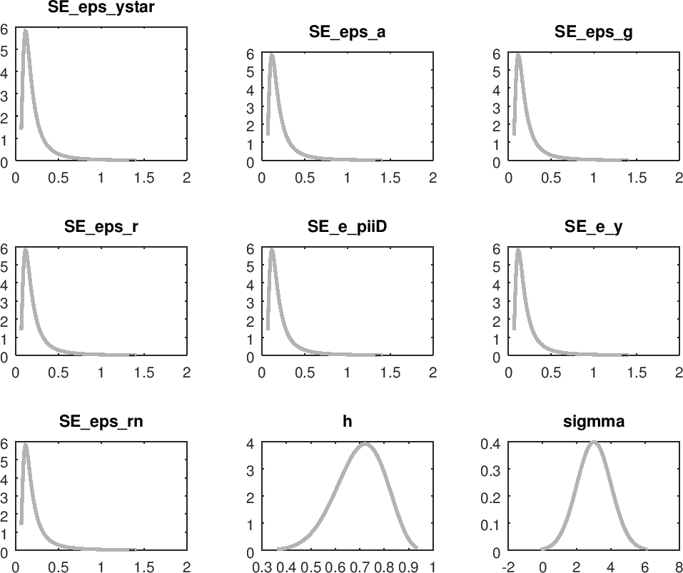

Appendix One: Prior

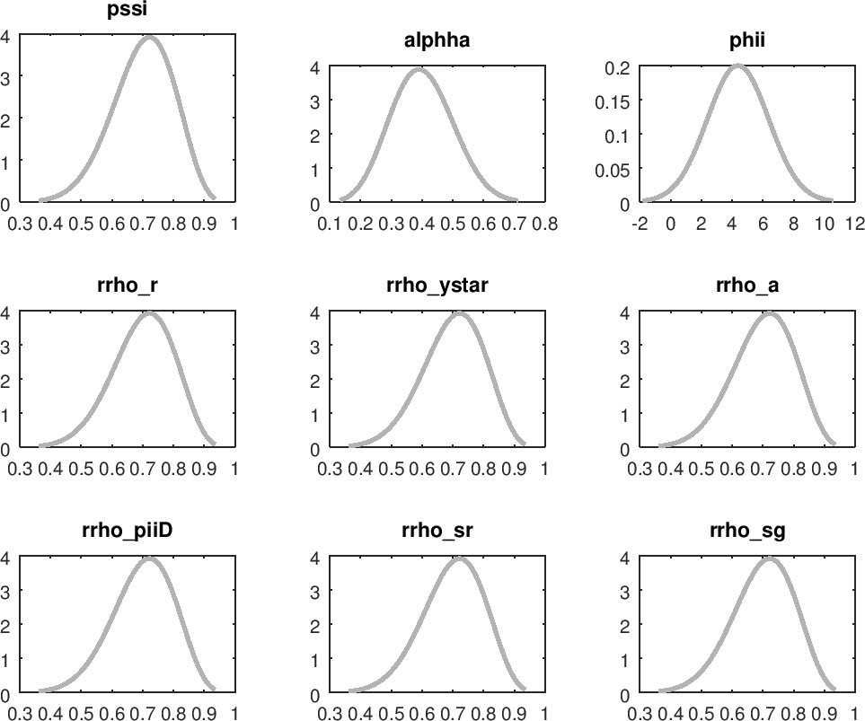

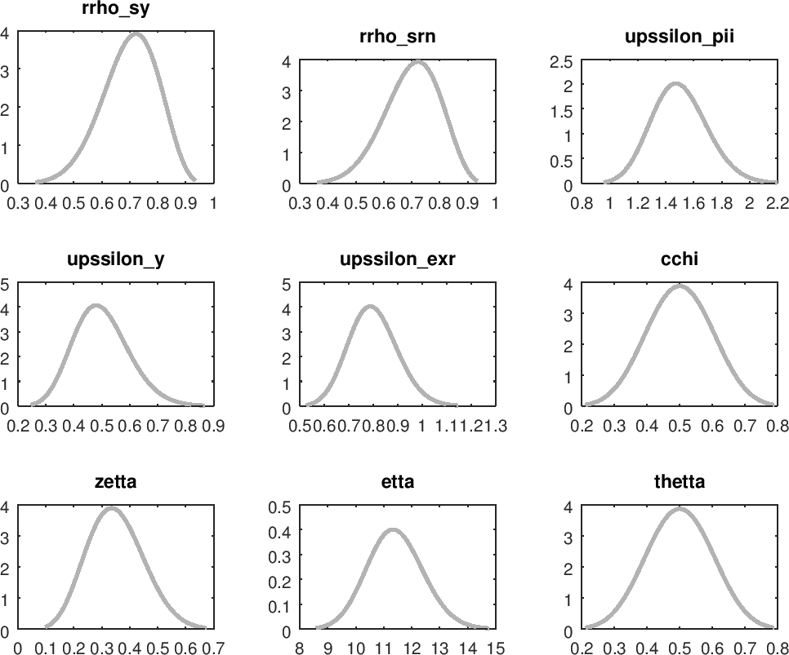

Appendix Two: MCMC Univariate Diagnostics

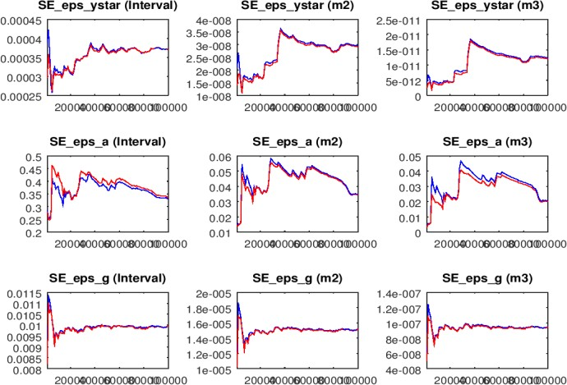

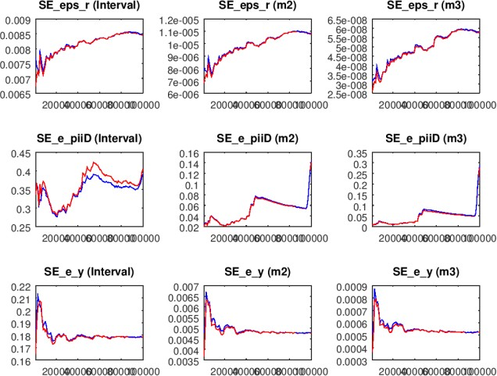

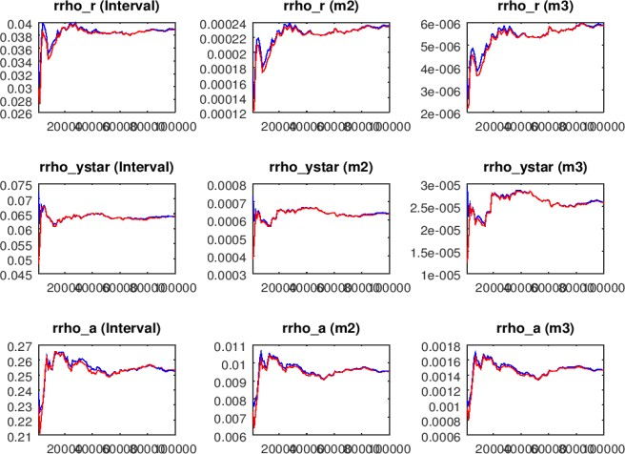

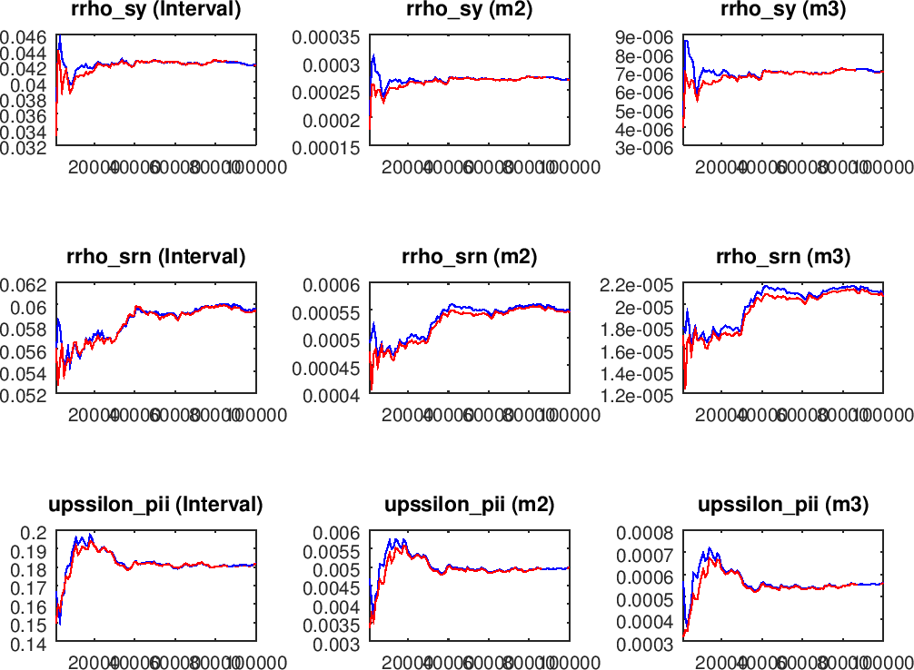

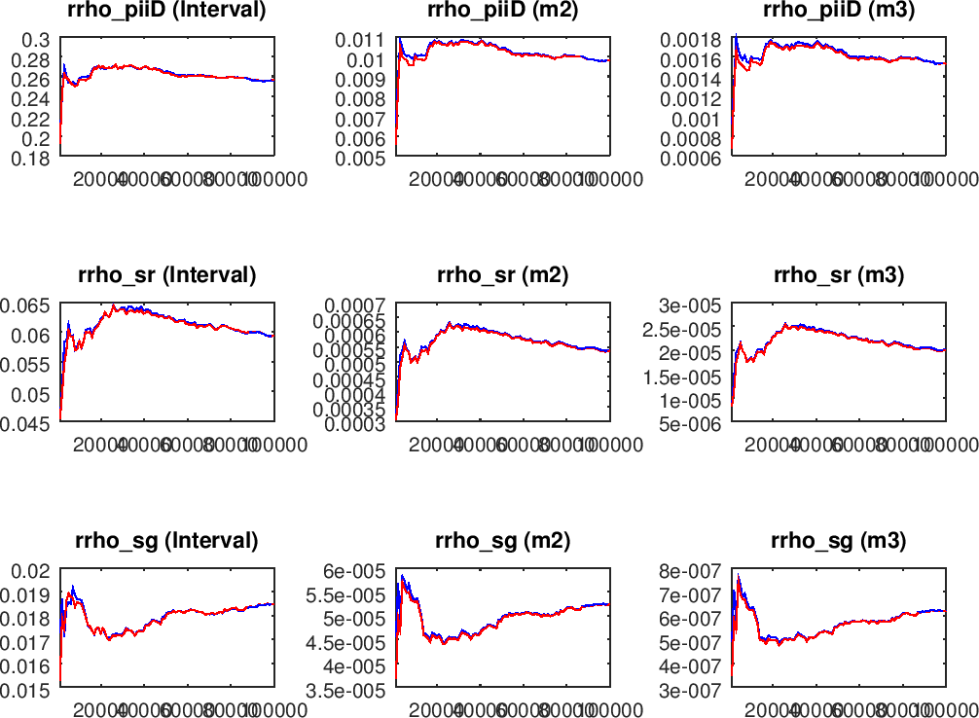

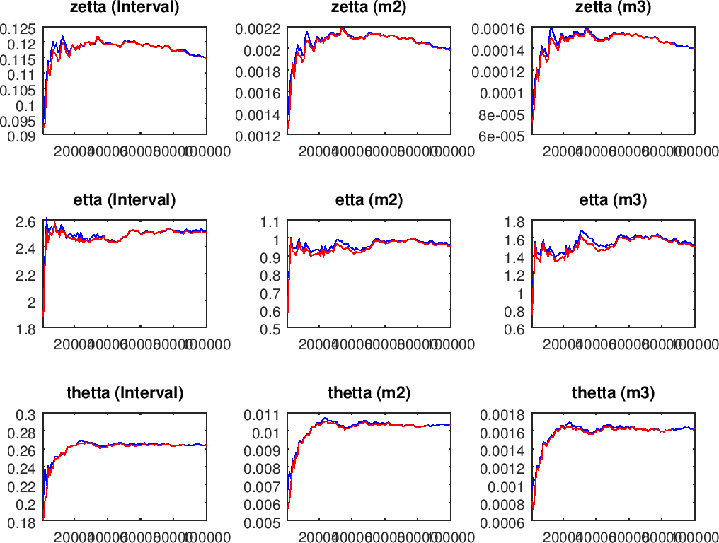

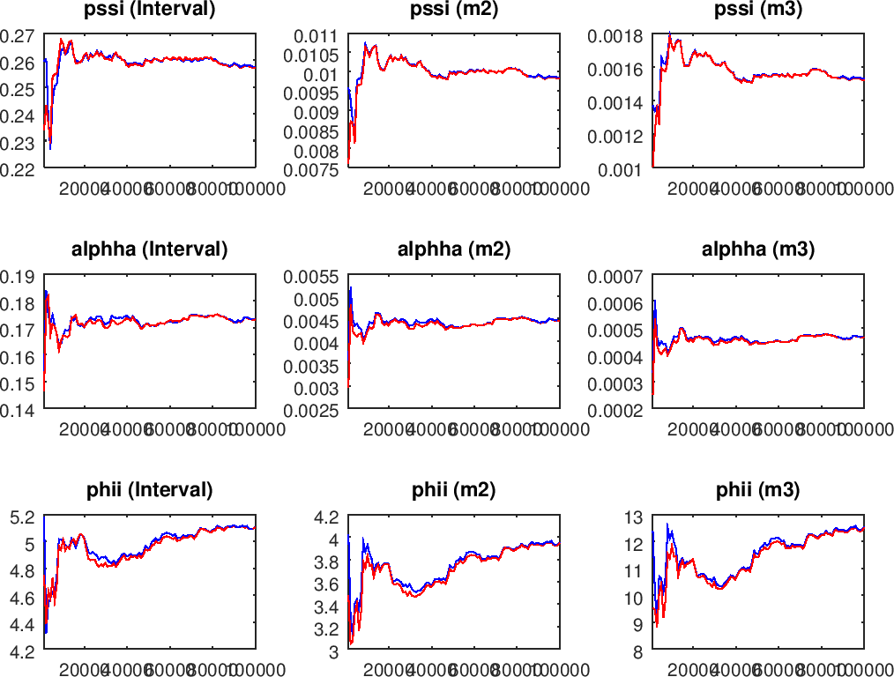

Appendix Three: Dynare Code for Bayesian Estimation

var CR CNR C y pii_D mc s r exr g ytilde pii_F ystar piistar rstar a taxx w NNR TP rn pii s_piiD s_r s_y s_g s_rn;

varexo eps_g eps_r eps_ystar eps_piistar eps_rstar eps_a eps_taxx eps_TP e_piiD e_y eps_rn;

parameters h sigmma pssi alphha omegga betta phii rrho_r rrho_ystar rrho_piistar rrho_rstar rrho_a rrho_taxx rrho_TP cchi zetta gamarr etta thetta upssilon_pii upssilon_y upssilon_exr kapa_alphha sigmma_alphha paw patp rrho_rn rrho_piiD rrho_sr rrho_sg rrho_sy rrho_srn;

h=0.7;

sigmma=3.0; pssi=0.7; alphha=0.4; betta=0.95; phii=4.38; rrho_r=0.8; rrho_ystar=0.7; rrho_piistar=0.7; rrho_rstar=0.7; rrho_a=0.7; rrho_rn=0.3; rrho_taxx=0.7; rrho_TP=0.7; rrho_piiD=0.7; rrho_sr=0.7; rrho_sg=0.7; rrho_sy=0.7; rrho_srn=0.7; upssilon_pii=1.5; upssilon_y=0.5; upssilon_exr=0.8; cchi=0.5; zetta=0.35; gamarr=0.75; etta=11.42; thetta=0.5; paw=3.2; patp=1.35;

omegga=((sigmma*gamarr)+(1-alphha)*((sigmma*etta)-1)); sigmma_alphha=sigmma/((1-alphha)+(alphha*omegga));

kapa_alphha=(1-thetta)*(1-(betta*thetta))/(thetta*(sigmma_alphha+phii));

model(linear);

CR-h*CR(-1)=CR(+1)-h*CR-(1-h/sigmma)*(r-pii_D(+1)); CNR=paw*(w+NNR)+(patp*TP);

w=(sigmma/(1-h))*CNR-h*CNR(-1)+phii*NNR; mc=w-a;

TP=rrho_TP*TP(-1)+eps_TP; C=pssi*CR+(1-pssi)*CNR;

y=CR+(((alphha*omegga)/sigmma)*s)+g+s_y;

CR-h*CR(-1)=ystar+h*ystar(-1)+(((1-h)*(1-alphha))/sigmma)*s+g; pii_D=betta*pii_D(+1)+(kapa_alphha*ytilde)+s_piiD; mc=(sigmma/(1-h))*CR-h*CR(-1)+phii*y-(phii+1)*a+(alphha*s); s=s(-1)+pii_F-pii_D;

r-rstar=exr(+1)-exr;

exr-exr(-1)=piistar-pii_F;

r=rrho_r*r(-1)+(1-rrho_r)*(upssilon_pii*pii_D+upssilon_y*y+upssilon_exr*(exr-exr(- 1)))+s_r;

g=((1/zetta)*(rn))+s_g;

rn=rrho_rn*rn(-1)+(1-rrho_rn)*(cchi*taxx)+s_rn; ystar=rrho_ystar*ystar(-1)+eps_ystar; piistar=rrho_piistar*piistar(-1)+eps_piistar; rstar=rrho_rstar*rstar(-1)+eps_rstar; a=rrho_a*a(-1)+eps_a;

taxx=rrho_taxx*taxx(-1)+eps_taxx; pii=pii_D+pii_F; s_piiD=rrho_piiD*s_piiD(-1)+e_piiD; s_r=rrho_sr*s_r(-1)+eps_r; s_g=rrho_sg*s_g(-1)+eps_g; s_y=rrho_sy*s_y(-1)+e_y; s_rn=rrho_srn*s_rn(-1)+eps_rn;

end;

steady; check;

shocks;

var eps_ystar=0.01; var eps_piistar=0.01; var eps_rstar=0.01; var eps_a=0.01;

var eps_g=0.01; var eps_r=0.01; var eps_taxx=0.01; var eps_TP=0.01; var e_piiD=0.01; var e_y=0.01;

var eps_rn=0.01; end;

estimated_params;

h, beta_pdf, 0.7, 0.1;

sigmma, normal_pdf, 3.0, 1;

pssi, beta_pdf, 0.7, 0.1;

alphha, beta_pdf, 0.4, 0.1;

phii, normal_pdf, 4.38, 2;

rrho_r, beta_pdf, 0.7, 0.1 ;

rrho_ystar, beta_pdf, 0.7, 0.1;

rrho_a, beta_pdf, 0.7, 0.1;

rrho_piiD, beta_pdf, 0.7, 0.1;

rrho_sr, beta_pdf, 0.7, 0.1;

rrho_sg, beta_pdf, 0.7, 0.1;

rrho_sy, beta_pdf, 0.7, 0.1;

rrho_srn, beta_pdf, 0.7, 0.1;

upssilon_pii, gamma_pdf, 1.5, 0.2;

upssilon_y, gamma_pdf, 0.5, 0.1;

upssilon_exr, gamma_pdf, 0.8, 0.1;

cchi, beta_pdf, 0.5, 0.1;

zetta, beta_pdf, 0.35, 0.1;

etta, gamma_pdf, 11.42, 1;

thetta, beta_pdf, 0.5, 0.1;

stderr eps_ystar, inv_gamma_pdf, 0.25, inf; stderr eps_a, inv_gamma_pdf, 0.25, inf; stderr eps_g, inv_gamma_pdf, 0.25, inf; stderr eps_r, inv_gamma_pdf, 0.25, inf; stderr e_piiD, inv_gamma_pdf, 0.25, inf; stderr e_y, inv_gamma_pdf, 0.25, inf; stderr eps_rn, inv_gamma_pdf, 0.25, inf;

end;

varobs y pii_D s r g ystar; identification;

estimation(datafile=quarter,mode_file=trialseven_mode,mode_compute=6,mh_replic=100000, mh_nblocks=5,mh_jscale=0.24,mh_drop=0.3,mode_check,diffuse_filter,moments_varendo,filt ered_vars,bayesian_irf,irf=20)y pii_D rn r g ;

Appendix Four: Dynare Code for Optimal Ramsey and Benevolent Government

var pii_D ytilde r g r_nat a ystar;

varexo eps_ytilde eps_g eps_ystar eps_a eps_piiD;

parameters betta sigmma alphha thetta phii etta gamarr rrho_ystar rrho_a pssi lambda1 lambda2 sigmma_alphha kapa_alphha rrho_sytilde rrho_sg rrho_spiiD upssilon_g rrho_g;

betta=0.99; sigmma=3; alphha=0.4; thetta=0.5; phii=4.38; etta=11.42; gamarr=1; pssi=0.8; upssilon_g=0.8; rrho_g=0.7; rrho_ystar=0.7; rrho_a=0.7; rrho_sytilde=0.7; rrho_sg=0.7; rrho_spiiD=0.7; lambda1=0.5; lambda2=0.5;

omegga=((sigmma*gamarr)+(1-alphha)*((sigmma*etta)-1)); sigmma_alphha=sigmma/((1-alphha)+(alphha*omegga)); kapa_alphha=(((1-thetta)*(1- (betta*thetta)))/thetta)*(sigmma_alphha+phii);

model(linear);

//1.Open economy NK Philips curve pii_D=betta*pii_D(+1)+kapa_alphha*ytilde+eps_piiD;

//2. Open economy Dynamic IS Curve

ytilde=ytilde(+1)-(1/sigmma_alphha)*(r-pii_D(+1)-r_nat)+eps_ytilde; r_nat= -sigmma_alphha*gamarr*(1-rrho_a)*a + alphha*sigmma_alphha*(thetta+pssi)*(ystar(+1)-ystar);

a=rrho_a*a(-1)+eps_a;

ystar= rrho_ystar*ystar(-1) + eps_ystar;

//3. Fiscal policy decision

g=rrho_g*g(-1)+(1-rrho_g)*(upssilon_g*ytilde)+eps_g; end;

shocks;

var eps_ytilde; stderr 0.01; var eps_g; stderr 0.01; var eps_ystar; stderr 0.01; var eps_a; stderr 0.01; end;

planner_objective(pii_D^2+lambda1*(ytilde^2)+lambda2*(g^2)); ramsey_policy(order=1, planner_discount=0.99);

Appendix Five: Dynare Code for Optimal Ramsey and Rent-seeking Government

var pii_D ytilde r g taxx r_nat a ystar rn ;

varexo eps_ytilde eps_g eps_taxx eps_ystar eps_a eps_piiD;

parameters betta zetta cchi sigmma alphha thetta phii etta gamarr rrho_taxx rrho_ystar rrho_a pssi lambda1 lambda2 sigmma_alphha kapa_alphha rrho_sytilde rrho_sg rrho_spiiD;

betta=0.99; zetta=0.35; cchi=0.7; sigmma=3; alphha=0.4; thetta=0.5; phii=4.38; etta=11.42; gamarr=1; pssi=0.8; rrho_taxx=0.7; rrho_ystar=0.7; rrho_a=0.7; rrho_sytilde=0.7; rrho_sg=0.7; rrho_spiiD=0.7; lambda1=0.5; lambda2=0.5;

omegga=((sigmma*gamarr)+(1-alphha)*((sigmma*etta)-1)); sigmma_alphha=sigmma/((1-alphha)+(alphha*omegga)); kapa_alphha=(((1-thetta)*(1- (betta*thetta)))/thetta)*(sigmma_alphha+phii);

model(linear);

//1.Open economy NK Philips curve pii_D=betta*pii_D(+1)+kapa_alphha*ytilde+eps_piiD;

//2. Open economy Dynamic IS Curve

ytilde=ytilde(+1)-(1/sigmma_alphha)*(r-pii_D(+1)-r_nat)+eps_ytilde; r_nat= -sigmma_alphha*gamarr*(1-rrho_a)*a + alphha*sigmma_alphha*(thetta+pssi)*(ystar(+1)-ystar);

a=rrho_a*a(-1)+eps_a;

ystar= rrho_ystar*ystar(-1) + eps_ystar;

//3. Fiscal policy decision g=(1/zetta)*(rn)+eps_g; rn=cchi*taxx;

taxx=rrho_taxx*taxx(-1)+eps_taxx;

end;

shocks;

var eps_ytilde; stderr 0.01; var eps_g; stderr 0.01; var eps_taxx; stderr 0.01; var eps_ystar; stderr 0.01; var eps_a; stderr 0.01; end;

planner_objective(pii_D^2+lambda1*(ytilde^2)+lambda2*(g^2)); ramsey_policy(order=1,periods=288, planner_discount=0.99);

Appendix Six: Dynare Code for Optimal Discretionary and Benevolent Government

var pii_D ytilde r g r_nat a ystar ;

varexo eps_ytilde eps_g eps_ystar eps_a eps_piiD;

parameters betta sigmma alphha thetta phii etta gamarr rrho_ystar rrho_a pssi lambda1 lambda2 sigmma_alphha kapa_alphha rrho_sytilde rrho_sg rrho_spiiD upssilon_g rrho_g;

betta=0.99; sigmma=3; alphha=0.4; thetta=0.5; phii=4.38; etta=11.42; gamarr=1; pssi=0.8; upssilon_g=0.8; rrho_g=0.7; rrho_ystar=0.7; rrho_a=0.7; rrho_sytilde=0.7; rrho_sg=0.7; rrho_spiiD=0.7; lambda1=0.5; lambda2=0.5;

omegga=((sigmma*gamarr)+(1-alphha)*((sigmma*etta)-1)); sigmma_alphha=sigmma/((1-alphha)+(alphha*omegga)); kapa_alphha=(((1-thetta)*(1- (betta*thetta)))/thetta)*(sigmma_alphha+phii);

model(linear);

//1.Open economy NK Philips curve pii_D=betta*pii_D(+1)+kapa_alphha*ytilde+eps_piiD;

//2. Open economy Dynamic IS Curve

ytilde=ytilde(+1)-(1/sigmma_alphha)*(r-pii_D(+1)-r_nat)+eps_ytilde; r_nat= -sigmma_alphha*gamarr*(1-rrho_a)*a + alphha*sigmma_alphha*(thetta+pssi)*(ystar(+1)-ystar);

a=rrho_a*a(-1)+eps_a;

ystar= rrho_ystar*ystar(-1) + eps_ystar;

//3. Fiscal policy decision

g=rrho_g*g(-1)+(1-rrho_g)*(upssilon_g*ytilde)+eps_g; end;

shocks;

var eps_ytilde; stderr 0.01; var eps_g; stderr 0.01; var eps_ystar; stderr 0.01; var eps_a; stderr 0.01; end;

planner_objective(pii_D^2+lambda1*(ytilde^2)+lambda2*(g^2)); discretionary_policy(irf=40,planner_discount=0.99,order=1,instruments= (r));

Appendix Seven: Dynare Code for Optimal Discretionary and Rent-seeking Government

var pii_D ytilde r g taxx r_nat a ystar rn ;

varexo eps_ytilde eps_g eps_taxx eps_ystar eps_a eps_piiD;

parameters betta zetta cchi sigmma alphha thetta phii etta gamarr rrho_taxx rrho_ystar rrho_a pssi lambda1 lambda2 sigmma_alphha kapa_alphha rrho_sytilde rrho_sg rrho_spiiD;

betta=0.99; zetta=0.35; cchi=0.7; sigmma=3; alphha=0.4; thetta=0.5; phii=4.38; etta=11.42; gamarr=1; pssi=0.8; rrho_taxx=0.7; rrho_ystar=0.7; rrho_a=0.7; rrho_sytilde=0.7; rrho_sg=0.7; rrho_spiiD=0.7; lambda1=0.5; lambda2=0.5;

omegga=((sigmma*gamarr)+(1-alphha)*((sigmma*etta)-1)); sigmma_alphha=sigmma/((1-alphha)+(alphha*omegga)); kapa_alphha=(((1-thetta)*(1- (betta*thetta)))/thetta)*(sigmma_alphha+phii);

model(linear);

//1.Open economy NK Philips curve pii_D=betta*pii_D(+1)+kapa_alphha*ytilde+eps_piiD;

//2. Open economy Dynamic IS Curve

ytilde=ytilde(+1)-(1/sigmma_alphha)*(r-pii_D(+1)-r_nat)+eps_ytilde; r_nat= -sigmma_alphha*gamarr*(1-rrho_a)*a + alphha*sigmma_alphha*(thetta+pssi)*(ystar(+1)-ystar);

a=rrho_a*a(-1)+eps_a;

ystar= rrho_ystar*ystar(-1) + eps_ystar;

//3. Fiscal policy decision g=(1/zetta)*(cchi*taxx)+eps_g; rn=cchi*taxx; taxx=rrho_taxx*taxx(-1)+eps_taxx; end;

shocks;

var eps_ytilde; stderr 0.01; var eps_g; stderr 0.01; var eps_taxx; stderr 0.01; var eps_ystar; stderr 0.01; var eps_a; stderr 0.01; var eps_piiD; stderr 0.01;

end; planner_objective(pii_D^2+lambda1*(ytilde^2)+lambda2*(g^2));

discretionary_policy(irf=40, planner_discount=0.99,order=1,instruments=(r));

### Appendix Eight: Derivation of the optimal pricing equation for the firm

Max Et ∑∞

(βθ)k Et,t+k Yt+k|t [𝑃∗ − mct+k|t] (1)

k=0 𝑡

Subject to

𝑃∗

𝑡

Yt+k|t = [ ]

𝑃𝑡+𝑘

−𝗌

𝑌𝑡+𝑘 (2)

Substitute equation (2) into (1):

∞ 𝑃∗ −𝗌

Max Et ∑ (βθ)k Et,t+k Yt+k ( 𝑡 ) [𝑃∗ − mct+k|t] (3)

k=0

𝑃𝑡+𝑘 𝑡

After expanding the bracket, this leads to:

Max Et ∑∞ (βθ)k Et,t+k Yt+k [(𝑃𝑡+𝑘)𝗌(𝑃∗)1−𝗌 − (𝑃𝑡+𝑘)𝗌(𝑃∗)−𝗌 mct+k|t] (4)

k=0 𝑡 𝑡

The first order condition on (𝑃∗) is obtained as:

𝑡

E ∑∞ (βθ)k E

Y (𝑃 )𝗌(𝑃∗) = 𝗌 E ∑∞

(βθ)k E

Y (𝑃

)𝗌 mc

t k=0

t,t+k

t+k 𝑡+𝑘 𝑡

𝗌−1 t

k=0

t,t+k

t+k 𝑡+𝑘

t+k|t

(5)

Equation (5) can be re-written as:

0 = E ∑∞

(βθ)k E

Y [(𝑃∗) − 𝗌 mc

] (6)

t k=0

t,t+k

t+k 𝑡

𝗌−1

t+k|t

Divide equation (6) through by 𝑃𝑡−1, it becomes

∞

∑(βθ)k E [E

( 𝑃∗) ε

Y [ −

𝑡

mct+k|t

𝑃𝑡+𝑘

] = 0

k=0

t t,t+k

t+k

𝑃𝑡−1

ε − 1

𝑃𝑡+𝑘

𝑃𝑡−1

∞ (𝑃∗) 𝗌

∑k=0(βθ)k Et [Et,t+k Yt+k [ 𝑡 −

𝑡−1

𝑃

𝗌−1

MCt+k|tπt−1,t+k] = 0 (7)

The first order Taylor expansion at the zero-inflation steady state yields the optimal pricing equation of the resetting firm:

𝑃∗ − 𝑃𝑡−1 = 1 − βθ ∑∞ (βθ)k Et [m̂ct+k|t + 𝑃𝑡+𝑘 − 𝑃𝑡−1] (8)

𝑡 k=0

Where m̂ct+k|t = mct+k|t − mc

Equation (8) can be re-arranged and re-written as:

𝑃∗ = 𝜇 + (1 − βθ) ∑∞ (βθ)k Et [mct+k|t + 𝑃𝑡+𝑘] (9)

𝑡 k=0

Where,

𝜇 = −𝑚𝑐 ≡ log

𝜀

𝜀 − 1

From equation (9), it can be deduced that firms set a price according to the desired mark-up over a weighted average of expected marginal cost

### Appendix Nine: Prior-Posterior Plot

