# EXTRACTION OF COLBALT(ΙΙ), COPPER(ΙΙ) AND NICKEl(ΙΙ) IONS FROM AQUEOUS MEDIUM INTO CHLOROFORM SOLUTION OF N, N1 –ETHYLENE BIS (4-PROPIONYL-2,4-DIHYDRO-5-METHYL-2-PHENYL- 3H-PYRAZOL-3-ONE) IMINE (H2PrEtP).

**BY**

# NWADIRE, FELIX CHIGOZIE 2012547002F

**A Ph.D. DISSERTATION SUBMITTED TO THE DEPARTMENT OF PURE AND INDUSTRIAL**

# CHEMISTRY,

**FACULTY OF PHYSICAL SCIENCES, NNAMDI AZIKIWE UNIVERSITY. AWKA.**

# IN PARTIAL FULFILMENT OF THE REQUIREMENTS F0R THE AWARD A DOCTOR OF PHILOSOPHY (Ph.D.) DEGREE IN INORGANIC CHEMISTRY.

**SUPERVISORS: PROF. V.I.E. AJIWE PROF. P.A.C. OKOYE.**

# AUGUST 2017.

**CERTIFICATION**

This is to certify that this dissertation was written by **Nwadire, Felix Chigozie,** a postgraduate student in the Department of Pure and Industrial Chemistry with **Reg. No: 2012547002F.** The work embodied in this dissertation is original and to the best of our knowledge has not been submitted in part or full for any other diploma or degree of this or any University.

# Supervisors:

Prof. V.I.E. Ajiwe Date

Supervisor Ι

Prof. P.A.C. Okoye Date

Supervisor ΙΙ

Dr. J. K. Nduka Date

Head of Department

External Examiner

Date

Prof. Eric Ofoedu Date

Faculty PG Sub Dean

Prof. A.J. Ekpunobi Date

Dean, Faculty of Physical Sciences

Prof. I.H. Odimegwu Date

Dean, S.P.G.S

# DEDICATION

This work is dedicated to the glory of Almighty God, the giver of all wisdom, knowledge and understanding and to the evergreen memory of my beloved father Late Chief Samuel Ogidi Nwadire, my M.Sc. supervisor, Late Prof. B.A. Uzoukwu (Ozubulu Anambra born Icon of Chemistry) and to all scholars and children of Igbo decent who died during the 1966-1970 Civil War on Biafran soil.

# ACKNOWLEDGEMENT

My total submission goes to God Almighty for His infinite mercy and sustenance physically, mentally and spiritually throughout this programme. My profound gratitude goes to my supervisors Prof. V.I.E Ajiwe and Prof. P.A.C Okoye whose wonderful and innovative ideas, guidance, humility, tolerance, understanding, materials assistance, corrections and suggestions contributed immensely to the successful completion of this work. My sincere appreciation goes to the H.O.D. of Pure and Industrial Chemistry, Dr. J.K. Nduka and Prof. T.U Onuegbu, whose role doubled as one of my internal examiners and her wonderful contributions gave this work a finer shape, Prof. Eboatu (One time Deputy Vice Chancellor of Nnamdi Azikiwe University) who was also one of my internal examiners and came up with a lot of quality recommendations. I am also thankful to Prof. E.N.O. Ejike, Director Central Instrument Equipment Centre, Federal University of Technology, Owerri (FUTO) and the departmental PG Coordinator Dr. (Mrs.) Uche Ekpunobi and all my lecturers in the Department of Pure and Industrial Chemistry Nnamdi Azikiwe University Awka. I remain grateful to you all for your assistance in the course of this programme.

In a special measure, I wish to acknowledge my mother LoLo Better Enyidiya Nwadire, my Uncle Elder G.A Amuchionu and Aunt Mrs. Joan Akwanma Amuchionu for their unrelenting effort to ensure that I pursue my academic career to apex. I am also thankful to my sibling and relatives for all their supports.

My appreciation goes to Prof. Joel Friday Ogbonna, (The Director Centre of Petroleum Research & Training University of Port Harcourt and managing consultant Pollution Control and Environmental Management LTD) for his assistance in analysis of my samples. Mr Ugochukwu Peter Okoye (Chairman/Director Ugolanson Nig. LTD Aba), Mr Chris I Egwu (Managing Director IDEX Scientific Supplies LTD) for their prompt and steady supply of all reagents used in this research. I wish to express my unreserved gratitude to Dr. Godwin Jackson (Department of Chemical Sciences, Niger Delta University Wilberforce Island Bayelsa State) for his wonderful assistance. Prof. Ositadinma Ugbogu (Department of Microbiology, Federal University Wukari), Elder Patrick Uzoma Okwuonu, Director St Patrick model schools Aba and Umuahia, Dr. (Engr) J.C Igwe and Dr Mrs N.E, Okoronkwo of Department of Pure and

Industrial Chemistry, Abia State University Uturu for their words of encouragement and assistance. I am also thankful to my elder brother Comrade Newman Eze Ogidi Nwadire for his moral support and to Nze Vincent Obinna Ofor and his amiable wife Lolo Nwanneka Immaculata Ofor, Hon. Dr. Pharm Sampson Esochaigh, Hon. Pharm Cherechi Nwogu and Mr. Onwuchekwa Onyekaba Sopuruchi (Head of Department of Public/Environmental Health Aba North Local Govt. Area, Abia State) for their all round assistance. Finally my special thanks go to my cousins Mr. Uzoma Nwokoma and Mr. Osondu Chimere Valentine for their brotherly encouragements and to my numerous and wonderful friends. I say big thanks to you all.

# Nwadire, Felix Chigozie

**August, 2017.**

# ABSTRACT

Liquid – liquid extraction of Ni(II) Co(II) and Cu(II) ions from buffered solution into N,N1 ~~-~~ethylenebis (4-propionyl-2,4- dihydro-5-methyl-2-phenyl-3H-pyrazol-3-one) imine (H2PrEtP) Schiff base as a function of pH and concentration of solution was investigated. The synergistic effect of 4-propionyl-2,4-dihydro-5- methyl-2-phenyl-3H-pyrazol-3-one (HPrP) have all been investigated and optimized. Effects of complexing species alongside anionic substances and certain mineral and organic acids were all investigated (for nickel(II) and cobalt(II) under a well-defined extraction conditions. The various effect of these reagents and experimental conditions on nickel(II), cobalt(II) and copper(II) ions extraction. About 99 % of nickel(II) was extracted between pH 6.0 to pH 9.0. The extraction of cobalt gave about 99 % between pH 7.5 to pH 9.5, while copper was quantitatively extracted in acidic pH of 3.0 to pH 6.5 where highest percentage extraction 98.23 % was observed at pH 6.1 in a mixed ligand system of H2PrEtP and HPrP in the ratio 9:1 by volume. In the extraction of nickel and cobalt, increase in pH above 9.0 and 10.0 resulted in a steady decrease in the extraction

while increase in pH above 8.0 resulted to decrease in the percentage extraction of copper. The addition of HPrP as a synergist in the extraction of these three metals not only increases the percentage extraction from 62.45 % at pH of 5.75 (pH **1/2**) to 99.14 % at pH 7.25 (pH **max**) for nickel, 52.60 % at pH

6.25 (pH**1/2**) to 99.30 % at pH 8.26 (pH **max**) for cobalt and 50.25

% at pH 3.0 (pH1/2) to 98.23 % at pH 6.10 (pH **max**) for copper but equally shifted the extraction pH to a more acidic region thus making way for quantitative extraction of these metals at a slightly acidic pH as seen in nickel and cobalt and higher acidic pH as in the case of copper. Studies carried out with varied metals‘ concentrations in aqueous medium showed that the extractions of the metal ions from solutions are independent of their concentrations in solution with nickel having highest extraction of 98.7 % at 4.77×10-4 M and 5.10×10-4 M respectively in a mixed ligand extraction while cobalt and copper gave highest percentage extraction of 98.52 % at 4.75×10-4 M and 97.43 % at 3.46×10-4 M respectively. All studies on chelating agents H2PrEtP and synergist HPrP showed that increase in their concentrations resulted into increase in the percentage extraction of nickel, cobalt and copper. Nickel gave maximum extraction of 99.50 % at 4.0×10-2 M H2PrEtP concentration while cobalt gave 97.20 % at 3.0×10-2 M H2PrEtP concentration all in the presence of HPrP. Of all the mineral acids and the organic acid studied non formed extractable complex with Ni(II) and Co(II) ions. Increasing the concentration of the various acids beyond 2.0 M pushed the percentage extraction to zero except in H2SO4, H3PO3 and CH3COOH where a negligible extraction of 4.80 %, 5.30 % and 5.60 % was obtained at dilute concentration of 0.01 M for H3PO4 and H2SO4 and 0.50 M for CH3COOH for nickel and 6.09 % (H3PO4), 8.09

% (H2SO4) and 7.67 % (CH3COOH) for cobalt. Anions and complexing agents showed different behaviors at different pH values and concentrations. CH3COO- at pH value of 7.95 and concentration of 0.10 M gave the highest percentage extraction of 96.30 % in the mixed ligands system while the least extraction was given by Cl- at pH of 5.65 and concentration of 0.00 M corresponding to 19.90 % E in single ligand (H2PrEtP) extraction for nickel. Cl- in single ligand at 1.00 M gave least extraction of

35.61 % for cobalt while PO 2- in mixed ligand gave highest

4

extraction of 92.06 % at 0.10 M for Co(II). For complexing agents the highest extraction was observed in Br- at pH value of

6.07 and concentration of 0.10 M which corresponds to 71.30 % E while EDTA gave the least extraction at pH value of 5.12 and concentration of 0.10 M where 21.60 % extraction was obtained in a single ligand system for nickel. F- in mixed ligand gave highest extraction of 83.35 % for cobalt while oxalate in single ligand gave the least 19.80 % E for Co (II). Generally anions gave a better extraction of the metals than the complexing species.

# TABLE OF CONTENTS

Title Page i

Certification ii

Dedication iii

Acknowledgement iv

Abstract vi

Table of Contents vii

List of Figures xiii

List of Abbreviations xviii

List of Appendices xix

# CHAPTER ONE: INTRODUCTION

* 1. Background of the study 1
  2. Statement of the Problem 4
  3. Aim and Objectives of the Study 5
  4. Significance of Study 5
  5. Justification of the study 6
  6. Scope of Study 6

# CHAPTER TWO: LITERATURE REVIEW

* + 1. History, Facts and General Properties of Nickel 8
    2. General Uses and Applications of Nickel 8
    3. Natural Abundance of Nickel 9
    4. History, Facts and General Properties of Cobalt 9
    5. General Uses and Applications of Cobalt 9
    6. Natural Abundance of Cobalt 10
    7. History, Facts and General Properties of Copper 10
    8. General Uses and Application of Copper 10
    9. Natural Abundance of Copper 11
  1. Principles of Solvent Extraction 11
  2. Uses of Solvent- Solvent Extraction 13
  3. Solvent Extraction of Metals 14
     1. Ion-Association Complexes 14
     2. Metal Chelates complexation 14
     3. Application of metal chelates complexes. 18
  4. Factors Influencing Solvent Extraction 22
     1. Equilibration Time

23

* + 1. pH of Aqueous Phase 23
    2. Concentration of Ligand 23
    3. Presence of Masking Agents 24
    4. Presence of Salting out Agents 24
    5. Oxidation State of Metal ion 24
    6. Type of Solvent Used 25

2.6 4-Acylbis (1-Phenyl-3 Methylpyrazolone-5). 25

# CHAPTER THREE: MATERIALS AND METHODS

3.1 Materials and Apparatus 30

* + 1. Methods 31
    2. Synthesis of 4-Propionyl-2,4-Dihydro-5-Methyl-2- Phenyl-3H-Pyrazol

-3-One (HPrP) 31

* + 1. *Synthesis of* N,N‘-Ethylenebis (4-Propionyl-2,4- Dihydro-5-Methyl-2-

Phenyl-3H-Pyrazol-3-One) imine *(H2PrEtP)*

33

* + 1. Preparation of Standard Solutions of Ligand and Synergist

Chloroform solution of 0.05M H2PrEtP 35

* + 1. Preparation of Standard Solutions Mineral Acids 35
    2. Preparation of Standard Solutions of Salts and Bases 36
    3. Preparation of Buffer Solutions for Calibration of pH Meter 37
    4. Preparation of Buffer Solutions 37
    5. Preparation of Metal Standard Solutions 37
    6. Preparation of Standard Solutions for Anions and Complexing Agents 38
    7. Extraction of Metal ions from Aqueous Phase at Different pH Values 40
    8. Extraction in the Presence of Synergist

40

* + 1. Extractions with Various Ligand Concentrations 40
    2. Extractions with Various Ligand Concentrations at Fixed

Concentration of Synergist 41

* + 1. Extractions with Various Synergist Concentrations at Fixed Ligand

Concentration 42

* + 1. Extractions with Various Metal Concentrations with Ligand Only 43
    2. Extractions with Various Metal Concentrations with Ligand

and Synergist

43

* + 1. Extraction in the Presence of Some Mineral Acids 43
    2. Extraction in the Presence of Some Anions

44

* + 1. Extraction in the Presence of Some Complexing Agents 44

# CHAPTER FOUR: RESULTS AND DISCUSSION

4.1. Calibration Curves 45

* + 1. Results on Extraction of Nickel(II) ion 46
    2. Result on effect of pH on extraction of Ni(II) ions into chloroform

solution of 0.05M H2PrEtP. 46

* + 1. Result on effect of HPrP as synergist on extraction of Ni(II) ion. 48
    2. Result on Effect of Various H2PrEtP and HPrP Concentrations on

Extraction of Ni(II) ions at Different pH.

49

* + 1. Result on Effect of Ni Concentrations on Extraction of Ni(II) ions

with H2PrEtP 51

* + 1. Result on effect of Mineral Acids on Extraction of Nickel with

H2PrEtP in Chloroform 52

* + 1. Result on Effect of Mineral Acids on Extraction of Nickel with

H2PrEtP and HPrP as Synergist 53

* + 1. Result on Effect of Anions on Extraction of Nickel with H2PrEtP 54
    2. Result on Effect of Anions on Extraction of Nickel with H2PrEtP

and HPrP as Synergist 55

* + 1. Result on Effects of Complexing Agents on Extraction of Ni(II)

ions with H2PrEtP 56

* + 1. Result on Effect of Complexing Agents on Extraction of Ni(II) ions with

Ligand (H2PrEtP) and HPrP as Synergist 57

* + 1. Proposed Structure for Nickel(II) H2PrEtP and Nickel (II) H2PrEtP/HPrP. 58
    2. Results on Extaction of Cobalt(II) ion 59
    3. Result on Effect of pH on Extraction of Co(II) Ions into Chloroform S

olution of 0.05 M H2PrEtP. 59

* + 1. Result on Effect of Addition of HPrP (Synergist) on the

Extraction of Co(II). 60

* + 1. Result on Effect of Various H2PrEtP and HPrP Concentrations on

Extraction of Co(II) ions at Different pH.

61

* + 1. Result on Effect of Co Concentrations on Extraction of Co(II) ions

with H2PrEtP 63

* + 1. Result on Effect of Mineral Acids on Extraction of Cobalt with

H2PrEtP in Chloroform 64

* + 1. Result on Effect of Mineral Acids on Extraction of Cobalt with

H2PrEtP and HPrP as Synergist 65

* + 1. Result on Effect of Anions on Extraction of Cobalt with H2PrEtP 66
    2. Result on Effect of Anions on Extraction of Cobalt with H2PrEtP and HPrP as Synergist

67

* + 1. Result on Effects of Complexing Agents on Extraction of Co(II) ions

with H2PrEtP 68

* + 1. Result on Effect of Complexing Agents on Extraction of Co(II) ions

with ligand (H2PrEtP) and HPrP as Synergist.

69

* + 1. Proposed Structure for Cobalt(II) H2PrEtP and Cobalt(II) H2PrEtP/HPrP.

70

* + 1. Results on Extraction of Copper (II) ions 70
    2. Result on Effect of pH on Extraction of Cu(II) ions into Chloroform

Solution of 0.05M H2PrEtP 71

* + 1. Result on Effect of HPrP as Synergist on Extraction of Cu(II) ion 72
    2. Result on Effect of Various H2PrEtP and HPrP Concentrations on

Extraction of Cu(II) ions at Different pH 72

* + 1. Result on Effect of Cu Concentrations on Extraction of Cu(II) ions

with H2PrEtP and HPrP 75

* + 1. Proposed Structure for Copper(II) H2PrEtP and Copper(II) H2PrEtP/HPrP. 77

# CHAPTER FIVE: CONCLUSION, CONTRIBUTION TO KNOWLEDGE

**AND RECOMMENDATIONS**

* 1. Conclusion

78

* 1. Contribution to Knowledge 78
  2. Recommendations 79

References 80

Appendices 91

# LIST OF FIGURES

2.1: Tautomeric forms of 4-acylpyrazolone Schiff bases 29

* 1. *:* Arrangement for the synthesis of 4-propionyl-2,4-dihydro- 5-methyl-2

-phenyl-3H-pyrazol-3-one (HPrP) 32

* 1. : Reaction between propionyl chloride and 1-Phenyl-3- Methyl-

Pyrazolone-5 33

* 1. : Arrangement for the synthesis of N,N‘-ethylenebis(4- propionyl-2,

4-dihydro-5- methyl-2-phenyl-3H-pyrazol-3-one) imine (H2PrEtP) 34

* 1. : Reaction between ethylenediamine and 4-propionyl-2,4- dihydro-5

-methyl-2-phenyl-3H-pyrazol-3-one 34

* 1. Calibration Curve for Nickel at 232 nm.

45

* 1. Calibration Curve for Cobalt at 240.7 nm

45

* 1. Calibration Curve for Copper at 324.7 nm 46
  2. Plot of logD against pH for the extraction of 8.52×10-4 M Ni2+ from

buffered aqueous solutions into 0.05 M H2PrEtP in chloroform. 47

* 1. : Plot of logD against pH for the extraction of 8.52×10-4 Ni2+ from buffered

aqueous solutions into 0.05 M H2PrEtP and 0.05 M HPrP in 9:1 by

volume in chloroform.

48

* 1. : Plot of log D against log [H2PrEtP] for the extraction of 8.52×10-4 M of

Ni(II) from aqueous solutions into H2PrEtP dissolved in chloroform in

the absence of HPrP at constant pH of 7.25, 7,75 and 8.5 50

|  |  |  |
| --- | --- | --- |
| 4.7: | Plot of logD against log[H2PrEtP] for the extraction | of |
|  | 8.52×10-4 M of |  |
|  | Ni(II) from aqueous solutions into H2PrEtP solution  chloroform with | in |
|  | HPrP kept constant at pH 6.5, 7.0 and 7.5 |  |

50

|  |  |  |
| --- | --- | --- |
| 4.8: | Plot of log D against log [HPrP] for the extraction | of |
|  | 8.52×10-4 M of |  |
|  | Ni(II) from aqueous solutions into H2PrEtP solution  chloroform | in |
|  | with H2PrEtP kept constant at pH 6.5, 7.0 and 7.5. |  |

51

4.9. Plot of Log D against Log Ni(II) for the extraction of Ni(II) from

buffer solution into chloroform solution of 0.05 M H2PrEtP at constant pH

of 7.25 and 8.5

52

* 1. : Plot of LogD against Log [Ni(II)] for the extraction of Ni(II) from buffer

solution into chloroform solution of 0.05 M H2PrEtP and

0.05 M HPrP in

9:1 ratio. 52

* 1. Plot of % E against Acid Conc. [M] for Effect of Mineral Acids on

Extraction of Nickel with H2PrEtP in chloroform.

53

* 1. Effect of Mineral Acids on Extraction of Nickel with H2PrEtP and

HPrP as synergist in chloroform

54

* 1. Effect of anion on extraction of nickel with H2PrEtP in chloroform 55
  2. Effect of anions on extraction of Nickel with H2PrEtP and HPrP as

Synergist in chloroform 56

* 1. Effects of complexing agents on extraction of Ni(II) ions with

H2PrEtP in chloroform 57

* 1. Effect of complexing agents on extraction of Ni(II) ions with H2PrEtP

and HPrP as synergist in chloroform 58

* 1. Proposed Ni complexes with H2PrEtP

58

* 1. Proposed structure of Ni (HPrEtP.PrP)O

59

* 1. Plot of Log D against pH for the extraction of 8.48×10- 4 M Co(II)

ions from buffered aqueous solution into chloroform solution of 0.05

M H2PrEtP.

59

* 1. Plot of LogD against pH for the extraction of 8.48×10-4 M Co(II)

ions from buffered aqueous solution into chloroform solution

of 0.05 M 9:1 H2PrEtP and HPrP 60

* 1. Plot of logD against log[H2PrEtP] for the extraction of 8.48×10-4 M of

Co(II) from aqueous solutions into chloroform solution o Fig.4.22 Plot

of logD against log[H2PrEtP] for the extraction of 8.48×10-4 M of

Co(II) from aqueous solutions into chloroform solution of H2PrEtP

with HPrP kept constant f H2PrEtP in the absence of synergist at constant

pH of 7.5, 8.5 and 9.0.

62

* 1. Plot of logD against log[H2PrEtP] for the extraction of 8.48×10-4 M of Co(II)

from aqueous solutions into chloroform solution of H2PrEtP with HPrP

kept constant 62

* 1. Plot of logD against log[HPrP] for the extraction of 8.48×10-4 M of

Co(II) from aqueous solutions into chloroform solution of H2PrEtP

with H2PrEtP kept constant 63

* 1. Plot of LogD against Log [Co(II)] for the extraction of Co(II) from

buffer solution into chloroform solution of 0.05 M H2PrEtP.

63

* 1. Plot of LogD against Log [Co(II)] for the extraction of Co(II) from buffer

solution into chloroform solution of 0.05 M H2PrEtP and

0.05 M

HPrP in 9:1 ratio.

64

* 1. Plot for Effect of Mineral Acids on Extraction of Cobalt with

H2PrEtP in chloroform.

65

* 1. Effect of Mineral Acids on Extraction of Cobalt with H2PrEtP and

HPrP as synergist in chloroform

66

* 1. Plot for the Effect of anion on extraction of Cobalt with H2PrEtP

in chloroform 67

* 1. Effect of anions on extraction of Cobalt with H2PrEtP and HPrP as

Synergist in chloroform 68

* 1. Effects of complexing agents on extraction of Co(II) ions with H2PrEtP

oin chloroform

68

* 1. Effect ofcomplexing agents on extraction of Cobalt with H2PrEtP

and HPrP as Synergist in chloroform 69

* 1. Proposed Structure of Co [PrEtP]

70

* 1. Proposed structure of Co (HPrEtP.PrP)O

70

* 1. Plot of log D against pH for the extraction of 7.87×10-4 M Cu(II)

ions from buffered aqueous solution into chloroform solution of 0.05

M H2PrEtP.

71

* 1. Plot of LogD against pH for the extraction of 7.87×10-4 M Cu(II)

ions from buffered aqueous solution into chloroform solution of

0.05 M 9:1 H2PrEtP and HPrP 72

4.36. Plot of logD against log[H2PrEtP] for the extraction of 7.87×10-4 M of

Cu(II) from aqueous solutions into chloroform solution of H2PrEtP in

the absence of synergist at constant pH of 5, 6 and 7.0.

74

* 1. Plot of logD against log[H2PrEtP] for the extraction of 7.87×10-4 M of

Cu(II) from aqueous solutions into chloroform solution of H2PrEtP

with HPrP kept constant.

74

* 1. Plot of logD against log[HPrP] for the extraction of 7.87×10-4 M of

Cu(II) from aqueous solutions into chloroform solution of H2PrEtP with H2PrEtP kept constant.

75

* 1. Plot of LogD against Log [Cu(II)] for the extraction of Cu(II) from

buffer solution into chloroform solution of 0.05 M H2PrEtP 76

* 1. Plot of LogD against Log [Cu(II)] for the extraction of Cu(II) from

buffer solution into chloroform solution of 0.05 M H2PrEtP and

0.05 M HPrP in 9:1 ratio. 76

* 1. Proposed Structure of Cu(HPrEtP) 77
  2. Proposed structure of Cu(HPrEtP.HPrP)

77

# LIST OF ABBREVIATION

H2PrEtP - N,N‘-ethylenebis(4-propionyl-2,4-dihydro-5- methyl-2-phenyl-3H- pyrazol-3-one) imine

HPrP - 4-propionyl-2,4-dihydro-5-methyl-2-phenyl- 3H-pyrazol-3-one

Log D - log of distribution ratio

pH½ - pH value at which 50% extraction occurred Kextr - Extraction constant

# LIST OF APPENDICES

A1 – A52: Table of values for the extraction of Nickel(II) ions B1 – B52: Table of values for the extraction of Cobalt(II) ions C1 – C18: Table of values for the extraction of Copper(II) ions

# CHAPTER ONE INTRODUCTION

* 1. **Background of the Study**

The separation and extraction of elements and ions from contaminated aqueous media have been of interest for long. In classical studies of elements, fractional crystallization, fractional precipitation and fractional decomposition processes have been used to achieve this. Metals are playing increased key roles in almost every area of human life. Even though some metals have been found to play vital role in biological systems, metal pollutions resulting from natural and anthropogenic causes and their toxicity to plants and animals are well reported (Otuya, *et al*.,2008; Aizenberg *et al*.,2001). Cost of exploration, extraction and purification of metals is increasingly getting higher and the search for improved recovery reagents and methods for metals is on the increase. There are a wide range of analytical methods for analysing metals in biological, environmental and industrial samples. Most of the methods involve a preliminary separation of analytes from sample to avoid interferences from sample matrices (Tack and Verloo, 1995; Saracoglu *et al*., *2003;* Stronski, 1976).

Separation of elements and ions similar in size and properties has been very challenging. Fractional crystallization, fractional precipitation and fractional decomposition were the classical separation methods used in earlier studies. However, these conventional classical methods are time consuming, harsh, labour intensive and several operations as many as twenty thousand have been reported in some cases before pure samples were obtained (MacKay and MacKay, 1972).

The dwindling supply of fossil fuels means we must look towards alternative sources of energy such as nuclear power. However, the use of radioactive actinides such as uranium and plutonium has led to a host of waste and environmental contamination issues. Most of the current systems used for extracting actinides work only at acidic pH. However, natural waters are at near neutral to basic pH, and much of the currently stored wastes are at very caustic conditions. Thus, there is high demand for ligands that can extract over a wide range of pH. In order to reduce the risks of environmental pollution, exposure and consumption of poisonous organic solvents, disposal cost,

and improve extraction time and efficiency, there is also an urgent need for research to find newer methods and reagents in the area of metal extraction and determination. These separation problems were greatly simplified by the use of solvent extraction and ion exchange techniques (Holdich and Lawson 1985, Yadav and Khopkar 1971). Metal ions can be extracted from an aqueous medium or separated from each other provided that they form complexes that are only insoluble in the aqueous medium or that it forms a hydrophobic complex while the other does not. These extractions and separations can be achieved in many ways; selecting suitable chelating reagents, solvents, pH, masking agents, salting out agents, equilibration time and change of oxidation state. Acetylacetone, 2-ethenoyltrifluoroacetone, 8- hydroxyquinoline, dimethylglyoxime and diphenylthiocarbazone were some of the earlier chelating agents used in solvent – solvent extraction of metals. *Werner’s* coordination theory in 1893 was the first attempt to explain the bonding in coordination complexes (Lee, 1999). Many advances have been made since 1930 for studying complexes.

Schiff bases are polydentate ligands with more than two electron donor groups. In the quest for new chelating agents for the extraction of metal ion, *Jenson, (1959a)* and *Zolotov et al*., *(1968)* were among the first researchers to introduce 4-acyl derivatives of 1-phenyl-3-methylpyrazolo-5-one. These 1,3 diketones have since been found to possess excellent physicochemical properties for extraction purposes. The 4- acylpyrazolones have proved to be very promising reagents in metal extractions because they can effect higher metal separation than corresponding β-diketones, which have the ability to extract metal ions at lower pH values than open chain β-diketones. Their derivatives are stable and easy to synthesize; they are cheap and reagents for their synthesis are easily accessible.

Roy and Nag, (1978) and Akama *et al*., (1985a) studied and fully developed the synthesis of these 4-acyl substituted pyrazolones. However, a modified method for the synthesis of these 4-acyl substituted pyrazolones was developed by Uzoukwu and Adiukwu, (1997). The 4-iso acyl derivatives of pyrazolones and their metal complexes from established method of synthesis by *Jenson,* (1959b) and *Akama,*(1985b) gave oily products. The

stability of the chelates these ligands form and the optimum pH for the extraction process depend on the substituents attached to the diketo group and the solvent used. Electron withdrawing group like –CCl3 group in the diketone molecule decreases the basicity of the ligands and favours extractions from acidic medium (Uzoukwu and Mbonu, 2005).

Derivatives of 1-phenyl-3-methyl-4-acyl-pyrazolone-5 are well established as a class of β-diketone that form very stable metal complexes (Xiao-yuan *et al*., 1996; Uzoukwu *et al*., 1993). They are renowned for their wide application in solvent extraction studies (Uzoukwu and Mbonu, 2005; Eyal *et al*., 1990, Barkat *et al*., 2004, Rashid and Ejaz, (1985) and have recently attracted much attention due to their potential application in electronic (Lu *et al*., 2008) and spent fuel (Zhang *et al*., 2004; Parajuli *et al*.*,* 2011; Mezhov *et al.,* 2002, Singh *et al*., 1988) reprocessing programmes. Beta-diketones as bidentate ligands employ the O=C-C=C-OH moiety as the principal functional group in their complexation reactions with transition metals. Schiff bases are compounds that contain the carbon-nitrogen double bond traditionally connected to an aryl or alkyl group. The synthesis provided an opportunity for a N=C-C-OH bonding moiety and

extended the scope of coordination to involve tetradentate ligands from the initial bidentate 4-acylpyrazolone. Earlier studies have shown that Schiff bases of 4-acylpyrazolone are capable of forming interesting metal complexes (Uzoukwu *et al*.*,* 1998c; [Amarasekara](http://www.springerlink.com/content/?Author=A.%2BS.%2BAmarasekara) *et al*.*,* 2009a, Khuhawar and Lanjwani, 1996) with appealing coordination properties.

Reports on monovalent and bivalent complexes of silver(I) and copper(II) has shown that the complexes are stable and obtainable in acid medium containing Bis(4-hydroxyPent-2-ylidene) diamino ethane (Ukoha *et al*., 2011) and samarium, europium and gadolinium complexes of tridentate salicylidene hydrazone derivatives of 4-acylpyrazolone-5 (Liu *et al*.*,* 2003) have shown that their solid complexes have fluorescence properties and the thiosemicarbazone (Karlin, 2003, Liu *et al*.*,* 2005) *Schiff base* derivatives exhibited biochemical (Yadav *et al*.*, 1995*), photochromic (Liu *et al*.*,* 2005) and acidichromic properties due to tautomerism in their molecular structures (Hashemi *et al*.,). Reports of promising anti-tumour, anti-pyretic and anti- inflammatory activity of *Schiff bases* are also known (Yadav *et al*.*, 1995*; Magdy *et al*.*, 2007*; Eyal *et al.,* 1997, Laghari *et al.,*

2011). The use of new *Schiff* bases in liquid-liquid extraction of metals is one area which has generated lots of interesting and positive results in the past fifty years (Jenson, 1959b; Stronski, 1976; Oshima *et al*.*, 2002;* Kalagbor *et al*., 2011).

New *Schiff* bases and their derivatives have been synthesised, characterised and tested successfully in liquid-liquid extraction of many metals (Zyadanogullari *et al*.*,* 2008). One of such new *Schiff base* is *N.N’-Ethylenebis(1-phenyl-3-methyl-4- acylpyrazolone)imine* and its derivatives *N,N’-Ethylenebis(4- butanoyl-2,4-dihydro-5-methyl-2-phenyl-3H-pyrazol-3- one)imine(H2BuEtP),N.N’-Bis(1-phenyl-3-methyl-4- acetylpyrazolon)eimin)-1, 2-propane (H2ADPP)* and *N.N’- Ethylenebis (1-phenyl-3-methyl-4-propionylpyrazolohne)imine) (H2PrEtP)* which have been successfully synthesised and characterized using ultraviolet, infrared, 1H and 13C NMR (Uzoukwu *et al*.*, 1998b*).

The 4-acylbis(1-phenyl-3-methyl pyrazolone)imines are synthesised by the reaction between a 4-acylpyrazolone and a diaminoalkyl derivative. Elemental analyses and spectral data

show that the compounds were formed from 4-acylpyrazolone and diaminoalkyl derivative in a mole ratio of 2:1. Like the normal 4-acylpyrazolones, the 4-acylbis (1-phenyl-3-methyl pyrazolones) can exist as ketones and enols, and the presence of the enolic form is necessary to form chelates. (Amarasekara *et al*., 2009a, Amarasekara *et al*., 2009b).The 4- acylbispyrazoloneimines possess heterocyclic pyrazolone moiety and function as quadridendate β-hydroxyimines.

As the search for efficient metal ion extractants goes on, we have studied the application of *N,N’-ethylenebis(4-propionyl-2,4- dihydro-5-methyl-2-phenyl-3H-pyrazol-3-one)imine* which has received little or no attention as a potential metal ion extractant long after its synthesis was reported (Uzoukwu *et al*.*, 1998a*). The study investigated the effect of pH, acids, anions and auxiliary complexing agents on the extraction of Ni(II), Co(II) and Cu(II) from aqueous solutions using the tetradentate ligand with a view to understanding the role played by these media in the interaction of these metals with Schiff base derivatives of 4- acylpyrazolone. The investigation also looked at the effect of 4- propionyl-2,4-dihydro-5-methyl-2-phenyl-3H-pyrazol-3-one

with O=C-C=C-OH moiety as a synergist on the distribution behaviour of Ni(II), Co(II) andCu(II) into a solution of predominantly N=C-C-OH bonding species.

# Statement of the Problem

The role of heavy metals in all aspect of human life is very tremendous. Sources of heavy metals serve as a major driving force and raw materials for virtually all kinds of industrial activities hence; they are used in construction of metallic equipment and machines which has been the backbone of man in his daily activities. Heavy metals also have gained wide application in health and pharmaceutical industries where they are used in little concentrations to manufacture drugs. Irrespective of the numerous advantages offered by metals, metal pollution resulting from man made and natural occurrences have shown varied degree of toxicity effect on plants, animals and even humans. Cost of exploration, extraction and purification of metals is increasingly getting higher and the search for improved recovery reagents and methods for used metals is on the increase to enable a reduction in the level of metals contaminant in both

aquatic and terrestrial environment. The 4-acylpyrazolones have proved to be very promising reagents in metal extractions because they can effect higher metal separation over a wide range of pH values thus making way for the reduction of heavy metals pollutants and toxicity in both biotic and non biotic components of the environment.

# Aim and Objectives of the Study

This research is aimed at evaluating the potentials and efficiency of the Schiff base *N, N1*-ethylenebis (4-propionyl-2,4-dihydro-5- methyl-2-phenyl-3H-pyrazol-3-one)imine *(H2PrEtP)* in the liquid – liquid extraction of nickel(II), cobalt(II) and copper(II).

The main objectives of the study are,

* + 1. To optimise the experimental conditions for the use of this schiff base in liquid-liquid extraction processes for these metals.
    2. To determine the synergistic effect of 4-propionyl-2,4- dihydro-5-methyl-2-phenyl-3H-pyrazol-3-one (HPrP) on the extraction of the three metals using the ligand H2PrEtP.
    3. To determine the effects of mineral acids, anions and complexing agents on these extractions.
    4. To propose the stiochiometry, extraction mechanism and extracted metal complexes structures using slope analysis.
    5. To determine the extraction parameters log Kex, log D and pH1/2 for the ligand H2PrEtP in the extraction of Ni(II), Co(II) and Cu(II).
    6. To evaluate the potential application of this *Schiff base* in coordination/inorganic chemistry.

# Significance of Study

The major significance of the study is to develop a system that would use complexing reagents that can give optimum extraction of metals from aqueous media and other sources at near neutral (weakly acidic or weakly alkaline) pH. The study is necessary to reduce the prevalent cases of various diseases that have widely occurred over the years as a result of heavy metals contaminants in aquatic environments. It is expected that the study can enhance the reduction of heavy metal pollution in both land and water bodies and also create a means of generating revenue through hydro-metallurgical processes. Also the study will provide relevant data for references in future studies on heavy metal extraction and coordination chemistry.

# Justification of the Study

This study is justified by the need for efficient and effective detoxification of our natural environment from hazardous heavy metal pollutant which has become a serious threat to both aquatic and terrestrial habitats. The processes, reagents and equipment used in this research were adopted in order to ensure that a quality, reliable and accurate results will be obtained from the research which could be developed in future as a method for the extraction of heavy metals. The need for alternative sources of energy other than fossil has necessitated the search by scientist for a cheap means of recovering used metals. Also the high risk of cancer related illnesses resulting from consumption of heavy metals polluted water has made it mandatory that man should develop a system that will enable him get the purest form of table water. The global economic downturn resulting from the fall of oil price entails that a nation like Nigeria that is richly blessed with deposits of heavy metals across all states of the Federation should develop in her tertiary institutions a research that gears toward educating her citizens on the best way of tapping these solid minerals widely distributed underground thus helping her to

revive and diversify her economy. Therefore, the research is justified on grounds that not only will it make a way for the detoxification of our domestic and industrial waste waters from heavy metal pollutants but that it could be adopted as a guide on how to extract the metal deposits across the country thus creating wealth, job opportunities, health security and improvement of export data.

# Scope of Study

The study covered the following;

* + 1. Preparation of buffer solutions of various pH values.
    2. Synthesis of the ligand (H2PrEtP) and the synergist (HPrP)
    3. Preparation of 3M solution of various mineral acids, anions and complexing agents.
    4. Preparation of 1000ppm and lower concentrations of the metal ions.
    5. Extraction of the metal ions from aqueous phase into organic phase (chloroform solution of H2PrEtP).
    6. Determination of the extraction parameters LogKex, LogD and pH1/2 for the ligand H2PrEtP in the extraction of the metals.
    7. Proposal of the stiochiometry, Extraction mechanism and Extracted metal complexes structure using the slope analysis.

# CHAPTER TWO LITERATURE REVIEW

* + 1. **History, Facts and General Properties of Nickel**

Nickel was discovered in 1751 by Axel Fredrik Cronstedt. The name is a shortened form of the German name ‗kupfernickel‘ which means either devils copper or St. Nicholas‘s copper. Nickel is a transition element with atomic weight of 28 and relative atomic mass of 58.693. It belongs to group 10, period 4, and block d of the periodic table. Nickel is one of the economically important heavy metals. Its density is 8.90 (g cm-3) and the ground state electronic configuration of nickel is [Ar] 3d84s2. It is solid at 20oC and has a melting point of 1455oC (2651 oF or 1728 K). Its boiling point is 2913oC (5275 oF or 3186 K). Nickel is silvery metal that resists corrosion even at high temperatures. (Cotton *et al*., 1999; Dean, 1998; Greenwood and Earshaw,1997; Emsley, 2011; Cottrel, 1954, Coursey *et al*., 2014; Hayness, 2015).

# General Uses and Applications of Nickel

Nickel resists corrosion and is used to plate other metals to protect them. It is, however, mainly used in making alloys such as stainless steel. Nichrome is an alloy of nickel and chromium with small amounts of silicon, manganese and iron. It resists corrosion, even when red hot, so is used in toasters and electric ovens. A copper-nickel alloy is commonly used in desalination plants, which convert seawater into fresh water. Nickel steel is used for armour plating. Other alloys of nickel are used in boat propeller shaft and turbine blades. Nickel is used in batteries, including rechargeable nickel-cadmium batteries and nickel- metal hydride batteries used in hybrid vehicles. Nickel has a long history of being used in coins. The US five-cent piece (known as a ‗nickel‘) is 25 % nickel and 75 % copper. Finely divided nickel is used as a catalyst for hydrogenating vegetable oils. Adding nickel to glass gives it a green colour. The biological role of nickel is uncertain. It can affect the growth of plants and has been shown to be essential to some species. Some nickel compounds can be carcinogenic if the dust is inhaled. Nickel cannot be avoided completely. We take in nickel compounds with our diet. It is an essential element for some beans, such as the navy bean that is used for baked beans. (Cotton *et al*., 1999;

Dean, 1998; Greenwood and Earshaw,1997; Emsley, 2011; Cottrel, 1954, Coursey *et al*., 2014; Hayness, 2015).

# Natural Abundance of Nickel

The minerals from which most nickel is extracted are iron/nickel sulfides such as pentlandite. It is also found in other minerals such as garnierite. A substantial amount of the nickel on earth arrived with meteorites. One of these landed in the region near Ontario, Canada, hundreds of millions of years ago. This region is now responsible for about 15 % of the world‘s production of nickel. (Cotton *et al*., 1999; Dean, 1998; Greenwood and Earshaw, 1997; Emsley, 2011; Cottrel, 1954, Coursey *et al*.,

2010; Hayness, 2015).

* + 1. **History, Facts and General Properties of Cobalt** Cobalt was discovered in 1739 by Georg Brandt. The name is a derived form of the German word ‗kobald‘ which means goblin. The atomic number of cobalt is 27 and its relative atomic mass of 58.933. It belongs to group 9, period 4, and block d of the periodic table. Its density is 8.86 (g cm-3) and the ground state

electronic configuration of cobalt is [Ar] 3d74s2. It is solid at 20 oC and has a melting point of 1495oC (2723 oF or 1768 K). The boiling point of cobalt is 2927oC (5301 oF or 3200 K). A lustrous, silvery-blue metal. It is magnetic. (Cotton *et al*., 1999; Dean, 1998; Greenwood and Earshaw, 1997; Emsley, 2011;

Cottrel, 1954, Coursey *et al*., 2014; Hayness, 2015).

# General Uses and Applications of Cobalt

Cobalt, like iron, can be magnetised and so is used to make magnets. It is alloyed with aluminium and nickel to make powerful magnets. Other alloys of cobalt are used in jet turbines and gas turbine generators, where high-temperature strength is required. Cobalt metal is sometimes used in electroplating because of its attractive appearance, hardness and resistance to corrosion. Cobalt salts have been used for centuries to produce brilliant blue colours in paint, porcelain, glass, pottery and enamels. Radioactive cobalt-60 is used to treat cancer and, in some countries, to irradiate food to preserve it. Biologically, Cobalt is an essential trace element, and forms part of the active site of vitamin B12. The amount we need is very small, and the body contains only about 1 milligram. Cobalt salts can be given

to certain animals in small doses to correct mineral deficiencies. In large doses cobalt is carcinogenic. Cobalt-60 is a radioactive isotope. It is an important source of gamma-rays. It is widely used in cancer treatment, as a tracer and for radiotherapy. (Cotton *et al*., 1999; Dean, 1998; Greenwood and Earnshaw, 1997; Emsley, 2011; Cottrel, 1954, Coursey *et al*., 2010;

Hayness, 2015).

# Natural Abundance of Cobalt

Cobalt is found in the minerals cobaltite, skutterudite and erythrite. Important ore deposits are found in Democratic Republic of Congo, Canada, Australia, Zambia and Brazil. Most cobalt is formed as a by-product of nickel refining. A huge reserve of several transition metals (including cobalt) can be found in strange nodules on the floors of the deepest oceans. The nodules are manganese minerals that take millions of years to form, and together they contain many tonnes of cobalt. (Cotton *et al*., 1999; Dean, 1998; Greenwood and Earshaw,1997; Emsley, 2011; Cottrel, 1954, Coursey *et al*., 2014; Hayness, 2015).

# History, Facts and General Properties of Copper

Historically, copper was the first metal to be worked by people. The discovery that it could be hardened with a little tin to form the alloy bronze gave the name to the Bronze Age. Hence its origin is not clearly known. The name is a derived form Old English name 'coper' in turn derived from the Latin 'Cyprium aes', meaning a metal from Cyprus. The atomic number of copper is 29 and its relative atomic mass of 63.546. It belongs to group 11, period 4, and block d of the periodic table. Its density is 8.96 (g cm-3) and the ground state electronic configuration of cobalt is [Ar] 4s23d7. It is solid at 20 oC and has a melting point of 1084.62oC, (1984.32 oF or 1357.77 K). The boiling point of copper is 2560 oC, (4640 oF, 2833 K). A reddish-gold metal that is easily worked and drawn into wire. (Cotton *et al*., 1999; Dean, 1998; Greenwood and Earshaw, 1997; Emsley, 2011; Cottrel,

1954, Coursey *et al*., 2014;).

* + 1. **General Uses and Application of Copper**. Traditionally it has been one of the metals used to make coins, along with silver and gold. However, it is the most common of the three and therefore the least valued. All US coins are now copper alloys, and gun metals also contain copper. Most copper

is used in electrical equipment such as wiring and motors. This is because it conducts both heat and electricity very well, and can be drawn into wires. It also has uses in construction (for example roofing and plumbing) and industrial machinery (such as heat exchanger). Copper sulfate is used widely as an agricultural poison and as an algicide in water purification. Copper compounds, such as Fehling‘s solution, are used in chemical tests for sugar detection. Biologically, Copper is an essential element. An adult human needs around 1.2 milligrams of copper a day, to help enzymes transfer energy in cells. Excess copper is toxic. Genetic diseases, such as Wilson‘s disease and Menkes‘ disease, can affect the body‘s ability to use copper properly. Unlike mammals, which use iron (in haemoglobin) to transport oxygen around their bodies, some crustaceans use copper complexes. (Cotton *et al*., 1999; Dean, 1998; Greenwood and Earshaw, 1997; Emsley, 2011; Cottrel, 1954, Coursey *et al*., 2014;

Hayness, 2015).

# Natural Abundance of Copper

Copper metal does occur naturally, but by far the greatest source is in minerals such as chalcopyrite and bornite. Copper is

obtained from these ores and minerals by smelting, leaching and electrolysis. The major copper-producing countries are Chile, Peru and China. (Cotton *et al*., 1999; Dean, 1998; Greenwood and Earshaw, 1997; Emsley, 2011; Cottrel, 1954, Coursey *et al*., 2014; Hayness, 2015).

The history, properties, availability, applications and scarce nature of these metals highlights the need to develop a cheap method through which they can be extracted and recovered from various sources hence the use of solvent extraction.

# Principles of Solvent Extraction

Solvent extraction can be generally described as a separation method or technique that involves at least a solvent phase as one of the two phases involved in the separation process. Thus, solvent extraction can be classified into three main types; namely *liquid-gas extraction, liquid-solid extraction* and *liquid-liquid extraction*. In liquid-liquid extraction both the extractant and the solute to be extracted are in liquid phases that are immiscible, whereas in the first two types, the solutes to be extracted are in a

gaseous and solid phases respectively (Zolotov, *et al.,* 1968, Mackay and Mackay, 1972).

The basis of liquid-liquid extraction is that under a given condition a solute would distribute between the two essentially immiscible solvents that are in contact with one another. Usually the solvents are an aqueous solution of the sample to be extracted in contact with an immiscible organic solvent that may be a pure organic solvent like benzene, carbon tetrachloride, chloroform, cyclohexane, ether, hexane, methyl isobutyl ketone, toluene and xylene, or a solution of a chelating or complexing agent like pentane-2,4-dione (Hacac), 2-ethenoytrifluoroacetone (HTTA), 1-phenyl-3-methyl-4-acetylpyrazolone-5 (HAP), 8-

hydroxyquinoline (oxine), dimethylglyoxime (DMG) and diphenylthiocarbazone (dithizone). in any of the organic solvents. These chelating agents are all bidentate because they have two lone pairs of electrons available for complexation reaction. Thus, the solvent extraction process simply transfers the substance from the aqueous phase to the organic phase. The distribution of solute between the two immiscible liquid phases is governed by the *‘Nernst distribution law’*. The Nernst

distribution law states that at equilibrium, a given solute would be distributed between two immiscible liquids such that the proportions of the solute in the two liquid phases will remain constant at a particular temperature (Mhaske and Dhadke, 2001). The basic requirement of this law is that the solute, after distribution from the aqueous phase to the organic phase would remain the same substance, that is, it will not change form through ionization, association or dissociation as it distributes to the organic phase. Mathematically, this is stated as:

Kd= ~~A~~or 2.1

Aaq

Where *A* is the activity of the solute in the organic phase (or), and aqueous phase (aq), *Kd* is called the *partition coefficient* or *distribution constant*. The activity *A* is related to the concentration of the solute as follows;

A = f[C]

Where *f* is the activity coefficient and *[C]* is concentration of the solute. At high solute concentration the values of *f* are less than

1. But for dilute concentrations of the solute *f* = 1. Thus, for dilute concentrations of solute *A = [C]* (Vogel, 1961, Zolotove *et al*., 1968).

# Distribution ratio (D)

During the extraction process a lot of species of the solute are known to exist in the two liquid phases. Thus, the partition coefficient (*Kd*) is not an appropriate term for describing the distribution processes that have taken place because solutes would change form as they distribute from one phase to another. A more appropriate term than the partition coefficient is called the *distribution ratio (D)*. The *distribution ratio (D)* is defined as the ratio of concentration of the solute in all its forms in the two liquid phases under a particular condition. It is constant at a particular temperature and is given mathematically as;

*D = ∑Cor*

2.2

*∑Caq*

Where *∑C* represents the total concentration of all forms of the solute in organic (*or*) and in aqueous phases (*aq*). The value of *D* is useful for determining the optimum conditions for an extraction process, for example, if the value of *D* is large *(≥ 102)*, then a single extraction can result in a quantitative transfer of the solute from the aqueous phase to the organic phase. If *D* is small

*(< 10-2)* that shows that a very small or insignificant amount of the solute was transferred from the aqueous phase to the organic phase, i.e. most of the solute are retained in the aqueous phase or masked in the aqueous phase from being extracted into the organic phase (Uzoukwu, 2009).

# The efficiency of extraction

The efficiency or percentage extraction *(%E)* into the organic phase is given by,

*E = 100D*

2.3

*D + Vaq*

*Vor*

Thus, the percentage extraction or efficiency *(%E)* depends on

both *D* and volume of the liquid phases. If the value of *D* = *1,000* that implies that *E = 99.9%.* This indicates that extraction into the organic phase is quantitative. If the value of *D = 0.01*, then the value of *E = 0.99%* showing that the extraction was not effective and masked in the aqueous phase. In the above calculations, the volume *Vaq = Vor*.

# Uses of Solvent- Solvent Extraction

Solvent – solvent extraction is used in the following:

1. Recovery and concentration of metal ions from a large volume of sample of dilute solution of the metal ion.
2. Separation of metal ions from one another by careful control of the condition of the aqueous phase, through adjustment of pH of the aqueous phase, addition of appropriate masking agent, etc.
3. Extraction and colorimetric determination of metal ions as their coloured metal complex species in the organic phase.
4. Determination of the overall stability constant *βn* of a metal complex species
5. Extraction of flavour essence, fats, oils and other food ingredients in food industry
6. Kinetic studies of the recovery of metal ions from aqueous solution (Vogel, 1961, Uzoukwu, 2009)

# Solvent Extraction of Metals

As outlined in 2.2., one of the most important applications of solvent extraction is separation of metal ions. This separation can be accomplished in many ways. Metal ions do not tend to dissolve appreciably in the organic phase. To make them become appreciably soluble, their charge must be neutralized and become

organic-like by adding a chelating agent. Charge neutrality reduces electrostatic interactions between metal and water, hence lowers its aqueous solubility. Uncharged metal complexes are formed by complexing metal ions either through formation of complexes or metal chelates (Okafor and Uzoukwu, 1990)

# Ion-Association Complexes

In ion-association complexes the metal ion associates with oppositely charge ions to form an electrically neutral extractible species by chelation. The two types of ion-association complexes well known include ion-pairs formed from a reagent having large organic ion and that which the solvent molecules are directly involved in its formation. For example, in the extraction of uranyl nitrate with isobutyl alcohol (Vogel, 1961), the extractible complex *UO2[Bu(OH)6][NO3]2* in which the coordinated solvent molecules contribute both to the size of the cation and charge neutrality.

# Metal Chelates complexation

The reaction between a metal ion and a chelating agent is called chelation and the product obtained is called a chelate. In the

formation of a metal chelate, the metal ion co-ordinates with an organic base (polydentate ligand) called a chelating agent forming a stable ring complex. The chelate stability increases with the number of rings formed due to the number of water molecules that are displaced from metal-co-ordination sphere by one molecule of the polydentate ligand.

The most widely used method for the extraction of metal ions is the formation of a chelate with an organic chelating agent. To form readily extractable chelates into the organic phase, the chelating agent must behave as a weak acid so that its anion can participate in charge neutralization with the hydrophobic groups to reduce the solubility of the complex. Many ligands form chelates with the metal ions and this forms the basis of spectrophotometric methods of analysis for determining the metal ion concentrations (Vogel, 1961, Vogel 2000).

A metal ion Mn+ in an aqueous phase is extracted into an organic phase by complexation with a ligand ion L-, forming a neutral metal chelate M(L)n that distributes into the organic phase. This complexation reaction can be described by the following series of reaction steps as the formation of a neutral metal chelate is a stepwise process:

Mn+ + L- *k1* ML(n-1) *k1* = [ML(n-1)]

[Mn+][ L-]

ML(n-1) + L- *k2* ML 2.5

*k*

]

(n-2) 2

*2* = [ML

(n-2) 2

[ML(n-1)][ L-]

**[**ML+ ] + L- *k* ML *k* = [ML ]

(n-1) *n* n *n* n

2.6

+

**[**ML

(n-1)

][L-] (Vogel, 2000)

The constants *k1*, *k2*, .........*kn* are called *stepwise formation constants*. The overall complexation reaction is described by equation 2.7,

Mn+ + nL- = MLn *βn* = [MLn] 2.7

[Mn+][L-]n

where *βn* is the *overall formation constant*. It can be expressed in terms of the stepwise formation constant as shown,

***βn*= *k1 × k2 × kn***

Distribution of the uncharged metal complex MLn formed between the two liquid phases is as shown,

MLn(aq) MLn(or) *kdC*= [MLn(or)]

2.8

**[**MLn(aq)]

Where *kdC* is the distribution coefficient of the metal complex. Dissociation of the ligand HL as a weak acid is given by,

HLaq L-aq + H+ *Ka*= [L-]aq[H+]aq

aq

2.9

[HL]aq

Distribution of the ligand HL between the two phases is as shown,

HLaq HLor *KdL* = [HL]or 2.10

**[**HL]aq

where *KdL* is the distribution coefficient of the ligand (Vogel, 1961, Uzoukwu, 2009)

With several assumptions made, at the end of extraction the organic phase shall contain the uncharged complex species MLn(or) only, while the aqueous phase shall contain the charged species Mn+, ML(n-1), [ML2(n-2)] .....etc. The uncharged MLn species in the aqueous phase is negligible because it cannot be

aquoated. Hence, the distribution ratio *D* of the metal complex formed is,

*D* = [MLn]or

2 aq

**[**Mn+]aq+ [ML(n-1)]aq + [ML (n-2)] +.....

Since **[**Mn+ ] >> [ML(n-1)] + [ML (n-2)] +.....), on

aq aq 2 aq

approximation D would become,

*D* = [MLn]or 2.11

**[**Mn+]aq

Rearranging equation2.7 to give,

[MLn]aq = *βn*[Mn+]aq[L-]n

aq

and substituting into equation 2.8 gives,

[MLn]or = *βnKdC*[Mn+]aq[L-]n

aq

2.12

Rearranging equation 2.9 to get,

[L-]aq = Ka[HL]aq

2.13 [H+]aq

Rearranging equation 2.10 to get,

[HL]aq = [HL]or

2.14

*KdL*

Substitution into equation 2.13 gives,

[L-]aq = *Ka*× [HL]or

2.15

*KdL* [H+]aq

Substitution of equation 2.15 into equation 2.12 gives,

[MLn]or = βnKdCKan×[Mn+]aq × [HL]n

or

2.16

*K*

aq

*dL*

*n* [H+]n

*D* = [MLn]or = βnKdCKan × [HL]n

or

(Uzoukwu, 2009) 2.17 . **[**Mn+]aq

*n* [H+]n

*K*

aq

*Dl*

The overall reaction involved in a liquid-liquid extraction process of metal chelates can be represented as follows:

Mn+aq + nHLor *Kex* MLn(or) + nH+

aq

The equilibrium constant Kex is called the *extraction constant*

and given by,

*Kex* = [MLn]or[H+]n [*Mn+*]aq[HL]n

aq

or

= *D* × [H+]n

[HL]n

aq

or

Or *D* = *Kex* × [HL]n

or

2.18

[H+]n

aq

Comparison of equation 2.18 with equation 2.17 shows that,

*Kex* = βnKdCKan = constant

2.19

*n*

*K*

*dL.*

Taking the log of both sides of equation 2.18 and rearranging gives,

*Log D = Log Kex + nLog[HL]or + npH*

Or *Log D = Log KdC Kn*

*a*

*+ Log βn*

*+ nLog[HL]or*

*+ npH*

2.20

*n*

*K*

*dL*

Equation 2.20 shows that *D* depends on the pH of aqueous phase, concentration of HL in the organic phase, the number of moles, n of ligand that interact with one mole of metal ion during the extraction process and the overall stability *βn* of the complex formed(Vogel, 2000, Uzoukwu 2009).

# Application of metal chelates complexes.

Metal complexes have gained a wide range of application across all areas of human fields which include medicine, automobile, telecommunication, agriculture and household appliances.

# Catalysis

Aromatic Schiff bases or their metal complexes catalyze reactions on oxygenation, hydrolysis, electro-reduction, and decomposition. Four coordinated Co(II) Schiff base chelate complexes show catalytic activity in oxygenation of alkene (Nishinaga *et al*., 1988). Metalloporphyrins oxidize phenols (naphthol). Some copper complexes, derived with amino acids, enhance (10-50 times) hydrolysis rate more than simple copper(II) ion. Synthetic iron(II) Schiff base complex exhibits catalytic activity towards electro-reduction of oxygen. Some metal complexes of a polymer bound Schiff base show catalytic activity on decomposition of hydrogen peroxide and oxidation of ascorbic acid. Cyanohydrinscobaltate complexes exhibit catalytic activity (Chakraborty *et al*., 1994)

# Antimicrobial Activities

Schiff base derived from furylglyoxal and p-toluidene show antibacterial activity against *Escherichia coli, Staphylococcus aureus, Bacillus subtilis, and Proteus vulgaris*. Complexes of thallium(I) with benzothiazolines show antibacterial activity against pathogenic bacteria. Various metal complexes in +2 and

+4 oxidation state derived with aniline show different behaviour with different types of bacteria. Metal complexes of Mo(IV) and Mn(II) with ligands hydrazine carboxamide and hydrazine carbothiamide show antibacterial activity against *S. aureus* and *Xanthomonas compestris*. Tridentate Schiff bases and their metal complexes show antibacterial activities against *E. coli S. aureus,*

*B. subtilis and B. pumpilis*. Some aldimines (E & Z forms), pyrazine, amino acid derived Schiff bases and heterocylic-ketone derived Schiffbases show antibacterial activity (Dhar and Taploo, 1982). Some heterocyclic Schiff bases can act as a antibacterial agent. Isatin derived Schiff bases possess *anti-HIV* activity and antibacterial activity. Schiff bases (benzimidazole, toluidinones, quinazolinones, furaldehyde,thiazole, pyridine and benzyldithio –carbazate, glucosamine, pyrazolone , hydrazide, furfuraldiamine, halogenated, thiazolidiones orazetidiones, indole, p fluorobenzaldehyde, p-anisidiene, thio-semi-carbazone,

thiadiazo-lines and imidazolinones) show antibacterial activity. Schiffbases ligands containing cyclo-butane and thiazole rings, show antimicrobial activity. Schiff bases of pyrolidione, pyridone with o-phenylenediamine and their metal complexes show antibacterial activity. N-5 chloro-salicylidiene tauriene Schiff base and its Cu, Ni complexes show antibacterial activities to *Colibacillus and Pseudomonas aeruginosa* (Angelusiu *et al*., 2008). Schiff base conjugates of p-amino salicylic acid enhance antimyco-bacterium activity against Mycobacteriumsmegmatis and M. lovis BCG. Schiff base with thiophene carboxaldehyde and aminobenzoic acid show antibacterial activity (Chinnasamy and Karuppannan, 2002). Lysine based Schiff bases and their complexes with La, Co, Fe, show bacteriostatic activity to *B. subtilis, E. coli and S. aureus*. Zn (II), Cd (II), Ni(II) and Cu (II) complexes with furfural and semicarbazide, and with furfurylidene diamine Schiff bases show antibacterial activities. Salicylidene derivatives, neutral tetra-dentate ligand and metal- complexes show antibacterial activities against *S. typhi, S. aureus, Kelbsiella pneumoniae, B. subtlis and S. flexneri*. Organo-silicon(IV) complexes with bi-dentate Schiff base, and organo-silicon(IV) complexes and organo-lead(IV) complexes

with nitrogen donar ligands of sulpha drugs possess antibacterial activities. Using microcalorimetery, antibacterial activities against *E. coli* of Schiff bases and their metal complexes can be studied (Azza *et al*., 2012)

# Antifungal Activities.

Thiazole and benzothiazole Schiff bases possess effective antifungal activity. Presence of methoxy, halogen and napthyl groups enhance fungicidal activity towards *Curvularia. Pyrandione* Schiff bases show physiological activity against A. niger. Some Schiff bases of quinazolinones show antifungal activity against *Candida albicans, Trichophyton rubrum,T. mentagrophytes, A. niger and Micosporum gypseum*. Furfurglidene nictoinamide Schiff base shows antifungal activity against *A. niger, Alternaria solani and Collectotricum capsici*. Schiff bases and their metal complexes formed between furan or furylglycoxal with various amines show antifungal activity against *Helminthosporium gramineum* (causing stripe disease in barely), *Syncephalostrumracemosus* (causing fruit rot in tomato) and *C. capsici* (causing die back disease in chillies). Moreover, ligand hydrazine and carbothioamide and their metal complexes

show antifungal activity against *A. alternate and H. graminicum*. Molybdenum and manganese complexes control disease (caused by A.alternata) in brinjal crop. Benzothiazole or phenyl-azo thiazole derived Schiff bases and metal complexes show microbiological activity against *A. niger and A. alternata*.Tridentate Schiff base and their metal complexes show biocidal activites. Ruthenium(II) complexes with Schiff base salicyladmine, thalium(I) complexes with benzothiazolines, copper(II) complexes of benzoylpyridine Schiff base show antifungal activities. Oxovanadium(IV) complexes with triazole show antifungal activity (Sreedaran *et al*., 2008). As(III), Sb(III), and Bi(III) complexes with o- tolylammonium di-thiocarbamate are antifungal against *A. niger and A. alternata*. Some novel cephalexin- derived Schiff bases and their metal complexes show antifungal activities. Schiff bases derived from salicylaldehydes and boronate esters show antifungal activities against *A. niger and A. flaves*. Schiff base of salicylaldehyde and O,O-di- methylthiophosphoramide and their complexes with Cu(II),Ni(II), and Zn(II) are effective chemicals to kill *Tetranychus bimaculatus* (Rajendran and Sankaralingam, 2009, Azza *et al*., 2012).

# Antiviral Activities

Schiff bases of gossypol show high antiviral activity. Silver complexes in oxidation state I showed inhibition against *Cucumber mosaic virus*; glycine salicylaldehyde Schiff base Ag(I), gave effective results up to 74.7 % towards *C. mosaic virus* (Cohan and Kausar, 2001).

# Synergistic Action on Insecticides

Schiff base derived from sulfane thiadizole and salicylaldehyde or thiophene-2-aldehydes and their complexes show toxicities against insects. α-Aminoacid acts as intermediate in synthesis of photostable pyrthriod insecticides. Flourination on aldehyde part of Schiff base enhances insecto-acracicidal activity. Schiff bases (thiadiazole derivatives with salicylaldehyde or o-vanillin) and their metal complexes with Mo(IV) show insecticidal activities against bollworm and promote cell survival rate of mung bean sprouts (Dhar and Taploo, 1982).

# Plant Growth Regulator.

N-acetylated compounds show growth inhibitory activity with seedling of wheat, rye and barley. Schiffbases show remarkable activities on plant hormone such as the auxins on root growth. Schiff base of ester and carboxylic acid show remarkable activity as plant growth hormone. Schiff bases of thiodiazole have good plant growth regulator activity towards auxin and cytokine (Beokon *et al*., 2004).

# Other Therapeutic Activities

Several Schiff bases possess anti-inflammatory, allergic inhibitors reducing activity radical scavenging, analgesic and anti-oxidative action .Thiazole derived Schiff bases show analgesic and antiinflammatory activity. Schiff base of chitosan and carboxymethyl-chitosan show antioxidant activity as superoxide and hydroxyl scavenging. Furan semicarbazone metal complexes exhibit significant anthelmintic and analgesic activites (Angelusiu *et al*., 2008).

# Anti Tumor and Cytotoxic Activities

Salicylidiene anthranilic acid possesses antiulcer activity and complexation behaviour with copper complexes, which show an

increase in antiulcer activity. Some Schiff bases and their metal complexes containing Cu, Ni, Zn and Co were synthesized from salicylaldehyde, 2,4 dihydroxy- benzaldehyde, glycine and L- alanine and possess antitumor activity and their order of reactivity with metal complexes is Ni>Cu>Zn>Co. Amino Schiff bases derived with aromatic and heterocylic amine possess high activity against human tumor cell lines. Aryl-azo Schiff bases exhibit anticancer activity. Schiff base of indole-2- caboxaldehydes show inhibitor activities to K B cell lines. Diorgano- tin (IV) complexes and Schiff base show antitumor activities in vitro and inhibit interaction to K B HCT-8 and BEL- 7402 tumor cell lines (Chakraborty *et al*., 1994, Angelusiu *et al*., 2008)

# Polymers

Photochemical degradation of natural rubber yield amine terminated liquid natural rubber (ATNR) when carried out in solution, in presence of ethylene-diammine. A TNR on reaction with glyoxal yield ploy Schiff base, which improves aging resistance. Organocobalt complexes with tridentate Schiff base

act as initiator of emulsion polymerization and co-polymerization of dienyl and vinyl monomers (Dhar and Taploo, 1982).

# Antifertility and Enzymatic Activity

Schiff bases of hydrazine carboxoamide and hydrazine and metal complexes of dioxo Mo(IV) and Mn(II) might alter reproductive physiology. Schiff base linkage with pyridoxal 5‘phosphate from lysine to alanine or histidine abolishes enzyme activity in protein (Angelusiu *et al*., 2008).

# Dyes

Chromium azomethine complexes, cobalt complex Schiff base, un-symmetrical complex 1:2 chromium dyes give fast colours to leathers, food packages, wools etc. Azo groups containing metal complexes are used for dying cellulose polyester textiles. Some metal complexes are used to mass dye polyfibers. Cobalt complex of a Schiff base (salicylaldehyde with diamine) has excellent light resistance and storage ability and does not degrade even in acidic gases (CO2). Novel tetra dentate Schiff base acts as a chromogenic reagent for determination of Ni in some natural food samples (Dhar and Taploo, 1982).

# Miscellaneous Applications

Chemistry of amine induced, head separation and action by pyridoxal, indicate that head and tail of sperm are joined by Schiff base formed between proteins within nuclear membrane. Effect of N-salicylaldehyde amino glucose (SG) Schiff base complex with Cu(II) and Zn(II) inhibit synthesis of O2 markedly; inhibitory effect of Cu (SG) was more than that of Zn (SG). Complexes Cu (SG) and Co (SG) combines with salman sperm DNA (Cohan and Kausar, 2001). Tetradentate Schiff base and its metal complexes with Mn(II), Ni(II), Cu(II), and Zn(II) show miscellaneous effect on membrane in amylase productions. Zn(II) and Mn(II) complexes stimulated amylose transportation through membrane while, Ni(II), and Cu(II) complexes inhibited it. Some Schiff bases possess simple harmonic generation activity. Amido-Schiff base forms chelates with Cu(II) and Fe(II) and acts as a thrombin inhibitor. Carnosine and anserine act as effective trans-glycating agent in decomposition of aldose- derived Schiff bases (Dhar and Taploo, 1982).

# Factors Influencing Solvent Extraction

During practical solvent extraction, the solute may have a lot of its species existing in the two liquid phases. The solute may dissociate, ionize, polymerize, associate or complex with other components of the sample or interact with one of the solvent. Certain factors like kinetic and equilibration time, pH of medium, concentration of chelating agents, and oxidation state of metals and nature of solvents used for the extraction may affect the extraction efficiency of metals from their contaminated aqueous medium (Uzoukwu and Adikwu, 1996).

# Equilibration Time

The equilibration time is the time taken by a species such as a metal complex, formed under a set of equilibrium condition to be transferred optimally from the aqueous phase to the organic phase. The equilibration time is a very important factor because it differs among the different metal ion species during extraction and for various sets of experimental conditions. It is known that when the value of Extraction constant Kex is high the rate of extraction also increases and the equilibration time gets smaller. It has been shown that when the difference between the equilibration times of two species is wide, it could be applied in their separation (Mhaske and Dhadke, 2001)

# pH of Aqueous Phase

At high pH, most metal ions form unextractible hydroxyl and polyhydroxy complexes with reagents present in the aqueous phase. Also at very low pH values, the metal ions may form stable anioinic complexes with the acid radicals in solution thus making extraction difficult.

Rearrangement of equation 2.20 shows that the distribution ratio

*D* increases exponentially with increase in pH of aqueous

solution for metal chelate extractions. The number of moles, n of hydrogen ions exchanged during the extraction process is determined from the slope of the plot of pH against distribution ratio *D*.

# Concentration of Ligand

Equation 2.20, shows that the distribution ratio *D* is also dependent on ligand concentration, but independent of metal concentration. The higher the concentration of extraction reagent the higher is the distribution ratio. Higher concentrations of the extraction reagent are used when quantitative extractions are of interest and the extraction reagent is cheap. Higher concentrations of the extraction reagent are not often used because gain in efficiency may be offset by increased cost if the reagent is expensive. Again, if the metal-ligand complex formed is coloured, and hence can be used for the colorimetric determination of the metal ion, a high ligand concentration could contribute an appreciable molar absorptivity that can interfere in the determination of the metal ion.

# Presence of Masking Agents

A masking agent is a reagent that can form stable complexes with metal ions in solution such that these metal ions do not interfere in the reaction between a metal ion of interest and another reagent introduced in the same solution. Examples of masking agents are EDTA, SCN-, CN-, oxalates, F-, phosphates, etc. In solvent extraction the masking agent forms very stable complexes with some metal ions in solution, thereby preventing the extraction of these metal ions by the organic extractant. Because a masking agent could form unstable complexes with some metal ions in solution it has become possible to extract these metal ions from a solution that also contains other metal ions that form stable and unextractible complexes with the masking agent. Thus, by introducing a masking agent selective extraction of a particular metal ion of interest in the presence of some other metal ions can be achieved. Example is the selective extraction of *UO 2+* from a mixture with Fe3+ by masking *Fe3+*in the aqueous phase with

*2*

0.001 M EDTA using 1-phenyl-3-methyl-4-butyrlpyrazolone-5 (Okafor and Uzoukwu, 1990).

# Presence of Salting out Agents

A salting-out agent is an ionic salt such as NaCl or NaNO3, introduced into the aqueous phase. The salting-out agent may assist in increasing the distribution ratio of the metal ion present particularly if an acid with the same type of anion is present. It does this by producing a common ion effect and by decreasing the number of water molecules around the hydrated metal ion, thus making it more extractible. It also decreases the solubility of the metal complex formed in the aqueous phase by increasing the dielectric constant of the aqueous phase. It must be pointed out that there are observed cases in which the salting out agent is masking the extraction of the metal ion rather than salting it out ([Rashid](http://www.springerlink.com/content/?Author=M.%2BRashid) and [Ejaz](http://www.springerlink.com/content/?Author=M.%2BEjaz), 1985; Mahjoub and Ali, 2001).

# Oxidation State of Metal ion

A particular metal ion may show a different tendency to be extracted when its oxidation state changes, for instance. *Fe3+* ion is extractible from aqueous solutions using ether as the organic extractant, but in its *Fe2+* state is unextractible by ether; *Pd2+* ions form extractible complexes with dithizone while *Pd4+* ions do not. When a metal ion is not in the appropriate oxidation state for extraction to occur, it can be converted to the suitable oxidation

state by oxidation or reduction, *Fe3+* can be reduced to *Fe2+* using hydroxylamine hydrochloride or hydroquinone (Okafor and Uzoukwu, 1990, Uzoukwu, 2009)

# Type of Solvent Used

This plays a vital role in the extraction of metal ions because a metal complex that is not soluble in a certain organic solvent is not likely to be extracted from the aqueous solutions by the organic solvent. Thus, the higher the solubility of a metal complex in an organic solvent the higher is the distribution ratio of its metal ion into an organic solution of the chelating agent. In many cases it is known that when the solvent molecule contains unsaturated-oxy and sulphoryl groups with lone-pairs of electrons, e.g. methyl isobutyl ketone, tri-n-butyl phosphate, diphenyl sulphoxide, etc. The distribution ratio tends to increase. This is called ‗*synergism’*. *Synergism* is a phenomenon in which the percentage extraction tends to increase remarkably when a solution contains a mixture of electron-pair donating group and an extractant when compared with the lower percentage extraction obtained when either the extractant or electron pair donating group is used separately as an extractant. The electron- pair donating group in a mixture with the extractant is called the

*synergist*. It has been suggested that synergism is facilitated by formation of adduct complexes between the electron-pair donating group and metal complex species of the extractant. Adduct complex formation tends to make the metal complex species more covalent and more hydrophobic, thereby aiding the distribution of the metal ion species more efficiently into the organic phase (Uzoukwu 2009).

# 2.6 4-Acylbis (1-Phenyl-3 Methylpyrazolone-5).

Different studies have indicated 1-phenyl-3-methyl-4- acylpyrazolones as powerful extraction reagents (Belcher *et al*.*, 1973;* Makrilik and Vanura, 2006; Okafor, 1982) for a variety of metal ions. In comparison with other types of β-diketones, 4- acyl-pyrazolones have some advantages such as strong acidity, high stability and hydrophobicity of their chelates (Uzoukwu *et al*.*,* 1998c, Ibrahim *et al*., 2006; Malek *et al*., 2005). These derivatives have been synthesised and studied as potential extractants (Reddy *et al*., 2000; Pendrido *et al*.,2005, Persson *et al.,* 2011) and their metal complexes have been characterised (Uzoukwu and Okafor, 1991). IR and proton NMR spectra studies of 1-phenyl-3-methyl-4-acetylpyrazol-5-one and its

divalent metal chelates have been carried out and the IR spectra show the mesomeric interaction between the pyrazolone moiety and the chelate ring leads to the strengthening of the C=O and M.......O bonds and the weakening of the C ........ C bond chelate ring. Replacement of the methyl group in methyl acetylacetone by a phenyl group strengthens the C = C and M─O and weakens the C ........ O bond (Nakamoto, 1970; Ferraro, 1971; Okafor, 1981 Sarbani *et al*., 2008). So much efforts have, therefore been directed towards increasing the range of 4-acyl derivatives of 1- phenyl-3-methyl pyrazolone-5 as potential extraction reagent for metal ions (Jenson and Navratti, 1970; Ghose *et al*., *1975;* Akama, 1985b; Sato *et al*., *1988;* Onyedika *et al;* 2013, Ekekwe *et al;* 2012). Much success has been reported for 1-phenyl-3- methyl-4-butrylpyrazolone-5 in extraction of a wide range of metal ions in different media (Uzoukwu and Nwachukwu, 1994; Okafor and Uzoukwu, 1990). Okafor and Uzoukwu, (1990) in their studies on the extraction of U(VI) and Fe(III) from solution of nitric, sulphuric and hydrochloric acids, and solutions of EDTA, oxalate and thiocyanate ions using 4-butyryl (HBUP), 4- palmitoyl (HPP) and 4-trichloroacetyl (HTCP) derivatives of 1- phenyl-3-methyl-4-acylpyrazol-5-ones showed the efficiency of

extraction to increase in the following order: HTCP<HPP<HBuP.

Following the encouraging results obtained with 1-phenyl-3- methyl-4-acylpyrazol-5-ones, the shift in recent studies is towards the 4-acylbis(1-phenyl-3-methyl pyrazolone-5) derivatives which are believed to be more reactive and their metal complexes more stable because of their size, than their 1-phenyl-3-methyl-4- acylpyrazol-5-ones counterparts (Uzoukwu and Adiukwu, 1996; Kalagbor *et al*.*,* 2011). In their study to examine the steric effect of the polymethylene chain length on the extraction of metanyl ions VO2-2 and UO2-2 using 4-adipoyl and 4-sebacoyl derivatives of bis(1-phenyl-3-methyl-pyrazolone-5 in the presence and absence of decanol as synergist gave very promising results (Uzoukwu *et al*., 1998b).

The liquid-liquid extraction of early actinides such as thorium(IV) and uranium(VI) and trivalent lanthanoids such as neodymium(lll), europium(lll) and lutetium(lll) from nitrate solutions was studied using 4-sebacoylbis(1-phenyl-3-methyl-5- pyrazolone) (H2SbP) and 4-dodecandioyl-bis(1-phenyl-3-methyl- 5-pyrazolone) (H2DdP) in chloroform as extractants. The results

demonstrate that these metal ions are extracted into chloroform as Th(SbP)2, Th(DdP)2, UO2(HSbP)2, UO2(HDdP)2, Ln(SP)(HSbP)

and Ln(DdBP)(HDdP) with H2SbP or H2DdP. The equilibrium constants of the above species were deduced by non-linear regression analysis. The results clearly highlight that thorium(IV) can be selectively separated from uranium(Vl) and trivalent lanthanoids when extracted from 0.2 mol/dm3nitric acid solutions using 4-acylbis(1-phenyl-3-methyl- 5-pyrazolones). Thorium(IV), uranium(VI) and lutetium(lll) complexes of H2SP were synthesised and characterised by IR and 1H NMR spectral data to further clarify the nature of the complexes (Reddy *et al*.*, 2000*).

The synthesis of tin(IV) complexes of 4-acetyl, 4-propanoyl and 4-butanoyl derivatives of 1-phenyl-3-methylpyrazolone and 4- adipoyl and 4-sebacoyl derivatives of bis(1-phenyl-3- methylpyrazolone-5) have been carried out. The complexes have been characterized by elemental analyses, UV, IR, 1H NMR and 119Sn Mössbauer spectral studies. The complexes conform to the general formula L2SnCl2 and XSnCl2.H2O where L is 4-acyl-1- phenyl-3-methyl-pyrazolonate anion and X is 4-acylbis(1-phenyl- 3-methylpyrazolonate) dianion. Results from 119Sn Mössbauer

spectral studies show that the complexes are *cis*-dichloro complexes with octahedral configuration. The molecular structure of 4-acetyl-1-phenyl-3-methylpyrazolone-5 has been determined using the molecular modelling HyperChem™ program. It shows that the acetylpyrazolone chelate ring is planar with the phenyl ring twisted by 36° from the pyrazolone plane (Uzoukwu *et al*.*,* 2004).

Description: single bondDescription: single bondPavithran and Reddy, (2005) synthesized and examined the solvent extraction behaviour of various 4-acylbis(pyrazolones), namely 4-adipoylbis(1-phenyl-3-methyl-5-pyrazolone) (H2AdP = **1**), 4-suberoylbis(1-phenyl-3-methyl-5-pyrazolone) (H2SuBP = **2**), 4-sebacoylbis(1-phenyl-3-methyl-5-pyrazolone) (H2SbP = **3**), 4-dodecandioylbis(1-phenyl-3-methyl-5- pyrazolone) (H2DdP = **4**) towards trivalent lanthanoids (Nd3+, Eu3+ and Tm3+). The extraction of Ln3+ ions was found to increase monotonically with increasing atomic number of these metal ions. **1**–**4** reagents showed an initial increase in the extraction efficiency of Ln3+ ion with increasing polymethylene chain length, (CH2)*n* , from *n* = 4 to 8 and thereafter a decreasing trend, for *n* = 10 (Pavithran and Reddy, 2005). The equilibrium

constants (*K*ex) of the extracted complexes have been deduced by nonlinear regression analysis with the aid of suitable chemically based model developed by taking into account chemical mass action principles. The *K*ex values were correlated with the polymethylene chain length, by measuring the distance between the carbonyl oxygen atoms connected to the polymethylene chain with the help of semi-empirical PM3 molecular modelling calculations. The synergistic effect on the addition of various neutral organophosphorus extractants to the metal–chelate system has also been investigated (Irving 1965.). Not only enhanced extraction efficiency, but also improved selectivity has been observed among these Ln3+ ions. The equilibrium constants of the synergistically extracted complexes have been correlated with the donor ability of the phosphoryl oxygen of the neutral organophosphorus extractants in terms of their 31P NMR chemical shifts and their basicity values (*K*H = nitric acid uptake constant)

Various 4-acylbis(1-phenyl-3-methyl pyrazolne-5) derivatives with different polymethylene chain have been shown to quantitatively extract vanadium(V) from other polyvalent metal ions (Remya *et al*., 2005; Topuz and Macit 2011.).

Liquid – liquid extraction of molybdenum (VI) ions from various aqueous medium have been carried out using chloroform solution of 4-adipoylbis (1-phenyl-3-methylpyrazolone-5), H2AdP and 4- sebacoylbis (1-phenyl-3-methylpyrazolone-5), H2SbP in acid media (HCl, H2SO4 and HNO3) in the presence and absence of butanol as a synergist. The degree of extraction of Mo(VI) using H2Adp was found to be in the range of 82 – 95% for HCl concentrations of 10-3M to 10-1M and 90 – 97% for HNO3 (10-3M to 10-1M) while H2SO4 concentrations gave 70% extraction. On the other hand, the degree of extraction of Mo(VI) using H2SbP was comparatively lower in all acid media. Under all acid conditions studied, H2AdbP was found to be a better extractant for Mo(VI) than H2SbP, while optimal extraction was better in HCl followed by HNO3 and least in H2SO4 concentrations. However, introduction of butanol into the organic phase resulted in enhanced extraction of Mo(VI) to above 98% using both ligands in all three acid media for both H2Adp and H2SbP. Statistical treatment using slope analysis showed that the extracted specie were MoO2(SbP)(o) and MoO2(AdP)(o) (Kalagbor *et al*., 2011).

In studies of synthesised and characterised derivatives of N. N‘ Ethylenebis(1-phenyl-3-methyl-4-acylpyrazoloneimine, the spectral data showed that the compounds behave in solution as quadridentate ligands and the bis(hydroxyimine) tautomer shown in Figure 1.2 is the most stable tautomeric form in solution (Uzoukwu *et al*., *1998a*).

# R

**H3C**

# C=N

**R**

# H3C H C

**R R**

# C=N

**N**

**N**

**N**

# N O H



**C-N H 3**

# N O

**N**



**H H3C**



**C=N**

# O

**O**

**H**

**1, 3 - Ketoimine**

**N**

**N**

**1, 3 - Hydroxyimine**

**1, 3 - Ketoamine**

**Figure 2.1:** Tautomeric forms of 4-acylpyrazolone Schiff bases

Despite the success reported with the various 4-acylbis(1-phenyl- 3-methyl pyrazolones) in solvent – solvent extraction of metal, no such studies has been done with N,N‘-Ethylenebis(4-propionyl- 2,4-dihydro-5-methyl-2-phenyl-3H-pyrazol-3-oneimine), hence the need for this research.

# CHAPTER THREE

**MATERIALS AND METHODS**

# 3.1 Materials and Apparatus

The following apparatus were used during the course of this research:

0 – 1000 µl micropipette with polymer tips, microplus model 050153425

Labtech digital pH meter, Jenway 3310.

Buck Scientific Atomic Absorption Spectrometer model 205A.

# Reagents

Except ligands H2PrEtP and HPrP that were synthesized, all other chemicals used were of analytical grade and from the following manufacturers: BDH, Labtech Chemicals, Kem light laboratories, Kermel, Qualikems, Phamacos limited and Aldrich

C28H34N6O2(H2PrEtP) - N,N‘-ethylenebis(4- propionyl-2,4-dihydro-5-methyl-2- phenyl-3H-pyrazol-3-oneimine)

C13H14N2O2 (HPrP) - 4-propionyl-2,4-dihydro- 5-methyl-2-phenyl-3H-pyrazol-3- one

CHCl3 - Chloroform C4H8O2 - 1, 4- Dioxane CH3CH2COCl - Propionyl Chloride

NaHPO4.2H2O - Sodium hydrogen tetraoxophosphate (VI) dihydrate

Na2PO4.12H2O - Sodium tetraoxophosphate

(VI) 12hydrate

C8H5KO4 - Potassium hydrogen phthalate

Na2B4O7 - Disodium tetraborate CH3COOH - Acetic acid CH3COONa.3H2O - Sodium acetate trihydrate HCl - Hydrochloric acid

KCl - Potassium chloride NaOH - Sodium hydroxide

KH2PO4 - Potassium dihydrogen tetraoxophosphate (V)

NH4Cl - Ammonium chloride

H2SO4 - Sulphuric acid

HNO3 - Nitric acid

H3PO4 - Phosphoric acid Na2SO4 - Sodium sulphate NaNO3 - Sodium nitrate

Na2PO4 - Sodium phosphate NaBr - Sodium bromide NaI - Sodium iodide [HO2CCH2]2C(OH)CO2H - Citric Acid

[NaO2CCH2]2C(OH)CO2Na. 2H2O– Sodium Citrate [CH2N(CH2COOHCH2COONa]2 2H2O- Ethylenediamine

tetraacetic acid disodium salt dihydrate

(COONa)2 - Disodium oxalate

NaF - Sodium fluoride

NH4SCN - Ammonium thiocyanate (CHOHCOOK)2 1/2H2O - Potassium Tartrate **(N**H4)2.SO4.NiSO4.6H2O - Ammonium nickel (II)

tetraoxosulphate (VI) hexahydrate

CoCl2.6H2O - Cobalt(II) chloride hexahydrate

CuSO4.5H2O - Copper(II)

tetraoxosulphate (VI) pentahydrate.

# Methods

* + 1. **Synthesis of 4-Propionyl-2,4-Dihydro-5-Methyl-2- Phenyl-3H-Pyrazol-3-One (HPrP)**

4-propionyl-2,4-dihydro-5-methyl-2-phenyl-3H-pyrazol-3- one (HPrP) was synthesized according the procedure outlined in the literature (Jenson, 1959a, Uzoukwu *et al*., 1998a,)

4.5 ml of propionyl chloride (CH3CH2COCl) was introduced into a 25 ml quick-fit dropping funnel. 8.5 g of 1-phenyl-3-methyl- pyrazolone-5 was dissolved in 80 ml of 1,4-dioxane in a 3-necked quick-fit flask carrying a condenser with warming and stirring on a hot plate (Figure 3.1). When the pyrazolone-5 was completely dissolved the solution was brought down and cooled to room temperature under tap water, before 10 g of calcium hydroxide was added with stirring to get a suspension of the pyrazolone-5. No heat was applied during drop wise addition of the acyl chloride from the dropping funnel within a space of 5 min with

stirring. The reaction is an exothermic reaction. The reaction between acyl chloride and pyrazolone-5 is in the mole ratio of 1:1 as shown (Figure 3.2):

Stirring of the hot reaction mixture was continued for another 40 min without heating. At the end of which the reaction mixture was poured into a chilled 400 ml of 3 M HCl with stirring to decompose the calcium product. This product was stored in a freezer until the 4-propionyl-pyrazolone-5 product crystallized. This was filtered and recrystallized from aqueous ethanol to get pure bone white crystals with analytical data determined at the Institut fur Anorganische Chemie, Technische Universitat Dresden, Germany.

**Figure 3.1*:*** Arrangement for the synthesis of 4- propionyl-2,4-dihydro-5-methyl-2-phenyl-3H- pyrazol-3-one (HPrP)

H3C

N

N

O

CH C

CH2CH3 H3C C=O

N

O Cl 2 H3

N OH

Ca(OH)2

Dioxane

3 M HCl

# 1-Phenyl-3-Methyl-Pyrazolone-5 4-propionyl-2,4-dihydro-5-

**methyl-2-phenyl-3H- pyrazol-3-one (HPrP)**

# Figure 3.2: Reaction between propionyl chloride and 1- Phenyl-3-Methyl-Pyrazolone-5

* + 1. ***Synthesis of* N,N’-Ethylenebis (4-Propionyl-2,4- Dihydro-5-Methyl-2-Phenyl-3H-Pyrazol-3-One)imine *(H2PrEtP)***

N,N‘-Ethylenebis(4-propionyl-2,4-dihydro-5-methyl-2-phenyl- 3H-pyrazol-3-one)imine *(H2PrEtP)* was synthesized according to the procedure outlined in literature (Okafor and Uzoukwu 1991, Uzoukwu *et al*., 1998a,)

10.5 g of 4-propionyl-2,4-dihydro-5-methyl-2-phenyl-3H- pyrazol-3-one (HPrP) obtained from the reaction in section 3.2.1 was dissolved in 60 ml of ethanol with stirring in a 250 ml beaker on a hot plate. 1.5 ml of ethylenediamine was introduced into a 25 ml dropping funnel as shown (Figure3.3).

The temperature of the ethanol solution obtained above was maintained at about 60 oC while ethylenediamine was added drop-wise to the solution of HPrP within a space of 5 minutes with stirring. The reaction between ethylenediamine and HPrP is in the mole ratio of 1:2 shown in Figure 3.4: Stirring was continued for another 30 min. At the end the reaction mixture was filtered and recrystallized from aqueous ethanol to get pure white crystals of the Schiff base with analytical data determined at the Institut fur Anorganische Chemie, Technische Universitat Dresden, Germany. 70 % yield, melting point 235 0C with molecule formula C28H32O2N6. Slightly soluble in ethanol;

soluble in methanol, CHCl3, acetone, CH2Cl2 and benzene (Uzoukwu,*et al*.*, 1998a***).**

**Figure 3.3:** Arrangement for the synthesis of N,N‘- ethylenebis(4-propionyl-2,4-dihydro-5- methyl-2- phenyl-3H-pyrazol-3-one)imine (H2PrEtP)

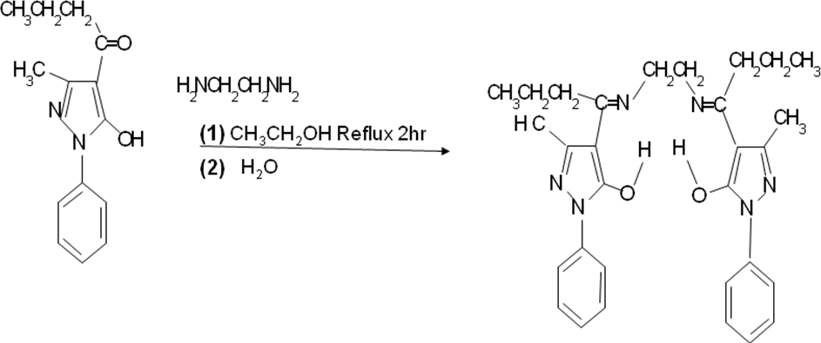

2

4-propionyl-2,4-dihydro-5-methyl-2-

phenyl-3H-pyrazol-3-one

**+**

N,N‘-ethylenebis(4-propionyl-2,4-dihydro-5- methyl-2-phenyl- 3H-pyrazol-3-one)imine (H2PrEtP)

**Figure 3.4:** Reaction between ethylenediamine and 4-propionyl- 2,4-dihydro-5-methyl-2-phenyl-3H-pyrazol-3-one

The ligand was characterized by elemental analyses, UV, IR, 1H and 13C NMR spectral studies, (Uzoukwu *et al*., 1998a)

# Preparation of Standard Solutions of Ligand and Synergist

**Chloroform solution of 0.05 M H2PrEtP**

A 0.05 M standard solution of H2PrEtP was prepared by dissolving 2.423 g of the solute in chloroform and making up to 100 ml mark in a 100 ml volumetric flask.

# Chloroform solution of 0.05 M HPrP

A 0.05 M standard solution of HPrP was prepared by dissolving

1.151 g of the solute with chloroform to the 100 ml mark in a 100 ml volumetric flask.

# Preparation of Standard Solutions Mineral Acids

All hygroscopic, deliquescent and efflorescent reagents used in this extraction were standardized using standard solution of Na2CO3, NaOH, HCl and EDTA.

# 5.0 M HCl solution

A 5.0 M standard solution of HCl was prepared by pippeting

43.7 ml of HCl (specific gravity of 1.19 gcm-3 and purity 36 %) standardized with Na2CO3 into a 100 ml volumetric flask and made up to the 100 ml mark with deionized water.

# 10.0 M CH3COOH solution

A 10.0 M standard solution of CH3COOH was prepared by pippeting 28.9 ml of glacial acetic acid (specific gravity of

1.05 gcm-3 and purity 99 %) into a 50 ml volumetric flask and made up to the 50 ml mark with deionized water.

# 5.0 M HNO3 solution

A 10.0 M standard solution of HNO**3** was prepared by pippeting 10.8 ml of HNO3 (specific gravity of 1.49 gcm-3 and purity 98 %) standardized with NaOH into a 25 ml volumetric flask and made up to the 25 ml mark with deionized water.

# 5.0 M H3PO4 solution

A 5.0 M standard solution of H3PO4 was prepared by pippeting 8.6 ml of H3PO4 (specific gravity of 1.685 gcm-3 and purity 85 %) into a 25 ml volumetric flask and made up to the 25 ml mark with deionized water.

# 5.0 M H2SO4 solution

A 5.0 M standard solution of H2SO4 was prepared by pippeting 7.0 ml of H2SO4(specific gravity of 1.83 gcm-3 and purity 96 %) standardized with a solution of NaOH into a 25 ml volumetric flask and made up to the 25 ml mark with deionized water.

# 0.5 M Citric Acid [HO2CCH2]2C(OH)CO2H solution

A 0.5 M standard solution of citric acid was prepared by dissolving 10.507 g of [HO2CCH2]2C(OH)CO2H in a 100 ml volumetric flask and made up to the 100 ml mark with deionized water.

# Preparation of Standard Solutions of Salts and Bases

1. **0.5 M Na2B4O7 solution**

A 0.5 M standard solution of disodium tetraborate was prepared by dissolving 5.031 g of Na2B4O7 in a 50 ml

volumetric flask and made up to the 50 ml mark with deionized water.

# 2.0 M KCl solution

A 2.0 M standard solution of potassium chloride was prepared by dissolving 7.455 g of KCl in a 50 ml volumetric flask and made up to the 50 ml mark with deionized water.

# 5.0 M CH3COONa solution

A 5.0 M standard solution of sodium acetate was prepared by dissolving 34.025 g of CH3COONa.3H2O in a 50 ml volumetric flask and made up to the 50 ml mark with deionized water.

# 1.0 M KH2PO4 solution

A 1.0 M standard solution of potassium dihydrogen phosphate was prepared by dissolving 6.805 g of KH2PO4 in a 50 ml volumetric flask and made up to the 50 ml mark with deionized water.

# 2.0 M NaOH solution

A 2.0 M standard solution of sodium hydroxide was prepared by dissolving 4.0 g of NaOH in a 50 ml volumetric flask and made up to the 50 ml mark with deionized water and standardized with HCl.

# 0.2 M Sodium Citrate [NaO2CCH2]2C(OH)CO2Na solution

A 0.2 M standard solution of sodium citrate was prepared by

dissolving 5.882 g of [NaO2CCH2]2C(OH)CO2Na. 2H2O in a 100 ml volumetric flask and made up to the 100 ml mark with deionized water.

# Preparation of Buffer Solutions for Calibration of pH Meter

1. **Buffer solution of pH 4.01**

A buffer solution of pH 4.01 was prepared by dissolving 0.5106 g of potassium hydrogen phthalate in 50 ml of deionized water.

# Buffer solution of pH 9.18

A buffer solution of pH 9.18 was prepared by dissolving 0.5031 g of disodium tetraborate in 50 ml of deionized water.

# Preparation of Buffer Solutions

The working solutions for all the acids, bases and salts used for preparation of buffers was 0.1 M and were obtained from various stock solutions using the dilution law *(M1V1 = M2V2).*

# Buffer solutions range 0 – 3.0 pH

These buffer solutions were prepared from 0.1 M HCl and

0.1 M KCl

# Buffer solutions range 3.0 – 3.5 pH

These buffer solutions were prepared from 0.1 M CH3COOH and 0.1 M KCl

# Buffer solutions range 3.5 – 6.0 pH

These buffer solutions were prepared from 0.1 M CH3COOH and 0.1 M CH3COONa

# Buffer solutions range 6.0 – 9.0 pH

These buffer solutions were prepared from 0.1 M NaOH and 0.1 M KH2PO4

# Buffer solutions above pH 9.0

These were prepared using 0.1 M NaOH and 0.1 M Na2B4O7

# Buffer solutions with Citric acid and Sodium citrate

Buffer solutions with pH ranging from 2.3 to 7.0 were prepared using 0.1 M [HO2CCH2]2C(OH)CO2H and 0.1 M [NaO2CCH2]2C(OH)CO2Na. 2H2O.

# Preparation of Metal Standard Solutions

The metallic salts were standardized using standard EDTA solution.

# Ni2+ (1000 mg/L) standard solution

A 1000 mg/L standard solution of Ni2+ was prepared by dissolving 0.67297 g of ammonium nickel (II) tetraoxosulphate (VI) hexahydrate (NiSO4.(NH4)2SO4.6H2O) in 100 ml volumetric flask containing 0.1 ml of 10 M HNO3

made up to the 100 ml mark with deionized water. This amount was calculated thus,

1 g of Nickel ~~× Total w~~eight of complex Molar mass of Ni 1

# Co2+ (1000 mg/L) stock

A 1000 mg/L standard solution of Co2+ was prepared by dissolving 0.40373g of Cobalt(II) chloride hexahydrate (CoCl2.6H2O) in 100 ml volumetric flask containing 0.1 ml of 10 M HNO3 and made up to the 100 ml mark with deionized water. The amount was calculated as in (a).

# Cu2+ (1000 mg/L) standard

A 1000 mg/L standard solution of Cu2+ was prepared by dissolving 0.39295 g of Copper(II)Sulphate penta hydrate (CuSO4.5H2O) in 100 ml volumetric flask containing 0.1 ml of 10 M HNO3 and made up to the 100 ml mark with deionized water. The amount was calculated as in (a).

# Preparation of Standard Solutions for Anions and Complexing Agents

1. **2.0 M Cl- solution**

A 2.0M Cl- standard solution was prepared by dissolving 10.698 g of ammonium chloride (NH4Cl) in 100 ml volumetric flask and made up to the 100 ml mark with deionized water.

# 2.0 M I- solution

A 2.0 M I- standard solution was prepared by dissolving 32.2 g of pottasium chloride (KI) in 100 ml volumetric flask and made up to the 100 ml mark with deionized water.

# 2.0 M SO42- solution

A 2.0 M SO42- standard solution was prepared by dissolving

28.408 g of sodium sulphate (Na2SO4) in 100 ml volumetric flask and made up to the 100 ml mark with deionized water.

# 2.0 M Br- solution

A 2.0 M Br- standard solution was prepared by dissolving

32.064 g of sodium bromide (NaBr) in 100 ml volumetric flask and made up to the 100 ml mark with deionized water.(e) **2.0 M CH3COO- solution**

A 2.0 M CH3COO- standard solution was prepared by dissolving 27.216 g of Sodium acetate trihydrate (CH3COONa.3H2O) in 100 ml volumetric flask and made up to the 100 ml mark with deionized water.

# 2.0 M PO42- solution

A 2.0 M PO42- standard solution was prepared by dissolving

50.0 g of Sodium tetraoxophosphate(VI)12hydrate (Na2PO4.12H2O) in 100 ml volumetric flask and made up to the 100 ml mark with deionized water.

# 2.0 M Tartrate ion (CHOHCOO-)2 solution

A 2.0 M tartrate ion (CHOHCOO-)2 standard solution was prepared by dissolving 47.04 g of potassium tartrate half hydrate[(CHOHCOOK)2 1/2H2O] in 100 ml volumetric flask and made up to the 100 ml mark with deionized water.

# 2.0 M EDTA ion [CH2N(CH2COOH)CH2COO-]2 solution

A 2.0 M ethylenediamine tetraacetate ion [CH2N(CH2COOH)CH2COO-]2 standard solution was prepared by dissolving 54.448 g of Ethylenediamine tetraacetic acid disodium salt dihydrate

|  |  |  |
| --- | --- | --- |
| [CH2N(CH2COOH)CH2COONa)2 | 2H2O] | in 100 ml |
| volumetric flask and made up to  deionized water | the 100 | ml mark with |

# 2.0 M Oxalate ion (COO-)2 solution

A 2.0 M oxalate ion (COO-)2 standard solution was prepared by dissolving 26.8 g of disodium oxalate (COONa)2 in 100 ml volumetric flask and made up to the 100 ml mark with deionized water.

# 2.0 M SCN- solution

A 2.0 M thiocyanate ion (SCN-) standard solution was prepared by dissolving 15.224 g of ammonium thiocyanate (NH4SCN) in 100 ml volumetric flask and made up to the 100 ml mark with deionized water.

# 2.0 M F- solution

A 2.0 M fluoride ion (F-) standard solution was prepared by dissolving 7.408 g of ammonium fluoride (NH4F) in 100 ml volumetric flask and made up to the 100 ml mark with deionized water.

# 2.0 M NO3- solution

A 2.0 M nitrate ion (NO3-) standard solution was prepared by dissolving 16.998 g sodium nitrate (NaNO3) in 100 ml volumetric flask and made up to the 100 ml mark with deionized.

# Extraction of Metal ions from Aqueous Phase at Different pH Values

The working concentrations for the three metals were 2 ml of 50 mg/L aqueous Ni2+, Co2+ and Cu2+ respectively prepared by pipetting 0.1 ml each from 1000 mg/L stock solution of the three metals and transferring into 3 sets of forty-two (42) 10 ml extraction bottles for Ni2+, Co2+and Cu2+respectively. Subsequently, 1.9 ml of the buffer solutions of known pH value was added accordingly to make 2 ml of the aqueous phase.

Two millilitres (2 ml) organic phase of 0.05 M H2PrEtP in chloroform was then added to each set of extraction bottles that contained the metal ions of study. The mixture was shaken using a mechanical shaker for 30 min. Thereafter, the immiscible phases were allowed to settle and separate out. 1 ml of aqueous raffinate was then taken by micropipette w ithout distillation and analysed by difference using Atomic Absorption Spectrophotometry (AAS) for nickel, cobalt and copper (Uzoukwu and Godwin, 2012)

# Extraction in the Presence of Synergist

The working concentrations for the three metals were 20 ml of 50 mg/L aqueous Ni2+, Co2+ and Cu2+ respectively prepared by pipetting 0.1 ml each from 1000 mg/L stock solution of the three metals and transfering into 3 sets of forty-two (42) 10 ml extraction bottles for Ni2+, Co2+ and Cu2+ respectively. Subsequently, 1.9 ml of the buffer solutions of known pH value was added accordingly to make 2 ml of the aqueous phase.

The synergist used was 4-propionyl-2,4-dihydro-5-methyl-2- phenyl-3H-pyrazol-3-one (HPrP). A solution was prepared containing 90 % of 0.05M H2PrEtP and 10 % of 0.05M HPrP and 2ml of this solution was used as organic phase containing synergist. This organic phase was added to the various 2 ml aqueous solutions that contained 50 mg/l of Ni(II), Co(II) and Cu(II) at various known pH. The extraction process and analysis was repeated as described in section 3.2.10.

* + 1. **Extractions with Various Ligand Concentrations** Extraction with ligand concentrations varied from 2.50 × 10-3 M to 4.00 × 10-2 M was studied at three (3) constant aqueous phase pH values of 7.25, 7.75 and 8.50 for

nickel, 7.50,8.50 and 9.0 for Cobalt and 5.0, 6.0 and 7.0 for Copper respectively

The organic phases containing various ligand concentrations studied were;

2.50 × 10-3 M: Corresponding to 0.1 ml from 0.05 M H2PrEtP plus 1.9 ml chloroform

5.00 × 10-3 M: Corresponding to 0.2 ml from 0.05 M H2PrEtP plus 1.8 ml chloroform

1.00 × 10-2 M: Corresponding to 0.4 ml from 0.05 M H2PrEtP plus 1.6 ml chloroform

1.50 × 10-2 M: Corresponding to 0.6 ml from 0.05 M H2PrEtP plus 1.4 ml chloroform

2.00 × 10-2 M: Corresponding to 0.8 ml from 0.05 M H2PrEtP plus 1.2 ml chloroform

2.50 × 10-2 M: Corresponding to 1.0 ml from 0.05 M H2PrEtP plus 1.0 ml chloroform

3.00 × 10-2 M: Corresponding to 1.2 ml from 0.05 M H2PrEtP plus 0.8 ml chloroform

3.50 × 10-2 M: Corresponding to 1.4 ml from 0.05 M H2PrEtP plus 0.6 ml chloroform

4.00 × 10-2 M: Corresponding to 1.6 ml from 0.05 M H2PrEtP plus 0.4 ml chloroform

For the aqueous phases, 0.1 ml for each of the three metals was taken from metal stock solutions and made up to 2 ml by addition of 1.9 ml of the buffer solution.

Equilibration was attained by mechanically shaking for 30 min and 1 ml of aqueous raffinate carefully taken and analysed as described in section 3.2.10.

* + 1. **Extractions with Various Ligand Concentrations at Fixed Concentration of Synergist** Extractions at a fixed synergist concentration of 5.00 × 10-3 M while ligand concentrations were varied from 2.50 × 10-3 M to 4.00 × 10-2 M was studied at three (3) constant aqueous phase pH values of 6.50, 7.0 and 7.5 for nickel(II), 7.0, 7.50, and 8.50 for Cobalt(II) and 4.7, 5.3 and 6.0 for Copper(II) based on previous observations.

The organic phase containing fixed synergist and various ligand concentrations studied were;

5.00 × 10-3 M constant volume of 0.2 ml from 0.05 M HPrP solution added to the following preparations to make 2 ml of organic phase.

2.50 × 10-3 M: Corresponding to 0.1 ml from 0.05 M H2PrEtP plus 1.7 ml chloroform

5.00 × 10-3 M: Corresponding to 0.2 ml from 0.05 M H2PrEtP plus 1.6 ml chloroform

1.00 × 10-2 M: Corresponding to 0.4 ml from 0.05 M H2PrEtP plus 1.4 ml chloroform

1.50 × 10-2 M: Corresponding to 0.6 ml from 0.05 M H2PrEtP plus 1.2 ml chloroform

2.00 × 10-2 M: Corresponding to 0.8 ml from 0.05 M H2PrEtP plus 1.0 ml chloroform

2.50 × 10-2 M: Corresponding to 1.0 ml from 0.05 M H2PrEtP plus 0.8 ml chloroform

3.00 × 10-2 M: Corresponding to 1.2 ml from 0.05 M H2PrEtP plus 0.6 ml chloroform

3.50 × 10-2 M: Corresponding to 1.4 ml from 0.05 M H2PrEtP plus 0.4 ml chloroform

4.00 × 10-2 M: Corresponding to 1.6 ml from 0.05 M H2PrEtP plus 0.2 ml chloroform

For the aqueous phases, 0.1 ml for each of the three metals was taken from metal standard solutions and made up to 2 ml by addition of 1.9 ml of the buffer solution.

Equilibration was attained by mechanically shaking for 30 min and 1ml of aqueous raffinate carefully taken and also analysed as described in section 3.2.10.

# Extractions with Various Synergist Concentrations at Fixed Ligand Concentration

Extractions was carried at a fixed ligand concentration of 2.50

× 10-2 M, while synergist concentrations were varied from

2.50 × 10-3 M to 2.25 × 10-2 M was studied at three (3) constant aqueous phase pH values of 6.50, 7.0 and 7.5 for nickel(II), 7.0, 7.50, and 8.50 for cobalt(II) and 4.7, 5.3 and

6.0 for copper(II) based on previous observations.

The organic phases containing fixed ligand and various synergist concentrations studied were;

2.50 × 10-2 M Constant volume of 1 ml from 0.05 M H2PrEtP solution was added to the following preparations to make 2 ml of organic phase.

2.50 × 10-3 M: Corresponding to 0.1 ml from 0.05 M HPrP plus 0.9 ml chloroform

5.00 × 10-3 M: Corresponding to 0.2 ml from 0.05 M HPrP plus 0.8 ml chloroform

7.50 × 10-3 M: Corresponding to 0.3 ml from 0.05 M HPrP plus 0.7 ml chloroform

1.00 × 10-2 M: Corresponding to 0.4 ml from 0.05 M HPrP plus 0.6 ml chloroform

1.25 × 10-2 M: Corresponding to 0.5 ml from 0.05 M HPrP plus 0.5 ml chloroform

1.50 × 10-2 M: Corresponding to 0.6 ml from 0.05 M HPrP plus 0.4 ml chloroform

1.75 × 10-2 M: Corresponding to 0.7 ml from 0.05 M HPrP plus 0.3 ml chloroform

2.00 × 10-2 M: Corresponding to 0.8 ml from 0.05 M HPrP plus 0.2 ml chloroform

2.25 × 10-2 M: Corresponding to 0.9 ml from 0.05 M HPrP plus 0.1 ml chloroform

For the aqueous phases, 0.1 ml for each of the three metals was taken from 1000 mg/L metal standard solutions and made up to 2 ml by addition of 1.9 ml and 1.8 ml of the buffer solution.

Equilibration was attained by mechanically shaking for 30 min and 1 ml of aqueous raffinate carefully taken and also analysed as described in section 3.2.10.

# Extractions with Various Metal Concentrations in absence of the synergist

Extractions were carried out with various concentrations of the three metals studied. The metal concentration were varied from 20 mg/L to 30 mg/L for Ni2+, Co2+ and Cu2+ solutions and was prepared by serial dilution from the 200 mg/L standard solution of the metals. Buffers of pH values 7.25, 7.75 and 8.50 for nickel, 7.50,8.50 and 9.0 for Cobalt and 5.0, 6.0 and 7.0 for copper were used to make 2 ml of aqueous phase for each metal.

2 ml from 0.05 M H2PrEtP solution was used as organic phase and process of equilibration and analysis was done as described in section 3.2.10.

# Extractions with Various Metal Concentrations with Ligand and Synergist

Extractions were carried out with various concentrations of the three metals studied as described in section 3.2.15.

2 ml from 90 % 0.05 M H2PrEtP and 10 % HPrP solution was used as organic phase and process of equilibration and analysis done as described in section 3.2.10 (Uzoukwu and Godwin, 2012)

# Extraction in the Presence of Some Mineral Acids and organic acid

The mineral acids used for this study were HCl, HNO3,

H2SO4, H3PO4 and the organic acid is CH3COOH

# With Ligand H2PrEtP Only

The working concentrations of the metals were 50 mg/l for each of nickel and cobalt respectively. Mineral acids concentration range was 0.001 M to 2.0 M for nickel and .001 M to 3.0 M for cobalt.

2 ml from the 0.05 M H2PrEtP solution was used as organic phase, equilibration and analysis was repeated as described in section 3.2.10.

# With Ligand H2PrEtP and Synergist HPrP

As in (a), working concentrations of the metals were 50 mg/l for each of nickel(II) and cobalt(II) respectively while Mineral acids concentration range was as in (a) above for the two metals

2 ml from 90 % 0.05 M H2PrEtP and 10 % HPrP solution was used as organic phase, equilibration and analysis also repeated as described in section 3.2.10 (Okafor and Uzoukwu, 1990, Kalagbor et al., 2011,)

# 3.2.19 Extraction in the Presence of Some Anions

The anions used for this study were Cl-, I-, PO 2-, SO 2-, NO -

4 4 3

and CH3COO-.

# With Ligand H2PrEtP Only

The working concentrations of the metals were 50 mg/l for both nickel and copper. Anions concentration range was 0.001 M to 1.0 M.

2 ml from the 0.05 M H2PrEtP solution was used as organic phase, equilibration and analysis was repeated as described in section 2.2.10.

# With Ligand H2PrEtP and Synergist HPrP

As in (a), working concentrations of the two metals were 50 mg/l for each and anions concentration range was also 0.001 M to 1.0 M.

2 ml from 90 % 0.05 M H2PrEtP and 10 % HPrP solution was used as organic phase and equilibration and analysis was repeated as described in section 3.2.10.

# 3.2.19 Extraction in the Presence of Some Complexing Agents

Bromide (B-), EDTA [CH2N(CH2COOH)CH2COO-]2, fluoride (F-

), oxalate (COO-)2, tartrate (CHOHCOO-)2, and thiocyanate (SCN-) were the complexing agents used for this study.

# With Ligand H2PrEtP Only

The working concentrations of the metals were 50 mg/l for nickel(II) and copper(II) respectively. Complexing agent‘s concentration range was 0.0005 M to 0.5 M. 2 ml from the

0.05 M H2PrtP solution was used as organic phase, equilibration and analysis was repeated as described in section 3.2.10.

# With Ligand H2PrEtP and Synergist HPrP

As in (a), working concentrations of the metals were 50 mg/l for each of nickel and copper respectively and complexing agents concentration range was also 0.0005 M to 0.5 M.

2 ml from 90 % 0.05 M H2PrEtP and 10 % HPrP solution was used as organic phase, equilibration and analysis was repeated as described in section 3.2.10 (Okafor and Uzoukwu, 1990, Uzoukwu and Godwin, 2012).

# CHAPTER FOUR RESULTS AND DISCUSSION

**4.1. Calibration Curves**

Figures 4.1, 4.2 and 4.3 (*Appendices A1, Table 1.0., B1, Table 2.0., and C1, Table 3.0)*, shows the calibration curves used for determining the unknown concentrations of the three metals in aqueous raffinate (plots of concentration of metal ion against absorbance) for nickel at 232.0 nm,(Appendices A1), cobalt at

240.7 nm (Appendices B1) and copper at 324.7 nm (Appendices C1) using the Bulk Scientific (A205 model) Atomic Absorption Spectrophotometer. The plots are straight lines showing that Beer‘s law was obeyed up to 25.0 mg/L for nickel with regression coefficient 0.996, cobalt with regression coefficient 0.997 and copper with regression coefficient of 0.993

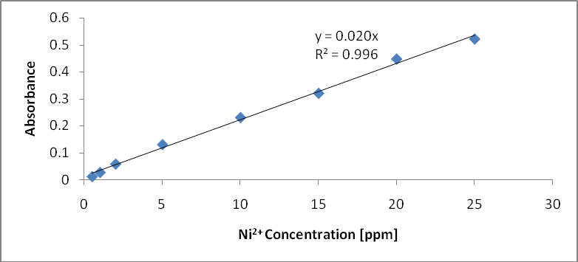

# Figure 4.1 Calibration Curve for Nickel at 232 nm.

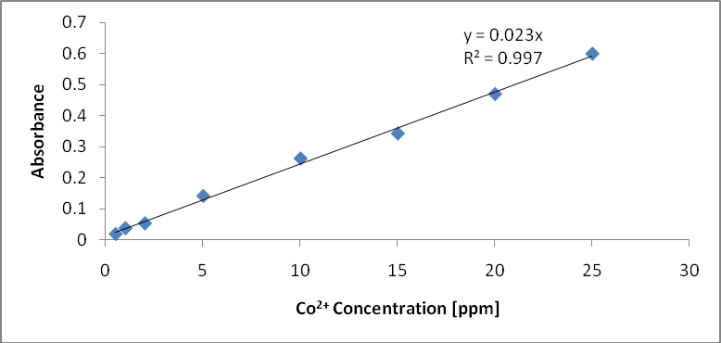

**Figure 4.2 Calibration Curve for Cobalt at 240.7 nm**

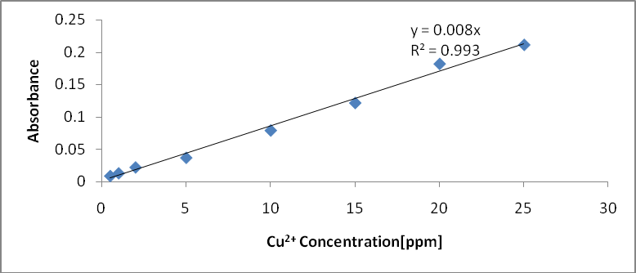

# Figure 4.3 Calibration Curve for Copper at 324.7 nm

* + 1. **Results on Extraction of Nickel(II) ion**

Extraction of Ni2+ from buffered aqueous phase into chloroform phase containing the Schiff base H2PrEtP can be represented by the equation (4.1)

Ni2 (aq) + H2PrEtP ↔ Ni (PrEtP) (org) + 2H+ (org)

(4.1)

The equation (4.1) is based on the assumption that the Ni(II) from aqueous phase is extracted into chloroform by the Schiff base by forming a complex with Ni(II) ion in the 1:1 mole ratio. Thus the extraction constant, Kextr can be expressed by equation

Kextr = [Ni(PrEtP)(org)][H+] 2 / [Ni2+][H2PrEtP](org)

(4.2)

# Effect of pH on extraction of Ni(II) ions into chloroform solution of 0.05 M H2PrEtP.

Figure 4.4 is Plot of logD against pH for the extraction of 8.52×10-4 M Ni2+ from aqueous medium.

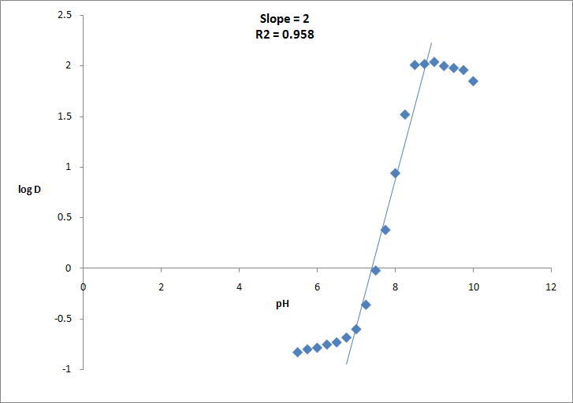

# Figure 4.4 Plot of logD against pH for the extraction of 8.52×10-4 M Ni2+ from buffered aqueous solutions into 0.05 M H2PrEtP in chloroform.

Figure 4.4 shows the effect of pH of solution on the distribution of Ni(II) into chloroform solution of H2PrEtP and on taking a linear regression of the graph through the point of inflexion a slope of two and R2 value of 0.958 was obtained from the graph indicating that 2 moles of hydrogen ions were displaced and confirmed that there were ligand-metal interaction through the oxygen atoms of the hydroxyl functional group of the ligand. The result also showed that D depends on pH and increased exponentially as pH increases. At lower pH of aqueous solutions metal ions tend to form stable anionic complexes with acid

anions in solution thus making the metal ion unextractable when pH is low. The distribution ratio D is given as

D = [Ni (PrEtP) org/ [Ni2+]

(4.3)

The pH1/2 was observed at pH value of 7.75. The study showed that Ni2+ was extracted quantitatively at pH above 8.5 where

99.05 % E was observed. The extraction reached a peak at pH

9.0 where percentage extraction of 99.08 was achieved. Thereafter, further increase in pH resulted to decrease in percentage extraction of Ni2+ into H2PrEtP solution in chloroform. (*Appendix A2, Table 1.1*). Okafor and Uzoukwu, (1990), Uzoukwu and Godwin, (2012), obtained similar results from their work on extraction Fe(III) and U(IV) with 1-phenyl-3- methyl-4-acylpyrazolones-5 from aqueous solutions of different acids and complexing agents.

# Effect of HPrP as synergist on extraction of Ni(II) ion.

Figure 4.5 is Plot of logD against pH for the extraction of 8.52×10-4 Ni2+. It shows the effect of HPrP on the extraction of Ni(II). On addition of HPrP, quantitative extraction of 99.14 % was observed at pH 7.25. The pH½ was lowered to pH 5.75 with percentage extraction of 62.45, D and logD values of 1.66 and

0.221 respectively. Figure 4.5 shows the effect of HPrP on the extraction of nicke

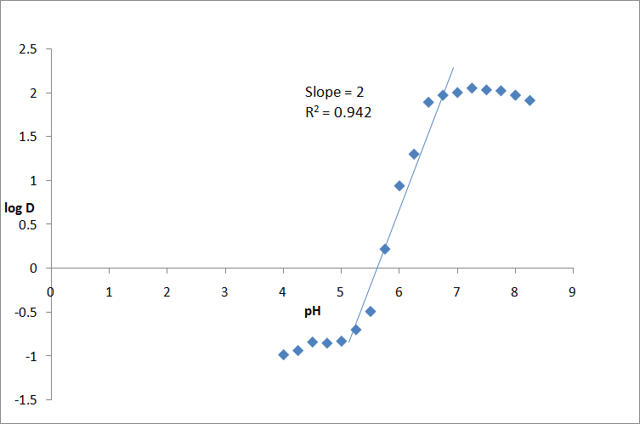

# Figure 4.5: Plot of logD against pH for the extraction of 8.52×10-4 Ni2+ from buffered aqueous solutions into 0.05 M H2PrEtP and 0.05 M HPrP in 9:1 by volume in chloroform.

Extraction plot of log D against pH in the mixed ligand system as shown in Figure 4.5 (*Appendix A3, Table 1.2*) also gave a slope of 2 indicating that two moles of hydrogen were displaced during the extraction process. The plot of log D against pH shows that

the distribution of the metallic ion is dependent on pH of aqueous mediums and increases as pH increased. Statistical analysis of Ni2+ interaction with H2PrEtP in the presence of HPrP at constant pH of 6.5, 7.0 and 7.5 as shown in Fig 4.7 and Fig 4.8 gave a slope of 2 indicating that the ligands reacted in the ratio of 1:1 to each other thus, the two hydrogen atoms displaced are equally contributed by the two ligands in a mixed ligand extraction as represented by equation 4. 6. Interaction of Ni2+ with H2PrEtP in the absence of HPrP as shown in Fig 4.6 gave a slope of 2 confirming that Ni2+ reacted with the ligands in metal – ligand ratio of 1:2. Also plots of log [Ni2+] against log D in metal variation studied both in the presence and absence of synergist (HPrP) as shown in Fig 4.9 and Fig 4.10 (*Appendices A13- A18,Table1.12- 1.18*) gave a slope of 0 showing that the extraction is independent of the metal ions concentration. Combining these results showed that the interaction between Ni2+ and H2PrEtP did not occur in the metal - ligand mole ratio of 1:1 as suggested by equation 4.1. The result showed that Ni(II) interacts with H2PrEtP in the ratio of 1:2 and therefore the probable reaction equation could be written as;

Ni2+ (aq) + 2H2PrEtP (org) ↔ Ni(HPrEtP)2 + 2H+

(4.4)

Equation 4.4 represents the possible reaction equation when Ni(II) ions react with H2PrEtP in the absence of HPrP. For the reaction in a mixed ligand system the probable reaction equation is as shown in equation 4. 5.

Ni2+ + H PrEtP + HPrP ↔ Ni(HPrEtP)(PrP) + 2H+ (4.5)

(aq) 2 (org) (org) (org)

Thus, KNiex= [Ni(HPrEtP).PrP(org)][H2+]/ [Ni2+[H2PrEtP](org)

(4.6)

Where [HPrP] is a constant incorporated into equation 4.5 Okafor and Uzoukwu, (1990), Uzoukwu and Godwin, (2012), obtained similar results from their work on extraction Fe(III) and U(IV) with 1-phenyl-3-methyl-4-acylpyrazolones-5 from aqueous solutions of different acids and complexing agents.

# Effect of Various H2PrEtP and HPrP Concentrations on Extraction of

**Ni(II) ions at Different pH.**

All extraction processes studied showed that the extraction Ni2+ into solution of H2PrEtP and HPrP dissolved in chloroform

increased steadily as the ligands concentrations increased. The distribution is similar on varying the concentration of either of the ligands. Hence increasing the concentration of either H2PrEtP or HPrP lead to a corresponding increase in % E, D and LogD values as shown in Figure 4.6, 4.7 and 4.8 (*Appendices A4- A12,Table1.3 to 1.11).* The plots are linear regressions of LogD against Log [H2PrEtP] and LogD against Log [HPrP] and the regression coefficient R2 values indicates that better extraction was achieved at pH value of 8.50 (R2 0.935) for H2PrEtP, pH value 6.5 (R2 0.987) for H2PrEtP at constant HPrP and pH value

7.5 (R2 0.939) for HPrP at constant H2PrEtP. The results showed that the extraction of Ni(II) ions is dependent on both pH of aqueous medium and the concentration of the ligands. The ligands gave a better extraction of nickel at near neutral to weakly alkaline pH. Okafor and Uzoukwu, (1990), Uzoukwu and Godwin, (2012), obtained similar results from their work on extraction Fe(III) and U(IV) with 1-phenyl-3-methyl-4- acylpyrazolones-5 from aqueous solutions of different acids and complexing agents.

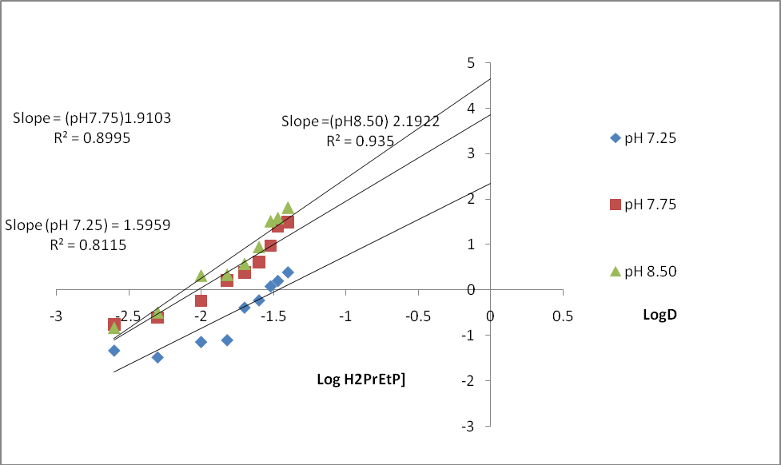

# Figure 4.6: Plot of log D against log [H2PrEtP] for the extraction of 8.52×10-4 M of Ni(II) from aqueous solutions into H2PrEtP dissolved in chloroform in the absence of HPrP at constant pH of 7.25, 7,75 and 8.5

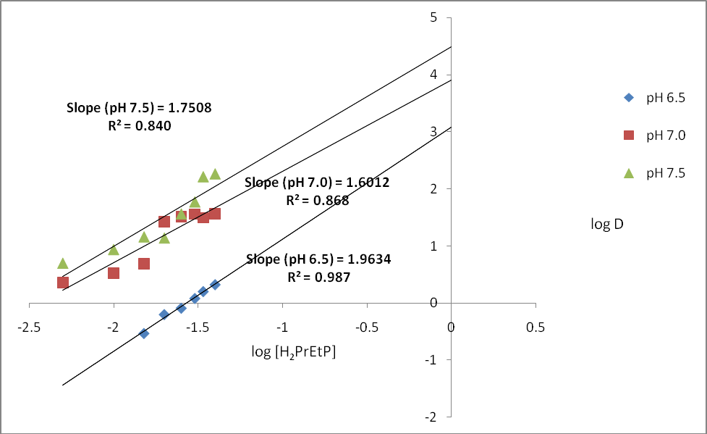

**Figure4.7: Plot of logD against log[H2PrEtP] for the extraction of 8.52×10-4 M of Ni(II) from aqueous solutions into H2PrEtP solution in chloroform with HPrP kept constant at pH 6.5, 7.0 and 7.5**

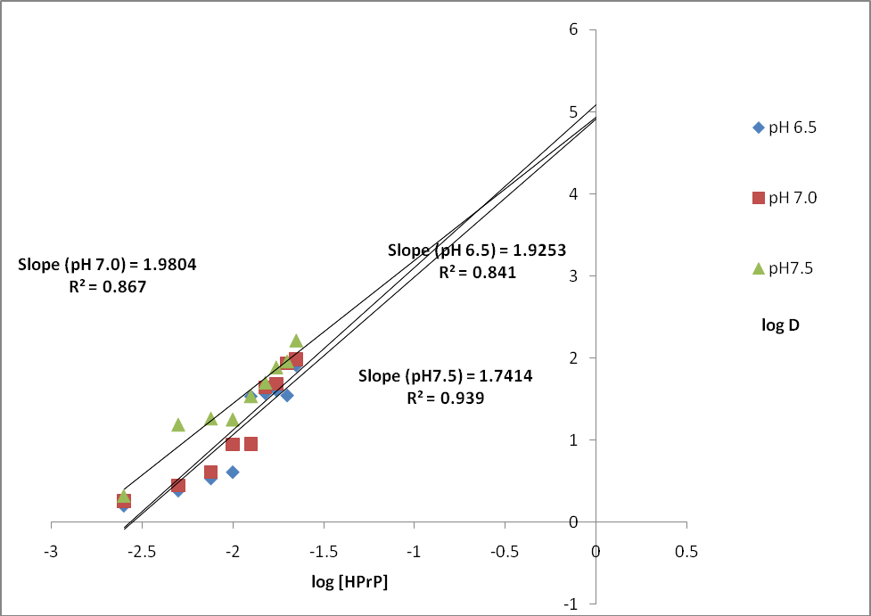

# Figure 4.8: Plot of log D against log [HPrP] for the extraction of 8.52×10-4 M of Ni(II) from aqueous solutions into H2PrEtP solution in chloroform with H2PrEtP kept constant at pH 6.5, 7.0 and 7.5.

* + 1. **Effect of Ni Concentrations on Extraction of Ni(II) ions with H2PrEtP**

As shown in Figure 4.9 and 4.10, variation of the metal ions concentration did not have much effect on the distribution pattern

of the metal into H2PrEtP in chloroform. Very high percentage extractions were achieved in all the metal ions concentrations studied in both mixed and single ligand system. The results showed that the distribution of Ni2+ into the organic phase is less dependent of its concentration in aqueous buffered medium as shown in Figure 4.9 and Figure 4.10 (*Appendices A13-A18, Table 1.12 to A1.17*) .

Extraction plots for the variation of metal concentrations gave a zero slope indicating that dependence of the extraction on the metal ions concentration is negligible. Data obtained from the extraction processes showed that Ni2+ distributes better into 9:1 H2PrEtP & HPrP at pH 6.5 and 7.5. In absence of HPrP maximum extraction of Ni2+ ions was observed at 5.10×10-4 M Ni(II) concentration at pH 8.5 where percentage extraction of

97.03 % was obtained corresponding to D value of 32.66 and log D, 1.5141 respectively. The least percentage extraction was observed at metal concentration of 4.26×10-4 M, pH 7.25 which gave a % E of 95.70 %, D, 22.44 and Log D 1.3503. In the presence of HPrP maximum extraction was achieved at 4.77×10-4 M and 5.10×10-4 M metal concentrations and pH 7.5

corresponding to 98.70 % E, D 75.82 and log D 1.8798 for both concentrations respectively. Uzoukwu and Mbonu obtained similar results in their work on effect of chloride ion in a buffer medium on liquid-liquid extraction of Cu(II) and Ni(II) (Uzoukwu and Mbonu, 2005).

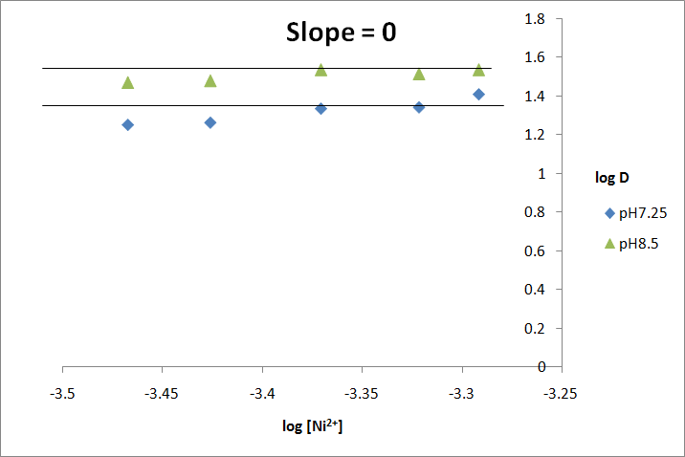

# Figure 4.9.Plot of Log D against Log Ni (II) for the extraction of Ni II) from buffer solution into chloroform solution of 0.05 M H2PrEtP at constant pH of 7.25 and 8.5

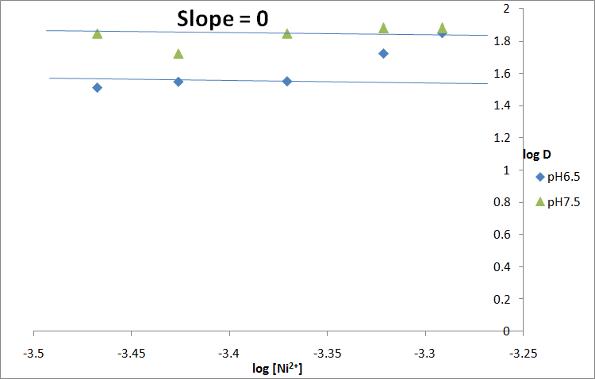

**Figure4.10: Plot of LogD against Log [Ni(II)] for the extraction of Ni(II) from buffer solution into chloroform solution of 0.05 M H2PrEtP and 0.05 M HPrP in 9:1 ratio.**

# Effect of Mineral Acids on Extraction of Nickel with H2PrEtP in Chloroform.

In the study of the extraction of Ni(II) ions with ligand H2PrEtP, the effect of mineral acids on the extraction of Ni(II) ions was investigated and the results are shown in Figure 4.11(*Appendice A19-A28, Table 1.18 to 1.27)*. The results showed that no mineral acid gave up to 10 % extraction of nickel(II) in both single and mixed ligand extraction. Increase in the concentration of mineral acids decreased the extraction of Ni(II) ions. This could be attributed to low pH of mineral acids that favoured polarity of solution, through ionization of the acid species into protons and its conjugate base thus causing a competition between the anionic conjugate base of the acids and ligand molecules for the metallic ions hence the Ni(II) ions are masked in the aqueous phase and as the concentrations of mineral acids in solutions were increased, the % extraction of Ni(II) ions became zero.

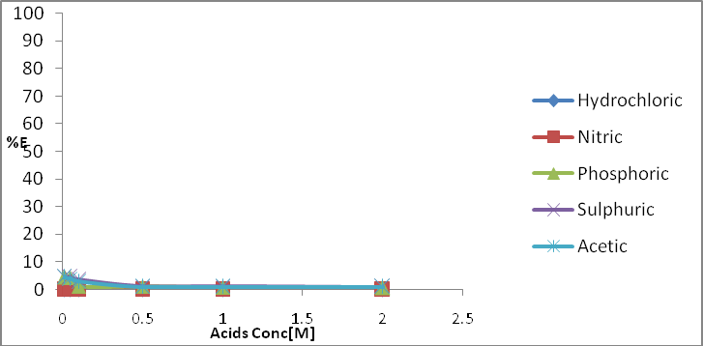

# Figure 4.11Plot of % E against Acid Conc. [M] for Effect of Mineral Acids on Extraction of Nickel with H2PrEtP in chloroform.

* + 1. **Effect of Mineral Acids on Extraction of Nickel with H2PrEtP and HPrP as Synergist**

Figure 4.12 showes the result of the effect of mineral acids on extraction of Ni(II) ions with H2PrEtP and HPrP as synergist in chloroform. From the result it was observed that HPrP increased slightly the extraction of Ni(II) ions by increasing the hydrophobicity of the Ni complex formed. All the mineral acids decreased the extraction of Ni(II) ions when their concentrations were increased.

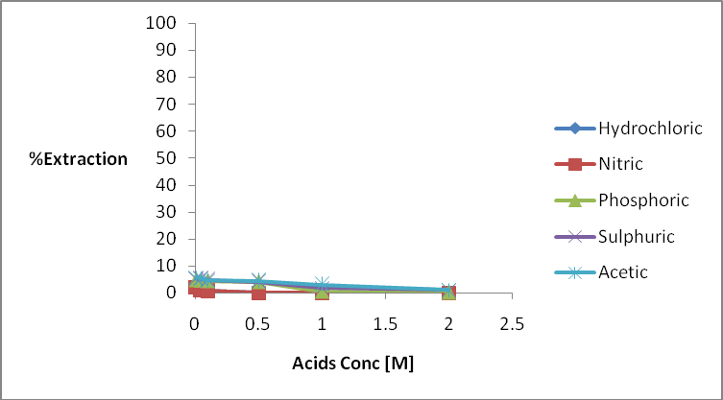

# Figure 4.12 Effect of Mineral Acids on Extraction of Nickel with H2PrEtP and HPrP as synergist in chloroform

* + 1. **Effect of Anions on Extraction of Nickel with H2PrEtP** The results of effects of anions on the extraction of Ni(II) ions with H2PrEtP in the absence of HPrP as synergist are shown in Figure 4.13. The results show that the extraction of Ni(II) ions increased with increase in concentration of sulphate ions from

0.001 M to 0.10 M. Further increase in sulphate ions concentration resulted to tremendous decrease in percentage extraction. This was as a result of formation of stable Ni(II) complex anion which is less hydrophobic (have more affinity for the water medium than the organic phase).

The extraction of Ni(II) ions fluctuates as the chloride ions concentration increased from 0.001 M to 0.5 M but gave high % E of 60.40 % at 0.50 M. The effect of nitrate ion on extraction of Ni(II) ion revealed that the extraction of Ni(II) ions increases with increase in nitrate ions concentration from 0.001 M to 0.1 M concentration where a percentage extraction of 65.90 % was obtained. It was also observed that an increase in concentration of iodide beyond 0.05 M resulted to a steady decrease in percentage extraction of Ni(II) ions. Increase in percentage extraction of Ni(II) ions was observed as concentration of phosphate ions was increased. The maximum extraction was achieved at concentration of 0.1 M, after which further increase in concentration of phosphate ions resulted to decrease in percentage extraction of Ni(II)ions. Phosphate ion gave above 50

% extraction in all the concentration studied. It was also observed that percentage extraction of Ni(II) ions increased with increase in concentration of acetate ions. Generally all the anions showed a steady increase in percentage extraction from 0.001 M to 0.1 M concentration beyond which percentage extraction started to decrease due to the formation of stable anionic species in the aqueous medium.

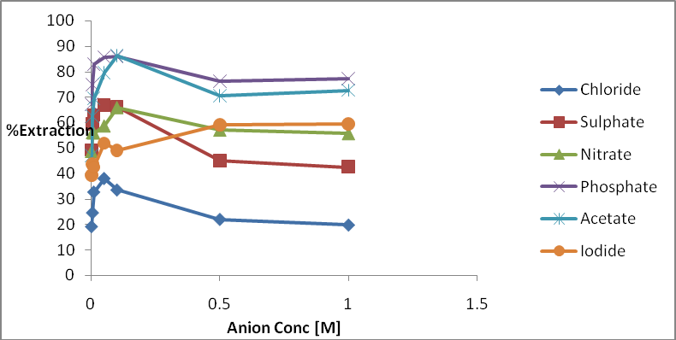

# Fig 4.13 Effect of anion on extraction of nickel with H2PrEtP in chloroform

* + 1. **Effect of Anions on Extraction of Nickel with H2PrEtP and HPrP as**

# Synergist

The results shown in Fig 4.14 indicate that there was a tremendous increase in extraction of Ni(II) ions in the presence of the synergist. The extraction of Ni(II) ions followed the same trend as in the absence of synergy. For sulphate ions, the extractions increased with increase in the concentration of sulphate ions and reached peak at 0.10 M sulphate ion where

96.80 % E was observed. The extraction of the Ni(II) ions fluctuates as the chloride ions concentration increased, but

showed a sharp decrease at 0.01 M concentration of chloride ions. The extraction of Ni(II) ions increased with increase in nitrate ions concentration but showed a sharp decrease at 0.5 M and 1.0 M concentration. It was also observed that an increase in concentration of iodide ions resulted to a increase in percentage extraction of Ni(II) ions but showed an increase at

0.005 M and 0.05 M concentrations. Increase in percentage extraction of Ni(II) ions was also observed as the concentrations of phosphate ions increased and maximum extraction was attained at 0.10 M after which, further increase in concentration of phosphate ions in the solution resulted to decrease in percentage extraction of Ni(II)ions. With acetate as the anion, it was observed that percentage extraction of Ni(II) ions increased with increase in concentration of acetate ions. Acetate ions gave its highest extraction of Ni(II) ions at 0.1 M acetate concentration. All data for the effect of anions on the extractions of Nickel (II) ions are presented in *Appendices A29- A40, Table 1.28 to 1.39.*

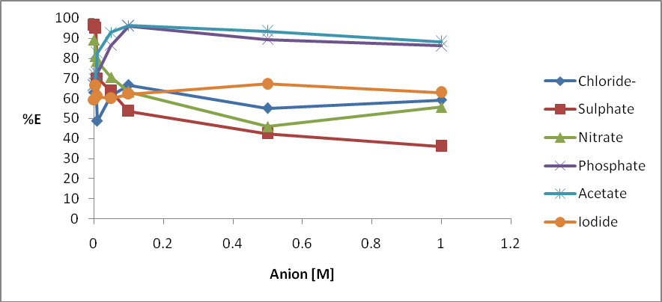

# Fig 4.14 Effect of anions on extraction of Nickel with H2PrEtP and HPrP as Synergist in chloroform

* + 1. **Effect of Complexing Agents on Extraction of Ni(II) ions with H2PrETP**

The results on the effects of complexing agents on the extraction of Ni(II) ion with H2PrEtP in the absence of HPrP as synergist are shown in Figure 4.15 (Appendices A41 – A52,Table 1.40 – 1.51). From the results, it was observed that the extraction of Ni(II) ions fluctuates as the thiocyanate, EDTA, and oxalate concentrations of the solutions increased respectively and with all percentage extractions less than 50 %. This might be due to formation of the stable charged

complexes which masked the Ni(II) ions in the aqueous phase. The extraction of Ni(II) ions decreased with increase in tartrate concentration but showed slight increase in Ni(II) ion extraction at 0.05 M and decreased largely with further increase in tartrate concentrations. An increase in concentration of bromide anion from 0.0005 M to 0.5 M resulted to fluctuation in percentage extraction of Ni(II) ions. It was observed that increasing bromide ion concentration of the solution gave net decrease in percentage extraction of Ni(II) ions.

From the result, it was observed that percentage extraction of Ni(II) ions increased with increase in concentration of fluoride ions in the solution. Quantitative extraction of Ni(II) ions was obtained at pH of 6.05 and 0.01 M concentration of fluoride ion. Flouride ions gave highest percentage extraction of Ni(II) ions followed by tartrate ions while oxalate ions gave the least percentage extraction of Ni(II) ions.

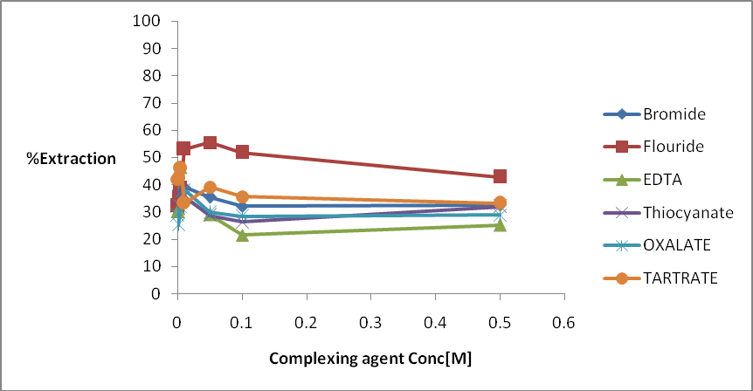

# Fig 4.15 Effects of complexing agents on extraction of Ni(II) ions with H2PrEtP in chloroform

* + 1. **Effect of Complexing Agents on Extraction of Ni(II) ions with Ligand**

# (H2PrETP) and HPrP as Synergist

Figure 4.16 showed the effects of complexing agents on the extraction of Ni(II) ions with H2PrEtP and HPrP as synergist. It was observed that in the presence of the synergist, increase in concentration of complexing agents greatly increased the extraction of Ni(II) ions. Bromide ions gave the highest percentage extraction (71.30 %) of Ni(II) ions obtained at pH of 6.07 and 0.10 M. It was observed that an increase in concentrations of thiocyanate, oxalate, EDTA and bromide

fluctuates the extraction of Ni(II) ions. The least extraction was observed in EDTA and oxalate. Extraction of Ni(II) ions increased as the concentration of tartrate was increased from 0.0005 M to 0.5 M but decreased as the concentrations were increased further. Similar results were obtained by Uzoukwu and Godwin in their work on separation of U(VI) from a mixture with Pb(II) in aqueous solution using N,N‘- ethylenebis(4-propionyl-2,4-dihydro-5-methyl-2-phenyl-3H- pyrazol-3-one)imine (Uzoukwu and Godwin, 2012). All data for effect of complexing agents on nickel extraction are presented in *Appendices A41-A52, Table 1.40 to 1.52.*

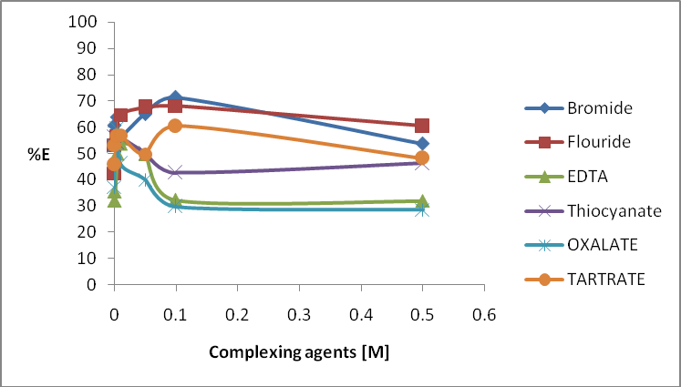

# Fig 4.16 Effect of complexing agents on extraction of Ni(II) ions with H2PrEtP and HPrP as synergist in chloroform

* + 1. **Proposed Structure for Nickel (II) H2PrEtP and Nickel**

# (II) H2PrEtP/HPrP.

Combining the various results obtained from all stages of extraction and what has been done before (Okafor, 1981, Uzoukwu and Adiukwu, 1997, Uzoukwu *et al*., 2004,Bulent et al., 2009) with statistical analysis of slopes we proposed the structures in Figure 4.17 and 4.18 for nickel(II) H2PrEtP complex and nickel(II) H2PrEtP/HPrP complex.

N N



N

N

N

O

N

N

N

N

Ni

O

N

N

N

OH

HO

# Figure 4.17 Proposed Ni complexes with H2PrEtP



N

~~N~~

HO

N

N

Ni

O

O

N

N

O

N

N

**Figure 4.18 Proposed structure of Ni (HPrEtP.PrP)O**

# Results on Extaction of Cobalt (II) ion

Distribution of Co(II) from aqueous phase into chloroform phase having the Schiff base H2PrEtP can be represented by the Eqn. (4.7)

Co2+ + H PrEtP ↔ Co(PrEtP) + 2H+ (4.7)

(aq) 2 (org) (org) (org)

The Eqn. (4.7) is based on the assumption that the Co(II) from aqueous phase is extracted into chloroform by the Schiff base by forming a complex with the Co(II) ion in the1:1 mole ratio. Thus the extraction constant Kext can be expressed by the Eqn.(4.8).

Kextr = [Co (PrEtP) (org)] [H+]2 / [Co2+](aq) [H2PrEtP](org)

(4.8)

# Effect of pH on Extraction of Co(II) Ions into Chloroform Solution of

**0.05M H2PrETP.**

**2**

**1.5**

**1**

**log0.D5**

**Slope = 1.0945**

**R2 = 0.958**

**0**

**-0.5 0 2**

**4 pH**

**6 8 10 12**

**-1**

# Figure 4.19 Plot of Log D against pH for the extraction of 8.48×10-4 M Co(II) ions from buffered aqueous solution into chloroform solution of 0.05 M H2PrEtP.

Fig.4.19 shows the effect of pH of aqueous solution on the distribution of Co(II) into chloroform solution of H2PrEtP and on taking a linear regression of the graph through the point of inflexion a slope of one and R2 value of 0.958 was obtained from the graph indicating that 1 mole of hydrogen ions were displaced and confirmed that there were ligand-metal interaction through the oxygen atoms of the hydroxyl functional groups of ligand according to Eqn. 4.7. The distribution ratio of the metal ion between the two liquid phases becomes

*D* = [Co(HPrEtP)(org)] / [Co2+(aq)] (4.9)

And on substituting D into Eqn. 4.8 after rearrangement gives Eqn. 4.10

Log *D* = Log Kext + Log [H2PrEtP] +

pH (4.10)

The result showed that the extraction of cobalt(II) ions into chloroform solution of H2PrEtP increased with increase in pH of aqueous solution and reached a peak at pH 9.25 where a percentage extraction of 98.43 % was achieved. Thereafter, further increase in pH resulted into a decrease in percentage extraction of the metal. The partition coefficient, log*D* was determined statistically from the plot and found to be 1.78±0.02. The pH½ was found to be 7.05.

# Effect of Addition of HPrP (Synergist) on the Extraction of Co(II).

Figure 4.20 shows the effect of addition of HPrP on the extraction of cobalt(II)

On addition of HPrP, quantitative extraction of 99.30 % was obtained at pH 8.26. The pH½ was significantly lowered from pH 7.05 (near neutral) to a slightly acidic pH of 6.25.

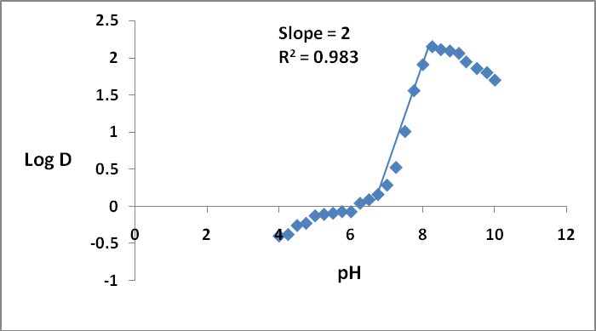

# Figure4.20 Plot of LogD against pH for the extraction of 8.48×10-4 M Co(II) ions from buffered aqueous solution into chloroform solution of 0.05 M 9:1 H2PrEtP and HPrP

The partition coefficient was found to be 2.06 ± 0.10 and was determined statistically from the plot as show in Fig. 4.20. Plot of Log*D* against pH in the mixed ligands system above gave a slope of 2 indicating that 2 moles of hydrogen ions were displaced during the extraction process, thus, the possible reaction equation for the extraction may be written as:

Co2+ +H PrEtP + HPrP ↔ Co(HPrEtP)(PrP) + 2H+ (4.11)

(aq) 2 (org) (org)

Hence,

Kext = [Co(HPrEtP)(PrP)(org)] [H+]2 / [Co2+(aq)] [H2PrEtP](org) [HPrP](org) (4,12)

All data for the effect of pH and effect of addition of HPrP are recorded in *Appendix B2 and B3, Tables 2.1 and 2.2.* Barkat *et al*., obtained similar result from their work on Ionic strength effect on the liquid-liquid extraction of zinc(II) and cadmium(II) from sulphate medium by 1-phenyl-3-methyl-4-benzoylpyrazol- 5-one in chloroform.

# Effect of Various H2PrEtP and HPrP Concentrations on Extraction of

**Co(II) ions at Different pH.**

Figure 4.21, 4.22 and 4.23 shows the effect of H2PrEtP and HPrP concentrations on the Extraction. All extraction processes studied showed that the extraction of Co2+ into chloroform solution of H2PrEtP and HPrP increases as the ligands concentrations increased. The extractions followed similar trends on variation of the concentrations of any of the ligands either in a mixed or single ligand extraction as shown in Figure 4.21, 4.22, 4.23 and *Appendices B4 to B12, Tables*

*2.3 to 2.11*. The plots are linear regressions of LogD against

Log [H2PrEtP] and LogD against Log [HPrP] and the regression coefficient R2 values indicates that better extraction of Co2+ was achieved at pH value of 7.5 (R2 0.943) for H2PrEtP, pH value 8.5 (R2 0.982) for H2PrEtP at constant HPrP and pH value 7.5 (R2 0.932) for HPrP at constant H2PrEtP. Our results are similar to that obtained by Uzoukwu and Godwin (2012), from their work on separation of U(VI) from a mixture with Pb(II) in aqueous solution using N,N‘-Ethylenebis (4- butanoyl-2,4-Dihydro-5-Methyl-2-Phenyl-3H-Pyrazol-3- One)imine.

**-**

|  |  |  |  |  |  |  |
| --- | --- | --- | --- | --- | --- | --- |
|  | | **Slope(pH7.5) = 1.4156** | **3.5**  **3** |  | | |
| **R² = 0.943** | **2.5** |
|  | **Slope(pH9.0)= 1.2242**  **R² = 0.877** | **Slope(pH8.5)= 1.384**  **R² = 0.862** | **2**  **1.5**  **1** |  | **log D** | log D(pH7.5)  log D{pH8.5) |
|  |  |  | **0.5** |  |  | log D(pH9.0) |
|  |  |  | **0** |  |  |  |
| **3** | **-2.5 -2** | **-1.5 -1 -0.5** | **-0.5** | **0** | **0.5** |  |
|  |  | **log** | **-1** |  |  |  |
|  |  | **[H2PrEtP]** | **-1.5** |  |  |  |
|  |  |  | **-2** |  |  |  |

# Figure.4.21 Plot of logD against log[H2PrEtP] for the extraction of 8.48×10-4 M of Co(II) from aqueous solutions

**into chloroform solution of H2PrEtP in the absence of synergist at constant pH of 7.5, 8.5 and 9.0.**

3

**Slope (pH 8.5) = 0.7175**

**R² = 0.982**

2.5

**Slope (pH 7.0) = 0.9495**

**R² = 0.7998**

2

1.5

**Slope (pH 7.5) =1.0079**

**R² = 0.820**

1

log D (pH 7.0)

log D (pH7.5) log D (pH8.5)

0.5

0

-3

-2.5

-2

-1.5

-1

-0.5

0

0.5

-0.5

**Log H2PrEtP**

**Log D**

# Figure 4.22 Plot of logD against log[H2PrEtP] for the extraction of 8.48×10-4 M of Co(II) from aqueous solutions into chloroform solution of H2PrEtP with HPrP kept constant

**Log D**

**Figure 4.23 Plot of logD against log[HPrP] for the extraction of 8.48×10-4 M of Co(II) from aqueous solutions into chloroform solution of H2PrEtP with H2PrEtP kept constant**

**Slope (pH 8.5) = 0.6915**

**R² = 0.853**

**Slope (pH 7.0) = 1.2549**

**R² = 0.7669**

**Slope (pH 7.5) = 1.4735**

**R² = 0.932**

-3

-2.5

-2

-1.5

-1

-0.5

4.5

4

3.5

3

2.5

2

1.5

1

0.5

0

-0.5 0

log D(pH7.0)

log D(pH7.5) log D(pH8.5)

0.5

**Log HPrP**

# Effect of Co Concentrations on Extraction of Co(II) ions with H2PrETP

Variation of the metal ion concentration did not have much effect on the distribution pattern of the cobalt into chloroform solution of H2PrEtP. Very high percentage extractions were achieved in all the metal ions concentrations studied both in

the presence and absence of (synergist) HPrP as shown in Fig.4.24 and Fig. 4.25

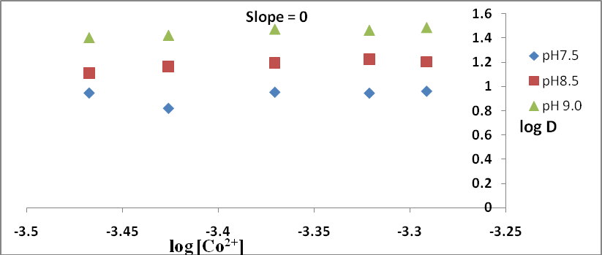

# Figure4.24 Plot of LogD against Log [Co(II)] for the extraction of Co(II) from buffer solution into chloroform solution of 0.05 M H2PrEtP.

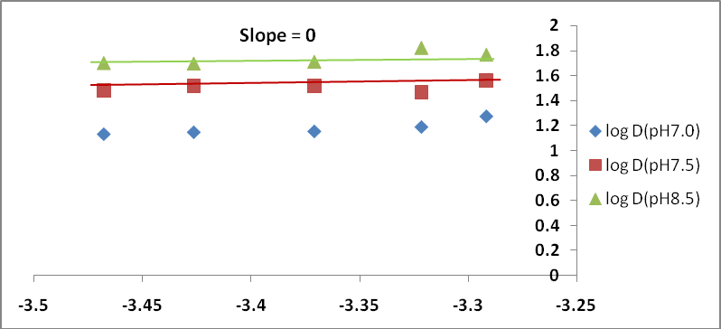

**Figure 4.25 Plot of LogD against Log [Co(II)] for the extraction of Co(II) from buffer solution into chloroform solution of 0.05 M H2PrEtP and 0.05 M HPrP in 9:1 ratio.**

Extraction plots for the variation of metal concentrations gave a zero slope indicating that the extraction was slightly dependent on the concentrations of the metal ions. Data obtained from the extraction processes showed that Co2+ distributes better into chloroform solution of H2PrEtP in the presence of HPrP as synergist at pH 7.0, 7.5 and 8.5. In absence of the synergist, the maximum extraction of Co2+ ions occurred at 3.0×10-2 M Co(II) concentration at pH 9.0 where a percentage extraction of 96.85

% was obtained. The least percentage extraction was observed at metal concentration of 2.2×10-2 M, pH 7.5 which gave a % *E* of

86.85 %. In the presence of HPrP as synergist the maximum extraction was achieved at 2.8×10-2 M metal ion concentration and pH 8.5 corresponding to 98.52 % extraction.

# Effect of Mineral Acids on Extraction of Cobalt with H2PrEtP in

**Chloroform**

In the study of the extraction of Co(II) ions with ligand H2PrEtP, the effect of mineral acids on the extraction of Co(II)

ions was investigated and the results are shown in Figure 4.26. The results shows that increase in the concentration of mineral acids decreased the extraction of Co(II) ions. This could be attributed to low pH of mineral acids that favours polarity of solution, the Co(II) ions are masked in the aqueous phase and as the concentrations of mineral acids in solutions were increased, the % extraction of Co(II) ions became zero.

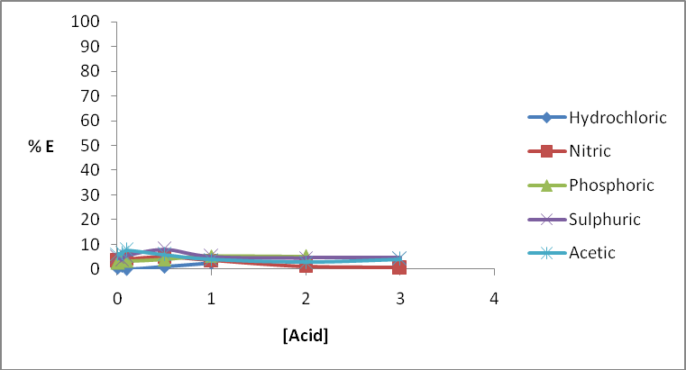

# Figure 4.26 Plot for Effect of Mineral Acids on Extraction of Cobalt with H2PrEtP in chloroform.

* + 1. **Effect of Mineral Acids on Extraction of Cobalt with H2PrEtP and**

# HPrP as Synergist

Figure 4.27 shows the result of the effect of mineral acids on extraction of Co(II) ions with H2PrEtP and HPrP as synergist in chloroform. From the result it was observed that HPrP increased slightly the extraction of Co(II) ions by increasing the hydrophobicity of the Co complex formed. All the mineral acids decreased the extraction of Co(II) ions when their concentration were increased. Kalagbor *et al*., obtained similar result from their work on the extraction of molybdenum(IV). Data for the effect of mineral acids in mixed and single ligand extractions are presented in *Appendices B19 to B28, (Tables 2.18 to 2.27).*

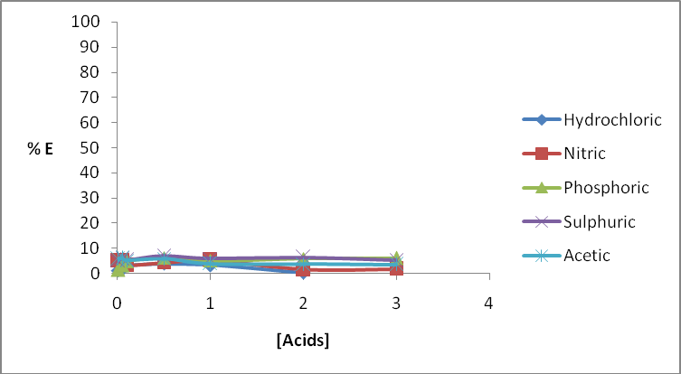

# Figure 4.27 Effect of Mineral Acids on Extraction of Cobalt with H2PrEtP and HPrP as synergist in chloroform

* + 1. **Effect of Anions on Extraction of Cobalt with H2PrEtP**

The results of effects of anions on the extraction of Co(II) ions with H2PrEtP in the absence of HPrP as synergist are shown in Figure 4.28. The results show that chloride ion gave the least extraction for cobalt(II) ions which corresponds to 35.61 % E at chloride ion concentration of 1.00 M. The extraction of Co(II) ions was observed to increase as the concentration of chloride ion was increased from 0.001 M to 0.10 M where % E of was achieved. Further increase in chloride ion concentration from 0.1 M to 0.5 M and 1 M resulted to decrease in extraction of Co(II). Increase in the concentration of sulphate ions from

0.001 M to 0.010 M increased the extraction of Co(II) ion from

46.28 % at 0.001 M to 60.26 % at 0.01 M which was the peak extraction observed for sulphate ions. More increase in the concentration of the sulphate ions resulted to tremendous decrease in percentage extraction. This was as a result of formation of stable Co(II) complex anion which is less hydrophobic (have more affinity for the water medium than the organic phase).

The extraction of Co(II) ions under the influence of nitrate ions in H2PrEtP was similar to that of sulphate ions. The extraction percentage increased readily from 53.00 % observed for nitrate at

0.001 M concentration to its peak extraction of 64.79 % observed at 0.01 M nitrate ion concentration. Phosphate and acetate ions gave the best enhancing effect on the extraction of Co(II) ions. Both anions gave above 50 % extraction at all concentrations. This could be attributed to the high pH values of these anions which enabled them to form a stable hydrophobic complexes with Co(II) ions. Phosphate ion at pH 11.15 and 0.05 M concentration gave its peak extraction of 84.15 % while its least extraction was observed at 1.00 M concentration and pH 11.22 which corresponds to 67.84 % E. Acetate gave 88.57 % as its highest extraction at 0.05 M concentration and pH 7.54. The extraction was poor in iodide ions. Iodide ion gave its highest extraction of 53.93 % at pH 6.37 and concentration of 0.05 M (Fig 4.28).

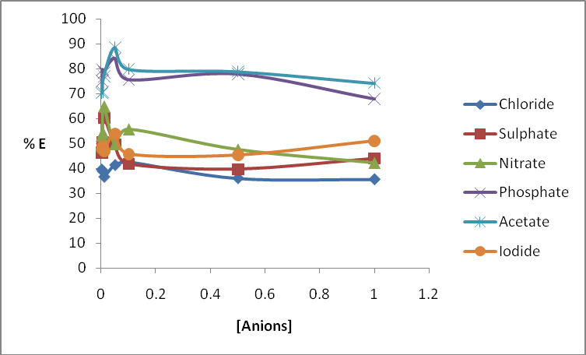

# Figure 4.28 Plot for the Effect of anion on extraction of Cobalt with H2PrEtP in chloroform

* + 1. **Effect of Anions on Extraction of Cobalt with H2PrEtP and HPrP as Synergist**

The results shown in Fig 4.29 indicated that there was a tremendous increase in extraction of Co(II) ions in the presence of the synergist. The extraction of Co(II) ions followed same trend as in the absence of synergy. All percentage extractions were above 50 % for all the anions studied except iodide ion where below 50 % E was observed in most concentrations studied. In most cases for all the anions increasing their concentrations beyond 0.10 M often results to

decrease in percentage extraction of Co(II). The highest extraction of Co(II) was observed at phosphate ion concentration of 0.10 M and pH 11.27 which corresponds to % E of 92.06. All data for the effect of anions on the extraction of Co(II) are presented in *Appendix B29 to B40, (Tables 2.28 to2.39).*

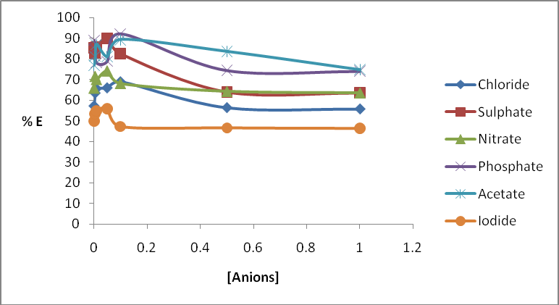

# Fig 4.29 Effect of anions on extraction of Cobalt with H2PrEtP and HPrP as Synergist in chloroform

* + 1. **Effect of Complexing Agents on Extraction of Co(II) ions with**

# H2PrETP

Figure 4.30 showed the results of the effects of complexing agents on the extraction of Co(II) ion with H2PrEtP in the absence of HPrP as synergist. From the results, it was observed

that the extraction of Co(II) ions was less than 50 % for all the complexing agents studied in their various concentrations. This could be attributed to the formation of negatively charged anionic species that are more stable in aqueous phase than in the organic chloroform phase thus resulting to poor extraction of Co(II) complex into the organic phase. In most cases increasing the concentration of the complexing species beyond

0.05 M results to decrease in the extraction of Co(II) ions.

100

80

60

**% E**

40

20

Bromide

Flouride EDTA

Thiocyanate

Oxalate

0

0

0.1

0.2

0.3

0.4

0.5

0.6

Tartrate

**[Complexing agents]**

# Fig 4.30 Effects of complexing agents on extraction of Co(II) ions with H2PrEtP in chloroform

* + 1. **Effect of Complexing Agents on Extraction of Co(II) ions with ligand (H2PrEtP) and HPrP as Synergist.**

Figure 4.31 shows the effects of complexing agents on the extraction of Co(II) ions with H2PrEtP and HPrP as synergist. It

was observed that in the presence of the synergist, increase in concentration of complexing agents greatly increased the extraction of Co(II) ions. EDTA gave the least extraction of Co(II) with all percentage extractions lower than 50 % while fluoride ion gave the best result for the extraction of Co(II) ions with all result above 50 % for all concentrations studied. The highest extraction of Co was observed at fluoride ion concentration of 0.50 M and pH 7.14 which corresponds to

83.35 % E as seen in Figure 4.31. The extraction of cobalt was observed to be dependent on concentration and pH of these species. The extraction values of bromide ions, thiocyanates, oxalates and tartrates fluctuate as their concentrations increased. In most cases, decrease in percentage extractions was observed at 0.1 M and 0.5 M of the complexing species. All data for effect of complexing agents on cobalt extraction are presented in *Appendix B41 – B52,( Tables 1.40 to 1.51).* In comparing our results, Uzoukwu and Godwin, (2012), Okafor and Uzoukwu, (1990) obtained similar results in their work on extraction and separation of U(VI) and Fe(III) and U(VI) and Pb(II) respectively.

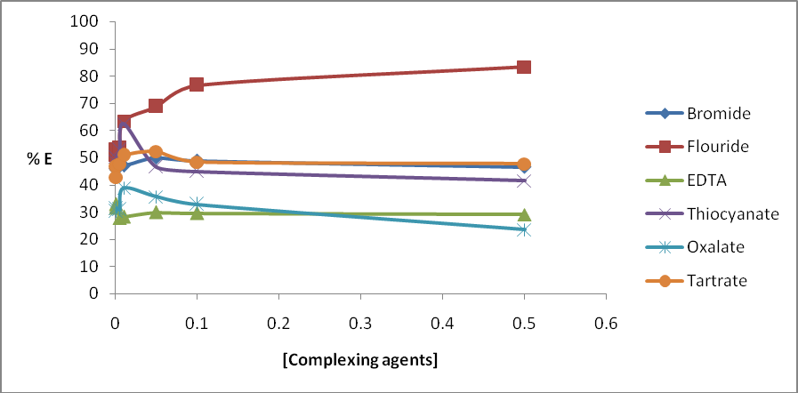

# Fig 4.31 Effect ofcomplexing agents on extraction of Cobalt with H2PrEtP and HPrP as Synergist in chloroform

* + 1. **Proposed Structure for Cobalt(II) H2PrEtP and Cobalt(II) H2PrEtP/HPrP.** Combining the various results obtained from all stages of extraction and what has been done before (Okafor, 1981, Uzoukwu and Adiukwu, 1997, Uzoukwu *et al*., 2004,Bulent et al., 2009) with statistical analysis of slopes we proposed the structures in Figure 4.32 and 4.33 for cobalt(II) H2PrEtP complex and cobalt(II) H2PrEtP/HPrP complex

.

**N**

**N**

**N**

**N**

**Co**

**O O**

**N**

**N**

# Figure 4.32 Proposed Structure of Co [PrEtP]

N



~~N~~

HO N N

Co O N N O O

N

N

# Figure 4.33 Proposed structure of Co (HPrEtP.PrP)O

* + 1. **Extraction of Copper(II) ions**

Distribution of Cu(II) from aqueous phase into chloroform phase having the Schiff base H2PrEtP can be represented by the equation. (4.13)

Cu2+(aq) + H2PrEtP(org) ↔ Cu(PrEtP)(org) + 2H+(org)

(4.13)

The Eqn. (4.13) is based on the assumption that the Cu(II) from aqueous phase is extracted into chloroform by the Schiff base by forming a complex with the Cu(II) ion in the 1:1 mole ratio. Thus the extraction constant Kext can be expressed by the Eqn.- (4.14). [Cu(PrEtP)(org)] [H+]2/ [Cu2+(aq)] [H2PrEtP]

(4.14)

# Effect of pH on Extraction of Cu(II) ions into Chloroform Solution of

**0.05M H2PrETP**

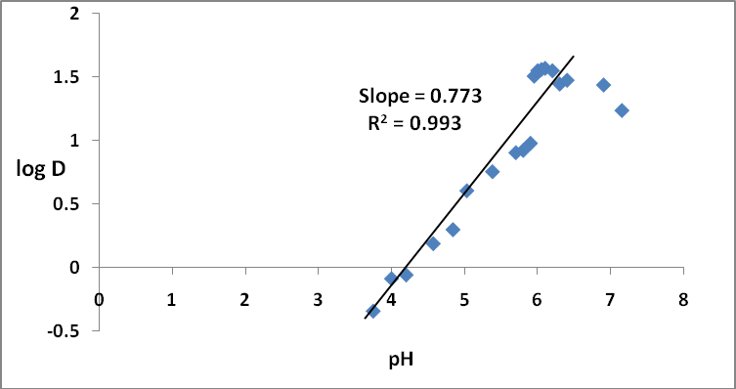

# Figure 4.34 Plot of log D against pH for the extraction of 7.87×10-4 M Cu(II) ions from buffered aqueous solution into chloroform solution of 0.05 M H2PrEtP.

The plot in Fig.4.34 showed the effect of pH of aqueous solution on the distribution of Cu(II) into chloroform solution of H2PrEtP and a slope of one with regression coefficient R2 0.993 was obtained from the graph indicating that 1 mole of hydrogen ion were displaced and confirmed that there were ligand-metal interaction through the oxygen atoms of the hydroxyl functional groups of ligand. The distribution ratio of the metal ions between the two liquid phases becomes;

*D* = [Cu(HPrEtP)(org)] / [Cu2+ ] (4.15)

(aq)

Substituting D into eqn. 4.14 after rearrangement gives Log *D* = Log Kext + Log H2PrEtP + pH

(4.16)

The equation (4.16) showed that the extraction of copper(II) ions into chloroform solution of H2PrEtP increased with increase in pH of aqueous solution and reached a peak at pH 6.10 where a

percentage extraction of 97.38 % was achieved. Thereafter, further increase in pH resulted into a decrease in percentage extraction of the metal. The partition coefficient, log*D* was determined statistically from the plot and found to be 1.56±0.01. The pH½ was found to be 4.57.

* + 1. **Effect of HPrP as Synergist on Extraction of Cu(II)** Figure4.35 is a Plot of LogD against pH for the extraction of 7.87×10-4 M Cu(II). It shows that on addition of HPrP, quantitative extraction of 98.23 % was obtained at pH 6.10. The pH½ was significantly lowered from pH 4.57 (very acidic) to a more acidic pH of 3.0.

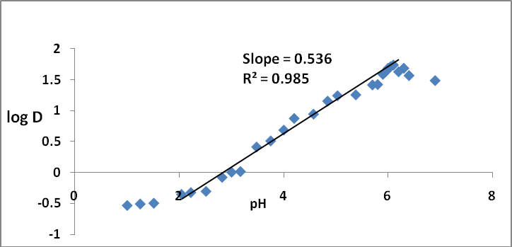

# Figure4.35 Plot of LogD against pH for the extraction of 7.87×10-4 M Cu(II) ions from buffered aqueous solution into chloroform solution of 0.05 M 9:1 H2PrEtP and HPrP

The partition coefficient was found to be 1.70 ± 0.05 and was determined statistically from the plot as show on Fig. 4.35. Plot of Log*D* against pH in the mixed ligands system also gave a slope of 1 indicating that 1 mole of hydrogen ion were displaced during the extraction process, thus the possible reaction equation for the extraction may be written as:

Cu2+(aq) + H2PrEtP(org) + HPrP(org) ↔ Cu(HPrEtP)(HPrP)+ H+

(4.17)

Kext = [Cu(HPrEtP)(HPrP)(org)][H+] /

[Cu2+(aq)][H2PrEtP][HPrP](org) (4.18)

Our results are comparable to that obtained by Uzoukwu *et al*., (1998b)

# Effect of Various H2PrETP and HPrP Concentrations on Extraction

**of Cu(II) ions at Different pH**

All extraction processes studied showed that the extraction of Cu2+ into chloroform solution of H2PrEtP and HPrP increases as the ligands concentrations increased. The extractions followed similar trends on variation of the concentrations of either the ligand (H2PrEtP) or the synergist (HPrP) as shown in Figures

4.36, 4.37 and 4.38. The plots are linear regressions of LogD against Log [H2PrEtP] and LogD against Log [HPrP] and the regression coefficient R2 values indicates that better extraction of Cu2+ was achieved at pH values of 5.0 and 6.0 with R2 0.964 and R2 0.945 for LogD against Log [H2PrEtP] and pH value 6.0 (R2 0.923) for LogD against Log[HPrP] at constant H2PrEtP. On varying the ligand concentration in the absence of the synergist from 2.5×10-3 M to 4.0×10-2 M at a constant pH of 5.0 the %E increased rapidly from 81.50 % observed at 2.5×10-3 M H2PrEtP to 97.37 % at 4.0×10-2 M H2PrEtP concentration. Variation of the ligand concentration at constant pH of 6.0 also gave the least percentage extraction at H2PrEtP concentration of 2.5×10-3 M which corresponds to 81.86% E while peak extraction was observed at H2PrEtP concentration of 3.5×10-2 M which corresponds to 97.50 % E as showed in the plot. At constant pH of 7.0 variation of the ligands concentration gave least extraction of 94.06 % E at H2PrEtP concentration of 2.5×10-3 M while highest percentage extraction of 97.61 %E was observed at H2PrEtP concentration of 3.5×10-2 M. (*Appendix C4-C6, Table 3.3 to 3.5*).

Variation of the ligand in the presence of the synergist at constant pH of 4.7, 5.3 and 6.0 also showed similar increase in percentage extractions copper(II) ions. At pH 4.7, the least extraction was observed at H2PrEtP concentration of 5.0×10-3 M which corresponds to 96.26 % E while peak extraction was achieved at H2PrEtP concentration of 3.0×10-2 M and 4.0×10-2 M where percentage extraction 98.22 % was achieved respectively. Similarly, varying the ligand in the presence of the synergist at pH 5.3 gave least extraction at H2PrEtP concentration of 2.5×10-3 which amounts to 95.40 % E while highest extraction of Cu2+ was observed at H2PrEtP concentration of 2.5×10-2 M and 4.0×10-2 M which gave 98.28 % E each. At constant pH of 6.0, the least percentage extraction was observed at ligand concentration of 2.5×10-3 M while the peak extraction of copper occurred at 4.0×10-2 M H2PrEtP corresponding to 98.53 % E. *(Appendices C7 to C9, Table 3.6 to 3.8).*

Variation of the synergist concentration in the presence of the ligand from 2.5×10-3 M to 2.25×10-2 M at constant pH of 4.7, 5.3 and 6.0 also showed similar results as in the case of ligand

variations. At pH 4.7, least percentage extraction of 94.30 % was observed at HPrP concentration of 2.5×10-3 M while maximum extraction of copper occurred at 2.0×10-2 M HPrP concentration which gave 97.67 % E. Varying the synergist at constant pH of

5.3 gave least extraction 94.06 % E at HPrP concentration of 2.5×10-3 M while maximum extraction of 97.85 % E occurred at HPrP concentration of 2.25×10-2 M. At pH 6.0, the least extraction was observed at HPrP concentration of 3.50×10-3 M while peak extraction of copper occurred at 2.0×10-2 M and 2.25×10-2 M corresponding to 97.50 % E for each. (*Appendices C9 to C11,Table 3.8 to 3.10*).

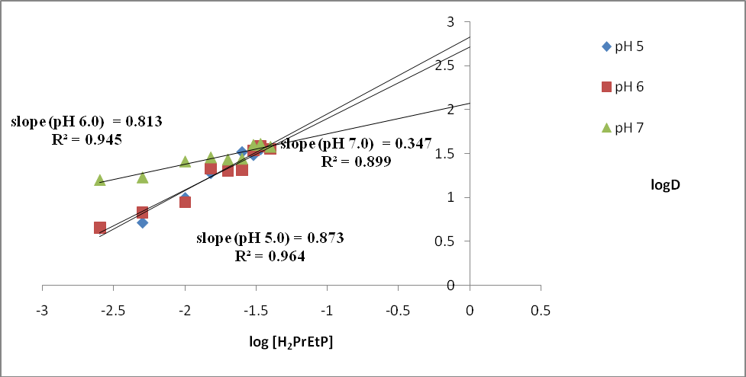

# Figure 4.36.Plot of logD against log[H2PrEtP] for the extraction of 7.87×10-4 M of Cu(II) from aqueous solutions into chloroform solution of H2PrEtP in the absence of synergist at constant pH of 5, 6 and 7.0.

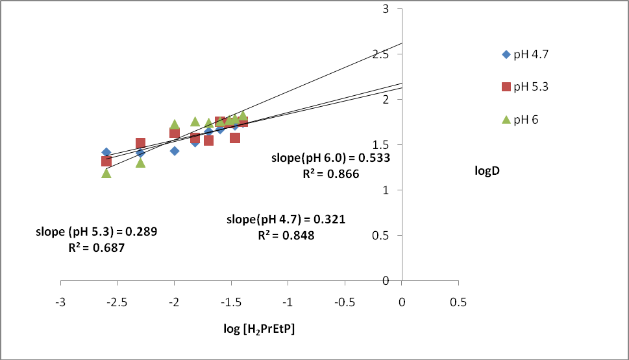

**Figure 4.37 Plot of logD against log[H2PrEtP] for the extraction of 7.87×10-4 M of Cu(II) from aqueous solutions into chloroform solution of H2PrEtP with HPrP kept constant.**

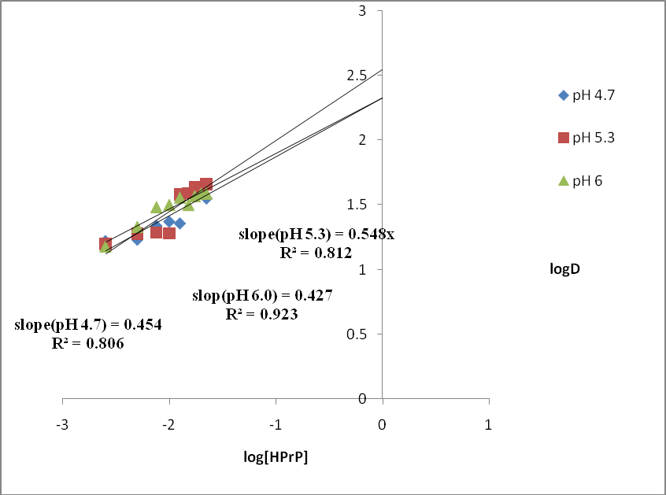

# Figure 4.38 Plot of logD against log[HPrP] for the extraction of 7.87×10-4 M of Cu(II) from aqueous solutions into chloroform solution of H2PrEtP with H2PrEtP kept constant.

* + 1. **Effect of Cu Concentrations on Extraction of Cu(II) ions with**

# H2PrETP and HPrP

Figures4.39 and 4.40 shows the effect of copper concentration on the extraction of copper(II) ions. The result shows that the extraction depends slightly on copper concentration hence a

slope of zero was obtained for the extractions in both mixed and single ligand system. Variation of the meal concentration from 3.15×10-4 M to 4.72×10-4 M at constant pH of 5.0, 6.0 and 7.0 in the absence of HPrP all gave similar result. Percentage extraction of copper for the three pH values fluctuates around 96 % E. Least extraction was observed at Cu2+ concentration of 3.46×10-4 M, pH 6.0 which gave 96.02

% E while maximum extraction occurred at Cu2+ concentration of 3.93×10-4 M, pH 5.0 which corresponds to 96.96 % E.

In the presence of HPrP, varying the metal concentration at three constant pH of 4.7, 5.3 and 6.0 gave its highest extraction at Cu2+ concentration of 3.46×10-4 M which corresponds to

97.43 % E while the least extraction was observed at Cu2+ concentration of 3.15×10-4 M and 3.93×10-4 M pH 5.3 where

96.56 % E was obtained respectively. (*Appendix C13 to C18, Table 3.12 to 3.17*). All data for the extraction of copper are presented in *Appendices C1 to C18 (Tables 3.0 – 3.17).* The results obtained are in agreement with the results obtained by Uzoukwu and Godwin and Uzoukwu and Mbonu (Uzoukwu and Godwin, 2012; Uzoukwu and Mbonu, 2005)

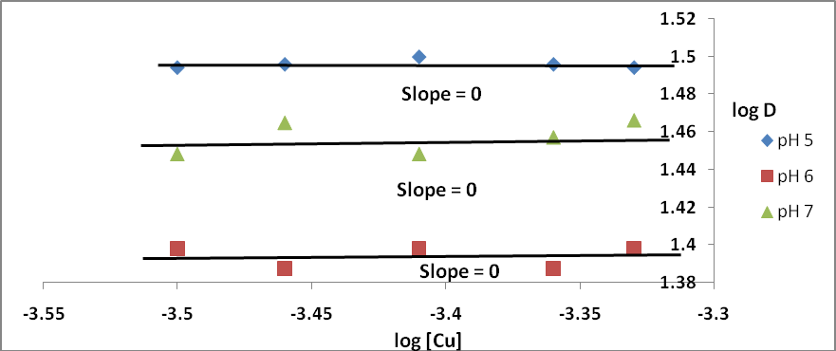

# Figure4.39 Plot of LogD against Log [Cu(II)] for the extraction of Cu(II) from buffer solution into chloroform solution of 0.05 M H2PrEtP

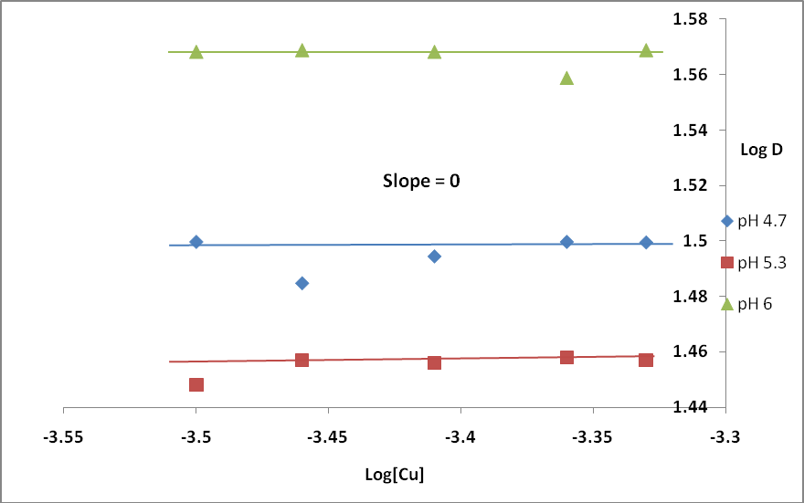

**Figure 4.40 Plot of LogD against Log [Cu(II)] for the extraction of Cu(II) from buffer solution into chloroform solution of 0.05 M H2PrEtP and 0.05 M HPrP in 9:1 ratio**.

# Proposed Structure for Copper(II) H2PrEtP and Copper(II) H2PrEtP/HPrP.

Based on the results and statistical analyses of data presented in *Appendix C1 to C18*, and available reports from literature, (Okafor, 1981, Uzoukwu and Adiukwu, 1997, Uzoukwu *et al*., 2004, Bulent *et al*., 2009) we proposed the structures in Figure

4.41 and 4.42 for cobalt(II) H2PrEtP complex and cobalt(II) H2PrEtP/HPrP complexwe propose the structures in Figures 4.41 and 4.42 for the copper(II) complex with H2PrEtP and H2PrEtP/HPrP respectively.

HO N N

N N

Cu O N N



# Figure 4.41 Proposed Structure of

**Cu(HPrEtP)o**





N

~~N~~

HO

N

N

Cu

O

O

N

N

N

N

OH

# Figure 4.42 Proposed structure of Cu(HPrEtP.HPrP)O

**CHAPTER FIVE**

# CONCLUSION, CONTRIBUTION TO KNOWLEDGE AND RECOMMENDATIONS

* 1. **Conclusion**

On studying the distribution of nickel(II), cobalt(II) and copper(II) in buffered aqueous medium with a chloroform

solution of H2PrEtP alone a pH½ of 7.75 was observed for nickel,

7.05 for cobalt and 4.57 for copper. The synergistic effect HPrP shifted the pH½‘s from pH 7.75 to pH 5.75 for nickel, from pH

7.05 (near neutral) to 6.25 (slightly acidic) for cobalt and from pH 4.57 to a more strongly acidic pH of 3.0 for copper. The partition coefficients were; H2PrEtP *D*1 2.02±0.02 and H2PrEtP/HPrP*D*2 2.03±0.02 for nickel, H2PrEtP alone *D*1 1.78±0.02 and H2PrEtP/HPrP mixture *D*2 2.06±0.10 for cobalt, H2PrEtP *D*11.56±0.01 and H2PrEtP/HPrP*D*2 1.70±0.05 for copper respectively indicating that there is a slight difference in the distribution of these metal ions into chloroform solution of H2PrEtP and into mixture of H2PrEtP/HPrP. The extraction constants*KextNi1*was found statistically to be -13.38±0.42 for Ni in H2PrEtP,*Kext Ni2* was also found to be -9.87±0.40 for Ni in H2PrEtP/HPrP and is more than *KextNi1*.*KextCo1* for H2PrEtP is - 14.12±0.40 and is also less than *KextCo2* -11.8±0.33 for H2PrEtP/HPrP while *KextCu1* is -3.25±0.10 and *KextCu2* was found to be -3.12±0.10. The values indicate that the metals distributes better into the mixed ligand system from the buffered media. From all the observation, we concluded that the extraction of Ni(II) and Co(II) ions in buffered media with H2PrEtP or its

mixture with HPrP is more efficient in slightly alkaline medium while that of Cu(II) ion is more effective in a strong to moderately acidic medium.

# Contribution to Knowledge

The research has shown that mixed ligand extraction is more effective and efficient in the concentration, recovery and separation of heavy metals from various kinds of contaminants in aqueous medium. It went further to demonstrate that a careful control of pH of aqueous medium and addition of various anionic species to the extraction medium can either enhance or inhibit the extraction of a metallic ion of interest depending on the desire of the researcher. Our work was able to achieve a complete and permanent removal of the three metallic ions of interest; cobalt(II), copper(II) and nickel(II) from aqueous medium by a process of complexation unlike the physisorptions process which cannot guarantee complete removal of these metals as a result of the high tendency of desorptions occurrence. Finally, the research has shown that certain ligand can complex metallic ions over a wide range of pH values ranging from acdic, moderately acidic, neutral, moderately alkaline to alkaline pHs

and hence can be well documented and recommended as a guide to students who want to carry out a research on Inorganic/coordination chemistry, analytical and environmental chemistry.

# Recommendations

From the results and conclusion, we recommend that:

The extracted metal complexes should be isolated and characterized to obtain actual arrangements of atoms in these complexes.

Kinetic studies on the extractions should be carried out to throw more insight into the extraction mechanisms. Extraction studies of the ligand H2PrEtP for other metals should be undertaken.

# REFERENCES

Aizenberg, I., Miara, L., and Ulman, O. (2001); ‗Heavy Metal Toxicity in Psittacine Birds‘, *Journal of Avian Medicine and Surgery*, 15: 31 – 36.

Akama, Y. (1985a); ‗The synthesis of 1-phenyl-3-methyl-4- acylpyrazolon-5-one,‘*Polyhedron,* 4: 59.

Akama, Y. (1985b); ‗Studies on extraction of Copper(II) with 1- phenyl-3-methyl-4-acylpyrazolon-5- one‘, *Polyhedron,* 4(II):53.

[Amarasekara](http://www.springerlink.com/content/?Author=A.%2BS.%2BAmarasekara), A. S., [Owereh](http://www.springerlink.com/content/?Author=O.%2BS.%2BOwereh), O. S., and Aghara, S. K., (2009a);‗Synthesis of 4-acylpyrazolone Schiff base ligand grafted silica and selectivity in adsorption of lanthanides from aqueous solutions‘, *Journal of Rare Earths*, *27*(5): 870.

Amarasekara, A.S., Owereh, O.S., Lyssenko, K.A., Timofeeva,

T.V. (2009b); Structural tautomerism of 4-acylpyrazolone Schiff bases and crystal structure of 5-methyl-2-phenyl-4-

{1-[pyridine-2-ylmethyl] amino} – ethylidene] -3-4- dihydro-pyrazol-3-one, Journal of Structural Chemistry,50(6),1159.

Angelusiu, M.V, Almăjan, G. L, Ilies, D.C, Rosu, T. and Negoiu, M, (2008); ‗Cu(II) Complexes with Nitrogen- Oxygen Donor Ligands:Synthesis and Biological Activity‘, Chem. Bull, 53:(67): 1-2.

Azza, A.A. Abou-Hussein, W. L.,(2012) ‗Synthesis, spectroscopic and biological activities studies of acyclic and macrocyclic mono and binuclear metal complexes containing a hard-soft Schiff base‘, Spectrochim. Acta Part A; 95: 596–609.

Barkat, D., Kameche, M., Tayeb, A., Benabdellah, T., and Derriche, Z.(2004); ‗Ionic strength effect on the liquid- liquid extraction of zinc(II) and cadmium(II) from sulphate medium by 1-phenyl-3-methyl-4-benzoylpyrazol-5-one in chloroform ‗, *Physics and Chemistry of Liquids*,42 (1); 53.

Belcher, R., Blessel, K., Cardwell, T., Praica, M., Stephen, W. I., and Uden, P. C. (1973); ‗Volatile transition metal complexes of bis-acetylacetone-ethylenedi-imine and its fluorinated analogues‘, *Journal of Inorganic Nuclear Chemistry,*35. 1127 – 1144.

Beokon, Y. N., Bulychev, A. G., Maleev, V. I., North, M., Malfanov, IL., and Nikolai, S., (2004); ‗Asymmetric synthesis of cyanohydrins catalysed by a potassium bis [ N-

salicylidene-(R) tryptophanato] cobaltate complex‘*, Mendeleev Comm,* 249-250; *Chem Abstr*,143 (2005) 277534 Bulent, D., Fatma, K., and Mustafa, C., (2009) ―Synthesis, Characterization and Extraction Studies of N,N‖-bis(1-

biphenyl-2-hydroxyimino-2-(4-acetylamilino)-1- ethylidene)-diamines and their homo and heteronuclear copper(II) complexex‖., Journal of Chemical Sciences, 121: 2, 163-171.

Chakraborty, H., Paul, N. and Rahman, M .L.,(1994); ‗Catalytic activities of Schiff bases aquo complexes of Cu(II) in the hydrolysis of aminoacid esters‘, *Trans. Met. Chemistry*,London, 19. 524-526

Chinnasamy, and Karuppannan, N.(2002); ‗Ruthenium(II) carbonyl complexes with tridentate Schiff bases and their antibacterial activity‘ Trans. Met. Chem; 27: 75–79.

Cohan, Zahid H and Kausar S, (2001);‗Synthesis, characterization and biological effect of anions on Co(II) and Ni(II) chelates of tridentate Schiff base‘, *Journal of Chemical Society Pak*., 23:163-167;Chem Abstr,136 (2002) 410591.

Cotton, F. A., Wilkinson, G., Murillo, C. A., and Bochmann, M. (1999); *Advanced Inorganic*

*Chemistry, John Wiley and Sons, Inc. New York. p. 1376*

Cotton, S. (1991). *Lanthanides and Actinides*. Oxford University Press, New York, p. 128

Cottrel, T.L.,(1954), The strength of chemical bonds, Butterworth London,Retrieved:1st December 2014.

Coursey, J.S., Schwab, D.J., Tsai, J.J and Dragoset, R.A., (2014),

Atomic weight and isotopic

composition (version 3.0) National Institute of Standard and Technology, Gaithersburg, p;3.

Dean, J. A. (1998); Lange‘s Handbook of Chemistry 15th Edition, McGraw-Hill Inc. New York, pp. 922 – 1156.

Dhar, D .N. and Taploo C. L.,(1982); ‗Schiff bases and their applications‘, *Journal of Scientific Industrial Research*, 41. 501-506

Ekekwe, D.N., Arinze, A.J, Nnanna, L.A, Ukpabia, C.F and Ogwuegbu, M.O.C. (2012); ―Synthesis, complexation and characterization of 1-phenyl-3-methyl {-4-(p-Nitrobenzoyl} pyrazolone-5 and its complexes of Ba (II), Sr (II), Zn (II)‖ American Journal of Chemistry, 2V; 52-56

Emsley, J., (2011) Natures building block, An A-Z Guide to elements 2nd Ed. Oxford University Press, New York, PP.15

– 35.

Eyal, A.M., Baniel, A.M., Hajdu, K., and Mizrahi, J. (1990);

‗New Process for Recovery of Zinc

Sulfate and Sulfuric Acid from Zinc Electrowinning Bleed Solutions‘, *Solvent Extraction and Ion Exchange*,8; 209.

Ferraro, J. R., (1971); Low – frequency vibration of inorganic and coordination compounds, Plenum Press, New York.pp. 34 – 23.

Ghose, A. K., Sebesta, F., and Stary, J. (1975); ‗The Synergic extraction of Radium and Barium with 1-Phenyl-3-Methyl- 4-benzoylpyrazol-5-one in the presence of Tri-n- octylphosphate‘, *Journal of Radioanalytical Chemistry,* 24; 345.

Greenwood, N. N., and Earnshaw, A. (1997); *Chemistry of the Elements* (2nd ed.). Butterworth-

Heinemann, Oxford, pp. 1273–1274.

Hashemi, O. R., Kargar, M. R., Raoufi, F., Moghimi, A., Aghabozorg, H., and Ganjali, M. R.

**(**2001);‗Separation and preconcentration of trace amounts of lead on octadecyl silica membrane disks modified with a new S-containing Schiff's base and its determination by flame atomic absorption spectrometry‘, [*Microchemical Journal*](http://www.sciencedirect.com/science/journal/0026265X), 29(1); 1- 6.

Hayness, W.M., (2015), C.R.C Handbook of Chemistry and physics, 95th Ed., C.R.C press / Taylor and Francis, Boca Raton FL, internet version 2015. Retrieved 1st December 2014.

Holdich, R. G., and Lawson, G. J.,(1985);‗The solvent extraction of lead from chloride solutions using di(2- ethylhexyl)phosphoric acid‘, [*Hydrometallurgy*](http://www.sciencedirect.com/science/journal/0304386X), [14( 3](http://www.sciencedirect.com/science?_ob=PublicationURL&_tockey=%23TOC%235935%231985%23999859996%23420065%23FLP%23&_cdi=5935&_pubType=J&view=c&_auth=y&_acct=C000050221&_version=1&_urlVersion=0&_userid=10&md5=39059812f74da16e466189027525c4c4)); 387-

393.

Ibrahim B, Ismail Z., Brahim H, Richard T and Abdelkrim R.(2006); Liquiq-liquid extraction of

copper (II), cadmium (II) and lead (II) using Tripodal N- donor pyrazole ligands, ARKIVOC, (XI); 59-65.

Irving, H.M.N.H. (1965); "Synergic Effects in Solvent Extraction", *Angewandte Chemie International Edition,*4 (1): 95–96.

Jenson, B.S. and Navratti, O., (1970); ‗Uranium (VI) extraction with benzyloctadecyldimethylammonium chloride (BODMAC) from chloride and sulphate solutions‘, Journal of Radioanalytical Chemistry, 5:313.

Jenson, B.S., (1959a); ‗The synthesis of 1-phenyl-4-acyl pyrazolones‘, Acta Che.Scand, 13:1668.

Jenson, B.S., (1959b); ‗Solvent extraction of metal chelates‘, Acta Che.Scand, 13:1890.

Kalagbor, A.I., Uzoukwu, B.A., and Chukwu J., (2011);

‗Extraction of molybdenum (VI) with 4-Adipoyl and 4- sebacoyl derivatives of Bis(1-phenyl-3-methylpyrazolone-5) in acid media‘, Nature and Science,9(3):37.

Karlin D.K., (2003); Progress in Inorganic Chemistry, volume 51, An Interscience Publication, John Wiley and Sons, Inc. New York, PP.21 – 49.

Khuhawar, M.Y., and Lanjwani, S.N., (1996); ‗Simultaneous solvent extraction and high performance liquid chromatographic determination of uranium, iron, nickel and copper in mineral ore samples and phosphate rock residues using N,N‘-ethylenebis(salicylaldimine) as complexing reagent‘, Journal of chromatography, 740(2);296 – 300.

Laghari, A.J., Ali, Z.M., Bughio, M.N., Shah, F.A., Zardari, L.A and Khuhawar, M.Y. (2011);

‗Capilary gas chromatographic separation of Copper,

Mercury, Lead and Cadmium as

complexes of pyrrolidine dithiocarbamate‘, Australian Journal of Basic and Applied Sciences, 5(5):1108 – 1111.

Lee, J.D., (1999); Concise Inorganic Chemistry 5th Edition, Blackwell Science Ltd, United Kingdom, 159.

Liu, G., Liu, L., and Jia, D.K.,(2005); ‗Synthesis, Structure and Photochromic Properties of 1-Phenyl-3-Methyl-4-(4-

Bromobenzal)-Pyrazolone-5 Thiosemicarbazone‘, Structural Chemistry, 16(2): 135.

Liu, L., Dian-Zeng, J., Ji, D.Z., Yu, Y.L., and Yu, K.B., (2003);

‗Synthesis, Structure and

photochromic properties of 4-acylpyrazolone derivatives‘, Journal of Photochemistry and

Photobiology, 154:117.

[Lu](http://www.deepdyve.com/search?author=Lu%2C%2BJuanjuan), J., Zhang, L., [Liu, L.,](http://www.deepdyve.com/search?author=Liu%2C%2BLang) [Liu, G.,](http://www.deepdyve.com/search?author=Liu%2C%2BGuangfei) [Jia, D.,](http://www.deepdyve.com/search?author=Liu%2C%2BGuangfei) [Wu, D., and](http://www.deepdyve.com/search?author=Wu%2C%2BDongling) [Xu,](http://www.deepdyve.com/search?author=Xu%2C%2BGuancheng) [G.,(2008)](http://www.deepdyve.com/search?author=Xu%2C%2BGuancheng); ‗Study of fluorescence properties of several 4- acyl pyrazolone derivatives and their Zn (II) complexes‘*,* [*Spectrochimi. Acta,*](http://www.deepdyve.com/browse/journals/spectrochimica-acta-part-a-molecular-and-biomolecular-spectroscopy)71(3): 1036.

MacKay, B., (2010)*; Officials Widen Nigeria Lead Poisoning- Tests; ‘Contamination from Gold mining has caused at least 163 deaths’,*The Wall Street Journal, U.S edition, *Thursday, June 17.*

Mackay, K. M., and Mackay, R. A.,(1972); *Experimental methods. Modern Inorganic Chemistry 2nd edition, intertext publishers, London,* pp*. 20 – 101.*

Magdy, A. H. Z., Farag, A. A., El-E., Salah, M. Y., Tarek, A. R. S., and Nader, M. B.,(2007);‗Rapid and Efficient Synthesis of 4-Substituted Pyrazol-5-one under Microwave Irradiation in Solvent-Free Conditions‘, *Archiv der Pharmazie,* 340(11): 591.

Mahjoub, A. R., and Ali M.,(2001); "A Dimeric Mixed-Anions Lead(II) Complex: Synthesis and

Structural Characterization of [Pb2(BTZ)4(NO3)(H2O)](ClO4)3 {BTZ = 4,4'-Bithiazole}",

[*Chemistry Letters*](http://en.wikipedia.org/wiki/Chemistry_Letters),30 (12): 1234.

Makrilik, E., and Vanura, P.M.,(2006);*‘Solvent extraction of lead using a nitrobenzene solution of strontium dicarbollycobaltate in the presence of polyethylene glycol (PEG 400)’,*Journal of Radioanalytical and Nuclear Chemistry, *267 (1):233 – 235.*

Malek, F., Ramdani, A., Zidane, I., Yahyi, A., Radi, S.,(2005), Tetrahedron ,61:2995.

[Mezhov](http://www.springerlink.com/content/?Author=E.%2BA.%2BMezhov), E. A., [V. A. Kuchumov](http://www.springerlink.com/content/?Author=V.%2BA.%2BKuchumov), V. A., and [Druzhenkov](http://www.springerlink.com/content/?Author=V.%2BV.%2BDruzhenkov), V. V., (2002); ‗Study of Extraction of Palladium from Nitric Acid Solutions with Nitrogen-Containing Compounds, as Applied to Recovery of Fission Palladium from Spent Nuclear Fuel of Nuclear Power Plants: 1. Extraction and Backwashing Conditions‘, [*Radiochemistry*](http://www.springerlink.com/content/1066-3622/), [44 (2](http://www.springerlink.com/content/1066-3622/44/2/)): 135.

Mhaske, A., and Dhadke, P.,(2001);‗Liquid-Liquid Extraction and Separation of Rhodium(III) from other Platinum Group Metals with CYANEX 925‘. *Separation Science and Technology,* 36([14):](http://www.informaworld.com/smpp/gotoissue~db%3Dall~content%3Da713732007) 3253 – 3265.

Nakamoto, K., (1970);‗Infrared spectra of Inorganic and coordination compounds‘, *Spectrochimica Acta,* 37A(11): 945

Nishinaga, A., Yamada, T., Fujisawa, H. and Ishizaki K., (1988);

‗Catalysis by cobalt Schiff complexes in the oxygenation of alkenes on the mechanism of ketonization‘, *Journal of Molecular Catalysis,*48. 249-64, (1276); Chem Abstr,111

(1989) 22902.

Okafor, E. C., (1981); ‗The metal complexes of heterocyclic β- diketones and their derivatives‘, *Spectrochemica Acta*, 37A(11): 945.

Okafor, E. C., and Uzoukwu, B. A.,(1990);‗Extraction of Fe (III) and U (VI) with 1-phenyl-3-methyl-4-acylpyrazolones-5 from aqueous solutions of different acids and complexing agents‘, *Radiochimica Acta,* 51: 167.

Okafor, E. C.,(1982); ‗Observations on 1-phenyl-3-methyl-4- trifluoroacetylpyrazolone-5, a promising extracting agent‘, *Talanta,* 29 (4): 275 – 278.

Onyedika, G., Arinze, J and Ogwuegbu, M.,(2005), Studies on Extraction behavour of Cobalt (II) with Nitrobenzoyl pyrazolone-5., Journal of mineral and material characterization and Engineering,,1:90-94.

Oshima, S., Hirayima, N., Kubono, K., Kokusen, H., and Honjo, T., (2002); ‗Structural Control of Schiff Base Ligands for Selective extraction of Copper (II)‘, *Analytical Chemistry,* 18: 1351 – 1355.

Otuya, B. O., Akporohnor, E. E., and Achuba, F. I., (2008);

‗Determination of Heavy Metals in Toads Exposed to Oil Polluted Environment (Ekpan) Delta State, Nigeria‘, *The Environmentalist,*28: 405 – 408.

[Parajuli](http://www.springerlink.com/content/?Author=Durga%2BParajuli), D., [Hirota](http://www.springerlink.com/content/?Author=Koichi%2BHirota), K., and [Seko](http://www.springerlink.com/content/?Author=Noriaki%2BSeko), N.,(2011);‗Effective separation of palladium from simulated high level radioactive waste***,***[*Journal of Radioanalytical and Nuclear*](http://www.springerlink.com/content/0236-5731/)[*Chemistry,*288(1](http://www.springerlink.com/content/0236-5731/)) 53.

Pavithran, R., and Reddy, M. L. P.,(2005); ‗Steric effects of polymethylene chain of 4- acylbis(pyrazolones) on the solvent extraction of trivalent lanthanoids: synergistic effect with mono and bifunctional neutral organophosphorus extractants‘, *Analytica Chimica Acta,* 536(1-2): 219 – 226.

Pendrido, R., Bermejo, M. R., Romero, M. J., Vázquez, M., González-Noya, A. M., Maneiro, M.,

Rodríguez, M. J., and Fernández, M. I.,(2005);**‘**Syntheses and X-ray characterization of metal complexes with the pentadentate thiosemicarbazone ligand bis(4-*N*-

methylthiosemicarbazone)-2,6-diacetylpyridine. The first pentacoordinate lead(II) complex with a pentagonal geometry‘, *Dalton Transactions*., 572-579.

[Persson, I](http://www.ncbi.nlm.nih.gov/pubmed?term=%22Persson%20I%22%5BAuthor%5D)., [Lyczko, K](http://www.ncbi.nlm.nih.gov/pubmed?term=%22Lyczko%20K%22%5BAuthor%5D)., [Lundberg, D](http://www.ncbi.nlm.nih.gov/pubmed?term=%22Lundberg%20D%22%5BAuthor%5D)., [Eriksson, L](http://www.ncbi.nlm.nih.gov/pubmed?term=%22Eriksson%20L%22%5BAuthor%5D)., and[Płaczek,](http://www.ncbi.nlm.nih.gov/pubmed?term=%22P%C5%82aczek%20A%22%5BAuthor%5D) [A](http://www.ncbi.nlm.nih.gov/pubmed?term=%22P%C5%82aczek%20A%22%5BAuthor%5D).,(2011);‗Coordination Chemistry Study of Hydrated and Solvated Lead(II) Ions in Solution and Solid State‘, *Inorganic Chemistry,*7; 50 (3):1058 – 72.

[Rashid](http://www.springerlink.com/content/?Author=M.%2BRashid), M., and [Ejaz](http://www.springerlink.com/content/?Author=M.%2BEjaz), M.,(1985); ‗Liquid-liquid partition of cobalt between trilaurylamine N-oxide and aqueous thiocyanate solutions‘, [*Journal of Radioanalytical and*](http://www.springerlink.com/content/0236-5731/)[*Nuclear Chemistry*](http://www.springerlink.com/content/0236-5731/), [89(2](http://www.springerlink.com/content/0236-5731/89/2/)): 399-408.

Reddy, M. L. P., Sushanta, K. S., and Chakravortty, V.,(2000);‗4-Acylbis(1-Phenyl-3-Methyl-5- Pyrazolones) as Extractants for f-Elements‘, *Solvent Extraction and Ion Exchange,*[*18(6):*](http://www.informaworld.com/smpp/title~db%3Djour~content%3Dt713597298~tab%3Dissueslist~branches%3D18#v18)1135– 1153.

Remya, P. N., Pavithran, R., and Reddy, M. L. P., (2005); ‗Effect of polymethylene chain length of 4-Acylbis(1-Phenyl-3- Methyl-5-Pyrazolones) on the extraction of Vanadium (V);

Synergistic effect with neutral organophosphorous extractants‘ *Solvent Extraction and Ion Exchange,* 23(4): 501 – 508.

Roy, A., and Nag, K**.,**(1978);‗Solvent extraction behavior of rare earth ions with 1-phenyl-3-methyl-4-benzoyl-5- pyrazolone—II: An examination of gadolinium break, tetrad effect, double-double effect and the relevance of ―inclined- W‖ plot‘, *Journal of Inorganic and Nuclear Chemistry, 40(2):* 331-334.

Saracoglu, S., Soylaka, M., and Elci, L.,(2003);‗Separation/Preconcentration of Trace Heavy Metals in Urine, Sediment and Dialysis Concentrates by Coprecipitation with Samarium hydroxide for Atomic Absorption Spectrometry‘,*Talanta,*59: 287 -293.

Sarbani, P., Mareddy, T. and Devi, M.S.,(2008) ―High speed synthesis of pyrazolones using microwave–assisted heat reaction technology‖, Journal of Brazilian Chemical Society, 19(6):1552-1590.

Sato[,](http://www.sciencedirect.com/science/article/pii/S0003267000808168#implicit0) K., Akama, Y., and Nakai, T.,(1988); ‗Liquid-liquid extraction separation of zinc and Cadmium with 1-phenyl-3- methyl-4-acyl-5-pyrazolones and tri-n-octylphosphine oxide‘, [*Analytica Chimica Acta*](http://www.sciencedirect.com/science/journal/00032670), [207](http://www.sciencedirect.com/science?_ob=PublicationURL&_tockey=%23TOC%235216%231988%23997929999%23269916%23FLP%23&_cdi=5216&_pubType=J&view=c&_auth=y&_acct=C000050221&_version=1&_urlVersion=0&_userid=10&md5=cf1a57425aa7c5c06572a4324be9bb1e): 367-372.

Singh, S., Chakravortty, V., and Dash, K. C.,(1988); ‗Solvent extraction of uranium(VI) by LIX-54 and its mixtures‘, *Journal of Radioanalytical and Nuclear Chemistry,*122: 137

-142.

Sreedaran, S., Shanmuga, B. K., Kalilur,R.A., Rajesh K, Nirmala, G., Jagadish, L., Kaviyarasan, V., and Narayanan, V., (2008); ‗Synthesis, electrochemical, catalytic and antimicrobial activities of novel unsymmetrical macrocyclic dicompartmental binuclear nickel(II) complexes‘, Polyhedron ; 27: 1867–1874.

Stronski, I.,(1976);‗Extraction of Chelates of Some Metal ions with Aromatic Schiff Bases‘, *Journal of Radioanalytical Chemistry,*33:153 – 161.

Tack, F. M. G., and Verloo, M. G., (1995); ‗Chemical Speciation and Fractionation in Soil and Sediment

Heavy Metal Analysis: A Review‘, *International Journal of Environmental Analytical Chemistry,* 59:225 – 238.

[Topuz, B](http://www.ncbi.nlm.nih.gov/pubmed?term=%22Topuz%20B%22%5BAuthor%5D)., and [Macit, M](http://www.ncbi.nlm.nih.gov/pubmed?term=%22Macit%20M%22%5BAuthor%5D).,(2011); ‗Solid phase extraction and preconcentration of Cu(II), Pb(II), and Ni(II) in environmental samples on chemically modified Amberlite XAD-4 with a proper Schiff base‘, [*Environmental*](http://www.ncbi.nlm.nih.gov/pubmed/20237836)[*Monitoring Assessment.*](http://www.ncbi.nlm.nih.gov/pubmed/20237836),173(1-4): 709 – 722.

Ukoha, P.O., Nwabue, F.I. and Obasi, L.N., (2011). ‗Solvent Extraction Studies of Bis(4-hydroxypent-2-ylidene) diamino ethane: Composition of Extracted Copper (II) species. *E- Journal of Chemistry*, 8(4), 1864-1871.

Uzoukwu, B.A.,(2009) ―Basic Analytical Chemistry‖. Millennium edition, Paragraphics (an imprint of Jeson Services) 314 Airforce Shops market Junction PH-Aba Expressway, Rumuomasi, PH, Rivers State, Nigeria. PP. 166-196.

Uzoukwu, B. A, Gloe, K., and Duddeck, H., (1998b);‗Extraction of Uranium(VI) and Vanadium(V) with

4-Adopoyl and 4-Sebacoyl Derivatives of Bis(1-Phenyl-3- Methyl-Pyrazolone-5) and Effect of Decanol on The distribution Behaviour of These Metal ions‘, *Solvent Extraction and Ion Exchange,*16(3):751- 774.

Uzoukwu, B. A., Adiukwu, P. U., Al-Juaid, S. S., Hitchcock, P. B., and Smith, J. D., (1996);

‗Pyrazolonato complexes of lead. Crystal structures of bis(1-phenyl-3-methyl-4-

acetylpyrazolonoato)lead(II) and bis(1-phenyl-3-methyl-4- butanoylpyrazolonoato)lead(II) *Inorganica Chimica Acta*,250:173.

Uzoukwu, B. A., Al-Juaid, S.S., Hitchcock, P. B., and Smith, J. D.,(1993);‗The Synthesis and crystal structures of 1-phenyl- 3-methyl-4-butanoylpyrazol-5-one and of two pyrazolonato complexes of iron‘,*Polyhedron,*12(22):2719.

Uzoukwu, B. A., and Adiukwu, P. U., (1996);‗Kinetic studies on the recovery of Lead (II0 and

Lanthanum (III) from aqueous solution with xylene solutions of 1-phenyl-3-methyl-4- benzoylpyrazolone‘,*Indian Journal of Chemistry,* 35A:230.

Uzoukwu, B. A., and Adiukwu, P. U., (1997); *‘*Metal-Nitrogen bonding in 1-phenyl-3-methyl-4-

acylpyrazolone-5 complexes of lead(II): Synthesis and spectroscopic studies‘,*Synthesis and*

*Reactivity in Inorganic and Metal-Organic Chemistry*, 27(2):187.

Uzoukwu, B. A., and Godwin, J., (2012); Separation of U(VI) from a mixture with Pb(II) in Aqueous Solutions using N,N‘-Ethylenebis(4-butanoyl-2,4-dihydro-5-methyl-2- phenyl-3H-pyrazol-3-oneimine) Schiff *Base* (*‘Separation of 238U from 207Pb using EKEYEKWUTE-technique’)’, Applied for Patent.*

Uzoukwu, B. A., and Mbonu, J. I.,(2005);‗Effect of chloride ion in a buffer medium on the liquid-liquid extraction of Cu(II) and Ni(II) using 1-phenyl-3-methyl-4-trichloroacetyl- pyrazolone-5‘,*Solvent Extraction and Ion Exchange*, 23(6):759 -77.

Uzoukwu, B. A., and Nwachukwu, C. K.,(1994);‗Extraction of Mo(VI) from mineral acid solutions using benzene solution of 1-phenyl-3-methyl-4-butyrylpyrazolone-5‘ *Indian Journal of Chemistry,* 33A:274 – 276.

Uzoukwu, B. A., Gloe, K., Menzel, M.,& Wawrzyniak, K.,(2004); ‗Syntheses and 119Sn Mössbauer spectral characterization of tin(IV) complexes of 4-acyl-1-phenyl-3 methylpyrazolones-5 and molecular modelling of 4-acetyl-1 phenyl-3-methylpyrazolone-5‘, Indian Journal of [*Chemistry,*43A: 701 - 705](http://www.niscair.res.in/sciencecommunication/researchjournals/rejour/ijca/ijca2k4/ijca_apr04.asp#p2).

Uzoukwu, B. A., Gloe, K., and Duddeck, H., (1998c); ‗4- Acylpyrazoloneimine Schiff Bases and their Metal Complexes: Synthesis and Spectroscopic Studies‘, *Synthesis*

*and Reactivity in Inorganic and Metal-Organic Chemistry,*

28(5):819 – 831.

Uzoukwu, B. A., Gloe, K., and Duddeck, H.,(1998a);‗N. N‘- Ethylenebis(1-phenyl-3-methyl-4-acylpyrazoloneimine) derivatives: Synthesis and UV, IR, 1H and 13C NMR Spectral Studies‘, *Indian Journal of Chemistry,*37B: 1180 – 1183.

Vogel, A.I., (2000); ―Textbook of Quantitative Chemical Analysis‖. 6th edition, Prentice Hall (an imprint of Pearson Education Limited), Edinburg Gate. Harlow Essex CM20 2JE England, PP.214-220

Vogel, A. I., (1961); Solvent Extraction.―Quantitative Inorganic Analysis Including Elementary

Instrumental Analysis‖. 3rd edition, Longmans, Green and Co. Ltd, London, P. 892.

Xiao-yuan, C., Shu-zhong, Z., and Qing-jin, M.,(1996); **‘**Synthesis and spectroscopic studies of trinuclear uranyl complexes with compartmental ligands H4L derived from 2,6-dipicolinoyl-hydrazine and 4-acyl-1-phenyl-3-methyl-

pyrazolones-5 (where acyl = benzoyl, acetyl, iso-butyryl or iso-valeroyl)‘, *Transition Metal Chem.istry,*21: 345.

Yadav, A. A., and Khopkar, S. M.,(1971);‗Liquid-liquid extraction of lead(II) with

tributylphosphate‘,[*Talanta*](http://www.sciencedirect.com/science/journal/00399140),[18( 8](http://www.sciencedirect.com/science?_ob=PublicationURL&_tockey=%23TOC%235288%231971%23999819991%23278974%23FLP%23&_cdi=5288&_pubType=J&view=c&_auth=y&_acct=C000050221&_version=1&_urlVersion=0&_userid=10&md5=14ad595da154cd94e8e51a3227aed98f)) 833-837.

[Yadav](http://www.springerlink.com/content/?Author=Sharda%2BYadav), S., [Pandey](http://www.springerlink.com/content/?Author=Om%2BP.%2BPandey), O. P.,and [Sengupta](http://www.springerlink.com/content/?Author=Soumitra%2BK.%2BSengupta), S. K.,(1995);‗Synthesis, physico-chemical and biological studies on

|  |  |  |
| --- | --- | --- |
| oxovanadium(IV) | derivatives | of |
| mercaptotriazoles‘[*Transition*](http://www.springerlink.com/content/0340-4285/) | [*Metal Chemistry*](http://www.springerlink.com/content/0340-4285/),20(2): | 107- |
| 110. |  |  |

[Zhang](http://www.springerlink.com/content/?Author=Anyun%2BZhang), A.,[Wanyan](http://www.springerlink.com/content/?Author=Guanghui%2BWanyan), G., and [Kumagai](http://www.springerlink.com/content/?Author=Mikio%2BKumagai), M.,(2004);‗Association Behavior of 4-Acylpyrazolone Derivative and Tertiary Amine of High Molecular Weight in Antagonistic Synergistic Extraction of Palladium‘, [*Journal of Solvent*](http://www.springerlink.com/content/0095-9782/)[*Chemistry*](http://www.springerlink.com/content/0095-9782/),[33(8](http://www.springerlink.com/content/0095-9782/33/8/)): 1017.

Zolotov, Y. A., Chmutova, M. K., and Palei, P. N., (1968);

‗Metal extraction with 4-acyl pyrazolone‘, *Zh Analit. Khim*., 25: 813.

Zyadanogullari, B., Cevizic, D., Temel, H., and Zyadanogullari, R.,(2008); ‗Synthesis, Characterisation and Structure Effects on the Preconcentration and Extraction of N, N‘- bis(Salicylaldehyde)-1, 4-bis(p-aminophenoxy) butane towards divalent cations‘, *Journal of Hazardous Materials*,150: 285 – 289.

# APPENDICES

**Appendix A1**

# Table 1.0: Standards for Ni(II) Calibration Curves

|  |  |
| --- | --- |
| **Ni(ppm)** | **Absorbance** |
| 0.5 | 0.0128 |
| 1 | 0.0281 |
| 2 | 0.0592 |
| 5 | 0.1315 |
| 10 | 0.2318 |
| 15 | 0.3217 |
| 20 | 0.4487 |
| 25 | 0.5227 |

**Appendix A2**

# Table 1.1: Extraction data for 50mg/L Nickel (II) in buffered solutions into 0.05M H2PrEtP in Chloroform solution

|  |  |  |  |  |  |
| --- | --- | --- | --- | --- | --- |
| **pH** | **Abs** | **12.5mg/L Ni Standard**  **Abs.** | **D** | **Log D** | **% E** |
| 5.5 | 0.2749 | 0.3156 | 0.1481 | -  0.83 | 12.9 |
| 5.75 | 0.2725 | 0.3156 | 0.1582 | -0.8 | 13.6 |
| 6 | 0.2712 | 0.3156 | 0.1637 | -  0.79 | 14.07 |
| 6.25 | 0.2682 | 0.3156 | 0.1767 | -  0.75 | 15.02 |
| 6.5 | 0.2662 | 0.3156 | 0.1856 | -  0.73 | 15.65 |
| 6.75 | 0.2615 | 0.3156 | 0.2069 | - | 17.14 |

|  |  |  |  |  |  |
| --- | --- | --- | --- | --- | --- |
|  |  |  |  | 0.68 |  |
| 7 | 0.2524 | 0.3156 | 0.2504 | -0.6 | 20.03 |
| 7.25 | 0.2198 | 0.3156 | 0.4359 | -  0.36 | 30.35 |
| 7.5 | 0.1618 | 0.3156 | 0.9506 | -  0.02 | 48.73 |
| 7.75 | 0.093 | 0.3156 | 2.3935 | 0.38 | 70.53 |
| 8 | 0.0325 | 0.3156 | 8.7108 | 0.94 | 89.7 |
| 8.25 | 0.0095 | 0.3156 | 32.22 | 1.51 | 96.99 |
| 8.5 | 0.003 | 0.3156 | 104.2 | 2.02 | 99.05 |
| 8.75 | 0.003 | 0.3156 | 104.2 | 2.02 | 99.05 |
| 9 | 0.0029 | 0.3156 | 107.83 | 2.04 | 99.08 |
| 9.25 | 0.0031 | 0.3156 | 100.81 | 2 | 99.02 |
| 9.5 | 0.0032 | 0.3156 | 97.63 | 1.98 | 98.99 |
| 9.75 | 0.0034 | 0.3156 | 91.82 | 1.96 | 98.92 |
| 10 | 0.0044 | 0.3156 | 70.73 | 1.85 | 98.6 |

**Appendix A3**

# Table 1.2: Extraction data for 50ppm Nickel (II) from buffered solutions

**Into 0.05M (90%) H2BuEtP/0.05M HPrP (10%) in**

# Chloroform solution

|  |  |  |  |  |  |
| --- | --- | --- | --- | --- | --- |
| **pH** | **Abs** | **12.5mg/L Ni** | **D** | **Log D** | **% E** |

|  |  |  |  |  |  |
| --- | --- | --- | --- | --- | --- |
| **Standard Abs.** | | | | | |
| 4 | 0.2857 | 0.3156 | 0.1047 | -  0.9802 | 9.47 |
| 4.25 | 0.2826 | 0.3156 | 0.1168 | -  0.9324 | 10.46 |
| 4.5 | 0.2754 | 0.3156 | 0.146 | -  0.8357 | 12.74 |
| 4.75 | 0.2763 | 0.3156 | 0.1422 | -  0.8478 | 12.45 |
| 5 | 0.2746 | 0.3156 | 0.1493 | -  0.8249 | 12.99 |
| 5.25 | 0.2627 | 0.3156 | 0.2014 | -  0.6956 | 16.76 |
| 5.5 | 0.2381 | 0.3156 | 0.3254 | -  0.4876 | 24.56 |
| 5.75 | 0.1185 | 0.3156 | 1.6633 | 0.221 | 62.45 |
| 6 | 0.0326 | 0.3156 | 8.6809 | 0.9386 | 89.67 |
| 6.25 | 0.015 | 0.3156 | 20.04 | 1.3 | 95.25 |
| 6.5 | 0.004 | 0.3156 | 77.9 | 1.89 | 98.73 |
| 6.75 | 0.0033 | 0.3156 | 94.64 | 1.97 | 98.95 |
| 7 | 0.0031 | 0.3156 | 100.81 | 2 | 99.02 |
| 7.25 | 0.0027 | 0.3156 | 111.71 | 2.05 | 99.14 |
| 7.5 | 0.0029 | 0.3156 | 107.83 | 2.03 | 99.08 |
| 7.75 | 0.003 | 0.3156 | 104.2 | 2.02 | 99.05 |
| 8 | 0.0033 | 0.3156 | 94.64 | 1.97 | 98.95 |
| 8.25 | 0.0038 | 0.3156 | 82.05 | 1.91 | 98.8 |

**Appendix A4**

# Table 1.3: Extraction Data For Ligand H2PrEtP variation

|  |  |  |  |  |  |
| --- | --- | --- | --- | --- | --- |
| **(2.5 × 10-3 to 4.0 × 10-2) without HPrP pH 7.25 for Ni** | | | | | |
| **12.5mg/L Ni standard Abs =**  **0.3115** | | | | | |
| **Conc.( M)**  **H2PrEt P** | **Log**  **H2PrEt P** | **Abs** | **D** | **Log**  **DpH7.2 5** | **% E** |
| 2.5 × 10-3 | -2.602 | 0.298 | 0.045  3 | -1.3439 | 4.33 |
| 5.0 × 10-3 | -2.301 | 0.301  7 | 0.032  5 | -1.4883 | 3.15 |
| 1.0 × 10-2 | -2 | 0.291 | 0.070  4 | -1.1521 | 6.58 |
| 1.5 × 10-2 | -1.824 | 0.289 | 0.077  9 | -1.1087 | 7.22 |
| 2.0 × 10-2 | -1.699 | 0.221  5 | 0.406  3 | -0.3911 | 28.9 |
| 2.5 × 10-2 | -1.602 | 0.196 | 0.589  3 | -0.2297 | 37.0  8 |
| 3.0 × 10-2 | -1.523 | 0.141  2 | 1.206  1 | 0.0814 | 54.7 |
| 3.5 × 10-2 | -1.456 | 0.120  1 | 1.593  7 | 0.2024 | 61.4  4 |
| 4.0 × 10-2 | -1.398 | 0.090  1 | 2.457  3 | 0.3905 | 71.0  7 |
| **Appendix A5**  **Table 1.4: Extraction Data For Ligand H2PrEtP variation** | | | | | |

|  |  |  |  |  |  |
| --- | --- | --- | --- | --- | --- |
| **(2.5 × 10-3 to 4.0 × 10-2) without HPrP pH 7.75 for Ni** | | | | | |
| **12.5mg/L Ni standard Abs =**  **0.3115** | | | | | |
| **Conc.(M) H2PrEtP** | **Log H2PrE**  **tP** | **Abs** | **D** | **Log DpH7.7**  **5** | **% E** |
| 2.5×10-3 | -2.6 | 0.265 | 0.175  5 | -0.7558 | 14.  93 |
| 5.0×10-3 | -2.3 | 0.249  7 | 0.247  5 | -0.6064 | 19.  84 |
| 1.0x10-2 | -2 | 0.198 | 0.573  4 | -0.2417 | 36.  44 |
| 1.5x10-2 | -1.82 | 0.118  7 | 1.624  3 | 0.2107 | 61.  9 |
| 2.0x10-2 | -1.7 | 0.091  5 | 2.404  4 | 0.381 | 70.  63 |
| 2.5x10-2 | -1.6 | 0.061 | 4.106  6 | 0.6135 | 80.  42 |
| 3.0x10-2 | -1.52 | 0.030  1 | 9.348  8 | 0.9708 | 90.  34 |

|  |  |  |  |  |  |
| --- | --- | --- | --- | --- | --- |
| 3.5x10-2 | -1.46 | 0.012 | 24.96 | 1.3972 | 96.  15 |
| 4.0x10-2 | -1.4 | 0.009  8 | 30.79 | 1.4883 | 96.  8 |
| **Appendix A6**  **Table 1.5: Extraction Data For Ligand H2PrEtP variation (2.5 × 10-3 to 4.0 × 10-2) without HPrP pH 5.9 for Ni** | | | | | |
| **12.5mg/L Ni standard Abs =**  **0.3115** | | | | | |
| **Conc.(M) H2PrEtP** | **Log H2PrE**  **tP** | **Abs** | **D** | **Log DpH8.**  **5** | **% E** |
| 2.5x10-3 | -2.6 | 0.271 | 0.149  4 | -  0.8255 | 13 |
| 5.0x-3 | -2.3 | 0.235 | 0.325  5 | -  0.4874 | 24.6 |
| 1.0x10-2 | -2 | 0.150  1 | 1.075  3 | 0.0315 | 51.8 |

|  |  |  |  |  |  |
| --- | --- | --- | --- | --- | --- |
| 1.5x10-2 | -1.82 | 0.098 | 2.178  6 | 0.3382 | 68.5  4 |
| 2.0x10-2 | -1.7 | 0.065 | 3.792  3 | 0.5789 | 79.1  3 |
| 2.5x10-2 | -1.6 | 0.031  5 | 8.888  9 | 0.9488 | 89.9 |
| 3.0x10-2 | -1.52 | 0.009  2 | 32.86 | 1.517 | 97.0  5 |
| 3.5x10-2 | -1.47 | 0.007  8 | 38.94 | 1.5904 | 97.5 |
| 4.0x10-2 | -1.4 | 0.004  6 | 66.72 | 1.8242 | 98.5  2 |

**Appendix A7**

# Table 1.6: Data forLigand H2PrEtP Variation (2.5 x 10-3 to

**4.0 x 10-2M) with Synergist HPrP Fixed at 5 x10-3M for Nickel (50 mg/l) at pH 6.5**

# 12.5mg/L Ni standard Abs = 0.3115

|  |  |  |  |  |  |
| --- | --- | --- | --- | --- | --- |
| **Conc.(M)**  **H2PrEtP** | **Log**  **H2PrEtP** | **Abs** | **D** | **Log**  **DpH6.5** | **% E** |
| 2.5x10-3 | -2.6 | 0.288 | 0.0816 | -1.0883 | 7.5 |
| 5.0x10-3 | -2.3 | 0.251 | 0.241 | -0.618 | 19.4 |
| 1.0x10-2 | -2 | 0.2212 | 0.4082 | -0.3891 | 29 |
| 1.5x10-2 | -1.82 | 0.241 | 0.2925 | -0.5338 | 22.6 |
| 2.0x10-2 | -1.7 | 0.1915 | 0.6266 | -0.203 | 38.5 |
| 2.5x10-2 | -1.6 | 0.1712 | 0.8195 | -0.0864 | 45 |
| 3.0x10-2 | -1.52 | 0.142 | 1.1937 | 0.0769 | 54.4 |
| 3.5x10-2 | -1.47 | 0.1212 | 1.5701 | 0.1959 | 61.1 |
| 4.0x10-2 | -1.4 | 0.1009 | 2.0872 | 0.3196 | 67.6 |

**Appendix A8**

# Table 1.7: Data forLigand H2PrEtP Variation (2.5 x 10-3 to 4.0 x 10-2M) with Synergist HPrP Fixed at 5 x10-3M for Nickel (50 mg/l) at pH 7.0

**12.5mg/L Ni standard Abs = 0.3115**

|  |  |  |  |  |  |
| --- | --- | --- | --- | --- | --- |
| **Conc.(M)**  **H2PrEtP** | **Log**  **H2PrEtP** | **Abs** | **D** | **Log**  **DpH7.0** | **% E** |

|  |  |  |  |  |  |
| --- | --- | --- | --- | --- | --- |
| 2.5x10-3 | -2.6 | 0.1121 | 1.7788 | 0.2501 | 64 |
| 5.0x10-3 | -2.3 | 0.095 | 2.2789 | 0.3577 | 69.5 |
| 1.0x10-2 | -2 | 0.071 | 3.3873 | 0.5299 | 77.2 |
| 1.5x10-2 | -1.82 | 0.053 | 4.8774 | 0.6882 | 83 |
| 2.0x10-2 | -1.7 | 0.0111 | 27.06 | 1.4324 | 96.4 |
| 2.5x10-2 | -1.6 | 0.0092 | 32.86 | 1.5167 | 97.05 |
| 3.0x10-2 | -1.52 | 0.0083 | 36.53 | 1.5627 | 97.3 |
| 3.5x10-2 | -1.47 | 0.0095 | 31.79 | 1.5023 | 97 |
| 4.0x10-2 | -1.4 | 0.0081 | 37.46 | 1.5735 | 97.4 |

# Appendix A9

**Table 1.8: Data forLigand H2PrEtP Variation (2.5 x 10-3 to 4.0 x 10-2M) with Synergist HPrP Fixed at 5 x10-3M for Nickel (50 mg/l) at pH 7.5**

# 12.5mg/L Ni standard Abs = 0.3115

|  |  |  |  |  |  |
| --- | --- | --- | --- | --- | --- |
| **Conc.(M)**  **H2PrEtP** | **Log**  **H2PrEtP** | **Abs** | **D** | **Log**  **DpH7.5** | **% E** |
| 2.5x10-3 | -2.6 | 0.0994 | 2.1388 | 0.3292 | 68.1 |
| 5.0x10-3 | -2.3 | 0.0518 | 5.0135 | 0.7001 | 83.4 |
| 1.0x10-2 | -2 | 0.0318 | 8.7956 | 0.9442 | 89.8 |
| 1.5x10-2 | -1.82 | 0.02 | 14.58 | 1.1632 | 93.6 |
| 2.0x10-2 | -1.7 | 0.0215 | 13.49 | 1.139 | 93.1 |
| 2.5x10-2 | -1.6 | 0.0083 | 36.53 | 1.5627 | 97.3 |
| 3.0x10-2 | -1.52 | 0.0052 | 58.9 | 1.7701 | 98.3 |
| 3.5x10-2 | -1.47 | 0.0019 | 162.95 | 2.212 | 99.4 |
| 4.0x10-2 | -1.4 | 0.0017 | 182.24 | 2.2606 | 99.5 |

**Appendix A10**

# Table 1.9: Data forSynergist HPrP Variation (2.5 x 10-3 to

**2.25 x 10-2M) with Fixed Ligand H2PrEtP at 2.5 x10- 2M for Nickel (50 mg/l) at pH 6.5**

# 12.5mg/L Ni standard Abs = 0.3115

|  |  |  |  |  |  |
| --- | --- | --- | --- | --- | --- |
| **Conc.(M)**  **HPrP** | **Log**  **HPrP** | **Abs** | **D** | **Log**  **DpH6.5** | **% E** |
| 2.50x10-3 | -2.6 | 0.121 | 1.5744 | 0.1971 | 61.2 |

|  |  |  |  |  |  |
| --- | --- | --- | --- | --- | --- |
| 5.00x10-3 | -2.3 | 0.0915 | 2.4044 | 0.381 | 70.63 |
| 7.50x10-3 | -2.12 | 0.071 | 3.3873 | 0.5299 | 77.2 |
| 1.00x10-2 | -2 | 0.0618 | 4.0405 | 0.6064 | 80 |
| 1.25x10-2 | -1.9 | 0.0089 | 34 | 1.5315 | 97.14 |
| 1.50x10-2 | -1.82 | 0.0082 | 36.99 | 1.5681 | 97.4 |
| 1.75x10-2 | -1.76 | 0.0075 | 40.53 | 1.6078 | 97.6 |
| 2.00x10-2 | -1.7 | 0.0087 | 34.81 | 1.5416 | 97.2 |
| 2.25x10-2 | -1.65 | 0.0038 | 80.97 | 1.9033 | 98.8 |

**Appendix A11**

# Table 1.10: Data forSynergist HPrP Variation (2.5 x 10-3 to

**2.25 x 10-2M) with Fixed Ligand H2PrEtP at 2.5 x10-2M for Nickel (50 mg/l) at pH 7.0**

# 12.5mg/L Ni standard Abs = 0.3115

|  |  |  |  |  |  |
| --- | --- | --- | --- | --- | --- |
| **Conc.(M)** | **Log** | **Abs** | **D** | **Log** | **% E** |

|  |  |  |  |  |  |
| --- | --- | --- | --- | --- | --- |
| **HPrP** | **HPrP** |  |  | **DpH7.0** |  |
| 2.50x10-3 | -2.6 | 0.1112 | 1.8013 | 0.2556 | 64.3 |
| 5.00x10-3 | -2.3 | 0.082 | 2.7988 | 0.447 | 73.7 |
| 7.50x10-3 | -2.12 | 0.0615 | 4.065 | 0.6091 | 80.3 |
| 1.00x10-2 | -2 | 0.0318 | 8.7956 | 0.9443 | 89.8 |
| 1.25x10-2 | -1.9 | 0.0315 | 8.8889 | 0.9488 | 89.9 |
| 1.50x10-2 | -1.82 | 0.007 | 43.5 | 1.6385 | 97.8 |
| 1.75x10-2 | -1.76 | 0.0063 | 48.44 | 1.6852 | 98 |
| 2.00x10-2 | -1.7 | 0.0036 | 85.53 | 1.9321 | 98.8 |
| 2.25x10-2 | -1.65 | 0.0032 | 96.34 | 1.9838 | 99 |

**Appendix A12**

# Table 1.11: Data forSynergist HPrP Variation (2.5 x 10-3 to

**2.25 x 10-2M) with Fixed Ligand H2PrEtP at 2.5 x10- 2M for Nickel (50 mg/l) at pH 7.5**

# 12.5mg/L Ni standard Abs = 0.3115

|  |  |  |  |  |  |
| --- | --- | --- | --- | --- | --- |
| **Conc.(M)**  **HPrP** | **Log**  **HPrP** | **Abs** | **D** | **Log**  **DpH7.0** | **% E** |
| 2.50x10-3 | -2.6 | 0.1002 | 2.1088 | 0.324 | 67.8 |
| 5.00x10-3 | -2.3 | 0.0189 | 15.48 | 1.1898 | 94 |

|  |  |  |  |  |  |
| --- | --- | --- | --- | --- | --- |
| 7.50x10-3 | -2.12 | 0.0161 | 18.35 | 1.2636 | 94.2 |
| 1.00x10-2 | -2 | 0.0165 | 17.88 | 1.2523 | 94.7 |
| 1.25x10-2 | -1.9 | 0.0088 | 34.4 | 1.5365 | 97.2 |
| 1.50x10-2 | -1.82 | 0.0061 | 50.07 | 1.6995 | 98.04 |
| 1.75x10-2 | -1.76 | 0.004 | 76.88 | 1.8858 | 98.7 |
| 2.00x10-2 | -1.7 | 0.0034 | 90.62 | 1.9572 | 98.9 |
| 2.25x10-2 | -1.65 | 0.0019 | 162.95 | 2.212 | 99.4 |

**Appendix A13**

# Table 1.12: Data forNi Variation without HPrP pH 7.25 7.5mg/l Ni Stantard Abs = 0.2996

|  |  |  |  |  |  |  |
| --- | --- | --- | --- | --- | --- | --- |
| **[Ni]mg/L** | **Ni**  **(M)** | **Log**  **Ni** | **Abs** | **D** | **Log D** | **%**  **E** |
| 20 | 3.41x1 | -1.7 | 0.0096 | 30.21 | 1.4801 | 96.8 |

|  |  |  |  |  |  |  |
| --- | --- | --- | --- | --- | --- | --- |
|  | -4 |  |  |  |  |  |
| 22 | 3.75x1  -4 | - 1.66 | 0.0085 | 34.25 | 1.5346 | 97.2 |
| 25 | 4.26x1  -4 | -1.6 | 0.0128 | 22.44 | 1.3503 | 95.7 |
| 28 | 4.77x1  -4 | -  1.55 | 0.0111 | 25.99 | 1.4148 | 96.3 |
| 30 | 5.10x1  -4 | -  1.52 | 0.0094 | 30.87 | 1.4896 | 96.9 |

**Appendix A14**

# Table 1.13: Data forNi Variation without HPrP pH 7.75 7.5mg/l Ni Stantard Abs = 0.2996

|  |  |  |  |  |  |  |  |
| --- | --- | --- | --- | --- | --- | --- | --- |
| **[Ni]Mg/L** | **Ni(M)** | **LogNi** | | **Abs** | **D** | **Log**  **D** | **%**  **E** |
| 20 | 3.4x10-  4 | -1.7 | 0.0012 | | 25.75 | 1.41 | 96.3 |
| 22 | 3.8x10-  4 | -1.66 |  | 0.013 | 22.05 | 1.34 | 95.7 |

|  |  |  |  |  |  |  |
| --- | --- | --- | --- | --- | --- | --- |
| 25 | 4.3x10-  4 | -1.6 | 0.009 | 32.3 | 1.51 | 97 |
| 28 | 4.8x10-  4 | -1.55 | 0.0132 | 21.7 | 1.34 | 95.6 |
| 30 | 5.1x10-  4 | -1.52 | 0.0116 | 24.83 | 1.39 | 96.1 |

**Appendix A15**

# Table 1.14: Data forNi Variation without HPrP pH 8.5 7.5mg/l Ni Stantard Abs = 0.2996

|  |  |  |  |  |  |  |
| --- | --- | --- | --- | --- | --- | --- |
| **[Ni]Mg/L** | **Ni(M)** | **LogNi** | **Abs** | **D** | **Log D** | **% E** |
| 20 | 3.4x10-  4 | -1.7 | 0.0115 | 25.05 | 1.3988 | 96.2 |
| 22 | 3.8x10-  4 | -1.66 | 0.0098 | 29.57 | 1.4709 | 96.7 |
| 25 | 4.3x10-  4 | -1.6 | 0.009 | 32.3 | 1.5091 | 97 |
| 28 | 4.8x10-  4 | -1.55 | 0.0089 | 32.66 | 1.5141 | 97.03 |

|  |  |  |  |  |  |  |
| --- | --- | --- | --- | --- | --- | --- |
| 30 | 5.1x10-  4 | -1.52 | 0.0096 | 30.21 | 1.4801 | 96.8 |

**Appendix A16**

# Table 1.15: Data forNi Variation with H2PrEtP/HPrP pH 6.5

**7.5mg/l Ni Stantard Abs = 0.2996**

|  |  |  |  |  |  |  |
| --- | --- | --- | --- | --- | --- | --- |
| **[Ni]Mg/L** | **Ni(M)** | **LogNi** | **Abs** | **D** | **Log D** | **% E** |
| 20.00 | 3.4x10-  4 | -1.7 | 0.0041 | 72.07 | 1.8577 | 98.6 |
| 22.00 | 3.8x10-  4 | -1.66 | 0.0043 | 68.67 | 1.8368 | 98.56 |
| 25.00 | 4.3x10-  4 | -1.6 | 0.0041 | 72.07 | 1.8577 | 98.6 |
| 28.00 | 4.8x10-  4 | -1.55 | 0.0044 | 67.09 | 1.8267 | 98.53 |
| 30.00 | 5.1x10- | -1.52 | 0.004 | 73.9 | 1.8686 | 98.66 |

4

# Appendix A17

**Table 1.16: Data forNi Variation with H2PrEtP/HPrP pH 7.0**

# 7.5mg/l Ni Stantard Abs = 0.2996

|  |  |  |  |  |  |  |
| --- | --- | --- | --- | --- | --- | --- |
| **[Ni]Mg/L** | **Ni(M)** | **LogNi** | **Abs** | **D** | **Log D** | **% E** |
| 20.00 | 3.4x10-  4 | -1.7 | 0.0044 | 67.09 | 1.8267 | 98.53 |
| 22.00 | 3.8x10-  4 | -1.66 | 0.0041 | 72.07 | 1.8577 | 98.6 |
| 25.00 | 4.3x10-  4 | -1.6 | 0.0043 | 68.69 | 1.8368 | 98.56 |
| 28.00 | 4.8x10-  4 | -1.55 | 0.0042 | 70.33 | 1.8472 | 98.6 |
| 30.00 | 5.1x10-  4 | -1.52 | 0.0042 | 70.33 | 1.8472 | 98.6 |

**Appendix A18**

# Table 1.17: Data forNi Variation with H2PrEtP/HPrP pH 7.5

**7.5mg/l Ni Stantard Abs = 0.2996**

|  |  |  |  |  |  |  |
| --- | --- | --- | --- | --- | --- | --- |
| **[Ni]Mg/L** | **Ni(M)** | **LogNi** | **Abs** | **D** | **Log D** | **% E** |

|  |  |  |  |  |  |  |
| --- | --- | --- | --- | --- | --- | --- |
| 20.00 | 3.4x10-  4 | -1.7 | 0.0041 | 72.07 | 1.8577 | 98.6 |
| 22.00 | 3.8x10-  4 | -1.66 | 0.0084 | 34.66 | 1.5399 | 97.2 |
| 25.00 | 4.3x10-  4 | -1.6 | 0.0041 | 72.02 | 1.8577 | 98.6 |
| 28.00 | 4.8x10-  4 | -1.55 | 0.0031 | 75.82 | 1.8798 | 98.7 |
| 30.00 | 5.1x10-  4 | -1.52 | 0.0031 | 75.82 | 1.8798 | 98.7 |

# Appendix A19

**Table 1.18: Data for Effect of HCl in Ni(II) Extractions with H2PrEtP only**

|  |  |  |  |  |  |
| --- | --- | --- | --- | --- | --- |
| **Conc.(M) HCl** | **Abs** | **12.5mg/l Std Abs** | **D** | **Log D** | **% E** |
| 0.01 | 0.3210 | 0.3148 |  |  |  |
| 0.05 | 0.3311 | 0.3148 |  |  |  |
| 0.10 | 0.3215 | 0.3148 |  |  |  |
| 0.50 | 0.3169 | 0.3148 |  |  |  |
| 1.00 | 0.3138 | 0.3148 | 0.0032 | -  2.4961 | 0.32 |
| 2.00 | 0.3169 | 0.3148 |  |  |  |

# Appendix A20

**Table 1.19: Data for Effect of HCl in Ni(II) Extractions with H2PrEtP/HPrP**

|  |  |  |  |  |  |
| --- | --- | --- | --- | --- | --- |
| **Conc.(M) HCl** | **Abs** | **12.5mg/l Std Abs** | **D** | **Log D** | **% E** |

|  |  |  |  |  |  |
| --- | --- | --- | --- | --- | --- |
| 0.01 | 0.3210 | 0.3148 |  |  |  |
| 0.05 | 0.3311 | 0.3148 |  |  |  |
| 0.10 | 0.3215 | 0.3148 |  |  |  |
| 0.50 | 0.3169 | 0.3148 |  |  |  |
| 1.00 | 0.3138 | 0.3148 | 0.0058 | -  2.2403 | 0.57 |
| 2.00 | 0.3169 | 0.3148 |  |  |  |

# Appendix A21

**Table 1.20: Data for Effect of HNO3 in Ni(II) Extractions with H2PrEtP only**

|  |  |  |  |  |  |
| --- | --- | --- | --- | --- | --- |
| **Conc.(M) HNO3** | **Abs** | **12.5mg/l Std Abs** | **D** | **Log D** | **% E** |
| 0.01 | 0.3156 | 0.3148 |  |  |  |
| 0.05 | 0.3210 | 0.3148 |  |  |  |
| 0.10 | 0.3149 | 0.3148 |  |  |  |
| 0.50 | 0.3150 | 0.3148 |  |  |  |
| 1.00 | 0.3160 | 0.3148 |  |  |  |
| 2.00 | 0.3250 | 0.3148 |  |  |  |

# Appendix A22

**Table 1.21: Data for Effect of HNO3 in Ni(II) Extractions with H2PrEtP/HPrP**

|  |  |  |  |  |  |
| --- | --- | --- | --- | --- | --- |
| **Conc.(M) HNO3** | **Abs** | **12.5mg/l Std Abs** | **D** | **Log D** | **% E** |
| 0.01 | 0.3158 | 0.3148 |  |  |  |
| 0.05 | 0.3149 | 0.3148 |  |  |  |
| 0.1 | 0.326 | 0.3148 |  |  |  |
| 0.5 | 0.3158 | 0.3148 |  |  |  |
| 1 | 0.368 | 0.3148 |  |  |  |

|  |  |  |
| --- | --- | --- |
| 2 | 0.3155 | 0.3148 |

# Appendix A23

**Table 1.22: Data for Effect of H3PO4 in Ni(II) Extractions with H2PrEtP**

|  |  |  |  |  |  |
| --- | --- | --- | --- | --- | --- |
| **Conc.(M) H3PO4** | **Abs** | **12.5mg/l Std Abs** | **D** | **Log D** | **% E** |
| 0.01 | 0.3112 | 0.3148 | 0.0116 | -  1.9367 | 1.1 |
| 0.05 | 0.311 | 0.3148 | 0.0122 | -  1.9139 | 1.2 |
| 0.10 | 0.3014 | 0.3148 | 0.0445 | -1.352 | 4.3 |
| 0.50 | 0.3125 | 0.3148 | 0.0074 | -  2.1331 | 0.7 |
| 1.00 | 0.3122 | 0.3148 | 0.0083 | -  2.0795 | 0.8 |
| 2.00 | 0.3011 | 0.3148 | 0.0455 | -  1.3419 | 4.4 |

# Appendix A24

**Table 1.23: Data for Effect of H3PO4 in Ni(II) Extractions with H2PrEtP/HPrP**

|  |  |  |  |  |  |
| --- | --- | --- | --- | --- | --- |
| **Conc.(M) H3PO4** | **Abs** | **12.5mg/l Std Abs** | **D** | **Log D** | **% E** |
| 0.01 | 0.2998 | 0.3148 | 0.05 | -  1.3007 | 4.8 |
| 0.05 | 0.3141 | 0.3148 | 0.0022 | -  2.6519 | 0.2 |
| 0.10 | 0.3133 | 0.3148 | 0.0048 | -  2.3199 | 0.5 |
| 0.50 | 0.3011 | 0.3148 | 0.0455 | -  1.3419 | 4.4 |
| 1.00 | 0.3002 | 0.3148 | 0.0486 | -  1.3131 | 4.6 |
| 2.00 | 0.3018 | 0.3148 | 0.0431 | -  1.3658 | 4.1 |

# Appendix A25

**Table 1.24: Data for Effect of H2SO4 in Ni(II) Extractions with H2PrEtP only**

|  |  |  |  |  |  |
| --- | --- | --- | --- | --- | --- |
| **Conc.(M) H2SO4** | **Abs** | **12.5mg/l Std Abs** | **D** | **Log D** | **% E** |
| 0.01 | 0.30008 | 0.3148 | 0.0465 | -  1.3321 | 4.40 |
| 0.05 | 0.3101 | 0.3148 | 0.0152 | -  1.8194 | 3.50 |
| 0.10 | 0.301 | 0.3148 | 0.0459 | -  1.3387 | 4.40 |

|  |  |  |  |  |  |
| --- | --- | --- | --- | --- | --- |
| 0.50 | 0.3114 | 0.3148 | 0.0109 | -  1.9618 | 1.10 |
| 1.00 | 0.3112 | 0.3148 | 0.0116 | -  1.9367 | 1.14 |
| 2.00 | 0.3119 | 0.3148 | 0.0093 | -  2.0316 | 1.00 |

# Appendix A26

**Table 1.25: Data for Effect of H2SO4 in Ni(II) Extractions with H2PrEtP/HPrP**

|  |  |  |  |  |  |
| --- | --- | --- | --- | --- | --- |
| **Conc.(M) H2SO4** | **Abs** | **12.5mg/l Std Abs** | **D** | **Log D** | **% E** |
| 0.01 | 0.2982 | 0.3148 | 0.0557 | -  1.2544 | 5.3 |
| 0.05 | 0.2988 | 0.3148 | 0.0536 | -  1.2713 | 5.1 |
| 0.10 | 0.3014 | 0.3148 | 0.0445 | -1.352 | 4.3 |
| 0.50 | 0.3015 | 0.3148 | 0.0441 | -  1.3554 | 4.2 |
| 1.00 | 0.3002 | 0.3148 | 0.0493 | -  1.3069 | 4.7 |
| 2.00 | 0.3001 | 0.3148 | 0.0489 | -  1.3099 | 4.1 |

# Appendix A27

**Table 1.26: Data for Effect of CH3COOH in Ni(II) Extractions with H2PrEtP only**

|  |  |  |  |  |  |
| --- | --- | --- | --- | --- | --- |
| **Conc.(M) CH3COOH** | **Abs** | **12.5mg/l Std Abs** | **D** | **Log D** | **% E** |
| 0.01 | 0.3119 | 0.3148 | 0.0093 | -  2.0316 | 0.9 |

|  |  |  |  |  |  |
| --- | --- | --- | --- | --- | --- |
| 0.05 | 0.3117 | 0.3148 | 0.0099 | -  2.0024 | 1.0 |
| 0.10 | 0.3018 | 0.3148 | 0.0431 | -  1.3658 | 4.1 |
| 0.50 | 0.301 | 0.3148 | 0.0459 | -  1.3387 | 4.4 |
| 1.00 | 0.3018 | 0.3148 | 0.0431 | -  1.3658 | 4.1 |
| 2.00 | 0.3115 | 0.3148 | 0.0106 | -  1.9749 | 1.0 |

# Appendix A28

**Table 1.27: Data for Effect of CH3COOH in Ni(II) Extractions with H2PrEtP/HPrP**

|  |  |  |  |  |  |
| --- | --- | --- | --- | --- | --- |
| **Conc.(M)CH3COOH** | **Abs** | **12.5mg/l Std Abs** | **D** | **Log D** | **% E** |
| 0.01 | 0.3002 | 0.3148 | 0.0486 | -  1.3131 | 4.6 |
| 0.05 | 0.3005 | 0.3148 | 0.0476 | -  1.3225 | 4.5 |
| 0.10 | 0.3018 | 0.3148 | 0.0431 | -  1.3658 | 4.1 |
| 0.50 | 0.2972 | 0.3148 | 0.0592 | -  1.2275 | 5.6 |
| 1.00 | 0.2982 | 0.3148 | 0.0557 | -  1.2544 | 5.3 |
| 2.00 | 0.3116 | 0.3148 | 0.0103 | - | 1.0 |

1.9884

# Appendix A29

**Table 1.28: Data for Effect of Cl- in Ni(II) Extractions with H2PrEtP**

|  |  |  |  |  |  |
| --- | --- | --- | --- | --- | --- |
| **Conc.(M) Cl-** | **Abs** | **12.5mg/l Std Abs** | **D** | **Log D** | **% E** |
| 0.001 | 0.2389 | 0.2983 | 0.2486 | -  0.6044 | 19.9 |
| 0.005 | 0.225 | 0.2983 | 0.3258 | -  0.4871 | 24.6 |
| 0.010 | 0.2008 | 0.2983 | 0.4856 | -  0.3138 | 32.7 |
| 0.050 | 0.185 | 0.2983 | 0.6124 | -  0.2129 | 37.0 |
| 0.100 | 0.2251 | 0.2983 | 0.3252 | -  0.4879 | 24.5 |
| 0.500 | 0.118 | 0.2983 | 1.5289 | 0.1841 | 60.4 |
| 1.000 | 0.2116 | 0.2983 | 0.4095 | -  0.3875 | 29.1 |

# Appendix A30

**Table 1.29: Data for Effect of Cl- in Ni(II) Extractions with H2PrEtP/HPrP**

|  |  |  |  |  |  |
| --- | --- | --- | --- | --- | --- |
| **Conc.(M)Cl-** | **Abs** | **12.5mg/l Std Abs** | **D** | **Log D** | **% E** |
| 0.001 | 0.1101 | 0.2983 | 1.7094 | 0.2328 | 63.1 |
| 0.005 | 0.0986 | 0.2983 | 2.0254 | 0.3065 | 66.9 |
| 0.01 | 0.153 | 0.2983 | 0.9497 | -  0.0224 | 48.7 |
| 0.05 | 0.1151 | 0.2983 | 1.5917 | 0.2019 | 61.4 |

|  |  |  |  |  |  |
| --- | --- | --- | --- | --- | --- |
| 0.1 | 0.0996 | 0.2983 | 1.995 | 0.2999 | 66.6 |
| 0.5 | 0.134 | 0.2983 | 1.2261 | 0.0885 | 55.07 |
| 1 | 0.1218 | 0.2983 | 1.4491 | 0.1611 | 59.2 |

# Appendix A31

**Table 1.30: Data for Effect of SO with H2PrEtP only**

# 2- in Ni(II) Extractions

**4**

|  |  |  |  |  |  |
| --- | --- | --- | --- | --- | --- |
| **Conc.(M) SO 2-**  **4** | **Abs** | **12.5mg/l Std Abs** | **D** | **Log D** | **% E** |
| 0.001 | 0.1518 | 0.2983 | 0.9651 | -  0.0154 | 49.1 |
| 0.005 | 0.121 | 0.2983 | 1.4653 | 0.1659 | 59.4 |
| 0.01 | 0.1111 | 0.2983 | 1.685 | 0.2266 | 62.8 |
| 0.05 | 0.0991 | 0.2983 | 2.0101 | 0.3032 | 66.8 |
| 0.1 | 0.1012 | 0.2983 | 1.9476 | 0.2895 | 66.07 |
| 0.5 | 0.181 | 0.2983 | 0.6481 | -  0.1884 | 39.3 |
| 1 | 0.1715 | 0.2983 | 0.7394 | -  0.1311 | 42.5 |

**Appendix A32**

# Table 1.31: Data for Effect of SO with H2PrEtP/HPrP

**2- in Ni(II) Extractions**

**4**

|  |  |  |  |  |  |
| --- | --- | --- | --- | --- | --- |
| **Conc.(M) SO 2-**  **4** | **Abs** | **12.5mg/l Std Abs** | **D** | **Log D** | **% E** |
| 0.001 | 0.1118 | 0.2983 | 1.6682 | 0.2222 | 62.5 |
| 0.005 | 0.0986 | 0.2983 | 2.0254 | 0.3065 | 66.95 |
| 0.01 | 0.0099 | 0.2983 | 29.13 | 1.4644 | 96.7 |
| 0.05 | 0.0098 | 0.2983 | 29.44 | 1.4689 | 96.7 |
| 0.1 | 0.0096 | 0.2983 | 30.07 | 1.4782 | 96.8 |
| 0.5 | 0.191 | 0.2983 | 0.5618 | -  0.2504 | 36 |
| 1 | 0.1718 | 0.2983 | 0.7363 | -  0.1329 | 42.4 |

# Appendix A33

**Table 1.32: Data for Effect of NO with H2PrEtP only**

# in Ni(II) Extractions

**3**

|  |  |  |  |  |  |
| --- | --- | --- | --- | --- | --- |
| **Conc.(M) NO -**  **3** | **Abs** | **12.5mg/l Std Abs** | **D** | **Log D** | **% E** |
| 0.001 | 0.153 | 0.2983 | 0.9497 | -  0.0224 | 48.7 |
| 0.005 | 0.131 | 0.2983 | 1.2771 | 0.1062 | 56.08 |
| 0.01 | 0.1315 | 0.2983 | 1.2684 | 0.1033 | 55.9 |
| 0.05 | 0.1231 | 0.2983 | 1.4232 | 0.1533 | 58.7 |
| 0.1 | 0.1017 | 0.2983 | 1.9331 | 0.2863 | 65.9 |
| 0.5 | 0.128 | 0.2983 | 1.3305 | 0.124 | 57.09 |
| 1 | 0.132 | 0.2983 | 1.2598 | 0.1003 | 55.7 |

**Appendix A34**

# Table 1.33: Data for Effect of NO with H2PrEtP/HPrP

**3**

* **in Ni(II) Extractions**

|  |  |  |  |  |  |
| --- | --- | --- | --- | --- | --- |
| **Conc.(M) NO -**  **3** | **Abs** | **12.5mg/l Std Abs** | **D** | **Log D** | **% E** |
| 0.001 | 0.1212 | 0.2983 | 1.4612 | 0.1647 | 59.4 |
| 0.005 | 0.1206 | 0.2983 | 1.4735 | 0.1683 | 59.6 |
| 0.01 | 0.0912 | 0.2983 | 2.2708 | 0.3562 | 69.4 |
| 0.05 | 0.0881 | 0.2983 | 2.386 | 0.3777 | 70.5 |
| 0.1 | 0.065 | 0.2983 | 3.5892 | 0.555 | 78.2 |
| 0.5 | 0.1615 | 0.2983 | 0.8471 | -  0.0721 | 45.9 |
| 1 | 0.1323 | 0.2983 | 1.2547 | 0.0985 | 55.6 |

# Appendix A35

**Table 1.34: Data for Effect of PO with H2PrEtP only**

# 2- in Ni(II) Extractions

**4**

|  |  |  |  |  |  |
| --- | --- | --- | --- | --- | --- |
| **Conc.(M) PO 2-**  **4** | **Abs** | **12.5mg/l Std Abs** | **D** | **Log D** | **% E** |
| 0.001 | 0.098 | 0.2983 | 2.0439 | 0.3105 | 67.1 |
| 0.005 | 0.075 | 0.2983 | 2.9773 | 0.4738 | 74.9 |
| 0.01 | 0.051 | 0.2983 | 4.849 | 0.6857 | 82.9 |
| 0.05 | 0.042 | 0.2983 | 6.1024 | 0.7855 | 85.9 |
| 0.1 | 0.0415 | 0.2983 | 6.1884 | 0.7915 | 86.2 |
| 0.5 | 0.071 | 0.2983 | 3.2014 | 0.5053 | 76.2 |
| 1 | 0.068 | 0.2983 | 3.3868 | 0.5298 | 77.2 |

**Appendix A36**

# Table 1.35: Data for Effect of PO with H2PrEtP/HPrP

**2- in Ni(II) Extractions**

**4**

|  |  |  |  |  |  |
| --- | --- | --- | --- | --- | --- |
| **Conc.(M) PO 2-**  **4** | **Abs** | **12.5mg/l Std Abs** | **D** | **Log D** | **% E** |
| 0.001 | 0.1008 | 0.2983 | 1.9593 | 0.2921 | 66.2 |

|  |  |  |  |  |  |
| --- | --- | --- | --- | --- | --- |
| 0.005 | 0.0915 | 0.2983 | 2.2601 | 0.3541 | 69.3 |
| 0.01 | 0.082 | 0.2983 | 2.6378 | 0.4212 | 72.5 |
| 0.05 | 0.041 | 0.2983 | 6.2756 | 0.7977 | 86.3 |
| 0.1 | 0.0118 | 0.2983 | 24.28 | 1.3852 | 96.04 |
| 0.5 | 0.0615 | 0.2983 | 3.8504 | 0.5855 | 79.4 |
| 1 | 0.0411 | 0.2983 | 6.2579 | 0.7964 | 86.22 |

# Appendix A37

**Table 1.36: Data for Effect of CH3COO- in Ni(II) Extractions with H2PrEtP only**

|  |  |  |  |  |  |
| --- | --- | --- | --- | --- | --- |
| **Conc.(M) CH3COO-** | **Abs** | **12.5mg/l Std Abs** | **D** | **Log D** | **% E** |
| 0.001 | 0.158 | 0.2983 | 0.888 | -  0.0516 | 47.03 |
| 0.005 | 0.112 | 0.2983 | 1.6634 | 0.221 | 62.5 |
| 0.01 | 0.0911 | 0.2983 | 2.2744 | 0.3569 | 69.5 |
| 0.05 | 0.061 | 0.2983 | 3.8902 | 0.981 | 79.6 |
| 0.1 | 0.041 | 0.2983 | 6.2756 | 0.7977 | 86.3 |
| 0.5 | 0.088 | 0.2983 | 2.3898 | 0.3784 | 70.5 |
| 1 | 0.0815 | 0.2983 | 2.6601 | 0.4249 | 72.7 |

# Appendix A38

**Table 1.37: Data for Effect of CH3COO- in Ni(II) Extractions with H2PrEtP/HPrP**

|  |  |  |  |  |  |
| --- | --- | --- | --- | --- | --- |
| **Conc.(M) CH3COO-** | **Abs** | **12.5mg/l Std Abs** | **D** | **Log D** | **% E** |
| 0.001 | 0.0991 | 0.2983 | 2.0101 | 0.3032 | 66.8 |
| 0.005 | 0.0831 | 0.2983 | 2.5897 | 0.4132 | 72.1 |
| 0.01 | 0.0518 | 0.2983 | 4.7587 | 0.6775 | 82.6 |
| 0.05 | 0.0212 | 0.2983 | 12.82 | 1.1079 | 92.9 |

|  |  |  |  |  |  |
| --- | --- | --- | --- | --- | --- |
| 0.1 | 0.0111 | 0.2983 | 25.87 | 1.4129 | 96.3 |
| 0.5 | 0.0197 | 0.2983 | 14.14 | 1.1505 | 93.4 |
| 1 | 0.0301 | 0.2983 | 6.4389 | 0.8088 | 86.6 |

# Appendix A39

**Table 1.38: Data for Effect of I- in Ni(II) Extractions with H2PrEtP**

|  |  |  |  |  |  |
| --- | --- | --- | --- | --- | --- |
| **Conc.(M) I-** | **Abs** | **12.5mg/l Std Abs** | **D** | **Log D** | **% E** |
| 0.001 | 0.181 | 0.2983 | 0.6481 | -  0.1884 | 39.3 |
| 0.005 | 0.168 | 0.2983 | 0.7756 | -  0.1104 | 43.68 |
| 0.01 | 0.1715 | 0.2983 | 0.7394 | -  0.1311 | 42.5 |
| 0.05 | 0.1436 | 0.2983 | 1.0773 | 0.0323 | 51.9 |
| 0.1 | 0.1518 | 0.2983 | 0.9651 | -  0.0154 | 49.1 |
| 0.5 | 0.1222 | 0.2983 | 1.4411 | 0.1587 | 59.03 |
| 1 | 0.121 | 0.2983 | 1.4653 | 0.1659 | 59.4 |

# Appendix A40

**Table 1.39: Data for Effect of I- in Ni(II) Extractions with H2PrEtP/HPrP**

|  |  |  |  |  |  |
| --- | --- | --- | --- | --- | --- |
| **Conc.(M) I-** | **Abs** | **12.5mg/l Std Abs** | **D** | **Log D** | **% E** |
| 0.001 | 0.121 | 0.2983 | 1.4653 | 0.1659 | 59.4 |
| 0.005 | 0.1008 | 0.2983 | 1.9593 | 0.2921 | 66.2 |
| 0.01 | 0.116 | 0.2983 | 1.5713 | 0.1963 | 61.1 |
| 0.05 | 0.1196 | 0.2983 | 1.4941 | 0.1744 | 59.9 |
| 0.1 | 0.1132 | 0.2983 | 1.6352 | 0.2136 | 62.05 |
| 0.5 | 0.098 | 0.2983 | 2.0439 | 0.3105 | 67.1 |

|  |  |  |  |  |  |
| --- | --- | --- | --- | --- | --- |
| 1 | 0.1111 | 0.2983 | 1.685 | 0.2266 | 62.8 |

# Appendix A41

**Table 1.40: Data for Effect of Br- in Ni(II) Extractions with H2PrEtP only**

|  |  |  |  |  |  |
| --- | --- | --- | --- | --- | --- |
| **Conc.(M) Br-** | **Abs** | **12.5mg/l Std Abs** | **D** | **Log D** | **% E** |
| 0.0005 | 0.1597 | 0.2819 | 0.486 | -  0.3133 | 32.7 |
| 0.001 | 0.163 | 0.2819 | 0.7294 | -0.137 | 42.2 |
| 0.005 | 0.182 | 0.2819 | 0.5489 | -  0.2605 | 35.4 |
| 0.01 | 0.1715 | 0.2819 | 0.6437 | -  0.1913 | 39.2 |
| 0.05 | 0.182 | 0.2819 | 0.5489 | -  0.2605 | 35.4 |
| 0.1 | 0.1915 | 0.2819 | 0.4721 | -0.326 | 32.07 |
| 0.5 | 0.19 | 0.2819 | 0.4837 | -  0.3154 | 32.6 |

# Appendix A42

**Table 1.41: Data for Effect of Br- in Ni(II) Extractions with H2PrEtP/HPrP**

|  |  |  |  |  |  |
| --- | --- | --- | --- | --- | --- |
| **Conc.(M) Br-** | **Abs** | **12.5mg/l Std Abs** | **D** | **Log D** | **% E** |
| 0.0005 | 0.131 | 0.2819 | 1.1519 | 0.0614 | 53.5 |
| 0.001 | 0.1112 | 0.2819 | 1.5351 | 0.1861 | 60.6 |
| 0.005 | 0.1021 | 0.2819 | 1.761 | 0.2458 | 63.8 |
| 0.01 | 0.1221 | 0.2819 | 1.3088 | 0.1169 | 56.7 |
| 0.05 | 0.0986 | 0.2819 | 1.859 | 0.2693 | 65.02 |
| 0.1 | 0.081 | 0.2819 | 2.4802 | 0.3945 | 71.3 |

|  |  |  |  |  |  |
| --- | --- | --- | --- | --- | --- |
| 0.5 | 0.1306 | 0.2819 | 1.1585 | 0.0639 | 53.7 |

# Appendix A43

**Table 1.42: Data for Effect of F- in Ni(II) Extractions with H2PrEtP only**

|  |  |  |  |  |  |
| --- | --- | --- | --- | --- | --- |
| **Conc.(M) F-** | **Abs** | **12.5mg/l Std Abs** | **D** | **Log D** | **% E** |
| 0.0005 | 0.191 | 0.2819 | 0.4759 | -  0.3225 | 32.2 |
| 0.001 | 0.1815 | 0.2819 | 0.5532 | -  0.2571 | 35.6 |
| 0.005 | 0.1715 | 0.2819 | 0.6437 | -  0.1913 | 39.2 |
| 0.01 | 0.0842 | 0.2819 | 2.348 | 0.3707 | 70.1 |
| 0.05 | 0.0962 | 0.2819 | 1.9304 | 0.2856 | 65.9 |
| 0.1 | 0.143 | 0.2819 | 0.9713 | -  0.0126 | 49.3 |
| 0.5 | 0.161 | 0.2819 | 0.7509 | -  0.1244 | 42.9 |

# Appendix A44

**Table 1.43: Data for Effect of F- in Ni(II) Extractions with H2PrEtP/HPrP**

|  |  |  |  |  |  |
| --- | --- | --- | --- | --- | --- |
| **Conc.(M) F-** | **Abs** | **12.5mg/l Std Abs** | **D** | **Log D** | **% E** |
| 0.0005 | 0.162 | 0.2819 | 0.7401 | -  0.1307 | 42.5 |
| 0.001 | 0.1318 | 0.2819 | 1.1388 | 0.0565 | 53.25 |
| 0.005 | 0.1221 | 0.2819 | 1.3088 | 0.1169 | 56.7 |
| 0.01 | 0.0998 | 0.2819 | 1.8246 | 0.2612 | 64.6 |
| 0.05 | 0.0914 | 0.2819 | 2.0842 | 0.3189 | 67.6 |
| 0.1 | 0.0901 | 0.2819 | 2.1287 | 0.3282 | 68.03 |

|  |  |  |  |  |  |
| --- | --- | --- | --- | --- | --- |
| 0.5 | 0.1116 | 0.2819 | 1.526 | 0.1836 | 60.4 |

# Appendix A45

**Table 1.44: Data for Effect of EDTAin Ni(II) Extractions with H2PrEtP only**

|  |  |  |  |  |  |
| --- | --- | --- | --- | --- | --- |
| **Conc.(M) EDTA** | **Abs** | **12.5mg/l Std Abs** | **D** | **Log D** | **% E** |
| 0.0005 | 0.1969 | 0.2819 | 0.4317 | -  0.3648 | 30.2 |
| 0.001 | 0.1936 | 0.2819 | 0.4561 | -  0.3409 | 31.3 |
| 0.005 | 0.1512 | 0.2819 | 0.8644 | -  0.0633 | 46.4 |
| 0.01 | 0.1818 | 0.2819 | 0.5506 | -  0.2592 | 35.5 |
| 0.05 | 0.2001 | 0.2819 | 0.4088 | -  0.3885 | 29.02 |
| 0.1 | 0.221 | 0.2819 | 0.2756 | -  0.5598 | 21.6 |
| 0.5 | 0.211 | 0.2819 | 0.336 | -  0.4736 | 25.2 |

# Appendix A46

**Table 1.45: Data for Effect of EDTAin Ni(II) Extractions with H2PrEtP/HPrP**

|  |  |  |  |  |  |
| --- | --- | --- | --- | --- | --- |
| **Conc.(M) EDTA** | **Abs** | **12.5mg/l Std Abs** | **D** | **Log D** | **% E** |
| 0.0005 | 0.1816 | 0.2819 | 0.5523 | -  0.2578 | 35.6 |
| 0.001 | 0.1917 | 0.2819 | 0.4705 | - | 32 |

|  |  |  |  |  |  |
| --- | --- | --- | --- | --- | --- |
|  |  |  |  | 0.3274 |  |
| 0.005 | 0.1412 | 0.2819 | 0.9965 | -  0.0015 | 49.91 |
| 0.01 | 0.1301 | 0.2819 | 1.1668 | 0.067 | 53.8 |
| 0.05 | 0.1416 | 0.2819 | 0.9908 | -0.004 | 49.8 |
| 0.1 | 0.1908 | 0.2819 | 0.4775 | -  0.3211 | 32.3 |
| 0.5 | 0.1919 | 0.2819 | 0.469 | -  0.3288 | 32 |

# Appendix A47

**Table 1.46: Data for Effect of Thiocyanatein Ni(II) Extractions with H2PrEtP only**

|  |  |  |  |  |  |
| --- | --- | --- | --- | --- | --- |
| **Conc.(M)Thiocyanat e** | **Abs** | **12.5mg/ l Std**  **Abs** | **D** | **Log D** | **% E** |
| 0.0005 | 0.192 | 0.2819 | 0.468  2 | - 0.329  5 | 31.9 |
| 0.001 | 0.181  8 | 0.2819 | 0.550  6 | - 0.259  2 | 35.5 |
| 0.005 | 0.171  6 | 0.2819 | 0.642  8 | - 0.191  9 | 39.1 |
| 0.01 | 0.181  4 | 0.2819 | 0.554 | - 0.256  5 | 35.7 |
| 0.05 | 0.201 | 0.2819 | 0.402  5 | - 0.395  2 | 28.7 |

|  |  |  |  |  |  |
| --- | --- | --- | --- | --- | --- |
| 0.1 | 0.15 | 0.2819 | 0.879  3 | -  0.055  8 | 46.8 |
| 0.5 | 0.191  8 | 0.2819 | 0.469  8 | - 0.328  1 | 32 |

# Appendix A48

**Table 1.47: Data for Effect of Thiocyanatein Ni(II) Extractions with H2PrEtP/HPrP**

|  |  |  |  |  |  |
| --- | --- | --- | --- | --- | --- |
| **Conc.(M)Thiocyanat e** | **Abs** | **12.5mg/**  **l Std Abs** | **D** | **Log D** | **% E** |
| 0.0005 | 0.132 | 0.2819 | 1.135  6 | 0.055  2 | 53.2 |
| 0.001 | 0.122  2 | 0.2819 | 1.306  9 | 0.116  2 | 56.7 |
| 0.005 | 0.129  6 | 0.2819 | 1.175  2 | 0.070  1 | 54.0  3 |
| 0.01 | 0.124  3 | 0.2819 | 1.267  9 | 0.103  1 | 55.9 |
| 0.05 | 0.140  9 | 0.2819 | 1.000  7 | 0.000  3 | 50 |
| 0.1 | 0.161  5 | 0.2819 | 0.745  5 | - 0.127  5 | 42.7 |
| 0.5 | 0.151  4 | 0.2819 | 0.862 | - 0.064  5 | 46.3 |

# Appendix A49

**Table 1.48: Data for Effect of Oxalate in Ni(II) Extractions with H2PrEtP only**

|  |  |  |  |  |  |
| --- | --- | --- | --- | --- | --- |
| **Conc.(M) Oxalate** | **Abs** | **12.5mg/l Std Abs** | **D** | **Log D** | **% E** |
| 0.0005 | 0.2009 | 0.2819 | 0.4032 | -  0.3945 | 28.7 |
| 0.001 | 0.2106 | 0.2819 | 0.3386 | -  0.4704 | 25.3 |
| 0.005 | 0.1916 | 0.2819 | 0.4713 | -  0.3267 | 32.03 |
| 0.01 | 0.1742 | 0.2819 | 0.6183 | -  0.2088 | 28.2 |
| 0.05 | 0.198 | 0.2819 | 0.4237 | -  0.5729 | 29.8 |
| 0.1 | 0.2016 | 0.2819 | 0.3983 | -  0.3998 | 28.5 |
| 0.5 | 0.2004 | 0.2819 | 0.4088 | -  0.3885 | 28.9 |

# Appendix A50

**Table 1.49: Data for Effect of Oxalate in Ni (II) Extractions with H2PrEtP/HPrP**

|  |  |  |  |  |  |
| --- | --- | --- | --- | --- | --- |
| **Conc.(M) Oxalate** | **Abs** | **12.5mg/l Std Abs** | **D** | **Log D** | **% E** |
| 0.0005 | 0.1769 | 0.2819 | 0.5936 | -  0.2265 | 37.2 |
| 0.001 | 0.1332 | 0.2819 | 1.1164 | 0.0478 | 52.7 |
| 0.005 | 0.1146 | 0.2819 | 1.4599 | 0.1643 | 59.3 |
| 0.01 | 0.1521 | 0.2819 | 0.8534 | -  0.0689 | 46.04 |

|  |  |  |  |  |  |
| --- | --- | --- | --- | --- | --- |
| 0.05 | 0.1688 | 0.2819 | 0.67 | -  0.1739 | 40.1 |
| 0.1 | 0.198 | 0.2819 | 0.4237 | -  0.3729 | 29.8 |
| 0.5 | 0.2014 | 0.2819 | 0.3997 | -  0.3983 | 28.6 |

# Appendix A51

**Table 1.50: Data for Effect of Tartrate in Ni (II) Extractions with H2PrEtP only**

|  |  |  |  |  |  |
| --- | --- | --- | --- | --- | --- |
| **Conc.(M) Tartrate** | **Abs** | **12.5mg/l Std Abs** | **D** | **Log D** | **% E** |
| 0.0005 | 0.1633 | 0.2819 | 0.7263 | -  0.1389 | 42.07 |
| 0.001 | 0.1618 | 0.2819 | 0.7423 | -  0.1294 | 42.6 |
| 0.005 | 0.1519 | 0.2819 | 0.8558 | -  0.0676 | 46.1 |
| 0.01 | 0.1882 | 0.2819 | 0.4979 | -  0.3029 | 33.2 |
| 0.05 | 0.1716 | 0.2819 | 0.6428 | -  0.1919 | 39.1 |
| 0.1 | 0.1812 | 0.2819 | 0.5557 | -  0.2551 | 35.7 |
| 0.5 | 0.1882 | 0.2819 | 0.4979 | -  0.3029 | 33.2 |

# Appendix A52

**Table 1.51: Data for Effect of Tartrate in Ni (II) Extractions with H2PrEtP/HPrP**

|  |  |  |  |  |  |
| --- | --- | --- | --- | --- | --- |
| **Conc.(M) Tartrate** | **Abs** | **12.5mg/l Std Abs** | **D** | **Log D** | **% E** |
| 0.0005 | 0.153 | 0.2819 | 0.8425 | -  0.0744 | 45.7 |
| 0.001 | 0.132 | 0.2819 | 1.1356 | 0.0552 | 53.2 |
| 0.005 | 0.1229 | 0.2819 | 1.2937 | 0.1118 | 56.4 |
| 0.01 | 0.1212 | 0.2819 | 1.3259 | 0.1225 | 57 |
| 0.05 | 0.1419 | 0.2819 | 0.9866 | - | 49.7 |

|  |  |  |  |  |  |
| --- | --- | --- | --- | --- | --- |
|  |  |  |  | 0.0059 |  |
| 0.1 | 0.1116 | 0.2819 | 1.526 | 0.1836 | 60.4 |
| 0.5 | 0.146 | 0.2819 | 0.9308 | -  0.0311 | 48.2 |

# Appendix B1

**Table 2.0: Standards for Co (II) Calibration Curves**

|  |  |
| --- | --- |
| **Co(ppm)** | **Absorbance** |
| 0.5 | 0.0175 |
| 1 | 0.0361 |
| 2 | 0.0518 |
| 5 | 0.1403 |
| 10 | 0.2613 |
| 15 | 0.3421 |
| 20 | 0.4695 |
| 25 | 0.5998 |

# Appendix B2

**Table 2.1Extraction data for 50mg/L Cobalt (II) in buffered solutions into 0.05M H2PrEtP in Chloroform solution**

|  |  |  |  |  |  |
| --- | --- | --- | --- | --- | --- |
| **pH** | **Abs** | **12.5mg/L** | **D** | **Log D** | **% E** |
| 4.5 | 0.2575 | 0.312 | 0.2117 | -  0.6744 | 17.47 |
| 4.75 | 0.255 | 0.312 | 0.2235 | -  0.6507 | 18.27 |
| 5 | 0.2452 | 0.312 | 0.2724 | -  0.5647 | 21.41 |
| 5.25 | 0.222 | 0.312 | 0.4054 | -  0.3921 | 28.84 |
| 5.5 | 0.221 | 0.312 | 0.4118 | -  0.3854 | 29.17 |
| 5.75 | 0.2201 | 0.312 | 0.4175 | -  0.3793 | 29.5 |
| 6 | 0.196 | 0.312 | 0.5918 | -  0.2278 | 37.18 |
| 6.25 | 0.1901 | 0.312 | 0.6412 | -0.193 | 39.07 |
| 6.5 | 0.176 | 0.312 | 0.7727 | -  0.1119 | 43.59 |
| 6.75 | 0.1703 | 0.312 | 0.8321 | -  0.0798 | 45.42 |
| 7 | 0.1459 | 0.312 | 1.1385 | 0.0563 | 53.24 |
| 7.25 | 0.133 | 0.312 | 1.3459 | 0.129 | 57.37 |
| 7.5 | 0.0945 | 0.312 | 2.3016 | 0.362 | 69.71 |
| 7.75 | 0.0562 | 0.312 | 4.5516 | 0.6582 | 81.99 |
| 8 | 0.0319 | 0.312 | 8.7806 | 0.9435 | 89.78 |
| 8.25 | 0.0119 | 0.312 | 25.22 | 1.4017 | 96.19 |
| 8.5 | 0.0084 | 0.312 | 36.14 | 1.558 | 97.13 |

|  |  |  |  |  |  |
| --- | --- | --- | --- | --- | --- |
| 8.75 | 0.0052 | 0.312 | 59 | 1.7709 | 98.33 |
| 9 | 0.0005 | 0.312 | 61.4 | 1.7882 | 98.4 |
| 9.25 | 0.0049 | 0.312 | 62.67 | 1.7971 | 98.43 |
| 9.5 | 0.0055 | 0.312 | 55.73 | 1.7461 | 98.24 |
| 9.75 | 0.0057 | 0.312 | 53.74 | 1.7303 | 98.17 |
| 10 | 0.0064 | 0.312 | 47.75 | 1.6799 | 97.95 |
| 10.25 | 0.0068 | 44.88 | 1.6521 | 1.6521 | 97.82 |

# Appendix B3

**Table 2.2: Extraction Data for 50mg/L Cobalt (II) from buffered solutions into 0.05M(90%)H2PrEtP/0.05M HPrP (10%) in Chloroform solution**

|  |  |  |  |  |  |
| --- | --- | --- | --- | --- | --- |
| **pH** | **Abs** | **12.5mg/L** | **D** | **Log D** | **% E** |
| 4.75 | 0.1951 | 0.312 | 0.5992 | -  0.2224 | 37.48 |
| 5 | 0.1778 | 0.312 | 0.7548 | -  0.1222 | 43.9 |
| 5.25 | 0.1743 | 0.312 | 0.79 | -  0.1024 | 44.13 |
| 5.5 | 0.1717 | 0.312 | 0.8171 | -  0.0877 | 44.96 |
| 5.75 | 0.168 | 0.312 | 0.8571 | -  0.0669 | 46.15 |
| 6 | 0.1681 | 0.312 | 0.856 | -  0.0675 | 46.12 |
| 6.25 | 0.1479 | 0.312 | 1.1095 | 0.0451 | 52.6 |
| 6.5 | 0.1392 | 0.312 | 1.2415 | 0.0939 | 55.38 |
| 6.75 | 0.127 | 0.312 | 1.4567 | 0.1633 | 59.3 |
| 7 | 0.1209 | 0.312 | 1.5806 | 0.1988 | 61.25 |
| 7.25 | 0.1058 | 0.312 | 1.949 | 0.2898 | 66.09 |
| 7.5 | 0.0714 | 0.312 | 3.3697 | 0.5276 | 77.12 |
| 7.75 | 0.0278 | 0.312 | 10.22 | 1.0096 | 91.09 |
| 8 | 0.0084 | 0.312 | 36.14 | 1.558 | 97.31 |
| 8.25 | 0.0022 | 0.312 | 140.82 | 2.1487 | 99.3 |
| 8.5 | 0.0024 | 0.312 | 129 | 2.1106 | 99.23 |
| 8.75  9 | 0.0025  0.0027 | 0.312  0.312 | 123.8  114.56 | 2.0927  2.059 | 99.2  99.13 |
| 9.25 | 0.0035 | 0.312 | 88.14 | 1.9452 | 98.87 |
| 9.5 | 0.0043 | 0.312 | 71.56 | 1.8546 | 98.62 |

|  |  |  |  |  |  |
| --- | --- | --- | --- | --- | --- |
| 9.75 | 0.0048 | 0.312 | 64 | 1.8062 | 98.46 |
| 10 | 0.0061 | 0.312 | 50.15 | 1.7002 | 98.04 |

# Appendix B4

**Table 2.3: Extraction Data for Ligand H2PrEtP variation(2.5**

# × 10-3 to 4.0 × 10-2without HPrP pH7.5 for Co

**12.5mg/L Co standard Abs = 0.3232**

|  |  |  |  |  |  |
| --- | --- | --- | --- | --- | --- |
| **Conc.(M) H2PrEtP** | **Log H2PrEtP** | **Abs** | **D** | **Log DpH7.5** | **% E** |
| 2.5 × 10-3 | -2.602 | 0.311 | 0.0392 | -1.4064 | 3.8 |
| 5.0 × 10-3 | -2.301 | 0.31 | 0.0426 | -1.3708 | 4.08 |
| 1.0 × 10-2 | -2 | 0.273 | 0.1839 | -0.7355 | 15.53 |
| 1.5 × 10-2 | -1.824 | 0.255 | 0.2675 | -0.5228 | 21.1 |
| 2.0 × 10-2 | -1.699 | 0.2061 | 0.5682 | -0.2455 | 36.23 |
| 2.5 × 10-2 | -1.602 | 0.1783 | 0.8127 | -0.0901 | 44.83 |
| 3.0 × 10-2 | -1.523 | 0.131 | 1.4672 | 0.1665 | 59.47 |
| 3.5 × 10-2 | -1.456 | 0.104 | 2.1077 | 0.3238 | 67.82 |
| 4.0 × 10-2 | -1.398 | 0.0645 | 4.0109 | 0.6032 | 80.04 |

# Appendix B5

**Table 2.4: Extraction Data for Ligand H2PrEtP variation(2.5 × 10-3 to 4.0 × 10-2without**

# HPrP pH 8.5 for Co

**12.5mg/L Co standard Abs = 0.3232**

|  |  |  |  |  |  |
| --- | --- | --- | --- | --- | --- |
| **Conc.(M) H2PrEtP** | **Log H2PrEtP** | **Abs** | **D** | **Log DpH8.5** | **% E** |
| 2.5 × 10-3 | -2.602 | 0.258 | 0.2527 | -0.5974 | 20.17 |
| 5.0 × 10-3 | -2.301 | 0.2512 | 0.2866 | -0.5427 | 22.28 |
| 1.0 × 10-2 | -2 | 0.1813 | 0.7827 | -0.1064 | 43.9 |

|  |  |  |  |  |  |
| --- | --- | --- | --- | --- | --- |
| 1.5 × 10-2 | -1.824 | 0.1201 | 1.6911 | 0.2282 | 62.84 |
| 2.0 × 10-2 | -1.699 | 0.111 | 1.9117 | 0.2814 | 65.66 |
| 2.5 × 10-2 | -1.602 | 0.035 | 8.2343 | 0.9156 | 89.17 |
| 3.0 × 10-2 | -1.523 | 0.0289 | 10.18 | 1.0079 | 91.06 |
| 3.5 × 10-2 | -1.456 | 0.0202 | 15 | 1.1761 | 93.75 |
| 4.0 × 10-2 | -1.398 | 0.0197 | 15.14 | 1.1877 | 93.9 |

# Appendix B6

**Table 2.5: Extraction Data for Ligand H2PrEtP variation(2.5**

# × 10-3 to 4.0 × 10-2without

**HPrP pH 9.0 for Co**

# 12.5mg/L Co standard Abs = 0.3232

|  |  |  |  |  |  |
| --- | --- | --- | --- | --- | --- |
| **Conc. (M)** | **Log H2PrEtP** | **Abs** | **D** | **Log DpH9.0** | **% E** |
| 2.5 × 10-3 | -2.602 | 0.2216 | 0.4585 | -0.3389 | 31.44 |
| 5.0 × 10-3 | -2.301 | 0.216 | 0.4963 | -0.3043 | 33.17 |
| 1.0 × 10-2 | -2 | 0.079 | 3.0911 | 0.4901 | 75.56 |
| 1.5 × 10-2 | -1.824 | 0.0615 | 4.2553 | 0.6289 | 80.97 |
| 2.0 × 10-2 | -1.699 | 0.0289 | 10.18 | 1.0079 | 91.06 |
| 2.5 × 10-2 | -1.602 | 0.022 | 13.69 | 1.1364 | 93.19 |
| 3.0 × | -1.523 | 0.0222 | 13.56 | 1.1322 | 93.13 |

|  |  |  |  |  |  |
| --- | --- | --- | --- | --- | --- |
| 10-2 |  |  |  |  |  |
| 3.5 × 10-2 | -1.456 | 0.0216 | 13.96 | 1.145 | 93.31 |
| 4.0 × 10-2 | -1.398 | 0.0214 | 14.1 | 1.1493 | 93.37 |

**Appendix B7**

# Table 2.6: Data forLigand H2PrEtP Variation (2.5 x 10-3 to

**4.0 x 10-2M) with Synergist HPrP Fixed at 5 x10-3M for Cobalt (50 mg/l) at pH 7.0**

# 12.5mg/L Co standard Abs = 0.3232

|  |  |  |  |  |  |
| --- | --- | --- | --- | --- | --- |
| **Conc.(M) H2PrEtP** | **Log H2PrEtP** | **Abs** | **D** | **Log DpH7.0** | **% E** |
| 2.5 × 10-3 | -2.602 | 0.1361 | 1.3747 | 0.1382 | 57.89 |
| 5.0 × 10-3 | -2.301 | 0.1299 | 1.488 | 0.1726 | 59.81 |
| 1.0 × 10-2 | -2 | 0.0982 | 2.292 | 0.3601 | 69.62 |
| 1.5 × 10-2 | -1.824 | 0.0918 | 2.5207 | 0.4015 | 71.6 |
| 2.0 × 10-2 | -1.699 | 0.0619 | 4.2213 | 0.6254 | 80.85 |
| 2.5 × 10-2 | -1.602 | 0.0514 | 5.288 | 0.7233 | 84.1 |
| 3.0 × 10-2 | -1.523 | 0.031 | 9.4258 | 0.9743 | 90.41 |
| 3.5 × 10-2 | -1.456 | 0.0163 | 18.83 | 1.2748 | 94.96 |
| 4.0 × 10-2 | -1.398 | 0.0161 | 19.07 | 1.2805 | 95.02 |

**Appendix B8**

# Table 2.7: Data forLigand H2PrEtP Variation (2.5 x 10-3 to 4.0 x 10-2M) with Synergist HPrP Fixed at 5 x10-3M for Cobalt (50 mg/l) at pH 7.5

**12.5mg/L Co standard Abs = 0.3232**

|  |  |  |  |  |  |
| --- | --- | --- | --- | --- | --- |
| **Conc.(M) H2PrEtP** | **Log H2PrEtP** | **Abs** | **D** | **Log DpH7.0** | **% E** |
| 2.5 × 10-3 | -2.602 | 0.1116 | 1.8961 | 0.2779 | 65.47 |
| 5.0 × 10-3 | -2.301 | 0.0918 | 2.5207 | 0.4015 | 71.6 |

|  |  |  |  |  |  |
| --- | --- | --- | --- | --- | --- |
| 1.0 × 10-2 | -2 | 0.079 | 3.0911 | 0.4901 | 75.56 |
| 1.5 × 10-2 | -1.824 | 0.0712 | 3.54 | 0.5489 | 77.97 |
| 2.0 × 10-2 | -1.699 | 0.0412 | 6.7 | 0.8259 | 87.25 |
| 2.5 × 10-2 | -1.602 | 0.031 | 6.52 | 0.9743 | 90.41 |
| 3.0 × 10-2 | -1.523 | 0.0142 | 21.76 | 1.3372 | 95.61 |
| 3.5 × 10-2 | -1.456 | 0.0121 | 25.7 | 1.4101 | 96.26 |
| 4.0 × 10-2 | -1.398 | 0.0117 | 26.62 | 1.4253 | 96.38 |

# Appendix B9

**Table 2.8: Data forLigand H2PrEtP Variation (2.5 x 10-3 to**

# 4.0 x 10-2M) with Synergist HPrP Fixed at 5 x10-3M for Cobalt (50 mg/l) at pH 8.5

**12.5mg/L Co standard Abs = 0.3232**

|  |  |  |  |  |  |
| --- | --- | --- | --- | --- | --- |
| **Conc.(M) H2PrEtP** | **Log H2PrEtP** | **Abs** | **D** | **Log DpH7.0** | **% E** |
| 2.5 × 10-3 | -2.602 | 0.056 | 4.77 | 0.6786 | 82.67 |
| 5.0 × 10-3 | -2.301 | 0.0316 | 9.23 | 0.9651 | 90.22 |
| 1.0 × 10-2 | -2 | 0.0189 | 16.1 | 1.2068 | 94.15 |
| 1.5 × 10-2 | -1.824 | 0.0186 | 15.08 | 1.2142 | 94.25 |
| 2.0 × 10-2 | -1.699 | 0.0132 | 23.48 | 1.3708 | 95.92 |
| 2.5 × 10-2 | -1.602 | 0.0112 | 27.86 | 1.4449 | 96.53 |
| 3.0 × 10-2 | -1.523 | 0.0097 | 32.32 | 1.5095 | 97 |
| 3.5 × 10-2 | -1.456 | 0.0089 | 35.32 | 1.548 | 97.25 |
| 4.0 × 10-2 | -1.398 | 0.0091 | 34.52 | 1.538 | 97.18 |

# Appendix B10

**Table 2.9: Data forSynergist HPrP Variation (2.5 x 10-3 to**

# 2.25 x 10-2M) with Fixed Ligand H2PrEtP at 2.5 x10- 2M for Cobalt (50 mg/l) at pH 7.0

**12.5mg/L Co standard Abs = 0.3232**

|  |  |  |  |  |  |
| --- | --- | --- | --- | --- | --- |
| **Conc.(M)HPrP** | **Log HPrP** | **Abs** | **D** | **Log DpH7.0** | **% E** |
| 2.50 × 10-3 | -2.60 | 0.3941 | 1.3941 | 0.1443 | 58.23 |
| 5.00 × 10-3 | -2.30 | 0.1301 | 1.4842 | 0.1715 | 59.75 |
| 7.50 × 10-3 | -2.1 | 0.1116 | 1.896 | 0.2779 | 65.47 |

|  |  |  |  |  |  |
| --- | --- | --- | --- | --- | --- |
| 1.00 × 10-2 | -2 | 0.0918 | 2.5207 | 0.4015 | 71.6 |
| 1.25× 10-2 | -1.9 | 0.065 | 3.9713 | 0.599 | 79.89 |
| 1.50 × 10-2 | -1.82 | 0.0612 | 4.28 | 0.6315 | 81.06 |
| 1.75 × 10-2 | -1.76 | 0.0211 | 14.32 | 1.1559 | 93.47 |
| 2.00 × 10-2 | -1.7 | 0.0196 | 15.49 | 1.19 | 93.94 |
| 2.25 × 10-2 | -1.65 | 0.0177 | 17.26 | 1.237 | 94.52 |

# Appendix B11

**Table 2.10: Data forSynergist HPrP Variation (2.5 x 10-3 to**

# 2.25 x 10-2M) with Fixed Ligand H2PrEtP at 2.5 x10- 2Mfor Cobalt (50 mg/l) at pH 7.5

**12.5mg/L Co standard Abs = 0.3232**

|  |  |  |  |  |  |
| --- | --- | --- | --- | --- | --- |
| **Conc.(M)HPrP** | **Log HPrP** | **Abs** | **D** | **Log DpH7.5** | **% E** |
| 2.50 × 10-3 | -2.60 | 0.1392 | 1.3218 | 6.1212 | 56.93 |
| 5.00 × 10-3 | -2.30 | 0.0768 | 3.208 | 0.506 | 76.24 |
| 7.50 × 10-3 | -2.1 | 0.0542 | 4.963 | 0.696 | 83.23 |
| 1.00 × 10-2 | -2 | 0.0514 | 5.288 | 0.723 | 84.1 |
| 1.25× 10-2 | -1.9 | 0.018 | 16.96 | 1.229 | 94.43 |
| 1.50 × 10-2 | -1.82 | 0.0132 | 23.48 | 1.371 | 95.92 |
| 1.75 × 10-2 | -1.76 | 0.013 | 23.86 | 1.378 | 95.98 |
| 2.00 × 10-2 | -1.7 | 0.0136 | 22.76 | 1.357 | 95.79 |
| 2.25 × 10-2 | -1.65 | 0.0127 | 24.45 | 1.388 | 96.07 |

# Appendix B12

**Table 2.11**: **Data forSynergist HPrP Variation (2.5 x 10-3 to**

# 2.25 x 10-2M) with Fixed Ligand H2PrEtP at 2.5 x10- 2Mfor Cobalt (50 mg/l) at pH 8.5

**12.5mg/L Co standard Abs = 0.3232**

|  |  |  |  |  |  |
| --- | --- | --- | --- | --- | --- |
| **Conc.(M)HPrP** | **Log HPrP** | **Abs** | **D** | **Log DpH8.5** | **% E** |
| 2.50 × 10-3 | -2.60 | 0.031 | 9.426 | 0.974 | 90.41 |
| 5.00 × 10-3 | -2.30 | 0.0352 | 8.182 | 0.913 | 89.11 |
| 7.50 × 10-3 | -2.1 | 0.0218 | 13.83 | 1.141 | 93.25 |
| 1.00 × 10-2 | -2 | 0.0129 | 24.05 | 1.381 | 96.01 |
| 1.25× 10-2 | -1.9 | 0.0111 | 28.12 | 1.449 | 96.51 |
| 1.50 × 10-2 | -1.82 | 0.0116 | 26.86 | 1.429 | 96.41 |

|  |  |  |  |  |  |
| --- | --- | --- | --- | --- | --- |
| 1.75 × 10-2 | -1.76 | 0.0108 | 28.93 | 1.461 | 96.66 |
| 2.00 × 10-2 | -1.7 | 0.0098 | 31.98 | 1.505 | 96.97 |
| 2.25 × 10-2 | -1.65 | 0.0101 | 31 | 1.491 | 96.88 |

# Appendix B13

**Table 2.12: Data forCo Variation without HPrP pH 7.5 7.5mg/l Co Stantard Abs = 0.3050**

|  |  |  |  |  |  |  |
| --- | --- | --- | --- | --- | --- | --- |
| **[Co]Mg/L** | **Co(M)** | **LogCo** | **Abs** | **D** | **Log D** | **% E** |
| 20.00 | 3.39x10-  4 | -1.7 | 0.031 | 8.839 | 0.9464 | 89.84 |
| 22.00 | 3.73x10-  4 | -1.66 | 0.0401 | 6.606 | 0.8199 | 86.85 |
| 25.00 | 4.24x10-  4 | -1.6 | 0.0306 | 8.967 | 0.9527 | 89.97 |
| 28.00 | 4.75x10-  4 | -1.55 | 0.0311 | 8.807 | 0.9448 | 89.8 |
| 30.00 | 5.10x10-  4 | -1.52 | 0.0301 | 9.133 | 0.9606 | 90.13 |

# Appendix B14

**Table 2.13: Data forCo Variation without HPrP pH 8.5 7.5mg/l Co Stantard Abs = 0.3050**

|  |  |  |  |  |  |  |
| --- | --- | --- | --- | --- | --- | --- |
| **[Co]Mg/L** | **Co(M)** | **LogCo** | **Abs** | **D** | **Log D** | **% E** |
| 20.00 | 3.39x10-  4 | -1.7 | 0.022 | 12.87 | 1.1094 | 92.79 |
| 22.00 | 3.73x10-  4 | -1.66 | 0.0196 | 14.56 | 1.1632 | 93.51 |
| 25.00 | 4.24x10-  4 | -1.6 | 0.0184 | 15.58 | 1.1925 | 93.97 |
| 28.00 | 4.75x10-  4 | -1.55 | 0.0172 | 16.73 | 1.2236 | 94.36 |

|  |  |  |  |  |  |  |
| --- | --- | --- | --- | --- | --- | --- |
| 30.00 | 5.10x10-  4 | -1.52 | 0.018 | 15.94 | 1.2026 | 94.1 |

# Appendix B15

**Table 2.14: Data forCo Variation without HPrP pH 9.0 7.5mg/l Co Stantard Abs = 0.3050**

|  |  |  |  |  |  |  |
| --- | --- | --- | --- | --- | --- | --- |
| **[Co]Mg/L** | **Co(M)** | **Log Co** | **Abs** | **D** | **Log D** | **% E** |
| 20.00 | 3.39x10-  4 | -1.7 | 0.0116 | 25.29 | 1.403 | 96.2 |
| 22.00 | 3.73x10-  4 | - 1.66 | 0.0111 | 26.48 | 1.4229 | 96.36 |
| 25.00 | 4.24x10-  4 | -1.6 | 0.0099 | 29.8 | 1.4743 | 96.75 |
| 28.00 | 4.75x10-  4 | - 1.55 | 0.0101 | 29.2 | 1.4654 | 96.69 |
| 30.00 | 5.10x10-  4 | - 1.52 | 0.0096 | 30.77 | 1.4881 | 96.85 |

# Appendix B16

**Table 2.15: Data forCo Variation with H2PrEtP/HPrP pH 7.0**

# 7.5mg/l CoStantard Abs = 0.3050

|  |  |  |  |  |  |  |
| --- | --- | --- | --- | --- | --- | --- |
| **[Co]Mg/L** | **Co(M)** | **Log Co** | **Abs** | **D** | **Log D** | **% E** |
| 20.00 | 3.39x10-  4 | -1.7 | 0.0211 | 13.45 | 1.1289 | 93.08 |
| 22.00 | 3.73x10-  4 | - 1.66 | 0.0204 | 13.95 | 1.1449 | 93.31 |
| 25.00 | 4.24x10-  4 | -1.6 | 0.0201 | 14.17 | 1.1515 | 93.4 |
| 28.00 | 4.75x10-  4 | - 1.55 | 0.0186 | 15.4 | 1.1875 | 93.9 |
| 30.00 | 5.10x10-  4 | - 1.52 | 0.0154 | 18.81 | 1.2743 | 94.95 |

**Appendix B17**

# Table 2.16: Data forCo Variation with H2PrEtP/HPrP pH 7.5

**7.5mg/l CoStantard Abs = 0.3050**

|  |  |  |  |  |  |  |
| --- | --- | --- | --- | --- | --- | --- |
| **[Co]Mg/L** | **Co(M)** | **LogCo** | **Abs** | **D** | **Log D** | **% E** |
| 20.00 | 3.39x10-  4 | -1.7 | 0.0098 | 30.1 | 1.4788 | 96.79 |
| 22.00 | 3.73x10-  4 | -1.66 | 0.009 | 32.89 | 1.517 | 97.05 |
| 25.00 | 4.24x10-  4 | -1.6 | 0.009 | 32.89 | 1.517 | 97.05 |
| 28.00 | 4.75x10- | -1.55 | 0.0101 | 29.2 | 1.4654 | 96.69 |

|  |  |  |  |  |  |  |
| --- | --- | --- | --- | --- | --- | --- |
|  | 4 |  |  |  |  |  |
| 30.00 | 5.10x10-  4 | -1.52 | 0.0082 | 36.2 | 1.5587 | 97.31 |

# Appendix B18

**Table 2.17: Data forCo Variation with H2PrEtP/HPrP pH 8.5**

# 7.5mg/l CoStantard Abs = 0.3050

|  |  |  |  |  |  |  |
| --- | --- | --- | --- | --- | --- | --- |
| **[Co]Mg/L** | **Co(M)** | **Log Co** | **Abs** | **D** | **Log D** | **% E** |
| 20.00 | 3.39×10-  4 | -1.7 | 0.0088 | 33.66 | 1.7025 | 96.95 |
| 22.00 | 3.73×10-  4 | - 1.66 | 0.006 | 49.83 | 1.6975 | 98.03 |
| 25.00 | 4.24×10-  4 | -1.6 | 0.0058 | 51.58 | 1.7125 | 98.09 |
| 28.00 | 4.75×10-  4 | - 1.55 | 0.0045 | 66.78 | 1.8246 | 98.52 |
| 30.00 | 5.10×10-  4 | - 1.52 | 0.0051 | 45.92 | 1.662 | 97.86 |

**Appendix B19**

# Table 2.18: Data for Effect of HCl in Co(II) Extractions with H2PrEtP only

|  |  |  |  |  |  |
| --- | --- | --- | --- | --- | --- |
| **Conc.(M) HCl** | **Abs** | **12.5mg/l Std Abs** | **D** | **Log D** | **% E** |
| 0.01 | 0.3926 | 0.3952 | 0.0066 | -2.179 | 0.66 |
| 0.05 | 0.3896 | 0.3952 | 0.0144 | -  1.8424 | 1.417 |
| 0.1 | 0.4106 | 0.3952 |  |  |  |
| 0.5 | 0.3915 | 0.3952 | 0.0095 | -  2.0245 | 0.9362 |
| 1 | 0.385 | 0.3952 | 0.0265 | -  1.5769 | 2.581 |
| 2 | 0.3961 | 0.3952 |  |  |  |
| 3 | 0.397 | 0.3952 |  |  |  |

**Appendix B20**

# Table 2.19: Data for Effect of HCl in Co (II) Extractions with H2PrEtP/HPrP

|  |  |  |  |  |  |
| --- | --- | --- | --- | --- | --- |
| **Conc.(M)HCl** | **Abs** | **12.5mg/l Std Abs** | **D** | **Log D** | **% E** |
| 0.01 | 0.3901 | 0.3952 | 0.0131 | -  1.8836 | 1.2905 |
| 0.05 | 0.388 | 0.3952 | 0.0186 | -  1.7315 | 1.8219 |
| 0.1 | 0.3826 | 0.3952 | 0.0329 | -  1.4824 | 3.1883 |
| 0.5 | 0.3796 | 0.3952 | 0.0411 | -  1.3862 | 3.9474 |

|  |  |  |  |  |  |
| --- | --- | --- | --- | --- | --- |
| 1 | 0.3822 | 0.3952 | 0.034 | -  1.4683 | 3.2895 |
| 2 | 0.3936 | 0.3952 | 0.0041 | -  2.3909 | 0.4049 |
| 3 | 0.4102 | 0.3952 |  |  |  |

**Appendix B21**

# Table 2.20: Data for Effect of HNO3 in Co(II) Extractions with H2PrEtP only

|  |  |  |  |  |  |
| --- | --- | --- | --- | --- | --- |
| **Conc.(M) HNO3** | **Abs** | **12.5mg/l Std Abs** | **D** | **Log D** | **% E** |
| 0.01 | 0.382 | 0.3952 | 0.0346 | -  1.4615 | 3.3401 |
| 0.05 | 0.3816 | 0.3952 | 0.0356 | -  1.4481 | 3.4413 |
| 0.1 | 0.3792 | 0.3952 | 0.0422 | -  1.3747 | 4.0486 |
| 0.5 | 0.3756 | 0.3952 | 0.0522 | -  1.2825 | 4.9595 |
| 1 | 0.3812 | 0.3952 | 0.0367 | -1.435 | 3.5425 |
| 2 | 0.3906 | 0.3952 | 0.0118 | -1.929 | 1.164 |
| 3 | 0.393 | 0.3952 | 0.0056 | -2.252 | 0.5567 |

**Appendix B22**

# Table 2.21: Data for Effect of HNO3 in Co(II) Extractions with H2PrEtP/HPrP

|  |  |  |  |  |  |
| --- | --- | --- | --- | --- | --- |
| **Conc.(M) HNO3** | **Abs** | **12.5mg/l Std Abs** | **D** | **Log D** | **% E** |
| 0.01 | 0.3756 | 0.3952 | 0.0522 | -  1.2825 | 4.9595 |
| 0.05 | 0.3751 | 0.3952 | 0.0536 | -1.271 | 5.086 |
| 0.1 | 0.3821 | 0.3952 | 0.0343 | -  1.4649 | 3.3148 |
| 0.5 | 0.378 | 0.3952 | 0.0455 | -1.342 | 4.3522 |
| 1 | 0.3782 | 0.3952 | 0.0561 | -  1.2509 | 5.3138 |
| 2 | 0.3891 | 0.3952 | 0.0157 | -  1.8047 | 1.5435 |
| 3 | 0.3886 | 0.3952 | 0.017 | -1.761 | 1.67 |

**Appendix B23**

# Table 2.22: Data for Effect of H3PO4 in Co (II) Extractions with H2PrEtP only

|  |  |  |  |  |  |
| --- | --- | --- | --- | --- | --- |
| **Conc.(M)H3PO4** | **Abs** | **12.5mg/l Std Abs** | **D** | **Log D** | **% E** |
| 0.01 | 0.3851 | 0.3952 | 0.0262 | -  1.5813 | 2.5557 |
| 0.05 | 0.3806 | 0.3952 | 0.0384 | -  1.4161 | 3.6943 |
| 0.1 | 0.3822 | 0.3952 | 0.034 | -  1.4683 | 3.2895 |
| 0.5 | 0.3796 | 0.3952 | 0.0411 | - | 3.9474 |

|  |  |  |  |  |  |
| --- | --- | --- | --- | --- | --- |
|  |  |  |  | 1.3862 |  |
| 1 | 0.3743 | 0.3952 | 0.0561 | -  1.2509 | 5.3138 |
| 2 | 0.3826 | 0.3952 | 0.0329 | -  1.4824 | 3.1883 |
| 3 | 0.3958 | 0.3952 |  |  |  |

**Appendix B24**

# Table 2.23: Data for Effect of H3PO4 in Co (II) Extractions with H2PrEtP/HPrP

|  |  |  |  |  |  |
| --- | --- | --- | --- | --- | --- |
| **Conc.(M)H3PO4** | **Abs** | **12.5mg/l Std Abs** | **D** | **Log D** | **% E** |
| 0.01 | 0.3892 | 0.3952 | 0.0154 | -1.812 | 1.5182 |
| 0.05 | 0.3821 | 0.3952 | 0.0343 | -  1.4649 | 3.2148 |
| 0.1 | 0.3759 | 0.3952 | 0.0513 | -  1.2895 | 4.8836 |
| 0.5 | 0.3703 | 0.3952 | 0.0672 | -  1.1724 | 6.3006 |
| 1 | 0.375 | 0.3952 | 0.0539 | -  1.2687 | 5.1113 |
| 2 | 0.3718 | 0.3952 | 0.0629 | -  1.2011 | 5.921 |
| 3 | 0.3711 | 0.3952 | 0.0649 | -  1.1875 | 6.0982 |

**Appendix B25**

# Table 2.24: Data for Effect of H2SO4 in Co (II) Extractions with H2PrEtP only

|  |  |  |  |  |  |
| --- | --- | --- | --- | --- | --- |
| **Conc.(M)H2SO4** | **Abs** | **12.5mg/l Std Abs** | **D** | **Log D** | **% E** |
| 0.01 | 0.3763 | 0.3952 | 0.0502 | -  1.2991 | 4.7824 |
| 0.05 | 0.3796 | 0.3952 | 0.0411 | -  1.3862 | 3.9474 |
| 0.1 | 0.374 | 0.3952 | 0.0567 | -  1.2465 | 5.3644 |
| 0.5 | 0.3632 | 0.3952 | 0.0881 | -1.055 | 8.0972 |
| 1 | 0.375 | 0.3952 | 0.0539 | -  1.2687 | 5.1113 |
| 2 | 0.3765 | 0.3952 | 0.0491 | -  1.3088 | 4.6812 |
| 3 | 0.3769 | 0.3952 | 0.0486 | -  1.3138 | 4.6306 |

**Appendix B26**

# Table 2.25: Data for Effect of H2SO4 in Co (II) Extractions with H2PrEtP/HPrP

|  |  |  |  |  |  |
| --- | --- | --- | --- | --- | --- |
| **Conc.(M)H2SO4** | **Abs** | **12.5mg/l Std Abs** | **D** | **Log D** | **% E** |
| 0.01 | 0.3746 | 0.3952 | 0.055 | -  1.2597 | 5.2126 |
| 0.05 | 0.3722 | 0.3952 | 0.0618 | -1.209 | 5.8198 |
| 0.1 | 0.374 | 0.3952 | 0.0567 | -  1.2465 | 5.3644 |

|  |  |  |  |  |  |
| --- | --- | --- | --- | --- | --- |
| 0.5 | 0.368 | 0.3952 | 0.0739 | -  1.1313 | 6.8826 |
| 1 | 0.3718 | 0.3952 | 0.0629 | -  1.2011 | 5.921 |
| 2 | 0.3701 | 0.3952 | 0.0678 | -  1.1686 | 6.3512 |
| 3 | 0.3751 | 0.3952 | 0.0536 | -1.271 | 5.086 |

**Appendix B27**

# Table 2.26: Data for Effect of CH3COOH in Co (II) Extractions with H2PrEtP only

|  |  |  |  |  |  |
| --- | --- | --- | --- | --- | --- |
| **Conc.(M) CH3COOH** | **Abs** | **12.5mg/l Std Abs** | **D** | **Log D** | **% E** |
| 0.01 | 0.3712 | 0.3952 | 0.0647 | -  1.1894 | 6.0729 |
| 0.05 | 0.3701 | 0.3952 | 0.0678 | -  1.1686 | 6.3512 |
| 0.1 | 0.3649 | 0.3952 | 0.083 | -  1.0807 | 7.667 |
| 0.5 | 0.3715 | 0.3952 | 0.0638 | -  1.1952 | 5.997 |
| 1 | 0.3796 | 0.3952 | 0.0411 | -  1.3862 | 3.9474 |
| 2 | 0.3801 | 0.3952 | 0.0391 | -  1.4009 | 3.8209 |
| 3 | 0.379 | 0.3952 | 0.0427 | -  1.3691 | 4.0992 |

**Appendix B28**

# Table 2.27: Data for Effect of CH3COOH in Co (II) Extractions with H2PrEtP/HPrP

|  |  |  |  |  |  |
| --- | --- | --- | --- | --- | --- |
| **Conc.(M) CH3COOH** | **Abs** | **12.5mg/l Std Abs** | **D** | **Log D** | **% E** |
| 0.01 | 0.3728 | 0.3952 | 0.0601 | -  1.2213 | 5.668 |
| 0.05 | 0.371 | 0.3952 | 0.0652 | -  1.1856 | 6.1235 |
| 0.1 | 0.3746 | 0.3952 | 0.055 | -  1.2597 | 5.2126 |
| 0.5 | 0.3718 | 0.3952 | 0.0629 | -  1.2011 | 5.921 |
| 1 | 0.3796 | 0.3952 | 0.0411 | -  1.3862 | 3.9474 |
| 2 | 0.3801 | 0.3952 | 0.0397 | -  1.4009 | 3.8209 |
| 3 | 0.3811 | 0.3952 | 0.0361 | -  1.4318 | 3.5678 |

**Appendix B29**

# Table 2.28: Data for Effect of Cl- in Co (II) Extractions with H2PrEtP only

|  |  |  |  |  |  |
| --- | --- | --- | --- | --- | --- |
| **Conc.(M)Cl-** | **Abs** | **12.5mg/l Std Abs** | **D** | **Log D** | **% E** |
| 0.001 | 0.1685 | 0.2783 | 0.6516 | -0.186 | 39.43 |
| 0.005 | 0.1705 | 0.2783 | 0.6323 | -  0.1991 | 38.74 |
| 0.01 | 0.1765 | 0.2783 | 0.5768 | -0.239 | 36.58 |

|  |  |  |  |  |  |
| --- | --- | --- | --- | --- | --- |
| 0.05 | 0.1635 | 0.2783 | 0.7021 | -  0.1536 | 41.25 |
| 0.1 | 0.1601 | 0.2783 | 0.7383 | -  0.1318 | 42.47 |
| 0.5 | 0.178 | 0.2783 | 0.5635 | -  1.2491 | 36.04 |
| 1 | 0.1792 | 0.2783 | 0.553 | -  1.2573 | 35.61 |

**Appendix B30**

# Table 2.29: Data for Effect of Cl- in Co (II) Extractions with H2PrEtP/HPrP

|  |  |  |  |  |  |
| --- | --- | --- | --- | --- | --- |
| **Conc.(M)Cl-** | **Abs** | **12.5mg/l Std Abs** | **D** | **Log D** | **% E** |
| 0.001 | 0.1195 | 0.2783 | 1.3289 | 0.1235 | 57.06 |
| 0.005 | 0.1021 | 0.2783 | 1.7258 | 0.237 | 63.31 |
| 0.01 | 0.0961 | 0.2783 | 1.896 | 0.2778 | 65.47 |
| 0.05 | 0.0951 | 0.2783 | 1.9264 | 0.2847 | 65.83 |
| 0.1 | 0.0869 | 0.2783 | 2.2025 | 0.3429 | 68.77 |
| 0.5 | 0.1218 | 0.2783 | 1.2849 | 0.1089 | 56.23 |
| 1 | 0.1236 | 0.2783 | 1.2516 | 0.0975 | 55.59 |

**Appendix B31**

# Table 2.30: Data for Effect of SO with H2PrEtP only

**2- in Co (II) Extractions**

**4**

|  |  |  |  |  |  |
| --- | --- | --- | --- | --- | --- |
| **Conc.(M) SO 2-**  **4** | **Abs** | **12.5mg/l Std Abs** | **D** | **Log D** | **% E** |
| 0.001 | 0.1495 | 0.2783 | 0.8615 | -  0.0647 | 46.28 |
| 0.005 | 0.1375 | 0.2783 | 1.024 | 0.0103 | 50.59 |
| 0.01 | 0.1106 | 0.2783 | 1.5163 | 0.1808 | 60.26 |
| 0.05 | 0.1401 | 0.2783 | 0.9864 | -  5.9301 | 49.66 |
| 0.1 | 0.1619 | 0.2783 | 0.719 | -  0.1433 | 41.83 |
| 0.5 | 0.168 | 0.2783 | 0.6565 | -  0.1827 | 39.63 |
| 1 | 0.1559 | 0.2783 | 0.7851 | -  0.1051 | 43.98 |

# Appendix B32

**Table 2.31: Data for Effect of SO with H2PrEtP/HPrP**

# 2- in Co (II) Extractions

**4**

|  |  |  |  |  |  |
| --- | --- | --- | --- | --- | --- |
| **Conc.(M) SO 2-**  **4** | **Abs** | **12.5mg/l Std Abs** | **D** | **Log D** | **% E** |
| 0.001 | 0.0413 | 0.2783 | 5.7385 | 0.7588 | 85.16 |
| 0.005 | 0.0482 | 0.2783 | 4.7739 | 0.6789 | 82.68 |
| 0.01 | 0.0395 | 0.2783 | 6.0456 | 0.7814 | 85.81 |
| 0.05 | 0.0282 | 0.2783 | 8.8688 | 0.9479 | 89.87 |
| 0.1 | 0.049 | 0.2783 | 4.6796 | 0.6702 | 82.39 |
| 0.5 | 0.1002 | 0.2783 | 1.7774 | 0.2498 | 64 |

|  |  |  |  |  |  |
| --- | --- | --- | --- | --- | --- |
| 1 | 0.1015 | 0.2783 | 1.7419 | 0.241 | 63.53 |

**Appendix B33**

# Table 2.32: Data for Effect of NO with H2PrEtP only

* **in Co (II) Extractions**

**3**

|  |  |  |  |  |  |
| --- | --- | --- | --- | --- | --- |
| **Conc.(M) NO -**  **3** | **Abs** | **12.5mg/l Std Abs** | **D** | **Log D** | **% E** |
| 0.001 | 0.1308 | 0.2783 | 1.1277 | 0.0522 | 53 |
| 0.005 | 0.1275 | 0.2783 | 1.1827 | 0.0729 | 54.19 |
| 0.01 | 0.098 | 0.2783 | 1.8398 | 0.2648 | 64.79 |
| 0.05 | 0.1401 | 0.2783 | 0.9864 | 5.9301 | 49.66 |
| 0.1 | 0.1236 | 0.2783 | 1.2516 | 0.0975 | 55.59 |
| 0.5 | 0.1601 | 0.2783 | 0.7383 | -  0.1318 | 47.47 |
| 1 | 0.1611 | 0.2783 | 0.7275 | -  0.1382 | 42.11 |

# Appendix B34

**Table 2.33: Data for Effect of NO with H2PrEtP/HPrP**

# in Co (II) Extractions

**3**

|  |  |  |  |  |  |
| --- | --- | --- | --- | --- | --- |
| **Conc.(M) NO -**  **3** | **Abs** | **12.5mg/l Std Abs** | **D** | **Log D** | **% E** |
| 0.001 | 0.0952 | 0.2783 | 1.9233 | 0.2841 | 65.79 |
| 0.005 | 0.0792 | 0.2783 | 2.5139 | 0.4003 | 71.54 |
| 0.01 | 0.0836 | 0.2783 | 2.3289 | 0.3672 | 70 |
| 0.05 | 0.0718 | 0.2783 | 2.876 | 0.4588 | 74.2 |
| 0.1 | 0.0889 | 0.2783 | 2.1305 | 0.3285 | 68.06 |
| 0.5 | 0.0996 | 0.2783 | 1.7942 | 0.2539 | 64.21 |
| 1 | 0.1017 | 0.2783 | 1.7365 | 0.2397 | 63.46 |

**Appendix B35**

# Table 2.34: Data for Effect of PO with H2PrEtP only

**2- in Co (II) Extractions**

**4**

|  |  |  |  |  |  |
| --- | --- | --- | --- | --- | --- |
| **Conc.(M) PO 2-**  **4** | **Abs** | **12.5mg/l Std Abs** | **D** | **Log D** | **% E** |
| 0.001 | 0.0696 | 0.2783 | 2.9986 | 0.4769 | 74.99 |
| 0.005 | 0.0567 | 0.2783 | 3.9083 | 0.592 | 79.63 |
| 0.01 | 0.0596 | 0.2783 | 3.6695 | 0.5646 | 78.58 |
| 0.05 | 0.0441 | 0.2783 | 3.3107 | 0.7251 | 84.15 |
| 0.1 | 0.068 | 0.2783 | 3.0926 | 0.4903 | 75.57 |
| 0.5 | 0.0618 | 0.2783 | 3.5032 | 0.5445 | 77.8 |
| 1 | 0.0895 | 0.2783 | 2.1095 | 0.3242 | 67.84 |

# Appendix B36

**Table 2.35: Data for Effect of PO with H2PrEtP/HPrP**

**4**

# 2- in Co (II) Extractions

|  |  |  |  |  |  |
| --- | --- | --- | --- | --- | --- |
| **Conc.(M) PO 2-**  **4** | **Abs** | **12.5mg/l Std Abs** | **D** | **Log D** | **% E** |
| 0.001 | 0.0306 | 0.2783 | 8.0948 | 0.9082 | 89 |
| 0.005 | 0.0425 | 0.2783 | 5.5482 | 0.7442 | 84.73 |
| 0.01 | 0.0612 | 0.2783 | 3.5474 | 0.55 | 78.01 |
| 0.05 | 0.0591 | 0.2783 | 3.709 | 0.5693 | 78.76 |
| 0.1 | 0.0221 | 0.2783 | 11.59 | 1.0642 | 92.06 |
| 0.5 | 0.0714 | 0.2783 | 2.8978 | 0.4621 | 74.34 |
| 1 | 0.0726 | 0.2783 | 2.8333 | 0.4523 | 73.91 |

**Appendix B37**

# Table 2.36: Data for Effect of CH3COO- in Co (II) Extractions with H2PrEtP only

|  |  |  |  |  |  |
| --- | --- | --- | --- | --- | --- |
| **Conc.(M) CH3COO-** | **Abs** | **12.5mg/l Std Abs** | **D** | **Log D** | **% E** |
| 0.001 | 0.083 | 0.2783 | 2.353 | 0.3716 | 70.18 |
| 0.005 | 0.0817 | 0.2783 | 2.4064 | 0.3814 | 70.64 |
| 0.01 | 0.0642 | 0.2783 | 3.3349 | 0.5231 | 76.93 |
| 0.05 | 0.0318 | 0.2783 | 7.7516 | 0.8894 | 88.57 |
| 0.1 | 0.0562 | 0.2783 | 3.952 | 0.5968 | 97.81 |
| 0.5 | 0.0589  0.0718 | 0.2783 | 3.725 | 0.5711 | 78.84 |
| 1 | 0.2783 | 2.876 | 0.4588 | 74.2 |

**Appendix B38**

# Table 2.37: Data for Effect of CH3COO- in Co (II) Extractions with H2PrEtP/HPrP

|  |  |  |  |  |  |
| --- | --- | --- | --- | --- | --- |
| **Conc.(M) CH3COO-** | **Abs** | **12.5mg/l Std Abs** | **D** | **Log D** | **% E** |
| 0.001 | 0.064 | 0.2783 | 3.3484 | 0.5248 | 77 |
| 0.005 | 0.052 | 0.2783 | 4.3519 | 0.6387 | 81.32 |
| 0.01 | 0.036 | 0.2783 | 6.7306 | 0.8281 | 87.06 |
| 0.05 | 0.0524 | 0.2783 | 4.3111 | 0.6346 | 81.17 |
| 0.1 | 0.0296 | 0.2783 | 8.402 | 0.9244 | 89.36 |
| 0.5 | 0.0456 | 0.2783 | 5.1031 | 0.7078 | 83.61 |
| 1 | 0.0701 | 0.2783 | 2.97 | 0.4728 | 74.81 |

**Appendix B39**

# Table 2.38: Data for Effect of I- in Co (II) Extractions with H2PrEtP only

|  |  |  |  |  |  |
| --- | --- | --- | --- | --- | --- |
| **Conc.(M) I-** | **Abs** | **12.5mg/l Std Abs** | **D** | **Log D** | **% E** |
| 0.001 | 0.1451 | 0.2783 | 0.918 | -  0.0372 | 47.86 |
| 0.005 | 0.1423 | 0.2783 | 0.9557 | -  0.0197 | 48.87 |
| 0.01 | 0.1471 | 0.2783 | 0.8919 | -  0.0497 | 47.14 |
| 0.05 | 0.1282 | 0.2783 | 1.1708 | 0.0685 | 53.93 |
| 0.1 | 0.1506 | 0.2783 | 0.8479 | -  0.0716 | 45.89 |
| 0.5 | 0.1518 | 0.2783 | 0.8333 | -  0.0792 | 45.45 |
| 1 | 0.136 | 0.2783 | 1.0463 | 0.0197 | 51.13 |

**Appendix B40**

# Table 2.39: Data for Effect of I- in Co (II) Extractions with H2PrEtP/HPrP

|  |  |  |  |  |  |
| --- | --- | --- | --- | --- | --- |
| **Conc.(M) I-** | **Abs** | **12.5mg/l Std Abs** | **D** | **Log D** | **% E** |
| 0.001 | 0.1396 | 0.2783 | 0.9936 | -  0.0028 | 49.84 |
| 0.005 | 0.1301 | 0.2783 | 1.1391 | 0.0566 | 53.25 |
| 0.01 | 0.1257 | 0.2783 | 1.214 | 0.0842 | 54.83 |
| 0.05 | 0.1228 | 0.2783 | 1.2663 | 0.1025 | 55.87 |
| 0.1 | 0.1471 | 0.2783 | 0.8919 | -  0.0497 | 47.14 |
| 0.5 | 0.1489 | 0.2783 | 0.869 | -0.061 | 46.5 |
| 1 | 0.1496 | 0.2783 | 0.8603 | -  0.0654 | 46.25 |

**Appendix B41**

# Table 2.40: Data for Effect of Br- in Co (II) Extractions with H2PrEtP only

|  |  |  |  |  |  |
| --- | --- | --- | --- | --- | --- |
| **Conc.(M) Br-** | **Abs** | **12.5mg/l Std Abs** | **D** | **Log D** | **% E** |
| 0.0005 | 0.163 | 0.2612 | 0.6025 | -  0.2201 | 37.6 |
| 0.001 | 0.1642 | 0.2612 | 0.5907 | -  0.2286 | 37.14 |
| 0.005 | 0.1582 | 0.2612 | 0.6511 | -  0.1864 | 39.43 |
| 0.01 | 0.1745 | 0.2612 | 0.4968 | -  0.3038 | 33.19 |

|  |  |  |  |  |  |
| --- | --- | --- | --- | --- | --- |
| 0.05 | 0.1762 | 0.2612 | 0.4824 | -  0.3166 | 32.54 |
| 0.1 | 0.1794 | 0.2612 | 0.456 | -  0.3411 | 31.32 |
| 0.5 | 0.1756 | 0.2612 | 0.4875 | -  0.3121 | 32.77 |

**Appendix B42**

# Table 2.41: Data for Effect of Br- in Co (II) Extractions with H2PrEtP/HPrP

|  |  |  |  |  |  |
| --- | --- | --- | --- | --- | --- |
| **Conc.(M) Br-** | **Abs** | **12.5mg/l Std Abs** | **D** | **Log D** | **% E** |
| 0.0005 | 0.142 | 0.2612 | 0.8394 | -0.076 | 45.65 |
| 0.001 | 0.1325 | 0.2612 | 0.9713 | -  0.0126 | 49.27 |
| 0.005 | 0.1295 | 0.2612 | 1.017 | 0.0073 | 50.42 |
| 0.01 | 0.1382 | 0.2612 | 0.89 | -  0.0506 | 47.09 |
| 0.05 | 0.1306 | 0.2612 | 1 | 0 | 50 |
| 0.1 | 0.1336 | 0.2612 | 0.9551 | -  0.0199 | 48.85 |
| 0.5 | 0.1397 | 0.2612 | 0.8697 | -  0.0606 | 46.52 |

**Appendix B43**

# Table 2.42: Data for Effect of F- in Co (II) Extractions with H2PrEtP only

|  |  |  |  |  |  |
| --- | --- | --- | --- | --- | --- |
| **Conc.(M) F** | **Abs** | **12.5mg/l Std Abs** | **D** | **Log D** | **% E** |
| 0.0005 | 0.1571 | 0.2612 | 0.6626 | -  0.1787 | 39.85 |
| 0.001 | 0.168 | 0.2612 | 0.5548 | -  0.2559 | 35.68 |
| 0.005 | 0.1638 | 0.2612 | 0.5946 | -  0.2258 | 37.29 |
| 0.01 | 0.1575 | 0.2612 | 0.6584 | -  0.1815 | 39.7 |
| 0.05 | 0.1497 | 0.2612 | 0.7448 | -  0.1279 | 42.69 |
| 0.1 | 0.1401 | 0.2612 | 0.8644 | -  0.0633 | 46.36 |
| 0.5 | 0.1365 | 0.2612 | 0.9136 | -  0.0393 | 47.74 |

**Appendix B44**

# Table 2.43: Data for Effect of F- in Co (II) Extractions with H2PrEtP/HPrP

|  |  |  |  |  |  |
| --- | --- | --- | --- | --- | --- |
| **Conc.(M) F-** | **Abs** | **12.5mg/l Std Abs** | **D** | **Log D** | **% E** |
| 0.0005 | 0.128 | 0.2612 | 1.0406 | 0.0173 | 51 |
| 0.001 | 0.1235 | 0.2612 | 1.115 | 0.0473 | 52.72 |
| 0.005 | 0.1216 | 0.2612 | 1.148 | 0.0599 | 53.45 |
| 0.01 | 0.0956 | 0.2612 | 1.7322 | 0.2386 | 63.4 |

|  |  |  |  |  |  |
| --- | --- | --- | --- | --- | --- |
| 0.05 | 0.0816 | 0.2612 | 2.201 | 0.3426 | 68.76 |
| 0.1 | 0.0612 | 0.2612 | 3.268 | 0.5143 | 76.57 |
| 0.5 | 0.0435 | 0.2612 | 5.0046 | 0.6994 | 83.35 |

**Appendix B45**

# Table 2.44: Data for Effect of EDTA in Co (II) Extractions with H2PrEtP only

|  |  |  |  |  |  |
| --- | --- | --- | --- | --- | --- |
| **Conc.(M) EDTA** | **Abs** | **12.5mg/l Std Abs** | **D** | **Log D** | **% E** |
| 0.0005 | 0.174 | 0.2612 | 0.5011 | -0.3 | 33.38 |
| 0.001 | 0.1715 | 0.2612 | 0.523 | -  0.2815 | 34.34 |
| 0.005 | 0.1895 | 0.2612 | 0.3784 | -  0.4221 | 27.45 |
| 0.01 | 0.1701 | 0.2612 | 0.5356 | -  0.2712 | 34.88 |
| 0.05 | 0.1835 | 0.2612 | 0.4234 | -  0.3732 | 29.75 |
| 0.1 | 0.1865 | 0.2612 | 0.4005 | -  0.3974 | 28.6 |
| 0.5 | 0.1821 | 0.2612 | 0.4344 | -  0.3621 | 30.28 |

**Appendix B46**

# Table 2.45: Data for Effect of EDTA in Co (II) Extractions with H2PrEtP/HPrP

|  |  |  |  |  |  |
| --- | --- | --- | --- | --- | --- |
| **Conc.(M) EDTA** | **Abs** | **12.5mg/l Std Abs** | **D** | **Log D** | **% E** |
| 0.0005 | 0.1754 | 0.2612 | 0.4892 | -  0.3105 | 32.85 |
| 0.001 | 0.1789 | 0.2612 | 0.46 | -  0.3372 | 31.51 |
| 0.005 | 0.1885 | 0.2612 | 0.3857 | -  0.4138 | 27.83 |
| 0.01 | 0.1875 | 0.2612 | 0.3931 | -  0.4055 | 28.22 |
| 0.05 | 0.1832 | 0.2612 | 0.4258 | -  0.3708 | 29.86 |
| 0.1 | 0.1839 | 0.2612 | 0.4203 | -  0.3764 | 29.6 |
| 0.5 | 0.1851 | 0.2612 | 0.4111 | -0.386 | 29.13 |

**Appendix B47**

# Table 2.46: Data for Effect of Thiocyanate in Co (II) Extractions with H2PrEtP only

|  |  |  |  |  |  |
| --- | --- | --- | --- | --- | --- |
| **Conc.(M)Thiocyanat e** | **Abs** | **12.5mg/ l Std**  **Abs** | **D** | **Log D** | **% E** |
| 0.0005 | 0.163 | 0.2612 | 0.602  5 | -0.22 | 37.6 |
| 0.001 | 0.160 | 0.2612 | 0.628 | - | 38.6 |

|  |  |  |  |  |  |
| --- | --- | --- | --- | --- | --- |
|  | 4 |  | 4 | 0.201  7 |  |
|  |  |  |  | - |  |
|  | 0.167 |  | 0.562 | 0.250 | 35.9 |
| 0.005 | 2 | 0.2612 | 2 | 1 | 8 |
|  |  |  |  | - |  |
|  | 0.162 |  | 0.610 | 0.214 |  |
| 0.01 | 2 | 0.2612 | 4 | 4 | 37.9 |
|  |  |  |  | - |  |
|  | 0.169 |  | 0.543 | 0.264 | 35.2 |
| 0.05 | 2 | 0.2612 | 7 | 6 | 2 |
|  |  |  |  | - |  |
|  | 0.164 |  | 0.587 | 0.230 | 37.0 |
| 0.1 | 5 | 0.2612 | 8 | 7 | 2 |
|  |  |  |  | - |  |
|  | 0.173 |  | 0.505 | 0.296 | 33.5 |
| 0.5 | 5 | 0.2612 | 5 | 3 | 8 |

**Appendix B48**

# Table 2.47: Data for Effect of Thiocyanate in Co (II) Extractions with H2PrEtP/HPrP

|  |  |  |  |  |  |
| --- | --- | --- | --- | --- | --- |
| **Conc.(M)Thiocyanat e** | **Abs** | **12.5mg/ l Std**  **Abs** | **D** | **Log D** | **% E** |
| 0.0005 | 0.135  4 | 0.2612 | 0.929  1 | - 0.031  9 | 48.1  6 |
| 0.001 | 0.129  6 | 0.2612 | 1.015  4 | 0.006  7 | 50.3  8 |
| 0.005 | 0.123 | 0.2612 | 1.115 | 0.047 | 52.7 |

|  |  |  |  |  |  |
| --- | --- | --- | --- | --- | --- |
|  | 5 |  |  | 3 | 2 |
| 0.01 | 0.098 | 0.2612 | 1.665  3 | 0.221  5 | 62.4  8 |
|  |  |  |  | - |  |
|  | 0.139 |  | 0.872 | 0.059 |  |
| 0.05 | 5 | 0.2612 | 4 | 3 | 46.6 |
|  |  |  |  | - |  |
|  | 0.143 |  | 0.815 | 0.088 | 44.9 |
| 0.1 | 9 | 0.2612 | 1 | 8 | 1 |
|  |  |  |  | - |  |
|  | 0.152 |  | 0.709 | 0.149 |  |
| 0.5 | 8 | 0.2612 | 4 | 1 | 41.5 |

**Appendix B49**

# Table 2.48: Data for Effect of Oxalate in Co (II) Extractions with H2PrEtP only

|  |  |  |  |  |  |
| --- | --- | --- | --- | --- | --- |
| **Conc.(M) Oxalate** | **Abs** | **12.5mg/l Std Abs** | **D** | **Log D** | **% E** |
| 0.0005 | 0.1851 | 0.2612 | 0.4111 | -0.386 | 29.13 |
| 0.001 | 0.1805 | 0.2612 | 0.4471 | -  0.3496 | 30.9 |
| 0.005 | 0.193 | 0.2612 | 0.3534 | -  0.4518 | 26.11 |
| 0.01 | 0.1906 | 0.2612 | 0.3704 | -  0.4313 | 27.03 |
| 0.05 | 0.2018 | 0.2612 | 0.2944 | -  0.5311 | 22.74 |
| 0.1 | 0.1996 | 0.2612 | 0.3086 | -  0.5106 | 23.58 |
| 0.5 | 0.2095 | 0.2612 | 0.2468 | -  0.6077 | 19.8 |

**Appendix B50**

# Table 2.49: Data for Effect of Oxalate in Co (II) Extractions with H2PrEtP/HPrP

|  |  |  |  |  |  |
| --- | --- | --- | --- | --- | --- |
| **Conc.(M) Oxalate** | **Abs** | **12.5mg/l Std Abs** | **D** | **Log D** | **% E** |
| 0.0005 | 0.1822 | 0.2612 | 0.4336 | -  0.3629 | 30.25 |
| 0.001 | 0.1795 | 0.2612 | 0.4552 | -  0.3418 | 31.28 |
| 0.005 | 0.1803 | 0.2612 | 0.4487 | -0.348 | 30.97 |

|  |  |  |  |  |  |
| --- | --- | --- | --- | --- | --- |
| 0.01 | 0.1595 | 0.2612 | 0.6376 | -  0.1954 | 38.94 |
| 0.05 | 0.168 | 0.2612 | 0.5548 | -  0.2559 | 35.68 |
| 0.1 | 0.1755 | 0.2612 | 0.4883 | -  0.3113 | 32.81 |
| 0.5 | 0.1996 | 0.2612 | 0.3086 | -  0.5106 | 23.58 |

**Appendix B51**

# Table 2.50: Data for Effect of Tartrate in Co (II) Extractions with H2PrEtP only

|  |  |  |  |  |  |
| --- | --- | --- | --- | --- | --- |
| **Conc.(M) Tartrate** | **Abs** | **12.5mg/l Std Abs** | **D** | **Log D** | **% E** |
| 0.0005 | 0.158 | 0.2612 | 0.6532 | -0.185 | 39.51 |
| 0.001 | 0.1597 | 0.2612 | 0.6356 | -  0.1968 | 38.86 |
| 0.005 | 0.1603 | 0.2612 | 0.6294 | -0.201 | 38.63 |
| 0.01 | 0.1717 | 0.2612 | 0.5213 | -0.283 | 34.26 |
| 0.05 | 0.1539 | 0.2612 | 0.6972 | -  0.1566 | 41.08 |
| 0.1 | 0.1789 | 0.2612 | 0.4617 | -  0.3357 | 31.58 |
| 0.5 | 0.1895 | 0.2612 | 0.3784 | -  0.4221 | 27.45 |

**Appendix B52**

# Table 2.51: Data for Effect of Tartrate in Co (II) Extractions with H2PrEtP/HPrP

|  |  |  |  |  |  |
| --- | --- | --- | --- | --- | --- |
| **Conc.(M) Tartrate** | **Abs** | **12.5mg/l Std Abs** | **D** | **Log D** | **% E** |
| 0.0005 | 0.1395 | 0.2612 | 0.8724 | -  0.0593 | 46.6 |
| 0.001 | 0.1492 | 0.2612 | 0.7507 | -  0.1246 | 42.88 |
| 0.005 | 0.1366 | 0.2612 | 0.9122 | -  0.0399 | 47.7 |
| 0.01 | 0.1283 | 0.2612 | 1.0359 | 0.0153 | 50.88 |
| 0.05 | 0.1247 | 0.2612 | 1.0946 | 0.0393 | 52.26 |
| 0.1 | 0.1347 | 0.2612 | 0.9391 | -  0.0273 | 48.43 |
| 0.5 | 0.1365 | 0.2612 | 0.9136 | -  0.0393 | 47.74 |

**Appendix C1**

# Table 3.0 Standards for Copper (II) Calibration curves.

|  |  |
| --- | --- |
| **Cu[ppm]** | **Absorbance** |
| 0.5 | 0.0085 |
| 1 | 0.0127 |
| 2 | 0.0218 |
| 5 | 0.0367 |
| 10 | 0.0791 |
| 15 | 0.1217 |
| 20 | 0.1823 |
| 25 | 0.2118 |

**Appendix C2**

# Table 3.1Extraction data for 50mg/L Copper (II) in buffered solutions into 0.05M H2PrEtP in Chloroform solution

|  |  |  |  |  |
| --- | --- | --- | --- | --- |
| **pH** | **Abs** | **D** | **Log D** | **% E** |
| 3.75 | 0.1233 | 0.4558 | -  0.3412 | 31.31 |
| 4 | 0.0986 | 0.8205 | -  0.0859 | 45.07 |
| 4.2 | 0.0956 | 0.8776 | -  0.0567 | 46.74 |
| 4.57 | 0.0704 | 1.5497 | 0.1903 | 60.78 |
| 4.84 | 0.0636 | 1.8223 | 0.5003 | 64.57 |
| 5.03 | 0.0356 | 4.0421 | 0.6066 | 80.18 |
| 5.38 | 0.0382 | 3.699 | 0.5681 | 78.72 |
| 5.7 | 0.0197 | 8.0657 | 0.9066 | 80.97 |
| 5.8 | 0.0191 | 8.395 | 0.9242 | 89.36 |
| 5.9 | 0.017 | 9.558 | 0.9804 | 90.53 |
| 5.95 | 0.0054 | 32.24 | 1.5084 | 96.99 |
| 6 | 0.0049 | 35.63 | 1.5518 | 97.27 |
| 6.05 | 0.0048 | 36.1 | 1.534 | 97.33 |
| 6.1 | 0.0047 | 37.19 | 1.5704 | 97.38 |
| 6.2  6.3 | 0.0049  0.0062 | 35.63  27.95 | 1.5518  1.4464 | 97.27  96.55 |
| 6.4 | 0.0058 | 29.95 | 1.4764 | 96.68 |
| 6.9 | 0.0063 | 27.49 | 1.4392 | 96.65 |
| 7.15 | 0.0098 | 17.32 | 1.2385 | 94.54 |

**Appendix C3**

# Table 3.2: Extraction Data for 50mg/L Copper (II) from buffered solutions into 0.05M (90%)H2PrEtP/0.05M HPrP (10%) in Chloroform solution

|  |  |  |  |  |
| --- | --- | --- | --- | --- |
| **pH** | **AbS** | **D** | **Log D** | **% E** |
| 1 | 0.139 | 0.2914 | -  0.5356 | 22.56 |
| 1.25 | 0.1372 | 0.3083 | -0.511 | 23.57 |
| 1.51 | 0.1363 | 0.317 | -0.499 | 24.07 |
| 2.04 | 0.1245 | 0.4418 | -  0.3548 | 30.64 |
| 2.22 | 0.1219 | 0.4725 | -  0.3256 | 32.09 |
| 2.51 | 0.1202 | 0.4933 | -  0.3068 | 33.04 |
| 2.82 | 0.098 | 0.8316 | -  0.0801 | 45.4 |
| 3 | 0.0893 | 1.0101 | 0.0041 | 50.25 |
| 3.17 | 0.0883 | 1.0328 | 0.0143 | 50.8 |
| 3.48 | 0.0501 | 2.5828 | 0.4121 | 72.09 |
| 3.75 | 0.0423 | 3.2435 | 0.5116 | 76.43 |
| 4 | 0.0307 | 4.847 | 0.6862 | 82.9 |
| 4.2 | 0.0211 | 7.5091 | 0.8755 | 88.25 |
| 4.57 | 0.0183 | 8.808 | 0.9449 | 89.81 |
| 4.84 | 0.0117 | 14.342 | 1.1566 | 93.48 |
| 5.03 | 0.0097 | 17.505 | 1.2432 | 94.6 |
| 5.38 | 0.0094 | 18.1 | 1.2576 | 94.76 |
| 5.7 | 0.0066 | 26.2 | 1.4183 | 96.32 |
| 5.8 | 0.0065 | 26.62 | 1.4248 | 96.38 |
| 5.9 | 0.0045 | 38.89 | 1.5898 | 97.52 |
| 5.95 | 0.0041 | 42.78 | 1.6312 | 97.72 |

|  |  |  |  |  |
| --- | --- | --- | --- | --- |
| 6  6.05 | 0.0036  0.0034 | 48.86  51.79 | 1.689  1.7165 | 97.99  98.1 |
| 6.1 | 0.0032 | 55.09 | 1.741 | 98.23 |
| 6.2 | 0.0041 | 42.78 | 1.6312 | 97.72 |
| 6.3 | 0.0036 | 48.86 | 1.689 | 97.99 |
| 6.4 | 0.0047 | 37.19 | 1.5704 | 97.38 |
| 6.9 | 0.0055 | 30.82 | 1.4888 | 96.94 |

**Appendix C4**

# Table 3.3: Extraction Data For Ligand H2PrEtP variation(2.5 × 10-3 to 4.0 × 10-2) without HPrP pH5.0 for Cu

**12.5mg/L Cu standard Abs = 0.1632**

|  |  |  |  |  |  |
| --- | --- | --- | --- | --- | --- |
| Conc.(M)  **H2PrEtP** | Log  H2PrEtP | Abs | D | Log  DpH5.0 | % E |
| 2.5 × 10-3 | -2.602 | 0.0302 | 4.404 | 0.6438 | 81.5 |
| 5.0 × 10-3 | -2.301 | 0.0265 | 5.159 | 0.7125 | 83.76 |
| 1.0 × 10-2 | -2 | 0.015 | 9.88 | 0.9948 | 90.81 |

|  |  |  |  |  |  |
| --- | --- | --- | --- | --- | --- |
| 1.5 × 10-2 | -1.824 | 0.0082 | 18.9 | 1.2765 | 94.98 |
| 2.0 × 10-2 | -1.699 | 0.0069 | 22.65 | 1.3551 | 95.77 |
| 2.5 × 10-2 | -1.602 | 0.0048 | 33 | 1.519 | 97.06 |
| 3.0 × 10-2 | -1.523 | 0.0052 | 30.38 | 1.4827 | 96.81 |
| 3.5 × 10-2 | -1.456 | 0.0045 | 35.27 | 1.5474 | 97.24 |
| 4.0 × 10-2 | -1.398 | 0.0043 | 36.95 | 1.5677 | 97.37 |

# Appendix C5

**Table 3.4: Extraction Data For Ligand H2PrEtP variation(2.5**

# × 10-3 to 4.0 × 10-2) without HPrP pH 6.0 for Cu 12.5mg/L Cu standard Abs = 0.1632

|  |  |  |  |  |  |
| --- | --- | --- | --- | --- | --- |
| **Conc.(M) H2PrEtP** | **Log H2PrEtP** | **Abs** | **D** | **Log DpH6.0** | **% E** |
| 2.5 × 10-3 | -2.602 | 0.0296 | 4.514 | 0.6545 | 81.86 |
| 5.0 × 10-3 | -2.301 | 0.0211 | 6.735 | 0.8283 | 87.07 |
| 1.0 × 10-2 | -2 | 0.0165 | 8.891 | 0.9489 | 89.89 |
| 1.5 × 10-2 | -1.824 | 0.0073 | 21.36 | 1.3295 | 95.53 |
| 2.0 × 10-2 | -1.699 | 0.0077 | 20.19 | 1.3052 | 95.28 |
| 2.5 × 10-2 | -1.602 | 0.0075 | 20.76 | 1.3172 | 95.4 |
| 3.0 × 10-2 | -1.523 | 0.0046 | 34.48 | 1.5375 | 97.18 |
| 3.5 × 10-2 | -1.456 | 0.0041 | 38.8 | 1.5889 | 97.5 |
| 4.0 × 10-2 | -1.398 | 0.0044 | 36.09 | 1.5574 | 97.3 |

**Appendix C6**

# Table 3.5: Extraction Data for Ligand H2PrEtP variation(2.5

**× 10-3 to 4.0 × 10-2) without HPrP pH 6.0 for Cu 12.5mg/L Cu standard Abs = 0.1632**

|  |  |  |  |  |  |
| --- | --- | --- | --- | --- | --- |
| **Conc.(M) H2PrEtP** | **Log H2PrEtP** | **Abs** | **D** | **Log DpH7.0** | **% E** |
| 2.5 × 10-3 | -2.602 | 0.0097 | 15.82 | 1.1993 | 94.06 |
| 5.0 × 10-3 | -2.301 | 0.0091 | 16.93 | 1.2288 | 94.42 |
| 1.0 × 10-2 | -2 | 0.0061 | 25.75 | 1.4108 | 96.26 |
| 1.5 × 10-2 | -1.824 | 0.0055 | 28.67 | 1.4575 | 96.63 |
| 2.0 × 10-2 | -1.699 | 0.0058 | 27.14 | 1.4336 | 96.45 |
| 2.5 × 10-2 | -1.602 | 0.0057 | 27.63 | 1.4414 | 96.51 |
| 3.0 × 10-2 | -1.523 | 0.004 | 29.8 | 1.5999 | 97.55 |
| 3.5 × 10-2 | -1.456 | 0.0039 | 40.85 | 1.6112 | 97.61 |
| 4.0 × 10-2 | -1.398 | 0.0042 | 37.86 | 1.5781 | 97.43 |

# Appendix C7

**Table 3.6: Data forLigand H2PrEtP Variation (2.5 x 10-3 to 4.0 x 10-2M) with Synergist HPrP Fixed at 5 x10-3M for Copper (50 mg/l) at pH 4.7**

# 12.5mg/L Cu standard Abs = 0.1632

|  |  |  |  |  |  |
| --- | --- | --- | --- | --- | --- |
| **Conc.(M)H2PrEtP** | **Log H2PrEtP** | **Abs** | **D** | **Log DpH4.7** | **% E** |
| 2.5 × 10-3 | -2.602 | 0.006 | 26.2 | 1.4183 | 96.32 |
| 5.0 × 10-3 | -2.301 | 0.0061 | 25.75 | 1.4108 | 96.26 |
| 1.0 × 10-2 | -2 | 0.0058 | 27.14 | 1.4336 | 96.43 |
| 1.5 × 10-2 | -1.824 | 0.0047 | 33.72 | 1.528 | 97.12 |
| 2.0 × 10-2 | -1.699 | 0.0036 | 44.33 | 1.6467 | 97.79 |
| 2.5 × 10-2 | -1.602 | 0.0034 | 47.99 | 1.6721 | 97.92 |

|  |  |  |  |  |  |
| --- | --- | --- | --- | --- | --- |
| 3.0 × 10-2 | -1.523 | 0.0029 | 55.28 | 1.7425 | 98.22 |
| 3.5 × 10-2 | -1.456 | 0.0031 | 51.65 | 1.713 | 98.1 |
| 4.0 × 10-2 | -1.398 | 0.0029 | 55.28 | 1.7425 | 98.22 |

**Appendix C8**

# Table 3.7: Data forLigand H2PrEtP Variation (2.5 x 10-3 to

**4.0 x 10-2M) with Synergist HPrP Fixed at 5 x10-3M for Copper (50 mg/l) at pH 5.3**

# 12.5mg/L Cu standard Abs = 0.1632

|  |  |  |  |  |  |
| --- | --- | --- | --- | --- | --- |
| **Conc.(M)H2PrEtP** | **Log H2PrEtP** | **Abs** | **D** | **Log DpH5.3** | **% E** |
| 2.5 × 10-3 | -2.602 | 0.0075 | 20.76 | 1.3172 | 95.4 |
| 5.0 × 10-3 | -2.301 | 0.0048 | 33 | 1.5185 | 97.06 |
| 1.0 × 10-2 | -2 | 0.0037 | 43.11 | 1.6346 | 97.73 |
| 1.5 × 10-2 | -1.824 | 0.0042 | 37.86 | 1.5781 | 97.43 |
| 2.0 × 10-2 | -1.699 | 0.0045 | 35.27 | 1.5474 | 97.24 |
| 2.5 × 10-2 | -1.602 | 0.0028 | 57.29 | 1.758 | 98.28 |
| 3.0 × 10-2 | -1.523 | 0.0029 | 55.28 | 1.7425 | 98.22 |
| 3.5 × 10-2 | -1.456 | 0.0042 | 37.86 | 1.5781 | 97.43 |
| 4.0 × 10-2 | -1.398 | 0.0028 | 57.29 | 1.758 | 98.28 |

**Appendix C9**

# Table 3.8: Data forLigand H2PrEtP Variation (2.5 x 10-3 to

**4.0 x 10-2M) with Synergist HPrP Fixed at 5 x10-3M for Copper (50 mg/l) at pH 6.0**

# 12.5mg/L Cu standard Abs = 0.1632

|  |  |  |  |  |  |
| --- | --- | --- | --- | --- | --- |
| **Conc.(M) H2PrEtP** | **Log H2PrEtP** | **Abs** | **D** | **Log DpH6.0** | **% E** |
| 2.5 × 10-3 | -2.602 | 0.0099 | 15.48 | 1.1899 | 93.93 |
| 5.0 × 10-3 | -2.301 | 0.0077 | 20.19 | 1.3052 | 95.28 |
| 1.0 × 10-2 | -2 | 0.003 | 53.4 | 1.7275 | 98.16 |
| 1.5 × 10-2 | -1.824 | 0.0028 | 57.29 | 1.758 | 98.28 |
| 2.0 × 10-2 | -1.699 | 0.0029 | 55.28 | 1.7425 | 98.22 |
| 2.5 × 10-2 | -1.602 | 0.0028 | 57.29 | 1.758 | 98.28 |

|  |  |  |  |  |  |
| --- | --- | --- | --- | --- | --- |
| 3.0 × 10-2 | -1.523 | 0.0027 | 59.44 | 1.7741 | 98.35 |
| 3.5 × 10-2 | -1.456 | 0.0026 | 61.77 | 1.7903 | 98.41 |
| 4.0 × 10-2 | -1.398 | 0.0024 | 67 | 1.8261 | 98.53 |

**Appendix C10**

# Table 3.9: Data forSynergist HPrP Variation (2.5 x 10-3 to

**2.25 x 10-2M) with Fixed Ligand H2PrEtP at 2.5 x10- 2M for Copper (50 mg/l) at pH 4.7**

# 12.5mg/L Custandard Abs = 0.1632

|  |  |  |  |  |  |
| --- | --- | --- | --- | --- | --- |
| **Conc.(M) HPrP** | **Log HPrP** | **Abs** | **D** | **Log DpH4.7** | **% E** |
| 2.50x10-3 | -2.6 | 0.0093 | 16.55 | 1.2188 | 94.3 |
| 5.00x10-3 | -2.3 | 0.0091 | 16.93 | 1.2288 | 94.42 |
| 7.50x10-3 | -2.12 | 0.0072 | 21.67 | 1.3358 | 95.59 |
| 1.00x10-2 | -2 | 0.0067 | 23.36 | 1.3684 | 95.89 |
| 1.25x10-2 | -1.9 | 0.0069 | 22.65 | 1.3551 | 95.77 |
| 1.50x10-2 | -1.82 | 0.0041 | 38.8 | 1.5889 | 97.5 |
| 1.75x10-2 | -1.76 | 0.0043 | 36.95 | 1.5677 | 97.37 |
| 2.00x10-2 | -1.7 | 0.0038 | 41.95 | 1.6227 | 97.67 |
| 2.25x10-2 | -1.65 | 0.0045 | 35.27 | 1.5474 | 97.24 |

**Appendix C11**

# Table 3.10: Data forSynergist HPrP Variation (2.5 x 10-3 to

**2.25 x 10-2M) with Fixed Ligand H2PrEtP at 2.5 x10- 2M for Copper (50 mg/l) at pH 5.3**

# 12.5mg/L Custandard Abs = 0.1632

|  |  |  |  |  |  |
| --- | --- | --- | --- | --- | --- |
| **Conc.(M) HPrP** | **Log HPrP** | **Abs** | **D** | **Log DpH5.3** | **% E** |
| 2.50x10-3 | -2.6 | 0.0097 | 15.82 | 1.1993 | 94.06 |
| 5.00x10-3 | -2.3 | 0.0082 | 18.9 | 1.2765 | 94.98 |
| 7.50x10-3 | -2.12 | 0.008 | 19.4 | 1.2878 | 95.1 |
| 1.00x10-2 | -2 | 0.0081 | 19.15 | 1.2821 | 95.04 |
| 1.25x10-2 | -1.9 | 0.0042 | 37.86 | 1.5781 | 97.43 |
| 1.50x10-2 | -1.82 | 0.0041 | 38.8 | 1.5889 | 97.5 |

|  |  |  |  |  |  |
| --- | --- | --- | --- | --- | --- |
| 1.75x10-2 | -1.76 | 0.0037 | 43.11 | 1.6346 | 97.73 |
| 2.00x10-2 | -1.7 | 0.0039 | 40.85 | 1.6112 | 97.61 |
| 2.25x10-2 | -1.65 | 0.0035 | 45.63 | 1.6592 | 97.85 |

**Appendix C12**

# Table 3.11: Data forSynergist HPrP Variation (2.5 x 10-3 to

**2.25 x 10-2M) with Fixed Ligand H2PrEtP at 2.5 x10- 2M for Copper (50 mg/l) at pH 6.0**

# 12.5mg/L Custandard Abs = 0.1632

|  |  |  |  |  |  |
| --- | --- | --- | --- | --- | --- |
| **Conc.(M) HPrP** | **Log HPrP** | **Abs** | **D** | **Log DpH6.0** | **% E** |
| 2.50x10-3 | -2.6 | 0.0102 | 15 | 1.1761 | 93.75 |
| 5.00x10-3 | -2.3 | 0.0073 | 21.36 | 1.3295 | 95.53 |
| 7.50x10-3 | -2.12 | 0.0052 | 30.38 | 1.4827 | 96.81 |
| 1.00x10-2 | -2 | 0.005 | 31.64 | 1.5002 | 96.94 |
| 1.25x10-2 | -1.9 | 0.0044 | 36.09 | 1.5574 | 97.3 |
| 1.50x10-2 | -1.82 | 0.005 | 31.64 | 1.5002 | 96.94 |
| 1.75x10-2 | -1.76 | 0.0043 | 36.95 | 1.5677 | 97.37 |
| 2.00x10-2 | -1.7 | 0.0041 | 38.8 | 1.5889 | 97.5 |
| 2.25x10-2 | -1.65 | 0.0041 | 38.8 | 1.5889 | 97.5 |

**Appendix C13**

# Table 3.12: Data forCu Variation without HPrP pH 5.0 7.5mg/L Cu standard Abs = 0.1482

|  |  |  |  |  |  |  |
| --- | --- | --- | --- | --- | --- | --- |
| **[Cu]Mg/L** | **Cu(M)** | **LogCu** | **Abs** | **D** | **Log D** | **% E** |
| 20.00 | 3.15x10-  4 | -1.7 | 0.0046 | 31.22 | 1.4944 | 96.9 |
| 22.00 | 3.46x10-  4 | -1.66 | 0.0049 | 29.24 | 1.4661 | 96.7 |
| 25.00 | 3.93x10-  4 | -1.6 | 0.0045 | 31.93 | 1.5042 | 96.96 |
| 28.00 | 4.41x10- | -1.55 | 0.0046 | 31.22 | 1.4944 | 96.9 |

|  |  |  |  |  |  |  |
| --- | --- | --- | --- | --- | --- | --- |
|  | 4 |  |  |  |  |  |
| 30.00 | 4.72x10-  4 | -1.52 | 0.0046 | 31.22 | 1.4944 | 96.9 |

**Appendix C14**

# Table 3.13: Data forCu Variation without HPrP pH 6.0 7.5mg/L Cu standard Abs = 0.1482

|  |  |  |  |  |  |  |
| --- | --- | --- | --- | --- | --- | --- |
| **[Cu]Mg/L** | **Cu(M)** | **LogCu** | **Abs** | **D** | **Log D** | **% E** |
| 20.00 | 3.15x10-  4 | -1.7 | 0.0057 | 25 | 1.3979 | 96.15 |
| 22.00 | 3.46x10-  4 | -1.66 | 0.0059 | 24.12 | 1.3823 | 96.02 |
| 25.00 | 3.93x10-  4 | -1.6 | 0.0057 | 25 | 1.3979 | 96.15 |
| 28.00 | 4.41x10-  4 | -1.55 | 0.0059 | 24.12 | 1.3823 | 96.02 |
| 30.00 | 4.72x10-  4 | -1.52 | 0.0057 | 25 | 1.3979 | 96.15 |

**Appendix C15**

# Table 3.14: Data forCu Variation without HPrP pH 7.0 7.5mg/L Cu standard Abs = 0.1482

|  |  |  |  |  |  |  |
| --- | --- | --- | --- | --- | --- | --- |
| **[Cu]Mg/L** | **Cu(M)** | **LogCu** | **Abs** | **D** | **Log D** | **% E** |
| 20.00 | 3.15x10-  4 | -1.7 | 0.0051 | 28.06 | 1.4481 | 96.56 |
| 22.00 | 3.46x10-  4 | -1.66 | 0.0049 | 29.24 | 1.4661 | 96.7 |
| 25.00 | 3.93x10-  4 | -1.6 | 0.0051 | 28.06 | 1.4481 | 96.56 |

|  |  |  |  |  |  |  |
| --- | --- | --- | --- | --- | --- | --- |
| 28.00 | 4.41x10-  4 | -1.55 | 0.005 | 26.64 | 1.457 | 96.63 |
| 30.00 | 4.72x10-  4 | -1.52 | 0.0049 | 29.24 | 1.4661 | 96.7 |

**Appendix C16**

# Table 3.15: Data forCu Variation with H2PrEtP/HPrP pH 4.7

**7.5mg/l CuStandard Abs = 0.1482**

|  |  |  |  |  |  |  |
| --- | --- | --- | --- | --- | --- | --- |
| **[Cu]Mg/L** | **Cu(M)** | **LogCu** | **Abs** | **D** | **Log D** | **% E** |
| 20.00 | 3.15x10-  4 | -1.7 | 0.0046 | 31.22 | 1.4945 | 96.9 |
| 22.00 | 3.46x10-  4 | -1.66 | 0.0047 | 30.53 | 1.4848 | 96.83 |
| 25.00 | 3.93x10-  4 | -1.6 | 0.0046 | 31.22 | 1.4945 | 96.9 |
| 28.00 | 4.41x10-  4 | -1.55 | 0.0047 | 30.53 | 1.4848 | 96.83 |
| 30.00 | 4.72x10-  4 | -1.52 | 0.0046 | 31.22 | 1.4945 | 96.9 |

# Appendix C17

**Table 3.16: Data forCu Variation with H2PrEtP/HPrP pH 5.3**

# 7.5mg/l CuStandard Abs = 0.1482

|  |  |  |  |  |  |  |
| --- | --- | --- | --- | --- | --- | --- |
| **[Cu]Mg/L** | **Cu(M)** | **LogCu** | **Abs** | **D** | **Log D** | **% E** |
| 20.00 | 3.15x10-  4 | -1.7 | 0.0051 | 28.06 | 1.4481 | 96.56 |

|  |  |  |  |  |  |  |
| --- | --- | --- | --- | --- | --- | --- |
| 22.00 | 3.46x10-  4 | -1.66 | 0.005 | 28.64 | 1.457 | 96.63 |
| 25.00 | 3.93x10-  4 | -1.6 | 0.0051 | 28.06 | 1.4481 | 96.56 |
| 28.00 | 4.41x10-  4 | -1.55 | 0.005 | 28.64 | 1.457 | 96.63 |
| 30.00 | 4.72x10-  4 | -1.52 | 0.005 | 28.54 | 1.457 | 96.63 |

**Appendix C18**

# Table 3.17: Data for Cu Variation with H2PrEtP/HPrP pH 6.0

**7.5mg/l CuStandard Abs = 0.1482**

|  |  |  |  |  |  |  |
| --- | --- | --- | --- | --- | --- | --- |
| **[Cu]Mg/L** | **Cu(M)** | **LogCu** | **Abs** | **D** | **Log D** | **% E** |
| 20.00 | 3.15x10-  4 | -1.7 | 0.0039 | 37 | 1.5682 | 97.37 |
| 22.00 | 3.46x10-  4 | -1.66 | 0.0038 | 38 | 1.5798 | 97.43 |
| 25.00 | 3.93x10-  4 | -1.6 | 0.0039 | 37 | 1.5682 | 97.37 |
| 28.00 | 4.41x10-  4 | -1.55 | 0.0039 | 37 | 1.5682 | 97.37 |
| 30.00 | 4.72x10-  4 | -1.52 | 0.0039 | 37 | 1.5682 | 97.37 |

# Published Works:

**Appendix D1**

Synergist Effect of 4-Propionyl-2,4-dihydro-5-methyl-2-phenyl- 3H-pyrazol-3-one (HPrP) on the Distribution of Ni2+into 4-

acylpyrazolone Schiff Base(H2PrEtP)in CHCl3: American Journal of Chemistry and Applications, 2015: 2(2); 50 – 54. **Appendix E1**

Distribution of Co(II) ions from aqueous media into CHCl3

solution of N,N‘-ethylenebis(4-propionyl-2,4-dihydro-5-methyl- 2-phenyl-3H-pyrazol-3-one imine) (H2PrEtP) : European Chemical Bulletin, 2015: 4(4); 186 – 189.

# Request from Lap Lambert Publishing Academy Germany Appendix F1 and F2

Request for Publication of the Research as a Printed book (monograph) by Lap Lambert Academic Publishing Germany.