**EXTRACTION AND CHARACTERISATION OF MALTENE AND ASPHALTENE FROM AGBABU BITUMEN**

**BY**

**BUKAR, Adam (MEng/SEET/2016/6568)**

**DEPARTMENT OF CHEMICAL ENGINEERING, FEDERAL UNIVERSITY OF TECHNOLOGY MINNA, NIGER STATE.**

**NOVEMBER, 2019**

**ABSTRACT**

Extraction is an important separation process for separating high value-added light oils from unconventional oils matrix such as bitumen and extra heavy oil. Thus it is important to understand the extraction process and the characterization of its products. Extraction of Agbabu bitumen yield 54.3 % maltene, 23.7% asphaltene and 21% impurities. The yield of maltene is almost twice (2 times) the yield of asphaltene. Agbabu bitumen, maltene and asphaltene fractions were analyzed using a thermogravimetric analyzer, XRD, FTIR and GC MS. From TGA It is observed that the pyrolysis behavior of maltene was similar to that of bitumen with one wide shoulder and one narrow peak, while that of asphaltene shows only one peak. The FTIR analysis of the bitumen and it compound shows the presence of aromatic, phenolic and aliphatic compounds. Scanning electron microscopy images showed that the structure of the bitumen is composed of quartz particles surrounded by a mixture of organic matter and clay minerals.

|  |  |  |
| --- | --- | --- |
| Contents | **TABLE OF CONTENT** | Page |
| Cover page |  |  |
| Title Page |  | ii |
| Declaration |  | iii |
| Certification |  | iv |
| Dedication |  | v |
| Acknowledgements |  | vi |
| Abstract |  | vii |
| Table of Contents |  | viii |
| List of Table |  | xi |
| List of Figures |  | xii |
| List of Plates |  | xiii |
| **CHAPTER ONE**  1.0 INTRODUCTION |  | 1 |
| 1.1 Background to the study |  | 1 |
| 1.2 Statement of the research problem |  | 4 |
| 1.4 Aim and objectives |  | 4 |
| 1.4 Justification of the study |  | 5 |
| 1.5 Scope of the work |  | 5 |

**CHAPTER TWO**

* 1. LITERATURE REVIEW 6
  2. Preamble 6
  3. Oil recovery 6
     1. Primary oil recovery 6
     2. Secondary oil recovery 7
     3. Enhanced oil recovery 8
        1. Gas injection 8
        2. Thermal injection 9
           1. Cyclic steam injection 9
           2. Steam flooding 10
           3. Fire flooding 10

2.2.3.2.3 Chemical injection 11

* 1. Method of bitumen extraction 11
     1. In Situ production 11
        1. Steam Assisted Gravity Drainage (SAGD) 12
        2. Cyclic Steam Stimulation (CSS) 13
        3. Toe To Heel Air Injection (THAI) 14
        4. Vapour extraction process (VAPEX) 14

2. 3.2 Open pit mining (Surface Mining) 15

* 1. Crude oil 16
     1. Formation of crude oil 16
     2. Composition of crude oil 17
     3. Crude oil history 18
     4. Crude oil history in Nigeria 20
  2. The future of bitumen in Nigeria 21
     1. How is bitumen extracted in Nigeria? 22
  3. Pyrolysis 25
  4. Characterization techniques 25
     1. X-ray diffraction characterization technique (XRD) 27
        1. X-ray Powder Diffraction (XRD) Instrumentation 28
        2. Application of x-ray diffraction 29
        3. Strengths and limitations of x-ray powder diffraction 30
     2. X-ray florescence spectroscopy (XRF) characterization technique 31
        1. Principle of x-ray florescence spectroscopy 31
        2. Application of X-ray florescence spectroscopy 33
     3. Fourier transform infrared spectroscopy (FTIR) 33
        1. Principle of Fourier transform infrared spectroscopy 34
        2. Mechanism of Fourier transform infrared 36
        3. Advantages of Fourier transform infrared spectroscopy over dispersive or filter methods of infrared spectral analysis 37
     4. Gas Chromatography Mass Spectrometry, GC-MS 39
  5. Application of bitumen, asphaltene and maltene 39

# CHAPTER THREE

* 1. MATERIAL AND METHOD 41
  2. Preamble 41
  3. Equipment and Reagent 41
     1. Equipment/Apparatus 41
  4. Sample Collection and Methods 42
  5. Proximate and ultimate analysis of bitumen 43
  6. Separation of maltene and asphaltene fractions 44
  7. Thermogravimetric analysis 49
  8. FTIR Analysis Procedure. 49
  9. Scanning Electron Microscope 49

# CHAPTER FOUR

* 1. RESULTS AND DISCUSSION 50
  2. Proximate and ultimate analysis of bitumen 50
  3. TGA analysis of bitumen, maltene and asphaltene components 52
  4. FTIR analysis of bitumen, maltene and asphaltene components 55
  5. SEM analysis of bitumen, maltene and asphaltene components 56
  6. GC MS analysis of bitumen, maltene and asphaltene components 59

4.5 Physico-Thermal Parameters 61

# CHAPTER FIVE

* 1. CONCLUSION AND RECOMMENDATION 64
  2. Conclusion 64
  3. Recommendation 64

Reference 65

Appendix 69

**LIST OF TABLES**

Table Title Page

|  |  |  |
| --- | --- | --- |
| Tab. 4.1 | Derivative component of bitumen | 50 |
| Tab. 4.2 | Proximate analysis of bitumen | 52 |
| Tab. 4.3 | Ultimate analysis of bitumen | 52 |

Tab. 4.5 Assignment of likely functional groups in the aromatic fraction of Agbabua bitumen. 58

Tab. 4.6 Absolute areas of the most probable and abundant compounds of Agbabu bitumen 59

Tab. 4.7 GC-MS index for organic compounds of Agbabu bitumen, asphaltene and maltene identified as belonging to four chemical groups 60

Tab. 4.8 Petroleum samples physico-thermal parameters 63

**LIST OF FIGURES**

Table Title Page

Fig. 2.1 Nigeria’s Bitumen Belt. Bitumen is found across Lagos, Ogun, Ondo, and Edo States.

|  |  |  |  |
| --- | --- | --- | --- |
|  | Blocks A, B, and C, were first bid on in 2009. | 23 |  |
| Fig. 2.2 | Map of Nigeria showing Agbabu. |  | 24 |
| Fig. 2.4 | Scheme for pyrolysis reaction of bitumen |  | 25 |
| Fig. 3.1 | The location of sample collection. |  | 42 |

Fig. 3.2a Schematic diagram of Soxhlet apparatus for the separation of maltene and asphaltene fractions from bitumen 45

|  |  |  |  |  |
| --- | --- | --- | --- | --- |
| Fig. 3.2b | | Schematic diagram of Soxhlet for extraction of maltene | | 46 |
| Fig.3.2c. | | Schematic diagram of Soxhlet for extraction of asphaltene. | | 47 |
| Fig.3.2d. | | Soxhlet apparatus for the separation of maltene and asphaltene fractions | |  |
|  | from bitumen. | | 48 |  |
| Fig. 2. | TG curves of bitumen and its derived components | |  | 54 |
| Fig. 3. | DTG curves of bitumen and its derived components | |  | 54 |
| Fig. 4. | FTIR analysis of bitumen, maltene and asphaltene components | |  | 56 |
| Fig. 5 | Image of glassy bitumen showing sand grain. | |  | 56 |
| Fig. 6 | Image of glassy asphaltene. | |  | 57 |
| Fig. 7 | Image of glassy maltene | |  | 57 |
| Fig. 1 | FTIR spectra of Bitumen | |  | 69 |
| Fig 2 | FTIR spectra of Maltene | |  | 69 |
| Fig. 3 | FTIR spectra of Asphaltene | |  | 70 |

**LIST OF PLATES**

Plate Title Page

|  |  |  |
| --- | --- | --- |
| Plate 3.1 | Sample of raw bitumen | 43 |
| Plate 4.1 | image of maltene yield | 51 |
| Plate 4.2 | image of asphaltene yield | 51 |

**CHAPTER ONE**

* 1. **INTRODUCTION**
  2. **Background to the Study**

The high energy consumption in the world is predominantly caused by increase in human population, urbanization and industrialization and their associated need such as electricity and transport fuel. The global increase in oil demand was seen in 2004 with world consumption of about 600,000 barrels per day oil in third quarter (BP, 2014). This energy demand has become a major challenge of our time since it has outpaced the discovery of conventional fossil fuel sources. There are two major source of energy, these include renewable and non-renewable. Renewable energy are from solar radiation, wind energy, hydropower, biomass, geothermal energy. While non-renewable are from fossil fuels and nuclear fuels (Sangcheol *et al*., 2017).

Non-renewable is also called conventional energy which include nuclear fuels, hydropower and fossil fuels. Fossil fuels further divided into natural gas, coal, petroleum, oil, and liquefied petroleum gas. However, Tar sand and oil shale belong to unconventional source of petroleum.

Between 1980 and 2007, the During last a few decades (1980–2007), the average annual growth rate of Gross Domestic Product (GDP) was more than 9% and the primary energy consumption increased more than three times. Recently, Chinese rapid economic growth entails explosive growth in energy consumption (Zhang *et al.,* 2009; Zhang *et al.,* 2013). Although USA is still the largest oil consumer, China and India became world’s second and third largest oil consumer, respectively, with the development of economy and industry (BP, 2016). In the last decade, the consumption of light transportation fuels, such as aviation and motor gasolines, jet and heating kerosene, and gas and diesel oils, has increased as energy demand increased. On the other hand, fuel oil consumption has decreased because of increasingly stringent environmental regulation and the opposite effect of growing demand for light products. The

world has heavily leaned on conventional crude oil as a major source of energy, however, crude oil is a finite resource and its production would be lacked to meet growing demand (Na *et al.,* 2012; Owen *et al*., 2010; Shin *et al.,* 2016).

Therefore, the development of alternative energy sources for conventional oil is required to fill the gap between energy supply and demand. The demand for energy is expected to be met by unconventional oil resources such as oil sand bitumen and extra heavy oil because unconventional oils are abundant in deposits compared to conventional oils and can be used to produce light transportation fuel and petrochemicals (Gai *et al.,* 2016; Liu *et al.,* 2016;).

Crude oil is an important feedstock for the petrochemical industry and the dominant energy source driving the world economy, but known oil reserves will cover demand for no more than 50 years at the current rate of consumption. In the quest for alternate energy sources, oil sand appears particularly attractive because of the large deposits. Oil sand (tar sand or bitumen sand), a kind of fossil fuels, consists of organic matter, water and mineral matter. The bitumen is a black syrupy material with a viscosity of several thousand centipoise at formation temperature of 5 °C with a specific gravity of about 1.03 g/cm3. The oil sand resources in the world are abundant (Shin *et al.,* 2016).

There is no thorough exploration and well-founded estimation of tar sand. The biggest oil sand reserve is located in Canada. Russia, Venezuela, America and China also have many oil sand resources (Shin *et al.,* 2016). Bitumen is one of the richly deposited mineral resources in Nigeria and in some countries in the world, just like crude oil, it is found in Ondo, Lagos, Ogun, and Edo State. The bitumen deposit in Nigeria is in huge quantity and recorded as the largest deposit in Africa and second largest deposit in the world.

Oil sand bitumen is a mixture of high molecular weight hydrocarbons contained in oil sand and itis highly viscous. Bitumen can be recovered by solvent extraction processes like hot water extraction widely used

in Canadian oil sand industry. Bitumen is known as a more environment-friendly and less toxic hydrocarbon resource than coal (Zhao *et al.,* 2012).To utilize unconventional heavy oils, upgrading processes are indispensable and they are largely categorized into carbon rejection and hydrogen addition (Ahn *et al.,* 2016; Li *et al* 2008). Hydrogen addition processes are often desirable to obtain high liquid yield, however, these are expensive processes because of the necessity of equipment withstanding harsh conditions and large amounts of hydrogen supply. Carbon rejection processes, such as thermal cracking, catalytic cracking, and solvent extraction, typically produce rejected high carbon materials besides gas and oil products. Tar san, also known as oil sands or bituminous sands consist of a highly viscous petroleum- like material called bitumen, mixed together in an intimate matrix with sands (khot, 1995). The bitumen is a black syrupy material with a viscosity of several thousand centipoises at formation temperature of 5 degree Celsius with a specific gravity of about 1.03g/cm3 (Ma Y, 2012). The oil sands resources in the world are abundant. Proven worldwide resources of tar sands have been estimated to be approximately 2.5 trillion barrels of petroleum equivalent (Meyer and Dufford, 1998). Most refined bitumen are used in the construction industry. Mainly, it is use in paving and roofing application. 85% of all bitumen is used as a binder in asphalt for roads, runways, parking lots and foot paths. Gravel and crushed rocks are mixed with tick bitumen, holding it together and it is then applied to roadways. 10% of bitumen used worldwide is used in the roofing industry as its waterproofing qualities help make roof function well while 5% of bitumen is used for sealing and insulating purposes in various building materials such as carpet tile backing and paint ( Donev *et al.*, 2018).

* 1. **Statement of the Research Problem**

Fluctuating oil prices have led to an uncertain future for an oil-dependent industrial world. Different countries are investing in other sources for oil other than conventional oil wells and these include oil shale, biomass, and tar sand (also named oil sand). Despite the fact that Nigeria is an oil producing

country, the high price of oil makes industrial development a considerable challenge. In addition to the enormous unutilized oil shale reserves in Nigeria, there is a significant amount of tar sand which is principally located in Ondo, Lagos, Ogun, and Edo State. The high percentage of inorganic materials present in these tar sands would make the future use of this bitumen material uncertain without further beneficiation to remove such materials.

* 1. **Aim and Objectives of the Research**

The aim of this research is to study the extraction of bitumen crude and it derived products. This can be achieved through the following objectives

* + 1. To carryout Proximate and Ultimate analysis of the sample
    2. Separation of maltene and asphaltene fraction from bitumen via solvent extraction process.
    3. Characterization of bitumen and the extracted components via TGA, FTIR, SEM and GC MS.
  1. **Justification of the Study**

Bitumen is a precursor to crude oil. However, its viscous nature relegates its use as a source of fuel. Consequently, the need for a viable energy sources have become imperative. Bitumen can be processed for oil recovery using solvent extraction, pyrolysed or the hot-water oil extraction. Due to inherent large throughput and fast rate of processing, the cost of the pyrolysis process is relatively low.

* 1. **Scope of the Work**

The scope of this study is limited to the collection and extraction of Agbabu as a means of determining its suitability as a fuel.

**CHAPTER TWO**

# LITERATURE REVIEW

# Preamble

Energy is the capacity of a physical system to do work and it is derived from various sources which includes, renewable and non-renewable. Energy also exists in several forms or types such as heat, chemical, kinetic, mechanical, light, potential, electrical.

# Oil Recovery

Oil recovery, it is a process by which crude oil is extracted from beneath the earth crust. Oil recovery can be classified into three category, these include primary, secondary and tertiary.

# Primary oil recovery

Primary oil recovery constitutes the first phase which begins once a well is drilled. The pressure inside the reservoir forces the oil into the wellbore. The oil from wellbore is brought to the surface through the tubing. However, since production is invariably accompanied by a decline in reservoir pressure, primary recovery through natural drive soon comes to an end. In addition, many oil reservoirs enter production with a formation pressure high enough to push the oil into the well but not up to the surface through the

tubing (Shin *et al.,* 2016). In these cases, some means of artificial lift must be installed. The most common installation uses a pump at the bottom of the production tubing that is operated by a motor and a walking beam on the surface. A string of solid metal connects the walking beam to the piston of the pump. Another method, called gas lift, uses gas bubbles to lower the density of the oil, allowing the reservoir pressure to push it to the surface. Usually, the gas is injected down the annulus between the casing and production tubing and through a special valve at the bottom of the tubing. In a third type of artificial lift, produced oil is forced down the well at high pressure to operate a pump at the bottom of the well. With the artificial lift methods described above, oil may be produced as long as there is enough nearby reservoir pressure to create flow into the well bore. Inevitably, however, a point is reached at which commercial quantities no longer flow into the well. In most cases, less than one third of the oil originally present can be produced by naturally occurring reservoir pressure alone, and in some cases where the oil is quite viscous and at shallow depth, primary production is not economically possible at all.

# Secondary oil recovery

When a large part of the crude oil in a reservoir cannot be recover by primary means, a method for supplying extra energy must be found. Most often, secondary recovery is accomplished by injection gas or water into the reservoir to replace produced fluids and thus maintain or increase the reservoir pressure. When alone is injected, it is usually put into the top of the reservoir, where petroleum gases normally collect to form a gas cap. Gas injection can be a very effective recovery method in reservoirs where the oil is able to flow freely to the bottom by gravity. When this gravity segregation does not occur , however, other means must be sought. An even more widely practiced secondary recovery method is water flooding. After being treated to remove any material that might interfere with its movement in the reservoir, water is injected through some of the wells in an oil field. It then moves through the formation, pushing oil toward the remaining production wells. The well to be used for injecting water are usually

located in a pattern that will best push oil toward the production wells. Water injection often increases oil recovery to twice that expected from primary means alone. Some oil reservoirs are connected to large, active water reservoirs or aquifers in the same formation. In such cases it is necessary only to reinject water into the aquifer in order to help maintain reservoir pressure.

# Enhanced oil recovery

Enhanced Oil Recovery (EOR), also called tertiary recovery, is the extraction of crude oil from an oil field that cannot be extracted otherwise. Enhanced oil recovery can extract 30% to 60% or more of reservoir oil, compared to 20% to 40% using primary and secondary recovery. According to the US department of energy, there are three primary techniques for enhanced oil recovery: thermal, gas injection, and chemical injection (Wikipedia). More advanced, speculative enhanced oil recovery (EOR) techniques are sometimes called quaternary recovery.

There are three primary techniques of enhanced oil recovery (EOR), namely: gas injection, thermal injection, and chemical injection. Gas injection, which uses gases such as natural gas, nitrogen, or carbon dioxide (CO2). Thermal injection, involves the introduction of heat while chemical injection involves the injection of long-chained molecules called polymers into the reservoir to increase the effectiveness of water floods.

In 2013, a technique called plasma pulse technology was introduced into the United State from Russia. This technique can result in another 50% of improvement in existing well production.

# Gas injection

Gas injection or miscible flooding is presently the most-commonly used approach in enhanced oil recovery. Miscible flooding refers to the injection processes that introduce miscible gases into the reservoir. Whereas miscible displacement process maintains reservoir pressure and improves oil displacement by a way of reducing the interfacial tension between oil and water. This allows for total

displacement efficiency. Gases uses include CO2, natural gas or nitrogen. However CO2 is the commonly used fluid for miscible displacement because it reduces the oil viscosity more effectively and is less expensive compare to liquefied petroleum gas. Oil displacement by carbon dioxide injection relies on the phase behavior of the mixture of that gas and the crude oil, which are strongly dependent on reservoir temperature, pressure and crude oil composition.

# Thermal injection

In this technique, various methods are used to heat the crude oil in the formation to reduce its viscosity or vaporize part of the oil and thus decrease the mobility ratio. The increased heat reduces the surface tension and increase the permeability of the oil. The heated oil may also vaporize and then condense forming improved oil.

Thermal injection include: cyclic steam injection, steam flooding and combustion.

# Cyclic steam injection

It is an increasingly common method of extracting heavy crude oil. It is considered an enhanced oil recovery method and is the main type of thermal stimulation of oil reservoirs. There are several different forms of the technology, with the two main ones being cyclic steam stimulation and steam flooding. Both are most commonly applied to oil reservoirs, which are relatively shallow and which contain crude oils which are very viscous at the temperature of the native underground formation. Another contributing factor that enhances oil production during steam injection is related to near-wellbore cleanup. In this case, steam reduces the viscosity which ties paraffins and asphaltenes to the rock surfaces while steam distillation of crude oil light ends create a small solvent bank that can miscibly remove trapped oil.

# Steam flooding

Steam flooding is one of the means of introducing heat to the reservoir by pumping steam into the well with a pattern similar to that of water injection. In a steam flood, some wells are used as steam injection

wells and other wells used for oil production. Two mechanisms are at works to improve the amount of oil recovered. The first is to heat the oil to higher temperatures and thereby decreasing its viscosity so that it flows more easily through the formation toward the producing wells. The second mechanism is the physical displacement employed in a way similar to water flooding, in which oil is meant to be pushed to the production wells. While more steam is needed for this method than for the cyclic method, it is typically more effective at recovering a larger portion of the oil.

The alternative to surface generated steam is down generation which reduces heat loss and generates high quality steam in the reservoir that allows for more heavy oil and oil sands production at a faster rate.

# Fire flooding

Fire flooding works best when the oil saturation and porosity are high. Combustion generates the heat within the reservoir itself. Continuous injection of air or other gas mixture with high oxygen content will maintain the flame front. As the fire burns, it moves through the reservoir toward production wells. Heat from the fire reduces oil viscosity and helps vaporize reservoir water to steam. The steam, hot water, combustion gas, and a bank of distilled solvent all act to drive oil in front of the fire toward production wells.

There are three methods of combustion: Dry forward, reverse and wet combustion. Dry forward uses an igniter to set fire to the oil. As the fire progresses the oil is pushed away from the fire toward the producing well. In reverse the air injection and the ignition occur from opposite directions. In wet combustion water is injected just behind the front and turned into steam by the hot rock. This quenches the fire and spreads the more evenly.

# 2.2.3.2.3 Chemical injection

The injection of various chemicals, usually as dilute solutions, has been used to aid mobility and reduction in surface tension. Injection of alkaline or caustic solutions into reservoir with oil that have organic acids

naturally occurring in the oil will result in the production of soap that may lower the interfacial tension enough to increase production. Injection of a dilute solution of a water soluble polymer to increase the viscosity of the injected water can also increase the amount of oil recovered in some formations. Dilute solution of surfactants such as petroleum sulfonates or biosurfactants such as rhamnolipids may be injected to lower the interfacial tension or capillary pressure that impedes oil droplets from moving through a reservoir. Special formulations of oil, water and surfactant, microemulsions, can be particularly effective.

# Method of Bitumen Extraction

Bitumen can be extracted using two methods depending on how deep the deposits are below the surface: in-situ production and open pit mining.

# In situ production

In-situ refers to methods of oil sands production that uses both drilling and steam to produce bitumen. In- situ comes from the latin word terms ‘’in position’’ or ‘’on site’’ and refers to the oil sands technologies used to recover bitumen that lies too deep beneath the surface of sand (more than 75 meters deep) and too viscous to flow on its own. In-situ technique is applied for approximately 80% of the bitumen found in the oil sands. The most commonly applied technique for in-situ production is steam assisted gravity drainage (SAGD). However, there are also three more techniques in application, these include: cyclic steam stimulation (CSS), toe to heel air injection (THAI) and vapour extraction process (VAPEX).

* + - 1. **Steam assisted gravity drainage**

Heavy oil and bitumen have high viscosity and low API gravity. The viscosities of the heavy oil and bitumen decrease drastically with increase in temperature. However, heavy oil production is much more expensive and technically challenging than conventional hydrocarbon resources exploitation. In particular, heavy oils constitutes more solids composition with a viscosity that can reach millions centipoises. Mining

is applied for oil very close to the surface while most of the methods for extraction of deeper resources involve some heating to lower the oil viscosity, thereby enabling it to flow. The steam assisted gravity drainage technique is as follow: extraction of bitumen from underground involves a pair of horizontal wells. In these horizontal wells, there are two parallel horizontal pipes with one situated about 4 to 6 meters above each other. The upper section of this configuration is known as a steam injection well whereas the bottom section is known as the production well. At a nearby plant, steam is allowed to be transported to the site where the drilling is taking place. The steam is then passed through the upper well and into the reservoir that contains the oil sand. Steam then leaves the upper well and expands out into the formation in all directions. The heat from the steam is transferred to the bitumen. The heating of the bitumen causes reduction of its viscosity, allowing it to flow freely. Since the viscosity is decreased, the less viscous bitumen flows downward under the force of gravity into the production well. This downward flow of the bitumen is known as gravity drainage. From the production well, the less viscous bitumen is pumped to the surface. The steps of steam injection and bitumen production occur simultaneously and continuously. The resulting bitumen and condensate steam is piped to the plant where it is separated and treated. The water from this process is recycled for steam generation.

* + - 1. **Cyclic steam stimulation**

Cyclic steam stimulation (CSS) is a process which involves injection of high pressure steam into reservoir formation for heavy oil transport and production. The process of CSS involves three phases which include injection of high temperature and high pressure steam for a period of one month. Secondly, the heavy oil formation is allowed to stay for a period of two weeks for heat to diffuse and lower the heavy oil viscosity. Thirdly, heavy oil is pumped out of the well until the production falls below feasible rate. However the process is repeated as many as 15 times until the production can no longer possible. Artificial lift is required to bring the heavy oil to surface.

Typical recovery factors for CSS ranges from 20% to 35% with steam to oil ratio (SOR) of 3:5.22. CSS is often the preferred method for production in heavy oil reservoir that can contain high pressure steam without fracturing the overburden. In Canada, the minimum depth for applying CSS technique is 300m even though there are some limited locations where steam injection has been successful at depth between 200 and 300m. CSS works best where there are thick pay zone (>10m) with high porosity sand (>30%). The steam heats the oil to lower its viscosity thereby provides pressure to drive the heavy oil toward producing wells. In almost all steam flood operation, all of the wells are steam stimulated at the beginning of the flood.

* + - 1. **Toe to heel air injection**

Toe to heel air injection (THAI) is a new method of extracting oil from heavy oil deposits which may have significant advantages over existing methods. This method uses a horizontal well with a vertical well at the toe of the horizontal interval. For the first three months, steam is injected in the vertical well to heat the horizontal well and condition the reservoir around the vertical well. After the first three months, air is injected in the vertical well and combustion initiated. The combustion raises temperature to approximately

400 to 600 degree centigrade. At these temperatures, both thermal cracking and coking occurs concurrently. In this process, about 10% of the oil (the coked portion) is consumed. The thermal cracking causes the remaining oil to be upgraded.

* + - 1. **Vapour extraction process**

It is a recovery method which uses solvent to reduce the viscosity of oil. The process of vapour extraction (VAPEX) of oil sand bitumen was introduced earlier than steam assisted gravity drainage (SAGD) process as an alternative to the conventional method of thermal recovery technique. In the vapour extraction

process, light hydrocarbons are injected into a reservoir at operating condition which allows the solvent remains in the gas phase close to that of dew point condition. The solvent dissolves in the high viscous oil. Eventually, the viscous oil gets diluted and drains to the horizontal production well by gravity. in Vapex process, a light hydrocarbon acts as mobilizing agent. The work done by Vapex process is directly linked to the amount of solvent dissolving into the bitumen. The more area of contact between solvent vapour and the crude ensures the higher rate of mass transfer of solvent and higher recovery (Das and Butler, 1996). Vapex process constitutes the diffusion of solvent into the heavy oil and bitumen. The Production rate is dependent of viscosity reduction, which also depends on the amount of solvent dissolved in the oil. However Solvent selection is a critical economic factor in vapex process. The ideal solvent depends on reservoir characteristics such as temperature, pressure, and bitumen properties. It is critical that the solvent remains in the gas phase to minimize the amount of solvent required to fill evacuated pore spaces. Moreover the diffusivity of gas-liquid is greater than liquid-liquid. The drawback of vapex is the low drainage rates predicted for real reservoirs compared with drainage rate given by SAGD process.

Vapex offers an alternative way to recover bitumen from reservoirs that are not amenable to thermal process such as reservoirs with water at the bottom or with high water saturation, vertical features, low porosity and thermal conductivity. Those factors which make vapex necessity include, viscosity of heavy oil and bitumen, diffusion of solvent into heavy oil and bitumen, dispersion of solvent with heavy oil and bitumen, deasphalting of heavy oil and bitumen, solvent selection for vapex, permeability of reservoir and geological factors of reservoir.

The disadvantage encounter from application of the vapex process is its lower oil production rate compared to SAGD process. The oil production rate is governed by the dispersion phenomenon, which is a combination of molecular diffusion and convective mixing. Thus, the principle of dispersion of solvents in heavy oil and bitumen is required to optimize the oil production rates.

# 2. 3.2 Open pit mining (Surface Mining)

Surface mining is a type of mining used to extract bitumen deposits that are close to the surface. This process involves digging up of the oil sand and transportation to on-site treatment facility where it will be subjected to steam or hot water treatment and centrifuge to separate the bitumen from the sand.

In open pit mining, it requires the removal of all overburden or vegetation cover and soil above the oil sands layer. The tar sands are mined by huge shovels and trucks and it will be transported to on-site plant where the bitumen is separated from the sand. Hot water extraction process is used to produce slurry of bituminous sands and water where bitumen floats to the surface. In the process, some quantities of the water is separated from the slurry and recycled. The tailing comprises of clay, water and sands are transported to on–site tailing ponds. The bitumen is transported to the upgrading plant, where it is upgraded to synthetic crude oil that can be sent to refineries.

# Crude oil

Crude oil or petroleum (derived from Latin petrus–rock and oleum–oil) or mineral oil is a thick, dark brown or greenish flammable liquid, which, at certain points, exists in the upper strata of Earth's crust. It consists of a complex mixture of various hydrocarbons, largely of the methane series, but may vary much in appearance, composition, and crude oil properties. It can be shortened to the prefix petro-, as in "petrodiesel"

# Formation of crude oil

There are two primary theories of the origin of oil. The biogenic theory, which is supported by most crude oil geologists, is based upon the burial of dead biological matter, which breaks down to a waxy material known as kerogen. Under the influence of heat and pressure, kerogen breaks down first into liquids and to gases. The biogenic crude oil origin theory is based upon large amounts of carbon existing in the planet,

some of which are hydrocarbons. Hydrocarbons are lighter than rocks so it seeps upward. Deep microbial life converts it to various hydrocarbon deposits (Castenada *et al.,* 2004).

# Composition of crude oil

Crude oil comes from carbon deposits exposed to great pressure and heat. Both the liquid oil (crude oil) and gas phases (natural gas) tend to migrate through porous rocks until they encounter impermeable beds where packets/pools will tend to collect. After a drilling and pumping process to extract it from the strata, crude oil is refined by distillation. The products based on refined crude oil include kerosene, benzene, gasoline, paraffin wax, asphalt, etc. (Kaminski and Husein, 2019).

Strictly speaking, crude oil consists entirely of aliphatic hydrocarbons, those composed of nothing but hydrogen and carbon. The four lightest hydrocarbons -- CH4 (methane), C2H6 (ethane), C3H8 (propane) and C4H10 (butane) -- are all gases, boiling at -107°C, -67°C, -43°C, and -18°C, respectively (-161°, -88°,

-46°, and -1° degrees F) (Wikipedia, 2004).

The chains in the C5-7 range are all light, easily vaporized, clear naphthas. They are used as solvents, dry cleaning fluids, and other quick-drying products. The chains from C6H14 through C12H26 are blended together and used for gasoline. Kerosene is made up of chains in the C10 to C15 range, followed by diesel fuel/heating oil (C10 to C20) and heavier fuel oils as the ones used in ship engines. These crude oil compounds are all liquid at room temperature. Lubricating oils and semi-solid greases (including Vaseline) ranges from C16 to C20. Chains above C20 form solids, starting with paraffin wax, then tar and asphaltic bitumen. Boiling ranges of crude oil atmospheric pressure distillation fractions in degrees Celsius.

1. petrol ether: 40 - 70 °C (used as solvent)
2. light petrol: 60 - 100 °C (automobile fuel)
3. heavy petrol: 100 - 150 °C (automobile fuel)
4. light kerosene: 120 - 150 °C (household solvent and fuel)
5. kerosene: 150 - 300 °C (jet engine fuel)
6. gas oil: 250 - 350 °C (Diesel fuel/ heating)
7. lubrication oil: > 300 °C (engine oil)
8. remaining fractions: tar, asphalt, residual fuel

# Crude oil history

Crude oil's worth as a portable, dense energy source (powering the vast majority of vehicles (automobiles, trucks, trains, ships, aircraft) and base of many industrial chemicals makes it one of the world's most important commodities. Access to it was a major factor in several military conflicts, including World War Two and the Gulf War. Much of the world's readily accessible reserves are located in the Middle East, a politically unstable region.

The crude oil industry was initialized by Edwin Drake in the 1850s, near Titusville, Pennsylvania. The industry grew slowly in the 1800s and did not become a real national concern until the early part of the 20th century; the introduction of the internal combustion engine provided a demand that has largely sustained the industry to this day. Early "local" finds like those in Pennsylvania and Ontario were quickly exhausted, leading to "oil booms" in Texas, Oklahoma, and California. Other countries had sizable oil reserves as a part of their colonial holdings, and started to develop them at an industrial level.

While even in 1955 coal was still the world's foremost fuel, oil began to take over. Today about 90% of fuel needs are met by oil. Following the 1973 energy crisis and the 1979 energy crisis there was significant media coverage of oil supply levels. This brought to light the concern that oil is a limited resource that we will eventually run out of, at least as an economically viable energy source. At the time, the most common and popular predictions were always quite dire, and when they did not come true, many

dismissed all such discussion. The future of crude oil as a fuel remains somewhat controversial. Some would argue that because the total amount of crude oil is finite, the dire predictions of the 1970s have merely been postponed. Others argue that technology will continue to allow for the production of cheap hydrocarbons and that the earth has vast sources of unconventional crude oil reserves in the form of tar sands, bitumen fields, oil shale, and methyl hydrate that will allow for crude oil use to continue for an extremely long period in the future.

The presence of the oil industry has significant social and environmental impacts, from accidents and from routine activities such as seismic exploration, drilling, and generation of polluting wastes. Oil extraction is costly and often environmentally damaging. Offshore exploration and extraction of oil disturbs the surrounding marine environment. Extraction may involve dredging, which stirs up the sea bed, killing the sea plants that marine creatures need to survive. Crude oil and refined fuel spills from tanker ship accidents have damaged fragile ecosystems in Alaska, the Galapagos Islands, Spain, and many other places. Renewable energy source alternatives do exist, although the degree to which they can replace crude oil and the possible environmental damage they may cause is controversial.

# Crude oil history in Nigeria

In June 1956, Shell-BP discovered oil in the Oloibiri community. Now this territory is in Bayelsa. From that day the history of crude oil in Nigeria was made. That was still four years before Nigeria gained its independence. The colonial authorities of the British Crown asserted that all the minerals found are their property. At the time only Shell-BP had the right to investigate this territory. Two years later, 22 wells to pump oil were built. To learn more, just continue reading this article for interesting facts.

In 1961, Shell opened its terminal, which extracted crude oil in Nigeria. Many companies such as Elf, Texaco, Golf, Mobile, and some others were involved at this point. The Oil companies created profitable

alliances, set rates and even formed laws that the participants of the oil market today still make use of.IOCs (International oil companies) still process Nigeria oil and find new fields since they have enough money and field to achieve this purpose. The Nigerian government earned quite the modest cut from these business dealings which were mostly in form of taxes. The main focus at that time was still agriculture, which provided a revenue for 45.9 million Nigerians (population of the country when Nigeria declared its independence).

1. The development of the industry was halted by the 1966 civil war:
2. At the time, 418 thousand barrels were produced daily but during military operations in 1968 only 150,000 barrels were produced.
3. The investments of IOCs were in danger. As a result, the founding countries of the organizations made efforts to suppress the civil war.
4. However, there was even some discord in this scenario. Some representatives of the alliance supported Biafra, while others believed that it was more profitable to cooperate with the Nigerian government.
5. Finally, at the end of the war, the national government realized the importance of oil exploration in Nigeria. In 1969 significant legislative changes were made.
6. In 1971 a state-owned oil company controlling the extraction of oil - NNPC ( Nigerian National Petroleum Corporation) was established. This was done to protect the interests of Nigerians.
7. By the end of the 1970s, five more legislative acts were introduced. Land use laws were revised and this created a separate economic zone.

# The future of bitumen in Nigeria

Nigeria’s bitumen, also known as oil sands, has not yet been exploited, but is a potential source of future revenue for Nigeria. Though the social and environmental impacts of bitumen exploitation are anticipated

to be serious and widespread, there is limited public understanding of what exactly Nigerians can expect during and after development.

The development of Nigeria’s bitumen poses two important questions for resource governance –

1. Is it truly in the best future interests of Nigeria to exploit bitumen?
2. If so, can Nigeria avoid repeating the mistakes made during oil development in the Niger Delta?

Bitumen and extra-heavy oils are unconventional oils that generally require additional processing to extract, transport, and refine into petroleum products than lighter, conventional oils. These additional steps typically incur additional costs - including investment costs as well as environmental and social costs. As conventional oil reserves decline, international companies are increasingly turning their attention towards unconventional oils to meet rising global demand for petroleum products. Nigeria has an estimated 38 billion barrels of extra-heavy oil and bitumen reserves. While this amount is significant, and roughly equivalent to its present conventional oil reserves, this amount is much, much smaller than Canada’s 2.4 trillion barrels and Venezuela’s 2.1 trillion barrels1, as shown in Figure 2.1, left. Geologists and engineers predict that Nigeria would use similar methods to extract bitumen as Canada, as the reserves are geologically similar. Though out this publication, Canada is used as a reference point for understanding what the impacts of bitumen development in Nigeria could be. This publication seeks to raise awareness of the potential impacts of Nigerian bitumen development, and asks two questions : (1) Is it truly in the best future interests of Nigeria to exploit bitumen? (2) If so, can Nigeria avoid repeating the mistakes made during oil development in the Niger Delta? The intent of the publication is not to directly answer either question. Instead, the publication aims to inform stakeholders of the potential impacts of bitumen development. As Nigeria is looking beyond conventional oil production, it is an ideal time to reflect on the full range of impacts of development before reaching a final decision.

# How is bitumen extracted in Nigeria?

Nigeria’s former Ministry of Mines and Steel Development has identified three potential methods of bitumen extraction in Nigeria:

1. Small-scale surface mining
2. Large-scale surface mining and
3. in-situ extraction (see Figure 2.2). The depth of bitumen below the surface determines which extraction type is possible. Both in-situ and largescale surface mining operations are most likely to extract bitumen for upgrading into synthetic crude oil and/or other petroleum products. Bitumen from small scale surface mining is likely to only be economical to use for paving roads. All three types of extraction are described in greater detail in the next sections. In Nigeria, the approximate locations of the different types of oil are perhaps best explained as a gradient running north to south, with the heaviest oils generally in the north at the surface and the lightest in the south deep underground (see Figure 2.1). The bitumen region spans roughly four states - including Lagos, Ogun, Ondo, and Edo states. Much of the area where heavier forms of oil and bitumen can be found remain underexplored, so the precise locations of each resource are unknown.

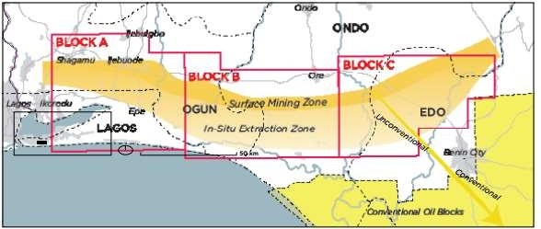

**Figure 2.1: Nigeria’s Bitumen Belt. Bitumen is found across Lagos, Ogun, Ondo, and Edo States.**

**Blocks A, B, and C, were first bid on in 2009 (Google).**

The selection of an appropriate solvent is an important factor in the optimization of bitumen separation by solvent extraction. Bitumen can be gotten as one of the fractions from distillation of crude oil or oil sands.

Figure 2.2 Map of Nigeria showing Agbabu. The oils sands extraction process is composed of an extraction step and a characterization step. The first step is the extraction with heated toluene into three components; bitumen, solid content (sand and clay) and water.

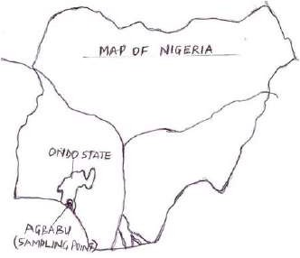

**Figure 2.2 Map of Nigeria showing Agbabu.**

The second step is the characterization of bitumen to determine the asphaltene content in the bitumen. Asphaltene is a low value added product present in the bitumen. The higher the asphaltene content, the lower the value of the bitumen. Bitumen comprises three main components, namely, maltenes, resins and asphaltenes. Whereas maltenes are infinitely soluble in paraffinic solvents, and the complete dissolution of resins and asphaltenes requires the use of relatively polar, aromatic solvents, such as benzene or toluene. In conventional practice, asphaltenes are separated from maltenes by adding a large excess of pentane to a solution of bitumen in benzene. However, the solubility of asphaltenes in paraffins increases in proportion to the number of carbon atoms in the solvent and this provides a means of fractionating asphaltenes on the basis of their molecular weight. The selected bitumen solvent must therefore have the proper balance between paraffinic and aromatic components.

# Pyrolysis

Pyrolysis is a subset of gasification, and it involves a complex set of cracking reactions that leads to the formation of tarry volatile compounds, hydrocarbons, oxygenates and non-condensable gases. The composition of the pyrolysates is complicated as it hugely depends on the type of feedstock and its biochemical or maceral composition. The condensable volatiles are further decomposed in the gas phase via secondary reactions such as cracking, reforming, combustion and CO shift to form the non- condensable gases as depicted in figure 1 above.

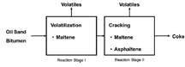

**Figure 2.4: Scheme for pyrolysis reaction of bitumen**

# Characterization techniques

Characterization describes those features of the composition and structure (including defects) of a material that are significant for a particular preparation, study of properties, or use, and suffice for the reproduction of the material (DON & JOHN, 1986)

1. ray diffractometry is often a fast and easy method to identify crystalline mineral phases. The method is based on the diffraction of very short-wave electromagnetic radiation in the regular, continuous mineral lattice. The primary output of this method is a set of interplanar lattice spacings, which in turn are characteristic to each mineral species. It should be noted that the method presumes crystalline structure of the sample, while amorphous phases cannot be studied. Also extremely fine grained, poorly crystallized and mixed layer materials may show “X-ray amorphous” behaviour. The output of the method is semi-

quantitative in nature. In well-crystallized samples, relative intensities of certain reflections can be used to estimate mineral composition semi-quantitatively, but without mineral-specific corrections the estimates are uncertain.

Diffraction pattern of mineral mixtures can be analysed using detailed computer-based procedures, which utilize for example the Rietveld method. In the Rietveld refinement process lattice parameters are modified to achieve an acceptable fit between the calculated and observed XRD pattern. A prerequisite for this type of approach is that the mineral lattice can be defined as a unique and well-defined set of parameter values, while – in general – lattice parameters of smectite minerals vary in a very complex way. If lattice parameters of smectite and other minerals in the mixture are known, Rietveld procedure can be applied.

Identification of smectite group minerals is possible with XRD combined with special treatments. Methods include 1) vacuum filtering to obtain oriented, smectite-enriched solvation and cation exchange treatments using inorganic salts (e.g. those of Mg2+, K+) and glycerol causing mineral specific expansion; sample heating causing mineral-specific transformations (e.g. smectite => illite). Laboratory can reach an accuracy of 5 – 10 percent, if experienced personnel are used. Relative uncertainties may be much larger for some accessory minerals. Carlson concluded that the best results could be achieved by a combination of mineralogical study (XRD) and chemical analysis. XRD-analysis gives most information if combined with solvation and ion exchange processes, as well as with heat treatment. The accuracy of the semiquantitative Rietveld analyses varies between different minerals. The accuracy is the sum of several different factors. For clay minerals it is typically ± 5% and for non-clay minerals ± 1%.( Lasse *et al.,*2012).Characterization techniques include XRD, XRF, SEM, TEM, EDAX, UVVisible spectroscopy, FTIR spectroscopy, etc. (kelsall, Hamley, & Geoghegan, 2005)

* 1. Characterization by x-ray diffraction technique(XRD)
  2. Characterization by x-ray florescence spectroscopy (XRF)
  3. Characterization by Fourier Transform Infrared (FT-IR)
  4. Scanning electron microscopy (SEM) analysis
     1. **X-ray diffraction characterization technique**

X-ray powder diffraction plays a critical role in material research and development. Among its applications is the identification of the present phases in a specimen, the quantitative analysis of the concentrations of each phase present in a multiphase specimen, the unit cell metrics, microstructure analysis of polycrystalline materials, etc.

X-rays are diffracted by the crystals. This diffraction represents the interference between X-ray scattered by the electrons in the various atoms at different locations in the unit cell. The diffracted beam is ‘reflected’ from a plane passing through points of the crystal lattice in a manner that makes this crystal-lattice planes analogous to mirrors, so the angle of incidence is equal to the angle of reflection. The diffraction from a crystal is described by the equation known as Bragg’s law:

n𝜆=2dhkl sinθhkl 2.1

Therefore, if 𝜆 (x-ray wavelength) and θhkl (one-half the diffraction angle) are known, then the perpendicular spacing between lattice planes dhkl and consequently, the unit cells dimensions and the indicesh, k, l of those crystal planes, can be determined. A powder pattern contains a set of diffraction peaks at 2θ positions which correspond to the interplanar spacing in the crystal. A schematic of x-ray powder diffractometer.

* + - 1. **X-ray powder diffraction instrumentation**

X-ray diffractometers consist of three basic elements: an X-ray tube, a sample holder, and an X-ray detector. X-rays are generated in a cathode ray tube by heating a filament to produce electrons, accelerating the electrons toward a target by applying a voltage, and bombarding the target material with electrons. When electrons have sufficient energy to dislodge inner shell electrons of the target material, characteristic X-ray spectra are produced. These spectra consists of several components, the most common being Kαand Kβ. Kα consists, in part, of Kα1 and Kα2. Kα1 has a slightly shorter wavelength and twice the intensity as Kα2. The specific wavelengths are characteristic of the target material (Cu, Fe, Mo, Cr). Filtering, by foils or crystal monochrometers, is required to produce monochromatic X-rays needed for diffraction. Kα1 and Kα2 are sufficiently close in wavelength such that a weighted average of the two is used. Copper is the most common target material for single-crystal diffraction, with CuKα radiation = 1.5418Å. These Xrays are collimated and directed onto the sample. As the sample and detector are rotated, the intensity of the reflected X-rays is recorded. When the geometry of the incident X-rays impinging the sample satisfies the Bragg Equation, constructive interference occurs and a peak in intensity occurs. A detector records and processes this X-ray signal and converts the signal to a count rate which is then output to a device such as a printer or computer monitor.

The geometry of an X-ray diffractometer is such that the sample rotates in the path of the collimated X-ray beam at an angle θ while the X-ray detector is mounted on an arm to collect the diffracted X-rays and rotates at an angle of 2θ. The instrument used to maintain the angle and rotate the sample is termed a goniometer. For typical powder patterns, data is collected at 2θ from ~5° to 70°, angles that are preset in the X-ray scan. (Barbara & Christine , 2015)

# Application of x-ray diffraction

1. ray powder diffraction is most widely used for the identification of unknown crystalline materials (e.g. minerals, inorganic compounds). Determination of unknown solids is critical to studies in geology, environmental science, material science, engineering and biology (Barbara & Christine , 2015).

Other applications include;

* 1. Characterization of crystalline materials
  2. Identification of fine-grained minerals such as clays and mixed layer clays that are difficult to determine optically
  3. Determination of unit cell dimensions
  4. Measurement of sample purity
  5. With specialized techniques, XRD can be used to:
  6. Determine crystal structures using Rietveld refinement
  7. Determine of modal amounts of minerals (quantitative analysis)
  8. Characterize thin films samples by:
  9. Determining lattice mismatch between film and substrate and inferring stress and strain
  10. Determining dislocation density and quality of the film by rocking curve measurements
  11. Measuring super lattices in multi-layered epitaxial structures
  12. Determining the thickness, roughness and density of the fi lm using glancing incidence X-ray reflectivity measurements make textural measurements, such as the orientation of grains, in a polycrystalline sample (Barbara & Christine , 2015).

# Strengths and limitations of x-ray powder diffraction Strengths:

* + - * 1. Powerful and rapid (< 20 min) technique for identification of an unknown mineral
        2. In most cases, it provides an unambiguous mineral determination
        3. Minimal sample preparation is required
        4. XRD units are widely available
        5. Data interpretation is relatively straight forward

**Limitations:**

* + - * 1. Homogeneous and single phase material is best for identification of an unknown
        2. Must have access to a standard reference file of inorganic compounds (dspacings, hkls)
        3. Requires tenths of a gram of material which must be ground into a powder
        4. For mixed materials, detection limit is ~ 2% of sample
        5. For unit cell determinations, indexing of pat terns for nonisometric crystal systems is complicated
        6. Peak overlay may occur and worsens for high angle 'reflections

Peak positions occur where the X-ray beam has been diffracted by the crystal lattice. The unique set of displacing derived from this patter can be used to 'fingerprint ' the mineral Details.

* + 1. **X-ray florescence spectroscopy characterization technique**

X-ray fluorescent spectroscopy is nowadays a frequently used method in analysis of solid geological and environmental materials. The method gives a representative composition of a macroscopic amount of material (measured in grams). The analysis is based on X-ray radiation of the pulverized material and detection of the emitted secondary X-ray radiation, which is characteristic for each element. Like in micro analytical methods, analysis of the radiation may be based on either energy dispersive detector (ED-XRF) or wavelength dispersive detector (WD-XRF) utilizing Bragg’s diffraction.

The method is fast and cost-effective, because the sample decomposition is not required. The WD detector provides a fairly uniform detection limit for elements heavier than fluorine. The method is very suitable for bentonite analysis. However, water and carbon contents must be analyzed by other methods. (Lasse *et al.,* 2008).

* + - 1. **Principle of x-ray florescence spectroscopy**

When a primary x-ray excitation source from an x-ray tube or a radioactive source strikes a sample, the x-ray can either be absorbed by the atom or scattered through the material. The process in which an x-ray is absorbed by the atom by transferring all of its energy to an innermost electron is called the “photoelectric effect.” During this process, if the primary x-ray had sufficient energy, electrons are ejected from the inner shells, creating vacancies. These vacancies present an unstable condition for the atom. As the atom returns to its stable condition, electrons from the outer shells are transferred to the inner shells and in the process give off a characteristic x-ray whose energy is the difference between the two binding energies of the corresponding shells. Because each element has a unique set of energy levels, each element produces x-rays at a unique set of energies, allowing one to nondestructively measure the elemental composition of a sample; Measurement is typically done with a solid state detector, most commonly called SiPIN, SDD or CdTe. The process of emissions of characteristic x-rays is called “X-ray Fluorescence,” or XRF.

Analysis using x-ray fluorescence is called “X-ray Fluorescence Spectroscopy.” In most cases the innermost K and L shells are involved in XRF detection. A typical x-ray spectrum from an irradiated sample will display multiple peaks of different intensities once the signals are processed through a digital pulse processor. (amptek, 2015)

The characteristic x-rays are labeled as K, L, M or N to denote the shells they originated from. Another designation alpha (a), beta (b) or gamma (g) is made to mark the x-rays that originated from the transitions of electrons from higher shells. Hence, a Ka x-ray is produced from a transition of an electron from the L to the K shell, and a Kb x-ray is produced from a transition of an electron from the M to a K shell, etc. Since within the shells there are multiple orbits of higher and lower binding energy electrons, a further

designation is made as a1, a2 or b1, b2, etc. to denote transitions of electrons from these orbits into the same lower shell.

* + - 1. **Application of X-ray florescence spectroscopy**

The XRF method is widely used to measure the elemental composition of materials. Since this method is fast and nondestructive to the sample, it is the method of choice for field applications and industrial production for control of materials. Depending on the application, XRF can be produced by using not only x-rays but also other primary excitation sources like alpha particles, protons or high energy electron beams.

* + 1. **Fourier Transform Infrared Spectroscopy**

Fourier transform infrared spectroscopy (FTIR) was used for the identification of clay minerals and poorly crystalline mineral phases, but also for identification of possible adsorbed elements or functional groups (Sirpa and Leena, 2010).

Infrared (IR) spectroscopy is based on the absorption of IR-radiation in the chemical bonds, if the vibration of the bond is associated with change of permanent dipole moment (e.g. stretching, bending). In conventional (dispersive) IR-spectroscopy the wave length range is scanned with changing monochromatic electromagnetic radiation and absorption is measured as a function of wave length, while Fourier IR (FTIR)

analyse the whole spectrum at once by means of mathematical Fourier-transformation. The result of an IR-spectroscopic measurement is the material-specific absorption (or transmittance) information as a function of the IR wave length (or wave number).

Infrared spectra of silicate minerals consist of a broad band of Si-Al-O -framework vibrations at wave numbers around 1000 cm-1, which are not very phase specific. Water molecules have very distinctive IR-

absorption. Thus, information on the amount and mode of occurrence of water in bentonite can be deduced from IR-spectrum. (Lasse, etal 2008)

The infrared spectrum of a clay mineral is sensitive to the chemical composition, isomorphous substitution and crystallinity. The method is best suitable for compounds with simple chemical formula. Bentonites are structurally simple, but chemically complicated and therefore this method is most suitable in comparing different samples and recording the differences. The primary output from this method is the characterization of smectite (octahedral layers), but it also provides information on surface properties and reactions of minerals with chemicals in the environment. This method can also give some information of the amorphous compounds present. FTIR analyses are rapid, economical and easy to make.

The FTIR method uses a very small amount of the actual sample and thus, extra care must be given to the representativeness of the sub-sample. Analyses should be made from the <2m or <1m fraction to minimize the amount of detrital minerals like quartz and feldspars. The limits of accuracy depend on the total composition of the sample, i.e. the infrared activity of the individual chemical bonds in the sample. Qualitatively the method shows most clay minerals and enables distinguishing of different species. The method is also semi-quantitative because the problem with infrared inactive components limits the quantitative determinations. (Lasse *et al.,* 2008).

* + - 1. **Principle of Fourier transform infrared spectroscopy**

FTIR spectroscopy is an interferometric method. It is a measurement technique whereby spectra are collected based on measurements of the temporal coherence of an irradiative source, using time-domain measurements of the electromagnetic radiation or other type of radiation.

Fourier Transform Infrared (FT-IR) spectrometry was developed in order to overcome the limitations encountered with dispersive instruments. The main difficulty was the slow scanning process. A method

for measuring all of the infrared frequencies simultaneously, rather than individually, was needed. A solution was developed which employed a very simple optical device called an interferometer. The interferometer produces a unique type of signal which has all of the infrared frequencies “encoded” into it. The signal can be measured very quickly, usually on the order of one second or so. Thus, the time element per sample is reduced to a matter of a few seconds rather than several minutes. Most interferometers employ a beam splitter which takes the incoming infrared beam and divides it into two optical beams. One beam reflects off of a flat mirror which is fixed in place. The other beam reflects off of a flat mirror which is on a mechanism which allows this mirror to move a very short distance (typically a few millimeters) away from the beam splitter. The two beams reflect off of their respective mirrors and are recombined when they meet back at the beam splitter. Because the path that one beam travels is a fixed length and the other is constantly changing as its mirror moves, the signal which exits the interferometer is the result of these two beams “interfering” with each other. The resulting signal is called an interferogram which has the unique property that every data point (a function of the moving mirror position) which makes up the signal has information about every infrared frequency which comes from the source (Nicolet, 2001).

This means that as the interferogram is measured all frequencies are being measured simultaneously. Thus, the use of the interferometer results in extremely fast measurements. Because the analyst requires a frequency spectrum (a plot of the intensity at each individual frequency) in order to make identification, the measured interferogram signal cannot be interpreted directly. A means of “decoding” the individual frequencies is required. This can be accomplished via a well-known mathematical technique called the Fourier transformation. This transformation is performed by the computer which then presents the user with the desired spectral information for analysis (nicolet corporation, 2001).

* + - 1. **Mechanism of Fourier transform infrared**

An infrared spectrum represents a fingerprint of a sample with absorption peaks which correspond to the frequencies of vibrations between the bonds of the atoms making up the material. Because each different material is a unique combination of atoms, no two compounds produce the exact same infrared spectrum. Therefore, infrared spectroscopy can result in a positive identification (qualitative analysis) of every different kind of material. In addition, the size of the peaks in the spectrum is a direct indication of the amount of material present. With modern software algorithms, infrared is an excellent tool for quantitative analysis (nicolet corporation, 2001)

The Fourier analyzing process is as follows;

The Source: Infrared energy is emitted from a glowing black-body source. This beam passes through an aperture which controls the amount of energy presented to the sample (and, ultimately, to the detector).

The Interferometer: The beam enters the interferometer where the “spectral encoding” takes place. The resulting interferogram signal then exits the interferometer.

The Sample: The beam enters the sample compartment where it is transmitted through or reflected off of the surface of the sample, depending on the type of analysis being accomplished. This is where specific frequencies of energy, which are uniquely characteristic of the sample, are absorbed.

The Detector: The beam finally passes to the detector for final measurement. The detectors used are specially designed to measure the special interferogram signal.

The Computer: The measured signal is digitized and sent to the computer where the Fourier transformation takes place. The final infrared spectrum is then presented to the user for interpretation and any further manipulation (nicolet corporation, 2001).

* + - 1. **Advantages of Fourier transform infrared spectroscopy over dispersive or filter methods of infrared spectral analysis**
         1. It is a non-destructive technique
         2. It provides a precise measurement method which requires no external calibration
         3. It can increase speed, collecting a scan every second
         4. It can increase sensitivity – one second scans can be co-added together to ratio out random noise
         5. It has greater optical throughput
         6. It is mechanically simple with only one moving part(nicolet corporation, 2001)
         7. Some other advantage of Fourier transform infrared spectroscopy includes;

Speed: Because all of the frequencies are measured simultaneously, most measurements by FT-IR are made in a matter of seconds rather than several minutes. This is sometimes referred to as the Felgett Advantage (Nicolet, 2001).

Sensitivity: Sensitivity is dramatically improved with FT-IR for many reasons. The detectors employed are much more sensitive, the optical throughput is much higher referred to as the

Jacquinot Advantage) which results in much lower noise levels, and the fast scans enable the coaddition of several scans in order to reduce the random measurement noise to any desired level (referred to as signal averaging).

Mechanical Simplicity: The moving mirror in the interferometer is the only continuously moving part in the instrument. Thus, there is very little possibility of mechanical breakdown.

Internally Calibrated: These instruments employ a HeNe laser as an internal wavelength calibration standard (referred to as the Connes Advantage). These instruments are self-calibrating and never need to be calibrated by the user. These advantages, along with several others, make measurements made by FT- IR extremely accurate and reproducible. Thus, it a very reliable technique for positive identification of virtually any sample. The sensitivity benefits enable identification of even the smallest of contaminants. This makes FT-IR an invaluable tool for quality control or quality assurance applications whether it be batch-to-batch comparisons to quality standards or analysis of an unknown contaminant. In addition, the sensitivity and accuracy of FT-IR detectors, along with a wide variety of software algorithms, have dramatically increased the practical use of infrared for quantitative analysis. Quantitative methods can be easily developed and calibrated and can be incorporated into simple procedures for routine analysis. Thus, the Fourier Transform Infrared (FT-IR) technique has brought significant practical advantages to infrared spectroscopy. It has made possible the development of many new sampling techniques which were designed to tackle challenging problems which were impossible by older technology. It has made the use of infrared analysis virtually limitless (nicolet corporation, 2001).

* + 1. **Gas Chromatography Mass Spectrometry**

The analysis of organic material by GC-MS allows for the identification of constituent chemical compounds in a complex mixture of organic compounds such as bitumen (Macpherson *et al.,* 1998; Selby *et al.,* 2005; Wolfson *et al.,* 2011). These compounds include alkanes, aromatics, alicyclics, branched hydrocarbons, and non-hydrocarbon heteroatom compounds containing nitrogen, sulphur and oxygen (NSO). For example, Sporstol *et al.,* (1983) used GC-MS to identify different aromatic hydrocarbons in ediments and Liang *et al.,* (2009) used the technique to identify the constituents of crude oil. Identification of biomarkers, in particular, using GC-MS has become a valuable tool in determining the origin and maturity of organic matter (Frysinger & Gaines, 2001). Biomarkers are

a suite of complex organic compounds composed of carbon, hydrogen and other elements such as oxygen, nitrogen and sulphur that are found in crude oils, bitumen and petroleum source rocks, and which are used by geologists and geochemists to unravel the origin and migration pathways of petroleum deposits (Peters *et al*., 1993).

* 1. **Application of Bitumen, Asphaltene and Maltene**

Bitumen applications in road construction: Bitumen is used especially in road construction, for example with machines for hot asphalt installation, for asphalt overlays and to repair road damage. It is also used in joint and sealing technology for concrete and asphalt surfaces. Pressure hoses are frequently used with both hot and cold recyclers. They keep bitumen at a temperature of 180°C so it remains free-flowing.

In cold recyclers the old road surface is milled and at the same time a new base layer is installed, all in one step with the milled material recycled. A supply of hot bitumen is necessary for the process to achieve a homogeneous surface while using the material that was removed. These supply lines are heated so that the material remains free-flowing. Since the machines are designed for different working widths, a flexible supply line is important. Our flexible heated pressure hoses are used for this application. Several heated hoses are often required for each system.

Asphaltenes asphaltene in the form of asphalt or bitumen products from oil refineries are used as paving materials on roads, shingles for roofs, and waterproof coatings on building foundations.

Maltenes***,*** is soluble in this solvent, are composed of saturated and aromatic compounds, and resins.

**CHAPTER THREE**

* 1. **MATERIAL AND METHOD**
  2. **Preamble**

The section spell out the experimental procedure on preparation and collection of bitumen, extraction process, determination of physical and chemical properties of the sample and it products. All equipment, chemical as well as reagent used in the experiment are clearly outlined. The materials and methods at which the experiment was performed form the subject of discussion in this chapter.

* 1. **Equipment and Reagent**
     1. **Equipment apparatus**

The list of equipment used in carrying out this research work is shown in Table 3.1. Some glass apparatus and other materials used are also shown below.

Serial no Equipment Manufacturer Source

* + - 1. Soxhlet apparatus Gallenkamp, England

Zaria

* + - 1. Membrane filter Kaduna
      2. Weighing balance OHAUS, china
      3. Thermogravimetry Analysis

Step B

* + - 1. Fourier transform infrared

spectroscopy

National Institute of Chemical Technology (NARICT), Zaria

* 1. **Sample Collection and Methods**

The bitumen samples were obtained from Agbabu, situated in Odigbo, Ondo State, Nigeria lying on the coordinates 6 o 35ˈ0" North, 4 o 50ˈ0" East. The samples were collected from the surface of the ground from the vast tar sands outcrops and sealed in polythene bags to prevent the oxidation of the hydrocarbons before being taken to the laboratory.

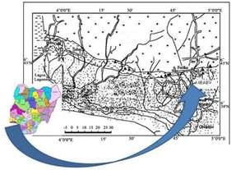Bituminous sand samples were collected from Agbabu, in Ondo State, Southwest Nigeria (**Figure 3.1**), by scooping the viscous bituminous sand samples into air light plastic containers and conveying the samples immediately to the laboratory for processing and analysis. All solvents were double distilled analytical grade.

**Figure 3.1. The location of sample collection.**

* 1. **Proximate**

**and Ultimate Analysis of Bitumen** Proximate analysis

was extracted from the TGA except for fixed carbon (FC) which was determined by computing the difference between 100 and the sum of the moisture, volatile matter and Ash contents of the samples. Ultimate analysis carried out on the samples according to standard method include nitrogen content,

carbon and hydrogen content, sulphur content, oxygen content and calorific value determination respectively.

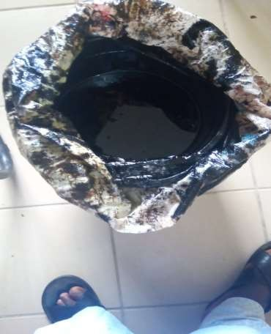

**Plate 3.1 Sample of raw bitmen**

* 1. **Separation of Maltene and Asphaltene Fractions**

Oils can be generally separated into its fractions based on their different solubilities (Aboyade *et al.,* 2012). Asphaltene is a fraction which is insoluble in n-alkane like n-heptane and soluble in aromatic solvents such as benzene and toluene, whereas other fractions (saturate, aromatic, and resin) called as

maltene are soluble in n-alkane. In order to study pyrolysis characteristic of the components of bitumen, fractionation of maltene and asphaltene from bitumen was conducted using soxhlet apparatus. 100g of bitumen sample of 100g weight was place in a thimble and bottom flask was heated for 2 hours. Hexane evaporated at 68oC and dissolve bitumen partially and the mixture was separated by 0.45 membrane filter paper. Maltene passes through the membrane filter while insoluble component (asphaltene and impurities) residues. Hexane was then recovered from maltene in a rotary dryer. The same extraction procedure was repeated for insoluble component with benzene as solvent. Finally, impurities and asphaltene were recovered after evaporating at 80 oC the remaining solvent.

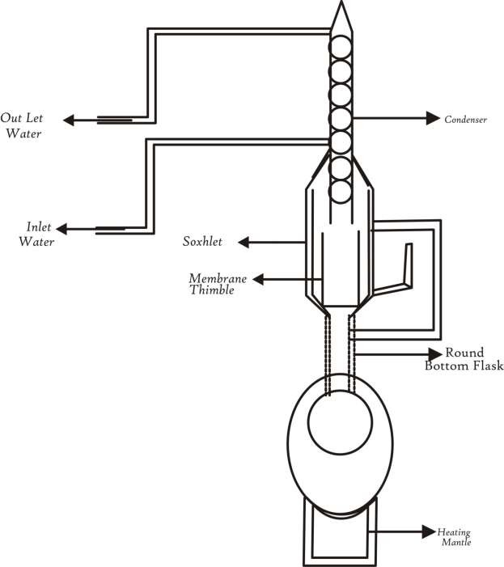

Schematic diagram of Soxhlet apparatus for the separation of maltene and

asphaltene fractions from bitumen

Figure 3.2a.

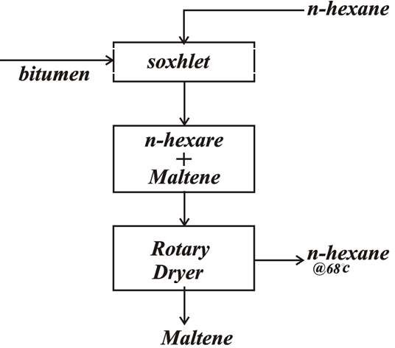

Figure 3.2b. Schematic diagram of Soxhlet for extraction of maltene

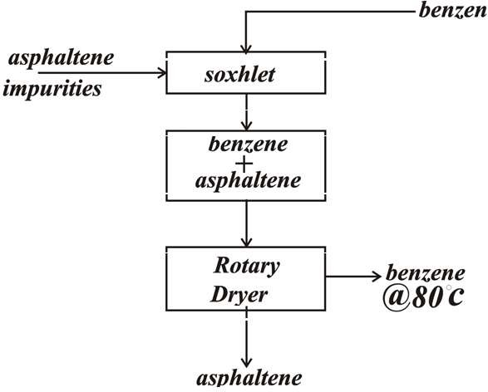

Figure 3.2c. Schematic diagram of Soxhlet for extraction of asphaltene.

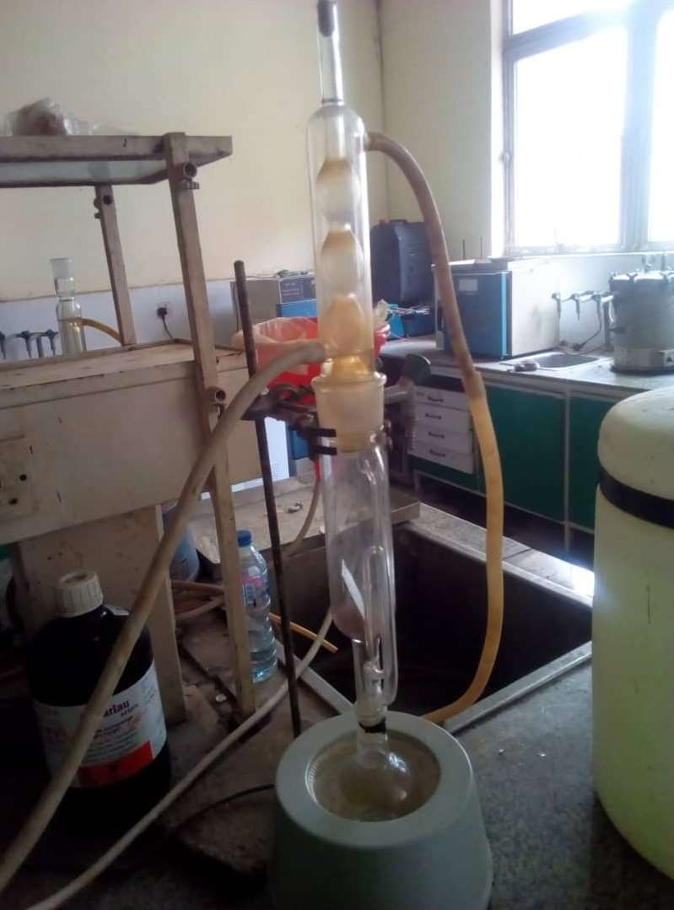

Figure 3.2d. Soxhlet apparatus for the separation of maltene and asphaltene fractions from bitumen (NARICT, Zaria)

* 1. **Thermogravimetric Analysis**

The pyrolysis experiments were performed using a thermogravimetric analyser (TA) instrument

SDT600), operating at heating rate of 10 oCmin-1 in a nitrogen flow at 150mlmin-1. About 6-7 mg of the bitumen was placed in an alumina crucible for each run. The final pyrolysis temperature was set at 950oC as the preliminary screening tests indicated that the pyrolysis process of bitumen has at by 950o oC.

* 1. **FTIR Analysis Procedure.**

Mineralogical Investigations of samples performed by the FTIR method was done by means of the FTIR- 8400s Fourier transform infrared spectrophotometer (Shimadzu Corporation) of NARICT, Zaria. Sample for testing was Agbabua bitumen. Investigations were performed by the transmission technique. Bands were recorded as the transmittance function, within the wave number range 4000–450 cm-1 at a resolution of 10 cm-1. The montmorillonite content was determined on the basis of the medium spectrum.

* 1. **Scanning Electron Microscope**

The surface morphology of the sample was analyzed through a Hitachi S-4800 scanning electron microscope (SEM). The test was carried out at room temperature (5 kV, 500×) without coating. The specific surface area and pore volume of the solid products were determined by way of isothermal adsorption of N2 at 77.4 K in a Quantachrome Instruments NOVA2000 system. Prior to recording the adsorption measurements, the samples were degassed under vacuum at 100 °C for 12 h.

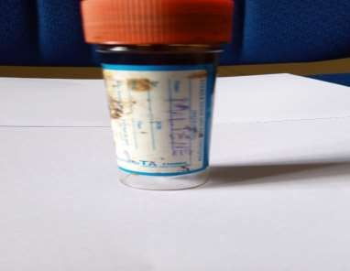**CHAPTER FOUR**

54

* 1. **RESULTS AND DISCUSSION**
  2. **Proximate and Ultimate Analysis of Bitumen**

Following a proximate analysis, the sampled Agbabua bitumen was found to contain mainly volatile matter (45.2 wt %) and fixed carbon (0.3 wt %). Moisture constituted only 4.0 wt % while the ash content was 0.74 wt %. An ultimate analysis revealed carbon (56.1wt %) was the most prominent content present in the bitumen. Other contents present in trace quantities were sulphur, nitrogen and oxygen. The findings is similar to that of previous studies (Liu *et al.,* 2016). The results of the analyses are presented on Table

4.1. Extraction of bitumen yield 23.7 % maltene, 54.3% asphaltene and impurities 21%. The yield of maltene is almost twice (2 times) the yield of asphaltene.

**Table 4.1 Derivative component of bitumen**

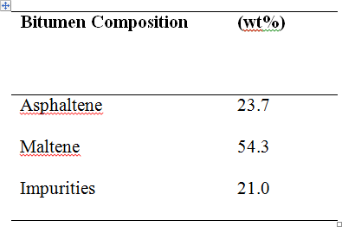

Plate 4.1 image of maltene yield

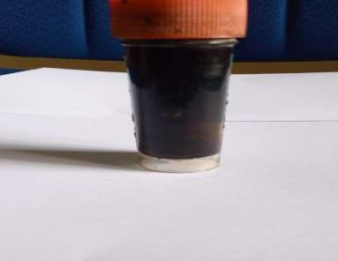

Plate 4.2 image of asphaltene yield

**Table 4.2: Proximate analysis of bitumen**

|  |  |
| --- | --- |
| **Proximate analysis (wt% ad)** |  |
| Moisture | 0.5 |
| Volatile | 45.2 |
| Ash | 54.0 |
| Fixed carbon | 0.3 |

**Table 4.3 Ultimate analysis of bitumen**

|  |  |
| --- | --- |
| **Ultimate analysis (wt% daf)** |  |
| C | 56.1 |
| H | 4.7 |
| S | 1.5 |
| O+N | 37.7 |

* 1. **TGA analysis of bitumen, maltene and asphaltene components**

Fig. 4.2 shows the TG and DTG curves of the bitumen and its derived components, namely maltene and asphaltene, at the heating rate of 10 oC min-1. As shown in Fig. 4.2, the bitumen started to lose weight at 200 oC and reached the maximum rate of weight loss at approximately 400 oC. In Fig. 4.2, it can be seen that bitumen lost approximately 90% of original weight and yielded 10 wt% coke after the pyrolysis reaction was terminated. Two shoulders are present in the differential thermogravimetric curves implying that bitumen thermally decomposes into one wide shoulder and one narrow peaks as shown in DTG curve

of Fig. 4.2. The wide shoulder peak (between 200 oC and 400 oC) correspond to maltene formation while the narrow peak (between 400 oC and 600 oC,) correspond to asphaltene formation.

For the maltene and asphaltene fractions, 4.6 wt% and 39.9 wt% remained as coke after the pyrolysis, respectively. From this result, it can be deduced that the pyrolysis of asphaltene is dominant reaction for coke formation in the pyrolysis of bitumen (Speight 1970 and Go *et al.,* 2016). It is noticeable that the pyrolysis behavior of maltene was similar to that of bitumen with one wide shoulder and one narrow peaks. This behavior did not appear in the pyrolysis of asphaltene because pyrolysis of asphaltene only shows one peak. This difference comes from the unique characteristics of asphaltene: asphaltene is the heaviest fraction in bitumen. Based on the TG analyses, it can be deduced that the pyrolysis of bitumen consists of two temperature regions: between 200 oC and 400 oC maltene is decomposed and between 400 oC and 600 oC asphaltene decomposed. In a similar work Yasar *et al.,* (2001) reported that pyrolysis bitumen lead to formation of maltene and subsequent transformation of maltene to asphaltene.

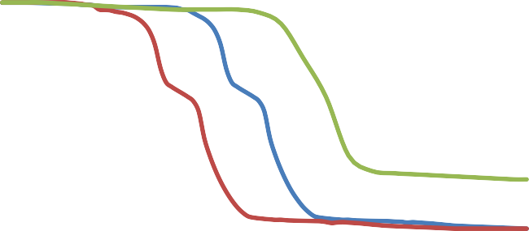

Bitumen

Maltene

Asphaltene

120

100

80

60

40

20

0

0

200

400

600

800

1000

**Temperature (oC)**

**Weight loss (%)**

Fig. 2. TG curves of bitumen and its derived components

Fig. 3. DTG curves of bitumen and its derived components

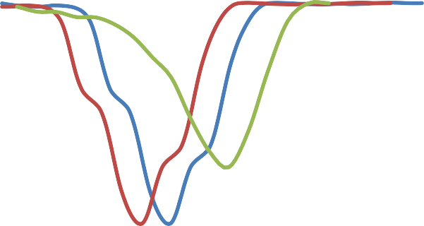

Bitumen

Maltene

Asphaltene

0

-0.5

-1

-1.5

-2

-2.5

-3

-3.5

-4

-4.5

-5

0

200

400

600

800

1000

**Temperature (oC)**

**DTG (oC/min)**

It is obvious from Fig. 3 shows the TG curves of maltene and asphatene that maltene experienced weight loss at lower temperature (between 200 oC and 400 oC) as compared to asphaltene in the higher temperature region (between 400 oC and 600 oC). Hence, asphaltene produced . Yasar *et al.,* (2001) studied the pyrolysis of maltene and asphaltene and found that both maltene and asphaltene produced coke in the end and maltene converted into asphaltene before the coke was formed.

* 1. **FTIR Analysis of Bitumen, Maltene and Asphaltene components**

The FTIR frequencies of bitumen and it derived components are presented in Figure 4 and in Table 2. Peaks with strong, medium and weak intensities were found demonstrating different bond types such as O–H, C–H, C–H, N–H and S=O in the samples. The FTIR spectra (Figure 2) of samples shows strong bands at 3352 cm –1 due to -OH stretching. For alkanes, C–H absorption occurs below 3000 cm-1. A weak C–H stretching peak of aromatic hydrocarbons were found just above 3000 cm-1, it is indicated as a shoulder on the strongest aliphatic C–H stretching vibration of all the samples. The –CH absorption band spectra around 3025cm-1 was because of methylene (–CH2) group. whereas the C–H aliphatic stretching vibrations between 2921 and 2922 cm-1 was because of alkanes. The bands around 1463 cm-1 for all the

samples represented C=C stretching band due to the presence of aromatics, while bands at 1604 cm-1 signified the presence of C=C alkenes. The IR spectra displayed a distinct significant C=O stretch absorption at approximately 1699 cm-1 for aromatic fraction. Presence of O–H and C–O stretching vibrations which covers the band between 1752 and 1653 cm_1 indicated presence of carboxylic acids and their derivatives, ketones and anhydrides

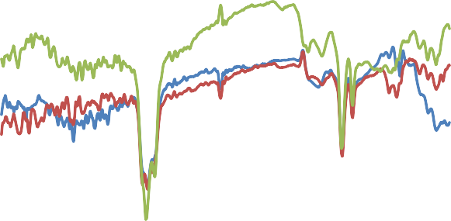

0

wavelength (1/cm)

% transmission

|  |  |  |  |  |  |  |  |  |
| --- | --- | --- | --- | --- | --- | --- | --- | --- |
|  |  |  |  |  |  |  |  |  |
|  |  |  |  |  |  |  |  |  |
|  |  |  |  |  |  |  |  |  |
|  |  |  |  |  |  |  |  |  |
|  |  |  |  |  |  |  |  |  |
|  |  |  |  |  |  |  |  |  |
|  |  |  |  |  |  |  |  |  |
|  |  |  |  |  |  |  |  |  |
|  |  |  |  |  |  |  |  |  |
|  |  |  |  |  |  |  |  |  |

|  |  |  |  |  |  |  |  |  |  |  |
| --- | --- | --- | --- | --- | --- | --- | --- | --- | --- | --- |
|  | | | | | | | | | | 120 |
| 115 |
| 110 |
| 105 |
| 100 |
| 95 |
| 90 |
| 85 |
| 80 |
| 75 |
| 4500 | 4000 | 3500 | 3000 | 2500 | 2000 | 1500 | 1000 | 500 |  | 70 |

Figure 4. FTIR analysis of bitumen, maltene and asphaltene components

* 1. **SEM analysis of bitumen, maltene and asphaltene components**

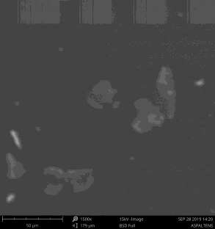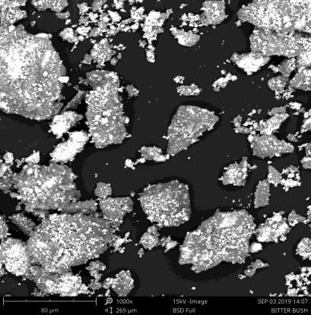

6

Figure 5: Image of glassy bitumen showing sand grain.

Fig. 5 shows a SEM image of a tar sand sample which was fixed in an epoxy resin and polished prior to imagining. It can be seen that the sample is composed of quartz particles surrounded by a mixture of organic matter and fine quartz, clay and some other minerals.

Figure 6: Image of glassy asphaltene

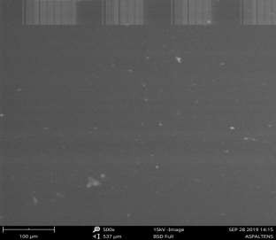

Figure 7: Image of glassy maltene

**Table 4.5 Assignment of likely functional groups in the aromatic fraction of Agbabua bitumen.**

Sample and wave number (cm-1)

|  |  |  |  |  |
| --- | --- | --- | --- | --- |
| Bitumen | Maltene | Asphatene | Functional  group | Compound type |
| 2921.31(s) Stretch | 2921.49(s) Stretch | 2921.93(s) Stretch | C–H (CH3) | Alkanes |
| 4.29(s) Stretch | 2729.83(s) Stretch | 2854.64(s) Stretch | C–H (CH2) |  |
| 3024.71(m) Stretch | 3025.11(m) Stretch | 3028.81(m) Stretch | CH | Aromatic ring |
| 728.72; 694.66(s) | 728.58; 694.60(s) | 728.66(s); 694.59 | CH | Phenyl ring |
| Bend | Bend | Bend |  | substitution bands |
| 1463.50(m) | 1463.58(m) | 1463.42(m) | C=C | Aromatic ring |

|  |  |  |  |  |
| --- | --- | --- | --- | --- |
| 1604.64(w) Stretch | 1604.74(w) Stretch | 1604.56(w) Stretch | C=C | Alkenes |
| 3584.01(s) stretch | 3584.29(s) Stretch | 3583.77(s) Stretch | N–H | Amine |
| 3435.79 stretch | 3436.57 Stretch | 3436.00 Stretch | OH | Alcohol |
| 1030.75(s) stretch | 1030.23(s) Stretch | 1030.18(s) Stretch | S=O | Organic sulfoxides |

* 1. **GC MS analysis of bitumen, maltene and asphaltene components**

No standards were run for GC-MS analysis in the current study. Peak areas were simply used to allow for qualitative comparison of the relative abundances of the different classes of chemical compounds present in Agbabu bitumen. There were over 80 identifiable peaks in the sampled bitumen with some shown on Table 4.5. A summary of those identified to belong to four chemical groups are indexed and presented in Table 4.6.

**Table 4.6: Absolute areas of the most probable and abundant compounds of Agbabu bitumen**

|  |  |  |
| --- | --- | --- |
| **s/n** | **Compounds** | **Area** |
| 1 | Hexadecanes | 78918 |
| 2 | Pentadecanes | 646628 |
| 3 | 2,6,10,14-tetramethyl hexadecane | 46829 |
| 4 | 1,2,3-trimethoxyl benzene | 44763 |
| 5 | Octadecanes | 2848261 |
| 6 | 2-aminopyrimidine-1-oxide | 20116 |
| 7 | Heptadecanes | 33877 |
| 8 | Dodecanes | 30156 |
| 9 | Octanes | 9022 |
| 10 | Cyclohexanes | 10540 |
| 11 | Cyclopentanes | 10564 |
| 12 | Naphthalene | 116638 |
| 13 | Dodecanoic acids | 17654 |
| 14 | Decanoic acids | 47654 |
| 15 | Pentadecanoic acids | 46231 |
| 16 | Sum of other aromatics | 418732 |
| 17 | Sum of other cycloalkanes | 3176 |
| 18 | Sum of other heteroatoms | 74286 |

Note: Identity based on most probable compounds as determined by the computer

software running the GC-MS analysis. Identity is not absolute.

**Table 4.7: GC-MS index for organic compounds of Agbabu bitumen, asphaltene and maltene identified as belonging to four chemical groups**

|  |  |  |  |  |
| --- | --- | --- | --- | --- |
| **s/n** | **Compounds** | **Bitumen** | **Maltene** | **Asphaltene** |
| 1 | Alkanes | 44.82 | 40.21 | 54.92 |
| 2 | Cycloalkanes | 18.64 | 10.14 | 22.33 |
| 3 | Aromatics | 13.12 | 21.20 | 10.12 |
| 4 | Heteroatom | 11.67 | 17.72 | 10.67 |

Alkanes, also known as paraffins [(CnH2n+2)] are hydrocarbons that occur in most crude oils with an abundance generally in the range of 15-20 % (Bjorlykke, 2010) was found to be the most abundant constituent of the solvent extracts of the Agbabu bitumen. The analysis revealed the most abundant alkanes were pentadecanes (C15H32), hexadecanes C16H14 and octadecanes (C18H38).

Cycloparaffins (naphthenes) (CH2)n , are a type of cyclic saturated hydrocarbon also present in all types of crude oils and constitutes 7-31 % of a sample (Bjorlykke, 2010). cyclohexanes (C6H12) and cyclopentanes (C5H10) (each a cycloalkane) are identified in sampled Agbabu bitumen. The abundance of cycloalkanes in the sampled Agbabu bitumen suggests that high performance oils may be derived from the bitumen since the content of cycloalkanes in an oil is reported to be proportional to the octane number (standard measure of the performance of fuel) and typically associated with high performance (Daniels *et al.,* 2004). The content of aromatic hydrocarbon; unsaturated hydrocarbons having one or more benzene rings with general formula CnH2n-6 (Demirel, 2012), can also be associated to performance (Bjorlykke, 2010; Oseev *et al*., 2012).

**4.5 Physico-Thermal Parameters**

In summary, the results for all the properties of the bitumen, maltene and asphaltene samples are highlighted in Table 4.8. This Table highlights the properties of the bitumen samples from the Agbabu in Ondo state Nigeria.

**Specific gravity**: The specific gravity of bitumen gives an estimated measure of the amount of lighter hydrocarbons present. The values obtained for the samples fall within a close range to each other. These values are also within the range of asphalt standard of 0.9 - 1.013 (Onojake e*t al.,* 2016) obtained from the same geological location. This low specific gravity value indicate that the bitumen is of high quality. The specific gravity values compare favourably with the values reported by Guma *et al.,* (2012). The values obtained for specific gravity are 0.921, 0.973 and 0.973 at 25oC/25oC for bitumen, maltene and alphaltene respectively as shown in Table 4.8. The specific gravity values compare favourably with the value 0.92 and 0.95 obtained by Guma *et al.,* (2012) at two other bitumen from different locations in Ondo state.

**Pour point**: Pour point when used in conjunction with the reservoir temperature gives a better indication of the condition of the oil, in the reservoir than does its viscosity, thus it presents a more accurate assessment of the condition of the oil in the reservoir, being an indicator of the mobility of the oil in the reservoir. The values obtained for specific gravity are 67, 79 and 83 at 25oC/25oC for bitumen, maltene and alphaltene respectively as shown in Table 4.8. The value of pour point for bitumen is close to the value of 44.70 oC obtained by Adebiyi *et al*., (2005), indicating the very low mobility on the bitumen fluids at reservoir conditions. In summary, the pour point is an important consideration because, for efficient production, additional energy must be supplied to the reservoir by a thermal process to increase the reservoir temperature beyond the pour point.

**Flash point**: Flash point measures only the response of the bitumen sample to heat and flame in or controlled laboratory conditions. The temperature values recorded as the flash point for each sample were observed as shown on the Table are 254, 263 and 271oC for for bitumen, maltene and alphaltene

respectively. These flash point values lie within the value range of 245oC to 325oC as reported by Guma *et al.,* (2012) for most bitumen of good grade. The pour point value of 67, 79 and 83 oC observed for bitumen, maltene and alphaltene respectively. The value obtained for Agbabu sample compare favourably with the vales of 44.70oC for Yagbata obtained by Adebiyi *et al.,* (2005).

**Viscosity:** Viscosity is a measure of internal friction of a liquid to the reluctance of a fluid to flow freely. It therefore indicates the ability of a fluid to flow from the point to another. Kinematic viscosity represents the dynamic viscosity of a fluid per unit density expressed in cSt (Centistoke). Viscosity affects the performance of injection systems. Low viscosity can result in excessive wear in some injection pumps and power loss due to pump and injector leakage. High viscosity fluids on the other hand cause excessive pump resistance or filter damage and higher line pressures (Adebiyi *et al.,* 2005). The viscosity of bitumen and it derived components were observed at temperature 40oC as shown in Table 4.8. The kinematic viscosity of Agbabu bitumen it derived component 73.44, 130 and 176 cSt. These values agree with the value range of 4.3×103 to 5.6×103cSt reported by Onajake and Ndubuka (Adebiyi *et al.,* 2005).

**TABLE 4.8: Petroleum samples physico-thermal parameters**

|  |  |  |  |  |
| --- | --- | --- | --- | --- |
| PARAMETERS | UNIT | BITUMEN | MALTENE | ASPHALTENE |
| VISCOSITY @  40 oC | cSt | 73.44 | 130 | 176 |
| OCTANE | % | 28 | 23 | 19 |
| NUMBER |  |  |  |  |

FLASH POINT oC FIRE POINT oC POUR POINT oC

|  |  |  |
| --- | --- | --- |
| 254 | 263 | 271 |
| 262 | 269 | 279 |
| 67 | 79 | 83 |

SPECIFIC GRAVITY

‐ 0.921 0.973 0.991

**CHAPTER FIVE**

* 1. **CONCLUSION AND RECOMENDATION**
  2. **Conclusion**

The extraction process of bitumen produce the yield of maltene that is almost twice (2 times) the yield of asphaltene. From the analysis of TGA it is observed that the pyrolysis behavior of maltene was similar to that of bitumen with one wide shoulder and one narrow peaks, while that of asphaltene shows only one peaks. The FTIR analysis of the bitumen and it compounds shows the presence of aromatic, phenolic and aliphatic compounds.

* 1. **Recommendation**

Several studies should be carried out on better understanding the pyrolysis characterization and kinetics as well as physiochemical components of other sand oils in Nigeria. It will be helpful if the necessary instruments for experimental setups involved are available at the department to facilitate research.

**REFERENCE**

A.O. Aboyade, M. Carrier, E.L. Meyer, J.H. Knoetze, J.F. Görgens (2012). Model fitting kinetic analysis and characterisation of the devolatilization of coal blends with corn and sugarcane residues, Thermochim. Acta 530, 95–106.

Adebiyi, F.M., Bello, O.O., Sonibare, J.A and Macaulay, S.R,A.(2005). Determination of Sara Constituents of Southwestern Nigerian Tars Sands and their Physical Properties. *Engineering Journal of the University of Qatar*, Vol. 18, 29–38.

BP Statistical Review of World Energy, 2016.

Deng, S., Wang, Z., Gu, Q., Meng, F., Li, J., & Wang, H. (2011). Extracting hydrocarbons from Huadian oil shale by sub-critical water. *Fuel Processing Technology*, 92 (5), 1062-1067.

Don, G., & John, W. (1986). Materials characterization. (W. M. JAME, & W. VOLKER, Eds.) *National material and advisory board*, 425-430.

EIA. Annual Energy Outlook (2016): U.S. Energy Information Administration: Washington, DC, USA; ES-5.

Gray, M.R. (2015): Upgrading Oilsands Bitumen and Heavy Oil; University of Alberta: Edmonton, AB, Canada.

Guma, T.N., Madakson, P.B., Yawas, D.S., Aku, S.Y. (2012). Assessment of Physicochemical Properties of some Bitumens from Nigerian Resources. *Nigerian Journal of Basic and Applied Science*, Vol. No. 2, 177–81.

H. Zhao, Y. Cao, S.P. Sit, Q. Lineberry, W. Pan, (2012). Thermal characteristics of bitumen pyrolysis, J. Therm. Anal. Calorim. 107, 541–547.

Heredy LA, Wender I (1980), Model structure for a bituminous coal. Rockwell International Corporation, Washington

Higman C, Tam S (2014), Advances in coal gasification, hydrogenation, and gas treating for the production of chemical and fuels. 114:1673–1708

J.G. Na, C.H. Im, S.H. Chung, K.B. Lee, (2012). Effect of oil shale retorting temperature on shale oil yield and properties, Fuel 95, 131–135.

J.G. Speight, (1970). Thermal cracking of Athabasca bitumen, Athabasca asphaltenes, and Athabasca deasphalted heavy oil, Fuel 49, 134–145.

Journal of Oil & Gas Science and Technology, (2017). Retrieved from: [http://ijogst.put.ac.ir](http://ijogst.put.ac.ir/)

K.S. Go, E.H. Kwon, K.H. Kim, N.S. Nho, K.B. Lee, (2016). Effect of ionic surfactants on improving deasphalting selectivity in a nonpolar system, Energy Fuels 30, 2076–2083.

Kaminski T. and Husein M. (2019): Partial Upgrading of Athabasca Bitumen Using Thermal Cracking, Catalysts, 431-497

Karimian M., Schaffie M., and Fazaelipoor M. H. (2017): A Kinetic Investigation into the In Situ Combustion Reactions of Iranian Heavy Oil from Kuh-E-Mond Reservoir, Iranian

Kelsall, R., Hamley, I., & Geoghegan, M. (2005). *Nanoscience and technology.* London: John Wiley and Sons, Ltd.

Lasse, A., Petri, K., Mia, T., Harri, K., & Rainer, L. (2008). *Quality Assurance of the Bentonite Material.*

Eurajoki, Finland: Posiva Oy.

Li C, Zhao X, Wang A, Huber GW, Zhang T (2015) Catalytic transformation of lignin for the production of chemicals and fuels. 11559–11624

M. J., Chowdhury A. A. and Rasul M. G. (2017): Pyrolysis of Municipal Green Waste: A Modelling, Simulation and Experimental Analysis Kabir, Energies, 7522- 7541;

Masliyah J, Zhou JZ, Xu JH, Czarnecki J, Hamza H., (2004). Understanding Water-Based Bitumen Extraction from Athabasca Oil Sands. *The Canadian Journal of Chemical Engineering*; **82**(4): 628-654.

Miller B G (2005) Coal energy systems. Elsevier Academic Press, U.S.A

N.A. Owen, O.R. Inderwildi, D.A. King, (2010). The status of conventional world oilreserves—Hype or cause for concern? Energy Policy 38, 4743–4749.

Nicolet corporation, (2001). *Introduction to Fourier Transform Infrared Spectrometry.* Madson,U.S.A: Thermo nicolet corporation

Onojake, M.C. and Ndubuka, C.O., (2016). Appraisal of the Bulk Properties of Bitumen Samples from Four Deposits in South West, Nigeria, *Petroleum & Coal*, 407–13.

Oseev, A., Zubtsov, M., & Lucklum, R. (2012). Octane number determination of gasoline with a phononic crystal sensor. *Procedia Engineering*, 47, 1382-1385.

P. Liu, M. Zhu, Z. Zhang, D. Zhang, (2016). Pyrolysis of an Indonesian oil sand in a thermogravimetric analyser and a fixed-bed reactor, J. Anal. Appl. Pyrolysis117, 191–198.

Phillips CR, Haidar NI, Poon Y.C., (1985). Kinetic models for the thermal cracking of athabasca bitumen: the effect of the sand matrix. *Fuel*; **64**(5): 678-691

Poulson, R. E. (1973). Nitrogen and Sulphur in raw and refined shale oils. *American Chemical Society*, 20(2), 183-197.

Prajapati, R.; Kohli, K.; Maity, S.K.; and Garg, M.O. (2017): Coking propensity during hydro processing of vacuum residues, deasphalted oils, and asphaltenes. Fuel, 203, 514–521.

S. Ahn, S. Shin, S.I. Im, K.B. Lee, N.S. Nho, (2016). Solvent recovery in solventdeasphalting process for economical vacuum residue upgrading, Korean J.Chem. Eng. 33, 265–270.

S. Shin, S.I. Im, N.S. Nho, K.B. Lee, (2016). Kinetic analysis using thermogravimetric analysis for nonisothermal pyrolysis of vacuum residue, J. Therm. Anal. Calorim. 126, 933–941.

Sirpa, K., & Leena, K. (2010). *Mineralogical and Chemical Characterization of Various Bentonite and Smectite-Rich Clay Materials.* EURAJOKI, FINLAND: POSIVA OY.

Speight, J.G., (2013): Heavy and Extra-Heavy Oil Upgrading Technologies; Gulf Professional Publishing: Woburn, MA, USA; ISBN 9780124045705.

SU, D. S., (2010). *Scanning electron microscopy.* mumbai: max planck.

Swapp, S., (2015). *Geochemical Instrumentat ion and Analysis.* Retrieved from serc.carleton.edu: <http://serc.carleton.edu/research_education/geochemsheets/techniques/SEM.html>

Tissot, B. P., & Vandenbrouck, M., (1983). Geochemistry and pyrolysis of oil shales. In F. P. Minknis &

J. F. McKay (Eds.), *Geochemistry and chemistry of oil shales* 1-11. Washington: American Chemical Society.

web.utk.edu(2015,38).*web.utk.edu*.Retrievedfromwe[b.utk.edu:htt](http://web.utk.edu/~prack/MSE%20300/SE)p://we[b.utk.edu/~pr](http://web.utk.edu/~prack/MSE%20300/SE)ac[k/MS](http://web.utk.edu/~prack/MSE%20300/SE)E%[20300/SE](http://web.utk.edu/~prack/MSE%20300/SE) M.pdf [www.wikipedia.org](http://www.wikipedia.org/)

X. Zhang, L. Wu, R. Zhang, S. Deng, Y. Zhang, J. Wu, Y. Li, L. Lin, L. Li, Y. Wang, L.Wang, (2013). Evaluating the relationships among economic growth energy consumption, air emissions and air environmental protection investment in China, Renew. Sustain. Energy. 18, 259–270.

X.K. Gai, H. Arano, P. Lu, J.W. Mao, Y. Yoneyama, C.X. Lu, R.Q. Yang, N. Tsubaki, (2016). Catalytic bitumen cracking in sub- and supercritical water, Fuel Process. Technol. 142, 315–318.

X.P. Zhang, X.M. Cheng, (2009). Energy consumption carbon emissions, and economic growth in China, Ecol. Econ. 68, 2706–2712.

Yasar M, T rauth DM, Klein MT. Asphaltene and resid pyrolysis. 2. The effect of reaction environment on pathways

Yasar M, T rauth DM, Klein MT. Asphaltene and resid pyrolysis. 2. The effect of reaction environment on pathways and selectivities. *Energy & fuels* 2001; **15**(3): 504-509.

Yen, T. F., Shue, F. F., Wu, E. H., & Tzeng, D., (1983). Ferric Chloride-clay complexation method: removal of nitrogen-containing components from shale oil and related fossil fuels. In

F. P. Miknis & J. F. Mckay (Eds.), *Geochemistry and chemistry of oil shales.* 457-466. Washington: American Chemical Society.

Z. Li, W. Zhao, B. Meng, C. Liu, Q. Zhu, G. Zhao, (2008). Kinetic study of corn strawpyrolysis: comparison of two different three-pseudocomponent models, Bioresour. 99, 7616–7622.

**APPENDIX**

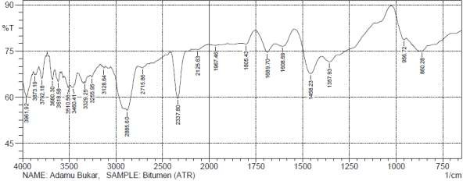

Figure 1. FTIR spectra of Bitumen

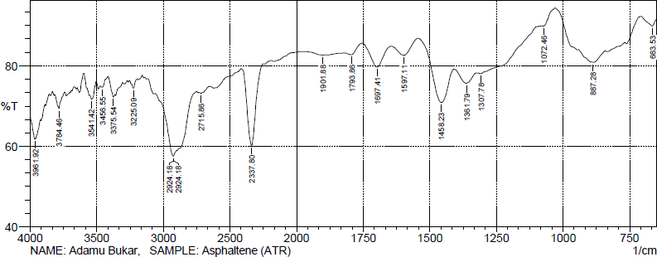

Figure 2. FTIR spectra of Maltene

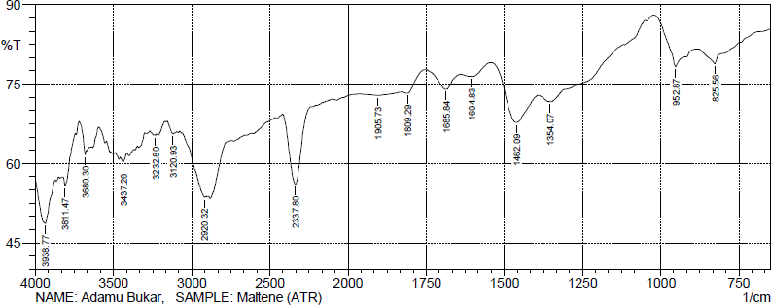

Figure 3. FTIR spectra of Asphaltene