# EXPERIMENTAL INVESTIGATION OF THE FLEXURAL AND SHEAR CAPACITIES OF REINFORCED CONCRETE BEAMS ENHANCED WITH CARBON FIBRE REINFORCED POLYMER (CFRP) LAMINATES

### BY

**NURUDEEN YUSUF**

### DEPARTMENT OF CIVIL ENGINEERING, FACULTY OF ENGINEERING, AHMADU BELLO UNIVERSITY,

**ZARIA, NIGERIA**

**March, 2021**

# EXPERIMENTAL INVESTIGATION OF THE FLEXURAL AND SHEAR CAPACITIES OF REINFORCED CONCRETE BEAMS ENHANCED WITH CARBON FIBRE REINFORCED POLYMER (CFRP) LAMINATES

### BY

**Nurudeen YUSUF, B.Eng. (Uni Maid) 2013 P15EGCV8007**

### A DISSERTATION SUBMITTED TO THE SCHOOL OF POSTGRADUATE STUDIES, AHMADU BELLO UNIVERSITY, ZARIA

**IN PARTIAL FULFILLMENT OF THE REQUIREMENTS FOR THE AWARD OF MASTER OF SCIENCE IN CIVIL ENGINEERING**

### DEPARTMENT OF CIVIL ENGINEERING, FACULTY OF ENGINEERING, AHMADU BELLO UNIVERSITY,

**ZARIA, NIGERIA**

### March, 2021

### DECLARATION

I hereby declare that the work in this Dissertation **‘Experimental Investigation of the Flexural and Shear Capacities of Reinforced Concrete Beams Enhanced with Carbon Fibre Reinforced Polymer Laminates’** is an authentic record of my study carried out as requirements for the award of Degree of Master of Engineering in Civil Engineering in the Department of Civil Engineering of Ahmadu Bello University, Zaria under the supervision of Dr. Jibril M. Kaura and Dr. Amana Ocholi.

### Nurudeen YUSUF Date

### CERTIFICATION

This dissertation entitled **‘Experimental Investigation of the Flexural and Shear Capacities of Reinforced Concrete Beams Enhanced with Carbon Fibre Reinforced Polymer Laminates’** by Nurudeen YUSUF, has been read and approved as meeting the partial requirement of the Postgraduate School of Ahmadu Bello University, Zaria, for the award of the degree of Master of Science (M.Sc) in Civil Engineering.

### Dr. J.M. Kaura Date

Chairman, Supervisory Committee

### Dr. A. Ocholi Date

Member, Supervisory Committee

### Dr. J.M. Kaura Date

Head of Department

### Prof. Sani .A. Abdullahi Date

Dean, School of Postgraduate Studies

### ACKNOWLEDGEMENT

My appreciation goes to Almighty Allah, The giver of life for seeing me through this level of educational achievement.

I would like to express my unalloyed gratitude to my supervisors Dr. Jibril MohammadKaura and Dr. Amana Ocholi for their immense contributions, guidance and mentorship.

I will like to thank my father Alh. Yusuf Ibrahim Kwami for his immeasurable support and my mother HajiyaAishatuBamusa for her kind and tender words. Also, my regards goes out to my brothers and sister for their support throughout my study.

I will like to extend my appreciation to my friendsMujahid Abbas, Hassan Auyo, Mahmood Kudu, MallamBalarabe and whose names were not mentioned here and have really being helpful and have contributed immensely to this research may Allah continue to bless you.

I also appreciate and acknowledge the efforts of the entire staff (academic and non-academic) of Civil Engineering Department, Ahmadu Bello University, Zaria.

### ABSTRACT

In this research, experimental research was carried out to assess the flexural and shear capacities of RC beams strengthened with different amount of carbon fibre reinforced polymer laminates at the tension face and U-strips. Twelve rectangular RC beams of cross-sectional dimension 150x150x750mm were cast and three were un-strengthened and used as reference beams and the remaining nine were strengthened with different amount of CFRP varying from single to triple layers and all were tested to failure under three point bending test. The increase of ultimate strength provided by the bonded CFRP laminates was assessed and failure modes identified and compared to the un-strengthened RC beams. The results indicated that the flexural capacity of the beams were significantly improved as the amount of the laminates increases. The increment ranges from 20% to 52% for single to triple layers laminates and also the shear capacity of the strengthened beam increased as compared to the un-strengthened beams. The experimental CFRP shear strength contribution were also compared with the predicted resultsand the results obtained closely agreed with the experimental results. It was concluded that the attachment of CFRP laminates has substantial influence on the performance improvement of CFRP strengthened RC beams in both shear and flexure but this increase is accompanied with the reduction in ductility due to the restraining effect offered by the CFRP material to the concrete surface.

### TABLE OF CONTENT

COVER PAGE… I

FLY LEAF II

TITTLE PAGE… III

DECLARATION IV

CERTIFICATION… V

AKNOWLEDGEMENTS VI

ABSTRACT… VII

TABLE OF CONTENTS… VIII

LIST OF TABLES… XI

LIST OF FIGURES… XII

LIST OF PLATES XIII

LIST OF NOTATIONS… XIV

LIST OF APPENDICES XV

CHAPTER ONE 1

INTRODUCTION… 1

* 1. Background of the Study 1
  2. Statement of the Problem… 3
  3. Justification of study 4
  4. Aim and

objectives 4

* + 1. Aim 4
    2. Objectives 4
  1. Scope 5
  2. Limitation… 5

CHAPTER TWO… 6

LITERATURE

REVIEW 6

* 1. Preamble 6
  2. Fibre Reinforced Polymer (FRP)… 6
  3. Common FRP Strengthening Application… 7
  4. Carbon Fibre Reinforced Polymer Wrapping on RC Beam for Flexure and Shear… 8
  5. Analytical Study on External FRP Shear Strengthening of RC Beams… 14
     1. Effective FRP Stress… 15
     2. Bond Mechanism 17

CHAPTER THREE… 20

MATERIALS AND METHODS… 20

* 1. Materials… 20
     1. Cement… 20
     2. Aggregates… 20
     3. Reinforcing

Steel… 21

* + 1. Fibre 21
    2. Resin… 22
    3. Water 23
    4. Formwork… 23
    5. Other Materials used… 23
  1. Method… 23
     1. Preparation of Specimen 23
     2. Strengthening of Specimen… 24
     3. Description of the Strengthening Method… 27
     4. Experimental Set-up… 28
  2. Theoretical FRP Shear Design… 28
  3. Flexural Stiffness… 30
  4. Ductility Index 30

CHAPTER FOUR 31

RESULTS AND DISCUSSIONS 31

* 1. Concrete Characteristics Test Result 31
  2. Experimental Results… 31
     1. Results of Reference Control Beam… 31
     2. Result of Single Layer Strengthened Beam (SL01)… 32
     3. Result of Single Layer Strengthened Beam (SL02) 33
     4. Result of Single Layer Strengthened Beam (SL03)… 35
     5. Result of Double Layers Strengthened Beam (DL01)… 36
     6. Result of Double Layers Strengthened Beam (DL02)… 38
     7. Result of Double Layers Strengthened Beam (DL03)… 39
     8. Result of Three Layers Strengthened Beam (TL01)… 41
     9. Result of Three Layers Strengthened Beam (TL02)… 42
     10. Result of Three Layers Strengthened Beam (TL03)… 44
  3. Overall Effect of Strengthening on Specimen… 45
     1. Effect of First Crack Load on Single Layer Strengthened Beams 45
     2. Effect of First Crack Load on Double Layers Strengthened Beams… 46
     3. Effect of First Crack Load on Three Layers Strengthened Beams… 47
     4. Effect of Ultimate Load Carrying Capacity for Single Layer Beams… 48
     5. Effect of Ultimate Load Carrying Capacity for Double Layers Beams… 49
     6. Effect of Ultimate Load Carrying Capacity for Three Layers Beams… 50
     7. Effect of Strengthening on Crack Width… 51
     8. Effect of Strengthening on Ductility of Beams… 52
     9. Effect of Strengthening on Stiffness of Beams… 53
  4. Summary of Experimental Result 55
  5. Comparison of Theoretical and Experimental Shear Strength… 56

CHAPTER

FIVE… 57

CONCLUSION AND RECOMMENDATION 57

* 1. Conclusion… 57
  2. Recommendation… 58

REFERENCES 59

APPENDICES… 64

### LIST OF TABLES

Table 3.1 Properties of Cement (OPC) 20

Table 3.2 Physical Properties of Coarse Aggregates… 20

Table 3.3 Properties of Fine Aggregates… 21

Table 3.4 Properties of Fibre CXS- 200… 21

Table 3.5 Properties of Epoxy Resin… 22

Table 3.6 Specimen Strengthening Method 27

Table 4.1 Compressive Strength Test Result 31

Table 4.2 Flexural Stiffness… 54

Table 4.3 Summary of Test Result 55

Table 4.4 Experimental and Theoretical Shear Test Result 56

### LIST OF FIGURES

Figure 2.1: Stress-Strain Relationship for FRP and Steel (ISIS 2008) 7

Figure 3.1a: Structural Detailing of Control Specimens… 24

Figure 3.1b: Structural Detailing of Strengthened Specimens… 24

Figure 3.2:Strengthening Scheme… 25

Figure 3.3: Experimental Set- up… 28

Figure 3.4: FRP Shear Contribution Design… 29

Figure 4.1: Load-Deflection for Reference Control Beam (RBC)… 32

Figure 4.2: Load-Deflection for Single Layer Strengthened Beam (SLO1)… 33

Figure 4.3:Load-Deflection for Single Layer Strengthened Beam (SL02)… 34

Figure 4.4: Load-Deflection for Single Layer Strengthened Beam (SL03)… 35

Figure 4.5: Load-Deflection for Double Layers Strengthened Beam (DL01)… 37

Figure 4.6: Load-Deflection for Double Layers Strengthened Beam (DL02)… 38

Figure 4.7: Load-Deflection for Double Layers Strengthened Beam (DL03)… 40

Figure 4.8:Load-Deflection for Three Layers Strengthened Beam (TL01)… 41

Figure 4.9:Load-Deflection for Three Layers Strengthened Beam (TL02)… 43

Figure 4.10: Load-Deflection for Three Layers Strengthened Beam (TLO3) 44

Figure 4.11:First Crack due to Load for Single Layer and Reference Control Beam… 46

Figure 4.12: First Crack due to Load for Double Layers and Reference Control Beam… 47

Figure 4.13: First Crack due to Load for Three Layers and Reference Control Beam… 48

Figure 4.14: Ultimate Load for Single Layer and Reference Control Beams… 49

Figure 4.15: Ultimate Load for Double Layers and Reference Beams… 50

Figure 4.16: Ultimate Loads for Three Layers and Reference Beams… 51

Figure 4.17: Crack Widths for Laminated and Reference Control Beams… 52

Figure 4.18: Ductility Index for Laminated and Reference Control Beams… 53

Figure 4.19: Stiffness for Laminated and Reference Control Beams… 54

### LIST OF PLATES

Plate I: Carbon Fiber Reinforced Polymer Material… 22

Plate II: Strengthening Procedure 26

Plate III: Strengthened Specimen… 26

Plate IV: Crack Pattern for Single Layer Beam (SL01)… 33

Plate V: Crack Pattern for Single Layer Beam (SL02)… 34

Plate VI: Crack Pattern for Single Layer Beam (SL03)… 36

Plate VII: Crack Pattern for Double Layers Beam (DL01)… 37

Plate VIII: Crack Pattern for Double Layers (DL02)… 39

Plate IX: Crack Pattern for Double Layers Beam (DL03)… 40

Plate X: Crack Pattern for Three Layers Beam (TL01)… 42

Plate XI: Crack Pattern for Three Layers Beam (TL02)… 43

Plate XII: Crack Pattern for Three Layers Beam (TL03)… 45

### LIST OF NOTATIONS

ACI = American Concrete Institute

AFRP = Aramid Fibre Reinforced Polymer

𝐴𝑠𝑡 = 𝐴rea Of The Steel Reinforcement

Avrg = Average

BS = British Standard

CFRP = Carbon Fibre Reinforced Polymer EBR = Externally Bonded Reinforcing

𝜀𝑓𝑒 = Effective Strain Level ***εfu*** = Design Rupture Strain ***εfe*** = Effective Strain Level

𝑓′ = Concrete Compressive Strength FRP = Fibre Reinforced Polymer

𝑐

𝑓𝑦 = Design Strength Of Steel

GFRP = Glass Fibre Reinforced Polymer NSMT = Near Surface Mounted Technique ***Pn =***Nominal Load Before Confinement ***Pnnew*** = Nominal Load After Confinement ***ρs*** = Steel Reinforcement Ration

RC = Reinforced Concrete

µ𝛥 = Ductility

### LIST OF APPENDICES

Appendix A: Load-Deflection Results for Strengthened and Reference Control Beams… 64

Table A.1: Load-Deflection Result for Reference Control Specimen… 64

Table A.2: Load-Deflection Result for single Layer Specimen (SL01)… 64

Table A.3: Load-Deflection Result for Single Layer Specimen (SL02)… 65

Table A.4: Load-Deflection Result for Single Layer Specimen (SL03)… 65

Table A.5: Load-Deflection Result for Double Layers Specimen (DL01)… 66

Table A.6: Load-Deflection Result for Double Layers Specimen (DL02)… 66

Table A.7: Load-Deflection Result for Double Layers Specimen (DL03)… 67

Table A.8: Load-Deflection Result for Three Layers Specimen (TL01)… 67

Table A.9: Load-Deflection Result for Three Layers Specimen (TL02)… 68

Table A.10: Load-Deflection Result for Three Layers Specimen (TL03)… 68

Appendix B: Shear Design Calculation… 69

Appendix B1: Effective Stress Method… 69

Appendix B2: Bond Mechanism Method 70

### Background of the study

### CHAPTER ONE INTRODUCTION

Deterioration and vandalization are factors that affects almost all structures. The current population of the modern developed world depends on a complex and extensive system of infrastructure to maintain the economy and quality of life. The existing public infrastructure of most countries has suffered from decades of neglect and overuse, leading to accelerated deterioration of systems, and resulting in a situation that is approaching a global infrastructure crisis. Most of the infrastructure are unsatisfactory in some aspect, and public funds are not generally available for the required replacement of existing structures or construction of new ones (ISISModule 4 2004).

One of the primary factors which have led to the current unsatisfactory state of our infrastructure is corrosion of reinforcing steel inside concrete which causes the deterioration of concrete, loss of steel reinforcement, and in some cases failure. Due to this, infrastructure owners can no longer afford to upgrade and replace existing structures using the same materials and methodology as have been used in the past, they are looking to newer technologies and rehabilitation schemes, such as non-corrosive externally-bonded CFRP reinforcement, that will prolong the useful service lives of concrete structures and reduce maintenance cost (ISIS Module 4, 2004).

Maintenance is not only about cost but also a necessity to keep a structure at a defined performance level. A structure that fulfills all demands of load carrying capacities might at the same time not satisfy durability demands or please the society‟s demands for aesthetic appearance (Carolin 2003).

Absence of, or incorrect maintenance will in most cases increase the speed of the degradation process and therefore lower the performance of the structure. If the performance level has become too low, then repair is needed to restore the structure to its original performance level. Structures with long life span, which most of the civil and building structures should have, will meet changed demands placed on them from the owner‟s, users or surrounding society. In the last ten to fifteen years, CFRP materials have emerged as alternative repair materials for reinforced concretestructures and they are widely becomingmaterials of choice for strengthening and rehabilitation of concrete infrastructure (Nasrin, 2013).

CFRP plates or sheets can be bonded to exterior of concrete structure using high-strength adhesives to provide tensile or confining reinforcement which supplements that provided by internal reinforcing steel. In addition, CFRP strips, rods and tendons can be inserted with adhesive into grooves cut in structural members in an application called near-surface monitoring (Carolin, 2003). CFRP materials are non-corrosive and non-magnetic, and can thus be used to eliminate the corrosion problems invariably encountered with traditional repair materials such as externally-bonded steel plates. In addition, CFRP are extremely light, strong (5x greater than steel), highly versatile, and comparatively easy to install, making them ideal materials for the repair and strengthening of concrete structures (Intelligent Sensing for Innovative Structures Manual 2004).

Despite the numerous studiesconducted using FRP and concludedthat strengthening externally with FRP (Carbon, Glass, Aramid, Basalt and Hybrid) contributes a lot in strengthening structures(Nadeem, 2010; Rania, 2011; Habibur, 2011) but little data is available in the literature onthe researchconducted in establishing the strength of a particular FRP (in terms of its thickness, tensile strength, manufacturer etc) toa particular resin (in terms of its strength and

binding properties) for various amount of FRP materials and Resins exist so as their various properties from different manufacturers worldwide.

### Statement of the Problem

The society around us is changing and demands on existing structures increases. The need for rehabilitation or strengthening of buildings, bridges, and other structural elements arise due to one or a combination of several factors including construction or initial design defects, increased load carrying demands, change in use of structure, vandalism due to act of terrorism, structural elements damage, widespread corrosion of steel reinforcing bars in concrete structures, contact with chemicals and saline water, seismic activities, upgrade or meeting new code requirements and overall deterioration and gradual loss of strength with ageing of the structures (Nadeem, 2010). The absence of proper maintenance will in most cases increase the speed of the deterioration process and therefore lower the performance of the structure and if performance level has become too low, then strengthening/repair of the structural membersisneeded to restore the structure to its original performance state. Flexural and shear modes of failures are failures associated with RC beams. As flexural mode of failure is ductile and shear is brittle in manner without warning, so inadequate design for shear of beam and/or material deterioration lead to the possibility of sudden failure of beams.Most researchers (Nadeem,2010; Rania,2011; Habibur,2011) have been focused on flexural strengthening of Reinforced Concrete (RC) beams, while the research on shear strengthening of RC beams is very limited and if the flexural capacity alone is increased, the structure will be loaded closer to its maximum shear capacity (Taljsten, 1994), therefore not only increasing the load carrying capacity in flexure for the RC

beams is needed, but also enhancement of the RC beams in both Shear and flexure should be obtained in FRP (CFRP) strengthened flexural members.

### Justification of Study

Traditional strengthening techniques, such as steel plate bonding, section enlargement, reinforced concrete jacketing and external post-tensioning show some imperfections and limitations associated with each traditional strengthening method were encountered (Nishikant, 2009). As the research field and practical applications of different strengthening materials expanded, assteel plates have low corrosion resistance which requires coating and painting and imposes high maintenance costs and also due to heavy weight it increases dead load of retrofitted structural element. Section enlargementis often unfavorable because it reduces the headroom and therefore reduces the usable living area. Likewise, external post-tensioning is limited to sections with large depth and has a high cost associated with its installation process and tensioning devices (Sahar 2015). In another word, FRP are widely used as externally bonded strengthening material due to numerous advantages; such as a high strength/self-weight ratio, high corrosion resistance, resistance to ultra violet radiation and oxidation, durability, ease of installation, speed of construction and design flexibility. In addition, FRP sheets have thin profiles which make them desirable when aesthetics is a concern or when the access is limited.

### Aim and Objectives

### Aim

The aim of this research is to perform experimental investigation of the flexural and shear capacities enhancement of CFRP laminated reinforced concrete beams.

### Objectives

* + - 1. To determine the flexural capacity of CFRP strengthened RC beams.
      2. To determine the experimental shear strength and theoretical shear strength gain for the FRP strengthened RC beams.
      3. To determine the effect of various layers of the CFRP strengthened RC beams on the ductility of the RC beams. (Conventional method).
      4. To establish the optimum wrapping amount of CFRP layers that could be used for strengthening action and expected percentage of strength increase for a particular CFRP material and a particular property of resin (experimentally).

### Scope

This research covers mainly strengthening of reinforced concrete beams using CFRP material in various amounts for the flexural and shears capacities enhancement.

### Limitation

This research was limited to experimental investigation on strength of CFRP strengthened Reinforced concrete beams in Shear and Flexure.Other techniques, including internal CFRP, were not examined in this study.

### Preamble

**CHAPTER TWO LITERATURE REVIEW**

Fibrereinforcedplastic/polymer (FRP) reinforcement plays a very important role in the retrofitting and rehabilitation of reinforced concrete (RC) structural elements as an external reinforcement. Recent developments in these fields are widespread in the eastern parts of the world.Several investigators carried out experimental and/ or theoretical investigations on concrete beams and columns retrofitted with carbonfibre reinforced polymer (CFRP, GFRP, and HYBRID) composites in order to study their effectiveness (Shanmugam, 2014). Many practical applications worldwide now confirm that the technique of bonding FRP laminates or plates to external surfaces is a technically sound and practically efficient method of strengthening and upgrading of reinforced concrete load-bearing members that are structurally inadequate, damaged or deteriorated. Of all the materials used as external plate reinforcement, carbon fibre reinforced polymer (CFRP) and glass fibre reinforced polymer (GFRP) composite materials have found special favour with engineers and users because of their many advantages (Han, 2008).

### Fibre Reinforced Polymer (FRP)

Fibre reinforced polymer (FRP) composites are formed by embedding continuous fibres in a resin matrix that binds the fibres together. The common fibres are carbon fibres, glass fibres, and aramid fibres, and epoxy resins, polyester resins and vinylester resins are the common resins.

Depending on the fibres used, FRP composites are classified into three types: Glass FRP (GFRP) composites; Carbon FRP (CFRP) composites; and Aramid FRP (AFRP) composites.The weight of FRP is much lighter with higher tensile strength compared to the conventional steel reinforcement.Typical properties of FRP composites is to exhibit perfect elastic behavior up to failure without yielding (ISIS Design manual No. 5 2008).

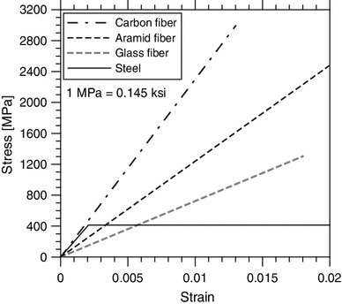

Figure 2.1: Stress - strain plots of FRP and steel materials (ISIS Manual No.5 2008)

### Common FRP-strengtheningapplication

There are currently three main applications for the use of FRPs as external reinforcement of reinforced concrete structures;

* + 1. Flexural/Bending strengthening: in this application, FRP materials are bonded to the tension and/or side faces of a concrete beam to provide additional tensile reinforcement and increase the strength of the member in bending. The fiber is oriented along the longitudinal axis of the beam.
    2. Shear strengthening: in this application, FRP materials are bonded to the side faces of concrete beam (often in the form of U-wraps) to provide shear reinforcement which supplements that provided by the internal steel stirrups. The fibers are oriented perpendicular to the longitudinal axis of the beam.
    3. Confining reinforcement: in this application, columns are wrapped in the circumferential direction with FRP sheets. Under compressive axial load, the column expand (dilates) laterally and the FRP sheets develop a tensile “confining” stress that places the concrete in a state of triaxial stress. This significantly increases the strength and ductility of the concrete and the column. The fibres are most commonly oriented perpendicular to the longitudinal axis of the member.

### Carbon Fibre Reinforced Polymer Wrapping on RC beam for Flexure and Shear

Khalifa and Nanni (2000) investigated the performance of T-beam strengthened in shear with CFRP sheets. They found that by using various configurations such as side strips and continuous wraps of CFRP sheets, the shear capacity of the beams could be increased by 35 to 40%. It was observed that an optimum quantity of FRP exists, beyond which strengthening effectiveness is uncertain. Strips of FRP applied only to the beam sides provide less strength enhancement than those bonded in U-shaped configuration although strips proved to be as effective as continuous sheets, researchers recommended that sheet be utilized in field applications. Since damage to an individual strips is more detrimental to its behaviour.

Omaret al. (2001)proposed design formulae to predict the strength of Carbon-Fibre-Reinforced Plastic (CFRP) strengthened beams, particularly when premature failure through laminates-end shear or concrete cover delamination occurs. The technique of externally bonded CFRP

laminates achieved considerable strengthening efficiency, particularly in case of smaller un- sheeted length and adequate strengthening ratios. The predictions using the proposed formulae were compared with the experimental results, as well as with the calculated design limit states and concluded that the predicted results corresponded to the experimental results and the design formulae can be used to predict the CFRP strength.

Francesco et al.(2002) conducted an experimental investigation of reinforced concrete beams strengthened in flexure and shear using externally epoxy bonded bidirectional carbon fibre fabric to overcome the bond slip and plate separation at the ends. In conclusion the results reported therein show that CF fabrics can provide an effective and efficient alternative to laminates strengthening existing concrete structures.

Islam et al. (2005) investigated shear strengthening of RC deep beams using externally bonded FRP systems. In there study, six identical beams were fabricated and tested to failure for this purpose. In conclusion the test results shown that the use of a bonded FRP system leads to a much slower growth of the critical diagonal cracks and enhances the load-carrying capacity of the beam to a level quite sufficient to meet most of the practical upgrading requirements,an enhancement of shear strength in the order of about 40%, was achieved in this study (Islam et al. 2005).

Raniaet al. (2006) investigated on flexural behavior of corroded steel reinforced concrete beams under repeated loading. The investigation was carried out on thirty beams of sizes 152mm x254mm x2000mm repaired with carbon fibre reinforced polymer (CFRP) sheets. They reported that retrofitting with CFRP sheets increased the fatigue capacity of the beams with corroded steel reinforcement beyond that of the control unrepaired beams with un-corroded steel reinforcement.

Beams repaired with CFRP at a medium corrosion level and then further corroded to a high corrosion level before testing had a comparable fatigue performance to those that were repaired and tested after corroding directly to a high corrosion level.

Saafan (2006) studied the shear strengthening of reinforced concrete (RC) beams using CFRP wraps. The objective of the experimental work was to investigate the efficiency of CFRP composites in strengthening simply supported reinforced concrete beams designed with insufficient shear capacity. Using the hand lay-up technique, successive layers of a woven fibre glass fabric were bonded along the shear span to increase the shear capacity and to avoid catastrophic premature failure modes. The strengthened beams were fabricated with no web reinforcement to explore the efficiency of the proposed strengthening technique using the results of control beams with closed stirrups as web reinforcement. The results indicated that significant increase in the shear strength and improvements in the overall structural behavior of beams with insufficient shear capacity could be achieved by proper application of CFRP wraps.

Tameret al. (2007) presented results of an experimental study designed to evaluate the performance of reinforced concrete beams repaired with carbon fibre reinforced polymer (CFRP) sheets under corrosive environmental conditions. The researchers concluded that the deflection capacity of the beams decreased as corrosion progressed after repair. The deflection capacity of the repaired beams was on an average approximately 45% lower than that of the control beam.

Barroset al. (2007) investigated experimentally the efficacies of the near surface mounted (NSM) and externally bonded reinforcing (EBR) techniques for the flexural and shear strengthening of reinforced concrete (RC) beams. They concluded that the CFRP shear strengthening systems applied in their work increased significantly the shear resistance of concrete beam. For the

flexural strengthening, the NSM technique was the most effective, but the difference between the efficiency of NSM and EBR techniques decreased with the increase of the longitudinal equivalent reinforcement ratio.

Mosallam and Banerjee (2007) studied experimentally on shear strength enhancement of reinforced concrete beams externally reinforced with fibre-reinforced polymer (FRP) composites. A total number of nine full-scale beam specimens of three different classes, builtunstrengthen were retrofitted and tested. Three composite systems namely carbon/epoxy wet layup, E-glass/epoxy wet layup and carbon/epoxy procured strips were used for retrofit and repair evaluation.Experimental results indicated that the composite systems provided substantial increase in ultimate strength of repaired and strengthened beams as compared to the pre-cracked and as-built beam specimens. A comparative study of the experimental results with published analytical models, including the ACI 440.3R-04, (2002) model, was also conducted in order to evaluate the different analytical models and identify the influencing factors on the shear behavior of FRP strengthened reinforced concrete beams. Comparison indicates that the shear span-to- depth ratio (a/d) is an important factor that actively controls the shear failure mode of beam and consequently influences on the shear strength enhancement.

Mahmut and John (2009) proved that, fatigue resistance of RC beams is improved by strengthening with CFRP fabrics. The increase in stiffness of the CFRP control beam was approximately two times that of the un-strengthened beam. All CFRP-strengthened beams survived fatigue testing of 2 million cycles. Delamination significantly decreased the stiffness of the CFRP-strengthened beams, the average decrease being 15% relative to specimens without defects.

Balamuralikrishnan et al. (2009) conducted an experimental study on beams to evaluate the performance of RC beams bonded with single and double layer CFRP fabric at the soffit of the beam under static and cyclic loading. The authors concluded that CFRP fabric properly bonded to the tension face of RC beams can enhance the flexural strength substantially. The strengthened beams exhibit an increase in flexural strength of 18 to 20 percent for single layer and 40 to45 percent fortwo layers both static and compression cyclic loading respectively.

Yasmeen (2010) investigated the behavior of structurally damaged full-scale reinforced concrete beams retrofitted with CFRP laminates in shear or in flexure experimentally. The main variables considered by them were the internal reinforcement ratio, position of retrofitting and the length of CFRP. The experimental results indicates that beams retrofitted in shear and flexure by using CFRP laminates are structurally efficient and are restored to stiffness and strength values nearly equal to or greater than these of the control beams. They found that the efficiency of the strengthening technique by CFRP in flexure varied depending of the length. The main failure mode in the experimental work was plate debonding in retrofitted beams.

Nadeem et al. (2010) presented the results of experimental study made on beams wrapped with CFRP and their test results clearly indicated that flexural strength can be substantially improved by externally bonding the CFRP sheets to the tension face of under-reinforced RC Beams. However, the percentage increase is dependent of steel reinforcement ratio. In order to develop a rational and meaningful concept of ductility that may be applied to all structural materials, a reference base is required. The yield point of internal steel provides a very objective reference point to define ductility. However, it is the unique yield plateau of the stress-strain curve of steel which impart the structural member an ability to sustain load while undergoing large deformations. This is not that case when the reinforcing medium is fibre reinforced polymer

(FRP) or a mixture of steel and FRP, as in the case of FRP sheet bonded RC beams, following expression was used to calculate the ductility index of control and CFRP strengthened beams:

𝐷𝑢𝑐𝑡𝑖𝑙𝑖𝑡𝑦 𝑖𝑛𝑑𝑒𝑥 = 𝑀𝑖𝑑 −𝑠𝑝𝑎𝑛 𝑑𝑒𝑓𝑙𝑒𝑐𝑡𝑖𝑜𝑛 𝑎𝑡 𝑝𝑒𝑎𝑘 𝑙𝑜𝑎𝑑

𝑀𝑖𝑑 −𝑠𝑝𝑎𝑛 𝑑𝑒𝑓𝑙𝑒𝑐𝑡𝑖𝑜𝑛 𝑎𝑡 𝑡𝑒𝑛𝑠𝑖𝑜𝑛 𝑠𝑡𝑒𝑒𝑙 𝑦𝑖𝑒𝑙𝑑

………. (2.1)

Shihy et al. (2010) reported that, strengthening of composite beams and concrete slab strengthened with CFRP sheets increased the load carrying capacity of the beam by 15%. This increase is related to the thickness of the CFRP sheet; doubling the sheet thickness increased the ultimate capacity of the beams to 21%.The load carrying capacity of the flexure strengthened beams with corrugated sheet predicted by the experimental data is higher than that of the control beams by 12%. The ductility of strengthened beams has a range of 2.4 to 2.5 compared to 3.5 for the control beam. The low ductility of strengthened beam indicates that addition of CFRP as reinforcement greatly reduces the deforming ability at the ultimate stage of loading.

Rania et al. (2011) investigated the flexural behavior of thirty numbers of (152x254x2000mm) corroded steel reinforcement beams repaired with CFRP sheets under repeated loading. They concluded that, repairing with a double flexural CFRP sheet at a high corrosion level increased the flexural fatigue capacity of corroded beams by 42% at 50000 cycles and 17% at 750000 cycles compared to the corroded beams. It was found that there was no difference in strength between repairing the beams with a single layer and a double layer of CFRP sheets. When severely cracked beams were repaired with FRP, their life was extended by about 10 times, suggesting that beams in service could be effectively rehabilitated using FRP. High-modulus FRP sheets have excellent tensile and fatigue strength properties but little global ductility.

Habiburet al. (2011) experimentally investigated the flexural behavior of reinforced concrete beams strengthened with CFRP laminates attached to the bottom of the beams by epoxy adhesive

subjected to transverse loading. A total of five beams having different CFRP laminates configurations were tested to failure in four-point bending over a clear span 1900mm. Four beams were strengthened by changing the levels of CFRP laminates whereas the last one was not strengthened with FRP and considered as a control beam. Test results showed that the addition of CFRP sheets to the tension surface of the beams demonstrated significantly improvement in stiffness and ultimate capacity of beams.

Sherif et al. (2013) examined the performance of reinforced concrete (RC) beams strengthened in shear. Experimental investigation was carried out on nine RC beams of three different sets, as- built beams (un-strengthened), beams strengthened with vertical carbon fibre-reinforced polymer (CFRP) wraps, and beams strengthened with inclined CFRP wraps. The main parameters investigated were concrete strength, CFRP thickness and wraps orientations (90°, 45°). The results of the experimental work indicated that externally bonded CFRP wraps enhanced the shear strength of beams significantly and that inclined CFRP configuration is more effective than vertical ones.

### Analytical Study on Externally FRP Shear Strengtheningof RC Beams

The researcher (Khalifa et al., 1998) showed the impact CFRP has on the shear capacity of the concrete beam through different design processes and techniques. The study presents two equations, dependent on the type of failure of the CFRP sheet used to calculate the shear strengthand suggest that the lowest value is taken. The parameter is dependent on a number of factors, including the stiffness of the sheet, density, number of layers, fibre orientation angle, width, length, adhesive material and the covering method. The types of failure modes that can occur when CFRP is used include delamination from the concrete surface and rupture (breaking suddenly due to the impact load). The two types of methods (Effective FRP stress and Bond

Mechanism) will be used to determine the CFRP contribution to the shear strength of the RC beam in this study. The effective FRP stress technique is dependent on the stresses and stress levels within the material, whereas the other mode of failure is based on the connection between the concrete member and the fabric (bond).

𝑉𝑛 = 𝑉𝐶 + 𝑉𝑠 + 𝑉𝑓 …………………………… (2.2)

Where:

𝑉𝑛 = 𝑇𝑜𝑡𝑎𝑙 𝑠𝑕𝑒𝑎𝑟 𝑠𝑡𝑡𝑟𝑒𝑛𝑔𝑡𝑕 𝑐𝑜𝑛𝑡𝑟𝑖𝑏𝑢𝑡𝑖𝑜𝑛

𝑉𝐶 = 𝑆𝑕𝑒𝑎𝑟 𝑠𝑡𝑟𝑒𝑛𝑔𝑡𝑕 𝑐𝑜𝑛𝑡𝑟𝑖𝑏𝑢𝑡𝑖𝑜𝑛 𝑑𝑢𝑒 𝑡𝑜 𝑐𝑜𝑛𝑐𝑟𝑒𝑡𝑒

𝑉𝑆 = 𝑆𝑕𝑒𝑎𝑟 𝑠𝑡𝑟𝑒𝑛𝑔𝑡𝑕 𝑐𝑜𝑛𝑡𝑟𝑖𝑏𝑢𝑡𝑖𝑜𝑛 𝑑𝑢𝑒 𝑡𝑜 𝑠𝑡𝑒𝑒𝑙

𝑉𝑓 = 𝑆𝑕𝑒𝑎𝑟 𝑠𝑡𝑟𝑒𝑛𝑔𝑡𝑕 𝑐𝑜𝑛𝑡𝑟𝑖𝑏𝑢𝑡𝑖𝑜𝑛 𝑑𝑢𝑒 𝑡𝑜 𝑓𝑖𝑏𝑟𝑒

### Effective FRP stress

This design method for calculating 𝑉𝑓involves calculating the stress levels in the CFRP. The stresses in the CFRP must be analyzed, including the force required to cause failure. The load is determined by multiplying the ultimate stress and the sheets area that intersects a possible crack. The moment that the CFRP ruptures and splits must be formulated. Triantafillou (1997) which noted that this type of failure is a result of concentrated stresses at certain positions within the sheet, which results in the CFRP rupturing below its ultimate strength capacity. Also, he observes that this technique doesn‟t take into consideration the concrete strength or the bonded surface configuration due to limited experimental data.

The design equation that was produced involving the shear capacity of the RC with CFRP externally bonded was,

𝑉𝑓

= 𝐴𝑓 𝑓𝑓𝑒 (cos 𝛽+sin 𝛽) 𝑑𝑓 (2.3)

𝑠𝑓

𝑊𝑕𝑒𝑟𝑒:

𝑑𝑓 = 𝐸𝑓𝑓𝑒𝑐𝑡𝑖𝑣𝑒 𝑑𝑒𝑝𝑡𝑕 𝑜𝑓 𝑡𝑕𝑒 𝐶𝐹𝑅𝑃 𝑠𝑕𝑒𝑎𝑟 𝑟𝑒𝑖𝑛𝑓𝑜𝑟𝑐𝑒𝑚𝑒𝑛𝑡.

𝛽 = 𝐴𝑛𝑔𝑙𝑒 𝑜𝑓 𝑡𝑕𝑒 𝑝𝑟𝑖𝑛𝑐𝑖𝑝𝑎𝑙 𝑓𝑖𝑏𝑟𝑒 𝑜𝑟𝑖𝑒𝑛𝑡𝑎𝑡𝑖𝑜𝑛 𝑎𝑛𝑑 𝑡𝑕𝑒 𝑙𝑜𝑛𝑔𝑖𝑡𝑢𝑑𝑖𝑛𝑎𝑙 𝑎𝑥𝑖𝑠 𝑜𝑓 𝑏𝑒𝑎𝑚.

𝐴𝑓 = 𝐴𝑟𝑒𝑎 𝑜𝑓 𝐶𝐹𝑅𝑃 𝑠𝑕𝑒𝑎𝑟 𝑟𝑒𝑖𝑛𝑓𝑜𝑟𝑐𝑒𝑚𝑒𝑛𝑡

𝑓𝑓𝑒 = 𝐸𝑓𝑓𝑒𝑐𝑡𝑖𝑣𝑒 𝑡𝑒𝑛𝑠𝑖𝑙𝑒 𝑠𝑡𝑟𝑒𝑠𝑠 𝑖𝑛 𝑡𝑕𝑒 𝑠𝑕𝑒𝑒𝑡 𝑖𝑛 𝑡𝑕𝑒 𝑑𝑖𝑟𝑒𝑐𝑡𝑖𝑜𝑛 𝑜𝑓 𝑡𝑕𝑒 𝑝𝑟𝑖𝑛𝑐𝑖𝑝𝑎𝑙 𝑓𝑖𝑏𝑟𝑒𝑠.

𝑆𝑓 = 𝐶𝐹𝑅𝑃 𝑠𝑡𝑟𝑖𝑝’𝑠 𝑠𝑝𝑎𝑐𝑖𝑛𝑔.

𝑉𝑓 = 𝐶𝑜𝑛𝑡𝑟𝑖𝑏𝑢𝑡𝑖𝑜𝑛 𝑜𝑓 𝐶𝐹𝑅𝑃 𝑠𝑕𝑒𝑒𝑡 𝑡𝑜 𝑡𝑕𝑒 𝑠𝑕𝑒𝑎𝑟 𝑠𝑡𝑟𝑒𝑛𝑔𝑡𝑕.

Triantafillou (1997) noted the need for a value of effective strain, which was experimentally determined by calculating 𝑉𝑓 and varying the shear and CFRP configurations. The experimental results obtained helped to find a relationship between the axial rigidity and the effective strain of the CFRP. The equations found for the effective strain include,

𝜀𝑓𝑒 = 0.0119 − 0.0205(𝜌𝑓 𝐸𝑓 ) + 0.0104(𝜌𝑓 𝐸𝑓 )2 𝑓𝑜𝑟 0 ≤ 𝜌𝑓 𝐸𝑓 ≤ 1𝐺𝑃……… (2.4)

𝜀𝑓𝑒 = 0.00245 − 0.00065(𝜌𝑓 𝐸𝑓 ) 𝑓𝑜𝑟𝜌𝑓 𝐸𝑓 > 1𝐺𝑃………………………….…. (2.5) Where:

𝜀𝑓𝑒 = 𝐸𝑓𝑓𝑒𝑐𝑡𝑖𝑣𝑒 𝐹𝑅𝑃 𝑠𝑡𝑟𝑎𝑖𝑛.

𝐸𝑓 = 𝐸𝑙𝑎𝑠𝑡𝑖𝑐 𝑚𝑜𝑑𝑢𝑙𝑢𝑠 𝑜𝑓 𝐹𝑅𝑃.

𝜌𝑓 = 𝐹𝑅𝑃 𝑠𝑕𝑒𝑎𝑟 𝑟𝑒𝑖𝑛𝑓𝑜𝑟𝑐𝑒𝑚𝑒𝑛𝑡 𝑟𝑎𝑡𝑖𝑜.

Due to advances in technology and developed progress, (Triantafillou, 1997) experimental work has been improved where the effective strain has been slightly modified. The model idea shows that the axial rigidity of the CFRP should not exceed 1.1GPa. Through experimental analysis, a reduction factor has been determined as the ratio of the effective strain to the ultimate strain (R). The ultimate strain is plotted against the axial rigidity of the CFRP. It was established that the line of best fit in terms of a quadratic were,

𝑅 = 0.5622(𝜌𝑓 𝐸𝑓 )2 − 1.2188(𝜌𝑓 𝐸𝑓 ) + 0.778 ≤ 0.5……………………….…. (2.6)

They adopted the limit „to maintain the shear integrity of the concrete‟ Therefore the effective strain can be calculated by the reduction factor multiplied by the ultimate strain. That is,

𝜀𝑓𝑒 = 𝑅𝜀𝑓𝑢 …………………. (2.7)

### Bond Mechanism

The study by Khalifa et al.(1998) analyses another type of failure mode, which is dependent on the bond and connection between the concrete surface and the external CFRP reinforcement. They referred to experiments proposed and implemented by Maeda et al. (1997)which entailed CFRP strips connected to a concrete structure under tensile loading. The experiments were designed to show the relationship between the bonded length and the ultimate tensile strength of the CFRP strip. This was achieved by conducting a number of experiments with a variety of different CFRP sheet stiffness (axial rigidity) and altering the bond length. The remarks by Maeda et al. (1997) proposed and found that if the bonded length exceeded 100mm, the tensile force at its ultimate limit within the CFRP is independent of the bonded length.

Through experimental data and calculations, Maeda et al. (1997) was able to formulate an equation based on the bondmechanisms of the CFRP and concrete surface. A number of steps are required to obtain the equation and are based on the CFRP configuration, concrete strength, and load capacity of the CFRP sheet, effective bond length and average bond strength.

The effective bond length (Le) is known as the CFRP strip length within the active bonded region of the concrete surface,

𝐿𝑒 = 𝑒6.134−0.58ln ⁡(𝑡𝑓 𝐸𝑓 ) (2.8)

Where:

𝐿𝑒 = 𝐸𝑓𝑓𝑒𝑐𝑡𝑖𝑣𝑒 𝑏𝑜𝑛𝑑 𝑙𝑒𝑛𝑔𝑡𝑕.

𝑡𝑓 = 𝐶𝐹𝑅𝑃 𝑠𝑕𝑒𝑒𝑡 𝑡𝑕𝑖𝑐𝑘𝑛𝑒𝑠𝑠.

𝐸𝑓 = 𝐸𝑙𝑎𝑠𝑡𝑖𝑐 𝑚𝑜𝑑𝑢𝑙𝑢𝑠 𝑜𝑓 𝐶𝐹𝑅𝑃.

The bond strength (τbu) was shown through experimental analysis as the thickness of the CFRP sheet multiplied by the elastic modulus and k, an experimental constant,

𝑡𝑏𝑢 = 𝐾𝐸𝑓 𝑡𝑓 …………………………………… (2.9)

Maedaet al. (1997) used a constant concrete strength throughout his experiments and thus to enable the equation to be used with a varying compressive strength, the average bond strength equation is customized to accommodate this problem. The equation is modified to;

𝑓; 2

42

𝑡𝑏𝑢 = 𝐾𝐸𝑓 𝑡𝑓 ( 𝑐 )3 …………………….… (2.10)

The final parameter is the configuration of the CFRP around the concrete surface. The three options investigated by Maeda et al. (1997) included completely wrapping the CFRP around the beam, a U shape and the sheet bonded only to the sides of the beam. An effective width of the CFRP is used „once a shear crack develops, only that portion of FRP extending past the crack by the effective bonded length will be capable of carrying shear‟. Therefore the three equations were established depending on the CFRP configuration,

𝑤𝑓𝑒 = 𝑑𝑓 for completely wrapped around beam (2.11)

𝑤𝑓𝑒 = 𝑑𝑓 − 𝐿𝑒 for a U shape wrap (2.12)

𝑤𝑓𝑒 = 𝑑𝑓 − 2𝐿𝑒 for bonded to sides only (2.13)

Vfwas established by taking into account all the factors and parameters above with the design equation proposed by Maeda et al.(1997) shown in equation (2.13). The limitation based on this method is that it doesn‟t take into consideration the angle of the CFRP orientation.

𝑉𝑓

= 2𝐿𝑒 𝑤𝑓 𝑡𝑏𝑢 𝑤𝑓𝑒 ….……………………... (2.14)

𝑠𝑓

## Where:

𝑤𝑓 = 𝑊𝑖𝑑𝑡𝑕 𝑜𝑓 𝐹𝑅𝑃 𝑠𝑡𝑟𝑖𝑝.

𝑤𝑓𝑒 = 𝐸𝑓𝑓𝑒𝑐𝑡𝑖𝑣𝑒 𝑤𝑖𝑑𝑡𝑕 𝑜𝑓 𝐶𝐹𝑅𝑃 𝑠𝑕𝑒𝑒𝑡.

𝑆𝑓 = 𝐶𝐹𝑅𝑃 𝑠𝑡𝑟𝑖𝑝’𝑠 𝑠𝑝𝑎𝑐𝑖𝑛𝑔.

𝐿𝑒 = 𝐸𝑓𝑓𝑒𝑐𝑡𝑖𝑣𝑒 𝑏𝑜𝑛𝑑 𝑙𝑒𝑛𝑔𝑡𝑕.

𝑡𝑏𝑢 = 𝐴𝑣𝑒𝑟𝑎𝑔𝑒 𝑏𝑜𝑛𝑑 𝑠𝑡𝑟𝑒𝑛𝑔𝑡𝑕.

𝑑𝑓 = 𝐸𝑓𝑓𝑒𝑐𝑡𝑖𝑣𝑒 𝑑𝑒𝑝𝑡𝑕 𝑜𝑓 𝑡𝑕𝑒 𝐶𝐹𝑅𝑃 𝑠𝑕𝑒𝑎𝑟 𝑟𝑒𝑖𝑛𝑓𝑜𝑟𝑐𝑒𝑚𝑒𝑛𝑡.

## Using the shear parameters ∅=0.85 and ∅=0.7 for shear reinforcement and CFRP reinforcement respectively thus the total shear strength will be calculated as;

𝑉𝑛 = 0.85(𝑉𝑐 + 𝑉𝑠 ) + 0.7𝑉𝑓 …….…………… (2.15)

### CHAPTER THREE MATERIALS AND METHODS

### Materials

### Cement

Ordinary Portland Cement (OPC) conforming to BS EN 197-1-2010of Dangote brand was used throughout the investigation and it was obtained from Samaru market and it was tested for its physical properties as presented in Table 3.1.

Table 3.1: Properties of cement (OPC)

|  |  |  |
| --- | --- | --- |
|  | Characteristics | Test Results |
|  | Specific gravity | 3.14 |
|  | Standard Consistency (%) | 34 |
|  | Setting time (min.) Initial | 89 |
|  | Final | 340 |
| **3.1.2 Aggregates** |  |  |

The coarse aggregate used in this investigation was crusher broken hard granite chips, maximum size was 20 mm with specific gravity 2.62, and grading confirming to BS EN 12620-2013. The fine aggregate used was clean river sand passing through 4.75 sieves with specific gravity of 2.50and all of which obtained in Zaria. The properties are presented in Tables 3.2 and 3.3 respectively.

Table 3.2: Physical properties of coarse aggregates

Properties Nominal size (10mm) Nominal size (20mm)

|  |  |  |
| --- | --- | --- |
| Specific gravity | 2.50 | 2.62 |
| Total water absorption (%) | 1.66 | 1.68 |
| Fineness modulus | 6.33 | 6.81 |

Table 3.3: Properties of fine aggregates

|  |  |
| --- | --- |
| Properties | Value |
| Specific gravity | 2.39 |
| Total water absorption (%) | 0.78 |
| Fineness modulus | 2.48 |

### Reinforcing steel

All longitudinal reinforcement used was High yield steel bars of 8mm diameter and 10mm diameter in accordance to BS EN 10080-2005. The stirrups used were 6 mm diameter steel bars and all reinforcement bars wereobtained and assembled in Panteka market, Kaduna.

### Fibre

Carbon fibre was used as strengthening reinforcing material for FRP and the carbon fiber used was obtained from China, manufactured by Beijing Glass Fibre Industries and the properties of this FRP is presented in Table 3.4 and the CFRP image is shown in Plate I. Epoxy was used as the binding material between fiber layers and concrete.

Table 3.4: Properties of fibreCXS-200 (Source: Beijing Glass Fibre Industries)

|  |  |  |
| --- | --- | --- |
| S/N | Physical properties | Value |
| 1 | Tensile strength | 3400MPa |
| 2 | Modulus of Elasticity | 240 MPa |
| 3 | Density | 1.76 g/cm3 |
| 4 | Thickness | 0.11 mm |

|  |  |  |
| --- | --- | --- |
| 5 | Ultimate strain | 1.7 % |
| 6 | Width | 200mm |

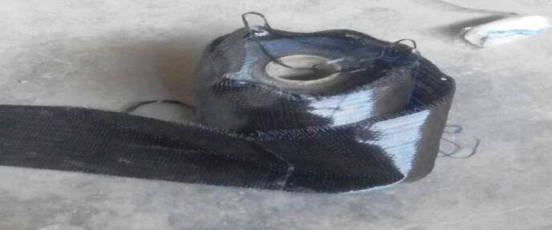

Plate I: CFRP Material

### Resin

Epoxy resins was used both as the matrix for the FRP and as the bonding adhesive between the FRP and the concrete. The success of the strengthening technique primarily depends on the performance of the epoxy resin used for bonding of FRP to concrete surface. Numerous types of epoxy resins with a wide range of mechanical properties are commercially available in the market. The epoxy resins are generally available in two parts, a resin and a hardener. The epoxy resin used for this research was Araldite GY epoxy bonding agent and it was obtained from Lagos. The properties for the resin is presented in Table 3.5.

Table 3.5: Properties of epoxy resin (Source: Super Floor Company)

|  |  |  |
| --- | --- | --- |
| S/N | Physical properties | Values |
| 1 | Mix ratio | 2:1 |
| 2 | Colour | Brown |
| 3 | Pot Life @ 30° C | ± 30-40 mins. |
| 4 | Cure time | 7 days |

|  |  |  |
| --- | --- | --- |
| 5 | Tensile strength, 7 days | 10.4 N/mm2 |
| 6 | Compressive strength, 7 days | 60 N/mm2 |
| 7 | Flexural Strength | 28.1 N/mm2 |
| **3.1.6 Water** |  |  |

Ordinary clean portable tap water free from suspended particles is used for mixing and curing of concrete throughout the experiment and was obtained fromConcrete Laboratory of Civil Engineering Department in Ahmadu Bello University, Zaria.

### Formwork

The form work used for concreting all specimens and cubes was fabricated in Samaru market to the required shape and size made of timber specimen mold sized 150x150x750mm and cubes 150x150x150mm. The bottom rests over thick polythene sheet laid over rigid as floor. The reinforcement cage is then lowered, placed in position inside the form work carefully with a cover of 25mm on sides and bottom by placing concrete cover in accordance to BS 8110.

### Other materials used

Other materials used for this research include dial guage with accuracy of 0.0001mm and it was obtained from the Department of civil engineering ABU Zaria, a roller, scissors, hand brush,mixing container, permanent markers all of which were obtained from Panteka market in Kaduna state.

### Method

### Preparation of Specimen

The test program consist of casting twelve beams with cross sectional dimension of 150x150x750mm using concrete grade M25 and all designed to be reinforced, out of which three

are control beams. The reinforcementsprovided weretwo bars of 10mm diameter in the tension zone and two bars of 8mm diameter in the compression zone with 6mm diameter steel stirrups at 100mm centers as shear links for the control specimen and for the strengthened specimens two 8mm diameter bars each were provided at the tension and compression zone to act as less strength in flexure than the control specimens and steel stirrups were also provided as two-legged of 6mm diameter with 125mm c/c spacing to act less in strength as compared to the control specimens. The structural detailing of these beams is shown in Figures 3.1a and 3.1b for the control and strengthened RC beams respectively.

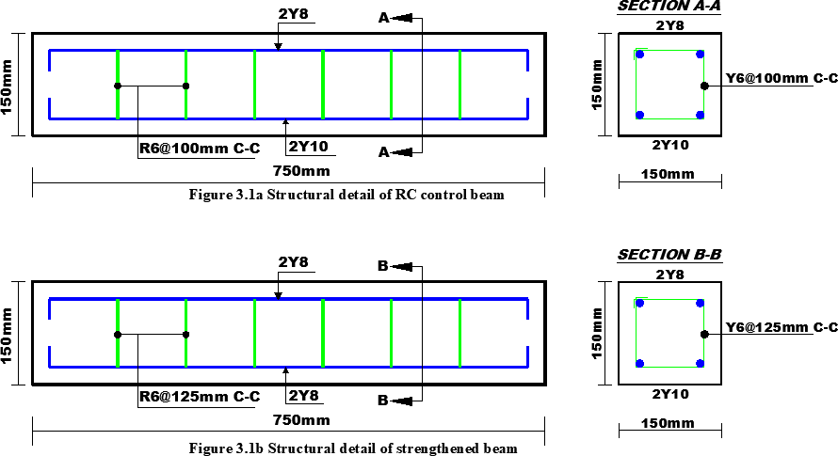

### Strengthening of specimen

The surface of the beam where the laminate is to be attached, is first smooth manually and properly cleaned to be able to develop a sound bond and withstand the imposed stresses and this

process includes preparing the surface and rounding the corner of the beam (for bonding the U- wrap strips).The CFRP sheet was then cut to the required length, prior to the preparation of the epoxy resin. The next step was applying an epoxy resin to the beam surface over which the laminate was attached (wet laying method was used for this research). The epoxy that comes in two components was mixed thoroughly until a smooth and homogenous mix was obtained. The mix was applied evenly with brush on the beam surfaces to be strengthened ensuring that all gaps were covered. The epoxy adhesive thickness was maintained constant throughout the application process on the beam. The CFRP sheet was placed on top of epoxy resin coating and the resin was squeezed through by roving the fabric to the concrete surface with a roller. Air bubbles entrapped at the epoxy/fabric interface were eliminated and the strengthened beams were cured for 7 days to attain maximum strength. The strengthening scheme and procedure for the RC beam specimen is shown in Figure 3.2 and Plate II respectively and the strengthened specimen is shown in Plate III.

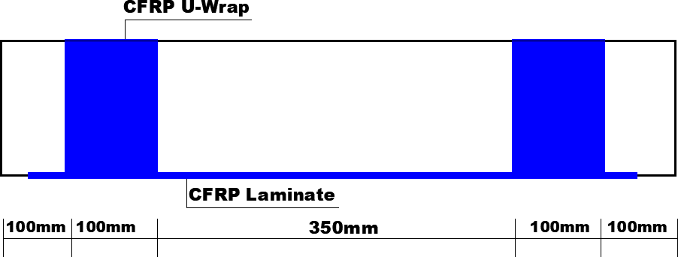

Figure 3.2: Strengthening scheme

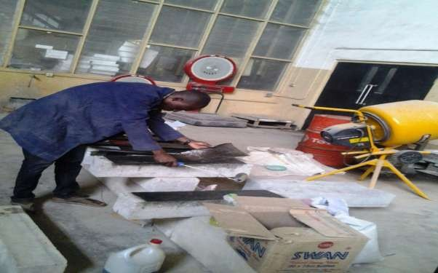

Plate II: Strengthening procedure

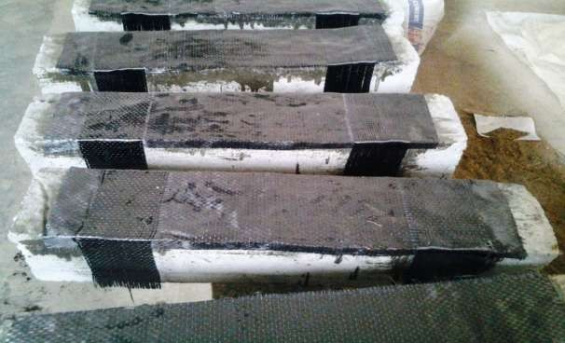

Plate III: Strengthened specimen

### Description of the strengthening method

The strengthening method, fibre placement orientation for both flexure and shear strengthening and the type of loading in which the specimens were subjected to is presented in Table 3.6.

Table 3.6: Specimen strengthening method

|  |  |  |  |  |  |
| --- | --- | --- | --- | --- | --- |
| Beam ID | Layers | Fibre Orientation for flexure | Fibre Orientation for shear | Fibre angle of inclination for shear | Load Type |
| CB01 | - | - | - | - | 3 Points |
| CB02 | - | - | - | - | 3 Points |
| CB03 | - | - | - | - | 3 Points |
|  |  |  | Perpendicular to beam |  |  |
| SL01 | 1 | Parallel to beam axis | axis (U wrap) 100mm | 90o | 3 Points |
|  |  |  | width |  |  |
|  |  |  | Perpendicular to beam |  |  |
| SL02 | 1 | Parallel to beam axis | axis (U wrap) 100mm | 90o | 3 Points |
|  |  |  | width |  |  |
|  |  |  | Perpendicular to beam |  |  |
| SL03 | 1 | Parallel to beam axis | axis (U wrap) 100mm | 90o | 3 Points |
|  |  |  | width |  |  |
|  |  |  | Perpendicular to beam |  |  |
| DL01 | 2 | Parallel to beam axis | axis (U wrap) 100mm | 90o | 3 Points |
|  |  |  | width |  |  |
|  |  |  | Perpendicular to beam |  |  |
| DL02 | 2 | Parallel to beam axis | axis (U wrap) 100mm | 90o | 3 Points |
|  |  |  | width |  |  |
| DL03 | 2 | Parallel to beam axis | Perpendicular to beam axis (U wrap) 100mm | 90o | 3 Points |
|  |  |  | width |  |  |
|  |  |  | Perpendicular to beam |  |  |
| TL01 | 3 | Parallel to beam axis | axis (U wrap) 100mm | 90o | 3 Points |
|  |  |  | width |  |  |
|  |  |  | Perpendicular to beam |  |  |
| TL02 | 3 | Parallel to beam axis | axis (U wrap) 100mm | 90o | 3 Points |
|  |  |  | width |  |  |
|  |  |  | Perpendicular to beam |  |  |
| TL03 | 3 | Parallel to beam axis | axis (U wrap) 100mm | 90o | 2 Points |
|  |  |  | width |  |  |

**CB =** Control Beam (01, 02 and 03 represents three specimens for each) **SL =** Single Layer (01, 02 and 03 represents three specimens for each) **DL =** Double Layers (01, 02 and 03 represents three specimens for each) **TL =** Three Layers (01, 02 and 03 represents three specimens for each)

### Experimental Setup

The beams were tested after curing for 28 days. All the beam specimens were tested as simply supported beams subjected to a three point bending load applied at mid span of the beam at a distance (L/2); where L is the effective span i.e. 750 mm. The testing procedure for the entire beam specimens was same. The test was performed using the set-up as shown in Figure 3.3. The testing of beams was carried out using Hydraulic Jack Machine in concrete laboratory of department of civil engineering, Ahmadu Bello University Zaria. The applied loads were monitored through a high accuracy loading cell. The load was applied over a time interval. One dial gauge was placed just below the center of the beam, i.e. at L/2 distance to measure the deflection. The reading was taken at regular intervals of loading. During loading, the specimen was visually inspected and cracks were noticed. For the clear visibility of cracks, the surfaces were marked with marker prior to testing.

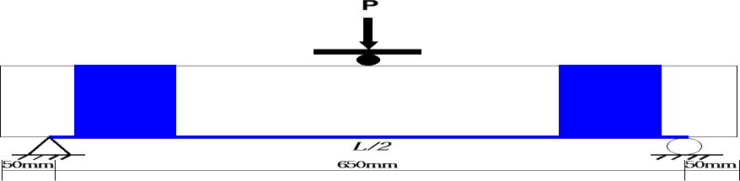

Figure 3.3: Experimental Set-up

### Theoretical FRP Shear design

The theoretical model for the prediction of the FRP shear strength contribution for the strengthened beams in both effective stress method and bond mechanism is shown in Figure 3.3.Both methods are used and the one with the smallest value was adopted.

FRP SHEAR DESIGN

**Design data required:** cross sectional details of specimen, concrete strength, FRP properties and configuration/orientation.

**Required:** calculate the contribution of externally CFRP laminates to shear capacity enhancement

.

Calculate;

R = Reduction factor

𝑓𝑓𝑒 = 𝑅𝜀𝑓𝑢

Calculate;

𝑝𝑡 = 2𝑡𝑓 /𝑏𝑤 for continuous strip

𝑝𝑡 = (2𝑡𝑓 /𝑏𝑤 ) (𝑤𝑓 /𝑠𝑓) for FRP strips

***Design approach based on the effective FRP stress method.***

Calculate;

𝐿𝑒 = 𝑒6.134−0.58ln ⁡(𝑡𝑓 𝐸𝑓 )

𝑡𝑏𝑢 = 𝐾𝐸𝑓 𝑡𝑓

𝑤𝑓𝑒 = 𝑑𝑓 − 𝐿𝑒

***Design approach based on bond mechanism.***



Calculate;

𝑉𝑓 =

2𝐿𝑒 𝑤𝑓 𝑡𝑏𝑢 𝑤𝑓𝑒

𝑤

𝑓

Calculate;

𝑉𝑓 =

𝐴𝑓 𝑓𝑓𝑒 (𝑠𝑖𝑛𝛽 + 𝑐𝑜𝑠𝛽)𝑑𝑓

𝑠

𝑓

Consider 𝑉𝑓 with the smallest value obtained from the

two methods.

Yes and adopt the smallest value

Figure 3.3: FRP shear contribution design (Khalifa et al., 1998).

### Flexural Stiffness

Stiffness component (K) can be defined as the resistance of a beam to elastic deformation under the application of load and is a function of Young‟s modulus of the material which is a measure to the stiffness. The deflection of the beam under load can be taken as a measure of stiffness.

The stiffness of a beam in bending from the linear-elastic behavior of each beam can be determined from equation 3.1 by Alhayek (2009).

𝐸𝐼 = 𝐹𝐿3 ………………………….3.1

48𝛿

Where;

𝐹 = 𝐹𝑎𝑖𝑙𝑢𝑟𝑒 𝑙𝑜𝑎𝑑

𝐿 = 𝑙𝑒𝑛𝑔𝑡𝑕 𝑜𝑟 𝑑𝑖𝑠𝑡𝑎𝑛𝑐𝑒 𝑏𝑒𝑡𝑤𝑒𝑒𝑛 𝑠𝑢𝑝𝑝𝑜𝑟𝑡𝑠

𝛿 = 𝐹𝑎𝑖𝑙𝑢𝑟𝑒 𝑑𝑒𝑓𝑙𝑒𝑐𝑡𝑖𝑜𝑛

### Ductility Index

The beam deflection capacity 𝛥𝑚𝑎𝑥 is defined as the maximum deflectionattained by the beam prior to failure. Large deflection before failure wouldprovide ample warning of structural distress. The beam ductility is the capacity ofthe beam to sustain large deformation before failure without a significant drop inload capacity. The beam ductility index is typically defined as the

ratio of thebeam deflection at ultimate load to the deflection at yield load (Mukhopadhyaya et al., 1998). On the basis of this observation, the ductilityindex of the beams of the present study𝜇𝛥is

defined as:

𝜇𝛥

= 𝛥𝑓 ……………………….. 3.2

𝛥𝑦

Where;

𝜇𝛥 = 𝑑𝑢𝑐𝑡𝑖𝑙𝑖𝑡𝑦 𝑖𝑛𝑑𝑒𝑥

𝛥𝑓 = 𝑚𝑖𝑑 − 𝑠𝑝𝑎𝑛 𝑑𝑒𝑓𝑙𝑒𝑐𝑡𝑖𝑜𝑛 𝑎𝑡 𝑢𝑙𝑡𝑖𝑚𝑎𝑡𝑒 𝑙𝑜𝑎𝑑

𝛥𝑦 = 𝑚𝑖𝑑 − 𝑠𝑝𝑎𝑛 𝑑𝑒𝑓𝑙𝑒𝑐𝑡𝑖𝑜𝑛 𝑎𝑡 𝑦𝑖𝑒𝑙𝑑𝑖𝑛𝑔 𝑙𝑜𝑎𝑑

### CHAPTER FOUR RESULTS AND DISCUSSIONS

### Concrete Characteristics Test Result

The concrete cubes compressive strength for the age of 1, 3, 7, 21 and 28 days results are presented in Table 4.1.

Table 4.1: Compressive strength test results

|  |  |  |  |  |  |
| --- | --- | --- | --- | --- | --- |
| Compressive strength |  | | | | |
| (N/mm2) | 1 Day | 3 Days | 7 Days | 21 Days | 28 Days |
| Average of 3 cubes | 5.4 | 12.5 | 20.9 | 22.7 | 32.0 |

### Experimental Results

The experimental results of all the beams were presented in this section with load-deflection data for all specimens presented in appendix A and the discussion is based on the following topics: load-deflection curve, first crack load, ultimate load, failure crack width, stiffness and ductile property of the RC beams. The results for the reference control beam and strengthened beams were compared.

### Results of referencecontrol beam (RCB)

From the results of load-deflection of the control beams (CB01, CB02 and CB03), their average values were used to comparefor all the strengthened beams in various layers and corresponding to it the load-deflection curve was plotted and shown in Figure 4.1. It was observed that the control specimen failed at an average load of 50KN with corresponding mid span deflection of 7.35mm, from the curve it was observed that at initial loading prior to cracking the load and

deflection behaves linearly up to the first appearance of crack and the deflection start increasing with increase in load and the curve becomes steeper than earlier up to yield load and eventually failed.



60

50

40

30

RCB

20

10

0

0

1

2

3

4

5

6

7

8

9

Dimension (mm)

Load (KN)

Figure 4.1:Load-Deflection for reference control beam (RBC)

### Result of Single layer strengthened RC beams (SL01)

The load-deflection data for the single layerbeam specimen (SL01) wasobtainedand corresponding to it the load-deflection curve was compared with the reference beam as shown in Figure 4.2 and from the test results, it was observed that the load carrying capacity of the beam increases as compared to reference control beam (RCB) but the beamfailedin a sudden manner (shear failure) despite the CFRP U-wrap for shear with less deformations as compared to ductile failure mode of controlled beams and also the curve follows same pattern as in the reference beam but only with a higher loading capacity and less deflection was observed. The first crack was observed at a load of about 15KN and the beam finally failed at load of about 60KN with amid-span deflection of 6.33mm, in PlateIV, the crack pattern for the beam was presented.

Load (KN)

Figure 4.2:Load-Deflection for single layer strengthened beam (SL01)



70

60

50

40

30

SLO1

RCB

20

10

0

0

2

4

6

8

10

Dimension (mm)

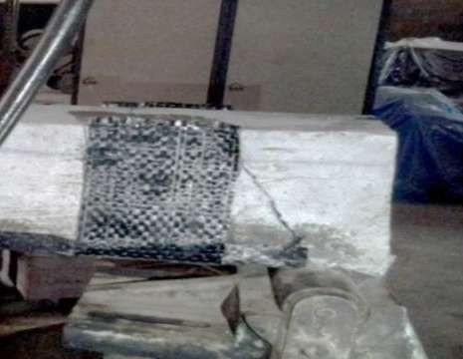

PlateIV: Crack pattern for single layer beam (SL01)

### Result of Single layer strengthened RC beams (SL02)

The load-deflection data for the single layer specimen (SL02) was obtained and corresponding to it the load-deflection curve was compared with the reference beam as shown in Figure 4.3 and from the test results, it was observed that the load carrying capacity of the beam increased when compared to the reference control beam (RCB), but the beam failed in a gradual manner as the

reference beam and with less deformations as compared to ductile failure mode of controlled beams. The first crack was observed at a load of about 14KN and the beam finally failed at load of about 59KN with a mid-span deflection of 6.19mm, in Plate V, the crack pattern for the beam was presented. These flexural cracks became the critical crack for the ultimate failure of the beam and full capacity of the FRP was not utilized due to these cracks.

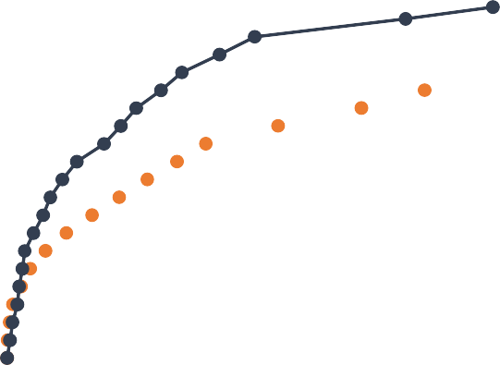

70

60

50

40

30

RCB

SL02

20

10

0

0

1

2

3

4

5

6

7

8

9

Dimension (mm)

Load (KN)

Figure 4.3:Load-Deflection for Single layer strengthened beam (SL02)

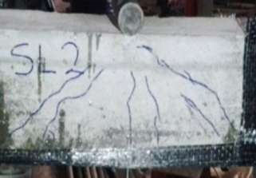

Plate V: Crack pattern for single layer beam (SL02)

### Result of Single layer strengthened RC beams (SL03)

The load-deflection data for the single layer specimen (SL03) was obtained,corresponding to it the load-deflection curve was compared with the reference beam as shown in Figure 4.4 and from the test results, it was observed that the load carrying capacity of the beam increases as compared to reference control beam (RCB). The first crack was observed at a load of about 16KN and the beam finally failed at load of about 61KN with a mid-span deflection of 6.25mm,in Plate VI, the crack pattern for the beam was presented. The shear crack became the critical crack for the ultimate failure of the beam which was inclined at an angle of about 450 from the tip of the shear U-wrap and resulted to debonding of the FRP at that point and full capacity of the FRP was not utilized due to these cracks.

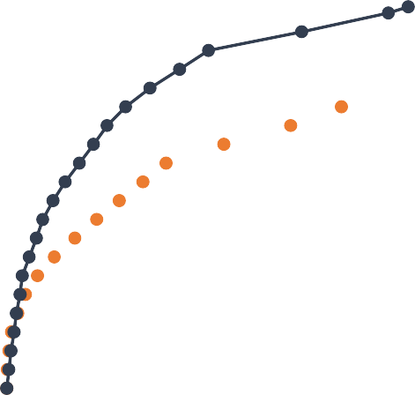

70

60

50

40

30

RCB

SL03

20

10

0

0

2

4

6

8

10

Dimension (mm)

Load (KN)

Figure 4.4:Load-Deflection for Single layer strengthened beam (SL03)

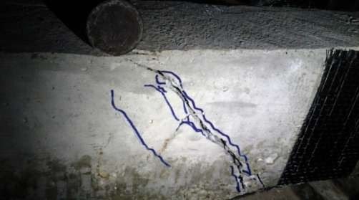

Plate VI: Crack pattern for single layer beam (SL03)

### Result of double layers strengthened beam (DL01)

The load-deflection data obtainedfor the double layers(DL01) beamwas plotted against the load deflection curve for the reference control beam as shown in Figure 4.5,it was observed that the load carrying capacity of the beam increases as compared to reference control beam (RCB). The single layer retrofitted beams load curve behaves elastically upto yield point as compared to the reference beam. The first crack was observed at a load of about 19KN and the beam finally failed at load of about 69KN with a mid-span deflection of 5.79mm, in Plate VII, the crack pattern for the beam was presented. The same deformation behaviour was noticed as in case of SL03 beam. With further increase in load, the shear crack formed at the bottom end of the U wrap laminates became wide and as the beam finally failed.

Load (KN)

Figure 4.5: Load-Deflection for double layers strengthened beam (DL01)



80

70

60

50

40

RCB

30

DL01

20

10

0

0

2

4

6

8

10

Dimension (mm)



Plate VII: Crack pattern for Double layer beam (DL01)

### Result of double layers strengthened beam (DL02)

The load-deflection data obtained for the double layers(DL02) beamwas plotted and corresponding to it the load deflection curve wascompared with the reference beam asshown in Figure 4.6, it was observed that the load carrying capacity of the beam increases as compared to reference control beam (RCB) and the curve behaves to be linearly elastic prior to the first crack which was observed at a load of about 18KN lower than that of the DL01 and the beam finally failed at load of about 68KN with a mid-span deflection of 5.88mm, in Plate VIII, the crack pattern for the beam was presented. The same deformation behaviour was noticed as in case of DL01 beam. With further increase in load, the shear crack formed at the bottom end of the U- wrap laminates became wider and the beam finally failed due to shear and concrete crushing at the loading point.



80

70

60

50

40

RCB

30

DL02

20

10

0

0

2

4

6

8

10

Dimension (mm)

Load (KN)

Figure 4.6:Load-Deflection for double layers strengthened beam (DL02)

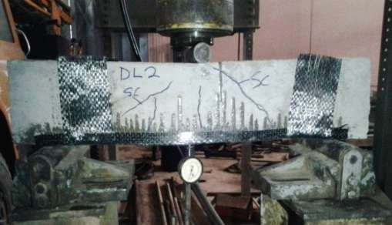

Plate VIII: Crack pattern for Double layer beam (DL02)

### Result of double layers strengthened beam (DL03)

The load-deflection data obtained for the double layers(DL03)beam was plotted and corresponding to it load-deflection curve was compared with that of the reference control beam as shown in Figure4.7; it was observed that the load carrying capacity of the beam increases as compared to reference control beam (RCB) and the curve behave more closely to that of the DL01 which was linearly up to the yield point. The first crack was observed at a load of about 19KN and the beam finally failed at load of about 69KN with a mid-span deflection of 5.83mm, in Plate IX, the crack pattern for the beam was presented. The same deformation behaviour was noticed as in case of DL02 beam. With further increase in load, the flexural crack formed directly beneath the loading cell became wide and the beam finally failed due to shear, flexural and concrete crushing.

Load (KN)

Figure 4.7:Load-Deflection for double layers strengthened beam (DL03)

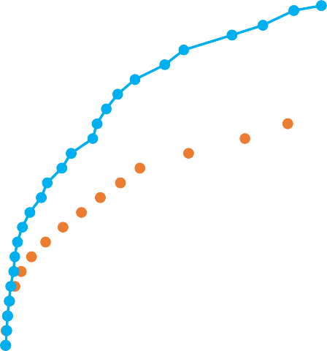

80

70

60

50

40

RCB

30

DL03

20

10

0

0

2

4

6

8

10

Dimension (mm)

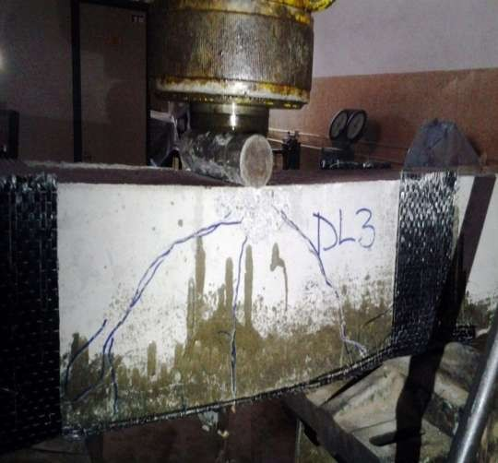

Plate IX: Crack pattern for Double layer beam (DL03)

### Result of three layers strengthened beam (TL01)

The load-deflection data obtained for the three layers (TL01) beam was plotted and corresponding to it the load deflection curve was compared with the reference beam as shown in Figure 4.8, it was observed that the load carrying capacity of the beam increases as compared withthe reference control beam (RCB), single and double layers retrofitted beams. The first crack was observed at a load of about 22KN and the beam finally failed at load of about 77KN with a mid-span deflection of 5.82mm, in Plate X, the crack pattern for the beam is presented. The same deformation behaviour was noticed as in case of DL02 beam. With further increase in load, the flexural crack formed directly beneath the loading cell became wider and the beam finally failed.

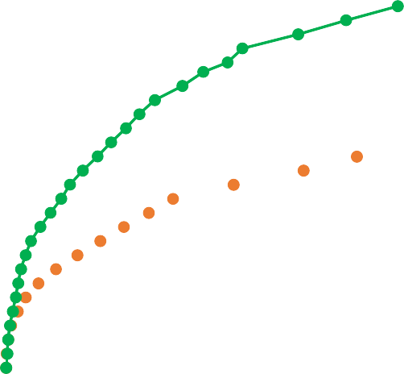

90

80

70

60

50

40

30

RCB

TL01

20

10

0

0

1

2

3

4

5

6

7

8

9

Dimension (mm)

Load (KN)

Figure 4.8: Load-Deflection for three layers strengthened beam (TL01)

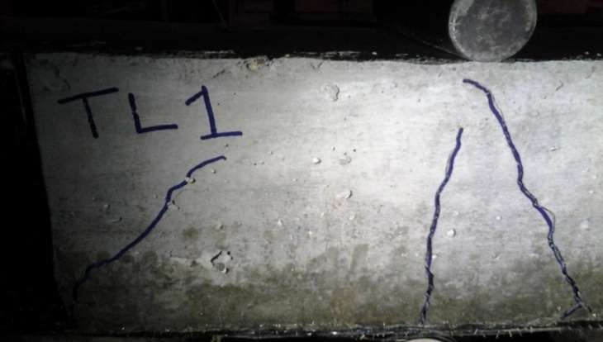

Plate X: Crack pattern for three layer beam (TL01)

### Result of three layers strengthened beam (TL02)

The load-deflection data obtained for the three layers TL02 beam was plotted and corresponding to it the load deflection curve was compared with that of the reference beam as shown in Figure 4.9, it was observed that the load carrying capacity of the beam increases as compared to reference control beam (RCB). The first crack was observed at a load of about 20KN and the beam finally failed at load of about 75KN with a mid-span deflection of 5.46mm,in Plate XI, the crack pattern for the beam was presented. The same deformation behaviour was noticed as in case of SL02 beam. With further increase in load, the shear crack formed at an angle almost 45obecame wider and debonding of laminate at the shear crack point and the beam finally failed.

Load (KN)

Figure 4.9:Load-Deflection for three layer strengthened beam (TL02)

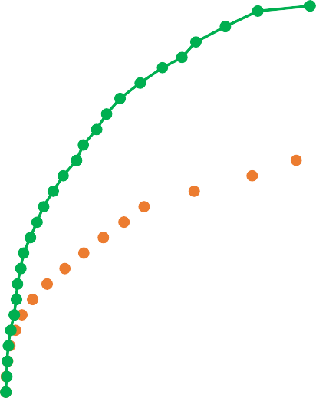

80

70

60

50

40

30

RCB

TL02

20

10

0

0

2

4

6

8

10

Dimension (mm)

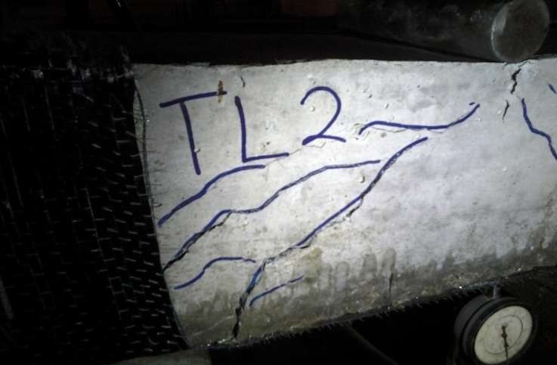

Plate XI: Crack pattern for three layer beam (TL02)

### Result of three layers strengthened beam (TL03)

The load-deflection data obtained for the three layers (TL03) beam wasplotted and corresponding to it the load deflection curve was compared with the reference beam and shown in Figure 4.10, it was observed that the load carrying capacity of the beam increases as compared to reference control beam (RCB). The first crack was observed at a load of about 21KN and the beam finally failed at load of about 76KN with a mid-span deflection of 5.85mm, in Plate XII, the crack pattern for the beam was presented. The same deformation behaviour was noticed as in case of TL02 beam. With further increase in load, the shear crack formed at an angle almost 45o became wider and debonding of laminate at the shear crack point occurred and the beam finally failed.

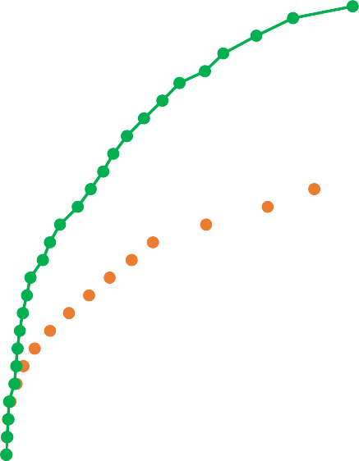

80

70

60

50

40

RCB

30

TL03

20

10

0

0

2

4

6

8

10

Dimension (mm)

Load (KN)

Figure 4.10: Load-Deflection for three layers strengthened beam (TL03)

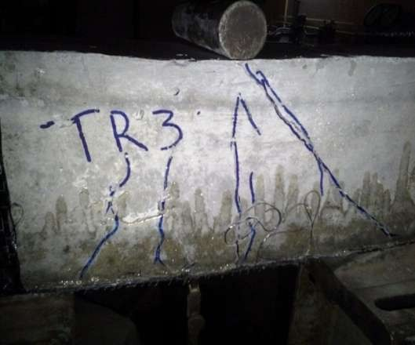

Plate XII: Crack pattern for three layer beam (TL03)

### Overall Effect of Strengthening on Specimen

### Effect of first crack load on single layer strengthened beams

The load at which the first crack appeared for reference control beam (RCB) and beams strengthened with one layer of FRP are presented in Figure 4.11. It was observed that the first crack due to load of SL01 beams was increased by 21.9%, SL02 increased by 38.21% and SL03 increased by 30.1%as compared to reference control beam (RCB). In general it was observed that the first crack load for all the strengthened beams with single layer laminate was increased as compared to the reference control beams.

**Load (KN)**

Figure 4.11: First crack due to loads for single layer and reference control beams

18**~~38.21%~~**

**30.1%**

16 **21.9%**

14

12

10

8

6

4

2

0

Reference beam Single layer 01 Single layer 02 Single layer 03

**Beam specimens**

### Effect of first crack load on double layers strengthened beams

The load at which the first crack appeared for reference control beam (RCB) and beams strengthened with two layers of FRP are presented in Figure 4.12. It was observed that the first crack load of DL01 beams was increased by 54.5%, DL02 increased by 62.6% and DL03 increased by 54.5% as compared to reference control beam (RCB).

**Load (KN)**

Figure 4.12: First crack due to loads for double layersand reference control beams

25

**54.5%**

**62.6%**

**54.5%**

20

15

10

5

0

Reference beam

Double layers 01

Double layers 02

Double layers 03

**Beam Specimens**

### Effect of first crack load on three layers strengthened

The load at which the first crack appeared for reference control beam (RCB) and beams strengthened with three layers of FRP are presented in Figure 4.13. It was observed that the first crack load of TL01 beam was increased by 78.9%, TL02 increased by 95.1% and TL03 increased by 70.7%as compared to reference control beam (RCB).

**Load (KN)**

Figure 4.13: First crack due to load for three layersand reference control beams

30

**95.1%**

25

**78.9%**

**70.7**

20

15

10

5

0

Reference beam

Three layers 01

Three layers 02

Three layers 03

**Beam Specimens**

### Effect of ultimate load carrying capacities for single layerbeams

The ultimate load carrying capacities of reference control beam (RCB) and strengthened beams with single layer of FRP was presented in Figure. 4.14. It was observed that the ultimate load carrying capacity of beams SL01 was increased by 20%, SL02 was increased by 18% and SL03 was increased by 22%as compared to reference control specimen (RCB).

**Load (KN)**

Figure 4.14: Ultimate load for single layer and reference control beams

70

**20%**

**18%**

**22%**

60

50

40

30

20

10

0

Reference beam

Single layer 01

Single layer 02

Single layer 03

**Beam Specimens**

### Effect of ultimate load carrying capacities for double layers beams

The ultimate load carrying capacities of reference control beam (RCB) and strengthened beams with two layers of FRP was presented in Figure. 4.15. It was observed that the ultimate load carrying capacity of beams DL01 was increased by 38%, DL02 was increased by 34% and DL03 was increased by 36%as compared to reference control beam (RCB) and 13.04% for DL01, 10.45% for DL02 and 11.76% for DL03 increased was observed as compared with single layer strengthened beams.

**Load (KN)**

Figure 4.15: Ultimate load for double layers and reference control beams

80

**38%**

70

**34%**

**36%**

60

50

40

30

20

10

0

Reference beam

Double layers 01

Double layers 02

Double layers 03

**Beam Specimens**

### Effect of ultimate load carrying capacities for three layers beams

The ultimate load carrying capacities of reference control beam (RCB) and strengthened beams with three layers of FRP was presented in Figure. 4.16. It was observed that the ultimate load carrying capacity of beams TL01 was increased by 54%, TL02 was increased by50% and TL03 was increased by 52%as compared to reference control beam (RCB) and **11.69%** for TL01, **9.33%** for TL02 and **10.53%** for TL03 increased was observed as compared with double layers strengthened beams, and also an increase of **22.1%** for TL01, **20%** for TL02 and **21.1%** for TL03 was observed as compared to single layer strengthened beams. In general the overall increased in strength was due to the restraining effect offered by the CFRP to the concrete surface.

**Load (KN)**

Figure 4.16: Ultimate load for three layers and reference control beams

90

**54%**

80

**50%**

**52%**

70

60

50

40

30

20

10

0

Reference beam

Three layers 01

Three layers 02

Three layers 03

**Beam Specimens**

### Effect of strengthening on crack width

The crack width for the entire tested specimen after failure was presented in Figure 4.17. It was observed that a decrease of 26.11%(avg)for single layer laminated beams as compared to RCB was obtained, a decrease of 39.44% (avg)for double layers laminated beams was observed as compared to RCB and 51.11%(avg) decreasefor three layers strengthened beams as compared to RCB. For double layers laminated beams a decrease of **18.10%** was observed as compared to single layer laminated beams and for three layers laminated beams a decrease of **19.27%** was observed as compared to double layers laminated beams and a decrease of **33.84%** was observed as compared with single layer laminated beams. In general it was observed that crack width decreases with increase in the number of CFRP laminates for the strengthened RC beams.

**width (mm)**

Figure 4.17: Crack widths for laminated and referencecontrol beams

2

1.8

1.6

1.4

**26.1%**

1.2

**~~39.4%~~**

1

0.8

**~~51.1%~~**

0.6

0.4

0.2

0

Reference beam

Single layer

Double layers

Three layers

**Beam Specimens**

### Effect of Strengthening on ductility of beams

The displacement ductility index is shown in Figure 4.18. It was observed that the ductility of single layer laminated beams was decreased by 16.80% (avg) as compared to RCB and for double layers laminated beams it was observed that the ductility decreases by 27.10% (avg) as compared to RCB and 12.32% (avg) decreased as compared to single layer laminated beams, for three layers laminated beams it was observed that the ductility of the beam decreases by 33.60% (avg) as compared with RCB. In general it was observed that the ductile property of the beams reduces as the number of FRP laminates increases from 1 to 3 and the decrease is due to the lack of ductility of the CFRP materials which was limited by their linear stress-strain response.

3

2.5

**16.8%**

2

**27.5%**

**33.6%**

1.5

1

0.5

0

Reference beam

Single layer

Double layers

Three layers

**Beam Specimens**

Figure 4.18: Ductility index for laminated and reference control beams

### Effect of strengthening on stiffness of beams

The stiffness of the reference control beam (RCB) and beams with single layer, double layers and three layers CFRP laminated beam are presented in Table 4.2 and Figure 4.19. It was observed that the stiffness for the strengthened beams was improved as compared to the control beams.

|  |  |  |
| --- | --- | --- |
|  | Table 4.2: Flexural stiffness |  |
| Beam ID | Stiffness N/mm2 | Percentage increase (%) |
| Reference beam | 2.36E+10 | - |
| Single layer 01 | 3.29E+10 | 39.41 |
| Single layer 02 | 3.30E+10 | 39.83 |
| Single layer 03 | 3.40E+10 | 44.10 |
| Double layers 01 | 4.13E+10 | 75.0 |
| Double layers 02 | 4.00E+10 | 69.50 |
| Double layers 03 | 4.04E+10 | 71.20 |
| Three layers 01 | 4.60E+10 | 94.90 |
| Three layers 02 | 4.76E+10 | 101.69 |
| Three layers 03 | 4.50E+10 | 90.67 |



**Stiffness N/mm2**

**5.00E+10**

**4.50E+10**

**4.00E+10**

**3.50E+10**

**3.00E+10**

**2.50E+10**

**2.00E+10**

**1.50E+10**

**1.00E+10**

**5.00E+09**

**0.00E+00**

**RB**

**SL01 SL02 SL03 DL01 DL02 DL03 TL01 TL02 TL03**

Figure 4.19: Stiffness for laminated and reference control beams

### Summary of Experimental Results

The results for the reference control beams and strengthened beams for all layers, there modes of failure and percentage increase for the load carrying capacities was summarised and presented in Table 4.3.

Table 4.3: Summary of test result

|  |  |  |  |  |
| --- | --- | --- | --- | --- |
| Beam ID | Failure  load (KN) | Failure  deflection (mm) | % increase  in flexure | Failure mode |
| CB01 | 51 | 7.43 |  | Flexural and Shear  failure crack behind |
|  |  |  |  | support. |
| CB02 | 49 | 7.11 |  | Flexural and crushing of concrete |
|  |  |  |  | at the loading point |
| CB03 | 50 | 7.52 |  | Flexural and Shear failure |
| SL01 | 60 | 6.33 | 20 | Shear failure |
| SL02 | 59 | 6.19 | 18 | Flexural failure |
| SL03 | 61 | 6.25 | 22 | Shear failure |
| **Average** | **-** | **-** | **20** |  |
| DL01 | 69 | 5.79 | 38 | Shear failure |
| DL02 | 67 | 5.88 | 34 | Shear and concrete crushing failure |
| DL03 | 68 | 5.83 | 36 | Flexural, Shear and debonding failure |
| **Average** | **-** | - | **36** |  |
| TL01 | 77 | 5.82 | 54 | Flexural and debonding failure |
| TL02 | 75 | 5.46 | 50 | Shear and debonding failure |
| TL03 | 76 | 5.85 | 52 | Shear and debonding failure |
| **Average** | **-** | **-** | **52** |  |

### Comparison of Theoretical and ExperimentalShearStrength

The shear strength of beams strengthened with CFRP U-wrap sheets obtained from the experimental study was compared to the theoretical designed shear strength by combining the contribution of concrete, steel and externally bonded FRP sheet as presented in appendix B. Table 4.4 provides the FRP shear contribution results.

𝑉𝑢 (𝑒𝑥𝑝. ) = 𝐸𝑥𝑝𝑒𝑟𝑖𝑚𝑒𝑛𝑡𝑎𝑙 𝑠𝑕𝑒𝑎𝑟 𝑙𝑜𝑎𝑑

𝑉𝑡 (𝑡𝑕𝑒𝑜. ) = 𝑇𝑕𝑒𝑜𝑟𝑖𝑡𝑖𝑐𝑎𝑙 𝑡𝑜𝑡𝑎𝑙 𝑠𝑕𝑒𝑎𝑟 𝑠𝑡𝑟𝑒𝑛𝑔𝑡𝑕 𝑐𝑜𝑛𝑡𝑟𝑖𝑏𝑢𝑡𝑖𝑜𝑛.

𝑉𝑓 (𝑡𝑕𝑒𝑜. ) = 𝐹𝑅𝑃 𝑆𝑕𝑒𝑎𝑟 𝑠𝑡𝑟𝑒𝑛𝑔𝑡𝑕 𝑐𝑜𝑛𝑡𝑟𝑖𝑏𝑢𝑡𝑖𝑜𝑛.

Table 4.4: Experimental and Theoretical shear strength test results

|  |  |  |  |  |
| --- | --- | --- | --- | --- |
| Beam ID | 𝑽𝒖(𝒆𝒙𝒑. ) KN | 𝑽𝒇(𝒕𝒉𝒆𝒐. )KN | 𝑽𝒕(𝒕𝒉𝒆𝒐. )KN | 𝑽𝒖(𝒆𝒙𝒑. )/𝑽𝒕(𝒕𝒉𝒆𝒐. ) |
| RCB | 38 | 0 | 0 | 0 |
| Single U-wrap 01 | 48 | 22.9 | 43.57 | 1.10 |
| Single U-wrap 02 | 49 | 22.9 | 43.57 | 1.12 |
| Single U-wrap 03 | 46 | 22.9 | 43.57 | 1.06 |
| Double U-wrap 01 | 60 | 39.48 | 55.18 | 1.09 |
| Double U-wrap 02 | 57 | 39.48 | 55.18 | 1.03 |
| Double U-wrap 03 | 58 | 39.48 | 55.18 | 1.05 |
| Three U-wrap 01 | 62 | 40.35 | 55.9 | 1.11 |
| Three U-wrap 02 | 65 | 40.35 | 55.9 | 1.16 |
| Three U-wrap 03 | 63 | 40.35 | 55.9 | 1.13 |

It was observed that experimental results slightly correlate with the theoretical calculations of shear capacity but slightly higher than the theoretical or predicted load.

It was also calculated that the FRP contribution to the shear strength of the laminated beams was about 58.2 %(avg) for single U-wrap and 100.4%(avg) strength contribution for two layers U- wrap and 102.6%(avg) shear strength contribution for three layers U-wrap.

### CHAPTER FIVE CONCLUSION AND RECOMMENDATION

### Conclusion

Based on the experimental and theoretical results the following conclusions were drawn:

* + 1. The external bonding of CFRP to the tension face of the beams samples contributes in flexural strength increase over the control specimen with an average increase of 20%, 36% and 52% for single layer beams, double layer beams and three layers laminated beams respectively over the un-strengthened beam.
    2. The experimental and theoretical results demonstrated that CFRP material externally bonded to concrete significantly increased the shear strength capacity of the strengthened RC beams over the control specimens as both results obtained experimentally and theoretical has close agreement and the strength increase is 58.2%, 100.4% and 102.6% for single, double and three layers U-wrap respectively.
    3. It was clearly noticed that various amounts or layers of CFRP material affects the beams ductility by decreasing the ductility for the strengthened beams and the strength increase for the strengthened beams is as a result of sacrifice of the ductility. The decrease in deflection ductility varied from 16.8% to 33.6% from single to three layers.
    4. It was established that a minimum of two layers of CFRP fabric and resin used provides the desired (optimum) results regarding the strength and ductility for the strengthened beams. The strengthened beams SL (single layer) and DL (double layers), exhibit 20% and 36% increase in flexural strength when compared to the reference beam.

### Recommendation

Based on the experimental and analytical investigation carried out from this research it is recommended that strengthening of deficient RC beams in both shear and flexure with a minimum of two layers of CFRP laminatesis significant in enhancing the load carrying capacities of the deficient RC beams.

**REFERENCES**

Anders, C. (2003)*.* “Carbon Fibre Reinforced Polymers for Strengthening of Structural Elements ,”*Doctoral Thesis, Division of Structural Engineering, Department of Civil and Mining Engineering Lulea University of Technology, Sweden.*

Balamuralikrishnan, R. and Antony, J., C. (2009)*.* “Flexural Behavior Of RC Beams Strengthened With Carbon Fibre Reinforced Polymer (CFRP) Fabrics,”*The Open Civil Engineering Journal, 3, pp. 102-109.*

Balasubramanian, K., Lakshmanan, N., Antony Jeyasehar, C., Krishnamoorthy, T.S. and Barathkumar, B.H (2010)*.* “Behavior of Reinforced Concrete Beam – Column Joint Retrofitted With Carbon–Fibre- Reinforced Polymer Wrap*”, International Journal Of 3R’s, pp. 170-178.*

Barros, J.A.O., Diass, S. J. E. and Lima, J. L.T. (2007). “Efficacy of CFRP – Based Techniques For the Flexural and Shear Strengthening of Concrete Beams”,*Cement and Concrete Composites, pp. 203- 217.*

Ferrier, E., Bigaud, D., Clement, J.C. and Hamelin, P. (2011). “Fatigue-loading effect on RC beams strengthened with externally bonded FRP”,*Construction and Building Materials, pp. 539-546.*

Ferrier, E., Michel, L., Jurkiewiez, B. and Hamelin, P (2011). “Creep Behavior of adhesives Used For External FRP Strengthening of RC Structures”,*Construction and Building Materials, pp. 461-467.*

Francesco Bencardino, Giuseppe Spadea and Narayan Swamy, R. (2002). “Strength and Ductility of Reinforced Concrete Beams Externally Reinforced with Carbon Fiber Fabric”,*Journal of ACI Structural, pp. 163-171.*

HabiburRahmanSobuz. (2011), “Use of carbon fiber laminates for strengthening reinforced concrete beams in bending”*International journal of civil and structural engineering. 2, No. 1, 67-84.*

Han Liang Wu, Yuan-Feng, Liu Yu and Xiao-Ran (2009), “Experimental and Computational Studies on High-Strength Concrete Circular Columns Confined by Aramid Fibre – Reinforced Polymer Sheets”,*Journal of Composites for Construction, ASCE, pp. 125- 134.*

Han Tae Choi (2008), “Flexural Behaviour of Partially Bonded CFRP Strengthened Concrete T-Beams”*Waterloo, Ontario, Canada.*

Intelligent Sensing for Innovative Structures (ISIS) Canada Network of Excellence, (2004).“Prestressing Concrete Structures with Fibre-Reinforced;polymers”,*Design Manual, No. 4., ISIS Canada Corporation, Winnipeg, Manitoba, Canada.*

Islam, M. R., Mansur, M. A., and Maalej, M. (2005),“Shear strengthening of RC deep beams using externally bonded FRP systems”, *Cement & Concrete Composites, 27, 413–420.*

Khalifa, A., and Nanni, A. (2000), “Improving shear capacity of existing RC T-section beams using CFRP composites”,*Cement & Concrete Composites, 22, 165-174.*

MahmutE. and John, J., M.(2009)“Fatigue Performance of CFRP Strengthened RC Beams under Environmental Conditioning and Sustained Load”,*Journal of Composites for Construction, ASCE, pp. 93-102.*

Mosallam A. S., and Banerjee S. (2007), “Shear enhancement of reinforced concrete beams strengthened with FRP composite laminates”,*Composites Part B Eng., 38, 781-793.*

Nadeem, A.S. (2010)*.* “Influence of Flexural Steel Reinforcement Ratio on RC Beams Strengthened With Externally Bonded FRP Sheets”,*Journal of Structural Engineering, 37, No. 2, pp 88-95.*

Nanni, A., (2003*).* “North American Design Guidelines for Concrete Reinforcement and Strengthening Using FRP: Principles, Applications, and Unsolved Issues,”*Journal of Construction and Building Materials, 17, No. 6-7, pp. 439-446.*

Omar Ahmed, Dionys Van Gemert and Lucie Vanddewalle (2011)*,* “Improved model for plate-end shear of CFRP strengthened RC beams”,*Journal of Cement Concrete Composites 23, pp. 03-19.*

Oudah, F., El-Hacha, and Raafat.(2012). “A new ductility model of reinforced concrete beams strengthened using Fiber Reinforced Polymer reinforcement”*composite part B: Engineering. 43. 3338-3347.*

Rania Al-Hammoud, KhaledSoudk and Timothy H. Topper (2011), “Fatigue Flexural Behavior of Corroded Reinforced Concrete Beams With CFRP Sheets,”*Journal of Composites for Construction, ASCE, pp. 42-51.*

Rania A., KhaledS. and Timothy H. T. (2006).“Fatigue Flexural Behavior of Corroded Reinforced Concrete Beams With CFRP Sheets,”*Journal of Composites for Construction, ASCE, pp. 42-51.*

Saafan M. A. A. (2006), “Shear strengthening of Reinforced Concrete beams using GFRP wraps”, *Czech Technical University in Prague ActaPolytechnica, 46 No. 1, 24–32.*

Shanmugam, U. (2014)“Experimental Investigation on RC Beams and Columns Retrofitted and Rehabilitated with CFRP-GFRP HYBRID wrapping”*Doctoral thesis, Anna University of Technology.*

Sherif, H. and Al-Tersawy.(2013), “Effect of fiber parameters and concrete strength on shear behaviour of strengthened RC beams”,*Construction and Building Materials, 44, 15–24.*

Taljsten, B. (1994): “Plate bonding, strengthening of existing concrete structures with epoxy bonded plates of steel or fibre reinforced plastics”*Doctoral thesis 1994:152 D, Lulea University of Technology, Division of structural Engineering. August 1994. 290 pp*

Tamer E., Khaled, S. and Timothy, T. (2007), “Performance Evaluation of Carbon Faiber Reinforced Polymer – Repaired Beams Under Corrosive Environmental Conditions”, *ACI Structural Journal, pp. 3-11.*

Nishikant Dash and K.C. Biswal (2009), “Strengthening of reinforced concrete beams using glass fiber reinforced polymer composites”,*a thesis for the award of MSc. In Structural Engineering.*

Maeda, T., Asano, Y., Sato, Y. Yeda T., and Kakuta, Y. (1997). A study on bond mechanism of carbon fiber sheet. Non-Metallic (FRP) Reinforced for Concrete Structures, *Proceedings of the 3rd International Symposium, Sapporo, Japan, pp. 279-285.*

Mukhopadhyaya, P., Swamy, N. and Lynsdale, C. (1998), „Optimizing structural response of beams strengthened with GFRP plates‟, *J. Compos. Constr., 2(2), 87-95.*

Thanasis, C. T. (1997), „Shear Reinforcement of Wood Using FRP Materials‟ *Journal of Materials in Civil Engineering. ASCE.*

Khalifa, A., J. Gold, W. and Nanni, A. (1998), „Contribution of Externally Bonded FRP to Shear Capacity of RC Flexural Members‟ *Journal of Composites for Construction. 2. DOI. 10.1061/CASCE) 1090-0268 (1998) 2:4 (195)*

Sahar. S. C. (*2015)*“Flexural Performance of Reinforced Concrete Beams Externally Strengthened with Carbon and Basalt FRP Sheets”

# APPENDIX A

### Load-Deflection Results for Strengthened and Reference Control Beams

Table A.1 Load deflection results for reference control (RB)

|  |  |  |  |  |  |
| --- | --- | --- | --- | --- | --- |
| **Load(KN)** | **Deflection(mm)** | **Load(KN)** | **Deflection(mm)** | **Load(KN)** | **Deflection(mm)** |
| 0 | 0 | 21 | 0.67 | 42 | 3.15 |
| 3 | 0.007 | 24 | 0.98 | 45 | 3.72 |
| 6 | 0.036 | 27 | 1.34 | 48 | 4.99 |
| 9 | 0.078 | 30 | 1.67 | 50 | 7.35 |
| 12 | 0.173 | 33 | 2.12 |  |  |
| 15 | 0.28 | 36 | 2.38 |  |  |
| 18 | 0.45 | 39 | 2.79 |  |  |

Table A.2 Load deflection results for single layer strengthened beam (SL01)

|  |  |  |  |  |  |
| --- | --- | --- | --- | --- | --- |
| **Load(KN)** | **Deflection(mm)** | **Load(KN)** | **Deflection(mm)** | **Load(KN)** | **Deflection(mm)** |
| 0 | 0 | 21 | 0.67 | 42 | 1.55 |
| 3 | 0.034 | 24 | 0.98 | 45 | 1.83 |
| 6 | 0.075 | 27 | 1.34 | 48 | 2.24 |

|  |  |  |  |  |  |
| --- | --- | --- | --- | --- | --- |
| 9 | 0.12 | 30 | 1.67 | 51 | 2.74 |
| 12 | 0.16 | 33 | 2.12 | 54 | 3.12 |
| 15 | 0.21 | 36 | 2.38 | 57 | 4.42 |
| 18 | 0.25 | 39 | 2.79 | 60 | 6.33 |

Table A.3 Load deflection results for single layer strengthened beam (SL02)

|  |  |  |  |  |  |
| --- | --- | --- | --- | --- | --- |
| **Load(KN)** | **Deflection(mm)** | **Load(KN)** | **Deflection(mm)** | **Load(KN)** | **Deflection(mm)** |
| 0 | 0 | 21 | 0.33 | 42 | 1.61 |
| 3 | 0.038 | 24 | 0.45 | 45 | 1.92 |
| 6 | 0.069 | 27 | 0.54 | 48 | 2.18 |
| 9 | 0.13 | 30 | 0.69 | 51 | 2.65 |
| 12 | 0.15 | 33 | 0.87 | 54 | 3.09 |
| 15 | 0.19 | 36 | 1.21 | 57 | 4.97 |
| 18 | 0.22 | 39 | 1.42 | 59 | 6.06 |

Table A.4 Load deflection results for single layer strengthened beam (SL03)

|  |  |  |  |  |  |  |  |
| --- | --- | --- | --- | --- | --- | --- | --- |
| **Load(KN)** | **Def’ (mm)** | **Load(KN)** | **Def’ (mm)** | **Load(KN)** | **Def’ (mm)** | **Load(KN)** | **Def’ (mm)** |
| 0 | 0 | 21 | 0.35 | 42 | 1.53 | 61 | 6.25 |
| 3 | 0.028 | 24 | 0.44 | 45 | 1.79 |  |  |
| 6 | 0.055 | 27 | 0.57 | 48 | 2.26 |  |  |
| 9 | 0.097 | 30 | 0.72 | 51 | 2.67 |  |  |
| 12 | 0.143 | 33 | 0.95 | 54 | 3.21 |  |  |

|  |  |  |  |  |  |
| --- | --- | --- | --- | --- | --- |
| 15 | 0.22 | 36 | 1.08 | 57 | 4.39 |
| 18 | 0.26 | 39 | 1.29 | 60 | 5.44 |

Table A.5 Load deflection results for double layer strengthened beam (DL01)

|  |  |  |  |  |  |  |  |
| --- | --- | --- | --- | --- | --- | --- | --- |
| **Load(KN)** | **Def’ (mm)** | **Load(KN)** | **Def’ (mm)** | **Load(KN)** | **Def’ (mm)** | **Load(KN)** | **Def’ (mm)** |
| 0 | 0 | 21 | 0.25 | 42 | 1.49 | 63 | 4.15 |
| 3 | 0.021 | 24 | 0.37 | 45 | 1.66 | 65 | 4.52 |
| 6 | 0.042 | 27 | 0.47 | 48 | 1.96 | 68 | 5.07 |
| 9 | 0.072 | 30 | 0.64 | 51 | 2.19 | 69 | 5.79 |
| 12 | 0.092 | 33 | 0.79 | 54 | 2.48 |  |  |
| 15 | 0.143 | 36 | 1.01 | 57 | 2.86 |  |  |
| 18 | 0.19 | 39 | 1.19 | 60 | 3.18 |  |  |

Table A.6 Load deflection results for double layer strengthened beam (DL02)

|  |  |  |  |  |  |  |  |
| --- | --- | --- | --- | --- | --- | --- | --- |
| **Load(KN)** | **Def’ (mm)** | **Load(KN)** | **Def’ (mm)** | **Load(KN)** | **Def’ (mm)** | **Load(KN)** | **Def’ (mm)** |
| 0 | 0 | 21 | 0.24 | 42 | 1.56 | 63 | 4.16 |
| 3 | 0.018 | 24 | 0.35 | 45 | 1.71 | 65 | 4.83 |
| 6 | 0.037 | 27 | 0.43 | 48 | 1.93 | 68 | 5.88 |
| 9 | 0.074 | 30 | 0.58 | 51 | 2.22 |  |  |
| 12 | 0.088 | 33 | 0.74 | 54 | 2.51 |  |  |

|  |  |  |  |  |  |
| --- | --- | --- | --- | --- | --- |
| 15 | 0.16 | 36 | 0.95 | 57 | 3.07 |
| 18 | 0.189 | 39 | 1.23 | 60 | 3.38 |

Table A.7 Load deflection results for double layer strengthened beam (DL03)

|  |  |  |  |  |  |  |  |
| --- | --- | --- | --- | --- | --- | --- | --- |
| **Load(KN)** | **Def’ (mm)** | **Load(KN)** | **Def’ (mm)** | **Load(KN)** | **Def’ (mm)** | **Load(KN)** | **Def’ (mm)** |
| 0 | 0 | 21 | 0.22 | 42 | 1.61 | 63 | 4.18 |
| 3 | 0.025 | 24 | 0.31 | 45 | 1.69 | 65 | 4.75 |
| 6 | 0.04 | 27 | 0.45 | 48 | 1.86 | 68 | 5.32 |
| 9 | 0.069 | 30 | 0.66 | 51 | 2.07 | 69 | 5.83 |
| 12 | 0.096 | 33 | 0.77 | 54 | 2.39 |  |  |
| 15 | 0.152 | 36 | 1.04 | 57 | 2.94 |  |  |
| 18 | 0.171 | 39 | 1.21 | 60 | 3.29 |  |  |

Table A.8Load deflection results for three layers strengthened beam (TL01)

|  |  |  |  |  |  |  |  |
| --- | --- | --- | --- | --- | --- | --- | --- |
| **Load(KN)** | **Def’ (mm)** | **Load(KN)** | **Def’ (mm)** | **Load(KN)** | **Def’ (mm)** | **Load(KN)** | **Def’ (mm)** |
| 0 | 0 | 21 | 0.223 | 42 | 1.14 | 63 | 2.93 |
| 3 | 0.021 | 24 | 0.29 | 45 | 1.36 | 65 | 3.29 |
| 6 | 0.032 | 27 | 0.37 | 48 | 1.56 | 68 | 3.51 |
| 9 | 0.057 | 30 | 0.51 | 51 | 1.78 | 71 | 4.34 |
| 12 | 0.1 | 33 | 0.66 | 54 | 1.98 | 74 | 5.05 |

|  |  |  |  |  |  |  |  |
| --- | --- | --- | --- | --- | --- | --- | --- |
| 15 | 0.144 | 36 | 0.82 | 57 | 2.21 | 77 | 5.82 |
| 18 | 0.18 | 39 | 0.95 | 60 | 2.62 |  |  |

Table A.9 Load deflection results for three layers strengthened beam (TL02)

|  |  |  |  |  |  |  |  |
| --- | --- | --- | --- | --- | --- | --- | --- |
| **Load(KN)** | **Def’ (mm)** | **Load(KN)** | **Def’ (mm)** | **Load(KN)** | **Def’ (mm)** | **Load(KN)** | **Def’ (mm)** |
| 0 | 0 | 21 | 0.21 | 42 | 1.03 | 63 | 2.81 |
| 3 | 0.017 | 24 | 0.27 | 45 | 1.27 | 65 | 3.16 |
| 6 | 0.028 | 27 | 0.32 | 48 | 1.39 | 68 | 3.41 |
| 9 | 0.045 | 30 | 0.44 | 51 | 1.63 | 71 | 3.94 |
| 12 | 0.09 | 33 | 0.56 | 54 | 1.81 | 74 | 4.52 |
| 15 | 0.15 | 36 | 0.68 | 57 | 2.05 | 75 | 5.46 |
| 18 | 0.19 | 39 | 0.85 | 60 | 2.41 |  |  |

Table A.10 Load deflection results for three layers strengthened beam (TL03)

|  |  |  |  |  |  |  |  |
| --- | --- | --- | --- | --- | --- | --- | --- |
| **Load(KN)** | **Def’ (mm)** | **Load(KN)** | **Def’ (mm)** | **Load(KN)** | **Def’ (mm)** | **Load(KN)** | **Def’ (mm)** |
| 0 | 0 | 21 | 0.23 | 42 | 1.21 | 63 | 2.93 |
| 3 | 0.019 | 24 | 0.28 | 45 | 1.43 | 65 | 3.36 |
| 6 | 0.037 | 27 | 0.35 | 48 | 1.64 | 68 | 3.67 |
| 9 | 0.05 | 30 | 0.41 | 51 | 1.81 | 71 | 4.23 |
| 12 | 0.14 | 33 | 0.62 | 54 | 2.04 | 74 | 4.85 |

|  |  |  |  |  |  |  |  |
| --- | --- | --- | --- | --- | --- | --- | --- |
| 15 | 0.17 | 36 | 0.74 | 57 | 2.33 | 75 | 5.86 |
| 18 | 0.193 | 39 | 0.91 | 60 | 2.64 |  |  |

### APPENDIX B

**Shear design calculations**

CFRP Design Data

𝑇𝑕𝑖𝑐𝑘𝑛𝑒𝑠𝑠 = 0.11𝑚𝑚

𝑀𝑜𝑑𝑢𝑙𝑢𝑠𝑜𝑓𝐸𝑙𝑎𝑠𝑡𝑖𝑐𝑖𝑡𝑦 = 240𝑀𝑃𝑎

𝑇𝑒𝑛𝑠𝑖𝑙𝑒𝑠𝑡𝑟𝑒𝑛𝑔𝑡𝑕 = 3400𝑀𝑃𝑎

𝑏𝑤 = 150𝑚𝑚

𝑠𝑓 = 150𝑚𝑚

𝑤𝑓 = 150𝑚𝑚

* 1. Effective stress method To calculate;

2𝑡𝑓

𝑃𝑓 =

𝑏

𝑤

𝑃𝑓 𝑓𝑜𝑟𝑠𝑖𝑛𝑔𝑙𝑒𝑙𝑎𝑦𝑒𝑟 = 0.0015

𝑃𝑓 𝑓𝑜𝑟𝑑𝑜𝑢𝑏𝑙𝑎𝑙𝑎𝑦𝑒𝑟𝑠 = 0.0029

𝑃𝑓 𝑓𝑜𝑟𝑡𝑕𝑟𝑒𝑒𝑙𝑎𝑦𝑒𝑟𝑠 = 0.0044

To calculate;

𝑅 = 0.5622(𝑃𝑓 𝐸𝐹)2 − 1.2188(𝑃𝑓 𝐸𝐹) + 0.778

𝑅𝑓𝑜𝑟𝑠𝑖𝑛𝑔𝑙𝑒𝑙𝑎𝑦𝑒𝑟 = 0.412 < 0.5 𝑐𝑜𝑛𝑑𝑖𝑡𝑖𝑜𝑛 𝑠𝑎𝑡𝑖𝑠𝑓𝑖𝑒𝑑

𝑅𝑓𝑜𝑟𝑑𝑜𝑢𝑏𝑙𝑒𝑙𝑎𝑦𝑒𝑟𝑠 = 0.203 < 0.5 𝑐𝑜𝑛𝑑𝑖𝑡𝑖𝑜𝑛 𝑠𝑎𝑡𝑖𝑠𝑓𝑖𝑒𝑑

𝑅𝑓𝑜𝑟𝑡𝑕𝑟𝑒𝑒𝑙𝑎𝑦𝑒𝑟𝑠 = 0.12 < 0.5 𝑐𝑜𝑛𝑑𝑖𝑡𝑖𝑜𝑛 𝑠𝑎𝑡𝑖𝑠𝑓𝑖𝑒𝑑

To calculate;

𝐴𝑓 = 2𝑏𝑤 𝑡𝑓

𝐴𝑓 𝑓𝑜𝑟𝑠𝑖𝑛𝑔𝑙𝑒𝑙𝑎𝑦𝑒𝑟 = 33𝑚2

𝐴𝑓 𝑓𝑜𝑟𝑑𝑜𝑢𝑏𝑙𝑒𝑙𝑎𝑦𝑒𝑟𝑠 = 66𝑚2

𝐴𝑓 𝑓𝑜𝑟𝑑𝑜𝑢𝑏𝑙𝑒𝑙𝑎𝑦𝑒𝑟𝑠 = 99𝑚2

To calculate;

𝑓𝑓𝑒 = 𝑅𝑓𝑓𝑢

𝑓𝑓𝑒 𝑓𝑜𝑟𝑠𝑖𝑛𝑔𝑙𝑒𝑙𝑎𝑦𝑒𝑟 = 1400.8𝑀𝑃𝑎

𝑓𝑓𝑒 𝑓𝑜𝑟𝑑𝑜𝑢𝑏𝑙𝑒𝑙𝑎𝑦𝑒𝑟𝑠 = 686.8𝑀𝑃𝑎

𝑓𝑓𝑒 𝑓𝑜𝑟𝑡𝑕𝑟𝑒𝑒𝑙𝑎𝑦𝑒𝑟𝑠 = 408𝑀𝑃𝑎

FRP shear contribution for the effective stress method;

𝐴𝑓 𝑓𝑓𝑒 (𝑆𝑖𝑛𝛽 + 𝑐𝑜𝑠𝛽)𝑑𝑓

𝑉𝑓 =

𝑠𝑓

For single layer

𝑉𝑓 =

33 𝑋 1.4 (𝑆𝑖𝑛90 + 𝑐𝑜𝑠90)149.95

= 46.18𝐾𝑁

150

For double layers

𝑉𝑓 =

66 𝑋 0.69 (𝑆𝑖𝑛90 + 𝑐𝑜𝑠90)149.89

= 45.51𝐾𝑁

150

Four three layers

𝑉𝑓 =

99 𝑋 0.408 (𝑆𝑖𝑛90 + 𝑐𝑜𝑠90)149.84

= 40.35𝐾𝑁

150

* 1. Bond mechanism method To calculate;

𝐿𝑒 = 2.71836.134−0.58ln ⁡(𝑡𝑓 𝐸𝑓 )

𝐿𝑒 𝑓𝑜𝑟𝑠𝑖𝑛𝑔𝑙𝑒𝑙𝑎𝑦𝑒𝑟 = 69.1𝑚𝑚

𝐿𝑒 𝑓𝑜𝑟𝑑𝑜𝑢𝑏𝑙𝑒𝑙𝑎𝑦𝑒𝑟𝑠 = 46.22𝑚𝑚

𝐿𝑒 𝑓𝑜𝑟𝑡𝑕𝑟𝑒𝑒𝑙𝑎𝑦𝑒𝑟𝑠 = 36.54𝑚𝑚

To calculate;

𝑡𝑏𝑢 = 𝐾𝐸𝑓 𝑡𝑓

𝐾𝑖𝑠𝑎𝑛𝑒𝑥𝑝𝑒𝑟𝑖𝑚𝑒𝑛𝑡𝑎𝑙𝑐𝑜𝑛𝑠𝑡𝑎𝑛𝑡 = 110.2 𝑋10−6/𝑚𝑚

𝑡𝑏𝑢 𝑓𝑜𝑟𝑠𝑖𝑛𝑔𝑙𝑒𝑙𝑎𝑦𝑒𝑟 = 0.00206𝐺𝑃𝑎

𝑡𝑏𝑢 𝑓𝑜𝑟𝑑𝑜𝑢𝑏𝑙𝑒𝑙𝑎𝑦𝑒𝑟𝑠 = 0.00412𝐺𝑃𝑎

𝑡𝑏𝑢 𝑓𝑜𝑟𝑡𝑕𝑟𝑒𝑒𝑙𝑎𝑦𝑒𝑟𝑠 = 0.0062𝐺𝑃𝑎

To calculate;

𝑤𝑓𝑒 = 𝑑𝑓 − 𝐿𝑒 𝑓𝑜𝑟 (𝑈 − 𝑊𝑟𝑎𝑝)

𝑤𝑓𝑒 𝑓𝑜𝑟𝑠𝑖𝑛𝑔𝑙𝑒𝑙𝑎𝑦𝑒𝑟 = 80.85𝑚𝑚

𝑤𝑓𝑒 𝑓𝑜𝑟𝑑𝑜𝑢𝑏𝑙𝑒𝑙𝑎𝑦𝑒𝑠𝑟 = 103.67𝑚𝑚

𝑤𝑓𝑒 𝑓𝑜𝑟𝑡𝑕𝑟𝑒𝑒𝑙𝑎𝑦𝑒𝑟𝑠 = 113.3𝑚𝑚

FRP shear contribution for the Bond mechanism method;

2𝐿𝑒 𝑤𝑓 𝑡𝑏𝑢 𝑤𝑓𝑒

𝑉𝑓 =

𝑠𝑓

For single layer

𝑉𝑓 =

2 𝑋 69.1 𝑋 150 𝑋 80.85 𝑋 0.00205

= 22.9𝐾𝑁

150

For double layers

𝑉𝑓 =

2 𝑋 46.22 𝑋 150 𝑋 103.67 𝑋 0.00412

= 39.48𝐾𝑁

150

For three layers

𝑉𝑓 =

2 𝑋 36.54 𝑋 150 𝑋 113.30 𝑋 0.0062

= 51.34𝐾𝑁

150

The lowest value for the two methods is taken as the controlling value. Therefore, the shear contribution of the CFRP sheet for the various layers is;

Single layer = 22.9KN Double layers = 39.48KN Three layers = 40.35KN

The total shear capacity of the beam may then be computed,

Shear contribution by concrete

(𝑓*′*

)0.5𝑏𝑤 𝑑

𝑉𝑢𝑐 =

𝑐

6

𝑉𝑢𝑐 =

(25)0.5𝑋 150 120

= 15𝐾𝑁

6

Shear contribution by steel

𝑉𝑢𝑠 =

𝐴𝑣𝑓𝑦 𝑑

𝑠

𝑉𝑢𝑠 =

58 𝑋 250 𝑋 120

= 17.4𝐾𝑁

100

Total shear capacity is;

𝛷𝑉𝑛 = 0.85(𝑉𝑐 + 𝑉𝑠 ) + 0.7 𝑉𝑓

For single layer

𝑉𝑛 = 0.85(15 + 17.4) + 0.7(22.9) = 43.57𝐾𝑁

For double layers

𝑉𝑛 = 0.85(15 + 17.4) + 0.7(39.48) = 55.18𝐾𝑁

For three layers

𝑉𝑛 = 0.85(15 + 17.4) + 0.7(40.35) = 55.9𝐾𝑁

Thus the percentage contribution can be calculated as;

𝑃𝑒𝑟𝑐𝑒𝑛𝑡𝑎𝑔𝑒𝑖𝑛𝑐𝑟𝑒𝑎𝑠𝑒 =

0.7(𝑉𝑓 )

0.85(𝑉𝑢𝑐 + 𝑉𝑢𝑠 )

% strength contribution for single layer

0.7(22.9)

𝑃𝑒𝑟𝑐𝑒𝑛𝑡𝑎𝑔𝑒𝑖𝑛𝑐𝑟𝑒𝑎𝑠𝑒 = 0.85(15 + 17.4) = 58.21%

% strength contribution for double layers

0.7(39.48)

𝑃𝑒𝑟𝑐𝑒𝑛𝑡𝑎𝑔𝑒𝑖𝑛𝑐𝑟𝑒𝑎𝑠𝑒 = 0.85(15 + 17.4) = 100.35%

% strength contribution for three layers

0.7(40.35)

𝑃𝑒𝑟𝑐𝑒𝑛𝑡𝑎𝑔𝑒𝑖𝑛𝑐𝑟𝑒𝑎𝑠𝑒 = 0.85(15 + 17.4) = 102.6%