**EVALUATION OF WASTEWATER MANAGEMENT SYSTEMS IN ABUJA FOR SUSTAINABILITY AND DEVELOPMENT OF APPROPRIATE ENGINEERING STRATEGY**

**EMMANUEL ABIODUN OLUWADAMISI MATRIC NO: 131547**

**JUNE 2013**

**EVALUATION OF WASTEWATER MANAGEMENT SYSTEMS IN ABUJA FOR THE DEVELOPMENT OF APPROPRIATE ENGINEERING STRATEGIES**

BY

**EMMANUEL ABIODUN OLUWADAMISI**

MATRIC No. 131547

Submitted to the Faculty of Technology in partial fulfilment of the requirements for the degree of

**MASTER OF PHILOSOPHY**

Of the

**UNIVERSITY OF IBADAN, NIGERIA**

JUNE 2013

## DEDICATION

This work is dedicated to my wife, Barrister (Mrs.) Helen Oluwadamisi and my children Joshua, Caleb, Gloria and Tobi Oluwadamisi for their understanding and love throughout the period of this academic pursuit. All Glory belongs to God, the Giver of life and Author of knowledge.

# ABSTRACT

Environmental pollution due to improperly managed wastewater has been a major challenge and of public health concern in Nigeria. Not many studies related to wastewater management have been carried out in Nigeria, hence the paucity of data on wastewater management in the country. The Wastewater Treatment Plants (WTP) in Nigeria’s capital city, Abuja are presently performing below capacity due to several problems. The aim of this study was to evaluate the wastewater management system for Abuja and develop an engineering strategy to improve it.

Six WTPs at Wuye lagoon, Gudu, Niger, Lungi, Mogadishu barracks and Sheraton were assessed in comparison with the existing wastewater Master Plan of Abuja. The sites were visited along with their sewer lines and manholes to assess their structural and environmental engineering adequacy. Influent and effluent samples were collected weekly from these plants at peak period in the morning hours (6.00 – 7.00am) in triplicates over six months period from October 2007 to March 2008. These samples were analyzed for quality parameters such as 5-Day Biochemical Oxygen Demand (BOD5), Chemical Oxygen Demand (COD), nitrate, nitrite, sulphate, chloride, phosphate, and microbial content. Data were further analysed using ANOVA at p= 0.05. Based on the evaluation, a suitable wastewater treatment plant was designed.

These WTPs are mini activated sludge treatment plants with submersible mechanical aerators. Wuye lagoon has a capacity of 50,000 Population Equivalent (PE). Gudu, Lungi and Mogadishu barracks have 6000 PE each while Niger and Sheraton have 3000 PE each. Average reduction of BOD5 of 6±50.2%, 4±25.8%, 30±0.8%, 10.2±0.2%, 10.8±24.9% and 5±39.6% were

observed for Wuye lagoon, Gudu, Mogadishu, Niger, Lungi and Sheraton respectively. For other evaluated parameters, average reduction in COD, nitrate, sulphate, chloride, phosphate and microbial quality were 7.8±12.4%, 13.1±4%, 13.5±65.4%, 21.5±89.8%, 10.1±8.4% and

48±87.9% respectively. Sludge treatments significantly affect the physico-chemical parameters. No regular aeration was carried out in the plants. In the satellite towns of Gwagwalada, Kuje, Kubwa and Nyanya, there were no sewer facilities, hence septic tanks and soak-away pits were constructed to handle the generated wastewater which is contrary to the provisions of Abuja Master Plan. Non-biodegradable substances such as nylon and plastics were observed in manholes. Discharge of evacuated septic sludge into sewer lines was the practice. A wastewater treatment plant combining both natural and electromechanical system was designed (Design flow of 2070 m3/d, BOD5 of 517Kg/day and Suspended Solids of 517.5kgSS/day). The treatment plant using water hyacinth yielded nutrient removal of about 70.0% when power is not available and enhanced treatment of up to 99.0% BOD removal when power is available.

The designed wastewater treatment plant using appropriate engineering strategy was adequate and capable of solving the wastewater management problems of Abuja. The design would be useful in other major cities in Nigeria.

**Keywords: -** Wastewater, Treatment plants, Management, Influent, Effluent, Sewer lines

# ACKNOWLEDGEMENTS

I wish to acknowledge with thanks the tremendous assistance and support received from many people during the course of this study, some of whom I can not mention their names due to constraint of space. However I wish to express my sincere appreciation to my supervisors: Professor A. O. Coker, Department of Civil Engineering, Faculty of Technology, University of Ibadan Nigeria; and to Professor M.K.C. Sridhar, Department of Environmental Health Sciences, Faculty of Public Health, College of Medicine, University of Ibadan, Nigeria for their unquantifiable support, encouragement and for giving time to supervise this study.

I have always loved Civil Engineering and Project Management until I travelled to the Netherlands to study Sanitary and Environmental Engineering at the International Institute for Hydraulic and Environmental Engineering (IHE), Delft in 1995 where I was exposed to global environmental challenges and the need for manpower development in water and waste water management. My contact with Professor D. D. Mara of Department of Civil Engineering, University of Leeds, UK who lectured me in Waste Water Engineering challenged and encouraged my interest in this area. I commend the great sacrifice and interest of Professor Mara in this unique field of Engineering. My other supervisors during my studies at Delft such as Professors Veenstra and Trifunovic are all appreciated. I wish to sincerely appreciate all lecturers of Civil Engineering Department, University of Ibadan for their tremendous contributions to this work especially during myseminar presentations. Particularly, I wish to acknowledge with thanks contributions of Professor. A. O. Agbede, Dr. B. I. O. Dahunsi and Dr. F. A. Olutoge as well as Professor A. Y. Sangodoyin of the Department of Agricultural and Environmental Engineering, University of Ibadan.

To my friends and brothers who have given moral support during the study, I say thank you particularly Dapo Ogunsola of Water Board, Ibadan. He was always ready to help whenever

the need arises. Samuel Jacob for inputs at the final stages of the work in statistical analysis and computer works. My bosses in the office, Engr. U. G Jibrin, FNSE, OON Director Department of Mass Housing/PPP and Engr. M. A Soso, Deputy Director, Water and Sewage of Federal Capital Development Authority (FCDA) are hereby appreciated for their understanding for my unavoidable absence sometimes in the office due to challenges of the research work.

## Oluwadamisi, E. A.

University of Ibadan, Nigeria

# CERTIFICATION

This is to certify that this study was carried out by Engr. Emmanuel Abiodun Oluwadamisi (Matric No. 131547) in the Department of Civil Engineering, University of Ibadan, Ibadan Nigeria under our supervision.

Supervisors:

Date: ..........................

## Prof. A. O. Coker

BSc.(Ibadan), MSc.(OAU, Ife), Ph.D.(Ibadan), MNSE, COREN Reg. Engr.

Professor of Water Resources and Environmental Health Engineering, Department of Civil Engineering, Faculty of Technology,

University of Ibadan, Ibadan, Nigeria

Date: ..........................

## Prof. M.K.C. Sridhar

BSc.(Andhra), MSc (Baroda), PhD (IISC) Professor of Environmental Health Sciences, Department of Environmental Health Sciences, Faculty of Public Health, College of Medicine, University of Ibadan, Ibadan, Nigeria

Title page

# TABLE OF CONTENTS

Dedication i

Abstract ii

Acknowledgements iii

Certification vi

Table of Contents vii

List of Figures x

List of Plates xii

List of Tables xiv

CHAPTER ONE: INTRODUCTION 1

* 1. Background to the Study 1
  2. Problem Identification 16
  3. Aim and Objectives of Research 18
  4. Research Justification 19

CHAPTER TWO: LITERATURE REVIEW 20

* 1. Sources of Wastewater and Usage 20
  2. Nature of Sewage 23
  3. Health Significance of Wastewater 29
  4. Guidelines for Wastewater Usage 30
  5. Wastewater Collection Methods (systems) 32
     1. On-site collection 32
     2. Sewerage system 33
  6. Wastewater Treatment Methods 33
     1. Waste Stabilization Ponds 35
     2. Activated Sludge Treatment 38
     3. Aerated Lagoons 41
     4. On Site Septic Tanks/Soak away System 43
     5. Trickling Filters 44
     6. Rotating Biological Contactors 46
     7. Completely Mixed Anaerobic Digestion 47
     8. Land Treatment 49

CHAPTER THREE: **METHODOLOGY** 57

* 1. Study Area 57
     1. Collection of Samples within the Project Area 58
  2. Laboratory Analysis of Collected Wastewater Samples 59
  3. Statistical Analysis of Data 70
  4. Appraisal of Abuja Wastewater Management System 72
     1. Generation system 72
     2. Collection system 73
     3. Treatment plant 73

CHAPTER FOUR: **RESULTS AND DISCUSSIONS** 75

* 1. Composition of Wastewater in Abuja 75
  2. Results of Laboratory Analysis 76
  3. Results of Statistical Analysis 90
  4. Compliance Level to Wastewater Masterplan 101
  5. Effects of non compliance with Masterplan 102
  6. Technical Description of existing Sewage Treatment Plants 102
  7. Design of Appropriate Sewage Treatment Plant 121

CHAPTER FIVE: **CONCLUSIONS AND RECOMMENDATIONS** 126

* 1. Conclusions 126
  2. Recommendations 127

**REFERENCES** 129

**APPENDIX I** 138

## APPENDIX II 144

## LIST OF FIGURES

Figure 1: Nigeria Map with the 36 States and Abuja at the Centre 4

Figure 2: Map of Federal Capital Territory showing Abuja 6

Figure 3: Map of FCC showing the different Phases 7

Figure 4: Map of FCC-Phase I and II showing some Districts and other areas 8

Figure 5: Map of FCT showing Rivers and their tributaries 11

Figure 6: Diagram Showing the Location of Wastewater Treatment

Aerator and Trunk Sewer Lines in Federal Capital City 15

Figure 7: Typical flow diagram for stabilization ponds 36

Figure 8: Typical flow diagram for Activated sludge flow process. 39

Figure 9: Typical flow diagram for aerated lagoons 42

Figure 10: Typical flow diagram for trickling filters 45

Figure 11: Typical flow diagram for Rotating Biological Contractor units 47

Figure 12: Metabolic pathway of anaerobic digestion 48

Figure 13: Flow Diagram for Niger Barrack Sewage Treatment Aerator in

Abuja 106

Figure 14: Flow Diagram for Mogadishu Barrack Sewage Treatment Aerator

in Abuja 108

Figure 15: Flow diagram of the Wuye Lagoon wastewater treatment plant

Abuja 112

Figure 16: Flow Diagram for Sheraton Sewage Treatment Aerator in Abuja 116

Figure 17: Flow Diagram for Gudu Sewage Treatment Aerator in Abuja 118

Figure 18: Flow Diagram for Lungi Barrack Sewage Treatment Aerator in

Abuja 120

Figure 19: Flow diagram of a redesigned Wastewater Sewage Treatment Plant,

Abuja-Nigeria 111

**LIST OF PLATES**

Plate 1: Blocked Manhole due to polythene bag at Gwarinpa District - Abuja 17

Plate 2: Overfilled Manhole at Wuse - Abuja 17

Plate 3: Inlet Chamber at the Wetlands Sewage Treatment Plant at University

of Ibadan 52

Plate 4: Side View of Distribution Chamber at the Sewage Treatment

Plant at University of Ibadan 52

Plate 5: Frontal View of the Entire Sewage Treatment Works at University of

Ibadan 53

Plate 6: View of A Flow Line of the Treatment Works at University of Ibadan 53

Plate 7: Closer View of a Chamber in the Sewage Works at University of Ibadan 54

Plate 8: The Drainage System to Avoid Over Flow at the Sewage Treatment

Work at University of Ibadan 54

Plate 9: Sample Collection at Gudu Treatment Plant in Abuja 136

Plate 10: Apparatus used on site for reading of parameters at Gudu Treatment

Plant, Abuja 136

Plate 11: Collection of Samples into Containers at Gudu treatment Plant in Abuja 137

Plate 12: Labeling of Samples and Recording of Some Physical Parameters at

Gudu Treatment Plant in Abuja 137

Plate 13: Taking Readings of Parameters Directly at the Gudu STP, Abuja 138

Plate 14: Brainstorming on Results at the Research Site in Abuja 138

Plate15: BOD Equipment Used for the Analysis 139

Plate 16: COD Equipment for Analysing Samples in this Study 139

Plate 17: LOVIBOND Kit used in Carrying out the Analysis 140

Plate 18: Oven for Sterilizing Samples and Keeping it in Normal Condition 140

Plate 19: Oxygen Meter Used in the Determination of Dissolved Oxygen 141

Plate 20: Regulated Water Bath Used in This Study 141

## LIST OF TABLES

Table 2.1: Typical Wastewater flow rates from residential sources 20

Table 2.2: Typical wastewater flow rates from institutional sources 21

Table 2.3: Safe Guidelines for Wastewater Usage in Agriculture 31

Table 4.1: Physiochemical and microbial components of wastewater from

Niger Barrack Sewage Treatment Plant, Abuja 77

Table 4.2: Flow rates for wastewater to Niger Barrack Sewage Aerator 78

Table 4.3: Physiochemical and microbial components of wastewater from

Mogadishu Barrack Sewage Treatment Plant, Abuja 79

Table 4.4: Flow rates for wastewater to Mogadishu Barrack Sewage Aerator 80

Table 4.5: Physiochemical and microbial components of wastewater from

Wuye Lagoon Sewage Treatment Plant, Abuja 81

Table 4.6: Flow rates for wastewater to Wuye Lagoon Sewage Aerator 82

Table 4.7: Physiochemical and microbial components of wastewater from

Sheraton Sewage Treatment Plant, Abuja 83

Table 4.8: Flow rates for wastewater to Sheraton Sewage Aerator 84

Table 4.9: Physiochemical and microbial components of wastewater from

Gudu Sewage Treatment Plant, Abuja 85

Table 4.10: Flow rates for wastewater to Gudu Sewage Plant 86

Table 4.11: Physiochemical and microbial components of wastewater from

Lungi Barrack Sewage Treatment Plant, Abuja 87

Table 4.12: Flow rates for wastewater to Lungi Barrack Plant 88

Table 4.13: Descriptive Statistics Analysis of Sewage Treatment Plants 90

Table 4.14: One-way ANOVA of Sewage Treatment Plants 91

Table 4.15: Tables of Homogeneous Subsets 94

Table 4.16: Table of correlation coefficients 100

Table 4.17: Summary of model predictor and ANOVA 101

Table 4.18: Design Data for Wuye Lagoon 110

**CHAPTER ONE**

## INTRODUCTION

## Background to the Study

Environmental pollution from waste generated by human activities has been a major problem and challenge to environmental engineers all over the world. Accordingly, METCALF and EDDY (1991) observed that wastewater collected from municipalities and communities must ultimately be returned to receiving water bodies or the land. Thus, to achieve this without polluting the environment, adequate treatment to remove contaminants from the wastewater is necessary. Wastewater, if untreated and allowed to accumulate, undergoes decomposition of its organic materials which lead to production of large quantities of malodorous gases.

Similarly, untreated wastewater usually contains numerous pathogenic or disease-causing micro-organisms that dwell in the human intestinal tract. These pathogenic micro-organisms if not properly eliminated can lead to transmission of diseases sometimes at an epidemic level. It is therefore clear that a relationship exists between uncontrolled wastewater disposal by man and the occurrence of water-borne diseases. To avoid environmental pollution and transmission of diseases, adequate provision was made in the development of Abuja Master Plan by proposing the central sewerage system with sewage treatment plants at the five different drainage basins within the Federal Capital Territory (FCT).

Horan (1990) observed that water courses utilized by man either as a source of potable water or for washings/bathing would present potential risks if not well protected. To ensure that problems are avoided or minimized, attention should be given to the management of aquatic resources and also of the pollutants which enter the receiving waters. A sensible management strategy will inevitably involve the determination of wastewater characteristics, method of

collection, subsequent treatment systems, and the quality of effluents discharged to the environment.

Domestic wastewater generated from households seems to be the closest form of waste to man; and this also happens to be the major form of wastewater in Abuja. Although industrial areas exist within the districts of the new Federal Capital Territory, the city is mainly an administrative Capital City of Nigeria.

## Federal Capital Territory – Abuja

Abuja was created as the New Federal Capital Territory of Nigeria in 1976 after a committee on the location of the Federal Capital of Nigeria carried out an extensive examination of the dual government role of Lagos, its suitability as a National Capital and the possibility of an alternative New Capital City elsewhere in the country accessible to all and spacious.

The option of a new Capital City centrally located was considered and the site selected was an 8000 Km2 area centrally located within Nigeria and easily accessible by all the states of the Federation. Since Abuja was not an existing city, development started immediately after its status was clearly defined by the 1976 FCT Federal Government Decree.

The master plan for Abuja, the [Federal Capital Territory](http://en.wikipedia.org/wiki/Federal_Capital_Territory_%28Nigeria%29) (FCT) was then developed by International Planning Associates (IPA), a consortium of three American firms: Planning Research Corporation; [Wallace, McHarg, Roberts and Todd](http://en.wikipedia.org/wiki/Wallace_Roberts_%26_Todd); and Archi-systems, a division of the Hughes Organization. The master plan defined the general structure and major design elements of the city that are visible in the city's current form. More detailed design of the central areas of the capital, particularly its monumental core, was accomplished by [Kenzo Tange](http://en.wikipedia.org/wiki/Kenzo_Tange), a renowned Japanese architect, with his team of city planners at Kenzo Tange and Urtec Company. Most countries then commence relocation of their [embassies](http://en.wikipedia.org/wiki/Embassy) to Abuja, and many maintain their former

embassies as [consulates](http://en.wikipedia.org/wiki/Consul_%28representative%29) in [Lagos.](http://en.wikipedia.org/wiki/Lagos) Abuja is currently the headquarters of the [Economic](http://en.wikipedia.org/wiki/ECOWAS) [Community of West African States](http://en.wikipedia.org/wiki/ECOWAS) (ECOWAS).

The geography of Nigeria is characterized by three large plateau areas divided from one another by the troughs of the Niger and Benue Rivers. Along the seacoast stretches into an alluvial plain raging about 100 miles (160 km) in width. This alluvial plain bulges out into the Atlantic ocean where the Niger Delta with its intricate pattern of watercourses penetrates it. The characteristic vegetation of the coastal plain is a dense tropical rain forest. This is replaced by various types of Savanna vegetation as the plateau uplands rise from the coastal plain. Moving north, the climate becomes drier until at the northern boundary of the country where it becomes nearly a desert.

The site selected is surrounded by the then Niger, Kaduna, Plateau and Kwara States of the Federation (Figure 1).

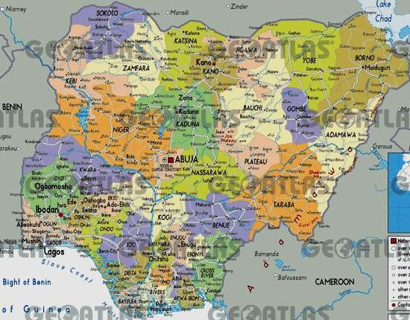**Figure 1: Map of Nigeria with the 36 States and Abuja at the Centre Source: (**[http://www.business-travel-nigeria.com/images/map_of_nigeria.gif**)**](http://www.business-travel-nigeria.com/images/map_of_nigeria.gif))

The Federal Capital Territory is central to all parts of Nigeria lying just above the hot and humid low lands of the Niger and Benue trough but below the drier parts of the country which is lying to the North. It lies just north of the wide alluvial plains formed by the confluence of the Niger and Benue rivers. It has an undulating topography and consists of flitted plain rising from an elevation of (92m) in the southwest corner to above (610m) at the northeast corner rising out of this flitted plain are numerous rocky knobs and isenbergs and several ranges of low mountains. This kind of landscape also characterizes the large areas of the region surrounding the Territory (International Planning Associates Joint Ventures Management Board, 1979).

Abuja was not an existing City as it is today, but a relatively virgin land. Thus a Master Plan was developed to guide in the developmental processes. Development started immediately after its status was clearly defined by the 1976 FCT Federal Government decree and by 1991, most of the needed infrastructure including buildings, roads, water and sewage system has progressed considerably to facilitate the actual movement of the Capital from the densely populated city of Lagos to the New Federal Capital – Abuja. Figure 2 is the map of the Federal Capital territory, with Abuja as the Federal Capital City.

The new Federal Capital City (FCC) was planned to be developed in phases I, II, III etc according to availability of resources and requirement. The phases are further subdivided into districts. Figures 3 and 4 show the different phases and districts of the FCC respectively. The districts have low, medium and high density areas to accommodate different types of houses and income groups. Some of the districts considered as low density include Maitama and Asokoro districts, while medium density areas include: Wuse I and Wuse II, Garki I and Garki II. The- high density areas are supposedly the satellite towns which include Gwagwalada, Kubwa, Karu and Nyanya etc.

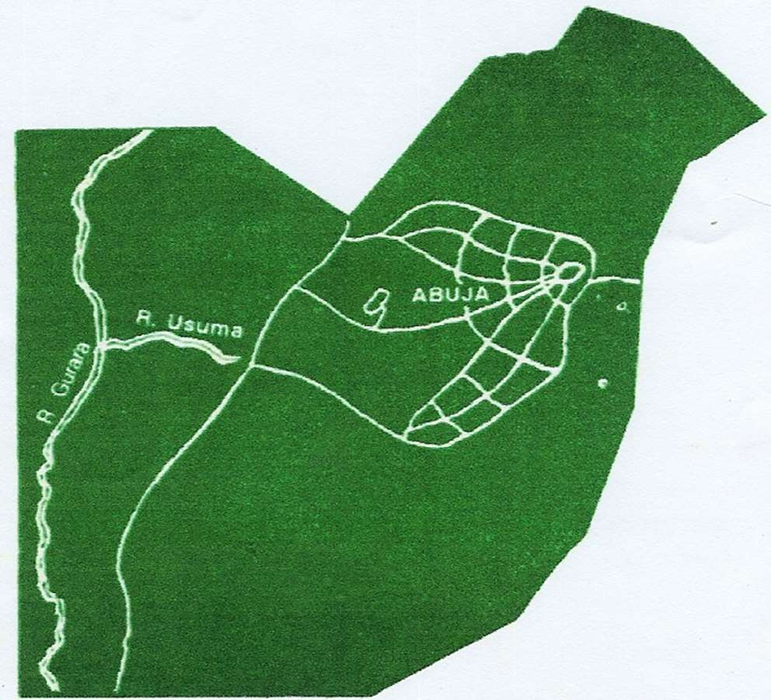Presently, many infrastructures exist in phases I and II and parts of phase III of the Federal Capital City (FCC). Although these facilities were not completely ready and adequate, but what was on ground motivated the government to move in 1991 since Lagos was getting more and more highly populated and difficult to manage environmentally.

## Figure 2: Map of Federal Capital Territory showing Abuja (Abuja Master Plan)

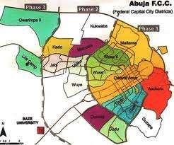**Figure 3: Map of FCC showing the different Phases** Source:**(**[http://t3.gstatic.com/images?q=tbn:ANd9GcR5z2UJUJdEGlLHszLQiWqe56UIoj7GeBb](http://t3.gstatic.com/images?q=tbn%3AANd9GcR5z2UJUJdEGlLHszLQiWqe56UIoj7GeBbofWRAG6_VKRs9Zfvk) [ofWRAG6_VKRs9Zfvk](http://t3.gstatic.com/images?q=tbn%3AANd9GcR5z2UJUJdEGlLHszLQiWqe56UIoj7GeBbofWRAG6_VKRs9Zfvk))

## Figure 4: Map of FCC-Phase I showing Districts and other prominent areas

Source: (<http://hotelownersforumabuja.com/img/abuja-map.gif>)

## Concept Plan for Wastewater Management in Abuja

The development of wastewater management plans for Abuja considered two types of issues in deciding the concept to be adopted. These are that:

1. The treatment and disposal of sanitary waste must be conducted in a manner to control disease vectors and contribute to the objectives of maintaining public health. Major diseases of concern in planning activity in the FCT include schistosomiasis, onchocerciasis, cholera, typhoid, malaria and other vector diseases transmitted by anopheles and other mosquitoes as reported in IPA

J.V.M.B. (1979). However it generally intends to provide control of pathogenic organisms found in wastewaters of human origin.

1. Wastewater effluent, if given adequate treatment may represent a valuable resource for agricultural irrigation in the city.

Thus the primary focus or objective is on management of wastewater in a manner which utilizes the wastewater as a resource, protects public health and utilizes wastewater treatment systems which can be operated and maintained at reasonable cost and with semi-skilled or unskilled staff. In consideration of the health-related issues for the FCT, the collection and treatment of wastewater emanating from the capital city and its outlying urban areas is essential in meeting the required stated objectives.

## Wastewater Generation and Re-use

The primary wastewater generation sources in the FCT include domestic wastewater from the capital city inhabitants; employment derived wastewater from the government building and commercial and industrial enterprises that develop in the FCT, process-related wastewater emanating from the industrial estates and from maintenance operations. Rivers and their tributaries in FCT are shown in Figure 5 wherein effluents from the wastewater treatment plant

are expected to be discharged. The quality of the effluent discharged into these rivers and tributaries must be such that does not pollute them and hence make them unsafe for aquatic life and other users.

The following assumptions were made in the concept plan of the wastewater management system. (IPA J.V.M.B., 1979)

* + - * 1. The per capita water consumption in FCT was estimated to be about 265 litres per capital per day, based on estimated supply of 425,000 m3/day for the interim population of 1.6 million people. It is estimated that the wastewater stream will tend to contain in excess of 250mg/l BOD5 and of suspended solids.
        2. It was assumed that from 20 to 25% of the delivered water supply will be used consumptively (i.e. will not be discharged to sewer system after use). Typical consumptive use is landscape irrigation.
        3. It was additionally assumed that the “loss” of water from the sewer system due to consumptive use will be almost equivalent in magnitude to the “gain” in flows due to infiltration of inflow to the sewerage system (particularly during the rainy season), such that the ultimate average wet-weather flow rate to the treatment plant will be approximately equal to the rate of water delivered i.e. 425,000m3/day.

## Figure 5: Map of FCT showing Rivers and their tributaries

Source: (Abuja Master Plan)

## Wastewater Collection System

The design of the sanitary sewerage system for the city was based on a number of major objectives and assumptions as documented in IPA J.V.M.B. (1979)

* + - * 1. The collection system should be by gravity flow, with no lift stations, force mains, or other powered devices. This type of system presents a number of advantages:

It is low in construction cost.

The long time required for the purchase and installation of large pumps is eliminated, together with their high cost.

The operational and maintenance costs are much lower than for pumped systems.

The possibility of a “catastrophic” type of system failure is extremely low.

Staging of construction is simplified.

Energy requirement is nearly zero.

* + - * 1. In order to reduce the loads on the wastewater treatment plant, the system adopted was a separate system. That is the storm run-off should not be allowed to enter the sanitary sewerage system.

## Wastewater Treatment

Performance standards to guide the selection of alternative wastewater treatment systems were developed for three treated effluent discharge conditions:

* + - * 1. Stream dilution
        2. Irrigated agriculture re-use; and
        3. Other re-uses.

Regardless of the discharge conditions, it is essential that any treatment system selected be capable of inactivating schistosome eggs, and that impoundments be managed so as to minimize the suitability of the impoundment for the breeding of mosquitoes.

Three wastewater treatment alternatives were selected in consideration of the treatment requirements set for Abuja and characterized in terms of land required, relative site development, total capital and operating costs, relative sludge generation, and supporting energy requirements. Land area and energy requirements were estimated for a treatment system collectively capable of treating a daily flow of 425,000m3 (IPA J.V.M.B., 1979). The selected treatment systems vary in complexity of technology from a combination of:

1. An anaerobic-oxidation pond system;
2. An anaerobic-aerated pond system; and
3. A standard activated sludge secondary treatment system.

From the evaluation of the alternatives, the wastewater treatment philosophy selected for the capital city by the master plan was the combined anaerobic pond-aerated pond system. IPA J.V.M.B, (1979) reported that anaerobic ponds are required to eliminate schistosome eggs. The combination has relatively low capital and operating costs and low sludge handling requirements. This system which is suited to the climatologically setting of the FCT is capable of meeting treatment requirements with a minimal commitment to mechanical equipment. Additionally, this processing philosophy is considerably less land-consumptive than the oxidation pond system and cheaper than standard secondary or advanced systems.

The treatment plant design flow rate is 560,000 m3/day. These design capacities allow for 25% peaking factor in relation to the average water consumption of 450,000 m3/day used for water supply.

The anaerobic ponds and aerated ponds are designed as modular units, with each anaerobic pond-aerobic pond module capable of treating 9,500m3/day. Sixty such modules are required to provide wastewater treatment service to the entire 1.6 million people (IPA J.V.M.B., 1979).

As a result of the modularity of the components of the wastewater treatment plant, the expansion of this facility can be scheduled in close coordination with the expansion of sewer service in the city. The individual anaerobic ponds are designed with a depth of 3m to provide a minimum 0.6m sludge storage depth (sufficient for at least five years of accumulation of decomposing sludge at the pond bottom). A design hydraulic detention time (the time required to fill a tank at a given flow or the theoretical time required for a given flow of wastewater to pass through a tank) of 1.36 days was selected as adequate for schistosome egg kill in the anaerobic environment.

The aerated ponds were designed at a depth of 4.5m to provide a minimum hydraulic detention time of seven days. Provision was also made in the preliminary design for effluent solids clarification, as well as plant piping and pumping. The wastewater treatment system described in this section would provide secondary treatment with residual biochemical oxygen demand and suspended solid residual of 30 to 50mg/l respectively. Figure 6 shows the location of sewage treatment aerator and trunk sewer lines in the Federal Capital City (FCC).

OF

Sewage Treatment Aerators

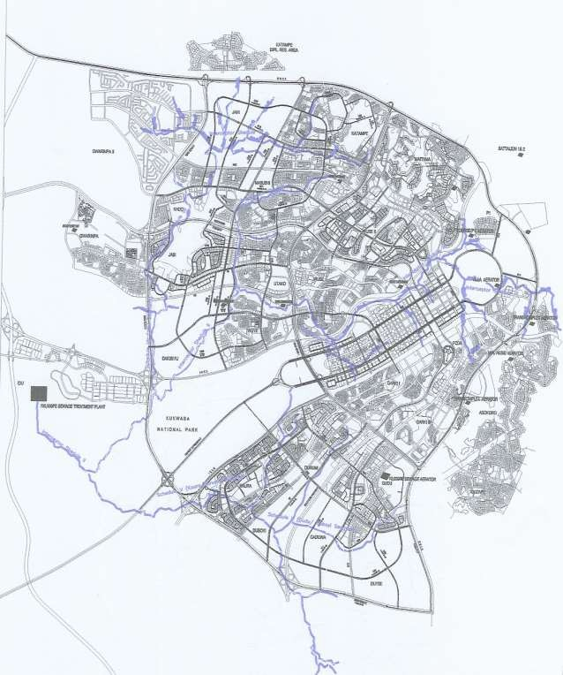

or WWTP Sewer lines

## Figure 6: Diagram Showing the Location of Wastewater Treatment Aerator and Trunk Sewer Lines in Federal Capital City

Source: (Abuja Master Plan)

## Problem Identification.

The problem currently is that the development of the Abuja in terms of the provision of sewerage infrastructure was delayed and could not match the influx of Nigerians who want to move to their new capital, thus inhabitants no longer comply with the provisions of the master plan. They build on sewer lines; throw non-biodegradable substances into sewer lines, construct septic tanks where there are no sewer lines, and sometimes discharge generated sewage into storm water line.

The provided sewage treatment plants could not function effectively due to excessive sand infiltration into the system, discharge of non-biodegradable substances into the system, poor and fluctuating electricity supply and non-availability of adequate funds to operate and maintain the plants. These and several other problems have rendered the sewerage system non effective and in a dilapidated state. Wastewater is discharged into waterways untreated due to blockage of manholes as shown in Plate 1 and others been overfilled as shown in Plate 2. The lack of provision of the central sewerage system in the satellite towns of Gwagwalada, Kuje, Kubwa, Nyanya etc have left inhabitants of such areas with no other alternative than to construct septic tanks and soak-away pits in order to manage their sewage which is not acceptable for a modern city like Abuja and was also not allowed in the Abuja Master plan.

## Plate 1: Blocked Manhole due to polythene bags at Gwarinpa District - Abuja

**Plate 2: Overfilled Manhole at Wuse - Abuja**

## Aim and Objectives of Research.

The aim of this research was to examine and evaluate the existing wastewater management systems in Abuja and to design appropriate strategies for effective wastewater management for the city.

More specifically, the objectives of the research were to:

* + 1. Carry out an inventory of wastewater generation, collection, treatment and reuse in Abuja.
    2. Identify the problems militating against the wastewater treatment system in Abuja and propose engineering solutions to the problem.
    3. Design appropriate strategies for wastewater management in Abuja in order to prevent transmission of diseases, and to have an environmentally-friendly modern sewerage system for the capital city for Nigeria.

## Research Justification

In a developing country such as Nigeria with old cities and communities, wastewater generated are commonly discharged openly and into drainages (open or closed), and in towns and communities, they are discharged into septic tanks/soak-away pits and cesspools. These systems are problematic as soils become saturated with decomposed solids, and effluents of very high suspended solids causing environmental pollution and even underground water pollution in some cases.

In order to avoid these and other problems, the sewage management for Abuja adopted the modern central system with sewage treatment plants as end of the pipeline solution to environmental pollution. Unfortunately, central sewerage system usage and management in Nigeria have not been fully appreciated. This is because they are not generally available except in Abuja and a few institutions or estates. It requires highly trained professionals to operate them; regular supply of electricity of specified voltage without fluctuations, and funding for operation and maintenance. Lack of these supporting conditions has led to poor performance of the system and thus the need for a well-thought out approach (both in terms of engineering and management) in order to proffer solution to these problems.

This research work evaluated the wastewater management system and the efficiency of the available treatment plants in existence in Abuja. In handling generated wastewater, evolution has taken place from the use of pit latrines to septic tanks and now to central sewerage system. Most modern cities of the world have followed these same patterns. Abuja in Nigeria cannot be an exception and therefore the need to evolve a way forward both in Engineering and management to sustain and fully adopt the new wastewater management system.

## CHAPTER TWO

* 1. **LITERATURE REVIEW**

## Sources of Wastewater and Usage

The major sources of wastewater in a community as documented by METCALF and EDDY (1991) are the residential areas, commercial districts, institutional and recreational sources. Each of these areas, proper estimation of the quantity of wastewater produced is vital for the design of sewer capacity to be provided for present and probable future quantities of expected wastewater during the design period of the sewerage system.

Wastewater flow rates in most residential are commonly determined on the basis of population density and the average per capital contribution of wastewater. Table 2.1 shows typical wastewater flow rates from residential sources as presented by METCALF and EDDY (1991).

Table 2.1: Typical wastewater flow rates from residential sources

|  |  |  |
| --- | --- | --- |
| **Sources**  1. Apartment: | **Unit** | **Typical Flow in l/c.d** |
| High-Rise  Low- Rise | Person Person | 190 l/c day  247 l/c day |
| 2. Hotel | Guest | 171 l/c day |
| 3. Individual |  |  |
| Residence: |  |  |
| Typical home | Person | 266 l/c day |
| Better home | Person | 304 l/c day |
| Luxury home | Person | 361 l/c day |
| 4. Motel | Unit | 380 l/c day |

Source: METCALF and EDDY INC. (1991)

Commercial wastewater flow rates are generally expressed in m3/ha.day and are based on existing future development. The average unit-flow rate allowances for commercial developments normally range from 7.5 to 14m3/ha.day (METCALF and EDDY 1991). Institutional facilities essentially are domestic in nature; however the flow rates vary with region, climate and type of facility. The table below shows the typical wastewater flow rates from institutional sources.

Table 2.2: Typical wastewater flow rates for institutional sources

**Source**

**Unit**

**Typical flow in L/unit. d**

Hospital (medical)

Bed

627 L/bed.d

|  |  |  |
| --- | --- | --- |
|  | Employee | 38 L/employee.d |
| Prison |  |  |
|  | Inmate | 437 L/inmate.d |
|  | Employee | 38 L/inmate.d |
| School, day |  |  |
| With cafeteria, gym and showers | Student | 95 L/person.d |
| With cafeteria only | Student | 57 L/person.d |
| Without cafeteria and gym | Student | 41.8 L/person.d |
| School, boarding | Student | 285 L/person.d |

Source: METCALF and EDDY INC. (1991)

Wastewater from Industrial sources varies with the type and size of facility, the degree of wastewater reuse of the industry and the on-site wastewater treatment methods. Typical design

values for estimating the flows from industrial areas that have little or no wet-process type industries is 9-14 m3/ha.day for light industrial developments; and 14-28 m3/ha.day for medium industrial developments.

Wastewater usage can be direct or indirect. The direct use means using treated wastewater for irrigation, aquaculture, industries, recreation, and even as potable water after passing through advance treatment. Indirect usage entails the utilization of wastewater which was disposed as raw material for other uses.

The direct use of wastewater for agricultural purposes as practiced in Nigeria had already been practiced for over 2000 years in Greece and China. (Pillai, 1955). Similarly, as early as 16th century, sewage farming was practiced in Germany; and in United States, the use of wastewater for farming started in the 1870‟s (Biswas and Arar, 1988).

Presently wastewater usage is practiced mainly in the arid and semi-arid tropical areas of the World. Veenstra (1992) observed that wastewater usage for agricultural purposes is common in Yemen and other Arab Countries, thus reiterated two major constraints with respect to reuse of wastewater as related to the quality of the treated effluent as: long term salinity effects on soil and crops; and public health risks to the workers and consumers. Therefore, the need for consideration of these two major factors before wastewater usage need not be over-emphasized.

Biswas and Arar (1988) also indicated that in the Arabian region, treated wastewater is used for irrigation of municipal areas; and the quality requirements in the Arab Gulf States have been based on 10 mg/L of BOD and 10 mg/L of suspended solids.

The range of wastewater use in the United States is wider than most parts of the world. In Southern California, wastewater is used for recreational purposes; but the treatment applied on the wastewater consists of combined biological wastewater treatment with sand filtration to

produce water devoid of bacteria and viruses of human origin. Boating, fishing, and swimming take place at these recreational sites. In other locations in California, injection of wastewater into groundwater occurs so as to prevent sea water intrusion, but the level of treatment is exorbitant.

## Nature of Sewage

According to Sridhar (1986), Sewage is the waste water of a community consisting of faeces, urine, kitchen washing and laundry washing. It is rich in organic matter, nitrogen, phosphorus and other minerals and vitamin. It is a veritable medium for a variety of microorganisms, both non-pathogenic and pathogenic. Fresh sewage is colloidal in nature, yellow, brown or black in colour with odour; depending on its age (fresh or stabilized).

The complex nature of domestic sewage precludes its complex analysis. Since it is comparatively easy to determine the amount of oxygen used by the bacteria as they oxidize the wastes the concentration of organic matter in the waste is expressed in terms of the oxygen required for its oxidation.

Waste + Oxygen bacteria Treated waste + new bacteria

There are basically three ways of expressing the oxygen demand of a waste.

* + 1. Theoretical Oxygen Demand (ThOD): This corresponds to the stoichiometric amount of oxygen required to oxidize completely a given compound. Usually expressed in milligrams of oxygen required per litre of solution. It is a calculated value and can only be evaluated if a complete chemical analysis of the wastewater is available, which is very rarely the case. Therefore, its utilization is very limited.
    2. Chemical Oxygen Demand (COD): This is the amount of oxygen required to oxidize the organic fraction of a sample which is susceptible to permanganate or dichromate oxidation in an

acid solution. COD does not differentiate between biologically available and inert organic matter, and it is a measure of the total quantity of oxygen required to oxidize all organic material into carbon dioxide and water. COD values are always greater than BOD values, but COD measurements can be made in a few hours while BOD measurements take five days. (Brown, 2001). COD can also be determined using Standard Dichromate Oxidation method, Rapid COD tests and Instrumental COD Methods.

* + 1. Bio-chemical Oxygen Demand (BOD): This is used as a measure of the quantity of oxygen required for oxidation of biodegradable organic matter present in wastewater sample by aerobic biochemical action. It is also a measure of the amount of oxygen that bacteria will consume while decomposing organic matter under aerobic conditions. Oxygen demand of wastewater is exerted by three classes of materials: (a) carbonaceous organic materials useable as a source of food by aerobic organisms; (b) oxidizable nitrogen derived from nitrite, ammonia, and organic nitrogen compounds which serve as a food for specific bacteria (e.g. *Nitrosomonas* and *Nitrobacter*); (c) chemical reducing compounds, e.g., ferrous ion (Fe2+) and sulfide (S2-), which are oxidized and dissolved. For domestic sewage, nearly all oxygen demand is due to carbonaceous organic materials and can be determined by either BOD dilution test or BOD manometric method. (Ramalho, 1977).

According to Brown (2001), BOD is determined by incubating a sealed sample of water for five days at 20oC and measuring the loss of oxygen from the beginning to the end of the test. Samples often must be diluted prior to incubation or the bacteria will deplete all of the oxygen in the bottle before the test is complete.

## Strength of Sewage

Sridhar and Pillai (1986) similarly observed that the higher the concentration of faeces in sewage, the stronger it is said to be, thus Sewage is most often judged by its Biochemical Oxygen Demand (BOD) or Chemical Oxygen Demand (COD).

## Protein in Wastewater and Wastewater sludge

Similarly, research carried out by Sridhar and Pillai (1973) showed that protein existed in wastewater, septic tank sludge, activated sludge, and that the dominant protozoa and bacteria in the activated sludge adhere to these proteins.

As reported by Pamela and Chul (2007), proteins have been identified on the basis of their solubility in different solvents such as water, salt solution, alkali, acid and ethanol. Knowledge of the nature of proteins in wastewater and wastewater sludge is useful for determining the pollution effects on the environment and the changes in the protein structures during decomposition or treatment and also for determining the possible usage of the resulting materials in agriculture, including animal nutrition.

Proteins constitute one of the largest fractions of organic material in secondary effluent from domestic wastewater treatment plants, and are a significant source of organic released into received waters.

## Protease Activity in Sewage

Protease, a common enzyme associated with the decomposition of proteinaceous organic matter like human wastes, is present in bacteria and other organisms on the decomposing matter. (Sridhar and Pillai, 1973). Domestic sewage consists mostly of faecal matter, urine, kitchen washings and soil washing. Normal urine is known to contain some protease activity. The result

of analysis of faecal suspension, kitchen washing indicate that all these materials which are present in the sewage contribute, to various extents the protease activity (Sridhar and Pillai, 1973).

## Enzymes in Raw Sewage

Domestic sewage is composed mostly of faecal matter, urine, soil and other washings. The observations on the enzymes in these constituents and in the sewage as a whole are considered thus:

* + - 1. Faecal matter: Since 1908, studies of enzymes in a variety of biological matters have been carried out and observations have been made on faecal and urinal matters. Sridhar and Pillai (1966) showed in their study that lipase, diastase, and catalase are present in faeces.
      2. Urine: The enzymes in urine have also attracted attention. It has been shown that the total daily excretion of diastase is fairly constant in normal individuals; an average of from 10 to 20 units was reported by Sridhar and Pillai (1966). Pepsin and lipase have also been shown to be present in Urine, but the amounts of these increase during certain pathological conditions. The amount of catalase in urine is an index of the number of cells therein and the urine of patients suffering from pyelitis can be differentiated from that of normal individuals by its catalase content.

Diastase, trypsin, pepsin, lipase as well as disaccharide‟ enzymes are nearly always present in domestic sewage partly derived from animal and vegetable waste products and are continuously formed by the microorganisms (American Public Health Association, 1971).

## Present State of Knowledge

Digestion or stabilization of sewage is brought about by microorganisms; the possible involvement of enzymes in the process was not envisaged until after 1908 (Sridhar and Pillai,

1966). With the more rapid development of the general concept of enzymes in the early years, the knowledge of the enzymes in biological materials, such as faeces and urine, was naturally applied to the study of enzymes in sewage, the material in sewage filters and in the anaerobic systems of sludge digestion and gas production. The advent of the activated sludge process as a more rapid and efficient method of sewage treatment has afforded an interesting biological material for the study of enzymes as well.

## Electrophoretic separation of protein in sewage and Sludge:

Electrophoresis is the phenomenon or the pattern of movement of the ions or charged particles in aqueous solution when subjected to direct electric current towards one or other of the electrode. The rate at which the movement occurs depends on a number of factors, particularly on the charge, size and shape of the molecules. This technique of disc electrophoresis is used to separate the proteins in sewage, septic tank sludge, activated sludge, the bacteria and the dominant protozoan- *Epistylis articulata* from the activated sludge and in the bacteria adhering to this protozoan (Sridhar et al, 1974).

## An Enzymic Approach to the Study of Sewage and Sludge

The study of the principles of sewage treatment seems to have begun in 1877 with concept of organized ferments and as the knowledge of enzymes in general advanced in the early years of this century, attempts were also made to investigate the clotting enzymes in sewage filters, in certain bacteria and activated sludge (Sridhar and Pillai, 1966).

## Catalase activity in polluted water:

In 1811, Thenard observed that hydrogen perioxide (H2O2) was able to decompose the tissues of plants and animals with the evolution of oxygen. This action was later shown to be due to an enzyme (catalase), which is present in all aerobic living systems and is broken down hydrogen peroxide, a toxic product of oxidative metabolism, into water and oxygen. This enzyme, unlike others, is active over a wide range of pH (3 to 9) and temperature (40 to 250 C) and does not require any co-factors or catalase (Sridhar and Pillai, 1969).

## Catalase activity in sewage effluents

A new method of assessing the quality of sewage effluents has thus been developed to measure more accurately and rapidly the biological activity in treated sewage by the application of recent knowledge of the enzyme, catalase. Catalase is generally present in all aerobic living systems. In these systems catalase is essential for spontaneous breakdown of hydrogen peroxide which is formed in the cell as a toxic product of oxidative metabolism, into water and oxygen (Sridhar and Pillai, 1969).

## Magnetic bugs cut sewage sludge

Adding iron dust to wastewater makes bacteria reusable. Magnetic bacteria could cut sewage sludge. They could shave up to five tonnes of waste off the several hundred tonnes produced every day by a plant serving 100,000 people, say Japanese researchers. Bacteria used to break down some harmful pollutants in waste water add to leftover sludge. Much of this ends up buried in landfills; but microbes will cling to powdered iron sprinkled into the brew and magnets can then drag them out, reducing the sludge volume and enabling a plant to re-use the bugs (Sakai, 2003).

The report of APHA (1976) confirmed that microbes will cling to powdered iron sprinkled into the brew. Magnets can then drag them out, reducing the sludge volume and enabling a plant to re-use the bugs and that magnetic separation is fast and reliable. A year-long test, in which 80 litres of raw sewage were passed through a rotating magnetic drum every day, produced no bacterial sludge.

Bacteria can be strained out or allowed to settle. Both approaches have disadvantages, says microbiologist Tom Curtis, and that "Gravity is cheap but not very effective; membranes are effective but expensive. “Magnetic separation "is ingenious, and it could find favour", he adds, but it's too early to say whether the running costs will make the technique competitive (APHA, 1976).

## Health Significance of Wastewater

Pathogenic organisms like viruses, bacteria, and helminthes are commonly present in wastewater in high numbers. These organisms can survive in the wastewaters for a long period of time due to the conducive environment the wastewater creates for their survival. Since it is difficult to analyze the presence of each individual type of microorganism in the sewage, the faecal coliform are used as indicator group to indicate to what extent the wastewater is contaminated with human excreta and to what degree treatment will be able to reduce the level of contamination (Veenstra, 1992).

The quality of wastewater discharged into rivers, or pool of water should be such that it will not tamper with the health of inhabitants who may in one way or the other use the water for different purposes. Thus it is important to check the presence and collection of micro pollutants which may tamper with the health of inhabitants.

Similarly, persistent organic chemicals sometimes exist in municipal wastewater at low concentrations and ingestion over prolonged periods would produce detrimental effects on human health. This is not likely to occur with agricultural/aquaculture use of wastewater, unless cross-connections with potable supplies occur. The principal health hazards associated with the chemical constituents of wastewater thus arise from the contamination of crops or groundwater.

Odour is one of the most serious environmental concerns to the public, new techniques for odour measurement are now being used to quantify the development and movement of odours that may emanate from wastewater facilities. Special efforts are being made to design facilities that minimize the development of odours (METCALF and EDDY, INC. 1991). However, no strong evidence has been adduced to suggest that population groups residing near wastewater treatment plants or wastewater irrigation sites are at greater risk from pathogens in aerosolized wastewater resulting from aeration processes or sprinkler irrigation.

Shuval et al (1986) suggested that the high levels of immunity against most viruses endemic in the community are essentially from environmental transmission by wastewater irrigation.

## Guidelines for Wastewater Usage

Wastewater usage cuts across so many areas of human endeavour like agriculture, recreation, irrigation and sometimes for human consumption as potable water. Environmental specialists and WHO Scientific Group on Health Aspects of usage of treated wastewater have set guidelines for the safe use of wastewater for different purposes. These guidelines as shown in Table 2.3 for agricultural purposes were established on the consensus view that the actual risk associated with irrigation using treated wastewater is much lower than previously thought; and that earlier standards and guidelines for effluent quality, such as the WHO (1973) recommended standards, were unjustifiably restrictive particularly with respect to bacterial pathogens

Table 2.3: Safe Guidelines for Wastewater Usage in Agriculture

Category(a)

Use

Exposed

Intestinal

Fecal

Workers

A

≤ 1

≤ 1000(e)

Unrestricted(d) Consumers

& public

B

Restricted(f) Workers

≤ 1

No

Recom. Standard

C

Localized (g)

None

Wastewater Treatment expected to achieve required microbial quantity

WSPs designed to achieve the microbiological quality indicated or equiv. treatment

Retention time in WSP for 8-10.d or equiv helminth & faecal coliform removal.

Pretreatment as required

Not Not by irrigation techn. But Applicable Applicable not less than prim.

sediment

Source: World Health Organization, WHO (1989)

1. In specific cases, local epidemiological, socio-culture and environmental factors should be taken into account, and the guidelines modified accordingly.
2. *Ascaris* and *Trichuris* species and hookworms (arithmetic mean number of eggs per litre).
3. During the irrigation period (geometric mean number per 100 ml).
4. Irrigation of crops likely to be eaten uncooked, sports fields, and public parks.

During the last decade wastewater reclamation, recycling and reuse especially in agriculture has received much attention around the world especially in arid and semi-arid regions.

In Yemen where there is scarcity of water, domestic wastewater may present a valuable additional source of water for use after adequate treatment. Wastewater reuse in agriculture may serve different purposes such as: providing an extra reliable water source, providing valuable

fertilizers for stimulation of agricultural crop production and minimizing environmental pollution (Veenstra, 1992b). Not every wastewater is suitable for reuse in irrigation and other purposes, thus the need for a guideline for safe use of wastewater effluent.

## Wastewater Collection Systems

Wastewater produced in a community should generally be collected and treated or disposed of in such a way that it does not disturb the healthy living of the inhabitants in the area. Generally, there are two wastewater collection methods.

## On-Site Collection

This involves the collection of wastewater and its disposal within the site or location of the wastewater production. On site-collection and disposal of waste is carried out basically by the use of septic tanks, cesspools, pit latrines etc. for the disposal of human wastes. Traditionally these pits are constructed with depths easily in excess of 10m. The liquid carrying all kinds of organic and inorganic contaminants is expected to infiltrate into the soil.

The overall health hazards from these on-site sanitation systems are dependent on the depth of groundwater table in the area involved. The deeper the groundwater table the better, as long travelling times of wastewater will allow for physical, chemical and biological purification of the infiltrating liquid.

In areas where the groundwater table is close to the surface, there is a lot of concern as the groundwater may be polluted with increased concentration of nitrates and even microorganisms. (Driscoll, 1986).

## Sewerage System

The sewerage system involves the transportation of wastewater via sewer pipes to a central collector which finally discharge the wastewater to a treatment plant. This modern system of wastewater helps to keep the whole environment of human residence free from the produced waste; thus preventing risk of environmental pollution, odour and various ills associated with wastewater. This system although expensive initially during conception and construction; its durability, spanning over 50 - 100 years makes it cheaper on the long run. (Chartterjee, 2010).

## Wastewater Treatment Methods

There are basically three levels in wastewater treatment methods: Primary, Secondary and Tertiary treatment methods.

1. Primary treatment

Primary treatment involves the partial removal of suspended solids and organic matter from the wastewater by means of physical operations such as screening and sedimentation. Pre- aeration or mechanical flocculation with chemical additions can also be used to enhance primary treatment. Primary treatment acts as a precursor for secondary treatment. It is aimed mainly at producing a liquid effluent suitable for downstream biological treatment and separating out solids as a sludge that can be conveniently and economically treated before ultimate disposal. The effluent from primary treatment contains a good deal of organic matter and is characterized by a relatively high BOD.

1. Secondary treatment

The purpose of secondary treatment is the removal of soluble and colloidal organics and suspended solids that have escaped the primary treatment. This is typically done through

biological processes, namely treatment by activated sludge, fixed-film reactors, or lagoon systems and sedimentation.

1. Tertiary/Advanced wastewater treatment

Tertiary treatment goes beyond the level of conventional secondary treatment to remove significant amounts of nitrogen, phosphorus, heavy metals, biodegradable organics, bacteria and viruses. In addition to biological nutrient removal processes, unit operations frequently used for this purpose include chemical coagulation, flocculation and sedimentation, followed by filtration and activated carbon. Less frequently used processes include ion exchange and reverse osmosis for specific ion removal or for dissolved solids reduction (Economic and Social Commission for Western Asia, 2003).

Also, wastewater treatment methods can be classified into two types based on the location of treatment works. These are on-site treatment and off-site treatment. On-site treatment involves the collection of wastewater and its treatment near the site of its production via septic tank/soak away or cesspools. While off-site treatment involves the collection of wastewater from all points of production within a district, community or town and its treatment at a designated point outside the city. The treatment of wastewater of large quantities can be done through so many treatment processes depending on the level of treatment expected, availability of funds and the treatment standard specified for such a country.

Similarly, wastewater treatment methods can be grouped into two main categories namely natural (biological treatment) and technological systems.

1. **Natural systems (Biological Treatment)**. In this type of system, sewage is treated by means of Anaerobic, Facultative and Aerobic (maturation) stabilization ponds, land treatment systems (different types of wetland or direct land application).
2. **Technological Systems**. Here, high technology system is adopted in such a way that the natural wastewater treatment is accelerated through artificial input of extra oxygen.

In general, natural treatment systems are advantageous as they do not rely so much on skilled operational labour nor do they need sophisticated (imported) equipment. However, they require land areas of more than 2m2 per population equivalent while for technological system, it requires less than 1m2 per population equivalent depending on the type of treatment plant and its capacity (Veenstra, 1992b).

## Waste Stabilisation Ponds

Waste stabilization ponds (WSPs) are generally arranged as a series of shallow ponds which receive a continuous flow of wastewater. These shallow ponds could be earthen basins using a completely mixed biological process without solids return. The mixing process may be either natural (wind, heat or fermentation) or induced (mechanical or diffused aeration). The waste stabilization process can be classified by considering the type(s) of biological activity occurring in the pond. Three types of ponds may be distinguished in a waste stabilization pond treatment process, they are: - Anaerobic ponds, Facultative ponds and Maturation ponds.

Anaerobic ponds are deep wastewater treatment ponds that exclude oxygen and encourage the growth of algae, with bacteria to help break down the effluent. The anaerobic pond acts mostly like an uncovered tank that breaks down the organic matter in wastewater with the use of organisms, releasing methane and carbon dioxide.

Facultative ponds are divided into two types: primary, which receives raw wastewater: and secondary, which receives the settled wastewater left over from the anaerobic pond. Facultative ponds are designed for BOD5 removal using algae, which help to produce oxygen to the pond.

Finally, maturation ponds are ponds that receive the effluent from a facultative pond and its size and number depends on the quality of the bacteria that is released in the effluent. This kind of pond is shallow and shows less vertical stratification than the other types of ponds. Its water volume is well oxygenated throughout the day, due to the population of algae. The purpose of this type of pond is to remove pathogens and fecal coliforms by the oxidation process. Maturation ponds only achieve a small removal of BOD5, but they remove more nitrogen and phosphorus than the other pond systems (Liu and Lipták, 1999).

The normal sequence is that the raw wastewater first settle in an anaerobic pond; followed by the facultative pond, where organic matter of the wastewater is oxidized to carbon dioxide and water. Finally it flows into the maturation pond where the treatment is mainly concentrated on pathogen removal. Figure 7 shows typical flow diagram of waste stabilization

pond.

Screenings

Cl2 or NaOCl

Effluent

Influent

Stabilization ponds

Sludge treatment facility

Sludge removal pond

Bar Racks

Chlorine contact chamber

Solid separation facility

Figure 7: Typical flow diagram for stabilization ponds

WSPs are most often referred to as oxidation pond or lagoon – this is a natural secondary wastewater treatment. The primary treatment takes place in the anaerobic pond, which serves the purpose of removing suspended solids and some of the soluble matter (BOD5). Waste stabilization pond technology is particularly well suited to countries in tropical and subtropical regions, because the greater amount of sun and the higher temperatures contribute to a more efficient removal of waste. The secondary wastewater treatment is man-made basins and has the ability to stabilize the waste and reduce the pathogens. WSPs have been used all around the world because of the efficiency to reduce the waste with the use of micro-organisms, although its effectiveness is affected by the different climatic conditions in different locations. This treatment is most appropriate for wastewater treatment and is followed by a microbiological and chemical quality guidelines with a low cost, minimal operational, and maintenance requirements.

The overall performance of wastewater stabilization ponds is strongly dependent on the hydraulic and surface loading rates applied and on the prevailing environmental conditions of its location such as temperature, solar radiation level etc. with reference to the design criteria of the WSP which are based on the maximum and minimum BOD volumetric loading. It is suggested that for high temperatures (>20oC) and a hydraulic detention time of 2.5days, BOD removal would be 60%. Doubling the retention time would only achieve a 17% increase, with a removal rate of 70% (Mara, 2003).

Shuval et al (1986) observed that Wastewater Stabilization Ponds is the most appropriate wastewater treatment method for effluent use in agriculture. Wastewater Stabilization Ponds are also a preferred wastewater treatment system to be used in developing countries, where land is often available at reasonable opportunity cost and skilled labour in short supply.

## Activated Sludge Treatment

Activated sludge process is one of the biological wastewater treatment processes most often used for large installations. The process was developed in England in 1914 by Arden and Lockett and was so named because it involved the production of an activated mass of microorganisms capable of stabilizing a waste aerobically (METCALF and EDDY, INC. 1991).

The activated sludge process is an aerobic, continuous-flow system containing a mass of activated micro-organisms that are capable of stabilizing or biodegrading organic matter. The process consists of delivering clarified wastewater, after primary settling, into an aeration basin where it is mixed with an active mass of micro-organisms, mainly bacteria and protozoa, which aerobically degrade organic matter into carbon dioxide, water, new cells, and other end products. The bacteria involved in activated sludge systems are primarily Gram-negative species, including carbon oxidizers, nitrogen oxidizers, floc formers and non-floc formers, and aerobes and facultative anaerobes. The protozoa, for their part, include flagellates, amoebas and ciliates.

An aerobic environment is maintained in the basin by means of diffused or mechanical aeration, which also serves to keep the contents of the reactor (or mixed liquor) completely mixed. After a specific retention time, the mixed liquor passes into the secondary clarifier, where the sludge is allowed to settle and a clarified effluent is produced for discharge. The process recycles a portion of the settled sludge back to the aeration basin to maintain the required activated sludge concentration as shown in Figure 8. The process also intentionally wastes a portion of the settled sludge to maintain the required solids retention time (SRT) for effective organic removal (Economic and Social Commission for Western Asia, 2003).

Operationally, biological wastewater treatment using the activated sludge process is accomplished by the introduction of organic waste into a reactor where aerobic bacterial culture

is maintained in suspension. The aerobic environment in the reactor is achieved and maintained by the use of diffused or mechanical aeration system.

The activated sludge system of wastewater treatment is commonly used nowadays in view of the high effluent quality; and the system can easily be controlled to achieve different

degree of nutrient removal from the wastewater.

Screenings Grit Waste sludge



Influent

Settling tank

Aeration tank

Grit Chamber/Primary Sedimentation

Bar Racks

Cl2 or NaOCl

Effluent

Chlorine contact chamber

Figure 8: Typical flow diagram for Activated sludge flow process.

The control of the activated-sludge process is important to maintain a high treatment performance level under a wide range of operating conditions. The principal factors in the process control are the following:

* + - 1. Maintenance of dissolved oxygen levels in the aeration tanks;
      2. Regulation of the amount of returning (re-circulated) activated sludge;
      3. Control of the waste activated sludge.

The main operational problem encountered in a system of this kind is sludge bulking, which can be caused by the absence of phosphorus, nitrogen and trace elements and wide fluctuations in pH, temperature and dissolved oxygen (DO). Bulky sludge has poor settleability and compatibility due to the excessive growth of filamentous micro-organisms. This problem can be controlled by chlorination of the return sludge (Liu and Lipták, 1999).

## Enzymes in Activated Sludge:

Similarly, Wooldridge (1933), have observed the occurrence and activities of enzymes in the sludge while working with activated sludge. Sludge from sedimentation and humus tanks, demonstrated the presence of dehydrogenises, indophenols oxides and urea‟s activities. Activated sludge and crude sewage did not show the presence of catalyses and the sludge showed a doubtful peroxides activity. It was further shown that sterile sewage was oxidized readily by non- sterile activated sludge and by bacteria suspensions, less rapidly by protozoa suspensions and that activated sludge contains many oxidation-reduction enzymes.

## Sludge Density Index (SDI)

The sludge density index is the reciprocal of the sludge volume index, multiply by 100, and is calculated on the basis of the suspended solid and settled volume of the sludge in 30 minutes.

Per cent suspended solids

Per cent settling by volume

SDI = × 100

## Sludge Volume Index (SVI)

The sludge volume index (SVI) is the volume in ml occupied by 1 gram of sludge after setting the mixed liquor for 30minutes in a graduated cylinder (Metcalf and Eddy, 1991). The sludge volume index is calculated on the basis of the suspended solids and the settled volume of the sludge in 30minutes.

Percent settling volume

Percent suspended solids

SVI = × 100

According to Veenstra and Duijl (1995), in the design of Activated sludge treatment, the process is commonly preceded by primary treatment (screening, grit removal and primary setting), and consist of aeration tanks and secondary setting compartments. The major parameters used in the design are the hydraulic and the volumetric loading rates. They are usually designed with hydraulic retention times ranging from two hours to several days. The retention time largely depends on the design objectives. However, the most important design parameter for activated sludge plant is the sludge loading rate or F/M ratio. The F/M ratio is defined as the daily BOD load to the plant (food F) divided by the microbial biomass (micro-organisms M) in the aeration tank.

Thus

F/M = Amount of substrade = Q × [BODi] KgBOD/Kg MLSS/d Amount of Biomass [MLSS] × V

Where: Q = Daily flow rate to the plant (m3/day) BODi = settled influent BOD (mg/L)

MLSS = Mixed Liquor Suspended Solids (mg/L) V = Volume of the Aeration tank (m3)

## Aerated Lagoons

` An aerated lagoon is a basin between one (1) and four (4) metres in depth in which wastewater is treated either on a flow-through basis or with solids recycling. The microbiology involved in this process is similar to that of the activated-sludge process. However, differences arise because the large surface area of a lagoon may cause more temperature effects than are ordinarily encountered in conventional activated-sludge processes. Wastewater is oxygenated by surface, turbine or diffused aeration. The turbulence created by aeration is used to keep the contents of the basin in suspension. Depending on the retention time, aerated lagoon effluent

contains approximately one third to one half the incoming BOD value in the form of cellular mass. Most of these solids must be removed in a settling tank before final effluent discharge as

shown in figure 9.

Screenings Sludge

Return sludge

Influent

Aerated Lagoon

Settling tank

Bar Racks

Cl2 or NaOCl

Effluent

Chlorine contact chamber

Figure 9: Typical flow diagram for aerated lagoons

All lagoons take advantage of natural processes to treat wastewater. Wind and sunlight on the lagoon surface also plays an important role as do the microbes that live in the wastewater. Natural lagoons are made up of three layers an aerobic (layer with oxygen), an anaerobic (layer with no oxygen) and a facultative (mixed layer). In a constructed aerated lagoon air is pumped into the lagoon to turn the whole pond into an aerobic zone. Adding air to the water speeds up the natural processes that break down organic waste. This means that the lagoon can process more waste in less space. When air is added to the lagoon it changes the environment and the types of microbes that process the wastewater. Different microbes create different chemical reactions as they process waste. The difference in chemical reaction changes or reduces the odours produced by the lagoon (Economic and Social Commission for Western Asia, 2003)

Lagoons have proven to be very adaptable and well suited to tropical (Northern) climates. Examples of an aerated lagoon in the North are Fort Nelson in Alaska, B.C in Canada and Haines Junction in Yukon, Canada. The lagoon in Haines Junction is naturally aerated by the wind, there are no mechanical pumps. When temperatures drop and sunlight disappears in the winter the microbes that do the work of processing waste in the lagoons slow down. This does

not mean that that the lagoon stops working. Microbes are still active and solids can settle at the bottom of the pond. When spring returns the microbes in the aerobic level of the pond become very active again. Lagoons are resilient and adaptable to variations in seasonal flows because of the size of the ponds (Qasim, 1999).

## On-Site Septic Tank/Soak-away pits System

On-site septic tank/soak-away pit is a treatment method where the wastewater is collected and treated at the site of production. On-site wastewater treatment systems contain three components: a treatment unit which treats water prior to dispersal into the environment; a soil dispersal component which assures that treated water is released into the environment at a rate which can be assimilated; and a management system which assures proper long term operation of the complete system. Disinfection of the treated effluent may be provided prior to dispersal. A typical onsite system consists of a septic tank followed by an effluent distribution system. Alternative treatment systems include aerobic treatment and sand filtration systems.

A septic tank is a tank buried in the ground used to treat sewage without the presence of oxygen (anaerobic). The sewage flows from the plumbing in homes or small businesses establishment into the first of two chambers, where solids settle out. The liquid then flows into the second chamber. Anaerobic bacteria in the sewage break down the organic matter, allowing cleaner water to flow out of the second chamber. The liquid typically discharges through a sub- surface distribution system. Periodically, the solid matter in the bottom of the tank, referred to as septage, must be removed and disposed of properly. Septic tanks are suitable for houses that have both water connection (necessary for flushing toilets) and sufficient land with permeable soil for effluent disposal

The basic treatment mechanisms that occur in the septic tanks include the sedimentation of settleable solids and some pathogenic micro-organisms to the tank bottom; anaerobic stabilization of organic matters contained in the liquid and sludge layers; partial reduction of pathogenic micro-organisms due to anaerobic conditions in the tank. Impermeability of the soil can create problem for the effluent disposal in the use of septic tanks; and in areas where the water table is high, pollution of the groundwater may occur where septic tank is used. Septic tank system is observed to be often used in the satellite areas of the Federal Capital of Nigerian Abuja, although this is not provided for in the Abuja Master Plan.

## Trickling Filters

The trickling filter is the most commonly encountered aerobic attached-growth biological treatment process used for the removal of organic matter from wastewater. It consists of a bed of highly permeable medium to which organisms are attached, forming a biological slime layer, and through which wastewater is percolated. The filter medium usually consists of rock or plastic packing material. The organic material present in the wastewater is degraded by adsorption onto the biological slime layer. In the outer portion of that layer, it is degraded by aerobic micro- organisms. As the micro-organisms grow, the thickness of the slime layer increases and the oxygen is depleted before it has penetrated the full depth of the slime layer. An anaerobic environment is thus established near the surface of the filter medium. As the slime layer increases in thickness, the organic matter is degraded before it reaches the micro-organism s near the surface of the medium. Deprived of their external organic source of nourishment, these micro-organisms die and are washed off by the flowing liquid. A new slime layer grows in their place; this phenomenon is referred to as „sloughing‟ (METCALF and EDDY, INC. 1991).

After passing through the filter, the treated liquid is collected in an under-drain system, together with biological solids that have become detached from the medium. The collected liquid then passes to a settling tank where the solids are separated from the treated waste-water. A portion of the liquid collected in the under-drain system or the settled effluent is recycled to dilute the strength of the incoming wastewater and to maintain the biological slime layer in moist condition as shown in figure 10.

Chlorine contact chamber

Cl2 or NaOCl

Effluent

Grit Sludge

Screenings

Influent

Bar Racks

|  |  |  |  |  |  |  |  |
| --- | --- | --- | --- | --- | --- | --- | --- |
| Grit chamber/Primary Sedimentation | |  | Trickling filters |  | Settling tank | | |
|  |  | |  |
|  | | | | |  |
|  | Return sludge | | | | |  |

Figure 10: Typical flow diagram for trickling filters

The engineering design of trickling filters is based on three important process parameters:

the volumetric organic loading rate (LV), the organic surface loading rate (OSLR), and the hydraulic surface loading rate (HSLR):

|  |  |  |  |
| --- | --- | --- | --- |
| Thus:  i) | LV = | Load (KgBOD/d) | (KgBOD/m3 filter/d) |
| ii) | OSLR = | Volume Filter (m3)  Load (KgBOD/d) × 100 | (gBOD/m3 media surface/day) |

V. Aspec

Where: Aspec = Specific filter area per m3 volume V = Volume of filter bed (m3)

iii) HLSR = Hourly design flow rate Q (m3/h) (m/h)

Area filter Af (m2)

To compensate for the various filter materials, the volumetric loading rate is frequently replaced by the organic surface loading rate (OSLR) which is defines as: OSLR = 100 × LV/Aspecific

For a typical natural rock filter, the OSLR equals (13.3 × LV) assuming a specific surface area of 75m2/m3 and LV expressed in KgBOD/m3.d (Veenstra and Duijl, 1995).

## Rotating Biological Contactors

A rotating biological contractor (RBC) is an attached-growth biological process that consists of one or more basins in which large closely-spaced circular disks mounted on horizontal shafts rotate slowly through wastewater. The disks, which are made of high-density polystyrene or polyvinyl chloride (PVC), are partially submerged in the wastewater, so that a bacterial slime layer forms on their wetted surfaces. As the disks rotate, the bacteria are exposed alternately to wastewater, from which they adsorb organic matter, and to air, from which they absorb oxygen. The rotary movement also allows excess bacteria to be removed from the surfaces of the disks and maintains a suspension of sloughed biological solids. A final clarifier is needed to remove sloughed solids. Organic matter is degraded by means of mechanisms similar to those operating in the trickling filters process. Partially submerged RBCs are used for carbonaceous BOD removal, combined carbon oxidation and nitrification, and nitrification of secondary effluents. Completely submerged RBCs are used for denitrification (METCALF and EDDY, INC. 1991).

Figure 11 shows a typical arrangement of RBCs. In general, RBC systems are divided into series of independent stages or compartments by means of baffles in a single basin or separate basins arranged in stages. Compartmentalization creates a plug-flow pattern, increasing

overall removal efficiency. It also promotes a variety of conditions where different organisms can flourish to varying degrees. As the wastewater flows through the compartments, each subsequent stage receives influent with a lower organic content than the previous stage; the

system thus enhances organic removal.

Cl2 or



Influent

Bar Racks

Screenings

Grit

Sludge

Baffle

NaOCl

Sludge

Settling tank

Primary Sediment ation

Grit Chamber

Effluent

Chlorine contact chamber

Figure 11: Typical flow diagram for RBC units

## Completely Mixed Anaerobic Digestion

Drive Motor

Anaerobic digestion involves the biological conversion of organic and inorganic matter in the absence of molecular oxygen to a variety of end-products including methane and carbon dioxide. This involves the transformation of organic matter by a consortium of anaerobic micro- organisms giving the main product as biogas. It is composed of a mixture of methane and carbon dioxide as main components, and di-hydrogen, carbon monoxide and di-hydrogen sulphur as minor components. The metabolic pathway of anaerobic digestion is shown in Figure 12 (Moletta, 2005).

A consortium of anaerobic organisms work together to degrade the organic sludge and wastes in three steps, consisting of hydrolysis of high-molecular-mass compounds, acidogenesis and methanogenesis.

The process takes place in an airtight reactor. Sludge is introduced continuously or intermittently and retained in the reactor for varying periods of time. After withdrawal from the

reactor, whether continuous or intermittent, the stabilized sludge is reduced in organic and pathogen content and is non-putrescible. The two most widely used types of anaerobic digesters are standard-rate and high-rate. In the standard-rate digestion process, the contents of the digester are usually unheated and unmixed, and are retained for a period ranging from 30 to 60 days. In the high-rate digestion process, the contents of the digester are heated and mixed completely, and are retained, typically, for a period of 15 days or less. A combination of these two basic processes is known as the two-stage process, and is used to separate the digested solids from the supernatant liquor. However, additional digestion and gas production may occur.

## Hydrolysis and acidogenesis

Monomers

Macro-molecules

Volatile fatty acids

**Acetogenesis**

H2, CO2

Acetic acid

## Methanogenesi

CH4, H2O

CH4, CO2

Figure 12: Metabolic pathway of anaerobic digestion

Anaerobic digesters are commonly used for the treatment of sludge and waste-waters with high organic content. The disadvantages and advantages of a system of this kind, as compared to aerobic treatment, stem directly from the slow growth rate of methanogenic bacteria. A slow growth rate requires a relatively long retention time in the digester for adequate waste stabilization to occur; however, that same slow growth means that only a small portion of the degradable organic matter is synthesized into new cells. Another advantage of this type of

system is the production of methane gas, which can be used as a fuel source, if produced in sufficient quantities. Furthermore, the system produces a well-stabilized sludge, which can be safely disposed of in a sanitary landfill after drying or dewatering. On the other hand, the fact that high temperatures are required for adequate treatment is a major drawback.

## Land Treatment

Land treatment of wastewater is the controlled application of wastewater onto the land surface to achieve a specified degree of treatment through natural, physical, chemical and biological processes within a plant-soil-water matrix. It is the controlled application of wastewater to the soil where physical, chemical, and biological processes takes place as the wastewater passes across or through the soil. The principal types of land treatment are slow rate, overland flow, and rapid infiltration. In the arid western states, pretreated municipal wastewater has been used for many years to irrigate crops. In more recent years, land treatment has spread to all sections of the country. Land treatment of many types of industrial wastewater is also common.

Whatever method is used, land treatment can be a feasible economic alternative, where the land area needed is readily available, particularly when compared to costly advanced treatment plants. Extensive research has to be conducted at land treatment sites to determine treatment performance and study the numerous treatment processes involved, as well as potential impacts on the environment, e.g. groundwater, surface water, and any crop that may be grown.

## Slow Rate Infiltration

In the case of slow rate infiltration, the wastewater is applied to the land and moves through the soil where the natural filtering action of the soil along with microbial activity and

plant uptake removes most contaminants. Part of the water evaporates or is used by plants and the remaining is either collected via drains or wells for surface discharge or allowed to percolate into the groundwater. Slow rate infiltration is the most commonly used land treatment technique. The wastewater, which is sometimes disinfected before application, depending on the end use of the crop and the irrigation method, can be applied to the land by spraying, flooding, or ridge and furrow irrigation. The method selected depends on cost considerations, terrain, and the type of crops. Much of the water and most of the nutrients are used by the plants, while other pollutants are transferred to the soil by adsorption, where many are mineralized or broken down over time by microbial action.

## Rapid Infiltration

Rapid infiltration process is most frequently used to polish and recover wastewater effluents for reuse after pretreatment by secondary and advanced treatment processes. It is also effective in cold or wet weather and has been successfully used in Florida, northeastern and arid southwestern states. Large amounts of wastewater are applied to permeable soils in a limited land area and allowed to infiltrate and percolate downward through the soil into the water table below. If the water is to be reused, it can be recovered by wells. The cost-effectiveness of this process depends on the soil‟s ability to percolate a large volume of water quickly and efficiently, so suitable soil drainage is important.

## Overland Flow

This method has been used successfully by the food processing industries for many years to remove solids, bacteria and nutrients from wastewater. The wastewater is allowed to flow down a gently-sloped surface that is planted with vegetation to control runoff and erosion.

Heavy clay soils are well suited to the overland flow process. As the water flows down the slope, the soil and its microorganisms form a gelatinous slime layer similar in many ways to a trickling filter that effectively removes solids, pathogens, and nutrients. Water that is not absorbed or evaporated is recovered at the bottom of the slope for discharge or reuse (U.S. Environmental Protection Agency (EPA), 2004).

Land treatment has been widely adopted in Australia, New Zealand, Uganda and the United Kingdom for tertiary upgrading of secondary effluent. However, this system is yet to receive adequate attention by the Government in Nigeria.

The use of aquatic plants in wastewater treatment has also been identified as a natural means of wastewater treatment. In particular water hyacinth (*Eichhornia crassipes*) is an aquatic plant that has high rate of nutrient uptake. It therefore present itself along with other members of its family as a useful plant for the treatment of wastewater (Malik, 2007). He also added that this plant is one of the plant species that attracted considerable attention because of its ability to grow in heavily polluted water and with high capacity for uptake of pollutants. It has the ability to absorb inorganic nutrients and store them in its roots, as well as converts nutrients to plant material that can be removed from the water. Water hyacinth along with duckweed and blue algae have found worldwide acceptance in treating wastewater in tropical countries. Plates 3 to Plate 8 capture the scenarios of the wastewater treatment plant at the University of Ibadan which uses water hyacinth for nutrient removal.

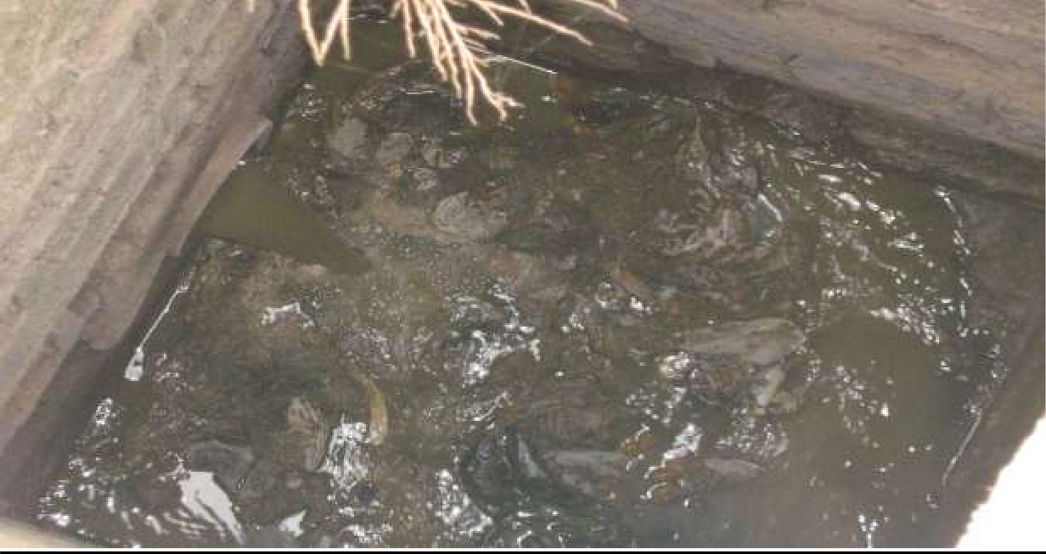

## Plate 3: Inlet Chamber of the wastewater Treatment Plant at University of Ibadan

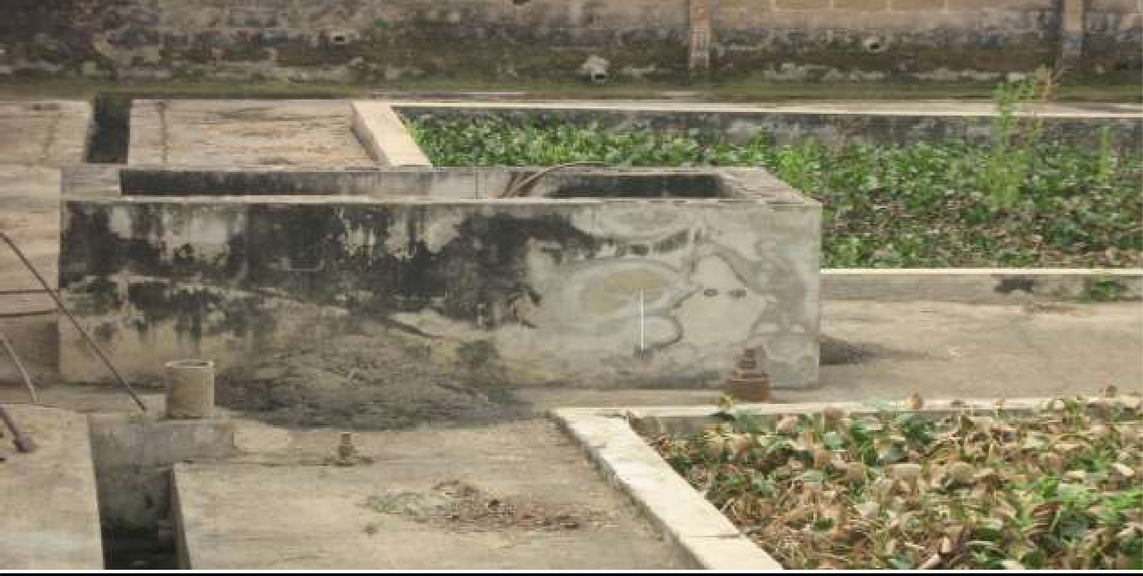

**Plate 4: Side View of Distribution Chamber at the wastewater Treatment Plant at University of Ibadan**

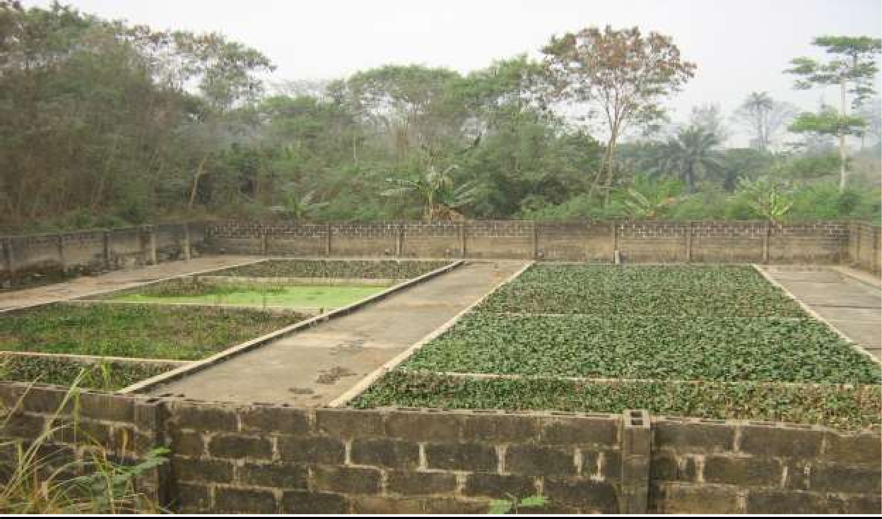

## Plate 5: Frontal View of the wastewater Treatment Plant at University of Ibadan

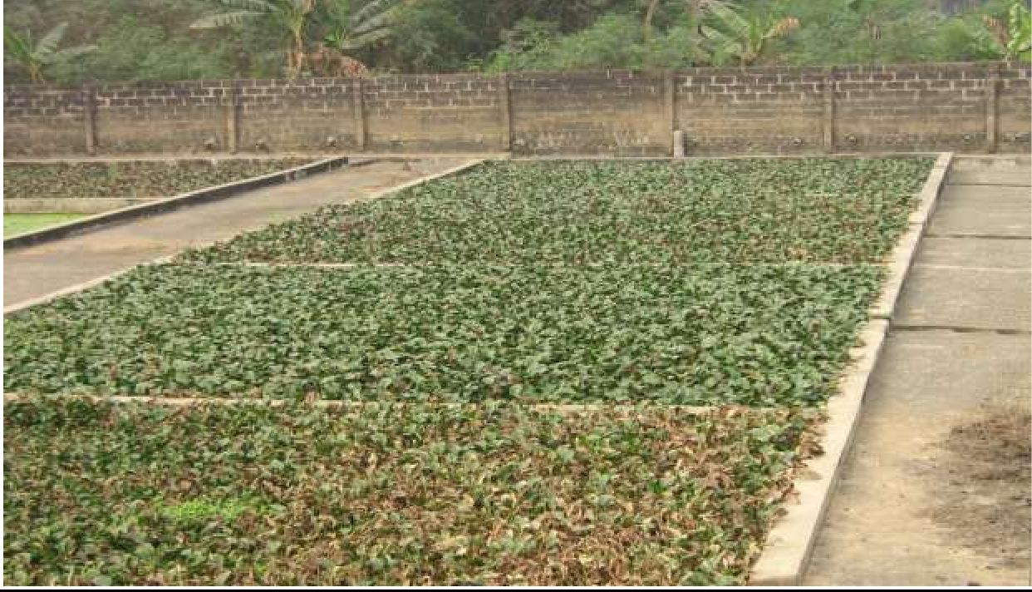

**Plate 6: View of One Flow Line of the wastewater Treatment Plant at University of Ibadan**

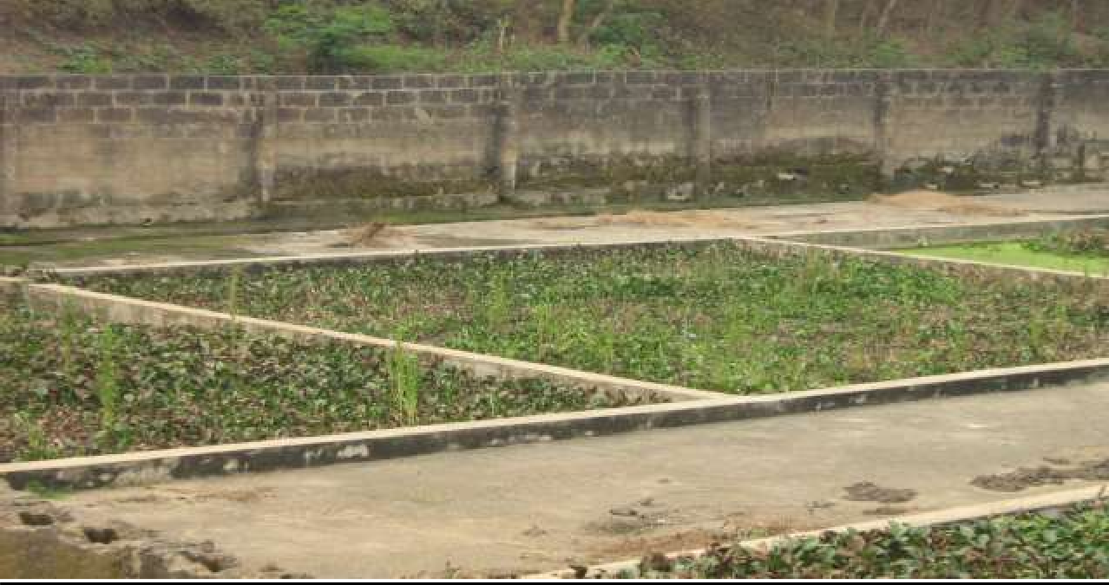

## Plate 7: Closer View of a Chamber in the Sewage Works at University of Ibadan

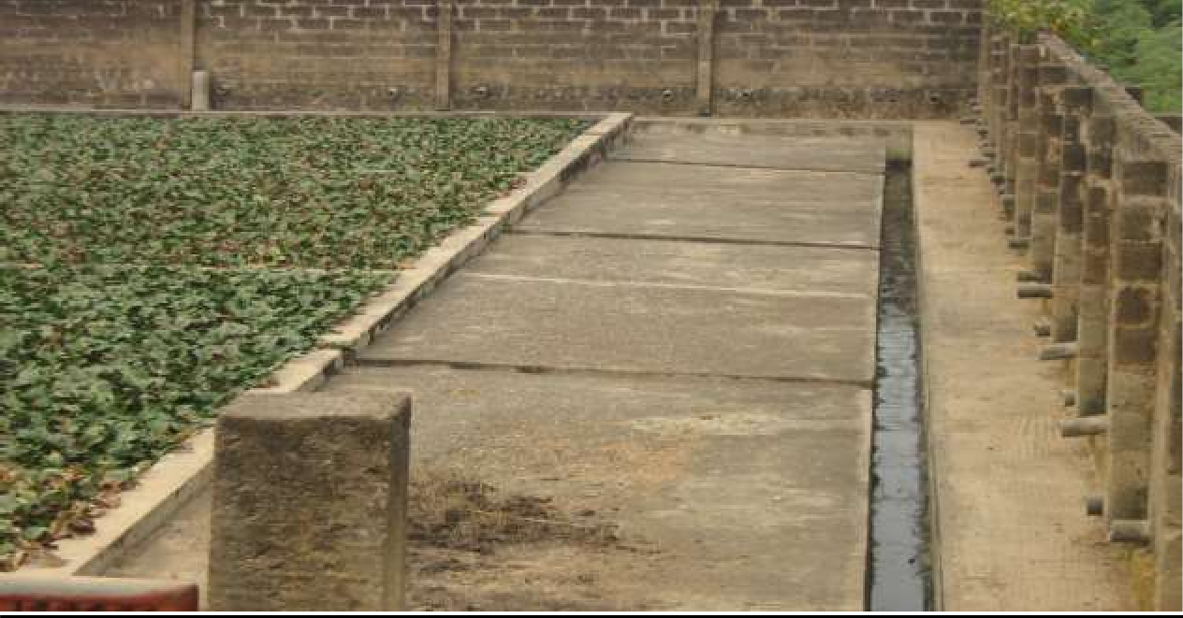

**Plate 8: The Drainage System to Avoid Over Flow at the Sewage Treatment Work at University of Ibadan**

## Factors influencing Land Treatment of Sewage

The land treatment depends on climate, the type of soil, the type of crops to be grown, the groundwater table and the proper management of the land.

* + - * + Climate: The solar radiation, temperature, rainfall, wind and humidity will govern the requirement of sewage for irrigation. These factors influence the evapo-transpiration of water.
        + Types of soils: The type of soil, particularly the texture, structure and depth will influence the requirement of water.
        + Type of Crops: The water requirements of crops vary with the duration of growth and also with the stage of growth.

## Problems Associated with Land Treatment of Sewage

While it is economical to use sewage for irrigation purposes, it poses several problems to the people handling it. These are sewage sickness of soil, health of farm workers, and quality deterioration of sewage grown crops, ground water pollution and odour problems around.

## Sewage Sickness of Soil

Environmental sustainability depends largely on a sustainable soil ecosystem. When soil is polluted, the physiochemical properties are affected which may decrease its productive potentials (Nwaogu et al, 2012).

Continuous application of sewage on soil leads to destruction of soil porosity and leads to complete loss of crops. It was observed that the fine colloidal particles present in sewage chokes the soil pores and affects the root aeration. On such soil, not even weeds can grow (Pillai, 1955).

## Health of Farm Workers:

Workers on the sewage farm are prone to infections through direct contact with sewage or with sewage irrigated soils. The status of health of sewage farm worker reported from developed countries and from developing countries has been varying. A survey conducted in India in five sewage farms indicated that the percentages of anemia, gastrointestinal diseases, respiratory disease and skin diseases were significantly higher among sewage farm worker as compared to the control group (Central Public Health Engineering Research Institute, 1973).

## CHAPTER THREE

* 1. **METHODOLOGY**

## Study Area

Abuja, the study area was created as the New Federal Capital Territory of Nigeria in 1976 after a committee on the location of the Federal Capital of Nigeria carried out an extensive examination of the dual government role of Lagos, its suitability as a National Capital and the possibility of an alternative New Capital City elsewhere in the country accessible to all and spacious. The option of a new Capital City centrally located was considered and the site selected was an 8000 Km2 area known as Abuja centrally located within Nigeria and easily accessible by all the states of the Federation. Since Abuja was not an existing city, development started immediately after its status was clearly defined by the 1976 FCT Federal Government Decree.

The master plan for Abuja, the [Federal Capital Territory](http://en.wikipedia.org/wiki/Federal_Capital_Territory_%28Nigeria%29) (FCT) was then developed to define the general structure and major design elements of the city that are visible in the city's current form. Most of the needed infrastructure including buildings, roads, water; and sewage system has progressed considerably to facilitate the actual movement of the Capital from the densely populated city of Lagos to the New Federal Capital – Abuja. In view of the delay in the completion of the main sewage treatment plant and sewer network for the city; coupled with the fact that several important projects such as houses and public buildings of importance have been completed, simple sewage treatment schemes in the form of Aerators were designed and constructed in designated and isolated areas to enable the usage of these completed facilities. Some of these facilities included the Army Barracks, Staff Quarters, Federal Secretariat, and Legislative Quarters in Gudu etc. Thus, there are thirteen wastewater treatment aerators all around the city handling wastewater generated from between 3000 to 10,000 inhabitants of FCT.

In carrying out this research, an evaluation of the study area was conducted through the following approaches amongst others.

* + 1. Carrying out a study review of the Abuja master plan with particular reference to the wastewater management schemes. This study was subsequently followed by site visits to identify what has been done in terms of practical construction or provision of sewer lines, manholes, treatment plants and other sewerage infrastructure.
    2. In order to obtain additional information, oral interviews were conducted amongst personnel currently charged with the responsibility of providing and managing the sewerage infrastructure as well as other stakeholders.
    3. Data were also collected at the six sewage treatment plants both at their influent and effluents to determine the qualities of influent sewage and the discharge to the environement from the sewage treatment plants. The collected sample data were analysed using standard analytical and statistical methods as described in standard methods (APHA, 1976). The results were subsequently reviewed and compared with acceptable international and World Health Organization (WHO) standards to check level of acceptance of effluent to the environment.

## 3.1.1 Collection of Samples within the Project Area

Materials used during samples collection at the various project sites include the following: Masking tape (label), Funnel, Sampling bottles, pH meter, Flow rate meter, CO 150 conductivity meter, Ice pack, Ice bag (box), Water sampler, Safety clones, Nose mask, laboratory coat, Safety boot, etc. The wastewater samples were collected using sterilized sampling bottles, well capped and packed into ice-bag (box). This helped to acclimatized the samples condition for

onward transport to the laboratory for testing. Brown glass bottles were filled to the brim so that air is not trapped.

Wastewater samples were collected from various sewage treatment plants/aerators in the project area for a period of six months on weekly basis spanning from October 2007 to March 2008 to give a good representation of generated wastewater during sampling periods and also during the raining and dry seasons. The characteristics of the wastewater were evaluated at influent and at effluent points to ascertain the level of treatment achieved by the various wastewater treatment plants. Plate 9 to Plate 20 in Appendix I are photographs captured during site visit and collection of wastewater sample at Gudu project site and at the laboratory in Abuja where the analysis of were conducted.

## Laboratory Analysis of Collected Wastewater Samples

Samples volume of 2Litres was collected from the different sewage treatment plant locations within the city. These wastewater samples were analyzed at the Abuja Environmental Protection Board laboratory for several constituents using the analytical method. The different wastewater constituents and methods of analysis used are detailed below:

## pH

The lovi bond checkit has the ability to test for pH ranging from 3.0-12.0 using pH universal tablets. This method was used to test the samples collected at points. Samples were collected in 250ml sampling bottles and tested for their pH immediately. The samples in the bottles were packed in a plastic cooler containing ice park to maintain the temperature of same before analysis in the laboratory.

The checkit has compartment which were rinsed with the water sample, then refilled to the 10ml mark. A pH universal tablet was added to the sample in the compartment, crushed with

a clean stirring rod and replaced by a stopper held firmly in place and repeatedly inverted several times until the tablet was fully dissolved. The colour produced in the sample was compared against the checkit standard colour using daylight and selection of the nearest colour match was read which equal the pH value. The same procedure was adopted for all the collected samples.

## Temperature, Conductivity, Salinity and Total Dissolved Solids (TDS)

Hach CO150 conductivity meter by HACH Industrial Partners is a potable analytical meter used for the measurement of the above parameters namely temperature, conductivity, salinity, total dissolved solids. It consists of a probe which has the ability to measure these parameters and also temperature. The meter consist of a mode button at which toggling from one parameter to another are made when the meter is put on reading being observed through the movement of the cursor on the liquid crystal display (LCD) unit. End point reading of each parameter was obtained by a ready sign indicator. Probe was rinsed with diluted water and meter put to rest, same procedure was adopted for all the samples.

## Iron

The HI 3834 Iron test kit (colorimetric method) has the capability to test for iron at the range 0 - 5mg/L Iron, the equipments used are:

* + - * HI 3834 – 0 reagents
      * colour comparator tube
      * Plastic vessel (20mL)

The cap from the plastic vessel is removed and the plastic vessel rinsed with water sample, then filled to the 10mL mark. One packet of the reagent HI3834-0 was added to the sample and capped and mixed until solids dissolves. Cap was then removed and solutions transferred into

the colour comparator cube and allowed to settle for four minutes, colour match from the solution with the comparator standard was read in mg/L of Iron.

## Nitrate

The HI 3874 Nitrate test kit (colorimetric method) has a test range for nitrate from 0- 50mg/L NO3 – N.

* + - * HI 3874 – 0 reagent
      * A colour comparator
      * A glass cuvet with cap

One packet of the reagent HI 3874 – 0 was added to 10mL of sample initially introduced into a glass curvet, capped and shaken vigorously for exactly 1 minute. The mixture was then allowed to stand for four minutes to allow full development of colour in the sample. The cap of the curvet was removed and the comparator tube filled with 5ml of the treated sample the colour match between the sample and comparator was read and result obtained as Mg/L eiirtin– Nitrogen. To convert the reading to mg/l of Nitrate (NO3) value obtained was multiplied by a factor of 4.43.

## Total Hardness

Water hardness is caused by the presence of calcium and magnesium salts. High level of hardness prevents the formation of lather with soap and can cause scaling in water system, particularly boilers and steam generating plants. The hardness test provides a simple method of checking water hardness from a range 0-500mg/L CaCO3:

Calcium and magnesium ions are completed by reaction with EDTA. Excess calcium and magnesium ion react with specific indicators to produce a distinctive amount of EDTA with Erichrome black as indicator. The test carried out involved addition of tablets one at a time to a

sample of water until the colour changed from the plum red to blue. The result was calculated from the number of tablet used in relation to the volume of water sample taken. i.e. 50ml.

* One – Hardness tablet was added to sample of water (50mﺎ) shaken until the tablet dissolved.
* More tablets were added one at a time until the colour of the solution change from plum red to blue.
* Noting the number of tablets the calculation below is used to compute result (No. of tablets x 40) – 20.

= mg/L CaCO3 (Hardness).

## Phosphate

Using vanadomolybdate tablets, phosphate was measured at the range 0-26.5mg/L, the use of colour comparator checkit was employed. The stopper of the comparator kit was removed, compartment rinsed with water sample and then filled to the 10ml mark. One vanadomolybdate tablet was added, crushed with clean stirring rod and capped, held firmly in position and repeatedly inverted several times until the tablet is fully dissolved and allowed to settle for 10 minutes. After this, a final shake was made to the sample and colour produced was compared with that of the test kit standard. Readings were rendered in mg/L of phosphate, same procedure was repeated for all samples

## Aluminium

The lovi-bond test kit was used to determine the concentrate of aluminum in the sample collected. It has the capacity to sample the aluminum at the range of 0-0.5mg/L.The test was carried out using 10mL sample filled into the compartment having a standard colour match. One aluminum tablet was added to one of compartment crushed with a clean stirring rod and mixed to dissolve. A second aluminum tablet was also added to the same compartment crushed with the

stirring rod and capped and compartment inverted several times until both tablets were fully dissolved, preparation was allowed to stand for 10min.

After this period, colour produced was compared against the standard using daylight selecting the nearest colour match; the Lg/L of aluminum was read. The same procedure was repeated for all samples.

## Sulphate

This is a method for sulphates test. The sulphates Turbidity tablet is a name given to the tablet which makes turbid the sample. The whole process gave a description of how the sample becomes turbid when the tablet is added to the sample. Note that this is not a turbidity test.

The sulphate check (Turbidity method) provides a simple method of checking sulphate level in water at the range of 0-400mg/L of SO42-

Sulphate test kit:

1. Sulphate tablets
2. One double tube assembly
3. one 5mL syringe

* The double tube assembly was separated and the round outer tube filled to the top with water sample. One sulphate (turbidity) tablet was added and capped and shaken to mix. A cloudy solution indicated the present of sulphate.
* The graduated inner tube was inserted into the round tube and we ensured that cap was in position in the round tube.
* Viewing from above, the inner tube was moved up and down until the black spot was just no longer visible. Then read the graduation mark on the inner tube with the top of the solution in the tube immediately. The value obtained (read) was multiplied by 2, this gave the level (concentration) of sulphate as mg/L of SO4.

## Chlorine

The Lovi-bond checkit has the ability to test for free combine and total chorine using DPD no. 1 and DPD no. 3 tablets.

* 10mL of sample was introduced into the test kit compartment and one tablet of DPD was placed and crushed with a clean stirring rod with the stopper in place, the kit was inverted several times until the tablet was fully dissolved.
* The colour produced was compared with the kits standard color using daylight. The nearest colour match was read of the free chlorine. To measure the total and combined chlorine, the stopper was removed and one DPD 3 tablet was added to the same compartment as to that DPD 1, crushed and stirred until the tablet was fully dissolved. Allowed to stand for 2 minutes, the colour was then compared in the same way as for free chlorine. The nearest colour was selected which indicated the total chlorine. The difference between the free chlorine level and the total chlorine level equals the combined chlorine concentration in the samples.

## Chloride

The HI 3815 chloride test kit is a mercuric nitration method and can give a test range from 0-1000mg/L of chloride. It is a set of kit containing

* + - * Diphenylcarbozone indicator
      * A dropper
      * Nitric acid solution
      * Mercuric Nitrate solution
      * Calibrated vessel
      * Calibrated syringe with tip.

The cap of the vessel was removed and the vessel rinsed with sample to be analyzed filled to the 5mL mark and capped. Two (2) drops of the indicator was added to the sample and the vessel was swirled in a tight circle. The solution then became reddish – violet. The addition of nitric acid solution dropwise made the solution turn yellow. The titration syringe was used to dispense titration solution drop wise. After each drop, careful observation was made to observe the colour formation from yellow to violet. The milliliters of the titration solution dispensed from the syringe were read and value multiplied by 1000 to obtain mg/L of chloride.

## Biochemical Oxygen Demand (BOD5)

Definite precautions were observed in collection of samples to ensure that the samples were good representation of the flow under examination.

Equipment used – Aluminum dipper, glass stopper bottle, pipettes: 0.1ml, 1ml, 5ml, 250ml graduated cylinder 500ml, Erlenmeyer flask, burette stands and clamp dropping bottle, Analytical Balance, 20oC water bath (incubator)

Reagent: (a) Conc. H2 SO4

1. 450g MnSO4
2. Alkaline iodide azide 500g NaOH 135NaI, 1g NaN3 in 1.00mﺎ of alkaline iodide solution
3. N/40 Na2 S2 O3 (one volume to 300 volumes in distilled water.
4. 5g starch (indicator) (5%)
5. 0.25g FeCl3 6H2O
6. 27.5g CaCl2

(h) 22.5g MgSO4. 7H20

1. (8.5g KH2PO4, 21.75g K2Hp O4, 33.4g Na2HPO4. 7H2O and 1.7g NH4CL in about 500mL DH2O and dilute to 1L) = Ammonia phosphate buffer pH = 7.2
2. N/40 sodium sulfite (1.575g in 1000ml) distilled water was prepared daily before use.

Procedure:-

## Aerate about nineteen litre of distilled water

* 1. Add 18.9mL of ferric chloride solution 18.9mL calcium chloride solution 18.9mL magnesium sulfate solution

18.9mL ammonium phosphate solution was used to dilute water sample and mix.

* 1. Siphon the dilution water into 300ml glass stopper bottle until the bottle is about one half full.
  2. To the half – full bottle add with a pipette the desired quantity of sample possible quantities
     + settled sewage = 2-3%
     + Physically treated sample = 3-7%
     + Raw sewage = 1-2%
     + Biologically treated H20 = 5-30%
     + River water = 25 – 100%
  3. The bottle was filled to the neck with dilution water and stopper so that no air bubbles are entrained (preparation should be in duplicate)
  4. Each preparation in a 20oC was placed in an incubator (water bath) and allowed to stay for 5 days and the one prepared used to determine the initial dissolved oxygen of the sample.
  5. After 5 days, determination of dissolved oxygen was carried out (Ademoroti, 1996).

Calculation: DO1 – DO5

% dilution Where: DO1 = initial dissolved oxygen

DO5 = final dissolved oxygen

% dilution = Ratio of sample to dilution H2O

Result = The BOD5 at 20oC equals the volumes of thiosulphate used for the titration for the initial and final dissolved oxygen as calculated in the formulae.

## Chemical Oxygen Demand (COD)

Samples were collected in glass bottles and tested for COD without delay. Samples were heated for 2hrs to boiling point of water in a water bath; this is for oxidation of samples with chromic and strong sulfuric acid. The digestion was done with the help of potassium permanganate. After digestion the remaining unreduced KMnO4 is titrated with sodium thiosulfate to determine the amount of KMnO4 consumed and the oxidised organic matter calculated in terms of oxygen equivalent.

1. Apparatus:-

250mL conical flask COD water bath pipettes,

Foil paper, magnetic stirrer Stand and clamp

Burette, measuring cylinder,

1. Reagents:-
2. Procedure:-

0.1N KMnO4

4.0N H2SO4

10% KI

0.1N Na2S2O3

1% starch solution

Using 250mL measuring cylinder, 50mL of sample was measured into the conical flask, heated on water bath to boiling points; 5mL of KMnO4 was added to the sample. After the heating preparations were cooled to about 40 – 450C, 5mL KI and 10mL 4H2SO4 were added respectively. Na2S2O3 was used as the titrant and starch solution as an indicator during titration. During titration, the solution became pale-yellow, 1mL of the indicator was added as titration

continued until the blue color disappeared (Note that end point of titration is a colorless solution). Blank sample was also run using distilled water.

COD mgO2/L = (a - b) x N x 8 x 1000 ML sample

Where

a = ML Na2S2O3 used for blank b = ML Na2S2O3 used for sample

N= Normality of the Na2S203 used for titration.

## Bacteriological Analysis

13g of dehydrated ingredient of lactose broth was added to distilled water, mixed thoroughly in a 500mL conical flask; 10mL of the mixture was dispensed into vial tubes containing durham tubes in an inverted position. The preparations were sterilized using an autoclave at 121oC for 15minutes and after the sterilization; the preparations in the autoclave were brought out and allowed to cool to about 45oC.

Samples were inoculated into the sterilized medium at the dilutions of 10mL, 1mL, and 0.1mL for each samples preparation respectively. Each of the samples was further subdivided into 15 sterilized medium: 10mL into 5set of tubes, 1mL into 5set of tubes and 0.1mL into 5set of tubes.

After the inoculations, the tubes with their content were all inverted so that the durham tubes in them were filled with the mixture with air trapped in them. Preparations were incubated in the incubator for 24hours. This process is to determine lactose fermenting organisms which with the combine positive (bubble firmed) reaction gives the Most Probable Number of bacterial in each sample.

All these procedures were carried out using aseptic techniques and conducive atmospheric conditions with material:-

Fermentation tubes, Durham vials, Autoclave, incubator, pipettes, (10mL, 1mL, 0.1mL) conical flask, Hot oven, pipette bulb, lamina flow (Hood), sterilized Petri dishes, inoculating loop, burner, thermometers.

## Media Preparation

Dehydrated ingredient of eosin methylane blue, brilliant green agar and deoxychlolate citrate agar were weighed, dissolved in distilled water as described by Titan Biotec Limited (manufacturer): 9.25g, 13g, and 11.375, respectively in 250mL distilled water in a conical flask. For EMB and BGA, these media were corked with cotton wool and then with foil paper and then autoclaved at 121oC for 15min. DCA on the other hand was heated on a bunsen burner and then brought to boiling for the ingredient to be perfectly dissolved and to be sterilized. All media was brought to a temperature of about 400C-450C after sterilization/heating and then poured into sterilized Petri dishes (15-20mL) into each plate and allowed to stand for some times (seconds) for it to solidify then ready for sample to be inoculated i.e. (culturing).

## Vale-port (Flow rate meter)

The vale port “Bray stoke” current flow-meter is an instrument being designed to withstand long period of operation under water. It is also designed to accurately measure water velocity in open channels with flows varying from 0.03 m/s to 10m/s. The flow meter is available with both wading and suspension setting to allow the equipment to be employed in a wide variety of application.

The basic principle of the meter is to open and close a read switch by rotating magnets around it to open and close a circuit producing a pulse. The pulse count is displayed on one of

the liquid crystal display (LCD) in the control circuit. A bias magnet fitted into the meter hub produce a strong magnetic field and allows only one pulse per impeller revolution. The only moving part of the meter is the neutrally buoyant impellers which house the magnet.

The meter was used in a wading mode principle as the water level permits the operator to make measurements of velocity at the required intervals and depths. The centimeter marking on the wading rods permits the meter to be accurately positioned at the required height in the water column and also to establish total depth to enable profile depths to be calculated. The meter was run at a fixed average display at a time 20 second running period after which values in m/s were recorded.

## Statistical Analysis of Data

Having carried out laboratory tests on the collected wastewater samples, the obtained data were analyzed statistically using One-Way ANOVA (Post Hoc Test, LSD or Duncan), for comparison of means, Descriptive Analysis, and Multivariate Regression Analysis.

These statistical analysis were carried out using the following software: Microsoft-Excel, SPSS Statistic 17.0 and STATA 8.

## One-Way ANOVA (Post Hoc Test, LSD or Duncan)

A One-Way Analysis of Variance is a way to test the equality of two or more means at one time by using variances.

## Assumptions:

* The populations from which the samples were obtained are normally or approximately normally distributed.
* The samples are independent
* The variances of the populations are equal

## Hypothesis 1:

H0 (null hypothesis): all population means are equal

H1 (alternative hypothesis): at least one of the mean is different

**Between Group Variations:** the variation due to the interaction between the samples is denoted Sum of Squares (SS (B)) for sum of squares between groups. The variance due to the interaction between the samples is denoted MS (B) for Mean Square Between groups.

**Within Group Variations:** the variation due to differences within the individual samples denoted Sum of Squares (SS (W)) for sum of squares within groups. Each sample is considered independently, no interaction between samples involved. The variance due to the difference within individual samples is denoted MS (W) for Mean Square Within groups.

**Decision Rule:** If the between variance is smaller than the within variance, then the means are really close to each other and therefore, accept the claim that they are all equal. Furthermore, the decision will be to reject the null hypothesis if the test statistic from the table is greater than the F critical value.

## Multivariate Regression Analysis

**Modeling of Effluent Temperature and Sample BOD and Total Nitrogen**

In order to obtain the correlation coefficient between effluent temperature and sample BOD and total nitrogen (Nitrate and Ammonia), five major constituents of the wastewater sample were correlated.

The five major constituents are: 1- Temperature

1. Nitrate
2. BOD5 at 20oC
3. COD
4. Microbial Content (MPN)

## Hypothesis 2:

H0: βi = 0 (The coefficient is not significant) H1: βi ≠ 0 (The coefficient is significant) **Decision Rule**

Reject H0 (null-hypothesis) if **P-value** ≤ α (level of significance = 0.05

## Appraisal of Abuja Waste Water Management System

The wastewater management system for Abuja was appraised and categorized into generation, collection and treatment approaches for easy evaluation and identification of where improvements can be recommended. These different categories are discussed and analyzed in this section.

## Wastewater Generation System

The Federal Capital Territory, Abuja is basically an administrative centre for Nigeria. Hence, the major sources of wastewater are domestic sources from households and public buildings. However, additional wastewater is generated from hospitals, and some factories located within the industrial layout. It is important to note that wastewater generated from factories, hospitals are expected to be pre-treated at the sources of generation before discharge to public sewers to reduce the load on public sewage treatment plants. The provided sewage treatment plants are thus expected to handle liquid waste of domestic origin.

Analysis of the sources of wastewater generation today in Abuja shows that significant quantity of up to 90% is domestic wastewater. The industrial layout is yet to be developed and as such has insignificant contribution to the generated wastewater within Abuja.

## Wastewater Collection System

The wastewater collection system in Abuja is through the centralized system were wastewater is collected from households into district sewers. These district sewers discharge the wastewater into trunk interceptor sewer lines that finally transfer the wastewater to the treatment plants.

Analysis of the wastewater collection system in Abuja shows that not all the districts have the interceptor sewer lines to convey the wastewater to a treatment plant. Most of the districts in phase II of the FCC do not have the interceptor sewer lines, thus their sewage is either conveyed to a nearby cesspool or in some cases, and residents illegally construct septic tanks which are not in the master plan. In some other cases, sewer lines are constructed to a sewage aerator that is designated to handle the sewage generated from that area. Examples of such arrangement are the Army barracks, Legislative quarters etc.

In the satellite towns and area councils, there are no sewer lines or treatment plants to handle generated sewage. The wastewater is collected into septic tanks and cesspools only even though the master plan provided for central sewage system for the entire Federal Capital Territory.

## Treatment Plant

The sewage treatment systems currently used in the handling of generated waste water in FCT is the Activated Sludge System and its various modifications into sewage aerator, and extended aeration system. These treatment plants are mainly designed for temporary purposes

apart from the main Wupa Basin sewage treatment plant that has all the components including sludge handling facilities.

The evaluation carried out revealed that only some parts of the Federal Capital City (FCC) and some areas and the barracks have the central sewage network with its associated treatment facility. Most areas with high population are not covered by the sewage treatment facilities. Most other areas are forced to construct septic tanks and soak away pits which are obsolete and not acceptable for a modern city like Abuja.

## CHAPTER FOUR

* 1. **RESULTS AND DISCUSSIONS**

## Composition of Wastewater in Abuja

The quality of generated wastewater in Abuja was evaluated by carrying out laboratory analysis of samples at influent and effluent points of six sewage treatment plants in the city. The results of these analyses vary depending on the period of the year. It was observed that during the raining season, there are lots of infiltrations of rainwater into the sewer lines from joints and sometimes through manholes that are not high enough from the ground levels. Such developments increase the quantity of sand and other particulate objects in the treatment plants. Even though, significant quantities of suspended particles are eliminated at the treatment plant screens, fine particles such as sand still find their way into the treatment plant aeration basins. This development significantly affects the biodegradation process in the Aeration basin when the plants are functional.

The average characteristics of wastewater generated in six existing Wastewater Treatment Plants in Abuja was evaluated. Based on the laboratory analysis, the results obtained are shown in the Tables 4.1 to 4.12.

The average results of the analysis was collated and analyzed for each month. It was generally observed that the results are generally not okay in comparison with acceptable international and World Health Organization (WHO) standards. The outcome of this analysis could be attributed basically to the lack of proper functioning of the treatment plants as a result of faults in the electromechanical components of most of the plants.

## Results of Laboratory Analysis Conducted on Samples Collected at Different Locations of the Sewage Treatment Plants in FCT

**Key Description of the Units of Parameters**

MPN(Per 100mL) Most Probable No of Bacteria A= Influent

B= Effluent

mg/L Milligramme per litre

% Percentage

g Gram

o Degree

µS/cm Micro-siemen

Sp Specie

rps Revolution per second

77

|  |  |  |  |  |  |  |  |  |  |  |  |  |  |  |  |  |  |
| --- | --- | --- | --- | --- | --- | --- | --- | --- | --- | --- | --- | --- | --- | --- | --- | --- | --- |
|  |  |  |  |  |  |  |  |  |  |  |  |  |  |  |  |  |  |
|  |  |  |  |  |  |  |  |  |  |  |  |  |  |  |  |  |  |
|  | Table 4.1 : Physiochemical and Microbial Component of Wastewater from Niger Barrack Sewage Aerator (STP), Abuja | | | | | | | | | | | | | | |  |  |
|  |  |  |
|  |  |  |  |  |  |  |  |  |  |  |  |  |  |  |  |  |  |
|  |  | **PARAMAETER** | **OCT** | | **NOV** | | **DEC** | | **JAN** | | **FEB** | |  | **EQUIPMENT** | **METHOD OF** |  |  |
|  |  |  | **A\*** | **B+** | **A\*** | **B+** | **A\*** | **B+** | **A\*** | **B+** | **A\*** | **B+** | **STDª** | **MODEL** | **ANALYSIS** |  |  |
|  | 1 | pH | 7.83 | 7.80 | 5.68 | 5.70 | 6.85 | 6.49 | 7.24 | 7.26 | 6.5 | 6.4 | 6-9 | LOVIBOND TEST KIT | COLORITY |  |  |
|  | 2 | Temperature (oC) | 18.5 | 19 | 19.2 | 19.4 | 20.8 | 20.6 | 22 | 22.1 | 20.0 | 20.2 | 40 | CO150 (HACH)CONDUCTIVITY METER |  |  |  |
|  | 3 | Salinity (%) | 0.2 | 0.2 | 0.8 | 0.6 | 0.2 | 0.2 | 0.2 | 0.2 | 0.2 | 0.2 | 0.2 | " |  |  |  |
|  | 4 | Dissolve oxygen (mg/L) | 3.7 | 3.1 | 0.4 | 0.3 | 0.8 | 0.6 | 2.8 | 2.61 | 0.4 | 0.4 | 4 |  |  |  |  |
|  | 5 | Conductivity fus | 860 | 771 | 1544 | 469 | 333 | 323 | 123 | 121 | 120 | 117 | 50-125 | CO150 (HACH)CONDUCTIVITY METER |  |  |  |
|  | 6 | Total dissolve solid (mg/L | 762 | 754 | 752 | 223.3 | 158 | 153 | 602 | 600 | 501 | 452 | 2000 | " |  |  |  |
|  | 7 | Flow Rate (R/sec) m/s | 0.39 | 0.35 | 1.40 | 1.36 | 1.36 | 1.35 | 1.33 | 1.29 | 1.14 | 0.76 |  | 0012B CURRENT FLOW METER |  |  |  |
|  | 8 | Hardness (mg/L) | 175 | 125 | 1.2 | 100 | 60 | 60 | 80 | 80 | 60 | 60 | 200 | LOVIBOND TEST KIT | COLORITY |  |  |
|  | 9 | Nitrate (mg/L) | 9.8 | 9.8 | 10 | 8 | 0.5 | 0.45 | 2.1 | 2 | 5 | 8 | 20 | LOVIBOND TEST KIT | COLORITY |  |  |
|  | 10 | Iron (mg/L) | 1 | 1 | 0.5 | 0.38 | 0.5 | 0.5 | 4 | 3.81 | 0.5 | 0.5 | 20 | " | " |  |  |
|  | 11 | Chloride (mg/L) | 211 | 197 | 280 | 100 | 100 | 50 | 220 | 212 | 30 | 41 | 600 | " | " |  |  |
|  | 12 | Suphate (mg/L) | 240 | 150 | 180 | 110 | 160 | 80 | 278 | 274 | 200 | 200 | 500 | " | " |  |  |
|  | 13 | Aluminium (mg/L) | 0.1 | 0.1 | 0 | 0 | 0.1 | 0.1 | 0 | 0 | 0 | 0 | - | " | " |  |  |
|  | 14 | Hydrogen peroxide (mg/L) | 0 | 0 | 0 | 0 | 0 | 0 | 0 | 0 | 0 | 0 | - | " | " |  |  |
|  | 15 | Total Chlorine (mg/L) | 0.46 | 0.44 | 2 | 0.8 | 0.20 | 0.20 | 0.5 | 0.5 | 0.56 | 0.52 | - | " | " |  |  |
|  | 16 | Free Chlorine (mg/L) | 0 | 0 | 0 | 0 | 0.09 | 0.09 | 0.1 | 0.1 | 0 | 0 | 1.0 | " | " |  |  |
|  | 17 | Combine chlorine (mg/L) | 0.46 | 0.44 | 2 | 0.8 | 0.11 | 0.11 | 0.4 | 0.4 | 0.56 | 0.52 | - | " |  |  |  |
|  | 18 | BOD (mg/L) | 68 | 60 | 272 | 26.1 | 95 | 83 | 38 | 44 | 58 | 56 | 30 | Iodometric method of Azide modification |  |  |  |
|  | 19 | COD (mg/L) | 187 | 171 | 204 | 195 | 180 | 179 | 203 | 205 | 199 | 192 | 80 | OPEN REFLUX METHOD |  |  |  |
|  | 20 | Fiterable solid (g) |  |  |  |  | 0.08 | 0.01 |  |  |  |  | - |  |  |  |  |
|  | 21 | Suspended solid (mg/L) |  |  |  |  | - | - |  |  |  |  | 30 |  |  |  |  |
|  | 22 | Total solid(g) |  |  |  |  | 0.2370 | 1.08 |  |  |  |  | - |  |  |  |  |
|  | 23 | Gramic Matter (g) |  |  |  |  | 0.08 | 0.01 |  |  |  |  | - |  |  |  |  |
|  | 24 | MPN/100Ml | 178 | 115 | 190 | 240 | 240 | 6x10 | 310 | 211 | 415 | 184 | 400mpN/n | FERMENTATION TUBE METHOD |  |  |  |
|  |  | A* Influent B+ Effluent STDª Acceptable Standard by Federal Ministry of Environment | | | | | | | |  |  |  |  |  |  |  |  |
|  |  |  |  |  |  |  |  |  |  |  |  |  |  |  |  |  |  |
|  |  |  |  |  |  |  |  |  |  |  |  |  |  |  |  |  |  |

78

|  |  |  |  |  |  |  |  |  |  |  |  |  |
| --- | --- | --- | --- | --- | --- | --- | --- | --- | --- | --- | --- | --- |
|  |  | | | | | | | | | | | |
|  | Table 4.2 : Flow rates for wastewater to Niger Barrack Sewage Aerator (STP), Abuja | | | | | |  |  |  |  |  |  |
|  |  |  | [Flow Rates X 10-3 m3/sec] | | |  |  |  |  |  |  |  |
|  |  |  |  |  |  |  |  |  |  |  |  |  |
|  | **TIME OF THE DAY** | **OCT** | **NOV** | | | **DEC** |  | **JAN** |  | **FEB** |  |  |
|  | **FOR SAMPLING** | **A\*** | **B+** | **A\*** | **B+** | **A\*** | **B+** | **A\*** | **B+** | **A\*** | **B+** |  |
|  |  |  |  |  |  |  |  |  |  |  |  |  |
|  | MORNING |  |  |  |  |  |  |  |  |  |  |  |
|  | 8.15am | 7.1 | 6.9 | 6.5 | 6.3 | 6.5 | 6.4 | 6.5 | 6.4 | 4.1 | 4 |  |
|  |  |  |  |  |  |  |  |  |  |  |  |  |
|  | AFTERNOON |  |  |  |  |  |  |  |  |  |  |  |
|  | 12.15pm | 6.3 | 6.2 | 6.1 | 6.3 | 5.5 | 5.4 | 5.3 | 5.2 | 5.9 | 1.4 |  |
|  |  |  |  |  |  |  |  |  |  |  |  |  |
|  | EVENING |  |  |  |  |  |  |  |  |  |  |  |
|  | 4.15pm | 6.8 | 6.6 | 6.3 | 6.8 | 6.3 | 6.3 | 6.1 | 5.8 | 5.4 | 5.4 |  |
|  |  |  |  |  |  |  |  |  |  |  |  |  |
|  | AVERAGE |  |  |  |  |  |  |  |  |  |  |  |
|  | FLOW RATE |  |  |  |  |  |  |  |  |  |  |  |
|  | PER DAY | 6.7 | 6.6 | 6.3 | 6.5 | 6.1 | 6 | 6 | 5.8 | 5.1 | 3.6 |  |
|  |  |  |  |  |  |  |  |  |  |  |  |  |
|  | A* Influent B+ Effluent |  |  |  |  |  |  |  |  |  |  |  |
|  |  |  |  |  |  |  |  |  |  |  |  |  |
|  |  |  |  |  |  |  |  |  |  |  |  |  |

79

|  |  |  |  |  |  |  |  |  |  |  |  |  |  |  |  |  |
| --- | --- | --- | --- | --- | --- | --- | --- | --- | --- | --- | --- | --- | --- | --- | --- | --- |
|  |  |  |  |  |  |  |  |  |  |  |  |  |  |  |  |  |
|  | Table 4.3 : Physiochemical and Microbial component of Wastewater from Mogadishu Sewage Aerator (STP), Abuja | | | | | | | | | | | | | | |  |
|  |  |
|  |  |  |  |  |  |  |  |  |  |  |  |  |  |  |  |  |
|  |  | **PARAMAETER** | **OCT** | | **NOV** | | **DEC** | | **JAN** | | **FEB** | |  | **EQUIPMENT** | **METHOD OF** |  |
|  |  |  | **A\*** | **B+** | **A\*** | **B+** | **A\*** | **B+** | **A\*** | **B+** | **A\*** | **B+** | **STDª** | **MODEL** | **ANALYSIS** |  |
|  | 1 | pH | 6.43 | 6.9 | 6.89 | 6.47 | 7.27 | 7.94 | 7.0 | 7.1 | 7.47 | 7.3 | 6-9 | LOVIBOND TEST KIT | COLORITY |  |
|  | 2 | Temperature (oC) | 34.2 | 34.4 | 26.3 | 26.3 | 28.6 | 27.9 | 28.8 | 28.7 | 27.2 | 27.3 | 40 | CO150 (HACH)CONDUCTIVITY METER |  |  |
|  | 3 | Salinity (%) | 0.2 | 0.2 | 0.2 | 0.2 | 0.2 | 0.2 | 0.2 | 0.2 | 0.2 | 0.2 | 0.2 | " |  |  |
|  | 4 | Dissolve oxygen (mg/L) | 2.49 | 3.2 | 2.8 | 2.5 | 0.7 | 0.5 | 0.1 | 0.12 | 5.01 | 5.05 | 4 |  |  |  |
|  | 5 | Conductivity fus | 902 | 811 | 860 | 851 | 469 | 609 | 286 | 291 | 453 | 321 | 50-125 | CO150 (HACH)CONDUCTIVITY METER |  |  |
|  | 6 | Total dissolve solid (mg/L | 850 | 654 | 300 | 285 | 1172 | 901 | 136 | 128 | 854 | 710 | 2000 | " |  |  |
|  | 7 | Flow Rate (R/sec) m/s | 1.79 | 1.67 | 1.64 | 1.60 | 1.89 | 1.76 | 1.36 | 0.58 | 0.54 | 0.52 |  | 0012B CURRENT FLOW METER |  |  |
|  | 8 | Hardness (mg/L) | 160 | 140 | 175 | 125 | 60 | 52 | 20 | 20 | 80 | 80 | 200 | LOVIBOND TEST KIT | COLORITY |  |
|  | 9 | Nitrate (mg/L) | 4.49 | 4.47 | 8.88 | 8.86 | 8.49 | 7.56 | 4.43 | 4.40 | 1.52 | 1.55 | 20 | LOVIBOND TEST KIT | COLORITY |  |
|  | 10 | Iron (mg/L) | 2.11 | 2.10 | 1 | 1 | 3.2 | 2.7 | 0.5 | 0.48 | 0.23 | 0.23 | 20 | " | " |  |
|  | 11 | Chloride (mg/L) | 221 | 210 | 50 | 47 | - | - | 101 | 100 | 101 | 112 | 600 | " | " |  |
|  | 12 | Phosphate (mg/L) | 1.88 | 1.82 | 4 | 3 | 10.2 | 10.0 | 3 | 3 | 2.76 | 0.08 | 5 | " | " |  |
|  | 13 | Suphate (mg/L) | 278 | 274 | 100 | 89 | 80 | 80 | 100 | 60 | 90.1 | 89.1 | 500 | " | " |  |
|  | 14 | Aluminium (mg/L) | 0.1 | 0.1 | 0 | 0 | 0 | 0 | 0.1 | 0.07 | 0 | 0 | - | " | " |  |
|  | 15 | Copper (mg/L) | 0.1 | 0.1 | 0.1 | 0.1 | 0.2 | 0.1 | 0.2 | 0.16 | 0.02 | 0.01 | <1 | " |  |  |
|  | 16 | Hydrogen peroxide (mg/L) | 0 | 0 | 0 | 0 | 0.0 | 0.0 | 0.1 | 0.0 | 0 | 0 | - | " | " |  |
|  | 17 | Total Chlorine (mg/L) | 1.5 | 1.8 | 1.5 | 0.9 | 0.80 | 0.60 | 0.79 | 0.40 | 0.5 | 1.2 | - | " | " |  |
|  | 18 | Free Chlorine (mg/L) | 1.5 | 1.8 | 0.05 | 0.04 | 0.08 | 0.06 | 0.07 | 0.07 | 0.1 | 0.1 | 1.0 | " | " |  |
|  | 19 | Combine chlorine (mg/L) | 0 | 0 | 1.45 | 0.86 | 0.72 | 0.54 | 0.72 | 0.67 | 0.4 | 1.1 | - | " |  |  |
|  | 20 | Amonia (mg/L) | - | - | - | - | - | - | 0.10 | 0.08 | - | - | - |  |  |  |
|  | 21 | BOD (mg/L) | 116 | 74 | 54 | 51 | 30 | 24 | 60 | 62 | 52 | 49 | 30 | Iodometric method of Azide modification |  |  |
|  | 22 | COD (mg/L) | 730 | 610 | 197 | 192 | 87 | 68 | 365 | 370 | 330 | 230 | 80 | OPEN REFLUX METHOD |  |  |
|  | 23 | Fiterable solid (mg/L) |  |  |  |  | 0.0810 | 0.08 |  |  |  |  | - |  |  |  |
|  | 24 | Suspended solid (mg/L) |  |  |  |  | - | - |  |  |  |  | 30 |  |  |  |
|  | 25 | Total solid(g) |  |  |  |  | 1.2530 | 0.99 |  |  |  |  | - |  |  |  |
|  | 26 | Gramic Matter (g) |  |  |  |  | 0.0790 | 0790 |  |  |  |  | - |  |  |  |
|  | 27 | Inorganic Matter (g) |  |  |  |  | 0.0020 | 0009 |  |  |  |  | - |  |  |  |
|  | 28 | MPN/100Ml | 12.11X1 | 1X10 | 240 | 210 | 1.6X10 | 1.6X10 | 1400 | 1240 | 40X10 | 11X10 | 400mpN/n | FERMENTATION TUBE METHOD |  |  |
|  |  | A* Influent B+ Effluent STDª Acceptable Standard by Federal Ministry of Environment | | | | | | | |  |  |  |  |  |  |  |
|  |  |  |  |  |  |  |  |  |  |  |  |  |  |  |  |  |
|  |  |  |  |  |  |  |  |  |  |  |  |  |  |  |  |  |

80

|  |  |  |  |  |  |  |  |  |  |  |  |  |
| --- | --- | --- | --- | --- | --- | --- | --- | --- | --- | --- | --- | --- |
|  |  | | | | | | | | | | |  |
|  | Table 4.4: Flow rates for Wastewater to Mogadishu Barrack Sewage Treatment Plant | | | | | |  |  |  |  |  |  |
|  | [Flow Rates X 10-3 | | | |  | | | | | | |  |
|  |  |  |  |  |  |  |  |  |  |  |  |  |
|  | **TIME OF THE DAY** | **OCT** | **NOV** | | | **DEC** |  | **JAN** |  | **FEB** |  |  |
|  | **FOR SAMPLING** | **A\*** | **B+** | **A\*** | **B+** | **A\*** | **B+** | **A\*** | **B+** | **A\*** | **B+** |  |
|  |  |  |  |  |  |  |  |  |  |  |  |  |
|  | MORNING |  |  |  |  |  |  |  |  |  |  |  |
|  | 8.15am | 9.9 | 9.5 | 8.7 | 8.1 | 9.5 | 8.6 | 9 | 3.5 | 3.2 | 3.2 |  |
|  |  |  |  |  |  |  |  |  |  |  |  |  |
|  | AFTERNOON |  |  |  |  |  |  |  |  |  |  |  |
|  | 12.15pm | 5.1 | 4.5 | 6.5 | 6.3 | 7.2 | 6.7 | 4.9 | 0.7 | 1.9 | 1.8 |  |
|  |  |  |  |  |  |  |  |  |  |  |  |  |
|  | EVENING |  |  |  |  |  |  |  |  |  |  |  |
|  | 4.15pm | 9.2 | 8.5 | 7 | 7.2 | 8.8 | 8.5 | 4.5 | 3.7 | 2.2 | 2.2 |  |
|  |  |  |  |  |  |  |  |  |  |  |  |  |
|  | AVERAGE |  |  |  |  |  |  |  |  |  |  |  |
|  | FLOW RATE |  |  |  |  |  |  |  |  |  |  |  |
|  | PER DAY | 8.1 | 7.5 | 7.4 | 7.2 | 8.5 | 7.9 | 6.1 | 2.6 | 2.4 | 2.4 |  |
|  |  |  |  |  |  |  |  |  |  |  |  |  |
|  | A* Influent B+ Effluent |  |  |  |  |  |  |  |  |  |  |  |
|  |  |  |  |  |  |  |  |  |  |  |  |  |
|  |  | | | | | | | | | | |  |

81

|  |  |  |  |  |  |  |  |  |  |  |  |  |  |  |  |  |
| --- | --- | --- | --- | --- | --- | --- | --- | --- | --- | --- | --- | --- | --- | --- | --- | --- |
|  |  |  |  |  |  |  |  |  |  |  |  |  |  |  |  |  |
|  |  | Table 4.5 : Physiochemical and Microbial component of Wastewater from Wuye Treatment Plant (STP), Abuja | | | | | | | | | | | |  |  |  |
|  |  |  |  |  |  |  |  |  |  |  |  |  |  |  |  |  |
|  |  |  |  |  |  |  |  |  |  |  |  |  |  |  |  |  |
|  |  | **PARAMAETER** | **OCT** | | **NOV** | | **DEC** | | **JAN** | | **FEB** | |  | **EQUIPMENT** | **METHOD OF** |  |
|  |  |  | **A\*** | **B+** | **A\*** | **B+** | **A\*** | **B+** | **A\*** | **B+** | **A\*** | **B+** | **STDª** | **MODEL** | **ANALYSIS** |  |
|  | 1 | pH | 7.5 | 7.2 | 6.66 | 5.67 | 5.97 | 5.97 | 7.0 | 7.2 | 7.1 | 7.9 | 6-9 | LOVIBOND TEST KIT | COLORITY |  |
|  | 2 | Temperature (oC) | 30.4 | 30.2 | 20.5 | 20.6 | 22.7 | 23.0 | 26.3 | 26.0 | 28.9 | 29 | 40 | CO150 (HACH)CONDUCTIVITY METER |  |  |
|  | 3 | Salinity (%) | 0.2 | 0.2 | 0.2 | 0.2 | 0.2 | 0.2 | 0.1 | 0.1 | 0.2 | 0.2 | 0.2 | " |  |  |
|  | 4 | Dissolve oxygen (mg/L) | 3.5 | 4.2 | 0.91 | 0.7 | 4 | 3 | 1.5 | 1.4 | 2.5 | 3.8 | 4 |  |  |  |
|  | 5 | Conductivity fus | 215 | 135 | 770 | 752 | 780 | 791 | 254 | 249 | 125 | 115 | 50-125 | CO150 (HACH)CONDUCTIVITY METER |  |  |
|  | 6 | Total dissolve solid (mg/L | 910 | 8'90 | 404 | 290 | 201 | 282 | 120 | 107 | 208 | 198 | 2000 | " |  |  |
|  | 7 | Flow Rate (R/sec) m/s | 1.05 | 1.56 | 1.26 | 1.20 | 0.79 | 1.57 | 1.48 | 1.45 | 1.40 | 1.26 |  | 0012B CURRENT FLOW METER |  |  |
|  | 8 | Hardness (mg/L) | 80 | 80 | 80 | 80 | 60 | 60 | 20 | 20 | 60 | 40 | 200 | LOVIBOND TEST KIT | COLORITY |  |
|  | 9 | Nitrate (mg/L) | 4.56 | 3.66 | 8.5 | 80 | 30 | 20 | 0 | 0.28 | 1.57 | 1.52 | 20 | LOVIBOND TEST KIT | COLORITY |  |
|  | 10 | Iron (mg/L) | 2.09 | 1.99 | 2 | 1 | 0.1 | 0.1 | 0.5 | 0.22 | 0.15 | 0.10 | 20 | " | " |  |
|  | 11 | Chloride (mg/L) | 350 | 201 | 120 | 50 | 40 | 40 | - | - | 102 | 98 | 600 | " | " |  |
|  | 12 | Phosphate (mg/L) | 12.2 | 10.9 | 13 | 10.3 | 18 | 16 | 20 | 20 | 17.6 | 18.8 | 5 | " | " |  |
|  | 13 | Suphate (mg/L) | 90.1 | 72.2 | 106 | 106 | 40 | 38 | 50 | 48 | 89.1 | 89.1 | 500 | " | " |  |
|  | 14 | Suphide (mg/L) | - | - | - | - | - | - | 26 | 24 | - | - | 0.2 |  |  |  |
|  | 15 | Aluminium (mg/L) | 0.1 | 0.1 | 0.94 | 0.82 | 0.07 | 0.05 | 0.09 | 0 | 0.12 | 0.08 | - | " | " |  |
|  | 16 | Copper (mg/L) | 0.4 | 0.42 | 0.89 | 0.80 | 0.96 | 0.96 | 0.99 | 0 | 1.0 | 0.91 | <1 | " |  |  |
|  | 17 | Hydrogen peroxide (mg/L) | 0 | 0 | 0 | 0 | 0 | 0 | 0 | 0 | 0 | 0 | - | " | " |  |
|  | 18 | Total Chlorine (mg/L) | 1.0 | 0.98 | 0.2 | 0.2 | 0.1 | 0.1 | 0.2 | 0.2 | 0.5 | 0.5 | - | " | " |  |
|  | 19 | Free Chlorine (mg/L) | 0.5 | 0.5 | 0.2 | 0.2 | 0.1 | 0.1 | 0.2 | 0.2 | 0 | 0 | 1.0 | " | " |  |
|  | 20 | Combine chlorine (mg/L) | 0.5 | 0.48 | 0 | 0 | 0 | 0 | 0 | 0 | 0.5 | 0.5 | - | " |  |  |
|  | 21 | Amonia (mg/L) | - | - | - | - | - | - | - | - | - | - | - |  |  |  |
|  | 22 | BOD (mg/L) | 61 | 70 | 159 | 65 | 181 | 152 | 152 | 78 | 59 | 60 | 30 | Iodometric method of Azide modification |  |  |
|  | 23 | COD (mg/L) | 320 | 246 | 672 | 752 | 736 | 651 | 424 | 197 | 128 | 118 | 80 | OPEN REFLUX METHOD |  |  |
|  | 24 | Suspended solid (mg/L) |  |  |  |  |  |  |  |  |  |  | 30 |  |  |  |
|  | 25 | MPN/100Ml | 1680 | 1600 | 840 | 800 | 1.6x10 | 1.6x10 | 1.6x10 | 1.6x10 | 1.6x10 | 1.6x10 | 400mpN/n | FERMENTATION TUBE METHOD |  |  |
|  |  | A* Influent B+ Effluent STDª Acceptable Standard by Federal Ministry of Environment | | | | | | | |  |  |  |  |  |  |  |
|  |  |  |  |  |  |  |  |  |  |  |  |  |  |  |  |  |

82

|  |  |  |  |  |  |  |  |  |  |  |  |  |
| --- | --- | --- | --- | --- | --- | --- | --- | --- | --- | --- | --- | --- |
|  |  | | | |  |  |  | | | | |  |
|  | Table 4.6: Flow rates for Wastewater to Wuye Lagoon Sewage Aerator | | | | |  |  |  |  |  |  |  |
|  |  |  | [Flow Rates X 10-3 m3/sec] | | |  |  |  |  |  |  |  |
|  |  |  |  |  |  |  |  |  |  |  |  |  |
|  | **TIME OF THE DAY** | **OCT** | **NOV** | | | **DEC** |  | **JAN** |  | **FEB** |  |  |
|  | **FOR SAMPLING** | **A\*** | **B+** | **A\*** | **B+** | **A\*** | **B+** | **A\*** | **B+** | **A\*** | **B+** |  |
|  |  |  |  |  |  |  |  |  |  |  |  |  |
|  | MORNING |  |  |  |  |  |  |  |  |  |  |  |
|  | 8.15am | 209 | 108 | 196 | 190 | 97 | 211 | 218 | 209 | 200 | 190 |  |
|  |  |  |  |  |  |  |  |  |  |  |  |  |
|  | AFTERNOON |  |  |  |  |  |  |  |  |  |  |  |
|  | 12.15pm | 111 | 107 | 125 | 120 | 69 | 148 | 69 | 67 | 61 | 50 |  |
|  |  |  |  |  |  |  |  |  |  |  |  |  |
|  | EVENING |  |  |  |  |  |  |  |  |  |  |  |
|  | 4.15pm | 195 | 173 | 56 | 50 | 72 | 112 | 158 | 158 | 158 | 140 |  |
|  |  |  |  |  |  |  |  |  |  |  |  |  |
|  | AVERAGE |  |  |  |  |  |  |  |  |  |  |  |
|  | FLOW RATE |  |  |  |  |  |  |  |  |  |  |  |
|  | PER DAY | 172 | 129 | 126 | 120 | 79 | 157 | 148 | 145 | 140 | 127 |  |
|  |  |  |  |  |  |  |  |  |  |  |  |  |
|  | A* Influent B+ Effluent |  |  |  |  |  |  |  |  |  |  |  |
|  |  |  |  |  |  |  |  |  |  |  |  |  |

83

|  |  |  |  |  |  |  |  |  |  |  |  |  |  |  |  |  |
| --- | --- | --- | --- | --- | --- | --- | --- | --- | --- | --- | --- | --- | --- | --- | --- | --- |
|  |  |  |  |  |  |  |  |  |  |  |  |  |  |  |  |  |
|  |  | Table 4.7 : Physiochemical and Microbial component of Wastewater from Sheraton Sewage Treatment Plant (STP), Abuja | | | | | | | | | | | | |  |  |
|  |  |  |  |  |  |  |  |  |  |  |  |  |  |  |  |  |
|  |  |  |  |  |  |  |  |  |  |  |  |  |  |  |  |  |
|  |  | **PARAMAETER** | **OCT** | | **NOV** | | **DEC** | | **JAN** | | **FEB** | |  | **EQUIPMENT** | **METHOD OF** |  |
|  |  |  | **A\*** | **B+** | **A\*** | **B+** | **A\*** | **B+** | **A\*** | **B+** | **A\*** | **B+** | **STDª** | **MODEL** | **ANALYSIS** |  |
|  | 1 | pH | 4.4 | 7.3 | 5.89 | 5.60 | 6.79 | 7.06 | 9.92 | 10 | 6.5 | 6.8 | 6-9 | LOVIBOND TEST KIT | COLORITY |  |
|  | 2 | Temperature (oC) | 18.4 | 18.5 | 26.1 | 26.3 | 27.0 | 27.0 | 28.4 | 29.1 | 30.1 | 30.1 | 40 | CO150 (HACH)CONDUCTIVITY METER |  |  |
|  | 3 | Salinity (%) | 0.2 | 0.2 | 0.2 | 0.2 | 0.2 | 0.2 | 0.2 | 0.2 | 0.2 | 0.2 | 0.2 | " |  |  |
|  | 4 | Dissolve oxygen (mg/L) | 3 | 4.2 | 1.9 | 1.3 | 0.4 | 0.4 | 2.9 | 3.7 | 3.3 | 3.7 | 4 |  |  |  |
|  | 5 | Conductivity fus | 2200 | 1800 | 750 | 691 | 8600 | 7700 | 8600 | 8466 | 1510 | 809 | 50-125 | CO150 (HACH)CONDUCTIVITY METER |  |  |
|  | 6 | Total dissolve solid (mg/L | 135 | 120 | 205 | 201 | 104 | 102 | 95 | 91 | 142 | 102 | 2000 | " |  |  |
|  | 7 | Flow Rate (R/sec) m/s | 1.66 | 1.51 | 1.63 | 1.44 | 1.85 | 1.46 | 1.51 | 1.46 | 1.10 | 0.68 |  | 0012B CURRENT FLOW METER |  |  |
|  | 8 | Hardness (mg/L) | 69 | 65 | 60 | 60 | 80 | 80 | 80 | 80 | 91 | 65 | 200 | LOVIBOND TEST KIT | COLORITY |  |
|  | 9 | Nitrate (mg/L) | 8 | 8 | 10 | 10 | 2.12 | 0.01 | 0.01 | 0 | 4.6 | 3.9 | 20 | LOVIBOND TEST KIT | COLORITY |  |
|  | 10 | Iron (mg/L) | 0.65 | 0.29 | 1.5 | 1.9 | 2.12 | 0.23 | 1 | 0.92 | 0.21 | 0.25 | 20 | " | " |  |
|  | 11 | Chloride (mg/L) | 235 | 100 | 130 | 110 | 220 | 101 | 60 | 50 | 92 | 94 | 600 | " | " |  |
|  | 12 | Phosphate (mg/L) | 3 | 3.2 | 2 | 1.5 | 4.82 | 2.88 | 1.5 | 0.7 | 1.7 | 1.5 | 5 | " | " |  |
|  | 13 | Suphate (mg/L) | 120 | 100 | 50 | 33.3 | 278 | 90.1 | 200 | 60 | 60 | 60 | 500 | " | " |  |
|  | 14 | Aluminium (mg/L) |  |  | 0 | 0 | 0.1 | 0 | 0 | 0 | - | - | - | " | " |  |
|  | 15 | Copper (mg/L) | 1.87 | 0.99 | 0.2 | 0.2 | 0.2 | 0.1 | 0.2 | 1 | 0.17 | 1.14 | <1 | " |  |  |
|  | 16 | Hydrogen peroxide (mg/L) | 0 | 0 | 0 | 0 | 0 | 0 | 0 | 0 | 0 | 0 | - | " | " |  |
|  | 17 | Total Chlorine (mg/L) | 2.6 | 2.4 | 1.5 | 1.0 | 0.92 | 0.61 | 0.3 | 0.2 | 1.98 | 1.96 | - | " | " |  |
|  | 18 | Free Chlorine (mg/L) | 0.07 | 0.04 | 0.09 | 0.06 | 0.03 | 0.02 | 0.08 | 0.04 | 0.01 | 1.00 | 1.0 | " | " |  |
|  | 19 | Combine chlorine (mg/L) | 2.53 | 2.36 | 1.41 | 0.94 | 0.89 | 0.59 | 0.22 | 0.16 | 0.97 | 0.96 | - | " |  |  |
|  | 20 | Amonia (mg/L) | - | - | - | - | - | - | - | - | - | - | - |  |  |  |
|  | 21 | BOD (mg/L) | 70 | 50 | 126 | 127 | 60 | 74 | 61 | 70 | 10.4 | 8.5 | 30 | Iodometric method of Azide modification |  |  |
|  | 22 | COD (mg/L) | 230 | 732 | 300 | 309 | 109 | 134 | 124 | 138 | 150 | 78 | 80 | OPEN REFLUX METHOD |  |  |
|  | 23 | Fiterable solid (g) |  |  |  |  | 0.03 | 0 |  |  |  |  | - |  |  |  |
|  | 24 | Suspended solid (mg/L) |  |  |  |  | - | - |  |  |  |  | 30 |  |  |  |
|  | 25 | Total solid(g) |  |  |  |  | 0.13 | 0.11 |  |  |  |  | - |  |  |  |
|  | 26 | Gramic Matter (g) |  |  |  |  | 0.03 | 0 |  |  |  |  | - |  |  |  |
|  | 27 | Inorganic Matter (g) |  |  |  |  | 0 | 0 |  |  |  |  | - |  |  |  |
|  | 28 | MPN/100Ml | 1900 | 500 | 430 | 420 | 1.6X10 | 1.6X10 | 50 | 30 | 240 | 170 | 400mpN/n | FERMENTATION TUBE METHOD |  |  |
|  |  | A* Influent B+ Effluent STDª Acceptable Standard by Federal Ministry of Environment | | | | | | | |  |  |  |  |  |  |  |
|  |  |  |  |  |  |  |  |  |  |  |  |  |  |  |  |  |
|  |  |  |  |  |  |  |  |  |  |  |  |  |  |  |  |  |

84

|  |  |  |  |  |  |  |  |  |  |  |  |  |
| --- | --- | --- | --- | --- | --- | --- | --- | --- | --- | --- | --- | --- |
|  |  | | | |  |  |  | | | |  |  |
|  | Table 4.8: Flow rates for Wastewater to Sheraton Sewage Aerator | | | | |  |  |  |  |  |  |  |
|  |  |  | [Flow Rates X 10-3 m3/sec] | | |  |  |  |  |  |  |  |
|  |  |  |  |  |  |  |  |  |  |  |  |  |
|  | **TIME OF THE DAY** | **OCT** | **NOV** | | | **DEC** |  | **JAN** |  | **FEB** |  |  |
|  | **FOR SAMPLING** | **A\*** | **B+** | **A\*** | **B+** | **A\*** | **B+** | **A\*** | **B+** | **A\*** | **B+** |  |
|  |  |  |  |  |  |  |  |  |  |  |  |  |
|  | MORNING |  |  |  |  |  |  |  |  |  |  |  |
|  | 8.15am | 8.3 | 7.2 | 7.9 | 7.2 | 8.2 | 7.9 | 7.2 | 7.1 | 4.1 | 4 |  |
|  |  |  |  |  |  |  |  |  |  |  |  |  |
|  | AFTERNOON |  |  |  |  |  |  |  |  |  |  |  |
|  | 12.15pm | 6.5 | 5.9 | 6 | 5.4 | 4.1 | 3.6 | 6.3 | 5.8 | 7.8 | 2.3 |  |
|  |  |  |  |  |  |  |  |  |  |  |  |  |
|  | EVENING |  |  |  |  |  |  |  |  |  |  |  |
|  | 4.15pm | 7.7 | 7.3 | 7.1 | 6.8 | 8.2 | 8.1 | 6.9 | 6.8 | 2.9 | 2.7 |  |
|  |  |  |  |  |  |  |  |  |  |  |  |  |
|  | AVERAGE |  |  |  |  |  |  |  |  |  |  |  |
|  | FLOW RATE |  |  |  |  |  |  |  |  |  |  |  |
|  | PER DAY | 7.5 | 6.8 | 7 | 6.5 | 6.8 | 6.5 | 6.8 | 6.6 | 4.9 | 3 |  |
|  |  |  |  |  |  |  |  |  |  |  |  |  |
|  | A* Influent B+ Effluent |  |  |  |  |  |  |  |  |  |  |  |
|  |  |  |  |  |  |  |  |  |  |  |  |  |

85

|  |  |  |  |  |  |  |  |  |  |  |  |  |  |  |  |  |
| --- | --- | --- | --- | --- | --- | --- | --- | --- | --- | --- | --- | --- | --- | --- | --- | --- |
|  |  |  |  |  |  |  |  |  |  |  |  |  |  |  |  |  |
|  |  | Table 4.9 : Physiochemical and Microbial component of Wastewater from Gudu Sewage Treatment Plant (STP), Abuja | | | | | | | | | | | | |  |  |
|  |  |  |  |  |  |  |  |  |  |  |  |  |  |  |  |  |
|  |  |  |  |  |  |  |  |  |  |  |  |  |  |  |  |  |
|  |  | **PARAMAETER** | **OCT** | | **NOV** | | **DEC** | | **JAN** | | **FEB** | |  | **EQUIPMENT** | **METHOD OF** |  |
|  |  |  | **A\*** | **B+** | **A\*** | **B+** | **A\*** | **B+** | **A\*** | **B+** | **A\*** | **B+** | **STDª** | **MODEL** | **ANALYSIS** |  |
|  | 1 | pH | 11.0 | 11.5 | 7.27 | 7.10 | 6.7 | 6.6 | 7.4 | 7.3 | 7.0 | 7.0 | 6-9 | LOVIBOND TEST KIT | COLORITY |  |
|  | 2 | Temperature (oC) | 18.2 | 18.4 | 20.2 | 20.2 | 30 | 30 | 28 | 28.2 | 30.2 | 25.4 | 40 | CO150 (HACH)CONDUCTIVITY METER |  |  |
|  | 3 | Salinity (%) | 0.2 | 0.2 | 0.2 | 0.2 | 0.2 | 0.2 | 0.2 | 0.2 | 0.2 | 0.2 | 0.2 | " |  |  |
|  | 4 | Dissolve oxygen (mg/L) | 1.3 | 4 | 1.0 | 0.7 | 1.4 | 0.8 | 1.2 | 1.09 | 1.3 | 3.7 | 4 |  |  |  |
|  | 5 | Conductivity fus | 552 | 313 | 469 | 609.3 | 306 | 284 | 413 | 405 | 422 | 404 | 50-125 | CO150 (HACH)CONDUCTIVITY METER |  |  |
|  | 6 | Total dissolve solid (mg/L | 140 | 131 | 223 | 220.10 | 147 | 138 | 196 | 194 | 200 | 192 | 2000 | " |  |  |
|  | 7 | Flow Rate (R/sec) m/s | 2.16 | 2.13 | 1.26 | 1.22 | 2.31 | 1.95 | 2.34 | 2.12 | 1.66 | 1.20 |  | 0012B CURRENT FLOW METER |  |  |
|  | 8 | Hardness (mg/L) | 122 | 112 | 180 | 160 | 1800 | 1220 | 60 | 60 | 60 | 60 | 200 | LOVIBOND TEST KIT | COLORITY |  |
|  | 9 | Nitrate (mg/L) | 7.8 | 9.8 | 10 | 10 | 7 | 5 | 0.19 | 0.17 | 0.20 | 4.83 | 20 | LOVIBOND TEST KIT | COLORITY |  |
|  | 10 | Iron (mg/L) | 4.9 | 4.8 | 2 | 2 | 4 | 3 | 1 | 1 | 1 | 3.4 | 20 | " | " |  |
|  | 11 | Chloride (mg/L) | 162 | 154 | 170 | 120 | 78 | 62 | 100 | 100 | 97 | 109 | 600 | " | " |  |
|  | 12 | Phosphate (mg/L) | 6.2 | 8.1 | 10 | 6.5 | 18 | 13.6 | 20 | 20 | 22 | 34 | 5 | " | " |  |
|  | 13 | Suphate (mg/L) | 100 | 98.2 | 50 | 52 | 134 | 128 | 180 | 160 | 129 | 200 | 500 | " | " |  |
|  | 14 | Suphide (mg/L) | - | - | - | - | - | - | 22 | 20 | - | - | 0.2 |  | " |  |
|  | 15 | Aluminium (mg/L) | 0 | 0 | 0 | 0.001 | 0 | 0 | 0.009 | 0.08 | 0.06 | 0.12 | - | " |  |  |
|  | 16 | Copper (mg/L) | 0.09 | 0.09 | 0.1 | 0.0 | 0.1 | 0.1 | 0 | 0 | 0 | 0.2 | <1 | " | " |  |
|  | 17 | Hydrogen peroxide (mg/L) | - | - | 0 | 0 | - | - | 0.2 | 0.18 | 0.0 | 0.15 | - | " | " |  |
|  | 18 | Total Chlorine (mg/L) | 5.1 | 3.4 | 0.5 | 0.5 | 2.7 | 2.10 | 0.1 | 0.1 | 0.1 | 3.4 | - | " | " |  |
|  | 19 | Free Chlorine (mg/L) | 0.9 | 0.84 | 0.40 | 0.5 | 1.80 | 1.70 | 0.1 | 0.1 | 0.0 | 2.2 | 1.0 | " |  |  |
|  | 20 | Combine chlorine (mg/L) | 4.2 | 2.56 | 1.10 | 0 | 0.90 | 1.40 | 0 | 0 | 0.1 | 1.2 | - | " |  |  |
|  | 21 | BOD (mg/L) | 3.2 | 3.6 | 38 | 59 | 83 | 64 | 30 | 32 | 20 | 44 | 30 | Iodometric method of Azide modification |  |  |
|  | 22 | COD (mg/L) | 20 | 30 | 109 | 138 | 199 | 161 | 64 | 68 | 136 | 192 | 80 | OPEN REFLUX METHOD |  |  |
|  | 23 | Fiterable solid (g) |  |  |  |  | 0.08 | 0.06 |  |  |  |  | - |  |  |  |
|  | 24 | Suspended solid (mg/L) |  |  |  |  | - | - |  |  |  |  | 30 |  |  |  |
|  | 25 | Total solid(g) |  |  |  |  | 0.23 | 0.2 |  |  |  |  | - |  |  |  |
|  | 26 | Gramic Matter (g) |  |  |  |  | 0.0810 | 0.06 |  |  |  |  | - |  |  |  |
|  | 27 | Inorganic Matter (g) |  |  |  |  | 0 | 0 |  |  |  |  | - |  |  |  |
|  | 28 | MPN/100Ml |  | 540 | 260 | 136 | 1.6X10 | 1.6X10 | 1.6X10 | 1.6X10 | 23 |  | 400mpN/n | FERMENTATION TUBE METHOD |  |  |
|  |  | A* Influent B+ Effluent STDª Acceptable Standard by Federal Ministry of Environment | | | | | | | |  |  |  |  |  |  |  |
|  |  |  |  |  |  |  |  |  |  |  |  |  |  |  |  |  |
|  |  |  |  |  |  |  |  |  |  |  |  |  |  |  |  |  |

86

|  |  |  |  |  |  |  |  |  |  |  |  |  |
| --- | --- | --- | --- | --- | --- | --- | --- | --- | --- | --- | --- | --- |
|  |  | | | | |  |  | | | | |  |
|  | Table 4.10: Flow rates for Wastewater to Gudu Sewage Aerator | | | |  |  |  |  |  |  |  |  |
|  |  |  | [Flow Rates X 10-3 m3/sec] | | |  |  |  |  |  |  |  |
|  |  |  |  |  |  |  |  |  |  |  |  |  |
|  | **TIME OF THE DAY** | **OCT** | **NOV** | | | **DEC** |  | **JAN** |  | **FEB** |  |  |
|  | **FOR SAMPLING** | **A\*** | **B+** | **A\*** | **B+** | **A\*** | **B+** | **A\*** | **B+** | **A\*** | **B+** |  |
|  |  |  |  |  |  |  |  |  |  |  |  |  |
|  | MORNING |  |  |  |  |  |  |  |  |  |  |  |
|  | 8.15am | 13.5 | 13.4 | 7.1 | 6.8 | 12.7 | 11.5 | 11.5 | 11.2 | - | - |  |
|  |  |  |  |  |  |  |  |  |  |  |  |  |
|  | AFTERNOON |  |  |  |  |  |  |  |  |  |  |  |
|  | 12.15pm | 7.3 | 7.2 | 5.5 | 4.5 | 6 | 4.6 | 8.9 | 7.7 | 7.7 | 5.4 |  |
|  |  |  |  |  |  |  |  |  |  |  |  |  |
|  | EVENING |  |  |  |  |  |  |  |  |  |  |  |
|  | 4.15pm | 8.3 | 8.1 | 4.4 | 5 | 12.5 | 3.1 | 11.1 | 9.5 | 8.8 | 2.3 |  |
|  |  |  |  |  |  |  |  |  |  |  |  |  |
|  | AVERAGE |  |  |  |  |  |  |  |  |  |  |  |
|  | FLOW RATE |  |  |  |  |  |  |  |  |  |  |  |
|  | PER DAY | 9.7 | 9.6 | 5.7 | 5.4 | 10.4 | 6.4 | 10.5 | 9.5 | 8.25 | 3.9 |  |
|  |  |  |  |  |  |  |  |  |  |  |  |  |
|  | A* Influent B+ Effluent |  |  |  |  |  |  |  |  |  |  |  |
|  |  |  |  |  |  |  |  |  |  |  |  |  |

87

|  |  |  |  |  |  |  |  |  |  |  |  |  |  |  |  |  |
| --- | --- | --- | --- | --- | --- | --- | --- | --- | --- | --- | --- | --- | --- | --- | --- | --- |
|  |  |  |  |  |  |  |  |  |  |  |  |  |  |  |  |  |
|  |  | Table 4.11 : Physiochemical and Microbial component of Wastewater from Lungi Barrack Sewage Treatment Plant (STP), Abuja | | | | | | | | | | | | |  |  |
|  |  |  |  |  |  |  |  |  |  |  |  |  |  |  |  |  |
|  |  |  |  |  |  |  |  |  |  |  |  |  |  |  |  |  |
|  |  | **PARAMAETER** | **OCT** | | **NOV** | | **DEC** | | **JAN** | | **FEB** | |  | **EQUIPMENT** | **METHOD OF** |  |
|  |  |  | **A\*** | **B+** | **A\*** | **B+** | **A\*** | **B+** | **A\*** | **B+** | **A\*** | **B+** | **STDª** | **MODEL** | **ANALYSIS** |  |
|  | 1 | pH | 5.89 | 6.88 | 7.93 | 7.01 | 7.5 | 6.5 | 6.42 | 6.40 | 6.91 | 6.70 | 6-9 | LOVIBOND TEST KIT | COLORITY |  |
|  | 2 | Temperature (oC) | 28.6 | 28.7 | 27.9 | 27.6 | 28.8 | 28.7 | 29.4 | 30.0 | 28.0 | 28.1 | 40 | CO150 (HACH)CONDUCTIVITY METER |  |  |
|  | 3 | Salinity (%) | 0.2 | 0.2 | 0.2 | 0.2 | 2.3 | 0.3 | 0.2 | 0.2 | 0.2 | 0.1 | 0.2 | " |  |  |
|  | 4 | Dissolve oxygen (mg/L) | 4 | 3 | 3.3 | 2.9 | 0 | 0 | 2.4 | 1.8 | 4.2 | 5.1 | 4 |  |  |  |
|  | 5 | Conductivity fus | 1544 | 1423 | 515 | 502 | 369 | 551 | 514 | 497 | 752 | 600 | 50-125 | CO150 (HACH)CONDUCTIVITY METER |  |  |
|  | 6 | Total dissolve solid (mg/L | 754 | 302 | 161 | 160 | 174 | 262 | 174 | 153 | 231 | 109 | 2000 | " |  |  |
|  | 7 | Flow Rate (R/sec) m/s | 0.95 | 0.85 | 0.52 | 0.40 | 0.42 | 0.37 | 0.39 | 0.37 | 0.42 | 0.38 |  | 0012B CURRENT FLOW METER |  |  |
|  | 8 | Hardness (mg/L) | 100 | 80 | 60 | 60 | 20 | 20 | 20 | 20 | 20 | 20 | 200 | LOVIBOND TEST KIT | COLORITY |  |
|  | 9 | Nitrate (mg/L) | 10 | 8 | 9 | 5 | 0.5 | 0.45 | 5 | 8 | 4 | 6 | 20 | LOVIBOND TEST KIT | COLORITY |  |
|  | 10 | Iron (mg/L) | 0.5 | 0.5 | 0.2 | 0.2 | 0.5 | 0.5 | 0.2 | 0.3 | 0.4 | 0.31 | 20 | " | " |  |
|  | 11 | Chloride (mg/L) | 270 | 234 | 120 | 100 | 100 | 50 | 50 | 50 | 48 | 52 | 600 | " | " |  |
|  | 12 | Phosphate (mg/L) | 0.8 | 9.8 | 9.72 | 9.51 | 20 | 40 | 10.4 | 12.1 | 10.8 | 14.0 | 5 | " | " |  |
|  | 13 | Suphate (mg/L) | 178 | 174.0 | 200 | 120 | 160 | 80 | 40 | 40 | 90.1 | 89.1 | 500 | " | " |  |
|  | 14 | Copper (mg/L) | 0.02 | 0.09 | 1.0 | 0 | 1.0 | 1.0 | 1.0 | 1.0 | 0.12 | 0.0 | <1 | " | " |  |
|  | 15 | Hydrogen peroxide (mg/L) | 0 | 0 | 0.06 | 0.04 | 0.04 | 0.08 | 0.1 | 0.09 | 0.10 | 0.08 | - | " |  |  |
|  | 16 | Total Chlorine (mg/L) | 0.5 | 0.5 | 2 | 2 | 0.20 | 0.2 | 1.5 | 0.5 | 1.5 | 2 | - | " | " |  |
|  | 17 | Free Chlorine (mg/L) | 0.0 | 0 | 1.2 | 1.1 | 0.10 | 0.10 | 0.1 | 0.1 | 0.1 | 0 | 1.0 | " | " |  |
|  | 18 | Combine chlorine (mg/L) | 0.5 | 0.5 | 0.8 | 0.9 | 0.10 | 0.10 | 1.4 | 0.4 | 1.4 | 2 | - | " | " |  |
|  | 19 | Amonia (mg/L) | - | - | - | - | - | - | - | - | - | - | - |  |  |  |
|  | 20 | BOD (mg/L) | 83 | 86.5 | 120 | 122 | 140 | 102 | 60 | 120 | 84.5 | 80.6 | 30 | Iodometric method of Azide modification |  |  |
|  | 21 | COD (mg/L) | 199 | 272 | 214 | 672 | 615 | 510 | 208 | 240 | 271 | 261 | 80 | OPEN REFLUX METHOD |  |  |
|  | 22 | Fiterable solid (g) |  |  |  |  | 0.05 | 0.01 |  |  |  |  | - |  |  |  |
|  | 23 | Suspended solid (mg/L) |  |  |  |  |  |  |  |  |  |  | 30 |  |  |  |
|  | 24 | Total solid(g) |  |  |  |  | 0.23 | 0.27 |  |  |  |  | - |  |  |  |
|  | 25 | Gramic Matter (g) |  |  |  |  | 0.05 | 0.01 |  |  |  |  | - |  |  |  |
|  | 26 | Inorganic Matter (g) |  |  |  |  | 0.0010 | 0 |  |  |  |  | - |  |  |  |
|  | 27 | MPN/100Ml | 1300 | 390 | 1.6x10 | 1.6x10 | ≥9x10 | 1.6x10 | 1.7x10 | 1.6x10 | 250 | 174 | 400mpN/n | FERMENTATION TUBE METHOD |  |  |
|  |  | A* Influent B+ Effluent STDª Acceptable Standard by Federal Ministry of Environment | | | | | | | | |  |  |  |  |  |  |
|  |  |  |  |  |  |  |  |  |  |  |  |  |  |  |  |  |

88

|  |  |  |  |  |  |  |  |  |  |  |  |  |
| --- | --- | --- | --- | --- | --- | --- | --- | --- | --- | --- | --- | --- |
|  |  | | | |  |  |  | | | | |  |
|  | Table 4.12: Flow rates for Wastewater to Lungi Barrack Sewage Aerator | | | | |  |  |  |  |  |  |  |
|  |  |  | [Flow Rates X 10-3 m3/sec] | | |  |  |  |  |  |  |  |
|  |  |  |  |  |  |  |  |  |  |  |  |  |
|  | **TIME OF THE DAY** | **OCT** | **NOV** | | | **DEC** |  | **JAN** |  | **FEB** |  |  |
|  | **FOR SAMPLING** | **A\*** | **B+** | **A\*** | **B+** | **A \*** | **B+** | **A \*** | **B+** | **A \*** | **B+** |  |
|  |  |  |  |  |  |  |  |  |  |  |  |  |
|  | MORNING |  |  |  |  |  |  |  |  |  |  |  |
|  | 8.15am | 5.3 | 5 | 2.5 | 1.8 | 2 | 1.8 | 2.2 | 2 | 2.3 | 2.3 |  |
|  |  |  |  |  |  |  |  |  |  |  |  |  |
|  | AFTERNOON |  |  |  |  |  |  |  |  |  |  |  |
|  | 12.15pm | 3.3 | 2.6 | 2.3 | 1.4 | 0.6 | 0.5 | 0.4 | 0.3 | 0.8 | 0.9 |  |
|  |  |  |  |  |  |  |  |  |  |  |  |  |
|  | EVENING |  |  |  |  |  |  |  |  |  |  |  |
|  | 4.15pm | 4.2 | 4.1 | 2.2 | 1.4 | 2.8 | 2.7 | 2.7 | 2.6 | 2.6 | 2.3 |  |
|  |  |  |  |  |  |  |  |  |  |  |  |  |
|  | AVERAGE |  |  |  |  |  |  |  |  |  |  |  |
|  | FLOW RATE |  |  |  |  |  |  |  |  |  |  |  |
|  | PER DAY | 4.3 | 3.9 | 2.3 | 1.5 | 1.8 | 1.7 | 1.8 | 1.6 | 1.9 | 1.8 |  |
|  |  |  |  |  |  |  |  |  |  |  |  |  |
|  | A* Influent B+ Effluent |  |  |  |  |  |  |  |  |  |  |  |
|  |  |  |  |  |  |  |  |  |  |  |  |  |

From the laboratory results shown in Table 4.1 to 4.12, it was observed that the results obtained do not depict the waste water characteristics expected from a functional Sewage Treatment Plant. Firstly, the average influent BOD5 of 127.8mg/l at 20oC is considerably low. This result is basically due to high infiltration of groundwater into the sewer lines from practically collapsed or broken down manholes. Another reason is illegal connection of storm water drain into public sewer lines by unskilled plumbers. These developments are currently being addressed by the local Authority (Abuja Environmental Protection Board) charged with maintenance of public sewers. In view of the low BOD5 at 20oC at influent, the resultant effluents which have undergone minimal treatment becomes low also with average BOD5 at 20oC reduction of only 4-10% instead of the expected 90-95%. The situation also applies to reduction level in other major pollutants such as nitrates, sulphates, COD, etc.

Secondly, none of the six sewage treatment plants evaluated are functioning effectively during the period of the research. Gudu sewage treatment Aerator had two installed submersible Aerators out of which only one is functional. The only functional one cannot be allowed to work day in day out, hence, it is operated only for about an hour a day to avoid odour. Irregular power supply sometimes makes it non-operational for days until power supply is restored. It is important to note that many suspended solids and particles of sizes 10-20mm are screened out at the inlets of the six sewage treatment plants. This primary treatment requires no power supply; therefore incoming sewage flows continuously through the screening device and the solids are trapped and removed at the screens. However, fine aggregates of sizes less than 10mm finds their way into the Aeration basin, thus interfering with the biological processes. This leads to a build- up of fine sand aggregates at the base of the Aeration basins. This situation requires that a better

system be adopted for the handling or removal of fine particles in the wastewater treatment processes.

## Results of Statistical Analysis Descriptive Statistics

The descriptive statistical analysis serves to give simple quantitative summaries of the various concentrations of wastewater parameters that describe the various sewage treatment plants as presented in table 4.13.

Table 4.13: Descriptive Statistical Analysis of Sewage Treatment Plants in Abuja

Number of Minimum

Maximum

Mean

Standard.

Variance

Influent Niger Barrack Effluent Niger Barrack Influent Mangadishu Barrack Effluent Mangadishu Barrack Influent Wuye TP

Effluent Wuye TP

Influent Sheraton TP Effluent Sheraton TP Influent Gudu TP

Effluent Gudu TP

Influent Lungi TP

Effluent Lungi TP

Valid N (leastwise)

|  |  |  |  |  |  |
| --- | --- | --- | --- | --- | --- |
| Observation |  |  |  | Deviation |  |
| 80 | 0 | 1544 | 139.94 | 242.21 | 58664 |
| 80 | 0 | 771 | 107.35 | 168.04 | 28238.7 |
| 80 | 0 | 12110 | 306.07 | 1366.21 | 1866523 |
| 80 | 0 | 1240 | 135.48 | 245.99 | 60510.2 |
| 80 | 0 | 1680 | 144.44 | 274.37 | 75276.6 |
| 80 | 0 | 1600 | 130.86 | 262.77 | 69047.7 |
| 80 | 0.01 | 8600 | 355.17 | 1378.02 | 1898945 |
| 79 | 0 | 8466 | 306.63 | 1287.19 | 1656846 |
| 80 | 0.19 | 1800 | 108.06 | 228.73 | 52317 |
| 80 | 0.17 | 1220 | 94.34 | 169.29 | 28660.2 |
| 80 | 0 | 1544 | 146.45 | 277.55 | 77036 |
| 80 | 0 | 1423 | 118.52 | 214.58 | 46044.8 |
| 79 |  |  |  |  |  |

From the Table 4.13, the high standard deviation indicates that the data points are spread out over a large range of values and hence less reliable.

## Comparing means using One-Way ANOVA:

Considering five major consistent constituents of the collected and tested wastewater samples from the all the sewage plants, the output are presented in Table 4.14 as follows:

Table 4.14 One-way ANOVA of Sewage Treatment Plants

Influent Niger Barrack

Effluent Niger Barrack

Influent Mogadishu Barrack

Effluent Mogadishu Barrack

Influent Wuye TP

Between Groups

Within Groups

|  |  |  |  |  |
| --- | --- | --- | --- | --- |
| SS(B) |  | SS (W) |  | |
| Sum of Squares | DF | Mean Square | F | Significant |
| 251660.722 | 4 | 62915.18 | 16.797 | 0 |
| 74912.228 | 20 | 3745.611 |  |  |
| 326572.95 | 24 |  |  |  |
| 269374.546 | 4 | 67343.637 | 9.146 | 0 |
| 147262.182 | 20 | 7363.109 |  |  |
| 416636.728 | 24 |  |  |  |
| 3.07E+07 | 4 | 7667007.17 | 1.418 | 0.264 |
| 1.08E+08 | 20 | 5407076.51 |  |  |
| 1.39E+08 | 24 |  |  |  |
| 521226.138 | 4 | 130306.535 | 2.183 | 0.108 |
| 1193582.48 | 20 | 59679.124 |  |  |
| 1714808.62 | 24 |  |  |  |
| 1411909.02 | 4 | 352977.255 | 3.401 | 0.028 |
| 2075681.68 | 20 | 103784.084 |  |  |
| 3487590.69 | 24 |  |  |  |

Total

Between Groups

Within Groups

Total

Between Groups

Within Groups

Total

Between Groups

Within Groups

Total

Between Groups

Within Groups

Total

Effluent Wuye TP

Influent Sheraton TP

Effluent Sheraton TP

Influent Gudu TP

Effluent Gudu TP

Influent Lungi TP

Effluent Lungi TP

Between Groups

Within Groups

|  |  |  |  |  |
| --- | --- | --- | --- | --- |
| 1260424.12 | 4 | 315106.029 | 3.216 | 0.034 |
| 1959455.52 | 20 | 97972.776 |  |  |
| 3219879.63 | 24 |  |  |  |
| 1040065.85 | 4 | 260016.461 | 2.196 | 0.106 |
| 2367778.89 | 20 | 118388.944 |  |  |
| 3407844.73 | 24 |  |  |  |
| 348362.673 | 4 | 87090.668 | 3.875 | 0.017 |
| 449549.188 | 20 | 22477.459 |  |  |
| 797911.862 | 24 |  |  |  |
| 170823.155 | 4 | 42705.789 | 6.009 | 0.002 |
| 142132.929 | 20 | 7106.646 |  |  |
| 312956.084 | 24 |  |  |  |
| 80748.569 | 4 | 20187.142 | 8.244 | 0 |
| 48972.954 | 20 | 2448.648 |  |  |
| 129721.523 | 24 |  |  |  |
| 1073258.22 | 4 | 268314.555 | 4.466 | 0.01 |
| 1201596.51 | 20 | 60079.826 |  |  |
| 2274854.73 | 24 |  |  |  |
| 496983.434 | 4 | 124245.859 | 13.105 | 0 |
| 189619.442 | 20 | 9480.972 |  |  |
| 686602.876 | 24 |  |  |  |

Total

Between Groups

Within Groups

Total

Between Groups

Within Groups

Total

Between Groups

Within Groups

Total

Between Groups

Within Groups

Total

Between Groups

Within Groups

Total

Between Groups

Within Groups

Total

From the ANOVA table above, at 95% confident level and 5% level of significance,

influent and effluent concentration at Niger barrack, Wuye, Gudu and Lungi treatment plants has

their *significant-value* less than the 5% significance level. Mogadishu barrack treatment plant has its *significant-value* greater than 5% significance level.

From the earlier stated decision rule, if the between variance is smaller than the within variance, then the means are really close to each other and therefore, accept the claim that they are all equal. Furthermore, the decision will be to reject the null hypothesis if the test statistic from the table is greater than the F critical value.

From the ANOVA table, the between Variance is greater than the within Variance and based on this note, we accept the H0 (null hypothesis). This therefore tells that there is no significant difference in the means of the samples concentration.

Furthermore, we can deduce that a significant result has been found F (4, 20) = 16.8, p ˂ 0.05. Therefore, the calculated value 16.8 is greater than the table value 2.87, we therefore, accept the H0 (null hypothesis). There is no significant difference in the mean of the samples.

## Duncan Multiple Range Test or LSD

This test compares the mean of the constituents from the largest with the mean of the next constituent, on and on until there is no significant difference between the means compared. This procedure is repeated for the next largest mean. The constituents in the same group are not different significantly from each other but they are different from others that are not in the group. Therefore, the constituents not significantly different is responsible for the acceptance of H0 (null hypothesis) in the ANOVA analysis. From the Post Hoc Test as shown in Appendix II and Table 4.15, temperature was significantly different to BOD, COD and MPN. Nitrate is significantly different to BOD, COD, and MPN, BOD and COD are significantly different to others while Microbial content (MPN) is significantly different to all but COD.

Table 4.15: **Tables of Homogeneous Subsets**

**Influent for Niger Barrack Treatment Plant**

Major Sewage Components

Subset for alpha = 0.05

N

5

5

1

5.48

20.1

2

3

NITRATE

TEMPERATURE

BOD

5

106.2

Duncana

COD

MICROBIAL CONTENT (MPN)

5

194.6

5

266.6

Significant

0.71

1

0.08

Means for groups in homogeneous subsets are displayed.

a. Uses Harmonic Mean Sample Size = 5.00.

**Effluent for Niger Barrack Treatment Plant**

Major Sewage Components

N

Subset for alpha = 0.05

1 2

NITRATE

5

5.65

Duncana

TEMPERATURE BOD

COD

5

5

5

19.94

53.8

188.4

MICROBIAL CONTENT (MPN)

5

270

Significant

0.412

0.15

Means for groups in homogeneous subsets are displayed.

a. Uses Harmonic Mean Sample Size = 5.00.

Means for groups in homogeneous subsets are displayed.

a. Uses Harmonic Mean Sample Size = 5.00.

|  |  |  |
| --- | --- | --- |
| **Influent for Mogadishu Barrack Treatment Plant**  Major Sewage N Subset for alpha = 0.05 Components  1  NITRATE 5 5.56  TEMPERATURE 5 29.02  BOD 5 62.4  Duncana COD 5 341.8  MICROBIAL | | |
| CONTENT | 5 | 2862 |
| (MPN) |  |  |
| Significant |  | 0.1 |

Means for groups in homogeneous subsets are displayed.

a. Uses Harmonic Mean Sample Size = 5.00.

**Effluent for Mogadishu Barrack Treatment Plant**

Major Sewage

N

Subset for alpha = 0.05

|  |  |  |
| --- | --- | --- |
| Components |  | |
|  |  | 1 |
| NITRATE | 5 | 5.39 |
| TEMPERATURE | 5 | 28.8 |
| BOD | 5 | 52 |
| Duncana COD | 5 | 294 |
| MICROBIAL CONTENT | 5 | 346 |
| (MPN) |  |  |
| Significant |  | 0.06 |

Means for groups in homogeneous subsets are displayed.

a. Uses Harmonic Mean Sample Size = 5.00.

|  |  |  |  |
| --- | --- | --- | --- |
| **Influent for Wuye Treatment Plant**  Major Sewage N Subset for alpha = 0.05  Components | | | |
|  |  | 1 | 2 |
| NITRATE | 5 | 24.23 |  |
| TEMPERATURE | 5 | 25.76 |  |
| BOD | 5 | 122.4 |  |
| Duncana COD | 5 | 456 | 456 |
| MICROBIAL CONTENT | 5 |  | 600 |
| (MPN) |  |  |  |
| Significant |  | 0.06 | 0.49 |

Means for groups in homogeneous subsets are displayed.

a. Uses Harmonic Mean Sample Size = 5.000.

|  |  |  |  |
| --- | --- | --- | --- |
| **Effluent for Wuye Treatment Plant**  Major Sewage N Subset for alpha = 0.05 Components | | | |
|  |  | 1 | 2 |
| NITRATE | 5 | 21.09 |  |
| TEMPERATURE | 5 | 25.84 |  |
| BOD | 5 | 85 |  |
| Duncana COD | 5 | 392.8 | 392.8 |
| MICROBIAL CONTENT | 5 |  | 576 |
| (MPN) |  |  |  |
| Significant |  | 0.1 | 0.37 |

|  |  |  |  |
| --- | --- | --- | --- |
| **Influent for Sheraton Treatment Plant**  Major Sewage N Subset for alpha = 0.05 Components | | | |
|  |  | 1 | 2 |
| NITRATE | 5 | 4.95 |  |
| TEMPERATURE | 5 | 26 |  |
| BOD | 5 | 65.48 |  |
| Duncana COD | 5 | 182.6 | 182.6 |
| MICROBIAL CONTENT | 5 |  | 556 |
| (MPN) |  |  |  |
| Significant |  | 0.46 | 0.1 |

Means for groups in homogeneous subsets are displayed.

a. Uses Harmonic Mean Sample Size = 5.00.

Means for groups in homogeneous subsets are displayed.

a. Uses Harmonic Mean Sample Size = 5.00.

|  |  |  |  |  |
| --- | --- | --- | --- | --- |
| **Effluent for Sheraton Treatment Plant**  Major Sewage N Subset for alpha = 0.05 Components | | | | |
|  |  | 1 | 2 | 3 |
| NITRATE | 5 | 4.38 |  |  |
| TEMPERATURE | 5 | 20.12 |  |  |
| BOD | 5 | 65.9 | 65.9 |  |
| MICROBIAL  Duncana CONTENT | 5 |  | 256 | 256 |
| (MPN) |  |  |  |  |
| COD | 5 |  |  | 278.2 |
| Significant |  | 0.547 | 0.06 | 0.82 |

Means for groups in homogeneous subsets are displayed.

a. Uses Harmonic Mean Sample Size = 5.00.

|  |  |  |  |
| --- | --- | --- | --- |
| **Influent for Gudu Treatment Plant**  Major Sewage N Subset for alpha = 0.05  Components | | | |
|  |  | 1 | 2 |
| NITRATE | 5 | 5.04 |  |
| TEMPERATURE | 5 | 25.32 |  |
| BOD | 5 | 34.84 |  |
| Duncana COD | 5 | 105.6 |  |
| MICROBIAL CONTENT | 5 |  | 231.2 |
| (MPN) |  |  |  |
| Significant |  | 0.1 | 1 |

Means for groups in homogeneous subsets are displayed.

a. Uses Harmonic Mean Sample Size = 5.00.

|  |  |  |  |
| --- | --- | --- | --- |
| **Effluent for Gudu Treatment Plant**  Major Sewage N Subset for alpha = 0.05 Components | | | |
|  |  | 1 | 2 |
| NITRATE | 5 | 5.95 |  |
| TEMPERATURE | 5 | 24.32 |  |
| BOD | 5 | 40.52 |  |
| Duncana COD | 5 |  | 117.8 |
| MICROBIAL CONTENT | 5 |  | 152.6 |
| (MPN) |  |  |  |
| Significant |  | 0.31 | 0.28 |

Means for groups in homogeneous subsets are displayed.

a. Uses Harmonic Mean Sample Size = 5.00.

|  |  |  |  |
| --- | --- | --- | --- |
| **Influent for Lungi Treatment Plant**  Major Sewage N Subset for alpha = 0.05 Components | | | |
|  |  | 1 | 2 |
| NITRATE | 5 | 5.7 |  |
| TEMPERATURE | 5 | 28.54 |  |
| BOD | 5 | 97.5 |  |
| Duncana COD | 5 | 301.4 | 301.4 |
| MICROBIAL CONTENT | 5 |  | 556 |
| (MPN) |  |  |  |
| Significant |  | 0.09 | 0.12 |

Means for groups in homogeneous subsets are displayed.

a. Uses Harmonic Mean Sample Size = 5.00.

|  |  |  |  |  |
| --- | --- | --- | --- | --- |
| **Effluent for Lungi Treatment Plant**  Major Sewage N Subset for alpha = 0.05 Components | | | | |
|  |  | 1 | 2 | 3 |
| NITRATE | 5 | 5.49 |  |  |
| TEMPERATURE | 5 | 28.6 |  |  |
| BOD | 5 | 102.3 | 102.3 |  |
| MICROBIAL  Duncana CONTENT | 5 |  | 208.8 |  |
| (MPN) |  |  |  |  |
| COD | 5 |  |  | 391 |
| Significant |  | 0.15 | 0.1 | 1 |

## Correlation Coefficient between Effluent Temperature, Sample BOD and Total Nitrogen (Ammonia, Nitrates)

The α-coefficient determines the significance of the predictors and how related it is to the dependent variable (effluent temperature), β-values can be used in comparing the contribution of each predictor (independent variables) while p-values determines the significance of the predictors.

Table 4.16: Table of Correlation Coefficients

Model α (coefficient) Std. Error β t-value Sig. (p-value)

|  |  |  |  |  |  |  |  |  |  |  |
| --- | --- | --- | --- | --- | --- | --- | --- | --- | --- | --- |
|  | Nitrate - 0.0981 |  | 0.5479 | -0.3217 |  | -179 |  | 0.085 |  |  |
| Ammonia | 36.7208 |  | 53.4564 | 0.1231 |  | 0.69 |  | 0.498 |
| BOD520 | 0.0311 |  | 0.0231 | 0.2418 |  | 1.35 |  | 0.190 |  |
|  | Constant | 24.2683 |  | 1.7482 | - |  | 13.88 |  | 0.000 |  |

Significant at 5% level

From Table 4.16, Nitrate has a negative α-value (coefficient). Ammonia and BOD have positive correlation coefficient with the effluent temperature.

Furthermore, the table reveals the β-value of each predictor which states the contributions of individual to the effluent temperature. BOD520 makes the strongest unique contribution to explaining the effluent temperature when the variance explained by all other variables in this model is controlled for. The p-value for the predictors is greater than the 5% significant level. Therefore, H0 (null hypothesis) is not rejected.

The multiple correlation coefficients, (R) is the linear correlation between the observed and the model-predicted values of the dependent variable. The value of R-square (0.1667), the

coefficient of determination show that about 16.7% of the variation in the effluent temperature is explained by the model while the remaining 83.3% is due to the random effect of the other data. For the probability value for F-test statistic (0.18) is greater than (0.05) level of significance, therefore, we do not reject hypothesis 2 (null-hypothesis). The fitted model is not significant.

Therefore, the regression equation is represented as

Effluent Temperature = 36.7208AMMONIA + 0.0311BOD520 - 0.0981NITRATE + 24.2683

Table 4.17: Summary of Model Predictor and ANOVA

|  |  |  |  |  |
| --- | --- | --- | --- | --- |
|  | SS | DF | MS | Num. of Obs. = 30 |
| Model | 91.71 | 3 | 30.5708 | Prob. ˃ F = 0.1847 |
| Residual | 458.50 | 26 | 17.6345 | R-square = 0.1667 |
| Total | 550.21 | 29 | 18.9727 | Adj. R-square= 0.0705 |

## Compliance level to Wastewater Master Plan

The Abuja wastewater Master plan provides that the city shall be provided with central sewer network draining by gravity towards the sewage treatment plants at each drainage basin. A treatment plant is proposed for each of the five drainage basins in the Federal Capital Territory, Abuja. Currently, only the sewer network and sewage treatment plants serving the Federal Capital City that is, the Wupa Basin Sewage Treatment Plant is in place. The existing Sewage Treatment Aerators are also located in the Wupa drainage basins and no provision is made for other basins. The idea is that when the main Wupa basin sewage treatment plant is completed, these aerators can be disconnected and reconnected to the trunk sewer line leading to the Main Sewage Treatment Plant (MSTP).

The satellite towns that harbor most of the inhabitants of the city have no centralized sewage systems contrary to the Master Plan provision. Hence the level of compliance with the Abuja Master Plan is far below standard. At the satellite towns, cesspools, septic tanks and soak away are the main means of handling generated sewage from these areas which is contrary to the Master Plan provisions.

## Effects of non-compliance to Master Plan

Non-compliance to the Abuja Master Plan in terms of the implementation of Wastewater management has resulted in the inhabitants of FCT providing soak away and septic tanks for sewage treatment. The use of septic tank and soak-away pits is becoming out of use and does not follow global developmental patterns expected of a modern city like Abuja.

Soak-away pits and septic tanks are known to have detrimental effects on the environment. It constitutes avenue for breeding of mosquitoes, causes ground water pollution, and when not properly constructed can lead to collapse which could cause injury when accidentally stepped upon by inhabitants.

The idea of building a modern Capital City for Nigeria that will be comparable to any city in the world will be a mirage if the wastewater Master Plan is not implemented as planned.

## Technical Description of existing Sewage Treatment Plants in Abuja

In view of the delay in the completion of the main sewage treatment plant and sewer network for the city; and the fact that several important projects such as houses and public buildings of importance have been completed, simple sewage treatment schemes in the form of Aerators were designed and constructed in designated and isolated areas to enable the usage of these completed facilities. These facilities included Army Barracks, Staff Quarters, Federal

Secretariat, and Legislative Quarters in Gudu etc. Thus, there are thirteen wastewater treatment aerators all around the city handling wastewater generated from between 3000 to 10,000 inhabitants of F.C.T.

Aerators are recommended in the Abuja Master Plan for isolated areas located in sewer drainage basins which cannot be easily connected to the central sewerage. Also accelerated development of certain areas like the Army Barracks, Presidential Villa etc. which received urgent attention from government and were hurriedly constructed were served with aerators to make the projects habitable. Similarly, hotels and industries which discharge high concentration of sewage are expected to construct and operate the aerators to reduce the load to be transported to the main sewage treatment plant.

The running of these aerators was handled by the Federal Government through the Federal Capital Development Authority (FCDA); except those of the hotels and industries.

The existing sewage treatment Plants or Aerators in Abuja can be classified into three main categories based on their population equivalent or capacity as follows:

* + 1. The 3,000 Population Equivalent Sewage Treatment Plant Aerator is designed and planned for a population of 3,000 inhabitants with a specific wastewater quantity of 210 L/c.d and 30% extraneous wastewater as provided in the Master Plan. Examples of this category of treatment plant evaluated in this report in Abuja include: Niger Barrack Sewage Treatment Aerator and Sheraton Sewage Treatment Aerator.
    2. The 6,000 Population Equivalent Sewage Treatment Plant Aerator is designed and planned for a population of 6,000 inhabitants with a specific quantity of 210 L/c.d and 30% extraneous wastewater. Examples of this category of treatment plant in Abuja

includes: Mogadishu Barrack Sewage Treatment Aerator, Gudu Sewage Treatment Aerator and Lungi Barrack Sewage Treatment Aerator.

* + 1. The 50,000 Population Equivalent Sewage Treatment Plant Aerator is designed and planned for a population of 50,000 inhabitants with a specific quantity of 210 L/c.d and 30% extraneous wastewater. An example of this category in Abuja is Wuye Lagoon.

## Niger Barrack Sewage Treatment Aerator

The Niger Barrack Sewage Treatment Aerator consists of an inlet chamber with a screen, Aeration Tank, Sedimentation Tank, effluent Weir, Return Sludge Pump compartment and control room.

Screening Chamber: This chamber is made of concrete of size 2.00m by 0.60m and serves to remove large particulate objects such as wood, polythene, paper, etc. which may come along with the wastewater. The screened wastewater is then allowed to flow into the aeration tank.

Aeration Tank: This has a dimension of 6.00m by 6.00m by 6.00m receiving the screened wastewater. Inside the Aeration tank is a submersible mechanical aerator. This aerator suck-in atmospheric air through a 150mm UPVC pipe connected to it. The air is circulated and distributed into the tank to provide oxygen for aerobic biodegradation of constituents of the wastewater. The operation of the submerged mechanical aerator is controlled by a timer at the control panel located in the control room.

Sedimentation Tank: In the sedimentation tank which measures 4.60m by 6.00m by 6.00m, effluent from the aeration tank flows into it. Settle-able solids form as a result of biological activities during aeration in the activated sludge pond is allowed to settle.

This settled matter is re-circulated to the inlet of the activated sludge by a return sludge pumped to the sludge pond. The supernatant water is retained for some time for further sedimentation and the supernatant water is finally discharged to the river through the effluent weir. The re-circulated sludge is to allow enough aerobic microbial biomass in the aeration tank for biodegradation of the wastewater. It is upon the principle of aerobic biodegradation that the Niger Barrack Sewage Aerator works.

Sludge Tank: The sludge tank is with a dimension 2.20m by 2.20m by 5.00m. Sludge which accumulates into it from the sedimentation tank is pumped out for recirculation through the inlet chamber. Figure 13 represent the flow chart of the treatment processes in the Niger Barrack Sewage Aerator.



Distribution Manhole

Aeration and Final Settling Tank

Pumping Station

Operation Building

Screen

## Figure 13: Flow Diagram for Niger Barrack Sewage Treatment Aerator in Abuja

* + 1. **Mogadishu Barrack Sewage Treatment Aerator**

The Mogadishu Barrack Sewage Treatment Aerator consists of an inlet chamber with a screen, Aeration Tank, Sedimentation Tank, Effluent Weir, Return Sludge Pump compartment and control room. Screenings of large particles and substances that can damage aerator pumps are removed before the sewage is allowed into the aeration tank.

Screening Plant: The screen which is 4.00m by 1.20m in dimension is made of concrete. It serves to remove large particulate objects such as wood, polythene, paper, etc. which may come along with the wastewater.

Aeration Tank: This comprises of two separate chambers which operate independently for the treatment of the screened wastewater. The Aeration tank has a dimension of 21.00m by 22.50m each and 6.00m deep. There are two submersible aeration pumps in each of the two compartments to suck-in and distribute oxygen into the wastewater for aerobic biodegradation.

Sedimentation Tank: The sedimentation tank which is also separated into two compartments measures 10.00m by 22.50m, settleable solids which form as a result of biological activities during aeration in the aeration tank is allowed to settle. This settled sludge is re-circulated to the inlet of the plant for recirculation.

Sludge Tank: The sludge tank has a dimension of 3.00m by 3.00m and 6m deep. Sludge which accumulates into it from the sedimentation tank is pumped out for recirculation through the inlet chamber while excess sludge is pumped out. Figure 14 represent the flow chart of the treatment processes in the Mogadishu Barrack Sewage Aerator.

OF



Pumping Station

Operation Building

Aeration and Sedimentation Tank

Distribution Manhole

Screen

## Figure 14: Flow Diagram for Mogadishu Barrack Sewage Treatment Aerator in Abuja

* + 1. **Wuye Lagoon Sewage Treatment Plant**

The Wuye lagoon is the major Sewage Treatment system existing in Abuja prior to the completion of the Main Sewage Treatment Plant (MSTP). It receives wastewater from phase 1 mainly Wuse, Garki, Maitama, Asokoro and Central area through the Interceptor sewer lines; and treat the sewage biologically before the effluent is discharged into the river.

Wuye lagoon was basically developed from the Activated Sludge Treatment process. Around 1880 in England, aeration of sewage was found to reduce odour and decrease organic pollution with time, producing sludge which stimulated the process of biodegradation (Veenstra and van Duijl, 1995). This phenomenon led to the development of Activated treatment process in which organic matter is degraded, and partly transformed into sludge. It is upon this process that Wuye lagoon was designed. The treatment process is commonly preceded by primary treatment processes (i.e. screening, grit removal, primary settling etc) as also the case in Wuye Lagoon. Table 4.18 shows the design data or basis for the design calculations for the Wuye Lagoon.

Table 4.18: Design Data for Wuye Lagoon

|  |  |  |  |
| --- | --- | --- | --- |
| S/N | Description of Parameter | Unit | Design data |
| 1 | Population Equivalent | P.E | 50,000 |
| 2 | Specific waste water quantity | l/E.d | 210 |
| 3 | Extraneous water | % | 30 |
| 4 | Total specific sewage inflow | m3/d | 14,000 |
| 5 | Expected hourly inflow (1/10) | m3/h | 1200 |
| 6 | Specific load BOD5 @ 20oC | g/E.d | 70 |
| 7 | Total BOD5 @ 20oC load | kg/d | 3500 |
| 8 | Specific load NH4-N | g/E.d | 12 |
| 9 | Total load NH4-N | kg/d | 600 |
| 10 | Specific load PO4-P | g/E.d | 3 |
| 11 | Total load PO4-P | kg/d | 150 |

## Technical basis for Planning Wuye Lagoon

* + - * + As shown in the design data table (Table 4.18), the plant is planned for a population of 50,000 inhabitants, with specific wastewater quantity of 210 L/c.d and 30% extraneous wastewater.
        + A mechanical – biological treatment of the wastewater is planned.
        + The plant is constructed with two flow lines to obtain the highest degree of safety.
        + The wastewater in the treatment plant is cleaned mechanically to remove coarse and other substances likely to disrupt the functioning of the plant (pre-treatment processes).
        + The biological phase is a single stage pond system with activated sludge and sludge stabilization.

During this process, hydro-carbon compounds of the pretreated raw sewage are degraded

and nitrogen compounds oxidized into nitrites and finally nitrate (nitrification). The resulting sludge is then aerobically established.

* + - * + Biomass is produced in the activated tank (MLSS) and the excess is continually removed from the activated tank, some deposited in the sludge polder and others recirculate.

Figure 15 shows the functioning processes of the Wuye Lagoon

Pump Station



Screen

Sludge Polder

Grit Chamber

Activated Pond

Intermediate Sedimentation

Sedimentation Tank

## Figure 15: Flow diagram of the Wuye Lagoon wastewater treatment plant Abuja

* + - 1. **Technical Description of the System**

Sewage Pumping Station: The wastewater transported to Wuye lagoon through the Interceptor Sewer pipes of schedule I is pumped from the pumping station through four installed submersible sewage pumps of equal capacity. Three pumps are designed to be working simultaneously while one is on standby in case of technical breakdown of any of the pumps. Screenings of large particles and substances that can damage pumps are done before the sewage is pumped to the treatment plant.

Screening Plant: The plant which is 8.60m by 3.00m in dimension serves to remove large number of un-dissolved substances and particles; a rotating drum screen is installed as the screening plant into which the sewage is pumped through to the grit chamber.

Aerated grit chamber with grease trap: The grit chamber which is 3.00m by 3.00m is intended to allow for settling of grits and particles, and the grit chamber is aerated to allow for flotation of grease and its removal through the grease trap while grits/sand settle and are removed by the sand dredger. The grease chamber is 49.00m by 3.00m from which the pre-treated sewage flow into the Activation/Aeration tank.

Activation/Aeration Tank: This comprises of two separate chamber for further treatment of the pre-treated sewage from the grease chamber having a dimension of 65.00m by 65.00m each. A pump is connected to each tank which serves to pump the treated sludge into the sludge tank and the treated sewage back into activated tank for treatment again and finally into the sedimentation tank.

Activated Sludge Pond: In the activated sludge pond with the dimension 60.00m by 60.00m are micro-organisms (Nitrosamines, Nitrobacteria, Enterobacteria serogenes,

protozoa etc.) which comes together in the form of flakes to act on the organic impurities (which are soluble and do not settle easily) and nutrients in the form of ammonium and phosphate compounds reduces them into insoluble nitrates etc.

Intermediate Sedimentation Tank: In the intermediate sedimentation tank which measures 65.00m by 65.00m, settleable solids form as a result of biological activities during aeration in the activated sludge pond is allowed to settle. This settled matter is re- circulated to the inlet of the activated sludge with some pumped to the sludge pond. The supernatant water is allowed to move to the final sedimentation tank.

Final Sedimentation Tank: The final sedimentation tank retains the supernatant water of the intermediate tank for some time for further sedimentation and its supernatant water is discharged to the river. The sewage treatment plant of Wuye lagoon is a mini-treatment process as it has no possibility for denitrification, digester, drying beds etc.

## Sheraton Sewage Treatment Aerator

The Sheraton Sewage Treatment Aerator consists of an inlet chamber with a screen, Aeration Tank, Sedimentation Tank, effluent Weir, Return Sludge Pump compartment and control room.

Screening Chamber: This chamber is made of concrete of size 2.00m by 0.60m and serves to remove large particulate objects such as wood, polythene, paper, etc. which may come along with the wastewater. The screened wastewater is then allowed to flow into the Aeration tank.

Aeration Tank: This has a dimension of 6.00m by 6.00m by 6.00m receiving the screened sewage. Inside the aeration tank is a submersible mechanical aerators. This

aerator suck-in atmospheric air through a 150mm UPVC pipe connected to it. The air is circulated and distributed into the tank to provide oxygen for aerobic biodegradation of constituents of the wastewater. The operation of the submerged mechanical aerator is controlled by a timer at the control panel.

Sedimentation Tank: The sedimentation tank in this plant measures 4.60m by 6.00m and 6.00m, Effluent from the aeration tank flows into it and allowed to settle. This settled matter is re-circulated to the inlet of the plant by a return sludge pumped. The supernatant water is finally discharged to the river through the effluent weir. The re- circulated sludge is to allow enough aerobic microbial biomass in the aeration tank for biodegradation of the wastewater. It is upon the principle of aerobic biodegradation that the Niger Barrack Sewage Aerator works.

Sludge Tank: The sludge tank is of the dimension 2.20m by 2.20m and 5.00m deep. Sludge which accumulates into it from the sedimentation tank settles while it is pumped out for recirculation through the inlet chamber and the excess sludge are pumped out. Figure 16 represent the flow chart of the treatment processes in the Sheraton Sewage Aerator.



Distribution Manhole

Aeration and Final Settling Tank

Pumping Station

Operation Building

Screen

## Figure 16: Flow Diagram for Sheraton Sewage Treatment Aerator in Abuja

* + 1. **Gudu Sewage Treatment Aerator**

The Gudu Sewage Treatment Aerator consists of an inlet chamber with a screen, Aeration Tank, Sedimentation Tank, effluent Weir, Return Sludge Pump compartment and control room. Screenings of large particles and substances that can damage pumps are done before the sewage is pumped to the treatment plant.

Screening: The screening takes place in a concrete compartment of 4.00m by 1.20m in dimension. This serves to remove large particulate objects such as wood, polythene, paper, etc. which may come along with the wastewater. Aluminium bars at a spacing of 10mm is placed to prevent substances whose sizes are bigger from passing.

Aeration Tank: This comprises of two separate chambers which operate intermittently to allow for maintenance. It serves for further treatment of the screened sewage from the screening chamber. It has a dimension of 21.00m by 22.50m each and two submersible sewage Aerators are installed in the tank to suck-in atmospheric oxygen and distribute into the wastewater. This result in an aerobic biodegradation of the wastewater and thereafter, the wastewater flows into the sedimentation tank.

Sedimentation Tank: The sedimentation tank which is also separated into two compartments measures 10.00m by 22.50m, settleable solids which form as a result of biological activities during aeration in the aeration tank is allowed to settle. This settled sludge is re-circulated to the inlet of the plant for recirculation.

Sludge Tank: The sludge tank has a dimension of 3.00m by 3.00m and 6m deep. Sludge which accumulates into it from the sedimentation tank is pumped out for recirculation through the inlet chamber while excess sludge is pumped out. Figure 17 represent the flow chart of the treatment processes in the Gudu Sewage Aerator.



Pumping Station

Operation Building

Aeration and Sedimentation Tank

Distribution Manhole

Screen

## Figure 17: Flow Diagram for Gudu Sewage Treatment Aerator in Abuja

* + 1. **Lungi Barrack Sewage Treatment Aerator**

The Lungi Barrack Sewage Treatment Aerator consists of an inlet chamber with a screen, Aeration Tank, Sedimentation Tank, Effluent Weir, Return Sludge Pump compartment and control room. Screenings of large particles and substances that can damage pumps are done before the sewage is pumped to the treatment plant.

Screening: The screening takes place in a concrete compartment of 4.00m by 1.20m in dimension. This serves to remove large particulate objects such as wood, polythene, paper, etc. which may come along with the wastewater. Aluminium bars at a spacing of 10mm is placed to prevent substances whose sizes are bigger from passing.

Aeration Tank: This comprises of two separate chambers which operate intermittently to allow for maintenance. It serves for further treatment of the screened sewage from the screening chamber. It has a dimension of 21.00m by 22.50m each and two submersible sewage Aerators are installed in the tank to suck-in atmospheric oxygen and distribute into the wastewater. This result in an aerobic biodegradation of the wastewater and thereafter, the wastewater flows into the sedimentation tank.

Sedimentation Tank: The sedimentation tank which is also separated into two compartments measures 10.00m by 22.50m, settleable solids which form as a result of biological activities during aeration in the aeration tank is allowed to settle. This settled sludge is re-circulated to the inlet of the plant for recirculation.

Sludge Tank: The sludge tank has a dimension of 3.00m by 3.00m and 6m deep. Sludge which accumulates into it from the sedimentation tank is pumped out for recirculation through the inlet chamber while excess sludge is pumped out. Figure 18 represent the flow chart of the treatment processes in the Lungi Barrack Sewage Aerator.



Pumping Station

Operation Building

Aeration and Sedimentation Tank

Distribution Manhole

Screen

## Figure 18: Flow Diagram for Lungi Barrack Sewage Treatment Aerator in Abuja

* 1. **Design of an appropriate Sewage Treatment Plant**

The conventional Activated Sludge Treatment Plant has failed in Abuja in view of poor electric power supply and inadequate funding for regular operation and maintenance.

As a way out of this problem, it is proposed in this work that combination treatment scheme be adopted for the Federal Capital Territory. The treatment schemes proposed would be the existing Activated Sludge and the use of Water hyacinth. In this scheme, the natural treatment using water hyacinth will be adopted for enhanced pre-treatment. Water hyacinth and sedimentation has a capacity to reduce BOD up to about 35% and suspended solids up to 50% (Hammer, 1986). With improved retention time, the same author specified that the treatment efficiency could rise up to above 90%.

The existing wastewater treatment plant is to be redesigned to accommodate additional treatment works before the aeration tank. To achieve this, a redesign of the 6000 equivalent wastewater treatment plant at Gudu is hereby presented:

A: **Design Data**

1. Population equivalent 6000 PE
2. Daily sewage Production 230 L/c.day (According to Abuja Master Plan provision)
3. Total sewage Production = 6000 X 230 X 10-3 = 1380 m3/day
4. For this design, wastewater is assumed to be produced only within 12 hours of the day and therefore the Average hourly wastewater production is 1380 m3/day X 1/12 = 115 m3/hr
5. Design flow, Q = 1.5 X Qavg = 1.5 X 115 = 172.5 m3/hr
6. Design flow for daily basis Q = 172.5 X 12 = 2070 m3/day

For designing this plant, low strength sewage with assumed influent characteristics as presented by METCALF and EDDY (1991) is adopted.

* + Suspended Solids 250 mg/l
  + BOD (influent) 250 mg/l
  + Organic Nitrogen (N-Kj) 30 mg/l
  + Phosporus 20 mg/l
  + E – Coli 106 N/100ml

1. Design flow 2070 m3/day
2. Suspended Solids 250 X 2070 X 10 -3 = 517.5 Kg SS/day
3. BOD load 250 X 2070 X 10 -3 = 517.5 Kg BOD/day

iv) N – Kj 30 X 2070 X 10 -3 = 62.1 Kg N/day

v) Phosphorous 20 X 2070 X 10 -3 = 41.4 Kg P/day

The generated wastewater with the characteristics strength calculated above is allowed to undergo pre-treatment before discharge into the activated sludge treatment system. These pretreatment and other schemes include:

* Screening for grit removal
* Tanks with water hyacinth for settling and part nutrient removal
* Sedimentation
* Aeration Tanks
* Further Sedimentation and Recirculation
* Clarification Tank and effluent discharge

Design for each stage of the scheme is thus presented below:

## Screening

Screening is Primary Treatment Processes in wastewater Treatment Plants to improve its quality and make it more acceptable for subsequent biological treatment. It is usually located at the beginning of the treatment scheme. Screening is necessary for safety of pumps and other electromechanical installations. It helps to remove and reduce solids that may interfere with the downstream operations of the treatment plant equipment. Depending on the clear distance between the bars of the screen, they can be classified as fine, medium or coarse screens. Screens can also be cleaned mechanically or manually.

In this design, a manually cleaned medium screen is proposed at the inlet. The screen design here includes the sizing of approach channel, design of the screen itself and the establishment/control of flow velocity between the bars.

The following design criteria were used based on experimental findings in screen design.

1. Approach velocity should be between 0.5 – 0.6m/s to prevent sediments settling in the channels.
2. The maximum flow velocity between the bars should be 0.6 – 1.2 m/s
3. For manual cleaning, the channel depth should be less than 1.5m
4. The minimum width of approach channel is 0.5m
5. The drainage plate should be large enough, more than 1m2 to allow sufficient storage.
6. The slope of the bars with the horizontal should be 30-40o
7. For medium screen, the clear distance between the bars should be 10-40mm
8. Bars of thickness 10-12mm are recommended.

* Approach Channel:

Take a maximum wastewater flow observed in Mogadishu Barrack Sewage Treatment Plant in Abuja of 9.9 X 10-3 m3/sec and approach velocity of 0.5m/s

Hence cross sectional area of channel = 9.9 X 10-3 = 0.02 m2

0.5

An allowance of 25 - 30 cm height is given for the drainage plate and free board of 30 cm is also to be provided.

* **Screens:** Take 10mm diameter bars for the screens and assume a clear distance between medium screens of 15mm. Let X be the number of bars of the screen.

300 = 10X + 15 (X+1)

Therefore, X = 11.4 mm

The number of bars become X = 12

Therefore the actual opening = 300 - 12X10 =13.8 approximately 14mm

(12+1)

Actual velocity between screens = 300X 0.5 = 0.8 m/sec (ok)

300 – 12X10

## Water Hyacinth Tank

1. Effective treatment with water hyacinth, a retention time of 2 – 5 days is required.

ii) To avoid anaerobic condition at the base of tanks, its depth should be between 1.5 –

2.0 m

For a design flow of 2070 m3/day, take a depth of 2m and retention time of 2 days.

For an unrestricted flow system according to Reed et al (1988), retention time, t = L X W

X d/Q

Where, L = Length of system, m W = Width of system, m

D = Depth of system, m and Q = Average Flow Rate

Taking a depth, d = 2 m and width W = 3 m, then

Length of tank L = t × Q = 2 days × 2070 = 690 m

W × D 3 × 2

Therefore the size of the tank would be:

L X W X D = 690m length X 3m width X 2m depth

After treatment or nutrient removal with the water hyacinth, the pre-treated wastewater is allowed to undergo the conventional treatment process. In case of power or system failure, the Aeration tanks will act as additional sedimentation tank which will further reduce nutrients and microbial content in the wastewater.

The proposed scheme will be in accordance with the flow diagram in Figure 19.

MH Screen



Water Hyacinth Tank

Aeration Tank

Sedimentation Tank

Sludge Recirculation

**Figure 19: Flow diagram of a redesigned Wastewater Sewage Treatment Plant, Abuja - Nigeria**

## CHAPTER FIVE

* 1. **CONCLUSIONS AND RECOMMENDATIONS**

## Conclusions

The waste water management system in Abuja was evaluated. The evaluation included adopted methods for collection, transportation and treatment systems for the different areas of the city. The classification was based on the system used for the city center and the satellite towns. From the study conducted, the following conclusions were drawn.

1. The new Federal Capital Abuja is the only city in Nigeria currently planned to have a central sewerage system. This system of wastewater handling involves the collection and transportation of generated wastewater to a sewage treatment plant. After treatment, the effluent water is discharged to receiving water bodies. Inadequate treatment of the wastewater would lead to pollution of water bodies.
2. In the study, it was observed that most of the wastewater treatment works are not functioning effectively due to lack of efficient maintenance of the plants. Poor power supply, inadequate funding amongst other issues. The level of BOD removal in the wastewater at the wastewater treatment plant after treatment ranges between 4 – 10% which is grossly inadequate compared to between 90 – 95% BOD removals expected. Therefore, public health and aquatic life is currently being threatened as the waste water is given little or no treatment at all before they are discharged to water ways.
3. The sewer lines are similarly filled up with debris and wastes which are solid in nature and not supposed to be discharged into sewer lines. Thus, causing blockages of these lines and sometimes causing disruption at the treatment plants.
4. It was observed that there were no wastewater treatment plants at the satellite towns. Hence inhabitants of these areas have no option than to construct septic tanks and soak-away pits. This is contrary to the provisions of the Abuja Master Plan. In some housing estates at the satellite towns, cesspools are sometimes constructed.
5. A design is proposed for Abuja which is a combination of natural and advanced electromechanical system wherein the natural system can serve when electric power supplies are not available.

## Recommendations

In view of the observed wastewater management situation in Abuja and the current low level of wastewater management infrastructure, the following recommendations are hereby suggested to improve the level of wastewater management.

1. The current wastewater treatment plants in use should be re-designed where possible or the designs should be modified to reduce cost of operation and maintenance which is difficult to come by since government is funding their operations. Additionally, a review and adopting appropriate engineering strategies that would be utilized on the existing Sewage Treatment Plants used in Abuja to improve their performance.
2. The associated infrastructure such as sewer lines, Manholes and Treatment works should be considered for the satellite towns instead of the Septic Tank/Soak-away pits currently being used by the inhabitants which are not in accordance with the Abuja Master Plan.
3. A well-articulated management system should be developed wherein funding for operation and maintenance would not be dependent on government or National budget.
4. Public Private Partnership (PPP) option for development and management of wastewater infrastructure should be considered and developed to enhance system efficiency.
5. The findings of this study can be used as a guide or step for further research in enhancing wastewater management in Abuja, FCT and indeed other upcoming Cities in Nigeria.

## REFERENCES

1. Ademoroti, C.M.A. (1996b). *Standard Methods for Water and Effluents Analysis.*

Foludex Press Ltd., Ibadan.

1. American Society of Civil Engineers 1986. *Design and construction of sanitary and storm sewers.* Prepared by a joint Committee of the American Society of Civil Engineers and the Water Pollution Control Federation. Retrieved Feb. 2, 2011, from <http://trove.nla.gov.au/work/10040710>
2. American Public Health Association 1971. *Standard Methods for the examination of water and wastewater.* APHA 13th Edition Washington.
3. 1976. *Standard Methods for the examination of water and wastewater.* 14th Edition Washington.
4. Bailey, J.L 1962. *Techniques in protein chemistry*. Publishing Company, Amsterdam, Netherlands.
5. Biswas, A.K. and Arar, A. 1988. “Ed.” *Treatment and reuse of Wastewater.* U.K. Butterworth Publication. 139-141.
6. Brown and Caldwell 2001. A Guidebook for Local Governments for Developing Regional Watershed Protection Plans. Water Resources Management Program, Georgia Environmental Protection Division, Water Resources Branch. Appendix B. 1-11.
7. Central Public Health Engineering Research Institute 1973. *Sewage farming* - *A course manual.* Nagpur, India.
8. Chatterjee A. K. 2010. *Water supply, waste disposal and environmental engineering.*

8th Edition, Khanna Publishers, Darya Ganj, New Delhi.

1. Corti, U.A. 1953. Chemical studies of the protein in activated sludge from sewage disposal plants. 15, 152.
2. Design of Aerators for Abuja.
3. Driscoll G. F. “Ed” 1986. *Groundwater and Wells.* 2nd ed. St. Paul, Minnesota: Johnson Filtration System Inc. Chapter 23: 796-824.
4. Economic and Social Commission for Western Asia. September 2003.

*Wastewater treatment* technologies: A *general review.* Publication No: E/ESCWA/SDPD/2003/6. Retrieved November 12, 2012 from [http://www.igemportal.org/Resim/Wastewater%20Treatment%20Technologies_](http://www.igemportal.org/Resim/Wastewater%20Treatment%20Technologies_%09%09%20A%25)

[%20A%](http://www.igemportal.org/Resim/Wastewater%20Treatment%20Technologies_%09%09%20A%25)20general%20rewiev.pdf

1. El-fatih A.H. 1996. Strategies for wastewater treatment and use in Khartoum State. MSc Thesis. Dept. of Environmental Engineering. International Institute for Infrastructure, Hydraulic, and Environmental Engineering Delft, The Netherlands. ix + 77pp
2. Facility Management Engineers 1991. Recommended design criteria manual wastewater collection and treatment facilities. South Dakota Department of Environment and Natural Resources.
3. Gabbita, K.V, Sridhar, M.K.C and Pillai, S.C. 1985. Potential risk of bird strike to aircraft. Context and summary of an investigation from Bangalore, India. *Environmental Conservation* U.S.A. 173-174.
4. Gabbita, K.V, Sridhar, M.K.C. and Pillai, S.C. 1985. What caused Bangalore‟s drinking water smell like “DDT”? *Water Engineering and Management*. U.S.A
5. Habitat (1986). *The Design of Shallow Sewer system*. United Nations Centre for human Settlements Design Manual. Nairobi. 1-87
6. Hammer, M. J. 1986. *Water and Wastewater Technology*. 2nd edition. U.K. John Wiley & Sons Inc.
7. Horan, N. J 1990. Biological *Wastewater Treatment: Theory and Operations Systems.*

3rd ed. London. John Wiley & Sons Inc.

1. International Planning Associates (IPA) Joint Venture Management Board (1979). *The Master Plan for Abuja the new Federal Capital of Nigeria.* Federal Capital Development Authority. Nigeria.
2. Kalbermatten, J.M., Julius D. S. and Gunnerson C. G. 1982. Appropriate sanitation Alternatives. *A Technical and Economic Appraisal*. Baltimore, Johns Hopkins University Press.
3. Liu, D.H.F. and B.G. Lipták. 1999. *Wastewater Treatment.* Boca Raton, Florida: Lewis.
4. Nwaogu, A. L., Agha, C. N and Ihejirika, E. C. 2012*.* Investigation on the long term effects of palm oil mill effluent. *Journal of Biodiversity and Environmental Sciences (JBES)*. 2: No 4. 10-14. Retrieved April 5, 2013 from [http://www.innspub.net](http://www.innspub.net/)
5. Malik, A. 2007. Environmental challenge vis-à-vis opportunity: the case of water hyacinth. *Environmental International*. No 33. 122-138.
6. Mara, D. D. and Pearson, H. W. 1998. *Design manual for waste stabilization ponds in Mediterranean countries.* European Investment Bank. Lagoon Technology International. Leeds, United.
7. METCALF and EDDY 1991. *Wastewater Engineering. Treatment, Disposal and Reuse*.
8. J. Clark and John M. Morriss. Eds. 3rd ed. Singapore: McGraw Hill International.
9. Microsoft ® Encarta ® online Encyclopedia 2010. Sewage disposal. Microsoft Corporation.
10. Ministry of Local Housing and Local Government, Britain. 1956. Methods of Chemical Analysis as Applied to Sewage and Sewage Effluents, H.M. Stationary office London 2nd Edition.
11. Moletta, R. 2005. Winery and distillery wastewater treatment by anaerobic digestion.

*Water Science and Technology France.* 51: No 1. 137–144.

1. Oluwande, P.A. (1978). Cheap Sewage disposal in Developing Countries. *An International Journal of Science and Technology Bahir Dar*. Vol. 1. (3). 112-125.
2. Pamela, W. and Chul, P. (2007). Characterization of Proteins in Domestic Wastewater Effluent Discharged to the Connecticut River. *Water Resources Research Centre Conference: 70.* Department of Civil and Environmental Engineering, University of Massachusetts Amherst, *Retrieved 7th November, 2013. From* [*http://scholarworks.umass.edu/wrrc_conf/70/*](http://scholarworks.umass.edu/wrrc_conf/70/)
3. Pillai, S.C, Sridhar, M.K.C and Kasi Viswanath, G. K. 1986. Primary sewage treatment plant as a source of bird hazards at airport. *Journal of Aeronautical Society of India*. 32, 149-153.
4. Pillai, S.C (1955). Investigation on Sewage Farming, Indian Council of Agricultural Research, New Delhi.
5. Pillai, S.C, Mohanrao, G.J, Prabhararao, A.V.S, Sastry, C.A, Subrahmanyam, P.V.R and Natarajan, C.V. 1960. Natural purification of flowing sewage. 29, 461.
6. Pillai, S.C and Sridhar, M.K.C (1975). Unpublished Data.
7. Qasim, S.R. 1999. *Waste-water Treatment Plants: Planning, Design, and Operation*, 2nd Edition. Lancaster, Pennsylvania.
8. Ramalho R. S. 1977. *Introduction to wastewater treatment processes*. Laval University Quebec, Canada. Academic Press New York San Francisco, London.
9. Report 1992. Engineering Design of Sanitary Sewer system for the new Federal Capital City, Abuja, Nigeria.
10. New Federal Capital Abuja 1981. Report on Concept plan for the wastewater system.
11. Sakai, Y. 2003. Magnetic bugs cut sewage sludge: Adding iron dust to wastewater makes bacteria reusable. *Nature International weekly Journal of Science. Retrieved on November 8, 2013 from* [*http://www.nature.com/news/2003/030328/full/news030324-8.html*](http://www.nature.com/news/2003/030328/full/news030324-8.html)
12. Shuval, H.I., Adin, A., Fattal, B., Rawitz, E. and Yekutiel, P. 1986. *Wastewater Irrigation in Developing Countries: Health Effects and Technical Solutions.* World Bank Technical Paper Number 51, World Bank, Washington, D.C.
13. Sridhar, M.K.C and Ademoroti, C.M.A (1986). Efficient discharge standards required in Nigeria. *African Water and Sewage*, U.K., 3: 32-36
14. Sridhar, M.K.C (1986). Health aspects of Land Treatment of sewage. Research Publication. Department of Preventive and Social Medicine, College of Medicine, University of Ibadan, Ibadan, Nigeria. Vol. 2: 6-28
15. Sridhar, M.K.C and Pillai, S.C. 1966. Enzymes in sewage and sludges. *Journal of scientific and industrial research* Vol. 25: 25,167-171.
16. Sridhar, M.K.C and Pillai, S.C. 1965. Catalase in activated sludge. *Current science* 34.

Nov. 5: 21, 602-605.

1. Sridhar, M.K.C and Pillai, S.C. 1969. Catalase activity in sewage effluents. *Water and waste treatment.* U.K., 12: 177-182.
2. Sridhar, M.K.C and Pillai, S.C. 1973. Protein in wastewater and wastewater sludge.

*Journal of water pollution control Federation.* U.S.A., 45: 1595-1600.

1. Sridhar, M.K.C and Pillai, S.C. 1974. An enzymic approach to the study of sewage and sludges. *Environmental pollution*. U.K., 6: 195-220.
2. Sridhar, M.K.C. 1981. Waste Management and Animal Production. *Proceedings of a symposium on the Realities of a multidisciplinary approach to national effort in environmental health.* Organized by the faculty of Veterinary medicine, University of Ibadan, March, 1-9th.
3. Sridhar, M.K.C, Oluwande, P.A and Okubadejo, A.O 1981. Health hazards and pollution from open drains in a Nigeria City. Ambio Sweden, 10: 29-33.
4. Sridhar, M.K.C. 1982. A field study of Estuarine Pollution in Madras‟ India. *Marine Pollution Bulletin* 13: 233-236.
5. Sridhar, M.K.C and Ojediran, O. 1983. The problems and prospects of refuse disposal in Ibadan City, Nigeria. *Journal of Environmental Health* U.S.A., 46: 28-31.
6. Sridhar, M.K.C. and Rami, R. 1983. Surface tension of polluted waters and treated wastewaters. *Environmental Pollution* U.K., Series B, 13: 49-69.
7. Sridhar, M.K.C., Ewenkhare, E.O., Bammeke, A.O., and Omishakin, M.A. 1985.

Composting in a Nigerian community. *Biocycle,* U.S.A., 26: 51-54.

1. Sridhar, M.K.C and Omishakin, M.A. 1986. Living near a refuse disposal site.

*Biocycle*, U.S.A., 27: 50-51

1. Sridhar, M.K.C., Bammeke, A.O. and Omishakin, M.A. 1985. A study on the characteristics of refuse in Ibadan, Nigeria. *Waste Management & Research*, Denmark, 3: 191-201.
2. Sridhar, M.K.C., Akpovi, S.U. 1985. Solid waste Management. *African Technical Review*, U.K., June, 18-20.
3. Sridhar, M.K.C., Ekpenyong, T.E. and Shoremi, O.I.A. 1986. Sewage effluents as drinking water for the Nigerian poultry. *Effluent and water treatment Journal*., U.K. 25: 327-330.
4. U.S. Environmental Protection Agency (EPA). Office of Water, Office of Wastewater Management. Sept., 2004. *Primer for Municipal Wastewater Treatment Systems.* Publication No: EPA 832-R-04-001. Retrieved November 12, 2012 from *water.epa.gov/aboutow/owm/upload/2005_08_19_****primer****.pdf.*
5. Woods, C. (1965). Determination of protein in wastewater.
6. Veenstra, S. 1992a. General characteristics of domestic wastewater and their potential for diseases transmission. *Proceedings of National Seminar on wastewater Reuse.*
7. Veenstra, S. and Duijl, L. A. 1995. Wastewater engineering. General wastewater treatment. Part 1, International Institute IHE-Delft, The Netherlands.
8. Veenstra, S. 1992b. Wastewater treatment technologies and their potential for reuse.

*Proceedings of National Seminar on wastewater Reuse.*

1. Wooldridge, W.R (1933). Enzymes in activated sludge. *Biochemistry Journal* 7. 193.

## APPENDIX 1

**COLLECTION OF PHOTOGRAPHS DURING VISIT TO PROJECT SITE, ABUJA**

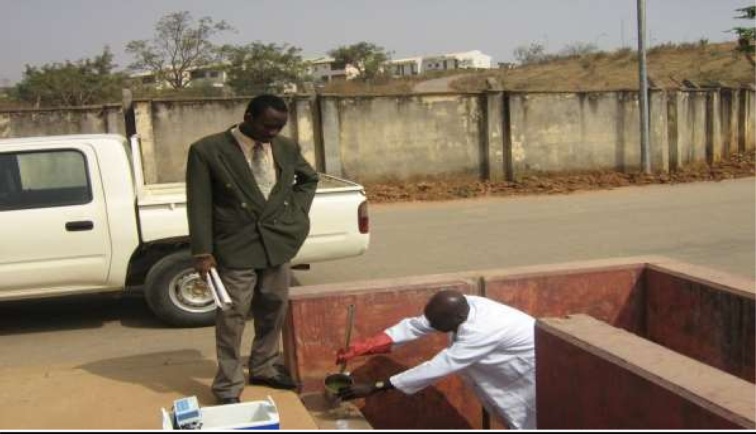

## Plate 9: Sample collection at Gudu Treatment Plant in Abuja

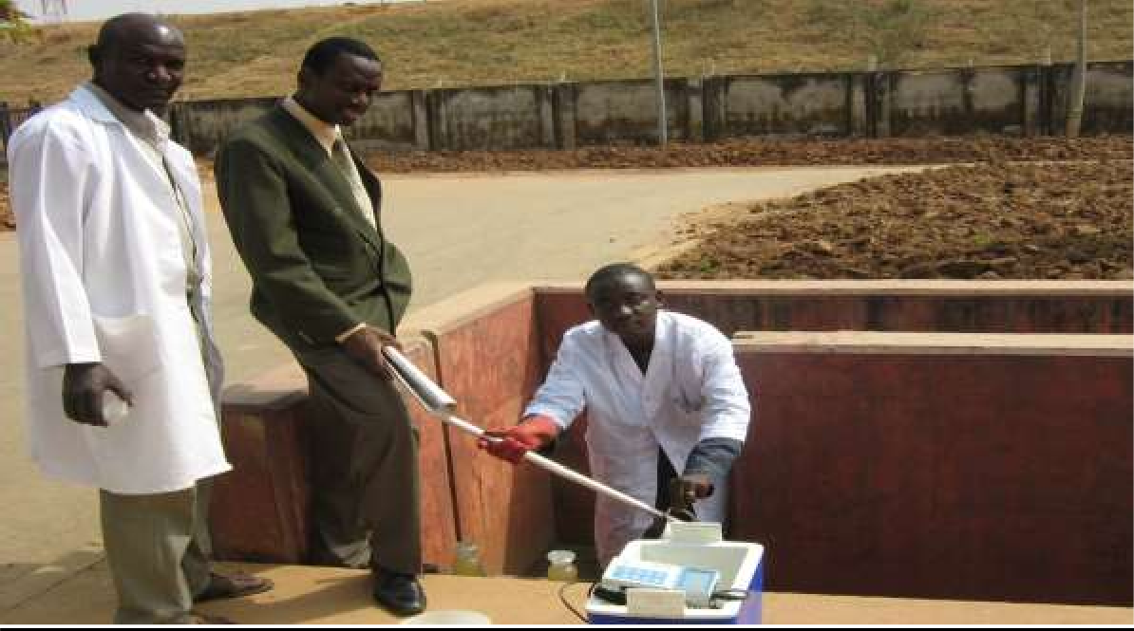

**Plate 10: Apparatus used on site for reading of parameters at Gudu Treatment Plant in Abuja**

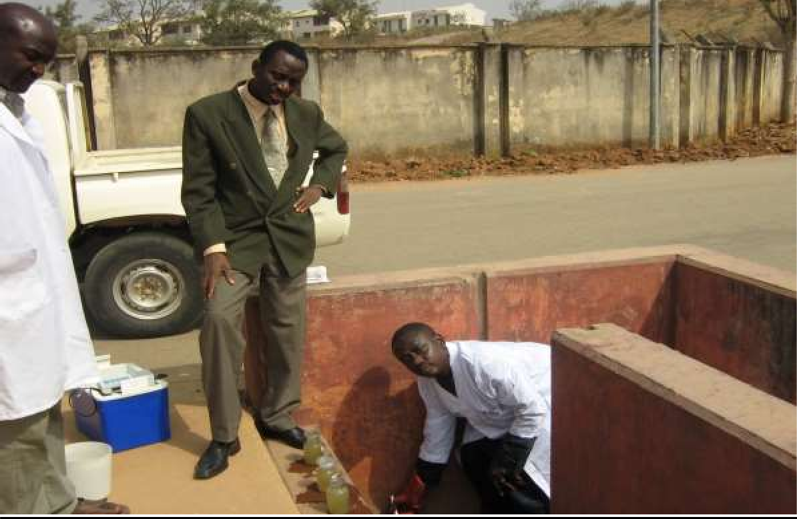

## Plate 11: Collection of samples into containers at Gudu Treatment Plant in Abuja

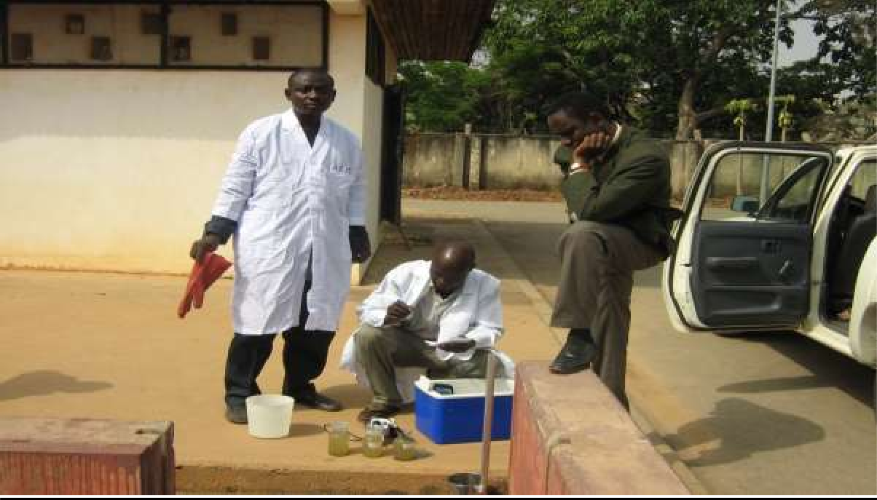

**Plate 12: Labelling of samples and recording of some physical parameters at Gudu Treatment Plant in Abuja**

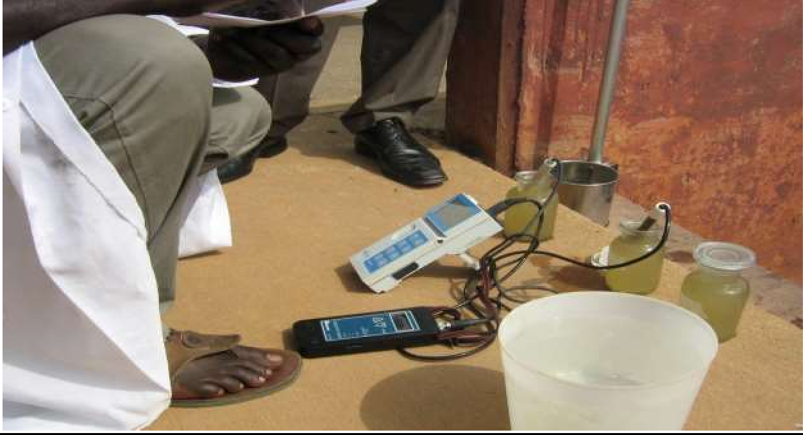

## Plate 13: Taking readings of paramters directly at the Gudu Sewage Treatment Plant, Abuja

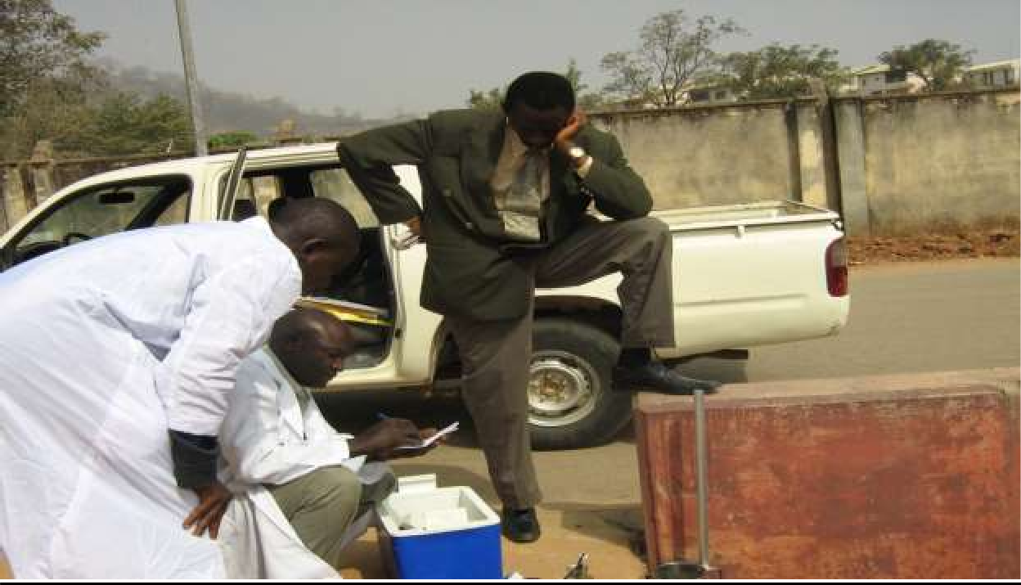

**Plate 14: Brainstorming on results at the research site in Abuja**

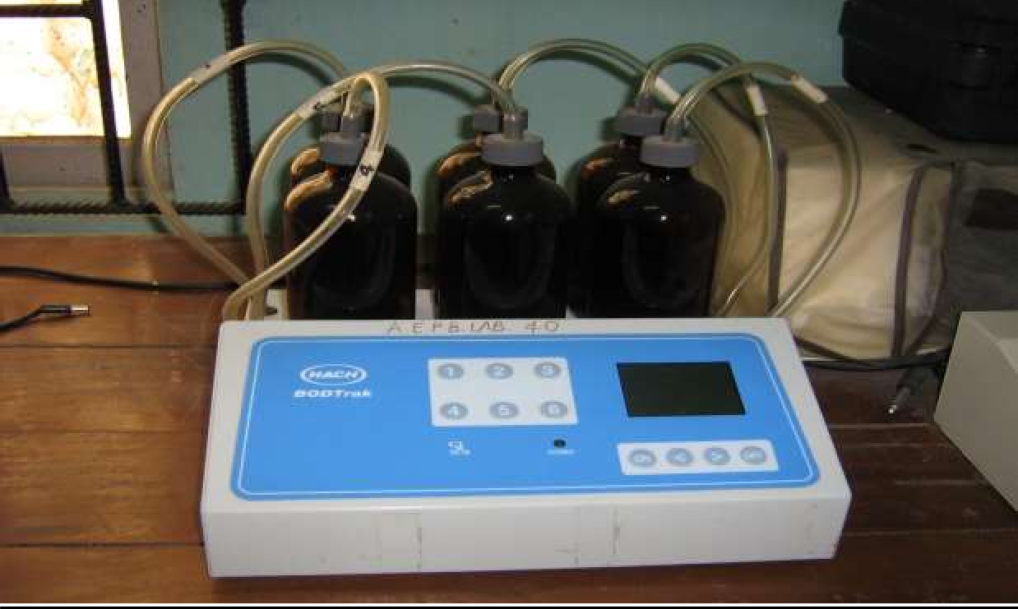

## Plate 15: BOD equipment used for the analysis

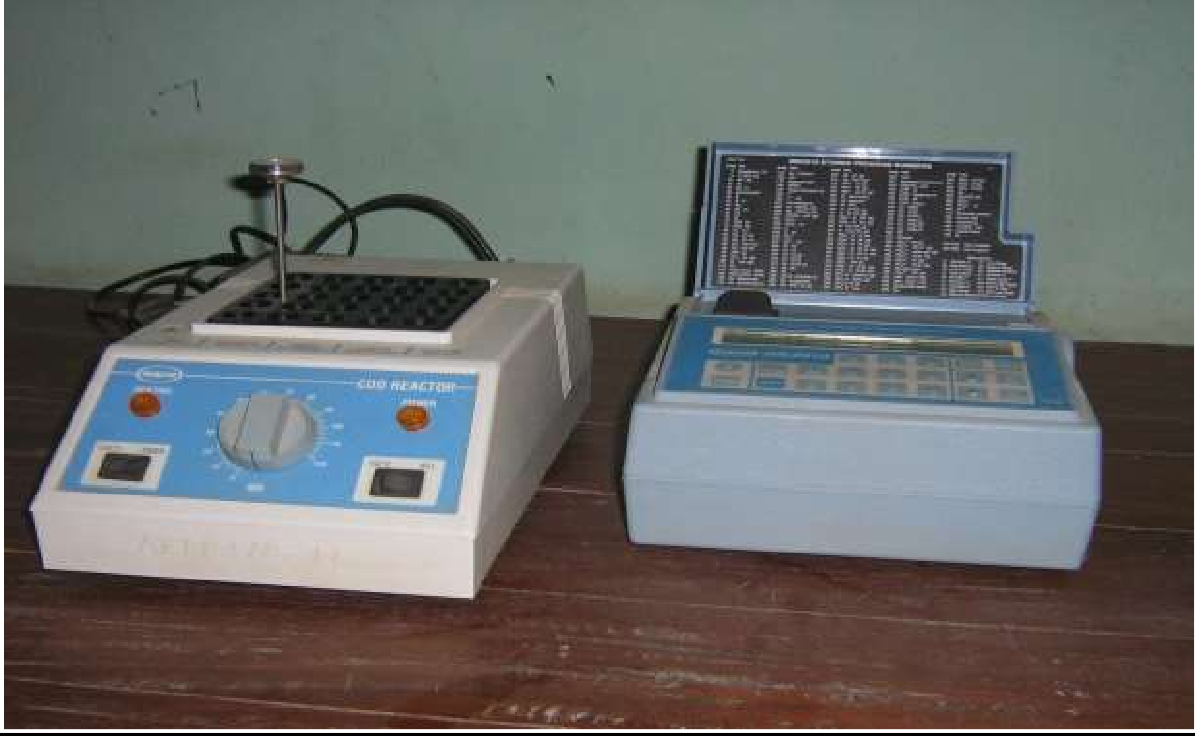

**Plate 16: COD equipment for analysing samples in this study**

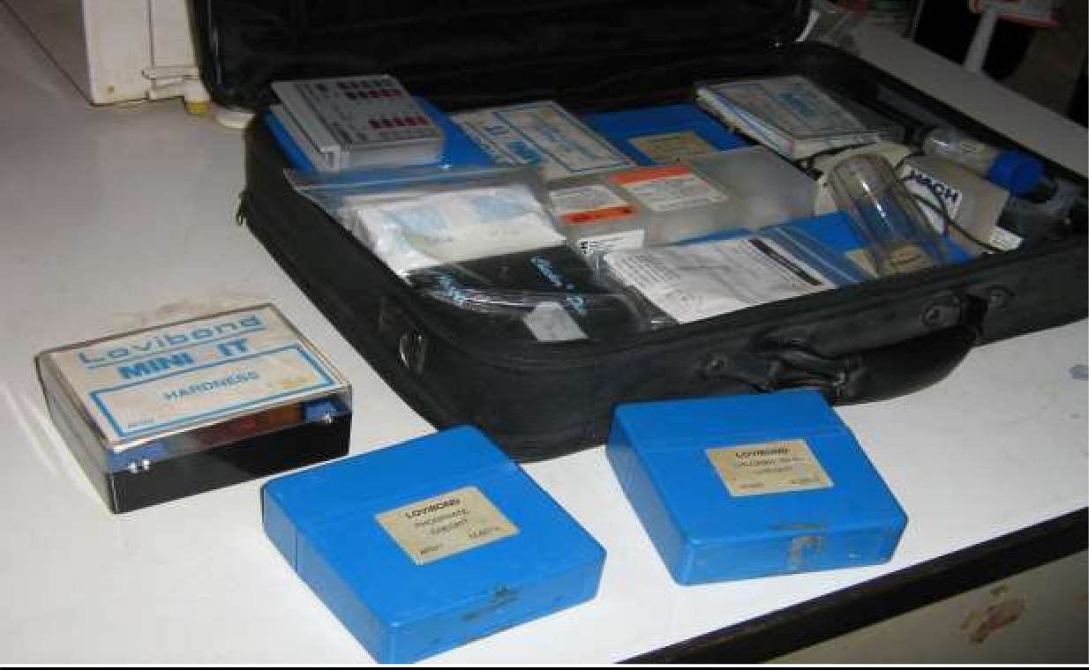

## Plate 17: LOVIBOND Kit used in carrying out analysis

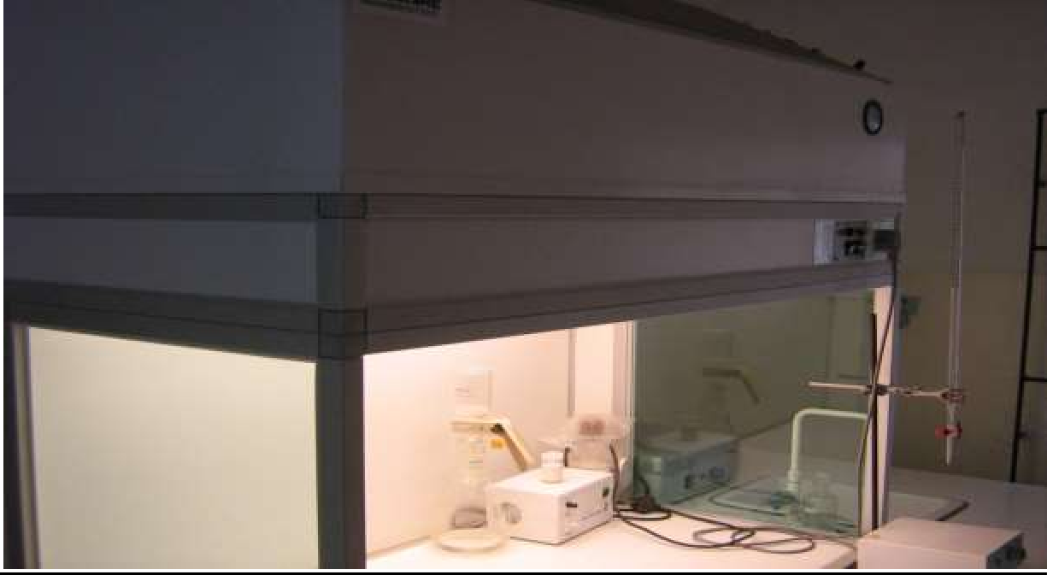

**Plate 18: Oven for sterilizing samples and keeping it in normal condition**

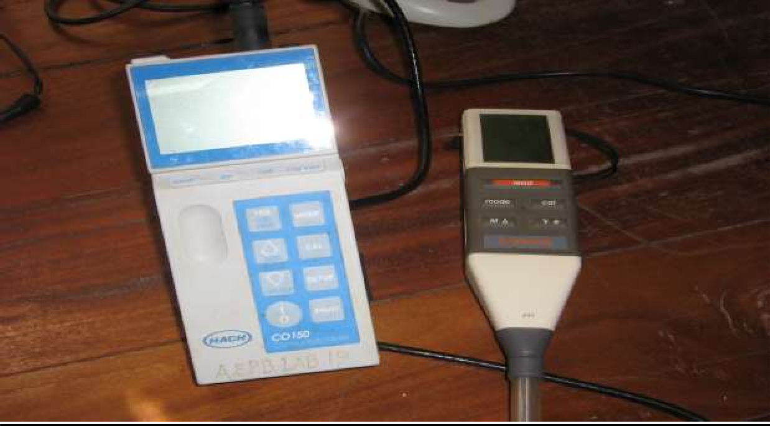

## Plate 19: Oxygen meter used in the determination of dissolved oxygen

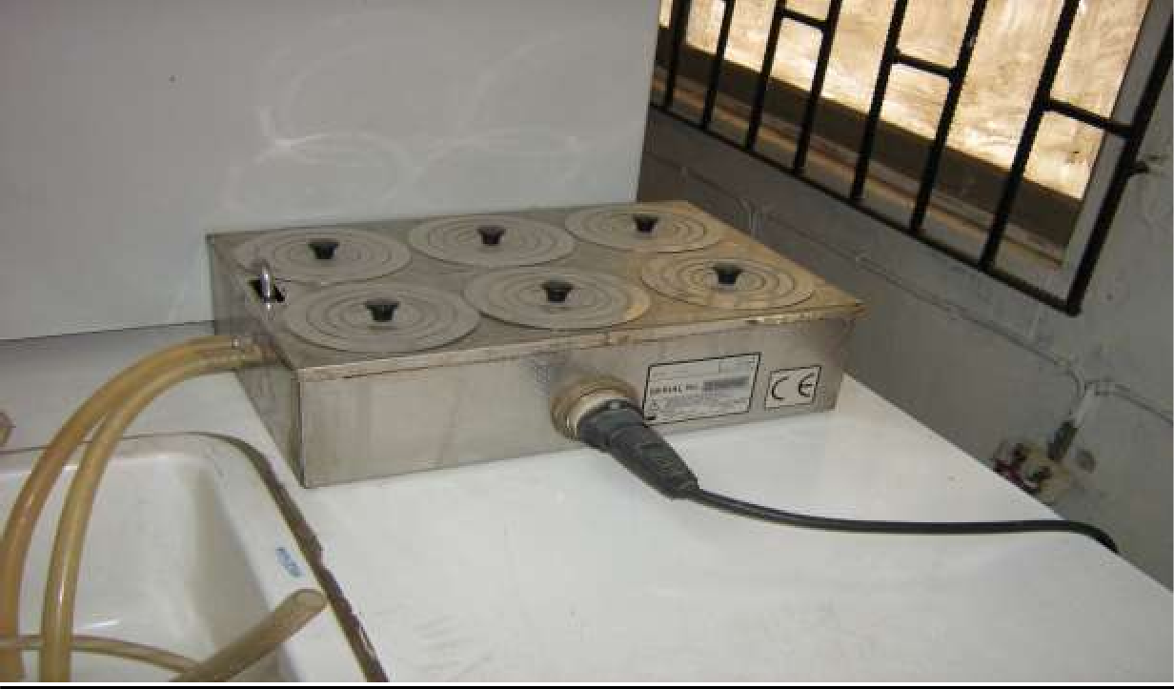

**Plate 20: Regulated water bath used in this study**

## APPENDIX II

**Post HOC Test**

**Multiple Comparisons**

Dependent Variable

(I) Major Sewage (J) Major Sewage Components Components

Mean Difference (I-J)

Standard Error

Significant

95% Confidence Interval

Lower Bound

-66.1217

- 166.8417

Upper Bound

95.3617

-5.3583

TEMPERATURE COD

- 174.50000*

38.70716

0

- 255.2417

-93.7583

Influent Niger Barrack

MICROBIAL CONTENT (MPN)

TEMPERATURE

-

-

-

LSD

BOD

NITRATE

COD

|  |  |  |  |
| --- | --- | --- | --- |
| NITRATE | 14.62 | 38.70716 | 0.71 |
| BOD | -86.10000* | 38.70716 | 0.038 |

|  |  |  |  |  |
| --- | --- | --- | --- | --- |
| 246.50000* | 38.70716 | 0 | 327.2417 | 165.7583 |
| -14.62 | 38.70716 | 0.71 | -95.3617 | 66.1217 |
| - 100.72000*  - 189.12000* | 38.70716 0.017  38.70716 0 | | - -19.9783  181.4617  - -  269.8617 108.3783 | |

BOD

MICROBIAL CONTENT (MPN)

TEMPERATURE NITRATE

|  |  |  |  |  |
| --- | --- | --- | --- | --- |
| - |  | - - | | |
| 261.12000* | 38.70716 | 0 | 341.8617 | 180.3783 |
| 86.10000* | 38.70716 | 0.038 | 5.3583 | 166.8417 |
| 100.72000* | 38.70716 | 0.017 | 19.9783 | 181.4617 |

COD -88.40000*

38.70716 0.033 -

169.1417

-7.6583

MICROBIAL CONTENT (MPN)

TEMPERATURE

- 160.40000*

174.50000*

38.70716 0.001

38.70716 0

- 241.1417

93.7583

-79.6583

255.2417

COD

NITRATE 189.12000*

BOD 88.40000*

MICROBIAL

38.70716 0

38.70716 0.033

108.3783

7.6583

-

269.8617

169.1417

CONTENT

|  |  |  |  |  |  |
| --- | --- | --- | --- | --- | --- |
| (MPN)  TEMPERATURE | 246.50000* | 38.70716 | 0 | 165.7583 | 327.2417 |
| NITRATE | 261.12000* | 38.70716 | 0 | 180.3783 | 341.8617 |

-72

38.70716 0.078

152.7417

8.7417

MICROBIAL CONTENT (MPN)

|  |  |  |  |  |  |  |  |
| --- | --- | --- | --- | --- | --- | --- | --- |
|  | | BOD | 160.40000* | 38.70716 | 0.001 | 79.6583 | 241.1417 |
| COD | 72 | 38.70716 | 0.078 | -8.7417 | 152.7417 |
| Effluent | LSD TEMPERATURE | NITRATE | 14.29 | 54.2701 | 0.795 | -98.9154 | 127.4954 |

Niger Barrack

BOD -33.86

COD -

*

168.46000

54.2701 0.54 -

147.0654

54.2701 0.006 -

281.6654

79.3454

-55.2546

MICROBIAL CONTENT (MPN)

- 250.06000*

54.2701 0

- 363.2654

- 136.8546

|  |  |  |  |
| --- | --- | --- | --- |
| 54.2701 | 0.795 | - | 98.9154 |
| 54.2701 | 0.386 | - 161.3554 | 65.0554 |
| 54.2701 | 0.003 | - 295.9554 | -69.5446 |
| 54.2701 | 0 | - 377.5554 | - 151.1446 |
| 54.2701 | 0.54 | -79.3454 | 147.0654 |
| 54.2701 | 0.386 | -65.0554 | 161.3554 |
| 54.2701 | 0.022 | - 247.8054 | -21.3946 |
| 54.2701 | 0.001 | - 329.4054 | - 102.9946 |
| 54.2701 | 0.006 | 55.2546 | 281.6654 |

NITRATE

BOD

COD

TEMPERATURE BOD

COD

MICROBIAL CONTENT (MPN)

TEMPERATURE NITRATE

COD

MICROBIAL CONTENT (MPN)

TEMPERATURE

-14.29

-48.15

- 182.75000*

- 264.35000*

33.86

48.15

- 134.60000*

- 216.20000*

168.46000*

127.4954

NITRATE 182.75000*

54.2701 0.003 69.5446 295.9554

BOD 134.60000*

MICROBIAL

54.2701 0.022 21.3946 247.8054

-

CONTENT (MPN)

-81.6

54.2701 0.148

194.8054 31.6054

MICROBIAL CONTENT (MPN)

TEMPERATURE NITRATE

BOD

COD

250.06000* 54.2701 0 136.8546 363.2654

264.35000* 54.2701 0 151.1446 377.5554

216.20000* 54.2701 0.001 102.9946 329.4054

81.6 54.2701 0.148 -31.6054 194.8054

Influent

TEMPERATURE

NITRATE 23.458

BOD -33.38

COD -312.78

MICROBIAL

1470.6565 0.987

1470.6565 0.982

1470.6565 0.834

- 3044.278

- 3101.116

- 3380.516

-

3091.194

3034.356

2754.956

Mogadishu barrack

LSD

CONTENT (MPN)

-2832.98

1470.6565 0.068

5900.716 234.7557

NITRATE

TEMPERATURE -23.458

BOD -56.838

COD -336.238

1470.6565 0.987

1470.6565 0.97

1470.6565 0.821

- 3091.194

- 3124.574

- 3403.974

3044.278

3010.898

2731.498

- 211.2977

5924.174

BOD

- 3034.356

- 3010.898

- 3347.136

-

3101.116

3124.574

2788.336

5867.336 268.1357

|  |  |  |  |
| --- | --- | --- | --- |
| MICROBIAL CONTENT | -2856.44 | 1470.6565 | 0.066 |
| (MPN) |  |  |  |
| TEMPERATURE | 33.38 | 1470.6565 | 0.982 |
| NITRATE | 56.838 | 1470.6565 | 0.97 |
| COD | -279.4 | 1470.6565 | 0.851 |
| MICROBIAL CONTENT | -2799.6 | 1470.6565 | 0.071 |
| (MPN) |  |  |  |
| TEMPERATURE | 312.78 | 1470.6565 | 0.834 |
| NITRATE | 336.238 | 1470.6565 | 0.821 |
| BOD | 279.4 | 1470.6565 | 0.851 |
| MICROBIAL CONTENT | -2520.2 | 1470.6565 | 0.102 |
| (MPN) |  |  |  |
| TEMPERATURE | 2832.98 | 1470.6565 | 0.068 |
| NITRATE | 2856.438 | 1470.6565 | 0.066 |
| BOD | 2799.6 | 1470.6565 | 0.071 |
| COD | 2520.2 | 1470.6565 | 0.102 |
| NITRATE | 23.414 | 154.50453 | 0.881 |
| BOD | -23.2 | 154.50453 | 0.882 |

Effluent Mogadishu Barrack

LSD

COD

MICROBIAL CONTENT (MPN)

TEMPERATURE

- 2754.956

- 2731.498

- 2788.336

- 5587.936

- 234.7557

- 211.2977

- 268.1357

- 547.5357

- 298.8768

- 345.4908

3380.516

3403.974

3347.136

547.5357

5900.716

5924.174

5867.336

5587.936

345.7048

299.0908

COD -265.2

MICROBIAL

154.50453 0.102 -

587.4908

-

57.0908

CONTENT (MPN)

-317.2

154.50453 0.053

639.4908 5.0908

NITRATE

TEMPERATURE -23.414

BOD -46.614

COD -288.614

154.50453 0.881 -

345.7048

154.50453 0.766 -

368.9048

|  |  |  |  |
| --- | --- | --- | --- |
| 154.50453 | 0.076 | -  610.9048 | 33.6768 |
| 154.50453 | 0.039 | - 662.9048 | -18.3232 |
| 154.50453 | 0.882 | - 299.0908 | 345.4908 |
| 154.50453 | 0.766 | -  275.6768 | 368.9048 |
| 154.50453 | 0.133 | -  564.2908 | 80.2908 |
| 154.50453 | 0.072 | - 616.2908 | 28.2908 |
| 154.50453 | 0.102 | -57.0908 | 587.4908 |
| 154.50453 | 0.076 | -33.6768 | 610.9048 |
| 154.50453 | 0.133 | -80.2908 | 564.2908 |
| 154.50453 | 0.74 | - 374.2908 | 270.2908 |
| 154.50453 | 0.053 | -5.0908 | 639.4908 |
| 154.50453 | 0.039 | 18.3232 | 662.9048 |

298.8768

275.6768

MICROBIAL CONTENT

|  |  |
| --- | --- |
| (MPN)  TEMPERATURE | 23.2 |
| NITRATE | 46.614 |
| COD | -242 |
| MICROBIAL CONTENT | -294 |
| (MPN) |  |
| TEMPERATURE | 265.2 |
| NITRATE | 288.614 |
| BOD | 242 |
| MICROBIAL CONTENT | -52 |
| (MPN) |  |
| TEMPERATURE | 317.2 |
| NITRATE | 340.61400* |

- 340.61400*

BOD

COD

MICROBIAL CONTENT

(MPN)

BOD 294 154.50453 0.072 -28.2908 616.2908

TEMPERATURE

COD 52

NITRATE 1.534

BOD -96.64

COD -

*

430.24000

154.50453 0.74

203.74895 0.994

203.74895 0.64

203.74895 0.047

- 270.2908

- 423.4789

- 521.6529

- 855.2529

374.2908

426.5469

328.3729

-5.2271

Influent Wuye TP

LSD

MICROBIAL CONTENT (MPN)

TEMPERATURE BOD

- 203.74895 0.011

574.24000

*

-1.534 203.74895 0.994

-98.174 203.74895 0.635

- 999.2529

- 426.5469

- 523.1869

- 149.2271

423.4789

326.8389

NITRATE

COD -

431.77400

*

203.74895 0.047

- 856.7869

-6.7611

MICROBIAL CONTENT (MPN)

- 575.77400*

203.74895 0.01

- 1000.787

- 150.7611

BOD

TEMPERATURE 96.64

NITRATE 98.174

COD -333.6

203.74895 0.64

203.74895 0.635

203.74895 0.117

- 328.3729

- 326.8389

- 758.6129

521.6529

523.1869

91.4129

MICROBIAL CONTENT (MPN)

- 477.60000*

203.74895 0.03

- -52.5871

902.6129

TEMPERATURE 430.24000*

203.74895 0.047 5.2271 855.2529

COD

NITRATE 431.77400*

BOD 333.6

MICROBIAL

203.74895 0.047 6.7611 856.7869

203.74895 0.117 -91.4129 758.6129

-

CONTENT (MPN)

TEMPERATURE

-144 203.74895 0.488

574.24000* 203.74895 0.011

569.0129

149.2271

281.0129

999.2529

Effluent Wuye TP

MICROBIAL CONTENT (MPN)

LSD TEMPERATURE

NITRATE 575.77400* 203.74895 0.01

BOD 477.60000* 203.74895 0.03

COD 144 203.74895 0.488

NITRATE 4.752 197.9624 0.981

BOD -59.16 197.9624 0.768

COD -366.96 197.9624 0.079

MICROBIAL CONTENT (MPN)

|  |  |  |  |  |
| --- | --- | --- | --- | --- |
| -  550.16000* | 197.9624 | 0.012 | -  963.1023 | -  137.2177 |
| -4.752 | 197.9624 | 0.981 | - | 408.1903 |

150.7611

52.5871

- 281.0129

- 408.1903

- 472.1023

- 779.9023

1000.787

902.6129

569.0129

417.6943

353.7823

45.9823

NITRATE TEMPERATURE

CONTENT (MPN)

554.91200*

197.9624 0.011

417.6943

- 476.8543

|  |  |  |  |
| --- | --- | --- | --- |
| BOD | -63.912 | 197.9624 | 0.75 |
| COD  MICROBIAL | -371.712  - | 197.9624 | 0.075 |

- 784.6543

- 967.8543

349.0303

41.2303

- 141.9697

BOD

COD

MICROBIAL CONTENT (MPN)

TEMPERATURE NITRATE

COD

MICROBIAL CONTENT (MPN)

TEMPERATURE NITRATE

BOD

MICROBIAL CONTENT (MPN)

TEMPERATURE NITRATE

BOD

59.16

63.912

|  |  |  |  |
| --- | --- | --- | --- |
| 197.9624 | 0.768 | -  353.7823 | 472.1023 |
| 197.9624 | 0.75 | -  349.0303 | 476.8543 |
| 197.9624 | 0.136 | -  720.7423 | 105.1423 |
| 197.9624 | 0.022 | - 903.9423 | -78.0577 |
| 197.9624 | 0.079 | -45.9823 | 779.9023 |
| 197.9624 | 0.075 | -41.2303 | 784.6543 |
| 197.9624 | 0.136 | -  105.1423 | 720.7423 |
| 197.9624 | 0.366 | - 596.1423 | 229.7423 |
| 197.9624 | 0.012 | 137.2177 | 963.1023 |
| 197.9624 | 0.011 | 141.9697 | 967.8543 |
| 197.9624 | 0.022 | 78.0577 | 903.9423 |

-307.8

- 491.00000*

366.96

371.712

307.8

-183.2 550.16000*

554.91200*

491.00000*

MICROBIAL -

- 229.7423

- 432.8795

|  |  |  |  |  |
| --- | --- | --- | --- | --- |
|  | COD | 183.2 | 197.9624 | 0.366 |
| NITRATE | 21.054 | 217.61337 | 0.924 |
| BOD | -39.48 | 217.61337 | 0.858 |
| TEMPERATURE | COD | -156.6 | 217.61337 | 0.48 |

- 493.4135

- 610.5335

-

596.1423

474.9875

414.4535

297.3335

CONTENT

|  |  |  |  |
| --- | --- | --- | --- |
| (MPN)  TEMPERATURE | -21.054 | 217.61337 | 0.924 |
| BOD | -60.534 | 217.61337 | 0.784 |
| COD | -177.654 | 217.61337 | 0.424 |

530.00000* 217.61337 0.024

983.9335 -76.0665

Influent Sheraton TP

LSD

NITRATE

COD

MICROBIAL CONTENT

MICROBIAL CONTENT (MPN)

TEMPERATURE

- 217.61337 0.02

551.05400

*

- 217.61337 0.036

*

490.52000

156.6 217.61337 0.48

- 474.9875

- 514.4675

- 631.5875

- 1004.988

|  |  |  |  |  |
| --- | --- | --- | --- | --- |
|  | (MPN)  TEMPERATURE | 39.48 | 217.61337 | 0.858 |
| NITRATE | 60.534 | 217.61337 | 0.784 |
| BOD | COD | -117.12 | 217.61337 | 0.596 |

- 414.4535

- 393.3995

- 571.0535

- 944.4535

- 297.3335

432.8795

393.3995

276.2795

-97.1205

493.4135

514.4675

336.8135

-36.5865

610.5335

|  |  |  |  |
| --- | --- | --- | --- |
| NITRATE | 177.654 | 217.61337 | 0.424 |
| BOD | 117.12 | 217.61337 | 0.596 |
| MICROBIAL CONTENT | -373.4 | 217.61337 | 0.102 |

MICROBIAL CONTENT (MPN)

- 276.2795

- 336.8135

- 827.3335

631.5875

571.0535

80.5335

|  |  |  |  |  |  |
| --- | --- | --- | --- | --- | --- |
| (MPN)  TEMPERATURE | 530.00000* | 217.61337 | 0.024 | 76.0665 | 983.9335 |
| NITRATE | 551.05400* | 217.61337 | 0.02 | 97.1205 | 1004.988 |
| BOD | 490.52000* | 217.61337 | 0.036 | 36.5865 | 944.4535 |
| COD | 373.4 | 217.61337 | 0.102 | -80.5335 | 827.3335 |
| NITRATE 15.738  BOD -45.78 | | 94.8208 0.87  94.8208 0.634 | | - 182.0547  - 243.5727 | 213.5307  152.0127 |

Effluent

LSD

TEMPERATURE

COD -

258.08000

*

94.8208 0.013

- 455.8727

-60.2873

SheratonTP

MICROBIAL CONTENT (MPN)

- 235.88000*

94.8208 0.022

- -38.0873

433.6727

NITRATE

TEMPERATURE -15.738

BOD -61.518

94.8208 0.87

94.8208 0.524

- 213.5307

- 259.3107

182.0547

136.2747

COD -

*

273.81800

94.8208 0.009 -

471.6107

-76.0253

MICROBIAL CONTENT (MPN)

- 251.61800*

94.8208 0.015

- -53.8253

449.4107

TEMPERATURE

45.78 94.8208 0.634 -

152.0127

|  |  |  |  |
| --- | --- | --- | --- |
| 94.8208 | 0.524 | - | 259.3107 |
| 94.8208 | 0.037 | - 410.0927 | -14.5073 |
| 94.8208 | 0.059 | - 387.8927 | 7.6927 |
| 94.8208 | 0.013 | 60.2873 | 455.8727 |
| 94.8208 | 0.009 | 76.0253 | 471.6107 |
| 94.8208 | 0.037 | 14.5073 | 410.0927 |
| 94.8208 | 0.817 | - 175.5927 | 219.9927 |
| 94.8208 | 0.022 | 38.0873 | 433.6727 |
| 94.8208 | 0.015 | 53.8253 | 449.4107 |

243.5727

BOD

NITRATE

COD

MICROBIAL CONTENT (MPN)

TEMPERATURE

61.518

- 212.30000*

-190.1 258.08000*

136.2747

COD

NITRATE 273.81800*

BOD 212.30000* MICROBIAL

CONTENT (MPN)

22.2

MICROBIAL CONTENT (MPN)

TEMPERATURE 235.88000* NITRATE 251.61800*

-7.6927 387.8927

|  |  |  |  |
| --- | --- | --- | --- |
| BOD | 190.1 | 94.8208 | 0.059 |
| COD | -22.2 | 94.8208 | 0.817 |
| NITRATE | 20.282 | 53.31659 | 0.708 |
| BOD | -9.52 | 53.31659 | 0.86 |
| COD | -80.28 | 53.31659 | 0.148 |

- 219.9927

175.5927

-90.9345 131.4985

TEMPERATURE

MICROBIAL -

- 120.7365

- 191.4965

-

101.6965

30.9365

CONTENT (MPN)

205.88000* 53.31659 0.001

317.0965 -94.6635

Influent LSD Gudu TP

NITRATE

BOD

COD

TEMPERATURE BOD

COD

MICROBIAL CONTENT (MPN)

TEMPERATURE NITRATE

COD

MICROBIAL CONTENT (MPN)

TEMPERATURE NITRATE

BOD

-20.282 53.31659 0.708

-29.802 53.31659 0.582

-100.562 53.31659 0.074

- 53.31659 0

*

226.16200

9.52 53.31659 0.86

29.802 53.31659 0.582

-70.76 53.31659 0.199

- 53.31659 0.001

*

196.36000

80.28 53.31659 0.148

100.562 53.31659 0.074

70.76 53.31659 0.199

- 131.4985

- 141.0185

- 211.7785

- 337.3785

- 101.6965

-81.4145

- 181.9765

- 307.5765

-30.9365

-10.6545

-40.4565

90.9345

81.4145

10.6545

- 114.9455

120.7365

141.0185

40.4565

-85.1435

191.4965

211.7785

181.9765

MICROBIAL CONTENT (MPN)

- 125.60000*

53.31659 0.029

- -14.3835

236.8165

TEMPERATURE 205.88000*

53.31659 0.001 94.6635 317.0965

MICROBIAL CONTENT (MPN)

NITRATE 226.16200*

BOD 196.36000*

53.31659 0 114.9455 337.3785

53.31659 0.001 85.1435 307.5765

COD

NITRATE BOD

125.60000* 53.31659 0.029

18.366 31.29631 0.564

-16.2 31.29631 0.61

14.3835 236.8165

-46.917 83.649

-81.483 49.083

TEMPERATURE

COD -93.48000*

MICROBIAL -

31.29631 0.007

-158.763 -28.197

CONTENT (MPN)

128.28000*

31.29631 0.001

-193.563 -62.997

Effluent LSD Gudu TP

NITRATE

|  |  |  |  |  |  |
| --- | --- | --- | --- | --- | --- |
| (MPN) |  | | | | |
| TEMPERATURE | 16.2 | 31.29631 | 0.61 | -49.083 | 81.483 |
| NITRATE | 34.566 | 31.29631 | 0.282 | -30.717 | 99.849 |

TEMPERATURE -18.366

BOD -34.566

COD -

*

111.84600

31.29631 0.564

31.29631 0.282

31.29631 0.002

-83.649 46.917

-99.849 30.717

-177.129 -46.563

BOD

MICROBIAL CONTENT

- 146.64600*

31.29631 0

-211.929 -81.363

COD -77.28000*

31.29631 0.023 -142.563 -11.997

MICROBIAL CONTENT (MPN)

- 112.08000*

31.29631 0.002 -177.363 -46.797

COD

TEMPERATURE 93.48000* NITRATE 111.84600*

BOD 77.28000*

MICROBIAL

31.29631 0.007 28.197 158.763

31.29631 0.002 46.563 177.129

Influent LSD Lungi TP

MICROBIAL CONTENT (MPN)

TEMPERATURE

NITRATE

CONTENT (MPN)

TEMPERATURE NITRATE

BOD

COD NITRATE BOD COD

MICROBIAL CONTENT (MPN)

TEMPERATURE BOD

COD

-34.8

128.28000*

|  |  |  |  |
| --- | --- | --- | --- |
| 31.29631 | 0.023 | 11.997 | 142.563 |
| 31.29631 | 0.279 | -100.083 | 30.483 |
| 31.29631 | 0.001 | 62.997 | 193.563 |
| 31.29631 | 0 | 81.363 | 211.929 |
| 31.29631 | 0.002 | 46.797 | 177.363 |
| 31.29631 | 0.279 | -30.483 | 100.083 |
| 155.02235 | 0.884 | -300.531 | 346.211 |
| 155.02235 | 0.661 | -392.331 | 254.411 |
| 155.02235 | 0.094 | -596.231 | 50.511 |
| 155.02235 | 0.003 | -850.831 | -204.089 |
| 155.02235 | 0.884 | -346.211 | 300.531 |
| 155.02235 | 0.56 | -415.171 | 231.571 |
| 155.02235 | 0.071 | -619.071 | 27.671 |

146.64600*

112.08000*

34.8

22.84

-68.96

-272.86

- 527.46000*

-22.84

-91.8

-295.7

|  |  |  |  |  |  |
| --- | --- | --- | --- | --- | --- |
| (MPN) |  | | | | |
| TEMPERATURE | 68.96 | 155.02235 | 0.661 | -254.411 | 392.331 |
| NITRATE | 91.8 | 155.02235 | 0.56 | -231.571 | 415.171 |
| COD | -203.9 | 155.02235 | 0.203 | -527.271 | 119.471 |

|  |  |  |  |  |  |
| --- | --- | --- | --- | --- | --- |
| (MPN) |  | | | | |
| TEMPERATURE | 272.86 | 155.02235 | 0.094 | -50.511 | 596.231 |
| NITRATE | 295.7 | 155.02235 | 0.071 | -27.671 | 619.071 |
| BOD | 203.9 | 155.02235 | 0.203 | -119.471 | 527.271 |
| MICROBIAL CONTENT | -254.6 | 155.02235 | 0.116 | -577.971 | 68.771 |
| (MPN) |  |  |  |  |  |
| TEMPERATURE | 527.46000* | 155.02235 | 0.003 | 204.089 | 850.831 |
| NITRATE | 550.30000* | 155.02235 | 0.002 | 226.929 | 873.671 |
| BOD | 458.50000* | 155.02235 | 0.008 | 135.129 | 781.871 |
| COD | 254.6 | 155.02235 | 0.116 | -68.771 | 577.971 |

- 105.3486

MICROBIAL CONTENT

- 550.30000*

BOD

MICROBIAL CONTENT

COD

MICROBIAL CONTENT (MPN)

NITRATE

23.11 61.58237

0.711

Effluent Lungi TP

BOD

-73.7 61.58237

0.245

LSD TEMPERATURE

COD

- 362.40000*

61.58237

0

155.02235

0.002 -873.671 -226.929

- 458.50000*

155.02235

0.008 -781.871 -135.129

- 202.1586

- 490.8586

151.5686

54.7586

- 233.9414

MICROBIAL CONTENT

|  |  |  |  |
| --- | --- | --- | --- |
| (MPN) |  | | |
| TEMPERATURE | -23.11 | 61.58237 | 0.711 |
| BOD | -96.81 | 61.58237 | 0.132 |

- 180.20000*

61.58237 0.008

- -51.7414

308.6586

NITRATE

COD -

385.51000

*

- 151.5686

- 225.2686

61.58237 0 -

513.9686

105.3486

31.6486

- 257.0514

MICROBIAL CONTENT

|  |  |  |  |  |  |  |
| --- | --- | --- | --- | --- | --- | --- |
| (MPN) | |  | | | | |
| TEMPERATURE | | 73.7 | 61.58237 | 0.245 | -54.7586 | 202.1586 |
| NITRATE | | 96.81 | 61.58237 | 0.132 | -31.6486 | 225.2686 |
| BOD | COD | - 288.70000* | 61.58237 | 0 | - 417.1586 | - 160.2414 |
|  | MICROBIAL CONTENT (MPN) | -106.5 | 61.58237 | 0.099 | - 234.9586 | 21.9586 |
|  | TEMPERATURE | 362.40000* | 61.58237 | 0 | 233.9414 | 490.8586 |
| COD | NITRATE | 385.51000* | 61.58237 | 0 | 257.0514 | 513.9686 |
|  | BOD | 288.70000* | 61.58237 | 0 | 160.2414 | 417.1586 |

- 203.31000*

61.58237 0.004

- -74.8514

331.7686

MICROBIAL CONTENT (MPN)

COD

- 182.20000*

61.58237

0.008

- 310.6586

-53.7414

*. The mean difference is significant at the 0.05 level.

|  |  |  |  |  |  |
| --- | --- | --- | --- | --- | --- |
| MICROBIAL  CONTENT (MPN) | 182.20000* | 61.58237 | 0.008 | 53.7414 | 310.6586 |
| TEMPERATURE | 180.20000* | 61.58237 | 0.008 | 51.7414 | 308.6586 |
| NITRATE | 203.31000* | 61.58237 | 0.004 | 74.8514 | 331.7686 |
| BOD | 106.5 | 61.58237 | 0.099 | -21.9586 | 234.9586 |