**EVALUATION OF UGA MICRO FINANCE BANK**

**AWALASI, UGA BRANCH**

**CHAPTER ONE**

**BACKGROUND OF THE STUDY**

The history of micro financing can be traced back as long to the middle of the 1800s when the theorist by sander spooner was writing over the benefits from small credits to entrepreneurs and farmers as a way getting the people out of poverty. But it was at the end of world war II with Marshall plan the concept had an big impact. The today use of the expression micro financing has it roots in the 1970s when organizations, such as Grammeer Bank of Bangladesh with the micro finance pioneer Mohammad Yunus, where starting and shaping the modern industry of micro financing (Wikipedia 2015).

In United states, micro finance institutions was developed in 1980s. They served low income and marginalized minority communities. By 2007, there were 500 micro finance organizations operating in the US with 200 lending capital (Wikipedia 2015).

In Africa the first credit union in Africa was established in Northern Ghana in 1955 by Canadian Catholic missionaries. However, susu, which is one of the micro finance schemes in Ghana, is thought to have originated from Nigeria and spread to Ghana in the early twentieth century (www.economicswebinstitute.org).

In Nigeria micro finance banking came into being in 2005 with the launching of the micro finance policy by the former CBN governor Professor Chukwuma Soludo. The policy was influenced by the globally acclaimed impact of micro finance in helping the economically active poor to exit the poverty threshold and thus leading to significant poverty reduction. Hence micro finance banking was introduced with the expectation that over time, it would in reducing poverty in the country (Ngutor Nyor, 2013).

In Anambra state, micro finance banking came into existence following the 2005 government policy which leads to the conversion of community banks to micro finance bank so many banks were given provisional approval while others were given final license (Chukwuma 2007).

In Uga micro finance bank came as a result of 2005 policy so Uga community bank was converted to Microfinance bank with provisional approval (Umunne, 2009).

**1.2 STATEMENT OF THE PROBLEMS**

Despite the importance of micro finance bank to the community, there has been complaint form both staff and customers regarding to

1. The location

2. The design

3. Space

**1.3 AIM AND OBJECTIVES**

The aim of this study is o evaluate the location design and space of Uga micro finance bank building.

**OBJECTIVES**

1. To determine a suitable location for Uga micro finance bank building.

2. To re-design Uga micro finance bank building.

3 to create comfortable spaces in Uga micro finance bank.

**1.4RESEARCH QUESTIONS**

i Is Uga micro finance bank properly located?

ii Does the design of Uga micro finance bank functional?

iii Does the spaces inside Uga micro finance bank comfortable ?

**1.5 SIGNIFICANCE OF THE STUDY**

The finding of this study will significantly contribute to the re-designing of Uga Micro finance bank.

The study will also provide a suitable location for easy access for staff and customers. The study will provide a comfortable and ventilated spaces in Uga micro finance bank

**1.6 SCOPE OF THE STUDY**

This study is made to evaluate the location, design and space of Uga micro finance bank. It covered only micro finance bank not Akpo micro finance bank.

**1.7 LIMITATIONS OF THE STUDY**

1. Poor attention was given to the researcher because the bank were having their annul supervision by the federal government.

2. Staff and customers list were not easily provided.

3. Most customers did not return their questionnaire.

**CHAPTER TWO**

**2.1 LITERATURE REVIEW**

The related literature on micro finance bank will be discussed under the following sub-headings.

* Concept and definition of Micro finance bank

* Historical Development of Micro finance bank

* Micro finance bank in United state

* Micro finance bank in Africa

* Micro finance bank in Nigeria

* Micro finance bank in Uga

**2.2 CONCEPT AND DEFINITION OF MICRO FINANCE BANK**

The term “Micro finance bank” refers to the activity of the provision of financial services to clients who are excluded from the traditional financial system on account of their lower economic status (Nwanyanwu, 2011).

According to CBN (2004), Micro finance is a development tool used to create access for the economically active poor to financial services at a sustainably affordable price.

**2.3 HISTORICLA DEVELOPMENT OF MICROFINANCE BANK**

The beginning of the Micro finance bank movement are most closely associated with the economist Muhammed Yunus, who in the early 1970’s was a professor in Bangladesh. In the midst of a country-wide famine, he began making small loans to poor families in neighboring villages in an effort to break their cycle of poverty. The experiment was a surprising success, with Yunus receiving timely repayment and observing significant changes in the quality of life for his loan recipients. Unable to self-finance an expansion of his project, he sought governmental assistance, and the Grameen bank was born. In order to focus on the very poor, the bank only lent to households owing less than half-acre of land. Repayment rates remained high and the bank began to spread its operations to other regions of the country. In less than a decade, the bank was operating independently from its governmental founders and was advertising consistent repayment rates of about 98% (Keven Davis / IILJ, 2008)

**2.4 MICRO FINANCE BANK IN UNITED STATE**

In the late 1980s, Micro finance institutions developed in the United state. They served low-income and marginalized minority communities. By 2007, there were 500 Micro finance organizations operating in the US with 200 lending capital (Wikipedia, 2011).

**2.5 MICRO FINANCE BANK IN AFRICA**

Turning now to another world of microfinance, our journey back in history takes us to Nigeria to a microfinance revolution, centuries ago. The earliest evidence of financial institutions in Africa dates back to the 16th century to esusu, a rotating savings and credit association (ROSCA) among the Yoruba. As a form of social capital, the esusu as a financial self-help group was transported during the slave trade to the “Caribbean Islands (Bascom 1952:69), where both the institution and the term still exist today now carried by a new wase of migrants to major American cities (Siebel, 2000).

**2.6 MICRO FINANCE BANK IN NIGERIA**

The launching of microfinance policy, regulation and supervisory framework guideline by the central bank Nigeria 2005, according to Asuquo (2005:16) was the emergence of large number of private-sectro initiated microfinance banks (MFBs) across the country, either through converting existing community banks, transforming the existing NGO-MPIs or promoting fresh microfinance operators. The basic concept underlying the emergence of microfinance banks is community oriented. Moruf (2013).

**2.7 MICRO FINANCE BANK IN UGA**

Years back before 2005, Uga community Bank was operating as the sole financial institution which must shareholders were Uga famous indigene. The community bank came in existence because of the high demand by Orie Uga marketers who complain of being attack on there way to Ekwulobia bank. So, the demand for a bank was much so these famous indigene contributed and built a community bank to serve the purpose of saving and lending money. In 2005 government policy to encourage entrepreneur converted the bank into Uga microfinance bank (Ojiako, 2006).

**2.8 SYNTHESIS OF LITERATURE**

From the literature review, the following conclusions was drawn.

i A well centralized location will be provided for easy access to the bank building.

ii Provision of well ventilated space in the bank building will enhance the working ability of their staff.

iii Provision of standard design of microfinance bank building will attract more customers to the bank.

**2.9 GAP IN LITERATURE**

From the numerous relevant reviewed relating to microfinance bank building several gaps were identified which include:

1) None of the works showed how the building will be position for easy identification by the people using it.

2) None of the works showed the size of the building for smaller population.

3) None of the works showed the landscape of the building unused space.

CHAPTER THREE

This chapter deals with methodology adopted in carrying out this study. It is presented under the following sub-heading. Study area, research design, data needs, source of data, population of study, sample size and population of study, sample size and sampling procedures, instrument for data collection, validation of the instrument, reliability of the instrument, and method of data presentation.

**3.1 STUDY AREA**

The study area Uga Micro Finance Bank is located in Aguata Local Government Area of Anambra State in Nigeria, one of the thirty-six states in Nigeria, Anambra state was created on 27th August 191, its named was derived from “Oma Mbala” now known as Anambra River, a tributary of famous River Nigeria.

**MAP OF NIGERIA LOCATING ANAMBRA STATE**

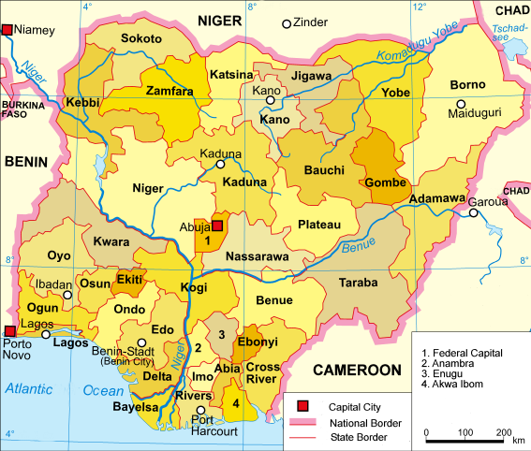

Nigeria Geographical co-ordinates Area 100 00N 80 00E

DATA BASE: www.google.earth.com

**ANAMBRA STATE MINISTRY OF LAND SURVEY AND URBAN DEVELOPEMENT**

Awka is the capital of Anambra State after it was carved out of the old Anambra state in 19991, which comprised of present Anambra and Enugu state (Ogunoh 2008). Uga is one of major town that made up the Aguata local of Anambra state. Nwabu, (2010) google.map.

**3.2 ORIGIN AND SETTLEMENT**

Historically on 1987, Uga community bank was built by some of the wealth indigence of the town and later re-built on 2006 at the same location at Orie square market Awalasi Uga in Aguata local government Area of Anambra state in Nigeria Uga has a recognized landmark and tourism attractions like the “Obizi Uga” spring water, shish is a spectacular natural site of an accient tales, Uga is also known for their popular (Obu ofo) social event of every 26th December.

**(WIKIPEDIA FREE ENCYCLOPEDIA)**

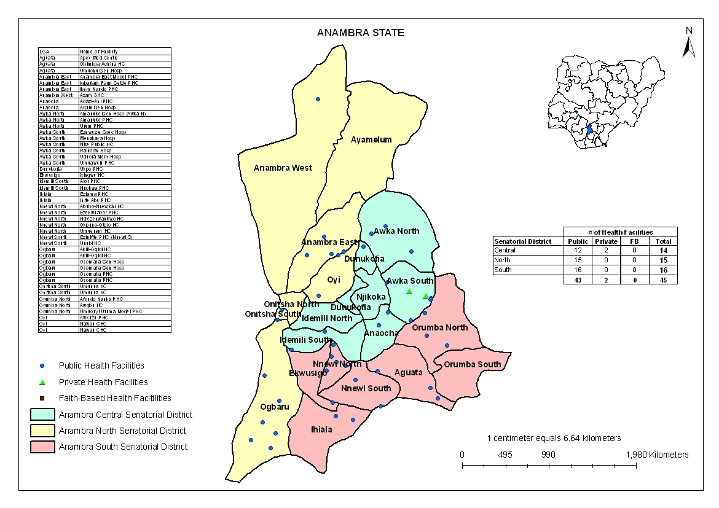

**MAP OF ANAMBRA LOCATING AGUATA L.G.A**

**3.3 LOCATION**

Geographically, Micro Finance Uga is located in Orie Uga market. It occupies a total land area of 600m2. It is located geographical co-ordinate of 60 30 0”North 70 60 0” East.

**CLIMATE AND VEGETATION**

Uga Micro finance Bank lies in the tropical rainforest zone of Nigeria with the mean annual rainfall of 2000mm. the vegetation has, however, been modified to near man made savanna ecological zone. The region has two distinction seasons wet or rainy season starting from the month of April to October and the dry season starting from November to March Ogunoh, 2008.

Market

Market

Ekwulobia Rd.

Akokwa Rd.

Igboukwu Rd.

Umunze Rd.

Micro finance bank

School

Church

**MICRO FINANCE BANK UGA LOCATION PLAN**

**3.4 RESEARCH DESIGN**

This study is a survey design which will portray to the challenges of location, space and design of Micro finance Bank Uga.

**3.5 DATA NEEDS**

The data needs would be informed by the research objectives and question. The include the following.

- Determination of the location, existing structure and architectural importance of Micro finance Bank building.

- Determination of the challenges of provision of new spaces in Uga Micro finance Bank building.

- Establishment of new design for Uga Micro finance Bank building.

**3.6 SOURCES OF DATA**

The datas needed for this study were obtained from both primary and secondary sources.

**3.6.1 SECONDAYR SOURCES OF DATA**

The secondary sources of data for this study were both published and unpublished materials. Unpublished materials used include B.Sc, M.Sc and Ph.D papers delivered at seminars, conferences and dissertations. While published sources of data include books, periodicals, journals, newspapers, maps and magazines. Internet materials were also sensibly utilized to balance primary data as can be seen in the literature review and references.

**3.6.2 PRIAMRY SOURCES OF DATA**

These include data obtained through field observation, oral interview method and self administration of structured questionnaire.

**3.7 POPULATION OF STUDY**

In this research work the target population is the number of regular customers and staff of Uga Micro finance Bank, who are 364 in number which contain 91 staff and 273 customers.

**3.8 SAMPLE SIZE AND SAMPLING TECHNIQUE**

In this research work the sample size is 36 which is obtained by random sampling technique which is the 10% of the total population.

**3.9 INSTRUMENT FOR DATA COLLECTION**

The instrument for data collection include the use o questionnaire, personal interviews etc. questionnaire is used in order to gather facts for this study for it is a quicker method to cover wide range of respondent.

**3.10 RELIABILITY AND VALIDITY OF THE INSTRUMENT**

The researcher presented this research instrument to his supervisor who after going through them, he gives corrections.

Consequently, the instruments should be accepted as valid and reliable and could be replicated in further studies.

**3.11 METHOD OF DATA PRESENTATION**

The data obtained from the study were presented in the form of tables figures, percentages, bar chart and pie chart.

In this method, the researcher thought, is more convenient and easy to understand and more concrete.

Therefore F = Total number of returned questionnaire.

N = Total number of respondent formular =

Number of respondents x 100%

Sample size

**CHAPTER FOUR**

**DATA ANALYSIS PRESENTATION AND DISCUSSION**

**4.1 INTRODUCTION**

This chapter consists of the analysis of the data collected in the Micro finance bank for the purpose of answering the respondent’s questions. The data are arranged as shown below starting with the respondents personal background information containing total of 36 questionnaires on which 35 questionnaires were returned. The research question includes.

**LOCATION**

1. Do you like the location of the micro finance bank?

2. Can you run to the security post incase of danger?

3. Do you think that the location is well centralized.

4. Do you find it easy to locate the bank building?

5. Do you need the relocation of the bank building?

**SPACE**

1 Do you have enough spaces inside the building?

2 Are the spaces inside big enough?

3. Do you have enough parking lot?

4. Do you have escape route incase of emergency?

5 Are spaces inside well ventilated?

**DESIGN**

1 Do you like the design of the building?

2 Do you have security post near the bank?

3 Is the building aesthetic for the purpose?

4 Do you have vegetative landscape?

5 Do you want the bank building design to be changed?

**4.2 PERSONAL BACKGROUND INFORMATION**

In this subsection, information bordering on respondents was analyzed using percentage, bar chart and pie chart such information includes gender, age, marital status, qualification with a view to evaluating micro finance bank building.

**4.3 GENDER OF RESPONDENTS**

Out of a total of 35 respondents which are made of 5 males and 30 females.

**TABLE 4.3**

|  |  |  |  |  |  |
| --- | --- | --- | --- | --- | --- |
| **N0** | **MALE** | **FEMALE** | **MALE %** | **FEMALE %** | **TOTAL** |
| 1 | 5 | 30 | 14% | 86% | 35 |

**4.4 AGE OF RESPONDENT**

This distribution of responses on the age of respondents is shown on the fig 4.4, where ages 20-30 are 20, 31-40 are 8, 41-50 are 2, 51-60 are 3, 61 and above are 2.

**Fig 4.4**

Age (years)

20-30

31-40

41-50

51-60

20

18

16

14

12

10

8

6

4

2

0

Numbers

61 and above

**4.5 MARITAL STATUS OF RESPONDENTS**

The distribution of responses on the marital status of respondents is shown on the table 4.5

**MARITAL STATUS OF RESPONDENTS**

|  |  |  |  |
| --- | --- | --- | --- |
| **S/N0** | **STATUS** | **RESPONDENTS** | **PERCENTAGE OF RESPONDENT** |
| 1 | Married | 7 | 20% |
| 2 | Single | 27 | 77% |
| 3 | Undefined | 1 | 3% |
|  | Total | 35 | 100% |

**4.6 QUALIFICATION OF RESPONDENTS**

The distribution of responses on the qualification of respondents is shown on the fig 4.6

BSC 51.40

MSC 51.40

HND

51.40

51.40

ND

51.40

NCE

SSCE

1030

The above pie chart presented the qualification distribution of responses which show that SSCE is 1, ND are 5, HND are 5, NCE are 5, BSC are 5, MSC are 5, making total of 35 respondents.

**4.7** The percentage of respondents that answered the questions regarding to location, space and design of Uga Micro finance bank building.

**4.7.1 LOCATION**

**OBJECTIVE I**

Do you like the location of the Micro finance bank?

|  |  |  |
| --- | --- | --- |
| **OPTIONS** | **FREQUENCY** | **PERCENTAGE %** |
| Yes | 5 | 14.29% |
| N0 | 30 | 85.71% |
| **Total** | **35** | **100%** |

**OBJECTIVE 2**

Can you run to the security post incase of danger?

|  |  |  |
| --- | --- | --- |
| **OPTIONS** | **FREQUENCY** | **PERCENTAGE %** |
| Yes | 15 | 42.86% |
| N0 | 20 | 57.14% |
| **Total** | **35** | **100%** |

**OBJECTIVE 3**

Do you think that the location is well centralized?

|  |  |  |
| --- | --- | --- |
| **OPTIONS** | **FREQUENCY** | **PERCENTAGE %** |
| Yes | 32 | 91.43% |
| N0 | 3 | 8.57% |
| **Total** | **35** | **100%** |

**OBJECTIVE 4**

Do you find it easy to locate the bank building?

|  |  |  |
| --- | --- | --- |
| **OPTIONS** | **FREQUENCY** | **PERCENTAGE %** |
| Yes | 30 | 85.71% |
| N0 | 5 | 14.28% |
| **Total** | **35** | **100%** |

**OBJECTIVE 5**

Do you need the re-location of the bank building?

|  |  |  |
| --- | --- | --- |
| **OPTIONS** | **FREQUENCY** | **PERCENTAGE %** |
| Yes | 5 | 14.29% |
| N0 | 30 | 85.71% |
| **Total** | **35** | **100%** |

The above study shows the micro finance bank is well positioned by poorly oriented.

**4.7.2 SPACE**

**OBJECTIVE 6**

Do you have enough spaces in the building?

|  |  |  |
| --- | --- | --- |
| **OPTIONS** | **FREQUENCY** | **PERCENTAGE %** |
| Yes | Nil | 0% |
| N0 | 35 | 100% |
| **Total** | **35** | **100%** |

**OBJECTIVE 7**

Are the space inside big enough?

|  |  |  |
| --- | --- | --- |
| **OPTIONS** | **FREQUENCY** | **PERCENTAGE %** |
| Yes | 5 | 85.71% |
| N0 | 30 | 14.29% |
| **Total** | **35** | **100%** |

**OBJECTIVE 8**

Do you have parking hot?

|  |  |  |
| --- | --- | --- |
| **OPTIONS** | **FREQUENCY** | **PERCENTAGE %** |
| Yes | Nil | 0% |
| N0 | 35 | 100% |
| **Total** | **35** | **100%** |

**OBJECTIVE 9**

Do you have escape route incase of emergency?

|  |  |  |
| --- | --- | --- |
| **OPTIONS** | **FREQUENCY** | **PERCENTAGE %** |
| Yes | Nil | 0% |
| N0 | 35 | 100% |
| **Total** | **35** | **100%** |

**OBJECTIVE 10**

Are the spaces inside well ventilated?

|  |  |  |
| --- | --- | --- |
| **OPTIONS** | **FREQUENCY** | **PERCENTAGE %** |
| Yes | 2 | 5.71% |
| N0 | 33 | 94.29% |
| **Total** | **35** | **100%** |

Above results show that new spaces are to be created in Uga micro finance bank building.

**4.7.3 DESIGN**

**OBJECTIVE 11**

Do you like the design of the building?

|  |  |  |
| --- | --- | --- |
| **OPTIONS** | **FREQUENCY** | **PERCENTAGE %** |
| Yes | 10 | 28.57% |
| N0 | 25 | 71.43% |
| **Total** | **35** | **100%** |

**OBJECTIVE 12**

Do you have security post near the bank?

|  |  |  |
| --- | --- | --- |
| **OPTIONS** | **FREQUENCY** | **PERCENTAGE %** |
| Yes | Nil | 0% |
| N0 | 35 | 100% |
| **Total** | **35** | **100%** |

**OBJECTIVE 13**

Is the building aesthetic for the purpose?

|  |  |  |
| --- | --- | --- |
| **OPTIONS** | **FREQUENCY** | **PERCENTAGE %** |
| Yes | 11 | 31.43% |
| N0 | 24 | 68.57% |
| **Total** | **35** | **100%** |

**OBJECTIVE 14**

Do you have vegetative landscape?

|  |  |  |
| --- | --- | --- |
| **OPTIONS** | **FREQUENCY** | **PERCENTAGE %** |
| Yes | 0 | 0% |
| N0 | 35 | 100% |
| **Total** | **35** | **100%** |

**OBJECTIVE 15**

Do you want the bank building design to be changed?

|  |  |  |
| --- | --- | --- |
| **OPTIONS** | **FREQUENCY** | **PERCENTAGE %** |
| Yes | 31 | 88.57% |
| N0 | 4 | 11.43% |
| **Total** | **35** | **100%** |

From the above results there is need for the re-designing Uga Micro finance bank.

**CHAPTER FIVE**

**5.1 INTRODUCTION**

This chapter is the conclusion of the research study. it gives a summary of the research findings, recommendation and then a conclusion. It is necessary to recall that this study is altogether an investigation to find out the evaluation of microfinance bank building in Awalasi Uga.

**5.2 SUMAMRY**

The aim of study is to evaluate the design location and spaces of Uga Microfinance bank. The specific objectives are:

1. To determine a suitable location for Uga Microfinance bank.

2. To establish comfortable spaces for their works.

3. To determine the appropriate design of Uga Microfinance bank.

Alterative hypothesis was formulated the population of the study consists of 35 respondents. A questionnaire was used to gather the necessary information (data) for the study.

**5.3 RESEARCH FINDING**

From the finding of this study are:

1) That the good number of respondents say that the Micro finance bank should be centralized for easy access. We inferred that a centralize location should be chosen.

2) That a good number of respondents say that a spacious and functional space should be provided. We inferred that adequate functional spaces should be provided.

3) The majority of the respondents show that a good and permanent design for the Micro finance bank should be provided. Also the a green landscape is also needed. Therefore, we inferred to re-design the micro finance bank that will look solid and good.

**5.4 CONTRIBUTION TO KNOWLEDGE**

This paper was aimed at discussing the concept of evaluation of Uga Microfinance bank and establishing parameter and theoretical frame work which can be used as case study for the planting and design of Microfinance bank. This study was therefore on imperative to provide a comfortable Microfinance bank has on location space and design in order to add more to the landscape of Orie Uga.

**5.5 RECOMMENDATIONS**

With reference to the above finding. I recommend that

1) There is need for a good design of Micro finance bank in Awalasi Uga.

2) This is need for a comfortable spaces in Uga Micro finance bank in Uga.

3) This is need for a centralize location which will not cause obstruction to road users in Uga Micro finance bank.

**5.6 INTERNATIONAL CASE STUDY**

First Micro finance bank Tajikistan (FMFB-T)

**HISTORY**

Tajikistan is one of the least developed of the is former soviet republics partially due to limited employment possibilities in the country. Around 350,000 households are estimated to be living under the poverty line, out of which it is estimated that 127,000 households had access to Micro finance services at the end of December 2010.

The first Micro finance bank Tajikistan (FMFB-T); which commenced operations as a Micro finance bank in July 2004, spent much of the last year consolidating and, at the end of the year, started to rebuild the ground that it had lost during the economic crisis.

FMFB-T is currently one of two Micro finance banks in the country, along with numerous Micro finance institutions.

In addition to the head office in dushaube, the bank also has branches in Khorog, Gharm, khujand and Kulya. The branches are supported by a network of 36 banking service centres serving semi-urban and rural areas.

**5.7 MERITS**

1) The elevations looks like a bank

2) The bank landscape is attractive by involving green architecture.

**5.8 DEMERITS**

1) The roof plan is more suitable to the North than this south east.

2) It has small parking lot

PICTURE

**5.9 REGIONAL CASESTUDY**

**PROJECT: NATIONAL MICRO FINANCE BANK LIMITED**

**LOCATION: KENYATTA ROAD BRANCH TANZANIA**

**HISTORY**

DAI began working in August 1999 to transform the National Micro finance bank (NMB), a troubled state-owned savings bank in one of the world’s poorest countries, into a profitable commercial bank providing a full range of services to poor and middle-income customers. With technical assistance financed by the world bank and the government of Tanzania, NMB’s management was restructured, new products were developed, all levels of staff were trained and retrained, and new information technology and management information systems were implemented.

**MERITS**

1) The white colour paint will make the interior colour

**DEMERITS**

1) It lack green architecture

2) It looks more like a residential building.

**5.10 NATIONAL CASESTUDY**

Project Title: development of Advans Lofayette Micro finance bank New Gbagi branch.

Project description Building & Civil Engineering, works, Mechanical Engineering works, Electrical engineering works.

**Location** : Oyo State, Nigeria

**Year:** This project was commissioned in 2014.

**Project completion:** This project was completed in March 2015.

Client Website: [www.advansgroup.com](http://www.advansgroup.com)

**HISTORY**

Created in June 2012 and formally incorporated as La Fayette Micro finance bank Ltd, Advans Nigeria is the seventh green field of the Advans Network. Advans Nigeria’s objectives is to target MsMEs in urban areas of Nigeria, where market studies have shown that only one in ten entrepreneurs has access to credit.

**NETWORK:** Advans La Fayette Micro finance bank opened its first branch in Ibadan the country’s third largest city, at the need of January, 2013. A second branch opened in May 2013 and two further branches in early 2014. In the coming years, Advans La Fayette Micro finance bank plans to continue its expansion to cover other regions of Oyo state, home to about 5.5 million inhabitants.

**MERITS**

1) It has a attractive elevations

2) It looks like a commercial building.

**DEMERITS**

1) It has a paved landscapes.

2) It has small parking lots.

PICTURE

**5.11 LOCAL CASESTUDY**

**PROJECT:** UGA MICRO FINANCE BANK

**LOCATION:** ORIE UGA

**CLIENT:** UGA BROTHERS

**SERVICE:**  Provision of small loans to entrepreneurs.

**YEAR OF CONSTRUCTION:** 2005-2006