**EVALUATION OF THE USE OF MANGO PEEL, BANANA PEEL AND ALLIGATOR PEPPER POD EXTRACT AS CORROSION INHIBITOR ON CARBON STEEL IN ACIDIC MEDIUM.**

**BY**

**NIKORO OGHENETEJIRI 14/017092/ENG**

**DEPARTMENT OF CHEMICAL ENGINEERING IGBINEDION UNIVERSITY, OKADA.**

**SEPTEMBER, 2021.**

CERTIFICATION

This is to certify that NIKORO OGHENETEJIRI carried out this project work in chemical engineering department, Igbinedion University Okada, Edo state, Nigeria in fulfilment of requirement for the award of masters of engineering (M.ENG) in Chemical Engineering

Dr. Rowland Azike

Name of Supervisor date

Engr Mrs. P.O Obeta

Head of department date

External Supervisor date

#### gt

DEDICATION

This project is dedicated to the Almighty God for the gift of life, my dear parents Mr and Mrs Victor Nikoro for their support, my siblings Gavraye, Brukevwe, Kevwe, Yoborue, Waire and my friends.

ACKNOWLEDGEMENT

I wish to express my profound gratitude to my project supervisor Dr. Rowland Azike, He has been a wonderful supervisor.

Special thanks goes to my head of department Engr Mrs. P.O Obeta for all his love and support.

I also want to appreciate my Course Adviser Dr Ekpobi for her advice and care towards, Engr Yerima Yakubu for his unending love and Mr. Ngubi F.W for his supports.

And to my course mates, I want to say I appreciate you for your love and support. May God bless you all.

|  |  |
| --- | --- |
| **TABLE OF CONTENT** |  |
| TABLE OF CONTENT | **Error! Bookmark not defined.** |
| ABSTRACT | 6 |
| CHAPTER ONE | 7 |
| 1.0 INTRODUCTION | 7 |
| 1.1 Background of the Study | 7 |
| 1.2 Statement of the Problem | 8 |
| 1.3 Aim and Objectives | 8 |
| 1.4 Scope of Study | 9 |
| 1.5 Relevance of Study | 9 |
| CHAPTER TWO | 10 |
| 2.0 LITERATURE REVIEW | 10 |
| 2.1 Corrosion Cycle | 10 |
| 2.2 Classification of Corrosion | 11 |
| 2.3 Factors Influencing Corrosion | 19 |
| 2.4 Consequences (Effects) of Corrosion | 20 |
| 2.5 Nature of Carbon Steel (Metal) | 21 |
| 2.6 Significance of Hydrochloric Acid | 22 |
| 2.7 Corrosion Control | 23 |
| 2.8 Prevention by Corrosion Inhibition | 23 |
| 2.9 Review on Previous Work | 29 |
| CHAPTER THREE | 34 |
| 3.0 METHODOLOGY | 34 |
| 3.1 Materials used | 34 |
| 3.3 Test specimen | 35 |
| 3.4 Preparation of specimen | 35 |
| 3.5 Preparation of inhibitor | 36 |
| 3.6 Solvent Extraction | 36 |
| 3.7 Methods for cleaning specimen after test | 39 |
| 3.8 Static weight loss / gravimetric test | 39 |
| 3.9 Characterization of the Extracts | 42 |
| CHAPTER FOUR | 51 |
| 4.0 RESULTS AND DISCUSSION | 51 |
| 4.1 Gravemetric Method/Weight loss study | 51 |
| 4.2 Optimization and Statistical Analysis | 61 |
| CHAPTER FIVE | 68 |
| 5.0 CONCLUSION AND RECOMMENDATION | 68 |
| 5.1 Conclusion | 68 |
| 5.2 Recommendation | 68 |

# ABSTRACT

This work investigates the use of extract of alligator pepper pod, mango peel and banana peel as inhibitors to carbon steel corrosion in an acidic industrial environment (oil refinery). Corrosion weight loss method was adopted on the carbon steel coupons to evaluate inhibition efficiency in the presence of these plant extracts. The corrosion inhibitor was extracted with the aid of Soxhlet apparatus.

Corrosion rate (CR), Inhibitor Efficiency (IE) and Weight loss (∆W) were studied from gravimetric measurement of carbon steel coupons immersed in 1.5M HCl in the presence and absence of different concentrations (2.5ml,7.5ml,12.5ml,17.5ml,22.5ml respectively) of the inhibitor.

# CHAPTER ONE

INTRODUCTION

* 1. Background of the Study

Corrosion in the working areas of the refinery may be attributed to various compounds present in crude oil or other compounds which may form during the refining process. The hydrocarbons themselves do not corrode the materials used to construct the equipment (Stephen, 2017).

Corrosion is an undesirable process. Due to corrosion, there is limitation of progress in many areas. The cost of replacement of materials and equipment lost through corrosion is unlimited. Metals and alloys are used as fabrication or construction materials in engineering. If the metals or alloy structures are not properly maintained, they deteriorate slowly by the action of atmospheric gases, moisture and other chemicals. This phenomenon of destruction of metals and alloys is known as corrosion.

The equipment has to be protected because of the presence of some chlorides, Sulphur compounds, organic acids etc., in order to ensure safety and continuity of equipment. The necessary measures may consist of neutralizing the corrosive substances or making use of corrosion inhibitors (WRPC, 2018)

Therefore, by definition, a corrosion inhibitor is a chemical substance that is added to an environment of metallic materials to decreases their corrosion. The efficiency of an inhibitor can be expressed by a measure of this improvement. Also, the reliability of assessment of the effectiveness of equipment protection by inhibition depends on the method employed. Assessment based on results received by several methods make it possible to find a set of inhibitors that rate most effective for crude distillation unit application. Corrosion is a constant and continuous problem, often difficult to eliminate completely. Prevention would be more achievable than eliminating completely.

However, conventional inhibitors like chromates and nitrates have proved to exert toxic effect to the environment and human health (Abdel-Gaber *et al*., 2011). Thus, attention is being redirected to develop eco-friendly inhibitors commonly obtain from plant extracts and other natural products (Oguzie *et al*., 2013). These materials have many benefit such as low cost, high availability, renewability, non-toxic, and their phytochemical composition which present a number of compounds frequently related to anticorrosive activity (Vrsalovic, 2009). Various substances such as Phenols, tannins, oils and fats, etc. have been reported as corrosion inhibitors on Carbon steel, aluminum, zinc and other metals (Rajalakshmi *et al*., 2012).

Current research deals with the use of non-edible plant extracts as a source of green corrosion inhibitor that could efficiently replace and eliminate the relative impact caused by convectional anticorrosive products. (Faustim et al., 2015).

* 1. Statement of the Problem

The objective of any oil refining and petrochemical company is to efficiently and profitably process crude oil into high quality petroleum products. This objective is accomplished by the process plant. However, some process plant is still facing some challenges due to corrosion of process pipelines. In spite of the corrosion control measures being adopted, some corrosion failures are still being experienced. Investigation and evaluation of Mango peel, banana peel and alligator pepper pod extract as green corrosion inhibitors for carbon steel under a variety of conditions is the challenging task.

* 1. Aim and Objectives

The aim of this study is to evaluate the use of Mango peel, banana peel and alligator pepper pod extract as a corrosion inhibitor on carbon steel in acidic medium

* + 1. To assess the current techniques in controlling corrosion in a process plant
    2. To highlight the consequences of corrosion failure in a refinery
    3. To obtain extract from Mango peel, banana peel and alligator pepper pod using Soxhlet extractor.
    4. To determine the phytochemical composition of the extracts
    5. To ascertain the performance and effectiveness of the inhibitors in carbon steel
    6. To compare the results with literature values on similar works.
  1. Scope of Study

This work covers the area of the chemistry, mechanism and kinetics of corrosion; corrosion inhibitors and the use of Mango peel, banana peel and alligator pepper pod as corrosion inhibitors on carbon steel in acidic medium. It seeks to consider the effectiveness or possibility of using Mango peel, banana peel and alligator pepper pod as corrosion inhibitors to prevent corrosion in carbon steel.

* 1. Relevance of Study

Corrosion due to hydrochloric acid in Crude Distillation Unit, Vacuum Distillation Unit, Naphtha Hydro treating Unit, Catalytic Reforming Unit, etc. represents a significant portion of refining cost as a result of loss in production, high maintenance, inefficient operation and cost incurred in control of corrosion. Acid solution media are used extensively for different purposes to clean heat exchangers, remove deposits, pickling preparation for descaling and improving efficiency of heat transfer equipment. Thus, corrosion inhibition study of carbon steel in acidic medium using Mango peel, banana peel and alligator pepper pod is a good technological significance to the process industries.

* 1. Corrosion Cycle

# CHAPTER TWO LITERATURE REVIEW

Man extracts metals from the earth’s natural minerals, together with which they are chemically combined. These metals return to the earth with time via the corrosive action done by natural or artificial corrosion agents. Corrosion helps to carry out the natural cycle of metals. (KRPC, 2016).By this, corrosion is defined as a chemo-physical phenomenon that gives way to the gradual decline of the characteristics of the metals with the aid of the surrounding environment (WRPC, Continous training system general module, 2017 )

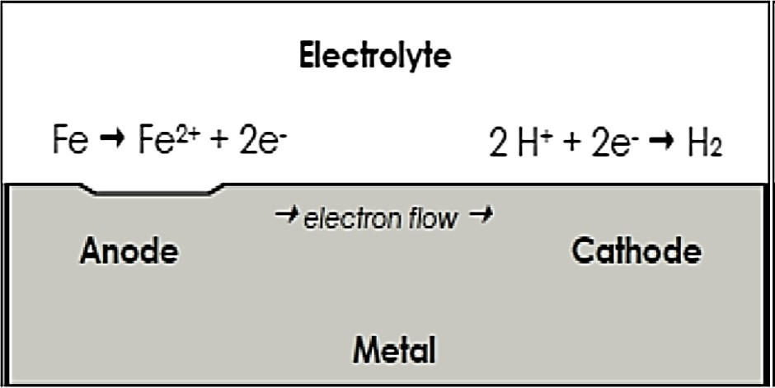

**Figure 2.1:** Corrosion process. Source: (David, 2018).

* 1. Classification of Corrosion
* Based on the environment, corrosion is classified into
  + 1. Chemical Corrosion
    2. Electrochemical Corrosion
    3. *Chemical Corrosion*

The chemical corrosion is defined as the direct chemical attack of metals by the atmospheric gases present in the environment such as oxygen, halogen, hydrogen sulphide, sulphur dioxide, nitrogen or anhydrous inorganic liquid, etc.

#### Types of chemical corrosion

* + - 1. Oxidation
      2. Corrosion by Hydrogen
      3. Liquid Metal Corrosion

#### Oxidation corrosion:

Oxygen is a strong oxidant and reacts with the metal very quickly. Oxygen dissolved in drilling fluids is a major cause of drill pipe corrosion. Oxygen ingress takes place in the well fluids through leaking pump seals, casing, and process vents and open hatches. As a depolarizer and electron acceptor in cathodic reactions, oxygen accelerates the anodic destruction of metal. (David, 2018)

#### Corrosion by hydrogen

* + **Hydrogen embrittlement**

Loss in ductility of a material in the presence of hydrogen is known as hydrogen embrittlement.

#### Mechanism

This occurs when a metal is exposed environment that contains hydrogen. Iron liberates atomic hydrogen with hydrogen sulphide in the following way.

 **2.1**

Hydrogen diffuses into the metal matrix in this atomic form and gets collected in the voids present inside the metal. Further, diffusion of atomic hydrogen makes them combine with each other and forms hydrogen gas.

↑ **2.2**

Collection of these gases in the voids develops very high pressure, causing cracking or blistering of metal.

#### Decarburization

This is the reduction of the carbon content in metals usually steel. It occurs when metal is heated

at very high temperature.  Heat 2H atomic hydrogen reacts with the carbon of the steel and produces methane gas.

C + 4H →  **2.3**

Hence, the carbon content in steel decreases. The process of decrease in carbon content in steel is known as decarburization.

Collection of methane gas in the voids of steel develops high pressure, which causes cracking. Thus, steel loses its strength.

#### Liquid metal corrosion

This is due to chemical action of flowing liquid metal at high temperatures on solid metal or alloy. Such corrosion occurs in devices used for nuclear power.

#### The corrosion reaction involves either:

1. Dissolution of a solid metal by a liquid metal
2. Internal penetration of the liquid metal into the solid metal.

Both these modes of corrosion cause weakening of the solid metal.

* + 1. *Electrochemical corrosion*

Electrochemical corrosion involves the formation of anodic and cathodic areas or parts in contact with each other

Corrosion of anodic areas only

The formation of anodic and cathodic areas or parts in contact with each other.

#### Types of electrochemical corrosion

The electrochemical corrosion is classified into the following two types:

* + - 1. Galvanic (or Bimetallic) Corrosion
      2. Concentration cell corrosion.

#### Galvanic Corrosion

Galvanic corrosion occurs when a potential difference exists between two dissimilar metals immersed in a corrosive solution. The potential difference results in the ﬂow of electrons between the metals. The less corrosion-resistant metal becomes the anode, and the more corrosion-resistant metal the cathode. Galvanic corrosion is generally more prominent at the junction of two dissimilar metals and the severity of attack decreases with increasing distance from the junction (Sastri, 2017)

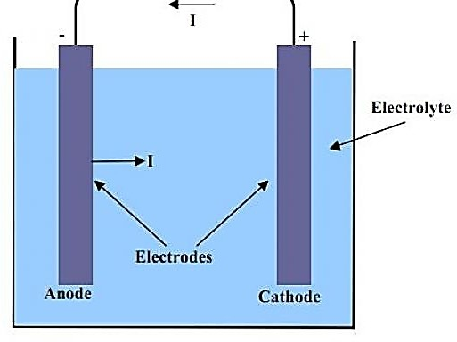

**Figure 2.2:** Galvanic corrosion process.

[Galvanic corrosion](https://cms.corrosionpedia.com/definition/568/galvanic-corrosion) occurs when dissimilar alloys or metals of different corrosion potentials are connected electrically. In this case, only the metal working as an anode with respect to the other will deteriorate. This reaction can be prevented by using a combination of metals that are closer in the galvanic series, and by placing insulation between the two. Coating of the cathodic surface will also help.

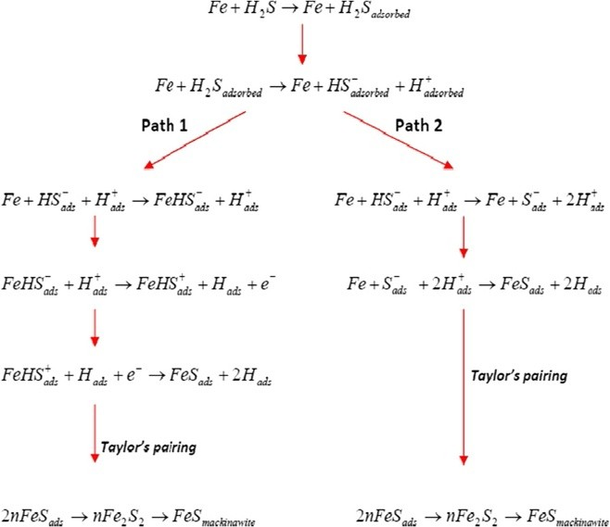

Figure 2.3 Probable mechanism for iron dissolution in aqueous solutions containing H2S.

#### Concentration cell corrosion

It is due to electrochemical attack on the metal surface, exposed to an electrolyte of varying concentrations or of varying aeration. It occurs when one part of metal is exposed to a different air concentration from the other part. This causes a difference in potential between differently aerated areas. It has been found experimentally that poor-oxygenated parts are anodic

#### Examples for this type of corrosion are

* 1. Pitting or localized corrosion
  2. Crevice corrosion
  3. Pipeline corrosion

#### Pitting Corrosion

Pitting corrosion is the severe, localized deterioration of a limited surface area, leading to cavity formation, or pits, on a pipe's surface. In some cases, these pits may puncture the pipe (Agarry et al, 2015). This is one of the most destructive and insidious forms of corrosion. Pitting can cause equipment failure due to perforation, accompanied by a small percentage weight loss of the whole structure.

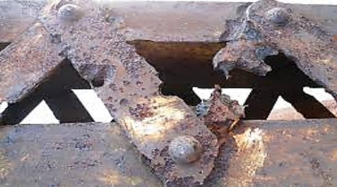

**Figure 2.4:** Pitting corrosion. Source: (Contributors, 2019)

#### Crevice corrosion

If a crevice (a crack forming a narrow opening) between metallic and non-metallic material is in contact with a liquid, the crevice becomes anodic region and undergoes corrosion. Hence,

oxygen supply to their crevice is less. The exposed area has high oxygen supply and acts as cathode. Bolts, nuts, rivets, joints are examples for this type of corrosion.

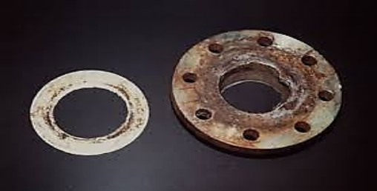

**Figure 2.5:** Crevice corrosion (beneath a seal) on a stainless steel flange exposed to a chloride- rich medium. Source: (Uwah, 2017).

#### Pipeline corrosion

The most common form of corrosion in the oil and gas industry occurs when steel comes in contact with an aqueous environment and rusts. When metal is exposed to a corrosive solution (the electrolyte), the metal atoms at the anode site lose electrons, and these electrons are then absorbed by other metal atoms at the cathode site. The cathode, in contact with the anode via the electrolyte, conducts this exchange in an attempt to balance their positive and negative charges. Positively charged ions are released into the electrolyte capable of bonding with other groups of atoms that are negatively charged. This anodic reaction for iron and steel is

Fe → Fe2+ + 2e- (2.5)

After the metal atoms at the anode site release electrons, there are four common cathode reactions:

O2 + 4H+ + 4e− → 2H2O (oxygen reduction in acidic solution) (2.6)

½O2 + H2O + 2e−→2OH− (oxygen reduction in neutral or basic solution) (2.7) 2H+ + 2e− → H2 (hydrogen evolution from acidic solution) (2.8) 2H2O + 2e− → H2 + 2OH− (hydrogen evolution from neutral water): (2.9)

In the oil and gas industry, carbon dioxide (CO2) and hydrogen sulfide (H2S) are commonly present, and water is their catalyst for corrosion. When water combines with CO2 and H2S, the environments form the following reactions:

H2CO3 Reaction: Fe + H2CO3 →FeCO3 + H2 (2.10)

H2S Reaction: Fe + H2S + H2O →FeS + 2H: (2.11)

There may be a combination of the above two reactions if both gases are present. These resulting molecules either attach themselves to the cathode or are released into the electrolyte and the corrosion process continues.

It is a great challenge to classify the types of corrosion of Carbon steel in a uniform way. One can divide the corrosion on the basis of appearance of corrosion damage, mechanism of attack, industry section, and preventive methods. The mechanism present in a given piping system varies according to the fluid composition, service location, geometry, temperature, and so forth. In all cases of corrosion, the electrolyte must be present for the reaction to occur. In the oil and gas production industries, the major forms of corrosion include sweet corrosion, sour corrosion, oxygen corrosion, galvanic corrosion, crevice corrosion, erosion corrosion, microbiologically induced corrosion, and stress corrosion cracking.

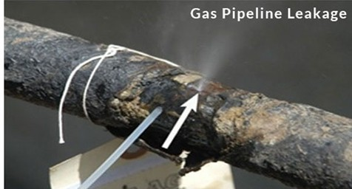

**Figure 2.6**: Resulting fire from Elume pipeline failure (EFR, 2019)

* 1. Factors Influencing Corrosion

There are two main factors influencing corrosion, which are:

* + 1. Nature of the metal
    2. Nature of the corroding environment
    3. *Nature of the metal*

#### Physical state

The rate of corrosion is influenced by physical state of the metal such as grain size, orientation of crystals, stress, etc. (Muhammad, 2017). The smaller the grain size of the metal or alloy, the greater will be its solubility and hence greater will be its corrosion. Moreover, areas under stress, even in a pure metal, tend to be anodic and corrosion takes place at these areas.

#### Nature of surface film

In aerated atmosphere, practically all metals get covered with a thin surface film of metal oxide. Some metals, such as aluminum, form an insoluble oxide film that prevent corrosion while others like iron form oxides that crumble away or dissolve and expose the metal below to further oxidation (Houton, 2015)

#### Purity of metal

Impurities present in metals form minute galvanic cells with the metal under approximate environment and the anodic part get corroded. (Muhammad, 2017).

* + 1. *Nature of the corroding environment:*

#### Influence of pH

Generally acidic media (i.e., pH<7) are more corrosive than alkaline and neutral media. The corrosion rate of iron in oxygen-free water is slow, until the pH is below 5. The corresponding corrosion rate in presence of oxygen is much higher.

#### Temperature

The rate of chemical reaction and the rate of diffusion increases with increase in temperature and polarization decrease. Thus it can be stated that rate of corrosion increases with temperature (Muhammad, 2017).

#### Presence of impurities in atmosphere

Atmosphere in industrial areas contains corrosive gases like and fumes of hcl, 

etc. In presence of these gases, the acidity of the liquid adjacent to the metal surfaces increases, thereby the rate of corrosion increases.

* 1. Consequences (Effects) of Corrosion

The economic and social consequences of corrosion include:

* Due to formation of corrosion product over the machinery, the efficiency of the machine reduces and can lead to plant shut down.
* Health (e.g., from pollution due to a corrosion product or due to the escaping chemical from a corroded equipment).
* The corroded equipment must be replaced therefore costing more.
* Preventive maintenance like metallic coating or organic coating is required.
* The products contamination or loss of products due to corrosion. (Stephen, 2017)
* Corrosion releases the toxic products which affects the health of personnel.
  1. Nature of Carbon Steel (Metal)

Carbon steel corrosion is the destruction of industrial Carbon steel material by chemical, biochemical or electrochemical reaction with the surrounding environment (Shivananda Prabhu, 2016). carbon steel as an item of construction is unsurpassed by other alloys. It is the most extensively used construction material. As steels deteriorate in numerous environments, their resistances to corrosion in the very common and frequently used reagents like hydrochloric (HCl) acid is a vital and important economic consideration for many industries. Acids, especially phosphoric, nitric, sulphuric and hydrochloric acids are utilized in virtually every manufacturing process. Fortifying steel against corrosion as they function as pressure, reaction, and transport and storage devices in the oil refining environment where they come in contact with these hostile acids and is a major consideration for all concerned industries. Corrosion occurs because metals naturally tend to stable oxide form, such as iron in the presence of moist air returns to iron oxide (Rahuma *et al*, 2013). The fundamental cause of the deterioration of Carbon steel buried underground is soil corrosion is because soil is a complex material, a porous heterogeneous and discontinuous environment constituted by mineral or organic solid phase, water liquid phase and air and other gas phase.

The transportation of crude oil and gas by land from production area to distribution terminal is through Carbon steel pipelines in Nigeria. Most pipelines in Nigeria are made up of low carbon steel allied with Carbon and Magnesium. Elemental composition of X60 low carbon steel as reported (Rim-rukeh *et al*. 2016) is presented in Table 2.1. Low carbon steel, although susceptible to corrosion is widely used because of its low cost, high strength and the ease of field

make up by welding. Crude oil and gas pipelines in Nigeria are usually protected externally by wrapping with cement or polyamide or expoxy resin coating couple with a cathodic protection system with minimum specific potential of -850mv (Cu/CuSO4) (Makanjuola et al. 2015).

#### Table 2.1: Material/Specification for system 2A pipeline

|  |  |
| --- | --- |
| **Specifications** | **Designation** |
| Pipeline | Carbon steel pipeline |
| Length of pipeline | 79.9KM |
| pipeline diameter | 19” Diameter |
| Pipe Grade | Shedule 60 (g60) |
| Type of Coating | Coal-Tar |
| Weight (W.T) / Size | 0.271/0.312 inches |
| Periodicity of potential measurement | 3 months |
| Periodicity of measurement staff | 6 months |
| Distribution of test points | 3km Average |
| Protection limit (criteria) | -ve Voltage 1 - 2.5V |
| measurement time | 15 minutes excluding (travelling time) |
| Periodicity of thickness measurement | 3 months |
| Preventive Maintenance on T/Rs and all pump stations | Bi-monthly |
| Test Instruments | Voltmeter 100.000 Ohms/Volt |
| Half cell | Cu/CuSO4 |
| Soil condition | Wet |

Source: Unueroh *et al*. 2016

* 1. Significance of Hydrochloric Acid

Hydrochloric acid is used widely for steel pickling, oil well acidizing, food manufacturing, production of calcium chloride and ore processing. In steel pickling operations, hydrochloric acid is used in treating carbon, alloy and stainless steels. Pickling is the method by which iron oxides and scales are removed from the surface of steel by transforming the oxides to soluble compounds. Pickling is a necessary step for steel production that undergo additional processing

such as wire production, coating of sheet and strip, and tin mill products and corrosion is in most instances initiated. (Parker *et a*l., 2010).

* 1. Corrosion Control

The most common and important method of controlling corrosion in crude distillation unit are:

* + 1. *Material selection*

The use of corrosion resistant alloys. Several corrosion resistant alloys have been developed for specific purposes and environment.

* + 1. *Proper Designing*

Proper design plays an important role in the control of corrosion of equipment and structures. Design should consider mechanical and strength requirement together with allowance for corrosion.

* + 1. *Alteration of environment*

Altering the environment provides a versatile means of reducing corrosion (KRPC, 2016).

* Typical changes in the medium that are often employed are:
  + - 1. Lowering temperature
      2. Removing oxygen
      3. Decreasing velocity
      4. Coatings
  1. Prevention by Corrosion Inhibition

In general, any corrosion retardation process can be considered corrosion inhibition (Sastri, 2011). This has been achieved by the addition of a chemical compound that inhibits the oxidation of the metal. The inhibitor added may be in the form of a liquid or vapor or both.

* + 1. *Corrosion inhibitors*

The use of chemical inhibitors to decrease the rate of corrosion processes is quite varied. In the refinery, inhibitors have always been considered to be the first line of defense against corrosion.(Sastri, 2011) defines corrosion inhibitor as a chemical substance which, when added to an environment in small concentration, effectively reduces the corrosion rate of a metal exposed to that environment. Inhibitors are often added in industrial processes to secure metal dissolution from acid solutions.

In general, the efficiency of an inhibitor increases with an increase in inhibitor concentration (e.g., a typically good inhibitor would give 95% inhibition at a concentration of 0.008% and 90% at a concentration of 0.004%). The scientific and technical corrosion literature has descriptions and lists of numerous chemical compounds that exhibit inhibitive properties. Of these, only very few are actually used in practice. This is partly because the desirable properties of an inhibitor usually extend beyond those simply related to metal protection. Considerations of cost, toxicity, availability, and environmental friendliness are of considerable importance. Commercial formulations generally consist of one or more inhibitor compounds with other additives such as surfactants, film enhancers, de-emulsifiers, oxygen scavengers, and so forth (Ahmed, 2014).

* Inhibitors are classified into
  + - 1. Aniodic inhibitors (chemical passivators)
      2. Cathodic inhibitors (adsorption inhibitors)
      3. Vapour phase inhibitors (volatile corrosion inhibitors)
    1. *Organic corrosion inhibitors*

Most acid corrosion inhibitors are nitrogen, oxygen and / or sulphur containing organic compounds. O, N and S are the active centers for the process of adsorption (a process by which a

solid holds molecules of a gas, liquid or solute as a thin film) on metal surface (Ahmed, 2014).they are found at higher basicity and electro density, thus acts as a corrosion inhibitor (Amitha, 2018). Unfortunately, most of them are highly toxic to both human beings and the environment. Hence use of natural products which are eco-friendly, inexpensive and are being used as corrosion inhibitors. Now the development of corrosion inhibitors of natural source and nontoxic type has been considered more important and desirable. Leaves, barks, seeds, fruits and roots extracts of some plant contains organic constituents with molecular structures containing nitrogen or oxygen atoms and could have considerable potential as inexpensive, nontoxic, readily available and renewable sources of corrosion inhibiting additives (oguzie *et a*l,2013).The use of organic corrosion inhibitor containing O,N and S has shown that most organic inhibitors absorb on the surface of the metal by water molecule displacement on the surface and resulting in the formation of a compact barrier. The organic inhibitor performance is associated to the physiochemical properties and chemical structure of the compound e.g. electron density, functional group and electronic structure of the molecule (Rani *et al*, 2011).the role of inhibitors is to form barriers of one or several molecular layers against acid attack. Sulphur or nitrogen containing heterocyclic compounds with various constituents are considered to be effective corrosion inhibitors.

* + 1. *Corrosion inhibition*

Various types of inhibitors are being applied by pipeline industry to minimize corrosion along the internal wall of pipelines during gas transport. These inhibitors are generally organic and inorganic in nature (Ryu and Lee, 2019; Teryusheva et al, 2019). They include hexamine (Vashi and Naik, 2017), phenylenediamine (Abd El Rehim et al, 2018), dimethylethanolamine (Muller and Fischer, 2016), nitrites (Loto, 2012), cinnamaldehyde and condensation products of aldehydes (Kandepi and Narender, 2012; Seiad et al, 2012), amine (imines) (Khaled et al, 2015; Aiad et al, 2016), chromates (Sangeetha et al, 2018), phosphates, hydrazine and ascorbic acid amongst others (Rani and Basu, 2017). The suitability of each chemical for a task in hand

depends on many factors such as the material of the pipeline under consideration, the nature of the substances they are added into and the operating conditions such as temperature and pressure. The inhibitors could be anodic in nature or cathodic, the anodic inhibitors form a passivation layer on the metal surface thus, preventing its oxidation while cathodic inhibitors retard the corrosion by inhibiting the reduction of water to hydrogen gas. However, corrosion inhibitors have surfactants properties and some surfactants have been established to promote hydrate by increasing the gas content and the formation rate (Ricaurte et al, 2017).

**Table 2.5: Recommended inhibitors for oil and gas Applications (**Zhong and Rogers, 2019**)**

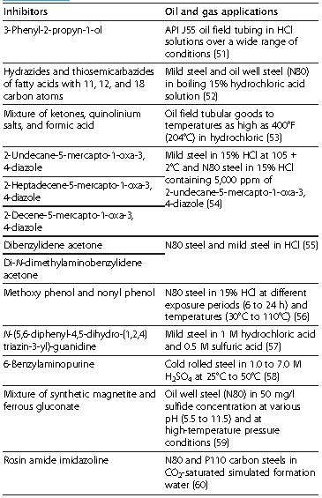

VpCI technology is an environmentally safe and cost-effective option for corrosion protection in the oil refinery. VpCIs form a physical bond on the metal surface and create a barrier layer to protect against aggressive ions. The barrier reheals and self-replenishes, and can be combined with other functional properties for added protective capabilities.

It can be used in pipelines, oil and gas wells, refinery units, and fuels. In addition, these VpCI- based anti-corrosion additives have been designed to work well in multiphase flow systems in

conjunction with different drag reducers. These different combinations of corrosion inhibitors and drag reducers provide systems with improved water flow and corrosion protection of pipelines carrying water or the mixture of hydrocarbon and water.

* + 1. *Corrosion monitoring and inspection*

Corrosion monitoring is the practice of measuring the corrosivity of process stream conditions by the use of probes (mechanical, electrical, or electrochemical devices) which are inserted into the process stream and continuously exposed to the process stream condition. Corrosion monitoring techniques alone provide direct and online measurement of metal loss/corrosion rate in oil and process systems (CAPP 2019). One of the methods is to carry out the on-stream inspection by doing the wall thickness measurements periodically on fixed and vulnerable locations on the equipment, piping, and pipelines to assess the material conditions and corrosion rates (CAPP 2019). Also, corrosion is monitored by placing electronic probes in the pipelines and by measuring the change in the electric resistance in the probe coil. The cross-country pipelines are normally checked with intelligent pigging operations like magnetic flux or ultrasonic pigs. These pigs will detect the internal conditions of the pipeline and corrosion conditions on the pipe wall thickness and also indicate the wall thickness available on the pipe wall (Nalli 2018).

Most of the equipment like separators, drums, and heaters are checked for corrosion during annual shutdown and turnaround operations. Based on the physical assessment of the material conditions, corrective action is initiated to change the material or replace the equipment or at times do temporary repair work before replacement is carried out. In practice, it is observed that physical inspection is the best method of monitoring corrosion and assessing the material conditions. Other areas where corrosion monitoring and inspection are necessary in the oil and gas industry include drilling mud systems, digesters, water wash systems, flow lines, transport pipelines, desalters, sour water strippers, crude overheads, and many more (Champion Technologies 2012). Figure 2.9 is the framework for successful corrosion management (Energy Institute 2018).

* 1. Review on Previous Work

The use of natural products as corrosion inhibitors have been reported widely by several authors. Leaves, barks, seeds, fruits and roots extracts of some plant contains organic constituents with molecular structures containing nitrogen or oxygen atoms and could have considerable potential as renewable sources of corrosion inhibiting additives (oguzie *et al*,2017)

The study of the apparent activation energy and inhibition mechanism of organic film forming inhibitor for the control of corrosion in oil field environment (Chinaza, 2015) using electrical resistance and linear polarization method.

The study of corrosion of mild steel with organic inhibitor (rosemary extract) in salt water environment (Muhammad, 2017) using static weight loss method.

The study of corrosion inhibition of Carbon steel in 5M HCl has been carried out using three naturally occurring substances like onion (Allium cape), Garlic (Allium sativum) and Bitter gourd (Momordica charatina) (Parikh *et al*., 2016) using classical weight loss method, Tefel extrapolation and Residence polarization methods.

The effect of rosemary oil on the corrosion of steel in 3M HCl has been studied using weight loss and electrochemical polarization methods by Chaieb *et al*., (2014).

The dual function of leaf extract of Fig (Ficus carica L.) as antiscalant and corrosion inhibitor for steel was studied. The obtained results showed that the plant extract inhibits the corrosion of steel under the tested conditions. The extract of Fig leaf acted as an anodic inhibitor, reducing metal dissolution. (Abdel-Gaber *et al*., 2015)

Berberine extracted from Coptis chinensis was evaluated for the inhibition efficiency on corrosion of Carbon steel in IM H2SO4 through weight loss experiment, electrochemical techniques and scanning electronic microscope with energy disperse spectrometer. The data showed a good fit to Flory-Huggins isotherm (Van Li *et al.*, 2015).

Rosemary oil was tried as green corrosion inhibitor for steel in phosphoric acid at various temperatures and by polarization measurements. The oil was found to be rich in 1,8-cineole. Polarization measurements showed that rosemary oil acted essentially as a cathodic inhibitor. (Bendahou *et al*., 2016).

The efficiency of Schiff base derived from 4-aminoantipyrine, namely 2-(1,5-dimethyl-4-(2- methylbenzylidene)amino)-2-phenyl-1H-pyrazol-3(2H)-ylidene) hydrazinecarbothioamide as a corrosion inhibitor on mild steel in 1.0 M H2SO4 was investigated using electrochemical impedance spectroscopy (EIS), potentiodynamic polarization (PD) and electrochemical frequently modulation (EFM) in addition to the adsorption isotherm, corrosion kinetic parameters and scanning electron microscopy (SEM) (Ahmed, 2014).

The extract from the seeds of Aframomum melegueta (AM) was investigated as corrosion inhibitor for mild steel in aerated 1 M HCl and 0.5 M H2SO4 solutions using gravimetric and electrochemical techniques (Oguzie, 2017)

Okafor et al., (2016) investigated the extracts of Ailium saliva and Aliium cepu as corrosion inhibitors of Carbon steel in hydrochloric acid using gravimetric and gasometric techniques. The adsorption followed Langmuir isotherm. Kinetic treatment showed first order type of mechanic

The study of corrosion inhibition of Carbon steel in 5M HCl has been carried out using three naturally occurring substances like onion (Allium cape), Garlic (Allium sativum) and Bitter gourd (Momordica charatina) (Parikh et al., 2014) using classical weight loss method, Tefel extrapolation and Residence polarization methods.

The dual function of leaf extract of Fig (Ficus carica L.) as antiscalant and corrosion inhibitor for steel was studied. The obtained results showed that the plant extract inhibits the corrosion of steel under the tested conditions. The extract of Fig leaf acted as an anodic inhibitor, reducing metal dissolution. (Abdel-Gaber et al., 2015).

The efficacy of Telfaria occiclentalis extract as a corrosion inhibitor for Carbon steel in 2M HC1 and I M H2SO4 solutions was investigated by Oguzie (2015). The corrosion rate was calculated from the hydrogen evolution. It was reported that protonated species in the extract composition played a vital role in the inhibiting action.

Extracts of Ricinus cominunis leafs were tested for the corrosion inhibitory effect of Carbon steel in 100ppm sodium chloride solution. The anticorrosion effects were studied by means of weight loss, electrochemical polarization and impedance measurements. The studies revealed it as an efficient inhibitor. The polarization measurements indicated that the plant extract acted as an anodic inhibitor (Ananda Louise Sathiyanathan et al., 2015).

Berberine extracted from Coptis chinensis was evaluated for the inhibition efficiency on corrosion of Carbon steel in IM H2SO4 through weight loss experiment, electrochemical techniques and scanning electronic microscope with energy disperse spectrometer. The data showed a good fit to Flory-Huggins isotherm (Van Li et al., 2015).

Rosemary oil was tried as green corrosion inhibitor for steel in phosphoric acid at various temperatures and by polarization measurements. The oil was found to be rich in 1,8-cineole. Polarization measurements showed that rosemary oil acted essentially as a cathodic inhibitor. (Bendahou et al., 2016).

Natural oil extracted from Pennyroyal mint (Mentha pulegium,) was evaluated as corrosion inhibitor of steel in molar hydrochloric acid using weight loss measurements, electrochemical polarization and impedance methods. The natural oil was found to retard the corrosion rate of steel. (Bouyanzer et al., 2016).

The Azadirachta indica extract was tested for its inhibitive action for steel in

the acid media. The extract functioned as a mixed type, depending on its concentration. At lower concentration the inhibition was by physical adsorption and at higher concentration the adsorption was noted to be chcmisorption. (Oguzie, 2016).

Okafor et al., (2016) investigated the extracts of Ailium saliva and Aliium cepu as corrosion inhibitors of Carbon steel in hydrochloric acid using gravimetric and gasometric techniques. The adsorption followed Langmuir isotherm. Kinetic treatment showed first order type of mechanism.

The inhibitive effect of inhibitor (Theobroma Cacao) and kolanut (Cola `Acuminata) extracts on the corrosion of Carbon steel in seawater at room temperature has been investigated by Urnoru et al., (2016). The results showed kola and alligator pepper podss extracts as potential inhibitors of Carbon steel corrosion in sea water and marine environment.

The corrosion inhibition effect of naturally o1ccurring extract of arteinisia on steel in 0.5M H2SO4 in the temperature range 298 - 353 K was studied by weight loss method and electrochemical polarization methods. The study revealed that the presence of natural arternisia does not change the mechanism of hydrogen evolution reaction and acted as a mixed type inhibitor (Bouklah and Hammouti, 2016).

The inhibitive effect of ethanol extracts of Garcinia kola for the corrosion of Carbon steel in a solutions was investigated by Okafor et al., (2017). The inhibition efficiency has been evaluated using the hydrogen evolution technique at 30 - 600C. The experimental data obeyed the Langmuir adsorption isotherrn as well as the El-Awady et al thermodynamic —kinetic model. The activation energy calculated for the process suggested that the molecules are physically adsorbed on the metal surface.

The extract of Dalura strarnonium (Bothi Raja et al., 2017) has been studied as a possible source of green inhibitor for corrosion of Carbon steel in HC1 and H2SO4 media by conventional weight loss studies, electrochemical studies namely; Tafel polarization, ac impedance and SEM studies. The studies revealed that the plant extract acted as good inhibitor in both the acid media and better in H2SO4 medium.

The inhibitive action of the aqueous extract of olive (Olea europaea L.) leafs toward the corrosion of C-steel in 2 M HCI solution was investigated using weight loss measurements, Tafel polarization, and cyclic voltammetry. The extract acted as a good corrosion inhibitor for the tested system (El-Etre, 2017).

Ehteram Noor (2020) has studied the temperature effects on Carbon steel corrosion in 2M Hall and H2SO4 using the aqueous extract of fenugreek leafs by gravimetric method. The adsorption was spontaneous and followed Langmuir isotherm in HCI and Temkin isotherm in H2SO4.

Corrosion inhibition of Carbon steel in 2 M HCI and 1 M H2SO4 by the leaf extracts of Occimum i'iridis, Telferia occidentalis, Azadirachta indica and Hibiscus sabdariffa as well as extracts from the seeds of Garcinia kola was investigated using a gasometric technique at temperatures 30 and 60°C. Synergistic effects increased the inhibition efficiency in the presence of halide additives. Comparative analysis of the inhibitor adsorption behaviour in 2M Hall and 1M H2SO4 as well as the effects of temperature and halide additives suggested that both protonated and molecular species as responsible for the inhibiting action of the extracts (Emeka 2021).

* 1. Methodology

# CHAPTER THREE

This reports on the corrosion inhibiting efﬁcacy of extracts of Mango peel, banana peel and alligator pepper pod on carbon steel corrosion in hydrochloric solutions.

* 1. Materials used

The materials to be used are;

**Table 3.1** :Materials used

|  |  |  |  |
| --- | --- | --- | --- |
| **S/N** | **MATERIALS** | **SOURCE** | **USES** |
| **1** | Alligator Pepper Pods | Okada market, Edo state. | Used as corrosion inhibitor |
| **2** | Mango Peel | Okada market, Edo state. | Used as corrosion inhibitor |
| **3** | Banana Peel | Okada market, Edo state. | Used as corrosion inhibitor |
| **4** | Hydrocloric Acid | Pyrex-ig scientific company,  benin city, Edo state | Used as corrodent |
| **5** | Distilled water | Igbinedion-university analysis  laboratory, Okada | Used for washing |
| **6** | Acetone | Pyrex-ig scientific company,  benin city, Edo state | Used for cleaning of specimen |
| **7** | Ethanol | Pyrex-ig scientific company,  benin city, Edo state | Used as solvent for extraction |
| **8** | Carbon steel | Rocap Ventures, benin city,  Edo state. | Used as specimen for corrosion  analysis |
| **9** | Soft brush | Igbinedion-university chemical  analysis laboratory, Okada | Used in cleaning |

**Table 3.2:** Test Apparatus

|  |  |  |  |
| --- | --- | --- | --- |
| **S/N** | **TEST APPARATUS** | **SOURCE** | **USES** |
| **1** | Beaker | Pyrex glass material | This shall be used to measure distilled water from its  container. |
| **2** | Conical flask | Pyrex glass material | This flask would be used to  prepare standard solutions |
| **3** | Measuring cylinder | Pyrex glass material | This would be used to measure a certain quantity of liquid  samples |
| **4** | Heating mantle | Techmel and techmel USA | Used in heating during  extraction |
| **5** | Weighing balance | Scout pro SPU 2001 | This would be used to measure  the weight of samples. |

* 1. Test specimen

Carbon steel samples was used as the corrosion testing specimen, was obtained from a commercial outfit.

* 1. Preparation of specimen

Carbon steel specimens of approximate resemblance to one that is used in the oil refinery with known size was employed for the weight loss test. Before each test, each specimen was polished with grit abrasive papers (sandpaper), washed with tap water followed by distilled water, dried with tissues and then degreased with acetone and dry with tissues again. Upon drying, the specimens was immediately weighed.

The corrodent used is hydrochloric acid (HCL)

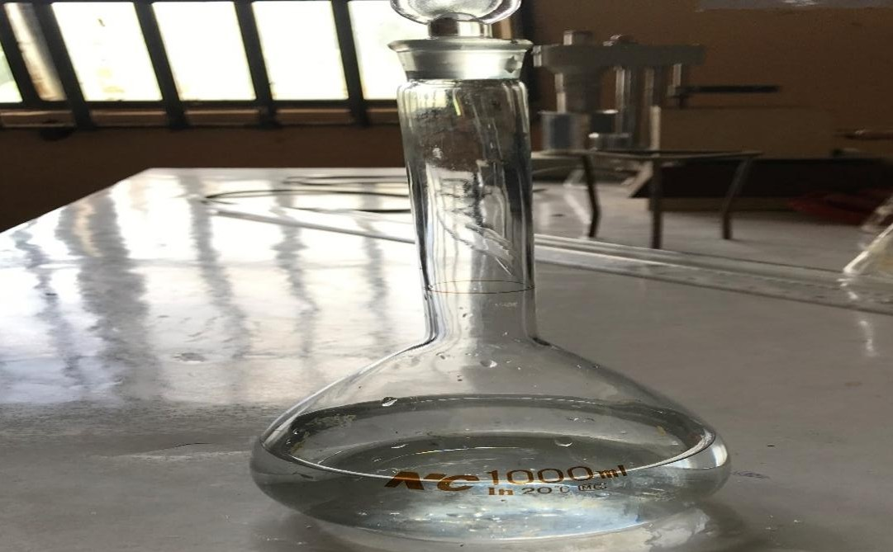

**Figure 3.1 :** 1.5 HCL acid

* 1. Preparation of inhibitor

The Mango peel, banana peel and alligator pepper pod was washed thoroughly with running water to remove unwanted materials. The washed sample was then dried separately in oven at 45oC and grinded to a particle size. The sample was stored in a container before use.

* 1. Solvent Extraction

The Mango peel, banana peel and alligator pepper pod extract was separately extracted with the use of a small scale soxhlet extractor which is available in the Department of Chemical Engineering, Igbinedion University, Okada. The soxhlet extractor consists of a main extractor, thimble (round bottom flask). A reflux condenser and an electric heater as shown in figure 3.1. The solid material (prepared powder Mango peel, banana peel and alligator pepper pod ) was placed separately and at different times in a porous bag or thimble made of strong filter paper or loaded into the main chamber of the thimble holder of the Soxhlet extractor. The Soxhlet extractor was then placed on a round bottom distillation flask containing the extraction solvent. The solvent was equipped with a condenser. The extracting solvent was heated in the distillation

flask and its vapour condense in the condenser. The condensed extract will drip into the thimble containing the powder leaves and extracts it by contact. When the level of the liquid in thimble chamber rises to the top of the siphon tube, the liquid content of the chamber siphon into the distillation flask. The process was continuous and carried out until a drop of the solvent from the siphon tube does not leave residue when evaporated (ICS, 2018).

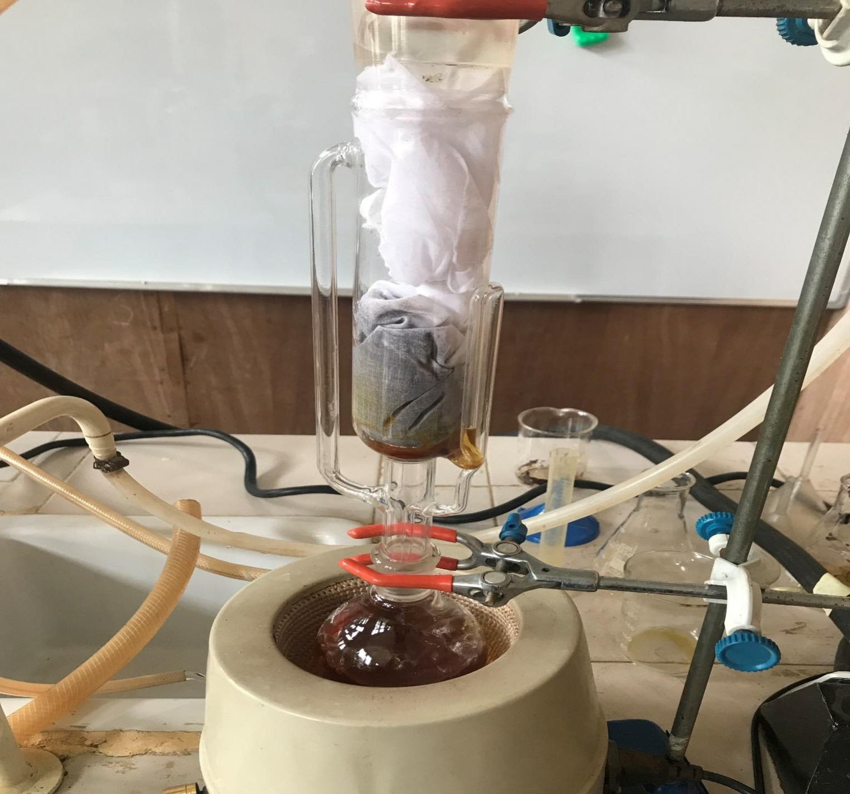

Figure 3.2: Soxhlet Extractor set-up

* + 1. *Extraction procedure*

Mango peel, banana peel and alligator pepper pod was cleaned then chopped into small pieces and dried in the oven separately. 25g of the dry Mango peel, banana peel and alligator pepper pod powder was transferred into a 500mL round-bottom flask and 300mL of 70% ethanol. A reflux condenser will then be connected to the flask and cold water will be allowed to flow through the condenser for better reduction of solvent losses. The set up was placed in a heating mantle and the Mango peel, banana peel and alligator pepper pod was extracted exhaustively by heating the solution under reflux at 78C. The refluxed solution was allowed to cool overnight and will be filtered using a filter paper. The mass of the Mango peel, banana peel and alligator pepper pod will be obtained which will be used for the extraction and the mass of the residue from the filter paper will be essential in carrying out gravimetric analysis to determine the concentration of the filtrate. A rotary evaporator was used to remove all the left over ethanol from the extract and also as a solvent recovery mechanism.

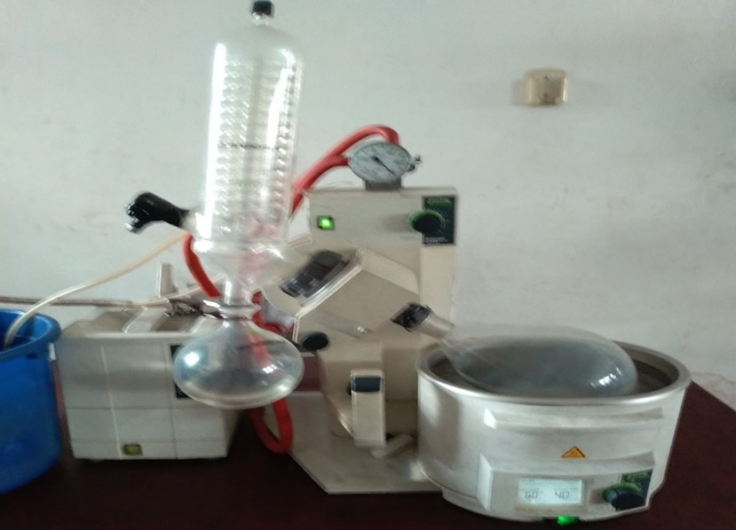

Figure 3.3: Rotary Evaporator

* 1. Methods for cleaning specimen after test

1. Observation and recording of specimen appearance was done noting the sites, location and variation in types of deposits.
2. The specimen was washed using distilled water.
3. Specimen was dipped into acetone after washing
4. Lastly, the specimen was removed to air-dry and weighed
   1. Static weight loss / gravimetric test

The gravimetric or weight loss method was used. The carbon steel was mechanically polished with Silicon carbide abrasive paper, degreased with ethanol, washed in distilled water and dried with acetone. Each metal coupon was sized 40mm × 20mm × 2mm. Before polishing, a hole of about 0.3cm was drilled on each coupon. The coupon was suspended with the aid of a nylon

thread in a 100ml beaker with 100ml of diluted HCl with different concentrations of the various inhibitors at various time intervals of 48, 96, 144, 192 and 240 hours at room temperature (30

C). At the designated time intervals, the samples were retrieved, dipped in distilled water and

washed with a soft brush to remove residual acid and inhibitors, dried in acetone before it was reweighed.

Weight loss = weight before immersion – weight after immersion

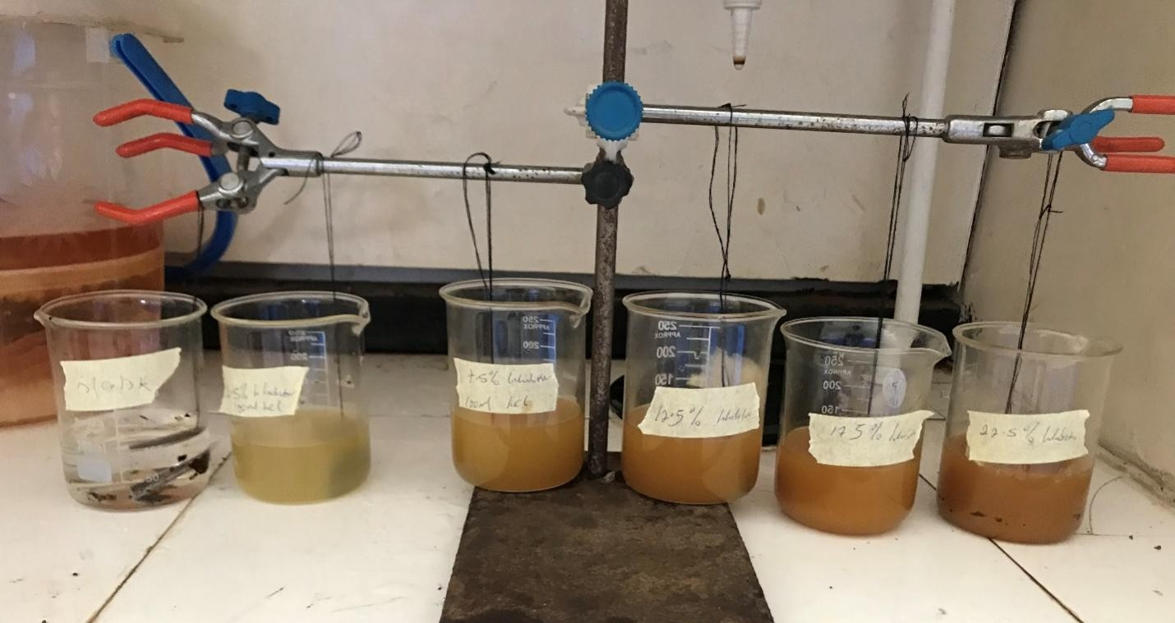

**Figure 3.4**: specimen in different concentrations of inhibitors

For use in this work, carbon steel bar was cut into rectangular coupons. The area of the specimen was obtained from the relation:

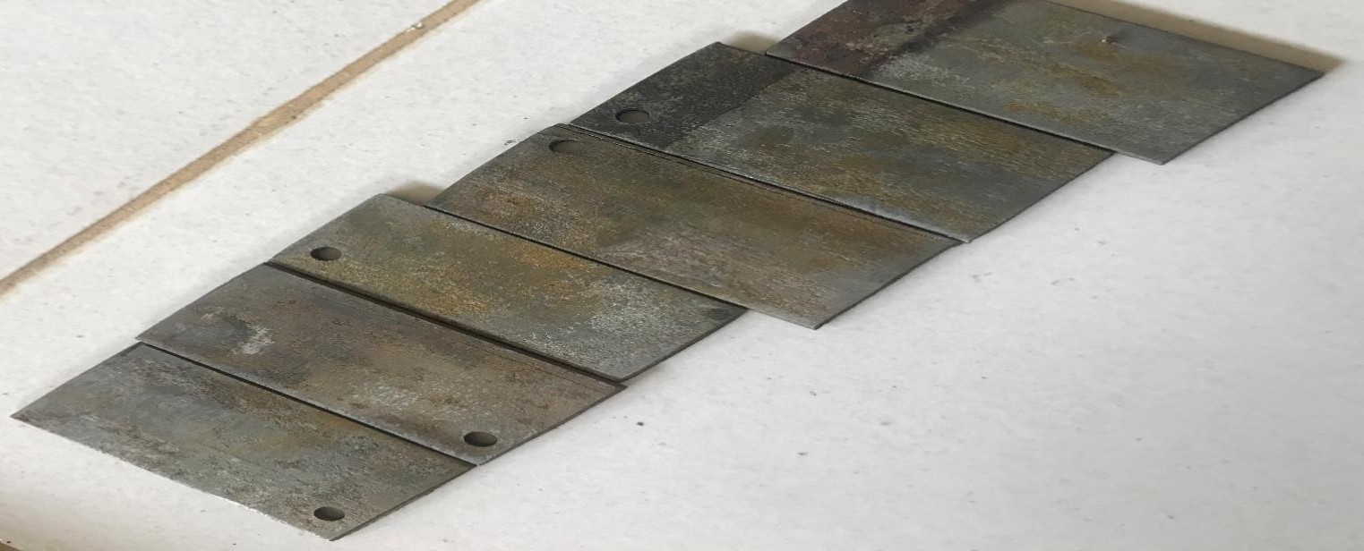

**Figure 3.4**: carbon steel coupons

 3.1

Where

A = area of specimen

x = breadth of specimen = 20mm y = length of specimen = 40mm

z = thickness of specimen = 2mm

Weight loss = weight before immersion – weight after immersion

From the weight loss results, the inhibitor efficiency (IE), in %, was calculated using the formula below:

 3.2

Where  and  are the weight loss (g) of carbon steel in the presence and absence of inhibitor respectively.

* + 1. *Determination of corrosion rate*

Assuming,

1. No internal attack on material
2. Mass loss has been used due to general corrosion

Corrosion rate CR=  3.3

Where, W= mass loss (g) A= area of specimen( )

D= density of carbon steel(g/ ) T= time of exposure in hours

* + 1. *Effect of inhibitor concentration*

The effect of the inhibitor’s concentration was investigated by changing its concentration from 2.5ml to 22.5ml with a step size of 5ml at a specific temperature.

* + 1. *Effect of immersion time*

The effect of the exposure time was also investigated by varying the exposure time from 48 hours to 240 hours with a step size of 48 hours at a specific temperature.

* 1. Characterization of the Extracts

The characterization of the Mango peel, banana peel and alligator pepper pod extract was carried out to determine its physical and chemical properties such as, specific gravity, pH, moisture content, viscosity, density and phytochemical composition.

* + 1. *GC-MS (Gas Chromatography Mass Spectroscopy) analysis.*

GCMS (Gas Chromatography Mass Spectroscopy) analysis was carried out, to detect all organic components present in the Mango peel, banana peel and alligator pepper pod extract.

* + 1. *Phytochemical analysis*

The phytochemical screening of the extract was done to identify the main groups of active chemical constituents present in the solvent extracts by their colour reaction. The presence of saponins, alkaloids, terpenes, flavonoids, glycosides, reducing sugars and tannins was tested by simple qualitative and quantitative methods of (Trease and Evans, 2019) and (Sofowora, 2019). The presence of these compounds has been reported to promote the inhibition of Carbon steel in aggressive acid media (Eddy, and Ebenso, 2018).

#### Phytochemical analysis of Aligator pepper

* Test for saponins

0.2g of extracts was shaken with 5ml of distilled water in a test tube. Frothing which persists on warming was taken as evidence for the presence of saponin (Odeja et al., 2015).

* Test for alkaloids

0.2g of extracts was shaken with 1% HCl for two minutes. The mixture was filtered and drops of wagner’s reagent added. Formation of a precipitate indicated the presence of alkaloids. (Odeja et al., 2015).

* Test for phenols

0.2g of extracts was dissolved in ferric chloride solution. A green or dirty green precipitate indicated the presence of phenolic compound. (Odeja et al., 2015).

* Test for steroids (Salkowski’s test)

0.2g of the extracts was dissolved in 2ml of chloroform. Concentrated sulphuric acid was carefully added to form a lower layer. A reddish-brown colour at the interphase indicated the deoxy sugar characteristics of cardenolides. (Odeja et al., 2015).

* Test for flavonoids

0.2g of magnesium powder and two drops of concentrated hydrochloric acid were added to 3ml of the extracts. A red or intense red colouration indicated the presence of flavonones. (Odeja et al., 2015).

* Test for anthraquinones

0.2g of the extracts was shaken with 3ml of benzene. The mixture was filtered and 2ml of 10% ammonia solution was added to the filtrate. The mixture was shaken and the presence of pink, red or violet colour in the ammoniacal phase indicated the presence of free anthraquinones. (Odeja et al., 2015).

* Test for tannins

0.2g of extracts was stirred with distilled water and filtered. Ferric chloride was added to the filtrate. A blue- black, green or blue-green precipitate was taken as an evidence for the presence of tannins .(Odeja et al., 2015).

* Test for phlobatannins

The extracts (0.2g) was dissolved in distilled water and filtered. The filtrate was boiled with 2% HCl solution. Red precipitate shows the presence of Phlobatannins. (Odeja et al., 2015).

**Table 3.3:** Phytochemical Consituents of Aligator pepper pod extract

|  |  |
| --- | --- |
| Constituent | Aligator pepper pod |
| Tannin | + |
| Saponin | + |
| Steriod | + |
| Terperniods | - |
| Cardiac glucoside | + |
| Alkanoid | + |
| Phlobatannins | - |
| Key: + indicate present,  - indicate not present |  |

#### Phytochemical analysis of Mango peel

* Test for saponins

0.2g of extracts was shaken with 5ml of distilled water in a test tube. Frothing which persists on warming was taken as evidence for the presence of saponins. (Odeja et al., 2015).

* Test for alkaloids

0.2g of extracts was shaken with 1% HCl for two minutes. The mixture was filtered and drops of wagner’s reagent added. Formation of a precipitate indicated the presence of alkaloids. (Odeja et al., 2015).

* Test for phenols

0.2g of extracts was dissolved in ferric chloride solution. A green or dirty green precipitate indicated the presence of phenolic compound. (Odeja et al., 2015).

* Test for steroids (Salkowski’s test)

0.2g of the extracts was dissolved in 2ml of chloroform. Concentrated sulphuric acid was carefully added to form a lower layer. A reddish-brown colour at the interphase indicated the deoxy sugar characteristics of cardenolides. (Odeja et al., 2015).

* Test for flavonoids

0.2g of magnesium powder and two drops of concentrated hydrochloric acid were added to 3ml of the extracts. A red or intense red colouration indicated the presence of flavonones.(Odeja et al., 2015).

* Test for anthraquinones

0.2g of the extracts was shaken with 3ml of benzene. The mixture was filtered and 2ml of 10% ammonia solution was added to the filtrate. The mixture was shaken and the presence of pink, red or violet colour in the ammoniacal phase indicated the presence of free anthraquinones. (Odeja et al., 2015).

* Test for tannins

0.2g of extracts was stirred with distilled water and filtered. Ferric chloride was added to the filtrate. A blue- black, green or blue-green precipitate was taken as an evidence for the presence of tannins .(Odeja et al., 2015).

* Test for phlobatannins

The extracts (0.2g) was dissolved in distilled water and filtered. The filtrate was boiled with 2% HCl solution. Red precipitate shows the presence of Phlobatannins.(Odeja et al., 2015).

**Table 3.4:** Phytochemical Consituents of Mango peel extract

|  |  |
| --- | --- |
| Constituent | Mango peel extract |
| Tannin | + |
| Saponin | + |
| Steriod | + |
| Terperniods | + |
| Cardiac glucoside | + |
| Alkanoid | + |
| Flavonoid | - |

|  |  |
| --- | --- |
| Key: + indicate present,  - indicate not present |  |

#### Phytochemical analysis of Banana peel

* Test for saponins

0.2g of extracts was shaken with 5ml of distilled water in a test tube. Frothing which persists on warming was taken as evidence for the presence of saponins, (Odeja et al., 2015).

* Test for alkaloids

0.2g of extracts was shaken with 1% HCl for two minutes. The mixture was filtered and drops of wagner’s reagent added. Formation of a precipitate indicated the presence of alkaloids. (Odeja et al., 2015).

* Test for phenols

0.2g of extracts was dissolved in ferric chloride solution. A green or dirty green precipitate indicated the presence of phenolic compound. (Odeja et al., 2015).

* Test for steroids (Salkowski’s test)

0.2g of the extracts was dissolved in 2ml of chloroform. Concentrated sulphuric acid was carefully added to form a lower layer. A reddish-brown colour at the interphase indicated the deoxy sugar characteristics of cardenolides. (Odeja et al., 2015).

* Test for flavonoids

0.2g of magnesium powder and two drops of concentrated hydrochloric acid were added to 3ml of the extracts. A red or intense red colouration indicated the presence of flavonones. (Odeja et al., 2015).

* Test for anthraquinones

0.2g of the extracts was shaken with 3ml of benzene. The mixture was filtered and 2ml of 10% ammonia solution was added to the filtrate. The mixture was shaken and the presence of pink, red or violet colour in the ammoniacal phase indicated the presence of free anthraquinones.(Odeja et al., 2015).

* Test for tannins

0.2g of extracts was stirred with distilled water and filtered. Ferric chloride was added to the filtrate. A blue- black, green or blue-green precipitate was taken as an evidence for the presence of tannins .(Odeja et al., 2015).

* Test for reducing sugar**s**

0.2 g of the extracts was shaken with distilled water and filtered. The filtrate was boiled with drops of Fehling’s solution A and B for two minutes. An orange precipitate on boiling with the Fehling’s solution indicated the presence of reducing sugars.(Odeja et al., 2015).

* Test for cardiac-active glycoside (Keller-Killani Test)

0.2 g of the extracts was dissolved in 2ml of glacial acetic acid containing one drop of ferric chloride solution followed by the addition of 1ml of concentrated sulphuric acid. A brown ring at the interface confirmed the presence of cardiac glycoside. (Odeja et al., 2015).

* Test for phlobatannins

The extracts (0.2g) was dissolved in distilled water and filtered. The filtrate was boiled with 2% HCl solution. Red precipitate shows the presence of Phlobatannins. (Odeja et al., 2015).

**Table 3.5:** Phytochemical Consituents of Banana peel pod extract

|  |  |
| --- | --- |
| Constituent | Banana peel extract |
| Tannin | + |
| Saponin | + |
| Steriod | + |
| Terperniods | - |
| Cardiac glucoside | - |
| Flavanoids | - |
| Alkanoid | + |
| Phlobatannins | - |
| Key: + indicate present,  - indicate not present |  |

# CHAPTER FOUR

1. RESULTS AND DISCUSSION
   1. Gravemetric Method/Weight loss study

### Corrosion rate (CR), Inhibitor Efficiency (IE) and Weight loss (∆W) were studied from gravimetric measurement of carbon steel coupons immersed in 1.5M HCl in the presence and absence of different concentrations of the inhibitor.

* + 1. *Effect of Inhibitor Concentration*

Below shows the variation of weight loss with time for the corrosion of carbon steel in 1.5M HCl containing various concentrations (2.5ml, 7.5ml, 12.5ml, 17.5ml, 22.5ml respectively) of the inhibitor at room temperature.

* **Aligator pepper pod**

### Table 4.1: weight loss (g) with time and varying concentration of Alligator pepper pods extract.

blank

Weight loss(g) at

2.5ml concentration

Weight loss

(g) at 7.5ml concentration

Weight loss

(g) at 12.5ml concentration

Weight loss

(g) at 17.5ml concentration

Weight loss

1. at 22.5ml concentration

|  |  |  |  |  |  |  |
| --- | --- | --- | --- | --- | --- | --- |
| 48 | 0.2 | 0.2 | 0.2 | 0.1 | 0.1 | 0 |
| 98 | 0.3 | 0.2 | 0.2 | 0.1 | 0.1 | 0 |
| 144 | 0.4 | 0.3 | 0.2 | 0.2 | 0.1 | 0 |
| 192 | 0.6 | 0.4 | 0.4 | 0.3 | 0.1 | 0 |
| 240 | 0.9 | 0.8 | 0.7 | 0.5 | 0.2 | 0.04 |

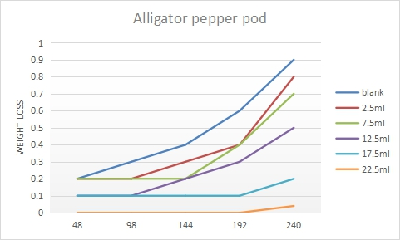

Figure 4.1: weight loss (g) with time and varying concentration of Alligator pepper pods extract.

## Mango peel extract

### Table 4.2: weight loss(g) with time and varying concentration of mango peel extract

|  |  |  |  |  |  |  |
| --- | --- | --- | --- | --- | --- | --- |
| Weight loss | | | Weight loss | Weight loss | Weight loss | Weight loss |
| (g) at 2.5ml | | | (g) at 7.5ml | (g) at 12.5ml | (g) at 17.5ml | (g) at 22.5ml |
|  | blank | concentratio | concentratio | concentratio | concentratio | concentratio |
|  |  | n | n | n | n | n |
| 48 | 0.2 | 0.2 | 0.1 | 0.1 | 0 | 0 |
| 98 | 0.3 | 0.2 | 0.1 | 0.08 | 0 | 0 |
| 144 | 0.4 | 0.2 | 0.1 | 0.07 | 0 | 0 |
| 192 | 0.6 | 0.3 | 0.1 | 0.04 | 0 | 0 |
| 240 | 0.9 | 0.3 | 0.2 | 0.02 | 0.01 | 0 |

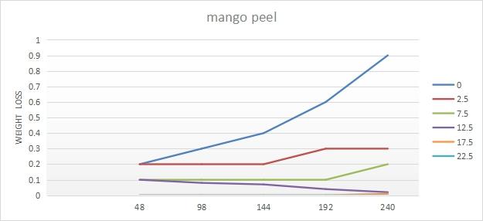

Figure 4.2: weight loss(g) with time and varying concentration of mango peel extract

## Banana peel extract

### Table 4.3: weight loss(g) with time and varying concentration of banana peel extract

|  |  |  |  |  |  |  |
| --- | --- | --- | --- | --- | --- | --- |
| Weight loss | | | Weight loss | Weight loss | Weight loss | Weight loss |
| (g) at 2.5ml | | | (g) at 7.5ml | (g) at 12.5ml | (g) at 17.5ml | (g) at 22.5ml |
|  | blank | concentratio | concentratio | concentratio | concentratio | concentratio |
|  |  | n | n | n | n | n |
| 0 | 0 | 0 | 0 | 0 | 0 | 0 |
| 48 | 0.2 | 0.2 | 0.2 | 0.1 | 0.1 | 0 |
| 98 | 0.3 | 0.2 | 0.2 | 0.1 | 0.1 | 0 |
| 144 | 0.4 | 0.2 | 0.2 | 0.1 | 0.1 | 0 |
| 192 | 0.6 | 0.4 | 0.2 | 0.1 | 0.1 | 0 |
| 240 | 0.9 | 0.6 | 0.5 | 0.3 | 0.2 | 0.07 |

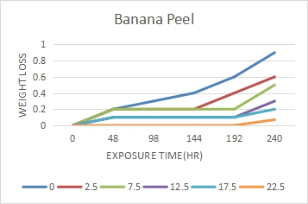

Figure 4.3: weight loss(g) with time and varying concentration of banana peel extract

* + 1. *Corrosion rate*

## Alligator pepper pod

### Table 4.4: Corrosion rate with time and varying concentration of alligator pepper extract

|  |  |  |  |  |  |  |
| --- | --- | --- | --- | --- | --- | --- |
| rate at  12.5ml | | | | | rate at  17.5ml | rate at  22.5ml |
|  |  | concentration | concentration | concentration | concentration | concentration |
| 48 | 0.002527001 | 0.002527001 | 0.002527001 | 0.0012635 | 0.0012635 | 0 |
| 96 | 0.001856572 | 0.001237715 | 0.001237715 | 0.000618857 | 0.000618857 | 0 |
| 144 | 0.001684667 | 0.0012635 | 0.000842334 | 0.000842334 | 0.000421167 | 0 |
| 192 | 0.001895251 | 0.0012635 | 0.0012635 | 0.000947625 | 0.000315875 | 0 |
| 240 | 0.002274301 | 0.002021601 | 0.001768901 | 0.0012635 | 0.0005054 | 0.00010108 |

blank

corrosion rate at 2.5ml

corrosion rate at 7.5ml

corrosion

corrosion

corrosion

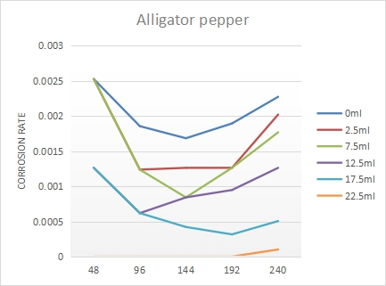

Figure 4.4: plot of Corrosion rate with time and varying concentration of alligator pepper extract

## Mango peel

### Table 4.5: Corrosion rate with time and varying concentration of Mango peel extract

blank

corrosion rate at 2.5ml concentratio

n

|  |  |  |  |  |  |  |
| --- | --- | --- | --- | --- | --- | --- |
|  | | | | n | n | n |
| 48 | 0.002527001 | 0.002527001 | 0.0012635 | 0.0012635 | 0 | 0 |
| 96 | 0.001856572 | 0.001237715 | 0.000618857 | 0.000495086 | 0 | 0 |
| 144 | 0.001684667 | 0.000842334 | 0.000421167 | 0.000294817 | 0 | 0 |
| 192 | 0.001895251 | 0.000947625 | 0.000315875 | 0.00012635 | 0 | 0 |
| 240 | 0.002274301 | 0.0007581 | 0.0005054 | 5.054E-05 | 2.527E-05 | 0 |

corrosion rate at 7.5ml concentratio

n

corrosion rate at 12.5ml concentratio

corrosion rate at 17.5ml concentratio

corrosion

rate at 22.5ml concentratio

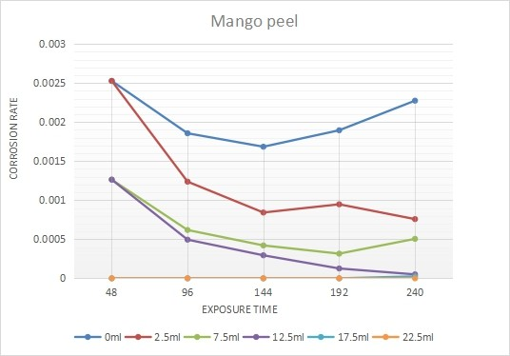

Figure 4.5: Plot of Corrosion rate with time and varying concentration of Mango peel extract

## Banana peel

### Table 4.6: Corrosion rate with time and varying concentration of banana peel extract

blank

corrosion rate at 2.5ml concentratio

n

|  |  |  |  |  |  |  |
| --- | --- | --- | --- | --- | --- | --- |
|  |  |  |  | n | n | n |
| 0 | 0 | 0 | 0 | 0 | 0 | 0 |
| 48 | 0.002527001 | 0.002527001 | 0.002527001 | 0.0012635 | 0.0012635 | 0 |
| 96 | 0.001856572 | 0.001237715 | 0.001237715 | 0.000618857 | 0.000618857 | 0 |
| 144 | 0.001684667 | 0.000842334 | 0.000842334 | 0.000421167 | 0.000421167 | 0 |

corrosion rate at 7.5ml concentratio

n

corrosion rate at 12.5ml concentratio

corrosion

rate at 17.5ml concentratio

corrosion

rate at 22.5ml concentratio

|  |  |  |  |  |  |  |
| --- | --- | --- | --- | --- | --- | --- |
| 192 | 0.001895251 | 0.0012635 | 0.00063175 | 0.000315875 | 0.000315875 | 0 |
| 240 | 0.002274301 | 0.0015162 | 0.0012635 | 0.0007581 | 0.0005054 | 0.00017689 |

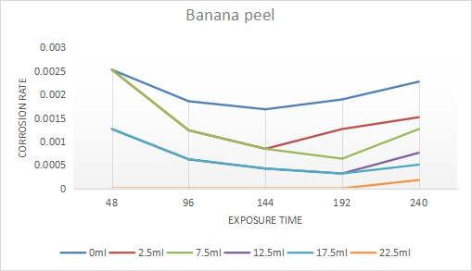

### Figure 4.6: plot of Corrosion rate with time and varying concentration of banana peel extract

It was observed that the corrosion rate decreases with increase in inhibitor’s concentration. It provides clear evidence that all extracts inhibited the corrosion reaction in agreement with (Rondang, 2019) in the acid media but mango peel extract had the most efficiency. The inhibiting effect increases with increase in at concentration.

* + 1. *Inhibition efficiency*

### In order to further sustain our findings, The inhibition performance of extracts on Carbon steel corrosion was quantiﬁed by evaluating the inhibition efficiency

we calculated the inhibition efficiencies of the inhibitors of carbon steel in 1.5M HCl in the absence and presence of extracts (as an inhibitors). From the results obtained we observed that the inhibition efficiency increases with increasing concentration of the extract especially for mango peel which agrees and supports with the results from (Janaina *et al,* 2014)

These findings imply that mango peel extract retarded most the weight loss of carbon steel in 1.5M HCl

## Alligator pepper pod

Table 4.7: Inhibitor efficiency with time and varying concentration of Alligator pepper pod

|  |  |  |  |  |  |  |
| --- | --- | --- | --- | --- | --- | --- |
| extract |  | | | | | |
|  |  | Inhibitor efficiency (%)  at 2.5ml concentration | Inhibitor efficiency (%)  at 7.5ml concentration | Inhibitor efficiency (%) at 12.5ml concentration | Inhibitor efficiency (%) at 17.5ml concentration | Inhibitor efficiency (%) at 22.5ml concentration |
|  | 48 | 0 | 0 | 50 | 50 | 100 |
|  | 96 | 33.33333333 | 33.33333333 | 66.66666667 | 66.66666667 | 100 |
|  | 144 | 25 | 50 | 50 | 75 | 100 |
|  | 192 | 33.33333333 | 33.33333333 | 50 | 83.33333333 | 100 |
|  | 240 | 11.11111111 | 22.22222222 | 44.44444444 | 77.77777778 | 95.55555556 |

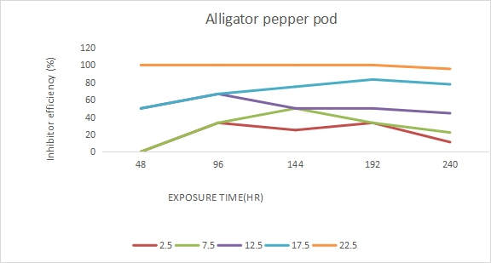

Figure 4.7: plot Inhibitor efficiency (%) with time and varying concentration of Alligator pepper extract

## Mango peel

Table 4.8: Inhibitor efficiency (%) with time and varying concentration of mango peel extract

|  |  |  |  |  |  |
| --- | --- | --- | --- | --- | --- |
|  | Inhibitor  efficiency (%) | Inhibitor  efficiency (%) | Inhibitor  efficiency (%) | Inhibitor  efficiency (%) | Inhibitor  efficiency (%) |
| at 2.5ml | at 7.5ml | at 12.5ml | at 17.5ml | at 22.5ml |
| concentration | concentration | concentration | concentration | concentration |
| 48 | 0 | 50 | 50 | 100 | 100 |
| 96 | 33.33333333 | 66.66666667 | 73.33333333 | 100 | 100 |
| 144 | 50 | 75 | 82.5 | 100 | 100 |
| 192 | 50 | 83.33333333 | 93.33333333 | 100 | 100 |
| 240 | 66.66666667 | 77.77777778 | 97.77777778 | 98.888 | 100 |

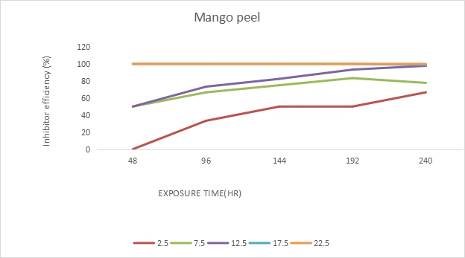

Figure 4.8 :Plot Inhibitor efficiency (%) with time and varying concentration of mango peel extract

## Banana peel

Table 4.9: Inhibitor efficiency with time and varying concentration of banana peel extract

|  |  |  |  |  |  |
| --- | --- | --- | --- | --- | --- |
|  | Inhibitor  efficiency (%) | Inhibitor  efficiency (%) | Inhibitor  efficiency (%) | Inhibitor  efficiency (%) | Inhibitor  efficiency (%) |
|  | at 2.5ml | at 7.5ml | at 12.5ml | at 17.5ml | at 22.5ml |
|  | concentration | concentration | concentration | concentration | concentration |
| 48 | 0 | 0 | 50 | 50 | 100 |
| 96 | 33.33333333 | 33.33333333 | 66.66666667 | 66.66666667 | 100 |
| 144 | 50 | 50 | 75 | 75 | 100 |
| 192 | 33.33333333 | 66.66666667 | 83.33333333 | 83.33333333 | 100 |
| 240 | 33.33333333 | 44.44444444 | 66.66666667 | 77.77777778 | 92.22222222 |

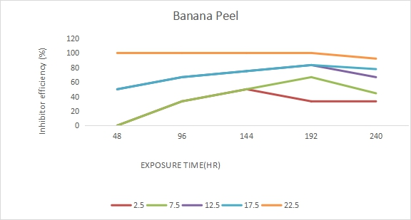

Figure 4.9: Plot of Inhibitor efficiency (%) with time and varying concentration of banana peel extract

* 1. Optimization and Statistical Analysis

In order to optimize the inhibition of corrosion of carbon steel in 1.5M HCl using Alligator pepper pods, mango peel and banana peel extract, the effect inhibitor extract concentration and immersion time on the inhibitor efficiency was investigated and optimized using Response Surface Methodology (RSM). A 13 run central composite design of experiment plan was generated and the results were analyzed and modelled using Design Experts 13 software. The factors were considered at two levels.

From the results of the modelling and statistical analysis, various models including linear, quadratic, 2FI and cubic were evaluated and a quadratic model was best described the process. Analysis of Variance (ANOVA) was used as a statistical analysis method to compare and evaluate the significance of the model and the model terms as seen in below.

#### Alligator pepper pod

The ANOVA result gives a F-value of 24.43 and a p-value of <0.0003 which shows that the model generated is significant hence the quadratic model represents the behaviour. A R-square value of 0.9313 was obtained which was considered high and indicates that the model shows good fit to the data. Values of “Prob>F” less than 0.0500 indicate the model terms are significant. In this case Concentration(A), Exposure time(B), AC, BC, A2 are significant model terms. These interactions between factors were suggested as major factors that affect the corrosion of carbon steel in 1.5M HCl using alligator pepper extract. In an effort to optimize the model, the desirability function of the RSM was selected as a valid criterion. An adequate precision value of 14.376 was obtained which implies that the model provides an adequate signal to noise ratio.

#### Table 4.10: ANOVA for Response Surface Quadratic Model

Source

sum of

df

Squares

Mean Square

F Value

P-value Prob > F

|  |  |  |  |  |  |  |
| --- | --- | --- | --- | --- | --- | --- |
| Model | 18666.36 | 5 | 3733.27 | 24.43 | 0.0003 | significant |
| A-concentration | 7026.3 | 1 | 7026.3 | 45.97 | 0.0003 |  |
| B-time | 5110.83 | 1 | 5110.83 | 33.44 | 0.0007 |  |
| AB | 2288 | 1 | 2288 | 14.97 | 0.0061 |  |
| A^2 | 1595.47 | 1 | 1595.47 | 10.44 | 0.0144 |  |
| B^2 | 3159.29 | 1 | 3159.29 | 20.67 | 0.0026 |  |
| Residual | 1069.84 | 7 | 152.83 |  |  |  |
| Lack of Fit | 1069.84 | 3 | 356.61 |  |  |  |
| Pure Error | 0 | 4 | 0 |  |  |  |
| Cor Total | 19736.2 | 12 |  |  |  |  |

D e s ig n - E xp e rt® S o ftw a re

in h ib itio n e ffic ie n c y D e s ig n P o in ts

1 0 0

0

X1 = A: c o n c e n tra tio n X2 = B : tim e

240.00

180.00

inhibition efficiency

120.00

B: time

60.00

0.00

0.00 5.63 11.25 16.88

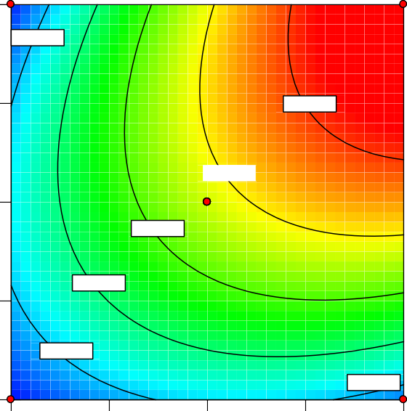

21.1839

94.3991

5

39.4877

21.1839

21.1839

57.7915

76.0953

22.50

A: concentration

#### Figure 4.10 Contour Plot of Inhibitor Concentration and time against Efficiency

Table 4.11: Model Optimization Values

|  |  |  |  |
| --- | --- | --- | --- |
|  | A-exposure time (hours) | B-Inhibitor concentration(ml) | Inhibitor Efficiency(%) |
| Natural Variables | 24**0** | 22.5 | 62.703 |

#### Mango peel

The ANOVA result gives a F-value of 18.95 and a p-value of <0.0006 which shows that the model generated is significant hence the quadratic model represents the behaviour. A R-square value of 0.9313 was obtained which was considered high and indicates that the model shows good fit to the data. Values of “Prob>F” less than 0.0500 indicate the model terms are significant. In this case Concentration(A), Exposure time(B), AC, BC, A2 are significant model terms. These interactions between factors were suggested as major factors that affect the

corrosion of carbon steel in 1.5M HCl using mango peel extract. In an effort to optimize the model, the desirability function of the RSM was selected as a valid criterion. An adequate precision value of 12.165 was obtained which implies that the model provides an adequate signal to noise ratio.

#### Table 4.12: ANOVA for Response Surface Quadratic Model ( Mango peel)

|  |  |  |  |  |  |  |
| --- | --- | --- | --- | --- | --- | --- |
| Source | Sum of Squares | df | Mean Square | F Value | P-value Prob > F |  |
| Model | 22760.3 | 5 | 4552.06 | 18.98 | 0.0006 | significant |
| A-concentration | 7285.53 | 1 | 7285.53 | 30.38 | 0.0009 |  |
| B-time | 7285.53 | 1 | 7285.53 | 30.38 | 0.0009 |  |
| AB | 2500 | 1 | 2500 | 10.42 | 0.0145 |  |
| A^2 | 3215.65 | 1 | 3215.65 | 13.41 | 0.0081 |  |
| B^2 | 3215.65 | 1 | 3215.65 | 13.41 | 0.0081 |  |
| Residual | 1678.93 | 7 | 239.85 |  |  |  |
| Lack of Fit | 1678.93 | 3 | 559.64 |  |  |  |
| Pure Error | 0 | 4 | 0 |  |  |  |
| Cor Total | 24439.23 | 12 |  |  |  |  |

D e s i g n - E xp e r t® S o ftw a r e i n h i b i ti o n e ffi c i e n c y

D e s i g n P o i n ts 1 0 0

0

X 1 = A : c o n c e n tr a ti o n X 2 = B : ti m e

240.00

180.00

inhibition efficiency

120.00

B: time

60.00

0.00

0.00

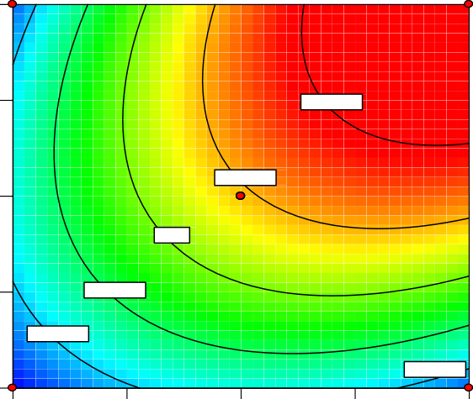

102.737

42.3816

22.2631

22.2631

5

82.6184

62.5

5.63 11.25 16.88

22.50

A: concentration

#### Figure 4.11 Contour Plot of Inhibitor Concentration and time against Efficiency

Table 4.13: Model Optimization Values

|  |  |  |  |
| --- | --- | --- | --- |
|  | A-exposure time (hours) | B-Inhibitor concentration(ml) | Inhibitor Efficiency(%) |
| Natural Variables | 24**0** | 22.5 | 83.4536 |

#### Banana peel

The ANOVA result gives a F-value of 31.73 and a p-value of <0.0001 which shows that the model generated is significant hence the quadratic model represents the behaviour. A R-square value of 0.9313 was obtained which was considered high and indicates that the model shows good fit to the data. Values of “Prob>F” less than 0.0500 indicate the model terms are significant. In this case Concentration(A), Exposure time(B), AC, BC, A2 are significant model terms. These interactions between factors were suggested as major factors that affect the corrosion of carbon steel in 1.5M HCl using banana peel extract. In an effort to optimize the

model, the desirability function of the RSM was selected as a valid criterion. An adequate precision value of 16.175 was obtained which implies that the model provides an adequate signal to noise ratio.

#### Table 4.14: ANOVA for Response Surface Quadratic Model

Source

Sum of

df

|  |  |  |  |  |  |  |
| --- | --- | --- | --- | --- | --- | --- |
|  | Squares |  | Square |  | Prob > F |  |
| Model | 16833.14 | 5 | 3366.63 | 31.76 | 0.0001 | significant |
| A-concentration | 6849.61 | 1 | 6849.61 | 64.61 | < 0.0001 |  |
| B-time | 2991.8 | 1 | 2991.8 | 28.22 | 0.0011 |  |
| AB | 2146.75 | 1 | 2146.75 | 20.25 | 0.0028 |  |
| A^2 | 863.34 | 1 | 863.34 | 8.14 | 0.0246 |  |
| B^2 | 4408.12 | 1 | 4408.12 | 41.58 | 0.0004 |  |
| Residual | 742.1 | 7 | 106.01 |  |  |  |
| Lack of Fit | 742.1 | 3 | 247.37 |  |  |  |
| Pure Error | 0 | 4 | 0 |  |  |  |
| Cor Total | 17575.24 | 12 |  |  |  |  |

Mean

F Value

P-value

D e s ig n - E xp e rt® S o ftw a re

in h ib itio n e ffic ie n c y D e s ig n P o in ts

1 0 0

0

X1 = A: c o n c e n tra tio n X2 = B : tim e

240.00

180.00

120.00

B: time

inhibition efficiency

60.00

0.00

0.00 5.63 11.25 16.88

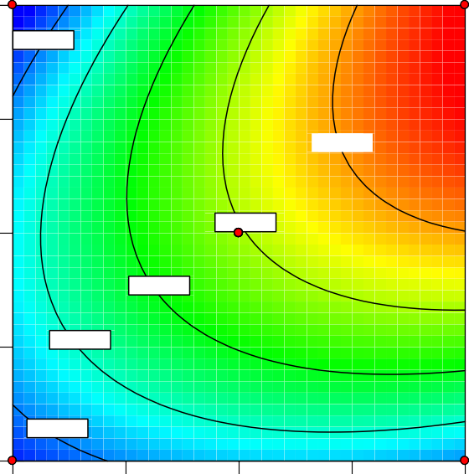

14.0554

7

14.0554

49.2103

656.787

31.6329

84.3651

22.50

A: concentration

#### Figure 4.12 Contour Plot of Inhibitor Concentration and time against Efficiency

Table 4.15: Model Optimization Values

|  |  |  |  |
| --- | --- | --- | --- |
|  | A-exposure time (hours) | B-Inhibitor concentration(ml) | Inhibitor Efficiency(%) |
| Natural Variables | 24**0** | 22.5 | 67.536 |

# CHAPTER FIVE

1. CONCLUSION AND RECOMMENDATION
   1. Conclusion

### The experimental results obtained in the present study can be summarized as follows alligator pepper pod, mango and banana peel extract acts as an inhibitor for carbon steel corrosion in 1.5M HCl solution but mango peel had the best result. The inhibition efficiency increased with increase in the concentration of inhibitor. The inhibition is due to the presence of some phytochemical constituents in the extracts which is adsorbed on the surface of the carbon steel. The present study provides new information on the inhibition characteristics of inhibitor under the specified conditions.

* 1. Recommendation

### This work was done in the Chemical engineering laboratory of Igbinedion University, Okada. During the course of the work, not all conditions were analysed such as temperature. I will recommend that the work be taken for further research using more conditions.

#### REFERENCES

Ahmed, A. A.-A. (2014). Inhibition of Mild Steel Corrosion in Sulfuric Acid Solution by New Schiff Base. 788.

Amitha, r. b. (2011, june 17). green inhibitors for corrosion protection of metals and alloys: an overview. Retrieved from [www.hindawi.com](http://www.hindawi.com/)

Chinaza, N. D. (2015). the study of the apparent activation energy and inhibition mechanism of an organic film forming inhibitor of the control of corrosion in an oil field environment. 44-46.

Contributors, W. (2019). *pitting corrosison.* Wikipedia, The Free Encyclopedia.

David, W. S. (2018). *The use of aframomum meleguata as a corrosion inhibitor on carbon steel in acidic medium.* warri.

Buchweishaija, I., &Mhinzi, G.S. (2008). Natural products as a source of environmentally friendly corrosion inhibitors: The case of gum exudates from Acacia seyalvar.Seyal. PortugaliaeElectrochimicaActa, 26 (3), 257-265.

Liu S, Xu N, Duan J, Zeng Z, Feng Z, Xiao R., 2019. Corrosion inhibition of carbon steel in tetra ntetra-n-butylammonium bromide aqueous solution by benzotriazole and Na3PO4. Corrosion science, Volume 6, pp. 1356-1363

Himipex.com. (2015). Metal perotection from hydrogen sulphide corrosion.

Houton, S. (2015, september 2). what are the factors that affect corrosion. Retrieved February 2, 2019, from enotes.com

James, F. (2012). Corrosion inhibitor. *autolab application note cor05*, part 5. KRPC. (2006). corrosion control and plant availability in krpc. 5.

Muhammad, M. M. (2017). *Corrosion of mild steel with organic inhibitor(rosemary plant extract) in salt water environment.* Edo state.

Oguzie, Z. O. (2013). Corrosion Inhibiting Effect of Aframomum melegueta extractand adsorption characteristics of the active constituent on mild steel in acidic media.

Sastri, V. (2011). *green corrosion ihibitor.* new jersey: John Wiley & Sons.

Gunasekaran, G., &Chauhan, L.R. (2004).Eco-friendly inhibitor for corrosion inhibition of mild steel in phosphoric acid medium.Electrochimical Act, 49(25), 4387-4395.

Inhibition of Mild Steel in HCl. Corrosion Prevention and Control,47 (2), 50-56.

Solomon Umukoro, A. C. (2011). Ttherapuetic effects of grain of paradise. In A. C. Solomon Umukoro, *nuts and seeds in health and disease prevention* (pp. 535-543).

Stephen, I. (2017, 3rd quater). Corrosion management in refinery.

Uwah, D. (2017). the multimedia corrosion guide. Retrieved from Cdcorrosion.com WRPC. (2017). WRPC Operation Manual. 22.

WRPC. (2019). Continous training system general module. *Warri refining and petrochemical company manual*, 2504.

WRPC. (2018). Mission Statement.