# EVALUATION OF THE IMPLEMENTATION OF SPECIAL EDUCATION CURRICULUM IN SPECIAL JUNIOR SECONDARY SCHOOLS IN PLATEAU STATE, NIGERIA

**BY**

**Nanjip, Wuyep DASHE**

**DEPARTMENT OF EDUCATIONAL FOUNDATIONS AND CURRICULUM, FACULTY OF EDUCATION,**

**AHMADU BELLO UNIVERSITY, ZARIA, NIGERIA**

**APRIL, 2021**

**EVALUATION OF THE IMPLEMENTATION OF SPECIAL EDUCATION CURRICULUM IN SPECIAL JUNIOR SECONDARY SCHOOLS IN PLATEAU STATE, NIGERIA**

**BY**

**Nanjip, Wuyep DASHE P15EDFC8064**

**A DISSERTATION SUBMITTED TO THE SCHOOL OF POSTGRADUATE STUDIES AHMADU BELLO UNIVERSITY IN PARTIAL FULFILLMENT OF THE REQUIREMENTS FOR THE AWARD OF MASTER DEGREE IN EDUCATION (CURRICULUM AND INSTRUCTION)**

**DEPARTMENT OF EDUCATIONAL FOUNDATIONS AND CURRICULUM, FACULTY OF EDUCATION,**

**AHMADU BELLO UNIVERSITY, ZARIA, NIGERIA**

**APRIL, 2021**

**DECLARATION**

I hereby declare that the work in the dissertation entitled “Evaluation of the Implementation of Special Education Curriculum (Programme) in Special Junior Secondary Schools in Plateau State, Nigeria” has been carried out by me in the Department of Educational Foundations and Curriculum, Faculty of Education, Ahmadu Bello University, Zaria. The information derived from the literature has been duly acknowledged in the text and a list of references provided. No part of this dissertation was previously presented for another degree or diploma at this or any other Institution.

**Nanjip Wuyep Dashe Date**

# P15EDFC8064

**CERTIFICATION**

This dissertation entitled “Evaluation of the Implementation of Special Education Curriculum (Programme) in Special Junior Secondary Schools in Plateau State, Nigeria” by Nanjip Wuyep Dashe meets the regulations governing the award of the degree of Master in Education (Curriculum and Instruction) of the Ahmadu Bello University, and is approved for its contribution to knowledge and literary presentation.

**Prof. (Mrs) H.O. Yusuf Date**

**Chairperson, Supervisory Committee**

**Prof. A. Guga Date**

**Member, Supervisory Committee**

**Dr. A.D. Aliyu Date**

**Head of Department**

**Educational Foundations and Curriculum**

**Prof. S. Abdullahi Date**

**Dean, School of Postgraduate Studies**

# DEDICATION

This dissertation is dedicated to my father, late Wuyep Dashe and my mother, Kapzir Dashe for their huge contributions in prayers and financial support.

# ACKNOWLEDGEMENTS

I acknowledge the endless effect of my first, supervisor Prof. (Mrs) H.O. Yusuf for her patience and endurance in checking and correcting this research work. Moreso, I acknowledge the contributions of my second supervisor, Prof. A. Guga who gave his time despite his tight schedule for vivid corrections even when he was not yet fully recovered from his pain of eye surgery to make this research work great.

I like to specially express my gratitude to Dr. M. I. Harbau (HOD, Educational Foundations and Curriculum) you are indeed a father of all, your fatherly advice, inspirations, leadership by humility, guidance is indeed great, Again, I want to thank and appreciate Dr. S.U. El- Yaqub, the royal father (Walikin Malaman, Zazzau) your skillful coaching and training to us, the postgraduate students in the art of research writing and seminar papers is what will ever remain memorable in my life. I sincerely acknowledge my lecturers and members of defence panel such as Prof. R.B. Bako, Dr.A.F. Mohammed, Dr. (Mrs) W.A. Ehinmdu, Dr.

A.M. Aminu and Prof. G. Sa‟ad for their contributions and criticism. Dr. (Mrs) H.Y. Audi, your wonderful criticism, motherly care is highly appreciated and noted.

To all mentioned here and not mentioned who have greatly contributed in one way or the other to the success of this research work and all the authors whose works have been cited or consulted in the course of this research work. I am grateful to you all.

# ABSTRACT

The study evaluated the implementations of Special Education Curriculum (Programme) in Special Junior Secondary Schools in Plateau State, Nigeria. To study the level of special education curriculum implementation, five research objectives were raised which were to evaluate, whether there are adequate provision of instructional materials, the teaching methods used in the implementation of special education curriculum, the qualification of teachers, the roles of parents of children with disabilities, the contribution of the host community in the implementation process. The study raised five research questions and five research hypotheses in line with the research objectives. Appropriate literature of both conceptual and theoretical frame work for the study was built on theory Context, Input, Process and Product (CIPP) model of curriculum evaluation. The research adopted descriptive survey research design which involved the use of questionnaire. The target population was four hundred and thirty six (436) while the sample population was two hundred and nineteen (219) made up of teachers and students. The research questionnaires were collected and analysed using two statistical tools, descriptive statistic and inferential statistic. At descriptive level, frequencies and simple percentage were used for the demographic characteristics of respondent while mean and standard deviation were used to answer the research questions. The hypotheses were subjected to chi-square statistical test. The outcome of hypotheses tested at 0.05 level of significance revealed that the five (5) null hypotheses were rejected. The study revealed that there are inadequate instructional materials in the schools, special teachers used the appropriate teaching methods in the implementation of special education. Parents of children with disabilities preferred to provide education to their children without disabilities; the host community supported the implementation of special education. The study recommended that the regular teachers should be encouraged for better service delivery through workshops, seminars and conferences, instructional materials be made available to special schools to cater for all categories of students living with disabilities, parent of children with disabilities should be sensitized on the causes of disabilities, benefit of special education and the right of a disabled child towards education because most parents especially the illiterate have negative attitudes towards the exceptional child. The community should know that giving education to the disabled is a right and not a privilege and they should get rid of rejection, stigmatization, stereotyping, and labeling towards persons with disabilities.

|  |  |  |
| --- | --- | --- |
| Title Page | **TABLE OF CONTENTS** | i |
| Declaration  Certification |  | ii  iii |
| Dedication |  | iv |
| Acknowledgements  Abstract |  | v  vii |
| Table of Contents |  | viii |
| List of Tables |  | ix |

# CHAPTER ONE: INTRODUCTION

* 1. Background to the Study 1
  2. Statement of the Problem 5
  3. Objectives of the Study 6
  4. Research Questions 6
  5. Hypotheses 7
  6. Significance of the Study 8
  7. Scope of the Study 11

CHAPTER TWO: REVIEW OF RELATED LITERATURE

* 1. Introduction 12
  2. Conceptual Framework 12
     1. Concept of Curriculum 12
     2. Curriculum needs for children with special needs 15
     3. Concept of Evaluation 19
     4. Concept of Implementation 20
     5. Concept of Special Education 23
     6. Attitudes towards Persons Living with Disabilities 37
     7. Attitude of Parents of Children with Disabilities 43
     8. Attitude of the Host Community toward Persons living with

Disabilities 47

* 1. Theoretical Framework 49
  2. Empirical studies 57
  3. Summary of Reviewed Relevant Literature 65

CHAPTER THREE: RESEARCH METHODOLOGY

* 1. Introduction 67
  2. Research Design 67
  3. Population of the Study 67
  4. Sample and Sampling Techniques 68
  5. Instrumentation 69
     1. Validity of the Instrument 70
     2. Pilot Study 70
     3. Reliability of the Instrument 70
  6. Procedure for Data Collection 71
  7. Procedure for Data Analysis 71

CHAPTER FOUR: RESULTS AND DISCUSSION

* 1. Introduction 72
  2. Demographic Data of Respondents 72
  3. Hypotheses 84
  4. Discussion of Findings 89

CHAPTER FIVE: SUMMARY, CONCLUSION AND RECOMMENDATIONS

* 1. Summary 93
  2. Conclusion 94
  3. Recommendations 94
  4. Contribution to Knowledge 95

References 96

Appendix A 103

Appendix B 108

Appendix C 112

Appendix D 118

**LIST OF TABLES**

|  |  |  |
| --- | --- | --- |
| Table 3.1 | The Study Population | 68 |
| Table 3.2 | Sample Size for the Study | 69 |
| Table 4.2.1: | Qualification of Respondents | 72 |
| Table 4.2.2:  Table 4.3 | Status of Respondents  Descriptive Statistics of Means Score and Standard Deviation on the Adequate Provision of Instructional Materials Used For the Implementation of Special Education Curriculum in Special  Junior Secondary Schools in Plateau State, Nigeria | 73  74 |
| Table 4.4 | Descriptive Statistics of Means Score and Standard Deviation on the Methods Used in the Implementation of Special Education Curriculum in Junior Secondary Schools in  Plateau State | 76 |
| Table 4.5: | Descriptive Statistics of Means Score and Standard Deviation  on the qualification of Teachers in the Implementation of |  |
|  | Special Education Curriculum in Special Junior Secondary  Schools in Plateau State | 78 |
| Table 4.6 | Descriptive Statistics of Means Score and Standard Deviation on the Role of Parents of Children with Disabilities  in the Implementation of Special Education Curriculum in the  Special Junior Secondary Schools in Plateau State | 80 |
| Table 4.7: | Descriptive Statistics of Means Score and Standard Deviation on the Contribution of the Host Community in the Implementation of Special Education Curriculum  in The Special Junior Secondary Schools in Plateau State | 82 |
| Table 4.8: | Chi-square Analysis on the Opinion of Students and Teachers |  |
|  | on the Adequate Provision of Instructional Materials used |  |
|  | in the Implementation of Special Education Curriculum in |  |

|  |  |  |
| --- | --- | --- |
|  | Special Junior Secondary Schools in Plateau State, Nigeria | 84 |
| Table 4.9: | Chi-Square Analysis on the Opinion of Students on the |  |
|  | Appropriate Methods used and the Inappropriate Methods |  |
|  | used in the Implementation of Special Education Curriculum |  |
|  | in Special Junior Secondary Schools in Plateau State, Nigeria | 85 |
| Table 4.10: | Chi-Square Analysis on the Opinion of Students on the |  |
|  | Appropriate Methods used and the Inappropriate Methods |  |
|  | used in the Implementation of Special Education Curriculum |  |
|  | in Special Junior Secondary Schools in Plateau State, Nigeria | 86 |
| Table 4.11: | Chi-Square Analysis on the Opinion of Students and Teachers  on the Role Parent of Children with Disabilities in the |  |
|  | Implementation of Special Education Curriculum in Special  Junior Secondary Schools in Plateau State, Nigeria | 87 |
| Table 4.12: | Chi-Square Analysis on the Opinion on the Contributions of Host |  |

Community in the Implementation of Special Education Curriculum in Special Junior Secondary Schools in

Plateau State, Nigeria 87

Table 4.13: Summary of the statistical analyses conducted to test the

five hypotheses formulated in chapter one of this research work. 88

**OPERATIONAL DEFINITION OF TERMS**

**Special Education:** education given to persons with special needs.

**Special School**: school that is especially designed for the education of children with special needs

**Inclusive Education:** placement of every child with mild, moderate and severe special needs in regular classroom as well as placement of normal

students in the special school.

**Disability:** loss of ability or loss of function such as difficulty in seeing, walking, etc

**Impairment:** abnormality/disorder of physical structure or organ of the body.

**Handicap:** the disadvantages of having impairment or disability

which prevent or hinder the impaired or disabled person from living a normal life.

**Beliefs:** what one accepts as true.

**Feelings:** individual emotions towards person with disability.

**Behaviours:** manners showed towards person with disability.

**Exceptional Children:** the gifted talented and handicapped children.

# CHAPTER ONE INTRODUCTION

## Background to the Study

Education liberates, raises class status regardless of one‟s family or home background. It makes someone economically buoyant, politically upgraded and socially adjusted. Education also is a tool for national development for every nation. However, the plight of the number of people living with disabilities is increasing especially in the developing countries. This is because high level of malnutrition, diseases, accident, crises and ignorance are persistent in developing countries. Nevertheless, it is obvious that disabilities exist throughout the world without respect for nationality, ethnicity, races, social status or cultural boundary. (Lere, 2007).

In Nigeria today, and elsewhere in the world, there are large numbers of children and adult who differ so markedly in mental, physical, emotional, sensory or behaviour characteristics from their normal peers as to require special help in realizing their optimum potentials. This has taken the form of provision to serve persons living with disability in regular classes of the school or provide instructions appropriate to their abilities if that served their needs more effectively.

Policies and programmes in special education close tie with the existence of man from time immemorial, cultural and religious beliefs are the current trends in the contemporary society. Historically, the roots of the field of special education and programme implementation could be traced to the beginning of human existence. They could be traced to the primitive time when human beings first became aware of those

whose appearance and behaviour differed significantly from what was typical of the majority. Those who were different were destroyed, tortured, exorcised, sterilized, ignored, exiled, and even considered divine. (Hewelt as cited in Lere, 2007). According to him, over the years, they have been pitied and cared for and given the benefit of education, they had to cope with survival in the world where the harshness of both nature and those around them threatened their very existence. By the estimation of people living with disability, there are about 600 million people with disabilities worldwide and two third of them live in developing countries, including Nigeria. According to the world benchmark, 10% of a country‟s population has disabilities. Based on Nigeria‟s current estimated population of 140 million, 14 million people have disabilities. (Quteng as cited in Lere, 2007, National Population Commission, 2006).

The declaration on the human rights of disabled persons by United Nations General Assembly made persons living with disabilities become functional, acceptable, and respectful as members of the society. Among the declaration on the right of disabled persons by the United Nations in year 1975 are;

* + 1. The term person living with disability means any person unable to ensure by himself or herself wholly or partly the necessities of a normal individual and/or social life as a result of a deficiency either congenital or not in his or her physical or mental capacities.
    2. Persons living with disability shall enjoy all the rights set forth in this declaration.

This right shall be granted to all disabled persons without distinction or discrimination on the basis of race, colour, sex, language, religion, political or

other opinions, national or social origin, state of wealth, birth or any other situation applied either to the disabled person himself or herself or to his or her family.

* + 1. Persons living with disability have the right to medical, psychological and functional treatment including, prosthetic and orthotic appliances, to medical and social rehabilitation, education and vocational education, training and rehabilitation and, counseling, placement services and other services which enable them to develop their capabilities and skills to the maximum and hasten the process of their social integration or reintegration.
    2. Persons living with disability have the right to economic and social security to their capabilities to ensure and retain employment or to engage in useful, productive and remunerative occupations and to join trade unions.
    3. Persons living with disability shall be protected against all forms of exploitation, all regulations and all treatment of a discriminatory, abusive or degrading nature.

The World Conference on Special Needs Education and network for action in access and quality, Salamanca, Spain 7 – 10 June, 1994, asserted that;

1. Every child has basic right to education.
2. Every child has unique characteristics, interest, abilities and learning needs.
3. Education services should take into account those diverse characteristics and needs.
4. The person with special needs must have access to regular schools.
5. Regular schools with an inclusion ethos are the most effective way to combat discriminatory attitudes, create welcoming and inclusive communities and achieve Education for All (EFA).
6. Federal, state and local governments shall fund these programmes within their area of jurisdiction.
7. Architectural designs of school buildings shall take into account the special needs of the handicapped.

There was earliest evidence available on legislation in Nigeria for provision of special education to persons with special needs. According to Brooke as cited in Lere and Yakwal, (2005) “education ordinance” which states that grants may be paid to local authority or an approved voluntary agency for among others, provide special education purpose which may come from time to time regarded as calling Financial Support. Additionally, the Lagos Education Act of 1957 was also devoted to special education. Article 61 of the Act clearly calls for provision for children requiring special needs education. Besides, the law of Northern Nigeria (Education Law NN43) gave Authority to the Minister to provide special schools for handicapped children to ensure an adequate supply of trained teachers by providing sufficient fund for their training. Again, the education law of western Nigeria cap 34 (1962) was enacted.

The universal primary education was introduced in 1977 where, it gave a legal status to the education of the handicapped in Nigeria. It gave the handicapped right to demand education along with non-handicapped, for the first time in Nigeria. History, government made a policy statement on special education and included it in the National Policy on Education (NPE) in 1977. In the revised 4th edition, section ten was devoted to special education (NPE, 2004). The policy documented a lot of promises with regards to the provision of appropriate education and relevant services to citizens with special needs in the country. Available records also revealed that the defunct Plateau State House of

Assembly under the then speaker Mr. D.G Shown, passed a bill in favour of special education in 1981 entitled „„Handicapped Education Law‟‟. More so, the Plateau State Rehabilitation laws of August 2001, and the Plateau State Disability and Community Integration Agency bill of 2003 were promulgated. Finally the bill to establish Plateau State, Indigenes with disabilities rights law was first presented from 1981 and passed into law in December 2005 24years later by Governor Joshua Dariye. The law makes provision for free education, free medication, rehabilitation, employment and civil rights for Plateau state indigenes with special needs (Lere and Yakwal, 2005, Unachukwu Ozoji, and Kolo 2016).

## Statement of the Problem

In an attempt to provide equal educational opportunities for persons living with disabilities, the educational sector globally has proffered solutions for their educational attainment by enacting laws and policies that can enable the disabled persons to restore to the fullest physical, mental, psychological, social, vocational and economic usefulness. As contained in the National Policy on Education (2014), and in line with the World Conference held at Salamanca in June 1994 at Spain, by 2015, special education might have fully been implemented at all levels of education among the nations and Nigeria is one of the nations that signed the agreement. (UNESCO, 2005).

The study therefore sought to ascertain whether children with special needs in the Special Junior Secondary Schools have access to special education or not. The study examined adequacy of assistive technology, instructional materials; educational qualification of teachers, and the role of parents and the host community in the implementation of special education programmes.

## Objectives of the Study

The study was guided by the following objectives; To

1. find out whether there are adequate provision of instructional materials used for the implementation of special education curriculum in Special Junior Secondary Schools in Plateau State, Nigeria;
2. examine the teaching methods used in the implementation of special education curriculum in Special Junior Secondary Schools in Plateau State, Nigeria;
3. determine the qualification of teachers used in the implementation of special education curriculum in Special Junior Secondary Schools in Plateau State, Nigeria;
4. examine the roles of parents of children with disabilities in the implementation of special education in Special Junior Secondary Schools in Plateau, Nigeria;
5. find out the contributions of host community in the implementation of special education curriculum in Special Junior Secondary Schools in Plateau, Nigeria;

## Research Questions

The following research questions were raised in the study;

1. How adequate is the provision of instructional materials used in the implementation of special education curriculum in Special Junior Secondary Schools in Plateau State Nigeria?
2. What are the teaching methods used in the implementation of special education curriculum in Special Junior Secondary Schools in Plateau State, Nigeria?
3. What are the qualifications of teachers used in the implementation of special education curriculum in Special Junior Secondary Schools in Plateau State, Nigeria?
4. What are the roles of parents of children with disabilities in the implementation of special education curriculum in Special Junior Secondary Schools in Plateau, Nigeria?
5. What are the contributions of the host community in the implementation of special education curriculum in Special Junior Secondary School Plateau, Nigeria?

## Hypotheses

The following hypotheses were formulated to be tested at Alfa value of 0.05 significant levels.

H01 There is no significant difference in the adequate provision of instructional materials used in the implementation of special education curriculum in Special Junior Secondary Schools in Plateau State, Nigeria;

H02 There is no significant difference in the appropriateness of methods used in the implementation of special education curriculum in Special Junior Secondary Schools in Plateau State, Nigeria;

H03 There is no significant difference in the qualification of teachers used in the implementation of special education curriculum in Special Junior Secondary Schools in Plateau State, Nigeria;

H04 There is no significant difference in the roles of parents of children with disabilities in the implementation of special education curriculum in Special Junior Secondary Schools in Plateau, Nigeria;

H05 There is no significant difference in the contributions of host community in the implementation of special education curriculum in Special Junior Secondary Schools in Plateau. Nigeria.

## Significance of the Study

The findings of this research work would be of immense benefit to students, teachers, ministry of education and SUBEB, institutions of higher learning, educational planners, parent/communities, legislative bodies and national associations: Students can directly benefit from this study because any designed curriculum is for the consumption of the learners first and at large to the society. Students as part of the curriculum implementation, must have their areas of needs and dislikes as factual information to curriculum planners. Students also from this study would know what the parents, community, teachers and government are supposed to do for them for their educational attainment as a right. Low self esteem among students with special needs will reduce drastically and the disabled students can also form students‟ Union Associations to pursue education with all vigor. Being it a law inclusiveness as a law and a right in special schools and regular schools will reduce discriminatory attitudes in schools and in the communities. It is the right of children with special needs to compete with the so-called normal students from all fields of endeavors.

Teachers would benefit greatly from this research findings as they are directly involved in implementing educational programmes in our school system. This could challenge them to work in line with the national/international goals/objectives of inclusion (special education) by making sure that they accommodate all children without segregation.

It would also awaken special teachers to hold on to their responsibilities in educating special students that cannot receive education in the normal class with regular students.

From this research finding also, state school boards would benefit immensely from the outcome of this research work as they may use some of the information obtained in this research work to address specific and general problems facing the implementation of special education curriculum in the state. Areas such as provision of instructional materials, facilities, buildings/structures, emphasis on training teachers in the field of special education and organizing workshops seminars, conferences among others can be effectively addressed. More so, the findings also would benefit teachers training institutions like Colleges of Education, Faculties and Institutes of Education in various universities in Nigeria to draw out practical approaches for training and re-training of teachers in terms of content coverage, pedagogies Information and Communication Technologies. (ICT) and other contemporary approaches in the field of special education.

Curriculum planners such as Nigeria Research and Development Council (NERDC), National Teachers Institute (NT1), National Commission for Colleges of Education (NCCE), National Board for Technical Education (NBTE), National University Commission (NUC), would be attracted by this research findings as an evaluative means for them or by deeply carrying the evaluation at all stages to ensure the success of the implementation of special education curricula.

This research finding would also help the parents of children with disabilities and the communities with the provision and support for the implementation of special education. It would help them to have positive attitudes towards persons with disabilities

and to also help them to know that there is ability in disability and that persons living with disabilities can still maintain normal standards of living, raise families and contribute immensely towards the progress of the community if given opportunities in education. Effective implementation of special needs education, requires the role of parent. Apart from the need of feeding, clothing medical care and education, parents must meet certain responsibilities which also involve psychological needs of the child. Parents of special needs children are expected to make necessary contacts with specialists such as physicians, special educators, counselors, optometrists, audiologists, social workers and other personnel in training, assessment and treatment of children with special needs. The research would also help parents of children with special needs to know that the children have fundamental rights to life and requires consistent love so that they should not develop feeling law/rejection or low self-esteem.

In addition government policies and programmes can come through bills, edicts, and legislative discussions. The members of the legislative house of the local government, state house of assembly, federal houses of representative and the senate, can acquire relevant information from the findings so as to make them formulate laws for the implementation of special education programmes. The enforcement of the rights of persons living with disabilities by lawmakers will make the implementation of special education successful.

The various National Associations for the disabled would benefit from the research work by initiating more ideas leading to programme implementation. They can press on the government to come up with certain programmes and services for the welfare and well being of their members. These associations include National Association for Learning

disabilities, National Association of the deaf, National Association of the Blind, National Association of the physically impaired, and National Association of Autistic children.

## Scope of the Study

The study evaluated the implementation of special education curriculum (programme) in Special Junior Secondary Schools in Plateau State, Nigeria. The study investigated, teachers and students, this is because they are both agents of curriculum implementation. The study particularly investigated JSS 2. This is because they have already had knowledge of the state of things in the school. The study looked into the following variables; adequate provision of instructional materials, teaching methodology, teachers‟ qualification, the roles of parents and the roles of host community towards the implementation of special education curriculum. It is hoped that the findings of this study will fill the gap created by other researchers.

# CHAPTER TWO

**REVIEW OF RELATED LITERATURE**

## Introduction

This chapter focuses on reviewing relevant literature such as conceptual frame work and theoretical frame work, under the following headings; Conceptual framework, Concept of Curriculum, Concept of evaluation, Concept of Implementation, Concept of special education, Attitude of parents towards implementation of special education curriculum, attitude of the community towards the implementation of special curriculum in Plateau state, empirical studies and summary.

## Conceptual Framework

## Concept of Curriculum

Every country in the world today has its curriculum and some countries today are more advanced in a number of ways than others. This depends on the type of curriculum they designed based on their national education policy. What is contained in a curriculum of every society heavily depends on norms, values, cultures, traditions, needs and interests of the society. The concept of curriculum viewed by some authorities is based on traditional and progressive perspectives.

Curriculum according to Walton as cited in Yunusa (2008) defined curriculum as that content and those processes designed to bring about learning of educational value. Curriculum is viewed by Doll as cited in Yusuf (2012), as the formal and informal content and process by which learners gain knowledge and understanding, develop skills and alter attitudes, appreciations and values under the auspices of the school. According to Hass as cited in Izang (2013), defined curriculum as the experiences that all individual learners have in a program of education whose purpose is to achieve broad goals and related specific

objective. Walton as cited in Yunusa (2008), said that curriculum is the programme of activities designed so that pupils will attain by learning certain specific aims and objectives. Also Izang (2013), defined curriculum as a preconceived intention or mapped out plans of all learner activities deliberately chosen and directed by the school which students follow to reach predetermined goals. In another development Akpale (2010), viewed curriculum as the planned and unplanned educational experiences in which both students and teachers work for the attainment of educational goals. Grundy (2007) viewed curriculum as a programme of activities designed so that pupils will attain as far as possible certain educational and other schooling objectives. In the same vain Oliva as cited in Yusuf (2012) defined curriculum as a plan or programme of all the experiences that the learner encounters under the direction of the school. Tanner and Tanner as cited in Yusuf (2012) posited that curriculum is a plan or programme of all experiences which the learner encounters under the direction of a school.

While Alexander as cited in Yusuf (2012), defined curriculum as a planned programme of learning opportunities aimed at achieving board goals and related objectives. Jenkin defined a curriculum as all the activities, experiences, situations, and conditions which the School select and organize Systematically to bring about positive changes in the individuals so that they will become morally strong, physically fit, emotionally stable, mentally sound, and socially amiable. Beside Moreno (2006) Defined a curriculum as that document geared towards achieving the goals, the aspiration and desire needs of the society. Hass (2007) pointed out that, a school curriculum includes all of the experiences that an individual learners have in a program of education whose purpose is to achieve abroad goals and related specific objective. In addition Bolaji (2007) A curriculum is referred to as those activities carefully selected to improve learners well being with the teachers as directing the

live action of children. Kelly (2009) Views curriculum as the totally of learning experience provided to student so that they can attain general skills and knowledge of different varieties. Often Akpale (2011) views curriculum as planned and unplanned educational experiences in which both students and teachers all works for the attainment of educational goals.

## Types of Curriculum

* + - 1. Overt/ Explicit or written curriculum:- it is that type of curriculum which is written as part of formal instruction of schooling experience. It may refer to a curriculum document, text or supportive materials that are chosen to support the instructional agenda of a school
      2. Curriculum in use:- it comprises those things in textbooks, content and concepts in distinct curriculum guides. The curriculum-in use is the actual curriculum that is delivered and presented by each teacher.
      3. Rhetorical Curriculum:- This is the type of curriculum that comprises of ideas offered by policy makers, school officials, administrators, or politicians. The Rhetorical Curriculum may also come from the publicized works offering updates on pedagogical knowledge.
      4. Concomitant Curriculum: - This is the type of curriculum that emphases on what is taught at home, that are part of family experiences, church or mosque, moral training that moulds pupils character.
      5. Platform Curriculum:- Is the curriculum when messages that are prevailing in and taught through exposure of media.
      6. Social Curriculum:- It is defined as the massive, ongoing, informal curriculum of family, peer groups, neighborhood, Churches, organizations, occupations, mass media and other socializing forces that educate all of us throughout our lives.
      7. Intended Curriculum:-This is the recommended, adopted and official curriculum.

The curriculum serves as document map of theories, beliefs and intentions about schooling, teaching, learning and knowledge evidence in the development of Teacher proof curriculum.

* + - 1. Received Curriculum: - Are those things that students actually take out of classroom. Those concepts that are truly learned and remembered.
      2. Null Curriculum: - This Curriculum concerned with that which we do not teach, thus giving students the message that these element are not important in their educational experiences in our society.
      3. Hidden Curriculum:- it is seen as the non- academic but educational significant component of the schooling. Examples are sequential room arrangement, timed segment, an annual schedule that is still arranged to accommodate an agrarian ages disciplined messages, competition for grades among students. (Izang 2013, Yusuf, 2015)

## Curriculum needs for children with special needs

Children with special needs are entitled to the formal curriculum of the society. This means that what the school teaches should be made available to them as a right, no matter how difficulty this may be for the school to achieve. However, there are additional curriculum contents that are in addition to the ones open to all learners including

themselves. For example the study of sign language as a curriculum content is only limited to those with hearing impairment. The former is regular or general while the later is additional or extra or unique to children with special needs. A child with visual impairment should learn English language (regular curriculum) in addition, he should study Braille which is addition to the regular curriculum. This is part of what is called unique curriculum for children with visual impairment. It is unique because only such children need it in order to access the society. A balanced education of these children must include the regular and the unique. Provision of one and the exclusion of the other renders the education of children with special needs hollow, inadequate, incomplete, and of limited practical value to them. (Unachukwu Ozoji and Kolo 2016).

Children with special needs by right should be access to education. In education, the concept of access is often limited to school enrolment, retention and graduation. If there are obstacles on the way to this equal participation all special provisions essential to benefit from the opportunity are not available, these are removed or provided so that no one is disadvantaged in the process. Barriers to curriculum achievement are professionally treated while adequate preparation of learners to face the world beyond the school is vigorously pursued. Access to education means adopting ways in which educational institutions and policies ensure that student have equal and equitable opportunities to take full advantage of their education, (Kolo, 2015) when these conditions are not met, access is denied. This is what Kalu (2014) refers to as dysfunction which refers to a situation in which people are excluded from meaningful learning.

In provision of education for children with visual impairment a device called Braille grade one is used where words are brailed by letters used for beginners. The Braille grade

includes contractions in which certain letters are used for words. There are Braille for music, Braille for Maths, and Braille for sciences e.t.c. Another training for the visual impaired is called orientation and mobility. Orientation is the mental map that people have of their surroundings and there are topics of instructions for children with visual impairment (Smith, 2007). Assistive technology for their education are closed-circuit television, optical aids, Magnifiers, talking calculators, slate and stylus, Abacus e.t.c.

Devices for educating children with mental retardation includes Hughes video sonic machine, Litton industrial communicator system, programmed text, diagnostic and statistical manual of mental disorder –iv (DSM-IV) and AAMR. The AAMR has different views on how intellectual disability should be measured with reference level of intelligence quotient.

Methods for teaching disabled students are Drilled and practice, tutorial, games assimilation. Neuro developmental observation (NDO) and universal design for learning are devices used for learning problems (Lere, 2009). Number race and graphogame are methods for teaching Dyscalculia students, class-white peer tutoring (CWPT) is a method used in teaching children with emotional and behavioral disorders. For Autism attitudinazation and step by step sub-objectives base methodology are used for their instructions.

Assistive technologies for educational needs for the gifted and talented are Gifted Student Service Plan (GSSP), Primary Talent Pool (PTP), and Omnibus Personality Inventory (OPI). To a large extent, most gifted and talented children are very creative with their possession of the following characteristics; great power of imagination, resourcefulness, curiosity, originality, aesthetics and sense of wonder. They therefore

produce work that has freshness, vitality and uniqueness attached to it. They usually solve problems by ingenious methods that are original in one or more areas. They always ask many provocative questions in an effort to know how things work, they explore things and situations in an investigative manner. These characteristics are quite comprehensive and if they are properly organized can serve as a checklist of traits that can be used in the identification of the gifted and talented children.

According to Adima as cited in Jatau, Uzo and Lere (2016) highly gifted children hardly succeed in the traditional classroom system where everything done is on routine basis. Such children thrive better outside regimented environment. Some of them who are forced to identify themselves with this type of environment eventually drop out of school. Glaring examples of such children were Einstein who was considered a withdrawn and low starter, Edison whose IQ was estimated at 81, Rogers who in his school days was labeled a behavioral problem boy, Adolph Hittler who was a school dropout, Bill Gate who was a drop out and who eventually invented Microsoft which made the computer what it is today, John Stuart Mill was said to have written the history of Rome at the age of 6 years. Some authorities like Lombroso cited in Jatau, Uzo and Lere (2016) said that such an achievement was a marked aberration from the normal and akin to other mental aberrations. Highly gifted children are assets of incalculable value and therefore need to be assisted to accept learning as a motivating challenge in regular schools while efforts are made to teach them through the method of monitoring

Curriculum therefore in its broad sense is a set of courses offered in a school setting derived from the needs and aspirations of the society which has opened doors for learners

who have potential abilities, talents and gifts guided by teachers for students to achieve their needs and interests which will bring positive impact to the society at large.

## Concept of Evaluation

Goals are set and plans and programmes are made to achieve the targeted goals in our lives been it individual plans, organizations or government enterprises. It is through evaluation that are determined whether our set goals are achieved or not. Evaluation also helps us to identify strengths and weaknesses of a programme. Evaluation is a special strategy used by educators to check or judge the academic progress made by the students.

Yusuf (2015) defines evaluation as the systematic process of identifying assembling or gathering data and making value judgment about such data to determine the merit, worth and significance of a curriculum. Cronback as cited in Yanusa (2008) defined evaluation as the collection and use of information to make decisions about the educational programme. More so, Lewy as cited in Izang (2013) contended that evaluation is the provision of information for the sake of facilitating decision making at various stages of curriculum development. Ugodulunwa (2008) defined evaluation as the process of making value judgment about the worth of a thing. It includes obtaining information for judging the worth of a programme, products, procedure or objective in education. Tyler cited in Yusuf (2015) defines evaluation as a process to determine the extent to which instructional objectives are actually being realized. Besides, Amadi and Obafuna as cited in Izang (2013) said that evaluation is the process of obtaining information about a programme for such decisions as whether to continue, change, modify, improve or terminate the programme. Garba as cited in Izang (2013) viewed evaluation as the systematic collection of evidence to determine whether in fact certain changes are taking place in the learners as

well as to determine the amount or degree of change in individual students. According to Ayala (2009) evaluation is a systematic process of determining the extent to which instructional objectives are achieved by students.

## Concept of Implementation

It is one thing to plan a programme and another thing to implement it. Programme implementation is as important as the programme itself otherwise it will make no meaning. Curriculum well designed can only be of relevance if it is properly implemented. Izang (2013) defined curriculum implementation as the execution or the putting into effect of curriculum plans and programmes. Damar (2005), viewed curriculum implementation as a trying out stage or putting into effect curriculum plans. It is a stage where the teacher and the learners are involved in negotiation aimed at promoting learning.

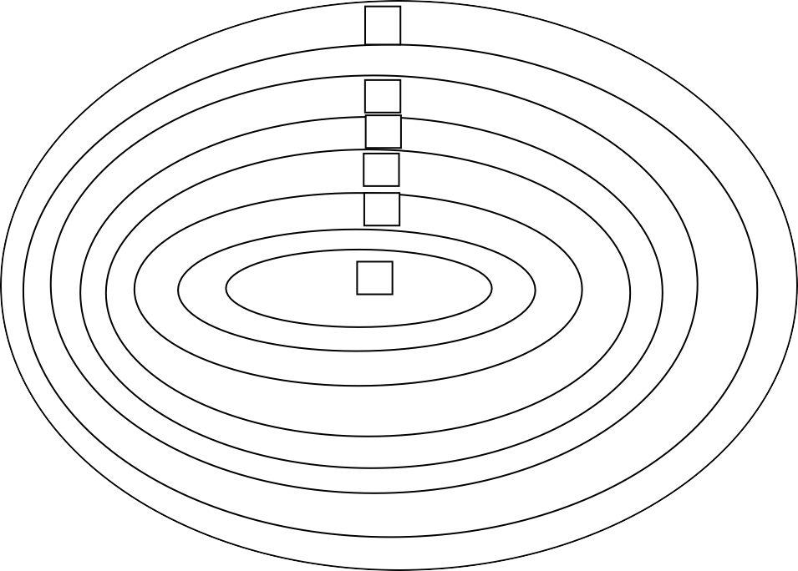

7

5

4

3

2

1

6

* + - 1. Conception
      2. Planning
      3. Section/ development of objective
      4. Trying out
      5. Revision
      6. Generalization
      7. Monitoring

A model of curriculum implementation

Curriculum implementation is a continuous process which starts with conception stage and ends up with monitoring stage.

1. Conception stage: This starts in the minds of people about certain things that need changes e.g government professionals etc.
2. Planning: Is the preparation of a set of decisions on the subject matter content etc.
3. Selection/Development of objectives, contents, materials and methods, clearly stated objectives will assist the implementer to determine the direction or nature of the implementation.
4. Try out: This is the small scale trial of the curriculum or programme.
5. Revision: In this stage, modification of the original text by the designer and implementer based on field trial is done.
6. Generation stage: This is large scale implementation of the curriculum plan in all the schools.
7. Monitoring/quality control: This is the evaluation of the different levels in order to determine the efficacy of the programme (Esu, Enukoha and Umoren as cited in Izang, 2013)

For a successful implementation of special education policy, teachers‟ competencies in this field are of utmost importance. Hence teachers need training about special education principles and the basics of disability to ensure that their attitudes and approaches do not prevent disabled children from gaining equal access to the curriculum. Implementation of special education needs very careful planning, more funding, training and re-training of both specially trained teachers and the regular teacher (Timothy, 2014).

Umar (2002) asserted that those teachers who are not professionally trained will make any system fail. More so, Oladele (2008) said that availability of infrastructural facilities is very crucial in order to achieve desired outcomes in teaching and learning of

persons with special needs. The Federal Government of Nigeria (FGN) (2014) advocated that only qualified and trained qualitative teachers will teach in order to ascertain these successfully desired in the policy implementation. As supported by Kassim (2008) only preferable teachers are to teach in the programmes of special education in Nigeria in order to enhance rapid progress and government at all levels must ensure that only qualified, qualitative and trained personnel are to monitor the progress.

Ozoji (2009) lamented that some aspects of the curriculum are not implemented either because of incompetence of teachers or absence of the enabling assistive technologies or both. More so, Ekpiwre (2014) posits that no matter what educational system, mandates and/or expectation in the end, effective teaching is very much dependent on the will and competence of the teacher. Teaching children with special needs calls for extra care, patience, diligence, commitment, emotional balance and understanding on the part of the teacher. The teacher must also be able to absorb shock and emotional crisis associated with teaching this category of children. It is imperative that preparation of teachers that will cater for children with special needs be emphasized in our teacher producing institutions since Okoli (2011) advised teachers of inclusive education to ensure that no child is left behind.

More so, for the teacher to succeed in his task, he must be practical, plan adequately set realistic goals and must consider the peculiar learning needs of each child in the class in the course of teaching. He must have been exposed to the nature and demands of the special needs children during his days in school as students or through workshops seminars or conferences. (Akinola, 2008). For teaching is a noble profession.

On a contrary , Ipadaela and James (2007) stated that the idea of bringing all children especially the school age children together in one environment to learn, either with a view to eliminate, discriminate, reduce cost or to give the special needs children a sense of belonging is a mirage. The communication between regular and special education Teacher appears to be further strengthened through the operation of a resource room. The consultation and cooperation between them could be very instructive to both. The special needs person seems to benefit the most, for it enables him/her to reap the social (e.g bolstered self-image which could serve as reducing virtue) and educational (e.g satisfaction of his unique educational needs) benefit of education in the inclusive setting (Ihanacho, 2010). Beside, Nkangwung and Adeyemi (2002) said that infrastructure and facilities in regular schools are not designed to meet the needs of children with disabilities. Implementation therefore is a process of effecting the broad aims and objectives of a programme. It needs the availability of instructional materials, teachers‟ qualification, and infrastructural facilities among others.

## Concept of Special Education

In a typical classroom situation, there are different categories of learners. We have exceptional, average and slow learners. Apart from the intellectual abilities, we have those that are disadvantaged or disabled either physically, socially, emotionally or mentally retarded as such they cannot cope with the regular curriculum and so they need additional curriculum to make them understand regular curriculum content wherever it is possible. This calls for special education as a concept.

Lere (2007) viewed special education as those additional services over, and above the regular school programmes that are provided for exceptional children to assist in the

development of their potentialities and/or amelioration of their disabilities. Nigerian Educational Research and Development Council (NERDC) (2014), defines special education as a customized educational programme, designed to meet the unique needs of persons with special needs that the general education programme cannot cater for. More so, special education is defined as „„the education of children and adults who have learning difficulties because of some handicaps such as blindness, partial sightedness, deafness, hard of hearing, mental retardation, social maladjustment, physical handicap etc. due to circumstances of birth, inheritance, mental and physical health pattern, accident in later life; or specially gifted and talented children who are intellectually precocious and find themselves insufficiently challenged by the programme of the normal school and who may take to stubbornness and apathy in resistance to it. (FRN 2014) Beside, Heward and Orlanksy as cited in Lere (2007) said that special education is designed to respond to the unique characteristics of children who have needs that cannot be met by the regular school instructional programming and practices. This means that special education is individually planned, systematically and carefully evaluated instruction to help exceptional learners achieve the greatest possible personal self-sufficiency and success in present and future environments. In another attempt, Ozoji (2005), viewed special education as a system of education which is an important aspect of and can be found within the operations of regular education, its focus is the exceptional child while the focus of regular education is the normal child. It can be seen that without special education, regular education may be likely unprepared to provide education for the exceptional child/handicapped and gifted. Inclusive education calls for a closer regular and special teacher for team work in teaching special needs children in the regular school.

Rogers et al as cited in Okeke (2007) describe special education as an area within the framework of general education that provides.

* + - 1. Appropriates facilities
      2. Specialized materials
      3. Teachers with specialized training for children considered handicapped.
      4. Clientele.

Ibang (2005) sees special education as education for special people, the handicapped and the disabled. She further said that special education should be given in regular neighbourhood schools by any well trained regular class teacher. The Special Education Review Committee (SERC) as cited by Nation Council for Curriculum and Assessment (NCCA) (2015), defined special education as any educational provision which is designed to cater for pupils with special educational needs and in addition to or different from the provision which is generally made in ordinary classes for pupils of the same age. Furthermore, Public law 91 – 230, section 906 of the United States of America as cited in Ozoji (2007) defines gifted and talented children as those defined by professionally qualified persons, by virtue of outstanding abilities capable of high performance. These children require different educational programmes and services normally provided by the regular school programmes in order to realize their contributions to themselves and the society. Kolo (2015) said that special education refers to specialized teaching, learning, psycho-educational services, training and research meant to enable individuals with disabilities or exceptional conditions to maximize their capacities for life endeavors to the fullest. Beside, Timothy (2014) said that special needs education in Nigeria is still

grappling with problems of policy implementation, an environment that is not conducive for practice and a lackadaisical attitude of the people and government.

Special education according to Obasi as cited in Unachukwu Ozoji, and Kolo (2015) said that special education refers to special teaching, learning, psycho educational services, training and research meant to enable individuals with disabilities or exceptional conditions to maximize their capabilities for life endeavors to the fullest. Special education means the individually planned and systematically monitored arrangement of physical setting special equipment and material, teaching procedures and often interventions designed to help exceptional children achieve the greatest possible self-sufficiency and academic success (Heward & Oriansky as cited in Lere (2005).

## Specialness of Special Education

1. Appropriate facilities
2. Appropriate materials
3. Special methods
4. Special teachers
5. The clientele

Special education is an appropriately determined educational sub-system with in- built aspects for prevention and or reduction of obvious learning problem or for accelerating obvious learning assets. (Lere, 2005). Special education is used to indicate those aspects of education which apply to handicapped and gifted children and comprise modifications of or additions to school practices intended for the ordinary child, practices that are unique, uncommon, of unusual quality and in particular are in addition to the organization and instructional procedure used with majority of students. (Kirk as cited in

Ozoji 2008). Hewett and Forness as cited in Mawaida (2008) defined special education as those aspects of good education that regular educators do not worry about as such or that may be over looked in a typical classroom.

More so, special education is an individualized application of techniques, procedures, instructional materials and equipment designed to accommodate to unusual forms or rates of cognitive, affective and motor status or development to sensory, deprivation, to lack of earliest schooling, to ineffective earlier instruction, or to any personal or environmental conditions that stand in the way of a broad and thorough education. (Reynolds and Birch as cited in Ozoji 2008).

Bessa as cited in Mawaida (2008) defined special education as a programme of education that is oriented and designed to provide an environment that makes it possible for the handicapped to grow and learn to the best potential to which they are capable. Lere (2007) defined special education as a specially designed instruction that meets the unique needs of a student with disability. Kirk and Gallagher as cited in Lere (2007) described special education as any form of education specially designed for exceptional children. National Policy on Education (2014) defined gifted and talented children as „„there are specially gifted children who are intellectually precocious and find themselves insufficiently challenged by the programme of the normal school and who may take to stubbornness and apathy in resistance to it.

Special education can be defined as a specialized educational and training service meant to enable persons with disabilities or potentials to achieve their educational and rehabilitative capacities in life endeavous (Unachukwa, Ozoji and Kolo, 2016). Kanu (2008) said special education is the education given to those generally referred to as

exceptional persons and they comprise of children, youth, adults with one form of disability or learning difficulty or the other. Besides, it is the one who deviates from the ordinary child such that he/she requires special attention, special services and area that could make life meaningful and worth living, those who require special educational service in order to benefit from the regular curriculum. (Akuogibo and Dada cited in Nwachukwu, 2006). Faudai (2010) sees the special needs child as one who deviates from the ordinary child such that he/she requires attention, special services and other area that could make life more meaningful and worth living.

## Rationale of Special Educational as a Discipline and Profession

In talking about rationale (why) of special education, as cited in Unachukwu, Ozoji, and Kolo (2010) one is actually concerned with such questions as: on what ground do we provide special education?: What is the logic or reason for providing special education?: is special education actually necessary in the first instance?; Do exceptional children basically have a right to education? etc. The main rationale or justification for Special Education as supplementary and pedagogical approach that is additional to Regular Education includes the following:

## Enhancing Educational opportunities for the Un-served, Underserved and Neglected

Based on the dictum that development in every nation is strongly determined by the level and quality of education provided for the citizens, all Governments make efforts to be seen to provide equal educational opportunities to everybody, irrespective of their socio-economic, location or human status. Most often in especially developing countries, disadvantaged groups like people in rural areas or urban slums, poor families, people with

disabilities, etc., are mostly missed out in efforts meant to provide adequate, appropriate and quality education in the larger society. A key rationale for Special Education, therefore, is to underscore educational opportunities for exceptional persons and people with disabilities as underserved or neglected group.

## Ensuring Equity in Access to Education for All

Since the 1990 Jumtien Declaration on Education for All – EFA, even subsequent universal United Nations declarations for national development agenda (Salamanca Declaration on Special Needs and Inclusive Education: Millennium Development Goals- MDGs ; and the Sustainable Development Goals –SDGs) have emphasized ensuring equity in ensuring Education for every Citizen, irrespective of the status of their human development abilities. As the human group making up those with exceptional or limited human development capacities. Special Education is justifiably regarded as most imperative for people with disabilities; otherwise known as Exceptional Persons.

## Maximizing Human Resource and Human Capital Education

Education for all means Education for all citizens, notwithstanding who they are. And all citizens of every nation is the whole population; inclusive of those with disabilities (those experiencing all forms of handicaps or developmental deficits in life endeavours – the visual people living with handicap; communication and behavioural disorder; etc). Special Education, therefore, has a strong justification in the utility value of education as strategy for maximizing human resource and human capital development.

## Ensuring that everyone counts in Educational Endeavours

Even in developed countries with advanced Education Sectors, challenges come up from time to time in respect of every one benefiting in specific educational programmes meant to reach every citizen. Special Education therefore has a rational as a specific effort in the Education Sector means to reach out to every citizen who must count.

## The National Policy on Education Specification

The National Policy on Education (1981) indicated that the important aspect of the universal primary education (UPE) is that „„special arrangement must be made for the handicapped and exceptional learners‟‟. The UBE was initially intended to be compulsory for all Nigeria children (including exceptional children). One may conclude that the special child deserves education on the basis of the official government education policy.

## National Policy on Education Mandate on Special Education:

The Nigerian National Policy on Education directed in 2004 that „„inclusive education or integration of special classes and units into ordinary/public schools under the UBE schools should be implemented in order to ensure the special needs child has easy access to education. Thus there is official government rationale for the provision of special education. (Federal Republic of Nigeria, FRN, 2004).

Ozoji (2006) maintained that philosophy of inclusive education is not only meant for regular schools but also for special schools. Inclusive education came because of the excluding life of the disabled person in the society. A word that summaries the condition of

disabled is exclusion while inclusive means together (Ozoji, 2006) In the same vein, Mani (2006) maintained that inclusive is not a programme but an ideology.

## The United Nations Specification

The United Nations in 1948 stated that “everyone has the right to education. This shall be given free at least in the elementary and primary grades”. Similarly, the Nigerian Constitution says that every Nigeria is equal before the laws of the land. It noted that „„no citizen of Nigeria shall be subjected to any disability or deprivation merely by reason of the circumstance of his birth‟‟. There is therefore a legal basis for providing special education.

## Equality of Opportunity

The preceding discussion may be summarized in one phrase: “equality of opportunities”. This means that every Nigeria (including the exceptional child) has equal access to the rights and responsibility of citizenship. This implies that what is done for some people (e.g education) must be done for others with special learning needs (special education). Therefore special education is provided as a right of the exceptional child.

## To work is a Right not a privilege

This means that everyone has a right to be prepared for work and the usual means to do this is education. When this is achieved, it makes everybody equal receivers from and contributors to nation building. It follows that not to provide special education is to openly deny exceptional learners the opportunity to be prepared for work. This implies that they will be only receivers but not contributors. It is unfair to allow this to happen.

## The Contribution of Gifted learners

Gifted and talented children can contribute significantly to nation building. They grow to become future problem solvers, inventing new ideas and technology. No country can afford to toy with educating such citizens. To do so is to be ever dependent on other nations that have educated and trained their gifted and talented citizens. Special education of the gifted is important for the above reasons.

## Not on Religious Basis

Some have justified the provision of special education purely on religious (humanitarian) ground. It is assumed that special learners are suffering and therefore need to be pitied and provided special education as a privilege. This rationale should be condemned. In these days of science and technology, global economic recession, every citizen regardless of status, physical/mental appearance should be given an opportunity to make his or her contribution toward a better nation. Special learners are capable of making useful contribution to this country and that is why special education should be considered a right (not a privilege) for them. (Unachukwu Ozoji and Kolo, 2016).

## Goals/Purpose of Special Education

To provide appropriate education for exceptional persons:

Exceptional Persons are individuals whose ability or capacity potentials are unrealized or limited by circumstances of life or personal conditions of life which hinder their full achievements in life endeavours. People with disabilities and gifted and talented persons are such individuals whose ability or capacity potentials can be unrealizable or

limited by such life conditions or misunderstanding of their circumstance. One of the key goals of Special Education is to provide the appropriate type of Education (Special) that would meet the challenges to their learning and training potentials and limited abilities. Hence, teaching the child with severe visual disability to read by Braille, teaching the child with severe hearing disability to communicate by sign language and total communication; helping the child with severe intellectual retardation to learn self help skills by ability sub- skills the methodologies; etc. are educational approaches which are utilized to achieve the purpose of Special Education.

## Explore and develop the potentials of persons with disabilities:

All persons with disabilities irrespective of the extent of their disability condition do have some potentials to learn or acquire certain skills in life. One of the key goals of special education is to enable people with disabilities realize to the extent possible, their residual potentials.

## Nurture Self Reliance Skills in People with disabilities:

One of the main purposes of Education in any form or style is to make the individual self reliant by being useful to the self. Special education aims at making all people with disabilities self reliant.

## Ensure the contribution of Exceptional persons of social development:

Exceptional persons or person with Disabilities obviously have the capacity to contribute to societal development, in a way that does not become liabilities on society. A

key Goal of Special Education is to nurture the abilities and capacities of Exceptional persons for contribution to societal development (Kolo, 1997).

## Reduction of drop-out rate in schools

With inclusive education regime, many children now have access to regular education, unlike before when such access was limited only to special residential schools. The provision of special education in regular schools now means that struggling learners will be assisted to stay rather than drop-out.

## Economic Gains

The economics of education in special education shows that there are economic gain arising from promotion of the education of exceptional children. For instance, for one naira spent on educating the exceptional child, government reaps two to five times in return. When the exceptional child is adequately educated and rehabilitated and obtains employment, he/she pays tax to the government. If he is self-employed, he reduces unemployment in the country including for those he would train later. (Nigeria Education Research and Development Council - NERDC, 2010).

## Philosophy of Special Education

The philosophical thrust of special education is that every child deserves to be educated as a right no matter what. Specifically, the following are the philosophical bases of special education as pointed out by Ozoji (2003).

1. Universal and basic education for every exceptional children irrespective of the severity of organ dysfunction or level of development or the precocity of

intellectual performance. The field came into being to initiate, stress and implement this mandate to the letter.

1. Special education believes in the educatibility of all learners irrespective of degree of development. The issue of ineducability has no place in special education.
2. Special education believes that special needs children should be educated within the regular school community. Any other form of segregated education must be defended, rationalized and justified. It purses this mandate through the principle of zero demission.
3. Special education believes that the value and worth of any child is not diminished by impairment no matter its severity. Exceptional child is full-fledged human being, equal in status, value and worth compared to his peers.
4. Special education believes in equality for its clients to available opportunities in the society.
5. Special education believes in the philosophy of „„catch them young‟‟. That is why special education starts as soon as soon as a child is detected to have special needs and it pursue this mandate through the early intervention programme. (Salend and Duhaney, 2008). In inclusive class, the regular teacher teaches with the special teacher for the overall benefit of all children including children with special needs. For regular teachers to perform this expected role, they must be exposed to elements of special education. Exposure of regular teachers to special education is critically expedient for the under listed reasons.
   1. To appreciate the enrollment of special need children in the regular schools without frowning that they should be taken to special schools.
   2. To ensure that these children are full members of their classrooms. Full membership means being valued and appreciated by their teachers and socially accepted by their peers.
   3. To know that globally inclusive educations is the most current educational programme for these children in which regular teachers are actively involved in their education.
   4. To learn about regular curriculum adaptation, accommodation and modification including unique curriculum for special needs children.
   5. To identify services and assistive devices required to support the education for the children.
   6. To identify children with gifts and talents for enhanced, accelerated and enriched instruction that meet their learning needs and styles.
   7. To develop and properly use special education terms in line with current lexicon in the field.
   8. To develop the needed scientific beliefs and attitudes about and towards children with special needs. Stereotypic understanding of the children which may negatively influence teachers in instructing the children will be held in check.
   9. To understand planned work within the inclusive ethos of the school.
   10. To inculcate the principles and practice of advocacy and volunteerism in the education of the children.
   11. Salamanca 1994 declaration asked governments to ensure that both initial and in – service teacher training address the provision of inclusive (special) education. (Unachukwu Ozoji and Kolo, 2016).

Special education therefore is the type of education given to persons living with disabilities, the disadvantaged, gifted and talented either in a regular school, special school or home-care wherever they are capable.

## Attitudes towards Persons Living With Disabilities

The status of persons with disabilities is mediated by attitudes of people that surround them. Proper management of attitude issues may mean happiness for the persons with disabilities. The veteran deaf blind American genius: Keller Hellen once said „„Not blindness but the attitudes of the society towards blindness that is greatest burden to bear‟‟ (Ozoji, 2008). More so, Jones cited in Mawaida (2008), admits that we have indeed witnessed a considerable shift to legislation affecting handicapped persons in recent years but the battle is far from won. A critical obstacle remains attitudinal barriers. The real barrier to special education is not lack of money but attitudes.

Marfo as cited in Mawaida (2008) explained that attitude often prevent the family from seeking assistance or from following recommended interventions, bridging gap of a lienation between persons with disabilities and able bodies persons requires attitudinal change among individuals and society as a whole.

In special education, attitude means an individual‟s predisposition respond either verbally or behaviourally, positively or negatively towards persons with disabilities. Attitude in human expression in made up to (3) interrelated components. These are beliefs, feelings and behavior. Attitude manifest in an individual when he or she forms an opinion (Beliefs). A belief (refers to what one accepts as true about the object i.e diable) gives a mark to one‟s attitude towards people with disabilities e.g Alms giving is the best way of making persons with disabilities happy. Attitude refers to feeling (affective) tendency of individual to behave towards an object on the basis of what belief one has about that object. Feeling is derived from one‟s belief about the object (Kassim, 2008). Ozoji (2008), opined that „„one main reason for studying attitude is that they enable us to predict behaviour‟‟ He identified the following types/forms of attitude.

## Protectionism

The protective attitude are those that predispose the society to think that persons with disabilities have problems of such magnitude that only carefully designed programmes can best address them e.g special schools.

## Hostility

Hostile attitude manifest in feeling and behavior that directly or indirectly mistreat, deny or discriminate against persons with disabilities.

## Indifference, Neutral Continuum (Sit on a Fence)

The „„I don‟t care attitude‟‟ is as worst as being hostile to the person with disability. The person knows what to do but chooses to with hold it may be because he/she does not believe the disabled has a case.

## Ambivalence (Confused About what to do)

A conflict exists in the mind of some Nigerians about what they wish to do and what they do not wish to do for persons with disabilities. This attitude is mostly expressed by professionals in special education who may have conflicts with what they learnt about disabled and what the society strongly feels and does to persons with disabilities Government is guilty of ambivalence for her inconsistencies between expressed policies for persons with disabilities and what is actually does for persons with disabilities.

## Positive Attitude

This resolve is an expression on favourable attitude towards persons with disabilities such an attitude may mean understanding the disabled as they are not as they ought to be, sympathizing and accepting them such attitudes and actions blocked rather than more verbiage about how nice to treat persons with disabilities. According to Gani cited in Ozoji (2008), the attitudes of the society towards the disabled are classified into 4 groups.

* + - 1. Send them to beg
      2. I am ashamed of you
      3. It is not my business
      4. Something has to be done.

## Common Beliefs about Impairment and the Disabled

* + - * 1. Disability is a sign of course to the family
        2. It is God‟s will that disabled person should beg
        3. Blind people move around through the assistance of the spirits
        4. Impairment is contagious
        5. Eating and Drinking with the blind will make one blind as well.
        6. Disable persons are feared as witches
        7. They are believed to see the mind of others
        8. They are second raced individual
        9. Impairment is a bad omen (Ozoji, 2008)

## Ways of creating handicaps to persons with disabilities by the society. Attitude:

Through negative attitude of the society, creates additional handicaps by outright rejection, intellectual disregard, stigmatization, limitation of Job opportunities etc.

## Attribution

The behavior of the disabled is a cue to others to infer, its possible cause. This inference is called attribution and could be disposition (based solely on the disabled person‟s beliefs, attitudes personality characteristics) or Situation base on factors outside the disable, such as strong social norms. We take the behavior of the disabled out its face value and speedily Jump to the disposition of the disabled while discounting situational factors. This bias has the potency of creating further social distance.

## Impression Formation

Way of perceiving is derived from the major structures of the disabled, which are mostly the damaged organs. There is a bias in our tendency to perceive another person mostly in the direct on of one particular trait we like or dislike. Unhealthy impressions are about the disabled are formed on the basis of the damaged organs and the primacy effect of these impressions further create additional handicaps for the disabled.

## Labeling

The bias in labeling is that the disabled are known and addressed more by the label than by their real name, nature and ability. Labels hide one‟s ability and slama stigma on the person. Labeling leads to additional handicaps.

## Spreading the effect of disability

The society believes that impairment (damaged little portion of the physique) is the damage of the whole physique. Thus a visually impaired person is also auditory, socially, intellectually impaired. It is no longer localized but diffused in the person. A disabled body is also a disabled mind.

## Expectations

These refer to particular behaviours or competencies anticipated of group members. A perceived behavior is often expected of the disabled for instance, he is expected to be overly grateful for whatever the society provides him. The additional handicap here is that we set lower levels in order to arouse lower level of performance from the disabled.

## Stereotypes

These refer to over simplified and often generalized false beliefs about a group of people. Most people believe that every disabled person is a beggar. Here lies the additional handicap.

## Prejudice

Prejudice conveys intense hatred or dislike for a group the basis of which cannot be verified. Prejudices are often firmly fixed, often not open to free or rational discussion and most often resistant to change.

## Connotative meaning associated with disability

Two sets of inference can be drawn here. The denotative meaning (primary meaning) of a person with disability is one who has loss of ability in some defined area of endeavour. Connotative meaning (emotional meaning) which suggests so many stereotypes and prejudices about these people. The bias here is putting aside the primary meaning of disability and giving undue attention to its connotative meaning. This creates additional handicaps.

## Standard specification

The society is made up of majority of non-disabled and minority disabled persons usually, the majority determines and sets the standards in all the fields of endeavour and expects everyone to meet these standards individual unable to meet these standards (including the disabled) are perceived to be different (labeled) and accordingly treated.

## Attitude change

Attitude change according to Johnson and Matros cited in Ozoji (2008) said that it means „„the acquisition, reversal or intensification of an attitude‟‟ Formation of an attitude is integral of change in attitudes, as individuals acquire new experiences and information. One‟s beliefs affect one‟s attitudes and that the behavior dispositions can be altered by breaking the negative belief According to Towner as cited in Ozoji, (2008) said that attitude can be changed through:

1. Contact with the attitude object in an educational setting
2. Discussion and active participation
3. Role – playing a disabling condition
4. Persuasive message
5. Information with contact
6. Vicarious experience
7. Systematic desensitization
8. Positive reinforcement.

## Attitude of Parents of Children with disabilities

Child rearing practices differ across cultures, religious, beliefs and social class. Abang, (2005) said that the family reaction to a child with a disability will depend on their cultural beliefs about disability, their level of education and knowledge about disability and socio-economic background.

Education of children is generally neglected in the developing countries especially where there are high level of illiteracy and poverty. This view is summarized in the words of Gabrielle Mistral, children nobel prizewinning poet. He states „„we are guilty of many errors and many faults. But our worst crime is abandoning the children, neglecting the fountain of life. Many things we need can wait: The child cannot. Right now is the time his bones are being formed, his blood is being made and his senses are being developed to him we cannot answer tomorrow his name is today” (Okeke, 2007:pp99).

Parents no doubt, have a vital role to play in the education of their children irrespective of disabilities. The home or the family is the first socializing agency in a Child‟s life. Learning takes place as soon as the child is born. The parents of the child,

therefore are the child‟s first teacher and can provide intellectual stimulation and emotional well being. The development of self-concept, self-esteem and interest in literacy all depends on the support and encouragement parents provide within the home.

Educating exceptional children is an uphill task for parents due to poverty. Some parents who can afford education for their exceptional children deny them that opportunity on the ground that it is a waste of resources. Thus the mother of a fifteen – year - old child said. “What use is it to have children when you have this kind/ what good are they? They change your life and personality. You become flat. They take everything from you and give nothing in return. They tie you down and there is no one to help you. It takes a lot of you. You become a machine. Everything has to be done in a routine order to train them. It is not just doing the same thing over and over, it is that there‟s so little progress to show for the effort‟‟. (Okeke, 2007:pp105).

The words „„they take everything from you and give nothing in return‟‟… the researcher suspects, is the feeling of most parents who deny exceptional persons education. There is no doubt that education liberates, it can brighten one‟s future. The discovery of impairment in a member of the family especially the child could be very traumatic in the sense that the child will be delivered normal and goes through the developmental milestone much like any other member of the family. Though children develop differently, because of individual differences, there comes a time in life of the child that the parents begin to suspect suspicion. If diagnosis confirms presence of impairment (i.e some form of damage of the sensory apparatus) leading to confirmed developmental arrest, the parents are divested.

Recounted experiences of some parents on confirmation to them of the impairment (such as autism spectrum disorder, blindness or deafness in their children) “I was divested, so confused and had heart break‟‟. Another parent confessed that „„she felt as if a big sack was pulled down over the head, blocking the ability to see, hear and think in normal ways‟‟. Yet another parent described the trauma „„as if having a knife struck in her heart‟‟. (Smith, 2008:pp88).

Shem Mbaka Suchia, an exceptional person from Kenya, aptly summarized the difficulty associated with gaining access to education and what education does for an individual. He writes „„many are the disabled whose futures could have been brighter if they were given access to education. Because they are denied it, they now live miserable lives. Few are the schools catering for disabled people and even they, are poorly equipped and so expensive that only those well-to-do families can afford it. There is a great need for equal opportunities for the disabled‟‟. (Okeke, 2007:pp203).

Different bodies, agencies and persons have advocated equal educational opportunities for exceptional children. In Nigeria, it has even assumed the status of a policy statement, it is therefore not in existence. The problem is translating the policy statement into practice. The implementation stages hits the rock (Okeke, 2007). It is an objective that special education should be pursued to its logical conclusion given the transformatory effect of education on individuals. Parents should ensure that their exceptional children are educated since this seems to be a major dimension in the possibilities available for exceptional person‟s improvement and self reliance.

Exceptional persons who were given educational opportunity showed that disability is not inability. Below are some examples.

* + - 1. Roosevelt, one time president of the United States of America, governed and led the nation through many victorious wars while on a wheel chair.
      2. Appius Claudius though blind, governed the Roman Republic in the third Republic and inaugurated various reforms which raised the standard of living of the Lebeans in Rome.
      3. Louis Braille of France was the one who perfected the embossed system of writing.
      4. Helen Keller, though blind and deaf wrote several text books. (Okeke, 2007).

Duties of parents towards their exceptional children are:

1. Assurance of the maintenance of an individualized education programme for their exceptional children.
2. Guarantee of complete due procedural safeguard
3. Special education services for their children
4. Non-discriminatory behavior
5. Protection and vocational education (Okeke, 2007).

Eyiuche (2006), states that for the curriculum to be successfully implemented, it needs the involvement of parents. In addition, Ozoji, (2008) said that education programme for parents of exceptional children who require skills, competencies and attitudes to better attend to their children. He also said that in Multidisciplinary approach parents and a whole range of professionals are involved in Assessment, decision-making, planning and implementation of appropriate educational programmes for the child. He further said that

parents must be involved in all aspects of their children education needs. Hardman et al as cited in Kassim (2008), argued that each team member must clearly understands his roles and responsibilities in the team. If parents know their roles and responsibilities and fulfill them, it will bring a huge success.

Unachukwu, Ozoji and Kolo, (2016) said that parents positive perception of their children with disabilities highly influences their children‟s perception of school which in turn positively contributes to children‟s academic, social and emotional learning.

The fear of the Unknown about the child, the “expectation frustration” about the child, the guilt associated with the delivering a child with impairment, the shock and disbelief, the mourning for the „„perfect‟‟ child with impairment, the grief the depression, the recrimination, the bitterness, the resentment, the anger and shame are most of the reactions that parents often experience about the child with impairment. However, there are some parents who do not go through most of the experiences above. They easily accept the child as he/she is without any prolonged unhelpful emotional outburst. Many of these crises are arised because of parents‟ status in the extended family, the attitudes of the society towards deviants and society‟s normalcy consciousness and the parents desire to feel they belong to the community in all respects.

## Attitude of the Host Community toward Persons living with Disabilities

It is obvious that disabilities exist throughout the world without respect for nationality, ethnic, religion social status or cultural boundary. The history of the treatment of persons with disabilities has been one of ignorance and isolation. Andzayi, (2012) discussed the attitude of the society worldwide towards persons with disabilities among are.

Among the Dahomeans of West Africa, it is a singular fact that children born with anomalous, physical characteristic are held to be under the guardianship of special supernatural agents, some of the children are destined to bring good luck and signs from the supernatural that determine the fate of others. In addition, Among the Balinese, Sexual relation with albinos, idiots, lepers are in general, the sick and the deformed is a taboo. Among the Moori of New Zealand, deformed persons meet with little sympathy and often receive a castigating nick names. Between the Jukin, a Sudaese Kingdom, deformed children are not allowed to live, but are left to perish in the bush or in a cave for it is believed that such children are gotten by an evil spirit.

Abang cited in Ozoji (2006) claims that the Greeks abandoned their disabled babies on the hillside to die while early Chinese left their disabled people to drown in rivers. Europe, Nero Commodious is said to have targeted bow and arrows on physically disabled individuals. Coleridge cited in Ozoji (2008) traces through history the killing of people with disabilities, beginning with the Spartans who killed disabled persons as a matter of law; the endorsement by martin Luther to kill disable babies because they were incarnations of the Devils; the English eugenicists who eliminated disabled people under the Darwinian evolution theory of the „Survival of the fittest‟, and the Nazi Euthanasia programme under Hitler to exterminate disable people as they could not make any contribution to society. Ezera, Ezenea Ozoji and Abednego (2006), said that no programme in itself can deliver appropriate services without the enabling support system from the community.

The societal attitude towards persons with disabilities in developed communities is changing positively compare to developing countries MCconkey and O Toole as cited in

Kassim (2008) said that in developing countries, people with handicapping conditions are yet victimized by neglect, superstition, stereotyping and exploitation. Again, Create (2006) said that in African communities, father deny being the father of the child with disability or blame mother for giving birth to a child with disability. To the educated and the employed people, they keep the children indoor or pay someone to look after the children with disabilities. Parents hold negative misconceptions about the special needs child. The most grievous problem is the unfavourable attitudes of society toward special education, Handicapped people complain loudly that their greatest problem on earth is the uneducated attitudes of the society towards them. The way the society talks, feels and treats the handicapped leaves much to be desired, constrict rather than dilate the life space of the handicapped.

## Theoretical Framework

Theories are very important in the understanding of concept used in education, they are carefully selected in line with the topics. Therefore the study selected Context, Input Process and Product (CIPP) model of curriculum evaluation. The CIPP model was developed by Guba and Stufflebeam as cited in Muhammed (2018). It is an evaluation framework to serve policy makers who are faced with four different kinds of decisions. In this case the study endeavored to examine the overall impact of the implementation of the programme. In essence, Context, Input, Process and Product will evaluate carefully. As Galvin as cited in Fwangle (2018). Notes, the CIPP is decision – oriented and it focuses on providing information to decision makers. He listed some advantages of the CIPP Model to include: practicality, effectiveness, efficiency, comprehensiveness, balance and usability. In carrying out an evaluation study according to Ten and Broton, (2010), the evaluator is

expected to identify the objectives of the evaluation, the areas or variables to be evaluated, design valid instruments to collect data, and analyze the data before decision is made base on the results. The purpose of this study was evaluates the implementation of Special Education Curriculum (Programme) in Special Junior Secondary Schools in Plateau State. Therefore, the CIPP Model was adopted for the study and to provide information as to how the products are being explained by the Context, Inputs, Process and Product. The CIPP Model provides a plan to structure the type of data which will be collected and the kind of questions raised. The variables of the study are: Context Variables: Students, teachers, Teacher qualifications, Teacher experiences, Input variables: Availability of facilities and equipment, adequacy of facilities and equipment, availability and adequacy of teachers. Process Variables: Strategies for implementing Special Education programme of students with special needs and the attitudes of the government, parent and community to the implementation of the curriculum.

The CIPP Model is represented schematically in Fig.1.1 below

Input

Process

Context

Product

(Sowell as cited in Fwangle, 2018)

Fig.1: Evaluation Model

The explanation of CIPP model in Fig.1.1

## Context variables

Context variables for this study involved students with special needs which are the bases for special education. There are various categories of students with special needs but they

are generally classified as disabled, disadvantaged, and gifted and talented students. They need special education so as to develop their potentialities. Teachers are also found under context variables. The importance of teachers in curriculum implementation cannot be overstressed. In handling students with disabilities, it calls for specialists, patience, endurance, experience and hard work for teaching is a noble profession.

## Input variables

For proper implementation of special education, it needs availability and adequacy of appropriate facilities such as modernized buildings and structures, special materials such as Braille, universal design for learning, special teaching methods, special teachers as well as the clientele.

## Process

Process identifies strategies for implementing special education. It needs the support of parents, community, and government among others for the blueprint to be translated into reality.

## Product

At this level of the model, comparism is made between intended out comes and the actual outcomes so as to make judgment as to continue, terminate or modify. Here it tells us whether students with special needs are benefiting from the program or not and what should be done for effective result to yield.

This model informed the conceptual framework for this study and this is presented in Fig.

1.2 below

1. Environment students/ Teachers

1. Students’

achievement

1. Teaching

strategies

1. Problems of Implementati on

Product

1. Facilities and Equipment
   * Availability
   * Adequacy
2. Teachers

Input

Context

Process

(Stufflebean and Guba as cited in Tukur 2018)

Fig. 2: theoretical frame work for the evaluation of special education curriculum The explanation of CIPP model in Fig 2:

## The Context

Here, the environment to implement the programme is defined, it describes the actual and intended conditions of the programme, identify unmet needs and diagnosing barriers that prevent needs from being met. Is the environment appropriate for students with special needs to achieve the broad goals and specific objectives of the programme? The greatest barrier for the successful implementation of special education is the attitude of the teachers, parents, community and government towards persons living with disabilities. Positive attitudes of teachers teaching special students will lead to the achievement of the set objectives.

## Input

Input determines to what extend available resources were used to achieve curriculum objectives. Are the resources available and adequate? Are the personnel qualified for the task of implementing the curriculum? Are there enough facilities to determine the extent to which the resources and equipment are utilized. In special schools or inclusive education, the buildings and structures should not be a barrier to special students so that they can use wheel chair, mobility cane without any difficulty. Appropriate materials such as Hughes video-sonic teaching machine, Diagnostic and statistical manual of mental disorder -iv, number race, slate and stylus, magnifiers, closed-circuit television be made available and adequate. More so they should be intenerate teachers to serve as counsellors to regular teachers who are handling special students. Seminars and workshops should be organized for regular teachers to acquire and update their knowledge on special education.

## Process

This stage lay emphasis on various teaching methods used for different categories of special needs students such as Drill and practice, class-wide peer tutoring, step by step sub-objectives base methodology, sign language, Games and simulation e.t.c. the stage also identifies deficiencies in the implementation of the programme.

## Product

This is the level in which the aims and objectives of the programme are emphasized. Do the students achieve the intended objectives? If the objectives are not realized then the judgment will be made as to modify or terminate the programme.

Yusuf (2015) further gave a highlight on the C1PP procedure as: the context evaluation level identifies both the purpose for the determination of objectives and unmet needs and hypothesize reason they are unmet. There is also a definition of the curriculum environment as: who, what and why. The input provides instructional materials to determine how to utilize goals and objectives analyses resources and experiences to be used to meet goals and make comparism with alternative programmes and strategies.

The process level, Yusuf (2015) maintained that it predicts defects in the procedural design of its implementations during the implementation stage and also provides information for programmed decisions and maintains a record of the procedures as it occurs.

And the product level provides formative and summative data .and make rational interpretations on the basis of the recorded context, input and process information.

This can be summarized as thus:

Fig. 3: Context, Input, Process and Product (CIPP) Stufflebeam model of curriculum evaluation.

Process Evaluation

Input Evaluation

Context Evaluation

Product Evaluation

|  |  |  |  |
| --- | --- | --- | --- |
| Planning | Structuring | Implementing | Recycling |
| Decisions | Decisions | Decisions | Decisions |

(Stufflebean and Guba as cited in Tukur 2018)

## Explanation of Fig 1.3 CIPP Model of Curriculum Evaluation Context Evaluation

Here, the curriculum is engaged in planning and decisions making. It also provides

a rationale for selections of objectives. According to Yusuf (2015) opined that context evaluation is a continuous process for finishing baseline information for the operations of the total system. It is the most basic kind of evaluation that defines the relevant environment. Identifies unmet needs and unused opportunities from being used. The diagnosis of problem enables the evaluator to formulate objectives where achievement will result in programme improvement. This sheds light on what to be done for person living with disabilities to be economically reliable, educationally balance and socially fit.

## Input Evaluation

This type of evaluation provides information for determining how to utilize available resources to achieve the objectives of the programme. The resources required for any programme include human and material resources. Input evaluation involves determining the following:

1. Provide information for determining how to utilize resources to achieve the objectives
2. The potential strategies for achieving programme objectives identified through context evaluation
3. Design for implementing selected strategy

Pophan in Guga (2009), asserted that input evaluation helps decision makers to select and design procedures considered suitable for promoting the achievement of

programme objectives. Special education needs logical decisions in formulating objectives, designing programme and the strategies for achieving the objectives.

## Process Evaluation

This type of evaluation provides periodic feedback about the programme in use.

Process evaluation has three main purposes which includes;

1. To detect or predict defects in the procedural design or in implementation during the curriculum stages
2. To provide information for programme decisions
3. It maintains a record of procedures as it occurs

Process evaluation according to Fwangle (2015), said that it helps to monitor the actual procedure in education in order to help educational decision makers anticipate and overcome the procedure difficulties. Special education progrmme needs constant evaluation at all stages of its implementation for it is a difficult programme that deals with different categories of disabilities that also requires individualised education programmes and services.

## Product Evaluation

This form of evaluation seeks to measure and interpret attainment of as often as necessary in the process of the programme and the concluding stage i.e it provides formative and summative data. Product evolution according Yusuf (2015), makes rational interpretation on the bases of recorded context, input and process information.

The CIPP model provide a general framework for this study which sought to evaluation the environment of the persons with special needs (context), the human and material resources in the implementation of the programme (input), the strategies of

teaching and learning children with disabilities (process) and the effect of the curriculum on the learners (product).

## Empirical studies

Maiwada (2008) carried out a case study comprising of two schools reform efforts in the United States of America. The aim of the study was to see how the process of inclusive education worked for Special Education Needs (SEN) and whether the students and their teachers felt integrated in the school reform. The research design was descriptive survey design. The population of the study comprised all teachers in studied area. A sample of 410 subjects, 205 male teachers and 205 female teachers was selected for the study using random sampling technique. Instrument used for data collection for the study was a questionnaire designed by the researcher. Frequency counts and percentages were used to answer the research questions. The findings revealed that changes in school organization, climate, curriculum and instructional strategies build on the strengths of students, staff and community to bring about optional learning results for all students. The study is related to the present study as it was conducted on inclusive (special education) and it adopted descriptive survey like the present study. However, the study was carried out in United States of America and the present study is in Plateau state. Also, the respondents were drawn from teachers alone but the present study embraced from teachers and students as respondents.

Uche & Onuigbo (2008) carried out a study on strategies for meeting the challenges of quality early childhood education of special needs. The study was guided by five research questions and adopted a descriptive survey design. The sample consisted of 47 professional childhood educators, educational psychologists and educators drawn from tertiary institutions in Enugu State. Questionnaire was developed for data collection. The data collected were analysed using mean and standard deviation. The findings of the study showed that all teachers that are involved in special education must undertake training in early childhood education with a minimum certificate of NCE. The finding also revealed measures for effective curriculum development for special needs children to include, curriculum that promotes the creative potential of children and curriculum that make provision for activities for children. The study is related to the present study because it was conducted on special education implementation. The area of difference is that the previous study was conducted in Enugu state, while the present study was in Plateau state. The former concern with early childhood education for special needs while the present study concern with JSS II.

Unachukwu, Ozoji & Ifelumi (2009) conducted a research to explore opportunities for inclusive education in Nigeria primary schools. The study was guided by twelve research questions and one hypothesis. The study design was the descriptive survey. The sample of the study consisted of 4,320 head teachers in public primary schools in Nigeria. To collect data, the researchers developed questionnaire tagged „Opportunities for Inclusive Education in Primary Schools Questionnaire (OIEPO). Data collection was done using three research assistants using both on- the spot delivery and collection where possible and making a re-visit where necessary. The data collected were computer analysed

using frequency tables, percentages, ranks, aggregate scores, pie and bar charts to answer the research questions and ANOVA was used to test the hypothesis. Based on the analysis, the results showed that:- Head teachers exposed to the area of special education through the studies in schools and professional training, workshops, only 24.6 percent of the head teachers had heard of inclusive education, most of the categories of students for inclusive education were not found in the schools, and the personnel needed for inclusive education in the primary schools in Nigeria were not available. Also, most of the primary school environments were not found to be friendly for inclusive education in Nigeria, and necessary assistive technologies for inclusive education in Nigeria were not available among other. The study is related to the present study as it was conducted on special education implementation. The area of difference is that the previous study was carried out in Nigeria primary schools while present study was carried out in Special Junior Secondary Schools in Plateau State.

Another study conducted by Rahaman (2011) titled “Inclusive education (special education) practices for Secondary School Students with disabilities in Bangladish”. The purpose of the study was to understand and describe the inclusive education practices for students with disabilities in secondary schools in Bangladesh. The researcher used a phenomenological research design consisting of participants interviews and observations. An additional questionnaire was used to measure teacher attitudes and understanding of teaching strategies. A total of 12 interviews (2 for each participant classroom teacher) and 12 observations (2 for each participant) were conducted. The findings of the research revealed that teachers encounted enormous challenges in practicing inclusive education due to their inadequate knowledge and limited professional development scopes, the barriers

for teachers within inclusive practices are likely the result of their beliefs and experiences in relation to students with disabilities and professional support. Positive attitudes towards appropriate teaching and learning for students with disabilities could improve the situation.

The research is related to the present study because both are concerned with education of special needs students in secondary schools. The difference is that the former is concerned with secondary schools in Bangladesh while the present study is concerned with special secondary schools in Plateau State, Nigeria.

Obiyo (2011), conducted a study on effect of co-operative learning and classroom centres on the academic achievement of children in inclusive setting (special education) in Enugu state. The study was carried out in a school in Nsukka urban in Enugu State of Nigeria. A research question and a hypothesis tested at 0.05 level of significance were used to guide the study. The research design was true experimental. Two different classes of children in grade five were used for the study. They were intact classes in an inclusive classroom setting. A class was taught with classroom centres while the other class was taught with co- operating learning. The class taught with co-operative learning had a higher mean of 78.79 and standard deviation of 9.82 while the class taught with classroom centres had a slightly lower mean of 78.48 and standard deviation of 9.43. From the t-test analysis, there was no significant difference in the performances of the two groups. The null hypothesis was therefore accepted. The study found out that the performances of the pupils were both high within the classes taught with classroom centres and cooperative learning. For this, teachers in primary schools can use either cooperative education like the present study. The study was carried out in Enugu state using true experimental design, while the present study is carried out in Plateau State using descriptive survey research design.

A research conducted by Francis (2013) titled evaluation of the implementation of the inclusive education (special education) practices in some selected public primary schools in Plateau state. The population size was 1,102 schools with a sample size of 278. The research was cross sectional survey research design. The study was subjected to simple percentages and frequencies. The above research is related to the present study because it evaluated the implementation of special education in public primary schools considering variables like instructional materials, teachers qualification, physical facilities, for a successful implementation. The present study was also concerned with the curriculum implementation in special Junior Secondary Schools which also considered instructional materials, teacher qualification facilities for the implementation. The difference here is that the previous research was concerned with primary section while the present research was concerned with Special Junior Secondary Schools.

A research conducted by Tugli (2013) was on “challenges and needs of learners with disabilities in an inclusive institution of higher education in the Limpopo province of South Africa. The purpose of the study was to investigate the challenges and needs of learners with disabilities in an inclusive institution of higher education and to use the findings to develop guidelines that would promote their accommodation in the learning environment. The study employed a descriptive cross-sectional quantitative design where self administered questionnaires were used to collect data. A total of 67 learners from different disability categories participated in the study. Data were analyzed using the statistical package for the social sciences (SPSS). With regard to challenges facing the participants, 64.1% said lecturers were not flexible in their teaching methods and 68.8% said lecturers did not make follow up on them when they failed to cope academically. In

addition, 43.8% indicated that the physical environment constituted a great barrier to their learning, 53.8% said they were vulnerable to abuses and dangers. The study established that there were significant relationship between types of secondary school (special or regular) attended and the ability to cope with the demands of the tertiary education.

The study above is related to the present study because both are concerned with the education of special needs. Area of difference is that the former carried the research in higher institution of learning while the present study was conducted in secondary schools. The former study was in South Africa while the present study is in Plateau, Nigeria.

This section presented the reviewed work of other researchers, the essence was to look at the similarities and differences that existed in the previous works of other researchers and the present study and hopefully fill the gap created by other studies at the end of the day. Nalova (2013) conducted a research on Secondary school Teachers preferences of special needs students: Implications for Teacher Education. The purpose of the study was to identify the categories of special needs, teachers can handle in the regular schools in order to identify competence they need in teaching a wide range of special needs students. Participants consisted of 500 public secondary school teachers from 15 schools in 4 regions of Cameroon. A questionnaire and a focus group discussion were used for data collection. Participants rated their willingness to teach various categories of special needs on a 5 point scale. Out of 10 categories of special needs, teachers were positive about teaching 5 (50%) of them.

The research has a strong relationship with the present study because both focused education of special needs in secondary schools. The area of difference is that the former

talked about the teaching of categories of special needs by regular teachers while the present study, is concerned with adequacy of instructional materials, Teachers qualifications, the roles of parents and the host community in the implementation of special education programme. Another difference is that the former research was in Cameroon while the present study, is in Nigeria.

In similar circumstance, Kolo (2014), Assessed the integration potential of a community based vocational rehabilitation in Kano and Katsina, Nigeria as a yardstick for inclusive education (special education) practices in designing rehabilitation programme. The research design was descriptive survey. The population of the study comprised of all Local Government Officers in Kano and Katsina States. A sample of 830 subjects was selected for the study using simple random sampling technique. Data for the study were collected using focus group discussion and in-depth interview. Research assistants/informants made up of Local Government officers were used to collect information from two categories of response – participants for the study from identifiable friends, opinion leaders and neighbours in both home and training sites, vicinities where the persons with disabilities receive training. Using percentage for the analysis of data, the result showed among others that full integration of people with disability (for example, fostering of positive attitude, recognition of the worth of people with disabilities and community patronage) were not categorically guaranteed by respondents who would be those to make or mar the integration of the trainees into the mainstream society. To put it clearly therefore, there was a negative attitude towards the disabled in spite of their training. Kolo concluded that this is a source of worry as integration is not merely all about enabling people with disability live independent life but that it entails „„acceptance,

positive and accommodating attitudes, patronage of their abilities and products, equality of opportunities and social status.

The study is related to the present study as it was concerned with attitudes towards person with special needs. The area of difference is that the previous study was conducted in Kano and Katsina states while the present study was conducted in Plateau State. Another area of difference is that the former talked about education and rehabilitation of the special people for self-reliance but the present study is concerned only with education. The statistical tools that used for the present study is Chi- Square to test the hypotheses.

Research conducted by Orim and Ejue (2014) titled Opinions and strategies for effective collaboration in enhancing learning among children with learning disabilities in an inclusive setting, (Special Education) The population of the study was 50 teacher, where 20 were special education teachers. The whole population formed the sample size. The study was carried out in Calabar metropolis. A survey research design was adopted. Means score was used (descriptive statistic) the standard mean of 2.50 was set as a cut-off point for decision making.

The above research is related to the present study because both dealt with the education of persons with disabilities. Both took into account Teacher qualification, instructional materials, and facilities among others. The difference here is that, the previous study involved primary and secondary schools while the present study was carried out in Special Junior Secondary Schools using Chi- Square to test the hypotheses at 0.05 level of significance.

Another research was carried out by Rogo (2016) the aim of the study was to investigate the attitudes and knowledge of Junior Secondary School teachers in Kano State towards implementing Inclusive (special) Education. The attitudinal scale called attitudes of teacher towards inclusive education was used. It was 20 items, modified to suit the study. The finding revealed that junior secondary school teachers had positive attitudes towards implementing the special education curriculum.

The study is related to this present study because both evaluated the implementation of special education curriculum in Junior Secondary Schools. The area of difference is that the previous examined the attitudes of teachers towards the implementation while present study examined the role of governments parents and community, assistive technology, facilities and the instructional materials. Another difference is that former study was in Kano state while the present study is in Plateau state.

A research was conducted by Wuyep and Jikukka (2017) titled Creativity in special needs education methods with hearing impairment in Jos metropolis‟ to identify possible factors responsible for depressed language development of this category pupils. The pre- test and post test experimental design was used. The population of the study was all pupils with hearing impairment in primary 5 in Otana. A sample of 10 pupils with hearing impairment was selected. Propositional stratified sample technique was used. The above research is related to this study because it involved possible teaching methods for person with special needs. Both studies called for teachers‟ knowledge in special education. The difference is that the former study dealt with only one category of disabled persons but the present study talked about all categories of persons living with disabilities in achieving education as a right.

## Summary of Reviewed of Related Literature

In this review, an attempt was made to highlight the concept of curriculum and its various types, curriculum needs for children with special needs was also revealed. Concept of Evaluation was reviewed as well as concept of Curriculum implementation and its models. Concept of special education was reviewed and the philosophy of special education was also revealed. Moreso, Attitudes towards persons living with disabilities were revealed; Attitudes of parents of children with disabilities and the Attitudes of the host community towards persons living with disabilities were also highlighted. Under theoretical framework, context, input, process and product (CIPP) model of curriculum evaluation was selected for this study. In the course of writing this research work; textbooks, internet, related theses, dissertations were used as well as both national and international Journals were consulted. Twelve empirical studies were reviewed, area of similarities and differences were shown.

# CHAPTER THREE RESEARCH METHODOLOGY

## Introduction

The chapter centers on describing the methods and procedures adopted in this study. It was presented under the following sub-headings: Research Design, population of the study, sample and sampling techniques, instrument for data collection, procedure for data collection, validity, pilot testing and reliability of the instrument and the method of data analysis.

## Research Design

This study adopted descriptive survey research. A descriptive survey research is that type that studies in detail about a population using data obtained from a representative sample and generalized on the entire population. The choice of the design is based on the opinion of Agbe (2003), that this design should be employed when a research work involves the use of questionnaire to seek the opinions of respondents in a large coverage of study.

## Population of the study

The target population of the study was four hundred and thirty six (436) comprised of one hundred and twenty one (121) teachers and three hundred and fifteen (315) JSSII students. The names of the special Junior Secondary Schools are given in Table 3.1.

## Table 3.1: The Study Population

|  |  |  |  |
| --- | --- | --- | --- |
| **S/N** | **Name of School** | **Number of**  **Teachers** | **Number of**  **Students** |
| 1. | Plateau school for the deaf (PSFD) | 11 | 50 |
| 2. | Otana Special School Jos | 10 | 40 |
| 3. | Ganaka International | 12 | 28 |
| 4. | Mwansat College Mangu | 8 | 13 |
| 5. | Plateau State Rehabilitation center Jos | 10 | 28 |
| 6. | Gidan Bege (House of Hope) for | 2 | 4 |
| 7. | physically challenged and destitute Jarawa Kogi Faith Tabernacle College | 8 | 15 |
|  | Jos East |  |  |
| 8. | School For The Physically Challenged | 8 | 26 |
| 9. | Sabon Layin Mangu  Integrated Program For Blind Children | 7 | 10 |
| 10. | GTC Zaria Road Jos School for the Blind Gindiri | 8 | 24 |
| 11. | Sabon Fege Workshop For Blind, Mudi  Nagarba Street Jos | 7 | 14 |
| 12. | Four Seas Christian Communicare | 6 | 15 |
| 13. | Center Jos  Special Education Teaching Model Jos | 8 | 14 |
| 14. | Zawan Vocational Center for the Blind | 9 | 18 |
| 15. | Jos  Open Door Special Education Center | 7 | 16 |
|  | Jos |  |  |
|  | **Total** | **121** | **315** |
| **3.4** | **Sample and Sampling Techniques** |  |  |

The sample size for the study was two hundred and eighteen (218). It was drawn out of Fifteen (15) special schools. Fifty percent (50%) of the population was selected to serve as sample of the study as recommended by Olayiwola (2007), who noted that a sample of 30% and above is adequate and appropriate for use in a research. In support of this idea, Evans (2005) stated that sample size should be adequate to ensure effective representation of research population. The respondents were randomly selected by the

researcher as shown in Table 3.2 with number of teachers and special needs students. The teachers and students made make-up the total number of the respondents.

## Table 3.2: Sample size for the study

|  |  |  |  |
| --- | --- | --- | --- |
| **S/N** | **Name of school** | **Number of teachers** | **Number of students** |
| 1 | Plateau school for the deaf | 11 | 35 |
|  | Bassa (PSFD) |  |  |
| 2 | Plateau State Rehabilitation | 10 | 18 |
| 3 | center Jos  Zawan Vocational Center | 9 | 18 |
|  | for the Blind Jos |  |  |
| 4 | Mwansat College Mangu | 3 | 6 |
| 5 | Jarawa Kogi Faith | 8 | 15 |
|  | Tabernacle College Jos East |  |  |
| 6 | School For The Physically | 6 | 20 |
|  | Challenged Sabon Layin |  |  |
|  | Mangu |  |  |
| 7 | Open Door Special | 6 | 14 |
|  | Education Center Jos |  |  |
| 8 | Otana Special School Jos | 8 | 32 |
|  | **Total** | **61** | **158** |

## Instrumentation

A self structured questionnaire was used as instrument for data collection in the study, the questionnaire has two sections A and B, developed based on the variables in the study. Section A was concerned with general information about the personal data of the respondents while section B contains option A-D, developed based on the variables of the study. A modified likert scale of 5 point rating scale of strongly agreed (SA) agreed (A) disagreed (AD) strongly disagreed (SD) and undecided (U) were used in evaluating the implementation of special education curriculum (programme) in Special Junior Secondary Schools in Plateau State, Nigeria. The respondents were expected to tick (√) the option of their choice.

## Validity of the instrument

The instrument was validated by the researcher‟s supervisors in the Department of Educational Foundations and Curriculum, Faculty of Education, Ahmadu Bello University, Zaria, experts in the Department of special education and Rehabilitation Sciences Faculty of Education, University of Jos other experts in the field of Test and Measurement in the Department of Educational Psychology and Counseling Faculty of Education, Ahmadu Bello University, Zaria for the instrument to measure what it purported to measure. Comments, corrections, suggestions and modifications were made which were duly effected by the researcher to give the content validity of the instrument.

## Pilot Study

Having validated the instrument by the experts and supervisors, the instruments were subjected to pilot testing in order to ascertain the reliability of the instrument. Twenty (20) copies of questionnaire were used for pilot study. Fifteen (15) copies of the questionnaire were administered to JSS II class and five (5) copies were given to teachers at Four Seas Christian Communicare Center Jos. They were randomly selected using hat and ballot system, some pieces of paper tagged yes or no were arranged in hat and both the teachers and students were asked to pick. The students and Teachers that picked yes were the ones that participated in the pilot study.

## Reliability of the instrument

To determine the internal consistency of the instrument, the reliability was determined using Cronbach Alpha (r) statistical method. According to Tuckman (2005), the closer the reliability coefficient of the instrument to 1, the more reliable the instrument is to

measure what it is suppose to measure. The reliability coefficient obtained was 0.780, which indicated that the instrument was reliable for use in the study.

## Procedure for Data Collection

A letter of introduction was collected from the head of Department (HOD) Educational Foundations and Curriculum, Faculty of Education, Ahmadu Bello University, Zaria. The letter was taken to the respective schools so as to get the cooperation of the school authorities and students, in order to have a successful field exercise. Two research assistants were used in the course of carrying out the research. The two research assistants were trained for two days on the modalities, on the objectives of the study, the system of collecting and the administration of the filled questionnaire.

## Procedure for Data Analysis

The researcher used two statistical tools, descriptive statistic and inferential statistic. At descriptive level, frequencies and simple percentage was used for the demographic characteristics of the respondents, while mean and standard deviation was used to answer the research questions. Chi- Square test was used to test the hypotheses at

0.05 level of significance. The choice of the Chi-square was to compare observed frequencies according to specific hypothesis. It compares proportions actually observed in a study with the expected to establish if they are significantly different. Whether the calculated Chi-square value is significant is determined by comparing it with the value from table. If the calculated value exceeds the table value, the difference between the observed and expected frequencies is taken as significant otherwise it is considered insignificant.

# CHAPTER FOUR RESULTS AND DISCUSSION

## Introduction

The first part of the chapter contains a description of respondents demographic characteristics, considered to be associated with their expressed opinions. In the analysis of the research questions, frequency, mean and standard deviations were used for the respective items. Decision on the items and the mean variables of the investigation is based on the mid-point of (2.50). The mid-point is based on the level of the internal scales used. Two hundred and nineteen (219) questionnaires were distributed to the respondents, four were rendered invalid, while seven got missing and two hundred and eight were used for the analysis.

## Demographic data of Respondents

This section presents the frequency and percentage of the study variable which include academic qualification of respondents and the status of respondents.

## Table 4.2.1: Qualification of Respondents

|  |  |  |
| --- | --- | --- |
| **Qualification** | **Frequency** | **Percentage (%)** |
| NCE | 30 | 51.7 |
| B.ED | 21 | 36.2 |
| M.ED | 7 | 12.1 |
| **Total** | **58** | **100.0** |

The educational qualification of respondents shows that 30(51.7%) of the respondents had NCE certificate, 21(36.2%) of the respondents indicates B.ED while 7(12.1%) of the

respondents indicated M.Ed. This implies that majority of the respondents had NCE certificate as their educational qualification.

## Table 4.2.2: Status of Respondents

|  |  |  |
| --- | --- | --- |
| **Status** | **Frequency** | **Percent** |
| Students | 150 | 72.1 |
| Teachers | 58 | 27.9 |
| **Total** | **208** | **100.0** |

Regarding the status of respondents, findings shows that 150(72.1%) of the respondents were students while 58(27.9%) of them were teachers. It is clear that majority of the respondents were students.

## Response of Research Questions

This section is a tabular presentation of the responses of the respondents in mean and standard deviation.

## Research question one: How adequate are the provision of instructional materials used in the implementation of Special Education curriculum in Special Junior Secondary Schools in Plateau State, Nigeria?

**Table 4.3 Descriptive Statistics of Means Score and Standard Deviation on the Adequate Provision of Instructional Materials used for the Implementation of Special Education Curriculum in Special Junior Secondary Schools in Plateau State, Nigeria.**

|  |  |  |  |  |  |
| --- | --- | --- | --- | --- | --- |
| **S/N** | **Items** | **N** | **Mean** | **Std.**  **Deviation** | **Remark** |
| 1 | There are adequate instructional materials such as |  |  |  | Reject |
|  | Braille, audiometers, psychological toys, and speech |  | 2.24 | .97738 |  |
|  | synthesizer in the school |  |  |  |  |
| 2 | There are adequate assistive technologies such as |  |  |  | Reject |
|  | equipment artificial limbs, talking watch, total |  | 1.67 | .87272 |  |
|  | communication techniques in the school |  |  |  |  |
| 3 | The instructional materials are available in helping all |  |  |  | Reject |
|  | categories of children living with disabilities in the |  | 2.45 | .93146 |  |
|  | school. |  |  |  |  |

4 The instructional materials are current and up to date in the implementation of special education.

2.52 1.12727 Accept

|  |  |  |  |  |  |
| --- | --- | --- | --- | --- | --- |
| 1. Internet facilities are provided in the implementation of special education. 2. There is resource room where the instructional   materials and assistive devices are kept in the school | | 2.44  2.86 | | .94287  .92025 | Reject  Accept |
| for special education.  7 The instructional materials and assistive devices are provided at the appropriate time by the government for | | 2.36 | | .79748 | Reject |
| special education | |  | |  |  |
| 8 | The instructional materials are functional in teaching  students with special needs. |  | 2.85 | .98874 | Accept |
|  | **Cumulative mean score** | **208** | **2.42** | **0.9448** |  |

Benchmark: Mean ≥ 2.50 = Agree; Mean < 2.50 = Disagree

Table 4.3. showed the distribution of respondent opinions as regard the adequate provision of instructional materials used for the implementation of special education curriculum in Special Junior Secondary Schools in Plateau State, Nigeria. Result showed

that, items 4, 6, and 8 of the responses were in agreement because mean responses were greater than 2.50 of the bench mark mean. While items 1, 2, 3, 5, and 7 were below the bench mark of 2.50.

On the overall aggregate mean response as regard the adequate provision of instructional materials used for the implementation of special education curriculum in Special Junior Secondary Schools in Plateau State, Nigeria is 2.42 and standard deviation 0.9448. This implies that there are inadequate provision of instructional materials used for the implementation of special education curriculum in Special Junior Secondary Schools in Plateau state, Nigeria.

**Research questions two: What are the Teaching Methods Used in the Implementation of Special Education Curriculum in Junior Secondary Schools in Plateau State?**

**Table 4.4 Descriptive Statistics of Means Score and Standard Deviation on the Methods Used in the Implementation of Special Education Curriculum in Junior Secondary Schools in Plateau State.**

**S/N Items N Mean Std.**

**Deviation**

9 Teachers do choose right teaching methods that suit

1.95 .69497

## Remark

Reject

each topic during lesson delivering

|  |  |  |  |  |
| --- | --- | --- | --- | --- |
| 10 Teachers are flexible enough to change teaching |  |  |  | Reject |
| 2.23 | | | .95397 |  |
| 11 Teachers do use different methods in teaching  different methods in teaching different categories of 2.61 | | | 1.24697 | Accept |
| children with disabilities during lessons delivering.  12 Teachers use resource room for effective lesson  2.57 | | | 1.12039 | Accept |
| 13 Teachers do adapt the regular curriculum either  through accommodation or modification for person 2.52 | | | 1.04837 | Accept |
| with special needs.  14 Teachers are able to choose contents that suit the  2.67 | | | 1.50580 | Accept |
| 15 Teachers are able to select curriculum contents that  measure cognitive, affective and psychomotor 2.53 | | | 1.20851 | Accept |
| domain of persons with special needs.  16 Teachers are skillful in teaching students living with  2.22 | | | .93668 |  |
| disabilities. |  |  |  | Reject |
| 17 Teachers are able to select learning strategies to allow |  |  |  |  |
| different categories of students living with disabilities |  | 2.38 | .87035 | Reject |
| to cope with learning in special education. |  |  |  |  |
| **Cumulative score** | **208** | **2.41** | **1.06511** |  |

methods during lesson delivering

delivery.

needs and interest of learners.

Benchmark: Mean ≥ 2.50 = Agree; Mean < 2.50 = Disagree

Table 4.4 showed the respondents‟ responses as regard the methods used in the implementation of Special Education Curriculum in Junior Secondary Schools in Plateau State. Result showed that items 11,12, 14 and 15 of the responses were in agreement since the responses were greater than bench mark of 2.50. While items (9 -10, 16 and 17) were below the bench mark of 2.50.

On the overall aggregate mean response as regard the methods used in the implementation of special education curriculum in Junior Secondary Schools in Plateau State is 2.41 and standard deviation 1.06511. This revealed that teachers were not able to select learning strategies to allow different categories of students living with disabilities to cope with learning in special education.

**Research Question Three: What are the qualifications of teachers in the implementation of special education curriculum in Special Junior Secondary Schools in Plateau State?**

**Table 4.5: Descriptive Statistics of Means Score and Standard Deviation on the qualification of Teachers in the Implementation of Special Education Curriculum in Special Junior Secondary Schools in Plateau State**

**S/N Items N Mean Std.**

**Deviation**

**Remark**

|  |  |  |
| --- | --- | --- |
| 19 Most of the teachers have NCE in teaching students  with special needs. | 2.50 | 1.10955 Accept |
| 20 Most of the teachers have B.Ed in teaching students  with special needs. | 1.68 | .73356 Reject |
| 21 Most of the teachers have M.ED in teaching students  with special needs. | 2.15 | .93516 Reject |
| 22 Special education teachers and regular teachers are  regularly sent for worship, seminar. | 2.50 | 1.13170 Accept |
| 23 Special education teachers are usually sent for in- service training to update their knowledge in special | 2.58 | Accept  1.22781 |
| education. |  |  |
| 24 Special education teachers have a good experience in  teaching special education. | 2.56 | 1.17361 Accept |
| 25 There is special educator in your school. | 1.86 | .74623 Reject |
| 26 Special education teachers and regular teachers are  motivated in teaching special education. | 1.77 | 1.02341 Reject |
| 27 Regular teachers also effectively teach special  education. | 2.48 | .10226 Reject |
| **Cumulative score 208** | **2.23** | **0.90925** |

Benchmark: Mean ≥ 2.50 = Agree; Mean < 2.50 = Disagree

Table 4.5 showed the distribution of respondents‟ responses as regard the qualification of teachers in the implementation of special education curriculum in Junior Secondary Schools in Plateau State. Result showed that, items 19, 22, 23, and 24 of the responses were above the bench mark mean of 2.50. While items (20, 21, 25, 26, 27) were below the bench

mark of 2.50.

The overall aggregate mean response as regard the qualification of teachers in the implementation of Special Education curriculum in Junior Secondary Schools in Plateau State is 2.23 and standard deviation 0.90925. The study revealed that Regular Teachers cannot teach special education effectively and most teachers had NCE.

**Research question four: What are the roles of parents of children with disabilities in the implementation of special education curriculum in the Special Junior Secondary Schools in Plateau State?**

**Table 4.6 Descriptive Statistics of Means Score and Standard Deviation on the Roles of Parents of Children with Disabilities in the Implementation of Special Education Curriculum in the Special Junior Secondary Schools in Plateau State.**

**S/N Items N Mean Std.**

**Deviation**

**Remark**

|  |  |  |
| --- | --- | --- |
| 29 Parents of the children with disabilities do not provide  aids for their children to enable them study very well. | 2.51 | 1.19541 Accept |
| 30 Children living with disabilities are always discriminated  by their parents in the provision of education. | 2.76 | .90149 Accept |
| 31 Most of the parents of children with disabilities do not  show adequate love for their children with special needs. | 2.18 | 1.08355 Reject |
| 32 Children with disabilities are treated badly by their  parents. | 2.31 | 1.14301 Reject |
| 33 Parents of children with disabilities usually pay less  interest in the education of their special needs children. | 2.86 | .94482 Accept |
| 34 Children living with disabilities are usually motivated to  study by their parents. | 2.41 | 1.37245 Reject |
| 35 Parents of children living with disabilities feel there is  nothing good will come from a special needs children | 2.89 | 1.06205 Accept |
| 36 Parents of children with disabilities do not provide good  environment for their special needs children to study. | 1.71 | 1.38715 Reject |
| 37 Many parents do not send their children with disabilities  to school. | 2.54 | 1.05451 Accept |
| 38 Most parents prefer to provide education for their  children with disabilities than the non-disabled children. | 2.18 | 1.22233 Reject |
| **Cumulative score 208** | **2.44** | 1**.**13668 |

Benchmark: Mean ≥ 2.50 = Agree; Mean < 2.50 = Disagree

Table 4.6 showed the respondent responses as regard the roles of parents with children with disabilities in the implementation of special education curriculum in junior secondary schools in Plateau state. Finding showed that items 29, 30, 33, 35 and 37 were

greater than 2.50 of the bench mark While items 31, 32, 34, 36, and 38 were less than the bench mark of 2.50.

On the overall aggregate mean responses as regard the roles of parents of children with disabilities in the implementation of special education curriculum in junior secondary schools in Plateau state is 2.44 and standard deviation is 1**.**13668. The study revealed that parents of children with disabilities do not provide aids for their children to enable them study very well, parents of children with disabilities have less interest in the education of their special needs children. More so, parents of children living with disabilities feel there is nothing good will come from a special needs children and they prefer to provide education to their children without disabilities.

**Research Question Five: What are the contributions of the host community in the implementation of special education curriculum in the Special Junior Secondary Schools in Plateau State?**

**Table 4.7: Descriptive Statistics of Means Score and Standard Deviation on The Contribution of The Host Community in The Implementation of Special Education Curriculum in The Special Junior Secondary Schools in Plateau State**

**S/N Item N Mean Std.**

**Deviation**

## Remark

|  |  |  |
| --- | --- | --- |
| 39 The host community helps in the provision of assistive  devices in the implementation of special education. | 2.13 | 1.17340 Reject |
| 40 The host community belief that the person living with  disability is educable. | 2.16 | 1.00395 Reject |
| 41 The host community is of the opinion that the person  born with disability is not an incarnation from the devil. | 2.56 | 1.28713 Accept |
| 42 The host community possesses hope in the future of  children with special needs. | 1.54 | 1.16147 Reject |
| 43 The host community provides land and the community  based resources in the provision of special education. | 2.54 | 1.27632 Accept |
| 44 The host community maintains a good relation with the school management in the implementation of special | 2.57 | 1.18576 Accept |
| education. |  |  |
| 45 The host community beliefs that education giving to  special needs person is a privilege. | 2.65 | 1.23212 Accept |
| 46 The host community is of the opinion that special needs  person cannot be able to contribute for his/her society. | 2.18 | .98188 Reject |
| 47 The host community do show love to persons with  disabilities. | 2.13 | .94366 Reject |
| 48 The host community do discriminate students living  with disabilities. | 2.55 | .95451 Accept |
| **Cumulative score 208** | **2.30** | **1.2002** |

Benchmark: Mean ≥ 2.50 = Agree; Mean < 2.50 = Disagree

Table 4.7 showed the respondent responses as regard the contribution of the host community in the implementation of special education curriculum in the special junior secondary schools in plateau state., result showed that items 41, 43, 44,45, and 48 of the responses were above the mean bench mark of 2.50 While items (39,40, 42, 46, and 47) were below the bench mark of 2.50.

On the overall aggregate mean score as regard the contributions of the host community in the implementation of special education curriculum in the special junior secondary schools in plateau state is 2.30 and standard deviation is 1.2002. The study revealed that the contributions of the host community in the implementation of special education curriculum is very crucial.

## Hypotheses

**Research hypothesis one**: There is no significant difference in the adequate provision of instructional materials used in the implementation of special education curriculum in special junior secondary schools in Plateau State, Nigeria.

To test this hypothesis, the chi-square statistic was used to show whether there is significant difference in the adequate provision of instructional materials used in the implementation of special education.

## Table 4.8: Chi-square Analysis on the Opinion of Students and Teachers on the Adequate Provision of Instructional Materials used in the Implementation of Special Education Curriculum in Special Junior Secondary Schools in Plateau State, Nigeria.

**N X2-cal Df Α X2-cri P Decision**

208 89.616a 25 0.05 12.59 0.03 Rejected

*'Significant at P ≤ 0.05, P-value = 0.03, Df. = 25, N = 208

From the chi-square test, the result showed that, the calculated chi-square value 89.616 is greater than chi-square critical 12.59 at df 25 while the calculated P-value observed is 0.03 which is less than the 0.05 alpha level of significance. This indicates that there are no adequate instructional materials such as Braille, audiometers, psychological toys, and the instructional materials and assistive devices in the implementation of special education. Hence the null hypothesis which states that there is no significant difference in the adequate provision of instructional materials used in the implementation of special education curriculum in special junior secondary schools in Plateau State, Nigeria is hereby rejected.

**Research hypothesis two**: there is no significant difference in the appropriate methods used and the inappropriate methods used in the implementation of special education curriculum in special junior secondary schools in Plateau State, Nigeria.

To test this hypothesis, the chi-square statistic was used to show whether there is significant difference in the appropriate method used and the inappropriate methods used in the implementation of special education curriculum in special junior secondary schools in Plateau State.

## Table 4.9: Chi-Square Analysis on the Opinion of Students on the Appropriate Methods used and the Inappropriate Methods used in the Implementation of Special Education Curriculum in Special Junior Secondary Schools in Plateau State, Nigeria

|  |  |  |  |  |  |  |
| --- | --- | --- | --- | --- | --- | --- |
| **N** | **X2-cal** | **Df** | **Α** | **X2-cri** | **P** | **Decision** |
| 208 | 76.697a | 16 | 0.05 | 14.45 | 0.00 | Rejected |

*'Significant at P ≤ 0.05, P-value = 0.00, Df. = 25, N = 208

The chi-square test revealed that the calculated chi-square value 76.697 is greater than chi-square critical 14.45 at df 16 while the calculated P-value observed is 0.00 which is less than 0.05 alpha level of significance. Hence the null hypothesis which states that there is no significant difference in the appropriate methods used and the inappropriate methods used in the implementation of special education curriculum in special junior secondary schools in Plateau State is rejected. Thus it means that there is significant difference in the used of appropriate methods in the implementation of special education curriculum in the special junior secondary schools in Plateau State.

**Research hypothesis three**: there is no significant difference in the qualification of teachers in the implementation of special education curriculum in special junior secondary schools in Plateau State, Nigeria.

To test this hypothesis, the chi-square statistic was used to show whether there is significant difference in the qualification of teachers in the implementation of special education.

## Table 4.10: Chi-Square Analysis on the Opinion of Students on the Appropriate Methods used and the Inappropriate Methods used in the Implementation of Special Education Curriculum in Special Junior Secondary Schools in Plateau State, Nigeria

|  |  |  |  |  |  |  |
| --- | --- | --- | --- | --- | --- | --- |
| **N** | **X2-cal** | **Df** | **X2-cri** | **Α** | **P** | **Decision** |
| 208 | 300.034a | 20 | 9.488 | 0.05 | 0.04 | Rejected |

*'Significant at P ≤ 0.05, P-value = 0.04, Df. = 25, N = 208

From the chi-square test, it revealed that the calculated chi-square value 300.034 is greater than chi-square critical 9.488 at df 20 while the calculated P-value observed is 0.04 which is less than alpha 0.05 alpha level of significance. This indicates that there is significant difference in the qualification of teachers in the implementation of special education curriculum in special junior secondary schools in Plateau State, Nigeria. Hence the null hypothesis which states that there is no significant difference in the qualification of teachers in the implementation of special education curriculum in special junior secondary schools in Plateau State, is hereby rejected.

**Research hypothesis four**: There is no significant difference on the roles of parents of children with disabilities in the implementation of special education curriculum in special junior secondary schools in Plateau State, Nigeria.

To test this hypothesis, the chi-square statistic was used to show whether there is significant difference on the roles of parents of children with disabilities in the implementation of special education.

## Table 4.11: Chi-Square Analysis on the Opinion of Students and Teachers on the Role Parent of Children with Disabilities in the Implementation of Special Education Curriculum in Special Junior Secondary Schools in Plateau State, Nigeria

|  |  |  |  |  |  |
| --- | --- | --- | --- | --- | --- |
| N | X2-cal | Df | X2-cri Α | P | Decision |
| 208 | 250.022a | 25 | 5.991 0.05 | 0.01 | Rejected |

*'Significant at P ≤ 0.05, P-value = 0.01, Df.= 25, N = 208

The chi-square test revealed that the calculated chi-square value 250.022 is greater than chi-square critical 5.991 at df 25 while the calculated P-value observed is 0.01 which is less than 0.05 alpha level of significance. This indicates that Children living with disabilities are always been discriminated by their parents in the provision of education, parents of children living with disabilities feel there is nothing good will come from a special needs children. Hence the null hypothesis which states that there is no significant difference on the role of parents of children with disabilities in the implementation of special education curriculum in special junior secondary schools in Plateau State is hereby rejected.

**Research hypothesis five**: There is no significant difference in the contributions of host community in the implementation of special education curriculum in special junior secondary schools in Plateau State, Nigeria.

To test this hypothesis, the chi-square statistic was used to show whether there is significant difference in the contribution of the host community in the implementation of special education.

## Table 4.12: Chi-Square Analysis on the Opinion on the Contributions of Host Community in the Implementation of Special Education Curriculum in Special Junior Secondary Schools in Plateau State, Nigeria

|  |  |  |  |  |  |  |
| --- | --- | --- | --- | --- | --- | --- |
| N | X2-cal | Df | X2-cri | Α | P | Decision |
| 208 | 228.680a | 25 | 15.15 | 0.05 | 0.00 | Rejected |

*'Significant at P ≤ 0.05, P-value = 0.00, Df. = 25, N = 208

Finally, the chi-square test revealed that the calculated chi-square value 228.680 is greater than chi-square critical 15.15 at df 25 while the P-value observed is 0.00 which is less than the alpha value of 0.05. Hence the null hypothesis which states that there is no significant difference on the contributions of the host community in the implementation of special education curriculum in special junior secondary schools in Plateau State, is hereby rejected.

## Summary of Hypotheses Testing

**Table 4.13: Summary of the statistical analyses conducted to test the five hypotheses formulated in chapter one of this research work.**

|  |  |  |  |  |  |
| --- | --- | --- | --- | --- | --- |
| **S/N** | **Hypotheses** | **Analysis**  **Tools** | **P-Value** | **Alpha**  **level** | **Result** |
| **1** | There is no significant difference in the | **Chi-square** | **0.03** | **0.05** | **Rejected** |
|  | adequate provision of instructional |  |  |  |  |
|  | materials used in the implementation of |  |  |  |  |
|  | special education curriculum in Special |  |  |  |  |
|  | Junior Secondary Schools in Plateau |  |  |  |  |
|  | State, Nigeria. |  |  |  |  |
| **2** | There is no significant difference in the appropriateness of methods used and | **Chi-square** | **0.00** | **0.05** | **Rejected** |
|  | the inappropriateness methods used in |  |  |  |  |
|  | the implementation of special education |  |  |  |  |
|  | curriculum in Special Junior Secondary |  |  |  |  |
|  | Schools in Plateau State, Nigeria |  |  |  |  |
| **3** | There is no significant difference in the qualification of teachers used in the | **Chi-square** | 0.04 | **0.05** | **rejected** |
|  | implementation of special education |  |  |  |  |
|  | curriculum in Special Junior Secondary |  |  |  |  |
|  | Schools in Plateau State, Nigeria |  |  |  |  |
| **4** | There is no significant difference in the | **Chi-square** | **0.01** | **0.05** | **rejected** |
|  | roles of parents of children with |  |  |  |  |
|  | disabilities in the implementation of |  |  |  |  |
|  | special education curriculum in Special |  |  |  |  |
|  | Junior Secondary Schools in Plateau, |  |  |  |  |
|  | Nigeria |  |  |  |  |
| **5** | There is no significant difference in the | **Chi-square** | **0.00** | **0.05** | **rejected** |
|  | contributions of host community in the |  |  |  |  |
|  | implementation of special education |  |  |  |  |
|  | curriculum in Special Junior Secondary |  |  |  |  |

Schools in Plateau. Nigeria.

## Summary of major findings

* + 1. There is no adequate provision of instructional materials used for the implementation of special education curriculum in Special Junior Secondary Schools in Plateau state, Nigeria.
    2. Teachers were not able to select learning strategies to allow different categories of students living with disabilities to cope with learning in special education.
    3. Regular teachers could not teach special education effectively and most teachers had NCE.
    4. Parents of children with disabilities render less roles in the education of their children with disabilities. They prefer giving educational attention to their so-called normal children hence, there is no equal educational opportunities between the special needs children and the normal children.
    5. The host community supports in the implementation of special education by providing land and community based resources even though the community discriminates persons with disabilities.

## Discussion of Findings

Finding on research question one revealed that there is no adequate provision of instructional materials such as Braille, audiometers, psychological toys, speech synthesizer, total communication technique used for the implementation of special education curriculum in special junior secondary schools in Plateau state, Nigeria.

This goes to support Oladele (2008) who said that availability of infrastructural facilities and instructional materials are very crucial in order to achieve desired outcomes in teaching and learning persons with special needs. In the same vein, Ozoji (2009)

lamented that some aspects of the curriculum are not implemented because of absence of enabling assistive technology.

Finding on research question two revealed that teacher were not able to select learning strategies to allow different categories of students living with disabilities to cope with learning in special education. In support of this Ekpiwre (2014) posited that no matter what educational systems, mandates and/or expectation in the end, effective teaching is very much dependent on the will and competence of the teacher. The Federal Government of Nigeria (FGN) (2014) advocated that only qualified and trained qualitative teachers will teach in order to ascertain successful desired in the policy implementation. As supported by Kassim (2008), who said that only preferable teachers are to teach in the programmes of special education in Nigeria in order to enhance rapid progress.

Finding on research question three revealed that Regular teachers cannot teach special education effectively and most teachers had NCE. In support of this, Umar (2002) asserted that those teachers who are not professionally trained will make any system fail. Ipadaela and James (2007) stated that the idea of bringing all children with disabilities together in one environment to learn either with a view to eliminate, discriminate, reduce cost or to give the special needs children a sense of belonging is a mirage. The communication between regular teacher and special education teacher appears to be further strengthened through the operation of a resource room.

Furthermore, research question four revealed that children living with disabilities are always discriminate by their parents in the provision of education and most parents do not sent their children with disabilities to school.

In support of this, Okeke (2007) opined that educating exceptional children is an uphill task for parents due to poverty and some parents who can afford education for their exceptional children deny them that opportunity on the ground that it is a waste of resources. Unachukwu, Ozoji and Kolo (2016) said that parents positive perception of their children with disabilities highly influences their children‟s perception of school which in turn positively contributes to children‟s academic, social and emotional learning. In the same vein Abang (2005) said that the family reaction to a child with a disability will depend on their cultural beliefs about disability, their level of education and knowledge about disability and socio-economic background. Create (2006) said that in Africa communities, father deny being the father of the child with disability or blame the mother for giving birth to a child with disability, to the educated and the employed people, they keep the children in door or pay someone to look after the children with disabilities, parents hold negative misconceptions about the special needs child.

Beside, Research question five revealed that community supports the implementation of special education by providing land and the community base resources and do maintain a good relation with the school management in the implementation of special education.

In support of this Ezera, Ezenea, Ozoji and Abednego (2006) said that no programme in itself can deliver appropriate services without the enabling support system from the community. But the society beliefs that special education is a privilege and not a right in support of this Kassim (2008) said that the most grievous problem is the unfavorable attitudes of society toward special education. Handicap people complain loudly that their greatest problem on earth is the uneducated attitudes of the society toward

them. The way the society talks, feels and treats the handicapped leaves much to be desired, constrict rather than dilate the life space of the handicapped.

## Summary of Research Questions

1. There is no adequate provision of instructional materials such as Braille, audiometers, psychological toys, speech synthesizer, total communication techniques used in the implementation.
2. Teachers were not able to select learning strategies to allow different categories of students living with disabilities to cope with learning in special education.
3. Regular teachers cannot teach special education effectively and most teachers had NCE.
4. Children living with disabilities are always discriminated by their parents in the provision of education and most parents do not send their children with disabilities to school.
5. The host community supports in the implementation of special education by providing land and community based resources, but the community maintains that education to the special needs person is a privilege.

# CHAPTER FIVE

**SUMMARY, CONCLUSION AND RECOMMENDATIONS**

## 5.2 Summary

The study evaluated the implementation of Special Education curriculum (programme) in special junior secondary schools in plateau state, Nigeria. Chapter one discussed the background of the study which revealed the plight of people living the disabilities, the causes of disabilities, attitudes towards persons living with disabilities, government position and efforts in the provision of education for persons with disabilities and their contributions to the society at large. The statement of the problem concerned with exceptional persons whether they have access to education or not. The objectives of the study were to: find out whether there are adequate provision of instructional materials used for the implementation of special education curriculum in Special Junior Secondary Schools in Plateau state, Nigeria, examine the teaching methods used in the implementation of special education curriculum in Special Junior Secondary Schools in Plateau state, Nigeria, determine the qualifications of teachers in the implementation of special education curriculum in Special Junior Secondary Schools in Plateau state, Nigeria, examine the roles of parents of children with disabilities in the implementation of special education curriculum in Special Junior Secondary Schools in Plateau state, Nigeria, and find out the contributions of host community in the implementation of special education curriculum in Special Junior Secondary Schools in Plateau State, Nigeria.

The study adopted descriptive survey research design. The target population of the study was 436 made up of teachers and students. The sampled respondents were two

hundred and eighteen (218) used in the study. The instrument was pilot tested in order to determine the reliability co-efficient. The reliability co-efficient was determined using Cronbach Alpha statistics and a reliability coefficient of 0.780 was obtained. The data collected was coded into a computerized database using Statistical Package for Social Sciences (SPSS) version 23. The descriptive statistics of frequency, mean and standard deviation were used to answer the research questions, while chi-square using SPSS was used to test the hypotheses at 0.05 level of significance. From the test analysis, it showed that there are inadequate instructional materials in teaching special education, most teachers had NCE, parents of children with disabilities prefer educating their normal children and the community supports the implementation of special education curriculum.

## Conclusions

Based on the hypotheses tested, conclusion was made that instructional materials were grossly inadequate for the categories of students with disabilities, appropriate teaching methods is one of the factors that make special education a special discipline. Training and re-training of teachers yield better result in implementation of special education. Parents prefer giving education for their normal children than their children with disabilities. The host community supports the implementation of special education curriculum but the community feels education is a privilege to the persons with disabilities and discriminates persons with disabilities.

## Recommendations

Based on the findings of this research, the following recommendations were proferred:

* + 1. There should be adequate provision of instructional materials in all special schools and for all categories of disabilities.
    2. Both special teachers and regular teachers should be flexible and knowledgeable in using different methods of teaching to various categories of both normal and special students.
    3. The philosophy of inclusion most be realized through the training of qualified teachers for our schools.
    4. Parents of children with disabilities should be sensitized on the causes of disabilities, benefit of special education and the right of disabled children towards education.
    5. Communities should know that giving education to the disabled is a right and not a privilege. Rejection, stigmatization, stereotyping and labeling towards persons with disabilities should be checked.

## Contribution to Knowledge

* + 1. This research work will provide empirical data for other researchers.
    2. It will help educational planners in decision making for special education.
    3. It will help the government to take necessary actions by supplying adequate instructional materials and recruiting special teachers.
    4. This research work has filled part of the gab that other researchers have created.

## References

Abang, T.B (2005). *The Exception Child Hand Book of Special Education*. Jos Fab Education: Jos Fab Educational books.

Agbe, N.N (2008). *Fundamentals of Research Reporting in Education*. *A Practical Approach*. Makurdi: Selfers.

Akinola, O. (2008). Childcare and Special Need Education in Nigeria. CELOA.

Akpale, M. (2008). *Curriculum Studies and Innovation*. Enugu: Energy Book Consult Publishers.

Andzayi, C.A (2012). *Programmes & Services for Child with Special Needs*. Department of Special Education University of Jos: Deka press.

Ben-Yunusa, M. (2008). *Issues on Curriculum*. Yag enterprise, Zaria.

Bolaji, .W. (2007). *Curriculum Development Theory and Practice*. Now clerk Harcourt: Brace.

Create, O. (2008). *Element of Special Education for Higher Education.* Enugu: Fredogah Publisher.

Damar, D.N. (2005). *Basic Issues in Curriculum Planning and Development*; Garki Abuja:Ya-Byangs Press.

Evans, J. R. (2005). *Encyclopedia of Educational Research*, Textbook Publishing in vol. 4 (6th Edition), State ANCOPSS (2nd Ed), Ibadan: Evans Brothers Nigeria Publishers.

Ezera, I.O. Ezeani, N.E. Ozoji E.D & Adednego, .M. (2006) *Contemporary Issues in Special Needs Education*. Jos: Deka Publications.

Federal Republic of Nigeria (1981). *National Policy on Education*. Lagos: NERDC Press. Federal Republic of Nigeria (2004). *National Policy on Education*. Lagos: NERDC Press. Federal Republic of Nigeria (2014). *National Policy on Education*. Lagos: NERDC Press.

Francis, M. (2013). Evaluation of the Implementation of Inclusive Education Practices in Some Selected Public Primary Schools in Plateau state. *Unpublished M.Ed Thesis* University of Jos.

Fuandi, .C. (2010). *Catering for Children with Special Need in Regular Classroom*. Jos: Deka Publication.

Fwangle, S.M (2018)*. Assessment of Social Studies Curriculum Implementation in Colleges of Education North Central Geo-political Zone of Nigeria*. Unpublished Ph.D. Thesis submitted to the Department of Educational Foundations and Curriculum, Faculty of Education Ahmadu Bello University, Zaria.

Gambo, J. (2017). Working with Measurement and Evaluation Approaches in Inclusive Education as a Strategy for the Achievement of Education for All (EFA) Goals in Nigeria. *International Journal of Indusive Education*, Research and Development 1(1):108 – 116.

Gichuki, F.W (2013). Influence of Immediate Pre-school Environment on Curriculum Implementation in Public Pre-schools in Kenya. University of Nairobi, February, 19, 2015. *(unpublished Ph.D Thesis)*.

Guga, A. (2011). *Curriculum Design and Evaluation*. Zaria: Stevano Printing Press. Hass, .V. (2007). *Introduction to Curriculum Studies*. Tamza: Publisher Ltd.

Ihenacho, I. J. (2010). *Inclusive Education in Higher Education*. Keynote. Address on the Investiture of the UNESCO Chair at the University of Burea.

Izang, I.D. (2013). *Basic Principles of Curriculum Studies in Tertiary Institutions*. Jos: Pobur Millinuim Printer.

Jatau, M.N, Uzo, C.C & Lere, M.M (2016), *Element of Special Education for Prospective Teachers.* Jos: Deka Publication.

Jenkin, A. (2008). *Development in Nigeria*. Ibadan: Education Communication Services. Tijjani, A. & Musa, M.A. (2017). Prospects for Parental Participation in Supporting

Children with Disabilities in Early *Childhood Development Inclusive Classes in*

*Nigeria* 1(1):203 -212.

Kalu, .I.(2014). *Intellectual Disability and Special Needs Education*. Ibadan: Kogi New Bodija.

Kanu, S.A (2008). *Special Needs Education in Perspective*. Jos: Deka publication.

Kassim, S.G (2008). *Repositioning Special Needs Education for Effective Service* in Nigeria. Jos: Deka publication.

Kelly, A.V. (2009). *An Overview of Curriculum Studies* Owerri – Lagos: Dolf Madi Books.

Kolo, I.A (2015). *Exploring The Utility Value of Gifted/Talented Persons With Disabilities as a Champions for Promoting Inclusive Education*: A Model For Promoting Gifted Education Driven Inclusive Special Needs Education Presented At the 2015 UNESCO West and Central Africa Inclusive Education Conference At The University of Buea, Cameroon.

Kolo, I.A (2014). *An Assessment of the Integration Potentials of Community Based Vocational Rehabilitation Scheme*. Jos: University Press Limited.

Lere, M.M (2007). *The Organization and Administration of Special Education* in Nigeria.

Jos: University Press Limited.

Lere, M.M (2009). *Teaching Children with Disabilities and Inclusive Education in Nigeria*.

Mangu: Binachik Printing Press.

Lere, M.M and Yakwal, S.M (2005). State and future of legislating for special education in Nigeria: the Plateau state experience paper presented at the national conference of Nigeria primary and teacher education held at Asaba, Delta state. June 13 – 17.

Maiwada, D.A (2008). Inclusive Education. Global Trend and the Nigeria Experience. The Experience. *The Journal of Advocacy and Rehabilitation in Special Education*. 2, (2), 1- 9.

Mmaduakonam, A. (2008). *Special Education and Management of the Challenged in Schools.* Onisha Nigeria: Ofoma Publishers.

Moreno, D. (2006). *The making of a curriculum Theory, process and evaluation*. Onitsha: Cape Publishers INT. LTD.

Muazu, F.J. (2017). Legislation and Human Rights for Persons‟ with Disabilities. *International Journal of Inclusive Education, Research and Development*. 1(1) 39 – 43.

Muhammed, M. I. (2018). Assessment of the Implementation of Nigeria Certificate in Education Hausa Language Curriculum in Colleges of Education in Nigeria. An unpublished Ph.D Thesis. Ahmadu Bello University Zaria.

Nalova, E.M (2013). Secondary School Teachers Preferences of Special Needs Students: Implication for Teachers Education In Cameroon. *International Journal of Continuing Education. Published by Center for Continuing Education*, vol. 1(7): Unijos 1(7) Unijos 73-86.

National Eating Disorder Association (2010). Terms & Definitions Retrieve: http:/[www.national.eatipdisorders.org/informationresources/general.information.p](http://www.national.eatipdisorders.org/informationresources/general.information.p) hp.

Nigeria Education Research and Development Council - NERDC (2010). Survey of Facilities for the Implementation of Inclusive Education in Nigeria. Abuja: NERDC.

Nigeria‟s National Population Commission (2006). *Journal of Moierii African Studies*.

Retrieve from [www.bbc.co.uk/2/hi/african/4512240.stm](http://www.bbc.co.uk/2/hi/african/4512240.stm).

Nited Nations Human Right of the High Commissioner UNHR (2008) Retrieved on 25th July 2016 from [www.](http://www/) Ohchr.org. *Journal of Education Research & devt* volume number/2017.

Nwachukwu T.B (2004). Interdisciplinary Assessment Practice For Special Needs Children.

*Journal Of National Council For Exceptional Children* (NCEG) 7 (1) 22 – 27.

Obani, T.C. (2006). *Special Education and Special Educational Needs*. Teaching Pupils Learning disabilities. Jos: Deka Publications.

Obiyo, L. (2011). Effect of Co-Operating Learning and Classroom Centres On The Academic Achievement of Children In Inclusive Setting in Enugu state. Unpublished M.Ed. University of Science and Technology.

Okeke, B.A (2007). *Essential of Special Education* Nsukka: Afro-orb‟s Publishing Co-Ltd University of Nigeria, Nssukka.

Okeke, B.A. (2001). *Essentials of Special Education*. Nsukka: Afro – orbis Publishing co- Ltd University of Nigeria, Nsukka.

Olabisi, A. (2015). *Child Care & Special Needs Education in Nigeria*. *Centre for Learning Disabilities and Audiology*. Dutse Alhaji P.O. Box 15629 Wuse office, Abuja ISBN 978 – 198 – 0680.

Oladele, A. (2008). *Multi-disciplinary Personal Collaborative Effort in the Management of People with Learning Difficulties*. *Special Needs Education development in Nigeria Past, Present, and Future*, Ibadan: Glory land publishing company.

Olayiwola, A. O. (2007) *Procedures in Educational Research*. Kaduna: Hanijam Publications.

Onwubolu, L.O. & Edozie, C. (2011). *Schools and Special Needs: Issues of Innovation and Inclusion*. Ibadan: Clavarium Press.

Orim, S. and Ejue, F. (2014). Opinions and Strategies for effective collaboration in enhancing learning among children with learning disabilities in an inclusive setting unpublished. M.Ed Thesis University of Jos.

Ozoji, E.D. (2005). *Special Education for General Studies Purpose*. Jos: Deka publication.

Ozoji, E.D (2005). *Special Needs Education and Rehabilitation for Beginners Professional*.

Jos: Deka publications.

Ozoji, E.D (2006). *Updates in Educating Special Needs Children in the Regular schools*.

Jos: Daka Publication.

Ozoji, E.D (2008). *Psychology of Attitudes towards the Disabled*. Department of Special Education. Jos: Deka press.

Ozoji, E.D (2009). *The Exceptional Child Journal of NCEC*.2(2)300.

Ozoji, E.D. & Okuoyibo, J.M. (2007). *The Practice and Future of Special Needs Education in Nigeria*. Jos: Deka Publications.

Ozoji, E.D (2008). *Psychology of Attitudes towards the Disable*. Department of Special Education University of Jos: Deka Publications.

Rahaman, M.M (2011). Inclusive Education Practices for Secondary School Students with disabilities in Bangladesh. https:ir.centerbury.ac.nz/bitstream/handle/ 10092/6302/thesis-fulltext.pdf;sequence=1

Rogo, S.S (2016). Teachers Attitudes and Knowledge towards the Implementation of Inclusive Education Curriculum in the Junior Secondary Schools in Kano state. *Journals Of Inclusive Education Research And Development*. 1(1) 60 – 66.

Salend, S. and Duhancy, .L. (2008): *Inclusion, Yesterday, today and tomorrow*. Illinois: The Dorsey Press.

Sambo, A.A (2008). *Research Methods in Education*. Lagos: Starling Horden Publishers. Smith, D.D (2007). *Introduction to Special Education*; Making a difference. New York:

McGraw Hill Company Inc.

Smith, D.D (2008). *Introduction to Special Education: making a Difference*. New York: John Wiley.

Ten, .W. and Broton, .S. (2010). *Curriculum Development theory and practice*, Onitsha: Adoson Educational Publishers.

Timothy, O. (2014). Effective Management of Inclusive Education for Accomodation and Educational Achievement of Children with Special Needs in Nigeria. *National Journal of Inclusive Education* 1(2):1 – 6.

Tugli, A. K. (2013). Challenges and Needs of Learners with Disabilities in an inclusive Institution of Higher Education in the Limpopo Province of South Africa uir.unisa.ac.za/bitstream/handle/10500/10396/thesis-tugli- ak.pdf?sequence=1&isallowed=y

Tukur, H.M (2018). Assessment of Implementation of National commission for colleges Education Nigeria certificate in Education Social Studies Minimum Standards in Colleges of Education, Nigeria. Unpublished Ph.D. Thesis submitted to the Department of Educational Foundations and curriculum, Faculty of Education, Ahmadu Bello University, Zaria.

Tunkman, W.T.(2011). *Conducting Educational Research.* New York: Harcourt Brace Jovanovah.

Uche, A. & Onuigbo, A. (2008). Strategies or Meeting the Challenges of Quality Early Childhood Education of Special needs. *Journal of Special Education*, 6 (1), 140 – 147.

Ugodulumwa, C. A. (2008). *Fundamentals of Educational Measurement and Evaluation*.

Jos: Fab. Educational Books.

Umar, .A. (2002). *Assessing the Quality of Special Education in Nigeria*. Kaduna: NTI Publication Centre.

Unachukwu, G.C., Ozoji, E.D., & Kolo, L.A. (2016). *Modern Trends and Practices in Special Education*. Jos: Deka Enterprises.

Unachukwu, G.C Ozoji, E.D & Ifelumi, I.C.S (2009). *Opportunities for Inclusive Education in Nigeria Primary Education*. Abuja: NERDC.

UNESCO (1994). *The Salamanka World Conference on Special Needs Education, Access and Quality*; UNESCO and the Ministry of Education, Spain, Paris UNESCO.

UNESCO (2005). Guidelines for Inclusion: Ensuring Access to Education for All. Wuyep .J.N and Jikukka .L.J (2017), Creativity in Special Needs Education Methods

Selection in Language Remediation of Pupils with Hearing Impairment in Jos

Metropolis: *International Journal of Inclusive Reduction Research and Development* Vol. 1 No. 1 2017 Unijos. ISSN:2016-1001. [www.google.com.search?=francisgichukiwanjuabtne2chent=NS](http://www.google.com.search/?=francisgichukiwanjuabtne2chent%3DNS).

Yakwal, S.M. (2005) *Elements of Special Needs Education*. Jos: Deka Publications.

Yala, R.J (2009). *The Theory and Practice of Item Response Theory*. New York: The Guilford Press.

Yunusa, B.M. (2008). *Issues on Curriculum Zaria*: Yang Express.

Yusuf, H.O. (2012). *Fundamentals of Curriculum and Instruction*: Kaduna: Joyce Graphic Printers & Publishers.

# APPENDIX A – QUESTIONNAIRE

## SECTION A: Bio Data of Respondent

**Please tick and fill the appropriate column that suits your opinion. Qualification of Respondent**

NCE B.ED M.ED

Status of Respondent

A. Teacher B Student

SECTION B

1. **Identify adequacy of instructional materials used in the implementation of special education curriculum in special Junior Secondary Schools in Plateau Stale.**

|  |  |  |  |  |  |  |
| --- | --- | --- | --- | --- | --- | --- |
| **S/n** | **Item statement** | **Strongly**  **agree** | **Agree** | **Disagree** | **Strongly**  **disagree** | **Undecided** |
| 1. | There are adequate instructional materials such as Braille, audiometers, psychological toys, and speech synthesizer in the school. |  |  |  |  |  |
| 2. | There are adequate assistive  technologies such as equipment artificial limbs, talking watch,  total communication techniques in the  school. |  |  |  |  |  |
| 3. | The instructional materials are  available in helping all categories of children living with disabilities in the school. |  |  |  |  |  |
| 4. | The instructional materials are current  and up to date in the implementation  of special education. |  |  |  |  |  |
| 5. | Internet facilities are provided in the  implementation of special education |  |  |  |  |  |
| 6. | There is resource room where the instructional materials and assistive devices are kept in the school. |  |  |  |  |  |
| 7. | The instructional materials and  assistive devices are provided at the  appropriate time by the government for special education. |  |  |  |  |  |
| 8. | The instructional materials are functional and adequate in teaching students with special needs |  |  |  |  |  |

1. **Examine the teaching methodologies used in the implementation of special education curriculum in special Junior secondary schools in Plateau State.**

|  |  |  |  |  |  |  |
| --- | --- | --- | --- | --- | --- | --- |
| **S/N** | **Item statement** | **Strongly**  **agree** | **Agree** | **Disagree** | **Strongly**  **disagree** | **Undecided** |
| 9. | Teachers do choose right teaching methods that suit each topic during  lesson delivering. |  |  |  |  |  |
| 10. | Teachers are flexible enough to change teaching methods during  lesson delivering |  |  |  |  |  |
| 11. | Teachers do use different methods in teaching different categories of children with disabilities during  lessons delivering. |  |  |  |  |  |
| 12. | Teachers use resource room for  effective lesson delivery. |  |  |  |  |  |
| 13. | Teachers do adapt the regular curriculum either through accommodation or modification  for person with special needs |  |  |  |  |  |
| 14. | Teachers are able to select right contents in teaching special  education. |  |  |  |  |  |
| 15. | Teachers are able to choose  contents that suit the needs and interest of learners. |  |  |  |  |  |
| 16. | Teachers are able to select curriculum contents that measure cognitive, affective and psychomotor domain of persons  with special needs. |  |  |  |  |  |
| 17. | Teachers are skillful in teaching  students living with disabilities. |  |  |  |  |  |
| 18. | Teachers are able to select learning strategies to allow different categories of students living with disabilities to cope with learning in  special education. |  |  |  |  |  |

1. **To determine the qualification of teachers in the implementation of special education curriculum in special junior secondary schools in Plateau State.**

|  |  |  |  |  |  |  |
| --- | --- | --- | --- | --- | --- | --- |
| **S/N** | **Item statement** | **Strongly**  **agree** | **Agree** | **Disagree** | **Strongly**  **disagree** | **Undecided** |
| 19 | Most of the teachers have NCE in teaching students with special  needs. |  |  |  |  |  |
| 20. | Most of the teachers have B.Ed in teaching students with special  needs |  |  |  |  |  |
| 21. | Most of the teachers have M.ED in teaching students with special  needs. |  |  |  |  |  |
| 22. | Special education teachers and  regular teachers are regularly sent for worship, seminar. |  |  |  |  |  |
| 23. | special education teachers are usually sent for in-service training to update their knowledge in  special education. |  |  |  |  |  |
| 24. | Special education teachers have a  good working environment. |  |  |  |  |  |
| 25. | Special education teachers possess good experience in teaching  special education. |  |  |  |  |  |
| 26. | There is special educator in your  school. |  |  |  |  |  |
| 27. | Special education teachers and regular teachers are motivated in  teaching special education. |  |  |  |  |  |
| 28. | Regular teachers also effectively  teach special education |  |  |  |  |  |

1. **Examine the roles of parents of children with disabilities in the implementation of special education curriculum in the special Junior Secondary Schools in Plateau State**

|  |  |  |  |  |  |  |
| --- | --- | --- | --- | --- | --- | --- |
| **S/N** | **Item statement** | **Strongly**  **agree** | **Agree** | **Disagree** | **Strongly**  **disagree** | **Undecided** |
| 29. | Parents of the children with disabilities do not provide aids for their children to enable them study very well. |  |  |  |  |  |
| 30. | Children living with disabilities are always discriminated by their parents in the provision of education. |  |  |  |  |  |
| 31. | Most of the parents of children with disabilities do not show adequate love for their children with special needs. |  |  |  |  |  |
| 32. | Children with disabilities are treated badly by their parents. |  |  |  |  |  |
| 33. | Parents of children with disabilities usually pay less interest in the education of their special needs children. |  |  |  |  |  |
| 34. | Children living with disabilities  are usually motivated to study by their parents. |  |  |  |  |  |
| 35. | Parents of children living with disabilities feel there is nothing good will come from a special needs child. |  |  |  |  |  |
| 36. | Parents of children with disabilities do not provide good environment for their special needs children to study. |  |  |  |  |  |
| 37. | Most parents do not send their children with disabilities to  school. |  |  |  |  |  |
| 38. | Most parents prefer to provide education for their children with disabilities than the non-disabled children. |  |  |  |  |  |

1. **Find out the contributions of the host community in the implementation of special education curriculum in the special Junior Secondary Schools in Plateau State.**

|  |  |  |  |  |  |  |
| --- | --- | --- | --- | --- | --- | --- |
| **S/N** | **Item statement** | **Strongly**  **agree** | **Agree** | **Disagree** | **Strongly**  **disagree** | **Undecided** |
| 39. | The host community helps in the provision of assistive devices in the implementation of special education. |  |  |  |  |  |
| 40. | The host community does not belief that the person living with  disability is educable. |  |  |  |  |  |
| 41. | The host community is of the opinion that the person born with disability is an incarnation from the devil. |  |  |  |  |  |
| 42. | The host community possesses  hope in the future of children with special needs. |  |  |  |  |  |
| 43. | The host community provides land and the community based resources in the provision of special education. |  |  |  |  |  |
| 44. | The host community maintains a good relation with the school management in the implementation of special  education. |  |  |  |  |  |
| 45. | The host community beliefs that  education giving to special needs person is a privilege. |  |  |  |  |  |
| 46. | The host community is of the opinion that special needs person cannot be able to contribute for his/her society. |  |  |  |  |  |
| 47. | The host community do show  love to persons with disabilities. |  |  |  |  |  |
| 48. | The host community do discriminate students living with disabilities. |  |  |  |  |  |

# APPENDIX B

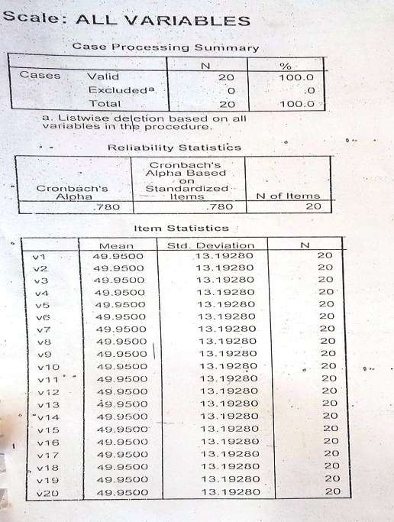

108

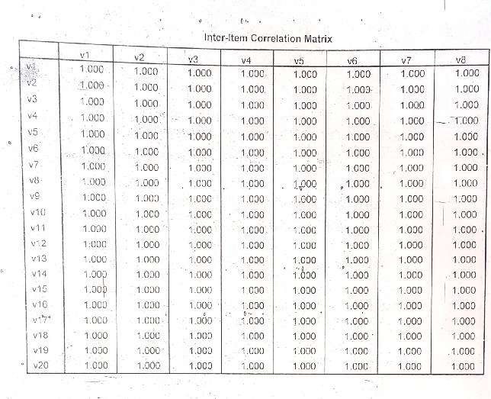A

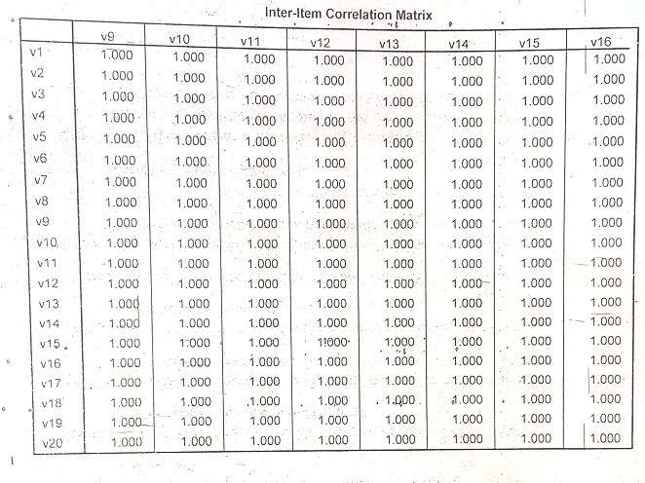

109

110

**APPENDIX C**

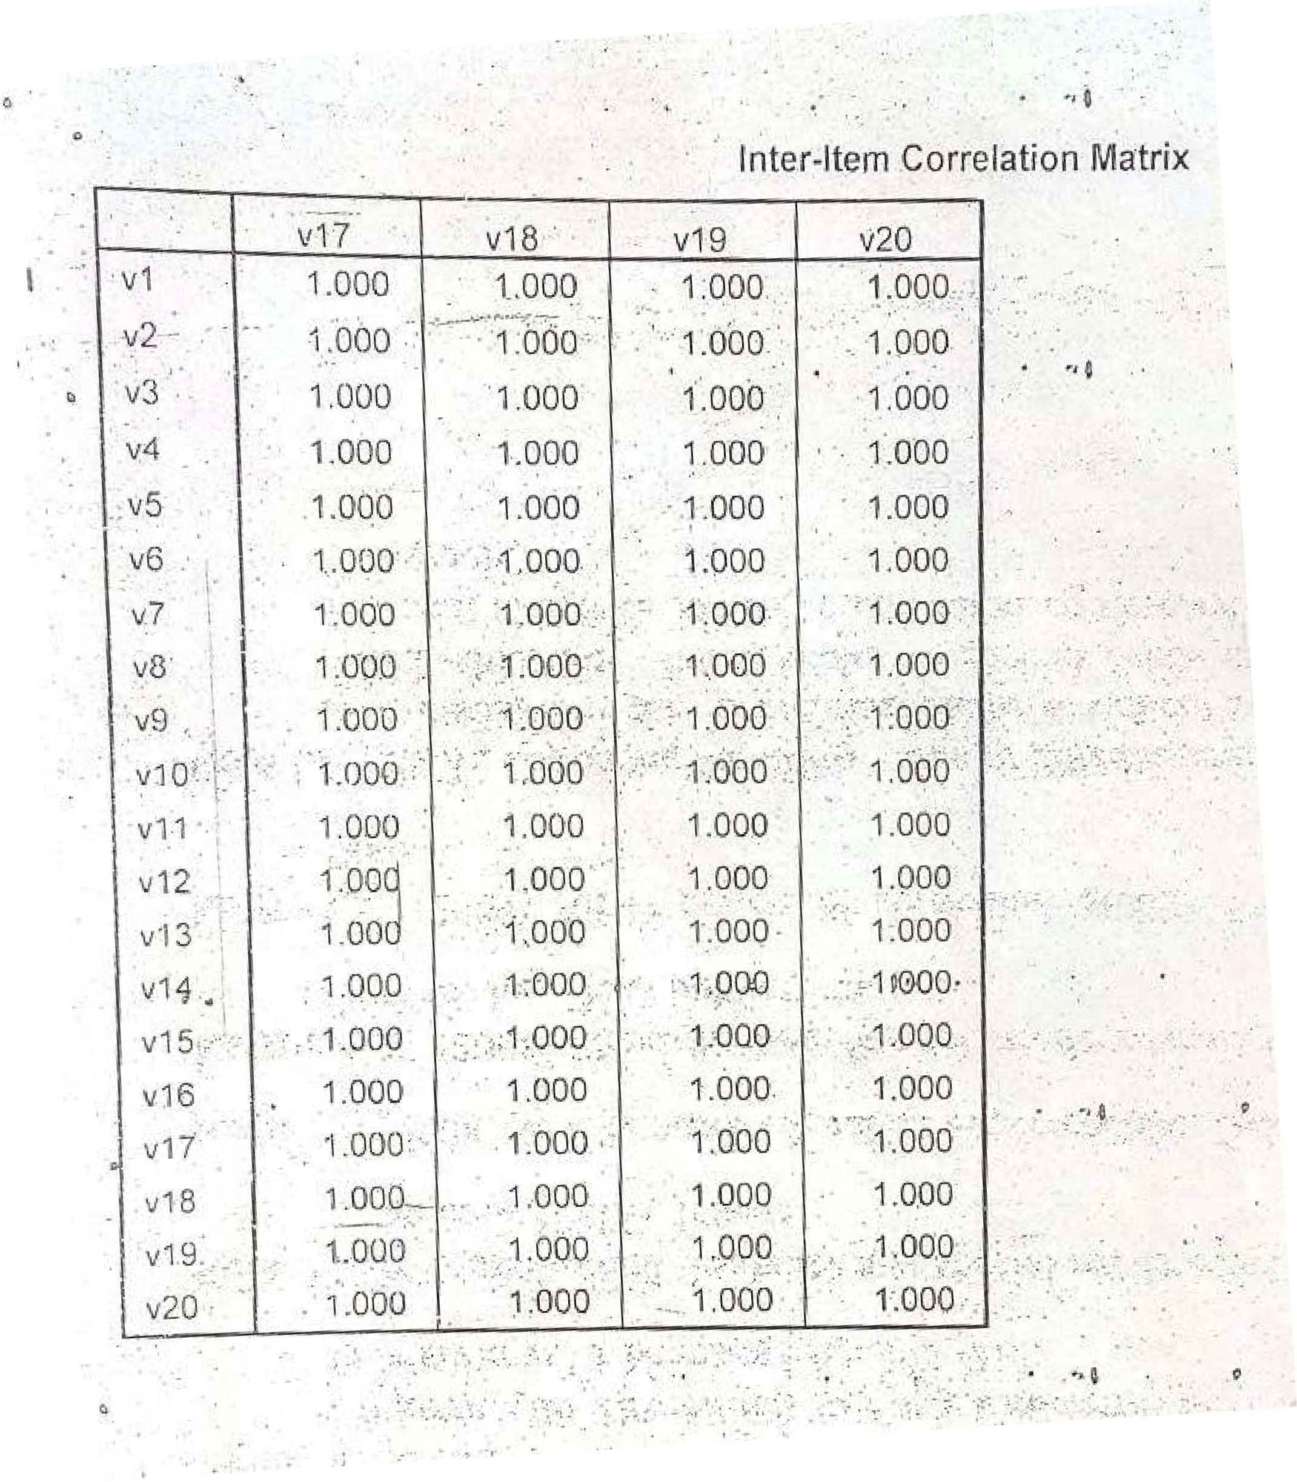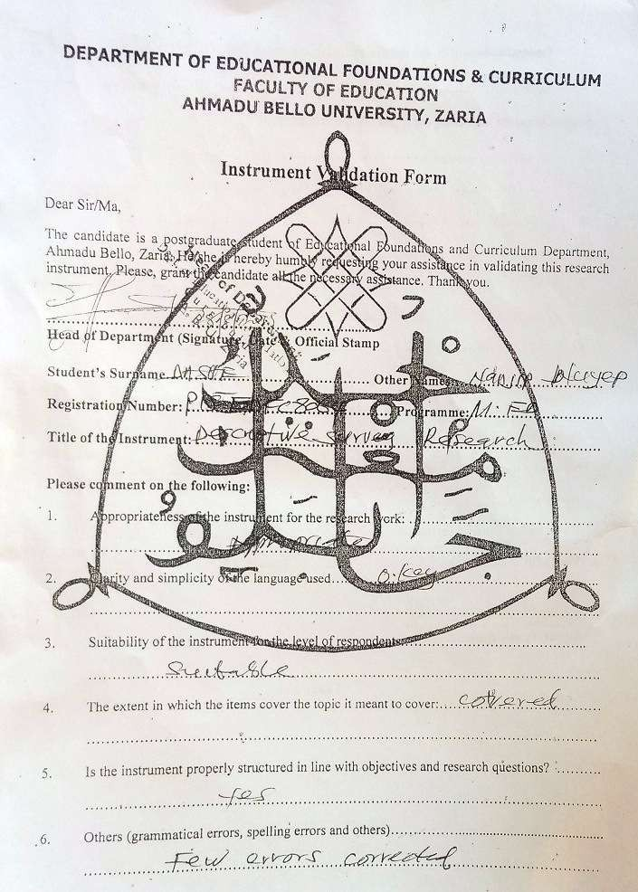

111

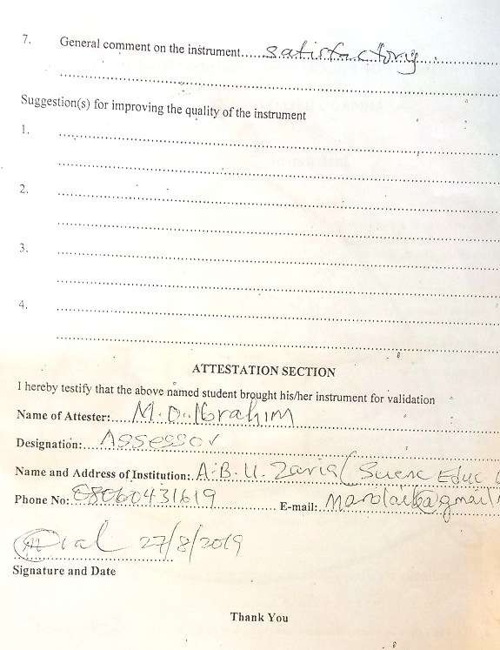

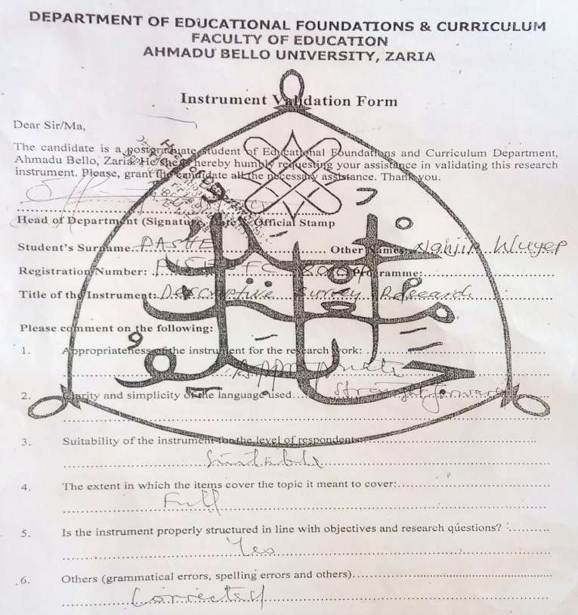

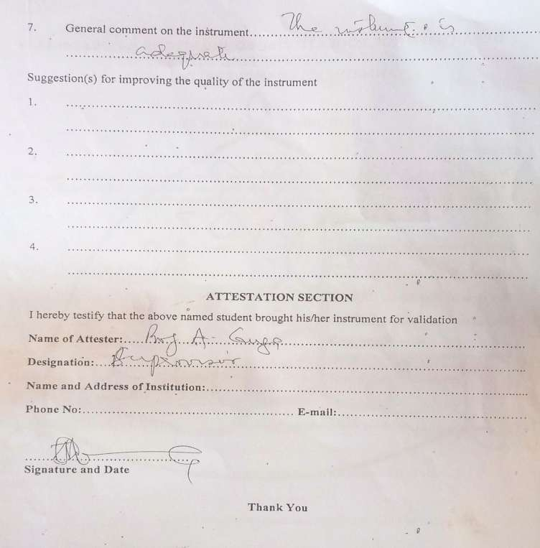

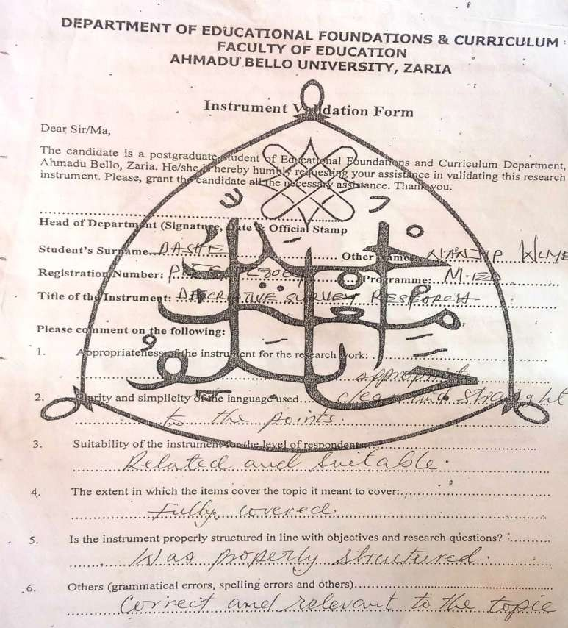

129

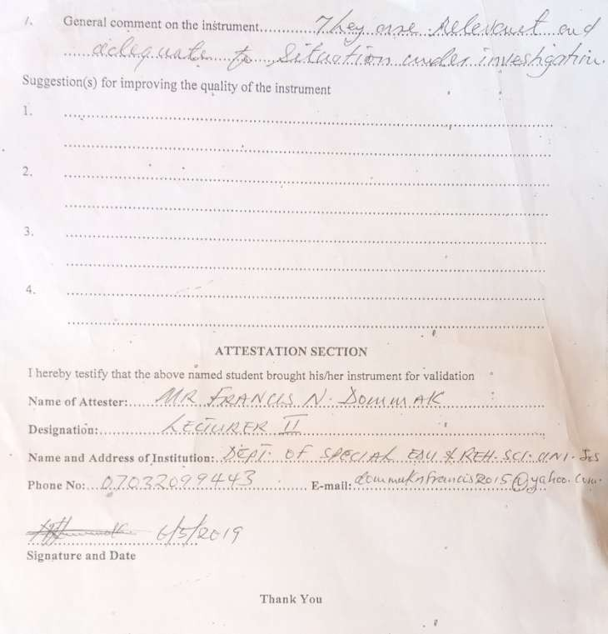

# APPENDIX D

117

117

131