**EVALUATION OF THE DISSOLUTION AND OTHER CHARACTERISTICS OF CYCLODEXTRIN MOLECULAR**

**INCLUSION COMPLEXES OF ARTEMETHER**

**BY**

**ZWANDEN SULE YAHAYA**

**DEPARTMENT OF PHARMACEUTICS AND PHARMACEUTICAL MICROBIOLOGY FACULTY OF PHARMACEUTICAL SCIENCES AHMADU BELLO UNIVERSITY**

**ZARIA, NIGERIA**

**FEBRUARY, 2014**

# EVALUATION OF THE DISSOLUTION AND OTHER CHARACTERISTICS OF CYCLODEXTRIN MOLECULAR

**INCLUSION COMPLEXES OF ARTEMETHER**

# BY

**ZWANDEN SULE YAHAYA**

**(B.Pharm)**

# M.SC/PHARM. SCI/03123/2010 - 2011

**A THESIS SUBMITTED TO THE SCHOOL OF POSTGRADUATE STUDIES AHMADU BELLO UNIVERSITY IN PARTIAL**

# FULFILLMENT OF THE REQUIREMENTS FOR THE AWARD OF THE DEGREE OF MASTER OF SCIENCE IN PHARMACEUTICS

**DEPARTMENT OF PHARMACEUTICS AND PHARMACEUTICAL MICROBIOLOGY,**

# FACULTY OF PHARMACEUTICAL SCIENCES, AHMADU BELLO UNIVERSITY,

**ZARIA, NIGRIA**

# FEBRUARY, 2014

## DECLARATION

I declare that the work in this thesis entitled “Evaluation of the dissolution and other characteristics of cyclodextrin molecular inclusion complexes of artemether‟‟, was carried out by me in the Department of Pharmaceutics and Pharmaceutical Microbiology, Faculty of Pharmaceutical Sciences, Ahmadu Bello University, Zaria, under the supervision of Dr. P.

G. Bhatia, Dr. T. S. Allagh and Dr. K. C. Ofokansi. The Information derived from the literature have been duly acknowledged in the text and a list of references provided. No part of this thesis was previously presented for another degree or diploma at this or any other Institution.

………………………………………………………………………………

Zwanden Sule Yahaya

## CERTIFICATION

This thesis entitled „‟EVALUATION OF THE DISSOLUTION AND OTHER CHARACTERISTICS OF CYCLODEXTRIN MOLECULAR INCLUSION COMPLEXES OF

ARTEMETHER‟‟ by Zwanden Sule YAHAYA meets the regulations governing the award of the degree of Master of Science (Pharmaceutics) of the Ahmadu Bello University, and is approved for its contribution to knowledge and literary presentation.

_ Date _ _

Chairman, Supervisory Committee Dr. P.G. Bhatia,

Department of Pharmaceutics and Pharmaceutical Microbiology, Ahmadu Bello University, Zaria.

_ Member, Supervisory Committee Dr. T. S. Allagh,

Department of Pharmaceutics and Pharmaceutical Microbiology, Ahmadu Bello University, Zaria.

Date

Member, Supervisory Committee Dr. K. C. Ofokansi,

Department of Pharmaceutics, University of Nigeria, Nsukka.

_ Head of Department

Dr. A. B. Isah,

Department of Pharmaceutics and Pharmaceutical Microbiology, Ahmadu Bello University, Zaria.

_ Dean, Postgraduate School

Prof. A.A. Joshua

School of Postgraduate studies Ahmadu Bello University, Zaria.

Date

Date _

Date _

## DEDICATION

Dedicated to my late grandmother, Mama Elizabeth Ayeye Duniya.

## ACKNOWLEDGEMENT

All thanks to Jehovah Almighty, who preserved my life, gave me a reason to live, a hope for living and for the second time, brought my sojourn in Ahmadu Bello University Zaria, to a glorious end. His praise will forever be on my lips.

My profound gratitude goes to my supervisors: Dr. P.G Bhatia, Dr. T.S. Allagh and Dr. K.C. Ofokansi, for their inspirational guidance, intellectual contributions and positive criticism.

Your joint supervision contributed to the success of this work. My gratitude also to the Head of Department, Dr. A. B. Isah and all the academic and technical staff of the department of Pharmaceutics and Pharmaceutical Microbiology for their constant support and advice.

Special thanks to Dr. A.K. Olowosulu and Dr. A. Abdulsamad for their encouragement and contributions which made the work a better piece

My heart-deep thanks go to my parents Mr. and Mrs. Yahaya Sule Dense and my guardians Mr. and Mrs. Mark Jerome Umar for a vision they had for me which they pursued tirelessly with all vigor, dedication, sacrifice and prayers. Thank you and may God grant all your heart desires.

To my friends and colleagues: Micah Timothy, Charles Dagogot, Ephraim Manga, Sophie Nok, Nkechi Ogwu, Florence Ationg, Phoebe Bako and Asiya Hamdana Kankiya, I give my thanks for your honest and memorable friendship.

Thanks also to the management of Afrab Chem. Nigeria Ltd., for their donation of the pure sample of artemether powder.

## ABSTRACT

The present study aimed to improve the dissolution rate, solubility and ultimately, bioavailability of poorly soluble artemether, an antimalarial drug, through inclusion complex formation with hydroxypropyl-β-cyclodextrin.

The solid complexes of artemether and hydroxypropyl-β-cyclodextrin (HP-β-CD) were prepared at a molar ratio of 1:1, 1:2 and 1:3 by kneading method. The effect of HP-β-CD on the aqueous solubility and dissolution rate of artemether was investigated through phase solubility analysis and *in-vitro* dissolution studies. The formation of inclusion complexes between artemether and HP-β-CD was confirmed by Fourier transform infrared (FT-IR) spectroscopy and differential scanning calorimetry (DSC). The inclusion complex containing artemether: HP-β-CD (1:1 M) was further formulated into tablets by direct compression. The prepared tablets were evaluated for various pharmaceutical characteristics; crushing strength, friability, drug content and *in-vitro* dissolution profiles.

Phase solubility diagram for the complex formation between artemether and HP-β-CD in water at 37 oC indicated the AL type, with an apparent stability constant KC found to be 143 M-1. FT-IR spectroscopy and DSC confirmed the true inclusion of artemether into the cyclodextrin cavity. Prepared inclusion complex tablets exhibited higher and faster dissolution rate than the pure drug and marketed products. It was observed that the inclusion complex tablet showed a 3.9-fold increase in the amount of drug released in 15 min

compared to the plain drug, 1.8-fold increase compared to the marketed brand – Lumartem®

and 1.6-fold increase compared to Coartem®. At 120 min, none of the marketed tablets released up to 90 % of the drug, but the inclusion complex tablet achieved 90 % drug release

in 31 min. The results of stability studies revealed no change in physical appearance and drug content over a reasonable period (ten weeks for short term stability test and 72 h for accelerated stability test), thus indicating that the formulation was stable. The result of the study shows that complexation of artemether by cyclodextrins is a good approach to enhance the solubility and dissolution rate of the drug.

## TABLE OF CONTENTS

**Page**

|  |  |
| --- | --- |
| Title page - | - - - - - - - - - i |
| Declaration - | - - - - - - - - - ii |
| Certification - | - - - - - - - - - iii |
| Dedication - | - - - - - - - - - iv |
| Acknowledgement | - - - - - - - - - v |
| Abstract - | - - - - - - - - - vi |
| Table of contents | - - - - - - - - - viii |
| List of tables - | - - - - - - - - - xiv |
| List of figures - | - - - - - - - - - xv |
| List of appendices | - - - - - - - - - xvii |

Abbreviations and symbols - - - - - - - - xix

## CHAPTER 1: INTRODUCTION

|  |  |  |
| --- | --- | --- |
| 1.1 Background of the study - - - | - - - - | 1 |
| 1.2 Factors affecting the solubility of solids in liquids | - - - - | 2 |
| 1.2.1 Temperature - - - - - | - - - - | 2 |
| 1.2.2 Molecular structure of solute - - - | - - - - | 2 |
| 1.2.3 Nature of solvent: cosolvents - - - | - - - - | 3 |
| 1.2.4 pH - - - - - - | - - - - | 3 |
| 1.2.5 Crystal characteristic: polymorphism and solvation | - - - - | 4 |
| 1.2.6 Particle size of the solid - - - - | - - - - | 5 |
| 1.2.7 Additional substances- - - - | - - - - | 5 |

|  |  |  |
| --- | --- | --- |
| 1.3 Complexation - | - - - - - - - - | 8 |
| 1.3.1 Metal complexes - | - - - - - - - - | 8 |

|  |  |  |  |  |  |  |  |  |  |  |
| --- | --- | --- | --- | --- | --- | --- | --- | --- | --- | --- |
| 1.3.2 | Molecular complexes - | | - | - | - | - | - | - | - | 9 |
| 1.3.3 | Ion exchange compounds - | | - | - | - | - | - | - | - | 10 |
| 1.3.4 | Inclusion complexes - | | - | - | - | - | - | - | - | 11 |
| 1.4 | Cyclodextrins (CD) - - | | - | - | - | - | - | - | - | 11 |
| 1.4.1 | Properties of cyclodextrin - | | - | - | - | - | - | - | - | 12 |
| 1.4.2 | α-Cyclodextrin- | - | - | - | - | - | - | - | - | 13 |
| 1.4.3 | β*-*Cyclodextrin - | - | - | - | - | - | - | - | - | 13 |
| 1.4.4 | ϒ-Cyclodextrin - | - | - | - | - | - | - | - | - | 14 |
| 1.4.5 | Synthetic cyclodextrin- | | - | - | - | - | - | - | - | 14 |
| 1.5 | Hydroxypropyl-β-cyclodextrin - | | | - | - | - | - | - | - | 15 |
| 1.6 | Statement of research problem - | | | - | - | - | - | - | - | 15 |
| 1.7 | Justification of the Study- | | - | - | - | - | - | - | - | 17 |
| 1.8 | Research aim- - | - | -- | - | - | - | - | - | - | 19 |
| 1.9 | Research objectives | - | - | - | - | - | - | - | - | 19 |
| 1.10 | Research hypothesis | - | - | - | - | - | - | - | - | 20 |
| 1.10.1 | Null hypothesis - | - | - | - | - | - | - | - | - | 20 |

**CHAPTER 2: LITERATURE REVIEW**

|  |  |  |
| --- | --- | --- |
| 2.1 The drug artemether - - | - - - - - - - | 21 |
| 2.1.1 Profile of artemether - | - - - - - - - | 21 |
| 2.1.2 Chemistry of artemether - | - - - - - - - | 21 |
| 2.1.3 Formulations of artemether | - - - - - - - | 22 |

* + 1. Pharmacokinetics of artemether- - - - - - - 22
    2. Toxicity of artemether- - - - - - - - 23
    3. UV Spectrophotometric analysis of artemether - - - - 23
  1. Chromophores - - - - - - - - - 24
  2. Derivatization - - - - - - - - - 25
  3. Pharmaceutical application of cyclodextrins - - - - - 25
  4. Inclusion complex formation - - - - - - - 27
  5. Methods of preparing inclusion complexes - - - - - 31

2.6.1 Spray drying - - - - - - - - - 32

* + 1. Freeze drying - - - - - - - - - 32
    2. Paste complexation or kneading - - - - - - 32
    3. Solid phase complexation - - - - - - - 32
    4. Co-precipitation - - - - - - - - 33
  1. Analysis of inclusion complexes - - - - - - 34
  2. Solubility isotherm and the stability or equilibrium constants (kc) - - 35
  3. Methods of enhancing complexation - - - - - - 38
  4. Factors affecting complexation - - - - - - - 40
     1. Steric effects - - - - - - - - - 40
     2. Electronic effects - - - - - - - - - 42
     3. Effect of temperature and co-solvent - - - - - - 44
  5. Release from complexes - - - - - - - 45
  6. Benefits of complexation- - - - - - - - 45
     1. Improvement in solubility, dissolution and bioavailability - - - 45
     2. Reduction of unpleasant Side effects and bitter taste - - - - 47
     3. Improvement in drug stability - - - - - - - 48
     4. Reduction in volatility- - - - - - - - 49
  7. Disadvantages in using cyclodextrins- - - - - - 50

CHAPTER 3: MATERIALS AND METHODS

3.1 Materials - - - - - - - - - - 52

3.1.1 Chemicals and reagents - - - - - - - 52

3.1.2 Equipments - - - - - - - - - 52

3.2 Methods - - - - - - - - - 53

* + 1. Identification of artemether (IP) - - - - - - 53
    2. Preparation of reagents - - - - - - - - 54
       1. Preparation of 1 M ethanolic HC - - - - - - - 54
       2. Preparation of simulated body fluids - - - - - - 54
    3. Preparation of calibration curve - - - - - - 54
    4. Phase solubility studies - - - - - - - 55
       1. Determination of the phase solubility diagram - - - - 55
    5. Preparation of artemether - 2-hydroxypropyl-β-cyclodextrin

Complexes - - - - - - - - - - 56

* + - 1. Determination of stability constant - - - - - - 56
    1. Drug content estimation - - - - - - - 56
    2. Drug-excipient interaction studies - - - - - - 57
       1. Fourier transform infrared spectroscopy - - - - - 57
       2. Differential scanning calorimetry - - - - - - 57
       3. UV interference - - - - - - - - - 57
    3. Dissolution characteristics - - - - - - - 58
       1. *In vitro* dissolution studies for artemether-HP-β-CD complexes - - 58
    4. Formulation of artemether-cyclodextrin inclusion complex tablets - - 59
       1. Evaluation of prepared tablets of artemether - - - - - 59
       2. Kitazawa analysis - - - - - - - - 61
    5. Stability studies - - - - - - - - 62
    6. Statistical analysis - - - - - - - - 62

CHAPTER 4: RESULTS

* 1. Identification of pure sample - - - - - - - 63
  2. Phase solubility studies - - - - - - - 63
     1. Stability constant - - - - - - - - 65
  3. Physical appearance and drug content estimation - - 65
  4. Drug-excipient interaction studies - - - - - - 65
     1. Fourier transform infrared spectroscopy - - - - - 65
     2. Differential scanning calorimetry - - - - - - 72
     3. UV spectra of artemether and its inclusion complexes - - - - 79
  5. Dissolution characteristics - - - - - - - 82
     1. Dissolution profile of pure drug and inclusion complexes

in simulated intestinal fluid (pH 7.4) - - - - - - 82

* + 1. Dissolution profile of pure drug and inclusion-complexes in

simulated gastric fluid (pH 1.2) - - - - - - 84

* 1. Evaluation of tablet properties - - - - - - 86
     1. Dissolution Profile of the Inclusion-complex (1:1 M) tablet,

Marketed tablets (Coartem®and Lumartem®) and the Pure

artemether powder in Simulated Gastric Fluid (pH 1.2) - - - 87

* + 1. Result of Kitazawa analysis - - - - - - - 89
  1. Stability studies - - - - - - - - 93

CHAPTER 5: DISCUSSION

* 1. Identification of pure samples- - - - - - - 95
  2. Calibration curve - - - - - - - - 95
  3. Phase solubility studies - - - - - - - 95

5.4 Drug content - - - - - - - - - 97

* 1. Drug-excipient interaction studies - - - - - - 97
     1. Fourier transform infrared spectroscopy - - - - - - 97
     2. Differential scanning calorimetry - - - - - - 97
     3. UV interference - - - - - - - - - 99
  2. In vitro dissolution - - - - - - - - 99
  3. Evaluation of Tablets - - - - - - - - 102
  4. Stability studies - - - - - - - 103

CHAPTER 6: SUMMARY AND CONCLUSION

6.1 Summary - - - - - - - - - 104

6.2 Conclusion - - - - - - - - - 105

6.3 Recommendation for further work - - - - - - 106

REFERENCES - - - - - - - - 107

APPENDICES - - - - - - - - 121

## LIST OF TABLES

**Table Page**

* 1. Solubility definition in the United State Pharmacopoeia - - - 22
  2. Advantages and disadvantages of preparing inclusion complexes - - 34
  3. Methods of enhancing complexation - - - - - - 39
  4. Examples of marketed products containing cyclodextrin- - - - 51

3.1 Tablet formula- - - - - - - - - 59

* 1. Color, texture and drug content of formed complexes - - - 65
  2. Evaluation of marketed and formed artemether tablets - - - 86
  3. Parameters obtained from the dissolution and Kitazawa plots

for pure drug 1:1 M, 1:2 M, 1:3 M complexes and the commercial parenteral injection(drutemal injection) in simplate intestinal

fluid (pH 7.5)- - - - - - - - - 92

* 1. Parameters obtained from the dissolution and Kitazawa plots for pure drug, lumartem®, coartem® and 1:1 M complex tablet in simulated gastric

fluid (pH 7.2) - - - - - - - - - 92

* 1. Results of short term stability studies of the inclusion complexes and the

formulated tablets at room temperature (28-30 oC) - - - - 93

* 1. Results of accelerated stability studies of the inclusion complexes and

the formulated tablets at 50 oC - - - - - - 94

## LIST OF FIGURES

**Figure Page**

1.1 The chemical structure and conical shape of β-cyclodextrin molecule - 12

* 1. Chemical structure of artemether - - - - - - 21
  2. The chemical structure of α,β unsaturated decalone - - - 24
  3. Cyclodextrin structure and inclusion complex formulation - - - 28
  4. Graphical representation of A and B -type phase solubility profiles with

applicable subtypes (AP, AL, AN, BS, and B1)- - - - - 36

* 1. Phase solubility diagram for artemether-2-hydropropyl-β-cydodextrin system

of 37 oC in distilled water - - - - - - - 64

* 1. FT-IR spectrum of pure artemether - - - - - - 67
  2. FT-IR spectrum of pure 2-hydroxypropyl-β-cyclodextrin - - - 68
  3. FT-IR spectrum of artemether -2-HP-β-CD (1:1) complex - - - 69
  4. FT-IR spectrum of artemether -2-HP-β-CD (1:2) complex - - - 70
  5. FT-IR spectrum of artemether -2-HP-β-CD (1:3) complex - - - 71
  6. DSC thermogram of pure artemether - - - - - - 73
  7. DSC thermogram of pure 2-HP-β-CD - - - - - 74
  8. DSC thermogram of artemether-2-HP-β-CD (1:1) complex - - - 75
  9. DSC thermogram of artemether-2-HP-β-CD (1:2) complex - - - 76
  10. DSC thermogram of artemether-2-HP-β-CD (1:3) complex - - 77
  11. DSC thermogram of pure artemether, pure 2-HP-β-CD and prepared inclusion complexes all superimposed for comparism - - - - - 78
  12. UV spectrum of pure artemether - - - - - - 80
  13. UV spectrum for (1:1) artemether-2-HP-β-CD complex - - - 81

|  |  |  |
| --- | --- | --- |
| 4.15 | Dissolution profile of pure artemether -2-HP-β-CD complexes and a |  |
|  | Commercial parenteral product in simulated intestinal fluid (pH 7) - - | 83 |
| 4.16 | Dissolution profile of pure artemether and artemether -2-HP-β-CD |  |
|  | complexes in simulated gastric fluid pH 1.2 - - - - - | 85 |
| 4.17 | Dissolution profile of pure artemether commercial products and inclusion |  |
|  | complex (1:1) tablet in simulated gastric fluid pH 1.2 - - - | 88 |
| 4.18: | Kitazawa plots for release of artemether from the pure drug, inclusion |  |
|  | complexes of 1:1 M, 1:2 M, 1:3 M and the marketed parenteral product (Drutemal® Injection) in simulated intestinal fluid (pH 7.4) - - - | 90 |
| 4.19: | Kitazawa plots for release of artemether from the pure drug, lumartem®, coartem® and tablets formed from inclusion complex (1:1 M) in simulated |  |
|  | gastric fluid (pH 1.2) - - - - - - - - | 91 |

## LIST OF APPENDICES

**Appendix Page**

I Absorbance values for Beer - Lambert calibration curve for artemether 121 II Calibration curve of artemether - - - - - 122

1. Absorbance values for phase solubility studies of artemether with

2-HP-β-CD at 37 oC - - - - - - - 123

1. Absorbance value for the dissolution profile of artemether complex (molar ratios of 1:1, 1:2, 1:3), pure drug and marketed parental

formulation in simulated intestinal fluid (pH 7.4) - - - 124

1. Result of the dissolution profile of artemether complexes

(molar ratios of 1:1, 1:2, 1:3), pure drug and a marketed parenteral

product in simulated intestinal fluid (pH 7.4)- - - - 125

1. Parameters for the dissolution profile of pure artemether,

2-hydroypropyl-β-cydodextrin inclusion complexes of artemether and a marketed parenteral product (Drutemal Injection) in simulated

gastric fluid - - - - - - - - 126

1. Result of statistical analysis of the dissolution profile of artemether complexes (molar ratios 1:1, 1:2, 1:3), pure drug and a marketed

parenteral formulation in simulated intestinal fluid (pH 7.4). - 127

1. Absorbance values for the dissolution profile of artemether complexes (molar ratios of 1:1, 1:2, 1:3), and pure drug in simulated

gastric fluids pH 1.2 - - - - - - - 128

1. Results of the dissolution profile of artemether complexes (molar ratios of 1:1, 1:2, 1:3) and pure drug in simulated

gastric fluids (pH 1.2) - - - - - - - 129

1. Parameters for the dissolution profile of pure artemether and 2-HP-β-CD inclusion complexes of artemether of molar

ratios 1:1, 1:2 and 1:3 M in simulated gastric fluid (pH 1.2) - - 130

1. Results of statistical analysis of the dissolution profile of artemether complexes (molar ratios of 1:1, 1:2, 1:3) and pure drug in simulated

gastric fluid (pH 1.2) - - - - - - - 131

1. Absorbance values for the dissolution profile of pure Artemether, commercial products (Coartem and Lumartem) and formulated

inclusion complex (1:1) tablet (pH 1.2) - - - - 132

1. Results of the dissolution profile of pure artemether, commercial products (Coartem and Lumartem) and formulated inclusion complex

(1:1) tablet in simulated gastric fluid (pH 1.2) - - - 133

1. Results of statistical analysis of the dissolution profile of pure artemether, commercial products (Coartem and Lumartem) and formulated inclusion complex (1:1) tablet in simulated

gastric fluid (pH 1.2) - - - - - - - 134

1. Parameters for the dissolution profile of pure artemether inclusion complex tablet and marketed tablet (Coartem and

Lumartem) in simulated gastric fluid (pH 1.2) - - - 135

1. Results of statistical analysis of accelerated stability studies of the

inclusion complexes and the formulated tablet at 50 0C - - 136

1. Results of statistical analysis of short term stability studies of the inclusion complexes and the formulated tablet at room

temperature (28-30 oC) - - - - - - 137

## ABBREVIATIONS AND SYMBOLS

HP-β-CD - Hydropropyl-β-cyclodextrin FT-IR - Fourier transform infrared

DSC - Differential scanning calorimetry KC - Stability constant

CD - Cyclodextrin

α - Alpha

β - Beta

ϒ - gamma

WHO - World health organization

ACTs - Artemisinin combination therapies DHA - Dihydro-artemether

IP - International Pharmacopoeia SBE-β-CD - Sulfobutyl ether-β-cyclodextrin M-β-CD - Methyl-β-cyclodextrin

DS - Degree of substitution

F - Bioavailability

SGF - Simulated gastric fluid

SIF - Simulated intestinal fluid

MS - Molar degree of substitution

## CHAPTER 1: INTRODUCTION

* 1. **BACKGROUND OF THE STUDY**

Dissolution is the process by which molecules or ions are transferred from a solid state into solution. The extent to which the dissolution proceeds under a given set of experimental conditions is referred to as the solubility of the solute in the solvent. The solubility of a substance is a measure of the maximum amount of that substance that can be dissolved in a given amount of solvent to form a stable solution (Aulton, 2007). To achieve a pharmacological activity, molecules must in general, exhibit certain solubility in physiological intestinal fluids to be present in the dissolved state at the site of absorption.

The aqueous solubility is a major indicator for the solubility in the intestinal fluids and its potential contribution to bioavailability issues (Stegemann *et al.,* 2007). Aqueous solubility is one of the key determinants in development of new chemical entities as successful drugs. Drugs with poor water solubility typically have low bioavailability. The rate of absorption and bioavailability of poor water soluble drugs is often controlled by the rate of dissolution of the drug in the gastrointestinal tract. Dissolution is therefore essential for a drug to be absorbed through the biological membranes into systemic circulation for therapeutic efficacy (Ghodke *et al.,* 2009). The improvement of drug solubility its oral bioavailability remains one of the most challenging aspects of the drug development process especially for oral drug delivery systems.

## FACTORS AFFECTING THE SOLUBILITY OF SOLIDS IN LIQUIDS

* + 1. **Temperature**

In most cases, the dissolution of a solid in liquid involves the absorption of heat, that is, it is an endothermic process with a positive heat of solution. Thus a rise in temperature will lead to an increase in the solubility of a solid with a positive heat of solution. Conversely, if the dissolution of a solid involves the liberation of heat, that is, it is an exothermic process with a negative heat of solution then an increase in temperature will lead to a decrease in the solubility (Carter *et al*., 2000).

## Molecular Structure of Solute

A small change in the molecular structure of a compound can have a marked effect on it solubility in a given liquid. For example, the introduction of a hydrophilic hydroxyl group can produce a large improvement in the water solubility as evidenced by the more than the 100-fold difference in the solubility of phenol compared with benzene (Aulton, 2007)

In addition, the conversion of a weak acid to it sodium salt leads to a much greater degree of ionic dissociation of the compound when it dissolves in water. The overall interaction between solute and solvent is increased markedly and the solubility consequently rises. A specific example of this is provided by a comparison of the aqueous solubility of salicylic acid and its sodium salt, which are 1 in 550 and 1 in 1, respectively (Aulton, 2007)

The reduction in aqueous solubility of a parent drug by its esterification may also be cited as an example of the effects of changes in the chemical structure of the solute (Aulton, 2007)

## Nature of Solvent: cosolvents

Like, is said to dissolve like (Aulton, 2007). The solubility of a particular solid in a variety of liquids differs. In addition, changes in the properties of a solvent caused by the addition of other substances, may affect the solubility of a solid in the system. Such mixtures are often used in pharmaceutical practice in order to obtained aqueous-based systems that contain solutes in excess of their solubilties in pure water. This is achieved by using cosolvents such as ethanol or propylene glycol, which are miscible with water and which act as better solvents for the solute in question. For example the aqueous solubility of metronidazole is about 100 mg in 10 ml. The solubility of this drug can be increased exponentially by the incorporation of one or more water miscible cosolvents so that a solution containg 500 mg in 10 ml (and thus suitable for parenteral administration in the treatment of anaerobic infection) can be obtained (Aulton, 2007).

## pH

Many drugs behave as weak acids or weak bases and their solubility is therefore affected by the pH of an aqueous medium. For example, a weakly acidic drug such as acetylsalicylic acid will be more soluble in alkaline solution, since it will be converted to the more soluble salt. Conversely, the drug will be precipitated from aqueous solution if the pH is lowered by the addition of a strong acid. Similarly, a weakly basic drug will be more soluble in solution of low pH and will be precipitated if the pH is raised by the addition of an alkali (Carter *et al*., 2000). This relationship between pH and solubility of ionized solutes is extremely important with respect to the ionization of weakly acidic and basic drugs as the pass through the gastrointestinal tract and can experience pH changes between about 1 and 8. This will

affect the degree of ionization of the drug molecule which will in turn influence their solubility and their ability to be absorbed (Aulton, 2007).

## Crystal Characteristic: polymorphism and solvation

When the conditions under which crystallization is allowed to occur are varied then some substances produce crystals in which the constituent molecules are aligned in different ways with respect to one another in the lattice structure. These different crystalline forms of the same substance, which are known as *polymorphs,* consequently possesses different lattice energies and this difference is reflected by changes in other properties. For example, the polymorphic form with the lowest free energy will be the most stable and possess the highest melting point. Other less stable (or metastable) forms will tend to transform into the most stable one at rates that depend on the energy differences between the metastable and the stable forms. The effect of polymorphism on solubility is particularly important from a pharmaceutical point of view because it provides a means of increasing the solubility of a crystalline material, and hence its rate of dissolution, by using a metastable polymorph (Aulton, 2007).

Although the more soluble polymorphs are metastable and will convert to the stable form, the rate of such conversion is often slow enough for metastable form to be regarded as been sufficiently stable from a pharmaceutical point of view. The degree of conversion should obviously be monitored during storage of the drug product to ensure that its efficacy is not altered significantly (Aulton, 2007).

## Particle size of the solid

The changes in interfacial free energy that accompany the dissolution of particles of varying sizes cause the solubility of a substance to increase with decreasing particle size as indicated by the Equation 1 (Aulton, 2007).

Log S So = 2ϒ*M* (1)

2.303*RT*ρr

Where s is the solubility of small particles of radius r, So is the normal solubility (that is, of a solid consisting of fairly large particles). ϒ is the interfacial energy, *M* is the molecular weight of the solid, ρ is the density of the bulk solid, *R* is the gas constant and *T* is the thermodynamic temperature.

The increase in solubility with decrease in particle size ceases when the particles have a very small radius (less than about 1 µm), any further decrease in size causes a decrease in solubility. It has been postulated that this change arises from the presence of an electrical charge on the particles and that the effect of these charge becomes more important as the particle decreases. Such solubility changes are rarely a problem in conventional dosage forms and drug delivery but could be significant with nanotechnology products (Aulton, 2007).

## Additional Substances

* + - 1. **Effect of non electrolytes on the solubility of electrolytes:** The solubility of electrolytes depends on the dissociation of dissolved molecules into ions. The ease of this dissociation is affected by the dielectric constant of the solvent,

which is a measure of the polar nature of the solvent. Liquids with a high dielectric constant (for example, water) are able to reduce the attractive forces that operate between oppositely charged ions produced by dissociation of an electrolyte. If a water-soluble non electrolyte such as alcohol is added to an aqueous solution of a sparingly soluble electrolyte, the solubility of the latter is decreased because the alcohol lowers the dielectric constant of the solvent and ionic dissociation of the electrolyte becomes more difficult (Aulton, 2007).

* + - 1. **Effect of electrolytes on the solubility of non electrolytes:** Non electrolytes do not dissociate into ions in aqueous solution, and in dilute solution the dissolved species therefore consist of single molecules. Their solubility in water depends on the formation of weak intermolecular bonds (hydrogen bonds between their molecules and those of water). The presence of a very soluble electrolyte (for example, ammonium sulphate), the ions of which have a marked affinity for water, will reduce the affinity of a non electrolyte by competing for the aqueous solvent and cause breaking of the intermolecular bonds between the non electrolyte and water. This effect is important in the precipitation of proteins (Aulton, 2007).
      2. **Effect of complex formation:** The apparent solubility of a solute in a particular liquid may be increased or decreased by the addition of a third substance which forms an intermolecular complex with the solute. The solubility of the complex will determine the apparent change insolubility of the original solute. For example, the formation of the complex between 3-

aminobenzoic acid and various dicarboxylic acids has been shown to increase the apparent water solubility of the former compound (Carter *et al*., 2000). Use is made of formation of a complex as an aid to solubility in the preparation of mercuric iodide (HgI2). The latter is not very soluble in water but it is soluble in aqueous solution of potassium iodide because of the formation of water-soluble complex, K2 (HgI4) (Aulton, 2007).

* + - 1. **Effect of surface active agents:** These compounds are capable of forming large aggregates or micelles in solution when their concentrations exceed certain values. In aqueous solution the centre of these of aggregates resemble a separate organic phase and organic solutes may be taken up by the aggregates, thus producing an apparent increase in their solubilities in water. The phenomenon is termed solubilisation (Carter *et al.,* 2000). A similar phenomenon occurs in organic solvents containing dissolved solubilizing agents because the centre of the aggregates in these systems constitutes a more polar region than the bulk of the organic solvent. If polar solutes are taken up into these regions their apparent solubilities in the organic solvents are increased. (Aulton, 2007).
      2. **Common ion effect:** The solubility of a sparingly soluble electrolyte is decreased by the addition of a second electrolyte that possesses a similar ion to the first. This is known as common ion effect (Aulton, 2007).
      3. **Effect of indifferent electrolytes:** The solubility of a sparingly soluble electrolyte may be increased by the addition of a second electrolyte that does

not possess ions common to the first, that is, an indifferent electrolyte (Aulton, 2007).

## COMPLEXATION

Complexation is one of several ways to favorably enhance the physicochemical properties of pharmaceutical compounds. It may be defined as the reversible association of a substrate and a ligand to form a complex. Although the classification of complexes is somewhat arbitrary, the differentiation is usually based on the types of interactions and species involved, for example, metal complexes, molecular complexes, inclusion complexes, and ion exchange compounds (Gerold and Thompson, 2002).

## Metal Complexes

A metal complex (coordination complex) consists of a central metal atom or ion surrounded by several atoms, ions or molecules called ligands. Ligands are ions or molecules that can have an independent existence and are attached to the central metal atom or ion. Examples of ligands are halide ions, carbon monoxide, ammonia, cyanide ion, etc (Cotton *et al.,* 1999).

In most cases, only one atom in the ligand binds to the metal, such a ligand is said to be unidentate (or monodentate). Ligands with more than one bonded atom are referred to as multidentate or polydentate and the form chelate complexes. The formation of such complexes is called chelation. Chelation involves the formation or presence of two or more separate coordinate bonds between a polydentate (multiple bonded) ligand and a single central atom. Usually these ligands are organic compounds, and are called chelants, chelators, chelating agents, complexing agents or sequestering agents (Cotton *et al.,* 1999).

The concept of chelation have found application in producing nutritional supplements, fertilizers, commercial products such as shampoos and food preservatives, medicines, water treatment, chemical analysis, heavy metal detoxification and other industrial applications. For example, Chelation therapy is the use of chelating agents to detoxify poisonous metal agents such as mercury, arsenic, and lead by converting them to a chemically inert form that can be excreted without further interaction with the body, and was approved by the U.S. Food and Drug Administration in 1991. Chelation in the intestinal tract is a cause of numerous interactions between drugs and metal ions (also known as "minerals" in nutrition). As examples, antibiotic drugs of the tetracycline and quinolone families are chelators of Fe2+, Ca2+ and Mg2+ ions (Gold, 2012)

## Molecular Complexes

Molecular binding is an attractive interaction between two molecules that results in a stable association in which the molecules are close to each other. The result of molecular binding is the formation of a molecular complex. A molecular complex is a loose association involving two or more molecules. The attractive bonding between the components of a molecular complex is normally weaker than in a covalent bond (Gold, 2012).

Examples of molecules that can participate in molecular complexation include proteins, nucleic acids, carbohydrates, lipids, and small organic molecules such as drugs. Hence the types of complexes that form as a result of molecular complexation include:

protein – protein (Haian, 2004). protein – DNA (Harald, 2007). protein – hormone

protein – drug (Gerd, 2003).

Proteins that form stable complexes with other molecules are often referred to as receptors while their binding partners are called ligands (Klotz, 1997).

## Ion Exchange Compounds

Ion exchange referred to exchange of ions between two electrolytes (compounds that ionizes when dissolved in a suitable solvent such as water, example, acids, salts, bases) or between an electrolyte and a complex (Zagorodni, 2006)

Ion exchange compounds are either cation exchangers that exchange positively charged ions (cations) or anion exchangers that exchange negatively charged ions (anions). There are also amphoteric exchangers that are able to exchange both cations and anions simultaneously. However, the simultaneous exchange of cations and anions can be more efficiently performed in mixed beds that contain a mixture of anion and cation exchange resins (Zagorodni, 2006)

Some examples of ion exchange compounds are: Zeolites (examples, natrolites, stilbite, chabazite), Clay (examples, kaolinite, illite, chlorite), ion exchange resins (examples, sodium polystyrene sulfonate, colestipol, cholestyramine).

Typical examples of ions that can bind to ion exchangers are: H+ (proton) and OH− (hydroxide)

Single-charged monatomic ions like Na+, K+, and Cl− Double-charged monatomic ions like Ca2+ and Mg2+ Polyatomic inorganic ions like SO42− and PO43−

Organic bases, usually molecules containing the amine functional group -NR2H+ Organic acids, often molecules containing -COO− (carboxylic acid) functional groups

Biomolecules that can be ionized: amino acids, peptides, proteins and so forth (Zagorodni, 2006).

## Inclusion Complexes

Inclusion complexes are formed when a „guest‟ molecule is partially or fully included inside a „host‟ molecule, with no covalent bonding (Schneiderman *et al.,* 2000). When inclusion complexes are formed, the physicochemical parameters of the guest molecules are distinguished or altered and an improvement in the molecule‟s solubility, stability, taste, safety, bioavailabilty and so on are commonly seen (Gerold and Thompson, 2002). Cyclodextrins are classical examples of compounds that form inclusion complexes.

## CYCLODEXTRINS (CD)

Cyclodextrins are a family of cyclic oligosaccharides, composed of α-(1, 4) linked glucopyranose subunits. They are useful molecular chelating agents. The may consist of six (α-cyclodextrin), seven (β-cyclodextrin), eight (γ-cyclodextrin or more glucopyranose units linked by α - (1,4) bonds.

cyclodextrins are also known as cycloamyloses, cyclomaltoses and Schardinger dextrins (Eastburn and Tao, 1994). They are produced as a result of intramolecular transglycosylation reaction from degradation of starch by cyclodextrin gluconotransferase (CGTase) enzyme (Szetjli *et al.,* 1998). They possess a cage-like supramolecular structure.

## Properties of Cyclodextrin

Cyclodextrins are of three types: α-cyclodextrin, β-cyclodextrin, and ϒ-cyclodextrin

referred to as first generation or parent cyclodextrins. α-, β- and ϒ-cyclodextrins are

composed of six, seven and eight α-(1, 4)-linked glycosyl units, respectively (Dass and Jessup*,* 2000). β -Cyclodextrin is the most accessible, the lowest-priced and generally the most useful cyclodextrins (Martin Del Valle, 2003).

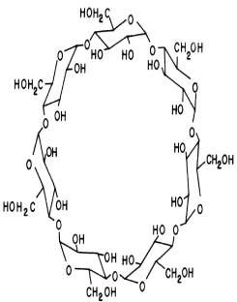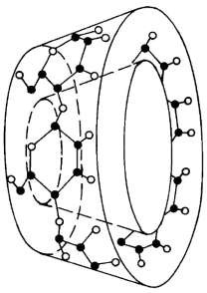

Fig. 1.1: The chemical structure and the conical shape of β-cyclodextrin molecule (Loftsson *et al.,* 2005)

## α-Cyclodextrin

These are cyclodextrins consisting of six glucopyranose units. The main properties of α- Cyclodextrin are: slightly irritating effect after i.m. injection, binding of some lipids, eye

irritation, 2 – 3 % absorption after oral administration to rats, no metabolism in the upper intestinal tract and cleavage only by the intestinal flora of caecum and colon.

Excretions after oral administration to rats were: 60% as CO2 (no CO2 exhalation after oral administration to germ-free rats), 26–33 % as metabolite incorporation and 7–14 % as metabolites in faeces and urine. It is mainly excreted unchanged by the renal route after i.v. injections with *t* ½ = 25 min in rats, LD50 oral, rat >10,000 mg/kg, LD50 i.v., rat: between 500 and 750 mg/kg (Martin Del Valle, 2003).

## β*-*Cyclodextrin

These are cyclodextrins consisting of seven glucopyranose units. The main properties are: less irritating effect than *α-*cyclodextrin after i.m. injection, binds cholesterol, very small amount (1–2 %) absorbed in the upper intestinal tract after oral administration, no metabolism occurs in the upper intestinal tract, metabolised by bacteria in caecum and colon and currently the most common cyclodextrin in pharmaceutical formulations and, thus, probably the best studied cyclodextrin in humans. Application of high doses may be harmful and is not recommended. Bacterial degradation and fermentation in the colon may lead to gas production and diarrhoea, LD50 oral, rat >5000 mg/kg, LD50 i.v., rat: between 450 and 790 mg/kg (Martin Del Valle, 2003).

## ϒ-Cyclodextrin

These are cyclodextrins consisting of eight glucopyranose units. The main properties are: insignificant irritation after i.m. injection; rapid and complete degradation to glucose in the upper intestinal tract by intestinal enzymes (even at high daily dosages, for example 10–

20 g/kg); little (0.1 %) or no absorption (of intact ϒ-cyclodextrin) is observed after oral administration, practically no metabolism occurs after i.v. administration, probably the least

toxic cyclodextrin, of the three natural cyclodextrins, it is actively promoted as food additive by its main manufacturers, complexing abilities in general, are less than those of β - cyclodextrin and the water soluble β -cyclodextrin derivatives. It complexes frequently, have limited solubility in aqueous solutions and tends to aggregate in aqueous solutions, which makes the solution unclear (opalescence) LD50 oral, rat >8000 mg/kg, LD50 i.v. rat: about 4000 mg/kg (Szente *et al.,* 1998).

Apart from these naturally occurring cyclodextrins, many cyclodextrin derivatives have been synthesized. These derivatives are usually produced by amination, esterification or etherification of primary and secondary hydroxyl groups of the cyclodextrins. Depending on the substituent, the solubility of the cyclodextrin derivatives is usually different from that of their parent cyclodextrins. Virtually all derivatives have a changed hydrophobic cavity volume and also these modifications can improve solubility, stability against light or oxygen and help control the chemical activity of guest molecules (Martin Del Valle, 2003).

## Synthetic Cyclodextrin

Hundreds of modified cylodextrin (CD) derivatives have been prepared and shown to have potentials requiring further research. However, only the derivatives containing the hydroxypropyl (HP), methyl (M), and sulfobutyl ether (SBE) substituents are presently being used commercially as new pharmaceutical excipients. These substituents vary in size and electronic character and are attached to the CD structure through reaction with one or more of the three hydroxyl groups of the glucopyranose units. The parent CDs contain 18 (α-CD), 21 (β-CD), or 24 (γ-CD) hydroxyl groups that are available for modification. The

most reactive hydroxyls are those in the C-6 position and the C-3 hydroxyls are the least reactive. However, the difference in reactivity is not much, and changing reaction conditions can often alter the position of substitution (Gerold and Thompson, 2002).

## HYDROXYPROPYL-β-CYCLODEXTRIN

Hydroxy alkylation of β-CD requires treating base-solubilized β-CD with appropriate epoxide or haloalcohol (Irie *et al.,* 1998). Propylene oxide or propylene carbonates are used in preparation of 2-hydroxypropyl-β-CD (2-HP-β-CD), the derivative being commercialized. The reactions occur at both primary and secondary alcohol on the β-CD generating a mixture of numerous isomeric forms. This results in a heterogeneous product that is amorphous and highly water soluble (Pitha *et al.,* 1990).

## STATEMENT OF RESEARCH PROBLEM

Malaria remains a serious and potentially fatal disease, particularly in the case of *falciparum* malaria. The artemisnin-based combination therapies (ACTs), which are recommended by the World Health Organization (WHO), have become the main-stay of malaria treatment. Some derivatives of artemisinin include: artesunate, artemether, arteether, dihydroartemisinin, and artelinic acid.

Artemether is the most widely used artemisinin derivative in malaria control programs (Adjei and Goka 2009). It has been observed that the drug has poor aqueous solubility, this affects its dissolution rate and ultimately its bioavailability and that hamper‟s it therapeutic efficacy greatly (Hartell *et al*., 2004). To enhance it bioavailability, its aqueous solubility needs to be modify. This present work is focused on the complexation and solubilization of artemether by 2-hydroxypropyl-β-cyclodextrin on artemether, as these may provide a useful

approach to produce novel artemether formulations with high bioavailability. Designing and producing medicine that will give improved systemic bioavailability will be an immense contribution in the effort to combat and eradicate malaria.

A review of the literature on methods that have been used to improve the drug solubility showed that the following studies have been conducted:

* Artemether-Soluplus®Hot-Melt Extrudate Solid Dispersion Systems for Solubility and Dissolution Rate Enhancement with Amorphous State Characteristics (Fule *et al.,* 2010). This work studied Artemether solid dispersion formulation using mixture of polymer excipient Soluplus®, PEG 400, Lutrol F127 and Lutrol F68 melts at temperatures lower than the melting point of artemether using a laboratory-size, single-screw rotating batch extruder. The effects of three surfactants PEG 400, Lutrol F127, Lutrol F68 and parameters like mixing temperature, screw rotating speed and residence time were systematically studied.
* Dissolution Rate Enhancement and Physicochemical Characterization of Artemether and Lumefantrine Solid Dispersions (Fule *et al.,* 2012). Solid dispersions were prepared by melt method using different ratios of drug and Lutrol F127. Saturation solubility study was conducted to evaluate the effect of polymer on aqueous solubility of artemether and lumefantrin. Solid state characterization was evaluated by fourier transformation infrared spectroscopy, differential scanning calorimetry, x- ray diffraction study and scanning electron microscopy.
* Solid microemulsion preconcentrate (NanOsorb) of artemether for effective treatment of malaria (Patravale *et al.,* 2008). A microemulsion preconcentrate was formulated on the basis of solubility of artemether in the various oily phases and

surfactants and phase diagrams. Various solid adsorbents were evaluated for their ability to yield solid microemulsion preconcentrates (NanOsorb-ARM).

The poor solubility of artemether can therefore impact negatively on bioavailability with grave implications for development of resistance in the long run.

There is the need therefore, to seek for possible solutions to this emerging problem immediately. One of this is the need to search continuously for better ways of formulating this drug in order to maximize efficacy.

## JUSTIFICATION OF THE STUDY

Malaria is a major public health problem and a negative factor in socio-economic development, particularly in sub-Saharan Africa (Enato *et al.,* 2010). It results in significant medical and socio-economic burden in endemic regions of the world. For example, it has been reported that about 300 – 500 million clinical cases of malaria occur every year, resulting in over 1 million deaths, particularly in under five year old children. Over 90 % of malaria occurs in Sub-Saharan Africa (WHO, 2008). Malaria is one of the top three killer diseases in tropical Africa. In Nigeria, malaria accounts for 50 % of all out patient visits and 10-30 % of all hospital admissions (Enato *et al.,* 2009).

Furthermore, in sub-Saharan Africa, over 50 million pregnancies are threatened by *falciparum* malaria each year. Also *falciparu*m malaria is an important contributor to morbidity and perinatal morbidity and mortality (Federal Ministry of Health Nigeria, 2004). In Africa today, malaria is understood to be both a disease of poverty and a cause of poverty and is both a major public health problem and a negative factor in socioeconomic development. It has significant measurable direct and indirect cost (Sachs *et al.,* 2002).

The problem is compounded by the spread of drug resistant strains of the parasite. As a result, traditional alkaloid drugs such as chloroquine and quinine are now largely ineffective (Yang *et al.,* 2009). The control of this disease requires an integrated approach made up of prevention including vector control, and treatment with effective antimalarials (World Health Organization Guidelines for the Treatment of Malaria, 2010). Most countries where malaria is endemic have adopted the WHO recommendation of using the ACTs for fast and reliable malaria treatment. The poor aqueous solubility of artemether will impact negatively on bioavailability resulting in the delivery of sub-therapeutic dose with grave implication for the development of resistance. Recently, there is a report of partial artemisinin-resistant *P. falciparum* malaria on the Cambodia–Thailand border (Dondorp and Yeung*,* 2006).

There is presently little or no other effective alternative to prevail over the ever increasing problem of drug resistance. It is thus essential to focus all efforts on the research and development of formulations for the effective delivery of this compound.

## RESEARCH AIM

The aim of this work is to improve (enhance) the dissolution rate, solubility and hence the bioavailability of poorly soluble artemether via inclusion complex formation with 2 - hydroxypropyl-β-cyclodextrin (HP-β-CD).

## RESEARCH OBJECTIVES

The specific objectives of the work are:

1. To investigate how hydroxypropyl-β-cyclodextrin affect the solubility of artemether and the stoichiometric proportion.
2. To prepare hydroxypropyl-β-cyclodextrin-artemether inclusion complexes using the kneading method.
3. To estimate the drug content of artemether in the inclusion complexes.
4. To characterize the hydroxypropyl-β-cyclodextrin-artemether inclusion complexes using Fourier Transform infra-red spectroscopy (FT–IR) and differential scanning colorimetry (DSC) in order to confirm the formation of inclusion complexes.
5. To evaluate the dissolution characteristics of the prepared inclusion complexes.
6. To formulate and evaluate tablets from the artemether - hydroxypropyl-β-cyclodextrin inclusion complex and compare with marketed products.
7. To carry out stability studies of the artemether–cyclodextrin inclusion complexes and the prepared tablets.

## RESEARCH HYPOTHESIS

* + 1. **Null Hypothesis**

Inclusion complexes of artemether with 2-hydroxypropyl-β-cyclodextrin will not show increased solubility and dissolution rate compared to the pure drug.

## CHAPTER 2: LITERATURE REVIEW 2.1: THE DRUG ARTEMETHER

* + 1. **: Profile of artemether**

Artemether is an ether derivative of Artemisinin used for the treatment of multi-drug resistant strains of *falciparum* malaria. It is at present the most widely used artemisinin derivative in the treatment of malaria. It is more lipid soluble than artemisinin or artesunate and is remarkably well tolerated (Sunil *et al,* 2010**).**

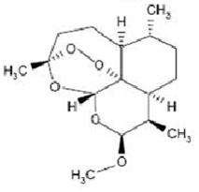

Fig. 2.1 Chemical structure of artemether

## Chemistry of artemether

Artemether is available as white crystals or a white crystalline powder which melts at 86

- 90 ˚C. Its chemical name is (3R,5aS,6R,8aS,9R,10S,12R,12aR)-Decahydro-10-methoxy- 3,6,9-trimethyl-3,12-epoxy-12H-pyrano[4,3-j]-1,2-benzodioxepin and it has a molecular mass of 298.4. Based on definition of solubility given in the United State Pharmacopoeia (Table 2.1), the compound is practically insoluble in water; very soluble in dichloromethane, chloroform and acetone; freely soluble in ethyl acetate, dehydrated ethanol and methanol (Sunil *et al.,* 2010).

## Table 2.1: Solubility definition in the United State Pharmacopoeia (USP) (Stegemann *et al*., 2007)

|  |  |  |  |
| --- | --- | --- | --- |
| **Description forms** | **Parts of solvent** | **Solubility** | **Solubi** |
| **(solubility definition)** | **required** | **range** | **lity** |

**for one part of solute**

## (mg/ml)

**assigned**

## (mg/m

**l)**

|  |  |  |  |
| --- | --- | --- | --- |
| Very soluble (VS) | <1 | >1,000 | 1,000 |
| Freely soluble (FS) | From 1 to 10 | 100-1,000 | 100 |
| Soluble (S) | From 10 to 30 | 33-100 | 33 |
| Sparingly soluble (SPS) | From 30 to 100 | 10-33 | 10 |
| Slightly soluble (SS) | From 100 to | 1-10 | 1 |
| 1,000  Very slightly soluble (VSS) From 1,000 to | | 0.1–1 | 0.1 |
| 10,000  Practically insoluble (PI) >10,000 | | <0.1 | 0.01 |

## Formulations of artemether

The commercially available formulations of artemether are mainly two types:

* Ampoules of injectable solution for intramuscular injection containing 80 mg of artemether in 1 ml for adults or 40 mg of artemether in 1 ml for paediatric use.
* In a co-formulation with Lumefantrine: tablets containing 20 mg of Artemether and 120 mg of Lumefantrine.

## Pharmacokinetics of artemether

Peak plasma concentrations of artemether occur within 2 – 3 h after oral administration (Ezzet-Mull *et al.,* 1998). Following intramuscular injection, absorption is quite variable, especially in children with poor peripheral perfusion. Peak plasma concentrations generally occur after around 6 h but absorption is slow and erratic and times to peak can be 18 h or

longer in some cases (Hien *et al.,* 2004). Artemether is metabolized to dihydro artemether (DHA), the active metabolite. After intramuscular administration, artemether predominates, whereas after oral administration DHA predominates. Biotransformation is mediated via the cytochrome P450 enzyme CYP3A4. Auto-induction of metabolism is less than that with artemisinin. Artemether is 95 % bound to plasma proteins. The elimination half-life is approximately 1 h, but following intramuscular administration, the elimination phase is prolonged because of continued absorption. No dose modifications are necessary in renal or hepatic impairment.

## Toxicity of artemether

In all species of animals tested, intramuscular artemether and arteether caused an unusual selective pattern of neuronal damage to certain brain stem nuclei. Neurotoxicity in experimental animals is related to the sustained blood concentrations that follow intramuscular administration. It is much less frequent when the same doses are given orally, or with similar doses of water-soluble drugs such as artesunate. Clinical, neurophysiological and pathological studies in humans have not shown similar findings with therapeutic use of these compounds (Hien *et al.,* 2004). Toxicity of artemether is otherwise similar to that of artemisinin.

## UV Spectrophotometric Analysis of artemether

The artemisinins lack strongly absorbing chromophores and artemether is no exception. Due to its lack of such chromophore groups, artemisinin and its derivates absorb weakly in the low wavelength region and this makes their quantification difficult. The available UV spectrophotometric methods for the analysis of artemether make use of its HCl

decomposition product. This acid decomposition product of artemether has been described as α β unsaturated decalone and absorbs at a wavelength of 254 nm (Thomas *et al.,* 1992).

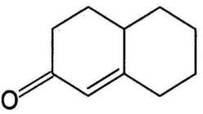

Fig. 2.2 The chemical structure of α β unsaturated Decalone

Though this product absorbs strongly at the said wavelength, it requires very vigorous conditions for its formation. The International Pharmacopoeia (IP) method for the assay of artemether (both as the pure sample and in formulations) requires the addition of 1 M ethanolic HCl solution to an aliquot of artemether in ethanol solution followed by heating at 55 ˚C for 5 h (IP, 2008). Another method developed by Shrivastava *et al.* (2008) requires heating at 60 ˚C for 3 h. The time demands as well as the extent of heating required by these methods make them uneconomical. Green *et al.* (2001) have also described a method for the assay of artemether and other artemisinins by the reaction of the acid decomposition product with a dye to yield a coloured derivative which absorbs at 420 nm. This method requires a period of 1 h for the formation of the product prior to reaction with the dye (Green *et al.,* 2001).

## CHROMOPHORES

A chromophore is a group of atoms and electrons forming part of an organic molecule that causes it to be coloured. The colour arises when a molecule absorbs certain wavelengths of

visible light and transmits or reflects others. The chromophore is a region in the molecule where the energy difference between two different molecular orbits falls within the range of the visible spectrum. Visible light that hits the chromophore can thus be absorbed by exciting an electron from its ground state into an excited state (Gold, 2012).

## DERIVATIZATION

Derivatization is a technique used in chemistry which transforms a chemical compound into a product (the reaction derivate) of similar chemical structure, called a derivative. A specific functional group of the compound is altered, resulting in new chemical properties that can be used for quantification or separation of the derivate.

Generally, it is performed to modify an analyte‟s functionality in order to enhance detectability and quantification (Britannica Online, 2012). Since artemether lacks strongly absorbing chromophore, it (both as a pure sample and in formulations) is dissolved in dehydrated ethanol and treated with 1 M ethanolic HCl solution followed by heating at 55˚C for 5 h (IP, 2008).

## PHARMACEUTICAL APPLICATION OF CYCLODEXTRINS

A drug substance has to have a certain degree of water solubility to be readily delivered to the cellular membrane, yet it needs to be lipohilic enough to cross the membrane. One of the unique properties of cyclodextrins is their ability to enhance drug delivery through biological membranes. The cyclodextrin molecules are relatively large (molecular weight ranging from almost 1000 to over 1500), with a hydrated outer surface, and under normal conditions, cyclodextrin molecules will only permeate biological membranes with considerable difficulty, (Frömming and Szejtli, 1994; Rajewski *et al.,* 1996).

It is generally recognized that cyclodextrins act as true carriers by keeping the hydrophobic drug molecules in solution and delivering them to the surface of the biological membrane, for example, skin, mucosa or the eye cornea, where they partition into the membrane. The relatively lipophilic membrane has a low affinity for the hydrophilic cyclodextrin molecules and therefore, they remain in the aqueous membrane exterior, for example, the aqueous vehicle system (such as o/w cream or hydrogel), saliva or the tear fluid. Conventional penetration enhancers, such as alcohols and fatty acids, disrupt the lipid layers of the biological barrier (Gerold and Thompson, 2002).

Cyclodextrins, on the other hand, act as penetration enhancers by increasing drug availability at the surface of the biological barrier. For example, cyclodextrins have been used successfully in aqueous dermal formulations (Uekama *et al.,* 1992), aqueous mouthwash solution, (Kristmundsdóttir *et al.,* 1996), nasal drug delivery systems and several eye drop solutions (Loftsson *et al.,* 1997; Van, 1993 and Jarho *et al.,* 1996). The majority of pharmaceutical active agents do not have sufficient solubility in water and traditional formulation systems for insoluble drugs involve a combination of organic solvents, surfactants, and extreme pH conditions, which often cause irritation or other adverse reactions. Cyclodextrins are not irritants and offer distinct advantages such as the stabilisation of active compounds, reduction in volatility of drug molecules and masking of malodours and bitter tastes (Gerold and Thompson*,* 2002).

There are numerous applications for cyclodextrins in the pharmaceutical field. For example, the addition of α- or β-cyclodextrin increases the water solubility of several poorly water-soluble substances. In some cases, this results in improved bioavailability, and show improved pharmacological effect allowing a reduction in the dose of the drug administered

and reduced side effects. Inclusion complexes can also facilitate the handling of volatile products. This can lead to a different way of drug administration, for example, in the form of tablets. Cyclodextrins are used to improve the stability of substances by increasing their resistance to hydrolysis, oxidation, heat, light and metal salts. The inclusion of irritating products in cyclodextrins can also protect the gastric mucosa for the oral route, and reduce skin damage for the dermal route (Gerold and Thompson, 2002).

Furthermore, cyclodextrins can be applied to reduce the effects of bitter or irritant tasting and bad smelling drugs (Irie *et al*., 1999; Zhao *et al*., 1995). Administered cyclodextrins are quite resistant to starch degrading enzymes, although they can be degraded at very low rates

by α-amylases. α-Cyclodextrin is the slowest, and ϒ-cyclodextrin is the fastest degradable compound, due to their differences in size and flexibility. Degradation is not performed by

saliva or pancreas amylases, but by α-amylases from microorganisms in the colon flora. Adsorption studies revealed that only 2–4 % of cyclodextrins were adsorbed in the small intestines, and that the remainder is degraded and taken up as glucose. This can explain the low toxicity found upon oral administration of cyclodextrins.

## INCLUSION COMPLEX FORMATION

The most notable feature of cyclodextrins is their ability to form solid inclusion complexes (host–guest complexes) with a very wide range of solid, liquid and gaseous compounds by molecular complexation (Martin Del Valle 2003). In these complexes, a guest molecule is held within the cavity of the cyclodextrin host molecule. Complex formation is a dimensional fit between host cavity and guest molecule (Muñoz-Botella *et al.,* 1995). The lipophilic cavity of cyclodextrin molecules provides a microenvironment into which appropriately sized non-polar moieties can enter to form inclusion complexes

(Loftsson *et al.,* 1996). No covalent bonds are broken or formed during formation of the inclusion complex (Schneiderman *et al.,* 2000). The main driving force of complex formation is the release of enthalpy-rich water molecules from the cavity. Water molecules are displaced by more hydrophobic guest molecules present in the solution to attain an apolar–apolar association and decrease of cyclodextrin ring strain resulting in a more stable lower energy state (Szetjli 1998). The binding of guest molecules within the host cyclodextrin is not fixed or permanent but rather a dynamic equilibrium.

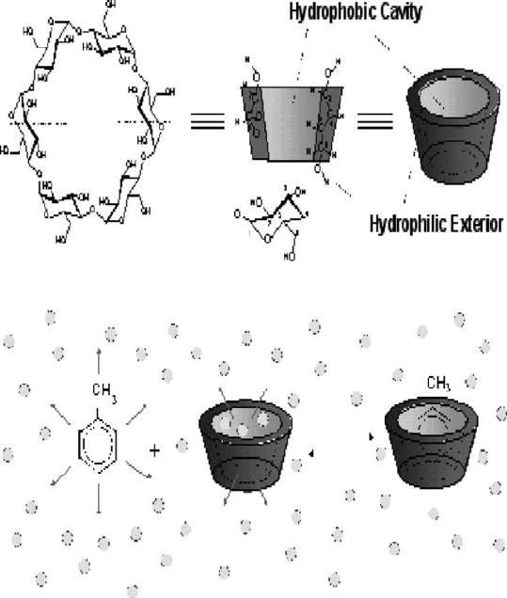

Fig. 2.3 Cyclodextrins structure and inclusion complex formation.

Adapted from Martin Del Valle E.M. (2003).

Binding strength depends on how well the „host–guest‟ complex fits together and on specific local interactions between surface atoms. Complexes can be formed either in

solution or in the crystalline state and water is typically the solvent of choice. Inclusion complexation can be accomplished in a co-solvent system and in the presence of any non- aqueous solvent. Cyclodextrin architecture confers upon these molecules a wide range of chemical properties markedly different from those exhibited by non-cyclic carbohydrates in the same molecular weight range.

Inclusion in cyclodextrins exerts a profound effect on the physicochemical properties of guest molecules as they are temporarily locked or caged within the host cavity giving rise to beneficial modifications of guest molecules, which are not achievable otherwise (Schmid, 1989). These properties are: solubility enhancement of highly insoluble guests, stabilization of labile guests against the degradative effects of oxidation, visible or UV light and heat, control of volatility and sublimation, physical isolation of incompatible compounds, chromatographic separations, taste modification by masking off flavours, unpleasant odours and controlled release of drugs and flavours (Schmid, 1989).

Therefore, cyclodextrins are used in foods (Fujishima *et al.,* 2001), pharmaceuticals (Bhardwaj *et al.,* 2000), cosmetics (Holland *et al.,* 1999), environment protection (Lezcano *et al.,* 2002), bioconversion (Dufosse *et al.,* 1999), packing and the textile industry (Hedges 1998). The potential guest list for molecular encapsulation in cyclodextrins is quite varied and includes such compounds as straight or branched chain aliphatics, aldehydes, ketones, alcohols, organic acids, fatty acids, aromatics, gases, and polar compounds such as halogens, oxyacids and amines (Schmid,1989). Due to the availability of multiple reactive hydroxyl groups, the functionality of cyclodextrins is greatly increased by chemical modification. Through modification, the application of cyclodextrins has expanded.

CDs are modified through substituting various functional compounds on the primary and/or secondary face of the molecule. Modified CDs are useful as enzyme mimics because the substituted functional groups act in molecular recognition. The same property is used for targeted drug delivery and analytical chemistry as modified CDs show increased enantioselectivity over native CDs (Martin Del Valle, 2003).

The ability of cyclodextrin to form an inclusion complex with a guest molecule is a function of two key factors. The first is steric and depends on the relative size of the cyclodextrin to the size of the guest molecule or certain key functional groups within the guest. If the guest is the wrong size, it will not fit properly into the cyclodextrin cavity.

The second critical factor is the thermodynamic interactions between the different components of the system (cyclodextrin, guest, solvent). For a complex to form, there must be a favourable net energetic driving force that pulls the guest into the cyclodextrin. While the height of the cyclodextrin cavity is the same for all three types, the number of glucose units determines the internal diameter of the cavity and its volume. Based on these dimensions, α-cyclodextrin can typically complex low molecular weight molecules or compounds with aliphatic side chains, β-cyclodextrin will complex aromatics and

heterocycles and ϒ-cyclodextrin can accommodate larger molecules such as macrocyclics and steroids. In general, therefore, there are four energetically favourable interactions that help shift the equilibrium to form the inclusion complex:

* The displacement of polar water molecules from the apolar cyclodextrin cavity.
* The increased number of hydrogen bonds formed as the displaced water returns to the larger pool.
* A reduction of the repulsive interactions between the hydrophobic guest and the aqueous environment.
* An increase in the hydrophobic interactions as the guest inserts itself into the apolar cyclodextrin cavity (Martin Del Valle, 2003).

While this initial equilibrium to form the complex is formed very rapidly (often within minutes), the final equilibrium can take much longer to reach. Once inside the cyclodextrin cavity, the guest molecule makes conformational adjustments to take maximum advantage of the weak van der Waals forces that exist.

## METHODS OF PREPARING INCLUSION COMPLEXES

There are several methods of preparing inclusion complexes, which include;

* Spray drying
* Freeze drying
* Paste complexation (Kneading)
* Solid phase complexation
* Co-precipitation

In general, spray drying is preferred over the other methods. Co-precipitation is an older method often found in the literature but no longer recommended. The method selected will depend on the properties of the active ingredient, the equipment available and the cost. The choice of method will need to be optimized to achieve optimum performance (Martin Del Valle, 2003).

## Spray Drying

To form a complex by spray drying, the cyclodextrin is either dissolved or suspended in water at room temperature (20 - 25 OC) and stirred vigorously. Typically, 1 part of cyclodextrin is mixed with 10 parts of water. The drug active is then slowly added to the water-cyclodextrin solution or suspension. The active can either be added as it is or dissolved in a solvent. The complex is isolated by spray drying the solution (Martin Del Valle, 2003).

## Freeze Drying

The drug active and cyclodextrin are dissolved in water or water co-solvent mixture. The complex is isolated by freeze drying the solution.

## Paste Complexation or Kneading

The cyclodextrin and drug active are mixed with a small amount of water (usually 1:1 on weight basis of cyclodextrin to water), in a high-shear granulator or with a mortar and pestle in the laboratory. Complexation occurs within 1 to 2 h (Martin Del Valle, 2003).

## Solid Phase Complexation

The cyclodextrin and drug active are milled, co-grinded or extruded using a high level of mechanical energy. Without sufficient energy to dry the cyclodextrin, complexation will not occur (Martin Del Valle, 2003).

## Co-precipitation

The cyclodextrin and drug active are added to water or a short-chain alcohol, such as ethanol or isopropanol at 40-60 0C to form a saturated solution. The complexation time

varies from 24 to 48 h. Upon cooling, the complex precipitate is then isolated by filtration or centrifugation. Due to the high level of water or solvent and the length of time required, this method is not recommended (Martin Del Valle, 2003).

The advantages and disadvantages of each method are presented in Table 2.2.

## Table 2.2: Advantages and Disadvantages of different Methods of Preparing Inclusion Complexes

**METHOD ADVANTAGES DISADVANTAGES**

**Spray drying** Common technique

Continuous process Scaleable

Efficient

Limited commercial

capacity

**Freeze drying** Efficient Low throughput Expensive

Limited commercial capacity

## Paste complexation (Kneading)

Equipment commonly available

Scaleable

Not as effective as spray drying or freeze drying at forming complexes

**Solid phase dispersion** Simple method Less effective method Equipment less common at

commercial scale

**Co-precipitation** No advantage compared to other methods

E.M. Martin Del Valle (2003).

## ANALYSIS OF INCLUSION COMPLEXES

Low yield Difficult to scale

Requires up to 48 hours Expensive

It is important to effectively analyze inclusion complexes to determine the degree of complexation. There is no one method that completely characterizes inclusion complexes. So it is best to rely on several methods. To quantitatively evaluate a complex, differential scanning calorimetry (DSC) is often used to determine the amount of uncomplexed active. Microscopy and x-ray diffraction are also used to qualitatively evaluate the residual crystallinity of the active drug. Other methods used include high-performance liquid chromatography (HPLC) for determining the relative amounts of complexed and uncomplexed active; dissolution testing for evaluation of solubility improvements of

uncomplexed and complexed active; and Karl-Fischer titration and loss of weight on drying for evaluation of moisture content (Martin Del Valle, 2003).

## SOLUBILITY ISOTHERM AND THE STABILITY OR EQUILIBRIUM CONSTANTS (Kc)

Measurement of stability or equilibrium constants (Kc) of the drug–cyclodextrin complexes are important since this is an index of changes in physicochemical properties of a compound upon inclusion (Martin Del Valle, 2003). One of the most useful and widely applied analytical approaches in this context is the phase–solubility method described by Higuchi and Connors (1964). Phase–solubility analysis involves an examination of the effect of a solubilizer, that is, cyclodextrin or ligand, on the drug being solubilized, that is, the substrate. Phase–solubility analysis of the effect of complexing agents on the compound being solubilized is a traditional approach to determine not only the value of the stability constant but also to give insight into the stoichiometry of the equilibrium.

Experimentally, an excess of a poorly water-soluble drug is introduced into several vials to which a constant volume of an aqueous vehicle containing successively larger concentrations of the cyclodextrins are added. The need for excess drug is based on the desire to maintain as high a thermodynamic activity of the drug as possible. The vials are shaken or otherwise agitated at constant temperature until equilibrium is established. The suspensions are then filtered and the total concentration of the drug determined based on appropriate analytical techniques (UV spectrophotometry, HPLC, and so forth). The phase– solubility profile is then constructed by assessing the effect of the cyclodextrin on the apparent solubility of the drug. The practical and phenomenological implications of phase– solubility analysis were developed by Higuchi and Connors (1964) and later reviewed by

Connons and Zha (1995). Based on the shape of the generated phase–solubility relationship, several types of behaviors can be identified (Ekberg *et al*., 1989). Phase–solubility diagrams fall into two major types: A and B, as shown in Fig. 2.4.

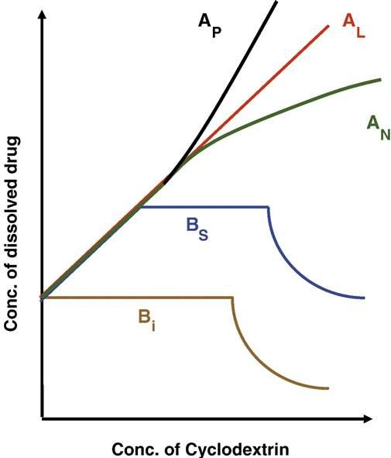

Fig. 2.4. Graphical representations of A and B-type phase–solubility profiles with applicable subtypes (AP, AL, AN, BS, and BI), (Martin Del Valle, 2003).

In type A diagrams; an increase in the solubility of the compound occurs as the amount of complexing agent increases. Soluble complexes are formed between the compound and the complexing agent, thereby increasing the total amount of compound in solution. Depending on the nature of the complexes formed, the diagram can be linear, AL, show curvature in a positive, AP, or negative, AN (Fig. 2.4). Linear diagrams are formed when each complex contains only one molecule of complexing agent. When more than one

molecule of complexing agent is found in the complex, an AP type diagram is formed. AN diagram are uncommon but may result if self-association is present or high concentrations of complexing agent cause alteration in the nature of the solvent.

Type B diagrams are observed when complexes of limited solubility are formed. B-type phase-solubility profiles indicate formation of complexes with limited solubility in the aqueous complexation medium. In general, the water-soluble cyclodextrin derivatives form A-type phase solubility profiles, whereas the less soluble natural cyclodextrin forms B-type profiles. β-cyclodextrin often gives rise to B-type curves due to the poor water solubility of the ligand itself. The chemically modified cyclodextrins including hydroxypropyl-β- cyclodextrin (HP-β-CD) and sulfobutyl ether-β-cyclodextrin (SBE-β-CD) usually produce soluble complexes (that is, A-type systems) (Martin Del Valle, 2003).

The most common type of cyclodextrin complexes is the 1:1 drug/cyclodextrin (D/CD) complex where one drug molecule (D) forms a complex with one cyclodextrin molecule (CD) and is given Equation 2 (Martin Del Valle, 2003).

K1:1 = 

(2)

The value of K1:1 is most often between 50 and 2000 M-1. Under such conditions, for an AL-type phase-solubility diagram with slope less than unity, the stability constant (K1:1) of the complex can be calculated from the slope and the intrinsic solubility (so) of the drug in aqueous complexation media (that is, drug solubility when no CD is present) as given in Equations 3a and 3b (Shankarrao *et al.,* 2010).

(3a)

That is:

K1:1 =

Stability constant (Kc) = 

(3b)

If the Kc is too low, forming a complex will be difficult. If it is too high, the complex may not dissociate quickly enough *in vivo.* A slope greater than one indicates a complex greater than 1:1 drug-cyclodextrin (Shankarrao *et al.,* 2010). The most common stoichiometry of higher order D/CD complexes is the 1:2 D/CD complex resulting in Ap- type phase solubility diagram. Consecutive complexation is assumed where 1:2 complexes (Equation 3) are formed when one additional cyclodextrin molecule forms a complex with an existing 1:1 complex. The value of k1:2 frequently lies between 10–500 M-1 and is lower than that of K1:1 (50–2000 M-1) (Martin Del Valle, 2003).

K1:2 = 

## (4) 2.9:METHODS OF ENHANCING COMPLEXATION

Table 2.3 outlines the various methods of enhancing complexation (Arun *et al.,* 2008)

Table 2.3: Methods of enhancing complexation

## Method Explanation

Drug ionization Unionized drugs do usually form more stable complexes

than their ionic counterparts. However, ionization of a drug increases its apparent intrinsic solubility resulting in enhanced complexation.

Salt formation It is sometimes possible to enhance the apparent intrinsic solubility of a drug through salt formation.

Complex-in-complex It is sometime possible to increase the apparent intrinsic

solubility of a drug through formation of meta complexes

The acid/base ternary Complexes

It has been shown that certain organic hydroxy acids (such as citric acid) and certain organic bases are able to enhance the complexation efficiency by formation of ternary drug/cyclodextrin/acid or base complexes.

Polymer complexes Water-soluble polymers form a ternary complex with

drug/cyclodextrin complexes increasing the observed stability constant of the drug/cyclodextrin complex. This observed increase in the value of the constant increases the complexation efficiency.

Solubilization of Cyclodextrin aggregates

Organic cations and anions are known to solubilize uncharged drug/cyclodextrin complex that have limited aqueous solubility. This will enhance the complexation efficiency during preparation of solid drug/cyclodextrin complex powder.

Combination of two or more methods

Frequently, the complexation efficiency can be enhanced even further by combining two or more of the above mentioned methods, for example, drug ionization and the polymer method, or solubilization of the cyclodextrin aggregates by adding both polymers and cations or anions to the aqueous complexation medium.

## FACTORS AFFECTING COMPLEXATION

## Steric Effects

Cyclodextrins are capable of forming inclusion complexes with compounds having a size compatible with the dimensions of the cavity. Complex formation with molecules significantly larger than the cavity may also be possible in such a way that only certain groups or side chains penetrate into the carbohydrate channel. The three natural CDs α, β and γ have different internal diameters and are able to accommodate molecules of different sizes. Cyclohexane is able to complex with all three CDs, but because of size, naphthalene does not complex with α-CD, which has the smallest cavity. Anthracene fits only into γ-CD, which has the largest cavity (Gerold and Thompson, 2002).

Derivatization of the hydroxyls on one or both faces of the natural CD can impact the stearic requirements for an acceptable guest molecule. The presence of bulky groups can sterically block entrance to the CD cavity. However, some groups, depending on their number, flexibility, and position of attachment, may actually act to extend the cavity and provide for better complexation. Substitution at the 3 and 6 positions will be more likely to narrow the cavity opening while substitution at the 2 and 6 positions may allow for extension of the opening. The binding constants of flurbiprofen (Imai *et al.,* 1984), bromazepam (Abdel-Rahman *et al.,* 1994), and nitrazepam (Ahmed *et al.,* 1990) to 2, 6- MD-β-CD (methyl substituent in the 2 and 6 positions) are 2.3, 2.9, and 3.8 folds higher respectively. TM-β-CD (methyl substituents in the 2, 3, and 6 positions), however, show constants that are less than half of that observed with β-CD.

The number of substitutions added to the ring and molar degree of substitution (MS) can also affect binding in both positive and negative manners. Muller and Brauns (1985) showed

that increasing the MS from 3 to 11 decreased the solubilisation of hydrocortisone from

10.98 to 5.76 mg/ml for a 0.04 M HE-β-CD (hydroxyethyl) solution (~5 % w/v). A similar effect was observed for digitoxin, diazepam, and indomethacin. The decrease in solubilization was thought to be due to steric hindrance of the increased number of hydroxyethyl substituents. An additional explanation may be that some polymerization of the hydroxyethyl groups may have occurred during preparation of the higher MS products, thereby, creating bulkier side chains that may have crowded the cavity entrance.

The hydroxypropyl substituent, though larger, appears to require a lower degree of substitution (DS) to improve binding without sterically obscuring the cavity entrance. Muller *et al.* (1985) have studied the effect of the DS on complexing ability and have observed that lower degrees of hydroxypropyl substitution (2 to 5) are more conducive to complexation. As the DS increases, the solubilization of six different drugs decreases but when the DS is from 4 to 8, the solubilization is fairly consistent.

There is compromise between the steric hindrance of a substituent and its ability to extend the hydrophobic cavity. Yoshida *et al.* (1989) have shown that introduction of the 3- hydroxypropy1 (3HP) substituent (-O-CH2 - CH2 -CH2-OH) at an MS of approximately 6, results in higher binding constants than those observed with β-CD, apparently due to the extension of the hydrophobic cavity. The introduction of an equivalent number of 2, 3- dihydroxypropy1 (2, 3-DHP) substituents (-O-CH2-CH (OH)-CH2-OH), however, results in a decrease in the binding constants. This was speculated to be due to steric hindrance of the larger 2,3-DHP substituents, though this group, being more hydrophilic than 3HP, may not serve to extend the hydrophobicity of the cavity.There is also a compromise between the ability to form complexes and the intrinsic water solubility. Rao *et al.* (1992)*,* have shown

that increasing the DS of (2HP)-β-CD improves the aqueous solubility but impairs the complexation capability.

## Electronic Effects

**Effect of proximity of charge to CD cavity:** The ionic derivatives that have charges close to the CD cavity are the carboxylate, sulphate, and sulfonate derivatives. The complexation characteristics of the directly carboxylated CDs, C-β-CDs have not been reported but the highly anionic sulphated CD derivatives (S14-β-CD), do not appear to form inclusion complexes (Gerloezy *et al.,* 1994). This may be either due to steric effects from 14 sulfate substituents or due to the ionic state of the CD. The effect of charge proximity on CD complexation behaviour was evaluated by studying the complexation of two steroids (Testosterone and Progesterone) by the sulfonate, sulfopropyl ether (SPE), and sulfobutyl ether (SBE) derivative (Stella *et al.*, 1992). Electronic effect seems to be more of a factor than steric effect because even when only one sulfonate substituent is attached at the 6- position (6-SA1-β-CD), the derivative loses its complexation. The binding constant for testosterone is only 64 *M*–1 for 6-SA1-β-CD versus 17,800 *M*–1 for the neutral β-CD. The attachment of a single negative charge close to the CD cavity appears to disrupt the thermodynamics driving the complexation. When one sulfonate ion (SA1) is directly attached to the CD, there is a minimal binding of the steroids but as the charges are spaced away by the three carbon propyl, sulfopropyl ether (SPE1), or a four carbon butyl group (SBE1), the derivatives regain the binding capability of the β-CD molecule. The monosubstitute sulfopropyl (SPE1) and sulfobutyl (SBE1) derivitives are able to bind progesterone and testosterone as well as β-CD. This suggests that ionic substituents too close to the CD cavity adversely disrupt the thermodynamics driving the inclusion

complexation. Moving the charge away from the cavity re-establishes the complexation characteristics but this is dependent on the charge density in the structure (Gerold and Thompson, 2002).

**Effect of charge density:** As the charge density increases in the sulfopropyl family from a mono to a tetra and hepta anion, the binding of the steroids decreases. However, when the sulfonate anion was spaced four methylene units away, the charge density did not adversely affect the binding of the steroids. The mono, tetra, and hepta substituted sulfobutyl ether derivatives all displayed comparable binding abilities for the steroids and the strength of binding was similar to that observed for β-CD (Gerold and Thompson, 2002).

**Effect of charge state of CD and drug:** Ionic CDs are capable of complexing neutral hydrophobic drugs, if the ionic charge is not directly attached to the carbohydrate backbone of the CD. The trianion of CM3-β-CD is able to complex a neutral drug, hydrocortisone with an association constant that is 74 % of that observed for neutral β-CD (Thuaud *et al*., 1990). Although this anionic derivative is less effective than the neutral β-CD, a more favourable situation has been observed for the interaction of anionic SBE-β-CDS and neutral drugs. Okimoto *et al*., (1996) reported that the anionic SBE-β-CD often exhibits 1:1 binding constant with neutral drugs that are comparable to or better than those observed for the neutral HP-β-CD. The better binding may be due to the butyl “micellar” arms extending the hydrophobic cavity of the CD. When the drugs and the CD are both charged, electrostatic effect may be observed. Adverse electronic effects have been observed for the complexation between the anionic form of indomethacin and the dianion carboxymethyl–β-CD, CM2-β- CD (Muller and Brauns*,* 1985). At pH 6.6, indomethacin exists as an anion and under these conditions, the anionic carboxymethyl CD did not complex the drug at all, probably due to

electrostatic repulsions. Cooperative electrostatic interaction between the cationic drugs and the anionic CDs has been observed. Enhanced complexation is observed for the complexation of the cationic form of propranolol with the anionic CM3-β-CD and is probably due to cooperative electrostatic interactions. Similar positive interactions are observed with the SBE-β-CD and the cationic forms of cinnarizine, miconazole, papaverine, and thiabendazole (Gerold and Thompson, 2002).

## Effect of Temperature and Co-solvent

Inclusion complexation is an equilibrium process and the strength of association is affected by the temperature of the system. In most cases, as the temperature increases, the binding constant will decrease. For example, the binding constant for the neutral naproxen molecule and β-CD decreased from 1379 to 975 to 778 *M*–1 as the temperature increased from 25 oC to 35 oC and 45 oC respectively. The solubility of a drug in the CD solution may increase with temperature even though the binding constant is decreasing because the increased temperature improves the intrinsic solubility of the free drug (Gerold and Thompson, 2002).

Organic solvents typically reduce the complexation of a drug with CD by competing for the hydrophobic cavity. They also reduce the solubility of most CDs and their complexes. Loftsson *et al*. (1999) have reported on the use of water soluble polymers and hydroxyl acids, respectively, to increase CD:drug complexation and to improve the solubilizing effect.

## RELEASE FROM COMPLEXES

Complexation of drugs by CDs improves their delivery characteristics and does not interfere with their therapeutic activity because complexation is a rapidly reversible process. In aqueous solution, drug: CD complexes are continually forming and dissociating with half lives times in the range of milliseconds or less (Turro *et al*., 1982; Hashimoto *et al.*, 1985). Although slower kinetics of dissociation are seen with stronger binding, the rates are still fast and essentially instantaneous. After administration, the drug is released from the complex as a result of displacement of the hydrophilic cyclodextrin by endogenous lipophiles. Drug uptake into tissue is not available to the whole complex, and rapid elimination of the CD results (Stella *et al.,* 1999).

## BENEFITS OF COMPLEXATION

## Improvement in Solubility, Dissolution and Bioavailability

CD formulations provide aqueous solubility to poorly soluble drugs, and the drug:CD complex often exhibits improved dissolution characteristics compared to other formulations of the drug. These two features can provide for an improvement in oral bioavailability when solubility and the rate of dissolution are limiting the availability of the drug for absorption. For example, the drug cefotiam hexetil hydrochloride forms a gel under the acidic condition of the gastric content and shows poor dissolution. A variety of excipients were screened to prevent gelation and α-CD complexation afforded the best formulation for the dissolution and solubilization of the drug (Hirai, 1994).

Another example is the calcium channel blocker, cinnarizine. This drug exhibits a very low and erratic bioavailability (F) after oral administration as a suspension (F = 8 ± 4 %) or capsule (F = 0.8 ± 0.4 %). When cinnarizine was administrated as a complex with SBE4-β-

CD or HP-β-CD (Jarvinen *et al.,* 1995), either as a solution (F = 55 - 60 %) or in a capsule (F = 38 ± 12 %), the bioavailability was significantly enhanced. The improvement in bioavailability was attributed to the enhanced dissolution and solubilization via the complexation.

A review of the literature reveals several hundred citations and reviews that describe the effect of complexation on dissolution and bioavaibility of drugs. A broad range of CDs and CD derivatives have been investigated as well as many different drugs. Some other representative examples are spironolactone (Soliman *et al.*, 1997), meclizine (Saket, 1997), ketoprofen (Nargasenker *et al*., 1997), oxazepam (Moyano *et al.*, 1997), danazol (Badawy *et al*., 1995) and phenytoin (Savolainen *et al.,* 1998). Although these studies demonstrate the general application of complexation for improvement in dissolution and bioavailability, the use of complexation may not be practical for some dosage forms due to the amount of CDs required. β-CD for example, has molecular weight of 1135. If one uses a mole ratio of 5:1 to promote solubility, then over 350 mg of CD will be required for a 25 mg dose of a drug having a molecular weight of 400. This can limit the type and dose of drug that can realistically be used with complexing agents for solid oral dosage forms, and therefore constitute a draw back.

Solution formulations, however, do not typically have these same constraints, and complexation provides an alternative to the use of non-aqueous solvents or large volumes. A few derivatized CDs (for example, hydroxypropyl and sulfobutyl ether), often can be can be safely administered by parenteral routes. This is often where complexation and its improvements in aqueous solubility can be most readily achieved. The derivatized CDs often can be used to replace cosolvents such as ethanol, polyethylene glycol, and lipids, as

well as provide an alternative to the use of emulsions and liposomes. The hydroxypropyl and sulfobutyl ether derivatives are stable in solution and can be readily autoclaved, often improving the heat stability of drugs. There are however, reports of complexation of CDs with anti-oxidants (Vora *et al.*, 1995) and preservatives (Lehner *et al*., 1994; (Loftsson *et al.,* 1992) with both decreased and increased efficacy respectively (Nunuz-Delicado *et al*., 1997).

## Reduction of Unpleasant Side Effects and Bitter Taste

The improvements in the rate and extent of dissolution of a drug can improve the rate of absorption of the drug. Reducing the contact time between the drug and the tissue mucosa can help minimize tissue irritation produced by drugs. Nonsteroidal anti-inflammatory drugs cause high incidence of gastrointestinal ulcerative lesion as a result of tissue irritation and systemic inhibition of prostaglandin synthesis by these drugs. CD formulations of naproxen (Otero *et al.*, 1991), diclofenac (Park *et al*, 1997), and piroxicam (Santucci *et a.l,* 1992) cause fewer gastric lesions associated with the acute local tissue irritation than produced by the drug formulations containing CDs have also shown less irritation that non CD containing formulation for ophthalmic (Loftsson *et al*., 1999), intravenous (Doenicke *et al.,* 1994), and intramuscular (Stella *et al.,* 1995) administration, and in cellular injury screening tests (Howard *et al.,* 1992).

Complexation with CDs can also have effect of reducing the period of contact with taste receptors. This can be of great benefit in the preparation of oral solutions. Not only are the drugs “masked” from the receptors by inclusion in the CD cavity, the increased hydrophilicity enables the easier removal of the bitter substance from the receptor surface as well. The apparent concentration of the uncomplexed bitter drug is a function of the

complexation constant, the amount of free CD, and the water solubility of the drug (Weizfeiler *et al*., 1988). Complexation has been used to mask the unpleasant bitter taste of a number of drugs such as oxyphenonium bromide (Funaski *et al.,* 1999), propantheline bromide, (Funaski *et al.,* 1996), clofibrate (Uekama *et al*., 1983), and acetaminophen (Weizfeiler *et al.,* 1988).

## Improvement in Drug Stability

CDs are normally thought of as stabilizing agents in pharmaceutical formulations (Loftsson *et al.,* 1995; Loftsson *et al.,* 1996). They have been shown to stabilize drugs to hydrolysis (Ueda *et al*., 1997), hydrolytic dehalogenation (Ma *et al*., 2000), oxidation (Schlenk *et al.,* 1955), decarboxylation, and isomerization (Hirayama *et al.,* 1984), both in solution and in the solid state. They can, however, accelerate these same reactions under certain conditions (Jarho *et al.*, 2000; Oguchi *et al*., 1989). The nature of the stabilization or destabilization depends on the mode of CD used (parent and functional groups of any derivative) and on the position of the guest molecule inside the CD. If the molecule is positioned such that the area of instability is located outside the CD, no effect on stability may be observed. When the position allows interaction of the CD hydroxyls (or derivative functional groups) with a hydrolytically prone site, decreased stability may be observed but if the site is located fully within the CD, enhanced stability usually results.

In the solid state, stabilization of drugs to degradation has been reported for numerous drugs including nicardipine (Miclearek, 1996), colchicine (Ammar and El-Nahhas, 1995) and prostaglandin (Lee *et al*., 1988).

Stabilization is not limited to small compounds, as larger molecules such as peptides and proteins can also form complex that results in enhanced chemical and physical stability (Sigurjonsdottir *et al*., 1999). The CDs will typically interact with functional groups present on exposed surfaces of the macromolecules and often form multiple complexes (several CDs per molecule). Stabilization against aggregation has been observed for CD complexes in carbonic anhydrase (Karumppiah *et al*., 1995), insulin (Tokihiro *et al*., 1997) and in the solid state, with albumin and gamma-globulin (Katakam *et al.,* 1995). CD complexes have also been investigated as chaperone-mimics (Cooper *et al*., 1996) in the refolding of denatured proteins (Sharma *et al*., 1997).

The degree of stabilization/destabilization of drug complexing with a CD depends not only on the rate of degradation within the complex, but also on the fraction of drug that is complexed (Loftsson *et al*., 1996), and the stoichiometry (Utsuki *et al.,* 1993). Increased stability is often observed for compounds having high association constants and those that tend to form higher order complexes.

## Reduction in Volatility

Inclusion complexes have been prepared with a number of volatile substances (Lin *et al.,* 1992; Qi *et al.,* 1995) including spices, flavours, essential oils, and several drugs. CD complexation has been shown to reduce the volatility and improve the stability of many compounds. Examples include lemon oil (Bhandari *et al.,* 1998) and other flavouring agents (Qi *et al*, 1995), clofibrate (Uekama *et al.,* 1983), isosorbide 5-mononitrate (Uekama *et al.,* 1985), and nitroglycerine (Umemura *et al*., 1990). In addition, complexation facilitates the handling of products, particularly because they transform liquids to solids. The solid form can also provide certain formulation advantages over liquids such as eliminating the melting

point and hardness reduction of suppositories commonly observed when liquids are added (Szente *et al*., 1984).

## DISADVANTAGES IN USING CYCLODEXTRINS

* Cyclodextrins are unstable to strong acids (Martin Del Valle, 2003).
* If a guest molecule dissociate slowly from cyclodextrin complex, it pharmacokinetic properties may be altered (Gerold and Thompson, 2002).
* β-cyclodextrin can not be given parenterally due to it low aqueous solubility and adverse effects (nephrotoxicity), but it is essentially non toxic when given orally (Loftsson *et al.,* 1992)
* Unless they are modified, cyclodextrins complexes with substrates are rather flexible with unpredicted geometry (Howard *et al.,* 1992).

## Table 2.4: SOME EXAMPLES OF MARKETED PRODUCTS CONTAINING

**CYCLODEXTRIN**

|  |  |  |  |
| --- | --- | --- | --- |
| **Drug** | **Formulation** | **Trade name** | **Company** |
| **α-Cyclodextrin** |  |  |  |
| Alprostadil (PGE1) | IV solution | Prostavasin | Ono (Japan) |
| Cefotiam hexetil HCl | Oral tablet | Pansporin T | Takeda |
|  |  |  | (Japan) |
| **β-Cyclodextrin**  Benexate HCl | Oral capsule | Ulgut | Teikoku |
|  |  |  | Kagaku Sangyou |

Dexamethasone Dermal ointment

Nicotine Sublingual

tablet

Nitroglycerin Sublingual tablet

(Japan)

Glymesason Fujinaga (Japan)

Nicorette Pharmacia (Sweden)

Nitropen Nihon Kayaku (Japan)

Piroxicam Oral tablet Brexin Chiesi (Italy)

Tiaprofenic acid Oral tablet Surgamyl Roussel- Maestrelli (Italy)

## 2-Hydroxypropyl -β- cyclodextrin

Cisapride Suppository Propulsid Janssen (Belgium)

Indomethacin Eye drop solution

Itraconazole Oral and IV solutions

Indocid Chauvin (France)

Sporanox Janssen (Belgium)

Mitomycin IV solution Mitozytrex SuperGen(USA)

## Randomly methylated β – cyclodextrin

MitoExtra Novartis (Switzerland)

17-β-Oestradiol Nasal spray Aerodiol Servier (France)

Chloramphenicol Eye drop solution

Clorocil Oftalder (Portugal)

## Sulfobutylether β- cyclodextrin

Voriconazole IV solution Vfend Pfizer (USA)

Ziprasidone maleate IM solution Geodon, Zeldox

Pfizer (USA)

## 2-Hydroxypropyl-γ- cyclodextrin

Diclofenac sodium Eye drop solution

Adapted from: Thorsteinn *et al*. (2005*)*

Voltaren ophtha

Novartis (Switzerland)

## CHAPTER 3: MATERIALS AND METHODS

## MATERIALS

## Chemicals and Reagents

(2-Hydroxypropyl)-β-cyclodextrin: CAS No. 128446-35-5 (SIGMA-ALDRICH, U.S.A.). Melting point; 305 0C, Molecular weight 1540.

Absolute ethanol, hydrochloric acid, maize starch BP, magnesium stearate, talc powder and potassium iodide (BDH Chemicals Ltd. Poole -England).

Pure sample of artemether used; Batch no. ATM 121003, Manufac. date, Feb. 2012, Expiry date, Jan. 2016. Source: Afrab Chem. Nigeria Ltd, Lagos

Coartem® tablets; Batch no. X1571, Manufac. date Jan. 2012, Expiry date Dec. 2013,

NAFDAC Reg. No. 04 -275. Manufactured by Beijing Novartis Pharma Ltd, Beijing China. Lumartem® tablets; Batch no.FD2011, Manufac. date Jan. 2012, Expiry date Dec. 2013,

NAFDAC Reg. No. A4 -4845. Manufactured by CIPLA Ltd, India.

Drutemal® injection; Batch no.HJ110801, Manufac. date Aug. 2011, Expiry date Aug.

2014, NAFDAC Reg. No. A4 -3232. Drugfield Pharmaceutical Ltd, Nigeria.

## Equipment

Flask Shaker: Grant OLS 200 (Cambridge – England)

Digital thermostatic water bath, Grant JB series (Cambridge – England). UV Visible spectrophotometer: Jenway 6405 UV/VIS – England.

Dissolution apparatus; Erweka apparatus, type DT – Germany. Endeccot Test sieve shaker, London W19, England.

Roche frabilator, Germany.

Erweka AR400 Tableting Machine – Germany.

pH- meter Oakton pH meter. Model – 1100 series – England.

Shimadzu FTIR-8400S Fourier transform infrared spectrophotometer – England. NETZSCH DSC 204 F1 Differential Scanning Calorimeter – England.

Erweka Tablet Disintegration Apparatus – Germany. Electrothermal melting apparatus, England (series; 657862)

## METHODS

## Identification of artemether (IP)

1. Thirty milligrams (30 mg) of artemether was weighed and placed in a conical flask, 1 ml of dehydrated ethanol was added to it. One hundred milligrams (100 mg) of potassium iodide was added and the mixture heated on a water-bath. The colour change was observed.
2. Melting point determination: The melting point was determined using Electrothermal melting apparatus. The drug was incorporated and heated; the temperature range at which the drug began and finished melting was noted. This was repeated twice.

## Preparation of Reagents

* + - 1. **Preparation of 1 M ethanolic HCl**

Concentrated HCl (85.9 ml) was accurately measured into a 500 ml volumetric flask containing about 300 ml of ethanol. The solution was mixed adequately and then transferred into a 1000 ml volumetric flask and volume made to 1000 ml with ethanol.

## Preparation of simulated body fluids

1. **Preparation of simulated intestinal fluid (SIF)**

Monobasic potassium phosphate (BDH Chemicals Ltd. Poole -England) (6.8 g) was dissolved in 77 ml of 0.2 N sodium hydroxide and the volume made up to 1000 ml with distilled water. The pH was adjusted to 7.4 by adding drops of 0.2 N sodium hydroxide (Ofokansi *et al*., 2012).

## Preparation of simulated gastric fluid

Two grams (2 g) of sodium chloride (BDH Chemicals Ltd. Poole -England) was dissolved in 7 ml of concentrated hydrochloric acid and the volume made up to 1000 ml with distilled water, the pH was adjusted to 1.2 by adding drops of concentrated HCl (Ofokansi *et al*., 2012).

## Preparation of Calibration Curve

Fifty miligrams (50 mg) of artemether was accurately weighed and dissolved in dehydrated ethanol to give a 100 ml solution. The solution was filtered and concentrations of approximately 2, 4, 6, 8 and 10 µg/ml were prepared by serial dilution from the stock solution using 1 M ethanolic HCl in different conical flasks. The flasks were stoppered and placed in a water-bath at 60 °C for 3 h, then allowed to cool to room temperature (The

treatment with ethanolic HCl and heating for 3 h was necessary to impart absorbing chromophores in order to enhance detectability). The samples were then analyzed spectrophotometrically using a UV Visible spectrophotometer for drug content at 254 nm against a blank solution made up of ethanolic HCl. A calibration curve was plotted with the readings.

## Phase Solubility Studies

## Determination of the phase solubility diagram

Phase solubility studies were carried out according to the method reported by Higuchi and Connors (1965). An excess of the drug (200 mg) was added to 20 ml portions of distilled water in six conical flasks, each containing variable amounts of 2-HP- β -CD (0, 3, 6, 9, 12, and 15 x10-3 moles/liter). The solutions were shaken on a flask shaker (Grant OLS 200, Cambridge – England) for 24 h at 37 oC ± 2 oC, filtered and 100 ml of 1 M ethanolic HCl added to 2 ml of each filtrate and shaken for 5 s. This was heated in a water bath for 3 h at 60 oC and allowed to cool to room temperature. Their absorbance was taken at 254 nm wavelength. The solubility of the artemether in every 2-HP-β-CD solution was calculated and phase solubility diagram was drawn between the solubility of artemether and different concentrations of 2-HP-β-CD.

## Preparation of artemether - 2-hydroxypropyl-β-cyclodextrin Complexes

Artemether and HP-β-CD in different molar ratios (1:1 M, 1:2 M and 1:3 M) were taken. First, cyclodextrin was placed in the mortar, small quantity of 50 % ethanol was added while triturating to get a slurry-like consistency. Then, the drug was incorporated slowly into the slurry and trituration was further continued for 1 h. The slurry was then air dried at room temperature (28 oC) for 24 h, pulverized, passed through sieve of size 90 µm and stored in a desiccator over fused calcium chloride.

Molar mass of artemether = 298.4

Molar mass of 2-Hydroxypropyl-β-cyclodextrin = 1540

The required grams used in the different molar ratios were calculated using Equation 5 Given mass = number of moles x molar mass

(5)

## 3.2.5.1 Determination of the stability constant

The stability constant of artemether: 2-HP-β-CD complex was calculated using equation 3b **3.2.6 Drug Content Estimation**

A quantity of the complex equivalent to 50 mg of artemether was accurately weighed and dissolved in sufficient quantity of dehydrated ethanol to produce 100 ml. Two millilitres of this solution was diluted with 100 ml with hydrochloric acid/ethanol (mol/l) in a conical flask. The flask was stoppered and placed in a water-bath at 60 °C for 3 h, then allowed to cool to room temperature and the absorbance measured at 254 nm.

## Drug-Excipient Interaction Studies

## Fourier transform infrared spectroscopy

Infrared spectroscopy is one of the most powerful analytical techniques that offer the possibility of chemical identification. The FT-IR spectra of artemether, its complexes and cyclodextrin were obtained by KBr pellet method using FTIR spectrophotometer over the range 500 - 4,500 cm–1.

## Differential scanning calorimetry

Thermograms of pure artemether, 2-hydroxypropyl-β-cyclodextrin and inclusion complex were obtained by heating the samples at a rate of 10 °C/min at a temperature range of 30 to 300 0C in order to confirm the formation of inclusion complexes and characterize such complexes.

## UV interference

Scanning of inclusion complexes was performed to ascertain whether there was any interference in UV detection of inclusion complexes compared to control (drug) which can depict the drug polymer interaction, if any (Ghodke *et al.*, 2008). The UV interference of each inclusion complex was determined using powder equivalent to 20 mg of artemether, dissolved in 20 ml of ethanol and shaken for 20 min using a magnetic shaker. To 2 ml of the solution obtained, ethanolic HCl was added and volume made up to 50 ml. The solution was then heated at 60 oC for 3 h filtered through Whatman filter paper No.42 and allowed to cool to room temperature before scanning in the ultraviolet region of the spectrum.

## Dissolution Characteristics

## *In vitro* dissolution studies for artemether-HP-β-CD complexes

The *in vitro* dissolution study of artemether (pure powder) and inclusion complexes was carried out both in simulated intestinal fluid (SIF) and simulated gastric fluid (SGF): whereas the *in vitro* release of artemether from the commercial parenteral product (Drutemal injection) was carried out only in SIF. The apparatus used was the Erweka dissolution apparatus. In each case, the volume of the dissolution medium (simulated body fluid) used was 500 ml. The dissolution medium was previously warmed to 37 ± 0.5 ºC and the temperature maintained throughout the experiment. The volume withdrawn at each time interval was replaced with fresh quantity of dissolution medium.

In each case, inclusion-complex, commercial parenteral product and pure artemether powder equivalent to 40 mg of artemether was transfered into a dialyzing membrane, securely tied at both ends and placed in the dry basket and the apparatus was set to a rotational speed of 50 rpm. Five millilitres aliquots were withdrawn at predetermined time intervals (5, 10, 15, 30, 45, 60, 75, 90, 105 and 120 min) and filtered using Whatman filter paper No. 41. Two millilitres of the filtrate was treated with 100 ml of ethanolic HCl in a conical flask, stoppered and placed in a water-bath at 60 °C for 3 h, then allowed to cool to room temperature and the absorbance was measured at 254 nm. Percentage amount of artemether released was calculated and plotted against time.

## Formulation of artemether-cyclodextrin Inclusion complex Tablets

Inclusion complex of artemether-cyclodextrin of molar ratio 1:1 was used for the preparation of tablets. The complex of artemether: 2-HP-β-CD containing the equivalent of 20 mg artemether was compressed into tablet by direct compression method. The complex, maize starch and microcrystalline cellulose were all properly mixed together after which talc and magnesium stearate were added and mixed for 5 min. The mixture was then compressed into tablets (using a compression force of 10.5 metric tone and a punch size of 12.5 mm) using the single punch tableting machine (AR 400 Erweka, Germany). Table 3.1 shows the tablet formula used for artemether-cyclodextrin inclusion complex (1:1M) tablets.

## Table 3.1: Formula for artemether inclusion complex (1:1) tablets

**Ingredients Quantity for 1 Tablet (in**

**mg)**

|  |  |
| --- | --- |
| Artemether:2-HP-CD complex equivalent to 20mg | 117.96 |
| Microcrystalline cellulose | 238.04 |
| Maize starch | 40 |
| Magnesium stearate | 0.8 |
| Talc | 3.2 |
| **Tablet weight** | **400** |

# Batch size: 50 tablets

## Evaluation of Prepared Tablets of artemether

1. **Tablet thickness and diameter**

The thickness and diameter of 5 tablets were measured using digital caliper (Z – 540 – 1, U.S.A) 24 h after the tablets were produced.

## Crushing strength

The crushing strength of five tablets was determined using Monsanto hardness tester. It was done by holding the tablet between a fixed anvil and a moving jaw. The load was gradually increased until the tablet just fractured. The value of the load gives a measure of the crushing strength.

## Tablet friability

Ten tablets were dusted, weighed together and then subjected to abrasion test in a Roche frabilator set to rotate at 25 rpm for 4 min. Then the tablets were re-dusted and reweighed collectively. The difference in weight was determined and the percentage loss in weight was calculated using equation 7.

F = (Initial weight – Final Weight) .100 (6)

Initial Weight

## Tablet disintegration

The disintegration times of the produced tablets was determined according to the BP 2002 procedure using disintegration tester (Type ZT3, Erweka, Germany). Distilled water thermostatically maintained at 37 oC was used as the disintegration medium. Six tablets were placed in the tube which had the lower end fitted with a gauze disc made of rust-proof wire. The disintegration apparatus was set to operate at thirty cycles per minute. A cycle is made up of one complete up and down movement. The apparatus was adjusted such that at the highest up movement, the tube containing the tablet is completely out of the disintegration medium and completely immersed at the lowest down movement. The time for each of the six tablets to disintegrate and pass through the mesh was determined using a stop clock (Smith Clock, Britain).

## *In vitro* dissolution studies for artemether-CD inclusion complex tablets

*In vitro* dissolution of artemether inclusion complex tablets containing 20 mg of artemether was studied in Erweka dissolution apparatus (Erweka DT, Germany). Five hundred millilitres of simulated gastric fluid was used as dissolution medium. The basket was rotated at 50 rpm and the temperature of dissolution media maintained at 37 ± 0.5 ºC. Five millilitre aliquots were withdrawn at predetermined intervals (5, 10, 15, 30, 45, 60, 75, 90, 105 and 120 min) and filtered using Whatman filter paper No. 41. The volume withdrawn at each time interval was replaced with fresh quantity of dissolution medium. Two millilitre of the filtrate was treated with 100 ml of 1 M ethanolic HCl in a conical flask, stoppered and placed in a water-bath at 60 °C for 3 h, then allowed to cool to room temperature and the absorbance was measured at 254 nm. Percentage amount of artemether released was calculated and plotted against time. This was compared with both the dissolution profile of the pure artemether and the commercial products.

## Kitazawa analysis

The data obtained from the dissolution studies was further subjected to kitazawa analysis using Equation (Kitazawa et al., 1975).

In [Cs**/**Cs – C] = kt

(7)

Where Cs is the concentration of the solute at saturation, C is the concentration at time t, and k is dissolution rate constant. Values of In [Cs**/**Cs – C] were plotted versus t.

## Stability Studies

Stability studies of the artemether inclusion cyclodxtrin complexes and the prepared inclusion complex tablets were carried out at different temperature conditions: short term stability studies at room temperature (28 ± 0.5 0c) for 10 weeks and accelerated stability studies at 50 ± 0.5 ºC on a water bath for 72 h.

The samples of the artemether complexes and the prepared inclusion complex tablets were stored at room temperature for 10 weeks. Formulations containing the of equivalent to 50 mg artemether (for the complexes) and 20 mg of artemether for the inclusion complex tablet were withdrawn at the end (after 10 weeks), weighed accurately and dissolved in sufficient dehydrated ethanol to produce 100 ml. Two millilitres of this solution was diluted with 100 ml with 1 M ethanolic HCl in a conical flask. The flask was stoppered and placed in a water-bath at 60 °C for 3 h, then allowed to cool to room temperature and the absorbance was measured at 254 nm. The same treatment was given to the sample stored at 50 oC for 72 h.

## Statistical Analysis

The results generated from the various determinations were expressed as mean ± standard error of mean. The differences between the data sets were determined using one way analysis of variance (ANOVA) and ρ value less than 0.05 was considered significant.

## CHAPTER 4: RESULTS

## IDENTIFICATION OF PURE SAMPLE

A yellow colour was produced when potassium iodide was added to the ethanolic solution of the sample and heated. The melting point range of the pure artemether sample was 87-90 oC. These results indicate that the sample was artemether.

## PHASE SOLUBILITY STUDIES

The phase solubility diagram of artemether with different concentrations of 2- hydroxypropyl-β-cyclodextrin is shown in Figure 4.1

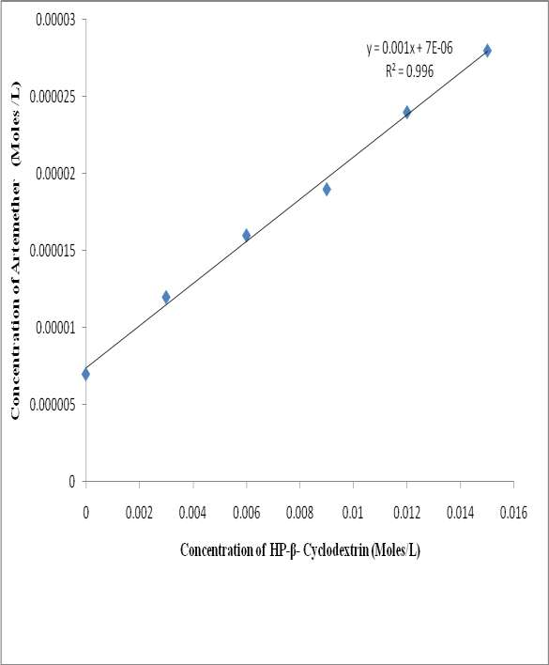

## Figure 4.1 Phase solubility diagram for artemether-2-hydroxypropyl-β-cyclodextrin system at 37 oC in distilled water

The result of phase solubility studies between artemether and 2-hydroxypropyl-β- cyclodextrins in water at 37 oC showed the AL type profile, indicating that the solubility of artemether increases as the concentration of 2-hydroxypropyl-β-cyclodextrins increases.

## Stability Constant

The stability constant (Kc) of artemether and 2-hydroxypropyl-β-cyclodextrins inclusion complex was found to be 143 M-1.

## PHYSICAL APPEARANCE ASSESSMENT AND DRUG CONTENT ESTIMATION

The results of physical appearance, texture and drug content of the prepared inclusion complexes are given in Table 4.1.

## Table 4.1: Colour, Texture and Drug content of formed Complexes

**DRUG TO CARRIER RATIO**

## COLO

**UR**

## TEXTURE Drug Content (%)

1:1 M complex White Fine and non sticky

1:2 M complex White Fine and non sticky

1:3 M complex White Fine and non sticky

87.5

87

86

## DRUG-EXCIPIENT INTERACTION STUDIES

## Fourier Transform Infrared Spectroscopy

The FT-IR spectra of the pure artemether and its inclusion complexes over the frequency range of 500 – 4500 cm-1 are presented in Figures 4.2 - 4.6.

The characteristic FT-IR peaks of the pure artemether occurred at 3198.08 cm-1 due to O-H stretching vibration, C-H stretching at 2932.86 cm-1, C-H bending at 1020.38 cm-1, C-O bending at 1020.38 cm-1, C-O-O-C bending vibration at 1195.95 cm-1, O-O-C stretching at 857 cm-1 and O-O stretching at 746 cm-1 respectively. These values are comparable to those reported by Fule *et al.* (2012).

In the FT-IR spectra of 1:1 M inclusion complex, the bands of the pure drug due to O-H bending and C-O bending vibration were shifted to higher frequencies 3396 cm-1 and 1037.74 cm-1 respectively, while those due to C-H stretching and C-H bending were shifted to lower frequencies, 2930.93 cm-1 and 1373.36 cm-1 with marked decrease in intensity.

In 1:2 M inclusion complex spectra, the decrease in peak intensity was more, compared to what was observed in the 1:1 M inclusion complex. In addition, peaks at 3198.08 cm-1 and 1020.38 cm-1 were shifted to a high frequencies and appeared at 3424 cm-1 and 1043.32 cm-1 respectively. Those at 2932 cm-1 and 1449.55 cm-1 were shifted to lower frequencies and appeared at 2928.04 cm-1 and 1368.54cm-1 respectively. Also, there was a disappearance of bands at 4594.59 cm-1, 4241.61 cm-1, 4066.08 cm-1 and 3862.58 cm-1.

For the 1:3 M inclusion complex spectra, peaks at 3198.08 cm-1 and 1020.38 cm-1 were equally shifted to higher frequencies while those at 2932.86 cm-1 and 1449.55 cm-1 were shifted to lower frequencies. More absorption bands were modified significantly and a disappearance of the band 4349.62 cm-1 was observed in addition to those earlier observed in 1:2 M inclusion complex spectra.

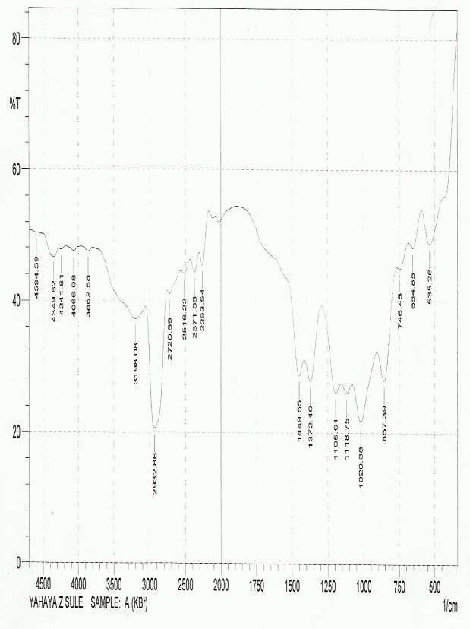

## Figure 4.2: FT-IR spectrum of pure artemether

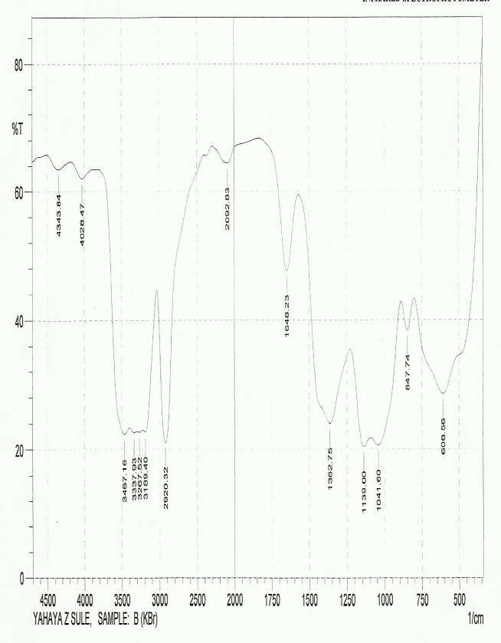

**Figure 4.3: FT- IR spectrum of pure 2-hydroxypropyl-β-cyclodextrin**

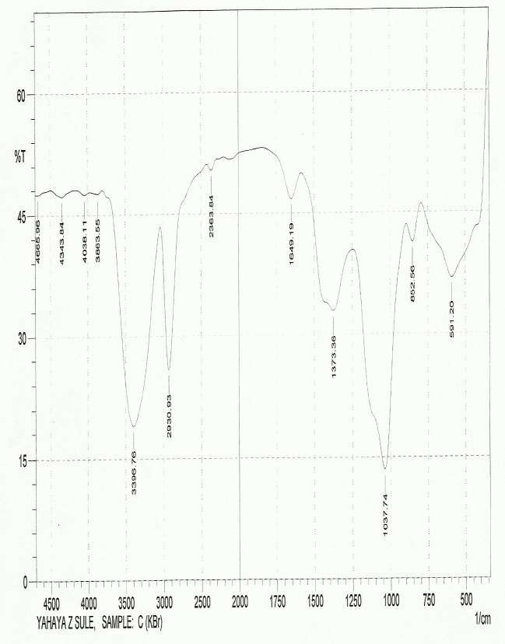

## Figure 4.4: FT-IR spectrum of artemether-2-HP-β-CD (1:1 M) complex

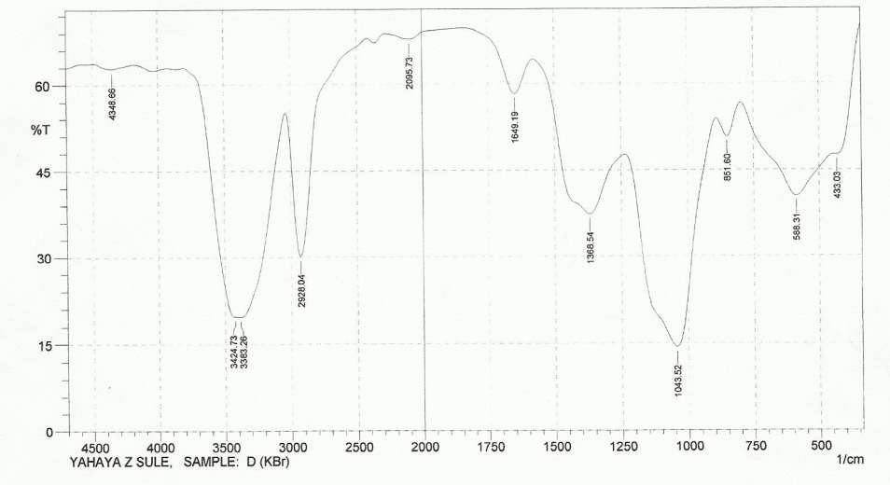

**Figure 4.5: FT-IR spectrum of artemether-2-HP-β-CD (1:2 M) complex**

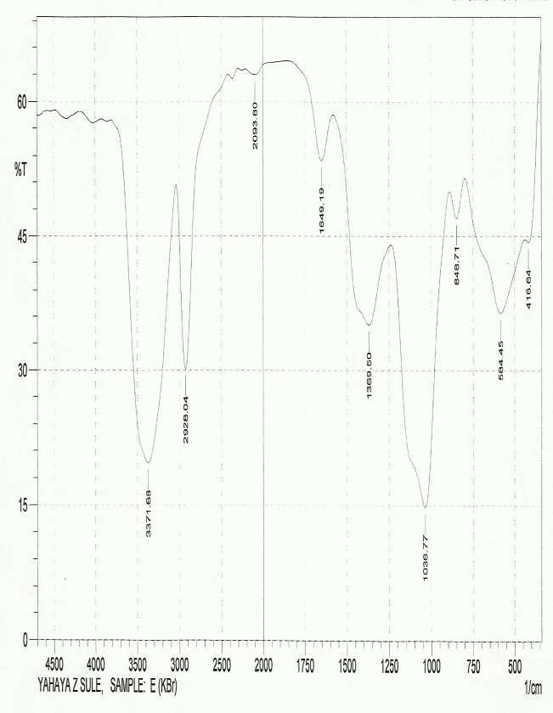

## Figure 4.6: FT-IR spectrum of artemether-2-HP-β-CD (1:3 M) complex

## Differential Scanning Calorimetry

The DSC thermograms of the pure drug, the 2-hydroxypropyl-β-cyclodextrin and the prepared inclusion complexes are presented in Figures 4.7 - 4.12. The DSC thermogram of pure artemether exhibits a sharp endothermic peak at 89.6 oC and an exothermic peak at 180 oC. The 2-hydroxypropyl-β-cyclodextrin exhibited a typical broad endothermic peak between 50 - 100 °C, which attained maximum at 87.2 oC.

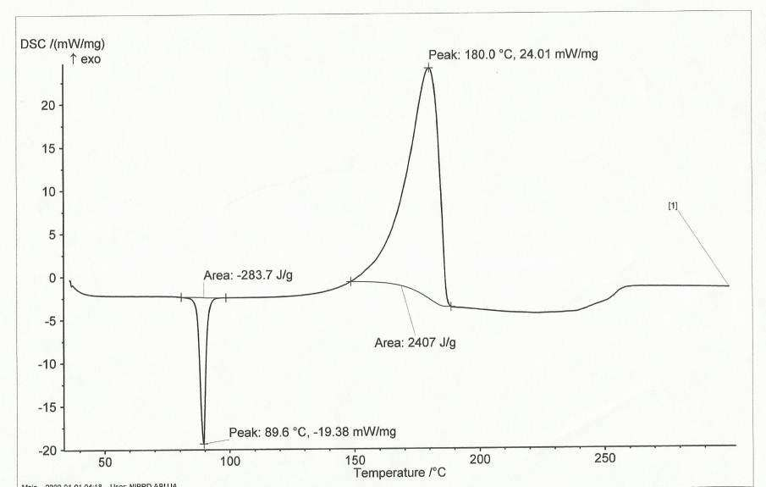

## Figure 4.7: DSC-thermogram of pure artemether showing a sharp endothermic peak at 89.6 0C and an exothermic peak at 180 0C.

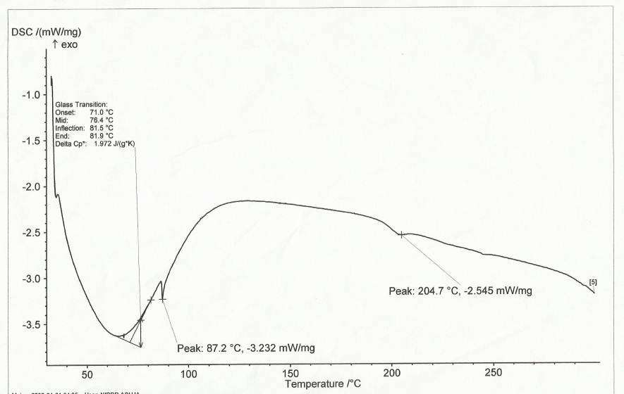

**Figure 4.8: DSC-thermogram of pure 2-hydroypropyl-β-cyclodextrin**

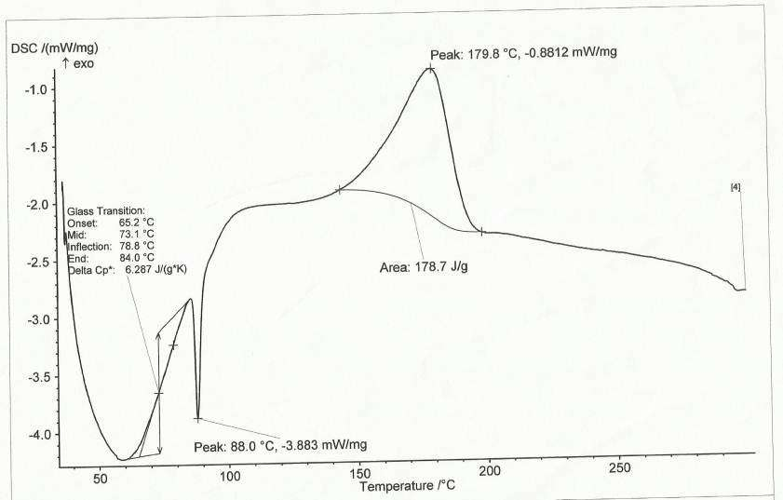

## Figure 4.9: DSC-thermogram of artemether-2-HP-β-CD (1:1 M) complex

The thermograms of the inclusion complexes showed marked decrease in the intensity of the endothermic and exothermic peaks, compared to the single components.

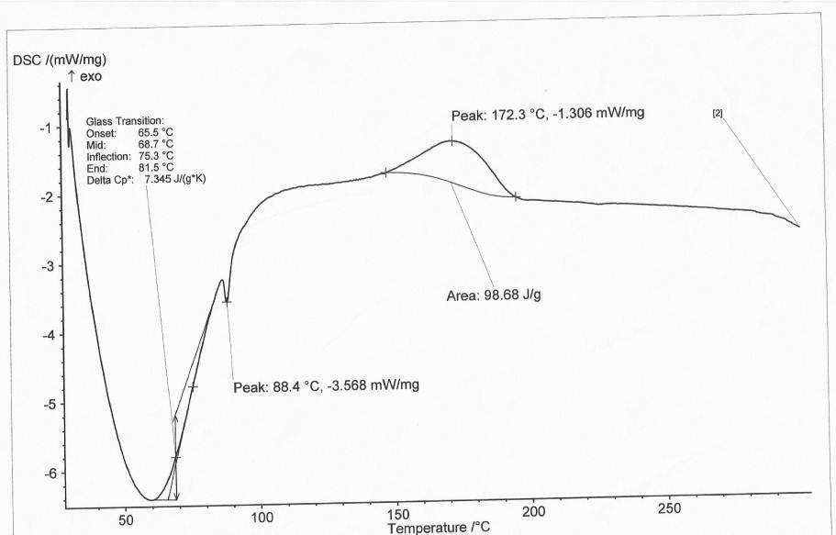

## Figure 4.10: DSC-thermogram of artemether-2-HP-β-CD (1:2 M) complex

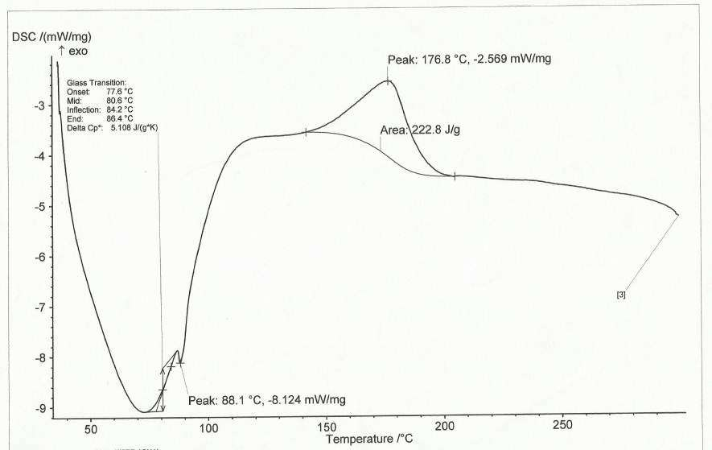

**Figure 4.11: DSC-thermogram of artemether-2-HP-β-CD (1:3 M) complex**

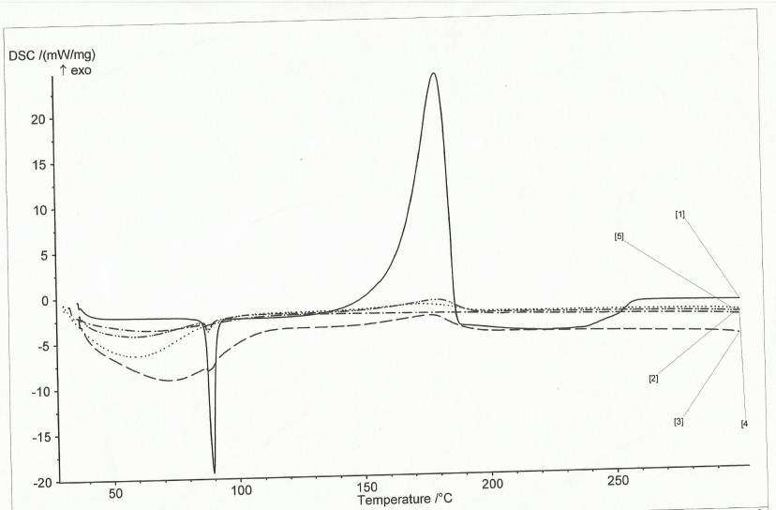

## Figure 4.12: DSC thermograms of pure artemether, pure 2-hydroxypropyl-β- cyclodextrin and prepared inclusion complexes all superimposed for comparism.

**KEY:**

1. Thermogram of the pure artemether: ( )
2. Thermogram of artemether-2-hydroxypropyl-β-cyclodextrin (1:2 M): (**············)**
3. Thermogram of artemether-2-hydroxypropyl-β-cyclodextrin (1:3 M): (**─ ─ ─ ─ ─)**
4. Thermogram of artemether-2-hydroxypropyl-β-cyclodextrin (1:1 M**): (─ · · ─ · · ─ ·**

## ·)

1. Thermogram of pure 2-hydroxypropyl-β-cyclodextrin:( **─ · ─ · ─ · ─ · ─)**

## UV spectra of artemether and its Inclusion complexes

The UV spectra of artemether and its 1:1 M complex are given in Figures 4.13 and 4.14.

The UV spectrum of artemether gave a λmax (wavelength of maximum absorbance) of 254 nm.

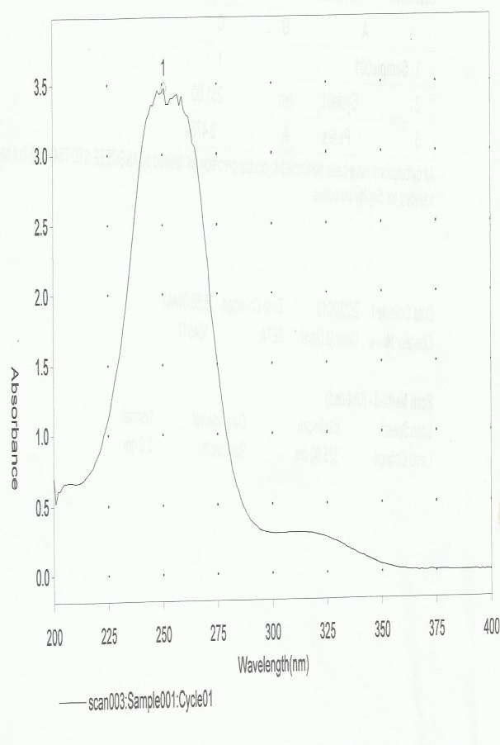

## Figure 4.13: UV spectrum for pure artemether showing peak at 254 nm.

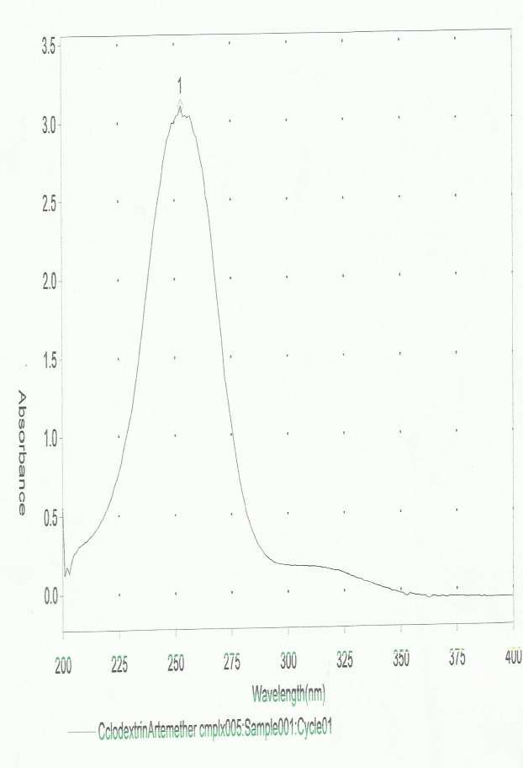

**Figure 4.14: UV spectrum for (1:1) artemether-2-HP-β-CD complex**

## DISSOLUTION CHARACTERISTICS

* + 1. **Dissolution Profile of Pure drug and inclusion complexes in Simulated Intestinal Fluid (pH 7.4)**

The dissolution profiles of the pure drug, the various inclusion complexes and the commercial parenteral product in phosphate buffer (pH 7.4) are shown in Figure 4.15.

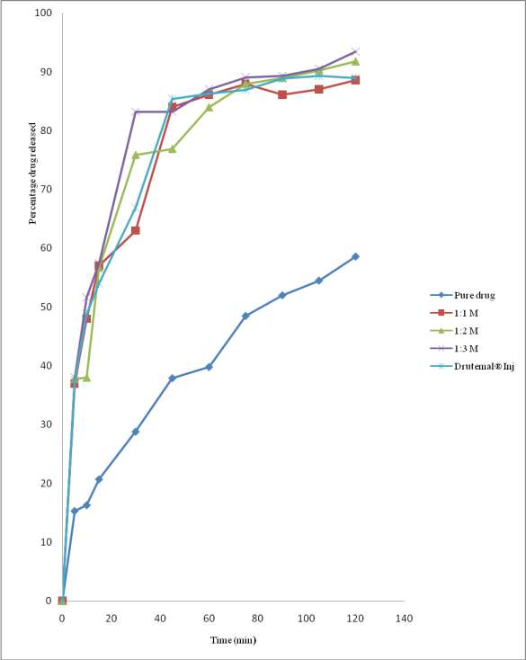

## Figure 4.15: Dissolution profile of pure artemether, artemether-2-hydroxypropyl-β- CD complexes and a commercial parenteral product in simulated intestinal fluid (pH 7.4)

* + 1. **Dissolution Profile of Pure drug and Inclusion-complexes in Simulated Gastric Fluid (pH 1.2)**

The dissolution profile of the pure drug and the inclusion complexes (1:1 M, 1:2 M and 1:3 M) in simulated gastric fluid (pH 1.2) are presented in Figure 4.16.

It was observed that the complexes released the drug faster than the pure drug, while the inclusion complex of molar ratio 1:3 released the drug faster than the other combinations.

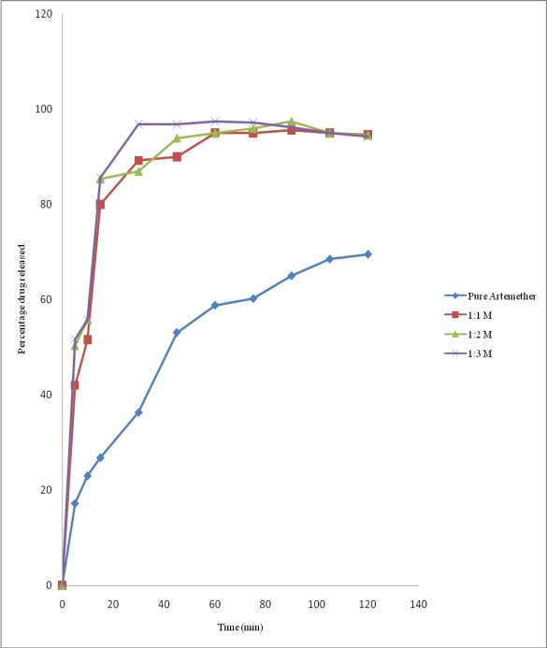

## Figure 4.16: Dissolution profile of pure artemether and artemether-2-hydroxypropyl- β-CD complexes in simulated gastric fluid pH 1.2

## EVALUATION OF TABLET PROPERTIES

The properties of the commercial and prepared tablets of cyclodextrin-artemether inclusion complex are given in Table 4.2.

## Table 4.2: Properties of Marketed and Formed artemether Tablets (Mean±SE)

**Tablet Properties Coartem**® **Lumatem**® **Artemethe**

## r-2-HP-β-CD

**Complex (1:1)**

|  |  |  |  |
| --- | --- | --- | --- |
|  | | | **tablet** |
| Thickness (mm) | 3.22±0.01 | 3.52±0.01 | 3.54±0.02 |
| Uniformity of weight (mg) | 240.65±0.335 | 344.95±5.173 | 402.85±1.3  85 |
| Diameter (mm) | 8.88±0.02 | 10.09±0.03 | 12.07±0.02 |
| Crushing strength (kg/F) | 11.7±0.12 | 7.40±0.40 | 10.90±0.20 |
| Drug content (%) | 98.5±0.00 | 97.00±0.03 | 95.50±0.07 |
| Disintegration time (Minute) | 3.37±0.03 | 3.30±0.25 | 9.28±0.04 |
| Friability (%) | 0.048±0.00 | 0.083±0.001 | 0.058±0.00 |

1

## Dissolution Profile of the Inclusion-complex (1:1 M) tablet, Marketed

**tablets (Coartem**®**and Lumartem**®**) and the Pure artemether powder in Simulated Gastric Fluid (pH 1.2)**

The dissolution profile of the inclusion complex (1:1 M) tablet, marketed tablets (Coartem® and Lumartem®) and the pure drug sample in simulated gastric fluid, pH 1.2 are

shown in Figure 4.17.

The complex tablet, Coartem and Lumatem all released the drug faster than the pure drug with complex tablet having better drug release than Coartem® and Lumartem®.

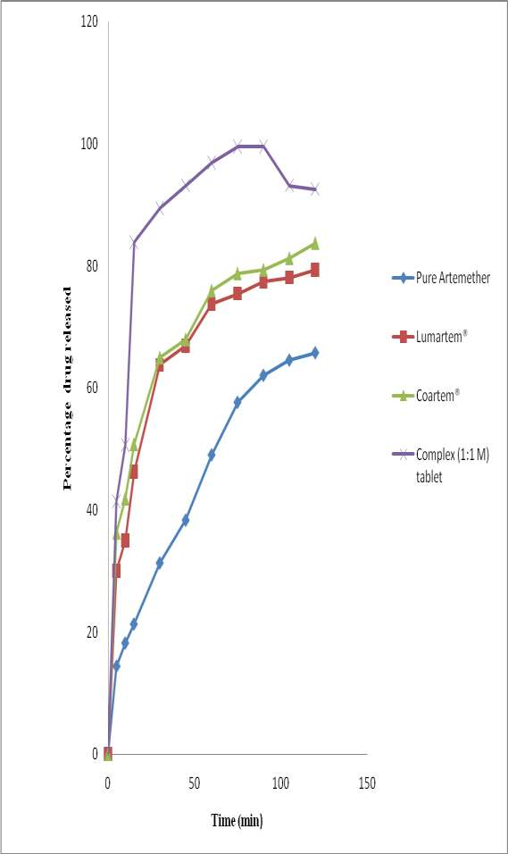

## Figure 4.17: Dissolution profiles of pure artemether, commercial products and inclusion complex (1:1) tablet in simulated gastric fluid pH 1.2

## Result of Kitazawa analysis

The Kitazawa plots for release of artemether from the pure drug, inclusion complexes, marketed products and the inclusion complex (1:1 M) tablets are given in Figures 4.18 and 4.19.

The plots for the pure drug, inclusion complexes and the marketed products exhibited monophasic dissolution, hence showed single dissolution rate constants, k1. However, inclusion complex tablets exhibited triphasic dissolution and therefore, gave three dissolution rate constants, k1, k2 and k3.

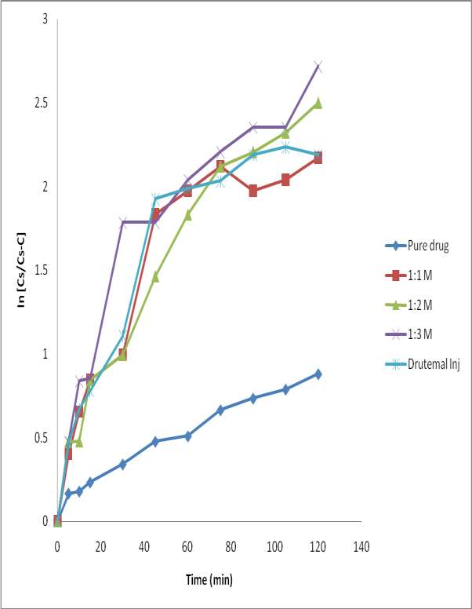

## Figure 4.18: Kitazawa plots for release of artemether from the pure drug, inclusion complexes of 1:1 M, 1:2 M, 1:3 M and the marketed parenteral product (Drutemal® Injection) in simulated intestinal fluid (pH 7.4).

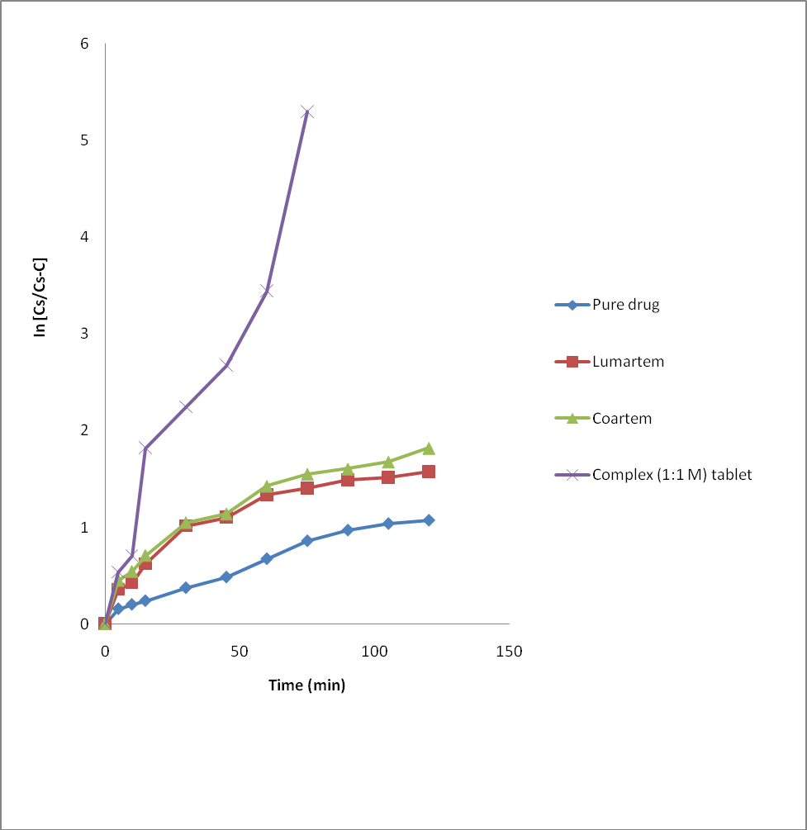

**Figure 4.19: Kitazawa plots for release of artemether from the pure drug, lumartem**®**, coartem**® **and tablets formed from inclusion complex (1:1 M) in simulated gastric fluid (pH 1.2).**

The parameters obtained from the kitazawa and dissolution plots are given in Table 4.3 and 4.4.

## Table 4.3 Parameters obtained from the dissolution and Kitazawa plots for pure drug 1:1 M, 1:2 M, 1:3 M complexes and the commercial parenteral injection (Drutemal injection) in simplate intestinal fluid (pH 7.5)

|  |  |  |  |  |  |
| --- | --- | --- | --- | --- | --- |
|  | K1 | K2 | K3 | t5 | t90 |
|  |  |  | 0 |  |
| Pure drug  1:1m | 0.0072  0.0030 | -  - | -  - | 8  0  1 | >120  >120 |
| 1:2m | 0.0186 | - | - | 1.3  1 | 104 |
|  |  |  |  | 2.5 |  |
| 1:3m | 0.0094 | - | - | 1 | 97.5 |

Drutemal® injection

0

0.022 - - 1 1.3

>120

## Table 4.4 Parameters obtained from the dissolution and Kitazawa plots for pure

**drug, lumartem®, coartem® and 1:1 M complex tablet in simulated gastric fluid (pH 7.2)**

|  |  |  |  |  |  |
| --- | --- | --- | --- | --- | --- |
|  | K1 | K2 | K3 | t5 | t90 |
|  |  |  |  | 0 |  |
| Pure drug | 0.0094 | - | - | 6 | >120 |

1

Lumartem® 0.0290 - - 2

1

Coartem® 0.0240 - - 1

4

>120

>120

1:1 M complex tablet

0.034 0.040 0.12

4

9 31

## STABILITY STUDIES

There was no significant difference observed in the colour, texture and drug content of the inclusion complexes and the formulated tablets after the stability testing. The results are given in Tables 4.5 and 4.6.

## Table 4.5: Results of short term stability studies of the inclusion complexes and the formulated tablet at room temperature (28-30 oC).

|  |  |  |  |  |
| --- | --- | --- | --- | --- |
| **Sample** | **Color** | | **Percent drug content at**  **room tempt. (28-30 oC)** | |
| Day one (1) | After 10 weeks |
| Day one  (1) | After 10  weeks |

|  |  |  |  |  |
| --- | --- | --- | --- | --- |
| 1:1 M complex | white | white | 87.50 | 87.30 |
| 1:2 M complex | white | white | 87.00 | 86.96 |
| 1:3 M complex | white | white | 86.00 | 86.00 |
| 1:1 M complex | white | white | 95.50 | 95.10 |

tablet

## Table 4.6: Results of accelerated stability studies of the inclusion complexes and the formulated tablet of artemether at 50 oC.

|  |  |  |  |  |  |  |  |  |
| --- | --- | --- | --- | --- | --- | --- | --- | --- |
| **Sample** | **Color**  **HOURS** | | | | **Percent drug content at**  **50 oC upon storage.**  **HOURS** | | | |
|  | 0 | 24 | 48 | 72 | 0 | 24 | 4 | 72 |

|  |  |  |  |  |  |  |  |  |  |
| --- | --- | --- | --- | --- | --- | --- | --- | --- | --- |
| 1:1 M complex | w | whi | wh | white | 87. | 87. | 8 | 8 | 87.2 |
|  | hite | te | ite |  | 5 | 5 | 7.3 |  |  |
| 1:2 M complex | w | whi | wh | white | 87. | 86. |  | 8 | 86.7 |
|  | hite | te | ite |  | 0 | 8 | 6.8 |  |  |
| 1:3 M complex | w | whi | wh | white | 86. | 86. |  | 8 | 85.6 |
|  | hite | te | ite |  | 0 | 0 | 5.8 |  |  |
| 1:1 M complex | w | whi | wh | White | 95. | 95. |  | 9 | 95.1 |
| tablet | hite | te | ite |  | 5 | 5 | 5.5 |  |  |

## CHAPTER 5: DISCUSSION

## IDENTIFICATION OF PURE SAMPLES

Ascertaining the authenticity of a pure sample of drug material is very important because this serves as a basis for comparison with test drugs and formulations. To ensure their authenticity, they have to be identified prior to their use.

The test indicates that the sample was artemether. The melting point of the sample agreed with the literature value of 86-90 oC as stated in the IP, further confirming its identity purity. The purity of the artemether sample was further confirmed from it DSC thermogram which showed the presence of characteristic peaks; showing an endothermic peak at 89.6 oC corresponding to its melting point. The UV spectrum also indicated a λmax of 254nm which agreed with the literature value stated in the IP.

## CALIBRATION CURVE

Linearity was observed with concentrations of artemether over the range of 2 µg – 10 µg/ml. Within this range, plots of absorbance against concentration values of artemether gave straight lines with R2 values above 0.99 in all instances. This shows that there is linear relationship between the artemether concentrations and the absorbance values at 254 nm.

## PHASE SOLUBILITY STUDIES

A phase solubility diagram is constructed by plotting the molar concentration of dissolved drug on the y-axis, against the concentration of complexing agent added on the x-

axis. Two types of phase solubility profiles exist, type A where soluble complexes are formed, and type B where complexes of limited solubility are formed (Gerold and Thompson, 2002). In type A diagrams, an increase in solubility of the compound occurs as the amount of complexing agent increases. Soluble complexes formed increases the total amount of compound in solution. Depending on the type of complexes formed, the diagram can be linear, AL, or show curvature in a positive, AP or negative, AN fashion (Fig. 2.4). Linear diagrams are formed when each complex contains only one molecule of the complexing agent. When more than one molecule of the complexing agent is found in the complex, an AP-type diagram is formed. AN diagrams result if self association is present or high concentration of the complexing agent causes alteration in the nature of the solvent (Gerold and Thompson, 2002).

The result of phase solubility studies between artemether and 2-hydroxypropyl-β- cyclodextrins in water at 37 oC showed the AL type profile following the Higuchi and Connors classification (Higuchi and Connors, 1965). This is an indication that an increase in solubility of the artemether occurs as the amount of 2-hydroxypropyl-β-cyclodextrins increases. It also shows that each complex contains only one molecule of the complexing agent. The linear plot of the phase solubility diagram had a slope less than 1, suggesting that the stoichiometry of the complexes is 1:1 (mol/mol) Artemether-2-HP-β-CD. (Loftsson *et al.,* 2005; Shankarrao *et al.,* 2010).

The apparent 1:1 M stability constant (Kc) was calculated from the linear plot of the phase solubility diagram according to the equation 3a.

The phase solubility diagram of artemether and 2-HP-β-CD illustrates the solubility enhancement capability of cyclodextrin. The aqueous solubility of artemether increased linearly (r = 0.996) as a function of 2-HP-β-CD concentration. The stability constant (Kc) of artemether - 2-HP-β -CD inclusion complex was found to be 143 M-1, a value falling within the range of 50-2000 M.-1 which is adequate for the formation of inclusion complex, which may contribute to improved disssolution of poorly water soluble drugs (Brewester and Loftsson, 2007).

## DRUG CONTENT

Drug contents of all the inclusion complexes were in the range of 86 % - 87.5 %w/w. This indicates the proper loading of drug in inclusion complexes and the effectiveness of the kneading method employed (Ghodke *et al*., 2009).

## DRUG-EXCIPIENT INTERACTION STUDIES

## Fourier Transform Infrared Spectroscopy*.*

Generally the FT-IR spectra of the inclusion complexes showed significant differences in the characteristic bands of the respective spectra of the pure artemether. These range from shifting of peaks to both higher and lower frequencies, to disappearance of some bands. Liu and Zhu, (2006) attributed such changes and modifications, to restriction of drug molecule vibration, due to inclusion of the drug into the cyclodextrin cavity.

## Differential Scanning Calorimetry

Supporting evidence for complex formation was also obtained from DSC studies. Although DSC is mostly used to establish identity and purity, it is also useful for detecting whether solid-solid interaction took place or not. It is stated that when a guest molecule is

incorporated in CD cavity, its melting, boiling or sublimation points are usually shifted to different temperature or disappear from the range (Polla *et al*., 2005; Vivek *et al*., 2007).

The DSC thermogram of pure artemether exhibits a sharp endothermic peak at 89.6 oC corresponding to its melting point and an exothermic peak at 180 oC corresponding to its decomposition temperature, which is consistent with the findings of Yang *et al*. (2009). The 2-hydroxypropyl-β-cyclodextrin exhibited a typical broad endothermic peak between 50 - 100 °C, which attained maximum at 87.2 oC assigned to its dehydration (Liu and Zhu, 2006).

The DSC thermograms of the inclusion complexes exibited marked decrease in intensity and even complete disappearance of the artemether endothermic and exothermic peaks. Changes in the exothermic peak (corresponding to its decomposition temperature), ranging from a marked reduction in intensity, to a complete disappearance, suggest that the 2-HP-β- CD-artemether complexes are more thermally stable than the artemether alone, which is consistent with the findings of Chadha *et al.* (2010) who reported that the decomposition of artemether was shifted to a higher temperature and was greatly reduced after formation of inclusion complex with β-CD and methyl-β-CD. Yang *et al.* (2009) also reported that the artemether exothermic peak at 180 oC corresponding to it decomposition temperature disappeared and appeared at 365 oC after inclusion complex formation with HP-β-CD. Inclusion of drugs into cyclodextrin, temporarily locked or caged the drug within the host cavity, giving rise to beneficial modifications like solubility enhancement, stabilization of labile guest against oxidation, visible or UV light, heat and so forth (Schmid, 1989). The results obtained from the DSC thermograms of artemether:2 -HP-β-CD complexes, are therefore clear evidence of inclusion of artemether into the 2-HP-β-CD cavity with a

consequent enhancement in stability of the artemether molecule against thermal degradation. The results of short term and accelerated stability testing presented in tables 4.6 and 4.7 further confirmed the stability of these formulations, evident by the insignificant changes in their drug contents.

## UV interference

Scanning results indicated that there was no interference or shifting of λmax of artemether after complexation with 2-HP-β-CD. This showed that the artemether molecule did not degraded or change chemically after complexation.

* 1. ***IN VITRO* DISSOLUTION**

Dissolution of drug from oral solid dosage forms is a necessary criterion for drug bioavailability (that is, the drug must be solubilized in the aqueous environment of the gastrointestinal tract to be absorbed). For this reason, dissolution testing of drug products has emerged as one of the most important control tests. The dissolution studies of a marketed parenteral product in comparison with all the batches of the inclusion complexes was carried out in SIF pH 7.4 to simulate the tissue fluid and blood.

The release of artemether from both the pure drug and from inclusion complexes was found to be higher in SGF (pH 1.2) than in SIF (pH 7.4). This finding is consistent with the findings of Awofisayo *et al*. (2012) that artemether released from products is higher in simulated gastric fluid and food-modified simulated gastric fluid than in simulated intestinal fluid and food modified simulated intestinal fluid.

All complexes with cyclodextrin exhibited better dissolution properties than the pure drug alone. The calculated dissolution parameters revealed that pure artemether exhibited a

slow initial dissolution rate and the maximum amount of drug dissolved after 2 h was 69.5%. Statistically significant difference (ρ = 0.005) in terms of dissolution rate was found between the artemether-2-HP-β-CD inclusion complexes and the pure artemether. The inclusion complexes produced pronounced enhancement of their dissolution rate compared to that of the pure drug. The extent of this enhancement in the dissolution varied with the host-guest molar ratio. Even though the ranking of dissolution rate was in the order 1:3 M > 1:2 M > 1:1 M, for the inclusion complexes, they all have comparable values.

It was observed that the prepared inclusion complexes had drug release profiles comparable and even slightly better than the marketed parenteral formulation. While the pure artemether gave a percentage drug release of 58.6 % in SIF after 2 h, inclusion complex of molar ratio 1:1 gave a release of (88.6 %), 1:2 (91.8 %), and 1:3 (93.4 %) whereas the marketed parenteral formulation gave a release of 88.9 %.

Tablets formed from inclusion complex of 1:1 M ratio showed pronounced enhancement in dissolution rate compared to the pure drug (ρ = 0.034). Comparing the inclusion complex tablets with marketed tablets, it was observed that the prepared inclusion complex tablet showed a 3.9-fold increase in dissolution compared to the pure drug, 1.8-fold increase

compared to the marketed brand - Lumartem® and 1.6-fold increase compared to Coartem®

in the amount of drug released in 15 min from the *in vitro* dissolution studies. In 45 min, the prepared inclusion complex tablets had a release of 93.1 %, while Coartem® released of 68

% and Lumartem® 66.9 %. The percentage of artemether released from the pure drug, Coartem®, Lumartem® and the parenteral product (Drutemal® injection) was less than 90 %

even in 120 min, whereas the prepared inclusion complex tablet achieved a 90 % drug release in 31 min.

The increased dissolution rate of artemether - cyclodextrin inclusion complexes has been attributed to improvement in drug wettability, decrease of drug crystallinity, formation of readily soluble complexes in dissolution medium, increase in hydrophilicity or a reduction in the interfacial tension between the drug and the dissolution medium due to the surfactant- like properties of CDs (Lin and Xu, 1989).

Using the Kitazawa plots, the release of artemether from the pure drug, inclusion complexes of 1:1 M, 1:2 M, 1:3 M and the marketed parenteral product (Drutemal® Injection) were found to exhibit monophasic (k1 only) dissolution (in simulated intestinal fluid, pH 7.4) and low values of dissolution rate constant (K1). This indicates that these formulations released the drug slowly over the test period of 120 min. This analysis further suggests that the formulations might result in poor bioavailability as a result of very slow rate of drug release (Ayorinde *et al.*, 2012).

In simulated gastric fluid pH (1.2), the pure drug, coartem and lumartem also exhibited monophasic (k1 only) dissolution and low values of K1. This indicates that the formulations also released the drug slowly over the test period of 120 min. This analysis equally suggests that the formulations might result in poor bioavailability as a result of very slow rate of drug release. For the tablets formed from the inclusion complex (1:1 M) the Kitazawa plot produced a linear graph with three segments (triphasic dissolution) corresponding to three phases of drug dissolution from the tablet surface, the aggregate granules and from de- aggregated (fine) particles (Adegboye *et al.*, 2003*)*. The ranking of the dissolution rate constants was k1 < k2 < k3, showing an increase in the rate of release of artemether with

time. The increase in slope indicates the explosive increase in dissolution rate on disintegration as well as on final de-aggregation. This is attributable to changes in surface area of the dissolving particles brought about by the disintegration and de-aggregation of the tablets (Adebayo *et al.,* 1998). The increased in the release rate of artemether with time and the higher values of the dissolution rate constant obtained from the kitazawa plot of the inclusion complex (1:1 M) tablets suggests that the formulation will give better bioavailability compare to the other formulations (Ayorinde *et al.*, 2012).

## TABLETS EVALUATION

For the prepared inclusion complex tablets, the crushing strength was in the range, 10.0

– 10.5 kgF. The percent friability was 0.048 which is less than 1 %. The drug content was

95.5 %. The disintegration time was 9.28 min which is within pharmacopoeial limit (15 min for uncoated tablets, BP 2002). The mean weight of 402.85 mg was within the B.P (2002) specification which states that for tablets weight > 250 mg, ± 5 % weight variation is allowed. The prepared inclusion complex tablets therefore, were within the limit considering the 400 mg theoretical weight. The tested commercial tablets equally conformed to the compendial specification for uniformity of weight, percentage friability and disintegration time. The prepared inclusion complex tablets showed higher release (93.1 %) than the

marketed tablets: Coartem® (68.0 %) and Lumartem® (66.9 %) at 45 min. At 75 min, the

respective release was 99.5 % (inclusion complex tablet), 78.8 % (Coartem®) and 75.5 % (Lumartem®). The time taken to release 50 % of the drug was 9 min for the prepared inclusion complex tablet, 14 min for Coartem® and 21 min for Lumartem®.

## 5.8 STABILITY STUDIES

There was no significant difference (ρ = 0.999) for the accelerated stability testing and ρ

= 0.960 (for the short-term stability testing) observed in the colour, texture and drug content value after the stability testing as presented in Tables 4.6 and 4.7. These imply that the formulations are stable.

## CHAPTER 6: SUMMARY AND CONCLUSION

## SUMMARY

Malaria is a serious and potentially fatal disease, particularly in the case of *falciparum* malaria. Artemether is a rapidly acting antimalarial drug that is potent and efficient against acute and severe *P. falciparum* malaria. WHO has listed it as an essential drug for the treatment of multiple drug resistant malaria as reported by Joshi *et al.* (2008). However, its therapeutic efficacy is greatly hampered by its poor bioavailability and low aqueous solubility (Hartell *et al*., 2004). Poor aqueous solubility of artemether is the main reason for its oral bioavailability. The objective of this study was to enhance the solubility as well as the dissolution rate of the drug by complexing it with 2-hydroxypropyl-β-cyclodextrin (2- HP-β-CD), a derivative of β-cyclodextrin. The inclusion complexes were prepared by the kneading method at a molar ratio of 1:1, 1:2 and 1:3. The phase solubility analysis indicated the formation of 1:1 molar inclusion complex of artemether with 2-HP-β-CD. Apparent stability constant (KC) was 143 M**-1**. The prepared complexes were characterized using FT- IR and DSC, and the results indicate the formation of inclusion complex with the cyclodextrin derivative - HP-β-CD. The inclusion complex exhibited higher release (97.5 % release in 60 min) of artemether. The inclusion complex containing artemether: 2 -HP-β-CD (1:1 M) was formulated into tablets by direct compression technique using microcrystalline cellulose, maize starch, magnesium stearate and talc. The prepared tablets were evaluated for crushing strength, percentage friability, disintegration time, drug content and *in vitro*

dissolution profile. The *in vitro* dissolution profile of the prepared tablet was compared with that of some commercial tablets and was found to be superior. The results of stability studies revealed no change in physical appearance, and drug content, thus indicating that the formulation was stable.

## CONCLUSION

From the present study, the following conclusions can be drawn:

1. 2-hydroxypropyl-β-cyclodextrin (2-HP-β-CD) can be used to prepare inclusion complexes of artemether with an improved solubility of the drug. Phase solubility studies of artemether with 2-HP-β-CD illustrated the solubility enhancement capability of 2-HP-β-CD. The stability constant (Kc) of artemether**:** 2-HP-β-CD complex was found to be 143 M-1 which is within the expected range (50 – 2000 M-1 ) adequate for the formation of inclusion complex.
2. Characterization using FT-IR and DSC studies confirmed the formation of inclusion complex between artemether and 2-HP-β-CD by kneading method.
3. The dissolution rate of artemether from inclusion complexes was found to be higher than the pure drug.
4. The tablets formulated with artemether**:** 2-HP-β-CD complex at 1:1 M ratio exhibited faster dissolution rate when compared to commercial products.
5. The inclusion complexes and formulated tablets subjected to short-term and accelerated stability study showed no appreciable change in their physical appearance and drug contents.
6. Cyclodextrins like 2-HP-β-CD can be used to prepare inclusion complex tablets of artemether (1:1 M) with improved solubility and dissolution rate of the drug.

## RECOMMENDATION FOR FURTHER WORK

Further work that could be carried out sequel to this work includes;

* + - Evaluation of other methods of preparation of artemether-inclusion complex on the dissolution and other characteristics of artemether.
    - *In vivo* animal studies to investigate the clearance of parasitemia by 2- hydroxypropyl-β-cyclodextrin inclusion complexes of artemether.

## REFERENCES

Abdel-Rahman A.A., Saleh S.I., Nakai Y., Aboutaleb A.E. and Ajimed. M.O. (1994). Investigation of the Interaction of Bromazepam with Cyclodextrins in Solutions and in Ground Mixtures*. J. Pharm. Belg,* **49** *(1), 23-32*

Adjei G., O. and Goka B. Q. (2009). Artemether-lumefantrine: an oral antimalarial for uncomplicated malaria in children. *Expert Rev Anti Infect Ther,* **7***(6): 669-81.*

Adegboye T.A. and Itiola O.A. (2003). Formulation effects on the mechanical and release properties of metronidazole suppositories. *Afr. J. Med. Med. Sci.* **32,** 247-251.

Adebayo A.S. and Itiola O.A. (1998). Evaluation of Breadfruit and Cocoyam Starches as Exodisintegrants in a Paracetamol Tablet Formulation. *Pharm. Pharmacol. Commun.* **4** (6), 385–389.

Ahmed M.O., Nakai Y., Aboulaleb A.E.S., Yamamoto K., AbdelRaliman A.A.Z. and Saleh

S.I. (1990). Complex Formation of Nitrazepam in Coprecipitating and in Co grinding with Methylated-β-Cyclodextrin*. Chem., Pharm. Bull.,* **38** *(12), 2423-2427.*

Amin A. A., and Kokwaro G.O. (2007). Antimalarial drug quality in Africa*. J Clin Pharm Ther,* **32***(5): 429-40.*

Ammar H.O. and El-Nahhas S.A. (1995). Improvement of Some Pharmaceutical Properties of Drugs by Cyclodextrin Complexation. 2. Colchicine. *Pharmazie,* **50** *(4), 269-*

*272.*

Arun R., Ashok K. C. and Sravanthi V. V. (2008). Cyclodextrins as Drug Carrier Molecule:

*A Review Sci Pharm.* **76*:*** *567–598.*

Atemnkeng M. A. and De Cock A. (2007). Quality control of active ingredients in artemisinin-derivative antimalarials within Kenya and DR Congo. *Trop Med Int Health* **12***(1): 68-74.*

Aulton M. E. (2007). Pharmaceutics: The science of dosage form design, **3**rd edition, London: Churchill Livingstone, pp. 287-303.

Awofisayo S. O., Oladoja A. A., Nse E. and Imo E. U. (2010). Comparative Assessment of the Quality Control Measurements of Multisource Ofloxacin Tablets Marketed in Nigeria. *Dissolution Technologie, ,* **50** *(4),* 20-25.

Ayorinde J.O., Odeniyi M.A. and Itiola A.O. (2012). Evaluation of Pharmaceutical and Chemical Equivalence of Selected Brands of Diclofenac Sodium Tablets. *East and Central African Journal of Pharmaceutical Sciences* **15**, 3-9.

Badawy S.I.F., Ghorab M.M. and Adeyeye C. (1995). Study of the Complexation Between Danazol and Hydrophilic Cyclodextrin Derivatives. *Pharm. Res.,* **12** *(9), 204.*

Bhandari B.R., D'arcy B.R.., and Bich L.L.T. (1998). Lemon Oil to β-Cyclodextrin Ratio Effect on the Inclusion Efficiency of β- cyclodextrin and the retention of oil volatiles in the complex. *J. Agric. Food Chem*., **46** *(4), 1494-1499.*

Bhardwaj R., Dorr R.T. and Blanchard J. (2000). Approaches to reducing toxicity of parenteral anticancer drug formulations using cyclodextrins. *J Pharm Sci Technol,* **54***:233–9.*

Brewester M.E and Loftsson T. (2007). Cyclodextrins as pharmaceutical solubilizers.

*Advanced Drug Delivery Reviews* **59,** *645–666*

Britannica Online Encyclopedia (2012). [www.britannica.com/](http://www.britannica.com/) EBchecked/chromophore.

Accessed sept. 2012.

Carter S.J. (2000). Cooper and Gunn‟s Tutorial Pharmacy. **6**th ed, CBS Publishers and Distributors, pp. 7-16.

Cooper A., Lovatt M. and Nutley M.A. (1996). Energetics of Protein-Cyclodextrin Interactions. *J. Inclusion Phenom. Mol. Recognit. Chem.* **25** *(1-3), 85-88.*

Cotton F.A., Geoffery W. and Carlos A.M. (1999). Advance inorganic chemistry, (2 nd ed.). pp.1355-1356.

Chadha R., Gupta S., Shukla G., Jain D.S and Singh S. (2010). Characterization, thermodynamic parameters and *in vivo* antimalarial activity of inclusion complexes of artemether. *Drug Discoveries & Therapeutics.* **4***(3):190-201.*

Cwiernia B., Hladon, T. and Stobiccki M. (1999). Stability of Diclofenac Sodium in die Inclusion Complex with 3-Cyclodcxtrin in the Solid State. *J. Pharm. Pharmacol. J*. **5***, 1213-1218.*

Dondorp, A., M. and Yeung S. (2006). Artemisinin resistance: current status and scenarios for containment. *Nat Rev Microbiol*. **43**: 5-9

Dass C.R. and Jessup W. (2000). Apolipoproteins A-I Cyclodextrins and liposomesas potential drugs for the reversal of atherosclerosis*. J Pharm Pharmacol;* **52***:731–61.*

Doenicke A., Roizen M.F., Nebauer A.E., Kugler A., Hocrncke R. and Begcr-Hintzen H. (1994). A Comparison of Two Formulations for Etomidate, 2 -hydroxypropyl-β- CycIodextrin (HP-β-CD) and Propylene Glycol. *Anesth. Analg. (NY),* **79** *(****5****), 933- 939.*

Dufosse L., Souchon I., Feron G., Latrasse A. and Spinnler H.E. (1999). In situ detoxification of the fermentation medium during gamma-decalactone production with the yeast *Sporidiobolus salmonicolor*.*BiotechnolProg****;* 15*:****135–9.*

Eastburn S.D. and Tao B.Y. (1994). Applications of modified cyclodextrins. *Biotechnol Adv;* **12***:325–39.*

Ekberg B., Anderson L. and Mosbach K. (1989). The synthesis of an active derivative of cyclomalto hexose for the hydrolysis of esters and the formation of amide bonds. *Carbohydr Res;* **192***:111–7*

*.*

Enato E.F.O. (2010). Pharmaceutical care in Malaria: *Essentials of Pharmaceutical care*. A Cybex Publication, pp. 393 – 408.

Ezzet, F. and Mull R. (1998). Population pharmacokinetics and therapeutic response of CGP 56697 (Artemether + benflumetol) in malaria patients. *Br J Clin Pharmacol* **46***(6): 553-61.*

FMOH (2004). Federal Ministry of Health National Malaria Control Policy for Nigeria.

National Malaria and Vector control Division, Lagos, Nigeria.

Frömming K.H. and Szejtli J. (1994). Cyclodextrins in pharmacy. *Topics in inclusion science. Dordrecht: Kluwer* Academic Publishers*.*

Fujishima N., Kusaka K., Umino T., Urushinata T. and Terumi K. (2001). Flour based foods containing highly branched cyclodextrins. *Japanese Patent Journal Pharm.* **136*,*** *898*

Fule R. A., Meer T. S., Sav R.A. and Amin D.P. (2012). Dissolution rate enhancement and physicochemical characterization of artemether and lumefantrin solid dispersions. *International Journal of Drug Delivery* **4*,*** *95 -106*

Funasaki N., Kawaguchi R., Ishikawa S., Hada S., Neya, S. and Katsu T. (1999). Quantitative Estimation of the Bitter Taste Intensity of Oxyphenonium Bromide Reduced by Cyclodextrins from Electromotive Force Measurements. *Anal. Chem.* **71** *(9), 1733-1736.*

Funasaki N., Uemura Y., Hada, S. and Neya S. (1996). Reduction of die Bitter Taste Intensity of Propantheline Bromide by Cyclodextrins as Predicted by Surface Tension Measurements. *J. Phys. Chem* **100** *(40), 16298-16301.*

Gerloczy A., Hoshino T. and Pitha J. (1994). Safety of Oral Cyclodextrins: Effects of Hydroxypropyl-β-Cyclodextrins, Cyclodcxtrin Sulfates and Cationic Cyclodextrins on Steroid Balance in Rats*. J. Pharm. Sci.,* **3** *(2), 193-196.*

Gerold M. and Diane-Thompson O. (2002). Complexation and Cyclodextrins, Encyclopedia of Pharmaceutical Technology: Marcel Dekker, Inc., pp 77-89. Gerd F., Hans- Joachim B., Gisbert S., Raimund M. and Hugo K. (2003). Protein-ligand interactions from molecular recognition to drug design. Weinheim: Wiley-VCH. pp. 21-23.

Ghodke D.S., Nakhat P.D., Yeole P.G., Naikwade N.S., Magdum C.S. and Shah R.R. (2008). Preparationa and Characterization of Domperidone Inclusion complexes with cyclodextrin: Influence of preparation method. *Iranian Journal of Pharmaceutical Research*, **8** *(3): 145-151.*

Gold Book (IUPAC) Chromophore (2012). [www.goldbook.iupac.org.](http://www.goldbook.iupac.org/) Accessed August 2012.

Green, M. D. and Mount, D. L. (2001). Authentication of artemether, artesunate and dihydroartemisinin antimalarial tablets using a simple colorimetric method. *Trop Med Int Health* **6***(12): 980-2.*

Hartell M.G., Hicks R., Bhattacharjee A. K., Koser B. W., Carvalho K., and Van Hamont J.

E. (2004). Nuclear magnetic resonance and molecular modeling analysis of the interaction of the antimalarial drugs artelinic acid and artesunic acid with β- cyclodextrin. *J Pharm Sci.* **93***:2076-2088.*

Hashimoto S. and Thomas J.K. (1985). Fluorescence Study of Pyrene and Naphthalene in Cyclodextrin-Amphiphile Complex Systems. *J. Am. Chem. Soc.,* **707** *(16): 4655- 4662.*

Haian Fu (2004). Protein-protein interactions: methods and applications. Totowa, NJ: Humana Press. pp. 5-5

Harald Seitz (2007). Analytics of Protein-DNA Interactions (Advances in Biochemical Engineering / Biotechnology). Berlin: Springer. pp.7-8

Hien, T. T. and Davis, T. M. (2004). Comparative pharmacokinetics of intramuscular artesunate and artemether in patients with severe falciparum malaria. *Antimicrob Agents Chemother* **48***(11): 4234-9.*

Higuchi T. and Connors K.A. (1965)*.* Phase-Solubility techniques. *Advance Analytical Chemistry Instrumental*. **4**: 117-212.

Hirai S. (1994). Formulation Studies of Cefotiam Hexetil Hydrochloridc: Effect of α- Cyclodextrin as Dissolution Enhancer. *Proceedings of* **7***th International Symposium on Cyclodextrins;* Osa, T., Ed.; Komiyama Printing Co.,Ltd.: Tokyo, pp. 39-44.

Hirayama R., Kurihara M'. and Uekama K. (1984). Improving the Aqueous Stability of Prostaglandin E2 and Prostaglandin A2 by Inclusion Complexation With Methylated-β-Cyclodextrins*. Chem.Pharm. Bull.* **32***(10), 4237-4240.*

Holland L., Rizzi G. and Malton P. *(1999).* Cosmetic compositions comprising cyclic oligosaccharides and fragrance. *PCT Int Appl WO* **67***,716*

Howard D., Moms R.M., Rinkcma L., Morrow T.K. and Laska, D.A. (1992). Moderation of Untoward Side Effects during *In Viv*o and *In Vitro* Screening of Potential I.V. Preparations. Min. **6t**h Int. Symp. Cyclodextrin; Hedges. A.R., Ed.; Editions de Sante: Paris, pp. 474-477.

Imai T., Irie T., Otagiri M., Uekama K. and Yamasaki M. (1984). Comparative Study on Inclusion Complexation of Antiinflammatory Drug Flurbiprofen with β-Cyclodextrin and Methylated-β-Cyclodcxtrins. *J. Inclusion Phenom.* **2** *(3/4), 597-604.*

Irie T., Fukunaga K., Yoshida A., Uekama K., Fales H.M.and Pitha J. (1998). Amorphous water-soluble cyclodextrin derivatives: 2-Hydroxypropyl, 2-Hydroxyisobutyl, and carboxamidomethyl derivatives of β-cyclodextrin. *Pharm. Res***., 5***(11), 713-717.*

Irie T. and Uekama K. (1999). Cyclodextrins in peptide and protein delivery. *Adv Drug Deliv Rev;***36***:101–23.*

Jantratid E., Janssen N., Reppas C. and Dressman J. B. (2008). Dissolution media simulating conditions in the proximal human gastrointestinal tract: an update. *Pharm. Res***., 25** *(7), 1663–1676.*

Jarho P., Urtti A., Pate D.W., Suhonen P., and Järvinen T. (1996). Increase in aqueous solubility. *Int J Pharm***; 137***:209–17.*

Jarho P. Vander Velde. D. and Stella V.J. (2000). Cyclodextrin-Catalyzed Deacetylation of Spironolactone is pH and Cyclodextrin Dependent. *J. Pharm. Sci.,* **89** *(2), 241-249.*

Jarvinen, T., Jarvinen, K., Schwarting N., and Stella V.J. (1993**).** β-Cyclodextrin Derivatives, SBE4-β-Cyclodextrin and HP-β-Cyclodcxtrin, Increase the Oral Unavailability of cinnarizine in Beagle Dogs*. J. Pharm. Sci.****,* 84** *(3), 295-299.*

Joshi M., Pathak S., Sharma S. and Patravale V. (2008). Design and *in vivo* pharmacodyanmic evaluation of nanostructured lipid carriers for parenteral delivery of artemether: *Nanoject. Int J Pharm.* **364***:119-126.*

Kitazawa S., Johno I., Ito Y., Teramura S. and Okada J. (1975). Effects of hardness on the disintegration and dissolution rate of uncoated caffeine tablets. *J Pharm Pharmacol* **27**, 765-770.

Kalakam M. and Banga A.K. (1995). Aggregation of Proteins and Its Prevention by Carbohydrate Excipients: Albumins and y-Globulin. *J. Pharm. Pharmacol***., 47***(2), 103-107.*

Karuppiah N. and Sharma A. (1995). Cyclodextrins as Protein Folding Aids*.Biochem.*

*Biophys. Res. Common.,* **27** *(I), 60-66.*

Kristmundsdóttir T., Loftsson T. and Holbrook W.P. (1996). Formulation and clinical evaluation of a hydrocortisone solution for treatment of oral disease.*Int J Pharm***; 139***:63–8.*

Klotz I. M. (1997). Ligand-receptor energetics: a guide for the perplexed. Chichester: John Wiley & Sons. pp. 3-5.

Lee, H.J., Kim S.U. and Sco S.H. (1988). Pharmaceutical Studies on the Drug (III). Enhancement of Dissolution and Stability of Sulfamethoxazole by Beta-Cyclodextrin Complexation. *Yakche Hakhoechi,* **75** *(4), 181 -186.*

Lehner S.J. Muller B.W. Scydcl J.K. (1994). Effect of Hydroxypropyl-β-Cyclodextrin on the Antimicrobial Action of Preservatives. *J. Pharm. Pharmacol.,* **46** *(3), 186-191.*

Lezeano M., Ai-Soufi W., Novo M., Rodriguez-Nunez E, and Tato J.V. (2002). Complexation of several benzimidazole-type fungicides with alpha and beta- cyclodextrins. *J Agric Food Chem;* **50***:108–12.*

Lin, G. and Xu S.A (1989). New Method of Encapsulating Volatile Oils in Chinese Medicinal Herbs with Beta-Cyclodextrin. Zhongguo Zhongyao *Zazhi***, 17** *(5), 283-285.*

Liu L. and Zhu S., (2006). Preparation and characterization of inclusion complexes of prazosin hydrochloride with β-cyclodextrin and hydroxypropyl-β-cyclodextrin. *Journal of Pharmaceutical and Biomedical Analysis* **40*:*** *122–127*

Loftsson T., and Brewster M.E. (1996)*.* Pharmaceutical applications of cyclodextrins: 1.

Drug solubilisation and stabilization. *J Pharm Sci;* **85***:1017–25.*

Loftsson T., Másson M. and Brewster M.E. (2005). Self-Association of cyclodextrins and cyclodextrin complexes, *J. Pharm. Sci.* **93,** *1091-1099.*

Loftsson T. and Stefánsson E. (1997). Effect of cyclodextrins on topical drug delivery to the eye. *Drug Devel Ind Pharm;* **23***:473–81.*

Loftsson T. Stcfansdottir, O. Frioriksdottir H. and Guomundsson, O. (1992). Interactions Between Preservatives and 2-Hydroxypropyl β-cyclodextrin. *Drug Dev. Ind.Pharm***., 18** *(13), 1477-1484.*

Loftsson, T. and Jarho M. (2005). Cyclodextrins in drug delivery*. Expert Opin. Drug Deliv*

**2***(2):* 3-5.

Loftsson, T. (1995). Effects of Cyclodextrins on the Chemical Stability of Drugs in Aqueous Solutions.*Drug Stab***., 7** *(1), 22-33.*

Loftsson T. and Brewster M..E*. (*1996). Pharmaceutical applications of cyclodextrins. 1.

Drug Solubilization and Stabilization. *J. Pharm. Sci.* **85** *(10), 1017-1025.*

Loftsson T. and Jarvinen T. (1999). Cyclodextrins in Ophthalmic Drug Delivery*. Adv. Drug Del. Rev.* **36** *(1), 59-79.*

Ma, D.Q., Rajewski R.A., Vander Vclde, D. and Stella, V.J. (2000). Comparative Effects of (SBC)(7m)-β-CD and HP-β-CD on the Stability of Two Anti-Neoplastic Agents, Melphalan and Carmustine. *J. Pharm. Sci.* **59** *(2).275-287.*

Martin Del Valle E.M. (2003). Cyclodextrins and their uses: a review. *Process Biochemistry*

**20***(60)*, *2-8*

Miclearek J. (1996) Photochemical Stability of the Inclusion Complexes of Nicardipinc with *a-,ϒ*-Cyclodextrin, Methyl-β-CycIodextrin and Hydroxypropvl-β-Cyclodextrin in the Solid State and in Solution. *Pharmazie,* **57** *(7), 477-479.*

Moyano, J.R., Arias M.J., Gine J.M., Perez, I.I and Rabaseo, A.M. (1997). Dissolution Behavior of Oxazepam in Presence of Cyclodcxtrins: Evaluation of Oxazepam- DlMEB Binary System. *Drug Dev. Ind. Pharm.,* **23** *(4), 379-385.*

Muller B.W. and Brauns U. (1985). Solubilizalion of Drugs by Modified Beta-Cyclodextrins.

*Int. J. Pharm.,* **26** *(1/2), 77-88.*

Muñoz-Botella S., del Castillo B. and Mart˝yn M.A. (1995). Cyclodetrin properties and applications of inclusion complex formation. *Ars Pharm;* **36**:*187–98*.

Nagarsenker M.S. Tamry J.S. and Shenai, H. (1997) Influence of Hydroxypropyl-β- Cyclodextrin on the Dissolution of Ketoprofen and Irritation to Gastric Mucosa after Oral Administration in Rats. *Pharm. Sci.,* **3** *(9).443-445.*

Nunuz-Delicado, E., and Sanchez-Ferrer A. (1997) Garcia-Carmona, F. Cyclodextrins As Secondary Antioxidants: Synergism with Ascorbic Acid*. J. Agric. Food Chem.* **45** *(8), 2830-2835.*

Ofokansi K.C., Kenechukwu F.C., Isah A.B., Allagh T.S., and Anumeka O.O. (2012). Formulation and evaluation of solid dispersions based on Eudragit R.S 100and PEG 8000 for improved delivery of transdolapril. *African Journal of Pharmaceutical Research and Development.* **4***(1)*:38-42

Oguchi.T., Yoncmochi E., Yamamoto, K. and Nakai, Y. (1989). Freeze-Drying of Drug- Additive Binary Systems. II. Relationship Between Decarboxylation Behavior and Molecular States of p-Aminosalicylic Acid. *Chem. Pharm. Bull.* **37** *(11), 3088-3091.*

Okimoto, K., Rajewski R.A., Jona I.A. and Stella V.J. (1996). The Interaction of charged and Uncharged Drugs with a neutral (HP-β-Cyclodextrin) and Anionically Charged (SBE7-β-Cyclodexcrin) β-Cyclodcxtrin. *Pharm. Res.* **13** *(2), 256-264.*

Otero-Espina F.J., Anguiano I. S., Blanco-Mendez., J. V. and Jato .I.E. (1991). Reduction in the Ulcerogenicity of Naproxen by Complexation with β-Cyclodextrin*. Int .J. Pharm.,* **70***(1/2), 35-41.*

Park J.H., Kim J.H., Kim J.I., Kim S.J., Sco S.H. and Lee. K. (1997). Comparison of Diclofenac Sodium and Diclofenac Sodium-β-Cyclodextrin Complexation on Gastric Mucasal Injury in Rats. *Yakche Hakhoechi,* **27** *(I), 11 -14.*

Pitha J., Rao C.T., Lindberg B. and Seffers P. (1990). Distribution of substituent in 2- hydroxypropyl Ethers of cyclomaltoheptose. *Carbohydr. Res.,* **200***, 429-435.*

Polla G.I., Vega D.R. and Hilda L. (2005). Thermal behavior and stability of olanzapine. *Int.*

*J. Pharm*. **301**: 33-40.

Qi., Z.H. and Hedges A.R. (1995). Use of Cyclodextrins for Flavors.

*ACS Symp. Scr., Flavor Technology* **670***, 231-243.*

Rajewski R.A. and Stella V.J. (1996). Pharmaceutical applications of cyclodextrins. 2. *In vivo* drug delivery. *J Pharm Sci,* **85***:1142–68.*

Rao. C.T., Pitha J., Lindberg B. and Lindberg J. (1992). Distribution of Substituents In O-(2- Hydroxypropyl) Derivatives of Cyclomalto-Oligosaccharidcs (Cyclodextrins): Influence of Increasing Substitution, of the Base Used in the Preparation, and of Macrocyclic Size. *Carbohydr. Res***. 22***, 99-107.*

Sachs J. and Malaney P. (2002). The economic and social burden of malaria. *Nature.*

**415**: 673 – 679.

Sah, H. (1999). Stabilization of Proteins against methylene chloride water interface-Induced Denaturation and Aggregation*. J. Controlled Release* **55** *(2), 143-151.*

Saket M. (1997). Improvement of solubility and dissolution rate of meclizine hydrochloride utilizing cyclodextrins and non-ionic surfactant solutions containing cosolvents and additives. *Acta Tcchnologiac ct Legis Medicamenti,* **5***(1), 33-48.*

Santucci L., Fiorucci, S., Chiucchiu., S., Sicilia A., Bufalino L. and Morelli A. (1992). Placebo-Controlled Comparison of Piroxicam-β-Cyclodextrin, Piroxicam, and Indomethacin on Gastric Potential Difference and Mucosal Injury in Humans. *Dig. Dis. Sci.,***7***(12), 1825-1832.*

Savolainen, J. Jarvinen, K., Matilainen, L., and Jarvinen T. (1998). Improved Dissolution and Unavailability of Phenytoin by Sulfobutylether-β-Cyclodextrin ((SBE)(7m)-B- CD) and Hydroxypropyl-β-Cyclodextrin (HP-β-CD) Complexation*. Int. J. Pharm***. 165** *(I), 69-78.*

Shankarrao K. A., Ghadge D. and M. Kokate P. B. (2010). Formulation and *In-vitro* Evaluation of Orally Disintegrating Tablets of Olanzapine-2-Hydroxypropyl-β- Cyclodextrin Inclusion Complex, Iranian Journal of Pharmaceutical Research, **9** (4): 335-347

Schlenk H., Sand D.M. and Tillotson J.A. (1955). Stabilization of Autoxidiazable Materials by Means of Inclusion*. J. Am. Chem. Soc.* **77***, 3587-3590.*

Schmid G. (1989). Cyclodextrin glucanotransferase production: yield enhancement by overexpression of cloned genes. *Trends Biotechnol,* **7***:244–8.*

Schneiderman E. and Stalcup A.M. (2000). Cyclodextrins: a versatile tool in separation science. *J Chromatogr B,* **745***:83–102.*

Sharma A. (1997). Cyclodextrin-Assisted Protein Folding. *Symposium on Pharmaceutical Applications of Cyclodextrins;* Lawrence. KS. June 29 - July 2..

Shrivastava, A., B. P. and Nagori B. P (2008). New Simple and Economical Spectrophotometric Method for Estimation of Artemether in Pharmaceutical Dosage Forms *Asian J. Research Chem* **1***(1): 19 – 21.*

Sigurjonsdottir I.E., Loftsson T. and Masson M. (1999). Influence of Cyclodextrins on the Stability of the Peptide Salmon Calcitonin in Aqueous Solution. *Int. J. Pharm.* **7S6** *(2). 205-213.*

Soliman. O.A., Kimura, K., Hirayama, F., Uekama, K., El-Sabbagh H.M., El-Gawad,

A.E. and Hashim F.M. (1997). Amorphous Spironolactone-Hydroxypropylated Cyclodextrin Complexes with Superior Dissolution and Oral bioavailability. *Int. J. Phann.* **149** *(1), 73-83.*

Stegemann S., Leveiller F., Franchi D., De Jong D.and Lindén H., (2007). When poor solubility becomes an issue: From early stage to proof of concept: *European Journal of Pharmaceutical Science,* **3***. 249 – 261.*

Stella V.J., Rao V.M., Zannou, E.A. and Zia V. (1999). Mechanisms of Drug Release from Cyclodextrin Complexes. *Adv. Drug Del. Rev.,* **36** *(1), 3-16.*

Stella V.and Rajewski R.A. (1992). Derivatives of Cyclodextrins Exhibiting Enhanced Aqueous Solubility and the Use Thereof*.US Patent* **5***,134,127,.*

Stella V.J., Lee H.K. and Thompson D.O. (1995). The Effect of SBE4-β-Cyclodcxtrin on

I.M. Prednisolone Pharmaco-kinetics and Tissue Damage in Rabbits: Comparison to a Co-Solvent Solution and a Water-Soluble Prodrug. *Int. J. Pharm.,* **720** *(2), 197- 204.*

Sunil J., Sanjith N. M. and Samba M. U. (2010). HPLC method development and validation for simultaneous estimation of Artemether and lumefantrine in pharmaceutical dosage forms. *International Journal of Pharmacy and Pharmaceutical Sciences vol* **2***:93-96.*

Szente L., Szejtli J. and Kis G.L. (1998). Spontaneous opalescence of aqueous ϒ- cyclodextrin solutions: complex formation or self-aggregation. *J Pharm Sci* ***87****:778– 81.*

Szente L., Apostol I. and Szejtli, J. (1984). Suppositories containing β-cyclodextrin complexes. Part 1: Stability Studies*. Pharmazie,* **39** *(10), 697-699.*

Szetjli J. (1998). Introduction and general overview of cyclodextrin chemistry. *Chem Rev,*

**98***:1743–53.*

The International Pharmacopoeia (2008). Fourth Edition (incl. First Supplement), <http://www.who.int/phint/>19th September 2009.

Thomas C. G. and Ward S.A. (1992). Selective determination, in plasma, of artemether and its major metabolite, dihydroartemisinin, by high-performance liquid chromatography with ultraviolet detection*. J Chromatogr* **583***(1): 131-6.*

Thuaud N., Sebille B., Deratani A. and Lelicvre G. (1990). Determination by High- Performance Liquid Chromatography of the Binding Properties of Charged β- Cyclodextrin Derivatives with Drugs*. J. Chromatogr.,* **503** *(2),453-458.*

Tokihiro K., Irie T., Uckama K. (1997). Varying Effects of Cyclodextrin Derivatives on Aggregation and Thermal Behavior of Insulin in Aqueous Solution*. Chem. Pharm. Bull.,* **45** *(3), 525-531.*

Turro, N J., Okubo T. and Chung C.J. (1982) Analysis of Static and Dynamic Host-Guest Associations of Detergents with Cyclodextrins via Photoluminescence Methods. *J. Am. Chern. Soc.,* **104** *(7), 1789-1794.*

Ueda H., On D., Endo T., Nagasc H. and Nagai, T. (1997). Evaluation of a Sufobutyl Ether-3-Cyclodextrin as a Solubilizing/Stabilizing Agent for Several Drugs. *Sym- posium on Pharmaceutical Applications of Cydodextrins;* Lawrence, KS, June 29 - July 2,

Uekama K., Adachi H., Irie T., Yano T. and Saita M. (1992). Improved transdermal delivery of prostaglandin E 1 through hairless mouse skin: combined use of carboxymethyl- ethyl-β-cyclodextrin and penetration enhancers. *J Pharm Pharmaco,* **44***:119–21.*

Uekama, K., Oh K., Iric T., Otagiri M., Nishimiya Y. and Nara T. (1985). Stabilization of Isosorbide 5-Mononitrate in Solid State by β-cyclodextrin complextion. *Int. J. Pharm.,* **25** *(3), 339-346.*

Uekama, K., Oh, K., Otagiri M., Seo H. and Tsunaoka, M. (1983). Improvement of Some Pharmaceutical Properties of Clofibrate by Cyclodextrin Complexation.*Pharm. Acla Helv.,* **55** *(12), 338-342.*

Umemura M., Ueda H., Tmono K. and Nagai T. (1990). Effects of Diethyl-β-cyclodextrin on the Release of Nitroglycerin from formulations. *DrugDes. Delivery* **6** *(4), 297- 310.*

Utsuki T., Hirayama P. and Uekama, K. (1993). Different Photo-dimerization Behavior of Tranilast in α-, β- and ϒ-Cyclodextrin Complexes: Cavity-Size and Stoichiometry Dependence*. J. Chem. Soc., Perkin Trans,* **2***(1), 109-114.*

Van Dorne H. (1993). Interaction between cyclodextrins and ophthalmic drugs. *Eur J Pharm Biopharm,* **39**:133–9.

Vivek K., Reddy H. and Murthy R.R. (2007). Investigation of the effect of the solid lipid matrix on drug entrapment, *in-vitro* release, physical stability of olanzapine-loaded solid lipid nanoparticles. *AAPS Pharm. Sci. Tech*. **8**: 1-17.

Vora L., Boroujerdi M. (1995). Enhanced Aqueous Solubility of Phenolic Antioxidants Using Modified Beta-Cyclodextrins*. Drug Dev. Ind. Pharm***., 21** *(4), 495-502.*

Weiszfeiler V. and Szejtli J. (1988). Bitterness Reduction with 3-Cyclodextrin. *Proceedings of* **4***th International Symposium of Cychdextrins;* Huber O., Szejtli, J., Eds.; Kluwer Academic Publishers: *Dordrecht The Netherlands*,pp*. 359-366.*

WHO Fact Sheet (2008). [www.net4nets.net/pdf/Malaria_Facts_Detailed.pdf](http://www.net4nets.net/pdf/Malaria_Facts_Detailed.pdf) **27**th March 2010, 14:30.

WHO Fact Sheet (2010), [www.who.int/mediacentre/factsheets/fs094/en/](http://www.who.int/mediacentre/factsheets/fs094/en/) **27**th March 2010, 15:10

WHO guidelines for treatment of malaria (2010). WHO Press, World Health Organization, 20, avenue Appia, 1211 Geneva 27, Switzerland.

Yamamolo M., Hirayama F. and. Uekama, K. (1992). Improvement of Stability and Dissolution of Prostaglandin El by Maltosyl β-Cyclodexirin in Lyophilizcd Formulation. *Chem. Pharm. Bull.,* **40** *(3), 747-751.*

Yang B., Jun L. and Yu L. (2009). Artemether/hydroxypropyl-β-cyclodextrin host – guest system. *Bioorganics and medicinal chemistry,* **17**, *6311 -63*17

Yoshida A., Yamamoto M., Me T., Hirayama F. and Uekama K. (1989). Some Pharmaceutical Properties of 3-Hydraxypropyl- and 2,3-Dihydroxypropyl-β-Cyclodextrins and their Solubilizing and Stabilizing Abilities*. Chem. Pharm. Bull.,* **37***(4), 1059-1063.*

Zhao T., Temsamani J. and Agarwal S. (1995). Use of cyclodextrin and its derivatives as carriers for oligonucleotide delivery. *Antisense Res,* **5***:185–92.*

Zagorodni A.A (2006). Ion Exchange Materials: Properties and Applications. Elsevier, Amsterdam. pp. 9-11.

## APPENDICES

**Appendix I: Absorbance values for Beer - Lambert calibration curve for artemether.**

## S

**/No.**

## Conc. (µg/ml)

**Abs. at 254nm (Mean±SE)**

|  |  |  |
| --- | --- | --- |
| 1 | 0.0 | 0.000±0.000 |
| 2 | 2.0 | 0.209±0.003 |

|  |  |  |
| --- | --- | --- |
| 3 | 4.0 | 0.443±0.001 |
| 4 | 6.0 | 0.695±0.001 |
| 5 | 8.0 | 0.894±0.011 |
| 6 | 10.0 | 1.123±0.003 |

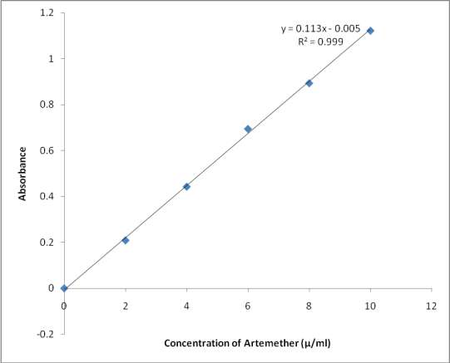

## Appendix II: Calibration curve of artemether

**Appendix III: Absorbance values for phase solubility studies of artemether with 2- HP-β-CD at 37 oC.**

|  |  |  |  |
| --- | --- | --- | --- |
| **S/No.** | **Conc. of 2-HP-β-** | **Absorbance** | **Conc. of artemether (Moles**) |
|  | **CD (Moles)** | **(Mean±SE)** |  |
| 1 | 0 | 0.227±0.002 | 0.000007 |
| 2 | 0.003 | 0.390±0.011 | 0.000012 |
| 3 | 0.006 | 0.538±0.003 | 0.000016 |
| 4 | 0.009 | 0.650±0.003 | 0.000019 |
| 5 | 0.012 | 0.809±0.003 | 0.000024 |
| 6 | 0.015 | 0.940±0.001 | 0.000028 |

## Appendix IV: Absorbance values for the dissolution profile of artemether complexes

**molar ratio of 1:1, 1:2, 1:3, pure drug and a marketed parenteral formulation (Drutemal**®**) in simulated intestinal fluid pH 7.4 (Mean±SE)**

## Time

**Pure 1:1 M 1:2 M 1:3 M**

## Drutemal® Injection

0.000±0.

0

000

0.000±0.

000

0.000±0.

000

0.000±0.000 0.000±0.000

0.046±0.

5

002

0.128±0.

003

0.129±0.

002

0.130±0.002 0.069±0.000

0.076±00

10

1

0.167±0.

001

0.131±0.

001

0.178±0.003 0.168±0.001

0.089±0.

15

004

0.193±0.

003

0.196±0.

003

0.199±0.079 0.189±0.002

0.124±0.

30

003

0.219±0.

002

0.264±0.

002

0.289±0.004 0.233±0.002

0.129±0.

45

000

0.294±0‟

000

0.267±0.

000

0.290±0.004 0.298±0.001

0.136±0.

60

001

0.304±0.

001

0.296±0.

001

0.306±0.001 0.302±0.005

0.167±0.

75

002

0.307±0.

001

0.308±0.

001

0.310±0.000 0.304±0.000

0.179±0.

90

002

0.304±0.

000

0.309±0.

003

0.313±0.000 0.309±0.004

105

0.203±0.

002

0.306±0.

003

0.317±0.

000

0.315±0.001 0.312±0.001

120

0.203±0.

002

0.309±0.

001

0.321±0.

002

0.326±0.000 0.311±0.002

## Appendix V: Results of the dissolution profile of artemether complexes (molar

**ratio of 1:1, 1:2, 1:3) pure drug and a marketed parenteral product (Drutemal**®**) in simulated intestinal fluid (pH 7.4)**

## Time

**Pure**

## Percent Drug Released

**1:1M 1:2M 1:3M Drutemal**®

|  |  |  |  |  |  |
| --- | --- | --- | --- | --- | --- |
| **(min)** | **Drug** |  |  |  | **Injection** |
| 0 | 0 | 0 | 0 | 0 | 0.00 |
| 5 | 15.3 | 37.0 | 37.8 | 38 | 37.5 |
| 10 | 16.3 | 48.0 | 38.0 | 51.6 | 48.8 |
| 15 | 20.7 | 57.0 | 56.7 | 57.4 | 54.0 |

|  |  |  |  |  |  |
| --- | --- | --- | --- | --- | --- |
| 30 | 28.8 | 63.0 | 75.9 | 83.2 | 66.9 |
| 45 | 37.9 | 84.0 | 76.9 | 83.2 | 85.4 |
| 60 | 39.8 | 86.1 | 84.0 | 87.0 | 86.3 |
| 75 | 48.5 | 88.0 | 88.0 | 89.0 | 86.9 |
| 90 | 52.0 | 86.1 | 89.0 | 89.3 | 88.8 |
| 105 | 54.5 | 87.0 | 90.2 | 90.5 | 89.3 |
| 120 | 58.6 | 88.6 | 91.8 | 93.4 | 88.9 |

## Appendix VI: Parameters for the dissolution profile of pure artemether, 2- hydroxypropyl-β-cyclodextrin inclusion complexes of artemether and a marketed

**parenteral product (Drutemal**® **injection) in simulated intestinal fluid.**

## Parameter Pure drug

**1:1 M**

## complex

**1:2 M**

## complex

**1:3 M**

## complex

**Drutemal**® **injection**

D.R 15 min (%) 16.3 57.0 56.7 57.4 54

D.R 45 min (%) 37.9 84 76.9 83.2 85.4

t 50% (min) 80 11.3 12.5 10 11.3

t 90% (min) >120 >120 104 97.5 >120

D.R: Drug release

## Appendix VII: Results of statistical analysis of the dissolution profile of artemether complexes (Molar ratio of 1:1, 1:2, 1:3) pure drug and a marketed parenteral formulation (Drutemal®) in simulated intestinal fluid (pH 7.4)

**T**

## ime

**Pure drug**

**1:2**

## 1:1 M

**M**

## 1:3 M Drutemal® Injection

0 0.00 0.00

0.0

0

0.00 0.00

5 15.3 37.0

37.

8

38.0 37.5

1

16.3 48.0

0

38.

0

51.6 48.8

1

20.7 57.0

5

56.

7

57.4 54.0

3

28.8 63.0

0

75.

9

83.2 66.9

4

37.9 84.0

5

76.

9

83.2 85.4

6

39.8 86.1

0

84.

0

87.0 86.3

7

48.5 88.0

5

88.

0

89.0 86.9

9 52.0 86.1 89. 89.3 88.8

0 0

1

54.5 87.0

05

90.

2

90.5 89.3

1

58.6 88.6

20

91.

8

93.4 88.9

ANOVA: df = (4, 50) F-Calculated = 2.903 ** F-tabulated = 2.40 ρ = 0.031**

*H0: Samples and commercial injection are not significantly different. H1: Samples and commercial injection are significantly different.*

*Note: ** denotes significance at 5% level, hence the rejection of H0 (i.e. ρ < 0.05 or F-Cal >F-tab).*

## Appendix VIII: Absorbance values for the dissolution profile of artemether complexes (molar ratio of 1:1, 1:2, 1:3) and pure drug in simulated gastric fluids pH

**1.2 (Mean±SE)**

|  |  |  |  |  |
| --- | --- | --- | --- | --- |
| **Time** | **Pure drug** | **1:1 M** | **1:2 M** | **1:3 M** |
| 0 | 0.000±0.000 | 0.000±0.000 | 0.000±0.000 | 0.000±0.000 |
| 5 | 0.056±0.002 | 0.159±0.002 | 0.174±0.001 | 0.179±0.002 |
| 10 | 0.059±0.000 | 0.178±0.004 | 0.193±0.001 | 0.193±0.002 |
| 15 | 0.068±0.001 | 0.279±0.001 | 0.298±0.001 | 0.229±0.002 |

|  |  |  |  |  |
| --- | --- | --- | --- | --- |
| 30 | 0.097±0.002 | 0.316±0.001 | 0.304±0.000 | 0.339±0.002 |
| 45 | 0.119±0.002 | 0.318±0.001 | 0.329±0.001 | 0.339±0.000 |
| 60 | 0.169±0.004 | 0.335±0.002 | 0.335±0.002 | 0.341±0.004 |
| 75 | 0.196±0.001 | 0.329±0.002 | 0.338±0.004 | 0.340±0.003 |
| 90 | 0.226±0.000 | 0.336±0.001 | 0.341±0.005 | 0.336±0.001 |
| 105 | 0.239±0.001 | 0.335±0.000 | 0.335±0.002 | 0.332±0.001 |
| 120 | 0.241±0.004 | 0.331±0.002 | 0.331±0.004 | 0.330±0.001 |

## Appendix IX: Results of the dissolution profile of artemether complexes (Molar ratio of 1:1, 1:2, 1:3) and pure drug in simulated gastric fluids (pH 1.2)

**Percent Drug Released**

|  |  |  |  |  |  |
| --- | --- | --- | --- | --- | --- |
| **Time(min)** | **Pure Drug** | **1:1 M** | **1:2 M** | **M** | **1:3** |
| 0 | 0.00 | 0.00 | 0.00 |  | 0.00 |
| 5 | 17.2 | 42.0 | 50.4 |  | 51.8 |
| 10 | 23.0 | 51.6 | 55.8 |  | 55.8 |

|  |  |  |  |  |
| --- | --- | --- | --- | --- |
| 15 | 26.8 | 80.0 | 85.4 | 85.7 |
| 30 | 36.3 | 89.2 | 87.0 | 96.9 |
| 45 | 53.1 | 90.0 | 94.0 | 96.9 |
| 60 | 58.8 | 95.0 | 95.0 | **97.5** |
| 75 | 60.2 | 95.0 | 96.0 | _ |
| 90 | 65.0 | **95.6** | **97.5** | _ |
| 105 | 68.5 | _ | _ | _ |
| 120 | 69.5 | _ | _ | _ |

## Appendix X: Parameters for the dissolution profile of pure artemether, 2- hydroxypropyl-β-cyclodextrin inclusion complexes of artemether of (molar ratio 1:1 M, 1:2 M and 1:3 M) in simulated gastric fluid (pH 1.2).

|  |  |  |  |  |  |
| --- | --- | --- | --- | --- | --- |
|  | **Parameter** | **Pure drug** | **1:1 M**  **complex** | **1:2 M**  **complex** | **1:3**  **M**  **complex** |
| (%) | D.R 15 min | 26.8 | 80 | 85.4 | 87.5 |
| (%) | D.R 45 min | 53.1 | 90 | 94.0 | 96.9 |
|  | t 50% (min) | 39.5 | 8.5 | 4.8 | 4.0 |
|  | t 90% (min) | >120 | 45 | 36.8 | 21 |

D.R: Drug release

## Appendix XI: Results of statistical analysis of the dissolution profile of artemether complexes (Molar ratio of 1:1, 1:2, 1:3) and pure drug in simulated gastric fluid (pH 1.2)

|  |  |  |
| --- | --- | --- |
| **Time Pure drug 1:1 M** | **1:2 M** | **1:3 M** |
| 0 0.00 0.00 | 0.00 | 0.00 |
| 5 17.2 82.0 | 50.4 | 51.8 |
| 10 23.0 51.6 | 55.8 | 55.8 |
| 15 26.8 80.0 | 85.4 | 85.7 |
| 30 36.3 89.2 | 87.0 | 96.9 |
| 45 53.1 90.0 | 94.0 | 96.9 |
| 60 58.8 95.0 | 95.0 | 97.5 |
| 75 60.2 95.0 | 96.0 | 97.2 |
| 90 65.0 95.6 | 97.5 | 96.3 |
| 105 68.5 95.0 | 95.0 | 95.0 |
| 120 69.5 94.6 | 94.6 | 94.3 |
| ANOVA: df = (3, 40) F-Calculated = 5.070** | F-tabulated = 2.84 | ρ = |

0.005**

*H0: Prepared samples and pure drug are not significantly different. H1: Prepared samples and pure drug are significantly different.*

*Note: ** denotes significance at 5% level, hence the rejection of H0 (.i.e. ρ < 0.05 or F-Cal >F-tab).*

## Appendix XII: Absorbance values for the dissolution profile of pure Artemether,

**commercial products (Coartem**® **and Lumartem**®**) and formulated inclusion complex (1:1) tablet in SGF (Mean±SE)**

|  |  |  |  |  |
| --- | --- | --- | --- | --- |
| **Time** | **Pure drug** | **Lumartem**® **Coartem**® **Complex**  **Tablets** | | |
| 0 | 0.000±0.00 | 0.000±0.000 | 0.000±0.000 | 0.000±0.000 |
| 5 | 0.021±0.001 | 0.049±0.002 | 0.061±0.001 | 0.070±0.000 |
| 10 | 0.024±0.003 | 0.058±0.001 | 0.071±0.002 | 0.086±0.001 |
| 15 | 0.033±0.001 | 0.079±0.002 | 0.087±0.002 | 0.147±0.000 |
| 30 | 0.052±0.000 | 0.110±0.001 | 0.113±0.002 | 0.157±0.001 |
| 45 | 0.091±0.003 | 0.116±0.002 | 0.118±0.001 | 0.164±0.001 |
| 60 | 0.101±0.001 | 0.128±0.001 | 0.133±0.019 | 0.170±0.003 |
| 75 | 0.103±0.002 | 0.132±0.000 | 0.137±0.002 | 0.175±0.002 |
| 90 | 0.108±0.003 | 0.135±0.001 | 0.139±0.002 | 0.175±0.001 |
| 105 | 0.111±0.002 | 0.136±0.001 | 0.142±0.000 | 0.164±0.001 |
| 120 | 0.114±0.000 | 0.139±0.005 | 0.147±0.000 | 0.162±0.001 |

## Appendix XIII: Results of the dissolution profile of pure artemether, commercial

**products (Coartem**®**and Lumartem**® **and formulated inclusion complex (1:1) tablet in SGF**

|  |  |  |  |  |
| --- | --- | --- | --- | --- |
|  | | | | **tablets** |
| 0 | 0.00 | 0.00 | 0.00 | 0.00 |
| 5 | 14.4 | 30.0 | 36.3 | 41.4 |
| 10 | 18.2 | 35.0 | 41.9 | 50.6 |
| 15 | 21.3 | 46.3 | 50.8 | 83.8 |
| 30 | 31.3 | 63.8 | 65.0 | 89.4 |
| 45 | 38.3 | 66.9 | 68.0 | 93.1 |
| 60 | 49.0 | 73.8 | 76.0 | 96.8 |
| 75 | 57.6 | 75.5 | 78.8 | **99.5** |
| 90 | 62.0 | 77.5 | 79.4 | _ |
| 105 | 64.5 | 78.1 | 81.3 | _ |
| 120 | 65.7 | **79.4** | **83.8** | _ |

**Percent Drug Released**

**Time(min)**

**Pure**

**Drug**

**Artemether:HP-β-**

**CD**

**Lumartem**

®

**Coartem**

®

**Complex (1:1)**

**Marketed formulation**

## Appendix XIV: Parameters for the dissolution profile of pure artemether,

**inclusion-complex tablet and marketed tablets (Coartem**® **and Lumartem**®**) in simulated gastric fluid (pH 1.2)**

|  |  |  |  |  |  |
| --- | --- | --- | --- | --- | --- |
| **Parameter** | | **Pure drug** | **Lumartem** | **Coartem** | **1:1 M** |
| ® | | | | ® | **complex** |
|  | | | |  | **tablet** |
| (%) | D.R 15 min | 21.3 | 46.3 | 50.8 | 83.8 |
|  | D.R 45 min | 38.3 | 66.9 | 68.0 | 93.1 |
| (%) |  |  |  |  |  |
|  | t 50% (min) | 61.0 | 21.0 | 14.0 | 9.0 |
|  | t 70 (min) | >120.0 | 50.0 | 48.5 | 11.5 |

t 90% (min) >120.0 >120.0 >120.0 31.0

D.R: Drug release.

## Appendix XV: Results of statistical analysis of the dissolution profile of pure

**artemether, commercial products (Coartem**® **and Lumartem**®**) and formulated inclusion complex (1:1) tablet % drug released in simulated gastric fluid (pH 1.2)**

|  |  |  |  |
| --- | --- | --- | --- |
| **Time** | **Pure drug** | **Lumartem**® | **Coatem**® **Formed Tablets** |
| 0 | 0.00 | 0.00 | 0.00 0.00 |
| 5 | 14.4 | 30.0 | 36.3 41.4 |
| 10 | 18.2 | 35.0 | 41.9 50.6 |
| 15 | 21.3 | 46.3 | 50.8 83.8 |
| 30 | 31.3 | 63.8 | 65.0 89.4 |
| 45 | 38.3 | 66.9 | 68.0 93.1 |
| 60 | 49.0 | 73.8 | 76.0 96.8 |
| 75 | 57.6 | 75.5 | 78.8 99.5 |
| 90 | 62.0 | 77.5 | 79.4 99.5 |
| 105 | 64.5 | 78.1 | 81.3 93.1 |
| 120 | 65.7 | 79.4 | 83.8 92.5 |
| ANOVA: df | = (3, 40) | F-Calculated = 3.183** | F-tabulated = 2.84 ρ = 0.034** |

*H0: Pure drug, marketed formulations and prepared tablets are not significantly different.*

*H1: Pure drug, marketed formulations and prepared tablets are significantly different.*

*Note: ** denotes significance at 5% level, hence the rejection of H0 (.i.e. ρ < 0.05 or F- Cal >F-tab).*

## Appendix XVI: Result of statistical analysis of accelerated stability studies of the inclusion complexes and the formulated tablets at 50 oC

|  |  |  |
| --- | --- | --- |
| **Sample** | **Color** | **Percent Drug Content at** |
|  | **HOURS** | **50 0C**  **HOURS** |

|  |  |  |  |  |  |  |  |  |  |  |  |  |  |
| --- | --- | --- | --- | --- | --- | --- | --- | --- | --- | --- | --- | --- | --- |
|  | | 24 |  | 48 | 72 |  | 0 |  | 24 |  | 48 |  | 72 |
| 1:1 | e | whit | e | whit | white | 5 | 87. | 5 | 87. | 3 | 87. | 2 | 87. |
| 1:2 | e | whit | e | whit | white | 0 | 87. | 8 | 86. | 8 | 86. | 7 | 86. |
| 1:3 | e | whit | e | whit | white | 0 | 86. | 0 | 86. | 8 | 85. | 6 | 85. |
| Tablet | e | whit | e | whit | White | 5 | 95. | 5 | 95. | 5 | 95. | 1 | 95. |

ANOVA: df = (3,12 ) F-Calculated = 0.005 F-tabulated = 3.89 ρ = 0.999

**Appendix XVII: Results of statistical analysis of short term stability studies of the inclusion complexes and the formulated tablets at room temperature (28-30 oC).**

# Sample Color Percent Drug Content at Room temp. ( 28-30 oC)

|  |  |  |  |
| --- | --- | --- | --- |
|  | After 10 weeks | Day one (1) | After 10 weeks |
| 1:1 | white | 87.50 | 87.30 |
| 1:2 | white | 87.00 | 86.96 |
| 1:3 | white | 86.00 | 86.00 |
| Tablet | white | 95.50 | 95.10 |

t-test df = 6 T-calculated = 0.053 T- tabulated =1.872 ρ-value = 0.960