EVALUATION OF THE BIODIESEL POTENTIALS OF SELECTED PLANT BIOMASSES IN IBADAN NORTH LOCAL GOVERNMENT AREA, NIGERIA


BY

UDOFIA, BASSEY GABRIEL

(B.Sc. Biochemistry, U.I.) Matric No: 127076

A DISSERTATION SUBMITTED TO THE UNIVERSITY OF IBADAN IN PARTIAL FULFILMENT OF THE REQUIREMENT FOR THE AWARD OF MASTERS OF PUBLIC HEALTH (ENVIRONMENTAL HEALTH) DEGREE.

DEPARTMENT OF ENVIRONMENTAL HEALTH SCIENCES, FACULTY OF PUBLIC HEALTH,

COLLEGE OF MEDICINE, UNIVERSITY OF IBADAN.

JANUARY, 2015

CERTIFICATION
I certify that this research work was carried out by Udofia, Bassey Gabriel of the Department of Environmental Health Sciences, Faculty of Public Health, College of Medicine, University of Ibadan, Ibadan.

Supervisor

Dr G. R. E. E. Ana
B.Sc (PH), M.Eng (PH), MPH (Ib), PhD (Ib), FLEAD (UK), MRSPH (UK), MAPHA (USA)
Department of Environmental Health Sciences, Faculty of Public Health, College of Medicine, University of Ibadan, Ibadan.

DEDICATION
This work is dedicated to Jehovah God Almighty, in whose mercy and grace I found favour to carry out this research work from start to finish; and for the gift of life.

Also dedicate this work to my Father (Cosmas Etim Udofia) and Mother (Eno Etim Udofia), both of whom have been my pillar of support and encouragement, without whom I might have even given up hope.

ACKNOWLEDGEMENTS
I thank the Almighty God, the author and finisher of my faith, and the one who alone is justifiable to receive all my praise in its entirety. I am forever grateful to you Lord for seeing me throughout my course of study and preserving my life up till this moment. I pray thee to receive my sincere thanks and appreciation.

My profound and inestimable gratitude goes to my supervisor, Dr Godson R.E.E. Ana for his immense contribution to my personal and academic life. I cannot but say that your invaluable pieces of advice, criticism and encouragement have gone a long way in repositioning my mind for present and future challenges. Sir, you have not only taken me as student but also taken personal interest in my growth and development like a brother. I pray God to continually bless all the works of your hand and increase you in leaps and bounds even to achieve greater unprecedented feats in life. May he also keep and protect your family all the way.

My warm and sincere appreciation goes to all the lecturers and staff of the Department of Environmental Health Sciences-Prof. M.K.C. Sridhar, Prof. A.M. Omishakin, Dr E.O. Oloruntoba, Dr O.T. Okareh, Mr O.M. Morakinyo, Mr B.T. Hammed, Mr Dele James, Mrs Olaide Ikpele and Mr Kehinde Adewusi, for their respective assistance in different ways in the course of my programme. May God continually bless you all and make your efforts in life fruitful.

I will also like to use this opportunity to thank the members and staff of the Multidisciplinary Central Research Laboratory (MCRL), Nigerian Institute of Science Laboratory Technology (NISLT), Agronomy Department, Department of Botany, etc, who in one way or the other assisted me in the conduct of my bench work or my laboratory analyses, but who are just too numerous to mention. I pray that God who knows and sees all things will reward the time and effort you put into the accomplishment of this work wherever you may be. I will not forget to specially thank Mr Abiola T. Adebayo for his kind disposition and Mrs Oluronke Korede of the MCRL for her understanding, kind heartedness, motherly care and affection even to students who she doesn’t know from anywhere. I pray God to keep you and your family and help your children to find boundless favour wherever they go in life.

This section would be incomplete if I fail to specially thank all my classmates (2011/2012 MPH set) of the Department of Environmental Health Sciences for their cordial relationship and enabling us all to work in tandem in accomplishing several set targets of the class even within tight time schedules. My special recognition goes to my notable departmental colleagues, Oluwafemi Muyiwa, Samuel Adekunle, Ifiok Udofia and Alufa Ife. My warm appreciation also goes to my colleague and my most-caring classmate-Alege Adenike. I pray God to bless and prosper you all abundantly.

Finally, I would like to appreciate immensely my family and my siblings Mr Daniel Udofia, Mr Akaniyiene Udofia, Mr Kufre Udofia and Miss Blessing Udofia, for giving me a sense of belonging. I must once again sincerely appreciate my parents, who were not only committed financially to this work but also morally and physically, especially the immense role they played in the tedious process of collection and processing of the Spirogyra filaments and other biomasses used in this work. I pray God to bless and keep you and give you long life to reap the fruit of your labour.

Udofia, Bassey Gabriel

ABSTRACT
There has been an increasing emphasis on renewable sources of energy following recurrent economic crises and environmental concerns associated with petrodiesel. In Nigeria, there is an abundance of oil-bearing inedible plant biomasses, which are underutilized. Research into biodiesel production from these renewable oil sources can provide a more sustainable alternative to petrodiesel. This study was designed to evaluate the biodiesel yielding potentials of selected locally available plant biomasses.

Four plant biomasses (Moringa oleifera, Elaeis guineensis, Thevetia peruviana and Spirogyra africana) were utilised. Oil extraction from the biomasses was carried out using Soxhlet and Cold-solvent extraction methods. Hexane-only (H-only) solvent was used in the Soxhlet extraction while two solvent systems were used in the Cold extraction [Hexane/Ether (H/E) mixture and H-only]. The extracted oils were processed to biodiesel via transesterification reaction using sodium hydroxide as catalyst, and two alcohol systems [Methanol/Ethanol (M/E) mixture and Methanol-only (M-only)]. Samples of biomasses were analysed for moisture content and levels of the elements-Phosphorus (P), Calcium (Ca), Sodium (Na) and Sulphur (S)]; and the oil samples for Kinematic Viscosity (KV), Free Fatty Acid (FFA) level and Saponification value. Samples of the biodiesels were also analysed for KV, Flash Point (FP), Acid Value (AV) and the levels of P, Ca, Na and S according to the methods described by the American Standard for Testing and Materials (ASTM D6751). Results of analyses were compared with ASTM D6751 guidelines. Data were analysed using descriptive statistics and t-test at 5% level of significance.

The oil yields from Soxhlet extraction, Cold extraction (H/E mixture) and Cold extraction (H- only) were: Moringa (45.0%, 27.7% and 18.0%), PK (38.4%, 33.2% and 25.4%), Thevetia
(62.3%, 51.9% and 45.8%) and Spirogyra (22.3%, 11.5% and 6.4%) respectively. Similarly, biodiesel yield from the extracted oils in the M/E and M-only transesterification processes were: Moringa (61.2% and 65.5%), PK (72.4% and 75.3%), Thevetia (78.4% and 85.2%) and Spirogyra (19.1% and 26.2%) respectively. The M-only alcohol proved to be more effective than the M/E mixture as it gave better biodiesel yield. Moisture content of the seeds of Moringa, PK, Thevetia and Spirogyra were 9.4%, 8.3%, 6.6% and 39.7% respectively. The KV, FFA level and Saponification value of the oils were Moringa (44.5 mm²/s, 3.0%, 192.5 mgKOH/g), PK (4.9

mm²/s, 1.9%, 230.2 mgKOH/g), and Thevetia (21.5 mm²/s, 0.6%, 120.1 mgKOH/g). Also, the KV, FP, and AV of the biodiesels were Moringa (5.0 mm²/s, 176ºC and 0.7 mgKOH/g), PK (2.4 mm²/s, 166ºC and 0.4 mgKOH/g), and Thevetia (4.7 mm²/s, 130ºC and 0.4 mgKOH/g). Analyses of elemental composition of the biomasses and biodiesels revealed a significant decline in the percentage compositions of P, Ca, Na and S in the biomasses when compared to their respective biodiesel. Spirogyra oil and biodiesel were insufficient to undergo the physiochemical tests.

The seeds of Moringa, Palm kernel and Thevetia are good sources of oil for biodiesel production but Thevetia proved to be the highest oil- and biodiesel-yielding biomass. The quality parameters of the biodiesels were found to be within international acceptable standard.

Keywords: Biodiesel production, Plant biomasses, Cold-solvent extraction, Transesterification
Word count: 489

TABLE OF CONTENTS

Page

Title page i
Certification ii
Dedication iii
Acknowledgements iv
Abstract vi
Table of Contents viii
List of Tables xiv
List of Figures xvi
List of Plates xviii
List of Formulae xx
Glossary of Technical terms and Abbreviations xxi

CHAPTER ONE 1

INTRODUCTION 1
  - Background Information 1
  - Problem Statement 3
  - Rationale for the study 4
  - Objective of the study 5
    - Broad Objective 5
    - Specific Objectives 5

CHAPTER TWO 6

LITERATURE REVIEW 6
  - Fossil fuels 6
    - Challenges associated with fossil fuels 6
    - Quality of Emissions from Fossil Fuels 8

  - Biofuels 10
  - Classes of Biofuels 11
    - First Generation Biofuels 11
    - Second Generation Biofuels 12
  - Prospects of Biofuel Production 12
  - Biodiesel 12
    - Quality of Emissions from Biodiesel 15
  - Conventional Feedstock for Biodiesel Production 15
  - Prospects of Biodiesel Production 19
    - Effects of Biodiesel Production on the Economy 19
    - Challenges associated with Biodiesel Production 22
    - Challenges associated with Biodiesel Production from Edible Vegetable oils 22
    - Effects of biodiesel use on different factors 23
      - Environmental Benefits of Biodiesel use 23
      - Health Benefits of Biodiesel use 25
      - Other Benefits of Biodiesel use 25
    - Future Outlook for Biodiesel Production 28
  - Local oil Biomasses for Biodiesel Production 30
    - Biomass 30
    - Challenges of Biofuel Production from Biomasses 33
  - Algal Biomass 34
    - Basic Algae Biology 34
    - Classes of Algae 35
    - Important Functions of Algae in the Environment 36
    - Spirogyra 38
    - Cultivation and Reproduction of Spirogyra biomass 40
    - Prospects of Algal oil as a Biofuel 40
  - Moringa oleifera Biomass 44
    - Moringa plant 44
    - Plant Morphology 46
    - Cultivation of Moringa oleifera 49
    - Prospects of M. oleifera 49
  - Thevetia peruviana (Yellow oleander) Biomass 50
    - Thevetia plant 50
    - Thevetia Plant Morphology 51
    - Cultivation of Thevetia Plant 57
    - Prospects of Thevetia Plant 57
  - Palm kernel biomass 59
    - Characteristics of Oil Palm Tree 59
    - Cultivation of Oil Palm Tree 63
    - Harvesting and Processing of Oil Palm Fruits 64
    - Potentials of Palm Kernel oil 64
  - Available Methods for Biodiesel Production 67
    - Homogenous catalysis 67
      - Base Transesterification and Acid catalysis 67
      - Enzymatic catalysis 70
    - Heterogenous catalysis 70
    - Non-catalytic conversion 70
  - Effect of Different Parameters on the Production of Biodiesel 70
    - Effect of molar ratio 71
    - Effect of temperature 72
    - Effect of water and Free Fatty Acid (FFA) content on the yield of biodiesel 72
    - Effect of catalyst content 73
  - Summary of Available Literatures 73
CHAPTER THREE 76
  - METHODOLOGY 76
  - Study Design 76
  - Description of Study Area 76
  - Laboratory Management Practices 77
  - Sourcing for Materials 77
    - Sample source 77
    - Field Sampling of Substrates 79
  - Materials and Methods 81
    - Materials 81
    - Consumables 81
  - Laboratory Methods 82
    - Sample Processing 82
      - Decortications and Sun-drying 82
      - Milling and Oven-drying 85
    - Substrate Preparation and Characterization 87
      - Determination of Moisture Content 88
      - Determination of Relative Density 90
      - Elemental composition determination (Proximate Analysis) 91
      - Wet (organic matter) digestion 92
      - Total Organic Carbon determination 93
      - Total Nitrogen determination 95
      - Total Phosphorus determination 96
      - Calcium and Sodium determination 97
      - Total Sulphur determination 99
    - Oil Extraction 100
    - Characterization of Extracted Oils 108
      - Determination of pH 108
      - Determination of Relative Density 109
      - Determination of Free Fatty Acid level 109
      - Determination of Fatty acid Composition 111
      - Determination of Viscosity 111
      - Determination of saponification value 112
    - Transesterification Process 114
    - Phase separation and Purification process (washing and drying) 116
    - Determination of Biodiesel Yield 118
    - Characterization studies for the biodiesels 121
      - Determination of Relative Density 121
      - Determination of Flash Point 121
      - Determination of Cloud and Pour points (using the Freezer test) 122
      - Determination of Viscosity 123
      - Determination of Acid value 123
      - Determination of Elemental composition (Proximate analysis) 124
  - Data Management and Statistical Analysis 127
CHAPTER FOUR 128
  - RESULTS 128
  - Characteristics of the Plant Biomasses 128
    - Physical characteristics of the Plant Biomasses 128
    - Chemical characteristics of the Plant Biomasses 131
  - Characteristics of the Extracted Oils 134
    - Physical characteristics of the Extracted Oils 134
    - Chemical characteristics of Extracted Oils 137
  - Characteristics of the Biodiesels 142
    - Physical Characteristics of the Biodiesels 142
    - Chemical characteristics of the Biodiesels 148
CHAPTER FIVE 163
  - DISCUSSION 163
  - Sources of Substrates 163
  - Physical characteristics of the Plant Biomasses 164
  - Chemical characteristics of the Plant Biomasses 165
  - Physical characteristics of the Extracted Oils 165
  - Chemical characteristics of the Extracted Oils 166
  - Physical characteristics of the Biodiesels 168
  - Chemical characteristics of the Biodiesels 169
CHAPTER SIX 172
  - CONCLUSION AND RECOMMENDATIONS 172
  - Conclusion 172
  - Recommendations 173
REFERENCES 175
APPENDICES 202
Appendix 1 Supplementary result of Plant biomass characteristics 202
Appendix 2 Supplementary result of Extracted oil characteristics 205
Appendix 3 Supplementary result of Biodiesel characteristics 207

 | LIST OF TABLES
 |  | Page
Table 2.1 | Examples of different plant species and their possible biofuel derivative | 14
Table 2.2 | Alternative biodiesel feedstock that have been physico-chemically tested | 17
Table 2.3 | Alternative biodiesel feedstock which have been engine-tested | 18
Table 2.4 | Global oil demand projection for year 2014 | 30
Table 2.5 | Comparison of the oil yield from some biodiesel sources | 42
Table 2.6 | Physical properties of Thevetia fruits and kernels | 56
Table 2.7 | Palm oil and Palm kernel production in the world | 66
Table 2.8 | A chronology of publications on biodiesel research works in Nigeria | 74
Table 3.1 | Showing the ASTM and EN Guidelines for Biodiesel Fuels | 119
Table 3.2 | Comparison of certain key Parameters of B100 Biodiesel fuel with Conventional Petroleum-based Diesel fuel | 120
Table 4.1 | Showing the different physical parameters that were determined in the biomasses | 129
Table 4.2 | Different chemical parameters that were determined in the biomasses | 132
Table 4.3 | Showing the different physical parameters estimated for in the extracted oils | 136
Table 4.4 | Showing the chemical parameters estimated for in the extracted oils | 138
Table 4.5 | Showing the Fatty Acid Profile (FAP) for the extracted oils | 141
Table 4.6a | Physical characteristics of Biodiesel | 144
Table 4.6b | Comparison of pH of oils and pH of biodiesels | 147
Table 4.7a | Chemical characteristics of Biodiesels | 150
Table 4.7b | Comparison of the KV of oils to the KV of biodiesels | 151
Table 4.8 | Spearman correlation between mean elemental compositions in biomasses and biodiesel yield | 152
Table 4.9 | Showing a comparison between properties of the biodiesels obtained in this work with ASTM and EN guidelines respectively | 159
Table 7.1 | Showing the Percentage moisture content removed by sundrying from each of the substrates used in the different extraction processes | 202
Table 7.2 | Showing triplicate moisture content determination in the biomasses using the Moisture analyzer equipment | 202

Table 7.3 | Showing triplicate moisture content determination in the biomasses using the Oven-drying method | 203
Table 7.4  Table 7.5  Table 7.6 | Showing triplicate readings for the density of the respective milled biomasses  Showing duplicate readings for Elemental composition (Proximate readings) of the biomasses  Showing triplicate readings for the pH determination of the respective extracted oils | 203  204  206
Table 7.7 | Showing triplicate readings for the density of the respective extracted oils | 205
Table 7.8 | Showing the determination of dynamic viscosity | 206
Table 7.9 | Showing the triplicate determination for Kinematic viscosity of oils | 206
Table 7.10 | Showing the triplicate readings for the Fatty Acid Profile (FAP) of the extracted oils | 207
Table 7.11 | Showing duplicate readings for the pH determination of the respective biodiesels | 208
Table 7.12 | Showing triplicate determination of density for the respective biodiesels | 208
Table 7.13 | Showing duplicate determinations for the elemental composition (Proximate analysis) of the biodiesels | 209
Table 7.14 | Showing the duplicate determination of Flash point for the biodiesels | 209
Table 7.15 | Showing duplicate readings for the Cloud and Pour points of the biodiesels respectively | 210
Table 7.16 | Showing the duplicate determination of acid number for the biodiesels | 210
Table 7.17 | Showing the determination of dynamic viscosity of the biodiesels | 211
Table 7.18  Table 7.19 | Showing the duplicate determination of Kinematic viscosity for the biodiesels  Comparison of the Relative densities of test parameters using  ANOVA with Least Significance Difference (LSD) | 211  212

LIST OF FIGURES
Page
Figure 2.1 Indicators of Electricity crises in Nigeria (1970-2008) 7
Figure 2.2 Global Oil Product Demand 29
Figure 2.3 Energy consumption in Nigeria, 2009 31
Figure 2.4 Schematic diagram of bioenergy conversion 32
Figure 2.5 Microalgae biodiesel value chain stages 43
Figure 2.6 Structure of Thevetin A 58
Figure 2.6 Process Flowchart for typical biodiesel production 69
Figure 3.1 A simple flow chart of the major steps involved in the experimental work 82 Figure 3.2 Schematic representation of the steps involved in Cold solvent extraction
using two solvent systems 104
Figure 3.3 Schematic Representation of EPA Method 3031-Acid Digestion of Oils
for Metal Analysis by AAS 125
Figure 4.1 Comparison of the Moisture content of biomasses determined using
two different methods 130
Figure 4.2 Showing the proportion of elements in the biomasses 133
Figure 4.3 Shows the percentage oil yield from the biomasses via three
extraction methods 135
Figure 4.4 Comparison of the physicochemical parameters of biomass oils 139
Figure 4.5 Comparison of the pH of oils to the pH of biodiesels 143
Figure 4.6 Comparison of the Relative density of oils to the Relative density
of biodiesels 145
Figure 4.7 Comparison of Percentage biodiesel yield from the oils using two transesterification processes 146
Figure 4.8 Relationship between percentage Total Phosphorus in biomasses
and Biodiesel yield (M-only transesterification) 153
Figure 4.9 Relationship between percentage Total Phosphorus in biomasses
and Biodiesel yield (M/E transesterification) 154
Figure 4.10 showing the proportion of elemental constituent of the biodiesels 155
Figure 4.11 Comparison of some physicochemical parameters of each biodiesel 156
Figure 4.12 Comparison of the Kinematic viscosity of oil to the Kinematic
viscosity of biodiesel 157

Figure 4.13 | Comparison of the Percentage Elemental composition of biomasses to those of biodiesels | 158
Figure 4.14: | Shows the comparison of some biodiesel physicochemical parameters to ASTM and EN standards | 160
Figure 4.15 | Comparison of Flash Point to ASTM and EN standards | 161
Figure 4.16 | Comparison of elemental composition of biodiesels to ASTM and EN limits | 162

 | LIST OF PLATES
 |  | Page
Plate 2.1 | Picture of gas flaring activity in a part of the Niger delta region of Nigeria 9
Plate 2.2 | Schematic representation of the overview of photosynthesis | 13
Plate 2.3 | Different morphological organization of green algae | 36
Plate 2.4 | Showing algal blooms on water bodies | 37
Plate 2.5 | Showing an algal (Spirogyra) bloom | 37
Plate 2.6 | Pictures of Spirogyra filament clusters | 39
Plate 2.7 | Picture of Moringa oleifera branch with dry pods | 45
Plate 2.8 | Showing matured and dried M. oleifera pods | 47
Plate 2.9 | Longitudinally divided pods showing Moringa seeds | 47
Plate 2.10 | Picture of brown-winged M. oleifera seeds | 48
Plate 2.11 | Freshly removed M. oleifera seeds from pod | 48
Plate 2.12 | Picture of a Thevetia peruviana Juss (Yellow oleander) plant | 52
Plate 2.13 | Picture of the funnel-shaped flowers of Yellow oleander plant | 53
Plate 2.14 | Picture of matured Yellow oleander fruits | 54
Plate 2.15 | Picture of soft, ripe and dark Oleander fruits | 54
Plate 2.16 | Picture of matured T. peruviana kernels | 55
Plate 2.17 | Showing freshly removed Yellow oleander seeds | 55
Plate 2.18 | Picture of Palm oil plantation | 59
Plate 2.19 | Bunches of freshly harvested palm kernel fruits | 61
Plate 2.20 | showing palm nuts detached from the bunch | 61
Plate 2.21 | Longitudinal section through a palm fruit | 62
Plate 2.22 | Picture of Palm kernel seeds | 62
Plate 3.1 | Showing an array of the biomasses utilized in the study | 78
Plate 3.2 | Showing an array of the samples in their natural state when collected from their different sources | 80

Plate 3.3 | Picture of the Light Microscope used for morphological assessment of the spirogyra filaments | 81
Plate 3.4 | Pictures of decorticated biomasses | 83
Plate 3.5 | Showing an array of the different substrates prepared for sundrying | 84
Plate 3.6 | Showing the rinsing of spirogyra biomass to remove extraneous materials | 85
Plate 3.7 | Showing an array of sundried milled substrates | 86
Plate 3.8 | Showing the instruments used for pulverization/milling | 87
Plate 3.9 | Showing the AИD EK-410i model Top-loading balance | 88
Plate 3.10 | Picture of the Moisture Analyzer (AИD MX-50 model) device | 90
Plate 3.11 | Picture showing the Jenway® Model PFP7 Flame Photometer | 98
Plate 3.12 | Showing the Soxhlet extraction system | 102
Plate 3.13 | Showing an array of the different sample/solvent mixtures | 104
Plate 3.14 | Picture of the Muslin sieves used | 105
Plate 3.15 | Showing an array of some of the residual biomasses obtained after
 | the squeeze-filtration process | 105
Plate 3.16 | Oils suspended on paste of sediments | 106
Plate 3.17 | Part of the decanted oils in labeled bottles | 106
Plate 3.18 | Residual paste of sediments left over after decanting the respective oils | 107
Plate 3.19 | Picture of the Buchi Rotavapor (R-210 model) concentrating the residual oil | 107
Plate 3.20 | Showing the pH of one of the oils being determined using Jenway® 3520 model pH meter | 109
Plate 3.21 | Showing some of the preparatory stages preceding the
 | transesterification reaction | 115
Plate 3.22 | Showing a typical example of the reaction mixture
 | obtained after transesterification reaction in a separatory flask | 116
Plate 3.23 | Showing the pH testing of a sample of one of the biodiesels | 117
Plate 3.24 | Showing the Buck Scientific® Model 210 VGP AAS machine | 126

LIST OF FORMULAE

Page
Formula 1.1 Transesterification reaction used in conventional biodiesel production 2
Formula 2.1 Photosynthesis reaction where λѵ is energy of photons 13
Formula 3.1 Formula for calculating the Moisture content of the substrates 89
Formula 3.2 Formula for the calculation of Density 90
Formula 3.3 Formula for the calculation of Relative density/Specific gravity 91
Formula 3.4 Formula for calculating Percentage Total Organic Carbon (T.O.C)
in hydrosylate 94
Formula 3.5 Formula for calculating Percentage Total Nitrogen using Kjeldahl method 96 Formula 3.6 Formula for calculating Percentage Total Phosphorus Vanadomolybdate
(Yellow) Colorimetric Method 97
Formula 3.7 Formula for calculation of Percentage Calcium and Sodium 99
Formula 3.8 Formula for the calculation of Percentage Oil content of substrates 108
Formula 3.9 Showing a Saponification reaction process 113
Formula 3.10 Formula for calculating Saponification value 114
Formula 3.11 Formula for calculating Percentage Biodiesel yield 118
Formula 3.12 Formula for calculation of the Acid value of biodiesels 123

GLOSSARY OF TECHNICAL TERMS AND ABBREVIATIONS

A.A.S | Atomic Absorption Spectrophotometer
A.O.A.C | Association of Official Analytical Chemists
ASAE | Division of American Society of Agricultural Engineers
ASTM | American Standard for Testing and Material
A.V | Acid Value
B20 | Blend of biodiesel and petrodiesel (i.e. 20% biodiesel and 80% petrodiesel)
B50 | Blend of biodiesel and petrodiesel (i.e. 50% biodiesel and 50% petrodiesel)
B100 | Unblended biodiesel
B.Y | Biodiesel Yield
CBT | Computer-based Test
CI | Combustion Ignition
CIA | Central Intelligence Agency
CNG | Compressed Natural Gas
COPESCO | Conservation Policy, Education and Science Committee
C.P | Cloud Point
CRIN | Cocoa Research Institute of Nigeria
D.I | De-ionized
DME | Dimethyl ether
EBB | European Biodiesel Board
EEA | European Environment Agency
EIA | Energy Information Administration
EJ | Exajoule (1 exajoule = 10¹⁸ joules)
EPA | Environmental Protection Agency
FAME | Fatty Acid Methyl Esters
FAO | Food and Agriculture Organization
FAP | Fatty Acid Profile
FFA | Free Fatty Acid
F.P | Flash Point
FSU | Former Soviet Union
FTL | Fischer-Tropsch Liquid

GHG | Green House Gas
HC | Hydrocarbon
HDL-C | Cholesterol contained in High Density Lipoproteins
HFRR | High Frequency Reciprocating Rig
IAR&T | Institute of Agricultural Research and Training
ICIC | International Centre for underutilized Crops
IEA | International Energy Agency
IITA | International Institute of Tropical Agriculture
IPCC | Intergovernmental Panel on Climate Change
JIAS | Journal of the International AIDS Society
K.V | Kinematic viscosity
LDL-C | Cholesterol contained in Low Density Lipoproteins
LNG | Liquefied Natural Gas
LPG | Liquefied Petroleum Gas
mb/d | million barrels per day
MCRL | Multidisciplinary Central Research Laboratory
MDG | Millennium Development Goals
MMT | Million Metric Tonnes
MPH | Masters of Public Health
MSHA | Mining Safety Health Administration
MTBE | methyl tert-butyl ether
MTOE | Million Tonnes of Oil Equivalent
NEH | National Engineering Handbook
NFPA | National Fire Protection Association
NIFOR | Nigerian Institute for Oil Palm Research
NIHORT | National Institute for Horticultural Research and Training
NNPC | Nigeria National Petroleum Corporation
NISLT | Nigerian Institute of Science Laboratory Technology
OD | Optical Density
OMR | Oil Market Report
OPEC | Oil Producing and Exporting Countries

PK Palm Kernel
PKO Palm Kernel Oil
PM Particulate Matter
PP Pour Point
ppm parts per million
R.D Relative Density
SBSTTA Subsidiary Body on Scientific, Technical and Technological Advice SHS Super Hybrid Sensor
TAG Triacylglycerol
THF Tetrahydrofuran
T.N Total Nitrogen
T.O.C Total Organic Carbon
T.P Total Phosphorus
T.V Titre Value
US United States
USDA United States Department of Agriculture

CHAPTER ONE

INTRODUCTION

  - Background Information
The relative availability of middle-distillate petroleum fuels over the years has provided little reason for man to experiment with alternative, renewable fuels for diesel engines. Global atmospheric concentrations of carbon dioxide, methane and nitrous oxide have also increased markedly as a result of human activities since 1750 and now far exceed pre-industrial values determined from ice cores spanning many thousands of years (Ding et. al., 2001).

The global increases in carbon dioxide concentration are due primarily to fossil fuel use and land use change, while those of methane and nitrous oxide are primarily due to agriculture (Vaughn, 2011). However, since the oil crisis of the 1970s and considering the environmental impact of petroleum fuels as well as the decrease in world‟s reserve of petroleum, it becomes imperative to source for an alternative renewable energy. Hence, research interest has expanded in the area of alternative fuels (Oghenejoboh & Umukoro, 2011; Petchmata et. al., 2008; Gupta et. al., 2007; Math, 2007; Saravanan et. al., 2007; Bobboi et. al., 2006; Singh et. al., 2006; Canakci, 2001).

Amongst the main renewable energy sources which include solar, wind, geothermal, hydro, tides, waves and biofuels, biodiesel (which is an example of a biofuel) holds much prospect as a viable alternative to conventional fossil-derived diesel. The concept of vegetable oils as fuel is not new. It was first proposed by the German Engineer, Rudolf Diesel (1858-1913) at the time of Second World War (1900) when he experimented with pea nut oil as a fuel in his compression ignition (diesel) engine (Leray, 2006) and Fujio Magao achieved operation with pine oil in 1948 (Thomas, 2003).

Biodiesel is defined as the mono alkyl esters of long chain fatty acids obtained from renewable feedstock such as vegetable oil or animal fats, for use in compression ignition engines; and it is much cleaner than conventional fossil-fuel diesel (Murugesan, et. al., 2009). The most commonly used and most economical process is called the base catalyzed transesterification of oil/fat with methanol, sometimes referred to as “the methyl ester process”.

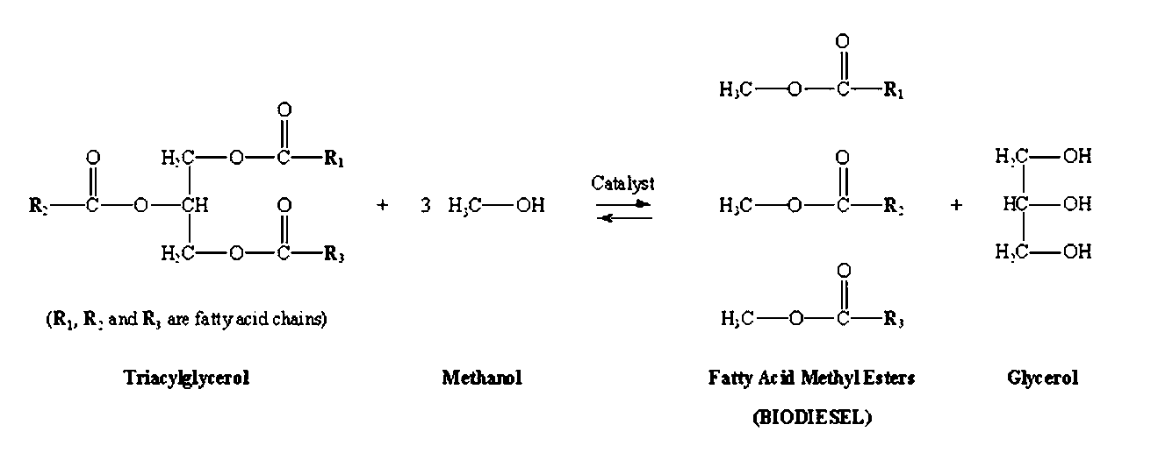Essentially, biodiesel production begins with pressing a crop (or using other oil extraction means), which yields a liquid oil fraction to be converted and a first by-product, oil cake, used as cattle feed. After filtering, transesterification provides a low-cost way to transform the large- branched molecule structure of the extracted oils into smaller, straight-chained molecules similar to the hydrocarbons in the diesel boiling range.

The process basically involves combining the oil/fat (made up of triglyceride molecules) with methanol and sodium or potassium hydroxide. This process creates three main products-methyl esters (biodiesel), glycerine and residual methanol; and the latter could be recycled back through the system (Franz et. al., 2005) (Formula 1.1).

Formula 1.1: Transesterification reaction used in conventional biodiesel production

Many proposals have been made regarding the availability and practicality of an environmentally sound fuel that could be domestically sourced. Methanol, ethanol, compressed natural gas (CNG), liquefied petroleum gas (LPG), liquefied natural gas (LNG), vegetable oils, reformulated gasoline, and reformulated diesel fuel have all been considered as alternative fuels. Of all alternative fuels, only ethanol and vegetable oils are non-fossil fuels. Many researchers have concluded that vegetable oils hold promise as alternative fuels for diesel engines (Oghenejoboh et. al., 2010; Bajpai and Tyagi, 2006; Demirbas, 2003; Haque et. al., 2009; Banerjee et. al., 2009).

Biodiesel is highly favored as alternative to petroleum-based diesel because it is renewable and environmentally friendly (Zhang et. al. 2003). It has the advantages of being non-toxic, highly biodegradable with non-flammable characteristics (Bajpai and Tyagi, 2006). It is safer to handle (flash point above 110ºC), contains little or no sulfur or carcinogenic polyaromatic components, and decreases soot emission considerably, which is very advantageous in environmentally sensitive areas (Knothe et. al., 2005).

Furthermore, biodiesel is a suitable outlet for the vegetable oil industry requiring little or no changes in current diesel engines when used in blends and also increases engine life due to its superior lubricity over petrodiesel (Knothe and Steidley, 2005a; Ramos and Wilhelm, 2005). Unlike ethanol, which is only two-thirds as efficient as gasoline (Al Gore, 2009), biodiesel is just as powerful as petroleum diesel while retaining its environmental advantages.

Biodiesel has been accepted as a possible substitute for conventional diesel fuel because of its certain desirable properties as stated earlier, but in spite of these properties as a diesel fuel substitute, biodiesel from food-grade oils is not economically competitive with petroleum-based diesel fuel. The major obstacle to this competitiveness is the cost of biodiesel. Approximately 70-90% of biodiesel cost arises from the cost of feed stocks (Zhang et. al., 2003).

Cost of edible oils specifically is higher than petroleum-diesel and the use of edible oils for biodiesel production could lead to food oil crisis, hence it is rather impossible to justify the use of these oils for fuel purposes such as in biodiesel production. However, this could be justifiable if there is a massive commensurate increase in the production of the edible oil sources such that there would be surplus enough to guarantee food security as well as biofuel production.

Problem Statement
Fossil fuels such as petroleum, coal and natural gas, which have been used to meet the energy needs of man over the years, are associated with negative environmental impacts such as global warming (Saravanan et. al., 2007; Munack et. al., 2001).

The continuous emission of greenhouse gases (CH₄, CO₂, NO_{x}) into the atmosphere from burning of fossil fuels (mainly from petroleum) has also been identified as the major cause of

climate change, emergence of drought, spread of diseases and biodiversity loss (Oghenejoboh et. al., 2010; IPCC, 2007).

There are already certain projections that the supply of non-renewable fossil fuel sources are threatening to run out in a foreseeable future as not less than ten major oil fields from the 20 largest world oil producers are already experiencing decline in oil reserves (EIA, 2007; Alamu et. al., 2007a). This is as a result of the spate of industrialization and “motorization” of the world, which has led to a steep rise in the demand of petroleum-based fuels. (Rambabu et. al., 2010 and Munack et. al., 2001).

There is paucity of research work that have been carried out to specifically determine the biodiesel potential of locally available materials in Nigeria except for investigation such as Oghenejoboh and Umukoro, 2011; Agarry et. al., 2010; Alamu et. al., 2008; Ibiyemi et. al., 2002; Abigor et. al., 2000).

Rationale for the study
Considering the environmental impact of petroleum fuels as well as the dwindling World’s reserve of petroleum (Petchmata et al., 2008), it becomes imperative to source for alternative renewable fuels such as biodiesel, which has been found to be non-toxic, environmentally friendly, highly biodegradable with non-flammable characteristics.

In Nigerian perspective, the continuous reliance of the country on the oil and gas exploration and production sector since the discovery of commercial reserves in the Delta region in mid 1950s is unsustainable. This is especially so because of the fact that the current respective proven reserves of oil and gas, which are 36.20 billion barrels and 187 trillion cubic feet, as released by the Nigerian National Petroleum Corporation (NNPC) in 2007, could only last for the next 35 to 40 years. Hence, to reduce the country‟s dependence on imported petrol and to mitigate the country‟s total GHG emissions, certain types of biofuels must be targeted, such as biodiesel and cellulose-based ethanol (Galadima et. al., 2011; Forge, 2007).

Nigeria falls within the region of the world rated to have high potential for biofuel production
based on three criteria: the level of water availability, level of available arable land and the state

of food insecurity (Von, 2007). Hence, in view of the failure of past policies of technology importation in the petroleum refining industries, there is need to emphasize the development of Nigerian indigenous technology to improve our vast biodiesel potentials from renewable biomasses. This would in turn ensure that the full benefits of the production of biodiesel are realized. However, the viability of the biodiesel production from these sources, amongst other factors, depends on the oil content of the oil-bearing biomasses as well as their product meeting basic fuel characteristics for diesel fuels (Oghenejoboh and Umukoro, 2011), which this work seeks to investigate.

Data on research works assessing the biodiesel potential of locally sourced substrates in Nigeria are very scanty; hence this work is intended to significantly contribute to the baseline data on this subject area.

Objectives of the study
    - Broad Objective
To determine the biodiesel yielding capacity of selected locally available oil-bearing substrates in Nigeria and their individual fuel characteristics.

Specific Objectives
- Explore the sources of the oil-bearing substrates.
- Quantitatively assess the oil-yield from the substrates.
- Characterize certain physical and chemical components of the oils.
- Generate biodiesel from the oils of the substrates.
- Evaluate the biodiesel yield from the oils.
- Determine the properties of the biodiesels obtained.

CHAPTER TWO

LITERATURE REVIEW

  - Fossil Fuels
These are fuels formed by natural processes such as anaerobic decomposition of buried dead organisms. The age of the organisms and their resulting fossil fuels is typically millions of years, and sometimes exceeds 650 million years (Paul et. al., 2009) Fossil fuels contain high percentages of carbon and include coal, petroleum, and natural gas. They range from volatile materials with low carbon-hydrogen ratios like methane, to liquid petroleum and nonvolatile materials composed of almost pure carbon, like anthracite coal.

Challenges associated with fossil fuels
Anthropogenic factors, mostly associated with the use of fossil fuels, have been identified as the main cause of global warming, which is responsible for the adverse change in climate that is currently a serious global environmental concern. Concentrations of carbon dioxide in the atmosphere are projected to double with future energy use based on today‟s trend (Vaughn, 2011). Also, as the Arctic thaws, methane, a more potent greenhouse gas than CO₂, would further increase global warming (Stoddard et. al., 2006).

But since the realization of the need by world leaders to save the planet from further environmental degradation, the world is daily seeking to substitute petrochemicals in general, most especially diesel and other engine combustion fuels with cleaner and environmentally- friendly ones.

The Kyoto Protocol to reduce greenhouse gas emissions became effective in 2005 as Russia became the 55th country to ratify the agreement. The goal was for the participating countries to collectively reduce emissions of greenhouse gases by 5.2% below the emission levels of 1990 by 2012 (Vaughn, 2011). However, carbon dioxide emissions will still increase, even if nations reduce their emissions to 1990 levels, because of population growth and increase in energy use in the under-developed world.

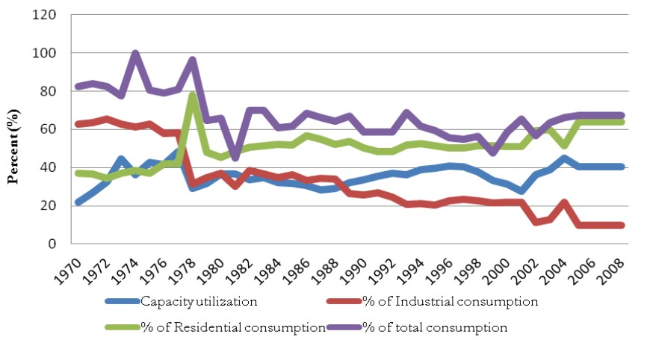Nigeria, as a nation, has been described as one of the major leaders in electric generator imports in Africa. This is probably due to the failed attempts to find lasting solution to the power sector, which from all indications, is tending towards a virtual collapsed in spite of the money already pumped into it. A whooping sum of about $103.1 million was spent importing generators between January and June 2010 (Ibitoye and Adenikinju, 2007).

In addition, due to the lack of reliable electricity (Figure 2.1), many people and companies complement the electricity provided by the national grid with their own generators. In fact, almost everyone who can afford a generator owns one. According to one estimate, well over 90% business ventures in Nigeria have generators (Oparaku, 2003). A study conducted by Stanley et al., (2010) showed that small household generators in Nigeria operate an average of six (6) hours daily, while average distance of generator away from building was 5.6m. Therefore, continuous efforts have to be made towards the solution of the energy supply depletion problem and the environmental impacts caused by these human activities (Li et al., 2009a).

Fig. 2.1: Indicators of Electricity crises in Nigeria (1970 – 2008)
Source: Godwin and Usenobong, 2012

Quality of Emissions from Fossil Fuels
The World‟s energy demand is increasing geometrically as observed in the increased need of fuels for transportation, industrial as well as domestic operations. This has resulted in the unsuccessful war against the sky-rocketing energy demand despite the attendant environmental pollution and global warming effect resulting from the use of petroleum-based fuels (Rodrigues et al., 2009). Within the last 20 years about 75% of human made CO₂ emissions were from burning of fossil fuels. Nigeria‟s oil, for example, has not guaranteed ecologically and socially acceptable development in the country.

There are over 11 oil companies operating 1,481 wells from 159 oil fields in the Niger Delta, producing 2.7 million barrels of crude oil each day and flaring about 17 billion cubic metres of associated gas. These companies spew 2,700 tons of particulates, 160 tons of sulphur oxides, 5,400 tons of carbon monoxide, 12 and 3.5 million tons of methane and carbon dioxide respectively in the process (Olaniyi, 2007).

Nigeria currently stands as the largest emitter of these undesirable gases from the sub-saharan Africa and particularly the second worlds‟ biggest gas „flarer‟-contributing immensely to the global atmospheric pollution (Galadima et. al., 2011). The country is also one of the world‟s 10 largest emitters of methane (which is known to be more prevalent in flares that burn at lower efficiency and more harmful than carbon dioxide), with 38 per cent of it coming from oil and gas exploration, coal mining and landfills (Shaad and Wilson, 2009).

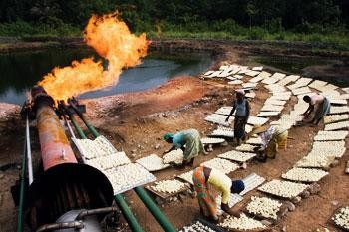Plate 2.1: Picture showing gas flaring activity in a part of the Niger Delta region of Nigeria
Source: http://viiphoto.com/articles/nigeria/

Gas flares release toxic substances, including benzene and particulates, which damage the human immune system and increase the acidity of rain. It is common to see women drying kpokpo garri (as shown in Plate 2.1) and fish at flare sites, bearing the searing heat and reaping a benefit of snacks dried by the infernal flames. This act, which may be considered as an economic benefit to the people, is in fact harmful to human health because the products of these processes (i.e. the kpokpo garri and the dried fish) are all poisoned (Bassey, 2008).

Households that rely on traditional livelihoods such as fishing and crop production have also suffered due to negative impacts of gas flaring on fish and vegetation (Shaad and Wilson, 2009). The health risks associated with these flaring activities include child respiratory illnesses, asthma and cancer. According to Bassey (2008), gas flaring from Bayelsa State in Nigeria alone is believed to be responsible annually for 49 premature deaths, 4,960 children‟s respiratory illnesses and 120 asthma cases.

The current trajectory of fossil fuel use and its related emission of greenhouse gases are unsustainable (IEA, 2008). The environment and various life-forms are threatened by exploration of oil. For example, emissions of hazardous gases from the exhausts of heavy duty vehicles have increased tremendously over the years, which have resulted in intense air pollution-identified to be one of the reasons for climatic change that results in frequent heavy rains, hurricanes and floods threatening lives and properties (Bamgboye and Hansen, 2008).

Cooking is the most important energy need for most Nigerians; sixty-seven per cent of the population use wood or charcoal as a cooking fuel, and this wood fuel is inefficient and is believed to be responsible for about 79,000 deaths annually from indoor air pollution (Shaad and Wilson, 2009). Kerosene is also used for cooking, but is polluting, hazardous and expensive. Kerosene lamps provide poor lighting and are expensive, inefficient, highly polluting and dangerous. Small diesel generators are an option for those with sufficient cash, but these carry high fuel costs and require maintenance. They produce polluting fumes and noise and they often generate excess unused power (Shaad and Wilson, 2009).

Biofuels
These could be defined as organic primary and/or secondary fuels derived from biomass, which can be used for the generation of thermal energy by combustion or by other technology. They comprise purpose-grown energy crops, as well as multipurpose plantations and by-products (residues and wastes) (FAO, 2000).

The term biofuel here is used to mean any liquid fuel made from plant materials that can be used as a substitute for petroleum-derived fuel. Biofuels can include relatively familiar ones, such as ethanol made from sugar cane or diesel-like fuel (biodiesel) that can be made from soybean oil and several other plant materials (Bugaje, 2006; Bobboi et. al., 2006), to less familiar fuels such as dimethyl ether (DME) or Fischer-Tropsch liquids (FTL) made from lignocellulosic biomass.

Biodiesel and bioethanol, which are the main primary sources of biofuels, both currently account for more than 95 percent of global biofuels usage (Bugaje and Mohammed, 2008). Biodiesel is a light to dark yellow liquid immiscible with water, with high boiling point and low vapour

pressure. The „bio‟ in biodiesel represents its renewable and biological source in contrast to traditional petroleum-based diesel (i.e. fossil diesel), and the „diesel‟ refers to its use in diesel engines (Zhang et. al., 2003).

A variety of biolipids can be used to produce biodiesel. These include (a) virgin vegetable oil feedstock; rapeseed and soybean oils are most commonly used, though other crops such as mustard, palm oil, sunflower, hemp, and even algae show promise; (b) waste vegetable oil; (c) animal fats including tallow, lard, and yellow grease; and (d) non-edible oils such as algal oil, jatropha oil, neem oil, castor oil, and tall oil (Demirbas, 2008).

Bioethanol (also known as ethyl alcohol), on the other hand, is a biofuel produced from renewable feedstocks such as cassava, sugarcane, maize, sorghum, and potatoes by fermentation; and it can be used in either neat form in specially designed engines, or blended with petroleum fuel.

Classes of Biofuels
“First-generation” and “second-generation” fuels are the two relatively recent classifications for biofuels that have been popularized. There are no strict technical definitions for these terms, and the main distinction between them is the feedstock used.

First Generation Biofuels
A first-generation fuel is generally one made from sugars, grains, or seeds, i.e. one that uses only a specific (often edible) portion of the above-ground biomass produced by a plant, and relatively simple processing is required to produce a finished fuel (Naik et al, 2010).

Biodiesel, made from oil-seed crops, is a well-known first generation biofuel. The other well- known first-generation biofuel is ethanol made by fermenting sugar extracted from sugar cane or sugar beets, or sugar extracted from starch contained in maize kernels or other starch-laden crops (Naik et al, 2010). Similar processing, but with different fermentation organisms, can yield another alcohol, butanol. First-generation fuels are already being produced in significant commercial quantities in a number of countries.

Second Generation Biofuels
Second-generation fuels are generally those made from non-edible lignocellulosic biomass, either non-edible residues of food crop production (e.g. corn stalks or rice husks) or non-edible whole plant biomass (e.g. grasses or trees grown specifically for energy). Second-generation fuels are not yet being produced commercially in any country (Eric, 2008).

Prospects of Biofuel Production
Research on improving biofuels production has been accelerating for both ecological and economic reasons, primarily for its use as an alternative to petroleum based fuels to help address energy cost, energy security and global warming concerns associated with liquid fossil fuels (Prasad et al., 2007). Biofuels are environmentally friendly fuels that are similar to petrol, diesel or LPG in combustion properties (El Diwani et al., 2009).

Biofuels may be of special interest in many developing countries for several reasons. Climates in many of the countries are well suited to growing biomass which can be converted to biofuels. The potential for producing rural income by production of high-value products (such as liquid fuels) is attractive. The potential for export of fuels to industrialized-country markets also may be appealing (Eric, 2008). In addition, the potential for reducing greenhouse gas emissions may offer the possibility for monetizing avoided emissions of carbon, e.g., via Clean Development Mechanism credits.

Nigeria has an abundance of biomass resources which could be used as feedstock for biofuels. Although biomass can be produced continuously over a long term, the amount that can be produced at a given time is limited by the availability of the natural resources that support biomass production (Ololade, 2007 and EBB, 2005). Also, most arable lands in Nigeria are already being used for food, feed, and fiber production (Highina et. al., 2011).

Biodiesel
Biodiesel can be thought of as a solar collector that operates on carbon dioxide (CO₂) and water (H₂O) through the process of photosynthesis (Plate 2.2 and Formula 2.1). The photosynthesis process captures the energy from sunlight to produce the hydrocarbon (vegetable oil). CO₂ is

used by the plant in the creation of the organic material and then the CO₂ is released in the combustion process when the fuel is used by a diesel engine.

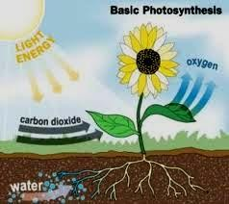Plate 2.2: Schematic representation of the overview of photosynthesis
Source: http://static.ddmcdn.com/gif/irrigation-photosynthesis.gif

6CO₂ + 12H₂O + λѵ C₆H₁₂O₆ + 6O₂ + 6H₂O
Formula 2.1: Photosynthesis reaction where λѵ is energy of photons

Photosynthesis is carried out by many different organisms, ranging from plants to bacteria. Energy for the process is provided by light, which is absorbed by pigments such as chlorophylls and carotenoids. Photosynthesis produces organic matter as vegetables such as sugarcane, sorghum, soybean, castor oil plant, oil palm tree, eucalyptus, water hyacinth, water lily and others.

From these plant biomasses it is possible to produce biofuels such as: ethanol, biodiesel, methanol from wood, charcoal, biogas and hydrogen (Israel, 2005). Thus, through the process of photosynthesis, the energy of sunlight could be converted to a liquid fuel that, with some additional processing, can be used to power a diesel engine.

The photosynthesis process requires one major element, which is land. The crop must be planted over a wide area and to be economically feasible must compete advantageously with other crops which the landowner might choose to plant (Peterson, 2005).

Different vegetal species can be converted into solid, liquid and gaseous fuels by means of different processes of conversion, economically adequate to each application, with biodiesel fuel being an example of such as shown in the following table.

Table 2.1: Examples of different plant species and their possible biofuel derivative

Biomass or its derivatives | Process | Biofuel
Sugarcane | Mechanical | Bagasse
Fermented of sugarcane, sorghum, etc | Distillation | Ethanol
Eucalyptus and other forest species | Mechanical | Wood, chips, etc
Vegetal oils | Transesterification | Biodiesel
Crop residues, Urban residues, etc | Anaerobic digestion | Methane
Water hyacinth, Water lily, etc | Anaerobic digestion | Methane
Crop residues and from wood industry | Pyrolysis and reform | Hydrogen
Ethanol | Direction reform | Hydrogen
Green algae | Transesterification | Biodiesel
(Source: Israel, 2005)

Quality of Emissions from Biodiesel
Biodiesel has a superior lubricity to petrodiesel and hence its addition allows the overall reduction of sulphur in the fuel to almost nil (Drown et. al., 2001). Infact, most emissions are greatly reduced (Lapuerta et. al., 2008). Typical biodiesel produces about 65% less net carbon monoxide, 78% less carbon dioxide, 90% less sulphur dioxide and 50% less unburnt hydrocarbon emission (Margaroni, 1998; Knothe and Steidley, 2005b; Krahl et al., 2005).

When biodiesel is used as a blend for petrodiesel up to 20%, no changes are required for existing diesel engines (ASTM International, 2009). On the other hand, while raw vegetable oils have some environmental and cost advantages over biodiesel, engine modifications are required (Hossain and Davies, 2010).

Conventional Feedstock for Biodiesel Production
Vegetable oils, which are renewable fuels, have become more attractive recently not only because they are renewable resources but also because of their environmental benefits. These oils, which are present in a huge variety of plants commonly called oil crops, are liquid substances at room temperature, with low fusion point as a result of unsaturated fatty acids. They are an important source of liquid biomass and are the main input in biodiesel production (Franz et. al., 2005).

The renewable nature of vegetable oils makes them a potentially inexhaustible source of energy, with energy content close to that of diesel fuel. Global vegetable oil production increased from 56 million tons in 1990 to 88 million tons in 2000, following a below-normal increase. The source of this gain was distributed among the various oils. Global consumption rose to about 56– 86 million tons, leaving world stocks comparatively tight (Demirbas, 2005).

Various oils have been in use in different countries as raw materials for biodiesel production owing to their availability. Soybean oil is commonly used in United States and rapeseed oil is used in many European countries for biodiesel production, whereas, coconut oil and palm oils are used in Malaysia and Indonesia for biodiesel production (Sarin et. al., 2007; Demirbas, 2006 and Ghadge & Raheman, 2005). In India and Southeast Asia, Jatropha tree (Jatropha curcas) (Tiwari et. al., 2007), Karanja (Pongamia pinnata) (Srivastava & Verma, 2008; Sharma & Singh,

2008; Karmee & Chadha, 2005) and Mahua (M. indica) (Ghadge & Raheman, 2005) is used as a significant fuel source.

Generally, a considerable amount of research has been done on alternative feedstocks. Table 2.2 lists those for which only physico-chemical laboratory tests have been done. Table 2.3 lists those plant species for which engine tests have been conducted. While every effort has been made to make these lists complete and the classifications accurate, the lists are almost certainly incomplete nonetheless.

For the most widely studied species, only review papers and some representative studies are included. Not included in these lists are those that have long been used as biodiesel feedstocks: soybean, palm, rapeseed, coconut, sunflower, peanut and cottonseed oil. The „plant type‟ classifications follow those of the United States Department of Agriculture (USDA) (Plants, 2009). When there is no classification available from the USDA database, the „plant type‟ is derived from the cited literature.

Table 2.2: Alternative biodiesel feedstock that have been physico-chemically tested
Scientific name | Common name Plant type Plant part |  |  | References
Aleurites (Vernicia) fordii | Tung Tree Nut |  |  | Park et al., 2008
Asclepias syriaca | Milkweed Herbaceous perennial Seed |  |  | Holser& Harry-
 |  |  |  | O‟Kuru, 2006
Astrocaryum vulgare¹ | Tucum | Tree | Kernel | Lima et al., 2008
Canarium ovatum¹ | Pili | Tree | Pulp | Bicol & Razon, 2007
Cerbera odollam¹ | Sea mango | Tree | Seed | Kansedo et al., 2009
Coffea spp. | Coffee | Shrub/tree | Defective beans | Oliveira et al., 2008;
 |  |  | coffee grounds | Kondamudi et al., 2008
Cucurbita pepo | Pumpkin | Annual vine | Seed | Schinas et al., 2009
Cuphea viscosissima× | Cuphea | Herbaceous annual | Seed | Knothe et al., 2009
Cuphea Lanceolata
Cynara cardunculus Cardoon Herbaceous perennial Seed Encinar et al., 1999
Cyperus esculentus | Yellow nutsedge | Herbaceous perennial | Tuber | Barminas et al., 2002;
 |  |  |  | Pascual et al., 2000
Guizotia abyssinica | Niger | Herbaceous annual | Seed | Sarin et al., 2009
Hura crepitans | Sandbox tree | Tree | Seed | Sunandar et al.,2005
Idesia polycarpa¹ |  | Tree | Fruit | Yang et al.,2009
Kosteletzkya virginica | Seashore mallow Herbaceous perennial |  | Seed | Ruan et al., 2008
Melia azedarach | Syringa Shrub/tree |  | Berries | Stavarache et al.,2008
Michelia champaca¹ | Champaca Tree |  | Seed | Hosamani et al., 2009
Moringa oleifera | Moringa Shrub/tree |  | Seed | Rashid et al.,2008b
Orbignya oleifera¹ | Babassu Tree |  | Nut | Lima et al., 2007
Psophocarpus tetragonolobus¹ | Winged bean Perennial vine |  | Seed | Bicol & Razon, 2007
Raphanus sativus | Radish Herbaceous annual |  | Seed | Domingos et al., 2008
Sclerocarya birrea¹ | Marula Tree |  | Seed | Mariod et al.,2006
Simmondsia chinensis | Jojoba Shrub |  | Seed | Canoira et al.,2006
Terminalia catappa | Tropical almond Tree |  | Nuts | dos Santos et al., 2008
Zanthoxylum bungeanum | Chinese pepper Shrub/tree |  | Seed | Yang et al., 2008;
Zhang & Jiang, 2008

¹No USDA classification available. Classification is derived from cited literature.
Source: Luis, 2009

Table 2.3: Alternative biodiesel feedstock which have been engine-tested
Scientific name | Common name | Plant type | Plant part | References
Azadirachta indica | Neem | Tree | Seed | Nabi et al., 2006
Camelina sativa | Camelina | Herbaceous annual | Seed | Frohlich and Rice, 2005
Eruca vesicaria ssp.sativa | Rocket | Herbaceous annual | Seed | Li X. et al.,2009
Olea europaea | Olive | Tree/shrub | Pomace | Caynak et al.,2009
Salvadora oleoides¹ | Peehl | Tree | Seed | Kaul et al.,2007
Brassica carinata¹ Ethiopian mustard Herbaceous annual Seed (a)
Calophyllum inophyllum | Polanga | Tree | Seed | (b)
Hevea brasiliensis | Rubber | Tree | Seed | (c)
Jatropha curcas | Physic | Tree/shrub | Seed | (d)
Linum usitatissimum | Linseed | Herbaceous annual | Seed | (e)
Madhuca indica¹ | Mahua | Tree | Seed | (f)
Oryza sativa | Rice | Grass annual | Bran | (g)
Nicotiana tabacum | Tobacco | Herb | Seed | (h)
Pongamia (Millettia)  pinnata/Pongamia glabra | Koroch, karanja | Tree | Seed | (i)
Ricinus communis | Castor | Tree/shrub | Seed | (j)
Balanites aegyptiaca¹ | Desert date | Tree | Kernel | (k)
Carthamus tinctorius | Safflower | Herbaceous annual | Seed | (l)
Corylus avellana | Hazelnut | Tree | Kernel | (m)
Sesamum indicum | Sesame | Herbaceous annual | Seed | (n)
Simarouba glauca | Paradise tree | Tree | Seed | (o)
Sterculia foetida | Poon | Tree | Seed | (p)
Thevetia peruviana | Yellow oleander | Shrub | Seed | (q)
¹No USDA classification available. Classification is derived from cited literature.
Source: Luis, 2009

- Bouaid et al. (2005 and 2009), Cardone et al. (2002 and 2003), Vicente et al. (2005).
- Banapurmath et al. (2008), Sahoo et al. (2007), Sahoo and Das (2009).
- Ikwuagwu et al. (2000), Ramadhas et al. (2005a, 2005b and 2005c).
- Achten et al. (2008), Carels (2009), Foidl et al. (1996), Gubitz et al. (1999), Kumar and Sharma (2008), Makkar et al. (2009), Pramanik (2003).
- Agarwal et al. (2003 and 2008), Sendzikiene et al. (2005).

- Agarwal et al. (2008), Kapilan and Reddy (2008), Puhan et al. (2005a and 2005b), Raheman and Ghadge (2007).
- Agarwal et al. (2008), Lin et al. (2009), Saravanan et al. (2009), Sinha et al. (2008), Zullaikah et al. (2005).
- Giannelos et al. (2002), Usta (2005a and 2005b), Veljkovic et al. (2006).
- Das et al. (2009), Karmee and Chada (2005) Sahoo and Das (2009), Sahoo et al. (2007), Sarma et al. (2005).
- Albuquerque et al. (2009), Ali et al. (2008), Conceição et al. (2007), Goodrum and Geller (2005), Scholz (2008).
- Chapagain et al. (2009); Deshmukh and Buyar (2009)
- Rashid and Anwar (2008a); Xin et al. (2009)
- Gumus (2008); Xu and Hanna (2009)
- Banapurmath et al. (2008);Saydut et al. (2008)
- Devan and Mahalakshmi (2009b and 2009c)
- Devan and Mahalakshmi (200a)
- Balusamy and Marappan (2007); Oluwaniyi and Ibiyemi (2007)

The Nigerian government has recently embraced the production of biofuels, particularly bioethanol and biodiesel, as a good option. The production of these fuels would enhance fuel use in automotive industry, electric power generation and rural development, including agricultural mechanization and light industrial goods development; and ensuring that the common man is fully benefiting from the country‟s economy (Azih, 2007). These positive attributes prompted the Biofuels Policy of year 2007, where the necessary framework to ensure a successful biofuels production and utilization in Nigeria was designed (Oniemola and Sanusi, 2009).

Prospect of Biodiesel Production

Effects of Biodiesel Production on the Economy
Modern biofuels have even been reported as a promising long term renewable energy source, which has potential to address both environmental impacts and security concerns posed by current dependence on fossil fuels (Batidzirai et al., 2006; Alamu et al., 2007a; Gupta et al., 2007). In comparison with petroleum-based fuels, biodiesel offers reduced exhaust emissions, improved biodegradability (Prince et. al., 2008), reduced toxicity (Lapinskiene et. al., 2006) and higher cetane rating which can improve performance and clean up emissions (Gerpen, 2005; and Pahl, 2005).

At the moment, there is no commercial biodiesel plant that exists in Nigeria, except for maybe a few production facilities that are notably not well documented. Production and consumption are still at their infancy stage. There is now an increasing emphasis on renewable energy following the global trend in the automobile industry, and biodiesel is gaining increasing popularity. This global trend is paving the way for increased consumer confidence in automobile engines‟ ability to utilize biodiesel of which Nigeria cannot be isolated. With an estimated population of about 150 million people and a population growth rate of 2.38% (2007 estimate) and an average of 12 vehicles to 1000 people (1997 estimate), the potentials of biodiesel cannot be underestimated (Idusuyi et. al., 2012).

With the rise in oil prices and the adverse effects of global climate change, Sub-Saharan Africa has an unprecedented opportunity in choosing a cleaner development pathway via low-carbon energy alternatives that can reduce greenhouse gas (GHG) emissions; and at the same time, meeting current suppressed energy demand and future needs more efficiently and affordably (Christophe et. al., 2008).

The current need for renewable fuel sources stresses what Rudolf Diesel (in 1912) said at the World Exhibition in Paris: “The use of vegetable oils for engine fuels may seem insignificant today, but such oils may become in the course of time as important as the petroleum and coal tar products in the present time” (Leray, 2006). Therefore, in order to have a real impact on the country‟s total GHG emissions, certain types of biofuels must be targeted, such as biodiesel and cellulose-based ethanol (Forge, 2007).

The oil crises of the 1970‟s has in fact rekindled interest in the use of renewable fuels such as biodiesel and the following main factors have sustained this interest to date:
- Prices of petroleum products have been on the increase since the time of the oil crises (EPA, 2008).
- Uncertainties in oil supplies due to political instability and conflicts in some oil producing areas of the world (Bobboi et. al., 2006).
- Growing anxiety over the future security of the world‟s supply of crude oil (USDA, 2005)

The production of biodiesel from oilseeds is potentially going to create a new window of opportunity for agriculture and at the same time mitigate GHG emissions and generate environmental benefits for agriculture itself. In terms of effects on the agricultural frontier, if the cultivation of energy crops replaces intensive agriculture, impacts can range from neutral to positive; if it replaces natural ecosystems or displaces other crops into protected areas, the effects will be mostly negative.

In terms of energy balances, emissions and air quality, the evidence suggests wide variation in greenhouse gas (GHG) savings from biofuel use depending on feedstock, cultivation methods, conversion technologies, and energy efficiency assumptions. For example, the greatest GHG reductions can be derived from sugarcane-based bioethanol and the forthcoming „second generation‟ of biofuels such as lignocellulosic bioethanol and Fischer-Tropsch biodiesel. On the other hand, maize-derived bioethanol shows the worst GHG emission performance and, in some cases, the GHG emissions can even be higher than those related to fossil fuels (Peskett et. al., 2007).

Contrary to crude oil as feedstock for fossil-based diesel, the feed stocks for biodiesel (plants and animal fats) are more uniformly dispersed, being available in every country, albeit in varying quantities and at different costs. The concerns over having to rely on a limited number of countries for crude oil supply and their enormous market power also make biofuels like biodiesel attractive as a means of enhancing security of energy supply (Bugaje and Mohammed, 2007).

Biodiesel as a fuel can be handled and used safely, thanks to extensive experience in handling stems from the oils used in the food sector and the esters employed as feedstocks in the detergent, cosmetics and soap industries. Biodiesel causes less health risk to humans and animals than fossil diesel and present less danger to the environment because of its biodegradability. Due to the automobile fuel consumption profile, which has diesel oil as the main item, biodiesel is the biomass by-product with the best potential to be used as a replacement for fossil fuels (Franz et. al., 2005).

Challenges associated with Biodiesel Production
Regarding soil and water management, the production of some biofuels (e.g. biodiesel via the common homogenous catalysis, which is described in Section 2.3) requires large volumes of water for washing the product-fatty acid esters; and this would be problematic in semi-arid areas. In addition, processing of some feedstocks requires large volumes of water and tends to generate large volumes of effluent.

The introduction and enforcement of appropriate technologies, regulations and standards can help to mitigate most of these problems, but this would be slow to materialize where policy environments are weak. As regards environmental management, biodiesel has been tested for the bioremediation of petroleum spills (Pereira and Mudge, 2004 & Ferna´ ndez-A´ lvarez et. al., 2007).

Contrary to the benefits accruable from biodiesel production from oilseeds such as the new window of opportunity for agriculture amongst others, the production of biodiesel from edible oilseeds, like palm oil and soya bean oil grown for traditional markets may prove too expensive for use as fuel and may bring about rising cost of food (Highina et. al., 2011).

The IEA (2008) World Energy Outlook stated in a report that rising oil demand, if left unchecked, would accentuate the consuming countries' vulnerability to a severe supply disruption and resulting price shock. This report suggested that biofuels may one day offer a viable alternative, but also that "the implications of the use of biofuels for global security as well as for economic, environmental, and public health need to be further evaluated (EEA, 2006).

Challenges associated with Biodiesel Production from Edible Vegetable oils
The use of edible vegetable oils from biomasses like those of soybean (de Oliveira, 2005), sunflower (Vicente et. al. 2004), cotton seed (Öznur et. al., 2002), safflower (Meka et. al., 2007), canola (Singh et. al., 2006), palm (Oghenejoboh & Umukoro, 2011; Alamu et. al., 2008; Cheng et. al., 2004; Crabbe et. al,. 2001; Darnoko & Cheryman 2000; and Abigor et. al., 2000), fish oil (El Mashad et. al., 2006) and also animal fats for biodiesel production has recently been of great concern. This is because of the major criticism against large-scale fuel production from

agricultural crops that it will consume vast expanse of farmlands and native habitat, compete with food materials, and drive up food prices (Patil et. al., 2008).

Infact, the demand for vegetable oils for food has increased tremendously in recent years. For example, meeting only half the existing US transport fuel by biodiesel would require unsustainably 54% and 24% of the US cropping land using coconut and oil palm, respectively (Chisti, 2007). Researchers have even questioned whether the net energy benefits of biofuels production may be negative for many crops because their energy outputs are less than the fossil energy inputs required to produce them. Peskett et. al. (2007) stated that biofuels will be a “Pandora‟s box” and questioned whether large-scale biofuel production can be environmentally, socially and economically sustainable and efficient.

Amongst the more than 350 known oil bearing crops, those with the greatest production potential are sunflower, safflower, soybean, cottonseed, rapeseed, canola, corn, and peanut oil (Peterson, 2005). Unfortunately though, most of these oil sources are commodities whose prices are strongly dependent on the international market. Asides this, the food industry also imposes a direct competition for these feedstock and this may be critical for a world with an exponentially increasing population.

In view of these underlying factors, the production of biodiesel is preferably carried out, especially on commercial scale using non-edible oil sources, particularly those that require low agronomic demand for cultivation, a reasonable plant cycle, favorable geographic adaptability, high oil content and a low cost for cultivation and harvesting. (Domingos et. al., 2008).

Effects of biodiesel use on different factors
      - Environmental benefits of biodiesel use
- Reduction in Life-Cycle Greenhouse Gas Emissions: When biodiesel displaces petroleum, it significantly reduces greenhouse gas (GHG) emissions. By one estimate, GHG emissions [including carbon dioxide (CO₂), methane (CH₄), and nitrogen oxide (NOx)] are reduced by 41%, if biodiesel is produced from crops harvested from fields that were already in production (Sheehan et. al., 1998b). When plants, such as oil crops grow, they take CO₂ from the air to make the stems, roots, leaves, and seeds (soybeans). After oil is extracted from the crop, the

oil is converted into biodiesel. When the biodiesel is burnt, CO₂ and other emissions are released and return to the atmosphere. This cycle does not add to the net CO₂ concentration in the air because the next oil crop will reuse the CO₂ as it grows. When fossil fuels such as coal or diesel fuel are burned however, 100% of the CO₂ released add to the CO₂ concentration levels in the air.

- Biodiesel Reduces Tailpipe Emissions: Biodiesel reduces tailpipe PM, hydrocarbon (HC), and carbon monoxide (CO) emissions from most modern four-stroke combustion ignition (CI) or diesel engines. These benefits occur because biodiesel contains 11% oxygen by weight. The fuel oxygen allows the fuel to burn more completely, so fewer unburnt fuel emissions result. This same phenomenon reduces air toxics, which are associated with the unburnt or partially burnt HC and PM emissions. Testing has shown that PM, HC, and CO reductions are independent of the biodiesel feedstock. The EPA reviewed 80 biodiesel emission tests on CI engines and has concluded that the benefits are real and predictable over a wide range of biodiesel blends.

An investigation into the Environmental Protection Agency‟s (EPA) database confirms the positive impact of B20 (blend of biodiesel and petrodiesel i.e. 20% biodiesel and 80% petrodiesel) on emissions of HC, CO, and PM. However, examination of the NOx results shows that the effect of biodiesel can vary with engine design, calibration, and test cycle. At this time, there is insufficient data for users to conclude anything about the average effect of B20 on NOx, other than that it is likely very close to zero.

When biodiesel is used in boilers or home heating oil applications, NOx tends to decrease because the combustion process is different (open flame for boilers, enclosed cylinder with high-pressure spray combustion for engines). The NOx reduction seen with biodiesel blends used in boilers appears to be independent of the type of biodiesel used. In blends with heating oil up to 20% biodiesel, NOx is reduced linearly with increasing biodiesel content. For every 1% biodiesel added NOx decreases by 1%. A B20 heating oil fuel will reduce NOx by about 20% (Krishna, 2003 and Batey, 2002).

Sulfur dioxide (SO₂) emissions are also reduced when the two fuels were blended, because biodiesel contains much less sulfur than typical heating oil does. A 20% blend of biodiesel in heating oil will reduce SO₂ by about 20%. Heating oil and diesel fuel dyed red for off-road use (agriculture, power, boiler fuels, construction, forestry, and mining) can contain as much as 500 ppm sulfur. Blending biodiesel into off-road diesel fuel can significantly reduce SO₂ emissions.

Health Benefits of biodiesel use
- Reduction of toxic emissions entering human respiratory system: Some PM and HC emissions from diesel fuel combustion are toxic or carcinogenic. Using B100 (i.e. unblended biodiesel) can eliminate as much as 90% of these air toxics. B20 reduces air toxics by 20% to 40%. The positive effects of biodiesel on air toxics have been shown in numerous studies.

Recently, the U.S. Department of Labor Mining Safety Health Administration (MSHA) has implemented rules for underground mines that limit workers‟ exposure to diesel PM. MSHA found that switching from petroleum diesel fuels to high blend levels of biodiesel (B50 to B100) significantly reduced PM emissions from underground diesel vehicles and substantially reduced workers‟ exposure. However, even low concentrations of biodiesel reduce PM emissions and provide significant health and compliance benefits wherever humans receive higher levels of exposure to diesel exhaust.

Other Benefits of biodiesel use
- Provision of a High Energy Return and Displacement of Imported Petroleum: Life- cycle analyses show that biodiesel contains 2.5 to 3.5 units of energy for every unit of fossil energy input in its production, and because very little petroleum is used in its production, its use displaces petroleum at nearly a 1-to-1 ratio on a life-cycle basis (Hill et. al. 2006 and Huo et. al. 2008). This value includes energy used in diesel farm equipment and transportation equipment (trucks, locomotives); fossil fuels used to produce fertilizers, pesticides, steam, and electricity; and methanol used in the manufacturing process. Because biodiesel is an energy-efficient fuel, it can extend petroleum supplies.

- Improves Engine Operation: Even in very low concentrations, biodiesel improves fuel lubricity and raises the cetane number of the fuel. Diesel engines depend on the lubricity of the fuel to keep moving parts, especially fuel pumps, from wearing prematurely. One unintended side effect of the federal regulations, which have gradually reduced allowable fuel sulfur to only 15 ppm and lowered aromatics content, has been to reduce the lubricity of petroleum diesel. The hydro-treating processes used to reduce fuel sulfur and aromatics content also reduces polar impurities such as nitrogen compounds, which provide lubricity. To address this, the ASTM D975 diesel fuel specification was modified to add a lubricity requirement (a maximum wear scar diameter on the high-frequency reciprocating rig [HFRR] test of 520 microns). Biodiesel can impart adequate lubricity to diesel fuels at blend levels as low as 1%.

- Is Easy To Use: Finally, one of the biggest benefits to using biodiesel is that it is easy. Blends of B20 or lower are literally a “drop in” technology. No new equipment and no equipment modifications are necessary. B20 can be stored in diesel fuel tanks and pumped with diesel equipment. B20 does present a few unique handling and use precautions, but most users can expect a trouble-free B20 experience.

- Lower Energy Density: Biodiesel contains 8% less energy per gallon than typical No. 2 diesel in the United States and 12.5% less energy per pound. The difference between these two measurements is due to the higher density of biodiesel compared with diesel fuel. All biodiesel, regardless of its feedstock, provides about the same amount of energy per gallon or per pound. Typical values are as follows: Btu/lb Btu/gal Typical Diesel No. 2 18,300 129,050 Biodiesel (B100) 16,000 118,170. The difference in energy content between petroleum diesel and biodiesel can be noticeable with B100. For B20, the differences in power, torque, and fuel economy are 1% to 2%, depending on the base petroleum diesel. Most users report little difference in fuel economy between B20 and No. 2 diesel fuel. As the biodiesel blend level is lowered, differences in energy content become proportionally less significant; blends of B5 or lower cause no noticeable differences in performance in comparison to No. 2 diesel.

- Low-Temperature Operability: In some areas of the country, the cold flow properties of biodiesel are important. Unlike gasoline, petroleum diesel and biodiesel both freeze or gel at common winter temperatures; however, biodiesel‟s freeze point may be 20º to 30ºF higher than that of petroleum diesel. If the fuel begins to gel, it can clog filters and eventually become so thick that it cannot be pumped from the fuel tank to the engine. However, with proper handling, B20 has been used successfully all year in the coldest U.S. climates. Soy biodiesel, for example, has a cloud point of 32ºF (0ºC). In contrast, most petroleum diesels have cloud points of about 10º to 20ºF (-12º to -5ºC).

Blending of biodiesel can significantly raise the cloud point above that of the original diesel fuel. For example, a recent study (Coordinating Research Council, 2006) showed that, when soy biodiesel was blended into a specially formulated cold weather diesel fuel (cloud point of
-36ºF [-38ºC]) to make a B20 blend, the cloud point of the blend was -4ºF (-20ºC). In very cold climates, this cloud point may still not be adequate for wintertime use. To accommodate biodiesel in cold climates, low cloud point petroleum diesel or low-temperature flow additives, or both, are necessary.

- Storage Stability Although biodiesel blends have adequate storage stability for normal use, special precautions must be taken if they are to be stored for extended periods. This might occur in a snow plow or farm implement used seasonally, or in the fuel tank of a backup generator. If the fuel will be stored for more than a few months, a stability additive is recommended, and acidity should be measured monthly.

Finally, biodiesel is generally more susceptible than petroleum diesel to microbial degradation. In the case of spills in the environment, this is a positive attribute because it biodegrades more rapidly. However, microbial contamination of fuel storage tanks can plug dispensers and vehicle fuel filters and cause vehicles to stall. This is not unheard of for petroleum diesel, but anecdotal evidence suggests it is a greater problem for biodiesel blends. The best way to deal with this issue (for both petroleum diesel and biodiesel) is adequate fuel storage tank housekeeping and monitoring, especially minimizing water in contact with the

fuel. Water bottoms must be removed from tanks, and standing tanks should be sampled and tested for microbial contamination.

Future Outlook for Biodiesel Production
Biodiesel production at the present day volume is relatively recent, but that notwithstanding, it is experiencing very dramatic expansion in the developed countries; and for classification of national development, it is almost an index. There is already considerable experience in the oleochemicals industry in biodiesel manufacture and handling.

Some countries and territories have been able to move quickly and actually require that a certain percentage of diesel fuel be from biodiesel (Colares, 2008 and Republic Act 9367, 2006). The need for the commodity, which is preferred to the conventional diesel, serves as a great driver for success in the sector. The drive is greatly supported by high price arising from artificial scarcity and fear for future real scarcity of petroleum diesel.

In view of the continued epileptic power situation plaguing the country and the increase in the use of diesel generators by individuals and corporate organizations, an alternative fuel source such as biodiesel with a proven higher efficiency and environmentally friendly nature, becomes necessary. Biodiesel demands in 2007 alone was 480 million liters, with a projected demand of 900 million liters in 2020 stressing the need for an intensified effort into developing plans for the sustainable production of biodiesel.

According to the US National Biodiesel Board, the number of active and proposed biodiesel plants grew by more than 67% in six months in 2005 (Frank, 2006). Projected production capacity for 2005 was 545 million gallons per year. As the capacity of biodiesel production increases, there shall be a corresponding increase in demand for oils and fats. In USA, soybean is the favorite oil, because it is easily available and the ease of processing it into biodiesel. Even in the developed nations, there is an aggressive drive for alternate seed oil feedstock for biodiesel in particular. This is in anticipation of a major need of biodiesel by internal combustion engines, a justification for source in unorthodox new oil seed crops world over.

The United States of America is the largest consumer of oil in the world. As of 2008, the US consumed 19.5 million barrels of oil per day, on average, with a production of only 8.154 million barrels per day (Central Intelligence Agency, 2008). As shown in Figure 2.2, in recent history, 2008 was the last year that global oil supplies were greater than the demands globally.

Fig 2.2: Global Oil Product Demand
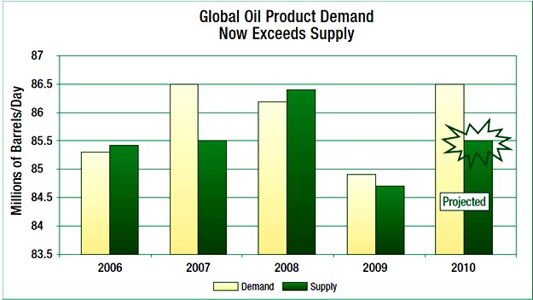Source: IEA Oil Market Report (2010)

As of 2009 around 84.9 million barrels of oil were consumed daily, with a supply of 84.6 million. For 2010, staggering predictions were made that the oil demand will exceed availability by nearly 1 million barrels of oil per day, and the IEA Oil Market Report (OMR) later reported a global oil demand of 86.5mb/d. For year 2013, the IEA OMR projects that the global oil demand would increase from 89.9mb/d in 2012 to 92 mb/d in 2014 (Table 2.4). In 2013, the world oil demand estimate was 90.8mb/d but total OPEC supply estimate for that same year was 30.41mb/d as released in July 2013 by the IEA Market Report, and this is clearly a source of concern to the world.

Table 2.4: Global Oil demand Projection for year 2014
Global Oil Demand, 2012-2014 (million barrels per day)
 | 2012 | 2013 | 2014
Africa | 3.6 | 3.7 | 3.9
America | 30.1 | 30.4 | 30.5
Asia/Pacific | 29.7 | 30.1 | 30.7
Europe | 14.4 | 14.2 | 14.1
FSU | 4.5 | 4.6 | 4.7
Middle East | 7.6 | 7.8 | 8.1
World | 89.9 | 90.8 | 92.0
Source: IEA Oil Market Report, 2013
*FSU = Former Soviet Union

This difference has a great effect on oil prices and certainly contributes to the reason prices have skyrocketed in recent history. Such high oil consumption has many implications. The first major global implication is that, since astronomically high amounts of oil are being consumed, there is an ever increasing release of polluting emissions to the atmosphere. The second concern is how the oil demand gap can be met in order to keep providing affordable energy. Hence, there is need for more research works to develop sustainable protocols in the use of non-edible oils as major non-edible raw materials for biodiesel production that are adaptable to specific local conditions.

Local Oil Biomasses for Biodiesel Production
    - Biomass
Biomass is a biological material derived from living, or recently living organisms (Van Wyk, 2001). It most often refers to plants or plant-derived materials which are specifically called lignocellulosic biomass (Boerrigter & van der Drift, 2003; and Kartha & Larson, 2000). It contains carbon, hydrogen and oxygen (oxygenated hydrocarbon), sometimes with high level of moisture and volatile matter, low bulk density and calorific value (Lal and Reddy, 2005).

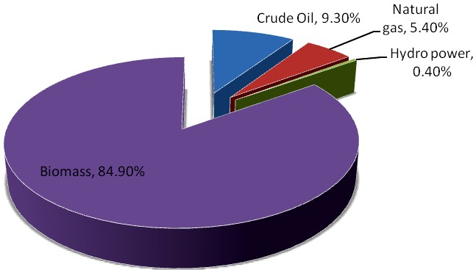The use of biomass for energy can complement solar, wind, and other intermittent energy resources in the renewable energy mix and reduce fossil fuel greenhouse gas emissions (Li et al., 2009b). In Nigeria for example, the estimated total energy consumption in 2009 was about 4.6 EJ or 111 MTOE (IEA, 2012) (Figure 2.3). Out of this, traditional biomass (wood fuel and charcoal) accounted for 85% of total energy consumption. However, this has contributed to desertification, deforestation and erosion in the country.

The high percent share of biomass represents its use to meet off-grid heating and cooking, mainly in rural areas and by the urban poor. It has been estimated that about 80% of Nigerian households living in the rural and urban areas use wood fuel and charcoal for cooking and heating (Sambo, 2006).

Fig. 2.3: Energy consumption in Nigeria, 2009. Source: IEA (2012)

As a renewable energy source, biomass can either be used directly via combustion to produce heat, or indirectly after converting it to various forms of biofuels. This conversion of biomass to biofuel can be achieved by different methods which are classified into: physicochemical, biochemical, and thermochemical methods (Figure 2.4).

Biomass is one of the better sources of energy (Kulkarni and Dalai, 2006), and is the only renewable source of carbon, which makes it the only renewable resource for producing carbon- bearing liquid fuels (Eric, 2008).

BIOMASS

Physico-chemical | Bio-chemical | Thermo-chemical
Biodiesel Production | Anaerobic Digestion | Pyrolysis
 | Hydrolysis/Fermentation | Gasification  Combustion

Liquefaction

Fig. 2.4: Schematic diagram of bioenergy conversion
Source: Eric, 2008

Oil crops are important biomasses that are widely grown in different parts of the world due to their wide application. World oilseed stocks were estimated at 39.8 million tons for 2003/2004 (USDA, 2004). On an impressive note, as of 2005, Germany led the world in production of biodiesel (primarily from rapeseed and sunflower) with about 2.3 billion litres produced (EBB, 2006); and production worldwide has been growing rapidly since that year.

Asides from the fact that oil seeds are a major source of vegetable protein and oils for human and animal nutrition, they also constitute an essential part of industrial raw materials. For example, interest in palm biodiesel is growing, especially in South-East Asia (Malaysia, Indonesia and

Thailand) where the majority of the world‟s palm oil for food use is made. Also, Jatropha- a non- edible oil tree is drawing attention for its ability to produce oil seeds on lands of widely varying quality. In India, Jatropha biodiesel is being pursued as part of a wasteland reclamation strategy (Government of India Planning Commission, 2005).

Oil seeds that are commonly used as industrial raw materials include soybean, cotton seed, rape seed, sunflower seed and peanut (Usman et. al., 2009). In Nigeria, notable among the non-edible lesser known oil seeds are Castor, Jatropha curcas, Jatropha gossipifolia and Thevetia peruviana. Apart from these crops, other seeds that are used in the production of oils include linseed and sesame seed (O‟Brien et al., 2000). When these seeds are defatted for oil and/or biodiesel production, the seed cakes could be used in animal feed formulation.

Challenges of Biofuel Production from Biomasses
According to the Food and Agriculture Organization (FAO), traditional oil crops like ground nut and sesame seeds continue to be important in the food supply and food security of many countries, e.g. Sudan and Myanmar. As the evident role of agrofuels as a suitable and sustainable means to meet regional and global energy needs increases, this raises serious questions about biodiversity conservation (habitat fragmentation and degradation), increased green-house gas emissions from degraded carbon sinks and deforestation. Concerns are also raised about water pollution and eutrophication, overexploitation caused by land conflicts, food security and human livelihoods. All these face increasing threats from the demands placed on limited land resources (COPESCO, 2008 and SBSTTA, 2007).

MDG 7 calls for environmental sustainability, emphasizing that the current and future wellbeing of ecosystems are not negatively affected in the long run by inappropriate development practices or technologies. Currently, there are concerns about biofuel production from edible oil crops competing with food supply; and with no reliable prospects for a massive compensatory scale-up in food production capacity (especially in developing countries like Nigeria). Hence, there is the need to intensify effort in exploring other potentially viable inedible oil biomasses that can be employed in liquid biofuel production such as algae, thevetia, jatropha, rice bran, neem, castor, etc.

Algal Biomass
    - Basic Algae Biology
Algae are a large and diverse group of simple, typically autotrophic organisms, ranging from unicellular to multicellular forms. The study of algae is called Phycology or Algology. By modern definitions algae are eukaryotes that conduct photosynthesis within membrane-bound organelles called chloroplasts. Chloroplasts contain circular DNA and are similar in structure to Cyanobacteria, presumably representing reduced cyanobacterial endosymbionts. The exact nature of the chloroplasts is different among the different lines of algae, reflecting different endosymbiotic events. Algae are not a monophyletic group because they do not all descend from a common algal ancestor (Louise and Richard, 2004).

Algae generally contain three main components: Carbohydrates, Protein and Natural oils. They are photosynthetic-like “simple” plants because they lack the many distinct organs that characterize land plants such as phyllids (leaves) and rhizoids in nonvascular plants; or leaves, roots, and other organs that are found in tracheophytes (vascular plants) (Zhiyou and Michael, 2009). Nearly all algae have photosynthetic machinery ultimately derived from the cyanobacteria, and so produce oxygen as a by-product of photosynthesis, unlike other photosynthetic bacteria such as purple and green bacteria.

Although many are photoautotrophic, some groups however contain members that are mixotrophic, deriving energy both from photosynthesis and uptake of organic carbon either by osmotrophy, myzotrophy, or phagotrophy. Some unicellular species even rely entirely on external energy sources and have limited or no photosynthetic apparatus. Fossilized filamentous algae from the Vindhya basin have been dated back to 1.6 to 1.7 billion years ago.

The green algae and land plants are closely related based on the structure and pigment composition of their plastids. This hypothesis was put forward a long time before molecular and ultrastructural data were available. Just as many green algae are single cells, others form groups of cells or grow as seaweeds (Thomas, 2002).

Like plants, most green algae use sunlight to make their own food. The green algae contain two forms of chlorophyll (a and b), which they use to capture light energy to fuel the manufacture of sugars, but unlike plants they are primarily aquatic. They also contain the accessory pigments- beta carotene and xanthophylls, and have stacked thylakoids (Graham and Wilcox, 2000). Because they are aquatic and manufacture their own food, these organisms are called "algae", along with certain members of the Chromista, the Rhodophyta, and photosynthetic bacteria, even though they do not share a close relationship with any of these groups.

Classes of Algae
There are two general classifications of algae: macroalgae and microalgae.

Macroalgae are the large (measured in inches), multi-cellular algae often seen growing in ponds. The largest and most complex marine forms are called seaweed, and can grow in a variety of ways. An example is the giant kelp plant which can be more than 100 feet long.

Microalgae, on the other hand, are tiny (measured in micrometers), unicellular algae that normally grow in suspension within a body of water (Zhiyou and Michael, 2009).

The term „algae‟ is not phylogenetically meaningful without qualifiers. There are about 6,000 species of green algae (singular: green alga) (Thomas, 2002). Algae in general and green algae in particular are difficult to define to the exclusion of other phylogenetically related organisms that are not algae. This difficulty is a reflection of recent data on algae as well as the way phylogenetic thinking has permeated classification (Louise and Richard, 2004). The green algae are one of the most diverse groups of eukaryotes, showing morphological forms ranging from flagellated unicells, coccoids, branched or unbranched filaments, to multinucleated macrophytes and taxa with parenchymatic tissues (Plate 2.3).

Monadoid Palmelloid Coccoid Filamentous Coenocytic
EVOLUTION OF STRUCTURAL COMPLEXITY

Plate 2.3: Different morphological organization of green algae (Parenchymatous and Siphonocladous levels of organization/morphological forms are not illustrated).
Source: Pröschold and Leliaert, 2007.

Important Functions of Algae in the Environment
The various forms of algae play significant roles in aquatic ecology. Microscopic forms that live suspended in the water column (phytoplankton) provide the food base for most marine food chains. Algae are also variously sensitive to different factors, which have made them useful as biological indicators in the Ballantine Scale (a biologically defined scale for measuring the degree of exposure level of wave action on a rocky shores) and its modifications.

However, in very high densities where there is rapid or excessive reproduction (algal blooms) these algae may discolor the water and outcompete, poison, or asphyxiate other life forms. Examples of algal blooms are the ones on Liberty Lake in Spokane County, Washington and Waughop Lake, Pierce County in the city of Lakewood, Washington (Plate 2.4). Another smaller example of algal bloom on a water course in the University of Ibadan is shown in plate 2.5.

Also, some algae may harm other species by producing protective toxins (e.g. microcystins and anatoxin), which can kill aquatic animals and even sometimes terrestrial animals that come in contact with the water (Department of Ecology, Washington, 2009). Dinoflagellates, for

example, secrete a compound that turns the flesh of fish into slime, and then the algae consume this nutritious liquid.

- 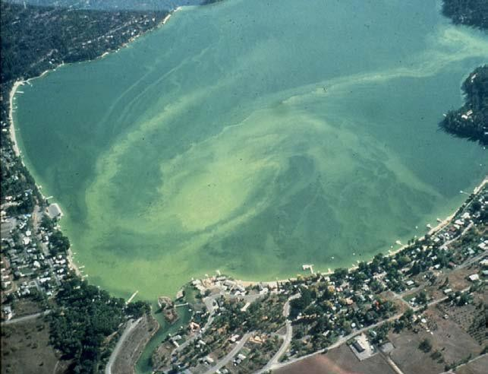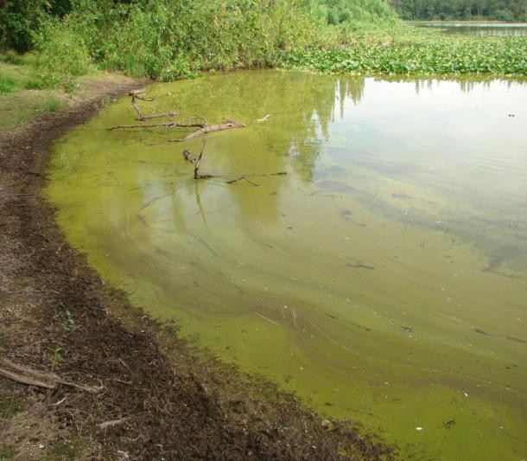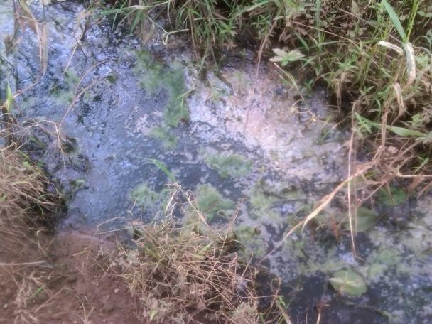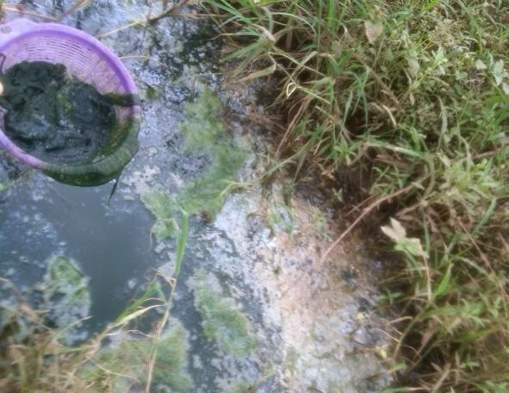(b)
Plate 2.4: Showing algal blooms on water bodies (a) Aerial view of a blue-green bloom on Liberty Lake near Spokane. Photo source: Liberty Lake Water and Sewer District (b) Blue-green algal bloom on Waughop Lake. Photograph by Don Russell (Water Quality Program, Washington State Department of Ecology, Olympia, Washington; www.ecy.wa.gov/biblio/0910082.html)

(c) (d)
Plate 2.5: Showing an algal (Spirogyra) bloom (c) Watercourse with several clusters of Spirogyra filaments showing algal scum with bubbles of oxygen gas (yellow arrow); (d) Arrow shows a sample of scooped-out spirogyra filaments from the water course. Snapshot of photos (c) and (d) were taken at a water course sandwiched between Obafemi Awolowo Hall, CBT (Computer-based Test) centre and the New Sport Complex, University of Ibadan.

Spirogyra
This is one of the commonest of green algae abundant in spring (Fuad et. al., 2010). It is one of the three species representatives of key freshwater macroalgae genera viz: Oedogonium, Cladophora and Spirogyra (Lawton et. al., 2013). It is a genus of filamentous green algae of the order Zygnematales, named for the helical or spiral arrangement of the chloroplasts that is diagnostic of the genus (Plate 2.6). The scientific classification of Spirogyra (Lewis and McCourt, 2004) is presented below:

Domain: | Eukaryote
(unranked): | Archaeplastida
Kingdom: | Plantae
(unranked): | Streptophyta
Phylum: | Charophyta
Class: | Zygnematophyceae
Order: | Zygnematales
Family: | Zygnemataceae
Genus: | Spirogyra

Species: africana (Fritsch)

There are more than 400 species of Spirogyra in the world (John and Brook, 2002) and they measure approximately 10 to 100μm in width, and may stretch centimeters long. According to Gerrath (2003), Spirogyra is extremely common and occasionally an abundant genus in standing water bodies with most species collected as large floating masses or flimsy aggregates or long strings of cells from permanently or temporarily stagnant aquatic habitats that have neutral or slightly acidic pH values such as ponds, lakes and ditches.

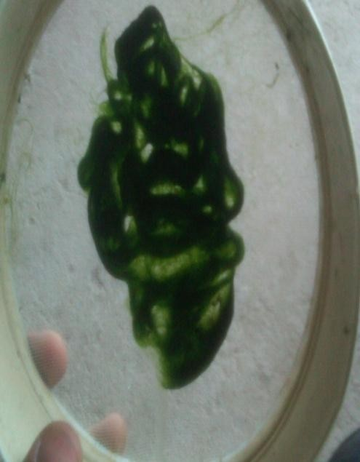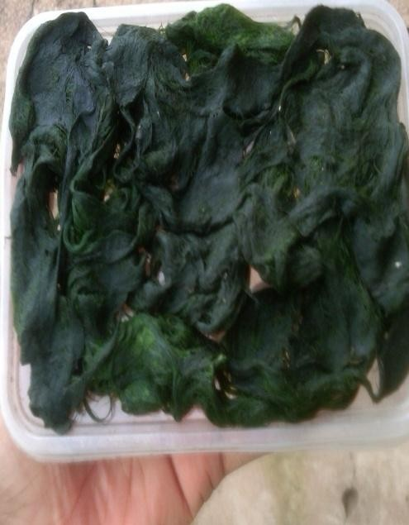a b c
Plate 2.6: Pictures of Spirogyra filament clusters: (a) Freshly collected spirogyra filaments from the stream
- Lump of Spirogyra filaments for drying (c) Dry Spirogyra filaments

The large groups of Spirogyra cells are slimy and often called “pond scum” (Plate 2.5c). All the cells are bright green and morphologically similar; and capable of growth, division and reproduction. The only exception to the fact that all the cells are capable of reproduction is because of a unique cell, that is, the apical basal cells of the attached forms of spirogyra filaments. Unlike in the free floating forms that do not show apical basal polarity, the attached species (such as S. jogensis and S. adnata) have polarity. This is because the apical basal cell is colourless or dull green coloured and is incapable of dividing or reproducing. It only functions in helping to attach the filament to the substratum, and hence this unique cell is known as Holdfast or Hapteron.

Spirogyra filaments are distinguishable by their unbranched filaments with the cells connected end to end in long male reproductive system, and with their chloroplasts forming a spiral ribbon just under the cell surface. This gives a coiled or twisted texture to the cells, and it is from this appearance that the organism gets its name (Greek: speira = "coil" + gyros = "twisted"). The cell wall is characteristically straight and parallel-sided. It has two layers viz: the outer wall, which is composed of pectin that dissolves in water to make the filaments slimy to touch; and the inner wall which made up of cellulose.

Spirogyra is very common in relatively clean eutrophic water, developing slimy filamentous green masses. In spring Spirogyra grows under water, but when there is enough sunlight and warmth they produce large amounts of oxygen, adhering as bubbles between the tangled filaments. The filamentous masses come to the surface and become visible as slimy green mats. Mougeotia and Zygnema are often found tangled together.

Cultivation and Reproduction of Spirogyra biomass
The suitable season for the growth of Spirogyra is spring. In other unfavorable seasons, the filament gets converted to resistant spores (Sharma et. al., 2013). Spirogyra can reproduce vegetatively, sexually and rarely asexually.

In vegetative reproduction, fragmentation takes place due to mechanical injury by water currents, aquatic animal movements and bitings and gelatinization of middle lamellum. The fragmentation causes Spirogyra to simply undergo intercalary mitosis and form new fragment of cell(s). Each fragment then develops into a filament by repeated divisions.

Sexual reproduction involves conjugation where neighboring filaments and/or cells send out processes which fuse into tubes. There are two types of sexual reproduction: Scalariform conjugation and Lateral conjugation.

Asexual Reproduction is uncommon in Spirogyra. It takes place by non-motile spores known as Akinetes and Aplanospores. Akinetes are resting spores formed due to thickening of the cell wall of vegetative cells to overcome unfavourable conditions. In favourable conditions however, each akinete germinates and forms a new Spirogyra filament. An example is in S. farlowii. Aplanospores, unlike the akinetes, are formed in favourable conditions, e.g. S. aplanospora.

Prospects of Algal Oil as a Biofuel
Microalgae have the potential to produce more biofuel per acre than any other potential source. In fact algae are the highest yielding feedstock for biodiesel, and biodiesel from algae may be the only way to produce enough automobile fuels to replace current gasoline usage (Hossain et. al.,

2008). The basic idea with algae is that some algae have a high lipid (fat) count, which can be turned into biodiesel.

Algae can grow very fast, so the productivity is faster than corn or other possibilities to biofuels. It can be grown on water bodies, so it doesn‟t compete for prime agriculture land. It can grow in both fresh and salt water, even if the water is polluted. Many areas of the world/country are ideally suited for algae growth since algae needs large amounts of sunlight, brackish water and carbon dioxide. Those conditions are typical in the coastal regions (Scott et. al., 2010).

Algae offer a diverse spectrum of valuable products and pollution solutions (Pienkos and Darzins, 2009). Because of environmental conditions such as temperature, the locally occurring strains of algae are preferred in most cases (Sheehan et. al., 1998a). The best algae for biodiesel would be microalgae (Bajhaiya et. al., 2010). Microalgae have much more oil than macroalgae and it is much faster and easier to grow and harvest.

The use of microalgae can be a suitable alternative because algae are the most efficient biological producer of oil on the planet and a versatile biomass source and may soon be one of the Earth's most important renewable fuel crops (Yang et. al., 2010). Higher photosynthetic efficiency, higher biomass production, a faster growth rate than higher plants, highest CO fixation and O₂ production, growing in liquid medium which can be handled easily make the algae to stand high in front of other oil seed crops.

Microalgae are generally sunlight-driven cell factories of which convert fractional carbondioxide to prospective biofuels, food items, feeds and high value bioactive products. Their production is not seasonal and can be harvested throughout the year (Chisti, 2008 and Chisti, 2007). Infact, average oil yield from microalgae can be 10 to 20 times higher than the yield obtained from oleaginous seeds and/or vegetable oils (Chisti, 2007 and Tickell, 2000) as shown in Table 2.5.

Different types of biofuels can be derived from microalgae. These include methane produced by anaerobic digestion of algal biomass (Spolaore et.al., 2006), biodiesel derived from microalgal oil (Thomas, 2006 and Banerjee et. al., 2002) and photo-biologically produced bio-hydrogen (Gavrilescu and Chisti, 2005 and Fedorov et. al, 2005) etc.

Table 2.5: Comparison of the oil yield from some biodiesel sources

Crop | Oil yield(L ha-1)
Soybean | 446
Canola | 1,190
Jatropha | 1,892
Palm | 5,950
Microalgae | 136,900
Source: Chisti, 2007.

The great ability of algae to fix CO makes it an interesting method for the removal of gases emitted from power plants; and can be used to reduce greenhouse gases with higher production of microalgal biomass and consequently higher biodiesel yield (Maeda, 1995). Few microalgae have convenient fatty acid profile and unsaponifiable fraction allowing biodiesel production with high oxidation stability (Minowa, 1995). The physical and fuel properties of biodiesel from microalgal oil in general (e.g. density, viscosity, acid value, heating value etc.) are comparable to those of fuel diesel (Gouveia and Oliveira, 2009; Rana and Spada, 2007; and Miao and Wu, 2006).

Animals and plants were mostly used for production of oil but nowadays microalgae are mostly preferred. In United States soybean is used for the production of biodiesel, but “Biofuels, if done right” must be derived from feed stocks with low greenhouse gas emissions and little or no competition with food production. Algae are likely to win on both counts (Hill et. al., 2006). Microalgae can produce valuable co-products such as proteins and residual biomass after oil extraction, which may be used as feed or fertilizer, or fermented to produce ethanol or methane (Hirano et. al., 1997).

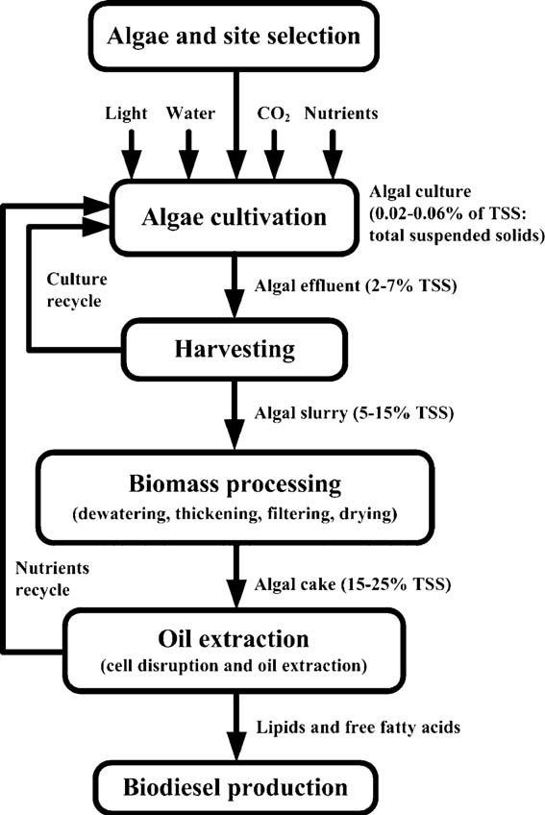

Fig 2.5: Microalgae biodiesel value chain stages.
Source: Emad, 2011

In the past 2-3 years the production of biodiesel from algae has been an area of considerable interest (Miao and Wu, 2006). This is due to algae higher productive abilities compared to land plants, with many species obtaining doubling times of some hours while many species could accumulate very large amounts connected with triacylglycerides (TAGs), the major feedstock regarding biodiesel production and also high good quality agricultural land is just not required growing the biomass.

Figure 2.5 above shows a schematic representation of the algal biodiesel value chain stages, starting with the selection of microalgae species depending on local specific conditions and the design and implementation of cultivation system for microalgae growth. Then, it follows the biomass harvesting, processing and oil extraction to supply the biodiesel production unit.

Despite all the positive attributes accruable to biodiesel generation from algal biomass, several challenges have to be tackled permitting commercial production of algal biodiesel in a scale sufficient enough to make significant contributions to our transport and energy needs. For example, algal oil could be sometimes highly viscous with viscosities ranging from 10-20 times (those of No. 2 Diesel fuel) as a result of large molecular mass and chemical structure of the oils. This could lead to problems in pumping, combustion and atomization in the injector systems of a diesel engine. Therefore, this viscosity could and should be reduced to make the highly viscous oil a suitable alternative fuel for diesel engines.

  - Moringa oleifera Biomass

Moringa plant
Moringa oleifera Lam (syn. M. ptreygosperma) is one of the best known and most widely distributed and naturalized species of the monogeneric family Moringaceae (Garima et. al., 2011). It is also commonly called „Miracle Tree‟, „Drumstick Tree‟ (arising from the shape of the pods - Plate 2.7), and „Horseradish-tree‟ (arising from the taste of a condiment prepared from its roots). In addition, it is sometimes addressed as „Ben oil‟ or „behen oil‟ due to its content of behenic (docosanoic) acid, which makes it possesses significant resistance ability to oxidative degradation; and hence has been extensively used in the enfleurage process. The plant has a host of other country specific vernacular names, an indication of the significance of the tree around the world.

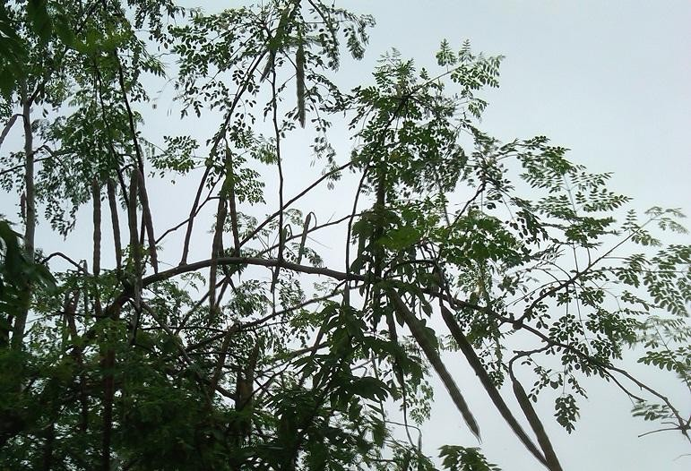M. oleifera is found either wild growing or cultivated throughout the plains, especially in hedges and in house yards. Native to Western and sub-Himalayan tracts, India, Pakistan, Asia, and Africa (Kumar et al., 2010), the plant is well distributed in the Philippines, Cambodia, America, and the Caribbean Islands; and has an impressive range of medicinal uses with high nutritional value throughout the world.

Plate 2.7: Picture of Moringa oleifera branch with dry pods

The taxonomic classification of M. oleifera is given below:
Kingdom - Plantae
Sub kingdom - Tracheobionta Super Division - Spermatophyta Division - Magnoliophyta
Class - Magnoliopsida
Subclass - Dilleniidae
Order - Capparales
Family - Moringaceae
Genus - Moringa
Species - oleifera

Plant Morphology
M. oleifera is a slender softwood perennial tree species that thrives best under the tropical insular climate, and is plentiful near the sandy beds of rivers and streams. It has a very fast growth rate and usually grows as high as 9 m, with a soft and white wood and corky and gummy bark. It commonly reaches about four metres in height just 10 months after the seed is planted and can bear fruit within its first year (International Centre for Underutilized Crops, 2008).

The roots have the taste of horseradish and the leaves are longitudinally cracked, it has 30-75 cm long main axis and its branches are jointed, glandular at joints. The leaflets, which are glabrous and entire, are finely hairy, green and almost hairless on the upper surface, paler and hairless beneath, with red-tinged mid-veins. The leaflets are also with entire (not toothed) margins, and are rounded or blunt-pointed at the apex and short-pointed at the base.

The twigs are finely hairy and green. The flowers are white, scented in large axillary down panicles; the pods are pendulous and ribbed. These pods are triangular in cross-section (30 to 50 cm long) and legume-like in appearance (Brockman, 2008) (Plate 2.8). These pods contain oil- rich black-winged or brown-winged seeds that are 3-angled (Roloff et. al., 2009) (Plate 2.10), and the seeds have the potential to produce oil for biodiesel production (Rashid et. al., 2008b and Hsu et. al., 2006).

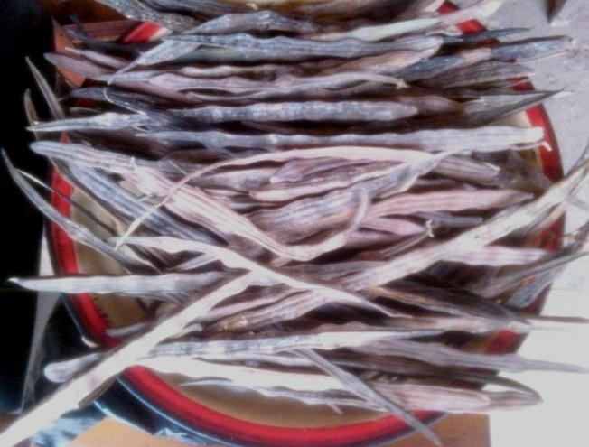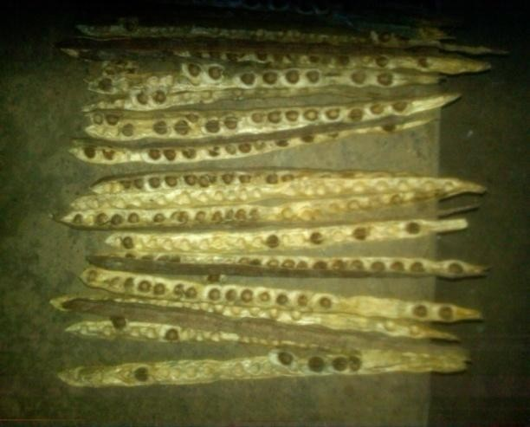

Plate 2.8: Showing matured dried M. oleifera pods

Plate 2.9: Longitudinally divided pods showing Moringa seeds

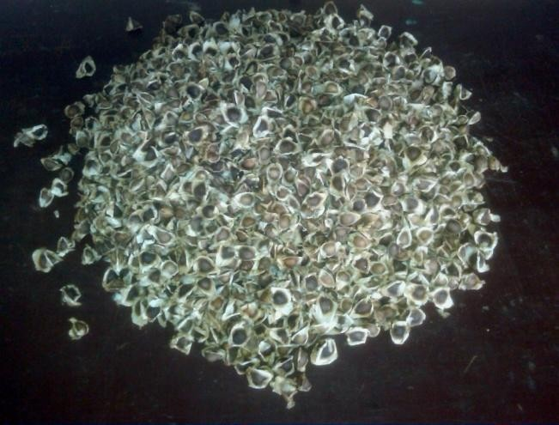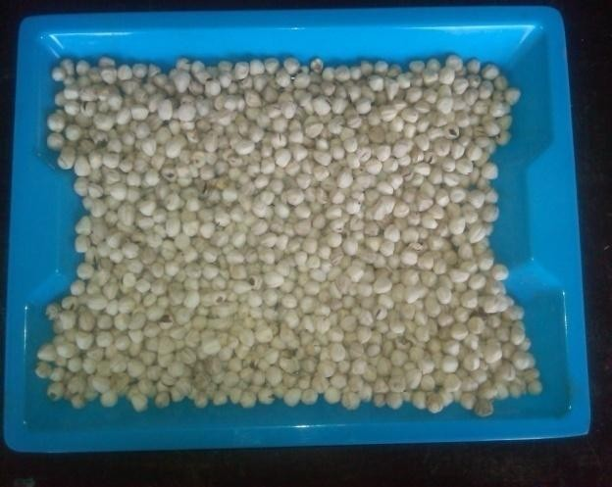

Plate 2.10: Picture of brown-winged M. oleifera seeds

Plate 2.11: Freshly removed M. oleifera seeds from pod

    - Cultivation of Moringa oleifera
Moringa can be grown easily from seeds or cuttings. In the Philippines, moringa is propagated by planting 1–2m long limb cuttings, preferably from June to August. The plant starts bearing pods 6–8 months after planting, but regular bearing commences after the second year, continuing for several years. It can also be propagated by seeds, which are planted an inch below the surface and can be germinated year-round in well-draining soil. Seeds should be planted 2cm (approximately 1 inch) deep and ought to germinate within 1-2 weeks. Germination rates are usually very good, but can drop to 0% after 2 years.

M. oleifera and M. stenopetala for example, can be started from cuttings. Cuttings 45-100 cm (18-40 inches) long with stems 4-10 cm (2-4 inches) wide should be taken from the woody parts of the branches. It should be wood from the previous year. Cuttings can be cured for 3 days in the shade and then planted in a nursery or in the field. However, one should note that trees grown from cuttings are known to have much shorter roots. Where longer roots are an advantage for stabilization or access to water, seedlings are clearly preferable.

    - Prospects of M. oleifera
Moringa oleifera plant is highly esteemed such that almost every part of it have long been consumed by humans and used for various domestic purposes as for alley cropping, animal forage, biogas, domestic cleaning agent, blue dye, fertilizer, foliar nutrient, green manure, gum (from tree trunks), honey and sugar cane juice-clarifier (powdered seeds), ornamental plantings, bio-pesticide, pulp, rope, tannin for tanning hides, water purification, machine lubrication (oil), manufacture of perfume, and hair care products (Anwar et. al., 2007 and Fahey, 2005).

Generally, various parts of this plant such as the leaves, roots, seed, bark, fruit, flowers and immature pods act as cardiac and circulatory stimulants, possess antitumor, antipyretic, antiepileptic, anti-inflammatory, antiulcer, antispasmodic, diuretic, antihypertensive, cholesterol lowering, antioxidant, antidiabetic, hepatoprotective, antibacterial and antifungal activities, and are being employed for the treatment of different ailments in the indigenous system of medicine (Kumar et al., 2010 and Nadkarni, 2009).

M. oleifera is variably labeled as Miracle Tree, Tree of Life, God‟s Gift to Man, Savior of the Poor, etc (Majambu, 2012). In many regions of Africa, it is widely consumed for self-medication by patients affected by diabetes, hypertension, or HIV/AIDS (Dieye et al., 2008; Kasolo et al., 2010; Monera and Maponga, 2010). The fruit (pod)/drum sticks and leaves have been used to combat malnutrition, especially among infants and nursing mothers (Estrella et. al., 2000). Infact, in the Philippines, it is known as “mothers’ best friend” because of its utilization to increase women‟s breast milk production (Kumar et al., 2010). It also functions to regulate thyroid hormone imbalance (Tahiliani and Kar, 2000). The sap can also be used as a potential dye.

Moringa plants are generally highly tolerant to salinity, water logging, frost and drought. A large amount of Nigerian salinity affected land and drought-prone areas could be potentially used to grow these plants to increase its productivity. Amongst the several advantages accruable from the production of biodiesel from Moringa oleifera plants, when compared with some other crops for example, is the fact that Moringa tree plantations can potentially increase green coverage to sequester more CO₂ than other vegetable oil crops (Hsu et. al., 2006). This is because when their pods are harvested, the trees keep on growing to produce more pods. In the process, it uses water, thereby reducing high water table whilst sequestrating carbon.

  - Thevetia Peruviana (Yellow oleander) Biomass

Thevetia Plant
This is a tropical shrub which grows in the wild and remains ornamental, despite the abundance of the plant around our homes, schools and other buildings. The plant is grown as hedges and kept for its bright and attractive flowers. In Nigeria specifically, the plant has been grown for over fifty years as an ornamental plant in homes, schools and churches by missionaries and explorers (Ibiyemi, 2007).

Thevetia plant is recorded to be more than 2000 years in its native countries-West Indies, Brazil and Mexico. It was taken to Europe about three hundred years ago, and today it has naturalized in virtually all countries in the tropics. Thevetia plant thrives very well in all the climatic and vegetation belts of Nigeria, it is readily found in Port Harcourt and in Maiduguri or Sokoto.

To date, despite the fact that there is high level of oil content of its kernel, about 60-65% (Azam et al., 2005) and valuable protein content in the seed, about 40-45% (Ibiyemi et al., 2002), it remains non-edible because of the presence of cardiac glycoside (toxins), hence the plant remains a plant of no significant economic value whereas it has a lot of potentials.

The botanical classification of Thevetia peruviana Juss is given below:
Kingdom - Plantae Subkingdom - Tracheobionta Superdivision - Spermatophyta Division - Magnoliophyta
Class - Magnoliopsida
Subclass - Asteridae
Order - Gentianales
Family - Apocynaceae
Genus - Thevetia
Species - Thevetia peruviana Juss
Common names - Yellow oleander, Kolke (Bengal), Mexican oleander, Lucky nut, etc

Thevetia Plant Morphology
The plant is a dicotyledon which belongs to the Apocynaceae family. It is a composite, evergreen shrub, which is found to have a milky sap. It is commonly found in the tropics and sub-tropics but it is native to Central and South America. There are two varieties of the plant, one with yellow flowers (i.e. yellow oleander), and the other with purple flowers (i.e. nerium oleander). Both varieties flower and fruit all the year round hence provide a steady supply of seeds (Kokate et. al., 2005).

However, thevetia plants are generally addressed as Yellow oleander (or Nerium oleander), Gum bush, Bush milk, Be-still, Trumpet flower, Flor Del Peru, Lucky beans (in Sri Lanka and are worn as talismans or charms to attract luck), Exile tree (in India), Cabalonga (in Puerto Rico), Ahanai (in Guyana), and Olomi ojo (by the Yorubas in Nigeria)

The plant is a shrub that can reach a height of 3.0-3.9metres (Plate 2.12). It is perennial and the evergreen leaves are spirally arranged, linear, narrow/sword-like and about 13-15 cm in length. The plant starts flowering after one and a half year; and after that it blooms thrice a year (Balusamy & Manrappan, 2007).



Plate 2.12: Picture of a Thevetia peruviana Juss (Yellow oleander) plant
(Photo taken at the Chemistry department, University of Ibadan)

The plant produce fruits virtually ten out of the twelve months of the year. The flowers are yellow flutes (or funnel-shaped) with petals that are spirally twisted (Plate 2.13). These flowers develop to fruits that have a pair of follicles or drupes. They can produce between 400-800 fruits per annum depending on the rainfall pattern and plant age (Ibiyemi, 2007).

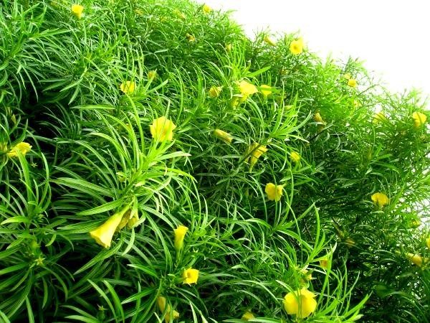Plate 2.13: Picture of the funnel-shaped flowers of Yellow Oleander plant

The fruits of T. peruviana are drupes and are globular in shape with a fissure on the ventral side where it can be opened up (Plate 2.14). It consists of deep green-waxy pericarp, fleshy mesocarp (that has a diameter of 4-5 cm) and a bony endocarp. The fruits have varying masses (2.0-6.1g) which are dispersed by man or propagated by seed or stem. The fruits are usually hard and green in colour when unripe but after drying or when they fall-off/plucked from the parent plant, the pulpy meso-pericarp (hull) becomes soft, turns dark and shrinks to expose the endocarp (Plate 2.15).

However, the bony endocarp (shell) has been referred as „kernel‟ (Plate 2.16) in some texts for convenience and would be used as such in the course of this write-up for easy understanding. The kernels, which are longitudinally and transversely divided, have one to four compartments, each containing a light brown or white seed (especially in the matured and bigger ones) (Plate 2.17).

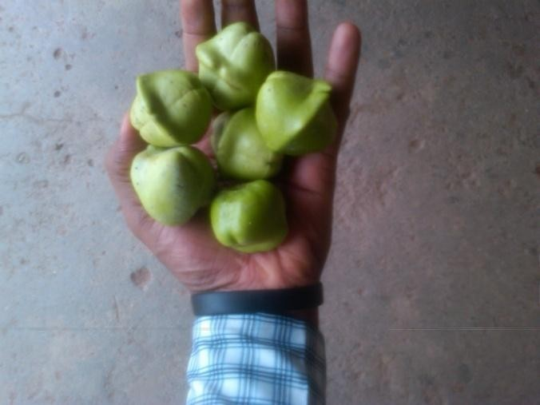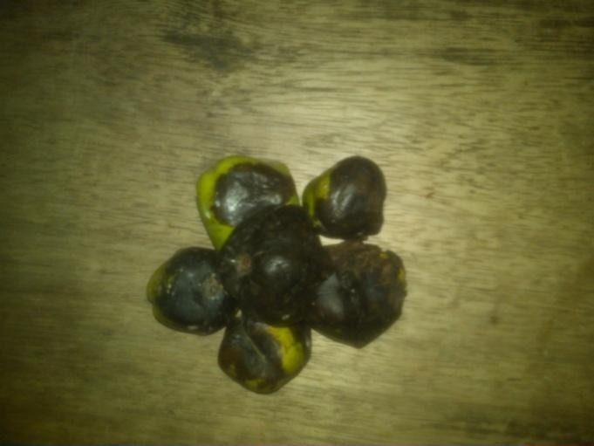

Plate 2.14: Picture of matured Yellow Oleander fruits

Plate 2.15: Picture of soft, ripe and dark Oleander fruits

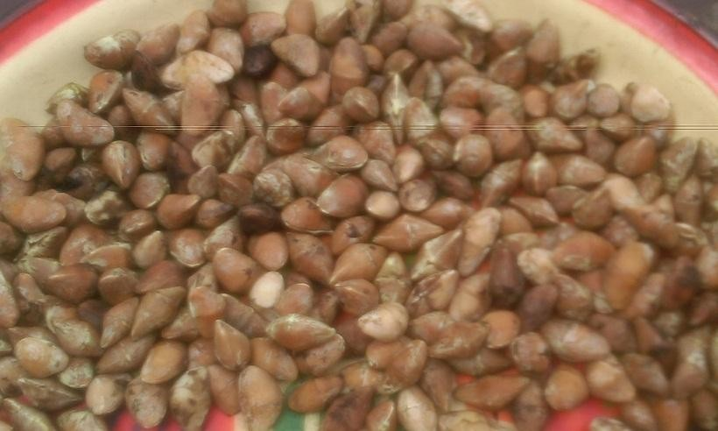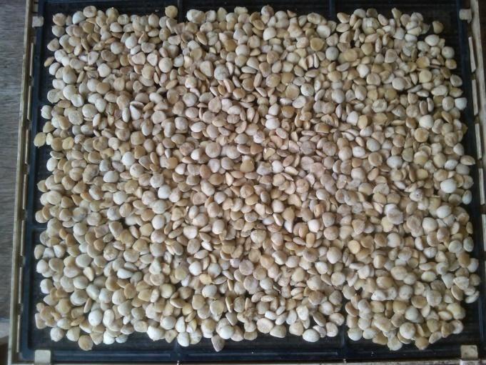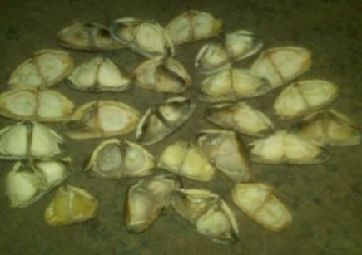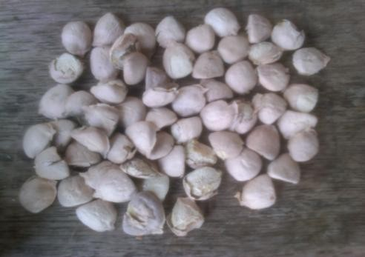

Plate 2.16: Picture of matured T. peruviana kernels
Inset: Longitudinally divided kernels showing two compartments with one seed each covered with seed coat

Plate 2.17: Showing freshly removed Yellow Oleander seeds Inset: Showing the seeds still covered with their seed coat

These seeds are also covered with a seed coat, which is very fragile (Insets: Plates 2.16 and 2.17). With utmost care one can get intact seeds but normally the seed coat ruptures or at least the wing shaped structure gets separated. During manual/mechanical dehulling, hardly 1 to 2% seed coat remains intact (Sahoo et. al., 2009). The seed contains about 60-65% oil and the cake comprise of 30-37% protein on dry matter basis (Usman et. al., 2009).

Generally, the estimated physical parameters of the fruits and kernels of Thevetia are summarized in the table below:

Table 2.6: Physical properties of Thevetia fruit and kernel

Physical properties | Number of sample | Fruit | Kernel
Length (mm) | 100 | 31.08 ± 3.47 | 13.35 ± 1.05
Width (mm) | 100 | 15.87 ± 1.13 | 10.75 ± 0.59
Thickness (mm) | 100 | 14.27 ± 1.17 | 5.40 ± 0.46
1000 unit mass (g) | 20 | 2586.63 ± 69.65 | 330.92 ± 11.68
Kernel fraction (%) | 20 | 16.14 | N.A.
Shell fraction (%) | 20 | 83.86 | N.A.
Arithmetic mean diameter (mm) | 100 | 20.41 ± 1.71 | 9.83 ± 0.52
Geometric mean diameter (mm) | 100 | 19.14 ± 1.47 | 9.17 ± 0.48
Sphericity (decimal) | 100 | 0.62 ± 0.03 | 0.69 ± 0.04
Surface area (mm²) | 100 | 1157.60 ± 179.53 | 264.86 ± 26.86
Aspect ratio (%) | 100 | 51.44 ± 4.33 | 80.85 ± 6.00
Bulk density (kg m⁻³) | 20 | 591.7 ± 8.91 | 657.73 ± 5.23
True density (kg m⁻³) | 20 | 1106.68 ± 38.85 | 942.05 ± 79.87
Nos per m³ | - | 222 364 | 1 840 515
Porosity (%) | 20 | 46.51 ± 1.15 | 29.82 ± 6.48
Angle of repose (°) | 20 | 44.05 ± 2.04 | 43.28 ± 0.90
  - - not applicable.
Source: Sahoo et al, 2009

Cultivation of Thevetia plant
Thevetia peruviana is cultivated as large flowering shrub or small ornamental standards in gardens and parks in temperate climates. It is mostly planted as a container plant in frost-prone areas, and in the winter season, it is brought inside a greenhouse or a plant house. It tolerates most soils and it is drought tolerant.

The plant generally grows best when overwintering period is short. Overwinter is a cool location (40s F), such as basement or garage, with moderate light and very little water or as a houseplant in a bright sunny but cool room with reduced water. It grows well in average, medium moisture soils in full sun to part shade. It is drought tolerant and tolerates most soils (Bandara et. al., 2010) but thrives a little better in rich, sandy soils. Container plants do best in fertile soils with good drainage. Water regularly but let plant soils dry out between watering.

The plant could be propagated by seed in spring by putting a clean seed coat in a glass of water containing 10% bleach and 90% warm water for 2-3mins; after which the seed is washed and soaked in warm water for 24hours. It can also be propagated from cuttings in spring-early summer with hardwood cuttings. For both, it is advisable to use seed cutting compost that contains perlite (Singh et. al., 2012) and by extension, this same procedure could be scaled-up to cultivate a thevetia plantation.

Prospects of Thevetia Plant
The plant produces white milky juice or latex (sap) in all its organs, which is highly poisonous and the seed is also highly poisonous. This attribute accounts solely for the lack of interest in the development of the plant. The seed on the basis of its protein content (40-45%) should be preferred to most orthodox protein sources in the formulation of animal feeds. Bisset (1963) was among the first few to report on the seeds for its toxins, cause of death as recorded for two children, horses and other animals.

The seed, which is cardiotonic, has been shown to contain between 3.6-4.0% of the cardenolides- thevetin A and B (cerebroside) (Figure 2.6), the major glycosides of the seed, and the most lethal toxins (Ibiyemi, 2007). Some of the other compounds that have been identified asides from

thevetin are theveside, theveridoside, neriifolin, digitoxigenin (thevetigenin), cerberin, ruvoside, and perusitin (Perez-Amador et. al., 1994). These cardenolides are not destroyed by drying or heating and they are very similar to digoxin from Digitalis purpurea (Sangodare et. al., 2012). They produce gastric and cardiotoxic effects.

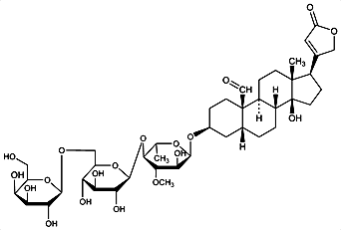Fig. 2.6: Structure of Thevetin A
Source: www.drugfuture.com/chemdata/structure/Thevetin-A.gif

In spite of the toxicity of the plant, it has found useful applications in several spheres of life. Its latex is used as analgesic for toothache when the stem part is chewed in Juccata, and also as an insecticide. The latex or extract of the stem is used as vesicant; and the bark as a febrifuge and an effective abortifacient. The wood is used by some as handle for axes (Usman et. al., 2009).

There is a myriad of edible and non-edible oils that could be used as bio-diesel feedstocks, but the appropriate technology would be to utilize the abundantly available native non-edible oil feedstocks rather than edible ones. One of these feedstocks could be Thevetia peruviana J. oil. This is because, amongst other benefits, in a hectare of land, 3000 saplings can be planted and out of which 52.5 tons of seeds (3,500kg of kernels) can be collected. Hence, about 1,750litres of oil can be obtained from a hectare of wasteland (Balusamy and Marappan, 2007).

However, most of the research works on Thevetia has revolved around aspects such as the clinical, toxicological, pharmacological, e.t.c. This is probably the reason for limited research on the oil and biodiesel yielding potential of Thevetia seeds that would have promoted its industrial and domestic potentials. Though some literatures are available on Thevetia plant and its oil characteristics (Ibiyemi et al., 2002 and Usman et. al., 2009), there is only a few studies available on its biodiesel properties (see Table 2.8).

Palm Kernel Biomass
    - Characteristics of Oil Palm Tree
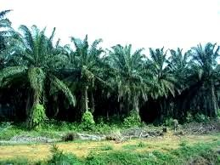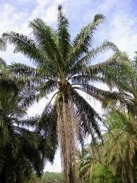Palm kernels are nuts that are obtained from the fruits of oil palm trees (Plate 2.18). The oil palm tree is a tropical plant, which commonly grows in warm climates at altitudes of less than 1,600 feet above sea level. The species, Elaeis oleifera (H.B.K) Cortes is native of America; and the species Elaeis guineensis Jacq. (Binomial name of Elaeis guineensis), which originated in the Gulf of Guinea in West Africa (hence its scientific name) is better known as the African oil palm. This tree produces one of the most popular edible oils (palm oil) in the world-a versatile oil of superb nutritional value. Oil from the African oil palm (Elaeis guineensis Jacq.) has long been recognized in West and Southwest African countries.

Oil palm grows best in areas with a mean maximum temperature of 30-32 ºC and on an average of at least five hours of sunlight. It can be grown in areas, which receive well-distributed annual rainfall of 200 cm or more. However, it can tolerate 2-4 months of dry spell. The oil palm grows on wide range of tropical soils. The adult palms can withstand occasional water-logging, but frequently waterlogged, extremely sandy and hard lateritic soils should be avoided.

Plate 2.18: Left picture-Palm oil plantation; Right picture-Enlarged single Palm oil tree
(Photos taken at the Teaching and Research Farm, University of Ibadan)

The Scientific classification of African oil palm is given thus:
Kingdom: Plantae Subkingdom Viridaeplantae Division Tracheophyta Subdivision Spermatophyta Class Magnoliopsida Superorder Lilianae Order Arecales
Family: Arecaceae
Subfamily: Arecoideae
Genus: Elaeis Jacq.-Oil palm
Species: Elaeis guineensis-African oil palm

Oil palms have both male and female flowers on the same tree. They produce thousands of fruits, in compact bunches whose weight varies between 10-40 kilograms (Plate 2.19). Each fruit is almost spherical, ovoid or elongated in shape. Generally, the fruit is dark purple, almost black before it ripens and orange red when ripe (Plate 2.20). The fruit has a single seed (i.e. the palm kernel) (Plate 2.22) protected by a wooden endocarp or shell, surrounded by a fleshy mesocarp or pulp (Plate 2.21).

Palm kernel fruit produces two types of oil: one extracted from the pulp (palm oil) and the other from the kernel (palm kernel oil-PKO) (Figure 2.20). Both palm oil and palm kernel oil are two of the highly saturated vegetable fats. These oils give the name to the 16-carbon saturated fatty acid, palmitic acid that they contain.

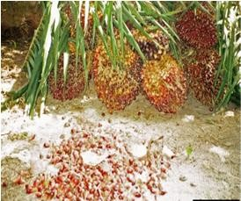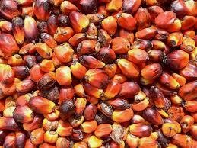

Plate 2.19: Bunches of freshly harvested palm kernel fruits

Plate 2.20: Showing palm nuts detached from the bunch

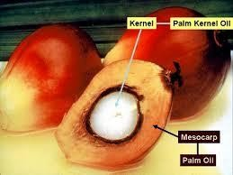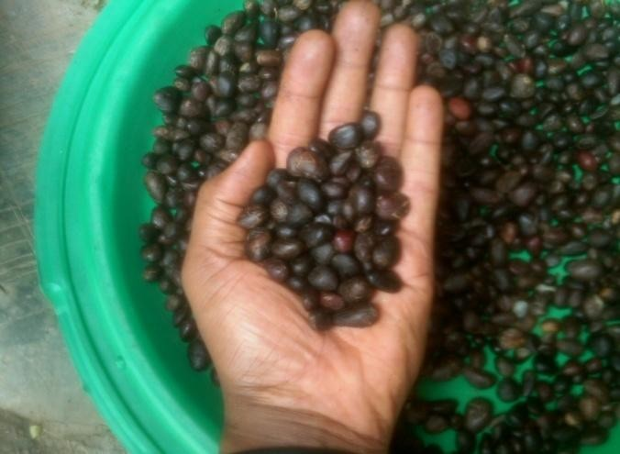

Plate 2.21: Longitudinal section through a palm fruit

Plate 2.22: Picture of Palm kernel seeds

Cultivation of Oil palm tree
- Planting
African oil palms are indigenous to the tropical rain forest region in the coastal belt of West Africa from Liberia to Angola. Oil palms grow on a wide range of tropical soils, require adequate water supply and are best cultivated on lowlands, with a 2-4 month dry period. In commercial cultivation 75 to 150 palm trees are planted per hectare, yielding about 2.5 MT of palm fruits per hectare per year.

Oil palms are propagated by seed or seedlings and could be planted in the main field in triangular system at spacing of 9 meters accommodating 140 palms per ha. For seedling, the polythene bag is torn open and the entire ball of earth is buried in the pit (50 × 50 × 50 cm) and leveled. Planting is preferably done at the onset of monsoon during May-June. A commercial plantation of 410 ha would sustain about 50,000 trees. Each tree produces on average 5 bunches of fruit, equivalent to 5 kg oil per year. The total annual yield of such a plantation can be 250,000 kg oil per annum.

Leaf pruning
Dead and diseased leaves and all inflorescences should be cut off regularly up to three years after planting. When the palms are yielding, judicious pruning to retain about 40 leaves on the crown is advocated. It is necessary to remove some of the leaves while harvesting. In such cases, care should be taken to avoid over pruning. In addition, all dead and excess leaves should be cut off and crown cleaned at least once in a year, usually during the dry season.

Pollination
Oil palm is a cross-pollinated crop, and so assisted pollination is done to ensure fertilization of all female flowers. However, this is not necessary if the pollination weevil Elaedobius kamerunicus is introduced in the plantation. They congregate and multiply on male inflorescence during flower opening. The weevils also visit the female flowers and pollinate them effectively.

Harvesting and Processing of Palm Oil Fruits
The first harvest of the oil palm tree can be taken 3.5-4.0 years after planting. When a few ripe fruits are loose/fall off, this indicates that the bunch is ready for harvesting. Processing over-ripe fruits reduces quantity and quality of oil. A chisel is used for harvesting bunches from young palms. The stalk of the bunch is struck hard with the chisel to cut off and push the bunch out. When the palms become taller (from 10 year onwards) a harvesting hook has to be used. When the palms are too tall, it is necessary to climb the palms for harvesting.

For mature plantations not exceeding 40 ha, a hand-operated hydraulic press will be enough for extraction of oil. In the case of large-scale plantations, the hydraulic press will not be economical and as such, mechanically driven oil mills have to be established. The fruit bunches brought to the factory are first quartered by means of a chisel. They are then sterilized in steam or boiling water for 30-60 minutes. The objective of this process is to soften the fruits for easy pounding and to inactivate the fat splitting enzymes which are present in the fruit. This is because these enzymes may raise the free fatty acid content of the oil if this is not done.

The sterilized fruits are stripped off from the bunch and then pounded. The pounded fruit mass is then reheated and squeezed using a hydraulic press. It is then boiled in a clarification drum where the sludge will deposit and pure oil float over the water. The oil is then drained out.

Potentials of Palm Kernel Oil
Palm kernel oil is high in saturated fats and is more saturated than palm oil (Chow, 2007). The oil is high in lauric acid, which has been shown to raise blood cholesterol levels, both as LDL-C (cholesterol contained in low density lipoproteins) and HDL-C (cholesterol contained in high density lipoprotein) (Rakel, 2012). Palm kernel oil, which is semi-solid at room temperature, is commonly used in commercial cooking because it is lower in cost than other oils and remains stable at high cooking temperatures. It can be stored longer than other vegetable oils (Bjorklund, 2010).

Palm kernel oil (PKO) is one vegetable oil in Nigeria which had hitherto been underutilized as edible oil. Available records ranked Nigeria as one of the world‟s best producer of palm kernel.

Between 1995 and 1998, Nigeria‟s share in the world production of palm kernel were 0.27, 0.26 and 0.25MMT for 1995/96, 1996/97 and 1997/98 production seasons respectively; and in 2002, the country‟s production of palm kernel was approximately 0.61MMT. This record placed Nigeria next to Malaysia and Indonesia, and ahead of PKO producing countries like Thailand, China, Ivory Coast, Congo and Brazil (Alamu et al., 2007a, b and FAO, 2006) as shown in Table
2.7 below.

Malaysia purchased its first palm oil seedling in mid 50s from NIFOR (Nigerian Institute for Oil Palm Research). In less than 50 years after, Malaysia and Indonesia led the world in the production of palm oil and palm kernel oil. In 2002, Malaysia produced approximately 3 MMT crude palm kernel oil and 12 MMT of crude palm oil (FAO, 2006 and Salmiah, 2003). Today, Malaysian oil palm industry is one of the most highly organized sectors of any national agriculture system of the world and the world‟s largest producer of palm oil (Yusof, 2007). The country has the largest oleochemicals capacity of any country in the world with her capacity representing 25% of the world capacity in 2002. Oleochemicals from Malaysia have been exported to over 100 countries, including North America, European Union countries, Japan and China.

Although the volume of trade to Nigeria on the oleochemicals and crude vegetable oils is negligible, Nigeria however imports a lot of its oleochemicals for the few oleochemical industries in the country possibly mainly from Malaysia and Indonesia. But unfortunately, Nigeria has greater potentialities to have been producers of oleochemicals which now compete effectively with petrochemicals. If certain measures are not taken, sooner than later, the country shall have to import biodiesel to supplement, if not replace, her petroleum diesel (Ibiyemi, 2007). This would however most likely then be at a high price and a major drain on the economy of the nation, and this would be nothing but an unfortunate circumstance for a country with such potentials.

Table 2.7: Palm oil and Palm kernel production in the world
(Source: FAO, 2006; www.unctad.org)

Palm Oil Production (x1000 tons) |  |  |  |  | Palm Kernel Production (x1000 tons)
 | 1969-71 | 1980 | 1990 | 2002 | 1969-71 | 1980 | 1990 | 2002
World | 1,983,034 | 5,052,641 | 11,163,308 | - | 1,178,651 | 1,812,081 | 3,511,624 | 7,059,000
Africa | 1,108,647 | 1,365,350 | 1,683,454 | - | 731,005 | 733,927 | 672,208 | 1,018,000
S. America | 46,752 | 134,759 | 505,660 | - | 248,489 | 330,549 | 325,701 | 312,000
Asia | 769,583 | 3,461,300 | 8,687,410 | - | 177,683 | 730,405 | 2,420,034 | 5,520,000
Malaysia | 457,298 | 2,573,000 | 6,094,700 | 11,909,000 | 98,996 | 557,000 | 1,844,700 | 3,269,000
Indonesia | 217,900 | 676,800 | 2,186,210 | 9,350,000 | 48,980 | 121,105 | 477,824 | 2,053,000
Nigeria | 528,330 | 675,000 | 820,000 | 908,000 | 287,100 | 345,000 | 356,000 | 608,000
Thailand | - | 9,500 | 226,000 | 590,000 | - | 1,900 | 50,000 | 126,000
China | 114,333 | 190,000 | 133,000 | 220,000 | 28,333 | 48,000 | 33,500 | 56,000
Ivory Coast | 46,467 | 170,000 | 207,714 | 216,000 | 19,333 | 30,000 | 36,800 | 40,000
Congo | 232,433 | 108,300 | 180,000 | 170,000 | 99,100 | 69,300 | 74,000 | 81,000
Brazil | 7,166 | 16,000 | 65,000 | 118,000 | 218,599 | 265,988 | 229,000 | 120,000

  - Available Methods for Biodiesel Production
There are different approaches for the conversion of vegetable oils or fats to biodiesel. These include the homogenous catalysis viz: base catalysis/transesterification, acid catalysis method & enzymatic conversion method; the heterogeneous catalysis, which involves the use of solid catalysts; and the non-catalytic conversion method, which does not require any catalyst.

Homogenous Catalysis
The homogenous catalysis involves the use of catalysts that are soluble in alcohol. The catalyst could either be a base, an acid or an enzyme. In the homogenous system, the catalyst ends up in the byproducts, and it is not recovered for re-use.

Base Transesterification and Acid Catalysis
The base catalysis/transesterification and the acid catalysis are the commonest amongst the different approaches available for the conversion of oils/fats to biodiesel. However, most of the current biodiesel production operations use base transesterification. In 1977, the Brazillian scientist-Expedito Parente, produced biodiesel by transesterifying palm oil with ethanol (Addison, 2005). In the experiment, he heated a mixture of ethanol, sodium hydroxide, and palm oil for two hours and later separated a layer of fatty acid methyl ester for use as biodiesel.

Biodiesel produced by transesterification involves the conversion of large, branched triglycerides into smaller, straight chain molecules of methyl or ethyl esters using an alkali or acid or enzyme as catalyst. Many studies have been done on the transesterification of vegetable oils such as Jatropha and Palm oil to produce biodiesel (Shweta et. al, 2004 and Cheng et. al., 2004). In each of these studies, transesterification of vegetable oils is an important reaction that produces fatty acid methyl esters (FAME) which are excellent substitute for diesel fuel.

The base-catalysed transesterification is much faster, and less corrosive, than the acid catalyzed reaction. Thus alkali hydroxides are the most commonly used catalyst. However, if the feedstock has a high free fatty acid (FFA) content (as is common with rendered fats and spent restaurant oils), excess of alkali causes loss of the free fatty acids as their insoluble soaps. This decreases the final yield of ester and consumes alkali. As an alternative in these cases one can conduct an

acid catalysed reaction via esterification (Figure 2.6), which requires higher reaction temperature (100ºC) and longer reaction times than alkali catalysed reaction (Shweta et. al., 2004).

Drewette and Dwyer documented in their research work titled “Biofuels for Transport” where they explained that there are three basic routes to production of fatty acid methyl esters (FAME) viz: esterification of fatty acid distillates to fatty acid methyl esters, base-catalyzed transesterification of triglyceride oils, and acid catalyzed transesterification (Drewette and Dwyer, 2005).

Igbokwe (2005) reported in her research work titled “Optimization and Characterization of Palm and Kernel Oils for use as Biodiesels in Compression Ignition Engines”, that biodiesel of good ignition qualities could be successfully produced by transesterifying palm oil with a mixture of sodium hydroxide and ethanol.

Transesterification, which involves chemical conversion of the oil into its corresponding fatty ester, also serves as the most common method used in the biodiesel industry to reduce vegetable oil viscosity. Other methods of producing biodiesel from raw feedstock oils that have been considered to reduce the high viscosity of the oil are:

- Dilution of 25 parts of plant with 75 parts of diesel fuel
- Micro-emulsions with short chain alcohols (e.g. Ethanol or Methanol)
- Thermal decomposition, which produces alkanes, alkenes, carboxylic acids and aromatic compounds.
- Catalytic cracking, which produces alkanes, cycloalkanes and alkybenzenes

Waste vegetable oil (<2.5% FFA) Waste vegetable oil (>2.5% FFA)

Esterification
Sulphuric acid + Methanol

DRYER

Glycerine + Methanol

Virgin vegetable Oil

Methanol + NaOH

REACTOR
(Transesterification)
Crude Biodiesel

W A S H

C O L U M N
SEPARATOR
Water

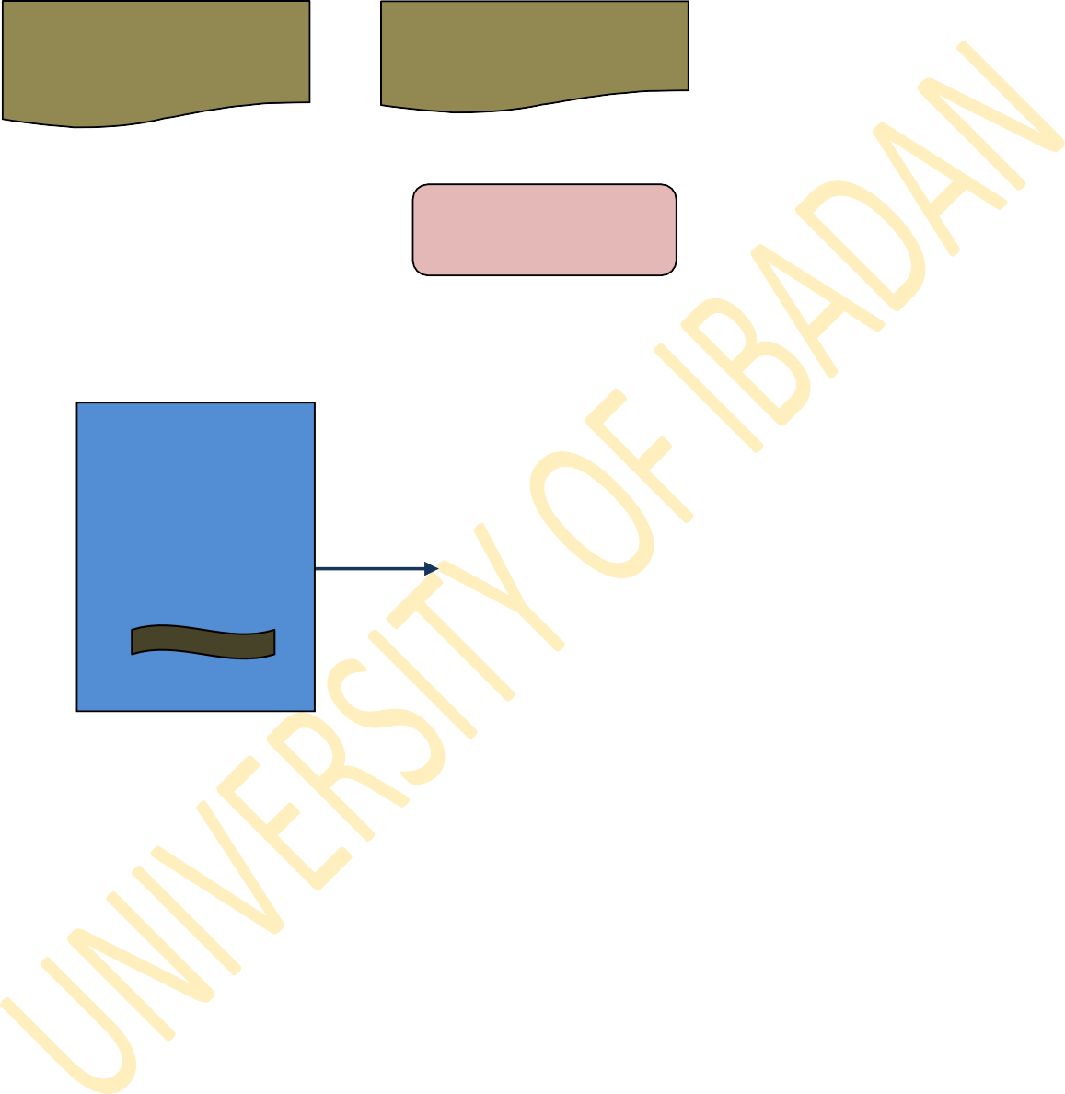

Glycerine recovery
METHANOL RECOVERY
Glycerine+ Methanol + Water
Methanol

Fig. 2.6: Process Flowchart for typical Biodiesel Production
Flowchart design by Udofia and Ana, 2014 (unpublished dissertation)

Enzymatic Catalysis
In the enzymatic method, lipase catalysed transesterification is carried out in non-aqueous environments. Although chemical transesterification is efficient in terms of reaction time, however, the utilization of the method in synthesizing biodiesel from triglyceride has draw backs such as difficulty in the recovery of glycerol and the energy intensive nature of the process. In contrast, biocatalyst allows synthesis of specific alkyl esters and usually the recovery of glycerol and transesterification of glycerides with high free fatty acid content (Highina et. al., 2011).

One common draw back with the use of enzymes based process is the high cost of the enzymes. Immobilization of enzymes has generally been used to obtain reliable enzymes derivative. There are three stepwise reactions with intermediate formation of diglycerides and monoglycerides resulting in the production of three moles of methyl esters and one mole of glycerol from triglycerides.

Heterogeneous Catalysis
Heterogeneous catalysis on the other hand involves the use of solid catalysts such as Alkaline earth metal oxides, various alkaline metal compounds supported on alumina or zeolite and sulfonic resins (where the catalyst stays on fixed-bed reactors and is used for an extended time).

Non-catalytic conversion
The non-catalytic conversion technique involves the use of a co-solvent that is soluble in both methanol and oil and can improve reaction rates. The BIOX Process (www.bioxcorp.com) is a typical example of such which utilizes either tetrahydrofuran (THF) or methyl tert-butyl ether (MTBE) as a co-solvent to generate a one-phase system. In the presence of a co-solvent, the reaction is 95 percent complete in 10 minutes at ambient temperatures and does not require a catalyst.

Effect of Different Parameters on the Production of Biodiesel
Several works have established that the parameters affecting methyl ester formation are reaction temperature, pressure, molar ratio, water content, and free fatty acid content. It is evident that at subcritical states of alcohol, the reaction rate is very slow and gradually increases as either

pressure or temperature rises. The most important variables affecting the methyl ester yield during transesterification reaction are molar ratio of alcohol to vegetable oil and reaction temperature.

Effect of molar ratio
According to Demirbas (2002), the yield of alkyl ester increases when the molar ratio of oil to alcohol is increased. In the supercritical alcohol transesterification method, the yield of conversion rises from 50% to 95% in the first 10 min. The stoichiometric ratio for transesterification reaction requires 3 mol of alcohol and 1 mol of triglyceride to yield 3 mol of fatty acid ester and 1 mol of glycerol. Ramadhas et. al. (2004) and Sahoo et. al., (2007) have reported 6:1 molar ratio during acid esterification and 9:1 vegetable oil-alcohol molar during alkaline esterification to be the optimum amount for biodiesel production from high FFA rubber seed oil and polanga seed oil, respectively.

Atu et. al. (2011) studied the optimum requirements of temperature, retention time, mole ratio of reactants and catalyst for the direct synthesis of biodiesel from fatty acid distillates of palm kernel oil using tetraoxosulphate (VI) acid as catalyst. Their result showed that the optimal conditions for the acid catalyzed esterification of palm kernel oil fatty acid distillates are: eight moles of methanol per mole of fatty acid; 0.06 moles of tetraoxosulphate (VI) acid per mole of fatty acid; a retention time of sixty (60) minutes and a reaction temperature of 65ºC.

Veljkovic et al. (2006) employed 18:1 molar ratio during acid esterification and 6:1 molar ratio during alkaline esterification. Meher et al. (2006) took 6:1 molar ratio during acid esterification and 12:1 molar ratio during alkaline esterification. Instead of taking molar ratio, Tiwari et al. (2007) and Ghadge and Raheman (2005) utilized volume as a measure of ratio. Demirbas (2002) also reported in an experiment where he transesterified vegetable oils between 1:6 to 1:40 vegetable oil-alcohol molar ratios in catalytic and supercritical alcohol conditions that higher molar ratios result in greater ester production in a shorter time.

Effect of temperature
It was observed that increasing the reaction temperature, especially to supercritical conditions, had a favorable influence on the yield of ester conversion. In the alkali (NaOH or KOH) transesterification reaction, the temperature maintained by researchers during different steps range between 45-65ºC. The boiling point of methanol is 65ºC. Temperature higher than this will burn the alcohol and will result in much lesser yield.

A study by Leung & Guo (2006) showed that temperature higher than 50ºC had a negative impact on the product yield for neat oil, but had a positive effect for waste oil with higher viscosities. Demirbas (2002) also reported that increasing the reaction temperature, especially to supercritical temperatures, had a favorable influence on ester conversion.

Effect of water and free fatty acid (FFA) contents on the yield of biodiesel
In the transesterification process, the vegetable oil should have an acid value less than 1 and all materials should be substantially anhydrous. If the acid value is greater than 1, more NaOH or KOH is injected to neutralize the free fatty acids. Water can cause soap formation and frothing. The resulting soaps can induce an increase in viscosity, formation of gels and foams, and make the separation of glycerol difficult (Ghadge & Raheman, 2005). Water content is an important factor in the conventional catalytic transesterification of vegetable oil.

In the conventional transesterification of fats and vegetable oils for biodiesel production, free fatty acids and water always produce negative effects since the presence of free fatty acids and water causes soap formation, consumes catalyst, and reduces catalyst effectiveness. Kusdiana and Saka (2004) are of the opinion that water can pose a greater negative effect than presence of free fatty acids and hence the feedstock should be water free. Canakci and Gerpen (1999) insist that even a small amount of water (0.1%) in the transesterification reaction will decrease the ester conversion from vegetable oil.

In conventional catalyzed methods, the presence of water and FFA has negative effects on the yields of methyl esters. Presence of water and FFA in raw material cause soap formation, a decrease in yield of the alkyl ester, greater consumption of catalyst and a reduced catalyst

effectiveness (Demirbas, 2006). However, Demirbas in 2006 also reported that the presence of water had a positive effect on the yield of methyl esters when methanol at room temperature was substituted by supercritical methanol. The presence of water had negligible effect on the conversion while using lipase as a catalyst (Madras et. al., 2004).

Effect of catalyst content
It has been reported that CaO can accelerate the methyl ester conversion from sunflower oil at 252ºC and 24 MPa even if a small amount of catalyst (0.3% of the oil) was added. The transesterification speed obviously improved as the content of CaO increased from 0.3% to 3%. However, further enhancement of CaO content to 5% produced little increase in methyl ester yield (Demirbas, 2008).

Summary of Available Literatures
There is currently no commercial biodiesel plant that exists in Nigeria, except for a few production facilities that are notably not well documented. Production and consumption are still at their infancy stage. This work sought to evaluate the oil- and biodiesel-yielding potential of the seeds of Palm kernel (Elaeis guineensis), Yellow oleander (Thevetia peruviana), Moringa (Moringa oleifera) and also Spirogyra biomass (Spirogyra africana Fritsch).

Generally, a few amount of experimental work have been carried out by Nigerian researchers on some of the local plant feedstocks used for biodiesel production in this work viz Palm kernel (Elaeis guineensis), Yellow oleander (Thevetia peruviana), Moringa (Moringa oleifera) and also Spirogyra biomass (Spirogyra africana Fritsch) as highlighted in Table 2.8 below. No online publication was found for the production of oil and biodiesel from Spirogyra filaments by any Nigerian researcher.

From available literature, it is clear that researches in Nigeria and even West Africa are still evolving, with so much work left to be done in evaluating the full potential of locally available biomasses for oil and biodiesel production. This is because the parameters that have been evaluated in the works highlighted in Table 2.8 are not exhaustive. This work was therefore designed to further give more insight into some of these and other parameters as they affect the biodiesel production process.

Table 2.8: A chronology of publications on biodiesel research works in Nigeria
Year | Investigators | Title of Publication | Source
 |  | Palm Kernel
2000 | Abigor R.D., Uadia P.O., Foglia T.A., Hass M.J., Jones K.C., Okpefa E., Obibuzor J.U. & Bafor M.E. | Lipase-catalyzed production of biodiesel fuel from some Nigerian lauric oils. | PubMedAbstract; BiochemSoc Trans, 28:979-981
2004 | Igbokwe P.K., Effiong E.E., Nwafor O.M.I. and Ngochindo R.I. | Factors affecting the transesterification of Palm olein | Nigerian Journal of Engineering Management; Vol 5, N0 2, pp. 25-30
2008 | Igbokwe P.K., Effiong E.E., Mgbemena C. and Obike I.J. | Kinetics of the transesterification of Nigeria Palm and Palm kernel oils | Journal of Science, Engineering and technology (JSET); vol 15, N0 1, pp.  7998-8003
2007a | Alamu O.J., Waheed M.A., and Jekayinfa S.O | Biodiesel production from Nigerian palm kernel oil: effect of KOH concentration on yield | Energy for Sustainable Development. Journal; 11(3):  77-82
2007b | Alamu O.J., Waheed M.A., Jekayinfa S.O | Alkali-catalysed laboratory production and testing of biodiesel fuel from Nigerian palm kernel oil | Agricultural Engineering International: the CIGR Journal of Scientific Research and Development. 9(EE 07- 009)
2008 | AlamuO.J., Akintola T. A., Enweremadu C. C. &Adeleke A. E. | Characterization of palm-kernel oil biodiesel produced through NaOH-catalysed transesterification process. | Academic Journals, Scientific Research and Essay;Vol.3 (7), pp. 308-311
2011 | Atu A.A., Emeka C.U and Akunna E.E. | Optimum Requirements for the Synthesis of Biodiesel Using Fatty Acid Distillates | Journal of Emerging Trends in Engineering and Applied Sciences (JETEAS) 2 (6): 897-  900
2011 | Oghenejoboh K. M. &Umukoro P. O. | Comparative analysis of fuel characteristics of biodiesel produced from selected oil- bearing seeds in Nigeria | European Journal of Scientific Research, ISSN 1450-216X, Vol.58, No.2 (2011), pp.238- 246
2012 | Igbum O.G., Asemave K. and Ocheme P. C | Evaluation of the biodiesel potential in Palm kernel Oil | International Journal of Natural Products Research; 1(3):57-60
2012 | Ojolo S.J., Adelaja A.O. and Sobamowo G.M. | Production of Biodiesel from  Palm Kernel Oil and Groundnut Oil | Advanced Materials Research Vol. 367; pp 501-506

 |  | Yellow Oleander
2007 | Balusamy T. and MarappanR. | Performance evaluation of direct injection diesel engine with blends of Thevetia peruviana seed oil and diesel | Journal of Scientific and Industrial Research; 66:1035–  40
2007 | Oluwaniyi O.O. and Ibiyemi  S.A. 2007 | Efficacy of catalysts in the batch esterification of the fatty acids of Thevetia peruviana seed oil | Journal of Applied Science and Environmental Management; 66:1035–40
2009 | Olisakwe H.C.,Tuleun L.T. and Eloka-Eboka A.C. | Comparative Study of Thevetia peruviana and Jatropha curcas seed oils as feedstock for grease production | International Journal of Engineering Research and Applications (IJERA); Vol. 1, Issue 3, pp.793-806
2009 | Usman L.A., Oluwaniyi O.O., Ibiyemi S.A., Muhammad N.O. and Ameen O.M | The potential of Oleander (Thevetia peruviana) in African agricultural and industrial development: A case study of Nigeria | Journal of Applied Biosciences 24: 1477-1487
2013 | Chindo I. Y., Danbature W. and Emmanuel M | Production of Biodiesel from Yellow Oleander (Thevetia peruviana) Oil and its Biodegradability | Journal of the Korean Chemical Society 2013; Vol. 57, No. 3
 |  | Moringa Oleifera
2008 | Rashid U., Anwar F., Moser  B.R. and Knothe G. | Moringa oleifera oil: a possible source of biodiesel | Bioresource Technology; 99:8175–9
2011 | Uzama D., Thomas S.A., Orishadipe A.T. and Clement O.A. | The Development of a Blend of Moringa Oleifera Oil with diesel for Diesel Engines | Journal of Emerging Trends in Engineering and Applied Sciences (JETEAS) 2 (6): 999-  1001
2013 | Aliyu A. O., Nwaedozie J.  M. and Ahmed A. | Quality Parameters of Biodiesel Produced from Locally Sourced Moringa oleifera and Citrullus colocynthis L. Seeds found in  Kaduna, Nigeria | International Research Journal of Pure & Applied Chemistry 3(4): 377-390

CHAPTER THREE

METHODOLOGY

  - Study Design
The study was an experimental study which involved field and laboratory components. The field component involved exploring and sourcing for the substrates while the laboratory component involved oil extraction, oil processing to biodiesel and analysis for specific parameters in the different substrates, oils and biodiesels produced. Different types of plant-based biomasses such as palm kernel seeds, moringa seeds, yellow oleander seeds and spirogyra filaments were utilized in the experiment. The experiment employed a complete randomized design with three (3) replicates of most of the analyses carried out on the biomass samples unless where otherwise stated.

Description of Study Area
The study area for this research work was Ibadan, the capital city of Oyo state, located in south-
western Nigeria. The city, which is located on coordinates 7º23΄47״N 3º55΄0״E on the global map, is the third largest metropolitan area (by population) in Nigeria after Lagos and Kano, with a population of 2,258,625 according to the 2006 census (Omonijo et. al., 2007). At
independence, Ibadan was the largest and most populous city in Nigeria and the third in Africa
after Cairo and Johannesburg.

Ibadan, which has a total area of 1,190 sq mi (3,080 km²) is located in the southeastern part of Oyo state about 120 km east of the border with the Republic of Benin in the forest zone close to the boundary between the forest and the savanna. The city has a tropical wet and dry climate with a lengthy wet season and relatively constant temperatures throughout the course of the year. Basically, the city experiences an annual rainfall of about 2,500 mm and temperature below 53ºF.

The choice of Ibadan city as a study area is because of large scale agricultural activities, which is evident by the presence of Research Institutes like International Institute of Tropical Agriculture (IITA), Institute of Agricultural Research and Training (IAR&T), Cocoa Research Institute of Nigeria (CRIN), National Institute for Horticultural Research and Training (NIHORT) and

Agricultural plantations (government and private-owned). The city also serves as a commercial nerve centre for agricultural produce such as grains, tuber crops, plants seeds and seedlings of various types and so on that are brought from other states in the country, most especially from the Northern states.

Laboratory Management Practices
The motive was to avoid any source of contamination of the equipment and/or samples under study by mineral oils, greases, plasticizers from plastics and detergents. Therefore, the glassware that was used for this study were thoroughly washed with detergent, rinsed properly with distilled water and then allowed to dry in hot-air oven. The container used in handling any one of the biomasses at any particular time was also properly cleaned before being used to hold another biomass. This was to forestall any cross-contamination of one substrate by another, which may give false results in oil yield and biodiesel yield afterwards.

The following gears were utilized during the biodiesel production process for safety purposes:
- Chemical-resistant gloves (butyl rubber is best for methanol and lye)
- Chemistry goggles (indirect vented) and face shield
- Eyewash bottle with saline solution
- Fire extinguishers (ABC or CO₂)
- Access to running water

Sourcing for Materials
    - Sample Source
The biomasses utilized for these experiments were: Palm kernel (Elaeis guineensis) seeds, Moringa seeds (Moringa oleifera), Yellow oleander (Thevetia peruviana) seeds and Green algae (Spirogyra africana Fritsch) as shown in Plate 3.1 below. It should be noted at this point that “substrates” and/or “biomass” are used interchangeably in this write-up.

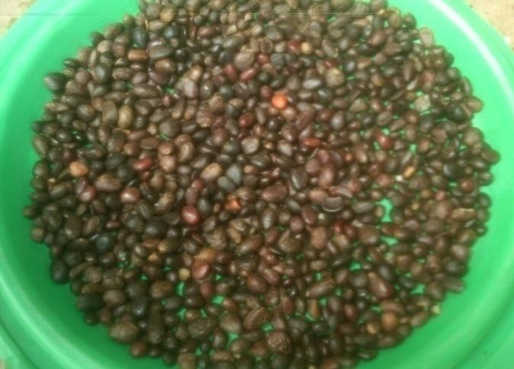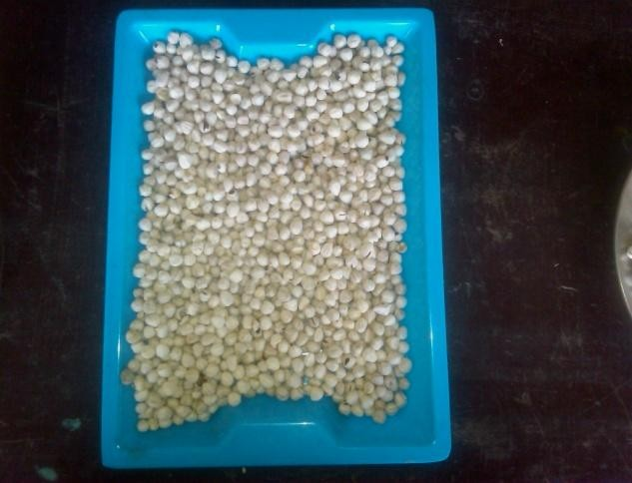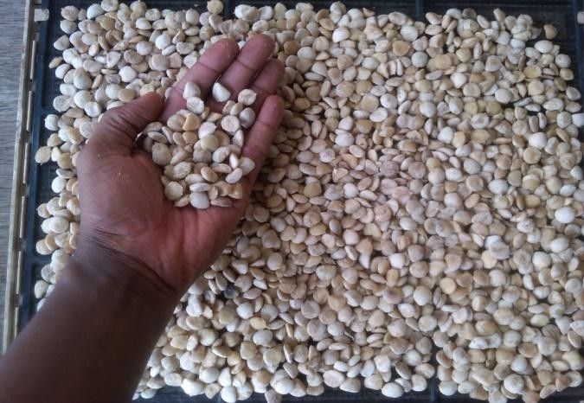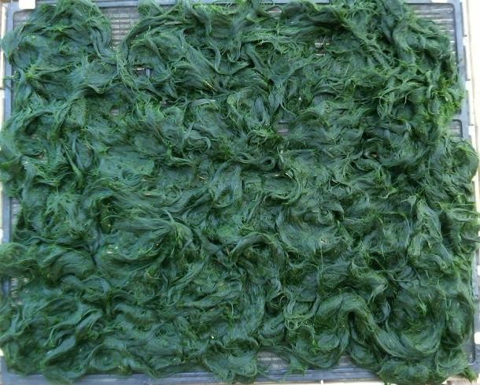

      - (b)

(c) (d)
Plate 3.1: Showing an array of the biomasses utilized in the study-(a) Palm kernel seeds (b) Moringa seeds (c) Thevetia seeds (d) Spirogyra filaments

Palm kernel seeds and Moringa seeds were obtained from the Teaching and Research Farm, University of Ibadan, Thevetia seeds harvested from a Thevetia plantation grown as hedges around the Faculty of Education, University of Ibadan; while the Spirogyra filaments were harvested from a water course sandwiched between Obafemi Awolowo Hall, CBT centre and the New Sport Complex, University of Ibadan.

Field Sampling of Substrates
About four (4) polythene bags each of matured dry Moringa pods and fresh matured Thevetia fruits were harvested from their parent trees and gathered for this work; while one (1) polythene bag of decorticated dry palm kernel nuts was also collected from the oil milling section of the Teaching and Research farm, University of Ibadan (Plate 3.2). Identification of all the plant biomasses utilized for the experiment was done at the Herbarium unit of Botany Department, University of Ibadan for validation.

Palm kernel seeds were identified as the African oil palm seeds (Elaeis guineensis), Moringa seeds identified as Moringa oleifera, and Yellow oleander fruits identified as Thevetia peruviana. In the case of the Spirogyra biomass, the genus of the different samples taken randomly from the different spirogyra biomasses that were collected from the same source at different points were identified to be majorly comprised (over 90%) of Spirogyra africana (Fritsch) Czurda under binocular light microscope (x10 magnification) (Plate 3.3) based on morphological studies with reference to the published algal monograms (Smith, 1950; Transeau, 1951; Randhawa, 1959 and Zaman et. al., 2009).

Present amongst some of the Spirogyra biomass collected was a mixture of few cells of Oedogonium, Zygnema, Zygnemopsis and epiphytic diatom species. A sieve was used to scoop the filaments from the water course into a clean large bowl. All the collected biomass samples were taken home for preparation (as described shortly) prior to laboratory processing.

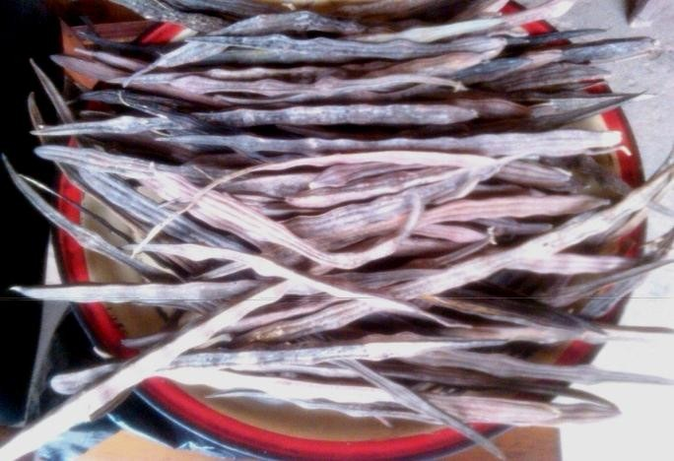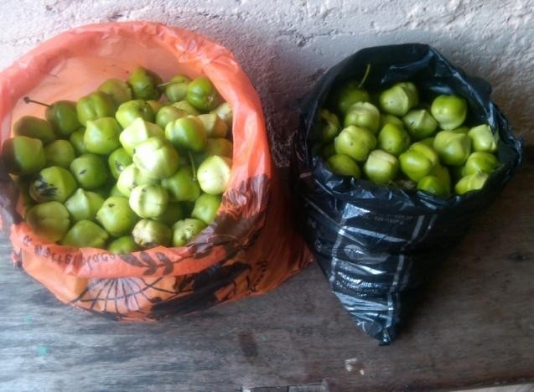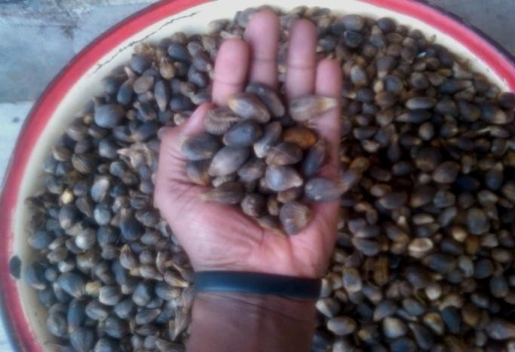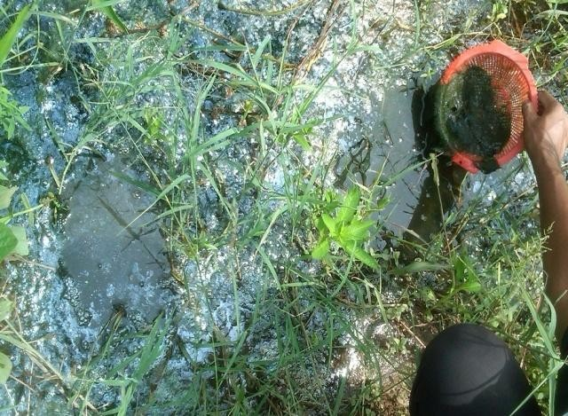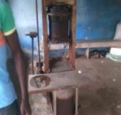

      - (b)

(c) (d)
Plate 3.2: Showing an array of the samples in their natural state when collected from their different sources-
(a) Matured dry Moringa pods; (b) Showing some of the polythene bags that were used to collect fresh matured Thevetia fruits; (c) Decorticated dry palm kernel nuts (Inset: Oil mill, Teaching and Research farm, University of
Ibadan); (d) Spirogyra filaments being harvested from the water course.

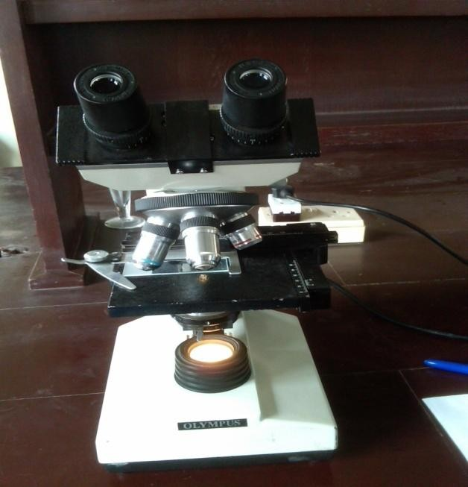Plate 3.3: Picture of the Light Microscope used for morphological assessment of the Spirogyra filaments

Materials and Methods
    - Materials
The following materials were utilized in this study: Miller, Mortar & pestle, Weighing balance, Oven, Dessicator, Filter papers, Soxhlet extractor, Muslin fabric, Centrifuge, 20ml and 50ml air tight plastic bottles, Erlenmeyer flasks, Water bath, Conical flasks, Test tubes, Beakers, Spatula, Cotton wool, Aluminum foil, Retort stand, pH meter, Magnetic stirrer with hot plate, Separating glass funnel, Rota-evaporator, etc.

Consumables
The following consumables were utilized in the course of the experiment: n-Hexane (99.0% purity; 0.659g wt per mL @ 20ºC), 99.5% methanol, 0.5M NaOH and Sulphuric acid. Other consumables include Detergent and Distilled water.

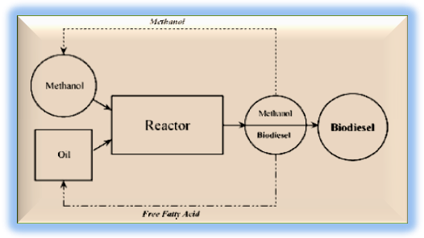All reagents that were used for the experiments were of analytical grade and were purchased as industrial-sealed products from Juliemak (Nig) Enterprises, N0 100, Yemetu-Adeoyo road, opposite Kitchenette Palladium, Yemetu, Ibadan, Oyo state, while some few others were obtained from the Department of Environmental Health Sciences Laboratory, Faculty of Public Health, College of Medicine, University of Ibadan, Oyo state.

Laboratory Methods
The operations that were undertaken in this experimental work (summarized in Fig. 3.1) include:
- Sample processing
- Substrate preparation and characterization
- Oil extraction
- Characterization of the extracted oils
- Transesterification process
- Phase separation and Purification process
- Determination of biodiesel yield
- Characterization of the biodiesels

Substrate preparation & Extraction of oils + Characterization studies
Determination of Biodiesel yield + Characterization studies

Transesterification reaction
Fig 3.1: A simple flow chart of the major steps involved in the experimental work

Sample Processing
      - Decortications and Sun-drying
The dry moringa pods were manually unshelled with hand, while the brown-winged seeds were decorticated with knife (while taking care not to cut the seeds in the process). The thevetia fruits

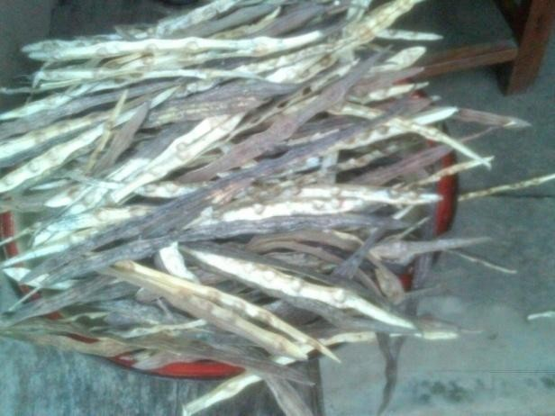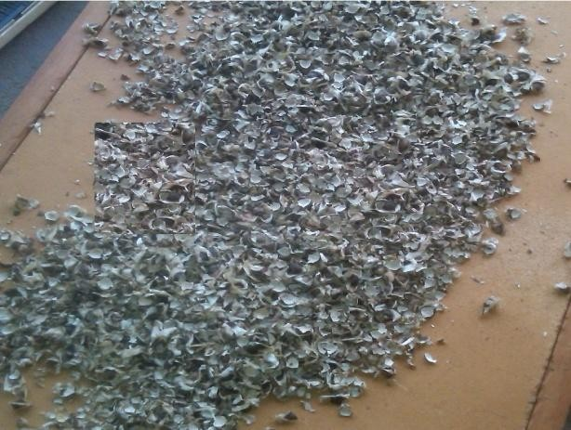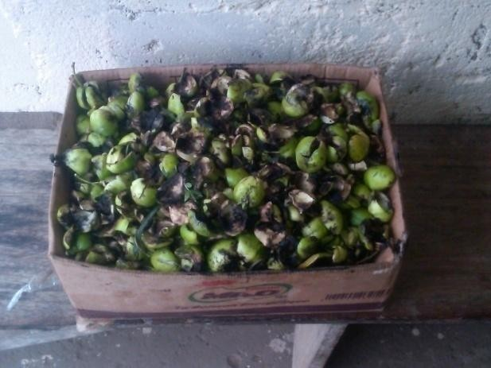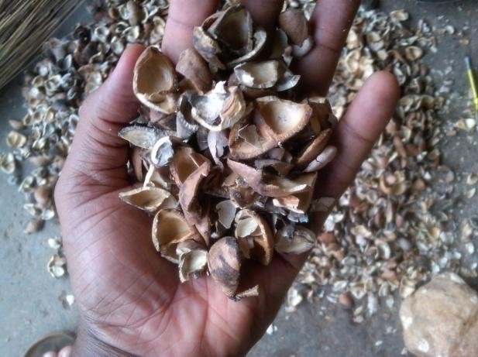were manually decorticated with knife to reveal the kernels, which were dried in continuous sunlight for about 5 hours and subsequently decorticated with stones to reveal the seeds. The decorticated dry palm kernel nuts were unshelled manually with stone to reveal the embedded seeds. The pods/shafts obtained from the decorticated biomasses (Plate 3.4) were discarded. The weight of the seeds from each of the substrates was measured using a Top-loading balance and recorded as wet weight-W₁.

All the decorticated/unshelled seeds were then individually spread on trays or drying slab, subjected to sundrying for about 48 hours intermittent sunlight, and then allowed to air-dry for about a week (Plate 3.5).

        - (b)

(c) (d)
Plate 3.4: Pictures of decorticated biomasses-(a) Detached moringa pods/shafts (b) Detached moringa brown-winged shafts (c) Decorticated thevetia flesh (d) Broken/empty thevetia kernels

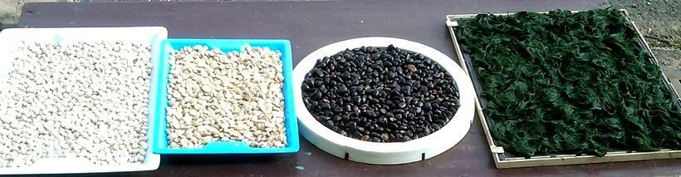

Plate 3.5: Showing an array of the different substrates prepared for sundrying

In the case of the Spirogyra biomass, the sample was prepared according to the method of Fuad et. al., 2010. The filaments were gradually rinsed with fresh water in a basin to remove all extraneous materials/debris/sediments e.g. plant materials or residues, sand particles, scum, and macro-invertebrates like water snails, tadpoles, insects, etc. (Plate 3.6).

The clean filaments were then drained off water by packing them in the sieve and pressing down gently until water stopped dripping. These were then spread on a slab and air-dried for about a day. The weight of these filaments was then measured and also recorded as wet weight-W₁. The filaments were also subsequently spread on a drying slab (Plate 3.5), sundried for about 24 hours intermittent sunlight and allowed to air-dry for about a week.

All the sundried samples were thereafter taken to the laboratory and the weight of the individual samples were measured using a Top-loading balance and recorded as sundried weight-W_{s}.

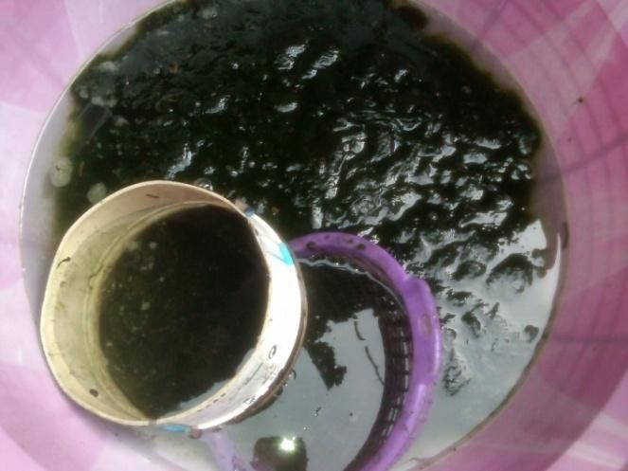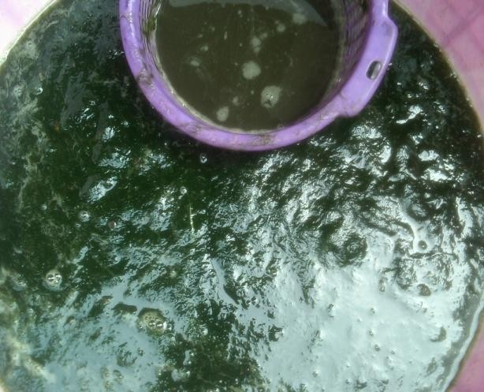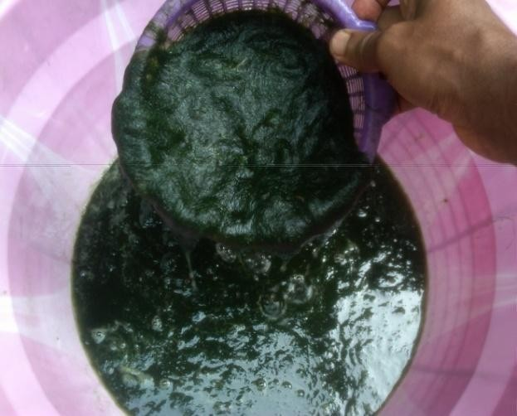

(a) (b)

(c) (d)
Plate 3.6: Showing the rinsing of Spirogyra biomass to remove extraneous materials-(a) Commencement of the filaments rinsing; (b) Showing the nature dirt in the biomass from the colour of water in the purple sieve; (c) Relatively clean spirogyra biomass (d) Part of the extraneous materials
removed from the biomass

Milling and Oven-drying
The sundried samples of moringa and thevetia seeds were ground using a hand-powered bench grinder (Plate 3.8b); the sundried sample of palm kernel seeds were ground using a fuel-powered domestic grinder (Plate 3.8c); while the sundried spirogyra filaments were pulverized using a dry mill blender (IKA®A11 BS2 model) that is equipped with a stainless steel cutting blade (Plate 3.8a); to granular form that would expose a larger surface area of the substrates for enhanced extraction of oil from them (Plate 3.7).

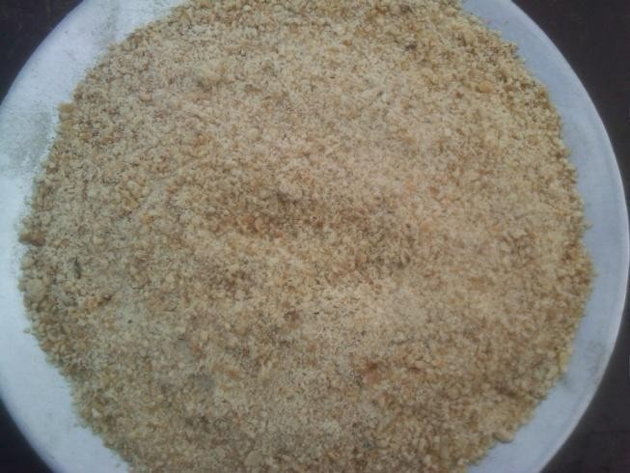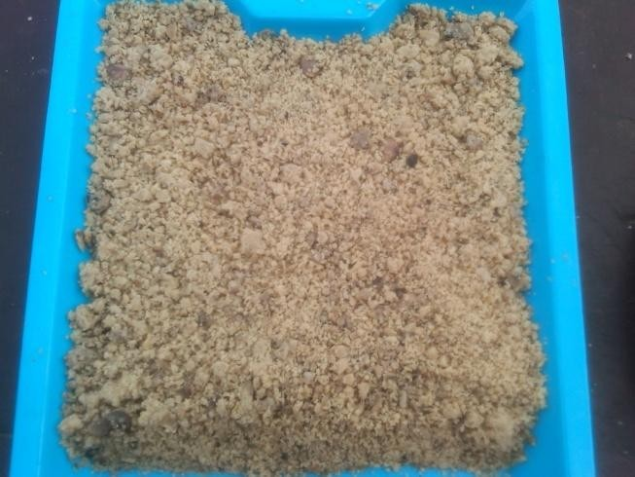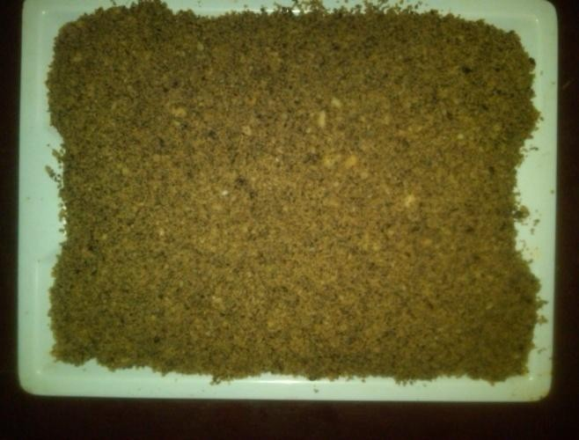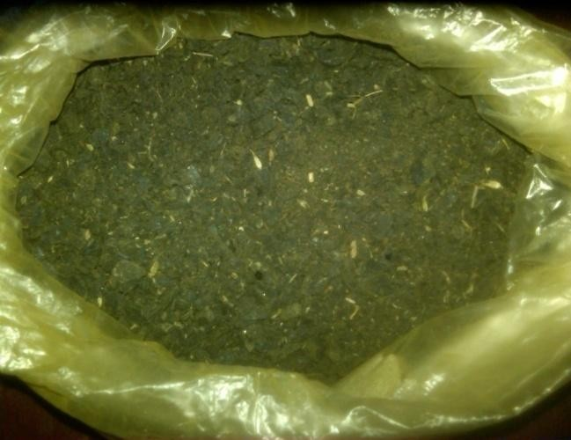The ground/pulverized substrates were respectively weighed (in clean empty crucibles that have been tare) and then subjected/left to oven-dry at 105ºC for an intermittent period of 48 hours. The drying temperature of 105ºC and the extended period of 48 hours were chosen to ensure that the weight loss was because of water losses and not losses of organic matter through volatilization (NEH, 2000).

During the oven-drying period, the weights of the respective substrates were measured at intervals until there was no longer loss of water-weight. When this point of nil water-weight loss was reached, the oven-dried substrates were put in a dessicator for about 30 minutes to cool. Thereafter, the weight of the substrates were taken again and recorded as dry weight-W₂.

        - (b)

(c) (d)
Plate 3.7: Showing an array of sundried milled substrates (a) Milled moringa seeds (b) Milled thevetia seeds
(c) Milled palm kernel seeds (d) Milled spirogyra biomass

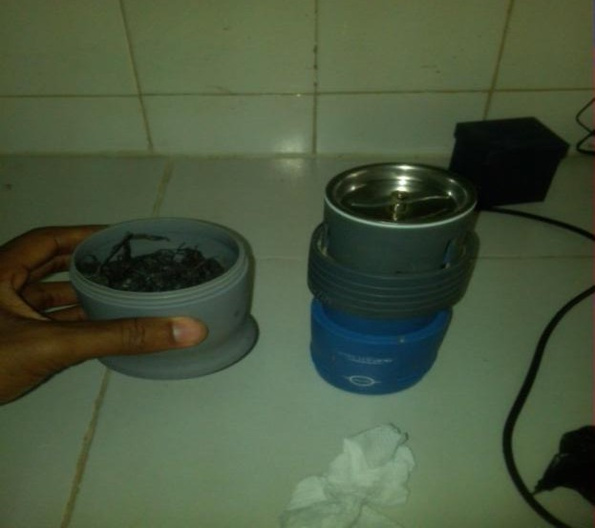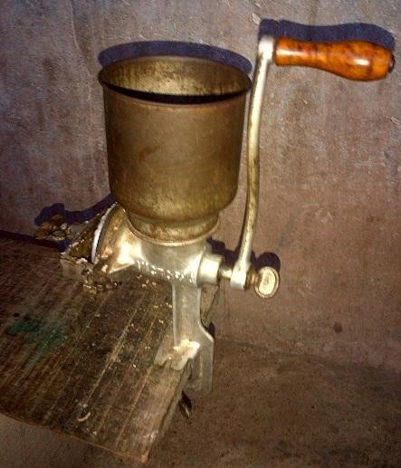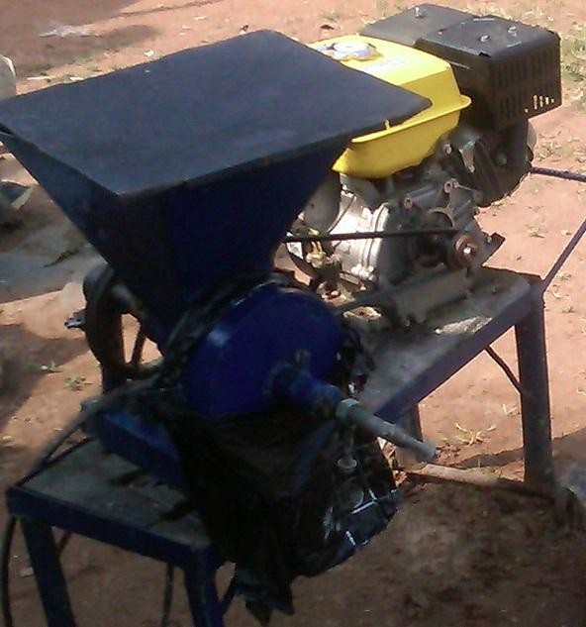

(a) (b) (c)
Plate 3.8: Showing the instruments used for pulverization/milling-(a) Miller (IKA®A11 BS2 model); (b) Hand- powered bench grinder (c) Fuel-powered domestic grinder

Substrate Preparation and Characterization
Each of the milled substrates (i.e. seeds of Palm kernel, Moringa, Thevetia and Spirogyra biomass) utilized in this experiment was weighed using a Top-loading balance (AИD EK-410i model) which has a maximum limit of 400 g and sensitive enough to read as low as 0.01g of a substance (Plate 3.9). Once the balance was tare with a measuring container, the respective biomasses were scooped using a spatula in a stepwise mode unto the aluminum foil or any other container placed on the balance until the meter reads the desired quantity.

All weighing were carried out in the balance room of the laboratory where the ambient environmental conditions such as temperature, pressure, relative humidity, air speed, etc, were relatively stable.

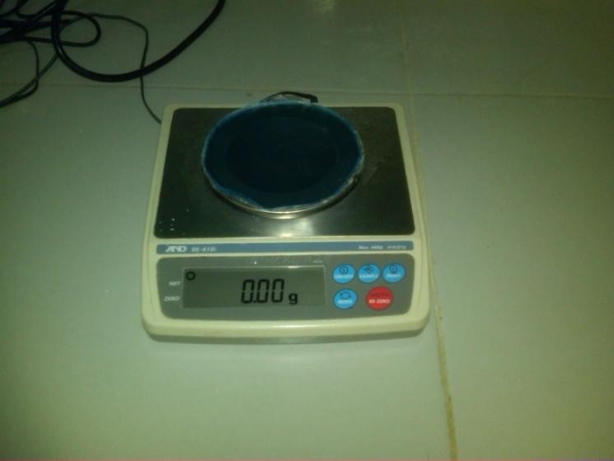Plate 3.9: Showing the AИD EK-410i model Top-loading balance

Determination of Moisture Content
Moisture content can be expressed on a wet basis, dry basis, or as the fixed solids content (NEH, 2000). The moisture content as expressed on a wet basis gives the percentage of the original wet sample that is water. This is useful for determining whether a dry matter is sufficiently dry.

Moisture content expressed on a dry basis denotes the moisture content as a percentage of the sample after it has been dried. The content remaining after a sample has been dried is known as the total solids. Because a dry sample is defined as the total solids of a sample, the dry basis moisture can also be expressed as units of moisture per unit of total solids. Dry basis moisture is useful when calculating moisture changes.

Fixed solids are defined as the weight remaining after ignition of the total solids at 600 degrees Celsius until complete combustion (NEH, 2000).

For the purpose of this work, the percentage moisture in the substrates was determined using two different methods: First, the oven-drying method (Section 3.6.1.2) was used for the moisture content determination (% wet basis), where the formula below was used for the calculation:

Moisture content = (W₁ – W₂) × 100% Formula 3.1
W₁
where W₁ = Original weight of the fresh sample before any drying, W₂ = Weight of the sample after oven drying.
  - : The weight of the container used in measurement is negligible because the weighing balance is always tare with the weight of the container before any measurement takes place.

Secondly, the moisture content was determined using a Moisture Analyzer device, which contains a Super Hybrid Sensor (SHS) (Plate 3.10). It is an automated device which is simple to use, and displays both the percentage moisture content of the biomass, the temperature at which the reading was done and the time range of exposure of the sample to the heating process.

The substrate was measured unto the aluminum foil sample holder of the device in a stepwise fashion until the LCD screen displayed 5 g (which was the required quantity of substrate to be loaded on the sample holder). The sample holder containing the substrate was then covered with a thin glass fiber material to ensure that the sample did not get burnt in the heat-to-dryness operation of the device.

This is because, if burning (carbonization) occurs during drying, the results are not valid because organic matter is also lost in addition to the water. Then the lid of the device was closed and the start button was pressed. Once the device was through with the moisture content determination, it displayed the results of the analysis on the screen to be read. The process was done in triplicate for each of the biomasses

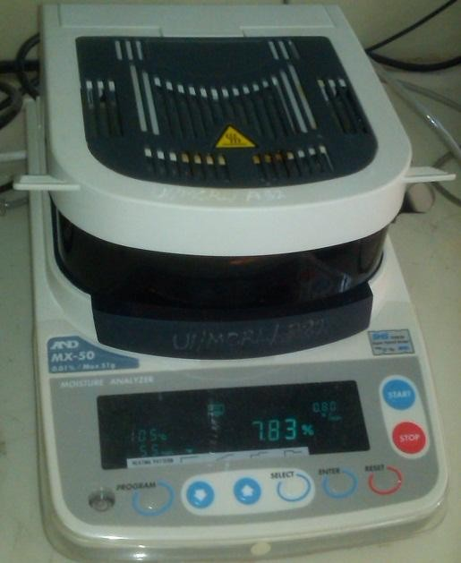Plate 3.10: Picture of the Moisture Analyzer (AИD MX-50 model) device

Determination of Relative density
The density (and hence, Relative density) of the biomasses was determined by using the simple weight to volume ratio estimation using weighing balance and measuring cylinder.

Principle: All matter has mass and volume. Mass and volume are the physical properties of matter and may vary with different objects. The amount of matter contained in an object is called mass. Its measure is usually given in grams (g) or kilograms (kg). Volume is the amount of space occupied by an object. The units for volume include liters (L), meters cubed (m³), and gallons (gal).

The mass of a unit volume of a substance is called its density.

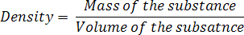………………….Formula 3.2

If D is the density of a body of mass M and volume V, then

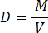 In S.I unit, density is expressed in kg/m³ or g/cm³.

Relative density of a substance is defined as the ratio between the density of the substance to the density of water at 4ºC. Relative density is also known as specific gravity but the term "relative density" is often preferred in modern scientific usage. The relative density of a substance is a pure number without any unit. It tells how many times a substance is heavier than water.

The density of the biomasses was determined at room temperature using the weight to volume (w/v) ratio, wherein a measuring cylinder was used to determine the compacted volume of the milled biomasses and a weighing balance was used to determine their weights. This was done in triplicates for each of the substrates using different weight to volume ratios, and the results expressed in g/cm³.

Relative density (R.D) of a substance can be calculated by dividing density of a substance with the density of water. In SI units, the density of water is (approximately) 1000 kg/m³ or 1 g/cm³, which makes relative density calculations particularly convenient: the density of the object only needs to be divided by 1000 or 1, depending on the units.

…..Formula 3.3

Elemental composition determination (Proximate Analysis)
Plant analysis may be regarded as the study of the relationship of the nutrient/elemental composition of plant with respect to certain predefined parameters such as the effects that these elements could mediate in vitro when the plant materials are utilized in experiments.

Phosphorous, calcium, and magnesium, for example, are minor components typically associated with phospholipids and gums that may act as emulsifiers (ASTM Standard D6751, 2009) or cause sediment, lowering yields during the transesterification process (Gerpen et. al., 2004). Hence, plant analysis (in the context of biofuels such as biodiesel) requires the determination of

the level of certain mineral element constituents of the plant tissues that are to be used for the production of the biodiesel.

Such mineral elements might have been implicated to affect any of the stages in the biofuel production processes, hence their percentage composition need to be measured so as to determine the best methods that could be used to derive optimal yield from processing the biomasses. The procedures used in plant analysis include: the conversion of the organic form of the nutrient to the inorganic forms; and the determination of the nutrient element in the extract by an appropriate method.

The conversion of the organic form of the element to the inorganic form is generally done by either dry digestion method or by wet digestion method. Dry ashing involves the sample being heated to a high temperature without the addition of any reagent. Dry ashing is not however suitable for the determination of volatile elements such as Sulphur, Arsenic and Selenium. However for this work, wet digestion was used for organic matter destruction in the biomasses prior to elemental analysis as described below.

Wet (organic matter) digestion
Principle: The wet digestion procedure was carried out according to the method described by Owen, 1992. Wet digestion involves the destruction of organic matter through the use of both heat and acids. Acids that have been used in these procedures include H₂SO₄, HNO₃, and HClO₄, either alone or in combination. Hydrogen peroxide (H₂O₂) is also used to enhance reaction speed and complete digestion. Most laboratories have eliminated the use of HClO₄ due to risk of explosion. Safety regulations require specially designed hoods where HClO₄ is utilized. Hot plates or digestion blocks are utilized to maintain temperatures of 80 – 125 ºC. After digestion is complete and the sample is cooled, the vessel is filled to volume and dilutions are made to meet analytical requirements.

Apparatus: Hot plate, block digester, fume hood and 200 mL tall-form beakers or digestion tubes.

Reagents: Deionized water, conc. Nitric acid (HNO₃), conc. Sulphuric acid H₂SO₄) and 30% Hydrogen peroxide (H₂O₂).

Procedure: 1 g of dried plant material that has been ground (0.5-1.0 mm) and thoroughly homogenized was weighed and placed in a digestion tube. 5.0 mL concentrated HNO₃ was added and a funnel was placed in the mouth of digestion tube and allowed to stand overnight or until frothing subsided. The digestion tube was placed into a block digester and heated at 125ºC for 1 hour. The digestion tube was removed and allowed to cool. 2 mL of 30 % H₂O₂ was added and digested at the same temperature (i.e. 125 ºC). Heating and 30 % H₂O₂ additions were repeated until digest was clear. Additional HNO₃ was added as needed to maintain a wet digest. After sample digest was clear, the funnel was removed and the temperature lowered to 80 ºC. The heating was continued until near dryness. The residue became clear white indicating that digestion was completed. Dilute HNO₃ and deionized water was then added to dissolve the digest residue and bring sample to final volume depending upon requirements of subsequent analytical procedures.

The percentage composition of the following elements were determined in the fresh milled substrates: Total Organic Carbon (T.O.C), Total Nitrogen (TN), Total Phosphorus (TP), Sodium content (Na), Calcium content (Ca) & Sulphur content (S). Samples were generally analyzed chemically according to the official methods of analysis described by the Association of Official Analytical Chemists (A.O.A.C., 1998). All analysis and/or readings were carried out in triplicates.

Total Organic Carbon determination
This was measured using the Walkley-Black Wet Oxidation method (1934).

Apparatus: Automatic burette, Conical flask and Pipette.

Reagents: Std. Normal K₂Cr₂O₇, Std. Normal Fe(NH₄)(SO₄)₂ and Diphenylamine indicator.
        - Preparation of Standard Normal Potassium dichromate: K₂Cr₂O₇ was oven dried at 130-150ºC for 2-3 hours. It was cooled in a dessicator; 49.035 g of the dried salt was

weighed out; this was dissolved in about 950 ml of distilled water, and placed in a cool place overnight. When cool, it was made up to 1000 ml with cold distilled water.

        - Preparation of Standard Normal Ferrous Ammonium Sulphate: 156.86 g of Fe(NH₄)(SO₄)₂ was weighed out and dissolved in about 900 ml of distilled water. 25 ml of conc. H₂SO₄ was added and allowed to cool. It was made up to mark with distilled water and standardized using normal Potassium dichromate.
        - Preparation of Diphenylamine indicator: 1g of Diphenylamine was dissolved in 200 ml of 1:1 solution of water and H₂SO₄.

Procedure: 3 g of the sample was weighed (depending on how deep the colour of the analyte was), and unto this was added 10 ml of 1N K₂Cr₂O₇ from an automatic burette. 20 M conc. H₂SO₄ was then gently added into the mixture from a dispensing burette. The mixture was shaken gently and left to cool. Afterwards, distilled water was added to make up to the 150 ml mark on the conical flask. Thereafter, about 8-10 drops of diphenylamine indicator was added, and the colour changed to dark violet. This solution was then titrated against 0.4N Fe(NH₄)(SO₄)₂ until the violet colour changed to green. A duplicate blank determination was carried out on 10ml of the Normal K₂Cr₂O₇ using all the reagents each time a set of determination was done.

Calculations: Let y be the volume in milliliters of the 0.4 N Fe(NH₄)(SO₄)₂ used to react with the remaining K₂Cr₂O₇ which is 0.4y. For example, since 10 ml of K₂Cr₂O₇ was used in the first place, then the amount used to oxidize any carbon in the sample will be (10-0.4y). 1 ml of K₂Cr₂O₇ = 0.003 g carbon. However, the reaction is only approximately 75 % complete.

Therefore, 1 ml of K₂Cr₂O₇ = 0.003 × 100 = 0.004 g
75
That is, % Total Organic Carbon (TOC) = (10 – 0.4 × T.V) × 0.004 ×100
in sample (hydrosylate) Wt of sample taken where T.V = Titre value

….Formula 3.4

Total Nitrogen determination
The Total Nitrogen in the substrates was determined by the routine Semi-micro Kjeldahl technique. This technique consists of three major stages viz: Digestion, Distillation and Titration.

Apparatus: Weighing balance, Digestion tubes, Digestion block heater, 50 ml burette, 5 ml pipette, 10 ml Measuring cylinder, 100 ml Beakers, and Fume cupboard.

Reagents: Conc. H₂SO₄, 0.01 N HCl, 40 % (w/v) NaOH, 2 % Boric acid solution, Methyl red Bromocresol green mixed indicator, Kjeldahl catalyst tablet.

Procedure:
- Digestion: 0.5 g of each milled substrate was weighed carefully into the Kjeldahl digestion tubes to ensure that all the sample materials got to the bottom of the tubes. To these were added one (1) Kjeldahl catalyst tablet and 10 ml of conc. H₂SO₄. These were set in the appropriate holes of the Digestion block heater that have been positioned in a fume cupboard. The digestion was left on for four (4) hours, after which a clear colourless solution was left in the tube. The digest was cooled and transferred into 100 ml volumetric flask, thoroughly rinsing the digestion tube with distilled water and the flask was made up to mark with distilled water.

- Distillation: This was done with Markham distillation apparatus, which allows volatile substances such as ammonia to be steam-distilled with complete collection of the distillate. The apparatus was steamed out for about ten (10) minutes. The steam generator was then removed from the heat source to the developing vacuum to remove condensed water. The steam generator was then placed on the heat source (i.e. heating mantle) and each component of the apparatus was fixed up appropriately.

A 5 ml portion of the digest above was pipette into the body of the apparatus via the small funnel aperture. To this was added 5 ml of 40 % (w/v) NaOH through the same opening with the 5 ml pipette. The mixture was steam-distilled for 2 minutes into a 50 ml conical flask containing 10 ml 0f 2 % Boric Acid plus mixed indicator solution placed at the receiving tip

of the condenser. The Boric Acid plus indicator solution changed colour from red to green showing that all the ammonia liberated had been trapped.

- Titration: The green colour solution obtained was then titrated against 0.01 N HCl contained in a 50 ml burette. At the end point or equivalent point, the green colour turned to wine colour, which indicated that all the Nitrogen trapped as Ammonium borate {(NH₄)₂BO₃} was removed as Ammonium chloride (NH₄Cl).

The percentage Nitrogen in the respective biomasses was calculated from the formula:

Titre value × Normality of HCl used × Atomic mass of N
%N = × Volume of flask containing the digest × 100
2000

…….Formula 3.5

Total Phosphorus determination
Phosphorus was determined the Vanadomolybdate (Yellow) Colorimetric Method or Spectrophotometric method.

Apparatus: Colorimeter/Spectrophotometer, 50 ml Volumetric flask, 10 ml Pipette, Whatman filter paper, Funnel, Wash bottle, Glass rod, Heating mantle, Crucibles, Weighing balance and Flame photometer.

Reagents: Vanadomolybdate yellow solution, 2 M HCl
- Preparation of Standard Phosphate solution: 219.5 mg anhydrous KH₂PO₄ was dissolved in distilled water and diluted to 1000 ml; 1 ml = 10 ug PO₄³⁻P
- Preparation of Standard Calibration Curve: 10 ml of the standard Phosphate solution was placed in a 50 ml volumetric flask. 10 ml Vanadate-molybdate yellow solution was added and diluted to the mark with distilled water, stoppered and left for 10 mins for full yellow development. After 10 mins or more, the absorbance was measured versus a blank solution (using 15 ml, 20 ml, 25 ml and 30 ml). A graph of Absorbance against Concentration was drawn and the slope was calculated.

Procedure: 20 mg (0.02 g) of each milled substrate was digested by adding 5 ml of 2 M HCl solution to the hydrosylate in the crucible and heated to dryness on a heating mantle. 5 ml of 2 M HCL was added again, heated to boil, and filtered through a No 1 Whatman filter paper. 10 ml of the filterate solution was pipette into 50 ml standard flask and 10 ml of vanadate yellow solution was added; and the flask was made up to mark with distilled water, stoppered and left for 10minutes for full yellow development.

The concentration of phosphorus was obtained by taking the optical density (OD) or absorbance of the solution on a Spectronic 20 spectrophotometer at a wavelength of 470 nm. It is pertinent to note that the wavelength of 470 nm was used because ferric ion causes interference at lower wavelengths, especially at 400 nm.

The Percentage Phosphorus was calculated from the formula below:

%P = Absorbance reading × Slope × Dilution factor
1000
………….Formula 3.6

But Absorbance × Slope × Dilution factor = ppm/10,000 Hence, %P = ppm/10,000
Where, Absorbance = Reading obtained from the Spectrophotometer Slope = Result of the Standard curve
Dilution factor = Volume of the extract/weight of the sample

Calcium and Sodium determination
Wet ashing was used to digest the samples prior to the determination of the percentage calcium and percentage sodium present in the respective samples. Wet ashing is suitable for the determination of Ca, Mg, Na, K, Cu, Fe, Mn, Se and Zn in plant tissues, and may be applicable for the determination of other elements as well.

Apparatus: Fume cupboard, Berzelius beaker, 50 ml volumetric flask, Flame photometer

Reagents: Nitric acid (HNO₃), 70 % Perchloric acid (HClO₄) solution, 5 % (w/v) Lanthanum solution and a watch glass.

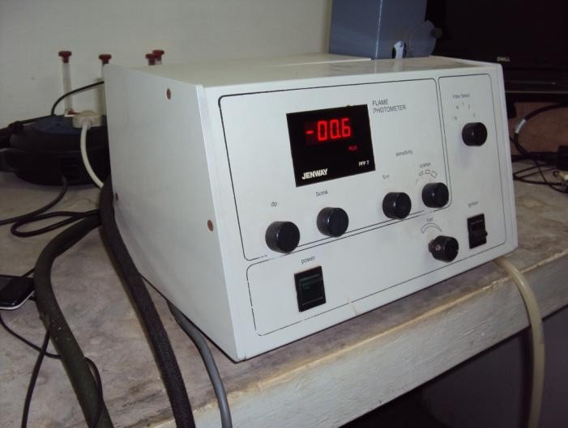

Plate 3.11: Picture showing the Jenway® Model PFP7 Flame Photometer

Procedure: 1 g of milled dried substrate was weighed into 100 ml Berzelius beaker; and 5ml of HNO₃ and 2 ml HClO₄ were added into the beaker. The mixture was covered with a watch glass, and digested in a fume cupboard, heating to dryness (since no volatile elements was required in this stage). 15 ml of deionized water was added and the digest solution was filtered through an acid-washed No 1 Whatman filter paper into a 50 ml volumetric flask. The filter paper was washed with deionized water and the filtrate made up to volume with the water.

Note: Because of contaminations from reagents used, it is advisable to add the same reagents in the blank. Also, as a precaution, nitric acid was added to the substrate sample before adding Perchloric acid to avoid any explosive reaction of Perchloric acid with the untreated organic material.

The filtrates were read with Jenway® Model PFP7 Flame Photometer (Plate 3.11) to determine the proportion of Ca and Na. This was done by setting up the flame photometer, aspirating the

blank solution into it and zeroing. Thereafter, a standard curve of calcium concentration against intensity was plotted. Then the sample solution was aspirated into the flame and the reading obtained recorded. But specifically (for Calcium estimation), the final solution of filtrate has 1 % (w/v) Lanthanum added to it

The sample‟s concentration was determined from the recorded reading on the calibration graph, and the determined concentration was multiplied with the dilution factor to obtain Percentage Calcium thus (and same calculation used to obtain Percentage Sodium):

% Ca = Absorbance reading × Slope × Dilution factor
1000
………….Formula 3.7

But Absorbance × Slope × Dilution factor = ppm/10,000 Hence, % Ca = ppm/10,000
Where, Absorbance = Reading obtained from the spectrophotometer Slope = Result of the Standard curve
Dilution factor = Volume of the extract/weight of the sample

Total Sulphur determination
This procedure was a modification of the Massoumi and Cornfield (1963) and the Chaudry and Cornfield (1966) methods. Sulfate-sulfur was precipitated in aqueous solution by adding barium chloride. The finely divided barium sulfate crystals remained suspended in the solution, diffracting light. The effect on light transmission through the solution was measured with a spectrophotometer.

Apparatus: A spectrophotometer with digital display capable of measuring absorbance to 0.001 was used. A vortex stirrer was used for uniform mixing.

Reagents:
- Acetic/phosphoric acid solution: 75 mL concentrated acetic acid was mixed with 25 mL concentrated H₃PO₄ and diluted to 1 L.

- Gum acacia solution: 5 g gum acacia was dissolved in 500 mL hot water. This was filtered hot through a Whatman No. 42 filter paper on a Buchner funnel using suction. This was then cooled and diluted to 1 L with acetic acid.
- Barium sulfate seed suspension: 18 g BaCl₂.2H₂O was dissolved in 44 mL hot water. Unto this was added 0.5 mL of the 2,000 mg S L-1 standard. The mixture was boiled and cooled quickly. 4 mL of the gum acacia solution was added and mixed well. This suspension was always prepared fresh whenever it is to be used.
- Barium chloride solution: 200 g BaCl₂.2H₂O was added to a 1 L volumetric flask. Enough hot water was added to dissolve. The solution was then cooled and diluted to volume.
- Standard sulfate solution (2,000 mg S L⁻¹): 1.0875 g of oven-dried K₂SO₄ was dissolved in
0.1 M HCl and diluted to 100 mL. Working standards containing 10, 20, 30, 40, 50, and 100 mg S L⁻¹ were prepared by diluting appropriate aliquots of this stock with demineralized water. New working standards were prepared fresh on each day of use.

Procedure: 1 mL aliquots of each standard and digested sample were pipetted into standard test tubes. Not more than 30 samples with a single set of standards were run. Unto this was added 22 mL of the acetic/phosphoric acid solution. The solution was mixed on a vortex mixer. Exactly
0.5 mL of the barium sulfate seed suspension was added. Thereafter, 1 mL of the barium chloride solution was added and each tube was mixed exactly the same length of time on a vortex mixer. 1mL of the gum acacia solution was added, and the solution was mixed again. The mixtures were allowed to set for 30minutes. Each sample was mixed uniformly just prior to reading absorbance or transmittance on a spectrophotometer set on a wavelength of 440nm. The wavelength was not critical since only light blockage and not absorbance by the barium sulfate suspension was measured. Absorbance or transmittance was plot against S concentration.

Oil Extraction
Materials: Measuring cylinder, Conical flask, Muslin fabric, Soxhlet extractor, Cotton wool, Weighing balance, Rotary evaporator, Oven, Dessicator, 50 ml and 100 ml Plastic bottles.

Reagents: n-Hexane (99 % purity) and Petroleum ether

Procedure: The milled, oven-dried biomass samples were used for the extraction process and two extraction methods were experimented viz: Soxhlet extraction and Cold solvent extraction. For the Soxhlet extraction, 250 g each of palm kernel seeds, moringa seeds and oleander seeds were respectively placed in the thimble of a Soxhlet extractor with the use of about 800 ml hexane (as extracting solvent) (Plates 3.12 b and c).

In the case of the algal biomass, a dual-phase Soxhlet procedure was used to extract 40 g of the Spirogyra biomass (20 g in each thimble) using 300 ml n-hexane (i.e. 150 ml n-hexane for each extraction set-up) (Plate 3.12d). The spirogyra biomasses were wrapped in a muslin fabric, and put into their separate thimbles respectively (Awolu et. al., 2013).

A round bottom flask containing the estimated sufficient n-hexane (800 ml as estimated from literatures) was fixed to the end of the extractor and a condenser was tightly fixed at the bottom end of the extractor. Once the respective sample for a particular extraction period was placed in the thimble of the extractor, the flask was heated at 60 ºC with the use of an electric mantle.

As the solvent was heated in the boiler, the pure vapor rose through a by-pass and into the top part of the Soxhlet container (thimble) where the sample to extract was contained. In the condenser, the vapors condensed and drip into the sample-containing thimble. When the level of liquid reaches the same level as the top of the siphon, the liquid containing the extracted material was siphoned back into the boiler.

Soxhlet extraction is recognized by the A.O.A.C as the standard method for crude fat analysis (Celine et. al., 2012). Extraction by Soxhlet is not a continuous procedure, but a batch system with repeated extractions. Each of the extraction processes carried out underwent a minimum of 40 cycles within the 8 hours period, which is considered necessary to complete an extraction (Barthet and Daun, 2004). After the extraction period, the residual biomass was weighed and recorded. The solvent was recovered at 65 ºC under vacuum using a rotary evaporator (Buchi Rotavapor:R-210 model) (Plate 3.19), and the respective residual oils obtained thereafter were also measured and recorded.

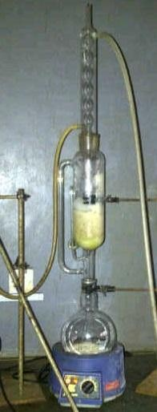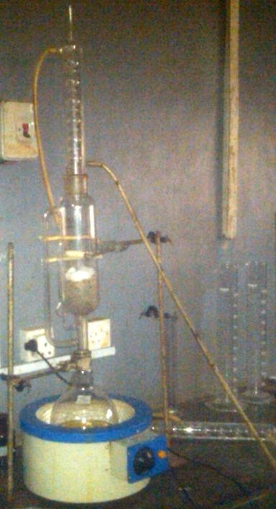
      - 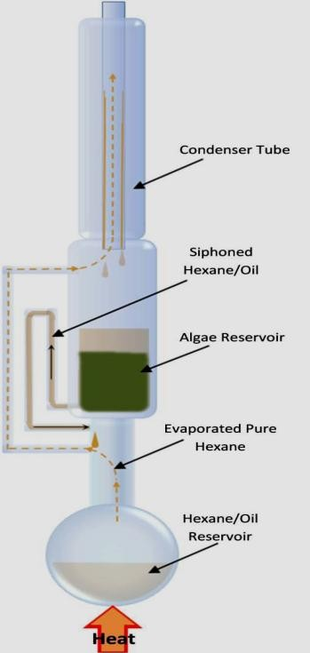(b) (c)

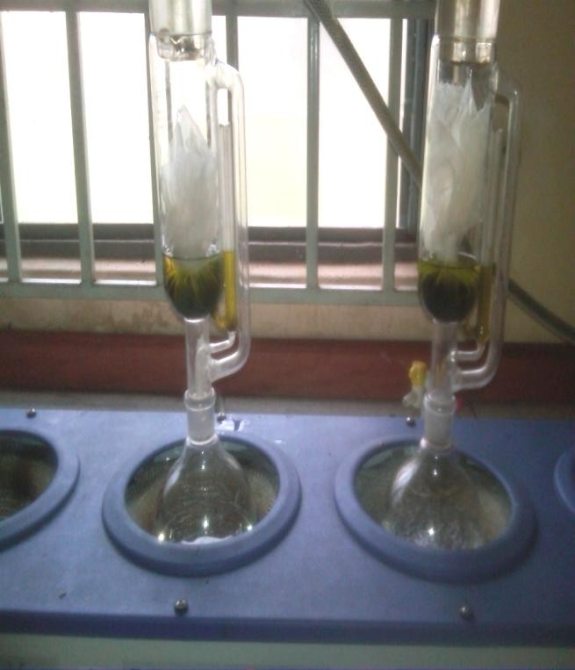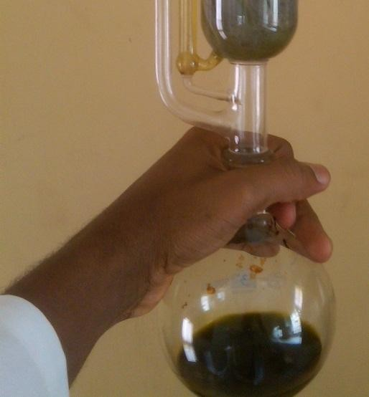
(d)
(e)
Plate 3.12: Showing the Soxhlet Extraction Systems-(a) Schematic diagram showing some parts of a Soxhlet extraction system; (b) & (c) Extraction of oil from the milled moringa and palm kernel seeds respectively; (d) Simultaneous extraction of algal biomass oil using two Soxhlet apparatus; (e) Picture of the round bottom flask containing a mixture of the extracted algal oil and little hexane solvent after the Soxhlet extraction.

For the Cold Solvent extraction, the method used by Hossain et. al., 2008, which was also used by Abd El-Moneim et. al., 2010, Emad, 2011 and Sangodare et. al., 2012 was modified. Two extraction-solvent systems (Figure 3.2 below) were experimented to compare the oil yield in each case and report the more suitable solvent system for the highest biodiesel yield (Afify et al., 2010).

A known weight of each of the ground dried palm kernel, moringa and thevetia substrates (250 g dry weight) was mixed with the extraction solvent mixtures viz: hexane/ether (600 ml, 1:1, v/v) and hexane only (600 ml). In the case of the algal substrate, 30 g dry weight of the biomass was mixed with the extraction solvent mixtures viz: hexane/ether (200 ml, 1:1, v/v) and hexane only (200 ml) (Plate 3.13 below).

All the different sample/solvent mixtures were kept to settle in their respective labeled and well- sealed plastic containers (cover lids further held air-tight with sellotape) for 48 hours, with intermittent shaking (every 3-5 hours) of the containers to enhance a better percolation/breakage of the solvent into the cell wall of the plant biomasses.

After the 48hour period was followed by the separation of the sample/solvent mixtures by “squeeze-filtration” using two muslin cloths inserted into each other as a precaution to better reduce the amount of sediment that may probably be small enough to pass through the sieve pores into the solvent/oil mixture (Plate 3.14 below).

The residual biomass (Plate 3.15 below) was collected, weighed and recorded after the complete “squeezing-out”/filtering-out of the oil/solvent mixture. The extracted oil/solvent mixture (which was still rather cloudy) was left to settle and air-dry for 24 hours. After this settling period, the extracted oil, which was still mixed with the extraction solvent, was seen on the upper layer of the sediments (that were in form of paste, possibly a mixture of gums, tannins, etc) (Plate 3.16 below).

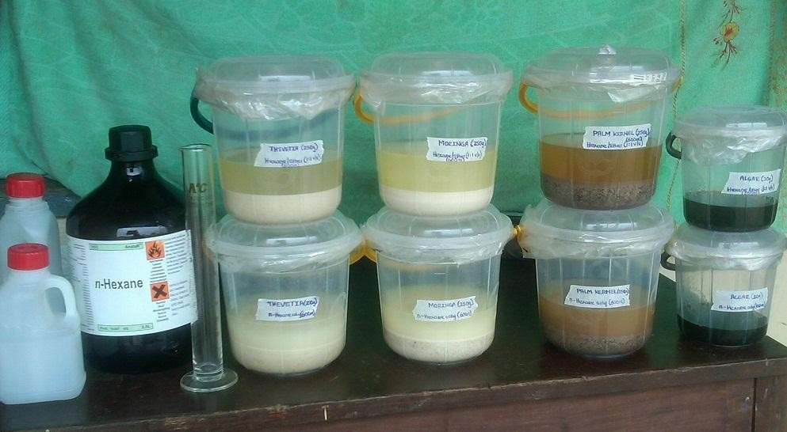
Solvent recovery (Optional)
Filtration; re-extraction (optional); & then evaporation
OIL
300 ml Hexane only and kept for 48 hours
600 ml Hexane/Ether (1:1, v/v) and kept for 48 hours
Oven-dried samples

Fig 3.2: Schematic representation of the steps involved in Cold solvent extraction using two solvent systems.

Plate 3.13: Showing an array of the different sample/solvent mixtures

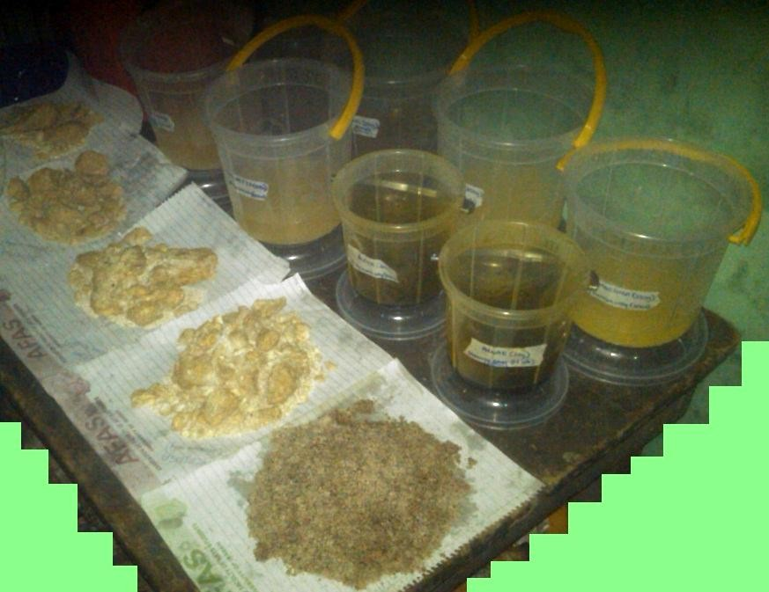

Plate 3.14: Picture of the Muslin sieves used

Plate 3.15: Showing an array of some of the residual biomasses obtained after the squeeze-filtration process

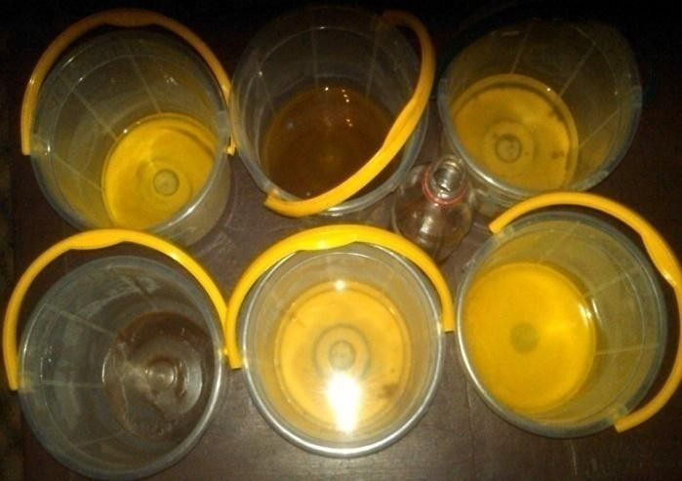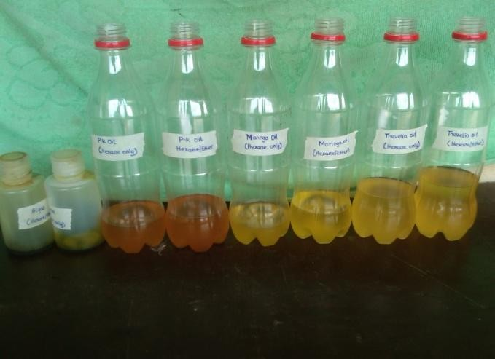

Plate 3.16: Oils suspended on the paste of sediments

Plate 3.17: Part of the decanted oils in labeled bottles

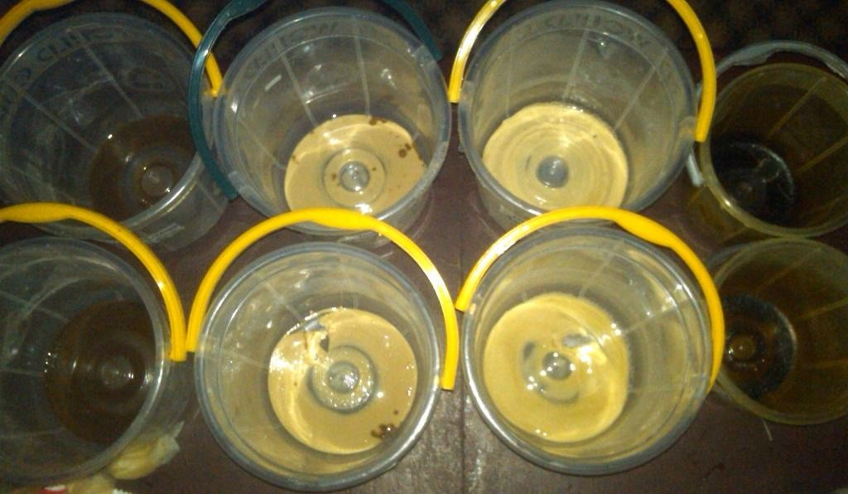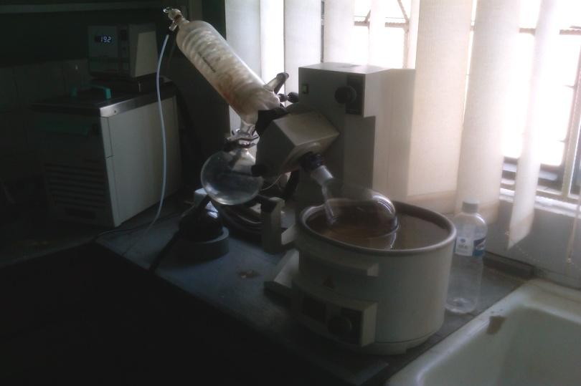

Plate 3.18: Residual paste of sediments left over after decanting the respective oils

Plate 3.19: Picture of the Buchi Rotavapor (R-210 model) concentrating the residual oil

The clear oils were then decanted through a No 1 Whatman filter paper into labeled bottles (Plate
3.17 above), leaving behind the residual paste/sediments (Plate 3.18 above). Each of the decanted oils were individually evaporated under vacuum for about 5 minutes at 60 ºC using the Buchi type Rotavapor (R-210 model) (Plate 3.19 above). This was to ensure that all the extraction solvents in the oils are evaporated off.

The residual oils obtained after evaporation were left to air-dry for about 2 hours; the volume and weight of the oils were subsequently measured and recorded. The weight and volume of the oils obtained from the different extraction methods; alongside the weight of the residual biomasses left-over from the extractions and the quantity of solvent used in each of the extraction methods for each substrate were measured and recorded. The oils were kept for characterization and further processing via transesterification process.

The proportion (%) of oil extracted from the different substrates by both the Soxhlet extraction and Cold extraction systems respectively was determined using equation below:

% Oil content = (W_{o}/W_{u}) 100 % Formula 3.8
where: W_{o} = weight of oil extracted
W_{u} = Weight of the oven-dried biomass used for the extraction process (g)

The weights of the residual oils obtained were taken and they were also characterized for: pH, Relative density, Free Fatty Acid (FFA) level, Fatty Acid Composition-FAC (otherwise called Fatty Acid Profile-FAP), Kinematic viscosity and Saponification value.

Characterization of Extracted Oils
      - Determination of pH
The pH of the sample oils was read using a calibrated Jenway® 3520 pH meter (Plate 3.20 below). The pH meter probe was inserted into the containers holding the respective oils, making sure it did not touch the inside wall of the containers. The pH reading was then taken from the LCD display after it had stabilized.

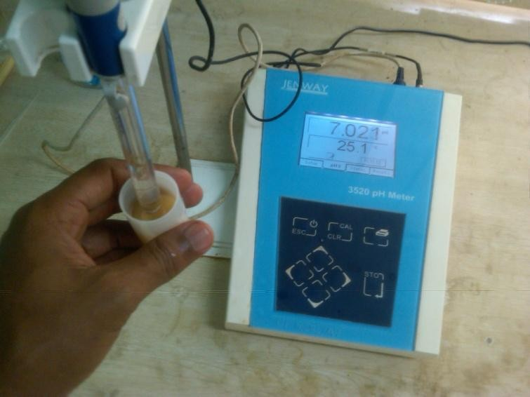Plate 3.20: Showing the pH of one of the oils being determined using Jenway® 3520 model pH meter

Determination of Relative density
The Relative density of the oils was determined at 25 ºC following the same method that was described in Section 3.5.2.2.

Determination of Free Fatty Acid level
Free Fatty Acid (FFA) level is a critical parameter that needs to be determined in oils because they can react with the catalyst during transesterification and lead to soap formation, emulsions, increased catalyst consumption and reduced catalyst efficiency; and these are undesirable factors in the production process (Knothe et. al, 2005).

Apparatus: Micropipette, 20 mL capacity screw-capped tubes, Centrifuge, and PerkinElmer® Clarus® 600 Gas chromatography.

Reagents: Arachidic acid, Chloroform, Dichloromethane, Diisopropylethylamine, Diethylamine, Bis (2-methoxyethyl) aminosulfur trifluoride, Hexane, Distilled water and Substrate oil sample.

Procedure: The FFA content was determined by selective formation of diethyl amide derivatives according to Kangani et. al., 2008. To do this, 0.45 mg arachidic acid (C20:0) in chloroform (150 μL) was added as internal standard before extraction. The extracted lipids were then dissolved in 750 μL dichloromethane and transferred into a screwcapped tube. After addition of 10 μL diisopropylethylamine and 30 μL diethylamine, the solution was cooled to 0 ºC. Bis (2-methoxyethyl) amino sulfur trifluoride (10 μL) was added dropwise and the solution was vortex mixed for 5 seconds.

The solution was kept at 0 ºC for 5 min, subsequently warmed to room temperature, and kept there for 15 min. Water (2 mL) and hexane (4 mL) were added and the tubes were vortex mixed for 1min. After centrifugation for 10 minutes at 2,000 rpm, the organic layer was collected and transferred into a vial for GC analysis. A blank analysis was performed by use of the same method, but without addition of bis (2-methoxyethyl) amino sulfur trifluoride.

The diethyl amide derivatives were analyzed with a Perkin Elmer® Clarus® 600 GC-FID equipped with a Supelco SP 2340 fused silica column (Sigma-Aldrich Co.), 60 m, 0.25 μm ID,
0.2 μm film thicknesses based on AOCS Method Ce 1c-89. The GC oven was heated to 150°C, ramped to 200 °C at 1.3 °C/min and held at 200 °C for 20 minutes.

A total volume of 1.0 μL was injected and split at a 100:1 ratio, the helium flow was 2.0 ml/min at 1.6 psi and the FID temperature was 210 °C. Samples were prepared and measured separately in triplicate. The area percentages from the output reading corresponding to the proportion (%) of each fatty acid were recorded with a TotalChrom® chromatography data system.

Determination of Fatty Acid Composition
The determination of Fatty acid composition, otherwise known as Fatty Acid Profile (FAP) was done according to the method described by Christie (2003) with little modifications.

Apparatus: Micropipette, 20 mL capacity screw-capped tubes, and PerkinElmer® Clarus® 600 Gas chromatography.

Reagents: Toluene, Sulphuric acid, Methanol, Sodium chloride (NaCl) solution, Hexane, Distilled water and Substrate oil sample.

Procedure: In the Methylation stage, which preceded GC analysis, 5 mg oil sample was dissolved in 1 mL toluene, and 2 mL of 1 % sulfuric acid in methanol was added. The mixture was left overnight in a stoppered tube at 50 ºC. Aqueous sodium chloride solution (5 %, 5 mL) was then added and the required methyl esters were extracted with 3mL hexane. Necessary dilutions were made before injection for GC analysis.

The fatty acid methyl esters (FAMEs) obtained were separated by gas chromatography in a PerkinElmer® Clarus® 600 GC-FID equipped with a Supelco SP 2340 fused silica column (Sigma-Aldrich Co.), 60 m, 0.25 μm ID, 0.2 μm film thicknesses based on AOCS Method Ce 1c-
89. The GC oven was heated to 150 °C, ramped to 200 °C at 1.3°C/min and held at 200 °C for 20 minutes. A total volume of 1.0 μL was injected and split at a 100:1 ratio, the helium flow was 2.0 ml/min at 1.6 psi and the FID temperature was 210 °C. Samples were prepared and measured separately in triplicate. Peak areas were quantified with TotalChrom® chromatography data system.

Determination of Viscosity
Kinematic viscosity (ѵ) is the measure of an oil‟s resistance to flow and shear under the forces of gravity. Dynamic viscosity (η) of oil is the ratio between the applied shear stress and rate of shear of the oil, and its value could be determined from the value of Kinematic viscosity once the density of the oil is known for a specific working temperature. Oil has a unique molecular structure, and larger molecules create greater resistance (higher kinematic viscosity). Highly viscous liquid flows less readily under the force of gravity.


Oil and/or biodiesel viscosity are one of the most important properties of these liquids because it brings out a fuel‟s capacity to lubricate moving parts. Incorrect viscosity leads to poor lubrication, and poorly lubricated machinery can quickly break down. The viscosity of the oils was predetermined for an easy comparison with that which was obtained for their corresponding biodiesels.

Apparatus: Cannon-ubbelohde viscometer, Temperature-controlled bath, and Temperature measuring device (in the range of 0 ºC-100 ºC).
Reagent: Chromic Acid Cleaning Solution, biodiesel samples

Procedure: The kinematic viscosity (ѵ) was measured following the established procedure in the ASTM D445. It was determined with the use of a calibrated Cannon-ubbelohde viscometer at a temperature of 40 ºC. The viscometer was placed in a temperature-controlled vessel equipped with a thermostat, which maintained the temperature with an accuracy of +0.1 ºC.

The density vs. temperature measurement was taken using a 25 CC pycnometer immersed in a temperature-controlled circulating water bath. The kinematic viscosity value at 40 ºC was determined by multiplying the measured flow time of the oil through the viscometer capillary with the calibration constant of the viscometer.

The Dynamic viscosity (η) was estimated by the product of Kinematic viscosity (ѵ) and the corresponding density (ρ) of the biodiesels at 40ºC using the following equation for the temperature: η = ѵ × ρ

Determination of Saponification value
Saponification is defined as the reaction of triacylglycerol (fatty acid esters) with an alkali (such as Sodium hydroxide or Potassium hydroxide) to produce Sodium or Potassium salt of the fatty acid and glycerol (Formula 3.9 below).

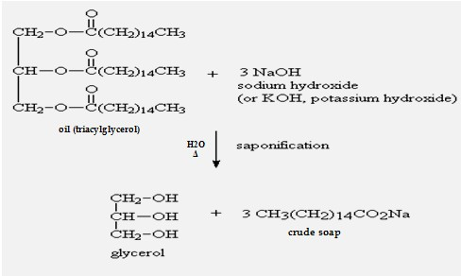

Formula 3.9: Showing a Saponification reaction process

Saponification value is the number of milligrams of KOH required to neutralize the fatty acids resulting from the complete hydrolysis of 1 g of fat or oil. It gives an indication of the nature of the fatty acids constituent of oil and thus, depends on the average molecular weight of the fatty acids constituent of the oil. The greater the molecular weight (longer carbon chain), the smaller the number of fatty acids that is liberated per gram of fat hydrolyzed and therefore, the smaller the saponification number and vice versa.

Apparatus: 3 ground neck Erlenmeyer flasks (250 mL capacity), Reflux condenser, Heating mantle, 50 ml volumetric Pipette, and 50 mL volumetric Burette.

Reagents: 0.7 N Alcoholic potassium hydroxide (KOH), Phenolphthalein indicator (1.0 % in Isopropanol), 1.0 N Sulfuric acid (H₂SO₄) and Substrate oil sample.

Procedure: 5 g of the substrate oil was weighed into a 250 mL ground neck Erlenmeyer flask. A second flask, which was left empty (i.e. without the sample) was also provided that served as blank. 50 mL alcoholic KOH was pipette into each of the 2 flasks and approximately 10 mL deionized (D.I) water was added to each of them. Then a boiling stone was put in the sample

flask. A condenser was attached to the sample flask and heat was applied to reflux on the heating mantle for 30 minutes. The blank flask was left to stand at room temperature.

At the end of the refluxing period, the flask was allowed to cool to 60ºC and the condenser was rinsed with about 10 mL D.I. water. The flask was thereafter removed from the condenser and the ground glass neck was also rinsed with about 10 mL D.I. water. 10 mL D.I. was then added to the blank flask. 1 mL Phenolphthalein indicator was added to the sample flask and blank flask and each of them was titrated with 1.0 N Sulphuric acid until a colourless endpoint was reached.

Saponification value = [mL(blank) – mL(sample)] × N(H₂SO₄) × 56.1
Wt of sample (in grams)
……….Formula 3.10

Transesterification Process
Materials: 200 ml Erlenmeyer flasks, 100 ml Conical, Beakers, Measuring cylinder, Weighing balance, Aluminum foil, Glass stirrer, Thermometer, and a Magnetic stirrer with hot plate.

Reagents: 99.5 % Methanol, 90 % Ethanol, 0.5 M NaOH, Distilled water

Procedure: The transesterification of Palm kernel, Moringa seed, Thevetia and Spirogyra oils were carried out with methanol-only and methanol/ethanol mixture (1:1) in the presence of NaOH as catalyst respectively (i.e. identical reaction conditions and production protocols would be used for each of the oils). This implies that each of the extracted oils was allowed to undergo a transesterification reaction using methanol-only (as the alcohol) and another one using methanol/ethanol (1:1 v/v) mixture (as the alcohol) respectively, with all other reaction conditions remaining the same.

The transesterification reaction (Section 2.12.1.2) for each of the oils was carried out at a 6:1 alcohol to oil molar ratio, 1 % weight of the oil of NaOH catalyst and 65ºC reaction temperature. The transesterification is a reversible reaction, thus the alcohol quantity is required to shift the equilibrium favorably. The alcohol to oil molar ratio, the weight percent of catalyst and the reaction temperature were chosen since they have been found to give optimal yields of alkyl ester from seed oils (Berchmans and Hirata, 2008).

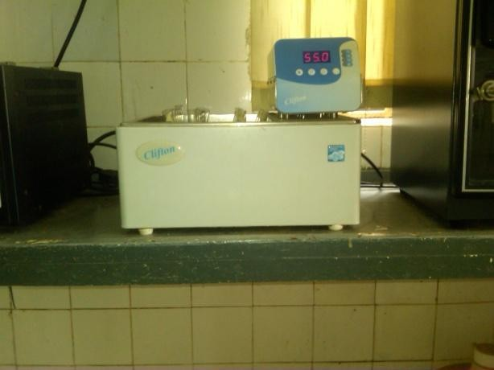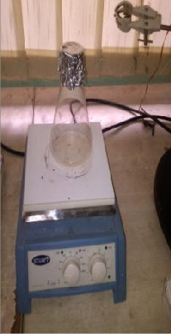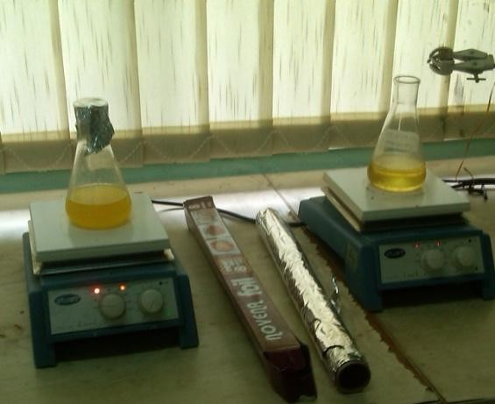An Erlenmeyer flask (500 ml capacity) was charged with about 100 g of the individual oils respectively (i.e. one substrate oil per production process) and warmed to a desired temperature of about 55ºC, which is less than the boiling point of methanol (65ºC) in a water bath (Plate 3.21a). While the oil was being warmed, a methanol quantity of 6:1 molar ratio of methanol to oil and an optimal weight of NaOH pellets (1 % weight of the oil) were mixed and heated in a separate flask to a desired temperature of 50ºC on the magnetic stirrer until the NaOH pellets were completely dissolved (Plate 3.21b).

The weight and volume of each of the oils used for the transesterification reactions were measured to enable a definite estimation of the quantity of alcohol (methanol and/or ethanol) and NaOH pellets that would be used in the respective reactions.

      - (b) (c)
Plate 3.21: Showing some of the preparatory stages preceding the transesterification reaction-(a) Picture of the water bath set at 55ºC (b) NaOH pellets mixed with alcohol placed on the hot plate (c) R-Warm oil placed on the magnetic stirrer with hot plate; L-Sealed flask with reaction mixture about undergoing transesterification.

After the complete dissolution, the beaker was taken-off the magnetic stirrer, and the Erlenmeyer flask containing the warm oil was removed from the water bath and placed on the stirrer (Plate 3.21c-R). The methanol-NaOH mixture (i.e. sodium methoxide) in the beaker was then added to the oil in the flask (including a corrode-resistant stir bar), the temperature of the hot plate was immediately increased to 65ºC and the revolution of the stirrer was set at level four (i.e. 400 rpm). The mouth of the flask was sealed with an aluminum foil to minimize alcohol evaporation during the conversion process (Plate 3.21c-L).

The reaction was allowed to continue for 1 hour, after which the stirrer was turned off, the stir bar was removed, and the content of the flask was immediately poured into a separatory funnel (Plate 3.22a). This procedure was repeated for each of the oils using the specific alcohol or alcohol-mixture and all other reaction parameters.

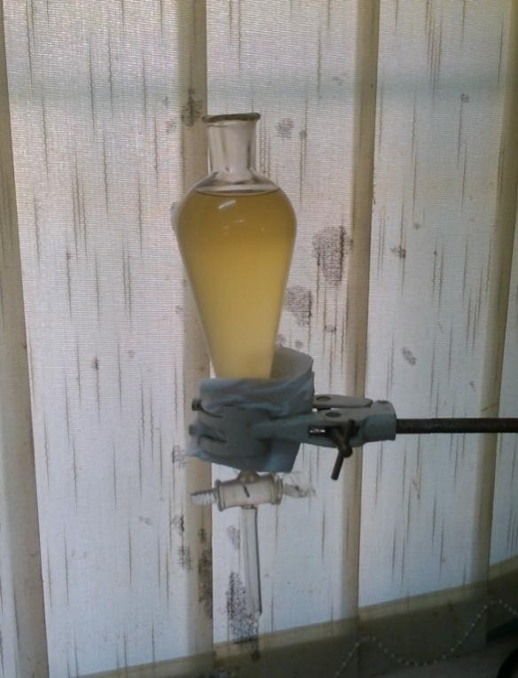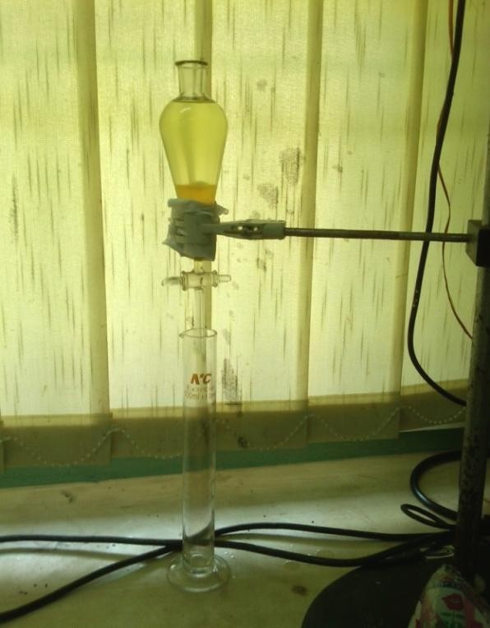Phase separation and Purification process (washing and drying)
Materials: Separatory flask, Measuring cylinder, LabPro pH tester, Wash bottle, Retort stands with clamp.

Reagents: Hot distilled water (about 60ºC) and 1M H₂SO₄ solution

Procedure: The transesterification reactions produced glycerol and methyl esters when they were completed as was later observed after phase separation (Plate 3.22b). These, being completely insoluble with one another, separated into two distinct phases when poured into a separatory funnel.

      - (b)
Plate 3.22: Showing a typical example of the reaction mixture obtained after transesterification reaction in a separatory flask-(a) Before separation (b) After separation

The impure glycerol settled at the bottom part of the funnel (as shown in Plate 3.22b above) and was thus drained out by the stopper at the bottom of the separator. The quantity of the glycerol impurity was measured using a measuring cylinder.

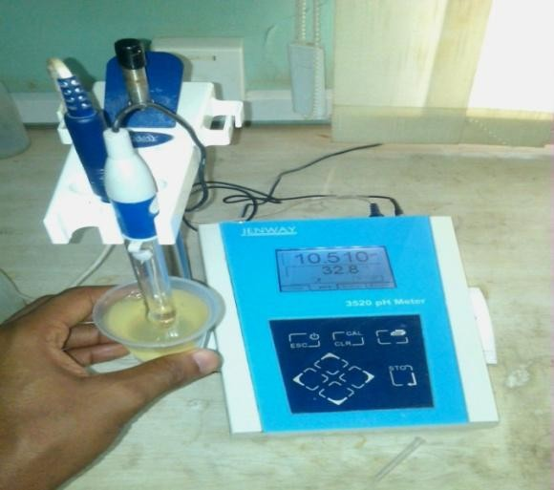A sample of the biodiesel remaining in the flask was thereafter taken and the pH determined (Plate 3.23). If found to be caustic i.e. alkaline (pH 8 and above), the biodiesel in the flask was washed with hot water (about 55ºC) and 0.1% acid solution. However, if found to be in normal pH range (of say like 7.0-7.5), then only warm distilled water was used in washing.

Plate 3.23: Showing the pH testing of a sample of one of the biodiesels

One third (¹/₃) as much hot distilled water as there is biodiesel was added in a stepwise fashion to the biodiesel in the flask. The water settles quickly at the bottom of the flask and was subsequently drained out as it settles. The washing continued in the stepwise fashion until the water settling at the bottom of the flask was visibly clear; and until the time it took for the water to separate from the biodiesel was < 30 minutes.

A sample of the biodiesel was again taken and the pH determined using a pH meter to verify that the biodiesel is neutral (pH 7 + 0.1) as exemplified in Plate 3.23 above. Thereafter, the biodiesel was observed from all angles to make sure there were no particles in the fuel. The biodiesel was then heated at 100ºC for 15 minutes, air-dried for about 30minutes, and then bottled and kept for characterization studies.

Determination of Biodiesel Yield
The biodiesel yield (% wt) after the post-treatment stage, relative to the amount of the different substrate oils poured into the flask for each of the alcohol parameters used viz: Methanol-only transesterification yield and Methanol/Ethanol mixture transesterification yield was calculated from the equation below:

Biodiesel yield = Volume of biodiesel produced × 100 %
…
Volume of oil used
…...Formula 3.11

The biodiesels obtained were characterized for Relative density, Flash point, Cloud and Pour points (using the Freezer test), Viscosity, Acid value and Elemental composition. These parameters were compared with European (EN) standard and American Standard for Testing and Materials (ASTM) (Table 3.1 below); while Table 3.2 highlights some key parameters of conventional diesel fuels as compared to unblended (or B100) biodiesel.

Table 3.1: Showing the ASTM and EN Guidelines for Biodiesel Fuels
Fuel properties ASTM guideline (D6751) EN standard (EN 14214)

 | Limits |  | Method | Limits |  | Method
Density (g/cm³) | Unspecified |  | D287 | 0.860-0.900 @ 15ºC |  | EN ISO 3675/12185
Kinematic Viscosity  @ 40ºC (mm²/s) | 1.9-6.0 |  | D445 | 3.5-5.0 |  | EN ISO 3104
Flash point (ºC) min. | 130 |  | D93 | 101 |  | ISO/CD 3679
Acid value (mg KOH/g) max. | 0.8 |  | D664 | 0.5 |  | EN 14104
Phosphorus content max. | 0.001% | or | D4951 | 0.001 % or |  | EN 14107
 | 10 mg/kg | 10 mg/kg
Alkaline earth metal content (Ca + | - | - 0.00005 % or 5 mg/kg |  |  |  | EN 14108 EN 14109
Mg) max.
Alkaline metal content (Na + K) max. | - | - 0.00005 % or 5 mg/kg |  |  |  | EN 14108 EN 14109
Sulphur content max. | 0.05% or |  | D5453 | 0.001 % | or 10 mg/kg | EN ISO 14596
 | 500 mg/kg
Cloud point (ºC) | Report to |  | D2500 | - |  | -
 | customer
Pour point (ºC) | - |  | - | - |  | -

Sources: ASTM D6751, 2009 and EN 14214 standards, 2008

Table 3.2: Comparison of certain key Parameters of Conventional Petroleum-based Diesel fuel with B100 Biodiesel fuel
Fuel Property | Diesel |  | Biodiesel
Kinematic Viscosity 40ºC (mm²/s) | ASTM D975  1.3-4.1 | ASTM D6751  1.9-6.0 | EN 14214  3.5-5.0
Flash point (ºC) | 60-80 | 130 min. | 101 min.
Sulphur content (wt %) | 0.0015 | 0.05 | 0.001
Cloud point (ºC) | -15 to 5 | -3 to 12 | -
Pour point (ºC) | -35 to -15 | -15 to 10 | -

Source: US Department of Energy, Biodiesel Handling and Use Guidelines (2nd Edition, March 2006)

Characterization studies for the biodiesels
      - Determination of Relative density
The Relative density of the biodiesels was determined at 25ºC following the same method that was described in Section 3.5.2.2.

Determination of Flash point
A minimum flash point for diesel fuel is required for fire safety. Flash point is used in shipping and safety regulations to define flammable and combustible materials. The flash point is the lowest temperature at which fuel emits enough vapors to ignite (ASTM D93, 2003).

Biodiesel has a high flash point; usually more than 150 °C, while conventional diesel fuel has a flash point of 55-66 °C (Knothe et. al., 2005). If methanol, with its flash point of 12 °C is present in the biodiesel the flash point can be lowered considerably. Hence, a manually operated Pensky- Martens closed cup flash point test was used to ensure that the methanol has been adequately stripped from the biodiesel according to ASTM D93, 2003.

The apparatus and method consist of the controlled heating of the biodiesel in a closed cup, introducing an ignition source, and observing if the heated biodiesel flashes. The temperature at which the biodiesel flashes is recorded as the flash point.

Apparatus: Manual Pensky-Martens closed cup apparatus-This apparatus consists of the test cup, test cover and shutter, stirring device, heating source, ignition source device, air bath, and top plate.

Reagent: Cleaning solvent (toluene)

Procedure: The test cup was filled with the biodiesel sample to the filling mark inside the cup. The temperature of the test cup and biodiesel sample was ensured to be at least 18 ºC or 32 ºF below the expected flash point for biodiesels. The test cover was placed on the test cup and this assembly was placed into the apparatus. The test flame was lighted and adjusted to a diameter of about 3.2 mm (0.126 inches). The heat was subsequently applied at such a rate that the

temperature (as indicated by the temperature measuring device) increased to 5 ºC (9 ºF)/min. The stirring device was turned at about 90 rpm, stirring in a downward direction.

The observed flash point was recorded as the reading on the temperature measuring device at the time ignition source application caused a distinct flash in the interior of the test cup. The sample was deemed to have flashed when a large flame appeared and instantaneously propagated itself over the entire surface of the test specimen. The test cover and the test cup were removed when the apparatus has cooled down to a safe handling temperature (less than 55 ºC or 130 ºC), and the apparatus was cleaned in readiness for another round of flashpoint determination for another sample.

Determination of Cloud and Pour points (using the Freezer test)
The Freezer test is a simple test using jars, a freezer, and a thermometer and is effective in determining proper winter blending rates. Cloud point is the temperature at which small solid crystals are first visually observed as the fuel is cooled. Below cloud point, these crystals might plug filters or could drop to the bottom of a storage tank. However, fuels can usually be pumped at temperatures below cloud point.

Pour point is the temperature at which the fuel contains so many agglomerated crystals that it is essentially a gel and will no longer flow. Distributors and blenders use pour point as an indicator of whether the fuel can be pumped, even if it would not be suitable for use without heating or taking other steps.

A deep freezer which is capable of measuring as low as -10 ºF and which has been completely defrosted was used for the tests. The biodiesel fuels of varying proportions were made up in two jars respectively and then placed in the freezer. By frequently checking the temperature of each jar, the temperature at which clouding and gelling occurred for the biodiesels was roughly estimated. Knowing the expected low temperature, users can then predict if a biodiesel fuel would be trouble free.

Determination of Viscosity
The viscosities of the respective biodiesels were determined according to the method earlier described in Section 3.5.4.5.

Determination of Acid value
The acid number for biodiesel is primarily an indicator of Free Fatty Acids (natural degradation products of fats and oils) and can be elevated if a fuel is not properly manufactured or has undergone oxidative degradation. Acid numbers higher than 0.50 mgKOH/g have been associated with fuel system deposits and reduced life of fuel pumps and filters. By definition, acid value is the number of mg of potassium hydroxide required to neutralize the free fatty acids in 1g of the biodiesel.

Apparatus: Titration vessels (Burette, Pipette, Conical flasks)

Reagents: Solvent mixture 1/1 (v/v) of 95 % ethanol and diethyl ether; 0.5 N Potassium hydroxide (KOH), about 0.1 mol/L solution in ethanol; 10g/L Phenolphthalein solution in 95 % (v/v) ethanol.

Procedure: 2.8 g of the biodiesel sample was weighed into a 125 ml Erlenmeyer flask and 50ml of the solvent mixture (ethanol/diethylether) was added and the mixture swirled for few minutes.1mL of Phenolphthalein solution was added into the Erlenmeyer flask. The content of the flask was then titrated (while shaking) with the solution of KOH in ethanol contained in a burette until a pink colour (that persisted for 30 seconds or more) was obtained. The burette reading was then taken as accurately as possible to two (2) decimal places.

Calculation:

Acid value = mL sample × N KOH × 56.1
g sample
………...….Formula 3.12

Determination of Elemental composition (Proximate analysis)
Sodium (Na), Potassium (K), Calcium (Ca), and Magnesium (Mg) can cause deposits to form, catalyze undesired side reactions, and poison emission control equipment. The Group I and II metals are limited as the combination of metals in each category, Na+K and Ca+Mg. For each combination, the limit is 5 ppm. Phosphorus for example is limited to 10 ppm maximum in biodiesel because it can damage catalytic converters; phosphorus above 10 ppm can be present in some plant oils.

Biodiesel produced in the United States generally has phosphorus levels of about 1 ppm. Also, sulfur content is limited in biodiesels by standard to reduce sulfate and sulfuric acid pollutant emissions and to protect exhaust catalyst systems when they are deployed on diesel engines in the future. Sulfur content of 15 ppm or lower is also required for proper functioning of diesel particle filters. Biodiesel generally contains less than 15 ppm sulfur.

Prior to elemental analysis, the biodiesel samples were digested according to EPA Method 3031, 1996 for the determination of Calcium (Ca) and Sodium (Na) metals. Schematic summary of the digestion procedure is presented in Figure 3.3 below.

Apparatus: Beakers (250 ml capacity), Thermometer, Filter paper-Whatman No 41, Funnels, Heating mantle, Volumetric flasks, Volumetric pipette, glass rod.

Reagents: Nitric acid (conc. HNO₃), Hydrochloric acid (conc. HCl), Sulfuric acid (conc. H₂SO₄), Potassium permanganate (KMNO₄), Ammonium hydroxide (NH₄OH), Ammonium phosphate (NH₄PO₄), Distilled water and Biodiesel samples.

Procedure: The biodiesel sample to be digested was homogenized and then a representative sample of 0.5 g was taken and placed in a beaker. 0.5 g of potassium permanganate powder and 1 mL of conc. H₂SO₄ (in a dropwise fashion) were added, and the mixture was stirred with a glass rod. A grey-white vapor was emitted from the beaker (SO₃) and splattering or bubbling occurred. The beaker became very hot. This step was deemed to be complete when no more gases were given off and the sample was a thick black lumpy paste. The beaker was allowed to cool to room temperature.

START

Homogenize sample
Add Potassium permanganate and heat
Add Conc. H₂SO₄ and Permanganate mixture

Filter digestate
Heat beaker until there is no gas evolution
Add Conc.
HNO3

Rinse filter paper and containment vessel into the flask containing digestate

Add 5ml Conc. HCl and re-heat

(Optional) Heat to drive off
HCl

Analyze by FAAS

STOP

Fig 3.3: Schematic Representation of EPA Method 3031-Acid Digestion of Oils for Metal Analysis by AAS

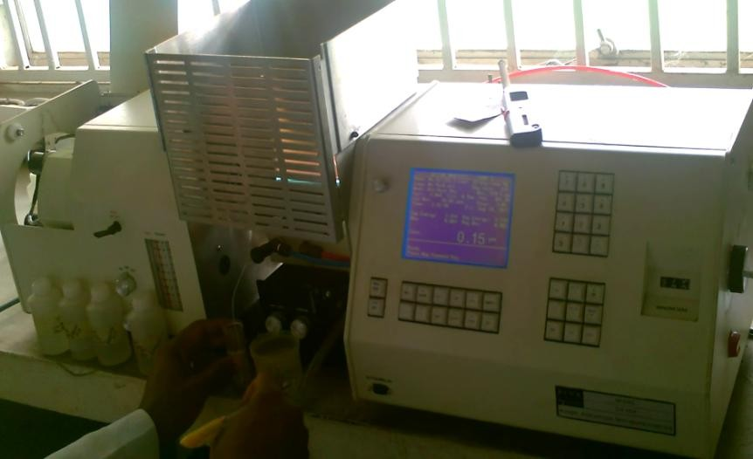2 ml of concentrated HNO₃ was then added to the beaker and stirred. Some reddish-brown vapor (NO₂) was given off, and the reaction was allowed to continue until complete (which was determined by the point at which the digestate gave off no more fumes). The beaker was again allowed to cool to room temperature. 10 ml of concentrated HCl was subsequently added and the mixture stirred. The beaker was heated to about 120 ºC until there was no further evolution of gas. The final digestate was observed to be a clear yellow liquid with black to dark reddish-brown particulates.

The digestate was filtered through a No 41 Whatman filter paper, and the filtrate was collected in a volumetric flask. The digestion beaker was washed with about 5 ml hot HCl into the filter paper and the filter paper was also washed while still in the funnel with the same acid solution. The final filtrate obtained was thereafter analyzed with an Atomic Absorption Spectrophotometer (Plate 3.24).

Plate 3.24: Showing the Buck Scientific® Model 210 VGP AAS machine

Data Management and Statistical Analysis
Data was recorded in tabular formats and other details were taken at each step of the production process. These included measurement of weight (or specific gravity), volumes, relative density, moisture content of biomasses, etc.

- All data were analyzed using the SPSS statistical software version 15. Descriptive statistics such as proportions, means and standard deviations were used to summarize the data.

- The results obtained from the proximate analysis and physicochemical properties of oils and biodiesels were subjected to Inferential statistics such as Student t-test, while One-way Analysis of Variance (ANOVA) with Least Significance Difference (LSD) at 5% level of precision (α = 5%) was used to test for significant differences in the mean relative densities across the test groups.

- Spearman-rank correlation was used to check if a relationship exists between the biodiesel yield and the levels of the elements in the substrates.

CHAPTER FOUR

RESULTS

This chapter presents the results of the exploration study which includes evaluation of the oil and the biodiesel yielding potentials of the selected plant biomasses; and characterization studies on the plant biomasses, the oils from these biomasses and the biodiesel obtained from the processed oils.

Characteristics of the Plant Biomasses

Physical Characteristics of the Plant biomasses

Table 4.1 below shows the quantity of the respective plant-based biomasses that were used in each of the experimental setup for oil extraction viz: Soxhlet extraction, Cold extraction using Hexane/Ether solvent mixture and Cold extraction using Hexane as the only extraction solvent. The mean percentage moisture contents of the biomasses for each of the three (3) methods of oil extraction are presented in Table 4.1.

A comparison between the Moisture content determined by the two methods [i.e. Moisture analyzer equipment method (Table 7.2 in appendix) and Oven-drying method (Table 7.3 in appendix)] is presented in Figure 4.1 below. The mean relative density estimated for the biomasses is presented in Table 4.1 and the triplicate readings shown in Table 7.4 (appendix).

Table 4.1: Showing the different physical parameters that were determined in the biomasses
Biomass
Weight of biomass (for Soxhlet extraction) (g)
Weight of biomass (for Cold Weight of biomass (for Cold extraction: Hexane/Ether)(g) extraction: Hexane only) (g)
Mean Moisture content using the Moisture analyzer equipment (%)
Mean Moisture Relative content through oven- density
drying method (%) (R.D)
W1 Ws W2 Wbu W1 Ws W2 Wbu W1 Ws W2 Wbu
Moringa
9.37
@160oC
9.48
@105oC
0.604
@25oC
P.K
8.25
@160oC
8.31
@105oC
0.572
@25oC
300
292.20
271.85
250
300
295.00
270.90
250
300
292.50
271.92
250

Thevetia
300
300
295.50
275.20
250
300
292.15
274.90
250
300
294.50
275.15
250
6.63
@160oC
250
6.64
@105oC
0.750
@25oC

Spirogyra
292.02
280.01
40
250
300
289.44
30
280.05
30
250
300
290.10
30
280.05
30
39.65
@160oC
39.71
@105oC
0.641
@25oC

Key: W₁ = Wet weight of biomass (g)
77.80
52.00
48.25
48.39
41.40
48.39
41.31
W_{s} = Sundried weight of biomass (g)
W₂ = Oven-dried weight of biomass (g)
W_{bu} = Weight of oven-dried Biomass Used for the extraction process (g)

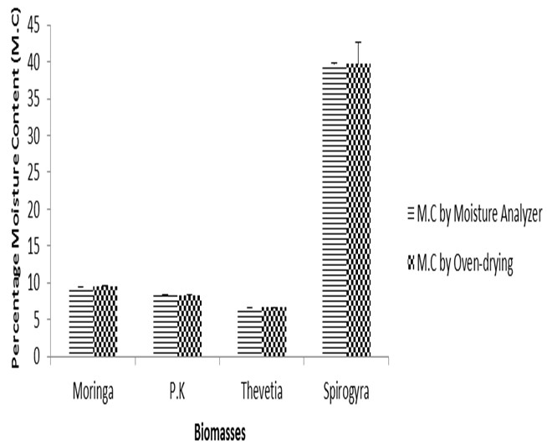
Fig. 4.1: Comparison of the Moisture content of biomasses determined using two different methods

Chemical Characteristics of the Plant biomasses
Table 4.2 shows that the Total Organic Carbon contained in these substrates were considerably high as compared to other elemental composition viz: Total Nitrogen, Total Phosphorus, Calcium, Sodium and Sulphur. Moringa seeds were observed to contain the highest T.O.C (60.9%) closely followed by Palm kernel and Thevetia seeds (60.8% and 60.7%) respectively, with Spirogyra biomass having the lowest percentage of (50.9%).

The percentage Total Nitrogen (T.N) content of Moringa oleifera seeds was seen to surpass all the other substrates with Palm kernel seeds having the least percentage T.N value. Moringa seeds were also shown to have a high percentage Total Phosphorus (T.P) value that was surpassed by that of Spirogyra biomass (0.28%). In the same vein, the Spirogyra biomass was again seen to possess the highest percentage Calcium (Ca), Sodium (Na) and Sulphur (S) content of 0.05%, 1.35% and 0.88% respectively.

The proximate analysis carried out to estimate the percentage elemental composition of the biomasses were all carried out in duplicate as shown in Table 7.5 (appendix) and represented pictorially in Figure 4.2 below.

Table 4.2: Different chemical parameters that were determined in the biomasses Biomass Elemental Composition

 | T.O.C | T.N | T.P | Ca | Na | S
 | (%) | (%) | (%) | (%) | (%) | (%)
Moringa | 60.85 | 0.210 | 0.211 | 0.050 | 0.016 | 0.038
P.K
60.84
0.091
0.118
0.045
0.016
0.047
Thevetia
60.73
0.147
0.046
0.040
0.017
0.080
Spirogyra
50.96
0.112
0.281
0.054
1.350
0.882
Key: T.O.C = Total Organic Carbon; T.N = Total Nitrogen; T.P = Total Phosphorus;
Ca = Calcium content; Na = Sodium content; S = Sulphur content

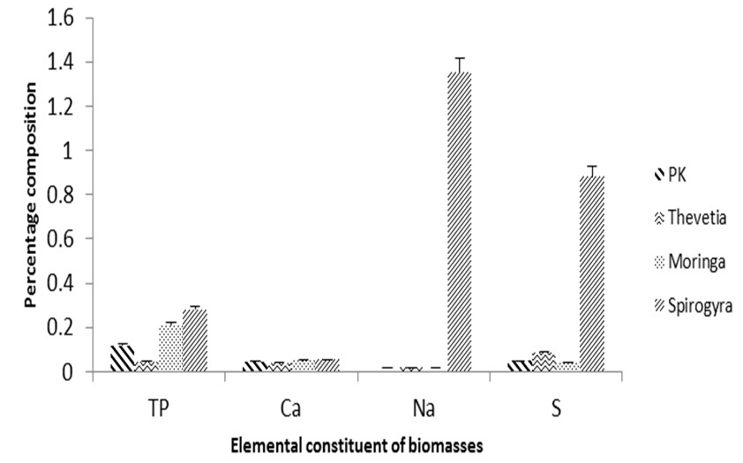

Fig 4.2: Showing the proportion of elements in the biomasses

Characteristics of the Extracted Oils
    - Physical Characteristics of the Extracted Oils
The results of the measurements made on each of the oils from the different extraction methods described in this work are presented in Table 4.3 below. All the oils from each of the three (3) extraction processes, after undergoing evaporation in a Rotavapor apparatus and left to air-dry for about 24hours, were put together respectively and their total weight and volume measured as presented in Table 4.3. This latter measurement was done to know exactly what weight or volume of each of the oils was necessary for the transesterification reaction process so as to remain some quantity of oil sufficient enough for characterization. A comparison of the oil yields across the three (3) extraction procedures performed is presented in Figure 4.3 below.

The pH of each of the oils was determined in triplicate (shown in Table 7.6-appendix) and the mean pH value presented in Table 4.3. Also, the density of the oils at 25ºC was determined in triplicate as shown in Table 7.7 and the mean relative density presented in Table 4.3. The Kinematic viscosity of the oils was determined in duplicate (Table 7.9-appendix) and the result presented in Table 4.3. The dynamic viscosity of the oils was also determined using the values of both the Kinematic viscosity and density @ 40ºC and the result shown in Table 7.8 (appendix).

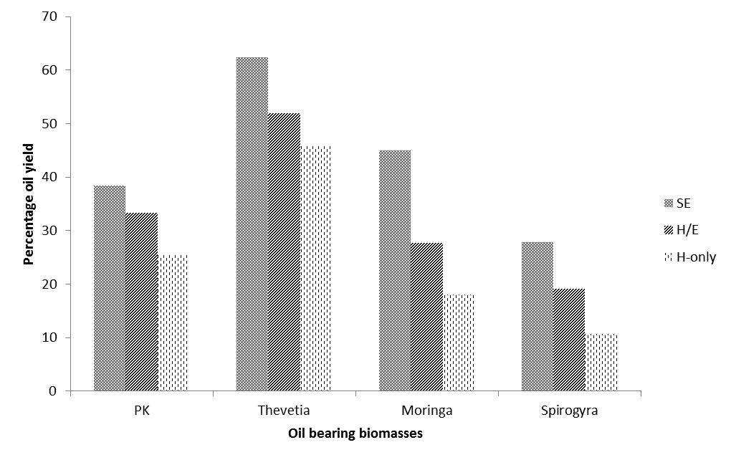

Fig. 4.3: Shows the percentage oil yield from the biomasses via three extraction methods

Table 4.3: Showing the different physical parameters estimated for in the extracted oils
Test parameter
Soxhlet extraction
Cold extraction (Hexane/Ether solvent mixture; 1:1 v/v)
Wbu (g)
W.O
(g)
V.O (mL)
W.R
(g)
Q.S (mL)
O.Y (%)
Wbu (g)
W.O
(g)
V.O (mL)
W.R
(g)
Q.S (mL)
O.Y (%)
Wbu (g)
W.O
(g)
V.O (mL)
Moringa
P.K
Thevetia
Spirogyra
Colour of Extracted Oils
Deep yellow Deep orange Deep yellow
Deep green
Moringa P.K
Thevetia
Spirogyra
Light orange Light orange Deep yellow
Deep green
Deep yellow Deep orange Deep yellow
Deep green
136

pH
6.63  @26.9ºC | 6.02  @24.8ºC | 6.64  @26.3ºC | 6.68  @25.2ºC
252.30 | 224.49 | 267.87 | 12.73
200 | 200 | 200 | 10
276.10 | 290.67 | 482.16 | 18.15
226.71 | 258.96 | 359.99 | 14.26
18.04 | 25.43 | 45.81 | 6.40
300 | 300 | 300 | 100
195.40 | 160.92 | 115.45 | 27.40
55.00 | 80.00 | 140.00 | 1.15
45.10 | 63.57 | 114.52 | 1.92
250 | 250 | 250 | 30
27.67 | 33.24 | 51.87 | 11.47
600 | 600 | 600 | 200
175.50 | 162.00 | 116.50 | 24.50
91.00 | 102.00 | 163.00 | 2.06
69.17 | 83.09 | 129.68 | 3.44
250 | 250 | 250 | 30
44.98 | 38.35 | 62.32 | 22.25
800 | 800 | 800 | 300
122.o0 | 149.50 | 85.20 | 29.60
140.00 | 108.67 | 179.16 | 14.94
112.44 | 95.87 | 155.79 | 8.90
250 | 250 | 250 | 40

Kinematic viscosity (mm²/s) | 44.50  @ 40ºC | 4.85  @ 40ºC | 21.50  @ 40ºC | 4.50  @ 40ºC
Relative | 0.803 | 0.881 | 0.871 | 0.531
density (R.D) | @25ºC @25ºC @25ºC @25ºC

Vou (ml)

Wou (g)

V.O.T (mL)
W.O.T (g)
Cold extraction (Hexane only)
W.R
(g)
Q.S (mL)
O.Y (%)

KEY: W_{bu} | = | Weight of oven-dried Biomass Used for the extraction process (g)
W.O | = | Weight of Oil (g)
V.O | = | Volume of Oil (ml)
W.R | = | Weight of Residual biomass (g)
Q.S | = | Quantity of solvent used (ml)
O.Y | = | Oil Yield (%)
W.O.T | = | Weight of Oil Total (g)
V.O.T | = | Volume of Oil Total
Wou | = | Weight of Oil Used for the transesterification reaction
Vou | = | Volume of Oil Used for the transesterification reaction

Chemical Characteristics of Extracted Oils
The chemical characterization of the oils revealed Palm kernel oil as having the highest Saponification value (230.2 mgKOH/g) amongst the other substrate oils. However, the extracted algal (spirogyra) oil was only sufficient for few physicochemical characterizations and processing into biodiesel but insufficient for the three chemical characterizations under this section (i.e. saponification value, FFA value and FAP. This was followed by Moringa seed oil (192.5 mgKOH/g) with Thevetia oil having the least value (120.1 mgKOH/g) (Table 4.4).

The analysis of the Free Fatty Acid content of the biomass oils revealed Moringa oil to possess a significant highest level of the these free molecules (3.0 %) as compared to the other two substrates viz: Palm kernel (1.9 %) and Thevetia (0.6 %). A pictorial comparison of some physicochemical properties of the extracted oils is presented in Figure 4.4 below.

Table 4.4: Showing the chemical parameters estimated for in the extracted oils

Oil Sap. value
(mgKOH/g)

FFA content
(%)

Moringa 192.5 3.0
P.K
230.2
1.9
Thevetia
120.1
0.6
Spirogyra
-
-
Key: Sap. value = Saponification value
FFA = Free Fatty Acid content

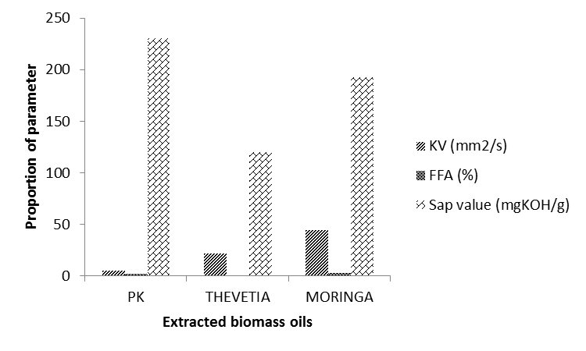

Figure 4.4: Comparison of the physicochemical parameters of biomass oils

The fatty acid profile of the oils, which was read in triplicates (Table 7.10-appendix) and summarized in Table 4.5 below, shows a divergent range of composition of fatty acids in the oils, and a varying degree of saturation and unsaturation across the various substrate oils. From the results, it was clear that the major fatty acid component of Palm kernel oil is Lauric acid (C12:1) while Moringa seed oil, Thevetia peruviana (Yellow oleander) seed oil and Spirogyra oil have Oleic acid (C18:1) as their major component fatty acid.

The fatty acid profile of Moringa seed oil shows a high level of unsaturation followed by that of Spirogyra and Thevetia while Palm kernel oil shows the lowest level of unsaturated fatty acid composition. This invariably indicates that Palm kernel oil contains the highest level of saturated fatty acids (79.99%).

It is pertinent to note that while a higher number of the total fatty acid composition of the oils of moringa, palm kernel and spirogyra were accounted for, the result obtained for thevetia analysis showed that there was about 17.30% of the fatty acids that their values were not accounted for. These unaccounted fatty acids may belong to the group of uncommon fatty acids, but which may probably find some usefulness in some areas if they could be identified and their beneficial value explored.

Table 4.5: Showing the Fatty Acid Profile (FAP) or Percentage Fatty Acid Composition (FAC) of the Extracted Oils

Fatty Acid Profile of Oils

Test parameter ª Name Moringa (%) x + S.D
Palm kernel (%) x + S.D
Thevetia (%) x + S.D
Spirogyra (%) x + S.D

C8:0 Caprylic 0.04+0.01 3.28+0.01 - - C10:0 Capric - 3.41+0.01 - -
C12:0 Lauric - 47.60+0.01 - 0.99+0.01
C14:0 Myristic 0.15+0.01 16.12+0.02 0.19+0.01 7.50+0.00
C15:0 Pentadecanoic - - - 0.50+0.01 C16:0 Palmitic 6.10+0.01 8.35+0.00 19.50+0.01 25.05+0.01
C16:1 Palmitoleic 1.35+0.01 0.31+0.01 0.25+0.01 8.50+0.01
C17:0 Margaric 0.05+0.01 - 0.10+0.01 0.20+0.01
C18:0 Stearic 5.80+0.01 2.49+0.01 6.39+0.01 4.50+0.00
C18:1 Oleic 71.19+0.6 15.50+0.01 42.25+0.01 33.47+0.06 C18:1-9c, 12 (OH) Ricinoleic - - 0.05+0.01 -
C18:2 Linoleic 0.69+0.00 2.10+0.00 10.50+0.00 10.80+0.01
C18:3 Linolenic 3.00+0.02 0.15+0.01 0.50+0.01 0.50+0.01
C18:3-9c,11t, 13t α-Eleostearic - - 0.01+0.01 -
C20:0 Arachidic 3.60+0.01 0.20+0.01 1.25+0.00 1.20+0.01
C20:1 Gadoleic 2.00+0.06 0.05+0.01 0.13+0.01 0.50+0.01 C20:1-11c,14(OH) Lesquerolic - - - 0.15+0.01
C20:2 Eicosadienoic - - - -
C20:5 Timnodonic - - - 0.05+0.01 C22:0 Behenic 4.57+0.01 0.10+0.00 0.82+0.01 1.50+0.01
C22:1 Erucic - - - 0.39+0.01 C24:0 Lignoceric 0.50+0.01 - 1.15+0.00 -
C24:1 Nervonic - - - 0.85+0.01

Unknown = 1.21 2.62 17.30 3.93

Total known = 98.79 97.38 82.70 96.07

Total saturated = 20.79 79.99 29.02 41.01

Total unsaturated = 78.00 17.41 53.68 55.06
ª Numbers denote the number of carbon atoms and double bonds in one molecule. For example, in Linoleic acid, 18:2 indicates that each molecule contains eighteen carbon atoms and two double bonds.

Characteristics of the Biodiesels
    - Physical Characteristics of the Biodiesels
The results of the measurements made on each of the biodiesel obtained from the two (2) different alcohol system described in this work (Section 3.5.5) are presented in Table 4.6a below. The glycerine content of the oils is presented in Table 4.6a. The pH of the biodiesels is also presented in the same table 4.6a and duplicate readings shown in Table 7.11-appendix.

There was a significant difference (p<0.05) between the all oils and their respective biodiesels (both M-only and M/E biodiesels) except the pH of Moringa M/E biodiesel, where there was no significant difference (p > 0.05) between the biodiesel and its parent oil (Table 4.6b below). The chart showing the comparison between the pH of oils and the pH of the biodiesels is presented in Figure 4.5 below. The colour of the cleaned/refined biodiesels, which were visually inspected, is also reported in Table 4.6a.

The Relative density (R.D.) of the individual biodiesels obtained from each of the alcohol system reactions was also determined in triplicate (Table 7.12-appendix). The biodiesel yield expressed in percentage v/v is presented in Table 4.6a. A comparison of the R.D. of the biodiesels to that of the oils, and a comparison of the biodiesel yield using the different alcohol systems are presented pictorially in Figure 4.6 and Figure 4.7 below respectively.

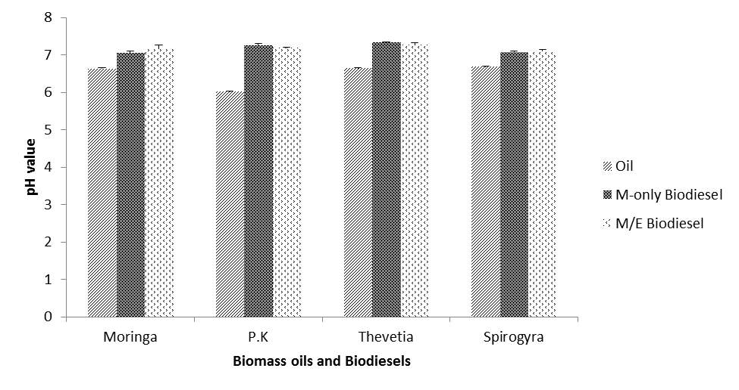

Figure 4.5: Comparison of the pH of oils to the pH of biodiesels

Table 4.6a: Physical characteristics of Biodiesels
Oil | Parameter | Q.O | Q.M | Q.E | Q.NaOH | Q.D | G.C | C.B | pH | R.D | B.Y
 |  | (g and ml) | (g and ml) | (g and ml) | (g) | (ml) | (ml) |  |  | @25ºC | (g, ml & %)
Moringa M-only transesterification 100g 16.67g - Light
 |  | 126ml | 20.9ml |  | 1.00 | 29.0 | 26.05 | yellow | 7.05 | 0.877 72.21g, 82.53ml, 65.50%
M/E (1:1) transesterification |  | 100g | 8.37g | 8.29g |  |  |  | Light
 |  | 126ml | 10.5ml | 10.5ml | 1.00 | 27.0 | 28.50 | yellow | 7.17 | 0.878 67.59g, 77.16ml, 61.24%

P.K M-only transesterification 100g
145ml
M/E (1:1) transesterification 100g
145ml

Thevetia M-only transesterification 100g
134ml | 22.4ml |  | 1.00 | 41.0 | 17.50 | yellow | 7.34 | 0.839 | 95.65g, 114.20ml, 85.20%
M/E (1:1) transesterification 100g | 8.77g | 8.68g |  |  |  | Light
134ml | 11.0ml | 11.0ml | 1.00 | 38.0 | 27.00 | yellow | 7.27 | 0.842 | 88.05g, 105.10ml, 78.43%
Spirogyra M-only transesterification 5.00g  6.3ml | 0.89g  1.3ml | - | 0.05 | 0.60 | 2.10 | Light green | 7.08 | 0.881 | 1.46g, 1.65ml, 26.19%
M/E (1:1) transesterification 5.00g | 0.45g | 0.51g |  |  |  | Light
6.3ml | 0.65ml | 0.65ml | 0.05 | 0.40 | 2.45 | green | 7.12 | 0.885 | 1.06g, 1.20ml, 19.05%

19.30g
24.2ml
9.57g
12.0ml 17.90g

7.25 0.913 99.50g, 109.11ml, 75.25%

7.19 0.899 94.38g, 104.98ml, 72.40%
-
9.47g
12.0ml
1.00
41.0
14.40
1.00
40.0
16.80
Light orange
Light orange
-
Light

KEY: M-only transesterification = Transesterification reaction using Methanol
M/E transesterification = Transesterification using Methanol/Ethanol mixture in ratio 1:1
Q.O = Quantity of Oil used (expressed in g and ml)
Q.M = Quantity of Methanol used (expressed in g and ml)
Q.E = Quantity of Ethanol used (expressed in g and ml)
Q.NaOH = Quantity of NaOH pellets used (expressed in g)
Q.D = Quantity of Distilled water used (expressed in ml)
G.C = Glycerine content of oil (expressed in ml)
C.B = Colour of Biodiesel obtained
R.D = Relative density of biodiesel (no unit)
B.Y = Biodiesel yield (expressed in g, ml and % v/v)

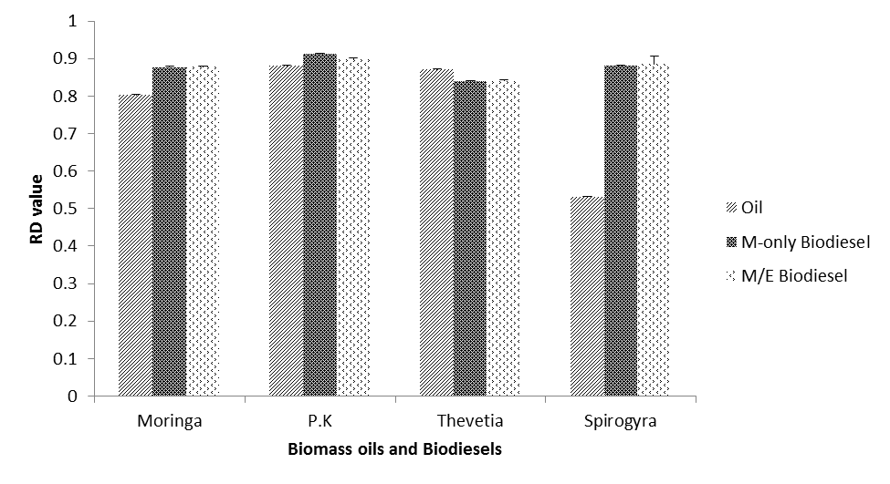

Figure 4.6: Comparison of the Relative density of oils to the Relative density of biodiesels

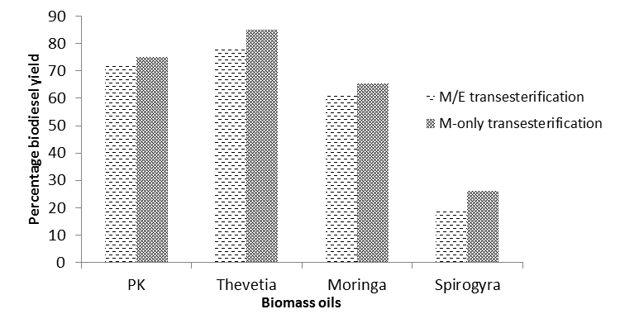

Figure 4.7: Comparison of Percentage biodiesel yield from the oils using two transesterification processes

Table 4.6b: Comparison of pH of oils and pH biodiesels

Parameter Test Group Mean + S.D T-test p-value

pH Oil | 6.63 + 0.02 | 14.70 | 0.00
Moringa pH (M-only BD) | 7.05+ 0.05 | 11.60 | 0.04
pH (M/E BD) | 7.17 + 0.10 | 7.70 | *0.08
pH Oil | 6.02 +0.02 | 34.68 | 0.00
P.K  pH (M-only BD) | 7.25 + 0.06 | 26.79 | 0.02
pH (M/E BD) | 7.19 + 0.01 | 88.00 | 0.00
pH Oil | 6.64 + 0.01 | 81.72 | 0.00
Thevetia  pH (M-only BD) | 7.34 + 0.01 | 66.72 | 0.00
pH (M/E BD) | 7.27 + 0.06 | 15.78 | 0.04
pH Oil | 6.68 + 0.01 | 34.84 | 0.00
Spirogyra
pH (M-only BD) | 7.08 + 0.01 | 33.01 | 0.00
pH (M/E BD) | 7.10 + 0.04 | 15.91 | 0.03

KEY: pH Oil = pH of oil; pH M-only BD = pH Methanol-only biodiesel; pH M/E BD = pH Methanol/Ethanol biodiesel; * p > 0.05 is not significant

Chemical Characteristics of the Biodiesels
Table 4.7a below shows the results of the proximate analysis carried out on the biodiesel obtained from the transesterification of each of the substrate oils. There was a significant reduction in the percentage content of each of the elements that were initially analyzed for in the substrate oils as compared to their corresponding biodiesel result (duplicate readings presented in Table 7.13-appendix). Moringa seed biodiesel recorded the highest percentage value of Total Phosphorus (T.P) and Sulphur (S) contents amongst the other biodiesels; and had an equal proportion of Sodium (Na) content with Thevetia biodiesel.

A comparison of the mean percentage elemental composition of the biodiesels is shown in a chart format (Figure 4.10 below). The correlation between mean elemental compositions in biomasses to their biodiesel yield is presented in Table 4.8 below. The percentage T.P in the biomasses negatively correlated with the biodiesel yield in both M-only (r = 0.99, p = 0.00) and M/E (r = 0.99, p = 0.00) transesterification processes. In the same vein, the percentage Calcium in the biomasses negatively correlated with the biodiesel yield in both M-only (r = 0.80, p = 0.02) and M/E (r = 0.80, p = 0.02) transesterification processes. There was also a negative correlation between the percentage sodium (r = 0.30) and percentage sulphur (r = 0.29) with the biodiesel yield in both M-only and M/E transesterification processes respectively although both correlations were not significant (p > 0.05). Figures 4.8 and 4.9 below show the strength of linear relationship between the T.P content of the biomasses and the yield of biodiesel in the M-only (R² = 85.5%) and M/E (R² = 82.2%) transesterification processes respectively.

Also, Moringa biodiesel was observed to have the highest flash point (176ºC) with Thevetia biodiesel having the lowest (130ºC). P.K biodiesel was observed to have the highest Cloud and Pour points (14.1ºC and 8.6ºC respectively), closely followed by Moringa biodiesel with Thevetia biodiesel having the lowest temperature points for the two parameters. Moringa biodiesel was also observed to have the highest acid value of 0.657mgKOH/g, which is slightly above the < 0.5mgKOH/g limit set by the EN standard. The Flash point, Cloud and Pour points and the Acid value for the respective biodiesels were all determined in duplicate as presented in Table 7.14, Table 7.15 and Table 7.16 respectively (appendix).

There was a reduction in the density of all the biodiesels at 40ºC (Table 4.7a below) when compared to their density at the room temperature of 25ºC (Table 7.12-appendix). The oils of Moringa, Palm kernel and Thevetia seeds all witnessed a significant reduction in their resistance to flow and sheer under the forces of gravity (i.e. Kinematic viscosity, whose readings were determined in duplicate, Table 7.18-appendix). This reduction was after the oils underwent transesterification and purification processes as presented in Table 4.7a and represented pictorially in Figure 4.12 below. Moringa seed oil witnessed the highest reduction in kinematic viscosity (88.72%) followed by Thevetia oil (78.14%) with Palm kernel oil, which experienced the least but significant reduction of 50.72%. A comparison of certain physicochemical parameters (KV, FP and AV) of the different biodiesels is presented in Figure 4.11 below.

In the same vein, the estimated values of Dynamic viscosity (and hence Kinematic viscosity) of the biodiesel fuels obtained revealed a significant reduction in these values as compared to their corresponding precursor oils. Again, Moringa biodiesel witnessed the highest significant reduction (p<0.05) with a decline of 87.7% from its parent oil (i.e. Moringa oil). Thevetia oil also reduced by 79.2% though the t-test and p-value could not be computed due to equal standard deviation of the test groups. Palm kernel oil witnessed the lowest reduction value (though again significant, p<0.05) but with a value of 50.35% (Table 4.7b below).

Some parameters of the biodiesels produced in this work were compared with ASTM and EN standards/limits (Table 4.9 below) and the comparison is shown pictorially (Figures 4.13 and
4.14 below). There was a significant decrease (p<0.05) in the proportion of elements in the biomasses when compared to their respective biodiesels (shown in Figure 4.12). The elemental composition of the biodiesels as compared with ASTM and EN guidelines is also shown pictorially in Figure 4.15 below.

Table 4.7a: Chemical characteristics of Biodiesels
Biodiesel Elemental composition Fuel properties

 | T.P | Ca | Na | S | F.P | C.P | P.P | A.V | Density | K.V | D.V
 | (%) | (%) | (%) | (%) | (ºC) | (ºC) | (ºC) | (mgKOH/g) | @ 40ºC | @ 40ºC  (mm²/s) | (g/ms)
Moringa | 0.020 | 0.005 | 0.002 | 0.035 | 176ºC | 13.6 | 6.5 | 0.657 | 0.872 | 5.02 | 4.38
P.K | 0.002 | 0.004 | 0.001 | 0.002 | 166ºC | 14.1 | 8.6 | 0.417 | 0.881 | 2.39 | 2.11
Thevetia | 0.001 | 0.003 | 0.002 | 0.008 | 130ºC | 8.5 | 5.1 | 0.441 | 0.825 | 4.70 | 3.88

N.B: Analyses of the parameters in the above table were not carried out on Spirogyra biodiesel

KV Biodiesel 4.70 + 0.00^{(a)} - -
Table 4.7b: Comparison of the KV of oils to the KV of biodiesels
Parameter
Kinematic viscosity (mm²/s)
Mean
T-test
p-value
KV Oil
44.50 + 0.01
2791.658
0.000
Moringa
KV Biodiesel
5.02 + 0.01
2791.658
0.000
KV Oil
4.85 + 0.00
246.000
0.000
P.K
KV Biodiesel
2.39 + 0.01
246.000
0.003
KV Oil
21.50 + 0.00^{(a)}
-
-
Thevetia

Spirogyra
KV Oil - - -

KV Biodiesel - - -

^{(a)}t cannot be computed because the standard deviations of both groups are 0; p < 0.05 is significant; The KV of Spirogyra oil and biodiesel was not determined due to limited quantity of each.
Key: KV Oil = Kinematic viscosity of Oil; KV Biodiesel = Kinematic viscosity of biodiesel

Table 4.8: Spearman correlation between mean elemental composition of biomasses and biodiesel yield
Parameter |  | TP (%) | Ca (%) | Na (%) | S (%) | M-only biodiesel yield (%) | M/E biodiesel yield (%)
TP (%) | Correlation coefficient | 1.00
 | Sig. (2-tailed) | .
Ca (%) | Correlation coefficient | 0.79* | 1.00
 | Sig. (2-tailed) | 0.02 | .
Na (%) | Correlation coefficient | 0.27 | -0.20 | 1.00
 | Sig. (2-tailed) | 0.52 | 0.64 | .
S (%) | Correlation coefficient | 0.34 | 0.02 | 0.39 | 1.00
 | Sig. (2-tailed) | 0.40 | 0.60 | 0.34 | .
M-only biodiesel | Correlation coefficient | -0.99** | -0.80* | -0.30 | -0.29 | 1.00
yield (%) | Sig. (2-tailed) | 0.00 | 0.02 | 0.47 | 0.48 | .
M/E biodiesel | Correlation coefficient | -0.99** | -0.80* | -0.30 | -0.29 | 1.00** | 1.00
yield (%) | Sig. (2-tailed) | 0.00 | 0.02 | 0.47 | 0.48 | . | .

* Correlation is significant at p<0.05
** Correlation is significant at p<0.01

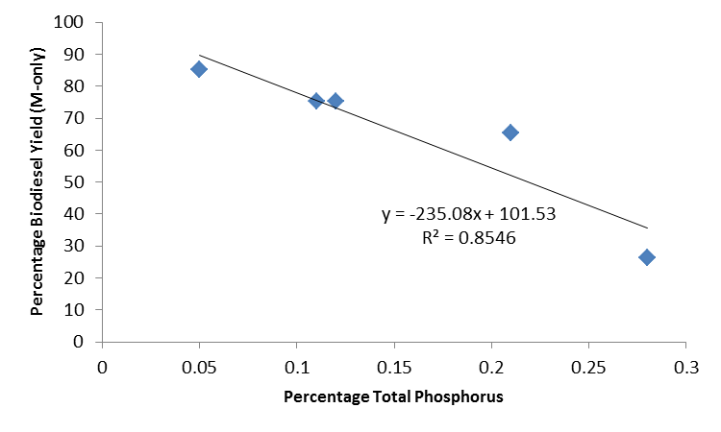

Fig 4.8: Relationship between percentage Total Phosphorus in biomasses and Biodiesel yield (M-only transesterification)

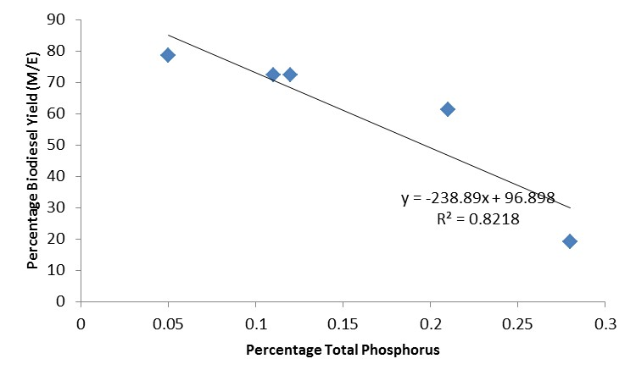

Fig 4.9: Relationship between percentage Total Phosphorus in biomasses and Biodiesel yield (M/E transesterification)

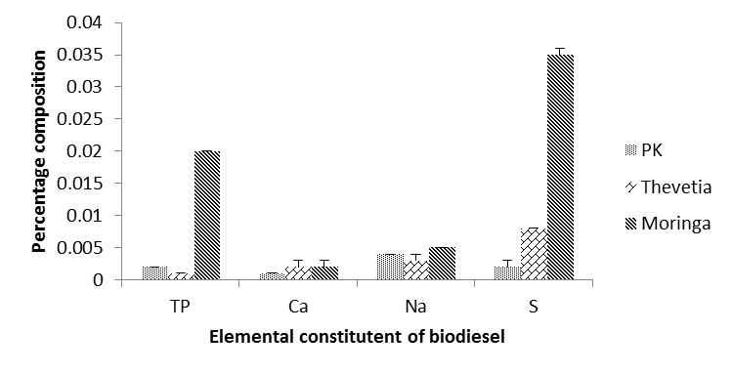

Fig 4.10: Showing the proportion of elemental constituent of the biodiesels

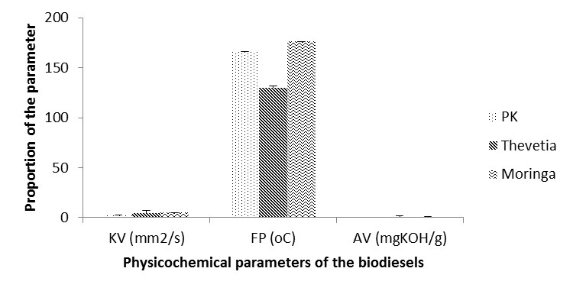

Fig 4.11: Comparison of some physicochemical parameters of each biodiesel

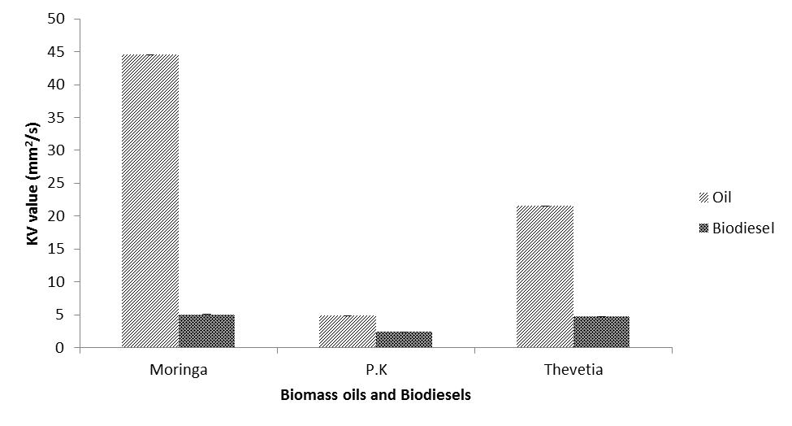

Figure 4.12: Comparison of the Kinematic viscosity of oil to the Kinematic viscosity of biodiesel

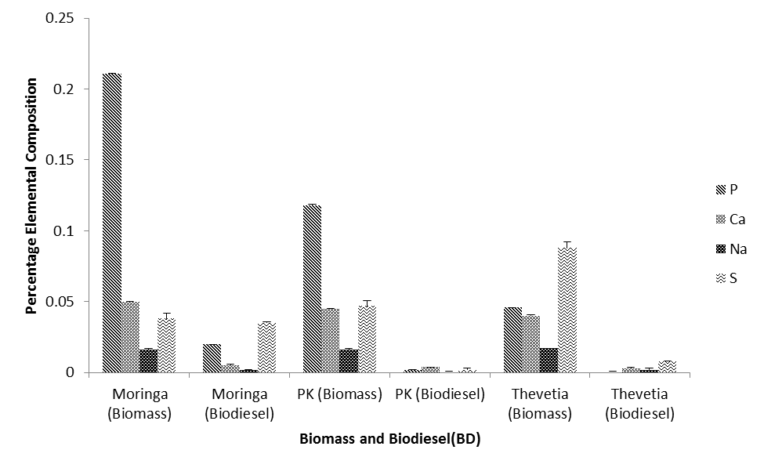

Figure 4.13: Comparison of the Percentage Elemental composition of biomasses to those of biodiesels

Table 4.9: Showing a comparison between properties of the biodiesels obtained in this work with ASTM and EN guidelines respectively
Fuel properties | Moringa | PK | Thevetia | Spirogyra | ASTM guideline | EN standard
 | biodiesel | biodiesel | biodiesel | biodiesel | (D6751)  Limits | (EN 14214)  Limits

00 @ 15ºC
Density | M-only transesterification | 0.877 | 0.913 | 0.839 | 0.881
@ 25ºC |  |  |  |  |  | Unspecified 0.860-0.9
(g/cm³) | M/E (1:1) transesterification | 0.878 | 0.899 | 0.842 | 0.885

Kinematic viscosity | 5.02 | 2.39 | 4.70 | Undetermined | 1.9-6.0 |  | 3.5-5.0
@ 40ºC (mm²/s)
Flash point (ºC) min. | 176 | 166 | 130 | Undetermined | 130 |  | 101
Acid value (mg KOH/g) max. | 0.657 | 0.417 | 0.441 | Undetermined | 0.8 |  | 0.5
Phosphorus content max. | 0.020 | 0.002 | 0.001 | Undetermined | 0.001% | or | 0.001 % or
 |  |  |  |  | 10 mg/kg |  | 10 mg/kg
Alkaline earth metal content (Ca) max. | 0.005 | 0.004 | 0.003 | Undetermined | - |  | 0.00005 % or 5 mg/kg
Alkaline metal content (Na) max. | 0.002 | 0.001 | 0.002 | Undetermined | - |  | 0.00005 % or 5 mg/kg
Sulphur content max. | 0.035 | 0.002 | 0.008 | Undetermined | 0.05% or  500 mg/kg |  | 0.001 % or 10 mg/kg
Cloud point (ºC) | 13.6 | 14.1 | 8.5 | Undetermined | Report to customer |  | -
Pour point (ºC) | 6.5 | 8.6 | 5.1 | Undetermined | - |  | -

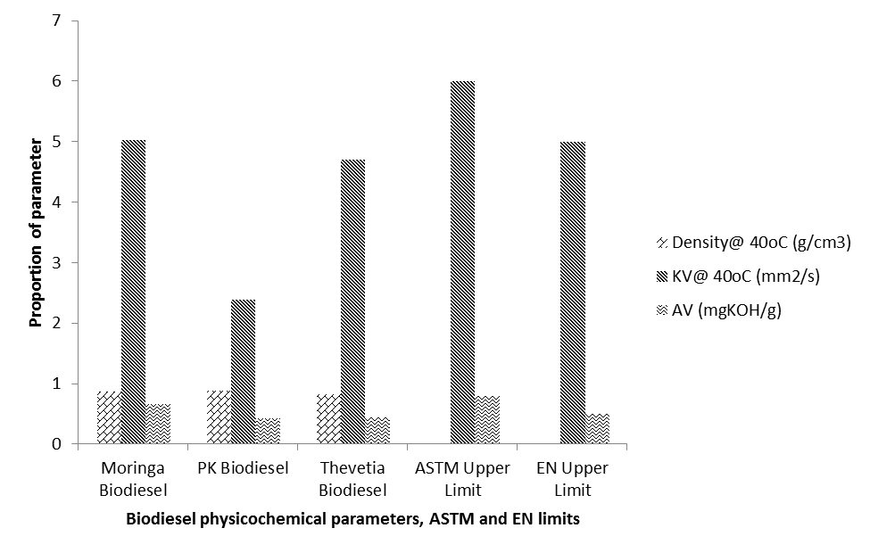

Figure 4.14: Shows the comparison of some biodiesel physicochemical parameters to ASTM and EN standards

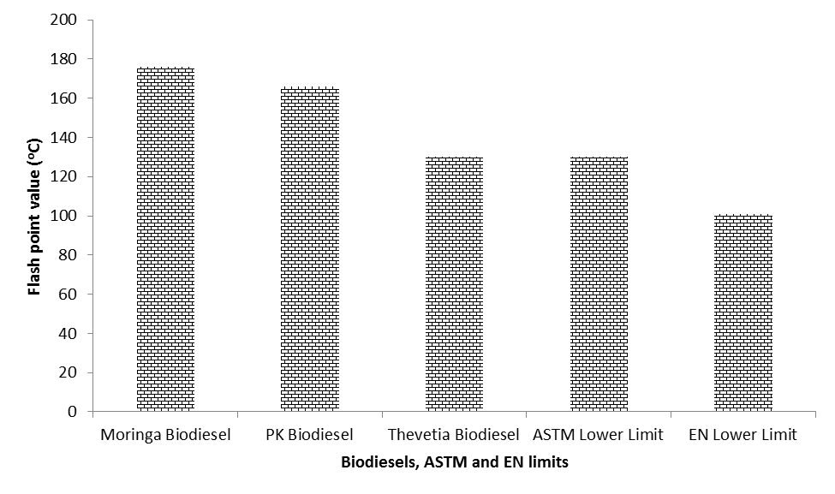

Fig 4.15: Comparison of Flash point to ASTM and EN standards

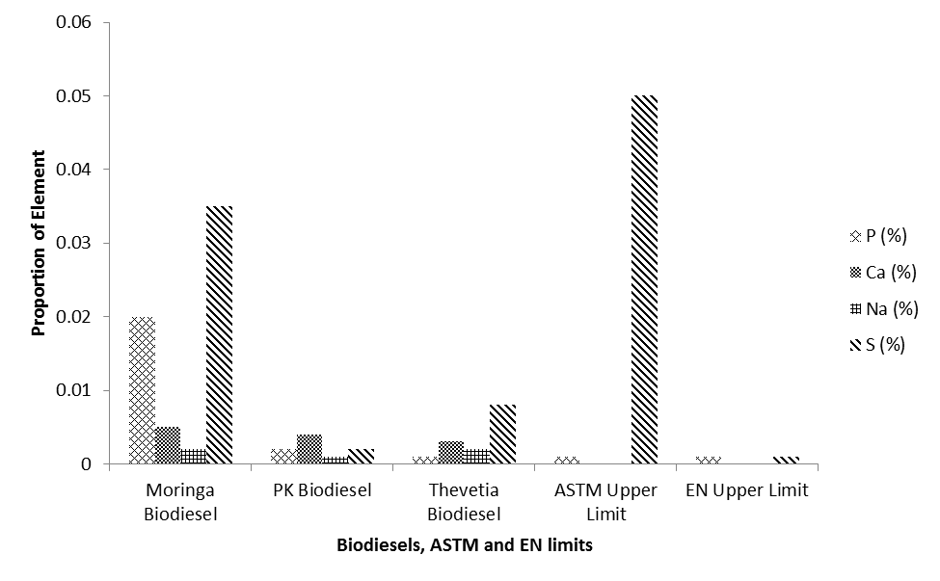

Fig 4.16: Comparison of elemental composition of biodiesels to ASTM and EN limits

CHAPTER FIVE

DISCUSSION

  - Sources of Substrates
An assessment of the availability of the biomasses used in this work when prospecting for them indicated that Moringa and Palm kernel seeds were readily available in commercial quantities. However, the former was relatively expensive in commercial quantities because of the high demand for it in some areas. However, this study sought to characterize the biomasses derived directly from their natural source.

There is no known supply of Thevetia and Spirogyra biomasses in commercial quantities in the state. Thevetia plants are majorly grown as hedges in homes, schools, offices, etc, and most are constantly trimmed to shape and to maintain the plant for its aesthetic appearance. The seeds are, therefore available on the plants since the plant produces fruits virtually in ten out of the twelve months of the year.

Spirogyra filaments are extremely common and occasionally an abundant genus in standing water bodies. Most species are collected as large floating masses or flimsy aggregates or long strings of cells from permanently or temporarily stagnant aquatic habitats. These habitats usually have neutral or slightly acidic pH values such as ponds, lakes and ditches. They are mostly found anywhere there is a relatively slow flowing or stagnant water body with a relatively sufficient sunlight. That is why the green filaments could even grow in a container of water left in a household environment for a long period of time. However, there is the need for sunlight, a favorable pH and certain essential nutrients to support their growth.

Most of the substrates used in this experimental work, especially Thevetia and Spirogyra biomass are relatively available in the environment but not utilized for the economic growth and development of the society. Based on available records that ranks Nigeria as one of the world‟s top producers of palm oil and hence palm kernel (FAO 2006, see Table 2.7), it would not be out of place to say that palm kernel oil has just relatively found application in few industrial uses (such as soap-making) but its full potentials are yet to be explored. Moringa plant has just

recently been gaining increased popularity across board in Nigeria as a plant that has every part of it with their own potentials. However, majority of the research works on Moringa oleifera has centered on its nutritional and therapeutic value, with just very few works done to explore its oil and biodiesel potential in the country.


Physical Characteristics of the Plant Biomasses
The 24 hours intermittent sundrying period (for the biomasses used in each of the 3 different extraction process) was observed to remove approximately a mean moisture of 2.3+0.4 %, 2.0+0.2 %, 3.2+0.4 % and 20.7+8.8 % from the fresh biomass samples of milled Moringa seeds, Palm kernel seeds, Thevetia seeds and Spirogyra biomass respectively as presented in Table 7.0- appendix.

Also, Table 4.1, shows that Spirogyra biomass had a significantly high moisture content (39.7+0.1 % and 39.7+3.0 %) from the two methods used for moisture content determination (i.e. Moisture analyzer equipment and Oven-drying method respectively) in comparison with the three (3) other substrates.

Fuad et. al., (2010) reported 40% moisture content in Spirogyra biomass, Rutikanga (2011) also reported 10.7+0.4 % while Kanyaporn et. al., (2012) reported 8.5 % moisture in Spirogyra biomass. However, it was only the report of Fuad et. al., (2010) that was in agreement with the moisture content of Spirogyra biomass obtained in this work. Also, Moringa seeds (9.37+0.03 % and 9.48+0.19 %) were shown to have slightly higher moisture content (%) than Palm kernel seeds (8.3+0.0 % and 8.3+0.1 %), with Thevetia seeds having the lowest moisture content (6.6+0.1 % and 6.6+0.0 %) from the two methods used respectively.

However, the results of moisture content obtained for Moringa seeds were at variance with the 4.7+0.3 % reported for Moringa seeds by Dalen et. al. (2009). Also, Chindo et. al. (2013) reported 2.2 % moisture content for Thevetia seeds, which was also at variance with the results obtained for the moisture content of fresh milled Thevetia seeds used in this work.

Milled Thevetia seeds were observed to have the highest mean relative density (0.750+0.001) amongst the substrates while Milled Palm kernel seeds had the lowest value of 0.572+0.002 as shown in the Table 4.1 and Table 7.3-appendix.

Chemical Characteristics of the Plant biomasses

The results of the proximate analysis carried out on the biomasses (Table 4.2, with the duplicate readings presented in Table 7.4-appendix) shows the percentage Total Organic Carbon (T.O.C) present in Moringa seeds, Palm kernel seeds and Thevetia seeds to be very close, but Moringa seeds had the highest T.O.C content (60.9+0.5 %) and Spirogyra had the least (51+0.7 %). Moringa oleifera seeds were found to have the highest proportion of Total Nitrogen (T.N) (i.e. 0.210+0.007 %) with Palm kernel seeds having the lowest (0.091+0.001%).

Spirogyra biomass, unlike in the T.O.C where it recorded the lowest value, was observed to surpass the other three substrates (i.e. Moringa, Palm kernel and Thevetia seeds) in the levels of Percentage T.P (0.28+0.00), Percentage Calcium (0.05+0.00), Percentage Sodium (1.35+0.00) and Percentage Sulphur (0.882+0.01) respectively (Table 4.2).

Phosphorous, calcium, and magnesium are minor components typically associated with phospholipids and gums that may act as emulsifiers (ASTM Standard D6751, 2009) or cause sediment, lowering yields during the transesterification process (Gerpen et. al., 2004), hence, their percentage composition in the respective biomasses were determined to establish if there would be a significant reduction in their composition upon taking the substrates through the solvent extraction process and the oils through the transesterification process respectively.

Physical Characteristics of the Extracted Oils
The oven-dried biomasses used in this experimental work were all observed to give a significantly different yield of oil across the three different extraction methods that were employed. The Soxhlet extraction gave the highest oil yield across the four substrates followed by Cold extraction (using Hexane/Ether mixture as the extraction solvent) while the Cold extraction (using Hexane-only) gave the lowest yield.


All the extracted oils were observed to have a slightly acidic pH (Table 4.2 with the triplicate readings presented in Table 7.5-appendix). Palm kernel oil recorded the lowest pH (6.02+0.02) while Spirogyra oil had an almost neutral pH (6.68+0.01). Palm kernel oil was observed to have the highest specific gravity (0.88+0.002) at a room temperature (25.0+0.4 ºC), which somewhat agrees with the 0.85g/cm³ value that was reported by Ojolo et. al. (2012), while Spirogyra oil had the least value (0.53+0.001) at the same temperature (Table 7.6-appendix).

The test for oil viscosity showed Moringa oil to have the highest kinematic viscosity (44.5+0.014) with Spirogyra oil having the least value (4.50+0.000) (Table 4.2 with duplicate readings presented in Table 7.8-appendix). Viscosity, from a physicochemical point of view, means the measure of resistance to flow that a liquid offers when it is subjected to sheer stress. Hence, it must be closely correlated with the structural parameters of fluid particles.

Viscosity is one of the important properties of oil which needs to be determined as it influences the ease of handling, transport and nature of storage. The viscosity of oils is strongly dependent on temperature as an increase in temperature causes a decrease in viscosity (Abramovic and Klofutar, 1998). The kinematic viscosity observed for Moringa seed oil corroborates what was reported by Sanford et. al, (2009). Also, Uzama et. al., (2011) reported a Kinematic viscosity of 43.5mm²/s, which further agrees with the result obtained for moringa seed oil in the present work.

The oils extracted from each of the biomasses via the different extraction processes employed in this work were observed to have characteristic colour, as reported in Table 4.2. The oils were also observed to possess a characteristic odour. Generally Moringa oils were perceived to have a sweet fruity smell, while Palm kernel oils had a sweet nutty smell, Thevetia had a very sweet butter fragrance and Spirogyra oil possessed a sweet forest tree smell.

Chemical Characteristics of the extracted Oils
Saponification value indicates the average molecular weight of a fat or oil. It gives us information whether an oil or fat contains high proportion of lower or higher fatty acids. The greater the molecular weight (longer carbon chain), the smaller the number of fatty acids that is

liberated per gram of oil hydrolyzed and therefore, the smaller the saponification value and vice versa.


Palm kernel oil was observed to have the highest Saponification value (Table 4.3) indicating a high molecular weight as a result of fatty acids with long carbon chains. It should be noted at this point that Saponification value (alongside some other parameters) was not estimated for in the Spirogyra oil (and by extension in the Spirogyra biodiesel) due to insufficient quantity that was available to undergo transesterification and yet be enough for those analyses.

FFA (or fatty acids that have been unbound from the original triglyceride) occur in vegetable oils either because of contact with water or poor storage or because of the presence of enzymes that rapidly cleave the fatty acids from the glycerol backbone. A good example is rice bran oil (Zullaikah et. al., 2005), which would have been a nutritionally desirable oil if not for its very high content of FFA caused by naturally occurring lipases. When a homogeneous alkali catalyst is used, Gerpen (2005) recommends that the maximum FFA content of the feed oil should be 5%. Otherwise, soaps will form, making separation of the glycerine difficult. Hence, an additional step to remove the FFA or to convert them via an esterification step is necessary before using the feed oil in transesterification reaction.

Stavros and John (2002) had reported a saponification value of 188.4mgKOH/g for the degummed oil of Moringa oleifera seeds. Also, Sanford et. al. (2009) and Uzama et. al. (2011) reported 195.0mgKOH/g and 191.4mgKOH/g saponification values respectively for moringa seed oil. The result of the saponification analysis (Table 4.3) seemed closer to that of Sanford et. al. (2009) and Uzama et. al. (2011), but was in considerable variance with that of Stavros and John (2002). Also, the result of the FFA analysis carried out on Moringa oil agrees with the 2.9% value reported by Sanford et. al. (2009) but does not agree with the 1.12+0.20% value reported by Stavros and John (2002).

Palm kernel oil was observed to have a lower FFA content (1.9 %) compared to that of Moringa seed oil. However, it had a higher saponification value (230.2 mgKOH/g) than both Moringa and Thevetia seed oils (Table 4.3). Igbum et. al. (2012) reported a value of 210.3 mgKOH/g for palm

kernel oil, which seemingly conflicted with the 230.2 mgKOH/g value that was recorded in this work. The saponification value obtained in this work for PK oil however was found to fall between the 230-254 mgKOH/g range that was estimated by CODEX-STAN 210 (1999) as the general Saponification range of value for Palm kernel oils.

The “soap-formation value” (Saponification value) of Thevetia oil was observed to be the least amongst the three different oils that were analyzed where a value of 120.1 mgKOH/g was recorded. Also, and as expected though, the FFA value of the oil was also the least among the three oils where it recorded a percentage value of 0.58 (Table 4.3).
.
The analysis of the Fatty acid composition (Table 4.4) of the respective biomass oils revealed a diverse array of fatty acid types in each of the oils. Palm kernel oil, which was observed to be a high Lauric acid (C12:1)-containing oil, was shown to contain the highest level of saturation (79.99%) amongst the substrate oils and consequently the lowest unsaturation level of 17.41%. The oils of Moringa seeds, Thevetia seeds and Spirogyra biomass were found to be majorly composed of Oleic acid (C18:1). They were observed to be relatively more unsaturated, with Moringa seed oil having the highest level of unsaturation (78%).

Physical Characteristics of the Biodiesels
Table 4.5a shows that the different transesterification reaction processes, which employed two different alcohol systems viz: Methanol-only and Methanol/Ethanol mixture for each of the extracted oils, gave different biodiesel parameters such as pH, relative density and biodiesel yield. Also, the quantity of glycerine that was obtained from each of the transesterification process using the two alcohol systems gave different yields for each system.

Generally, the alcohol system where methanol-only was utilized was observed to have a higher conversion of oil to biodiesel efficiency as opposed to the methanol/ethanol (M/E) mixture, which gave a considerable lower yield across the substrate oils. It could then be said that unlike in the cold solvent extraction process where two extraction solvent systems were evaluated viz: Hexane-only and Hexane/Ether mixture and the latter gave a higher oil yield across all the biomasses, this could not be said of the alcohol systems used in the transesterification processes

as the Methanol/Ethanol mixtures were observed to give a lower biodiesel yield compared to Methanol-only. The M/E transesterification process gave an expectedly higher yield of the by- product (glycerine) than the methanol-only transesterification process. This suggests the lower conversion efficiency of the M/E transesterification compared to the methanol-only transesterification process.

There was no significant difference (p > 0.05) in the pH of all the biodiesels obtained from the different transesterification processes suggesting that the washing (or cleaning) step was effective in considerably bringing the pH of the biodiesels within neutral range. The results of ANOVA showed that there was significant difference (p<0.05) in the density of almost all the oils when compared to their respective biodiesels (Table 7.18-appendix). Density is temperature dependent, so the density of biodiesel varies with temperature. Since biodiesel is typically sold by volume, the density of biodiesel as a function of temperature is therefore an important factor in biodiesel commerce (Biodiesel Handling and Use Guide, 2008).

Chemical Characteristics of the Biodiesels
There are specifications that govern biodiesel quality, and the differences in key performance parameters of biodiesels versus conventional diesel. ASTM International (www.astm.org) is a consensus-based standards group that comprises engine and fuel injection equipment companies, fuel producers, and fuel users whose standards are recognized in the United States by most government entities and in some other countries.

The specification for biodiesel (B100) is ASTM D6751. This specification is a compilation of efforts from researchers, engine manufacturers, petroleum companies and distributors, and many other fuel-related entities, and it is intended to ensure the quality of biodiesel used as a blend stock at 20% and lower blend levels. In the United States for example, any biodiesel used for blending should meet ASTM D6751 standards (ASTM D6751, 2009) Also, the German Institute of Standardization (DIN EN 14214) is another notable regulatory body that issues specifications for all biodiesels produced or sold for use in the European Union.

The result of the elemental analyses carried out on the respective biodiesel fuels produced (except for the Spirogyra biodiesel where there was insufficient quantity to run the analyses) showed a significant reduction (p < 0.05) in the levels of all the elements that were assessed in the biodiesel compared to their corresponding parent biomass. The negative correlation observed between the percentage elemental composition of the biomasses and the biodiesel yield in the two transesterification processes (Table 4.7) indicates that an increase in the proportion of the elements in the biomasses results in the decrease of biodiesel yield after transesterification. This is in agreement with the findings of Gerpen et. al. (2004). There was also a significant decrease (p < 0.05) in the kinematic viscosity of the biodiesels when compared to their parent oils. This suggests a significant increase in the fluidity of the fuels and a greater performance in diesel engines in terms of fluid operability.

Table 3.1 shows the specifications made by ASTM and DIN EN. It can be seen from the table that the Phosphorus content of Moringa biodiesel clearly exceeded the 0.001% maximum limit set by both regulatory bodies. Palm kernel biodiesel slightly surpassed the limit but Thevetia biodiesels was within the maximum set value. The Calcium and Sodium levels of the biodiesels of Moringa, Palm kernel and Thevetia all considerably surpassed the EN standard for these elemental compositions in biodiesel fuels. However, the Sulphur content in all the biodiesel fuels were clearly within the guideline set by ASTM, except that they slightly exceeded the guideline set by DIN EN.

A minimum flash point for diesel fuel is required for fire safety. B100‟s flash point should be at least 93ºC (200ºF) to ensure it is classified as nonhazardous under the National Fire Protection Association (NFPA) code. The biodiesels from all the respective oils in this work were in definite conformity with both ASTM and DIN EN guidelines, indicating a good level of safety handling with much less danger of inflaming accidentally.

Aliyu et. al, (2013) reported 186ºC as the flash point for moringa biodiesel, while Sanford et. al. (2009) also reported a value of >160ºC as the flash point for moringa biodiesel. Also, Alamu et. al. (2008) reported 167ºC, Atu et. al. (2011) reported 209ºC, while Oghenejoboh and Umukoro, (2011) reported 152ºC as the flash point of Palm kernel biodiesel respectively. In the same vein,

Balusamy and Marappan (2007) reported a flash point value of 128ºC for Thevetia biodiesel whereas Olisakwe et. al. (2009) and Chindo et. al. (2013) reported a flash point of 168ºC and 175ºC respectively.


The results of all the flash point values recorded in this work for the biodiesels from the different substrate oils clearly show all these biodiesels to have a significantly higher “ignitability point” as compared to that of conventional diesel fuel as shown in Table 3.1, which compares certain parameters of B100 biodiesel to conventional petroleum-based diesel.

The low-temperature properties of biodiesel and conventional petroleum diesel are extremely important. Unlike gasoline, petroleum diesel and biodiesel can freeze or gel as the temperature drops. If the fuel begins to gel, it can clog filters on dispensing equipment and may eventually become too thick to pump. Cloud point is the most commonly used measure of low-temperature operability; fuels are generally expected to operate at temperatures as low as their cloud point.

The B100 cloud point is typically higher than the cloud point of conventional diesel. Cloud point must be reported to indicate biodiesel‟s effect on the final blend cloud point. Thevetia oil had the lowest cloud point (8.5+0.1ºC) amongst the three biodiesels indicating a substantially very good cold property while Moringa and Palm kernel biodiesel fuels were observed to start containing small solid crystals at 13.6+0.1ºC and 14.1+0.1ºC respectively. At the same time, Thevetia, Moringa and Palm kernel oils were observed to essentially become a gel/solid (i.e. Pour point) at 5.1+0.1ºC, 6.5+0.0ºC and 8.6+0.1ºC respectively.

Balusamy and Marappan (2007) had reported a Cloud point value of -4ºC and a Pour point of - 7ºC for Thevetia biodiesel while Olisakwe et. al. (2009) reported 8ºC Pour point value for Thevetia biodiesel. Also, Alamu et. al. (2008) had reported a Cloud point value of 6ºC and a Pour point value of 2ºC for Palm kernel biodiesel, whereas Oghenejoboh and Umukoro (2011) reported a Cloud point value of 8ºC and a Pour point value of-15ºC. Furthermore, Igbum et. al. (2012) reported -13.19ºC as the Pour point value for Palm kernel biodiesel. These results generally show that the biodiesel from these substrate oils considerably conform to ASTM D6751 and/or EN 14214 standards.

CHAPTER SIX

CONCLUSION AND RECOMMENDATIONS

  - Conclusion
The purpose of this study was to evaluate the biodiesel yielding potential of certain plant biomasses viz-a-viz the characteristics of the biomasses and their respective products (i.e. extracted oil and biodiesel). The oils were extracted by Solvent extraction processes: Soxhlet extraction and Cold extraction respectively; while these oils were processed to biodiesel by transesterification reaction using two alcohol systems.

The results of the experimental work show that Thevetia seeds produced the highest oil yield across the different extraction processes utilized while Spirogyra biomass produced the lowest yields. In the same vein, Thevetia oil gave the highest biodiesel yield across the two transesterification reaction systems in this work while Spirogyra oil produced the least biodiesel yields.

The extraction of oil from the plant biomasses via Solvent system proved that a mixture of the organic solvent (n-hexane) with another non-polar solvent (pet ether) in ratio 1:1 was more effective than the use of one organic solvent alone. However, the transesterification experiment showed that the use of a single alcohol such as methanol alone proved to be more effective than the combination of two alcohol systems (such as methanol/ethanol mixture). The physical and chemical characteristics of the biomasses and their respective products showed that they conformed to set standards that are stipulated by some regulatory bodies such as ASTM and DIN EN.

There was significant reduction in the level of certain undesirable parameters in the extracted oils when they were processed to their respective biodiesels through the base-catalyzed transesterification process. This suggests that undesirable qualities of biodiesels (such as high viscosity and high content of certain elements) could be significantly reduced by processing the oils to biodiesels via the base-catalyzed transesterification process.

The results of analyses that were carried out in this work also revealed that there was a significant difference (p<0.05) between the relative density of the oils and that of the biodiesels that were produced from the oils. In the same vein, there was a significant difference (p<0.05) between the pH of the oils and their respective biodiesels. There was also a significant difference (p<0.05) between the Kinematic viscosity of the oils and their respective biodiesels.

Conclusively, the biodiesels derived from the respective extracted oils are acceptable substitutes for petrodiesel based on the plausible results from the analyses that were carried out to assess certain physicochemical properties of the oils and biodiesels respectively. Although the analyses carried out were somewhat limited to the available resources, but the major physicochemical properties analyzed for in the oils make them an attractive alternative feedstocks for biodiesel production. However, same cannot be said for Spirogyra biomass due to its significantly low oil and biodiesel yield respectively.

Recommendations
The need for an alternative biofuel such as biodiesel that is environmentally friendly and sustainable in today‟s economy cannot be over-emphasized. This is because there is an increasing awareness of renewable energy as a viable option to mitigate against the woes that are persistently posed by the use of conventional biofuels. Hence, there is the need to propose, develop and implement modalities that would support and sustain the growth of biodiesel production, especially in Nigeria.

Arising from this work, the following recommendations are therefore proffered for biodiesel production:
- Further investigations to develop other solvent mixtures that could prove to be more efficient in extracting oils from the oil-bearing biomasses using desirable equipment.

- Research into processing the substrate oils to biodiesel via transesterification (or esterification if required) using other alcohol systems and catalysts.

- The list of biodiesel guideline parameters by International regulatory bodies such as the American Standard for Testing and Material, which is used in accessing biodiesel quality,

was not exhausted in this work. Hence, further oil and biodiesel characterization studies could be carried out to access the conformity of the substrate oils and their respective biodiesels to other guideline parameters by these regulatory bodies.

- Biodiesels produced from the biomasses and/or their blends with petrodiesel could be subjected to comprehensive ignition testing operations to access their suitability for use in direct ignition diesel engines.

- Engineering systems or automobile engines that would be locally adaptable and suitable for the efficient utilization of biodiesels produced from the substrate oils or their blends could be developed.

- Life Cycle Assessment (LCA) studies of the biomasses could be carried out to establish the detailed agronomic and environmental requirements for maximal production output right from the farm to the industry, and up to the point of sale of the biodiesel products for either profit-making or other purposes.

- There could be further studies to evaluate the oil and/or biodiesel potential of other locally available oil bearing biomasses in Nigeria asides from the ones explored in this work.

- Considering the low yield of oil and biodiesel from spirogyra filaments, a microalga could be explored for its oil and/or biodiesel potentials rather than a macroalga (like the spirogyra that was used in this work).

REFERENCES
Abigor R.D., Uadia P.O., Foglia T.A., Hass M.J., Jones K.C., Okpefa E., Obibuzor J.U. & Bafor
M.E. 2000. Lipase-catalyzed production of biodiesel fuel from some Nigerian lauric oils. Biochem Soc Trans, 28:979-981. PubMed Abstract | Publisher Full Text

Abramovic H. and Klofutar C. 1998. The temperature dependence of dynamic viscosity for some vegetable oils. Acta chim. Slov., 45(1), pp.69-77. Available at www.acta.chem- soc.si/45/45-1-69.pdf.

Abd El-Moneim M.R.A., Emad A.S., and Sanaa M.M.S. 2010. Enhancement of biodiesel production from different species of algae. Grasas y aceites, 61 (4), 416-422, 2010.

Achten W.M.J., Verchot L., Franken Y.J., Mathijs E., Singh V.P. and Aerts R. et. al. 2008.
Jatropha bio-diesel production and use. Biomass Bioenergy; 32:1063–84.

Addison K. 2005. Make Your Own Biodiesel, Available at http://www.journey- toforever.org/biodieselmaking.httm.

Adinet Ejigu. 2008. Moringa stenopetala seed oil as a potential feedstock for Biodiesel production in Ethiopia. Thesis Submitted to School of Graduate Studies, Addis Ababa University, in Partial Fulfillment of the Requirements for the Attainment of the Degree of Masters of Science in Environmental Science. andinet21@gmail.com.

Afify A.M.M., Shanab S.M. and Shalaby E.A. 2010. Enhancement of biodiesel production from different species of algae, grasas y aceites, 61 (4): 416-422.

Agarry, S. E., Ajani, A. O. Aworanti, A. O. & Solomon B. O. 2010 „Alkali-catalyzed Production of Biodiesel Fuel from Nigerian Citrus Seeds Oil‟ in Proceedings of Conference of Nigerian Society of Chemical Engineers 40: 145-154

Agarwal A.K., Bijwe J. and Das L.M. 2003. Effect of biodiesel utilization of wear of vital parts in compression ignition engine. Journal of Engineering for Gas Turbines and Power; 125:604–11.

Agarwal D., Kumar L. and Agarwal A.K. 2008. Performance evaluation of a vegetable oil fuelled compression ignition engine. Renewable Energy; 33:1147–56.

Aghalino S.O. 2000. “British Colonial Policies and the Oil Palm Industry in the Niger Delta Region of Nigeria, 1900-1960”. African Study Monographs 21 (1): 19-33.

Alamu O.J., Waheed M.A., & Jekayinfa S.O. 2007a. Biodiesel production from Nigerian palm kernel oil: effect of KOH concentration on yield; Energy for Sustainable Development. 11(3): 77-82.

Alamu O.J., Waheed M.A., Jekayinfa S.O. 2007b. Alkali-catalysed laboratory production and

testing of biodiesel fuel from Nigerian palm kernel oil, Agricultural Engineering International: the CIGR Journal of Scientific Research and Development. 9(EE 07- 009).

Alamu O.J., Akintola T. A., Enweremadu C. C. & Adeleke A. E. 2008. Characterization of palm- kernel oil biodiesel produced through NaOH-catalysed transesterification process. Vol.3 (7), pp. 308-311, July 2008, Available online at http://www.academicjournals.org/SRE,
ISSN 1992-2248.

Albuquerque M.C.G, Machado Y.L., Torres A.E.B., Azevedo D.C.S., Cavalcante Jr C.L. and Firmiano L.R. et. al. 2009. Properties of biodiesel oils formulated using different biomass sources and their blends. Renewable Energy; 34:857–9.

Al Gore. 2009. Our Choice: A Plan to Solve the Climate Crisis. Rodale, Inc., 124 West 13th Street, New York, NY 10011.

Ali M.S., Ramana Rao P.S.V. and Gopinath C.V. 2008. A comparative study of engine performance by using different bio-fuels. European Journal of Scientific Research; 21:365–75.

Aliyu A. O., Nwaedozie J. M. and Ahmed A. 2013. Quality Parameters of Biodiesel Produced from Locally Sourced Moringa oleifera and Citrullus colocynthis L. Seeds Found in Kaduna, Nigeria. International Research Journal of Pure & Applied Chemistry 3(4): 377- 390, SCIENCEDOMAIN international; www.sciencedomain.org.

Anwar F., Latif S., Ashraf M., and Gilani A. H. 2007. “Moringa oleifera: a food plant with multiple medicinal uses”. Phytotherapy Research, vol. 21, no. 1, pp. 17–25.

A.O.A.C. 1998. Association of Official Analytical Chemists Book; English, 16th edition

ASTM D445-04. 2006. Standard Test Method for Kinematic viscosity of transparent and opaque liquids (and the calculation of Dynamic viscosity); ASTM D445-04

ASTM Standard D93. 2003. Standard Test Methods for Flash Point by Pensky-Martens Closed Cup Tester. ASTM International; West Conshohocken, PA.

ASTM Standard D6751. 2009. “Standard Specification for Biodiesel Fuel Blend Stock (B100) for Middle Distillate Fuels,” ASTM International, West Conshohocken, PA, 2009.

ASTM International. 2009. D7467: Specification for Diesel Fuel Oil, Biodiesel Blend (B6 to B20). ASTM International, West Conshohocken, PA: 2009.

Atu A.A., Emeka C.U and Akunna E.E. 2011. Optimum Requirements for the Synthesis of Biodiesel Using Fatty Acid Distillates. Journal of Emerging Trends in Engineering and Applied Sciences (JETEAS) 2 (6): 897-900; ©Scholarlink Research Institute Journals; ISSN: 2141-7016; Available online at jeteas.scholarlinkresearch.org.

Awolu O.O., Obafaye R. O. and Ayodele B.S. 2013. Optimization of Solvent Extraction of Oil from Neem (Azadirachta indica) and its characterizations. Journal of Scientific Research & Reports 2(1): 304-314, 2013; Article no. JSRR.2013.020. www.sciencedomain.org.

Azam M.M., Waris A., and Nahar N.M., 2005. Prospects and potential of fatty acid methyl esters of some non-traditional seed oils for use as biodiesel in India. Biomass and Bioenergy, 29, 293-302.

Azih, I. 2007. Biofuels Demand; Opportunity for Rural Development in Africa (Nigerian Case Study). Paper presented for the 2nd Forum on Sustainable Development. Berlin, Germany, June 18-21, 2007.

Bajhaiya A.K., Mandotra S.K., Suseela M.R., Toppo K. and Ranade S. 2010. Algal Biodiesel: the next generation biofuel for India. Asian J. Exp. Biol. Sci., 1(4): 728-739.

Bajpai D. and Tyagi V. K. 2006. „Biodiesel: Source, Production, Composition, Properties and its Benefits‟, J. Oleo Sci. 55 (10): 487-488

Balusamy T. and Marappan R. 2007. Performance evaluation of direct injection diesel engine with blends of Thevetia peruviana seed oil and diesel. Journal of Scientific and Industrial Research; 66:1035–40.

Bamgboye A.I. and Hansen A.C. 2008. Prediction of cetane number of biodiesel fuel from the fatty acid methyl ester (FAME) composition. Int. Agrophysics, 2008, 22, 21-29. www.international-agrophysics.org.

Bandara V., Weinstein S. A., White J. and Eddleston M. 2010. A review of the natural history, toxicology, diagnosis and clinical management of Nerium oleander (common oleander) and Thevetia peruviana (yellow oleander) poisoning. Toxicology, 56: 273-281.

Banapurmath N.R., Tewari P.G. and Hosmath R.S. 2008. Performance and emission characteristics of a DI compression ignition engine operated on Honge, Jatropha and sesame oil methyl esters. Renewable Energy; 33:1982–8.

Banerjee A. Sharma R., Chisti Y. and Banerjee U.C. 2002. Botryococcus braunii: A renewable source of hydrocarbons and other chemicals. Crit. Rev. Biotechnol., 22: 245-279.

Banerjee T., Bhattacharya T. K. & Gupta R. K. 2009. „Assessment of Fuel Characteristics and Emissions of Biodiesel from Jatropha‟, Poll. Res. 28 (2): 143-148

Barminas J.T., Maina H.M., Tahir S., Kubmarawa D. and Tsware K. 2002. A preliminary investigation into the biofuel characteristics of tigernut (Cyperus esculentus) oil. Bioresource Technology; 79:87–9.

Barthet V.J. and Daun J.K. 2004. Oil Content Analysis: Myths and Reality. Paper C76, Chapter

6, Canadian Grain Commission, Grain Research Laboratory; Copyright © 2004, AOCS Press.

Bassey Nnimmo. 2008. Gas flaring: Assaulting Communities, Jeopardizing the World. Paper presented at the National Environmental Consultation hosted by the Environmental Rights Action in conjunction with The Federal Ministry of Environment at Reiz Hotel, Abuja. http//:eraction.org/publications/presentations/senate_testimony_24_09_2008.pdf.
Batey J.E. 2002. Interim report of test results, Massachusetts Oil heat Council Biodiesel Project. Batidzirai B., Faaij A.P.C., Smeets E. 2006. Biomass and Bioenergy supply from Mozambique;
Energy for Sustainable Development-10 (1): 54-81.

Berchmans, B. J. and Hirata, S. 2008. „Biodiesel Production from Crude Jatropha Curcas L. Seed Oil with a High Content of Free Fatty Acids‟ in Bioresource Technology, 99: 1717.

Bicol J.P.G. and Razon L.F. 2007. Evaluation of biodiesel from Canarium ovatum (pili) pulp oil and Psophocarpus tetragonolobus (winged bean) seed oil. Philippine Agricultural Scientist; 90:215–21.

Biodiesel Handling and Use Guide. 2008. Biodiesel Handling and Use Guide (Fourth Edition), National Renewable Energy Laboratory (NREL); NREL/TP-540-43672. Available at http://www.osti.gov/bridge.

Bisset N. G. 1963. Cardiac glycosides IV, Apocynaceae: a preliminary paper chromatographic study of the glycosides from T. peruviana. Ann. Bogor 4(2) 145-152 (Chemical Abstract 58:14438h).

Bjorklund Chad. 2010. “What are the benefits of Palm kernel Oil”. The Lance Armstrong Foundation. www.livestrong.com.

Bobboi U., Usman A.M. & Kwanyo U.A. 2006. Advances in biodiesel production, use and quality assessment. University of Maiduguri Faculty of Engineering Seminar Series, Vol.4(1): p.1-10

Boerrigter H. and van der Drift A. 2003. Liquid fuels from biomass: the ECN concept(s) for integrated FT-diesel production systems. Presented at the Biomass Gasification Conference, Leipzig, Germany, 1–2 October.

Bouaid A., Diaz Y., Martinez M. and Aracil J. 2005. Pilot plant studies of biodiesel production using Brassica carinata as raw material. Catalysis Today; 106:193–6.

Bouaid A., Martinez M. and Aracil J. 2009. Production of biodiesel from bioethanol and Brassica carinata oil: oxidation stability study. Bioresource Technology; 100:2234–9.

Brockman H. 2008. Production of biodiesel from perennials. Assessable at

http://agric.wa.gov.au/content/SUST/BIOFUEL/250507_biof.pdf.

Bruinsma J. 2003. World Agriculture: Towards 2015/2030-an FAO perspective. Earthscan Publication Limited, London.

Bugaje I.M. 2006.Renewable Energy for Sustainable Development in Africa: a Review.
Renewable and Sustainable Energy Review, 10 (6):603-612.

Bugaje I.M. & Mohammed I.A. 2007. Biofuels as Petroleum Extender: Prospects and Challenges in Nigeria. Petroleum Training Journal,4:11-21.

Bugaje I.M. & Mohammed I.A. 2008. Biofuels Production for Transport Sector in Nigeria.
International Journal of Development Studies ,Vol.3, No 2 p.36-39.

Campbell C.J. 1997. The coming oil crisis; Multi-science Publishing Company and petro- consultants S.A, Essex, England.

Canakci M. & Gerpen J.V. 1999. Biodiesel production via acid catalysis. Trans Am Soc Agric Eng; 42:1203–10.

Canakci M. 2001. Production of biodiesel from feedstocks with high free fatty acids and its effect on diesel engine performance and emissions. Retrospective Theses and Dissertations; Digital Repository @ Iowa State University; Paper 1100.

Canoira L., Alca´ ntara R., Jesus Garci´a-Marti´nez M. and Carrasco J. 2006. Biodiesel from jojoba oil-wax: transesterification with methanol and properties as a fuel. Biomass Bioenergy; 30:76–81.

Cardone M., Prati M.V., Rocco V., Seggiani M., Senatore A. and Vitolo S. 2002. Brassica carinata as an alternative oil crop for the production of biodiesel in Italy: engine performance and regulated and unregulated exhaust emissions. Environmental Science and Technology; 36:4656–62.

Cardone M., Mazzoncini M., Menini S., Rocco V., Senatore A. and Seggiani M. et. al. 2003.
Brassica carinata as an alternative oil crop for the production of biodiesel in Italy: agronomic evaluation, fuel production by transesterification and characterization. Biomass Bioenergy; 25:623–36.
Carels N. 2009. Chapter 2 Jatropha curcas: a review. Advances in Botanical Research; 50:39–86. Catharina Yung-kang Wang Ang, Yao-Wen Huang, and KeShun Liu, eds. 1999. Asian Foods:
Science and Technology. Lancaster, Pa Technomic Pub. Co © 1999.

Çaynak S., Gürü M., Biçer A., Keskin A. and Içingür Y. 2009. Biodiesel production from

pomace oil and improvement of its properties with synthetic manganese additive. Fuel; 88:534–8.

Celine D.T, Maryline A.V, Christian G., Mohamed E. and Farid C. 2012. Terpenes as Green Solvents for Extraction of Oil from Microalgae. Molecules,17,8196-8205; doi:10.3390/molecules17078196;ISSN1420-3049;Available- www.mdpi.com/journal/molecules.

Central Intelligence Agency. 2008. CIA - The World Factbook--United States. Retrieved 4 13, 2010, from Central Intelligence Agency: https://www.cia.gov/library/publications/the- world-factbook/geos/us.html

Chapagain B.P., Yehoshua Y. and Wiesman Z. 2009. Desert date (Balanites aegyptiaca) as an arid lands sustainable bioresource for biodiesel. Bioresource Technology; 100:1221–6.

Chaudry I.A. and A.H. Cornfield. 1966. The determination of total sulfur in soil and plant material. Analyst 91:528-530.

Cheng, S. F., Choo Y. M., Ma A. N., & Chuah C. H. 2004. Kinetics study on transesterification of Palm oil, J. Oil Palm Res., 16 (2), 19-29.

Chindo I. Y., Danbature W. and Emmanuel M. 2013. Production of Biodiesel from Yellow Oleander (Thevetia peruviana) Oil and its Biodegradability. Journal of the Korean Chemical Society 2013 (57): 3.

Chisti Y. 2007. Biodiesel from microalgae; Biotechnol Adv; 25(3):294-306. PubMed; doi:10.1016/j.biotechadv.2007.02.001.

Chisti Y. 2008. Biodiesel from microalgae beats bioethanol; Trends Biotechnol 26:126–131. doi:10.1016/j.tibtech.2007. 12.002.

Christie W.W. 2003. Lipid Analysis: Isolation, Separation, Identification and Structural Analysis of Lipids. 3rd ed. Oily Press, Bridgwater, UK.

Chow Ching Kuang. 2007. Fatty Acids in Foods and their Health Implications. Third Edition, CRC Press. p. 241.

Christophe de Gouvello, Dayo F. B. and Thioye M. 2008. „„Low-carbon Energy Projects for Development in Sub-Saharan Africa Unveiling the Potential, Addressing the Barrier‟‟. Washington DC: The International Bank for Reconstruction and Development/The World Bank, P.1.

CODEX-STAN 210. 1999. Codex Standards for Fats and Oils from Vegetable Sources.
Produced by Agriculture and Consumer Protection; FAO Corporate Document Repository. Available at www.fao.org/docrep/004/y2774e/y2774e04.htm

Colares J.F. 2008. A brief history of Brazilian biofuels Legislation. Syracuse Journal of Law and Commerce; 35. Available from: URL: http://ssrn.com/abstract=1079994

Conceição M.M., Candeia R.A., Silva F.C., Bezerra A.F., Fernandes Jr V.J. and Souza AG.
2007. Thermoanalytical characterization of castor oil biodiesel. Renewable and Sustainable Energy Reviews; 11:964–75.

Conservation, Policy, Education and Science Committee (COPESCO). 2008. “Position on the Use of Agrofuels in Africa”. Society for Conservation Biology (SCB), Africa Section. Paper available at www.globalbioenergy.org/bioenergyinfo.

Coordinating Research Council. 2006. Biodiesel Blend Low-Temperature Performance Validation. www.crcao. com/reports/recentstudies2008/DP-2a-07/CRC%20650.pdf.

Crabbe E., Nolasco-Hipolito C., Kobayashi G., Sonomoto K., & Ishizaki A. 2001. Biodiesel production from crude palm oil and evaluation of butanol extraction and fuel properties. Process Biochem, 37:65-71: Publisher Full Text.

Dalen, M.B., Pam J.S., Izang A. and Ekele R. 2009. Synergy between Moringa oleifera Seed powder and alum in the purification of domestic water. Science World Journal; 4 (4); 6343; www.scienceworldjournal.org.

Darnoko D. & Cheryman M. 2000. Kinetics of palm oil transesterification in a batch reactor. J. Am. Oil Chem. Soc., 77 (12), 1263-1267.

Das L.M., Bora D.K., Pradhan S., Naik M.K. and Naik S.N. 2009. Long-term storage stability of biodiesel produced from Karanja oil. Fuel; 88:2315–8.

de Oliveira D., Di Luccio M., Faccio C., Dalla Rosa C., & Bender J. P., et. al 2005. Optimization of alkaline transesterification of soybean oil and castor oil for biodiesel production. Appl. Biochem. Biotech. 122 (1-3), 553- 560.

Department of Ecology, State of Washington. 2009. Freshwater Algae Control Program: Report to the Washington State Legislature (2008-2009). Publication No. 09-10-082; Available online at http://www.ecy.wa.gov/biblio/0910082.html.

Demirbas A. 2002. Biodiesel from vegetable oils via transesterification in supercritical methanol.
Energy Convers Manage; 43:2349–56.

Demirbas, A. 2003. „Biodiesel from Vegetable Oils via Catalytic and non-catalytic Supercritical Alcohol Transesterification and other Methods: A Survey‟ in Energy Conversion and Management, 44: 2093-2109.

Demirbas A. 2005. Biodiesel production from vegetable oils via catalytic and noncatalytic supercritical methanol transesterification methods. Prog Energy Combus Sci; 31:466–87.

Demirbas A. 2006. Biodiesel production via non-catalytic SCF method and biodiesel fuel characteristics. Energy Convers Manage; 47:2271–82.

Demirbas A. 2008. “New liquid biofuels from vegetable oils via catalytic pyrolysis”. Energy Educ. Sci. Technol; 21:1–59.

Deshmukh S.J. and Bhuyar LB. 2009. Transesterified hingan (Balanites) oil as a fuel for compression ignition engines. Biomass Bioenergy; 33:108–12.

Devan P.K. and Mahalakshmi N.V. 2009a. Study of the performance, emission and combustion characteristics of a diesel engine using poon oil-based fuels. Fuel Process Technology; 90:513–9.

Devan P.K. and Mahalakshmi N.V. 2009b. A study of the performance, emission and combustion characteristics of a compression ignition engine using methyl ester of paradise oil-eucalyptus oil blends. Applied Energy; 86:675–80.

Devan P.K. and Mahalakshmi N.V. 2009c. Utilization of unattended methyl ester of paradise oil as fuel in diesel engine. Fuel; 88:1828–33.

Dieye A.M., Sarr A., Diop S.N., and Ndiaye M., et. al. 2008. Medicinal plants and the treatment of diabetes in Senegal: Survey with patients. Fundamental and Clinical Pharmacology 22(2):211-216.

Ding Y. D., Griggs D. J., Noguer M., van der L. and Dai P. J. et. al. 2001. Climate change 2001: the scientific basis (Vol. 881). Cambridge: Cambridge university press.

Division of American Society of Agricultural Engineers (ASAE) in September 2001. Vol. 44(6): 1429–1436; ASAE ISSN 0001-2351.

Domingos A.K., Saad E.B., Wilhelm H.M. and Ramos L.P. 2008. Optimization of the ethanolysis of Raphanus sativus (L. Var.) crude oil applying the response surface methodology. Bioresource Technology; 99:1837–45.

dos Santos I.C.F., de Carvalho S.H.V., Solleti J.I., Ferreira de La Salles W., Teixeira da Silva de La Salles K. and Meneghetti S.M.P. 2008. Studies of Terminalia catappa L. oil: characterization and biodiesel production. Bioresource Technology; 99:6545–9.

Drewette A. & Dwyer S. 2005. “Biofuels for Transport”. Available at http://www.esru.strath.ac.uk/EandEwebsites/0203/biofuels/home.html.

Drown D.C., Harper K. and Frame E. 2001. Screening vegetable oil alcohol esters as fuel lubricity enhancers. Journal of the American Oil Chemists‟ Society: 78:579–84.

EBB (European Biodiesel Board). 2005. Biodiesel production statistics for 2004: European Biodiesel Board. Available at: http://www.ebb-eu.org/stats.php., 2005.1.

EBB (European Biodiesel Board). 2006. EBB/EOA Press release “Biodiesel and Oilseeds”.
Available on www.ebb-eu.org/EBB press releases/EBB press release 2006 stats 2007 cap final.pdf.

EEA (European Environment Agency). 2006. How Much Bioenergy Can Europe Produce Without Harming the Environment? EEA Report No. 7.

EIA (Energy Information Administration). 2007. World proved reserves of oil & natural gas- most recent estimates. www.eia.doe.gov visited.

El Diwani G., El Rafie S. and Hawash S. 2009. Protection of biodiesel and oil from degradation by natural antioxidants of Egyptian Jatropha. Int. J. Environ. Sci. Tech., 6 (3), 369-378.

El Mashad H. M., Zhang R., & Roberto J. 2006. Biodiesel production from fish oil. American Society of Agricultural Engineers Annual Meeting, 066144.

Emad A. Shalaby. 2011. Algal Biomass and Biodiesel Production. Available online at InTechOpen; DOI: 10:5772/25531.www.intechopen.com.

EN 14214 Standards. 2008. Biofuel specifications: EN 14214 for Bio-auto fuels. Seta biofuel testing; Available at www.biofueltesting.com/specifications.asp.

Encinar J.M., Gonza´ lez J.F., Sabio E. and Ramiro M.J. 1999. Preparation and properties of biodiesel from Cynara cardunculus L. oil. Industrial and Engineering Chemistry Research; 38:2927–31.

Enibe S.O and Odukwe S. A. 1990. Patterns of Energy Consumption in Nigeria. Energy Conservation and Management, 30(2): 69-73.

EPA (U.S. Environmental Protection Agency). 2008. Inventory of U.S. Greenhouse Gas Emission and Sinks: 1990-2006. EPA 430-R-08-005. Washington, D.C.: U.S. Environmental Protection Agency.

Eric L.D. 2008. Biofuel production technologies: status, prospects and implications for
trade and development. United Nations Conference on Trade and Development. UNCTAD/DITC/TED/2007/10.

Estrella M. C. P., Mantaring J. B. V., and David G. Z. 2000. “A double blind randomized controlled trial on the use of malunggay (Moringa oleifera) for augmentation of the volume of breast milk among non-nursing mothers of preterm infants,” The Philippine Journal of Pediatrics, vol. 49, pp. 3–6.

Fedorov A.S., Kosourov S., Ghirardi M.L. and Seibert M. 2005. Continuous H₂ photo-

production by Chlamydomonas reinhardtii using a novel two stage, sulfate-limited chemostat system. Appl. Biochem. Biotechnol., 124: 403-12.

Fahey J. W. 2005. “Moringa oleifera: a Review of the medical evidence for its nutritional, therapeutic, and prophylactic properties. Part 1”. Trees for Life Journal, vol. 1, article 5.

FAO (Food Agricultural Organization). 2000. “The Energy and Agriculture Nexus”, Environment and Natural Resource Working Paper 4, Annex 1. Available at http://www.fao.org/docrep/003/X8054E/x8054e00. htm.

FAO (Food Agricultural Organization). 2006. Global Forest Resources Assessment 2005: Progress towards sustainable forest management. Forestry Paper 147, FAO, Rome (Global Overview of the extension, biological diversity, productive, protective and socio- economic functions of forest resources and recommendations for a sustainable forest management).

Ferna´ ndez-A´ lvarez P., Vila J., Garrido J.M., Grifoll M., Feijoo G., and Lema J.M. 2007.
Evaluation of biodiesel as bioremediation agent for the treatment of the shore affected by the heavy oil spill of the prestige. Journal of Hazardous Materials: 147:914–22.

Foidl N., Foidl G., Sanchez M., Mittelbach M. and Hackel S. 1996. Jatropha curcas L. as a source for the production of biofuel in Nicaragua. Bioresource Technology; 58:77–82.

Forge Frédéric. 2007. Biofuels-An Energy, Environmental or Agricultural Policy? Science and Technology Division, PRB 06-37E p13.

Frank Gumstone. 2006. INFORM 17 (8) 541-543.

Franz J.K., Gil F.P.A., Ivonice A.C., and Agenor O.F.M. 2005. Liquid Biofuels for Transportation in Brazil: Potential and Sustainable Implications for Sustainable Agriculture and Energy in the 21st Century. Paper prepared by Fundação Brasileira para o Desenvolvimento Sustentável-FBDS and presented at a workshop held in FBDS offices on 24th October, 2005.website: http://www.fbds.org.br.

Frohlich A. and Rice B. 2005. Evaluation of Camelina sativa oil as a feedstock for biodiesel production. Industrial Crops and Products; 21:25–31.

Fuad S.E., Mir N.A. and Mazharuddin K.M. 2010. Spirogyra biomass a renewable source for biofuel (bioethanol) Production. International Journal of Engineering Science and Technology Vol. 2(12), 2010, 7045-7054.

Galadima A. Garba Z.N., Ibrahim B.M., Almustapha M.N., Leke L., & Adam I.K. 2011.
Biofuels Production in Nigeria: The Policy and Public Opinions. Journal of Sustainable Development; Vol. 4, No. 4; August 2011; www.ccsenet.org/jsd.

Garima Mishra, Pradeep Singh, Ramesh Verma, Sunil Kumar, and Saurabh Srivastav, et. al.

2011. Traditional uses, phytochemistry and pharmacological properties of Moringa oleifera plant: An overview. Available online at Scholars research Library, ISSN 0975- 5071, USA Coden: DPLEB4. www.scholarsresearchlibrary.com.

Gavrilescu M. and Chisti Y. 2005. Biotechnology-a sustainable alternative for chemical industry.
Biotechnol. Adv., 23: 471-99.

Gerrath J.F. 2003. Conjugating green algae and desmids. In Freshwater Algae of North America. Ecology and Classification (Wehr, J. D. & Sheath, R. G., eds), pp. 353.381. Academic Press,New York.

Gerpen V.P., Clements D., Knothe G., Shanks B., and Pruszko R. 2004. Building a successful biodiesel business; Biodiesel Technology Workshop, Chapter 28, Iowa State University.

Gerpen J. V. 2005. Biodiesel processing and production, Fuel Processing Technology, 86(10), 1097-1107.

Ghadge S.V. & Raheman H. 2005. Biodiesel production from mahua (Madhuca indica) oil having high free fatty acids. Biomass Bioenergy; 28:601–5.

Ghirardi M.L., Zhang L., Lee J.W., Flynn T., Seibert M. and Greenbaum E. et al. 2000.
Microalgae: a green source of renewable H2 Trends in Biotechnology, 18 (12) pp. 506– 511.

Giannelos P.N., Zannikos F., Stournas S., Lois E. and Anastopoulos G. 2002. Tobacco seed oil as an alternative diesel fuel: Physical and chemical properties. Industrial Crops and Products; 16:1–9.

Godwin E.A. and Usenobong F.A. 2012. Electricity consumption, Carbon Emissions and Economic Growth in Nigeria. International Journal of Energy Economics and Policy. ISSN: 2146-4553; www.econjournals.com

Goodrum J.W. and Geller D.P. 2005. Influence of fatty acid methyl esters from hydroxylated vegetable oils on diesel fuel lubricity. Bioresource Technology; 96:851–5.

Gouveia L. and Oliveira A.C. 2009. Microalgae as a raw material for biofuels production. J Ind.
Microbiol Biotechnol 36:269-274. doi:10.1007/s10295-008-0495-6.

Government of India Planning Commission. 2005. Report of the Committee on Development of Bio-Fuel.

Graham L.E. and Wilcox L.W. 2000. Algae-Prentice Hall, Upper Saddle River, New Jersey, USA.

Gübitz G.M., Mittelbach M. and Trabi M. 1999. Exploitation of the tropical oil seed plant Jatropha curcas L. Bioresource Technology; 67:73–82.

Gumus M. 2008. Evaluation of hazelnut kernel oil of Turkish origin as alternative fuel in diesel engines. Renewable Energy; 33:2448–57.

Gupta P.K, Kumar R., Panesar B.S. & Thapar V.K. 2007. Parametric studies on bio-diesel prepared from rice bran oil. Agricultural Engineering International: the CIGR J. Sci. Res. Dev. 9(EE 06-007).

Haque M. A., Islam M. P., Hussain M. D. & Khan F. 2009. Physical, Mechanical Properties and Oil Content of Selected Indigenous Seeds Available for Biodiesel Production in Bangladesh. CIGR e-journal, Vol. XI: 2-4

Highina B.K., Bugaje I.M., & Umar B. 2011. Liquid biofuels as alternative transport fuels in Nigeria. Journal of Applied Technology in Environmental Sanitation, 1 (4): 317-327; International peer-reviewed journal. ISSN 2088-3218.

Hill, J., Nelson E., Tilman D., Polasky S. and Tiffany D. 2006. “Environmental, economic and energetic costs and benefits of biodiesel and ethanol blends.” Proc. Natl. Acad. Sciences, 103, 11206-11210.

Hirano A., Ueda R., Hirayama S. and Ogushi Y. 1997. CO₂ fixation and ethanol production with microalgal photosynthesis and intracellular anaerobic fermentation Energy, 22 (2–3) pp.137-142.

Holser R.A. and Harry-O‟Kuru R. 2006. Transesterified milkweed (Asclepias) seed oil as a biodiesel fuel. Fuel; 85:2106–10.

Hosamani K.M., Hiremath V.B. and Keri R.S. 2009. Renewable energy sources from Michelia champaca and Garcinia indica seed oils: a rich source of oil. Biomass Bioenergy; 33:267–70.

Hossain S.A.B.M., Salleh A., Amru N.B., Partha C. and Mohd N. 2008. Biodiesel fuel production from algae as renewable energy. Am. J. Biochem. and Biotechn., 4(3): 250- 254; ISSN 1553-3468.

Hossain A.K. and Davies P.A. 2010. Plant oils as fuels for compression ignition engines: a technical review and life-cycle analysis. Renewable Energy: 35:1–13.

Hsu R., Midcap S. and de Witte L. 2006. Moringa oleifera: medicinal and socio economic uses. International Course on Economic Botany, National Herbarium Leiden, the Netherlands. Accessible at http://www.zijapower.com/files/moringa2006.pdf.

Huo H., Wang M., Bloyd C. and Putsche V. 2008. Life-Cycle Assessment of Energy and Greenhouse Gas Effects of Soybean-Derived Biodiesel and Renewable Fuels, ANL/ESD/08-2, Argonne National Laboratory, Illinois.

Ibitoye F.I. and Adenikinju A. 2007. Future Demand for Electricity in Nigeria, Applied Energy, 84, 492-504.

Ibiyemi S.A., Fadipe V.O., Akinremi O.O. and Bako S.S. 2002. Variation in oil composition of Thevetia peruviana Juss (Yellow Oleander) fruits seeds, Journal of Applied Science and Environmental Management (JASEM), 6 (2): 61-65.

Ibiyemi S.A. 2007. Thevetia Plant Economic Potential: Chemistry‟s Key Position. The Eighty- fourth Inaugural Lecture University of Ilorin, Kwara State. Published by the Library and Publications Committee, University of Ilorin ©2007. www.worldcat.org/title/thevetia- plant-economic-potential-chemistrys-key-position/oclc/225887791.

Idusuyi N., Ajide O.O. & Abu R. 2012. Biodiesel as an Alternative Energy Resource in Southwest Nigeria. International Journal of Science and Technology. Volume 2 No.5: ISSN 2224-3577. http://www.ejournalofsciences.org.

IEA (International Energy Agency). 2008. World Energy Outlook (2007 Edition), Paris: IEA- OECD.

IEA (International Energy Agency). 2012. Energy balance for Nigeria. OECD/IEA. Available online at http://data.iea.org.

IEA Oil Market Report. 2010. International Energy Agency Oil Market Report; 11th February, 2010. IEA OMR Users‟ Guide available on www.oilmarketreport.org/glossary.asp.© OECD/IEA 2010.

IEA Oil Market Report. 2013. International Energy Agency Oil Market Report; 9th August, 2013. IEA OMR Users‟ Guide available on www.oilmarketreport.org/glossary.asp.© OECD/IEA 2013.

Igbokwe P.K. 2005. “Optimization and Characterization of Palm and Kernel Oils for use as Biodiesels in Compression Ignition Engines”, Department of Chemical Engineering, Federal University of Technology, Owerri, pp. 64-67.

Igbum O.G., Asemave K. and Ocheme P. C. 2012. Evaluation of the biodiesel potential in Palm kernel Oil. International Journal of Natural Products Research; 1(3):57-60.

Ikwuagwu O.E., Ononogbu I.C. and Njoku O.U. 2000. Production of biodiesel using rubber [Hevea brasiliensis (Kunth. Muell.)] seed oil. Industrial Crops and Products; 12:57–62.

International Centre for Underutilized Crops (ICIC). 2008. Moringa oleifera Curry (Drumsticks or Murunga); http://icuciwmi.org/receipeofthemonth/recipe_september%202008.htm.

IPCC. (2007). Climate Change 2007. Intergovernmental Panel on Climate Change (IPCC). 4th Assessment Report (AR4). Released 17th November, Valencia Spain.

Israel Klabin. 2005. Roundtable: Success with Bioenergy-The Brazilian Experience. Fundação Brasileira para o Desenvolvimento Sustentável-FBDS. Paper presented at 2005 World Congress, World Agricultural Forum, St Louis, Missouri-USA.

John W.B.A. and Brook A.J. (editors). 2002. The Freshwater Algal Flora of the British Isles.
Cambridge University Press, Cambridge. ISBN 0-521-77051-3.

Kangani C.O., Kelley D.E. and DeLany J.P. 2008. New method for GC/FID and GC-C-IRMS Analysis of plasma free fatty acid concentration and isotopic enrichment. J Chromatogr B Analyt Technol Biomed Life Sci. 2008 September 15; 873(1): 95–101.

Kansedo J., Lee K.T. and Bhatia S. 2009. Cerbera odollam (sea mango) oil as a promising non- edible feedstock for biodiesel production. Fuel;88:1148–50.

Kanyaporn C., Tanongkiat K., Nat V. and Churat T. 2012. Biochar production from freshwater algae by slow pyrolysis. Maejo International Journal of Science and Technology; Maejo Int. J. Sci. Technol. 2012, 6(02), 186-195.

Kapilan N. and Reddy R.P. 2008. Evaluation of methyl esters of Mahua oil (Madhuca indica) as diesel fuel. Journal of the American Oil Chemists‟ Society; 85:185–8.

Karmee S.K. and Chadha A. 2005. Preparation of biodiesel from crude oil of Pongamia pinnata.
Bioresource Technology; 96:1425–9.

Kartha S. and Larson E.D. 2000. Bioenergy Primer: Modernized Biomass Energy for Sustainable Development. United Nations Development Programme, New York, 133 pp.

Kasolo J.N., Bimenya G.S., Ojok L., Ochieng J. and Ogwa-Okeng J.W. 2010. Phytochemicals And Uses Of Moringa Oleifera Leaves In Ugandan Rural Communities. . J. Med. Plants Res., 4: 753-757.

Kaul S., Saxena R.C., Kumar A., Negi M.S., Bhatnagar A.K. and Goyal H.B., et al. 2007.
Corrosion behavior of biodiesel from seed oils of Indian origin on diesel engine parts. Fuel Process Technology; 88:303–7.

Knothe G., Bagby M.O., and Ryan T.W. 1997. Cetane numbers of fatty compounds: influence of compound structure and of various potential cetane improvers. Soc. Aut. Eng. Techn. Paper No. 971681.

Knothe, G., Krahl, J., Gerpen, J.V. (Eds). 2005. The Biodiesel Handbook. Am. Oil Chem.Soc.
Press, Champaign, IL (USA) p 98-114.

Knothe G. and Steidley K.R. 2005a. Lubricity of components of biodiesel and petrodiesel. The origin of biodiesel lubricity. Energ. Fuel 19; 1192–1200.

Knothe G. and Steidley K.R. 2005b. Kinematic viscosity of biodiesel fuel component and related

compounds: Influence of compound structure and comparison to petrodiesel fuel components, Fuel; 1059–1065.

Knothe G., Cermak S.C. and Evangelista R.L. 2009. Cuphea oil as source of biodiesel with improved fuel properties caused by high content of methyl decanoate. Energy and Fuels; 23:1743–7.

Kokate C.K., Purohit A.P. and Gokhle S.B. 2005. Pharmacognosy: Nirali Prakashan; Thirty second edition; pp 201.

Kondamudi N., Mohapatra S.K. and Misra M. 2008. Spent coffee grounds as a versatile source of green energy. Journal of Agricultural and Food Chemistry; 56:11757–60.s

Krahl J., Munack A., Schröder O., Stein H., Herbst L., Kaufmann A., and Bünger J. 2005. Fuel design as constructional element with the example of biogenic and fossil diesel fuels; Agricultural Engineering International: the CIGR J. Sci. Res. Dev. 7(EE 04 008).

Krishna C.R. 2003. Biodiesel Blends in Space Heating Equipment. NREL/SR-510-33579.
National Renewable Energy Laboratory, Golden, CO.

Kulkarni M.G. and Dalai A.K. 2006. Waste cooking oil-an economical source for biodiesel: A review. Ind. Eng. Chem. Res., 45: 2901-2913.

Kumar A and Sharma S. 2008. An evaluation of multipurpose oil seed crop for industrial uses (Jatropha curcas L.): a review. Industrial Crops and Products; 28:1–10.

Kumar Sudhir, Debasis Mishra, Goutam Ghosh, and Chandra Panda. 2010. Medicinal uses and pharmacological properties of Moringa oleifera, International Journal of Phytomedicine 2; 210-216.http://www.arjournals.org/ijop.html.

Kusdiana D. & Saka S. 2004. Effects of water on biodiesel fuel production by supercritical methanol treatment. Bioresour Technol; 91:289–95.

Lal Banwari and Reddy M.R.V.P. 2005. Wealth from waste: Trends and Technologies, 2nd edition. The Energy and Resources Institute (TERI) press, New Delhi-110003, India.

Lapinskiene A., Martinkus P. and Rebzˇ daite V. 2006. Eco-toxicological studies of diesel and biodiesel fuels in aerated soil. Environmental Pollution: 142:432–7.

Lapuerta M., Armas O. and Rodri´guez-Ferna´ ndez J. 2008. Effect of biodiesel fuels on diesel engine emissions. Progress in Energy and Combustion Science: 34:198–223.

Lawton R.J., de Nys R. and Paul N.A. 2013. Selecting reliable and robust freshwater macroalgae for biomass applications. PLoS ONE 8(5): e64168; doi:10.1371/journal.pone.0064168.

Leray C. 2006. “Biodiesel”[Online].Available:http://www.cyberlipid.org/glycer/biodiesel.htm.

Leung D.Y.C. & Guo Y. 2006. Transesterification of neat and used frying oil: Optimization for biodiesel production. Fuel Process Technol; 87: 883–90.

Lewis L. A and McCourt R. M. 2004. "Green algae and the origin of land plants". American Journal of Botany 91 (10): 1535–1556. www.amjbot.org/cgi/content/full/91/10/1535.

Li S., Wang Y., Dong S., Chen Y., Cao F. and Chai F. et. al. 2009a. Biodiesel production from Eruca sativa Gars vegetable oil and motor, emissions properties. Renewable Energy; 34:1871–6.

Li X., Yang H., Roy B., Wang D. and Yue W. et. al. 2009b. The most stirring technology in future: Cellulase enzyme and biomass utilization. African Journal of Biotechnology 8 (11): 2418-2422

Lima J.R.D.O., Da Silva R.B., Da Silva C.C.M., Dos Santos L.S.S., Dos Santos Jr J.R. and Moura E.M. et. al. 2007. Biodiesel from babassu (Orbignya sp.) synthesized via ethanolic route. Quimica Nova; 30:600–3.

Lima J.R.D.O., da Silva R.B., Miranda de Moura E. and Rodarte de Moura C.V. 2008. Biodiesel of tucum oil, synthesized by methanolic and ethanolic routes. Fuel;87:1718–23.

Lin .L, Ying D., Chaitep S. and Vittayapadung S. 2009. Biodiesel production from crude rice bran oil and properties as fuel. Applied Energy; 86:681–8.

Louise A.L and Richard M.M. 2004. Green algae and the origin of land plants. American Journal of Botany Vol 91(10): 1535–1556. 2004.

Luis F. Razon. 2009. Alternative crops for biodiesel feedstock. CAB Reviews: Perspectives in Agriculture, Veterinary Science, Nutrition and Natural Resources 2009 4, No. 056. Available at http://www.cabi.org/cabreviews; Online ISSN: 1749-8848

Madras G., Kolluru C. & Kumar R. 2004. Synthesis of biodiesel in supercritical fluids. Fuel; 83:2029–33.

Maeda K., Owada M., Kimura N., Omata K. and Karube J. 1995. CO fixation from the flu gas on coal-red thermal power plant by microalgae; Energy Conversion Management 36:717– 720. doi:10.1016/0196-8904(95)00105-M.

Majambu Mbikay. 2012. Therapeutic Potential of Moringa oleifera Leaves in Chronic Hyperglycemia and Dyslipidemia: A Review. Frontiers in Pharmacology Journal. PMCID: PMC3290775. doi: 10.3389/fphar.2012.00024.

Makkar H., Maes J., De Greyt W. and Becker K. 2009. Removal and degradation of phorbol esters during pre-treatment and transesterification of Jatropha curcas oil. Journal of the American Oil Chemists‟ Society; 86:173–81.

Margaroni D. 1998. Fuel lubricity; Industrial Lubrication and Tribology. 50(3): 108-118.

Mariod A., Klupsch S., Hussein I.H. and Ondruschka B. 2006. Synthesis of alkyl esters from three unconventional Sudanese oils for their use as biodiesel. Energy and Fuels; 20:2249– 52.

Massoumi A. and Cornfield A.H. 1963. A rapid method for determining sulfate in water extracts of soil. Analyst 88:321-322.

Math M.C. 2007. Performance of a diesel engine with blends of restaurant waste oil methyl ester and diesel fuel, Energy for Sustainable Development, 11(3): 93-95.

McGovern S. & Lee C. K. 2008. „Biofuel Economics, CO₂ Balance and Energy Efficiency‟ in Petroleum Technology Quarterly, Q3: 87-95.

Meher L.C., Dharmagadda V.S.S. & Naik S.N. 2006. Optimization of alkali-catalyzed transesterification of Pongamia pinnata oil for production of biodiesel. Bioresour Technol; 97:1392–7.

Meka P. K., Tripathi V. & Singh R. P. 2007. Synthesis of biodiesel fuel from safflower oil using various reaction parameters. J. Oleo Sci., 56 (1), 9-12.

Miao X. and Wu Q. 2006 Biodiesel production from heterotrophic microalgal oil. Bioresource Technol 97:841–846. doi:10.1016/j.biortech.2005.04.008

Minowa T., Yokoyama S.Y. Kishimoto M. and Okakurat T. 1995. Oil production from algal cells of by direct thermochemical liquefaction. Fuel 74:1735–1738. doi:10.1016/0016- 2361(95)80001-X.

Monera T.G. and Maponga C.C. 2010. Moringa oleifera supplementation by patients on antiretroviral therapy. J Int AIDS Soc. 2010; 13(Suppl 4): P188. PMCID: PMC3112969.

Mughal M. H. S., Ali G., Srivastava P. S., and Iqbal M. 1999. “Improvement of drumstick (Moringa pterygosperma Gaertn). A unique source of food andmedicine through tissue culture” Hamdard Medicus, vol. 42, pp. 37–42.

Munack A., Schroder O., Krahl J. & Bunger J. 2001. Comparison of relevant exhaust gas emissions from biodiesel and fossil diesel fuel Agricultural Engineering International: the CIGR J. Sci. Res. Dev. 3(EE 01- 001)

Murugesan A., Umarani C., Chinnusamy T., Krishnan M., Subramanian R. & Neduzchezhain N. 2009. Production and analysis of bio-diesel from non-edible oils-A review. Renew. Sustain. Energy Rev. 13, 825–834.

Nabi M.N., Akhter M.S. and Shahadat M.M.Z. 2006. Improvement of engine emissions with

conventional diesel fuel and diesel–biodiesel blends. Bioresource Technology; 97:372–8.

Nadkarni K.M. 2009. Indian Materia Medica. Bombay Popular Prakashan, Vol.I, 811-816.

Naik S.N., Vaibhav V.G., Prasant K.R. and Ajay K.D. 2010. Production of first and second generation biofuels: A comprehensive review. Elsevier journal of renewable and sustainable energy reviews; 14 (2010) 578–597; www.elsevier.com/locate/rser

NEH (National Engineering Handbook). 2000. Environmental engineering-Part 637; Chapter 2- Composting; Pg 29-30; United States Department of Agriculture, National Resources Conservation Service.

Nurhan Turgut Dunford. FAPC Oilseed Chemist. FAPC-150 Food Technology Fact Sheet. 405- 744-6071: www.fapc.biz.

O‟Brien R.D., Farr W.E., Wan P.J., eds 2000. Introduction to fats and oil Technology, 2nd edn.
ACCS press, Champaign, Illinois.

Oghenejoboh K. M., Babatunde A. A. & Nwuakwa C. T. 2007. „Effects of Air Pollution Arising from Associated Gas Flaring on the Economic Life of the People of Oil Producing Communities in Nigeria‟ in Journal of Industrial Pollution Control, Vol. 23, No. 1, pp. 1- 9.

Oghenejoboh K. M., Akhihiero E. T. & Adiotomre K. O. 2010. Viability of Biofuel as Alternative fuel in Nigeria‟s Transport System; International Journal of Engineering. 4 (3): 445-453

Oghenejoboh K. M. & Umukoro P. O. 2011. Comparative analysis of fuel characteristics of biodiesel produced from selected oil-bearing seeds in Nigeria. European Journal of Scientific Research, ISSN 1450-216X, Vol.58, No.2 (2011), pp.238-246 © EuroJournals Publishing, Inc. http://www.eurojournals.com/ejsr.htm.

Ojolo S.J., Adelaja A.O. and Sobamowo G.M. 2012. Production of Biodiesel from Palm Kernel Oil and Groundnut Oil. Advanced Materials Research Vol. 367; pp 501-506; Trans Tech Publications, Switzerland; doi:10.4028/www.scientific.net/AMR.367.501.

Olaniyi A. 2007.„„Biofuels Opportunities and Development of Renewable Energies Markets in Africa: A Case of Nigeria‟‟. A paper presented during the Biofuels Market Africa 2007 Conference, in Cape Town, South Africa, on November 5-7.

Olisakwe H.C., Tuleun L.T. and Eloka-Eboka A.C. 2009. Comparative Study of Thevetia peruviana and Jatropha curcas seed oils as feedstock for grease production. International Journal of Engineering Research and Applications (IJERA); Vol. 1, Issue 3, pp.793-806; ISSN: 2248-9622; www.ijera.com.

Oliveira L.S., Franca A.S., Camargos R.R.S. and Ferraz V.P. 2008. Coffee oil as a potential feedstock for biodiesel production. Bioresource Technology; 99:3244–50.

Ololade B.G. 2007. Biofuel-cassava-ethanol in Nigeria the investors Haven current issues and success factors. Being papers presented at the 2007 international fuel ethanol workshop and Expo, USA.

Oluwaniyi O.O. and Ibiyemi S.A. 2007. Efficacy of catalysts in the batch esterification of the fatty acids of Thevetia peruviana seed oil. Journal of Applied Science and Environmental Management; 66:1035–40.

Omonijo A.E., Niyi M. and Kunle J. 2007. An overview of Ibadan and its population; New press, Ibadan.

Oniemola P.K. and Sanusi G. 2009. The Nigerian Biofuel Policy and Incentives (2007): A need to follow the Brazillian pathway. International Association for Energy Economics, Fourth Quarter, 35-39.

Oparaku O.U. 2003. Rural area power supply in Nigeria: a cost comparison of the photovoltaic, diesel, generator and grid utility options.”Renewable energy 28:2089-2098.

Owen C.P. 1992. Wet ashing procedural guide, “Plant Analysis Reference Procedures for the Southern Region of the United States”. Plant Anal. Ref. Proc. for S. US (SCSB # 368); http://www.cropsoil.uga.edu/~oplank/sera368.pdf.

Öznur K., Tüter M. & Aksoy H.A. 2002. Immobilized Candida antarctica lipase-catalyzed alcoholysis of cottonseed oil in a solvent-free medium. Bioresour Technol. 83:125-129. PubMed Abstract | Publisher Full Text.

Pahl G. 2005. Biodiesel: growing a new energy economy; Chelsea Green Pub., White River Junction, Vt.

Park J., Kim D., Wang Z., Lu P., Park S. and Lee J. 2008. Production and characterization of biodiesel from Tung oil. Applied Biochemistry and Biotechnology;148:109–17.

Pascual B., Maroto J.V., Lopez-Galarza S., Sanbautista A. and Alagarda J. 2000. Chufa (Cyperus esculentus L. var. sativus Boeck.): an unconventional crop. Studies related to applications and cultivation. Economic Botany; 54:439–48.

Patil V., Tran K.Q. and Giselrød H.R. 2008. Towards sustainable production of biofuels from microalgae. Int. J. Mol. Sci., 9: 1188-1195.

Paul M., Lisa G., and Mark B.G. 2009. "Tectonic setting of the world's giant oil and gas fields," in Michel T. Halbouty (ed.) Giant Oil and Gas Fields of the Decade, 1990–1999, Tulsa, Okla.: American Association of Petroleum Geologists, p.50.

Pereira M.G. and Mudge S.M. 2004. Cleaning oiled shores: laboratory experiments testing the potential use of vegetable oil biodiesels. Chemosphere: 54:297–304.

Perez-Amador M., Bratoeff E.A. and Hernandez S.B. 1994. Thevetoxide and digitoxigenin, cardenolides from two species of Thevetia (Apocynaceae). Chemical Abstract 120: 319441t.

Peskett L., Slater R., Stevens C. and Dufey A. 2007. “Biofuels, Agriculture and Poverty Reduction”. Natural resource Perspective-107. Paper published by Overseas Development Institute (ODI) series. website: www.odi.org.uk/nrp. ISSN 1356–9228.

Petchmata A., Yujatoen D. & Shotipruk A. 2008. „Production of methyl esters from Palm Fatty Acids in Supercritical Methanol‟ in Chiang Mai Journal of Science, 35: 23-25

Peterson C.L., 2005. Potential Production of Biodiesel. The biodiesel handbook (Published- January 30, 2005). Online ISBN: 978-1-4398-2235-7. DOI: 10.120/9781439822357.ch8.5.

Pienkos P.T. and Darzins A. 2009. “The promise and challenges of micro-algal derived biofuels, Biofuel Bioproducts and Biorefinening”, 3 Pp. 431– 440.

Plants [database on the Internet]. 2009. Plants: Department of Agriculture (United States); Available from: URL: http://plants.usda.gov/

Pramanik K. 2003. Properties and use of Jatropha curcas oil and diesel fuel blends in compression ignition engine. Renewable Energy; 28:239–48.

Prasad S., Singh A. and Joshi H.C. 2007. Ethanol as an alternative fuel from agricultural, industrial and urban residues. Resources, Conservation and Recycling; 50 (1): 1-39.

Prince R.C., Haitmanek C., and Lee C.C. 2008. The primary aerobic biodegradation of biodiesel B20. Chemosphere: 71:1446–51.

Pröschold T. and Leliaert F. 2007. Systematics of the green algae: conflict of classic and modern approaches. pp. 123‐153 In Brodie J. & Lewis J. Unraveling the algae: the past, present and future of algal systematics. CRC press, Boca Raton, 376 p.

Puhan S., Vedaraman N., Ram B.V.B., Sankarnarayanan G. and Jeychandran K. 2005a. Mahua oil (Madhuca indica seed oil) methyl ester as biodiesel-preparation and emission characteristics. Biomass Bioenergy; 28:87–93.

Puhan S., Vedaraman N., Sankaranarayanan G. and Ram B.V.B. 2005b. Performance and emission study of mahua oil (Madhuca indica oil) ethyl ester in a 4-stroke natural aspirated direct injection diesel engine. Renewable Energy; 30:1269–78.

Raheman H. and Ghadge S.V. 2007. Performance of compression ignition engine with Mahua

(Madhuca indica) biodiesel. Fuel; 86:2568–73.

Rakel David. 2012. Integrative Medicine, 3rd edition, Elsevier Health Sciences. Chapter 39, p.381. ISBN-9781437717938.

Ramadhas A.S., Jayaraj S. & Muraleedharan C. 2004. “Biodiesel production from high FFA rubber seed oil” Fuel; 84:335–40.


Ramadhas A.S., Jayaraj S. and Muraleedharan C. 2005a. Biodiesel production from high FFA rubber seed oil. Fuel; 84:335–40.

Ramadhas A.S., Jayaraj S. and Muraleedharan C. 2005b. Characterization and effect of using rubber seed oil as fuel in the compression ignition engines. Renewable Energy; 30:795– 803.

Ramadhas A.S., Muraleedharan C. and Jayaraj S. 2005c. Performance and emission evaluation of a diesel engine fueled with methyl esters of rubber seed oil. Renewable Energy; 30:1789–800.

Rambabu Kantipudi, Appa Rao B.V., Hari Babu N. & Satyanarayana C.H. 2010. Studies on Di Diesel Engine Fueled With Rice Bran Methyl Ester Injection and Ethanol Carburetion. International Journal of Applied Engineering Research, Dindigul Volume 1, N0 1. ISSN- 09764259.

Ramos L.P. & Wilhelm, H.M. 2005. Current status of biodiesel development in Brazil. Appl.
Biochem. Biotechnol. 121; 807–820.

Rana R. and Spada V. 2007. Biodiesel production from ocean biomass. In: Proceedings of the 15th European conference and exhibition, Berlin.

Randhawa M.S. 1959. Zygnemaceae, monograph on algae. ICAR publisher, New Delhi, pp 478.

Rashid U. and Anwar F. 2008a. Production of biodiesel through base-catalyzed transesterification of safflower oil using an optimized protocol. Energy and Fuels; 22:1306–12.

Rashid U., Anwar F., Moser B.R. and Knothe G. 2008b. Moringa oleifera oil: a possible source of biodiesel. Bioresource Technology; 99:8175–9.

Republic Act 9367. 2006. Biofuels Act of 2006. Manila, Philippines.

Rodrigues S., Mazzone I. C. A. & Santos, F. F. P. 2009. „Optimisation of the Production of Ethyl Esters by Ultra-sound Assisted Reaction of Soybean Oil and Ethanol‟ in Brazilian Journal of Chemical Engineering, 26 (2): 361-363.

Roloff A., Weisgerber H., Lang U., and Stimm B. 2009. Enzyklopädie der Holzgewächse, Handb

uch und Atlas der Dendrologie. 2009, 1-8.

Ruan C.J., Li H., Guo Y.Q, Qin P., Gallagher J.L. and Seliskar D.M. et. al. 2008. Kosteletzkya virginica, an agroecoengineering halophytic species for alternative agricultural production in China‟s east coast: Ecological adaptation and benefits, seed yield, oil content, fatty acid and biodiesel properties. Ecological Engineering; 32:320–8.

Rutikanga Adrien. 2011. Characterization of freshwater algae from JKUAT and evaluation of its bioethanol and biodiesel potential. A Thesis submitted in a partial fulfillment of the Degree of Master of Science in Chemistry in the Jomo Kenyatta University of Agriculture and Technology.

Sahoo P.K., Das L.M., Babu M.K.G. & Naik S.N. 2007. Biodiesel development from high acid value polanga seed oil and performance evaluation in a CI engine. Fuel; 86:448–54.

Sahoo N.K., Subhalaxmi P., Pradhan R.C., and Naik S.N.2009. Physical properties of fruit and kernel of Thevetia peruviana J.: A potential biofuel plant. Int. Agrophysics, 2009, 23, 199-204. www.international-agrophysics.org.

Salmiah Ahmad. 2003. Malaysia: the hub for plant-based oleochemicals. INFORM 14 (10) 604-
606.

Sanford S.D., James M.W., Parag S.S., Claudia W., Marlen A.V. and Glen R.M. 2009. “Feedstock and Biodiesel Characteristics Report,” Renewable Energy Group, Inc., www.regfuel.com.

Sangodare R.S.A., Agbaji A.S., Dakare M.A., Usman Y.O., Magomya A., and Paul E.D. et. al.
2012. Investigation of the Chemical Constituent of Extracts of Thevetia peruviana Seed Using GC-MS and FT-IR. Int. J. Food Nutr. Saf. 2012, 2(1): 27-36. ISSN: 2165-896X.

Saravanan S., Nagarajan G., Rao G.L.N. & Sampath S. 2007. Feasibility study of crude rice bran oil as a diesel substitute in a DI-CI engine without modifications, Energy for Sustainable Development, 11(3): 83-95.

Saravanan S., Nagarajan G. and Narayana Rao G.L. 2009. Feasibility analysis of crude rice bran oil methyl ester blend as a stationary and automotive diesel engine fuel. Energy for Sustainable Development; 13:52–5.

Sarin R., Sharma M., Sinharay S. & Malhotra R.K. 2007. Jatropha-Palm biodiesel blends: an optimum mix for Asia. Fuel; 86:1365–71.

Sarin R., Sharma M. and Khan A.A. 2009. Studies on Guizotia abyssinica L. oil: biodiesel synthesis and process optimization. Bioresource Technology; 100:4187–92.

Sarma A.K., Konwer D., Bordoloi P.K. 2005. A comprehensive analysis of fuel properties of biodiesel from koroch seed oil. Energy and Fuels; 19:656–7.

Saydut A., Duz M.Z., Kaya C., Kafadar A.B. and Hamamci C. 2008. Transesterified sesame (Sesamum indicum L.) seed oil as a biodiesel fuel. Bioresource Technology; 99:6656–60.

SBSTTA (Subsidiary Body on Scientific, Technical and Technological Advice), 2007. “New and Emerging Issues Relating to the Conservation and Sustainable Use of Biodiversity- Biodiversity and Liquid Biofuel Production”. SBSTTA Convention on Biological Diversity. Available on Global Bioenergy Partnership(GBEP); www.globalbioenergy.org/bioenergyinfo/biofuels-for -transportation/detail/pt/c/1198/pdf.

Sahoo P.K., Das L.M., Babu M.K.G. and Naik S.N. 2007. Biodiesel development from high acid value polanga seed oil and performance evaluation in a CI engine. Fuel; 86:448–54.

Sahoo P.K. and Das L.M. 2009. Combustion analysis of jatropha, karanja and polanga based biodiesel as fuel in a diesel engine. Fuel; 88:994–9.

Sambo A.S. 2006. Renewable energy electricity in Nigeria: The way forward. Paper presented at the Renewable Electricity Policy Conference held at Shehu Musa Yarádua Centre, Abuja. pp. 11-12.
Schinas P., Karavalakis G., Davaris C., Anastopoulos G., Karonis D. and Zannikos F. et. al.
2009. Pumpkin (Cucurbita pepo L.) seed oil as an alternative feedstock for the production of biodiesel in Greece. Biomass Bioenergy; 33:44–9.

Schenk P.M., Thomas-Hall S.R., Stephens E., Marx U.C., & Mussgnug J.H. et. al. 2008. Second generation biofuels: High-Efficiency microalgae for biodiesel production. Bioenerg. Res., 1: 20-43.

Scholz V. and da Silva J.N. 2008. Prospects and risks of the use of castor oil as a fuel. Biomass Bioenergy; 32:95–100.

Scott S.A., Davey M.P., Dennis J.S., Horst I. and Howe C.J. et. al. 2010. Biodiesel from algae: challenges and prospects. Current Opinion in Biotechnology. 21(3):277-86.

Sendzikiene E., Makareviciene V. and Janulis P. 2005. Oxidation stability of biodiesel fuel produced from fatty wastes. Polish Journal of Environmental Studies; 14:335–9.

Shaad B. and Wilson E. 2009. Access to Sustainable Energy: What role for International Oil and Gas Companies? Focus on Nigeria. IIED (International Institute for Environment and Development), London. ISBN: 978-1-84369-718-3; www.iied.org/pubs/display.php?o= 16022IIED.

Sharma Y.C. & Singh B. 2008. Development of biodiesel from karanja, a tree found in rural India. Fuel; 67:1740–2

Sharma P., Tandon G.D. and Khetmalas M.B. 2013. Total biomass utilization of Spirogyra

singularis for renewable biofuel production. IJBPAS (International Journal of Biology, Pharmacy and Allied Sciences), 2(1): 138-148; ISSN: 2277–4998.

Shay E.G. 1993. Diesel fuel from vegetable oils: status and opportunities. Biomass Bioenergy, 4:227-242.

Sheehan J., Dunahay T., Benemann J. and Roessler P. 1998a. A look back at the U.S.Department of Energy's Aquatic Species Program on biodiesel from algae. National Renewable Energy Laboratory, Golden, CO.

Sheehan J., Camobreco V., Duffield J., Graboski M. and Shapouri H. 1998b. An Overview of Biodiesel and Petroleum Diesel Life Cycles; NREL/TP-580-24772, National Renewable Energy Laboratory, Golden, CO.

Shweta S., Sharma S. & Gupta M.M. 2004. Biodiesel Preparation by Lipase catalysed Transesterification of Jatropha oil. Energy and fuels 18 (11), 154.

Singh A. B. H., Thompson, J. and Gerpen, J.V. 2006. Process optimization of biodiesel production using different alkaline catalysts. Appl. Eng. Agric., 22 (4), 597-600.

Singh K., Agrawal K.K., Mishra V., Uddin S.M. and Shukla A. 2012. A Review on Thevetia peruviana. Int‟l Research Journal of Pharmacy (IRJP);3(4); ISSN: 2230-8407. www.irjponline.com.

Sinha S., Agarwal A.K. and Garg S. 2008. Biodiesel development from rice bran oil: transesterification process optimization and fuel characterization. Energy Conversion and Management; 49:1248–57.

Smith G.M. 1950. The Freshwater Algae of the United States, McGraw-Hill Book Company, INC, pp.299-302.

Spolaore P., Joannis-Cassan C., Duran E. and Isambert A. 2006. Commercial applications of microalgae. J. Biosci. Bioeng. 101: 87-96.

Srivastava P.K & Verma M. 2008. Methyl ester of karanja oil as alternative renewable source energy. Fuel; 87:1673–7.

Stavarache C.E., Morris J., Maeda Y., Oyane I. and Vinatoru M. 2008. Syringa (Melia azedarach
L.) berries oil: a potential source for biodiesel fuel. Revista de Chimie; 59:672–7.

Stanley A.M., Mbamali I. and Dania A.A. 2010. Effect of fossil-fuel electricity generators on indoor air quality in Kaduna Nigeria. ww1.abu.edu.ng/publications/2012-03-30- 061936_3144.pdf

Stavros L. and John T. 2002.Characterization of Moringa oleifera Seed Oil Variety “Periyakulam

1‟‟. Journal of Food Composition and Analysis; 15:65–77; doi:10.1006/jfca.2001.1042 Available online at http://www.idealibrary.com.

Stoddard L., Abiecunas J. and O‟Connell R. 2006. Economic, energy and environmental benefits of concentrating solar power in California.http://www.nrel.gov/docs/fy06osti/39291.pdf.

Sunandar K., Minami E. and Saka S. 2005. Potential of kisamir (Hura crepitans L.) and bintaro (Cerbera manghas L.) oils for biodiesel fuel production in Indonesia. In: Abdullah K, editor. Proceedings of World Renewable Energy Regional Congress and Exhibition, 17– 21 April 2005, Jakarta, Indonesia.

Tahiliani P. and Kar A. 2000. “Role of Moringa oleifera leaf extract in the regulation of thyroid hormone status in adult male and female rats”. Pharmacological Research, vol. 41, N0. 3, pp. 319–323.

Thomas D. 2002. Seaweeds: The Natural History Museum, London. ISBN 0-565-09175-1. Thomas M. 2003. The world outlook for major oilseeds; INFORM 14 (12) 712-713.
Thomas F.R. 2006. Algae for liquid fuel production Oakhaven Permaculture center.
PermacultureActivist, 59: 1-2.

Tickell, J. 2000. From the fryer to the fuel tank: The complete guide to using vegetable oil as an alternative fuel; Tallahasseee, USA.

Tiwari A.K., Kumar A. & Raheman H. 2007. Biodiesel production from jatropha oil (Jatropha curcas) with high free fatty acids: an optimized process. Biomass Bioenergy; 31:569–75.

Transeau E.N. 1951. The Zygnemataceae (fresh-water conjugate algae) with keys for the identification of genera and species; and seven hundred and eighty-nine illustrations. pp. 1-327, 789 figs. Columbus: The Ohio State University Press.

Turkenburg W.C. 2000. Renewable energy technologies. In: Goldemberg, J. (Ed). World Energy Assessment, Preface. United Nations Development Programme, New York, USA, pp: 219-272.

Udofia B.G. and Ana G.R.E.E. 2014. Evaluation of the biodiesel potentials of selected biomasses in Ibadan North Local Government Area, Nigeria. Unpublished MPH (Env. Health) dissertation; Pg 69.

USDA (United States Department of Agriculture). 2004. Oil seeds: World Markets and Trade Circular Series FOP 01– 04 January 2004.

USDA (United States Department of Agriculture). 2005. Synthetic diesel may play a significant

role as renewable fuel in Germany. Production Estimates and Crop Assessment Division, Foreign.

Usman L.A., Oluwaniyi O.O., Ibiyemi S.A., Muhammad N.O. and Ameen O.M. 2009. The potential of Oleander (Thevetia peruviana) in African agricultural and industrial development: A case study of Nigeria. Journal of Applied Biosciences 24: 1477-1487; ISSN 1997–5902. www.biosciences.elewa.org.

Usta N. 2005a. An experimental study on performance and exhaust emissions of a diesel engine fuelled with tobacco seed oil methyl ester. Energy Conversion and Management; 46:2373–86.

Usta N. 2005b. Use of tobacco seed oil methyl ester in a turbocharged indirect injection diesel engine. Biomass Bioenergy; 28:77–86.

Uzama D., Thomas S.A., Orishadipe A.T. and Clement O.A. 2011. The Development of a Blend of Moringa Oleifera Oil with diesel for Diesel Engines. Journal of Emerging Trends in Engineering and Applied Sciences (JETEAS) 2 (6): 999-1001; Scholarlink Research Institute Journals; ISSN: 2141-7016). jeteas.scholarlinkresearch.org.

Van Wyk J.P.H. 2001. Biowaste as a resource for bioproduct development. TRENDS in Biotechnology 19 (5): 172-177.

Vaughn Nelson. 2011. Introduction to renewable energy. Energy and the Environment; Pg 5, ISBN-13:978-1-4398-9120-9 (eBook-PDF).

Veljkovic´ V.B., Lakic´ evic´ S.H., Stamenkovic´ O.S., Todorovic´ Z.B. and Lazic´ M.L. 2006.
Biodiesel production from tobacco (Nicotiana tabacum L.) seed oil with a high content of free fatty acids. Fuel; 85:2671–5.

Vicente G., Martinez M. & Aracil J. 2004. Integrated biodiesel production: a comparison of different homogeneous catalysts systems. Bioresource Tech., 92 (3), 297-305.

Vicente G., Marti´nez M. and Aracil J. 2005. Optimization of Brassica carinata oil methanolysis for biodiesel production. Journal of the American Oil Chemists‟ Society; 82:899–904.

Vicente G., Martinez M., & Aracil J. 2006. A comparative study of vegetable oils for biodiesel production in Spain. J.Ener. Fuels 20; 394–8.

Von Braun. 2007. “When food makes fuel: the promises and challenges of biofuels”, keynote speech at the Crawford Fund Annual Conference, 2007, Melbourne.

Walkley A. and Black I.A. 1934. An examination of the Degtjareff method for determining organic carbon in soils: Effect of variations in digestion conditions and of inorganic soil constituents; Soil Science, 63, pp 251-263.

Xin J., Imahara H. and Saka S. 2009. Kinetics on the oxidation of biodiesel stabilized with antioxidant. Fuel; 88:282–6.

Xu Y.X. and Hanna M.A. 2009. Synthesis and characterization of hazelnut oil-based biodiesel.
Industrial Crops and Products; 29:473–9.

Yang F., Su Y., Li X., Zhang Q. and Sun R. 2008. Studies on the preparation of biodiesel from Zanthoxylum bungeanum maxim seed oil. Journal of Agricultural and Food Chemistry; 56:7891-6.

Yang F.X., Su Y.Q., Li X.H., Zhang Q. and Sun R.C. 2009. Preparation of biodiesel from Idesia polycarpa var. vestita fruit oil. Industrial Crops and Products; 29:622–8.

Yang Jia, Ming Xu, Xuezhi Zhang, Qiang Hu, Milton Sommerfeld, and YongShen Chen. 2010. "Life-cycle analysis on biodiesel production from microalgae: Water footprint and nutrients balance". Bioresources Technology 10: 1016.

Yusof Basiron. 2007. Palm oil production through sustainable plantations. Eur. J. Lipid Sci.
Technol. 109 (2007) 289–295 DOI 10.1002/ejlt.200600223. www.ejlst.com.

Zaman A., Hussain F. and Sarim F.M. 2009. Genus Spirogyra from Peshawar Valley, Pakistan.
Pak. J. Pl. Sci., 15 (2), 115-122.

Zhang Y., Dube M. A., McLean D. D. & Kates M. 2003. „Biodiesel Production from Waste Cooking Oil: 2. Economic Assessment and Sensitivity Analysis‟ in Bioresource Technology 90: 229- 230.

Zhang J. and Jiang L. 2008. Acid-catalyzed esterification of Zanthoxylum bungeanum seed oil with high free fatty acids for biodiesel production. Bioresource Technolog; 99:8995–8.

Zhiyou Wen and Michael B. Johnson. 2009. Microalgae as a Feedstock for Biofuel Production.
Virginia Cooperative Extension. Publication 442-886. www.ext.vt.edu.

Zullaikah S., Lai C., Vali S.R. and Ju Y. 2005. A two-step acid-catalyzed process for the production of biodiesel from rice bran oil. Bioresource Technology; 96:1889–96.

APPENDICES
Appendix 1: Supplementary result of Plant biomass characteristics

Table 7.1: Showing the Percentage moisture content removed by sundrying from each of the substrates used in the different extractions

Biomass | Soxhlet biomass moisture | Cold extraction biomass (H/E) moisture | Cold extraction biomass (H-only) moisture | Mean (%) Moisture content removed | Standard deviation
Moringa | 2.60 | 1.67 | 2.50 | 2.26 | 0.42
P.K | 1.50 | 2.62 | 1.83 | 1.98 | 0.22
Thevetia | 2.66 | 3.52 | 3.30 | 3.16 | 0.36
Spirogyra | 33.16 | 14.45 | 14.45 | 20.68 | 8.82

Table 7.2: Showing triplicate moisture content determination in the biomasses using the Moisture analyzer equipment

Biomass | Soxhlet biomass reading  @ 160ºC | Cold extraction biomass (H/E) reading  @ 160ºC | Cold extraction biomass (H-only) reading  @ 160ºC | Mean (%) Moisture content | Standard deviation
Moringa | 9.34 | 9.38 | 9.40 | 9.37 | 0.03
P.K | 8.29 | 8.22 | 8.25 | 8.25 | 0.04
Thevetia | 6.65 | 6.58 | 6.67 | 6.63 | 0.05
Spirogyra | 39.70 | 39.74 | 39.50 | 39.65 | 0.13

Table 7.3: Showing triplicate moisture content determination in the biomasses using the Oven-drying method
Table 7.4: Showing triplicate readings for the density of the respective milled biomasses
Biomass
1st reading @ 25ºC
(g/cm³)
2nd reading @ 25ºC
(g/cm³)
3rd reading @ 25ºC
(g/cm³)
Mean density Standard (g/cm³) deviation
Moringa
0.606
0.603
0.604
0.604
0.002
P.K
0.570
0.573
0.574
0.572
0.002
Thevetia
0.750
0.750
0.749
0.750
0.001

Biomass | Soxhlet biomass reading  @ 105ºC | Cold extraction biomass (H/E) reading  @ 105ºC | Cold extraction biomass (H-only) reading  @ 105ºC | Mean (%) Moisture content | Standard deviation
Moringa | 9.38 | 9.70 | 9.36 | 9.48 | 0.19
P.K | 8.27 | 8.37 | 8.28 | 8.31 | 0.06
Thevetia | 6.63 | 6.65 | 6.65 | 6.64 | 0.01
Spirogyra | 43.12 | 38.00 | 38.00 | 39.71 | 2.96

Spirogyra 0.642 0.641 0.641 0.641 0.001

S.D
0.004
0.004
0.004
0.011

x | 0.038 | 0.047 | 0.088 | 0.882
R2 | 0.041 | 0.049 | 0.090 | 0.890
R1 | 0.035 | 0.044 | 0.085 | 0.874
S.D
0.001
0.001
0.000
0.000
0.000
0.000
0.001
0.001
0.000
0.001
0.000
0.001
0.007
0.001
0.001
0.000
0.49
60.85
61.20
60.50
0.05
60.84
60.80
60.87
0.39
60.73
60.45
61.00
0.65
50.96
51.42
50.50
Table 7.5: Showing duplicate readings for Elemental composition (Proximate readings) of the biomasses
Biomass
T.O.C
(%)
T.N
(%)
T.P
(%)
Ca
(%)
Na
(%)
S
(%)
204

x | 0.016 | 0.016 | 0.017 | 1.350
R2 | 0.016 | 0.015 | 0.017 | 1.350
R1 | 0.015 | 0.016 | 0.017 | 1.350
S.D

x | 0.050 | 0.045 | 0.040 | 0.054
R2 | 0.050 | 0.045 | 0.039 | 0.053
R1 | 0.050 | 0.045 | 0.040 | 0.054
S.D

x | 0.211 | 0.118 | 0.046 | 0.281
R2 | 0.211 | 0.118 | 0.046 | 0.281
R1 | 0.211 | 0.117 | 0.046 | 0.280
S.D
R₁ = 1st reading R₂ = 2nd reading x = Mean
S.D = Standard deviation

x | 0.210 | 0.091 | 0.147 | 0.112
R2 | 0.200 | 0.090 | 0.146 | 0.112
R1 | 0.210 | 0.091 | 0.147 | 0.112
S.D

x
R2 R1
Moringa
P.K
Thevetia
Spirogyra
Key:

Appendix 2: Supplementary result of Extracted oil characteristics
Table 7.6: Showing triplicate readings for the pH determination of the respective extracted oils

Oil 1st reading 2nd reading 3rd reading Mean pH
value
Standard deviation

Moringa 6.61@ 26.9ºC 6.63@ 26.9ºC 6.64@ 25.8ºC 6.63@ 26.6ºC 0.02

P.K 6.00@ 24.9 ºC 6.02@ 25.1 ºC 6.03@ 24.8ºC 6.02@ 24.9 ºC 0.02

Thevetia 6.63@ 26.3 ºC 6.64@ 26.4 ºC 6.64@ 26.3 ºC 6.64@ 26.3 ºC 0.01

Spirogyra 6.69@ 24.9 ºC 6.67@ 25.1 ºC 6.69@ 25.5 ºC 6.68@ 25.2 ºC 0.01

Table 7.7: Showing triplicate readings for the density of the respective extracted oils

Oil 1st reading @ 25ºC (g/cm³)
2nd reading @ 25ºC (g/cm³)
3rd reading @ 25ºC (g/cm³)
Mean density (g/cm³)
Standard deviation

Moringa 0.803 0.803 0.802 0.803 0.001
P.K 0.879 0.883 0.881 0.881 0.002
Thevetia 0.872 0.870 0.871 0.871 0.001
Spirogyra 0.532 0.531 0.531 0.531 0.001

Table 7.8: Showing the determination of dynamic viscosity of oils

Oil Density
@ 40ºC
Kinematic viscosity
@ 40ºC
Dynamic viscosity
@ 40ºC

Moringa 0.798 44.50 35.51
P.K
0.877
4.85
4.25
Thevetia
0.868
21.50
18.66
Spirogyra
0.450
4.50
2.03
Table 7.9: Showing the duplicate determination for Kinematic viscosity of oils
Biodiesel
1st reading
@ 40ºC
2nd reading
@ 40ºC
Mean
@ 40ºC
Standard deviation

 | (mm²/s) | (mm²/s) | (mm²/s)
Moringa | 44.51 | 44.49 | 44.50 | 0.014
P.K | 4.85 | 4.85 | 4.85 | 0.000
Thevetia | 21.50 | 21.50 | 21.50 | 0.000
Spirogyra | 4.50 | 4.50 | 4.50 | 0.000

Table 7.10: Showing the triplicate readings for the Fatty Acid Profile (FAP) of the extracted oils
Fatty Acid Profile of Oils (Triplicate Readings)
Moringa (%)
Palm kernel (%)
Thevetia (%)
Test parameter Name

Spirogyra (%)

 |  | R1 | R2 | R3 | Mean + S.D | R1 | R2 | R3 | Mean + S.D | R1 | R2 | R3 | Mean + S.D | R1 | R2 | R3 | Mean + S.D
C8:0 | Caprylic | 0.03 | 0.03 | 0.05 | 0.04+0.01 | 3.28 | 3.27 | - | 3.28+0.01 | - | - | - | - | - | - | - | -
C10:0 | Capric | - | - | - | - | 3.42 | 3.41 | 3.40 | 3.41+0.01 | - | - | - | - | - | - | - | -
C12:0 | Lauric | - | - | - | - | 47.60 | 47.59 | 47.60 | 47.60+0.01 | - | - | - | - | 1.00 | 0.99 | 0.99 | 0.99+0.01
C14:0 | Myristic | 0.15 | 0.15 | 0.14 | 0.15+0.01 | 16.10 | 16.13 | 16.13 | 16.12+0.17 | 0.20 | 0.19 | 0.19 | 0.19+0.01 | 7.50 | 7.50 | 7.50 | 7.50+0.00
C15:0 | Pentadecanoic | - | - | - | - | - | - | - | - | - | - | - | - | 0.51 | 0.50 | 0.50 | 0.50+0.01
C16:0 | Palmitic | 6.10 | 6.11 | 6.10 | 6.10+0.01 | 8.35 | 8.35 | 8.35 | 8.35+0.00 | 19.51 | 19.50 | 19.50 | 19.50+0.01 | 25.05 | 25.05 | 25.04 | 25.05+0.01
C16:1 | Palmitoleic | 1.35 | 1.36 | 1.35 | 1.35+0.01 | 0.30 | 0.32 | 0.31 | 0.31+0.01 | 0.25 | 0.26 | 0.25 | 0.25+0.01 | 8.50 | 8.51 | 8.50 | 8.50+0.01
C17:0 | Margaric | 0.04 | - | 0.05 | 0.05+0.01 | - | - | - | - | 0.10 | 0.11 | 0.09 | 0.10+0.01 | 0.19 | 0.21 | 0.20 | 0.20+0.01
C18:0 | Stearic | 5.79 | 5.80 | 5.81 | 5.80+0.01 | 2.49 | 2.49 | 2.50 | 2.49+0.01 | 6.39 | 6.39 | 6.40 | 6.39+0.01 | 4.50 | 4.50 | 4.50 | 4.50+0.00
C18:1 | Oleic | 71.52 | 70.50 | 71.56 | 71.20+0.60 | 15.51 | 15.50 | 15.50 | 15.50+0.01 | 42.25 | 42.24 | 42.25 | 42.25+0.01 | 33.50 | 33.40 | 33.50 | 33.47+0.06
C18:1-9c, 12 (OH) | Ricinoleic | - | - | - | - | - | - | - | - | 0.04 | 0.05 | - | 0.05+0.01 | - | - | - | -
C18:2 | Linoleic | - | 0.69 | 0.69 | 0.69+0.00 | 2.10 | - | 2.10 | 2.10+0.00 | 10.50 | 10.50 | 10.50 | 10.50+0.00 | 10.81 | 10.80 | 10.81 | 10.80+0.01
C18:3 | Linolenic | 2.98 | 3.01 | 2.98 | 2.99+0.02 | 0.16 | 0.15 | 0.15 | 0.15+0.01 | 0.51 | 0.50 | 0.50 | 0.50+0.01 | 0.50 | - | 0.49 | 0.50+0.01
C18:3-9c,11t, | α-Eleostearic | - | - | - | - | - | - | - | - | 0.01 | 0.02 | 0.01 | 0.01+0.01 | - | - | - | -
C20:0 | Arachidic | 3.61 | 3.60 | 3.60 | 3.60+0.01 | 0.21 | 0.20 | 0.20 | 0.20+0.01 | 1.25 | 1.25 | 1.25 | 1.25+0.00 | 1.21 | 1.20 | 1.20 | 1.20+0.01
C20:1 | Gadoleic | 2.01 | 2.01 | 1.99 | 2.03+0.06 | 0.05 | 0.05 | 0.04 | 0.05+0.01 | 0.14 | 0.13 | 0.13 | 0.13+0.01 | 0.50 | 0.50 | 0.49 | 0.50+0.01
C20:1-11c,14(OH) | Lesquerolic | - | - | - | - | - | - | - | - | - | - | - | - | - | 0.01 | 0.02 | 0.02+0.01
C20:5 | Timnodonic | - | - | - | - | - | - | - | - | - | - | - | - | 0.05 | 0.04 | 0.05 | 0.05+0.01
C22:0 | Behenic | 4.56 | 4.58 | 4.57 | 4.57+0.01 | 0.10 | - | 0.10 | 0.10+0.00 | 0.82 | 0.81 | 0.82 | 0.82+0.01 | 1.50 | 1.49 | 1.50 | 1.50+0.01
C22:1 | Erucic | - | - | - | - | - | - | - | - | - | - | - | - | 0.40 | 0.39 | 0.39 | 0.39+0.01
C24:0 | Lignoceric | 0.50 | 0.51 | 0.50 | 0.50+0.01 | - | - | - | - | 1.15 | - | 1.15 | 1.15+0.00 | - | - | - | -
C24:1 | Nervonic | - | - | - | - | - | - | - | - | - | - | - | - | 0.86 | 0.85 | 0.85 | 0.85+0.01
Unknown | = | 1.36 | 1.65 | 0.61 | 1.21 | 0.84 | 2.92 | 4.10 | 2.62 | 16.88 | 18.05 | 16.96 | 17.30 | 3.42 | 4.91 | 3.47 | 3.93
Total known | = | 98.64 | 98.35 | 99.39 | 98.79 | 99.16 | 97.08 | 95.90 | 97.38 | 83.12 | 81.95 | 83.04 | 82.70 | 96.58 | 95.09 | 96.53 | 96.07
Total saturated | = | 20.78 | 20.78 | 20.82 | 20.79 | 81.12 | 81.06 | 77.80 | 79.99 | 29.42 | 28.25 | 29.40 | 29.02 | 41.01 | 40.59 | 41.43 | 41.01
Total unsaturated | = | 77.86 | 77.57 | 78.57 | 78.00 | 18.12 | 16.02 | 18.10 | 17.41 | 53.70 | 53.70 | 53.64 | 53.68 | 55.57 | 54.50 | 55.10 | 55.06

R1 = 1st Fatty acid value reading from GC analysis (expressed in percentage) R2 = 2nd Fatty acid value reading from GC analysis (expressed in percentage) R3 = 3rd Fatty acid value reading from GC analysis (expressed in percentage)

207

Appendix 3: Supplementary result of Biodiesel characteristics

Table 7.11: Showing duplicate readings for the pH determination of the respective biodiesels
Biodiesel Parameter 1st reading 2nd reading Mean pH value

Standard deviation

Moringa M-only transesterification 7.01@ 25.4ºC 7.08@ 25.7ºC 7.05@ 25.6ºC 0.050
M/E (1:1) transesterification 7.10@ 26.1ºC
P.K
M-only transesterification
7.24@ 24.9ºC 7.17@ 25.5ºC

7.20@ 25.7 ºC 7.29@ 25.3 ºC 7.25@ 25.5 ºC
0.099

0.064
M/E (1:1) transesterification 7.18@ 24.6 ºC
Thevetia M-only transesterification
7.33@ 26.3 ºC
M/E (1:1) transesterification 7.23@ 25.5 ºC
7.20@ 25.9 ºC 7.19@ 25.3 ºC

7.35@ 25.4 ºC 7.34@ 25.8 ºC

7.31@ 25.6 ºC 7.27@ 25.6 ºC
0.014

0.014

0.057
Spirogyra M-only transesterification
7.09@ 24.9 ºC 7.07@ 25.1 ºC 7.08@ 25.2 ºC
0.014
M/E (1:1) transesterification 7.12@ 25.7 ºC 7.07@ 25.3 ºC 7.10@ 25.5 ºC
0.035
Table 7.12: Showing triplicate determination of density for the respective biodiesels

Biodiesel | Parameter | 1st reading @ 25ºC (g/cm³) | 2nd reading @ 25ºC (g/cm³) | 3rd reading @ 25ºC (g/cm³) | Mean density (g/cm³) | Standard deviation
Moringa | M-only transesterification | 0.875 | 0.877 | 0.879 | 0.877 | 0.002
 | M/E (1:1) transesterification | 0.876 | 0.880 | 0.877 | 0.878 | 0.002
P.K | M-only transesterification | 0.912 | 0.914 | 0.912 | 0.913 | 0.001
 | M/E (1:1) transesterification | 0.899 | 0.902 | 0.897 | 0.899 | 0.003
Thevetia | M-only transesterification | 0.838 | 0.839 | 0.839 | 0.839 | 0.001
 | M/E (1:1) transesterification | 0.842 | 0.841 | 0.843 | 0.842 | 0.001
Spirogyra | M-only transesterification | 0.880 | 0.882 | 0.882 | 0.881 | 0.001
 | M/E (1:1) transesterification | 0.884 | 0.884 | 0.886 | 0.885 | 0.022

Table 7.13: Showing duplicate determinations for the elemental composition (Proximate analysis) of the biodiesels

Biodiesel T.P
(%)
S.D
0.001
x
0.035
R2
0.036
R1
0.034
S.D
0.000
x
0.002
R2
0.002
R1
0.002
S.D
0.001
x
0.005
R2
0.006
R1
0.004
S.D
0.000
x
0.020
R2
0.020
R1
0.020
Ca (%)
Na (%)
S (%)

0.001
0.000
0.002
0.008
0.003
0.008
0.001
0.008
0.000
0.001
0.001
0.002
0.001
0.003
0.001
0.001
0.000
0.001
0.004
0.003
0.004
0.004
0.004
0.002
0.000
0.000
0.002
0.001
0.002
0.001
0.002
0.001

Table 7.14: Showing the duplicate determination of Flash point for the biodiesels
Moringa
P.K
Thevetia
Spirogyra
-
-
-
-
-
-
-
-
-
-
-
-
-
-
-
-

Biodiesel | 1st reading | 2nd reading | Mean | Standard
 | (ºC) | (ºC) | (ºC) | deviation
Moringa | 175 | 177 | 176 | 1.41
P.K | 164 | 168 | 166 | 2.83
Thevetia | 129 | 131 | 130 | 1.41
Spirogyra | - | - | - | -

Table 7.15: Showing duplicate readings for the Cloud and Pour points of the biodiesels respectively

Biodiesel Cloud point (ºC) Pour point (ºC)

 | 1st reading | 2nd reading | Mean | S.D | 1st reading | 2nd reading | Mean | S.D
Moringa | 13.5 | 13.7 | 13.6 | 0.1 | 6.5 | 6.5 | 6.5 | 0.0
P.K | 14.0 | 14.2 | 14.1 | 0.1 | 8.6 | 8.5 | 8.6 | 0.1
Thevetia | 8.5 | 8.4 | 8.5 | 0.1 | 5.0 | 5.1 | 5.1 | 0.1
Spirogyra | - | - | - |  | - | - | - | -

Table 7.16: Showing the duplicate determination of acid number for the biodiesels

Biodiesel | 1st reading | 2nd reading | Mean | Standard
 | (mgKOH/g) | (mgKOH/g) | (mgKOH/g) | deviation
Moringa | 0.603 | 0.711 | 0.657 | 0.076
P.K | 0.410 | 0.423 | 0.417 | 0.009
Thevetia | 0.440 | 0.442 | 0.441 | 0.001
Spirogyra | - | - | - | -

Table 7.17: Showing the determination of dynamic viscosity of the biodiesels

Biodiesel Density
@ 40ºC
Kinematic viscosity
@ 40ºC
Dynamic viscosity
@ 40ºC

Moringa 0.689 5.02 3.46
Palm kernel
0.772
2.39
1.85
Thevetia
0.760
4.70
3.57
Spirogyra
-
-
-
Table 7.18: Showing the duplicate determination of Kinematic viscosity for the biodiesels
Biodiesel 1st reading 2nd reading @ 40ºC @ 40ºC
(mm²/s) (mm²/s)
Mean @ 40ºC (mm²/s)
Standard deviation
Moringa
5.01
5.03
5.02
0.01
Palm kernel (P.K)
2.38
2.40
2.39
0.01
Thevetia
4.70
4.70
4.70
0.00

Spirogyra - - - -

Table 7.19: Comparison of the Relative densities of test parameters using ANOVA with Least Significance Difference (LSD) Test Group Mean + S.D Test Parameter ANOVA (F-value) p-value
MORINGA | RD Biomass | 0.60 + 0.00 | RD Oil | 18140.48 | 0.00
 |  |  | RD M-only BD |  | 0.00
 |  |  | RD M/E BD |  | 0.00
 | RD Oil | 0.80 + 0.00 | RD Biomass |  | 0.00
 |  |  | RD M-only BD |  | 0.00
 |  |  | RD M/E BD |  | 0.00
 | RD M-only BD | 0.88 + 0.00 | RD Biomass |  | 0.00
 |  |  | RD Oil |  | 0.00
 |  |  | RD M/E BD |  | *0.64
 | RD M/E BD | 0.88 + 0.00 | RD Biomass |  | 0.00
 |  |  | RD Oil |  | 0.00
 |  |  | RD M-only BD |  | *0.64
P.K | RD Biomass | 0.57 + 0.00 | RD Oil | 19971.72 | 0.00
 |  |  | RD M-only BD |  | 0.00
 |  |  | RD M/E BD |  | 0.00
 | RD Oil | 0.88 + 0.00 | RD Biomass |  | 0.00
 |  |  | RD M-only BD |  | 0.00
 |  |  | RD M/E BD |  | 0.00
 | RD M-only BD | 0.91 + 0.00 | RD Biomass |  | 0.00
 |  |  | RD Oil |  | 0.00
 |  |  | RD M/E BD |  | 0.00
 | RD M/E BD | 0.90 + 0.00 | RD Biomass |  | 0.00
 |  |  | RD Oil |  | 0.00

 |  |  | RD M-only BD |  | 0.00
THEVETIA | RD Biomass | 0.75 + 0.00 | RD Oil | 12399.67 | 0.00
 |  |  | RD M-only BD |  | 0.00
 |  |  | RD M/E BD |  | 0.00
 | RD Oil | 0.87 + 0.00 | RD Biomass |  | 0.00
 |  |  | RD M-only BD  RD M/E BD |  | 0.00  0.00
 | RD M-only BD | 0.84 + 0.00 | RD Biomass |  | 0.00
 |  |  | RD Oil |  | 0.00
 |  |  | RD M/E BD |  | 0.00
 | RD M/E BD | 0.84 + 0.00 | RD Biomass |  | 0.00
 |  |  | RD Oil |  | 0.00
 |  |  | RD M-only BD |  | 0.00
SPIROGYRA | RD Biomass | 0.64 + 0.00 | RD Oil | 112880.00 | 0.00
 |  |  | RD M-only BD |  | 0.00
 |  |  | RD M/E BD |  | 0.00


RD Oil
0.53 + 0.00
RD Biomass
0.00

 |  | RD M-only BD | 0.00
 |  | RD M/E BD | 0.00
RD M-only BD | 0.88 + 0.00 | RD Biomass | 0.00
 |  | RD Oil | 0.00
 |  | RD M/E BD | 0.00
RD M/E BD | 0.89 + 0.00 | RD Biomass | 0.00
 |  | RD Oil | 0.00
 |  | RD M-only BD | 0.00

* p > 0.05 is not significant

