## EVALUATION OF THE BINDING AND SUSPENDING PROPERTIES OF BAGGASE-DERIVED METHYLCELLULOSE

BY

Mariam Aduke IBRAHIM

B.Pharm. (ABU ZARIA, 1984), M.Sc. (ABU ZARIA, 1992) Ph. D/PHARM-SCI/07400 /2009-2010

A THESIS SUBMITTED TO THE SCHOOL OF POSTGRADUATE STUDIES AHMADU BELLO UNIVERSITY, ZARIA

IN PARTIAL FULFILMENT OF THE REQUIREMENTS FOR THE AWARD OF A DOCTOR OF PHILOSOPHY DEGREE IN PHARMACEUTICS.

DEPARTMENT OF PHARMACEUTICS AND PHARMACEUTICAL MICROBIOLOGY FACULTY OF PHARMACEUTICAL SCIENCES

AHMADU BELLO UNIVERSITY, ZARIA NIGERIA

OCTOBER, 2015

i

## DECLARATION

I hereby declare that this thesis was written by me as a record of my research work carried out under the supervision of Professors Y. K. E. Ibrahim, A. R. Oyi, and Dr B. A. Tytler. No portion of this thesis has been presented in any previous work for award of a degree. The works of other researchers and investigators have been duly acknowledged and referenced accordingly.

MARIAM ADUKE IBRAHIM

12th November, 2015

NAME SIGNATURE DATE

## CERTIFICATION

This thesis entitled, ―Evaluation of the binding and suspending properties of bagasse-derived methylcellulose‖, submitted by Mariam Aduke IBRAHIM meets the regulations governing the award of the degree of Doctor of Philosophy (Pharmaceutics) of Ahmadu Bello University Zaria and is approved for its contributions to science and literary presentation.

|  |  |  |
| --- | --- | --- |
| **Professor Y.K.E. Ibrahim** |  | |
| Chairman, Supervisory Committee |
| Department of Pharmaceutics and |  |  |
| Pharmaceutical Microbiology  Faculty of Pharmaceutical Sciences, | Signature | Date |
| Ahmadu Bello University, Zaria, Nigeria |  |  |
| **Professor (Mrs) A. R. Oyi** |  |  |
| Member, Supervisory Committee |  |  |
| Department of Pharmaceutics and |  |  |

Pharmaceutical Microbiology Faculty of Pharmaceutical Sciences,

Ahmadu Bello University, Zaria, Nigeria

Signature

Date

### Dr B. A. Tytler

Member, Supervisory Committee

Department of Pharmaceutics and Pharmaceutical Microbiology

Faculty of Pharmaceutical Sciences, Ahmadu Bello University, Zaria, Nigeria

Signature

Date

### Professor A. B. Isah

Head of Department

Department of Pharmaceutics and Pharmaceutical Microbiology

Faculty of Pharmaceutical Sciences, Ahmadu Bello University, Zaria, Nigeria

Signature

Date

### Professor K. Bala

Dean, School of Postgraduate Studies

Ahmadu Bello University, Zaria, Nigeria

Signature

Date

## DEDICATION

This research work is duly dedicated to my mother who likes sugarcane.

## ACKNOWLEDGEMENT

I am grateful to Allah for sparing my life and seeing me through this research. I am indebted to my supervisor Professor Y.K.E Ibrahim, for his thorough and objective criticism, detailed supervision and encouragement throughout the research work. I cannot thank you enough. May I thank Professor R. A. Oyi and Dr B. A. Tytler for their constant advice, supervision and useful comments. To all the academic, technical and administrative staff of Department of Pharmaceutics and Pharm microbiology, Ahmadu Bello University (ABU), especially Bunmi Olayemi, Innocent Agbo, Godwin, Mr Ainoje, Victoria and others, you have helped me one way or the other. Thank you.

Professor B R Conway, thanks for your advice, suggestions and guidance. I would like to express my gratitude to my former colleagues at the School of Pharmacy, Aston University Birmingham, Nep Elijah, Adeola, Wilson, and Mirza, as well as the technical staff, Mr Chris Bache, Christine Jakeman, and Mr Jitten Kansara.

My former Director, University Health Services, Dr S.K Musa, I appreciate your encouragement. To my colleagues at the Pharmacy Unit of the University Health Services, I say, ‗Thank you all‘. You have been wonderful. I thank my husband, Layinde for all the support, words of encouragement and for making my stay in Birmingham for part of the bench work possible. To my entire household, my children, you have been wonderful. You have all contributed to the success of this work and I cannot thank you enough.

My nephew, Abdul-Azeez, may your soul rest in peace, Yusuf Umar, Yusuf Ibrahim, Aisha Yahaya and Solomon Ada contributed to the successful completion of this piece of work. Thank you all.

## ABSTRACT

Sourcing of raw materials for use in pharmaceutical industries is a continuing challenge. Excipients, which form the bulk of a dosage form, are derived either from natural sources or synthesized wholly or semi-synthesized. The absence of an ideal excipient material continues to spur research towards identifying and developing excipients from various sources. One of such potential sources is sugar cane bagasse which is an abundant agricultural waste. This work, investigated the properties of derived methylcellulose from sugarcane and evaluated its suitability as a pharmaceutical grade excipient.

Methylcellulose was derived from locally sourced bagasse in Zaria, Nigeria by standard extraction procedures. The bagasse-derived methylcellulose (BDMC) was characterised by studying its physicochemical properties, namely moisture content, particle size distribution, shape and viscosity. The stability and flow properties of the powder were also investigated. To confirm the quality of the BDMC, the measured properties were compared with those of a high- grade standard methylcellulose (Methocel®). To ascertain its suitability as an excipient, its effectiveness as a binder in a large dose formulation was studied using 500 mg paracetamol tablets. Its use as a suspending agent was investigated in co-trimoxazole and metronidazole suspensions.

The physical properties such as mean particle size, size distribution, shape, and viscosity of BDMC compared favourably with those of Methocel®. The disintegration time, crushing strength, friability and dissolution profiles of tablets formulated with BDMC as binder were very similar to those prepared with Methocel®. BDMC and Methocel® containing suspensions exhibited pseudoplastic flow behaviour as indicated by their reduced viscosity values. The redispersibility study revealed that, both BDMC and Methocel® influenced the intrinsic

properties of the active constituents in the suspension formulations. Suspensions made with Methocel® were more flocculated than those formulated with BDMC.

Results of the various parameters studied indicated that concentration of 2 per cent of the BDMC can be used as a binder to produce pharmaceutical grade tablets. It is also a suitable suspending agent for producing flocculated, easily dispersible suspensions of indiffusible pharmaceutical active ingredients such as co-trimoxazole and metronidazole.

## TABLE OF CONTENTS

Title Page i

DECLARATION ii

CERTIFICATION iii

DEDICATION iv

ACKNOWLEDGEMENT v

ABSTRACT vi

TABLE OF CONTENTS viii

LIST OF FIGURES xii

LIST OF TABLES xiv

LIST OF ABREVIATIONS xv

LIST OF PLATES xvi

INTRODUCTION 1

* 1. Problem Statement 4
  2. Justification 6
  3. Aim, Scope and Objectives 6
     1. Aim 6
     2. Scope of the Study 7
     3. Specific Objectives 7
  4. Hypothesis 8
  5. Limitations and Constraints 8
     1. Limitations 8
     2. Constraints 9

LITERATURE REVIEW 10

* 1. Cellulose and Cellulose Derivatives 10
     1. Cellulose 10
     2. Types of Cellulose 11
     3. Sources of cellulose 12
     4. Cellulose derivatives 12
  2. Sugarcane plant 18
     1. Sugarcane cultivation in Nigeria 18
     2. The Bagasse 21
  3. Pharmaceutical excipients 23
     1. Tablet Excipients 24
     2. Excipients in liquid dosage forms 28
  4. Tablets 30
     1. Tablets and tablet technology 30
     2. Tablet Production 34
     3. Problems in tablet production 38
     4. Tablet evaluation 40
  5. Suspensions and suspension formulations 44
     1. Problems associated with suspension formulation 46
     2. Evaluation of suspending agents 48
  6. Excipient development 50
     1. Recent advances in excipient development 50

MATERIALS AND METHODS 52

* 1. Materials 52
     1. Chemicals and reagents 52
     2. Equipment 52
  2. METHODS 53
     1. Extraction of alpha (α) cellulose 53
     2. Production of methylcellulose 54
     3. Determination of percentage yields 55
     4. Identification of Synthesised Cellulose 56
     5. Powder characterisation 57
     6. Determination of flow properties 58
     7. Moisture content determination 60
     8. Identification of extract using spectrophotometric method 61
     9. Viscometric analysis 61
     10. Thermal analysis 62
     11. Formulation Studies on the Synthesised Products 62

RESULTS 74

* 1. Physicochemical Characteristics of BDMC and Methocel® 74
  2. Flow Properties 74
  3. Particle Sizes and Distribution 77
  4. Viscosity Analysis 82
  5. Stability Analysis 82
  6. FTIR Spectral Analysis of Derived Cellulose Materials 86
  7. Flow Properties of Paracetamol Granules 90
  8. Physical Properties of Formulated Paracetamol Tablets 90
  9. Dissolution Studies of Formulated Paracetamol Tablets 94
  10. Characteristics of Suspensions Formulated with Cellulose Derivatives 102

DISCUSSION 116

* 1. Physicochemical Characteristics of BDMC and Methocel® 116
  2. Flow properties of BDMC and Methocel® 117
  3. Particle size distribution of BDMC and Methocel® 118
  4. Viscosity and Rheological Properties 118
  5. Thermal Analysis 118
  6. FTIR Spectra Analysis 119
  7. Formulation Studies 120
     1. Granules Properties 120
     2. Physical properties of formulated paracetamol tablets 120
     3. Evaluation of Formulated Suspensions 121

SUMMARY, CONCLUSION AND RECOMMENDATIONS 124

* 1. Summary 124
  2. Conclusion 125
  3. Recommendations 125
  4. Contribution to Knowledge 126

REFERENCES 127

APPENDICES 135

Appendix I: Flow Chart of the Protocol for the Extraction -cellulose from Bagasse 135

Appendix II: Flow Chart of the Protocol for the methylation of -cellulose 136

Appendix III:Table of Sedimentation Ratio (h/ho) of Co-trimoxazole Suspensions using BDMC and Methocel® as Suspending agents upon storage 137

Appendix IV:Table of Sedimentation Ratio (h/ho) of Metronidazole Suspensions using BDMC and Methocel® as Suspending Agents Upon Storage 138

## LIST OF FIGURES

|  |  |  |
| --- | --- | --- |
| Fig 2.1 | Basic Structure of Cellulose. | 11 |
| Fig 4.1 | Histogram of Particle Size Distribution of Methocel® and BDMC | 78 |
| Fig. 4.2 | Graph showing Cumulative Frequency Vs Particle Size Distribution of BDMC and Methocel® | 79 |
| Fig 4.3 | SEM Histogram of Size Distribution of Sugarcane Bagasse, Alpha Cellulose BMDC and the Reference Methocel® particles. | 80 |
| Fig.4.4 | Scanning Electron Micrographs of Sugarcane Bagasse, alpha cellulose, BDMC and the reference Methocel® | 81 |
| Fig 4.5 | Plot of Intrisic Viscosity (ƞsp/c and ln(ƞrel)/c) of Methocel® and BDMC |  |
|  | at different Concentrations. | 83 |
| Fig 4.6 | Dynamic viscosities of BDMC and Methocel® at different temperatures | 84 |
| Fig 4.7 | Thermogravimetric Plot for Methocel® and BDMC | 85 |
| Fig 4.8 | FTIR spectra of alphacelluloses produced from bagasse. | 87 |
| Fig 4.9 | FTIR spectra of Baggase, Alphacellulose and BDMC | 88 |
| Fig 4.10 | FTIR spectra of BDMC and Methocel® | 89 |
| Fig.4.11 | Dissolution Profile of Paracetamol tablets formulated with 0.5% w/v binder |  |
|  | at compressional force of 2.8 kgf | 95 |
| Fig 4.12 | Dissolution profile of Paracetamol tablets formulated with 0.5% w/v binder |  |
|  | at compressional force of 3.7 kgf | 96 |
| Fig 4.13 | Dissolution profile of Paracetamol tablets formulated with 0.5% w/v binder |  |
|  | at compressional force of 4.8 kgf. | 97 |
| Fig 4.14 | Dissolution profile of Paracetamol tablets formulated with 0.5% w/v binder |  |
|  | at compressional force of 6.4 kg/f. | 98 |
| Fig 4.15 | Dissolution profile of Paracetamol tablets produced Using 0.5% w/w binder |  |
|  | concentration and compression pressure of 3.7 kg/f | 99 |

|  |  |  |
| --- | --- | --- |
| Fig. 4.16 | Dissolution profile of Paracetamol tablets produced using 1.0% w/w binder |  |
|  | concentration and compression pressure of 3.7 kg/f. | 100 |
| Fig. 4.17 | Dissolution profile of Paracetamol tablets produced using 2.0% w/w binder |  |
|  | concentration and compression pressure of 3.7 kg/f. | 101 |
| Fig 4.18 | Comparative Viscosities of Co- trimoxazole Suspensions formulated with |  |
|  | 1.0% BDMC and Methocel® at day 1 and after 28 days of storage. | 104 |
| Fig 4.19 | Comparative Viscosities of Metronidazole Suspensions formulated with |  |
|  | 1.0% w/w BDMC and Methocel® at day 1 and after 28 days of storage | 105 |
| Fig. 4.20 | Rheological profile of cotrimoxazole Suspensions formulation containing |  |
|  | 2% w/v of BDMC or Methocel® as Suspending agent. | 106 |
| Fig 4.21 | Rheological Profile of Cotrimoxazole Suspensions formulation containing |  |
|  | 1% w/v of BDMC or Methocel as Suspending agents | 107 |
| Fig 4.22 | Number of Inversions Required to Completely Re-disperse Co-trimoxazole |  |
|  | Suspension Formulations containing 1% w/v suspending Agent. | 109 |
| Fig 4.23 | Number of Inversions Required to Completely Re-disperse Co-trimoxazole |  |
|  | Suspension Formulations Containing 2% w/v Suspending Agent | 110 |
| Fig 4.24 | Degrees of flocculation for Suspension formulations containing 1% w/v |  |
|  | Suspending Agent. | 112 |
| Fig 4.25 | Degrees of flocculation for Suspension formulations containing 2% w/v |  |
|  | Suspending Agent. | 113 |
| Fig 4.26 | Sedimentation ratio (h/ho) versus time of Co-trimoxazole suspensions formulated with BDMC and Methocel® as suspending agents upon storage | 114 |
| Fig 4.27 | Sedimentation ratio (h/ho) versus time for Metronidazole suspensions formulated with BDMC and Methocel® as suspending agents upon storage | 115 |

## LIST OF TABLES

Table 3.1 Working Formula for Paracetamol Tablet Formulation 65

Table 3.2 Composition of metronidazole suspension formulations using methylcellulose

as suspending agent. 68

Table 3.3 Composition cotrimoxazole suspension formulations using methylcellulose

as suspending agent. 69

Table 4.1 Physico-chemical properties of Bagasse Derived Methylcellulose (BDMC)

and the Reference (Methocel®) 75

Table 4.2 Flow properties of Bagasse Derived Methylcellulose (BDMC) and

Methocel® 76

Table 4.3 Flow properties of Paracetamol granules prepared using BDMC

and Methocel® as binders 92

Table 4.4 Physical Properties of Paracetamol tablets formulated with varying

concentrations of Methocel® and BDMC as binders 93

Table 4.5 pH of Suspension Formulations with BDMC and Methocel as at Different

Storage Periods. 103

## LIST OF ABREVIATIONS

|  |  |
| --- | --- |
| API | Active Pharmaceutical Ingredient |
| IPEC | International Pharmaceutical Excipient Council |
| LPLD | Lipoprotein Lipase deficiency |
| BDMC | Bagasse Derived Methylcellulose |
| Ho | Null hypothesis |
| Ha | Alternate hypothesis |
| MCC | Microcrystalline Cellulose |
| MC | Methylcellulose |
| C.A | Cellulose Acetate |
| EC | Ethyl Cellulose |
| Na-CMC | Sodium Carboxy Methylcellulose |
| CAP | Cellulose Acetate Phthalate |
| CMC | Carboxy Methylcellulose |
| LCST | Low Critical Solution temperature |
| Tg | Glass transition temperature |
| NSDC | National Sugarcane Development Council |
| BP | British Pharmacopeia |
| USP | United States Pharmacopoeia |
| F.T.I.R | Fourier Transform Infrared Spectrophotometry |
| D.S.C | Differential Scanning Calorimeter |
| D.S | Double Strength |
| PEG | Polyethylene glycol. |

## LIST OF PLATES

Picture I: Picture showing sugarcane stalks in sugarcane plantation… 20

Picture II: Picture of sugarcane bagasse after extraction of the cane juice 22

**CHAPTER ONE**

# INTRODUCTION

### General Introduction

Most therapeutic human and veterinary products contain, beside the active pharmaceutical ingredients (APIs), one or more other substances, collectively referred to as ―excipients‖, added to facilitate convenient and accurate dispensing of a drug substance during usage (Bhattacharyya *et al.,* 2006). Excipients are substances other than the active drugs of finished dosage forms, which have been appropriately evaluated for safety and are included in a drug delivery system, either to aid the processing of the drug delivery system during its production; protect, support or enhance stability, promote bioavailability or patient acceptability; assist in product identification; or enhance any other attributes and overall safety and effectiveness of the drug delivery system during storage or use (Ogaji *et al.*, 2012).

Following from the above, excipients have defined functional roles in pharmaceutical dosage forms. These include:

* modulating solubility and bioavailability of the active ingredients,
* enhancing stability of the active ingredients in finished dosage form,
* helping active ingredients maintain a proffered polymorphic form,
* maintaining pH and osmolarity of liquid formulations, and
* acting as anti-oxidants and emulsifying agents in liquid and semi-solid formulations, binders and disintegrants in tablets, and propellants in aerosols, among others.

In most cases, the total amount and types of excipients used in a product are much more than the amount of the active substance(s) in the dosage form. Thus, excipients can have substantial impact on the manufacture, quality, safety and efficacy of the drug substances in a dosage form. Approximately 800 excipients are currently in use in marketed pharmaceutical products in the United States alone and the number is expected to increase with new therapeutic categories such as gene therapy, a new drug delivery technology and discovery of new drugs requiring innovative formulations such as Glybera®, a gene therapy for the treatment of lipoprotein lipase deficiency (LPLD) (Bhattacharyya *et al*., 2006).

Excipients are derived either from natural sources or are synthesised chemically or by other means and range from simple to complex materials that may be difficult to fully characterise. Excipients can be classified according to derivation as natural (such as cellulose, starch and chitosan), inorganic (such as dicalcium phosphate), synthetic (such as polyvinylpyrrolidone) and semisynthetic (such as hydroxypropyl cellulose). A sizeable number of pharmaceutical excipients are derived from agricultural wastes. The number, nature and varieties of excipients required in a formulation depend largely on the pharmaceutical dosage form, route of administration and the active ingredient. Pharmaceutical dosage forms are essentially pharmaceutical products in the form in which they are marketed for use: involving a mixture of active drug components and non-drug components (excipient) along with other non-reusable materials that may not be considered ingredient or packaging, for example, capsule shells. The dosage forms come in several types (liquids, solids, semisolids, aerosols) depending on the route of administration. A specific dosage form may be more appropriate for certain drugs due to factors like stability and pharmacokinetics of such drugs, and may thus require excipients with distinctive properties. The greater proportion of pharmaceutical excipients are used in products

for oral administration due to the fact that more than three quarter of dosage forms are administered by this route. A major group of excipients in this dosage form are polymers.

Polymers when used as excipients in tablets, impact good pharmaceutical properties: they determine the compressibility, hardness, hygroscopy, friability, lubricity, stability and dissolution rate of the prepared tablets (Ogaji *et al.*, 2012). Polymers of plant origin, particularly plant polysaccharides comply with many requirements expected of pharmaceutical excipients such as non-toxicity, stability, ready availability and re-newability. They are therefore, extensively investigated for use in the development of solid dosage forms. Furthermore, polysaccharides with varying physicochemical properties can be extracted from plants at relatively low cost and can be chemically modified to suit specific needs (Park and Kinman, 2012).

A major polymeric material commonly used as excipients in tablets is cellulose and its derivatives. Cellulose is abundantly available in all higher plants. It is present in high quantity in sugarcane. A number of researchers have investigated the development of cellulose from local sources. Okhamafe *et al.* (1991; 1995) investigated the pharmaceutical qualities of cellulose from groundnut shell, rice husk, maize cobs and bagasse, while Musa (1996) and Audu-Peter (2000) obtained pharmaceutical grades of cellulose from bagasse and maize cob respectively. These investigators developed microcrystalline cellulose and studied its use as disintegrant in tablets. Musa, (1999) obtained sodium carboxy methylcellulose from rice husk which compared favourably with a commercial grade of microcrystalline cellulose (Avicel®) used as bulk laxative.

Cellulose triacetate for use as a coating agent has also been produced from bagasse by Cerqueira

*et al.* (2007). Filho *et al.* (2007) produced methylcellulose from locally sourced bagasse in

Brazil. Ethyl cellulose derived from sawdust was investigated by Oyeniyi, (2010) as a polymer in the formulation of sustained release matrix tablets of tramadol and indomethacin.

In liquid formulations, excipients specifically impart such properties ranging from ease in dosing to ease in administration and myriad possibilities of innovative drug delivery systems. One of the most important features of liquid formulations is the relatively lower importance of bioavailability consideration as the drug molecules are in dispersed phase, removing many rate limiting steps in the absorption of drugs (Sarfaraz, 2009).

### Problem Statement

Excipients were once considered to be inactive ingredients. It is now obvious that excipients are not inactive and frequently have substantial impact on the manufacture, quality, safety and efficacy of drug substances in a dosage form. The performance of excipients has also been observed to vary between batches from same manufacturer, and between manufacturers which eventually affect the performance of dosage forms, hence they are now known to have defined functional role in pharmaceutical dosage form (Bhattacharyya *et al.*, 2006).

The United States Pharmacopoeia (2005) listed 40 functional categories of excipients for pharmaceuticals and many more are expected as new and usually increasingly complex drug delivery systems emerge and evolve. As a general rule, the more complex the dosage form and/or its ingredients, the greater is the impact of excipients‘ functionality (Bhattacharyya *et al.*, 2006).

Sourcing of pharmaceutical raw materials, especially excipients had been a challenge over the years due to the fact that most are imported. The attendant consequences of changes in importation policies like restriction on the importation of goods, difficulty in obtaining import

licence, delay in clearance at various ports and high import duties have increased cost of production and subsequently cost of products. The end result is a very low mark-up profit margin which is unable to sustain small scale pharmaceutical companies, accounting majorly for their folding up.. This has also inadvertently contributed to the slow industrial revolution in Nigeria (Oyeniyi, 2010).

The adverse effects of dependence on importation of needed excipients prompted many pharmaceutical researchers to start looking inwards for local alternatives. A number of such researchers include Nasipuri (1975; 1979a and 1979b), who pioneered works on sourcing of starches from cassava and cocoyam. Akande (1988) investigated the suitability of millet starch as a tablet binder and disintegrant while Garr and Bangudu (1991) investigated and developed pharmaceutical grade starch from sorghum.

While considerable amount of works had been carried out to develop α-cellulose from various cellulose sources in Nigeria, very little work has been carried out to develop other derivatives of cellulose from these sources. Of particular interest is methylcellulose which finds wide use as binder, suspender, thickener, adhesives, and modified release dosages, among others. A veritable source of this material, which is currently wasting, is sugarcane chaff (bagasse). Sugarcane is widely grown in northern part of Nigeria, chewed and the chaff simply thrown away. It is also a waste product in sugar industries.

This study therefore focuses on developing methylcellulose from bagasse and exploring its suitability as an excipient in solid and liquid formulations.

### Justification

A high percentage of drugs consumed in Nigeria are imported. It is estimated that while about 75% of drugs consumed in the country are imported, the raw materials used in the remaining 25% locally manufactured ones are also imported (Kio, 1987). Sugarcane bagasse, which contains 30-40% of cellulose, is presently discarded as wastes in Nigeria.

Various varieties of sugarcane are widely cultivated and consumed in the northern part of Nigeria, and its chaff, simply thrown away. This chaff is principally cellulose. It is estimated that several tonnes of sugarcane are consumed annually in the northern part of Nigeria. Unlike many other sources of cellulose, there is virtually no competing demand for sugarcane chaff and there is thus, an abundant and cheap source of cellulose that is only waiting to be exploited.

Development of raw materials from agricultural wastes like bagasse, for use as excipient in pharmaceutical dosage form, is therefore worthwhile and this would boost the economy of the country by increasing its production which will also lead to preservation of foreign exchange. The use of cellulose and its extractives sourced from this agricultural waste will apart from being beneficial to the economy of the country, also strengthen the development of local pharmaceutical manufacturing industries.

### Aim, Scope and Objectives

### Aim

The aim of this study is the production of pharmaceutical grade methylcellulose from sugarcane bagasse.

### Scope of the Study

The study will encompass the extraction of cellulose from sugarcane chaff and synthesis of the methylcellulose from it. The derived methylcellulose will be evaluated for its binding property in paracetamol tablet formulation, and as a suspending agent in co-trimoxazole and metronidazole suspensions.

### Specific Objectives

The objectives of this study are:

* + - 1. Extraction of alpha cellulose from sugarcane bagasse after debarking and de-juicing of sugarcane using standard methods described in monographs and by other researchers.
      2. Synthesis of methylcellulose from the bagasse cellulose by methylation of the alpha cellulose.
      3. Characterisation of the bagasse-derived cellulose and its methyl derivative by the evaluation of their physicochemical properties such as particle sizes, shape, density, flow property and thermal stability.
      4. Production of paracetamol tablets using the derived methylcellulose and evaluation of the pharmaceutical properties of the obtained tablet formulations such as hardness, friability, disintegration, and dissolution.
      5. Formulation of co-trimoxazole and metronidazole suspensions using the derived cellulose derivative as suspending agent and evaluation of the pharmaceutical properties of the

formulated suspensions such as sedimentation rate, viscosity, degree of flocculation and redispersibility.

### Hypothesis

Null Hypothesis (Ho)

* Ho1 Methylcellulose derived from sugarcane baggase (BDMC) does not have binding properties required for production of pharmaceutical grade tablets.
* Ho2 BDMC does not possess suspending properties in cotrimoxazole and metronidazole suspensions.

Alternate Hypothesis (HA)

* HA1 Methylcellulose derived from sugarcane bagasse (BDMC) possesses useful binding properties in paracetamol tablets.
* HA2 BDMC possesses suitable suspending properties in the formulation of pharmaceutical suspensions.

### Limitations and Constraints

### Limitations

1. The study addressed only the methylcellulose derived from bagasse and not other cellulose derivatives from the source.
2. Only the binding and suspending properties of the methylcellulose derived from bagasse were investigated.

### Constraints

1. Non-availability of some facilities required to fully characterise the excipients, such as X-ray photo electron spectroscopy, gel filtration chromatograph and solid state ‗H NMR Analysis.
2. Inadequate funds: bench work at Aston University, Birmingham had to be cut short due to financial constraint.
3. The percentage purity and structural characterisation of the derived methylcellulose were not carried out due to unavailability of the required equipment.

**CHAPTER TWO**

# LITERATURE REVIEW

### Cellulose and Cellulose Derivatives

### Cellulose

Cellulose is the major constituent of plant cell walls, and provides the backbone structure of the plant material. It exists usually in association with other non-carbohydrate substances, such as lignin and hemicelluloses (Okhamafe *et al*., 1991). Cellulose is a very complex structure of high molecular weight polysaccharide carbohydrate consisting of long straight or branched chain of glycopyranose units linked by (1-4) glycosidic bonds. Martins *et al.* (1981) reported that cellulose is resistant to human digestive enzymes because of the β linkage structure, hence it is an important source of bulk in the diet. It has the empirical formula of (C6H10O5)n where ‗n‘ ranges between 2000-4000 units (Podczeck, 2009). Cellulose from different plant sources and/or different preparations may differ in mean chain length as well as degree of homogeneity, hence cellulose molecules differ in number and type of arrangement of glucose unit (Martins *et al*., 1981). However, the more homogenous it is, the more suitable is its use industrially.

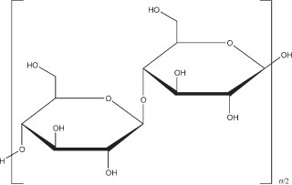

Fig 2.1: Basic Structure of Cellulose (Podezeck, 2009).

### Types of Cellulose

Plant-derived cellulose can be classified into three types (based on their solubility in 17.5% sodium hydroxide solution). Treatment with the alkaline solution of sodium hydroxide generally removes xylose and variable amount of other non cellulose cell wall constituents (Cross, *et al.,* 1895).

1. Alpha Cellulose (α-Cellulose). This is insoluble in 17.5% w/v sodium hydroxide solution. It has much higher degree of polymerization than the other two cellulose types and hence has the longest chain length. α-cellulose exists in various grades and exhibits degree of fineness ranging from a free flowing dense powder to a coarse, fluffy, non-flowing material. It is used as a self-binding, tablet diluent and disintegrating agent.
2. Beta cellulose (β-cellulose): This type of cellulose is freely soluble in 17.5% sodium hydroxide solution and can be precipitated from the alkaline by acidifying with mineral acid. Its degree of polymerization and chain length is lower than the α-cellulose.
3. Gamma Cellulose (γ-Cellulose): This is also soluble in 17.5% w/v sodium hydroxide but cannot be precipitated with acid. It can however, be extracted by first filtering off α-cellulose, followed by precipitating the β cellulose with acid and finally neutralizing the acidified

cellulose with ammonia, followed by evaporation of the solvent to get rid of the ammonium salt (Ojile *et al*., 2001).

#### Identification of Cellulose by Fourier Transform Infrared Spectrophotometry (FTIR)

Fourier Transform Infrared Spectroscopy (FTIR) is a reliable method of characterization of celluloses. FTIR spectrum is a finger print of functional groups in a molecule. Infrared radiation is passed through a sample; while some of the radiation is absorbed by the sample, some are transmitted. The resulting spectrum represents the molecular absorption and transmission characteristics, creating a molecular fingerprint of the sample. No two unique molecular structures produce the same infrared spectrum. FTIR is therefore, used in identifying unknown materials, determine the quality or consistency of a sample and determine the components in mixtures.

### Sources of cellulose

Cellulose is the major constituent of plant cell wall. Many researchers have worked on cellulose from different sources. Common sources of cellulose explored include maize cobs, rice husk, groundnut shell, sugarcane bagasse, sawdust, grass etc. Percentage cellulose content in these materials varies according to the researchers. For example, Musa (1996) reported a yield of 27.44% from sugarcane chaff while Musa (1999) obtained 23% from rice husk and Biala (2002) recorded 10.16% from groundnut shell.

### Cellulose derivatives

Cellulose derivatives are produced either by means of etherification (e.g. methylcellulose, ethyl cellulose, carboxyl methylcellulose), or by esterification (e.g. cellulose nitrate, cellulose acetate, cellulose acetate phthalate). Pharmaceutically and medicinally important cellulose derivatives include microcrystalline cellulose (MCC), methylcellulose (MC), cellulose acetate (CA), ethyl

cellulose (EC), sodium carboxy methylcellulose (Na-CMC), cellulose acetate phthalate (CAP), oxidized cellulose and carboxy methylcellulose (CMC).

#### Microcrystalline cellulose (MCC)

MCC is a purified, partially depolymerized cellulose prepared by treating alpha cellulose (type Iβ), obtained as a pulp from fibrous plant material, with concentrated mineral acids (Thoorens *et al*., 2014). It was first discovered in 1955 by Battista and Smith, and introduced to the pharmaceutical industry in 1964 by FMC Corporation under the brand name Avicel® as an ingredient for direct compression tableting (Albers *et al*., 2006). It occurs as a white, odourless, tasteless crystalline powder, composed of porous particles (Guy, 2009). It is practically insoluble in water, dilute acid, and most organic solvents, but slightly soluble in 5% w/w sodium hydroxide solution (Rowe *et al.*, 2009). A 1.2% w/v dispersion in water has a pH of 6-8. Microcrystalline cellulose has moisture content of 6%; however, various grades may contain different amounts of water. Particle size typically varies from 20-200 µm depending on the grade of product. Microcrystalline cellulose chars at 260-270 oC. It is quite stable when stored in a well closed container and cool dry place. MCC may be an irritant to the eye.

It is used as a tablet diluent as well as a disintegrant (Reilly, 2000). It has also been employed as binder/diluent in oral tablet and capsule formulations using both wet and dry granulation processes. Microcrystalline cellulose also has disintegrant properties and is also used in cosmetics and food products (Guy, 2009). It is also used as emulsifying, suspending and stabilizing agent (Reilly, 2000). The disintegrant and lubricant properties of microcrystalline cellulose from sugarcane were investigated by Musa in 1996, where he reported it to be comparable with a commercial grade Avicel®. Audu-Peter (2000) studied the compressibility properties of microcrystalline cellulose obtained from maize cob.

#### 2.1.4. 2. Methylcellulose (MC)

This is methyl ether of cellulose obtained by treating alpha cellulose with caustic soda and a methyl halide (e.g. methyl chloride, methyl iodide) or dimethyl sulphate. Methylcellulose does not occur naturally hence it is chemically or synthetically produced. It is prepared from wood pulp cellulose by treating the alkali cellulose with dimethyl sulphate. The hydroxyl group (OH-) in the glucose unit is substituted with methoxyl (OCH3) group. The degree of substitution depends on the average number of substituted OH groups per glucose unit (Rowe *et al.*, 2009).

Methylcellulose is a hydrophilic white or cream powder in pure form. It is soluble in cold but not hot water forming a clear viscous solution or gel. It gels when heat is applied, but when cold, it acts as a thickener (Allen Jnr and Luner, 2009). It is a thermo reversible gelling agent. Methylcellulose has a lower critical solution temperature (LCST) of about 40-50 oC; above which it is insoluble, forming precipitates (Allen Jnr and Luner, 2009). The temperature at which this precipitation occurs depends on the degree of substitution; the higher the degree of substitution, the lower is the precipitating temperature. Various grades of methylcellulose have different degrees of polymerization, ranging from 50-1000, with mean molecular weights number in the range of 10,000-220,000. The degree of polymerization also dictates the viscosity of its aqueous solution at 20 oC (Daiyong, 2005).

Methylcellulose, in 1% w/v aqueous suspension has acidity/ alkalinity pH of 5.0-8.0. Its bulk and tapped densities are 0.276 g/cm3 and 0.464 g/cm3 respectively while its true density is reported to be 1.341 g/cm3 (Allen Jnr and Luner, 2009). The glass transition temperature (𝑇g) for methylcellulose is 196 oC with melting point between 190 and 200 oC with a refractive index of

1.336 for 2% aqueous solution.

Methylcellulose is used pharmaceutically as a coating, emulsifying and suspending agent, tablet and capsule disintegrant, tablet binder and viscosity increasing agent in liquid preparations (Allen Jnr and Luner, 2009). It is also used as a bulk forming laxative in controlling constipation because it attracts water into the colon. It is used as a thickener in shampoo, tooth paste, and liquid soaps, as a lubricant in jellies because of its high viscosity and as a capsule shell used in nutritional supplement, in place of gelatin. Its film forming properties are utilised for the manufacture of skin protecting creams.

#### Cellulose Acetate (CA)

This is an acetate ester of cellulose. It is prepared from alpha cellulose by treating with acetic acid or acetic anhydride using a mineral acid (sulphuric acid) as a catalyst. It is a derivative of cellulose in which a portion or the entire hydroxyl group is acetylated. It is available in a wide range of acetyl levels and chain lengths hence a range of molecular weights (Rowe *et al.*, 2009). It occurs as a hygroscopic white to off white, free flowing powder, pellet or flakes. It is tasteless, odourless or may have a slight odour of acetic acid.

Cellulose acetate has bulk density of 0.4 g/𝑐𝑚3 and a glass transition temperature (𝑇g) of 170 - 190 oC while its melting point ranges from 230-300 °C (Daugherity and Nause, 2009). Its viscosity depends on the molecular weight but ranges from 210-228 mPas. The solubility depends on the level of acetylation (number of acetyl group present). In general, it is soluble in acetone water blends of varying ratios, dichloromethane, ethanol blends, dimethyl formamide and dioxane (Daugherity and Nause, 2009). Cellulose acetate is used in pharmacy as a coating agent, in extended release formulation and as tablet and capsule diluent.

#### Ethyl Cellulose

It is an ethyl ether of cellulose. Ethyl cellulose is a free flowing, tasteless, white to tan-coloured powder. It is practically insoluble in glycerol, propylene glycol and water. It is stable chemically and resistant to alkalis. Ethyl cellulose is a hygroscopic material with a glass transition temperature (Tg) of 129-133oC. It has water retarding properties hence its use in retarding the release of active medicament in pharmaceuticals. It is widely used in oral and topical pharmaceutical formulations. In oral formulations, it is used as a hydrophobic coating agent for tablets and granules, to modify release of drug, to mask unpleasant taste or to improve stability of a formulation. Ethyl cellulose may also be employed as binder (dry or wet) in tableting. It produces hard tablets when used as binder, resulting in low friability but poor dissolution (Dahl, 2009). In topical formulations, ethyl cellulose is used as a thickening agent in creams, lotions or gels, and as a stabilizer in emulsions.

#### Hydroxypropyl Cellulose (HPC)

This is the propylene glycol ester of methylcellulose where the methyl and propyl groups are attached to the hydro glucose rings of cellulose by ether linkages. It occurs as white to slightly yellow, fibrous or granular, odourless and tasteless powder. It is freely soluble in water below 38 oC, forming a smooth clear colloidal solution. It is insoluble in hot water, precipitated to form highly swollen flocs at temperature of between 40 and 45oC. Hydroxypropyl cellulose is non- toxic and non-irritant. It is widely used in oral and topical pharmaceutical formulations. In oral pharmaceuticals, it is employed as suspending and thickening agent, and as tablet excipient. It is also used extensively in cosmetics and food products.

#### Oxidized Cellulose

This is a cellulose derivative, which contains not less than 16 % and not more than 24 % carboxyl group. It is a water soluble cellulose derivative. Oxidised cellulose can be produced by action of oxidising agents such as chlorine, hydrogen peroxide etc. and a variety of metal catalysts. It may contain carboxylic ketones, aldehyde groups, in addition to the original hydroxyl group of the starting material cellulose, depending on the oxidant and reaction conditions (Oto *et al*., 1999). They are used in form of sterile pads, strips or pidgets as local haemostatic on a bleeding surface.

#### Cellulose Acetate Phthalate (CAP)

This is cellulose in which about half of hydroxyl groups are acetylated and about a quarter are esterified with one of the acidic groups, phthalic acid, while the remaining acid group is free (Daugherity and Nause, 2009). It is a white or off-white, free flowing powder, granules or flakes. It is tasteless, odourless or may have a slight acetic odour (Daugherity and Nause, 2009). It is practically insoluble in water, alcohol, chlorinate and non-chlorinated hydrocarbons. It is soluble in a number of ketones, esters, ether alcohols, cyclic ethers and certain solvent mixtures. Cellulose acetate phthalate has a melting point of 192 oC, and glass transition temperature (Tg) of 160-170 oC. It is hygroscopic in nature and produces a very good coating solution with a honey- like consistency. CAP is employed as enteric film coating material or matrix former for tablets and caplets. It is compatible with many plasticisers like dibutyltartarate, acetylated monoglyceride, butylphthalybutylglycolate, diethylphthalate, glycerine, propylene glycol, etc. It is used in combination with other coating agents such as ethyl cellulose in controlled drug release preparations (Daugherity and Nause, 2009).

### Sugarcane plant

Sugarcane is a tall perennial grass with stout fibrous touted stalks. It is grown in many tropical countries where it is cultivated for its sweet juice and used in sugar production. Sugarcane *(Saccharium officinarum*, L) belongs to the Family *Graminaceae*, believed to have originated from New Guinea (Brandes, 1956). It is however, widely cultivated in almost all the continents of the World (Barnes, 1974). Other species are *S*. *barber*i (―Indian cane‖), *S. robustum* (a wild ancestor of *S*. *officinarum*), *S*. *sinense* known as ―Chinese cane‖ and thought to be a hybrid of *S*. *officinarum* and *S*. *spontaneum* which is known as ―Wild cane‖, used for hybridisation purposes. The leaves are long and cylindrically shaped and grow from nodes on alternate sides of the stem. The stem is divided into a number of joints each consisting of a characteristic ring (nodes and internodes). Lateral buds appear at the nodes, one on each, normally on alternate sides of the stem. The plant is propagated asexually by cuttings with one or more buds.

The colour of the internodes varies remarkably according to variety and environmental condition. The colours are traceable to two pigments - anthocyanin and chlorophyll (Dillewyn, 1952). The colour can be yellow, green, brownish red or red. Today, sugarcane is grown in over 110 countries. In 2009, an estimated 1,683 million metric tons were produced worldwide which amount to 22.4% of the total agricultural production by weight (Peter, 1998).

### Sugarcane cultivation in Nigeria

Sugarcane is widely grown all over the country. Nigeria is one of the most important producers, with a land potential of over 500,000 hecters of suitable canefield capable of producing over 3.0 million metric tons of sugarcane. If processed, it yields about 3.0 million metric tons of sugar (NSDC, 2003). There are many varieties, depending on the geographical location. In the Northern States of Nigeria, about 55-65% of total sugarcane produced is solely cultivated for

direct consumption (Giren and Giroh, 2012). The bulk of this is consumed for the sweetness of the juice but some are processed into variety of products such as sugar molasses, bagasse jiggery, sweets and leftover leaf stalks (Giren and Giroh, 2012). Broadly speaking, sugarcane can be categorised into: industrial sugarcane and chewing sugarcane varieties. The most common chewing sugarcane grown in northern Nigeria is called ―Dan Makarfi‖ (*Saccharium officinarum*). This variety is robust, purple in colour with short inter nodes and usually very sweet because of its high sucrose content. It is characterized by moderate to high fibre content, high rind hardness and high resistance to smut and red rot diseases. It is solely cultivated for direct consumptions.

The industrial varieties of sugarcane are hybrid especially those used in the production of sugar. Refined sugars are obtained from the cane juice which is highly concentrated to enable the sugar separate by crystallization. Major examples of the industrial sugarcane varieties are CO 957, CO 997, CO 1001, and B6604 (Georg, 1972).

In Nigeria, sugar production increased to around 100,000 tons in 2007/2008 up from 80, 000 tons in 2006/2007 as a result of government encouragement of privatization process and maintenance of a duty differential of 50% between imports of refined sugar and raw sugar (Giren and Giroh, 2012), and the Governmen‘s 5 years tax free holiday to sugar refineries.

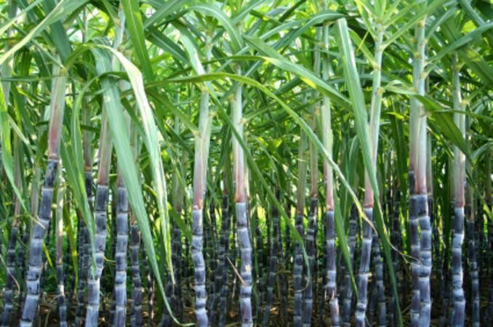

### Plate I: Picture showing sugarcane stalks in a sugarcane plantation

### The Bagasse

Bagasse is the fibrous matter that remains after sugarcane stalks are crushed to extract their juice. For each 10 tonnes of sugarcane crushed, a sugar factory produces nearly three tonnes of wet bagasse. It is a by-product of the cane sugar hence the quantity produced in each country is determined by the quantity of sugarcane produced. Bagasse on wash and dry basis shows a typical chemical composition of cellulose (45-55%), hemicellulose (20-25%), lignin (18-24%), ash (1-4%) and waxes (1%). (Engineeringcivil.com).

Researchers have explored bagasse as a renewable power generation source and for production of bio-based materials. It is used as a primary fuel source for sugar mills. When burned in quantity, it produces sufficient heat energy to supply all the needs of a typical sugar mill with energy to spare.

Cellulose rich bagasse is now being tested for production of commercial quantities of ethanol in America (Cadona *et al.,* 2010). It has also been used in coarse paper production and insulated disposable food containers. It has also found use in the production of cattle feed where it is mixed with molasses to produce ―Cow Candy‖ in Australia (Deepchand, 2005). Some cellulose derivatives (methylcellulose and cellulose acetate) are recently being produced from sugarcane bagasse (Filho *et. al.*, 2007).

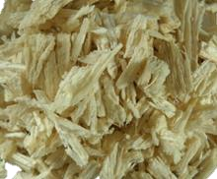

### Plate II: Picture showing sugarcane bagasse after extraction of the cane juice.

### Pharmaceutical excipients

Pharmaceutical excipients are inert substances which are added to the active ingredient of a dosage form to impact good processing characteristics and properties to the drug. They are added to impart aesthetic values, control drug release, enhance stability and give suitable physical characteristics. Excipients are the largest components of any pharmaceutical formulation (Ogaji *et al*., 2012). They can be of natural or synthetic origin and synthetic excipients have some common place in today‘s pharmaceutical dosage forms.

Synthetic excipients are common in modern pharmaceutical dosage forms. Fully synthetic and semi synthetic products offer advantages and unique properties over the naturally derived components are used frequently. Such properties as low sensitivity to various ingredients or moisture result in more efficient and effective pharmaceutical products. Semi synthetics are typically substances that are naturally derived but have been chemically modified. Most excipients in use today, fall into this category (Russell, 2004).

Natural polysaccharides as well as their derivations represent a group of polymers that are widely used in pharmaceutical formulations and their presence plays a fundamental role in determining the mechanism and rate of drug release from the dosage form. These natural polymers have been employed as excipients in the pharmaceutical industry in the formulation of solid, liquid and semi-solid dosage forms in which they play different roles such as disintegrants, binders, film formers, matrix formers, release modifiers, thickness or viscosity enhancers, stabilizers, emulsifiers, suspending agents and muco-adhesives (Ogaji *et al.*, 2012).

### Tablet Excipients

Pharmaceutical excipients used in tablets can be grouped based on the functions they perform. Some of the excipients used in tableting are major excipients (diluent, binder, lubricant, disintegrant, surfactant and coating agent), while others (colouring, flavouring, sweetening agents, and absorbents) are minor excipients. In virtually all tablet formulations, excipients such as diluents, lubricants, disintegrants and binders are integral part of formulation components.

#### Diluents (Bulking agents)

Diluents are included in tablet formulations to bulk up the volume that will ensure compressibility in tablet or provide enough fill in capsules. They give adequate weight and size to assist in production and handling.

A suitable diluent should:

* + - * 1. be inert so as not to cause pharmacological activity on its own.
        2. be compa~~ti~~ble with the active ingredient and other excipients in the formulation.
        3. be hygroscopic so as not to absorb significant amount of moisture from the surrounding.
        4. have similar particle size with the active substance to ensure optimum mixing and uniformity of content.

In some cases, a diluent performs more than one function in a pharmaceutical formulation. Examples of commonly used diluents are: starch, sucrose, dextrose, mannitol, sorbitol and lactose (Spray dried and conventional).

#### Binders (Adhesives)

Binders are agents used to impart cohesiveness and structural strength to powdered materials in tablet formulations. Binders are used both in direct compaction (as dried powdered materials)

and in wet granulation (solutions of such binders previously prepared) are used. Binders added as solution are more effective than those added as dried powder (Ibrahim, 1997; and Ahmed and Fars, 2013). In dry granulation (compaction), binders are used as dried powdered materials which must exhibit cohesive and adhesive forces so that when the particles are compacted, they agglomerate. In wet granulation, binders are hydrophilic and are usually dispersed in water which is then used in wetting the dry powder mix, to form a damp mass kneaded and screened to give granules.

The concentration of binders in tableting is of paramount importance on the characteristics of the compressed tablet. The higher the concentration, the longer is the disintegration time of the tablet (Mgbahurike and Igwilo, 1991). Therefore, the concentration of the binders needs to be carefully selected because too high a concentration will result in capping of tablets, premature wear and tear of punches and dies, and high pressure requirement for tablet compression, while inadequate binder also results in too soft a tablet, high friability and breakages during handling. Nasipuri and Akala (1986), and Builders *et al.* (2011) reported increases in mean granule sizes, hardness and disintegration times as consequences of increased binder concentration. Sakr *et al.* (1972) and Tadese *et al.* (2014) have also reported decreases in friability of paracetamol and lactose tablets, respectively when papyrifera gum concentration, in the former and gelatin binder concentration in the later, were increased.

Commonly used binders in tableting are gelatin, starch, sugars like glucose, dextrose, gums natural (acacia) and synthetic gums like methylcellulose, polyvinyl pyrolidine, microcrystalline cellulose, carboxy methylcellulose, polyethylene glycol, etc.

#### Disintegrants

A disintegrant is a substance or a mixture of substances added to a tablet formulation to enhance its break up into smaller fragments for easy dissolution after administering. Disintegrants are added to powder mix of the active ingredient and diluents before granulation (intra-granular disintegrants) or after granulation (extra-granularly). They are usually added in concentrations of 5-20% w/v of the granules. Depending on the composition of the tablet, disintegrants constitute 1-5% of the total tablet mass. Disintegrants are chemically classified as starches, cellulose, clays, alginates or gums. Most popularly used disintegrants are starches especially corn and potatoes.

All disintegrants follow three major mechanisms of action in tablet disintegration (Lowenthal and Wood, 1973; and Carter, 2002).

* + - * 1. Swelling of tablets through absorption of water with subsequent bursting resulting in tablet break up. Hydration of tablet leads to weakness of the bonds in the tablet.
        2. Capillary action where internal pressure is created and subsequent breakup of the tablets into swell fragments. The capillaries are thought to promote the rapid absorption of water into the tablet and subsequent disintegration of tablets. This is the major mechanism of disintegration theory with starches. Using the method described by Bowen and Vadino (1984), Adedokun and Itiola (2011) found that corn starch absorbs 32% of its own weight of water in 24 h
        3. The Gas Evolution Theory: This is common with solution tablets which contain mixture of sodium carbonate where carbon dioxide is produced from the reaction of sodium carbonate with citric acid in the presence of water. Sufficient acid is added to ensure that

the disintegration is rapid and complete in less than 15 minutes. Such formulations, however, have to be kept dry throughout manufacturing, packaging and storage.

The mode of action of a disintegrant in tablet dissolution is governed by its proportion (concentration) in the tablet mass. In general, the higher the concentration of the disintegrant, the shorter is the disintegration time as long as the concentration is below an optimum value above which the gain in disintegration time is no longer commensurable with increase in disintegrant proportion (Akande, 1988; Rudnic and Schwartz, 2005; and Adedokun and Itiola, 2011).

#### Lubricant/Glidant

Lubricants are substances incorporated into tablet formulations to improve the rate of flow of granules or powders and prevent adhesion of the tablet material to the die cavity. When added in adequate quantities, lubricants serve a number of functions in tablet production. They can improve the rate of flow of the tablet granulation, prevent adhesion of the tablet material to the surface of the dies and punches, reduce inter particle friction, and facilitate the ejection of the tablets from the die cavity.

Lubricants are incorporated in the dry state, just before compression at a concentration of between 0.5 and 5% w/w of the granules and as fine powder (< 60 mm) (Kunle *et al*., 1999 and Rudnic and Schwartz, 2005). Lubricants generally act between surfaces in relative motion to prevent friction and wear. It is needed to reduce the friction between the inner die wall and tablet edge during the ejection cycle. The quantity of a lubricant and the time of mixing with granules or powder also affect some properties of the resultant tablet, like dissolution rate, hardness and friability. While Bolhuis *et al.* (1975) found that increased mixing time produced more uniform distribution of magnesium stearate. Desai *et al.* (1993) reported that excessive mixing led to

redused dissolution rate. Commonly used lubricants in tableting are talc, magnesium stearate, calcium stearate, stearic acid and hydrogenated vegetable oil.

Glidants in common use are talc and silicon dioxide.

### Excipients in liquid dosage forms

Liquid dosage forms include mixtures, suspensions, emulsions, lotions, liniments, solutions and drops. Major excipients used in liquid dosage forms are suspending, emulsifying, colouring, flavouring and sweeten agents, and preservatives.

#### Suspending agents

These are excipients which increase the viscosity and density of the vehicles used in formulation of suspensions. They retard the sedimentation of the indiffusible drugs. Pharmaceutical suspensions are solid dispersions of insoluble or sparingly soluble drug in an aqueous or oily vehicle. They are mostly intended for oral administration, as a convenient way to administer insoluble or sparingly soluble drugs to infants and the elderly, who may have difficulty in swallowing tablets or capsules. Some are also intended to mask taste. Other dosage forms in suspensions are topical applications, parenterals, and aerosols for inhalations.

As a requirement, a good suspension should be homogeneously mixed and remain both physically and chemically stable during the shelf-life of the formulation. This is important because of the need to dispense a uniform and accurate dose of the medicine per portion of the suspension. Additional requirement of sterility is specified for parenterals and eye preparations formulated as suspensions. Suspensions will settle when left for a long time and this can happen during storage. The insoluble drug agents separate from the vehicle and settle to the bottom of the container. In a good suspension, such separated fraction/portion is expected to be re-

dispersed or re-suspended easily by shaking to ensure homogeneity of dose. Loose network of flocs (flocculated system) settle rapidly, do not form cakes and are easily re-dispersible. In the formulation of suspension, wetting agents are used to promote wettability of insoluble drug substance. Non-wetting of insoluble substances can result in floating of drug in the continuous phase, adversely affecting content uniformity.

Suspending agents are used to prevent rapid settling of the dispersed phase, as viscosity imparting agents, reduce caking and promote re-dispersibilty. Commonly used suspending agents are compound tragacanth powder, powdered tragacanth, tragacanth mucilage, sodium carboxyl methylcellulose and methylcellulose.

#### Emulsifying agents (Emulgents)

These are substances that lower the surface tension between two immiscible liquid phases, they tend to congregate at an oil-water interface. They provide a barrier around the droplets as they are formed and prevent coalescence of the droplets. They are mostly used to stabilize emulsions.

There are three basic classes of emulgents

* + - * 1. The amphipats (soaps, long chain amines and alcohols).
        2. The hydrophilics (acacia, gelatin, sodium alginate and celluloses like methylcellulose).
        3. Finely divided solids such as magnesium and aluminium hydroxide and bentonite.

Commonly used emulsifying agents are acacia, methylcellulose, and bentonite.

#### Preservatives

These are substances included in liquid preparations to prevent microbial growth or spoilage either during drug production, drug shelf life or in between doses administration.

A preservative should have the following properties:

1. It should be effective at low concentration.
2. It should be non- toxic, not irritant and not sensitizing.
3. It should be odourless, tasteless, colourless and soluble in proposed vehicle
4. It should be stable and effective, unaffected by pH.
5. It should be inert, non-volatile, readily prepared in a pure state and easily standardized.
6. It should be compatible with other product constituents.

Commonly used preservatives, for oral liquid preparations are chloroform, benzoic acid, ethyl alcohol, propylene glycol, etc.

### Tablets

### Tablets and tablet technology

A tablet is a solid dosage form containing one or more active substances with or without- excipient, and compressed under pressure, to a definite shape. The shape of a tablet depends on the set of die-and-punch used in the compression. Common tablet shapes are convex, flat, circular, oval, and rhombic. Tablet sizes vary because of differences in drug dosages and intended method of administration.

The prevalence of tablet as the most popular oral dosage form is attributable to some of its advantages, which include:

* Simplicity and economy of preparation
* Stability and convenience in drug packaging, shipping and dispensing
* Accuracy of dosage, compactness, easy administration.
* Taste of drug (unpleasant tastes can be masked by sugar or film coating)
* Rate of release can be controlled so that pharmacological action can be targeted or monitored
* Two or more active substances can be combined in one tablet (e.g in multilayered tablets).

#### Tablet properties.

A good tablet according to Bangudu (1993), should have the following properties:

* The active constituent(s) should be available which may be directly related to its disintegration time and dissolution rate.
* It should be strong and resistant to abrasion and be able to withstand all stress during manufacturing, packaging, transportation and usage. This is measured with friability and hardness tests.
* The active ingredient content and weight of the tablet must be uniform. This can be evaluated with drug content and weight uniformity tests.
* It should be elegant in appearance and may have the characteristic colours, shape and other markings that may identify the product.
* It should retain all the functional attributes that include stability and efficacy at site of action.

#### Types of tablets

Tablets are designed for various uses and for different routes of administration. The various types of tablets in use nowadays are as follows:

#### Plain compressed tablets

These are tablets formed by compression of powdered, crystal or granular materials intended to be swallowed. They may contain some or all the excipients like binders, disintegrants, lubricants, glidants, diluents and sometimes colourants.

#### Solution tablets

A solution tablet is a tablet dissolved in water to form a clear solution before it is administered internally or externally. It could be administered orally, parenterally or externally but has to be completely dissolved in water. The BP (1973) also specifies that solution tablets should not contain a lubricant. An example of this type of tablet is ascorbic acid tablet.

#### Effervescent Tablet.

These are tablets that are formulated with a base like sodium bicarbonate and organic acids like citric acid as additives so as to liberate carbon dioxide when such tablet is placed in water. This acts as a disintegrant and produces effervescence. A typical example of this type of tablet is Ca- C 1000 (Sandoz®) tablet which contains calcium lactate-gluconate, calcium-carbonate and ascorbic acid in the tablet. Disintegration is hastened by this formulation and the resulting light acidic taste masks the unpleasant taste of calcium, hence palatability is increased.

#### Chewable Tablets

These are tablets designed for chewing in the buccal cavity before swallowing. The chewing is to hasten disintegration and so disintegrants are not required in the formulation. However, other

excipients like flavourants, colourants, or sweetening agents may be required to enhance palatability in the mouth during chewing. Many antacids and some multivitamins are formulated this way.

#### Lozenges

These are tablets designed to slowly dissolve in the mouth, releasing the active constituent in the throat for local effect. The disintegration is through erosion in the mouth. Some antimicrobial agents are formulated this way e.g. Dequadin® lozenges (Evans).

#### Buccal or Sublingual tablets

These are tablets designed to be absorbed directly without passing through the alimentary canal. They are placed in the buccal pouch or under the tongue to be slowly absorbed through the oral mucosa. Such tablets dissolve or disintegrate in the mouth and are absorbed. They should not have bitter taste and should be highly soluble so as to avoid medicament loss to salivation. They should also not be bulky. Aulton (1988) stipulated that such tablets should not be more than 300 mg. Steroids and some hormones are commonly formulated this way. Common examples are ethisterone, progesterone and glyceryl trinitrate tablets.

#### Implants

The implants or pellets are tablets made by fusion or compressed with high pressure and made to be inserted subcutaneously by means of a minor surgery. They are implanted under the skin to be slowly absorbed. The implants are aseptically prepared and stored in single sterile containers. They should therefore remain sterile throughout their shelf lives (Carter, 1975). The commonest example is testosterone tablets.

#### Coated Tablets

Coated tablets are compressed tablets that are covered with a thin film to enhance stability, ease administration, mask taste, improve product identity or control their release. Coated tablets are therefore three types:

***Film Coated Tablets:*** where a film of water-soluble polymer is applied on compressed tablets. A common example is tinidazole.

***Sugar Coated Tablets:*** Tablets here are coated with sugar e.g. sucrose, in most cases, to mask the taste. An example is the iron tablet (Ferrous Sulphate)

***Enteric Coated Tablets:*** These are tablets coated with substances that retard the release of active medicament in the stomach or gastric fluid but are readily released in the intestinal fluid. This formulation can be employed for drug substances which can be destroyed or inactivated in the stomach environment. It can also be employed as a means of delaying drug release e.g. low dose aspirin (Vasoprin®).

#### Sustained Release Tablets

These are coated tablets or tablets embedded in a matrix with the sole aim of releasing the drug slowly over a prolonged period of time. They are formulated to release steadily or combine a number of mechanisms to release pulse of drug in repeat action tablet. Common examples are Amlodipine, and Nifedipine.

### Tablet Production

Compressed tablets are produced by compressing fine crystals, free flowing powders and or granules in a cavity between punches and dies under pressure. Materials to be compressed must be of good lubricity and flow properties. Many materials lack these properties, hence the need

for formulators to impart these properties to the materials to be compressed. The compression characteristics and fluidity of powder particles are improved by the process of granulation. Granulation is a process by which primary [powder](https://en.wikipedia.org/wiki/Powder_(substance)) [particles](https://en.wikipedia.org/wiki/Particles) are either subjected to compression or by using a binding agent, to create bonds between the particles thereby forming larger, multiparticle entities called [granules.](https://en.wikipedia.org/wiki/Granular_material) Powder particles are mostly cohesive due to their irregular shapes, and do not flow well. Granules are generally larger and more isodiametric leading to improved flow properties. Thus granulation allows the production of more predictable and repeatable tablets of high quality from powder materials. Granulation is extensively used in tablet production.

There are three main methods of tablet manufacture. The choice of the appropriate method to use in the production of a tablet depends on the properties, the desired doses and physicochemical nature of the active constituent as well as the equipment to be used and the regulatory concerns.

#### Wet Granulation

This is the oldest and most commonly used method of tablet manufacture. The sole aim of this method is to improve the flow and compressibility of powder materials which may not be achieved when other methods are used. Basically, wet granulation involves weighing and mixing of the drugs and excipients, preparation of binder solution, mixing of the binder solution with powder mixture to form wet mass, coarse force screening of wet mass through mesh screen, drying of moist granules, screening of dried granules, mixing of screened granules with lubricant and/or disintegrant and compression into tablets.

Wet granulation can be achieved in six different ways:

* + **Massing and Screening:** Here, the dry powder is mixed with the binder solution; the mixing is continuous until equilibrium granular stage is reached. The wet mass is then force-screened through a granulator to form granules which are then dried.
  + **Pan Granulation:** Here, the powder mix is put into the rotating pan and the binding fluid is sprayed to it through a nozzle as the pan is rotating. On contact with the liquid droplets, two or more, particles will bind together to form agglomerates. The round spherical granules are aided by the rotating pan. The granules are dried either by heating the pan or forcing in hot air through the nozzles.
  + **Spheronization:** In this method, the wet mass is made by adding excess binding fluid or massed for a longer period to form a plastic mass which is force-screened through a sieve. The strands so formed are chopped to form short cylindrical granules which are passed through a rotating manumeriser to form compact spherical granules.
  + **Spray Granulation:** Here the slurry or solution of the powder and binding fluid is sprayed into a hot chamber maintained by hot fluidized air. As the liquid evaporates, it leaves clusters of particles which impinge themselves to form agglomerates as long as surfaces are wet.
  + **Fluidized Granulation:** In this method, the powder particles are fluidized into the chamber and the binding fluid is sprayed through an atomizer. As the particles are wet, they form agglomerates leading to larger particles. The granules are formed and dried simultaneously.
  + **Controlled Crystallization:** Powdered mass and the binding liquid are made into crystals under controlled condition like temperature. The particle size of such crystals so formed will depend on the temperature of the solution used in forming the crystals.

#### Dry Granulation

This basically means granulation of powder mix ingredients without the use of solvent. The basic procedure is to form a compact of the material by compression and then mill the compact to obtain the granules. The compacted masses are called slugs. When the slugs comminute, they form materials that flow more uniformly than the original powder.

There are two methods of dry granulations, namely, slugging and nebulisation. The more widely used is slugging where the milled powder is pre-compressed, then milled to produce granules. In nebulisation, the powder is pre-compressed with pressure rolls using a machine.

Dry granulation has the advantages of requiring fewer pieces of equipment, does not require liquid binder solutions and eliminates the need for any drying time unlike the wet granulation. Dry granulation is therefore the method of choice in the following situations:

-where moisture sensitive materials are involved

-where heat sensitive materials are involved

-to improve disintegration since a binder is not required for powder particles that bond together.

-to improve blending of the ingredients since there is no migration of active ingredient which might occur during drying in the wet granulation method.

* where anhydrous materials are involved since such materials tend to change when wet.

Disadvantages of dry granulation include excessive dust formation, lack of uniform colour distribution, and the need for heavy specialized equipment.

#### Direct Compression method

This is the process whereby powder blends of the active ingredients and suitable excipients which will flow uniformly into a die cavity are compressed directly to form a firm compact.

Few compounds can form a firm compact when directly compressed under pressure, because of the flow, cohesion, compressibility and lubricating properties requirement of such compounds. Such few crystalline substances like in-organic salts (sodium chloride, sodium bromide and potassium chloride) may be compressed directly. The crystals are first broken and then passed through the sieves to select required size. They are then mixed with the diluents and disintegrant in the dried state and compressed (Rawlins, 1997; Kallam, 2011).

Direct compression method has the advantage of economy; it eliminates the need for heat and moisture, hence greater stability, and uniformity of particle size. Its major limitation is the narrow spectrum of compounds to which it is applicable.

### Problems in tablet production

Problems in tablet production may arise as a result of improper formulation, incorrect setting of the machine and difficulty in one or more processing steps among others. Some of these problems could result to one or more of the following:

### Capping and Lamination

Capping occurs when the top or bottom segment of a tablet is removed or separated from the main body. Lamination is the complete separation of tablet into two or more distinct layers.

These problems occur when air is entrapped in the granules which is compressed as the punches move together to apply pressure. When such pressure is released, such air expands. The problem occurs when the granules are too light or with high percentage of fines or over dried.

Capping and lamination can be overcome by increasing the binder amount for light granules, addition of water to over dried granules and granulation of powdered materials with coarse sieve and reduction of excessive fines.

### Binding

Binding occurs when there is difficulty in ejecting tablets due to adherence to the die wall. This is usually caused by insufficient lubrication. Such tablets have rough soles or edges with vertical scratches or score marks caused by abrasion on ejection.

Binding causes cracking and/or chipping of tablets and in the case of coloured tablets, edges are lighter. The problem can be remedied by increasing and improving lubrication (King, 1975; Rana, 2013).

### Sticking and Picking

Sticking occurs when a tablet adheres to the wall of the die preventing a free movement of the lower punch. Picking however refers to when some parts of the tablet surface is removed. Picking usually starts with a small fragment but larger pieces of the tablet surface are picked subsequently as compression continues.

Sticking and picking commonly occur with tablets that have letter engravings or designs that may be too sharp. These problems are mostly caused by inadequate amount of lubricant and oily

or waxy material. The problems are eradicated by maintaining smooth punch surfaces, reducing moisture content of the granulation and increasing binder proportion.

### Chipping and Cracking

Chipping is when pieces are broken out of the tablet. It usually occurs on the edges of a tablet. Sticking to the die wall of the material, incorrect setting of lower punch or damaged punches are some of the causes of these problems. Cracking occurs when there is a crevice in the tablet, usually at the centre. It is usually due to the expansion of the tablet immediately after compression.

The problems can be eradicated by reducing the granule size, increasing the binder concentration, polishing punch tips, removal of fines and avoiding tablet expansion by reformulation.

### Tablet evaluation

Solid dosage forms are formulated to deliver active ingredient(s) at, or over a period of time in the desired area of pharmacological action. For this to be attained, such dosage form needs to conform to certain standards, which are often stated in official monographs. Some tests are official, while others are unofficial. Tablet evaluation tests include:

#### Weight variation test

This is a test for uniformity of tablet weight. Variation in weight may occur either as a result of poor flow which will lead to improper filling of the die cavity or due to improper mixing of the granules. Sample of tablets in a batch are weighed, and the mean weight and deviations from the mean weight are determined. The deviation from the mean weight is compared with official limits (BP, 2013; USP, 2009). To pass the test, not more than two tablets are permitted to

deviate from the mean by greater than a stated percentage and no tablet by more than double that percentage.

#### Active ingredient test

The active content uniformity test is a necessary test to ensure constant and consistent therapeutic response when the tablets are used by different individuals. In order to ensure that every tablet within a batch contains the amount of drug substance intended, official official pharmaceutical guide books such as the USP include content uniformity test for tablets. However, individual drug assay is normally used. Variations in the percentage of medicament might occur for various reasons such as variation in the weight of the tablets, permitted variation in the purity of the drug, errors of random sampling, and limit of accuracy in the analysis.

#### Disintegration time test

This measures the time it takes a tablet to break down into small granules or particles when placed in a liquid medium. The tablet has to break up to go into solution before it can be absorbed into the system. Hence, disintegration time is an indirect way of measuring the availability of the active ingredient.

The official disintegration apparatus consists of six perspex tubes arranged round in racks, open at the top with the bottom ends sealed with a number 10 mesh screens. The tubes are attached to an arm and are raised and lowered at 30 cycles per minute through a water bath thermostated at 37 oC. The maximum permitted disintegration time for uncoated tablet is fifteen minutes (15 mins) unless otherwise stated in the individual monograph. The USP (1980) allowed up to 45 minutes and 60 minutes for hydrophobic tablets and sugar coated tablets respectively.

The test fails if any one of the six tablets is beyond this time and the test is repeated. If at the 3rd time, any one fails again, the entire batch is considered to have failed the test. Disintegration test is useful as a means of assessing the potential importance of formulation and process variables on the biopharmaceutical properties of the tablet.

#### Dissolution profile

This is a measure of the rate at which the active ingredient is released into the solution from the tablet. Tablet dissolution is a standardized method for measuring the rate of drug release. It is an official test recommended by the BP 2013. Dissolution test functions as a tool for:

* Optimization of therapeutic effectiveness during product development and stability assessment.

* Routine assessment of production quality to ensure uniformity between production tests.
* Assessment of bioequivalence of batches of product from one or different manufacturers.
* Prediction of *In-vivo* availability i.e. bioavailability (where applicable).

Dissolution rate testing is essential in tableting. The rate limiting step affecting bioavailability is the rate of dissolution in gastrointestinal fluids. In dissolution testing, the media used simulate the composition of gastrointestinal tract fluid, while the apparatus uses a method of forced convection by gradual fluid turbulence to simulate peristaltic activity obtained *in-vivo*.

#### Uniformity of diameter (Tablet dimension)

The dimension of a tablet can be characterised by determining the diameter of the tablet. Tablets of the same diameter will usually be assumed to have similar weight range if they are compressed by the same machine under the same pressure (Staniforth, 2002).

Tablet diameters are specified in the Pharmacopoeia. Tablet thicknesses are not directly controlled but, in practice, most manufacturers design the thicknesses of uncoated tablets to be half of their diameters, for the resultant elegant and pleasing shapes. If the diameter and thickness are both defined, the volume and weight of a tablet are obviously fixed implying that there is officially little variation in the dimensions of tablets produced by different manufacturers. The Pharmacopoeia permits some slight deviations, usually ±5% from the normal diameter (Copper and Gunn, 1986). Diameters are determined using Vernier callipers while the thicknesses are measured with micrometre screw gauges.

#### Hardness/Crushing test

The mechanical strength (Crushing) of a tablet is associated with the resistance of the solid specimen towards fracturing. According to Staniforth (2002), the test is carried out for several reasons which include:

* + 1. To assess the importance of formulation and production variables for the resistance of a tablet towards fracturing and attrition during formulation process, design and scaling up.
    2. To control the quality of tablets during production (in-process and batch control).
    3. To characterise the fundamental mechanical properties of materials used in tablet formulation.

The test consists of breaking or crushing the tablets by the application of compressive load. Since crushing strength is measured by the application of pressure without any consideration for the tablet dimensions which may vary, tensile strength measurement may be utilized instead to account for differences in sizes and shapes.

#### Friability test

The friability of a tablet is a measure of its resistance to abrasion. It measures the abrasive effect of tumbling motion encountered by tablets during coating, packing or transportation. After a period, the abraded material is sifted from the tablets and the percentage estimated. Ten tablets are selected from a batch and the total weight is determined. After subjecting to abrasion/agitation, the final weight is determined and the loss from the tablet is expressed as a percentage using the equation:

𝐹𝑟i𝑎𝑏i𝑙i𝑡𝑦(%) = Original weight − Final weight X100 (1)

Original weight

To pass the test, a batch must possess a friability of not more than 1%. A friabilator is used in carrying out the test.

### Suspensions and suspension formulations

Suspensions are heterogeneous systems consisting of two phases, the dispersed phase usually made up of insoluble particles and the continuous phase or dispersion medium. Liquids or semi- solid vehicles usually form the continuous phase. The particle size in most pharmaceutical suspensions is between 1 and 50 µm, while colloidal dispersions range from 1 nm to 0.5 µm (Crowley, 2013). Fine dispersions such as magmas and gels are from 0.5 to 10 µm in size. Drug particles in inhalation therapy are usually between 0.5 and 5 µm to ensure effective deposition within the lower respiratory tract (Snodin, 2009).

Pharmaceutical suspensions are employed to address various medication issues. For example, in children, where there is difficulty in swallowing. It is also useful where there is poor solubility of certain medicaments in a suitable solvent. Pharmaceutical suspensions have been used to mask disagreeable tastes of some drugs such as Paracetamol Elixir (B.P.2011) which is less palatable than its suspension (Aulton, 1988). The degradation of a drug in the presence of water may also preclude its use as an aqueous solution in which case, it may be possible to synthesise an insoluble derivative which can then be formulated as suspension.

The extemporaneous preparation of suspensions on a small scale includes the trituration of the dry insoluble materials in a mortar to a smooth paste with a vehicle containing a suspending agent. It may also be necessary at this stage to include a wetting agent to aid the dispersion, thereafter a portion of the dispersion medium into which any soluble ingredient such as colorants, flavourings and preservatives may be dissolved, is gradually added. The slurry thus prepared is transferred into a graduated cylinder and the mortar and pestle are thoroughly rinsed with successive portions of vehicle until the suspension is brought to the desired final volume. On a large scale, dispersion of solid in liquid is achieved by the use of colloid mills, ball mills, pebble mills, and sometimes pony mixers are also used (Crowley, 2005).

A good pharmaceutical suspension should have the following properties:

* It should remain sufficiently homogenous for at least the period between shaking the container and withdrawing the required dose.
* The sediment formed on standing should be bulky and easily re-dispersible.
* The viscosity should not be so high that removal of the product from the container and transfer to the application site would be difficult.
* The suspended particles should be small and relatively uniform in size so that the product is free from gritty texture.
* Suspensions meant for injectables must not clog the needle.
* The suspension may be required to be thickened in order to reduce the rate of sedimentation of the particles.

### Problems associated with suspension formulation

Suspension formulation is associated with some problems which are basically dependent on size and density of particles, viscosity of the suspending medium, and the wetting agents. The rate at which particles in a suspension sediment is illustrated by Stokes law (Martins *et.al*, 1983).

𝑣 =

𝑑2(𝜌𝑠 − 𝜌𝑜)𝑔 185

… … … … … … … … … … … … … … … … … … … (2)

Where v = terminal velocity of suspended particles in cm/sec. d = diameter of the particles in cm.

ρs = density of dispersed phase g/cm3

ρo = density of liquid medium in g/cm3.

η = viscosity of the dispersion medium in Pas. g = acceleration due to gravity in cm/sec2

An increase in particle size or a large difference between the densities of the solid and liquid phases will increase the sedimentation rate while an increase in viscosity of the liquid medium will decrease the rate of sedimentation (Martins *et.al*, 1983; Crowley, 2005).

In pharmaceutical oral suspensions, which are usually coarse dispersions, the system sediments overtime because of the size of the particles and the effect of gravity. The dispersed particles slip past one another forming closely parked arrangement at the bottom of the container with smaller particles filling up the void between larger ones and gradually the particles below are pressed together by the weight of particles above.

The repulsive barrier surrounding the particles is overcome and a physical bonding occurs leading to ―cake‖ formation due to bridges between the particles as a consequence of crystal growth and hydration effects requiring forces greater than agitation to disperse the sediments. Conversely, the particles may form a loosely bonded structure or aggregate called a ―floc‖ or flocculate and the process of its formation is called flocculation. These flocs separate out and sediment fairly rapidly but because they are loosely packed high volume sediment which retain their structures, they are easily re-dispersible. The supernatant liquid is clear because the colloidal particles are trapped within the flocs and sediment with them. This latter state is desirable for pharmaceutical suspension.

The addition of wetting agents to some suspension formulations may be necessary to reduce the interfacial tension between the solid and the liquid so that the absorbed air is displaced from the solid surface by the liquid. Wetting agents in use include surface-active agents like Quillia tincture and sodium lauryl sulphate which are mostly used for external preparations, while hydrophilic colloids such as acacia, tragacanth and the alginate have wide application in formulations for internal use.

### Evaluation of suspending agents

#### Sedimentation of suspension

One parameter for assessing pharmaceutical suspension is the sedimentation volume, F which is defined as the ratio of the final volume, νu to the original volume, νo:

𝐹 = 𝑣𝑢⁄𝑣𝑜……………………………….…………. *(3)*

The ratio, F is a measure of the aggregate deflocculated state of a suspension. F may be plotted together with the measured zeta potential against the concentration of additive to enable the assessment of the state of the dispersion to be made. The appearance of supernatant layer needs to be noted as well as redispersibility of the suspension evaluated (Billany, 2007).

#### Rheological properties of suspension

Depending on the concentration, flocculated systems can exhibit plastic or pseudo plastic flow behaviour as the structure progressively breaks down under shear.

Flocculated systems show time-dependent reversibility of the loss of structure whereas, deflocculated dispersions exhibit Newtonian behaviour, owing to the absence of such structures and may even exhibit dilatancy at high temperatures. The dilatancy, when observed in deflocculated dispersions has been explained to be due to electrical repulsion that occurs when the charged particles are forced close together causing the particles to rebound, creating voids into which the fluid flows leaving other parts of the dispersion dry (Billany, 2007).

#### 2.5.2.3. Electrical properties of suspensions

Particle surfaces in suspensions are often electrically charged when they come in contact with a medium. The charges are usually negative and the process by which it occurs takes place in

various ways. The amount of charges on the particle surface is an important particle characteristic and determines many of the properties of suspensions (Nep, 2010).

Although particles are regarded as being electrically charged, the suspension is neutral overall, because the charge on the surface of each particle is neutralised with charges (ions) of opposite type in the surrounding solution. This distribution of ions is in turn affected by thermal agitation which tends to disperse the ions in solution and results in the formation of an electrical double layer made up of charged surface and neutralizing excess of counter ions over co-ions distributed in a diffused manner in the aqueous medium (Nep, 2010).

#### Viscometric analysis

When a polymer is in solution, its viscosity is always directly related to the size and shape of the polymer molecules (Wang and Cui, 2005). In determining dilute solutions viscosity, relative viscosity (ŋr) is measured for a series of dilute solutions of the polymer or polysaccharide which allows for calculation of the intrinsic viscosity (ŋ). Molecular weight can then be calculated using Mark-Houwink equation (Idris, *et al.*, 1998).

[ ] =  … … … … … … … … … … … … … … … … … … … … ( )

Where;

*M* is the average molecular weight, and α and *K* are constant.

Dilute solution viscosity does not give absolute molecular weight but only a relative measure of the molecular weight (Wang and Cui, 2005). The determination of intrinsic viscosity (ŋ), is theoretically based on the Huggins (Huggins, 1942) and Kraemer (Amalvy, 1997) equations.

Determination of intrinsic viscosity (ƞ), requires that the viscosity of several dilute solutions are determined and plotted in the forms of specific viscosity versus concentration ( ƞsp/C) or log of relative viscosity versus concentration ( ln(ƞrel)/C). Ideally, both lines usually extrapolate to the same point at zero concentration to give the intrinsic viscosity. The average of the two intercepts gives the intrinsic viscosity where the two intercepts are not identical (Vinod, *et al.*, 2008).

### Excipient development

Excipient development in pharmaceutical drug formulation is growing at an alarming rate. This is orchestrated by the increasing need for more sophisticated excipients and/or new use for the established ones.

Pharmaceutical excipients can no longer be regarded as totally inert/inactive substances within a of pharmacologically active drug formulation hence the recognition of the need for pre-clinical and clinical safety and toxicity evaluations of excipients. The possibilities of interactions between excipients and between excipients and drugs are causes for concern. Physical interactions can affect the speed of dissolution or alter dose uniformity while chemical interactions can lead to drug degradation and/or formation of impurities. Pre-clinical and clinical studies on new excipients are required to avoid the potential dangers of these interactions. The International Pharmaceutical Excipient Council (IPEC) issues guidelines for the safety evaluation of new excipients.

### Recent advances in excipient development

New excipients are being developed to improve and make formulations more economic and alter bioavailability (to produce more favourable drug exposure) and as specific drug delivery materials, for instance, large molecule and gene therapies. Recently, liposomes (phospholipid

based vesicles) have been examined as drug delivery systems largely used in cancer therapy. Liposomes have the ability to greatly increase circulation times of drugs, protect drugs from enzymatic or chemical degradations and reduce the side effects of drugs. Liposomes, sometimes, are also modified by the addition of well-known excipients like poly ethylene glycol (PEG) to increase hydrophobicity and hence reduce interaction or conjugation to antibodies or ligands to enhance target-specific drug therapy (Baldrick, 2006).

### CHAPTER THREE

### Materials

# MATERIALS AND METHODS

### Chemicals and reagents

Chemicals and reagents used in this study were sourced from several companies. They include hydrogen peroxide, methylcellulose (Methocel®), methanol, sodium nitrite and sodium sulphate, all from BDH Chemical Limited, Poole, United Kingdom. Sodium hypochlorite and nitric acid were products of Nigerian Germany Chemicals, Ltd, Nigeria, while paracetamol, sulphamethoxazole, trimethoprim, metronidazole, magnesium stearate, maize starch and talc were products of Hopkin and Williams Ltd, England.

### Equipment

The following equipments were utilized in this work:

* + - * Powder Flowability Tester (Type GDT, Erweka Apparatebau GmbH, Germany).
      * Tablet press, single stroke (Type AR 400, Erweka Apparatebau GmbH, Germany)
      * Test Sieve Shaker (Endecott, London, U.K).
      * Tablet Friability Tester (Type TA3R, Erweka Apparatebau GmbH, Germany).
      * Micrometer screw gauge (Moore and Wright, England).
      * Vernier calipers (Moore and Wright, England).
      * Weighing Balance (Type 163, Mettler Instruments AG. Switzerland)
      * Disintegrating Tester (Erweka Apparatebau GmbH, Germany, Germany)
      * Hardness tester (Monsanto, Speke, Liverpool, England)
      * Oven ( size three) (Gallenkamp, England)
      * Binocular Microscope (Type T/202681, Olympus, Tokyo, Japan)
      * Magnetic stirrer with regulator (Model 1255670, Gallenkamp, England)
      * U.V Spectrophotometer (Type 160A, Shimadzu, Japan)
      * Dissolution apparatus (Type A441, LEK, Slovenia)
      * pH meter (Model: 042000, Walthan Exteat Instruments Corp., U.S.A).
      * Milling machine (Type TL 112M-4-T4, Atlas Aizco Ltd, Italy)
      * Automated Anton Paar Microviscometer (Am Vn, Graz –Germany)
      * Viscometer, Brookfield (Model Dv-1, Brookfield Engineering Labs; Stoughton, USA)
      * Thermogravimetric Analyzer (Model Pyris 1 TGA, Perkin Elmer, U.S.A)
      * Fourier Transform Infrared Spectrometer (Perkin Elmer, U.S.A.)
      * Scanning Electron Microscope (Phenon Procs X, Eindhoven, Netherlands)

### METHODS

### Extraction of alpha (α) cellulose

Sugarcane (*Saccharium officinarum)*, purple variety, was obtained from Samaru market in Zaria Kaduna State, Nigeria. Extraction of α-cellulose from the bagasse was carried out as described by Okhamafe (1991) and Filho *et al.,* (2007). Barks of sugarcane stalks were removed, dejuiced and washed thoroughly with hot water, to remove traces of sucrose. They were thereafter dried, first in an open air and later, in a Gallenkhamp oven at 40 oC for 72 h. The dried chaff was then milled using mortar and pestle and sieved on an Endecott Sieve Shaker. The powdered material was separated into fractions (500 μm, 250 μm, 125 μm and < 125 µm). The >500 µm size fraction was used for further studies.

Four hundred (400) grams of the powdered bagasse suspended in 4 L of distilled water containing 3.5% nitric acid (HNO3) and 40 mg sodium nitrite (NaNO2) was heated at 90 ºC for 2

h. After cooling, it was filtered on a Whatman filter paper and washed several times with distilled water to remove lignin. The de-lignified filtered mass was digested with solution of 2% sodium hydroxide and 2% sodium sulphate in a water bath kept at 50 oC for 1 h. The resulting residue was washed several times, with distilled water. The digested mass was subjected to bleaching as follows:

The washed residue was transferred to a vessel containing 500 ml of 1:1 solution of sodium hypochlorite in water and left for 1.5 h at 40 ºC. The bleaching solution was changed twice and thereafter, the material was washed and filtered to obtain the hollocellulose. The hollocellulose, which is a mixture of several celluloses, was purified by removing the β and γ cellulose components, using 17.5% sodium hydroxide solution for half an hour on a water bath maintained at 80 ºC. This was then washed and filtered several times, with distilled water.

Further bleaching of the alpha cellulose obtained was done by treating with 20% v/v hydrogen peroxide on a water bath kept at 40 oC for 1.5 h. Thereafter, it was washed several times, with distilled water and filtered, air dried at room temperature for 48 h and later dried in a Gallenkamp oven at 60 oC for 1 h. The dried alpha cellulose obtained was then milled with a blender (Moulinex blender Mill, China) and sieved. This was then stored at room temperature in a silica gel desiccator.

### Production of methylcellulose

Methylcellulose was prepared from bagasse cellulose by methylation as described by Gennaro

*et al*. (1990). Ten grams (10 g) of bagasse-derived alpha cellulose was dissolved in 400 ml of

20% sodium hydroxide for one hour in a 1.2 litre stainless steel bowl and immersed in a water bath kept at 70 ºC. The solution was cooled to room temperature, filtered and the filtrate heated on a heating mantle at 100 oC for 1h. To this, 10 ml dimethylsulphate was added and refluxed in a bowl for 5 h. The refluxed material was allowed to cool to room temperature. Thereafter, 200 ml of methanol was added to precipitate out the methylcellulose. The mixture was left for 24 h at room temperature.

The supernatant layer of the resulting mixture was decanted off and the sediment centrifuged for 10 min after addition of methanol. This was to remove the sodium hydroxide that may remain in the solution. The obtained mass (methylcellulose) was spread on a white tile to dry at room temperature for 24 h. The dried methylcellulose was size-reduced with mortar and pestle and further dried in a Gallenkamp oven kept at 40 oC, for 1 h. After drying, it was further size- reduced and weighed.

### Determination of percentage yields

Percentage yields of the α-cellulose and methylcellulose were calculated using the equation (Reilly, 2000):

Y = 100 𝑥 𝖶2

𝖶1

……………………………………………. *(5)*

where Y = percentage yield of the extracted product

*w*1 = weight of the starting material

*w*2 = weight of obtained product.

The starting material in the extraction of α-cellulose was bagasse while α-cellulose was the starting materials in the case of methylcellulose.

### Identification of Synthesised Cellulose

#### Identification tests for Bagasse derived methylcellulose

The following tests were carried out to confirm the identity of the extracted methylcellulose.

* + - * 1. Approximately 0.1 g of the extracted methylcellulose (BDMC) was placed in a beaker containing 10 ml distilled water and observed for swelling. It was then boiled and observed for precipitate formation.
        2. Hot water (100 ml) was added to 1.0 g of the extracted BDMC. This was cooled to room temperature by stirring. The resulting solution was heated on a water bath and observed for gel formation.
        3. From the obtained methylcellulose, 0.1 g was soaked in 10 ml of iodine water for a few minutes and the excess of the reagent removed with the aid of filter paper. Two (2) drops of 66% v/v sulphuric acid were then added, and any colour change noted.

#### 3.2.4.2. Identification tests for some phytochemicals

The following chemical identification tests were carried out to detect the presence or otherwise of lignin and sugars in the extracted materials as described by Trease and Evans (1998).

#### Test for Lignin

One gram (1.0 g) of the BDMC was placed on a glass slide, moistened with concentrated hydrochloric acid, followed by gentle heating until the liquid content dried off. Two drops of

phloroglucinol were then added and the slide examined under light microscope using 56X objective lens for any colouration.

#### Test for starches

About 100 mg of the obtained methylcellulose was placed in a test tube and 5 ml of 5% w/v potassium hydroxide solution added. It was followed by gently heating and observed for yellow colouration.

#### Test for sugar

Five hundred milligrams (500 mg) of the obtained methylcellulose was dispersed in 5 ml of distilled water in a test tube. It was boiled in a water bath for a few minutes and allowed to cool. To a portion of this, 5 ml of equal volume of Fehling‘s solutions A and B were added and boiled for a few minutes. It was observed for brick red colouration.

### Powder characterisation

#### Particle size analysis

Particle size determination of the powder was carried out using two methods, namely, sieve analysis and microscopy.

* + - * 1. ***Sieve analysis:*** A set of sieves was arranged and stacked in a descending order of fineness, that is, the largest size was on top and the smallest sitting on top of the collecting Pan on Endecott sieve shaker. A weighed amount (30 g) of powder was transferred to the top sieve (1000 µm). Sieves of sizes 1000, 500, 250, 180, and 90 µm were used. These were clamped to the Endecott sieve vibrator operated for 30 min. The weight of the powdered/granule materials retained on each sieve size was determined, and the percentage distribution calculated.
        2. ***Microscopy Method:*** About 20 mg of the material was mounted on a slide in 10 ml distilled water and observed under a wild light microscope (Magnification 10x) in which a calibrated graticule was fixed in the eye piece. One-hundred particles were selected randomly and their diameter measured by varying the field of view. From the values, the mean particle size and distribution were obtained.

Particle size determinations of the bagasse, bagasse-derived methylcellulose, and Methocel® the (reference type) were carried out as described above.

#### Scanning electron microscopy

Powdered samples of bagasse, alpha-cellulose, bagasse-derived methylcellulose (BDMC) and Methocel® were scanned in a scanning electron microscope (SEM; Phenon Procs X, Eindhoven, Netherlands) at the Department of Chemical Engineering, Ahmadu Bello University, Nigeria. The particle size, morphology, shape and distribution were generated at ranging magnifications and the best magnification producing a 2-dimensional image was recorded.

### Determination of flow properties

#### Bulk and Tapped densities determinations

Twenty gram (20 g) of the powdered material was weighed and transferred to a 100 ml capacity measuring cylinder. Without disturbing the cylinder, the bulk volume was read. The cylinder was then tapped 50 times on a hard top table and the tapped volume recorded. This procedure was repeated with two more sets of 20 g of the powder and the average values determined. The tapped and bulk densities were computed using the following equations:

𝐵𝑢𝑙𝑘 𝑑𝑒𝑛𝑠i𝑡𝑦 =

𝑚𝑎𝑠𝑠

𝑣𝑜𝑙𝑢𝑚𝑒

… … … … … … … … … … … … … … . (6)

𝑇𝑎𝑝𝑝𝑒𝑑 𝑑𝑒𝑛𝑠i𝑡𝑦 =

𝑚𝑎𝑠𝑠

𝑡𝑎𝑝𝑝𝑒𝑑 𝑣𝑜𝑙𝑢𝑚𝑒

… … … … … … … … … . . (7)

#### Determination of Carr’s index

The percentage differences between the tapped and bulk densities were calculated using the method of Schwartz *et al.,* (1975) thus:

𝐶𝑎𝑟𝑟′𝑠 𝐼𝑛𝑑𝑒𝑥 (𝐶𝐼) = 𝑇𝑎𝑝𝑝𝑒𝑑 𝑑𝑒𝑛𝑠i𝑡𝑦 (𝑇𝐷)−𝐵𝑢𝑙𝑘 𝑑𝑒𝑛𝑠i𝑡𝑦( 𝐵𝐷) 𝑥 100 (8)

𝑇𝑎𝑝𝑝𝑒𝑑 𝑑𝑒𝑛𝑠i𝑡𝑦(𝑇𝐷)

#### Angle of repose determination

The angle of repose was determined as described in Cooper and Gunn‘s by Martin *et al.* (1983). A clean and dried glass funnel was mounted on a retort stand beneath which was placed a clean white paper on a flat table surface. The perpendicular height of the top of the funnel from the table surface was adjusted to 10 cm. The tip of the funnel was covered with a soft cardboard paper. A 20 g weight of the powder to be determined was weighed accurately and poured into the funnel. The stop watch was set and the tip of the funnel previously blocked, was opened simultaneously with the commencement of the timing. The powder flowed down to form a heap. The height (H) of the heap was measured and the base line of the heap was also traced on the white paper. Two parallel lines were constructed on the traced line to form the tangents on the circumference. The maximal perpendicular distance between the tangential points of the parallel lines on the circle is the diameter, half of which is the radius R and repose angle (Q) calculated using Equation 9.

𝑇𝑎𝑛 Ø =

𝐻

… … … … … … … … … … … … … … … (9)

𝑅

Where:

ϕ is angle of repose,

H is the height of the heap

R is the radius of the heap base.

#### Flow rate determination.

Ten grams (10 gm) of the bagasse-derived methylcellulose powder was passed through the Erweka flowability tester. The time taken for the powder to pass or flow through the orifice of the tester was recorded. Three sets of readings were obtained for each powder and the average of the readings was recorded.

### Moisture content determination

Thirty grams (30 g) of the BDMC powder was weighed on an electronic balance and placed in an evaporating dish with known weight. It was heated in a Gallenkhamp oven set at 105 oC until a constant weight was obtained. The experiment was repeated twice and the average weight was determined.

The percentage moisture content measured as a fraction of the original weight of the methylcellulose powder was obtained using Equation 10.

% 𝑀𝐶 =

𝐼𝑤 − 𝐹𝑤

𝐼𝑤

… … … … … … … … … … … … … … … (10)

Where

MC = Moisture content

Iw = Initial weight of the powder

Fw = Final weight of the powder after drying to constant weight.

### Identification of extract using spectrophotometric method

#### Fourier Transform Infrared Spectrophotometry (FTIR)

Identification and confirmation of the synthesised celluloses, bagasse and Methocel® were carried out using FTIR spectroscopy. Potassium bromide (KBr) discs of the methylcellulose were prepared by dispersion of a small amount of the cellulose in KBr (1:10) and blended in a mortar. A small amount of the powder blend was introduced into a 13 mm mould and compressed in a KBr press at a pressure of 3 tons for 30 seconds and then 8 tons for 5 minutes. The transparent KBr discs obtained were then placed in the oven at 50 oC for 10 minutes to remove moisture before FTIR spectroscopy. The FTIR spectrum was obtained at a wavelength range of 500 – 4000 cm-1.

### Viscometric analysis

Bagasse derived methylcellulose sample was hydrated in water (to make 1% w/v suspension) for 24 h at room temperature. The hydrated dispersion was then diluted serially to obtain 0.1, 0.05 and 0.025% w/v solution of the polysaccharide. The viscosities of the diluted solutions were determined using automated Anton Paar Micro viscometer. (AmVn Graz, Germany) calibrated using water at 20 oC and at an angle of 50 oC. The intrinsic viscosity [ƞ] was determined according to Huggins (1942) and Kraemer (Amalvy, 1997) equations.

η = [η]c + K'[ ] *(11)*

sp

ln(ηrel) = [η]c + (K'-0.5)[η]2c2 (12)

Where ηsp = specific vicosity,

η𝑟𝑒𝑙 = relative viscosity,

c = concetration of polymer

𝐾′ = Huggins coefficient.

η in equations 11 and 12 is referred to as the intrinsic and inherent viscosities, respectively. When the concentration of the polymer is zero, the intrinsic and inherent viscosities are the same (Oberlerchner *et al*, 2015). Plots of ηsp and ln(ηrel) as functions of concentration were made from the viscosity measurements. At the intercept of both plots, where the concentration is zero, the intrinsic viscosity is the same as to the inherent viscosity. The average of the two intercepts was thus taken as the intrinsic viscosity of the polysaccharide (Amalvy, 1997).

### Thermal analysis

A Thermo gravimetric analyser (Pyris 1, TCA, Perkin Elmer, USA) was used to study the thermal degradation of the obtained BDMC sample under nitrogen atmosphere. Approximately, one milligramm (1 mg) of sample was introduced into the sample pan and heated at 10 oC per minute up to 400 oC. Results were obtained in triplicate and the representative plots and derivation collated.

### Formulation Studies on the Synthesised Products

#### Formulation of tablet using BDMC as excipient

Paracetamol tablets of 500 mg strength were formulated with bagasse methylcellulose as binder. The composition of the formulation is as stated in Table 3.1 Wet granulation method was employed to produce the granules.

The powdered ingredients were accurately weighed and sieved. Dispersions of Methocel® and BDMC containing various binder concentrations were made representing different batches (Table 3.1). The various components (paracetamol, maize starch, talc and magnesium stearate) were mixed together and made into a wet mass with the binder suspension. The mass was passed through a sieve mesh size 4. The granules were then dried in a Gallenkamp oven until constant weight of granules was obtained. The granules were sieved through mesh sizes 12 and 20 and thereafter stored in a desiccator. Prior to compression, the granules were evaluated for their flow properties. The required amount of granules was weighed and mixed with the extragranular material (talc and magnesium stearate) for about 10 min.

#### Granule Analysis

The granules were analysed using the following parameters which have already been discussed in section 3.2.5-3.2.7.

* + - * 1. Sieve analysis
        2. Determination of flow properties
        3. Moisture content

#### Compression of granules into tablets

Compression of granules into tablets was carried out using Erweka (Manesty) single punch tabletting machine (Type AR400, GmbH, Germany). A 12.5 mm diameter flat faced set of punch and dies was used and tablets produced at a compression force of 8 metric tons. Three batches of paracetamol tablets (Table 3.1) were made from the granules, each batch containing 100 tablets. The batches differ in the concentration of BDMC used as binders in the tablets. Batch I was made with 0.5% w/v of the BDMC as binder, while Batch II contained 1.0% w/v of BDMC and

Batch III was made using 2% w/v BDMC. For comparison, similar batches of tablets (Batches IV, V and VI in Table 3.1) were made using a commercially available methylcellulose, Methocel® (BDH Chemical Ltd. England).

### Table 3.1 Working Formula for Paracetamol Tablet Formulation (100 tablets)

|  |  |  |  |  |  |  |
| --- | --- | --- | --- | --- | --- | --- |
| **Amount of Ingredients** | **Batch**  **I** | **Batch**  **II** | **Batch**  **III** | **Batch**  **IV** | **Batch**  **V** | **Batch**  **VI** |
| **Paracetamol (g)** | 50 | 50 | 50 | 50 | 50 | 50 |
|  | 0.28 | - | - | - | - | - |
| **BDMC (g)** | - | 0.56 | - | - | - | - |
|  | - | - | 1.12 | - | - | - |
|  | - | - | - | 0.28 | - | - |
| **Methocel® (g)** | - | - | - | - | 0.56 | - |
|  | - | - | - | - | - | 1.12 |
| **Mag. Stearate (g)** | 0.10 | 0.10 | 0.10 | 0.10 | 0.10 | 0.10 |
| **Talc (g)** | 1.00 | 1.00 | 1.00 | 1.00 | 1.00 | 1.00 |
| **Maize Starch (g)** | 4.62 | 4.34 | 3.78 | 4.62 | 4.34 | 3.78 |
| **Total (g)** | 56.00 | 56.00 | 56.00 | 56.00 | 56.00 | 56.00 |

**Key:**

BDMC – Bagasse Derived Methylcellulose

Concentration of BDMC: Batch I: 0.5%; Batch II: 1.0%; Batch III: 2.0% Concentration of Methocel®: Batch IV: 0.5%; Batch V: 1.0%; Batch VI: 2.0%

#### Formulation of suspensions using BDMC as suspending agent

Metronidazole and co-trimoxazole suspensions are known to sediment fast on standing because of their in-diffussible nature. This influenced the choice of the two drugs for suspension formulation. The suspension formulations were made according to the working formulae shown in Tables 3.2 and 3.3

#### Preparation of methylcellulose mucilages

Methylcellulose (BDMC and Methocel®) mucilages were prepared using one third (1/3) volume of water heated to boiling and allowed to cool. The water was added to pre-wet the cellulose, to form the mucilage. The remaining water was added to the mucilage and stirred until homogenous mixture was obtained.

#### Preparation of metronidazole suspension

Methylcellulose (BDMC and Methocel®) mucilages were prepared and poured into a clean mortar. Accurately weighed metronidazole benzoate powder (6.44 g) equivalent to 4.0 g metronidazole was weighed and poured in a mortar, containing the mucilage and triturated with the mucilage. Raspberry syrup (2 ml) was added and trituration continued until a smooth paste was formed. Thereafter, amaranth solution (1 ml) was added and further triturated. The paste was then diluted with double strength (DS) chloroform water and transferred to already calibrated 100 ml bottle. The mortar was rinsed with distilled water and the rinsing was added to the content of the bottle. It was then made up to the 100 ml mark with distilled water. The bottles were tightly covered and kept at room temperature (25 °C).

#### Preparation of Co-trimoxazole suspension

Methylcellulose mucilage was measured and poured into a clean mortar. Four grams (4 g) of sulphamethoxazole and 0.8 g of trimethoprim powder were triturated with the mucilage in the mortar. Raspberry syrup (2 ml) was added, followed by double strength chloroform water and mixed continuously until a smooth paste was formed which was diluted and transferred into a calibrated 100 ml bottle. In the bottle, amaranth solution (1 ml) was added and shaken. The volume was made up to the required 100 ml with distilled water and the bottles were tightly covered and kept at room temperature (25 °C).

### Table 3.2 Composition of metronidazole suspension formulations using methylcellulose as suspending agent

|  |  |  |  |  |
| --- | --- | --- | --- | --- |
| **Composition** | **Batch I**  **(1% w/v)** | **Batch II**  **(2% w/v)** | **Batch III**  **(1% w/v)** | **Batch IV**  **(2% w/v)** |
| **Metronidazole** | 6.44 g | 6.44 g | 6.44 g | 6.44 g |
| **Methocel®** | 1 % | 2 % | - | - |
| **BDMC** | - | - | 1 % | 2 % |
| **Amaranth solution** | 1 ml | 1 ml | 1 ml | 1 ml |
| **Raspberry syrup** | 2.0 ml | 2.0 ml | 2.0 ml | 2.0 ml |
| **Chloroform water D/S** | 50 ml | 50 ml | 50 ml | 50 ml |
| **Water (QS)** | 100 ml | 100 ml | 100 ml | 100 ml |

Key:

* Batch I contains 1% of Methocel
* Batch II contains 2% Methocel
* Batch III contains 1% BDMC
* Batch IV contains 2% BDMC BDMC – Bagasse derived methylcellulose

### Table 3.3 Composition of co-trimoxazole suspension formulations using methylcellulose as suspending agent.

|  |  |  |  |  |
| --- | --- | --- | --- | --- |
| **Composition** | **Batch I (1% w/v)** | **Batch II (2% w/v)** | **Batch III (1% w/v)** | **Batch IV (2% w/v)** |
| **Sulphamethoxazole** | 4 g | 4 g | 4 g | 4 g |
| **Trimethoprim** | 800 mg | 800 mg | 800 mg | 800 mg |
| **Methocel** | 1 % | 2 % | - | - |
| **BDMC** | - | - | 1 % | 2 % |
| **Amaranth solution** | 1 ml | 1 ml | 1 ml | 1 ml |
| **Raspberry syrup** | 20 ml | 20 ml | 20 ml | 20 ml |
| **Chloroform water D/S** | 50 ml | 50 ml | 50 ml | 50 ml |
| **Water (QS)** | 100 ml | 100 ml | 100 ml | 100 ml |

**Key:**

### BDMC- Baggase Derived methylcellulose

* + 1. **Quality control studies on the formulated products**

#### Quality analysis of formulated tablets

All batches of tablets formulated with methylcellulose as binder were evaluated for compliance with the various parameters stated in the British Pharmacopoeia (BP, 2013).

#### Appearance

All tablets were examined for defects such as colour changes, surface texture and any other visible defects.

#### Uniformity of weight

Uniformity of tablet weight was determined as described in the BP (2013). Twenty randomly selected tablets from each batch were weighed individually and collectively on an electronic weighing balance. The average weight of the tablets was then recorded. The percentage coefficient of tablet weight variation (%CV) was calculated according to the expression,

%𝐶𝑉 = 𝑆𝑡𝑎𝑛𝑑𝑎𝑟𝑑 𝑑𝑒𝑣i𝑎𝑡i𝑜𝑛 𝑥 100 (13)

𝑀𝑒𝑎𝑛 w𝑒igℎ𝑡

#### Uniformity of diameter and thickness

Ten (10) tablets of each batch of the tablets produced were subjected to diameter and thickness uniformity test. Venire calliper and digital micrometre screw gauge (Moore and Wright, England) were used for the determinations. The means of the values for the ten tablets in each batch were calculated. The specific tablet thickness (ST) defined as the thickness per milligram weight of the tablet was calculated using Equation 14

𝑆𝑇 = 𝑇ℎi𝑐𝑘𝑛𝑒𝑠𝑠 (𝑚𝑚)

𝑇𝑎𝑏𝑙𝑒𝑡 w𝑒igℎ𝑡 (𝑚g)

… … … … … … … … … … … … … … … … (14)

#### Friability test

This was performed as described in the official monographs. Ten tablets were randomly picked from each batch of produced tablet. They were slightly and gently dusted with a soft brush to remove any surface dust on each tablet. The tablets were accurately weighed and placed in the drum of the friabilator (Erweka, Germany), which was then rotated at 25 rpm for 4 min. The tablets were removed from the drum and brushed to free it from any adhering dust and then reweighed. The procedure was followed for three sets of ten tablets per batch. The loss in weight (friability) was calculated as a percentage of the initial weight according to the following formula.

𝐹𝑟i𝑎𝑏i𝑙i𝑡𝑦 (%) =

𝐼𝑛i𝑡i𝑎𝑙 𝑤𝑒i𝑔ℎ𝑡 − 𝐹i𝑛𝑎𝑙 𝑤𝑒i𝑔ℎ𝑡

𝐼𝑛i𝑡i𝑎𝑙 𝑤𝑒i𝑔ℎ𝑡

𝑥 100 … … … … (15)

#### Crushing strength

Five tablets randomly selected from each batch of the tablets produced were subjected to a mechanical strength test using the Monsanto Tablet Hardness Tester. The mean crushing strength was recorded.

#### Disintegration time

The disintegration time test was performed on six tablets from each batch of the paracetamol formulations produced, using a disintegration tester (Erweka Apparatus ZT4 model) set to 37 ºC and 30 cycles per minute. One tablet each was placed in each of the six tubes and with the guide disc in place, the time taken for the tablets to completely disintegrate was recorded. The disintegration medium used was distilled water. The procedure was repeated thrice for each batch of tablets.

#### Dissolution test

A tablet from each batch was subjected to dissolution test using the dissolution rate tester (Type A441, Lek, Slovenia). Hydrochloric acid (0.1N) maintained at 37 ±0.5 ºC was used as the dissolution medium. The speed of rotation was varied and at 5 minute-intervals, 5 mls of the solution was removed with a pipette and replaced with fresh equivalent volume of the dissolution medium and absorbance of the withdrawn samples was assayed using a UV spectrophotometer (model 160A, Shimadzu, Japan) at 230 nm wavelength. Each of the assays was carried out in triplicates and the mean computed for each batch. The percentage drug release was plotted against time to generate the dissolution profile.

#### Quality analysis of formulated suspensions a.) pH, Viscosity and rheology determinations

The pH of suspension formulations was measured using a digital pH meter. The viscosities of the suspensions using BDMC and Methoccel® at the different concentrations as binders were determined using the Brookfield viscometer (DV-1+version 5, Brookfield Engineering Labs, Staoughton, USA) at shear rates of 10, 20, 30, 50, and 100 rpm. The apparent viscosity in centipoise was read at a temperature of 20°C using spindle number 2.

#### Determination of sedimentation volume

The method described by Nep (2010) was employed. Three 50 ml portions of the prepared suspensions were each poured separately into a 100 ml measuring cylinder and allowed to stand. Sedimentation volume was taken after three and seven days and thereafter, at weekly intervals for six weeks.

Sedimentation ratio (F) was calculated according to the equation:

𝐹 =

𝑉𝑢

𝑉𝑜

… … … … … … … … … … … … … … … . … … … … … … … . (16)

Where;

Vu is volume at period of measurement V0 is the initial volume.

#### Redispersibility study

Using the method described by Billany (2007), 35 ml portion of each of the formulated suspensions was transferred into a capped cone tube and evaluated for redispersibility at 7 days interval. This was done by clamping the tube to a stand and then turning it through a ninety degree angle. Redispersibility was taken as the number of inversions required to completely re- disperse the suspension in the cone tube.

#### Degree of flocculation

To evaluate the degree of flocculation, the method described by Nep (2010) was adopted. Four microliters of I M potassium di-hydrogen phosphate (KH2PO4) was measured with a micro pippete and added as a flocculating agent. The degree of flocculation was assessed by comparing the ultimate sedimentation volume after six weeks with the same formulation in which no flocculant was added.

𝐷𝑒𝑔𝑟𝑒𝑒 𝑜ƒ ƒ𝑙𝑜𝑐𝑐𝑢𝑙𝑎𝑡i𝑜𝑛 (𝛽) =

𝐹

𝐹

… … … … … … … … … … … (17)

Where;

F is the ultimate sedimentation height in the flocculated system Fα is the ultimate sedimentation height in de-flocculated system.

**CHAPTER FOUR**

# RESULTS

### Physicochemical Characteristics of BDMC and Methocel®

The physicochemical properties of the bagasse derived methylcellulose (BDMC) and Methocel® are shown in Table 4.1. Data presented in this table showed that the derived methylcellulose (BDMC) exhibited similar properties with the reference cellulose (Methocel®). Both BDMC and Methocel were free of reducing sugars, lignin, and starch. They were both tasteless, odourless, and slightly off-white in colour while the viscosity, density, refractive index and transition temperature were very similar. Slight differences were observed in their mean particle sizes, pH values and moisture contents. The derived methylcellulose particles were observed to be cylindrical with a few being polygonal in shapes, while the Methocel® particles were generally spherical. Both BDMC and Methocel® were soluble in cold water, forming viscous solutions.

### Flow Properties

The flow properties of the bagasse derived methylcellulose and that of the reference (Methocel®) are shown in Table 4.2. From this table, the values in the different parameters of flow are in many cases similar. While the bagasse derived methylcellulose exhibited lower tapped and bulk densities (they were almost half of the values for Methocel®), the Carr‘s indices were not much different. The angles of repose and the flow rates were also similar. Bagasse derived methylcellulose only marginally exhibited better flow characteristics.

### Table 4.1 Physicochemical properties of Bagasse Derived Methylcellulose (BDMC) and the reference (Methocel®)

|  |  |  |
| --- | --- | --- |
| **Properties** | **BDMC** | **Methocel®** |
| Yield %  Colour | 7.2  Cream powder | -  Off-white |
| Odour | Odourless | Odourless |
| Taste | Tasteless | Tasteless |
| Reducing Sugar | Absent | Absent |
| Starch | Absent | Absent |
| Lignin | Absent | Absent |
| Solubility | Soluble in cold water forming viscous solution. | Soluble in cold water forming viscous solution |
| Mean Particle size (mm) | 38.70 | 34.10 |
| Particle shape | Oval, few rectangular | Spherical. |
| Viscosity (1%) | 35,000 mPa | 5-75,000 mPa |
| pH (1% solution) | 6.8 | 7.6 |
| Moisture content | 8.32 | 7.85 |

**Table 4.2: Flow properties of Bagasse Derived Methylcellulose (BDMC) powder and Methocel® powder**

|  |  |  |
| --- | --- | --- |
| Flow properties | BDMC | Methocel® |
| Bulk density (g/cm3) Tapped density (g/cm3) Carr‘s Index (%)  Flow Rate (g/sec)  Angle of Repose (°) | 0.166  0.208  21.06  0.56  17.5 | 0.384  0.5  23.2  0.47  21.8 |

### Particle Sizes and Distribution

The histogram presented in Fig 4.1 shows that both methylcelluloses (the bagasse derived and Methocel®) have similar size distributions, characteristics and are largely made up of fines. Approximately 80% of the bagasse derived methylcellulose had particle sizes below 50 µm as against 85% for the Methocel®. The mean particle sizes were also similar, 38.7 µm and 34.1 µm for the bagasse derived methylcellulose and Methocel® respectively. Generally, the two materials did not have particles with sizes above 100 µm.

Fig 4.2 shows the cumulative frequency size distribution of the two methylcelluloses. As shown in this figure, BDMC had more fines than the Methocel®.There is higher proportion of particles within size range 31-60 µm in case of Methocel® compared with those of BDMC. For example, particle sizes of ≤ 40 µm constitute 62% for BDMC as against 76% for Methocel. Similarly, particles of sizes ≤ 60 µm constitute as much as 86% in case of Methocel as against 95% for BDMC.

Fig 4.3 depicts the particle size distribution of bagasse, alpha cellulose, BDMC and Methocel® as revealed by the Scanning Electron Microscope. The mean particle size increased from bagasse to alpha cellulose and to BDMC. Figure 4.4(a-d) showed the particle shapes of the Bagasse, Alphacellulose, BDMC and Methocel® respectively. The particles vary in shapes from oval to cylindrical.

35

BDMC

Methocel

30

25

20

**% Frequency**

15

10

5

0

11--20 21-30 31-40 41-50 51-60 61-70 71-80 81-90 91-100

### Particle size (µm)

**Fig 4.1 Histogram of Particle Size Distribution of Methocel® and BDMC**

120

BDMC

Methocel®

100

80

60

**Cumulative frequency**

40

20

0

particles11--20 21-30 31-40 41-50 51-60 61-70 71-80 81-90 91-100

### Particle Size (µm)

**Fig. 4.2 Graph showing Cumulative Frequency Vs Particle Size (µm) of BDMC and Methocel®**

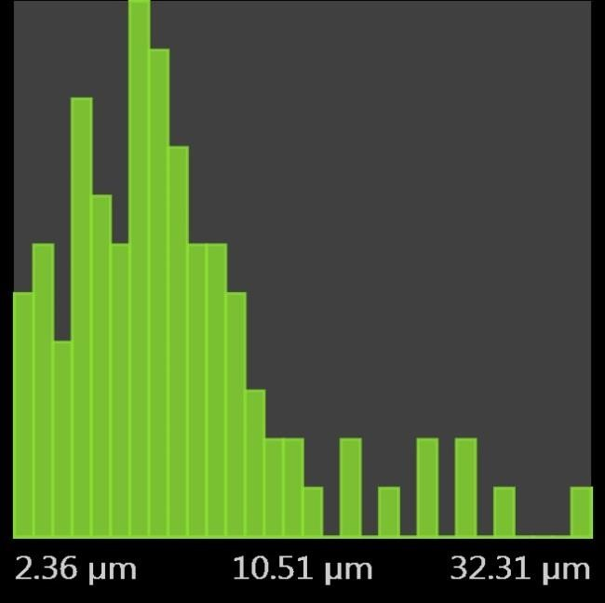 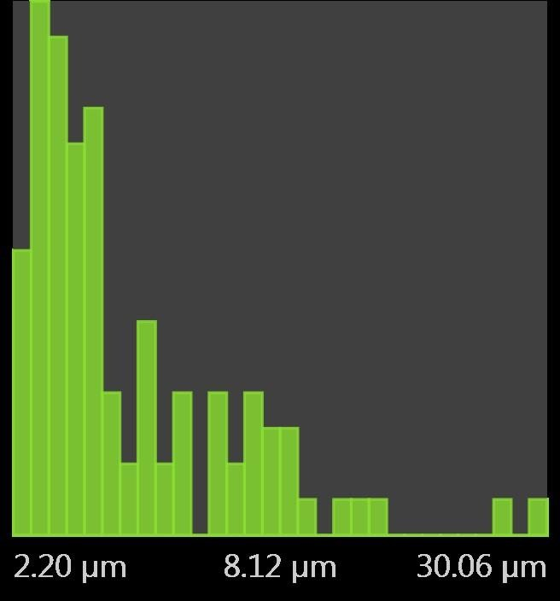

* + 1. **Baggasse b. Alpha Cellulose**

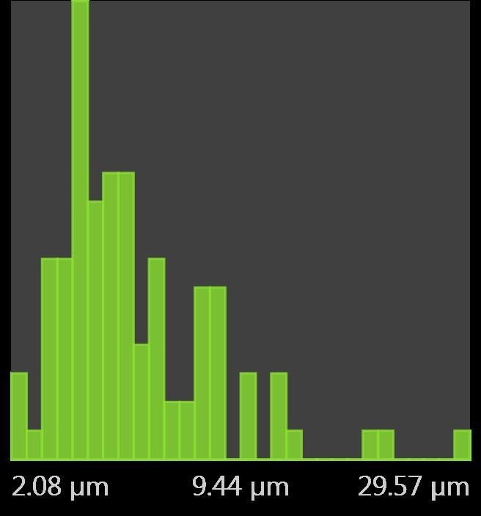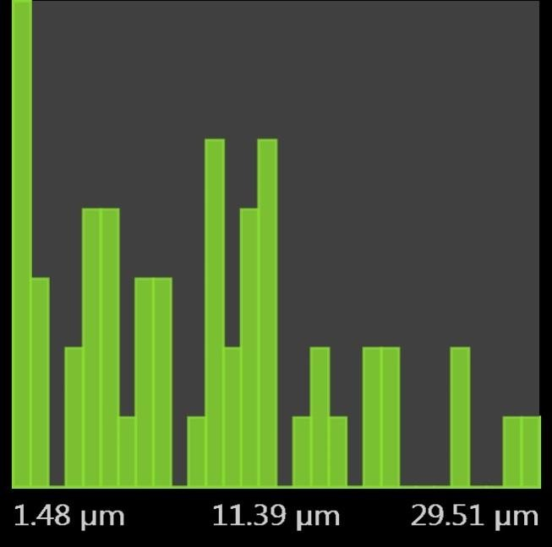

**c. BDMC d. Methocel®**

**Fig 4.3. SEM Histogram of Size Distribution of Sugarcane Bagasse, Alpha Cellulose, BDMC and the Reference Methocel® particles.**

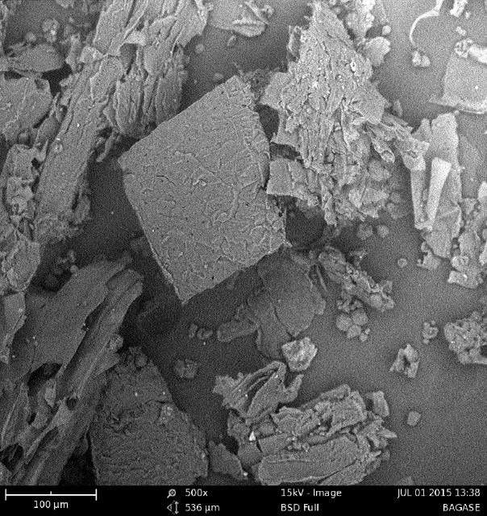 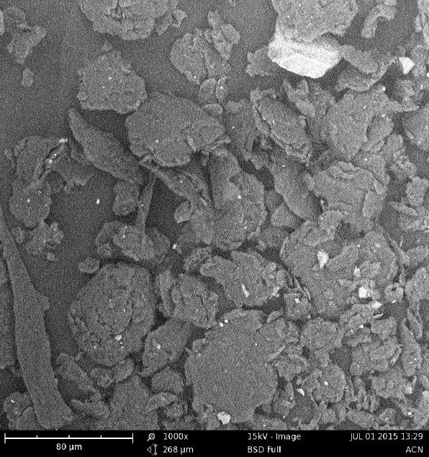

### a. Bagasse b. alpha Cellulose

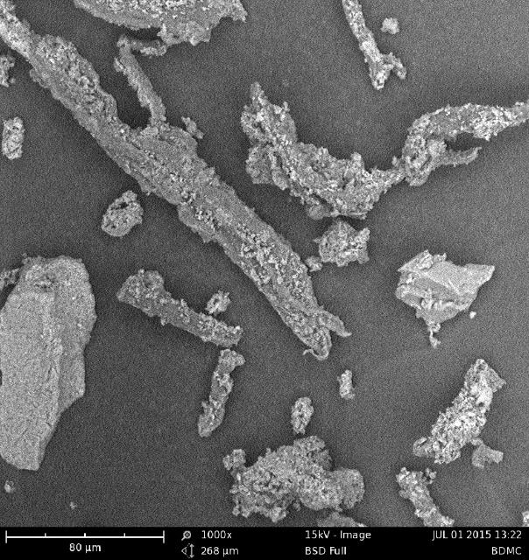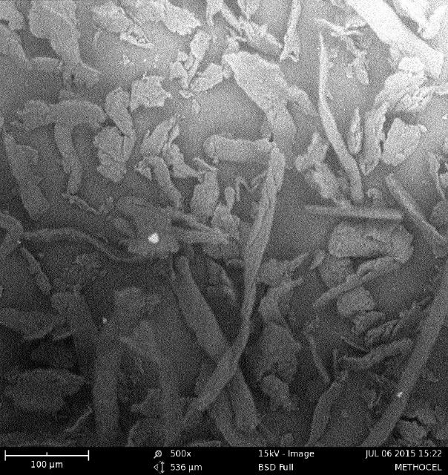

**c. BDMC d. Methocel®**

### Fig.4.4 Scanning Electron Micrographs of Sugarcane Bagasse, alpha cellulose, BDMC and the reference Methocel®

### Viscosity Analysis

The Huggins and Kraemer plot of specific viscosity (ƞ) and relative viscosity against concentration for both BDMC and Methocel® at 20 °C are presented in Figs 4.5a and 4.5b. The specific viscosity of both Methocel® and BDMC increased with increasing concentration. The log relative viscosity of BDMC also increased with concentration while that of Methocel® decreased.

The effect of temperature on the viscosity of methylcellulose is shown in Figure 4.6. As temperature increases, viscosity decreases. For example, as temperature increased from 15 0C to 40 0C, intrinsic viscosity of Methocel® reduced from 58 Pa to about 20 Pa and that of BDMC decreased from 37 Pa l to 17 Pa translating to percentage decrease of 65.52% and 54.05% for Methocel® and BDMC respectively. The BDMC is less sensitive to temperature change compared with Methocel®, in terms of their viscosities.

### Stability Analysis

Figure 4.7 shows the result of the thermogravimetric analysis of the methylcellulose samples. The percentage weight loss for BDMC and Methocel® were very similar; 6.433% and 6.394% respectively, indicating that both materials were relatively stable to heat. The figure also showed that the two methylcelluloses only started to decompose at temperatures above 300oC. BDMC started at 320 ºC, while Methocel® started at 322 ºC.

**1.9**



**y = 0.2426x + 1.3014**

**R² = 0.8954**

**ln(****rel)/c**

**sp/c**

**y = -0.2229x + 1.1924**

**R² = 0.9628**

**Intrisic Viscosity (hsp/c ; ln(hrel)/c)**

**1.7**

**1.5**

**ln(hrel)/c**

**hsp/c**

**1.3**

**Methocel**

**1.1**

**0.9**

**0.7**

**0.5**

**0 0.5 1 1.5 2**

**Conc [%]**

5



**y = 6.0726x + 1.41**

**R² = 0.9548**

**y = 1.062x + 1.8381**

**R² = 0.8486**

4.5

4

**Intrinsic viscosity (****sp/c ; ln(****rel)/c)**

3.5

**BDMC**

3

2.5

2

1.5

1

0.5

0

0.00 0.10 0.20 0.30 0.40 0.50 0.60

**Conc [%]**

### Fig 4.5 Plot of Intrisic Viscosity (ƞsp/c and ln(ƞrel)/c) against Conc (%) of Methocel® and BDMC.

70



60

50

40 BDMC

**Dynamic Viscosity (pasc)**

Methocel

30

20

10

0

0 10 20 30 40 50 60

**Temperature 0C**

### Fig 4.6 Plot of Dynamic Viscosities against Temperature (ºC) of BDMC and Methocel®

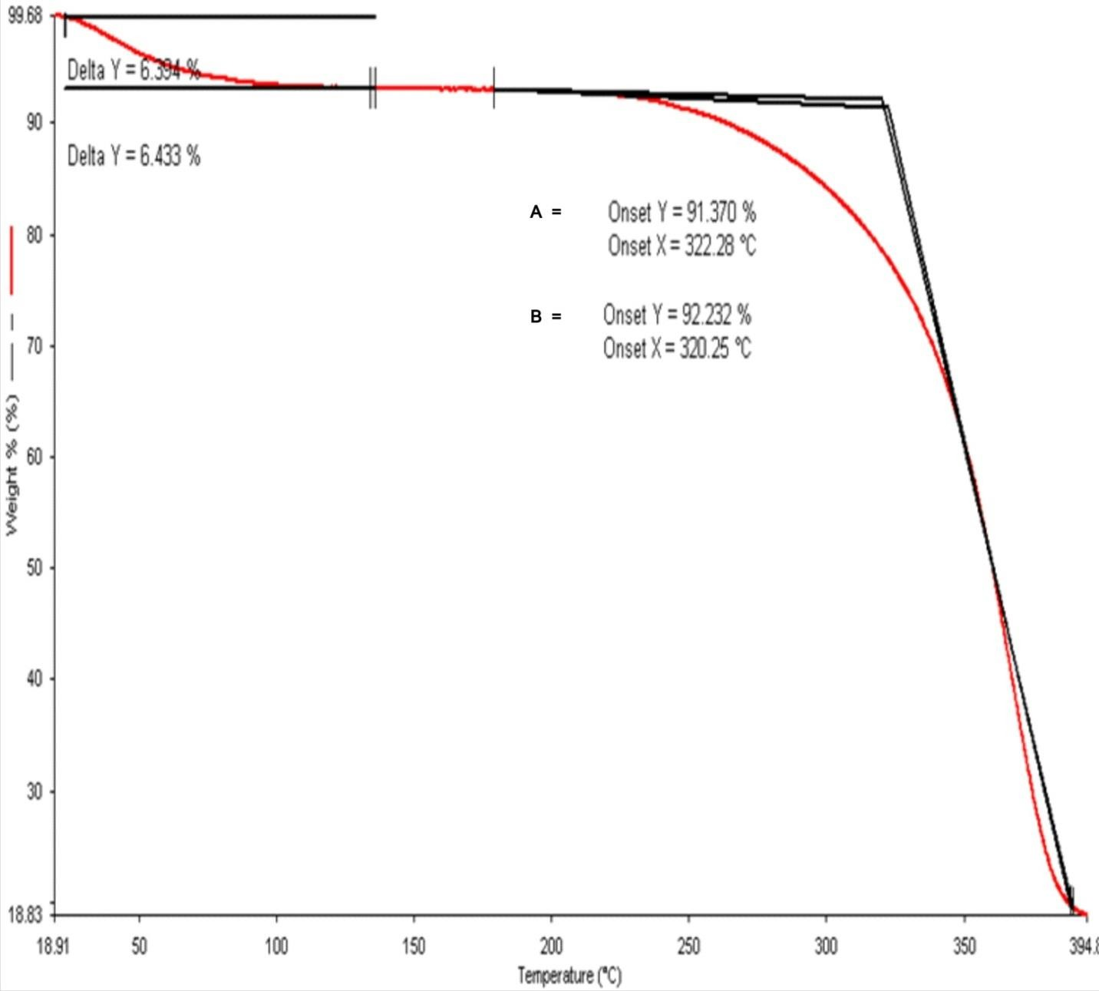

**Key**

### A-Methocel® B-BDMC

**Fig 4.7 Thermogavimetric plot for Methocel® and BDMC.**

### FTIR Spectral Analysis of Derived Cellulose Materials

Figure 4.8 shows the FTIR spectra for alpha cellulose obtained from the test bagasse and that of alpha cellulose produced in U.K. The FTIR spectra for the two samples are similar. This shows the reproducibility of the extraction method used in this study. There was absorbance at 576 cm-1 to 616 cm-1 in the two samples.

Figure 4.9 shows the FTIR spectra of bagasse, alpha cellulose and BDMC stacked together to show the similarity in the delignification of the bagasse. The intensity of the bands in the extractives is well pronounced. The polymers showed absorbance at hydroxyl (-OH) and aliphatic (-CH) stretching bands in the region between 3352 and 2989 cm-1 respectively. The intensities of the bands between 1000 and 2000 cm-1 in the bagasse spectra which were lower in the alpha cellulose spectra were further reduced in the methylcellulose spectra. The FTIR of the BDMC and Methocel® presented in Fig 4.10 display the well pronounced C-H/O-H stretching band ratios in both Methocel® and BDMC. In the Figure, there are more absorbances at wavenumbers 1316 and 1373 cm-1 on the Methocel® spectra which were absent in the BDMC spectra indicating that the degree of methylation was higher in BDMC than in Methocel®.

.

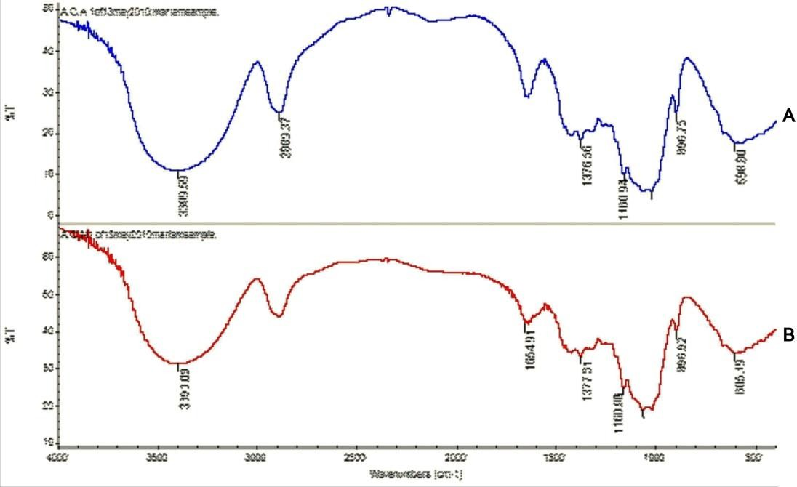

### Key:

**A- Alphacellulose (UK)**

### B- Alphacellulose (Nigeria

**Fig 4.8 FTIR spectra of alphacelluloses produced from bagasse.**

C

**B**

**A**

### Key:

**A- BDMC**

### B- Alphacellulose

**C- Baggase**

### Fig 4.9 FTIR spectra of Baggase, Alphacellulose and BDMC

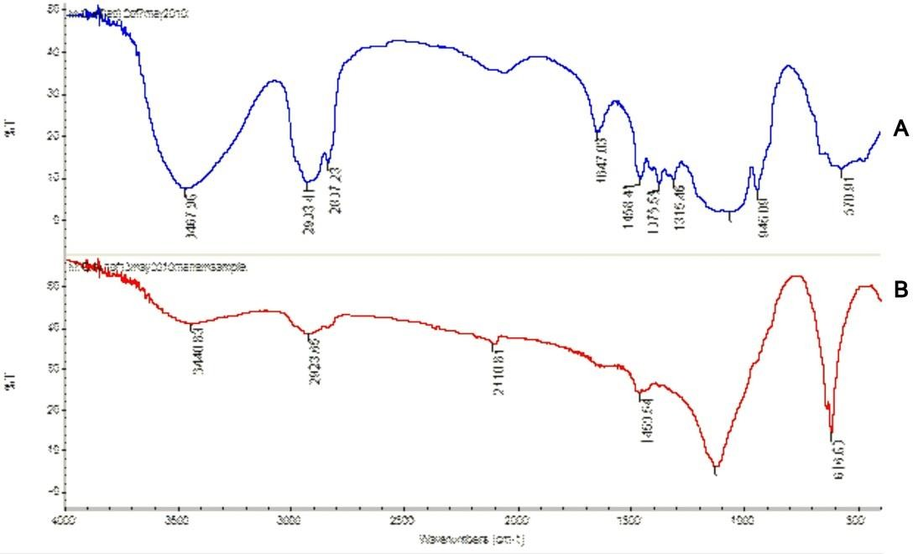

**Key:**

### A- Methocel®

**B- BDMC**

### Fig 4.10 FTIR spectra of BDMC and Methocel®

### Flow Properties of Paracetamol Granules

The flow properties of paracetamol granules made using BDMC and Methocel® as binder are shown in Table 4.3. It is generally observed that the moisture on drying increased with concentration and was higher in BDMC than in Methocel®. The tapped and bulk density of both Methocel® and BDMC are similar at the two concentrations. The angles of repose were below 25° for both BDMC and Methocel®. The compressibility for both granules made using BDMC and Methocel® were fair with compressibility values of 19.9% for BDMC to 23.2% Methocel®.

### Physical Properties of Formulated Paracetamol Tablets

Table 4.4 displays the physical properties of paracetamol tablets formulated with BMDC and Methocel® as binders. Weight variation test showed that all the tablets produced at the two concentrations showed compliance with official requirements. At 1% binder concentration, the thickness of the tablets was 5.1mm which only slightly increased to about 5.2 mm at 2% of BDMC and 5.5 mm at 2% of Methocel®. Similarly, the crushing strength of the tablets produced with BDMC increased from 6.5 kg/f to 8.6 kg/f while those produced with Methocel® as binders increased from 8.6 kg/f to 10.4 kg/f as binder concentration increased from 1% to 2%. Generally, the crushing strength of tablets produced using Methocel® was higher than those produced with BDMC as binder.

Friability of the tablets however, decreased with increased concentration of the binder in both BDMC and Methocel® tablets. For example, at 1%, friability of 2.37% and 1.92 % were obtained with BMDC at 1 and 2% respectively. Friability values of tablets produced with Methocel® as binder were generally lower; 1.68% and 1.52% for 1% and 2% concentrations respectively.

Disintegration times of the tablets also increased with increased binder concentrations. The disintegration times of 47 and 55 sec at 1% concentrations of BDMC and Methocel® respectively rose to 72 sec and 96 sec when prepared with 2% concentrations of the respective binders. The tablets produced using both polymers as binder were smooth, free of any defect and did not adhere to the surfaces of the dies and punches.

### Table 4.3 Flow Properties of Paracetamol Granules Prepared Using BDMC and Methocel® as Binders

|  |  |  |  |  |
| --- | --- | --- | --- | --- |
| **Properties of Granules** | **1% BDMC** | **2% BDMC** | **1%**  **Methocel®** | **2%**  **Methocel®** |
| **Moisture loss on drying (% w/w)** | 13% | 15% | 12% | 14% |
| **Bulk density (g/ml)** | 0.500 | 0.526 | 0.384 | 0.408 |
| **Tapped density (g/ml)** | 0.625 | 0.642 | 0.50 | 0.55 |
| **Angle of Repose (o)** | 19.49 | 19.38 | 21.80 | 20.35 |
| **Flow Rate (g/sec)** | 3.00 | 4.28 | 3.80 | 4.50 |
| **Carr’s Compressibility Index (%)** | 19.90 | 20.45 | 22.98 | 23.20 |

**Table 4.4 Physical Properties of Paracetamol Tablets Formulated with Varying Concentrations of Methocel® and BDMC as Binders**

|  |  |  |  |  |
| --- | --- | --- | --- | --- |
| **Tablet Properties** | **Binder Concentration 1%**  **Methocel® BDMC** | |  | |
|  | **2%**  **Methocel® BDMC** | |
| Mean tablet weight (mg) | 574 ± 11 | 556 ± 14 | 605 ± 16 | 570 ± 12 |
| Mean tablet thickness (mm) | 5.08 ± 0.03 | 5.01 ± 0.10 | 5.53 ± 0.05 | 5.10 ± 0.04 |
| Mean Crushing Strength (kg/f) | 8.0 ± 1.8 | 6.6 ± 0.6 | 10.5 ± 0.6 | 8.6 ± 2.3 |
| Friability (%) | 1.68 | 2.37 | 1.52 | 1.92 |
| Disintegration time (sec) | 65 | 49 | 96 | 72 |
| Mean Tablet diameter (mm) | 12.07 ± 0.03 | 12.03 ± 0.07 | 12.07 ± 0.02 | 12.09 ± 0.03 |
| Tablet Appearance | Smooth with | Smooth with | Smooth with | Smooth with |
|  | no defect | no defect | no defect. | no defect |

### Dissolution Studies of Formulated Paracetamol Tablets

Results of the dissolution studies are presented in Figs 4.11 to 4.14. The Figures showed dissolution of paracetamol formulated at compressional forces of 2.8 kgf, 3.7 kgf, 4.8 kgf, and

6.4 kgf respectively using 0.5% w/v concentration of both binders. It was generally observed that, the lower the compressional force applied, the higher the percentage drug dissolved for both BDMC and Methocel® batches. However, this inverse proportionality of the percentage drug dissolution to compressional force was more pronounced in the tablets produced, using BDMC as binder than in those produced with Methocel®.

Figures 4.15 - 4.17 show the release profile of paracetamol from tablets formed using binder concentrations of 0.5% w/w, 1.0% w/w and 2.0% w/w for both Methocel® and BDMC. The release of drug from the BDMC-based tablets followed a similar pattern to the release from Methocel® tablets, with the latter being slightly higher at all concentrations and times. The difference in percentage dissolved at 40 minutes at binder concentration of 2% w/w was however considerably higher for Methocel® than for BDMC tablets.

**Percentage Dissolution**

### Fig.4.11 Dissolution profile of paracetamol tablets formulated with 0.5% w/v binder at compressional force of 2.8 kgf



45

40

35

30

25

20

Methocel

BDMC

15

10

5

0

0

5

10

15

20

25

30

35

40

45

**Time (min)**

**Percentage Dissolution**

**Fig 4.12 Dissolution profile of paracetamol tablets formulated with 0.5% w/v binder at compressional force of 3.7 kgf**



40

35

30

25

20

15

Methocel

BDMC

10

5

0

0

5

10

15

20

25

30

35

40

45

**Time (min)**

**Percentage Dissolution**

### Fig 4.13 Dissolution profile of paracetamol tablets formulated with 0.5% w/v at compressional force of 4.8 kgf.



35

30

25

20

Methocel

15

BDMC

10

5

0

0

5

10

15

20

25

30

35

40

45

**Time (min)**

**Percentage Dissolution**

**Fig 4.14 Dissolution profile of paracetamol tablets formulated with 0.5% w/v binder at compressional force of 6.4 kg/f.**



30

25

20

15

Methocel

BDMC

10

5

0

0

5

10

15

20

25

30

35

40

45

**Time (min)**

40



BDMC

Methocel

35

30

25

**Drug Release (%)**

20

15

10

5

0

0 5 10 15 20 25 30 35 40 45

**Time (min)**

### Fig 4.15 Dissolution profile of paracetamol tablets produced using 0.5% w/w binder concentration and compression pressure of 3.7 kg/f

**Percentage drug release**

**Fig. 4.16 Dissolution profile of paracetamol tablets produced using 1.0% w/w binder concentration and compression pressure of 3.7 kg/f.**



40

35

30

25

20

BDMC

Methocel

15

10

5

0

0

5

10

15

20

25

30

35

40

45

**Time (mins)**

45



BDMC

Methocel

40

35

30

25

**Drug Release (%)**

20

15

10

5

0

0 5 10 15 20 25 30 35 40 45

**Time (min)**

### Fig. 4.17 Dissolution profile of paracetamol tablets produced using 2.0% w/w binder concentration and compression pressure of 3.7 kg/f.

### 4.10 Characteristics of Suspensions Formulated with Cellulose Derivatives

All formulated suspensions using both Methocel® and BDMC at concentrations of 1.0%w/w and

2.0 %w/w were pourable. Sedimentation rates were higher and the supernatant layer cloudier, in suspensions formulated using BDMC as suspending agent.

The pHs of the suspensions on day 1, and on day 28 are presented in Table 4.5. There was no appreciable change in pH indicating that the suspensions were stable during the period of storage. Although the pH of the suspensions made with BDMC were generally lower compared with those prepared with Methocel®, the differences were however not significant (p< 0.1).

Comparisons of the viscosities of the suspensions on days 1 and 28 are shown in Figs 4.18 and

4.19 for co-trimoxazole and metronidazole suspensions respectively. Viscosities of co- trimoxazole suspensions on day 28 were lower than the values on day 1. The percentage viscosity reductions were 20% and 30% for BDMC and Methocel® respectively. In the case of metronidazole suspensions, the percentage reductions were 20.41% and 26.3% for BDMC and Methocel® respectively.

Result of the apparent viscosities plotted against shear rate for all the formulated suspensions at 1.0% w/v and 2.0% w/v concentrations of the suspending agent are presented in Figs 4.20, and

4.21. All the suspensions exhibited pseudoplastic flow behaviour at the concentrations studied.

Generally, the apparent viscosities for the formulations using BDMC though higher, were not significantly so.

### Table 4.5. pH of Suspension Formulations with BDMC and Methocel® as Suspending Agents at Different Storage Periods.

|  |  |  |  |  |  |
| --- | --- | --- | --- | --- | --- |
|  |  | **pH on storage** |  |  |  |
|  |  | **Day 1** |  | **Day 28** | |
| **Suspension** | **Concentration (%)** | Methocel® | BDMC | Methocel® | BDMC |
| **Co-trimoxazole** | **1.0** | 5.4±0.1 | 4.9±0.3 | 5.2±0.2 | 5.1±0.2 |
|  | **2.0** | 5.4±0.03 | 4.8±02 | 5.1±0.3 | 5.0±0.04 |
| **Metronidazole** | **1.0** | 5.2±0.02 | 5.3±0.2 | 5.1±0.2 | 5.4±0.3 |
|  | **2.0** | 5.0±0.4 | 5.1±0.4 | 5.2±0.7 | 5.1±0.03 |

(p<0.1)

120

100

80

**Viscosities (Pasc)**

60

Day 1

40 Day 28

20

0

BDMC Methocel

**Suspending agent**

### Fig 4.18 Comparative Viscosities of Co-trimoxazole Suspensions formulated with 1.0% BDMC and Methocel® at day 1 and after 28 days of storage.

120

100

80

**Viscosities (Pasc)**

60

Day 1

40 Day 28

20

0

BDMC Methocel

**Suspending agent**

### Fig 4.19 Comparative Viscosities of Metronidazole Suspensions formulated with 1.0% w/w BDMC and Methocel® on day 1 and 28 days of storage.

300



250

200

150

**Apparent Viscosity (cPoise)**

BDMC

Methocel

100

50

0

10 20 30 50 100

**Shear Rate (rpm)**

### Fig. 4.20 Rheological profile of Metronidazole Suspension formulations containing 2% w/v of BDMC or Methocel® as Suspending agents.

300



250

200

**Apparent Viscosity (cPoise)**

150

BDMC

Methocel

100

50

0

10 20 30 50 100

**Shear Rate (rpm)**

### Fig 4.21 Rheological Profile of Cotrimoxazole Suspension formulations containing 2% w/v of BDMC or Methocel as Suspending agents

Figures 4.22 and 4.23 show the number of vertical inversions required to resuspend formulated suspensions on days 7, 14, 21, 28, 35, and 42. Figure 4.22 shows that there was an incremental progression in the number of inversions required for both suspending agents at 1% w/v concentration with that for Methocel® being slightly higher for days 7, 14, and 21. For days 28, 35 and 42, number of inversions required for BDMC was higher, considerably more so on day 42.

At a concentration of 2% w/v, the number of inversions required for redispersion was considerably lower than at 1% w/v for both suspending agents with BDMC suspensions requiring less number of inversions than Methocel® until day 42. The BDMC suspensions remained totally dispersed on days 7 and 14.

80

70

60

50

**Number of Inversions**

40

BDMC

Methocel

30

20

10

0

1 2 3 4 5 6

**Time (weeks)**

### Fig 4.22 Number of Inversions Required to Completely Re-disperse Co-trimoxazol Suspension Formulations Containing 1% w/v Suspending Agent.

35

30

25

20

**Number of Inversions**

BDMC

15 Methocel

10

5

0

1 2 3 4 5 6

**Time (weeks)**

### Fig 4.23 Number of Inversions Required to Completely Re-disperse Co-trimoxazole Suspension Formulations Containing 2% w/v Suspending Agent.

The flocculation behaviour of co-trimoxazole and metronidazole suspensions formulated with 1 and 2% w/v concentrations of suspending agents are shown in Figs 4.24 and 4.25. The degree of flocculation (β) of BDMC and Methocel® containing formulations increased with increase in concentration of suspending agent. At 1% w/v concentration of suspending agent, BDMC and Methocel® exhibited similar degrees of flocculation in the formulations of the two drugs. However, at 2% w/v, there was a clear difference in the degree of flocculation in both formulations, with the Methocel® formulation being consistently higher, and the difference between Methocel® and BDMC in the metronidazole suspension being significant at p< 1.

The sedimentation ratios at different storage periods for the suspensions are shown in Figs 4.26 and 4.27. There were high initial sedimentation ratios in the suspensions. Sedimentation height gradually dropped over a period of six days in co-trimoxazole and seven days in metronidozole suspensions. Sedimentation ratios in co-trimoxazole suspension formulated with 1% w/v suspending agent (BDMC) were slightly higher than those formulated with Methocel®.

In the metronidazole suspension, the two suspending agents (Methocel® and BDMC) behaved similarly in terms of sedimentation rate. In co-trimoxazole suspensions, however, there were some slight differences between the suspensions made with Methocel® and those with BDMC. The suspension with BDMC settled faster than those with Methocel®. The two suspensions however re-dispersed on shaking. These differences were however not significant. The results also showed that increased concentration led to lower sedimentation ratio and therefore, a more flocculated system.

1.6

1.4

1.2

**Degree of Floculation (β) at 1% w/v conc**

1

0.8

0.6

BDMC

Methocel

0.4

0.2

0

Cotrimox Metronid

### Fig 4.24 Degrees of flocculation for Suspension formulations containing 1% w/v Suspending Agent.

1.55

1.5

**Degree of Floculation (β) at 2 % w/v conc**

1.45

1.4

1.35

BDMC

Methocel

1.3

1.25

1.2

cotrimoxazole Metronidazole

### Fig 4.25 Degrees of flocculation for Suspension formulations containing 2% w/v Suspending Agent.

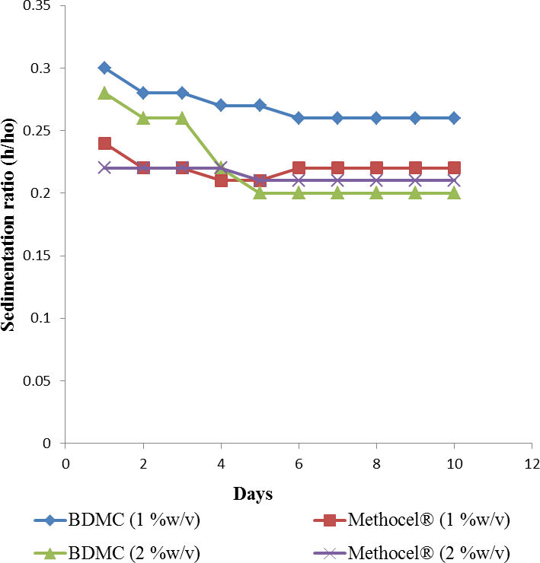

**Fig 4.26: Sedimentation ratio (h/ho ) versus time of Co-trimoxazole suspensions formulated with BDMC and Methocel® as suspending agents upon storage.**

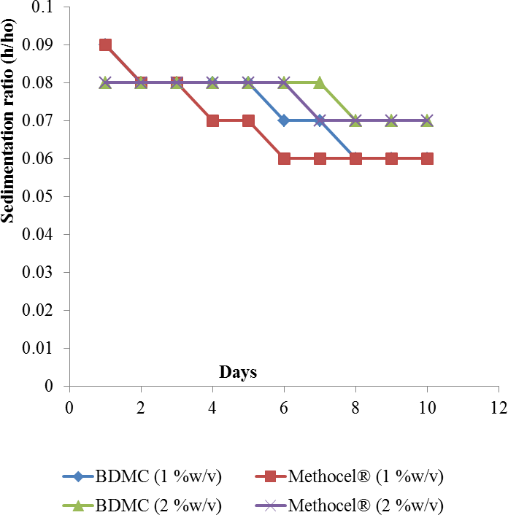

### Figure 4.27 Sedimentation ratio (h/ho) versus time for metronidazole suspensions formulated with BDMC and Methocel® as suspending agents upon storage.

**CHAPTER FIVE**

# DISCUSSION

Development and introduction of a new excipient requires consideration of the intrinsic and extrinsic properties of such material as well as its economic viability. The intrinsic properties essentially involve characterization of the physicochemical properties while the extrinsic properties largely concern the performance of such excipient in areas of its application.

Cellulose and its derivatives are polymeric substances which, due to their wide range of molecular weights/sizes are used to perform different functions and in the formulation of various pharmaceutical applications (Coffey, 1995; Edgar, 2007; Kamel, 2008). Often, the intrinsic and extrinsic characteristics of these polymers are influenced by the type of substitution and thus the cellulose derivative, the processing technique/parameters employed in its synthesis and the source of the raw/originating material.

In the evaluation of a new excipient therefore, an appropriate reference or standard to which the new excipient must be compared should be carefully chosen. In this study, Methocel®, a low substitution methylcellulose, manufactured by Dow Chemical limited (M262) was selected as a reference. Methocel® is a methylcellulose derived from potato tubers which has well established and characterized parameters.

### Physicochemical Characteristics of BDMC and Methocel®

The physicochemical properties (pH, moisture content, solubility, viscosity, flow properties) of the bagasse-derived methylcellulose exhibited close similarity to that of the Methocel® used as the reference in this study. The similarities in their physicochemical profiles provide a good basis for comparison of their performances in various areas of application. Physical-chemical tests

performed on the obtained methylcellulose from bagasse (BDMC) confirmed that it is high quality grade methylcellulose.

### Flow properties of BDMC and Methocel®

Bulk densities are a measure of the packing characteristics of powders. Carr‘s compressibility is a simple index that can be determined on a small quantity of granules. Carr‘s index values of 23- 35 indicate poor flow, 18-21 show fair flow, 12-16 indicate good flow, while 5-15 indicate excellent flow (Staniforth, 2002). The lower the value of Carr‘s index, the higher is the flow ability of the powder (Staniforth, 2002). The Carr‘s index for BDMC and Methocel® fall within the fair flow category. The angle of repose is an index of flow ability. Low angle of repose is indicative of good flow because the angles are higher when there is frictional force between the particles. Particles whose angles of repose are between 22o and 30o exhibit good flow. The angle of repose of BDMC is below this range, which further supports the assertion that BDMC has only a fair flow property.

The moisture content of BDMC and Methocel® (8.3% and 7.8% respectively) are relatively similar. A little moisture is required during compression of powdered materials to aid in bond formation between particles of powder. The moisture contents obtained in this study for the two powders are adequate to impart good flow (Reilly, 2000).

### Particle size distribution of BDMC and Methocel®

The particles of the BDMC were predominantly spherical in shape which compared well with imported commercial grade of methylcellulose (Methocel®). Spherical particles minimise inter- particulate friction and static charges. The particle size of a drug determines and influences the subsequent physical performance of the formulation and the pharmacological performance of the drug (Staniforth, 2002). The particles are mainly fines. Fine particles are good candidates for compression because they are closely packed when compressed, and the energy required for densification is lower than those of large particle sized powders.

### Viscosity and Rheological Properties

The intrinsic viscosity (ƞ) behaviours reported in this work are in line with the findings of Wang and Cui (2005). Wang and Cui (2005) also inferred that the intrinsic viscosity of a material is dependent upon the molecular structure, molecular weight and the quality of the solvent in which the material is dissolved. From the figures, the intrinsic viscosity of Methocel® is slightly higher than that of BDMC, which may be attributed to a possible difference in the molecular weights since same solvent was used for the samples. The shearing or thinning behaviour observed in this study with temperature increase could be attributed to disentanglement of the polymer chain. This assertion was made by Cui (2005), who said that disentanglement of polysaccharide chain causes decrease in viscosity and is promoted by temperature rise.

### Thermal Analysis

The stability study carried out on the Methocel® and synthesised BDMC through the TGA showed similarity in weight loss for both methylcelluloses. The weight loss in both samples may

be attributed to desorption of water from the polysaccharide structure. The synthesised methylcellulose (BDMC) showed high thermal stability with a thermal oxidation onset temperature greater than 320 ºC. The decomposition pattern observed with BDMC and Methocel® indicated that both materials are relatively stable to heat. This is in conformity with what was reported by Zohuriaan *et.al*, (2004), who stated that methylcellulose will usually start decomposing at high temperature of 325 ºC. This shows that the BDMC and Methocel® are highly stable to heat and the slight difference in the decomposing temperature could be attributed to differences relating to cellulose source.

### FTIR Spectra Analysis

The FTIR spectra revealed several changes that occurred during the processing of bagasse to BDMC. The presence of unsaturated (C=C) stretching band at about 1514 nm wavelength in the bagasse spectrum and its absence in the other spectra indicate that lignin, which was present in bagasse has been dissolved or removed from the alpha cellulose and methylcellulose. The similarities in the spectra, confirms the reproducibility of the extraction method. The absorbance at about 897 to 945 nm wavelength in the samples indicates the presence of glycosidic linkages which is the basic unit of all carbohydrates. The presence of absorbance at 574 to 616 nm indicates aromatic rings stretching which is common to all polymers.

The synthesis of methylcellulose from the bagasse cellulose, using dimethyl sulphate, produced a derivative in which the infrared spectrum showed a higher CH/OH stretching band absorption intensity ratio than that in the alpha cellulose. This shows that methylation actually took place. The intensity of the bands (peaks) at wavelengths of 1000 to 2000 cm-1 in bagasse spectra became reduced in alpha cellulose spectra and further reduced in the methylcellulose spectra. This could be as a result of presence of other celluloses like β and γ cellulose in the bagasse

which were removed, leading to preponderance of the α-cellulose. Further reduction of the peaks in BDMC shows substitution of hydroxyl (-OH) group with methyl (-CH3) group.

### Formulation Studies

### Granules Properties

The slight increase in moisture content observed as binder concentration increased for both BDMC and Methocel®, could probably be due to the fact that as the concentration of binder increased, the granule size increased meaning less surface area that will be exposed hence effective drying is not achieved. Moderate flow of the granules was observed and this was confirmed by the compressibility values which indicate fair flow according to Staniforth (2002).

### Physical properties of formulated paracetamol tablets

The properties of paracetamol tablets formulated with BDMC and Methocel® were very similar. The disintegration time increased with increasing concentration of the binder for both BDMC and Methocel®. This is expected because the harder the tablet, the longer it takes to disintegrate and since the effect of binder is to increase the strength of the tablets, it is expected to take longer time for the tablet to disintegrate when the concentration is increased. Similarly, the tablet crushing strength increased with increased binder concentration. This agrees with what was observed earlier by Esezobo and Pilpel (1977) who found out that the tensile strength of griseofulvin tablets increased with increased gelatin concentration.

The physical properties of paracetamol tablets formulated with Methocel and BDMC as binder showed no significant difference at 1% binder concentration in terms of tablet thickness, diameter and appearance. However, there were little differences in their friability values disintegration time, and crushing strengths. Similarly, at 2% concentration, the friabilities,

weight of tablets, disintegration time and crushing strength showed significant difference within the two tablet formulations. The tablet diameter; thickness and appearance showed no significant difference for both Methocel and BDMC.

The dissolution studies on the paracetamol tablets produced using BDMC as binder revealed that the higher the concentration of the binder, the lower the percentage drug released into the solution at any given time. The binder is expected to bind the granules together; hence the percentage release is low. This pattern is expected since the increased concentration of binder enhances the binding of the granules together, hence dissolution is low. Generally, the two celluloses showed similarity in dissolution profile at similar concentrations. From the percentage drug release profiles, it was evident that the methylcellulose retards the release of paracetamol from the tablet formulation. This is expected as methylcellulose is usually used to formulate slow release solid dosage forms (Allen Jr. *et al*., 2009).

### Evaluation of Formulated Suspensions

The rheological data revealed that both BDMC and Methocel® exhibited pseudoplastic flow behaviours. Kittipongpatana and Sirithauyalug (2006) reported that a large number of suspensions exhibit pseudo plastic behaviour due to shear stress. This is a desirable property of a good suspending agent.

The BDMC hydrated and swole slowly. It formed a viscous aqueous dispersion with pH of about

5.10. This is consistent with aqueous solutions of polymers such as celluloses (Wang and Cui, 2005). The formulation containing BDMC produced a cloudy supernatant layer; which could be due to the presence of colloidal particles that remain dispersed in the system.

Suspending ability of BDMC was studied at concentrations 1% w/v and 2% w/v in metronidazole and co-trimoxazole suspensions. The evaluation parameters included viscosity of suspension, rheology, redispersibility, sedimentation ratio, and degree of flocculation. The suspending ability of a polysaccharide is related to its ability to increase solution viscosity. They are therefore called viscosity enhancers (Bilany, 2007). Generally, as the viscosity of the dispersed phase increased, the sedimentation rate of the dispersion medium reduced. Consequently, the degree to which a material enhances solution viscosity is a direct measure of its suspending ability and this explains the link between the low sedimentation and high viscosity observed in the BDMC and Methocel® containing suspensions. It was also generally observed that the viscosity of the formulations slightly reduced at the end of the storage period for all the formulated suspensions. Billany (2007) reported that natural polysaccharides show a gradual reduction in the viscosities of their dispersions or solutions, with age, due to bacterial or mould growth, although such microbial growth was not observed in this study.

The number of inversions required to re-disperse the two suspensions differed. While a lower number was recorded for the suspensions containing Methocel®, in the case of co-trimoxazole suspensions, it was the reverse with metronidazole suspensions. This implies that re- dispersibility is not only a function of the suspending agent, but also the intrinsic properties of the active constituents in the formulation.

The flocculation behaviour of the dispersions revealed that the suspensions made with Methocel® were more flocculated than those of BDMC. The variation in the degree of flocculation was however significant (p > 0) at 2% concentration, especially with metronidazole suspension

The relative abundance of sugarcane chaff, an agricultural waste means that its development as pharmaceutical excipient will, apart from providing an alternative raw material, save foreign exchange and provide a means of livelihood for the local people in places where the plant is abundant. This is particularly true as there is currently no competitive demand for this material in the country.

**CHAPTER SIX**

# SUMMARY, CONCLUSION AND RECOMMENDATIONS

### Summary

Sugarcane is a perennial crop grown in the savannah region or the middle belt of Nigeria. The chaff from sugarcane, after juice extraction, principally contains cellulose. Cellulose and some of its derivatives are known to be good candidates for pharmaceutical excipients and this is what informed the search for this excipient from this agricultural waste.

The development of pharmaceutical grade methylcellulose from sugarcane bagasse as an excipient in pharmaceutical preparations was investigated. Extraction of alpha cellulose and subsequent methylcellulose production from sugarcane chaff was carried out using standard extraction procedures.

Alpha cellulose was obtained from the bagasse with a yield of 17%. From the alpha cellulose, methylcellulose was synthesised by methylation using methyl ether. Several physicochemical properties of the resulting methylcellulose (particle size, density, moisture content, viscosity, etc.) were compared with those of a reference excipient, Methocel®, a low substitution methylcellulose from Dow Chemical Company.

FTIR was used to characterise the synthesised cellulose while TGA and DSC were used to assess its thermal stability. The binding properties of the synthesised cellulose were compared with those of the reference excipient in paracetamol tablet formulation. Its profile as a suspending agent was also evaluated in two formulations (co-trimoxazole and Metronidazole suspensions).

The bagasse derived methylcellulose (BDMC) compared well with Methocel® (a reference commercial methylcellulose) as a binder in paracetamol tablets and as a suspending agent in Co- trimoxazole and metronidazole suspensions.

### Conclusion

The results obtained in this work show that methylcellulose produced from sugarcane bagasse (BDMC), exhibited properties similar to commercial methylcellulose (Methocel®). This emphasizes the potential of sugarcane bagasse cellulose as raw material for pharmaceutical formulations

### Recommendations

The result of this study justifies the need to continue further investigation into this raw material for production of pharmaceutical excipients

1. This study principally focused on the binding and suspending properties of BDMC in tablet and suspension formulations. However, there are other important applications of methylcellulose that requires investigation, for example, its use as adhesives and coating agents
2. Lack of facilities did not allow determination of molecular size of BDMC. This needs to be done, as molecular sizes of polysaccharides often determine their application in various preparations
3. Further work also needs to be carried out to determine the optimum reaction condition such as concentration of reactant, temperature and time on the yield and other physicochemical characteristics of the methylcellulose and therefore establish optimum condition for its synthesis
4. There is a need to engage in pilot scale production of methylcellulose from this source. This will enable consideration of other factors/parameters that will affect mass production, and thus provide information on economic viability of the production of methylcellulose from bagasse

### Contribution to Knowledge

* + - Production of methylcellulose from bagasse obtained from local variety of sugarcane
    - Concentration of up to 2% of BDMC can be used as a binder to produce pharmaceutical grade tablet such as paracetamol
    - BDMC is useful as a suspending agent in producing flocculated, easily dispersible suspensions of non-dispersible pharmaceutical active ingredients such as co-trimoxazole and metronidazole
    - BDMC compares favourably with commercially available methylcellulose in terms of their binding and suspending properties

# REFERENCES

Ahmed, A. S. and Fars, K. A. (2013). Oral Solid Dosage Forms. In Felton, L. A. (Ed) *Remington: Essentials of pharmaceutics.* Philadelphia: Philadelphia College of Pharmacy, Pp. 583-584

Adedokun, M. O and Itiola, O. A. (2011). Disintegrant activities of natural and pregelatinized trifoliate yams, rice and corn starches in paracetamol tablets. *Journal of Applied Pharmaceutical Science,* 01(10): 200-206

Akande, O. F (1988). Evaluation of millet starch as tablet binder and disintegrant. MSc thesis, Department of Pharm & Pharm Microbiology, Ahmadu Bello University Zaria.

Albers, J., Knop, K. and Kleinebudde, P. (2006). Brand-to-brand and batch-to-batch uniformity of microcrystalline cellulose in direct tableting with a pneumohydraulic tablet press. *Pharmazeutische Industrie*, 68: 1420–1428

Allen, L. V. Jnr and Luner, P. E. (2009). *Methylcellulose*. In: Rowe, R.C. (Ed) *Hand Book of Pharmaceutical Excipients* (6th ed). Pharmaceutical Press London. Chicago, pp. 438- 441.

Amalvy, J. I. (1997). Dilute Solution Viscometry of Carboxylated acrylic Latices. *Pigment & Resin Technology.* 26: 363-369.

Audu-Peter, J. D. (2000). Properties of directly compressed Paracetamol tablets containing alpha cellulose and MCC derived from maize cob. MSc thesis, Department of Pharmaceutics and Pharmaceutical Microbiology, Ahmadu Bello University Zaria, Nigeria.

Aulton, M. E. (1988). *Pharmaceutics. The Science of Dosage Form Design.* ELBS Churchill Livingstone Press, Scotland, pp. 304-321.

Barnes, A. C. (1974). *The Sugar Cane* (2nd ed.). Intertext Publisher, Leonard Hill Books London, pp. 412-440

Baldrick, P. (2006). Pharmaceutical Excipient Development: A pre-clinical Challenge: In: Katdare, A. andChaubal, M. V. (Eds) *Excipient Development for Pharmaceutical, Biotechnology, and Drug Delivery Systems.* Baxter Headcare Round Lake, Illinios, U.S.A., pp. 15-32

Bangudu, A. B. (1993). The Theory of Tablet Compression. *African Journal of Pharmacy and Pharmacology,* 23(1); 1-11.

Bhattacharyya, L., Schuber, S., Sheehan, C. and William, R. (2006), In: *Excipient Development for Pharmaceutical Biotechnology and Drug Delivery Systems.* Baxter Headcare, Round Lake, Illinios, U.S.A., pp. 1-2.

Biala, O. J. (2002). Formulation Studies of Groundnut Shell Derived Methylcellulose. BPharm thesis, Department of Pharmaceutics and Pharmaceutical Microbiology, Ahmadu Bello University Zaria, Nigeria.

Billany, M. R. (2007). Suspension and Emulsions. In: Aulton, M. E. (Ed) *Pharmaceutics: The Design and Manufacture of Medicine* (3rd ed.). Philadelphia; Churchill Livingstone, pp. 383-405.

Bolhuis, G. K, Lerk, C. F., Zijlstra, H. T. and De Boer, A. H. (1975). Film formation by magnesium-stearate during mixing. Effect of Tablet disintegrants. *Journal of Pharmaceutical Sciences,* 70(1): 1328-1330

Bowen, F. E. and Vadino, W. A. (1984). A simple method for differentiating starches. *Drug Development and Industrial Pharmacy,* 10: 505-511.

Brandes, E. W. (1956) Sugar cane: Its origin and improvement. *Proceedings of International Society of Sugarcane Technologists* (9th Congress), pp. 231 -240.

British pharmacopoeia (1973). Her Majesty‘s Stationery Office, London, England.

British Pharmacopoeia (2002). Her Majesty‘s Stationery Office, London, England. Vols I & II. British Pharmacopoeia (2011). Her Majesty‘s Stationery Office, London, England.

British Pharmacopoeia (2013). Her Majesty‘s Stationery Office, London, England.

Builders, P. F., Ogwuche, P., Isimi, Y. and Kunle, O. O. (2011). Some critical effects of starch gel on the granule and tablet properties of a potent herbal extract AM-1. *African Journal of Pharmacy and Pharmacology*. 5(13): 1603-1611.

Cardona, C. A., Quintero, J. A. and Paz, I. C. (2010). Production of bioethanol from sugarcane bagasse: Status and perspectives. *Bioresource Technology*, 101(13): 4754-4766.

Cui, S. W. (2005). Structural Analysis of Polysaccharides: In *Food carbohydrates: Chemistry, physical properties and applications*. Boca Raton, FL: Taylor & Francis.

Cross, C. F., Bevan, E. J. and Beadle, C. (1895). *Cellulose; an outline of the Chemistry of the Structural Elements of plants*. Longmans Green and Co. London, pp. 100-110.

Carter, S. J. (1975). Dispensing for Pharmaceutical Students (12th ed.). Pitman Publishing Inc.

Mashfield, Massachusetts, pp. 47-53.

Carter, J. C. (2002). The role of disintegrants in solid oral dosage manufacturing. *Carter Pharmaceutical Consulting Inc*.: 6.

Cerqueira, D. A., Filho, R. G. and Meireles, C. S. (2007). Optimisation of Sugarcane bagasse cellulose acetylation. *Carbohydrate Polymers,* 69(3): 579-582.

Coffey, D. G., Bell, D. A. and Henderson, A. (1995). Cellulose and cellulose derivatives. In: Stephen, A. M., Phillips, G. O. and William, P. A. (Eds) *Food Polysaccharides and Their Applications*. Marcel Dekker Inc., New York, NY, USA, Vol. 5, pp. 123–153.

Cooper, J., Gunn, C. (1986). Powder flow and compaction. In: Carter S. J. (Ed) *Cooper and Gunn’s Tutorial Pharmacy.* India, New Delhi. C.B.S. Publishers and Distributers, pp. 211–233.

Crowley, M. M. (2005). Solutions, Emulsions, Suspensions, and Extracts. In: Troy D. B. (Ed) *Remington: The Science and Practice of Pharmacy* (21st ed.). Philadelphia: Lippincott Williams & Wilkins, pp. 759-766.

Crowley, M. M. (2013). Solutions, Emulsions, Suspensions, and Extracts. In: Felton, L. A. (Ed). *Remington: Essentials of pharmaceutics*. Philadelphia: Philadelphia College of Pharmacy, pp. 435-468

Dahl, T. C. (2009). Ethylcellulose. In: Rowe, R. C. (Ed) *Hand book of Pharmaceutical Excipients* (6th ed.). Phamaceutical Press London. Chicago. 262-267.

Daiyong, Y (2005). Preparation of methyl cellulose from annual plants: Doctoral dissertation, Graduate School, Rovira I. Virgili University, Tarragona Spain.

Daugherity, P. D. and Nause, R. G (2009). Cellulose Acetate: In Rowe, R. C. (Ed). *Handbook of Pharmaceutical Excipients* (6th ed.). Phamaceutical Press London, Chicago, pp. 141- 146.

Deepchand K, (2005). Sugar Cane Bagasse Energy Cogeneration Lesson from Mauritius. Paper presented to parliamentarian forum on energy legislation and Sustainable development, Cape Town, South Africa.

Desai, D. S., Rubitski, B. A., Varia, S. A. and Newman, W. A. (1993). Physical Interaction of Magnesium stearate with starch derived disintegrant and their effect on capsules & tablet dissolution. *International Journal of Pharmaceutics*, 8: 217-226.

Dillewyn, C. V. (1952). *The botany of sugar cane*. The Ronald Press Co. New York, pp. 7-8. Edgar, K. J. (2007). Cellulose Esters in Drug Delivery. *Cellulose* 14(1): 49-64.

Esezobo, S. and Pilppel, N. (1977). Formulation factors affecting strength and dissolution of uncoated oxytetracycline tablets. *Journal of pharmaceutical sciences*. 66: 852-8.

Filho, G. R., Assuncao, R. M., Vieria, J. G., Meireles, C. S., Cerqueira, D. A., Barud, H. S., … Messadeq, Y. (2007). Characterisation of methylcellulose produced from sugar cane bagasse cellulose: Crystallinity and thermal properties. *Polymer Degradation and Stability.* 92: 205-210.

Garr, J. S. M. and Bangudu, A. B. (1991). Evaluation of sorghum starch, as a tablet excipient.

*Drug development and Industrial Pharmacy,* 17(1): 1-6.

Gennaro, A. R. (1990). *Remington's Pharmaceutical Sciences.* Mark Publishing Company Easton, Pennsylvania, pp. 1305 – 1321.

Georg, S. H. (1972). *Sugarcane: Cultivation and fertilisation.* Series of Monograph on Tropical and Subtropical crops. Ruhr-Stickstoff A. G, Bochum, West Germany, pp. 14-16.

Giren, A. A. and Giroh, D. Y. (2012). Analysis of the Factors affecting Sugarcane (*Saccharium Officinarium*) production under the out growers Scheme in Numan Local Government Area, Adamawa State, Nigeria. *Advances in Agriculture, Sciences and Engineering Research,* 2(5):158-164.

Guy, A. (2009). Cellulose Microcrystalline. In Rowe, R. C. (Ed) *Hand Book of Pharmaceutical Excipient* (6th ed.). Pharmaceutical Press London. Chicago. pp. 129-133.

Huggins, M. L. (1942). The viscosity of dilute solutions of long-chain molecules. IV: Dependence on the concentrations. *Journal of the American Chemical Society.* 64: 2716-2718

Ibrahim, M. A. (1997). The Use of a Novel polymer from the stem bark Of *Cissuepopulnea* in the formulation of controlled-release matrix tablets. Doctoral dissertation, Ahmadu Bello University, Zaria, Nigeria.

Idris, O. H. M., Williams, P. A. and Phillips, G. O. (1998). Characterisation of gum from Acacia senegal trees of different ages and location using Multidetection gel permeation chromatography. *Food Hydrocolloids.* 12: 379-388.

Kallam, M., Deorkar, N., Mînea, L. A., Mehta, R., Farina, J. A. (2011). Evaluation and Characteristics of a New Direct Compression Performance Excipient. *Pharmaceutical Technology*. Volume 35, Issue 3.

Kamel, S., Ali, N., Jahangir, K., Shah, S. M. and El-Gendy, A. A. (2008) Pharmaceutical Significance of Cellulose - A Review. *eXPRESS Polymer Letters*. 2(11): 758-78.

King, R. E. (1975). Tablets, Capsules and Pills. In *Remington’s Pharmaceutical Sciences* (15th ed.). Mac Publishing Company, Easton Pennsylvania 18042 U.S.A., pp. 1576-1607.

Kio, P. R. O. (1987). Problems of raw materials in pharmaceutical production in Nigeria. A paper presented at the annual meeting of the Nigeria Society of Pharmacognosy, University of Ibadan, Nigeria.

Kittipongpatana, O. S. and Sirikhauyalug, J. (2006). Development of suspending agent from Sodium Carboxymethyl Mungbeen starches. *Drug Development and Industrial Pharmacy.* 32: 809-820.

Kunle, O. O., Nasipuri, R. N., Oyewumi M. O., Ojile, J. E. and Wambebe, C. N. (1999). Formulation studies on the hot water leaf extract of Iscussur (Monicease): Compaction characteristics of magnesium stearate on granules and tablet properties. *Acta Pharmaceutica.* 49(3): 189-199.

Lowenthal, W. and Wood, J. H. (1973). Mechanism of action of starch as a disintegrant. *Journal of Pharmaceutical Sciences.* 61**:** 445-549.

Martins, D. W., Mayes, P. A. and Rodwell, V. W. (1981). *Harper’s Review of Biochemistry*

(18th ed.). Lange Medical Publication, Los Altos, California, pp. 149 -150.

Martins, A., Swarbrick, J. and Cammarata, A. (1983). Micromeritics. In: Chun, A. H. (illus) *Physical Pharmacy: Physico-chemical principles in Pharmaceutical Sciences* (3rd ed.). Philadelphia: Lippincott Williams and Williams. Pp. 423-453.

Mgbahurike, A. and Igwilo, C. (1991). Binding properties of gum from *Kaya senegalensis*

granules. *The Nigerian Journal of Pharmacy,* 22: 41 - 43.

Musa, N. A. (1996). Physical, Chemical and Tableting Properties of Cellulose (Treated and Untreated) derived from Sugarcane. MSc thesis, Ahmadu Bello University, Zaria, Nigeria.

Musa, H. (1999). *Evaluation of Cellulose and Sodium Carboxy Methyl Cellulose produced from Rice husk in Tableting*. MSc thesis, Ahmadu Bello University, Zaria, Nigeria.

NSDC (2003): Information Brochure towards Self-sufficiency in Sugar, Abuja, pp.1-26.

Nasipuri, R. N. (1975). The use of cassava starch as binder/disintegrant in the formulation of tablets. *Journal of Medical and Pharmaceutical Marketing*. 4**:** 17-20.

Nasipuri, R. N. (1979a). Evaluation of yam starch as tablet binder and disintegrant Part 1: before storage. *Nigerian Journal of Pharmacy.* 10: 162-196.

Nasipuri, R. N. (1979b). Evaluation of Cocoyam starch as tablet binder and disintegrant.

*Pharmaceutical Acta Helvetiae.* 54: 48-53.

Nasipuri, R. N. and Akala, E. O. (1986). Effect of concentration of cassava starch mucilage as a binder on granules and tablet properties. *Nigerian Journal of Pharmacy*. 17: 13.

Nep, E. I. (2010). Grewia polysaccharide gum as a pharmaceutical excipient. Doctoral dissertation, Aston University, Birmingham, United Kingdom.

Oberlerchner, J. T., Rosena, T. and Potthast, A. (2015). Overview of Methods for the Direct Molar Mass Determination of Cellulose. *Molecules* 20: 10313 - 10341

Ogaji, I. J., Nep, E. I. and Audu-Peter, J. D. (2012). Advances in Natural Polymers as Phamaceutical Excipients. *Pharmaceutica Analytica Acta.* 3(146): 1-14.

Ojile, J. E., Selkirk, A. B. and Macfarlare, C. B. (1980). Some factors affecting solute migration in granular beds. *International Journal of Pharmaceutics.* 5**:** 207-213.

Okhamafe, A. O., Ighoechi, A. and Obaseki, T. O. (1991). Cellulose extracted from groundnut shell and rice husk: Preliminary physiochemical characterization. *Pharmacy World Journal.* 8(4): 120-123.

Okhamafe, A. O., Ejike, E. N., Akinrinola, F. F. and Ubuane-Inedegbo, A. (1995). Aspects of the tablet disintegrant properties of cellulose derived from bagasse and maize cobs. *West African Journal of Pharmacy.* (1): 8 -13.

Oto, A., Remer, E. M., O‘Malley, G. M., Tkach, J. A. and Gill, I. S. (1999). M R Characteristics of oxidised Cellulose (Surgical). *American journal of roentgenology.* 172(6): 1481- 1484.

Oyeniyi, Y. J. (2010). *In-vitro* studies on the use of sawdust derived Ethylcellulose (SDEC) in the formulation of sustained-release matrix tablets by direct compression. Doctoral dissertation, Ahmadu Bello University, Zaria, Nigeria.

Park, H. and Kinman, P. (2012). ―Polymers in Pharmaceutical Products‖ In *Handbook of Pharmaceutical Manufacturing Formulations*: *Liquid Products*. (2nd ed.), 3: 287.

Peter, S. (1998). *Sugar cane*: *Past and Present.* Illinois: Southern Illinois University. 23(1): 12

Podczeck, F. (2009). Cellulose powdered. In Rowe, R. C. (Ed) *Hand Book of Pharmaceutical Excipient* (6th ed.). Pharmaceutical Press London. Chicago, pp. 136 -138

Rana, A. S., Hari, S. L. (2013). Manufacturing defects of Tablets - A Review. *Kumar Journal of Drug Delivery & Therapeutics*, 3(6), 200-206

Rawlins, E. A. (1997). Tablets and Capsules. In*: Bentley’s Textbook of Pharmaceutics* (11th ed.).

Cassel and Colier Macmillan Publisher Ltd. London, England, pp. 269-315

Reilly (Jr), W. J. (2000). Microcrystalline cellulose, Pharmaceutical necessities. In: Gennaro

A.R. (Ed). *Remington: The Science and Practice of Pharmacy.* Mark Publishing Company Easton, Pennsylvania, USA, pp. 1105-1110.

Rowe, R. C., Sheskey, P. J. and Quinn, M. E. (2009); *Handbook of Pharmaceutical Excipients*

(6th ed.). Pharmaceutical Press London. Chicago, pp. 141-143 and 438-440.

Rudnic, E. M. and Schwartz, J. B. (2005). Oral Solid Dosage Forms. In: Troy, D. B. (Ed) *Remington: The science and practice of pharmacy*. Philadelphia, PA: Lippincott, Williams & Wilkins, pp. 889-910.

Russel, E. A. (2004). Synthetic Excipients Challenge: All Natural Organic offer advantages/challenges to developer & formulators. *Pharmaceutical Technology,* pp. 38-50.

Sakr, A. and Kassem, A. (1972). Factors Affecting Tablet Hardness and Friability.

*Manufacturing chemist and aerosol news,* 43(12): 51-55

Sarfaraz, K. N. (2009). Liquid Product. In: *Handbook of Pharmaceutical Manufacturing Formulations*. (2nd ed.). Informa, Healthcare. U. S. A., 3: 227.

Schwartz, J. E., Martin E. T. and Dehner, E. J. (1975). Intra-granular starch; comparison of starch USP and modified cornstarch*. Journal of Pharmaceutical Science.* 64: 328- 332.

Snodin, D. J. (2009). Environmental Risk Assessment. In: Cartwright, A. C and Mathews, B. (Ed) *International Pharmaceutical Product Registration* (2nd ed.): 200 (Drugs and the Pharmaceutical Sciences)

Staniforth, J. N. (2002). Powder flow. In: Aulton M E(Ed); *The Science of Dosage Form Design*

(2nd ed.). Philadelphia: Churchill Livingstone, pp. 205-208.

Tadese, E., Belete, A. and Gebre-Mariam, T. (2014) Evaluation of the Binding Effect of Local Gum of Boswellia papyrifera in Paracetamol Granules and Tablet Formulations. *Ethiopian Pharmaceutical Journal,* 30(1): 10-20.

The United States Pharmacopoeia (1980). The US Pharmacopoeia Convention (12th ed); Inc 12601 Twin Brook Parkways, Rockville Water land.

The United States Pharmacopoeia (2005). The US Pharmacopoeia Convention Inc 12601 Twin Brook Parkways, Rockville Water land.

The United States Pharmacopoeia (2009). The US Pharmacopoeia Convention Inc 12601 Twin Brook Parkways, Rockville Water land.

Thoorens, G., Krier, F., Leclercq, B., Carlin, B. and Evrard, B. (2014). Microcrystalline cellulose, a direct compression binder in a quality by design environment—A review. *International Journal of Pharmaceutics* 473(1–2): 64-72

Trease, G. E. and Evans, W. C. (1998) *Trease and Evans’ Pharmacognosy* (14th ed.). W.B Saunder Company Limited, London.

Vinod, V. T. P., Sashidhar, R. B., Suresh, K. I., Rao, B. R., Saradhis, U. V. R. and Rao, T. P. (2008). Morphological, physico-chemical and Structural Characterisation of gum Kondagogu (Colchis permum gossypium): A tree gum from India. *Food Hydrocolloids*. 22: 899-915

Wang, Q. and Cui, S. W. (2005) Understanding the physical properties of food polysaccharides. In: Cui, S. W. (Ed) *Food Carbohydrates: Chemistry, Physical Properties and Applications.* Boca Raton, Florida: Tay Lorand, pp. 162-214.

Zohuriaan, M. J. and Shokrolahi, F. (2004). Thermal Studies on natural and modified gums.

*Polymer Testing*; 23: 575-9.

# APPENDICES

### Appendix I: Flow Chart of the Protocol for the Extraction -cellulose from Bagasse

**Appendix II: Flow Chart of the Protocol for the methylation of** **-cellulose**

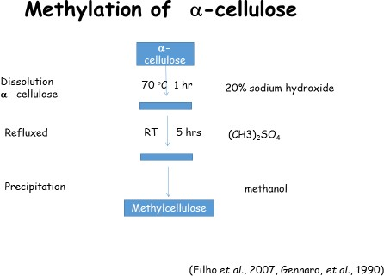

### Appendix III:Table of Sedimentation Ratio (h/ho) of Co-trimoxazole Suspensions using BDMC and Methocel® as Suspending agents upon storage

|  |  |  |  |  |
| --- | --- | --- | --- | --- |
| Sedimentation Ratio | | | | |
| **Day** | 1% |  | 2% | |
|  | BDMC | Methocel® | BDMC | Methocel® |
| **1** | 0.3 | 0.24 | 0.28 | 0.22 |
| **2** | 0.28 | 0.22 | 0.26 | 0.22 |
| **3** | 0.28 | 0.22 | 0.26 | 0.22 |
| **4** | 0.27 | 0.21 | 0.22 | 0.22 |
| **5** | 0.27 | 0.21 | 0.20 | 0.21 |
| **6** | 0.26 | 0.22 | 0.20 | 0.21 |
| **7** | 0.26 | 0.22 | 0.20 | 0.21 |
| **8** | 0.26 | 0.22 | 0.20 | 0.21 |
| **9** | 0.26 | 0.22 | 0.20 | 0.21 |
| **10** | 0.26 | 0.22 | 0.20 | 0.21 |

**Appendix IV: Table of Sedimentation Ratio (h/ho) of Metronidazole Suspensions using BDMC and Methocel® as Suspending Agents Upon Storage**

|  |  |  |  |  |
| --- | --- | --- | --- | --- |
| Sedimentation Ratio | | | | |
| **Day** | 1% |  | 2% | |
|  | BDMC | Methocel® | BDMC | Methocel® |
| **1** | 0.09 | 0.09 | 0.08 | 0.08 |
| **2** | 0.08 | 0.08 | 0.08 | 0.08 |
| **3** | 0.08 | 0.08 | 0.08 | 0.08 |
| **4** | 0.08 | 0.07 | 0.08 | 0.08 |
| **5** | 0.08 | 0.07 | 0.08 | 0.08 |
| **6** | 0.07 | 0.06 | 0.08 | 0.08 |
| **7** | 0.07 | 0.06 | 0.08 | 0.07 |
| **8** | 0.06 | 0.06 | 0.07 | 0.07 |
| **9** | 0.06 | 0.06 | 0.07 | 0.07 |
| **10** | 0.06 | 0.06 | 0.07 | 0.07 |