# EVALUATION OF TABLETING PROPERTIES OF NATIVE AND MODIFIED STARCHES, DERIVED FROM *SOLENOSTEMON ROTUNDIFOLIUS*, AS TABLET BINDER AND DISINTEGRANT

**BY**

# ODUOLA, ADEMOLA RASAQ

**DEPARTMENT OF PHARMACEUTICS AND PHARMACEUTICAL MICROBIOLOGY, FACULTY OF PHARMACEUTICAL SCIENCES, AHMADU BELLO UNIVERSITY, ZARIA**

# DECEMBER, 2012

**EVALUATION OF TABLETING PROPERTIES OF NATIVE AND MODIFIED STARCHES, DERIVED FROM *SOLENOSTEMON ROTUNDIFOLIUS,* AS TABLET BINDER AND DISINTEGRANT.**

**BY**

**ODUOLA, ADEMOLA RASAQ B. Pharm. (OAU 1990)**

**M.Sc./Pharm. Sci./03693/2008-09**

**A THESIS SUBMITTED TO THE DEPARTMENT OF PHARMACEUTICS AND PHARMACEUTICAL MICROBIOLOGY, AHMADU BELLO UNIVERSITY, ZARIA, NIGERIA**

**IN PARTIAL FULFILLMENT FOR THE AWARD OF MASTERS OF SCIENCE IN PHARMACEUTICS**

**DEPARTMENT OF PHARMACEUTICS AND PHARMACEUTICAL MICROBIOLOGY, FACULTY OF PHARMACEUTICAL SCIENCES, AHMADU BELLO UNIVERSITY, ZARIA**

**DECEMBER, 2012**

# DECLARATION

I declare that the work in the thesis entitled “Evaluation of tableting properties of native and modified starches, derived from *Solenostemon rotundifolius*, as tablet binder and disintegrant” has been carried out by me in the Department of Pharmaceutics and Pharmaceutical Microbiology, under the supervision of Dr. H. Musa and Dr. T.S. Allagh.

The information derived from the literature has been duly acknowledged in the text and a list of references provided. No part of this thesis was previously presented for another degree or diploma at any university.

|  |  |  |
| --- | --- | --- |
| **ODUOLA, A. R.** |  |  |
| Name of Student | Signature | Date |

# CERTIFICATION

This thesis titled “EVALUATION OF TABLETING PROPERTIES OF NATIVE AND MODIFIED STARCHES, DERIVED FROM *SOLENOSTEMON ROTUNDIFOLIUS*, AS

TABLET BINDER AND DISINTEGRANT” by Oduola, Ademola Rasaq meets the regulations governing the award of the degree of Masters of Science (Pharmaceutics) of Ahmadu Bello University, Zaria and is approved for contribution to knowledge and literary presentation.

|  |  |  |
| --- | --- | --- |
| **Chairman, Supervisory Committee Dr. H. Musa**  **B.Sc.Pharm., MBA, M.Sc., Ph.D (ABU)** | **(Signature)** | **(Date)** |
| **Department of Pharmaceutics and** |  |  |
| **Pharmaceutical Microbiology,** |  |  |
| **Ahmadu Bello University, Zaria.** |  |  |

# Member, Supervisory Committee (Signature) (Date) Dr. T.S Allagh

**B.Sc.Pharm.(ABU), M.Sc.(London), Ph.D (ABU) Department of Pharmaceutics and Pharmaceutical Microbiology,**

# Ahmadu Bello University, Zaria.

|  |  |  |  |
| --- | --- | --- | --- |
| **Head of Department Dr. A.B Isah**  **B.Sc.Pharm., M.Sc., Ph.D (ABU)** | **(Signature)** |  | **(Date)** |
| **Department of Pharmaceutics and Pharmaceutical Microbiology, Ahmadu Bello University, Zaria.** |  |  |  |
| **Dean, Postgraduate School Prof. A.A. Joshua**  **BA, MA, Ph.D (ABU)** | **(Signature)** |  | **(Date)** |

# DEDICATION

This work is dedicated to my dear wife, Tope and our wonderful kids Oladele, Gbemisola and Opeyemi.

# ACKNOWLEDGEMENT

All praise and gratitude unto Almighty God, the creator and Lord of the worlds and the heaven, the compassionate, the merciful who has given me the strength and the resources to actualize the seemingly impossible academic task.

When I knew not what to do, the wisdom and the knowledge of my two guides and erudite scholars were handy. Dr. H. Musa and Dr. T.S. Allagh, I cannot thank you enough. You were always there to solve all my problems. Your pots of knowledge will never dry, amen.

I cannot easily commit to the dark cloud of my memory the friendly climate in the Department of Pharmaceutics and Pharmaceutical Microbiology under which this academic work was carried out. The captain of the ship then, the indefatigable and hard-working Dr.

T.S. Allagh provided the much-needed ingredients in making the scholastic soup a reality.

May the Almighty God continue to strengthen you.

My special and sincere appreciations go to my brothers, Dr. A.K. Olowosulu and Mr. Yonni Apeji. Your timely pieces of advice and unquantifiable inputs really helped to put this work in shape particularly, when my supervisors were not there. I give my heartfelt gratitude to Mrs. O.J. Olayemi and Mr. Shittu for the much-needed motivation in the laboratory.

I will remain grateful to the staff of the Department of Pharmaceutics and Pharmaceutical Microbiology. They include Prof. F. Ehinmidu Prof.Y.K.E Ibrahim, Prof. Onaolapo, Dr. A.B. Isah, Dr. A.R Oyi, Dr. B.O. Olayinka, Dr. Adeshina, Dr. Tytler, Dr. K.

Mshelbwala, Mrs. H. Mohmud, Mr. A.A Falaki. Special thanks go to the able hands in the laboratories such as Mr. Mike Ainoje, Mr. Godwin Ugwu and in particular Mr. Innocent Agbo who has contributed in no small measures and facilitated the completion of the laboratory part of the work.

I want to specially thank my course-mate, co-researcher, brother and friend, Pharm. Gideon Okpanachi who motivated me when the morale was low and helped in other ways that cannot be mentioned here.

I also enjoyed the spirit of comradeship from my other course-mates. They include Pharmacist Maroof, Dafiel, John, Oche, Pharm.(Mrs.) David, Miss Rabiah, and others. The times we shared together were moments of great academic fellowship.

My regards to my parents, Alhaji and Mrs. Adeleke Oduola and all my brothers and sisters who showed concern for me while this work lasted. I also specially thank my immediate family- my wife and my kids who always helped me with prayers and encouraged me in their own great ways. I love you all.

All others I failed to mention here who have contributed in one way or other to make this great work a possibility, I say thank you.

# ABSTRACT

The aim of this research was to study the tableting properties *of Solenostemon rotundifolius starch* (SRS) and modified forms for use as pharmaceutical excipient by wet granulation method of tablet production in paracetamol formulation.

The physicochemical properties of native and modified starches were investigated and compared with Maize starch B.P. (MZS). Properties of granules and tablets formulated with various experimental starches and gelatin (GLT) tested as binders and disintegrants at varying concentrations of 2.5-12.5%w/w were also investigated. In order to characterize the mode of deformation of the experimental starches the compaction studies were carried out using Heckel plots and the tensile strength evaluated.

The dry and wet weights of starch extracted by standard method of extraction were 9.02%w/w and 18.37%w/w respectively. Pregelatinisation produced 96.23%w/w with water (PGSW) and 57.45%w/w when precipitated with ethanol (PGSA). The pregelatinised starches exhibited better flow properties and swelling capacity than MZS and SRS.

Granule properties such as angle of repose, Hausner’s ratio and Carr’s index revealed that increase in concentration of materials tested as binder and disintegrant led to improvement in flow characteristics. Tablet properties which included friability, crushing strength and disintegration time showed that an increase in binder concentration in the tablet led to a decrease in friability and an increase in crushing strength and disintegration time while increase in disintegrant concentration produced the opposite effect. The drug release for all the batches both as binder and disintegrant were below

50%. 500 mg compacts of experimental starches made using a hydraulic press at various tableting pressures (56.6-169.9MNm-2) and investigated for deformation characteristics and tensile strength had the ranking order for mean yield pressure, PY as PGSA>MZS>GLT>SRS>PGSW; total plastic deformation, DA, as SRS<GLT<PGSW<MZS<PGSA showing that SRS and PGSW deforms plastically with fast onset of deformation while PGSA has tendency to show fragmentation before plastic deformation. The tensile strength result showed that SRS and the modified starches produced harder and more compact tablets compared with Maize starch B.P.

The results obtained shows that in paracetamol tablet prepared by wet granulation method, pregelatinising SRS makes it a suitable binder and a poor disintegrant with high bond strength. Thus, SRS, PGSW and PGSA could be useful in formulation of tablets with desired mechanical properties.

# TABLE OF CONTENTS

Cover Page - - - - - - - - - i

Title Page - - - - - - - - - ii

Declaration - - - - - - - - - iii

Certification - - - - - - - - - iv

Dedication - - - - - - - - - v

Acknowledgement - - - - - - - - vi

Abstract - - - - - - - - - viii

List of figures - - - - - - - - - xix

List of plates - - - - - - - - - xxi

Abbreviations, definitions, glossaries and symbol - - - - xxii

Chapter One

* 1. Introduction - - - - - - - - 1
  2. Starch – versatile polymer - - - - - - 1
  3. Sources of starch - - - - - - - 1
  4. Types of starch - - - - - - - 2
     1. Native starch - - - - - - - - 2
     2. Modified starch - - - - - - - 3
  5. Extraction of starch - - - - - - - 3
  6. Modification of starch - - - - - - 3
     1. Physical modification of starch - - - - - 4
        1. Pregelatinization - - - - - - - 4

1.5.1.2 Annealing - - - - - - - - 4

* + 1. Chemical modification of starch - - - - - 5
       1. Cross-linking - - - - - - - - 5
       2. Stabilization - - - - - - - - 5
       3. Conversion - - - - - - - - 5
  1. Particle and molecular description of starch - - - - 6
  2. Starch molecular structure - - - - - - 7
  3. Starch granules - - - - - - - 9
  4. Uses of starch - - - - - - - - 11
  5. Solenostemon rotundifolius (Poir.) J.K. Morton - - - 11
     1. Origin and geographic distribution - - - - - 12
     2. Chemical constituents - - - - - - 13
     3. Plant description - - - - - - - 13
     4. Growth and development - - - - - - 14

1.10.5 Uses - - - - - - - - - 14

* 1. Statement of Research Problem - - - - - 15
  2. Justification of the study - - - - - - 15
  3. Limitation of the study - - - - - - 16
  4. Aim of the study - - - - - - - 16
  5. Objectives and scope of the study - - - - - 16

Chapter Two

* 1. Literature review - - - - - - - 18
  2. Tablet – pharmaceutical dosage form- - - - - 18
     1. Advantages and disadvantages of tablet as a dosage form - - 19
  3. Types of tablets - - - - - - - 20
  4. Formulation of tablets - - - - - - - 22
     1. Fillers/diluents - - - - - - - 25

2.3.2 Binders - - - - - - - - 26

* + 1. Disintegrants - - - - - - - - 27
    2. Glidants, lubricants and anti-adherents - - - - 28
    3. Flavours, sweeteners and colourants - - - - - 28
  1. Techniques of tablet production - - - - - 28
     1. Granulation - - - - - - - - 29
        1. Wet granulation - - - - - - - 30
        2. Limitations of wet granulation - - - - - 31
        3. Mechanism of pharmaceutical granulations - - - - 32
     2. Process of granule formation - - - - - - 32

2.4.2 Wet granulation equipment - - - - - - 35

2.4.4 Advancement in granulations - - - - - - 37

* 1. Manufacturing of tablets - - - - - - 40
     1. Common problems encountered during tablet manufacturing operations 40
  2. Compression and compaction of pharmaceutical powders into tablets 41
     1. Compression and decompression of pharmaceutical powders into tablets 42
     2. Compressional characteristics of granules - - - - 44
     3. Consolidation - - - - - - - - 45
     4. Decompression - - - - - - - 46
  3. Models expressing the compression of powders. - - - 47
  4. Evaluation of tablet - - - - - - - 50
     1. Content uniformity of active ingredient - - - - 51
     2. Thickness and diameter uniformity of the tablet - - - 53
     3. Crushing strength (hardness) test - - - - - 53
     4. Friability test - - - - - - - - 54
     5. Disintegration test - - - - - - - 54
     6. Dissolution test - - - - - - - 55
  5. Integrity of tablets - - - - - - - 56
  6. Recent works related to this study - - - - - 57

Chapter Three

3.0 Materials and methods - - - - - - 62

3.1 Materials - - - - - - - - 62

* + 1. Experimental sample - - - - - - - 62
    2. Chemical and reagents - - - - - - 62

3.1.3 Equipment - - - - - - - - 62

3.2 Methods - - - - - - - - 64

* + 1. Collection, identification and extraction of solenostemon rotundifolius

starch. - - - - - - - - - 64

* + 1. Preparation of pregelatinised solenostemon rotundifolius starch(pgs) 64
  1. Physicochemical characterization - - - - - 65
     1. Organoleptic properties - - - - - - 65
     2. Identification test - - - - - - - 65

3.3.3 Ash content - - - - - - - - 65

* + 1. Moisture content determination - - - - - 65
    2. Determination of ph - - - - - - - 66

|  |  |  |  |  |  |  |  |  |  |  |
| --- | --- | --- | --- | --- | --- | --- | --- | --- | --- | --- |
| 3.3.6 | Solubility | - | - | - | - | - | - | - | - | 66 |
| 3.3.7 | Swelling power | - | | - | - | - | - | - | - | 66 |
| 3.3.8 | Microscopy | - | - | - | - | - | - | - | - | 66 |

* + 1. Determination of lipid content - - - - - - 67
    2. Determination of protein content (nitrogen and crude protein) - 67
    3. Determination of carbohydrate - - - - - 69
    4. Determination of amylose and amylopectin content - - - 69
  1. Physicomechanical characterization - - - - - 69
     1. Particle size analysis - - - - - - - 69
     2. Particle density - - - - - - - 70
     3. Angle of repose - - - - - - - 70

3.4.4 Flow rate - - - - - - - - 71

* + 1. Bulk and tapped densities - - - - - - 71
    2. Hydration capacity - - - - - - - 72
    3. Moisture sorption capacity - - - - - - 72

3.8 Bulkiness, Packing Fraction and Porosity - - - - 72

|  |  |  |  |  |  |  |  |  |
| --- | --- | --- | --- | --- | --- | --- | --- | --- |
| 3.5 | Formulation studies | - - - - - - - | | | | | | 73 |
| 3.5.1 | Preparation of paracetamol granules - | | | - | - | - | - | 73 |
| 3.5.2 | Analysis of paracetamol granules | | - | - | - | - | - | 73 |

* 1. Compression of granules - - - - - - 73
  2. Evaluation of tablet properties - - - - - 79
     1. Weight uniformity test. - - - - - - 79
     2. Tablet thickness and diameter - - - - - 79
     3. Crushing strength determination - - - - - 79
     4. Friability test - - - - - - - - 79
     5. Disintegration test - - - - - - - 80
     6. Dissolution studies - - - - - - - 80
  3. Compression studies - - - - - - - 82
  4. Tablet tensile strength - - - - - - - 82

3.9 Statistical Analysis - - - - - - - 83

# Chapter Four

4 .0 Results- - - - - - - - - 84

* 1. Properties of Paracetamol Tables Produced with Various

Binder Type and Concentration - - - - - 94

* 1. Properties of Paracetamol Tables Produced with Various

Disintegrant Type and Concentration - - - - - 99

# Chapter Five

|  |  |  |
| --- | --- | --- |
| 5.0 Discussion - - - | - - - - - | 112 |
| 5.1 Evaluation of starch powder - | - - - - - | 112 |
| 5.2 Analysis of paracetamol granules | - - - - - | 115 |

* + 1. Effects of binder type and concentration on the physical

properties of the paracetamol granules - - - - 115

* + 1. Effects of disintegrant type and concentration on the physical

properties of the paracetamol granules - - - - 116

* 1. Analysis of paracetamol tablets - - - - - 117
     1. Effects of disintegrant and binder types and concentration on

uniformity of weight of paracetamol tablets - - - - 117

* + 1. Effect of binder and disintegrant type and concentration on the

crushing strength of paracetamol tablets - - - - 117

* + 1. Effect of binder and disintegrant type and concentration on the

friability of paracetamol tablets - - - - - 118

* + 1. Effect of binder and disintegrant type and concentration on the

disintegration time of paracetamol tablets - - - - 119

* + 1. In-vitro drug-release studies - - - - - - 121
  1. Compression studies - - - - - - - 123
  2. Tablet tensile strength - - - - - - - 125
  3. Statistical Analysis - - - - - - - 125

# Chapter Six

* 1. Summary, conclusion and recommendation - - - - 126
  2. Summary and conclusion - - - - - - 126
  3. Recommendations - - - - - - - 127

References - - - - - - - - - 129

Appendices - - - - - - - - - 140

# LIST OF TABLES

|  |  |  |
| --- | --- | --- |
| Table 1.1: | Characteristics of Starch Granule - - - - | 10 |
| Table 2.1: | Particle properties influencing excipient functionality - | 24 |
| Table 2.2: | Tablet weight variation requirements (B.P. 1980) - - | 52 |
| Table 3.1: | The working formula for studying the binding properties of |  |
|  | Solenostemon rotundifolius starch and modified starches |  |
|  | compared with gelatin in paracetamol tablets- - - | 75 |
| Table 3.2: | The working formula for studying the disintegrant properties of |  |
|  | solenostemon rotundifolius starch and modified starches |  |
|  | compared with maize starch B.P in Paracetamol tablets - | 76 |
| Table 4.1: | Results of physical examination and identification tests on |  |
|  | Solenostemon rotundifolius starch - - - - | 84 |
| Table 4.2: | Result of preliminary investigation on the water prepared |  |
|  | pregelatinised starch and alcohol dehydrated pregelatinised starch | 85 |
| Table 4.3: | Physicochemical properties of native and modified starches of |  |
|  | solenostemon rotundifolius compared with maize starch B.P | 86 |
| Table 4.4: | Effects of various binder concentrations on the physical properties |  |
|  | of the paracetamol granules - - - - - | 88 |

Table 4.5: Effect of various disintegrant concentration on the physical properties of the paracetamol granules - - - - - 89

Table 4.6: Properties of paracetamol tablets produced with various binder types and concentration - - - - - - 95

Table 4.7: Properties of paracetamol tablets produced with various disintegrant types and concentration - - - - - 100

Table 4.8: Parameters from Heckel Plots for SRS, PGSW, PGS (A) Compared with MZS - - - - - - - - 108

Table 4.9: Parameters from Heckel plots for SRS, PGS (W), PGS (A) Compared with GLT - - - - - - - 109

# LIST OF FIGURES

**FIGURES PAGES**

Fig.1.1: Linear chain structure of amylose and amylopectin structure with a branch point at d-(1,6)-position 8

Fig.2.1: Stages involved in compression (I-,III) and decompression 42

Fig. 4.1: Cumulative frequency (%) versus particle size for SRS, MZS, PGSW & PGSA 87

Fig.4.2: Effect of binder concentration on crushing strength of paracetamol tablet 96

Fig.4.3: Effect of binder concentration on the tablet friability 97

Fig.4.4: Effect of binder concentration on the disintegration time of paracetamol tablet 98

Fig.4.5: Effect of disintegrant concentration on the crushing strength of paracetamol

tablet 101

Fig.4.6: Effect of disintegrant concentration on the friability of paracetamol tablet 102

Fig.4.7: Effect of disintegrant concentration on the disintegration time of paracetamol tablet 103

Fig.4.8: Percentage drug released versus time(BINDERS) 104

Fig.4.9: Percentage drug released versus time (DISINTEGRANTS) 105

Fig.4.10: In (1/1-D) against applied pressure for SRS, PGSW, PGSA compared with MZS 106

Fig.4.11: In (1/1-D) against applied pressure for SRS, PGSW, PGSA compared with GLT 107

**LIST OF PLATES**

PLATE PAGE

Plate I: SRS X 400 90

Plate II: PGSW X 400 91

Plate III: PGSA X 400 92

Plate IV: MZS X 400 93

# ABBREVIATIONS, DEFINITIONS, GLOSSARIES AND SYMBOL

|  |  |
| --- | --- |
| **A** | Intercept on the Heckel plot. |
| **a** | Minimum porosity |
| **b** | Plasticity of material |
| **BE** | Bioequivalence |
| **BP** | British Pharmacopoeia |
| **C** | Degree of volume reduction for the Kawakita plot |
| **CS** | Crushing strength |
| **D** | Relative Density |
| **DA** | Total densification at zero and low pressure |
| **DB** | Relative density at low pressure |
| **DO** | Relative density at zero pressure |
| **D.E** | Dissolution Efficiency |
| **D.T** | Disintegration Time |
| **F.R** | Friability |
| **GLT** | Gelatin |
| **HCL** | Hydrochloric Acid |
| **HPMC** | Hydroxypropylmethycellulose |
| **K** | Slope of the linear portion of the Heckel plot. |
| **Kgf** | Kilogram force |

|  |  |
| --- | --- |
| **MCC** | Microcrystalline cellulose |
| **MNM-2** | Meganewton per metre square |
| **MZS** | Maize starch |
| **OH** | Hydroxyl |
| **P** | Applied pressure/ load |
| **Py** | Mean yield pressure |
| **PEG** | Polyethylene glycol |
| **PGS** | Pregelatinised starch |
| **PGSA** | Alcohol-dehydrated pregelatinised starch |
| **PGSW** | Water-prepared pregelatinised starch |
| **PPS** | Partially pregelatinised starches |
| **RH** | Relative humidity |
| **rPM** | Revolution per minute |
| **SRS** | *Solenostemon rotundifolius* starch |
| **V** | Powder volume after compression |
| **VO** | Initial volume of the powder bed |
| **Vt** | Volume of tablet |
| **W** | Weight of tablet |
| **et/es** | Particle density |

# CHAPTER ONE

# INTRODUCTION

# Starch – Versatile Polymer

Starch, the plant food reserve homopolysaccharide is a biocompatible, biodegradable, non-toxic polymer which abounds widely in nature (Oladebeye *et al*, 2011).

Since early 70’s, starch harnessed from various botanical sources has been proven to be a widely resourceful pharmaceutical excipient, used in tablet production due to its inertness, cheapness and possibility of modification to a variety of useful complex derivatives (Joshi and Neves, 2005; Olayemi *et al*, 2008).

A lot of work has been carried out by researchers on various starches for use as binders, fillers, disintegrants, glidants and lubricants ( Ezezobo *et al,* 1989; Adebayo and Itiola, 1998; Itiola, 1991; Alebiowu and Itiola, 2001; Odeku *et al,* 2005). The polymeric carbohydrate called starch has no competition with any other food ingredient in terms of sheer versatility (Light, 1990).

# Sources of Starch

Starch occurs as a discrete, partially crystalline granules in the seeds, roots (tubers), stems (pith), leaves, fruits and pollen grains of higher plants. It functions as the main storage or reserve form of carbohydrate and second only to cellulose, a major structural components of plants (Frazier *et al*, 1997).

Starch is obtained commercially from cereals, grain seeds (maize, wheat, rice, and sorghum), roots and tubers (potato, cassava, and yam). Large quantities of starch are found

in seeds and pith and 50 – 60% of dry weight of cereal seeds powdered extract. It is widely distributed and its granules’ characteristics vary with respect to the source of the plant from which they are obtained e.g. cassava and potato starches have largest granules while rice and buck wheat starches have smaller size granules. Starches are also obtained from many micro-organisms such as cyanobacteria (Musa *et al,* 2008; Ball and Morell, 2003).

# Types of Starch

Starch is simply classified into two types according to its physical or chemical nature. In its natural form, it is called native starch while it is referred to as modified starch when it has been altered physically, chemically and enzymatically.

# Native Starch

This is starch obtained through separation of naturally occurring starch from either grain or root crops such as cassava, maize and sweet potato. The natural starch produced still retains the original structure and characteristics and is called native starch. It has limited usage because it is poor in certain desired functional properties. Native starch granules hydrate easily when heated in water. They swell and gelatinize, with viscosity increasing to peak value followed by a decrease, yielding weak-boiled, stringy and cohesive pastes of poor stability and poor tolerance to acidity with low resistance to shear pressure (Orlando, 2000).

Native starch has been recognized as one of the most commonly used excipients in the manufacture of tablets which can be used as fillers, disintegrants or as binders (Alebiowu and Itiola, 2003; Banker and Anderson, 1986).

# Modified Starch

Modified starch is native starch that has been changed in some or all of its physical and/or chemical properties. Due to limitations of native starches such as poor compressibility and flow properties, modifications are carried out with the aim of acquiring certain physiochemical and chemical properties such as improved gelatinization, enhanced adhesive force, and introduction of ionic substituent which alters the form of the granules or change the shape and composition of the constituents. These changes in properties enhance and improve the flowability and compressibility (Radosta *et al*, 2004; Bos *et al,* 1992; B.P. 2002).

# Extraction of Starch

The separation of pure starch from the other components of the raw material such as fiber, oil and tightly – bound protein through wet milling is a standard method of extracting starch. When the insoluble starch is collected as undamaged or intact granules, it is referred to as native starch. At this stage, it is washed and dried and kept for future processing into modified starches (Whistler *et al*, 1984).

# Modification of Starch

This is a process of altering the starch structure in a controllable manner to improve the functionality and extend their application. The alteration takes place at the molecular level, hence the physical appearance of the starch granule may not change significantly (Light, 1990).

Starch can be modified through chemical, physical and enzymatic treatments (Radosta *et al,* 2004). The physical methods of modifying starch include pregelatinization,

annealing and heat-moisture treatment, while heating, shearing or mixing with chemical in presence of water comprise the chemical processes of modification of starch (Oladebeye *et al,* 2011). Enzymatic treatment of starch is a form of biochemical modification which results in products with a wide range of functionalities.

# Physical Modification of Starch

# Pregelatinization

This is a physical method of modification used for certain starches to enhance their functions. Such starches are called cook-up starches and the process of pregelatinization is designed to remove the necessity for cooking (Light, 1990).

These pregelatinised starches (PGS) exhibit good flow, binding and compressibility. The degree of starch gelatinization can be varied to obtain fully pregelatinised or partially pregelatinised starches (PPS) (Joshi and Neves, 2005).

# Annealing

Starch is said to be annealed when it is soaked in excess water between 40 to greater than 60% w/w at a temperature between the glass temperature and the gelatinization temperature for a specific period of time (Tukomane, 2008).

The modified properties of enhanced crystalline structure from amorphous starch molecule does not rupture the starch granules (Oladebeye *et al*, 2011). Annealed starch also possesses a decreased swelling characteristics (Tester *et al,* 1998).

# Chemical Modification of Starch

# Cross-Linking

This involves replacement of the hydrogen bonding between starch chain by stronger, more permanent, covalent bonds. The starch granule is exposed to disintegration by chemical attack. The more the number of cross-links, the more the resistance to gelatinization, thereby offering better storage stability over their parent native starches (Demergoz *et al*, 2000). Cross-linking also leads to reduced swelling and solubility and reinforced granules (Huijbrechts *et al*, 2008).

# Stabilization

This method of modification is used in conjunction with cross-linking. The stabilization is used to prevent retrogradation and thus enhance shelf life through tolerance to temperature fluctuations such as freeze-thaw cycles (Lee *et al,* 2002).

# Conversion

This is a collective term for a range of chain cleavage reactions of starch. Examples are acid hydrolysis, enzyme hydrolysis and oxidation.

# Acid Hydrolysis

Acid reacts and depolymerises the amorphous regions of the granules such that when the starch is heated beyond its gelatinization temperature, the granules rupture quickly. This results in a hot, lower viscosity cooked starch which becomes a stronger gel on cooking compared to the native parent starch (Jacobs *et al,* 1998).

# Oxidation

Oxidizing reagents such as hydrogen peroxide, permanganate, alkaline hypochlorite is used to deploymerise the starch chains. Viscosity of the oxidized starch is also significantly reduced in hot form due to breakdown of the starch beyond its gelatinization temperature. The gel strength is however reduced due to disruption of tendency of re- association of the shorter chains of starch by steric hindrance of the bulky groups. The temperature stability is also reduced (Huijbrecht *et al*, 2008).

# Enzyme Hydrolysis

This is a biochemical process of modification as it involves use of enzyme and chemical reactions. Enzymes are used to produce a spectrum of hyrolysates. The extent of enzyme hydrolysis will determine the range of chain length produced such as glucose (dextrose), maltose, oligosaccharides, and polysaccharides. α – Amylases selectively and randomly attacks the 1, 4 – linkages of the starch to produce maltodextrins.

# Particle and Molecular Description of Starch Starch Particles

Starch has been described as insoluble, compact and microscopic, semi-crystalline granules of size 1-100 um. Quantitatively, 1 g of starch contains one billion granules. Each granule, in turn contains about 10 trillion starch molecules.

The repository sites for starch are the seeds, tubers, roots and stem piths, obtained mostly from maize or corn, potato, wheat, cassava and rice (Light, 1990; Crogan and Mason, 1998).

# Starch Molecular Structure

The molecular structure of starch is composed of glucose polymers that come in two molecular forms, linear and branched. The linear form is referred to as amylose while the branched portion is called amylopectin. The basic glucose building block is a ring-shaped molecule with six atoms in the ring. Simply, the ring is often presented and drawn as a flat structure but is actually mobile and can take many shapes through ‘puckering’ (Light, 1990; Crogan and Mason, 1998).

The chair form conformations, which is most favoured is in two varieties (stereo- isomers): α – D-glucose and β – D-glucose. The two are inter-convertible when heated and by twisting around the six-membered ring, one is transformed into the other.

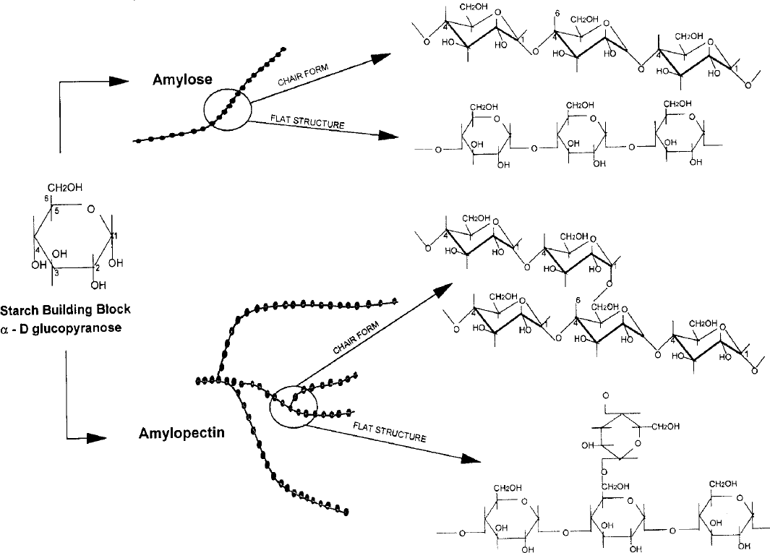

# Figure 1.1: Linear and branched starch polymers (Light, 1990; Crogan and Mason, 1998, Whistler et al, 1984).

A linear amylose chain has up to 6000 glucose units with a molecular weight of 105 – 106gmol-1 while amylopectin has a molecular weight of 107-109gmol-1. (Huijbrechts *et al,* 2008)

# Starch Granules

The backbone of starch contains a lot of hydroxyl (-OH) groups. The attraction of these hydroxyl groups serves as a driving force in bringing starch chains together in an ordered manner through hydrogen bonding. The ordered arrangement accounts for the crystalline regions of the granules. The unordered regions of the starch are called amorphous.

The identification of a raw, uncooked starch and the structure are facilitated by the crystalline regions of the starch granule.

When starch granules are illuminated with polarized light under a microscope, a characteristic ‘Maltese Cross’, also known as birefringence is shown. The source of each starch granule is determined by microscopic examination. This is easier when iodine is used to stain the amylase to a characteristic blue-black colour. This is a result of the association between the two to form a couple, in which the amylose forms a helical coil around iodine molecules (Whistler *et al,* 1984).

# Table 1.1: Characteristics of Starch Granule

|  |  |  |  |  |  |
| --- | --- | --- | --- | --- | --- |
| **Starch** | **Type** | **Diameter** | **Morphology** | **Gelatinization** | **% Amylose** |
|  |  | **(mm)** |  | **Temp. (0C)** | **Content** |
| **Maize** | Cereal | 5-30 | Round,  polygonal | 62 – 72 | 25 |

|  |  |  |  |  |  |
| --- | --- | --- | --- | --- | --- |
| **Tapioca** | Root | 4-35 | Oval,  Truncated | 62-73 | 63 |
|  |  |  | ‘Kettle |  |  |
|  |  |  | Drum’ |  |  |
| **Potato** Tuber 5-100 Oval, 59 -68 20  Spherical | | | | | |

**Wheat** Cereal 1-45 Round, Lenticular

58-64 25

**Rice**

Cereal

3-8

Polygonal, Spherical compound granules

68-78

19

(Light, 1990; Crogan and Mason, 1998, Whistler *et al,* 1984)

# Uses of Starch

Starch is widely used for a lot of applications, domestically and in industries. In most homes, starch serves as a source of food, while its modification provides an avenue for a range of usage such as thickening agent, stabilizer, emulsifier, papers.

In pharmaceutical industries, it is used as binders, disintegrants, fillers or diluents and lubricants.

Starch is one of the most important plant products to man. Annual starch production from cereals is approximately 2050 million tonnes and 679 million tonnes from roots and tubers.

Starch provides at least 35% of man’s daily calorific intake, in the developed world. In Africa and the far East, the daily man’s calorific intake, as much as 80% is provided by starch. It has been used in both food and non-food products for centuries. It is also used for medicinal purposes (Burrell, 2002).

* 1. ***Solenostemon rotundifolius* (Poir.) J.K. Morton**

The above named is a tuber under investigation. Botanical information on it is as detailed below:

Family

*Lamiaceae (Labiatae)*

# Synonyms

*Germanea rotundifolia* Poir. (1812), *Plectranthus ternatus* Sims (1824), *Plectranthus rotundifolius* (Poir.) Spring, (1825*), Coleus rotundifolius* (Poir). A. Chev. B. Perrot (1905), *Coleus dysentericus* Baker (1894).

# Vernacular names

French: Pomme de terre de Madagascar, pomme de terre du Soudan English: Hausa Potato, Coleus Potato

Nigeria:

Hausa: Tumuku Gbirom: Baku Ibo: Saluga

# Origin and Geographic Distribution

*Solenostemon rotundifolius* originates from tropical Africa. Presently, it is cultivated in the Kita region in Mali, the Northern district of Ghana, the Jos Plateau in Nigeria and Northern and Eastern parts of South Africa (Nkasah, 2004).

# Chemical Constituents

The composition of the raw tubers per 100g edible portion is:

Water, 75.6 g; Energy, 394 KJ (94 Kcal); Protein, 1.3 g; Fat, 0.2 g; Carbohydrate,

21.9 g; Fibre, 1.1 g; Calcium 17 mg; Ferrous, 6.0 mg; Thiamine, 0.05 mg; Riboflavine, 0.02 mg; Niacin, 1.0 mg; Ascorbic acid, 1.0 mg.

The above is calculated on wet weight basis (Leung *et al*, 1968).

# Plant Description

*Solenostemon rotundifolius,* also referred to as *Hausa potato* or coleus potato is a perennial, semi-succulent, aromatic herb up to 40-60 cm tall, branched, producing ovoid tubers up to 4-8cm long; stem erect to decumbent, 4-angled, shortly pubescent. Leaves opposite, simple; stipules absent; blade ovate; 2.5-8cm X 2-5cm, cuneate at base, obtuse to acute at apex, distinctly veined.

Inflorescence a terminal and slender false spike up to 15cm long. Flowers bisexual, zygomorphous; pedicel up to 1-2mm long; calyx campanulate, 1.5-3mm long. Fruit consisting of 4 nutlets, but rarely developing.

Tubers of *Hausa potato* are found in a diversity of shapes, sizes and colours depending on their geographic distribution. Grey to blackish brown tuber skin is found in Mali; while tubers with pale yellow to dark red are found elsewhere in Africa. There are also wild types without tubers (Agnew and Agnew, 1994).

# Growth and Development

The crop is planted between July and October at a temperature of 25 – 300C, with soil pH of 5.5 – 7.0. It reaches maturity in 5-6 months. Application of manure, chlormequat or ethrel reduces maturation time considerably (Holland, 1992).

Tubers occur in clusters of 3-7, either at the base of the stem or at the nodes below the soil surface. They are harvested 150-200 days after planting, by which time the plant has flowered and aerial parts have become senescent. Size of the tubers in Africa is 2.5 - 4cm X 1-1.5cm, while it can reach 8cm in India and Sri Lanka (Nkasah, 2004).

# Uses

*Hausa potato* is used in several ways:

1. In the Jos Plateau of Nigeria, it is used as a substitute for potato and is usually cooked and eaten with rice.
2. It is boiled, baked or fried as potato chips. It is also roasted whole and eaten as a snack.
3. The tubers are also used to make alcoholic drinks.
4. The leaves are occasionally used as a potherb.
5. Traditionally, *Hausa* potato is used in the treatment of diarrhea, dysentery and certain eye disorders.
6. The stem of the plant is used as a bedding material for livestock. This is later converted to farmyard manure.

# Statement of Research Problem

There are growing concerns over the continuous unavailability of the raw materials particularly excipients used in Nigerian pharmaceutical industries to produce solid dosage forms. Excipients such as starch are generally imported. The need to break new grounds has led to unrelenting efforts by pharmaceutical researchers to come up with new starches (major constitutents of drugs) that will lessen difficulties encountered in the formulation of tablets.

The bottlenecks involved in importation of excipients culminating in erratic supply of raw materials of tablet formulation encourage research into local production of starches. Government socio-economic activities are also affected by importation of raw materials, thereby increasing the burden on common man.

Local production will ameliorate all these difficulties and initiate exportation of the raw materials, thereby fetching hard currency for the country. This will eventually boost our foreign exchange. More jobs will also be created for Nigerian populace and the prices of drugs will come down.

# Justification of the Study

* + - Few literature has been found on this material for its utilization in the pharmaceutical industries.
    - It was investigated so as to determine whether it can be developed as a pharmaceutical excipient.
    - Also, because it is not a staple food, it could be investigated for pharmaceutical use.

# Limitation of the Study

The research is limited to paracetamol 500mg, an elastic material with poor compressibility as the active ingredient.

The study will also be limited to evaluation of tableting properties of native and modified starches of *Solenostemon rotundifoliius* in formulation of paracetamol 500 mg. Other factors that might limit the study are time, resources and socio-political situation of the country.

# Aim of the Study

The aim of this research is to evaluate the tableting properties of native and modified starches derived from *Solenostemon rotundifolius,* as tablet binder and disintegrant.

# Objectives and Scope of the Study

1. Collection and identification of *Solenostemon rotundifolius* tubers.
2. Extraction and modification of starch by pregelatinization and determination of the percentage yields.
3. Determination of the physico-chemical properties of native and modified starches.
4. Production of granules by wet granulation method of massing and screening.
5. Evaluation of the granules.
6. Mixing of granules with extra-granular excipients.
7. Evaluation of the tablets.
8. Evaluation of binding, disintegrant, compression and compaction properties of native and modified starches of *Solenostemon rotundifolius* and comparing it to maize starch and gelatin.

# CHAPTER TWO

# LITERATURE REVIEW

# Tablet – Pharmaceutical Dosage Form

Tablets are solid dosage forms that contain active pharmaceutical ingredients with or without suitable diluents (Parmer and Rane, 2009).

The European Pharmacopoeia (2002) also defines tablets as “Solid preparations each containing a single dose of one or more active substances and usually obtained by compressing uniform volumes of particles. The particles to be compressed consists of one or more active ingredients with or without auxiliary substances such as diluents, binders, jdisintegrating agents, glidants, lubricants, substances capable of modifying the behaviour of the active ingredients in the digestive tract, authorized colouring matter and flavouring agents (B.P, 1988).

The term “tablet” is derived from Latin word, tabuletta, which describes the appearance of the dosage form i.e. small, disc-like or cylindrical specimen. An ideal tablet should be kept above 3 mm in diameter and 50 mg in weight for easy handling and targeted content uniformity. The first appearance of tablet was in 1843 and till date remains the most popular solid dosage form (Alderborn, 2007).

Tablet is the most popular oral dosage form, due to many advantages it offers to formulation as well as physicians and patients.

# Advantages and Disadvantages of Tablet as a Dosage Form The advantages are:

* + - 1. Large scale manufacturing is possible compared to other dosage forms. This reduces unit cost of production.
      2. Accuracy of dose is maintained since tablet is a solid unit dosage form.
      3. The profile of release from tablet can be manipulated and tailored to one’s need.
      4. Longer expiration period and minimum microbial spoilage owing to lower moisture content.
      5. Stringent environmental conditions are not required as tablet is not a sterile dosage form.
      6. Packaging and handling are easier than liquid dosage form.
      7. Transport of tablet is easier than liquid.
      8. Organoleptic properties such as taste, appearance and odour are best improved by use of tablet through coating.
      9. Product identification is easy. Markings are done with grooved punches and printing with edible ink.
      10. A second party is not required for administration.

# The disadvantages are:

1. Slower onset of action in comparison to parenterals, liquid and sometimes capsules.
2. It is difficult to swallow for kids, geriatric patients, unconscious patients and patients in coma.
3. Drugs that are denatured by stomach acids such as insulin cannot be made into tablets.
4. Due to poor absorption and consequently low bioavailability of some drugs, the injectables are preferred.
5. The amount of liquid drug (e.g. Vitamin E) that can be trapped into a tablet is very small.

# Types of Tablets

There are many types of tablets. They include:

# Disintegrating Tablets

These types of tablets are intended to be swallowed and to release the active ingredient in a relatively short time thereafter by disintegration and dissolution. They are also referred to as plain or conventional tablets and normally include at least the following types of excipients: filler (if the dose of the drug is low), disintegrant, binder, glidants, lubricant and anti adherent (Alderborn, 2007).

# Chewable Tablets

The tablets are chewed and mechanically disintegrated in the mouth, but dissolution takes place in the stomach or intestine. Chewable tablets are either used to accomplish a quick and complete disintegration of tablet to obtain a rapid drug effect or to facilitate the administration of the tablet. Example of former is antacid tablets while vitamin tablets are good examples of the latter and are especially used for the elderly and kids.

Chewable tablets can be taken when water is not available. The only difference between chewable tablets and conventional tablets is the absence of disintegrants in chewable tablets composition.

# Effervescent Tablet

These are tablets which are dropped into a glass of water releasing effervescent carbon dioxide as a result of reaction between a carbonate or bicarbonate and a weak acid such as citric or tartaric. This process facilitates tablet disintegration and dissolution of drug, which completes within a few minutes. Rapid absorption and bioavailability of drug result form rapid stomach emptying time and short residence time. This is because the pH of the resultant buffered solution increases the pH of the stomach. Binders are not included in effervescent tablets.Effervescent tablets are packaged in water proof containers to protect them against moisture. (Verloop *et al*, 2004).

# Compressed Lozenges

Compressed lozenges can be described as tablets that dissolve slowly in the mouth and thus release the drug dissolved in the saliva, for systemic drug uptake or from local medication in the mouth or throat. The components usually include local anesthesia, antiseptic and antibiotic drugs.

They are similar to conventional tablets except that they do not contain disintegrants. The filler and binder used in formulation are expected to be water –soluble and have a good taste. (Alderborn, 2007).

# Sublingual and Buccal Tablets

The tablets are released in the mouth followed by systemic uptake of the drug. This results to rapid systemic drug effect without first pass liver metabolism. Sublingual tablets are placed under the tongue and buccal tablets are placed in the side of the cheek. The small size and porosity of sublingual and buccal tablets facilitate fast disintegration and drug release.

# Prolonged – release Tablets

The term is used to refer to tablets which are swallowed and thereafter slowly release the active ingredients in the gastrointestinal tract. They are also sometimes called slow release, extended release, sustained- release or controlled- release preparations. The drug should normally be absorbed into the systemic circulation after release from the tablet. The aim of formulation is to increase the time period during which the therapeutic drug concentration level in the blood is maintained or to increase release time for drugs that cause local irritation in the stomach or intestine.

Drug release of prolonged – release tablet is for a period of about 12 – 24 hours. The release pattern could be continuous or in pulses which could either be a rapid release of the drug or a combination of a rapid release of one portion of drug followed by a slow release of second portion (Alderborn, 2007).

# Formulation of Tablets

The pharmaceutical industry is currently at the edge of re-inventing itself to meet emerging challenges. These challenges include continually increasing drug development

costs, slowed new product approval, drug patent expirations, price pressure and global competition.

At the same time, much opportunities exist for the industry such as increasing patient population, numerous unmet medical needs, growing disease awareness, globalization of operation and markets, and advances in efficiency (Shangraw and Demarest, 2006; Deorkar, 2008).

Formulation for pharmaceutical products particularly solid dosage form such as tablet is a complex process involving the interaction of many ingredients and process variables (Colbourn, 2004).

Tablets are composed of active pharmaceutical ingredients and excipients which are responsible for the functionality of the active ingredients. Excipients (additives or adjuncts) are indispensable in pharmaceutical formulations. Many products would not be suitable or convenient for administration without excipients. Beside other applications, excipients are used as lubricants, diluents, binders, disintegrants, colourants and sweeteners (Alebiowu, 2001). In selection of excipients for any formulation, the following factors are considered as much as possible:

1. Keep the excipients to a minimum in number.
2. Minimize the quantity of each excipients.

Multifunctional excipients may be given preference over unifunctional excipients. Excipients play a crucial role in design of the delivery system, determining its quality and performance. Excipients are usually regarded as non-toxic but there are examples of excipients which induce toxicities such as osmotic diarrhea caused by mannitol.

# Table 2.1: Particle properties influencing excipient functionality Particle Property Excipient Functionality

**Enlargement of particle size** Flowability, compressibility

**Restricting particle size distribution** Segregation potency

**Enlargement of particle porosity** Compressibility, solubility

**Surface roughness** Flowability, segregation, potency

(Patel and Bhavsar, 2009)

Pharmaceutical excipients influence physicochemical properties as well as the release profiles and availability of the drug in the system (Olayemi *et al,* 2010).

The defined function of excipients in pharmaceutical dosage forms are to modulate manufacturing and delivery of drug substances. The better the excipients can perform these functions, the more suitable that excipient is (Silverstein, 2002). Excipients improve solubility and stability, thus enhancing the bioavailability (Van de Waterbeemd and Terta, 2008). However, challenges of drug-excipients interaction leads to a reduction of number of excipients used in formulation (Jaclern *et al*, 2000). The introduction of new high speed tablet machinery requires excipients with good compressibility, compatibility, flow properties and even short dwell times. These requirements have led to most available ones falling short in fulfilling their roles.

Excipients are modified to improve their properties. For example, starch is modified to become soluble or spray-dried lactose to improve its flowability (Monedero Perales *et* al, 1996).

Also excipients can be co-processed with other excipients with added advantages. For example, microcrystalline cellulose (MCC) is co-processed with silicon dioxide to obtain a high compatibility and high intrinsic flow with enhanced lubricant activity, resulting in a better tablet hardness, particularly when wet granulation is used (Hwang and Peck, 2001).

# Fillers/Diluents

These are inert substances which are added to the formulation when weight of the active pharmaceutical ingredients is very small to make a reasonably-sized tablet. Examples

of diluents are calcium phosphate, lactose, microcrystalline cellulose, kaolin and starches (Alebiowu, 2001).

A standard tablet should weigh at least 50 mg. A low dose or a potent drug requires the addition of a substance into the formulation to increase the bulk volume and form acceptably-sized tablet. These substances are called fillers or diluents, and may not be necessary if the dose of the drug per tablet is high. An ideal filler should be chemically inert, non-hygroscopic, cheap, compatible, bio-compatible and have acceptable taste or tasteless.

Examples are lactose, sucrose, glucose, mannitol, sorbitol, calcium carbonate and magnesium stearate (Alderborn, 2007).

# Binders

Binders are agents used to impart cohesive qualities to the powdered material during the production of tablet. This ensures that the tablet remains intact after compression as well as improving the free flowing quality (King, 1975). Binders could be used in solution and in dry form depending on the other ingredients in the formulation and the method of preparation, at relatively low concentration of 2-10% by weight. The choice of a particular binding agent depends on the binding force required to form granule and its compatibility with the other ingredients particularly the active drug (Ibezim *et al*, 2008). Binders are usually employed in the wet granulation methods of tablets productions where a binder solution previously prepared is used in wetting the dry powder mix to form a damp mass, massed and screened to give granules (Musa *et al*, 2010). Too much quantity of binder

could lead to hard tablets, prolonged disintegration and consequently poor drug release (Udeala and Chukwu, 1985; Mgbahurike and Igwilo, 1991).

# Disintegrants

Disintegrant is that excipient which facilitates the break-up of the tablet in a liquid environment into fine particles prior to dissolution of the active ingredient and its absorption from the gastro intestinal tract (Iwuagwu and Onyekweli, 2002).

Disintegration are achieved through two main processes:

# Water uptake facilitation:

These disintegrants act by facilitating the transport of water into the pores of the tablet, thereby leading to the breaking of the tablet into fragments e.g. surface active agents. Other substances can promote liquid penetration using capillary forces to suck water into the pores of the tablet.

# Tablet rupture promotion

Tablets can be ruptured by swelling of the disintegrant particles during sorption of water. However, non-swelling disintegrants break the tablet by repulsion of particles when in contact with water and also by the recovery of deformed particles of their original shape when in contact with water. (Alderborn, 2007).

Other mechanisms by which disintegration of tablets may be achieved are; gas release, melting and enzymatic action, heat or wetting, lysis of physicochemical bonds (Bakre and Jaiyeoba, 2009). Examples of disintegrants are starches derived from potato and

maize. They are used at concentration ranging from 1-10% by weight depending on the swelling capacity of the disintegrant. (Alebiowu and Itiola, 2003).

Improved disintegrant properties are achieved with larger particles than finer particles since they have been found to swell better and at a faster rate (Rudnic *et al*, 1982).

# Glidants, Lubricants and Anti-adherents

Glidants are used to promote powder flow by reducing inter-particle friction and cohesion. They are used in combination with lubricants which prevents ingredients from clumping together and from sticking to the tablet punches. Lubricants also ensure that tablet formation and ejection occur with low friction between the solid and die wall. Anti- adherents are used to reduce the adhesion between the powder (granules) and the punch faces and, thus prevent sticking to tablet punches. Good examples of glidant is talc; lubricant and anti-adherent commonly used is magnesium stearate.

# Flavours, Sweeteners and Colourants

Flavours and sweeteners are added to formulation in order to improve the taste particularly chewable tablets while colourants are included in drug formulation to aid identification, patient compliance and to mask undesired colour of an active ingredient.

# Techniques of Tablet Production

Two basic techniques have been recognized for production of tablets. These are direct compression and granulation.

Direct compression is the process by which tablets are compressed directly from the powdered blends of active ingredient(s) and suitable excipients. (Shangraw, 1988). The process is simpler than other methods of tablet manufacture such as wet granulation, roller

compaction in terms of steps involved (Shangraw, 1989). Since direct compression requires fewer steps of unit operations it is more economical. It is also suitable for moisture and heat-sensitive active pharmaceutical ingredients since it eliminates wetting and drying steps.

Certain limitations discourage the use of direct compression such as segregation, inability to compress poorly compressible materials such as paracetamol and materials with poor flowability.

Granulation is the method of converting powder into free-flowing granules in order for it to flow freely and evenly from the hopper into the dies. Granulation can either be dry or wet depending on the physicochemical properties of the drug formulation ingredients. Wet granulation involves use of liquid while dry granulation does not involve the use of liquid in the process. Granulation is used to overcome the challenge of segregation on direct compression method of tablet manufacture.

# Granulation

The mixture of powder has to be converted into free-flowing granules in order to improve its compressibility and to flow freely and evenly from the hopper into the dies. A granule is an aggregation of component particles that is held together by the presence of bonds of finite strength.

The strength of a wet granule is due mainly to the surface tension of the granulation liquid and capillary forces. These forces are responsible for initial agglomeration of the wet powder. The most important reasons for a granulation step prior to tableting are to improve the flow properties of the mix and hence the uniformity of the dose; to prevent segregation

of the ingredients in the hopper of the tablet machine; to improve the compressive characteristics of the tablet mixture and to reduce dust handlings (Aklilu, 2002).

Other reasons that might necessitate granulation include compression into tablets of poorly compressible materials, convenience of storage since granules occupy less volume per unit weight than their parent powder mix, granulation of slightly hygroscopic materials will prevent caking and adherence of powder (Summers and Aulton, 2002).

# Wet Granulation

This is the most widely used method, accomplished by adding a liquid binder or an adhesive to the powdered mix, pressing the wetted mass through a screen of the desired mesh size, drying the granules and then passing through a second screen of smaller mesh size to reduce further the size of the granules (Gohel, 2005).

Proper control of amount of liquid is essential as over-wetting will cause them to be soft and friable, leading to soft tablets.

Granulating liquids include water, ethanol and isopropanol used either alone or in combination. Water is most commonly used for economical and ecological reasons although it has problem of affecting drug stability and also it needs longer drying time than do organic solvents (Summers and Aulton, 2002).

Aqueous solutions have the advantage of being safer to deal with than solvent-based systems but may not be suitable for drugs which are degraded by hydrolysis. The following steps are involved in wet granulation.

**Step 1:** The active ingredient and excipients are weighed and mixed.

**Step 2:** Preparation of binder solution.

**Step 3:** The wet granulate is prepared by adding the liquid binder adhesive to the powder blend and mixing thoroughly.

**Step 4:** Screening the damp mass through a mesh to form pellets or granules (6-12 screen).

**Step 5:** Drying of moist granules. A conventional tray-dryer or fluid bed dryer are most commonly used.

**Step 6:** After the granules are dried, they are passed through a screen of smaller size than the one used for the wet mass to create granules of uniform size (14-20 screen).

**Step 7:** Mixing of screened granules with disintegrant, glidants and lubricant.

# Limitations of wet granulation

* The greatest disadvantage of wet granulation is its cost. It is an expensive process because of labour, time, equipment, energy and space requirement.
* Loss of material during various stages of processing.
* Stability may be a major concern for moisture sensitive or thermo-labile drugs.
* Multiple processing steps add complexity and make validation and control difficult.
* An inherent limitation of wet granulation is that any incompatibility between formulation components is aggravated due to presence of liquid as a result of possible chemical reactions.

# Mechanism of Pharmaceutical Granule Formation

Granulation involves the formation of granules and for this to occur, there has to be formation of strong bonds between powder particles to adhere properly and prevent breakdown of the granule to powder during handling. In pharmaceutical granulation, various mechanisms have been identified for bonding of particles to form granules (Summers and Aulton, 2007). These are:

* + - * 1. Adhesion and cohesion forces in immobile liquid films between individual primary powder particles;
        2. Interfacial forces in mobile liquid films within the granules;
        3. Formation of solid bridges after solvent evaporation;
        4. Attractive forces between solid particles;
        5. Mechanical interlocking.

# Process of Granule Formation

Four stages are involved in granule formation. These are:

1. **Nucleation:** Formation of particle-particle contact and adhesion due to liquid bridges. Particles are joined to form pendular followed by capillary states, which are bodies that act as nuclei for further granule growth.
2. **Transition:** This stage sometimes marks the end point for granules and is characterized by the presence of a large number of small granules which are formed by growth of nuclei produced at the nucleation stage.
3. **Ball growth:** Large spherical granules are produced with continuous granule growth. Further agitation will lead to granule coalescence which may lead to

production of an unstable, over-massed system. This is however dependent on the amount of liquid added and the properties of materials being granulated. Ball growth is common in planetary mixers and some spheronising equipment. Ball growth can be prevented in pharmaceutical production by using monitoring equipment to stop the granulation at a predetermined point known as granulation end point control (Summers and Aulton, 2002).

1. **Attrition and breakage:** Breakage of wet agglomerates in the granulator and attrition of dry agglomerates are phenomena that affects the final products size distribution. The decrease in mean granule size is a function of impeller speed in a process of melt granulation in a high shear mixer (Chitu, 2009).

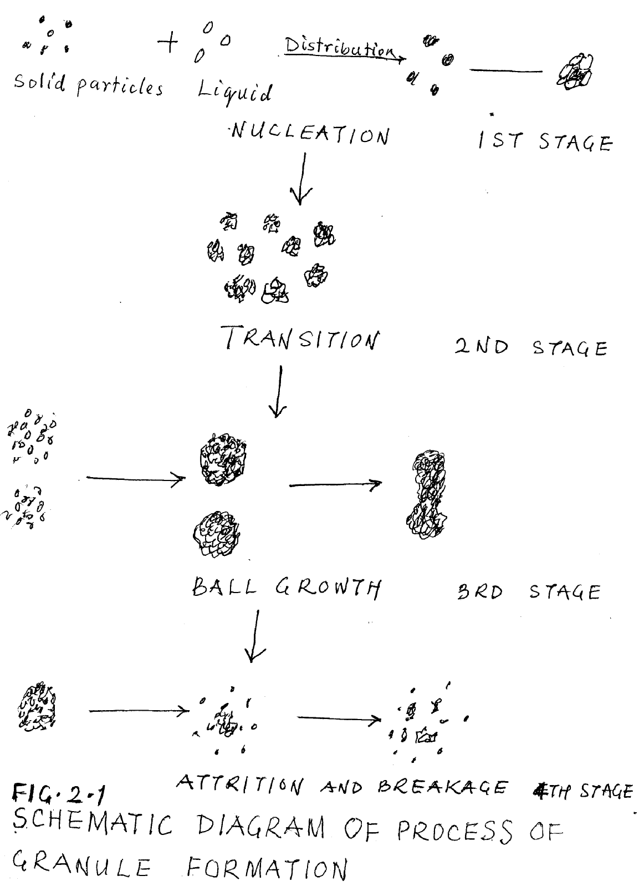

(Chitu, 2009)

# Wet granulation equipment

Three main equipments are used for wet granulation in pharmaceutical industries:

# High- speed granulators

This machine has a stainless steel mixing bowl containing a three - bladed main impeller which revolves in the horizontal plane, and a three -bladed auxiliary chopper (breaker blade) which revolves either in the vertical or the horizontal plane.

The rotating impeller mixes the unmixed dry powders when placed in the bowl with the granulating liquid which is added through a port in the lid of the granulator while the impeller is rotating. A bed of granulating material is produced from the moist mass when the chopper is switched on. The granular material is passed through a wire mesh when a satisfactory granule has been produced. It is then passed through a wire mesh which breaks up any large aggregates, into the bowl of a fluidized - bed drier.

The advantages of this equipment is that processing time is short as mixing, massing and granulation are all performed within a few minutes in the same piece of equipment. However, a suitable monitoring system, is necessary to indicate the end of granulation as the process is so rapid and that a usable granule can be converted very quickly into a useless, over-massed system. Example of these granulators are Diosna and Fielder (Alderborn, 2007).

# Shear granulators

The process involves feeding of mixed powders into the bowl of the planetary mixer with addition of granulating liquid. The paddle of the mixer agitates the powders until a moist mass is formed. The moist mass is then transferred to an oscillating granulator, which forces the moist mass through the sieve screen, the size of which determines the granule size. Adequate liquid is essential for good granules. Excess liquid should not be added as strings of materials will be formed which on drying will be sieved to powder and failure of granulation.

The granules are then collected on trays and transferred to an oven for drying. Drying on tray has some disadvantages such as long drying time; migration of dissolved material to the upper surface of the bed of granules, as the solvent is only removed from the upper surface of the bed on the tray; and aggregation of granules due to bridge formation at the points of contact of the granules.

To deaggregate the granules and remix them, sieving is necessary after drying. Alternatively, fluidized - bed drier is used to dry the granules. This is faster and reduced the problems of aggregation and inter-granular solute migration, as it keeps the individual granules separated during drying. Thus, the need for sieving after drying is reduced.

The advantages of this process are that it is not very sensitive to changes in the characteristics of the granule ingredients (e.g. surface area variations in different batches of an excipient), and the end- point of the massing process can be determined by

inspection. Some of the commonly used equipment include Hobart, Collerte and Beken. (Alderborn, 2007).

# Fluidized - bed granulators

These are similar in design and operation to fluidized-bed driers. Examples are Aeromatic and Glatt. The operation is such that heated and filtered air is blown through the bed of unmixed powder to fluidize the particles and mix the powders. Granulation fluid is sprayed from a nozzle on to the bed of powders. The fluid causes the powder particles to adhere when the droplets and powders collide. Exhaust filters prevent the escape of material from the granulation chamber. Adequate liquid must be sprayed to produce granules of the required size. At this point, the spray is turned off but the heated fluidizing air continues to dry the wet granules.

Advantages of this process are that it can be automated and all the granulation processes can be performed in one unit, saving labour costs, transfer losses and time.

Disadvantage is that the equipment is expensive and optimization of the process parameters affecting granulation is very tedious as numerous apparatus, process and product variables that affect the quality of the final granule are involved. (Alderborn, 2007).

# Advancement in granulations

* + - 1. **Steam granulation**

This is modification of wet granulation, where steam is used as a binder instead of water. Its several benefits includes higher distribution uniformity, higher diffusion rate into powders, more favourable thermal balance during drying step, steam granules are more spherical, have large surface area, hence increase dissolution rate of the drug from granules, processing time is shorter, therefore more number of tablets are produced per batch. The limitation is that it is unsuitable for thermolabile drugs and special equipment are required. (Saharan *et al*, 2001).

* + - 1. Melt granulation/Thermoplastic granulation

Granulation is achieved by the addition of a meltable binders. The binder is in solidstate at room temperature but melts in the temperature range of 50 – 80OC. There is no need of drying phase since dried granules are obtained by cooling it to room temperature. Also, amount of liquid binder can be controlled precisely and the production and equipment costs are reduced. It is ideal for granulating water- sensitive material and producing slow-release granulation or solid dispersion. However, this method is not suitable for thermolabile substances. When water- soluble binders are needed, polyethylene glycol (PEG) is used as melting binders while when water - insoluble binders are needed, stearic acid, cetyl or stearyl alcohol, various waxes and mono-, di-, and triglycerides are used as melting binders. (Saharan *et al*, 2009).

# Moisture activated dry granulation (MADG)

This involves moisture distribution and agglomeration. Tablets prepared with this process have better content uniformity, utilizes very little granulating fluid, decreases drying time and produces granules with excellent flowability. Advantages include short processing t ime and litt le energy usage.The disadvantage is that it is not used for moisture-sensitive drugs (Ullah, 2011).

# Moist granulation technique (MGT)

A small amount of granulating fluid is added to activate dry binder and to facilitate agglomeration. A moisture absorbing material such as microcrystalline cellulose (MCC) is added to absorb any excess moisture. This makes unnecessary drying step. This is applicable for developing a controlled-released formulation.

# Thermal adhesion granulation process (TAGP)

This process is applicable in direct compression method of tablet production. It is performed under low moisture content or low content of pharmaceutically acceptable solvent by subjecting a mixture containing excipients to heating at a temperature in the range of about 30°C and 130°C in a closed system under mixing by tumble rotation until granule is formed. The method utilizes less - water or solvent than traditional wet granulation method. It produces granules with good flow properties and binding capacity to form tablets of low friability/adequate hardness and have a high uptake capacity for active substances whose tableting is poor. (Lin *et al*, 2002).

# Foam granulation

Liquid binders are added as aqueous foam. Some of the benefits over wet/spray granulation include the use of less binders and water than wet granulation, no over wetting, reduced drying and manufacturing time and useful for granulating water-sensitive formulations.

# Manufacturing of Tablets

The production of tablets involves three stages known as compaction cycle. These are die filling, tablet formation and tablet ejection. Particles are forced into close proximity with each other in a process called compression. A defined geometry formed from compression in a die by the action of lower and upper punches. This leads to formation of a compact or tablet. Compression of powder is defined as the reduction of volume of a powder owing to the application of a force while compaction is defined as the formation of a solid specimen of defined geometry by powder compression (Alderborn, 2007).

The process of manufacture of tablets is the same irrespective of the methods of production of tablet blends. Initially, the powder is filled into the die from above. The mass of powder is influenced by the position of the lower punch in the die, the cross - sectional area of the die, and the powder density. Repositioning of the lower punch is done to make necessary adjustment to the tablet at this stage.

After die filling, the upper punch is lowered into the die and the powder is compressed to a porosity of between 5 and 20%. One or two stages are involved in the compression, (main compression and sometimes, pre-compression or tamping).

# Common Problems Encountered during Tablet Manufacturing Operations

* Poor (low) weight uniformity, usually caused by uneven powder flow into the die.
* Poor (low) content uniformity, caused by an uneven distribution of the active ingredients in the tablet blend.
* Sticking of the powder blend to the tablet machine, due to inadequate lubrication, worn or dirty machine, and sub-standard material properties.
* Capping, lamination or chipping. Such mechanical failure is due to improper formulation design or faulty equipment operation.

# Compression and Compaction of Pharmaceutical Powders into Tablets

The properties of pharmaceutical powders are related to the characteristics of their compression and compaction under pressure. Compression and compaction are expressed in terms of compressibility and compactibility, respectively. Compressibility is the ability of the powder to deform under pressure, while compactibility is the ability to form mechanically strong compacts or tablets. Compaction of pharmaceutical powder involves simultaneous processes of compression and consolidation of a two - phase (particulate solid- gas) system due to an applied force (Odeku, 2007).

# Compression and Decompression of Pharmaceutical Powders into Tablets

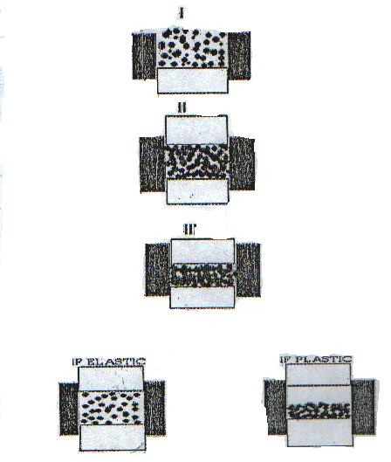

**Fig. 2.1: Stages involved in compression (I-III) and decompression.**

Key: I – Die filling II – Initial volume reduction due to closer packing of powder particle III – Increased load, decreased rearrangement and particle deformation

The ability of a powder bed to be compressed and consequently be reduced in volume is referred to as compression. It plays an important role in the manufacturing of tablets and granules (Marshal, 1986; Bodga, 2002).

Compression also refers to a reduction in the bulk volume of materials as a result of displacement of the gaseous phase. At the initial stage of compression process, when the powder is filled into the die cavity, the forces that exist between the particles are those that are related to the packing characteristics of the particles, the density of the particles and the total mass of the material that is filled into the die. The packing characteristics of the powder mass will be determined by the packing characteristics of the individual particles. (Marshall, 1986).

Application of external mechanical forces to a powder mass results in a reduction in volume due to closer packing of the powder particles - main mechanism of initial volume reduction at most times (Fig. 2.1).

As the load increases, re-arrangement of particles becomes more difficult and further compression results in some form of particle deformation (Fig 2.1). On removal of the load, if the deformation is somehow reversible in which it behaves like rubber, the deformation is said to be; elastic. Most solids experience elastic deformation when external force is applied.

In some other occasions, when the elastic limit is reached, and loads above this level result in deformation not immediately reversible on the removal of the applied force, the deformation is said to be plastic. This mechanism occurs most frequently in materials in which the shear strength is less than the tensile or breaking strength. Plastic deformation results in clean surfaces and is time - dependent. (Armstrong, 1989; Ayorinde *et al*, 2005).

Thus, application of higher rate of force will result in less new clean surfaces, and weaker tablets. Also, high concentration or over- mixing of materials that form weak bonds results in weak tablets, and thus, less new clean surfaces.

A good example is magnesium stearate, which form weak bond and easily wet surfaces. Hence, over-mixing of magnesium stearate may lead to weak tablets. (Bodga, 2002).

Materials in which the shear strength is greater than the tensile strength, particles may be preferentially fractured, and the smaller fragments help to fill up the adjacent air spaces. This is common in hard, brittle particles. This is known as brittle fracture. Sucrose is a good example. The deformity pattern of a particular material depends on the lattice structure. Brittle fracture produces clean surfaces that are brought in intimate contact by applied load.

In summary, Compression involves four stages of events:

* + - 1. Initial repacking of particles
      2. Elastic deformation of the particles until the elastic limit (yield point) is reached.
      3. Plastic deformation and/or brittle fracture then predominate(s) until all the voids are virtually eliminated.
      4. Compression of the solid crystal lattice then occurs.

# Compressional characteristics of granules

A granulating agent imparts a degree of plasticity to the particulate system, so that the formation of inter-particulate bonds is favoured and tablet strength is enhanced. The

amount of bonding between the particles due to asperity melting and plastic and elastic deformation of the particles depends on the amount of binder present and the compression force applied. It appears that the concentration of binder has a greater influence in more porous tablets than those approaching zero voids. As the applied pressure is increased the porosity of the tablet is decreased, the inter-particulate distances through which bond forces operate are shorter and hence less amount of binder is used.

Studies on the role of the granulation moisture content on compression properties of granules made with selected binders (povidone, pregelatinised starch) showed that at lower pressure, higher moisture- containing granules were slightly more compressible than lower moisture -containing granules. At lower pressure, the water lubrication effect did not occur but at higher pressures, the reverse was true because of the water lubrication effect. It is also reported that at all compression speeds, an increase in moisture content reduced the percentage -elastic recovery of HPMC due to greater tablet consolidation (Aklilu, 2002).

# Consolidation

This is the increase in the mechanical strength of a material as a result of particle to particle interaction (Bodga, 2002). The mechanisms of powder consolidation are discussed below:

When the surfaces of two particles approach each other closely enough, their free surface energies result in a strong attractive force through a process known as cold welding. The hypothesis is believed to be a major reason for the increasing mechanical strength of a bed of powder when subjected to rising compressive forces. The frictional

heat generated between the surfaces leads to rise in temperature which results in melting of the contact area. When the melt solidifies, bonding occurs which in turn results in increase in the mechanical strength of the mass (Odeku, 2007).

Another possible mechanism of powder consolidation is asperitic melting of the local surface of powder particles. During compression, the powder compact undergoes an increase in temperature between 4 and 30°C which depends on the friction effects, the specific material characteristics, the lubrication efficiency, the magnitude and rate of application of compression forces and the machine speed. (Rankell and Higuchi, 1968; York and Pipel, 1973; Hanus and King, 1968). Strong compacts are formed as the tablet temperature rises, stress relaxation and plasticity increases while elasticity decreases (Bodga, 2002).

# Decompression

Decompression is the stage where the applied force is removed after compression of tablet. It is as important as the compression stage, but not independent of it in determining the satisfactory formulation of tablet. For instance, some deformation processes are time -dependent and occur at different rates during the compaction sequence, so that the tablet mass is never in a state of stress/strain equilibrium during the actual tableting process. Thus, the rate at which load is applied and removed may be a critical factor in materials for which dependence on time is significant. If a plastically deforming solid is loaded (or unloaded) too rapidly for the process to take place, the solid may exhibit brittle fracture. As a result of this, researches have shifted to relating the capping and lamination tendencies of tablet formulations to their plastic and elastic behaviour during compression - decompression -ejection cycle. (Carless and Leigh, 1974;

Hiestand *et al*, 1977; Rees and Rue, 1978; Itiola and Pipel, 1986). The same deformation characteristics that come into play during compression play a role during decompression (Bodga, 2002).

Decompression leads to a new set of stresses within the tablet as a result of elastic recovery, which is augmented by the forces necessary to eject the tablet from the die. Apart from the consolidation mechanism, the tablet must be mechanically strong enough to withstand these new stresses, otherwise structural failure will occur. (Marshall, 1986).

A large value of the Heckel constant indicates, the onset of plastic deformation at relatively; low pressure. Plastic deformation occurs during compression when Heckel plot is linear (Parrot, 1990; Paronen and Ikka, 1996; Marshall, 1986; Banker and Anderson, 1986).

# Models expressing the compression of powders.

1. **The Heckel Equation**

The compression behaviour of powders may be characterized by Heckel plots (Heckel, 1961). Several researches have been carried out and Heckel's equation has successfully been applied to identify the types of mechanisms occurring during compression. (Hou and Carstensen, 1985; Roberts and Roe, 1985) The Heckel equation (1) states that the relative density (D) is related to the applied compression pressure (P)



(1 - D) represents the pore fraction or porosity, K is proportional to the reciprocal of the mean yield pressure (Py) and A is function of the initial porosity. Materials with a high mean yield pressure are classified as brittle - fracturing or fragmentary and material with low mean yield pressure are classified as plastic and elastic deforming materials.

The Heckel analysis is based on the assumption that powder compression follows first order kinetics with the inter-particulate pores as the reactants and the densification of the powder as the product (Odeku, 2007).

Graphically, K is the slope of the straight linear portion of the plot, while A is the intercept of the prolonged linear portion with the Y-axis. The linear part of Heckel plot is curved at the low and high pressure ends. The yield pressure depicts the stress at which plastic deformation of the particles is initiated, and can be derived from the linear part of the Heckel plot. At the non-linear part, the initial curvature at low pressure reflects particle fragmentation and rearrangement, while the deviation from a straight line at higher pressure may be caused by capping and lamination of the powder (Apeji, 2010).

Heckel plot is influenced by variables such as overall time of compression, the degree of lubrication and the size of the die. The effects of these parameters are important and should be taken into consideration (Odeku, 2007).

# The Kawakita Equation

The Kawakita equation was developed to assess the compression mechanics of granules by calculation of compression shear strength. The assumption is that during compression of powder or granules in a confined space, the system is in equilibrium at all

stage, so that the product of a pressure term and a volume term is constant. The equation is written in the following linear form:



where P is applied pressure, C the degree of volume reduction and a and b are constants (Alderborn 2002). The degree of volume reduction relates the initial height of the powder and is expressed as:





Where V0 is the initial volume of the powder bed and V is the powder volume after compression. (Odeku, 2007)

a and b are constants which are obtained from the slope and intercept of the P/C versus P plots respectively. The constant a, is equal to the minimum porosity of the bed prior to compression while b, which is termed the co-efficient of compression is related to the plasticity of the material.

The equations are usually applied to powders of solid particles but suggestions have been made that the compression corresponds to the strength of granules in terms of



their compression strength. Thus, it is possible to characterize the mechanical properties of granules from a compression experiment (Alderborn, 2007).

The relationship between the volume reduction of the powder column and the applied pressure is also described by Kawakita and expressed as:

 

Where C is degree of volume reduction, Vo the initial volume. V the volume of the powder column under the applied pressure, P and a and b are constants characteristic to powder being compressed (Paronen and Ikka, 1996).



# Cooper and Eaton Equation (1962)

VO –V/VO - VS = a1 exp ( -k1/P) + a2 exp ( -k2/P ) V = volume of compact at pressure P (m3)

VO = volume of compact at zero pressure (m3) VS = void-free solid material volume (m3) and A1, a2, k1 ,k2 = Cooper – Eaton model constants

Assumption: Compaction proceeds through particle rearrangement and deformatlon. First Process: Filling of voids of the same order as the size of the original particles which may require elastic deformation or even slight fracturing or plastic flow of particles. The second process involves the filling of voids that are substantially smaller than the original particles. The process can be accomplished by plastic flow or fragmentation, in which the former is more efficient because the material is always forced into the voids (Mani *et al*, 2004).

# Evaluation of Tablet

A number of procedures are used to assess the quality of the tablets. Some test methods that are concerned with the tablet content and the in-vitro release of the active ingredient, are described in pharmacopoeias. Others that are not found in pharmacopoeias are

referred to as non-compendial and concern quality attributes that need to be evaluated such as the porosity of tablet. Some of the quality control tests used for tablets are described below.

# Content uniformity of active ingredient

Pharmaceutical preparations are required to have a constant dose of drug between individual tablets, but in practice, small variations exist. The limits for the acceptable variation appear as standards in official books. Dose variation or uniformity of dose is tested using uniformity of weight and uniformity of active ingredient tests.

Uniformity of weight test is carried out by collecting a sample of tablets from a batch and determining their individual weights. The average weight of the tablets is then calculated. The sample passes the test if the individual weight do not deviate from the mean more than is permitted in terms of percentage. Obviously, if the drug substance forms the greater part of the tablet mass, any weight variation means variation in the content of active ingredient.

In the case of low dose, potent drugs where the excipients form the greater part of the tablet, there might be poor correlation between tablet weight and amount of active ingredient. Thus, the test for weight variation in content of the drug substance. The test for uniformity of drug content is carried out by collecting a sample of tablets followed by a determination of the amount of drug in each. The average drug content is calculated and the content of thindividual tablets should fall within specified limits in terms of percentage deviation from the mean.

# Table 2.2: Tablet weight variation requirements (B.P. 1980) Average weight Percentage difference

**130mg or less** 10

# > 130mg – 324mg 7.5

**More than 324mg** 5

# Thickness and Diameter Uniformity of the Tablet

The necessity of reproducing identical tablets in appearance and to avoid problems of packaging make carrying out this test applicable. These are carried out by selecting five tablets and determining their thickness and diameter with micrometer screw gauge. The mean of such determination should not deviate from acceptable limits.

Thickness and diameter could vary due to change in the compression pressure or size segregation within the hopper even when compression pressure remains the same.

# Crushing Strength (Hardness) Test

The crushing strength or hardness of a tablet determines its resistance to chipping, abrasion or breakage under storage condition, transportation and handling before usage.

Over the years, several methods have been used to assess the hardness of tablet, starting from the rule of thumb to when in 1930, Monsanto introduced a portable hardness tester. This instrument measures the force requires to break the tablet when the force generate by the coil spring is applied diametrically to the tablet. It is measured in kilogram force.

It is the practice in manufacturing of tablet to measure crushing strength throughout the production cycle in case of any need for pressure adjustment. Hard tablets may not disintegrate within the required period of time or meet the dissolution specification while soft tablets will not withstand the handling during processes such as coating, packaging and shipping operations (Odeku and Itiola, 2006).

# Friability Test

Friability is a parameter also used to measure hardness of a tablet. It measures the ability of a tablet to withstand abrasion in packaging, handling and shipping. The most common equipment used to measure tablet friability is the Roche friabilator.

A specified number of tablets are weighed and placed in the apparatus where they are exposed to rolling and repeated shocks as they fall 6 inches in each turn within the apparatus. The equipment is set at 25 revolutions per minutes for four minutes after which the tablets are re-weighed and the weight compared with the initial weight. The loss due to abrasion is a measure of the tablet friability. The value is expressed as a percentage.

The generally acceptable standard is that the maximum weight loss should not be more than 1% of the weight of the tablets being tested. Any broken or smashed tablets are not picked up. Normally, friability values are not calculated for capping tablets (Odeku and Itiola, 2006).

# Disintegration Test

Disintegration test do not normally seek to establish a correlation with in-vivo behaviour. Thus, compliance with the specification is no guarantee of an acceptable release and uptake of the drug in-vivo and hence an acceptable clinical effect. However, it is reasonable to assume that a preparation which fails to comply with the test is unlikely to be efficacious. (Alderborn, 2007).

The disintegration of tablets into small fragments is an integral part of drug release process. In order to assess this, disintegration test methods have been developed. Examples of such test can be found in pharmacopoeias.

The disintegration test is carried out using the disintegration instrument which consists of 6 plastic tubes opened at the upper end and closed by a screen at the lower end. Before testing, one tablet is placed in each of the tube. The tubes are placed on a water bath at 37 0C ±

0.5 0C, preferably in a 1L beaker and raised and lowered at a constant frequency in the water in such a way that at the highest position of the tubes, the screen and the tablet remain below the surface of the water. For most uncoated tablets, the BP specifies that the tablets disintegrate in 15 minutes while up to 2 hours may be required for coated tablets. (B.P, 1980).

# Dissolution Test

The release of a drug from solid dosage form is studied under in-vitro conditions through dissolution testing. Dissolution testing also helps to assess factors that affect the bioavailability of a drug from a solid preparation. Dissolution studies are carried out to evaluate the potential effect of formulation and process variables on the bioavailability of a drug; to ensure that preparations comply with product specification; and to indicate the performance of the preparation under in-vivo conditions

This study is carried out by locating a tablet in a chamber containing a dissolution medium, of controlled volume and temperature. In the rotating basket method, the tablet is placed in a small basket formed from a screen. This is then immersed in the dissolution medium and rotated at agiven speed. The BP (2002) specifies that at least 70% of the drug should be in solution after 30 minutes.

# Integrity of Tablets

Integrity of tablets, also known as mechanical strength of tablets is a measure of the binding potential of the materials in the tablet. Information from the assessment of this binding potential is useful in the selection of excipients. If the bond is excessively strong, there may be slow disintegration and subsequent dissolution of a drug. Weak bonding may limit the selection and/or proportion of excipients, such as lubricants that would be added to the formulation.

The mechanical properties of pharmaceutical tablets, are quantifiable by the friability, hardness or crushing strength, crushing strength- friability values, tensile strength and brittle fracture index (Odeku, 2007).

Mechanical strength of tablet is an important quality attribute, which depends on both formulation and process (Narang *et al*, 2010). Bonding results from interactions between two particles. Sometimes, there are barriers to this interaction. Compaction removes these barriers to spontaneous attraction and strength. The attraction which results in bonding comes predominantly from dispersion forces (individual atom-to -atom bonds), plastic deformation and visco-elastic properties which provides additional plastic deformation. (Hiestand,1997).

The tableting forces and lubricant concentration influences the bonding strength in complex layer tablets. High amount of lubricant in the central layer produces weak bonding strength, while the compression forces for complex layer tablets exerts a positive effect on layer adhesion. (Dietrich *et al*, 2000).

A study has shown that reproducible results for the strength of tablet prepared at a given compression force can be obtained by ensuring the tablet breaks in such a manner that

the tensile stress is the major stress. For a given tablet, suitable padding material is required to be planted between the tablet and the compressing surfaces. Assessment of the type of failure can be made visually and under the correct condition, the results are expressed as a tensile strength. However, there are a range of conditions which ensure tensile failure resulting in different values for the tensile strength. The values are characteristics of the tablet and; test conditions and are not absolute values of tensile strength. (Fell and Newton 2006).

# Recent Works Related to this Study

Over the years, increasing attention is being paid by pharmaceutical scientists to the extraction, development and use of starches in the formulation of dosage forms. (Garr and Bagudu, 1991). The limitation of native starches such as poor compressibility and flow properties have led to production of special starch products, which are gradually being introduced to pharmaceutical industries. (Apeji, 2010).

Bos *et al,* (1987) investigated maize, potato, rice, and tapioca (cassava) starches with respect to their properties on direct compression. Rice starch showed much better compactability as compared to maize, potato and tapioca starches. Its binding capacity, almost insensitive to mixing with magnesium stearate. This is in contrast to the dramatic decrease in crushing strength of potato starch tablets containing the lubricant. The compactability of the starches was found to be strongly affected by the equilibrium moisture content of the starches, which is dependent on the relative humidity of the atmosphere under which the powders were stored. All starches showed adequate capacity for water uptake to act as a disintegrant. Rice starch exhibited worst

flowability due to small particle size as compared to the other starches. Granulation of rice starch changed it into a potential filler-binder in tablets prepared by direct compression.

Subhadhirasakul (2001) investigated taro and sweet potato starches based on compressibility, friability and disintegration. It was found that the binding and disintegrating performance of both taro and sweet potato starches was similar to that of commercial corn starch.

Kunle *et al* (2003) carried out research on physicochemical and compaction properties of Tacca starch as a potential pharmaceutical excipient. The result was compared to those of maize and potato starches. It was found out that tacca starch features were comparable to those of maize starch in the formation of compacts (tablets), with tacca starch being more resistant to deformation.

Alebiowu and Itiola (2003) evaluated the effects of plantain and sorghum starches on mechanical properties of tablet formulation. They concluded that pregelatinization of the starches has significant effects on the mechanical properties of the tablets and pregelatinised plantain starch could be useful in particular situations where a high bond strength is required with minimal lamination and capping problems. The result also suggested that the tested starches have similar properties to that of corn starch B.P.

Akin-Ajani *et al*, (2005) also studied the effects of plantain and corn starches on the mechanical disintegration properties of paracetamol tablets and concluded that plantain starch could be used as alternative binding agent to corn starch (faster disintegration, lamination and capping problems are resolved).

Odeku *et al* (2005) studied the compression and mechanical properties of tablet formulations using corn, sweet potato and cocoyam starches as binders. Using Heckel and Kawakita equations and plots for analysis, the result showed that corn starch would be more useful than the experimental starches for minimizing the problems of lamination and capping, especially on high-speed tableting machine with short dwell times for the plastic deformation of materials. Cocoyam and sweet potato starches would be useful when a tablet's high bond strength is needed. The results indicated botanical starches could be useful to produce tablets with desired mechanical properties for specific purposes depending on whether stronger or softer tablets are required in cases such as chewable or disintegrating tablets.

In 2006, Adetunji *et al* evaluated corn and trifoliate yam starches for their compression, mechanical and released properties in the formulation of tablet. It was concluded that trifoliate yam starch would be a better alternative to corn starch in producing uncoated tablets for which high bond strength is essential.

Dare *et al* (2006) discovered that pigeon pea starch exhibited the highest bond strength and lowest brittleness, suggesting the usefulness in producing strong tablets with minimal lamination tendency. He also found out that plantain starch would be more useful where faster disintegration of tablet is desired.

Comparative evaluation of maize, rice and wheat starches’ powders as pharmaceutical excipients by Olayemi *et al*, (2008) showed that rice starch had the lowest cohesiveness and would be the starch of choice when good flowability is desired and also could be a better tablet disintegrant.

Also, in 2009, Oyi *et al* evaluated wheat, rice and maize starches binding effects and crushing strength in formulation of tablet. They concluded that wheat starch is a stronger binding agent especially in the formulation of chewable tablets and lozenges.

Mohammed *et al,* (2009) studied the influence of compaction pressures on modified cassava starch. Using Heckel and Kawakita equations and plots, they discovered that the modified cassava starch has comparable activity to that of maize starch B.P and could be substituted for it when the need arises.

Okunlola and Odeku (2009) also investigated the compressional and tableting properties of starches obtained from four Dioscorea species. The result of the study provides an insight into the material, compressional and tableting properties of the four Dioscorea starches in comparison with the official corn starch. The four Dioscorea starches generally exhibited poor flow properties and deform mainly by plastic flow. Water and white yam starches showed faster onset of plastic deformation than corn starch while bitter and Chinese yams starches showed higher amounts of total plastic deformation. Bitter and Chinese yams starches tablets had higher tensile strengths than corn starch and longer disintegration times suggesting their potential use as binding agents in tablet formulation. On the other hand, water and white yam starches produced tablet with lower tensile strength and shorter disintegration times than corn starch suggesting their potential use as disintegrant. Thus, the Diosocorea starches could be used as substitute for corn starch depending on the intended use of formulation.

It is apparent that a lot of researches have been carried out on many local starches in respect of their tableting, compression and compaction characteristics but with

information available so far, *Solenostemon rotundifolius* is yet to be investigated as an excipient in pharmaceutical formulations despite its global existence.

# CHAPTER THREE

# MATERIALS AND METHODS

# Materials

# Experimental sample

* + - * Solenos*temon rotundifolius* starch (Kpam, Jos, Plateau State).
      * Maize Starch B.P (BDH Laboratories, UK)
      * Gelatin (May and Baker Ltd, Dagenham, England)
      * Paracetamol powder (May and Baker, Nigeria)

# Chemical and Reagents

* + - * Talc Powder (BDH Chemicals Ltd Poole, England)
      * Magnesium stearate powder (BDH Chemicals Ltd Poole, England)
      * Lactose Powder (BDH Chemicals Ltd Poole, England)
      * Ethanol (Absolute) (BDH Chemicals Ltd Poole, England)
      * Xylene (BDH Chemicals Ltd Poole, England)
      * Sodium Hydroxide Pellets (Avondale Laboratories Ltd, Banbury, England)
      * Glycerol (BDH Chemicals Ltd Poole, England)
      * Potassium Sulphate (BDH Chemicals Ltd Poole, England)
      * Copper Sulphate (BDH Chemicals Ltd Poole, England)
      * Boric Acid (BDH Chemicals Ltd Poole, England)

# Equipment

* + - * Gallenkamp oven BS size 3 (Made in England)
      * General Laboratory Centrifuge – 2 (Sorvall Serial 75061 80)
      * HH-S Digital Thermostatic water bath (McDonald Scientific International, Lagos, Nigeria).
      * Compound Biological Microscope (Fischer Scientific Company, China.
      * Electronic scale (MSI-A Electronic Balance)
      * Gallenkamp Regulator Hotplate (Made in England)
      * Oaklon PH Meter (PH 1100 series) (Eutech Instruments, Singapore).
      * Erweka Flow Apparatus (Type GD7, Erweka – Apparatebau – G.m.b.H Heusentamm, Made in West Germany)
      * Single Punch Tableting Machine (Type EKO, Erweka-Apparatebau

– G.m.b.H Heusentamm, Made in West Germany).

* + - * Monsanto Tablet Hardness Tester (Monsanto Chemical Co., USA).
      * Tablet Friabilator (Type TA3R, Erweka – Apparatebau – G.m.b.H Heusentamm, Made in West Germany).
      * Micrometer Screw Gauge (Moore & Wright Sheffield, England).
      * Disintegration Test unit (Type ZT3, Erweka – Apparatebau –G.m.b.H Heusentamm, Made in West Germany)
      * Dissolution Test Apparatus (Type DT, Erweka – Apparatebau – G.m.b.H Heusentamm, Made in West Germany).

# Methods

* + 1. **Collection, Identification and Extraction of *Solenostemon rotundifolius* starch.**

Fresh tubers of Hausa potato (*Solenostemon rotundifolius* (Poir) J.K. Morton) (Fam. Labiatae) was obtained from a farm in Kpam village, Plateau State. The tubers were identified and authenticated at the herbarium of the Department of Biological Sciences, Ahmadu Bello University, Zaria, Nigeria, with a voucher number 151.

The tubers were washed, peeled, washed again, weighed and grated. The grates were further reduced to a fine pulp using a grinding machine. The pulp was sieved using a calico cloth with adequate distilled water until starch was completely separated from the chaff. 0.IN NaoH was added to neutralize the acidity and allowed to sediment overnight. The supernatant was decanted and a suspension of the starch in distilled water was centrifuged to remove the non-starch components from the starch. The starch sediment was then collected and spread on aluminum trays to air- dry and then dried in an oven at 400C. The dried starch was later size-reduced to fine powder using a blender. This was then weighed, packed in a polythene bag and stored at room temperature until required. The percentage yield of starch was determined.

* + 1. **Preparation of Pregelatinised *Solenostemon rotundifolius* Starch(PGS)**

500 mL of cold distilled water was added to 160 g of dry native starch powder in a bowl. 1.5 liters of hot water at 60 0C was added with continuous stirring and placed on Gallenkamp Regulator Hotplate (England) while the stirring continued until translucent mucilage was formed. The mucilage was dried in the oven at 40 0C. The resulting flakes were milled in a blender. This was labeled as water-prepared pregelatinised starch (PGSW).

The weight of the PGSW (W) was expressed as the percentage weight of the dry starch (W1) used in producing the mucilage to determine % yield (Y). The process was repeated but instead of drying the mucilage, 95% of ethanol was used to precipitate the starch from the mucilage. The precipitate was dried, milled and labeled PGSA.

Y = W/W1 x 100 (5)

# Physicochemical Characterization

# Organoleptic Properties

The colour, odour, taste and texture of the starch powder were observed and noted.

# Identification test

One (1) gram of powder was suspended in 50 mL distilled water, allowed to boil for I minute and cooled. One drop of iodine solution was added to 1 mL of the mucilage and the colour change was noted (BP, 2002).

# Ash content

Two (2) gram of starch was made to undergo combustion in a silica dish at 450 0c. The residue recovered was measured and percentage of ash was calculated with reference to the weight of the starch taken.

# Moisture content determination

Five (5) grams of the powder sample was dried in an oven (Gallenkamp Oven Bs size 3) at 1050c to constant weight. The percentage loss in weight on drying was calculated as the moisture content.

# Determination of pH

One (1) gram of the sample was dispersed in 100 mL of distilled water, shaken rigorously for 5 min and allowed to stand. The pH of the supernatant liquid was determined using a PH meter (Oaklon pH meter; pH 1100 series,Singapore).

# Solubility

One (1) gram of the powder was dispensed in 10 mL each of cold distilled water, hot distilled water, ethanol and left overnight. 5 mL of the clear supernatant solution of each mixture was taken and heated to dryness over a water bath. The weight of the dried residue with reference to the volume of the solution was determined as the percentage solubility of the powder in the solvent.

# Swelling Power

The swelling capacity of the powder was estimated by a method described by Iwuagwu and Onyekweli (2002). The tapped volume occupied by 5 g of the powder, VX, was noted. The powder was then dispersed in 85.0 mL of water and the volume made up to 100 mL with more water. After 24 hr of standing, the volume of the sediment, VV, was estimated. The swelling capacity, (S) was computed as follows:

S = VV/VX (6)

# Microscopy

A small quantity of the powder in glycerol was mounted on a slide of a microscope, that had been calibrated using the eye-piece and stage micrometer. The powder was viewed under the microscope and five hundred (500) particles were counted to determine the particle size distribution at x400 magnification.

A picture of the powder particles under the microscope was taken using a camera, and the particle size determined

# Determination of Lipid Content

This was done by the continuous extraction of fat content from the sample using a suitable solvent e.g. petroleum ether (40-600C) in a Soxhlet extractor. The principle is that non-polar component of the sample are easily extracted into organic solvent ether. The extractible liquid was calculated as:





Where the weight of lipid extracted is given by the loss in weight of thimble content (Soxhlet extractor) after extraction.

# Determination of Protein Content (Nitrogen and Crude Protein)

Two gram of the starch was weighed into 100 mL Kjedhl flask and 1 g of catalyst (K2SO4 +anh. Cu SO4) was added to hasten the reaction. The flask was then heated slowly at first until fretting subsides and then more rigorously with occasional rotation of the flask to ensure even digestion and avoid over-heating of content.

After a clear solution was obtained, the sample was transferred to a 100 mL volumetric flask and diluted to the mark with distilled water after cooling.10mL of the diluted sample was pipetted into a Markham semi –macro nitrogen still and 10 mL of 40% NaOH solution added. The sample was distilled liberating NH3 into 100mL conical flask containing 10 mL of 40% Boric acid and 2 drops of methyl red indicator. Distillation is continued until the pink colour of the indicator turns greenish.

The control was titrated with 4% Boric acid with end-point indicated by a change from greenish to pink colour.

The volume of the acid used for each sample distillate was noted as well as that of

blank.

%Total N per sample was calculated as:



  



Where V= Vol. of HCl required for blank

V1= Vol. of HCl required for 10mL sample solution M=molarity of acid (0.1M)

14=atomic weight of N

100=total volume of digest or diluted sample 100=% conversion

10=volume of distillate 0.2=amount of sample in gram 1000=to convert to litre

The crude protein was calculated as % crude protein (CP) = 6.25 X N

**Note:** Protein contains 16% N. This makes the general conversion factor to be 6.25.

# Determination of Carbohydrate

According to Pearson (1976), the total of protein moisture content, ash content and lipid content subtracted from 100 gives the carbohydrate, and this is referred to as estimation by difference.

# Determination of Amylose and Amylopectin Content

The method employed by Song and Jane (2000) was adopted in the determination of the amylose and amylopectin content of the starches. A 0.8% w/v of the starch suspension was prepared and heated on the water bath with constant stirring at 100 oC until the starch was fully gelatinized. The starch solution was separated from the insoluble residue by filtration and the pH adjusted to 6.3 using a phosphate buffer. The solution was then stirred on the boiling water bath for 2 hour to disperse the starch molecules and 20% v/v butanol was added while the heating continued at 100 oC for another 1 hour. It was then allowed to cool at room temperature over a period of 24 hour. Amylose butyl alcohol complex crystals was formed during cooling and separated by filtration. The amylopectin remaining in the supernatant was recovered by adding excess methanol. It was allowed to dry to get rid of the methanol and the dry weight determined gravimetrically.

# Physicomechanical Characterization

* + 1. **Particle Size Analysis**

Twenty (20) grams of powder was placed in a nest sieves and allowed to vibrate for

10 mins. The weight of material retained on each sieve was determined. A plot of percentage frequency distribution against particle size was drawn for each powder sample.

# Particle Density

The method as described by Odeku *et al*, 2005 was adopted. The particle density was determined using a pycnometer with xylene as the displacement fluid. An empty 50 ml pycnometer bottle was weighed (W). The bottle was filled with xylene and the excess wiped off. The filled bottle was weighed a second time (W1). The difference between W1 and W was obtained (W2). A 2 g quantity of the sample was weighed (W3) and transferred into the pycn ometer bottle. The excess solvent was wiped off and the bottle was weighed again (W4). The particle density, Pt (g/cm3), was calculated from the following equation:





Where Pt is particle density W is weight of empty bottle W2 is weight of xylene

W3 is weight of powder

W4 is weight of bottle, sample and xylene

# Angle of repose

The angle of repose, was obtained using the funnel and stand method. A plugged glass funnel was mounted on laboratory stand at a height of 10 cm from the flat surface. Fifty grams (50g) of the powder sample was placed in the funnel. The plug was removed

and the sample allowed to flow. The height and diameter of the heap formed was noted.

The angle of repose ( ) was calculated as:



  



Where is the angle of repose

H is the height of the conical powder heap R is the radius of the circular base

# Flow Rate

Fifty (50) grams of the powder was placed in an Erweka flow apparatus (Type GD7, Erweka – Apparatebau G.M.B.H Heusentamm, West Germany) and allowed to flow through the funnel orifice. The time taken for the powder to flow through the orifice was noted and the flow rate was determined as the ratio of mass (g) to time (s). The mean of three determination were recorded.





# Bulk and Tapped Densities

Fifty (50) grams of powder was weighed on an electronic balance and poured into a 100 mL glass measuring cylinder at an angle of 450 using a glass funnel. The cylinder was dropped on a wooden platform from a height of 2.5 cm there times at interval of 2 s. The volume occupied by the powder was recorded as bulk volume . The cylinder was then tapped on the wooden platform until the volume occupied by the powder became constant. This was recorded as tapped volume. The bulk and tapped densities were calculated as the ratio of weight to volume. The data generated were used in computing the Carr’s index and Hausner’s ratio. The equations are as follows:

Bulk Density or Tapped Density=  /Volume of powder…(12)









# Hydration Capacity

One (1) gram sample was placed in each of four 15 mL plastic centrifuge tube to which 10 mL distilled water was added and then stoppered. The content were mixed on a vortex mixer for 2 min. The mixture was allowed to stand for 10 min and then centrifuged at 1000 rpm for 10 min on a bench centrifuge. The supernatant was carefully decanted and the sediment weighed. The hydration capacity was calculated as the ratio of sediment weight to the dry sample weight.

# Moisture Sorption Capacity

Two (2) grams of starch powder was weighed and uniformly distributed over the surface of a 70 mm tarred Petri-dish. The sample was placed in a dessicator containing distilled water in its reservoir (RH=100%) at room temperature and the weight gained by the exposed sample at the end of the five-day period was noted and the amount sorbed was calculated from the weight difference.

# Bulkiness, Packing Fraction and Porosity

The results of bulk and particle densities were used in the determination of bulkiness, packing fraction and porosity using the following formulae (Eichie and Kudehinbu, 2009):

Bulkiness = 1/Bulk Density (15)

Packing Fraction = Bulk Density/Particle Density (16)

Porosity = 1 – Bulk Density/Particle Density x 100 (17)

# Formulation Studies

* + 1. **Preparation of Paracetamol Granules**

Granules were prepared by wet granulation method of massing and screening. 100 g of paracetamol powder and 6.5 g of maize starch (disintegrant) were mixed in a mortal with pestle until fine powder was obtained after which 6.5 g of binder (in solution) was added to the dry mixture. The resultant mixture was mixed gradually until a moist and cohesive mass was formed. The wet mass was screened through a 1.7 mm mesh using a spatula. The resulting granules were dried in a hot air oven at 40 0C for 30 minutes after which they were re- screened through a 1.6 mm mesh size and further dried for another 30 minutes. The granules were allowed to cool and stored (Batch 2) . The same procedure was used for the remaining four batches with changes in binder concentration (Table 3.2).

# Analysis of paracetamol granules

The paracetamol granules were subjected to the following tests: sieve analysis, moisture content, angle of repose, bulk and tapped densities Carr’s index and Hausner’s ratio. The same procedures were used as earlier described for powdered starch (3.3.4, 3.4.1, 3.4.3 and 3.4.5).

# Compression of Granules

Tablets equivalent to 650 mg paracetamol were made by compressing granules made up of paracetamol powder (500 mg), disintegrant (5%w/w) and binder solution(0-

12.5 %w/w) mixed with 2.8 %w/w of maize starch (extra- granular excipients ), 2.0 %w/w of dried talc (lubricant) and 0.2 %w/w of dried magnesium stearate (glidant ). The mixture

was made up to required weight with enough quantity of lactose before being compressed to tablets with a single punch tableting machine fitted with 12 mm normal concave-faced punches (Type EKO, Erweka Apparatebau. G. M. B. H Heusentamm, West Germany). Tablets were made at various compression loads between 7.5 and 8.5 MT (Table 3.1). The same procedure was used in Table 3.3. The tablet formulae for the different batches of five are given below (Tables 3.1 and 3.3):

# Table 3.1: The Tablet formula for studying the binding properties of *Solenostemon rotundifolius* starch and modified starches compared with gelatin in

**paracetamol tablets.**

# Ingredient Quantity/Tablet

**Paracetamol** 500 mg

**Lactose** q.s

**Disintegrant: Maize Starch** 5 % w/w

# Binder Solution:

**SRS/ PGSA/PGSW/Gelatin** (0, 5, 7.5, 10, 12.5)% w/w

# Extragranular excipient:

**Maize starch** 2.8 % w/w

# Lubricant/Glidant:

**Dried Talc** 2.0 %w/w

**Dried Magnesium Stearate** 0.2 %w/w

Key: PGSA – Alcohol – Dehydrated Pregelatinised Starch

PGSW – Water-Prepared Pregelatinised Starch SRS - *Solenostemon rotundifolius* starch

# Table 3.2 : Formula for tablet and batch size (Testing for binding properties)

Ingredient Quantity/ tablet (mg) Quantity / Batch size of 200 tablet (g)

B1 B2 B3 B4 B5

|  |  |  |  |  |  |  |
| --- | --- | --- | --- | --- | --- | --- |
| Paracetamol | 500 | 100 | 100 | 100 | 100 | 100 |
| Lactose | q.s | 17 | 10.5 | 7.25 | 4 | 0.75 |
| Disintegrant: maize starch | 3.25 | 6.5 | 6.5 | 6.5 | 6.5 | 6.5 |
| Binder:SRS/PGSA/PGSW/GLT | (0,5,7.5,10,12.5) %w/w | 0 | 6.5 | 9.75 | 13 | 16.25 |
| Extragranular excipient: Maize | 18.2 | 3.64 | 3.64 | 3.64 | 3.64 | 3.64 |
| starch |  |  |  |  |  |  |
| Lubricant/ Glidant: |  |  |  |  |  |  |
| Dried Talc | 13 | 2.6 | 2.6 | 2.6 | 2.6 | 2.6 |
| Dried Mag.Stearate | 1.3 | 0.26 | 0.26 | 0.26 | 0.26 | 0.26 |
| Total | 650 | 130 | 130 | 130 | 130 | 130 |

# Table 3.3: The Tablet Formula for Studying the Disintegrant Properties of *Solenostemon rotundifolius* Starch and Modified Starches Compared with Maize Starch B.P in Paracetamol Tablets

**Ingredient Quantity/Tablet**

**Paracetamol** 500 mg

**Lactose** q.s

# Disintegrant

**SRS/PGSA /PGSW /Maize Starch** (0, 2.5, 5, 7.5, 10, 12.5) % w/w

# Binder:Gelatin Solution Lubricant/Glidant:

5 % w/w

**Dried talc** 2.0 % w/w

**Dried magnesium stearate** 0.2 % w/w

Key: PGSA – Alcohol-dehydrated pregelatinised starch

PGSW – Water-prepared pregelatinised starch SRS - *Solenostemon rotundifolius starch*

# Table 3.4: Formula for tablet and batch size (Testing for disintegrant properties)

Ingredient Quantity/ Tablet (mg) Quantity/ Batch size of 200 tablet (g)

|  |  |  |  |  |  |  |  |
| --- | --- | --- | --- | --- | --- | --- | --- |
|  | | B1 | B2 | B3 | B4 | B5 | B6 |
| Paracetamol | 500 | 100 | 100 | 100 | 100 | 100 | 100 |
| Lactose | q.s | 20.64 | 17.39 | 14.14 | 10.89 | 7.64 | 4.39 |
| Disintegrant: |  |  |  |  |  |  |  |
| SRS/PGSA/PGSW/MZS | (0,2.5,5,7.5,10,12.5)%w/w | 0 | 3.25 | 6.5 | 9.75 | 13 | 16.25 |
| Binder: Gelatin solution | 3.25 | 6.5 | 6.5 | 6.5 | 6.5 | 6.5 | 6.5 |
| Lubricant / Glidant: |  |  |  |  |  |  |  |
| Dried talc | 13 | 2.6 | 2.6 | 2.6 | 2.6 | 2.6 | 2.6 |
| Dried Mag. Stearate | 1.3 | 0.26 | 0.26 | 0.26 | 0.26 | 0.26 | 0.26 |
| Total | 650 | 130 | 130 | 130 | 130 | 130 | 130 |

# Evaluation of Tablet Properties

* + 1. **Weight Uniformity Test.**

Twenty tablets from each batch were selected randomly and weighed individually using an electronic balance (Mettler Analytical Balance, Philip Harris Ltd., England). Their mean weights and standard deviations were determined based on an official method (B.P 2002) .

# Tablet Thickness and Diameter

Five (5) tablets were used to determine thickness and diameter with screw gauge micrometer (Moore & Wright Sheffield, England). The mean of five readings will be calculated.

# Crushing Strength Determination

Five (5) tablets randomly selected from each batch were tested for hardness using a Monsanto hardness tester. The tablet was held between the spindle and anvil of the tester. The knob was then screwed gradually and gently until the tablet was properly fixed. The reading pointer was adjusted to zero on the scale. Pressure was applied by turning the knob until the required pressure that crushed the tablet was reached. The pressure was read at a unit of kilogram force (kgf) on the scale. The mean of five determinations on each batch was recorded.

# Friability test

Ten tablets were selected at random from each batch, dusted and weighed together on an electronic balance. They were then subjected to abrasive shock in a Tablet friabilator (Type TA3R, Erweka – Apparatebau – G m. b. h Heusenstamm, Made in West Germany)

operated at 25rpm for 4mins. The tablets were dusted again and reweighed. The percentage loss in weight was determined for each batch of the tablets.

# Disintegration Test

Six (6) tablets were used to determine the disintegration time. This was carried out by placing the tablets in the basket fitted with the Erweka disintegration test apparatus (Type ZT3,Erweka – Apparatebau – G.m.b.H Heusentamm, West Germany) in distilled water at 37 + 0.50C. The time taken for each tablet to break into small particles and pass

through the me~~sh~~ was recorded and the mean taken as the disintegration time.

# Dissolution studies

The dissolution rate of the tablets was carried out using an Erweka dissolution apparatus. The dissolution medium was 1000 mL of 0.1N HCl for paracetamol, maintained at 37 ± 0.5 0C. The revolution of the basket containing the test tablet was 100 rpm. 10 mL of the sample was taken at a point half – way between the surface of the dissolution medium and the top of the rotating basket at 5 mins intervals for 30 min. Each volume of sample withdrawn was replaced with an equivalent volume of dissolution medium maintained at the same temperature. A twenty fold (1:19) dilution with the dissolution medium was done for each sample withdrawn before absorbance of the samples were read at 243 nm for paracetamol (Pharm. Codex, 1989) using a UR/VIS Spectrophotometer, Thermo Fischer Scientific Inc., Cambridge, U.K). The percentage drug released was plotted against time to generate dissolution curve.

Before dissolution studies, the following procedures were carried out:

# Determination of wavelength of maximum absorption for paracetamol

A 10 ug/mL solution of paracetamol was prepared by dissolving 100 mg of paracetamol in 100 mL of 0.1N HCl, and subsequently making up 1.0 mL of this solution to 100 mL with 0.1N HCl.

The absorbance of 10 ug/ml solution of paracetamol was determined with a UR/VIS spectrophotometer at different wavelength range, starting from 200 nm to 800 nm. A graph of wavelength versus absorbance was plotted with the same instrument to get the wavelength of paracetamol at the point on the graph where the absorbance was at peak. The wavelength of the paracetamol was found to be 243 nm.

# Calibration curve (Beer-Lambert plot) for paracetamol

A 1.0 mg/mL or 1000 ug/mL stock solution A of paracetamol was prepared by dissolving 100 mg of paracetamol in 100 mL of 0.1N HCl. 10ug/mL stock solution B of paracetamol was prepared by taking 1 mL of stock solution A and making it up to 100 mL with 0.1N HCl. Also, a 100 ug/mL stock solution C of paracetamol was prepared by taking 10 mL of stock solution B and making it up to 100 mL with 0.1N HCl.

Concentrations of 4 ug/mL and 8 ug/mL were prepared by making up 4 mL and 8 mL of stock solution B to 10 mL respectively. In the same manner, concentrations of 12 ug/mL, 16 ug/mL, 20 ug/mL, 24 ug/mL, 28 ug/mL and 32 ug/mL were prepared by making up 1.2 mL, 1.6 mL, 2.0mL, 2.4 mL, 2.8 mL and 3.2 mL of stock solution C to 10 mL respectively. The absorbance of each concentration was read at 243 nm and plotted against the various concentrations to obtain the calibration curve for paracetamol. The

linear regression equation for the graph was resolved from the plot and used to calculate the amount of drug released with time during dissolution studies.

# Compression Studies

Each material weighing 500 mg were made into compacts by compressing them for 30s with pre-determined loads (56.6 – 169.9 MNm-2) on Apex hydraulic presses (Type 814, Apex Construction Ltd., London W.I and Dartford). The die and 12 mm flat-faced punches were lubricated with 2 % w/v dispersion of magnesium stearate in acetone solution, before each compression.

Following ejection of the compacts, they were stored in a desiccator for 24 hr to allow for elastic recovery and hardening to prevent false low yield values. The weight, thickness, diameter and crushing strength were then determined. The relative density (D) was calculated using the following equation:



  



Where W is the weight (g), Vt, the volume (cm3) of the tablet and Ps is the particle density (g/cm3) of the solid material. HeckeI plots of In (1/1-D) versus applied pressure (P) were constructed for all the materials.

# Tablet Tensile Strength

This is the stress needed to fracture a tablet by diametrical compression. It is determined by the expression below:

TS=2P/πD (19)

Where P is the load that causes tensile failure of a tablet of diameter, D and thickness, t.The fracture load of three tablets was determined individually with the Monsanto hardness tester.The mean values of the fracture load were used to calculate the TS.

# Statistical Analysis

A 2 X 3 factorial statistical analysis was employed to compare the tablet ingproperties of the tested materials.

# CHAPTER FOUR

**4 .0 RESULTS**

**Table 4.1: Results of the physical tests on *Solenostemon rotundifolius* native starch Properties Result**

**Odour** Odourless

**Colour** Light brown

**Taste** Tasteless

# Texture

**% Yield Dry weight Wet weight**

# Gelatinisation temperature

Smooth

9.02

18.37

740C

# Table 4.2: Result of preliminary investigation on the water prepared pregelatinised starch and alcohol dehydrated pregelatinised starch

|  |  |  |
| --- | --- | --- |
| **Pregelatinised starch** | **Yield (%w/w)** | **Colour** |
| **Water prepared** | 96.23 | Light brown |
| **Alcohol dehydrated** | 57.45 | Light brown |

**Table 4.3: Physicochemical properties of native and modified starches of *Solenostemon rotundifolius* compared with Maize**

**starch B.P**

**Physicochemical Properties Maize Starch B.P Native Starch Modified (Pre-gelatinised) Starch**

|  |  |  |  |  |
| --- | --- | --- | --- | --- |
|  | | | **Water prepared** | **Alcohol-dehydrated** |
| Flow rate (g/sec) | 2.09 | 2.68 | 3.76 | 1.92 |
| Angle of Repose(o) | 39.47 | 51.71 | 29.25 | 25.80 |
| Carr’s index (%) | 20.89 | 32.26 | 12.63 | 14.29 |
| Moisture content (%w/w) | 9.00 | 6.00 | 5.00 | 4.00 |
| True Density (g/ml) | 1.40 | 1.50 | 1.36 | 1.39 |
| Bulk Density (g/ml) | 0.53 | 0.63 | 0.83 | 0.66 |
| Tapped Density (g/ml) | 0.67 | 0.93 | 0.95 | 0.77 |
| Moisture sorption Capacity(%) | 19.00 | 33.50 | 46.00 | 36.00 |
| Swelling Power (%) | 20.59 | 13.75 | 319.04 | 246.15 |
| Hausner’s Ratio | 1.26 | 1.48 | 1.14 | 1.17 |
| Solubility | Insoluble | Insoluble | Insoluble | Insoluble |
| pH | 5.73 | 5.02 | 5.96 | 5.99 |
| Protein content (%) | 14.00 | 10.50 | 15.75 | 17.50 |
| Ash content (%) | 4.10 | 5.08 | 3.40 | 3.30 |
| Fat content (%) | 13.00 | 12.47 | 10.73 | 9.94 |
| Amylopectin content (%) | 77.81 | 78.39 | 75.25 | 78.39 |
| Amylose content (%) | 22.19 | 21.61 | 24.75 | 21.61 |
| Mean particle size | 8.00 | 10.75 | 121.38 | 90.46 |
| Bulkiness | 1.89 | 1.59 | 1.20 | 1.52 |
| Packing fraction | 0.38 | 0.42 | 0.61 | 0.47 |
| Porosity (%) | 62 | 58 | 39 | 53 |

**Native starch has comparable properties with maize starch but with poorer flow properties. Modification improved flowability and swelling capacity**

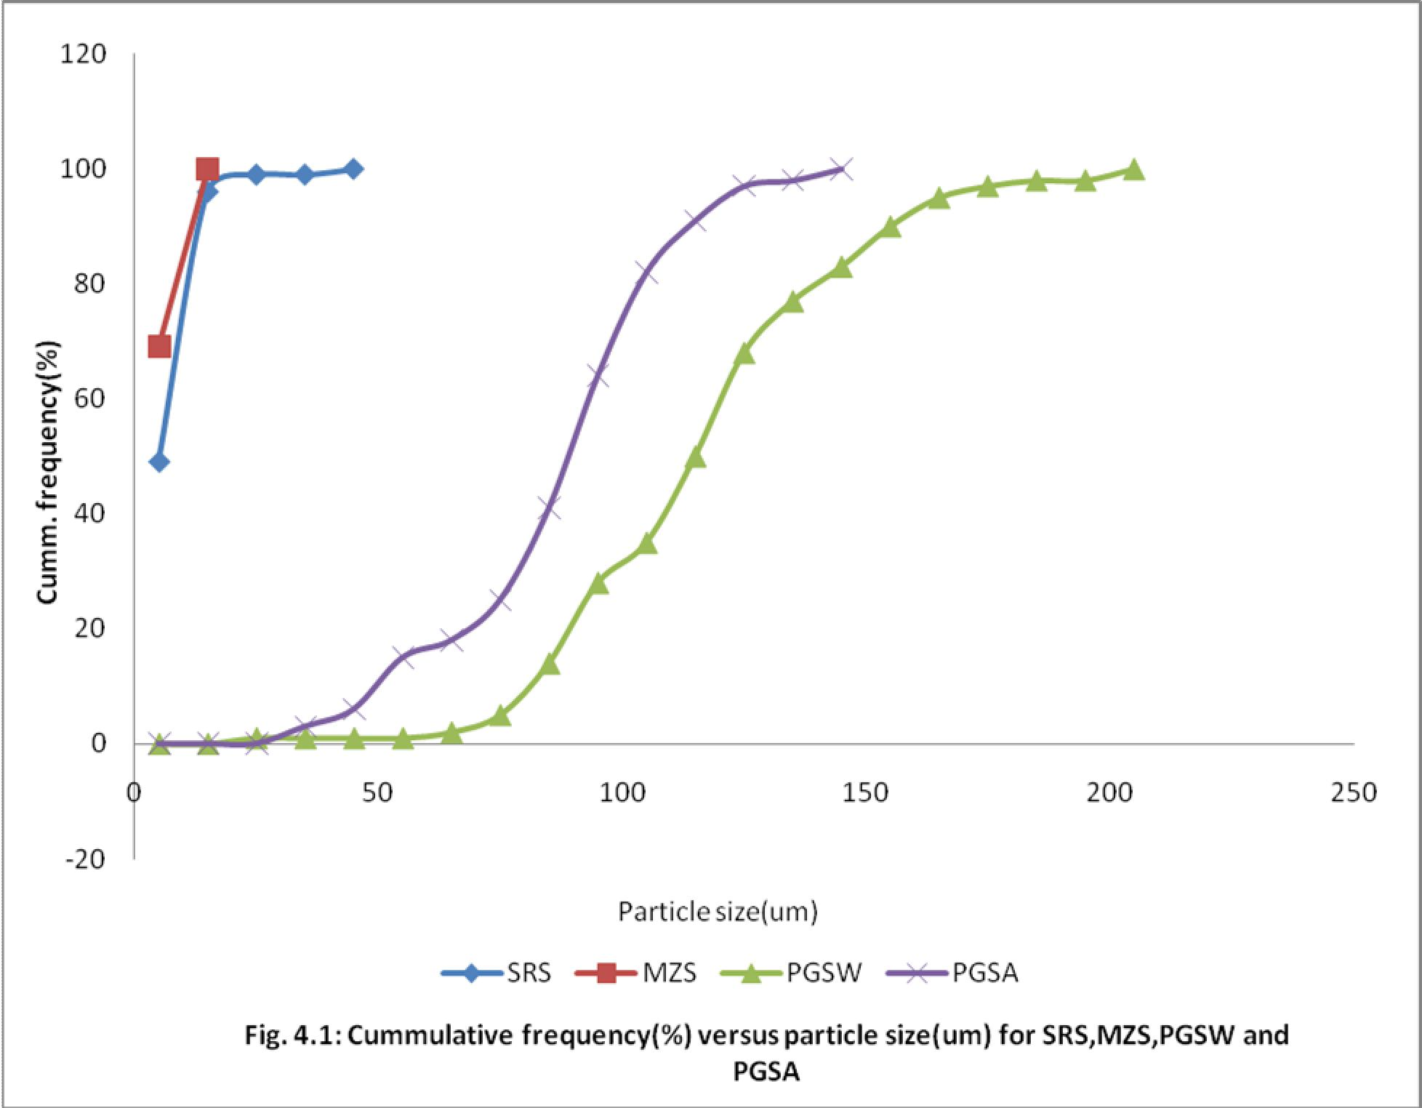

Table 4.4: Effects of Various Binder Concentrations on the Flow and Density Properties of the Paracetamol Granules

|  |  |  |  |  |  |  |  |
| --- | --- | --- | --- | --- | --- | --- | --- |
| **Binder**  **concentration** | **Angle of Repose (o)** | **Flow rate g/sec** | **Bulk**  **g/cm3** | **Density** | **Tapped**  **Density g/cm3** | **Carr’s Index (%)** | **Hausner’s Ratio** |
| **0% w/w** | 37.30 | 3.13 |  | 0.44 | 0.54 | 19.59 | 1.24 |
| **5%w/w** |  |  |  |  |  |  |  |
| **NS** | 32.43 | 3.44 |  | 0.40 | 0.46 | 13.04 | 1.15 |
| **PGSW** | 41.04 | 3.23 |  | 0.40 | 0.44 | 10.81 | 1.12 |
| **PGSA** | 32.04 | 3.09 |  | 0.41 | 0.46 | 10.87 | 1.12 |
| **GLT** | 31.76 | 3.15 |  | 0.44 | 0.50 | 13.00 | 1.15 |
| **7.5% w/w** |  |  |  |  |  |  |  |
| **NS** | 30.47 | 3.33 |  | 0.40 | 0.44 | 9.09 | 1.10 |
| **PGSW** | 36.11 | 3.34 |  | 0.40 | 0.46 | 12.09 | 1.14 |
| **PGSA** | 34.00 | 3.12 |  | 0.38 | 0.43 | 11.63 | 1.13 |
| **GLT** | 33.02 | 3.48 |  | 0.44 | 0.15 | 15.20 | 1.18 |
| **10% w/w** |  |  |  |  |  |  |  |
| **NS** | 31.37 | 3.51 |  | 0.43 | 0.48 | 10.42 | 1.12 |
| **PGSW** | 35.94 | 3.44 |  | 0.40 | 0.47 | 13.98 | 1.16 |
| **PGSA** | 34.01 | 3.23 |  | 0.43 | 0.49 | 12.24 | 1.14 |
| **GLT** | 32.74 | 3.40 |  | 0.44 | 0.53 | 18.39 | 1.23 |
| **12.5%w/w** |  |  |  |  |  |  |  |
| **NS** | 22.83 | 3.36 |  | 0.50 | 0.57 | 12.28 | 1.14 |
| **PGSW** | 35.54 | 3.55 |  | 0.40 | 0.47 | 13.12 | 1.15 |
| **PGSA** | 35.54 | 2.96 |  | 0.41 | 0.47 | 12.77 | 1.15 |
| **GLT** | 32.43 | 3.42 |  | 0.50 | 0.55 | 8.76 | 1.10 |

**Flowability increases with increased binder concentration**

# KEY:

**NS –** Native Starch

**PGSW –** Water prepared Pre-gelatinised starch **PGSA –** Alcohol – Dehydrated Pre-gelatinised starch **GLT -** Gelatin

# Table 4.5: Effect of Various Disintegrant Concentration on the Flow and Density Properties of the Paracetamol Granules

|  |  |  |  |  |  |  |  |
| --- | --- | --- | --- | --- | --- | --- | --- |
| **Disintegrant concentration** | **Angle of Repose (o)** | **Flow rate g/sec** | **Bulk g/cm3** | **Density** | **Tapped Density g/cm3** | **Carr’s Index (%)** | **Hausner’s Ratio** |
| **0% w/w** | 36.98 | 2.87 | 0.40 |  | 0.44 | 9.09 | 1.10 |
| **2.5%w/w** |  |  |  |  |  |  |  |
| **NS** | 31.76 | 3.16 | 0.42 |  | 0.45 | 6.67 | 1.07 |
| **PGSW** | 34.01 | 2.96 | 0.41 |  | 0.44 | 6.82 | 1.07 |
| **PGSA** | 34.00 | 2.91 | 0.40 |  | 0.44 | 9.09 | 1.10 |
| **MZS** | 33.37 | 3.12 | 0.40 |  | 0.44 | 9.09 | 1.10 |
| **5% w/w** |  |  |  |  |  |  |  |
| **NS** | 32.43 | 3.04 | 0.40 |  | 0.43 | 6.98 | 1.08 |
| **PGSW** | 29.74 | 3.04 | 0.41 |  | 0.44 | 6.82 | 1.07 |
| **PGSA** | 32.77 | 2.98 | 0.40 |  | 0.44 | 9.09 | 1.10 |
| **MZS** | 35.86 | 3.10 | 0.39 |  | 0.43 | 9.30 | 1.10 |
| **7.5% w/w** |  |  |  |  |  |  |  |
| **NS** | 33.69 | 3.00 | 0.40 |  | 0.44 | 9.09 | 1.10 |
| **PGSW** | 31.76 | 3.23 | 0.40 |  | 0.45 | 11.11 | 1.13 |
| **PGSA** | 34.76 | 3.00 | 0.40 |  | 0.45 | 11.11 | 1.13 |
| **MZS** | 32.25 | 3.20 | 0.40 |  | 0.45 | 11.11 | 1.13 |
| **10%w/w** |  |  |  |  |  |  |  |
| **NS** | 31.53 | 2.99 | 0.39 |  | 0.43 | 9.30 | 1.10 |
| **PGSW** | 30.87 | 3.14 | 0.39 |  | 0.43 | 9.30 | 1.10 |
| **PGSA** | 34.59 | 2.90 | 0.40 |  | 0.43 | 6.98 | 1.08 |
| **MZS** | 34.95 | 3.12 | 0.41 |  | 0.45 | 8.89 | 1.10 |
| **12.5 %w/w** |  |  |  |  |  |  |  |
| **NS** | 32.80 | 2.91 | 0.38 |  | 0.42 | 9.52 | 1.11 |
| **PGSW** | 36.11 | 3.13 | 0.37 |  | 0.42 | 11.90 | 1.14 |
| **PGSA** | 33.99 | 2.58 | 0.36 |  | 0.41 | 12.20 | 1.14 |
| **MZS** | 34.31 | 3.21 | 0.39 |  | 0.44 | 11.36 | 1.13 |

**Flowability increases with increased disintegrant concentration.**

**KEY:** NS – Native Starch, PGSW – Water- prepared Pregelatinised Starch, PGSA – Alcohol- Dehydrated Pregelatinised Starch MZS - Maize Starch

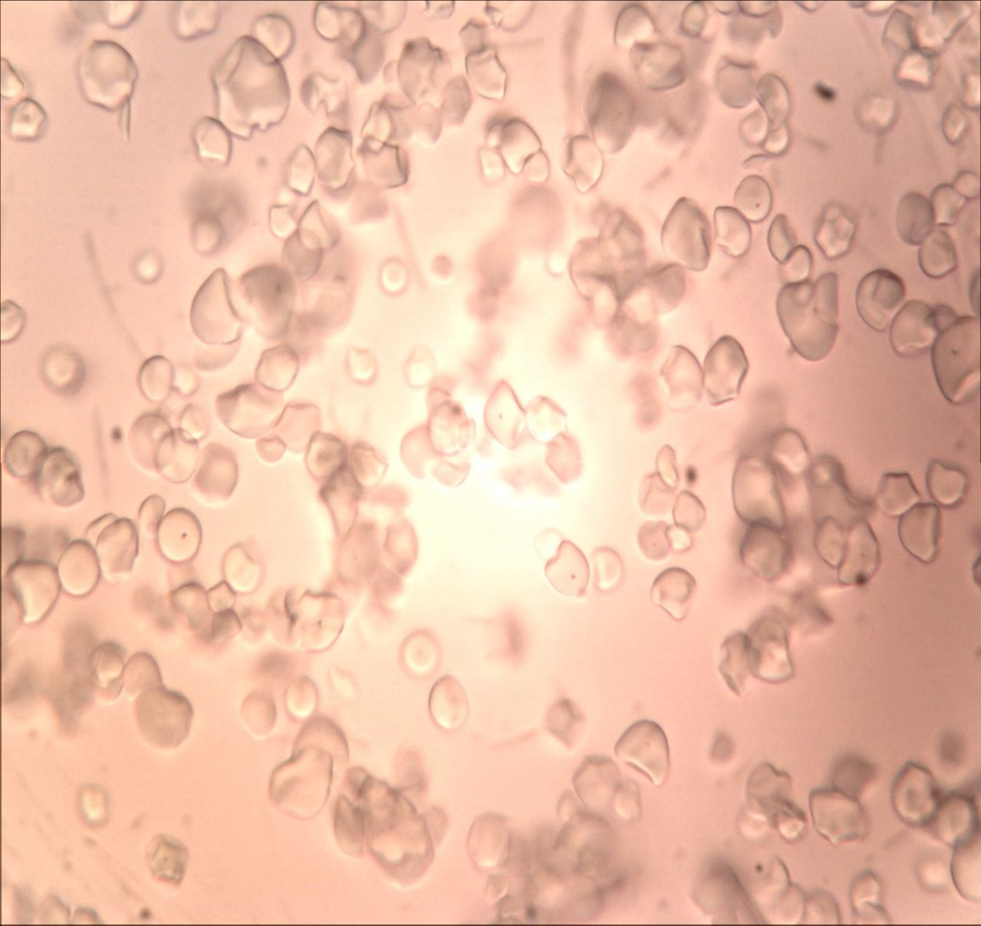

# Plate I: Photomicrograph of SRS at X 400 Magnification Key:

SRS – *Solenostemon rotundifolius* starch

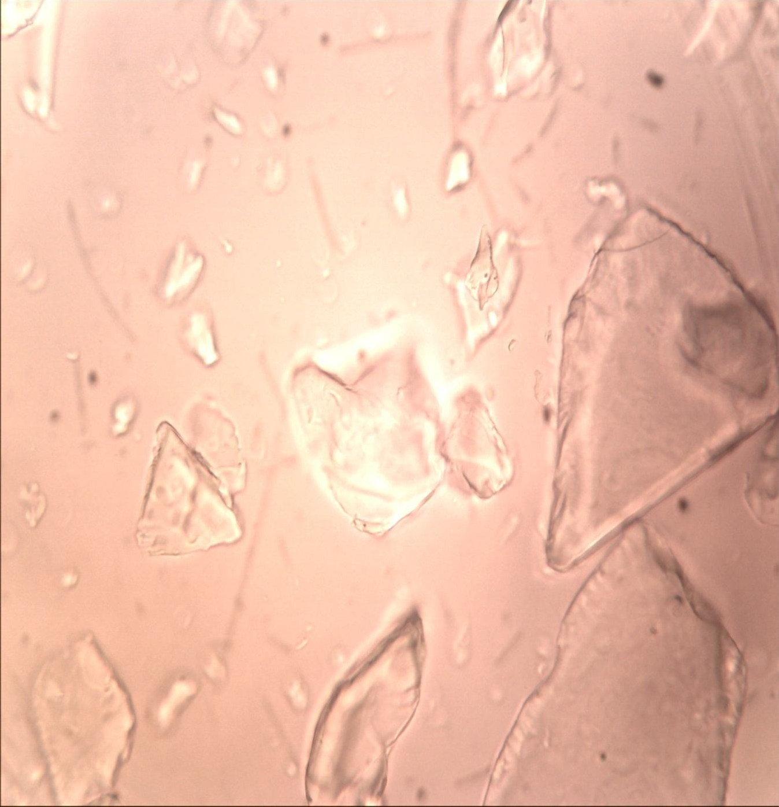

# Plate II: Photomicrograph of PGSW at X 400 Magnification

**Key:**

PGSW – Water-prepared pregelatinised starch

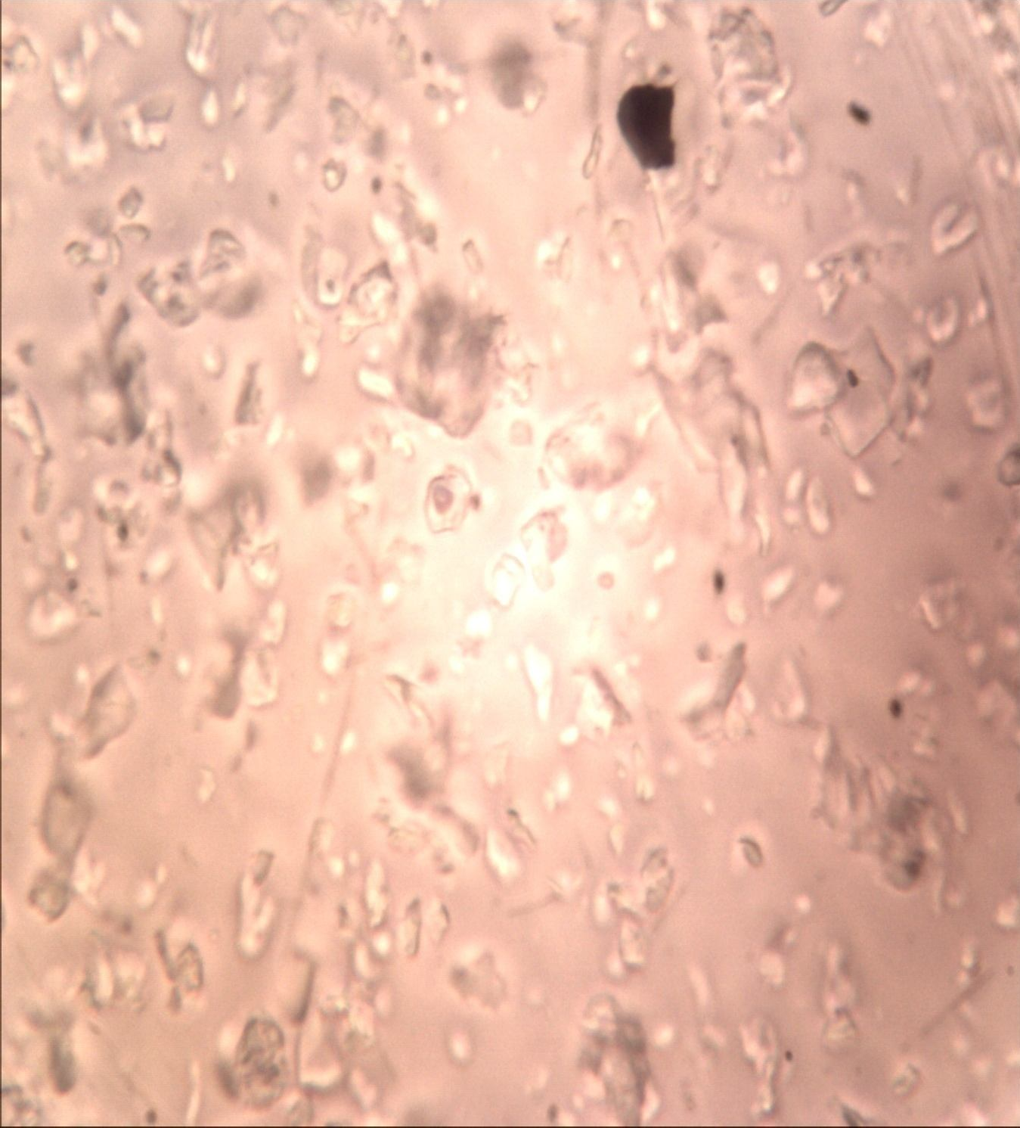

# Plate III: Photomicrograph of PGSA at X 400 Magnification Key:

PGSA – Alcohol-dehydrated pregelatinised starch

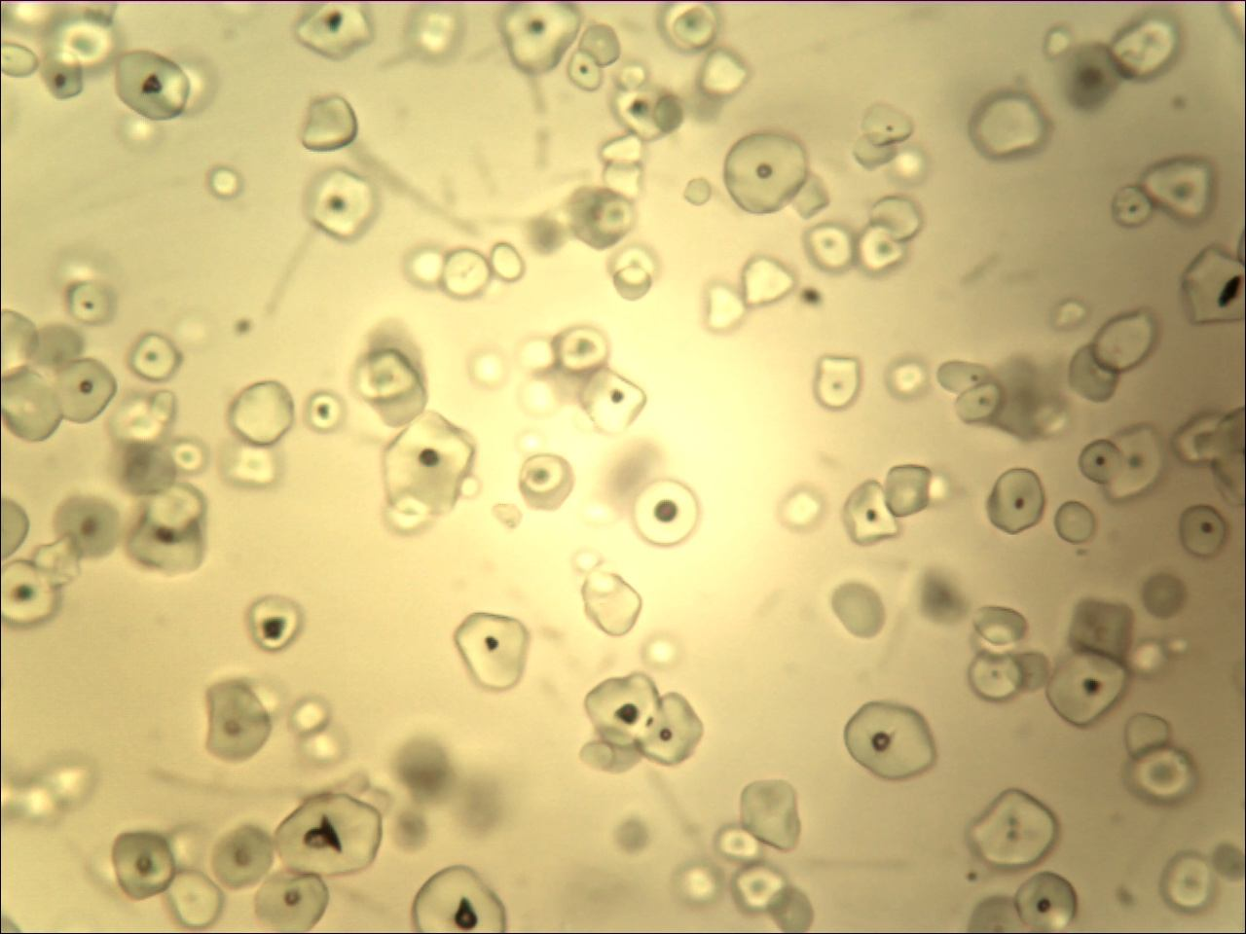

# Plate IV: Photomicrograph of MZS at X 400 Magnification

**Key:**

MZS - Maize Starch

# Properties of Paracetamol Tablets Produced with Various Binder Type and Concentration

The results displayed in Table 4.6 shows generally, that as the binder concentration increased in paracetamol tablets produced, crushing strength and disintegration time increased while friability reduced.

Apparently at zero binder concentration, the disintegration time was lowest, crushing strength drastically increased. While crushing strength of 2.94 showed the significant reduction of binding property.

All the paracetamol tablets passed disintegration test at 5%w/w and 7.5%w/w binder concentration.

There was no significant change in the thickness and diameter of the tablet produced as the binder concentration increased.

Native starch is good as a binder at 10%w/w concentration as it produced hard tablet. It also passed friability and disintegration tests.

The PGS (W) is good at 5%w/w and 7.5%w/w binder concentrations, while PGS

(A) gave good crushing strength, friability and disintegration time at 7.5%w/w and 12.5%w/w. binder concentration.

# Table 4.6: Properties of Paracetamol Tablets Produced with Various Binder Types and Concentration

|  |  |  |  |  |  |  |  |  |
| --- | --- | --- | --- | --- | --- | --- | --- | --- |
| **Binder Concentration** | **Mean Weight (g)** | **Thickness (mm)** | **Diameter (mm)** | **Crushing strength (kgf)** | **Friability (%)** | **Disintegration time (min)** | **CSFR/DT** | **Tensile Strength**  (MNm-2) |
| 0% w/w | 0.641±0.011 | 5.44 | 12.10 | 2.94 | 31.15 | 0.33 | 277.52 | 0.28 |
| 5%w/w |  |  |  |  |  |  |  |  |
| NS | 0.633 ± 0.014 | 5.79 | 12.10 | 9.98 | 2.23 | 1.64 | 13.57 | 0.91 |
| PGSW | 0.634 ± 0.020 | 5.44 | 12.08 | 9.50 | 2.21 | 0.62 | 33.86 | 0.92 |
| PGSA | 0.634 ± 0.020 | 5.42 | 12.13 | 7.14 | 1.27 | 1.05 | 8.64 | 0.69 |
| GLT | 0.662 ± 0.020 | 5.88 | 12.07 | 8.22 | 2.17 | 13.88 | 1.29 | 0.74 |
| 7.5% w/w |  |  |  |  |  |  |  |  |
| NS | 0.652 ± 0.015 | 5.73 | 12.17 | 9.66 | 2.17 | 1.88 | 11.15 | 0.88 |
| PGSW | 0.641 ± 0.028 | 5.46 | 12.07 | 12.22 | 0.95 | 2.22 | 5.23 | 1.18 |
| PGSA | 0.645 ± 0.024 | 5.69 | 12.07 | 8.46 | 0.93 | 2.22 | 3.54 | 0.78 |
| GLT | 0.640 ± 0.019 | 5.57 | 12.08 | 12.32 | 0.60 | 21.68 | 0.34 | 1.17 |
| 10% w/w |  |  |  |  |  |  |  |  |
| NS | 0.664 ± 0.018 | 5.55 | 12.14 | 12.30 | 1.06 | 1.98 | 6.58 | 1.16 |
| PGSW | 0.651 ± 0.028 | 5.27 | 12.04 | 12.32 | 0.92 | 19.01 | 0.60 | 1.24 |
| PGSA | 0.646 ± 0.024 | 5.39 | 12.06 | 12.20 | 0.77 | 62.00 | 0.15 | 1.19 |
| GLT | 0.642 ± 0.021 | 5.48 | 12.03 | 12.30 | 0.79 | 30.66 | 0.32 | 1.19 |
| 12.5%w/w |  |  |  |  |  |  |  |  |
| NS | 0.664 ± 0.018 | 5.60 | 12.02 | 12.28 | 0.75 | 65.00 | 0.14 | 1.16 |
| PGSW | 0.651 ± 0.021 | 5.42 | 12.03 | 12.30 | 1.26 | 11.36 | 1.36 | 1.20 |
| PGSA | 0.646 ± 0.024 | 5.81 | 12.09 | 12.17 | 1.39 | 75.00 | 0.22 | 1.10 |
| GLT | 0.642 ± 0.021 | 5.55 | 12.01 | 12.44 | 0.77 | 63.00 | 0.15 | 1.19 |

. Generally crushing strength and disintegration time increase with increased binder concentration, while friability decreases

**KEY: NS –** Native Starch, **PGSW –** Water- prepared Pregelatinised Starch**, PGSA –** Alcohol- Dehydrated Pregelatinised Starch **,GLT -** Gelatin

95

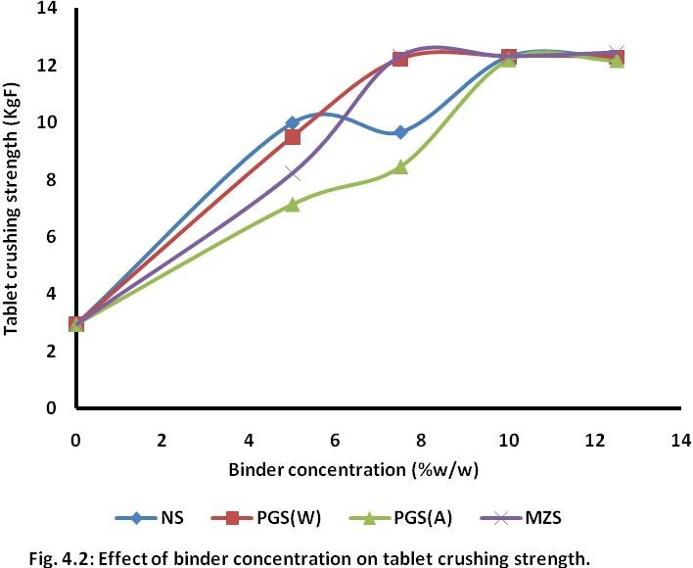

# Crushing strength increases with increased binder concentration up to 10%w/w

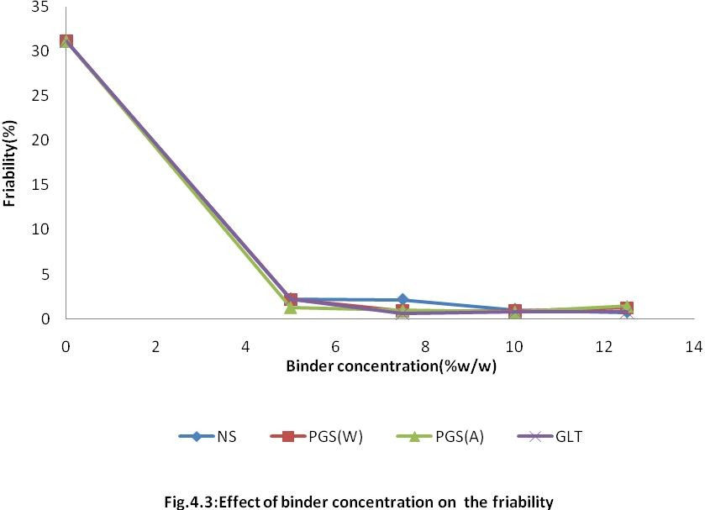

**Friability decreased with increased binder concentration**

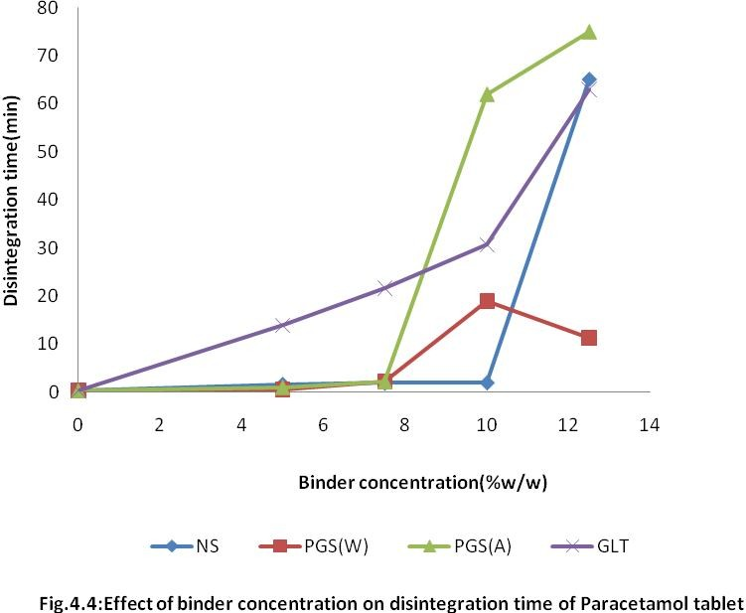

# Disintegration time generally increased with increased binder concentration

* 1. **Properties of Paracetamol Tablets Produced with Various Disintegrant Types and Concentration**

In Table 4.7, the result has shown that as the disintegrant concentration increased for all the disintegrants used in the paracetamol formulation, the disintegration time and crushing strength reduced. Most of the tablets produced at various disintegrant concentration passed the friability test.

The PGSA was not good as a disintegrant throughout while PGSW gave good disintegrating properties at 10%w/w disintegrant concentration.

Native starch and maize starch gave good disintegrant properties at 10%w/w disintegrant concentration. Also, both have good crushing strength and friability.

Thus, native starch, PGSA and PGSW can be used as disintegrant at 10%.

***Table 4.7: Properties of Paracetamol Tablets Produced with Various Disintegrant Types and Concentration***

|  |  |  |  |  |  |  |  |  |
| --- | --- | --- | --- | --- | --- | --- | --- | --- |
| **Disintegrant Concentration** | **Mean Weight (g)** | **Thickness (mm)** | **Diameter (mm)** | **Crushing strength (kgf)** | **Friability (%)** | **Disintegration time (min)** | **CSFR/DT** | **Tensile Strength (MNm-2)** |
| **0% w/w** | 0.654 ± 0.025 | 5.75 | 11.99 | 9.30 | 0.77 | 102.42 | 0.07 | 0.86 |
| **2.5%w/w NS** | 0.634 ± 0.023 | 5.29 | 11.97 | 11.82 | 2.55 | 68.45 | 0.44 | 1.19 |
| **PGSW** | 0.660 ± 0.018 | 5.24 | 11.98 | 12.00 | 0.64 | 65.25 | 0.12 | 1.22 |
| **PGSA** | 0.643 ± 0.021 | 5.30 | 11.99 | 12.06 | 0.78 | 85.02 | 0.11 | 1.21 |
| **MZ** | 0.638 ± 0.020 | 5.44 | 11.99 | 11.46 | 0.77 | 57.37 | 0.15 | 1.12 |
| **5% w/w NS** | 0.636 ± 0.022 | 5.67 | 11.97 | 8.90 | 0.94 | 42.93 | 0.19 | 0.83 |
| **PGSW** | 0.636 ± 0.019 | 5.25 | 11.99 | 12.14 | 0.63 | 65.23 | 0.12 | 1.23 |
| **PGSA** | 0.649 ± 0.020 | 5.34 | 11.95 | 11.96 | 0.61 | 78.85 | 0.09 | 1.19 |
| **MZ** | 0.616 ± 0.019 | 5.71 | 11.98 | 7.78 | 0.79 | 25.09 | 0.24 | 0.72 |
| **7.5% w/w NS** | 0.654 ± 0.022 | 6.10 | 11.99 | 7.28 | 0.92 | 33.74 | 0.20 | 0.63 |
| **PGSW** | 0.646 ± 0.022 | 5.46 | 11.97 | 11.48 | 0.62 | 41.93 | 0.02 | 1.12 |
| **PGSA** | 0.654 ± 0.026 | 5.38 | 11.96 | 11.96 | 0.46 | 69.02 | 0.08 | 1.18 |
| **MZ** | 0.622 ± 0.018 | 5.82 | 11.98 | 6.98 | 1.11 | 12.91 | 0.60 | 0.64 |
| **10%w/w NS** | 0.634 ± 0.021 | 6.19 | 11.98 | 6.96 | 0.79 | 8.48 | 0.65 | 0.60 |
| **PGSW** | 0.635 ± 0.018 | 5.85 | 11.99 | 8.82 | 1.11 | 5.24 | 1.87 | 0.80 |
| **PGSA** | 0.656 ± 0.020 | 5.58 | 11.97 | 11.94 | 0.45 | 59.52 | 0.09 | 1.14 |
| **MZ** | 0.633 ± 0.017 | 6.16 | 11.97 | 7.74 | 1.12 | 5.95 | 1.46 | 0.67 |
| **12.5% w/w NS** | 0.625 ± 0.017 | 6.31 | 12.00 | 6.16 | 1.44 | 10.56 | 0.84 | 0.52 |
| **PSGW** | 0.645 ± 0.020 | 6.05 | 11.99 | 5.78 | 0.93 | 4.01 | 1.34 | 0.51 |
| **PGSA** | 0.648 ± 0.021 | 5.51 | 12.00 | 11.39 | 0.30 | 78.05 | 0.04 | 1.10 |
| **MZ** | 0.627 ± 0.020 | 6.19 | 11.99 | 5.56 | 0.63 | 7.12 | 0.49 | 0.48 |

**KEY: NS –** Native Starch **PGSW –** Water prepared Pregelatinised Starch **PGSA –** Alcohol Dehydrated Pregelatinised starch **MZS** – Maize starch

100

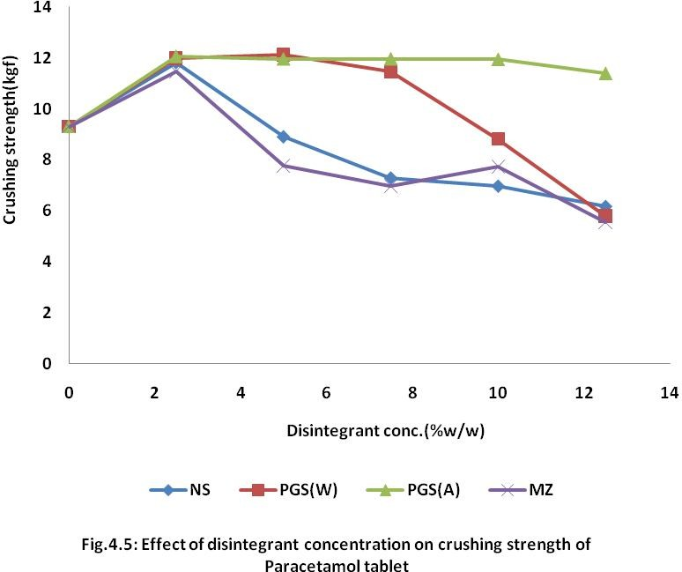

# Generally, crushing strength decreased with increased disintegrant concentration. However, for PGSA, increased concentration of disintegrant appears to have no effect on crushing strength

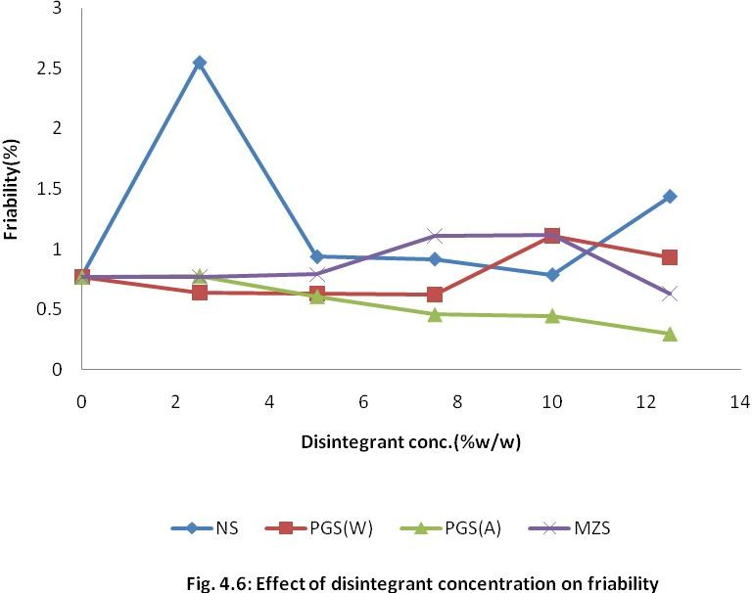

**In PGSA, friability decreased with increased disintegrant concentration while in other starches, increased friability was observed beyond 7.5%w/w disintegrant concentration.**

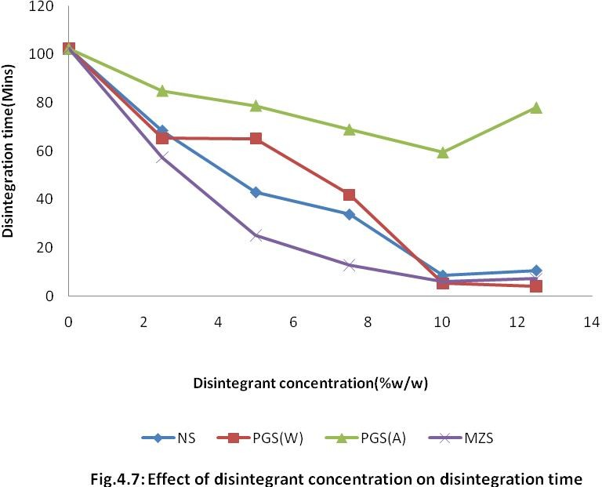

# Generally, disintegration time decreased with increased disintegrant concentration.

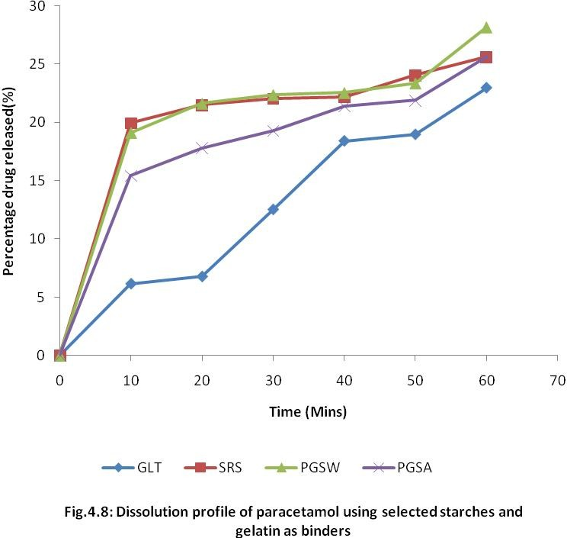

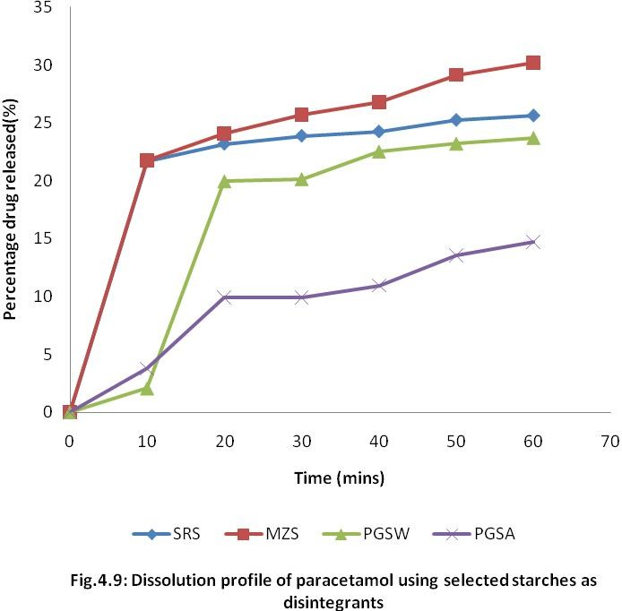

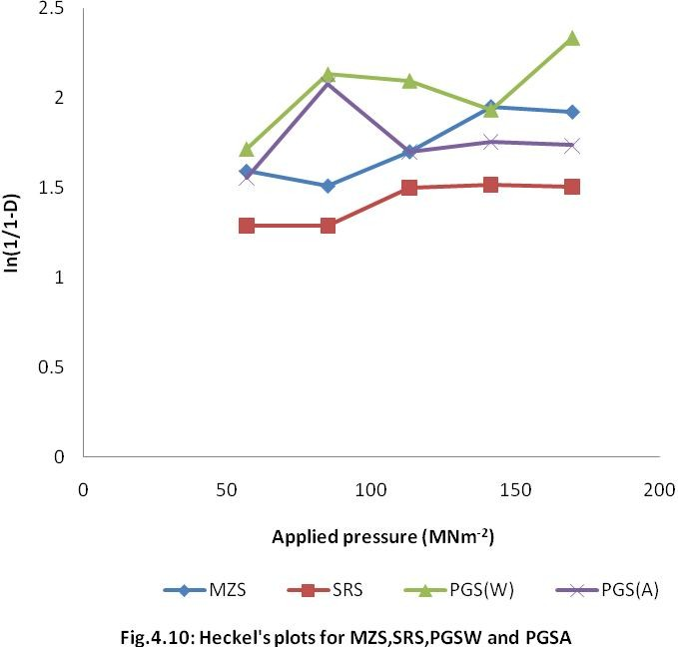

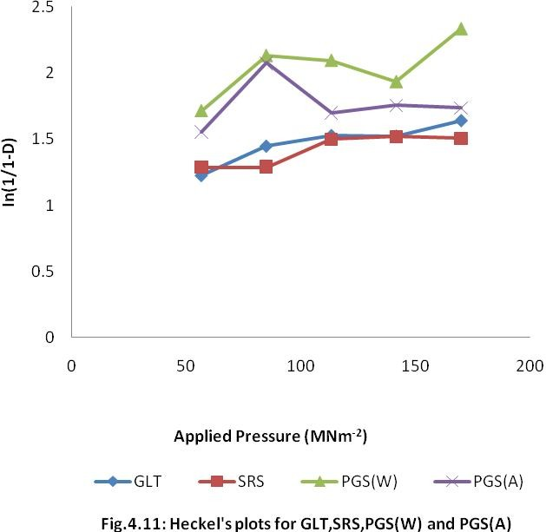

**Table 4.8: Parameters from Heckel Plots for SRS, PGSW, PGS (A) and MZS**

|  |  |  |  |  |
| --- | --- | --- | --- | --- |
| **Material** | **Py** | **D0** | **DA** | **DB** |
| **SRS** | 264.80 | 0.4200 | 0.6463 | 0.2263 |
| **PGS (W)** | 149.32 | 0.6103 | 0.7562 | 0.1459 |
| **PGS (A)** | 1617.14 | 0.4748 | 0.8067 | 0.3319 |
| **MZS** | 519.42 | 0.3786 | 0.7626 | 0.3840 |

# Table 4.9: Parameters from Heckel Plots for SRS, PGS (W), PGS (A) and GLT

|  |  |  |  |  |
| --- | --- | --- | --- | --- |
| **Material** | **Py** | **D0** | **DA** | **DB** |
| **SRS** | 264.80 | 0.4200 | 0.6463 | 0.2263 |
| **PGS (W)** | 149.32 | 0.6103 | 0.7562 | 0.1459 |
| **PGS (A)** | 1617.14 | 0.4748 | 0.8067 | 0.3319 |
| **GLT** | 293.69 | 0.5496 | 0.6652 | 0.1156 |

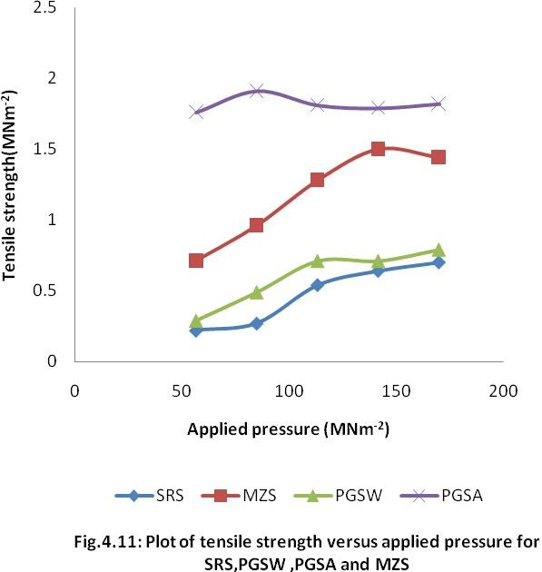

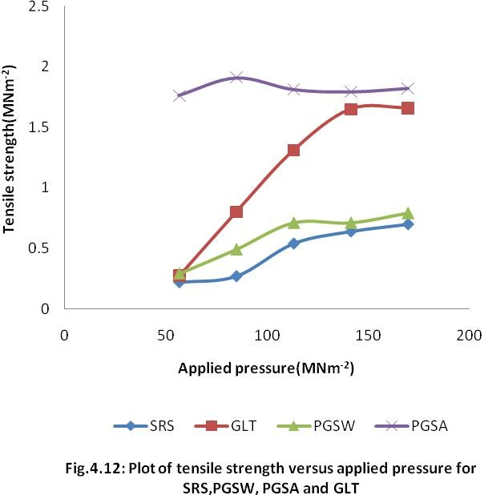

**CHAPTER FIVE**

# DISCUSSION

* 1. **EVALUATION OF STARCH POWDER**

The result for evaluation of *Solenostemon rotundifolius* starch (SRS) for its starch content is shown in Table 4.1. On dry weight of basis, the yield was found to be 9.02% while the wet weight was 18.37%. Leung *et al* (1968) calculated SRS wet weight to be 21.9% (inclusive of other types of carbohydrate). Ukpabi *et al* (2011) reported 15.14% starch content. Thus, the starch content could be due to species and geographical locations.

Modification of the SRS was done through pregelatinization with water and ethanol. The light brown colour of SRS did not change after undergoing modification, but there was change in the particle size and shape of the granules. Pregelatinization resulted in larger particle size with improved flow properties. During the process of pregelatinization, agglomeration causes a significant increase in particle size. As particle size increases and shape changes, there is a lesser influence of adhesive forces on the powder’s ability to flow. Pregelatinised starch powders, therefore show lesser adherence with the hopper walls and between particles, resulting in better flow properties. This shows that heat, water and ethanol could affect the physicochemical properties of the starch. The percentage yield of water prepared pregelatinised starch (PGSW) was 96.23 while that of alcohol- dehydrated (PGSA) was 57.45. The low yield of PGSA could be as a result of loss of material during precipitation and washing.

The results of the physiochemical tests are shown in Table 4.3. The angle of repose of powder is a measure of the degree of cohesiveness of the powder (Aulton, 2007). An

angle of repose values above 50 0 is an indication of a poor flow characteristics of a powder while an angle of repose close to 25 0 shows a very good flow. (Veslasco *et. al* 1995). All the starch powders except the SRS exhibited good flow as can be observed from their angles of repose. Modified starches had better flow than maize starch and the SRS. PGSW and PGSA with angles of repose of 29.250 and 25.800 could be considered to have very good flow. This could be due to the fact that the particles are larger in size (Table 4.3).

Hausner’s ratio and Carr's compressibility index are parameters used to express the flowability of powders and granules. Carr's compressibility index of 5-15 shows excellent flow properties. 18-21, fair while 23-28 is poor flow. Hausner’s ratio of 1.2 indicates good flow behavior (Aulton,2007).The modified starches had better flow properties than both native and maize starches as can be observed from Hausner’s ratio and Carr’s index (Tcbable 4.3).

The B.P. 2002 states that moisture content of starches should not be more than 15%. All starches were within specification. High moisture content could encourage growth of microorganisms, chemical degradation of excipients and leads to poor flow of the granules. This could affect tablet parameters such as weight and content uniformity (Musa *et al,* 2008).

Density is the ratio of mass of material to the volume occupied by the same material. Table 4.3 also presents the true, bulk and tapped densities of all the materials. The values of bulk and tapped densities in ascending order is as follows: MZS<SRS<PGSA<PGSW; while the true density occur in ascending order as follows;

PGSW<PGSA<MZS<SRS. The tapped density is usually higher than the bulk density because of diminished void spaces while the bulk density is always less than the true density because the bulk powder contains more interparticulate pores. (Staniforth and Aulton, 2007). Particle packing and consolidation have great impact on the flowability of powders, and sometimes used as an indirect method of measuring or quantifying powder flow. There is a direct relationship between particle packing and bulk and tapped densities. Thus, the results of bulk and tapped densities in table 4.3 show that PGSW consolidates more easily followed by SRS whereas PGSA consolidates poorly when compared to PGSW. The modified starch (PGSW) consolidates better than the other ones. Hence, their flowability might follow this order; PGSW>SRS>PGSA>MZS. Also, from the results of packing fraction, bulkiness and porosity in Table 4.3, PGSW exhibited the largest maximum volume reduction while maize starch exhibited the lowest. Thus, it would appear under the applied tapping pressure, the polygonal shape and larger particle size of PGSW promoted closer packing of particles than the ovoid shape and smaller particle size of maize starch.

The equilibrium moisture content of starch is a measure of its sorption characteristic. This may introduce instability into moisture - sensitive – starch drug formulations (Okafor, 1990; Preiss and Levy, 1980). The two pregelatinised starches had lower moisture content, but had higher sorption capacity. The crushing strength – friability

/disintegration ratio (CSFR/DT) is a parameter for measuring tablet strength and weakness and the negative effects of these two parameters on the disintegration time (Ogaji and Okafor, 2009) while tablet tensile strength is the stress needed to fracture a tablet by diametrical compression (Mohammed et al, 2009). The starches appeared to be good

disintegrants but the results of tensile strength and CSFR/DT tests showed they have binding activities. Maybe, the mechanism of disintegration is not due to swelling. The moisture sorption was in the following descending order; PGSW>PGSA>SRS>MZS (Table 4.3).

Tester *et al,* (2004) predicted a direct relationship between swelling power and amylopectin content, suggesting that the higher the amylopectin content, the greater the swelling power. Table 4.3 shows a contrary view, where SRS with highest amylopectin content of 78.39% had the lowest swelling power of 13.75%. Therefore, amylopectin might not probably be the only constituent contributing to swelling capacity. Swelling is an indication of tablet disintegration ability (Caramella, 1991). There is a correlation between moisture sorption and swelling capacity. Both indicate disintegration ability. The two modified starches (PGSW and PGSA) had the highest values and thus have potentials of good disintegrant properties. The results of swelling power was in the order PGSW (319.04%)>PGSA (246.15)>MZS (20.59%)>SRS (13.75%).

The modification of SRS by pregelatinization with water produced a reduction in amylopectin content while the alcohol dehydrated PGS remained the same. This shows that modifying with ethanol did not change the amylose-amylopectin content of SRS.

# ANALYSIS OF PARACETAMOL GRANULES

* + 1. **Effects of Binder Type and Concentration on the Physical Properties of the Paracetamol Granules**

The effect of varied binder concentration on the physical properties of the paracetamol granules is presented in Table 4.4. The angle of repose decreased as binder

concventration increased from 5-12.5%w/w because of increased cohesive properties of the powders.

The flow rate of PGSW and PGSA increased as the binder concentration increased while it behaved abnormally in NS and GLT, increasing first and then decreasing as the binder concentration increased. The same behaviour was also reported by Musa *et al,* 2010.

Bulk and tapped densities are measures of degree of densification of powders and granules. From zero to 7.5%w/w binder concentration, there was no significant change in bulk and tapped densities. As the binder concentration increased to 10%w/w and 12.5%w/w, an increase was observed in NS, PGSA and GLT.

Carr's index and Hausner's ratio are parameters used to measure the ability of materials to be reduced in volume under pressure and ultimately the flow behavior when subjected to compression forces. According to Schwartz *et al*, (1975), the lower the indices, the better the flow of granules. As reported by Nyqvist and Nicklasson, (1985), Carr's index above 23% and Hausner's ratio above 1.2 indicate poor flow behavior. The results of the Carr’s index and Hausner’s ratio are shown in Table 4.4. All the batches showed good flow properties except gelatin at 10%w/w.

# Effects of Disintegrant Type and Concentration on the Physical Properties of the Paracetamol Granules

The results of the effects of various disintegrant concentrations on the physical properties of the paracetamol granules are presented in Table 4.5.The angle of repose was highest at zero disintegrant concentration, while at various concentrations and materials, it behaved abnormally ranging from 29.750 to 35.860. According to Alderborn, (2007),angle

of repose between 200 and 30O shows good flow properties .Most of them indicated poor flow except PGSW at 5%w/w as can be observed from its angle of repose.

The flow rate generally increased from zero to 7.5%w/w disintegrant concentrations and then decreased from 10%w/w to 12.5%w/w disintegrant concentration.

No significant change in bulk and tapped densities from zero to 7.5%w/w but there was a slight decrease from 10%w/w to 12.5%w/w.

The Carr's index ranges from 6.67 to 12.20 and Hausner's ratio from 1.07 to 1.14. All the materials at different concentrations were within official specification for Carr’s index and Hausner’s ratio.

# ANALYSIS OF PARACETAMOL TABLETS

* + 1. **Effects of Disintegrant and Binder Types and Concentration on Uniformity of Weight of Paracetamol Tablets**

Uniformity of weight is one of the characteristics of good tablets, which can be affected by powders properties and equipment (Ogaji and Okafor, 2009).Variation in weight of tablets could also indicate variation in the content of the drug. According to B.P. 2002, the acceptable weight variation for tablets weighing more than 324mg is + 5%. All

the batches of paracetamol tablets formulated with various starches were within allowed limits of weight variation (Tables 4.6 and 4.7).

# Effect of Binder and Disintegrant Type and Concentration on the Crushing Strength of Paracetamol Tablets

The structural or mechanical strength of tablets could be evaluated using mean crushing strength or tensile strength. Tablets are held together by binding agents that act

through forces such as Van Der Waal forces, electrostatic forces of attraction, frictional and mechanical forces, and forces due to the formation of solid bonds (Musa *et al,* 2010). Generally, the crushing strength increased as the binder concentration increased in all the materials under investigation while it decreased as the disintegrant concentration increased. The increase in crushing strength with increase in binder concentration might be as a result of increased bonds formed within the tablets. The opposite occurred with increased in disintegrant concentration.The action of the disintegrant is to break the bonds that hold the tablets together to facilitate absorption. GLT and PGSA gave the highest crushing strength indicating that they are better binders when evaluated as binder while PGSW had the highest crushing strength when evaluated as disintegrant, indicating that it is a poor disintegrant . Maize starch proved to be a better disintegrant as can be observed from its lower crushing strength (Table 4.6 and 4.7).

# Effect of Binder and Disintegrant Type and Concentration on the Friability of Paracetamol Tablets

The results of the effects of binder and disintegrant type and concentration on friability of paracetamol tablets is given in Tables 4.6 and 4.7. Generally, as the binder concentration increased, friability decreased. This could be as a result of formation of more solid bonds. Noticeable decrease was observed in friability with increase in disintegrant concentration but for SRS/NS, there was an increase in friability at 12.5%w/w disintegrant concentration. Generally, there was decrease in friability with increased disintegrant concentration . This could be attributed to the fact that some of the starch disintegrant was wetted thereby giving additional bonds and thus, enhancing more resistance to tablet abrasion. However, for NS, decrease in friability was noted as disintegrant concentration

increased to 12.5 %w/w. Friability should not be more than 1 %.Only the NS at 2.5 %w/w and 12.5 %w/w failed the test. GLT gave the lowest value of friability when binding property was evaluated while PGSA gave the lowest value of friability when disintegrant property was evaluated.

# Effect of Binder and Disintegrant Type and Concentration on the Disintegration time of Paracetamol Tablets

The British Pharmacopoeia, 2002 specifies that uncoated tablet should disintegrate within 15 minutes. The main mechanisms of disintegration proposed are swelling of disintegrant resulting in development of swelling force, capillary action and annihilation of intermolecular forces resulting in development of a repulsive force between particles (Ngwuluka *et al*, 2010). Disintegration time increased as binder concentration increased from zero to 12.5 %w/w except PGSW which decreased at 12.5 %w/w binder concentration (Table 4.6). This could be explained by possibility of PGSW bonds getting saturated at 10 %w/w and stopped binding. It then started acting as a disintegrant through swelling resulting in development of swelling force and arrest of intermolecular forces leading to repulsion between particles and finally disintegration (Ngwuluka *et al,* 2010). Generally, for all the disintegrants, disintegration time decreased with increased disintegrant concentration up to 10 %w/w and then an increase at 12.5 %w/w. PGSA did not pass the disintegration time test.

As shown in Table 4.7, as the disintegrant concentration increased from 2.5 %w/w to 12.5 %w/w disintegration time decreased. Only MZS passed disintegration test at 7.5%w/w, while at 10% w/w and 12.5 %w/w disintegrant concentration all the materials passed the test except PGSA. This shows maize starch is a better disintegrant.

At 10 %w/w binder concentration, NS produced good paracetamol tablet with good crushing strength, friability and disintegration time. At 7.5 %w/w binder concentration PGSW and PGSA produced good tablets while GLT also made fairly good tablets at the same binder concentration.

Also, at 10 %w/w disintegrant concentration, PGSW, NS and MZS had good crushing strength, friability and disintegration time. Only PGSA was not good as disintegrant for all its concentrations.

As seen in Table 4.6 and 4.7, the (CSFR/DT) crushing strength – friability disintegration ratio was determined in preference to crushing strength friability ratio (CS/FR) because it has been suggested to be a better index of measuring the quality of tablets. In addition to measuring the tablet strength (crushing) and weakness (friability), it simultaneously evaluates all negative effects of these parameters on the disintegration time. (Ogaji and Okafor 2009) Table 4.6 describes the effect of binder on the quality of paracetamol tablets. As the value reduced, hardness and disintegration time increased. At

7.5 %w/w binder concentration, NS had CSFR/DT of 11.15, while GLT had 0.34. PGSW had CSFR/DT of 5.23 and PGSA had 3.54 at the same binder concentration. Good paracetamol tablets were produced at these concentrations, being sufficiently hard enough to withstand pressure without sacrificing the ability to disintegrate in good time.

Table 4.7 also describes the effect of disintegrant on the mechanical strength and disintegration of the tablet when different materials were used at various concentrations as disintegrants. Higher values of CSFR/DT indicates better effect of binder on the disintegration (Ogaji and Okafor, 2009). Generally, the CSFR/DT were very low,

indicating hard tablets. At 10 %w/w disintegrant concentration the CSFR/DT were; PGSW (1.87); MZS (1.46) and NS (0.65). The tablets had good crushing strength, friability and disintegration time. PGSA that has consistently lower values (CSFR/DT of 0.09 at 10%w/w) has longer disintegration time which indicates that the tablets were harder than the others.

The results of the CSFR/DT are in agreement with Ogaji and Okafor, (2009).

# In-Vitro Drug-Release Studies

The rate of dissolution determines the rate and extent of absorption and subsequent therapeutic outcome of a drug (Ngwuluka *et al,* 2010). The rate of absorption of poorly soluble drugs is usually controlled by their dissolution rate in the gastrointestinal tract. Unless a drug substance is released after dissolution upon disintegration, absorption cannot take place. (Ogaji and Okafor, 2009).

The dissolution profiles of the paracetamol formulation at 7.5 %w/w binder concentrations and 10 %w/w disintegrant concentrations are displayed on Table A5.1 – A5.8 and Figs 4.8 - 4.9 The dissolution efficiency (D.E) i.e. percentage of drug released after 30 min ranged from 12.56 to 22.38 % for various binders formulated with paracetamol while it ranged from 9.88 to 25.69 % for different disintegrant concentrations.

Paracetamol tablets formulated with 7.5 %w/w binder concentration and 10 %w/w disintegrant concentration could not release even 50 % of the active ingredient within 30 minutes. A lot of reasons could be attributed to why 7.5 %w/w binder concentration of GLT, SRS, PGSW and PGSA; and 10%w/w disintegrant concentration of MZS, SRS, PGSW and PGSA in paracetamol formulation gave poor disintegration and active drug

release.

Rahman *et al*, (2008), in their study showed that when fully pregelatinised starches are used as binders in wet granulation formulation, much of the disintegration properties are lost, due to gelatinization. Also, slower drug release from tablets with pregelatinised starch may be due to slower penetration of fluid due to the formation of intermolecular hydrogen bonds in the highly branched amylopectin; and the fact that low amount of amylose (25% and lower), as found in pregelatinised starches, produces a very strong tablet due to strong gel layer (Levina and Sihaboomi, 2004). Alebiowu and Itiola, (2003) also found out that increase in relative density such as found in pregelatinised starches leads to reduction in disintegration time. The results also confirm previous findings of Khan and Rhodes (1972, 1979). They have shown that efficiency of a swelling type disintegrant such as PGSA and PGSW was impaired in insoluble tablet systems compacted at low pressure due to their higher porosity.

Babalola *et al* (2001) have suggested that the systematic absorption of paracetamol might not be dissolution rate limited and thus using in-vitro dissolution rate studies alone to establish bio-equivalence (BE) of paracetamol tablet should be done with caution. This view point was corroborated by the study of Retaco *et al* (1996) in which in vivo BE was observed despite disparities in in-vitro dissolution carried out in phosphate butter PH 5.8 and in HCL 0.1N in the paddle apparatus operated at 50rpm.

The BP, 2002 specifies that at least 70 % of the drug should be in solution after 30 min. The formulations could not satisfy this official requirement probably due to pre- determined hardness (>7kgf) of the tablets. Higuchi *et al,* 1953 showed that the inverse correlation between the hardness of the tablet and dissolution rate is due to the fact as the

hardness increased as a result of increase in compression pressure, the density increased and the porosity decreased, so that dissolution medium could not penetrate the tablets. The drug dissolution only occurred from the surface of the tablet. It was also suggested that the initial hardness of the tablet still influenced the dissolution rate constant of the drug from the disintegrated particles which were small enough to pass through the screen of the basket of the dissolution apparatus.

At 7.5 %w/w binder concentration, the paracetamol tablets formulated showed good disintegrant properties with disintegration time ranging from 1.88-21.68 min but failed dissolution test. Good disintegration properties were also shown by NS, PGSW and MZS with disintegration time of 8.48, 5.24 and 5.95 min respectively. The dissolution profile could not also meet up with official specification.

Although the release profile did not follow the disintegration time-dissolution trend, it has been reported that there is not an always automatic correlation between disintegration and dissolution (Odeku and Itiola, 2006).

Although, all the paracetamol tablets formulated with various starches and gelatin failed the BP (2002) dissolution test for tablets which states that at least 70% of the drug should be in solution after 30 mins, this study has indicated that lower concentrations of the binders and disintegrants would be required to produce paracetamol tablets that would release the content within acceptable time.

# COMPRESSION STUDIES

The Heckel equation is widely used for relating the relative density of a powder bed during compression to the applied pressure (Odeku and Itiola, 2007). Figures 4.10 and 4.11

show the Heckel plots for the three starches compared with maize starch and gelatin respectively. A linear fit was obtained from all the formulations (usually 84.93 – 226.47 MNm-2), indicating deformation mainly by plastic flow (Odeku, 2005). The values of the mean yield pressure, Py, Do, DA and DB for the materials are presented in Tables 4.8 and

4.9. Py was calculated from the regions of the plots showing the highest linear fit while the intercept was determined from the extrapolation of the line.

The Do value which represents the degree of initial packing in the die as a result of die filling and zero pressure was lowest with MZS followed by SRS. GLT was higher than SRS and MZS. Modification of SRS by pregelatinization increased the value. The result shows that modified starches exhibited the highest degree of densification or packing in the die because of die filling due to the denatured particles of the granules, while MZS exhibited the lowest values.

The DA, which indicates the total degree of packing at zero and low pressures was highest with PGSA and lowest with SRS.

The DB valued represents the particle rearrangement phase or packing in the early compression stages at low pressure. The value also indicates the extent of particle fragmentation. The DB value was highest in MZS, and lowest in GLT. PGSA was higher than SRS. This means that modification of starch with ethanol increased densification and fragmentation at low pressures.

The mean yield pressure, Py is inversely related to the ability of the materials to deform plastically under pressure. PGSA had the highest while PGSW had the lowest values. These results indicate that PGSW exhibits the fastest onset of plastic deformation

than PGSA. This means PGSW is soft and ductile and readily deforms plastically during compression, at low pressures. Generally, the PY values were presented in descending order; PGSA>MZS>GLT>SRS>PGSW and DA thus; PGSA>MZS>PGSW>GLT>SRS,

indicating that PGSA is more plastic than other materials under test. This means PGSA produced the hardest tablet. This result is in agreement with the result of tensile strength which showed that PGSA had the highest value (Fig.4.11 – 4.12).

# TABLET TENSILE STRENGTH

The results of Fig. 4.11 - 4.12 and Table A 3.6 on tensile strength for the selected starches and gelatin powder compacts showed that increase in the pressure applied from 56.6-169.9 MNm-2 led to a consistent increase in the tensile strength except maize starch at

169.9 MNm-2 that showed a slight reduction instead of an increase. This showed that *Solenostemon rotundifolius* starch and the modified starches produced harder and more compact tablets compared with maize starch. PGSA had the highest tensile strength, probably because of slowest onset of plastic deformation, DO and highest total plastic deformation, DA, since higher amount of plastic deformation would lead to more contact points for interparticulate pores (Odeku and Itiola, 2007).

# 5.6 STATISTICAL ANALYSIS

There were both positive and negative influences on the tensile strength and crushing strength-friability disintegration ratio of the paracetamol tablets produced. A positive influence indicates that a particular parameter increased while a negative influence indicates that the value of the parameter decreased (Ogunjimi and Alebiowu, 2010).

# CHAPTER SIX

* 1. **SUMMARY, CONCLUSION AND RECOMMENDATION**

# SUMMARY AND CONCLUSION

The research carried out on *Solenostemon rotundifolius* starch (SRS) has shown that modification of the starch by pregelatinization (water and ethanol) produced products with better pmhysicochemical properties in terms of flowability, compressibility swelling capacity and water sorption capacity. SRS possessed poor flow properties, as determined by flow rate and angle of repose and poor compressibility, as determined by Carr’s index and Hausner’s ratio.

The poor drug-release profile of the SRS and the modified starches was as a result of compression pressure (>7 kgf); loss of disintegration properties due to gelatinization; a slower penetration of fluid into the tablet due to formation of intermolecular hydrogen bonding in the highly branched amylopectin; formation of hard compact by strong gel layer due to low amount of amylose.

Compaction studies have shown that SRS and PGSW deforms plastically during compression, while PGSA has tendency to show fragmentation before plastic deformation. Also, PGSA produced the hardest tablets because of slowest onset of plastic deformation and highest total degree of packing at zero and low pressures.

# In conclusion:

* + 1. Modification of SRS by pregelatinization affects some of the physicochemical properties of native starch such as increase in flowability, compressibility, swelling capacity and water sorption capacity.
    2. Pregelatinization of SRS makes it a good binder.
    3. Modification of the starch by pregelatinization with alcohol (PGSA) increases the mean yield pressure, (Py) drastically, resulting in slow onset of deformation while modification with water (PGSW) results in a reduced mean yield pressure and rapid onset of deformation. Also, total plastic deformation(DA) increases when modified with ethanol (PGSA) and reduces when modified with water (PGSW).
    4. *Solenostemon rotundifolius* and the modified starches could be used at 7.5 %w/w and 10 %w/w concentrations as binder and disintegrant respectively.
    5. Modification of SRS by pregelatinization does not enhance its drug release properties.
    6. The results of the statistical analysis imply that pregelatinising SRS can create binders that produce tablets of the same basic formulation but having different mechanical properties. It also suggests that the nature of the material pregelatinised determines the properties of the binder obtained.

# Recommendations

* *Solenostemon rotundifolius* and modified starches as excipients should be explored in a sustained release drug formulation.
* *Solenostemon rotundifolius* and modified starches should be evaluated for direct compression as filler-binder.
* Other forms of modification should be explored to improve the drug release properties of *Solenostemon rotundifolius* starch

# REFERENCES

Adebayo, A.S. and Itiola, O.A. (1998) Evaluation of Breadfruit and Cocoyam Starches as Exodisintegrants in a Paracetamol Tablet Formulation*. Pharm. Pharmacol. Commun*. 4(6):385- 389.

Adetunji, O.A., Odeniyi, M.A and Itiola, O.A. (2006) Compression, Mechanical and Release Properties of Chloroquine Phosphate Tablets containing corn and Trifoliate yam starcnbhes as binders, Tropical *Journal of Pharmaceutical Research* 5(2):589-596.

Agnew, A. D Q and Agnew, S., (1994) Upland Kenya wild Flowers: a Flora of the Terms and Herbaceous Flowering Plants of Upland Kenya. 2nd Edition*. East Africa Natural Thentory Society*, Nairobi, Kenya 374pp.

Akin - Ajani, O.D., Itiola, O.A and Odeku, O.A. (2005) Effects of Plantain and Comrn Starches on the Mechanical and Disintegration Properties of Paracetamol tablets. *Pharm. Sci Tech*, 6 (3): 458 -463.

Aklilu, T. (2002) Evaluation of Local Gum of Acacia Polyacantha as a Binder in Tablet Formulations. A Thesis submitted to the School of Graduate Studies of Addis Ababa University, Addis Ababa Ethiopia.

Alderborn, G. (2007) Tablets and Compaction. In; Aulton, M.E. (Ed.), *Aulton's Pharmaceutics: The Design and Manufacture of Medicine*, Churchill Livingstone Elsevier, London, 3rd Edition, Chapter 31, pp. 441 -482.

Alebiowu, G. (2001) Studies on the Tableting Properties of Sorghum Bicolor Linn (Poaceae) Starch In: Evaluation of Binder Types and Concentrations on the Properties of Sorghum Starch Granulations *Discov. Innov*., 13:1- 2.

Alebiowu, G. and Itiola, O.A. (2002) Compressional Characteristics of Native and Pregelatinised Forms of Sorghum, Plantain and Corn Starches and the Mechanical Properties of their Tablets. *Drug Dev. Ind. Pharm*. 28(6): 663 - 672.

Alebiowu, G. and Itiola, O.A. (2003) The Effects of Starches on Mechanical Properties of Paracetamol Tablet Formulations. I. Pregelatinization of Starch Binders. *Acta Pharm*, 53: 231-237.

Alebiowu, G. and Itiola, O.A. (2003) The influence of Pregelatinised starch disintegrants on interacting variables that act on Disintegrant Properties*. Pharm. Tech*. pp. 28 - 32 [www.pharmtech.com](http://www.pharmtech.com/)

Ali, I. (2011) Tablets: Manufacturing Methods/granulation. Downloaded on 16lh June, 2011 at [http://pharmaceuticalguidebook.blogspot.com.](http://pharmaceuticalguidebook.blogspot.com/)

Apeji, Y.E. (2010) Tableting Properties of Microcrystalline Starch Derived from Cassava (Manihot esculenta) Starch by Enzymatic Hydrolysis Using a- Amylose Enzyme. M.Sc Thesis submitted to the Postgraduate School, Ahmadu Bello University, Zaria, Nigeria.

Armstrong, N.A. (1989) Time dependent factor involved in powder compression and tablet manufacture*. Int. J. Pharm*. 49: 1- 13

Ayorinde, J.O., Odeku, O.A and Itiola, O.A. (2005). The Survival of B. subtilis spores in dicalcium phosphate, lactose and corn starch and their binary mixtures during tableting. *Pharmaceutical Technology*, 29 (12): 56-57.

Babalola, C.P. Oladimeji, F.A and Femi Oyewo, M. W (2001) Correlation between In- Vitro and In-Vivo Parameters of Commercial Paracetamol Tablets. *African Journal of Medical Sciences,* 30:275-280.

Bakre, L.G. and Jaiyeoba, K. T. (2009) Evaluation of a new Tablet Disintegrant from Dried Pods of Abelmuscus esculatus L.(Okra). *Asian Journal of Pharmaceutical and Clinical Research*, 2(3):1-10.

Ball, S. G. and Morell, M. K. (2003) From Bacterial Glycogen to Starch: Understanding the Biogenesis of the Plant Starch Granule. Annual Review of Plant Biology, 54:207- 233.

Banker, G.S and Anderson, N.R. (1986) Tablet In: Lachman, L., Lieberman, H.A. and Kanig, J.L. (eds), *The Theory and Practice of Industrial Pharmacy*, 3rd edn. Lea and Febiger, Philadelphia, pp. 301 - 303.

Banker, G.S. and Anderson, N.R (1986) Tablets In: Lachman, L., Lieberman, H.A and Schwartz, J.B, (Eds.) *The Theory and Practice of Industrial Pharmacy*, Lea and Febiger, Philadelphia 3rd Ed. Pp. 293

Bhowmik, D., Chiranjib., B. Krishnakanth, Panking, R., and Chandira M., (2009) Fast Dissolving Tablet: An Overview*. Journal of Chemical and Pharmaceutical Research*, 1(1): 163-177.

Bodga, MJ. (2002) Tablet Compression: Machine Theory, Design and Process Troubleshooting. In: Swarbick, J. and Boylan J. (Eds.), *Encyclopedia of Pharmaceutical Technology,* Marcel and Dekker. Incorporation USA, 3: 2669 – 2688

Bos, C.E., Bolhuis, G.K., Van Doorne and Lerk C.F. (1987) Native Starch in tablet formulations: Properties on Compaction*, Pharmaceutisch Weekblad*, Scientific Edition, 9: 274- 282.

Bos, C.E; Bolhuis, O.K., Lerk, C.F and Duineveld, C.A.A. (1992) Evaluation of Modified Rice Starch, A New Excipient for Direct Compression*. Drug Dev. Ind. Pharm* 18: 93 - 106.

British Pharmacopoeia (1980), Vol. I and II: Her Majesty’s Stationary Office, University Press, Cambridge.

British Pharmacopoeia (2002) Starch. Her Majesty's Stationery Office, London, pp. 378.

British Pharmcopoeia (2002). Vol. I and II: Her Majesty’s Stationary Office, University Press, Cambridge.

Burrell, M.M. (2002) Starch: The Need for Improved Quality or Quantity - An overview*. Journal of Experimental Botany.* 54 (382): 451-456

Caramella, C. (1991) Novel Methods for Disintegrant Characterization, Part 1*. Pharm. Technol.*: 48-56.

Carless, J.E. and Leigh, S.(1974) Compression Characteristics of Powders: Radial die wall pressure transmission and density changes*. J. Pharm. Pharmacol*, 26: 189 – 297.

Colbourn, E. A. (2004) Neural Computing in Pharmaceutical Formulation. Pharm. Tech Vol. 2 [www.intelligensys.co.uk.](http://www.intelligensys.co.uk/)

Chitu, T. M. (2009) Wet Granulation of Cohesive Powders. Doctorate Thesis of University of Toulouse.

Croghan, M. and Mason, W. (1998) “100 years of Starch Innovation*”. Food Science and Technology Today,* Pp. 17-24.

Dare, K., Akin-Ajani, D.O., Odeku, O.A. and Itiola, O.A.(2006) Effects of Pigeon Pea and Plantain Starches on the Compressional, Mechanical and Disintegration Properties of Paracetamol Tablets*.Drug Dev Ind Pharm*; 32(3):357-365.

Dietrich, P., Bauer - Brandl, A. and Schubert, R. (2000) Influence of tableting forces and lubricant concentration on the adhesion strength in complex layer tablets. *Drug Dev. Ind. Pharm,* 26(7): 745 - 754.

Done Demirgoz, Carlos Elvira, Joao F. Mano, Antonio M. Cunha, Eorhan Piskin, Rui L. Resi (2000) Chemical Modification of Starch based Biodegradable Polymeric Blends; Effects on Water Uptake, Degradation Behaviour and Mechanical Properties. *Polymer Degradation Stability,* Vol. 70 Issue 2, pg. 161-170.

Eichie, F. E. and Kudehinbu, A. O. (2009) Effect of Particle Size of Granules on Some Mechanical Properties of Paracetamol Tablets. African Journal of Biotechnology, 8(21): 5913-5916.

Esezobo, S., Zubair, S., and Pilpel N. (1989) Effects of Tapioca obtained from cassava (Manihotiutillisima) on the Disintegration and Dissolution Rates of Paracetamol Tablets.

*J. Pharm Pharmacol*. 41(1): 7-10.

European Pharmacopeia, Fourth Edition (2002). Convention on the Elaboration of a European Pharmacopeia, Council of Europe, Strasbourg Codex, France, pp. 191 -201, 561.

Frazier, P.J., Richmond P. and Donald, A.M (1997) Starch Structure and Functionality.

*Royal Society of Chemistry*, Cambridge, U.K.

Fell, J.T. and Newton, J.M. (2006) Determination of tablet strength by the diametral - compression test*. Journal of Pharmaceutical Sciences*, 59(5): 688 - 691.

Frazier, PJ, Richmond P. and Donald A.M (1997) Starch Structure and Functionality.

*Royal Society of Chemistry*, Cambridge, U.K.

Garr, J.S.M. and Bagudu, A.B. (1991) Evaluation of sorghum starch as a tablet excipient.

*Drug Dev. Ind. Pharm*., 17: 1-6.

Gohel, M.C. (2005) A review of co- processed directly compressible excipients*. J. Pharm. Pharmaceut. Sci.,* [www.cspscanada.org](http://www.cspscanada.org/) 8(1): 76-93

Gordon, E.R.,Rosanko, T.V.,Fonner, O.E.,Anderson, N.R.,Baker, G.S.(1990). In:Pharmaceutical Dosage Forms:’Tablets, Lieberman, H.A.,Lachman, L., and Schwartz(Eds*.), Marcel Dekker*, New York, 2:83.

,

Hanus, E.H. and King, L.D. (1968) Thermodynamic effects on the compression of solids *J. Pharm. Sci*., 57: 677 - 684.

Heckel, R.W. (1961) An analysis of powder compaction phenomena. *Trans Metal]., AIME* 222 (4): 671-675

Hiestand, E.N. (1997) Principles, tenets and notions of tablet bonding and measurements of strength. *European Journal of Pharmaceutics and Biopharmaceutics*, 44 (3): 229 - 242.

Hiestand; E.N., Wells, J.E., Poet, C.B. and Ochs, J.F. (1977) Physical processes of tableting*. J. Pharm. Sci.,* 66:510-519.

Holland, J.H. (1922) Coleus rotundifolius. The useful plants of: Nigeria. Royal Botanic Gardens, Kew, Bulletin of Miscellaneous Information, Additional Series IX*. His Majesty's Stationery Office,* London, pp. 531 -533.

Hou, X.P. and Carstensen, J.T. (1985) Compression Characteristics of Basic Tricalcium Phosphate*. Int. J. Pharm*., 25 (2): 207 – 215

Huijbrechts, A. M. L; Franssen, M.C.R, Visser, G.M., Boeriu, C.G; and Subholter, E.J.R (2008) Synthesis and Characterization of Multifunctional Starch Derivatives*. Starch,* 60 (2) 60.

Hwang, R. and Peek, G.R. (2001) A systematic Evaluation of the Compression and Tablets Characteristics of Various Types of Microcrystalline Cellulose*. Pharm. Technol*., 24: 112

-132 .

Ibezim, E. C., Ofo efu le, S. I . , Ome je, E. O., Onyishi, V. I . and Odo h, U. I . ( 2008 ) T he Ro le o f Ginger Starch as a B inder in Acetaminophen Tablet s. *Scientific Research and Essay* , Vo l. 3 ( 2 ) : 046 - 050 .

Itiola, O.A. (1991) Compressional Characteristics of Three Starches and the Mechanical Properties of their Tablets*. Pharm. World J.* 8(3): 91 -94

Itiola, O.A. and Pipel, N. (1966) Tableting Characteristics of Metronidazole formulations*. Int. J. Pharm*., 31: 99 - 105.

Iwuagwu, M.A. and Onyekweli, A.O. (2002) Preliminary Investigation into the use of Pleurotus tuber - regium as a tablet disintegrant. *Tropical Journal of Pharmaceutical Research,* 1 (1): 29 - 37.

Jaclern, K., Young, D. and Pant, S. (2000) Drug - Excipient Interactions and their effects on Absorption. *Pharm Sci. Technol*. Today, 3: 336 – 345

Jacob, H. Earlingen, R.C., Rouseu, N., Colonna P. and Delcour J. A. (1998) Carbohydrate Research, Vol. 308, Issue 3-4, pages 359-371.

Joshi, A.A and Neves, S. (2005) From commodities to Specialized Excipients*. Journal of Pharmaceutical Formulation and Quality*. Retrieved March 15, 2011 from [www.pharmaquality.com](http://www.pharmaquality.com/)

Khan, K. A and Rhodes C. T. (1972). Dissolution Studies *Pharm. Acda*. Helv. 421:152 Khan, K. A and Rhodes, C.T (1979), Dissolution Studies Ibid., 49:258.

King, R.E.(1975) Tablets in Remington’s Pharmaceutical Sciences, 15th Ed*. Mack Pub. Coy*., Easton, Pennsylvania, p. 1587.

Kunle, O., Akin - Ajani, D. O., Odeku, O.A., Itiola, O.A. and Odusote, O.M. (2006). Effects of Pigeon Pea and Plantain Starches on the Compression, Mechanical and Disintegration Properties of Paracetamol Tablets, *Drug Development and Industrial Pharmacy*, 32 (3): 357 -360.

Kunle, O.O., Ibrahim, Y.E., Emeje, M.O., Shaba S. and Kunle Y. (2003) Starch, *International Journal for the Investigation, Processing and Use of Carbohydrates and their Derivatives,* 55 (7): 319 -325.

Lee, M. H. Back M. H. Cha, D. S., Park, H.J and Lim S. T (2002) Freeze-Thaw Stabilization of Sweet Potato Starch gel by Polysaccharide guals. *Food Hydrocrolloids,* Vol. 16 (4): 345 - 352.

Leung, W. - T.W., Busson, F. and Jardin, C. (1968) Food Composition Table for use in Africa*. FAO*, Rome, Italy. Pp. 306.

Levina, M. and Rajabi-Siahboomi, A. R. (2004) The Influence of Excipients on Drug Release from Hydroxypropyl Methylcellulose Matrices. *Journal of Pharmaceutical Sciences*, Vol. 93 (11): 2746 – 2754.

Light, J.M. (1990). Modified Food Starches: Why, What, Where and How? *Cereal Food World.* 35(11): 1081-1092.

Lin, H., Ho, H., Chen, C., Yeh, T. and Sheu, M. (2008) Process and Formulation Characterizations of the Thermal Adhesion Granulation (TAG) Process for Improving Granular Properties*, International Journal of Pharmaceutics*, Vol. 357, Issues 1-2, pp. 206- 212.

Mani, S., Tabil, L. G. and Sokhansanj, S. (2004) Evaluation of Compaction Equations applied to four Biomass Species. Canadian Biosystems Engineering, 46: 1-7.

Marshall, K. (1986) Compression and Consolidation of Powdered Solids. In: Lachman, L., Lieberman, H.A and Kanig, J.L. (Eds.). *The Theory and Practice of Industrial Pharmacy*, 3rd Edition, Lea Febiger, Philadelphia, pp. 66 - 69.

Marshall, K. (1986) Compression and Consolidation of Powdered Solids In: Lachman, L., Lieberman, H.A and Schwartz, J.B., (Eds.), *Theory and Practice of Industrial Pharmacy*, Lea and Febiger, Philadelphia, 3rd Edition, pp. 66 – 99.

Mgbahurike, A and Igwilo, C (1991). Binding properties of gum from Kaya senegalensis granules*. Nig. Journal of Pharmacy*, 22: 41 – 43

Mohammed, B.B., Isah, A.B. and Ibrahim, M.A. (2009) Influence of Compaction Pressures on Modified Cassava Starch as a Binder in Paracetamol Tablet Formulations*. Nigerian Journal of Pharm Sci*., 8 (1): 80 - 88.

Monedero Perales, M.C., Munoz - Ruiz, A., Velasco Antequera, M.V., Munoz Munoz,

N. and Jimenez Castellanos, M.R. (1996). Comparative Tableting and Micro- structural i Properties of a New Starch for Direct Compression. *Drug Develop. Ind. Pharm.,* 22: 689:695.

Musa, H., Ochu, S. N and Bhatia, P.G. (2010) Evaulation of the Tablet Binding Properties of Barley (Hordeum Vulgare) Starch*; International Journal of Applied Pharmaceutics*, Vol. 7, Issue, pg. 6 – 7.

Musa, H. Ochu, S.N and Bhatia, P.G. (2010) Evaluation of the Tablet Binding Properties of Barley (Hordeum vulgare) Starch. *International Journal of Applied Pharmaceutics*, Volume 2, Issue 4.

Musa, H; Ochu, S, Bhatia, P.G. and Gwarzo, M.S (2008) Studies on the Physico- chemical/Properties of Starches from Hordeum Vulgare and Zea Mays. *West African Journal of Pharmacy,* 21 (1): 46 - 50.

Nafang, A.S., Rao, V.M;, Guo, H., Lu, J. and Desai, D.S. (2010) Effects of force feeder on tablet strength during compression*. International Journal of Pharmaceutics.*

National Drug Policy. Second Edition (2005) Federal Ministry of Health, Nigeria. Pp2.

Natoli, D. (2011) Progression in Tablet Compression*, European Industrial Pharmacy*, Issue 11, pp 7 – 9.

Ngwuluka, N. C., Idiakhoa, B. A., Nep, E. I., Ogaji, I and Okafor I. S. (2010) Formulation and Evaluation of Paracetamol Tablets Manufactured using the Dried Fruit of *Phoenix dactylifera* Lina as an Excipient*. Research In Pharm. Biotech*. Vol. 2(3): pp. 25-32.

Nkasah, G.O. (2004) Solenostemon rotundifolius (Poir) J.K. Morton In: Grubbon, G.J.H and Denton, O.A. (eds) PROTA 2: *Vegetables/Legumes*. (CD-ROM), PROTA, Wageningen, Netherlands.

Nygvist, H. and Nicklasson (1985) Properties of Compressible small quantities of Drug. Su

*Ind. Pharm*. 11: 745 – 759.

Odeku, O.A. (2006) Tablet Evaluation Tests/Mechanical Strength of Tablets. Downloaded on 5th October, 2010 at [http://www.pharmpedia.com](http://www.pharmpedia.com/)

Odeku, O. A and Itiola, O. A (2006). “Tablet Evaluation Tests” in Free Books. Retrieved from Pharminfo.net

Odeku, O. A. and Itiola, O. A. (2007) Compaction Properties of Three Types of Starch. Iranian Journal of Pharmaceutical Research, 6 (1): 17 – 23.

Odeku, O. A. (2007) The Compaction of Pharmaceutical Powders. Downloaded on 14, August, 2010 from <http://www.pharmainfo.net/reveiws/compaction-pharmaceutical-powers>

Odeku, O.A., Awe, O. O., Popoola, B., Odeniyi, M.A and Itiola, O. A. (2005) Compression and Mechanical Properties of Tablet Formulations Containing Corn, Sweet Potato and Cocoyam Starches as Binders*. Pharmaceutical Technology*. Pp. 82-90.

Ogaji, I. and Okafor, I.S (2009) Binding Effects of Two Brands of Pregelatinised Starch on Acetaminophen Tablets in a Wet Granulation Process *Nigerian Journal of Pharmaceutical Sciences,* Vol. 8, No. 1 Pp 54 – 65.

Ogunjimi, A. T. and Alebiowu, G. (2010) A Quantitative Study of the Influence of Coprocessing of Binders on the Mechanical Properties of Paracetamol Tablets. Brazilian Journal of Pharmaceutical Sciences, 46(2): 1-10.

Okafor, I. S. (1990). A Comparative Study of Modified Starches in Direct Compression Tableting. M.Sc.Dissertation. Department of Pharmaceutical Technology and Industrial Pharmacy, University of Nigeria, Nsukka, Nigeria.

Okunlola, A. and Odeku, O.A. (2009) Compressional Characteristics and Tableting Properties of Starches Obtained from four Dioscorea Species*. Farmacia* volume 57, pp. 6.

Oladebeye, A.O. Oshodi, A.A. Oladebeye A. A and Amoo I. A (2011) Pasting and Properties of Heat – Moisture Treated Starches of White and Yellow Yam (Dioscorea Species) Cultivars*. Nature and Science* 9:1 Retrieved February 17, 2011, from [http://www.sciencepub.net](http://www.sciencepub.net/)

Olayemi O.J. Oyi A.R and Allagh T. S (2008) Comparative Evaluation of Maize, Rice and Wheat Starch Powders as Pharmaceutical Excipients, *Nigerian Journal of Pharmaceutical Sciences,* 7(1): 131-138.

Olayemi, O.J., Mohammed, H.S. and Apeji, Y. (2010) Effects of Concentration on the release property of *Khaya Senegalensis* Gum in Chloroquine Phosphate Tablet Formulation*. International Journal of Applied Pharmaceutics*, 2(3):22-26.

Orlando J. (2000) Improvement in the Manufacture of Starch. Middlesex, England, Retrieved February 16, 2011, from [www.cassavabiz.org/postharvest/starch](http://www.cassavabiz.org/postharvest/starch)

Oyi, A.R., Allagh, T.S and Olayemi, O.J. (2009) Comparative Binding Effects of Wheat, Rice and Maize Starches in Chloroquine Phosphate Tablet Formulations. *Research Journal of Applied Sciences, Engineering and Technology*, 1(2): 77-80.

Parmer, J. and Rane, M. (2009) Tablet Formulation Design and Manufacture; Oral Immediate Release Application*. Pharma Times*, Vol. 41, No. 4.

Paronen, P. and Ikka, J. (1996) Porosity – Pressure Functions In: Alderborn, G. and Nystrom, c. (Eds.), *Pharmaceutical Powder Compaction Technology*, Marcel Dekker, Inc, New York, Basel, Hong Kong, Pp. 55.

Parrot, E. L. (1990) Tablets In: Lieberman, H. A., Lachman, L. and Schwartz J.B, (Eds) *Compression in Pharmaceutical Dosage Forms*, Marcel Dekker Inc, New York and Basel, Vol. 2, 2nd Ed., Pp. 201.

Patel, R. P. and Bhavsar, M. (2009) Directly Compressible Materials Via Co-Processing.

*International Journal of Pharmceutical Technology Research*, 1:3 pp 745-753.

Patel, R.P and Bhavsvar, M. (2009). Directly Compressible Materials Via Co-Processing.

*International Journal of Pharm. Tech. Research* 1(3): 745-753.

Preiss, J. and Levi, C. (1980) *The Biochemistry of Plants*, A Comprehensive Treatise: Carbohydrates; Structure and Function. Vol. 3, Academy Press, New York, Pp. 371.

Radosta, S., Vorwerg, W., Ebert, A., Begli, A. H., Grull, D. and Wastyn, M. (2004) Properties of Low Substituted Cationic Starch Derivatives Prepared by Different Derivatisation Processes. *Starch/Starke*, 56(7): 227-287.

Rahman, B. H., Wahed, M. I. Khondka, P., Ahmed, M, Islam, R., Barman, R. K. and Anwar ul Islam, M. (2008) Effect of Starch 1500 as a Binder and Disintegrant in Lamivudine Tablets Prepared by High Shear Wet Granulation*. Pakistan Journal of Pharmaceutical Science*, 21 (4): 455-459.

Rankell, A. S. and Higuchi, T. (1968) Physics of Tablet compression XV *J. Pharm. Sci.,*

57:574-577.

Rees, J. E. and Rue, P.J. (1978). Time dependent deformation of some direct compression excipient *J. Pharm. Pharmacol.,* 30:601-607.

Retaco, P., Gonzalez, M, Pizzorno, M. T and M. G (1996). Bioavailability Study of Paracetamol Tablets in Saliva and Urine. *European Journal of Drug Metabolism*, *Pharmacokinet*. 21: 295-300.

Roberts, R. I. and Rowe, R. C. (1985) the Effects of Punch Velocity on the Compaction of Variety of Materials*. J. Pharm. Pharmacol*., 37(6): 377-384.

Rudoic, E. M, Rhodes C. T., Welech, S. and Bernado, P. (1982) Evaluation of the Mechanism of Disintegrant Action*. Drug Dev. Ind. Pharm*., 8:87-109.

Saharan, V. A., Kukkar, V, Katania, M, Gera, M and Choudhury, P.K (2009) Dissolution Enhancement of Drugs. Part I: Technologies and Effect of Carriers*, International Journal of Health and Research*, 2(2): 107-124.

Schiermeir, S. and Schmidt, P.C (2002). Fast Dispressible Ibuprofen Tablets. *Eur. J. Pharm. Sci.* 15(3): 295-305.

Schwartz, J. B., Martin, E.T. and Deliner, E.J. (1975) Intragranular Starch: Comparison of Starch U.S.P and Modified Corn Starch*. J. Pharm. Sci*., 64: 328 – 332.

Shangraw, R. F. (1988) Direct Compression Tableting*. Encyclopedia of Pharmaceutical Technology,* Vol. 4, Marcel Dekker, USA, 2nd Ed., pp. 85-160.

Shangraw, R. F. (1989) Compressed Tablets by Direct Compression Granulation, *Pharmaceutical Dosage Forms; Tablets*, Vol. 1, Marcel Dekker, USA, 2nd Ed., pp. 195- 246.

Shangraw, R.F and Demarest, D. A (2006) “Survey of Current Practices in the Formulation and Manufacture of Tablets and Capsules” Pharm. Taechnol. 17:32-44, 1993*. Journal of Pharmaceutical Innovation,* Sept/Oct, 2006. 12 Deorkar, N. (2008) High Functionality Excipients; A review. Tablet and Capsule July issue.

Shuhadhirasakul, S., Yuenyongsawad, S., Ketjinda, W., Phadoongsombut, N. and Forroongsarng, D. (2001) Study on Tablet Binding and Disintegrating Propterites of Alternative Starches Prepared from Taro and Sweet Potato Tubers.

Silverstein, I. (2002) Excipient GMP Quality Standards one is enough *Pharm. Technol.*

25:46-52.

Staniforth, J. N and Aulton, M. E. (2007) Powder Flow. In*: Aulton, M.E. (Ed*.), *Aulton’s Pharmaceutics: The Design and Manufacture of Medicines*, Churchill Livingstone, Elservier, London, 3rd Edition, Chapter 13. Pp 168-180.

Summers, M. and Aulton, M. (2002) Granulation In: *Aulton, M. E (Ed.) Aultons Pharmaceutics: The Design and Manufacture of Medicines*, Churchill Livingstone Elsevier, London, 2nd Edition, Chapter 29, pp. 410-426.

Tester, R.F and Karkalas J. (2002) Polysaccharides II. Polysaccharides from eukaryotes. In: Vandamme E.J., Dc Bacts, S., Steinbuchel, A. (eds.) *Starch in Biopolymers*, Vol. 6. Weinheim: Willey VCII, 381-438.

Tester, R.F. and Karkalas, J. (2001) The Effects of Environmental Conditions on the Structural Features and Physico-chemical properties of Starches*. Starch*, 53:513-551.

Tester, R.F., Debon, S.J.J and Karkalas, J.J. (1998) Anncaling of Wheat Starch*. Journal of Cereal Science,* 28:259-272.

Tester, R.F., Karkalas, J. J and Qi, (2004) Starch Composition, Fine Structure and Architecture (Review*) Journal of Cereal Science* 39:151-165.

Tukomane, T. (2008) Preparation and Characteristics of annealed – enzymatic hydrolyzed tapioca starch and the utilization in tableting. PhD Thesis, Mahidol University, Mahidol, Thailand.

Udeala, O. K and Chukwu, A. (1985) Direct compression property of musol in ascorbic acid tablet; and abstract of a paper presented at the scientific session of the 59th Annual National Conference of the Pharmaceutical Society of Nigeria held at Bauchi, Nigeria

.

Ullah, I. (2011) Moisture – Activated Dry Granulation *Pharmaceutical Technology*, Vol. 23, Issue 3, Pg. 1-2.

United States Pharmacopeia 24 NF 19: 1088. 2000 12601 Twinbrook. Parkway, Rockville, MD 20852 USA. United States of Pharmacopeial Convention.

Van de Waterbeemd, H. and Terta, B. (2008) Drug Bioavailability: Estimation of Solubility, Permeability, Absorption and Bioavailability, 2nd ed., Wiley – VCH, New York, NY,

Velasco, M. V. and Mun Rui Jimenz – Castellanus M. R. (1995). Studies on Vmaltodextrins as Direct Vehicles. *Drug Dev*., 1: 2-5.

Verloop, C. Liebenberg, W., Marais, A. F., Lotter, A.P, and Villiers, M.M. (2004) Compounded Laxative formulations for substituting Phenolphthalein with sennosides A and B in Solid Dosage Forms*, Tropical Journal of Pharmaceutical Research*, Vol. 3, No. 1, pp. 265-277.

Whistler, R. L., Bemiller, J. N. ad Paschall, E. F. (eds.) (1984) Starch: Chemistry and Technology, 2nd edn., Academic Press, New York.

York, P. and Pipel, N. (1973) The tensile strength and compression behaviour of lactose, four fatty acids and their mixtures in relation to tableting*. J. Pharm. Pharmacol*., 25:1P- 11P.

# APPENDIX

**A1.1: Particle Size Distribution for Solenostemon rotundifolius Starch**

|  |  |  |  |
| --- | --- | --- | --- |
| **Particle Size** | **Frequency** | **% Frequency** | **Cumulative** |
| **(um) (X)** | **(F)** |  | **Frequency** |
| **2.1** | 2 | 2 | 2 |
| **4.2** | 4 | 4 | 6 |
| **5.25** | 5 | 5 | 11 |
| **6.3** | 7 | 7 | 18 |
| **7.35** | 8 | 8 | 26 |
| **8.4** | 16 | 16 | 42 |
| **9.45** | 7 | 7 | 49 |
| **10.5** | 9 | 9 | 58 |
| **11.55** | 10 | 10 | 68 |
| **12.6** | 8 | 8 | 76 |
| **13.65** | 9 | 9 | 85 |
| **14.7** | 3 | 3 | 88 |
| **15.75** | 7 | 7 | 95 |
| **16.8** | 1 | 1 | 96 |
| **21.0** | 1 | 11 | 97 |
| **23.1** | 2 | 2 | 99 |
| **42** | 1 | 1 | 100 |

Mean particle size: =



# APPENDIX

**A1.2: Particle Size Distribution for Solenostemon rotundifolius Starch**

|  |  |  |  |  |
| --- | --- | --- | --- | --- |
| Particle size  (um) | Mid- point  (X) | Frequency  (F) | %Frequency | Cum. Frequency(Y) |
| 0 – 10 | 5.0 | 49 | 49 | 49 |
| 10- 20 | 15.0 | 47 | 47 | 96 |
| 20 – 30 | 25.0 | 3 | 3 | 99 |
| 30 – 40 | 35.0 | 0 | 0 | 99 |
| M40 – 50 | 45.0 | 1 | 1 | 100 |

Mean particle size: =



# A1.3: Particle size distribution for Maize Starch

|  |  |  |  |  |
| --- | --- | --- | --- | --- |
| Particle size(um) | Mid-point (X) | Frequency (F) | %Frequency | Cum. Frequency(Y) |
| 0-10  10-20 | 5. 0  15.0 | 69  31 | 69  31 | 69  100 |

Mean particle size: =



# A1.4:Particle size distribution for water-prepared pregelatinised starch(PGSW)

|  |  |  |  |  |
| --- | --- | --- | --- | --- |
| Particle  size(um) | Mid-point (X) | Frequency  (F) | % Frequency | Cum.  Frequency |
| 0 – 10 | 5.0 | 0 | 0 | 0 |
| 10 -20 | 15.0 | 0 | 0 | 0 |
| 20 – 30 | 25.0 | 1 | 10 | 1 |
| 30 – 40 | 35.0 | 0 | 0 | 1 |
| 40 – 50 | 45.0 | 0 | 0 | 1 |
| 50 – 60 | 55.0 | 0 | 0 | 1 |
| 60 – 70 | 65.0 | 1 | 1 | 2 |
| 70 – 80 | 75.0 | 3 | 3 | 5 |
| 80 – 90 | 85.0 | 9 | 9 | 14 |
| 90 – 100 | 95.0 | 14 | 14 | 28 |
| 100 – 110 | 105.0 | 7 | 7 | 35 |
| 110 – 120 | 115.0 | 15 | 15 | 50 |
| 120 – 130 | 125.0 | 18 | 18 | 68 |
| 130 – 140 | 135.0 | 9 | 9 | 77 |
| 140 – 150 | 145.0 | 6 | 6 | 83 |
| 150 – 160 | 155.0 | 7 | 7 | 90 |
| 160 – 170 | 165.0 | 5 | 5 | 95 |
| 170 – 180 | 175.0 | 2 | 2 | 97 |
| 180 – 190 | 185.0 | 1 | 1 | 98 |
| 190 – 200 | 195.0 | 0 | 0 | 98 |
| 200 – 210 | 205.0 | 2 | 2 | 100 |

Mean particle size: =



# A1.5: Particle size distribution for alcohol-dehydrated pregelatinised starch (PGSA)

|  |  |  |  |  |
| --- | --- | --- | --- | --- |
| Particle  size(um) | Mid-point (X) | Frequency  (F) | % Frequency | Cum.  Frequency |
| 0 – 10 | 5.0 | 0 | 0 | 0 |
| 10 -20 | 15.0 | 0 | 0 | 0 |
| 20 – 30 | 25.0 | 0 | 0 | 0 |
| 30 – 40 | 35.0 | 3 | 3 | 3 |
| 40 – 50 | 45.0 | 3 | 3 | 6 |
| 50 – 60 | 55.0 | 9 | 9 | 15 |
| 60 – 70 | 65.0 | 3 | 3 | 18 |
| 70 – 80 | 75.0 | 7 | 7 | 25 |
| 80 – 90 | 85.0 | 16 | 16 | 41 |
| 90 – 100 | 95.0 | 23 | 23 | 64 |
| 100 – 110 | 105.0 | 18 | 18 | 82 |
| 110 – 120 | 115.0 | 9 | 9 | 91 |
| 120 – 130 | 125.0 | 6 | 6 | 97 |
| 130 – 140 | 135.0 | 1 | 1 | 98 |
| 140 – 150 | 145.0 | 2 | 2 | 100 |

Mean particle size: =



# A2.1: Size Distribution of Paracetamol Granules using Solenostemon rotundifolius Starch as Binder

|  |  |  |  |  |  |  |  |  |  |  |
| --- | --- | --- | --- | --- | --- | --- | --- | --- | --- | --- |
|  | **0%** |  | **5%** |  | **7.5%** |  | **10%** |  | **12.5%** |  |
| **Sieve** | **%** | **Cum.** | **%** | **Cum.** | **%** | **Cum.** | **%** | **Cum.** | **%** | **Cum.** |
| **size mm** | **Freq.** | **Freq.** | **Freq.** | **Freq.** | **Freq.** | **Freq.** | **Freq.** | **Freq.** | **Freq.** | **Freq.** |
| **500** | 50.7 | 80.6 | 80.6 | 75.8 | 75.8 | 79.9 | 79.9 | 84.7 | 84.7 | 84.7 |
| **250** | 26.3 | 77.0 | 14.7 | 95.3 | 17.4 | 93.2 | 13.7 | 93.6 | 11.2 | 95.9 |
| **150** | 12.4 | 89.4 | 1.4 | 96.7 | 2.8 | 96.0 | 2.6 | 96.2 | 1.8 | 97.7 |
| **90** | 5.9 | 95.3 | 0.3 | 97.0 | 0.2 | 96.2 | 0.2 | 96.4 | 0.1 | 97.8 |
| **75** | 3.9 | 99.2 | 0.8 | 97.8 | 1.6 | 97.8 | 1.5 | 97.9 | 1.3 | 99.1 |
| **Pan** | 0 | 99.2 | 0.2 | 98.0 | 0.4 | 98.2 | 0.3 | 98.2 | 0.2 | 99.2 |

**A2.2: Size Distribution of Paracetamol Granules using PGS (W) as Binder**

|  |  |  |  |  |  |  |  |  |  |  |
| --- | --- | --- | --- | --- | --- | --- | --- | --- | --- | --- |
|  | **0%** |  | **5%** |  | **7.5%** |  | **10%** |  | **12.5%** |  |
| **Sieve** | **%** | **Cum.** | **%** | **Cum.** | **%** | **Cum.** | **%** | **Cum.** | **%** | **Cum.** |
| **size mm** | **Freq.** | **Freq.** | **Freq.** | **Freq.** | **Freq.** | **Freq.** | **Freq.** | **Freq.** | **Freq.** | **Freq.** |
| **500** | 50.7 | 50.7 | 70.5 | 70.5 | 73.1 | 73.1 | 69.4 | 69.4 | 71.3 | 71.3 |
| **250** | 26.3 | 77.0 | 20.5 | 90.1 | 18.5 | 91.6 | 20.7 | 90.1 | 19.6 | 90.9 |
| **150** | 12.4 | 89.4 | 3.5 | 93.6 | 3.1 | 94.7 | 1.6 | 91.7 | 4.2 | 95.1 |
| **90** | 5.9 | 95.3 | 1.0 | 94.6 | 2.2 | 96.9 | 3.2 | 94.9 | 1.7 | 96.8 |
| **75** | 3.9 | 99.2 | 1.4 | 96.0 | 0.5 | 97.4 | 2.8 | 97.7 | 1.2 | 98.0 |
| **Pan** | 0 | 99.2 | 0 | 96.0 | 0 | 97.4 | 2.0 | 99.7 | 0 | 98.0 |

# A2.3: Size Distribution of Paracetamol Granules using Gelatin as Binder

|  |  |  |  |  |  |  |  |  |  |  |
| --- | --- | --- | --- | --- | --- | --- | --- | --- | --- | --- |
|  | **0%** |  | **5%** |  | **7.5%** |  | **10%** |  | **12.5%** |  |
| **Sieve** | **%** | **Cum.** | **%** | **Cum.** | **%** | **Cum.** | **%** | **Cum.** | **%** | **Cum.** |
| **size mm** | **Freq.** | **Freq.** | **Freq.** | **Freq.** | **Freq.** | **Freq.** | **Freq.** | **Freq.** | **Freq.** | **Freq.** |
| **500** | 50.7 | 50.7 | 86.8 | 86.8 | 73.3 | 73.3 | 83.8 | 83.8 | 74.8 | 74.8 |
| **250** | 26.3 | 77.0 | 10.4 | 97.2 | 18.4 | 91.7 | 11.6 | 95.4 | 14.5 | 89.3 |
| **150** | 12.4 | 89.4 | 0.9 | 98.1 | 3.1 | 94.8 | 2.0 | 97.4 | 0.3 | 89.6 |
| **90** | 5.9 | 95.3 | 0.3 | 98.4 | 2.8 | 97.6 | 1.1 | 98.5 | 5.4 | 95.0 |
| **75** | 3.9 | 99.2 | 0.6 | 99.0 | 1.1 | 98.7 | 0.4 | 98.9 | 2.2 | 97.2 |
| **Pan** | 0 | 99.2 | 0 | 99.0 | 0.3 | 99.0 | 0.1 | 99.0 | 0.6 | 97.8 |

**A2.4: Size Distribution of Paracetamol Granules using PGS (A) as Disintegrant**

|  |  |  |  |  |  |  |  |  |  |  |  |  |
| --- | --- | --- | --- | --- | --- | --- | --- | --- | --- | --- | --- | --- |
|  | **0%** |  | **2.5%** |  | **5%** |  | **7.5%** |  | **10%** |  | **12.5%** |  |
| **Sieve** | **%** | **Cum.** | **%** | **Cum.** | **%** | **Cum.** | **%** | **Cum.** | **%** | **Cum.** | **%** | **Cum.** |
| **size mm** | **Freq.** | **Freq.** | **Freq.** | **Freq.** | **Freq.** | **Freq.** | **Freq.** | **Freq.** | **Freq.** | **Freq.** | **Freq.** | **Freq.** |
| **500** | 89.8 | 89.8 | 80.6 | 80.6 | 82.3 | 82.3 | 74.6 | 74.6 | 73.5 | 73.5 | 73.6 | 73.6 |
| **250** | 8.0 | 97.8 | 14.2 | 94.8 | 14.5 | 96.8 | 19.5 | 94.1 | 18.8 | 92.3 | 18.7 | 92.3 |
| **150** | 0.7 | 98.5 | 2.2 | 97.0 | 1.4 | 98.2 | 3.1 | 97.2 | 0.7 | 93.0 | 3.0 | 95.3 |
| **90** | 0.1 | 98.6 | 1.9 | 98.9 | 0.5 | 98.7 | 0.2 | 97.4 | 0.8 | 93.8 | 1.4 | 96.7 |
| **75** | 0.3 | 98.9 | 0.4 | 99.3 | 0.3 | 99.0 | 1.4 | 98.8 | 4.5 | 98.3 | 2.8 | 99.5 |
| **Pan** | 0.1 | 99.0 | 0. | 99.3 | 0 | 99.0 | 0.3 | 99.1 | 0.7 | 99.0 | 0.5 | 100 |

# A2.5: Size Distribution of Paracetamol Granules using PGS (W) as Disintegrant

|  |  |  |  |  |  |  |  |  |  |  |  |  |
| --- | --- | --- | --- | --- | --- | --- | --- | --- | --- | --- | --- | --- |
|  | **0%** |  | **2.5%** |  | **5%** |  | **7.5%** |  | **10%** |  | **12.5%** |  |
| **Sieve** | **%** | **Cum.** | **%** | **Cum.** | **%** | **Cum.** | **%** | **Cum.** | **%** | **Cum.** | **%** | **Cum.** |
| **size mm** | **Freq.** | **Freq.** | **Freq.** | **Freq.** | **Freq.** | **Freq.** | **Freq.** | **Freq.** | **Freq.** | **Freq.** | **Freq.** | **Freq.** |
| **500** | 89.8 | 89.8 | 92.3 | 92.3 | 81.3 | 81.3 | 80.7 | 80.7 | 77.7 | 77.7 | 74.0 | 74.0 |
| **250** | 8.0 | 97.8 | 6.8 | 99.1 | 16.7 | 98.0 | 15.2 | 95.9 | 17.7 | 95.4 | 19.7 | 93.7 |
| **150** | 0.7 | 98.5 | 0.1 | 99.2 | 1.1 | 99.1 | 1.0 | 96.9 | 0.7 | 96.1 | 0.2 | 93.9 |
| **90** | 0.1 | 98.6 | 0.2 | 99.4 | 0.4 | 99.5 | 1.3 | 98.2 | 0.5 | 96.6 | 0.6 | 94.5 |
| **75** | 0.3 | 98.9 | 0.1 | 99.5 | 0.2 | 99.7 | 1.4 | 99.6 | 2.3 | 98.9 | 4.6 | 99.1 |
| **Pan** | 0.1 | 99.0 | 0 | 99.5 | 0 | 99.7 | 0.3 | 99.9 | 0.2 | 99.1 | 0.3 | 99.4 |

**A2.6: Size Distribution of Paracetamol Granules using Solenostemon rotundifolius**

|  |  |  |  |  |  |  |  |  |  |  |  |  |
| --- | --- | --- | --- | --- | --- | --- | --- | --- | --- | --- | --- | --- |
|  | **0%** |  | **2.5%** |  | **5%** |  | **7.5%** |  | **10%** |  | **12.5%** |  |
| **Sieve** | **%** | **Cum.** | **%** | **Cum.** | **%** | **Cum.** | **%** | **Cum.** | **%** | **Cum.** | **%** | **Cum.** |
| **size mm** | **Freq.** | **Freq.** | **Freq.** | **Freq.** | **Freq.** | **Freq.** | **Freq.** | **Freq.** | **Freq.** | **Freq.** | **Freq.** | **Freq.** |
| **500** | 89.8 | 89.8 | 89.0 | 89.0 | 78.1 | 78.1 | 82.0 | 82.0 | 70.9 | 70.9 | 80.4 | 80.4 |
| **250** | 8.0 | 97.8 | 7.3 | 96.3 | 15.8 | 93.9 | 12.8 | 94.8 | 22.8 | 93.7 | 15.0 | 95.4 |
| **150** | 0.7 | 98.5 | 1.2 | 97.5 | 1.4 | 95.3 | 0.4 | 95.2 | 0.3 | 94.0 | 1.8 | 97.2 |
| **90** | 0.1 | 98.6 | 0.1 | 97.6 | 1.8 | 97.1 | 0.3 | 95.5 | 0.9 | 94.9 | 1.5 | 98.7 |
| **75** | 0.3 | 98.9 | 0.8 | 98.4 | 1.5 | 98.6 | 2.8 | 98.2 | 4.2 | 99.1 | 0.3 | 99.0 |
| **Pan** | 0.1 | 99.0 | 0.2 | 98.6 | 0.3 | 98.9 | 0.1 | 98.4 | 0.5 | 99.6 | 0.1 | 99.1 |

# A2.7: Size Distribution of Paracetamol Granules using Maize Starch as Disintegrant

|  |  |  |  |  |  |  |  |  |  |  |  |  |
| --- | --- | --- | --- | --- | --- | --- | --- | --- | --- | --- | --- | --- |
|  | **0%** |  | **2.5%** |  | **5%** |  | **7.5%** |  | **10%** |  | **12.5%** |  |
| **Sieve** | **%** | **Cum.** | **%** | **Cum.** | **%** | **Cum.** | **%** | **Cum.** | **%** | **Cum.** | **%** | **Cum.** |
| **size mm** | **Freq.** | **Freq.** | **Freq.** | **Freq.** | **Freq.** | **Freq.** | **Freq.** | **Freq.** | **Freq.** | **Freq.** | **Freq.** | **Freq.** |
| **500** | 89.8 | 89.8 | 86.2 | 86.2 | 80.2 | 80.2 | 74.6 | 74.6 | 75.5 | 75.5 | 86.3 | 86.3 |
| **250** | 8.0 | 97.8 | 10.9 | 97.1 | 16.5 | 96.7 | 19.2 | 93.8 | 18.8 | 94.3 | 12.3 | 98.6 |
| **150** | 0.7 | 98.5 | 1.2 | 98.3 | 0.8 | 97.5 | 2.7 | 96.5 | 2.3 | 96.6 | 0.3 | 98.9 |
| **90** | 0.1 | 98.6 | 0.1 | 98.4 | 0.1 | 97.6 | 0.6 | 97.1 | 1.2 | 97.8 | 0.2 | 99.1 |
| **75** | 0.3 | 98.9 | 0.8 | 99.2 | 1.2 | 98.8 | 2.3 | 99.4 | 0.7 | 98.5 | 0.6 | 99.7 |
| **Pan** | 0.1 | 99.0 | 0.1 | 99.3 | 0.1 | 98.9 | 0.1 | 99.5 | 0.1 | 98.6 | 0.1 | 99.8 |

**A2.8: Size Distribution of Paracetamol Granules using PGS (A) as Binder**

|  |  |  |  |  |  |  |  |  |  |  |
| --- | --- | --- | --- | --- | --- | --- | --- | --- | --- | --- |
|  | **0%** |  | **5%** |  | **7.5%** |  | **10%** |  | **12.5%** |  |
| **Sieve** | **%** | **Cum.** | **%** | **Cum.** | **%** | **Cum.** | **%** | **Cum.** | **%** | **Cum.** |
| **size mm** | **Freq.** | **Freq.** | **Freq.** | **Freq.** | **Freq.** | **Freq.** | **Freq.** | **Freq.** | **Freq.** | **Freq.** |
| **500** | 50.7 | 50.7 | 83.0 | 83.0 | 79.3 | 79.3 | 77.3 | 77.3 | 70.4 | 70.4 |
| **250** | 26.3 | 77.0 | 11.0 | 94.0 | 13.8 | 93.1 | 14.2 | 91.5 | 17.8 | 88.2 |
| **150** | 12.4 | 89.4 | 0.9 | 94.9 | 0.5 | 93.6 | 0.5 | 92.0 | 0.6 | 88.8 |
| **90** | 5.9 | 95.3 | 0.8 | 95.7 | 0.3 | 93.9 | 0.4 | 92.4 | 5.5 | 93.3 |
| **75** | 3.9 | 99.2 | 4.0 | 99.7 | 2.8 | 96.7 | 5.0 | 97.4 | 2.3 | 95.6 |
| **Pan** | 0 | 99.2 | 0.2 | 99.9 | 0.5 | 97.2 | 0.8 | 98.2 | 1.0 | 96.6 |

# Compaction studies

**A 3.1: Parameters for Heckel Plot(SRS)**

|  |  |  |  |  |  |  |
| --- | --- | --- | --- | --- | --- | --- |
| **Compression** | **Tablet** | **Relative** | **1 – D** |  |  | |
| **pressure**  **(MN/M2)** | **density**  **(g/cm3)** | **density**  **D** |  |  |
| **56.6** | 1.0861 | 0.724 | 0.276 | 3.6245 | 1.288 |  |
| **84.9** | 1.0865 | 0.724 | 0.276 | 3.6284 | 1.289 |  |
| **113.3** | 1.1661 | 0.777 | 0.223 | 4.4924 | 1.502 |  |
| **141.6** | 1.1715 | 0.781 | 0.219 | 4.5662 | 1.519 |  |
| **169.9** | 1.1674 | 0.778 | 0.222 | 4.5106 | 1.506 |  |

# A 3.2: Parameters for Heckel Plot (PGS – W)

|  |  |  |  |  |  |  |
| --- | --- | --- | --- | --- | --- | --- |
| **Compression** | **Tablet** | **Relative** | **1 – D** |  | | |
| **pressure**  **(MN/M2)** | **density**  **(g/cm3)** | **density**  **D** |  |  |  |  |
| **56.6** | 1.1153 | 0.820 | 0.180 | 5.5555 | 1.715 |  |
| **84.9** | 1.1986 | 0.881 | 0.119 | 8.4246 | 2.131 |  |
| **113.3** | 1.1925 | 0.877 | 0.123 | 8.1235 | 2.095 |  |
| **141.6** | 1.1635 | 0.856 | 0.144 | 6.9204 | 1.934 |  |
| **169.9** | 1.2282 | 0.903 | 0.097 | 10.3200 | 2.334 |  |

**A 3.3: Parameters for Heckel Plot (PGS – A)**

|  |  |  |  |  |  |  |
| --- | --- | --- | --- | --- | --- | --- |
| **Compression** | **Tablet** | **Relative** | **1 – D** |  |  |  |
| **pressure**  **(MN/M2)** | **density**  **(g/cm3)** | **density**  **D** |  |  |  |  |
| **56.6** | 1.0966 | 0.789 | 0.211 | 4.7371 | 1.555 |  |
| **84.9** | 1.2158 | 0.875 | 0.125 | 7.9808 | 2.077 |  |
| **113.3** | 1.363 | 0.818 | 0.182 | 5.4795 | 1.701 |  |
| **141.6** | 1.1499 | 0.827 | 0.173 | 5.7904 | 1.756 |  |
| **169.9** | 1.1450 | 0.824 | 0.176 | 5.6721 | 1.736 |  |

# A 3.4: Parameters for Heckel Plot (MZS)

|  |  |  |  |  |  |  |
| --- | --- | --- | --- | --- | --- | --- |
| **Compression** | **Tablet** | **Relative** | **1 – D** |  |  |  |
| **pressure**  **(MN/M2)** | **density**  **(g/cm3)** | **density**  **D** |  |  |  |  |
| **56.6** | 1.1149 | 0.796 | 0.204 | 4.9116 | 1.592 |  |
| **84.9** | 1.0907 | 0.779 | 0.221 | 4.5269 | 1.510 |  |
| **113.3** | 1.1445 | 0.818 | 0.182 | 5.4795 | 1.701 |  |
| **141.6** | 0.2012 | 0.859 | 0.142 | 7.0423 | 1.952 |  |
| **169.9** | 0.1955 | 0.854 | 0.146 | 6.8446 | 1.923 |  |

**A 3.5: Parameters for Heckel Plot (PGS – A)**

|  |  |  |  |  |  |  |
| --- | --- | --- | --- | --- | --- | --- |
| **Compression** | **Tablet** | **Relative** | **1 – D** |  |  |  |
| **pressure**  **(MN/M2)** | **density**  **(g/cm3)** | **density**  **D** |  |  |  |  |
| **56.6** | 0.9263 | 0.707 | 0.293 | 3.4130 | 1.228 |  |
| **84.9** | 1.0028 | 0.765 | 0.235 | 4.2553 | 1.448 |  |
| **113.3** | 1.0256 | 0.783 | 0.217 | 4.6083 | 1.528 |  |
| **141.6** | 1.0249 | 0.782 | 0.218 | 4.5872 | 1.523 |  |
| **169.9** | 1.0562 | 0.806 | 0.194 | 5.1546 | 1.640 |  |

# A 3.6:Tensile strengths for selected starches and gelatin powder in compact of 500mg

|  |  |  |  |  |  |
| --- | --- | --- | --- | --- | --- |
| Applied pressure  (MNm-2) | Solenostemon rotundifolius starch(MNm-2) | Maize starch (MNm-2) | Gelatin (MNm-2) | Water – prepared pregelatinized  starch (MNm-2) | Alcohol  Dehydrated pregelatinized  starch (MNm-2) |
| 56.6 | 0.22 | 0.71 | 0.27 | 0.29 | 1.76 |
| 84.9 | 0.27 | 0.96 | 0.80 | 0.49 | 1.91 |
| 113.3 | 0.54 | 1.28 | 1.31 | 0.71 | 1.81 |
| 141.6 | 0.64 | 1.50 | 1.65 | 0.71 | 1.79 |
| 169.9 | 0.70 | 1.44 | 1.66 | 0.79 | 1.82 |

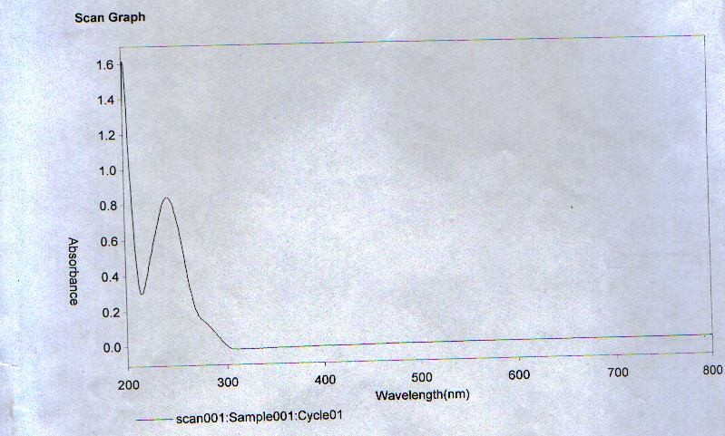

**Figure A1.1: Scan Graph of Wavelenghth versus Absorbance for Paracetamol**

|  |  |
| --- | --- |
| **A 4.1: Calibration Table for Paracetamol** |  |
| **Concentration (Mg/Ml)** | **Absorbance** |
| **4** | 0.275 |
| **8** | 0.609 |
| **12** | 0.805 |
| **16** | 1.061 |
| **20** | 1.235 |
| **24** | 1.548 |
| **28** | 1.875 |
| **32** | 2.112 |

# A5.1: Dissolution Test Results for PCM – GLT (7.5% Binder)

**Time (Mins) Absorbance Amt. dissolved % drug dissolved**

|  |  |  |  |
| --- | --- | --- | --- |
|  | | **(mg/1000ml)** |  |
| **0** | 0 | 0 | 0 |
| **10** | 0.132 | 30.94 | 6.19 |
| **20** | 0.142 | 34.06 | 6.81 |
| **30** | 0.234 | 62.81 | 12.56 |
| **40** | 0.328 | 92.19 | 18.44 |
| **50** | 0.337 | 61.88 | 19.00 |
| **60** | 0.401 | 115.00 | 23.00 |

# A5.2: Dissolution Test Results for PCM – SRS (7.5% Binder)

**Time (Mins) Absorbance Amt. dissolved % drug dissolved**

|  |  |  |  |
| --- | --- | --- | --- |
|  |  | **(mg/1000ml)** |  |
| **0** | 0 | 0 | 0 |
| **10** | 0.352 | 99.69 | 19.94 |
| **20** | 0.377 | 107.50 | 21.50 |
| **30** | 0.386 | 110.31 | 22.06 |
| **40** | 0.388 | 110.94 | 22.19 |
| **50** | 0.418 | 105.63 | 24.06 |
| **60** | 0.443 | 128.13 | 25.63 |

# A5.3: Dissolution Test Results for PCM – PGS – W (7.5% Binder)

**Time (Mins) Absorbance Amt. dissolved % drug dissolved**

|  |  |  |  |
| --- | --- | --- | --- |
|  |  | **(mg/1000ml)** |  |
| **0** | 0 | 0 | 0 |
| **10** | 0.339 | 95.63 | 19.13 |
| **20** | 0.379 | 108.13 | 21.63 |
| **30** | 0.391 | 111.88 | 22.38 |
| **40** | 0.394 | 112.81 | 22.56 |
| **50** | 0.407 | 116.88 | 23.38 |
| **60** | 0.484 | 140.94 | 28.19 |

# A5.4: Dissolution Test Results for PCM – PGS – A (7.5% Binder)

**Time (Mins) Absorbance Amt. dissolved % drug dissolved**

|  |  |  |  |
| --- | --- | --- | --- |
|  |  | **(mg/1000ml)** |  |
| **0** | 0 | 0 | 0 |
| **10** | 0.280 | 77.19 | 15.44 |
| **20** | 0.318 | 89.06 | 17.81 |
| **30** | 0.342 | 96.56 | 19.31 |
| **40** | 0.375 | 106.88 | 21.38 |
| **50** | 0.383 | 109.38 | 21.88 |
| **60** | 0.443 | 128.13 | 25.63 |

# A5.5: Dissolution Test Results for PCM – MZS (10% Disintegrant)

**Time (Mins) Absorbance Amt. dissolved % drug dissolved**

|  |  |  |  |
| --- | --- | --- | --- |
|  |  | **(mg/1000ml)** |  |
| **0** | 0 | 0 | 0 |
| **10** | 0.381 | 108.75 | 21.75 |
| **20** | 0.418 | 120.31 | 24.06 |
| **30** | 0.444 | 128.44 | 25.69 |
| **40** | 0.461 | 133.75 | 26.75 |
| **50** | 0.499 | 145.63 | 29.13 |
| **60** | 0.516 | 150.94 | 30.19 |

# A5.6: Dissolution Test Results for PCM – SRS (10% Disintegrant)

**Time (Mins) Absorbance Amt. dissolved % drug dissolved**

|  |  |  |  |
| --- | --- | --- | --- |
|  |  | **(mg/1000ml)** |  |
| **0** | 0 | 0 | 0 |
| **10** | 0.380 | 108.44 | 21.69 |
| **20** | 0.404 | 115.94 | 23.19 |
| **30** | 0.415 | 119.38 | 23.88 |
| **40** | 0.421 | 121.25 | 24.25 |
| **50** | 0.437 | 126.25 | 25.25 |
| **60** | 0.443 | 128.13 | 25.63 |

# A5.7: Dissolution Test Results for PCM – PGS-W (10% Disintegrant)

**Time (Mins) Absorbance Amt. dissolved % drug dissolved**

|  |  |  |  |
| --- | --- | --- | --- |
|  |  | **(mg/1000ml)** |  |
| **0** | 0 | 0 | 0 |
| **10** | 0.066 | 10.31 | 2.06 |
| **20** | 0.352 | 99.69 | 19.94 |
| **30** | 0.355 | 100.63 | 20.13 |
| **40** | 0.393 | 112.50 | 22.50 |
| **50** | 0.404 | 115.94 | 23.19 |
| **60** | 0.412 | 118.44 | 23.69 |

# A5.8: Dissolution Test Results for PCM – PGS - A (10% Disintegrant)

**Time (Mins) Absorbance Amt. dissolved % drug dissolved**

|  |  |  |  |
| --- | --- | --- | --- |
|  |  | **(mg/1000ml)** |  |
| **0** | 0 | 0 | 0 |
| **10** | 0.093 | 18.75 | 3.75 |
| **20** | 0.191 | 49.38 | 9.88 |
| **30** | 0.191 | 49.38 | 9.88 |
| **40** | 0.208 | 54.69 | 10.94 |
| **50** | 0.249 | 67.50 | 13.50 |
| **60** | 0.268 | 73.44 | 14.69 |

# A6.1: 2 x 3 Factorial Statistical Analysis for Paracetamol Tablets formulated with various Excipients

Quantitative effects of nature of binder (N) concentration of binder (C) and applied pressure (P) on the tensile strength and CSFR/DT

|  |  |  |
| --- | --- | --- |
| Independent coefficient  Variables | Tensile strength | CSFR/DT |
| (i)Employing NS and GLT |  |  |
| N | 0.0025 | -9.770 |
| C | O.308 | -3.505 |
| P | 0.138 | 0.645 |
| (ii) Employing PGSW and  GLT |  |  |
| N | -0.023 | -16.868 |
| C | 0.328 | -17.013 |
| P | 0.123 | 0.588 |
| (iii) Employing PGSA and  GLT |  |  |
| N | 0.020 | -4.730 |
| C | 0.345 | -5.290 |
| P | 0.215 | 1.313 |

Quantitative effect of nature binder (N), concentration (C) and applied pressure (P) on the tensile strength and CSFR/DT

|  |  |  |
| --- | --- | --- |
| Interaction coefficient  Variables | Tensile strength | CSFR/DT |
| (i)Employing NS and GLT |  |  |
| N-C | 0.043 | 2.870 |
| N-P | O.073 | -0.500 |
| C-P | -0.043 | 0.475 |
| (ii) Employing PGSW and  GLT |  |  |
| N-C | 0.023 | -16.378 |
| N-P | -0.025 | -0.443 |
| C-P | -0.058 | 0.103 |
| (iii) Employing PGSA and  GLT |  |  |
| N-C | 0.005 | 4.655 |
| N-P | -0.005 | -1.130 |
| C-P | -0.145 | -0.810 |

Rankings obtained for the independent coefficient effects on the TS and CSFR/DT

|  |  |  |
| --- | --- | --- |
| Formulation | Independent rankings  Tensile strength | Independent rankings  CSFR/DT |
| With GLT as high level |  |  |
| NS/GLT | C>P>>N | N>C>>P |
| PGSW/GLT | C>P>>N | C>N>>P |
| PGSA/GLT | C>P>N | C>N>P |

Ranking obtained for the interaction coefficient effects on the TS and CSFR/DT

|  |  |  |
| --- | --- | --- |
| Formulation | Interaction rankings  Tensile strength | Interaction rankings  CSFR/DT |
| With GLT as high level |  |  |
| NS/GLT | N-P>N-C=C-P | N-C>N-P>C-P |
| PGSW/GLT | C-P>N-P>N-C | N-C>N-P>C-P |
| PGSA/GLT | C-P>N-C>N-P | N-C>C-P>N-P |

Note: There were positive and negative influences on the tensile strength and also the crushing strength-friability disintegration time ratio. A positive influence indicates that a particular parameter increased, whereas a negative influence indicates that the value of the parameter decreased.